EVALUATION OF TABLETING PROPERTIES OF CRUDE TURMERIC (*CURCUMA LONGA* LINN) POWDER

BY

BISHIR ATTIKU

DEPARTMENT OF PHARMACEUTICS AND PHARMACEUTICAL MICROBIOLOGY AHMADU BELLO UNIVERSITY, ZARIA NIGERIA

SEPTEMBER, 2018

EVALUATION OF THE TABLETING PROPERTIES OF CRUDE TURMERIC (*CURCUMA LONGA* LINN) POWDER

BY

Bishir ATTIKU, B.PHARM (ABU) 2002 P13PHPH8010

A DISSERTATION SUBMITTED TO THE SCHOOL OF POST GRADUATE STUDIES, AHMADU BELLO UNIVERSITY, IN PARTIAL FULFILMENT OF THE REQUIREMENT FOR THE AWARD OF A MASTER DEGREE IN PHARMACEUTICS

DEPARTMENT OF PHARMACEUTICS AND PHARMACEUTICAL MICROBIOLOGY,

FACULTY OF PHARMACEUTICAL SCIENCES AHMADU BELLO UNIVERSITY, ZARIA NIGERIA

SEPTEMBER, 2018

### DECLARATION

I declare that the work in this dissertation tittle “Evaluation of Tableting Properties of Crude Turmeric (*Curcuma longa*) Powder” has been carried out by me in the Department of Pharmaceutics and Pharmaceutical Microbiology, under the supervision of Prof. T.S. Allagh and Prof. A.B. Isah.

The information derived from the literature has been duly acknowledged in the text and a list of references provided. No part of this dissertation was previously presented for another degree or diploma at this or any other Institution.

Attiku BISHIR ………………………… …………………….

Signature Date

### CERTIFICATION

This dissertation titled “EVALUATION OF TABLETING PROPERTIES OF CRUDE TURMERIC (*CURCUMA LONGA* LINN) POWDER” by Bishir ATTIKU meets the

regulations governing the award of the degree of Master of Science in Pharmaceutics of Ahmadu Bello University, and is approved for its contribution to knowledge and literally presentation.

Prof. T.S Allagh …………………….. ……………………..…

B.Sc. (Pharm.), M.Sc., PhD (ABU), Signature Date Department of Pharmaceutics and

Pharmaceutical Microbiology, Ahmadu Bello University, Zaria Chairman, Supervisory Committee

Prof. A.B. Isah …………………….. ……………………..…

B. Pharm., M.Sc., PhD (ABU), Signature Date Department of Pharmaceutics and

Pharmaceutical Microbiology, Ahmadu Bello University, Zaria Member, Supervisory Committee

Prof. B.O. Olayinka …………………….. …………………….…

B. Pharm. (OAU), M.Sc., PhD (ABU), Signature Date Department of Pharmaceutics and

Pharmaceutical Microbiology, Ahmadu Bello University, Zaria Head of Department

Prof. S. Z. Abubakar …………………….. ………………………

B. Sc., M.Sc., PhD (ABU), Signature Date Dean, School of Postgraduate Studies

### DEDICATION

This work is dedicated first to Almighty Allah Who sustained my life in all ramifications throughout the difficulties involved, then to my wife Fatima, for her patience, understanding and support. Finally My parents and children for their support and continued prayers.

### ACKNOWLEDGEMENT

I humbly appreciate Almighty ALLAH for granting me the inspiration and the strength and also for saving my life to commence and finished this program. All praise be to Allah, the Beneficent the Most merciful.

My sincere gratitude and appreciation go to my supervisors, Prof. T.S. Allagh and Prof.

A.B. Isah, who provided the support and the guidance needed to see to the completion of this work. I really appreciate your contributions Profs.

I am highly indebted to my darling wife, Hajia Fatima for her support and encouragement and also for taken care of the family as she managed my absence. Thank you, my Dear. To my children, Muhammad, Maryam, „Aysh‟ and Abdullahi I say, thank you for bearing with my absence and also your prayers.

My sincere appreciation goes to all my lecturers. Special thanks to Dr. Tytler, Dr. Olowosulu, Dr. Apeji and Dr. S. Mahmud for coming to my rescue at difficult times of the work. Malam Umar and Malam Salisu of Pharmaceutical & Medicinal chemistry Department are highly appreciated. The contribution of Dr. (Mrs) Hadiza Adamu of the Institute of Education is hereby acknowledged.

I acknowledged Dr. J. Alfa, former Director, Pharmaceutical Services, National Assembly without whose support and encouragement, I would not have even commenced the program. The new Director, Pharm. Ali Umoru (Oga Ali) and the Deputy Director Pharm.

H.B Idris have immensely contributed.

Finally, my mother, late father and my step mother Hajia Umma, for their upbringing and prayers. To my father, may your gentle soul rest in perfect peace. Amin.

### ABSTRACT

The aim of this work is to formulate crude turmeric powder into tablet form. The powder was produced from the turmeric rhizome. Physicochemical properties of the powder; angle of repose (AR), bulk density (BD), tapped density (TD), Hausner‟s ratio (HR), Carr‟s index (CI), true density, moisture content, and flow rate (FR) were evaluated. The particles size and morphology were determined using Scanning electron microscope and sieve analysis. The tablets were formulated using both wet granulation and direct compression methods. The wet granulation was carried out using microcrystalline cellulose (MCC) as diluent and gelatin (GLT) as binder and compared with maize starch (MS), polyvinylpyrrolidone (PVP), and Acacia (AC) as binders. Direct compression method was carried out using Avicel PH101 and Ludipress. Compaction studies were also conducted on the powder. The powder particles were found to be rough, elongated and flaky shaped, with poor flow based on AR (40.3⁰), HR (1.736), CI (42.4 %) and FR (1.4 g/s) and the particles are also interlocked. The granules exhibited marked improvement in flowability: AR (31.14 ° - 34.79 °), HR (1.21-1.29), CI (17.14 – 37.00), FR (1.44 – 2.81 g/s) and moisture content

(10.50 – 13.50 %). The powder deformed by fragmentation and is brittle in nature. The granules have improved plastic deformation explained by both Heckel and Kawakita equations. Turmeric tablets with good mechanical properties were produced by both wet granulation and direct compression methods. Gelatin binder produced good tablets at 2.5 % concentrations and above. Using wet granulation method, MS at 5 % binder concentration produced best tablets in terms of mechanical strength (CSFR: 8.667 compared with gelatin‟s 7.547) but 5 % gelatin binder gave best release tablets (97.70 % at 45 min). Avicel PH101 and Ludipress produced good tablets both at 50 – 60 % dilutions. Avicel

PH101 produced best quality tablets in terms of mechanical strength (CSFR/DT: 6.1460 compared with Ludipress: 2.587) and release profile (86.19 % at 45 min). Turmeric powder can best be formulated into tablet by wet granulation method using gelatin as a binder while Avicel PH101 produced best tablets by direct compression method.

### TABLE OF CONTENT

COVER PAGE i

TITTLE PAGE… ii

DECLARATION iii

CERTIFICATION iv

DEDICATION v

ACKNOWLEDGEMENT vi

ABSTRACT vii

TABLE OF CONTENT ix

LIST OF FIGURES xiii

LIST OF TABLES xiv

LIST OF PLATES xvi

LIST OF APPENDICES xvii

ABBREVIATIONS AND SYMBOLS xix

CHAPTER 1 1

* 1. INTRODUCTION 1
  2. Medicinal Plants 1
  3. Turmeric Plant (Curcuma longa) 2
     1. Description and general appearance 3
     2. Parts of the plant used 4
     3. Chemical composition 4
     4. Non-medicinal use 5
     5. Medicinal uses 5
     6. Pharmaceutical issues 6
     7. Safety/toxicity 6
     8. Usage/dose 6
  4. Statement of Research Problem 7
  5. Justification of the Work 7
  6. Hypotheses 8
     1. Null hypothesis 8
     2. Alternate hypothesis 8
  7. Aim 8
  8. Specific Objectives 8

CHAPTER TWO 10

* 1. LITERATURE REVIEW 10
  2. Oral Route and the Tablet 10
     1. Ideal properties of a tablet 11
     2. Types of tablets 12
     3. Components of a tablet 13
  3. Active Pharmaceutical Agent (Drug) 13
  4. Excipients 13
     1. Diluent 14
     2. Binder 14
     3. Disintegrant 15
     4. Glidants 16
     5. Lubricants 16
     6. Sweeteners 17
  5. Excipients Selection 17
  6. Tableting 17
     1. Methods of preparation of tablets 17
     2. Granulation 18
     3. Wet Granulation 18
     4. Dry Granulation 19
     5. Direct compression 19
     6. Requirements for Directly Compressible Excipients 20
     7. Problems of Tablet Production 21
  7. Compaction of Pharmaceutical Powders 21
     1. Powder compression models 22
     2. Heckel model 23
     3. Kawakita equation 24
  8. Standardization of Herbal Medicines 27
  9. Solid Dosage Formulation of Herbal Medicine 27
  10. A Review on Turmeric Plant 29

CHAPTER THREE 36

* 1. MATERIALS AND METHOD 36
  2. Materials 36
     1. Chemicals 36

3.1.2. Equipment 36

* 1. Methods 37

3.2.1. Plant Collection, Identification and Processing 37

3.2.2 Processing of the Powder 37

* 1. Characterisation of the Powder 38
     1. Angle of repose 38
     2. Bulk density (BD) 38
     3. Tapped density (TD) 39
     4. True density 40
     5. Moisture content determination 40
     6. Determination of flow rate 41
     7. Particles size analysis 41
     8. Preparation of Granules 42
     9. Analysis of Granules 42
     10. Tablet Formula 43
     11. Compression of the granules 46
     12. Evaluation of tablets 46
     13. Determination of dilution potential of Avicel PH 101 and Ludipress 47
     14. Direct Compression 47
  2. Release Profile 50
     1. Determination of the wavelength of maximum absorption (λ max) 50
     2. Beer-Lambert Curve 50
     3. Dissolution test 50
  3. Compaction Studies of Turmeric Powder and granules 51
  4. Stability Studies 51

3.8. Statistical Analysis 51

CHAPTER FOUR 52

4.0 RESULTS 52

CHAPTER FIVE 100

5.0. DISCUSSION 100

* 1. SUMMARY, CONCLUSION AND RECOMMENDATIONS 114
  2. Summary 114
  3. Conclusion 115
  4. Recommendations 116

REFERENCES 117

APPENDICES 133

### LIST OF FIGURES

Figure 2.1: A typical Heckel profile plot 24

Figure 2.2: A typical Kawakita plot 25

Figure 4.1: Percentage Particle Weight Retained (%) Versus Sieve Size (µm) 57

Figure 4.2: Cumulative Percentage Oversize Frequency Distribution Curve for Turmeric (*Curcuma longa*) Powder 58

Figure 4.3: Effect of Binder Concentration on Granules Size Distribution 62

Figure 4.4: Effect of Binder Type on Granules Size Distribution 65

Figure 4.5: The Mean Weight of Turmeric Tablets Using Different Concentration of Gelatin 70

Figure 4.6: Effect of Increase Concentration of Gelatin Binder on the Crushing strength of Turmeric Tablets 71

Figure 4.7: Mean tablet weight of tablets formulated by direct compression method 84

Figure 4.8: Effect of increased Avicel PH 101 and Ludipress on the disintegration time Direct Compression tablets 85

Figure 4.9: Beer's - Lambert Plot (Calibration Curve) for Turmeric Powder in 0.05M HCl Containing 0.8% W/V Sod. Lauryl Sulfate 89

Figure 4.10: Release Profile of Turmeric Tablets against Time (Min) 91

Figure 4.11: Heckel plot for Turmeric (*Curcuma longa*) powder alone and with gelatin and maize starch binders 93

Figure 4.12: Kawakita plot of Turmeric (*Curcuma longa*) powder 94

Figure 4.13: Effect of granulation on the compressibility of turmeric powder

……………………………………………………………………………………………. 96

### LIST OF TABLES

Table 3.1: Formula for Turmeric tablet (500 mg) using gelatin binder by weight granulation (batch size:100). 43

Table 3.2: Formula for Turmeric tablet (500 mg) using different binder types at 5% (batch size: 100) 44

Table 3.3: Formula for Turmeric tablet (500 mg) using maize starch as disintegrant (batch size: 100) 45

Table 3.4: Formula for Turmeric tablets by DC method 49

Table 3.5: Formula for Turmeric tablets by DC method (Batch size:100) 49

Table 4.1: Physicochemical and Organoleptic Properties of Turmeric (*Curcuma longa*) Powder 53

Table 4.2: Effect of Binder Concentration on the properties of Turmeric Granule 60

Table 4.3: Effect of Binder Type on the Granules properties of Turmeric 64

Table 4.4: Effect of Disintegrant Concentration on the Granules of Turmeric Powder

….……………………………………………………………………………………….....67

Table 4.5: Properties of Turmeric Tablets (500 mg) Produced using Gelatin Binder at Different Concentrations 69

Table 4.6: Effect of Binder Type on the Properties of Turmeric Tablets (500 mg) 73

Table 4.7: Properties of Turmeric Tablets (500 mg) at Different Concentrations of Maize Starch as Disintegrant 75

Table 4.8: Effect of Disintegrant Type on the Properties of Turmeric Tablets (500 mg)…77

Table 4.9: Properties of Turmeric Tablets Produced by Direct Compression at Varying Concentrations of Avicel PH101 79

Table 4.10: Properties of the Turmeric tablets produced by Direct Compression at varying concentration of Ludipress 81

Table 4.11: Properties of tablets produced by direct compression method 83

Table 4.12: Crushing Strength-Friability Disintegration Time Ratio of Turmeric Tablets. 87 Table 4.13: Constants Derived from Heckle and Kawakita Plot 95

Table 4.14: Organoleptic Properties of Tablets after six month Stability Studies 98

Table 4.15: Physicochemical Properties of Tablets Studied after six month 99

### LIST OF PLATES

Plate 1: Photograph of turmeric rhizome immediately after harvest in Fadan Kagoma village, Kaduna state. Nigeria 4

Plate 2: Photomicrograph of Curcuma longa particle using SEM… 55

Plate 3: Structure of Turmeric powder particle using Scanning Electron Microscopy (SEM)

…………...………………………………………………..…………………… ………... 55

### LIST OF APPENDICES

A3.1: Tablet Formula for a 500 mg Turmeric tablet: Gelatin binder testing A4.1: Particle properties (weighted by count) of Turmeric powder using SEM A4.2: Particles size analysis by microscopy

A 4.3: Cumulative percentage oversize for the Turmeric powder

A 4.4: Granules size distribution of Turmeric Powder formulations

A4.5: Friability of Turmeric tablets produced using different concentration of gelatin as binder

A4.6: Effect of gelatin binder concentration on the disintegration time of Turmeric tablets A4.7: Dilution potential of Avicel PH101 for direct compression of turmeric tablets A4.8: Effect of Avicel PH101 dilution on the hardness of turmeric compacts

A4.9: Dilution potential of Ludipress for direct compression of turmeric tablet

A4.10: Comparison of crushing strength of tablets produced using Avicel PH101 and Ludipress at different dilutions

A4.11: Comparison of friability of tablets produced using Avicel PH101 and Ludipress at different dilutions

A4.12: Calibration table of turmeric powder in 0.05M HCL containing 0.8% w/v Sodium lauryl sulfate

A4.13: Dissolution test result for A2 A4.14: Dissolution test result for B1 A4.15: Dissolution test result for D1

A4.16: Dissolution test result for D2 A4.17: Dissolution test result for D3 A4.18: Dissolution test result for DC1 A4.19: Dissolution test result for DC2 A4.20: Dissolution test result for DC3. A4.21: Dissolution test result for DC4.

A4.22: Parameters generated from Kawakita plot

A4.23: Effect of granulation on the compressibility of turmeric powder

### ABBREVIATIONS AND SYMBOLS

|  |  |
| --- | --- |
| A | Intercept of linear potion |
| a | Minimum porosity before compression |
| AC | Acacia |
| AMPK | AMP-activated protein kinase |
| API | Active pharmaceutical Ingredient |
| AR | Angle of Repose |
| b | Represent the Material plasticity from Heckel plot |
| BD | Bulk Density |
| BP | British Pharmacopoeia |
| C | Degree of Volume of Reduction |
| CABG | Coronary Aartery Bypass Grafting |
| CI | Carr‟s Index |
| CTC | Compressibility, Tabletability and Compactability |
| *D* | Relative Density |
| DC | Direct Compression |
| DT | Disintegration Time |

|  |  |
| --- | --- |
| D1 | Initial Relative Density from Kawakita plot |
| ɛ | Porosity |
| GLT | Gelatin |
| Ha | Alternate hypothesis |
| HCl | Hydrochloric |
| HR | Hausner‟s Ratio |
| *K* | Slope of the linear potion |
| Kg F | Kilogram Force |
| MCC | Microcrystalline Cellulose |
| 𝑀𝑁𝑚−2 | Mega Newton per square meter |
| *MRSA* | Methicillin resistant *Staphylococcus aureus* |
| MS | Maize starch |
| 𝑃𝑘 | Inverse Measure of Plastic deformation (Reciprocal of b) |
| 𝑃𝑦 | Mean yield Pressure |
| PVP | Polyvinylpyrrolidone |
| SEM | Scanning Electron Microscopy |
| TD | Tapped Density |

|  |  |
| --- | --- |
| TS | Tensile Strength |
| µm | Micro meter |
| V | Volume under applied pressure |
| *VO* | Initial Volume of powder bed |
| USP | United States Pharmacopoeia |
| WG | Wet Granulation |
| 𝑤⁄𝑣  < | Weight by volume  Less than |
| > | Greater than |
| ≥ | Greater than or equals to |
| ⁰ | Degree |
| П | Pie (3.142) |
| Σ | Summation |
| % | Percent |
| ρ | Relative Density |

### CHAPTER 1

### INTRODUCTION

### Medicinal Plants

Traditional medicine is the sum total of knowledge, skills, and practices based on the theories, beliefs, and experiences indigenous to different cultures that are used to maintain health, as well as to prevent, diagnose, improve, or treat physical and mental illnesses (Fawzi *et al.,* 2013). It is an important part of healthcare delivery system in most of the developing world and is a source of primary health care to 80 % of the world‟s population (Shohawon and Mahomoodally, 2013; Aone *et al.,* 2001). This use of traditional medicine is especially in the developing world, but during the past decades, the developed world has also witnessed an increased in the utilization of Complementary and alternative medicine with more emphasis on herbal remedies (Shohawon and Mahomoodally, 2013).

The most common traditional medicine in practice across the African continent is the use of medicinal plants. The World Health Organization (WHO) defines a [medicinal plant](http://www.scialert.net/asci/result.php?searchin=Keywords&cat&ascicat=ALL&Submit=Search&keyword=medicinal%2Bplant) as plant in which some or all of its parts can be used directly in the management of a disease (Shohawon and Mahomoodally, 2013)

Medicinal plants have been successfully used for centuries by man as remedies in the treatment of ailments. In many parts of Africa, medicinal plants are the most easily accessible health resource to the community. In addition, they are most often the preferred option for the patients (Allagh *et al*., 2009). For most of these people, traditional healers offer information, counseling, and treatment to patients and their families in a personal manner as well as

having an understanding of their patient‟s environment (Gurib-Fakim *et al.,* 2013). Also, Medicinal plants are more likely to be accepted by the body than synthetic drugs. Moreover, some of them are used as food (Nuhu *et al.,* 2009).

Medicinal plants are use either directly or indirectly. Directly, the plant parts like leaves, fruits, stem bark and roots or even the whole plant are themselves used in the treatment of illnesses (Falodun, 2010).

A typical plant contains mixture of compound called secondary metabolites. These are responsible for most plants‟ therapeutic activity. Up to 12,000 secondary metabolites were isolated as at 2006 and the number estimated to be less than 10% of the total (Tapsell *et al.,* 2006). They work in diverse ways to produce combined effects that surpasses the total activity of the individual components. This could be by increasing the stability of the main active compound, reducing its side effects or having additive, potentiative or antagonistic effects on the active moiety. This is one of the differences between traditional medicine and the orthodox medicine (Shohawon and Mahomoodally, 2013). There is higher momentum for the use crude and/or standardised extract in the scientific community as opposed to single isolated single compound (Fawzi-Mahomoodally, 2013).

* 1. **Turmeric Plant (*Curcuma longa*)**

Turmeric *(Curcuma longa)* a member of the ginger family, Zingiberaceae is a rhizomatous herbaceous perennial plant (Priyadarsini, 2014). Other species are: *C. domestica, C. rotunda L., C. xanthorhizanaver,*

Local names: *Gangamau* (Hausa); *Kurkum* (Kanuri); *Ata ile pupa, Aayu* (Yoroba);

*Nwandumo* (Igbo).

It is a native of southeast India but found also in other parts of the world. It requires considerable amount of rainfall and temperatures of 20 – 30 ⁰C to grow (Prasad *et al.,* 2011).

Turmeric has been used in Asia for over four thousand years and is a major part of Siddha medicine. It was first used as a dye and then later for its medicinal properties (Prassad, 2014).A U.S patent on Turmeric awarded to University of Mississippi Medical Center in 1995, for the use of Turmeric in wound healing, was revoked only two years later when The Indian Council for Scientific and Industrial Research, complained on ground of piracy. They argued that the use has been in practice and documented for thousands of years in India. (Prassad, 2014)

* + 1. Description and general appearance

Turmeric plant is a perennial herb that grows up to 1.0 m in height with highly branched, yellow to orange, cylindrical aromatic rhizomes. Stout, fleshy main rhizome is nearly ovoid while lateral rhizomes that are slightly bent. The leaves are alternate and arranged in two rows. Larger leaves are lanceolate, uniformly green, and up to 50 cm long. Apex is acute and caudate with tapering base (Lise, 2013)

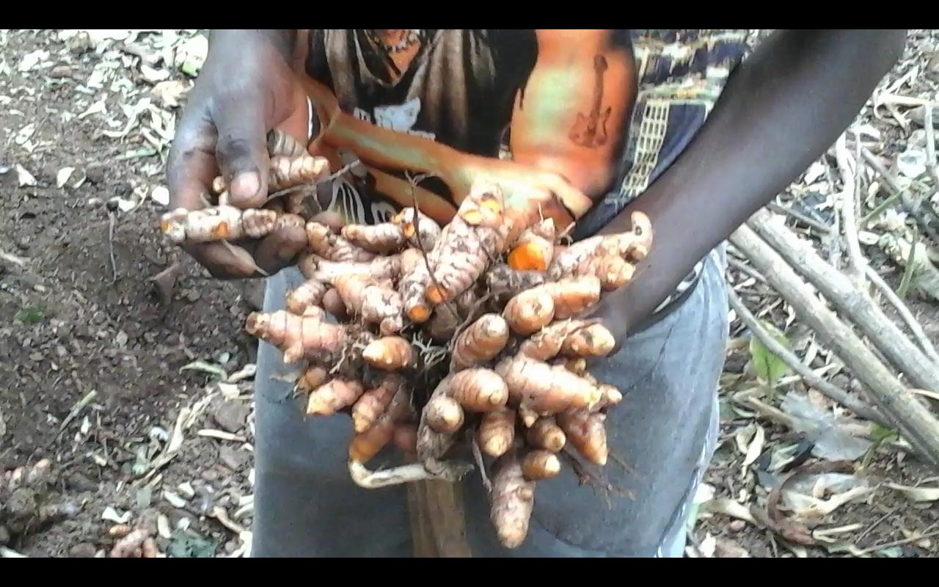

### Plate 1: Turmeric rhizome immediately after harvest at Fadan Kagoma, Kaduna State. Nigeria

* + 1. Parts of the plant used

The roots, or rhizomes and bulbs are used in the medicine and as food (Lise, 2013).

* + 1. Chemical composition

The rhizome is the part used medicinally. The constituents are: Yellow-pigmented polyphenolic curcuminoids {Curcumin (diferuloylmethan) 85 %, Demethoxycurcumin 10 %, Bisdemethoxycurcumin 5 %, and Cyclocurcumin}; Pale yellow to orange yellow volatile oils

{sesquiterpenes (Turmerone, Atlantone, Zingiberone, Turmeronol, Germacrone, and Bisabolen) and monoterpenes}; Curcumene; Alpha and Beta turmerone; carbohydrates; protein; resins; and caffeic acid (Lise, 2013)

* + 1. Non-medicinal use

Turmeric leaves are used to wrap and cook food. Indians use the rhizome as a spice in cuisine and curry powder and also as a dye and colourant to colour cheese; yogurt; salad; butter; and margarine. It is also used in Hindu ceremonies such as weddings and religious celebrations (Ravichandran, 2013).

In Borno State Nigeria, Turmeric (Kurkum in local dialect) is used as a beauty treatment for brides, while in southern Kaduna Nigeria, it is widely used to impart colour to locally made mats.

* + 1. Medicinal uses

Traditional Indian medicine has used Turmeric (Curcumin) in the management of conditions such as anorexia, coryza, cough, hepatic diseases, sinusitis and respiratory conditions (asthma, bronchial hyperactivity, and allergy) (Lise, 2013)

In Nigeria, discussions with local herbalists around Zaria, and users in Federal capital territory; Kaduna and Katsina states revealed that Turmeric powder is used in varied ways for the management of many diseases including skin condition; overweight; fibroid; liver diseases; diabetes and ulcers.

Extensive research over the past 30 years has shown that it plays an important role in the prevention and treatment of various diseases including: indigestion or dyspepsia, ulcerative colitis, stomach ulcers, rheumatoid and osteoarthritis, heart diseases, cancer, dental procedures, Alzheimer‟s disease, bacterial and viral infections, amenorrhea, dysmenorrhea, epilepsy, pain, skin diseases (common use in Northern Nigeria), uveitis, pulmonary conditions., metabolic diseases, and autoimmune conditions (Prasad, 2014). Curcumin

(Turmeric) has been studied for its chemo-preventive potential in a wide variety of cancers, in both preclinical studies and in clinical trials (Gupta *et al.* 2013).

How curcumin (Turmeric) exhibits the diverse effects mentioned above unknown. However, numerous researches indicates that the agent is highly pleiotropic with anti-inflammatory, hypoglycemic, antioxidant, wound healing and antimicrobial activities It has also been shown to possess chemo sensitization, chemotherapeutic and radio-sensitization activities (Nishiyama *et al.,* 2005)

* + 1. Pharmaceutical issues

Because of its marvelous properties, curcumin is being marketed in several countries including the United States, India, Japan, Korea, Thailand, China, Turkey, South Africa, Nepal, and Pakistan in different form such as: Capsules; tablets (extract); ointments; energy drinks; soaps; and cosmetics (Prasad *et al.,*, 2011). It is also used as fluid extract and as a tincture in combination with bromalain (Ravichandran, 2013). In Nigeria, it is commonly available as powder (spice), drink, lotion and creams.

* + 1. Safety/toxicity

Turmeric (curcumin) is safe even at a dose of up to 12 g per day, but has poor bioavailability due to poor absorption, rapid metabolism and rapid elimination. Turmeric even with the above problems still has good therapeutic efficacy in the management of various human diseases (Gupta *et al*., 2013)

* + 1. Usage/dose

Cut rhizome: 1.5 – 3 g per day (Ravichandran, 2013)

Dried powdered root 1 – 3 g per day (Ravichandran, 2013)

500-8000 mg/day (Lise, 2013)

Standardised powder(Curcumin): 400-600 mg tds

250-2000 mg/day (Lise, 2013)

Fluid extract (1: 1) 30-90 drops per day (Lise, 2013)

Tincture (1:2): 15-30 drops qid (Ravichandran, 2013)

### Statement of Research Problem

Turmeric is use in Nigeria for various ailments ranging from skin conditions; overweight; fibroid; liver diseases; diabetes and ulcers. The forms used are as spice, powder mixed with food or dispersed in water and taken. In both methods, accurate dose cannot be measured, thus, the need to standardize the dose by formulating the crude powder into a tablet.

### Justification of the Work

Turmeric has been used in Asia for thousands of years and is a major part of Siddha medicine. It was first used as a dye and then later for its medicinal properties. Extensive research over the past 30 years has shown that it plays an important role in the prevention and treatment of various diseases. (Prasad, 2014)

In Nigeria Turmeric is used for various ailments without accurate dose.

No literature has been found on tableting of crude turmeric powder in this country.

Successful production of the tablets will provide a more convenient method of administration of the turmeric for the users.

The tablet will be cheap and there will be increased cultivation of the plant thus creation of more jobs and generation of income for the farmers.

### Hypotheses

* + 1. Null hypothesis

Turmeric powder cannot be formulated into a tablet using wet granulation and direct compression methods.

* + 1. Alternate hypothesis

Turmeric powder can be formulated into a tablet using wet granulation and direct compression methods.

### Aim

To formulate tablet from crude turmeric rhizome powder using wet and direct compression methods and evaluate the properties of the tablet.

### Specific Objectives

* + 1. To collect Turmeric plant rhizome, process it into powder and characterize the powder
    2. To conduct compaction studies on the powder
    3. To prepare turmeric tablet using gelatin as a binder at different concentrations (2.5 %; 5 %; 7.5 % and 10 %) and compare the best batch with 3 binders (Maize starch; acacia and Polyvinylpyrrolidone) at same concentrations
    4. To prepare 500 mg tablet of the best batch above using Maize starch as disintegrant at different concentrations (5 %; 7.5 % and 10 %) and compare the tablet of the best

batch from above with those prepared with other disintegrants ( Methyl cellulose and Pre-gelatinized potato starch) at same concentrations.

* + 1. To prepare turmeric tablets, by direct compression using Avicel PH101 and Ludipress as direct compression excipients.
    2. To determine the release profile of the best formulations using UV Visible Spectrophotometer.

### CHAPTER TWO

### LITERATURE REVIEW

### Oral Route and the Tablet

The administration of a medicine by mouth (Oral route) is the most common way of drug administration and among the oral dosage forms; tablets of various kinds are the most popular type of solid dosage form in contemporary use (Vimal, *et al.,* 2013).

Tablet are small disc-like or cylindrical specimen solid pharmaceutical dosage forms containing drug substances (one or more) with or without suitable diluents and prepared by either compression or moulding method. Tablets are manufactured by mainly three techniques: wet granulation, dry granulation and direct compression (Rudnic and Schwartz, 2000).

Tablets are obtained by compressing uniform volume of particles or other suitable manufacturing techniques such as extrusion, moulding or freeze drying (lyophilization). They are intended for oral administration. Some are swallowed as a whole, some are being chewed, some are dissolved or dispersed in water before being administered (effervescent) and some are retained in the mouth (buccal), where the active ingredient is 'liberated (Jariwala *et al.,* 2016)

Tablets have the advantage of being;

* + 1. Generally stable physically, chemically, and microbiologically (does not need sterilization but must be hygienic)
    2. Simple and economical in production and have flexible production procedure.
    3. Accurate in dosage, compact and easy to administer
    4. Convenient in packaging, shipping, dispensing and usage Able to mask unpleasant taste, odour and colour.
    5. Able to combine two or more active substances in one tablet ( e.g. Multilayered tablets)
    6. Able to control rate of release in terms of time and site, so that action can be targeted and monitored.

The limitations of the use of tablets as a dosage form include:

1. Poor bioavailability with high dose or low solubility drugs
2. Poor drug absorption due to food and gastro intestinal motility
3. Effect of first-pass metabolism
4. Cannot be used by unconscious patients (Jariwala *et al.,* 2016)
5. Difference in the chemical and therapeutic equivalence among the different brands of the same drug lead to differences in patient response (Alderborn, 2013)
   * 1. Ideal properties of a tablet
        1. The tablet should include the correct dose of the drug.
        2. The appearance of the tablet should be elegant and its weight, size and appearance should be consistent.
        3. The drug should be released from the tablet in a controlled and reproducible way.
        4. The tablet should be biocompatible, i.e. not include excipients, contaminants and microorganisms that could cause harm to patients.
        5. The tablet should be of sufficient mechanical strength to withstand fracture and erosion during handling.
        6. The tablet should be chemically, physically and microbiologically stable during the shelf life of the product
        7. The tablet should be formulated into a product acceptable to the patients.
        8. The tablet should be packed in a safe manner (Jariwala *et al.,* 2016)
     2. Types of tablets

There are different classifications of tablets. A common classification is based on the drug release pattern from the tablet. Here tablets are classified as:

* + - 1. Immediate release: These tablets release the drug rapidly after administration or dissolve in liquid to form solution before administration. They are the commonest type of tablet and they include:
         1. Disintegrating tablet
         2. Chewable tablet
         3. Effervescent tablet
         4. Sublingual tablet and
         5. Buccal tablets
      2. Modified release: These are:
         1. Prolonged release;
         2. Pulsatile release and
         3. Delayed release. (Alderborn, 2013)

Another classification is based on the route of administration. These are: Oral; sublingual, buccal; rectal and vaginal tablets (Gaud and Gupta, 2007).

Tablets could also be coated or uncoated. Examples of coated tablets are

1. Film coated tablets: A film of water soluble polymer is applied on a compressed tablet. E.g. Tinidazole tablet
2. Sugar-coated tablets: Sugars such as Sucrose are used to mask unpleasant taste. E.g.

Ferrous sulfate.

1. Enteric coated tablets: Drug substances that are corrosive or are inactivated in the stomach are coated with substances that retard the release of the active moiety. It can also be used to modify the release of the drug (Alderborn, 2013)
   * 1. Components of a tablet

A tablet is mainly composed of two components and they are: The active pharmaceutical ingredient (API) and the excipients. The physicochemical properties of the API and the type of manufacturing process determine the different type of excipients to be used (Fathima *et al.*, 2011).

### Active Pharmaceutical Agent (Drug)

This is the most important component of the tablet and it is responsible for eliciting the pharmacological action. For there to be therapeutic efficacy, it must be chemically stable and compactible with the used excipients. The percentage API in tablet is in the range of 0.05 – 60 % depending on the potency of the drug (Alderborn, 2013).

### Excipients

Excipients are substances used to convert API into pharmaceutical dosage forms suitable for administration to patients. The excipients used in tablets include diluents, binder (granulating agents), lubricants, disintegrant, sweeteners or flavours, sorbents, antiadherent and pigments and each of these has its own characteristics and uses. Their role is to ensure that tablets of specified quality are produced. Excipients are suitably selected and determined to achieve proper delivery of the API to the target tissues (Parmer and Rane, 2009).

* + 1. Diluent

This is also called filler. They are substances that are added in order to produce tablets of size suitable for handling. A tablet should normally weigh at least 50 mg, and therefore, a potent low dose drug require the addition of suitable substance in order to increase the powder volume and hence the size of the tablet. A good diluent should be non-hygroscopic; biocompatible; chemically inert; cheap; of acceptable taste and possesses good biopharmaceutical properties. It should also have good technical properties such as compatibility and dilution capacity. The diluent is not needed if the dose of the drug per tablet is high. Diluents are also added to enhance compressibility and stability (Amstrong, 2007)

Lactose is the most commonly used diluent in pharmaceutical production; Sucrose & dextrose are hygroscopic and therefore not suitable for moisture sensitive APIs; Starch may cause stability problems due to its 14 % moisture content; Calcium phosphate produce hard granules and is insoluble in water; Microcrystalline cellulose is a free flowing diluent with good compression properties and it is also non-hygroscopic and efflorescent. It is therefore good for moisture sensitive APIs. Other diluents are mannitol; sorbitol; and other cellulose derivatives such as methyl cellulose (Parma and Rane, 2009).

* + 1. Binder

This is also termed granulating agent or adhesive. They are added to the drug – diluent mixture to produce granules and then tablets of required mechanical strength. The choice of a binder and the concentration affects the hardness and the disintegration time of the tablet. They are used at a concentration of 2 – 10 % (Alderborn, 2013).

Binder could be used as:

* + - 1. Dry powder mixed with other ingredients before wet agglomeration.
      2. A solution (solution binder) used as agglomeration liquid in wet granulation. These are considered the most effective and so, most commonly used. E.g. gelatin, acacia, polyvinylpyrrolidone etc.
      3. Dry binder mixed with other ingredients before compaction. E.g. Microcrystalline cellulose; cross-linked Polyvinylpyrrolidone Jariwala *et al.,* (2016). Others are Pre- gelatinized starch (Starch Rx1500) and hydroxylpropyl methylcellulose. (Parma and Rane, 2009)

Granules formed by using binders are generally larger in particle size and freer flowing for tablet production. This is due to the formation of liquid bridges followed by the drying process (Parma and Rane, 2009).

* + 1. Disintegrant

In order to overcome the cohesive strength produced by the compression process and break the tablet into primary particles as rapidly as possible, there is the addition of disintegrant to the tablet. They ensure breaking up of the tablet into smaller fragments to promote rapid dissolution. Disintegrants lead to the achievement of largest possible surface area during dissolution ((Sakr, *et al.,* 2012). The process of disintegration involves two steps: Liquid wets the solid and penetrates the pores of the tablet and the tablet breaks into smaller fragments.

There are two types of disintegrants;

1. Disintegrants that facilitate water uptake.
2. Disintegrants that ruptures the tablet. Tablet rupture is caused by the swelling during sorption. Non swelling disintegrants are also available. Some act by particle- particle repulsion (Jariwala *et al.,* 2016).

Disintegrants may be added within the granules (Intra-granular addition) or added to the dried granules (extra granular addition). Gas (Carbon dioxide, commonly used for effervescent tablets) producing disintegrant are also available. The position of the disintegrants (internal or external) affects their water uptake and disintegration time (Alderborn, 2013).

Traditional disintegrants and their use concentrations include: Starch (Potatoes, corn and maize are common) (up to 10); modified cellulose and modified starch (1 – 5 %). Many disintegrants have less than satisfactory compaction properties and therefore high concentration can reduce tablet strength. Recent trend involve the use of super disintegrants such as sodium starch glycolate, crospovidone, croscarmelose sodium and certain ion- exchange resin. They have excellent disintegration property at low concentration (Parma and Rane, 2009).

* + 1. Glidants

These are often added to granules before compression to achieve powder flowability and production speed. The main role is to improve powder flowability. They are used at low concentration. The most commonly used is colloidal silica at a concentration of 0.2 % w/w. Others are talc (1-2 % w/w) and magnesium stearate (< 1 % w/w) (Gaud and Gupta, 2007).

* + 1. Lubricants

These reduce problems and enhance ejection of the tablet from the die cavity. They act by the reduction of inter-particulate friction leading to the production of a smooth tablet. A commonly used lubricant is magnesium stearate. Others include talc, magnesium stearate, stearic acid, calcium stearate, starch derivatives and polyethylene glycols (Gaud and Gupta 2007).

* + 1. Sweeteners

These produce pleasant taste and also mask unpleasant taste. They are often thermo labile hence added after the operations involving heat. They are added to the granules as an alcohol solution. Sweeteners are used in chewable tablets because they are not swallowed. Examples are sugars, aspartame and saccharin sodium (Gaud and Gupta, 2007).

### Excipients Selection

The physicochemical properties of the API and the excipients; the desired release pattern and the manufacturing processes affect excipient selection. The decision could be both objective and subjective. For example, the choice of manufacturing method depends on available facilities, cost, training and personal preferences or experience. The availability and the quality of the excipients also play a major role (Alderborn, 2013).

### Tableting

* + 1. Methods of preparation of tablets

There are 3 main methods of producing tablets. The choice of the method to be used depends on the properties of the API, its dose, regulatory concern and the availability of the required equipment. The methods are:

* + - 1. Wet granulation: The powder mixture of the drug and excipients is granulated by wet massing before compressing.
      2. Dry granulation: The powder mixture of the drug and excipients is granulated by dry methods prior to compression
      3. Direct compression: The drug itself is compressible and/or it can be mixed with directly compressible excipients (e.g. Avicel PH101, Starlac, Ludipress etc.) (Alderborn, 2013)
    1. Granulation

This is a process in which larger multi particulate entities called granules are made from primary [powder](https://en.wikipedia.org/wiki/Powder_%28substance%29) [particles](https://en.wikipedia.org/wiki/Particles). It improves the flowability and processing properties of most fine pharmaceutical compounds prior to tableting. Granulation is therefore, very important in the production of oral dosage forms. There are three most common granulation processes for solid dosage form production. They are: wet granulation, dry granulation (roller compaction) and direct blending (Sakr, *et al.,* 2012).

* + 1. Wet Granulation

This is the preferred tableting method for most agents, even if they are moisture sensitive. It is the oldest and most commonly used method. It involves massing of powder mix of API, diluent and sometimes disintegrant with a granulating fluid containing mostly volatile non- toxic liquid and a binder. The solvent, gaseous or aqueous is suitably selected not to affect the physicochemical properties of the agent. The presence of a binder ensures the maintenance of a strong inter-particulate bond within the powder after the removal of the solvent. The wet mass is made into granules by passing through a sieve and then drying at an appropriate temperature but generally not exceeding 60⁰C. Agglomerate of granules is broken by passing through a suitable sieve thereby rejecting under sized and oversized granules. Organic solvents or modern techniques such as fluidized drying are used when water sensitive agents are involved. Examples of liquids used are water, ethanol and isopropanol, either alone or in

combination. Disintegrants, glidants and lubricants are added before compression into the desired tablets (Gaud and Gupta, 2007).

Other methods of achieving wet granulation apart from massing and screening are pan granulation (Sakr, *et al.,* 2012)

The disadvantages of wet granulation include: degradation of heat sensitive APIs; solute migration during drying of soluble materials; the large number of steps and high cost of the method in terms of equipment, energy and time (Solanki *et al.*, 2010)

* + 1. Dry Granulation

Moisture is not involved. Poorly compressible, heat and some moisture sensitive agents can be granulated using dry granulation method. The process involved compacting the powder mix and then size reducing free flowing granule blend of uniform size. This is done in a heavy duty tableting press to produce a tablet (Slug) or by using two roller compactors (Chilsonator) to produce a sheet of powder material (Gaud and Gupta, 2007).

The powder mix contains API, and if necessary with half the disintegrant and the lubricant. The broken granules are passed through a set of sieves and the remaining disintegrant and lubricant plus the glidant are added to the granules before compression (Gaud and Gupta, 2007).

* + 1. Direct compression

This is the process by which tablets are compressed directly from API powder and an excipient which flow uniformly in the die forming a film contact. It involves less processing

steps than other methods, making it the simplest and most economical (McCormick *et al,*

2005)

Direct compression has the advantage of being cost effective; suitable for moisture and heat sensitive APIs; gives tablets with faster dissolution rate; and also tablet with less wear and tear due to punches. It is also less susceptible to microbial and other contamination (Gowtham *et al.,* 2013)

Direct compression tablets may have weight variation and content uniformity problems. This is due to segregation as a result of differences in density of the APIs and excipients. The dry state of the materials induces static charges and lead to segregation. The technique produces tablets containing about 30-50 % of poorly compressible APIs (Apeji, 2010). This leads to large tablets that may result in ecstatic and swallowing problems (Gowtham and Dolaka*,* 2013).

* + 1. Requirements for Directly Compressible Excipients

In order to achieve a good product, the material candidate for direct compression should:

* Have good compactibility.
* Good flow properties: Good flow of the material ensures rapid and uniform flow of the powder during die cavity filling. Incorrect powder flow causes non-uniform blending, over or under weight tablets (Alderborn, 2013).
* Have controlled particle size: The particle size of the excipient and that of the API should be equivalent. This helps in achieving blending and avoiding segregation.
* Have optimum dilution potential: A minimum possible weight of a tablet is obtained with a directly compressible excipient that has high dilution potential.
* Be stable: It should not interfere with the API physically and chemically and should also not affect its bioavailability. Directly compressible excipients should also not interact with other excipients.
* Should have low lubricant activity (Gohel and Jogani, 2005)
  + 1. Problems of Tablet Production

Ideally, tablet should be free of any visible or functional defect. But modern advancements and innovation have even increased such problems. Tablet defects could be from any of the following:

* The raw materials (API and excipients) being unable to meet quality specifications.
* The processing steps. The processing and granulating of the powder, compression of the powder and the ejection of the tablets

Some possible tablets defect include: variable hardness, variable weight, sticking, picking, chipping, capping, lamination and melting (Aulton and Taylor, 2013). Other defects are double impression, blistering, crating, pitting, and blooming (Rana and Hari 2013)

### Compaction of Pharmaceutical Powders

The propensity of a powder to form a coherent tablet is called powder compactibility. It represents a critical powder property in successful tableting operations, as it is the ability of the powder to form mechanically strong tablets. Compaction is a result of compression and cohesion properties of a powder and it involves the formation of a solid specimen of defined geometry by the powder (Aulton, 2013). Compaction, as it relates to a pharmaceutical powder, comprise of dual processes of compression and consolidation of the powder (particulate solid – gas) system as a result of applied force (Gonul *et al.,* 2000).

While in the compression process, the particles are brought closer and inter-particulate attraction occurs, in compaction of dried powders, binding mechanism is roughly divided into three: Solid bridges; attraction force and mechanical interlocking (Nystrom, 1996). Under the influence of applied pressure, powders may consolidate by plastic deformation, elastic deformation or by fragmentation of the particles (Zhou and Qiu, 2010).

Particle fragmentation and plastic deformation are two particle deformation mechanisms that are bond producing. While particle fragmentation increases bonding surfaces, plastic deformation enhances bonding force, thus, the two have a positive effect on tablet strength. The smaller the particle size, the stronger the compact formed (more bonding surfaces) but the particle shape has effects more on the elastic materials. Tablet strength is negatively affected by elastic deformation of the particles as it causes bond breakage following removal of the applied force (Klevan, 2011). A combination of brittle fracture and plastic deformation are necessary mechanical properties as they are both irreversible and promote tableting (Egart *et al*., 2014)

Tablets with high resistance to fracturing and less tendency to cap or laminate are produced by powders that have high compactibility. Studying the effect of compaction pressure on the strength of the tablet is the common way to assess powder compactibility.

* + 1. Powder compression models

Mathematical representation of compression processes of pharmaceutical powders is derived mainly by the relationship between volume and applied pressure during compression (Aulton and Taylor, 2013). There are up to fifteen different models, but Heckel, Kawakita, Ludde and Adams have been validated for Pharmaceutical systems (Gonul *et al,* 2000). Among the aforementioned models, the most recognised expression is the tablet porosity - applied

pressure function according to Heckel. Another frequently used expression is the Kawakita model. They relate either powder porosity or volume to applied pressure. Heckel and Kawakita are simple mathematical forms and substantial knowledge has been built on the two.

* + 1. Heckel model

It is the most commonly used. Heckel equation is based on the measurement of the tablet porosity on a powder load (die) or on an ejected tablet. The former can be performed rapidly with minimal powder hence more common. It assumed that powder compression follows first order reaction with pores as reactants and densification as the product (Alderborn, 2013).

Base on this, Heckel derived the equation:

ln (1) = 𝐾𝑃 + 𝐴 …………….……………………………………….. (1)

𝑒

*e* = Tablet porosity

P = Applied pressure

A = Constant reflecting particle rearrangement and fragmentation

K = Slope of linear part of the relationship reflecting particle deformation during compression.

Yield stress or Yield pressure of the particle ( 1 ) is calculated to represent the reciprocal of

𝐾

the slope K. Yield stress is the stress at which plastic deformation of the particle is initiated.

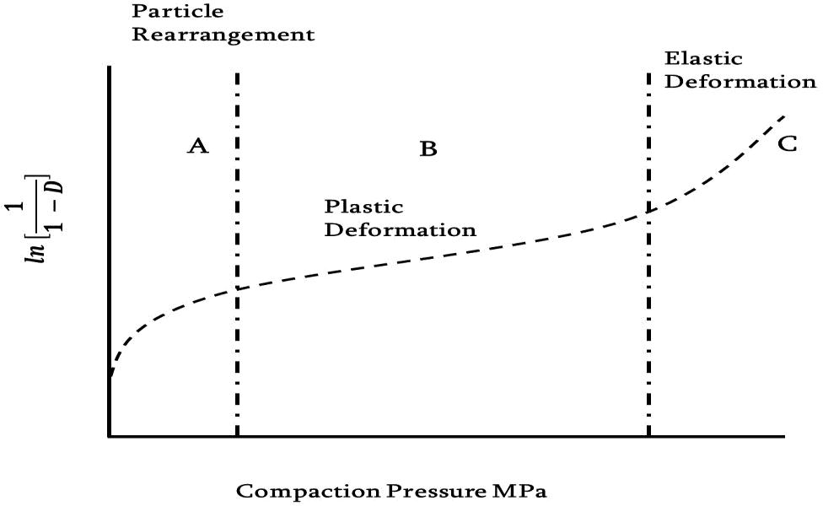

Figure 2.1: A typical Heckel profile indicating three regions of powder of compression (He, 2009)

A typical Heckel profile consist of an initial curvature (A) representing particle fragmentation and repositioning; a linear region (B) obeying the expression, where compression process is controlled by particle deformation; and a third non-linear region (C) reflecting elastic deformation of the tablet. Yield stress is calculated from the gradient of the linear region (B) and is an indication of the hardness or plasticity of the tablet Alderborn, 2013).

Heckel analysis was originally developed for metals but later extended to pharmaceutical powder (Cunningham *et al.,* 2004)

* + 1. Kawakita equation

Compression data can also be expressed by relating the volume of reduction of a powder bed to applied pressure. This could be done using Kawakita equation. It is used to calculate compression shear strength. It assumes that during compression in a confined space, the system is in equilibrium at all stages, so that the product of pressure term and a volume term is constant

.Thus:

𝑃𝐶 = ( 1 )= (𝑃) ……………………………………………………………………… (2)

𝑎𝑏 𝑎

P = applied pressure

*C* = Degree of volume of reduction

*a* & *b* are constants Thus:

𝐶 = 𝑉𝑜−𝑉𝑝

𝑉𝑜

………………………………………………‟……………………. (3)

𝑉𝑜= Initial volume of powder column

𝑉𝑝= volume of powder column (the compact)

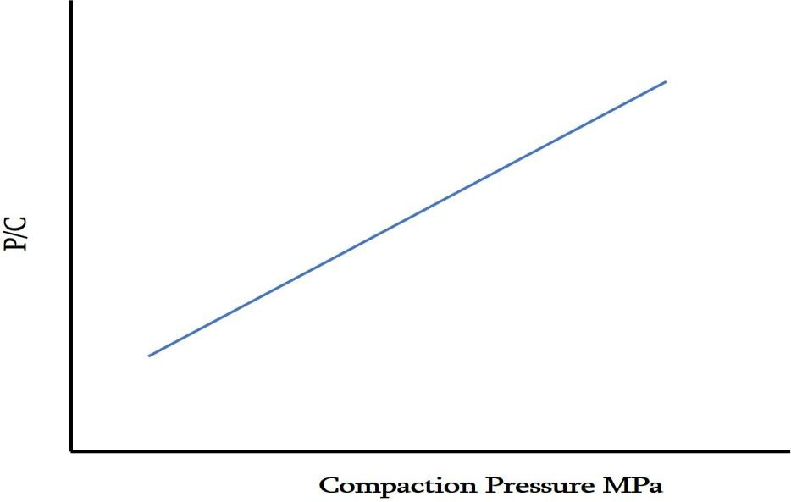

Figure 2.2: A typical Kawakita plot (Denny, 2002).

A linear relationship between ( 𝑃 ) and P is used to derive the values of *a* and *b*. *a* reflects the

𝐶

maximum strain of the powder bed while b is the reciprocal of the pressure when reaches one half of the limiting value.

Kawakita equation is best used for analysis of soft powder compressed under pressure. *1/b* reflects agglomerate strength, Fracture strength of single particle or plasticity of a granule (Nordstrom *et al.,* 2008; Yap *et al.,* 2008).

### Standardization of Herbal Medicines

In comparison to modern drugs, herbal medicines are frequently used to treat chronic diseases. Medicinal plants are still the most abundant and economical source of new drug innovations. The unmatched availability of chemical diversity in standard plant extract and pure compounds of natural products provide a big opportunity for new drugs leads (Prasad, 2014).

Due to the effect of environmental and genetic factors on the biochemical components of herbal plants, there is the need to standardize their use condition to ensure biochemical consistency and optimum efficacy and safety.

The purity and quality of herbal plants are achieved by using several methods. These include:

1. Morphology and organoleptic evaluation: these include sensory and macroscopic characteristics sufficient to identify the drug. They include colour, odour, taste, size, fracture etc.
2. Microscopy: this is both qualitative and quantitative. Items such stomata, trichome, calcium oxalate etc., are used to identify and standardize the plant.

Other parameters include solubility, chemical test, moisture content, extractive value, microbial contamination, characteristics and DNA finger printing, toxicity studies and use of makers (Garg *et al.,* 2012).

### Solid Dosage Formulation of Herbal Medicine

There has been a lot of efforts by scientists to formulate herbal medicine into different standardize dosage forms. Both herbal extracts and the crude plant material have been

formulated into different dosage forms. Below are some of the works done to formulate

herbal products into tablet dosage form either using the crude product or using different extract.

Niranjan *et al.,* (2015) formulated herbal tablet of the dry leave extract of *Costus pictus* with varied concentration of Polyvinylpyrrolidone binder and other excipients by direct compression. The tablet parameters were all found to be within normal limit and no manufacturing defect was observed. They concluded that the optimized tablet exhibited reasonable antidiabetic activity.

Tablet of the aqueous extract of the plant *Linum usitatissimus* showed acceptable Pharmacopoeia limits and complied with the specifications of thickness, hardness, friability and weight variation (Manimarum, 2014).

Manton *et al.,* (2014) reported that direct compression is not a suitable method for the formulation of the Thai traditional herbal tablet (Original JIT-TRA-ROM recipe) but that; it can be formulated by wet granulation method.

Mu‟azu *et al.,* (2013) successfully formulated bitter leave tablet from the crude leave powder of the plant *Vernonia amygdalina*. They found that, gelatin is a better binder compared to maize starch and MCC.

Allagh *et al.,* 2012 tableted the crude leave powder of *Ageratum conzoides* using Maize starch (MS), gelatin and Acacia at 5% level. They concluded that 5% MS provided better tablet properties.

Vijaye *et al.,* (2011) studied poly herbal aqueous extract tablets and recommended that the threshold level of the dry extract be kept at 700 mg/g of the tablet for excipient blend of cross carmelose sodium, sodium starch glycolate and cross povidone.

Autamashih *et al.,* 2011 studied binding effect of maize starch, polyvinylpyrrolidone (PVP), and gelatin in the formulation of the deliquescent crude extract of the leaves of *Vernonia*

*galamensis* (Asteraceae). They found that tablets produced using PVP and anhydrous calcium phosphate used as diluent produced the best quality tablets in terms of the disintegration time and dissolution of the tablets.

Sharma and Kaushik, (2011) tableted the ethanolic extract of the seed of *Alangium salvifolium* Linn. The tablet had all the major tablet properties within the acceptable limit.

Ghiware *et al.,* (2010) successfully tableted powdered fruit of *Piper nograium* (Maricha) and leaves of *Nyctanthes arbortristis* showing good elegance and quality with regards to hardness, friability, weight variation and disintegration test.

Tavakoli *et al.,* (2007) formulated tablet from crude leave powder of *Fragawa vesca and Vitis vinifera* as a natural therapy for hepatitis C. The tablet had a mean weight of 262 mg, hardness of 6 kg F and a disintegration time of 22.6 minutes. It had a drug release of 76 % and 97 % at 30 and 60 minutes respectively. They concluded that the tablet formula was good enough to be used as a remedy for the treatment of some chronic inflammatory and degenerative liver disorders.

### A Review on Turmeric Plant

For over several centuries, the rhizome of Turmeric (*Curcuma longa*) plant has been used to make yellow dyes and spike food with some tasty zing. But evidence from recent research work, have shown turmeric to have a lot of potentials in the management of so many disease conditions (David 2015).

There was increased interest in turmeric when scientists began wondering why India has one of the lowest rates of colorectal, prostate and lung cancer in the world, in comparison with different countries. For example, the United States has 13 times higher rate of the above than

India. The reason was traced to India‟s diet staple of curry powder, which is a combination of spices, with turmeric being the main ingredient (David, 2015)

A 2015 review suggest that oxidative stress, chronic inflammation, and many chronic diseases are closely related and the antioxidant effects of curcumin can play a major role in prevention and treatment of chronic inflammatory diseases (David, 2015).

A review by Naksuriya, (2014) reported that curcumin has hepatoprotective, nephroprotective, cardioprotective, neuroprotective, hypoglycemic, antirheumatic, and antidiabetic activities. It also suppresses thrombosis and protects against myocardial infarction. And particularly, curcumin has demonstrated efficacy as an anticancer agent

A five year research project on turmeric plant revealed over 600 potential preventive and therapeutic uses. It was also found to have up to 175 physiological effects. Results from a growing number of studies have concluded that turmeric (curcumin) compares favourably to a variety of drugs (Sayer, 2013)

Researchers have turned their attention to turmeric with up to 3, 000 papers on turmeric health benefits over 25 yrs. Studies have found that turmeric has antiseptic, antiviral and antibacterial properties. It also has antioxidant, heart protective and improved digestion. Other Disease conditions are cystic fibrosis, hemorrhoids, gastric ulcer, colon and breast cancer, liver disease atherosclerosis, arthritis, dementia and traumatic brain injury (Prasad *et al.,* 2011).

Chandran and Goel, (2012), found that a group of patients taking 500 mg curcumin showed higher improvement in overall disease activity score (DAS) and American College of Rheumatology (ARC) score compared with a group of patients using diclofenac 50 mg in the

management of Rheumatoid arthritis (RA). They also found curcumin treatment to be safe and did not relate to any adverse effect. The studies, therefore, provided evidence showing the superiority and safety of curcumin (turmeric) in the management of patients with active RA. Turmeric has also been used as a tonic to relieve stomach upsets and as a paste to heal wounds (Sahdeo and Prasad 2011).

Yasunari *et al.,* (2004) found curcumin to be an effective alternative to Ibuprofen, sulindac, naproxen, diclofenac, celecoxib, tamoxifen and aspirin in exerting anti-inflammatory and anti-proliferative activity against tumor cells.

Goozee *et al.,* (2016) reviewed the current evidence that supports association between curcumin and mutulation of Alzheimer‟s disease (AD) pathology using in-vitro and in-vivo studies. They also studied the use of curcumin in emerging retional imaging technology, as a fluorochrome for AD.

Mishra, 2008 reviewed the various mechanisms of action of curcumin in Alzheimer‟s disease (AD) and concluded that the various effects of curcumin such as decrease beta-amyloid plague, delayed degeneration of neurons metal chelatron, and anti-inflammatory and antioxidant effect decreased microglia formation. The overall patient‟s memory in AD is improved.

Wanwarang *et al*., (2012) evaluated whether curcuminoids (Turmeric) prevent myocardial infarction (MI) after coronary artery bypass grafting (CABG) compared to placebo. They found the incidence of MI (in-Hospital) to decrease from 30% in the placebo group to 13.1% in the Curcuminoids (Turmeric) group. They concluded that Curcuminoids decrease MI associated with CABG. This may be caused by the cardio-protective effects due to the

antioxidant and anti-inflammatory effects of curcuminoids.

Curcumin (Turmeric) has been extensively studied for its potential anti-inflammatory and/or anticancer effects. It has been shown to suppress initiation, progression and metastasis of a variety of tumors. The anticancer effect are mostly mediated by its negative regulation of various transcription factors, growth factors, inflammatory cytokinines, proteins kinases and other oncogenic molecule (Shanmugam, 2015).

Suejung *et al*., (2011), found that treatment of patients having head and neck cancer with Curcumin lead to a reduction in Inhibitor of nuclear factor kappa-B kinase(IKKB) within the salivary cells of the patients. They concluded that Curcumin inhibit IKKB-kinase activity in the salivary cells of HNSCC (head and neck squamous cell carcinoma) patient and the inhibition correlated with reduced expression of a number of cytokines. IKKB kinase is a useful biomarker for detecting the effect of curcumin in HNSCC (Kim, 2011).

Ravindran *et al.,* (2009), described curcumin, as a safe, affordable, and efficacious killer of tumor cells. They showed that curcumin modulates growth of tumor cells through regulation of multiple cell signaling pathways including cell proliferation pathway, cell survival pathway, Caspase activation pathway, tumor suppressor pathway, death receptor pathway, mitochondrial pathways, and protein kinase pathway. They also described how curcumin selectively kills tumor cells, and not normal cells.

Curcumin has been found to be used as an anti-proliferative agent in colorectal cell lines. Its effect was found to tally with that of oxaliptan. It was also found that quercetin and curcumin extract is able to improve the clinical efficacy of Prulifloxacin in patients affected by chronic bacterial prostatitis (Cai *et al.,* 2009).

A 1986 study has shown curcumin antiplatelet and prostacyclin effects compared to Aspirin.

It showed turmeric to have value in vascular thrombosis and patients requiring anti-arthritis

therapy (Sayer, 2013). Curcumin, compared favorably to steroids in the treatment of anterior uveitis (Lal, 1999).

In 2003, Sun *et al.*, compared curcumin with dexamethasone in the animal model as an alternative in protecting lung ischemia-reperfusion injury model while in 2008, Jiayuan *et al.,* found curcumin to compare favorably with dexamethasone as an alternative therapy in preventing lung transplantation associated injury by down-regulating inflammatory genes.

Teayoun *et al.,* (2009) explored how curcumin might be used in treating diabetes. And they found that curcumin activates AMPK increasing glucose uptake, and suppresses gluconeogenic gene expression and that tetrahydrocurcuminoid is 10,000 times more potent than metformin in activating AMPK and its downstream target acetyl-CoA carboxylase.

Usharani *et al.*, (2008) found that standardised turmeric extract (curcumin) compared fovaurably with atorvastatin on endothelial dysfunction and is also associated with a reduction in inflammation and oxidative stress.

Curcumin has also been found to have anti-depressive effects in the animal model. It compared well with imipramine and fluoxetine (Sanmukhani *et al.*, 2011). Agrawal *et al.*, (2008) revealed demethoxycurcumin, possesses antitubercular activity against some strain of mycobacterium tuberculosis H (37).

Morais *et al.,* 2013 demonstrated that curcumin causes the separation of *Schistosoma mansoni* adult worm pairs, eggs infertility, decreased oviposition and parasite viability, leading to death.

Chusri *et al.*, 2013 tested water and ethanol extracts of different formulas for their antibacterial potency against methicillin-resistant *Staphylococcus aureus* (MRSA) and

susceptible *Staphylococcus aureus*. Anti-inflammatory activities of the extracts were also assessed by detection of the inhibition of lipopolysaccharide-induced nitric oxide production. Anti-oxidant activities and cytotoxicity of the extracts were also measured. They found a formula consisting of four herbs: *Curcuma longa L., Areca catechu L., Oryza sativa L., and Garcinia mangostana L.*, possess promising antibacterial activities against *MRSA* isolates. The ethanol extract offered the highest anti-inflammatory activity. They concluded that the remarkable antibacterial, anti-inflammatory, and antioxidant activities, as well as low toxicity on Vero cells of the curcumin ethanol extract, provide scientific information to support the topical use of the formula for wound treatment. This information proposes the potential to develop a new generation of phytopharmaceuticals based on traditional knowledge.

Rong *et al.*, 2012, investigated the effect of curcumin on chronic alcoholic liver disease (ALD) *in vivo*. They found that curcumin attenuate ethanol-induced histopathological changes of the liver and ameliorate the release of cellular alanine aminotransferase (ALT) and aspartate aminotransferase (AST) and concluded that, curcumin by mechanism relating to the alleviation of oxidative damage protect against chronic ALD.

Formation of crude herbal material into the tablet has precedence, and therefore the possibility of achieving a tablet of crude turmeric powder with all the quality control features of the tablet achieved.

A major problem in the use of curcumin in health promotion and as a medicinal plant is its extreme low bioavailability due to its efficient first pass metabolism, poor GIT absorption, rapid metabolism, and poor aqueous solubility. The major limiting factor is its extremely low aqueous solubility which hampers its use as a therapeutic agent. The therapeutic efficacy of turmeric is still good even though the above challenges (Adnan *et al.*, 2007).

Many technologies have been developed and applied to overcome this limitation. Some of the recent works designed to improve the delivery systems for Curcumin include the use of liposomes, polymeric nanoparticles and micelles, conjugates, peptide carriers, cyclodextrins, solid dispersions, lipid nanoparticles and emulsions (Naksuriya, 2014).

### CHAPTER THREE

### MATERIALS AND METHOD

### Materials

* + 1. Chemicals

Turmeric rhizome (Obtained from Fadan kagoma, Kaduna state, Nigeria) Gelatin (BDH Chemicals Ltd, UK)

Polyvinyl Pyrrolidone (BDH Chemicals Ltd, UK) Maize Starch (BDH Chemicals Ltd, UK)

Acacia gum (BDH Chemicals Ltd, UK)

Microcrystalline Cellulose (Avicel PH101), (IMCD UK LTD) Ludipress (BASF, Germany)

Avicel PH101 (FMC Corporation, United Kingdom) Pregelatinized Potato Starch (DFE Pharma, Germany) Methyl Cellulose (BDH Chemicals Ltd, UK)

Talc (BDH Chemicals Ltd, UK)

Magnesium stearate (May and Baker Ltd, England).

## 3.1.2. Equipment

Sieve shaker (Endecott, Germany)

Tableting Machine (Erweka AR 400, Germany)

Electronic Weighing Machine (Philips Harris Ltd, England) Monsanto hardness tester (Erweka MT 306404, Germany) Roche friabilator (Erweka, TA3R, Germany)

Basket type tablet dissolution test apparatus (Erweka DT, Germany) Disintegration machine (Erweka ZT3, Germany)

UV Visible Spectrophotometer (UV-1800 Shimadzu, England) Gallenkamp hot air Oven BS size 3 (Gallenkamp, England)

Apex hydraulic hand press (Model 184, Apex construction Ltd., London W.I and Dartford)

### Methods

3.2.1. Plant Collection, Identification and Processing

The Turmeric rhizome was collected from Fadan Kagoma in Jama‟a Local Government area of Kaduna state and identified in the Herbarium section of the Department Biological sciences, Ahmadu Bello University Zaria and a specimen voucher 2261 issued**.**

3.2.2 Processing of the Powder

The rhizome was cleaned thoroughly by washing with distilled water, cut into pieces and then sun dried for 2 weeks. It was then powdered by manual pounding in a mortar and sieved using 180 µm sieve size.

### Characterisation of the Powder

* + 1. Angle of repose

This was determined by using the funnel method. A glass funnel was clamped on the retort stand at a height of 10 cm above a plain piece of paper placed on a flat horizontal surface. A 20 g sample of the Turmeric powder was carefully placed in the funnel and allowed to flow freely onto the surface forming a conical heap. The height of the heap and the diameter of the cone were determined. The angle of repose was calculated using the equation:

tan Ø = ℎ (4)

𝑟

# Ø = tan−1 ℎ

𝑟

Where Ø = angle of repose, h = height of powder cone formed, r = radius of powder cone formed (Auton, 2013).

Three determinations were carried out and the average was taken.

* + 1. Bulk density (BD)

This was determined using a 100 ml measuring cylinder. 50g of the powder was placed into the measuring cylinder and the volume, 𝑉0 occupied by the powder was noted. Bulk density was then calculated using the equation:

BD = W𝑝 .……………………………………………………………………………... (5)

𝑉0

Where W𝑝 = Weight of the powder, 𝑉0 = Volume of packing (Aulton, 2013).

* + 1. Tapped density (TD)

The powder in the measuring cylinder from the bulk density determination was tapped by allowing the cylinder to drop at a height of 2 cm. Tapping was continued until there was no noticeable change in volume. The new volume 𝑉ƒ was recorded and used to calculate the tapped density using the equation below:

TD = 𝖶𝑝

𝑉ƒ

……….………………………………………………………………….. (6)

Where W𝑝 = Weight of the powder, 𝑉ƒ = Volume of tapped packing (Aulton, 2013)

* + 1. Carr‟s index (*CI*)/Compressibility index and Hausner‟s ratio

The bulk and tapped densities were used to calculate the Carr‟s index and Hausner‟s ratio. The Carr‟s index is determined using equation 7

𝐶𝐼 = 𝑇𝐷−𝐵𝐷 × 100…...………………………………………………………………. (7)

𝑇𝐷

*CI* = Compressibility index (%)

*TD* = Tapped Density

*BD =* Bulk Density (Carr, 1965)

Hausner‟s ratio is determined using the equation below:

# Hausner ratio = Tapped Density (8)

Bulk Density

(Aulton, 2013)

* + 1. True density

The true density of the powder was determined by the liquid displacement method using xylene as the immersion fluid. A 50 ml specific gravity bottle was filled with xylene and then weighed. 1.0 g of the powder was weighed and transferred into the bottle, which was previously weighed and re-weighed.

The density was computed according to the equation:

# 𝐷𝑡

= 𝖶𝑝 × 𝑆𝐺 …………………….………………………………………... (9)

{(𝑎+𝖶𝑝)−𝑏}

W𝑝 = Weight of powder

SG = Specific gravity of solvent.

*a* = weight of bottle with solvent

*b* = weight of bottle with solvent with powder (Odeku *et al.*, 2008).

* + 1. Moisture content determination

Two gram (2.0 g) of the powder was weighed, placed in a petri dish and dried in a Gallenkamp size three oven at 105 ⁰C. The powder was weighed periodically until constant weight. The average of three determinations was used to calculate the percentage moisture content:

Moisture content = 𝖶i−𝖶ƒ × 100 (10)

𝖶i

*Wi =* Initial weight

*Wf =* Final weight (Aulton, 2013).

* + 1. Determination of flow rate

Thirty grams (30g) (W) of the powder was placed in an Erweka flow meter (Erweka TA – 3R). The time (t) taken for the powder to flow through the orifice of the flow meter was taken and used to calculate the flow rate using the below equation:

𝐹𝑙𝑜𝑤 𝑟𝑎𝑡𝑒 = w

𝑡

………………..………………………………………….. (11)

*w* = weight of powder (g), *t* = time (s) (Aulton, 2013).

* + 1. Particles size analysis
       1. Scanning electron microscopy (SEM): The size, shape and surface morphology of the particles were analysed using the SEM.
       2. Microscopy: The particle size and distribution of the powder were determined by observing 500 particles under an optical Microscope. A small amount of the powder was placed on a slide; one drop of glycerol was added and viewed under the microscope that has been calibrated using the eyepiece and a stage micrometre. This was used to calculate the percentage oversize (Aulton, 2013).

c Sieve analysis: This analysis was carried out using an Endecott sieve shaker. A stack of sieves was arranged in descending order: 180 µm, 150 µm, 125 µm and 75 µm. 20 g of the powder was placed on the top sieve and the stack was placed on the sieve shaker and set to vibrate for 15 min. The particles retained on each sieve were collected, weighed and used to calculate the mean particle size of the powder using the equation 12 below (Aulton, 2013).

Z(𝑆i𝑒𝑣𝑒 𝑆i𝑧𝑒 K % w𝑒igℎ𝑡 𝑟𝑒𝑡𝑎i𝑛𝑒𝑑) 100

………….……..………… 12

### Formulation Studies

Turmeric tablets were prepared using both wet granulation and direct compression methods. The daily dose of dried powdered turmeric rhizome 1 – 3 g (Ravichandran, 2013), therefore a 500 mg turmeric tablet was formulated by wet granulation method. The wet strength of the direct compression tablets were derived from the dilution potential of the direct compression excipients.

* + 1. Preparation of Granules

The wet granulation method by massing and screening was used to prepare the granules for a batch size of 100 tablets. The appropriate quantities of the Turmeric powder and microcrystalline cellulose were geometrically mixed in a glass mortar according to the formula in Table 3.1. The 1.63 g (2.5 %) of gelatin was dissolved in 5 ml of hot water and used to mass the powder mix while hot to form a damp mass which was screened through a size 1.8 mm and dried in the Gallenkamp hot air oven at 40⁰C for 30 min. The granules were further screened through a 1.2 mm sieve, dried further in the oven at 40⁰C for another 30 min and stored in the dried air tight container. This procedure was repeated for all the other batches (Tables 3.2 and 3.3).

* + 1. Analysis of Granules

The granules of the different batches were analysed for Angle of repose, bulk density and tapped density using the same procedure as described earlier under characterisation of the powder. The values were used to calculate the Hausner‟s ratio and the Carr‟s index. The flow rate, moisture content and the granules sizes were also analysed as earlier reported in the characterisation of the powder.

* + 1. Tablet Formula

Table 3.1: Tablet Formula for Turmeric (500 mg) Tablet Using Gelatin Binder at Different Concentrations (Batch size: 100) by weight granulation.

|  |  |  |  |  |
| --- | --- | --- | --- | --- |
| Ingredients(g) | A1 | A2 | A3 | A4 |
| Turmeric powder | 50.00 | 50.00 | 50.00 | 50.00 |
| MCC | 6.88 | 5.25 | 3.63 | 2.00 |
| Gelatin | 1.63 | 3.25 | 4.88 | 6.50 |
| Maize starch (7.8 %) | 5.07 | 5.07 | 5.07 | 5.07 |
| Talc (2 %) | 1.30 | 1.30 | 1.30 | 1.30 |
| Mag. Stearate (0.2 %) | 0.13 | 0.13 | 0.13 | 0.13 |
| Total | 65.00 | 65.00 | 65.00 | 65.00 |

Key

A1: 2.5 % Gelatin as binder

A2: 5 % Gelatin as binder

A3: 7.5 % Gelatin as binder

A4: 10 % Gelatin as binder

Batch A2 (5.0 % gelatin binder), having the overall best tablet properties was selected as the optimum batch and compared with other binders (Maize starch, PVP and Acacia) at the same concentration level .

Table 3.2: Formula for Turmeric Tablet (500 mg) Using Different Binders Types (Batch size: 100)

|  |  |  |  |
| --- | --- | --- | --- |
| Ingredients(g) | B1 | B2 | B3 |
| Turmeric powder | 50.00 | 50.00 | 50.00 |
| MCC | 5.25 | 5.25 | 5.25 |
| MS (5% w/w) | 3.25 | - | - |
| PVP (5 %) | - | 3.25 | - |
| Acacia (5 % w/w) | - | - | 3.25 |
| MS (7.8% w/w) | 5.07 | 5.07 | 5.07 |
| Talc (2 % w/w) | 1.30 | 1.30 | 1.30 |
| Mag. Stearate (0.2 % w/w) | 0.13 | 0.13 | 0.13 |
| Total | 65.00 | 65.00 | 65.00 |

KEY:

B1: 5 % Maize starch

B2: 5 % PVP

B3: 5 % Acacia

Table 3.3: Formula for Turmeric Tablets (500 mg) Using Maize Starch as Disintegrant (Batch size: 100)

|  |  |  |  |
| --- | --- | --- | --- |
| Ingredients(g) | D1 | D2 | D3 |
| Turmeric powder | 50.00 | 50.00 | 50.00 |
| MCC | 5.00 | 3.60 | 2.50 |
| Maize starch | 2.50 | 3.90 | 5.00 |
| Gelatin | 2.50 | 2.50 | 2.50 |
| Maize starch | 3.90 | 3.90 | 3.90 |
| Talc | 1.00 | 1.00 | 1.00 |
| Mag. Stearate | 0.10 | 0.10 | 0.10 |
| Total | 65.00 | 65.00 | 65.00 |

KEY

D1: 5 % Maize starch as disintegrant

D2: 7.5 % Maize starch as disintegrant.

D3: 10 % Maize starch as a disintegrant.

* + 1. Compression of the granules

The different batches of the granules were thoroughly mixed with the calculated quantities of maize starch (disintegrant), talc (lubricant) and magnesium stearate (glidant) (Tables 3.1, 3.2, and 3.3) and compressed into tablets using the Erweka single punch tableting machine (Erweka AR 400 Germany) at compression pressure of 10.5 metric tons and a punch and die size of 12 mm.

* + 1. Evaluation of tablets
       1. Tablet thickness and diameter

Six tablets were randomly selected from each batch and used to determine the thickness and diameter of each tablet using a micrometre screw gauge. The mean values of the six tablets were recorded.

* + - 1. Weight uniformity test

Weight uniformity was assessed according to the BP (1988) method. Twenty tablets from each batch were weighed individually and the mean weight and the standard deviation calculated.

* + - 1. Crushing strength

Six (6) tablets from each batch were randomly selected. The force required to break each tablet was determined using a Monsanto tablet hardness tester. The average force required to break the tablets was taken as the crushing strength (BP, 1988).

* + - 1. Friability

Ten (10) tablets were randomly selected from each batch, weighed and placed in the Erweka friabilator. The friabilator was set to rotate at 25 rpm for 4 min. The tablets were dusted and weighed again. The percentage weight loss was calculated using equation 12

Friability = initial weight – final weight ×100 13

initial weight

(USP/NF (2009)

* + - 1. Tensile strength

The tensile strength was calculated from the equation:

Tensile strength = 2p

dt

….……………………………………..……………………………. 14

Where p = force required to break the tablet diametrically d = diameter of tablet

t = thickness of tablet

* + - 1. Disintegration time

Six tablets were picked at random from each batch and placed in the disintegration apparatus (Erweka) containing 1000 ml of distilled water maintained at 37 ± 2⁰ C. The time taken for the tablets to disintegrate was recorded and the average was taken (BP 1988).

* + 1. Determination of dilution potential of Avicel PH 101 and Ludipress

Turmeric powder and the direct compression excipient (Avicel PH101 and Ludipress) were mixed in percentage ratio 30:70, 40:60; 50:50, 60:40 and 70:30 (mg). The mixture was then compressed at a compression pressure of 10.5 metric tons using the single punch tabletting machine. Crushing strength, friability and disintegration time of the compacts were evaluated and used to determine dilution potential (Apeji *et al.,* 2010).

* + 1. Direct Compression

Different proportions of the powder were mixed with direct compression excipients (Avicel PH 101 and Ludipress) using geometric mixing in a glass mortar according to the formula in

Table 3.4. The mixture was compressed using the single punch tabletting machine, fitted with a 12 mm diameter punch and die system that was adjusted to accommodate the tablet weight. The compression force used was 10.5 Metric tons (MT). The tablets were evaluated as described in section 3.4.5.

### Table 3.4: Formula for Turmeric tablets by DC method

|  |  |  |  |  |
| --- | --- | --- | --- | --- |
| Weight (mg) | DC1 | DC2 | DC3 | DC |
| Turmeric Powder | 180.00 | 225.00 | 260.00 | 325.00 |
| Avicel PH101 | 265.49 | 220.49 |  |  |
| Ludipress |  |  | 383.89 | 318.51 |
| Mg. Stearate (0.25 %) | 1.13 | 1.13 | 1.63 | 1.63 |
| Talc (0.75 %) | 3.38 | 3.38 | 4.48 | 4.86 |
| Total (mg) | 450.00 | 450.00 | 650.00 | 650.00 |

**Table 3.5: Formula for Turmeric tablets by DC method (Batch size: 100)**

|  |  |  |  |  |
| --- | --- | --- | --- | --- |
| Weight (g) | DC1 | DC2 | DC3 | DC |
| Turmeric Powder | 18.00 | 22.50 | 26.00 | 32.50 |
| Avicel PH101 | 26.55 | 22.05 | - | - |
| Ludipress | - | - | 38.39 | 31.85 |
| Mg. Stearate (0.25 %) | 0.11 | 0.11 | 0.16 | 0.16 |
| Talc (0.75 %) | 0.34 | 0.34 | 0.49 | 0.49 |
| Total (g) | 45.00 | 45.00 | 65.00 | 65.00 |

Key:

DC1 Tablets formulated by DC using 60 % Avicel PH101 dilution DC2 Tablets formulated by DC using 50 % Avicel PH101 dilution DC3 Tablets formulated by DC using 60 %: Ludipress dilution DC4 Tablets formulated by DC using 50 % Ludipress dilution

### Release Profile

* + 1. Determination of the wavelength of maximum absorption (λ max)

Ten gram (10 g) of the Turmeric powder was macerated in 100 ml of 0.05 M HCl containing

0.8 % W/V Sodium lauryl sulphate for 24 hr (Sittichai *et al.,* 2007). The solution was used to scan for λ max using a UV-VIS Spectrophotometer (UV-1800 Shimadzu, England) (Sittichai *et al.,* 2007).

* + 1. Beer-Lambert Curve

The stock of the extract above was serially diluted and the absorbance was taken at λ max (421 nm) and used to plot the Beer-Lambert Curve {Absorbance (nm) against concentration (µm/ml)}. The slope and the intercept of the plot above were used to determine the amount of drug released (Sittichai *et al.,* 2007)

* + 1. Dissolution test

The method of Sittichai *et al.,* 2007 was used to determine dissolution profile of the tablets. A 500 mg Turmeric tablet was placed in the basket of the dissolution apparatus. The basket was immersed in 900 ml of the medium (8.0 % w/v Sodium lauryl sulphate in 0.05 M hydrochloric acid) and the basket set to rotate at 100 rpm. The dissolution medium was maintained at 37± 0.5⁰ C. Samples were taken at 0, 5, 10, 15, 20, 25, 30, 35, 40, 45, 50, 55, 60 and 120 minutes and diluted 10 fold. The withdrawn sample (1 ml) was replaced with a fresh dissolution medium after each withdrawal. The absorbance of the samples was measured using the UV spectrophotometer at 421 nm.

* 1. Compaction Studies of Turmeric Powder and granules

The method of Alebiowu and Itiola, 2002 was used in this study. A 10.5 mm die and flat faced punch were lubricated with 2 % w/v dispersion of magnesium stearate in acetone. Compacts of individually weighed 500 mg turmeric powder were made by compressing at compression loads: 39.9, 79.9, 119.8, 159.7, and 199.7 (𝑀𝑁𝑚−2) on Apex hydraulic hand press (Model 184, Apex construction Ltd., London W.I and Dartford). The dwell time for each compression was 30 s. Similar method was also done for the granules. After ejection, the compacts were stored in an air tight dried dark glass bottle for 24 h to allow for elastic recovery and hardening. The tablet weights (*W*), thickness and diameter (mm) were measured and the respective relative densities (*D*) were determined according to equation 14 below.

*D =* 𝖶

𝑉𝑝𝑠

…..…………………………………………………………………….………..... 15

*V* is the tablet volume (𝑐𝑚3) and 𝑝𝑠 is the particle density ( g

3

𝑐𝑚

) of the solid material.

### Stability Studies

The tablets were subjected to stability test after a period of 6 months. The different parameters such as colour, odour, appearance and the surface of the tablets, weight uniformity, crushing strength, friability and disintegration time were evaluated.

### 3.8. Statistical Analysis

The data were presented using tables and graphs and analyzed using ANOVA at 95 % confidence interval. *P-* Values less than or equal to 0.05 were considered statistically significant.

### CHAPTER FOUR

### RESULTS

### Physicochemical Properties of Turmeric Powder

The results of the physicochemical investigation and organoleptic properties of Turmeric powder are presented in Table 4.1. The result reveals turmeric powder to be deep orange- yellow, aromatic odour, and gingery taste. Scanning electron microscopy (SEM) shows that turmeric powder is rough in texture and mostly elongated and flaky in shape. The average angle of repose is 40.3⁰. The bulk and tapped densities of the powder were 0.30 g/ml and

0.53 g/ml respectively. The Carr‟s index and Hausner‟s Ratio of the Turmeric Powder were

42.4 % and 1.74 respectively. The true density of the powder was 1.38 g/ml. The powder was found to have a moisture content of 6.33 % and a hydration capacity of 0.54.

### Table 4.1: Physicochemical and Organoleptic Properties of Turmeric (*Curcuma longa*) Powder

|  |  |
| --- | --- |
| Property | Result |
| Colour | Deep Orange Yellow |
| Odour | Aromatic |
| Taste | Pungent |
| Texture | Fibrous and rough |
| Mean particle size (µm) Particle shape (SEM) Flow rate (g/s)  Angle of repose(⁰) Bulk density (g/ml) Tapped density (g/ml) True density(g/ml) Carr‟s Index (%) Hauser‟s ratio Porosity  Moisture content (%)  Hydration capacity | 122.49  Elongated and flaky 1.40  40.30  0.30  0.53  1.38  42.30  1.74  0.78  6.33  0.54 |

* 1. **Particle Morphology and Size Distribution**

Scanning electron microscopy (SEM) reveals that Turmeric powder particles are rough with different shapes and sizes but Elongated and platy (Plate 4.1 and 4.2). The percentage weight of particles retained on each sieve is as shown in Figure 4.1. Most of the particles were retained on the 150 µm sieve (about 50 %), while the least number of particles were retained on the180 µm sieve (0.18 %). The mean particle size of the Turmeric powder is 122.49 µm. Figure 4.2 shows the Cumulative percentage weight oversize of the Turmeric (*Curcuma longa*) powder

### Particle Shape using Scanning Electron Microscopy (SEM)

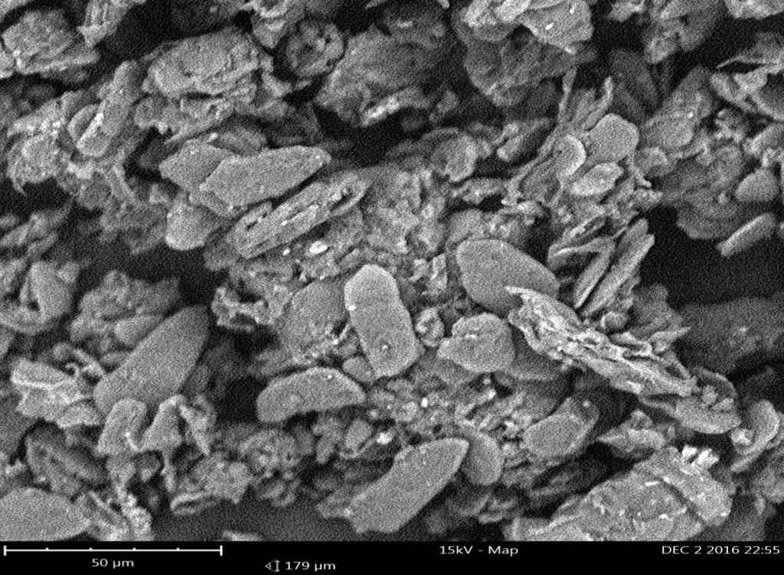

**Plate 2: Photomicrograph of particles of Turmeric powder using SEM (**Magnification: X 300)

### Particle Structure using Scanning Electron Microscopy (SEM)

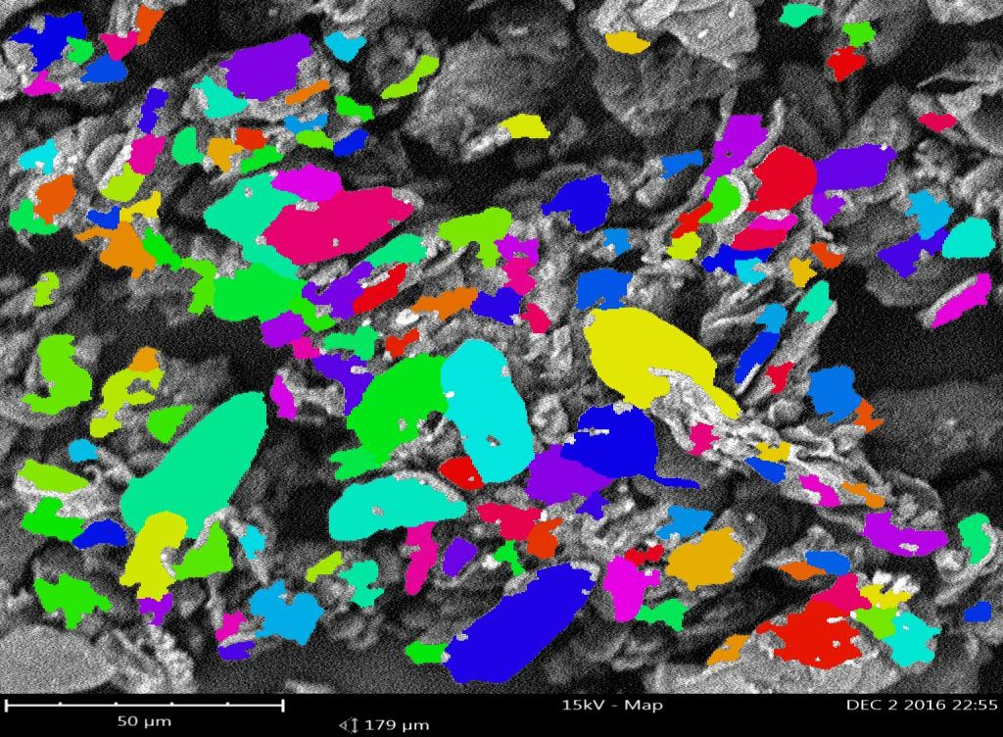

**Plate 3:** Structure of Turmeric powder particle using Scanning Electron Microscopy (SEM)

50

45

40

35

**Percentage particle retained (%)**

30

25

20

15

10

5

0

< 75ųm 75ųm 125ųm 150ųm 180ųm

**Sieve Size(µm)**

Figure 4.1: Percentage Particle Weight Retained (%) Versus Sieve Size (µm)

120



100

80

**% Cumulative frequency of the particles**

60

40

20

0

0 20 40 60 80 100 120 140 160 180 200

**Particle Size (µm)**

### Figure 4.2: Cumulative Percentage Oversize Frequency Distribution Curve for Turmeric (*Curcuma longa*) Powder

* 1. **Granules Analysis**
     1. Effect of binder concentration on granule properties

The result of the effect of the concentration of binder on the granule properties is given in Table 4.2. The angle of repose increase as the concentration of binder increases. Carr‟s index and Hausner‟s ratio decreased with increased binder concentration. While the moisture content increased with increased concentration of binder

### Table 4.2 Effect of Binder Concentration on the Properties of Turmeric Granule

|  |  |  |  |  |
| --- | --- | --- | --- | --- |
| Physical property | A1 | A2 | A3 | A4 |
| Angle of repose (º) | 31.33 | 31.4 | 33.13 | 34.25 |
| Bulk density (g/ml) | 0.29 | 0.28 | 0.28 | 0.29 |
| Tapped density (g/ml) | 0.37 | 0.36 | 0.35 | 0.35 |
| Carr‟s Index (%) | 21.62 | 22.22 | 20.00 | 17.14 |
| Hausner‟s ratio | 1.28 | 1.29 | 1.25 | 1.21 |
| Flow rate (g/s) | 2.81 | 2.42 | 1.98 | 1.44 |
| Mean granule size (µm) | 566.76 | 595.12 | 600.00 | 619.56 |
| Moisture content (%) | 12.00 | 12.50 | 13.00 | 13.50 |

Key

A1: 2.5 % Gelatin as binder

A2: 5 % Gelatin as binder

A3: 7.5 % Gelatin as binder

A4: 10 % Gelatin as binder

* + 1. Effect of binder concentration on granules size distribution

The effect of binder concentration on granule size distribution is as shown in Figure 4.3. The 1000 µm sieve size had a higher percentage of larger granules (20.44 – 31.52 %). The fines (170 µm) are in range of 1.03 (A1) to 4.72 % (A3)

35

30

25

**Percentage Particles retained (%)**

20 A1

A2

15 A3

A4

10

5

0

1000 710 500 180 170

**Sieve Size (µm)**

### Figure 4.3 Effect of Binder Concentration on Granules Size Distribution

Key

A1: 2.5 % Gelatin as binder

A2: 5 % Gelatin as binder

A3: 7.5 % Gelatin as binder

A4: 10 % Gelatin as binder

* + 1. Effect of binder type on granule properties

Table 4.3 shows the results of the effect of binder type on the properties of Turmeric granules. The angle of repose of the batches ranged from 31.14 to 33.97. They had similar Carr‟s index ranging from 20.00 to 22.22. Batch B2 with PVP as binder had better Husner‟s ratio and Carr‟s index than the other batches. The moisture content of the granules ranged from 11.5 to 13% with maize starch having the highest moisture content (13%). Figure 4.4 shows the results of the effect of binder type on the Granules Size Distribution.

### Table 4.3 Effect of Binder Type on the Granules Properties of Turmeric

|  |  |  |  |  |
| --- | --- | --- | --- | --- |
| Physical Property | A2 | B1 | B2 | B3 |
| Angle of repose (º) | 31.4 | 31.14 | 33.97 | 33.97 |
| Bulk density (g/ml) | 0.28 | 0.28 | 0.28 | 0.28 |
| Tapped density (g/ml) | 0.36 | 0.36 | 0.35 | 0.36 |
| Carr‟s Index (%) | 22.22 | 22.22 | 20.00 | 22.22 |
| Hausner‟s ratio | 1.29 | 1.29 | 1.25 | 1.29 |
| Flow rate (g/s) | 2.42 | 2.45 | 2.39 | 2.41 |
| Mean granule size (µm) | 595.12 | 595.46 | 538.67 | 569.37 |
| Moisture content (%) | 12.50 | 13.00 | 11.50 | 12.00 |

KEY:

A2: 5.0 % Gelatin as binder

B1: 5.0 % Maize starch as binder

B2: 5.0 % PVP as binder

B3: 5.0 % Acacia as binder

30

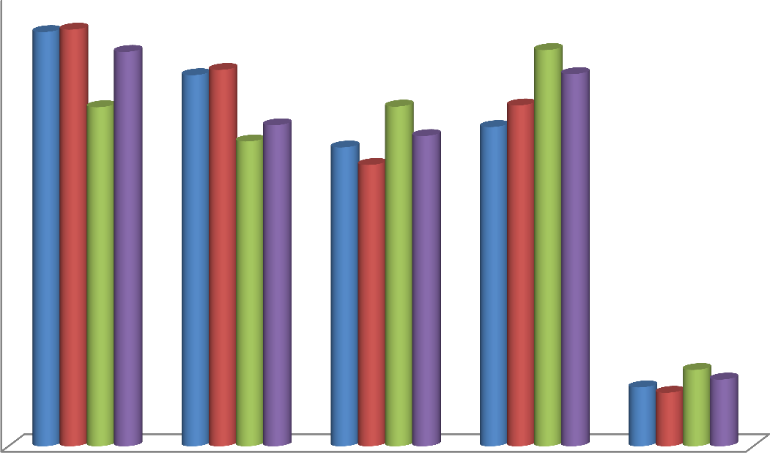

25

**Percentage Particles retained (%)**

20

A2

15 B1

B2

10 B3

5

0

1000 710 500 180 170

### Sieve Size (µm)

**Figure 4.4 Effect of Binder Type on Granules Size Distribution**

Key

A1: 2.5 % Gelatin as binder

A2: 5 % Gelatin as binder

A3: 7.5 % Gelatin as binder

A4: 10 % Gelatin as binder

* + 1. Effect of disintegrant concentration on the granule of turmeric powder

Table 4.4 shows the effect of disintegrant concentration on the granule of turmeric powder. The mean granules size is in the range 478.23 – 595.12 µm. The moisture content is 10.50 –

12.00 % with D3 having the highest. Angle of repose is in the order D1 > D3> D2. D2 and D3 have same BD (g/ml), TD (g/ml), CI (%) and HR of 0.28, 0.36, 22.22 and 1.29 respectively.

### Table 4.4 Effect of Disintegrant Concentration on the Granules of Turmeric Powder

|  |  |  |  |
| --- | --- | --- | --- |
| Physical Property | D1 | D2 | D3 |
| Angle of repose (º) | 34.79 | 34.25 | 34.51 |
| Bulk density (g/ml) | 0.28 | 0.28 | 0.28 |
| Tapped density (g/ml) | 0.35 | 0.36 | 0.36 |
| Carr‟s Index (%) | 20.00 | 22.22 | 22.22 |
| Hausner‟s ratio | 1.25 | 1.29 | 1.29 |
| Flow rate (g/s) | 2.33 | 2.49 | 2.27 |
| Mean granule size (µm) | 478.23 | 595.12 | 534.64 |
| Moisture content (%) | 10.50 | 11.50 | 12.00 |

KEY:

D1: 5.0 % Maize starch as disintegrant

D2: 7.5 % Maize starch as disintegrant.

D3: 10.0 % Maize starch as disintegrant.

### Properties of Tablets Produced by Wet Granulation

* + 1. Effect of binder concentration on the properties of turmeric tablets

The result of the evaluation of Turmeric tablets produced by wet granulation method using gelatin as a binder at different concentration is given in Table 4.5. Crushing strength ranged between 3.5 – 4.17 KgF. Batches A1 and A2 disintegrated within the acceptable limit (15 min) while batches A3 and A4 failed the disintegration test. All the batches passed the friability test. The mean tablet weights were within the USP range of not more than ±5 % (Figure 4.5)

### Table 4.5: Properties of Tablets Produced by Weight Granulation using Gelatin Binder at Different Concentrations

|  |  |  |  |  |
| --- | --- | --- | --- | --- |
| Physical property | A1 | A2 | A3 | A4 |
| Mean tablet weight (mg) | 605.50±25.44 | 638.50±13.49 | 638.50±21.09 | 655.00±18.21 |
| Diameter (mm) | 12.14±0.02 | 12.18±0.05 | 12.15±0.02 | 12.24±0.03 |
| Thickness (mm) | 4.63±0.19 | 5.11±0.01 | 5.10±0,00 | 5.24±0.01 |
| Crushing strength (KgF) | 4.00±0.32 | 4.00±0.32 | 4.17±0.26 | 3.50±0.63 |
| Tensile strength (MNm-2) | 0.47±0.04 | 0.41±0.04 | 0.43±0.03 | 0.34±0.06 |
| Friability (%) | 0.50±0.03 | 0.53±0.010 | 0.79±0.00 | 1.03±0.01 |
| Disintegration time (Min) | 9.69±1.79 | 12.28±1.69 | 19.61±5.12 | 32.28±4.47 |

Key:

A1: Tablets formulated using 2.5 % Gelatin as binder

A2: Tablets formulated using 5.0 % Gelatin as binder

A3: Tablets formulated using 7.5.0 % Gelatin as binder

A4: Tablets formulated using 10.0 % Gelatin as binder

660

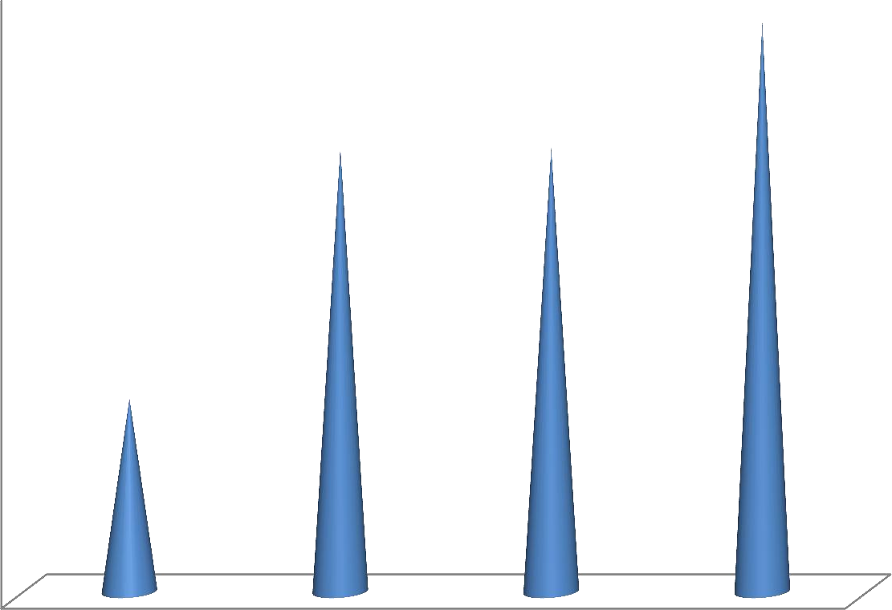

650

640

Mean Tablet weight (Mg)

630

620

610

600

590

580

A1 A2 A3 A4

Batches of Tablets Produce at Different Concentrations of Gelatin as a Binder

### Figure 4.5: The Mean Weight of Turmeric Tablets Using Different Concentration of Gelatin

Key:

A1: Tablets formulated using 2.5 % Gelatin as binder

A2: Tablets formulated using 5.0 % Gelatin as binder

A3: Tablets formulated using 7.5.0 % Gelatin as binder

A4: Tablets formulated using 10.0 % Gelatin as binder

4.2

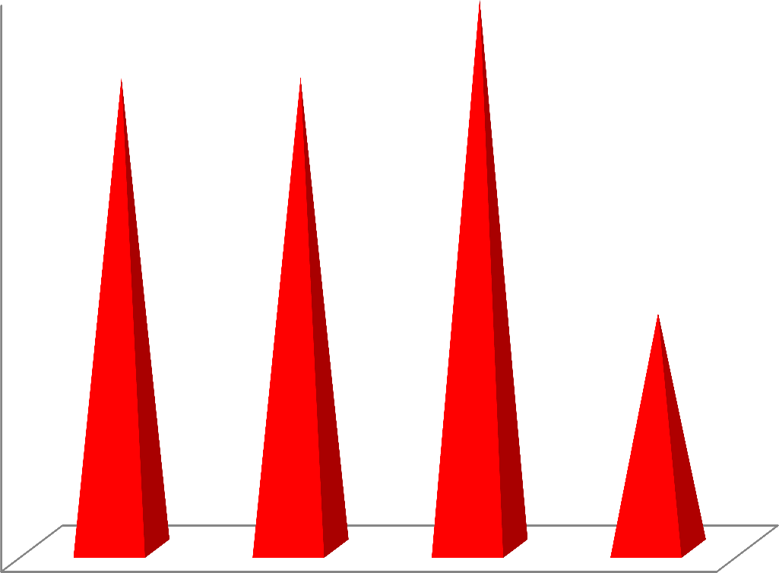

4

3.8

Crushing Strength (KgF**)**

3.6

3.4

3.2

3

A1 A2 A3 A4

Batches of Tablets produced using gelatin at different concentrations

### Figure 4.6: Effect of Increased Concentration of Gelatin Binder on the Crushing strength of Turmeric Tablets

Key:

A1: Tablets formulated using 2.5 % Gelatin as binder

A2: Tablets formulated using 5.0 % Gelatin as binder

A3: Tablets formulated using 7.5.0 % Gelatin as binder

A4: Tablets formulated using 10.0 % Gelatin as binder

* + 1. Effect of binder type on the properties of turmeric tablets

The effect of the binder type is as shown in Table 4.6. Batch B1 has better property in all the tablet parameters (Tensile strength: 0.451 MNm-2; crushing strength: 4.42 KgF; friability:

0.51 %; disintegration time: 7.46 min; and mean tablet weight: 640.5 mg) compared to batch A2, B2 and B3. The tensile strength and the crushing strength (less than 4 KgF) of batches B2 and B3 are less than batch A2 (batches B2 and B3 failed the crushing strength test). Batches B1 and B2 have better disintegration but similar friability compared to batch with A2. Batch B1 produced even better tablets than batch A2.

### Table 4.6: Effect of Binder Type on the Properties of Turmeric Tablets (500 mg)

|  |  |  |  |  |
| --- | --- | --- | --- | --- |
| Physical property | A2 | B1 | B2 | B3 |
| Mean tablet weight(mg) Crushing strength (KgF) Thickness (mm) Diameter (mm) Friability (%)  Disintegration time (Min)  Tensile strength (MNm-2) | 638.50±13.49  4.00±0.32  5.11±0.01  12.18±0.05  0.53±0.01  12.28±1.69  0.41±0.04 | 640.5±13.17  4.42±0.49  5.12±0.09  12.13±12.13  0.51±0.00  7.46±1.96  0.45±0.06 | 653±14.90  3.833±0.61  5.11±0.07  12.14±0.02  0.53±0.01  7.32±2.41  0.39±0.04 | 639±17.74  3.83±0.41  5.13±0.03  12.17±0.03  0.53±0.00  8.42±1.48  0.39±0.04 |

KEY:

A2: Tablets formulated using 5 % Gelatin as binder

B1: Tablets formulated using 5 % Maize starch as binder

B2: Tablets formulated using 5 % PVP as binder

B3: Tablets formulated using 5 % Acacia as binder

* + 1. Effect of disintegrant concentration on the properties of turmeric tablets (500 mg) Properties of turmeric tablets at different concentrations of Maize starch disintegrant are shown in Table 4.7. All the batches produced tablets with acceptable parameters (crushing strength, friability, and disintegration time).

### Table 4.7: Properties of Turmeric Tablets (500 mg) at Different Concentrations of Maize Starch as Disintegrant

|  |  |  |  |
| --- | --- | --- | --- |
| Physical property | D1 | D2 | D3 |
| Mean tablet weight (mg) Crushing strength (Kg F) Thickness (mm) Diameter (mm) Friability (%)  Disintegration time (min)  Tensile strength (MNm-2) | 655.00±11.92  4.42±0.58  5.18±0.06  12.15±0.03  0.51±0.01  6.22± 1.20  0.44±0.06 | 618.00±20.16  4.08±0.58  4.94±0.06  12.23±0.04  0.53±0.00  4.90±1.17  0.43±0.06 | 649.00±16.83  4.42±1.07  5.08±0.08  12.16±0.03  0.51±0.00  6.89±1.14  0.46±0.11 |

KEY:

D1: Tablets formulated using 5.0 % Maize starch as a disintegrant. D2: Tablets formulated using 7.5 % Maize starch as a disintegrant. D3: Tablets formulated using 10 % Maize starch as a disintegrant.

* + 1. Effect of disintegrant type on the properties of turmeric tablets (500 mg)

The effect of the disintegrant type on the properties of Turmeric tablets is shown in Table 4.8. All the batches of tablets produced with Methylcellulose (E1) and Pregelatinized potato starch (E2) gave tablets with poor crushing strength. The friability and disintegration time were both within acceptable range.

### Table 4.8 Effect of Disintegrant Type on the Properties of Turmeric Tablets (500 mg)

|  |  |  |  |
| --- | --- | --- | --- |
| Physical property | D1 | E1 | E2 |
| Mean tablet weight(mg) Crushing strength (KgF) Thickness (mm) Diameter (mm) Friability (%)  Disintegration time (min) | 655.00±11.92  4.42±0.58  5.18±0.06  12.15±0.03  0.51±0.01  6.22± 1.20 | 599.00±20.00  3.33±0.26  4.97±0.09  12.13±0.04  0.35±0.21  6.92±1.69 | 635.00±16.83  1.13±0.21  5.05±0.08  12.17±0.03  0.50±0.00  5.70±0.57 |

Key:

D1: Tablets formulated using 5.0 % Maize starch as a disintegrant E1: Tablets formulated using 5 % Methylcellulose as a dinintegrant

E2: Tablets formulated using 5 % Pregelatinized potato starch as a dinintegrant

### Dilution Potential of Avicel PH101 and Ludipress

* + 1. Dilution potential of Avicel PH101 with turmeric powder

The drug carrying capacity (dilution potential) of Avicel PH 101 for the direct compression of Turmeric powder into tablets is presented in Table 4.9. The 60 % dilution gave the best parameters followed by 50 % dilution based on crushing strength, friability and disintegration time. Therefore batches 60 % and 50 % were selected and coded CD1 and CD2 respectively.

### Table 4.9: Properties of Turmeric Powder Compacts (450 mg) Produced by Direct Compression at Varying Concentrations of Avicel PH101 (Dilution Potential)

|  |  |  |  |  |  |
| --- | --- | --- | --- | --- | --- |
| Dilution (Drug:Excipient ratio) (%) | Mean tablet weight(mg) | Quantity of Turmeric/tablet(m g) | Crushing strength (Kg F) | Friability (%) | Disintegration Time (Min) |
| 30:70 | 441.67 | 132.50 | 10.17 | 0.556 | 4.82 |
| 40:60 | 430.00 | 172.00 | 6.83 | 0.738 | 2.65 |
| 50:50 | 400.00 | 200.00 | 4.50 | 0.820 | 2.60 |
| 60:40 | 401.00 | 241.00 | 3.00 | 0.912 | 1.72 |
| 70:30 | 375.00 | 288.82 | 0.92 | 1.923 | 0.82 |

* + 1. Dilution potential of Ludipress using turmeric powder

The drug carrying capacity (dilution potential) of Ludipress for the direct compression of Turmeric powder into tablets is presented in table 4.10. The 60 % dilutions gave the best parameters followed by 50 % as can be seen in crushing strength, friability, and disintegration time. Batches 60 % and 50 % dilutions were selected and coded CD3 and CD4 respectively for further investigation.

### Table 4.10: Properties of the Turmeric Powder Compacts (650 mg) produced by Direct Compression at varying concentration of Ludipress

|  |  |  |  |  |  |
| --- | --- | --- | --- | --- | --- |
| Dilution (Drug/Excipie nt ratio) (%) | Mean tablet weight(mg) | Quantity of Turmeric/tablet (mg) | Crushing strength (KgF) | Friability (%) | Disintegration Time (Min) |
| 30/70 | 628.33 | 188.50 | 9.71 | 0.50 | 5.32 |
| 40/60 | 621.67 | 248.67 | 6.46 | 0.63 | 4.89 |
| 50/50 | 638.33 | 319.17 | 4.75 | 0.71 | 2.94 |
| 60/40 | 625.00 | 375.00 | 4.75 | 0.95 | 1.74 |
| 70/30 | 618.33 | 375.00 | 4.75 | 1.93 | 0.90 |

* 1. **Properties of Turmeric Tablets Formulated by Direct Compression Method**

The tablets in all the batches were of good quality with acceptable crushing strength, tensile strength, friability, and disintegration time (Table 4.11). Tablets formulated using Ludipress were harder than those formulated using Avicel PH 101. Figure 4.7 shows the mean tablet weight of tablets formulated by direct compression method

### Table 4.11: Properties of Turmeric tablets produced by direct compression method

|  |  |  |  |  |
| --- | --- | --- | --- | --- |
| Physical property | DC1 | DC2 | DC3 | DC4 |
| Mean tablet weight(mg) | 452.00±20.42 | 471.50±18.14 | 641.50±35.28 | 649.60±8.26 |
| Thickness(mm) | 3.85±0.031 | 3.87±0.06 | 5.22±0.06 | 5.16±0.08 |
| Diameter(mm) | 12.09±0.03 | 12.06±0.02 | 12.09±0.07 | 12.09±0.03 |
| Crushing strength (Kg F) | 5.75±1.20 | 6.13±0.21 | 7.04±0.37 | 8.81±0.23 |
| Tensile strength (𝑀𝑁𝑚−2) | 0.79±0.16 | 0.85±0.04 | 0.71±0.04 | 0.69±0.03 |
| Friability (%) | 0.69±0.02 | 0.60±0.01 | 0.51±0.01 | 0.51±0.00 |
| Disintegration time (min) | 2.38±0.21 | 1.65±0.42 | 5.36±0.24 | 6.11±0.53 |

Key:

DC1 Tablets formulated by DC using 60 % Avicel PH101 dilution DC2 Tablets formulated by DC using 50 % Avicel PH101 dilution DC3 Tablets formulated by DC using 60 %: Ludipress dilution DC4 Tablets formulated by DC using 50 % Ludipress dilution

700

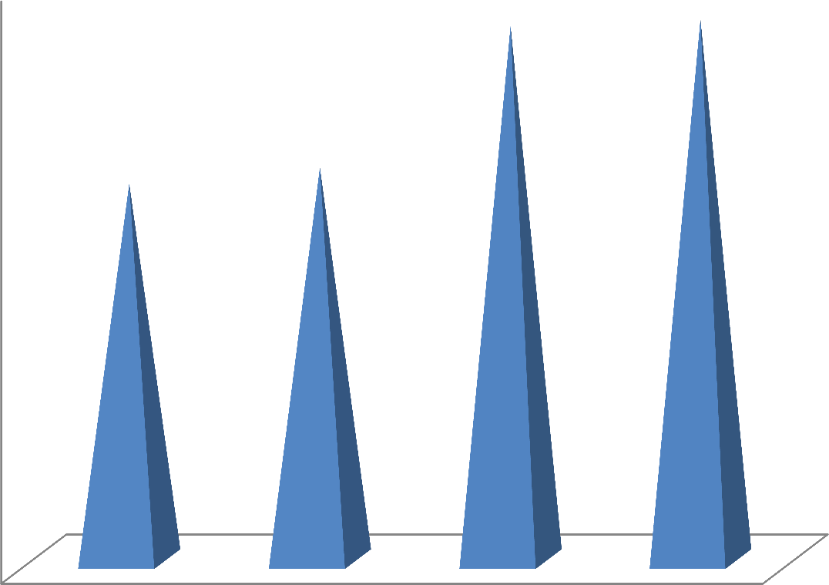

600

500

Mean tablet weight (mg)

400

300

200

100

0

DC1 DC2 DC3 DC4

Batches of tablets produced by direct compression

### Figure 4.7: Mean tablet weight of tablets formulated by direct compression method

Key:

DC1 Tablets formulated by DC using 60 % Avicel PH101 dilution DC2 Tablets formulated by DC using 50 % Avicel PH101 dilution DC3 Tablets formulated by DC using 60 % Ludipress dilution DC4 Tablets formulated by DC using 50 % Ludipress dilution

7

6

5

4

Disintegration time(minutes)

3

2

1

0

DC1 DC2 DC3 DC4

Batches of Tablets produced by direct compression

### Figure 4.8: Effect of increase in amount of Avicel PH 101 and Ludipress on the disintegration time of Direct Compression Tablets

Key:

DC1 Tablets formulated by DC using 60 % Avicel PH101 dilution DC2 Tablets formulated by DC using 50 % Avicel PH101 dilution n DC3 Tablets formulated by DC using 60 % Ludipress dilution

DC4 Tablets formulated by DC using 50 % Ludipress dilution

### 4.7: Crushing Strength-Friability Disintegration Time Ratio of Turmeric Tablets

The crushing strength-friability disintegration time ratio of the turmeric tablets is presented in table 4.12. The result shows highest value of 6.146 in DC2. This is followed by DC1, DC3 and DC4 in that order. B1 has the highest among the wet granulation tablets.

### Table 4.12: Crushing Strength-Friability Disintegration Time Ratio of Turmeric Tablets

|  |  |  |
| --- | --- | --- |
| BATCH | CSFR | CSFR/DT |
| A1 | 7.547 | 0.779 |
| A2 | 7.547 | 0.615 |
| A3 | 5.261 | 0.268 |
| A4 | 3.411 | 0.106 |
| B1 | 8.667 | 1.162 |
| B2 | 7.232 | 0.988 |
| B3 | 7.226 | 0.859 |
| D1 | 8.695 | 1.398 |
| D2 | 7.646 | 1.560 |
| D3 | 8.627 | 1.252 |
| DC1 | 8.285 | 3.481 |
| DC2 | 10.141 | 6.146 |
| DC3 | 13.864 | 2.587 |
| DC4 | 13.455 | 2.202 |

KEY

|  |  |
| --- | --- |
| A1: 2.5 % Gelatin binder tablets | D1: 5.0 % Maize starch disintegrant tablets |
| A2: 5.0 % Gelatin binder tablets | D2: 5.0 % Maize starch disintegrant tablets |
| A3: 7.5 % Gelatin binder tablets | D3: 5.0 % Maize starch disintegrant tablets |
| A4: 10.0 % Gelatin binder tablets | DC1: 60.0 % Avicel PH101 dilution tablets |
| B1: 5.0 % Maize starch binder tablets | DC2: 50.0 % Avicel PH101 dilution tablets |
| B2: 7.5.0 % Maize starch binder tablets | DC3: 60.0 % Ludipress dilution tablets |
| B3: 10.0 % Maize starch binder tablets | DC4: 50.0 % Ludipress dilution tablets |

### 4.8. Calibration Curve

Figure 4.9 presents the calibration curve of turmeric powder for the dissolution tests conducted on the batches of turmeric tablets. The absorbance was taken at a wavelength of 421 nm which was the peak obtained by scanning the turmeric extract in 0.05 M HCl containing 0.8 % Sodium lauryl sulphate. The result is a linear graph with a slope of 0.0005 and intercept of -0.0016. The R² obtained was 0.9996.

0.6



y = 0.0005x - 0.0016

R² = 0.9996

0.5

0.4

Absorbance (nm)

0.3

0.2

0.1

0

0 200 400 600 800 1000 1200

Concentration (ug/ml)

### Figure 4.9: Beer's - Lambert Plot (Calibration Curve) for Turmeric Powder in 0.05M HCl Containing 0.8% W/V Sod. Lauryl Sulfate

**4.9. Dissolution Profile of Turmeric Tablets Formulated by Different Methods**

The percentage drug release profile of turmeric tablets is shown in figure 4.10. At 45 min (BP requirement is 70 % release in 45 min) A2, B1, DC4, DC2, DC1 and DC3 and DC4 had percentage released of 97.7, 94.1, 94.1, 86.2, 82.6 and 71.4 respectively. The direct compression batches released faster than the wet granulation tablets. At 10 min, DC3, DC2, and DC1 had release of 61.73 %, 48.82 %, and 48.42 % respectively.

120

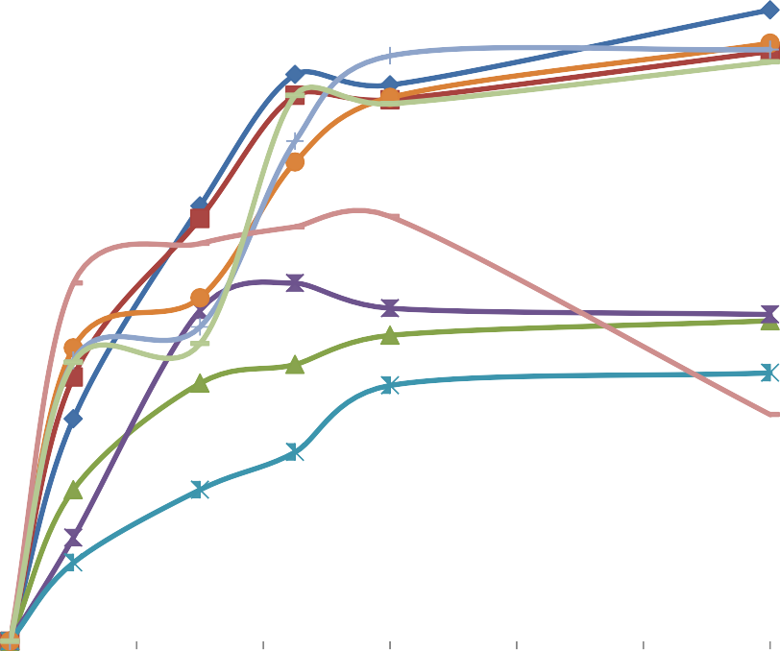

100

A2

80 B1

D1

**% Release**

60 D2

D3 DC1

40

DC2

DC3

20 DC4

0

0 20 40 60 80 100 120 140

### Time (Min)

**Figure 4.10: Release Profile of Turmeric Tablets against Time (Min)**

KEY:

A2: 5 % Gelatin binder tablets (wet granulation)

B1: 5 % Maize starch binder tablets (wet granulation)

D1: 5.0 % Maize starch disintegrant tablets (wet granulation) D2: 7.5 % Maize starch disintegrant tablets (wet granulation) D3: 10.0 % Maize starch disintegrant tablets (wet granulation) DC1: 60 % Avicel PH101 dilution tablets (direct compression) DC2: 50 % Avicel PH101 dilution tablets (direct compression) DC3: 60 % Ludipress dilution tablets (direct compression) DC4: 50 % Ludipress dilution tablets (direct compression)

### Compaction Studies

Figure 4.11 and 4.12 presents Heckle and Kawakita plots for the turmeric powder; gelatin binder granules and MS binder granules respectively. Table 4.13 shows the constants derived from Heckle and Kawakita Plot.

7



6

5

4

ln(1/Ԑ)

TP

3 A2

B1

2

1

0

39.9 79.9 119.8 159.7 199.7

Compaction pressure (MN𝑚−2)

### Figure 4.11: Heckel plot for Turmeric powder (TP), 5 % Gelatin binder granulation (A2) and 5 % MS binder granulation (B1)

KEY:

TP: Turmeric Powder

A2: 5.0 % Gelatin binder granules

B1: 5.0 % Maize starch binder granules

450



400

350

300

**P/C**

250

TP

200 A2

150 B1

100

50

0

39.9 79.9 119.8 159.7 199.7

### Compaction pressure (MN𝑚−2)

**Figure 4.12: Kawakita plot of Turmeric (*Curcuma longa*) powder and granulation**

KEY:

TP: Turmeric Powder

A2: 5.0 % Gelatin binder granules

B1: 5.0 % Maize starch binder granules

### Table 4.13: Constants Derived from Heckle and Kawakita Plot

1. **Heckel parameters**

|  |  |  |  |  |  |  |  |
| --- | --- | --- | --- | --- | --- | --- | --- |
| **HECKEL** | | | | **CONSTANTS** | |  |  |
| **Formulation** | **Slope (K)** | **Intercept (A)** | 𝑃𝑦 **(**𝑀𝑁𝑚−2) | | 𝐷𝐴 | 𝐷𝑂 | 𝐷𝐵 |
| TP | 0.0015 | 1.8970 | 654.7008 |  | 0.8500 | 0.2271 | 0.6228 |
| A2 | 0.0198 | 1.9050 | 50.5128 |  | 0.8511 | 0.2271 | 0.6240 |
| B1 | 0.0221 | 1.1781 | 45.3461 |  | 0.6921 | 0.2238 | 0.4683 |

### Kawakita parameter

|  |  |  |  |  |  |  |
| --- | --- | --- | --- | --- | --- | --- |
|  |  |  | **KAWAKITA** | **CONSTANTS** | |  |
| **Formulation** | **Slope (K)** | **Intercept (A)** | **A** | **b** | 𝐷i | 𝑃𝑘 |
| TP | 1.9338 | -2.8750 | 0.5171 | -0.6726 | 0.4829 | -1.4867 |
| A2 | 1.9217 | -2.1879 | 0.5204 | -0.8783 | 0.4796 | -1.1386 |
| B1 | 1.9174 | -2.2792 | 0.5215 | -0.8413 | 0.4784 | -1.1887 |

KEY:

TP: Turmeric Powder

A2: 5.0 % Gelatin binder granules

B1: 5.0 % Maize starch binder granules

0.12

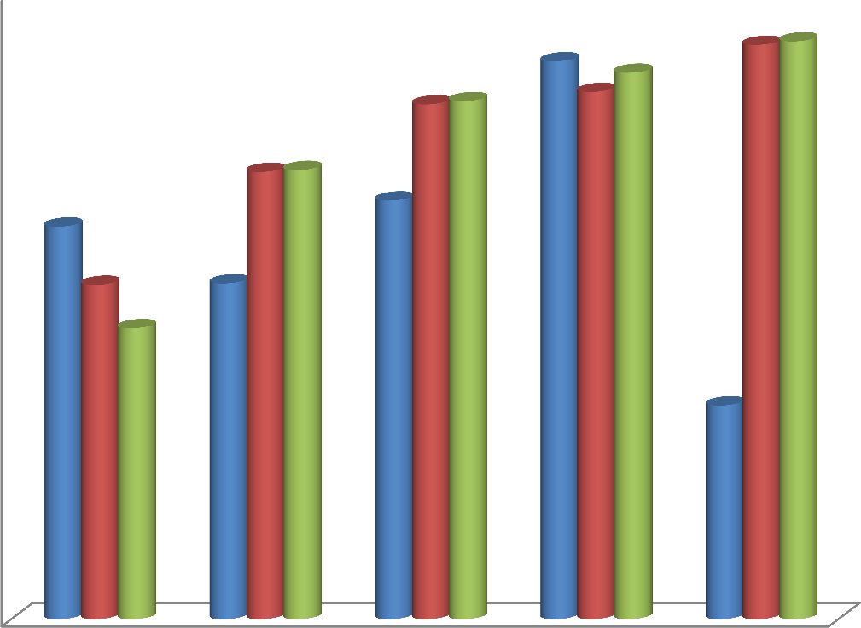

0.1

0.08

Tensile strength (𝑀𝑁𝑚--2)

0.06 TP

A2 B1

0.04

0.02

0

39.9 79.9 119.8 159.7 199.7

Compaction Pressure (𝑀𝑁𝑚--2)

### Figure 4.13: Effect of granulation on the compressibility of turmeric powder

KEY:

TP: Turmeric Powder

A2: 5.0 % Gelatin binder granules

B1: 5.0 % Maize starch binder granules

### Stability Studies of Turmeric Tablet

The result of stability studies on turmeric tablet after six months is as shown in tables 4.14 and 4.15. There was no noticeable change in the organoleptic properties of the tablets. However, there were changes in physicochemical properties. The crushing strength and disintegration time decreased on storage while friability increased.

### Table 4.14: Organoleptic Properties of Tablets after six month Stability Studies

|  |  |  |  |
| --- | --- | --- | --- |
| Batch | Colour/Odour | Homogeneity | Tablet surface |
| A1 | No change | Homogenous | No change |
| A2 | No change | Homogenous | No change |
| A3 | No change | Homogenous | No change |
| A4 | No change | Homogenous | No change |
| B1 | No change | Homogenous | No change |
| B2 | No change | Homogenous | No change |
| B3 | No change | Homogenous | No change |

|  |  |
| --- | --- |
| Key |  |
| A1: | Tablets formulated using 2.5 % Gelatin as binder |
| A2: | Tablets formulated using 5.0 % Gelatin as binder |
| A3: | Tablets formulated using 7.5.0 % Gelatin as binder |
| A4: | Tablets formulated using 10.0 % Gelatin as binder |
| B1: | Tablets formulated using 5 % Maize starch as binder |
| B2: | Tablets formulated using 5 % PVP as binder |
| B3: | Tablets formulated using 5 % Acacia as binder |

**Table 4.15: Physicochemical Properties of Tablets Studied after six month**

|  |  |  |  |  |  |  |  |  |  |  |
| --- | --- | --- | --- | --- | --- | --- | --- | --- | --- | --- |
|  | A1 | A2 | A3 | A4 | B1 | B2 | B3 | D1 | D2 | D3 |
| CS (KgF) | 3.75 | 4.00 | 4.08 | 3.58 | 4.17 | 3.67 | 3.83 | 2.08 | 2.67 | 2.42 |
| FR (%) | 1.23 | 0.92 | 0.93 | 1.18 | 0.94 | 1.20 | 1.21 | 1.25 | 1.57 | 1.70 |
| DT (min) | 8.66 | 11.79 | 16.33 | 28.27 | 7.46 | 7.00 | 8.10 | 3.90 | 3.99 | 4.66 |

|  |  |
| --- | --- |
| Key: |  |
| CS: | Crushing Strength |
| FR: | Friability |
| DT: | Disintegration Time |
| A1: | Tablets formulated using 2.5 % Gelatin as binder |
| A2: | Tablets formulated using 5.0 % Gelatin as binder |
| A3: | Tablets formulated using 7.5.0 % Gelatin as binder |
| A4: | Tablets formulated using 10.0 % Gelatin as binder |
| B1: | Tablets formulated using 5 % Maize starch as binder |
| B2: | Tablets formulated using 5 % PVP as binder |
| B3: | Tablets formulated using 5 % Acacia as binder |
| D1: | Tablets formulated using 5.0 % Maize starch as disintegrant |
| D2: | Tablets formulated using 7.5 % Maize starch as disintegrant |
| D3: | Tablets formulated using 10.0 % Maize starch as disintegrant |

### CHAPTER FIVE

**5.0. DISCUSSION**

Characterization of the particles of powdered materials is an important aspect of the pharmaceutical industry during drug product development and in the quality control of solid dosage forms (Sun *et al.,* 2010). The result of the studies of the physicochemical and organoleptic properties of turmeric powder is shows Table 4.1. The Turmeric powder used in the work was deep orange-yellow and this agrees with Lise, 2013 and Azam *et al.,* 2016 who reported that standard turmeric powder is yellow to orange in colour. According to Tayyem *et al.,* 2006, the colour of turmeric powder is a function of its content of Curcumin and its related compounds which are the most important and most studied components of the rhizome. The texture was fibrous and rough, the shape was mostly elongated and flaky, the odour was slightly aromatic while the taste slightly bitter.

Particle size and size distribution affect the manufacture of the drug in terms of flowability, content uniformity and compressibility. It can also affect drug performance in dissolution, bioavailability, and stability (Sun *et al.,* 2010). This makes the characterization of powdered Active Pharmaceutical Ingredient (API) and excipients very paramount prior to the development of solid dosage forms. According to Aulton and Staniforth, (2013), particles under 10 µm in size do not flow under gravity. Particles under 100 µm sizes are usually cohesive and have relatively poor flowing while particles above 250 µm are free-flowing. The mean particle size of the Turmeric powder was 122.49 µm, which is similar to the mean particle size of 132.12 µm for turmeric powder reported by Mangaraj *et al.,* 2017, processed by burr milling method. The slight differences in the mean particle size of Tumeric could be due to differences in method of processing.

Flowability and compressibility are two important powder properties in tabletting. Flow rate, the angle of repose, Hausner‟s ratio and Carr‟s index are used to determine the flowability and compressibility of a powder. The angle of repose of a powder is a measure of powder flow and is based on the scientific principle that powder particles will begin to flow when the angle of inclination is large enough to overcome the frictional forces. Cohesive powders have a large angle of repose while non-cohesive powders have a low angle of repose. Good flowing powder has an angle of repose close to 25 ⁰ while powders with an angle of repose above 40 ⁰ are poor flowing and may require flowing aid (Aulton, 2013). The angle of repose of the turmeric powder was found to be 40.3 ⁰ which indicates poor flow.

The micrograph of the Scanning electron microscopy (SEM) is as shown on Plate 2 and 3. SEM analysis gives insight into the texture, shape, size and arrangement of the powder particles. The particles were seen to be irregular, elongated and platy in shape and in variable sizes. The surface of the particles appeared to be rough. Irregularly shaped particles cause mechanical interlocking leading to poor flow (Persson, 2013). The poor flow of Turmeric powder could therefore be due to mechanical interlocking of the particles.

Hausner‟s ratio (HR) and Carr‟s compressibility index (CI) are other parameters used in assessing the flowability and compressibility of powders. Carr‟s index of 1-10, 11-15, and 16-20 shows excellent, good and fair flow respectively. CI above 38 is very poor flow. Good flow powders have HR of 1.25. Above 1.25 indicates poor flow (Aulton and Taylor, 2013B). The Carr index of the turmeric powder (42.3 %) and the Hauser‟s ratio (1.74) shows that Turmeric powder has poor flow and poor compressibility.

The powder has a flow rate of 1.4 gm /sec which also indicates a poor flow of the powder as seen with other parameters. The low flow rate may be related to the cohesive nature of the powder or to the mechanical interlocking due to the rough texture and the irregular shape of

the powder particles. The fibrous and rough texture of the powder may have presented flowability issue as very rough particles have greater tendency to interlock (Aulton, 2013).

Table 4.2 shows the properties of Turmeric granules produced using MCC as diluent and gelatin binder at different concentrations. The mean granule size increased as concentration of binder increase with the 10 % binder concentration having the largest mean granules size of 619.56 µm. Similar results were obtained by AutaMashih *et al*., 2011 and Qusaj *et al.,* 2012. Qusaj *et al.,* 2012 reported that increased binder concentration led to larger granules. The granules produced with 10% binder concentration had a higher percentage of the larger granules. A good granulation should have some fine which will fill the spaces created by the larger granules. Generally, all the batches of the Turmeric granules had more of the larger size granule than the fines. This indicates good granulation.

Moisture content of granules is important as high moisture content may affect the activities of water sensitive drug, the flow properties of the granules and support the growth of microorganisms. According to Sezer *et al*., 2011, “the higher the moisture content the larger the granules and the better the flow and compressibility up to moisture content of 10 %”. The percentage moisture content obtained in this study using different binder concentrations was in the range of 12.0 – 13.5 %. Moisture content increased with increased binder concentration. The moisture content obtained in this study was higher than the 10 % suggested by Sezer *et al* (2011). The high moisture content in the larger granules could be due to fact that larger granules have smaller surface area hence reduced exposure of absorbed water to drying.

This study shows that the angle of repose is affected by the concentration of the binder. The higher the binder concentration, the higher is the moisture content and the larger is the angle of repose. The angle of repose was in the range of 31.33 – 34.25 º. Muazu (2013) found a

similar change in angle of repose with a similar change in the concentration of Maize starch binder. However, Musa *et al*., (2012) found that there was a less consistent change in angle of repose when paracetamol granules were produced with gelatin binder at an increasing binder concentration. The angle of repose of the granules was lower than that of the powder (40.30 º). This indicates that granulation has improved the flow of the powder.

Carr‟s index (CI) and the Hausner‟s ratio (HR) were improved significantly compared to the crude powder. The CI and HR decreased with increased binder concentration (17.14-22.22 and 1.21-1.29 respectively). CI changed from 42.3 % in the crude powder to 17.14 % in the case of 10 % gelatin binder granules. The 5 % granules had CI and HR values of 22.22 % and

1.29 respectively.

Figure 4.3 shows the effect of binder concentration on granules size distribution. The granule size increased with increased binder concentration. The 1000 µm sieve size had a higher percentage of larger granules in the range of 20.44 – 31.52 %. This may be due to enhanced viscosity and stronger bridges in the granules (Isimi, 2001). All the binder concentrations produced granules with small amount of fines. The percentage fines (170 µm sieve size) were in the range of 3.84 – 4.72 %. Appendix 4.4 shows the granules size distribution of the different Turmeric powder formulations.

The properties of the granules produced using different binders are presented in Table 4.3. Maize starch granules had the largest mean granules size (595.46 µm) while PVP granules had the smallest mean granule size (538.67 µm). The mean granule sizes were in the order of MS > GLT > AC >PVP (p-value: 0.055). Maize starch had the highest percentage of larger sized granules while PVP had the largest percentage of the fines. MS and GLT had similar granules size distribution at all the sieve sizes (Figure 4.4).

The moisture content of the granules were in order of MS > GLT > AC >PVP with MS having the highest moisture content. This is not in agreement with the work of AutaMashih, 2012 who working with the leaf extract of *Vernonia galamensis* reported that gelatin had higher moisture content than MS. PVP had the best moisture content. Its low moisture content could be due to the small particle size of the granules. Smaller granules have the ability to release more absorbed water as a result of increased surface area. The results also showed that the larger the granules the better the flow. The bulk and tapped densities remained similar across the binders. All the granules had bulk density of 0.28 g/ml which is an indicator for excellent flow ability. According to BP 2007, good flowing powder materials should have bulk density of 1.2 g/ml while powders or granules with values greater than 1.6 g/ml have poor flow. The CI and HR of the granules were the same (22.22 % and 1.29 respectively) for GLT, MS and AC. PVP had CI and HR values of 20.0 % and 1.25 respectively. These parameters are an indirect measure of flowability (Oyi *et al.,* 2009) and therefore, PVP has produced the best granules in terms of compressibility and flowability.

The results of the effect of concentration of disintegrant on the granules are presented in Table 4.4. Granules produced with different concentrations of maize starch disintegrant were having almost similar parameters, with the 5 % MS having more optimal properties based on BD, TD, CI, HR and moisture content (0.28 g/ml, 0.35 g/ml, 20 %, 1.25 and 10.50 % respectively). MS at 7.5 % had the largest granules and the fastest flow rate, while 10 % had the highest moisture content. All the values for the granules were within acceptable range (BP 1988).

Tablets are routinely subjected to a series of compendia and non-compendia quality tests. This is intended to guarantee their quality (Apeji, 2016). Turmeric tablets produced by both

wet granulation and direct compression methods were subjected to the quality control tests.

The tablets produced by wet granulation had a smooth surface and acceptable elegance. The mechanical strength of the tablet was evaluated using the crushing strength and friability. Tablet crushing strength values of 4.0 – 7.8 Kg F are generally acceptable for uncoated tablets (Allen *et al.,* 2004). The binding agents hold granules together to form tablets by means of various forces such as *Van Der Waals* forces, electromagnetic force of attraction, frictional and mechanical forces, and also due to the formation of solid bonds (Musa *et al.,* 2010).

The crushing strength (CS) of tablets produced using gelatin binder at different concentration was in the order of 4 Kg F (2.5 %) = 4 Kg F (5 %) < 4.17 Kg F (7.5 %) > 3.5 Kg F (10 %). Increasing the binder concentration from 2.5 – 7.5 % increased crushing strength only slightly then decreased as the binder concentration was increased to 10 %. (Table 4.5) This result is at variance with other researchers who reported that increased binder concentration increases crushing strength of the tablets (Muazu, 2013; Autamashih 2012; Musa *et al.,* 2008). However, Musa, 2002 reported a decrease in CS of the tablets produced with 10 % binder concentration and suggested that there could be an optimum binder concentration above which CS decreases. The result shows that increased binder concentration did not led to significant increase in crushing strength (p-value: 0.055). This is at variance with Kuntz *et al.*, 2011, who reported that increased binder concentration leads to higher crushing strength. The tensile strength which is the crushing strength/friability ratio (CS/FR) measures the mechanical strength of the tablets. Turmeric tablets produced with gelatin binder (2.5 %) had the highest tensile strength.

The disintegration time increased with increase binder concentration (Table 4.5). Tablets produced using 2.5 % gelatin concentration had the least disintegration time of 9.69 min

while the 10 % binder concentration had a disintegration time of 32.38 min. This is in

consonance with the work of Tahir *et al.,* 2010 and Kagalkar, *et al.,* 2014. This could be due to increased cohesive forces with increased binder concentration. Batches A3 and A4 with DT of 19.61 and 32.38 min respectively, failed the disintegration test while A1 (9.69) and A2 (12.28 min) passed the test. The disintegration time of uncoated tablets should not exceed 15 min (BP 1988). The longer DT of A4 (32.28 min) that has the lowest CS 3.5 Kg F may be due the presence of some internal bonds that has to be broken before disintegration. These forces could include hydrogen bond, liquid bridges and *Vander waal* forceswithin the tablet. Also the nature of the powder may have contributed as some powders are to supply some binding property to the tablets (Musa *et al.,* 2010).

Friability (FR) is a measure of tablet weakness and strength (Majekodunmi *et al.,* 2008). The friability value of 1 % or less is an indicator of good mechanical strength of tablets prepared by weight granulation method. All the batches of tablets produced by wet granulation with gelatin as a binder passed the friability test (0.50 – 1.03 %). The friability followed the same trend as the CS (increased with increase binder concentration). Tablets produced with higher binder concentration were more friable. This may be due the binder reaching a saturation point above which its binding effect is exceeded. This is at variance with the works Musa *et al.,* 2008 and Autamashih, (2011). Autamashih, (2011) reported the friability of tablets of the leaf extract of *Vernonia galamensis* produced with gelatin binder to reduce with increased binder concentration.

Table 4.6 shows the result of the effect of binder type (GLT, MS, PVC and AC) on properties of Turmeric tablet. The crushing strength was in the order B1 > A2 > B2 > B3. Similar results were obtained by Varshosaz, *et al.,* 1997 and Autamashih (2012), who reported that maize starch and gelatin had higher binding capacity than PVP and Acacia.

Measurement of the tensile strength is a more fundamental measure of mechanical strength of a tablet. It takes care of the differences in the geometry of the tablets. The tensile strength of the tablets was in the order are B1 > A2 > B2 > B3. That is tablets produced with maize starch binder had better mechanical strength than the other binder types.

The friability of tablets produced using different binder type was in the range of 0.51 – 0.53

%. Tablets produced with maize starch (Batch B1) had the lowest friability of 0.51 % while the friability of the tablets of other binders was the same (0.53 %). Therefore all batches passed friability test. The disintegration time (DT) was in the range of 7.32 – 12.28 min. Tablets with gelatin binder (A2) has the longest DT of 12.28 min while B2 (PVP) had the lowest DT of 7.32 min. However, all the batches passed DT test.

Maize starch was used as a disintegrant in the preparation of Turmeric tablet at different concentrations (5, 7.5 and 10 %). The result is presented in table 4.7. All the different concentrations of MS disintegrant produced good tablets based on crushing strength (4.08 -

4.42 KgF); tensile strength (0.43 – 0.46); friability (0.51 – 0.53 %) and disintegration time (4.90 – 6.89 min). All the batches also passed the weight variation test.

Maize starch as disintegrant (5 %) was used to compare with other disintegrant at the same concentration. The disintegrant used were methylcellulose and pregelatinized potato starch. The tablets with maize starch disintegrant produced good tablets, however, the other disintegrant could not form good compacts even at 12 MT compression pressure. Table 4.8 shows the result of the effect of disintegrant type {MS (D1), MC (E1) and PGPS (E2)} on properties of Turmeric tablet. The crushing strength was in the order 4.42 (D1) > 3.33 (E21)

> 1.13 (E2) Kg F. This shows that only MS produced mechanically strong tablets. All the batches had good friability and disintegration time. The results indicate that methylcellulose

and pregelatinized potato starch at 5 % are not good disintegrant for the production of Turmeric tablets.

The results of the dilution potential of Avicel PH101 and Ludipress with Turmeric powder was as shown in Tables 4.9 and 4.10 respectively. The amount of an active pharmaceutical ingredient (API) that can be satisfactorily compressed into a tablet with a given directly compressible excipient is called dilution potential of that excipient (Gohel and Jogani, 2005). The 60 % and 50 % Avicel PH101 dilutions produced good tablets in terms of crushing strength, friability and disintegration time. The 60 % and 50 % Ludipress dilutions also gave good tablets. The result shows that Ludipress has a higher dilution potential for Turmeric powder (325 mg) compared to Avicel PH101 which carried only about 225 mg. The crushing strength, tensile strength and the disintegration time decreased with decrease concentration of the Turmeric while friability increased with increase quantity of the Turmeric powder. The dilution of 60 % and 50 % each of Avicel PH101 and Ludipress were selected and used to formulate Turmeric tablets. They all fell within the dilutions range reported by Apeji *et al.,* 2010.

The properties of tablets produced by direct compression of turmeric powder using Avicel PH101 and Ludipress are shown in Table 4.11. The tablets have their tensile strength in the order DC2 > DC1 > DC3 > DC4. This means that tablets compressed using Avicel PH101 had higher mechanical strength than those produced with Ludipress. Tablet mechanical strength is a function of the bonding sites and the strength between the bonding particles. MCC (Avicel PH101) has high bonding capacity and densify by plastic deformation. Its irregularly shaped elongated particles undergo mechanical interlocking and also promote inter-particulate hydrogen bonding. This may lead to more compressibility of the mixture

(Rojas and Kumar, 2011).

All the tablets produced by direct compression passed the disintegration time (1.65 – 6.11 min) and friability tests (0.51-0.69 %). Avicel PH101 tablets had good tensile strength (TS) with DC2 having higher tensile strength compared with DC1 though DC1 has lower friability than DC2. Tablets produced with Ludipress had higher CS, longer disintegration time and lower friability than tablets produced with Avicel PH101.

Crushing strength – Friability is a measure of the mechanical strength of a tablet. The lower the CSFR value the weaker is the tablet and vice vasa. The results are presented on table 4.12. Direct compression tablets were generally having stronger tablets compared to wet granulation tablets. Tablets produced with Ludipress were the strongest. This may be due to the nature of the powder as it may have enhanced bonding property to the direct compression Avicel PH101 and the Ludipress.

Crushing strength – Friability Disintegration time Ratio (CSFR/DT) is a more useful parameter for the measurement of tablet quality than CSFR. This is because it measures both the crushing strength (CS) and friability (FR) and also evaluates their negative effects on the disintegration time of the tablet (Apeji 2016). The higher the CSFR/DT value, the better a balance is met between the binding and disintegration properties of the tablets. In this study, the CSFR/DT did not follow any standard sequence (Table 4.12), but the direct compression tablets have the highest values. In terms of CSFR/DT Avicel PH101 produced better tablets than Ludipress. The CSFR/DT of the tablets produced using different binders at 5% concentration is in the order B1>B2>B3>A2.

The Beer‟s- Lambert plot (Calibration curve) of Turmeric powder is shown in Figure 4.9. The linear graph had a slope of 0.0005 and an intercept of -0.00016. The dissolution profiles of the tablets are shown in figure 4.10. The percentage drug release at 30 min is called

dissolution efficiency (DE) (Autamashih, 2012). The DE obtained in this study ranges from

26.13 to 75.04 %. Batch A2 (5 % gelatin binder) had the highest DE while Batch D2 (5 % starch disintegrant) had the least DE. A2 with the highest DT (12.28 min) also has the highest DE (75.04 %) followed by 5 % starch binder (batch B1) (DE: 72.88 % and DT: 7.46 min) while DC3 (60 % Ludipress) with the least DT (1.65 min) released 54.17 % and D3 (DT:

6.89 min) released only 26.13 %. One will expect that DC3 with the fastest DT will release fast, but that‟s not the case. This means that fast disintegration does not necessary means fast release of drugs or bioavailability. The BP (2007) dissolution test specified that 70 % of the API be released within 45 min. The result showed that five batches (A2, B1, DC1, DC2, and DC3) have passed dissolution test while all the batches with MS as disintegrant (D1, D2, and D3) failed the BP specification.

Figure 4.11 presents the Heckel plot of the Turmeric powder (TP), 5 % Gelatin binder granules (A2) and 5 % MS binder granules (B1). The very low slope (0.0015), high 𝑃𝑦 (654.7008) and the curve-linear nature of the Turmeric plot shows that the powder is a brittle material and it deforms by fragmentation. Teixeira, 2007 found a similar behavior when analyzing the compaction behaviour of powder from the seed coat of Tingui. Lactose also deforms in a similar way.

There are three type of powder compression behaviour based on Heckel equation. These are determined by the nature of Heckel plot and the compaction behaviuor of the powder. The three classes are: Type A, B and C (York and Pilpel, 1973). There is relative linear and parallel relationship in the A2 & B1 plots at some of the pressures and curve at some compression pressures (there is a mild transition from the curved to linear in A2 and B1). This is an indicative of type B granules. This shows that the densification process is by both fragmentation and plastic deformation (York and Pilpel, 1973).

𝑃𝑦 describe the tendency of the material to deform either by plastic deformation (Isimi *et al*., 2003). It is the reciprocal of the slope (*K*) and is inversely related to the ability of the material to deform plastically under low pressure (Isimi *et al*., 2003). Low values of 𝑃𝑦 indicate a faster onset of plastic deformation (Odeku, 2007). A2 had a higher 𝑃𝑦 (50.5128) than B1 **(**45.3461**).** This means, B1 has faster onset of plastic deformation (Figure 4.11). The values of A which shows the degree of packing at achieved low compression pressure was also slightly higher in A2 (1.9050) than B1 (1.1781). A is also an indicator of densification by particle rearrangement (Isimi *et al*., 2003). The value of A indicate that A2 has a higher ability to consolidate by plastic flow (Alfa *et al.,* 2017)

Other Heckel parameters were all within similar range [𝐷𝐴 **(**0.692 – 0.851**);** 𝐷0 (0.222 – 0.227) 𝐷𝐵 (0.468 0.624)]. A2 has higher 𝐷𝐴 (0.851) than B1 **(**0.692) hence higher degree of densification at zero and low pressure. The higher value of 𝐷0, for A2 (0.227) compared with B1 (0.222) indicates its higher densification at the initial rearrangement phase of densification as a result of filling (when pressure is zero). This means it is compressed at a higher relative density.

The relative density 𝐷𝐵 describes the phase rearrangement of the particles in the early stage of compression and also the extent of particle or granule fragmentation (Odeku, 2007). A2 has higher 𝐷𝐵 value hence higher extent of fragmentation and densification. The result indicates that the extent of plastic deformation happening in the granulation process appears to be similar and slightly higher in A2 though has faster on set in B1.

Autamashih, (2011) found a different type of plot with the granules of the crude extract of

*Vernonia galamensis* using both gelatin and MS binders at 5 % concentration with Calcium

phosphate, Avicel and aerosil as diluent. He also found gelatin binder to have higher 𝑃𝑦, 𝐷𝐴, and 𝐷𝐵 values than MS at same concentration and same diluent.

Figure 4.12 present the Kawakita plot while Table 4.13b are the constants derived from the plot. The slope and the intercept were derived from the linear plot. The slope and the intercept were used to determine the value of „a‟ and „b‟ respectively. The reciprocal of b was used to determine the 𝑃𝑘 value which has an inverse relationship with the measurement of plastic deformation during the compression process. Materials with higher plastic deformation have more inter-particulate bonding during compression (Odeku and Itiola, 1998). Table 4.13b shows the parameters derived from the plot. The 𝑃𝑘 value of -1.4867 indicates low plastic deformation of the powder. This means that Turmeric (*Curcuma longa*) powder produced tablets of low mechanical strength. This is confirmed by the tensile strength of tablets produced by direct compression method (range: 0.506 – 0.694).Singh *et al.,* (2012), found a similar linear Kawakita plot on *Saraca indica* bark powder and 𝑃𝑘 of

11.49. Also Singh *et al.,* (2011) found a 𝑃𝑘 value of 12.08 in the powder of *Terminalia chebula* fruit powder. They also found 𝑃𝑘 of 1.44 and 2.84 for the wet granulation granules and DC powder of the fruit powder respectively. Granulation using gelatin and maize starch binder improves the 𝑃𝑘 values to -1.1386 and -1.1887 respectively. This showed an improvement in plastic deformation due to granulation of the powder.

The 𝐷𝐼 value was determined as the initial relative density of the materials derived from the bulk density and the true density of the powder and the granules, and it is the measurement of the initial relative density at small pressure or tapping. 𝐷𝐼 value of 0.4796 (A2), 0.4784 (B1) and 0.4829 (TP) were obtained. This indicates that the powder the lowest relative density while A2 granules had the highest at small pressure.

Compressibility is the ability of a material to reduce in volume as a result of applied compression pressure. The net compressibility of the Turmeric powder was compared with that of the granules made using gelatin (A2) and Maize starch (B1) binders. Figure 4: 13 and Table 4.13. Figure 4.13 show the effect of granulation on the compressibility of turmeric powder (Compaction pressure-tensile strength (TS) profile of compacts). The tensile strength (TS) of the Turmeric powder and the granules exhibited reasonable sensitivity to the compaction pressure. The TS of the Turmeric powder decreased from 39.9 MNm-2 to 79.9 MNm-2 and then increased up to 159.7 MNm-2 (maximum tensile strength of 0.107 MNm- 2). This is followed by a sharp decrease in the TS up to 199.7 MNm-2. The sharp decrease in TS of the Turmeric powder at above 159.7 could be due to recovery during elastic relaxation at that force. Similar effect was observed in the effect of binder concentration on the crushing strength of Turmeric tablets where there was a sharp reduction in the crushing strength of the tablets at gelatin binder above 7.5 % concentration.

The strength profiles of the compacts of A2 and B1 granules were found to be similar but better than Turmeric powder (TP) compacts. The A2 and B1 granules showed relative increase in TS with relative increase in compression force but B1 granules had higher tensile strength at most of the corresponding pressures.

### CHAPTER SIX

* 1. **SUMMARY, CONCLUSION AND RECOMMENDATIONS**

### Summary

The Turmeric powder was deep orange yellow in colour, has an aromatic odour, slightly bitter taste, fibrous texture and the particles were elongated and flaky in shape. All the physicochemical parameters (Angle of repose, bulk and tapped densities, flow rate, Carr‟s index and Hausner‟s ratio) indicated poor flow of the powder.

Crude Turmeric powder was formulated into tablet dosage by both wet granulation and direct compression methods. Wet granulation tablets were produced using MCC as the diluent, and gelatin (GLT), maize starch (MS), polyvinyl pyrrolidone (PVP) and acacia (AC) as binders. The granules showed significantly enhanced parameters than the powder in terms of flowability and compressibility. GLT and MS produced good tablets at 5 % concentration while PVP and AC fail to produce good property tablets at 5 % concentration. Gelatin binder at 10 % concentration also did not produce good tablets. MS at 5 % binder concentration produced best quality tablets.

Turmeric tablets were also produced by direct compression method using Avicel PH101 and Ludipres as direct compression excipients. Tablets produced using Avicel PH101 were of better parameters in terms of CSFR/DT compared to those produced using Ludipress and those produced by wet granulation method.

Tablets produced by wet granulation had higher release than tablets produced by direct compression method. Batches A2, B1, DC1, DC2, DC3 and DC4 passed the dissolution test

while all the batches with MS as disintegrant (D1, D2 and D3) failed the BP specification for drug release.

Heckel and Kawakita plots were successfully used to explain the compaction behaviour of the crude Tumeric powder and its granules. Compaction behaviour indicates that the powder is brittle in nature but granulation of the powder using Gelatin and MS improved the densification to plastic deformation. The strength profile of the compact of A2 and B1 were found to be similar and better than Turmeric powder (TP) compact at most of the compaction pressures The degree of packing (A) at achieved low compression pressure was also slightly higher in A2 than B1. The compaction studies show that Turmeric (*Curcuma longa*) powder produced tablets of low mechanical strength. This is confirmed by the tensile strength of tablets produced by direct compression method (range: 0.506 – 0.694)

### Conclusion

Crude powder of Turmeric (*Curcuma longa*) has poor flow characteristics. Turmeric powder deforms by low plastic deformation and can be explained by both Heckel and Kawakita plot. Granulation using gelatin and maize starch improve the plastic deformation of the powder. Turmeric powder can be formulated into tablet by both wet granulation and direct compression methods. Wet granulation tablets can be produce using gelatin or maize starch binders at 5 % concentration and microcrystalline cellulose as diluent. Direct compression tablets can be produced using Ludipress and Avicel PH101 as direct compression excipients. Ludipress produced better tablets than Avicel PH101 based on amount of powder carried CS, FR and DT. Therefore, the null hypothesis is rejected.

### Recommendations

1. Further research should be conducted to confirm some of the reported indications of Turmeric powder
2. Further studies should be carried out to determine the toxicity of the turmeric powder despite its wide use.

### REFERENCES

Adnan, P., Kunnumakkara, A.B., Newman, R.A., and Aggarwal B.B. (2007). Bioavailability of Curcumin: Problems and promise. *Molecular Pharmaceutics.* 007 (4):807-818. PMID: 1799464

Agrawal, D.K., Saika D., Tjiran R., and Ojha S.(2008). Demethoxy Curcumin and its semisynthetic analogues as anti-tubular agents. *Planta medica.* 74 (15): 1828

Alderborn, G. (2013). Tablets and Compaction. In M. E. Aulton, & K. M. Taylor (Eds.), *Aulton’s Pharmaceutics: The Design and Manufacture of Medicines*) 4th edition, pp. 504-509. London: Elsevier Ltd.

Alebiowu, G. and Itiola, O. A. (2002) Compressional characteristics of native and pregelatinised forms of Sorghum, plantain and corn starches and the mechanical properties of their tablets. *Drug Development and Industrial Pharmacy*, 28: 663-672.

Alfa, J., Chukwu, A. and Udeala, O.K. (2017). Compression and Compaction Behaviour of Microcrystalline Cellulose from Sorghum and Andropogon Stalks. *Journal of Pharmaceutical Research International*. 19 (1): 1-11

Allagh, T.S., Bagobiri, N.B., and Okafor, I.S. (2012). Tableting properties of crude leaf powder: Effect of binder type. *African Journal of Pharmaceutical Research & Development*, 4 (2): 55-58

Allagh, T.S., Ameh, G.O., Okafor, I.S. (2009). Formulation and evaluation of the physicochemical properties of *Ageratum conyzoides (Fam Asteraceae)* granules and tablets. *Nigerian Journal of Pharmaceutical Sciences.* 8 (2): 18-25.

Allen, L.V., Popovich N.G. and Ansel, H.C. (2004). *Ansel’s Pharmaceutical dosage forms and drug delivery systems*. 8th Edition. Lippincott Williams and Wilkins, Philadelphia. 236-8.

Amstrong, N. A. (2007). Tablet manufacture by direct Compression. In J. Swarbrick (Ed.),

*Encyclopaedia of Pharmaceutical Technology.* 3(5):3673-83

Aone Mokaila, (2001), [http://www.blackherbals.com/atcNewsletter913.**92**](http://www.blackherbals.com/atcNewsletter913.92)(6): 1150–1170. [doi](http://en.wikipedia.org/wiki/Digital_object_identifier):[10.1002/jsfa.5630](http://dx.doi.org/10.1002%2Fjsfa.5630).

Apeji, Y.E., Avosuahi, O., Musa, H., and Olowosulu, A.K. (2010). Investigation of direct compression properties of microcrystalline starch (MCS) as a filler/binder/disintegrant in Metronidazole tablet formulation”. *International Journal of Pharmaceutical Research and Innovation.* 1:8-14*.*

Apeji, Y.E. (2016) Design and Evaluation of a starch-based multifunctional excipient (Stargelasil) for tablet formulation*.* Unpublished PhD Thesis. Ahmadu Bello University Zaria, Nigeria. Pp181.

Aulton, M.E., (2013). Powder flow. In M. E. Aulton, & K. M. Taylor (Eds.), *Aulton’s Pharmaceutics: The Design and Manufacture of Medicines*) 4th edition, pp. 188-197. London: Elsevier Ltd.

Aulton, M.E. and Staniforth, J.N. (2013). Particle size reduction and size separation. *Aulton’s Pharmaceutics: The Design and Manufacture of medicines,* Churchill living stone Elsevier, London, 3rd edition, 156-168

Autamashih, M., Isah, A.B., Allagh, T.S. & Ibrahim, M.A. (2011). Use of anhydrous calcium phosphate and selected binders in the tablet formulation of *a* deliquescent crude plant

extract: *Vernonia galamensis* (Asteraceae), *Journal of Applied Pharmaceutical Science*, 01 (08): 118-122

Autamashih, M. (2012). Tableting and Hypoglycemic properties of *Vernonia galamensis leaf extract.* Unpublished PhD Thesis. Ahmadu Bello University Zaria, Nigeria. Pp181.

Azam, R., Mahnaz, M., Hedayatollah S., Seyyed, M.A., Sedigheh A., Azar, N., and Ghafar,

M. (2016). Curcuma longa: A review of therapeutic effects in traditional and modern medical references. *Journal of Chemical and Pharmaceutical Sciences.* 43438:3438- 48

British Pharmacopoeia (1988). Vol. 2: Her Majesty‟s Stationary Office, London, pg.893 British Pharmacopoeia (2007). Vol. 2: Her Majesty‟s Stationary Office, London, pg.

Cai, T., Mazzolis, A. and Bechi, A. (2009). Serenoa repens associated with Urtica dioica (prosta MEV) and curcumin and quercetin (flog MEV extracts are able to improve the efficacy of prulifloxacin in bacterial prostatitis patients. *International Journal of antimicrobial agents*. 33(6):549-553. Doi: 10.1016/J.ijantimicag. 2008. 11.12.

Carr, R.L. (1965), Evaluating flow properties of solids. *Chemical Engineering.* **72**: 163-168.

Chandran, B. and Goel, A. (2012). A randomized pilot study to assess the efficacy and safety of Curcumin in patients with active rheumatoid arthritis. *Phytotherapy Research*. 26(11):1719–25. doi:10.1002/ptr.4639.

[Chusri, S.](https://www.ncbi.nlm.nih.gov/pubmed/?term=Chusri%20S%5BAuthor%5D&cauthor=true&cauthor_uid=23363309), [Settharaksa, S](https://www.ncbi.nlm.nih.gov/pubmed/?term=Settharaksa%20S%5BAuthor%5D&cauthor=true&cauthor_uid=23363309)., [Chokpaisarn, J](https://www.ncbi.nlm.nih.gov/pubmed/?term=Chokpaisarn%20J%5BAuthor%5D&cauthor=true&cauthor_uid=23363309)., [Limsuwan, S](https://www.ncbi.nlm.nih.gov/pubmed/?term=Limsuwan%20S%5BAuthor%5D&cauthor=true&cauthor_uid=23363309)., and [Voravuthikunchai, S.P](https://www.ncbi.nlm.nih.gov/pubmed/?term=Voravuthikunchai%20SP%5BAuthor%5D&cauthor=true&cauthor_uid=23363309). (2013). Thai herbal formulas used for wound treatment: a study of their antibacterial potency, anti-inflammatory, antioxidant, and cytotoxicity effects. [*Journal of*](https://www.ncbi.nlm.nih.gov/pubmed/23363309)[*Alternative Complementary Medicine.*](https://www.ncbi.nlm.nih.gov/pubmed/23363309) 19(7):671-6. doi: 10.1089/acm.2012.0625.

Cunningham, J.C., Sinka, I.C., and Zavaliangos, A. (2004). Analysis of Tablet Compaction. and Characterization of Mechanical Behavior of Powder and Powder/Tooling Friction. *Journal of Pharmaceutical Sciences,* **93**: 2022–2039

David Templeton, (2015). Points to health benefits of turmeric. [http://www.post-](http://www.post-gazette.com/news/health/2015/06/02/Research-points-to-the-health-benefits-of-turmeric-and-curcumin-in-the-diet/stories/201505260008) [gazette.com/news/health/2015/06/02/](http://www.post-gazette.com/news/health/2015/06/02/Research-points-to-the-health-benefits-of-turmeric-and-curcumin-in-the-diet/stories/201505260008) (Accessed 29/3/15).

Denny, P.J., (2002) Compaction equations: a comparison of the Heckel and Kawakita equations. [*Powder Technology*](https://www.sciencedirect.com/science/journal/00325910)*.* 127 (2): 162 - 172

Falodun, A. (2010). Herbal Medicine in Africa-Distribution, Standardization and Prospects.

*Research Journal of Phytochemistry, 4: 154-161.*

DOI**:** [10.3923/rjphyto.2010.154.161](http://dx.doi.org/10.3923/rjphyto.2010.154.161)

Egart, M., Ilic, I., Jankovic, B., Lah, N., Srcic, S. (2014). Compaction properties of crystalline pharmaceutical ingredients according to the Walker model and nanomechanical attributes. *International Journal of Pharmaceutics*, 472: 347–355.

Emeje, M.O., Kunle, O.O. and Ofoefule, S.I. (2006). Compaction Characteristics of Ethylcellulose in the presence of Some Channeling Agents. *Pharmaceutical Science Technology.* 7(3): Article 58. DOI: 10.1208/pt070358

Fathima,N., Mamatha, T., Qureshi,H.K., Anitha N. and Rao J.V. (2011) Drug-excipient interaction and its importance in dosage form development, *Journal of Applied Pharmaceutical Sciences*. 01 (06):66-71

[Fawzi-Mahomoodally,](http://www.hindawi.com/80727549/) M. (2013). Traditional Medicines in Africa: An Appraisal of Ten Potent African Medicinal Plants. J*ournal of Evidence-Based Complementary and Alternative Medicine.* Vol 2013 (ID 617459): 1-14

[Garg, V., Dhar, V.J., Sharma, A, and Dutt, R.](http://www.ncbi.nlm.nih.gov/pubmed/23073189) (2012). Facts about standardization of herbal medicine: a review. *Journal of Chinese Integrated Medicine.* 10 (10):1077-83. DOI: 10.3736/jcim20121002

Gaud, R.S. and Gufta, G.D. (2007). Practical Pharmaceutics. CBS Publication and Distribution (India). 243-244.

Ghiware, N. B., Gattani, S.G., and Chalikwar, S. S. (2010). Design, Development and Evaluation of Oral Herbal Formulations of *Piper nigrum* and *Nyctanthes arbortristis*. *International Journal of Pharmaceutical Technology and Research*. Jan-Mar 2 (1):171-176.

Gohel, M.C. and Jogani, P.D. (2005). A review of co-processed directly compressible excipients. *Journal of Pharmaceutical Science.* 8 (1): 76-92

Gonul, N., Ogan- Hascicek, C. and Baykara, T. (2000). The consolidation and compressibility properties of some novel directly compressible filler-binders. *Acta Poloniac Pharmaceutical Drug Research.* 57:311-317.

Goozee, K. G., Shah, T. M., Sohrabi, H. R., Rainey-Smith, S. R. Brown, B., Verdile, G. and Martins, R. N. (2016). Examining the potential clinical value of Curcumin in the prevention and diagnosis of Alzheimer‟s disease. *British Journal of Nutrition.* 115: 449-65

Gowtham, K., and Dolaka, C.P. (2013). Direct compression: An overview, *International Journal of Research in Pharmaceutical and Biomedical Sciences* 4(1); 2229-3701

Gupta, S.C., Patchva, S., and Aggarwal, B.B., (2013). Therapeutic roles of curcumin: Lessons learned from clinical trials. *The American Association of Pharmaceutical Scientists Journal,* 15(1):195-218. DOI: 10.1208/s12248-012-9432-8

Gurib-Fakim, A., and Mahomoodally, M.F., (2013). African flora as potential sources of medicinal plants: towards the chemotherapy of major parasitic and other infectious diseases- a review. *Jordan Journal of Biological Sciences*, (6**)**:77–84.

He, X. (2009). Integration of physical, chemical, mechanical, and biopharmaceutical properties in solid oral dosage form development. In: Pharmaceutical theory and practice, *Academic Press*. Pp:407

Isimi, C. Y., Nasipuri, R. N., Ojile, J. B., Ibrahim, Y. K. E., and Emeje, M. (2003). Effects of the diluent type on compressional characteristics of the mixed stem bark extract of *Anogeissus leiocarpus* and *Prosopis Africana* tablet formulation. *Acta Pharmaceutics* 53: 49–56

Isimi, C.Y. (2001). Tabletting and Compaction Properties of *Anogeissuss leicarpus* and Antiasthmatics. In Autamashih, M. (2012). Tableting and Hypoglycemic properties of *Vernonia galamensis leaf extract*. An Unpublished PhD Thesis. Ahmadu Bello University Zaria, Nigeria. Pp170.

Jariwala, D. M., Patel, H. P., Desai, C. T., Shah., S. A. and Shah, D. R. (2016). A Review on multiple compressed Tablets. *Journal of Pharmaceutical Science and Bioscientific Research,* 6 (3): 371-375.

Jiayuan, S., Guo W., Yong, B., and Zude, X., (2008). Preventive effects of curcumin and dexamethazone on lung transplantation associated lung injury in rats. [*Critical Care*](https://www.ncbi.nlm.nih.gov/pubmed/18379247)[*Medicine.*](https://www.ncbi.nlm.nih.gov/pubmed/18379247) Apr; 36(4):1205-13. doi: 10.1097/CCM.0b013e31816a06fc

Kagalkar, A.A., Basavaraj, K. N., Bagli, R. S. (2014). Development and Evaluation of Herbal Fast Dissolving Tablets of *Tectona grandis* Linn. *International Journal of Pharma Research & Review*. 3(1):6-14 ISSN: 2278-6074

Kim, S.G, Veena, M.S., Basak, S.K., Han, E., Tajima, T, and Gjertson, D.W. (2011). Curcumin treatment suppresses beta kinase activity of salivary cells of patients with head and neck cancer: a pilot study. *Clinical Cancer Research*, 17(18):5953–5961. doi: 10.1158/1078-0432.CCR-11-1272.

Klevan, I. (2011), *Compression Analysis of Pharmaceutical Powders: Assessment of Mechanical Properties and Tablet Manufacturability Prediction.* PhD Dessertation, Uppsala University, Sweden.

Kuntz, T., Schibert, M.A. and Kleinebudde, P. (2011). Increase compactability of acetames after roll compaction. *Europian Journal of Pharmaceutics and Biopharmaceutics,***77** (1): 164-169.

Lal, B., Kapoor, A.K., Asthana, O.P., Agrawal, P.K., Prasad, R., Kumar, P., and Srimal, R.C. (1999). Efficacy of curcumin in the management of chronic anterior uveitis. *Phytotherapy Research*. 13(4):318-22.

Lise, A., (2013), Turmeric (Curcuma longa): An Overview of the Research and Clinical Indications. *Plant intelligence GAIA herb professional solutions*. Pp 1-12.

Majekodunmi, S. O., Odeku, O. A., Adegoke, O. A. (2008). Formulation of the extract of the stem Bark of Alstonia boonei as Tablet Dosage Form. *Tropical Journal of Pharmaceutical Research,* 7 (1): 870-880

Mangaraj, S., Singh, R., Adewumi, B. A. (2017). Impact of Milling Techniques on the Particle Size Distribution Pattern of Turmeric Powder. [www.unaab.edu.ng/index.php/publications](http://www.unaab.edu.ng/index.php/publications). Accessed on 24/02/2017.

Manimarun, S. and Chandrasekar, R. (2014). Monoherbal Formulation Development for Laxative Activity. *International Journal of Allied Medical Sciences and Clinical Research.* 2:127-132

McCormick, D. (2005), Special Report on Evaluation of Direct Compression. [www.pharmtech.com](http://www.pharmtech.com/) , 52-62. Accessed on 3rd March 2016.

Mishra, S. and Palanivelu, K. (2008). Effect of Curcumin (turmeric) on Alzheimer‟s Disease: An Overview. *Annual Indian Acadamy Neurology* 11 (1): 13 – 9. Doi 10.4103/0972-

2327.40220.

Monton, C., Saingam, W., Suksaeree, J. and Sakunpak, A. (2014). Formulation Development and Physical Properties Study of Thai Traditional Herbal Tablets: Original JIT-TRA- ROM Recipe. *International Journal of Pharmacy and Pharmaceutical Sciences* 6(4):611-614

[Morais, E.R](http://www.ncbi.nlm.nih.gov/pubmed/?term=Morais%20ER%5BAuthor%5D&cauthor=true&cauthor_uid=23276630), [Oliveira, K.C](http://www.ncbi.nlm.nih.gov/pubmed/?term=Oliveira%20KC%5BAuthor%5D&cauthor=true&cauthor_uid=23276630), [Magalhães, L.G,](http://www.ncbi.nlm.nih.gov/pubmed/?term=Magalh%C3%A3es%20LG%5BAuthor%5D&cauthor=true&cauthor_uid=23276630) [Moreira, E.B,](http://www.ncbi.nlm.nih.gov/pubmed/?term=Moreira%20EB%5BAuthor%5D&cauthor=true&cauthor_uid=23276630) [Verjovski-Almeida, S](http://www.ncbi.nlm.nih.gov/pubmed/?term=Verjovski-Almeida%20S%5BAuthor%5D&cauthor=true&cauthor_uid=23276630), and [Rodrigues, V.](http://www.ncbi.nlm.nih.gov/pubmed/?term=Rodrigues%20V%5BAuthor%5D&cauthor=true&cauthor_uid=23276630) (2013). Effects of Curcumin on the parasite schistosoma mansoni: a Transcriptomic Approach. [*Molecular*](http://www.ncbi.nlm.nih.gov/pubmed/23276630) *Biochemical Parasitology*. 187(2):91-7. doi: 10.1016/j.molbiopara.2012.11.006. Epub 2012 Dec 29.

Muazu, J., Abdulwoliyu A., and Mohammed G.T. (2013). Design, formulation and evaluation of bitter leaf lablets. *International Journal of Pharmaceutical Science and research.* 18:1789-1795

Muazu, J. (2013). Tabletting Properties of three local potato staches in low and high dose drug formulations. Unpublished PhD Thesis, Ahmadu Bello University Zaria, Nigeria. Pp 181- 185.

Musa, H., Ochu, S.N and Bhatia, P. G (2010). Evaluation of the Tablet Binding Properties of

Barley Starch. *International Journal of applied Pharm.* 2(4): 4-7

Musa, H., Muazu, J.A., Mshelbwala, K. and Bhatia, P.G. (2008). The investigation into the Use of Fonio (*Digitaria exilis*) Starch as a Tablet Disintegrant. *Nigerian Journal of Pharmaceutical Sciences* 7 (1): 67-78.

Musa, H. (2002). *Tableting properties of low-dose formulation containing Sodium carboxymethylcellulose derived from Oryza sativa husk.* PhD dissertation A.B.U. Zaria, Nigeria.

[Naksuriya, O.](http://www.ncbi.nlm.nih.gov/pubmed/?term=Naksuriya%20O%5BAuthor%5D&cauthor=true&cauthor_uid=24439402), [Okonogi, S](http://www.ncbi.nlm.nih.gov/pubmed/?term=Okonogi%20S%5BAuthor%5D&cauthor=true&cauthor_uid=24439402)., [Schiffelers, R.M](http://www.ncbi.nlm.nih.gov/pubmed/?term=Schiffelers%20RM%5BAuthor%5D&cauthor=true&cauthor_uid=24439402). & [Hennink, W.E](http://www.ncbi.nlm.nih.gov/pubmed/?term=Hennink%20WE%5BAuthor%5D&cauthor=true&cauthor_uid=24439402). (2014). Curcumin Nano Formulations: A Review of Pharmaceutical Properties and Preclinical Studies and Clinical Data Related to Cancer Treatment. *Biomaterials.* 35(10):3365-83. doi: 10.1016/j.biomaterials.2013.12.090. Epub January 15.

Niranjan, R., Ravela, N.D., Sampath, K.R. and Radhika, P.R. (2015). Fabrication and Evaluation of *Costus pictus* Herbal Tablet. *World Journal of Pharmaceutical Research.* 4(5):1290-1302

Nishiyama, T., Mae, T., Kishida, H. M., Mimaki, Y. and Kuroda, M. (2005). Curcuminoids and sesquiterpenoids in turmeric *Curcuma* longa L. Suppress an increase in blood glucose level in type 2 diabetic Mice. *Journal of Agricultural Food Chemistry.* 53 (95): 963

Nordstrom, J. (2008). Physical interpretation of Kawakita and Adams parameters derived from confined compression of granular solids. *Powder Technology.* 182 (3): Pp. 424- 435.

Nuhu, H., Abdurrahman, E M., and Shok, M. (2009). Comparative analysis of the alkaloids of three criteria species. *Nigerian Journal of Pharmaceutical Sciences.* 8 (2): 54-58

Nystrom, C. and Karechill, P.G. (1996). The importance of intermolecular bonding forces and the concept of bonding surface area. In Pharmaceutical Powder Compaction Technology., (Ed) Marcel Dekker: New York. Pp 17-51

Odeku, O.A., Schimdt, W., Picker-Freyer, K.M. (2008) Material and tablet properties of pregelatinised *Disocorea* starches. *Europian Journal of Pharmacyand Biopharmaceutics*70: 357-371

Odeku O.A., Awe, O.O., Popoola, B., Odeniyi, M.A. and Itiola, O.A. (2005). Compression and Mechanical Properties of Tablet Formulations Containing Corn, Sweet Potato, and Cocoyam Starches as Binders. *Pharmaceutical Technology* April: 82-90

Odeku, O.A. (2007). The Compaction of Pharmaceutical Powders. *Latest Reviews*. **5**(3); 1-31

Odeku, O.A. and Itiola, O.A. (1998). Evaluation of Khaya Gum as a Binder in a Paracetamol Tablet Formulation. *Pharma. Pharmacol. Commun*. 4 (3), 183–188

Oyi, A.R., Allagh T.S. and Olayemi O.J. (2009). Comparative Binding Effects of Wheat, Rice and Maize Starches in Chloroquine Phosphate Tablet Formulations. *Research Journal of Applied Sciences, Engineering and Technology* 1(2): 77-80, 2009

Parma, J. and Rane, M. (2009). Tablet formulation design and manufacture: Oral immediade release application. *Pharma Times.* 41(4): 21-29.

Persson, A.-S. (2013), *Flow and compression of granulated powders*: The accuracy of discrete element simulations and assessment of tablet microstructure PhD Dessertation, Uppsala University, Sweden. Pp 65

Prasad, S. (2014). Recent developments in delivery, bioavailability, absorption and metabolism of curcumin: the golden pigment from golden spice. *Official Journal of Korean Cancer Association.* 46 (1): 12-18

Prasad, S; Aggarwal, B. B.; Benzie, I. F. F.; Wachtel-Galor, S (2011). Turmeric, the Golden Spice: From Traditional Medicine to Modern Medicine*. Herbal medicines: Biomolecular and Clinical Aspects*; 13(2):19 [PMID](https://en.wikipedia.org/wiki/PubMed_Identifier) [22593922.](https://www.ncbi.nlm.nih.gov/pubmed/22593922)

Priyadarsini, K.I. (2014). The chemistry of curcumin: from extraction to a therapeutic agent.

*Molecules*. **19** (12): 20091–112. [doi](https://en.wikipedia.org/wiki/Digital_object_identifier):[10.3390/molecules191220091.](https://dx.doi.org/10.3390%2Fmolecules191220091) [PMID](https://en.wikipedia.org/wiki/PubMed_Identifier) [25470276](https://www.ncbi.nlm.nih.gov/pubmed/25470276).

Qusaj, Y., Leng, A., Alshihabi, F., Krasniqi B. and Vandamme T. (2012). Development Strategies for Herbal Products Reducing the Influence of Natural Variance in Dry Mass on Tableting Properties and Tablet Characteristics. *Pharmaceutic*, 4: 501-516; doi:10.3390/pharmaceutics4040501

Rana, A.S. and Hari, S.L. (2013). Manufacturing defects of Tablets- Review. *Kumar Journal of Drug Delivery & Therapeutics,* 3(6): 200-206.

Ravichandran, R. (2013). Studies on Dissolution Behaviour of Nanoparticulate Curcumin Formulation. *Advances in Nanoparticles*, 2: 51-59

<http://dx.doi.org/10.4236/anp.2013.21010>

Ravindran, J., Prasad, S. and Aggarwal, B.B. (2009). Curcumin4 and Cancer Cells: How Many Ways Can Curry Kill Tumor Cells Selectively?, American *Association of Pharmaceutical Scientists.* 11(3):495-10.

Rojas, J. and Kumar, V. (2011). Comparative evaluation of silicified Micricrystalline cellulose as a direct compression vehicle. *International Journal of Pharmaceutics.* 416(1): 120-128.

[Rong, S](http://www.ncbi.nlm.nih.gov/pubmed/?term=Rong%20S%5BAuthor%5D&cauthor=true&cauthor_uid=22445643)., [Zhao Y](http://www.ncbi.nlm.nih.gov/pubmed/?term=Zhao%20Y%5BAuthor%5D&cauthor=true&cauthor_uid=22445643)., [Bao, W](http://www.ncbi.nlm.nih.gov/pubmed/?term=Bao%20W%5BAuthor%5D&cauthor=true&cauthor_uid=22445643)., [Xiao, X](http://www.ncbi.nlm.nih.gov/pubmed/?term=Xiao%20X%5BAuthor%5D&cauthor=true&cauthor_uid=22445643)., [Wang, D](http://www.ncbi.nlm.nih.gov/pubmed/?term=Wang%20D%5BAuthor%5D&cauthor=true&cauthor_uid=22445643)., [Nussler, A.K](http://www.ncbi.nlm.nih.gov/pubmed/?term=Nussler%20AK%5BAuthor%5D&cauthor=true&cauthor_uid=22445643)., [Yan, H](http://www.ncbi.nlm.nih.gov/pubmed/?term=Yan%20H%5BAuthor%5D&cauthor=true&cauthor_uid=22445643)., [Yao, P.](http://www.ncbi.nlm.nih.gov/pubmed/?term=Yao%20P%5BAuthor%5D&cauthor=true&cauthor_uid=22445643) and [Liu, L.](http://www.ncbi.nlm.nih.gov/pubmed/?term=Liu%20L%5BAuthor%5D&cauthor=true&cauthor_uid=22445643) (2012). Curcumin prevents chronic alcohol-induced liver disease involving decreasing ROS generation and enhancing antioxidative capacity. [*Phytomedicine*.](http://www.ncbi.nlm.nih.gov/pubmed/22445643) 19(6):545-50. doi: 10.1016/j.phymed.2011.12.006.

Rudnic, E.M. and Schwartz, J.D. (2000). Oral Dosage Forms. In Remington: The Science and Practice of Pharmacy,‟ Ed, Gennaro, A.R. 20th Edition, Published by Philadelphia College of Pharmacy and Science. Pp.858-893.

Sahdeo P. and Bharat B.A (2011). Turmeric, the Golden Spice: From Traditional Medicine to Modern Medicine. <https://www.ncbi.nlm.nih.gov/books/NBK92752/>. Accessed on 3/9/2014

Sakr, A. A. and Alanazi, F. K (2012). Oral solid dosage form. In L.A Felton (Eds.), *Remington Essentials of Pharmaceutics*. (pp. 581-610). London: Pharmaceutical Press

[Sanmukhani J](https://www.ncbi.nlm.nih.gov/pubmed/?term=Sanmukhani%20J%5BAuthor%5D&cauthor=true&cauthor_uid=21928724)., [Anovadiya A.](https://www.ncbi.nlm.nih.gov/pubmed/?term=Anovadiya%20A%5BAuthor%5D&cauthor=true&cauthor_uid=21928724) and [Tripathi C.B.](https://www.ncbi.nlm.nih.gov/pubmed/?term=Tripathi%20CB%5BAuthor%5D&cauthor=true&cauthor_uid=21928724) (2011). Evaluation of antidepressant6 like activity of Curcumin and its combination with fluoxetine and imipramine: An acute and chronic study. *Acta Pol pharm*., 68 (5): 769-775. PMID: 21928724.

Sayer, J. (2013). Science confirms Turmeric as effective as 14 drugs. [www.greenmedinfo.com.](http://www.greenmedinfo.com/) Accessed May 13th, 2015

Sezer, I., Balkaya, A., Karagak, O., and Oner, F. (2011). Moisture Dependent of Physical and Morphological Properties of Dent Corn (*Zea mays* var. *indented* Sturt) Seeds. *African Journal of Biotechnology,* 10 (15): 2857-2866.

Shanmugam, M.K., Grishma, R., Madhu, M.K., Frank, A., Arunachalam, C., Zayed, M.E., Sulaiman, A.A., Tan, B.K.H., Alan, P.K. and Gautam, S. (2015). The Multifaceted Role of Curcumin in Cancer Prevention and Treatment. *Molecules* 2015, *20*, 2728- 2769; doi:10.3390/molecules20022728

Sharma AK, Kaushik K. and Agarwal, V. (2011). Formulation And Evaluation Of Herbal Antidiabetic Tablet. Journal of Drug Delivery & Therapeutics. (1): 65-67

Shohawon, S. and Mahomoodally, M.F. ( 2013). Complementary and alternative medicine use among Mauritian women, *Complementary Therapies in Clinical Practice*, 19(1): 36–43.

Singh, S.P., Patra, C.N. and Dinda, S.C (2012). A Systematic Study on Processing Problems and *Invitro* Release of *Saraca indica* Caesalpiniaceae Bark Powder Tablets. Tropical Journal of Pharmaceutical Research. 11 (3): 387-395.

Sittichai, N., Krabesri, S., Suthison, E., and Tengamnuay, P. (2007). An approach to developing dissolution standards for Turmeric capsules: Basket rotating method. *Thai Journal of Pharmaceutical Sciences,* 31**(**2007**)**: 83-90

Solanki, H.K., Basuri, T., Thakkar, J.H. and Patel, C.A. (2010). Recent advances in granulation technology. *International Journal of Pharmaceutical Sciences Review and Research”,* 5(3):48-54

Suejung, G.K., Mysore, S.V. and Marilene, B.W. (2011). Curcumin Treatment Suppresses IKKβ Kinase Activity of Salivary Cells of Patients with Head and Neck Cancer: A Pilot Study. *Clinical. Cancer Research*. **15**: 17 (18): 5953-5961

Sun, Z., Ya, N., Adams, R.C. and Fang, F.S. (2010). Particle Size Specifications for Solid Oral Dosage Forms: A Regulatory Perspective. *American Pharmaceutical ReviewTM.* [*http://www.americanpharmaceuticalreview.com.*](http://www.americanpharmaceuticalreview.com/) *Accessed* 23rd December 2016.

Sun, J., Yang, D., & Lis, X.Z. (2003). Effects of curcumin or dexamethasone on lung ischaemia-reperfusion injury in rats. *Cancer later*, Mar 31, 192(2) PMIDI, 1879504.

Tahir, M.A., Awadhesh, K., Swati, S., Sant, s., Sajid, M.A. and Pattnaik, G.D (2010). Optimisation of Fast disintegrating tablets for diclofenac sodium using isabgol muscilage as super disintegrant. *International Journal of Pharmaceutical Sciences,* **2**(2):496-501

Tapsell, L.C., Hemphill, I, and Cobiac, L. (2006). Health benefits of herbs and spices: the past, the present, the future. *Medical. Journal. Australia*. **185** (4 Suppl): S4–24. [PMID](http://en.wikipedia.org/wiki/PubMed_Identifier) [17022438.](http://www.ncbi.nlm.nih.gov/pubmed/17022438)

Tavakoli, N., [Ghodrati, M.,](http://jjnpp.ajums.ac.ir/?page=search&article_author_fname=M&article_author_mname&article_author_lname=Ghodrati&do_search=1&type=authors) Ghassemi-Dehkordi, N., and Sadeghi-Aliabadi, H. (2007). Formulation and Evaluation of a New herbal Tablet from strawberry and grape leaves. *Jundishapur Journal of Natural Pharmaceutical product* 3(01): 29-25.

Tayyem, R.F., Heath D.D., Al-Delaimy, W.K. and Rock, C.L. (2006). Curcumin content of turmeric and curry powders. *Nutrition and Cancer* **55** (2): 126–131. [doi](https://en.wikipedia.org/wiki/Digital_object_identifier)*:*[10.1207/s15327914nc5502_2](https://dx.doi.org/10.1207%2Fs15327914nc5502_2)*.* [PMID](https://en.wikipedia.org/wiki/PubMed_Identifier) [17044766](https://www.ncbi.nlm.nih.gov/pubmed/17044766)

Teixeira AA. Z. A.,(2007). Compaction Characteristics of the Powder from the Seed Coat of Tingui (Magonia Pubescens) (2007) Estud. Biol. 2007 Jul/Dez;29(68/69):277-282

Teoyoun, K., Jessica, D., Albert, J.Z. (2009). Curcumin activates AMPK and suppress gluconeogenic gen expression in Hepatoma cell. [*Biochem Biophys Res Commun*.](https://www.ncbi.nlm.nih.gov/pubmed/19665995) 388(2):377-82. doi: 10.1016/j.bbrc.2009.08.018.

United States Pharmacopeia(1980). United States Pharmacopeial Convention, Inc. 20th revision 1980, July 1, pg 990

Usharani, P., Mateen, A. A., Naidu, M., Raju, Y.S.N. and Chandra, N. (2008). [Effect of](http://www.greenmedinfo.com/article/standardized-preparation-curcuminoids-compares-favorably-atorvastatin-endothelial) [NCB-02, atorvastatin and placebo on endothelial function, oxidative stress and](http://www.greenmedinfo.com/article/standardized-preparation-curcuminoids-compares-favorably-atorvastatin-endothelial) [inflammatory markers in patients with type 2 diabetes mellitus: a randomized,](http://www.greenmedinfo.com/article/standardized-preparation-curcuminoids-compares-favorably-atorvastatin-endothelial) [parallel-group, placebo-controlled, 8-week study.](http://www.greenmedinfo.com/article/standardized-preparation-curcuminoids-compares-favorably-atorvastatin-endothelial) *Drugs Research and Development*. 9(4):243-50. PMID: [18588355](http://www.greenmedinfo.com/article/standardized-preparation-curcuminoids-compares-favorably-atorvastatin-endothelial)

USP/NF (2009). General chapters: Disintegration, loss on drying, viscosity and friability. In USP. Rockville, MD: USP32-NF27, PP. 2411-2748

Vijaya, S.R.R., Kumari, A., Ramesh, R.V. and Selvakumar, D. (2011). Design and development of tablets containing a high amount of polyherbal aqueous extract with improved disintegration time. *International Journal of Pharmaceutics & Biological Sciences*. 2(4): 135 -136

Vimal, V.V., Aarathi, T.S., Soumya, B.J., (2013). Superdisintegrants in fast disintegrating drug delivery systems: A brief review. *The International Journal of Pharmacy,* 3(2): 380-385

[W](https://www.ncbi.nlm.nih.gov/pubmed/?term=Wongcharoen%20W%5BAuthor%5D&cauthor=true&cauthor_uid=22481014)anwarang, W., [Jai-Aue S](https://www.ncbi.nlm.nih.gov/pubmed/?term=Jai-Aue%20S%5BAuthor%5D&cauthor=true&cauthor_uid=22481014), [Phrommintikul, A](https://www.ncbi.nlm.nih.gov/pubmed/?term=Phrommintikul%20A%5BAuthor%5D&cauthor=true&cauthor_uid=22481014)., [Nawarawong, W](https://www.ncbi.nlm.nih.gov/pubmed/?term=Nawarawong%20W%5BAuthor%5D&cauthor=true&cauthor_uid=22481014)., [Woragidpoonpol, S](https://www.ncbi.nlm.nih.gov/pubmed/?term=Woragidpoonpol%20S%5BAuthor%5D&cauthor=true&cauthor_uid=22481014)., [Tepsuwan, T](https://www.ncbi.nlm.nih.gov/pubmed/?term=Tepsuwan%20T%5BAuthor%5D&cauthor=true&cauthor_uid=22481014)., [Sukonthasarn, A](https://www.ncbi.nlm.nih.gov/pubmed/?term=Sukonthasarn%20A%5BAuthor%5D&cauthor=true&cauthor_uid=22481014)., [Apaijai, N](https://www.ncbi.nlm.nih.gov/pubmed/?term=Apaijai%20N%5BAuthor%5D&cauthor=true&cauthor_uid=22481014)., [Chattipakorn, N](https://www.ncbi.nlm.nih.gov/pubmed/?term=Chattipakorn%20N%5BAuthor%5D&cauthor=true&cauthor_uid=22481014). ( 2012). Effects of curcuminoids on the frequency of acute myocardial infarction after coronary artery bypass grafting. [*American Journal of Cardiology*.](https://www.ncbi.nlm.nih.gov/pubmed/22481014) 110(1):40-4. doi: 10.1016/j.amjcard..02.043.

Yab, S.F. (1993). Single and bulk compression of Pharmaceutical excipients: Evaluation of mechanical properties. *Powder Technology,* 185(1):1

Yasunari, T., Anzana, B., Pravin, P. and Bharat, B.A. (2004). NSAIDs differ in their ability to suppress NF-kappa B activation, inhibition of expression of cyclooxygenase 2 and cyclin Di and obligation of tumour cells proliferation. *Oncogene,* 23 **(**57**)**:9247-58. PMID: 15489888

York, P and Pilpel, N. (1973) The Tensile Strength and Compression Behaiour of Lactose, Four Fatty Acids and their Mixtures in Relation to Tabletting. In Autamashih, M. (2012). Tableting and Hypoglycemic properties of *Vernonia galamensis leaf extract.* Unpublished PhD Thesis. Ahmadu Bello University Zaria, Nigeria. Pp 223.

Zhou, D. and Qiu, Y. (2010). Understanding material properties in pharmaceutical product development and manufacturing: powder flow and mechanical properties. *Journal of Validation Technology,* 65-77.

### APPENDICES

**A3.1. Tablet Formula for a 500mg Turmeric Tablet: Gelatin Binder Testing**

|  |  |  |  |  |
| --- | --- | --- | --- | --- |
| Ingredients(mg) | A1 | A2 | A3 | A4 |
| Turmeric powder | 500.00 | 500 | 500 | 500 |
| MCC | 68.75 | 52.50 | 36.25 | 20.00 |
| Gelatin | 16.25 | 32,50 | 48.75 | 65.00 |
| Maize starch | 50.70 | 50.70 | 50.70 | 50.70 |
| Talc | 13.00 | 13.00 | 13.00 | 13.00 |
| Mag. Stearate | 1.30 | 1.30 | 1.30 | 1.30 |
| Total | 650.00 | 650.00 | 650.00 | 650.00 |

### A4.1. Particle Properties (weighted by count) of Turmeric Powder using SEM

|  |  |  |
| --- | --- | --- |
| Property | Median | Average |
| Circle equivalent diameter | 7.21 µm | 8.55 µm |
| Major axis | 9.61 µm | 11.5 µm |
| Minor axis | 5.4 µm | 6.5 µm |
| Circumference | 28.9 µm | 36.5 µm |
| Convex hull | 26.7 µm | 32.5 µm |
| Circumscribed circle  diameter | 10.7 µm | 13.2 µm |
| Area | 40.8 µm² | 70.1 µm² |
| Volume by area | 196 µm³ | 613 µm³ |
| Pixel count | 1338 | 2299 |
| Aspect ratio | 0.588 | 0.592 |
| Circularity | 0.57 | 0.584 |
| Convexity | 0.922 | 0.91 |
| Elongation | 0.412 | 0.408 |
| Grayscale | 132 | 132 |

**A4.2. Particle Size analysis by Microscopy**

|  |  |  |  |
| --- | --- | --- | --- |
| Class interval(µm) | Mean(*x*)(µm) | Frequency(*f*) | *Fx* |
| 0-30 | 15 | 420 | 6300 |
| 31-60 | 45.5 | 255 | 11602.5 |
| 61-90 | 75.5 | 72 | 5436 |
| 91-120 | 105.5 | 9 | 949.5 |
|  |  | Σ(*f*): 756 | Σ(*fx*):24288 |

MPS = 32.13 µ*m*

### A 4.3: Cumulative Percentage Oversize for the Turmeric Powder particles

|  |  |  |  |
| --- | --- | --- | --- |
| Particle size (µm) | Weight retained (g) | % Weight retained | % Oversize |
| 180 | 0.18 | 0.94 | 0.94 |
| 150 | 8.84 | 45.95 | 46.89 |
| 125 | 4.91 | 25.52 | 72.41 |
| 75 | 4.38 | 22.76 | 95.17 |
| Pan | 0.93 | 4.83 | 100 |

Sieve mean particle size =122.49 µ*m*

### A 4.4: Granules Size Distribution of the Turmeric Powder

|  |  |  |  |  |  |  |  |  |  |  |
| --- | --- | --- | --- | --- | --- | --- | --- | --- | --- | --- |
| Percentage of granules retained on each sieve (%) | | | | | | | | | | |
| Sieve size  (µm) | A1 | A2 | A3 | A4 | B1 | B2 | B3 | D1 | D2 | D3 |
| 1000 | 20.44 | 27.56 | 29.08 | 31.52 | 27.72 | 22.56 | 26.24 | 19.04 | 27.56 | 21.04 |
| 710 | 28.80 | 24.69 | 25.32 | 25.44 | 25.04 | 20.28 | 21.36 | 17.08 | 24.68 | 22.36 |
| 500 | 21.52 | 19.88 | 16.72 | 16.04 | 18.72 | 22.60 | 20.64 | 16.32 | 19.88 | 21.32 |
| 180 | 24.04 | 21.24 | 21.00 | 20.56 | 22.68 | 26.36 | 24.76 | 38.00 | 21.24 | 27.80 |
| Pan (<170) | 1.03 | 3.92 | 4.72 | 3.84 | 3.56 | 5.08 | 4.44 | 6.80 | 3.92 | 5.20 |

**A4.5. Friability of Turmeric Tablets Produced using Different Concentration of Gelatin as Binder.**

1.2

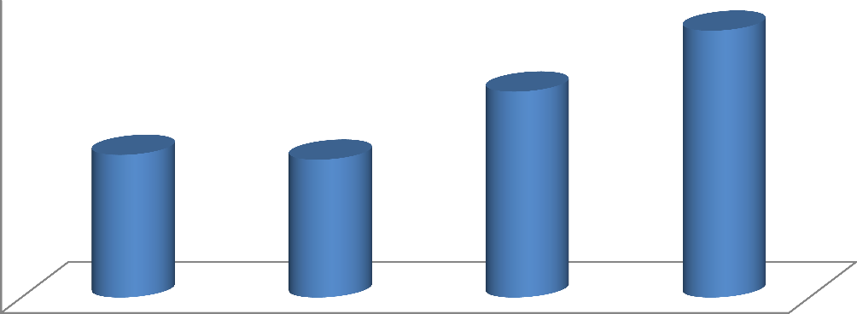

1.0257

0.7916

0.54835

0.5299

1

0.8

**Friability (%)**

0.6

0.4

0.2

0

A1 A2 A3 A4

**Batches of gelatin binder tablets**

### A4.6: Effect of Gelatin Binder Concentration on the Disintegration Time of Turmeric Tablets



35

30

25

20

15

10

5

0

A1

A2

A3

A4

**Batches of Turmeric Tablets**

**Disintegration Time (Min)**

Key

A1: 2.5 % Gelatin as binder

A2: 5 % Gelatin as binder

A3: 7.5 % Gelatin as binder

A4: 10 % Gelatin as binder

### A4.7. Dilution Potential of Avicel PH101 for Direct Compression of Turmeric Tablets

|  |  |  |  |  |  |
| --- | --- | --- | --- | --- | --- |
| Ingredients (mg) | 30/70 | 40/60 | 50/50 | 60/40 | 70/30 |
| Turmeric powder | 135.0 | 180.0 | 225.0 | 270.0 | 315.0 |
| Avicel PH101 | 315.0 | 270.0 | 225.0 | 180.0 | 135.0 |
| Expected weight | 450.0 | 450.0 | 450.0 | 450.0 | 450.0 |

**A4.8: Effect of Avicel PH101 Dilution on the Hardness of Turmeric Compacts (Kg F)**

12

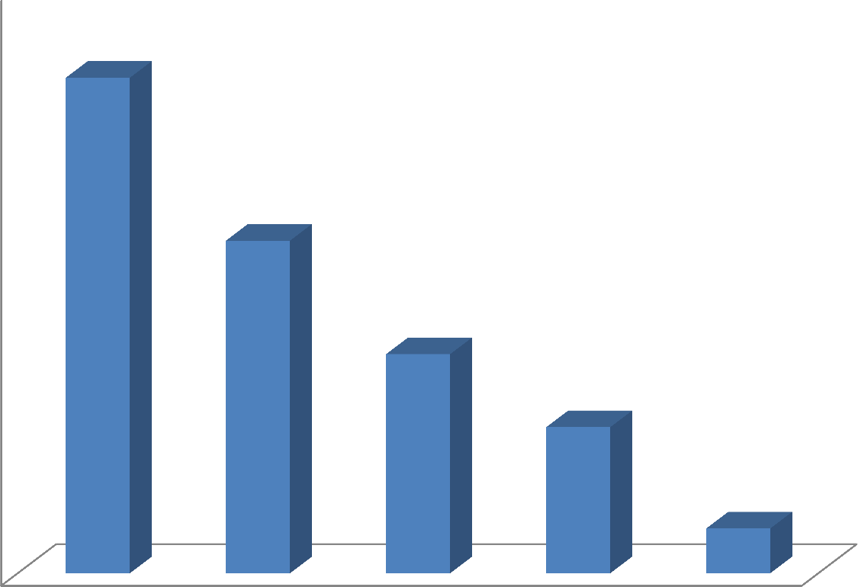

10

8

**Crushing Strength (KgF)**

6

4

2

0

30/70 40/60 50/50 60/40 70/30

**Turmeric:Avicel (%)**

### A4.9. Dilution Potential of Ludipres for Direct Compression of Turmeric Tablets

|  |  |  |  |  |  |
| --- | --- | --- | --- | --- | --- |
| Ingredients  (mg) | 30/70 | 40/60 | 50/50 | 60/40 | 7O/30 |
| Turmeric  powder | 195.0 | 260.0 | 325,0 | 390.0 | 455.0 |
| MCC or  Ludipress | 455.0 | 390.0 | 325.0 | 260.0 | 195.0 |
| Expected  weight | 650.0 | 650.0 | 650.0 | 650.0 | 650.0 |

**A4.10. Comparison of Hardness of Tablets Produced using Avicel PH101 and Ludipres at Different Dilution levels**

9

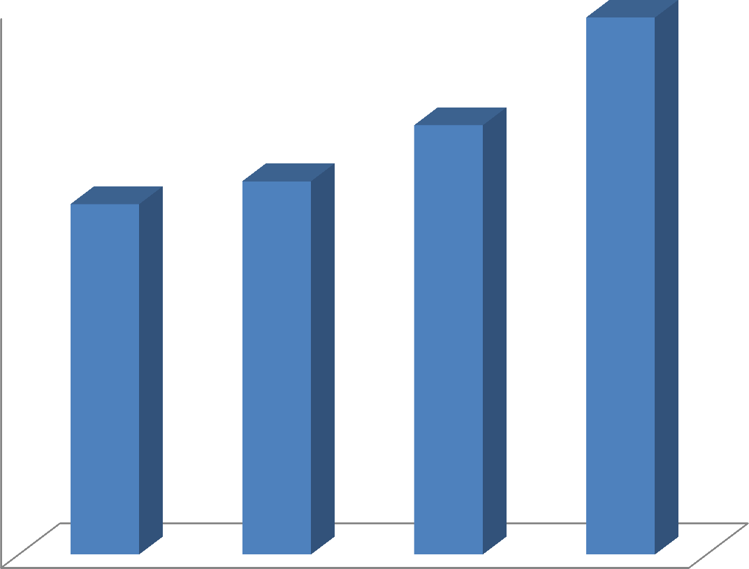

8

7

6

**Crushing Strenth (Kg F)**

5

4

3

2

1

0

DC1 DC2 DC3 DC4

**Batches of Tablets Produced by Direct Compression Method**

### A4.11. Comparison of Friability of Tablets Produced using Avicel PH101 and Ludipres at Different Dilutions

0.7

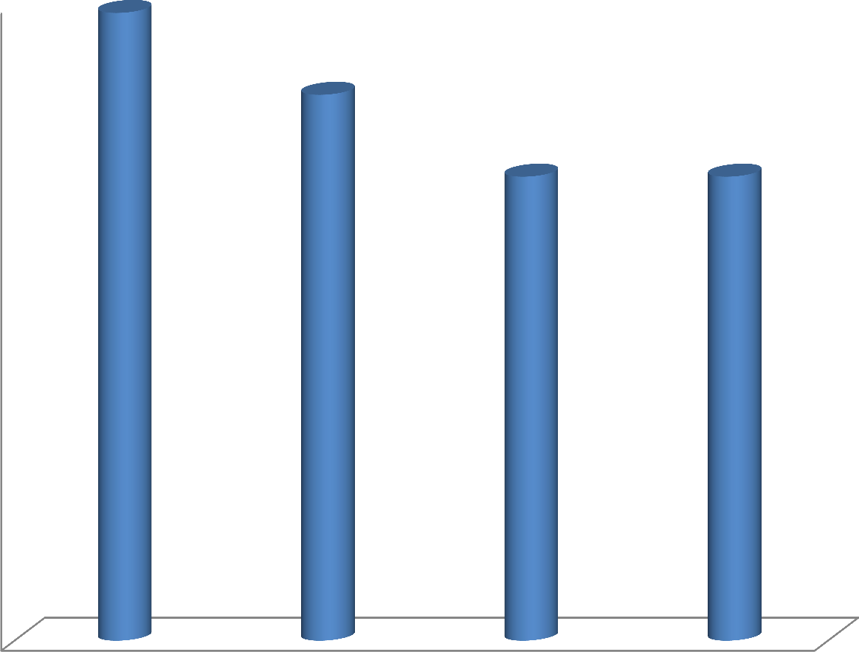

0.6

0.5

0.4

**Friability (%)**

0.3

0.2

0.1

0

DC1 DC2 DC3 DC4

**Batches of Tablets produced by direct compression Method**

### A4.12. Calibration Table for Turmeric Powder in 0.05M HCl Containing 0.8% W/V Sodium Lauryl Sulfate

|  |  |
| --- | --- |
| Concentration (µg/ml) | Absorbance (nm) |
| 15.63 | 0.010 |
| 31.25 | 0.013 |
| 62.50 | 0.031 |
| 125.00 | 0.062 |
| 250.00 | 0.121 |
| 500.00 | 0.241 |
| 1000.00 | 0.501 |

**A4.13. Dissolution Test Result for A2**

|  |  |  |  |
| --- | --- | --- | --- |
| Time (Min) | Absorbance(nm) | Amount of drug  dissolved(µg/ml) | % drug dissolved  (%) |
| 5 | 0.1 | 203.2 | 36.55 |
| 10 | 0.105 | 213.2 | 38.35 |
| 15 | 0.144 | 291.2 | 52.37 |
| 20 | 0.19 | 383.2 | 68.92 |
| 25 | 0.194 | 391.2 | 70.36 |
| 30 | 0.207 | 417.2 | 75.04 |
| 35 | 0.24 | 483.2 | 86.91 |
| 40 | 0.252 | 507.2 | 91.22 |
| 45 | 0.27 | 543.2 | 97.70 |
| 50 | 0.25 | 503.2 | 90.50 |
| 55 | 0.245 | 493.2 | 88.71 |
| 60 | 0.265 | 533.2 | 95.90 |
| 120 | 0.301 | 605.2 | 108.85 |

### A4.14. Dissolution Test Result for B1

|  |  |  |  |
| --- | --- | --- | --- |
| Time (Min) | Absorbance(nm) | Amount of drug  dissolved(µg/ml) | % drug dissolved  (%) |
| 5 | 0.116 | 235.2 | 42.30 |
| 10 | 0.125 | 253.2 | 45.54 |
| 15 | 0.14 | 283.2 | 50.94 |
| 20 | 0.179 | 361.2 | 64.96 |
| 25 | 0.182 | 367.2 | 66.04 |
| 30 | 0.201 | 405.2 | 72.88 |
| 35 | 0.234 | 471.2 | 84.75 |
| 40 | 0.242 | 487.2 | 87.63 |
| 45 | 0.26 | 523.2 | 94.10 |
| 50 | 0.255 | 513.2 | 92.30 |
| 55 | 0.249 | 501.2 | 90.14 |
| 60 | 0.258 | 519.2 | 93.38 |
| 120 | 0.281 | 565.4 | 101.69 |

**A4.15. Dissolution Test Result for D1**

|  |  |  |  |
| --- | --- | --- | --- |
| Time (Min) | Absorbance(nm) | Amount of drug  dissolved(µg/ml) | % drug dissolved  (%) |
| 5 | 0.075 | 153.2 | 27.55 |
| 10 | 0.071 | 145.2 | 26.12 |
| 15 | 0.070 | 143.2 | 25.76 |
| 20 | 0.077 | 157.2 | 28.27 |
| 25 | 0.119 | 241.2 | 43.38 |
| 30 | 0.122 | 247.2 | 44.46 |
| 35 | 0.126 | 255.2 | 45.90 |
| 40 | 0.125 | 253.2 | 45.54 |
| 45 | 0.131 | 265.2 | 47.70 |
| 50 | 0.126 | 255.2 | 45.90 |
| 55 | 0.141 | 285.2 | 51.29 |
| 60 | 0.145 | 293.2 | 52.73 |
| 120 | 0.152 | 307.2 | 55.25 |

### A4.16. Dissolution Test Result for D2

|  |  |  |  |
| --- | --- | --- | --- |
| Time (Min) | Absorbance(nm) | Amount of drug  dissolved(µg/ml) | % drug dissolved  (%) |
| 5 | 0.043 | 89.2 | 16.04 |
| 10 | 0.048 | 99.2 | 17.84 |
| 15 | 0.048 | 99.2 | 17.84 |
| 20 | 0.124 | 251.2 | 45.18 |
| 25 | 0.131 | 265.2 | 47.70 |
| 30 | 0.157 | 317.2 | 57.05 |
| 35 | 0.159 | 321.2 | 57.77 |
| 40 | 0.163 | 329.2 | 59.21 |
| 45 | 0.17 | 343.2 | 61.73 |
| 50 | 0.165 | 333.2 | 59.93 |
| 55 | 0.161 | 325.2 | 58.49 |
| 60 | 0.158 | 319.2 | 57.41 |
| 120 | 0.155 | 313.2 | 56.33 |

**A4.17. Dissolution Test Result for D3**

|  |  |  |  |
| --- | --- | --- | --- |
| Time (Min) | Absorbance(nm) | Amount of drug  dissolved(µg/ml) | % drug dissolved  (%) |
| 5 | 0.028 | 59.2 | 10.65 |
| 10 | 0.036 | 75.2 | 13.53 |
| 15 | 0.055 | 113.2 | 20.36 |
| 20 | 0.059 | 121.2 | 21.80 |
| 25 | 0.065 | 133.2 | 23.96 |
| 30 | 0.071 | 145.2 | 26.12 |
| 35 | 0.073 | 149.2 | 26.83 |
| 40 | 0.079 | 161.2 | 28.99 |
| 45 | 0.089 | 181.2 | 32.59 |
| 50 | 0.095 | 193.2 | 34.75 |
| 55 | 0.101 | 205.2 | 36.91 |
| 60 | 0.121 | 245.2 | 44.10 |
| 120 | 0.127 | 257.2 | 46.26 |

### A4.18. Dissolution Test Result for DC1

|  |  |  |  |
| --- | --- | --- | --- |
| Time (Min) | Absorbance(nm) | Amount of drug  dissolved(µg/ml) | % drug dissolved  (%) |
| 5 | 0.12 | 243.2 | 43.74 |
| 10 | 0.139 | 281.2 | 50.58 |
| 15 | 0.133 | 269.2 | 48.42 |
| 20 | 0.149 | 301.2 | 54.17 |
| 25 | 0.142 | 287.2 | 51.65 |
| 30 | 0.163 | 329.2 | 59.21 |
| 35 | 0.183 | 369.2 | 66.40 |
| 40 | 0.2 | 403.2 | 72.52 |
| 45 | 0.228 | 459.2 | 82.59 |
| 50 | 0.231 | 465.2 | 83.67 |
| 55 | 0.276 | 555.2 | 99.86 |
| 60 | 0.259 | 521.2 | 93.74 |
| 120 | 0.285 | 573.2 | 103.09 |

**A4.19. Dissolution Test Result for DC2**

|  |  |  |  |
| --- | --- | --- | --- |
| Time (Min) | Absorbance(nm) | Amount of drug  dissolved(µg/ml) | % drug dissolved  (%) |
| 5 | 0.129 | 261.2 | 46.98 |
| 10 | 0.133 | 269.2 | 48.42 |
| 15 | 0.125 | 253.2 | 45.54 |
| 20 | 0.144 | 291.2 | 52.37 |
| 25 | 0.148 | 299.2 | 53.81 |
| 30 | 0.149 | 301.2 | 54.17 |
| 35 | 0.149 | 301.2 | 54.17 |
| 40 | 0.161 | 325.2 | 58.49 |
| 45 | 0.238 | 479.2 | 86.19 |
| 50 | 0.227 | 457.2 | 82.23 |
| 55 | 0.285 | 573.2 | 103.09 |
| 60 | 0.279 | 561.2 | 100.94 |
| 120 | 0.282 | 567.2 | 102.01 |

### A4.20. Dissolution Test Result for DC3

|  |  |  |  |
| --- | --- | --- | --- |
| Time (Min) | Absorbance(nm) | Amount of drug  dissolved(µg/ml) | % drug dissolved  (%) |
| 5 | 0.154 | 311.2 | 55.97 |
| 10 | 0.17 | 343.2 | 61.73 |
| 15 | 0.179 | 361.2 | 64.96 |
| 20 | 0.173 | 349.2 | 62.81 |
| 25 | 0.189 | 381.2 | 68.56 |
| 30 | 0.189 | 381.2 | 68.56 |
| 35 | 0.192 | 387.2 | 69.64 |
| 40 | 0.199 | 401.2 | 72.16 |
| 45 | 0.197 | 397.2 | 71.44 |
| 50 | 0.199 | 401.2 | 72.16 |
| 55 | 0.204 | 411.2 | 73.96 |
| 60 | 0.202 | 407.2 | 73.24 |
| 120 | 0.107 | 217.2 | 39.06 |

**A4.21. Dissolution Test Result for DC4**

|  |  |  |  |
| --- | --- | --- | --- |
| Time (Min) | Absorbance(nm) | Amount of drug  dissolved (µg/ml) | % drug dissolved (%) |
| 5 | 0.119 | 241.2 | 43.38 |
| 10 | 0.132 | 267.2 | 48.06 |
| 15 | 0.136 | 275.2 | 49.50 |
| 20 | 0.14 | 283.2 | 50.94 |
| 25 | 0.115 | 233.2 | 41.94 |
| 30 | 0.141 | 285.2 | 51.29 |
| 35 | 0.167 | 337.2 | 60.65 |
| 40 | 0.23 | 463.2 | 83.31 |
| 45 | 0.26 | 523.2 | 94.10 |
| 50 | 0.26 | 523.2 | 94.10 |
| 55 | 0.265 | 533.2 | 95.90 |
| 60 | 0.256 | 515.2 | 92.66 |
| 120 | 0.276 | 555.2 | 99.86 |

### A4.22. Parameters Generated from Kawakita Plots

1. **A2**

|  |  |  |  |  |  |
| --- | --- | --- | --- | --- | --- |
| **App. Press** | **TS** | **100V** | **Porosity** | **ln(1/Ԑ)** | **P/C** |
| 39.9 | 0.075 | 117.73 | 0.15 | 1.91 | 76.34 |
| 79.9 | 0.06 | 113.23 | 0.12 | 2.15 | 150.72 |
| 119.8 | 0.08 | 114.32 | 0.12 | 2.09 | 226.85 |
| 159.7 | 0.12 | 112.67 | 0.11 | 2.21 | 300.97 |
| 199.7 | 0.04 | 112.80 | 0.11 | 2.18 | 387.67 |

### B1

|  |  |  |  |  |  |
| --- | --- | --- | --- | --- | --- |
| **App. Press** | **TS** | **100V** | **Porosity** | **ln(1/Ԑ)** | **P/C** |
| 39.9 | 0.01 | 114.28 | 0.12 | 2.08 | 75.56 |
| 79.9 | 0.06 | 110.54 | 0.09 | 2.390 | 149.56 |
| 119.8 | 0.05 | 108.47 | 0.08 | 2.65 | 223.04 |
| 159.7 | 0.08 | 105.88 | 0.06 | 2.90 | 295.11 |
| 199.7 | 0.09 | 109.19 | 0.08 | 2.57 | 383.18 |

A4.23: **Effect of granulation on the compressibility of turmeric powder**

0.12



0.1

0.08

0.06 TP

**Teasile Strenght**

A2 B1

0.04

0.02

0

0 50 100 150 200 250

**Applied Pressure (MPa)**