EVALUATION OF TABLETING AND COMPRESSIONAL CHARACTERISTICS OF NATIVE AND MICROCRYSTALLINE STARCHES DERIVED FROM DIGITARIA IBURUA.

BY
OKPANACHI, GIDEON OWOICHO B.Pharm (ABU 2006)
M.Sc./Pharm – Sci/02202/2008 – 2009

A THESIS SUBMITTED TO THE POSTGRADUATE SCHOOL, AHMADU BELLO UNIVERSITY, ZARIA, NIGERIA.

IN PARTIAL FULFILMENT FOR THE AWARD OF MASTER OF SCIENCE IN PHARMACEUTICS

DEPARTMENT OF PHARMACEUTICS AND PHARMACEUTICAL MICROBIOLOGY, FACULTY OF PHARMACEUTICAL SCIENCES, AHMADU BELLO UNIVERSITY, ZARIA.

DECEMBER, 2012

DECLARATION
I declare that the work in this thesis entitled “Evaluation of Tableting and Compressional Characteristics of Native and Microcrystalline Starch Derived from Digitaria iburua”, has been performed and reported by me in the Department of Pharmaceutics and Pharmaceutical Microbiology under the supervision of Dr. H. Musa and Dr. A.B. Isah.
The information derived from the literature has been duly acknowledged in the text and a list of references provided. No part of this thesis was previously presented for another degree or Diploma at any university.

OKPANACHI G.O.
Name of Student | Signature | Date

CERTIFICATION
This thesis entitled “Evaluation of Tableting and Compressional Characteristics of Native and Microcrystalline Starch Derived from Digitaria iburua, by Okpanachi, Gideon Owoicho meets the regulations governing the award of the degree of Master of Science (Pharmaceutics) of Ahmadu Bello University, Zaria, and is approved for contribution to knowledge and literary presentation.

(Signature) (Date)
Chairman, Supervisory Committee

Dr. H. Musa
B. Pharm., M.Sc., MBA., PhD (ABU)
Department of Pharmaceutics and Pharmaceutical Microbiology, Ahmadu Bello University, Zaria

(Signature) (Date)
Member, Supervisory Committee

Dr. A.B. Isah
B. Pharm., M.Sc., PhD (ABU)
Department of Pharmaceutics and Pharmaceutical Microbiology, Ahmadu Bello University, Zaria

(Signature) (Date)
Head of Department

Dr. A.B. Isah
B. Pharm., M.Sc., PhD (ABU)
Department of Pharmaceutics and Pharmaceutical Microbiology, Ahmadu Bello University, Zaria

(Signature) (Date)
Dean of Postgraduate School

Prof. A.A. Joshua
BA, MA, PhD (ABU)
School of Postgraduate Studies Ahmadu Bello University, Zaria

DEDICATION

This work is dedicated to my wife, Ajuma and my wonderful kids; Ebo and Ehiocho. I love you!

ACKNOWLEDGEMENT
To the Almighty God who has given me so much to be thankful for, my words are not enough to express my love. There is nothing I can do but to ALWAYS worship you.
To my Supervisors, Dr. H. Musa and Dr. A.B. Isah, thank you so much for being critical, for your scrutiny, support and careful supervision throughout the course of this work.
To the Head of Department, Dr. A.B. Isah, thanks for bringing out the best out

of me.

To the Post Graduate Co-ordinator, Dr. B.O. Olayinka, thank you for your understanding.
To the entire staff of the Department of Pharmaceutics and Pharmaceutical Microbiology, Prof. (Mrs.) A.R. Oyi, Dr (Mrs.) T.S. Allagh, Mrs. O.J. Olayemi, Mr.
A.A. Falaki, Mr. Innocent Agbo, Mr. Mike Ainoje, Mr. Godwin Ugwu, Mr. F.H.S. Apeji to mention a few who encouraged me at one point or the other in the course of my study, I say thank you so very much.
To Prof. D.A. Ameh of the Department of Biochemistry, Faculty of Sciences, Ahmadu Bello University, Zaria, Nigeria who provided some literature for further study on starch.
I cannot forget to mention Mr. Yonnie Apeji and Dr. A.K Olowosulu who made so many contributions in time, knowledge and skills towards the success of this work.
To Dr. I.S. Okafor of the University of Jos whose contribution for just a few hours was immeasurable. Thank you.

To my co-researchers; Pharm. Razak Ademola Oduola (Prof.), Pharm. Husseini and Pharm. Aisha. Sharing of your ideas and professionalism was worthwhile and encouraging.
To my parents and siblings, Elder J. Okpanachi, Mrs. H. Okpanachi, Aaron, Moses, Joshua, Hannah and Adah for always asking of my progress in the Laboratory. I love you.
To my pastor, Rev. M. Omede, thank you for your concern and prayers for my

family.

To my beloved wife Ajuma, who is always there for me, thank you so much. I always remain indebted to you.
Finally to my friends especially Ojone Akubo and everyone who at one point or the other helped throughout the course of this work. I say a big “THANK YOU”, God bless you.

ABSTRACT
Acid hydrolyzed starch produces microcrystalline starch (MCS) with improved functional properties in terms of flowability or compressibility. The aim of this study was to investigate the binder, disintegrant and compressional properties of native and modified starches derived form of Digitaria iburua.
Digitaria iburua grains were collected and identified by the herbarium unit of Department of Biological Sciences, Ahmadu Bello University, Zaria. Digitaria iburua starch (DS) was extracted from the grains using the wet method of extraction and the percentage yield was determined. Microcrystalline starch (MCS) was produced by acid hydrolysis using 6 N HCl. The amylose-amylopectin content of DS and MCS was determined. The physicochemical characterization for DS and MCS was conducted using standard methods. Metronidazole granules of varying binder and disintegrant concentrations (2.5, 5.0, 7.5, 10.0 and 12.5 % w/v) were prepared by wet granulation method of massing and screening and compared with Maize Starch BP (MS) and gelatin (GEL) as standard disintegrant and binder respectively. The granules were subjected to tests to determine its flowability and compressibility. The granules were then compressed into tablets at 7.0 metric tones after mixing with extra granular excipients. Quality control tests were conducted on the tablets after compression of the granules. The mode of fragmentation or deformation of the powder was assessed by Heckel analysis.
Digitaria iburua grains yielded 62.88 % w/w DS and after 24 h of hydrolysis, the yield of MCS was found to be 85.14 % w/w. The amylose-amylopectin ratio for MCS determined revealed that the amylose content at different hydrolyzing times was greater than the amylopectin content. The mean particle size was found to be less than 10.5 µm for both starches. The values of angle of repose, Carr`s index and Hausner`s ratio for

DS and MCS suggest that the materials possess poor flow property. The particle size distributions of the granules were uniformly distributed. Tablet parameters revealed that the crushing strength (CS) increased with increase in the binder concentration for all binder types while CS decreased with increase in disintegrant concentration for disintegrant types. The CS of the binder type is in the order; GEL>MCS>DS while that of the disintegrant is; MCS>MS>DS. The friability (FR) decreased with increase in binder concentration for all binder types while showing an increase with increase in disintegrant concentrations. The disintegration time (DT) increased with increase in binder concentration while increase in disintegrant concentration resulted in a decrease in DT. The (CS/FR)/DT values of the tablets decreased with increase in disintegrant concentration for all disintegrant type. Maize starch B.P. has the highest (CS/FR)/DT ratio at all concentrations. The (CS/FR)/DT ratio for tablets containing DS and MCS was comparable. The dissolution efficiency (D.E.) which is the percentage of drug released after 30 min ranged from 85.48 – 99.03 % for 7.5 % w/v binder concentration and 96.49 – 100 % for 10.0 % w/w disintegrant concentration. The order of D.E for 7.5
% w/v binder concentration was; DS>MCS>GEL while the order of D.E for 10.0 % w/w disintegrant concentration was; DS>MS>MCS. The mean yield pressure (P_{Y}), relative density at zero pressure (D_{O}) and total deformation occurring in the powder (D_{A}) ranked in this order: GEL>MCS>DS. The fragmentation tendency of the powder (D_{B}) value was in the order: MCS>GEL>DS. The mean yield pressure was high which is indicative of higher resistance against plastic deformation.
The (CS/FR)/DT and compressional studies results revealed that tablets were generally weak. DS and MCS could be used with other excipients to produce tablets that require fast disintegration

TABLE OF CONTENTS

TITLE PAGE i
DECLARATION ii
CERTIFICATION iii
DEDICATION iv
ACKNOWLEDGEMENT v
ABSTRACT vii
TABLE OF CONTENTS x
LIST OF TABLES xv
LIST OF FIGURES xvi
LIST OF PLATES xvii
LIST OF APPENDICES xviii
Abbreviations, Definitions, Glossaries and Symbols xxi
CHAPTER ONE i
  - INTRODUCTION 1
  - Starch chemistry 2
  - Energy store of plants 4
  - Biosynthesis 4
  - Commonly used starches 5
  - Starch extraction 6
    - Microbial softening technique 7
    - Use of microfluidiser 7
    - Enzymatic starch extraction 7
  - Modification of starch 8
    - Cross-linking 8
    - Stabilization 8
    - Conversions 9
    - Lipophilic substitution 10
    - Pregelatinization 10
    - Annealing 10
  - Survey of research work on local starches 11
  - Fonio 13
    - Distributional range 15
    - Description of Digitaria iburua (Stapf) 15
    - Economic use of fonio 16
  - Statement of research problem 16
  - Research hypotheses 17
  - Aim and objective of the study 17
1.13 Justification of the study 18
CHAPTER TWO 19
  - LITERATURE REVIEW 19
  - Tablets 19
  - Tablet types 19
    - Conventional compressed tablets 20
    - Multiple compressed tablets 20
    - Enteric-coated tablets 21
    - Sugar-coated tablets 21
    - Film-coated tablets 21
    - Chewable tablets 22
    - Effervescent tablets 22
    - Sublingual and buccal tablets 23
    - Vaginal tablets 23
  - Quality attributes of tablets 24
  - Manufacture of tablets 25
    - Manufacture of tablets by wet granulation 25
      - Advantages and disadvantages of wet granulation 27
    - Manufacture of tablets by dry granulation 28
      - Slugging 28
      - Roller compaction 28
    - Stages in dry granulation 28
      - Advantages and disadvantages of dry granulation 29
    - Manufacture of tablets by direct compression 29
    - Advantages and disadvantages of tablet manufactured by direct compression 30
  - Advancements in the manufacture of tablets 31
  - Stages in tablet compression 32
  - Stages in tablet compaction 33
  - Sequence of events in compaction of powders 33
  - Models describing compression of powders 35
    - Heckel equation 35
    - The Kawakita equation 36
    - Adams equation 37
  - Tablet defect 37
  - Post processing alteration on tablet properties 38
  - Quality standards of tablets 38
    - Pharmacopoeial (official) tests 39
      - Uniformity of weight 39
      - Disintegration test 40
      - Dissolution test 41
  - Non-Pharmacopoeial (non-official) test 42
    - Uniformity of thickness 43
    - Crushing strength 43
    - Friability 44
  - Pharmaceutical excipients 44
    - Diluents/fillers 44
    - Binders 45
    - Disintegrants 46
    - Lubricants 47
    - Glidants 48
    - Other excipients used in the formulation of tablets 48
CHAPTER THREE 52
  - MATERIALS AND METHODS 52
  - Materials 52
    - Botanical material 52
    - Chemicals 52
  - Methodology 52
    - Collection and identification of Digitaria iburua grains 52
    - Extraction of starch from Digitaria iburua grains 53
    - Determination of percentage yield of starch 53
    - Determination of gelatinization temperature 53
    - Production of microcrystalline starch 54
  - Physicochemical tests on the Digitaria iburua starch and microcrystalline starches 54
    - Determination of percentage yield and organoleptic properties of microcrystalline starch 54
    - Iodine test 54
    - pH determination 54
    - Determination of amylose and amylopectin content 55
    - Determination of ash content 55
    - Determination of moisture content 55
    - Determination of lipid content 55
    - Determination of protein content (nitrogen and crude protein) 56
    - Determination of carbohydrate 57
    - Microscopy 57
    - Determination of moisture sorption capacity 57
    - Determination of swelling capacity 57
  - Physical properties of powdered starch 57
    - Particle size analysis 57
    - Angle of repose 57
    - Flow rate 57
    - Particle density 57
    - Bulk and tapped density 58
    - Dilution potential 58
  - Granule and tablet studies 59
    - Preparation of metronidazole granules 59
    - Analysis of metronidazole granules 59
    - Compaction of granules to tablets 59
    - Quality control test for tablets 62
      - Weight uniformity test 62
      - Thickness and diameter measurement 62
      - Crushing strength test 62
      - Friability test 62
      - Disintegration time test 63
      - Dissolution studies 63
  - Compressional property study 64
    - Determination of particle density 64
    - Preparation of compacts 64
    - Evaluation of compression properties 64
  - Statistical analysis 64
CHAPTER FOUR 66
  - RESULTS 66
  - Production of microcrystalline starch 66
  - Amylose – Amylopectin content determination for microcrystalline starch
…………………………………………………………………………..67
  - Physicochemical properties 68
  - Microscopy 69
  - Particle size analysis 75
  - Dilution potential 75
  - Physical properties of metronidazole granules 75
  - Properties of tablets produced by wet granulation 77
  - Dissolution studies 81
  - Compression property study on Digitaria iburua starch and microcrystalline starch 83
CHAPTER FIVE 85
  - DISCUSSION 85
  - Preliminary investigation 85
  - Amylose – Amylopectin content of microcrystalline starch 85
  - Microscopy 86
  - Physicochemical properties 86
  - Analysis of granules 89
  - Evaluation of tablet properties 91
  - Compression property study 94
CHAPTER SIX 96
  - SUMMARY AND CONCLUSION 96
  - Recommendations 97
REFERENCES 98
APPENDICES 107

LIST OF TABLES

Table 1.1: Characteristics of starch grain 6
Table 2.1: Tablet weight variation requirements 39
Table 2.2: Examples of binders commonly used tableting 45
Table 2.3: Examples of lubricants commonly used in tableting 48
Table 3.1: Tablet formula for studying the binder properties of Digitaria iburua
starch and microcrystalline starch 61
Table 3.2: Tablet formula for studying the disintegrant properties of Digitaria iburua
starch and microcrystalline starch 61
Table 4.1: Preliminary investigation on Digitaria iburua starch 67
Table 4.2: Percentage yield and colour of microcrystalline starch 67
Table 4.3: Determination of amylose-amylopectin content for microcrystalline starch
. 67
Table 4.4: Physicochemical Parameters of Digitaria iburua starch and microcrystalline starch compared with maize starch B.P 69
Table 4.5: Dilution Potential for metronidazole and microcrystalline starch 75
Table 4.6: Effects of disintegrant concentration (% w/w) on the physical properties of the granules 76
Table 4.7: Effects of binder concentration (% w/v) on the physical properties of the granules 77
Table 4.8: Quality control tests on the binding properties of tablets produced by wet granulation 79
Table 4.9: Quality control tests on the disintegrating properties of
tablets produced by wet granulation 80
Table 4.10: Parameters from Heckel plots 83

LIST OF FIGURES
Figure 1.1: Linear and branched starch polymer 3
Figure 4.1: Graph of percentage frequency (%) against particle size (µm) for Digitaria iburua starch and microcrystalline starch 73
Figure 4.2: Graph of cumulative frequency against particle size (µm) for Digitaria iburua starch and microcrystalline starch 74
Figure 4.3: Graph showing dissolution profile of metronidazole tablets containing 7.5
% w/v binder concentration 81
Figure 4.4: Graph showing dissolution profile of metronidazole tablets containing 10.0
% w/w disintegrant concentration 82
Figure 4.5: Graph of ln (1/1-D) against pressure for Digitaria iburua starch, microcrystalline starch and gelatin compact… 84

LIST OF PLATES
Plate 1.1: Photograph of 𝐷𝑖𝑔𝑖𝑡𝑎𝑟𝑖𝑎 𝑖𝑏𝑢𝑟𝑢𝑎 grain 16

Plate 4.1: Photomicrograph of Digitaria iburua native starch (Mag. X 400) (Fisher, Rochester – New York) 70
Plate 4.2: Photomicrograph of Digitaria iburua microcrystalline starch 71
(Mag. X 400) (Fisher, Rochester – New York) 71
Plate 4.3: Photomicrograph of Maize Starch BP 72
(Mag. X 400) (Fisher, Rochester – New York) 72

LIST OF APPENDICES
  - Particle size distribution 107
  - Size distribution of metronidazole granules as binder 108
  - Size distribution of metronidazole granules as disintegrant 109
Figure A. 1: Cumulative oversize distribution of metronidazole granules using 2.5 % w/v as binder 110
Figure A. 2: Cumulative oversize distribution of metronidazole granules using 5.0 % w/v as binder 111
Figure A. 3: Cumulative oversize distribution of metronidazole granules using 7.5 % w/v as binder 112
Figure A. 4: Cumulative oversize distribution of metronidazole granules using 10.0 % w/v as binder 113
Figure A. 5: Cumulative oversize distribution of metronidazole granules using 12.5 % w/v as binder 114
Figure A. 6: Cumulative oversize distribution of metronidazole granules using 2.5 % w/w as disintegrant. 115
Figure A. 7: Cumulative oversize distribution of metronidazole granules using 5.0 % w/w as disintegrant. 116
Figure A. 8: Cumulative oversize distribution of metronidazole granules using 7.5 % w/w as disintegrant. 117
Figure A. 9: Cumulative oversize distribution of metronidazole granules using 10.0 % w/w as disintegrant. 118
Figure A. 10: Cumulative oversize distribution of metronidazole granules using 12.5 % w/w as disintegrant. 119
Figure A.11: Graph of crushing strength (kgf) against binder concentration (% w/v) of metronidazole tablets produced by wet granulation 120
Figure A.12: Graph of friability (%) against binder concentration (% w/v) of metronidazole tablets produced by wet granulation 121
Figure A.13: Graph of disintegration time (min) against binder concentration (% w/v) of metronidazole tablets produced by wet granulation 122
Figure A.14: Graph of crushing strength-friability index against binder concentration (% w/v) of metronidazole tablets produced by wet granulation 123
Figure A.15: Graph of crushing strength-friability/disintegration time index against binder concentration (% w/v) of metronidazole tablets produced by wet granulation 124
Figure A.16: Graph of crushing strength (kgf) against disintegrant concentration (% w/w) of metronidazole tablets produced by wet granulation 125
Figure A.17: Graph of friability (%) against disintegrant concentration (% w/w) of metronidazole tablets produced by wet granulation 126
Figure A.18: Graph of disintegration time (min) against disintegrant concentration (% w/w) of metronidazole tablets produced by wet granulation 127

Figure A.19: Graph of crushing strength-friability index against disintegrant concentration (% w/w) of metronidazole tablets produced by wet granulation 128
Figure A.20: Graph of crushing strength-friability/disintegration time index against disintegrant concentration (% w/w) of metronidazole tablets produced by wet granulation 129
  - Calibration curve for metronidazole 130
Figure A. 21: Calibration curve for metronidazole 131
  - Dissolution test results at 7.5 % w/v binder concentration 132
  - Dissolution test results at 10.0 % w/w disintegrant concentration 133
  - Parameter from dissolution profile of metronidazole tablets containing 7.5
% w/v binder concentration 134
  - Parameter from dissolution profile of metronidazole tablets containing
10.0 % w/w disintegrant concentration 135
  - Parameters for Heckel plot 136
A. 10 Statistical analysis 137

Abbreviations, Definitions, Glossaries and Symbols

ADP | Adenosine Diphosphate
Am | Amylose
AP | Amylopectin
API | Active pharmaceutical ingredient
ATP | Adenosine Triphosphate
BP | British Pharmacoeia
CS | Crushing Strength
D.E (30 min) | Percentage drug released after 30 min
D_{A} | Total Deformation occurring in the powder
D_{B} | Fragmentation Tendency of the powder
D_{O} | Relative Density at Zero Pressure
DS | Digitaria iburua Starch
DT | Disintegration Time
FR | Friability
GEL | Gelatin
GIT | Gastro intestinal Tract
HCl | Hydrochloric Acid
MADG | Moisture Activated Dry Granulation
MAGT | Moisture Activated Granulation Technique
MCC | Microcrystalline Cellulose
MCS | Microcrystalline Starch
MS | Maize Starch B.P.
NaOH | Sodium Hydrochloride
PEG | Polyethylene Glycol
P_{Y} | Mean Yield Pressure
TAGP | Thermal Adhesion Granulation Process
UDP | Uridine diphosphate

CHAPTER ONE

INTRODUCTION
Tablets consist of the active pharmaceutical ingredient (API) and excipients making up to 70 – 80 % of drug (York, 1992). An active pharmaceutical ingredient is the component of medication responsible for the medication’s effect (Bihari, 2008). An excipient is an inert substance added to the formulation in order to facilitate the preparation, patient acceptability and functioning of the dosage form as a drug delivery system (Ashford, 2002).
Excipients contribute significantly to a formulations functionality and process- ability (Bansal and Nachaegari, 2004). Starches are widely available and have been useful in tablet production due to their inertness, cheapness and utilization as fillers, binders, disintegrants and glidants (Alebiowu and Itiola, 2002). Starch is the major carbohydrate reserve of plant tubers and seed endosperm (Buleon et al, 1998) and has been identified by the Joint Conference on Excipients as one of the top ten excipients in the pharmaceutical industry (Adebayo and Itiola, 2003).
Starch occurs abundantly in most plants and is the most widely distributed substances in nature. Starch is formed by a process of photosynthesis when water, carbon dioxide interact in the presence of light and chlorophyll. The largest source of starch is the caryopsis of maize, wheat, tuber of potato, yam and cocoyam, roots of tapioca, and caryopsis of rice etc (Muazu, 2008). Several starches obtained from different food crops have shown enough potential as excipients in tablet formulations (Itiola et al, 2005). Starch is routinely used, for example as diluents, binder, disintegrant and glidant. Starch is widely used as a thickener, water binder, emulsion, stabilizer and gelling agent.

Starch is commonly used in an amount of 5 to 15 % when it functions as a binder (Handbook of Pharmaceutical Excipients, 2003). All percentages, unless specified are percentage by weight based on the total weight of the compressed solid dosage form. When functioning as a disintegrant, it is commonly added in an amount of 3 to 15 %. The amount of diluent that is called for in a particular application depends upon many parameters and is highly variable.
However, as the handbook notes, starch does not compress well and tends to increase tablet friability and capping if used in high concentration. Thus, the use of high concentration of starch as a diluent is limited by the deterioration in the hardness and friability (resistance to chipping) that occurs as the proportion of starch in the formulation is increased.

Starch Chemistry
Starch or amylum is a carbohydrate consisting of a large number of glucose units joined by glycosidic bonds. This polysaccharide is produced by all green plants as an energy store. It is the most important carbohydrate in the human diet.
Pure starch is a white, tasteless and odorless powder that is insoluble in cold water or alcohol. It consists of two types of molecules: the linear and helical amylose and the branched amylopectin. Depending on the plant, starch generally contains 20 to 25 % amylose and 75 to 80 % amylopectin (Brown and Poon, 2005). Glycogen, the glucose store of animals, is a more branched version of amylopectin.

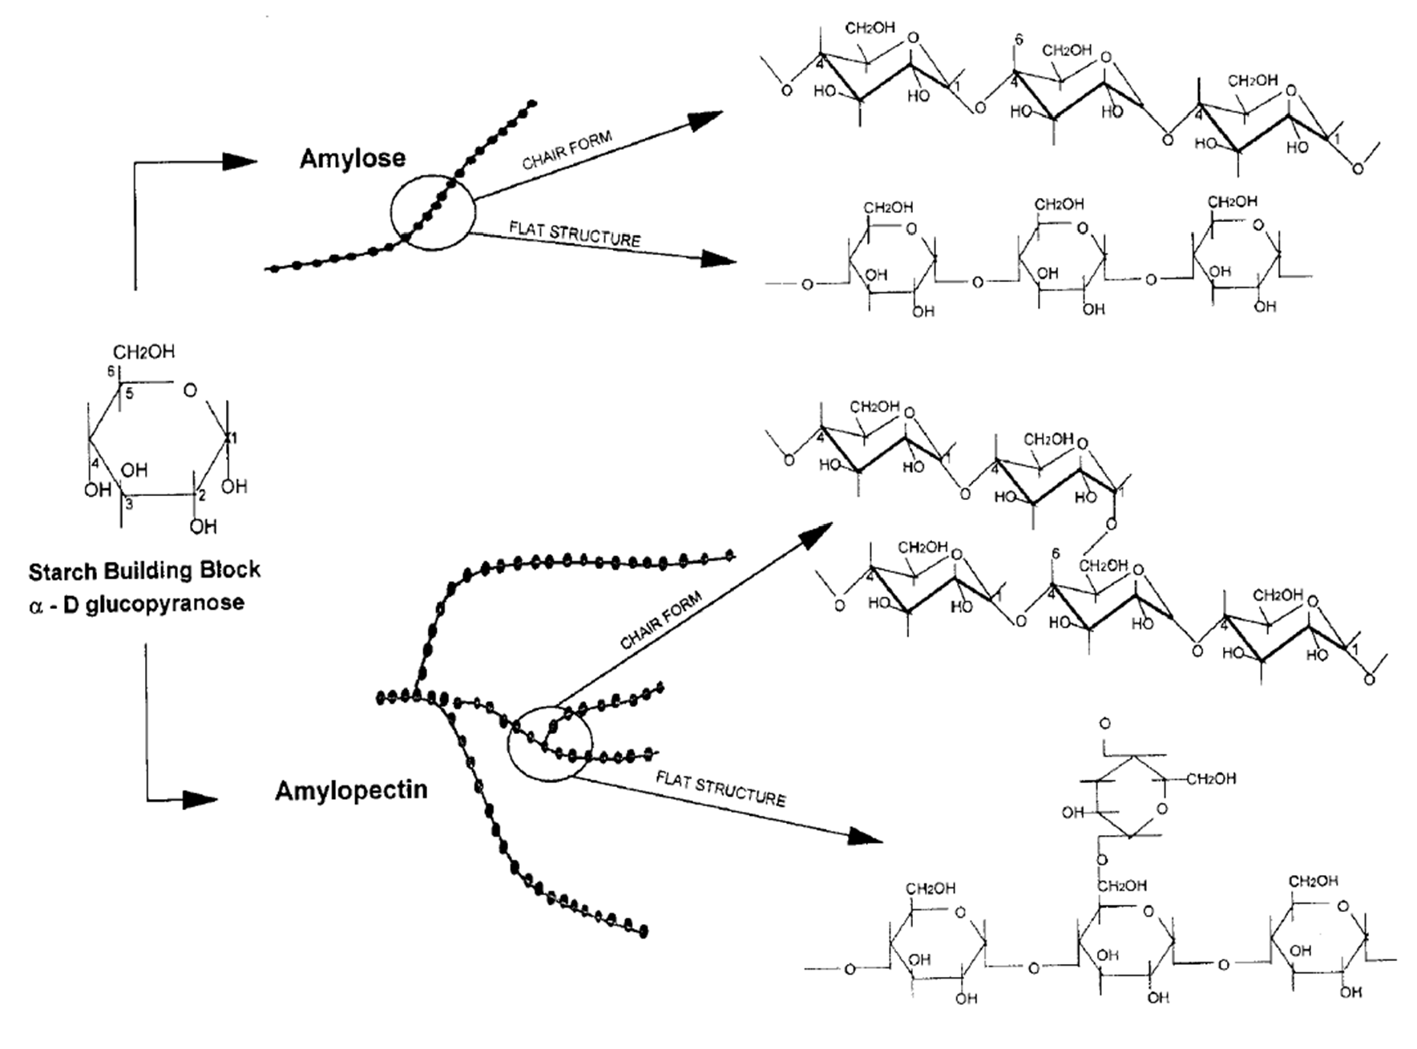

Figure 1.1: Linear and branched starch polymers (Light, 1990; Crogan and Mason, 1998, Whistler et al, 1984).

Amylose is a hydrocolloid. Its extended conformation causes the high viscosity of water soluble starch which varies relatively little with temperature. The extended loosely helical chains possess a relatively hydrophobic inner surface that is not able to hold water. Amylose forms useful gels and films. Its association and crystallization (retrogradation) on cooling and storage decrease storage stability, causing shrinkage and the release of water (syneresis). Increasing amylose concentration decrease stickiness, but increases gel firmness.
Amylopectin interferes with the interaction between amylose chains (and retrogradation) and its solution can lead to an initial loss in viscosity and followed by a slimy consistency. In normal starch, the amylose: amylopectin (Am:AP) ratio is approximately 1:4. Starch films made from different Am:AP ratio have different

properties. Amylose in starch gives stronger film whereas amylopectin generally leads to lower mechanical properties (Tharanathan, 2003; Mali and Grossmann, 2006). Adjustment of Am:Ap ratio may lead to tailoring of physical and chemical properties of starch films (Belitz and Grosh; 1999; Delvile et al, 2002).

Energy Store of Plants
In photosynthesis, glucose is produced from carbon dioxide in the presence of light energy. The glucose is stored mainly in the form of starch granules, in plastids such as chloroplasts and especially amyloplasts. Starch accumulates in twigs of trees near the buds toward the end of growing season. In preparation for the next growing season, starch is stored in fruit, seeds, rhizomes and tubers.
Glucose is soluble in water, hydrophilic, binds much water and then takes up much space. Glucose in the form of starch is insoluble and can be stored much more compactly. Glucose molecules are bound in starch by the easily hydrolyzed alpha bonds. The same type of bond can also be seen in the animal reserve polysaccharide glycogen.

Biosynthesis
Plants produce starch by first converting glucose 1-phosphate to ADP-glucose using the enzyme glucose-1-phosphate adenylyl transferase. This step requires energy in the form of ATP. The enzyme starch synthase then adds the ADP-glucose via a 1, 4- alpha glycosidic bond to a growing chain of glucose residues, liberating ADP and creating amylose. Starch branching enzyme introduces 1, 6-alpha glycosidic bonds between these chains, creating amylopectin. The starch debranching enzyme isoamylase removes some of these branches. Several isoforms of these enzymes exist, leading to a highly complex synthesis process (Smith, 2001).

Amylose was traditionally thought to be completely unbranched. Conversely, it is now known that some of its molecules contain a few branched points. Glycogen and amylopectin have the same structure; but glycogen has about one branch point per ten 1, 4-alpha bonds, compared to about one branch per thirty 1, 4-alpha bonds in amylopectin (Lubert et al, 2002). Glycogen is synthesized from UDP-glucose while starch is synthesized from ADP-glucose.

Commonly used starches
Commonly used starches recommended by the British Pharmacopoeia, (B.P. 2002) for pharmaceutical industries include:
- Maize starch obtained from caryopsis of Zea mays L.

- Rice starch obtained from caryopsis of Oryza sativa L.

- Wheat starch obtained from caryopsis of Triticum aestivum, Triticum vulgare L.

- Potato starch obtained from tuber of Solanum tuberosum L.

- Tapioca starch obtained from the root of Manihot esculenta (In tropical and subtropical regions where 1 – 4 above are not obtainable).

Table 1.1: Characteristics of Starch Grain (Apeji, 2010)

Starch | Type | Diameter  (µm) | Morphology | Gelatinization Temp. ⁰C | Amylose  content (%)
Maize(*) | Cereal | 5 – 30 | Irregular | 62 – 72 | 25
Waxy | Cereal | 5 – 30 | Round | 63 – 72 | < 1
maize |  |  | polygonal
Tapioca | Root | 4 – 35 | Spherical | 62 – 73 | 17
Potato | Tuber | 5 – 100 | Oval | 59 – 68 | 20
 |  |  | spherical
Wheat | Cereal | 1 – 45 | Round | 58 – 64 | 25
 |  |  | lenticular
Rice | Cereal | 3 – 8 | Polygonal | 68 – 78 | 19
 |  |  | spherical
 |  |  | compound
 |  |  | granular
Sago | Pith | 15 – 65 | Oval | 69 – 74 | 26
 |  |  | truncated
High | Cereal | 5 – 30 | Polygonal | 63 – 92 ** | 50 – 90
amylose |  |  | irregular
maize |  |  | elongated

* Maize is also referred to as “corn”, “dent corn,” or “regular maize.”

** High amylose maize starch is not completely gelatinized in boiling water.

Starch Extraction
At the end of the 19th century, the United State of America (USA) employed the wet technique in extraction of maize starch while potato starch extraction was developed in Europe. The wet method of extraction involves cleaning and or washing, then steeping for a specified period. The steeped material is then milled, filtered and then sodium hydroxide solution added to separate starch from protein. The pure starch is obtained by sedimentation and dried.

Recently, starch extraction is a subject of extensive research. Several new methods are employed; e.g. (1) microbial softening technique; (2) use of microfluidiser; and (3) enzymatic starch extraction.

Microbial softening technique
According to Eyini et al (2005) 64 – 91 percent starch was extracted from tubers of Dioscorea alata through microbial softening technique. Microorganisms that could be used include bacteria and yeasts.

Use of Microfluidiser
This involves the use of a machine to physically split apart the starch-protein content. The process of extraction is carried out without steeping which involves use of hydroxide solution which is corrosive. As the starch passes through the microfluidiser, yields of many small individual particles of starch and protein uniformly disperse in a watery matrix. The starch and protein constituents can be separated by traditional density-based separation technique.

Enzymatic starch extraction
The wet method of extraction (milling, sieving, sedimentation and drying) leads to up to 20 % of starch loss and also involves high energy inputs, use of large quantity of water and expensive machinery. Thus, the use of commercial cell wall degrading enzymes to release starch from cassava roots to enhance recovery has been investigated (Kallabinski and Balagopalan, 2005). The combination of enzymes (Pectinases and Cellulases) for starch recovery from milled cassava samples led to an increase in starch yield (21.49 %) compared to the wet method of extraction.

Modification of Starch
Modification of starch involves altering the structure and affecting the hydrogen bonding in a controllable manner to enhance and extend their application.
The chemical and biochemical modification occur through: (1) cross-linking; (2) stabilization; (3) Conversions (acid hydrolysis, oxidation, dextrinization, enzyme hydrolysis); (4) lipophilic substitution; (5) pregelatinization; (6) annealing. (Apeji,
2010).

Cross-linking
It involves replacement of the hydrogen bonding between starch chains by stronger, more permanent, covalent bonds. Commercial cross-linking is often performed by the reaction of a bi – or polyfunctional reagents e.g. phosphorus oxychloride, sodium trimetaphosphate, epichlorohydrine, and mixtures of adiphic anhydride and acetic acid. (Le Bail et al, 1999; Humdi and Ponchel, 1999). Cross-linking is often performed in combination with esterification and etherification, to provide appropriate gelatinization, viscosity and texture properties (Huijberchts, 2008). Cross-linked starches offer acid, heat and shear stability over their parent native starches (Apeji, 2010).

Stabilization
Stabilization method of modification is usually used in conjunction with cross- linking. Stabilization prevents retrogradation thus enhancing the shelf-life of the starch through tolerance, to temperature fluctuations such as freeze-thaw cycles. Stabilization involves substitution of bulky groups unto the starch thereby causing steric hindrance and tendency for dispersed (cooked), linear fragments to realign and retrograde.

Conversions
Conversion is a collective term for a range of chain reactions of starch.

- Acid hydrolysis: This involves the suspension of starch in acid for a specified temperature with constant stirring at a predetermined period. The suspension will then be neutralized using an alkali and then the microcrystalline starches recovered by centrifugation are freeze-dried (Karntarat et al, 2008). Acid-thinned, thin-boiling and fluidity starches are all terms which refer to starches which have been subjected to acid hydrolysis (Apeji, 2010).
- Oxidation: In the production of modified starch by oxidation, alkaline hypochlorite is used as a reagent. The two important modification that occur include (a) the introduction of bulky carboxyl (- COOH) and Carbonyl (- CO) groups with partial depolymerization of the starch chains and (b) Breakdown of starch beyond its gelatinization temperature. Unlike acid-thinned starch, the steric hinderance of the bulky groups disrupts any tendency towards re-association of the shorter chains thereby significantly reducing the gel strength. This is an advantage oxidized starch have over acid-thinned starches.
- Dextrinization: This is also known as pyroconversion, referring to two aspects of the structural modification of starch. Achieved first, by partial depolymerization through hydrolysis and secondly by repolymerization. The modified starches produced are called dextrins or pyrodextrins.
- Enzyme hydrolysis: This is a biochemical transformation of starch through hydrolysis using a selective enzyme. Depending on the extent of enzyme hydrolysis, a range of chain lengths corresponding to glucose (dextrose), maltose, oligosaccharides and polysaccharides can be produced. The commonly used enzyme induced amylases for breaking up the straight chains as well as other enzymes to break off the branched

segments of starch. Examples of enzymes include α – amylase, nbiso-amylase and pullulanase.

Lipophilic Substitution
Native starch which is hydrophilic can have hydrophilic – hydrophobic duality by transformation. This is useful for stabilizing interactions between materials such as oil and water. This is achieved by giving the hydrophilic starch a long hydrophobic, i.e. lipophilic, hydrocarbon chain. (Octenylsuccinate groups containing an eight-carbon chain provide the lipid-mimicking characteristic). The glucose part of starch binds the water while the lipophilic, octenyl part binds the oil. Thus complete separation of the oil and water phases is prevented.

Pregelatinization
Pregelatinization is a physical modification process. Certain starches require cooking to develop their function (“cook-up” starches). Pregelatinization removes the necessity for cooking. Pregelatinization may be applied to native or modified cook-up starches to achieve a wide range of cold thickening starches. The starch is pre-cooked by simultaneously cooking and drying using one of the following processes:
      - Drum – drying (starch suspensions) – commonly used

      - Extrusion (semi-dry starch) – rarely used

      - Spray-drying (starch suspensions) – increasing in use.

Annealing
Annealing is a peculiar physical modification process where starch is incubated in excess water (> 60 % w/w) or intermediate water content (40 to 55 % w/w) at a temperature between the glass temperature and the gelatinization temperature for a certain period of time (Tukomane, 2008). Annealing of starch is applied where

gelatinization does not occur. Annealing is sometimes associated with partial gelatinization. Annealing increases starch gelatinization temperature and sharpens the gelatinization range.
Annealing modifies the physicochemical properties of starch without destroying the granule structure. Amorphous starch molecules become mobile and reorganize to form an enhanced crystalline structure under annealing conditions, resulting in increase in starch overall crystallinity (Eliasson and Gudmundsson, 1996; Tester and Debon, 2000). Annealing reduces the swelling power of starch granules, it also affects the degree of susceptibility of starch to acid and enzymatic hydrolysis and the susceptibility varies with different starch sources e.g. annealing was found to increase enzymatic susceptibility of barley, oat and wheat starches, whereas the inverse was true for potato starch (Tester et al, 1998).

Survey of research Work on Local Starches
A survey of the literature reveals the usefulness of starches from various botanical sources as pharmaceutical excipients has formed a subject of interest for more than four decades (Olayemi, 2008).
Starches are widely available and have been very useful in production of tablets due to their inertness, cheapness, and utilization as filler/diluents, binders, disintegrants and glidants and recently, a lot of effort has been expended on the development of new starches from local sources as pharmaceutical excipients (Nasipuri, 1979; Esezobo and Ambujain, 1982; Weirik et al, 1996; Alebiowu and Itiola, 2001).
One of the earliest reported works on starch as pharmaceutical excipient was by Mital and Ocran (1968) who reported that yam and cassava starches could be used as a tablet disintegrant. Pilpel et al, (1978) investigated the factors affecting the disintegration and dissolution of chloroquine tablets formulated with starch as excipient.

According to Billi (1975), cassava starch could be used effectively as binder and disintegrant in the formulation of chloroquine tablet. Nasipuri (1975) also investigated the use of cassava starch as binder and disintegrant in tablet formulation. In 1978, Jaiyeoba and Opakunle discovered that yam and cassava starches were suitable as diluents and glidants. Nasipuri (1979) investigated the use of cocoyam starch as tablet binder and dissintegrant in the formulation of sulphadimidine and chloropheniramine maleate tablets. Also, Nasipuri (1979) evaluated the use of yam starch obtained from Dioscorea rotundata as binder and disintegrant in soluble and insoluble drugs. Ezezobo and Ambujan (1982) found out that plantain starch could be used as binder and disintegrant in tablet formulation. Iwuagwu et al (1986) evaluated the binding and disintegrant properties of selected Dioscoreacea plants. According to Akande (1988) Millet starch could be used as tablet binder and disintegrant. After a careful study done by Okafor et al (2000) on modified starches used in direct compression, they reported a significant effect of the modified starches on the drug release profile (disintegration and dissolution) of the tablet formulated. Acid treatment of tapioca powder imparted plasticity in tapioca powder that became compressible was a study reported by Eichie and Okor (2002). Alebiowu and Itiola (2003) evaluated the effects of pregelatinization of native sorghum and plantain starches on the mechanical properties of a paracetamol tablet formulation in comparison with corn starch BP. The tensile strength (TS) and brittle fracture index (BFI) were affected by pregelatinization of the starches. Alebiowu and Itiola (2003) also reported a decrease in disintegration time of tablets when changing from a native to a pregelatinized starch disintegrants. Evaluation of a new co-processed compound based on lactose and maize starch has been carried out by Picker-Freyer and Hauschild (2004). Ofoefule et al (2004) investigated the effects of physical (pregelatinization) and chemical (Acid hydrolysis) modifications on the

disintegrants and dissolution properties of Tacca involucrata starch. Starches obtained from potato, cassava and maize have been investigated as possible stablizers in emulsion; a study done by Uhumwangho et al, (2005). Itiola and Odeku (2005) evaluated the packing and cohesive properties of cassava, potato and yam starches. Evaluation of the compression, mechanical and release properties of chloroquine phosphate tablets containing corn and trifoliate yam starches as binder was done by Itiola et al (2006). Influence of cassava, cocoyam starch and maize starch BP on the brittle fracture of paracetamol tablets has been carried out by Uhumwangho et al (2006). A careful study on the influence of process variables on release properties of paracetamol tablet was done by Alebiowu and Itiola in 2007. Ibezim et al (2008) investigated the role of ginger starch as binder in acetaminophen tablets. Odeku et al (2008) investigated the material and tablet formation properties of pregelatinized (thermally modified) forms of four Dioscorea starches which indicated that pregelatinization improved the compressibility and flowability of the starches. A comparative evaluation of maize, rice and wheat starches as tabletting excipients was done by Olayemi (2008). Gambo (2009) evaluated fonio (Digitaria iburua) starch as tablet excipient. Alebiowu and Adeyemi (2009) investigated the influence of starch steeping period on the disintegration values of paracetamol tablet formulation.

Fonio
Scientific Classification

Kingdom: Plantae – plants

Subkingdom: Tracheobionta – vascular plants Superdivision: Spermatophyta – seed plants Division: Magnoliophyta – Flowering plants
Class: Liliopsida – Monocotyledons

Subclass: Commelindae

Order: Cyperales

Family: Poaceae – Grass family

Genus: Digitaria

Species: Digitaria exilis Stapf (white fonio), Digitaria iburua Stapf (black fonio)
(Integrated Taxonomic Information System (ITIS) for ITIS Taxonomic serial number 40635).
Digitaria exilis is the most important of a diverse group of wild and domesticated Digitaria species that are harvested in the savannas of West Africa, a similar specie is Digitaria iburua. Fonio is the smallest species of all millet. It has potential to improve nutrition. Boost food security, foster rural development and support sustainable use of land. Fonio has continued to be important locally because it is both nutritious and one of the worlds fastest growing cereals reaching maturity in as little as six to eight weeks. It is a crop that can be relied on in semi-arid areas with poor soils, where rains are brief and unreliable. The grains are used in porridge and couscous, for bread and for beer (National Research Council, 1996).
According to USDA, ARS 2000; the common names of Digitaria iburua include: Black fonio – English
Black acha – English Fonio noir – French Manne noir – French Iburu – German
Iburu – Nigeria (Hausa).

Distributional range
Digitaria iburua is mostly cultivated in Africa – West tropical Africa – (Benin, Nigeria and Togo). In northern Nigeria it is grown in Zaria, Jos, Bauchi, Plateau regions, as well as the northern regions of Togo and Benin (Harlan, 1993 and Jideani, 1999).
Fonio thrives in the sandy, rocky soils of the Sahel both in drought and flood and grows so fast that its crops can be harvested two or three times each year. The seeds are small, each kilogram of the plant contains about two million seeds and each seed weighs about 0.0005 g (Karen, 2004).
Digitaria iburua is cultivated along with millet (Hutchinson and Dalziel, 1937). Black fonio has similar features with white fonio – Digitaria exilis. It is more difficult to dehusk black fonio with the traditional pestle and mortar as compared with white fonio (Gambo, 2009).
    - Description of Digitaria iburua (Stapf)
Black fonio is taller than white fonio and may reach 1.4 m. It has 2 – 11 subdigitate racemes up to 13 cm long. Spikelets glabrous, elliptic – lanceolate, acute, 2 mm long, barren valve 7 – nerved; fertile floret darkening late.
Racemes: 4 – 10, digitates, the lowest usually below the others nearly 15 cm long Leaf: Pale green leaf, blades broadly linear tappered from near the base up to
30 cm long and 1 cm broad, with long hairs at the base.

Grain: Ellipsioid slightly compressed from the back, very tightly enclosed by the delicate pale to dark dull brown husks
Scutellum: Elliptic, not quite reaching to the middle

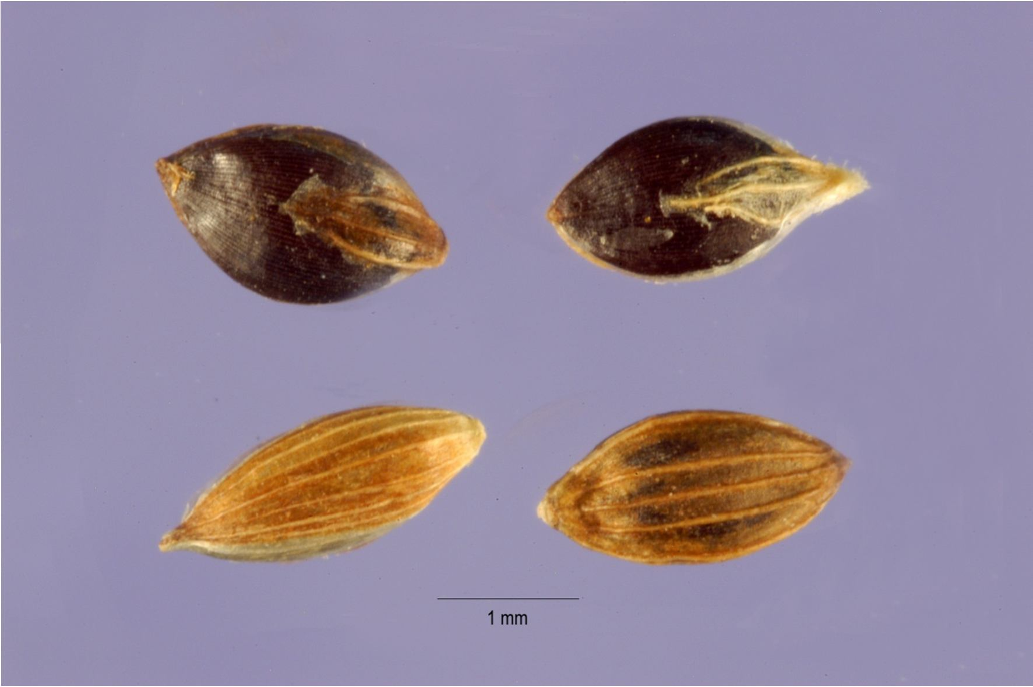

Plate 1.1: Photograph of Digitaria iburua grain (American Association of Cereal Chemist).

Fonio is one of the world’s best tasting and most nutritious cereal grains. Its seed has a high protein content of about 8.7 % with some black fonio samples having up to 11.8 %. Fonio is rich in methionine, cystine and other amino acids vital for human health but which are deficient in the major cereals of today: wheat, rice, maize, sorghum, barley and rye (National Research Council, 1996). Fonio has an attractive flavour and expands well when cooked.

Economic use of fonio
It is used as a source of meals, malting and brewing.

Statement of Research Problem
The rising cost of pharmaceutical dosage form (tablets) may be due to high cost of excipients that forms 70 – 80 % of medicines (York, 1992). Thus, in January 2005; the

Africa Union (AU) commission at the Abuja summit mandated scientists to explore local production of generic medicines in Africa. Local production will make raw materials readily available, save foreign exchange, create jobs, facilitate technology transfer and stimulate exportation.
Starch is widely used as a pharmaceutical excipient. Thus, it becomes expedient to source locally for affordable starch and ensure that it is of excellent pharmaceutical grade.

Research Hypotheses
There is no significant difference between starches extracted from Digitaria iburua and the conventional maize starch. Microcrystalline starch from Digitaria iburua is not directly compressible. The binder and disintegrant properties of Digitaria iburua are not different from maize starch B.P.

Aim and Objective of the Study
The aim of this research work was to investigate the binding, disintegrant and compressional properties of native and modified starches derived from Digitaria iburua in tableting.

Scope of the Study

- Collection and identification of Digitaria iburua grains.

- Extraction of starch from Digitaria iburua using the wet method and determination of percentage yield.
- Production of microcrystalline starch by acid hydrolysis and investigation of physicochemical properties of the modified starch.
- Physicochemical characterization of native and microcrystalline starches.
- Formulation of batches of metronidazole granules by the wet granulation method of massing and screening while using the starch extracted as binder and

disintegrant to compare with gelatin and maize starch as standard binder and disintegrant respectively.
- Compression of granules to tablets after addition of extra granular excipients.

- Carry out quality control tests on the tablets.

- Study the compressional properties of the starches by employing Heckel equation.

Justification of the Study
There is an increasing demand for starch as a pharmaceutical excipient despite huge amount of work and progress achieved in the pharmaceutical industries in formulation of solid dosage forms. The Federal Government`s policy places emphasis on the use of local raw materials in manufacturing which will conserve foreign exchange and also lead to self-reliance from importation.
In consideration of the above, it is pertinent to develop starch obtained from Digitaria iburua as a pharmaceutical excipient because literature revealed that little or no work has been done on it.

CHAPTER TWO

LITERATURE REVIEW

Tablets
Solid dosage forms encompass the largest category of dosage forms that are clinically used (David, 2008). Two types of formulation, namely tablets and capsules constitute solid dosage forms. Tablets and capsules constitute about 90 % of all dosage forms used to provide systemic administration of active pharmaceutical ingredients (API). (Rudnic and Kottke, 1999).
In the European Pharmacopoeia (1997), tablets are defined as “Solid preparations each containing a single dose of one or more active ingredients and obtained by compressing uniform volumes of particles. Tablets are intended for oral administration. Some are swallowed whole, some after being chewed, some are dissolved or dispersed in water before being administered and some are retained in the mouth, where the API is liberated”.

Tablet types
There are several types of tablet solid dosage forms that are designed to optimize the absorption rate of the drug, increase the ease of administration by the patient, control the rate and site of drug absorption and mask the taste of API.
Examples of tablet types available include (David, 2008):

- Conventional compressed tablets;

- Multiple compressed tablets;

- Enteric-coated tablets;

- Sugar-coated tablets;

- Film-coated tablets;

- Chewable tablets;

- Effervescent tablets;

- Buccal and sublingual tablets; and

- Vaginal tablets.

Conventional compressed tablets
Designed to provide rapid disintegration and drug release, and represent a significant proportion of tablets clinically used. The manufacture of these tablets involves the compression of granules or powders (both containing API) into the desired shape. The tablets after ingestion will disintegrate within the stomach, allowing the drug to dissolve in the gastric fluid and ultimately, be absorbed systematically (David, 2008).

Multiple compressed tablets
These tablets consist of at least two layers. Two designs of multiple compressed tablets exist (David, 2008):
(1) multiple-layered; and (2) compression coated.

In the former design, the first layer is formed by a relatively light compression of the API containing powder mix/granules. The next layer is then formed by compression of the powder/granule mix (containing API) on top of the lightly compressed first layer. Extra layers are formed in a similar fashion. In the second approach the initial layer is prepared by light compression, removed and located in a second tablet press. Granules/powders of the second coat are fed into the press and allowed to form a constant mass around the surface and edges of the pressed tablet prior to compression to form the finished product. The complexity of the manufacturing process is dramatically increased where tablets containing more than two layers are prepared.

Enteric-coated tablets
These are tablets that are coated with a polymer that does not dissolve under acidic conditions (i.e. stomach) but does dissolve under the more alkaline conditions of the small intestine (i.e. pH > 4). Enteric polymers are used as coatings of conventional tablet dosage forms and by inhibiting the dissolution of the therapeutic agent within the stomach, offer protection against possible drug degradation (e.g. erythromycin) or irritation of the gastric mucosa (e.g. non-steroidal anti-inflammatory drugs). The tablet will disintegrate following dissolution of the coating, and then the drug will dissolve in the gastric fluids (thereby facilitating absorption).
Examples of polymers used include (David, 2008):

- hydroxypropylmethyl cellulose succinate; and

- methacrylic acid co-polymers (Eudragit).

Sugar-coated tablets
Conventional tablets are usually coated with a concentrated sugar solution to improve the appearance of the formulation and/or to mask bitter taste of the API. Due to the advent of film-coated tablets, the use of sugar-coatings has dramatically decreased. Film coated tablets have improved mechanical properties (David, 2008).

Film-coated tablets
These are usually coated with a polymer or a mixture of polymers (and, when required, a plasticizer to render the coating flexible). Film coatings are generally less elegant than sugar coatings. Examples of polymers that are used to film-coat tablets (and which dissolve in the stomach to enable tablet disintegration and drug dissolution) include (David, 2008):
- hydroxypropylmethyl cellulose

- hydroxypropyl cellulose

- Eudragit E100 (a co-polymer of butylmethacrylate, 2 – dimethylaminoethylemethacrylate and methyl methacrylate, 1:2:1).
Other than improving the appearance of conventional tablets, film coatings are used to control the rate and duration of drug release or to target drug release to certain regions of the gastrointestinal tract. Drug release occurs by diffusion through the insoluble coating and subsequent partitioning into the gastrointestinal fluids.

Chewable tablets
Just like the name, these tablets are chewed in the buccal cavity and thus mechanically disintegrate in the mouth. Dissolution however occurs in the stomach or intestine (Aulton, 2002). The main applications for this dosage form are:
- For administration to children and adults who have difficulty in swallowing conventional tablets.
- Antacid formulations in which the size of the tablet is normally large and the neutralization efficacy of the tablet is related to particle size within the stomach.
- Chewable tablets are not conventionally used if the drug has issues regarding taste acceptability (David, 2008).

Effervescent tablets
These tablets are dropped in an aqueous solution where they will rapidly disintegrate and produce either a suspension or an aqueous solution (David, 2008).
Disintegration of the tablets occurs due to a chemical interaction between two components: (1) an organic acid (e.g. citric acid); and (2) sodium bicarbonate in the presence of water. Carbon dioxide is liberated from this tablet in tablet disintegration (Aulton, 2002).

The main advantage of the use of effervescent tablets is the production of a dosage from which the therapeutic agent is more rapidly absorbed than from alternative solid dosage forms.
The main advantages are the possible (un)availability of water and the need to package these tablets in moisture impermeable packaging (typically aluminum foil), to inhibit the interaction between the acid and sodium bicarbonate due to the presence of environmental moisture.

Sublingual and Buccal tablets
Buccal and sublingual tablets are used for drug release in the mouth followed by systemic uptake of the drug (David, 2008). These tablets are employed to achieve either rapid absorption in the systemic circulation or alternatively, to enable systemic drug absorption in situations where oral drug delivery is inappropriate, e.g. nausea.
Drug absorption across the buccal mucosa avoids first-pass liver metabolism. Sublingual tablets are placed under the tongue and buccal tablets are placed in the side of the cheek.
Sublingual and buccal tablets are often small and porous. Buccal tablets facilitate faster disintegration and drug release.

Vaginal tablets
They are ovoid-shaped and inserted into the vagina (with the aid of a special inserter). Following insertion, retention and slow dissolution of the tablet occur, thus releasing the API to provide the local pharmacological effect. Systemic absorption of API can also be achieved. In a similar fashion to buccal/sublingual tablets, it is important that absorption, and not disintegration of the tablet occurs in vivo, as disintegration will reduce tablet retention within the vagina (David, 2008).

The different types of solid dosage forms (tablets) are designed to provide flexible platforms for the delivery of therapeutic agents to the gastrointestinal tract.
Coating tablets with polymers offers opportunities for the release of the therapeutic agent at particular regions within the gastrointestinal tract, e.g. the small intestine, colon.
Absorption of poorly soluble drugs is greatly enhanced with effervescent tablets.

Quality Attributes of Tablets
According to Aulton (2002), the quality attributes a tablet must fulfill can be summarized as follows:
- The tablet should include the correct dose of the drug.

- The appearance of the tablet should be elegant and its weight, size and appearance should be consistent.
- The drug should be released from the tablet in a controlled and reproducible way.
- The tablet should be biocompatible, i.e. not include excipients, contaminants and microorganisms that could cause harm to patients.
- The tablet should be of sufficient mechanical strength to withstand fracture and erosion during handling.
- The tablet should be chemically, physically and microbiologically stable during the shelf-life of the product.
- The tablet should be formulated into a product acceptable by the patient.

- The tablet should be packed in a safe manner.

Manufacture of tablets
There are four main methods by which tablets may be manufactured (David,

2008):

- wet granulation;

- dry granulation (slugging);

- direct compression; and

- roller compaction

The choice of manufacturing process employed is dependent on several factors, including the compression properties of the API, the particle size of the API and excipients and the chemical stability of the API during the manufacturing process.
The manufacturing of tablets may be considered to consist of a series of steps:

  - mixing of the API with the excipients;

  - granulation of the mixed powders (this is not performed in direct compression);

  - mixing of the granules or powders with other excipients (most notably lubricants);
  - Compression into tablets.

Depending on the manufacturing method used, the details of these steps will vary.

Manufacture of tablets by wet granulation.
Wet granulation is a unit operation in which mixed powders is simultaneously mixed with a suitable fluid; e.g. water, isopropanol or ethanol or mixtures thereof. To achieve cohesion, a binder is required. Powder mixing, in conjunction with the cohesive properties of a binder enables the formation of granules.
A stepwise summary of the manufacturing steps used in the manufacture of tablets by the wet granulation method is described below (David, 2008).

Step 1: Mixing of the therapeutic agent with the powdered excipients (excluding the lubricant).
The API is mixed with other excipients. The mixing speed and time must be sufficient to ensure that a homogenous mixture is produced. The efficiency of mixing is enhanced by the use of powders that have similar average particle size/distribution, although this is often not the case with many mixing operators.
Examples of mixers that are used within the pharmaceutical industry include: (1) planetary bowl mixer; (2) Rotating drum mixer; (3) high-speed mixers; (4) Ribbon/trough mixers.
Step 2: Wet granulation of the powder mix.

Granulation is a unit operation in which mixed powders are aggregated into and retained as larger particles. Under ideal conditions, the chemical composition of the granules should be homogenous. There are several advantages for the use of granules in tabletting as follows:
- Prevention of segregation of powder components during the tabletting process or during storage.
- Enhancement of the flow properties

- Enhancement of the compaction properties

- Lower incidence of dust production.

Step 3: Processing granules into tablets.

Following the production of granules, further unit operations are required for the successful production of tablets. There are as follows:
  - Drying of granules. This is achieved using several types of drier including: the shelf or tray drier, the fluidized-bed drier.
  - Milling of the granules (reduction in the granules size)

  - Mixing of the granules with lubricant. The penultimate stage in the manufacture of tablets using wet granulation involves a final mixing of the dried granules with the lubricant.
  - Compression of the formulation into tablets.

Advantages and disadvantages of wet granulation
There are several advantages and disadvantages associated with this technique (David, 2008).

Advantages

        - Reduced segregation of formulation components during storage and/or processing, leading to reduced intra-and inter batch variability.
        - Tablets containing low concentrations of API can be manufactured using this technique.
        - Employs conventional excipients and therefore is not dependent on the inclusion of special grades of excipient.
        - Most manufacturing plants are built around wet granulation tablet manufacture.

        - Tablets produced by wet granulation are amenable to post-processing unit operations, e.g. tablet-coating technique.

Disadvantages

        - Several processing steps are required

        - Solvents are required which leads to a number of concerns, e.g.

          - Drug degradation may occur in the presence of the solvent

          - Drug may be soluble in the granulation fluid

          - Heat is required to remove the solvent which may result in the degradation of thermolabile API.

Manufacture of tablets by dry granulation
Dry granulation is similar to wet granulation. In any dry granulation no solvent is required; the aggregation of particles into granules is facilitated by the application of high stresses to the mixed powders. There are two methods by which dry granules are formulated (David, 2008):
- Slugging; and (2) roller compaction

Slugging
In this method, the powders are mixed and then compressed into oversized tablet or slugs using heavy duty tablet press. Following this the tablet is milled to produce granules of the required size.

Roller compaction
In this technique, the formulation ingredients are mixed and are then compressed using a roller compactor. In this the powders are fed from hopper on to a moving belt and then transported to, and compressed by the passage between the narrow gap between two (oppositely) rotating rollers to produce a sheet of compressed material. The compressed sheet is then milled to produce granules of the required size (Tousey, 2002).

Stages in dry granulation
The aggregation of particles is facilitated by the application of high compression stresses. In dry granulation particle- particle interactions occur due to:
(1) Electrostatic forces; (2) Van der Waals interactions; and (3) melting of components within the powder mix (David, 2008).

Advantages and disadvantages of dry granulation
The popularity of dry granulation for tableting has decreased in recent years, having been superseded by direct compression. However, both slugging and roller compaction are still employed in formulation. There are several advantages and disadvantages associated with dry granulation (David, 2008).

Advantages

        - Both methods of granulation require conventional grades of excipients

        - Both methods are not generally associated with alterations in drug morphology during processing.
        - No heat or solvent are required

Disadvantages

        - Specialist equipment is required for granulation by roller compaction

        - Segregation of components may occur post mixing

        - There may be issue regarding powder flow

        - Tablets produced by dry granulation tend to be softer than those produced by wet granulation, rendering them more difficult to process using post-tableting techniques, e.g. film coating.
        - Both method lead to the generation of dust. Therefore, containment measures are required. Furthermore, there may be a reduction in the yield of tablet.

Manufacture of tablets by direct compression.
Direct compression is of interest to the pharmaceutical industry for the manufacture of tablets due to the low number of processing steps and the absence of liquid (David, 2008).

Stages in the manufacture of tablets by direct compression.

A summary of the various steps used in the manufacture of tablets by direct compression is described below (David, 2008):
      - Pre-milling of formulation components;

      - Mixing of the API with the powdered excipients (including lubricant);

      - Compression of the mixed powders into tablets.

Advantages and disadvantages of tablet manufactured by direct compression.
The advantages and disadvantages of direct compression are detailed below (David, 2008):

Advantages

- Fewer processing steps/unit operations are involved and this method is potentially more cost-effective than other methods.
- Does not require the use of water or other solvents. Thus, negates potential problems regarding the stability of therapeutic agents in the presence of the solvent. In addition, heating is not required in direct compression.
- Lubrication is performed in the same vessel as powder mixing, thereby reducing both transfer losses and contamination of equipment.

Disadvantages

- Specialized and more expensive excipients are required.

- The quality of the final dosage form is dependent on the powders being easily mixed and remaining homogenously mixed. Segregation of the mixed components is minimized by ensuring that the excipients and the dosage forms exhibit similar morphologies, densities and particle size/distribution properties.

- The final tablets produced by direct compression tend to be softer than those produced by wet granulation, rendering them more difficult to process using post- tableting techniques, e.g. film coating.
- There may be issues regarding powder flow into the tableting machine.

- Direct compression is not used if a colourant is required in the formulation due to the mottled appearance of the resulting dosage form.
- If the loading of the API in the final formulation is high (> 10 % w/w), the compression properties of the powder mix are significantly affected by the compression of the API. In some cases the physical properties of the chosen drug may be inappropriate for compression using this technique.

Advancements in the manufacture of tablets
Olayemi (2008), described the advancement in tableting as detailed below:

- Steam granulation – A modification of wet granulation. Steam instead of water in used as a binder.
- Melt granulation/Thermoplastic granulation – The bind which is in solid state at room temperature melts in the temperature range of 50 – 80 ⁰C. Dried granules are obtained by cooling to room temperature; hence the need for a drying phase is not required.
- Moisture Activated Dry Granulation (MADG) – It involves moisture distribution and agglomeration. Tablets prepared using MADG technique has better content uniformity. MADG utilizes very little granulation fluid.
- Moist Granulation Techniques (MGT) – A little quantity of granulation fluid are added to activate dry binder and to facilitate agglomeration. Then a moisture absorbing material like microcrystalline cellulose (MCC) is added to absorb any excess moisture.

- Thermal Adhesion Granulation Process (TAGP) – This technique is performed under low moisture content or low content of pharmaceutically acceptable solvent by subjecting a mixture containing excipients to heating at a temperature in the range of about 30 to 130 ⁰C in a closed system under mixing by tumble rotation until the formation of granules. This method utilizes less water or solvent than the traditional wet granulation method.
- Foam granulation – here liquid binders are added as aqueous foam.

Stages in tablet compression
Powder compression is defined as the reduction in volume of a powder owing to the application of a force (Aulton, 2002).
The process of tableting can be divided into three stages.

- Die filling – This is achieved by gravitational flow of the powder form a hopper via the die table into the die. The die is closed at its lower end by the lower punch.
- Tablet formation – The upper punch descends and enters the die and the powder is compressed until a tablet is formed. During this phase, the lower punch can be stationary or can move upwards in the die. After maximum applied force is reached, the upper punch leaves the powder.
- Tablet ejection – The lower punch rises until its tip reaches the level of the top of the die, in this phase. The tablet in subsequently removed from the die and die table by a pushing device.

Stages in tablet compaction
Bonds are formed between particles which provides coherency to the powder (compact) due to increased proximity of particle surfaces accomplished during compression.
Compaction is defined as the formation of a porous specimen of defined geometry by powder compression (Aulton, 2002).

Sequence of events in compaction of powders
Granules enhance compactibility of tableting materials due to their porosity and the presence of inter and intra-granular pores. According to Muazu (2008), a sequence of events occurs during compaction in tableting:
(1) transition or particles rearrangement; (2) deformation at the point of contact; (3) fragmentation; (4) bonding; (5) deformation of solid body; (6) decompression; and (7) ejection of tablet.
Compaction of powder follows this sequence as detailed below (Muazu, 2008).

Transition or particle rearrangement

Particles get rearranged under pressure such that smaller ones fill the space created by larger particles. As a result, a closer packing and a decrease in relative volume is obtained, thereby increasing the density of the powder bed. The shape of the particle influences such a rearrangement.

Deformation at the point of contact

Increase in the applied pressure results in deformation of particles at the point of contact. The type of deformation that occurs depends on the nature of particle being compressed. The deformation can either be elastic or plastic in nature.

Fragmentation

This is the breaking of the particles into smaller parts especially bigger granules. When the applied pressure is high, particles crack and the new cracks expose fresh surfaces which yield potential bonding areas.

Bonding

This is the permanent attachment of particles to each other resulting from close proximity; the closer the distance between the two particles the higher the attachment.

Deformation of solid body

Bonded solids consolidate as applied pressure increases. Deformation can either be elastic or plastic; the ability of formulated powder to form a satisfactory tablet depends on its plastic deformation during compression and elastic recovery during ejection (decompression).

Decompression

This is a series of events that occur after applied pressure is removed from the upper punch. The residual pressure confines the tablet as the upper punch is removed from the die cavity. The ability to produce an intact tablet depends on the pressure exerted by elastic rebound and the associated deformation process during decompression or ejection.

Ejection

Compressed tablets are removed from the die as the lower punch rises and pushes the tablet upward. The tablet undergoes plastic recovery with an increase in volume of that portion of the tablet removed from the die as lateral pressure is removed.

Models describing compression of powders

Heckel equation
Heckel equation is one of the most widely used equations for describing the compression properties of powders (Odeku, 2005; Oladapo et al, 2006; Ravindra et al, 2006; Ohwoavworhua, 2007).
The Heckel plot is used to classify the compaction behaviour of materials. The plot usually has a linear part, but it is curved at the low and high pressure ends. The Heckel plot relates the density of the compact to the applied pressure. According to the Heckel equation, powder compression follows first – order kinetics, where the pores are the reactant and the densification of the product. Based on this assumption, the Heckel equation can be rendered as:
1
𝑙_{𝑛} (1 − 𝐷) = 𝐾𝑃 + 𝐴 … … … … … … … … . (1)
Where D is the relative density and (1 – D) denotes the pore fraction or tablet porosity; P the applied pressure, K the slope of the straight linear portion of the plot which is suggested to reflect the deformation of particles during compression. The reciprocal of K is the yield pressure (P_{Y}). A is a constant is the intercept of the prolonged linear portion of the plot with the y axis. It reflects particle rearrangement and fragmentation.
Alderborn (2002), defined the yield pressure as the stress at which plastic deformation of the particles is initiated which can be derived from the linear part of the Heckel plot. The non-linear parts of the curve has an initial curvature at low pressure which reflects particle fragmentation and rearrangement, while the deviation from a straight line at higher pressure may be as a result of capping and lamination of the powder.

The Heckel plot and the derived parameters are very sensitive to variations in the experimental conditions, such as the maximum compression pressure applied (Sonnergaard, 1999).

The Kawakita equation
Kawakita and Ludde, 1971 described the relationship between the compression pressure and the relative volume reduction as expressed by the equation:

𝑃 = 1
+ 𝑃 … … … … … … … … … … . . (2)

𝐶 𝑎𝑏 𝑎
Where C is the degree of reduction in volume (i.e., the ratio between the change in volume, which is the difference in the initial volume (V_{O}) and the volume at applied pressure (V), and the initial volume). Particular attention has to be paid to the determination of the initial volume of the powder to prevent deviation from the equation.

𝐶 =
𝑉₀₋𝑉

𝑉₀
… … … … … … … … … … … … … … (3)

P is the applied compression pressure, (a) and (b) are constants characterizing the compression behaviour of the powder.
The linear relationship P/C and P makes it possible to derive values for the constants (a) and (b) by linear regression. The compression parameter (a) reflects the total degree of compression at infinite pressure and the reciprocal of the compression parameter (b), 1/b, is considered to provide an indicator of the deformation or failure stress of the particle (Kawakita et al., 1977; Adams and McKeown, 1996; Nicklasson and Alderborn, 2000). Mathematically, 1/b is the pressure needed to compress the powder to one half of the total volume reduction, predicted as (a).

The Kawakita equation is best used for soft and fluffy powders compressed into high porosity powder beds under a low compression pressure (Kawakita and Ludde, 1971; Denny, 2002).
Kawakita equation is used frequently for investigation of pharmaceutical powders. Kawakita equation provides a promising means of assessing the compression mechanics of granules (Alderborn, 2002).

Adams Equation

The Adams equation was derived in order to estimate the fracture strength of single granules from in-die compression data. It models the bed granules in the die as a series of parallel load bearing columns (Adams and Mckeown, 1996). The following equation

was derived:

𝑙𝑛𝑃 = ln

𝑇_{𝑜} [ 𝛼 ]

+ 𝛼 ∈ + ln[1 − 𝑒^{(−𝛼∈)}] (4)

Where P is the applied pressure and E is the natural strain which is given by;

∈= ln[𝐻𝑜/𝐻𝑃] (5)
where H_{o} and H_{P} are the initial and current height of the bed respectively. The quantity T_{o} is the apparent single agglomerate strength which is related to the actual strength by the following expression:
𝛼 = 𝑘₂𝑎 … … … … … … … … … … … … … … … … … … … … … . (6)

where K₂ is a constant.

At higher values of the natural strain, the last term of the Adams equation becomes negligible and can be omitted, leaving a linear function. The intercept and slope of this linear part of the profile were used to calculate compression parameter T_{o}.

Tablet Defects
Some of the major tablet defects include: Pitting, capping and lamination.

Pitting refers to the production of pit marks on the surface of the tablet and is attributed to insufficient lubricant at the tablet/punch interface or punches with a roughened surface. This defect may be corrected by increasing the concentration of lubricant in the formulation or by altering the mixing conditions (time and rate of mixing), whereas punches should be polished regularly to prevent such adhesion.
Capping and lamination refer to mechanical splitting of the tablet. In capping, the top (cap) of the tablet is fractured whereas in lamination the fracture may occur within the main body of the tablet. Capping and lamination occur during the ejection stage of the manufacturing process and are attributed to stress-induced fracture/ alteration in the formulation procedure to increase the length of the tablets may resolve these problems. For example, increase in the compression pressure is known to increase the mechanical strength of tablets, but it should be noted that the application of excessive stresses often results in a reduction in the tablet strength, which may result in capping and lamination.

Post processing alteration on tablet properties
Tablets usually undergo post processing alterations in their physicochemical properties, particularly under defined conditions of humidity and temperature. Storage may affect the mechanical properties of the tablet due to the following processes:
- Adsorption of water on to the tablet surface and within the pores of the tablet leading to dissolution and then crystallization of tablet components, which in turn act as solid bridges and hence increase the powder/powder or granule/granule interaction.
- Adsorption of water on to the tablet surface and within the pores of the tablet may induce crystallization of amorphous excipients or change the polymorphic state of components within the tablet.

Conversely, in the presence of moisture, tablet strength may be decreased due to:

- Disruption of the granule-granule or powder-powder bonds due to dissolution of formulation components.
- Stress relaxation of visco-elastic components. Polymers possess visco-elastic properties and, as such, will undergo relaxation as a function of time following removal of the compression stress. As a result, there is movement/rearrangement of the polymeric chains, which may, in turn, compromise the mechanical properties of the tablet.

Quality standards of tablets
According to the British Pharmacopoeia (B.P. , 1980); to ensure that tablets meet some physical specification that would guarantee the quality of such tablets, appropriate test methods and specification have been developed. Some of these quality tests are official while others are unofficial and have only been added by various manufacturers to ensure that their tablets are of very high quality.

Pharmacopoeial (Official) tests
The B.P. 1993 contains standard test procedures for confirming quality of manufactured tablets. These include;
(i) Uniformity of weight; (ii) uniformity of content of active ingredient; (iii) disintegration test; and (iv) dissolution test.

Uniformity of weight
In order to minimize dose variations in tablets, testing for the uniformity of weight is essential. Tablet weight is adjusted to give the quality of granulation that will contain a unit dose of the mediation, thus any variation in weight will result in dose variation assuming uniform dispersion of the active ingredient in the tablet mix. This test requires

weighing twenty tablets individually and then calculating the average weight. Not more than two of the tablets must differ from the average weight by not more than the percentages stated in the Table below. Coated tablets are exempted from these requirements but must conform to the test for content uniformity if necessary.

Table 2.1: Tablet weight variation requirements (BP, 2002)

Average weight Percentage difference
130 mg or less 10
> 130 mg – 324 mg 7.5
More than 324 mg 5

Uniformity of content of active ingredient

This test ensures that every tablet contains the amount of drug substance intended with little variation among tablets within a batch. Twenty tablets are to be used for this test. The limits of the deviation in content from the stated amount are also given in the B.P. (2002).

Disintegration test
Until recently, the only pharmacopoeial standard test relating to the release of drug from a tablet was a simple tablet disintegration test.
It is generally recognized that in vitro tablet disintegration test does not necessarily bear a relationship with the in vivo action of the solid dosage form. To be absorbed, a drug substance must be in solution and the disintegration test is a measure of the time required, under specified conditions, for a group of tablets to disintegrate into particles.

This procedure is done using the disintegration tester which consists of a basket rack holding six plastic tubes, open at the top with the bottom covered by a ten-mesh screen. The basket is submerged in a bath of suitable liquid held at 37 + 0.5 ⁰C,
preferably in a 1 litre beaker. For compressed uncoated tablets, the testing fluid is usually water at 37 ⁰C. If one or two tablets fail to disintegrate, the test is repeated using 12 tablets. For most uncoated tablets, the BP requires that the tablet disintegrate in 15 minutes (although it varies for some uncoated tablets) while for coated tablets, up to 2 hours may be required (B.P., 1980).

Dissolution test
Dissolution can be defined as a process by which the drug substance in a formulation dissolves into solution (Wong and Collins, 2002).
Since the first publication on the mathematical treatment of dissolution authored by Noyes and Whitney (1897); modeling of dissolution rates from various dosage forms has continued to evolve and has become the research interest of many pharmaceutical scientists. One of the challenges of conducting a dissolution test that is different from many other analytical tests is that dissolution profiles may change significantly upon a slight modification of one of the dissolution parameters. A thorough understanding of the physical process of dissolution has been found to be critical in predicting dissolution rates.
In 1897, Noyes and Whitney developed an equation to describe dissolution rates. Later, Brunner and Tolloczko (1900) incorporated other variables into the Noyes and Whitney equation. The additional parameters included are: surface area, diffusion coefficient, the thickness of the diffusion layer, and the volume of the dissolution medium. This theory has remained the basic principle adopted by most pharmaceutical scientists in describing the phenomenon of dissolution.

Up to the early 1970’s, scientists have developed other dissolution models and started to standardize the instruments used in dissolution testing.
In 1931, Hixson and Crowell developed the “cube root law” of dissolution, which describes the appearance of a solute in solution. The cube root law describes the weight increase of the solute in solution upon its dissolution, instead of considering the rate of change in concentration as the predicted variable. In the pharmaceutical industry and in academia, researchers have attempted to understand the source of variability in dissolution. Instead of assuming the existence of a stagnant layer and a steady state during dissolution, some Scientists incorporated the concepts of continual renewal of the interfacial surface, and the existence of variable diffusion coefficients caused by concentration differences (Dankwerts, 1951; Nedich and Kildsig, 1972).
Meanwhile, the design of dissolution apparatus evolved when different instruments were utilized to study theoretical aspects of dissolution. Generally, the principle and hydrodynamics of a dissolution apparatus can fall into any of these three categories: (i) a beaker-like closed system, (ii) a flow-through open system, and (iii) two separate compartments based on dialysis.
Penarowski et al, 1968 developed the rotating basket dissolution apparatus, and shortly after that, Poole, 1969 invented the paddle dissolution method. These two dissolution designs have then become USP apparatus 1 and USP Apparatus 2, respectively; and are still the most commonly used dissolution instruments.

Non-Pharmacopoeial (non-official) test
A wide range of non-pharmacopoeial tests are conducted on tablets, both as in process control and as part of quality assurance programs.

Uniformity of thickness
In order to reproduce tablets identical in appearance and also to ensure that there are no problems with packaging, uniformity of tablet thickness is expedient. Tablet thickness is measured by the use of a micrometer screw gauge.
The thickness of tablets may vary due to;

- change in compression pressure

- Size segregation within the hopper resulting in weight variation and consequently difference in tablet thickness when the same compression pressure is applied.

Crushing strength
Crushing strength test is also known as hardness test. The resistance of the tablet to chipping, abrasion or breakage under conditions of storage, transportation before usage depends on its hardness. Crushing strength is the compressional force which, when applied diametrically to the tablet just cause it to fracture (Gambo, 2009).
Monsanto (1930), introduced a small portable hardness tester. It measures the force required to break the tablet when the force generated by the coil spring is applied diametrically to the tablet and the force measured in kilogram force. The Strong-Cobb hardness tester was introduced in 1950, and this also measures diametrically applied force required to break the tablet. Pfizer hardness tester also operates on the same mechanical principle as ordinary pliers. The force required to break the tablet is recorded on a dial and may be expressed as either kilograms or pounds of force. One of the applications of crushing strength measurement throughout the production cycle is to detect any need for pressure adjustment. A tablet that is too hard may not disintegrate within the specified time or meet standard dissolution time. If the tablet is too soft, it

will not withstand the handling during subsequent processing such as coating or packaging and shipping operations (Odeku and Itiola, 2006).

Friability
Friability is the measure of the ability of a tablet to withstand abrasion in packaging, handling and shipping. Roche Friabilator is the most common instrument used to measure tablet friability. Tablets are subjected to a standardized level of agitation for a given time, and friability is expressed as percentage loss in weight. Friability values are not calculated especially when capping occurs (Odeku and Itiola, 2006).

Pharmaceutical Excipients
A range of excipient materials are required along with the API in order to give a tablet the desired properties. The choice of excipient required for tableting is dependent on the process employed. Pharmaceutical excipients are substances other than the API which are included in tablet formulation to perform specific functions (Olayemi, 2008). Excipients are usually present in solid dosage forms in levels ranging between 10 % and 99 % of the formulation (Adeyeye, 2001). The role of tableting excipients is to ensure that the tableting operation can run satisfactorily and to ensure that tablets of specified quality are prepared (Aulton, 2002).
Typically, the following excipients are used in the manufacture of conventional tablets: (1) diluents/fillers; (2) binders; (3) disintegrants; (4) lubricants; (5) glidants; and
(6) adsorbents, sweetening agent, flavourants, colourants and surface active agents.

Diluents/fillers
They are employed in the formulation of tablets (by all methods) to increase the mass of the tablets that contain a low concentration of API and thereby render the

manufacturing process more reliable and reproducible. Diluents must possess good compression properties and be inexpensive (David, 2008).
Fillers that fragment easily may be advantageous, since this counteracts the negative effects of lubricant additions to the formula (de Boer et al, 1978). Examples of diluents for tablets are: (1) anhydrous lactose; (2) lactose monohydrate; (3) spray-dried lactose; (4) starch; (5) dibasic calcium phosphate; (6) microcrystalline cellulose (MCC); and (7) mannitol.

Binders
Binders are either added as a solution or as a solid into a powder mix to ensure that granules and tablets can be formed with the required mechanical strength.
Binders are ductile materials that are prone to undergo plastic (irreversible) deformation. A choice of a suitable binder for a tablet formulation requires extensive knowledge of the relative importance of binder properties for enhancing the strength of the tablet and also of the interactions between the various materials constituting a tablet (Mattson, 2000). The properties of commonly used binders are summarized in Table 2.2.

Table 2.2: Examples of binders commonly used in tableting (David, 2008).

Binders Concentration
(% w/v)
General comment

Hydroxypropylmethlcellulose 2 – 5 The required concentration is
dependent on molecular weight (grade) used
Polyvinylpyrollidone 0.5 – 5 The required concentration is
dependent on molecular weight (grade) used.
Hydroxypropyl cellulose 2 – 6 The required concentration is
dependent on molecular weight (grade) used.
Sucrose | 50 – 67 | Added as a syrup produces hard
 |  | tablets whose properties are affected
 |  | by moisture
Microcrystalline cellulose | 20 – 90 | Often used as a binder and diluent
Acacia | 1 – 5 | Produces hard tablets

Disintegrants
Disintegrants are employed in tablet formulations to enhance the breakdown of tablet into granules upon entry into the stomach. The rate of water uptake into the tablet and the disintegration of a tablet will be low if the formulated tablet is hydrophobic and/or it has been manufactured using a high compression force.
Disintegrants are an essential tableting excipient, enabling tablet disintegration to occur within the specifications defined in the various pharmacopoeias (typically disintegration of conventional tablets must occur within 15 minutes).
Several mechanisms by which disintegrants elicit their effect include:

- Disintegrants may increase the porosity and wettability of the compressed tablet matrix. Examples of disintegrants that operate in this fashion include: (1) starch;
(2) MCC; and (3) sodium starch glycolate.

- Disintegrants may operate by swelling in the presence of aqueous fluids, thereby expecting tablet disintegration due to the increase in the internal pressure within the tablet matrix. Examples of excipients that facilitate tablet disintegration by swelling in the pressure of aqueous fluids include:
- sodium starch glycolate

- croscarmellose sodium (a cross-linked sodium carboxymethylcellulose) (usual working range 0.5 – 5.0 % w/w).
- Crospovidone (a cross-linked polyvinylpyrollidone); usual working range 2 – 5 % w/w).
- Pregelatinized starch (usual working concentration of 5 % w/w).

  - Production of gas whenever the tablet contacts aqueous fluids (the mechanism of disintegration of effervescent tablets)
  - Disintegrants may act by destroying binders by enzymatic action (Rudnic and Kottke, 1999).

Lubricants
Lubricants act at the interface between the face of the die and the surface of the tablet thereby reducing friction at this interface during ejection of the tablet from the tablet press. Tablets with a pitted surface are produced where lubrication is inadequate; due to the inability of the tablet surface to detach from the surface of the tablet.
Conversely, addition of lubricants can have negative effects on tablet strength, since the lubricant often reduces the creation of inter-particulate bonds (de Boer et al, 1978).

Lubrication is achieved by mainly two mechanisms: (1) fluid lubrication; and (2) boundary lubrication (Aulton, 2002). In fluid lubrication, a layer of fluid is located between and separates the moving surfaces of the solids from each other thereby reducing friction while in boundary lubrication; sliding surfaces are separated by only a thin film of lubricant.
There are two main categories of lubricants:

(i) Insoluble lubricants: Are added to the final mixing stage prior to tablet compression.

The concentration used is an important consideration in the subsequent disintegration and dissolution of the API from the tablet. High concentration result in reduced disintegration and dissolution. Conversely, insufficient concentration may lead to tableting defects. Examples of insoluble lubricants that are commonly used are shown in Table 2.3:
Table 2.3: Examples of lubricants commonly used in tableting (David, 2008).

Lubricants Concentration (% w/w)
Composition

Magnesium stearate 0.2 – 5.0 Not a pure compound. A mixture of
magnesium salts of a range of fatty acids (stearic and palmitic acid
Stearic acid 1.0 – 3.0 Similar to magnesium stearate. A mixture of stearic and palmitic acids
Glyceryl behenate 1.0 – 3.0 A mixture of glyceryl fatty acid esters
Glyceryl palmitostearate 1.0 – 3.0 A mixture of mono-, di – and
triglycerides of fatty acids containing between 16 and 18 carbon atom

- Soluble lubricants: These are employed to overcome the possible deleterious effects of their insoluble counterparts on the time required for tablet disintegration and hence drug dissolution. Example of soluble lubricants includes:
  - Polyethylene glycol (PEG). PEGs, e.g. PEG 4000, 6000, and 8000 are commonly used. The efficacy as a lubricant is less than that of magnesium stearate.
  - Polyoxyethylene stearates. All members of this group are non-ionic surfactants that may be employed as tablet lubricants within the concentration range of 1.0 – 2.0 % w/w.
  - Lauryl sulphate salts: These salts are anomic surfactants that may be employed as lubricants within the concentration range of 1.0 – 2.0 % w/w. In addition to their action as lubricants, the dissolution of poorly soluble drugs from tablets will be enhanced due to the surface activity of these agents.

Glidants
Enhance the flow properties of the powders by reducing interparticulate friction (Olayemi, 2008). To achieve this effect, it is necessary for the glidant particles to be firstly small and secondly, to be arranged at the surface of the particles/granules. Glidants are hydrophobic substances and therefore care should be taken to ensure that the concentration of glidants used in the formulation does not adversely affect tablet disintegration and drug dissolution. Examples of glidants used in tablet manufacture include: (1) talc; and (2) colloidal-silicon dioxide.

Other excipients used in the formulation of tablets
The successful formulation of tablets may require the incorporation of other classes of excipients, in addition to the principal tableting excipient described previously.

These include: (1) adsorbents; (2) sweetening agents/flavours; (3) colours; and (4) surface-active agents.
Adsorbents are substances that are included in the formulation to prevent the adsorbing of liquid/semisolid constituent in solid components. Examples of these include: (1) magnesium oxide/carbonate; and (2) kaolin/bentonite.
Sweetening agents/flavours (in accordance with other dosage forms) are employed to control the taste and hence the acceptability of tablets. Sweeteners are used to impart a pleasant taste to a pharmaceutical formulation. Examples include: artificial sweeteners such as aspartame and saccharin, cyclamates including mixtures of aspartame and saccharin. The natural sweeteners include sucrose, fructose, glucose, sodium glycolate and other mono-and disaccharides.
Flavourants are agents incorporated into a formulation to give the tablet a more pleasant taste or to mask an unpleasant one, some examples of common flavourants include: cherry, strawberry, grape, cream, vanilla, chocolate, spearmint, and cola, (Amidon et al., 2007).
Colourants are added to tablets to aid identification and patient compliance. In some formulation the drug is coloured and, when manufactured, may result in the tablet exhibiting a speckled, and hence, inelegant appearance. To obviate this problem, an appropriate colourant is included in the tablet formulation. In order to ensure that a colourant is evenly distributed in the formulation, a water-soluble colour is added to the granulation liquid in the wet granulation method of manufacturing tablet. Commonly used colourants include; titanium dioxide, ferric oxide (Amidon et al., 2007).
Surface active agents may be incorporated into tablets to improve the wetting proprieties of hydrophobic tablets and hence increase the rate of tablet disintegration. In addition, surface active agents may increase the aqueous solubility of poorly soluble

drugs in the GIT and as such, the rate of dissolution of the API will increase (David, 2008). One of the most popular choices of surface-active agent for this purpose is Sodium Lauryl sulphate.

CHAPTER THREE

MATERIALS AND METHODS

Materials

Botanical Material
Digitaria iburua grains were obtained from Samaru, Zaria Nigeria.

Chemicals
Metronidazole powder (BDH Chemicals Ltd., Poole-England) Magnesium stearate (BDH chemicals Ltd., Poole-England) Hydrochloric acid (May & Baker, Lagos-Nigeria)
Xylene (May and Baker, Lagos-Nigeria)

Talc powder (BDH chemicals Ltd., Poole-England)

Sodium Hydroxide Pellets (Avondale Laboratories Ltd., Bradbury-England) Iodine Solution (BDH Chemicals Ltd., Poole-England)
Butanol (BDH Chemical Ltd., Poole-England) Petroleum ether (BDH Chemical Ltd., Poole-England) Boric Acid (BDH Chemical Ltd., Poole-England)
Methyl red indicator (BDH Chemical Ltd., Poole-England)

Methodology

    - Collection and Identification of Digitaria iburua grains
Digitaria iburua grains were obtained from a commercial source in Samaru, Zaria- Nigeria. The grains were identified with Voucher No. 1315 by the herbarium unit of Department of Biological Sciences, Ahmadu Bello University, Zaria.

    - Extraction of Starch from Digitaria iburua grains
The grains of Digitaria iburua were cleaned and foreign matter removed. Eight kilogram of the cleaned grains was weighed and then steeped over a specified period in distilled water. The grains were washed thoroughly with distilled water and milled by a milling machine (Philips Cucina HR 1757, Japan). The ground mixture was sieved several times with distilled water and starch recovered using a calico cloth. The starch was treated with 0.1 N NaOH to neutralize the acidity and also separate gluten from the starch. It was then allowed to settle over a period of time and the supernatant decanted leaving the sediment which was centrifuged for 10 min at 2,500 revolutions per min (rpm) (General Laboratory centrifuge– 2, Japan). The starch was obtained by scooping off the upper brown layers. The tightly packed starch was then dried in the oven (Gallenkamp oven BS size 3) at 40 ºC and milled to fine powder using a blender. The starch was then packed in amber-coloured air-tight glassware and stored for further use.

Determination of Percentage Yield of Starch
The percentage yield of starch was calculated as the ratio of the mass of starch obtained to the mass of the grains used as starting material.

Determination of Gelatinization Temperature
The gelatinization temperature was determined by a method described by Mohammed et al., (2009). A 0.2 % w/v starch suspension in 25 mL beaker was prepared. The suspension was heated in a water bath at 40 ºC. The temperature was raised stepwise in 2 ºC increments and samples withdrawn and viewed under a light microscope (Ceti, Belgium) after each rise until the temperature at which granules lost their polarization crosses completely was obtained. This temperature was recorded as the gelatinization temperature.

Production of Microcrystalline Starch (MCS)
The method described by World Intellectual Property Organization (1967) was adopted in the production of microcrystalline starch. A four 200 g suspension of 36 % w/v starch was prepared and 12.5 mL of 6 N HCl added and the reaction was allowed to proceed at 48 ºC. This reaction was allowed to run for 6 h, 12 h, 18 h and 24 h after which samples were withdrawn for processing and examination. Processing of the microcrystalline starch involved vacuum filtration and suspension of the microcrystalline starch in 250 mL water followed by adjustment to pH 6 with NaOH, vacuum filtration with 750 mL water and dehydration with ethanol.

Physicochemical Tests on Digitaria iburua starch (DS) and Microcrystalline Starch (MCS)
    - Determination of Percentage Yield and Organoleptic properties of MCS
The percentage yield of the microcrystalline starch was calculated. Organoleptic properties such as taste, colour, odour and texture at various hydrolysing conditions were determined.

Iodine Test
A 50 mL volume of 2 % w/v starch suspension was prepared. A volume (10 mL) was then measured, boiled and cooled. Two drops of 0.1 N iodine solution was added and shaken. The resulting colour was examined and noted.

pH Determination
Two gram of starch sample was dispersed in 100 mL distilled water and shaken for 5 min. The pH of the supernatant solution was determined using a pH meter.

Determination of Amylose and Amylopectin Content
The method of Song and Jane (2000) was adopted. A starch suspension (0.8 % w/v) was prepared and heated on the water bath stirring continuously at 100 ºC until the starch was fully gelatinized. The insoluble residue was obtained by filtration of the starch suspension and the pH adjusted to 6.3 using a phosphate buffer. The solution was then stirred on the boiling water bath for 2 h to disperse the starch molecules and then 20 % v/v butanol was added while the heating continued at 100 ºC for another 1 h. After cooling at room temperature over a period of 24 h, amylose butyl alcohol complex crystals were formed which was separated by filtration. The amylopectin contained in the supernatant was recovered by adding excess methanol. The amylopectin was dried to get rid of the methanol and the dry weight was determined gravimetrically.

Determination of Ash Content

The ash content was determined from the loss in weight that occurred during igniting at 550 ºC in muffle furnace which is enough to allow all organic matter to burn off without permitting any appreciable decomposition of the ash constituents.

Determination of Moisture Content
A sample (5 g) of the starch was weighed into an evaporating dish and placed in the oven (Gallenkamp oven BS, England) at 105 ºC. The sample was heated continuously until a constant weight was obtained. The moisture content was calculated as a ratio of loss in weight to the initial weight.

Determination of Lipid Content
This was done by the continuous extraction of fat content from the sample using a suitable solvent e.g. petroleum ether (40-60 ºC) in a Soxhlet extractor. The extractible lipid was calculated as:
% 𝐿𝑖𝑝𝑖𝑑 𝑤/𝑤 = 𝑤𝑒𝑖𝑔ℎ𝑡 𝑜𝑓 𝑙𝑖𝑝𝑖𝑑 𝑒𝑥𝑡𝑟𝑎𝑐𝑡𝑒𝑑/𝑤𝑒𝑖𝑔ℎ𝑡 𝑜𝑓𝑑𝑟𝑖𝑒𝑑 𝑠𝑎𝑚𝑝𝑙𝑒 𝑥 100 % − − (3.1)

Where the weight of lipid extracted is given by the loss in weight of thimble content (Soxhlet extractor) after extraction.

Determination of Protein Content (Nitrogen and Crude Protein).

The method as described by AOAC (1980) was adopted in the determination of protein content. Two gram of the starch was weighed into 100 mL Kjedahl flask and 1 g of catalyst (K₂SO₄ + anh CuSO₄) was added to hasten the reaction. The flask was then heated slowly at first until fretting subsided and then more rigorously with occasional rotation of the flask to ensure even digestion and to avoid overheating of content. After a clear solution was obtained, the sample was transferred to a 100 mL volumetric flask and diluted to the mark with distilled water after cooling. 10 mL of the diluted sample was pipetted into Markham semi macro nitrogen still and 10 mLof 40 % NaOH solution added. The sample was distilled liberating NH₃ into 100 mL conical flask containing 10 mL of 40 % Boric acid and 2 drops of methyl red indicator. Distillation continued until the pink colour of the indicator turned green. The control was titrated with 4 % Boric acid with end point indicated by a change from greenish to pink colour. The volume of the acid used for each sample distillate was noted as well as that of blank.
% total N per sample was calculated as:
% 𝑁 = 𝑉1 − 𝑉0 x 𝑀 x 𝐴 x 100 x 100 (3.2)
𝑎 x 1000 x 𝑉d x 1
where Vo is Volume of HCl required for blank, V₁ is Volume of HCl required for 10 ml sample solution, M is Molarity of acid (0.1 M), A is Atomic weight of N₂ (14), 100 is total volume of digest or diluted sample, 100 is % conversion, Vd is Volume of distillate (10), a is amount of sample taken in gram (0.2), 1000 is to convert to litre.
The crude protein was calculated as % crude protein (CP) = 6.25 x N

Note: Protein contains 16 % N₂. This makes the general conversion factor to be 6.25.

Determination of Carbohydrate
The total of protein, moisture content, ash content and lipid content subtracted from 100 gives the carbohydrate, and this is referred to as estimation by difference.

Microscopy
The microscope was calibrated using the eye-piece and stage micrometer. A little quantity of the powder sample was mounted on a slide in glycerol and the photograph of the powder sample was captured using a compound microscope (Fisher, Rochester – New York), at 400 x magnification.

Determination of Moisture Sorption Capacity
2 g starch sample was distributed uniformly on a Petri dish and placed in a desiccator containing distilled water with almost 100 % relative humidity for 5 days after which it was reweighed. The percentage increase in weight was calculated as the moisture sorption capacity.

Determination of Swelling Capacity
The method described by Iwuagwu and Onyekweli (2002) was used in the determination of swelling capacity of the powder. 5 g of the sample was weighed and the tapped volume determined and noted as V_{x}. The powder was then dispersed in 85 mL of water and the volume was made up to 100 mL with more water and allowed to stand for 24 h. The volume of the sediment, V_{v} was estimated. The swelling capacity was calculated as a ratio of the volume of the sediment to the tapped volume:

𝑆. 𝐶 =
V v − − − − − −(3.3)
Vx

Physical Properties of Powdered Starch

    - Particle Size Analysis: Twenty gram of the starch was placed on a nest of sieves containing sieves arranged in descending order (500, 250, 150, 90 and 75 µm) and the shaker vibrated for 15 min. The weight of starch retained or each sieve was taken and percentage cumulative weight oversize was plotted against particle size.
    - Angle of Repose: A plugged glass funnel of orifice diameter 0.8 cm was clamped at a height of 10 cm on a flat laboratory bench. A 20 g starch sample was weighed and placed in the funnel and then allowed to flow freely. The angle of repose was calculated

from the equation:

𝜃 = 𝑇𝑎𝑛⁻¹

2ℎ
( ) (3.4)
𝐷

Where h = height of heap and D is the diameter. It was repeated thrice and the average was calculated.
    - Flow Rate: A 20 g sample of starch was placed in Erweka Flow Tester (GDT, Germany). The time of flow was determined with the aid of a stop clock and the flow rate was determined as the ratio of mass (g) to time (seconds). The mean of three determinations was recorded.
𝐹𝑙𝑜𝑤 𝑅𝑎𝑡𝑒 = W𝑒𝑖𝑔ℎ𝑡 𝑜𝑓 𝑝𝑜𝑤𝑑𝑒𝑟 (𝑔𝑟𝑎𝑚𝑠) /𝑇𝑖𝑚𝑒 𝑜𝑓 𝑓𝑙𝑜𝑤 (𝑠𝑒𝑐𝑜𝑛𝑑𝑠) − − − (3.6)

    - Particle Density: The method described by Odeku et al, (2008) was used. An empty 50 mL pycnometer bottle was weighed (W) and filled with xylene. The filled bottle was weighed (W₁) and the difference between W₁ and W obtained as W₂. A 2 g quantity of the powder was weighed (W₃) and transferred into the bottle. The excess solvent was wiped off and the bottle weighed again (W₄). The particle density, ρ (g/cm³), was then calculated from the equation given below:

ρ = (W2 X W3)
50(W3- W4+ W2+ W)

. (3.7)

where ρ is particle density, W is weight of empty bottle, W₂ is weight of xylene, W₃ is weight of powder and W₄ is weight of bottle plus sample plus xylene.

Bulk and Tapped Densities:

A 50 g starch sample was weighed and poured into a 100 mL glass measuring cylinder. The cylinder was dropped on a wooden platform from a height of 2.5 cm three times at 2 s intervals. The bulk volume was recorded as the volume occupied by the starch. The bulk density was calculated as the ratio of the weight of starch sample to the volume occupied in the cylinder. The cylinder was then tapped uniformly on the wooden platform until the volume occupied by the powder became constant. The tapped density was calculated as the ratio of weight to volume. The values obtained were used in calculating the Carr’s index and Hausner`s ratio using the equations below:
𝐶𝑎𝑟𝑟’𝑠 𝐼𝑛𝑑𝑒𝑥 = 𝑇𝑎𝑝𝑝𝑒𝑑 𝑑𝑒𝑛𝑠𝑖𝑡𝑦– 𝐵𝑢𝑙𝑘 𝑑𝑒𝑛𝑠𝑖𝑡𝑦 / 𝑇𝑎𝑝𝑝𝑒𝑑 𝑑𝑒𝑛𝑠𝑖𝑡𝑦 𝑥 100 % − − (3.7)

𝐻𝑎𝑢𝑠𝑛𝑒𝑟`𝑠 𝑟𝑎𝑡𝑖𝑜 = 𝑇𝑎𝑝𝑝𝑒𝑑 𝑑𝑒𝑛𝑠𝑖𝑡𝑦 / 𝐵𝑢𝑙𝑘 𝑑𝑒𝑛𝑠𝑖𝑡𝑦 − − − −(3.8)

Dilution Potential
A binary mix of the drug and excipient were mixed in the following ratios: 10:90, 20:80, 30:70, 40:60, 50:50, 60:40, 70:30, 80:20 and 90:10. It was then compressed at varying compression loads on the Single Punch Tableting Machine (Type EKO, Erweka – Apparateu – G.m.b.H Heusenstamm, Germany). The crushing strength of each binary mix was determined and recorded.

Granule and Tablet Studies

Preparation of Metronidazole Granules

The tablet formula for studying the binding properties of DS and MCS is given in Table 3.1. The wet granulation method of massing and screening was employed in the preparation of metronidazole granules. The metronidazole powder and maize starch BP (intradisintegrant) were weighed appropriately and dry mixed for 5 min in a mortar with pestle until fine powder was obtained. An appropriate quantity of freshly prepared binder of concentration of 2.5, 5.0, 7.5, 10.0 and 12.5 % w/w was added depending on the batch to produce a moist and cohesive mass. The wet mass was then passed through a 1.7 mm sieve mesh screen and then oven dried at 40 ⁰C for 30 min after which they were re- screened through a 1.6 mm mesh size and further dried for another 30 min. The granules were allowed to cool and stored in an air tight container. The same procedure was repeated for preparation of granules for studying disintegrating properties.

Analysis of metronidazole granules
The granules were subjected to the following tests: sieve analysis, moisture content, angle of repose, bulk and tapped densities, Carr’s index and Hausner`s ratio. The same procedures were used as earlier described for powdered starch in Section 3.4.

Compaction of granules to tablets

The granules were mixed in a Tumble mixer for 5 min with extragranular excipients namely; 2.0 % w/w dried talc, 0.2 % w/w magnesium stearate and 7.8 % w/w maize starch BP. Quantities of the granules (700 mg) from each batch were compressed at 7.0 metric tones using 12.0 mm normal concave- faced punches on a single punch tablet machine (Type Eko Erweka Apparatebau. G. M. B. H Heusentamm, Germany).

Table 3.1: Tablet formula for studying the binding properties of DS and MCS.

Ingredient Percentage

Metronidazole 57.14 % w/w

Maize Starch BP 5.0 % w/w

* Binder (DS/MCS/Gelatin) (2.5, 5.0, 7.5, 10.0, 12.5) % w/v Dried talc 2.0 % w/w
Magnesium stearate 0.2 % w/w

Maize starch B.P. 7.8 % w/w

Lactose Total weight
q.s

700 mg

Table 3.2: Tablet formula for studying the disintegrating properties of DS and MCS

Ingredient Percentage

Metronidazole 57.14 % w/w

Maize Starch (MS) BP 5.0 % w/v

* Disintegrant (DS/MCS/MS) (2.5, 5.0, 7.5, 10.0, 12.5) % w/w Dried talc 2.0 % w/w
Magnesium stearate 0.2 % w/w

Maize starch B.P. 7.8 % w/w

Lactose Total weight
q.s

700 mg

* DS = Digitaria iburua Starch; MCS = Microcrystalline starch, MS = Maize Starch BP

Quality Control Test for Tablets
Quality Control Tests were conducted for all batches of tablets produced after 48 h of tablet production. These tests include:
- Weight uniformity test.

- Thickness and diameter measurement

- Crushing strength test

- Friability test

- Disintegration time test and

- Dissolution test.

Weight Uniformity Test
Twenty tablets from each batch were randomly selected and weighed individually and as a whole using an analytical balance (Mettler Analytical Balance Philip Harris Ltd., England). Their mean weight and standard deviations were determined based on an official method (BP, 2002).

Thickness and Diameter Measurement
The thickness and diameter of five tablets from each batch were measured using a digital caliper. A mean of five determinations was obtained and recorded.

Crushing Strength Test
Five tablets were randomly selected from each batch and the crushing strength was determined using a Monsanto hardness Tester (Monsanto Chemical Corp, USA).

Friability Test
Ten tablets randomly selected from each batch were dusted, weighed and then subjected to abrasion shock in an Erweka Friabilator operated at 25 revolutions per

minute for 4 min. The tablets were then dusted again and reweighed. The percentage loss in weight was determined for each batch of tablets.

Disintegration Time Test
The disintegration time for each batch of tablets was determined in distilled water at 37 + 0.5 ºC using the Erweka distintegration test apparatus (Type ZT3, Erweka
– Apparatebau – G.m.b.H Heusenstamm, Germany). Six tablets were tested and the time taken for each tablet to break into small particles and pass through the mesh was recorded as the disintegration time.

Dissolution Studies
The calibration curve for metronidazole was obtained before dissolution studies. A 0.1 mg of metronidazole was prepared by dissolving 100 mg of metronidazole in 1000 mL of 0.1 N HCl. Serial dilutions were performed to yield solutions of concentration range of 0.3125 – 10 µg/mL. The absorbance of each concentration was taken at 277 nm and plotted against the various concentrations to obtain the calibration curve for metronidazole. The linear regression equation for the graph was resolved from the plot and used to calculate the amount of drug released with time during dissolution studies.
The method of dissolution testing as described in B.P. (2002) was adopted. 1 liter of 0.1 M HCl thermostatically maintained at 37.0 + 0.5 ºC was the medium in
Erweka dissolution rate apparatus. A tablet was placed in the dry basket and the apparatus was set to a rotational speed of 100 rpm. 10 mL sample was taken out at 10 min interval with subsequent replacement with equal volume of buffer solution, withdrawn sample was filtered and 1mL of filtrate diluted to 20 mL. The absorbance of the resulting solution taken at the maximum wavelength of 277 nm was measured. A graph of percentage drug dissolved was plotted against time.

Compressional Property study
Each of the pure powder (DS, MCS and GEL) was used for these studies.

Determination of Particle Density
The sample particle density was determined as described in Section 3.4.4.

Preparation of Compacts

Compacts (500 mg) were produced by compressing powder with the various predetermined pressures (56.625, 84.938, 113.250, 141.563, 169.875, 198.188, 226.500,
254.813, 283.125 and 311.438 MNm⁻²) for 30 s (dwell time) using Carver hydraulic hand press (Model A14, Apex Co. Kent — U.K.).
Before each compression, the 12.5 mm die and the flat-faced punches were lubricated with a 2 % w/v dispersion of magnesium stearate in ethanol. After ejection, the tablets were stored over silica gel in a dessicator for 24 h to allow for elastic recovery and hardening preventing false low yield values (lsah, 2005).

Evaluation of Compression Properties
The dimensions (diameter and thickness) of the compacts were determined using a digital caliper (Z 540-1, USA) to the nearest 0.01 mm. Compact weights were also determined to the nearest 1 mg using Mettler analytical balance. Their relative density
(D) was calculated using the equation:

𝐷 =
W ρ − − − − − −(3.10)
𝑉

Where W = compact’s weight, V= compacts volume and ρ = particle density.

Heckel plot of ln [1 / (1 - D)] versus applied pressure (P) for all formulations were drawn. The mean yield pressure P_{Y}, was determined as the inverse of the slope k.

Statistical Analysis

Statistical analysis was carried out to compare the tableting properties of DS/ MCS/MS at 2.5-12.5 % w/w disintegrant concentration and DS/MCS/GEL at 2.5-12.5
% w/v binder concentration in the formulation of metronidazole tablets using correlation analysis as a statistical tool. Correlations were considered significant at the
0.01 level.

CHAPTER FOUR

RESULTS
The results of preliminary investigation on Digitaria iburua starch (DS) are presented in Table 4.1 below. On examination, DS was odourless, off-white and tasteless with a smooth texture when felt between the fingers. The yield of DS extracted from the Digitaria iburua grains was 62.88 % w/w. The DS gave a black-blue coloration when treated with iodine solution confirming the presence of starch. The gelatinization temperature was 56.0 ºC.
Table 4.1: Preliminary investigation on Digitaria iburua starch. Properties Result

Odour Odourless

Colour Off-White

Taste Tasteless

Texture

Percentage Yield (% w/w) Iodine Test
Gelatinisation temperature
Smooth 62.88
Positive (starch turned blue-black)

56.0 ⁰C

Production of Microcrystalline Starch
The result for the percentage yield and colour of the microcrystalline starch (MCS) is presented in Table 4.2. Digitaria iburua starch was subjected to acid hydrolysis at 48.0 ºC for 6 h, 12 h, 18 h and 24 h. The MCS derived, gave an impressive yield of 87.52 % w/w after 6 h but the yield decreased to 84.14 % w/w after 24 h. The change in yield

decreased as the hydrolyzing time increased. A colour change was noticed at 24 h as the off-white colour turned light brown.

Table 4.2: Percentage Yield and colour of MCS

Hydrolyzing condition | Yield (% w/w) | Colour
48 ºC / 6 h | 87.52 | Off White
48 ºC /12 h | 86.17 | Off white
48 ºC/ 18 h | 86.46 | Off white
48 ºC/24 h | 85.14 | Light brown

  - Amylose – Amylopectin Content Determination for MCS
Table 4.3 shows the various ratios of amylose and amylopectin content of MCS at the various times of hydrolysis. The amylose content decreased as the time of hydrolysis increased while the amylopectin content increased as the time of hydrolysis increased.

Table 4.3: Determination of Amylose – Amylopectin Content for MCS

Time of Hydrolysis (h) | Amylose (% w/w) | Amylopectin (% w/w)
0 | 78.125 | 21.875
6 | 67.625 | 32.375
12 | 66.500 | 33.500
18 | 53.125 | 46.875
24 | 51.250 | 48.750

Physicochemical Properties
The results for the flow properties and angle of repose are presented in Table 4.4.

The angle of repose obtained for DS (47.5º) and MCS at 24 h (46.3º) indicate that both starches possess poor flow properties. The bulk and tapped density values are also presented in Table 4.4. The values ranked in the following order; MCS>MS>DS. The Carr`s index and Hausner`s ratio were computed from the figures obtained for bulk and tapped densities. Powder having a Carr`s index above 28 % and a Hausner`s ratio greater than 1.2 possess poor compressibility profile. The true density of DS (1.43) is less than MS and MCS at 24 h (1.47). The powder porosity ranged form 60.45-72.03 %. The values obtained for swelling power rank in this order; MS>MCS>DS. The moisture sorption capacity values rank in the following order; MCS>DS>MS. The mean particle size values rank in the following order; MS>DS>MCS. The pH values for DS and MCS indicate those pHs are close to neutral.

Table 4.4: Physicochemical Parameters of DS and MCS compared with MS.

Physicochemical Properties
Maize starch DS
Microcrystalline Starch 6 h 12 h 18 h 24 h

BP
Flow rate (g/sec) | 0.93 | 0.96 | 0.97 | 1.01 | 1.13 | 0.97
Angle of Repose (º) | 43.69 | 47.50 | 46.36 | 49.27 | 48.90 | 46.30
Carr’s Index (%) | 30.26 | 41.18 | 32.05 | 31.16 | 31.64 | 32.05
True Density (g/ml) | 1.47 | 1.43 | 1.47 | 1.34 | 1.47 | 1.47
Bulk Density (g/ml) | 0.53 | 0.40 | 0.53 | 0.53 | 0.54 | 0.53
Tapped density (g/ml) | 0.74 | 0.68 | 0.78 | 0.77 | 0.79 | 0.78
Relative density | 0.64 | 0.72 | 0.64 | 0.60 | 0.63 | 0.64
Porosity (%) | 63.94 | 72.03 | 63.94 | 60.45 | 63.27 | 63.94
Hausner`s Ratio | 1.43 | 1.70 | 1.47 | 1.45 | 1.46 | 1.47
Swelling power (%) | 12.73 | 8.50 | 9.58 | 9.60 | 9.68 | 9.81
Moisture Sorption  Capacity (%) | 19.50 | 24.50 | 25.00 | 25.00 | 25.50 | 27.00
Moisture Content (%) | 5.60 | 3.20 | 5.80 | 7.60 | 7.80 | 8.00
Mean Particle Size (µm) | 12.73 | 10.50 | 9.58 | 9.60 | 9.68 | 9.61
pH | 6.50 | 6.46 | 6.36 | 6.30 | 6.28 | 6.05
Ash content (%) | 4.10 | 1.40 | 1.38 | 1.26 | 1.08 | 1.02
Lipid content (%) | 13.00 | 4.47 | 4.36 | 4.15 | 4.06 | 3.99
Protein content (%) | 14.00 | 6.13 | 4.30 | 4.30 | 4.15 | 4.02
Carbohydrate content (%) | 63.30 | 86.02 | 84.12 | 82.69 | 82.91 | 82.97

Microscopy
Plates 4.1, 4.2 and 4.3 showed photomicrographs of the DS, MCS and MS respectively when viewed under the microscope at 400 x magnification. On examination, DS and MCS appeared to be spherical in shape with a mean particle size range of 9.58-9.61 µm for MCS and 10.5 µm for DS.

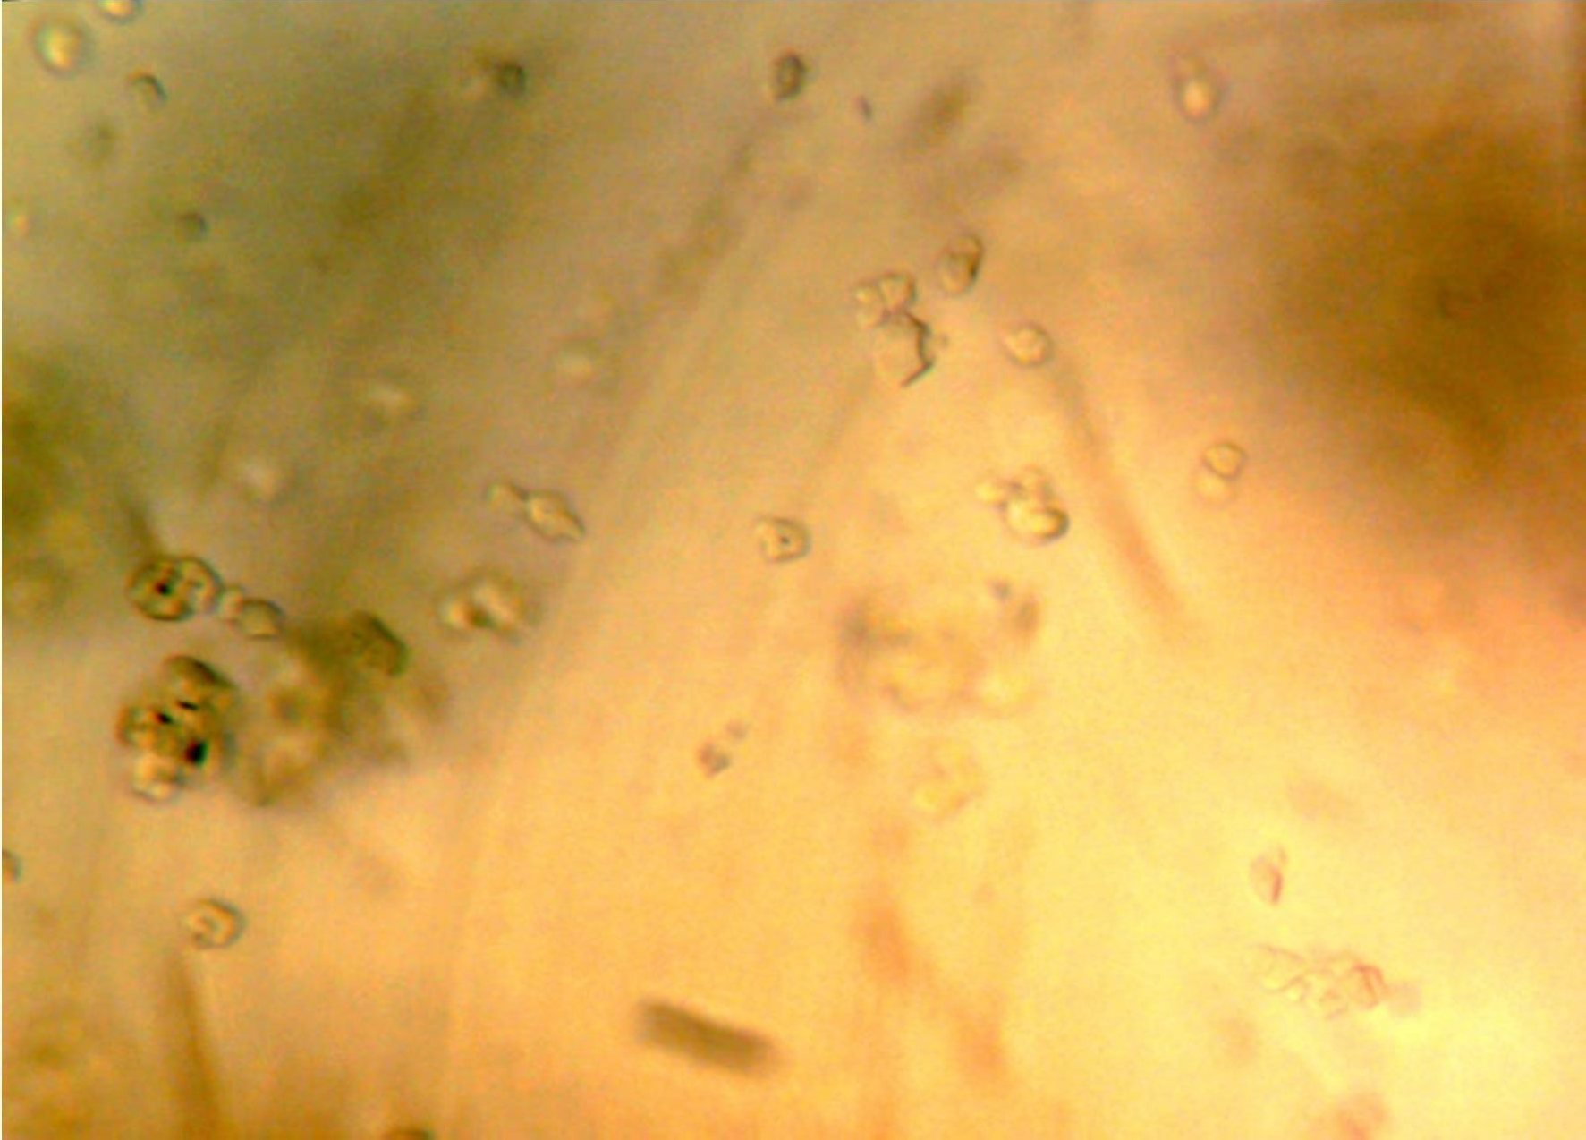

Plate 4.1: Photomicrograph of Digitaria iburua starch (Mag. X 400) (Fisher, Rochester – New York).

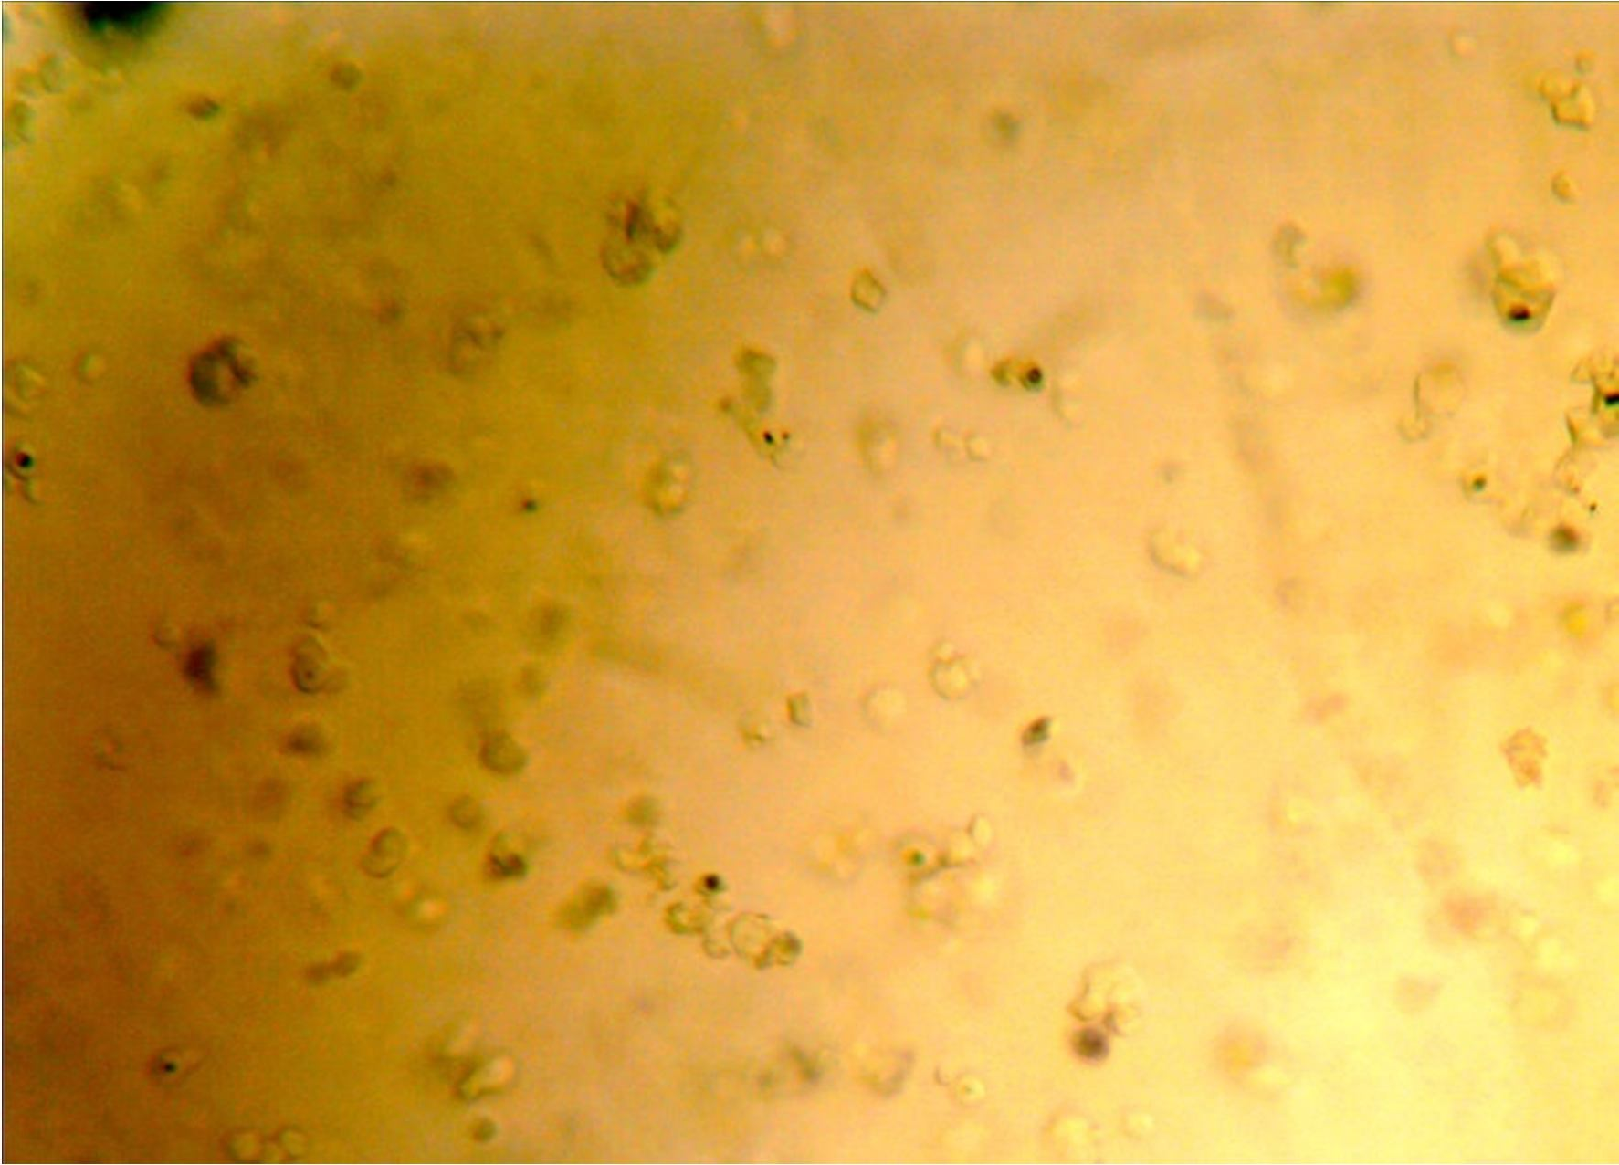

Plate 4.2: Photomicrograph of Digitaria iburua Microcrystalline Starch (Mag. X 400) (Fisher, Rochester – New York).

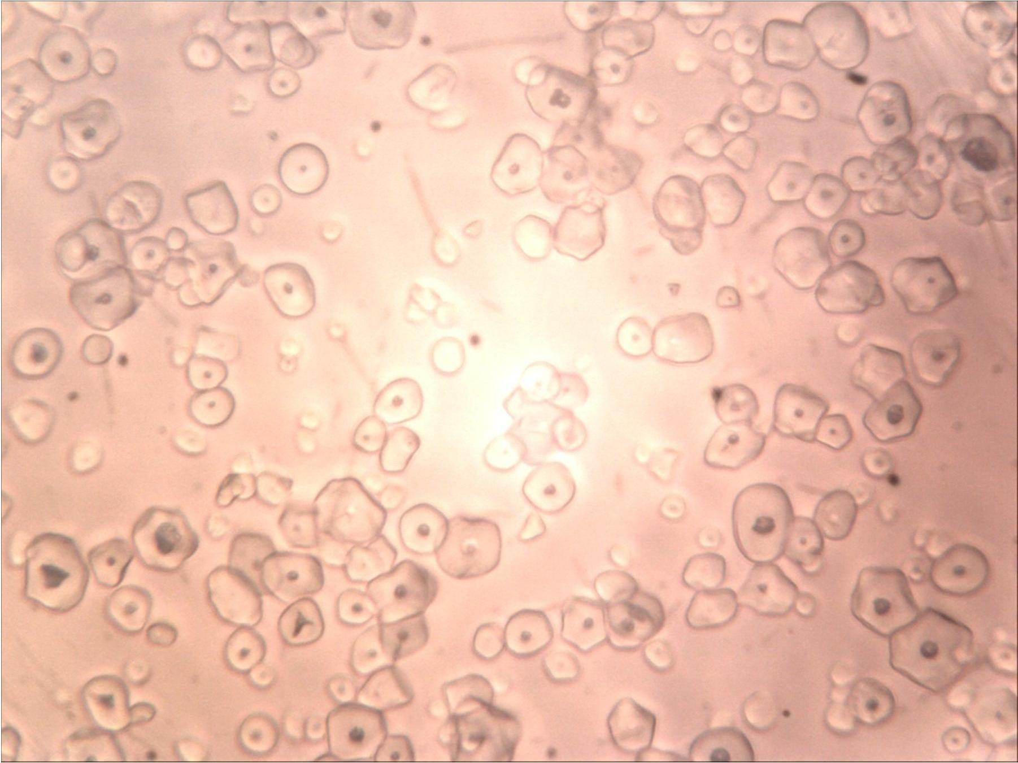

Plate 4.3: Photomicrograph of Maize Starch BP (Mag. X 400) (Fisher, Rochester – New York).

Particle size analysis
Figure 4.1 and 4.2 shows the graphs of percentage frequency against the particle size and cumulative frequency undersize against the particle size respectively for DS and MCS. The result showed that particle sizes range from 2.0-18.0 µm for MCS and 2.0-22 µm for DS.

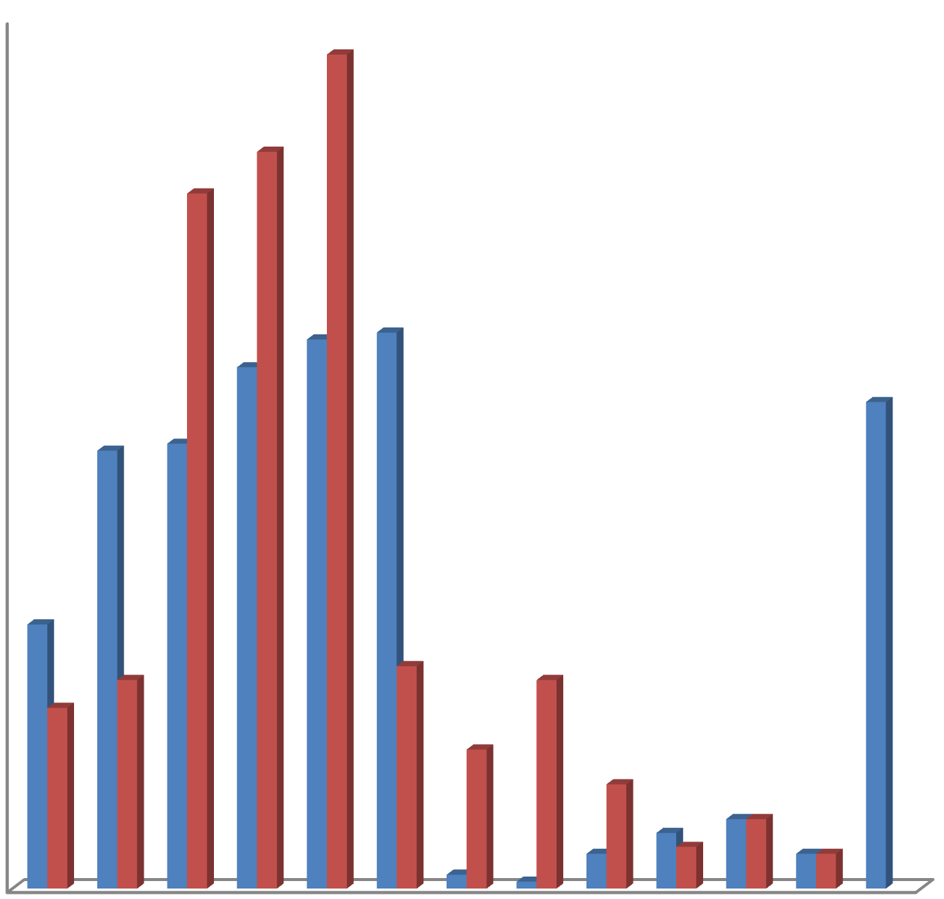
25

20

15
Percentage frequency (%)

DS
10 MCS

5

0
2 3 4 5 6 7 8 9 12 14 15 18 22
Particle size (µm)

Figure 4.1: Graph of Percentage frequency (%) against particle size (µm) for DS
and MCS.

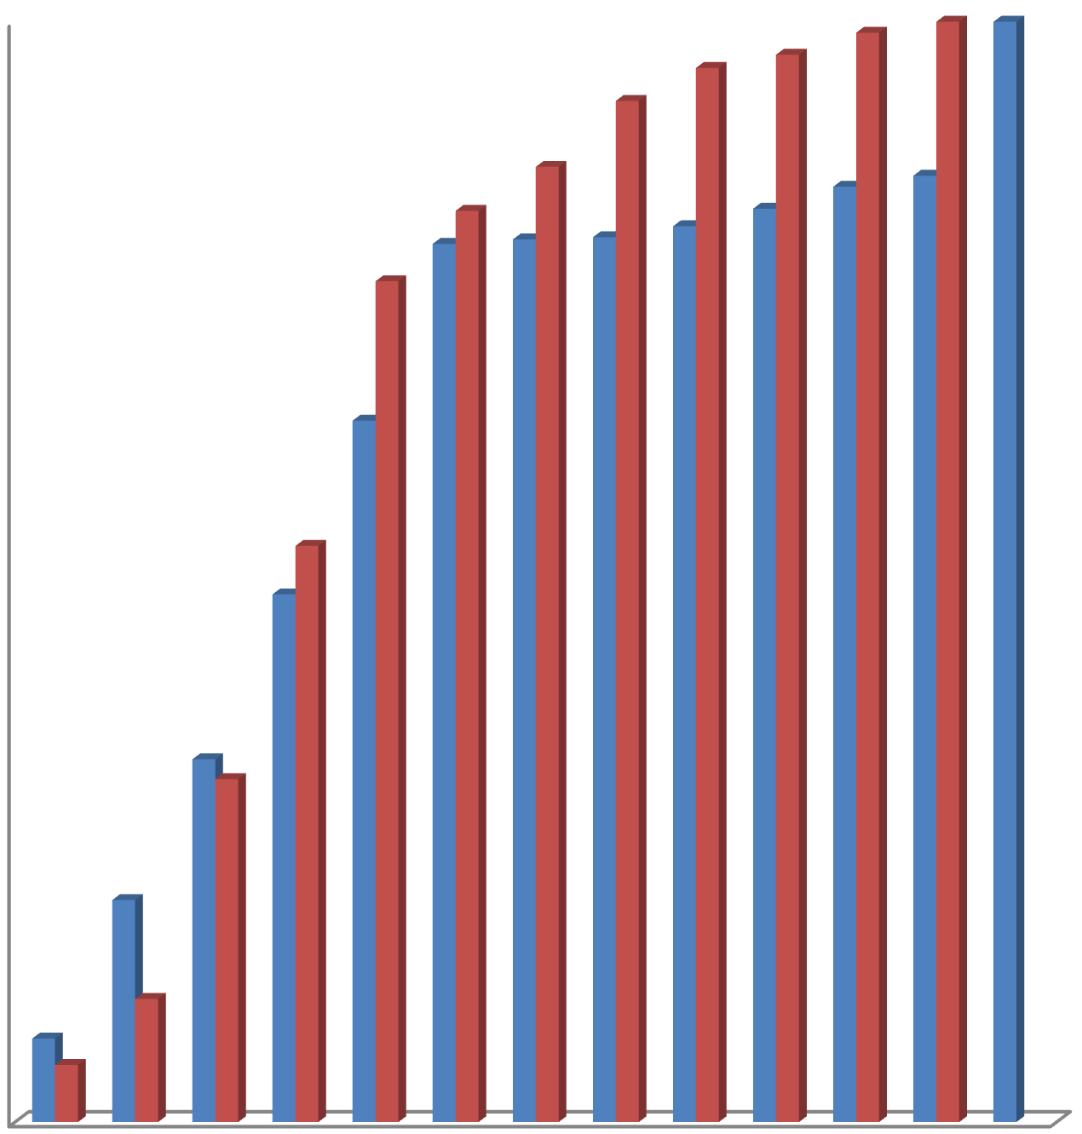
100

90

80

70

60
Cumulative frequency (%)

50 DS
MCS
40

30

20

10

0
2 3 4 5 6 7 8 9 12 14 15 18 22
Particle size (µm)

Figure 4.2: Graph of Cumulative frequency (%) against particle size (µm) for DS and MCS.

Dilution Potential
The results for dilution potential are displayed on Table 4.5 below. The results show that MCS was unable to bind MET; thus compressibility was not achieved at all ratios.

Table 4.5: Dilution Potential for MET: MCS

Binary Mix (MET:MCS) | Crushing Strength (Kgf) | Compressibility description
10:90 | 3.5 | Fair
20:80 | 3.0 | Fair
30:70 | 3.0 | Fair
40:60 | 2.5 | Poor
50:50 | 2.0 | Poor
60:40 | 2.0 | Poor
70:30 | 1.5 | Poor
80:20 | 1.5 | Poor
90:10 | 1.0 | Poor

MCS = Microcrystalline Starch, MET= Metronidazole

Physical properties of metronidazole granules
The effects of disintegrant and binder concentrations on the physical properties of metronidazole granules are presented in Table 4.6 and 4.7 respectively. Table 4.6 show that the values of angle of repose at all disintegrant concentrations was ≤ 36.03 º. The values of the flow parameters indicate that the granules have good flow properties. The Carr`s index and Hausner`s ratio values were computed from bulk density and tapped density values. The Carr`s index values at all concentrations were ≤ 16.67 % and the Hausner`s ratio values were ≤ 1.2. These parameters indicate that the granules have a good compressibility profile. A similar result was also obtained in Table 4.7 with angle of repose, Carr`s index and Hausner`s ratio values at all binder concentrations ≤ 36.03º,

13.56 % and 1.16 respectively. These parameters reveal the granules good flow properties and compressibility profile.

Table 4.6: Effects of Disintegrant Concentration on the Physical Properties of the granules.

Disintegrant Concentration | Angle of Repose | Flow Rate | Bulk Density | Tapped density | Carr’s Index | Hausner`s Ratio
(% w/w) | (º) | (g/sec) | (g/dm³) | (g/dm³) | (%)
2.5 %
DS | 33.02 | 3.38 | 0.45 | 0.53 | 15.09 | 1.18
MCS | 36.03 | 3.44 | 0.50 | 0.54 | 7.41 | 1.08
MS | 34.25 | 2.78 | 0.43 | 0.47 | 8.50 | 1.09
5.0 %
DS | 35.75 | 3.80 | 0.45 | 0.54 | 16.67 | 1.20
MCS | 34.66 | 3.90 | 0.47 | 0.56 | 16.07 | 1.19
MS | 35.82 | 2.84 | 0.43 | 0.45 | 4.40 | 1.05
7.5 %
DS | 34.70 | 3.50 | 0.44 | 0.51 | 13.73 | 1.16
MCS | 34.97 | 3.92 | 0.48 | 0.57 | 15.79 | 1.19
MS | 33.69 | 3.02 | 0.43 | 0.45 | 4.40 | 1.05
10.0 %
DS | 34.56 | 3.48 | 0.44 | 0.50 | 12.00 | 1.14
MCS | 34.53 | 3.86 | 0.47 | 0.51 | 7.84 | 1.08
MS | 34.19 | 3.09 | 0.43 | 0.47 | 8.50 | 1.09
12.5 %
DS | 34.73 | 3.50 | 0.47 | 0.53 | 11.32 | 1.13
MCS | 35.23 | 3.62 | 0.43 | 0.50 | 14.00 | 1.15
MS | 34.35 | 3.27 | 0.44 | 0.48 | 8.30 | 1.09

DS = Digitaria iburua Starch, MCS = Microcrystalline starch, MS = Maize starch B.P.

Table 4.7: Effects of Binder Concentration on the Physical Properties of the granules

Binder Concentration | Angle of Repose | Flow Rate | Bulk Density | Tapped density | Carr’s Index | Hausner`s Ratio
(% w/v) | (º) | (g/sec) | (g/dm³) | (g/dm³) | (%)
2.5 %
DS | 33.33 | 4.27 | 0.05 | 0.56 | 10.71 | 1.12
MCS | 30.07 | 4.32 | 0.54 | 0.59 | 8.47 | 1.09
GEL | 35.29 | 3.20 | 0.42 | 0.45 | 7.10 | 1.07
5.0 %
DS | 34.52 | 2.97 | 0.45 | 0.51 | 11.76 | 1.13
MCS | 30.07 | 4.03 | 0.54 | 0.61 | 11.48 | 1.13
GEL | 36.03 | 2.89 | 0.42 | 0.44 | 4.5 | 1.05
7.5 %
DS | 33.34 | 3.31 | 0.46 | 0.53 | 13.21 | 1.15
MCS | 32.62 | 4.26 | 0.53 | 0.59 | 10.17 | 1.11
GEL | 31.19 | 2.79 | 0.43 | 0.48 | 10.41 | 1.12
10.0 %
DS | 34.03 | 3.36 | 0.46 | 0.51 | 9.80 | 1.11
MCS | 32.28 | 4.29 | 0.51 | 0.59 | 13.56 | 1.16
GEL | 28.70 | 2.86 | 0.46 | 0.51 | 9.80 | 1.11
12.5 %
DS | 32.33 | 3.68 | 0.46 | 0.53 | 13.21 | 1.15
MCS | 31.76 | 4.30 | 0.51 | 0.59 | 13.56 | 1.16
GEL | 31.20 | 2.90 | 0.46 | 0.54 | 10.42 | 1.16

DS = Digitaria iburua Starch, MCS = Microcrystalline starch, GEL = Gelatin.

Properties of tablets produced by wet granulation

The results of the tablet parameters are presented in Tables 4.8 and 4.9. The values of the uniformity of weight for prepared metronidazole tablets ranged from 677 – 724 mg. The values are within the acceptable limits of BP, 2002 for the respective weights of the tablets. The crushing strength (CS) is a measure of tablet strength (Alebiowu and Adeagbo, 2009). From the result obtained in Tables 4.8 and 4.9, CS increased with increase in the binder concentration for all binder types while The CS decreased with increase in disintegrant concentration for disintegrant types. The CS of the binder type is in this order GEL > MCS > DS. CS of the disintegrant is in the order MCS > MS > DS. The friability (FR) is a measure of tablet weakness (Alebiowu and Adeagbo, 2009). FR decreased with increase in binder concentration for all binder types while showing an increase with increase in disintegrant concentrations. MCS and GEL passed FR test at 12.5 % w/v binder concentration, an indication of poor binding property of material.
The disintegration time (DT) increased with increase in binder concentration while as the disintegrant concentration increased, DT decreased.
The CS/FR index increased with increase in binder concentration with gelatin giving the highest CS/FR index and DS giving the least. However, the CS/FR index for disintegrant concentration decreased with increase in concentration. The CS/FR index for disintegrants used decreased in this order DS > MCS > MS.
(CS/FR)/DT is a better index of measuring the quality of tablets. It measures tablet strength and weakness and evaluates all negative effects of these parameters on the disintegration time (Ogaji and Okafor, 2009). The (CS/FR)/DT decreased with increase in disintegrant concentration for all disintegrant types. Maize starch B.P. has the highest (CS/FR)/DT ratio at all concentrations. The (CS/FR)/DT ratio for DS and MCS is comparable. The (CS/FR)/DT values were generally low.

Table 4.8: Quality Control Tests on the Binding Properties of Tablets Produced by wet granulation.

Binder
Conc.  (% w/v) | (mg) (
2.5 % DS | 705±6.42 5.49
MCS | 714±5.54 5.52
GEL | 723±4.17 5.67

Mean weight
Thickness
Diameter
CS (kgf) FR (%) DT (Min) CS/FR (CS/FR)/DT

mm) (mm)
±0.07 12.10±0.00 |  |  |  | 9.77±0.15 | 1.44±0.01 | 0.19±0.01 | 6.78 | 33.68
±0.09 12.10±0.01 |  |  |  | 11.17±0.17 | 1.39±0.01 | 0.55±0.02 | 8.04 | 14.62
±0.04 12.09±0.00 |  |  |  | 10.17±0.17 | 1.61±0.00 | 2.42±0.02 | 6.32 | 2.61
5.0 %
DS | 693±5.54 | 5.33±0.03 | 12.09±0.00 | 10.17±0.33 | 1.43±0.01 | 0.27±0.01 | 7.11 | 26.34
MCS | 681±6.30 | 5.21±0.03 | 12.10±0.01 | 11.50±0.29 | 1.80±0.10 | 2.50±0.01 | 6.39 | 2.56
GEL  7.5 % | 697±6.85 | 5.55±0.02 | 12.09±0.00 | 11.17±0.17 | 1.30±0.01 | 4.30±0.03 | 8.59 | 2.00
DS | 700±6.53 | 5.45±0.03 | 12.10±0.00 | 10.73±0.15 | 1.42±0.02 | 0.34±0.02 | 7.55 | 22.22
MCS | 721±3.94 | 5.37±0.07 | 12.09±0.01 | 12.16±0.17 | 1.25±0.01 | 3.41±0.02 | 9.73 | 2.85
GEL | 705±4.44 | 5.61±0.06 | 12.10±0.00 | 11.50±0.00 | 1.08±0.01 | 11.57±0.06 | 10.65 | 0.92
10.0 % DS | 712±5.63 | 5.47±0.09 | 12.10±0.00 | 11.00±0.00 | 1.11±0.02 | 0.36±0.01 | 9.91 | 27.52
MCS | 724±4.55 | 5.49±0.04 | 12.10±0.01 | 12.33±0.17 | 1.02±0.04 | 4.10±0.01 | 12.09 | 2.95
GEL | 713±6.48 | 5.49±0.11 | 12.09±0.01 | 12.50±0.29 | 1.05±0.01 | 15.18±0.04 | 11.90 | 0.78
12.5 %
DS | 707±6.58 | 5.42±0.06 | 12.09±0.00 | 11.67±0.17 | 1.04±0.04 | 0.49±0.01 | 11.22 | 22.90
MCS | 719±6.07 | 5.56±0.12 | 12.09±0.00 | 12.50±0.00 | 0.97±0.00 | 4.12±0.01 | 12.89 | 3.12
GEL | 696±4.61 | 5.51±0.05 | 12.09±0.01 | 12.50±0.29 | 0.87±0.01 | 23.41±0.32 | 14.37 | 0.61
DS = Digitaria iburua starch; MCS = Microcrystalline starch; GEL = Gelatin

Table 4.9: Quality Control Tests on the Disintegrating Properties of Tablets Produced by Wet Granulation.

Disintegrant Conc. (%w/w) | Mean weight (mg) | Thickness (mm) | Diameter (mm) | CS (kgf) | FR (%) | DT (Min) | CS/FR | (CS/FR)/DT
2.5 %
DS | 701±6.66 | 5.62±0.02 | 12.09±0.01 | 11.70±0.10 | 1.41±0.01 | 8.24±0.05 | 8.30 | 1.01
MCS | 680±5.87 | 5.40±0.06 | 12.08±0.01 | 12.20±0.07 | 1.31±0.01 | 7.11±0.02 | 9.31 | 1.31
MS | 707±5.90 | 5.56±0.04 | 12.09±0.01 | 12.00±0.00 | 1.32±0.02 | 3.57±0.65 | 9.09 | 2.54
5.0 %
DS | 705±6.18 | 5.55±0.03 | 12.09±0.01 | 10.07±0.20 | 1.44±0.02 | 8.24±0.01 | 6.99 | 0.85
MCS | 681±6.52 | 5.31±0.02 | 12.10±0.01 | 12.00±0.00 | 1.32±0.03 | 7.26±0.12 | 9.09 | 1.25
MS | 704±4.38 | 5.61±0.01 | 12.09±0.01 | 11.50±0.29 | 1.44±0.01 | 4.16±0.11 | 7.99 | 1.92
7.5 % DS | 708±5.26 | 5.58±0.05 | 12.09±0.01 | 10.83±0.15 | 1.46±0.01 | 8.18±0.02 | 7.42 | 0.91
MCS | 677±6.48 | 5.36±0.07 | 12.09±0.01 | 11.80±0.12 | 1.43±0.01 | 6.89±0.02 | 8.25 | 1.20
MS | 706±3.93 | 5.54±0.11 | 12.09±0.01 | 10.80±0.12 | 1.52±0.01 | 4.11±0.01 | 7.11 | 1.73
10.0%
DS | 700±5.50 | 5.59±0.08 | 12.09±0.01 | 9.83±0.09 | 1.83±0.02 | 7.50±0.02 | 5.37 | 0.72
MCS | 684±5.54 | 5.35±0.12 | 12.09±0.01 | 11.70±0.06 | 1.82±0.01 | 6.51±0.02 | 6.43 | 0.99
MS | 705±4.84 | 5.69±0.21 | 12.09±0.01 | 10.37±0.09 | 1.96±0.01 | 3.56±0.02 | 5.29 | 1.49
12.5 %
DS | 710±4.17 | 5.62±0.08 | 12.10±0.00 | 9.00±0.29 | 1.86±0.01 | 7.08±0.02 | 4.84 | 0.68
MCS | 695±5.89 | 5.38±0.08 | 12.09±0.02 | 9.50±0.50 | 1.85±0.01 | 6.42±0.01 | 5.14 | 0.80
MS | 703±6.77 | 5.52±0.03 | 12.09±0.01 | 8.50±0.29 | 2.04±0.02 | 3.41±0.00 | 4.17 | 1.22
DS – Digitaria iburua starch; MCS – Microcrystalline starch; MS – Maize starch

Dissolution studies

Figures 4.3 and 4.4 shown below revealed a rapid release of metronidazole after disintegration for both DS and MCS at 7.5 % w/v binder concentration and 10.0 % w/w disintegrant concentration respectively. Figure 4.3 show that at 30 min over 80 % of the drug was dissolved and Figure 4.4 show that at 30 min over 90 % of the drug was dissolved.

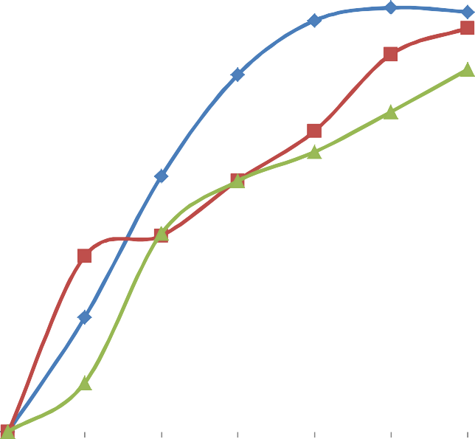
120

100

80
Percentage drug dissolved (%)

60
MS
MCS
40 GEL

20

0
0 5 10 15 20 25 30 35
Time (min)

DS = Digitaria iburua Starch, MCS = Microcrystalline starch, GEL = Gelatin

Figure 4.3: Graph showing dissolution profile of metronidazole tablets containing
7.5 % w/v binder concentration.

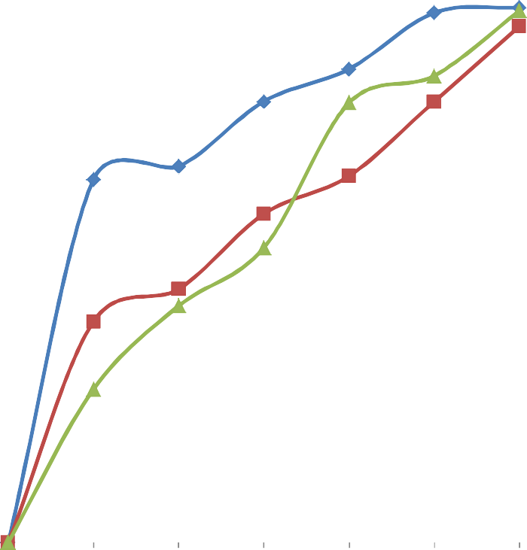
120

100

80
Percentage drug dissolved (%)

60 DS
MCS MS
40

20

0
0 5 10 15 20 25 30 35
Time (min)

DS = Digitaria iburua Starch, MCS = Microcrystalline starch, MS = Maize starch B.P.

Figure 4.4: Graph showing dissolution profile of metronidazole tablets containing
10.0 % w/w disintegrant concentration.

4.9 Compression property study of DS and MCS.
The results of the compression property study for the pure powder of DS and MCS is computed and presented in Table 4.10 below. The mean yield pressure P_{Y}, the relative density at zero pressure D_{O} and the total deformation occurring in the powder D_{A} values ranked in the following order; GEL>MCS>DS. The fragmentation tendency of the powder D_{B} ranked in this order; MCS>GEL>DS. The Heckel plots in Figure 4.5 show that DS, MCS and GEL possess non-linear curves at lower and higher pressures. The non – linear parts of the plot had an initial curvature at low pressure which reflects particle fragmentation and rearrangement while the deviation from a straight line at higher pressure was as a result of capping of the powder. The linear curve for the compression pressures suggests the materials compacted by plastic deformation.

Table 4.10: Parameters from Heckel plots

Material | P_{Y} | D_{O} | D_{A} | D_{B}
DS | 225.29 | 0.2797 | 0.5605 | 0.2808
MCS | 499.43 | 0.3706 | 0.6716 | 0.3010
GEL | 613.36 | 0.4615 | 0.7541 | 0.2926

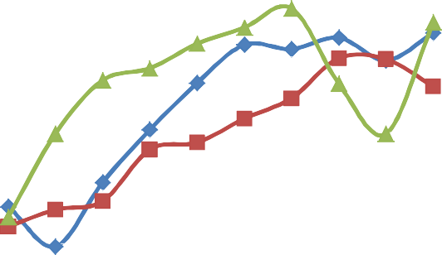
2

1.8

1.6

1.4

1.2

1
ln (1/1-D)

0.8
DS MCS GEL

0.6

0.4

0.2

0
0 50 100 150 200 250 300 350
Applied pressure (MN/m²)

DS = Digitaria iburua Starch, MCS = Microcrystalline starch, GEL = Gelatin

Figure 4.5: Graph of ln (1/1-D) against pressure (MN/m²) for DS, MCS and GEL compacts.

CHAPTER FIVE

DISCUSSION

Preliminary Investigation
Digitaria iburua grains yielded 62.88 % w/w DS. Musa et al, (2011), calculated the yield of DS to be 62.20 % w/w and the pregelatinized (modified) starch yielded
73.18 % w/w. However, on subjecting the starch to acid hydrolysis using 6 N HCl and varying hydrolyzing conditions of temperature (50 – 54 ⁰C) and time (6 – 24 h) the percentage yield of microcrystalline (modified) starch was 87.52 % w/w at 6 h and
85.14 % w/w at 24 h. This reveals that modification of Digitaria iburua grains by acid hydrolysis has a better yield than modification by pregelatinization.
The property of color was gradually lost as the hydrolyzing time increased. The presence of protein can cause unwanted colour in starch and starch hydrolysis products via reaction between amino acid groups and reducing sugars - Mailard reaction (Chichester, 1986). This implies that acid hydrolysis can alter the integrity of starches with increase in hydrolyzing time.

Amylose – Amylopectin Content of MCS
The amylose – amylopectin content of MCS was determined every 6 h. The results are presented in Table 4.3.The amylose – Amylopectin content for the starches decreased as the time of hydrolysis increased from 6 – 24 h. The results show that there is a higher percentage of amylose content compared to amylopectin content in the starch analyzed. In normal starch, the amylose: amylopectin (Am: AP) ratio is approximately 1:4 (Belitz and Grosh, 1999; Delvile et al, 2002). Pure starch generally contains 20 – 25 % w/w amylose and 75 % w/w amylopectin (Brown and Poon, 2005). From the results obtained, MCS contained >51.25 % w/w amylose and >21.88 % w/w amylopectin. The

variations in the amylose-amylopectin content could be due to differences in varieties (cereals, tubers, roots, etc) and geographical location.

Microscopy
The microscopical examination showed a decrease in the mean particle size of DS from 10.50 µm to 9.61µm for MCS (24 h) and there were more spherical particles with MCS. This had some slight improvement on the flow properties of the powder (Staniforth, 2007). The examination also showed that DS and MCS appeared to be spherical in shape as seen in the photomicrographs (x 400 magnification) displayed in Plates 4.1 and 4.2. Figure 4.1 and 4.2 show the particle size distribution for DS and MCS with MCS having a lower mean particle size. Plate 1, 2 and 3 shows photomicrographs of DS, MCS and MS respectively when viewed under the microscope at x 400 magnification. DS and MCS are spherical in shape with MCS having a smaller mean particle size (9.58-9.68 µm) compared to DS (10.5 µm) and MS (12.73 µm) as shown in Table 4.3.

Physicochemical Properties
The physicochemical properties are presented in Table 4.4. The values recorded for the angle of repose for the material was greater than 43.0⁰. The angle of repose of DS and MCS was > 45.0⁰. The angle of repose is an index of flowability of a powdered substance. The angle of repose is affected by the cohesiveness of the powder (Staniforth, 2007). When the powder is cohesive the angle of repose will be high and if the powder is non-cohesive or adhesive the angle of repose will be low (Bhimte and Tayade, 2007). Powders with angle of repose of 23 – 35.0⁰ are considered to possess good flow properties while mildly cohesive powders have angles of repose between 40

and 60.0⁰ (Neumann, 1967). From the result, the starches are said to have poor flow property because of the high cohesive/adhesive forces between powder particles.
There is a relationship between angle of repose and flow rate. Small angle of repose (≤30.0⁰) implies a faster flow rate (Veslasco et al, 1995). Table 4.4 shows that the greater the angle of repose the slower the flow rate. MCS at 24 h hydrolysis time had a faster flow rate compared to 6 – 18 h hydrolysis time. The flow rate of the starches is ranked in the order MS < DS < MCS.
The bulk and tapped densities of the starches are shown in Table 4.4. It is shown that the values of the bulk and tapped densities are in the order DS < MS < MCS. This indicates that MCS exhibited the largest maximum volume reduction while NS exhibited the least. The process of volume reduction of powders has been said to be dependent on factors such as shape, size and degree of interparticulate friction (Podczeck and Sharma, 1996). However, no general rule exists about the effect of particle size and shape on the packing properties of powder and how these factors interact (Shotton and Obiorah, 1973).
The tapped density results of the granules were higher than the bulk density. This may be due to diminished void spaces as a result of a change in bulk volume (Apeji, 2010). The change in bulk volume was produced by a rearrangement of the packing geometry of packed powder bed (Staniforth and Aulton, 2007). Also, the bulk density result in Table 4.4 was less than the true density of its component particles. The bulk powder contains interparticulate pores or voids (Staniforth and Aulton, 2007). The bulk density of a powder is dependent on particle packing. The order of packing of the starches is as follows: DS>MS>MCS.
According to Hausner`s 1967, for powder that possesses good flow properties the angle of repose, Carr’s index and Hausner`s ratio should not be greater than 20 ⁰, 28

% and 1.20 respectively. The results obtained in Table 4.4, showed that DS and MCS possess poor flow property because they had higher values. The angle of repose and flow rate were the parameters used to determine the flow properties of the starches while Carr`s index and Hausner’s ratio were used to evaluate the rate at which packing occurs. Particle packing has great impact on the flowability of powders, and sometimes used as an indirect method of measuring or quantifying powder flow (Staniforth, 2007). There is a direct relationship between particle packing and bulk and tapped densities.
Carr’s index and Hausner’s ratio previews the degree of densification which would occur during tableting. As the values of these indices increase, the flow of the powder decreases and gives more likelihood of producing tablets with more weight variation (Staniforth, 1996). The values of Carr’s index and Hausner’s ratio for the starches shown in Table 4.4 suggest that they possess poor flow property because they have Carr’s index and Hausner’s ratio greater than 28 % and 1.2 respectively (Hausner, 1967).
Moisture content for the material as shown in Table 4.4; did not exceed the limit of 15 % specified by the BP, 2002 for starches. Moisture content affects flow property and stability of a product. This could affect tablet parameters such as weight and content uniformity (Musa et al, 2008). Moisture is known to modify the flow and mechanical properties of many powders including starches (Adane et al, 2006).
The decreasing order of swelling power as shown in Table 4.4 was MS > MCS

> DS. The swelling power of starch was attributed to its amylopectin content (Tester et al, 2004).
There is a marked difference between the moisture sorption capacity of MS as compared to DS and MCS as shown in Table 4.4: (MCS > DS > MS). The values obtained for MCS and DS; 24.5 – 27.0 % indicates that MCS and DS are more

hygroscopic in nature compared to MS. Thus, formulations containing MCS will have stability problems because of their high propensity to absorb moisture (Okafor, 1990). Moisture sorption capacity is a measure of moisture sensitivity of a material and it reflects the relative physical stability of the tablets formulated with the material when stored under humid conditions (Ohwoavworhua and Adelakun, 2005).
A common feature of all theories of disintegration is that penetration of water (or liquid medium) must precede disintegration and this can be assessed by the determination of swelling power and moisture sorption capacity (Caramella et al, 1986).
The pH of the starches was similar as shown in Table 4.4. MCS was observed to be slightly acidic compared to DS and MS. This was due to the hydrolytic treatment with 0.6 N HCL. It was observed that as the hydrolyzing time increased, MCS became more acidic (hydrolysis time of 6 h had a pH of 6.36 while 24 h had a pH of 6.05).
There is a strong positive correlation when MS is compared with DS (0.979) and MCS (0.974), because the values obtained are close to 1. Thus correlation is significant at 0.001 levels. A stronger correlation is noticed when DS is compared with MCS (0.994) because the value is closer to 1.

Analysis of Granules
The angle of repose, Carr’s index and Hausner`s ratio of the granules as shown in Tables 4.6 and 4.7 showed a marked improvement compared to that of the starch powder on Table 4.4. Alteration of particle size of starch by the process of granulation produced relatively large sized granules with improved flowability (Staniforth, 2007). The flow properties were assessed using the parameters of angle of repose and flow rate while Carr`s index and Hausner`s ratio were used to evaluate starch compressibility. The angle of repose of the granules was less than 50º thus granules have satisfactory flow properties (Staniforth, 2007). Carr’s index of DS and MCS was between 7 and 16

% reflects good (free flowing powdered granules), (Staniforth, 2007). The Carr’s index and the Hausner`s ratio values obtained were less than or equal to 28 % and 1.20 respectively thus the prepared metronidazole granules had better flow properties (Hausner, 1967). The tapped densities for all the granules were higher than the bulk densities. The percentage compressibility (Carr’s index) and ultimately the Hausner`s ratio express the difference between the bulk and tapped densities and the ratio of tapped to bulk density. These indices give a measure of the ability of a material to be reduced in volume under pressure and the indication of the likely flow behavior of granules when subjected to compression forces to form compact mass. It has been reported that the flow of the granules is better when Carr’s index is lower (Schwartz et al, 1975).
Thus metronidazole granules produced had better flow properties. The tapped densities for all the granules were higher than the bulk densities as reflected in Tables
4.6 and 4.7. Granules produced at varying binder concentrations (2.5 – 12.5 % w/v) as shown in Table 4.6 had better flow properties than granules produced at disintegrant concentration in Table 4.7. This was probably due to increase in granule size with the binder used at different concentrations.
The percentage compressibility (Carr’s index) and ultimately the Hausner`s ratio express the difference between the bulk and tapped densities and the ratio of tapped to bulk density. These indices give a measure of the ability of a material to be reduced in volume under pressure and the indication of the likely flow behavior of granules when subjected to compression forces to form compact mass. Schwartz et al, (1975) reported that the lower the Car’s index, the better is the predicted flow of the granules.
At all disintegrant concentrations, a strong positive correlation is noticed when MS is compared with DS and MCS (>0.900). A much stronger correlation is noticed

when MCS is compared with DS (>0.990) except at 2.5 % w/w concentration (0.966). Thus correlation is significant at the 0.01 levels. At all binder concentrations, a strong positive correlation is noticed when GEL is compared with DS and MCS (>0.990) except at 5 % w/v concentration (0.975 and 0.966). A much stronger correlation is noticed when MCS is compared with DS (>0.990). Thus correlation is significant at the
0.01 levels.

Evaluation of Tablet Properties
There a slight variation in the weight of the tablet as shown in Table 4.8 and 4.9 even though it conforms to B.P. 2002 specification (i.e. percentage difference of tablets weighing more than 324 mg is + 5 %). The flow of powder during manufacturing
dictates the quality of the product in terms of its weight and content uniformity (Prescott and Barnum, 2000). Weight variation in tablets can be reduced if the powder/starches possessed a better flow property.
The results for the uniformity of weight, thickness and diameter for tablets produced at varying binder and disintegrant concentration are presented in Table 4.8 and 4.9. The values of the uniformity of weight for prepared metronidazole tablets range from 677 – 724 mg. The values are within the acceptable limits of BP, 2002 for the respective weights of the tablets. This implies that all batches passed weight variation test.
The uniform filling of the die cavity was as a result of the good flow properties of the granules and was also enhanced by the addition of glidant. Rawlins (2004), stated an assumption that the variation in the weight of individual tablets is a valid indication of the corresponding variation in the drug content.
The values of the diameter presented in Table 4.8 were determined by the diameter of the punch and die cavity while values for thickness ranging from 5.21 –

5.69 mm may be due to the compressibility of the material and/or the compression force applied.
There is no official requirement for crushing strength and friability in the British Pharmacopoeia (BP 2002). Crushing strength reflects tablet strength (Alebiowu and Adeagbo, 2009). The CS values obtained increased as the binder concentration increased as shown in Table 4.8 and it is in the order; GEL > MCS > DS. For disintegrant concentration, the CS values generally showed a decrease as the concentration increased. The CS is the measure of the structural strength of the tablets. The CS is the applied load that when applied diametrically to a tablet causes it to fracture. The CS is an index used to measure tablet hardness. Tablets are held together by binders that act through Van der Waal forces, electrostatic forces of attraction, frictional and mechanical forces, and forces due to the formation of solid bonds (Musa et al, 2010).
Friability is a measure of the weakness of the tablets (Alebiowu and Adeagbo, 2009). It gives an indication of the likely edge damage that would occur when the tablets are handled during packing and dispensing. The friability test values are presented in Table 4.8 and 4.9. Values obtained exceeded 1 % except for tablets produced at 12.5 % w/v binder concentration. This may be attributed to the fact that MCS and DS had a high moisture sorption capacity as shown in Table 4.3. The friability of tablets containing DS and MCS as binder far exceeded the limit of 1 %. This makes them unsuitable as binder, implying that DS and MCS may not be useful as a direct compressible excipient.
Tablets disintegrate by swelling of the disintegrant which results in development of swelling force, capillary action and breakdown of intermolecular forces resulting in development of a repulsive force between particles (Ngwuluka et al, 2010). The time

taken for a tablet to disintegrate when immersed in some test fluid should not exceed 15 min for uncoated tablets (BP, 2002). The values for disintegration time (DT) for all batches are presented in Tables 4.8 and 4.9. At all disintegrant concentrations, the tablets disintegrated in less than 15 min. This implies that they all passed the disintegration time test. The order of DT for the starches is as follows: MCS > MS > DS. This confirms the superiority of DS as a good disintegrant compared to MS and MCS. At 12.5 % w/v binder concentration the tablets produced failed the DT test.
The CS/FR index for disintegrant concentration decreased with increase in concentration. The CS/FR index for disintegrant used decreased in this order DS>MCS>MS. The balance between the binding and disintegration properties of the tablets was evaluated using (CS/FR)/DT (Alebiowu and Adeagbo, 2009). The (CS/FR)/DT decreased with increase in disintegrant concentration for all disintegrant types. MS has the highest (CS/FR)/DT ratio at all concentrations. The (CS/FR)/DT ratio for DS and MCS is comparable. (CS/FR)/DT values of DS and MCS at 5.0 % w/w and
7.5 % w/w disintegrant concentration is not significant. (CS/FR)/DT is a better index of measuring the quality of tablets. It measures tablet strength and weakness and evaluates all negative effects of these parameters on the disintegration time (Ogaji and Okafor, 2009).
There were slight variations in the mean weight and (CS/FR)/DT values of the tablets produced in Tables 4.8 and 4.9. The results were subjected to statistical analysis. The differences in the properties presented in Tables 4.8 and 4.9 when MS is compared to DS/MCS and when GEL is compared with DS/MCS was significant at p ≤ 0.05 at the 95 % confidence interval. There is a strong positive correlation when DS is compared with MCS.

The dissolution profiles of the tablets are shown in Figures 4.13 and 4.14. The dissolution efficiency (D.E.) which is the percentage of drug released after 30 min was greater than 85.00 % for 7.5 % w/v binder concentration and greater than 96.00 % for
10.0 % w/w disintegrant concentration. The order of D.E for 7.5 % w/v binder concentration was DS>MCS>GEL while the order of D.E for 10.0 % w/w disintegrant concentration was DS > MS > MCS.
All the batches of tablets passed the B.P. 2002 dissolution test for tablets which specifies that at least 70 % of the drug should be solution after 30 min. Only batch of tablet of DS – Metronidazole of 10.0 % w/w disintegrant concentration was able to release 100 % of the drug after 30 min. The rate of absorption of poorly soluble drugs is usually controlled by their dissolution rate in the gastrointestinal tract (Ogaji and Okafor, 2009).
It can be seen from the results obtained that the dissolution corresponds to the disintegration time of the tablets. The disintegration time for the tablets was fast which resulted in a corresponding rapid drug release. Batches formulated with DS had a better dissolution profile compared to MCS, MS and GEL.

Compression property study
The mode of fragmentation or deformation of the powder was assessed by Heckel analysis. According to Heckel equation, powder compression follows first order kinetics, with the interparticulate pores as the product and the compactibility of the powder bed as the product. The mean yield pressure P_{Y} is the pressure at which plastic deformation of a particle is initiated. The D_{O} value refers to the relative density at zero pressure. D_{A} value reflects the total deformation occurring in the powder while D_{B} values are an indication of the fragmentation tendency of the material. The Heckel plots show that DS, MCS and GEL possess non-linear curves at lower and higher pressures.

The non – linear parts of the plot had an initial curvature at low pressure which reflects particle fragmentation and rearrangement while the deviation from a straight line at higher pressure was as a result of capping of the powder (Alderborn, 2002). The linear curve for the compression pressures suggests the materials compacted by plastic deformation. A linear curve obtained from the results indicates deformation mainly by plastic flow (Odeku, 2005).The linear plot from which the Heckel equation is derived appeared between low and high pressures. P_{Y} value is ranked in this order: GEL>MCS>DS. D_{O} and D_{A} is in this order: GEL>MCS>DS. D_{B} value is in the order: MCS>GEL>DS implying that MCS had the greatest tendency to fragment compared to GEL or DS. The P_{Y} values derived from the part of the Heckel plot rank in this order: DS>MCS>GEL. This implies that DS easily undergoes deformation or that the onset of plastic deformation is faster compared to MCS and GEL. The slope of the Heckel plot was calculated from the compression part of the plot and the slope provides information on the total deformation of the powder during the compression phase. Picker-Freyer and Brink (2006), stated that a lower Heckel slope corresponds to a higher mean yield pressure and thus a higher resistance against deformation while a higher Heckel slope corresponds to a low mean yield pressure and thus a higher and easier deformation. The results show that mean yield pressure P_{Y,} values are all high and rank in this order GEL>MCS>DS. This implies that a higher resistance against pressure is required. DS and MCS do not deform readily on compression at low pressures. The mean yield pressure was high which is indicative of higher resistance against plastic deformation.

CHAPTER SIX

SUMMARY AND CONCLUSION
Digitaria iburua grains produced a high yield of DS. Modification of DS by acid hydrolysis produced microcrystalline starch (MCS) with a greater yield.
Microscopical studies showed that DS and MCS appeared spherical with particle size ranging from 2.0 – 22.0 µm.
MCS possessed better flow and compressibility properties compared to DS but not superior to MS as demonstrated by the parameters (i.e. angle of repose, flow rate, Hausner ratio and Carr’s index). The produced metronidazole granules had greater flow and compressible properties.
MCS is not a good direct compressible material because it failed the dilution potential test.
The amylose content of DS and MCS was greater than amylopectin content at different hydrolyzing times.
The friability test conducted revealed that metronidazole tablets produced were weak. The tablets passed disintegration and dissolution tests with some exceptions as discussed earlier in Chapter 4. The (CS/FR)/DT results showed that tablets produced are generally weak.
The mean yield pressure was high which is indicative of higher resistance against plastic deformation.
It can be concluded that:
    - Modification of Digitaria iburua starch by acid hydrolysis did not improve the compressibility of DS because the amylose content of MCS was greater than the amylopectin content which is responsible for increasing the relative crystallinity of the starch.

    - Modification of Digitaria iburua starch by acid hydrolysis increases the mean yield pressure (P_{Y}) for deformation with corresponding decline in onset of deformation and lesser total deformation.
    - MCS fragmented on compaction, thus no further compactional studies was carried out.
    - Modification of Digitaria iburua starch by acid hydrolysis did not make the material a suitable direct compressible excipient and thus cannot be employed in direct compression tableting.

RECOMMENDATIONS
    - Investigation into other methods of production of modified starch may give rise to Digitaria iburua starch which may be a suitable direct compressible material.
    - The modified starch (MCS) should be used with other excipients to produce tablets that require fast disintegration e.g. orally disintegrating tablet or orodispersible tablet (ODT).

REFERENCES
Adams, M.J. and Mckeown, R. (1996). Micromechanical analyses of the pressure volume relationship for powders under confined uniaxial compression. Powder Technol. 88:155-163.

Adebayo, A.S., Itiola, O.A., (2003). Effects of Breadfruit and Cocoyam Starch Mucilage binder on disintegration and dissolution behaviours of paracetamol tablet formulation. J. Pharm. Tech. P. 78-88.

Adane, M., Endale, A., Bultosa, G., Abdel-Mohsen, M.G. and Mariam, T. (2006) Isolation and Physicochemical characterization of Godare (Colocasia esculenta) Starch from Ethiopia. Ethiop Pharm J. 24: 13-22.

Adeyeye, M.C. and Brittain, H.G. (2008). Preformulation in Solid Dosage Form Development (Drug and the Pharmaceutical Sciences) pp 357-433, 477-511.

Akande, O.F. (1988). Evaluation of Millet Starch as a Binder and Disintegrant. MSc.Thesis submitted to the Department of Pharmaceutics and Pharmaceutical Microbiology, Faculty of Pharmaceutical Sciences, Ahmadu Bello University, Zaria.

Alderborn, G. (2002). Tablets and compaction In: Aulton, M.E. (ed.). Pharmaceutics: The Science of Dosage form design, 2nd edition. Churchill Livingstone, New York, pp. 397-440.

Alebiowu, G. and Adeagbo, A.A. (2009). Disintegrant properties of a paracetamol tablet formulation lubricated with co-processed lubricants. Farmacia, 57 (4): 500-510.

Alebiowu, G. and Itiola, O.A. (2001). Effects of Natural and Pregelatinized Sorghum, Plantain and corn starch binders on the compressional characteristics of Paracetamol tablet formulations. Pharm. Tech. 2001. 26-30.

Alebiowu, G. and Itiola, O.A. (2002). Compressional characteristics of native and pregelatinized sorghum, plaintain and corn starches and the mechanical properties of their tablets. Drug Dev. Ind. Pharm., 28 (6): 663-672

Amidon, G.E., Peck, G.E., Block, L.H., Katdare, A. and Sheehan, C. (2007). Proposed New USP General Information on excipient performance. Pharmacopocial Forum. 33 (6).

Anwar, E., Khotimah,.H. and Yanuar, A. (2006). An approach on pregelatinized cassava starch phosphate esters as hydrophilic polymer excipients for controlled release tablet J. Med. Sci., 6 (6): 923-929.

A.O.A.C. (1980). Official Methods of Analysis, 13th ed. Association of Official Analytical Chemist. AOAC inc. Washington DC.

Apeji, Y.E. (2010). Tabletting Properties of Microcrystalline Starch Derived from Cassava (Manihot esculenta Crantz) starch by Enzymatic Hydrolysis Using α-amylase enzyme. MSc Thesis. Ahmadu Bello University, Zaria.

Atichikudomchai, N., Shobsngob, S., Chinachoti, P. and Varavinit, S. (2001). A study of some physicochemical properties of high-crystalline tapioca starch. Starch/starke, 53:577-581.

Ashford, M., Aulton, M.E., Second Edition (2002). Pharmaceutics. The Science of Dosage Form Design.Churchill Living Stone New York, Pp. 234-252.

Aiyer, P.V. (2005). Amylases and their applications. Afr. J. Biotech., 4 (13): 1525-1529.

Behall, K.M., Scholfield, D.J., Canary, J. (1988). Amylose Chemistry. Am, J. Clin. Nutr.47, 428.

Behall, K.M., Scholfield, D.J., Yuhaniak, I., Canary, J. (1989). Amylose Chemistry.
Am J. Clin. Nutr. 49, 557.

Bhimte, N.A. and Tayade P.T. (2007). Evaluation of microcrystalline cellulose prepared from sisal fibres as a tablet excipient. AAPS Pharm Sci. Tech 8 (1). E56-E62

Billi, M.S. (1975). Manufacture of Chloroquine Phosphate tablets using cassava starch. Unpublished B.Sc Project submitted to the Department of Pharmaceutics and Pharmaceutical Microbiology, Ahmadu Bello University, Zaria.

British Pharmacopoeia, (1980).Vol. I and II: Her Majesty’s Stationary Office, University Press, Cambridge.

British Pharmacopoeia, (1993). Vol I and II: Her Magesty’s Stationary Office, University Press, Cambridge.

British Pharmacopoeia. (2002). Vol. 1 and II: Her Majesty’s Stationery Office, University Press, Cambridge.

Brown, W.H., Poon, T. (2005). Introduction to Organic Chemistry (3rd Ed).Wiley.ISBN 0-471-44451-0.

Buleon, A., Colonna, P., Planchot, V., Ball, S. (1998). Starch Chemistry. Int. J. Biol. Macromol.23:85.

Caramella, C., Colombo, P., Conte, U., Ferrari, U., LaManna, A., VanKamp, H.V. and Bolhuis G.K. (1986). Water uptake and disintegrating force measurements: Towards a general understanding of disintegration mechanisms. Drug Dev. Ind.
Pharm. 12: 1749-1766.

Chichester, C.O. (1986). Advances in Food Research (Advances in Food and Nutrition Research). Boston: Academic Press. ISBN 0-12-016430-2.

Croghan, M. and Mason, W. (1998) “100 years of Starch Innovation”. Food Science and Technology Today, Pp. 17-24.

Dankwerts, P.V. (1951). Significance of Liquid-film coefficients in gas absorption. Md Eng. Chem. 43:1460-7.

David, J (2008). Pharmaceutics – Dosage Form and Design. Pharmaceutical Press. (London Chicago) pp. 203-253.

Denny, P.J. (2002). Compaction equations: a comparison of the Heckel and Kawakita equations. Powder Technol. 127:162-172.

Deshpande, A.V. and Panya, L.B. (1987). Sorghum starch as tablet excipients. J. Pharm. Pharmacol 39:495.

Eichie, F.S. and Okor, R.S. (2002). Effect of Acid treatment on the consolidation and Plasto-elasticity of tapioca powder. Trop. J. Pharm Res.1 (1): 45-49.

Eliasson, A.C. and Gudmundsson, M. (1996). Physicochemical and functional aspects In: Eliasson, A., (ed.), Carbohydrate in Food. New York. P. 431-501.

Esezobo, S. and Ambujam, V. (1982). An evaluation of starch obtained from Plantain Musa Paradisiaca as a binder and disintegrant for compressed tablets. J. Pharm: Pharmacol 34:761.

European Pharmacopoeia 3rd Edition (1997). Council of Europe, Strasbourg.

European Pharmacopoeia, Fourth Edition (2002).Convention on the Elaboration of European Pharmacopeia, Council of Europe, Strasbourg Cedex, France, pp. 191-201 561.

Gambo, A. (2009). Evaluation of Fonio (Digitaria iburua) starch on Tablet Excipient. MSc Thesis, Dept. of Pharmaceutics and Pharmaceutical Microbiology, Faculty of Pharm. Sci., A.B.U., Zaria.

Hamdi, G.G. and Ponchel, D.D. (1999). Enzymatic degradation of epichlorohydrin
crosslinked starch microspheres by α- amylase. Pharm. Res., 16:867-875.

Harlan, J.R. (1993). Genetic Resources in Africa P65 in: J. Janick and J.E. Simon (eds). New Crops.Wiley Press New York.

Hixson, A., Crowell, J. (1931). Modeling and comparison of dissolution profile. Eur. J. of Pharma. Sci. 23: 923.

Huijiberchts, A.M.L. (2008). Multifunctional Starch derivatives: Synthesis, Characterization and Properties. Ph.D Thesis Wageningen University, Wageningen, The Netherlands.

Hausner, N.H. (1967). Flow Properties of some Pharmaceutical Powders. Int. J. Powder Metall., 3: 7-11.

Ibezim., E.C., Ofoefule, S.I., Omeje, E.O., Onyishi V.I. and Odoh, U.E. (2008). The Role of Ginger Starch as a binder in Acetaminophen Tablets. Scientific Research and Essay. 3 (2). Pp. 046-050.

Isah, A.B. (2005). Tabletting and Hypoglyceamic Properties of Stachytarpheta angustifoua (Verbanaceae) extract. Ph.D Dissertation submitted to the Department of Pharmaceutics and Pharmaceutical Microbiology, Ahmadu Bello University, Zaria. Nigeria.

Itiola, O.A, Odeniyi, M.A. and Adetunji, O.A. (2006). Compression, Mechanical and Release Properties of Chloroquine Prosphate Tablets containing corn and Trifoliate Yam starches as Binders. Trop J of Pharm Res, 5 (2): 589-596.

Itiola, O.A. and Odeku, O.A. (2005). Packing and Cohesive Properties of some locally extracted starches. Trop J of Pharm Res, 4 (1): 363-368.

Iwuagwu, A.M., Nwuoshai, C.A. and Iseogoni, F.E. (1986). Investigation into the binding and disintegrant properties from selected diassoreaceae plants. Nig. J. Pharm. Sci. 2:10.

Jaiyeoba, K.T. and Opakunle, W.O. (1979). The diluent and Glidant properties of yam and cassava starches. Mfg. Chem. Aero News 49 (5,6): 60, 77.

Jideani, I.A. (1999) Traditional and Possible Technological uses of Digitaria exilis
(acha) and D. iburua (Iburu): A Review Plant foods Human Nutri. 54: 363-374.

Karen, de Leschery. (2004) More Fonio Less Hard Work. Publication of Aramco Services Company.

Kawakita, K. and Ludde, K.H. (1971). Some Considerations on Powder Compression Equations.Powder Technol. 4:61-68.

Kawakita, K., Hattori, I. and Kishigami, M. (1977). Characteristic constants in Kawakita’s Powder Compression equation. J. Powder Bulk Solids Technol. 1:3-8.

Keshri, V.J. Chakrabarti, T. and Srivastava, G.P. (1974). Effects of various starches as binder on the physical properties of sulphanilamide tablet formulation. Indian J. Pharm. 36:100.

Kittipongpatana,O.S., Chaitep, W., Charumanee, S. and Kittipongpatana, N. (2006) Effects of Amylose Content on the physic Chemical Properties of Sodium Carboxymethyl rice starches. CMU, Journal, 5 (2): 199-207.

Korhonen, O., Pohja, S., Peltonen, S., Suikho, E., Mira, V., Paronen, P. and Ketolainen,J. (2002). Effects of Physical properties for starch acetate powder on tableting. AAPS Pharm Sci Tech., 3 (4):1-9.

Le Bail, P., Morin, F.G. and Marchessault, R.H. (1999). International Journal of Biological Molecules, 26:193-200.

Light, J.M. (1990). Modified Food Starches: Why, What, Where and How? Cereal Food World. 35(11): 1081-1092.

Mali, S., Grossmann, M.V.E., Garda, M.A., Martino, M.N., Zaritzky, N.E. (2006). J. Food Eng. 75 (4).

Mital, H.C. and Ocran, J. (1968).Cassava and Yam Starches as tablet binder and disintegrants. Pharm. Acta.Helv.43:493.

Mitrevej, A., Faroongsarng, D. and Sinchaipanid, N. (1996). Compression behavior of spray dried rice starch. Int. J. Pharm., 140:61-68.

Muazu, J., (2008) Evaluation of Fonio (Digitaria exilis) starch as tablet excipient, MSc Thesis Ahmadu Bello University, Zaria.

Muazu, J., Musa H., and Bhatia P.G., (2009).Effects of Native and Pregelatinised Fonio Starches on Compression, Mechanical and Release Properteis of Paracetamol Tablet Formulations. J of Adv in Med and Pharm Sci, 3 No. 1, Pp. 56-61.

Musa, H; Ochu, S, Bhatia, P.G. and Gwarzo, M.S (2008) Studies on the Physico- chemical/Properties of Starches from Hordeum vulgare and Zea mays. West Afr J of Pharm, 21 (1): 46 - 50.

Musa, H. Ochu, S.N and Bhatia, P.G. (2010) Evaluation of the Tablet Binding Properties of Barley (Hordeum vulgare) Starch. Int J of Appl Pharm, Volume 2, Issue 4.

Musa, H., Gambo, A., Bhatia, P.G. (2011). Studies on some Physicochemical Properties of Native and Modified Starches from Digitaria iburua and Zea mays. Int J Pharm Pharm Sci, 3, Issue 1, 28-31.

Nasipuri R.N. (1979). Evaluation of Cocoyam starch as tablet binder and disintegrant.
Pharm. Acta.Helva.54:48.

Nasipuri, R.N. (1975). Evaluation of Cassava Starch as tablet binder and disintegrant. J. Med. Pharm. 4:17.

Nasipuri, R.N. (1979). Evaluation of Yam starch as tablet binder and disintegrant. Nig.
J. Pharm. Sci 10:162.

National Research Council, N.R.C., (1996). Lost Crops of Africa, Vol. 1; Grains. National Academy Press Washington DC, USA Pp. 59-75.

Nedich, R.L., Kildsig, D.O. (1972). Amylose Chemistry. J. Pharm. Sci. 61:214h.

Ngwuluka, N. C., Idiakhoa, B. A., Nep, E. I., Ogaji, I and Okafor I. S. (2010) Formulation and Evaluation of Paracetamol Tablets Manufactured using the Dried Fruit of Phoenix Dactylifera lina as an Excipient. Res in Pharm. Biotech. 2 (3): pp. 25-32.

Nicklasson, F. and Alderborn, G. (2000). Analysis of the compression mechanics of Pharmaceutical agglomerates of different porosity and composition using the Adams and Kawakita equations. Pharm. Rest. 17:949-954.

Noyes A., Whitney W. (1897). The Rate of Solution of Solid Substances in their own solution. J. Am Chem. Soc. 19:930.

Neumann, B.S. (1967). The flow properties of powder. In Bean HS, Beckett AH, Carless JE (eds.). Advances in Pharmaceutical Sciences; Academic Press, London and New York, 1967; 2: 181-221.

Odeku, O.A., (2005). Assessment of Albizia zygia gum as a binding agent in tablet formulations. Acta Pharm. Sep; 55 (3) 263-276.

Odeku, O.A., Schimdt, W., and Picker-Freyer, K.M. (2008). Material and tablet properties of pregelatinized (thermally modified) Dioscorea starches. Eur. J. Pharm. Biopharm., 70:357-371.

Ofoefule, S.I., Omeje, E.O. and Odoh, U.E., (2008). Performance of Starch Obtained from Dioscorea dumetorium as disintegrant in Sodium Salicylate tablets. Afr J of Pharm and Pharmacol. 2 (3).Pp. 052-058.,

Ofoefule, S.I., Osuji, A.C. and Okorie, O. (2004). Effects of Physical and Chemical Modifications on the disintegrants and dissolution properties of Tacca involucrata starch. J of Biol Res and Biotech. 2 (1): 97-102.

Ogaji, I. and Okafor, I.S. (2009). “Binding effects of two brands of pregelatinised starch on acetaminophen tablets in a wet granulation process”. Nig J of Pharma Sci. 8, No. 1,
p. 54-65.

Ohwoavworhua, F.O., Adelakun, T.A. (2005). Some Physical characteristics of Microcrystalline cellulose – obtained from Raw cotton of Cochlospermum panchonii. Trop J of Pharm Res; 4 (2): 501-507

Ohwoavworhua, F.O., Adelakun, T.A, and Kunle, O.O. (2007). A comparative Evaluation of the Flow and Compaction Characteristics of & Cellulose obtained from Waste paper. Trop. J. of Pharm. Res, 6 (1): 645-651.

Okafor, I. S. (1990). A Comparative Study of Modified Starches in Direct Compression Tableting. M.Sc.Dissertation, Department of Pharmaceutical Technology and Industrial Pharmacy, University of Nigeria, Nsukka, Nigeria.

Okafor, I.S., Ofoefule, S.I. and Udeala, O.K. (2000).A comparative study of modified starches in direct compression of a water soluble drug – chloroquine phosphate. Boll Chim. Farm. 139 (6):252-5.

Oladapo, A.A., Micheal, A.O., and Oludele, A.I. (2006). Compression, Mechanical and Release Properties of chloroquine phosphate tablets containing corn and trifoliate yam starches as binder. Trop J of Pharm Res. 5 (2):589-696.

Olayemi, O.J. (2008). Comparative Evaluation of Maize, Rice and Wheat starches as tabletting excipients. MSc Thesis Department of Pharmaceutics and Pharm. Micro., Faculty of Pharm. Sci., Ahmadu Bello University, Zaria.

Paronen, P. and Jushin, M. (1983). Compression Characteristics of four starches. J. Pharm. Pharmacol. 35 (10): 627-635.

Peerapattana, J., Tattawasart, A. and Sridesdaruk, V. (2004). Modified glutinous starch as a hydrophilic matrix substance. Thai. J. Pharm. Sci., 28 (1-2): 57-72.

Pernarowski, M., Woo, W., Searle, R., (1968). Continuous flow apparatus for the determination of the dissolution characteristics of tablets and capsules. J. Pharm. Sci. 57:1419.

Picker-Freyer, K.M. and Hauschild, K. (2004). Evaluation of a New Coprocessed Compound Based on Lactose and Maize Starch for Tablet Formulation. AAPS Pharm Sci.6 (2): article16.

Picker-Freyer, K.M. and Brink, D. (2006). Evaluation of Powder and Tableting properties of Chitosan. AAPS Pharm Sci Tech, 7 (3): E1-E10.

Pilpel, N., Otuyemi, S.O. and Kurup, T.R.R. (1978). Factors affecting the disintegration and dissolution of Chloroquine Phosphate/starch tablets J. Pharm. Pharmacol. 30:214.

Podczeck, F., Sharma, M. (1996).The influence of particle size and shape of components of binary powder mixtures on the maximum volume reduction due to packing. Int. J. Pharm. 137: 41-47.

Poole, J. (1969). Fully-automated system for dissolution to the paddle method. Drug Inform Bull, 3:8.

Prescott, J.K. and Barnum, R.A. (2008).Powder flowability. Pharm. Tech., p 60-84.

Puehongkavarin, H., Bergthaller, W., Shosngob, S. and Varavinit, S. (2003). Characterization and utilization of Acid-modified rice starches for use in pharmaceutical tablet compression. Starch/Starke, 55:464-475.

Ravindra, S.D. Shamkant, L.S., Bhaskar, C, Kakasahib, R.M. and Anant, P., (2006). Evaluation of a drug with wax-like properties as a melt binder. Acta Pharm. 56:51-461.

Rawlins, E.A. (2004). Tablets and Capsules. In: Rawlins, E.A. (Ed), Bently,s textbook of pharmaceutics, 8th edition, AITBS Publishers, India, Chapter 19, pp 269-318.

Riley, C.K., Adebayo, A.S, Wheatley, A.O. and Asemota, H.N. (2006). Fundamental and Derived Properties of Yam (Dioscorea spp.) Starch powders and implications in Tablets and Capsule Formulation. Afr J of Biotec. 5 (17). Pp. 1528-1536.

Rudnic, E.M. and Kottke, M.K. (1999). Tablet dosage forms In: Banker, G.S. Rhodes,
C.T. (Eds.), Modern Pharmaceutics, 3rd Edition revised and expanded. Marcel Dekker Inc, New York, USA pp. 333-394.

Schwartz, J.B., Martin, E.T. and Deliner, E.J. (1975). Intragranular Starch U.S.P. and modified corn starch. J. Pharm. Sci. 64: 328-332.

Shotton, E and Obiorah, B.A. (1973). The effect of Particle shape and Crystal habit on properties of Sodium chloride. J. Pharm. Pharmacol.25: Suppl. 37p-43p.

Smith, A.M. (2001). “The biosynthesis of Starch granules”. Biomacromolecules 2(2): 335-41: PMID 11749190.

Sonnergaard, J.M. (1999). A critical evaluation of the Heckel equation. Int. J. Pharm.
193:63-71.

Staniforth, J.N. (1996). In: Aulton, M.E. (Ed). Pharmaceutics – The Science of Dosage Form Design. Churchill Livingstone. pp 600-615.

Staniforth, J.N. and Aulton, M.E. (2007). Powder flow In : Aulton, M.E. (Ed). Aulton Pharmaceutics: The design and manufacture of medicines, Churchill Living stone Elservier, London, 3rd edition, Chapter 13, pp 168-180.

Stryer, Lubert; Berg, Jeremy Mark; Tymoczok, John L. (2002).“Section 11.2.2”.Biochemistry (4th ed.). San Francisco: W.H. Freeman. ISBN 0-7167-3051-0.

Tester, R.F. and Debon, S.J.J. (2000). Annealing of Starch-a review. Int J of Biol Mol, 27:1-12.

Tester, R.F., Karkalas, J.J. and Qi, X. (2004). Starch Composition, Fine structure and Architecture (Review). J of Cereal Sci, 39:151-165.

Tester, R.F. Debon, S.J.J. and Karkalas, J.J. (1998). Annealing of wheat starch. J of Cereal Sci, 28:259-272.

Tharanathan, R.N. (2003). Trends in Food Science and Technology 14 (3), 71.

Tousey, M.E. (2002). The Granulation Process 101.Basic Technologies for Tablet Making. Pharmaceutical Technology “Tabletting and Granulation”. Retrieved from Wikipedia the free encyclopedia.

Tukomane, T. (2008). Preparation and Characterization of a revealed-enzymatic hydrolyzed tapioca starch and the utilization in tabletting, Ph.D Thesis Mahidol University, Mahidol Thailand.

Uhumwangho, M.U., Okor, R.S. and Ayomaror, M. (2005). Influence of Mucilage Viscosity on the globule structure and stability of certain starch emulsions. Health Allied Sci. 1:5.

Uhumwangho, M.U., Okor, R.S., Eichie, F.E. and Abbah, C.M. (2006). Influence of some starch binders on the brittle fracture tendency of Paracetamol tablets. Afr J of Biotec. 5 (20), Pp. 1950-1953.

Velasco, M. V. and Mun Rui Jimenz – Castellanus M. R. (1995). Studies on Vmaltodextrins as Direct Vehicles. Drug Dev., 1: 2-5.

Weirik, G.H.P., Bergsma J., Arends – Scholte A.W., Boersma J., Eissens A.C. and Lerk, C.F. (1996). A new generation of Starch Products as excipients in Pharmaceutical tablets. Int. J. Pharm; 134:27-36.

Whistler, R. L., Bemiller, J. N. ad Paschall, E. F. (eds.) (1984) Starch: Chemistry and Technology, 2nd edn., Academic Press, New York.

York, P. (1992). Crystal Engineering and Particle design for the powder compaction process. Drug Dev. Ind. Pharm. 18 (6, 7); 677-721.

APPENDICES

Particle Size Distribution

Particle Size (µm) | Frequency | FX | % Frequency | Cumulative Frequency (%)
DS  2.0 | 38 | 76 | 7.6 | 7.6
3.0 | 63 | 189 | 12.6 | 20.2
4.0 | 64 | 256 | 12.8 | 33.0
5.0 | 75 | 375 | 15.0 | 48.0
6.0 | 79 | 474 | 15.8 | 63.8
7.0 | 80 | 560 | 16.0 | 79.8
8.0 | 2 | 16 | 0.4 | 80.2
9.0 | 1 | 9 | 0.2 | 80.4
12.0 | 5 | 60 | 1.0 | 81.4
14.0 | 8 | 112 | 1.6 | 83.0
15.0 | 10 | 150 | 2.0 | 85.0
18.0 | 5 | 90 | 1.0 | 86.0
22.0 | 70 | 1540 | 14 | 100.0
MCS  2.0 | 26 | 52 | 5.2 | 5.2
3.0 | 30 | 90 | 6.0 | 11.2
4.0 | 100 | 400 | 20.0 | 31.2
5.0 | 106 | 530 | 21.2 | 52.4
6.0 | 120 | 720 | 24.0 | 76.4
7.0 | 32 | 224 | 6.4 | 82.8
8.0 | 20 | 160 | 4.0 | 86.8
9.0 | 30 | 270 | 6.0 | 92.8
10.0 | 15 | 150 | 3.0 | 95.8
11.0 | 6 | 66 | 1.2 | 97.0
12.0 | 10 | 120 | 2.0 | 99.0
16.0 | 5 | 80 | 1.0 | 100.0

Size Distribution of Metronidazole Granules as Binder

Sieve Size (µm)
% Frequency Cumulative Frequency (%) DS MCS GEL NS MCS GEL

2.5 % w/v
500 | 74.50 | 41.75 | 54.25 | 74.50 | 41.75 | 54.25
250 | 18.00 | 39.20 | 32.50 | 92.50 | 80.95 | 86.75
150 | 3.60 | 8.85 | 2.10 | 96.10 | 89.80 | 88.85
90 | 0.50 | 4.85 | 1.70 | 96.60 | 94.65 | 90.55
75 | 2.30 | 1.10 | 8.05 | 98.90 | 95.75 | 98.60
Pan | 0.20 | 1.05 | 0.15 | 99.10 | 96.80 | 98.75
5.0 % w/v
500 | 84.10 | 88.80 | 85.60 | 84.10 | 88.80 | 85.60
250 | 9.30 | 8.10 | 11.20 | 93.40 | 96.90 | 96.80
150 | 1.25 | 1.00 | 1.65 | 94.65 | 97.90 | 98.45
90 | 1.60 | 0.20 | 0.25 | 96.25 | 98.10 | 98.70
75 | 1.20 | 0.50 | 0.90 | 97.45 | 98.60 | 99.60
Pan | 0.25 | 0.20 | 0.15 | 97.70 | 98.80 | 99.75
7.5 % w/v
500 | 84.75 | 81.65 | 85.90 | 84.75 | 81.65 | 85.90
250 | 10.35 | 15.25 | 7.25 | 95.10 | 96.90 | 93.15
150 | 1.50 | 0.15 | 2.75 | 96.60 | 97.05 | 95.90
90 | 0.55 | 1.10 | 0.55 | 97.15 | 98.15 | 96.45
75 | 1.95 | 0.75 | 2.75 | 99.10 | 98.90 | 99.20
Pan | 0.25 | 0.05 | 0.30 | 99.35 | 98.95 | 99.50
10.0 % w/v
500 | 87.70 | 64.30 | 68.45 | 87.70 | 64.30 | 68.45
250 | 8.75 | 27.60 | 9.05 | 96.45 | 91.90 | 77.50
150 | 1.10 | 1.45 | 0.75 | 97.55 | 93.35 | 78.25
90 | 0.25 | 2.15 | 11.50 | 97.80 | 95.50 | 89.75
75 | 0.85 | 0.25 | 4.10 | 98.65 | 95.75 | 93.85
Pan | 0.30 | 0.20 | 1.20 | 98.95 | 95.95 | 95.05
12.5 % w/v
500 | 81.65 | 84.60 | 69.80 | 81.65 | 84.60 | 69.80
250 | 10.45 | 12.25 | 21.85 | 92.10 | 96.85 | 91.65
150 | 0.75 | 0.85 | 2.25 | 92.85 | 97.70 | 93.90
90 | 2.75 | 0.15 | 1.75 | 95.60 | 97.85 | 95.65
75 | 2.55 | 0.85 | 0.95 | 98.15 | 98.70 | 96.60
Pan | 0.40 | 0.10 | 0.30 | 98.55 | 98.80 | 96.90

  - Size Distribution of Metronidazole Granules Starch as Disintegrant

Sieve Size (µm)
% Frequency Cumulative Frequency (%) DS MS MCS NS MS MCS

2.5 % w/w
500 | 72.15 | 70.85 | 75.80 | 72.15 | 70.85 | 75.80
250 | 16.45 | 19.4 | 14.75 | 88.60 | 90.25 | 90.55
150 | 2.05 | 4.10 | 2.35 | 90.65 | 94.35 | 92.90
90 | 1.85 | 2.10 | 2.05 | 92.50 | 96.45 | 94.95
75 | 3.05 | 2.35 | 1.25 | 95.55 | 98.80 | 96.20
Pan | 0.70 | 0.45 | 0.10 | 96.25 | 99.25 | 96.30
5.0 % w/w
500 | 65.65 | 82.65 | 74.85 | 65.65 | 82.65 | 74.85
250 | 25.45 | 1.25 | 16.6 | 91.10 | 95.15 | 91.45
150 | 4.70 | 0.75 | 0.20 | 95.80 | 95.90 | 91.65
90 | 1.00 | 0.95 | 3.05 | 96.80 | 96.85 | 94.70
75 | 2.20 | 1.95 | 2.10 | 99.00 | 98.80 | 96.80
Pan | 0.35 | 0.25 | 0.55 | 99.35 | 99.05 | 97.35
7.5 % w/w
500 | 77.40 | 71.7 | 46.55 | 77.40 | 71.70 | 46.55
250 | 18.10 | 21.2 | 33.25 | 95.50 | 92.90 | 79.80
150 | 2.25 | 2.30 | 3.90 | 97.75 | 95.20 | 83.70
90 | 1.30 | 3.40 | 8.00 | 99.05 | 98.60 | 91.70
75 | 0.65 | 0.70 | 5.60 | 99.70 | 99.30 | 97.30
Pan | 0.15 | 0.25 | 0.90 | 99.85 | 99.55 | 98.20
10.0 % w/w
500 | 74.45 | 85.35 | 59.60 | 74.45 | 85.35 | 59.6
250 | 21.40 | 9.70 | 31.05 | 95.85 | 93.05 | 90.65
150 | 0.25 | 1.15 | 4.85 | 96.10 | 94.20 | 95.50
90 | 3.20 | 0.45 | 0.95 | 99.30 | 94.65 | 96.45
75 | 0.20 | 2.15 | 1.45 | 99.50 | 96.15 | 97.90
Pan | 0.15 | 0.30 | 0.30 | 99.65 | 97.10 | 98.20
12.5 % w/w
500 | 84.00 | 78.30 | 84.65 | 84.00 | 78.30 | 84.65
250 | 10.65 | 14.55 | 11.70 | 94.65 | 92.85 | 96.35
150 | 1.85 | 0.95 | 0.95 | 96.50 | 93.80 | 97.30
90 | 0.75 | 3.55 | 1.05 | 97.25 | 97.35 | 98.35
75 | 0.70 | 1.40 | 0.55 | 97.95 | 98.75 | 98.90
Pan | 0.65 | 0.25 | 0.35 | 98.60 | 99.00 | 99.25

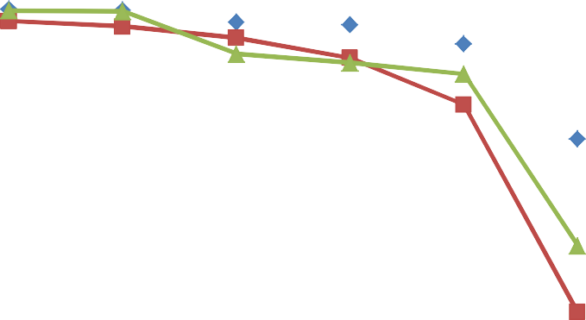
120

DS
100
MCS

GEL
Cumulative frequency (%)
80

60

40

20

0
PAN 75 90 150 250 500
Sieve size (µm)

Figure A. 1: Graph of Cumulative frequency (%) oversize distribution against
sieve size (µm) of metronidazole granules using 2.5 % w/v as binder.

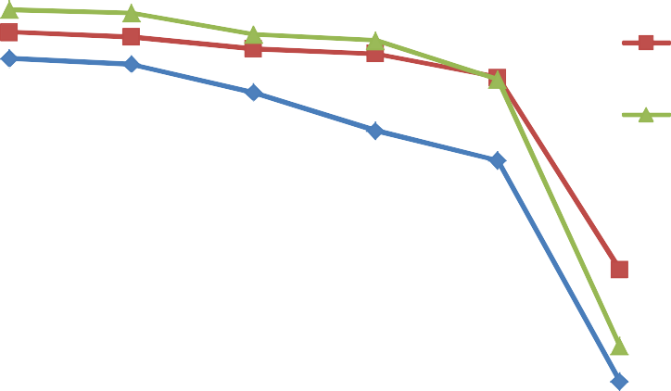
1
05
DS
00
MCS
95
GEL
90
85
80
75

1
Cumulative frequency (%)

PAN 75 90 150 250 500
Sieve size (µm)

Figure A. 2: Graph of Cumulative frequency (%) oversize distribution against
sieve size (µm) of metronidazole granules using 5.0 % w/v as binder.

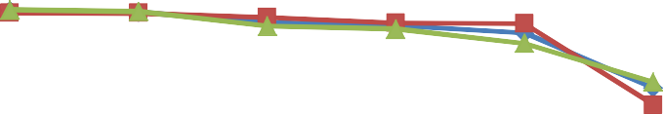
120

100

80
Cumulative frequency (%)

60 DS
MCS GEL
40

20

0
PAN 75 90 150 250 500
Sieve size (µm)

Figure A. 3: Graph of Cumulative frequency (%) oversize distribution against
sieve size (µm) of metronidazole granules using 7.5 % w/v as binder.

120

100

80
Cumulative frequency (%)

60 DS
MCS GEL
40

20

0
PAN 75 90 150 250 500
Sieve size (µm)

Figure A. 4: Graph of Cumulative frequency (%) oversize distribution against
sieve size (µm) of metronidazole granules using 10.0 % w/v as binder.


120

100

80
Cumulative frequency (%)

60 DS
MCS GEL
40

20

0
PAN 75 90 150 250 500
Sieve size (µm)

Figure A. 5: Graph of Cumulative frequency (%) oversize distribution against sieve size (µm) of metronidazole granules using 12.5 % w/v as binder.

120

100

80
Cumulative frequency (%)

60 DS
MCS MS
40

20

0
PAN 75 90 150 250 500
Sieve size (µm)

Figure A. 6: Graph of Cumulative frequency (%) oversize distribution against sieve size (µm) of metronidazole granules using 2.5 % w/w as disintegrant.

120

100

80
Cumulative frequency (%)

60

40 DS

MCS
20
MS

0
PAN 75 90 150 250 500
Sieve size (µm)

Figure A. 7: Graph of Cumulative frequency (%) oversize distribution against sieve size (µm) of metronidazole granules using 5.0 % w/w as disintegrant.

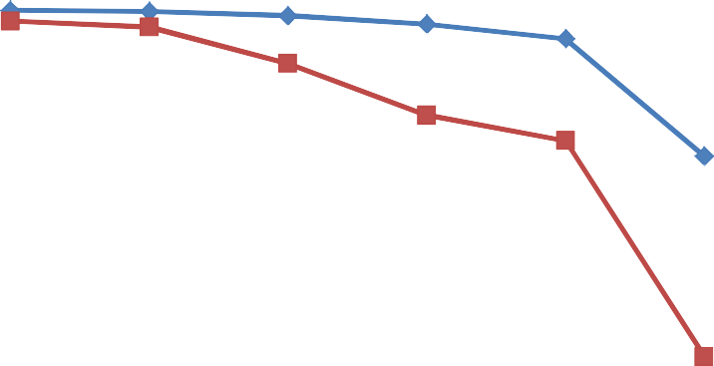
120

100

80
Cumulative frequency (%)

60 DS
MCS MS
40

20

0
PAN 75 90 150 250 500
Sieve size (µm)

Figure A. 8: Graph of Cumulative frequency (%) oversize distribution against sieve size (µm) of metronidazole granules using 7.5 % w/w as disintegrant.

120

100

80
Cumulative frequency (%)

60

40 DS

MCS
20
MS

0
PAN 75 90 150 250 500
Sieve size (µm)

Figure A. 9: Graph of Cumulative frequency (%) oversize distribution against sieve size (µm) of metronidazole granules using 10.0 % w/w as disintegrant.


120

100

80
Cumulative frequency (%)

60 DS
MCS MS
40

20

0
PAN 75 90 150 250 500
Sieve size (µm)

Figure A. 10: Graph of Cumulative frequency (%) oversize distribution against sieve size (µm) of metronidazole granules using 12.5 % w/w as disintegrant.

14
DS
MCS GEL

12

10

8
Crushing strength(kgf)

6

4

2

0
2.5 5 7.5 10 12.5
Binder concentration (% w/v)

Figure A.11: Graph of crushing strength (kgf) against binder concentration (% w/v) of metronidazole tablets produced by wet granulation.

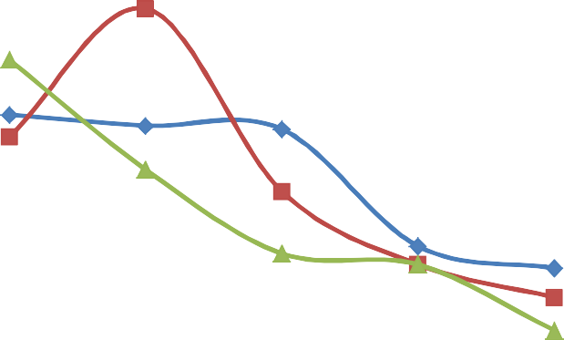
2

1.8

1.6 DS

1.4
MCS

1.2
Friability (%)
GEL

1

0.8

0.6

0.4

0.2

0
2.5 5 7.5 10 12.5
Binder concentration (% w/v)

Figure A.12: Graph of friability (%) against binder concentration (% w/v) of metronidazole tablets produced by wet granulation.

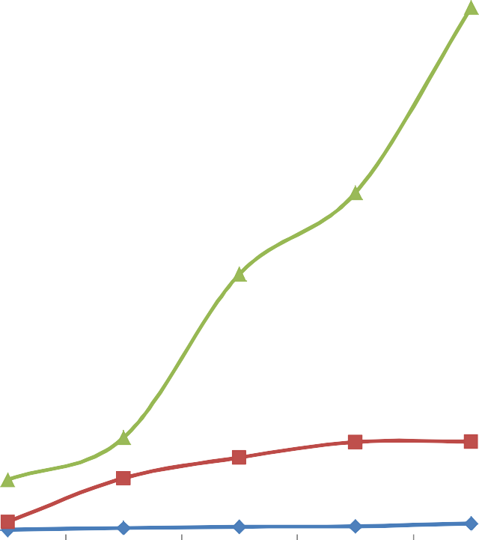
25

20

15
Disintegration time (min)

DS MCS
10
GEL

5

0
2.5 5 7.5 10 12.5
Binder concentration (% w/v)

Figure A.13: Graph of disintegration time (min) against binder concentration (% w/v) of metronidazole tablets produced by wet granulation.

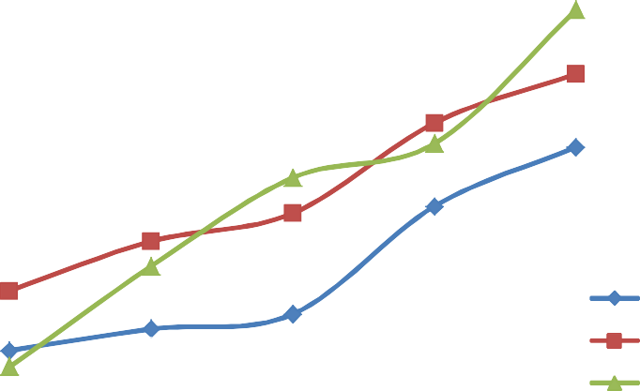
1
6
4
2
0
8

6
DS
MCS GEL
4
2
0

1

1

1
CS -FR

2.5 5 7.5 10 12.5
Binder concentration (% w/v)

Figure A.14: Graph of crushing strength-friability index against binder concentration (% w/v) of metronidazole tablets produced by wet granulation.

40

35

30

25
DS
CS -FR/DT
20
MCS
15
GEL

10

5

0
2.5 5 7.5 10 12.5
Binder concentration (% w/v)

Figure A.15: Graph of crushing strength-friability/disintegration time index against binder concentration (% w/v) of metronidazole tablet produced by wet granulation.

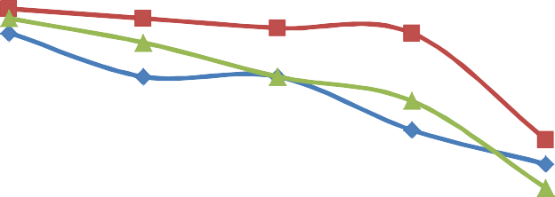
14

12

10

8
Crushing strength (kgf)
DS
6 MCS
MS

4

2

0
2.5 5 7.5 10 12.5
Disintegrant concentration (% w/w)

Figure A.16: Graph of crushing strength (kgf) against disintegrant concentration (% w/w) of metronidazole tablets produced by wet granulation.

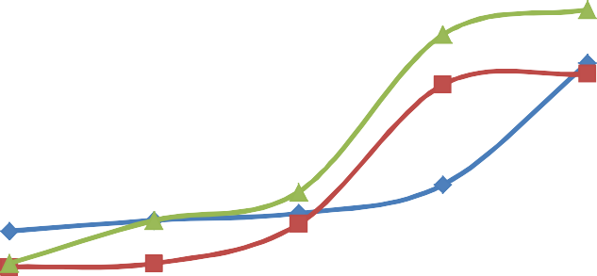
2.5

2

1.5

DS MCS
Friability (%)
1 MS

0.5

0
2.5 5 7.5 10 12.5
Disintegrant concentration (% w/w)

Figure A.17: Graph of friability (%) against disintegrant concentration (% w/w) of metronidazole tablets produced by wet granulation.

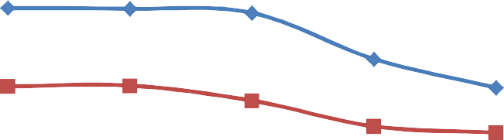
9

8

7

6
Disintegration time (min)

5
DS
4 MCS
MS
3

2

1

0
2.5 5 7.5 10 12.5
Disintegrant concentration (% w/w)

Figure A.18: Graph of disintegration time (min) against disintegrant concentration (% w/w) of metronidazole tablets produced by wet granulation.

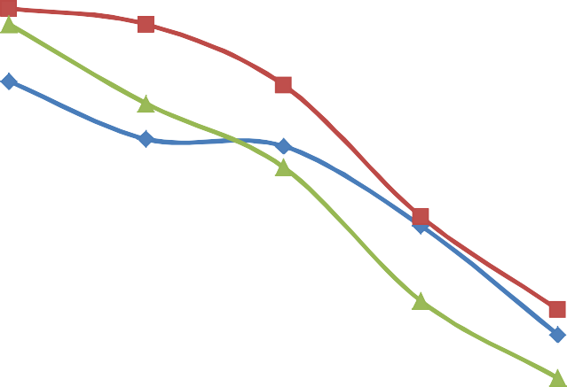
10

9

8

7

6

5 DS
CS -FR
MCS
4
MS

3

2

1

0
2.5 5 7.5 10 12.5
Disintegrant concentration (% w/w)

Figure A.19: Graph of crushing strength-friability index against disintegrant concentration (% w/w) of metronidazole tablets produced by wet granulation.

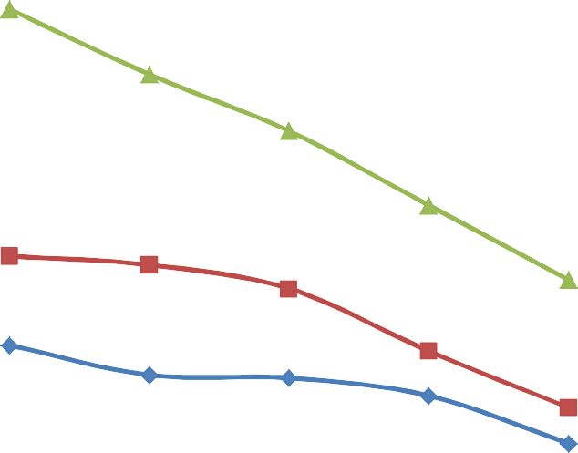
2.5

2

1.5

DS MCS
CS -FR/DT
1
MS

0.5

0
2.5 5 7.5 10 12.5
Disintegrant concentration (% w/w)

Figure A.20: Graph of crushing strength-friability/disintegration time index against disintegrant concentration (% w/w) of metronidazole tablets produced by wet granulation.

Calibration Curve for Metronidazole

Conc. (µg/ml) | Absorbance (nm)
10.0 | 0.529
5.0 | 0.324
2.5 | 0.233
1.25 | 0.170
0.625 | 0.160
0.3125 | 0.150

0.6
y = 0.0395x + 0.1317
R² = 0.998

0.5

0.4
Absorbance (nm)

0.3

0.2
Series1
Linear (Series1)

0.1

0
0 2 4 6 8 10 12
Concentration (µg/ml)

Figure A. 21: Graph of Absorbance (nm) against Concentration (µg/ml) for
metronidazole.

  - Dissolution Test Results for 7.5 % w/v Binder Concentration

Time (min) Abs(nm) Amount dissolved % drug dissolved
mg/1000ml DS/MET

5 | 0.345 | 108.00 | 27.00
10 | 0.608 | 241.16 | 60.29
15 | 0.797 | 336.86 | 84.22
20 | 0.898 | 388.00 | 97.00
25 | 0.925 | 400.00 | 100.00
30 | 0.914 | 396.10 | 99.03
MCS/MET
5 | 0.459 | 165.72 | 41.43
10 | 0.585 | 184.96 | 46.24
15 | 0.600 | 237.11 | 59.28
20 | 0.692 | 283.70 | 70.93
25 | 0.835 | 356.10 | 89.03
30 | 0.884 | 380.91 | 95.22
GEL/MET
5 | 0.223 | 46.23 | 11.56
10 | 0.501 | 186.98 | 46.75
15 | 0.599 | 236.61 | 59.15
20 | 0.653 | 263.95 | 65.99
25 | 0.728 | 301.93 | 75.48
30 | 0.807 | 341.92 | 85.48

Dissolution Test Results for 10.0 % w/w Disintegrant Concentration

Time (min) Abs(nm) Amount dissolved % drug dissolved
mg/1000ml DS/MET

5 | 0.668 | 271.54 | 67.89
10 | 0.687 | 281.16 | 70.29
15 | 0.783 | 329.77 | 82.44
20 | 0.831 | 354.08 | 88.52
25 | 0.914 | 396.10 | 99.03
30 | 0.923 | 400.65 | 100.16
MS/MET
5 | 0.358 | 114.58 | 28.65
10 | 0.481 | 176.86 | 44.22
15 | 0.567 | 220.41 | 55.10
20 | 0.781 | 328.76 | 82.19
25 | 0.821 | 349.01 | 87.25
30 | 0.917 | 397.62 | 99.41
MCS/MET
5 | 0.458 | 165.22 | 41.31
10 | 0.506 | 189.52 | 47.38
15 | 0.617 | 245.72 | 61.43
20 | 0.673 | 274.08 | 68.51
25 | 0.783 | 329.77 | 82.44
30 | 0.894 | 385.98 | 96.49

Parameter from Dissolution profile of metronidazole tablets containing
7.5 % w/v binder concentration.

Parameter | DS | MCS | GEL
T_{50%} (min) | 8 | 6 | 11
T_{90%} (min) | 16 | 26 | 32
Dissolution | 99.03 | 95.23 | 85.48
efficiency (30min)%

A. 8 Parameter from Dissolution profile of metronidazole tablets containing

10.0 % w/w disintegrant concentration.

Parameter | DS | MCS | MS BP
T_{50%} (min) | 4 | 11 | 11
T_{90%} (min) | 21 | 27 | 26
Dissolution | 100.00 | 96.49 | 99.41
efficiency (30min)%

A. 9 Parameters for Heckel Plot

Compression pressure (MN/m2)
Relative Density g/cm³
1 – D 1
1 − 𝐷
1
𝑙𝑛 (1 − 𝐷)

(DS)  56.625 | 0.7213 | 0.2787 | 3.6880 | 1.2776
84.938 | 0.6917 | 0.3083 | 3.2457 | 1.1773
113.250 | 0.7376 | 0.2624 | 3.8109 | 1.3379
141.563 | 0.7699 | 0.2301 | 4.3459 | 1.4692
169.875 | 0.7953 | 0.2047 | 4.8851 | 1.5862
198.188 | 0.8139 | 0.1861 | 5.3735 | 1.6815
226.500 | 0.8119 | 0.1881 | 5.3163 | 1.6708
254.813 | 0.8171 | 0.1828 | 5.4705 | 1.6993
283.125 | 0.8065 | 0.1935 | 5.1679 | 1.6425
311.438 | 0.8194 | 0.1806 | 5.5371 | 1.7115
(MCS)  56.625 | 0.7068 | 0.2932 | 3.4106 | 1.2269
84.938 | 0.7199 | 0.2801 | 3.5599 | 1.2698
113.250 | 0.7251 | 0.2749 | 3.6377 | 1.2913
141.563 | 0.7583 | 0.2417 | 4.1373 | 1.4201
169.875 | 0.7625 | 0.2375 | 4.2105 | 1.4376
198.188 | 0.7725 | 0.2375 | 4.2105 | 1.4376
226.500 | 0.7874 | 0.2126 | 4.7037 | 1.5483
254.813 | 0.8076 | 0.1924 | 5.1975 | 1.6482
283.125 | 0.8071 | 0.1929 | 5.1840 | 1.6456
311.438 | 0.7935 | 0.2065 | 4.8426 | 1.5776
(GEL)  56.625 | 0.7136 | 0.2864 | 3.4916 | 1.2504
84.938 | 0.7677 | 0.2323 | 4.3048 | 1.4597
113.25 | 0.7966 | 0.2034 | 4.9164 | 1.5926
141.563 | 0.8027 | 0.1973 | 5.0684 | 1.6230
169.875 | 0.8144 | 0.1850 | 5.3876 | 1.6842
198.188 | 0.8218 | 0.1782 | 5.6117 | 1.7248
226.500 | 0.8230 | 0.1699 | 5.8858 | 1.7725
254.813 | 0.7950 | 0.2050 | 4.8780 | 1.5847
283.125 | 0.7677 | 0.2323 | 4.3048 | 1.4597
311.438 | 0.1759 | 0.1759 | 5.6850 | 1.7378

A. 10 Statistical Analysis

Physicochemical Parameters of DS and MCS compared with MS using Correlations Analysis

 | MS | DS | MCS
MS Pearson Correlation Sig. (2-tailed)  N | 1  16 | .979**  .0001  16 | .974**  .0001  16
DS Pearson Correlation Sig. (2-tailed)  N | .979**  .0001  16 | 1  16 | .994**  .0001  16
MCS Pearson Correlation Sig. (2-tailed)  N | .974**  .0001  16 | .994**  .0001  16 | 1  16
**. Correlation is significant at the 0.01 level (2-tailed).

Effects of Disintegrant concentration at 2.5 % on the physical properties of the granules of DS and MCS compared with MS using correlation Analysis.

 | DS | MCS | MS
DS Pearson Correlation Sig. (2-tailed)  N | 1  6 | .966**  .002  6 | .978**  .001  6
MCS Pearson Correlation Sig. (2-tailed)  N | .966**  .002  6 | 1  6 | .999**  .0001  6
MS Pearson Correlation Sig. (2-tailed)  N | .978**  .001  6 | .999**  .0001  6 | 1  6
**. Correlation is significant at the 0.01 level (2-tailed).

Effects of Disintegrant concentration at 5.0 % on the physical properties of the and MCS compared with MS using correlation Analysis

 | DS | MCS | MS
DS Pearson Correlation Sig. (2-tailed)  N | 1  6 | 0.999**  .0001  6 | .939**  .006  6
MCS Pearson Correlation Sig. (2-tailed)  N | 0.999**  .0001  6 | 1  6 | .940**  .005  6
MS Pearson Correlation Sig. (2-tailed)  N | .939**  .006  6 | .940**  .005  6 | 1  6
**. Correlation is significant at the 0.01 level (2-tailed).

Effect of Disintegrant concentration at 7.5 % on the physical properties of the granules of DS and MCS compared with MS using correlation Analysis.

 | DS | MCS | MS
DS Pearson Correlation Sig. (2-tailed)  N | 1  6 | .998**  .0001  6 | .962**  .002  6
MCS Pearson Correlation Sig. (2-tailed)  N | .998**  .0001  6 | 1  6 | .946**  .004  6
MS Pearson Correlation Sig. (2-tailed)  N | .962**  .002  6 | .946**  .004  6 | 1  6
**. Correlation is significant at the 0.01 level (2-tailed).

Effect of Disintegrant concentration at 10.0 % on the physical properties of the granules of DS and MCS compared with MS using correlation Analysis

 | DS | MCS | MS
DS Pearson Correlation Sig. (2-tailed)  N | 1  6 | .992**  .0001  6 | .995**  .0001  6
MCS Pearson Correlation Sig. (2-tailed)  N | .992**  .0001  6 | 1  6 | .999**  .0001  6
MS Pearson Correlation Sig. (2-tailed)  N | .995**  .0001  6 | .999**  .0001  6 | 1  6
**. Correlation is significant at the 0.01 level (2-tailed).

Effect of Disintegrant concentration at 12.5 % on the physical properties of the granules of DS and MCS compared with MS using correlation Analysis

 | DS | MCS | MS
DS Pearson Correlation Sig. (2-tailed)  N | 1  6 | .997**  .0001  6 | .996**  .0001  6
MCS Pearson Correlation Sig. (2-tailed)  N | .997**  .0001  6 | 1  6 | .987**  .0001  6
MS Pearson Correlation Sig. (2-tailed)  N | .996**  .0001  6 | .987**  .0001  6 | 1  6
**. Correlation is significant at the 0.01 level (2-tailed).

Effect of Binder concentration at 2.5 % on the physical properties of the granules of DS and MCS compared with GEL using correlation analysis

 | DS | MCS | GEL
DS Pearson Correlation Sig. (2-tailed)  N | 1  6 | .999**  .0001  6 | .992**  .0001  6
MCS Pearson Correlation Sig. (2-tailed)  N | .999**  .0001  6 | 1  6 | .996**  .0001  6
GEL Pearson Correlation Sig. (2-tailed)  N | .992**  .0001  6 | .996**  .0001  6 | 1  6
**. Correlation is significant at the 0.01 level (2-tailed).

Effect of Binder concentration at 5.0 % on the physical properties of the granules of DS and MCS compared with GEL using correlation analysis

 | DS | MCS | GEL
DS Pearson Correlation Sig. (2-tailed)  N | 1  6 | .999**  .0001  6 | .975**  .001  6
MCS Pearson Correlation Sig. (2-tailed)  N | .999**  .0001  6 | 1  6 | .966**  .002  6
GEL Pearson Correlation Sig. (2-tailed)  N | .975**  .001  6 | .966**  .002  6 | 1  6
**. Correlation is significant at the 0.01 level (2-tailed).

Effect of Binder concentration at 7.5 % on the physical properties of the granules of DS and MCS compared with GEL using correlation analysis

 |  | DS | MCS | GEL
DS Pearson Correlation Sig. (2-tailed)  N |  | 1  6 | .995**  .0001  6 | .998**  .0001  6
MCS Pearson Correlation Sig. (2-tailed)  N |  | .995**  .0001  6 | 1  6 | .999**  .0001  6
GEL | Pearson Correlation | .998** | .999** | 1  6
 | Sig. (2-tailed)  N | .0001  6 | .0001  6
**. Correlation is significant at the 0.01 level (2-tailed).

Effect of Binder concentration at 10.0 % on the physical properties of the granules of DS and MCS compared with GEL using correlation analysis

 |  | DS | MCS | GEL
DS Pearson Correlation Sig. (2-tailed)  N |  | 1  6 | .991**  .0001  6 | .999**  .0001  6
MCS Pearson Correlation Sig. (2-tailed)  N |  | .991**  .0001  6 | 1  6 | .996**  .0001  6
GEL | Pearson Correlation | .999** | .996** | 1  6
 | Sig. (2-tailed)  N | .0001  6 | .0001  6
**. Correlation is significant at the 0.01 level (2-tailed).

Effect of Binder concentration at 12.5 % on the physical properties of the granules of DS and MCS compared with GEL using correlation analysis

 |  | DS | MCS | GEL
DS Pearson Correlation Sig. (2-tailed)  N |  | 1  6 | 0.999**  .0001  6 | .997**  .0001  6
MCS Pearson Correlation Sig. (2-tailed)  N |  | 0.999**  .000  6 | 1  6 | .995**  .0001  6
GEL | Pearson Correlation | .997** | .995** | 1  6
 | Sig. (2-tailed)  N | .0001  6 | .0001  6
**. Correlation is significant at the 0.01 level (2-tailed).

