EVALUATION OF SOME NATURAL AND SYNTHETIC PRODUCTS AGAINST AFRICAN TRYPANOSOMIASIS

AUGUSTINE CHINYERE IGWEH B.Sc., M. Sc. PHARMACOLOGY (PGPH/UJ/0026/04)

A thesis in the Department of PHARMACOLOGY of The FACULTY OF PHARMACEUTICAL SCIENCES, UNIVERSITY OF JOS,
submitted to The School of Postgraduate Studies, University of Jos, in partial fulfilment of the requirements for the award of the degree of DOCTOR OF PHILOSOPHY of the

UNIVERSITY OF JOS.

MARCH, 2007

DECLARATION

I hereby declare that this work is the product of my own research efforts, undertaken under the supervision of Prof. F.K Okwuasaba and has not been presented elsewhere for the award of a degree or certificate. All sources have been duly distinguished and appropriately acknolwedged.

AUGUSTINE CHINYERE IGWEH (PGPH/UJ/0026/04)

CERTIFICATION

This is to certify that this thesis has been examined and approved for the award of the degree of DOCTOR OF PHILOSOPHY in PHARMACOLOGY.

Professor Helen O. Kwanashie Professor C.O. Akueshi

External Examiner Internal Examiner

Date: Date:

Professor F.K. Okwuasaba Dr. J.C. Aguiyi (Reader)

Supervisor Head of Department

Date: Date:

Professor J.A. Kolawole Professor J.O. Kolawole

Dean of Faculty Dean, School of Postgraduate Studies

Date: Date:

ACKNOWLEDGEMENT

I am very grateful to Almighty God, the creator and giver of life and knowledge for seeing me through this research work and the whole programme. I am equally grateful to my supervisor, Prof. F. K. Okwuasaba for his supervisory role, advice, words of encouragement and constructive criticisms of the research work. My thanks go to Dr. G. Cuny and Dr.S. Herder of LRCT-IRD Montpellier France/University of Montpellier 1, Montpellier France and Prof. G. Duvallet of University of Montpellier III, Montpellier France for their supervisory role, guidance and motivation. I am also grateful to my parents Mr. Alphonsus Ibeh Igweh (Late) and Mrs. Justina Igweh for their role in my upbringing and education. My special thanks go to my entire family with special reference to my wife Cynthia and my children Chukwuemeka and Okechukwu for their words of encouragement and understanding throughout the whole programme. I thank the authorities of National Agency for Food and Drug Administration and Control (NAFDAC) Kaduna for permission to use some of their facilities for analysis. I am grateful to Mr. Francis V. Udoh, formerly of the Deparment of Pharmacology and Clinical Pharmacy University of Jos and currently of the Department of Pharmacology University of Calabar for his assistance especially at the critical period when some of the experimental animals had to be transported from Vom to University of Jos.
I thank Dr. Chris Isichei of Chemical Pathology Department of Jos University Teaching Hospital (JUTH) for allowing the use of his laboratory facilities for the biochemical analysis of some of the sera samples of the sleeping sickness patients. I also thank Mr. Abari Lawiye of the Insectary Unit of Entomology Section NITR Kaduna for the maintenance of the tsetse flies used for the natural and synthetic products repellent activities investigations.

Special thanks go to Drs .R.L.Barden and MacLaren of Baptist Medical Centre Eku Delta State where the patients were hospitalized, and also to Dr.(Mrs).E.O.Elhassan of Sight Savers Kaduna for providing the drugs (Pentamidine and Melarsoprol), which she obtained from the World Health Organization (WHO). I am grateful to the traditional healers, livestock owners and other respondents for the information obtained from them on local methods of controlling African trypanosomiasis.
I am very grateful to my colleagues and friends at the Nigerian Institute for Trypanosomiasis Research (NITR) and at the University of Jos, with special reference to Assoc. Prof. J. C. Aguiyi and Dr. (Mrs.) M. Uguru for their prayers and words of encouragement and constructive criticisms during my seminar presentations on the present research work.
I am very grateful to The Director - General of The Nigerian Institute for Trypanosomiasis Research (NITR), Dr. Ibrahim Halid for his words of encouragement, to the management of NITR for their approval of the study programme and the role of the Institute in the sponsorship of the programme.
I am grateful to the French Government for granting me the scholarship to go to France and carry out a crucial aspect of the research project.

DEDICATION

This Research Work is Dedicated to My Late Father

MR. ALPHONSUS IBEH IGWEH

Man of Peace and Ingeniuty, A Lover of Education

Who Denied Himself Much to Make Sure

That His Children Are Educated

TABLE OF CONTENTS
PAGE

TITLE PAGE I
DECLARATION II
CERTIFICATION III
ACKNOWLEDGEMENT IV
DEDICATION VI
TABLE OF CONTENTS VII
LIST OF TABLES XIV
LIST OF FIGURES XVI
LIST OF PLATES XX
ABSTRACT XXI
CHAPTER ONE INTRODUCTION
  - TRYPANOSOMES, TRYPANOSOMIASIS AND TRANSMISSION 1
  - HISTORICAL BACKGROUND AND PROBLEM OF AFRICAN TRYPANOSOMIASIS 17
  - ECONOMIC IMPORTANCE OF AFRICAN TRYPANOSOMIASIS 21
  - NATURAL PRODUCTS 27
  - SYNTHETIC PRODUCTS 31
  - CONCEPT, BROAD OBJECTIVES AND SCOPE OF THE RESEARCH 33
  - SPECIFIC OBJECTIVES 34
CHAPTER TWO LITERATURE REVIEW
  - PATHOLOGY AND PATHOGENESIS OF AFRICAN TRYPANOSOMIASIS 35
  - PROBLEMS AND CURRENT STATUS OF THE
CHEMOTHERAPY OF AFRICAN TRYPANOSOMIASIS 42
    - The Discovery of Trypanocidal Drugs 42
    - Problems and Current Status of the Chemotherapy 44
      - Drug toxicity 46
      - Drug resistance 47
      - Counterfeit/substandard drug products and formulation differences 56
      - Constraints related to drug discovery, development, availability and affordability 59
  - REVIEW OF THE NATURAL AND SYNTHETIC PRODUCTS AND RATIONALE FOR THEIR INCLUSION IN THE PRESENT WORK 62
    - Honey 62
    - Brassica oleracea 63
    - Skin of Frog and Snake 64
    - Cattle Butter and Shea Butter 64
    - Lantana camara 65
    - Tapinanthus (Mistletoe) 66
    - Chloroquine 68
    - DL-α-Difluoromethylornithine (DFMO) 69
    - Cymelarsan 71
    - Verapamil 72
    - Pentamidine 73
    - Melarsoprol 73
    - Prednisolone 74
    - Diminazene Aceturate 74
    - Ethidium Bromide 75
CHAPTER THREE MATERIALS AND METHODS
  - EQUIPMENT 77
  - STRAIN OF TRYPANOSOMES UNDER INVESTIGATION 78
  - STANDARD REFERENCE DRUGS USED 78
  - NATURAL PRODUCTS UNDER INVESTIGATION 78
  - SYNTHETIC DRUGS UNDER INVESTIGATION 79
  - SYNTHETIC CHEMICALS UNDER INVESTIGATION 80
  - ANIMALS 80
  - ANIMAL FEEDING AND MAINTENANCE 80
  - TSETSE FLIES 80
  - BACTERIAL AND OTHER MICROBIAL ISOLATES 81
  - STUDIES ON HONEY 81
    - Analysis of Honey Samples PBMH1, PBMH2 and ANH1 for Trace Elements 81
    - Quantitative Analysis of the Honey Sample PBMH1 82
      - Ash and total nitrogen 82
      - Free acid and pH 82
      - Invert sugar 82
      - Reducing sugars, fructose and dextrin 83
    - In vitro and In vivo Assessment of Possible Anti-trypanocidal Effect
of Honey Sample PBMH1 84
  - EVALUATION OF ANTI-TRYPANOSOMAL EFFECT OF THE
AQUEOUS EXTRACT OF BRASSICA OLERACEA 84
    - Plant Material 84
    - Preparation of Extract 85
    - Phytochemical Analysis 85
    - Strain of Test Organism 85
    - In vitro Assay and Infectivity Assessment 85
  - STUDIES ON FROG AND SNAKE SKINS 85
    - Phytochemical Analysis of Frog and Snake Skins 85
    - Investigation into Possible Potentiation of Diminazene Aceturate
Activity with Extracts of Frog and Snake Skins 86
  - EVALUATION OF CYMELARSAN AGAINST T. BRUCEI BRUCEI 87
  - EVALUATION OF CYMELARSAN AGAINST T. EVANSI 87
    - Antigen Enzyme – linked Immunosorbent Assay (ELISA) 88
    - Antibody ELISA 89
    - In vitro Evaluation of Cymelarsan Against T. evansi 90
  - TRIALS AT REVERSAL OF TRYPANOSOMAL RESISTANCE
USING VERAPAMIL 91
  - INVESTIGATION INTO NATURAL AND SYNTHETIC TSETSE REPELLENTS FOR PREVENTION OF TRYPANOSOME TRANSMISSION AND DRUG RESISTANCE 92
  - INVESTIGATION ON THE EFFECT OF ORAL COMBINATION THERAPY OF DFMO, CHLOROQUINE AND HONEY ON TRYPANOSOME INFECTION 93
    - T. brucei brucei Infection and Treatment of Animals 93
    - T. gambiense Infection and Treatment of Animals 93
    - Animal Inoculation 94
  - PRE-TREATMENT OF UNINFECTED ANIMALS WITH A COMBINATION OF DFMO, CHLOROQUINE AND HONEY
SAMPLE PBMH1 94
    - Drug Dilution 94
    - Pretreatment 94
    - The Rat Phrenic Nerve Hemidiaphragm Muscle Preparation 95
    - The Rat Isolated Uterus Preparation 96
  - TOPICAL APPLICATION OF TRYPANOCIDAL DRUGS COMBINED WITH NATURAL PRODUCTS OF ANIMAL AND
PLANT ORIGIN 96
  - STUDIES ON SOME SLEEPING SICKNESS PATIENTS TREATED WITH PENTAMIDINE, MELARSOPROL (MELB) AND PREDNISOLONE USING DIFFERENT TREATMENT STRATEGIES AT BAPTIST MEDICAL CENTRE EKU DELTA
STATE NIGERIA 98
    - Study Area 98
    - Ethical Clearance 98
    - Diagnosis and Clinical Parameters 98
    - Treatment of Patients 105
    - Biochemical Analysis of Sera Samples 105
  - THE APPLICATION OF POLYMERASE CHAIN REACTION (PCR) TECHNOLOGY TO ASSESS DRUG THERAPEUTIC EFFICACY IN SLEEPING SICKNESS PATIENTS AT ETHIOPE EAST LGA
OF DELTA STATE NIGERIA 106
    - Blood Sample Collection, Preservation and Transportation 106
    - Preparation of Template DNAs 107
      - Extraction of DNA using chelex method 107
      - Extraction of DNA by DNAzol method 108
    - DNA Amplification by PCR 109
    - Electrophoresis 110
    - Photography of the Gel 110
  - PARMACOSOCIOECONOMICS AND STUDIES OF OTHER HUMAN FACTORS WHICH CONTRIBUTE TO TREATMENT FAILURES AND ENHANCEMENT OF TRYPANOSOMAL DRUG RESISTANCE AND
TOXICITY 110
    - Study Areas/Scope 110
    - Questionnaire Administration and Analysis 111
  - STATISTICAL TREATMENT OF DATA 112
CHAPTER FOUR RESULTS
  - STUDIES ON HONEY 113
    - Analysis of Honey Sample PBMH1 for Trace Elements and Other Material Contents 113
    - In Vitro and In Vivo Assays of Honey Sample PBMH1 113
  - STUDIES ON BRASSICA OLERACEA 114
    - Phytocemical Analysis 114
    - Anti-trypanosomal Studies 114
  - STUDIES ON FROG AND SNAKE SKINS 114
    - Phytochemical Investigations 114
    - Studies on the Potentiation of Diminazene Aceturate Activity with
Extracts of Frog and Snake Skins. 114
  - DRUG RESISTANCE STUDIES 118
    - Evaluation of Cymelarsan Against T. brucei brucei 118
    - Evaluation of Cymelarsan Against T. evansi 118
    - Antigen Enzyme-linked Immunosorbent Assay (ELISA) 118
    - Antibody Enzyme-linked Immunosorbent Assay (ELISA) 126
    - In Vitro Assay 126
    - Trypanosomal Drug Resistance Reversal Studies Using Verapamil 126
    - Studies of Potential Tsetse Fly Repellent Materials 138
  - EFFECT OF ORAL COMBINATION OF DFMO, CHLOROQUINE AND HONEY SAMPLE PBMH1 ON TRYPANOSOME
INFECTIONS 138
  - PRE-TREATMENT STUDIES OF UNINFECTED ANIMALS WITH A COMBINATION OF DFMO, CHLOROQUINE AND HONEY
SAMPLE PBMH1 138
  - STUDIES ON TOPICAL APPLICATION OF TRYPANOCIDAL
DRUGS USING NATURAL PRODUCTS 139
    - Analysis of Butyrospermum paradoxum Seed and Shea Butter for Material Contents 139
    - Topical Application Investigations 139
  - STUDIES ON SLEEPING SICKNESS PATIENTS IN DELTA
STATE 172
  - PHARMACOSOCIOECONOMIC STUDIES 173
    - Family Size, Age, Religion and Level of Literacy of Respondents 173
    - Economic Activities of the People of the Surveyed Areas 183
    - Degree of Awareness 183
    - Attitude to Disease and Treatment Seeking Behaviour 183
    - Responses from Medical Practitioners/Other Health Officials and Veterinary Workers 184
    - Ethnotaxonomy, Ethnosemantics, Ethnodiagnosis and
Ethnotherapeutics 186
    - Impact Assessment 186
CHAPTER FIVE DISCUSSION
  - STUDIES ON HONEY 189
  - STUDIES ON BRASSICA OLERACEA 192
  - STUDIES ON FROG AND SNAKE SKINS 192
  - DRUG RESISTANCE STUDIES 193
    - Investigation of Activity of Cymelarsan and Trypanosomal
Resistance to Cymelarsan 193
    - Trypanosomal Drug Resistance Reversal Studies Using Verapamil 196
    - Studies on Repellent Activities 198
  - STUDIES ON ORAL COMBINATION THERAPY OF DFMO, CHLOROQUINE AND HONEY IN TRYPANOSOME INFECTIONS 199
  - PRE-TREATMENT STUDIES USING ORAL COMBINATION OF
DFMO, CHLOROQUINE AND HONEY 201
  - STUDIES ON TOPICAL APPLICATION OF TRYPANOCIDAL
DRUGS USING NATURAL PRODUCTS 202
  - STUDIES IN SLEEPING SICKNESS PATIENTS IN DELTA STATE NIGERIA 204
  - PHARMACOSOCIOECONOMIC STUDIES 210
  - CONCLUSION 214
    - Highlight of the Major Findings of the Research, Inference Made
From Them and Contribution to Knowledge 214
    - Recommendations/Suggestions and Areas of Further Work 217
REFERENCES 221
GLOSSARY 260
APPENDIX 261

LIST OF TABLES
PAGE
- Analysis of Honey Sample PBMH1 for Material Contents 115
- Effect of Brassica oleracea on the Motility of DE 52 Separated Trypanosomes and Trypanosomes in Whole Blood 116
- Assessment of the Effect of Brassica oleracea Extract on the Infectivity of DE 52 Separated Trypanosomes and Trypanosomes in
Whole Blood after Incubation Period 117
- Potentiation of Diminazene Aceturate Activity in Trypanosoma brucei
brucei Infected Albino Rats Using Extracts of Frog and Snake Skins 119
- Period Between Infection and Death of the Groups of Rabbits Infected with Trypanosoma evansi and Treated with Cymelarsan and
Verapamil 120
- Analysis of Lantana camera Sample and Tapinanthus (Mistletoe)
Parasitic on the Lantana camara 140
- Effect of Oral Combination Therapy of DFMO, Chloroquine and
Honey on Trypanosome Infection in Rats and Mice 142
- Percentage of Uterine Muscle Weight in Relation to Rat Body Weight 162
- Analysis of Butyrospermum paradoxum Seed and Shea Butter for
Material Contents 163
- Effect of Topical Application of Melarsoprol on Trypanosoma
gambiense Infected Mice 164
- Effect of Topical Application of Melarsoprol on Trypanosoma brucei
brucei Infected Albino Rats 165
- Effect of Topical Application of Ethidium Bromide and Cattle Butter (Ghee) Combination on Trypanosoma congolense Infected Albino
Rats 166
- Effect of Topical Application of Ethidium Bromide and Shea Butter Combination on Trypanosoma congolense Infected Albino Rats 167
- Effect of Topical Application of Ethidium Bromide on Trypanosoma congolense Infected Albino Rats 168
- Effect of Topical Application of Diminazene Aceturate (Berenil) on
Trypanosoma brucei brucei Infected Albino Rats 169
- Effect of Topical Application of Berenil and Cattle Butter (Ghee)
Combination on Trypanosoma brucei brucei Infected Albino Rats 170

- Effect of Topical Application of Berenil and Shea Butter Combination
on Trypanosoma brucei brucei Infected Albino Rats 171
- The Sleeping Sickness Patients in Some Villages of Ethiope East and Ndokwa West LGAs of Delta State who were Treated During the November/December Survey of 1992 174
- The Sleeping Sickness Patients at Ugono Village Ethiope East LGA of Delta State Who Could not be Treated Due to Non Availability of
Trypanocidal Drugs During the November/December Survey of 1992 175
- Biodata, Diagnosis and Clinical Parameters of Sleeping Sickness Patients Treated at Baptist Medical Centre Eku Delta State Nigeria in
1992 and 1995 176
- Biochemical Parameters of Sleeping Sickness Patients Before, During and After Treatment at Baptist Medical Centre Eku Delta State
Nigeria in 1992 and 1995 177
- Biodata and Body Weight Changes of Sleeping Sickness Patients Before, During and After Treatment with a Combination of Pentamidine, Melarsoprol and Prednisolone at Baptist Medical
Centre Eku, Delta State, Nigeria in 1996 and 1997 178
- Biodata and Body Temperature Changes of Sleeping Sickness Patients Before, During and After Treatment with a Combination of Pentamidine, Melarsoprol and Prednisolone at Baptist Medical
Centre Eku, Delta State, Nigeria in 1996 and 1997 179
- Biodata, Pulse Rate and Blood Pressure of Sleeping Sickness Patients Before, During and After Treatment with a Combination of Pentamidine, Melarsoprol and Prednisolone at Baptist Medical
Centre Eku Delta State Nigeria in 1996 and 1997 180
- Knowledge/Awareness and Attitude Responses of Respondents
Concerning Human African Trypanosomiasis (HAT) and its Causes 185
- Ethnodiagnosis of Trypanosomiasis and Ethnosemantics of Tsetse
Fly and Trypanosomiasis Recorded in the Surveyed Areas 187
- Ethnotherapeutics for Trypanosomiasis Identified by Vernacular
Names (Ethnotaxonomy) 188

LIST OF FIGURES
PAGE
- Life Cycle of Trypanosoma brucei brucei 16
- Diagram Illustrating the Process of Antigenic Variation 22
- Some Important Factors Influencing the Development of Resistance to Trypanocidal Drugs 55
- Schematic Representation of the Inhibition of Ornithine Decarboxylase by DL-α-Difluoromethylornithine (DFMO) and Chloroquine in Polyamine
Biosynthesis in Trypanosomes 70
- Map of Nigeria Showing Delta, Benue, Plateau and Nasarawa States Studied 100
- Map Showing the Lower Benue Districts of Benue State Harbouring the
Old Endemic Focus of Sleeping Sickness Studied 101
- Map Showing the Districts of Delta State Harbouring the New Endemic Focus of Sleeping Sickness Studied 102
- Map of Ethiope East Local Government Area of Delta State Surveyed 103
- Map Showing the North-Eastern Part of Ethiope East Local Government Area of Delta State Surveyed 104
- Parasitaemic Profile of Control Albino Rats and Rats Infected with Trypanosoma brucei brucei and Treated with Different Doses of Cymelarsan 120
- Parasitaemia and Packed Cell Volume in Control Rabbits Infected with
Trypanosoma evansi but not Treated 121
- Parasitaemia and Packed Cell Volume in Rabbits Infected with
Trypanosoma evansi and Treated with 0.25 mg/kg of Cymelarsan 122
- Parasitaemia and Packed Cell Volume in Rabbits Infected with
Trypanosoma evansi and Treated with 0.25 mg/kg of Cymelarsan 123
- Parasitaemia and Packed Cell Volume in Rabbits Infected with
Trypanosoma evansi and Treated with 1.0 mg/kg of Cymelarsan 124
- Parasitaemia and Packed Cell Volume in Rabbits Infected with
Trypanosoma evansi and Treated with 2.0 mg/kg of Cymelarsan 125
- Antigens in Rabbits Infected with Trypanosoma evansi and Treated
with Cymelarsan 127
- Antibodies in Rabbits Infected with Trypanosoma evansi and Treated
with Cymelarsan 128

- Parasitaemia and Packed Cell Volume in Rabbits Infected with
Trypanosoma evansi and Treated with 0.25 mg/kg of Cymelarsan and
50 mg/kg of Verapamil 130
- Parasitaemia and Packed Cell Volume in Rabbits Infected with
Trypanosoma evansi and Treated with 2.0 mg/kg of Cymelarsan and
50 mg/kg of Verapamil 131
- Parasitaemia and Packed Cell Volume in Rabbits Infected with
Trypanosoma evansi and Treated with 50 mg/kg of Verapamil only 132
- Parasitaemia and Packed Cell Volume in Control Rabbits Infected with
Trypanosoma evansi but not Treated 133
- Antigens in Rabbits Infected with Trypanosoma evansi and Treated
with 0.25 mg/kg of Cymelarsan and 50 mg/kg of Verapamil 134
- Antigens in Rabbits Infected with Trypanosoma evansi and Treated
with 2.0 mg/kg of Cymelarsan and 50 mg/kg of Verapamil 135
- Antigens in Rabbits Infected with Trypanosoma evansi and Treated
with 50 mg/kg of Verapamil only 136
- Antigens in Rabbits Infected with Trypanosoma evansi but not Treated 137
- Effect of Some Natural and Synthetic Products as Tsetse Repellents 141
- Daily Food Intake of Female Albino Rats Orally Treated with DL-α- Difluoromethylornithine (DFMO), Chloroquine and Honey 143
- Daily Water Intake of Female Albino Rats Orally Treated with DL-α- Difluoromethylornithine (DFMO), Chloroquine and Honey 144
- Daily Food Intake of Female Albino Rats Orally Treated with Different Combinations of DL-α-Difluoromethylornithine (DFMO), Chloroquine
and Honey 145
- Daily Water Intake of Female Albino Rats Orally Treated with Different Combinations of DL-α-Difluoromethylornithine (DFMO), Chloroquine
and Honey 146
- Activity Profiles of the Effects of Procaine on the Rat Phrenic Nerve Hemidiaphragm Twitch Contraction of DL-α-Difluoromethylornithine (DFMO) and Chloroquine Combination Pre-treated Female Albino
Rats 147
- Activity Profiles of the Effects of Procaine on the Rat Phrenic Nerve Hemidiaphgragin Twitch Contraction of DL-α-Difluoromethylornithine
(DFMO) and Honey Combination Pre-treated Female Albino Rats 148

- Activity Profiles of the Effects of Procaine on the Rat Phrenic Nerve Hemidiaphragm Twitch Contraction of Chloroquine and Honey
Combination Pre-treated Female Albino Rats 149
- Activity Profiles of the Effects of D-tubocurarine on the Rat Phrenic Nerve Hemidiaphragm Twitch Contraction of DL-α-
Difluoromethylornithine (DFMO) Pre-treated Female Albino Rats 150
- Activity Profiles of the Effects of D-Tubocurarine on the Rat Phrenic Nerve Hemidiaphragm Twitch Contraction of Chloroquine Pre-treated
Female Albino Rats 151
- Activity Profiles of the Effects of D-Tubocurarine on the Rat Phrenic Nerve Hemidiaphragm Twitch Contraction of DL-α- Difluoromethylornithine (DFMO) and Honey Combination Pre-treated
Female Albino Rats 152
- Activity Profiles of the Effects of D-Tubocurarine on the Rat Phrenic Nerve Hemidiaphragm Twitch Contraction of Chloroquine and Honey
Combination Pre-treated Female Albino Rats 153
- Activity Profiles of the Effects of D-Tubocurarine on the Rat Phrenic Nerve Hemidiaphragn Twitch Contraction of DL-α- Difluoromethylornithine (DFMO) and Chloroquine Combination Pre-
treated Female Albino Rats 154
- Activity Profiles of the Effects of Dantrolene on the Rat Phrenic Nerve Hemidiaphragn Twitch Contraction of DL-α-Difluoromethylornithine (DFMO) and Chloroquine Combination Pre-treated Female Albino
Rats 155
- Activity Profiles of the Effects of Dantrolene on the Rat Phrenic Nerve Hemidiaphragm Twitch Contraction of DL-α-Difluoromethylormithine
(DFMO) and Honey Combination Pre-treated Female Albino Rats. 156
- Effect of DL-α-Difluoromethylornithine (DFMO) and Chloroquine Combination Pre-treatment of Female Albino Rats on Ergometrine
Induced Contraction of Uterine Smooth Muscle 157
- Effect of DL-α-Difluoromethylornithine (DFMO) and Honey Combination Pre-treatment of Female Albino Rats on Ergometrine
Induced Contraction of Uterine Smooth Muscle 158

- Effect of DL-α-Difluoromethylornithine (DFMO) and Honey Combination Pre-treatment of Female Albino Rats on Oxytocin
Induced Contraction of Uterine Smooth Muscle 159
- Effect of Chloroquine and Honey Combination Pre-treatment of Female Albino Rats on Oxytocin Induced Contraction of Uterine
Smooth Muscle 160
- Rate of Contraction of Uterine Smooth Muscle of DL-α- Difluoromethylornithine (DFMO) and Honey ; Chloroquine (CHLO) and Honey ; DFMO and Chloroquine Combinations Pre-treated Female
Albino Rats 161

LIST OF PLATES
- Giemsa Stained Blood Smear Showing Trypanosomes and Red

PAGE

Blood Cells 4
- Light Micrograph of Slender and Stumpy Forms of Trypanosoma
brucei brucei in Mouse Blood 5
- Trypanosoma rhodesiense 6
- Trypanosoma gambiense 7
- Trypanosoma cruzi 8
- Light Micrograph of Trypanosomes that Cause Animal Trypanosomiasis 9
- Human African Trypanosomiasis (Sleeping Sickness) Patients 10
- Animal Suffering from Trypanosomiasis 11
- Trypanotolerant Breed of Cattle 12
- The Vectors 14
- Ethidium Bromide Stained Agarose Gel Electrophoresis Showing Polymerase Chain Reaction (PCR) Products of DNA Extracts of Whatman Filter Paper Blood Samples of Sleeping Sickness Patients
Treated at Ethiope East LGA of Delta State Nigeria 181
- Ethidium Bromide Stained Agarose Gel Electrophoresis Showing Polymerase Chain Reaction (PCR) Products of DNA Extracts of
Whatman Filter Paper Blood Samples of Positive Untreated Cases. 182

ABSTRACT
The chemotherapy of African trypanosomiasis, a fatal protozoal disease of man and animals is beset with many problems including a limited repertoire of expensive compounds, drug toxicity and resistance and protracted treatment protocols. In order to improve chemotherapy, some natural and synthetic products were evaluated against African trypanosomiasis using in vitro and in vivo assays. Honey, extracts of Brassica oleracea and of frog and snakes (viper and cobra) skins were assessed. Cymelarsan was evaluated in Trypanosoma brucei brucei and Trypanosoma evansi infections of albino rats and rabbits; and verapamil in the reversal of T. evansi resistance to cymelarsan, using parasitaemia and antigen and antibody enzyme linked immunosorbent assay. Five products were assessed for tsetse fly repellent activity. Oral combination administration of difluoromethylornithine (300 mg/kg), chloroquine (50 mg/kg) and honey (50 mg/kg) was evaluated in trypanosome infected albino rats. Topical application of melarsoprol, ethidium bromide and diminazene aceturate singly and combined with cattle butter (ghee) and shea butter was evaluated in infected mice and rats. Three groups of sleeping sickness patients were diagnosed and treated at Ethiope East, Delta State, Nigeria as follows: first group (pentamidine i.m. 4 mg/kg body weight for 10 days), second group (melarsoprol i.v. 1.8 – 3.6 mg/kg for 3 weeks plus prednisolone orally 1.0, 0.7 and 0.5 mg/kg daily for the first, second and third weeks respectively; third group (a single i.m. injection of 4mg/kg pentamidine plus melarsoprol and prednisolone as in second group). Questionnaires were used to assess the social, economic, cultural and behavioural factors which adversely affect treatment. The honey sample PBMH1 exhibited bactericidal and antitrypanosomal activities in vitro and transient in vivo antitrypanosomal activity. Brassica oleracea aqueous extract exhibited in vitro antitrypanosomal activity. 10 mg/kg of the aqueous extracts of frog and snake skins potentiated the activity of subcurative dose (2.5 mg/kg) of diminazene aceturate in T. brucei brucei infection. T. brucei brucei was sensitive to cymelarsan but T. evansi resisted it. Verapamil prolonged the lives of T. evansi infected rabbits but could not reverse the trypanosomal resistance. Lantana camara leaf extract and macerated tsetse fly fluid (but not Tapinanthus) as well as mosquito repellents (“OFF” and “ANTIMOS”) were shown to repel tsetse flies. Combined oral administration of difluoromethylornithine, chloroquine and honey was effective in either T. brucei brucei or T. gambiense infection. Melarsoprol, ethidium bromide/ghee combination; and diminazene aceturate/ghee combination were effective topically; but not ethidium bromide and diminazene aceturate singly or their combination with shea butter. In treated human groups, pentamidine alone cured the early stage cases, melarsoprol and prednisolone combination cured the early and late stages, and combination of pentamidine, melarsoprol and prednisolone cured the late stages. Prednisolone was effective against melarsoprol–induced encephalopathy. The evaluated serum biochemical parameters, body weight and temperature, blood pressure and pulse rate were normal in some of the patients. Abnormalities recorded in a few patients normalized after treatment. Results of polymerase chain reaction on patients’ blood samples showed therapeutic efficiency. Limited awareness of the disease, treatment seeking behaviour, some cultural and superstitious beliefs are the major factors which adversely affect treatment. The medicinal plants and animal parts used by the respondents in treatment can form important base for drug discovery. These findings are important for improved, safe and efficient chemotherapy and for the overall control of African trypanosomiasis.

CHAPTER ONE INTRODUCTION

  - TRYPANOSOMES, TRYPANOSOMIASIS, THE VECTORS AND TRANSMISSION
Trypanosomes belong to the genus Trypanosoma which are motile flagellate protozoan parasites transmitted mainly by the tsetse fly in tropical countries to man and animals. A typical trypanosome is a colourless serpentine spindle shaped organism having more or less rounded posterior and a sharp pointed anterior end (Plates 1 - 6). Trypanosomes cause a disease complex called trypanosomiasis.
Trypanosomiasis consists of a group of important human and animal diseases caused by the parasite protozoa of the genus Trypanosoma (Barrett et al., 2003). These diseases occur in tropical Africa and South America. Depending on the mode of transmission by the insect vector, the genus Trypanosoma (order kinetoplastida) is generally sub-divided into two main groups, the stercoraria (faecal transmission) and the salivaria (salivary transmission). The stercorarian parasite, Trypanosoma cruzi (Plate 5) causes Chagas’ disease, a major public health problem in South America (Britto et al., 1995; Chimelli & Scaravilli, 1997). Young children are particularly likely to die in the acute febrile stage, whereas adults tend to survive to the chronic stage of the disease, in which parasite damage to the heart muscle and autonomic nervous tissue causes congestive heart failure and dilatation of the oesophagus and colon respectively.
Trypanosoma brucei exists in three forms, all morphologically indistinguishable, T. brucei brucei (Plate 2) T. brucei rhodesiense (Plate 3) which

causes more acute Rhodesian sleeping sickness in man in eastern and southern Africa and T. brucei gambiense (Plate 4) as found in mainly western and central Africa, and which runs a chronic course of infection in humans. The virulence of the Rhodesian form of the disease is now attributed to the evolution of human serum resistance associated (SRA) gene, and at the molecular level, the presence of this gene can be used to distinguish between T. brucei brucei and T. brucei rhodesiense (Welburn, Fevre, Coleman & Maudlin, 2004). Plate 7 shows typical sleeping sickness patients.
Animal trypanosomiasis is caused by different species of trypanosomes. Plate 8 shows an animal (cattle) suffering from trypanosomiasis. Plate 9 shows trypanotolerant breed of cattle. Trypanosomiasis is very important from a veterinary point of view because of the high susceptibility of animals, especially cattle (Kwanashie, 2006). Nagana in cattle is caused by T. brucei brucei, T. vivax and T. congolense. These trypanosomes also cause disease in other domestic animals such as goats, sheep and dogs. African bovine trypanosomiasis, caused by T. congolense is endemic throughout sub-Saharan Africa and is a major constraint on livestock production (Hill et al., 2005). Surra in camels and horses is caused by T. evansi. It also causes disease in cattle, buffalo, goats, sheep and pigs. Camel trypanosomiasis (surra), is a major most important single cause of morbidity and mortality in camels (Mahmoud & Gray, 1980; Enwezor & Sackey, 2005). This disease (surra), transmitted non-cyclically by other haematophagus flies is endemic in Africa, Asia and South America (Enwezor & Sackey, 2005; Jindal, Batra & Singh, 2005; Bharkad, Bhikane, Raote, Markandeya & Khan, 2005; Rodrigues et al., 2005). According to Enwezor and Sackey (2005), much attention is given to T. evansi and surra because of the wider geographical

spread. Gutierrez, Corbera, Juste, Doresto and Morales (2005) also reported that T. evansi was diagnosed for the first time in the Canary Islands, Spain in 1998 in a dromedary. T. simiae causes devastating disease in pigs, whereas T. equiperdum, which is sexually transmitted causes dourine in horses.
Diseases produced by trypanosomes are generally characterized by intermittent chronic fevers, skin eruptions, local oedema, adenitis, spleen and liver enlargement, cardiac disturbances, physical and mental lethargy and death (Wilcocks & Manson – Bahr, 1972; Magez, Stijlemans, Caljon, Eugster & Baetselier, 2002). A promising approach to the disease control is to understand and exploit naturally evolved trypanotolerance (Hill et al., 2005). Trypanotolerance is the capacity of certain West African, taurine breeds of cattle to remain productive and gain weight after trypanosome infection (Agyemang, 2005; Naessens, 2006). A trypanotolerant breed of cattle is shown in Plate 9. Laboratory studies, comparing T. congolense infection in trypanotolerant N’Dama cattle (Bos taurus) and in more susceptible Boran Cattle (Bos indicus), confirmed the field observations. Experiments using haemopoietic chimeric twins, composed of a tolerant and a susceptible co-twins, and T cell depletion studies suggested that trypanotolerance is composed of two independent traits (Naessens, 2006). The first is a better capacity to control parasitaemia and is not mediated by haemopoietic cells, T lymphocytes or antibodies. The second is a better capacity to limit anaemia development and is mediated by haemopoietic cells, but not by T lymphocytes or antibodies. Weight gain was linked to the latter mechanism, implying that anaemia control is more important for survival and productivity than parasite control.

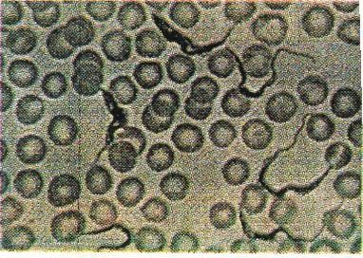
Red Blood Cell
Trypanosome

Plate 1. Giemsa Stained Blood Smear Containing Trypanosomes and Blood Cells

Source: Nigerian Institute for Trypanosomiasis Research Alert Bulletin, 2003

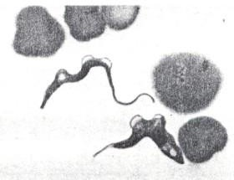Trypanosoma brucei brucei Red Blood Cell
Slender Form

Trypanosoma brucei brucei
Stumpy Form

Plate 2. Light Micrograph of Slender and Stumpy forms of Trypanosoma brucei brucei in Mouse Blood

Source: International Laboratory for Research in Animal Diseases (ILRAD) Annual Report, 1990

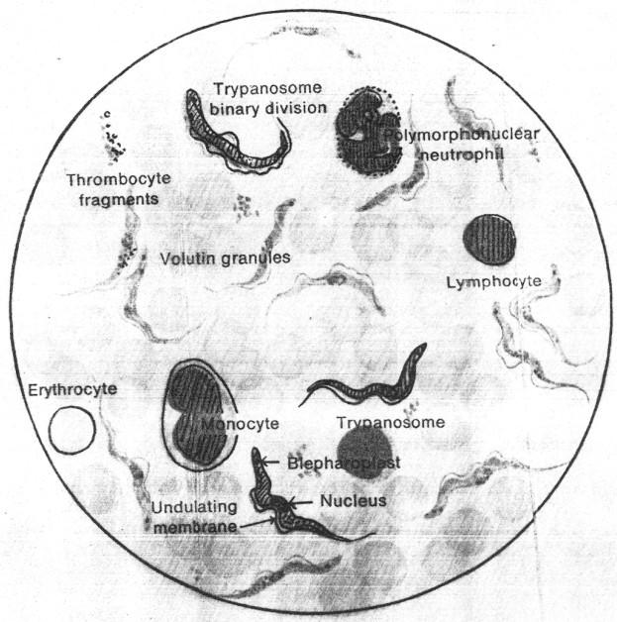

Plate 3. Trypanosoma rhodesiense, Blood Smear Giemsa Stain, mag. × 1100

Source: Microscopic Diagnosis of Tropical Diseases Bayer Germany, 1968

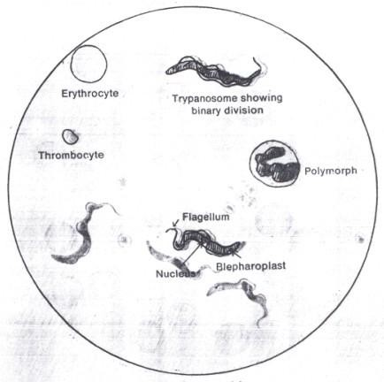
Flagellume
Thrombocyte

Plate 4. Trypanosoma gambiense, Blood Smear Giemsa Stain, mag. × 1100

Source: Microscopic Diagnosis of Tropical Diseases Bayer Germany, 1968

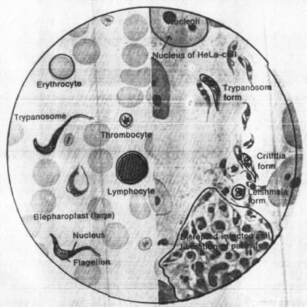

Plate 5. Trypanosoma cruzi, Blood Smear Tissue Culture (HeLa Cell), mag.
× 1100

Source: Microscopic Diagnosis of Tropical Diseases Bayer Germany, 1968

Trypanosome

Red Blood Cells

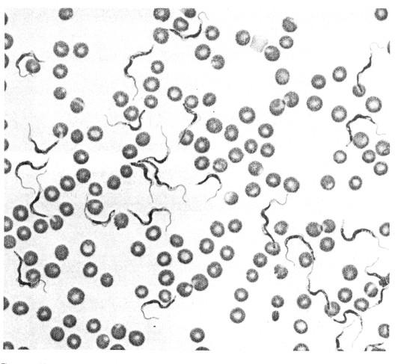

Plate 6. Light Micrograph of Trypanosomes, Protozoan Parasites that Cause Animal Trypanosmiasis, mag. × 400,

Source: International Laboratory for Research in Animal Diseases Annual Report, 1990

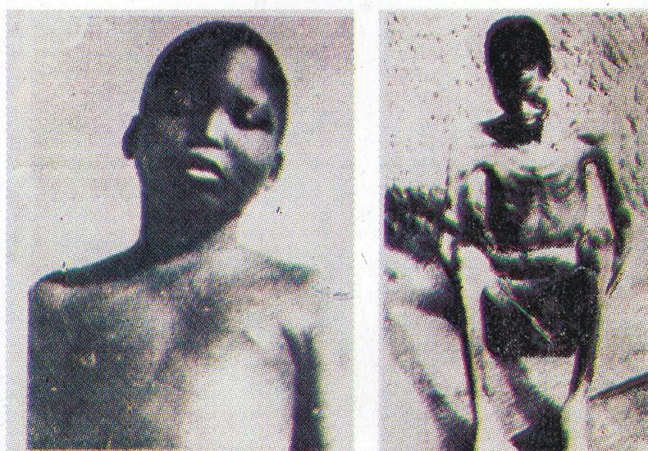
Bloated Sleeping Sickness Patient Emaciated Sleeping Sickness Patient
Plate 7. Human African Trypanosomiasis (Sleeping sickness) Patients Source: Nigerian Institute for Trypanosomiasis Research Alert Bulletin,
2003

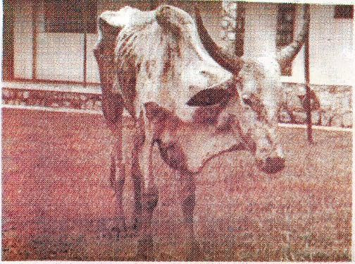
Emaciated Cattle

Plate 8. Animal Suffering from Trypanosomiasis (Nagana)

Source: Nigerian Institute for Trypanosomiasis Research Alert Bulletin, 2003

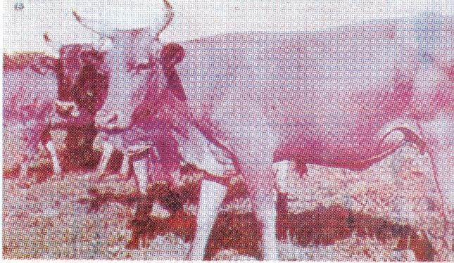
Trypanotolerant breed

Plate 9. Trypanotolerant Breed of Cattle

Source: Nigerian Institute for Trypanosomiasis Research Alert Bulletin, 2003

Arthropod vectors transmit both African and American trypanosomiasis. The transmission of African trypanosomiasis is mainly cyclical by the tsetse fly (Glossina) shown in Plate 10. In cyclic transmission, African trypanosome exhibits a complex digenetic life cycle that alternates between the tsetse fly and the mammalian host (Fig.1). The life cycle is characterized by a complex series of cell differentiation and variation in metabolism (Gull, 2002). The life cycle of Trypanosoma brucei brucei is shown in Fig.1. The life cycle begins when trypanosomes are injected into the blood of a mammal by a tsetse fly as it feeds on the mammal through a bite in the mammalian host. Slender forms of the parasites (a) multiply by binary fission until large parasite numbers build up in the blood. The trypanosomes then transform into intermediate forms (b) and then into stumpy forms (c), the latter of which are able to infect tsetse flies.
Stumpy forms of the parasites are ingested by a tsetse fly as it feeds on an infected mammal. In the mid gut of the tsetse fly, procyclic forms (d) arise and undergo division, after which the parasites enter the proventriculus and later the salivary glands of the tsetse fly, where they assume epimastigote forms (e) and undergo further division. Finally, metacyclic forms (f) arise in the salivary glands. The metacyclics are able to infect mammals and the life cycle is repeated.
The mitochondrion is inactive in the slender forms, begins to become active in the stumpy forms and is fully active in forms that occur in the tsetse fly. Parasite forms that live in the mammalian bloodstream (slender, intermediate and stumpy) have a glycoprotein surface coat. This surface coat of the parasite disappears in the procyclic forms that arise in the midgut of the tsetse fly and is later reformed in the metacyclic forms in the tsetse fly salivary glands.

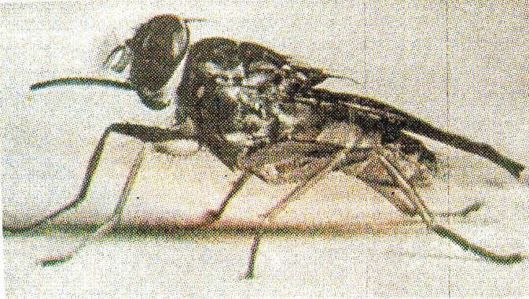
    - Tsetse Fly (Glossina)
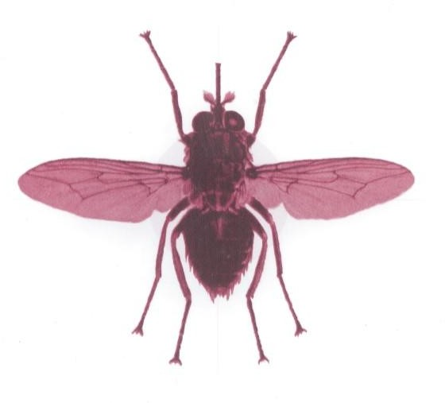
Lateral view – Resting
    - Tsetse Fly (Glossina)
Dorsal view – flying, wings spread out
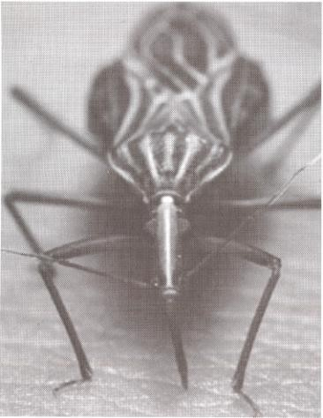
    - Triatomine Bug (Rhodinus prolixus)
Plate 10. Vectors of African and South American
Trypanosomiasis
SOURCE:
- Nigerian Institute for Trypanosomiasis Research Alert Bulletin,
2003

Programme Against African Trypanosomiasis (PAAT). Tsetse and Trypanosomiasis information, 2004
- Tropical Diseases Research News, 2000

Tsetse flies (Glossina) shown in plate 10 occur in the tropical regions of Africa, infesting 11 million square kilometers and cutting across 38 countries (Kabayo & Boussaha, 2002). Tsetse fly species commonly found in Africa include Glossina pallidipes, G. morsitans, G. morsitans submorsitans, G. austeni, G. swynertoni, G. longipennis, G. brevipalpis, G. euscipleuris, G. fuscipes fuscipes, G. tachinoides and G. palpalis palpalis. There are 11 tsetse fly species in Nigeria and four of these (G. palpalis palpalis, G. tachinoides, G. morsitans submorsitans and G. longipennis) are of great economic importance (Mariam, 2006). American trypnosomiasis is transmitted by triatomine bug (Rhodnius prolixus) shown in plate 10.
However, other modes of transmission recoded are mechanical, congenital and sexual. There is evidence of mechanical transmission of trypanosomiasis by African tabanids. Desquesnes, Bouyer and Fatehi (2004) have recorded mechanical transmission of Trypanosoma vivax and Trypanosoma congolense by common African tabanids Atylotus agrestis and Atylotus fuscipes. Stomoxys calcitrans is sympatric with tsetse flies, feeds on many of the same vertebrate hosts, and is thus regularly exposed to the trypanosomes that cause sleeping sickness and animal trypanosomiasis (Ruchel, 1975). Congenital T. brucei gambiense has been reported by Pepin and Milford (1991). Olowe (1975) has reported a case of congenital trypanosomiasis at Lagos Nigeria. Recent report has shown sexual and congenital transmission of T. rhodesiense. Rocha, Martins, Gama, Brandao and Atouguia (2004) have reported that a case of trypanosomiasis was diagnosed in a European woman who had never visited Africa but whose husband had spent some time in Angola, and who had trypanosomiasis.

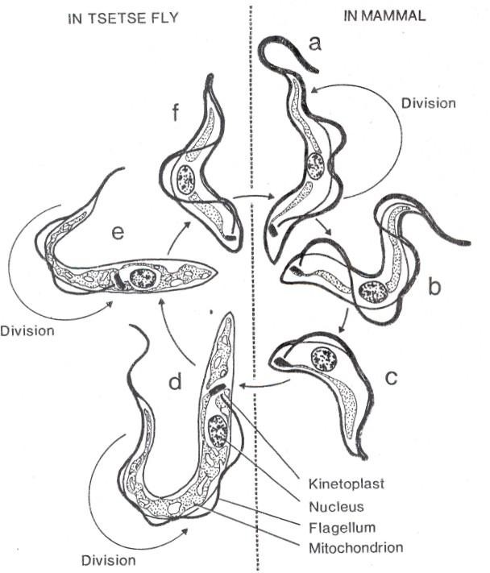

Figure 1. Life Cycle of Trypanosoma brucei brucei

Source: International Laboratory for Research in Animal Diseases (ILRAD) Annual Report, 1990

Sexual transmission was suspected. According to this report the woman’s 14 – month son also had trypanosomiasis (late stage sleeping sickness), and in this case congenital transmission was suspected. All three patients were successfully treated.

HISTORICAL BACKGROUND AND PROBLEM OF AFRICAN TRYPANOSOMIASIS
The pathologic importance of the parasites, which were given the name “trypanosomes” by Grumby in 1834, was confirmed by Evans in 1880 when he discovered protozoa in the blood of diseased horses and camels and identified them as the pathogenic organisms of “surra” (Ruchel, 1975). In India in 1885, Chrookshank recognized these protozoa as trypanosomes. In Africa it was reported that the missionary and explorer David Livingstone in 1857 described trypanosomes known there as “nagana”, which he had observed during his travels through the Zambezi region (Ruchel, 1975). In 1895 the Anglo – Australian doctor David Bruce discovered the pathogenic organism of the disease known as “nagana”. Later in 1899 Plimmer and Bradford named this pathogenic organism Trypanosoma brucei (Ruchel, 1975). Bruce also provided evidence of transmission of nagana through the tsetse fly (Glossina). The pathogenic organism of “dourine” was also discovered within this period.
Gambiense sleeping sickness has probably existed in an endemic form in west Africa since the 14th century; its symptoms were mentioned by the Arab historian, Ibn Kihaldun, and the king of Mali, Mansa Djata was reported to have died of this disease in 1374 (McKelvey, 1973). The spread of the disease coincided with the opening up of the continent by European colonial rule at the end of the 19th century, which brought about improved communication and increased contact between communities hitherto isolated. Sleeping sickness

reached the Congo basin in Central Africa and subsequently crossed the Congo

– Nile watershed and appeared for the first time in eastern Africa in 1896.

Disastrous epidemics which ensued ravaged through the Congo between 1906 and 1920 (Morris, 1963), and along the shores of Lake Victoria (Langlands, 1967) at the end of the 19th century, causing over three quarters of a million deaths.
The trypanosomes responsible for sleeping sickness were discovered by Doutton and Castellani at the beginning of the last century. Soon afterwards Bruce showed that the trypanosomes were transmitted by tsetse flies (Duggan, 1970). These men laid the foundation for knowledge of African trypanosomiasis. Broad strategies for the control of sleeping sickness were subsequently developed, and this brought about a general decline of the disease before the Second World War. Various campaigns against tsetse and trypanosomes carried out by British, French, Belgian, Portuguese and German workers under colonial administrations have been described by Duggan (1970) and McKelvey (1973).
From 1908 onwards a new type of human sleeping sickness was reported from the Rhodesias (Zambia and Zimbabwe), Nyasaland (Malawi), German East Africa (Tanzania) and Mozambique. It differed from the Gambiense type in its severity and short duration, and was named the Rhodesian type of sleeping sickness (Ross & Thomson, 1910). In 1940 this form of sleeping sickness appeared on the northern shores of Lake Victoria in Uganda. Evidence suggests that the trypanosome was introduced to these areas from Tanganyika (Tanzania) by immigrant workers from the Kagera basin. Epidemics of this form broke out

on the same shore where the gambiense form had occurred previously, and there were 2432 cases with 274 deaths (MacKichan, 1944).
Sleeping sickness control activities became institutionalized with the creation of special commissions, action programmes and institutes. Among these were the First International Sleeping Sickness Commission which was set up in 1925 by the League of Nations Health Committee, the Commission for Technical Co-operation in Africa south of the Sahara (COTA), which was formed in 1950, and the International Scientific Council for Trypanosomiasis Research (ISCTR) which was created simultaneously with the Bureau Permanent Interafricain pour la Tsetse et la Trypanosomiase in 1948. The ISCTR, which subsequently became the International Scientific Council for Trypanosomiasis Research and Control (ISCTRC), is an organ of the former Organization of African Unity (OAU) now African Union (AU) and collaborates with the Food and Agricultural Organization (FAO), World Health Organization (WHO) and several international organizations for research and control of both human and animal trypanosomiasis. In francophone Africa, the Organization de Co-ordination et de Co-operation pour la Lutte contre les Endemies en Afrique Centrale (OCEAC) continues to play a major role in the control of human trypanosomiasis.
In parallel, research and technology on tsetse and trypanosomes developed into an important field of science. Interregional institutions were created for basic research on sleeping sickness. The West African Institute for Trypanosomiasis Research (WAITR), Kaduna and Vom, Nigeria opened in 1950 and the East African Trypanosomiasis Research Organization (EATRO), Tororo, Uganda opened in 1948, both on the initiative of the Tsetse fly and Trypanosomiasis Committee of the United Kingdom colonial office. Following

independence of the participating countries in the late 1950s and 1960s these institutions became national. WAITR became Nigerian Institute for Trypanosomiasis Research (NITR) and EATRO became Uganda Trypanosomiasis Research Organization (UTRO) and later Kenya Trypanosomiasis Research Institute (KETRI) came into being. The exodus of the expatriate tsetse and trypanosomiasis workers depleted laboratories in Africa but accelerated basic research on these organisms in the United Kingdom (UK) and Europe, and stimulated research in the United States of America (USA). By the late 1960s research had spread to dozens of laboratories outside Africa (McKelvey, 1973).
Nearly 100 years ago since trypanosomes responsible for sleeping sickness were discovered by Doutton and Castellani at the beginning of the last century, scientists have been battling with this disease problem. Sleeping sickess affects as many as 500,000 people with more than 40,000 new cases being registered every year (Kabayo & Boussaha, 2002). The disease constantly threatens to reach epidemic proportions, as was the case at the beginning of the last century. Due to the zoonotic nature of the disease, animals have been found to harbour human infective trypanosomes thereby acting as reservoir hosts (Matovu, Enyaru, Lubega, Brun & Kaminsky, 1999; Simo et al., 2000; Coker, Isophehi, Thomas, Fagbenro – Beyioku & Omilabu, 2000; Murray, Pepin, Nutman, Hoffman & Mahmoud, 2000; Abenga & Lawal, 2005). These human infective strains of trypanosomes have been shown to be circulating in domestic cattle, the most significant animal reservoir (Hide et al., 1998). Animal trypanosomiasis is a serious obstacle to human welfare, because of the serious nutritional and economic problems it causes (Teale, 1997). Mixed trypanosome

infection is a common occurrence (Morlais et al., 1998; Truc et al., 1998b; Lehane et al., 2000).
Progress towards the discovery of an effective vaccine against trypanosomiasis has been handicapped by the problem of antigenic variation (Pays, 1995). African trypanosomes constantly confront the immune responses directed against them where they reside in the mammalian bloodstream (Donelson, 2003). These trypanosomes keep one step ahead of the immune system by continually switching from the expression of one variant surface glycoprotein (VSG) on their surfaces to the expression of another immunologically distinct VSG – a phenomenon called antigenic variation which is illustrated in Fig.2.
In the absence of an effective immunization strategy, chemotherapy and chemprohylaxis occupy important positions in the fight against this disease complex (Stanghellini, 2000). Although the problem of trypanosomiasis has stimulated research on different aspects of the disease and its treatment, chemotherapy and chemoprophylaxis still face a lot of problems. These problems include drug resistance and toxicity and lack of the necessary drugs.

ECONOMIC IMPORTANCE OF AFRICAN TRYPANOSOMIASIS
Trypanosomiasis in man and his livestock has had adverse effects on the economic growth of Africa (Tettey, 2006). It affects generally the health and well being of the human and livestock population. Human African trypanosomiasis (HAT) remains a major public health problem in sub-Saharan Africa (Solano et al., 2003). In parts of Uganda by 1900, the disease was estimated to have exterminated two-thirds of the local population (Apted, Omerod, Simyly, Stronach & Szlama, 1963).

As a new VSG becomes dominant in a trypanosome population, the amount of antibody (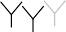) that specifically recognizes that VSG increases and reduces the numbers of trypanosomes with that VSG.
Number of trypanosomes Amount of specific antibody - - - -

1st wave of parasitaemia 2nd wave of parasitaemia 3rd wave of parasitaemia

Tsetse fly injects trypanosomes

Trypanosomes bearing one kind of VSG ( ) proliferate, creating a wave of parasitaemia. This population is reduced by antibody. Trypanosomes bearing another kind of VSG then create another wave of parasitaemia.

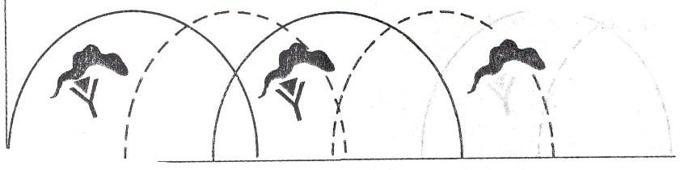

Figure 2. Diagram Illustrating the Process of Antigenic Variation, which Enables Trypanosomes to Survive Attack by the Immune System of Human or Animal Host

Source: International Laboratory for Research in Animal Diseases (ILRAD) Annual Report, 1990

Historically, epidemic sleeping sickness has caused massive loss of life, and the animal disease has had a crucial impact on development in sub-Saharan Africa (Sternberg, 2004). There is a dramatic resurgence of human African trypanosomiasis in sub-Saharan Africa (Stanghellini, 2000; Sternberg, 2004; Nok, 2005; Polley, 2005; Harrus & Baneth, 2005; Ehrhardt, Lippert, Burchard & Sudeck, 2006 ; Kaba et al., 2006). Trypanosoma brucei gambiense is spreading epidemically in large areas of Central Africa, especially the southern Sudan, Congo-Zaire, Angola, Uganda, the Central Africa Republic and Cameroon (Smith, Pepin & Stich, 1998; Stich, Barrett & Krishma, 2003). The causes of the re-emergence of sleeping sickness as a public health problem include widespread civil disturbance and war, declining economics and reduced health financing (Smith et al., 1998; Sternberg 2004; Harrus & Baneth, 2005; Chretien & Smoak, 2005). Despite the inevitably fatal outcome without treatment (Hewison, 2002; Stenberg, 2004; Ehrhardt et al., 2006; Kennedy, 2006a) HAT is often given low priority by donors and national governments. The World Health Organization (WHO) estimates in 1986 indicated that huge sums of money were expended annually as costs of surveillance, detection, treatment and vector control (Stanghellini, 1989).
Human African trypanosomiasis is confined to sub-Saharan Africa in defined geographical foci in some 37 countries (Kabayo & Boussaha, 2002). Tsetse fly infests these 37 countries, 32 of which are among the 42 Heavily Indebted Poor Countries (HIPCs) in the world (Kabayo & Boussaha, 2002). The disease still constitutes major obstacle to economic development and poses serious health risk to about 50 million human population in Africa (Kuzoe, 1991).

The debilitating effects of HAT on the populace leads to loss of man hours. Because of poor surveillance and diagnosis coupled with lack of treatment, most of the people who contracted HAT in the 1990s suffered for extended periods and will eventually die of the disease (Swallow, 2000). This reduces the productivity of people with the disease, family members who care for the ill and millions of rural residents who fear that they might contract the disease. However, there is little evidence available on these impacts, although what is known is what it would cost to implement an effective surveillance and treatment programme (Swallow, 2000). In some places sleeping sickness destroys the social structure of the community and nullifies the agro-economic activity of the affected families (Ngar-Ndigoum, 1997). In Nigeria, the disease is still perennial. The emergence of new foci of the disease in areas previously unthought of, such as Delta state (Edeghere, Olise & Olatunde, 1989; Nigerian Institute for Trypanosomiasis Research, 1992) together with the resurgence in old foci as evidenced by the number of voluntary cases reporting to Nigerian Institute for Trypanosomiasis Research (NITR) Epidemiology Clinic at Gboko Benue state, an old endemic focus is a matter of serious concern.
Animal trypanosomiasis has both socio-economic and socio-cultural importance, since it has been a major hindrance to efforts to settle the nomadic grazers (Ilemobade & Buys, 1970). There are reports of the problem of animal trypanosomiasis in Nigeria and elsewhere in Africa (Abenga et al., 2002a; Mbanasor et al., 2003; Abenga, Enwezor, Lawani, Osue & Ikemereh, 2004; Cherenet et al., 2004; Dinka & Abebe, 2005; Mahama et al., 2005; Abdalla et al., 2005; Van Den Bossche et al., 2006). These studies have shown that animal trypanosomiasis is still a major obstacle to livestock productivity in Nigeria and

other sub-Saharan African countries. Vast areas of the continent which are good for livestock and fertile lands for agricultural development are abandoned for fear of the disease. In sub-Saharan Africa where agriculture, mainly based on subsistence farming, employs about 70% of the labour force, the prevalence of under-nourishment is as high as 34% (Kabayo & Boussaha, 2002). According to these authors, Africa is the only region of the developing world where food production per capita has been declining over the past 40 years. Agriculture and rural development play central role in achieving rural development and food security goals. Kabayo and Boussaha (2002) affirmed that lack of productive livestock is an impediment to attaining household food security and a persisting factor contributing to rural poverty. Limited livestock rearing constrains severely small holder production, the backbone of national agricultural throughput and the main economic activity in rural communities. In various parts in sub-Saharan Africa, the inadequate contribution of the livestock component to the small holding agricultural output, mainly as a consequence of the absence of mixed farming practices, is caused by the prevalence of devastating diseases among which is the tsetse-transmitted animal trypanosomiasis (Kabayo & Boussaha, 2002).
Losses attributable to nagana in potential crop and livestock production amount to over US $4 billion (Kabayo & Boussaha, 2002). According to these authors, the Food and Agriculture Organization (FAO) of the United Nations has estimated that every year, over 3 million cattle and other domestic livestock are lost in Africa through deaths caused by animal trypanosomiasis. It is estimated that the economic losses in terms of cattle production is approximately US $1.2 billion per year (Tettey, 2006). According to this author, FAO has indicated that

50 million doses of trypanocides corresponding to US $35 – 40 million are administered to domestic ruminants for prevention and treatment each year. Trypanosomiasis has a severe impact on humans, livestock and other agricultural production system in Nigeria (Mariam, 2006). Economic losses due to tsetse and trypanosomiasis in Nigeria are enormous and have never been fully quantified, but it has been estimated that US $70 million are lost annually in cattle alone in six northern states (Mariam, 2006).
Animal trypanosomiasis causes abortion, retarded growth, weight loss, reduces calving rates, calf survival, meat and milk offtake and the draught efficiency of oxen used for cultivation of land by the peasant farmers and constraint on the use of improved breed which are highly susceptible to trypanosomiasis (Kabayo & Boussaha, 2002; Faye et al., 2004; Al-Qarawi, Omar, Abdel-Rahman, El-Mougy & El-Belely, 2004; Enwezor & Sackey, 2005; Muraguri, McLeod, McDermoth & Taylor, 2005; Mugunieri & Matete; 2005, Wymann et al., 2006). In effect, most of the countries in Africa are compelled to import meat and milk for their ever increasing human population. Thus trypanosomiasis has direct impact on livestock productivity, livestock management and human settlement, and through these direct impacts the disease has direct impacts on crop agriculture and human welfare (Swallow, 2000).
In recent years, vector-borne parasitic and bacterial diseases have emerged or re-emerged in many geographical regions causing global health and economic problems that involve humans, livestock, companion animals and wild life (Harrus & Baneth, 2005). African trypanosomiasis is one of them and it has economic impact on travel, tourism and international trade. Air, sea and land

transport networks continue to expand in reach, speed of travel and volume of passengers and goods carried. Pathogens and their vectors can now move further faster and in greater numbers than ever before (Tatem, Rogers & Hay, 2006). In further evidence of this impact Legros, Ancelle & Anofel (2006) reported that an inventory of imported cases of human African trypanosomiasis observed in France (1980 – 2004), 46 laboratories responded to the inventory study, and of these 13 recorded at least one case of imported human African trypanosomiasis. During 1980 – 2004, 26 cases were reported, 24 caused by T. gambiense and 2 by T. rhodesiense. According to this report, the incidence of the disease among travelers to Africa was estimated at 1.2 cases per million travelers. Among the 26 cases, 15 were of African origin and 11 were of European origin, and two of the patients died. There have been recorded cases of tourists returning to USA with human African trypanosomiasis (Osherwitz, 2003). Thus African trypanosomiasis is of great economic importance.

NATURAL PRODUCTS
Natural products are substances derived from or found occurring ordinarily in nature, often times existing in crude or unaltered forms from plants, animals and mineral deposits etc. Natural products were once the source of all drugs. The use of natural products has been on through folklore and traditional medicine for quite a long time (Sofowora, 1984). These products and their derivatives still have reasonable representation among the drugs in clinical use. Plants account for the highest source of naturally-occurring products followed by micro-organisms (Wambebe, 1990).
For many years, several major advancements in medicine came from lower organisms. Penicillin, tetracycline and aureomycin, derived from moulds

were hailed as wonder drugs for infections and communicable diseases (Perlman, 1979). There has also been a rapid pace of advancement in organ transplant due to cyclosporin, a drug derived from a fungus that uses insects as its host. Cyclosporin suppresses the immune system of transplant patients hence lowering tissue rejection rates. These lower organisms are also used to commercially produce bread, beer, wine, cheese, organic acids and vitamins.
Nature has secreted treasures into plant appendages such as roots, stem, bark, juice, flowers, fruits and seeds. These secrets of nature bounty were unlocked by people who knew nothing of botany, chemistry and pharmacology. Most of the products are known worldwide remedies (Sofowora, 1984). These benefactors of mankind were simple rural people, who never guessed their discoveries would some day reach the floor of the stock exchange. Among these benefactors of mankind who have helped immensely in the discovery of drugs have been the Indians from Amazon rain forests, Indians from the Andes, Greek peasants, Chinese and a host of others. Our ancestors had “cures” made from medicine, hundreds of them from plants and other materials (Sofowora, 1984; Okor, 1990).
Several accounts of studies are now available on the broad subject of ethnomedicine, and specifically on the use and application of natural products (Okor, 1990). According to this author, the materials used include alcoholic drink, palm wine, palm kernel oil, honey, potash, shea butter and clay chalk. The preparations are mostly boiled extracts, or simply materials soaked or dissolved in water, alcohol, palm wine, honey, palm oil or palm kernel oil. Preparations could also be presented in the form of pastes, pomades or ointments in a medium of oil.

Nature constitutes a “store house” for innumerable natural products (Wambebe, 1990). These natural products are diversified both qualitatively and quantitatively. Our current scientific advancement notwithstanding, nature is still the best organic chemist. Thus, brilliant scientists and perceptive physicians who ultimately listened and used the information gathered from those simple folk medicine, have given the world a rich catalogue of life-saving drugs. They would be the first to admit that jungle lore may lead to medical triumph.
Emphasis and interests on research into natural products are also shifting to marine products. Studies of marine organisms have focused on their potential applications, particularly the treatment of human diseases (Haefner, 2003). Several marine natural products are currently in pre-clinical and clinical evaluation, others show promising biological activities (Haefner, 2003). One of them, sarcophytol A, an oxygenated cembrane-type diterpenoid isolated from the soft coral Sarcophyton glaucum has been shown to inhibit the development of large bowel cancer in female rats, breast, thymus and skin cancer in mice (Fujiki et al., 1994). Because of these activities, sarcophytol A and its analogues have become very promising anti-cancer agents (Katsuyama et al., 2002).
Natural arsenolipids are analogues of neutral lipids, like monoglycerides, glycolipids, phospholipids and phosphonolipids. These natural arsenolipids have been found in micro-organisms, fungi, plants, lichens, in marine molluscs, sponges, other invertebrates and in fish tissues (Dembitsky & Levitsky, 2004). According to these authors, arsenolipids are thought to be end products of arsenate detoxification process, involving reduction and oxidative methylation and adenosylation. Different arseno species are shown to be inhibitors of glycerol kinase, bovine carbonic anhydrase and also are an effective therapy for

acute promyelocytic leukaemia, and there has been promising activity noted in other haematologic and solid tumours (Dembitsky & Levitsky, 2004). Arsenoliposomes have demonstrated high anti-trypanosomal activity against Trypanosoma brucei and inhibited growth of some types of cancer cells (Dembitsky & Levitsky, 2004).
Attention is also being focused on mushrooms. Mushrooms are valuable health food, low in calories, high in vegetable proteins, chitin, iron, zinc, fibre, essential amino acids, vitamins and minerals. Mushrooms have a long history of use in traditional Chinese medicine. Their legendary effects on promoting good health and vitality, and increasing the body’s adaptive abilities are being substantiated by studies. Mushrooms are probiotic and thus they help the body strengthen itself and fight off illness by maintaining physiological homeostasis – restoring the body’s balance and natural resistance to disease. The compounds in mushrooms have been classified as Host Defense Potentiators (HDP) which can have immune system enhancement properties. That is one of the reasons they are currently used as adjuncts to cancer treatments in Japan and China. In Japan, Russia, China and the United States of America several different polysaccharide anti-tumour agents have been developed from the fruiting body, mycelia and culture medium of various medicinal mushrooms (Lentinus edodes, Ganoderma lucidum, Schizophyllum commune, Trametes versicolor, Inonotus obliquus and Flammulina velutipes). Both cellular components and secondary metabolites of a large number of mushrooms have been shown to affect the immune system of the host and, therefore, could be used to treat a variety of disease states (HTTP://www.gmushrooms.com/Healthref.ht ml).

Research and development into natural products present two basic aims in view i.e. exploration of new templates and exploitation of existing templates (Wambebe, 1990). The former is a more rigorous approach as it involves screening of a large range of new products for desired effects. The latter involves the extrapolation of established effect to achieve optimal result such as increase in efficacy and reduction in undesirable side effects. Some of the natural products are used directly in the formulation of various pharmaceutical dosage forms or as raw materials for industrial purposes. Many of these natural products are cheap, have limited side effects, allergic reactions and limited potential for resistance cases (Wambebe, 1990).

SYNTHETIC PRODUCTS
The search for drugs has been, and will continue to be a problem for investigation as long as human ailments and those of domestic animals exist. This problem is normally tackled by different methods of drug development. Such methods include the development of drugs from natural sources, modification of chemical structure, and invention of drugs de novo. Until about 100 years ago, most drugs used in the treatment of disease were derived from naturally – occurring substances of plant or animal origin. For example, opium was obtained from the poppy, quinine from the cinchona tree and digitalis from the foxglove (Sofowora, 1984). In 1827 the glycoside salicin was extracted from the willow bark and in 1879 sodium salicylate was synthesized by Kolbe, introducing the era of synthetic therapeutics (Turner & Richens, 1980). Today the large majority of new therapeutic substances are synthesized in pharmaceutical laboratories.

In the invention of drugs de novo, the pharmacologist is sometimes pictured as devising unprecedented drug action de novo, predicting with the assistance of a chemist the requisite chemical structures on rational grounds, and then actually synthesizing effective drugs to fit the specifications. The history of the development of dimercaprol as an antidote to the war gas lewisite approaches this ideal. Thus the development of a new drug occurs mainly in the laboratories of a synthetic chemist, and is usually determined by structure activity consideration of related compounds (Turner & Richens, 1980; Molfetta et al., 2005).
This more rational directed approach involves a multi-disciplinary application of techniques in biochemistry, molecular biology, immunology, pharmacology, chemistry, crystallography and computer assisted molecular modeling (Hol et al., 1989). It begins with identifying striking differences between the host and parastite that could be exploited as drug targets. Ideally such targets must be essential for the survival of the parasite and absent from the host (Fairlamb et al., 1989). These targets are seldom found and so approach usually involves selective inhibition of an iso – functional parasite enzyme. Trypanothione metabolism is one of the chemotherapeutic targets for the design of new trypanocidal drug. Trypanothione is a radical scavenger and so lowering the level of this metabolite might render cells hypersensitive to oxidant damage. Since trypanothione is absent from mammalian cells (Fairlamb et al., 1989), it falls in line with attempts to design rational drug active against selected target.
Sometimes, however, completely novel compounds are synthesized in order to evaluate their possible therapeutic effects. Following synthesis, the structure of the new compound and its purity are confirmed by an analytical

chemist. It then passes to pharmacologists who screen its pharmacological and toxic effects. Another common pattern in the development of new drugs is the exploitation of the side effects of existing drugs. Thus, an action seen as undesirable in one therapeutic context may become the primary drug action in another. A typical example in this case is phenylbutazone which was developed as an antirheumatic drug, but it also had considerable uricosuric action. Therefore, studies on its metabolism in vivo have provided leads for the development of two wholly new drugs, oxyphenbutazone and sulfinpyrazone, in which these actions were largely separate

CONCEPT, BROAD OBJECTIVES AND SCOPE OF THE RESEARCH
The chemotherapy of African trypanosomiasis is beset with problems, including a limited repertoire of compounds which are expensive, drug toxicity and resistance, and protracted treatment protocols (Tropical Diseases Research, 1984; Legros et al., 2002; Verlinde et al., 2002; Kabayo & Boussaha, 2002; Chretien & Smoak, 2005). Most of the previous researchers have studied each problem in isolation. However, because of the inter-relationship of these problems, the present work has adopted a multidimensional approach. The present studies were, therefore, undertaken to evaluate some natural and synthetic products against African trypanosomiasis. Drug efficacy and the problem of toxicity and resistance in sleeping sickness patients and experimental animal models constitute the core of the evaluation. Natural and synthetic products, drug combination, treatment strategies and assessment of pharmacosocioeconomic factors which enhance treatment failures, toxicity, resistance and spread of the disease are the main tools and strategies employed in the work.

SPECIFIC OBJECTIVES
- To determine the potentials of honey, extracts of Brassica oleracea and those of frog and snake skins as trypanocides or potentiator of drug (diminazene aceturate).
- To investigate the efficacy of cymelarsan in Trypanosoma brucei brucei and Trypanosoma evansi infections in albino rats and rabbits respectively; the potential of verapamil in the reversal of T. evansi resistance to cymelarsan; and tsetse repellents as agents for blocking disease transmission and drug resistance.
- To evaluate the efficacy and safety of oral combination administration of difluoromethylornithine (DFMO), chloroquine and honey in trypanosome infection of albino rats.
- To investigate the effect of topical application of melarsoprol, ethidium bromide and diminazene aceturate singly, and their respective combinations with cattle butter (ghee) and shea butter, in the management of trypanosome infections in experimental animals.
- To assess the efficacy and safety of different treatment strategies and combinations of pentamidine, melarsoprol and prednisolone in the management of sleeping sickness patients.
- To carry out pharmacoscioeconomic studies including assessment of social, economic, cultural and behavioural factors which contribute to treatment failures, toxicity, and enhancement of drug resistance and spread of African trypanosomiasis.

CHAPTER TWO

LITERATURE REVIEW

PATHOLOGY AND PATHOGENESIS OF AFRICAN TRYPANOSOMIASIS
In order to appreciate some of the problems associated with the chemotherapy of African trypanosomiasis, it is important to review the pathology and pathogenesis of the disease. The study of the pathogenesis of sleeping sickness in man caused by trypanosomes has included investigations of the pathology of acute syndrome in sheep, goat, cattle and horses as well as various other aspects of pathogenesis in laboratory animals. The detailed study of the pathology included the descriptions of the lesions in the eyes, heart, reproductive organs and endocrine system (Losos & Ikede, 1972).
A chancre or nodule appears at the site of an infective bite of a tsetse fly. Lymph glands swell as the parasites multiply within them, and waves of parasitaemia follow with fevers. The first stages of infection include the establishment of the parasite in lymphatics, blood and other systems; later stages involve damage to the central nervous system with increases in white blood cell count, protein levels and the parasites in the cerebrospinal fluid (Pentreath & Kennedy, 2004). Various endocrine dysfunctions can result, perhaps caused by parasite invasion of different endocrine glands (Pentreath & Kennedy, 2004). According to these authors, the substances initiating pathogenesis may be the breakdown products of dead or inactivated trypanosomes, substances released by the living parasites, or substances from the host body released in response to the infection.

Human being infected with African trypanosomes develops a pantropic disease syndrome affecting most body organs, and in particular the brain and the heart (Manuelidis, Robertson, Amberson, Polak & Haymaker, 1965; Poltera, Cox & Owor, 1976; Buguet et al., 2003). The pathology of the disease is consistent with generalized inflammatory responses to this highly invasive parasite. In addition to parasite spread, the severity of the disease is associated with increased levels of inflammatory mediators, including tumour necrosis factor (TNF) –alpha and nitric oxide derivatives (Mamani – Matsuda et al., 2004).
Other symptoms appear to arise from dsy-function of the circadian pacemaker (Pentreath & Kennedy, 2004). Recent progress in understanding the neuropathological mechanisms of sleeping sickness reveals a complex relationship between the trypanosome parasite and the host nervous system. The pathology of late-stage sleeping sickness, in which the central nervous system is involved, is complicated and is associated with disturbances in the circadian rhythm of sleep (Enanga, Burchmore, Stewart & Barrett, 2002). Human African trypanosomiasis evolves from the hemolymphatic stage 1 to the meningo-encephalitic stage II when patients show a deregulation of the 24h distribution of the sleep-wake alternation, an alteration of the sleep structure, with frequent sleep onset rapid eye movement (REM) periods (Buguet, Pisser, Joisenando, Cahpotot & Cespuglio, 2005), and this has also been demonstrated in a rat model of African trypanosomiasis by Darsaud et al. (2004).
The blood brain barrier, which separates circulating blood from the central nervous system regulates the flow of materials to and from the brain (Lowsdale – Eccles & Grab, 2002). The neurological manifestations of sleeping sickness in man are attributed to the penetration of the blood brain barrier and invasion of

the central nervous system by T. gambiense and T. rhodesiense. However, how African trypanosomes cross the blood brain barrier remains an unresolved issue (Grab et al., 2004). In order to throw some light on this, Grab et al. (2004) examined the traversal of African trypanosomes across the blood brain barrier using an in vitro blood brain barrier model system constructed of human brain microvascular endothelial cells (BMECs) grown on costar Transwell inserts. These authors recorded that human infective T. gambiense strain IL1852 crossed human BMEC far more readily than the animal infective T. brucei brucei strain 427 and TREU 927. Light and electron microscopy carried out in this work revealed that T. gambiense initially bind at or near intercellular junctions before crossing the blood brain barrier paracellularity. Further studies are required to determine the mechanism of blood brain barrier traversal by these parasites at the cellular and molecular level.
During the course of the disease, the integrity of the blood brain barrier is compromised (Enanga et al., 2002). Dysfunction of the nervous system may be exacerbated by factors of trypanosomal origin or by host responses to parasites. Death occurs in human African trypanosomiasis and malaria due to neurological complications which are initiated at the blood brain barrier level (Bisser et al., 2006). These authors have further stated that adapted host immune responses present differences but also similarities in blood brain barrier/parasite interactions for these diseases. In both diseases neurological damage is caused mainly by cytokines (interferon-gamma, tumour necrosis factor – alpha and interleukin – 10), nitric oxide and endothelial cell apoptosis (Bisser et al., 2006). Such a comparative analysis is expected to be useful in the comprehension of disease mechanism, which may in turn have implications for treatment

strategies. However, according to Enanga et al. (2002) most drugs including many trypanocides do not cross the blood brain barrier.
Trypanosome infections are marked by severe pathological features including anaemia, splenomegaly and suppression of T-cell proliferation (Magez, Stiljemans, Caljon, Eugsten & Baetselier, 2002). Development of anaemia in inflammatory disease is cytokine-mediated (Naessens et al., 2005). Specifically the levels of TNF-alpha produced by activated macrophages, are correlated with severity of disease and anaemia in infections and chronic disease. In African trypanosomiasis, anaemia develops very early in infection around the time when parasites become detectable in the blood (Naessens et al., 2005). Since the anaemia persists after the first wave of parasitaemia when low numbers of trypanosomes are circulating in the blood, it is generally assumed that anaemia is not directly induced by a parasite factor, but might be cytokine-mediated, as in other cases of anaemia accompanying inflammation. Naessens et al. (2005) have affirmed that more than one mechanism promotes the development of anaemia associated with trypanosomiasis.
In T. rhodesiense the liver may become tender and some patients may show myocarditis with subsequent heart failure resulting from mononuclear cell infiltration in the heart, liver, as well as other tissues and organs (Bungener & Mehlitz, 1976). Infection with Trypanosoma brucei spp in humans is associated with adynamia, lethargy, anorexia, and more specifically amenorrhea/infertility in women and loss of libido/importence in men (Reincke et al., 1998). Animal trypanosomiasis causes infertility in animals, as it affects concentrations of plasma steroids and semen characteristics and results in testicular degeneration (Al-Qarawi, Omar, Abdel-Rahman, El-Mougy & El-Belely, 2004). Artificial T.

congolense infection has been reported to have affected reproductive performance of West African dwarf (WAD) goats with abortions, premature births and perinatal losses (Faye et al., 2004).
Studies of bone marrow functions and pathology in trypanosomiasis in ruminants infected with Trypanosoma vivax and T. congolense showed increased cellularity of haemopoitic tissue, selective proliferation of some cell lineage and hypoplasia of others, marked proliferation of macrophages with phagocytosis of cells (Anosa, 1999). Complement destruction of invading micro- organisms is a crucial first-line defense against infection, yet both African and American trypanosomes resist attack by complement. African trypanosomes resist non-specific complement attack by virtue of a thick glycoprotein surface coat (Tomlinson & Raper, 1998). However, some trypanolytic factors such as human high density lipoprotein and others present in human serum have adverse effects on Trypanosoma brucei brucei, whereas the human pathogenic species T. brucei gambiense and T. brucei rhodesiense resist lysis by human serum.
Trypanosomiasis causes immunosuppression in the host. Human trypanosomiasis is characterized by a major deregulation of the immune system, and thus hypergammaglobulinaemia, autoantibodies and immunodepression are cardinal features (Vincendeau, Okomo – Assoumou, Semballa, Fouquet & Daloude, 1996; Okomo - Assoumou et al., 1997). Anti - galactocerebroside antibodies in the cerebrospinal fluid of patients has been implicated in CNS involvement in African trypanosomiasis (Bisser et al., 2000). The use of certain trypanocidal compounds such as Suramin (Moranyl® - Specia) or DL – α - difluoromethylornithine (DFMO-Ornidyl®- Merrel Dow) requires the existence of

an active immune system (Bitonti, Dumont & McCann, 1986). A compromised immune system at the time of trypanocidal treatment may therefore lead to treatment failure. With immunosuppression due to trypanosomiasis, the host succumbs to fungal, viral and bacterial infections. These opportunistic organisms may complicate the pathology of trypanosomiasis. Moreover, the development of severe cachexia has been reported in T. brucei infection (Rouzer & Cerami, 1980). Cachexia is a syndrome mediated by the cytokine known as cachetin/tumour necrsis factor (TNF) and it gives rise to progressive weight loss, anaemia, immune suppression and terminal organ damage, even when the invasive burden may be relatively small (Rouzer & Cerami, 1980). Hence there is a need for novel treatment modalities.
The neurochemical changes which underlie the neurological and psychiatric manifestations of several parasitic diseases including trypanosomiasis have been investigated. The incidence of neuropsychiatric manifestations in patients with African trypanosomiasis has been reported to be as high as 90% (Lambo, 1966). In trypanosomiasis, Stibbs (1984) has demonstrated that there are alterations in certain neurotransmitters which were confined to specific regions of the brain. Amole et al. (1989) recorded significant alterations in monoamine neurotransmitters.
Information on biochemical changes which occur in the host as a result of animal trypanosomiasis is well documented. Various reports concerning protein levels in animal trypanosomiasis have been published. Normal levels were reported in T. rhodesiense infection of monkeys and mice (Smitters & Terry, 1959; Moon, Williams & Witherspoon, 1968), T. evansi – infected calves (Verma & Gautam, 1977). Elevated serum protein level was described in T. vivax –

infected sheep and goats (Anosa & Isoun, 1976), and in mixed T. brucei and Cowdria ruminatum (Adejinmi & Akinboade, 2000). Abenga and Anosa (2005) reported serum protein increase in T. gambiense infected vervet monkeys. The levels of serum aspartate aminotransaminase (AST) have been shown to increase in T. rhodesiense infection of mice (Moon et al., 1968) and monkeys (Sadun, Johnson, Nagle & Duxburry, 1973), and T. vivax infection of ruminants (Welde, Chumo, Kovatch, Mwongela & Opiyo, 1983). Similarly, T. brucei infection of dogs showed elevated AST (Kaggawa et al., 1988). Biochemical analysis in trypanosomiasis also indicates that there was no remarkable change in the alkaline phosphatase (ALKP) levels in T. rhodesiense infection of mice (Moon et al., 1968) and in T. evansi infection of buffalo calves (Singh & Gaur, 1983). In acute caprine trypanosomaisis, Abenga, Sanda, Idowu & Lawani (2002b) reported that serum urea level was significantly increased, while Cl⁻, K⁺ and HCO ⁻ levels were slightly increased above pre-infection, and serum Na⁺ increased only in the first week post infection, but returned to pre-infection values by the second week.
3
Trypanosome infections are generally characterised by anaemia, leucopenia, thrombocytopenia, as well as biochemical aberrations. The data of biochemical aberrations from experimental animals provide considerable insight into the pathogenesis of trypanosomiasis but cannot be assumed to be complete. One particular area of deficiency is the lack of adequate data on the sequential development of biochemical abnormalities in human trypanosomiasis (Anosa, 1988; Abenga & Anosa, 2005). The filling of this gap in knowledge is important because some of the drugs used in the management of trypanosomiasis exert their toxic effect by affecting among others the major

organs of the body such as the liver and the kidney. Thus both the infection and its treatment tend to have adverse effects on the host.
Pathology and pathogenesis studies of African trypanosomiasis have therefore thrown more light on the effects of the disease syndrome in tissues, organs and systems of the infected host including the cardiovascular and nervous systems. These effects should be studied in order to promote effective chemotherapy, since the deleterious effects may persist if unchecked, even after the parasites are eliminated from the host through drug treatment. Hence the importance of novel treatment modalities aimed at eliminating the parasites from the host as well as taking care of the deleterious effects brought about by the invading parasites.

PROBLEMS AND CURRENT STATUS OF THE CHEMOTHRAPY OF AFRICAN TRYPANOSOMIASIS

The Discovery of Trypanocidal Drugs
At the beginning of the last century a search for an effective trypanocidal drug was stimulated by the need to combat human sleeping sickness and the nagana disease which killed domestic cattle in Africa. Bruce had shown that nagana was propagated by trypanosomes through a carrier, the tsetse fly. In 1902, Laveran and Mesnil found that trypanosomes could be maintained in mice by the inoculation of infected blood from one animal to the other (Schild, 1983). At that time it was also observed that although arsenious oxide could produce a temporary improvement of trypanosome – infected animals, it was also toxic and the animals eventually relapsed and died (Schild, 1983).
In 1905 in Liverpool, Thomas prompted by the discovery that trypanosomes were also infectious in man and caused sleeping sickness, tested

a less toxic arsenical atoxyl, which had previously been used in clinical medicine for the treatment of skin diseases. He found that repeated doses of atoxyl could cure mice infected with trypanosomes and recommended its use against human sleeping sickness, after trying it first on himself in large intravenous doses (Schild, 1983).
Atoxyl proved to be an effective but toxic remedy for it caused optic nerve atrophy in some patients. At this juncture, Paul Ehrlich embarked on a systematic search for a more effective and less toxic trypanocidal compound (Schild, 1983; Maser, Luscher & Kaminsky, 2003). He varied the structure of atoxyl and with each new compound determined the minimum quantity required to cure an infected animal, and the maximum dose that must be administered without lethal effect. The ratio of tolerated dose to curative dose was named the curative ratio or chemotherapeutic index. Ehrlich believed that no substance could be administered safely to patients unless the curative ratio was at least three.
Atoxyl had presented a paradox since although it cured trypanosomiasis when injected into living animals but it had no trypanocidal action when incubated with trypanosomes in vitro. Ehrlich and Bertheim established the structure of atoxyl to be pentavalent (Schild, 1983). They also showed that when atoxyl was reduced to the trivalent p – aminophenylarsenoxide (II) it acquired trypanocidal activity in vitro. This compound was toxic but further reduction to the corresponding arsenobenzol (III) gave a product which was inactive in vivo, active in vitro and relatively non – totic. After studying many compounds, the most favourable curative ratio against trypanosomiasis was given by a

compound which Ehrlich called salvarsan (arsphenamine). Arsphenamine provided a good example of drug activation by the body.
Ehrlich found that organic arsenicals would kill trypanosomes in an infected animal but that if sub – effective doses were given, the trypanosomes acquired tolerance to the drug (Schild, 1983; Maser, Luscher & Kaminsky, 2003). In order to produce drug resistance, trypanosomes were exposed to a sub – effective dose of drug in an infected mouse, the strain, was then passaged into fresh mice and exposed again and this was continued until highly or completely resistant trypanosomes were produced. The resistance was then usually permanent.
The power of the parasites to acquire resistance made it desirable to find a drug which could kill all the parasites before they had time to become resistant. Ehrlich hoped to find a substance which would be so effective that a single dose would completely eradicate the parasites (therapia sterilisans magna). Therefore, he postulated that the effectiveness of chemotherapeutic drugs was due to their affinity for the parasite’s chemoreceptors and the development of resistance in trypanomes was due to a loss of affinity between the parasite’s chemoreceptors and the drug (Schild, 1983; Maser, Luscher & Kaminsky, 2003). Ehrlich’s early ideas of specific chemoreceptors for chemotherapeutic drugs had certain similarities to Langley’s subsequent concept of specific cellular sites on which drugs such as adrenaline produced their effect, and out of which the modern drug receptor concept has evolved.

Problems and Current Status of the Chemotherapy
Following Ehrlich’s pioneer work, a lot of research work has been done resulting in the production of other drugs for the treatment of African

trypanosomiasis. For animal trypanosomiasis, the drugs that have been used include diminazene aceturate (Berenil), phenanthridine compounds [homidium chloride, homidium bromide, ethidium bromide and isometamidium chloride (Samorin)] cymelarsan and quinapyramine dimethysulphate. Those that have been used for human chemotherapy include suramin, pentamidine, melarnyl drugs [melarsoprol (Mel B), melarsonyl (Mel W), the diethylamine analogue of Mel W (Mel D)] nitrofurazone, diminazene aceturate and difluoromethylomithine (DFMO).
Currently, the treatment of the early stages of human African trypanosomiasis involves the drugs pentamidine and suramin (Burchmore, Ogbunude, Enanga & Barrett, 2002). In the second stage of the disease, during which the trypanosomes reside in the cerebrospinal fluid, treatment is dependent on the arsenical compound melarsoprol (Burchmore et al., 2002). This is largely due to the inability to find compounds that can cross the blood brain barrier. Difluoromethylorinthine (DFMO) which crosses the blood brain barrier was later introduced. However, DFMO is not presently widely used as a substitute for melasoprol because of its high cost and limited availability.
For animal trypanosomiasis, the drugs currently used are diminazene aceturate, isometamidium chloride and homidium salts. Within the limited range of trypanocidal drugs for domestic livestock, diminazene accturate and isometamidium chloride are the most widely used (Kabayo & Boussaha, 2002). Homidium salts such as homidium chloride and especially homidium bromide or ethidium bromide are still widely used as trypanocidal drugs (Greerts & Holmes, 1998). Cymelarsan has not been widely used.

The fight against the vector (tsetse fly) has not been very successful, and the chemicals used as part of the control measures pollute the environment (Kabayo & Boussaha, 2002). Immunization against trypanosomiasis has not been possible because of the problem of antigenic variation (Pays, 1995; Mansfield & Paulnock, 2005). Therefore, chemotherapy continues to play a major role in the management and control of trypanosomiasis. This is essential because without treatment, the outcome of African trypanosomiasis is almost always fatal (Hewison, 2002; Sternberg, 2004; Kennedy, 2006b). There are, however, some serious problems which have continued to plague the chemotherapy of African trypanosomiasis. These problems seriously threaten the chemotherapy system. They include drug toxicity, drug delivery across the blood brain barrier, drug resistance, substandard drugs and formulation differences, limited quantity and high cost of drugs.

Drug toxicity
Drug toxicity and resistance presented themselves as problems right from the pioneer work of Ehrlich in the discovery of trypanocidal drugs in the early part of the last century (Schild, 1983; Maser et al., 2003). According to Maser et al. (2003) trypanosomal drug transporter genes are implicated in drug resistance. The toxicity problem continues to date. Many complicated treatment regimens have been used in the past. All are now abandoned due to toxicity (Geerts & Holmes, 1998).
The problem of toxicity has been highlighted (Braide & Eghianruwa, 1980; Ngampo, 1992). Suramin is one of the oldest drugs used in the treatment of early Gambian and Rhodesian sleeping sickness. It is the symmetrical 3 – urea of the sodium salt of 8 – (3 – benzamide – 4 methyl benzamido) naphthalene –

1,3, 5 – trisulphonic acid. Suramin may injure the kidney and so is used only in individuals with healthy excretory organs (Wilcocks & Manson – Bahr, 1972). There is usually a febrile response following the administration of suramin. In a few cases, suramin induces vomiting and shock. Other early toxic reactions of suramin include conjunctivitis, photophobia and in some individuals acute pain in the soles of the feet. Mild albuminaria is the most common toxic effect of suramin. If erythrocytes are seen in the urine during treatment with suramin, it indicates a serious damage and thus treatment should be continued with pentamidine instead of suramin (Wilcocks & Manson – Bahr, 1972). Recent findings by Manner, Seidl, Heinicke and Hesse (2003) using chick embryo indicate that suramin is a potent teratogen. Adverse reactions such as breathlessness, tachycardia and dizziness associated with pentamidine may be due to sharp fall of blood pressure (Rollo, 1980). The major toxicity of melarsoprol is a severe fatal post – treatment reactive encephalopathy (Jannin, 1992; Ngampo, 1992; Kennedy, 2006b). The side effects normally recorded with difluoromethylornithine include loose stools, anaemia and decreased hearing which are mild and transient and requires no treatment or interruption of the drug (Taelman et al., 1987). Diminazene acetuate attacks the central nervous system, whereby tremor, nystagmus, ataxia, shaking cramps, vomiting and even death can occur (Oppong, 1969).

Drug resistance
Drug resistance of human African trypanosomes has been recorded (Kibona, Matemba, Kaboya & Lubega, 2006). Isometamidium, diminazene aceturate and the homidium salts have been in use for more than 35 years, and it is estimated that about 35 million doses per year are currently used in Africa

(Geerts & Holmes, 1998). These drugs are popular with livestock owners and veterinarians. However, trypanosomal drug resistance is a major problem (Chaka & Abebe, 2003; McDermott el al., 2003; Knoppe et al., 2006). Since there is no indication that new products will become available in the near future, it is of utmost importance that measures are taken to avoid or delay the development of resistance and to maintain the efficacy of the currently available drugs (Geerts & Holmes, 1998).
The repeated use of chemicals as pesticides or chemotherapeutic agents inevitably leads to the development of resistance in the target organisms. Waller (1994) stated that resistance systematically occurs within approximately ten years following the introduction of antimicrobials, insecticides, trypanocides and anthelmintics to the market. This also occurred with the trypanocides, such as isometamidium chloride, homidium salts and diminazene aceturate, which were introduced during the 1950s. Quinapyramine was marketed earlier but was withdrawn in 1976 because of resistance and toxicity problems (Geerts & Holmes, 1998). It was later reintroduced for use in camels and horses and may still be used in error in cattle in some locations.
So far, resistance to one or more of the three trypanocidal drugs used in cattle has been reported in at least 13 countries in sub-Saharan Africa (Geerts & Holmes, 1998). In addition to 11 countries (Burkina Faso, Chad, Côte d’Ivoire, Ethiopia, Kenya, Nigeria, Somalia, the Sudan, the United Republic of Tanzania, Uganda, Zimbabwe) reported by Peregrine (1994), the Central African Republic (Finelle & Yvore, 1962) and Zambia should be included. This is probably an underestimation of the true situation, because in several countries surveys for resistance have not yet been carried out or cases of resistance have not been

published (Geerts & Holmes 1998). In eight of the 13 countries, multiple resistance has been reported (Geerts & Holmes, 1998). Most of the currently available information on drug resistance, however, is derived from limited numbers of case reports and does not give any indication of the prevalence of resistance in a region or a country as systematic surveys have not been conducted. There is also considerable variations in the criteria that have been used to diagnose resistance (Geerts & Holmes, 1998).
Very few authors provide information on the method of sampling (randomized or not). There is an urgent need for surveys in which representative numbers of trypanosome isolates are examined for drug resistance. Such surveys should be taken at random and use agreed methods of diagnosis. This type of survey should provide more reliable data on the true prevalence of drug resistance in regions and countries.
It is also important to stress that drug resistance is not an “all or nothing” phenomena and the degree of drug sensitivity and resistance varies considerably between individual trypanosomes (Geerts & Holmes, 1998). A further factor that can influence drug effectiveness is identified in the interesting observations of Burudi, Peregrine, Majiwa, Mbiuku and Murphy (1994) and Mamman et al. (1995), who reported differences in drug sensitivity according to the timing of treatment after infection and the concentration of trypanosomes in the blood.

Pathogenicity of drug - resistant parasites
Whether or not drug-resistant trypanosomes are less pathogenic than susceptible ones remains a controversial issue. Some authors (Berger, Carter & Fairlamb, 1995; Silayo & Marandu, 1989), have observed a loss of virulence

and/or a loss of fitness in drug-resistant trypanosomes. Transmission by tsetse flies, however, does not appear to affect the drug sensitivity of trypanosomes and so drug-resistant strains remain resistant after passage through tsetse flies. This has been shown by some workers (Peregrine, Gray & Moloo, 1997). Studies at the International Livestock Research Institute (ILRI), however, using four populations of Trypanosoma congolense, ranging from extremely sensitive to strongly resistant to isometamidium, found no differences in virulence between them (ILRI, 1996). Only the most resistant one showed a reduced viability, i.e. it took longer to establish parasitaemia than the other three. The loss of fitness in other drug-resistant parasites is a well known phenomenon and is probably also present in trypanosomes (Geerts & Holmes, 1998). Well-designed experiments in trypanosome naïve definitive hosts using significant numbers of resistant and sensitive isolates should provide valuable data on this controversial but important topic.

Mechanisms and genetics of resistance to trypanocides Isometamidium
In 1990, Shapiro and Englund suggested that the main mode of action of isometamidium was the cleavage of kinetoplast DNA – topoisomerase complexes. This explanation was supported by Wells, Wiles and Peregrine, (1995) who showed that the trypanosome kinetoplast is the primary site of isometamidium accumulation. The mechanism of resistance to isometamidium, however, is less clear. Decreased levels of drug accumulation have been observed in drug-resistant populations of T. congolense (Sutherland, Peregrine, Lonsdale – Eccles & Holmes. 1991) and later work found indirect evidence of an increased efflux of drug from resistant trypanosomes (Sutherland & Holmes, 1993). Later, Mulugeta et al. (1997) showed that the maximal uptake rates

(Vmax) of isometamidium in resistant T. congolense were significantly lower than in sensitive populations. It remains to be shown whether this is caused by a decreased number of protein transporters of isometamidium in the plasma membrane and/or by changes in the balance between the influx and efflux. The role of nucleoside transporters in resistance to isometamidium by T. congolense remains to be examined, although changes in these transporters have been associated with resistance to arsenical drugs in T. brucei brucei (Ross & Barns, 1996). Later, changes in mitochondria electrical potential have been demonstrated in isometamidium resistant T. congolense by Wilkes, Mulugeta, Wells and Peregrine (1997).
Although contradictory observations have been reported on the genetic stability of isometamidium resistance, field observations in Ethiopia, based on cloned populations, showed that the drug resistant phenotype of T. congolense have not altered over a period of four years (Mulugeta et al., 1997).

Homidium salts
Homidium salts, such as homidium chloride and especially homidium bromide or ethidium are still widely used as trypanocidal drugs. The mechanism of their antitrypanosomal action is not well understood. However, it has been shown that the drugs interfere with glycosomal functions, the function of an unusual adenosine monophosphate (AMP) binding protein, trypanothione metabolism and the replication of kinetoplast mimicircles (Wang, 1995). The mechanism of resistance by trypanosomes to these drugs is unknown. There are indications, however, that it is similar to that described for isometamidium (Peregrine et al., 1997).

Diminazene aceturate
Although diminazene aceturate exerts its action at the level of the kinetoplast DNA, this has not been proven in vivo and other mechanisms of action cannot be excluded (Peregrine & Mamman, 1993). Similarly the molecular basis of resistance to diminazene aceturate in trypanosomes is not clear. Carter, Berger and Fairlamb (1995) showed that the accumulation of diminazene aceturate was markedly reduced in arsenical resistant T. brucei brucei owing to alterations in the nucleoside transporter system (P2). However, there might be other resistance mechanisms (Zhang, Giroud & Baltz, 1992).
Similarly to isometamidium, contradictory reports have also been published on the stability of resistance to diminazene aceturate. Mulugeta et al. (1997), however, showed that the phenotype of multiple drug-resistant (including diminazene aceturate) T. congolense remained stable over a period of four years.
Therefore, it is clear that much more work is required in order to elucidate the mechanism of resistance to the currently available trypanocidal drugs. Such studies, as well as being of great value in their own right, may also provide novel methods for the detection of drug-resistant trypanosomes in the future. The same is true for the genetics of drug resistance in trypanosomes. Haynes and Wolf (1990) distinguished three major types of genetic change that are responsible for acquired drug resistance: mutations or amplifications of specific genes directly involved in a protective pathway; mutation in genes that regulate stress response processes and lead to altered expression of large numbers of proteins, and gene transfer. Gene amplification under conditions of drug pressure is well known in Leishmania spp and has also been demonstrated in

trypanosomes, but until now there is no evidence that this occurs in the later parasites as a mechanism of drug resistance (Ross & Sutherland, 1997). The current possibilities to insert or delete genes will certainly lead to a better insight into the resistance mechanisms (Ten Asbroek et al., 1990; Gaud et al., 1997). Other aspects, such as the stability of drug resistance, its mono or polygenic nature, dominance or recessiveness, also need to be examined, because of their far-reaching impact on the control of resistance (Geerts & Holmes, 1998).

Melarsoprol
According to Maser et al. (2003) trypanosomal drug transporter genes are implicated in drug resistance, TbATI encodes purine permease P2, which mediates influx of melarsoprol and diamidines. Disruption of TbATI in T. brucei reduced sensitivity to these trypanocides. TbMRPA encodes a putative trypanothione – conjugate efflux pump, and over expression of TbMRPA in T. brucei causes melarsoprol resistance. It is hoped that in future, it will be important to determine the role of TbATI and TbMRPA (genes) in sleeping sickness treatment failures.

Development and control of drug resistance
The factors responsible for the development of resistance to antitrypanosomal compounds are not well known. Some of the factors are shown in Fig. 3. The exposure of parasites to subtherapeutic drug concentrations owing to underdosing has been considered as the most important factor for the development of resistance (Boyt, 1986). Boyt suggested that the evolution of drug resistance in trypanosomes is fundamentally different from resistance in insects, helminths or micro-organisms. Once resistance is present, interventions

become necessary. The intervention will depend on whether the resistance is against a single drug or multiple drug resisance.
When resistance to diminazene aceturate, isometamidium chloride or homidium is present, the use of the other drug of the sanative pair is still possible. The second drug should be used with caution to avoid development of resistance here again. Integrated control measures, such as reducing vector numbers to reduce the number of drug treatments, will be of great importance. The same is true in cases of multiple resistance associated with mixed infections. Administration of various drugs to which the different sub-populations are sensitive, will eliminate the whole trypanosome population (Mulugeta et al., 1977).
Once resistance is present, it is unwise to increase the dose of the drug. Although some temporary benefits might be obtained, such an action would inevitably increase the selection pressure and the level of resistance. The use of a double dose of diminazene aceturate (two normal doses with an interval of eight or 24 hours between them) only slightly improved the therapeutic efficacy for resistant T. congolense (Silayo et al., 1992).
If multiple resistance is expressed at the level of the individual trypanosome, chemotherapy can become ineffectual. To counteract multiple resistance in such a case, intervention, at the level of the vector is required (Geerts & Holmes, 1998).

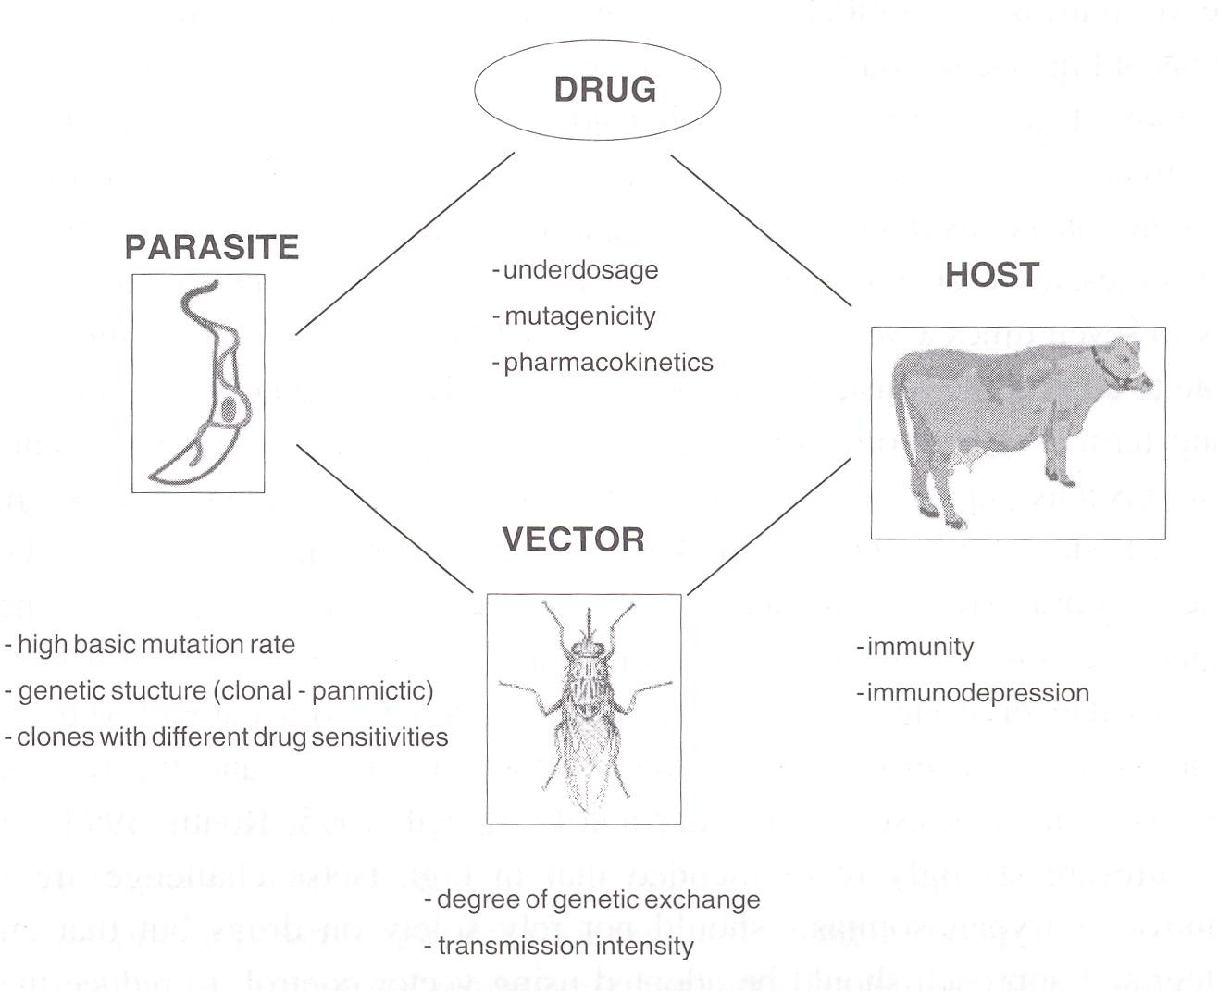

Figure 3. Some Important Factors Influencing the Development of Resistance to Trypanocidal Drugs

Source: PAAT Technical and Scientific Series 1: PAAT Information Service Publication, 1998

Peregrine, Mulatu, Leak and Rowlands (1994) showed that in the Ghibe valley, Ehiopia, multiple drug-resistant trypanosome infections (at the clonal level) could be controlled effectively using an integrated approach involving tsetse fly control (targets) and chemotherapy of clinically sick animals using diminazene aceturate. The apparent prevalence of trypanosome infections decreased by about 75 percent during the period of the study. A similar level of success was also reported by Fox, Mmbando, Fox and Wilson (1993) at the Mkwaja Ranch in the United Republic of Tanzania using a deltamethrin dipping programme to overcome the problem of drug resistance. This measure was reported to have resulted in significant cattle productivity, and the cost of the dip was more than offset by savings on trypanocidal drugs and oxytetracycline, and thereby overall treatment costs were reduced by 50 percent.

Counterfeit/substandard drug products and formulation differences
Tettey (2006) has reported that the incidence of sub-standard medicines in international commerce include trypanocides. Diminazene aceturate and isometamidium chloride are typical examples.

Diminazene aceturate
Diminazene aceturate is usually presented in admixture with pyrazone (antipyrine). Despite its use for over four decades, there are no current pharmacopoeial specifications for the control of the quality of the product (Tettey, 2006). A pilot study commissioned by the Food and Agriculture Organization of the United Nations to investigate the chemical equivalence of diminazene aceturate preparations in Africa was completed in 2001 (Tettey, 2006). According to this study, one hundred and four products, representing nineteen

different brands were obtained from eleven participating countries in Africa. The study revealed that one out of three products had a content of the active ingredient outside a + 10 percent tolerance range (90 – 110 percent of label claim). In addition, physical examination of the contents showed marked differences in formulation of the products.

Isometamidium chloride
Isometamidium chloride is used for the chemotherapy and chemoprophylaxis of animal trypanosomiasis. Since its introduction in 1958, the mixture of related substances commonly called isometamidium has remained the only agent available for the chemoprophylaxis of trypanosomiasis in animals (Tettey, 2006). Although the pharmacological action has been attributed to the major component [8 – (3 – m – amidinophenyl – 2 – triazeno) – 3 – amino – 5 – ethyl – 6 – phenylphenanthridinium chloride hydrochloride), the other isomers of which 7 – (m – amidinophenyldiazo) –3, 8 – diamino – 5 – ethyl – 6 – phenylphenanthridinium chloride hydrochloride] is the most abundant also posses trypanocidal properties. The composition of the final product is significantly affected by conditions such as pH and temperature used in the synthesis (Tettey, 2006). The effect of this synthetic problem on the chemical equivalence of two commercial brands of isometamidium, viridium and samorin has been reported (Tettey, 2006). The result of this investigation demonstrated significant variations in the composition of isometamidium between manufacturers and in batches from the same manufacturer.
Tettey (2006) stated that these variations have an impact on the quality, safety and efficacy of this important veterinary medicine and that some new isometamidium products fail to address the important issue of chemical

equivalence. A recent survey of some products in sub-saharan Africa revealed instances where the composition of isometamidium bore no similarity to the specification of the innovator product (Tettey, 2006). Standardization of manufacturing processes of isometamidium would go a long way in ensuring chemical equivalence of the finished product.
Veterinary medicines are subject to the same requirements of quality, safety and efficacy as those meant for human use. The lack or the limitation of resources available to medicines regulatory authorities in most developing economies has de-prioritized the control of veterinary pharmaceuticals (Tettey, 2006). This situation has made affected regions a haven for counterfeit/substandard drug products. Tettey (2006) is of the opinion that political will and resources are needed to guarantee that these trypanocides in international commerce are of the required quality.
An ideal chemotherapeutic agent for trypanosomiasis should be effective in a single dose against more than one specie of trypanosome and possess a few or no side effects, coupled with the absence of induction of drug resistance. It is important to note that no single drug currently in use has all these qualities, although they have helped to some extent in keeping the incidence of trypanosomiasis under check. The flaws of the existing drugs have created an urgent need for new drugs. For a long time now, no new trypanocides have been developed for field use and this alarming situation was discussed in a number of articles on the chemotherapy of protozoa and the prohibitive cost of new drugs (Hutner, 1977; Goodwin, 1978; Nok, 2005).

Constraints related to drug discovery, development, availability and affordability
Nearly a century ago, specific antimicrobial agents for the treatment of human African trypanosomiasis were among the first achievements in the new science of drug discovery and development (Moore, 2005). However, according to this author, few advances in HAT chemotherapy have been made in recent decades, and patients today are usually treated with drugs that were introduced before 1950. The infection is transmitted only in rural Africa and does not have a profitable market that would encourage drug development because the purchasing power of the affected consumers is poor and rapidly deteriorating (Fairlamb, Henderson & Cerami, 1989; Kabayo & Boussaha, 2002; Moore, 2005; Pink, Hudson, Mourles & Bendig, 2005). This lack of progress is part of a larger trend in the global pharmaceutical industry. Investment in treatment for tropical parasitic diseases has plummeted, despite the increasing health burden of these infections. Less than 1 percent of the new chemical entities introduced during the mid-1970s through 1999 were developed for tropical disease indications, and few candidate drugs are in development (Moore, 2005). Insufficient financial return has not only discouraged research and development but also caused companies to withdraw existing anti-parasitic drugs from the market (Kabayo & Boussaha, 2002; Moore, 2005). Five years ago, when virtually every drug capable of curing central nervous system infection was no longer produced or was threatened, it appeared that HAT might become untreatable. At present, these drugs are back in production and are available from the WHO through donation programmes, but a method to ensure availability in the long term has not been identified. The current serious resurgence of the disease and the present inadequacy of the available drugs to treat it are of serious concern.

Infact, Veeken and Pecoul (2000) have described drugs for neglected diseases as a bitter pill. Trials of new drugs and improved methods of applying the existing drugs give hope for some improvement in the present serious situation (Moore, 2005).
Hence emphasis is laid on selective screening of existing pharmaceutical compounds with broad spectrum activity against other human or veterinary diseases of economic importance (Williamson & Scott-Finingan, 1978; Igweh & Acholonu, 1984). There have also been efforts towards exploitation of the biochemical peculiarities of African trypanosomes. Biochemical pathways traced in trypanosomes offer the means of selecting targets to attack. Such areas are glucose metabolism and the glycosome, thiol metabolism and oxidant stress, polyamine metabolism, nucleotide metabolism and purine salvage, lipid and sterol metabolism, cell signaling and differentiation, protein degradation and amino acid metabolism, membrane architecture, the kinetoplast, RNA editing and regulation of gene expression (Barrett, Coombs & Mottram, 2004; Deterding et al., 2005). The great knowledge of trypanosome biochemistry and genetics that has built up has yet to be translated into progress on the pharmaceutical front (Barrett et al., 2004). New genomic sequencing and structural genomic projects are quickly elucidating new drug targets, providing incredible opportunities for medicinal chemists (Verlinde et al., 2002). According to these authors, structure-based drug design is now used to selectively block trypanosome glycolysis. Molecular, biochemical and genetic characteristics of ornithine decarboxylase, s-adenosylmethionine decarboxylase and spermidine synthase establish that these polyamine biosynthetic enzymes are essential for growth and survival of the agents that cause African trypanosomiasis, Chagas’

disease, leishmaniasis and malaria (Heby, Roberts & Ullman, 2003). These enzymes exhibit features that differ significantly between the parasites and the host. Therefore, it is conceivable that the exploitation of such differences will selectively kill the parasites while exerting minimal or at least tolerable effects on the host (Heby et al., 2003).
There is emphasis on an empirical approach which involves a multi- disciplinary application of the technology of biochemistry, molecular biology, immunology, pharmacology, chemistry, crystallography and computer assisted molecular modeling (Hol et al., 1989). Efforts have also been made towards the synthesis of some agents and derivatives (Susperregui, Bayle, Leger & Deleris, 1998; Girault et al., 2000; Katsuyama et al., 2002). The research for new trypanocidal drugs has been extended to indigenous medicinal plants (Igweh & Onabanjo, 1989; Camacho et al., 2000; Mikus, Harkenthal, Steverding & Reichling, 2000; Nyasse et al., 2004; Salem & Werbovertz, 2005). However, these investigations are in their infant stages, and the results of most of these works have up –to – date been somewhat fragmentary and inconclusive. A few candidate drugs are presently on clinical trials. Nifurtimox used for the treatment of Chagas’ disease and megazol are still on clinical trials for African trypansomiasis. The prodrug DB289 shows excellent oral activity with low toxicity for the treatment of early stage sleeping sickness, and it has recently entered phase II(b) clinical trials (Jannin & Cattand, 2004). The search/development of new drugs is a very slow and rigorous process. There is, therefore, an urgent need to embark on studies dealing with evaluation of natural and synthetic products and linking the studies with some of the problems surrounding the

chemotherapy of African trypanosomasis. This is important for existing and future drugs and for the control of the disease.

REVIEW OF THE NATURAL AND SYNTHETIC PRODUCTS AND RATIONALE FOR THEIR INCLUSION IN THE PRESENT WORK

Honey
Honey is an easily digestible, healthy, natural and energy-producing food with multiple qualities. Honey is produced from the nectar the bees collect from the flowers of plants, bushes and trees. The type of flower dictates the colour and flavour of the honey, and these can vary considerably. Some honeys are very light and delicate, and some are dark and quite thick.
It is known that to produce honey of one pound weight, the amount of work needed is 556 bees flying one third distance round the world (Lau, 1976). It is also known that every bee colony is highly organised with its communication system, mathematics, designated assignments etc. In short, each bee has an important role to play. The Queen bee lays about 1500 eggs per day and when these have become fully developed bees they learn the talk of the bee hive, progressing to more important ones as they grow older. Later, they qualify as scouts or foragers, leaving the hive to find and collect nectar and pollen. This is taken back to the bee hive where the nectar goes through various processes which turn it into honey. Thus, the bee can be regarded as a “herbalist” or “drug manufacturer” and considering all the work involved in the production of honey, it is a very cheap food item and drug.
Honey has occupied a prominent place in medicine throughout world history (Ali, 1991), and has therefore been regarded as a healer of diseases. About 2,000 years ago, honey was listed in the first medical handbook for use in

burns, cuts, abscesses and boils (Lau, 1976). The scientific basis for the efficacy of honey for therapeutic purposes is beginning to be substantiated. It has been reported that about 181 substances are present in honey (White, 1979). There are lots of citations in the literature on the therapeutic use of honey:- for example, diarrhoea (Ibrahim, 1981); respiratory diseases (Mladenov & Mladenov, 1986); hypertension (Ali et al., 1986) and wound healing (Wadi, Al – amin, Farouq, Kashef & Khaled, 1987; Efem, 1988). Zumla and Lulat (1989) have stated that honey is grossly under-utilized in conventional medicine. There is no report in the literature on the use of honey in the treatment of trypanosomiasis.
Previous studies suggest that trypanosomes are more susceptible to cellular damage by activated oxygen species (O₂, OH, H₂O₂) than mammalian cells (Fairlamb, 1982). This forms the basis for the use of nifurtimox and haematoprophyrin as trypanocides (Docampo & Stoppani, 1979). The interest in honey in the present work stems from the fact that honey has been found to have the capacity to produce hydrogen peroxide (Molan, 1992), and an antibiotic system containing inhibine. Secondly, honey is an easily available natural product. Thirdly if effective, honey could have a great potential in the management of African trypanosomiasis by eliminating trypanosomes as well as bacteria and other opportunistic organisms.

Brassica oleracea
While there is growing interest in the potential of Brassica vegetables (cabbage, cauliflower and brussels) as vectors for the introduction of anti - carcinogenic compounds into the diet (Stoewsand, Babish & Wimberly, 1983; Wattenberg, 1983), antitumour drugs are also screened for trypanocidal action

(Williamson & Scott-Finnigan, 1978). Trypanocidal drugs are also screened for anti-cancer activity (Barrett & Barrett, 2000). This is perhaps due to the fact that research suggests that protozoan parasites, such as those of malaria, trypanosomiasis and leishmaniasis, have a number of features in common with the proliferating cells of cancer and some forms of heart disease (Hide, 1989). They appear, for instance, to have molecules that function as uptake points (receptors) for essential nutrients and growth factors that they must acquire from their human hosts if they are to survive and thrive (Hide, 1989). Therefore, this stimulated the interest to evaluate the possible anti-trypanosomal effect of the aqueous extract of Brassica oleracea (cabbage) of the family Cruciferae.

Skin of Frog and Snake
The skin of frogs and snakes are claimed by traditional healers to be used to potentiate herbal preparations they use in the treatment of sleeping sickness in parts of Delta state. The skin of amphibians and reptiles are known to contain deposits of keratin, parelcidin, (a substance related to keratin), granules of keratohyalin, eleidin and other coloured materials believed to be of plant origin, and stored for protective and adaptive mechanisms.

Cattle Butter and Shea Butter
Preparations of materials in ethnomedicine could be presented in the form of pastes, pomades or ointments in a medium of either palm oil or shea butter from the seed of Butyrospermum paradoxum. These are rubbed into the affected parts of the body to effect healing. Essential oils are commercially important chemical compounds found in a large number of plants and they possess useful biological, pharmacological and therapeutic activities. Similarly, very useful fixed oils and fats have been derived from plants. These include palm fruit, corn, shea

butter, cocoa butter and groundnut oils among others. These oils are extensively employed in cosmetic and pharmaceutical industries (Wambebe, 1990). The oil from Colocynthis vulgaris (melon seed) has been used to formulate methyl salicylate liniment and this compared favourably with Arachis oil. Goat fat found in the peritoneum of Capra hircus and palm kernel oil extracted by boiling a suspension of the milled nuts of Elaeis guineensis have been applied as excipients for dosage formulations (Okor, 1988).
The interest in Cattle butter (ghee) and Shea butter called “Mai Shanu” and “Mai Kadanya” in Hausa language respectively is due to the fact that they are normally combined with herbal materials and other ethnopharmaceuticals and applied topically in traditional orthopedic medical practice probably as penetration enhancers and/or drug carriers. These two items are inexpensive and locally available. Shea butter is obtained from the seed of Butyrospermum paradoxum. Butryrospermum paradoxum is locally abundant in the derived Savanna and Guinea zones, especially near towns and villages. It is also envisaged that topical application of trypanocides with the aid of these materials will reduce toxicity and ease drug administration.

Lantana camara
Lantana camara (wild sage or Curse of Barbados), a common hedge plant of the family Verbenaceae is a weak-stemmed plant with prickles scattered over the stems (Nielsen, 1965). Verbenaceae is a mainly tropical and subtropical family of very varied habitat and members of the family have opposite or whorled exstipulate leaves which are often fragrant. The stems are usually 4-sided. The flowers are often small, zygomorphic and in spikes, heads or cymes. Each flower has 2 or 4 stamens and a 4-celled ovary with 1 or 2

ovules in each cell. The flowers are sometimes 2 – lipped, 4 – or 5 – part in the corolla. There are usually 5 persistent sepals, often giving the fruit a distinctive appearance.
The fruit is usually a drupe with one or four stones, although each stone may have one, two or four cells, each with a seed. Lantana camara has only one carpel forming a two-celled ovary with one ovule in each cell (Nielsen, 1965). The two cells are lateral, apparently in contradiction to the usual state of affairs in the family. The reason for this has been shown to be the abortion of one carpel, the remaining one becoming subdivided in the usual way. The ovary matures into a small black one-stoned drupe with one or 2 cells inside. Lantana camara was included in this study because of its peculiar odour.
    - Tapinanthus (Mistletoe)
Tapinanthus (Mistletoe) is a very peculiar plant in that its roots sink into the branches and trunks of other trees, instead of into the soil. Its seeds need sunlight to germinate, unlike most seeds that need darkness (Pamplona – Roger, 1999). However, the adult plant is able to produce chlorophyll even in the darkness, unlike other plants which become yellowish when there is no light. The thrushes, doves and other forest birds spread the seeds of mistletoe. After eating its white berries, they carry them to the branches of other trees, to which these seeds stick due to their gelatinous covering. The seed germinates there giving birth to a new plant.
Its medicinal properties were already known in the time of Hippocrates and Pliny the Elder, and recently mistletoe was discovered to present anti-tumour activity, though this fact is still being researched (Pamplona-Roger, 1999). A lot of work has also been done to demonstrate its effectiveness against

hypertension and arteriosclerosis. The leaves of mistletoe contain choline and acetyleholine, both substances which act on the autonomic nervous system (Pamplona – Roger, 1999). The berries also contain alkaloids and other toxic substances, thus their medicinal use is not recommended.
It possesses a notable balancing effect on the circulatory system and it is one of the most effective plants known against high blood pressure (Pamplona – Roger, 1999). According to this author, it improves blood flow in the brain and the heart, when these problems are caused by arteriosclerosis of the cerebral or coronary arteries. Its use is recommended for brain arteriosclerosis (sickness, vertigo, buzzing ear) or coronary arteriosclerosis (angina pectoris). It can be administered as prevention against new attacks in those people who have suffered from thrombosis or cerebral embolism.
It has antispasmodic and sedative properties. Mistletoe eases the oppressing sensation in the chest, palpitations, nervousness, and migranes (Pamplona – Roger, 1999). It is recommended for nephritis, gout, arthritis, and whenever blood should be purified. It is also known to possess anti – inflammatory properties. In local application, it eases rheumatic aches, and is very effective for acute lumbago or sciatica. It is known as menstruation regulator, and is therefore employed in menstrual disorders, excessive menstruation, and uterine hemorrhages, due to haemostatic effect (Pamplona – Roger, 1999).
Some proteins known as lectins have been isolated from mistletoe; and they have a strong destructive effect against tumour cells (Pamplona – Roger, 1999). These proteins stimulate the thymus and the cellular defenses of the body at the same time. In laboratories, some research was carried out with

animals with good results, in which mistletoe was able to heal superficial tumours (Pamplona – Roger, 1999). According to this author, it is hoped that new discoveries will come up in the future which will allow its clinical application. In the present work however, Tapinanthus was included to ascertain if it possesses a particular characteristic of Lantana camara which it parasitized.

Chloroquine
Chloroquine is a drug commonly used in the treatment of malaria in Africa. The interest in chloroquine as a possible trypanocide or agent in the management of African trypanosomiasis is based on the successful in vivo and in vitro trials of this drug and others as possible inhibitors of histamine metabolism (Duch, Bacchi, Edelstein & Nichol, 1984). Nathan et al. (1979) successfully cured T. brucei infection with imidocarb, one of the compounds that inhibited histamine-N-methyl transferase. Because chloroquine also inhibited this enzyme, it was thought that it could possibly have trypanocidal activity. Moreover, chloroquine is also known to inhibit ornithine decarboxylase (Konigk, Mirtsch, Pitfarken & Abdel – Rasoul, 1981; Wunderlich, Stubig & Konigk, 1981), the same enzyme inhibited by a known trypanocide, DFMO as shown in Fig. 4. Chloroquine is also known to inhibit glycolysis in bacteria (Fitch et al., 1984), have cytotoxic effects (Peters & Richards, 1983) including inhibition on nucleic acid synthesis, and also binds to DNA. It has also been found to be effective against T. brucei brucei in vitro (Igweh & Acholonu, 1984; Otigbuo & Woo, 1988). In oral administration, the absorption of chloroquine is rapid and almost complete. It is readily available and inexpensive. Combination of drugs with additive or potentiating effects mainly based on decarboxylase enzymes or methylating molecules has been advocated (Igweh & Acholonu, 1984; Otigbuo &

Woo, 1988; Wery, 1991). Hence the oral combination administration of DFMO, chloroquine and honey in the present work was considered necessary.

DL- α - Difluoromethylornithine (DFMO)
The main problem in the treatment of human African trypanosomiasis remains the toxicity of the universal and relatively effective drug melarsoprol. Other drugs do not penetrate the central nervous system (CNS), where the trypanosomes migrate very early in the infection before any inflammatory signs appear in the cerebrospinal fluid (Enanga et al., 2002). No new drugs were introduced for a long time before drugs such as DL - α - difluoromethylornithine (DFMO) were developed for the treatment of trypanosomiasis (Bacchi, Nathan, McCann & Hutner, 1982; McCann, Bacchi, Nathan & Sjoerdsma, 1983). This drug (DFMO), which was originally developed for use against cancer, was the first new drug for the treatment of trypanosomiasis in more than forty years. It is an effective inhibitor of polyamine synthesis by inhibiting ornithine decarboxylase, an enzyme essential for the growth and multiplication of trypanosomes (Bacchi et al., 1982). Its rapid efficacy in arousing comatose patients with trypanosomiasis that has not responded to conventional treatment has earned it the name “resurrection drug”. It has even been found useful in congenital T. brucei gambiense trypanosomiasis (Pepin & Milford, 1991; Ngoma et al., 2004). This drug, therefore, provides an efficient and safe alternative for T. brucei gambiense infection, while T. brucei rhodesiense is more resistant. The administration scheme is spread over 5 weeks including 14 days of intravenous injections.

ORNITHINE

H2N COOH
CHF2

(Inhibition)
COOH

H2N NH2
ORNITHINE DECARBOXYLASE

CL N

(Inhibition)

NH2
DL-α-DIFLUOROMETHYLORINTHINE (DFMO)

H2N
PUTRESCINE

NH2

NH

CH(CH2)3N(C2H5)2

CH2

SPERMIDINE SYNTHASE
CHLOROQUINE

SPERMIDINE

H2N N

NH2

SPERMINE

H2N

N N NH₂

Figure 4. Schematic Representation of the Inhibition of Ornithine Decarboxylase by DL-α-Difluoromethylornithine (DFMO) and Chloroquine in Polyamine Biosynthesis in Trypanosomes

One drawback that will limit the application of DFMO in the short-term is the fact that it is most effective when administered intravenously and therefore in a hospital rather than a village setting. Oral DFMO monotherapy results in relapses (Nieuwenhove, 1988). However, oral therapy should be a useful novel approach in the treatment of sleeping sickness since the disease mostly affects those who dwell in the rural areas. These rural dwellers would prefer oral therapy since it does not require specialized technique of administration and hospitalization. Secondly, while agreeing that DFMO has been highly successful in the cure of late-stage sleeping sickness, very high dose levels of 300 – 500 mg/kg/day administered intravenously for 10 – 15 days, followed by 200 – 300 mg/kg/day orally for 28 – 69 days are required, making it an unlikely first choice for therapy (Taelman et al., 1987). Thirdly, resistance to DFMO has been reported (Philips & Wang, 1987). The side effects normally recorded included loose stools, anaemia and decreased hearing which were mild and transient and required no treatment or interruption of the drug.
Therefore, the need for combination oral therapy of DFMO, chloroquine and honey became imperative. Secondly, considering the very high dose levels required to be administered for such a long time, it becomes necessary to investigate the activity profiles of the effects of procaine, D – tubocurarine and dantroline on phrenic nerve hemidiaphragm twitch contraction on DFMO, chloroquine and honey combination pre-treated experimental animals.

Cymelarsan
Cymelarsan, melarsenoxide cysteamine (Mel Cy, RM-110) is a relatively new trivalent arsenical derivative synthesised by Rhone-Merieux Pharmaceutical laboratory France for the treatment of T. evansi infection. Although the efficacy

of cymelarsan in T. evansi and other T. brucei infections has been reported (Raynaud, Sones & Freidheim, 1991; Sones, Vongool & Raynaud, 1991; Otsyula, Jamar, Mutugi & Njogu, 1992), reports of threat of resistance to this new drug are documented. Zhang, Giroud and Baltz (1992) reported of strains that could only be cured with 4 mg/kg of cymelarsan but not the recommended dose of 0.25 mg/kg body weight. Pospichal, Brun, Kaminsky and Jenni (1994) reported induction of resistance to cymelarsan in T. brucei brucei.

Verapamil
Effective use of existing trypanocides is hampered by the development of resistance to them by trypanosomes (Schillinger, 1989; Joshua & Sinyangwe, 1991). Future drugs will also face the same problem of drug resistance. The use of verapamil in this work is based on recent findings. Some strains of trypanosomes, like a number of mammalian tumour cells (Riodan & Ling, 1985) and Plasmodium falciparum (Martin, Oduola & Milhous, 1987) exhibit multi drug resistance. It has been reported that verapamil, a calcium channel blocker, reverses chloroquine resistance in chloroquine resistant parasite by reducing the efflux of chloroquine in the resistant parasite (Kroystad et al., 1987). And consequent with this phenomenon is an ultrastructural study showing that chloroquine and verapamil exhibit alteration morphologically similar to chloroquine induced changes found in chloroquine sensitive parasite. These changes include typical chloroquine related food vacuoles swellings with increased amount of granule matrix (Jacobs et al., 1988). In the case of Plasmodium chabaudi, verapamil and other calcium channel blockers reversed chloroquine resistance in dose-dependent manner (Ohsawa, Tanabe, Kimata & Miki, 1991). Verapamil is also known to block drug resistance in cancer cells (Kroystad, et al., 1987).

Pentamidine
Pentamidine is an aromatic diamidine which was introduced in 1946 for use in areas where people were at risk of African trypanosomiasis (Ochoga, 1981). It is the drug of choice in the treatment of early stages of T. gambiense infection in patients that cannot tolerate suramin (Burchmore et al., 2002). It does not cross the blood brain barrier. Pentamidine considerably impairs the DNA, RNA, protein and phospholipids synthesis, and only slightly impairs respiration (Ruchel, 1975). The transport of the essential amino acids lysine and arginine is also inhibited by pentamidine. Further properties of pentamidine are the inhibition of thymidine phosphorylase, as well as fragmentation of the kinetoplast in T. rhodesiense (Macadam & Williamson, 1969). Pentamidine is one of the four drugs currently used for the treatment of human African trypanosomiasis. However, adverse reactions such as breathlessness, tachycardia and dizziness associated with pentamidine have been probably connected with sharp fall of blood pressure (Rollo, 1980). There is progress in developing analogues of pentamidine aimed at improving its oral bioavailability and better blood – brain transport (Seed & Boykin, 2001).

Melarsoprol
Drug toxicity to the host is one of the major problems against the use of drugs in chemotherapy and management of African trypanosomiasis (Chretien & Smoak, 2005). Melarsoprol (Mel B), previously the only drug able to enter the central nervous system (CNS) and cure the late-stage of sleeping sickness, has side - effects, which prove fatal in up to 5% of the patients (Jannin, 1992; Ngampo, 1992; Buguet et al., 2005, Kennedy, 2006b). These investigators regarded reactive encephalopathy as a major toxicity due to melarsoprol

administration. Relapses in patients have been recorded after treatment wth melarsoprol (Pepin & Mpia, 2005).

Prednisolone
Prednisolone is a synthetic corticosteroid (glucocorticoid). It has anti- inflammatory properties and therefore inhibits inflammatory response whether the inciting agent is radiant, mechanical, chemical, infectious or immunological. It has been recorded in the literature that the current forms of treatment using suramin or pentamidine to eliminate blood-stream trypanosomes followed by melarsoprol to eliminate trypanosomes from the CNS encourages encephalitis (Pepin & Milford, 1991). Since one of the treatment strategies in the sleeping sickness patients under investigation involved the use of pentamidine followed by melarsoprol, it became necessary to find a solution to the subsequent encephalopathy. Prednisolone was carefully chosen for this work because it can be taken orally, it is considered less toxic than other drugs in the same group and it is cheap. The schedule designed for it was also aimed at reducing toxicity.

Diminazene Aceturate
Diminazene aceturate (4, 4’-diamidino-diazoaminobenzol) is a diamidine which is moderately soluble in water. Diminazene aceturate (Berenil) comprises two amidinophenyl groups inter-connected by a triazine bridge. This drug is one of the trypanocides currently used in the treatment of animal trypanosomiasis. Some reasons have been advanced for the success of diminazene aceturate as follows (Ruchel, 1975), therapeutic efficacy is greater than that of other curative trypanocides used in animal trypanosomiasis, and the preparation can be tolerated well. It has a wide therapeutic range. In its first 10 years of use,

virtually no resistance occurred apart from cases that were reported later. Some resistant strains of T. vivax and T. congolense have been reported (Arowolo & Ikede, 1977). The drug resistance observed with diminazene aceturate has been ascribed to widespread abuse and misuse of the drug making it progressively less effective, and also coupled with the problem of antigenic variation in the trypanosome (Ilemobade, 1981). In the case of human sleeping sickness, diminazene aceturate displayed curative and prophylactic efficacy even after oral dosing (Bailey, 1968).
Diminazene aceturate inhibits DNA synthesis and cell division in the organism, and other possible sites of action are modification of cytoplasmic membrane and lysosome (Macadam & Williamson, 1974); inhibition of phospholipids synthesis and basic amino acid transport (Gutteridge, 1969). It also acts on both cholinergic and histamine receptors (Arowolo & Adepolu, 1981). Experimentally, it has been shown that the activity of diminazene aceturate varies with the time interval between infection and treatment (Jennings et al., 1977). This has been attributed to low concentration of the drug in the tissues, resulting in the invasion of the bloodstream when the drug level has fallen below effective level. It was, therefore, considered necessary to investigate topical application of diminazene aceturate using natural products.

Ethidium Bromide
Ethidium bromide belongs to the phenanthridine derivatives. Ethidium bromide, as the successor of phenidium and dimidium, was developed from the knowledge of the fact that the phenylphenanthridine salts with two amino groups in the 2, 7 positions have trypanocidal efficacy. A therapeutic dose of 1 mg/kg body weight against various strains of T. congolense and T. vivax has been used

in the field, although action against T. evansi infections in dogs with a higher dose of 3 mg/kg body weight has been reported by Srivastava and Ahluwalia (1973). Although ethidium bromide has been used chiefly for curative purposes, it has also shown prophylactic activity for 2 to 3 months. Frequent use of ethidium bromide in cattle easily results in resistance phenomena, and this had been recorded in west and east Africa particularly in the northern parts of Nigeria as far back as the 1960s (Williamson, 1970; Ilemobade & Buys, 1970). Ethidium bromide is also referred to as homidium bromide, it is only slightly soluble in water but it only dissolves completely in boiling water. The drawback of the low solubility of ethidium could be eliminated by using chloride, soluble in cold water instead of bromide, and this compound is called novidium. An intramuscular injection of ethidium is recommended in order to keep local reactions as low as possible, as ethidium is one of the quaternary ammonium trypanocides that easily cause skin necrosis. Ethidium is ineffective orally. Homidium salts such as homidium chloride and especially homidium bromide or ethidium bromide are still widely used as trypanocidal drugs (Geerts & Holmes, 1998). There is, therefore, a need to investigate its topical application using natural products.

CHAPTER THREE

MATERIALS AND METHODS

EQUIPMENT

Polygraph Model 7D (Grass Instruments) Quincy, MD USA) Grass 588 Stimulator
Grass FT. O3 Strain Guage Transducer Dynatech ELISA auto-reader
Standard Organ Baths

Flame photometer (Evans Electro-Selenium Ltd. Hamsted Essex England) Flame photometer (Corning Model 400 Corning Scientific Limited England) Atomic Absorption Spectrophotometer (PU9100 X Philips)
Thermostatic water Baths

Spectrophotometer (Beckman) SMA 12/60 Auto-analyser (Sequential Multiple Analysis Systems, Technicon, New York)
Micro-haematocrit centrifuge (Hawksley and Sons Ltd., UK) Human Weighing Machine (Camry, Virhka Impex Ltd. China) Electronic Digital Blood Pressure Recording Device
Soxhlet Extractor Rotary Evaporator
Programmable Heating Block PCR Machine Computer CanoScan 300 (Canon) Computer assisted photographing machine

STRAIN OF TRYPANOSOMES UNDER INVESTIGATION
- Trypanosoma brucei brucei “Gboko” isolated from goat in Konshisha LGA of Benue State.
- T. brucei brucei “Lafia” isolated from livestock at Lafia Nasarawa State.

- T. brucei brucei “Federe” isolated from cattle at Federe, Jos East LGA Plateau State.
- T. evansi isolated from camel

- T. congolense an isolate obtained from livestock at Katsina Ala LGA of Benue State
- T. brucei gambiense isolated from a sleeping sickness patient (woman) at Urhuoka Abraka Ethiope East LGA, Delta State

STANDARD REFERENCE DRUGS USED
- Oxytocin - Sigma USA

- Ergometrine - Sigma USA

- D-Turbocurarine - Sigma USA

- Dantrolene Sodium - Norwich Eaton Pharmaceuticals, New York, USA

- Procaine – Sigma USA

NATURAL PRODUCTS UNDER INVESTIGATION
    - Honey (3 samples)

Sample 1 - Honey PBMH1 obtained from Miango in Bassa LGA of Plateau State.
Sample 2 – Honey PBMH2 also obtained from Miango in Bassa LGA of Plateau State.
Sample 3 – Honey ANH1 obtained from Numan in Adamawa State.

    - Cattle Butter (Ghee) – Bought from Fulani women at Bukuru Market Jos South LGA, Plateau State.

    - Shea Butter – Purchased from Jos Main Market Jos North LGA, Plateau State.
    - Butyrospermum paradoxum seed - Purchased at Kaduna Vom Market and identified at the Federal School of Forestry by Mr. Abdulakrim and authenticated at Botany Department, University of Jos by Prof. S.W.H. Husaini

Lantana camara

    - Mistletoe (Tapinanthus) grown (parasitic) on Lantana camara

Macerated tsetse fly

    - Skin of Frogs- Frogs of the Family Ranidae, order: Anura, consisting of edible frog (Rana esculentia) and green tree frog were collected at Vom as source of frog skin.
    - Skin of Snakes-Snakes of the Order squamata, sub-order: Serpentes, Cobra (Naja nigricollis) of the Family Elapidae and Viper (Echis carinatus) of the Family Viperidae, killed at different locations in Plateau State; and dried skin of similar snakes collected from traditional healers in Delta State served as the test materials.

SYNTHETIC DRUGS UNDER INVESTIGATION
    - Cymelarsan (Rhone Merieux, France)

    - DL – α - Difluoromethylornithine (Marion Merrel Dow pharmaceuticals Inc. USA)
    - Melarsoprol (Obtained from WHO through Dr. (Mrs.) E.O. Elhassan formerly of NITR Kaduna, now of Sight Savers Kaduna)
    - Prednisolone (Hovid)

    - Pentamidine isothinoate (Also obtained from WHO through Dr. (Mrs.) E.O. Elhassan of Sight Savers Kaduna)
    - Ethidium bromide (BDH Laboratory England)

    - Diminazene aceturate (Farbwerke Heochst AG Germany)

    - Chloroquine (Evans)

    - Verapamil (Cordilox) (Abbot Laboratories United Kingdom)

SYNTHETIC CHEMICALS UNDER INVESTIGATION
    - “OFF” - Product of Johnson Nig. Ltd

    - “ANTIMOS” - Perfumed mosquito Repellent cream made in Nigeria by Femina Hygienical Products (Nig) Ltd. 28 Trans-Amadi Industrial Layout Port Harcourt was bought from a Pharmacy shop at Jos.

ANIMALS
    - Albino Wistar rats (Rattus norvegicus) (150-200 g)

    - Swiss Mice (30-40 g)

    - Rabbits (1.5-2 kg)

    - Guinea Pigs (300-400 g)

ANIMAL FEEDING AND MAINTENANCE
The Swiss mice and albino rats from the animal breeding colony of NITR and NVRI, Vom, Jos were maintained in good environmental conditions and fed on a standard pelleted diet (Pfizer Feeds and NVRI/DFRRI Feeds Vom) with water ad libitum. The guinea pigs and rabbits were given similar pelleted feed and also given vegetables. They were given water in bowels.

TSETSE FLIES
(i) Tsetse flies were collected from the Tsetse fly Breeding colony at NITR Kaduna for repellent studies.

BACTERIAL AND OTHER MICROBIAL ISOLATES
- Salmonella typhi

- Esherichia coli

- Pseudomonas aeruginosa

- Staphylococcus aureus

- Streptococcus faecalis

- Listeria monocytogenes

- Candida albicans

These isolates were collected from patients and other sources in Kaduna and Plateau States of Nigeria.

STUDIES ON HONEY

Analysis of Honey Samples PBMH1, PBMH2 and ANH1 For Trace Elements
Digestion technique (Dry method) was used. For most biological samples, the process of digestion is usually necessary, in order to destroy materials of tissue origin and other carbonaceous materials and thereby reduce the presence of possible interfering species in the sample. 2 g of the honey sample was weighed out in a crucible (silica dish), and then heated on a hot plate to have it charred. The charred sample in the crucible was then transferred into a muffle furnace at 470ºC for 3 hours to have the sample ashed. After removal from the furnace, the sample was allowed to cool down after which the ash was dissolved in 5 ml of 5 molar HCL and a few drops of concentrated HNO₃, boiled to dryness on a water bath, after which 10 ml of 25% HCL was added. After further boiling, the mixture was filtered into a 100 ml volumetric flask and deionized water was used to make it up to the 100 ml mark, ready for analysis. Sodium and potassium were estimated by Flame photometry using

flame photometer (Evans Electro – Selenium Ltd Hamsted Essex England) whereas other trace elements were estimated by Atomic Absorption Spectrophotometry (AAS), using atomic absorbtion spectrophotometer (PU 9100 X Phillips). The other trace elements estimated by AAS and the wavelength (nm) used written beside them include magnesium (285.2), iron (248.2), lead (213.0), zinc (213.9), chromium (357.9), copper (324.7), manganese (279.5), cobalt
(240.7), calcium (422.7), nickel (232.0) and cadmium (228.8).

Quantitative Analysis of the Honey Sample PBMH1
Quantitative analysis of the honey sample was carried out using the various methods described in the Chemical Analysis of Food (Pearson, 1976). The values of ash, total nitrogen, free acid and pH, invert sugar, reducing sugars, fructose, dextrose and dextrin were determined.

Ash and total nitrogen
10 g of the honey sample was ignited using an argand burner, and the ash residue weighed and quantified as a percentage. Total nitrogen was determined by the Macro Kjedahl method.

Free acid and pH
10 g of the honey sample was diluted with 75 ml water and then titrated with 0.1 M sodium hydroxide using phenolphthalein. The result was expressed as percentage of formic acid. The pH value was determined on a 10% solution.

Invert sugar
During the manufacture of invert syrup by acid hydrolysis of sucrose, 5 – hydroxymethy – furfuraldehyde (HMF) is also formed. Thus Fiehe’s test was applied for the detection of invert sugar in the honey sample, and it depended on the formation of a red colour when the HMF reacted with resorcinol. 10 ml honey

was thoroughly stirred with 5 ml diethyl ether with the aid of a flat – ended rod. 2 ml of the ether extract was evaporated in a small basin. One drop of resorcinol (1% in concentrated HCL) was added to the residue and the colour development observed. 10 g unheated honey was dissolved in 20 ml oxygen – free cold water and then transferred to a 50 ml volumetric flask and made up to the mark. Without delay 2 ml honey solution and 5 ml p-toludine solution were added into each of two test tubes. 1 ml water (blank) was immediately added to one tube, and 1 ml barbituric acid solution to the other tube. The absorbance of the sample was measured against the blank in a 1 cm cell at 550 nm as soon as the maximum value was reached. From this the value of HMF was determined to form a lead for the estimation of the percentage of invert sugar present in the honey sample.
      - Reducing sugars, fructose, dextrose and dextrin
2 g of the honey sample was diluted to 250 ml and the total reducing sugars estimated gravimetrically on 25 ml. The dextrose was estimated iodiomertically by adding excess 0.1 M iodine to 25 ml of the honey solution and 100 ml carbonate solution. It was allowed to stand in the dark for 2 hours, and then acidified with 12 ml dilute sulphuric acid (25%) and then titrated with 0.1 M thiosulphate. A blank was carried out at the same time. The difference between the two titrations represented the dextrose (1 ml) 0.1 M iodine = 0.009005 g dextrose. The difference between total reducing sugars and dextrose represented the value of fructose. These were then converted into percentage.
8 g of the honey sample was transferred into a 100 ml volumetric flask using 4 ml of water. The mark of the flask was made up with absolute alcohol. The precipitate was then dissolved in hot water. It was dried at 70°C under

reduced pressure and weighed. The crude dextrin was dissolved in a definite volume of water (approximately 0.5 g ppt/50 ml) and the reducing sugars before and after inversion determined. Dextrin = crude dextrin – (sucrose + reducing sugars).

In Vitro and In Vivo Assessment of Possible Anti-trypanosomal Effect of Honey Sample PBMH1
Trypanosoma brucei brucei “Gboko” in whole blood and in separated form using diethylamino-ethyl cellulose (DE 52; Whatman Separation Ltd; England) according to the method of Lanham and Godfrey (1970) were used for the in vitro assay. The incubation, motility and infectivity assessments were carried out according to the method of Petana (1964). Different concentrations (100, 70, 4,
0.8, 0.2, 0.03, 0.006, 0.001, 0.0003 and 0.00005 mg/ml) of honey sample (PBMH1) were used for the assay. For in vivo assessment, groups of albino rats were infected with Trypanosoma brucei brucei. These animals were treated orally or intraperitonially (ip) with different concentrations of the honey sample PBMH1. PCV values were recorded and parasitaemia estimated daily.
  - EVALUATION OF ANTI-TRYPANOSOMAL EFFECT OF THE AQUEOUS EXTRACT OF BRASSICA OLERACEA

Plant Material
The matured leaves of Brassica oleracea were collected from a farm in Jos, Plateau State of Nigeria in March, 1997 and were identified by Prof. S. W.
H. Husaini of the Department of Botany, University of Jos, Jos. A voucher specimen Number B14 has been deposited in the Pharmacy Herbarium of the University of Jos.

Preparation of Extract
The dried leaves were pulverized and 50 g of the powder was soxhlet extracted with 250 ml of distilled water at 100°C for 72 hr. The extract was slowly evaporated to dryness using a Rotary evaporator at 40°C to yield 5 g W/W of dry weight of residue, which was stored at -4°C until use.

Phytochemical Analysis
The phytochemical screening of Brassica oleracea was carried out using the method of Sofowora and Hardman (1974).

Strain of Test Organism
The strain of test organism was Trypanosoma brucei brucei “Lafia” isolated from livestock at Lafia in Nasarawa State of Nigeria and maintained by serial passage in albino rats.
    - In Vitro Assay and Infectivity Assessment
The in vitro assay and infectivity assessment were carried out by the method of Petana (1964).

STUDIES ON FROG AND SNAKE SKINS

Phytochemical Analysis of Frog and Snake Skins
The skin samples of frogs and snakes are believed to contain materials of plant origin which are stored for protective and adaptive mechanisms. This prompted the phytochemical analysis of these skin samples so as to ascertain the presence of these materials. The dried skin samples dissected from the animals under investigation were used. The phytochemical analytical procedures as described by Sofowora and Hardman (1974) were carried out on the skin extracts.

Investigation into Possible Potentiation of Diminazene Aceturate Activity with Extracts of Frog and Snake Skin
Preliminary studies were carried out to determine if the extracts of the skin samples of the frogs and snakes under investigation possess trypanocidal activity. Then an experiment was set up to ascertain if extracts of the skin of frogs and snakes can potentiate a drug activity as claimed by traditional healers in Delta State. Diminazene aceturate (Berenil) a trypanocide of known activity was used as the test drug. Trypanosoma brucei brucei “Gboko” served as the test organism.
Albino rats were infected intraperitoneally with T. brucei brucei of inoculum 1 x 10⁶ trypanosomes per animal using the method of Herbert and Lumsden (1976). The animals were divided into 8 groups (A - H) of ten animals per group. The animals were treated when infection was established as follows:
Group A (2.5 mg/kg Berenil + 10 mg/kg Cobra skin extract) Group B (2.5 mg/kg Berenil + 10 mg/kg Viper skin extract) Group C (2.5 mg/kg Berenil + 10 mg/kg Frog skin extract) Group D (2.5 mg/kg Berenil)
Group E (3.5 mg/kg Berenil + 10 mg/kg Cobra skin extract Group F (3.5 mg/kg Berenil + 10 mg/kg Viper skin extract Group G (3.5 mg/kg Berenil + 10 mg/kg Frog skin extract Group H (3.5 mg/kg Berenil)
Haematocrit (PCV) determination and parasitaemia were carried out on the experimental animals.

  - EVALUATION OF CYMELARSAN AGAINST T. BRUCEI BRUCEI
The albino Wistar rats were divided into five groups (A-E) of ten animals in each group. Each animal in groups A-D was inoculated intraperitioneally (i.p) with 0.1 ml of the diluted infected blood collected by cardiac puncture with heparinized syringe from heavily infected rats. 0.1 ml of the diluted blood contained 1.0×10⁶ trypanosomes as calculated using the method of Herbert and Lumsden (1976). Sterile technique employed during the inoculation included wiping the inoculation area with methylated spirit. Animals in the last group E served as infected and untreated controls. Haematocrit Packed Cell Volume (PCV) determination was carried out according to the method of Woo and Kobayashi (1975). Parasitaemia estimation was carried out using the log equivalent value (LEV) calculation method of Walker (1967).
The infected animals were treated intraperitoneally with cymelarsan at a range of dose rates: 0.25 mg/kg (animals in group A), 0.5 mg/kg (group B), 1.0 m/kg (group C), 2.0 mg/kg (group D); as soon as infection was established by the detection of trypanosomes in the blood of the infected animals. PCV determination and parasitaemia estimation were continued thereafter.
  - EVALUATION OF CYMELARSAN AGAINST T. EVANSI
The rabbits were divided into five groups (A-E) of five animals in each group. Each rabbit in groups A-D was infected with 1 × 10⁵ trypanosomes (T. evansi) calculated by the method of Herbert and Lumsden (1976). The rabbits in group E served as infected and untreated controls. Haematocrit (PCV) determination and parasitaemia estimation were carried out. Blood was collected from the animals weekly for sera samples. The infected animals were treated with cymelarsan at a range of dose rates: 0.25 mg/kg (group A), 0.5 mg/kg

(group B), 1.0 mg/kg (group C), 2.0 mg/kg (group D); four days post inoculation, by which time infection was established in all the inoculated groups by detection of trypanosomes in their blood. Each group was retreated when relapse occurred in the group. PCV determination, parasitaemia estimation and collection of blood for sera samples were continued throughout the experiment. The sera samples were analysed for antibodies and circulating trypanosome antigens, using micro- plate enzyme-linked immunosorbent assay (ELISA) technique.

Antigen Enzyme – linked Immunosobent Assay (ELISA)
Circulating trypanosome antigens were detected and quantified using the assay developed by Rae and Luckins (1984). This method utilizes antisera to T. evansi lysates. Briefly, the micro-ELISA plates were treated with 1% gluteraldehyde (100 µl/well). After 30 minutes incubation, the plates were rinsed twice, then filled with distilled water and left for 15 minutes. The water was poured off and the plates coated with anti-T. evansi IgG diluted 1:1700 in carbonate-bicarbonate buffer, pH 9.6, (100 µl/well), and incubated at 37ºC for 1 hour; and later incubated at 4°C overnight.
The excess coating antibody was drained off and the plates rinsed once, then washed 3x5 minutes with washing buffer (0.01 M PBS/0.05% Tween 20). Washing buffer containing 1% bovine serum albumin (diluting and blocking buffer) was then dispensed in volumes of 100 µl/well and the plates incubated for 30 minutes at 37ºC. After incubation, the plates were rinsed and washed as indicated above. Then the test sera and control sera diluted 1:5 in diluting buffer were dispensed (100 µl/well). The plates were then incubated at 37ºC for 1 hour.
The plates were washed again in the same way and the conjugate (anti-

T. evansi IgG coupled with horse radish peroxidase) diluted 1:1000 in diluting

buffer was dispensed (100 µl/well). The plates were again incubated at 37ºC. After an extensive washing of about 3x5 minutes with washing buffer (0.01 M PBS/0.05% Tween 20), enzyme substrate (N’N-0-phenylenedimaleimide-OPD) was dispensed (100 µl/well). The plates were incubated at room temperature in the dark for 30 minutes. The enzyme substrate action was stopped by dispensing 50 µl/well of 2.0 M sulphuric acid. The optical densities (ODs) were read at 492 nm wavelength, using Dynatech ELISA auto-reader.

Antibody ELISA
Antibodies were detected and quantified using also the assay developed by Rae and Luckins (1984). The micro-ELISA plates were treated with 1% gluteraldehyde (100 µl/well). After 30 minutes incubation, the plates were rinsed twice, then filled with distilled water and left for 15 minutes. The water was poured off and the plates coated with T. evansi antigen diluted 1:160 in carbonate-bicarbonate buffer (100 µl/well), and incubated at 37ºC for 1 hour; and later incubated at 4ºC overnight.
The excess coating antigen was drained off and the plates rinsed once, then washed 3x5 minutes with washing buffer (0.01 M PBS/0.05% Tween 20). Washing buffer containing 1% bovine serum albumin (diluting and blocking buffer) was then dispensed in volumes of 100 µl/well and the plates incubated for 30 minutes at 37ºC. After incubation, the plates were rinsed and washed as indicated above. Then the test sera and control sera diluted 1:200 in diluting buffer were dispensed (100 µl/well). The plates were then incubated at 37ºC for 1 hour.
The plates were washed again in the same way and the conjugate diluted 1:500 in diluting buffer was dispensed (100 µl/well). The plates were then

incubated at 37ºC. After an extensive washing of about 3x5 minutes with washing buffer, enzyme substrate OPD was dispensed (100 µl/well). The plates were incubated at room temperature in the dark for 30 minutes. The enzyme substrate action was stopped by dispensing 50 µl/well of 2.0 M sulphuric acid. The optical densities (ODs) were read at 492 nm wavelength, using Dynatech ELISA auto-reader.
    - In Vitro Evaluation of Cymelarsan Against T. evansi
The trypanosomes (T. evansi) under investigation were harvested from infected but not treated rabbit, and prepared as follows:
      - By separation using Diethyl amino ethyl cellulose (DE52) according to the method of Lanham and Godfrey (1970).
      - Direct addition of whole blood containing trypanosomes.

The in vitro assay was carried out according to the method of Petana (1964). The supporting medium, phosphate buffered ringer-Glucose solution was prepared by dissolving one tablet of phosphate buffered saline in 1000 ml of distilled water containing sodium chloride (2.25 g), potassium chloride (0.11 g), calcium chloride (0.05 g) and glucose (2.0 g). The separated trypanosomes or trypanosomes in whole blood were exposed in vitro to different concentrations of cymelarsan in the supporting medium in sterile pyrex tubes.
The tubes in each case were placed in an incubator at 37ºC, and the contents of each tube were examined every half hour by withdrawing a small amount in a Pasteur pipette onto a glass slide and checking for the presence of trypanosomes, and assessing their motility under a microscope. This procedure was repeated throughout the incubation period of three hours and the results recorded.

At the end of the incubation period, the content of each sterilin tube was inoculated intraperitoneally (i.p.) into three mice (each mouse got 0.1 ml), for infectivity assessment. Tail blood was collected daily from each of the mice to check for the presence of trypanosomes using wet blood film and buffy coat methods. Mice that survived for 60 days without detection of trypanosomes in their blood were considered not infected and therefore disposed of.

TRIALS AT REVERSAL OF TRYPANOSOMAL RESISTANCE USING VERAPAMIL
Twenty (20) rabbits were used for the investigations. The animals were divided into four groups (A, B, C, D) of five animals each. Each rabbit in the four groups was infected with 1x10⁵ trypanosomes (T. evansi) calculated by the method of Herbert and Lumsden (1976). As soon as infection was established by detection of trypanosomes in the blood of the animals, using standard parasitological methods, animals in group A were treated with 50 mg/kg body weight of verapamil and 0.25 of cymelarsan. Animals in group B were treated with 50 mg/kg of verapamil and 2.0 mg/kg of cymelarsan, while those in group C were treated with 50 mg/kg body weight of verapamil only. Animals in group D served as infected but untreated controls. Each treated group was retreated when relapse occurred in the group. PCV determination, parasitaemia estimation and collection of blood for sera samples were carried out before and throughout the experiment, as earlier described. The weekly sera samples were analysed for circulating trypanosome antigens, using the micro-plate enzyme-linked immunosorbent assay (ELISA) technique developed by Rae and Luckins (1984), as earlier described.

INVESTIGATION INTO NATURAL AND SYNTHETIC TSETSE REPELLENTS FOR PREVENTION OF TRYPANOSOME TRANSMISSION AND DRUG RESISTANCE
Three natural products: Lantana camara and mistletoe (Tapinanthus) parasitic on the Lantana camara, material from macerated tsetse flies; and two synthetic mosquito repellent products “OFF” and “ANTIMOS” were evaluated. Quantitative chemical analysis of the Lantana camara and mistletoe (Tapinanthus) samples was carried out. The repellent tests were carried out using each material separately. Blue colour attracts tsetse flies and that is why tsetse fly traps and insecticide impregnated screens are made of blue cloth material. Cotton wool is white in colour and its colour does not attract tsetse fly. Therefore, preliminary investigations were carried out to ascertain if attractant colour and absorption capacity of the impregnated material influences repellent activity of a test material. In one set of the preliminary investigation, 60 mg/ml aqueous extract of Lantana camara, 60 mg/ml aqueous extract of mistletoe (Tapinanthus), few drops of “OFF”, few drops of “ANTIMOS”, and fluid from macerated tsetse flies were applied to five evenly cut pieces of blue cloth material respectively. The test materials were investigated separately. The blue cloth material containing a particular test material was carefully placed at one end of a tsetse fly cage. Then tsetse flies were introduced into the cage and the cage closed with the aid of the rubber cover. The behaviour of these tsetse flies, with special reference to their movement towards or away from the blue cloth material was studied and recorded. Tsetse cages which contained blue cloth material or cotton wool not impregnated with any of the agents above served as the control. The other set of the the premilinary investigation was carried out except that cotton wool was used instead of blue cloth material. Since no difference was observed in the preliminary tests using either of the two materials

(blue cloth or cotton wool), the main experiment was carried out with blue cloth material following the procedure detailed above.

INVESTIGATION ON THE EFFECT OF ORAL COMBINATION THERAPY OF DFMO, CHLOROQUINE AND HONEY ON TRYPANOSOME INFECTION
In another experiment, the effect of oral combination of DL–α- difluoromethylornithine (DFMO), chloroquine and honey (PBMH1) on trypanosome infection in albino rats and mice was studied. The test organisms were T. brucei brucei “ Gboko “ earlier described and T. gambiense isolated from a sleeping sickness woman at Urhuoka, Ethiope East LGA of Delta State. The T. gambiense was maintained by serial passage in mice. A total of 145 mice and 25 albino rats were used for the various aspects of the investigation.
    - T. brucei brucei Infection and Treatment of Animals
Twenty five (25) albino rats were infected with 1×10⁶ trypanosomes (T brucei brucei) per rat using the method of Herbert and Lumsden (1976) as earlier described. Five infected untreated rats served as controls. For early treatment, 10 rats were treated orally with 300 mg/kg of DFMO, 100 mg/kg of chloroquine and 50 mg/kg of honey as soon as trypanosomes were detected in tail blood. This treatment was done daily for 28 days. For late stage treatment, 10 rats were treated at the late stage of the infection with the same doses stated above for 28 days. Tail blood was collected from the experimental animals including the controls for estimation of daily parasitaemia. Evaluation of mortality and survival rates were also carried out.
    - T. gambiense Infection and Treatment of Animals.
25 mice were infected with the T. gambiense under investigation obtained from sacrificed infected maintenance mice. Each mouse was infected with 1X10³

trypanosomes as earlier described. Five mice acted as infected but untreated controls. For early treatment, 10 mice were treated orally with 300 mg/kg of DFMO, 50 mg/kg of chloroquine and 50 mg/kg of the honey as soon as trypanosomes were detected in tail blood. The treatment was done daily for 28 days. For late stage treatment, 10 mice were treated at the late stage of the infection with the same doses stated above for 28 days. Parasitaemia was estimated daily and mortality and survival rate recorded.

Animal Inoculation
The animals were observed after treatment for 60 days, after which tail blood was taken from each animal (Rat or Mouse) and inoculated into 3 clean (uninfected) mice. This was done to confirm clearance of parasite and cure. Parasitaemia was monitored in this new batch of mice for the next 100 days. Mortality and survival rate were recorded.

PRE-TREATMENT OF UNINFECTED ANIMALS WITH A COMBINATION OF DFMO, CHLOROQUINE AND HONEY SAMPLE PBMH1

Drug Dilution
The graded concentrations of reference drugs were prepared by weighing

0.1 gram of the sample dissolved in 1 ml of distilled water. That gave 10⁻¹ g/ml. 1 ml of 10⁻¹ g/ml was made up with 9 ml of normal saline to give 10⁻² g/ml of the same agent or drug. Following the procedure, up to the concentration of 10⁻⁹ g/ml were prepared. Normal saline is isotonic solution with a composition of 0.9 g of NaCL in 100 ml of distilled water.

Pretreatment
The drugs (DL - α - difluoromethylornithine and Chloroquine) and the honey sample PBMH1 were administered orally, in different combinations to

female albino rats weighing 150 – 200 g. DMFO was administered at a dose of 300 mg/kg, chloroquine 100 mg/kg and honey 50 mg/kg body weight. There were five animals in each group. The control group did not receive any treatment. The experimental animals were allowed free access to water and feed throughout the period of the experiment. Daily water and food intakes by the animals were recorded. The treated animals of all groups including the controls were killed sequentially following duration of drug administration or maintenance of Day 3, 14 and 28. On sacrifice, samples were collected from the experimental animals for uterine muscle and phrenic nerve-hemidiaphragm muscle preparations.

The Rat Phrenic Nerve Hemidiaphragm Muscle Preparation
The female albino wistar rats weighing between 150 – 200 g were killed by a blow on the head and exsanguinated. The phrenic nerve–hemidiaphragm muscle preparation as described by Bulbring (1946) was then set up with little modifications as described in detail (Okwuasaba et al., 1986). The tissue was mounted in a 50 ml organ bath containing double – glucose Tyrode solution of the following composition (mM/L): Na⁺ 149.2, K⁺ 2.7, Ca²⁺ 3.6, Mg²⁺ 2.1, CL⁻
145.3, H₂PO ⁻ 0.4, HCO ⁻ 11.9 and glucose 10. The preparations were continuously aerated with 100% oxygen and kept at 37ºC. A resting tension of
4 3
1.0 g was applied to each preparation throughout the study. The hemidiaphragm was stimulated either indirectly via the phrenic nerve (Nerve stimulation – NS) or directly (Muscle stimulation –MS) by rectangular wave pulses of 0.5 ms duration at a frequency of 1 HZ and supramaximal voltage of 30 volts. A Grass stimulator connected to a Grass SIU 5 stimulus isolation unit pulse generator was used to deliver the rectangular pulses. Tetanizing stimuli were delivered at 20 – 60 HZ for 5 – 10 seconds. All mechanical responses of the muscle preparations were

measured with Grass force – displacement transducers (FT.03) and displaced on a Grass Polygraph (Model 7D, Grass Instruments, Quincy, MA, USA). The preparations were allowed to equilibrate after set up in the organ baths with the physiological solution changed every 20 minutes until reproducible twitch tension had been obtained. This usually required 60 – 90 minutes of pre-equilibration.

The Rat Isolated Uterus Preparation
This was prepared as described in the British Pharmacopoeia (1968). The rats were killed as described earlier and the uterine horns exposed and isolated from the base of the abdominal cavity. Each of the muscle strips was trimmed to about 2.5 and 3 cm in length. The strips were suspended under a tension of 1.0 g in a 25 ml organ bath containing Tyrode solution and aerated constantly and maintained at 37ºC. The physiological solution was replaced every 15 minutes. Oxytocin and ergometrine were used as reference drugs. Drug responses were recorded isometrically using Grass FT.03 strain guage connected to a Grass Polygraph, Model 7D (Grass Instruments, Quincy, MA, USA).

TOPICAL APPLICATION OF TRYPANOCIDAL DRUGS COMBINED WITH NATURAL PRODUCTS OF ANIMAL AND PLANT ORIGIN
Albino rats and mice were used for the studies. Some of these animals were grouped and infected with different strains of trypanosome species as detailed below. Apart from group 1 animals which were mice infected with T. gambiense “Abraka”, all the other groups were albino rats infected with the different species/strains of trypanosomes written beside them as follows:– group 2 (T. brucei brucei “Federe”), group 3 (T. brucei brucei “Gboko”), group 4 (T. congolense “Katsina Ala”), group 5 (T. congolense “Katsina Ala”), group 6 (T.

congolense “Katsina Ala”), group 7 (T. brucei brucei “Gboko”), group 8 (T. brucei brucei “Gboko”) and group 9 (T. brucei brucei “Gboko”).
For each group, 10 animals were used for early stage of infection (5 shaved animals, 5 unshaved), and similarly 10 animals for the late stage of infection. The animals were shaved at the back region using Electric shaving machine, ensuring that no wound or skin abrasion was inflicted on any of the animals. Drug combination with the natural products (ghee and shea butter) was prepared by dissolving weighed out drug in fairly warmed ghee or shea butter. Groups of animals were treated with the drugs or drug/natural product combination indicated beside them as follows:– Groups 1, 2 and 3 (melarsoprol), group 4 (ethidium bromide + ghee), group 5 (ethidium bromide + shea butter), group 6 (ethidium bromide), group 7 (diminazene aceturate), group 8 (diminazene aceturate + ghee), group 9 (diminazene aceturate + shea butter). Drug or drug/natural product combinations under investigation were administered topically at the back area of the animals (shaved and unshaved). The back area was chosen as the site of topical application so as to ensure that the treated animals did not orally take the drug preparation topically applied on their body.
The animals were treated with one drop of drug preparation per day for 7 days or 2 drops of drug preparation once, after infection was established. The animals were separated singly i.e each animal was put in a separate cage so as to ensure that the animals did not take orally the drug preparation applied on the body of their mates if put together in a cage. The treated animals were monitored for 60 days during which time their tail blood was examined daily under the microscope for the presence of parasites. Mortality and survival rate were

recorded. Tail blood samples from animals that survived up to 60 days were inoculated into clean (uninfected) mice. These inoculated mice were monitored parasitologically for 100 days to confirm parasite clerance and cure.

STUDIES ON SOME SLEEPING SICKNESS PATIENTS TREATED WITH PENTAMIDINE, MELARSOPROL (MEL B) AND PREDNISOLONE USING DIFFERENT TREATMENT STRATEGIES AT BAPTIST MEDICAL CENTRE EKU DELTA STATE NIGERIA

Study Area
The study area of this aspect of the work is Ethiope East LGA and environs of Delta State. Fig. 5 is the map of Nigeria showing the location of Delta State. Fig. 7 shows the new endemic focus of sleeping sickness in Delta State studied. Figs 8 and 9 illustrate Ethiope East LGA and environs.

Ethical Clearance
The ethical clearance for this aspect of the work was obtained from the Ministry of Health Delta State Nigeria.

Diagnosis and Clinical Parameters
The diagnosis of human African trypanosomiasis (sleeping sickness) was carried out using the gland puncture (GP), wet blood film and buffy coat methods where necessary. Screening was also done by Card Agglutination Test for Trypanosomiasis (CATT) and Micro-CATT. The aspirate from the gland puncture was placed on a clean slide, covered with coverslip and examined under the microscope for the presence of trypanosomes. The CATT and Micro-CATT methods are as follows. Whole blood of persons under investigation was screened with the CATT kits (Smith Kline-RIT, Rixensart, Belgium). The CATT was carried out as directed by the manufacturers. Briefly, whole blood from each person was expressed onto each reaction area of the coated plastic card and mixed with a drop of the CATT reagent, and then placed on an electric rotator

(Smith Kline-RIT, Rixensart, Belgium) for 5 minutes. The results of the reaction were interpreted depending on the degree of agglutination observed as follows:
+ + + = Very strong reaction; + + = Strong reaction; + = Still good reaction; ± = Doubtful reaction; - = Negative.
For Micro-CATT, whole blood was collected on labelled filter paper and allowed to dry. Four “conferttis” were cut from the dried blood spot with a punch. They were then placed in a well of a microtiter plate and 80 Microlitre (µl) of CATT buffer added. This was incubated at 4⁰C overnight. The extract was tested by CATT using 20 µl of reagent and 20 µl of extract placed on CATT cards. Other steps and the interpretation were as described earlier for CATT.
Positive cases were hospitalized at Baptist Medical Centre Eku, Ethiope East LGA of Delta State. The patients of 1992 were treated with pentamidine alone, those of 1995 were treated with a combination of melarsoprol (Mel B) and prednisolone, while those of 1996 and 1997 were treated with a combination of pentamidine, melarosprol and prednisolone. In addition to the other parameters, the blood pressure, pulse rate, body weight and body temperature of the sleeping sickness patients treated in 1996 and 1997 were recorded. They were monitored for possible development of reactive encephalopathy as treatment progressed. Follow up studies were carried out on the patients after discharge from the hospital for a period of two years so as to identify relapse cases and/or reinfection.

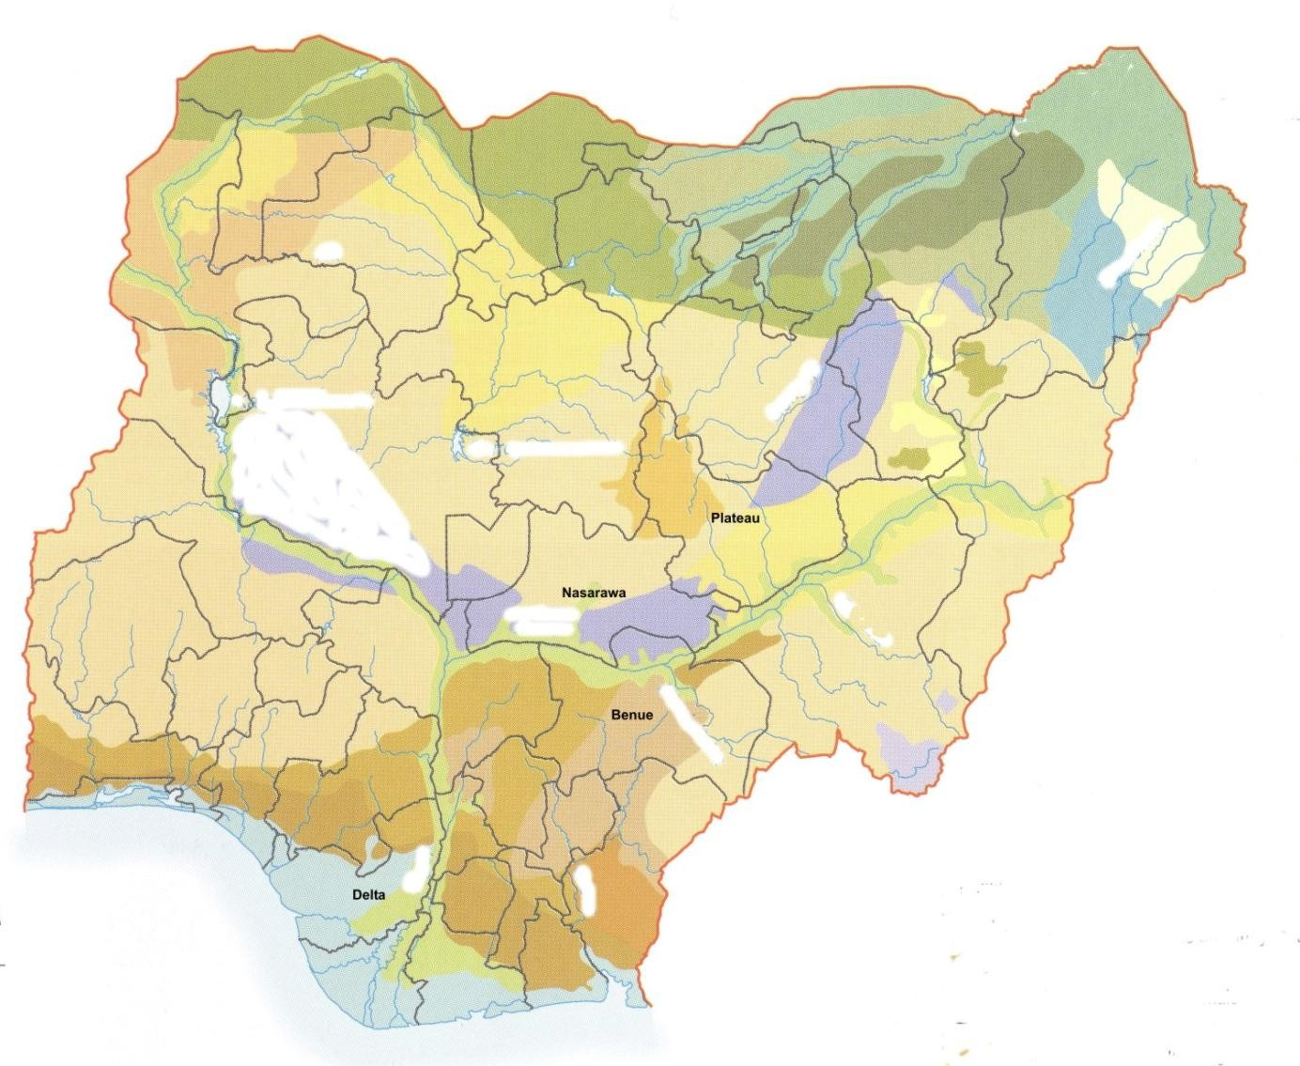

Figure 5. Map of Nigeria Showing Delta, Benue, Plateau and Nasarawa States Studied

Source : Secondary Atlas Macmillan Nigeria, 2003. Scale : 1 : 7,300,000 Series

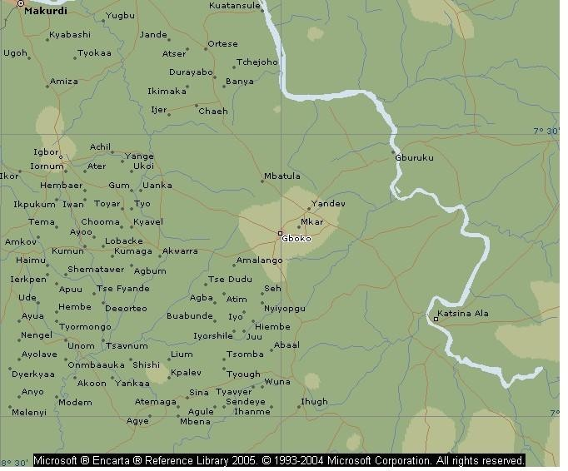

Figure 6. Map Showing the Lower Benue Districts of Benue State Harbouring the old Endemic Focus of Sleeping Sickness Studied

Source: Microsoft Encarta Reference Library, 2005

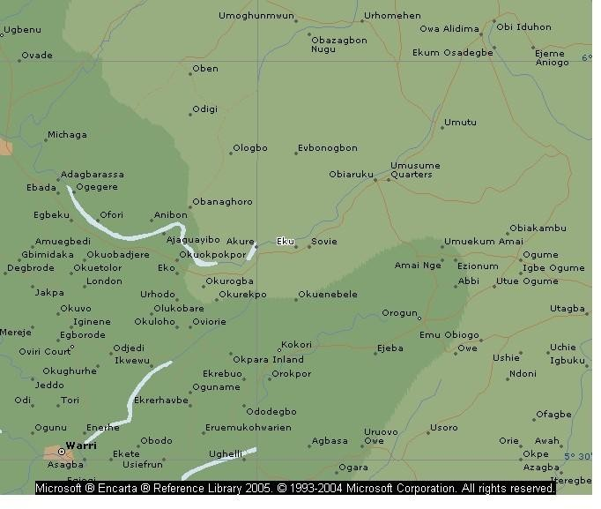

Figure 7. Map Showing the Districts of Delta State Harbouring the New Endemic Focus of Sleeping Sickness Studied

Source: Microsoft Encarta Reference Library, 2005

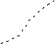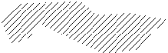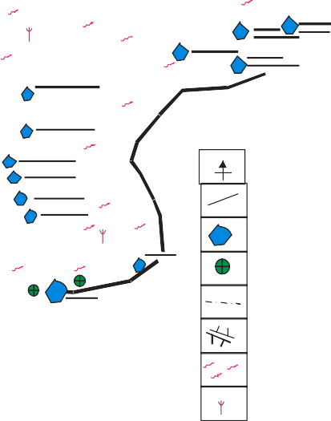45’
KEY
NorthernArrow MainRoad Towns/Villages HealthCentre
Local Govt. Boundary Rivers/Screams/Bridges ScarteredCultivation
PalmTrees

40’

35’

5033

45’

40’

35’

A G B O N C L A N

Figure 8. Map of Ethiope-East Local Government Area of Delta State Surveyed
Source: Ethiope-East Local Government, Delta State

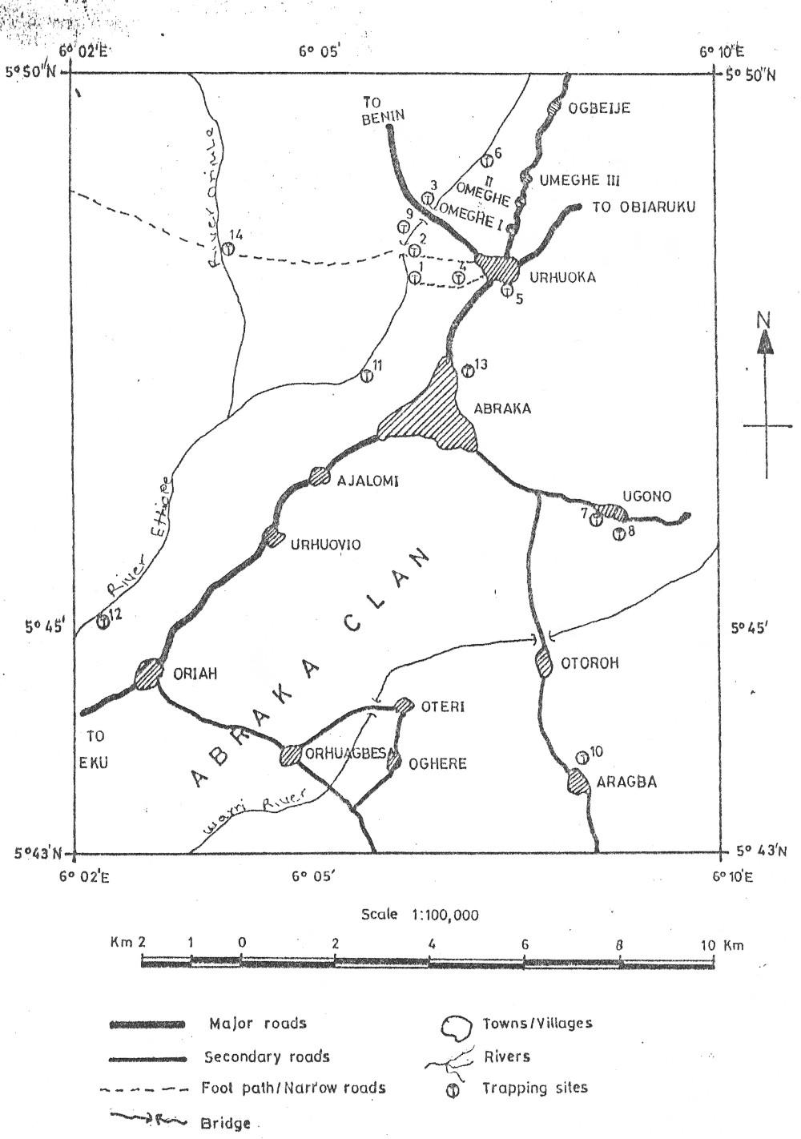

Figure 9 Map Showing the North-Eastern Part of Ethiope-East Local Government Area of Delta State Surveyed

Source: Ethiope-East Local Government, Delta State

Treatment of Patients
The patients treated with pentamidine alone were given intramuscular injection of the drug at 4 mg/kg body weight for 10 days. For those treated with a combination of melarsoprol and prednisolone, 1.8 mg/kg body weight of melarsoprol was administered intravenously for the first three days; 2.16 mg/kg from the 4th to the 6th day; 2.52 mg/kg from the 7th to the 14th day; 2.66 mg/kg on the 15th day; 3.24 mg/kg on the 16th day; and 3.60 mg/kg from the 23rd to the 25th day. Prednisolone was administered orally at a dose of 1.0 mg/kg body weight per day for the first week; 0.7 mg/kg body weight per day for the second week and 0.5 mg/kg body weight per day for the third week. For the patients treated with a combination of pentamidine, melarsoprol and prednisolone, treatment was initiated with an intramuscular injection of pentamidine at 4 mg/kg body weight, followed by the treatment protocol for melarsoprol and prednisolone already described above.

Biochemical Analysis of Sera Samples
Blood samples for sera were collected from patients by venipuncture. The blood was left to clot in clean sterile Bijou bottles at room temperature for 1 hr. The clear portion was separated using a Pasteur pipette and then centrifuged at 2000 g for 10 minutes. The clean sera (supernatant) were collected by sterile pipettes into sterile tubes and kept frozen at – 20°C until when required for analysis.
Serum sodium and potassium concentrations were determined with Flame photometer (Corning Model 400, Corning Scientific Limited, England). Total protein was estimated by the Biuret method (Reinhold, 1953). Chloride and serum bicarbonate were measured according to (Schales and Schales, 1941;

Toro and Ackermann, 1975) respectively. Serum urea was measured by SMA 12/60 auto-analyser (Sequential Multiple Analysis System, Technicon, New York). Serum glutamate pyruvic transaminase (GPT) and aspartate aminotransaminase (AST) were determined. The activities of alkaline phosphatase (ALKP) were determined by measuring the 4-nitrophenol liberated from 4-nitrophenyl phosphate at 400 nm using appropriate buffer systems (Wright, Leathwood & Plummer, 1978). Serum glucose was determined by the method of Richardson (1977).

THE APPLICATION OF POLYMERASE CHAIN REACTION (PCR) TECHNOLOGY TO ASSESS DRUG THERAPEUTIC EFFICACY IN SLEEPING SICKNESS PATIENTS AT ETHIOPE EAST LGA OF DELTA STATE NIGERIA

Blood Sample Collection, Preservation and Transportation
Blood samples were collected during follow-up survey from the sleeping sickness patients treated with trypanocidal drugs at Ethiope East LGA of Delta State Nigeria. The blood samples were collected on WHATMAN filter paper, after finger prick of the patients with lancet. Almeida, Ndao, Meirvenne and Geerts (1998) had used dried blood samples from goats experimentally infected with T. brucei for diagnostic evaluation with PCR. Each blood sample was collected on a neatly cut piece of the WHATMAN filter paper (7 cm × 3 cm), labelled at one end with the identity number of the patient. The blood samples were allowed to dry at room temperature. They were later preserved in a plastic container with silica gel. They were transported to Laboratoire de Recherches et de Coordination sur les Trypanosomes (LRCT) IRD Montpellier France/ University of Montpellier 1 Montpellier France for analysis and further investigations. On arrival in France the samples were stored in the refrigerator until required for analysis and further investigation.

Preparation of Template DNAs
Template Deoxyribonucleic Acids (DNAs) were prepared by the CHELEX and DNAzol methods.

Extraction of DNA using chelex method
Deoxyribonucleic acid (DNA) was extracted from the samples with the aid of a resin CHELEX ^{(R)} 100 Biotechnology Grade 100 - 200 mesh Sodium form (Bio-RAD Laboratories 200 Alfred Nobel Dr. Hercules CA USA). Extraction tubes were labelled and arranged for each to accommodate one blood sample. The zone of the Whatman filter paper without blood stain was carefully cut off with the aid of a pair of scissors and forceps, making sure that the scissors did not touch the blood stain. With the aid of the forceps, the zone of the filter paper with the blood stain was carefully picked and put into the appropriate labelled extraction tube. To avoid contamination, after each use the scissors and forceps were thoroughly cleaned before using them for another blood sample.
The 5% Chelex used for the extraction was put in a container and continuously stirred with a magnetic stirrer, even as the Chelex was being pipetted out from the container into the extraction tubes. 500 µl of the 5% Chelex was added to each tube containing the sample for extraction. However, as a form of modification, 1000 µl (1 ml) of the 5% Chelex was used for the extraction of deep coloured samples for more efficient extraction. The tubes were thereafter incubated at 56°C for 1 hr and then at 95°C for 30 minutes using a programmable incubator (Techne PHC - 2). After incubation, the tubes were centrifuged at 15,000 g for 5 minutes. The supernatant of each tube was carefully pipetted out and put into the appropriate labelled storage tube. The DNA extracts were stored at - 20°C until used. During use, after removal from

the freezer and thawing, the tubes containing the DNA extracts were centrifuged at 15,000 g for 5 minutes, in order to sediment any left over Chelex. Aliquots of the supernatant were used as DNA template for amplification in a PCR machine.

Extraction of DNA by DNAzol method
DNAzol is a chemical product specifically formulated for the isolation of genomic DNA from whole blood. The blood stained area of the Whatman filter paper was cut and put into pre-labelled tubes as earlier described for the Chelex method. 500 µl of ultra pure sterile water was added to each tube. A special plastic rod (one for each sample) was used to press the filter paper to facilitate the elution of the blood sample. The tubes were vortexed and then put in an incubator at 37ºC for two days. About 500 µl of the blood sample was pipetted out of each tube and then transferred into the appropriate labelled tubes. 1000 µl (1 ml) of DNAzol BD was added into each tube, after which the tubes were vortexed in a vortex machine. 5 µl of Polyacryl carrier was added to each tube, and the tubes were vortexed. The tubes were vortexed again after the addition of 400 µl of Isopropanol to each tube. The tubes were left on the table at room temperature for 5 minutes, and then centrifuged at 600 g for 6 minutes. The supernatant of each tube was carefully pipetted out, ensuring that any pellet at the base of the tube was not removed. 500 µl of DNAzol was added to each tube, which was then vortexed vigorously in order to have the pellets dissolved. The tubes were centrifuged at 2000 g for 4 minutes. The supernatant of each tube was pipetted out carefully to avoid the removal of the pellet formed. 1 ml of ethanol (95%) was added to each tube after which the tubes were centrifuged at 2000 g for 4 minutes.

The supernatant (ethanol) of each tube was carefully pipetted out leaving the pellets at the base of the tubes. 200 µl of ultra pure sterile water was added to each tube, which was then vortexed. The DNA extracts now ready to serve as templates for amplification in a PCR machine were stored at -20ºC until used.

DNA Amplification by PCR
Typical PCR amplifications were performed in a 50 µl reaction mixture containing specific oligonucleotide primers (TBR 1 “10 pm/µl” and TBR 2 “10 pm/µl”) with sequence as follows, TBR 1 (5’ – GAATATTAAACAATGCGCAG-3’) and TBR 2 (5’ – CCATTTATTAGCTTTGTTGC-3’), and expected amplification product (AP) size of 164, dnTPS (10 mM), buffer (10×) with magnesium chloride, water milliquantum (MQ) and DNA Taq Polymerase (Appligene). DNAs extracted from the blood samples were amplified in the final volume of 50 µl in each case, with the addition of 5 µl per reaction of the extracted DNA as templates. Reference DNA and negative (without DNA) as controls were included in each set of experiments. The samples in the tubes were incubated in a Programmable heating block PCR machine. They were incubated at 94°C for 3 minutes in an initial denaturation step i.e to denature the templates. This was followed by 45 cycles, starting with 94°C for 30 seconds and then cooled to 55°C for 30 seconds and then to 72°C for 1 minute to anneal the primers and finally incubated at 72°C for 5 minutes to extend the annealed primers (prolongation step). The temperature was then returned to 94°C during a 30 seconds period to initiate the next cycle. At the end of the last cycle the samples were cooled slowly over a 10 minutes period to room temperature.

Electrophoresis
Ten (10) µl aliquot of each of the amplified materials was analysed on Agarose gel (Molecular Biology Grade, Eurogentec) stained with ethidium bromide, at 100 V for 35 minutes. The positive and negative controls and the Marker (φ X174/Hae III) were also electrophoresed along with the samples under investigation. φ X174/Hae III is a molecular weight marker. The replicative form (Rf) of the icosahedral bacteriophage φ X174 (5366 base pairs) is a double stranded circular DNA molecule. φ X174 DNA is used as a substrate in the assay of restriction enzymes for kinase activity and is digested with restriction enzymes to generate molecular weight markers such as φ X174/Hae III) for use in gel electrophoresis.

Photography of the Gel
After electrophoresis, the Agarose gels were photographed under UV illumination using a Computer assisted photographing machine.

PHARMACOSOCIOECONOMICS AND STUDIES OF OTHER HUMAN FACTORS WHICH CONTRIBUTE TO TREATMENT FAILURES AND ENHANCEMENT OF TRYPANOSOMAL DRUG RESISTANCE AND TOXICITY

Study Areas/Scope
This aspect of the present study was carried out in relation to human and animal trypanosomiasis in four states of Nigeria (Delta, Benue, Plateau and Nasarawa) shown on the Map of Nigeria (Fig. 5). The human aspect was carried out in Ethiope East Local Government Area (LGA) of Delta State and environs where the disease is currently prevalent and Konshisha LGA in the old Gboko LGA of Benue State where the disease has been endemic (Figs. 6 - 9). The animal trypanosomiasis aspect was carried out in various LGAs of Plateau, Nasarawa, Benue and Delta States. The States and Local Government Areas

(LGAs) covered for the entire work are as follows: Delta State (Ethiope East, Ndokwa West, Isoko North and Oshimili LGAs); Plateau State (Bassa and Bokkos LGAs); Nasarawa State (Lafia LGA); Benue State (Ado, Apa, Gwer West, Konshisha, Katsina Ala and Otukpo LGAs).

Questionnaire Administration and Analysis
The study was carried out to determine the degree of awareness of the people in general and the livestock owners regarding the disease; and the possible relationship between psychosocial, cultural, socioeconomic, behavioural/other related factors and treatment failures/drug resistance and spread of the disease. Special emphasis was laid on enquiries into tradomedical/ethnoveterinary practices by the people, and possible combination of these practices with orthodox practices. There is paucity of researched data concerning this practice. The effects of poor availability of drugs and the high cost of available drugs were examined. The consequences of these are weighed against human/animal losses and general economic losses due to the spread of the disease.
Questionnaires were designed with EPI Info. 5.1 by using sampling methods with incidental components to gather data on age, sex, household size, religion, education, occupation, income, standard of living of respondents as independent variables and perception/knowledge of trypanosomiasis, vectors, attitude to disease, and treatment seeking behaviours as dependent variables. Some of the questions were designed in such a way as to give respondents ample opportunity to express themselves. There was also data collection from medical practitioners and other health officials from the surveyed areas with particular reference to Baptist Medical Centre Eku in Ethiope East LGA of Delta

State, where sleeping sickness patients in the locality were hospitalized for treatment. Data were gathered from veterinary officers, traditional healers, animal health superintendents and extension workers in the LGAs. Random sampling method was used. A total of 490 people were interviewed. Out of this number, 25 (5.1%) were medical and veterinary professionals, allied officers and traditional healers. 465 (94.9%) were local people resident in the surveyed communities and livestock owners. A breakdown of this figure (465) according to the four states under investigation is as follows- Delta 208 (44.7%), Benue 210 (45.2%), Plateau 37(7.9%) and Nasarawa 10(2.2%). Data analysis was done using simple proportions by percentiles.

STATISTICAL TREATMENT OF DATA
Statistical analysis of data was done using analysis of variance (ANOVA) at 5% level of significance.

CHAPTER FOUR

RESULTS

STUDIES ON HONEY

Analysis of Honey Sample PBMH1 for Trace Elements and Other Material Contents
Out of the three honey samples analysed for trace elements, honey sample PBMH1 from Miango, Bassa Local Government Area (LGA) Plateau State, with a pH value of 3.95 had the highest level of the following trace elements, sodium (2.6 ppm), potassium (8.3 ppm), magnesium (0.4 ppm) and iron (0.9 ppm) detected. Detectable from honey sample PBMH2 also from Miango Plateau State were sodium (2.5 ppm), potassium (8.1 ppm) and magnesium (0.3 ppm). Honey sample ANH1 from Numan LGA of Adamawa State had sodium (2.4 ppm), potassium (8.2 ppm), magnesium (0.4 ppm) and iron (0.7 ppm). However, lead, zinc, chromium, copper, manganese, cobalt, calcium, nickel and cadmium were not detectable in any of these three honey samples. Results of further analysis of honey sample PBMH1 for other material contents are shown in Table 1.
    - In Vitro and In Vivo Assays of Honey Sample PBMH1
The in vitro investigations revealed that the honey sample was able to immobilize most of the trypanosomes within the incubation period of 3 hr and rendered them uninfective to mice. However, the in vivo studies showed that the honey sample reduced parasitaemia in the infected animals, but later there was resurgence of high parasitaemia which resulted in the death of the experimental animals. One significant observation was that the honey treated animals lived longer than the control animals (infected but not treated). 13 out of 23 isolates of organisms (Listeria monocytogenes, Escherichia coli, Staphylococcus aureus,

Pseudomonas aeruginosa, Salmonella typhi, Streptococcus faecalis and Candida albicans) were sensitive to the honey sample, while 10 of them were not.
  - STUDIES ON BRASSICA OLERACEA

Phytochemical Analysis
Phytochemical screening of the aqueous extract of the dried leaves of Brassica oleracea showed the presence of alkaloids, tannins, glycosides and terpenes.

Anti-trypanosomal Studies
The results of the anti-trypanosomal studies showed that the extract of Brassica oleracea immobilized the trypanosomes and rendered them uninfective to mice (Tables 2 and 3).

STUDIES ON FROG AND SNAKE SKINS

Phytochemical Investigations
The results of the phytochemical analysis showed the presence of phlobatannins and cardiac glycosides in the skin of both the frogs and snakes under investigation. In addition, the skin of the frogs contained alkaloids, saponins and combined anthraquinones.

Studies on The Potentiation of Diminazene Aceturate Activity With Extracts of Frog and Snake Skins
The results of the investigations on the use of the extracts of frog and snake skins to potentiate diminazene aceturate activity in Trypanosoma brucei brucei infected albino rats are shown in Table 4. The extracts showed remarkable performances in potentiating the activity of diminazene aceturate.

TABLE 1 Analysis of Honey Sample (PBMH1) for Material Contents

pH = 3.95
Material Contents | Percentage (%)
Water | 16.52
Ash | 0.38
Free Acid | 45.27
Lactones | 0.92
Total Acids | 46.19
Nitrogen | 0.14
Dextrose | 32.28
Reducing Sugar | 60.10
Invert Sugar | 62.64
Fructose | 27.82
Sucrose | 2.40
Dextrin | 0.76

TABLE 2 Effect of Brassica oleracea Extract on the Motility of DE 52 Separated Trypanosomes and Trypanosomes in Whole blood

Extract concentration (mg/ml)
 | 0.5 | 1.0 | 1.5 | 2.0 | 2.5 | 3.0 | 0.5 | 1.0 | 1.5 | 2.0 | 2.5 | 3.0
100.0 | + | - | - | - | - | - | ++ | - | - | - | - | -
20.0 | ++ | - | - | - | - | - | ++ | - | - | - | - | -
4.0 | ++ | - | - | - | - | - | ++ | - | - | - | - | -
0.8 | ++ | - | - | - | - | - | ++ | - | - | - | - | -
0.2 | ++ | - | - | - | - | - | ++ | - | - | - | - | -
0.03 | ++ | - | - | - | - | - | ++ | - | - | - | - | -
0.006 | ++ | - | - | - | - | - | ++ | - | - | - | - | -
0.001 | ++ | - | - | - | - | - | ++ | - | - | - | - | -
0.0003 | ++ | - | - | - | - | - | +++ | ++ | + | - | - | -
0.00005 | +++ | + | + | + | + | + | +++ | ++ | + | + | + | +
Control 0.0 | +++ | +++ | +++ | +++ | +++ | +++ | +++ | +++ | +++ | +++ | +++ | +++
(No extract)

Separated trypanosomes Duration of incubation (hr)
Trypanosomes in whole blood Duration of incubation (hr)

Key: - | = | Full inhibition of motility
+++ | = | Many actively motile trypanosomes
++ | = | Reduced motility of trypanosomes
+ | = | Very few motile trypanosomes (very sluggish
 |  | motility)

2

TABLE 3. Assessment of the Effect of Brassica oleracea Extract on the Infectivity of DE 52 Separated Trypanosomes and Trypanosomes in Whole Blood After Incubation Period

Extract concentration  (mg/ml) | Separated trypanosomes |  |  | Trypanosomes in whole blood
No of mice  inoculated |  | Infection/  Parasitaemia | Survival  of mice | No of Mice  inoculated | Infection/  Parasitaemia | Survival  of mice
100.0 | 3 | N | 3/3 | 3 | N | 3/3
20.0 | 3 | N | 3/3 | 3 | N | 3/3
4.0 | 3 | N | 3/3 | 3 | N | 3/3
0.8 | 3 | N | 3/3 | 3 | N | 3/3
0.2 | 3 | N | 3/3 | 3 | N | 3/3
0.03 | 3 | N | 3/3 | 3 | N | 3/3
0.006 | 3 | N | 3/3 | 3 | N | 3/3
0.001 | 3 | N | 3/3 | 3 | N | 3/3
0.0003 | 3 | N | 3/3 | 3 | N | 3/3
0.00005 | 3 | N | 3/3 | 3 | N | 3/3
Control 0.0 (No extract) | 3 | P | 0/3* | 3 | P | 0/3**

Key: N | = | Parasitaemia and Infection negative
P | = | Parasitaemia and Infection positive
* | = | Mice died 8 – 10 days after inoculation
** | = | Mice died 7 – 9 days after inoculation

DRUG RESISTANCE STUDIES
    - Evaluation of Cymelarsan Against T.brucei brucei
The results of parasitaemia of the animals (albino rats) are shown in Fig.10. Animals treated with cymelarsan were cleared of circulating trypanosomes 2 – 3 days post treatment, and they remained aparasitaemic for 100 days post treatment when the experiment was terminated (Fig. 10). The control animals had high and fulminating parasitaemia, which had its peak toward the terminal stage of the infection when the animals died (Fig. 10).
    - Evaluation of Cymelarsan Against T. evansi
The results of parasitaemia and PCV of the animals (rabbits) are shown in Figs 12 - 15. These results show a fairly high parasitaemia before the initiation of treatment of the animals. The parasitaemia dropped even up to zero level after treatment, however recrudescence occurred after some time, resulting to another high level of parasitaemia. This repeated itself inspite of repeated treatment with cymelarsan as shown in Figs 12 - 15, and the infected and treated animals eventually died as a result of the infection. The packed cell volume (PCV) of the infected animals decreased as infection progressed in spite of the treatment (Figs. 12 - 15). The results of the control animals (infected but not treated) are shown in Fig. 11.

Antigen Enzyme-linked Immunosorbent Assay (ELISA)
The results of the micro-plate antigen ELISA performed on the sera samples of the experimental animals are shown in Fig.16. The antigen ELISA was positive for all the sera samples of the infected and treated animals.

TABLE 4. Potentiation of Diminazene Aceturate Activity in Trypanosoma brucei brucei Infected Albino Rats Using Extracts of Frog and Snake Skins

RESPONSES

Test organism
Groups

Treatment
Parasitaemia No. Cured
/Relapse No. Treated

Trypanosoma brucei brucei “Gboko”
A Diminazene Aceturate |  | 10/10
(2.5mg/kg) + 10mg/kg | -
Cobra Skin Extract.
B Diminazene Aceturate |  | 10/10
(2.5mg/kg) + 10mg/kg | -
Viper Skin Extract.
C Diminazene Aceturate |  | 9/10
(2.5mg/kg) + 10mg/kg | R (1)
Frog Skin Extract.
D Diminazene Aceturate | +P (4); R (6) | 0/10
(2.5mg/kg)
E Diminazene Aceturate |  | 10/10
(3.5mg/kg) + 10 mg/kg | -
Cobra Skin Extract.
F Diminazene Aceturate |  | 10/10
(3.5 mg/kg) + 10mg/kg | -
Viper Skin Extract.
G Diminazene Aceturate |  | 10/10
(3.5mg/kg) + 10mg/kg | -
Frog Skin Extract
H Diminazene Aceturate | - | 10/10
(3.5mg/kg)

Key: R=Relapse +P=Consistent Parasitaemia

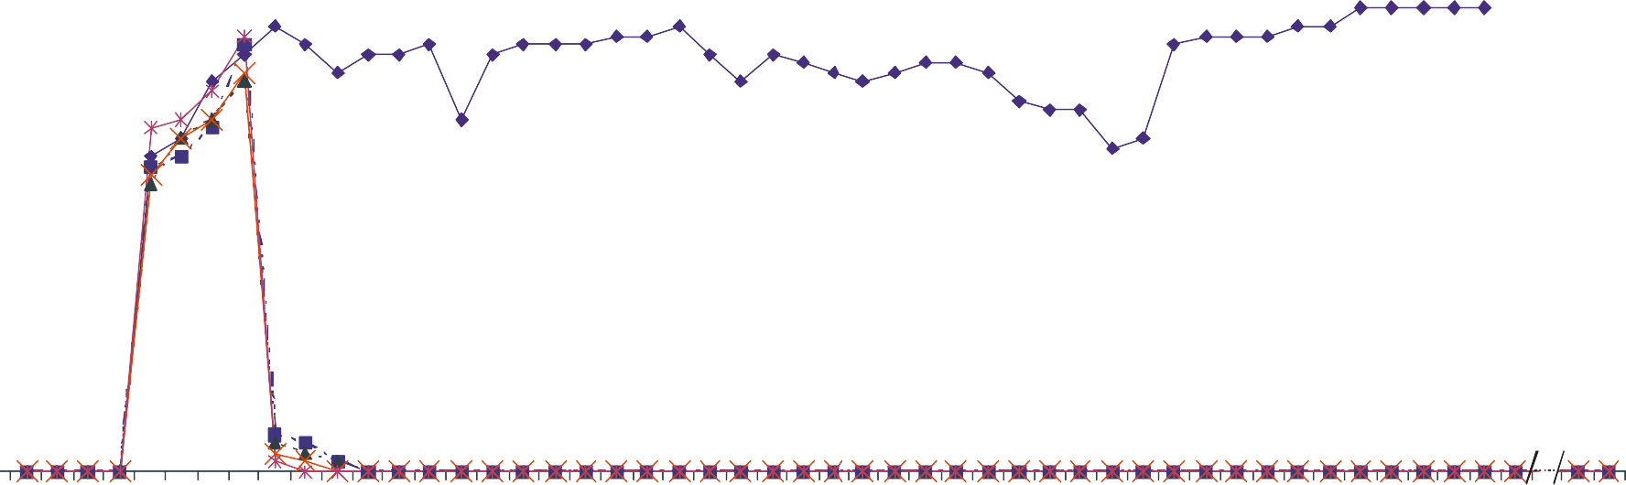6
Rx

5
Parasitaemia (Log Equivalent Value)

4

3

2

Key:
0 1 2 3 4 5 6 7 8 9 10111213 141516 17181920 212223 24252627 282930 31323334 353637 38394041 424344 45464748 99100
Days

2
Rx = Treatment Point
Control (Infected but not treated)
0.25 mg/Kg body weight of Cymelarsan
0.5 mg/Kg body weight of Cymelarsan
1.0 mg/Kg body weight of Cymelarsan
2.0 mg/Kg body weight of Cymelarsan

Figure 10. Parasitaemic Profile of Control Albino Rats and Rats Infected with Trypanosoma brucei brucei and Treated with Different Doses of Cymelarsan

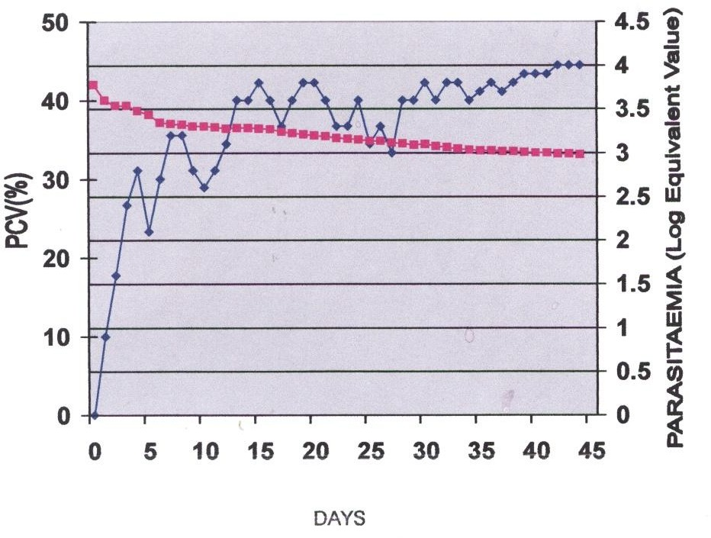

= Packed Cell Volume (%)
= Parasitaemia (Log Equivalent Value)

Figure 11. Parasitaemia and Packed Cell Volume in Control Rabbits Infected with Trypanosoma evansi but not Treated

50 4
Rx
Rx
Rx
PARASITAEMIA (LOG EQUIVALENT VALUE)

40
)
E U L A V
T N E L A
V I
U Q E
G O
L (

A I
M E A
T I
S A R A P
3

30
2
20

1
10

0 10 15 20 25 30 35 40 44 0
5
0
Days

Rx = Treatment Point PCV Parasitaemia

Figure 12. Parasitaemia and Packed Cell Volume in Rabbits Infected with
Trypanosoma evansi and Treated with 0.25 mg/kg of Cymelarsan

0
50
3.5
40
Rx
3
2.5
30
Rx
Rx
20

10
2.0
1.5
1.0
0.5
PARASITAEMIA(LOGEQUIVALENTVALUE)
0
0 5 10 15 20 25 30 35 40 44

Days
Rx = Treatment Point PCV Parasitaemia

Figure 13. Parasitaemia and Packed Cell Volume in Rabbits Infected with
Trypanosoma evansi and Treated with 0.5 mg/kg of Cymelarsan

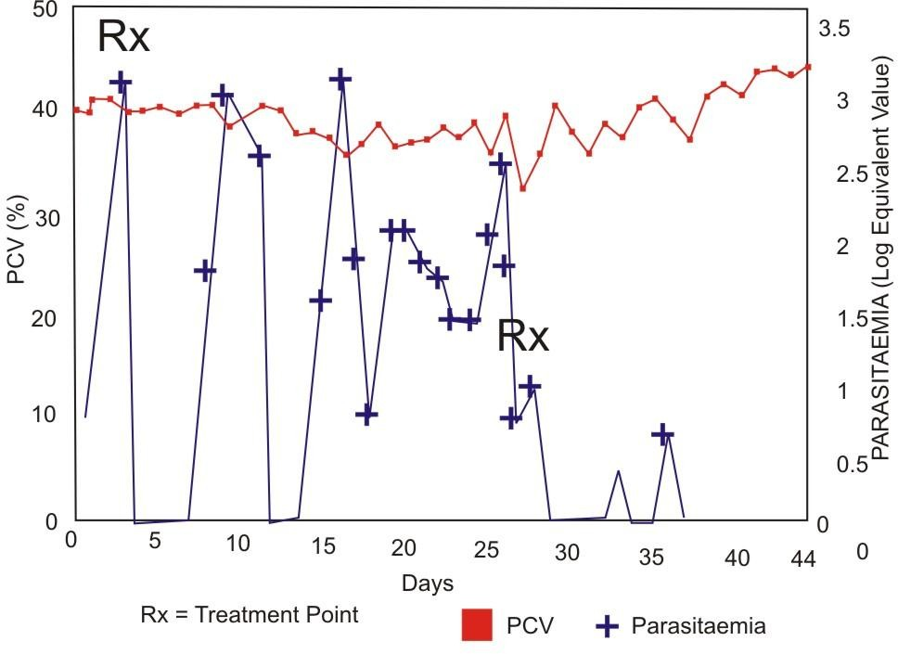

Figure 14. Parasitemia and Packed Cell Volume in Rabbits Infected with
Trypanosoma evansi and Treated with 1.0 mg/kg of Cymelarsan

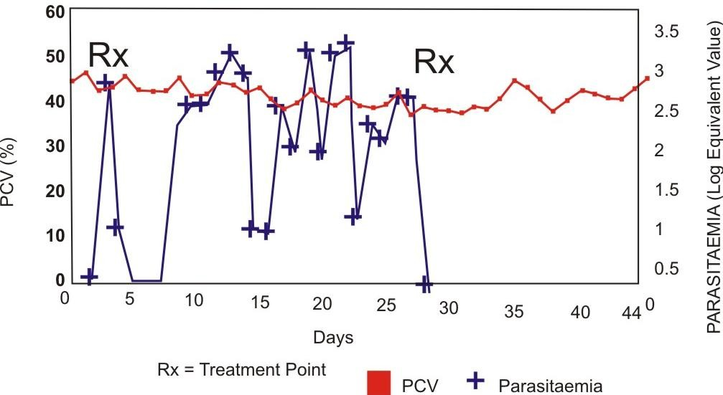

Figure 15. Parasitemia and Packed Cell Volume in Rabbits Infected with
Trypanosoma evansi and Treated with 2.0 mg/kg of Cymelarsan

Antibody Enzyme-linked Immunosorbent Assay (ELISA)
The results of the micro-plate antibody ELISA performed on the sera samples of the experimental animals are shown in Fig. 17. The antibody ELISA was positive for all the sera samples of the infected and treated animals.
    - In Vitro Assay
The results of the in vitro assay also indicate the resistance of the T. evansi to cymelarsan. The different concentrations of the drug were not able to immobilize the trypanosomes completely within the incubation period (3 hr). Thereafter, the trypanosomes were able to initiate parasitaemia and lethal infection in mice.

Trypanosomal Drug Resistance Reversal Studies Using Verapamil
The results show the inability of the calcium channel blocker, verapamil to reverse the resistance of the T. evansi to cymelarsan. However, the use of verapamil prolonged the life of the experimental animals. These results are shown in Table 5 and Figs. 18 - 25. Figs. 18 - 20 show relapse and resurgence of parasitaemia and the PCV profile decrease inspite of repeated treatment of the infected animals with cymelarsan and verapamil. Fig. 21 shows the results of the control animals. The antigen ELISA was positive for the animals treated with verapamil alone, cymelarsan and verapamil, and also for the infected but untreated rabbits (Figs.22 - 25). The rabbits in groups A, B and C where the treatment involved verapamil lived longer far beyond the death of those in group D (infected but not treated), as shown in Table 5.

0 .1 2
ANTIGEN - ELISA (OD)
0 .1
0 .0 8
0 .0 6
0 .0 4
0 .0 2
0
-0 .0 2
-0 .0 4
1 2 3 4 5 6 7 8 9 10 11 12 13 14
WEEKS
Positive Control (T. evansi lysate) = 0.028
Negative Control (Pooled serum from uninfected and untreated rabbits) = 0.017

Dose = 0.25 mg/kg Dose = 1.0 mg/kg
Dose = 0.50 mg/kg Dose = 2.0 mg/kg

Figure 16. Antigens in Rabbits Infected with Trypanosoma evansi and Treated with Different Doses of Cymelarsan

0.5
ANTIBODY - ELISA (OD)
0.4
0.3
0.2
0.1
0
-0.1

1 2 3 4 5 6 7 8 9 10 11 12 13 14
WEEKS

Positive Control (Pooled serum from parasitologically proven cases ofT. evansi infected rabbits ) = 0.161
Negative Control (Pooled serum from uninfected and untreated rabbits) = 0.034

Dose = 0.25 mg/kg Dose = 1.0 mg/kg
Dose = 0.50 mg/kg Dose = 2.0 mg/kg

Figure 17. Antibodies in Rabbits Infected with Trypanosoma evansi and Treated with Different Doses of Cymelarsan

TABLE 5. Period Between Infection and Death of the Groups of Rabbits Treated with Cymelarsan and Verapamil

Groups | Period Between Infection and Death (Weeks)
A B C  D | 21  23  8  5

KEY :
GROUP A: Rabbits infected with T. evansi and treated with 0.25 mg/kg of cymelarsan and 50 mg/kg of verapamil.

GROUP B: Rabbits infected with T. evansi and treated with 2.0 mg/kg of cymelarsan and 50 mg/kg of verapamil.

GROUP C: Rabbits infected with T. evansi and treated with 50 mg/kg of verapamil only.

GROUP D: Rabbits infected with T. evansi but not treated.

50

40


30

20

10

0

0 5 10 15 20 25 30 35 40 45
3.5

3
2.5

2
1.5

1
0.5
0

DAYS

= Packed Cell Volume (%)
= Parasitaemia (Log Equivalent Value)

Figure 18. Parasitaemia and Packed Cell Volume of Rabbits Infected with Trypanosoma evansi and Treated with 0.25 mg/kg of Cymlearsan and 50 mg/kg of Verapamil

50

40


30

20

10

0
0 5 10 15 20 25 30 35 40 45

DAYS

3

2.5

2

1.5

1

0.5

0

= Packed Cell Volume (%)
= Parasitaemia (Log Equivalent Value)

Figure 19. Parasitaemia and Packed Cell Volume of Rabbits Infected with Trypanosoma evansi and Treated with 2.0 mg/kg of Cymlersan and 50 mg/kg of Verapamil

50

40


30

20

10

0

0 5 10 15 20 25 30 35 40 45
4

3.5
3

2.5
2

1.5
1

0.5
0

DAYS

= Packed Cell Volume (%)
= Parasitaemia (Log Equivalent Value)

Figure 20. Parasitaemia and Packed Cell Volume of Rabbits Infected with Trypanosoma evansi and Treated with 50 mg/kg of Verapamil only

50

40


30

20

10

0
0 5 10 15 20 25 30 35

DAYS
= Packed Cell Volume (%)
= Parasitaemia (Log Equivalent Value)
4

3.5
3

2.5
2

1.5
1

0.5
0

Figure 21. Parasitaemia and Packed Cell Volume of Control Rabbits Infected with Trypanosoma evansi but not Treated

0.07
0.06
0.05
0.04
0.03
0.02
0.01
0
2 3 4 5 6 7 8 9 10 11 12 13 14 15 16 17 18 19 20 21

WEEKS

Positive control (T. evansi lysate) = 0.032 (OD)

Negative Control (Pooled serum from uninfected and untreated rabbits) = 0.018 (OD)

Figure 22. Antigens in Rabbits Infected with Trypanosoma evansi and Treated with 0.25 mg/kg of Cymelarsan and 50 mg/kg of Verapamil

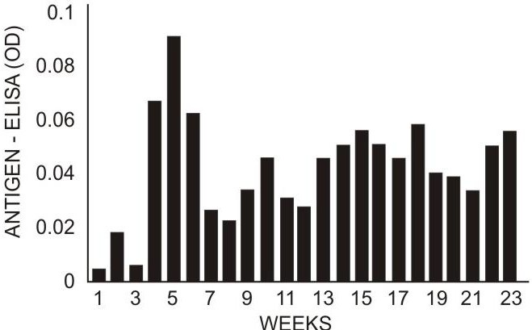

Positive control (T. evansi lysate) =0.032 (OD)
Negative Control (Pooled serum from uninfected and untreated rabbits)
= 0.018 (OD)

Figure 23. Antigens in Rabbits Infected with Trypanosoma evansi and Treated with 2.0 mg/kg of Cymerlarsan and 50 mg/kg of Verapamil

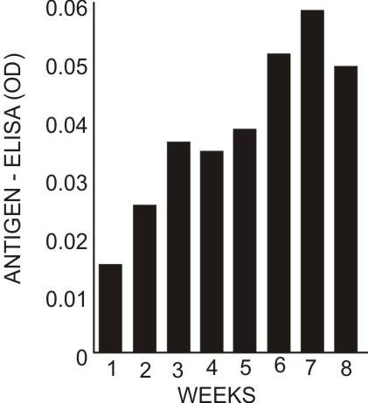

Positive control (T. evansi lysate) =0.032 (OD)
Negative Control (Pooled serum from uninfected and untreated rabbits) =
0.018 (OD)

Figure 24. Antigens in Rabbits Infected with Trypanosoma evansi and Treated with 50 mg/kg of Verapamil Only

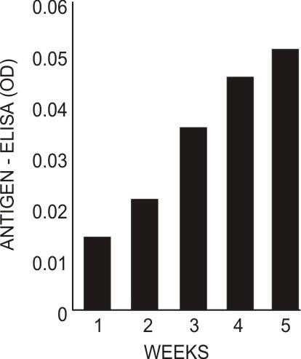

Positive control (T. evansi lysate) = 0.032 (OD)

Negative control (Pooled serum from uninfected and untreated rabbits) = 0.018 (OD)

Figure 25. Antigens in Rabbits Infected with Trypanosoma evansi but not Treated

Studies of Potential Tsetse Fly Repellent Materials
The results of investigations relating to natural and synthetic materials with potentials for tsetse fly repellency are shown in Table 6 and Fig. 26. The natural product Lantana camara exhibited the greatest repellent activity.

EFFECT OF ORAL COMBINATION THERAPY OF DFMO, CHLOROQUINE AND HONEY SAMPLE PBMH1 ON TRYPANOSOME INFECTIONS
The results of effective oral combination therapy of DFMO, chloroquine and the honey sample PBMH1 on trypanosome infections of Trypanosoma brucei brucei and T. gambiense in albino rats and mice are shown in Table 7.

PRE-TREATMENT STUDIES OF UNINFECTED ANIMALS WITH A COMBINATION OF DFMO, CHLOROQUINE AND HONEY SAMPLE PBMH1
The daily food and water intakes of the experimental animals are shown in Figs. 27 - 30. The pre-treatments did not suppress food and water intakes. The activity profiles of the effects of procaine, D-tubocurarine and dantrolene on the rat phrenic nerve hemidiaphragm of pre-treated female albino rats are shown in Figs. 31 - 40. The results of the effects of honey, chloroquine and DFMO combinations pre-treatment of female albino rats on oxytocin and ergometrine induced contraction of uterine smooth muscle are shown in Figs. 41 - 44. There was no significant difference (P>0.05) between the tension change of the control and that of either day 3, day 14 or day 28, pre-treated groups of animals for the different combinations (ANOVA at 5% level of significance). The rate of contraction of the uterine smooth muscle of albino rats pretreated with the various combinations is shown in Fig. 45. There was also no significant difference (P>0.05) when the rate of contraction of the uterine smooth muscle of the different groups of animals pre-treated with different combinations was

compared with the control and among themselves using ANOVA at 5% level of significance. The effect of acute and chronic administration of DFMO, chloroquine, honey and their various combinations on the weight of uterine muscle of the pre-treated female albino rats are shown in Table 8. Comparison of the percentage of uterine muscle weight over body weight of the animals in the different groups of pretreated animals for Day 3, Day 14 and Day 28 did not show any significant difference (P>0.05) between them and the control group and also among themselves (ANOVA of variance at 5% level of significance).

STUDIES ON TOPICAL APPLICATION OF TRYPANOCIDAL DRUGS USING NATRUAL PRODUCTS
    - Analysis of Butyrospermum paradoxum Seed and Shea Butter For Material Contents
The results of the analysis of Butyrospermum paradoxum seed and shea butter for material contents are shown in Table 9.

Topical Application Investigations
The effects of topical application of melarsoprol, ethidium bromide, diminazene aceturate singly and their various combinations with cattle butter (ghee) or shea butter on Trypanosoma brucei brucei, T. gambiense or T. congolense infected animals are shown in Tables 10 - 17. Melarsoprol, combination of either ethidium bromide or diminazene aceturate with cattle butter (ghee) were affective. Ethidium bromide, diminazene aceturate and thier respective combinations with shea butter were not effective.

TABLE 6. Analysis of Lantana camara Sample and Tapinanthus
(Mistletoe) Parasitic on the Lantana camara

Lantana camara |  |  | Tapinanthus  (Mistletoe)
Material Content | Leaf (%) | Stem (%) | Leaf (%) | Stem (%)
Moisture | 24.92 | 22.70 | 25.00 | 21.90
Ash | 10.50 | 4.14 | 17.81 | 5.48
Fat | 2.84 | 0.64 | 2.22 | 0.74
Protein | 18.38 | 7.14 | 23.62 | 11.97
Total Carbohydrate | 43.36 | 65.38 | 31.35 | 59.91
Chloride | 0.43 | 0.15 | 0.58 | 0.53
Phosphorus | 1.00 | 0.19 | 0.54 | 0.34
Copper | 0.02 | 0.02 | 0.04 | 0.03
Zinc | - | - | - | -
Magnesium | 23.19 | 2.53 | 2.60 | 1.47
Manganese | 0.03 | - | 0.02 | -
Calcium | 2.32 | 0.97 | 0.71 | 1.93
Sodium | 0.45 | 1.17 | 0.32 | 0.67
Potassium | 2.58 | 8.77 | 19.16 | 10.92

120
T
C
T
C
T
C

100
L T M O A
C
80
60

40
20
0
20 Mins 35 Mins 60 Mins

Duration

KEY:
L | = | Lantana camara
T | = | Tapinanthus (Mistletoe) parasitic on Lantana camara
M | = | Macerated tsetse fly fluid
O | = | “OFF”
A | = | “ANTIMOS”
C | = | Control (Blue cloth material without any test product)

Number of Tsetse Flies tested: 20 minutes (7); 35 minutes (12); 60 minutes (16)

Figure 26. Effect of Some Natural and Synthetic Products as Tsetse Fly Repellents

TABLE 7. Effect of Oral Combination Therapy of DFMO, Chloroquine and Honey on Trypanosome Infection in Rats and Mice

Test Organism Host Treatment stage Parasitaemia
RESPONSES

Animal
 | /Relapse | Inoculation | No. Treated
Trypanosoma brucei brucei Control (Not Treated) | +P | + | 0/10
“Gboko”  Rats Early | - | - | 10/10
Late | - | - | 10/10
Trypanosoma gambiense Control (Not treated) | (+P) | + | 0/10
“Abraka” Early  Mice | - | - | 10/10
Late | - | - | 10/10

No. Cured

2

KEY: +P = Consistent Parasitaemia

(+P) = Scanty and Irregular Parasitaemia

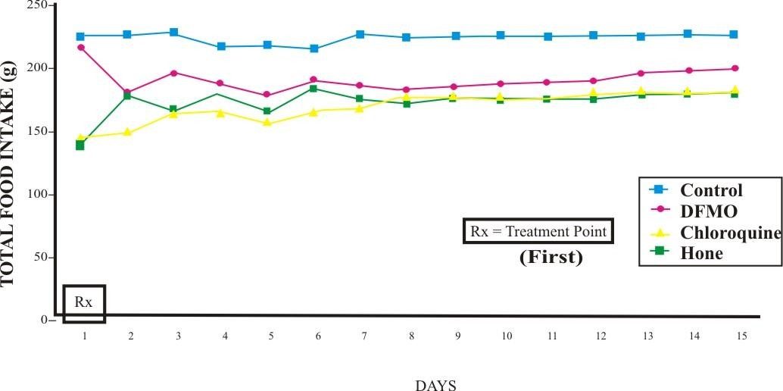Figure 27. Daily Food Intake of Female Albino Rats Orally Treated with DL-α- Diflouromethylornithine (DFMO), Chloroquine and Honey
Control DFMO
Chloroquine Honeyy
TOTAL FOOD INTAKE (g)

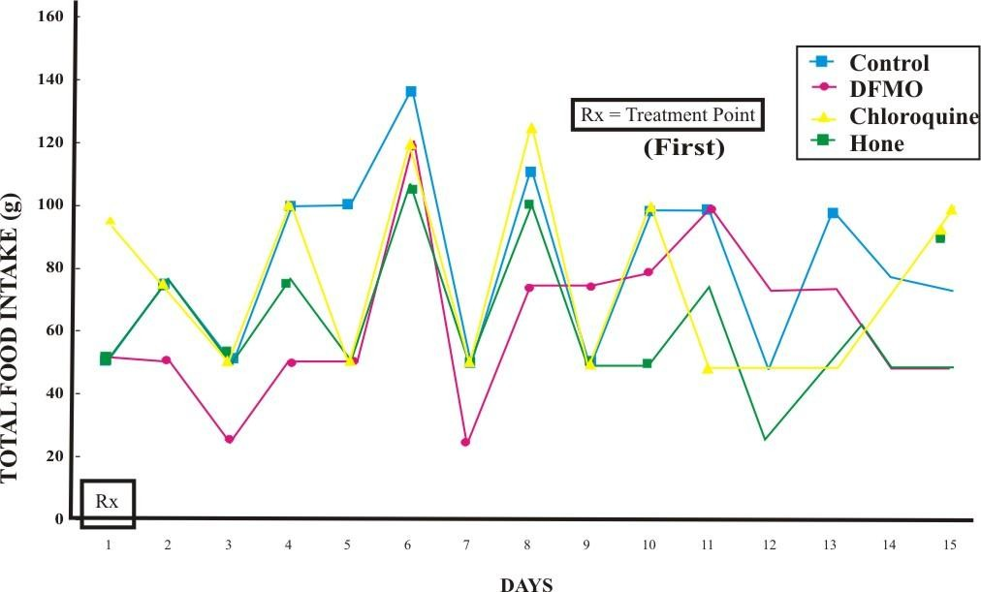Figure 28. Daily Water Intake of Female Albino Rats Orally Treated with DL-α- Difluoromethylornithine (DFMO), Chloroquine and Honey
Control DFMO
Chloroquine Honey
TOTAL WATER INTAKE (ml)

250
Rx

200
TOTAL FOOD INTAKE (g)

150

100

50

0
1 2 3 4 5 6 7 8

9 10 11

12 13 14 15

KEY:
Control
DFMO + Chloroquine
DFMO + Honey
Chloroquine + Honey
DAYS

(First)
Rx = Treatment Point

Figure 29. Daily Total Food Intake of Groups of Female Albino Rats Orally Treated With Different Combinations of DL-α-Difluoromethylorithine (DFMO), Chloroquine and Honey

160

Rx
TOTAL WATER INTAKE (ml)
140
120
100
80
60
40
20
0

1 2 3 4 5 6 7 8
9 10 11
12 13 14 15

DAYS
Control
DFMO + Chloroquine
DFMO + Honey
Chloroquine + Honey

(First)
Rx = Treatment Point

Figure 30. Daily Water Intake of Groups of Female Albino Rats Orally Treated With Different Combinations of DL-α–Diflouromethylornithine (DFMO), Chloroquine and Honey

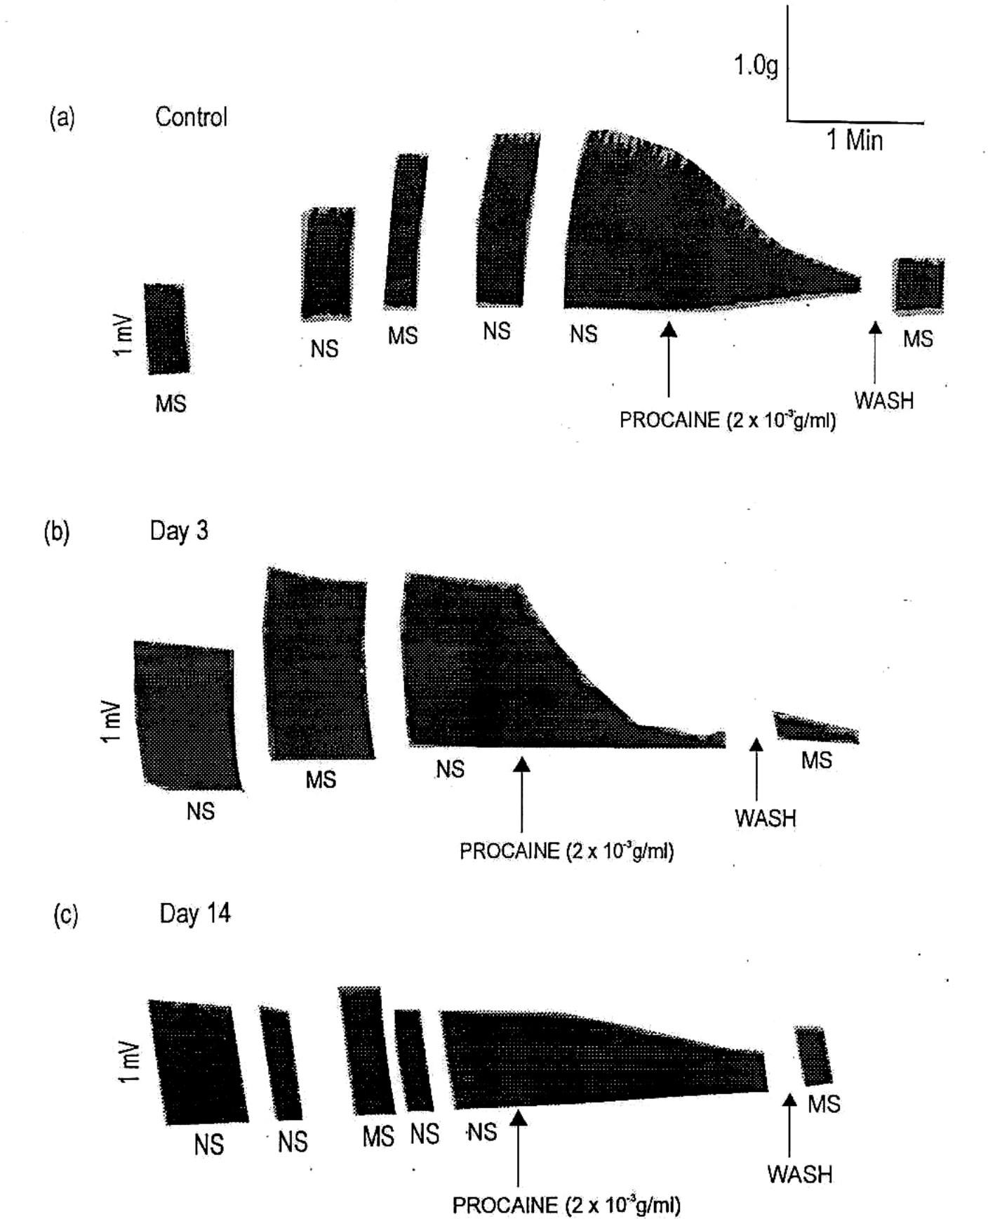

Abbraviations used are: | MS | = | Muscle Stimulation
 | NS | = | Nerve Stimulation
 | mV | = | Millivolt

Figure 31. Activity Profiles of the Effects of Procaine on the Rat Phrenic Nerve Hemidiaphragm Twitch Contraction of DL-α- Difluoromethylor- nithine (DFMO) and Chloroquine Combination Pre-treated Female Albino Rats

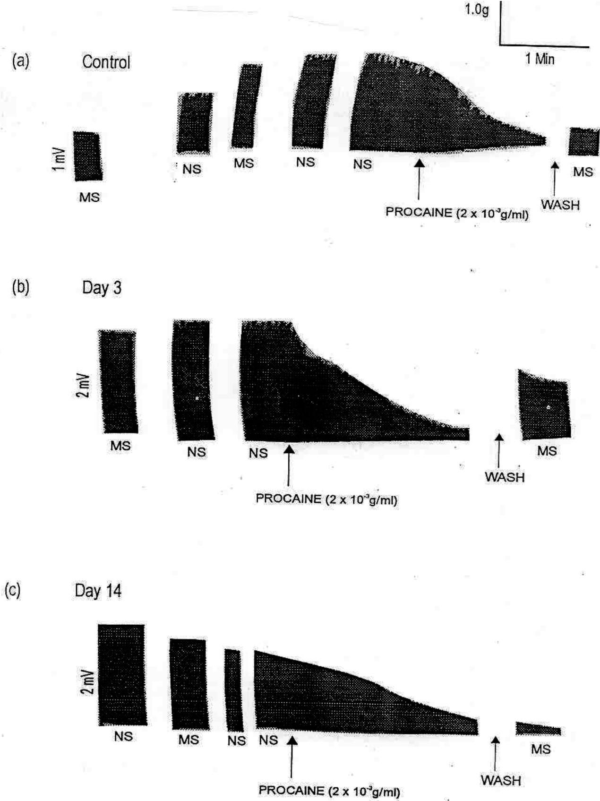

Abbreviations used are: | MS | = | Muscle Stimulation
 | NS  mV | =  = | Nerve Stimulation  Millivolt

Figure 32. Activity Profiles of the Effects of Procaine on the Rat Phrenic Nerve Hemidiaphragm Contraction of DL-α-Difluoromethylornithine (DFMO) and Honey Combination Pre-treated Female Albino Rats

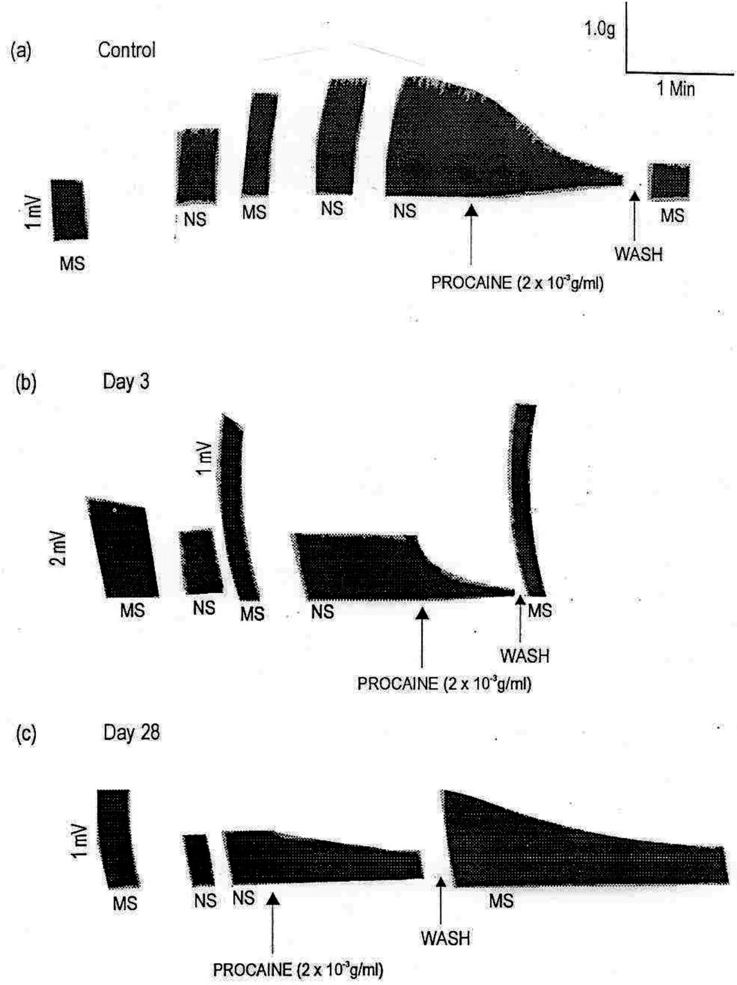

Abbreviations used are: | MS | = | Muscle Stimulation
 | NS  mV | =  = | Nerve Stimulation  Millivolt

Figure 33. Activity Profiles of the Effects of Procaine on the Rat Phrenic Nerve Hemidiaphragm Contraction of Chloroquine and Honey Combination Pre-treated Female Albino Rats

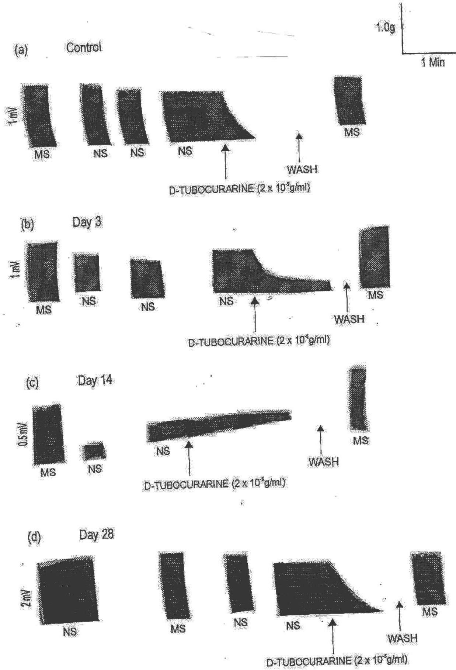

Abbreviations used are: | MS | = | Muscle Stimulation
 | NS  mV | =  = | Nerve Stimulation  Millivolt

Figure 34. Activity Profiles of the Effects of D-Tubocurarine on the Rat Phrenic Nerve Hemidiaphragm Contraction of DL-α-Difluoromethylornithine (DFMO) Pre-treated Female Albino Rats

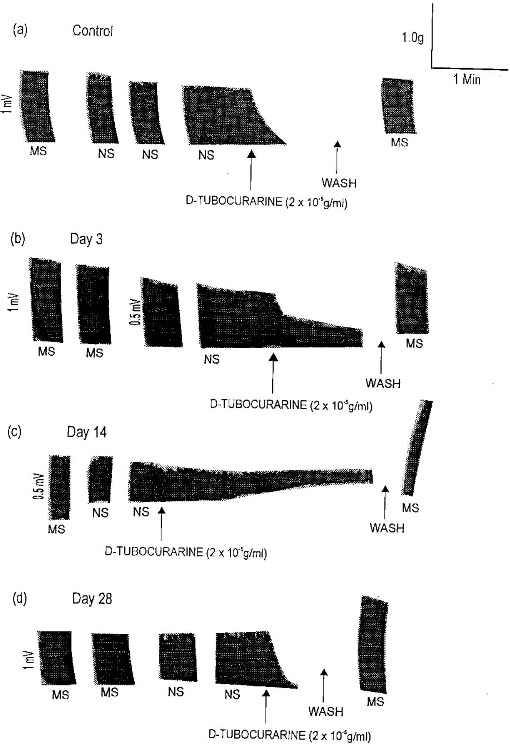

Abbreviations used are: | MS | = | Muscle Stimulation
 | NS  mV | =  = | Nerve Stimulation  Millivolt

Figure 35. Activity Profiles of the Effects of D-Tubocurarine on Rat Phrenic Nerve Hemidiaphragm Twitch Contraction of Chloroquine Pre- treated Female Albino Rats

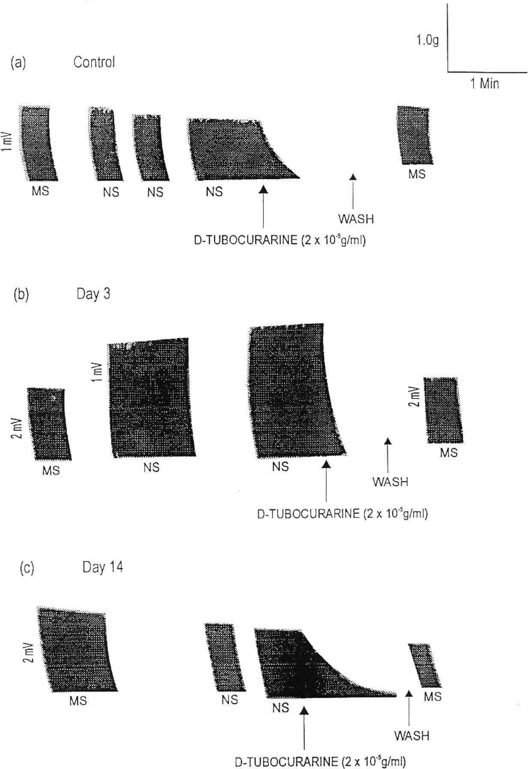

Abbreviations used are: | MS | = | Muscle Stimulation
 | NS | = | Nerve Stimulation
 | mV | = | Millivolt

Figure 36. Activity Profiles of the Effects of D-Tubocurarine on Rat Phrenic Nerve Hemidiaphragm Twitch Contraction of DL-α-Difluoromethy- lornithine (DFMO) and Honey Combination Pre-treated Female Albino Rats

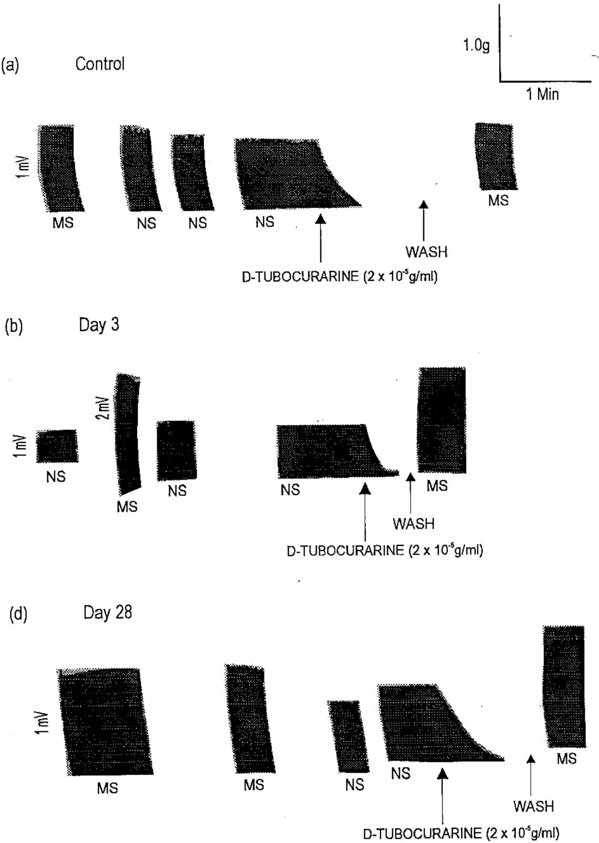

Abbreviations used are: | MS | = | Muscle Stimulation
 | NS | = | Nerve Stimulation
 | mV | = | Millivolt

Figure 37. Activity Profiles of the Effects of D-Tubocurarine on Rat Phrenic Nerve Hemidiaphragm Twitch Contraction of Chloroquine and Honey Combination Pre-treated Female Albino Rats

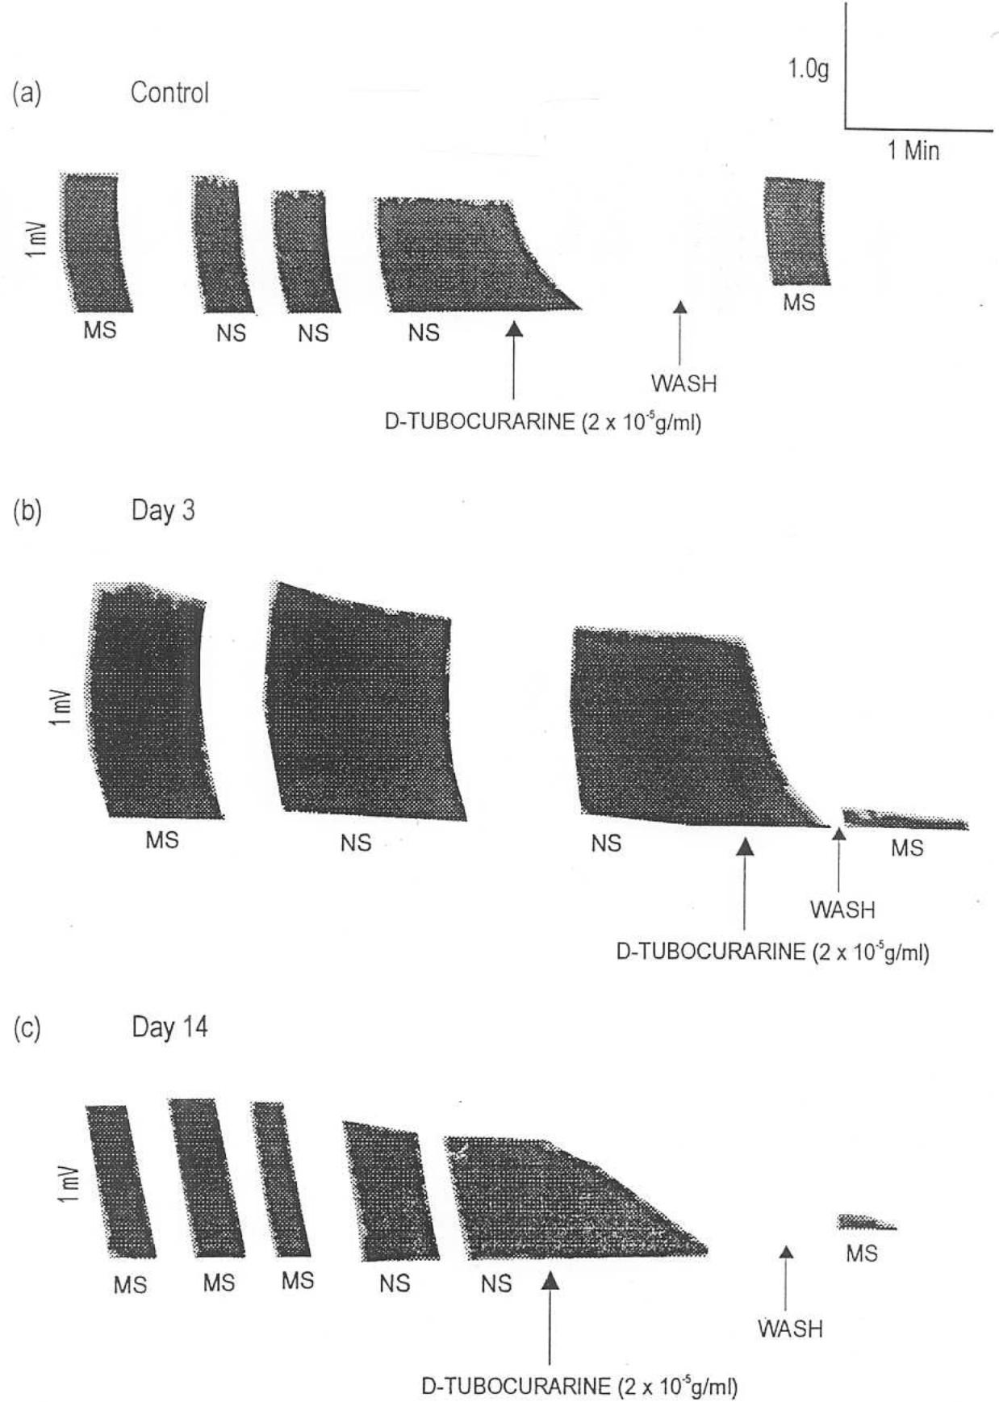

Abbreviations used are: | MS | = | Muscle Stimulation
 | NS  mV | =  = | Nerve Stimulation  Millivolt
Figure 38. Activity Profiles of the Effects of D-Tubocurarine on Rat Phrenic Nerve Hemidiaphragm Twitch Contraction of DL-α-Difluoromethy- lornithine (DFMO) and Chloroquine Combination Pre-treated Female Albino Rats

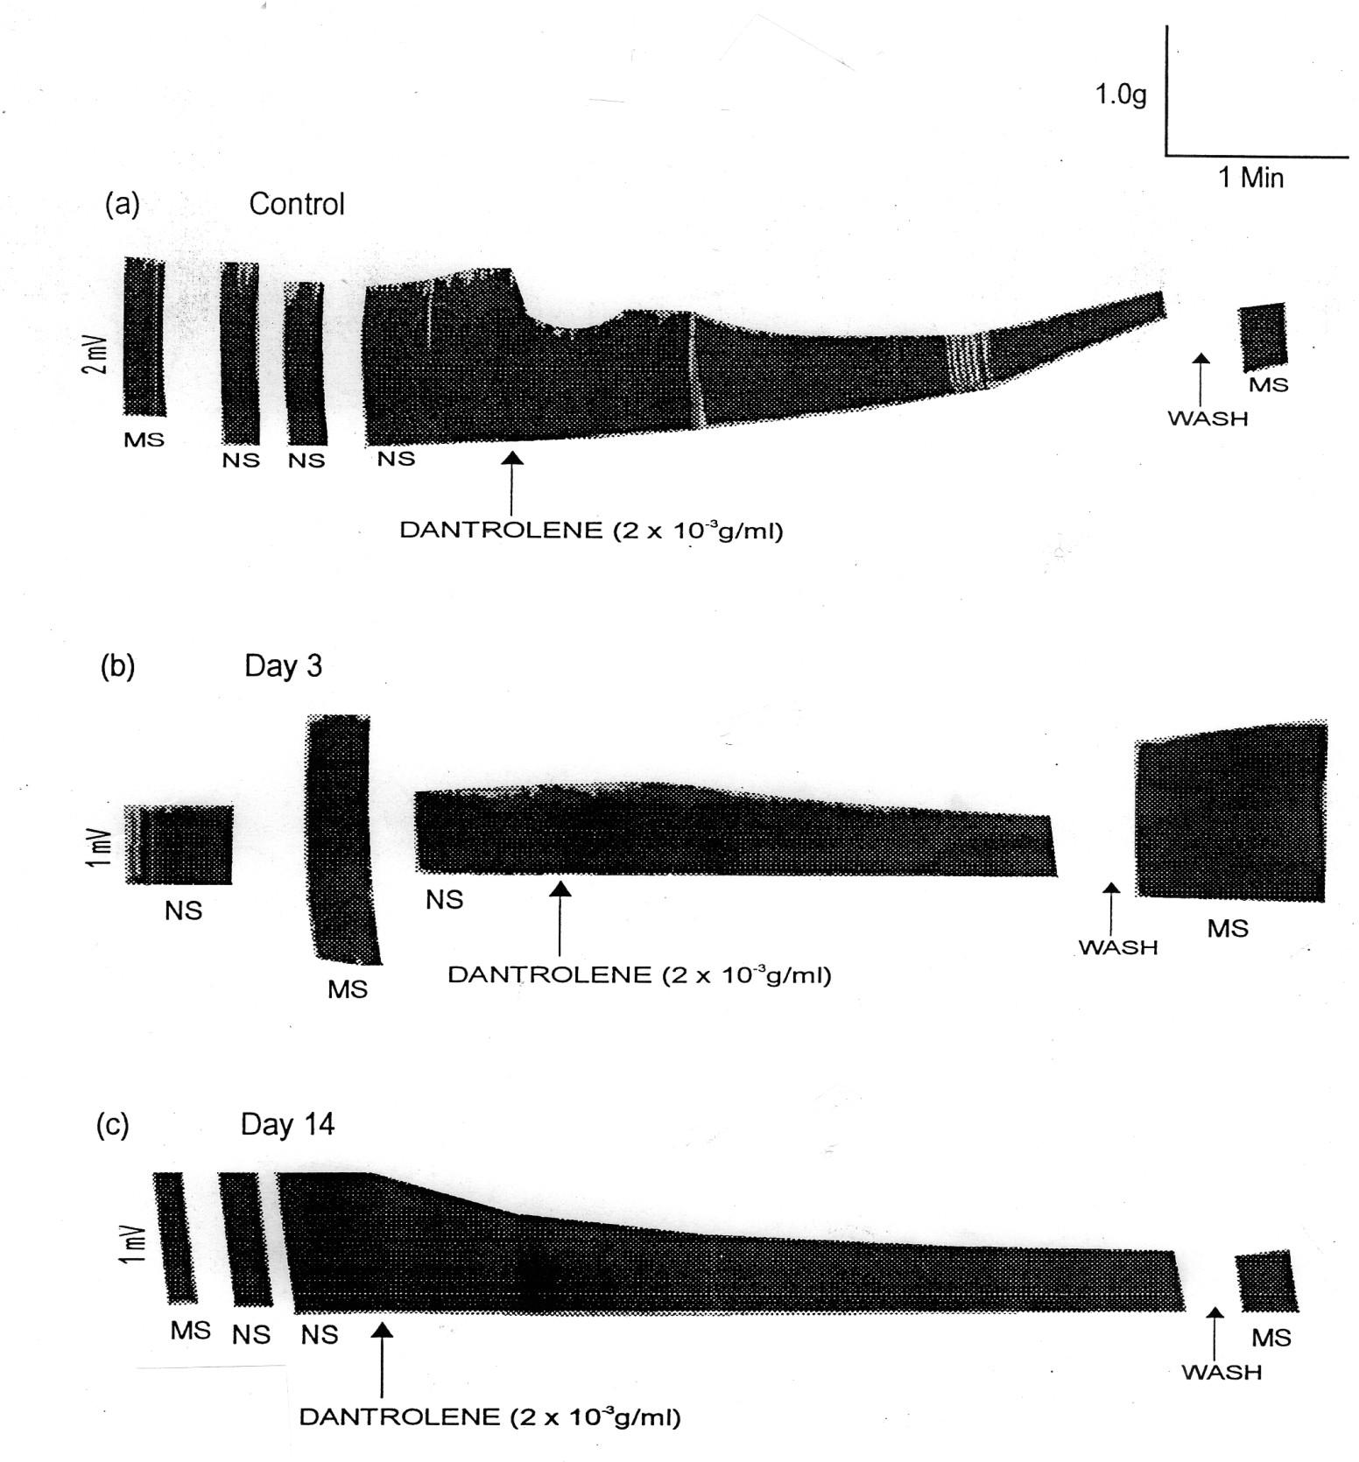

Abbreviations used are: | MS | = | Muscle Stimulation
 | NS  mV | =  = | Nerve Stimulation  Millivolt

Figure 39. Activity Profiles of the Effects of Dantrolene on Rat Phrenic Nerve Hemidiaphragm Twitch Contraction of DL-α-Difluoromethylornithine (DFMO) and Chloroquine Combination Pre-treated Female Albino Rats

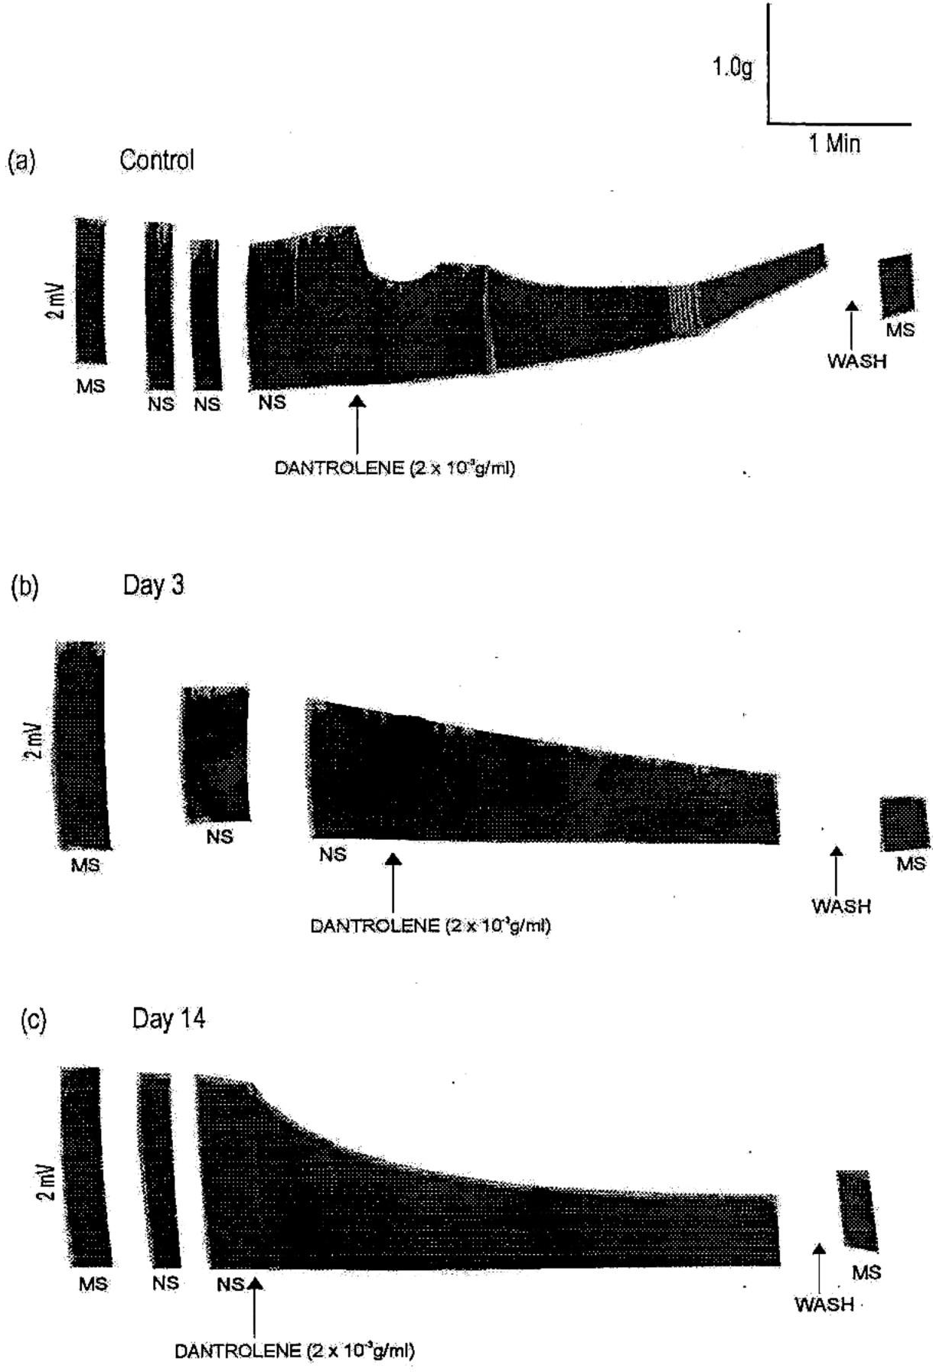

Abbreviations used are: | MS | = | Muscle Stimulation
 | NS  mV | =  = | Nerve Stimulation  Millivolt

Figure 40. Activity Profiles of the Effects of Dantrolene on Rat Phrenic Nerve Hemidiaphragm Twitch Contraction of DL-α-Difluoromethylornithine (DFMO) and Honey Combination Pre-treated Female Albino Rats

20
Day 14

10
TENSION CHANGE (g)

10 | 9 | 8 | 7 | 6
 |  | E R G O M E T R IN E | ( - L o g g / m l)

Figure 41. Effect of DL-α-Difluoromethylornithine (DFMO) and Chloroquine Combination Pretreatment of Female Albino Rats on Ergometrine Induced Contraction of Uterine Smooth Muscle

3.0
Day 14
Day 3
Castrol

2.0

1.0
TENSION CHANGE (g)

10 9 8 7 6 5
E R G O M E T R I N E ( - L o g g / m l )

Figure 42. Effect of DL-α-Difluoromethylornithine (DFMO) and Honey Combination Pretreatment of Female Albino Rats on Ergometrine Induced Contraction of Uterine Smooth Muscle

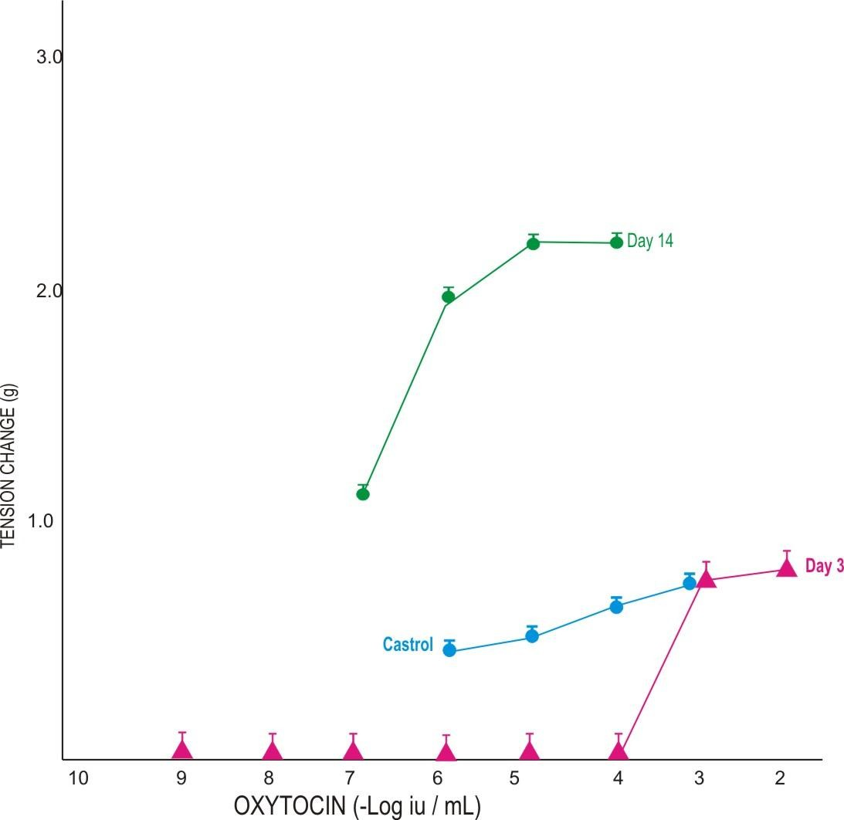

Figure 43. Effect of DL-α-Difluoromethylornithine (DFMO) and Honey Combination Pretreatment of Female Albino Rats on Oxytocin Induced Contraction of Uterine Smooth Muscle.

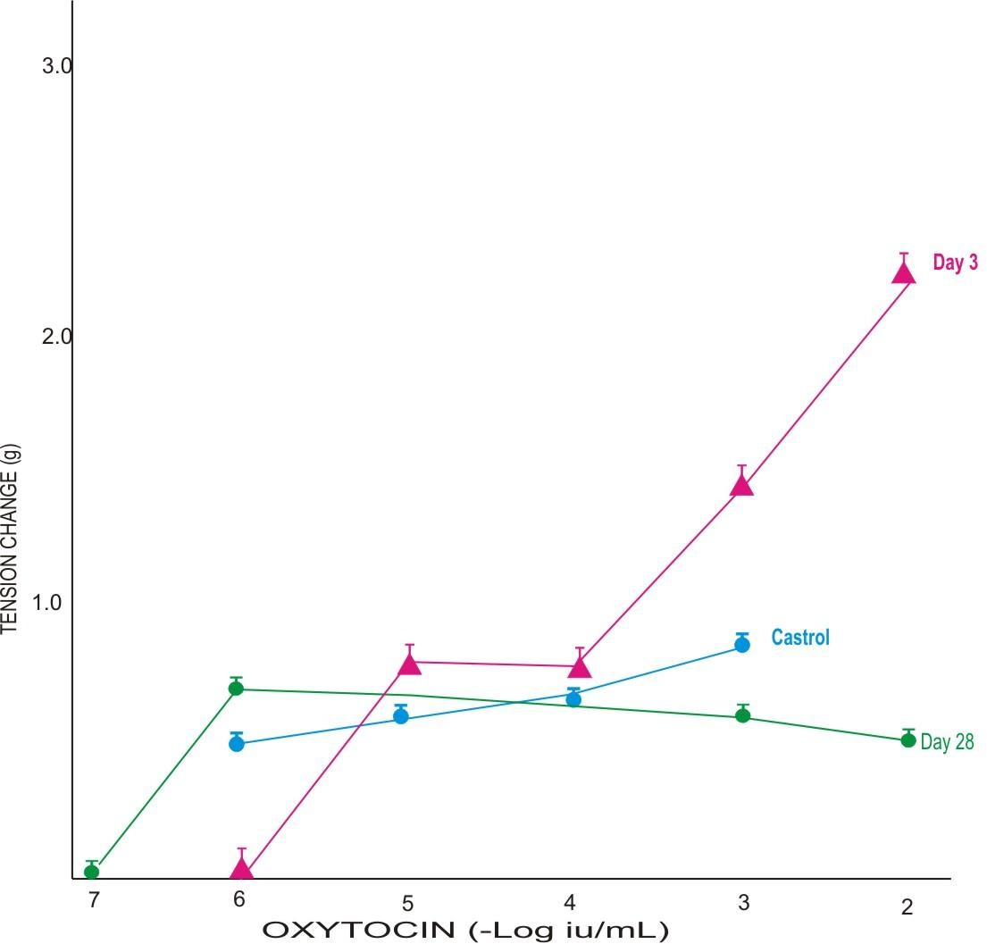

Figure 44. Effect of Chloroquine and Honey Combination Pretreatment of Female Albino Rats on Oxytocin Induced Contraction of Uterine Smooth Muscle

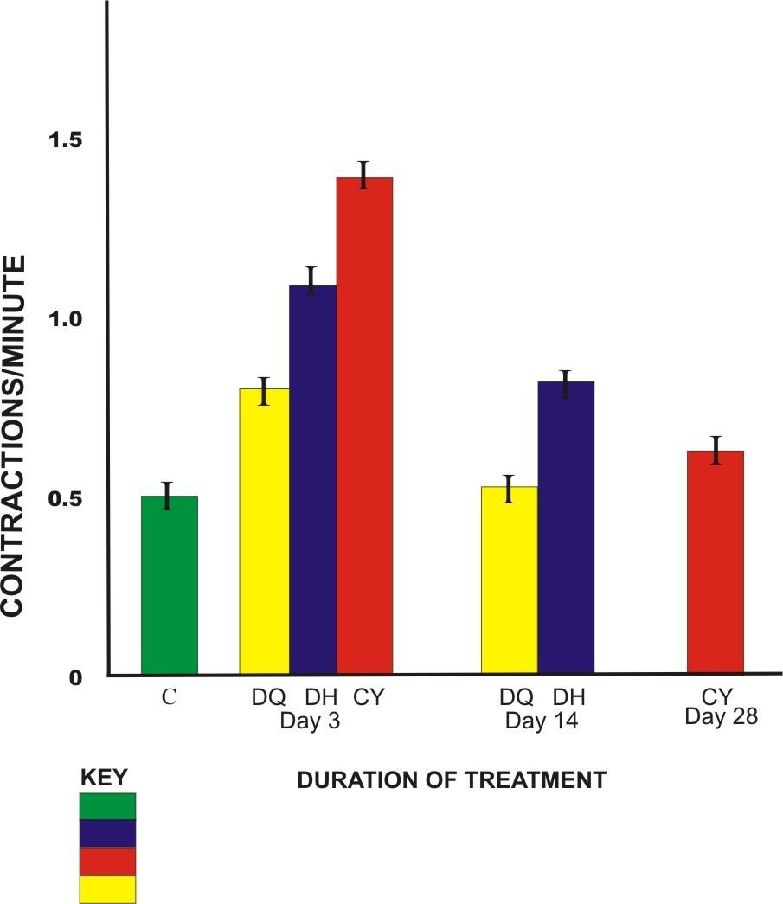

C = Control
DH = DL-α-Diflouromethylornithine (DFMO) + Honey CY = Chloroquine + Honey
DQ = DL-α-Diflouromethylornithine (DFMO) + Chloroquine

Figure 45 Rate of Contraction of Uterine Smooth Muscle of DL-α- Difluoromethylornithine (DFMO) and Honey; Chloroquine and Honey; DFMO and Chloroquine Combinations Pre-treated Female Albino Rats

Table 8. Uterine Muscle Weight Percentage of Body Weight of Pretreated Female Albino Rats

Pre-Treatment | Uterine Muscle (%) of Body Weight
 | Day 3 | Day 14 | Day 28
Control | 0.05 + 0.001 | 0.06 + 0.008 | 0.1 + 0.01
Honey | 0.05 + 0.002 | 0.06 + 0.02 | 0.1 + 0.01
DFMO | 0.06 + 0.001 | 0.07 + 0.02 | 0.08 + 0.04
Chloroquine | 0.04 + 0.001 | 0.06 + 0.01 | 0.08 + 0.006
DFMO + Honey | 0.05 + 0.001 | 0.06 + 0.002 | 0.1 + 0.01
Chloroquine + Honey | 0.04 + 0.002 | 0.05 + 0.01 | 0.06 + 0.001
DFMO + Chloroquine | 0.04 + 0.002 | 0.06 + 0.01 | 0.13 + 0.01

TABLE 9. Analysis of Butyrospermum paradoxum Seed and Shea Butter for Material Contents
Material Contents | Butyrospermum  paradoxum Seed (%) | Shea Butter (%)
Moisture | 0.42 | 2.43
Ash | 0.07 | 3.50
Fat | 88.96 | 37.14
Protein | 1.00 | 15.83
Total Carbohydrate | 9.55 | 40.10

TABLE 10. Effect of Topical Application of Melarsoprol on Trypanosoma gambiense Infected Mice

 |  |  |  | RESPONSES
Treatment Time | Application Area | Treatment Schedule | Parasitaemia/ Relapse | Animal Inoculation | No Cured No. Treated
Early Early Late Late Early Early Late  Late | Shaved Unshaved Shaved  Unshaved Shaved Unshaved Shaved  Unshaved | 1Dose per day x 7 days 1Dose per day x 7 days 1Dose per day x 7 days 1Dose per day x 7 days 2 Doses Once  2 Doses Once  2 Doses Once  2 Doses Once | -  -  -  -  -  -  - R (1) | -  -  -  -  -  -  -  - | 5/5  5/5  5/5  5/5  5/5  5/5  5/5  4/5
Control | - | - | +P | + | 0/5

KEY: R=Relapse +P = Scanty Inconsistent (Irregular) Parasitaemia Trypanosome strain used = Trypanosoma gambiense “Abraka”

TABLE 11. Effect of Topical Application of Melarsoprol on Trypanosoma brucei brucei Infected Albino Rats

RESPONSES
Test Organism | Host | Treatment Time | Application Area | Treatment Schedule | Parasitaemia  /Relapse | Animal Inoculation | No Cured No. Treated
 |  | Early | Shaved | 1Dose per day x | - | - | 5/5
 |  |  |  | 7 days
 |  | Early | Unshaved | 1Dose per day x | - | - | 5/5
 |  |  |  | 7 days
 |  | Late | Shaved | 1Dose per day x | - | - | 5/5
 |  |  |  | 7 days
T. brucei |  | Late | Unshaved | 1Dose per day x | - | - | 5/5
brucei | Rats |  |  | 7 days
“Federe” |  | Early | Shaved | 2 Doses Once | - | - | 5/5
 |  | Early | Unshaved | 2 Doses Once | - | - | 5/5
 |  | Late | Shaved | 2 Doses Once | - | - | 5/5
 |  | Late | Unshaved | 2 Doses Once | - | - | 4/5
 |  | Early | Shaved | 1Dose per day x | - | - | 5/5
 |  |  |  | 7 days
 |  | Early | Unshaved | 1Dose per day x | - | - | 5/5
 |  |  |  | 7 days
 |  | Late | Shaved | 1Dose per day x | - | - | 5/5
T. brucei |  |  |  | 7 days
brucei |  | Late | Unshaved | 1Doses per day | - | - | 5/5
“Gboko” | Rats |  |  | x 7 days
 |  | Early | Shaved | 2 Doses Once | - | - | 5/5
 |  | Early | Unshaved | 2 Doses Once | - | - | 5/5
 |  | Late | Shaved | 2 Doses Once | - | - | 5/5
 |  | Late | Unshaved | 2 Doses Once | - | - | 5/5
 |  | Control | - | - | +P | + | 0/5

KEY: R=Relapse +P = Consistent Parasitaemia

TABLE 12. Effect of Topical Application of Ethidium Bromide and Cattle Butter (Ghee) Combination on Trypanosoma congolense Infected Albino Rats

RESPONSES
Treatment Time | Application Area | Treatment Schedule | Parasitaemia/ Relapse | Animal Inoculation | No Cured No. Treated
Early | Shaved | 1Dose per day x 7 days | - | - | 5/5
Early | Unshaved | 1Dose per day x 7 days | - | - | 5/5
Late | Shaved | 1Dose per day x 7 days | - | - | 5/5
Late | Unshaved | 1Dose per day x 7 days | - | - | 5/5
Early | Shaved | 2 Doses Once | - | - | 5/5
Early | Unshaved | 2 Doses Once | - | - | 5/5
Late | Shaved | 2 Doses Once | - | - | 5/5
Late | Unshaved | 2 Doses Once | - | - | 5/5
Control | - | - | +P | + | 0/5

KEY: R = Relapse +P = Consistent Parasitaemia

Trypanosome strain used = Trypansoma congolense “Katsina Ala”

TABLE 13. Effect of Topical Application of Ethidium Bromide and Shea Butter Combination on Trypanosoma congolense Infected Albino Rats

 |  |  |  | RESPONSES
Treatment Time | Application Area | Treatment Schedule | Parasitaemia/ Relapse | Animal Inoculation | No Cured No. Treated
Early | Shaved | 1Dose per day x 7 days | +P | + | 0/5
Early | Unshaved | 1Dose per day x 7 days | +P | + | 0/5
Late | Shaved | 1Dose per day x 7 days | +P | + | 0/5
Late | Unshaved | 1Dose per day x 7 days | +P | + | 0/5
Early | Shaved | 2 Doses Once | +P | + | 0/5
Early | Unshaved | 2 Doses Once | +P | + | 0/5
Late | Shaved | 2 Doses Once | +P | + | 0/5
Late | Unshaved | 2 Doses Once | +P | + | 0/5
Control | - | - | +P | + | 0/5

KEY: R=Relapse +P = Consistent Parasitaemia

Trypanosma strain used = Trypanosoma congolense “Katsina Ala”

TABLE 14. Effect of Topical Application of Ethidium Bromide on
Trypanosoma congolense Infected Albino Rats

 |  |  |  | RESPONSES
Treatment Time | Application Area | Treatment Schedule | Parasitaemia  /Relapse | Animal Inoculation | No Cured No. Treated
Early | Shaved | 1Dose per day x 7 days | +P | + | 0/5
Early | Unshaved | 1Dose per day x 7 days | +P | + | 0/5
Late | Shaved | 1Dose per day x 7 days | +P | + | 0/5
Late | Unshaved | 1Dose per day x 7 days | +P | + | 0/5
Early | Shaved | 2 Doses Once | +P | + | 0/5
Early | Unshaved | 2 Doses Once | +P | + | 0/5
Late | Shaved | 2 Doses Once | +P | + | 0/5
Late | Unshaved | 2 Doses Once | +P | + | 0/5
Control | - | - | +P | + | 0/5

KEY: R = Relapse +P = Consistent Parasitaemia Trypanosome strain used = Trypanosoma congolense “Katsina Ala”

TABLE 15. Effect of Topical Application of Diminazene Aceturate (Berenil) on Trypanosoma brucei brucei Infected Albino Rats

 |  |  |  | RESPONSES
Treatment Time | Application Area | Treatment Schedule | Parasitaemia  /Relapse | Animal Inoculation | No Cured No. Treated
Early | Shaved | 1Dose per day x 7 days | +P | + | 0/5
Early | Unshaved | 1Dose per day x 7 days | +P | + | 0/5
Late | Shaved | 1Dose per day x 7 days | +P | + | 0/5
Late | Unshaved | 1Dose per day x 7 days | +P | + | 0/5
Early | Shaved | 2 Doses Once | +P | + | 0/5
Early | Unshaved | 2 Doses Once | +P | + | 0/5
Late | Shaved | 2 Doses Once | +P | + | 0/5
Late | Unshaved | 2 Doses Once | +P | + | 0/5
Control | - | - | +P | + | 0/5

KEY: R = Relapse +P = Consistent Parasitaemia

Trypanosome strain used = Trypanosoma brucei brucei “Gboko”

TABLE 16. Effect of Topical Application of Berenil and Cattle Butter (Ghee) Combination on Trypanosoma brucei brucei Infected Albino Rats

 |  |  |  | RESPONSES
Treatment Time | Application Area | Treatment Schedule | Parasitaemia  /Relapse | Animal Inoculation | No Cured No. Treated
Early | Shaved | 1Dose per day x 7 days | - | - | 5/5
Early | Unshaved | 1Dose per day x 7 days | - | - | 5/5
Late | Shaved | 1Dose per day x 7 days | - | - | 5/5
Late | Unshaved | 1Dose per day x 7 days | - | - | 5/5
Early | Shaved | 2 Doses Once | - | - | 5/5
Early | Unshaved | 2 Doses Once | - | - | 5/5
Late | Shaved | 2 Doses Once | - | - | 5/5
Late | Unshaved | 2 Doses Once | - | - | 5/5
Control | - | - | +P | + | 0/5

KEY: R = Relapse +P = Consistent Parasitaemia

Trypanosome strain used = Trypanosoma brucei brucei “Gboko”

TABLE 17. Effect of Topical Application of Berenil and Shea Butter Combination on Trypanosoma brucei brucei Infected Albino Rats

 |  |  |  | RESPONSES
Treatment  Time | Application  Area | Treatment Schedule | Parasitaemia/  Relapse | Animal  Inoculation | No. Cured No. Treated
Early Early Late Late Early Early Late  Late | Shaved Unshaved Shaved Unshaved Shaved Unshaved Shaved  Unshaved | 1Dose per day x 7 days 1Dose per day x 7 days 1Dose per day x 7 days 1Dose per day x 7 days 2 Doses Once  2 Doses Once  2 Doses Once  2 Doses Once | +P  +P  +P  +P  +P  +P  +P  +P | +  +  +  +  +  +  +  + | 0/5  0/5  0/5  0/5  0/5  0/5  0/5  0/5
Control | - | - | +P | + | 0/5

KEY: R = Relapse +P = Consistent Parasitaemia

Trypanosome strain used = Trypanosoma brucei brucei “Gboko”

STUDIES ON SLEEPING SICKNESS PATIENTS IN DELTA STATE
The results of studies on some sleeping sickness patients treated with pentamidine, melarsoprol (Mel B) and prednisolone at Baptist Medical Centre Eku, Delta State, using different treatment strategies in 1992, 1995, 1996 and 1997 are shown in Tables 18 - 24 and Plates 11 and I2. One patient out of the sleeping sickness patients diagnosed and treated in 1995 with a combination of Melarsopol and prednisolone died. This patient did not die of melarsoprol- induced encephalopathy. Follow-up investigations showed that the other patients survived and there was no relapse. There was no encephalopathy and death recorded among the patients treated in 1995, 1996 and 1997. The tables show the Biodata, Diagnosis, Clinical and Biochemical parameters, Body weight and Temperature changes, Pulse rate and Blood pressure values of the patients.
The mean values of the biochemical parameters are shown in Table 21. Analysis of variance (ANOVA) at 5% level of significance showed that on comparing the pre-treatment, during and after treatment mean values of the biochemical parameters of the patients, there was no significant difference(P>0.05) for the parameters (Serum protein, AST, GTP, Urea, HCO ⁻, CL⁻, glucose, ALKP, K⁺ and Na⁺) evaluated. However, on individual patient basis, there were cases of increases or reduction in level of these parameters, but they became normal after treatment (Appendix B1- B3).
3
Plate 11 depicts the photograph of ethidium bromide stained Agarose Gel Electrophoresis showing Polymerase Chain Reaction (PCR) products of DNA extracts of Whatman filter paper blood samples of sleeping sickness patients treated at Ethiope East LGA of Delta State. The Marker (M), positive (C⁺) and and negtive (C⁻) controls appeared normally, the Marker and the positive control

showing the expected bands. The lanes containing the PCR products of the blood samples of the treated sleeping sickness patients collected during follow- up studies did not show any band thereby indicating negativity of infection.
Plate 12 depicts the photograph of ethidium bromide stained Agarose Gel electrophoresis showing Polymerase Chain Reaction (PCR) products of DNA extracts of Whatman filter paper blood samples of positive untreated cases of sleeping sickness. The Marker (M), positive (C⁺) and negative (C⁻) controls appeared normally. Lanes S* and S** which contained PCR products of blood samples of positive untreated cases of sleeping sickness showed typical bands. This shows that the Whatman filter blood collection/preservation method and the extraction techniques are efficient and further confirms the result of Plate 11.

PHARMACOSOCIOECONOMIC STUDIES

Family size, Age, Religion and Level of literacy of Respondents
The age of the respondents ranged from 9-70 years and 16 – 35 years are in the majority. Most of the respondents have dependants, some have polygamous families while others maintain monogamous type of family. The religion of the respondents includes Christianity, Islam and traditional mode of worship. Superstitious beliefs and adherence to cultural norms influenced the thinking and attitude of some of the respondents. The level of literacy in the areas surveyed is not very high.

TABLE 18. Some of the Sleeping Sickness Patients in Some Villages of Ethiope East and Ndokwa West LGAs of Delta State Who Were Treated During The November/December Survey of 1992
2

PATIENT ID.  CODE | VILLAGE | SEX | AGE (YRS) | OCCUPATION | DIAGNOSIS  FILTER GP CATT | REMARKS
ETE/3/92/OF/URK ETE/5/92/ER/URK ETE/6/92/AQ/URK ETE/7/92/OA/URK  ETE/21/92/EB/URK ETE/301/92/OM/ORA ETE/357/92/JQ/ORA ETE/308/92/IE/ORA ETE/327/92/JV/ORA ETE/305/92/OI/ORA ETE/333/92/EF/ORA ETE/337/92/UT/ORA ETE/122/92/OD/UGO  ETE/168/92/IC/UGO | Urhuoka Urhuoka Urhuoka Urhuoka  Urhuoka Oria Oria Oria Oria Oria Oria Oria Ugono  Ugono | F F F F  F F F F M M M M M  F | 8  20  37  42  40  27  40  75  40  60  40  75  25  36 | Pupil Farming Farming Farming  Farming Farming Farming Farming Farming Farming Farming Farming Farming  Farming | + *LP (CSF) + ve ++  + ++ +  ++ ++  ++ + +  **Anim. Inoc (+ve)  ++ + +++  ++ +++ +++  + +++ ++  ++ ++ +  + +++ ++  + +++ ++  + +  + +  ++ + ++  + + + | Survived Died Survived Survived  Survived Survived Survived Survived Survived Survived Survived Survived Survived  Survived

* LP = Lumber Puncture, Cerebrospinal Fluid (CSF) +ve for trypanosomes

** Anim. Inoc (+ve) = Animal Inoculation +ve with trypanosomes

2

TABLE 19. Some of the Sleeping Sickness Patients at Ugono Village Ethiope East LGA of Delta State Who Could Not Be Treated Due to Non-Availability of Trypanocidal Drugs During the November/December Survey of 1992
175

PATIENT ID. CODE | VILLAGE | SEX | AGE (YRS) | OCCUPATION |  | DIAGNOSIS |  | REMARKS
 |  |  |  |  | GP | CATT | FILTER
ETE/144/92/NC/UGO | Ugono | F | 31 | Farming | + | + | ++ | Died
ETE/123/92/OW/UGO | Ugono | M | 75 | Farming | + | +++ | + | Died
ETE/135/92/UM/UGO | Ugono | F | 23 | Farming | + | ++ | + | Died
ETE/182/92/OV/UGO | Ugono | F | 25 | Farming | + | ND | + | Died
ETE/156/92/OE/UGO | Ugono | M | 8 | Pupil | ++ | + | ++ | Died
ETE/129/92/UE/UGO | Ugono | M | 27 | Farming | + | + | ++ | Died
ETE/127/92/EA/UGO | Ugono | F | 61 | Farming | ++ | + | ++ | Died

TABLE 20. Biodata, Diagnosis and Clinical Parameters of Sleeping Sickness Patients Treated at Baptist Medical Centre Eku Delta State Nigeria in 1992 and 1995

ID Number | Age (Yrs) | Sex | Occupation | Clincal | Gland Puncture | CATT | CATT  Filter
1788/YE/95 | 30 | F | Farming |  | +
412/AJ/92 | 42 | M | Farming |  | + | +++ | +
1615/EE/95 | 30 | F | Farming |  | + | ++ | +
308/IE/92 | 75 | F | Farming |  | ++ | ++ | +
1921/NI/95 | 23 | M | Farming |  | + | ++ | +
414/G0/92 | 36 | M | Civil Servant/  Farming | Low grade fever | + | ++ | ++
715/AA/92 | 5 | M | Student | Pale |  | ++
402/EE/92 | 75 | F | Farming | Pale |  | +++
725/OI92 | 52 | M | Farming |  |  | ++
1651/RF/95 | 27 | F | Farming |  |  | ++ | +
357/QJ/92 | 40 | F | Farming | Pale, Jaundice  emaciated | + | ++ | ++
397/GF/92 | 11 | M | Student |  | - | ++ | ++
477/RA/92 | 45 | F | Farming/  Trading | Pallor, lethargy | + | ++ | +
327/VJ/92 | 40 | M | Farming |  | + | ++ | ++
402/EE/92
491/MO/92 | 55 | F | Farming |  | + | ++
439/VS/92 | 45 | F | Farming | Slight jaundice  & Pallor | ++ | +
156/OE/92 | 8 | M | Student | Multiple  cervical glands | ++ | +++ | +
1658/OM95 | 66 | M | Farming |  |  |  | ++
301/MO/92 | 27 | F | Farming | Pale, Somnolent | +
1745/EO/95 | 35 | F | Farming | Clinical Pale | + | ++ | ++
1788/EK/95 | 35 | F | Farming |  | + | ++
1577/HI/95 | 15 | F | Student |  | + | + | +
194/EO/92 | 47 | M | Farming |  | ++ | ++ | +
189/UI/92 | 3 | F |  | Pale, Puffy face |  |  | ++
1650/FO/95 | 14 | F | Student |  |  | ++ | ++
1780/EO/95 | 19 | F | Student |  |  | ++ | +
1685/EE/95 | 23 | F | Farming | Pale, Somnolent | ++ | ++ | ++

Table 21. Biochemical Parameters of Sleeping Sickness Patients Before, During and After Treatment at Baptist Medical Center Eku Delta State Nigeria in 1992 and 1995

Parameters | Normal Values |  | Mean Values
 |  | Before Treatment | During Treatment | After Treatment
Protein | 62-80g/l | 66.04 + 8.11 | 89.04 + 11.78 | 67.68 + 5.87
AST | 5-18 iu/l | 11.36 + 5.08 | 12.24 + 5.75 | 10.96 + 3.87
GTP | 3-15 iul/l | 9.75 + 4.44 | 10.73 + 4.96 | 10.04 + 3.66
Urea | 2.5-6.6 µmol/L | 5.21 + 2.22 | 5.26 + 2.21 | 4.88 + 1.51
-  HCO₃ | 21-31 mmol/L | 25.43 + 3.74 | 26.04 + 3.31 | 25.21 + 2.24
CL⁻ | 96-106 mmol/L | 101.21 + 4.23 | 101.35 + 4.36 | 100.68 + 2.51
Glucose | 3.9-5.6 mmol/L | 4.91 + 1.35 | 5.04 + 1.37 | 4.79 + 0.65
Alkp | 21-92 iu/L | 54.86 + 29.95 | 53.77 + 30.70 | 52.72 + 28.25
K+ | 3.5 – 5.8 mmol/L | 4.40 + 0.91 | 4.41 + 0.94 | 4.47 + 0.76
Na⁺ | 134-145 mmo/L | 137.48 + 5.15 | 137.88 + 5.16 | 137.40 + 5.03

ANOVA (P-Value): Protein = 0.393; AST = 0.648; GPT = 0.706; Urea = 0.761; HCO₃⁻ = 0.661; CL⁻ = 0.806; Glucose = 0.760; ALKP = 0.932; K⁺ = 0.955; Na⁺ = 0.936

TABLE 22. Biodata and Body Weight Changes of Sleeping Sickness Patients Before, During and After Treatment With a Combination of Pentamidine, Melarsoprol and Prednisolone at Eku Baptist Medical Centre Delta State
2
Nigeria in 1996 and 1997

Patient Identity  Number | Age  (Yrs) | Sex |  |  |  |  | BODY WEIGHT [Kg]
 |  |  | Before Treatment
 |  |  |  |  |  |  | During Treatment |  |  |  |  | After Treatment
391568/RU/96 | 43 | F | 56.0 | 56.0 | 55.8 | 55.8 | 55.9 | 56.0 | 56.0 | 56.3 | 56.4 | 56.9 | 57.0
193769/OO/96 | 21 | M | 50.0 | 49.7 | 49.5 | 49.5 | 50.0 | 50.5 | 50.5 | 51.0 | 51.5 | 52.0 | 52.0
180819/OQ/96 | 28 | F | 73.4 | 52.0 | 52.0 | 52.6 | 54.6 | 55.0 | 56.0 | 57.0 | 58.0 | 59.0 | 59.0
391572/AE/96 | 52 | F | 35.5 | 34.0 | 35.5 | 53.0 | 35.4 | 35.0 | 35.5 | 36.0 | 37.0 | 38.0 | 38.0
357230/EE/96 | 22 | F | 68.5 | 68.0 | 48.5 | 48.8 | 50.0 | 50.5 | 60.0 | 60.8 | 61.3 | 62.0 | 62.5
393161/OR/96 | 20 | F | 57.5 | 57.0 | 57.0 | 56.8 | 56.8 | 56.7 | 56.8 | 56.7 | 57.0 | 57.2 | 57.3
201071/OG/96 | 26 | F | 44.0 | 41.0 | 45.5 | 42.0 | 44.5 | 44.0 | 50.7 | 51.5 | 52.0 | 52.5 | 52.5
391580/IA/96 | 20 | F | 48.5 | 48.5 | 48.0 | 48.5 | 50.0 | 50.5 | 51.0 | 51.5 | 52.0 | 53.0 | 53.0
215403/IL/96 | 14 | M | 64.0 | 64.0 | 64.0 | 62.0 | 61.0 | 62.0 | 62.0 | 62.5 | 63.0 | 64.0 | 64.0
391448/IG/96 | 26 | M | 63.0 | 63.6 | 62.4 | 62.5 | 61.0 | 63.0 | 63.0 | 64.0 | 64.0 | 64.5 | 64.5
400183/AB/96 | 22 | F | 44.0 | 44.0 | 44.1 | 44.3 | 44.3 | 44.5 | 44.7 | 44.9 | 50.0 | 50.0 | 50.2
398908/IG/96 | 20 | M | 60.0 | 60.2 | 60.1 | 60.2 | 60.2 | 60.3 | 60.5 | 60.4 | 61.0 | 61.8 | 62.0
400394/AB/97 | 22 | F | 44.5 | 44.4 | 44.3 | 44.4 | 44.5 | 44.6 | 44.8 | 45.0 | 45.3 | 45.8 | 46.0
400440/AB/97 | 20 | M | 42.0 | 43.0 | 44.5 | 43.0 | 42.5 | 41.5 | 42.0 | 43.0 | 44.0 | 45.0 | 45.0
310913/OA/96 | 12 | F | 46.0 | 44.5 | 44.5 | 42.0 | 42.2 | 42.6 | 44.0 | 45.0 | 46.0 | 47.0 | 47.0
396274/AY/96 | 30 | M | 66.0 | 65.5 | 68.6 | 67.5 | 68.5 | 68.0 | 68.0 | 68.5 | 68.5 | 69.0 | 69.0
391536/OH/96 | 21 | M | 62.0 | 66.5 | 66.7 | 66.8 | 66.4 | 66.5 | 66.9 | 70.0 | 70.3 | 70.5 | 70.6

TABLE 23 Biodata and Body Temperature Changes of Sleeping Sickness Patients Before, During and After Treatment With a Combination of Pentamidine, Melarsoprol and Prednisolone at Baptist Medical Centre Eku Delta State Nigeria in 1996 and 1997

Patient Identity Number
Age (Yrs)

Sex

Before Treatment
TEMPERATURE (°C)

During Treatment After Treatment

391568/RU/96 | 43 | F | 37.8 | 36.8 | 36.8 | 36.8 | 36.9 | 37.0 | 37.0 | 37.0 | 37.0 | 37.0 | 37.0
193769/OO/96 | 21 | M | 37.0 | 37.0 | 37.8 | 36.7 | 36.9 | 37.0 | 37.0 | 37.0 | 37.0 | 37.0 | 37.0
180819/OQ/96 | 28 | F | 36.7 | 36.9 | 36.7 | 37.8 | 37.2 | 37.2 | 37.0 | 37.0 | 37.0 | 37.0 | 37.0
391572/AE/96 | 52 | F | 36.7 | 37.8 | 36.1 | 37.0 | 37.2 | 37.0 | 37.0 | 37.0 | 37.0 | 37.0 | 37.0
357230/EE/96 | 22 | F | 37.8 | 36.7 | 36.7 | 37.0 | 37.0 | 37.2 | 37.2 | 37.2 | 37.0 | 37.0 | 37.0
393161/OR/96 | 20 | F | 37.8 | 36.7 | 36.7 | 36.7 | 36.8 | 36.8 | 36.8 | 37.0 | 37.0 | 37.0 | 37.0
201071/OG/96 | 26 | F | 36.9 | 36.7 | 37.0 | 37.2 | 37.8 | 37.0 | 37.0 | 37.0 | 37.0 | 37.0 | 37.0
391580/IA/96 | 20 | F | 36.9 | 37.2 | 36.9 | 36.9 | 37.2 | 37.0 | 37.0 | 37.0 | 37.0 | 37.0 | 37.0
215403/IL/96 | 14 | M | 36.7 | 36.7 | 36.9 | 37.2 | 37.2 | 37.2 | 36.7 | 36.7 | 36.7 | 37.0 | 37.0
391448/IG/96 | 26 | M | 36.7 | 36.7 | 36.7 | 37.8 | 37.8 | 37.2 | 37.0 | 37.0 | 37.0 | 37.0 | 37.0
400183/AB/96 | 22 | F | 37.0 | 37.0 | 37.0 | 37.5 | 37.5 | 37.2 | 37.0 | 37.0 | 37.0 | 37.0 | 37.0
398908/IG/96 | 20 | M | 37.2 | 37.4 | 37.4 | 37.2 | 37.2 | 37.0 | 37.0 | 37.1 | 37.1 | 37.0 | 37.0
400394/AB/97 | 22 | F | 37.0 | 37.0 | 37.0 | 37.0 | 37.2 | 37.2 | 37.1 | 37.0 | 37.0 | 37.0 | 37.0
400440/AB/97 | 20 | M | 38.0 | 37.1 | 37.0 | 36.0 | 36.8 | 37.2 | 37.0 | 37.0 | 37.0 | 37.0 | 37.0
310913/OA/96 | 12 | F | 37.2 | 37.2 | 36.7 | 36.0 | 36.7 | 36.7 | 36.7 | 37.0 | 37.0 | 37.0 | 37.0
396274/AY/96 | 30 | M | 36.7 | 37.2 | 36.9 | 37.0 | 36.0 | 37.2 | 37.3 | 36.8 | 37.0 | 37.0 | 37.0
391536/OH/96 | 21 | M | 37.2 | 36.8 | 37.8 | 37.0 | 37.2 | 37.2 | 37.0 | 37.0 | 37.0 | 37.0 | 37.0
2

TABLE 24 Biodata, Pulse Rate and Blood Pressure of Sleeping Sickness Patients Before, During and After Treatment with a Combination of Pentamidine, Melarsoprol and Prednisolone at Baptist Medical Centre Eku Delta State Nigeria in 1996 and 1997
2

Patient  Identity Number | Age (Yrs) |  |  |  |  |  | PULSE RATE (No/Min) /BLOOD PRESSURE (mm Hg)
 |  | Sex | Before Treatment |  |  |  | During Treatment |  |  |  |  |  | After Treatment
 |  |  | PR | BP | PR | BP | PR | BP | PR | BP | PR | BP | PR | BP | PR | BP | PR | BP | PR | BP
193769/OO/96 | 21 | M | 82 | 110 | 80 | 80 | 80 | 100 | 75 | 90 | 74 | 130 | 74 | 130
 |  |  |  | 80 |  | 50 |  | 60 |  | 60 |  | 80 |  | 80
180819/OQ/96 | 28 | F | 80 | 120 | 80 | 120 | 64 | 100 | 66 | 120 | 68 | 120 | 70 | 110 | 74 | 120
 |  |  |  | 80 |  | 80 |  | 60 |  | 80 |  | 80 |  | 70 |  | 86
391572/AE/96 | 52 | F | 80 | 150 | 80 | 140 | 76 | 130 | 76 | 140 | 68 | 120 | 78 | 120
 |  |  |  | 80 |  | 80 |  | 80 |  | 80 |  | 70 |  | 70
357230/EE/96 | 22 | F | 90 | 120 | 90 | 100 | 74 | 120 | 70 | 100 | 72 | 110 | 72 | 110
 |  |  |  | 80 |  | 70 |  | 70 |  | 70 |  | 70 |  | 70
393161/OR/96 | 20 | F | 80 | 100 | 82 | 120 | 82 | 120 | 72 | 110 | 72 | 110 | 72 | 110
 |  |  |  | 70 |  | 80 |  | 80 |  | 70 |  | 70 |  | 70
201071/OG/96 | 26 | F | 64 | 90 | 70 | 90 | 78 | 100 | 100 | 90 | 64 | 100 | 76 | 80 | 78 | 90
 |  |  |  | 60 |  | 60 |  | 60 |  | 60 |  | 60 |  | 70 |  | 60
391580/IA/96 | 20 | F | 80 | 100 | 80 | 100 | 88 | 90 | 86 | 100 | 76 | 100 | 72 | 100
 |  |  |  | 10 |  | 60 |  | 60 |  | 70 |  | 60 |  | 60
215403/IL/96 | 14 | M | 74 | 120 | 76 | 90 | 100 | 90 | 82 | 90 | 74 | 130 | 64 | 110 | 78 | 120 | 68 | 90 | 78 | 90
 |  |  |  | 20 |  | 60 |  | 60 |  | 60 |  | 80 |  | 60 |  | 70 |  | 80 |  | 70
391448/IG/96 | 26 | M | 76 | 120 | 70 | 120 | 80 | 110 | 76 | 110 | 80 | 110 | 80 | 100
 |  |  |  | 80 |  | 80 |  | 60 |  | 70 |  | 70 |  | 60
400394/AB/97 | 20 | M | 84 | 80 | 96 | 90 | 74 | 90 | 80 | 90 | 62 | 80 | 68 | 100
 |  |  |  | 60 |  | 70 |  | 60 |  | 60 |  | 60 |  | 80
310913/OA/96 | 12 | F | 64 | 70 | 96 | 120 | 20 | 100 | 80 | 120 | 76 | 110 | 60 | 100
 |  |  |  | 60 |  | 90 |  | 40 |  | 80 |  | 80 |  | 60
Average Normal Readings: Blood Pressure [BP] Males ( 120 ) Females (110): (Range 100 – 140
80 70 60 90
Pulse R ate [PR] 72/min.: 195Pulse Pressure = Difference Between Systolic & Diastolic Readings Pulse Pressure Range (30 – 50mmHg).

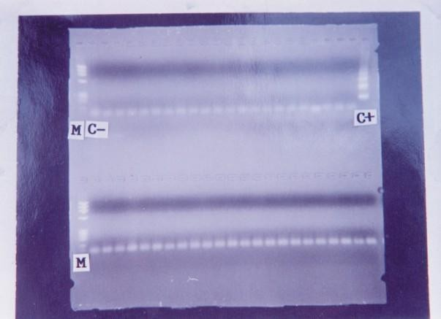

Plate 11 Ethidium Bromide Stained Agarose Gel Electrophoresis Showing Polymerase Chain Reaction (PCR) Products of DNA Extracts of Whatman Filter Paper Blood Samples of Sleeping Sickness Patients Treated at Ethiope East LGA of Delta State Nigeria

Key:
M = Marker Φ174/HaeIII
Lanes Marked C+ and C- show positive and negative controls respectively.
The other lanes contain PCR products of the blood samples of the treated sleeping sickness patients.

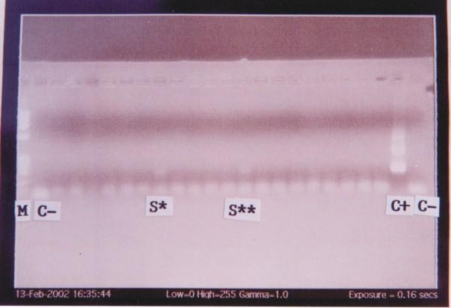

Plate 12. Ethidium Bromide Stained Agarose Gel Electrophoresis Showing Polymerase Chain Reaction (PCR) Products of DNA Extracts of Whatman Filter Paper Blood Samples of Postive Untreated Cases of Sleeping Sickness.

Key:
M = Marker Φ174/HaeIII
Lanes Marked C+ and C- show positive and negative controls respectively. Lanes S* and S** contain PCR products of the blood samples of positive untreated cases of sleeping sickness.
Other lanes contain PCR Products of the blood samples of uninfected individuals.

Economic Activities of the People of The Surveyed Areas
The economic activities of the people include farming, rubber tapping, hunting, fishing, garri and palm produce processing, petty trading, herbalists and civil servants. However, school children help their parents in farming activities after school hours and during holidays. For animal trypanosomiasis, a great number of respondents engaged in cattle and small ruminants rearing, and the nomadic/semi-nomadic Fulanis were in the majority. Some of the livestock owners engage in mix-farming system. They realized a reasonable income from livestock, plus other benefits which include milk, butter, animal dung as “fire wood” and manure. Apart from these farm products, some of the respondents own some durable goods.

Degree of Awareness
Some of the rural respondents are not literate. Some of the respondents showed lack of awareness concerning sleeping sickness and its causative agent and vector. However, comparatively the degree of awareness of the respondents seems to be more in Konshisha LGA in the old Gboko LGA of Benue State, an old endemic area than in Ethiope East LGA of Delta State, a new endemic focus (Table 25). Although a considerable number of the respondents indicated that they have heard of animal trypanosomiasis, they did know the actual cause of the disease. Majority of the respondents did not actually know the vector (the tsetse fly), which they seemed to confuse with the tabanid, a hard biting fly Atylotus agrestis or Atylotus fuscipes.

Attitude To Disease and Treatment Seeking Behaviour
In most cases, there is non-challant attitude to disease problems like sleeping sickness and often due to superstitious beliefs, disease problems are

linked to witchcraft and punishment from dead ancestors. Sleeping sickness is often confused with malaria and other ailments prevalent among these rural people.
Some patients combine herbal remedies with orthodox medication. Traditional healers who consulted the oracle before initiation of treatment are patronized. Patients are known to report for orthodox treatment at the Hospital only after self medication, patronage of quacks and traditional healers, when their situation might have deteriorated.
In the case of animal trypanosomiasis, some of the respondents have a non-challant attitude to disease problem among their animals. However, the Fulani cattle rearers showed concern for their sick animals. Though lacking in some areas, Veterinary clinics are rarely visited by livestock owners. Some livestock owners visit them only when their animals are seriously sick and do not respond to their own treatment or those of quacks.

Responses from Medical Practitioners/Other Health Officials and Veterinary Officers/Extension Workers
The medical practitioners/other health officials interviewed indicated the presence of sleeping sickness in Ethiope East LGA of Delta State. Some of them, however, stated that due to lack of diagnostic facilities and the expertise to diagnose trypanosomiasis, they found it difficult to ascertain sleeping sickness cases. Many of the respondents indicated that patients did not report their cases in time. Lack of trypanocidal drugs was highlighted as a major problem.

TABLE 25 Knowledge/Awareness and Attitude Responses of Respondents Concerning Human African Trypanosomiasis (HAT) and Its Causes

Ethiope East LGA Delta state (New Endemic Focus of HAT) |  | Konshisha LGA Benue State (Old Endemic Focus of HAT)
No. of People Interviewed | 192 | 190
 | % Responses | % Responses
Awareness of “sleeping sickness”- the disease problem in the community presently or in the past | 72.8 | 86.0
Knowledge of the cause of the disease. | 43.0 | 60.0
Percentage that regard trypanosome as the cause of the disease | 2.7 | 30.0
Percentage that regard a fly as the cause of the disease | 40.0 | 82.0
Percentage that rightly identified the fly habitats as farms, bush near stream/riverine areas or around homes | 70.2 | 88.0
Percentage that knew that the disease is cured using orthodox drugs | 2.3 | 80.0
Knowledge of where to go for treatment:
- No idea | 75.6 | 5.0
- Baptist Medical Centre Eku/(NITR Clinic Gboko) | 2.2 | 86.0
- To Native Doctors | 17.6 | 2.0

The veterinary officers and extension workers interviewed indicated that animal trypanosomiasis is a major disease problem they come across in domestic and peri-domestic animals in the areas they operate. They were of the opinion that many livestock owners prefer to treat their animals themselves or patronize quacks rather than consult them when their animals are sick. The livestock owners consulted them only when their animals are at the very advanced stages of the disease.

Ethnotaxonomy, Ethnosemantics, Ethnodiagnosis and Ethnotherapeutics
Ethnotaxonomy, ethnosemantics, ethnodiagnosis and ethnotherapeutics (herbal remedies and other ethnopharmaceuticals for trypanosomiasis) as identified by vernacular (local) names by the respondents are shown in Tables 26 and 27.

Impact Assessment
Sleeping sickness was found to cause mortality and debilitating effects on the youths and others that engage in important economic activities in Ethiope East LGA of Delta State. Inadequacy of the drugs compared with the number of cases has resulted in the loss of lives of diagnosed cases (Table 19). There is also loss of man hours as relatives look after their relations suffering from trypanosomiasis. Animal trypanosomiasis results in animal mortality and abortion. Huge amount of money was spent on chemotherapy and chemoprophylaxis. The patronage of quacks and/or self-treatment is an economic waste and also complicates the chemotherapy and management of animal trypanosomiasis with attendant problems.

TABLE 26. Ethnodiagnosis of Trypanosomiasis and Local Names of Tsetse Fly and Trypanosomiasis Recorded in the Surveyed Areas

ETHNODIAGNOSIS
TYPE OF TRYPANOSOMIASIS |  | ETHNODIAGNOSIS
ANIMAL TRYPANOSOMIASIS |  | - Sand – eating behaviour  - Fluffy coat  - Loss of appetite  - Emaciation  - Unsteady gait  - Circling motion
HUMAN TRYPANOSOMIASIS |  | - patient looks dull and heavy  - patient sleeps almost all the time even when he/she is eating food
LOCAL NAMES
LOCAL NAMES  (TSETSE FLY) | USERS | LOCAL NAMES  (TRYPANOSOMIASIS) | USERS
Odudu | Ibos | Emula/Oriaula | Ibos
Tsando | Hausas/Fulanis | Shamu/Basana | Fulanis
Orere | Urhobos | Samore | Hausas/Fulanis
 |  | “Abaraka” Disease | Urhobos and People  in various Parts of Delta State.
 |  | Otsemuna | Tivs
 |  | Ochiola | Idomas

TABLE 27. Ethnotherapeutics for Trypanosomiasis Identified by Vernacular Names (Ethnotaxonomy)
2

ETHNOTHERAPEUTICS | USERS/PLACE | ETHNOTHERAPEUTICS | USERS/PLACE
Madachi  Baskuru Garafina Gamji Buduji Tinya Busuruhi Karerehi Mayanwuhi Albarkahi Sunyi | Mentioned in all the surveyed areas. In some areas, the dry powder of the bark is mixed with salt leak and administered orally.  Mixed with potash (kanwa) Apa LGA, Benue State Ado LGA, Benue State Ado LGA, Benue State Lafia LGA, Nasarawa State  Fulani cattle rearers Ndokwa LGA, Delta State. Fulani cattle rearers Ndokwa LGA Delta State. Fulani cattle rearers Ndokwa LGA Delta State. Fulanis Bokkos LGA, Plateau State.  Fulanis Bokkos LGA, Plateau State. | Marke Okpete Eti Uhogbu Uziza Uriosio  Akanamudo Akakakpo Arua Eworie  * Skin of amphibians & reptiles | Fulanis Bokkos LGA, Plateau State Ibos Delta State  Ethiope east LGA, Delta State. Ethiope east LGA, Delta State. Ethiope east LGA, Delta State.. Ethiope east LGA Delta State. Ethiope east LGA, Delta State. Ethiope east LGA, Delta State. Ethiope east LGA, Delta State. Ethiope east LGA, Delta State.  Traditional healers, Delta State.  - used to potentiate herbal preparations

CHAPTER FIVE

DISCUSSION

STUDIES ON HONEY

The honey samples under investigation have been found to contain potassium, sodium and magnesium. In addition samples PBMH1 and ANH1 were found to contain iron with sample PBMH1 containing a higher quantity of iron. Other studies elsewhere have shown that honey could also contain calcium, zinc, copper, cobalt, lead and strontin (Lau, 1976; Ivanov & Chervenakova, 1984). However, no single honey sample will contain all the elements. Thus, although about 181 substances have been reported to be present in honey (White, 1979), the number of substances present in a particular honey sample depends on the geographical location and invariably on the type of trees, plants and other sources of the nectar and other materials. This explains the absence of some other elements mentioned above in the honey samples under investigation.
Honey sample PBMH1 was chosen for subsequent investigations in the present work due to its high content of the elements found including iron. Further analysis of honey sample PBMH1, which showed that it has a pH value of 3.95 and also the material contents listed in Table 1, agrees with the findings of previous workers (Ivanov & Chervenakova, 1984; White, 1979). The acute toxicity of some trypanocidal drugs currently used in the treatment of trypanosomiasis is characterised by muscle weakness, increased heart rate, salivation and diarrhoea, and these clinical signs have been associated with decreased serum cation (Ca, Mg, Na, K) concentrations (Schillinger, 1989). Hence these elements present in honey could be of help to reduce the toxic

effects of drugs. The present study has also shown that the honey sample under investigation has anti-trypanosomal effect in vitro. This is evident from the ability of the honey sample to immobilize the trypanosomes and render them uninfective to mice. This may be indicative of the fact that the honey sample one way or the other blocked respiration and glycolysis and perhaps cell division in the trypanosomes. The pH of the honey sample which was found to be low could also be a contributory factor.
Honey has the capacity to produce hydrogen peroxide (Molan, 1992), and previous studies have suggested that trypanosomes are more susceptible to cellular damage by activated oxygen species and other radicals including hydrogen peroxide than mammalian cells (Fairlamb, 1982). This forms the basis of the use of nifurtimox and haematoprophyrin as trypanocides (Docampo & Stoppani, 1979). Secondly, Owolabi et al. (1990) attributed the trypanocidal effects of several catecolamines, indolealkylamines and their analogues to their oxidation products such as hydrogen peroxide, quinones and free radicals. The in vitro activity of some drugs normally suggests some potentially vulnerable loci of chemotherapeutic attack. The two parameters, motility and infectivity, employed in the present in vitro study serve as useful preliminary guide as to whether an inhibitor acts on energy - producing reactions, on macromolecular synthesis, or on both. However, the results of the in vivo activity of honey sample PBMH1 for trypanocidal activity suggests an initial reduction in parasitaemia followed by resurgence of heavy parasitaemia resulting in the death of the treated animals. In vivo activity of a honey sample may depend on the type of trees, plants and other sources of the nectar and other materials for the production of the honey and also perhaps the time of collection.

The results of the in vitro testing of the antibacterial and other antimicrobial effects of honey are of significance. Some of the isolates from Kaduna State that were not sensitive to the honey sample have been found to be resistant to many antibiotics in series of preliminary investigations of the present work. The results of the antibacterial effects of the honey sample in the present work agree with those of previous workers (White, 1979; Molan, 1992).
Honey has been shown to shorten the duration and severity of both bacterial and non-bacterial diarrhoea (Ibrahim, 1981), and these have been attributed to its antibacterial and hygroscopic properties. The value of honey for the acceleration of wound healing has been proved experimentally (Efem, 1988), and it has been shown to promote rapid growth of healthy granulation tissues. These may well be related to honey being an excellent energy source in catabolic situations, being hygroscopic, containing enzymes and also having antibacterial actions. The antibacterial and other antimicrobial effects of honey might well be due to its low pH, hypertonicity and very high osmotic pressure as well as its content of an antibiotic system inhibine (Molan, 1992). Additionally, various enzymes like oxidase, invertase and lysozymes found in honey may also be responsible for the prevention of growth of bacteria and fungi (White, 1979). The fact that some of the bacterial isolates were not sensitive to the honey sample shows that those isolates one way or the other evaded the effect of honey. Efem (1988) has reported a case of a Buruli ulcer which failed to respond to daily treatment with honey; and the organism isolated, Mycobacterium ulcerans was not susceptible to honey in laboratory test. These findings confirm the usefulness of honey in the treatment of cases where bacteria and other microbes are involved. Hence honey should be considered as a useful adjunct in

the treatment of trypanosomiasis where opportunistic organisms thrive because of immunosuppression.
  - STUDIES ON BRASSICA OLERACEA
The present investigation on the aqueous extract of Brassica oleracea has shown that it is effective in vitro against the strain of trypanosome under investigation. This anti-trypanosomal effect is evident from the ability of the extract to immobilize the trypanosomes and render them uninfective to mice. Although the mechanism is not yet known, this may be indicative of the fact that the extract in one way or the other blocks glycolysis and cell division. This is evident from the observation that trypanosomes that were not completely immobilized after the incubation period (3 hr) were not able to initiate infection in the experimental hosts (mice), when compared with the control groups which initiated infections (Tables 2 and 3). These results indicate the potentials of Brassica oleracea for anti-trypanosomal activity. The potential of Brassica oleracea as a vector for the introduction of anticarcinogenic compounds into the diet has already been established (Stoewsand et al., 1983; Wattenberg, 1983).

STUDIES ON FROG AND SNAKE SKINS
The skin of amphibians and reptiles are known to contain deposits of keratin, parelcidin, a substance related to keratin, granules of keratohyalin, eleidin and other coloured materials believed to be of plant origin, and stored for protective and adaptive mechanisms. The results of the phytochemical analysis of the skin extracts of the frogs and snakes under investigation in the present work confirm this belief. The materials of plant origin, cardiac glycosides, alkaloids, saponins, phlobatannins and combined anthraquinones detected in the skin of these animals might have entered the animals through the food chain.

Snakes feed on frogs, and frogs feed on insects such as grasshoppers which feed on grass and leaves of different types of plants and trees. Most of these grass, plant and tree materials may possess medicinal properties. Moreover, since these materials are stored in the skin of these animals for adaptive and protective mechanisms, they are likely to be in concentrated form. These materials coupled with other mineral elements and active ingredients in the skin of amphibians and reptiles constitute a storehouse of natural source of drug. Although the mechanism of action of the observed potentiation of diminazene aceturate by the skin extracts of frogs and snakes (Table 4) is not known, these materials may play an important role in the potentiation activity. These findings have confirmed the claims of some traditional healers in parts of Delta State Nigeria, who potentiate the herbal preparations they use in the treatment of sleeping sickness with the skin of frogs and snakes.

DRUG RESISTANCE STUDIES
    - Investigation of Activity of Cymelarsan and Trypanosomal Resistance to Cymelarsan
The present study has shown that Trypanosoma brucei brucei “Gboko” strain is susceptible to cymelarsan, whereas the T. evansi strain under investigation was resistant to the drug. The efficacy of cymelarsan on the T. brucei brucei was shown by its ability to clear trypanosomes from the blood of the infected animals, and there was no mortality. The PCV of the infected animals decreased before treatment, but increased and normalised after treatment. These results were quite different from the control animals (infected untreated animals) where the parasitaemic profile and PCV worsened, and the infection culminated in the death of the animals. The results of this aspect of the present work therefore agree with the findings and suggestions of Raynaud et al.

(1991). It is, therefore, further suggested and recommended that small-scale and then later larger-scale trials of cymerlarsan against T. brucei brucei infections in livestock be carried out.
Results from earlier workers using parasitological methods of diagnosis have indicated impending resistance to cymelarsan. Zhang et al. (1992) reported that some strains of T. evansi could only be cured with 4 mg/kg of cymelarsan. Pospichal et al. (1994) reported of induction of resistance to Cymerlarsan in T. brucei brucei. However, these reports could not be conclusive since they used only parasitological methods of investigation. Detection of trypanosomes in the blood of infected animals is indeed a good evidence for an infection, but the parasite detection techniques are not only tedious, but have also a limited sensitivity especially in the chronic phase of the infection which is often aparasitaemic (Mahmoud & Gray, 1980). Secondly, although antibody detection is more sensitive than parasitological method, the presence of antibodies in blood does not always reveal a current infection, since an animal cured can have persistent antibodies for a long time (Luckins et al., 1978).
However, the immunoassays designed to detect circulating trypanosome antigens provide a significant improvement in diagnosis, and hence effective for monitoring the progress of treatment and will therefore be useful in revealing cases of trypanosomal resistance to drugs (Rae & Luckins, 1984; Nantulya et al., 1989; Diall et al., 1992; Olaho-Mukani et al., 1994). This is due to the fact that antigen-positivity is a reflection of current infection (Nantulya et al., 1989) and this is a big advantage of antigen detection assays over antibody assays. The use of the above mentioned three methods in this investigation constitutes the employment of more than one method in parallel, which is highly recommended.

The resurgence of parasitaemia some days after treating the T.evansi infected animals with cymelarsan indicates the resistance of this strain of T. evansi to the drug. This resurgence occured not only to the use of the recommended dose of 0.25 mg/kg but also when higher doses of 0.5 mg/kg, 1.0 mg/kg and 2.0 mg/kg were used, inspite of the fact that treatment was repeated after each recrudescence (Figs. 12 - 15). The infected and treated animals eventually died of the infection, although some appeared aparasitaemic towards the terminal stage of the infection. However, antigen ELISA (Fig. 16) was still able to reveal the presence of antigens in these animals that were declared aparasitaemic using the parasitological method. This confirms the limitation of the parasitological method as indicated by Mahmoud and Gray (1980) and upholds the advantage of antigen detection assay over parasitological method as put forward by Nantulya et al. (1989). It also has advantage over antibody detection (Fig.17). The decrease in PCV recorded in the animals infected with T. evansi and treated with cymelarsan (Figs. 12 - 15) is indicative of anaemia. Anaemia is a recognised feature of trypanosomiasis, and most often correlates with the parasitaemic profile (Woo & Kobayashi, 1975; Katunguk-Rwakishaya et al., 1991). The resistance of the T. evansi under investigation to cymelarsan is further confirmed by the in vitro assay since even the trypanosomes with very sluggish motility were able to initiate lethal infection in mice after the incubation period.
A lot of research work has been done to unravel the mechanism of trypanosomal drug resistance. Newton (1974) assumed that we would be further helped by knowledge of gene activities or gene inhibitions in the trypanosomes in the search for the cause of the resistance. He stated that these mechanisms

were responsible for the parasites being able to adapt themselves so well to the variable living conditions.
The resistance of the strain of T. evansi to cymelarsan as recorded in this investigation is likely due to cross-resistance. This is understandable through the structural kinship of the arsenical compounds to which cymelarsan belongs. Drug resistance is a complex phenomenon, caused by multiple factors and there are different mechanisms responsible for resistance among different parasite species.

Trypanosomal Drug Resistance Reversal Studies Using Verapamil
The results of the present investigation have shown the inability of verapamil to reverse the resistance of the T. evansi under investigation to cymelarsan (Figs. 18 - 21). This is shown by the relapse and resurgence of parasitaemia insipte of repeated treatment. The antigen profile also confirms the resistance. Reversal of chloroquine (CQ) resistance by verapamil, has been shown in CQ-resistant human and rodent malaria parasite (Martin et al., 1987). Verapamil and other Ca²⁺ channel blockers have been shown to reverse CQ resistance in CQ-resistant strains of Plasmodium falciparum in culture (Martin et al., 1987; Basco & Bras, 1990; Kyle et al., 1990). It has also been demonstrated that several Ca²⁺ antagonists and anti-histamine agents reverse CQ resistance in CQ-resistant strains of P. falciparum (Peters et al., 1989). Although the mechanism for reversal of CQ resistance is not fully understood (Foote et al., 1990), it has been reported that the efflux of CQ in CQ-resistant parasites is greatly reduced by Ca²⁺ channel blockers, resulting in the accumulation of CQ in the resistant parasites (Krogstad et al., 1987). Ultrastructural studies have shown alterations in CQ-resistant P. falciparum and P. chabaudi, after treatment with

CQ and verapamil (Jacobs et al., 1988; Ohsawa et al., 1991) and their findings suggest that swelling of the food vacuole is an initial event associated with reversal of CQ-resistance by verapamil. It seems, therefore, that verapamil is unable to exhibit similar alterations in the trypanosomes, or that the resistance of the trypanosomes to cymelarsan is by a mechanism entirely different from that of Plasmodium to chloroquine.
The fact that groups of animals treated with verapamil (Table 5) lived longer far beyond the death of the controls (infected and untreated) and those treated with only cymelarsan, is of significance. This verapamil-induced prolongation of the life of the hosts inspite of the infection indicates improvement of chemotherapy of trypanosomiasis by verapamil. Despite the high wave of parasitaemia exhibited by the animals treated with verapamil alone or in combination with cymelarsan, the animals lived longer than the controls. Although verapamil on its own does not have effect on the level of parasite in the blood of the host, nor does it have the capacity to reverse trypanosomal drug resistance, it has a way of sustaining the host inspite of the infection.
Verapamil could have probably reduced the virulence of the trypanosomes. It is also a well known fact that the obnoxious effect of trypanosomes on the various tissues and organs of the host contribute to the death of the infected host. For instance, trypanosomes are known to cause adverse effects in the heart of the host including myocardial infarction (Poltera et al., 1976). Beta-adrenergic blocking agents have been reported to be beneficial in patients with variant angina, as have perhexiline and the calcium antagonists verapamil and nifedipine (Hillis & Braunwald, 1978). The cardiovascular effects of both verapamil and nifedipine have been explained by their ability to block

calcium entry to the cell (Godfraind et al., 1986). It is, therefore, possible that verapamil reduces the adverse effects of the trypanosomes on the heart and other related systems of the host, thereby sustaining the host and prolonging its life inspite of the infection. Collectively therefore, the results of the present investigation and these other observations suggest that verapamil may be a useful adjunct in the treatment and management of trypanosomiasis.

Studies on Repellent Activities
The activities of “OFF”, “ANTIMOS”, Lantana camara and fluid from macerated tsetse fly as tsetse fly repellents recorded in the present work (Fig. 26), are important in the prevention of trypanosome transmission and drug resistance. The tsetse fly (Glossina) plays a major role in the transmission of trypanosomiasis from host to host as it feeds. It has been reported that trypanosomal drug resistance develops in the gut of tsetse flies especially when they feed on infected hosts treated with subcurative doses of drugs (Nyeko et al., 1988). Tsetse fly repellent agents prevent these phenomena. Apart from this major role, the application of these repellents will be useful in integrated tsetse control strategies. It will prevent tsetse flies from feeding on hosts. Repelled and fraustrated gravid tsetse flies will abort in the process of long flights in search of blood meal. There is also the tendency for the repelled tsetse flies to move to attractive devices such as traps and targets/screens where they will be caught or killed.
Apart from other unknown mechanisms of action, the odour of the tested materials seems to play a role in the observed repellent activities. Lantana camara has a peculiar odour. Most foraging insects avoid the leaves of Lantana camara. Mistletoe (Tapinanthus) parasitic on Lantana camara has no peculiar

odour, and did not show any repellent activity. The odour of “ANTIMOS” is similar to that of lemon grass, which the Igbos and some other communities in Nigeria burn to repel mosquitoes and other biting insects. The active ingredients in “ANTIMOS” are Lemon Grass oil (5%), Dimethyl phthalate (5%) and Pyrethrum extract (1%). The peculiar odour of “OFF” might also have contributed to the recorded repellent activity. The recorded repellent activity of macerated tsetse flies fluid on tsetse flies confirms the fact that some insects are repelled by the odour from dead members of their own species. Such odour signals danger to them. Ocimum gratissimum, Hemizygia welwitschi and Cymbopogon citratus are annual herbs which are traditionally grown around homes in West African sub-region to repel mosquitoes, houseflies and other insects (Dalziel, 1955). Therefore, the materials tested in the present work will be useful and easily accepted by communities in endemic areas, since the materials have links with ethnoknowledge system and practices.

STUDIES ON ORAL COMBINATION THERAPY OF DFMO, CHLOROQUINE AND HONEY IN TRYPANOSOME INFECTIONS
Oral administration of drugs has a lot of advantages over parenteral mode of administration (Barrett, Coombs & Mottram, 2004). These advantages are more pronounced in African trypanosomiasis, which is mainly a rural disease. In such rural settings where there is lack of medical facilities, parenteral administration of drugs will be handicapped and compliance by patients will be difficult. This is more so in the case of trypanosomiasis where the administration scheme is spread over five weeks. DFMO is most effective when administered intravenously and therefore in a hospital rather than a village setting. However, rural dwellers would prefer oral therapy since it does not require specialized technique of administration and hospitalization. Oral DFMO monotherapy results

in relapses (Nieuwenhove, 1988). The oral combination therapy of DFMO, chloroquine and honey in the present work resulted in the cure of the infected experimental animals without relapses (Table 7). This finding is of significance. Although the full mechanism is not yet understood, it is likely to be due to the synergistic activity between DFMO and chloroquine, coupled with the various advantages offered by honey. Both DFMO and chloroquine are inhibitors of polyamine synthesis by inhibiting ornithine decarboxylase, an enzyme essential for the growth and multiplication of trypanosomes (Bacchi et al., 1982; Konigk et al., 1981; Wunderlich et al., 1981). The in vitro anti-trypanosomal activity of chloroquine has earlier been reported (Igweh & Acholonu, 1984; Otigbuo & Woo, 1988).
Immunosuppression occurs as a result of trypanosomiasis (Mansfield, 1981; Vincendeau et al., 1996; Okomo-Assoumou et al., 1997; Pffaf & Candolfi, 2003). The use of certain trypanocidal compounds such as suramin and DFMO requires the existence of an active immune system (Bitonti et al., 1986). A compromised immune system at the time of trypanocidal drug treatment may therefore lead to treatment failure. Thus, the honey in the combination treatment apart from other beneficial effects may have boosted the immune system of the infected animals thereby providing the active immune system required by DFMO for its efficient activity. The honey sample under investigation was found to contain potassium, magnesium and iron. These and a host of enzymes contained in honey may ameliorate the haematological aberrations encountered in trypanosomiasis thereby improving the management of African trypanosomiasis. As a result of immunosuppression due to trypanosomiasis, opportunistic organisms come up in the host and complicate the pathology of the

disease complex. Thus, the antimicrobial effect of honey recorded in this study is of significance, in that the opportunistic organisms will be eliminated thereby resulting in better treatment and management of trypanosomiasis.
The acute toxicity of some trypanocidal drugs currently used in the treatment of trypanosomiasis is characterised by muscle weakness, increased heart rate, salivation and diarrhoea, and these clinical signs have been associated with decreased serum cation (Ca, Mg, Na, K) concentrations (Schillinger, 1989). Since these elements are present in the honey sample, in the oral combination therapy, the honey could be beneficial in reducing the toxic effects of DFMO which includes diarrhoea and also those of chloroquine.

PRE-TREATMENT STUDIES USING ORAL COMBINATION OF DFMO, CHLOROQUINE AND HONEY
The activity profiles of the effects of procaine on the rat phrenic nerve hemidiaphragm twitch contraction of DFMO and chloroquine combination pre- treated female albino rats (Fig. 31) showed that for Day 3, there was increase in contractile activity (MS and NS). After wash, there was recovery which was slow compared wirh the control. The recovery for Day 14 is similar to that of the control. Procaine in chloroquine and honey pre-treated female albino rats (Fig. 33), muscle contractile effect was high when compared with that of the control and recovery was very fast. For the same activity profiles (Procaine) in DFMO and honey pre-treated female albino rats (Fig. 32), there was effective contraction and recovery was very fast for Day 3, but recovery for Day 14 was very slow, about three times less than the control. The honey sample might have had an inhibitory effect on DFMO for muscle stimulation. Preliminary investigations with honey alone are indicative of such effect.

The activity profiles of dantrolene on the rat phrenic nerve hemidiaphragm twitch contraction of DFMO and chloroquine combination treated female albino rats (Fig. 39) for Day 3, is by far more than in the control animals both before and after wash. However, for Day 14 initial MS and NS activities and recovery after wash are similar to the control.
The activity profiles of the effects of D-tubocurarine on the rat phrenic nerve hemidiaphragm twitch contraction of chloroquine and honey pre-treated female albino rats (Fig. 37) showed that for Days 3 and 28, contraction was more for all the stimulations before and after wash. For DFMO and chloroquine combination using D-tubocurarine (Fig. 38) blockage was more here when compared with that of the control. It therefore seems that chloroquine is influencing the result as can be seen from its effect when used singly (Fig. 35). In cases where the agents are blocked by D-tubocurarine, it means that they are acting at the neuro-muscular junction (NMJ). However, in the cases of non- blockage by D-tubocurarine, it means that they are not acting at the neuro- muscular junction. In such a situation, it is likely to be interfering with Ca²⁺ movements and the processes involved in contraction and relaxation.
The rate of contraction of uterine smooth muscle of the albino rats treated with the different combinations (Fig. 45) and the effects of the various treatment combinations on ergometrine and oxytocin induced contraction of uterine smooth muscle (Figs. 41 - 44) do not show serious adverse effects.

STUDIES ON TOPICAL APPLICATION OF TRYPANOCIDAL DRUGS USING NATURAL PRODUCTS
Side-effects, resistance, problems of availability and price of currently approved trypanocidal drugs have prompted various new approaches such as

synthesis of new compounds, combination therapy, different dosage regimes and new methods of administration (Atouguia et al., 1999). One alternative to finding new drugs involves improving delivery of existing compounds to the target cell, thus decreasing toxicity to the host and improving the therapeutic index. Therefore, the efficacy of ghee (cattle butter) in topical application of ethidium bromide and diminazene aceturate as recorded in the present work (Tables 12 &16) is of significance. The findings confirm the use of ghee in topical application of herbal materials and other ethnopharmaceuticals in traditional orthopedic medical practice and in other healing procedures. Although the mechanism is not understood, it may act as a penetration enhancer and/or drug carrier.
The observed activity may also be due to conjugation. Previous reports have shown that the antitumour agent, daunorubicin, conjugated to albumin or ferritin is active against T. brucei infections, whereas the free drug is not (Williamson et al., 1981; Golightly et al., 1988), thereby suggesting that lysosomotropic therapy may be useful against African trypanosomiasis. When a drug is applied topically, there is a likelihood of slow release of the applied drug through the pores of the skin. Kageruka et al. (1999) have reported the efficacy of sustained release devices for the chemoprophylaxis of African trypanosomiasis. According to these authors, after i. m. injection, the serum concentration of drugs peaked immediately after administration followed by a relatively rapid decline, while after implantation of slow release devices peak concentrations were reached only after a few weeks but levels remained stable and higher for a longer period. Topical application of drug has advantage over

implanted slow release device, in that it does not require expertise, and hence will be very useful in the treatment of trypanosomiasis.

STUDIES IN SLEEPING SICKNESS PATIENTS IN DELTA STATE NIGERIA
Pentamidine was effective in the treatment of early cases of sleeping sickness in the present work (Table 18). Pentamidine is not used for the treatment of late (advanced) cases of the disease because of its inability to cross the blood brain barrier. The results obtained from the second group of patients who were treated with a combination of melarsoprol and prednisolone indicate efficacy in the early and late stages of the disease. There were no cases of melarsoprol-induced encephalopathy. The only patient (Patient I.D. Code 1685/EE/95) who died in this group did not die of melarsoprol-induced encephalopathy. This particular patient was already at a very advanced stage of the disease at the time of diagnosis and initiation of treatment. Further investigations showed that this patient had been receiving treatment from different traditional healers in the area before reporting for diagnosis and orthodox treatment. This type of treatment seeking behavior can lead to drug toxicity, resistance and treatment failures.The third group therapy which commenced with a single intramuscular (i.m) injection of 4 mg/kg body weight of pentamidine followed by melarsoprol and prednisolone as in the second group, cured the late stages of sleeping sickness. There were also no cases of melarsoprol-induced encephalopathy.
These observations show that the concurrent administration of prednisolone prevented or abolished melarsoprol-induced encephalopathy. Instead of the normal dose of 3.60 mg/kg body weight of melarsoprol, a graduated dose of 1.8, 2.16, 2.52, 2.66, 3.24 and 3.60 mg/kg body weight was

administered to each patient and distributed daily for 3 weeks. Prednisolone was also administered orally each day at 1.0, 0.7 and 0.5 mg/kg body weight for the first, second and third week respectively. These schedules and strategies adopted also helped to prevent, reduce or abolish the problem of reactive encephalopathy associated with melarsoprol. An immune phenomenon has been implicated in the pathogenesis of melarsoprol – induced encephalopathy (Pepin & Milford, 1991; Kennedy, 2006b). Prednisolone, a synthetic corticosteroid with anti-inflammatory properties may have exerted the beneficial effect recorded in the present investigation through its various mechanisms. These mechanisms include inhibitory effects on fibroblasts, phenomena which are of importance in the suppression of later phases of inflammation, inhibition of accumulation of macrophages and the formation by macropages of an activator of plasminogen; and also inhibition of the release of arachidonic acid from phospholipids, thereby decreasing the formation of prostaglandins and related compounds such as prostaglandin endoperoxides and thromboxane, which may play important role in inflammation (Rollo, 1980; Uguru, 2006). The present results are very important improvements in trypanosomiasis therapy because melarsoprol-induced encephalopathy is usually fatal (Pepin & Milford, 1991), starting from coma to death.
The other results of the present investigation have shown that the combination therapy and the special treatment schedules adopted for melarsoprol and prednisolone had no adverse effects on the blood pressure and pulse rate of the patients (Table 24). Increased heart rate and other clinical signs associated with some trypanocidal drugs have been linked with decreased serum cation (Ca, Mg, Na, K) concentrations (Schillinger, 1989). Adverse

reactions such as breathlessness, tachycardia and dizziness associated with pentamidine have been probably connected with sharp fall of blood pressure (Rollo, 1980). Since these adverse reactions including hypotension were not recorded in the treated patients, it means that the combination therapy and the special treatment schedules adopted reduced or abolished the adverse effects through a mechanism yet unknown. The increase in body temperature and decrease in body weight recorded in some patients (Tables 22 and 23) could be due to pyexia and emaciation respectively. These are features associated with typanosomiasis, but they normalized after treatment.
The sequential development of biochemical abnormalities in human trypanosomiasis has not been adequately documented (Anosa, 1988; Abenga & Anosa, 2005). Both trypanosomiasis and its treatment tend to have adverse effects on the host. Before treatment in the present study, Na⁺ increased in only one patient, decreased in a few others and the rest had normal values. The CL⁻ component decreased in four patients. There were increases in serum potassium level in three patients. These values persisted during the treatment of the patients. Some of these findings are similar to the pattern of infection in animals due to T. congolense, T. brucei, T. equiperdum and T. vivax (Gray, 1963; Omotainse et al., 2000; Ndoutamia, Mbakasse, Ibrahim & Khadija, 2002). The difference in these recorded results may be due to the chronic nature of T. gambiense, the infective trypanosomes in the patients under investigation. T. rhodesiense runs acute course of infection. The increase in the K⁺ concentration might be from the damaged red blood cells and tissues. The possible defective kidney could also be responsible for the increases (Anosa, 1988; Ndoutamia et

al., 2002). These serum electrolytes returned to normal levels in the patients after treatment.
The increase recorded in blood urea concentrations of some of the patients are in agreement with earlier observations T. vivax infections in animals (bovine and ovine) (Hudson 1944; Isoun, Isoun & Anosa, 1979); and also with observation in T. congolense infection of sahelian goats recorded by Ndoutamia et al. (2002). The concentration of alkaline phosphatase (ALKP) in some of the patients before and during treatment is in agreement with that observed in animal model infected with T. evansi, but disagrees with the situation in T. rhodesiense infection of mice where there were no changes (Moon et al., 1968). This difference in the two human infective trypanosomes T. rhodesiense and T. gambiense could also be due to the acute and chronic nature of the two respectively. With chronicity, there is a tendency for more damage to the tissues and organs.
Analysis of other enzymes (AST and GPT) showed increases in some of the patients during infection and treatment. The observations during infection are in agreement with those of previous workers (Gray, 1963; Omotainse et al., 2000) who recorded same in T. vivax infection of sheep, cattle and goats. Accumulation of transaminases in the plasma usually indicates the presence of tissue damage. Alteration to the tissues of the kidneys and liver results in defective plasma filtration and changes in the serum components. Treatment with pentamidine contributes to this damage. Pentamidine has been shown to be concentrated in the kidney and liver (Brack et al., 1972). This has accounted for the prophylactic activity of pentamidine for six months and also for its toxic effect. It has been observed that the high levels of the enzymes usually correlate with

periods of high parasitaemia during infection (Omotainse et al., 2000). This suggests that the increases may be partly due to organ damage or from the metabolite products of the parasites (Anosa, 1988). In all the cases, the levels normalized after treatment.
The diagnosis of trypanosomiasis in humans and animals with low parasitaemia is hampered by low diagnostic sensitivity of traditional detection methods (Truc et al., 1998a; Rebeski et al., 1999). The introduction of modern techniques such as Polymerase Chain Reaction (PCR) becomes essential. PCR provides a highly sensitive tool for the assessment of therapeutic efficiency, disease progression and drug resistance, especially in chronic infections when the level of parasitaemia is low or when trypanosomes are sequestered at cryptic sites (Clausen et al., 1999). Hence, the use of PCR in the analysis of the blood samples of the patients in the present work is of significance. The present work has shown that Whatman filter paper is good for the collection and dry preservation of human blood samples for PCR.
Therefore, with Whatman filter paper, blood samples can be preserved and transported from Africa to advanced laboratories abroad without the usual chains of refrigeration of samples after collection and in transit. In Plate 12, S* and S** show the lanes containing the samples of positive untreated patients. These two lanes have conspicuous and appropriate bands. Plate 11 shows the lanes containing the samples of sleeping sickness patients collected after treatment, and they have no bands. This indicates drug efficacy and no resistance. The two methods of extraction of DNA (preparation of DNA templates) employed in the present work are efficient and useful. The Chelex technique is a shorter method but the DNAzol method preserved the stability of

the DNA extracts longer than the Chelex. Kirchoff (1998) has indicated the advantages of PCR technology over others. Several methods have been described to identify drug resistance in trypanosomes (Peregrine, 1994). However, three types of technique are commonly used to identify drug resistance: tests in ruminants; tests in mice; and in vitro assays. As an alternative to the tests mentioned, the use of trypanocidal drug enzyme-linked immunosorbent assays (ELISAs) in combination with parasite detection test has given promising results for the detection of resistant trypanosomes (Eisler, Gault, Moloo, Holmes & Peregrine, 1997).
In the absence of PCR, another less costly alternative would have been Card Agglutination Test for Trypanosomiasis (CATT). One of the disadvantages of CATT is that trypanosome carriers may be CATT-negative because their parasites lack the Li Tat 1.3 gene, or because their parasites have this gene but do not express it (Kirchoff, 1998). The implication of this is that following treatment of the CATT – positive cases, the CATT – negative carriers of the trypanosomes remain as human reservoir hosts for continuous infection of the population because CATT-negative individuals are rarely examined further. This also has implication for detection of drug resistance. Although in terms of cost- effectiveness these other methods are cheaper than the use of PCR, the better sensitivity and species specificity of PCR have important advantages for diagnosis, assessment of therapeutic efficacy and drug resistance (Kirchoff, 1998; Masiga & Nyang’ao, 2001; Desquesnes & Davila, 2002; Gall et al., 2004). Masiga and Nyang’ao (2001) had indicated that PCR is a more sensitive technique that requires as little as a single parasite for identification. The most important criterion in terms of control programmes is effectivensss rather than

cost per se (Kamuanga, 2003). PCR amplification has been used as the first step in molecular diagnosis of several genetic and infectious diseases, has allowed identification of immature infections and also revealed mixed infections (Kogan, Doherty & Gitschier, 1987; Morlais et al., 1998; Truc et al., 1988b). Thus the present work has shown that human blood samples dried on Whatman filter paper assayed by PCR technology can be of great benefit in diagnosis, assessment of therapeutic efficacy and drug resistance in sleeping sickness patients especially in follow-up studies.
Prednisolone should, therefore, be incorporated in the treatment of sleeping sickness. The special treatment schedules adopted for melarsoprol and prednisolone should be used. There is also the need to monitor the blood pressure and pulse rate of sleeping sickness patients undergoing treatment. This is necessary considering the adverse effects of trypanosomiasis on the cardiovascular system (Bungener & Mehlitz, 1976) and also the adverse effects of drugs on the host. This is important especially in areas where there are no facilities for electrocardiogram.

PHARMACOSOCIOECONOMIC STUDIES
The results of the pharmacosocioeconomic investigations are of significance for the effective and safe therapy and for the overall management and control of both human and animal trypanosomiasis. Ignorance, lack of awareness, poor perception/knowledge of the respondents about the vector and the disease (Table 24), their superstitious belief and treatment seeking behaviors pose dangers of improper treatment and misuse of drugs. Some of the respondents (livestock owners) asserted that when their animals became sick, they used to treat them by themselves. This fact was confirmed by veterinarians,

animal health superintendents and agricultural extension workers. In some cases, parasitologically diagnosed sleeping sickness patients absconded from orthodox treatment and went to a traditional healer at Ogbeje village for oracle consultation and local treatment. The traditional healer at Ogbeje village associated sleeping sickness with punishment from the gods on the sufferers because of their evil deeds. Some of the respondents were also of the opinion that sleeping sickness was caused by evil spirits.
There is also belief among some of the respondents in Ethiope East area of Delta State that sleeping sickness is caused by witchcraft. A man from Ugono village which recorded a relatively high number of sleeping sickness patients (Tables 18 & 19) claimed that he was responsible for inflicting people with sleeping sickness through witchcraft. The people in this village and other neighbouring villages believed this man’s claim and feared him. This man’s claim is false and deceitful because the present work has used parasitological, serological and molecular methods of diagnosis to associate the disease problem in the patients with sleeping sickness. Moreover, Omoogun et al. (1995) have detected trypanosomes in a dissected tsetse fly caught at Urhuoka bridge area crossing Ethiope River at this part of Ethiope East LGA, thereby confirming possible transmission of trypanosomes by tsetse flies to human in this area.
Due to the taboo/stigma attached to sleeping sickness in this area, some infected individuals refuse to come for diagnosis and treatment, as they would not like to be known and identified with the disease. All these can lead to drug toxicity and resistance, treatment failures and spread of the disease. Such individuals may resort to self medication thinking that they are suffering from malaria or other ailments. They may also patronize quacks who may administer

higher or sub-curative doses of drugs which may not be related to sleeping sickness. They may eventually report at the hospital at the advanced stage of the disease after these unprofessional medications. These have toxicological and drug resistance implications and enhancement of treatment failures. Refusal to present oneself for diagnosis and treatment is equally a major contributory factor to the spread of the disease because such individuals will serve as source of infection to other people. Tsetse flies on biting them for blood meal pick and transmit trypanosomes from these sick individuals to healthy individuals. In this way the disease spreads in the community and beyond.
The comparatively higher degree of awareness of the respondents in Konshisha area in the old Gboko endemic focus of Benue State over those in Ethiope East area of Delta State, a new endemic focus (Table 25) is mainly due to the activities of the Nigerian Institute for Trypanosomiasis Research (NITR) in the old Gboko endemic focus. Over the years, sleeping sickness had claimed many lives in the old Gboko endemic focus and NITR had to establish a Clinic in Gboko which is functional up to date. This helped in creating awareness in Gboko and its environs. The lower degree of awareness of the respondents in Ethiope East area of Delta State may be due to the fact that the people of this area and environs are yet to get familiar with the disease problem. However, it is interesting to note that there are local names for the disease and its vector and some of the respondents were able to identify some signs in both human and animal trypanosomiasis associated with the disease complex (Table 26).
The investigations revealed that the orthodox medical practitioners in the study areas lack facilities and expertise to diagnose sleeping sickness. Such patients are given antimalarial drugs because of the signs and symptoms

presented. This practice can jeopardize and compound the management of trypanosomiasis. The present investigation has shown that ethnopractices and traditional ethnobotanical knowledge constitute a “store house” of useful information on medicinal plants and other natural products (Table 27).
The results have also shown that the disease complex affects mainly the poor rural agrarian populace who are unable to afford the high cost of drugs. Financial affordability adversely affects chemotherapy and spread of the disease. This poverty vis-à-vis high cost of trypanocidal drugs does not favour the control of the disease (Politi et al., 1995). Unavailability of trypanocidal drugs was a major obstacle. Some of the diagnosed sleeping sickness patients died due to the fact that they could not be treated along with other patients at Baptist Medical Centre Eku, Delta State because of inadequate quantity of drugs at the time (Table 19). The loss of these productive people in the agricultural sector and the psychological trauma to the affected families are enormous. These and other results on impact assessment of the present work show that the disease problem has adverse impact on the people in endemic areas and has been a major obstacle to socioeconomic development in rural areas.
Understanding the social and economic conditions of a population is essential for successful disease control (Vlassoff, 1992). Culrure, however defined, somehow affects people’s knowledge, attitudes and behaviour in relation to health. The application of social science by biomedical scientists has been used to rescue a situation when all other measures have failed, when for example, people refuse to cooperate in an immunizarion programme, or when problems such as drug resistance threaten the viability of medical solutions (Vlassoff, 1992). Efforts to control African trypanosomiasis are affected by a

number of social, economic, behavioural, cultural and demographic factors, collectively referred to as socioeconomic factors (Makubalo, 1992). The role of some socioeconomic factors are normally examined with respect to specific control strategies. Treatment is affected by time and financial affordability, availability of drugs and the presence of competing social commitments (Makubalo, 1992; Hatz & Brun, 1992).Therefore, for effective and safe therapy of trypanosomiasis, availability of drugs, advocacy, community health education and direct involvement of communities in endemic areas in the control measures are essential.

CONCLUSION
    - Highlight of The Major Findings of The Research, Inference Made From Them And Contribution To Knowledge
In conclusion, there are major findings in the present research work which have important roles to play in the current and future efforts to solve the problems of African trypanosomiasis. The findings on honey have shown that this important complex natural product which has occupied an important place in folklore medicine for a long time has potentials in the management of African trypanosomiasis. This is the first time the effect of honey on trypanosomiasis is investigated. The findings on Brassica oleracea portray it as having potentials against trypanosomiasis. This compares favourably with its potentials against cancer which have been established by other workers. The skin extracts of frogs and snakes were found to contain important active phytomaterials, and also able to potentiate the activity of subcurative dose of diminazene aceturate, a trypanocide. These findings have, therefore, confirmed the claims of traditional healers who use these products of animal origin to potentiate their herbal and other materials for the treatment of trypanosomiasis and other disease

conditions. This and other related pieces of information from the present work show that there is useful information obtainable from ethnopractices and ethnomedicine.
The resistance of trypanosomes to the new trypanocidal drug cymelarsan is established, using antigen and antibody enzyme-linked immunosorbent assay (ELISA). Although unable to reverse trypanosomal resistance to cymelarsan, verapamil was found useful in the management of African trypanosomiasis. Verapamil, therefore, has potentials for incorporation into the management of African trypanosomiasis. The finding on the potentials of the natural and synthetic products evaluated for tsetse fly repellent activities can be usefully applied in the integrated control of tsetse and African trypanosomiasis. More importantly, this finding can play important roles in the prevention of trypanosomal drug resistance.
The ability of prednisolone to prevent and remedy melarsoprol-induced encephalopathy in sleeping sickness patients is important. The efficacy and safety of the combination therapy and special treatment schedules involving pentamidine, melarsoprol and prednisolone are also very important novel approaches. Prednisolone should, therefore, be incorporated in the treatment of sleeping sickness. The special treatment schedules adopted for melarsoprol and prednisolone should be used. The monitoring of the blood pressure and pulse rate of the sleeping sickness patients in the work is also an important innovation. It is necessary to follow this practice especially in areas where there are no facilities for electrocardiogram. The findings have extended the frontiers of knowledge on the cardiovascular effects of the disease and its drug treatment. The biochemical parameters of sleeping sickness patients recorded before,

during and after treatment are important as these results from the present work have contributed in filling in some of the gaps in knowledge. Anosa (1988) and Abenga and Anosa (2005) had earlier reported that there were gaps in knowledge due to lack of adequate data on the sequential development of biochemical abnormalities in human trypanosomiasis. Extraction of Deoxyribonucleic acid (DNA) from human blood samples on Whatman filter paper and its amplification by Polymerase Chain Reaction (PCR) technology were found useful and reliable in the assessment of therapeutic efficiency and drug resistance in sleeping sickness patients. This innovation in the preservation and transportation of sample to destinations abroad and the sensitivity and specificity of the technique are very important.
The efficacy of oral combination therapy of African trypanosomiasis using difluoromethylornithine (DFMO), chloroquine and honey has been established in the present work. Oral monotherapy of DFMO in trypanosomiasis usually results in relapses. The finding of this oral combination therapy is important because oral drug administration is easily acceptable and adaptable to patients, and has some advantages over parenteral mode of administration. Parenteral administration of anti-trypanosomal drugs requires expertise and most often hospitalization. There is hope for the supply of DFMO in the near future, as “Médecins Sans Frontiers” has entered into agreement with some pharmaceutical companies for the production of DFMO.
The findings that melarsoprol, ethidium bromide/cattle butter (ghee) combination and diminazene aceturate/cattle butter combination were effective when applied topically for the treatment of trypanosome infected animals are other important innovations that can strengthen the management of African

trypanosomiasis. The use of these natural products which are acting either as drug carriers or as penetration enhancers is of significance. Topical application of trypanocidal drugs will be easily acceptable and adaptable, and will help to reduce drug toxicity.
The pharmacosocioeconomic aspect of the present work has shown the economic, cultural, social, behavioural and other factors which contribute to the enhancement of drug toxicity, resistance and treatment failures in African trypanosomiasis. This knowledge will form important basis for advocacy, enlightenment campaigns, community health education and participation in the control measures. The knowledge is also important in reducing the problems of drug toxicity and resistance.
These novel and other findings from the present research work have contributed to the extension of the frontiers of knowledge in my sub-discipline. The various presentations and Journal Publication emanating from the research work are also contributory to knowledge. These contributions are very important for the control of African trypanosomiasis.

Recommendations/Suggestions on Areas of Further Work
There is a need to carry out more research work aimed at combating trypanosomal drug resistance especially at the molecular level. Such work should include investigations dealing with the insertion of gene which can allow the hosts cells to tolerate higher doses of trypanocidal drugs. In such a situation, higher doses of drugs can be administered to humans and animals without the dangers of drug toxicity. This will pave a way for better chemotherapy with special reference to combating drug resistance.

There is a need to conduct research aimed at finding out if the Fulani cattle rearers have some immunity to African trypanosomiasis. This is necessary because inspite of the well known problem of cattle serving as reservoir hosts for human infective trypanosomes, the little ranfom pieces information gathered from the Fulani cattle rearers seem to indicate that they hardly suffer from sleeping sickness. This is important information that needs to be validated. If it is true, it will form a very important base for the study of human trypanotolerance of human infective trypanosomes. Similar work by Maurice (1992) revealed that the pigmies of the Congo have some immunity to human infective trypanosomes.
There is an urgent need to upgrade the knowledge of medical workers especially community health and agricultural extension workers on some important issues concerning trypanosomiasis. There is equally a need for enlightenment campaigns and involvement of the people in trypanosomiasis endemic areas and policy makers especially at the local level in the control programmes. This type of community participation will have positive multiplier effects in the control efforts. These will equally help minimise the problems of trypanosomal drug resistance and toxicity.
The studies of the potentials of natural products as possible tsetse repellents should be intensified as these are likely to be safe and environmentally friendly means of minimising the menace of the vectors and their vectorial capacity.
Honey samples from different geographical locations or samples collected at different seasons contain different materials. Honey samples from the same geographical location also contain different materials. Therefore, further work in

future should investigate the effects of honey sample combinations for possible synergistic and other pharmacological activities.
Taking into consideration the cardiovascular effect of trypanosomiasis and the possible adverse effects of drugs, it is recommended that blood pressure and pulse rate of sleeping sickness patients should be monitored during the course of treatment and during follow up investigations, especially in areas where there are no facilities for electrocardiogram.
Attempts should be made towards antigenic variation interference with chemotherapeutic agents. Very effective polymerase inhibitors will be good candidates for this objective. The hope would be that treatment would allow the host to more effectively deal with the infection by its own immune response in the absence of antigenic variation.
Polymerase Chain Reaction (PCR) technology and other areas of Genetic engineering/Molecular Biology should be employed more extensively in the search for solutions to the problem of trypanosomiasis and other diseases.
African trypanosomiasis is a rural disease problem and can be seen as one of the neglected diseases affecting marginalized populations (Barrett et al., 2003; Morel, 2003; Truc, 2003). In endemic communities in Africa, the areas where the greatest numbers of patients are recorded are the ones where there are lots of farming activities and where cash crops are grown and such rural activities tend to bring humans and tsetse flies in contact. Decision makers determine where and when priority control programmes should be implemented. Therefore, the Federal, State and Local Governments of Nigeria should as a matter of urgency provide rural communities with facilities such as pipe borne

water, toilet facilites and introduce mechanized agriculture to reduce man-fly contact. Tsetse and trypanosomiasis interventions need to be included in the National Poverty Reduction Strategy.
African trypanosomiasis is gradually having adverse effects on travel, tourism and international trade. Therefore on the international level, political decisions are required to apply intervention strategies in countries where endemic foci are present. A co-ordinated global approach for the prevention and control of vector-borne diseases including African trypanosomiasis should be implemented by international organizations and governmental agencies in collaboration with research institutions.

REFERENCES

Abdalla, M.A.S., Shiam, E. S. and Amel, D. B. (2005). Trypanosoma vivax infection in Sudanese cattle in Central Sudan. Journal of Animal and Veterinary Advances, 4 (11): 945 – 948.
Abenga, J. N. and Anosa, V. O. (2005). Serum total protein and creatinine levels in experimental Gambian trypanosomiasis of vervet monkeys. African Journal of Biotechnology, 4 (2): 187 – 190.
Abenga, J. N. and Lawal, I.A. (2005). Implicating roles of animal reservoir hosts in the resurgence of Gambian trypanosomiasis (sleeping sickness). African Journal of Biotechnology, 4(2): 134 – 137.
Abenga, J. N., Enwezor, F. N. C., Lawani, F. A. G., Ezebuiro, C., Sule, J. and David, K. M. (2002a). Prevalence of trypanosomiasis in trade cattle at slaughter in Kaduna, Nigeria. Nigerian Journal of Parasitology, 23: 107 – 110.
Abenga, J. N., Enwezor, F. N. C., Lawani, F. A. G., Osue, H. O, and Ikemereh,

E. C. D. (2004). Trypanosome prevalence in cattle in Lere area in Kaduna State, North Central Nigeria. Revue d’Elevage et de Médecine Vétérinaire des Pays Tropicaux, 57 (1-2): 45 – 48.
Abenga, J. N., Sanda, S. A., Idowu, T. B. and Lawani, F. A. G. (2002b). Effect of acute caprine trypanosomiasis on haemoglobin, urea and serum electrolytes. African Journal of Clinical and Experimental Microbiology, 3(1): 45 – 47.
Adejinmi, J.O. and Akinboade, O.A. (2000). Serum biochemical changes in West African Dwarf goats with experimental mixed Trypanosoma brucei and

Cowdria ruminantium infections. Tropical Veterinarian, 18(1-2): 111 - 120.
Agyemang, K. (2005). Trypanotolerant livestock in the context of trypanosomiasis intervention strategies. PAAT Technical and Scientific Series. Food and Agriculture Organization of the United Nations (FAO) Rome, Italy: 2005. 66pp.
Ali, A.T.M. (1991). Prevention of ethanol-induced gastric lesion in rats by natural honey, and its possible mechanism of action. Scandinavian Journal of Gastroenterology: 26(3): 281 - 288.
Ali, A.T.M., El-Bandy, M.A. and Sammour, M.B. (1986). Honey treatment of pregnancy induced hypertension. Proceedings of the XXXth International Congress of Apiculture, Nagoya, Japan, Apimondia, 425 – 428.
Almeida, P. P., Ndao, M., Meirvenne, N. Van and Geerts, S. (1998). Diagnostic evaluation of PCR on dried blood samples from goats experimentally infected with Trypanosoma brucei brucei. Acta Tropica, 70, (3): 269 - 276.
Al-Qarawi, A. A., Omar, H. M., Abdel – Rahman, H. A., El-Mougy, S. A. and El- Belely, M. S. (2004). Trypanosomiasis – induced infertility in dromedary (Camelus dromedaries) bulls: changes in plasma steroids concentration and semen characteristics. Animal Reproduction Science, 84(1-2): 73 – 82.
Amole, B., Sharpless, N., Wittner, M. and Tanowitz, H.B. (1989). Neurochemical measurement in the brains of mice infected with Trypanosoma brucei brucei (TREU 667). Annals of Tropical Medicine and Parasitology. 83(3): 225 – 236.

Anosa, V.O. (1988). Haematological and biochemical changes in human and animal trypanosomiasis. Part II. Revue d’Elevage et de Médecine Vétérinaire des Pays Tropicaux. 41(2): 151 – 164.
Anosa, V.O. (1999). Bone marrow functions and pathology in trypanosomiasis. In: OAU/STRC, 1999. Twenty-fourth Meeting of the International Scientific Council for Trypanosomiasis Research and Control Maputo, Mozambique, 29th Sept - 3 Oct. 1997. Nairobi OAU/STRC. OAU/STRC Publication no.119, 607pp. (pp 298 - 300).
Anosa, V.O. and Isoun, T.T. (1976). Serum proteins, blood and plasma volumes in experimental T. vivax infections of sheep and goats. Tropical Animal Health and Production, 8: 11 – 19.
Apted. F.I.C., Omerod, W.E., Smyly, D., Stronach, B.W. and Szlama, E.L. (1963). Trypanosomiasis in East Africa. Journal of Tropical Medicine and Hygiene, 66: 1 – 3.
Arowolo, R.O. and Adepolu, P.O. (1981). The interaction of Berenil with histamine on isolated mammalian tissues. Transactions of the Royal Society of Tropical Medicine and Hygiene, 75 (2): 302.
Arowolo, R.O. and Ikede, B.O. (1977). Susceptibility of a rodent – adapted strain of Trypanosoma vivax to Berenil, Samorin and Novidium. Acta Tropica, 34: 61 – 64.
Atouguia, J., Costa, J., Murray, M. and Jennings, F. (1999). Topical chemotherapy of experimental CNS - trypanosomiasis: drug combination. In: OAU/STRC, 1999 No.119 pp. 248 - 253.
Bacchi, C.J., Nathan, H., McCann, P.P. and Hutner, S.H. (1982). In vivo

biochemical effects of DL – α - difluoromethylornithine on T. brucei brucei.

Molecular and Biochemical Parasitology, Supplement: Parasites - their world and ours: 186.
Bailey, N.M. (1968). Oral berenil in the treatment of human trypanosomiasis. Transactions of the Royal Society of Tropical Medicine and Hygiene, 62: 122.
Barrett, M. P., Burchmore, R. J. S., Stich, A., Lazzari, J. O., Frasch, A. C., Cazzulo, J. J. and Krishna, S. (2003). The trypanosomiasis. Lancet, 362: 1469 – 1480.
Barrett, M. P., Coombs, G. H. and Mottram, J. C. (2004). Future prospects in chemotherapy for trypanosomiasis. In: The trypanosomiasis (eds. I. Maudlin, P. H. Holmes and M. A. Miles) CABI Publishing, 2004, pp 445 – 460.
Barrett, S. V. and Barrett, M. P. (2000). Anti - sleeping sickness drugs and cancer chemotherapy. Parasitology Today, 16(1): 7 – 9.
Basco, L. K. and Bras, J. L. (1990). Reversal of chloroquine resistance with desipramine in isolates of Plasmodium. Tropical Medicine and Hygiene, 84: 479-481.
Berger, B. J., Carter, N. S. and Fairlamb, A. H. (1995). Molecular and Biochemical Parasitology, 69: 289 – 298.
Bharkad, G. P., Bhikane, A. U., Raote, Y. V., Markandeya, N. M. and Khan, M.

A. (2005). Surra in a Kathiawuri mare: A case report. Intas Polivet, 6 (2): 205 – 206.
Bisser, S., Ayed, Z., Bouteille, B., Stanghellini, A., Breton, J. C., Dumas, M. and Jauberteau, M.O. (2000). Central nervous system involvement in African trypanosomiasis: presence of anti-galactocerebroside antibodies in

patients' cerebrospinal fluid. Transctions of the Royal Society of Tropical Medicine and Hygiene, 94(2): 225 - 226.
Bisser, S., Ouwe – Missi – Oukem – Boyer, O. N., Toure, F. S., Taoufiq, Z., Bouteille, B., Buguet, A. and Mazier, D. (2006). Harbouring in the brain: A focus on immune evasion mechanisms and their deleterious effects in malaria and human African trypanosomiasis. International Journal for Parasitology, 36 (5): 529 – 540.
Bitonti, A. J., Dumont, J.A. and McCann, P.P. (1986). Characterization of Trypanosoma brucei S-adenosyl-L-methionine decarboxylase and its inhibition by berenil, pentamidine and methylglyoxal bisguasnylhydrazone. Biochemical Journal, 237: 685 - 689.
Boyt, W. P. (1986). A field guide for diagnosis, treatment and prevention of African animal Trypanosomiasis. Food and Agriculture Organization (FAO) of the United Nations, Rome.
Brack, C.H., Delain, E., Riou, G. and Festy, B. (1972). Molecular organization of the kinetoplast DNA of Trypanosoma cruzi treated with Berenil, a DNA intercalating agent. Proceedings of National Academy of Science. USA. 1972, 69: 1642 - 1646.
Braide, V. B. and Eghianruwa, K. I. (1980). Isometamidium residue in goat tissues after parenteral administration. Research in Veterinary Science, 29: 111-113.
British Pharmacopoeia. (1968). The rat uterus method. Appendix XVV. The Pharmaceutical Press, London, p. 1342.
Britto, C., Cardoso, M.A., Monteiro Vanni, C.M., Hasslocher – Moreno, A., Xavier, S.S., Oelemann, W., Santoro, A., Pirmex, C., Morel, C. M. and Wincker, P. (1995). Polymerase chain reaction detection of

Trypanomosoma cruzi in human blood samples as a tool for diagnosis and treatment evaluation. Parasitology, 110: 241 – 247.
Buguet, A., Bisser, S., Josenando, T., Chapotot, F. and Cespuglio, R. (2005). Sleep structure: A new diagnostic tool for stage determination in sleeping sickness. Acta Tropica, 93 (1): 107 – 117.
Buguet, A., Bourdon, L., Bisser, S., Chapotot, F., Radomski, M. W. and Dumas,

M. (2003). Sleeping Sickness: a major disorder of circadian rhythm.

Bulletin de la Societé de Pathologie Exotique, 95(5): 537.

Bulbring, E. (1946). Observations on the isolated phrenic nerve diaphragm of the rat. British Journal of Pharmacology, 1: 38 – 61.
Bungener, W. and Mehlitz, D. (1976). Experimental Trypanosoma infections in Cameroon Dwarf goats: histological observations. Tropenmedizin und Parasitologie, 27: 405 – 410.
Burchmore, R. J. S., Ogbunude, P. O. J., Enanga, B. and Barrett, M. P. (2002). Chemotherapy of human African trypanosomiasis (Review). Current Pharmaceutical Design, 8 (4): 257 – 267.
Burudi, E. M. F., Peregrine, A. S., Majiwa, P. A. O., Mbiuki, S. M. and Murphy, N.

B. (1994). Annals of Tropical Medicine and Parasitology, 88: 595 - 606.

Camacho, M. del R., Mata, R., Castaneda, P., Kirby, G.C., Warhurst, D.C., Croft,

S.L. and Phillopson, J.D. (2000). Bioactive compounds from

Celaenodendron mexicanum. Planta Medica, 66(5): 463 - 468.

Carter, N. S., Berger, B. J. and Fairlamb, A. H. (1995). Journal of Biological Chemistry, 270: 53 - 57.
Chaka, H. and Abebe, G. (2003). Drug resistant trypanosomes: a threat to cattle production in the Southwest of Ethiopia. Revue d’Elevage et de Médecine Vétérinaire des Pays Tropicaux, 56 (1-2): 33 - 36.

Cherenet, T., Sani, R. A., Panandam, J. M., Nadzr, S., Spebroeck, N. and Van den Bossche, P. (2004). Seasonal prevalence of bovine trypanosomiasis in a tsetse – infested zone and a tsetse – free zone of the Amhara Region, North-West Ethiopia. Onderstepoort Journal of Veterinary Research, 71(4): 307 – 312.
Chimelli, L. and Scarvavilli, F. (1997). Trypanosomiasis. Brain Pathology, 7 (1): 599 – 611.
Chretien, J. P. L. and Smoak, B. L. (2005). African trypanosomiasis: changing epidemiology and consequences. Current Infectious Disease Reports, 7(1): 54 – 60.
Clausen, P. H., Waiswa, C., Katunguka-Rwakishaya, E., Schares, G., Steuber,

S. and Mehlitz, D. (1999). Polymerase chain reaction and DNA probe hybridization to assess the efficacy of diminazene treatment in Trypanosoma brucei-infected cattle. Parasitology Research, 85(3): 206- 211.
Coker, A.O., Isokpehi, R.D., Thomas, B.N., Fagbenro-Beyioku, A.F. and Omilabu, S.A. (2000). Zoonotic infections in Nigeria: Overview from a medical perspective. Acta Tropica, 76(1): 59 - 63.
Dalziel, J. M. (1955). The useful plants of West Tropical Africa. Crown Agents, London.
Darsaud, A., Bourdon, L., Mercier, S., Chapotot, F., Bouteille, B., Cespuglio, R. and Buguet, A. (2004). Twenty – four hours disruption of the sleep-wake cycle and sleep-onset REM – like episodes in a rat model of African trypanosomiasis. Sleep, 27 (1): 42 – 46.
Dembitsky, V. M. and Levitsky, D. O. (2004). Arsenolipids. Progress in Lipids Research, 43 (5): 403 - 448.

Desquesnes, M. and Davila, A. M. R. (2002). Application of PCR – based tools for detection and identification of animal trypanosomiasis: a review and perspectives. Veterinary Parasitology, 109 (3-4): 213 – 231.
Desquesnes, M. D., Bouyer, J. and Fatehi, M. (2004). Mechanical transmission of Trypanosoma vivax and Trypanosoma congolense by Common African tabanids Atylotus agrestis and Atylotus fuscipes. In: Multidisciplinarity for Parasites, Vectors and Parasitic Diseases. Medimond Publishing Co., Bologna, Italy, pp. 143 – 147.
Deterding, A., Dungey, F. A., Thompson, K. A and Steverding, D. (2005). Anti- trypanosomal activities of DNA topoisomerase inhibitors. Acta Tropica, 93(3): 311 – 316.
Diall, O., Nantulya, V.M., Luckins, A.G., Diarra, B. and Kouyate, B. (1992). Evaluation of mono and polyclonal antibody-based antigen detection immunoassays for diagnosis of Trypanosoma evansi infection in the dromedary camel. Revue d’Elevage et de Médecine Vétérinaire des Pays Tropicaux, 45(2): 149 – 153.
Dinka, H. and Abebe, G. (2005). Small ruminants trypanosomiasis in the South West of Ethiopia. Small Ruminants Research, 57 (2-3): 239 – 243.
Docampo, R. and Stoppani, A. O. M. (1979). New targets in the treatment of Chagas’ disease. Archives of Biochemistry and Biophysics, 197: 312 – 321.
Donelson, J. E. (2003). Antigenic variation and the African trypanosome genome. Acta Tropica, 85 (3): 391 – 404.
Duch, D. S., Bacchi, C.J., Edelstein, M. P. and Nichol, C. A. (1984). Inhibitors of histamine in vitro and in vivo: Correlations with antitrypanosomal activity. Biochemical Pharmacology, 33: 1547 - 1553.

Duggan, A. J. (1970). A historical Perspective. In: The African Trypanosomises, ed. H. W. Mulligan, London: George Allen and Unwin, pp. 41 – 87.
Edeghere, H., Olise, P. O. and Olatunde, D. S. (1989). Human African trypanosomiasis (sleeping sickness): new edemic foci in Bendel State, Nigeria. Tropenmedizin und Parasitologie, 40: 16 – 20.
Efem, E.E. (1988). Clinical observations on the wound healing properties of honey. British Journal of Surgery, 75: 679 – 681.
Ehrhardt, S., Lippert, U., Burchard, G. D. and Sudeck, H. (2006). Orchitis as an unusual malfunction of human African trypanosomiasis. Journal of Infection, 52(1): 31 - 33.
Eisler, M. C., Gault, E. A., Moloo, S. K., Holmes, P. H. and Peregrine, A. S. (1997). Acta Tropica, 63: 89 – 100.
Enanga, B., Burchmore, R. J. S., Stewart, M. L. and Barrett, M. P. (2002). Sleeping sickness and the brain. Cellular and Molecular Life Science, 59 (5): 845 – 858.
Enwezor, F. N. C. and Sackey, A. K. B. (2005). Camel trypanosomiasis: A review. Veterinarski Archives, 75 (5): 439 – 452.
Fairlamb, A.H. (1982). Biochemistry of trypanosomiasis and rational approaches to chemotherapy. TIBS - July 1982, 7(7): 249 – 253.
Fairlamb, A.H., Henderson, G.B. and Cerami, A. (1989). Trypanothione is the primary target for arsenical drugs against African trypanosomes. Proceedings of the National Academy of Science. USA. 86: 2607 - 2611.
Faye, D., Sulon, J., Kane, Y., Beckers, J. F., Leak, S., Kaboret, Y., de Sousa, N. M., Lossan, B. and Geerts, S. (2004). Effects of an experimental Trypanosoma congolense infection on the reproductive performance of West African dwarf goats. Theriogenology, 62(8): 1438 – 1451.

Finelle, P. and Yvore, P. (1962). Proceedings of the 9th International Scientific Council for Trypanosomiasis Research and Control (ISCTRC) Meeting, Conakry, pp. 107 – 110.
Fitch, C. D., Dutla, P., Kanjananggulpan, P. and Chevli, R. (1984). Ferriprotoporphyrin IX: A mediator of the anti-malarial action of oxidants and 4-aminoquinoline drugs. In: Malaria and the red cells, J. W. Eaton and G. J. Brewer (eds.). Allan R. Liss Inc., New York, pp. 119 - 130.
Foote, S.J., Kyle, D.E., Martin, R.K., Oduola, A.M.J., Forsyth, K., Kemp, D.J. and Cowman, A.F. (1990). Several alleles of the multidrug-resistance gene are closely linked to chloroquine resistance in Plasmodium falciparum. Nature, London, 345: 255 – 258.
Fox, R. G. R., Mmbando, S. O., Fox, M. S. and Wilson, A. (1993). Tropical Animal Health and Production, 25: 203 - 214.
Fujiki, H., Suganuma, M., Komori, A., Yatsunami, J., Okaba, S., Ohta, T. and Sueoka, E. A. (1994). Tumor promotion pathway and its inhibitors. Cancer Detection and Prevention, 18: 1 - 7.
Gall, Y., Woitag, T., Bauer, B., Sidibe, I., McDermoth, J., Mehlitz, D. and Clausen, P. H. (2004). Trypanocidal failure suggested by PCR results in cattle field samples. Acta Tropica, 92(1): 7 – 16.
Gaud, A., Carrington, M., Deshusses, J. and Schaller, D. R. G. (1997). Molecular and Biochemical Parasitology, 87: 113 – 115.
Geerts, S. and Holmes P. H. (1998). Drug management and parasite resistance in bovine trypanosomiasis in Africa. PAAT Technical and Scientific Series. Food and Agriculture Organization of the United Nations Rome, 1998: 1- 31.

Geerts, S. and Holmes, P.H. (1999). Drug management and parasite resistance in animal trypanosomiasis in Africa. In: OAU/STRC, 1999. Publication No.119. 371 - 385.
Girault, S., Grellier, P., Berecibar, A., Maes, L., Mouray, E., Lemiere, P., Debreu,

M. A., Davioud - Charvet, E. and Sergheraert, C. (2000). Antimalarial, antitrypanosomal and antileishmanial activities and cytotoxicity of bis (9- amino-6-chloro-2-methyox - acridines): influence of the linker. Journal of Medicinal Chemistry, 43(14): 2646 – 2654.
Godfraind, T., Miller, R. and Wibs, M. (1986). Calcium antagonism and calcium entry blockade. Pharmacology Review, 38: 321 – 420.
Golightly, L., Brown, J. E., Mitchell, J. B. and Brown, J. R. (1988). Trypanocidal activity of free and carrier bound daunorubicin. Cell Biology International Reports, 12(2): 77 - 83.
Goodwin, L.G. (1978). Pharmacy and World Health Organization Special Programme. Pharmaceutical Journal, 221: 365 – 366.
Grab, D. J., Nikolskala, O., Kim, Y. V., Lonsdale – Eccles, J. D., Ito, S., Hara, T.,

Fukuma, T., Nyarko, E., Kim, K. J., Stins, M. F., Dellanoy, M. J., Rodgers,

J. and Kim, K. S. (2004). African trypanosome interactions with an in vitro model of the human blood brain barrier. Journal of Parasitology, 90 (5): 970 – 979.
Gray, R.A. (1963). Serum transaminase levels in cattle and sheep infected with

T. vivax. Experimental Parasitology, 14: 374 – 381.

Gull, K. (2002). The cell biology of parasitism in Trypanosoma brucei: insights and drug targets from genomic approaches? (Review). Current Pharmaceutical Designs, 8(4): 241 – 256.

Gutierrez, C., Corbera, J. A., Juste, M. C., Doreste, F. and Morales, I. (2005). An outbreak of abortions and high neonatal mortality associated with Trypanosoma evansi infection in dromedary camels in the Canary Islands. Veterinary Parasitology, 130(1-2): 163 – 168.
Gutteridge, W.E. (1969). Further investigation on the mode of action of pentamidine. Transactions of the Royal Society of Tropical Medicine and Hygiene, 60:120.
Haefner, B. (2003). Drugs from the Deep: Marine natural products as drug candidates. Drug Discovery Today, 81: 536 – 544.
Harrus, S. and Baneth, G. (2005). Drivers for the emergence and re-emergence of vector-borne protozoal and bacterial diseases. International Journal for Parasitology, 35 (11-12): 1309 – 1318.
Hatz, C. and Brun, R. (1992). Cerebral trypanosomiasis: Epidemiology, clinical aspects, therapy and course of illness. Schweizerische Medizinische Wochenschnift, 122(23): 873 – 878.
Haynes, J. D. and Wolf, C. R. (1990). Biochemical Journal, 272: 281 - 295.

Heby, O., Roberts, S. C. and Ullman, B. (2003). Polyamine biosynthetic enzymes as drug targets in parasitic protozoa. Biochemical Society Transactions, 31 (2): 415 – 419.
Herbert, W. J. and Lumsden, W. H. R. (1976). Trypanosoma brucei: Rapid Matching Method for estimating the host’s parasitaemia. Experimental Parasitology, 40: 427 – 431.
Hewison, C. (2002). A success against sleeping sickness. Current Therapeutics, 43(5): 43.

Hide, G. (1989). Growth factor receptors in trypanosomes. In: Application of Modern Technology to African Trypanosomiasis, Gray, A. Keith, K. Tait,
A. (eds.). University of Glasgow, 1989: 13 - 14.

Hide, G., Angus, S.D., Holmes, P.H., Maudlin, I. and Welburn, S.C. (1998). Trypanosoma brucei: comparison of circulating strain in an endemic and an epidemic area of a sleeping sickness focus. Experimental Parasitology, 89(1): 21 - 29.
Hill, E. W., O’Gorman, G. M., Agaba, M., Gibson, J. P., Hanotte, O., Kemp, S. J., Naessens, J., Coussens, P. M. and MacHugh, D. E. (2005). Understanding bovine trypanosomiasis and trypanotolerance: the promise of functional genomics. Veterinary Immunology and Immunopathology, 105 (3-4): 247 – 258.
Hillis, L.D. and Braunwald, E. (1978). Coronary artery spasm. New England Journal of Medicine, 13: 695 - 702.
Hol, W. G. J., Wierenga, R. K., Groendyk, N., Read, R. J., Thunninssen, A. M.

W. H., Noble, M. E. M., Kalk, K. H., Veillieux, F. M. D., Opperdoes, F. R. and Michels, P. A. M. (1989). Protein crystallography, computer graphics, and sleeping sickness. In: Molecular Recognition: Chemical and Biochemical Problems, S. M. Robertys (ed). Exeter: University of Exeter, pp. 84 – 93.
Hudson, J.R. (1944). Acute and subactute trypanosomiasis in cattle caused by

T. vivax. Journal of Comparative Pathology, 54: 108 – 119.

Hutner, S.H. (1977). Essay and review of recent symposia on protozoan chemotherapy. Journal of Protozoology, 24(3): 475 - 478.
Ibrahim, A.S. (1981). Antibacterial action of honey. Proceedings of the 1st International Conference of Islamic Medicine., Kuwait, Jan. 1981 Bulletin

of Islamic Medicine. 2nd ed. Vol.1. Kuwait: Ministry of Health, 1981: 363 - 365.
Igweh, A.C. and Acholonu, A.D.W. (1984). In vitro testing of the trypanocidal action of certain drugs and chemical agents. Nigerian Journal of Microbiology, 4: 34 – 48.
Igweh, A.C. and Onabanjo, A.O. (1989). Chemotherapeutic effects of Annona senegalensis in Trypanosoma brucei brucei. Annals of Tropical Medicine and Parasitology, 83(5): 527 - 534.
Ilemobade, A. A. and Buys, J. (1970). The isolation of a strain of Trypanosoma vivax resistant against Novidium from cattle in Northern Nigeria. Veterinary Records, 87: 761 – 762.
Ilemobade, A.A. (1981). Research in the field of animal trypanosomiasis in Nigeria. An overview. Proceedings of the First National Conference of Trypanosomiasis Research in Nigeria, Kaduna Nigeria, August 1981. pp. 82 – 95.
International Livestock Research Institute (1996). International Livestock Research Institute (ILRI) Newsletter 2, pp. 7 – 10.
Isoun, T.T., Isoun, M.J. and Anosa, V.O. (1979). Plasma free amino acid profiles of cattle infected with T. vivax: Preliminary report. Nigerian Journal of Animal Production. 6: 94 – 96.
Ivanov, T.S. and Chervenakova, I. (1984). Some macro-oligo-and trace elements in Honey, Royal jelly and Pollen. In: "Zhivotnov" dni nauki, 21(6): 65 - 69.
Jacobs, G. H., Oduola, A. M., Kyle, D. E., Milhous, W. K., Martin, S. K., and Aikawa, M. (1988). Ultrastructural study of the effect of chloroquine and verapamil on Plasmodium falciparum. American Journal of Tropical Medicine and Hygiene, 39: 15 – 20.

Jannin, J. (1992). Should human African trypanosomiasis sero-positive cases be systematically treated? Decisional analysis. In: Habbema, J. D. F. and Muyncks, A. D. (eds) 1992, pp. 61 - 66.
Jannin, J. and Cattand, P. (2004). Treatment and Control of Human African Trypanasomiasis. Current Opinion in Infectious Diseases, 17(6) : 565 – 571.
Jennings, F.W., Whitelaw, D.D. and Urquhart, G.M. (1977). The relapse of Trapanosoma brucei infections after chemotherapy. Veterinary Records, 100: 375.
Jindal, N. G., Batra, M. and Singh, R. (2005). A note on prevalence of Surra in bovines in Haryana. Indian Veterinary Journal, 82: 1114 – 1115.
Joshua, R.A. and Sinyangwe, L. (1991). Resistance to diminazene aceturate and isometamidium chloride by Trypanosoma congolense. Bulletin of Animal Health and Production in Africa, 39(2):199 - 202.
Kaba, D., Dje, N. N., Courtin, F., Oke, E., Koffi, M., Garcia, A., Jamonneau, V. and Solano, P. (2006). The impact of war on the evolution of sleeping sickness in West – Central Côte d’Ivoire. Tropical Medicine and International Health, 11 (2): 136 – 143.
Kabayo, J. P. and Boussaha, A. (2002). Partnerships for Fighting Rural Poverty: Africa steps up campaign against the tse-tse fly. International Atomic Energy Agency (IAEA) Bulletin, 11 – 16
Kageruka, P., Geerts, S., Deken, R. De., Diall, O., Diarra, B., Brandt, J.R.A., Eisler, M.C., Lemmounchi, Y., Schacht, E. and Holmes, P.H. (1999). Laboratory and field evaluation of sustained release devices for the chemoprohylaxis of African trypanosomiasis in cattle. In: OAU/STRC, 1999. No. 119, pp 403 - 405.

Kaggawa, E., Mungua, W.K. and Mugera, G.M. (1988). Relapse in dogs experimentally infected with T. brucei and treated with Diminazene aceturate or Isometamidium chloride. Veterinary Parasitology, 27: 99 – 108.
Kamuanga, M. (2003). Socio-economic and cultural factors in the research and control of trypanosomiasis. Programme Against African Trypanosomiasis (PAAT) Technical and Scientific Series, 4: 7 - 8.
Katsuyama, I., Fahmy, H., Zjawiony, J. K., Sherief, I. K., Kilada, R. W., Konoshima, T., Takasaki, M. and Tokuda, H. (2002). Semisynthesis of new sarcophine derivatives with chemopreventive activity. Journal of Natural Products, 65: 1809 - 1814.
Katunguka-Rwakishaya, E., Murray, M. and Holmes, P.H. (1991). The pathophysiology of Trypanosoma congolense infection in sheep. Transactions of the Royal Society for Tropical Medicine and Hygiene, 85(6): 84.
Kennedy, P. G. (2006a). Human African trypanosomiasis: neurological aspects.

Journal of Neurology, 253(4): 411 – 416.

Kennedy, P. G. (2006b). Diagnosis and neuropathogenesis issues in human African trypanosomiasis. International Journal for Parasitology, 36(5): 505
– 512.

Kibona, S. N., Matemba, L., Kaboya, J. S. and Lubega, G. W. (2006). Drug- resistance of Trypanosoma brucei rhodesiense isolates from Tanzania. Tropical Medicine and International Health, 11(2): 144 –155.
Kirchhoff, L.V. (1998). Use of a PCR assay for diagnosing African trypanosomiasis of the CNS: a case report. Central African Journal of Medicine, 44(5): 134 - 136.

Knoppe, T. N., Bauer, B., McDermott, J. J., Peregrine, A. S., Mehlitz, D. and Clausen, P. H. (2006). Isometamidium sensitivity of Trypanosoma congolense stocks from cattle in West Africa tested in mice and the drug incubation infectivity test. Acta Tropica, 97 (1); 108 – 116.
Kogan, S.C., Doherty, M. and Gitschier, J. (1987). An improved method for prenatal diagnosis of genetic diseases by analysis of amplified DNA sequences. New England Journal of Medicine, 317: 985 - 990.
Konigk, E., Mirtsch, S., Putfarken, B. and Abdel-Rasoul, S. (1981). Plasmodium chabaudi infection of mice: Effects of Chloroquine and Mefloquine Inhibition of ornithine decarboxylase activity. Tropenmedizin und Parasitologie, 32: 73 – 76.
Krogstad, D.J., Gluzman, I.Y., Kyle, D.E., Oduola, A.M.J., Martin, S.K., Milhous,

W.K. and Schlesinger, P.H. (1987). Efflux of Chloroquine from Plasmodium falciparum: Mechanism of Chloroquine resistance. Science, 238: 1283 – 1285.
Kuzoe, F. A. S. (1991). Perspectives in research on and control of African trypanosomiasis. Annals of Tropical Medicine and Parasitology, 85(1): 34
– 41.

Kwanashie, H. N. (2006). Trypanosomiasis, Leishmaniasis and other protozoan diseases. In: Textbook of Pharmacology, P. Iwe Akubue (ed.) Africana First Publishers Limited (Vol. 1), pp. 563 – 577.
Kyle, D.E., Oduola, A.M.J., Martin, S.K. and Milhous, W.K. (1990). Plasmodium falciparum: modulation by calcium antagonists of resistance to chloroquine, desethyl chloroquine, quinine, and quinidine in vitro. Transactions of the Royal Society for Tropical Medicine and Hygiene, 84: 474 – 478.

Lambo, T.A. (1966). Neuropsychiatric syndromes associated with human trypanosomiasis in tropical Africa. Acta Psychiatrica Scandinavica, 42: 474 – 484.
Langlands, B. W. (1967). The sleeping sickness epidemics in Uganda 1900 – 1920: A study in historical geography. Kampala, Department of Geography, Makerere University College.
Lanham, S. M. and Godfrey, D. G. (1970). Isolation of salivarian trypanosomes from man and other mammals using DEAE cellulose. Experimental Parasitology, 28: 251 – 534.
Lau, J. (1976). Bees and honey 1st edn. Melbourne: Lothian, (1976): 41 - 49. Legros, D., Ollivier, G., Gastellu – Etchegorry, M., Paquet, C., Burri, C., Jannin,
J. and Buscher, P. (2002). Treatment of human African trypanosomiasis: present situation and needs for research and development. Lancet Infectious Diseases, 2(7): 437 – 440.
Legros, F., Ancelle, T. and Anofel. (2006). African human trypanosomiasis: Inventory of imported cases in France, 1980 – 2004. Bulletin Epidemiologique, 7: 57 – 59.
Lehane, M.J., Msangi, A.R., Whitaker, C.J. and Lehane, S.M. (2000). Grouping of trypanosome species in mixed infections in Glossina pallidipes. Parasitology, 120(6): 583 – 592.
Lonsdale-Eccles, J. D. and Grab, D. J. (2002). Trypanosome hydrolases and the blood-brain barrier. Trends in Parasitology, 18 (1): 17 – 19.
Losos, G. J. and Ikede, B. O. (1972). Review of the pathology of diseases in domestic and laboratory animals caused by Trypanosoma congolense, T. vivax, T. rhodesiense and T. gambiense. Veterinary Pathology, 2: 1 – 71.

Luckins, A.G., Gray, A.R. and Rae, P.F.V. (1978). Comparison of the diagnostic value of serum immunoglobulin levels, an enzyme linked immunosorbent assay and fluorescent antibody test in experimental infections with T. evansi in rabbits. Annals of Tropical Medicine and Parasitology, 72: 429 – 441.
Macadam, R.F. and Williamson, J. (1969). Lesions in the fine structure of Trypanosoma rhodesiense specifically associated with drug treatment. Transactions of the Royal Society of Tropical Medicine and Hygiene, 63: 421.
Macadam, R.F. and Williamson, J. (1974). Drug effects on the fine structure of Trypanosoma rhodesiense: Diamidines. Transactions of the Royal Society of Tropical Medicine and Hygiene, 68: 897 – 904.
MacKichan, I. W. (1944). Rhodesian sleeping sickness in Uganda. Transactions of the Royal Society of Tropical Medicine and Hygiene, 38: 49 – 60.
Magez, S., Stijlemans, B., Caljon, G., Eugster, H. P. and Baetselier, P. (2002). Control of experimental Trypanosoma brucei infections occurs independently of lumphotoxin-α induction. Infection and Immunity, 70 (3): 1342 – 1351.
Mahama, C. I., Desquesnes, M., Dia, M. L., Losson, B., de Deken, R., Speybroeck, N. and Geerts, S. (2005). A longitudinal epidemiological survey of bovine trypanosomiasis and its vectors in the White Volta basin of Northern Ghana. Veterinary Parasitology, 128 (3 – 4): 201 – 208.
Mahmoud, M. M. and Gray, A. R. (1980). Trypanosomiasis due to Trypanosoma evansi (Steel, 1985). A review of recent research. Tropical Animal Production, 12: 35 – 47.

Makubalo, E.L. (1992). The role of socioeconomic aspects in sleeping sickness control. In: Habbema, J.D.F. and Muynck, A.de (eds), 1992. Final Report of the Seminar on applied modelling for optimising decision making and programme monitoring in the control of sleeping sickness (Dalao, Côte d’Ivoire, 28-30 Oct. 1991). pp.77 - 100.
Mamani-Matsuda, M., Rambert, J., Malvy, D., Lejoly-Boisseau, H., Daulouede, S., Thiolat, D., Coves, S., Courtois, P., Vincendeau, P. and Mossalayi, M.
D. (2004). Quercetin induces apoptosis of Trypanosoma brucei gambiense and decreases the proinflammatory response of human macrophages. Antimicrobial Agents and Chemotherapy, 48(3): 924 – 929. Mamman, M., Gettinby, G., Murphy, N. B. and Peregrine, A. S. (1995).
Antimicrobial Agents and Chemotherapy, 39: 1107 – 1113.

Manner, J., Seidl, W., Heinicke, F. and Hesse, H. (2003). Teratogenic effect of suramin on the chick embryo. Anatomy and Embryology, 206(3): 229 – 237.
Mansfield, J. M. and Paulnock, D. M. (2005). Regulation of innate and acquired immunity in African trypanosomiasis. Parasite Immunity, 29 (10-11): 361 – 371.
Manuelidis, E.E., Robertson, D.H.H., Amberson, J.M., Polak, A. and Haymaker,

W. (1965). Acta Neuropathologica, 5:176 – 204.

Mariam, S.H. (2006). Country Reports. In: Tsetse and Trypanosomiasis Information. Programme Against African Trypanosomiasis (PAAT), FAO, Rome, Italy 2006; Volume 29 (1) pp. 29 – 30.
Martin, S.K., Oduola, A.M. and Milhous, W.K. (1987). Reversal of chloroquine resistance in Plasmodium falciparum by verapamil. Science, 235: 899 - 901.

Maser, P., Luscher, A. and Kaminsky, R. (2003). Drug transport and drug resistance in African trypanosomes. Drug Resistance Updates, 6(5): 281 - 290.
Masiga, R. C. and Nyang’ao, J. M. N. (2001). Identification of trypanosome species from camel using polymerase chain reaction and procyclic transformation test. Journal of Camel Practice and Research, 8(1): 17 – 22.
Matovu, E., Enyaru, J.C.K., Lubega, G.W., Brun, R. and Kaminsky, R. (1999). Trypanosoma brucei rhodesiense response to Berenil and implications for control of the domestic animal reservoir in South Eastern Uganda. In: OAU/STRC, 1999. No. 119, pp. 254 - 259.
Maurice, J. (1992). France and Research on Tropical Diseases. Paris Ellipses, France 159 pp.
Mbanasor, U. U., Anene, B. M., Chime, A. B., Nnaji, T. O., Eze, J. I. and Ezekwe, A. G. (2003). Haematology of normal and trypanosome – infected Muturu cattle in South Eastern Nigeria. Nigerian Journal of Animal Production, 30 (2): 236 – 241.
McCann, P.P., Bacchi, C.J., Nathan, H.C. and Sjoerdsma, A. (1983). Difluoromethylornithine and the rationale development of polyamine antagonism in the cure of protozoan infection. In: Mechanism of Drug Action. Eds. P. Singer, T.E. Mansur and R.N. Underza, Orlando, F.A. U.S.A; Academic Press, pp. 159 - 173.
McDermott, J., Woitag, T., Sidibe, I., Bauer, B., Diarra, B., Ouedraogo, D., Kamuana, M., Peregrine, A., Eisler, M., Zessin, K. H., Mehlitz, D. and Clausen, P. H. (2003). Field studies of drug resistant cattle trypanosomes in Kenedougou province, Burkina Faso. Acta Tropica, 86(1): 93 – 103.

McKelvey, J. J. (1973). Man against tsetse. Struggle for Africa. Ithaca, N. Y. Cornell University Press. p. 175.
Mikus, J., Harkenthal, M., Steverding, D. and Reichling, J. (2000). In vitro effect of essential oils and isolated mono-and sesquiterpenes on Leishmania major and Trypanosoma brucei. Planta Medica, 66(4): 366 - 368.
Mladenov, S. and Mladenov, D. (1986). New apitherapeutic methods for the treatment of certain non-specific acute and chronic diseases of the respiratory organs. Proceedings of the XXXth International Congress of Apiculture., Nagoya, 1985. Nagoya, Japan; Apimondia, 453 - 454.
Molan, P.C. (1992). The anti-bacterial activity of honey 1. The nature of the anti- bacterial activity. Bee World, 73(1): 5 - 28.
Molfetta, F. A., Bruni, A. T., Honorio, K. M. and da Silva, A. B. F. (2005). A structure-activity relationship study of quinine compounds with trypanocidal activity. European Journal of Medicinal Chemistry, 40(4): 329
- 338.

Moon, A.P., Williams, J.S. and Witherspoon, C. (1968). Serum biochemical changes in mice infected with T. rhodesiense and T. duttoni. Experimental Parasitology, 22: 112 – 121.
Moore, A.C. (2005). Prospect for improving African trypanosomiasis chemotherapy. Journal of Infectious Diseases, 191 (II): 1793 – 1795.
Morel, C. M. (2003). Neglected diseases: Under-funded research and inadequate health interventions: can we change this reality? European Molecular Biology Organization (EMBO) Reports, 2003, 4: 35 – 38.
Morlais, I., Grebaut, P., Bodo, J.M., Djoha, S., Cuny, G. and Herder, S. (1998). Detection and identification of trypanosomes by polymerase chain reaction in wild tsetse flies in Cameroon. Acta Tropica, 70(1): 109 - 177.

Morris, K. R. S. (1963). The movement of sleeping sickness across Central Africa. Journal of Tropical Medicine and Hygiene, 66: 59 – 76.
Mugunieri, L.L. and Matete, G.O. (2005). Association of trypanosomiasis risk with dairy cattle production in Western Kenya. Onderstepoort Journal of Veterinary Research, 72 (4): 279 – 284.
Mulugeta, W., Wilkes, J., Mulatu, W., Majiwa, P. A. O., Masake, R. and Peregrine, A. S. (1997). Acta Tropica, 64: 205 – 217.
Muraguri, G. R., McLeod, A., McDermott, J. J. and Taylor, N. (2005). The incidence of calf morbidity and mortality due to vector-borne infections in small holder dairy farms in Kwale District, Kenya. Veterinary Parasitology, 130 (3-4): 305 – 315.
Murray, H. W., Pepin, J., Nutman, T.B., Hoffman, S. L. and Mahmoud, A. A. F. (2000). Tropical medicine. British Medical Journal (Clinical Research edition), 320: 490 – 498.
Naessens, J. (2006). Bovine trypanotolerance: A natural ability to prevent severe anaemia and haemophagocytic syndrome? International Journal for Parasitology, 36 (5): 521 - 528.
Naessens, J. Kitani, H., Nakamura, Y., Yagi, Y., Sekikawa, K. and Iraqi, F. (2005). TNF – α mediates the development of anaemia in a murine Trypanosoma brucei rhodesiense infection, but not the anaemia associated with a murine Trypanosoma congolense infection. Clinical and Experimental Immunology, 139 (3): 405 – 410.
Nantulya, V.M., Bajyana-Songa, E. and Hamers, R. (1989). Detection of circulating trypanosomal antigens in Trypanosoma evansi infected animals using a Trypanosoma brucei group specific monoclonal antibody. Tropical Medicine and Parasitology, 40: 263 – 266.

Nathan, H. C., Soto, K. V. M., Moreira, R., Chunosoff, L., Hunter, S. H. and Bacchi, C. J. (1979). Curative effects of the antipiroplasms amicarbalide and imidocarb on Trypanosoma brucei infection in mice. Journal of Protozoology, 26: 657 - 660.
Ndoutamia, G., Mbakasse, R. N., Brahim, A. and Khadidja, A. (2002). Influence of Trypanosoma congolense infection on some haematological and serum biochemical parameters in sahelian goats. Revue de Médecine Vétérinaire, 153(6): 395 – 400.
Newton, B.A. (1974). The chemotherapy of trypanosomiasis and leishmaniasis: towards a more rational approach. In: Trypanosomiasis and Leishmaniasis, Ciba-Foundation Symposium 20(New Series), Elsevier, Amsterdam.
Ngampo, S. (1992). What are the criteria and the efficacy and lethality of treatment of resistant cases? The Congolese experience. In: Habbemma,
J. D. F. and Myunck, A. de (Eds). 1992. pp. 91 – 95.

Ngar – Ndigoum, K. (1997). Anthropological study: women and Human African Ttryponosomiasis at Tapol/Moundou, Chad. Bulletin de Laison et de Documentation de l’ OCEAC, 30 (3): 89.
Ngoma, M. S., Nalubamba, M., Kowa, S., Minyoi, D., Mubanga, J., Mwansa, J., Musuku, J., Chintu, C., Bhat, G., Kapakala, T., Mumba, P. and Nyalungwe, K. (2004). Congenital trypanosomiasis. Journal of Tropical Pediatrics, 50 (6): 377 – 381.
Nielsen, M. S. (1965). Verbenaceae. In: Introduction to the Flowering Plants of West Africa. University of London Press Ltd. p. 161 – 163.

Nieuwenhove, S. Van, (1988). Oral eflornithine (DFMO) therapy in late-stage arsenical-refractory gambiense sleeping sickness. Bulletin de la Societé de Pathologie Exotique et de ses Filiales, 81(3): 608.
Nigerian Institute for Trypanosomiasis Research. (1992). Epidemiology of Human and Animal Trypanosomiasis in Delta and Benue States of Nigeria. NITR 1992 Annual Report.
Nok, A. (2005). Effective measures for controlling trypanosomiasis. Expert Opinion on Pharmacotherapy, 6 (15): 2645 – 2653.
Nyasse, B., Ngantchou, L., Tchana, E. M., Sonke, B., Denier, C. and Fontaine,

C. (2004). Inhibition of both Trypanosoma brucei blood stream form and related glycolytic enzymes by a new kolavic acid derivative isolated from Entada Abyssinia. Pharmazie, 59 (11): 873 – 875.
Nyeko, J.H.P., Golder, T.K. and Otieno, L.H. (1988). Selection for drug resistance in Trypanosoma congolense during cyclic transmissions through Glossina morsitans and drug treated rabbits. Acta Tropica, 45(1): 21 - 26.
Ochoga, S.A.E. (1981). The eradication of human trypanosomiasis in Nigeria: Problems and Prospects. Proceedings of the First National Conference of Trypanosomiasis Research in Nigeria, Kaduna Nigeria, August 1981, pp. 65 – 80.
Ohsawa, K., Tanabe, K., Kimata, I. and Miki, A. (1991). Ultrastructural changes associated with reversal of chloroquine resistance by verapamil in Plasmodium chabaudi. Parasitology, 103: 185 – 189.
Okomo-Assoumou, M.C., Dauloude, S., Ndumbe, P., Buscher, P., Temesre, J. L

O. and Vincendeau, P. (1997). Presence of anti-tryptophan-like antibodies

in the serum of patients with Human African Trypanosomiasis. Bulletin de Liaison et de Documentation de l'OCEAC, 30(5): 91.
Okor, R.S. (1988). Mechanism of drug release from a new ointment base consisting of goat fat and palm kernel oil. Nigerian Journal of Pharmacy, 19(2): 62 – 64.
Okor, R.S. (1990). Application of some selected natural products as excipients for dosage formulation. In: Medicinal plants in a developing economy. Proceedings of the Nigerian Society of Pharmacognosy Jan. 9 – 13. (1990), University of Benin, Nigeria. Aladesanmi, A.J., Elujoba, A.A; Adesanya, S.A. & Igboechi, C.A. eds. p. 15 - 30.
Okwuasaba, F., Ejike, C. and Parry, O. (1986). Skeletal muscle relaxant properties of the aqueous extract of Portulaca oleracea. Journal of Ethnopharmacology, 19: 139 - 160.
Olaho-Mukani, W., Nyang’ao, J.M.N., Ngaira, J.M., Omuse, J.K., Mbwabi, D., Tengekyon, K.M., Njenga, J.N. and Igweh, A.C. (1994). Immunoassay of circulating trypanosomal antigens in sleeping sickness patients undergoing treatment. Journal of Immunoassay, 15(1): 69 – 77.
Olowe, S. A. (1975). A case of congenital trypanosomiasis in Lagos. Transactions of the Royal Society for Tropical Medicine and Hygiene, 69: 57 – 59.
Omoogun, G.A., Onyiah, J.A., Edeghere, H., Elhassan, E.O., Omotainse, S.O., Thompson, G.A., Igweh, A.C., Ukah, J.A.C and Ikenga, M.A. (1995). The occurrence of Glossina palpalis palpalis (ROD-DES) and transmission of Human African Trypanosomiasis (HAT) in Ethiope East local government area of Delta state in Nigeria. Proceedings of the 25th Annual Conference

of the Entomological Society of Nigeria. Entomological Society of Nigeria Occassional Publication, 30: 15 – 55.
Omotainse, S.O., Atawodi, S., Edeghere, H. and Oduwoye, L. (2000). Some biochemical changes in ovine Trypanosoma vivax infection. African Journal of Clinical and Experimental Microbiology, 1(2): 103 – 107.
Oppong, E. N. W. (1969). Toxicity of Berenil in the dog. Veterinary Records, 85: 370.
Oscherwitz, S.L. (2003). African trypanosomiasis. Journal of Travel Medicine, 10(2): 141 - 143.
Otigbuo, I. N. and Woo, P.T.K. (1988). In vitro and in vivo effects of metronidazole and chloroquine on Trypanosoma brucei brucei. Journal of Parasitology, 74(2): 201 – 206.
Otsyula, M., Kamar, K., Mutugi, M. and Njogu, A.R. (1992). Preliminary efficacy trial of cymelarsan, a new trypanocide in camels naturally infected with Trypanosoma evansi in Kenya. Acta Tropica, 50(3): 271 - 273.
Owolabi, O. A., Makanga, B., Thomas, E.W., Molyneux, D.H. and Oliver, R.W.A. (1990). Trypanocidal potentials of African woody plants: in vitro trial of Khaya grandifoliola seed extract against Trypanosoma brucei brucei. Journal of Ethnopharmacology, 30(2): 227 - 231.
Pamplona-Roger, G. D. (1999). Plants for the Arteries: Mistletoe. In: Encyclopaedia of Medicinal Plants. (eds.) J. Rodriguez, A. Goya & G. D. Pamploma – Roger. pp. 246 – 247.
Pays, E. (1995). Antigenic variation and the problem of vaccines against African trypanosomes. Bulletin et memoires de l'Academie Royale de Médecine de Belgique, 150(1-2): 123 – 131.

Pearson, D. (1976). The Chemical Analysis of Food. 7th Edition, 1976, Elvis, M. & Pearson D. [eds]. USA.
Pentreath, V. W. and Kennedy, G. E. (2004). Pathogenesis of human African trypanosomiasis. In: The trypanosomiasis (eds. I. Maudlin, P. H. Holmes and M. A. Miles) CABI Publishing 2004, pp. 283 – 301.
Pepin, J. and Milford, F. (1991). African trypanosomiasis and drug-induced encephalopathy: risk factors and pathogenesis. Transactions of the Royal Society of Tropical Medicine and Hygiene, 85(2): 222 - 224.
Pepin, J. and Mpia, B. (2005). Trypanosomiasis relapse after melarsoprol therapy, Democratic Republic of Congo, 1982 – 2001. Emerging Infectious Diseases, 11(6): 921 – 927.
Peregrine, A. S. (1994). Veterinary Parasitology, 54: 223 - 248.

Peregrine, A. S. and Mamman, M. (1993). Acta Tropica, 54: 185 - 203. Peregrine, A. S., Gray, M. A. and Moloo, S. K. (1997). Antimicrobial Agents and
Chemotherapy, 41: 1604 – 1606.

Peregrine, A. S., Mulatu, W., Leak, S. G. A. and Rowlands, G. J. (1994). Kenya Veterinarian, 18: 369 - 371.
Perlman, D. (1979). Microbial production of antibiotics. In: Microbial Technology, Volume 1 (eds. H. J. Repler and D. Pelman). Academic Press, Inc. New York, London. pp 241 – 280.
Petana, W.B. (1964). The action of oxytetracycline upon African trypanosomes in vitro. Annals of Tropical Medicine and Parasitology, 58: 13 - 16.
Peters, W. and Richards, W. H. G. (1983). Antimalarial Drugs, Vols 1, 2. Handbook of Experimental Pharmacology, 68, 1 and 2. Springer - Verlag, Berlin.

Peters, W., Ekong, R., Robinson, B.L., Warhurst, D.C. and Pan, X. Q. (1989). Antihistaminic drugs that reverse chloroquine resistance in Plasmodium falciparum. Lancet, 2: 334 - 335.
Pfaff, A. W. and Candolfi, E. (2003). Immune response to protozoan parasites and its relevance to diagnosis in immunocompromised patients. European Journal of Parasitology, 39(4): 428 – 434.
Phillips, M. A. and Wang, C.C. (1987). A Trypanosoma brucei mutant resistant to Alpha-difluoromethylornithine. Molecular and Biochemical Parasitology, 22(1): 9 – 17.
Pink, R., Hudson, A., Mourles, M. A. and Bendig, M. (2005). Opportunities and challenges in antiparasitic drug discovery. Nature Reviews Drug Discovery, 49(9): 727 – 740.
Politi, C., Carrin, G., Evans, D., Kuzoe, F. A. and Cattand, P. D. (1995). Cost- effectiveness analysis of alternative treatments of African gambiense trypanosomiasis in Uganda. Health Economics, 4(4): 273 – 287.
Polley, L. (2005). Navigating parasite webs and parasite flow: emerging and re- emerging parasitic zoonoses of wild life origin. International Journal of Parasitology, 35 (11-12): 1279 – 1294.
Poltera, A.A., Cox, J.N. and Owor, R. (1976). British Heart Journal, 38: 827 - 837.
Pospichal, H., Brun, R., Kaminsky, R. and Jenni, L. (1994). Induction of resistance to melarsenoxide cysteamine (Mel Cy) in Trypanosoma brucei brucei. Acta Tropica, 58(3-4): 187 - 197.
Rae, P.F. and Luckins, A.E. (1984). Detection of circulating trypanosomal antigens by enzyme immunoassay. Annals of Tropical Medicine and Parasitology, 78: 587 - 596.

Raynaud, J.P., Sones, K.R. and Freidheim, E.A.H. (1991). A review of cymelarsan - a new treatment proposed for animal trypanosomiasis due to T. evansi and other trypanosomes of the T. brucei group. In: OAU/STRC, 1991, 15: 334 – 338.
Rebeski, D.E., Winger, E.M., Rogovic, B., Robinson, M.M., Crowther, J.R. and Dwinger, R.H. (1999). Improved methods for the diagnosis of African trypanosomiasis. Memorias do Instituto Oswaldo Cruz, 94(2): 249 - 253.
Reincke, M., Arit, W., Heppner, C., Petzke, F., Chrousos, G.P. and Allolio, B. (1998). Neuroendocrine dysfunction in African trypanosomiasis - the role of cytokines. Annals of the New York Academy of Sciences, 840 (Neuroimmunomodulation): 809 - 821.
Reinhold, J.G. (1953). Total protein estimation by the Biuret method. In: Standard Methods in Clinical Chemistry. Reiner, M. (ed.). New York, Academic Press Inc. 1953, 1: 88 – 94.
Richardson, T. (1977). Estimation of glucose by glucose odixase method.

Annals of Clinical Biochemistry, 14: 223 – 226.

Riordan, J.R. and Ling, V. (1985). Genetic and Biochemical aspects of multidrug resistance. Pharmacology and Therapeutics, 28: 51 – 75.
Rocha, G., Martins, A., Gama, G., Brandao, F. and Atouguia, J. (2004). Possible cases of sexual and congenital transmission of sleeping sickness. Lancet, 363 (9404): 247.
Rodrigues, A., Fighera, R. A., Souza, T. M., Schild, A. L., Soares, M. P., Milano,

J. and Barros, C. S. L. (2005). Outbreaks of trypanosomiasis in horses by Trypanosoma evansi in the state of Rio Grande do Sul, Brazil: epidemiological, clinical, haematological and pathological aspects. Pesquisa Veterinaria Brasileria, 25 (24): 239 – 249.

Rollo, I. M. (1980). Miscellaneous drugs used in the treatment of protozoal infections. In: The Pharmacological Basis of Therapeutics. 6th Edition. Gilman, A. G. Goodman, L. S. and Gilman, A. (eds.) Macmillan N. Y. p. 1071.
Ross, C. A. and Barns, A. M. (1996). Parasitological Research, 82:183 - 188.

Ross, C. A. and Sutherland, D. V. (1997). In: Hide et al. eds. Trypanosomiasis and Leishmaniasis: Biology and Control, pp. 259 – 269.
Ross, R. and Thomson, D. (1910). A case of sleeping sickness studied by precise enumerative methods: regular periodic increase of the parasites discussed. Proceedings of the Royal Society of Medicine, 883: 393 - 411.
Rouzer, C.A. and Cerami, A. (1980). Molecular and Biochemical Parasitology, 2: 31 – 38.
Ruchel, W.M. (1975). Description of Disease: Transmission and Control Methods. In: Chemoprophylaxis of Bovine Trypanosomiasis. (ed) the German Agency for Technical Cooperation Ltd. (GTZ). Eschborn 1975. pp. 8 – 45.
Sadun, F., Johnson, A., Nagle, R. and Duxburry, R. (1973). Experimental infections with African trypanosomiasis. V. Preliminary parasitological, clinical, haematological, serological and pathological observations in rhesus monkeys infected with Trypanosoma rhodesiense. American Journal of Tropical Medicine and Hygiene, 22: 323 – 330.
Salem, M. M. and Werbovetz, K. A. (2005). Antiprotozoal compounds from

Psorothamnus polydenius. Journal of Natural Products, 68(1): 108 – 111.

Schales, O. and Schales, S.S. (1941). A simple and accurate method for the determination of chloride in biological fluids. Journal of Biology and Chemistry, 140: 879 – 884.

Schild, H. O. (1983). Trypanosomiasis, Leishmaniasis and Spirochaetal infections. In: Applied Pharmacology, 12th ed. English Language Book Society and Churchill Livingstone, p. 450.
Schillinger, D. (1989). The problem of trypanocidal drug resistance. Kenya Veterinarian, 9(2): 21 - 24.
Seed, J. R. and Boykin, D. W. (2001). Chemotherapy of African trypanosomiasis.

In: The African Trypanosomiasis (World Class Parasites, Volume 1, eds.

S. J. Black and J. R. Seed) Kluwer Academic Publishers, Dordrecht. pp.

65 – 78.

Silayo, R. S. and Marandu, W. P. (1989). Proceedings of the 20th International Scientific Council for Trypanosomiasis Research and Control (ISCTRC) Meeting, Mombasa, pp. 382 – 388.
Silayo, R. S., Mamman, M., Moloo, S. K., Aliu, Y. O., Gray, M. A. and Peregrine,

A. S. (1992). Research in Veterinary Science, 53: 98 - 105.

Simo, G., Njiokou, F., Nkinin, S., Mgbedie, M., Laveissiere, C. and Herder, S. (2000). Study of the prevalence of trypanosome infections in wild animals in the Bipindi sleeping sickness focus Cameroon. Bulletin de Liason et de Documentation de l’OCEAE, 33(2): 8 - 15.
Singh, D. and Gaur, S.N. (1983). Biochemical changes associated with T. evansi infection in buffalo calves. Indian Journal of Animal Science, 53: 498 - 502.
Smith, D.H., Pepin, J. and Stich, A.H.R. (1998). Human African Trypanosomiasis: an emerging public health crisis. British Medical Bulletin, 54(2): 341 - 355.
Smitters, S. R. and Terry, R. (1959). Changes in the serum proteins and leucocyte counts of rhesus monkeys in the early stages of infection with

Trypanosoma gambiense. Transactions of the Royal Society of Tropical Medicine and Hygiene, 53: 336 – 345.
Sofowora, A. (1984). Traditional Medicine: Definitions and Terminology. In: Medicinal Plants and Traditional Medicine in Africa. John Wiley and Sons. Chichester, New York. p . 6.
Sofowora, F. A. and Hardman, R. (1974). Planta Medica, 24: 385.

Solano, P., Kone, A., Garcia A., Sane, B., Michel, V., Michel, J. F., Coulibaly, B., Jamonneau V., Kaba, D., Dupont, S. and Fournet, F. (2003). Role of patient traveling in transmission of human African trypanosomiasis in a highly endemic area of Côte d’Ivoire. Médecine Tropicale, 63 (6): 577 - 582.
Sones, K.R., Vongool, F.T. and Raynaud, J.P. (1991). Cymelarsan, a new treatment of trypanosomiasis due to T. evansi in camels. In: OAU/STRC (1991), 15, NO.7082, pp. 485 – 488.
Srivastava, R.P. and Ahluwalia, S.S. (1973). A note on the efficacy of homidium bromide and pyrithidium bromide against T. evansi infection in the dog. Veterinary Records, 92: 260.
Stanghellini, A. (1989). Situation de la trypanosomiase dans les états membres de l’OCEAC. Bulletin de Liason et de Documentation - OCEAC, 87: 7 – 11.
Stanghellini, A. (2000). Human African trypanosomiasis : Therapeutic Control Strategy. Bulletin de la Societé de Pathologie Exotique, 93(1): 31 - 33.
Steowsand, G. S., Babish, J. G. and Wimberley, H. C. (1983). Journal of Environmental Pathology and Toxicology, 2: 399.
Sternberg, J. M. (2004). Human African trypanosomiasis: Clinical presentation and immune response. Parasite Immunology, 26(11-12): 469 – 476.

Stibbs, H. H. (1984). Effects of African trypanosomiasis on brain levels of dopamine, serotonin, 5-hydroxyindolactic acid, and homovanillic acid in the rabbit. Journal of Neurochemistry, 43: 1253 – 1256.
Stich, A., Barrett, M. P. and Krishma, S. (2003). Waking up to sleeping sickness.

Trends in Parasitology, 19 (5): 195 – 197.

Susperregui, J., Bayle, M., Leger, J.M. and Deleris, G. (1998). Synthesis, structure and trypanocidal activity of dibutyltin derivatives of 2-mercapto- benzoxazole and 5-chloro-2-meracaptobenzothiazole. Journal of Organometallic Chemistry, 556(1-2): 105 - 110.
Sutherland, I. A. and Holmes, P. H. (1993). Acta Tropica, 54: 271 - 278. Sutherland, I. A., Peregrine, A. S., Lonsdale-Eccles, J. D. and Holmes, P. H.
(1991). Parasitology, 103: 245 - 251.

Swallow, B. M. (2000). Impacts of trypanosomiasis on African agriculture. Programme Against African Trypanosomiasis (PAAT) Technical and Scientific Series 2. Food and Agriculture Organization of the United Nations Rome 2000. A PAAT Information Service Publication, p. 1 – 52.
Taelman, H., Schechter, P. J., Marcelis, L., Sonnet, J., Kazyemba, G., Dasnoy, J., Haegele, K. D., Sjoerdsma, A. and Wery, M. (1987). Difluoromethylornithine, an effective new treatment of Gambian trypanosomiasis: results in five patients. Ameican Journal of Medicine, 82: 607 – 615.
Tatem, A. J., Rogers, D. J. and Hay, S. J. (2006). Global transport networks and infectious diseases spread. Advances in Parasitology, 62: 293 - 343.
Teale, A. (1997). Biotechnology: a key element in the CGIAR's livestock research programme. Outlook on Agriculture, 26(4): 217 - 225.

Ten Asbroek, A. L. M. A., Ouellette, M. and Borst, P. (1990). Nature, 348: 174 - 175.
Tettey, J. (2006). Veterinary trypanocides: Time for a standardized approach to formulation and testing. In: Programme Against African Trypanosomiasis (PAAT). Food and Agriculture Organization of the United Nations Rome 2006. Tsetse and Trypanosomiasis Information (ed. J. Dargie), 29 (1): 55
– 56.

Tomlinson, S. and Raper, J. (1998). Natural human immunity to trypanosomes.

Parasitology Today, 14(9): 354 - 359.

Toro, G. and Ackermann, P.G. (1975). Practical Clinical Chemistry. 1st edn.

Boston, Little, Brown and Company, 1975, p. 237 - 238.

Tropical Diseases Research. (1984). Tropical Diseases Research, 7th Programme Report. 1st January 1984 – 13th December 1984. Chapter 5, 3 – 9. UNDP/World Bank/WHO.
Truc, P. (2003). About Trypanosoma brucei gambeinse, the causative agent of the chronic form of human African trypanosomiasis: some findings and proposals. African Journal of Biotechnology, 2 (12): 657 – 661.
Truc, P., Jamonneau, V., N’Guessan, P., Diallo, P.B. and Garcia, A. (1998a). Parasitological diagnosis of human African trypanosomiasis: a comparison of the quantitative buffy coat and miniature anion-exchange centrifugation techniques. Transactions of the Royal Society of Tropical Medicine and Hygiene, 92(2): 288 – 289.
Truc, P., Jamonneau, V., N’Guessan, P., N’Dri, L., Diallo, P.B. and Cuny, G. (1998b). Trypanosoma brucei spp and T. congolense: mixed human infection in Côte d’Ivoire. Transactions of the Royal Society of Tropical Medicine and Hygiene, 92 (5): 537 – 538.

Turner, P. and Richens, A. (1980). The assessment of new drugs. In: Clinical Pharmacology, 3rd edition, Churchill Livingstone Edinburgh London and New York. p. 1 - 2.
Uguru, M. O. (2006). Adrenocorticotropic hormones and antagonists. In: Textbook of Pharmacology, P. Iwe Akubue (ed.) Africana First Publishers Limited. (Vol. 1), pp. 278 – 288.
Van Den Bossche, P., Esterhuizen, J., Nkuna, R., Matjila, T., Penzhgorn, B., Geerts, S. and Marcotty, T. (2006). An update of the bovine trypanosomiasis situation at the edge of Huhiuwe – Imfolozi Park, Kwazulu – Natal Province, South Africa. Onderstepoort Journal of Veterinary Research, 73(1); 77 – 79.
Veeken, H. and Pecoul, B. (2000). Drugs for "neglected diseases": a bitter pill.

Tropical Medicine and International Health, 5(5): 309 – 311.

Verlinde, C. I. M. J., Bressi, J. C., Choe, J., Suresh, S., Buckner, F. S., Van

Voorhis, W. C., Michels, P. A. M., Gelb, M. H. and Hol, W. G. J. (2002). Protein structure based design of anti-protozoal drugs. Journal of the Brazilian Chemical Society, 13 (16): 843 – 848.
Verma, B.B. and Gautam, O.P. (1977). Studies on serum protein changes in experimental T. vivax infection of Buffalo calf. Indian Veterinary Journal, 54: 294 - 297.
Vincendeau, P., Okomo-Assoumou, M.C., Semballa, S., Fouquet, C. and Dalouede, S. (1996). Immunology and immunopathology of Human African Trypanosomiasis. Médecine Tropicale, 56(1): 73 – 78.
Vlassoff, C. (1992). Listening to the people: improving disease control using social science approaches. Transactions of the Royal Society of Tropical Medicine and Hygiene, 86: 465 – 466.

Wadi, M., Al-Amin, H., Farouq, A., Kashef, H. and Khaled, S. A. (1987). Sudanese bee honey in the treatment of suppurated wounds. Arab Medico, 3: 16 – 18.
Walker, P.J. (1967). Standardization of routine observations of blood for trypanosomes. In: Annual Report of the East African Trypanosomiasis Research Organization, Nairobi, 1967, p.15 - 16.
Waller, P. (1994). Acta Tropica, 56: 233 – 243.

Wambebe, C.O.N. (1990). Natural products in a developing economy. In: Medicinal plants in a developing economy. Proceedings of the Nigerian Society of Pharmacognosy Jan. 9 - 13, 1990. University of Benin, Nigeria. Aladesamni, A.J; Elujoba, A. A; Adesanya, S.A. & Igboechi, C.A. (eds.) p. 1 – 14.
Wang, C. C. (1995). Annual Review of Pharmacology and Toxicology, 35: 93 - 127.
Wattenberg, L. W. (1983). Cancer Research, 43: 2448.

Welburn, S. C., Fèvre, E. M., Coleman, P. G. and Maudlin, I. (2004). Epidemiology of human African trypanosomiasis. In: The trypanosomiasis (eds. I. Maudlin, P. H. Holmes and M. A. Miles) CABI Publishing, 2004. p. 219 – 232.
Welde, B.T., Chumo, D., Kovatch, R., Mwongela, G.N. and Opiyo, E.A. (1983). Haemorrhagic syndrome in cattle associated with T. vivax infection. Tropical Animal Health and Production, 15: 95 – 102.
Wells, C., Wilkes, J. and Peregrine, A. S. (1995). Proceedings of the 23rd International Scientific Council for Trypanosomiasis Research and Control (ISCTRC) Meeting, Banjul. p. 527.

Wery, M. (1991). Therapy for African trypanosomaisis. Current Opinion in Infective Diseases, 4(6): 8.
White, J.W. (1979). Composition of honey. In: Honey a Comprehensive Survey, Crane, E. (ed.) London: Heinemann, 1979: 157 – 206.
Wilcocks, C. and Manson – Bahr, P. E. C. (1972). African and American Trypanosomiasis. In: Manson’s Tropical Diseases. 17th ed. The Williams and Wilkins co. Baltimore USA. p. 1164.
Wilkes, J. M., Mulugeta, W., Wells, C. and Peregrine, A. S. (1997). Biochemical Journal, 336: 755 – 761.
Williamson, J. (1970). Review of chemotherapeutic and chemoprophylactic agents. In: The African Trypanosomiasis (Hrsg. H.W. Mulligan) Allen and Unwin, London.
Williamson, J. and Sott-Finnigan, T.J. (1978). Trypanocidal activity of antitumour antibiotics and other metabolic inhibitors. Antimicrobial Agents and Chemotherapy, 13: 735 - 744.
Woo, P. T. K. and Kobayashi, A. (1975). Studies in the anaemia in experimental African trypanosomiasis. 1. A preliminary communication on the mechanisms of anaemia. Annales Societé Belgique Médecine Tropicale, 55: 37 – 45.
Wright, P.J., Leathwood, P.D. and Plummer, D.T. (1978). Enzymes in rat urine: alkaline phosphatase. Enzymologia, 42: 311 – 327.
Wunderlich, F., Stubig, H. and Konigk, E. (1981). Chloroquine effects on parasite and host membranes of intraerythrocyte Plasmodium chabaudi. Tropenmedizin und Parasitologie, 37: 77 – 81.
Wymann, M. N., Bonfoh, B., Schelling, E., Bengaly, S., Tembely, S., Tanner, M. and Zimsstag, J. (2006). Calf mortality rate and causes of death under

different herd management systems in peri-urban Bamako, Mali.

Livestock Science, 100 (2 – 3): 169 – 178.

Zhang, Z.Q., Giroud, C. and Baltz, T. (1992). In vivo and in vitro sensitivity of Trypanosoma evansi and Trypanosoma equiperdum to Diminazene, Suramin, Mel Cy, Quinapyramine and Isometamidium. Acta Tropica, 50: 101 – 110.
Zumla, A. and Lulat, A. (1989). Honey - a remedy rediscovered. Journal of the Royal Society of Medicine, 82: 384 – 385.

GLOSSARY

 |  | ABBREVIATIONS USED
CATT | = | Card Agglutination Test for Trypanosomiasis
CNS | = | Central Nervous System
CSF | = | Cerebrospinal Fluid
CQ | = | Chloroquine
DFMO | = | Difluoromethylornithine
DNA | = | Deoxyribonucleic acid
dnTP | = | dinucleotide triphosphate
ELISA | = | Enzyme-linked Immunosorbent Assay
GP | = | Gland Puncture
HAT | = | Human African Trypanosomiasis
LEV | = | Log Equivalent Value
LP | = | Lumbar Puncture
LGA | = | Local Government Area
Mel B | = | Melarsoprol
OD | = | Optical Density
OPD | = | N’N-O-phenylenedimaleimide
PCV | = | Packed Cell Volume
PCR | = | Polymerase Chain Reaction
WHO | = | World Health Organization

APPENDIX A

QUESTIONNAIRE ON THE PHARMACOSOCIOECONOMIC ASPECT OF THE RESEARCH WORK

PERSONAL DATA

- State:

- Local Government Area:

- Village:

- Father’s Name:

- Other Names:

- Sex (M/F):

- Age (Years): 8. Identity Number:

8. Date (dd/mm/yy): //

9. No. of persons in family: 10. No. of dependants:
1 = Wives
2 = Children
3 = Father
4 = Sister
5 = Brother
6 = Others
Code– Dependants

If 6, specify: _

- Religion:
1 = Christian
2 = Muslim
3 = Traditional
4 = Others
Code – Religion

- Education:Formal
1 = Primary
2 = Secondary
3 = Post secondary (Tertiary)
Code – Education

Non Formal

Literacy
1 = Can read
2 = Can write
3 = Can read and write
4 = Cannot read or write
Code – Literacy

- Occupation:
1 = Farming
2 = Trading/Business
3 = Civil servant
4 = Public servant
5 = Others
(E.g. fishing, hunting, herbalist, etc.)
Code – Occupation

If occupation = 1;

Specify: 1a = Agro-farming

1b = Livestock farming

1c = Agro-Livestock farming

If occupation = 3 or 4

Specify position held

If occupation = 5

Specify:

- Income:

Do you generate income from livestock?

Specify other benefits you derive from livestock, if any

List other sources of income, if any: __

Estimate of sales: _

Average income per annum: N per annum

- Standard of Living:

Do you have any of these durable goods?
1 = Yes
2 = No
Code – Durable Goods

Durable Goods | Yes | No
Radio
Television
Bicycle
Motorcycle
Car
Refrigerator/Freezer
House

- Animal Rearing: Do you rear animals?
1 = Yes
2 = No
Code – Animal Rearing

Animals Reared | Yes | No
Cattle
Goats
Sheep
Cats
Dogs
Camels
Pigs
Turkey
Fowls
Guinea fowls
Ducks
Others

If others, specify: __

- Where do you keep the animals you rear?
1 = Homestead
2 = Household
3 = Ranch
4 = Nomadic
Code – Animal Rearing

- Explain how you feed your animals.

- During the rainy season _

- During the dry season

- Public utilities/facilities in living compounds
1 = Pipe borne water
2 = Wells
3 = Toilets
4 = None
Code – Utilities/Facilities

If none of these are available, how do you get water for domestic purposes?
1 = Stream
2 = Rivers
3 = Others
Code - Water Source

If 3, specify: _

How do you relieve yourself of inconveniences?

- Perception/Knowledge of disease (Human trypanosomiasis)

- What are the common health problems of people in this area?

_

(If human trypanosomiasis is not mentioned, ask.)

- Have you heard of sleeping sickness?
1 = Yes
2 = No
Code

- If ‘Yes’, how did you hear about it?

What is the cause? _

What is its name in your language? _

- Have you suffered from sleeping sickness before?
1 = Yes
2 = No
Code

- Have you seen/heard of anyone suffering from sleeping sickness?
1 = Yes
2 = No
Code

- How do you know the person is suffering from the disease

(signs)?

- Where do such people go for treatment?
1 = In my community
2 = Chemist
3 = General Hospital
4 = Traditional Healers
5 = Others
Code – Treatment

If 5, specify _

- How is the disease cured? _

- Perception/Knowledge of disease (Animal trypanosomiasis)

- What common diseases do you observe among your animals?

(If animal trypanosomiasis is not mentioned, ask)
1 = Yes
2 = No
Code

- Have you heard of nagana/samore?

- What is the native name for it?

- Does it affect your animals?
1 = Yes
2 = No
Code

- If ‘Yes’, when did it last affect them? __

- What is the cause? _ _

- What signs do you observe in your animals when they are sick?

- Which of these signs do you attribute to nagana/samore?

_

- Do you think that this disease (nagana/samore) is a problem?
1 = Yes
2 = No
Code
If ‘Yes’, specify the problem

_

- Treatment seeking behaviour (TSB) [Human trypanosomiasis]

- When you notice any health problem in you, what do you do first and why?
- Thereafter, what else do you do?

_

- Who makes decisions in your family on when and where to receive health care and why?

- Treatment seeking behaviour (TSB) [Animal trypanosomiasis]

- Do you treat the sick animals yourself?
1 = Yes
2 = No
Code

If ‘Yes’, how _ _

_

If ‘No’, where do you send them for treatment?

_

- Do you use any native drugs for treatment?
1 = Yes
2 = No
Code

If ‘Yes’, specify the native drugs you use for animal trypanosomiasis

- Please supply samples of such native drugs

_

_

- Do you visit Veterinary clinics?
1 = Yes
2 = No
Code

If ‘Yes’, how often and why?

_

If ‘No’, why? _

_

- Vector

- Describe the flies you observe in your community

- Do you know what tsetse fly is?
1 = Yes
2 = No
Code

- Have you seen tsetse fly before?
1 = Yes
2 = No
Code

- What is the local name for tsetse fly? __

- Do you recognize the tsetse fly?
1 = Yes
2 = No
Code

(Show bottled tsetse fly and tabanids)

- Where are tsetse flies found in your community?
Code
1 = Farm
2 = Stream
3 = River
4 = House
5 = Others
If 5, specify _
1 = Yes
2 = No
3 = Don’t know
Code

- Does tsetse fly cause any harm?

If ‘Yes’, what harm does it cause?

- Have you made any effort to reduce the number of tsetse flies in your community?
1 = Yes
2 = No
Code

If ‘Yes’, state what you did

If ‘No’, why?

_

Medical Practitioners

- Have you been recording cases of sleeping sickness in your hospital?
1 = Yes
2 = No
Code

If yes, when was the last case?

Please mention the towns and villages of the cases.

- Is sleeping sickness a problem in this community?

- How have you been diagnosing the cases?

_

- How have you been sourcing trypanocidal drugs, if any?

- Has there been patients’ compliance?

Cross check with medical records.

Traditional Healers

- Collect personal data, and then probe on perception/knowledge of disease (African trypanosomiasis and its vector).
_

_

- For how long have you been practising traditional medicine?

- How did you get into the profession?

Probe for family inheritance or apprenticeship.

- Mention the common disease problems that affect the people in your community.
_

_

Probe for African trypanosomiasis if not mentioned.

- How do you treat sleeping sickness?

Probe for oracle consultation and/or incantation if not mentioned.

- How long does it take you to treat a patient?

- How do you know that the patient has been cured?

Veterinarians/Animal Health Superintendents/Agricultural Extension Workers
- Have you been recording cases of animal trypanosomiasis in your clinic/area of operation?
1 = Yes
2 = No
Code

- How have you been diagnosing the cases?

- How have you been sourcing trypanocidal drugs?

- How often do livestock owners visit your clinic/office?

- Do livestock owners adhere to you expertise advice?

APPENDIX B1
Biochemical Parameters of Sleeping Sickness Patients Before Treatment at Baptist Medical Centre Eku Delta State Nigeria in 1992 and 1995

Identity Number | Protein (62-80)  g/L | AST (5-18)  iu/L | GPT (3-15)  iu/L | Urea (2.5-6.6)  umol/L | –  HCO 3  (21-31)  mmol/L | Cl⁻ (96-106)  mmol/L | Glucose (3.9-5.6)  mmol/L | Alkp (21-92)  iu/L | K+ (3.5-5.8)  mmol/L | Na⁺ (134-145)  mmol/L
1788/YE/95 | 60 | 17 | 14 | 3.3 | 30 | 102 | 6.0 | 22 | 5.2 | 145
412/AJ/92 | 58 | 5 | 5 | 6.0 | 22 | 106 | 5.0 | 24 | 4.5 | 136
1615/EE/95 | 64 | 6 | 5 | 2.0 | 26 | 96 | 4.5 | 30 | 5.0 | 135
308/IE/92 | 55 | 16 | 14 | 7.0 | 30 | 104 | 7.0 | 85 | 6.0 | 150
1921/NI/95 | 68 | 16 | 10 | 3.5 | 19 | 96 | 3.5 | 36 | 4.0 | 136
414/G0/92 | 62 | 10 | 7 | 2.5 | 21 | 100 | 2.5 | 70 | 5.0 | 140
715/AA/92 | 60 | 14 | 12 | 4.5 | 25 | 102 | 4.5 | 102 | 5.0 | 136
402/EE/92 | 60 | 13 | 17 | 6.0 | 27 | 106 | 6.0 | 90 | 4.8 | 137
725/OI92 | 58 | 19 | 15 | 5.6 | 30 | 104 | 4.5 | 88 | 4.5 | 134
1651/RF/95 | 64 | 7 | 8 | 2.0 | 20 | 97 | 3.0 | 32 | 3.6 | 136
357/QJ/92 | 62 | 13 | 12 | 5.0 | 27 | 103 | 5.0 | 90 | 3.5 | 138
397/GF/92 | 80 | 7 | 5 | 8.0 | 30 | 104 | 3.9 | 26 | 3.0 | 138
477/RA/92 | 60 | 13 | 13 | 6.0 | 30 | 104 | 5.6 | 87 | 3.9 | 134
327/VJ/92 | 62 | 6 | 5 | 9.0 | 27 | 98 | 4.5 | 23 | 3.5 | 135
402/EE/92 | 54 | 18 | 12 | 7.0 | 26 | 103 | 6.0 | 88 | 5.0 | 140
491/MO/92 | 62 | 17 | 6 | 4.4 | 27 | 106 | 4.6 | 70 | 4.6 | 142
439/VS/92 | 70 | 11 | 6 | 4.5 | 24 | 100 | 5.0 | 34 | 3.8 | 130
156/OE/92 | 64 | 17 | 10 | 5.6 | 18 | 102 | 4.0 | 80 | 3.9 | 140
1658/OM95 | 63 | 18 | 12 | 8.0 | 20 | 96 | 6.0 | 71 | 4.5 | 127
301/MO/92 | 75 | 6 | 5 | 6.5 | 30 | 94 | 3.5 | 20 | 4.5 | 128
1745/EO/95 | 62 | 5 | 5 | 4.5 | 26 | 94 | 3.0 | 24 | 3.0 | 145
1788/EK/95 | 76 | 5 | 10 | 2.0 | 27 | 105 | 8.0 | 80 | 7.0 | 140
1577/HI/95 | 80 | 10 | 16 | 3.5 | 27 | 106 | 4.5 | 24 | 5.0 | 137
194/EO/92 | 72 | 12 | 17 | 10.0 | 24 | 100 | 7.6 | 26 | 3.5 | 138
189/UI/92 | 62 | 7 | 5 | 7.0 | 24 | 92 | 5.5 | 30 | 4.0 | 134
1650/FO/95 | 80 | 5 | 5 | 2.0 | 21 | 106 | 3.0 | 60 | 3.4 | 136
1780/EO/95 | 76 | 6 | 5 | 3.5 | 24 | 103 | 4.5 | 24 | 3.6 | 140
1685/EE/95 | 80 | 19 | 17 | 7.0 | 30 | 105 | 6.0 | 100 | 5.0 | 145

APPENDIX B 2
Biochemical Parameters of Sleeping Sickness Patients During Treatment at Baptist Medical Centre Eku Delta State Nigeria in 1992 and 1995

ID No. | Drug Treatment | Protein (62-80)  g/L | AST (5-18)  iu/L | GPT (3-15)  iu/L | UREA (2.5-6.6)  umol/L | –  HCO 3  (21-31)  umol/L | Cl⁻ (96-106)  mmol/L | Glucose (3.9-5.6)  mmol/L | ALKP (21-92)  iu/L | K+ (3.5-5.8)  mmol/L | Na⁺ (134-145)  mmol/L
1788/95 | Mel B/Pred. | 57 | 17 | 15 | 3.3 | 30 | 102 | 7.0 | 22 | 5.2 | 145
412/92 | Pentamidine | 56 | 5 | 16 | 6.0 | 23 | 106 | 5.0 | 26 | 4.5 | 136
1615/95 | Mel B/ Pred. | 65 | 6 | 7 | 2.0 | 26 | 96 | 4.4 | 35 | 5.2 | 135
308/92 | Pentamidine | 54 | 17 | 14 | 7.2 | 30 | 104 | 7.0 | 85 | 6.0 | 150
1921/95 |  |  |  | DID NOT COME FOR TREATMENT (DIED)
414/92 | Pentamidine | 63 | 19 | 10 | 3.5 | 19 | 96 | 3.3 | 70 | 5.0 | 140
715/92 | Pentamidine | 60 | 14 | 12 | 4.5 | 25 | 102 | 4.5 | 103 | 5.0 | 136
402/92 | Pentamidine | 60 | 13 | 18 | 6.2 | 27 | 106 | 6.0 | 90 | 4.8 | 137
725/92 | Pentamidine | 60 | 20 | 17 | 5.6 | 30 | 104 | 4.5 | 88 | 4.5 | 134
1651/95 | Mel B/ Pred. | 64 | 7 | 8 | 2.0 | 19 | 98 | 3.0 | 34 | 3.6 | 136
357/92 | Pentamidine | 62 | 13 | 12 | 5.0 | 27 | 103 | 5.0 | 90 | 3.5 | 138
397/92 | Pentamidine | 80 | 7 | 5 | 8.0 | 30 | 104 | 3.9 | 26 | 3.0 | 138
477/92 | Pentamidine | 60 | 13 | 13 | 6.0 | 30 | 104 | 5.6 | 87 | 3.9 | 134
327/92 | Pentamidine | 62 | 6 | 5 | 9.0 | 27 | 98 | 4.5 | 23 | 3.5 | 135
402/92 | Pentamidine | 54 | 20 | 17 | 7.0 | 27 | 104 | 6.0 | 95 | 5.0 | 140
491/92 | Pentamidine | 62 | 19 | 6 | 4.0 | 28 | 106 | 4.6 | 78 | 4.6 | 142
439/92 | Pentamidine | 70 | 15 | 6 | 4.5 | 24 | 102 | 5.0 | 38 | 3.8 | 131
156/92 |  |  |  | NOT TREATED DUE TO LACK OF DRUG (DIED)
1658/95 | Mel B/Pred. | 63 | 18 | 12 | 7.0 | 20 | 96 | 6.0 | 72 | 4.5 | 130
301/92 | Pentamidine | 75 | 6 | 5 | 6.5 | 30 | 94 | 3.5 | 20 | 4.5 | 128
1745/95 | Mel B/Pred. | 62 | 5 | 5 | 4.5 | 26 | 94 | 3.3 | 24 | 3.0 | 145
1988/95 | Mel B/Pred. | 76 | 5 | 10 | 2.0 | 27 | 105 | 8.0 | 80 | 7.0 | 145
1577/95 | Mel B/Pred. | 80 | 10 | 16 | 3.5 | 27 | 106 | 4.5 | 24 | 5.0 | 137
194/92 | Pentamidine | 72 | 19 | 18 | 10.0 | 24 | 100 | 7.6 | 26 | 3.5 | 138
189/92 | Pentamidine | 62 | 7 | 5 | 7.0 | 24 | 92 | 5.5 | 30 | 4.0 | 134
1650/95 | Mel B/Pred. | 80 | 5 | 5 | 2.0 | 21 | 106 | 3.0 | 60 | 3.4 | 136
1780/95 | Mel B/Pred. | 76 | 6 | 5 | 3.5 | 24 | 103 | 4.5 | 24 | 3.6 | 140
1685/95 | Mel B/Pred. | 80 | 19 | 17 | 7.0 | 30 | 104 | 5.8 | 100 | 5.0 | 145

KEY :- Mel B = Melarsoprol, Pred. = Prednisolone

APPENDIX B 3
Biochemical Parameters of Sleeping Sickness Patients After Treatment at Baptist Medical Centre Eku Delta State Nigeria in 1992 and 1995

ID No | Drug Treatment | Protein (62-80)  g/L | AST (5-18)  iu/L | GPT (3-15)  iu/L | UREA (2.5-6.6)  umol/L | –  HCO 3  (21-31)  umol/L | Cl⁻ (96-106)  mmol/L | Glucose  (3.9-5.6)  mmol/L | ALKP (21-92)  iu/L | K+ (3.5-5.8)  mmol/L | Na⁺ (134-145)  mmol/L
1788/95 | Mel B/Pred. | 62 | 16 | 15 | 3.4 | 29 | 100 | 5.6 | 23 | 5.0 | 140
412/92 | Pentamidine | 63 | 7 | 14 | 5.8 | 23 | 102 | 4.8 | 24 | 4.4 | 137
1615 | Mel B/ Pred. | 65 | 7 | 6 | 2.6 | 25 | 98 | 4.4 | 34 | 5.2 | 138
308/92 | Pentamidine | 64 | 15 | 12 | 6.3 | 25 | 102 | 5.6 | 84 | 5.7 | 144
1921/95 |  |  |  | DID NOT COME FOR TREATMENT (DIED)
414/92 | Pentamidine | 63 | 12 | 7 | 3.5 | 23 | 98 | 3.9 | 67 | 5.3 | 238
715/92 | Pentamidine | 64 | 11 | 13 | 4.7 | 24 | 100 | 4.6 | 92 | 4.9 | 137
402/92 | Pentamidine | 65 | 14 | 15 | 6.0 | 26 | 104 | 5.5 | 88 | 4.9 | 140
725/92 | Pentamidine | 64 | 18 | 15 | 5.5 | 28 | 103 | 4.4 | 85 | 4.6 | 135
1651/95 | Mel B/ Pred. | 65 | 8 | 9 | 2.5 | 22 | 99 | 3.9 | 30 | 3.7 | 138
357/92 | Pentamidine | 64 | 13 | 12 | 4.9 | 26 | 102 | 5.0 | 88 | 3.6 | 139
397/92 | Pentamidine | 78 | 9 | 8 | 6.5 | 28 | 102 | 4.2 | 28 | 3.5 | 140
477/92 | Pentamidine | 63 | 10 | 11 | 5.9 | 29 | 102 | 5.4 | 85 | 4.2 | 138
327/92 | Pentamidine | 63 | 8 | 6 | 6.6 | 26 | 99 | 4.5 | 24 | 3.6 | 136
402/92 | Pentamidine | 64 | 17 | 14 | 6.5 | 25 | 101 | 5.6 | 91 | 5.1 | 141
491/92 | Pentamidine | 65 | 15 | 7 | 4.0 | 26 | 104 | 4.6 | 72 | 4.8 | 143
439/92 | Pentamidine | 71 | 10 | 5 | 4.6 | 23 | 100 | 4.9 | 35 | 4.0 | 131
156/92 |  |  |  | NOT TREATED DUE TO LACK OF DRUG (DIED)
1658/95 | Mel B/Pred. | 63 | 17 | 11 | 6.5 | 22 | 98 | 5.6 | 72 | 4.6 | 130
301/92 | Pentamidine | 76 | 7 | 6 | 6.4 | 29 | 96 | 4.0 | 21 | 5.5 | 128
1745/95 | Mel B/Pred. | 64 | 6 | 6 | 4.4 | 27 | 97 | 3.9 | 25 | 3.1 | 145
1788/95 | Mel B/Pred. | 75 | 6 | 11 | 2.6 | 26 | 103 | 5.6 | 81 | 5.7 | 142
1577/95 | Mel B/Pred. | 78 | 11 | 14 | 3.4 | 26 | 104 | 4.5 | 24 | 5.0 | 137
194/92 | Pentamidine | 73 | 14 | 15 | 6.6 | 23 | 101 | 5.6 | 28 | 3.8 | 139
189/92 | Pentamidine | 65 | 9 | 7 | 6.5 | 24 | 96 | 5.4 | 31 | 4.2 | 136
1650/95 | Mel B/Pred. | 78 | 7 | 6 | 2.6 | 22 | 104 | 3.9 | 61 | 3.6 | 137
1780/95 | Mel B/Pred. | 77 | 7 | 6 | 3.6 | 24 | 102 | 4.4 | 25 | 3.7 | 141
1685/95 | Mel B/Pred. |  |  |  | DIED DURING TREATMENT

KEY:- Mel B = Melarsoprol, Pred. = Prednisolone

APPENDIX C

PUBLICATION FROM THESIS

IGWEH, A. C., AGUIYI, J. C. AND OKWUASABA, F. K. 2000.

Antitrypanosomal effect of the aqueous extract of Brassica oleracea. Fitoterapia, 73: 17 – 21.

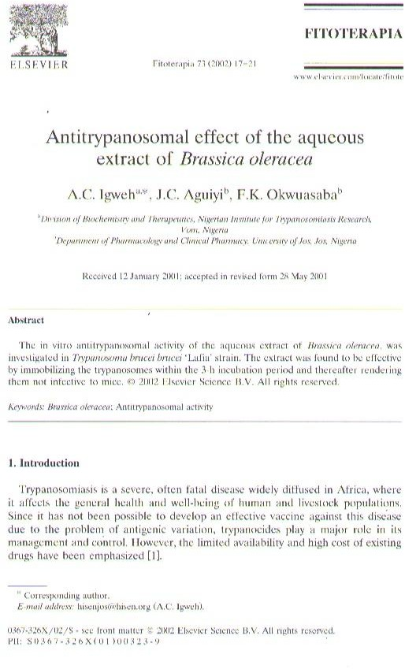

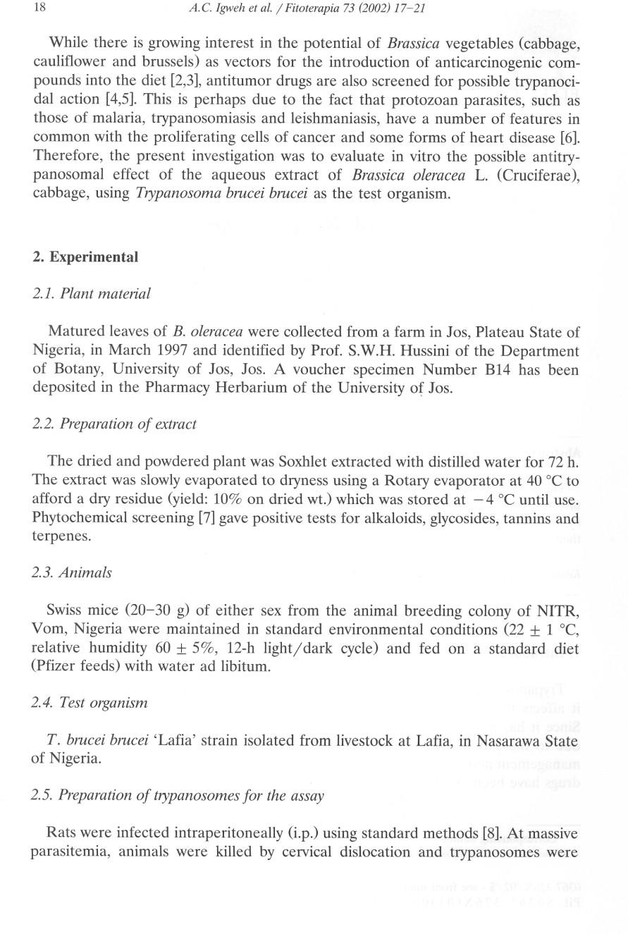

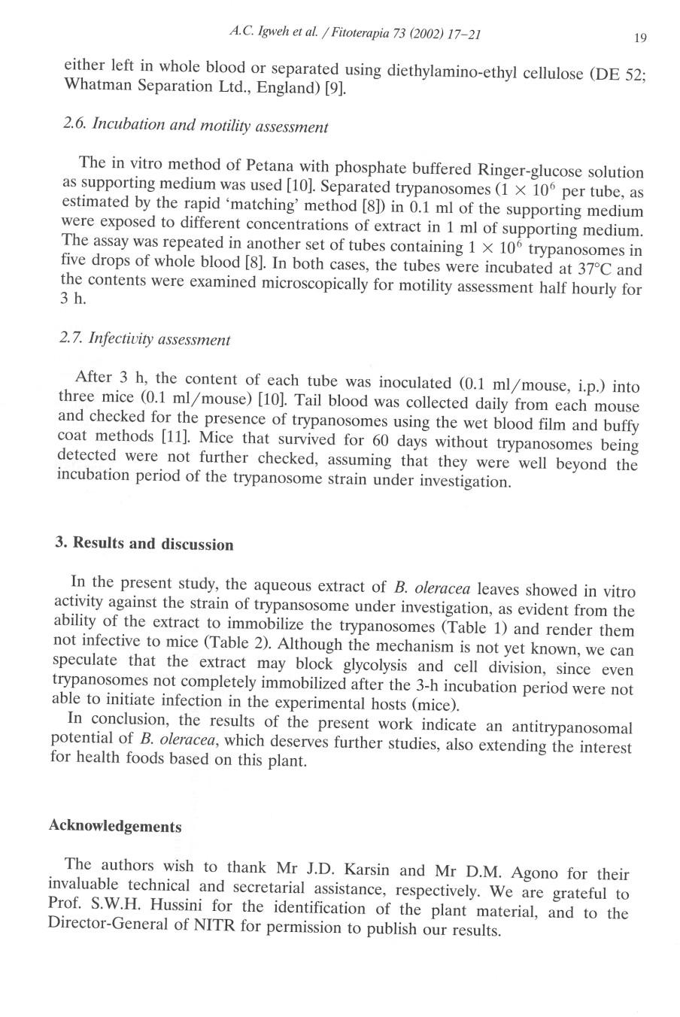

279

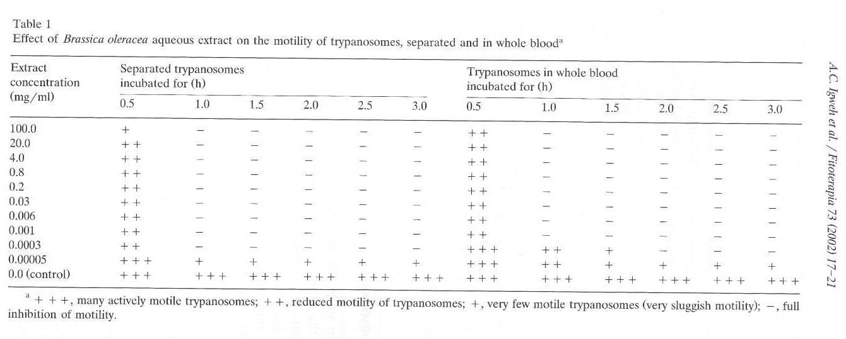

280

