**EVALUATION OF PULVERIZED COCONUT SHELL CHARCOAL AND PERIWINKLE SHELL FOR CARBURIZING MILD STEEL**

**BY**

**Nicholas Agbese AGBO**

**DEPARTMENT OF METALLURGICAL AND MATERIALS ENGINEERING,**

**FACULTY OF ENGINEERING, AHMADU BELLO UNIVERSITY, ZARIA NIGERIA.**

**MARCH, 2018**

**EVALUATION OF PULVERIZED COCONUT SHELL CHARCOAL AND PERIWINKLE SHELL FOR CARBURIZING MILD STEEL**

# BY

**Nicholas Agbese AGBO**

**M. Sc/Eng/40784/2012 – 2013**

**A THESIS SUBMITTED TO**

**THE SCHOOL OF POSTGRADUATE STUDIES, AHMADU BELLO UNIVERSITY, ZARIA**

**IN PARTIAL FULFILLMENT OF THE REQUIREMENTS FOR THE AWARD OF MASTER DEGREE IN ENGINEERING**

**DEPARTMENT OF METALLURGICAL AND MATERIALS ENGINEERING**

**FACULTY OF ENGINEERING AHMADU BELLO UNIVERSITY, ZARIA, NIGERIA**

**MARCH, 2018**

# DECLARATION PAGE

I declare that this work in this Dissertation entitled“Suitability of Pulverized Coconut Shell Charcoal and Periwinkle Shell for Carburizing Mild Steel” has been carried out by me in the Department of Metallurgical and Materials Engineering. The information derived from the literature has been duly acknowledged in the text and a list of references provided. No part of this Dissertation was previously presented for another degree or diploma at this or any other institution.

|  |  |  |  |  |
| --- | --- | --- | --- | --- |
|  |  |  |  |  |
| **Name of Student** |  | **Signature** |  | **Date** |

# CERTIFICATION PAGE

This dissertation entitled: **EVALUATION OF PULVERIZED COCONUT SHELL CHARCOAL AND PERIWINKLE SHELL FOR CARBURIZING MILD STEEL**by

Nicholas Agbese AGBO meets the regulations governing the award of the Master of Science (M.Sc) degree in Metallurgical and Materials Engineering of the Ahmadu Bello University, and is approved for its contribution to knowledge and literacy presentation.

|  |  |
| --- | --- |
| **Prof. E. T. Dauda**  Chairman, Supervisory Committee | Signature  Date |
| **Prof. TerverAuse**  Member, Supervisory Committee | Signature Date |
| **Dr. AwwalKasim**  Head of Department | Signature Date |
| **Prof. S. Z. Abubakar**  Dean, School of Postgraduate Studies | Signature Date |

# DEDICATION

This work is dedicated to God Almighty and my family members.

# ACKNOWLEDGEMENTS

I give all glory, honour and adoration to God Almighty for making it possible for the completion of this course despite all the challenges.

I will like to offer special thanks to Prof. E. T. Dauda and Prof. TerverAusewho have been supportive throughout this work. I am grateful for your guidance during the course of this work and your assistance given, may God continue to guide, protect, preserve and prosper you in all your lives Endeavour's.

Special thanks goes to all member of staff of the Department of Metallurgical and Materials Engineering for their moral support towards this work. Also,Brigadier Gen. John Obasa, Col.

N. P. Kashe‟Aure, Col. O. A. Adebanjo and GroupCaptain Clement Bot and entire staff of Heat and Surface Treatment and R & D of DICON, Kaduna, Dr. Victor Aigbodion of the Department of Metallurgical and Materials Engineering, UNN and Mr. OyebolaOyeladun of the Mineral Resources Engineering, Kaduna Polytechnic, Kaduna for their kind advice throughout my programme.

Finally, I would like to thank my parents and siblings who encouraged me to go on. Without their support, I will have not complete this work. God bless you all, in Jesus‟ name.

# ABSTRACT

The service conditions of many moving steel components require it to possess both hard and wear resistant surfaces witha tough and shock resistant cores. To achieve this, the suitability of pulverized coconut shell charcoal and periwinkle shell for carburizing 0.08%C mild steel was investigated in order to evaluate the carburizing parameters of the mild steel. The carburizing parameters evaluated were temperature, time and materials (ratio 75wt% pulverized coconut shell charcoal to 25wt% pulverized periwinkle shell). The results obtained revealed thateffective case depth and hardness values increased by increasing carburization temperature and time. Optimum hardness value of 630Hv was obtained at carburizing temperature of 950oC, carburizing time of 3 hours, carbon potential ratio of 75wt% pulverized coconut shell charcoal to 25wt% pulverized periwinkle shell and tempering temperature of 200oC with effective case depth of 2.50 mm, impact energy of 74 Joules and the wear rate of 2.023 × 10−2mm3/N/m. Hence,pulverized coconut shell charcoal and pulverized periwinkle shell can be effectively used as carburizing materials in the ratio of 75wt% pulverized coconut shell charcoal to 25wt% pulverized periwinkle shell to case hardened 0.08% C mild steel for engineering application.

# TABLE OF CONTENTS

## Page

|  |  |
| --- | --- |
| Title Page | ii |
| Declaration Page | iii. |
| Certification Page | iv |
| Dedication | v |
| Acknowledgement | vi |
| Abstract | vii |
| Table of Contents | viii |
| List of Tables | xii |
| List of Figures | xiv |
| List of Plates | xv |
| List of Appendices | xvi |

**CHAPTER ONE:** Introduction

* 1. Preamble 1
  2. Statement of Problem 1
  3. Research Questions 2
  4. Aim and Objectives of the Present Work 2
  5. Scope of the Work 3
  6. Justification of Present Work 3
  7. Significance of the Research 4
  8. Contributions to Knowledge 4

**CHAPTER TWO: Literature Review**

|  |  |  |
| --- | --- | --- |
| 2.1 Introduction |  | 5 |
| 2.2 Periwinkles Shell |  | 5 |
| 2.3 Coconut Shell |  | 6 |
| 2.4 Steel |  | 7 |
| 2.4.1 Plain Carbon Steels |  | 7 |
| 2.4.2 Alloy Steels |  | 8 |
| 2.5 Heat treatment |  | 9 |
| 2.6 Surface Hardening |  | 9 |
| 2.6.1 Carburization |  | 10 |
| 2.6.1.1 Solid Carburization | 10 |  |

|  |  |  |
| --- | --- | --- |
| 2.6.1.2 Liquid Carburization |  | 11 |
| 2.6.1.3 Gaseous carburization | 12 |  |
| 2.6.1.4 Vacuum carburization | 13 |  |
| 2.6.1.5 Plasma and salt bath carburization |  | 14 |
| 2.6.2 Nitriding | 14 |  |
| 2.6.3 Carbonitriding and Cyaniding | 14 |  |
| 2.6.4 Flame hardening | 15 |  |
| 2.6.5 Induction hardening | 16 |  |
| 2.7 The Principles of Case Hardening |  | 16 |
| 2.8 Mechanical Properties |  | 16 |
| 2.8.1 Strength |  | 17 |
| 2.8.2 Hardness |  | 17 |
| 2.8.3 Toughness |  | 17 |
| 2.8.4 Elasticity |  | 17 |
| 2.8.5 Plasticity |  | 18 |
| 2.8.6 Brittleness |  | 18 |
| 2.8.7 Ductility and malleability |  | 18 |
| 2.9 Review of Related Study |  | 18 |

**CHAPTER THREE: Materials and Methods**

* 1. Materials 22
  2. Equipment 23
  3. Method 24
     1. Optical Emission Spectrometer (OES) 24
     2. X-Ray Diffractometry Analysis(XRD) 24
     3. Scanning Electron Microscopy Analysis 24
     4. X-ray Fluorescence (XRF) 24
     5. Preparation of Test Specimens 25
     6. Carburization of Mild Steel Samples 25
     7. Heat Treatment after Carburization 26
     8. Hardness Testing and Effective Case Depth Determination 26
     9. Impact Energy Test 27
     10. Wear Rate Test 28

3.3.11 Optical Microscopy Analysis 28

CHAPTER FOUR: Results and Discussion

* 1. Chemical Composition of As – received Steel 29
  2. Chemical Composition of Coconut Shell Charcoal 29
  3. XRD and SEM Analyses of The Periwinkles Shell 31
  4. XRF Analysis of the Periwinkles Shell 34
  5. Carburization Parameters of the Mild Sample 35
  6. Effect of Time and Temperature on Effective Depth of Pack Carburization 44
  7. Microstructure of the Various Samples 46
  8. Effect of Carbon Potential on Carbon Distribution in Case Depth

with Different Carburizing Times 49

* 1. Impact Energy Test 49
  2. Wear Rate Test 50

CHAPTER FIVE: Conclusions and Recommendations

* 1. Conclusions 52
  2. Recommendations 53

|  |  |  |
| --- | --- | --- |
| References |  | 54 |
| Appendix 1 |  | 59 |
| Appendix 2 | 60 |  |

# LIST OF TABLES

**Page**

Table 3.1: Operating Parameters 25

Table 3.2: Number of level and process parameters 25

Table 3.3: Case depths for carburized steel rods using different composition of pulverized periwinkle shell and coconut shell charcoal at carburized temperatures for various times 26

Table 4.1 Chemical compositions of As-received steel 29

Table 4.2: Identified Compounds and Chemical Composition of

Coconut shell particle 30

Table 4.3: Result of Carbon and Sulphur Analyzed31

Table 4.4 Identified Compounds and Chemical Composition of Periwinkle

shell powder 33

Table 4.5: XRF analysis of periwinkle shell particles 35

Table 4.6: Case depths for carburized steel rods (using different composition of pulverized periwinkle shell and coconut shell charcoal)

at 850℃ for 1 hour 35

Table 4.7: Case depths for carburized steel rods (using different composition of pulverized periwinkle shell and coconut shell charcoal)

at 850℃ for 2 hours 36

Table 4.8 Case depths for carburized steel rods (using different composition of pulverized periwinkle shell and coconut shell charcoal)

at 850℃ for 3 hours 36

Table 4.9 Case depths for carburized steel rods (using different composition of pulverized periwinkle shell and coconut shell charcoal)

at 900℃ for 1 hour 38

Table 4.10 Case depths for carburized steel rods (using different composition of pulverized periwinkle shell and coconut shell charcoal)

at 900℃ for 2 hours 39

Table 4.11 Case depths for carburized steel rods (using different composition of pulverized periwinkle shell and coconut shell charcoal)

at 900℃ for 3 hours 39

|  |  |  |
| --- | --- | --- |
| Table 4.12 | Case depths for carburized steel rods (using different compositions  of pulverized periwinkle shell and coconut shell charcoal) |  |
|  | at 950℃ for 1 hour | 41 |
| Table 4.13 | Case depths for carburized steel rods (using different compositions of pulverized periwinkle shell and coconut shell charcoal) |  |
|  | at 950℃ for 2 hours | 42 |
| Table 4: 14 | Case depths for carburized steel rods (using different compositions of pulverized periwinkle shell and coconut shell charcoal) |  |
|  | at 950℃ for 3 hours | 42 |
| Table 4.15 | Comparison with previous work | 46 |
| Table 4:16 | Result of Wear Rate | 51 |

|  |  |  |
| --- | --- | --- |
|  | **LIST OF FIGURES** |  |
|  | **Page** |
| Fig. 4.1: | XRD pattern of the Coconut shell charcoal | 30 |
| Fig. 4.2: | SEM/EDS pattern of the coconut shell charcoal powder | 31 |
| Fig. 4.3: | XRD pattern of the Periwinkles shell powder | 32 |
| Fig. 4.4: | SEM/EDS pattern of the periwinkles shell powder | 34 |
| Fig. 4.5: | Hardness Profile at the Temperature 850℃ | 37 |
| Fig. 4.6: | Effect of the Energizer at 8500C | 37 |
| Fig. 4.7: | Hardness Profile at the Temperature 900℃ | 40 |
| Fig. 4.8: | Effect of the Energizer at 9000C | 40 |
| Fig. 4.9: | Hardness Profile at the Temperature 950℃ | 43 |
| Fig. 4.10: | Effect of the Energizer at 9500C | 43 |
| Fig. 4.11: | Effective Case Depth with Variation Time at 850℃ | 44 |
| Fig. 4.12: | Effective Case Depth with Variation Time at 900℃ | 45 |
| Fig. 4.13: | Effective Case Depth with Variation Time at 950℃ | 45 |
| Fig. 4.14: | Time at 850℃, 900℃ and 950℃ versus Effective  Case Depth for Various Composition of Coconut Shell Charcoal and Periwinkle Shell | 46 |
| Fig. 4.15: | Variation of weight %C with case depth | 49 |
| Fig. 4.16: | Impact Strength Test | 50 |

# LIST OF PLATES

## Page

Micrograph 4.1: Microstructure of the as – received Mild Steel sample

showingferritic structure; Etchant used: Nital (x200) 47

|  |  |  |
| --- | --- | --- |
| Micrograph 4.2: | Microstructure of the carburized sample x200 | 47 |
| Micrograph 4.3: | Microstructure of the carburized Quenched and Tempered at 200℃ for 1hour Sample x200 | 47 |
| Plate 4.1: | SEM image of the As – received Mild Steel sample ×3000 | 48 |
| Plate 4.2: | SEM image of the As – received Mild Steel sample ×1500 | 48 |
| Plate 4.3: | SEM image of the carburized sample ×1500 | 48 |
| Plate 4.4: | SEM image of the carburized Quenched and Tempered at 200℃ for 1hour Sample ×1500 | 48 |

# APPENDICES

**Page**

|  |  |
| --- | --- |
| Appendix1: Photograph taking during the carburizing of the steel samples | 59 |
| Micrograph B1**: A)** Microstructure obtained in this present work  B) Microstructure obtained by Palaniradja et al (2010) using active carbon C) ASM(2004) | 60 |
| Micrograph B2: Micrograph of carburized Steel at 925°C with the soaking time of 2 hours. | 61 |

# CHAPTER ONE INTRODUCTION

# PREAMBLE

The service conditions of many moving steel components such as gears, cams, valves etc, make it necessary for them to possess not onlyhard and wear resistant surfaces, but tough and shock resistant cores. A low carbon steel of approximately 0.1% carbon is naturally tough while a high carbon steel of about0.9% or more possesses adequate hardness and inherently low toughness when suitably heat-treated. The combination of hard and wear resistant surface with tough core required in the aforementioned components involve the treatment of a shock- resistant steel in order to alter the nature of the surface to increase the hardness while the core remains more or less unaltered (Akinluwade*et al*., 2012).

There are two major processes through which such an alteration of the surface layers of steel components can be carried out, namely, (i) processes which impact surface hardness by changing the microstructure of the surface skin without changing the chemical composition of the surface. Such steel must not have a carbon content of less than 0.4% for them to be amenable to hardening by any of flame, induction, laser, and electron beam hardening (ii) processes which impact surface hardness by changing the surface chemistry of the steel by diffusing carbon, nitrogen or both carbon and nitrogen into its surface (Asuquo and Ihom, 2013). Steels for this process may have a carbon content of about 0.1%. Examples of this latter process include carburizing, nitriding, cyaniding, diffusion coating, and hard surfacing.

# STATEMENT OF PROBLEM

Due to high demand ofhard and wear resistant components in automobile, defense and other steel industries, there is a need to find a suitable locally sourced carburizer and

energizer which will reduce the cost of production of machine components. Most mild steel produced are not suitable for engineering use as moving parts, hence, there is need for further treatment such as carburization. However, the conventional energizer in use e.g. Barium Carbonate is usually imported. This amounts to additional cost, hence the need to source and investigate the locally available onesfor use.

# RESEARCH QUESTIONS

The following research questions were formulated to guide the study.

* + 1. Whatis the hardness of mild steel carburized with coconut shell charcoal and periwinkles shell powder as energizer?
    2. What are the wear andimpact strengths of mild steel carburized with coconut shell charcoal and periwinkles shell powder as energizer?
    3. What is the effect of periwinkle on case depth formed after carburizing.
    4. What are the effects of carburizing temperatures and time on the hardness, wear, tensile strength of mild steel carburized with coconut shell charcoal and periwinkles shell powder as energizer?

# AIM AND OBJECTIVES OF THE PRESENT WORK

The aim of this work is to study the suitability ofpulverized coconut shell charcoal and periwinkle shell for carburizing mildsteel.

## The objectives of the study are:

1. Determination ofthechemical composition of coconut and periwinkle shells using X-ray florescence and X-ray diffraction;
2. Determination of the chemical composition of as-received and carburized mild steel using optical emission spectrometer (OES);
3. Carburization of mild steel samples under various conditions such as time and temperature and determination of the case depth of the carburized steels using hardness method;
4. Determination of the hardness profile and impact properties of the mild steel in the as-received, carburized, carburized quenched and tempered conditions.
5. Carry out wear rate test of the as-received, carburized, carburized quenched and tempered conditions samples.

# SCOPE OF THE WORK

This work involves carburization of the sourced mild steel using pulverized coconut shell as carburizer and pulverized periwinkle shell as energizer at different temperatures of 8500C, 9000C and 9500C.. The samples properties examined in the laboratory to ascertain its chemical composition using OES, its microstructural property using optical microscope/SEM, mechanical properties using impact testing machine and hardness testing machine and wear resistant using Antonpaar wear testing machine.

# JUSTIFICATION OF THE WORK

The demand for locally fabricated parts or machine components especially in defense industries, automobile industries and other steel industries is becoming high due to the fact that government want to reduce capital flight from economy and encouragelocal production of spare – parts, hence the increased in the demand of carburized steel parts. In order to lower the price of these parts in market and also compete favourably with imported ones, there is need to use a suitable locally sourced and cheap carburizer such as coconut shell and energizer such as periwinkle shell.

# SIGNIFICANCE OF THE RESEARCH

The significance of this work is to exploit the use of coconut shell as carburizer and periwinkle as energizer in order to ascertain their effectiveness onthe mechanical properties of the mild steel. These materials are cheaper, economical and ecofriendly compared to barium carbonate and coal/charcoal.

# CONTRIBUTIONS TO KNOWLEDGE

The followings are some of the contributions to knowledge for carrying this present research:

1. Coconut shell and periwinkles shell were considered as an alternativecarburizer and energizer respectively in case hardening of mild steel.
2. The optimum result was obtained using carburizing compound with ratio 75wt% pulverized coconut shell charcoal to 25wt% pulverized periwinkle shell at 950oC for 3 hours.
3. This researchprovided information on how to convert waste to wealth with the abundant coconut and periwinkles shellsfound in the coastal area of Nigeria.
4. This research provided information on carburized quenched – tempered mild steel which has a wear rate of 2.023 × 10−2𝑚𝑚3/𝑁/𝑚 .
5. This research provided inform on carburized quench – tempered mild steel which has an impact energy of 74Joules.

# CHAPTER TWO LITERATURE REVIEW

* 1. **INTRODUCTION**

Low carbon steel is the most common form of steel and it provides material properties that are acceptable for many applications. It is ductile and malleable due to its lower carbon content and has lower tensile strength than other classes of steel. Steel with low carbon content has properties similar to iron. As the carbon content increases, the metal becomes harder and stronger but less ductile and more difficult to weld.

All classes of steels can go through a heat treatment process either to soften the metal which is hard, change the grain size, modify the structure or to relieve internal stresses as a result of mechanical working and quenching effect. The various heat treatment processes are annealing, normalizing, hardening, austempering, martempering,tempering and surface hardening. Case hardening is the process of hardening the surface of metal, oftenusedin low carbon steel by infusing elements into the metal surface producing a hard and wear resistance skin yet preserving a tough and ductile corerequired in gears, ball bearings, railway wheels. The study of process parameters in metals during heat treatment has been of considerable interest for some years(Aramide*et al*, 2009a) but there has been relatively little work on process variables during the surface hardening process(Aramide*et al*,2009b) since controlling parameters in carburization is a complex problem. The major influencing parameters in carburization are the carburization temperature, holding time, carbon content and the quench time in oil.

# PERIWINKLES SHELL

The periwinkle shell is a naturally occurring outer covering of a periwinkle (Turritellacommunis). It is an external exoskeleton which protects the winkles from their

predators and mechanical damage. Structurally, the periwinkle shell has several layers and is typically made of an organic matrix (conchiolin) which is bonded with calcium carbonate precipitates. Periwinkles are abundant in riverine areas of Nigeria and their shells are waste products from the processing of these sea animals.

The main constituent of the periwinkles shell is calcium carbonates which are either of two crystalline forms: calcite and aragonite. The remained is organic matrix which constitute a protein known as conchiolin that is usually up to 5% of the shell. The fine structure of mollusks shells has been studied by using various techniques including scanning electron microscope of broken surfaces. In each of them, blocks or stripe of calcium carbonate are separated by a thin layer of conchiolin (Asia and Oladoja, 2003). The calcium carbonates are impervious to water and this property makes it possible for snail shells and their derivatives to have very wide applications.

Recently Aku*et al* (2012)**,**studied the characterization of periwinkle shell as asbestos- free brake pad materials**.** They found out that periwinkle shell can be effectively and eco-friendly utilized for scientific applications. The test results obtained were comparable with asbestos commonly used in brake pad product.

# COCONUT SHELL

The term coconut refers to the entire coconut palm. It is derived from Portuguese and Spanish word “coco” meaning “head” or “skull”. Coconut shell is the hard- stonyendocarps that surround the coconut, and the shells come in shapes and sizes. Large quantities of coconut shell are generated annually and only some fractions of it are used for fuel and other domestic and industrial applications, and also in the production of activated carbon. The unused coconut shells are dumped around the processing mill, constituting environmental and economic liability for the mill and the Nation at large. This waste is either burnt in the open air or left to settle in waste

ponds. This way, the coconut processing industry's waste contributed significantly to CO2 and methane emissions **(**Butler, 2006**)**.

# STEEL

Steel is usually defined as an alloy of iron and carbon with the carbon content up to about 2wt%. Other alloying elements can amount in total to about 5wt% in low-alloy steels and higher in more highly alloyed steels such as tool steels and stainless steels. Steels can exhibit a wide variety of properties depending on composition as well as the phases and microconstituents present, which in turn depends on the heat treatment(Metals Handbook, 1981).

The heat treatment given to steel can affect its properties. Cooling red-hot tool steel rapidly in cold water makes it harder and more brittle. The same work – piece of metal could be made softer by keeping it at red heat for longer and then cooling it slowly. Heat treatment is another method that the steelmaker uses to achieved desired properties of the steel(Rajan, 1988). We have different types of heat treatment each dependson the objective of the design engineer.

# PLAIN CARBON STEELS

Plain carbon steels can be classified conveniently as follows:

* + - 1. Low-carbon (<0.3% C),
      2. Medium-carbon (0.3 – 0.7% C)
      3. High carbon (0.7– 1.7% C).(Singh, 2010)

The low carbon steels combine moderate strength with excellent ductility and are used extensively for their fabrication properties in the annealed or normalized condition for structural purposes, in bridges, buildings, cars, ships and so on and so forth.

Improved low-carbon steels (<0.2% C) are produced by deoxidizing or „killing‟ the steel with Al or Si, or by adding Mn to refine the grain size. It is now more common, however, to add small amounts (<0.1%)ofNb which reduces the carbon content by forming NbC particles. These particles not only restrict grain growth but also give rise to strengthening by precipitation-hardening within the ferrite grains. Other carbide formers, such as Ti, may be used but because Nb does not deoxidize, it is possible to produce a semi-killed steel ingot which, because of its reduced ingot pipe, gives increased tonnage yield per ingot cast(Rashmi*et al*, 2012).

Medium-carbon steels are capable of being quenched to form martensite and tempered to develop toughness with good strength. Tempering in higher-temperature regions (i.e. 350–550°C) produces spheroidized carbide which toughens the steel sufficiently for use as axles, shafts, gears and rails. The process of ausforming can be applied to steels with this carbon content to produce even higher strengths without significantly reducing the ductility(Ravendra*et al*, 2012).

The high-carbon steels are usually quenched hardening and lightly tempered at 250°C to develop considerable strength with sufficient ductility for springs, dies and cutting tools. Their limitations stem from their poor hardenability and their rapid softening properties at moderate tempering temperatures(Rashmi*et al*, 2012).

# ALLOY STEELS

In low and medium alloy steels, with total alloying content up to about 5%, the alloy content is governed largely by the hardenability and tempering requirements, although solid solution hardening and carbide formation may also be important, Mn and Cr increase hardenability and generally retard softening and tempering; Ni strengthens the ferrite and improves hardenability and toughness; copper behaves similarly but

also retards tempering; Co strengthens ferrite and retards softening on tempering; Si retards and reduces the volume change to martensite, and both Mo and V retard tempering and provide secondary hardening. In larger amounts, alloying elements either open up the austenite phase field or close the austenite field. „Full‟ metals with atoms like hard spheres (e.g. Mn, Co, Ni) favour close-packed structures and open the field, whereas the stable BCC transition metals (e.g. Ti, V, Cr, Mo) close the field and form what is called a austenite loop(Rashmi*et al*, 2012).

# HEAT TREATMENT

The heat treatment given to steel can affect its properties. Cooling red-hot tool steel rapidly in cold water makes it harder and more brittle. The same work – piece of metal could be made softer by keeping it at red hot for longer and then cooling it slowly. Heat treatment is another method that the steelmaker uses to make the properties of the steel match the job it has to do(Rajan, 1988). We have different types of heat treatment each dependson the objective of the design engineer.

# SURFACE HARDENING

In many engineering applications, it is desirable that steel being used should have a hardened surface to resist wear and tear. It should have soft and tough interior or core so that it can absorb any shocks. Case hardening is the process ofhardening the surface ofmetal, often a low carbon steel by infusing elements into the metal surface forming a hard, wear resistance skin but preserving a tough and ductile interior (Metals Handbook, 1981). This type of treatment is applied to gears, ball bearings, railway wheels. The various case hardening processes are:

1. Carburizing,
2. Cyaniding,
3. Nitriding,
4. Carbonitriding and
5. Flame/Induction Hardening.

## Carburizing

Carburizing is a process of adding carbon to steel surface. This is done by exposing the part to carbon rich atmosphere at an elevatedtemperatureand allowdiffusion to transfer the carbon atoms in the steel (Metals Handbook, 1981). This diffusion works on the principle of differential concentration. The typesof carburization processes are:

* + - 1. Solid carburization,
      2. Liquid carburization,
      3. Gaseous carburization,
      4. Vacuum carburization,
      5. Plasma carburization and
      6. Salt bath carburization

## Solid Carburization

The solid or pack carburization involves heating the steels parts embedded in powdery mixture of 85% coal and 15% BaCO3 at a temperature in the range 900 – 950 degree Celsius. The residual airin the box combines with carbon to produce CO gas. Carbon monoxide gas is unstable at theprocess temperature and thus decomposes upon contacting the iron surface by the following reactions (Metals Handbook, 1981).

2C + O2 → 2CO (2.1)

2CO → C + CO2 (2.2)

The atomic carbon enters the steel through the following reaction.

Fe + 2CO → Fe(C) + CO2 (2.3)

C + CO2 → 2CO(2.4)

Where Fe(C) is carbon dissolved in austenite. This atomic and nascent carbon is absorbed by the steel surface, and subsequently it diffuses towards the centre of steel sample. CO2 thus formed react with the carbon (C) ofthe carburizing mediumtoproduce CO, and thus, the cycle of the reaction continues. Charcoal is the basic source of carbon during solid carburization (Metals Handbook, 1981). As entrapped air inside the box may be less to produce enough CO2 particularly in the beginning of the carburization, it is thus common practiceto add energizer (usually BaCO3) which decomposes during the heating up period as:

𝐵𝑎𝐶𝑂3 → 𝐵𝑎𝑂 + 𝐶𝑂2 (2.5)

The CO2 thus formedthenreact with the carbon ofthe carburizer to produce CO gas. Thus, BaCO3 makes CO2 available at an early stage of carburization and hence it is called energizer. The case depth increases with rise in carburization temperature and time. The steel surface absorbs carbon at a faster rate and therateat which it can diffuse inside, thus producing super saturated case which mayproduce cracks during quenching. In solid carburization, it is difficult to control exactly the case depth becauseof many factors affecting it, such as density of packing, amount of air present inside the box, reactivity of carburizer, etc. (Metals Handbook, 1981).

## Liquid Carburizing

Liquid carburizing is a method of case hardening steel by placing it in a bath of molten cyanide so that carbon will diffuse from the bath in to the metal and produce a case comparable to the one resulting from solid or gas carburizing. Liquid carburizing may be distinguished from cyaniding by the character and composition of the case produced(Rashmi*et al*, 2012). The cyanide case is higher in nitrogen and lower in carbon the reverse is true of liquid carburized cases. Low temperature salt baths (lights case) usually contain a cyanide content of 20 percent and operate between

1550 °F and 1650° F. High temperature salt baths (deep case) usually have cyanide content of 10 percent and operate between 1650°F and 1750° F(Rashmi*et al*, 2012).

## Gaseous Carburization

Gas carburizing has become the most popular method of carburizing in the last two decades. The main carburizing agent in this process is any carbonaceous gas such as methane, propane or natural gas. In this process, it is necessary that the hydrocarbon gases should be diluted with a carrier gas to avoid heavy soot formation(Rajan and Sharma, 1988). Carrier gas can be made by controlled combustion of hydrocarbon gas.

Methane can be burnt in air using air to methane ratio 2.5 and reacts as:

𝐶𝐻4 + 𝐶𝑂2 → 2𝐶𝑂 + 2𝐻2(2.6)

The common endothermic carrier gas has the composition (vol. %) N2=39.8%; CO=20.7%; H2=38.7%; CH4=0.8%

The important chemical reaction occurring during gas carburizing are as follows: (Rajan and Sharma, 1988):

𝐶𝐻4 + 𝐹𝑒 → 𝐹𝑒(𝐶) + 2𝐻2 (2.7)

2𝐶𝑂 + 𝐹𝑒 → 𝐹𝑒(𝐶) + 𝐶𝑂2 (2.8)

𝐶𝑂 + 𝐻2 + 𝐹𝑒 → 𝐹𝑒(𝐶) + 𝐻2𝑂

(2.9)

Where Fe(C) indicates carbon dissolved in austenite.

𝐶𝐻4 + 𝐶𝑂2 → 2𝐶𝑂 + 2𝐻2 (2.10)

𝐶𝐻4 + 𝐻2𝑂 → 𝐶𝑂 + 3𝐻2

(2.11)

The H2 and CO as regenerated by reactions (2.10) and (2.11), react with steel surface according to the reaction (2.8) and (2.9) to cause enrichment of surface by carbon. It is thus obvious that the ultimate source of carbon in gas carburizing is CH4.

## Vacuum carburization

In efforts required to simplify the atmosphere, carburizing in an oxygen-free environment at verylow pressure (vacuum carburizing) has been explored and developed into a viable and importantalternative. Although the furnace enclosure in some respects becomes more complex, theatmosphere is greatly simplified. A single- component atmosphere consisting solely of a simplegaseous hydrocarbon, for example methane, may be used. Furthermore, because the parts areheated in an oxygen-free environment, the carburizing temperature may be increasedsubstantially without the risk of surface or grain-boundary oxidation. The higher temperaturepermitted increases not only the solid solubility of carbon in the austenite but also its rate ofdiffusion, so that the time required to achieve the case depth desired is reduced(Ohize, 2009).

Although vacuum carburizing overcomes some of the complexities of gas carburizing, itintroduces a serious new problem that must be addressed. Because vacuum carburizing isconducted at very low pressures, and the rate of flow of the carburizing gas into the furnace isvery low, the carbon potential of the gas in deep recesses and blind holes is quickly depleted.Unless this gas is replenished, a great non-uniformity in case depth over the surface of the part is likely to occur.

## Plasma and salt bath carburization

A method that overcomes both of these major problems yet retains the desirable features of asimple atmosphere and permissible operating temperature is plasma or ion carburizing.These methods introduce carbon by the use of gas (atmospheric-gas, plasma, and vacuumcarburizing), liquids (salt bath carburizing), or solid compounds (pack carburizing). All of thesemethods have limitations and advantages, but gas carburizing is used most often for large-scaleproduction because it can be accurately controlled and involves a minimum of special handling.Vacuum carburizing and plasma carburizing have found applications because of the absence ofoxygen in the furnace atmosphere

## Nitriding

Nitriding is a surface-hardening heat treatment that introduces nitrogen into the surface of steel ata temperature range (500 to 600°C) while it is in the ferrite condition(Ihom, 2013). Thus, nitriding is similarto carburizing in that surface composition is altered, but different in that nitrogen is added intoferrite instead of austenite. Because nitriding does not involve heating into the austenite phasefield and a subsequent quench to form martensite(Ihom, 2013), nitriding can be accomplished with aminimum of distortion and with excellent dimensional control. In this process pure ammoniadissociates by the reaction2𝑁𝐻3 ⇌ 3𝐻2 + 𝑁2 (2.12)

The atomic nitrogen thus formed diffuses into the steel. In addition to providing outstandingwear resistance, the nitride layer increases the corrosion resistance of steel in moist atmosphere.Practically only alloy steels are subjected to nitriding.

## Carbonitriding and Cyaniding

Carbonitriding is a modified form of gas carburizing, at a temperature range between 750-900oC.The modification consists of introducing ammonia into the gas carburizing atmosphere to addnitrogen to the carburized case as it is being produced(Ihom, 2013).

Nascent nitrogen forms at the worksurface by the dissociation of ammonia in the furnace atmosphere; the nitrogen diffuses into thesteel simultaneously with carbon. Typically, carbonitriding is carried out at a lower temperatureand for a shorter time than in gas carburizing, producing a shallower case than inproduction carburizing(Ihom*et al*, 2013).

Furthermore, carbonitriding is similar to liquid cyaniding. Because of problems associated with disposing of cyanide – bearingwastes, carbonitriding is often preferred over liquid cyaniding. Interms of case characteristics, carbonitriding differs from carburizing and nitriding in thatcarburized cases normally do not contain nitrogen, and nitrided cases contain nitrogen primarily, whereas carbonitrided cases contain both.

## Flame hardening

This is the simplest form of heat treatment process. The workpiece is heated by means of a gastorch (oxy-acetylene flame) followed by a water spray on the heated parts. The heat from thetorch penetrates only to small depth on the surface and consequently the steel in the outer layersgets quenched to martensite and bainite(Rajan and Sharma, 1988). Case depth up to 3mm can be achieved by this process.This process can be followed by heating to about 2000C for the purpose of stress relieving. Thesurface hardness is not appreciably affected by these reheating operations. This process issuitable for any complex shape of component such as crank shaft, large gears, cam, etc. withcarbon percentage ranging from 0.3 to 0.6%. Though high carbon steel can also be flamehardened, greater care is needed to avoid surface cracking(Rajan and Sharma, 1988).

## Induction hardening

This is similar to flame hardening process where the heating of component surface is achievedby the electromagnetic induction. The workpiece such as crank shaft is enclosed in the magneticfield of an alternating (10 kHz to 2MHz) current conductor to obtain case depth of the order of0.25 to 1.5 mm. This causes induction heating of the workpiece, the heated workpiece thenquenched by water spray. The induction heat penetrates only outer surface of the workpiece as aresult only the skin gets hardened by the quenching process. The whole process is very fast (5s to4 minutes) and result in hard outer surface (50 to 60 Rc) which is wear resistant(Rajan and Sharma, 1988).

# THE PRINCIPLES OF CASE HARDENING

Carbonwill diffuse into iron in the temperature range of 850 – 9500C where FCC iron exist freely. For carburizationto take place, the component of interest is surrounded with suitable carbonaceous material and heating it to above its upper critical temperature for long enough to produce a carbon -enriched layer of sufficient depth.

Solid, liquid and gaseous carburizing media are used. The nature and scope of the work involved will govern which medium it is best to employ. The function of the carburizing medium is to release atoms of carbon at the surface of the work piece, so that at the carburizing temperature, they will be absorbed interstitially into the steel (Higgins, 2004).

# MECHANICAL PROPERTIES

Strength, hardness, toughness, elasticity, plasticity, brittleness, and ductility and malleability aremechanical properties used as measurements of how metals behave under a load. Theseproperties are described in terms of the types of force or stress that the metal must withstand andhow these are resisted(Dieter, 1988).

## Strength

Strength is the property that enables a metal to resist deformation under load. The ultimatestrength is the maximum load in tension which a material can withstand prior to fracture. Tensile strength is a measurement ofthe resistance to being pulled apart when placed in a tension load.Fatigue strength is the ability of material to resist various kinds of rapidly changing stresses andis expressed by the magnitude of alternating stress for a specified number of cycles.Impact strength is the ability of a metal to resist suddenly applied loads(Dieter, 1988).

## Hardness

Hardness is the property of a material to resist permanent indentation. Because there are severalmethods of measuring hardness, the hardness of a material is always specified in terms of theparticular test that was used to measure this property. Rockwell, Vickers, or Brinell are some ofthe methods of testing. Of these tests, Rockwell is the one most frequently used. The basicprinciple used in the Rockwell testis that a hard material can penetrate a softer one. We thenmeasure the amount of penetration and compare it to a scale. For ferrous metals, which areusually harder than nonferrous metals, a diamond tip is used(Dieter, 1988).

## Toughness

Toughness is the property that enables a material to withstand shock and to be deformed withoutrupturing. Toughness may be considered as a combination of strength and plasticity(Dieter, 1988).

## Elasticity

When a material has a load applied to it, the load causes the material to deform. Elasticity is theability of a material to return to its original shape after the load is removed. Theoretically, theelastic limit of a material is the limit to which a material

can be loaded and still recover itsoriginal shape after the load is removed(Dieter, 1988).

## Plasticity

Plasticity is the ability of a material to deform permanently without breaking or rupturing. By careful alloying of metals, the combination of plasticityand strength is used to manufacture large structural members. For example, should a member ofa bridge structure become overloaded, plasticity allows the overloaded member to flow allowingthe distribution of the load to other parts of the bridge structure(Dieter, 1988).

## Brittleness

Brittleness is the opposite of the property of plasticity. A brittle metal is one that breaks orshatters before it deforms. White cast iron and glass are good examples of brittle material.Generally, brittle metals are high in compressive strength but low in tensile strength. As anexample, you cannot be choose cast iron for fabricating support beams in a bridge(Dieter, 1988).

## Ductility and malleability

Ductility is the property that enables a material to stretch, bend, or twist without cracking orbreaking. This property makes it possible for a material to be drawn out into a thin wire. Incomparison, malleability is the property that enables a material to deform by compressive forceswithout developing defects. A malleable material is one that can be stamped, hammered, forged,pressed, or rolled into thin sheets(Dieter, 1988).

# REVIEW OF RELATED STUDY

Baldissera and Delprete(2009) studied effects of deep cryogenic treatment (DCT) on staticmechanical properties of 18NiCrMo5 carburized steel and concluded that the soaking timeparameter shows a strong influence on the hardness increase induced by

the pre-tempering DCTand, under the assumption that the microstructural mechanism could be possiblyfurther improvement with a prolonged DCT exposure. The unchanged tensilestrength of the pre-tempering DCT groups could be related to a compensation effects due to theloss in residual stress, as it is reported by literature.

Ibironke*et al.* (2004) reported the feasibility of improving the strength properties of low carbon steels with nascent carbon and nitrogen released in situ from the cyanide content of cassava leaf. Their studyreported carburization as a function of time at a temperature of 860oC in pack cyaniding medium. A mathematical model for the estimation ofhardness with depth as a function of residence time was presented. The results of the simulation of the model agrees approximately with experimental results Ihom(2013) studied various carburizing compounds used to pack carburized mild steel. Various weight percentages of cow bone were used as energizer in the carburizing compounds. The experiments were carried out using a muffle furnace at 900°C for 8 h. The result revealed that 60 wt% charcoal / 40 wt% cowbone had the best result with an effective case depth of 2.32 mm produced on the case of the carburized steel. The work revealed that cowbone can be used as energizer in pack carburization of mild steel.

Aramide*et al*(2010a) reported on the mechanical properties of mild steelsubjected to packed carburization treatment using pulverized cow bone as the carburizer, carburized at 850°C, 900°C and 950°C, soaked at the carburizing temperature for 15 minutes and 30 minutes, quenched in oil and tempered at 250°C. They concluded that the sample carburized at 900°C soaked for 15 minutes and the one carburized at 850°C soaked for 30 minutes followed by oil quenching and tempering at 250°C were better because they showed a trend of hard case with softer core

Rashmi*et al*(2012)reported on the mechanical and wear properties of carburized low carbon steel samples**.** The mechanical and wear properties of mild steels were found to be strongly influenced by the process of carburization. The experimental results also revealed that the mild steels carburized under different temperatures (850oC, 900oC and 950oC) out of which the mild steels carburized at the temperature of 950oC gave the best results for the different kinds of mechanical and wear properties.

Atanda*et al*(2009) reported on the investigation of the effect of carburizing variables – temperature, time and percentage of energizer –on the case properties of C2R steel obtained from HMT Ltd. India. A carburizer consisting of hardwood charcoal and coke respectively in the ratio of 2:1 was used for the research with sodium carbonate as the energizer. The carburizing box was filled with 20 mm thick carburizer compound prior to fixing the steel samples in place.

Asuquo*et al.* (2013) reported on the Mathematical modeling of the hardness of case hardened mild steel with respect to carburizing time. The work utilized data that was empirically generated at the heat treatment shop of the National Metallurgical Development Centre, Jos. The study established the existence of a relationship between carburizing time and hardness value in Hv of carburized steel as well as the effective case depth in mm. A strong positive correlation coefficient of + 0.98 was found for hardness value and +0.91 was found for effective case depth, both of these relationships were linear based on the two mathematical models developed for the prediction of hardness value and effective case depth using simple linear regression method. The result of the work agreed with existing theories on the relationship between carburizing time and hardness of carburized steel.

Ohize(2009) determined the effect of coal, boneand wood charcoal on the hardness, tensile and impact strengths of mild steel. Sample of mild steel machined to

specifications were carburized with each of coal, bone charcoal and wood charcoal and case hardened. Direct testing and measurement of hardness, tensile and impact strengths were done on respective conventional testing machines. The study answered four research questions with means, and tested seven null hypotheses at 0.01 level of significance with 3 × 5 analysis of variance (ANOVA). Coal, bone charcoal and wood charcoal as carburizing materials each had considerable increasing effect on hardness and tensile strengths but a decreasing effect on impact strengths of mild steel. Wood charcoal had the greater effect while coal had the least effect on hardness and tensile strengths; and only the interactive effect of carburizing material with carburizing time was significant at 0.01 level of significance. Results obtained compared favourably with results of conventional energized pack carburizing materials.

Hassan (2014) reported that carburizing charcoal contributed in increasing wear resistance and the compound of cow bone with 10% CaCO3 as energizer had a carburizing case depth of 2.32 mm which gives the highest wear resistance while charcoal compound gives a case depth of 1.1 mm. The mild steels specimens are carburized at 925° C for 2hr as soaking time and slow cooling in furnace then carburizing specimens were re heating to 870 °C for half hr. and water Quenching. Tempering was done at 160°C for 1 hour and air cooled. The work showed that cow bone can be used as compounds and energizer in pack carburization of mild steel 1020 AISI. The hardness profile plot of the 90 wt.% 10% caco3 cow bone carburized mild steel was also higher than the other compositions and this value contributed on improvements of wear resistance.

# CHAPTER THREE MATERIALS AND METHOD

# MATERIALS

The materials that were used for the work included, mild steel grade rods of 14 mm diameter obtained from Universal SteelIkeja, Lagos State.

Periwinkle shell obtained fromPort Harcourt, Rivers State. The coconut shellwas collected from coconut sellers in Central Market, Kaduna,KadunaState. Other materials such as acetone, water and clay were used.

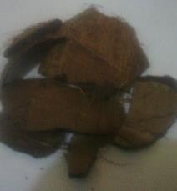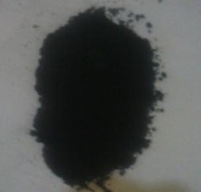

|  |  |
| --- | --- |
| Plate3.1: Coconut Shell Sample | Plate 3.2: Pulverized Coconut Shell Charcoal |
| Plate 3.3: Periwinkle Shell Sample | Plate 3.4: Pulverized Periwinkle Shell |

# EQUIPMENT

Equipment that wereused in this research are:

* Digital weighing balance,
* Tong,
* Drying oven,
* Shuttle Buffalo Hammer Mill (Model WA8H)
* Grinding Machine Shambhari Index
* Sieving Machine (Model S750)
* DergussaDurferit electric furnace with maximum temperature of 1000°C made in Germany,
* Microvickers Hardness Tester model -MVl-PC serial number 07/2012-1320 maximum capacity -500kgf made by fuel instruments & Engineers PVT. Ltd of Maharashtra (India).
* W&T Avery izod impact testing machine type 6701,serial number 5142519,
* Wear testing (pin &Disc) machine Anton paarstrasse 20 8054(make:AntonPaar GMBHinstruments company Austria).
* Optical Emission Spectrometer model PDA:7000,
* X-ray Diffractometer made by PAN Analytical BV of Netherland,
* Scanning ElectronMicroscope(SEM)made by Phenom World Model ProX.
* X-ray Fluorescence Machine Model Mini PAL 4
* Cylindrical Grinding Machine made by Jones -shipman model 1311 using soft sand paper.
* Polishing Machine made by Fritz Werner of Germany model-wp2000.
* Lathe Machine made by H.ErnaultSomua model j350.
* Metallurgical Microscope model NJF-1
* TSA Carbon and Sulphur Analyzer.

# METHOD

## Optical Emission Spectrometer (OES)

This involved the application electrical energy in form of spark generated between the electrode and the as-received steel, whereby the vaporized atoms were brought to a high-energy state. This created a unique emission spectrum which specific to a particular element and it is measured by detectors called photomultiplier tubes.

## X-Ray Diffractometry Analysis(XRD)

Thecoconut shell charcoal powder and the periwinkle shell powderwereanalyzedtoidentifyandquantifytheir chemical compound phases usingX- raydiffraction technique.BrukerD8θ-θX-raydiffractometerequippedwithCoKα monochromatingmultilayeredmirrors was used for the analysis.ARietveld refinement software,TOPASTM,was used for quantitative analysis of the samples.

## Scanning Electron Microscopy

Themicrostructureandthechemicalcompositionsofthe phases presentincoconut shell charcoal and periwinkleshell powderwere analyzedusingaJOELJSM5900LVScanningElectronMicroscope equippedwithanOxfordINCATMEnergyDispersiveSpectroscopy(EDS)system.The polishedsample wasfirmlyheldonthesampleholderusingadouble – sidedcarbon tapebeforeputtingtheminsidethesamplechamber.TheSEMwasoperatedatan acceleratingvoltage of5 to 20 kV.

## X-ray Fluorescence (XRF)

The samples of coconut shell and periwinkles were pulverized separately to fine homogenous size and then pelletized, packed and labelled. 20g of each prepared sample were weighed with a sensitive weighing beam balance and load into sample cup. The cup and the contents were carefully placed in the XRF machine where the

analyses took place.

## Preparation of Test Specimens and Samples

The 14mm diameter rods from Universal Steel were cut into 54 pieces of 100mm length. Each of the specimens went through the following treatments:

* + - * Carburization
      * The mechanical and wear properties test in line with ASTM standards. The process variables of the test follow the order in Tables 3.1 and 3.2.

The periwinkle shellswere washed and then pulverized.

**Table 3.1: Operating Parameters.**

|  |  |  |  |
| --- | --- | --- | --- |
| **Serial**  **No** | **Control variable** | **Notations** | **Value with range** |
| **1** | Carburizing Temperatures(oC) | A | 850-9500C |
| **2** | Carburizing Time(hours) | B | 1-3hrs |
| **3.** | Tempering Temperature (0C) | C | 200 |

**Table 3.2: Number of level and process parameters**

|  |  |  |  |  |
| --- | --- | --- | --- | --- |
| **Control variables** | **Level** | | | **Test carried out** |
| **1** | **2** | **3** |
| **Low** | **Middle** | **high** |
| Carburizing  Temperatures(oC) | 850 | 900 | 950 | Hardness values(HRC) Wear rate(mg/m)  Microstructures |
| Carburizing Time(hours) | 1 – 3 | 1 – 3 | 1 – 3 |
| Tempering Temperature (0C) | 200 | 200 | 200 |

## Carburization of Mild Steel Samples

The 54 test samples preparedwere subjected to carburization treatment. The samples were immersed totally on the thick bed of carburizer containing the various wt% of

coconut shell powder andperiwinkle shell powderin a stainless-steel container and the top of the container covered with a steel plate as lid (the ratio of mixture shown in Table 3.3 for various carburization temperature of the furnace). The container wasthenplaced into the muffle furnace and maintained at the different carburization temperatures and times.The container was removed and cooled in air.

## Table 3.3: Case depths for carburized steel rods using different composition of pulverized periwinkle shell and coconut shell charcoal at carburized temperatures for various times

|  |  |  |  |  |  |  |  |
| --- | --- | --- | --- | --- | --- | --- | --- |
| **Control Variables Exp. No** | **Pulverized Periwinkle shell (%)** | **Pulverized coconut shell charcoal**  **(%)** | **Carbon content after carburization (%C)** | **Case hardness values (HV**  **0.3kgf)** | **Core hardness values (HV**  **0.3kgf)** | **Case depth (mm)** | **Case depth hardness values** |
| Control | 0 | 100 |  |  |  |  |  |
| B1 | 5 | 95 |  |  |  |  |  |
| B2 | 10 | 90 |  |  |  |  |  |
| B3 | 15 | 85 |  |  |  |  |  |
| B4 | 20 | 80 |  |  |  |  |  |
| B5 | 25 | 75 |  |  |  |  |  |

* + 1. **Heat Treatment after Carburizing**

The carburized samples were removed from the container after cooling, placed back into the furnace and reheated to 900oC and allowed to soak for one hour. There after the samples were removed and quenched in water and then tempered at 200oC for one hour.

## Hardness Testing and Effective Case Depth Determination

Steel rod of 55mm long was used for the experiment. The carburized steel rods were prepared and polished for hardness measurements on a Vickers Hardness Tester.Hardness measurements on all the specimens werecarried out on Microvickers Hardness Tester model -MVl-PC. In order to determine the Vickers hardness (HV) according to ISO 6507, the diamond pyramid-shaped indenter (with interfacial angle of 136°) was pressed into the specimen with a defined test load of 0.3 Kgf. The Vickers hardness (HV) results from the quotient of the applied test force, F N and the surface area of the residual indent on the specimen. To calculate the surface area of the residual pyramidal indentation, the average of the two diagonals (d1 and d2 in mm) was used. This was repeated for each of the specimen.

Vickers hardness = Constant ×

Test force

Surface area of indentation (3.1)

2Fsin 136 °

F

= 0,102 × 2 = 0.1891 ×

d2 d2

From the hardness values obtained for each specimen, hardness profiles were plotted and effective case depths at various intervals were extracted.

## Impact Energy Test

The impact energy test was carried out using W&T Avery Izod impact testing machine type 6701. The specimen was a cantilever, clamped upright in an anvil, with a V-notch at the level of the top of the clamp. The specimen was hit by a striker carried on a pendulum which was allowed to fall freely from a fixed height, and gave a blow of 160 Joules (≈ 120 ft lb). After fracturing the specimen, the height to which the pendulum rose was recorded by a slave friction pointer mounted on the dial, from which the absorbed energy amount was read. The case depth of the samples was determined using Grossman hardness method.

## Wear Rate Test

The wear test was done using Anton Paar GmbH pin-on-disk tribometer at temperature of 250C and humidity of 55%. The normal load was 5N, steel ball with 6mm diameter as a counterbody, effective stop condit was 500 lap, acquisition rate was 10 Hz, cycled sample was 1/1 cycles and linear velocity of104.72 cm/s led to measurable wear. The static counterbody have contact with the rotating sample and caused damage to sample resulting in material removal. Wear was measured as the volume of material removed from the samples and test distance. The volume lost, applied load and test distance were measured.

Thewear rate, w is calculated according to this formula:

𝑉

𝑊𝑒𝑎𝑟 𝑟𝑎𝑡𝑒, 𝑤 = 𝑑. 𝑃 (3.2)

Where V isthevolume of material removed (mm3), d is the total test distance

(m) and P is appliedload(N).

* + 1. **Optical Microscopy** Opticalmicroscopywasusedtoprovidebasicinformationaboutthemicrostructure ofthesamples. The samples were cut from the as received,carburized and tempered samples. The cut samples were mounted in Bakelite, and mechanically ground progressively on grades of SiC impregnated emery paper (80-600 grits) sizes using water as the coolant. The ground samples were polished using one-micron size alumina polishing powder suspended in distilled water. Final polishing was achieved using 0.5-micron alumina polishing powder suspended in distilled water. Following the polishing operation, etching of the polished sample was done using Nital reagent.

The microstructures obtained photographically wererecorded using an optical microscope with built-in camera.

# CHAPTER FOUR RESULTS AND DISCUSSION

# CHEMICAL COMPOSITION OF AS – RECEIVED STEEL

Chemical compositions of the steel using Optical Emission Spectrometer (OES) is given in Table 4.1. The result shows that the steel is a low carbon steel.

**Table 4.1 Chemical compositions of as-received steel**

|  |  |  |  |  |  |  |  |  |  |  |  |
| --- | --- | --- | --- | --- | --- | --- | --- | --- | --- | --- | --- |
| **Composition** | **C** | **Fe** | **Mn** | **P** | **S** | **Ni** | **Cr** | **Mo** | **Cu** | **Si** | **Al** |
| Weight % | 0.08 | 99.31 | 0.37 | 0.01 | 0.01 | 0.03 | 0.03 | 0.01 | 0.05 | 0.09 | 0.01 |

# CHEMICAL COMPOSITION OF COCONUT SHELL CHARCOAL

The XRD pattern (Figure 4.1 and Table 4.2) of the coconut shell charcoal particles revealedthat, the diffraction majorpeaksare:24.39°,31 .50 °, 33.03°,27.63o, 44.18o and 50.06°and phases at these six peaks areFullerite(C60),Clinoenstatitesyn(MgSiO3), Stishovite(SiO2), Silicon oxide(SiO2),Moissanite(SiC) and Silicon Carbide (SiC) respectively.Table 4.2 revealed that carbon has the highest percentage of all the compound and element present as revealed by the XRD analysis.

The result obtained using TSA carbon sulphur analyzer revealed that 53.69%C and 0.13%S were present in the coconut shell charcoal (Table 4.3).This issimilar to results obtained in other biomass ash (Asuquo*et al*, 2013). The higher amount of carbon present in the coconut shell

charcoal powder shows that it can be used as carburizer.The microstructure of the coconut shell charcoal particle using SEM revealed that thesize andshapevary. They contain spherical and round shapes random distributed in the microstructure. The EDS revealedthat C, Si, Mg and O are presence ( see Figure 4. 2). The analysis is in line with the result of the XRD.

Counts

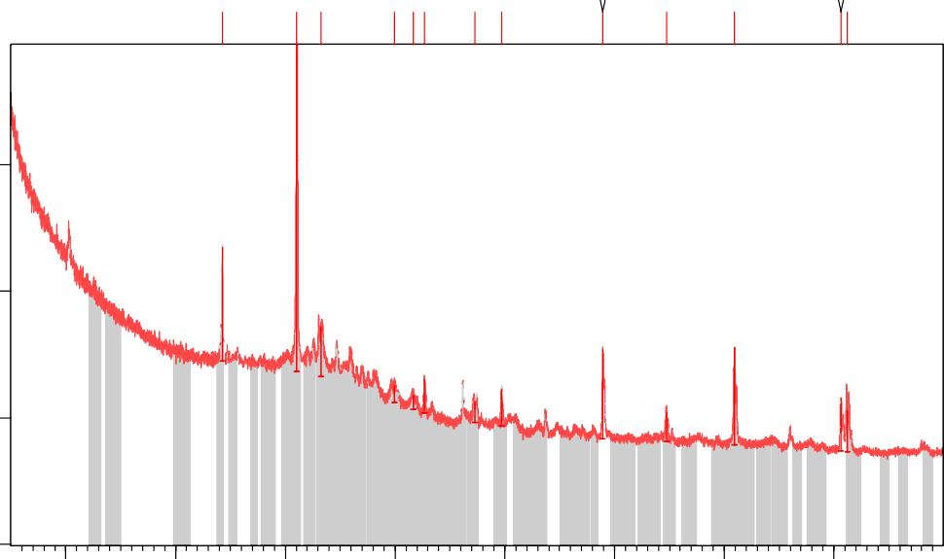

1.ASC

Mg Si O3; Si O2

3600

C60

1600

Si O2; Si C

Si O2

C60; Si O2; Si C

Mg Si O3

Mg Si O3; Si C

Si C

Mg Si O3; Si C

400

Si C

Si C

0

10 20 30 40 50 60 70 80

Position [°2Theta]

Fig. 4.1: XRD pattern of the coconut shell charcoal

Table 4.2: Identified compounds of coconut shell particles

|  |  |  |  |  |
| --- | --- | --- | --- | --- |
| **Ref. Code** | **Score** | **Compound Name** | **Scale Factor** | **Chemical Formula** |
| 49-1719 | 65 | Fullerite | 0.018 | C60 |
| 19-0769 | 12 | Clinoenstatite, syn | 0.232 | MgSiO3 |
| 47-1300 | 18 | Silicon Oxide | 0.054 | SiO2 |
| 82-1646 | 14 | Stishovite | 0.024 | SiO2 |
| 19-1138 | 27 | Moissanite-  2\ITH\RG, syn | 0.032 | SiC |

|  |  |  |  |  |
| --- | --- | --- | --- | --- |
| 49-1430 | 20 | Silicon Carbide | 0.044 | SiC |

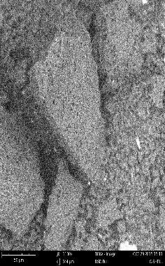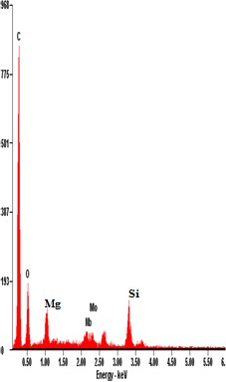

**Fig, 4.2: SEM/EDS pattern of the coconut shell charcoal powder**

**Table 4.3: Chemical Composition of pulverized coconut shell charcoal using carbonsulphuranalyzer**

|  |  |  |  |
| --- | --- | --- | --- |
| **Composition** | **Carbon** | **Sulphur** | **Other** |
| Percentage (%) | 53.69 | 0.013 | 46.297 |

# XRD AND SEM ANALYSIS OF THE PERIWINKLES SHELL (PS)

The XRD pattern of the periwinkles shell(PS) powder obtained has majordiffraction peaksat: 26.96, 34.06and phases at these peaks are: Calcite (𝐶𝑎𝐶𝑂3,Quartz, syn (SiO2) and Tilleyite (Ca5 Si2 O7 (CO3)2), while each of these phases has a score of 94, 25 and 13 (Figure 4.3 and Table 4.4). Complete analysis confirmed that the PS powder contained at least one of elements (C, O, Si, Ca). With Calcite (CaCO3) having higher score of 94 confirmed that PS powder is a calcium carbonate based materials.

The microstructure of the PS powder revealed that thesize andshapeofthepowderare porous and irregular. The EDS of the PS particles revealed that the particles contain Ca, Si, O (see Figure 4.4). These elements confirm that, the PS powder consists of calcium carbonate in the form of calcite (CaCO3).Tilleyite(Ca5 Si2O7(CO3)2)etc. These analyses are in agreement with the result of the XRD. Also in agreement with the earlier work of Aku*et al*(2012).

Counts

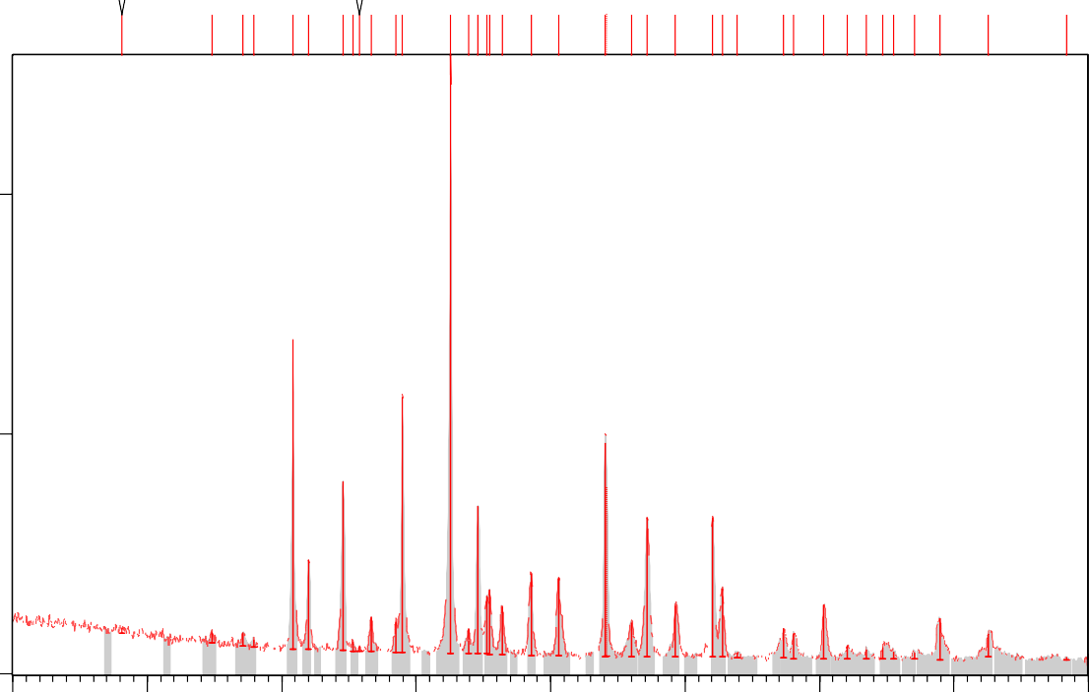

Clay powder-4 -ver3.raw

Ca C O3

1000

Ca C O3; Si O2

500

Ca C O3; Ca ( C O3 )

Ca C O3

Ca C O3; Ca ( C O3 )

Ca C O3; Ca ( C O3 )

Ca C O3

Ca C O3

Ca C O3; Ca C O3

CCaaCCOO33; Si O2

Fe.928 O

Ca C O3; Ca ( C O3 )

Ca C O3; Si O2

Ca C O3; Fe3 O4; Ca ( C O3 )

Ca C O3; Ca ( C O3 )

Ca C O3; Ca C O3

Ca C O3

Ca C O3

Si O2; Fe3 O4; Ca ( C O3 )

Ca C O3

Ca C O3; Ca ( C O3 ) Ca C O3

Ca C O3; Ca C O3; Si O2 Ca ( C O3 )

Si O2; Fe3 O4

Ca C O3; Ca C O3; Ca ( C O3 )

0

Ca C O3

Ca C O3

Fe3 O4

Ca C O3; Fe3 O4

Ca C O3

Ca C O3

Ca C O3

Fe3 O4; Ca ( C O3 )

Ca C O3; Ca ( C O3 )

10 20 30 40 50 60 70 80 90

Position [°2Theta]

**Fig, 4.3: XRD pattern of the periwinkles shell powder**

**Table 4.4: Identified compounds and chemical composition of periwinkle shell powder**

|  |  |  |  |  |  |
| --- | --- | --- | --- | --- | --- |
| **Ref. Code** | **Score** | **Compound**  **Name** | **Scale Factor** | **Chemical Formula** |  |
| 70-0095 | 36 | Calcium  Carbonate | 0.322 | CaCO3 |  |
| 03-1067 | 40 | Aragonite | 0.206 | CaCO3 |  |
| 81-0065 | 20 | Silicon Oxide | 0.248 | SiO2 |  |
| 75-0449 | 15 | Magnetite | 0.025 | Fe3O4 |  |
| 86-2334 | 21 | Calcite | 0.077 | CaCO3 |  |
| 79-2175 | 17 | W\PIstite, syn | 0.093 | Fe.928O |  |

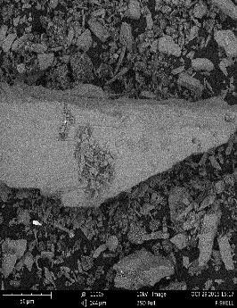

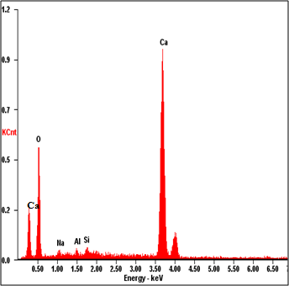

**Figure 4.4: SEM/EDS pattern of the periwinkles shell powder**

# XRF ANALYSIS OF THE PERIWINKLES SHELL

The XRF chemicalcompositionof the periwinkle shell particle isrepresentedin Table.

## Table 4.5: XRF analysis of pulverized periwinkle shell

|  |  |  |  |  |  |  |  |
| --- | --- | --- | --- | --- | --- | --- | --- |
| **Element** | **Al2O3** | **CaO** | **Fe2O3** | **TiO2** | **MgO** | **Na2O** | **SiO2** |
| % | 4.1 | 82.88 | 1.78 | 0.21 | 1.54 | 0.10 | 6.45 |

XRF analysis confirmed thatSiO2,CaO, MgO, Al2O3andFe2O3werefoundtobemajorconstituentsofthe periwinkles shell. With the present of high percentage of CaO mean that periwinkles shell can be used for carburizing and energizer. This result of XRF is in agreement with the result of XRD obtained.

# CARBURIZING PARAMETERS OF THE MILD STEEL SAMPLE

Table 4.6 to 4.14revealed the hardness valuesat various temperature and effect of energizer and the coconut shell charcoal during the diffusion of carbon into the various matrixof the steel rods.

**Table 4.6: Case depths for carburized steel rods (using different composition of pulverized periwinkle shell and coconut shell charcoal) at 850**℃ **for 1 hour**

|  |  |  |  |  |  |  |  |
| --- | --- | --- | --- | --- | --- | --- | --- |
| **Control Variables Exp. No** | **Pulverized Periwinkle shell (%)** | **Pulverized coconut shell charcoal**  **(%)** | **Carbon content after carburization (%C)** | **Case hardness values (HV 0.3kgf)** | **Core hardness values (HV**  **0.3kgf)** | **Case depth (mm)** | **Case depth hardness values** |
| Control | 0 | 100 | 0.45 | 429 | 241 | 0.5 | 340 |
| A1 | 5 | 95 | 0.47 | 457 | 257 | 0.6 | 350 |
| A2 | 10 | 90 | 0.52 | 457 | 258 | 0.8 | 400 |
| A3 | 15 | 85 | 0.56 | 520 | 260 | 1.0 | 410 |
| A4 | 20 | 80 | 0.76 | 545 | 254 | 1.1 | 400 |
| A5 | 25 | 75 | 1.03 | 561 | 290 | 1.2 | 415 |

**Table 4.7: Case depths for carburized steel rods (using different composition of pulverized periwinkle shell and coconut shell charcoal) at 850**℃ **for 2 hours**

|  |  |  |  |  |  |  |  |
| --- | --- | --- | --- | --- | --- | --- | --- |
| **Control Variables Exp. No** | **Pulverized Periwinkle shell (%)** | **Pulverized coconut shell charcoal**  **(%)** | **Carbon content after carburizat**  **ion (%C)** | **Case hardness values (HV**  **0.3kgf)** | **Core hardness values (HV**  **0.3kgf)** | **Case depth (mm)** | **Case depth hardness values** |
| Control | 0 | 100 | 0.60 | 432 | 251 | 1.1 | 350 |
| B1 | 5 | 95 | 0.67 | 404 | 236 | 1.2 | 380 |
| B2 | 10 | 90 | 0.87 | 465 | 238 | 1.3 | 400 |
| B3 | 15 | 85 | 0.88 | 487 | 239 | 1.5 | 420 |
| B4 | 20 | 80 | 1.01 | 537 | 223 | 1.6 | 440 |
| B5 | 25 | 75 | 1.28 | 568 | 289 | 1.6 | 450 |

**Table 4.8: Case depths for carburized steel rods (using different composition ofpulverized periwinkle shell and coconut shell charcoal) at 850**℃ **for 3 hours**

|  |  |  |  |  |  |  |  |
| --- | --- | --- | --- | --- | --- | --- | --- |
| **Control Variables Exp. No** | **Pulverized Periwinkle shell (%)** | **Pulverized coconut shell charcoal**  **(%)** | **Carbon content after carburizati**  **on (%C)** | **Case hardness values (HV 0.3kgf)** | **Core hardness values (HV**  **0.3kgf)** | **Case depth (mm)** | **Case depth hardness values (HV0.3kgf)** |
| Control | 0 | 100 | 0.70 | 444 | 310 | 1.0 | 400 |
| C1 | 5 | 95 | 0.72 | 467 | 261 | 1.1 | 410 |
| C2 | 10 | 90 | 0.89 | 490 | 274 | 1.2 | 420 |
| C3 | 15 | 85 | 1.01 | 572 | 280 | 1.5 | 440 |
| C4 | 20 | 80 | 1.02 | 575 | 333 | 1.6 | 450 |
| C5 | 25 | 75 | 1.70 | 598 | 373 | 1.8 | 460 |

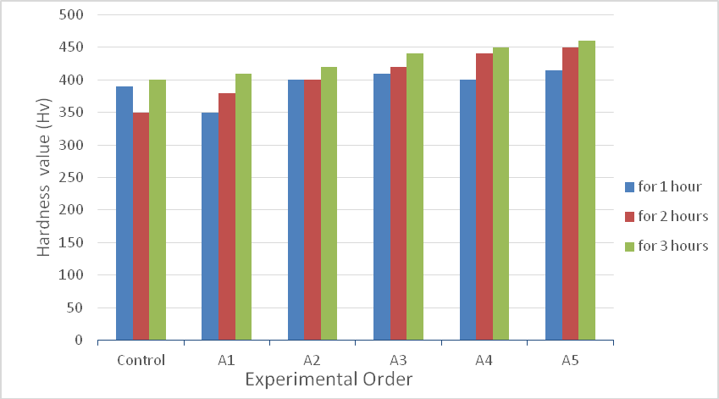

Fig. 4.5: Hardness Profile at 850℃

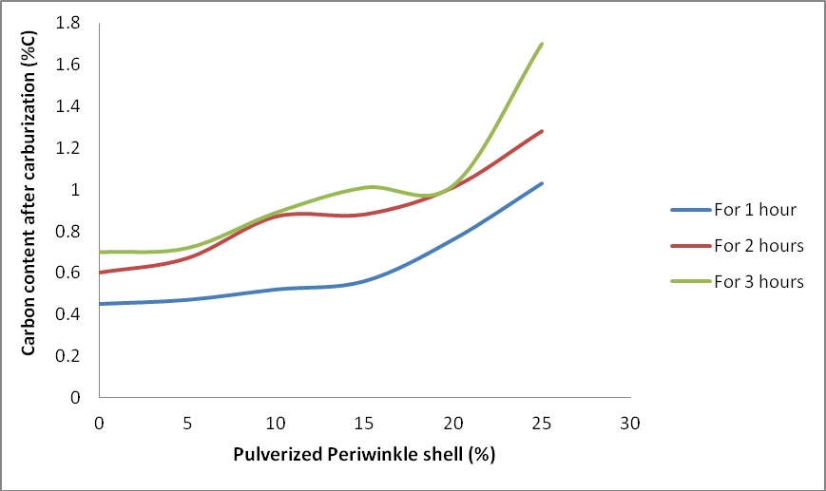

Fig. 4.6: Effect of the Energizer at 8500C

Figure 4.5 – 4.6 and Tables 4.6 – 4.8 showed that with increase in percentage of the energizer i.e. pulverized periwinkle shell, there is an increase in hardness value from 350Hv to 460Hv and effective case depth from 0.5mm to 1.8mm. Also, the carbon

content after carburization (%C) increases with increase in the percentage of pulverized periwinkle shell which served as energizer. The results indicate that the energizer facilities the increase of carbon from 0.45% to 1.70%.This result obtained compare favorably with the result by Rashmi*et al* (2012) and Asuquo et-al (2013a). The hardness values of carburized sample with 100% coconut shell charcoalincreases from 340Hv to 400Hv. **Table 4.9: Case depths for carburized steel rods (using different composition of pulverized periwinkle shell and coconut shell charcoal) at 900**℃ **for 1 hour**

|  |  |  |  |  |  |  |  |
| --- | --- | --- | --- | --- | --- | --- | --- |
| **Control Variables Exp. No** | **Pulverized Periwinkle shell (%)** | **Pulverized coconut shell charcoal**  **(%)** | **Carbon content after carburization (%C)** | **Case hardness values (HV 0.3kgf)** | **Core hardness values (HV**  **0.3kgf)** | **Case depth (mm)** | **Case depth hardness values** |
| Control | 0 | 100 | 1.61 | 514 | 305 | 1.2 | 380 |
| A1 | 5 | 95 | 1.65 | 547 | 310 | 1.3 | 380 |
| A2 | 10 | 90 | 1.78 | 527 | 294 | 1.4 | 380 |
| A3 | 15 | 85 | 1.79 | 606 | 255 | 1.8 | 400 |
| A4 | 20 | 80 | 1.82 | 618 | 284 | 1.9 | 420 |
| A5 | 25 | 75 | 1.83 | 680 | 318 | 2.0 | 440 |

## Table 4.10: Case depths for carburized steel rods (using different composition of pulverized periwinkle shell and coconut shell charcoal) at 900℃ for 2 hours

|  |  |  |  |  |  |  |  |
| --- | --- | --- | --- | --- | --- | --- | --- |
| **Control Variables Exp. No** | **Pulverized Periwinkle shell (%)** | **Pulverized coconut shell charcoal**  **(%)** | **Carbon content after carburization (%C)** | **Case hardness values (HV**  **0.3kgf)** | **Core hardness values (HV**  **0.3kgf)** | **Case depth (mm)** | **Case depth hardness values** |
| Control | 0 | 100 | 1.71 | 530 | 203 | 1.2 | 400 |
| B1 | 5 | 95 | 1.75 | 547 | 287 | 1.3 | 410 |
| B2 | 10 | 90 | 1.81 | 614 | 334 | 1.5 | 420 |
| B3 | 15 | 85 | 1.81 | 622 | 346 | 1.7 | 440 |
| B4 | 20 | 80 | 1.81 | 639 | 358 | 2.0 | 460 |
| B5 | 25 | 75 | 1.84 | 666 | 387 | 2.0 | 500 |

**Table 4.11: Case depths for carburized steel rods (using different composition of pulverized periwinkle shell and coconut shell charcoal) at 900**℃ **for 3 hours**

|  |  |  |  |  |  |  |  |
| --- | --- | --- | --- | --- | --- | --- | --- |
| **Control Variables Exp. No** | **Pulverized Periwinkle shell (%)** | **Pulverized coconut shell charcoal**  **(%)** | **Carbon content after carburization (%C)** | **Case hardness values (HV**  **0.3kgf)** | **Core hardness values (HV**  **0.3kgf)** | **Case depth (mm)** | **Case depth hardness values** |
| Control | 0 | 100 | 1.74 | 487 | 216 | 1.4 | 400 |
| C1 | 5 | 95 | 1.78 | 520 | 226 | 1.6 | 400 |
| C2 | 10 | 90 | 1.81 | 520 | 245 | 2.0 | 460 |
| C3 | 15 | 85 | 1.81 | 530 | 290 | 2.0 | 480 |
| C4 | 20 | 80 | 1.82 | 547 | 290 | 2.0 | 485 |
| C5 | 25 | 75 | 1.86 | 583 | 305 | 2.1 | 485 |

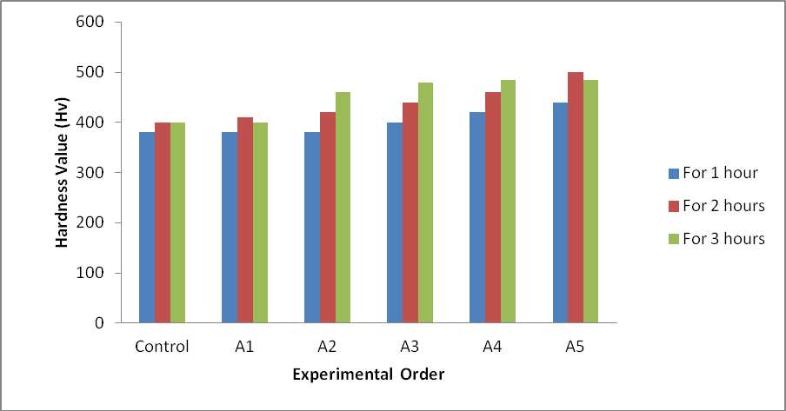

Fig. 4.7: Hardness Profile at 900℃

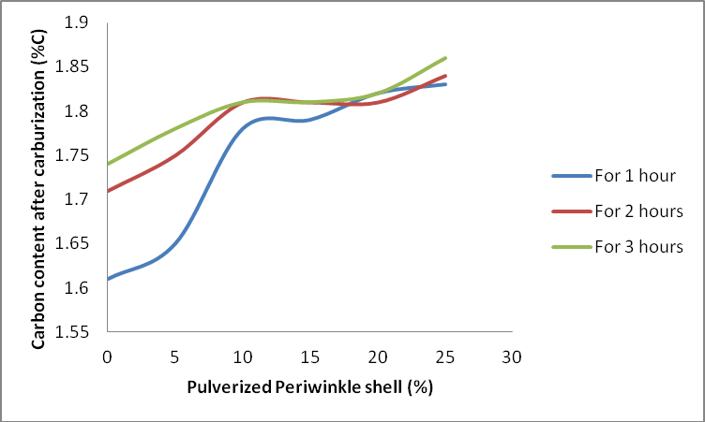

Fig. 4.8: Effect of the Energizer at 9000C

Also in Figure4.7 – 4.8 and Tables 4.9 – 4.11 the results showed thatwith increase in percentage of the energizer i.e. pulverized periwinkle shell, there is an increasein average hardness value from 380Hv to 500Hv and effective case depth from 1.2mm to

2.1mm at temperature of 900℃. Moreover, the carbon content after carburization (%C) increases with increase in the percentage of pulverized periwinkle shell which served as

energizer. The results indicate that the energizer facilitates the increase of carbon initially at high rate from 1.61% to 1.81%, but low rate from 1.81% to 1.86%.This result obtained compared favourably with the result by Asuquo*et al* (2013b) and Atanda*et al* (2009). The work is line with standard and previous work (see Table 4.14).

**Table 4.12: Case depths for carburized steel rods (using different composition of pulverized periwinkle shell and coconut shell charcoal) at 950**℃ **for 1 hour**

|  |  |  |  |  |  |  |  |
| --- | --- | --- | --- | --- | --- | --- | --- |
| **Control Variables Exp. No** | **Pulverized Periwinkle shell (%)** | **Pulverized coconut shell charcoal (%)** | **Carbon content after carburization**  **(%C)** | **Case hardness values (HV**  **0.3kgf)** | **Core hardness values (HV**  **0.3kgf)** | **Case depth (mm)** | **Case depth hardness**  **values** |
| Control | 0 | 100 | 1.74 | 564 | 195 | 1.0 | 400 |
| A1 | 5 | 95 | 1.76 | 586 | 249 | 1.2 | 460 |
| A2 | 10 | 90 | 1.77 | 614 | 286 | 1.6 | 530 |
| A3 | 15 | 85 | 1.8 | 622 | 377 | 1.8 | 540 |
| A4 | 20 | 80 | 1.84 | 627 | 432 | 1.8 | 550 |
| A5 | 25 | 75 | 1.86 | 631 | 473 | 2.1 | 625 |

**Table 4.13: Case depths for carburized steel rods (using different composition of pulverized periwinkle shell and coconut shell charcoal) at 950**℃ **for 2 hours**

|  |  |  |  |  |  |  |  |
| --- | --- | --- | --- | --- | --- | --- | --- |
| **Control Variables Exp. No** | **Pulverized Periwinkle shell (%)** | **Pulverized coconut shell charcoal**  **(%)** | **Carbon content after carburization (%C)** | **Case hardness values (HV**  **0.3kgf)** | **Core hardness values (HV**  **0.3kgf)** | **Case depth (mm)** | **Case depth hardness values** |
| Control | 0 | 100 | 1.79 | 666 | 394 | 1.8 | 460 |
| B1 | 5 | 95 | 1.79 | 594 | 432 | 1.8 | 480 |
| B2 | 10 | 90 | 1.8 | 618 | 459 | 1.9 | 540 |
| B3 | 15 | 85 | 1.82 | 662 | 473 | 1.9 | 540 |
| B4 | 20 | 80 | 1.85 | 690 | 462 | 2.0 | 580 |
| B5 | 25 | 75 | 1.87 | 690 | 411 | 2.2 | 600 |

**Table 4: 14: Case depths for carburized steel rods (using different composition of**

|  |  |  |  |  |  |  |  |
| --- | --- | --- | --- | --- | --- | --- | --- |
| **Control Variables Exp. No** | **Pulverized Periwinkle shell (%)** | **Pulverized coconut shell charcoal**  **(%)** | **Carbon content after carburization (%C)** | **Case hardness values (HV**  **0.3kgf)** | **Core hardness values (HV**  **0.3kgf)** | **Case depth (mm)** | **Case depth hardness values** |
| Control | 0 | 100 | 1.79 | 481 | 286 | 1.7 | 520 |
| C1 | 5 | 95 | 1.79 | 502 | 307 | 1.8 | 540 |
| C2 | 10 | 90 | 1.8 | 547 | 305 | 1.9 | 540 |
| C3 | 15 | 85 | 1.83 | 644 | 255 | 2.0 | 580 |
| C4 | 20 | 80 | 1.85 | 618 | 331 | 2.4 | 600 |
| C5 | 25 | 75 | 1.87 | 695 | 383 | 2.5 | 630 |

**pulverized periwinkle shell and coconut shell charcoal) at 950**℃ **for 3 hours**

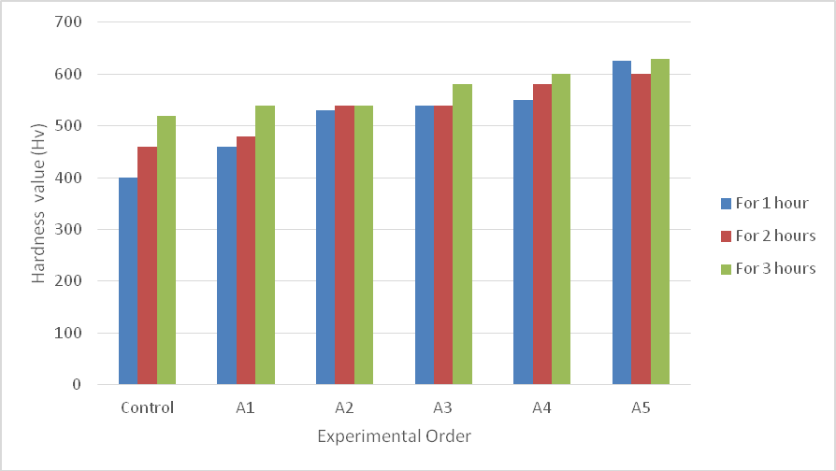

Fig. 4.9: Hardness Profile at 950℃

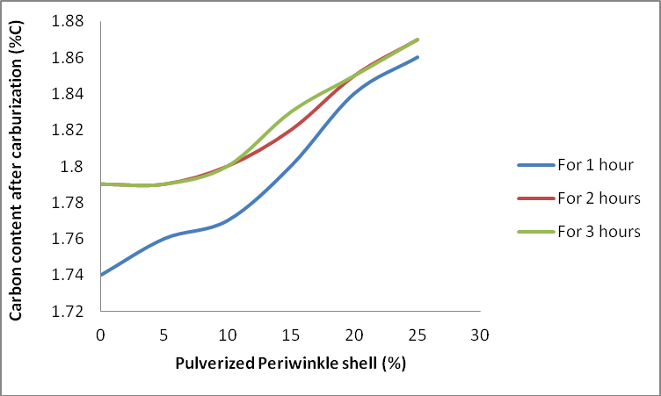

Fig. 4.10: Effect of the Energizer at 9500C

Figure4.9 – 4.10 and Tables 4.12 – 4.14 showedwith increase in percentage of the energizer i.e. pulverized periwinkle shell, there is an increase in average hardness value from 400Hv to 630Hv and effective case depth from 1.0mm to 2.5mm at temperature of950℃ and time changes from one to three hours. Furthermore, the

carbon content after carburization (%C) increases with increase in the percentage of pulverized periwinkle shell which served as energizer. However, the results indicate that the energizer facilitates the increase of carbon from 1.79 to 1.87% for two and three hours of carburizing time due to increase in time and temperature aiding diffusion rate of carbon into the steel**.**This result obtained compared favourably with the result obtained by Asuquo*et al* (2013b) and Atanda*et al* (2009).

# EFFECT OF TIME AND TEMPERATURE ON EFFECTIVE CASE DEPTH OF PACK CARBURIZATION

Figure 4.11 – 4.13 showed that with increase in carburizing time, the effective case depth increase from 0.5mm to 1.8mm at 850℃, 1.2mm to 2.1mm 900℃ and 1.0mm to

2.5mm 950℃. This was also influenced by the increase in the percentage of pulverized periwinkle shell which serves as energizer in the matrix of the carburizer. This is similar to the report byOhize (2009).

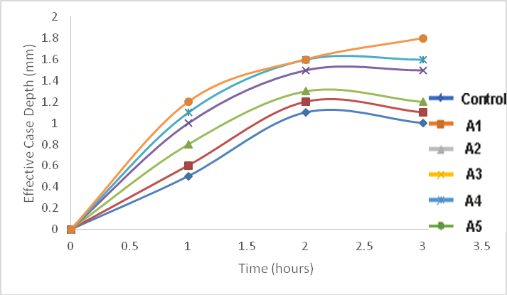

**Fig. 4.11:Effective Case Depth with Variationof Time at 850**℃

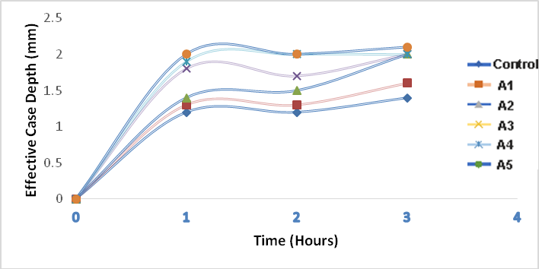

**Fig. 4.12:Effective Case Depth with Variationof Time at 900**℃

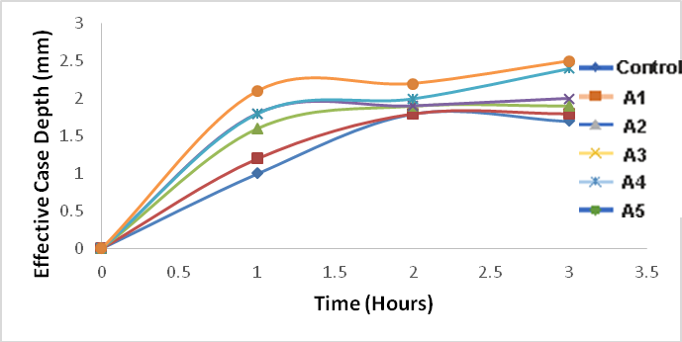

**Fig. 4.13:Effective Case Depth with Variationof Time at 950**℃

Figure 4.14 shows the graph of time and temperature on effective case depth for 75%wt coconut shell charcoal and 25%wt pulverized periwinkle shell used in carburization of mild steelat 850℃, 900℃ and 950℃ respectively. From the graph, the sample treated at 950℃ has the highest effective case depth. This is in line the report given by Rashmi*et al* (2012) and Asuquo*et al* (2013b).

**Fig. 4.14:Time at 850**℃**, 900**℃ **and 950**℃ **versus Effective Case Depth for Various Composition of Coconut Shell Charcoal and Periwinkle Shell**



**Time (Hour)**

4

3

2

1

0

0.5

0

For 850℃

For 900℃ for 950℃

3

2.5

2

1.5

1

**Effective Case Depth (mm)**

**Table 4.15: Comparison with previous work**

|  |  |  |  |
| --- | --- | --- | --- |
|  | **Optimum Hardness**  **values(Hv)** | **Case depth(mm)** | **Impact Energy(J)** |
| Aramide*et al*(2010) | 343.2 | --- | 60.4 |
| Ihom(2013) | 750 | 2.32 | ---- |
| ASM handbook | 620-772 | 125 μm–  1.5 mm |  |
| Priyadarshini*et al*(2014) | 294 | ---- | ----- |
| HeshamElzanaty(2014) | 551 – 694 | -- | ------ |
| Emmanuel Jose Ohize(2014) | 724.75-865 | --- | 7.0-14.0 |
| Ihom and Offiong(2014) | 830-900 | 1.8 | ------- |

# MICROSTRUCTURE OF THE VARIOUS SAMPLES

The microstructure of the as – received mild steel is shown in Micrograph 4.1. The micrograph showed the presence of pearlite(dark) in large ferrite structure(white). This is a confirmation that the steel used in the research is a mild carbon steel.

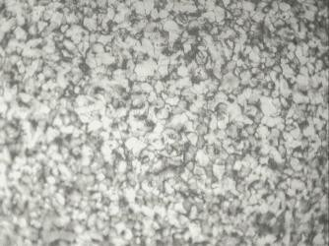

Ferrite

Pearlite

**Micrograph 4.1:** Microstructure of the as – received Mild Steel sample showing ferritic structure; Etchant used: Nital (x200)

Micrographs 4.2 and 4.3 were micrographs of carburized sample and carburized quenched and tempered sample respectively. The samples were selected from the many samples treated and this particular sample has composition of 75% pulverized coconut shell charcoal and 25% pulverized periwinkle shell at 950℃ for three hours. The area captured in the micrographs is within the compound layer and the diffusion layer, precipitates and tempered martensite can be seen in the structure. Micrographs

4.2 shows the present of pearlite and ferrite with a coarse grain size, while Micrographs 4.3 shows ferrite in the matrix of pearlite with a fine and compact grains which gives a higher value of hardness.

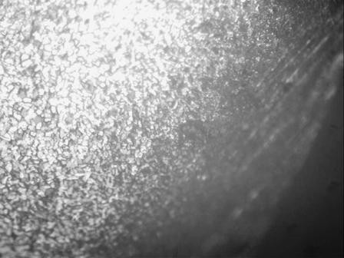

Ferrite

Cementite

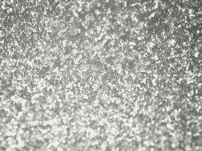

**Micrograph 4.2:** Microstructure of pack

carburized bright mild steel, 0.08% carbon. Carburized to produce a satisfactory case with a cementite network or eggshell hyper – eutectoid layer 1.87%C x200.Etchant: Nital

**Micrograph 4.3:** Microstructure of the carburized Quenched and Tempered at 200℃ for 1hour Sample x200

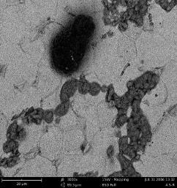**Plate 4.1:** SEM image of the as – received Mild Steel sample ×3000

Cementite Ferrite

Pearlite

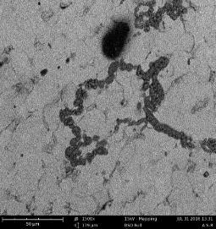

**Plate 4.2:** SEM image of the as – received Mild Steel sample ×1500

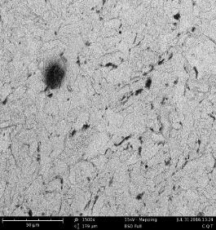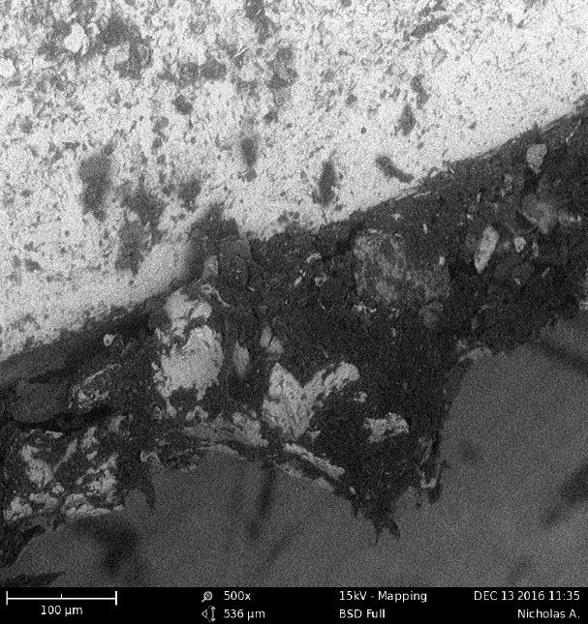

Pearlite

Pearlite

Ferrite

Ferrite

Cementite

**Plate 4.3:** SEM image of the carburized sample ×500

**Plate 4.4:** SEM image of the carburized Quenched and Tempered at 200℃ for 1hour Sample ×1500

From Plate 4.1 – 4.4 showedthe SEM image of as – received sample, carburized sample and carburized quenched and tempered sample. Plate 4.3 shows the presence of pearlite and ferrite with a coarse grain size and carbon ring layer, while Plate 4.4 shows pearlite and ferrite in the matrix of tempered martensite with a fine and compact grains which gives a higher value of hardness. This also support the earlier claimed that the optimized condition has the highest hardness values and case depth.The present study compared favorably with literature.

# EFFECT OF CARBON CONTENT ON CASE DEPTH WITH DIFFERENT CARBURIZING TIMES

From Figure 4.13 it was observed that as the weight percent (wt%) of carbon increases the case depth of the samples also increases. The presence of carbon increases the hardness of steel, hence, increasing the case depth. This is line with earlier observation that the higher the surface carbon after carburizing the higher the hardness values.

**Carbon wt %**

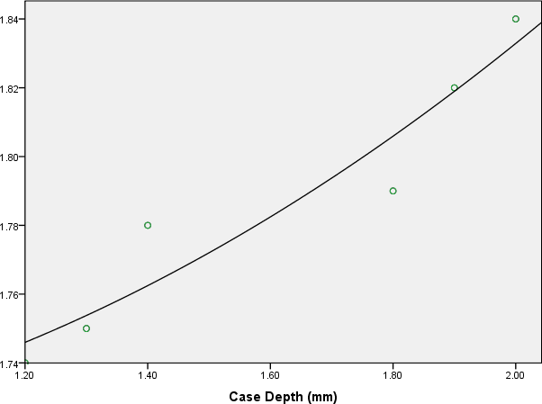

**Fig. 4.15: Variation of weight%C with case depth**

# IMPACT ENERGY TEST

W&T Avery Izod impact testing machine (type 6701) s/no E51425/9) was used to conduct impact energy test energy on the as – received, carburized and carburized quenched – tempered mild steel samples carburized using carburizing compound with ratio 75wt% pulverized coconut shell charcoal to 25wt% pulverized periwinkle shell at 950oC for 3 hours. The result obtained shows increase in the impact energy of the mild steel when subject to carburization and heat treatment which makes the steel to

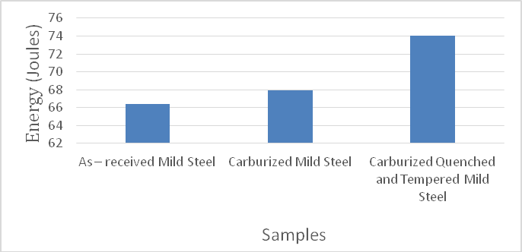be relieved of internal stress, hereby increase the toughness.The result obtained is shown in Figure 4.14and compared favourable with the result obtained by Atanda*et al* (2009) and Akinluwade*et al* (2012).

**Fig. 4.16: Impact Strength Test**

# WEAR RATE TEST

Table 4:18 shows the result of the wear rate test which was carried out at the optimum carburizing conditions (75wt% pulverized coconut shell charcoal to 25wt% pulverized periwinkle shell at 950oC in 3 hours) on the as - received, carburized and carburized quenched tempered. It was observed that the as-received sample had the highest wear rate. This could be attributed to the low hardness values obtained. The as – received sample had low carbon content and not heat treated making the hardness value low, hereby, given low resistance to wear to rate. This is in line with earlier report by Kumar *et al*(1995), Singh (2010) and Rashmi*et al* (2012) that the lowerthe hardness values the more the wear rate.

**Table 4.16: Result of Wear Rate**

|  |  |  |  |
| --- | --- | --- | --- |
| **S/No** | **Item** | **Worn Track**  **Section** 𝝁𝒎𝟐 | **Wear Rate**  **(mm3/N/m)** × 𝟏𝟎−𝟐 |
| 1. | As – received mild steel | 91322.0 | 3.654 |
| 2. | Carburized mild steel | 51192.9 | 2.609 |
| 3. | Carburized quenched –  tempered mild steel | 50568.6 | 2.023 |

# CHAPTER FIVE CONCLUSIONS AND RECOMMENDATIONS

# CONCLUSIONS

The study onsuitability of using pulverized coconut shell charcoal and periwinkle shell for carburizing 0.08% C mild steelwas carried out and the following conclusions were drawn:

* + 1. Case depth and hardness values can be increased by increasing carburization temperature and time.
    2. Samples with greater case depth and surface hardness showed better wear resistant than that with low case depth and low surface hardness.
    3. Optimum values of hardness were obtained at carburizing temperature of 950oC, carburizing time of 3 hours, carbon potential ratio of 75wt% pulverized coconut shell charcoal to 25wt% pulverized periwinkle shell, quenched and tempering temperature of 200oC and had the highest average effective case depth of 2.50 mm and hardness values of 630Hv.
    4. Impact test for the carburized quenched – tempered mild steel samples using carburizing compound ratio 75wt% pulverized coconut shell charcoal to 25wt% pulverized periwinkle shell at 950oC gave impact strength of 74 Joules.
    5. The wear rate of the carburized quenched – tempered mild steel samples carburized using carburizing compound with ratio 75wt% pulverized coconut shell charcoal to 25wt% pulverized periwinkle shell at 950oC was found to be

2.023 ×10-2mm3/N/m.

# RECOMMENDATIONS

After carrying out the suitability of using pulverized coconut shell charcoal and periwinkle shell for carburizing 0.08% c mild steel**.** The following recommendations are made as a result of the findings and implications of this study:

* + 1. Pulverized coconut shell charcoal and pulverized periwinkle shell powder can be effectively used as carburizing materials in the ratio of 75wt% pulverized coconut shell charcoal to 25wt% pulverized periwinkle shell at 950oC for 3 hours carburizing conditions.
    2. Workshops on process of pack carburizing with pulverized coconut shell charcoal and pulverized periwinkle shell should be organized for machinists, fabricators, blacksmiths and manufacturers engaged in the production and re-conditioning of steel parts like shafts, cams, gears, pinions, sprockets, hand tools and agricultural implements.
    3. The similar studies can be performed by increasing the carburization temperature, the soak time and tempering temperature
    4. Chemical method and visual method of case depth determination could be used in analyzing the case depth.
    5. Impact energy, wear test, SEM and micrograph analysis should be conducted for all the carburized and tempered samples.

# REFERENCES

Akinluwade, K. J., Adetunji, A. R., Adeoye, M. O., Umoru, L. E., Kalu, P. N., Taiwo,

A. T. and Adewoye, O. O(2012): Development of an Environmentally Friendly in- situ Pack-Cyaniding Technique *Journal of Minerals & Materials Characterization & Engineering*, Vol. 11, No.1, pp.21-30.

Aku, S.Y., Yawas D.S., Madakson P.B., and Amaren S.G. (2012): “Characterization of Periwinkle Shell as Asbestos-Free Brake Pad Materials”. *Pacific Journal of Science and Technology* Vol. 13, No. 2, pp57-63.

Aramide F. O., Ibitoye S. I., Oladele I.O. and Borode J. O. (2010a): Pack Carburization of Mild Steel, using Pulverized Bone as Carburize Optimizing Process Parameters, *Leonardo Electronic Journal of Practices and Technologies* ISSN 1583-1078 Issue 16, P.1-12

Aramide F. O., Ibitoye S. I., OladeleI.O. andBorode J. O. (2010):Pack Carburization of Mild Steel, using Pulverized Bone as Carburizer: Optimizing Process Parameters,*Leonardo Electronic Journal of Practices and Technologies Issue 16*.

Asia I. O. andOladojaN.A(2003): Determination of optimum dosage of coagulant/ flocculants needed for sludge treatment. *Journal of science, engineering and technology* Vol.10 No.3 pp 5031-5043

ASM international(2004). Metallography and Microstructure Vol 9

Asuquo L. O. and Ihom P A. (2013): Mathematical Modeling of the Hardness of Case Hardened Steel with Respect to Carburizing Time Research and Reviews: Journal of Engineering and Technology

Atanda P.O., Olorunniwo O.E., Umoru L.E., and Adeyeye A.D. (2009):A Study of Processing Parameters on the Carburization of C2R Steels, Journal of Minerals & Materials Characterization & Engineering, Vol. 8, No.2, pp 79-92

Baldissera P. and Delprete C. (2009): Effect of deep cryogenic treatment on static mechanical properties of 18NiCrMo5 carburized steel, Material and design: pp. 1435 –1440.

Butler R. A. (2006): Why is coconut replacing tropical rainforests? Why are biofuels fueling deforestation? [http://news.mongabay.com/2006/0425-ai)_palm.html.](http://news.mongabay.com/2006/0425-ai)_palm.html)

Callister W. D. (2007): Materials Science and Engineering: An Introduction, 7th Edition, John Wiley, New York

Child H.C. (1980): Surface Hardening of Steel (Engineering Design Guide),Oxford University press

Denis S. (1897): Coupled temperature stress, phase transformation calculation model numerical illustration of the internal stresses evolution during cooling of a eutectoid carbon steel cylinder. Metallurgical Transaction A; 18A: 1203-87.

Dieter G. E.(1988): Mechanical Metallurgy, 3rd Edition, McGraw Hills, Singapore, P – 277,333, 334.

Eke-Okoro, O. N., Olojede, O. A., and Nnodu, E. C. (1999). The use of bulking rate in selecting early maturing cassava cultivars. *J. Sustain. Agric. Environ.,* **1**(1): 134-137 Hassan K. S. (2014): Comparative of Wear resistance of low carbon steel pack carburizing using different media.*International Journal of Engineering &*

*Technology.* Pp 1-7

Hassan S. B., Agboola J. B., Aigbodion V. S. and Williams E. J. (2011): Hardening Characteristics of Plain Carbon Steel and Ductile Cast Iron Using Neem Oil as Quenchant, Journal of Minerals and Materials Characterization & Engineering (JMMCE), Printed in the U. S. A. 10(2), 161 – 172.

Higgins R.A (2004) Engineering Metallurgy Applied Physical Metallurgy, sixth Edition Viva Books private limited,New Delhi Pp463-470.

Ibironke O. J., Falaiye A., Ojumu T. V., Odo E. A. and Adewoye O. O. (2004) Case- Depth Studies of Pack Cyaniding of Mild Steel Using Cassava Leaves, Materials and Manufacturing Processes Vol. 19, No. 5, pp. 899–905

Ihom, A.P., Yaro, S.A., Aigbodion, V.S. (2005) The Effect of Carburization on the Corrosion Resistance of Mild Steel in Four Different Media, *Journal of Corrosion Science and Technology,* Vol. 3, Pp18-21.

Ihom, A, P. and Nyior, G.B., Suleiman, M.U. and Ibrahim, G.Z. (2011) Improving Surface Hardness of Steel using Rice Husk Waste, *Nigerian Journal of Tropical Engineering*Vol.1,No. 2, 107-115

Ihom, A.P., Nyior, G.B., Alabi, O.O., Segun, S, Nor, I.J. and Ogbodo, J.N. (2012) The Potentials of Waste Organic Materials for Surface Hardness Improvement of Mild Steel, *International Journal of Scientific and Engineering Research,* Vol.3. Issue 11 1-20

Ihom, A.P., Nyior, G.B., Nor, I.J., Ogbodo, N.J. (2013) Investigation of Egg Shell Waste as an Enhancer in the Carburization of Mild Steel, American Journal of Material Science and Engineering Vol. 1 No 2, 29-33

Ihom P. A. (2013): Case hardening of mild steel using cow bone as energizer, African Journal of Engineering Research Vol. 1(4), pp. 97-101

Izciler M. and Tabur M.(2006): Abrasive wear behavior of different case depth gas carburizedAISI gear steel, Wear, 220: pp. 90 – 98.

Khusid B. M. and Khina B.B.(1993): Wear of carburized high chromium steels, Wear,

pp. 109 – 112

Kumar M. and Gupta R. C. (1995): Abrasive wear characteristics of carbon and low alloy steels for better performance of farm implements, Journal of material science and technology, pp. 91 – 96.

Leblond J. B.(1989): Mathematical modeling of transformation plasticity in steels II: Coupling with strain hardening phenomena. *Int.JPlast*, pp573-1

Liu C. C., Xu X, Liu Z. A. (2003): modeling of quenching and tempering and its application in industrial engineering. Finite Elements in Analysis and Design,Vol. 39 No.11: pp1053-70.

Ohize E. J. (2009): Effects of Local in Carbonaceous Materials on the Mechanical Properties of Mild Steel, AU J.T. Vol. 13 No. 2: 107-113

Metals Handbook (1981): Heat-treating, Volume 4, American Society of Metals (ASM), 9thedition, 425.

PCU. (2003): Crop Area Yield Survey. Abuja, Nigeria: Federal Ministry of Agriculture and Rural Development: Project Coordinating Unit.

Palaniradja K., Alagumurthi N. and Soundararajan V.(2010): Hardness and Case Depth Analysis Through Optimization Techniques in Surface Hardening Processes, *The Open Materials Science Journal*Vol.4, pp38-63

Rajan T. V., and Sharma C.P. (1988): Heat Treatment Principles and Techniques, Hall of India Private limited, p. 45-150.

Rashmi R. P., Mohantyb A.M, Mohantac D.K (2012): Mechanical and Wear Properties of Carburized Low Carbon Steel Samples, *International Journal of Multidisciplinary and Current Research*

Ravendra S., Vedansh C., and Jyoti V. (2012): Investigation of Optimal ProcessParameters for Mechanical and Wear Properties of Carburized Mild Steel Using Taguchi Approach, Ijreas Vol.2, Issue 5

Rashavan V. (1989): Physical Metallurgy,principles and practice. *Indian institute of Technology*, Delhi, Hall of India.Pp-72-73.

Singh, V. (2004): Heat Treatment.Standard Publishers Distributors. Delhi Pp 337 – 340 Singh, V.(2010): Physical Metallurgy. Standard Publishers Distributors. DelhiPp542 –

576

Sunderesan, S., Nambisan, B., and D. Easwari, A. (1987). Bitterness in cassava in relation to cyanoglucoside contents*. Indian J. Agric. Sci.,* Vol.**57**: 37-40.

Wang KF, Chandrasekar S, Yang H. T. Y. (1997). Experimental and computational study of the quenching of carbon steel,*Intl. Journal Manufacturing Science Engineering*pp65

Xu D.H., Kuang Z.B. (1996): A study on the distribution of residual stress due to surface induction hardening. *International Journal Engineering MaterialTechnology*Vol. 2: 571-75.

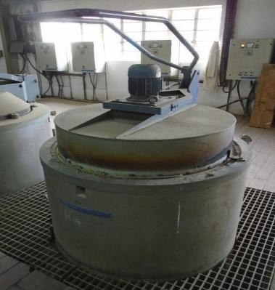Appendix 1: Photograph taking during the carburizing of the steel samples

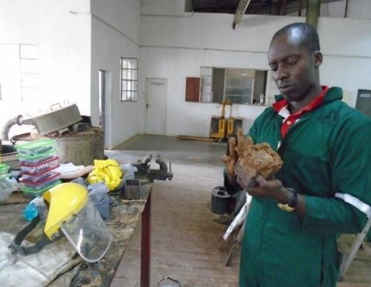

|  |  |
| --- | --- |
| **Plate A1:**DergussaDurferit electric furnace    **Plate A3:** Removing second set of the Container of Carburized Steel from the furnace | **Plate A2:**plastering the Container with clay before carburization    **Plate A4:**Removing first set of the  Container of Carburized Steel from the furnace |

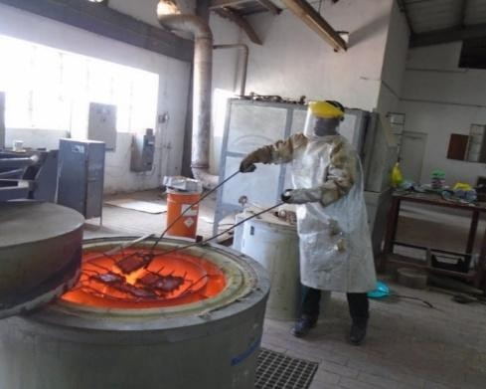

**Plate A5:** Removing the Container after tempering

Appendix 2: Micrographs result obtained for other authors

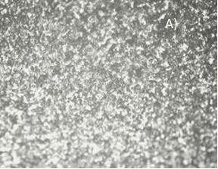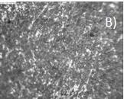

A B

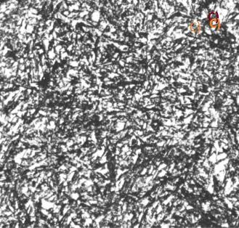

C

**Micrograph B1: A)** Microstructure obtained in this present work B) Microstructure obtained by Palaniradja*et al*(2010) using active carbon C) ASM(2004)

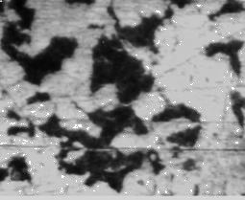

Sample A(as-recieved)

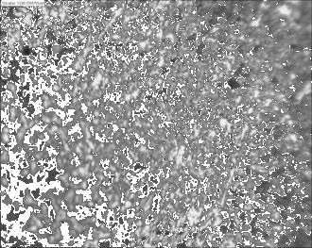 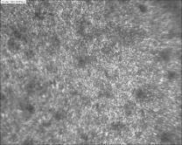

|  |  |
| --- | --- |
| Sample B (Case depth of 1.1mm) | Sample C (Case depth of 1.3mm) |
| Sample D (Case depth of 2.0mm) | Sample E (Case depth of 2.32mm) |

**Micrograph B2**: Micrograph of carburized Steel at 925°C with the soaking time of 2 hours. (Source: Hassan,2011)

Micrograph B1 and 2showed the comparison of the microstructure obtained after carburizing and tempered. From the Micrograph B1 and 2all the microstructure was tempered it was observed that all the microstructures revealed tempered martensiteand few ferrite structures.