EVALUATION OF PHARMACOGNOSTICPARAMETERS AND HEPATOTOXIC EFFECTS OF EXTRACTSOF *CASSYTHA FILIFORMIS* LINN

ON PARACETAMOL-INDUCED LIVER DISORDERS IN WISTER RATS

# By

**Aminu Ambi ADAMU**

# DEPARTMENT OF PHARMACOGNOSY AND DRUG DEVELOPMENT AHMADU BELLO UNIVERSITY, ZARIA

**NIGERIA**

# JANUARY, 2014

**EVALUATION OF PHARMACOGNOSTIC PARAMETERS AND HEPATOTOXIC EFFECTS OF EXTRACTSOF *CASSYTHA FILIFORMIS* LINN ON PARACETAMOL-INDUCED LIVER DISORDERS IN WISTER RATS**

# By

**Aminu AmbiADAMU, B. Pharm 1998, M.Sc. (ABU) Pharmacognosy 2006 Ph.D/Pharm. Sci/02275/2006-2007**

# A DISSERTATION SUBMITTED TO THE SCHOOL OF POST GRADUATE STUDIES,AHMADU BELLO UNIVERSITY, ZARIA

**IN PARTIAL FULFILMENT OF THE REQUIREMENTS FOR THE AWARDOF ADOCTOR OF PHILOSOPHY DEGREE IN PHARMACOGNOSY**

# DEPARTMENT OF PHARMACOGNOSY AND DRUG DEVELOPMENT, FACULTY OF PHARMACEUTICAL SCIENCES

**AHMADU BELLO UNIVERSITY, ZARIA NIGERIA**

# JANUARY, 2014 DECLARATION

I declare that the work in this Dissertation entitled **Evaluation of Pharmacognostic Parameters and Hepatotoxic Effects of Extractsof *Cassytha filiformis* Linn on Paracetamol-Induced Liver Disorders in Wister Rats**has been carried out by me in the Department of Pharmacognosy and Drug Development, Faculty of Pharmaceutical Sciences, Ahmadu Bello University, Zaria, Nigeria. The information derived from the literature has been duly acknowledged in the text and a list of references provided. No part of this Dissertation was previously presented for another Degree or Diploma at this or any other institution.

# …………………..……………………… Aminu Ambi ADAMU Signature Date

**CERTIFICATION**

This dissertation **Evaluation of Pharmacognostic Parameters and Hepatotoxic Effects of Extractsof *Cassytha filiformis* Linn on Paracetamol-Induced Liver Disorders in Wister Rats**by **Aminu Ambi ADAMU** meets the regulations governing the award of the degree of Doctor of Philosophy (Pharmacognosy) of Ahmadu Bello University, and is approved for its contribution to knowledge for both literary and presentation.

# Prof. K. Y. Musa Date

**Chairman Supervisory Committee,**

Department of Pharmacognosy and Drug Development, Ahmadu Bello University, Zaria.

# Prof. M. S. Abubakar Date

**Member, Supervisory Committee,**

Department of Pharmacognosy and Drug Development, Ahmadu Bello University, Zaria.

**Prof. N. D. G. Ibrahim**. Date

# Member, Supervisory Committee,

Department of Veterinary Pathology and Microbiology, Ahmadu Bello University, Zaria.

# Prof. M. S. Abubakar Date

**Head of Department,**

Pharmacognosy and Drug Development, Ahmadu Bello University, Zaria.

# Prof. A. A. Joshua Date

**Dean,**

School of Postgraduate Studies,

Ahmadu Bello University, Zaria.

# DEDICATION

This work is dedicated to my late father Senator Adamu Ambi Muhammad (Majidadin Bauchi) who laboured very hard and constantly prayed and encouraged me to face life challenges head on, but could not be there to reap the fruits of his labour. He passed away in June 2010. May Allah SubhanahuWata’ala reward him with Jannatulfirdaus. Amin!

# ACKNOWLEDGEMENT

I will like to start by acknowledging Allah (SWT) for given me the opportunity to start and complete this Ph.D program successfully. My profound gratitude goes to my main supervisors Prof. Kabir Musa Yusuf, Prof. MujtabaSulaimanAbubakar, first class gentlemen. Despite their tight schedules, they provided effective supervision of this research work. My appreciation also goes to my co-supervisor in the persons of Professor N. D. G. Ibrahim of the Department of Veterinary Pathology and Microbiology, Faculty of Veterinary Medicine, Ahmadu Bello University, Zaria who took the whole of his time in interpreting the numerous slides, reading and correcting the thesis. Their combined roles to ensure that this research work is a success cannot be over emphasized. Thank you so much.

My sincere gratitude goes to my father, Senator (Alhaji) Adamu Ambi Mohammed, Majidadin Bauchi, my mother Hajiya Rabi Adamu, my wife Fatima Garba Nuru, my five children, Rabi’atu and the twinsIliyasu and Safiya, Hasoor, Huzaifa and Maimuna (Mama Awanke) my numerous brothers, sisters, cousins, and aunties, who made significant contributions in making sure that this research work succeeds.

This work could never have been completed without mentioning the advisory roles played by my mentors, friends and colleagues Dr. Umar Usman Pateh, Dr. Muhammad Ibrahim Sule, Prof Haruna Abdu Kaita, Prof. Magaji Garba, Prof. EzzeidenMukhtar Abdurrahman, Dr. Garba Ibrahim, Dr. Habibu Umar Danmallam, Hon. (Dr.) Umar Adam Katsayal, Dr. AbdulkarimAgunu, Prof. Hajara Ibrahim, Dr.

HadizaNuhu and Malan Mansur Muhammad, senior and non-academic staff of the Department of Pharmacognosy and Drug Development and all the other colleagues in the other Departments of the Faculty of Pharmaceutical Sciences are fully acknowledged.

I will also want to specially thank Dr. Nasiruddeen Muhammad Baba, Department of Chemistry, University of London and Dr. AbubakarAlhajiAmmali, Department of Pharmacology and Therapeutics, University of Putra Malaysia for taking so much of their time to analyse my sample. Dr. M. G. Muhammad, Dr. Musa Aliyu, Professor Ibrahim Iliya for their immense help in the interpretation of the various spectra. I will not forget Dr. Ahmed Abubakar the Departmental Post Graduate Coordinator for his encouragements, guidance and immense help.

My very good friends HasoorMahmood, Sale YarimaLamido, Daudu Garba Sakwa, Idris Ibrahim Jibo, BabajiIsahNingi, Abdulkadir Ahmad,Abdullahi Umar Alkaleri, and BappahJalam, for their good advice, support and encouragements. I thank you all so much and may Allah SubhanahuWaTa’alaa reward you abundantly. Amin.

This dissertation has been completed with the Research grants received from University Board of Research, Bauchi State government, Mac-Arthur Foundation Project Grants and **STEP-B Grants**. I remain highly grateful.

# ABSTRACT

*Cassytha filiformis,* a leafless and perennial vine with small scales as a replacement of the leavesis currently being used in the treatment of various disease conditions including jaundice without standardization.Microscopical evaluation, chromatographic analysis (TLC, HPLC, LC-MS/MS), spectroscopic analyses (NMR, FTIR, MS) and hepathoprotective studies were carried out with the view to scientifically verify the potentials of this plant used in traditional medicine. The results revealed the presence of some diagnostic microscopical features such as paracytic stomata, unicellular covering trichomes with cystoliths, prismatic calcium oxalate crystals and annular xylem vessels. Quantitative physical constants include moisture contents (5.5 %), ash value (17 %), acid insoluble ash value (1 %), total tannins (27.3 %), swelling index (165 %), water, alcohol and oil extractive indices (20.6 %, 13.6 % and 1.6 % respectively). Trace metals detected in *C. filiformis* such as Fe (165.4279 ppm), Mn (14.4093 ppm) and Ni (2.7933 ppm) which are essential were higher than FAO/WHO (1984) permissible limit for edible plants. While others:Pb (0.0568 ppm) Zn (0.1094 ppm), Cd (0.0103 ppm) and Cu (0.0535 ppm) were found to be within the safety limit. Preliminary phytochemical screening of the plant signifies the presence of alkaloids, tannins, flavonoids, saponins and steroids Phytochemical constituents identified in ethyl acetate and methanol extracts of *C. filiformis* include 3,3,O-di-O-methyl ellagic acid, catechin, chalcone compounds, *p-* hydroxybenzoic acid, isorhamnetin 3-O-rutinoside or isorhamnetin 3-O-

neohesperidoside, kaemferol 3 rutinoside and 2-{cyclohex-2-en-1- yl(hydroxyl)methyl}-3-hydroxy-4-(2-hydroxyethyl)-3-methyl- oxoprolinate while that of methanol fraction include 3,3,O-di-O-methyl etllagic acid, methy2-

{cyclohex-2-ene-1-y(hydroxyl)methyl}-3-hydroxy-4-(2-hydroxyethyl)-3-methyl-5- oxoprolinate, kaemferol 3 rutinoside, rutin and cathechinas revealed by the library search on LC-MS/MS. Other compounds β-sitosterol and stigmasterol wereisolated from petroleum ether extracts.The petroleum ether extract (500 mgkg-1) and methanol (500 and 1000 mgkg-1) exhibited hepatoprotection properties on wistar albino rats. These results could serve as bases for the use of the plant in traditional medicine for the prevention of liver disorders.

|  |  |  |
| --- | --- | --- |
| **TABLE OF CONTENTS** |  | |
| Title page |  | i |
| Declaration |  | ii |
| Certification |  | iii |
| Dedication |  | iv |
| Acknowledgement |  | v |
| Abstract |  | vii |
| Table of Contents |  | ix |
| List of Tables |  | xiv |
| List of Figures |  | xv |
| List of Plates  List of Appendices | xvii | xix |
| List of Abbreviations |  | xx |
| **CHAPTER 1.0 INTRODUCTION** |  | **1** |
| 1.1 Introduction |  | 1 |
| 1.2 Statement of Research Problems |  | 5 |
| 1.3 Justification of the Study |  | 7 |
| 1.4 Aims and Objectives of the Study |  | 7 |

CHAPTER 2.0 LITERATURE REVIEW 8

* 1. Description of the family lauraceae 8
     1. Description of the genus Cassytha 8
     2. Morphological description of the specie C. filiformis 8
     3. Ethomedical uses of C. filiformis 11
     4. Phytochemical constituents of C. filiformis 12
     5. Biological activity of C. filiformis 15
  2. Hepatotoxicity and its Mechanism 16
     1. Pharmacological evaluation of hepatoprotective plants 18
  3. Conventional Management for Liver Disorders 21
  4. Contributions of Metals to Potential Treatments for Hepatic

Disorders 22

* 1. Medicinal Plants and Natural Products Used in the Management of

Liver disorder. 25

* 1. Research Techniques inPharmacognosy 32

Chapter 3.0 MATERIALS AND METHOD 33

* 1. Collection, Identification and Processing of Cassytha filiformis 33
     1. Collection of C. filiformis 33
     2. Identification of C. filiformis 33
     3. Processing of C. filiformis 33
  2. Equipment, Solvents and Reagents 33
     1. List of Equipment and other laboratory apparatus 33
     2. Solvents 35
     3. Preparation of Reagents / Solutions 35
  3. Pharmacognostic Studies of Cassytha filiformis 37
     1. Macroscopical studies of C. filiformis 37
     2. Microscopical studies of C. filiformis 38
  4. Phytochemical Studies of C. filiformis 40
     1. Test for alkaloids 40
     2. Test for cyanogenic glycosides 41
     3. Test for cardiac glycosides 41
     4. Test for Tannins 42
     5. Test for antraquinones (Borntrager’s reaction) 42
     6. Test for flavonoids 42
     7. Test for saponins 43
     8. Test for terpenoids 44
  5. Determination of Numerical Standards of C. filiformis 44
     1. Determination of Water-soluble Extractive Values 44
     2. Determination of Alcohol-soluble Extractive Values 45
     3. Determination of moisture content (loss on drying) 45
     4. Determination of total ash 45
     5. Determination of acid-insoluble ash 46
     6. Determination of bitterness value 46
     7. Determination of total tannins 48
     8. Determination of swelling index 49
     9. Determination of crude lipid 50
     10. Determination of crude fibres 50
  6. Extraction of powdered C. filiformis 51
  7. Analysis of metals of the powdered *C. filiformis* using atomic absorption spectrophotometry 52
  8. Chromatographic and Spectroscopic Studies 52
     1. Thin layer chromatography of the extracts 52
     2. Column Chromatographic separation of petroleum ether extract 52
     3. Melting Point analysis 53
     4. Spectroscopy of isolated compound 5B 53
     5. High performance liquid chromatography (HPLC) 54
     6. Liquid chromatography mass spectrometry/mass spectrometry (LCMS/MS) 54
  9. Hepatoprotective Studies of Cassytha filiformis 55
     1. Animals 55
     2. Drugs 55
     3. Test of acute toxicity of C. filiformis 55
     4. Experimental Design 56
     5. Histopathological studies of C. filiformis 57

Chapter 4.0 RESULTS 58

* 1. Collection, Identification and Processing of Cassytha filiformis 58
     1. Collection ofC. filiformis 58
     2. Identification ofC. filiformis 58

|  |  |  |
| --- | --- | --- |
| 4.2 | Equipment, Solvents and Reagents | 58 |
| 4.2.1 | Equipment | 58 |
| 4.2.2 | Solvents/Reagents | 58 |
| 4.3 | Pharmacognostic Studies of *Cassytha filiformis* | 59 |
| 4.3.1 | Macroscopic and Organoleptic Properties of *C. filiformis* | 59 |
| 4.3.2 | Microscopic Examination of *C. filiformis* | 59 |
| 4.3.3 | Chemomicroscopical examination of powdered *C. filiformis* | 63 |
| 4.4 | Preliminary Phytochemical Screening of *C. filiformis* | 65 |
| 4.5 | Numerical Standard of *C. filiformis* | 67 |
| 4.6: | Extraction of Powdered *C. filiformis* | 69 |
| 4.7 | Analysis of metals detected in powdered *C. filiformis* | 69 |
| 4.8 | Chromatography and Spectroscopy | 71 |
| 4.8.1: | Thin layer chromatography Profile of extracts | 71 |
| 4.8.2: | Column chromatography of petroleum ether extract | 75 |
| 4.8.3 | Melting point of 5B | 79 |
| 4.8.4 | Spectroscopic analysis | 81 |
| 4.8.5: | HPLC analysis for ethyl acetate and methanol extracts from *C. filiformis* | 87 |
| 4.8.6: | LCMS/MS analysis for ethyl acetate and methanol fractions from |  |
|  | *C. filiformis* | 92 |
| 4.9 | Hepatoprotective Studies of *Cassytha filiformis* | 108 |
| 4.9.1 | Acute toxicity studies on extracts of *C. filiformis* extracts | 108 |

4.9.2 Histopathological studies 110

# CHAPTER 5.0 DISCUSSION 123

5.1 Discussions 123

# CHAPTER 6.0 CONCLUSION AND RECOMMENDATION 131

* 1. Conclusion 131
  2. Recommendation 132

References 133

Appendix 142

**LIST OF TABLES**

|  |  |  |
| --- | --- | --- |
| Table 4.3.3: | Chemomicroscopical features from the powdered *C. filiformis* | 64 |
| Table 4.4: | Preliminary phytochemical screening of *C. filiformis* | 66 |
| Table 4.5: | Numerical Standards of *C. filiformis* | 68 |
| Table 4.7: | Elemental analysis of powdered *C. filiformis* | 70 |
| Table 4.8.4: | NMR Signals of Selected protons of Compound 5B Measured in CDCl3 at 500 MHz | 81 |
| Table 4.9.1: | Acute toxicity studies of *C. filiformis* Extracts | 109 |
| Table 4.9.2: | Histopathology report | 110 |

# LIST OF FIGURES

Fig. 1: Reported isolated compounds from *C. filiformis* 14

Fig. 2: 1H NMR spectrum of 5B in CDCl3 500MHz 82

Fig. 3: 1H-H COSY spectrum of 5B in CDCl3 500MHz 83

Fig. 4: Mass spectrum of 5B (Electron impact) 84

Fig. 5: Mass spectrum of 5B (Chemical ionization) 85

Fig. 6: FT-IR spectrum of 5B 86

Fig. 7: HPLC chromatogram of ethyl acetate extract at 254 nm 88

Fig. 8: HPLC chromatogram of ethyl acetate extract at 360 nm 89

Fig. 9: HPLC chromatogram of methanol extract at 254 nm 90

Fig. 10: HPLC chromatogram of methanol extract at 360 nm 91

Fig. 11: Compounds identified by LCMS/MS from ethyl acetate and methanol extracts. 93

Fig. 12: LCMS/MS chromatogram from ethyl acetate extract of *C. filiformis* 94

Fig. 13: LCMS/MS chromatogram and spectrum of 3,3,O-di-O-methyl ellagic acid from ethyl acetate extract of *C. filiformis.* 95

Fig. 14: LCMS/MS chromatogram and spectrum of catechin from ethyl acetate extract of *C. filiformis* 96

Fig. 15: LCMS/MS chromatogram and spectrum of Chalcone compounds from ethyl acetate extract of *C. filiformis* 97

Fig. 16: LCMS/MS chromatogram and spectrum of p hydroxybenzoic acid from ethyl acetate extract of *C. filiformis* 98

Fig. 17: LCMS/MS chromatogram and spectrum of isorhamnetin 3-O-rutinoside or isorhamnetin 3-O-neohesperidoside from ethyl acetate extract of *C. filiformis*

99

Fig. 18: LCMS/MS chromatogram and spectrum of kaemferol 3 rutinoside from ethyl acetate extract of *C. filiformis* 100

Fig. 19: LCMS/MS chromatogram and spectrum of 2-{cyclohex-2-en-1-yl (hydroxyl) methyl}-3-hydroxy-4-(2-hydroxyethyl)-3-methyl-5-oxoprolinate from ethyl acetate extract of *C. filiformis* 101

Fig. 20: LCMS/MS chromatogram from methanol extract of *C. filiformis* 102

Fig. 21: LCMS/MS chromatogram and spectrum of 3,3,O-di-O-methyl ellagic acid from methanol extract of *C. filiformis* 103

Fig.22: LCMS/MS chromatogram and spectrum of methy 2-{cyclohex-2-ene-1- y(hydroxyl)methyl}-3-hydroxy-4-(2-hydroxyethyl)-3-methyl-5-oxoprolinate from methanol extract of *C. filiformis* 104

Fig. 23: LCMS/MS chromatogram and spectrum of kaemferol 3 rutinoside from methanol extract of *C. filiformis* 105

Fig. 24: LCMS/MS chromatogram and spectrum of rutin from methanol extract of *C. filiformis* 106

Fig. 25: LCMS/MS chromatogram and spectrum of catechin from methanol extract of *C. filiformis* 107

Fig. 26: Isolated compounds from petroleum ether extract of *C. filiformis* 128

**LIST OF PLATES**

Plate I: The plant *Cassytha filiformis* 10

Plate II: Transverse section of *C. filifomis*stem 60

Plate III: Longitudinal section of *C. filifomis*stem 61

Plates IV: Microscopical features of powdered whole plant of C*. filiformis* 62

Plate V: Chromatogram of Pet ether (PE), Ethyl acetate (EA) and Methanol (ME) Extracts of C. filiformis Developed using Solvent System : EtOAc-CHCl3, MeOH, H2O ( 15-8-4-1). Sprayed with FeCl3 (A), Anisaldehyde (B) and Drangendoff’s Reagents 72

Plate VI: Chromatogram of Pet ether (PE), Ethyl acetate (EA) and Methanol (ME) Extracts of C. filiformis Developed using Solvent System BuOH-Acetic acid- H2O (6-1-1). Sprayed with FeCl3 (A), Anisaldehyde (B) and Drangendoff’s Reagents 73

Plate VII: Chromatogram of Pet ether (PE), Ethyl acetate (EA) and Methanol (ME) Extracts of C. filiformis Developed using Solvent System : Hex- EtOAc ( 2-

1. Sprayed with FeCl3 (A), Anisaldehyde (B) and Drangendoff’s Reagents 74

Plate VIII:Some column chromatographic profile of pet ether extract of *C. filiformis*

76

Plate IX:Some column chromatographic profile of pet ether extract of *C. filiformis*77

Plate X:TLC chromatogram of fractions obtained in the second column chromatography for pooled fractions, Hex: EtOAc (10:5) visualised with 10 % H2SO4 78

Plate XI: TLC plates of 5B developed in Hexane: Ethyl acetate (2:1) 80

Plate XII: Photomicrograph of a section of Liver from a rat dosed with 1.5 gkg-1 ethyl acetate extract of *C. filiformis* at 24 hr, 44 hr and 46 hr intervals,

followed by a single dose of Paracetamol 1.5 gkg-1 at 48 hr. 111

Plate XIII: Photomicrograph of a section of Liver from a rat dosed with 1 gkg-1 ethyl acetate extract of *C. filiformis* at 24 hr, 44 hr and 46 hr intervals, followed by a single dose of Paracetamol 1.5 gkg-1 at 48 hr. 112

Plate XIV: Photomicrograph of a section of Liver from a rat dosed with 0.5 gkg-1 ethyl acetate extract of *C. filiformis* at 24 hr, 44 hr and 46 hr intervals, followed by a single dose of Paracetamol 1.5 gkg-1 at 48 hr. 113

Plate XV: Photomicrograph of a section of Liver from a rat dosed with 1.5 gkg-1 petroleum ether extract of *C. filiformis* at 24 hr, 44 hr and 46 hr intervals, followed by a single dose of Paracetamol 1.5 gkg-1 at 48 hr. 114

Plate XVI: Photomicrograph of a section of Liver from a rat dosed with 1 gkg-1 petroleum ether extract of *C. filiformis* at 24 hr, 44 hr and 46 hr intervals, followed by a single dose of Paracetamol 1.5 gkg-1 at 48 hr. 115

Plate XVII: Photomicrograph of a section of liver from a rat dosed with 0.5 gkg-1 petroleum ether extract of *C. filiformis* at 24 hr, 44 hr and 46 hr intervals, followed by a single dose of paracetamol 1.5 gkg-1 at 48 hr.116

Plate XVIII: Photomicrograph of a section of Liver from a rat dosed with 1.5 gkg-1 methanol extract of *C. filiformis* at 24 hr, 44 hr and 46 hr intervals, followed by a single dose of Paracetamol 1.5 gkg-1 at 48 hr. 117

Plate XIX: Photomicrograph of a section of Liver from a rat dosed with 1 gkg-1 methanol extract of *C. filiformis* at 24 hr, 44 hr and 46 hr intervals, followed by a single dose of Paracetamol 1.5 gkg-1 at 48 hr. 118

Plate XX: Photomicrograph of a section of Liver from a rat dosed with 0.5 gkg-1 methanol extract of *C. filiformis* at 24 hr, 44 hr and 46 hr intervals, followed by a single dose of Paracetamol 1.5 gkg-1 at 48 hr. 119

Plate XXI: Photomicrograph of a section of Liver from a rat dosed with 2 ml normal saline at 24 hr, 44 hr, 46 hr and 48 hr intervals. 120

Plate XXII: Photomicrograph of a section of Liver from a rat dosed with 2 ml normal saline at 24 hr, 44 hr and 46 hr intervals, followed by a single dose of Paracetamol 1.5 gkg-1 at 48 hr. 121

Plate XXIII: Photomicrograph of a section of Liver from a rat dosed with 20 mgkg-1 silymarin at 24 hr, 44 hr and 46 hr intervals followed by single dose of paracetamol 1.5 gkg-1 at 48 hr. 122

# LIST OF APPENDICES

APPENDIX A: Calculation procedures for numericalstandard 142

APPENDIX B: Analysis of metals by atomic absorption spectrophotometer (AAS)

148

APPENDIX C: Some microscopical features powdered *C. filiformis* 151

# LIST OF ABBREVIATIONS

|  |  |
| --- | --- |
| %: | Percent |
| µL: | Microliter |
| µm: | Micro meter |
| µM: | Micro molar |
| 0C: | Degree Centigrade |
| 1HNMR: | Proton NMR |
| A: | Amperes |
| AAS: | Atomic Absorption Spectrophotometer |
| ABU: | Ahmadu Bello University |
| ALP: | Alkaline Phosphatase |
| ALT: | Alanine Amino Transferase |
| AOAC: | Association of Official Analytical Chemists |
| AST: | Aspartate Amino Transferase |
| ATP: | Adenosine Triphosphate |
| BHT: | ButylatedHydroytoluene |
| br s: | Broth singlet |
| CaCO3: | Calcium Carbonate |
| CAT: | Catalase |
| CCl4: | Carbon tetrachloride |
| CDCl3: | Deutrated Chloroform |
| Cl: | Chlorine |
| Cr: | Chromium |
| d: | Doublet |
| dd: | Double doublet |
| DNA: | Deoxyribonucleic acid |

|  |  |
| --- | --- |
| DPPH: | 1,1-diphenyl-2-picrylhydrazyl |
| e.g: | Example |
| EI/CI: | Electron Impact/Chemical Ionization |
| EP: | European Pharmacopoeia |
| ESI: | Electron spray Ionization |
| Etc: | Etcetera |
| FAB: | Fast Atomic Bombardment |
| FDA: | Food and Drug Administration |
| Fig: | Figure |
| FTC: | Ferric Thiocyanate |
| FT-IR: | Fourier Transform Infrared Spectrometer |
| g: | Gram |
| gkg-1: | Gram per Kilogram |
| GOT: | Glutamate Oxaloacetate Transaminase |
| GPT: | Glutamate Pyruvate transaminase |
| GPx: | Glutathione Peroxidase |
| GSH: | Glutathione |
| GST: | Glutathione Transferase |
| H & E: | Haematoxylin and Eosin |
| H2SO4: | Tetraoxosulphate VI acid |
| HCl: | Hydrochloric Acid |
| HNO3: | Nitric Acid |
| HPLC: | High Performance Liquid Chromatography |
| hr: | Hour(s) |
| Hz: | Hertz |
| IFN: | α, interferon |
| Ig: | Immunoglobulin |
| IL: | Interleukin |

|  |  |
| --- | --- |
| J: | Coupling constant |
| K: | Potassium |
| KC: | Kuffer Cells |
| kg: | Kilogram |
| LC-MS: | Liquid Chromatography-Mass Spectrometry |
| LD50: | Median Lethal Dose |
| m/z: | Mass to Charge Ratio |
| m: | Multiplet |
| MDA: | Malondialdhyde |
| Mg: | Milligram |
| mgkg-1: | Milligram per Kilogram |
| mgml-1: | Milligram per millimeters |
| MHz: | Mega hertz |
| Min: | Minute(s) |
| ml: | millimeter |
| mM: | Millimolar |
| MPL: | Maximum Permissible Limit |
| Na: | Sodium |
| NaOH: | Sodium Hydroxide |
| NARICT: | National Research Institute of Chemical Technology Zaria |
| NIH: | National Institute of Health |
| NK: | Natural Killer Cells |
| NKT: | Natural Killer T cells |
| Nm: | Nanometer |
| NMR: | Nuclear Magnetic Resonance |
| NO: | Nitric oxide |
| OECD: | Organization of Economic Co-operation Development |
| PDE: | Permitted Daily Exposure |

|  |  |
| --- | --- |
| Po: | Per oral |
| ppm: | Parts per million |
| PRF: | Phenolic Rich Fract |
| q: | Quintet |
| RDA: | Recommended Daily Allowance |
| Rf: | Reference Factor |
| RSA: | Radical Scavenging Activity |
| Sec: | Second(s) |
| SGOT: | Serum Glutamate Oxaloacetate Transaminase |
| SGP: | Serum Glutamate Pyruvate transaminase |
| Sn: | Tin |
| SOD: | Superoxide Dismutase |
| Sq: | Stock Solution Quinine Hydrochloride |
| Sc: | Stock Solution *C. filiformis* |
| t: | Triplet |
| TAA: | Thioacetamide |
| TAC: | Total Antioxidant Capacity |
| TBA: | Thiobarbituric Acid |
| TBARS | Thiobarbituric Acid Reactive Substances |
| TLC: | Thin Layer Chromatography |
| TNF: | Tumor Necrosis Factor |
| UK: | United Kingdom |
| USA: | United State of America |
| USP: | United State Pharmacopoeia |
| UV: | Ultraviolet |
| WHO: | World Health Organization |
| γ-GT: | γ-GlutamylTransferase |
| δ: | Chemical Shift |

**Chapter 1.0 INTRODUCTION**

# Introduction

The role of plants in the treatment of disease is exemplified by their employment in all the major systems of medicine irrespective of the underlying philosophical premise. As example, we have the western medicine with origin in Mesopotamia and Egypt, the Unani (Islamic) and the Ayurvedic (Hindu) system and in Western Asia and the Indian subcontinent and those of the Orient (China, Japan, Tibet*etc.*). There is a great wealth of knowledge concerning the medicinal*,*narcotic and other properties of plants that is still transmitted orally from generation to generation by tribal societies, particularly those of the tropical Africa, North and South America and the Pacific countries (Evans, 2009). These are areas containing the world’s greatest number of plant species, not found elsewhere, and with the westernization of so many of the people of these zones there is pressing need to record local knowledge before it is lost forever. In addition, with the extermination of plant species progressing at an alarming rate in certain regions, even before plant have been botanically recorded, much less studied chemically and pharmacologically, the need arises for increased efforts directed towards the conservation of gene pools (Evans, 2009).

Since plant taxa are defined by their morphology (more specifically on the morphology of the flowering parts), identification techniques have relied almost entirely on physical examination of the specimen. However, drying and powdering

alters or destroys diagnostic features and the plant parts traded in commerce may not include the parts necessary for establishing botanical identity. Classical description in compendia reflect this approach with physical descriptions that include appearance, color, order, and fracture. Advances in microscopy, chemical spot test and modern separation techniques, coupled with highly sensitive detectors and powerful software packages have extended the capability of plant identifications. When used in combination, these techniques may enable the investigator to confidently establish the botanical nature of even the most highly processed herbal products (Arias and Murray, 2009).One of the major driving forces behind the continued demand for novel bioactive molecular entities is the need to develop new therapies for disorders that are associated with our modern lifestyle such as, cardiovascular diseases, ischemic heart diseases malignant neoplasms and liver disorders; this necessitate the replacementof older drugs that have been used against bacteri*a,* viral and parasitic infections. Over the last few decades, there has been a marked decline in the efficacy of wide range of medications owing partly to the development of resistant strains of parasites and microorganisms. Unfortunately, the timeline for acquiring such resistance has diminished dramatically since the first reported case in 1950, and one of the major causes has been the widespread misuse and overuse of antibiotics (Arias and Murray, 2009).

The search for natural bioactive molecules as potential drugs can be conducted through at least three major disciplines or activities:

* + 1. Ethno-pharmacology: this is the study of indigenous medical systems that connect the ethnography of health and healing with the physiologic relevance of its medical practices.
    2. Ethnobotany and the associated traditional knowledge: this is one of the most useful approaches to get information on plant species since it facilitates targeted searches.
    3. Chemotaxonomy or Phylogenetic approach: this method can be employed to target a specific taxonomic group containing classes of compounds that are similar to those present in the species, genera, families that have previously exhibited high-hitrates for a particular type of bioactivity.
    4. High throughput-based bioprospecting programs: this is an approach using robotic technology to screen thousands of samples per day.

The current approach to drug discovery, based on the search for molecular diversity from natural sources, involves a number of complementary activities that necessitates multi- and interdisciplinary approaches and a multitude of players and different professionals. The combination of such activities can be broadly categorized with respect to the associated disciplines of natural product chemistry and Pharmacognosy (Arias and Murray, 2009).

Plant products as important sources of drugs have been used in diseases of many organs including that of the liver despite its complexity. The liver is an essential and the largest internal body organ which performs over different 500 functions (EASL, 2010). It plays a significant role in the maintenance, performance and regulation of

homeostasis of the body. It is involved in almost all the biochemical pathways to growth, fight against diseases, nutrient supply, energy provision and reproduction. The major functions of the liver are carbohydrate, protein and fat metabolism, detoxification, secretion of bile and storage of vitamin. Thus, to maintain a healthy liver is a crucial factor for overall health and well-being.

The complexity of the liver structure and frequency of its exposure to drugs and foods that might cause harm therefore, make it susceptible to many kinds of diseases, including hepatitis, cirrhosis, fatty liver, liver cancers and genetic diseases. The liver has a unique ability to regenerate itself. Liver diseases are among the most serious ailments (Samir, 2001) and have become some of the major causes of morbidity and mortality in man and animals all over the globe and hepatotoxicity due to drugs appears to be the most common contributing factor (Nadeem*et al.,* 1997). In 1998, Liver diseases ranked tenth among the diseases causing death in USA of which chronic liver diseases and cirrhosis was the prevalent. In UK, there is increase in liver disease with reports of rising morbidity and mortality, particularly in younger age groups (Kaner *et al*., 2007).

Liver diseases may be classified as acute or chronic hepatitis (inflammatory liver diseases), hepatosis (non-inflammatory diseases) and cirrhosis (degenerative disorder resulting in fibrosis of the liver). Causative factors of liver disorders include; virus infection, exposure to, or consumption of, certain chemicals, e.g. the excessive inhalation of chlorinated hydrocarbons or over indulgence in alcohol; medication

with, chemotherapeutic agents and possibly plant material such as those containing pyrrolizidine alkaloids; contaminated food containing toxins such as aflatoxins or peroxides in oxidized edible oils; ingestion of industrial pollutants, including radioactive material. Drug abuse in Western society and poor sanitary conditions in Third World countries are contributing factors to the above. The predominant type of liver disease varies according to country and may be influenced by local factors (Evans, 2009).

Except for the use of appropriate vaccine for the treatment of hepatitis caused by viral infections, there are few effective cures for liver disease (Evans, 2009). It is therefore necessary to search for other drugs for the treatment of liver diseases (Adewusi and Afolayan, 2010).In recent years many researchers have examined the effects of plants used traditionally to support liver function and treat diseases of the liver. In most cases, research has confirmed traditional experience by discovering the mechanisms and modes of action of these plants as well as reaffirming the therapeutic effectiveness of certain plants or plant extracts in clinicalstudies, a typical example is the use of sylimarin from *Silybum marianum* in treatment of liver diseases. Hundred plants have been examined for use in a wide variety of liver disorders.

# Statement of Research Problems

The liver, the largest and most complex organ in human body has a wide range of function making it vulnerable to a variety of disorders. Liver diseases such as

jaundice, hepatitis and fatty liver diseases are very common and large public health problem in the world and account for a high morbidity and mortality (Kumar *et al*., 2011). The principal causative factors for the liver diseases in developed countries are excessive alcohol consumption, and viral-induced chronic liver diseases while in the developing countries the most frequent causes are environmental toxins, parasitic disease, hepatitis B and C viruses, and hepatotoxic drugs (certain antibiotics, chemotherapeuticagents, high doses of paracetamol, carbon tetrachloride, thioacetamide *etc*.) (Saleem *et al*., 2010). Liver damage is associated with cellular necrosis, increase in tissue lipid peroxidation and depletion in the tissue GSH levels (Mascolo *et al*., 1998).

There is no rational therapy for the treatment of liver disorders and management of liver diseases is still a challenge to modern medicine (Chandrasekar *et al*., 2004). Conventional medicine is now pursuing the use of natural products such as herbs to provide support that the ailing liver needs on a daily basis (Gayatri *et al*., 2011). The traditional system of medicine like Ayurveda and Sindda system of medicine, Unani system, Chinese system and African traditional system have played a significant role in the management of liver disorders in the past and continue to play a major role (Mulla *et al*., 2009).

Medicinal plants constitute the corner stone of traditional medicine and the formulations of these medicinal plants are used in various traditional medical practices for the management of liver disorders (Bagban *et al*., 2012). However, there

is paucity of data on the validation of the folkloric claims of these medicinal plants. Similarly, there is absence of pharmacognostic and chemotaxonomic biomarkers for the identification of potential hepatoprotective medicinal plants. *C. filiformis* is one of the medicinal plants which has enjoyed wide patronage among the traditional practitioner of Northern Nigeria in the management of many diseases, including jaundice. However, there is little or no data on the validation of this claim.

# Justification of the Study

*Cassytha filiformis* is reputed to be beneficial in the management of jaundice and other liver diseases in traditional medicine. Validation of its hepatoprotective property will provide scientific basis for the use of the plant in traditional medicine. The results of the study could also provide useful information for the inclusion of the plant in Pharmacopoeia.

The pharmacognostic and spectroscopic study of the plant could provide useful information in formulating *C. filiformis* as drug. The possible correlation of the activity of the extracts with the constituents will lead to development of safer hepatoprotective drug of plant origin.

# Aims and Objectives of the Study

To set pharmacognostic standardfor*C. filiformis*

To isolate the phytochemical constituents of *C. filiformis.*

To evaluate the effects of *C. filiformis* extracts on the liver of Wister albino rats.

# Chapter 2.0 LITERATURE REVIEW

# Description of the family Lauraceae

Plants of the Lauraceae are nearly all woody trees and shrubs comprising 32 genera and about 2,000 – 2500 species. An exception is the vining, leafless, parasitic genus *Cassytha*(Watson and Dallwitz, 1993). The leaves are simple, without stipules, and usually alternate. The flowers are actinomorphic, usually bisexual (e.g.*Cinnamonum*), rarely unisexual (e.g *Laurus*). The fruit is a berry or drupe. Alkaloid, essential oil and flavonoids (epicatechin, catechin and epigallocatechin) occurs in many species. Volatile oil cells occur in the leaves and cortex. (Evans, 2009)

* + 1. **Description of the genus *Cassytha***

Cassytheae comes within the family Lauraceae and it is represented by the single genus *Cassytha* which further describes18 different species under it. The genus derived its name, *Cassytha*, fromthe Greek name of *Cuscuta*(meaning dodder). The vine has several common names in the regions of the tropics.For example, South Sea Islanders called this vine as *"tentanini"* which has the meaning "to goround and round," and this seems to be a true descriptive adjective for the plants entwininghabit (Mythili *et al.,* 2011).

* + 1. **Morphological description of the species*C. filiformis***

The plant is called in Nigeria by different cultures (Burkill, 1995)as:

**English*:***Seashore dodder ***Hausa:*** Runfar gadaa **Igbo:**Ugba mbeka **Yoruba:** Omonigelegele

A sprawling parasitic vine *Cassytha filiformis*, is widely distributed throughout the regions of tropics much along the seashores up to the extent of 300m. It is found to be parasiting on many host plants like *Acacia nilotica, Azadirachta indica,* and *Mangifera indica*. Stem were like tendrils, leaves were reduced to minute scales and spirally arranged on the stem, glabrous or pubescent. Inflorescence seems to be reduced to one flower being sessile or shortly seen as pedicellate, green or white coloured. Fruitswere round black berries. Flowering and fructification is found all the year round (Irum*et al.*, 2010)(Plate I). This plant is considered to be unique in the family of Lauraceae as it is a parasite (Mythilli, 2011).

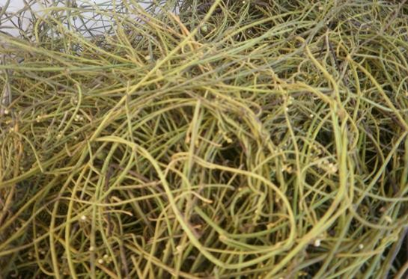

**Plate I: The plant *Cassytha filiformis***

* + 1. **Ethomedical uses of *C. filiformis***

*Cassytha filiformis* is a plant used in various ethnomedical purposes in Nigeria. The plant is used in traditional treatment of many diseases e.g vermifuge and also in the suppression of laction after still birth by several tribes in Nigeria (Burkill, 1995).The plant (stem and leaves) is boiled in water and administered for varying lengths of time to treat Jaundice(Personal communications).

In India, a decoction of *C. filiformis* is used to suppress hardness of the liver (Burkill, 1995). In Taiwan, *Cassytha filiformis* was reported as a beneficial medicine against the gonorrhoea, kidney ailments and as the diuretic. In Africa it was used to treat the cancer, African trypanosomiasis and other diseases (Nelson, 2008). Apart from the above, some unusual uses were made of the plant by the natives in the Gilbert Islands in which the vine was worn on the body by the dancers. The smooth orange yellow strands were designed as the beautiful necklaces and as the head wreaths or might be used as the cloth by crossing over the chest and then wrapping around the arms. Men were also reported to use it in the love magic while women used the extracts of the vine as a colouring agent or as a dye to provide a black color for the fabrics (Schroeder, 1967). It was a plant treasured by the Hawaiians as a light-hearted or as a ceremonial human ornament and also in the decorative garlands. It is a valued plant

in the traditional societies with much diverse healing applications and hence provides a promise for the modern medicine. It was used as a food plant to humans and animals. The vine was used in the thatched roof construction. It was considered as a potential biological control agent for the invasive plants. It is also a pestiferous and pathogenic weed which is a major threat to the agriculture and other endangered plants as they are capable of transmitting the pathogens between the plants (Nelson, 2008). They possess several aporphine alkaloids that was often used in the African folk medicine to treat certain diseases such as a cancer, African trypanosomiasis and other diseases (Quetin-Leclercq *et al.,* 2004). In the traditional Ayurveda, *Cassytha filiformis* is used as the major substitute for *Cuscuta* (Sakshy *et al.,*2010).The brown colour of the stem is used as the colouring agent and hence possess a major application in the dyeing industries.

* + 1. **Some Phytochemical constituentsof*C. filiformis***

The plant genus *Cassytha* (Lauraceae) provides a rich source of the phytochemical constituents such eg aporphine alkaloids.In the Brazilian species of *C. filiformis,* thirteen alkaloids were found. In Taiwan, the methanolic extract of *C. filiformis* was analyzed for a group of aporphine alkaloids withboldine nucleus **[1]**was found to be of them.Others are actinodaphnine**[2]**,cassythine**[3],** cathafiline**[4]**,cathaformine**[5]**,N-methylactinodaphnine**[8]**. The crude alkaloid extract of *C. filiformis* gave four aporphine alkaloids, actinodaphnine**[2]** cassythine**[3]** (cassyfiline), neolitsine**[6]** anddicentrine**[7]**. The following isoflavonoid glycosides:isorhamnetin 3-O-rutinoside**[9]**andisorhamnetin 3-O-

robinobioside**[10],**and the flavonoid glycosides: kaempferol 3-O- robinobioside**[11]**,quercetin 3-O-rutinoside**[12]**andquercetin 3-O- robinobioside**[13]**were reported by Yoshinori *et al*(2008).

Several aporphinoid alkaloids isolated from the samples originating from Taiwan, Brazil, Australia and New Guinea but compositions were found to be quite variable among the different origins. Six aporphines from*C. filiformis* were shown to have*in vitro*cytotoxic propertiesout of which actinodaphnine **[2]**, cassythine**[3]**, and dicentrine**[7]**also show *in vitro* antitrypanosomal properties against Trypanosoma *brucei brucei* (Quetin-Leclercq *et al*., 2004).

A methanolic extract of a Chinese sample was identified to possess a remarkable vasorelaxing activity and also the inhibitory effect on the platelet aggregation. A bio- guided fractionation of the above extractsindicated the presence ofactinodaphnine**[2]**,cathafiline**[4]**, cathaformine**[5]**, and *N*-methylactinodaphnine**[8]** in which all of the compounds showed the potent anti-platelet actions (Tung-Hu *et al*., 2008).Structures of these compounds are shown in Fig 1.

OCH3

HO

H3CO

CH3

3

4

2

3a

5

N

1 1a 11a

11

10

6a

H

7

7a

8

9

O

H2C

O

3 4

2 3a

1 1a 6a

11a 7

O

5

H2C

NH

O

H

3 4

2 3a 5

NH

1 1a 6a

H

11a 7

H3CO

OH

# 2

11 7a

10 8

H3CO 9

OH

H3CO

# 3

11 7a

10 8

9

OH **1**

3 4

O 2 3a

5

H2C

N

H2C

O 2 3 3a 4

5

N

O

1 1a

11a

11

10

6a

H

7

7a

8

O

9

H2C O

CH3

O

H3CO

1 1a 11a

11

10

9

6a CH3

H

7

7a 8

OCH3

**4**. **5 6 7**

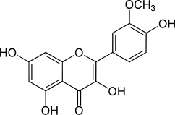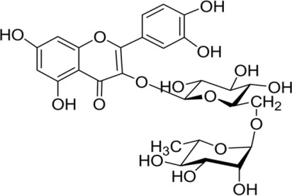

# 8 9 10

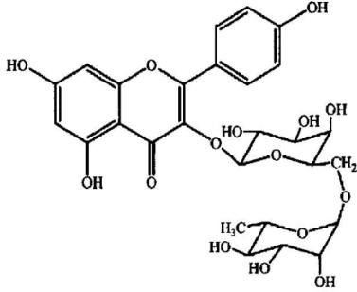

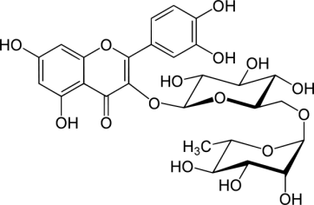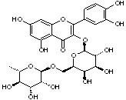

**11 12 13**

**Fig. 1: Reported isolated compounds from *C. filiformis***

1. *Boldine* ***2.*** *Actinodaphine* ***3.*** *Cassythine* ***4.*** *Cathafiline* ***5.*** *Cathaformine*

***6.*** *Neolistine* ***7.*** *Dicentrine* ***8.*** *N-methylactinodaphine* ***9.*** *Isorhamnetin-3-O-rutinoside*

***10.*** *Isohamnetin-3-O-robinobioside* ***11.*** *Kaemferol-3-O-robinobioside*

***12.*** *Quercetin-3-O-rutinoside* ***13.*** *Quercetin-3-O-robinobioside*

* + 1. **Biological activities of *C. filiformis***

The alkaloid extract of *C. filiformis*plants was found to show a cytotoxic property in the *in-vitro* condition with IC50 value of 2.2 μgml-1. Three alkaloids, particularly actinodaphnine, cassythine, dicentrine were found to be very active in vitro on the trypynosomes with IC50 values of 3-15 μm tested by using the optical methods. The mechanism is that the alkaloids have the ability to bind effectively to the DNA molecule and hence behaves as a typical intercalating agent. Actinodaphnine, cassythine, dicentrine also interferes with the catalytic activity of the enzyme topoisomerases. Four alkaloids isolated from a crude extract of *C.filiformis* (actinodaphnine,cassythine,neolitsine, dicentrine) were also tested on the cancer and non-cancer cells in the in vitro condition in which neolitsine was found to be the most active agent against the HeLa and 3T3 cells. actinodaphnineand cassythine has showed the highest activity against Mel-5 cells and HL-60 cells respectively (Hoet*et al*., 2004).

The antioxidant activity of *C. filiformis* extracts such as hexane, ethyl acetate and methanol were used for the assessment based on their radical scavenging activity (RSA) using the DPPH assay (Mythili *et al*., 2011) The methanolic extract was found to show potent antioxidant activity in comparision with the standard butylated hydroytoluene (BHT). The methanolic extracts were further evaluated by the other

methods such as ferric thiocyanate (FTC) method, thiobarbituric acid (TBA) test and superoxide anion radical scavenging assay. The results obtained from the above experiment suggested that the methanol extract of *C. filiformis*have provided a promising therapeutic potential and could be further applied as a potential source for the drug discovery before development by the pharmaceutical industries.

Aqueous and alcoholic extracts of *C. filiformis* were tested for their diuretic activity in Wister rats. Total urine output volume and the concentration of Na+, K+ and Cl− ions excretion in the urine were finally estimated. Aqueous and alcoholic extracts of

*C. filiformis* were found to exhibit significant diuretic activity by causing a marked increase in the Na+ and K+ excretion (Sharma*etal.,* 2009).

# Hepatotoxicity and its Mechanism

Liver plays a central role in transforming and clearing chemicals and is consequently susceptible to the toxicity induced from these agents. Chemicals that cause liver injury are termed hepatotoxins, and more than 900 drugs have been implicated in causing liver injury and it is the most common reason for a drug to be withdrawn from the market. Chemicals often cause subclinical injury to the liver which may be manifested by abnormal liver enzyme tests. Certain medicinal agents when taken in overdoses and sometimes even when introduced within therapeutic ranges may injure the organ. Other chemical agents such as those used in laboratories and industries, natural chemicals (e.g. microcystins) and herbal remedies can also induce hepatotoxicity.

The unique property of liver to metabolize substances and its close relationship with the gastrointestinal tract is highly susceptible to injury from drugs and other substances. Approximately 75% of blood reaching the liver arrives directly from gastrointestinal organs and then spleen through portal veins which bring drugs and xenobiotics in concentrated form. Numerous mechanisms may be cited to be responsible for either inducing hepatic injury or worsening the damage process. Although the exact mechanism of hepatic injury remains largely unknown, it appears to involve 2 pathways—direct hepatotoxicity and adverse immune reactions. In most instances, hepatic injury is initiated by the bio-activation of drugs to chemically reactive metabolites, which have the ability to interact with cellular macromolecules such as proteins, lipids, and nucleic acids, leading to protein dysfunction, lipid peroxidation, DNA damage, and oxidative stress (Lynch and Price, 2007). Additionally, these reactive metabolites may induce disruption of ionic gradients and intracellular calcium stores, resulting in mitochondrial dysfunction and loss of energy production. Its dysfunction releases excessive amount of oxidants which in turn injures hepatic cells. Activation of some enzymes in the cytochrome P-450 system such as CYP2E1 also leads to oxidative stress. Injury to hepatocyte and bile duct cells lead to accumulation of bile acid inside liver. This promotes further liver damage. This impairment of cellular function can culminate in cell death and possible liver failure (Blazka *et al.,* 1995). Hepatic cellular dysfunction and death also have the ability to initiate immunological reactions, including both innate and adaptive immune responses. Stress and damage to hepatocytes result in the release of

signals that stimulate activation of other cells, particularly those of the innate immune system, including Kupffer cells (KC), natural killer (NK) cells, and NKT cells. These cells contribute to the progression of liver injury by producing proinflammatory mediators and secreting chemokines to further recruit inflammatory cells to the liver. It has been demonstrated that various inflammatory cytokines, such as tumor necrosis factor (TNF)-α, interferon (IFN)-γ, and interleukin (IL)-1β, produced during hepatic injury are involved in promoting tissue damage (Bourdi *et al.,* 2002).

However, innate immune cells are also the main source of IL-10, IL-6, and certain prostaglandins, all of which have been shown to play a hepatoprotective role. Thus, it is the delicate balance of inflammatory and hepatoprotective mediators produced after activation of the innate immune system that determines an individual’s susceptibility and adaptation to hepatic injury.

# Pharmacological evaluation of hepatoprotective plants

In general,the therapeutic value, efficacy and toxicity of herbal drugs may be evaluated in animals experimentally made sick, followed by clinical trials. Detailed biochemical and other *invitro* assays are obligatory to establish the mechanism of action. Both *in vivo* and *in vitro* test systems need to be employed to assess hepatoprotective activity. Nonetheless, a single and simple screening method is not available to identify hepatoprotective drugs with confidence (Varsha *et al*., 2011).

* + - 1. ***In-vivo* models**

A toxic dose or repeated doses of a known hepatotoxin (paracetamol, carbon tetrachloride (CCl4), thioacetamide, alcohol, Dgalactosamine, allylalcohol *etc*.) might be administered, to induce liver damage in experimental animals. The test substance is administered along with, prior to and/or after the toxin treatment. Liver damage and recovery from damage are assessed by quantifying serum marker enzymes and observing for any histopathological changes and biochemical changes in liver. An augmented level of liver marker enzymes such as glutamate pyruvate transaminase (GPT), glutamate oxaloacetate transaminase (GOT) and alkaline phosphatase in the serum indicates liver damage. Therapeutic efficacy of a drug against diverse hepatotoxins differs especially when their mechanism of action vary. Consequently, the efficacy of each drug has to be tested against hepatotoxins which act by varied methods (Varsha *et al*., 2011).

**Paracetamol:**Although considered safe at therapeutic doses, at higher doses, acetaminophen produces a centrilobular hepatic necrosis that can be fatal. Acetaminophen poisoning accounts for approximately one-half of all cases of acute liver failure in the United States and Great Britain today (Hinson *et al.,* 2010). The mechanism occurs by a complex sequence of events. These events include:

* + - * 1. CYP metabolism to a reactive metabolite which depletes glutathione and covalently binds to proteins;
        2. Loss of glutathione with an increased formation of reactive oxygen and nitrogen species in hepatocytes undergoing necrotic changes;
        3. Increased oxidative stress, associated with alterations in calcium homeostasis and initiation of signal transduction responses, causing mitochondrial permeability transition;
        4. Mitochondrial permeability transition occurring with additional oxidative stress, loss of mitochondrial membrane potenti*al.,* and loss of the ability of the mitochondria to synthesize ATP;
        5. Loss of ATP which leads to necrosis. Associated with these essential events there appear to be a number of inflammatory mediators such as certain cytokines and chemokines that can modify the toxicity(Hinson *et al.,* 2010).

Some have been shown to alter oxidative stress, but the relationship of these modulators to other critical mechanistic events has not been well delineated. In addition, existing data support the involvement of cytokines, chemokines, and growth factors in the initiation of regenerative processes leading to the reestablishment of hepatic structure and function (Hinson *et al.,* 2010).

## In-vitrostudies

Fresh hepatocyte preparations and primary cultured hepatocytes may be exploited to study the anti-hepatotoxic activity of drugs. Hepatocytes are treated with hepatotoxin and the effect of the plant drug on the same is evaluated. The activities of the transaminases released into the medium are determined. An augmented activity of marker transaminases in the medium indicates liver damage. Parameters such as hepatocyte multiplication, morphology, macromolecular synthesis and oxygen

consumption are determined. Effective antiviral assays using cell culture and Polymerase Chain Reaction techniques remain to be explored and these may emerge as a very promising strategy for *in vitro* examination of hepatoprotective effect of herbal products (Skelly *et al.,* 2001).

# Conventional Management forLiver Disorders

Immunoglobulin (Ig) is quite effective against hepatitis A when administered to anyone exposed to the virus as soon as possible or within two weeks after jaundice appears. Vaccines for hepatitis are now a common feature of immunization programs the world over. Treatment for acute hepatitis consists of rest and small,nourishing meals, fluids, and sometimes antinausea drugs such as trimethobenzamide. Chronic cases of hepatitis B and C are treated with interferon. The problem of gallstones is usually solved by surgical operation. Chenodiol, a recently available drug that dissolves gallstones is an alternative to surgery, but troublesome side effects have been reported (Iqbal*et al.,*2006).

In the treatment of cirrhosis elimination of the underlying cause is emphasized, if possible, to avoid further damage, and to prevent or treat complications. Diuretics, vitamins, and abstinence from alcohol are supportive measures. For extreme cases a liver transplant is an option, though risky. If the offending organism cannot be determined, liver abscesses are treated with longterm administration of antibiotics such as aminoglycosides, cephalosporin, clindamycin, or chloramphenicol. If *E. coli* is the cause of infection, treatment includes ampicillin. For *Entamoeba histolytica*,

chloroquine or metronidazole is included. Biliary atresia is sometimes relieved by surgery. Vitamin B6 and *d*-penicillamine as well as corticosteroids such as prednisolone are administered in cases of Wilson’sdisease.

Despite advancements in modern medicine, no hepatoprotective medicine is available and treatment options for cirrhosis, fatty liver, and chronic hepatitis are limited as well as problematic (Iqbal*et al., 2006*). The conventional drugs used in such treatments are corticosteroids, interferon, colchicine, penicillamine, and antiviral and immune suppressant drugs. These are inadequate and inconsistent at best. Paradoxically, these drugs may themselves cause damage (e.g. azathioprine can cause cholestatic jaundice (Romaguolo*et al*., 1998), while interferons and virazole can cause elevation of serum transaminase (Fujimori*et al.,* 2002). Alternative treatments for liver diseases to replace the currently used drugs need to be given impetus in the light of current findings from research studies and publications in the field of herbal treatment of liver diseases, especially during the last quarter of the twentieth century.

* 1. **Contributions of Metals to Potential Treatments for Hepatic Disorders** Elementology is abranch of the natural sciences, based on the scientific study of metals and other trace elements for their therapeutic value (Iqbal*et al*., 2006). The search for alternative therapies in hepatic disorders provides immense opportunity for the field. The liver plays an important role in element metabolism, both in normal and pathological conditions. Medicines taken through the oral route on reaching the

gastrointestinal system are first released from the various formulations in order to be absorbed before becoming bioavailable. The liver plays a regulatory role in metabolism, as it is the very first organ perfused by the hepatic portal system containingnewly absorbed materials. In case of minerals, the liver acts as a sink for excess absorbed materials or metal ions. Minerals released from the liver are usually bound by plasma proteins that are mostly synthesized in the liver, such as albumin, ceruloplasmin etc (Iqbal*et al.,* 2006).

The significance of trace elements in biological systems is widely recognized, since they are components of many metalloproteins and metal enzymes. The properties of trace elements, which feature in their therapeutic activity, are in binding to macromolecules (enzymes, nucleic acids). This is far from specific, as is reflected in the fact that a number of diseases involve trace elements. Interactions with other elements are another such property (Sarkar, 1989). The role of elements in the treatment of liver disease is well documented (Antipenko and Antipenko, 1994).

Cascales, investigated altered liver function induced by chronic administration of thioacetamide (TAA), which was partially restored by rhodium complex (Cascales *et al*., 1991). Schwartz reported the importance of selenium in the treatment of liver necrosis (Schwartzand Foltz, 1957). Selenium is a natural antioxidant and appears to preserve tissue elasticity by delaying the oxidation of polyunsaturated fatty acids. Selenium participates in the lipooxygenase pathway along with catalase, superoxide dismutase, vitamin E, vitamin C, carotenoids etc., whose principal function is to

eliminate the free radicals involved in the pathogenesis of liver disorders (Batcioglu*et al*., 2002).

Zinc, as a component of metalloenzymes, protects against hydroxyl radicals and inhibits apoptosis induced by glucocorticoids. It is also effective against cirrhosis induced by thioacetamide (Dashti*et al.*, 1997). Boron hydrides are also inhibitors of pyridoxal dependent enzymes and aspartate aminotransferase activity and interact with cytochrome P-450 enzyme system of liver. Boron has recently been reported to protect against liver injury (Ali*et al.*, 2002)

Copper is a component of a variety of oxidative enzymes including ceruloplasmin, cytochrome oxidase, monoamine oxidase, and superoxide dismutase. It is also important in liver disorders, as liver is the organ responsible for storage of copper, its incorporation into ceruloplasmin, and its secretion in bile. Small amounts of copper are stored in liver in its parenchymal cells. Copper, added generally as copper sulfate to the diets of experimental animals, resulted in a decrease in hepatoma formation in response to carcinogenic azodyes and ethionine (Imai*et al.*, 2000). Copper may also exert an effect through its role in the complex with a tripeptide, glycyl histidyllysine, which may function to regulate growth and adhesiveness of both normal liver and cultured hepatoma cell (Conato, 2001).

The hepatoprotective effect of the organic germanium compound propagermanium is seen against concanavalin A and lipopolysaccharide-induced liver injury in mice (Ishiwata*et al*., 1998). The anticarcinogenic activity of manganese was also studied

and it was found to antagonize the carcinogenic effects of simultaneously applied nickel sulfide in rats. The carcinoma incidence was reduced from 77% in rats not given manganese to 70% in those given manganese. This was found to be due to its effect on superoxide dismutase, which prevents accumulation of the manganese superoxide radical (Pani*et al*., 2000).

The hepatoprotective effect of nickel was linked to an increase in the erythrocyte activity of Cu/Zn superoxide dismutase by NiCl2, which catalyzes the dismutation of the superoxide free radical and protects cells against superoxide damage (Iqbal*et al.*, 2006). Tin, as SnCl2, acts as reducing agent and can remove superoxide by reduction. Sn4+ protoporphyrin IX is a potent competitive inhibitor of heme oxygenase and thus of heme oxidation in liver, spleen, and kidney. This indicates the possibility that tin protoporphyrin IX may be useful in the chemoprevention of neonatal jaundice or hyperbilirubinemia (Iqbal*et al.*, 2006).

# Medicinal Plants and Natural Products Used in the Management of Liver disorder.

In last half a decade exploitation of herbal products in hepatic diseases has immensely augmented. This may be attributed to combining the strength of the traditional system of herbal therapy with that of the modern concept of evidence- based pharmacological evaluation,standardization and randomized placebo controlled clinical trials to support clinical efficacy. A number of herbal hepatoprotectives that

have been tested in hepato-toxicity models and provide an insight to the use of various plants against liver disorders have been scheduled below.

*Peumus boldus*leaves contains 2 % of volatile oils (ascaridole, linalool and cineol. E)out of 46 components of the oil identified, 22 of which were novel compounds.The active constituents have been shown to be alkaloids of the aporphine type (1-3 %) the chief of which is boldine **(**Miraldi *et al.,* 1996).

The cytoprotective and anti-inflammatory effects of boldine in an experimental model of acute colitis are reported. The administration of boldineto animals with colitis induced by the intrarectal administration of acetic acid, was found to protect against colonic damage as expressed by major reductions in the extent of cell death, tissue disorganization, and edema. Boldine also reduced the colonic neutrophil infiltration, as measured by the myeloperoxidase activity, but it did not significantly affect tissue lipoperoxides. Boldine was found to preserve the colonic fluid transport, a function otherwise markedly affected in the tissue of acid-treated animals. Results presented here provide experimental evidence supporting new cytoprotective and anti-inflammatory properties of boldine(Gotteland *et al*.,1997).

The phytochemical investigation of methanolic extract of *F. gnaphalocarpa* led to the isolation of six compounds identified as: betulinic acid (1); 3-methoxyquercetin (2); catechin (3); epicatechin (4); quercetin (5); and quercitrin (6). Test for biological activity of these compounds showed that compounds (5), (6) and (2) showed significant antioxidant and hepatoprotective activities as indicated by their ability to

prevent liver cell death and lactate dehydrogenase leakage during CCl4 intoxication. These results suggest that the protective effects of crude extract of *F. gnaphalocarpa*against the CCl4-induced hepatotoxicity possibly involve the antioxidant effect of these compounds (Hubert *et al*., 2011).

Samar *et al* (2013) reported that the extract of *D. regia* possessed not only a significant anticancer effect against HepG2 cells, but also an effective and a dose dependent hepatoprotective and antioxidant activities due to the presence of flavonoids content. Phytochemical investigation of *D. regia* extract with the activity led to the isolation of seven flavonoid glycosides; Kaempferol 3-rhamnoside, Quercetin 3-rhamnoside, Kaempferol 3-glucoide, Kaempferol 3-rutinoside, Kaempferol 3-neohesperidoside, Quercetin 3-rutinoside and Quercetin 3-glucoside.

Investigation of antioxidant and hepatoprotective activities of phenolic rich fraction (PRF) of Sea buckthorn ((*Hippophae rhamnoides*) leaves which include myricetin, quercetin, kaempferol and isorhamnetin on CCl4 induced oxidative stress in Sprague Dawley rats. The PRF protected against histopathological changes produced by CCl4 such as hepatocytic necrosis, fatty changes, vacuolation, etc. The data obtained in the present study suggests that PRF has potent antioxidant activity, prevent oxidative damage to major biomolecules and afford significant protection against CCl4 induced oxidative damage in the liver (Maheshwari *et al.,* 2011).

*Fumaria indica* (Fumariceae) were studied for their hepatoprotective activity against carbon tetrachloride, paracetamol and rifampicin-induced heptatotoxicites in albino rats. The petroleum ether extract against carbon tetrachloride, total aqueous extract against paracetamol and methanolic extract against rifampicin-induced hepato- toxicities showed similar reductions in the elevated levels of some of the serum biochemical parameters in a manner similar that of silymarin indicating its potential as a hepatoprotective agent (Patil *et al.,* 2011)

Ethanolic extract of the *Spermacoce hispida.* Linn (SHE) was used against carbon tetra chloride (CCl4) induced hepatotoxicity in rats. Liver functions were assessed by the determination of SGOT, SGPT, ALP and bilirubin. Histopathological studies were carried out. The serum biochemical analysis results suggest that the use of Ethanolic extract of *Spermacoce hispida*. Linn exhibited significant protective effect from hepatic damage in CCl4 induced hepatotoxicity model. Histopathological studies revealed that concurrent administration of the extract with CCl4 exhibited protective effect on the liver, which further evidenced its hepatoprotective activity (Suman *et al.,* 2011).

The Petroleum ether, ethyl acetate, n-butanol and total alcoholic extracts of *Juncus subulatus* were evaluated for their hepatoprotective and antioxidant activity in female rats against ethanol–induced hepatic injury. Serum Liver enzymes (AST, ALT and ALP), total protein, albumin, cholesterol, triglycerides, nitric oxide (NO), malondialdhyde (MDA) and total antioxidant capacity (TAC) were measured

colorimetrically. The results showed that all extracts of *Juncus subulatus* exhibited hepatoprotective activity in the following order: petroleum ether extract > ethyl acetate extract > n-butanol extract > total alcoholic extract (Balakrishanan *et al.,* 2011).

The hepatoprotective activity of *Mamordica subangulata* (leaf) and *Naragamia alata* (whole plant) suspension was studied using paracetamol overdose induced liver damage in rats. The effect of the plant suspensions on bile flow was studied in anaesthetised normal rats by surgical cannulation of bile duct with polyethylene tubing. The drug was given intraduodenally after 1 hour bile collection. *Mamordica subangulata* leaf suspension (500mgkg-1,fresh weight;50 mgkg-1, dry weight) protected rats from paracetamol induced liver damage as judged from serum marker enzyme activities. It also stimulated bile flow in normal rats. *Naragamia alata* was inactive in protecting rats from paracetamol induced hepatotoxicity. A suspension of *Mamordica subangulata* leaf (dry or fresh) can protect rats from paracetamol induced hepatotoxicity (Kuppan*et al.,* 2011).

Petroleum ether extract of root of *Plumbago zeylanica* was investigated for hepatoprotective activity against paracetamol induced liver damage to evaluate the hepatoprotective activity of ethanolic extract. In serum total bilirubin, total protein, aspartate transaminase, alanine transaminase, alkaline phosphatase, lactate dehydrogenase, γ-Glutamyl transferase, Total Cholesterol and serum triglycerides were determined to assess the effect of the extract on the paracetamol induced hepatic damage. The study was also supported by histopathology of liver sections.

Results of this study revealed that the markers in the animals treated with paracetamol recorded elevated concentration indicating severe hepatic damage by paracetamol, whereas the blood samples from the animals treated with petroleum ether extract of roots showed significant reduction in the serum markers indicating the effect of the plant extract in restoring the normal functional ability of the hepatocytes. The dosage of extract of plant roots used was 300 mgkg-1 bodyweight of rat. The present study reveals that the petroleum ether root extract of *Plumbago zeylanica* could afford a significant protection against paracetamol-induced hepatocellular injury (Kavita *et al.,* 2011).

Hepatoprotective activity of the n-hextane extract of *Cassia fistula* (Fabaceae) leaves was investigated by inducing hepatotoxicity with paracetamol in rats. The extract at a dose of 400 mgkg-1 body wt. exhibited orally, significant protective effect by lowering the serum levels of transaminases (SGOT and SGPT), bilirubin and alkaline phosphatase (ALP). The effects produced were comparable to that of a standard hepatoprotective agent (Mohammad, 2010).

Ethanolic extract of *Phyllanthus amarus* (Euphorbiaceae), at (0.3 gkg-1 BW 0.2 ml/day was given to all groups except control groups (groups I and V), after 30min of aflatoxin administration. The entire study was carried out for 3 months and animals were sacrificed after an interval of 30 days till the completion of study. *Phyllanthus amarus* extract was found to show hepatoprotective effect by lowering the content of thiobarbituric acid reactive substances (TBARS) and enhancing the

reduced glutathione level and the activities of antioxidant enzymes, glutathione peroxidase (GPx), glutathione- transferase (GST), superoxide dismutase (SOD) and catalase (CAT) (Samy*et al.*, 2011).

The protective effect of ethanol extract of *Sargassum polycystum* was evaluated in D- galactosamine-induced hepatitis in rats. Prior oral administration of *S.polycystum* extract (125mgkg-1 bodyweight/day for 15 days) significantly attenuated (P<0.05) the D-galactosamine-induced increases in the levels of diagnostic marker enzymes (AST, ALT and ALP) in plasma of rats. It has also demonstrated antioxidant activity against D-galactosamine-induced hepatitis by inhibiting the activation of lipid peroxidation and by preserving the hepatic enzymatic and non-enzymatic antioxidant defense system at near normal. The antihepatotoxic potential of *S. polycystum* might possibly be due to its antioxidant property and membrane stabilizing action (Rupesh*et al.,* 2011).

Methanol, hexane and chloroform extracts of *Prostechea michuacana* were studied against CCl4-induced hepatic injury in albino rats. Pre-treatment with methanolic extract reduced biochemical markers of hepatic injury levels demonstrated dose- dependent reduction in the in vivo peroxidation induced by CCl4. Likewise, pretreatment with extracts of *P.michuacana*on paracetamol-induced hepatotoxicity and the possible mechanism involved in this protection were also investigated in rats after administering the extracts of *P.michuacana* at 200, 400 and 600mgkg-1. The degree of protection was measured by monitoring the blood biochemical profiles.

The methanolic extract of orchid produced significant hepatoprotective effect as reflected by reduction in the increased activity of serum enzymes, and bilirubin. These results suggested that methanolic extract of *P.michuacana* could protect paracetamol-induced lipid peroxidation thereby eliminating the deleterious effects of toxic metabolites of paracetamol. This hepato-protective activity was comparable with sylmarin. Hexane and chloroform extracts did not show any apparent effect. The findings indicated that the methanolic extract of *P.michuacana* can be a potential source of natural hepatoprotective agent (Subash*et al.,* 2011).

# Research Techniques in Pharmacognosy

Most of the techniques in pharmacognosy are used for authentication and standardization of crude and purified drugs of natural origin. They include microscopical examination, numerical (physical) constant determination, extraction, bioassay guided isolation and structure elucidation of the active compounds (Evans, 2009). Recently genetic methods have been introduced as a means of authentication and standardization. These includes amplified fragment length polymorphism (AFLP), restricted fragment length polymorphism (RFLP), random amplified DNA polymorphism, simple sequence repeat (SSS) (Microsatellite) and many others(Bohlin,*et al*., 2007).Isolation and characterizations of plant constituents is not only useful in authentication and standardization but also essential in classification of the plants (chemotaxonomy)(Kinghorn, 2001).

# Chapter 3.0 MATERIALS AND METHOD

* 1. **Equipment, Solvents and Reagents**

# List of equipment and other laboratory apparatus

The following items were used.

Ash-less filter papers (Whatman England)

Atomic absorption spectrophotometer (AAS)(Shimadzu, 2010, Chemistry Lab, NARICT, Zaria)

Beakers of various capacities (Pyrex, England) Animal cages and feeders

Camera compound microscope (Wild mill England) Camera Lucida (Wild mill Switzerland)

Compound microscope (Wild mill Switzerland) Conical flask of different size (Pyrex, England) Desiccator (Pyrex, England)

Filter papers (Whatman England)

Fourier transform infrared spectrometer (FTIR) (Alpha, Bruker Optics, England) with an integrated diamond ATR accessory.

Glass funnels (Pyrex, England) Heating mantle (Labonco, England)

High performance liquid chromatography (HPLC) (Shimadzu, 2010, Chemistry Lab, NARICT, Zaria)

High pressure vacuum pump (Edward, England)

Liquid chromatography mass spectrometry, mass spectrometry (LCMS/MS) (Ab Sciex 3200 Qtrap mass spectrometer with Perkin Elmer F x15 flexar uplc, Bioscience Laboratory, University of Putra, Malaysia)

Measuring cylinders (Pyrex, England) Mechanical shaker (Stuart Scientific, England)

Melting point apparatus (Stuart Scientific, England) Micrometers (Tonbridge Kent England)

Muffle furnace (Gallenkamp, England)

Nuclear magnetic resonance spectrophotometer (NMR) (Bruker Avance, 500, Chemistry Department University of London)

Oven (Gallen Kamp, England) Porcelain dish

Sieve (mesh size 250 µm) Slides and cover slips

Sohxlet apparatus (Gallenkamp, England) Water bath (Gallenkamp England)

Weighing balance (Mettler, P1210 Switzerland)

# Solvents

Acetone (BDH, England)

Chloroform (Sigma Aldrich, Germany)

Ethyl acetate (Sigma Aldrich, Germany, BDH, England) Hexane (Sigma Aldrich, Germany, BDH, England)

Methanol (Sigma Aldrich, Germany, BDH, England) Petroleum ether 40-60 oC (Sigma Aldrich, Germany) Xylene (BDH, England)

# Preparation of reagents / solutions

Commercial solvents and reagents were used as supplied or purified in accordance with standard procedures as described by WHO, 2011 and Evans, 2009.

## Anisaldehyde/H2SO4

Anisaldehyde (0.5 ml) was mixed with 10 ml of glacial acetic acid, 85 ml of methanol and 5 ml of conc. sulfuric acid (1760 gl-1).

## Chloral hydrate solution

Chloral hydrate (50 g) was dissolved in 20 ml of water.

## Ferric chloride 5 % solution

Ferric chloride (5 g)was dissolved in 100 ml of water.

## Dilute Hydrochloric acid

Hydrochloric acid (23.6 ml)was mixed with water to make 100 ml (10%).

## Iodine solution

Iodine crystals (2.6 g) and potassium iodide (3 g) were dissolved in water 100 ml.

***Millions reagent*** (BDH, England)

A suitable commercially available material for laboratory use.

## Phloroglucinol

Benzene-1, 3,5-triol dehydrate (1 g) in 100 ml of ethanol.

## Silica gel

A suitable commercially available material for column chromatography.

***Sulfuric acid***(H2SO4) 1.25% - 0.255 ± 0.005 N. 12, 5g, 98% concentrated to 1000 ml with distilled water.

***Potassium hydroxide*** (KOH) 1.25% - 0.223 ± 0.005 N, free from carbonate. 12.5 g to 1000 ml with distilled water.

Anhydrous Diethyl ether, purified for fat extraction.

## 1-Naphthol

1-naphthol (20 g)was dissolved in 100 ml of ethanol Protect from light and use within a few days of preparation.

## Quinine hydrochloride

A suitable commercially available material.

## 10 % Sodium hydroxide

Sodium hydroxide (80 gl-1) (10 ml) was dissolved in 100 ml of distilled water.

## Zinc chloride, iodinated

Zinc chloride (40 g)and 13 g of potassium iodide were dissolved in 21 ml of water. Followed by 1 g of iodine and shake for 15 minutes then filtered.

## Sudan red

1-(4-Phenylazophenylazo)-2-naphthol) (0.5 g )in 100 ml of glacial acetic acid.

***Acetic acid, glacial***(BDH, England)

A suitable commercially available reagent.

## Acetic acid

A solution of glacial acetic acid containing about 300 g of glacial acetic acid per litre.

## Dragendorff’s spray reagent

Solution A: Bismuth subnitrate (0.85) dissolved in 40 ml of distilled water then 10 ml of acetic acid was added.

Solution B: Potassium iodide (8 g) was dissolved in 20 ml of distilled water. Mix solution A and B in ratio 1 : 1.

## Dragendorff’s reagent test solution

Solution A: Basic bismuth nitrate (1.7 g) was dissolved in 80 ml of distilled water; add 20 ml of tartaric acid.

Solution B: Potassium iodide (16 g) was dissolved in 40 ml of distilled water. Mix solution A and B in ratio 1: 1.

## Mayer’s reagent

HgCl2(1.36g) in 60 ml of water and add solution of 5 g KI in 100 ml of water and made up to 100 ml.

## Wagner’s reagent

Dissolve of iodine (2 g)and of KI (6 g) were dissolved in 100 ml of water.

* 1. **Collection, Identification and Processing of *Cassytha filiformis***
     1. **Collection of *C. filiformis***

The aerial part of *C. filiformis* was collected during the rainy season (July – November, 2008) from Ahmadu Bello University Dam, Samaru, Zaria, Sabon Gari Local Government Area, Zaria, Kaduna State, Nigeria.

* + 1. **Identification of *C. filiformis***

Sample of *C. filiformis* was identified at the field based on its botanical and taxonomic characters. Herbarium specimen was prepared and a sample was deposited at the Herbarium of the Department of Biological Sciences, Ahmadu Bello University Zaria, Nigeria for future reference.

* + 1. **Processing of *C. filiformis***

The plant materialwas dried under the shade, grounded and powered, sieved (mesh size, 250 µm) and stored in air tight container, for further use, to prevent possible degradation by humidity.

* 1. **Pharmacognostic Studies of *Cassyha filiformis***
     1. **Macroscopical studies of *C. filiformis***

The macroscopical features such as size, colour, texture *etc* of whole plant, and organoleptic properties such as odour, taste *etc,* were studied. The features were described using standard Pharmacognostic terms/words.

* + 1. **Microscopical studies of *C. filiformis***

## Sectioning, clearing and mounting of sample

Sectioning of the freshplant material was done with the aid of razor blade. The anatomical sections and powdered plant material were cleared with a solution of 80% chloral hydrate. Cleared samples are mounted on microscope slides and observed at x 200 magnification.

## Qualitative microscopical studies of C. filiformis

The microscopic properties of fresh and powdered *C. filiformis were* determined using the methods described by WHO (2011).

## Chemo-microscopical studies of powdered C. filiformis

Chemo-microscopical examinations were carried out on the powdered drug*.* Variouscellwall materials such as cellulose, lignin, hemicelluloseand cell contents such as starch, tannins and calcium oxalate crystals were observed following methods described by WHO (2011).

# Test for cellulose

To a small amount of the cleared powdered plant materialchlor– zinc iodine was added; cellulose cell walls are stained blue to blue-violet.

# Test for lignin

To a small amount of the cleared powdered plant material, phloroglucinol and conc. HCl were added; appearance of pink to cherry red will indicate lignified cell walls.

# Test for suberized or cuticular cell walls

To a small amount of the cleared powdered plant material*,* 1–2 or drops tincture of alkanna was added followed by gentle warming; suberized or cuticular cell walls are stained orange-red or red.

# Test for Protein

To a small amount of cleared powdered plant material, few drops of Million’s reagent were added and then heated. Appearance of red colour will indicate the presence of protein.

# Test for mucilage

To a small amount of the cleared powder plant material*,* ruthenium red was added; the mucilage turns violet-red.

# Test for tannins

To a small amount of the cleared powdered plant material*,* 5% FeCl3solution was added; it turns bluish black or greenish black

# Test for starch

To a small amount of the cleared powder plant material*,* N/50 I2 was added; appearance of blue colour would suggest the presence of starch.

# Test for calcium Oxalate Crystals

To a small amount of the cleared powdered plant material*.*80 % H2SO4 was added. Dissolution of crystals would suggest that the crystals are those of Calcium oxalate.

# Test for calcium carbonate

Small amount of the cleared powdered plant material wasmounted on the microscope slide and irrigated with acetic acid through the side of the cover slip. Dissolution of the crystals with effervescence would indicate the presence ofcalcium carbonates.

* 1. **Phytochemical Test of *C. filiformis***

Phytochemical tests were carried out on the powdered crude drug, following standard procedures as outlined in WHO (2011); Evans (2009); Sofowora (1993); Kokate, (2002) in order to detect the presence or absence of chemical constituents in powdered material.

# Test for alkaloids

To 1 g of powdered whole plant of *C. filiformis* in a test tube, 10 ml of methanol acidified with 5% HCl was added and heated on a water bath. The mixture was cooled and filtered. The filtrate was divided into four portions then 3 drops of Dragendorff’s, Mayer’s and Wagner’s reagents were respectively added to the first, second and third portions of the extracts.

# Test for cyanogenic glycosides

To 1 g of powdered whole plant of *C. filiformis* in a test tube, 3 ml of distilled water was added. A moist yellow sodium picrate paper was suspended at the neck of the test tube by means of a cork; the test tube was heated in a water bath for an hour. Appearance of brick red colour on the paper would indicate the presence of cyanogenic glycosides.

# Test for cardiac glycosides

The presence or absence of cardiac glycosides were established by three tests(Farnsworth, 1966) as given below:

1. **Test for Steroidal ring:**To 1ml of methanol extract, 1ml of chloroform, 2 ml of acetic anhydride, 2 drops of concentrated sulphuric acid were added. Dark green coloration will indicate the presence of steroidal nucleus
2. **Keller – Killiani Test:**To methanolic extract (100 mg) in 2 ml of chloroform. H2SO4(1 ml) was added. Brown ring at interphase will indicate the presence of *deoxy*-sugars.
3. **Keddes Test:** To 1ml of methanolic extract, 1 ml of 2 % solution of 3, 5 – dinitrobenzoic acid in 95 % aq ethanol was added. The solution was made alkaline with 5 % NaOH. A purple blue colour will indicate the presence of unsaturated lactone ring.

# Test for Tannins

1. **Lead acetate test:** To 2 ml of methanol extract solution of the whole plant of *C. filiformis* in a test tube, 5 drops of lead acetate solution was added. Buff coloured precipitate will indicate the presence of tannins.
2. **Bromine water test**: To 2 ml of methanol extract solution of the whole plant of *C. filiformis* in a test tube, 1 ml of bromine water solution was added. Appearance of blue colour will indicate the presence of condensed tannins.
3. **Ammonia solution test**: To 2 ml of methanol extract solution of the whole plant of *C. filiformis* in a test tube, 2 ml of 25 % ammonia solution was added and the solution was exposed to air. Appearance of a slowly forming green colouration indicates the presence of chlorogenic acid.

# Test for antraquinones (Borntrager’s reaction)

To 1 ml of 2 ml of chloroform extract, dilute (10 %) ammonia was added. A pink-red color in the ammoniacal (lower) layer.

# Test for flavonoids

1. **Ferric chloride test:** To 2 ml of methanol extract solution of the whole plant of *C. filiformis* in a test tube, 3 drops of 10 % ferric chloride solution was added. Blackish green or blue precipitate will indicate the presence of phenolic nucleus.
2. **Sodium hydroxide test:** The methanol extract was treated with dilute NaOH, followed by addition of dilute HCl. A yellow solution with NaOH, which will turn colourless with dilute HCl.
3. **Shinoda test:** To 2ml of methanolic extract, pieces of magnesium ribbon and 1ml of concentrated HCl were added. Appearance of pink-red or red coloration of the solution will indicate the presence of flavonoids.
4. **Amyl alcohol test:** To 3 ml of methanol extract solution of the whole plant of *C. filiformis* in a test tube, 2 ml of Amyl alcohol reagent was added. Yellow colouration will indicate the presence of flavonoid nucleus.

# Test for saponins

1. **Frothing test:** To 0.2 g of methanol extract of *C. filiformis* in a test tube, 5 ml of distilled water was dissolved and the solution was vigorously shaken. The occurrence of persistent thick froth was taken as a preliminary evidence for the presence of saponins.
2. **Haemolysis test:** Methanol extract (0.2 g) of the of *C. filiformis* was dissolved in 2 ml of distilled water in a test tube and 2 ml of 1.8 % NaCl solution was added to make the content isotonic with blood serum. Five drops of a freshly collected and preserved blood (5 % v/v of 3.8 % w/v sodium citrate solution in blood) were added to the test tube and inverted gently to mix with the content and allowed to stand for

few minutes. Haemolysis in the test tube containing the crude extract but not in the control indicates the presence of saponins.

# Test for terpenoids

**Salkowski’s test:** To the methanol extract (2 ml), chloroform (2 ml) and concentrated H2SO4 (3 ml) were added. Appearance of reddish brown colour at the interface will indicate the presence of terpenoids.

* 1. **Determination of Numerical Standards of *C. filiformis***

Physical constant examinations on powdered *C. filiformis* was carried out using standard procedures as outlined in WHO guidelines (2011). Constants determined were moisture contents, ash values and extractive values, total tannins, swelling index and bitterness value. The crude fibre and lipids were carried out using proximate analysis.

# Determination of water-soluble extractive values

Powdered plant material (5 g)was macerated in 100 ml-chloroform water (0.75 % v/v) in a stoppered flask for 24 hr. The mixture was frequently shaken, during the first 6 hr. using a flask shaker then mixture was filtered and 20 ml of the filtrate was evaporated to dryness in a beaker on a boiling water bath. This was dried to constant

weight at 105 °C in an oven for 2 hrs.The percentage of water-soluble extractive value was determined.

Water-soluble extractive value (%) = Wt. of residue x 4 x 100

Weight of Sample

# Determination of alcohol-soluble extractive values

Powdered plant material (5 g) were macerated with 100 ml of alcohol (Ethanol) in a stoppered flask for 24 hr. The mixture was frequently shaken during the first 6 hr. using a flask shaker. The mixture was filtered and 20 ml of the filtrate was evaporated to dryness in a beaker. It was dried to a constant weight at 105 °C. The percentage of alcohol –soluble extractive value was determined.

Alcohol –soluble extractive value (%) = Wt. of res. X 5 x 100

Weight of Sample

# Determination of moisture content (loss on drying)

Powdered plant material (5 g) was weighed in a crucible. The sample was heated for 1 hr. at 105 0C, cooled in a desiccator and re-weighed. This was repeated for about five times until a constant weight was obtained. The moisture content was determined as percentage

Moisture content (%) = Weight of water lost x 100

Original weight of sample

# Determination of total ash

Powdered plant material (5 g) was weighed, in a crucible. The sample was spread in an even layer and ignited it by gradually increasing the heatup to 500–600 °C in a Muffle furnaceuntil it is white, indicating the absence of organic materials.

The total ash value as percentage was determined as follows.

Total ash values (%) = Weight of residual ash x 100 Initial weight of sample

# Determination of acid-insoluble ash

The ash obtained in (d) above was quantitatively transferred into a beaker, containing 25 ml of dil HCl. It was boiled for 5 min and the insoluble ash was collected on an ash less filter paper. The beaker containing the acid and crucible were washed with hot water. The washings were filtered through the ash-less filter paper until it was free from acid. The residue and filter paper were dried gently in an oven. It was ignited in a tarred crucible, cooled and weighed. The acid- insoluble ash was determined as follows.

Acid – insoluble ash (%) *=* Weight of residual ash x 100

Initial weight of sample

# Determination of bitterness value

Bitterness value compares threshold bitter concentration of an extract with the threshold bitter concentration of dilute solution of quinine hydrochloride. The bitterness value is expressed in unit equivalent to the bitterness of a solution containing 1 g of quinine hydrochloride in 2000 ml of drinking water. Two stock

solutions were prepared one for dilute quinine hydrochloride solution and the other for the stock solution of*C. filiformis* extract.

1. **Preparation of standard quinine solution:**The quinine hydrochloride stock solution was prepared by dissolving 0.150 g of quinine hydrochloride in sufficient safe drinking water to produce 100 ml. 5ml of the solution was further diluted to 500ml with safe drinking water. This stock solution of quinine hydrochloride (Sq) contains 0.015 mgm-1. Nine test tubes labeled 1 to 9 were set up to contain 3.2. 3.4, 3.6, 3.8, 4.0, 4.2, 4.4, 4.6, and 4.8 ml of Sq respectively. Then tubes 1 to 9 were added 6.8, 6.6, 6.4, 6.2, 6.0, 5.8, 5.6, 5.4 and 5.2 ml of drinking water respectively. Therefore, tubes 1 to 9 contained 0.048, 0.051, 0.054, 0.057, 0.060, 0.063, 0.066,

0.069 and 0.072 mg of quinine hydrochloride respectively.

1. **Preparation of *C. filiformis* extract stock solution**: Stock solution of the plant material was prepared by macerating 100 g of powdered *C. filiformis* in 1000 ml of water in a stoppered flask for 24 hrs and obtained 19.2 g of the extract. 15 g of the extract was dissolved in 300 ml of water (50.0 mgml-1) and was label *C. filiformis* stock solution SC.The stock solution was serially diluted using 10 test tube-tubes labeled 1 to 10were set up to contain 1, 2, 3, 4, 5, 6, 7, 8, 9 and 10 ml of Sc respectively. Then tubes 1 to 10 were added 9, 8, 7, 6, 5, 4, 3, 2, 1 and 0 ml of drinking water. Therefore, tubes 1 to 10 contain 5.0 10.0, 15.0, 20.0, 25.0, 30.0, 35.0, 40.0, 45.0 and 50.0mgml-1 of stock solution of *C. filiformis* extract.
2. **Test procedure:** Volunteers (10) were assembled for the test. After rinsing the mouth with safe drinking water, each volunteer was asked to start by finding his threshold of bitter concentration by tasting 0.058 mg of quinine hydrochloride solution in 10 ml of water. Only those who reported bitterness of the quinine hydrochloride solution were selected for the test. Out of the ten individuals 5 were screened out based on their inability to perceive the taste of quinine at the threshold of bitter concentration and 5 were used for the tests. Each volunteer was asked to start by tasting 10 ml of the most dilute solution swirling it in the mouth mainly near the base of the tongue for 30 sec. If the bitter sensation is no longer felt in the mouth after 30 sec, spit out the solution and waited for one minute to ascertain whether this is due to delayed sensitivity. The threshold bitter concentration is the lowest concentration at which a material continues to provoke a bitter sensation after 30 sec. After first test series, each volunteer was asked to rinse the mouth thoroughly with safe drinking water until no bitter sensation remains, wait for at least 10 min before going to the next concentration.

Bitterness value in units per g= 2000 x c

a x b

# Where:

**a** = Concentration of stock solution of *C. filiformis* (mgml-1)(Sc)

**b** = Volume of Sc in ml

**c** = Quantity of quinine hydrochloride (in mg) in tube with the corresponding threshold of bitter concentration

# Determination of total tannins

Fresh mashed (5 g)*C. filiformis* was extracted with 150 ml of water by warm maceration method for 30 min. The resultant mixture was allowed to cool and

transferred into 250 ml volumetric flask and made to volume with water. The solid material was allowed to settle and filtered out through a filter paper, diameter 12 cm, using high pressure pump (Edward, England) discarding the first 50 ml of the filtrate so as to get rid of low concentrated extract. The remaining extract was used as follows:

To determine the total soluble matter. 50 ml of the remaining extract was evaporated to dryness. The residue was dried in an oven at 105ºC for 4 hr. and weighed T1.

To determine the amount of extract not bound to hide powder (Laboratory Grade Gelatin 275 Bloom Granular, Pharmacognosy Lab ABU, Zaria) that is extractable with water, 80 ml of the *C. filiformis* extract was taken and 6.0 g of the gelatin was added and mixture shaken for 60 min. The mixture was allowed to settle filtered and 50 ml of the filtrate was evaporated to dryness. The residue was dried in an oven at 105 ºC for 4 hr. and weighed T2.

To determine the solubility of the gelatin, 6.0 g of the gelatin powder was taken and 80 ml of water was added and mixture shaken for 60 min using lab mechanical shaker (Stuart scientific, England). The mixture was allowed to settle filtered and

50.0 ml of the filtrate was evaporated to dryness. The residue was dried in an oven at 105 ºC for 4 hr. and weighed T0. The total tannins in *C. filiformis* was calculated using a formula

Quantity of Tannins = {T1 – (T2 – T0)} x 500

w

# Determination of swelling index

Powdered *C. filiformis* (2 g) was transferred into 25 ml glass-stoppered measuring cylinder with internal diameter of 16 mm. The length of the graduated portion was

125 mm, marked in 0.2 ml division from 0 to 25 ml in an upward direction.

Sufficient quantity of water was added to make it up to 25 ml marked portion and the mixture was thoroughly shaken for 60 min. It was then allowed to stand for 3 hr. at room temperature. The volume in ml occupied by the powdered *C. filiformis* including the sticky mucilage was measured. Swelling index was calculated using a formula;

% Swellingindex =(b-a) x 100

a

# Where:

**a** = Initial volume occupied by 2 g of *C. filiformis*

**b** = Final volume occupied by 2 g of *C. filiformis*

# Determination of crude lipid

Crude lipid analysis was conducted on *C. filiformis* powder using proximate analysis described by Association of Official Analytical Chemists (AOAC) official method of analysis.Powdered *C. filiformis* weighing 0.5 g was wrapped in the filter paper and placed into an extraction thimble. The thimble was placed inside the Soxhlet apparatus, dried solvent flask was placed in a position beneath, with the required quantity of hexane and connected to the condenser. The heating rate was adjusted to give the condensation rate of 3 drops/sec and was extracted for 6 hr. The thimbles

was removed on completion and the ether reclaimed using the apparatus. The completion of the removal of diethyl ether was done on a water bath and dry beaker in an oven at 105 0C for 30 min, allowed to cool in a desiccator before weighing to constant weight (Horowitz, 2000).

% oil = Wt of oil x 100 Wt of sample

# Determination of crude fibres

Crude lipid analysis was conducted on *C. filiformis* powder using proximate analysis described by Association of Official Analytical Chemists (AOAC) official method of analysis.Powdered *C. filiformis* weighing 1.16 g was put into a 500 ml beaker and 200 ml of 1.25 % sulphuric acid was added and boiled for 30 min using a heating apparatus (Labonco England). The boiled sample was filtered, washed with hot water and the residue collected back into the beaker. 200 ml of 1.25 % sodium hydroxide solution was added and boiled for another 30 min. the boiled sampled was again washed with hot water and the residue washed with acetone to remove the pigment and was collected into a crucible for drying at 105 0C for 4 hrs. The dried residues was weighed together with the crucible as quickly as possible after cooling in a desiccator for 30 min to avoid absorption of moisture. The crucible and the contents were incinerated to ash at 600 0C for 3 hrs. The crucible and the ash content was allowed to cool in a desiccator for 30 min and reweighed (Horowitz, 2000).

% crude fibre = Wt of ash x 100

Wt of sample

* 1. **Extraction of Powdered *C. filiformis***

Powdered *C. filiformis* (1.5 kg) was extracted using sohxlet (Gallenkamp, England) with pet ether (40-60 oC) (2.5 L) the marc was extracted with EtOAc (2.5 L) andthe extract was removed and the marc was then extracted with MeOH (2.5 L). The extracts obtainedwere evaporated under reduced pressure to residue.

# Analysis of Metals of the Powdered *C. filiformis* using Atomic Absorption Spectrophotometry

Macro and micronutrients of *C. filiformis* were obtained using. atomic absorption spectrophotometer (AAS, Shimadzu 2010, Japan) available at National Research Institute for Chemical Technology (NARICT), Zaria

# Chromatographic and Spectroscopic Studies

# Thin layer chromatography of the extracts

Thin layer chromatography analysis of the three extracts were carried out on silica gel pre-coated plates (MERCK® GF 254, 0.25 mm) in order to establish profile of the major constituent in each extract. Suitable solvent systems used wereEtOAc: CHCl3: MeOH: H2O (15:8:4:1), BuOH: Acetic acid: H2O (6:1:1) and Hexane: Ethyl acetate

(2: 1). Visualization was achieved using anisaldehyde / H2SO4 (general detecting reagent),FeCl3(for phenolic compounds) and Dragendoff’s ragent (for alkaloids). The experiment was carried out following standard procedure described by WHO (2011).

# Column chromatographic separation of petroleum ether extract

The petroleum ether extractwas subjected to column chromatography using silica gel (60-100 mesh, Sigma-Aldrich, Germany) as stationary phase and ran by gradient elution technique where n-hexane and ethyl acetate were employed as the mobile phase. The silica gel 100 g was packed in a glass tube (100 cm long X 2 cm diameter) with hexane using wet packing method. The column was allowed to stabilize for 3 hours before the extract (2 g)was loaded on it. Elution began with hexane (100 %) and the followed by gradual introduction of ethyl acetate (5 %, 10

%, 15 % *etc*) until ethyl acetate (100 %) was used.50 ml aliquots were collected and analyzed using TLC visualized by UV light and 10% H2SO4 solution. Similar fractions were pooled together for further purification.

# Melting point analysis

The melting points of the isolated compound 5B was recorded on a Stuart Scientific SMP3 system.

# Spectroscopy of isolated compound 5B

The isolated compound was subjected to proton NMR(1H, NMR) using Bruker AVANCE 500 MHz spectrometers. Data was manipulated directly using Bruker

XwinNMR (version 2.6). Samples were made as dilute solutions of CDCl3 unless otherwise stated. All chemical shifts (δ) are reported in parts per million (ppm) relative to residual solvent peaks δ 7.27 for 1H NMR in CDCl3. COSY spectrum was obtained to aid in the structure elucidation.

Mass spectra were acquired on Thermo Finnigan Mat900xp (EI/CI), VG-70se (FAB) and Waters LCT Premier XE (ES) Instruments. Infrared spectrum was obtained using Perkin-Elmer 1600 FTIR machine as a thin film unless otherwise stated.

# High performance liquid chromatography (HPLC)

The High Performance Liquid Chromatography (HPLC, Shimadzu 2010, Japan) used is available at the National Research Institute for Chemical Technology (NARICT), Zaria.The crude pet ether, EtOAc and MeOH extracts were analysed. Gradient elution was carried out with acetonitrile interchanged with methanol containing 0.1

% formic acid (solvent A) and water containing 0.1 % formic acids (solvent B). C18 column was used. Formic acid was used as buffer. The flow rate was 0.8 mlmin-1. The extracts were separated with the following gradient: 5% A to 95 % A for 65 min.

U.V detector was set at 220nm, 254nm, 320nm and 360nm. The peak areas were generated automatically by computer using Agilent software.

# Liquid chromatography mass spectrometry/mass spectrometry (LCMS/MS)

The ethyl acetate and methanol extracts were subjected to LCMS/MS. The analysis was carried out using AB Sciex 3200 Qtrap mass spectrometer with Perkin f x 15 flexar uplc, available at the Vaccine and immunotherapeutic Laboratory, Institute of Bioscience, University of Putra Malaysia. The method involved an HPLC system and a full scan with MS/MS data collection on negative electron spray (ESI) ionisation mode. The analysis also utilizes Phenomenex Aqua C18 – 50 mm x 2.0 mm x 5 um as column and two solvent systems were used, (A) water with 0.1% formic acid and

5 mM ammonium formate (B) Acetonitrile with 0.1 % formic acid and 5 mM ammonium formate. Rapid screening mode with a flow rate of 0.6 mlmin-1 at 15 min run time was employed. Gradient run program with 10 % B to 90 % solvent system B from 0.01min to 8.0 min, hold for 2 min and back to 10 % B in 0.1 min and re-equilibrated for 5 min was used for running the samples.

* 1. **Hepatoprotective Studies of *Cassytha filiformis***

# Animals

The animals used were albino rats (36 in number Wister strains) of both sexes, weighing between 150 -200 g. The animals were housed in cages in a well cross ventilated room at a temperature of 30±3 0C and were fed with standard livestock feed (Brand Cereals and Oil Mills Ltd, Bukuru, Jos, Nigeria) and water *ad libitum*. The experiment, the animals were allowed two weeks to acclimatize to the new environment. All animal experiments were in accordance with the Ahmadu Bello

University Research Policy and Guide for the care and Use of laboratory animals (NIH Publication No. 85-23, revised 1996).

# Drugs

Silymarin (MADAUS GmbH, 51101 Koln, Germany) and paracetamol (Drugfield Pharmaceuticals Limited, Sango-Otta, Nigeria) were used as reference and experimental drugs respectively

* + 1. **Test for acute toxicity of *C. filiformis***

An acute toxicity study was conducted with the ethyl acetate, petroleum ether and methanol extracts according to the Organization of Economic Co-operation Development (OECD) 425 guideline (2001) where the limit test dose of 5,000 mgkg- 1was used. Three (3) rats were used for each extract. Each animal was dosed with the limit test dose of the extract (5, 000 mgkg-1) once and observed. In the absence of mortality, the two other animals were treated with the same dose (5, 000 mgkg-1). The animals were subsequently observed for 14 days for behavioural changes such as apathy hyperactivity, morbidity *etc*and physiological changes including body weight, respiration rate and heart rate. The median lethal dose was considered to be greater than 5, 000 mgkg-1 if all the three animals survived the limit test dose

# Experimental Design

Thirty six (36) rats were divided into twelve groups each having three rats. The animals were administered with the extracts 48 hours, 24 hours and 2 hours prior to

the administration of paracetamol (1.5 gkg-1 body weight, *p.o*) in normal saline, groups A1, A2 and A3 received ethyl acetate extract of aerial part of *C. filiformis* (1,500, 1000 and 500 mgkg-1, *p.o*), groups B1, B2 and B3 received petroleum ether extract of aerial part of *C. filiformis* (1,500, 1000 and 500 mgkg-1) respectively, groups C1, C2 and C3 received methanol extract of aerial part of *C. filiformis* (1, 500, 1000 and 500 mgkg-1, *p.o*), groups D1 and D2 received normal saline (2 ml/kg-1), while group D3 received the standard drug, sylimarin dissolved in distilled water (20 mgkg-1, *p.o*).Group D1 served as negative control (receiving normal saline only). Forty eight hours after administration of paracetamol suspension, the animals were anaethesized with CHCl3. The livers were removed and fixed in 10 %formalin for 48 hrs before sectioning. They were subjected to microscopical examination for any histopathological changes.

* + 1. **Histopathological studies of *C. filiformis***

Studies of the effects of the extracts of *C.filiformis*on hepatoprotection,the liver tissues were taken from the necropsied animals at post-mortem from each of the experimental groups mentioned above. In order to preserve the gross-microscopical tissue constituents and relationship, the tissues were fixed in 10% buffered neutral formalin for at least 48 hours before processing. This was to maintain the tissues near normal natural condition at ante-mortem. The tissues were dehydrated in graded series of alcohol in ascending order 70%, 80% 96% and 100% ethanol solution. The tissues were cleared in xylene, and were embedded in paraffin wax. The tissues sectioning was carried out with rotary microtome and microtome knife. The sections

were mounted on microscope slides with egg albumin and stained with Haematoxylin and Eosin (H& E). Slides were examined under the microscope at x 250 and 400 magnifications and results were photomicrographed (Arthur and John, 1978).

# Chapter 4.0 RESULTS

* 1. **Collection, Identification and Processing of *Cassytha filiformis***
     1. **Collection of*C. filiformis***

The plants *C. filiformis* collected is shown on Plates I with voucher specimen No. 2314.

* + 1. **Identification of*C. filiformis***

The voucher specimen for the identified sample of *C. filiformis* deposited at the Herbarium of the Department of Biological Sciences, Ahmadu Bello University Zaria is 2314.

# Equipment, Solvents and Reagents

* + 1. **Equipment**

All equipment and other laboratory apparatus used were in good experimental conditions.

# Solvents/Reagents

All solvents were of analytical grades and reagents were freshly prepared in accordance with the EP, 2011; Evans, 2009 and WHO, 2011 guidelines.

* 1. **Pharmacognostic Studies of *Cassytha filiformis***
     1. **Macroscopic and organoleptic properties of *C. filiformis***

Stem of *C. filiformis is* green to orange, filiform,and glabrous. Leaves are reduced to minute Scale 1mm long, near the tips of stem. Flowers are sessile and borne in small panicles. (Plates I). The organoleptic characters include, dark greenish colour, it has a

distinct odour, a slightly bitter taste of the powdered plant material. The fracture is fibrous and the texture is smooth and hairy.

* + 1. **Microscopic examination of *C. filiformis***

Diagnostic features identified from the aerial parts of *C. filiformis* include; unicellular covering trichome that is conical in shape, with thick walls. Scattered paracytic stomata, appearing on the aerial stem. The parenchyma cells which are rectangular in shape, the trichomes which contain cystoliths, conducting elements e.g annula xylem vessel were observed. Also observed is a lignified fibre with medulary rays crossing the fibres at right angles (Plates II, III, and IV).

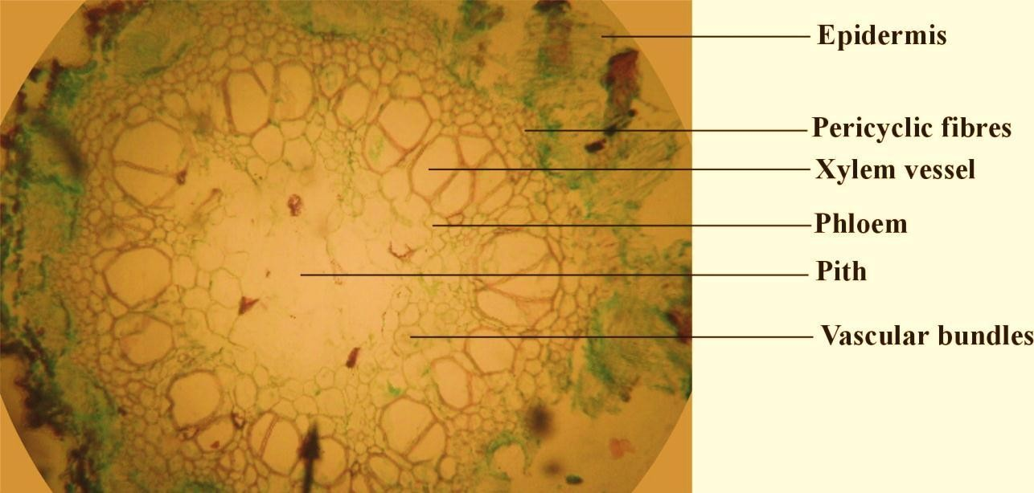

# Plate II: Transverse section of *C. filifomis* stem (Safranin and Fast green Stain. X 200)

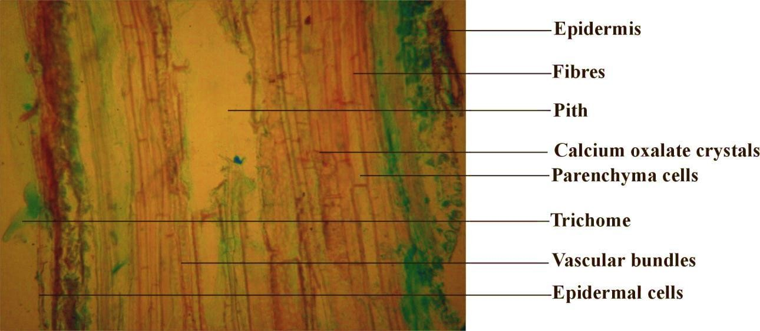

**Plate III: Longitudinal section of *C. filifomis* stem (Safranin and Fast green Stain. X 200)**

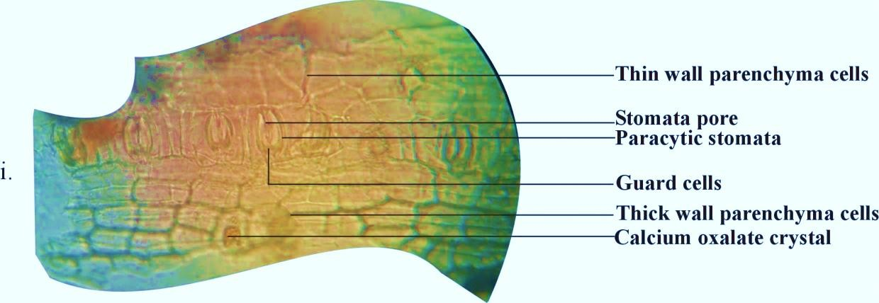

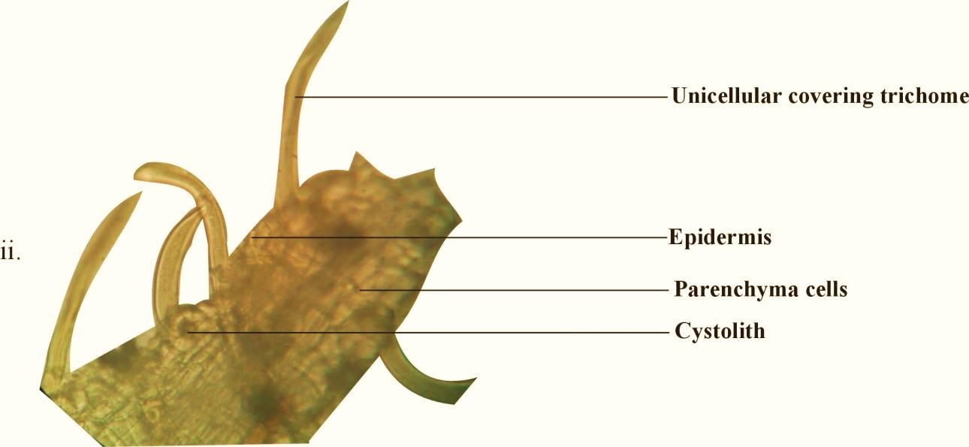

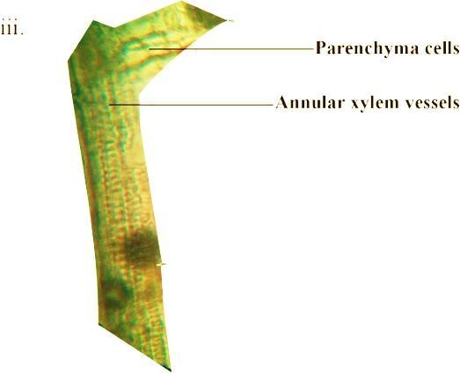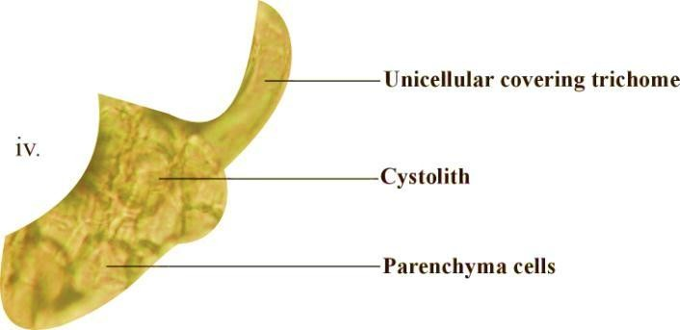

# PlatesIV: Microscopical features of powdered wholeplant of C*. filifomis*

**(X 200)**

* + 1. **Chemomicroscopical examination of powdered*C. filiformis***

The chemo-microscopical features identified were starch, and calcium oxalate crystals, (cell inclusions), tannins, and calcium carbonate (cell constituents), and cellulose and mucilage, suberin and cuticles (cell wall materials). (Table 4.3.3)

# Table 4.3.3: Chemomicroscopical features from the powdered *C. filiformis*

|  |  |  |  |
| --- | --- | --- | --- |
| **Reagents** | **Constituents** | **Observation** | **Inference** |
| **CELL WALL MATERIALS** |  |  |  |
| Chlor-zinc-iodine +  Conc. HCl | Cellulose | Blue-violet | Cellulose |

|  |  |  |  |
| --- | --- | --- | --- |
| Sudan iv red | Suberin/Cuticle | Orange red | Suberin/Cuticle |
| Phloroglucinol + Conc. HCl | Lignin | Pink | Lignin |
| **CELL CONSTITUENTS** |  |  |  |
| 5 % Ferric chloride | Tannins | Greenish black | Tannins |
| N/50 Iodine | Starch | Blue | Starch |
| Million’s reagent | Protein | Red colouration | Protein |
| 80 % H2SO4 | Calcium oxalate crystals | Shiny crystals dissolves | Calcium oxalate crystals |
| 5% acetic acid | Calcium carbonate | Crystals dissolves  with effervescence | CaCO3 |

* 1. **Preliminary Phytochemical Screening of *C. filiformis***

Phytochemical screening carried out on the powdered *C. filiformis* suggested the presence of alkaloids, steroids, flavonoids, tannins and saponins. (Table 4.4)

**Table 4.4: Preliminary phytochemical screening of *C. filiformis***

|  |  |  |
| --- | --- | --- |
| **Test** | **Observation** | **Inference** |
| **Dragendoff’s reagent** | Orange red precipitate | ***Alkaloids present*** |
| **Mayer’s reagent** | Creamy white precipitate | ***Alkaloids present*** |
| **Wagner’s reagent** | Brown precipitate | ***Alkaloids present*** |
| **Guinard Test** | Brick red colour | ***Cyanogenic present*** |

|  |  |  |
| --- | --- | --- |
| **Liebermann-Burchard’s reagent** | No green colouration | ***Steroidal nucleus present*** |
| **Kella-Killiani’s reagent** | No reddish brown at interphase | ***Deoxy-sugars absent*** |
| **Kedde’sreagent** | No purple blue colouration | ***Lactone ring absent*** |
| **Lead acetate Test** | Buff precipitate | ***Tannins present*** |
| **Bromine water Test** | Blue colouration | ***Tannins present*** |
| **Ammonia solution Test** | Green colouration | ***Tannins present*** |
| **Borntrager’sreagent** | Pink colour | ***Anthraquinones***  ***present*** |
| **FeCl3 Test** | Greenish | ***Phenolic nucleus***  ***present*** |
| **NaOH Test** | Yellow colouration turns colourless with HCl | ***Flavonoids present*** |
| **Shinoda Test** | Pink colouration | ***Flavonoids present*** |
| **Amyl alcohol Test** | Yellow colouration | ***Flavonoids present*** |
| **Frothing Test** | Persistent froth | ***Saponins present*** |
| **Haemolysis Test** | Haemolysis | ***Saponins present*** |
| **Salkowski’s Test** | Brown colour at interface | ***Terpenoids present*** |

* 1. **Numerical Standard of *C. filiformis***

The numerical standard of powdered *C.filiformis* measured under this work include; moisture content, total ash value, acid insoluble ash value, total tannins, swelling index, bitterness value, alcohol and water soluble extractive values, oil content and crude fibre (Table 4.5)

**Table 4.5: Numerical Standardsof *C. filiformis***

|  |  |
| --- | --- |
| **Numerical Standards** | ***C. filiformis* %** |
| Moisture content | 5.50 |
| Ash value | 17.00 |
| Acid insoluble ash | 1.00 |
| Water soluble extractive value | 20.60 |

|  |  |
| --- | --- |
| Alcohol soluble extractive value | 13.60 |
| Tannin content | 27.30 |
| Bitterness value | 0.23 |
| Swelling index | 165.00 |
| Oil | 1.60 |
| Crude fibre | 22.40 |
| n =4 - 5, see raw data in appendix |  |

* 1. **Extraction of Powdered *C. filiformis***

Extraction of dried powdered 1.5 kg of *C. filiformis* using various solvents yielded the following; Petroleum ether, 32.42 g (2.16 %), ethyl acetate, 29.13 g (1.94 %) and methanol, 215.02 g (14.34 %)

* 1. **Analysis of metals detected in powdered *C. filiformis***

Elemental analysis was carried out on the powdered *C. filiformis.* Some of the analysed metals include; copper, chromium, iron, manganese, potassium, calcium, sodium, nickel, cadmium, zinc and lead (Table 4.7).

**Table 4.7: Elemental analysis of powdered *C. filiformis***

# Elements Concentration (ppm)FAO/WHO (1984) limit*(ppm)

|  |  |  |  |
| --- | --- | --- | --- |
| Na | 5.1735 |  | - |
| Mg | 9.3911 |  | - |
| Ca | 84.3993 |  | - |
| Cr | 7.7940 | - |  |
| Cu | 0.0535 | 3.0 |  |
| Fe | 165.4279 | 20 |  |
| K | 0.8313 | - |  |
| Mn | 14.4093 | 2.0 |  |

|  |  |  |  |
| --- | --- | --- | --- |
| Zn |  | 0.1094 | 27.4 |
| Pb |  | 0.0568 | 0.43 |
| Cd |  | 0.0103 | 0.21 |
| Ni |  | 2.7933 | 1.63 |
| Co |  | 0.4621 | - |
|  | **\*For edible plants** |  |  |

**Keys**

ppm: Parts per million

# Chromatography and Spectroscopy

* + 1. **: Thin layer chromatography profile of extracts**

The thin layer chromatographic profile of the pet ether extract, ethyl acetate and methanol extracts of *C. filiformis* are presented in Fig V-VII below.

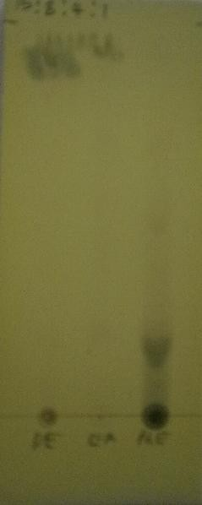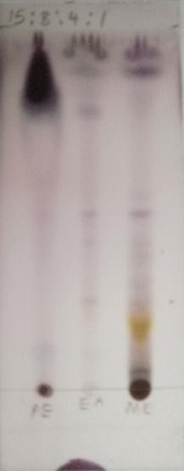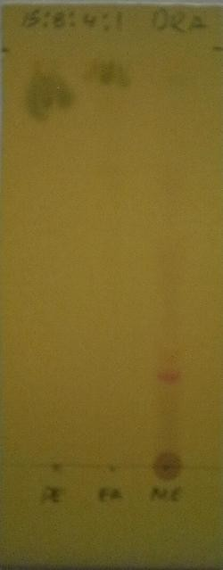

# A B C

**Plate V: Chromatogram of Pet ether (PE), Ethyl acetate (EA) and Methanol (ME) Extracts of *C. filiformis* developed using solvent system :EtOAc-CHCl3- MeOH-H2O ( 15-8-4-1). Sprayed with FeCl3 (A), Anisaldehyde/H2SO4 (B) and Drangendoff’s reagents (C).**

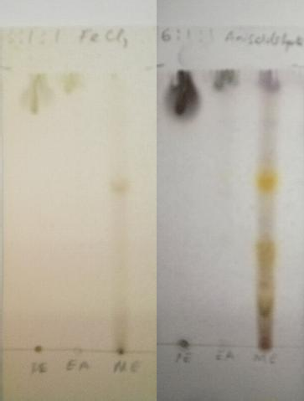

# A B C

**Plate VI Chromatogram of Pet ether (PE), Ethyl acetate (EA) and Methanol (ME) Extracts of *C. filiformis* Developed using solvent system BuOH-Acetic acid- H2O ( 6-1-1). Sprayed with FeCl3 (A), Anisaldehyde/H2SO4 (B) and Drangendoff’s reagents (C).**

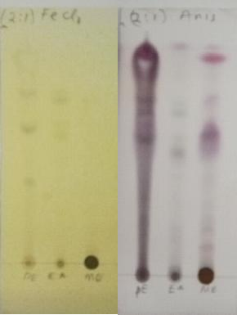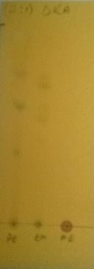

# A B C

**Plate VII Chromatogram of Pet ether (PE), Ethyl acetate (EA) and Methanol (ME) Extracts of *C. filiformis*developed using solvent system: Hex-EtOAc(2-1). Sprayed with FeCl3 (A), Anisaldehyde/H2SO4 (B) and Drangendoff’s reagents (C).**

# : Column chromatography of petroleum ether extract

Seventy column fractions were collected and were pooled together based on their TLC profile to give eight portions. Out of which fraction 54-63 (coded 7) yielded 3 spots (as shown below) was further purified by another round of column separation from which a white crystalline compound (5B) was obtained

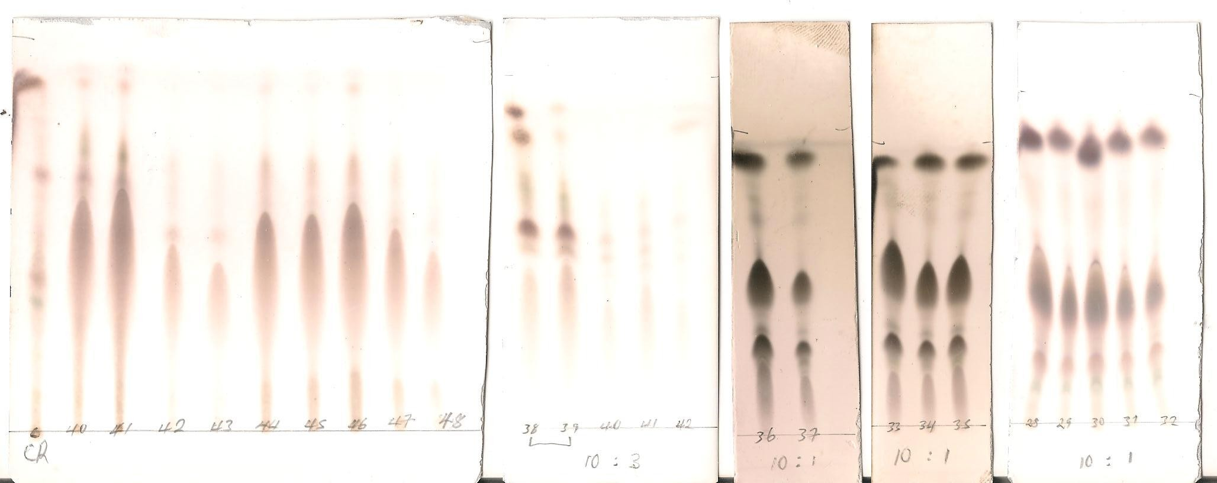

# Plate VIII:Some column chromatographic profile of pet ether extract of *C. filiformis*

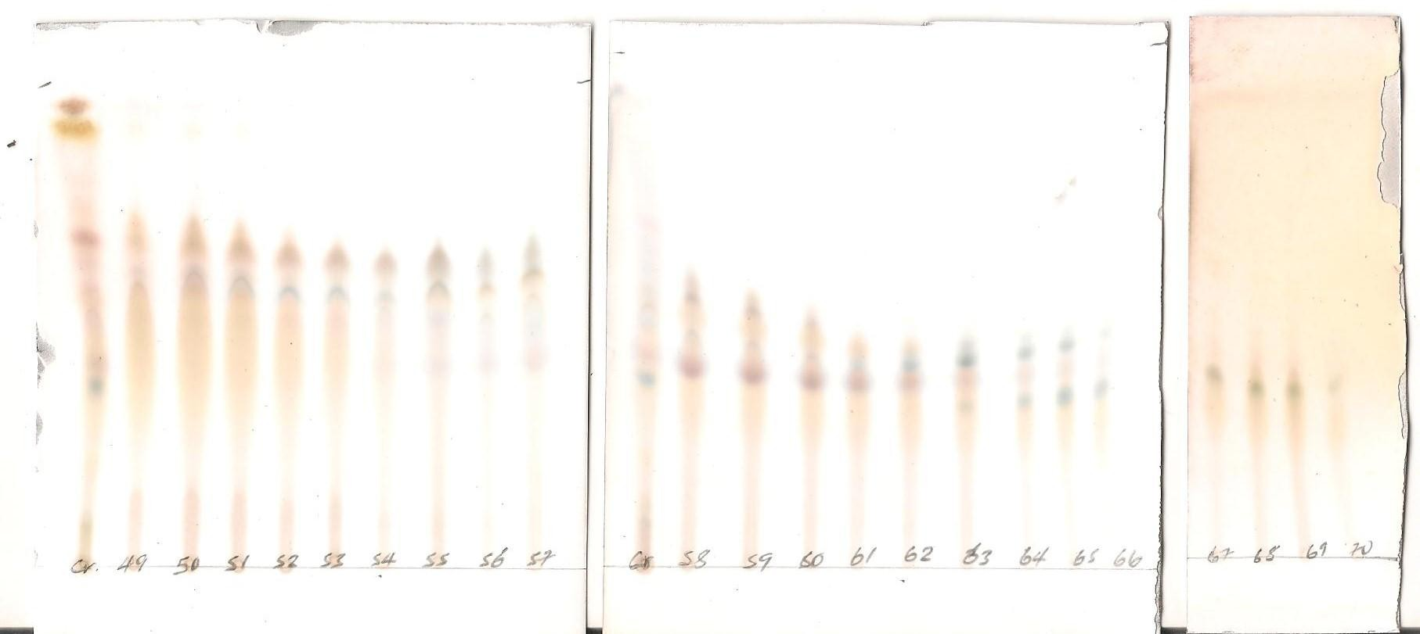

**Plate IX:Some column chromatographic profile of pet ether extract of *C. filiformis***

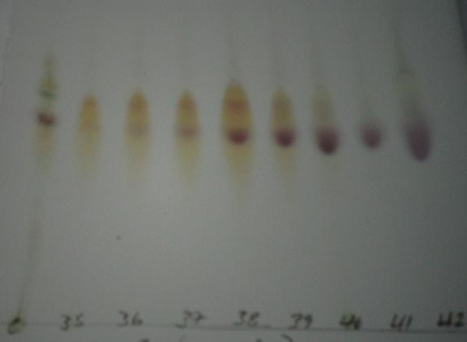

**Plate X:TLC chromatogram of fractions obtained in the second column chromatography for pooled fractions, Hex: EtOAc (10:5) visualised with 10 % H2SO4**

## Isolation of compound 5B

Column fractions showing single spots (plate X)was re-crystalized using ethyl acetateand afforded white crystalline powder coded 5B (10.2 mg) whichwas subjected to physical, chemical and spectral analysis for identification

## Thin layer chromatographic analysis of 5B

The result of thin layer chromatographic analysis of 5B revealed a single spot with Rfvalue of 0.70 when developed with hexane: ethyl acetate (2:1) as solvent system (Plate XI)

## Solubility profile of 5B

The compound 5B was found to be soluble in ethyl acetate andsoluble in chloroform

# Melting point of 5B

The sample was found to have a melting point range of 144 -146 0C.

 

# A B

**Plate XI: TLC plates of 5B developed in Hexane: Ethyl acetate (2:1)**

Visualized under UV light 360 nm (A) and with 10 % Sulphuric acid Reagent spray

# Spectroscopic analysis

The results of the spectroscopic analysis of compound 5B are presented below.

# Table 4.8.4:Some NMR Signals of Compound 5B Measured in CDCl3 at 500 MHz

|  |  |  |  |
| --- | --- | --- | --- |
| **δH1 (ppm)** | **Multiplicity** | **No. of Protons** | **Assignment** |
| 3.52 | m | 1H | H-3 |
| 5.36 | brs | 1H | H-6 |
| 0.70 | brs | 3H | H-18 |
| 1.01 | brs | 3H | H-19 |
| 0.92 | brs | 3H | H-21 |
| 5.02 | dd | 1H | H-22 |
| 5.15 | dd | 1H | H-23 |
| 0.82 | brs | 3H | H-26 |
| 0.83 | brs | 3H | H-27 |
| 0.86 | brs | 3H | H-29 |

*m= multiplet, brs= broad singlet, dd= double-doublet*

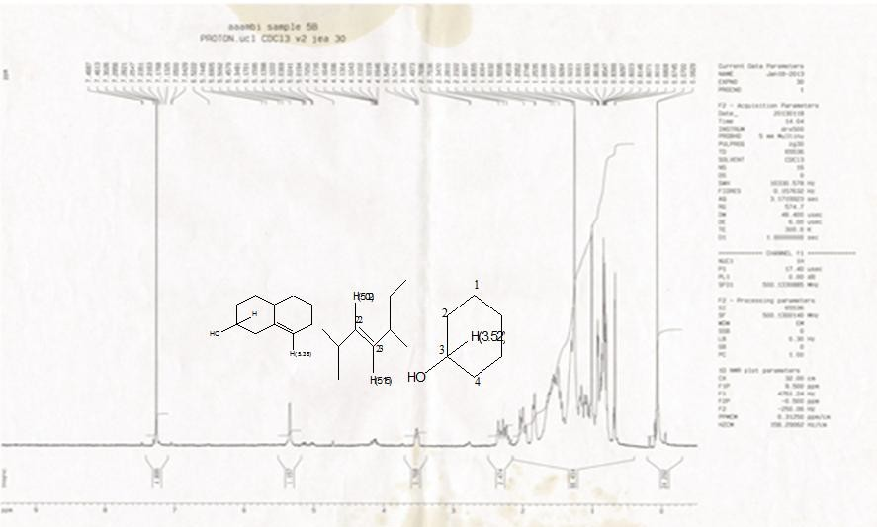

# Fig. 2:1H NMR spectrum of 5B in CDCl3 500MHz

The result of 1HNMR exhibited clusters of signals at down field (0.0-2.0 ppm, 3.52 (m). It also revealed the presence of a proton at

5.35 br s , 5.12 and 5.15 both double doublet (Table 4.8.4).

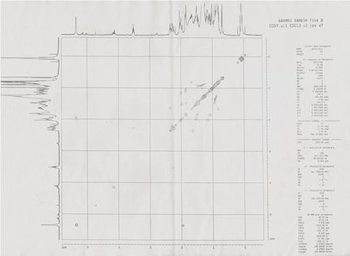

# Fig. 3: 1H-H COSY spectrum of 5B in CDCl3 500MHz

nb103_ei #7-27 RT: 0.78-2.86 AV: 21 NL: 4.93E6 T: + c EI Full ms [ 49.50-800.50]

100 83.93

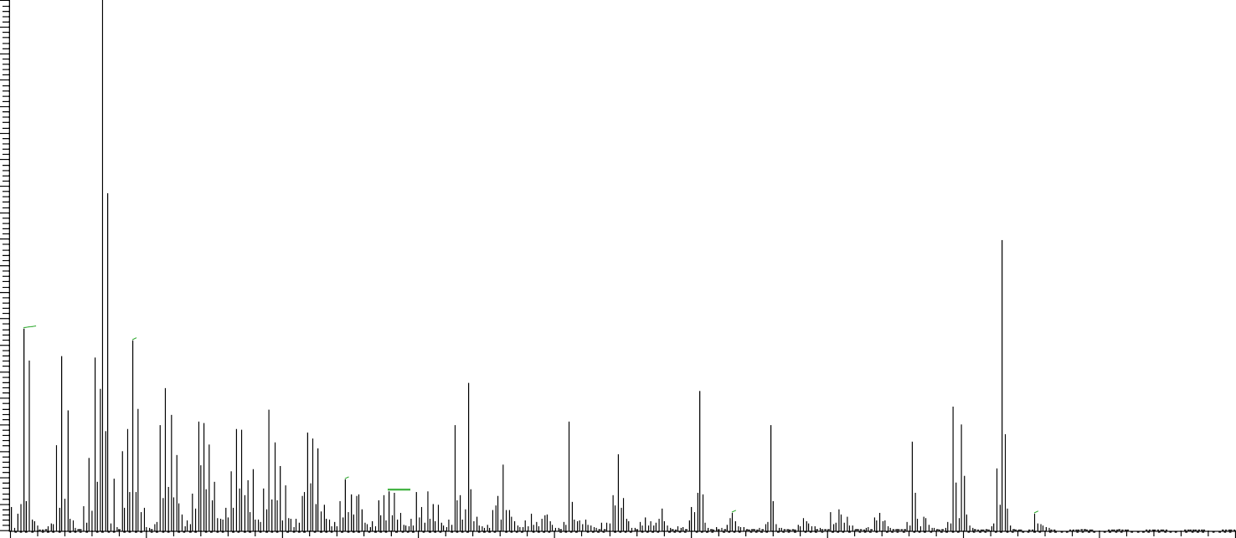

85.92

414.34

54.89

95.06

69.02

107.08

218.21

303.29

109.09

145.11

396.33

133.10

255.21

159.13

213.17

329.30

381.31

273.22

231.18

173.14

189.17

233.20

300.23

315.27

354.30

426.34

443.41 457.43 485.46

95

90

85

80

75

70

65

60

55

50

45

40

35

30

25

20

15

10

5

0

50 100 150 200 250 300 350 400

m/z

450 500

# Fig. 4: Mass spectrum of 5B (Electron impact)

Analysis of the fragmentation peaks of 5B exhibited the following *m/z*: 396 [M-H2O], 381.[M-CH3,-H2O], 303 [C7H110], 273 [M- C10H21] and 255 [M-H2O- C10H21].

nb106_ci_130131124956 #10-11 RT: 1.09-1.20 AV: 2 NL: 2.77E6 T: + c CI Full ms [ 49.50-800.50]

100 414.36

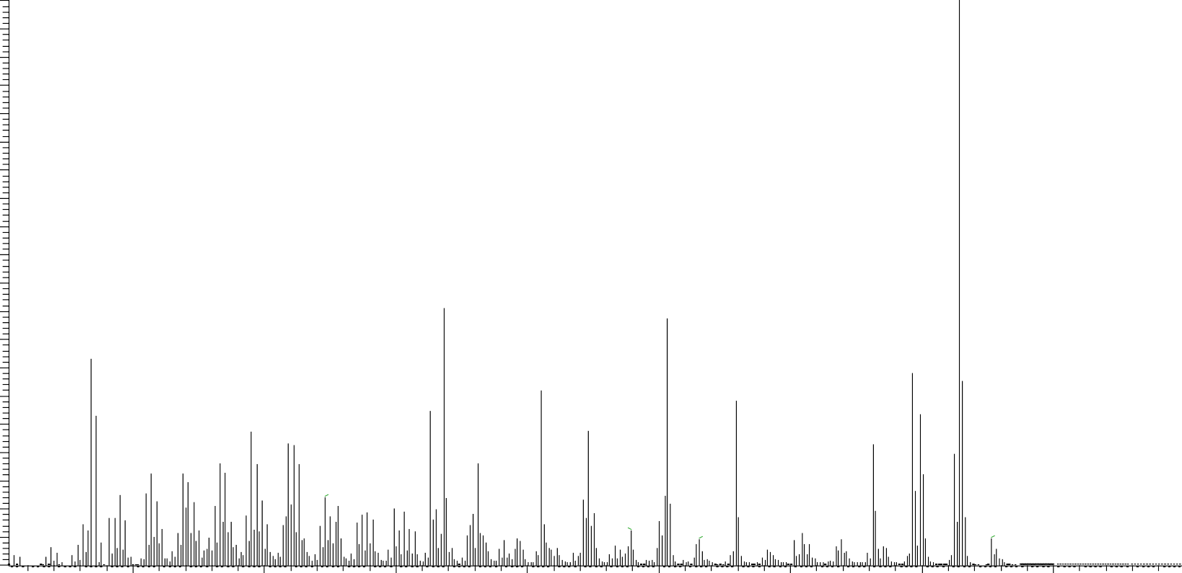

218.19

303.28

83.92

396.35

255.19

329.30

85.78

213.15

145.09 273.21

159.10 381.33

119.05

133.08

231.16

173.12

199.14

81.03

79.01

275.26

289.27

315.28

354.31

426.36

444.45 474.55

95

90

85

80

75

70

65

60

55

50

45

40

35

30

25

20

15

10

5

0

100 150 200 250 300 350 400

m/z

450

# Fig. 5: Mass spectrum of 5B (Chemical ionization)

The result of high resolution electron impact mass spectroscopy revealed the presence of two molecular ion M+ peaks at m/z 414 and 412

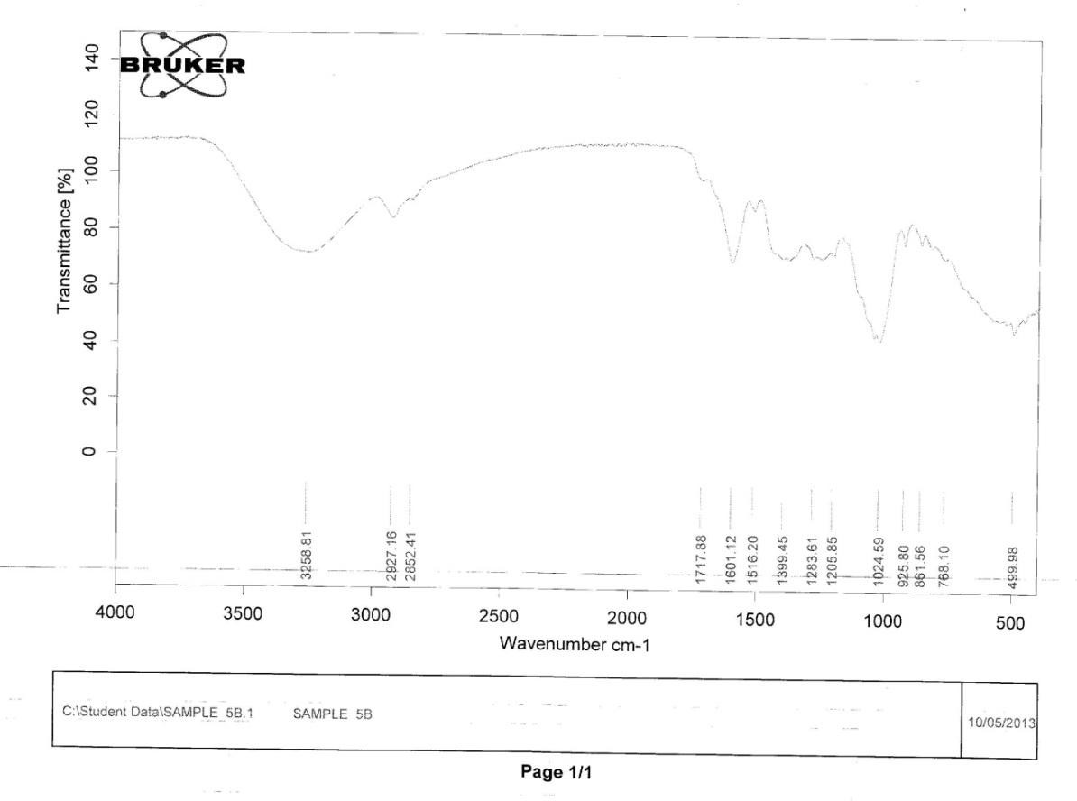

# Fig. 6: FT-IR spectrum of 5B

The FTIR spectroscopic analysis revealed absorption bands at 3258.8cm‐1 (OH), 2927.2 cm‐1 and 2852.4 cm‐1(C-H stretching). Other absorption frequencies were observed at 1601.1 cm‐1 (C=C), 1024.6 cm‐1 (C-C of cycloalkane) and at 861.6cm‐1 (out of plane C-H)

# : HPLC analysis for ethyl acetate and methanol extracts from *C. filiformis*

High Performance Liquid chromatographic analysis (HPLC) was carried for ethyl acetate and methanol extracts of *C. filiformis* to determine and compare the general profile of the compounds present in the crude extracts (methanol and ethyl acetate) so as to assist in easily getting an optimized conditions for the Liquid Chromatography and Mass Spectroscopic analysis (LC-MS/MS). The result is shown in Fig. 6 to 9.

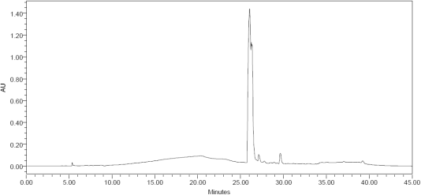

# Fig. 7: HPLC chromatogram of ethyl acetate extract at 254 nm

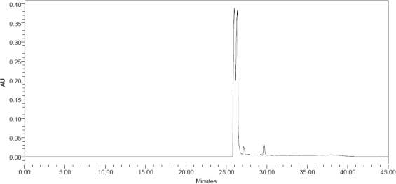

**Fig. 8: HPLC chromatogram of ethyl acetate extract at 360 nm**

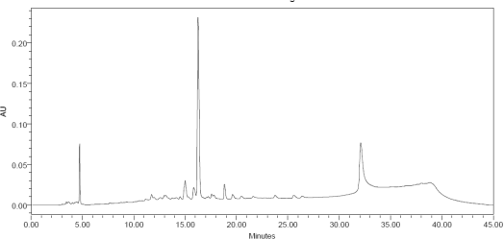

# Fig. 9: HPLCchromatogram of methanol extract at 254 nm

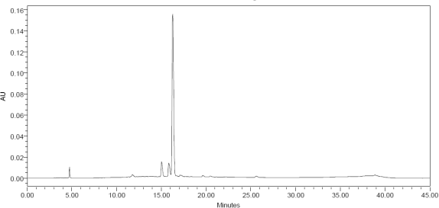

**Fig. 10: HPLC chromatogram of methanol extract at 360 nm**

# : LCMS/MS analysis for ethylacetate and methanol fractions from

## C. filiformis

The result of LCMS/MS analysis from ethyl acetate fractions of *C. filiformis* revealed the spectra of 7 phenolic compounds fully identified by the equipment using ACD/labs advanced chemometrics mass fragmentations predictive software. Also from the methanol extra, 5 phenolic compounds were fully identified. The 7 phenolic compounds from ethyl acetate fractions include, 3,3,O-di-O-methyl ellagic acid **[17]**, catechin **[15]**, Chalcone **[14]** compounds, *p*-hydroxybenzoic acid **[16]**, isorhamnetin 3-O-rutinoside **[9]** or isorhamnetin 3-O-neohesperidoside, kaemferol 3 rutinoside

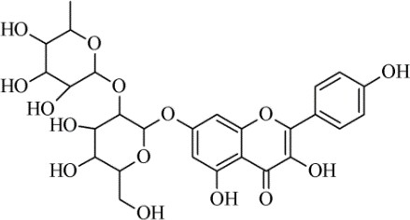**[13]** and 2-{cyclohex-2-en-1-yl(hydroxyl)methyl}-3-hydroxy-4-(2-hydroxyethyl)-3- methyl-5-oxoprolinate.

# http://upload.wikimedia.org/wikipedia/commons/thumb/5/54/3-methylquercetin.svg/250px-3-methylquercetin.svg.png 9 3 http://upload.wikimedia.org/wikipedia/commons/thumb/7/71/Chalcone.svg/200px-Chalcone.svg.png14

**1**

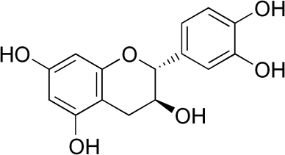 **17**

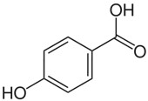

**15**

**16**

# Fig. 11: Compounds identified by LCMS/MS from ethyl acetate and methanol extracts.

***9.*** *Isohamnetin-3-O-rutinoside* ***12.*** *Quercetin-3-O-rutinoside*

***13.*** *Quercetin-3-O-robinobioside* ***14.*** *Chalcone* ***15.*** *Cathecin* ***16.*** *P-hydroxybenzoic acid* ***17.*** *3,3, O-dimethyl ellagic acid*

Those phenolic compounds identified from the methanol fraction of *C. filiformis* include; 3,3,O-di-O-methyl ellagic acid **[17]**, methy 2-{cyclohex-2-ene-1- y(hydroxyl)methyl}-3-hydroxy-4-(2-hydroxyethyl)-3-methyl-5-oxoprolinate, kaemferol 3 rutinoside **[13]**, rutin **[12]** and cathechin **[15]**.

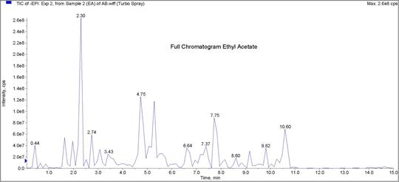

# Fig. 12: LCMS/MS chromatogram from ethylacetate extract of *C. filiformis*

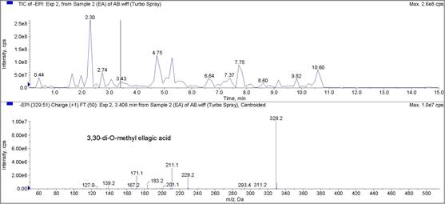

**Fig. 13: LCMS/MS chromatogram and spectrum of 3, 3, O-di-O-methyl ellagic acid from ethylacetate extract of *C. filiformis.***

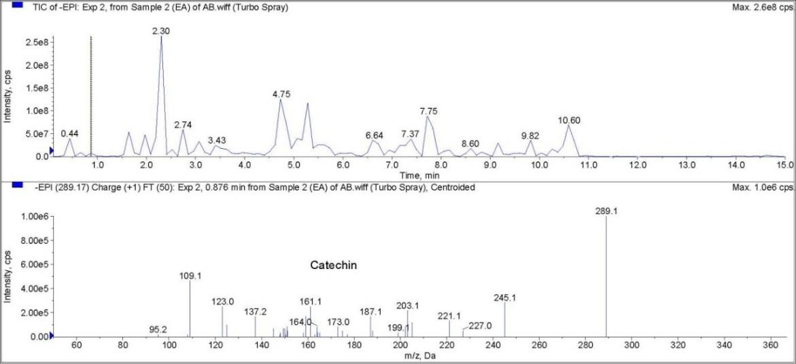

# Fig. 14: LCMS/MS chromatogram and spectrum of catechin from ethylacetate extract of *C. filiformis*

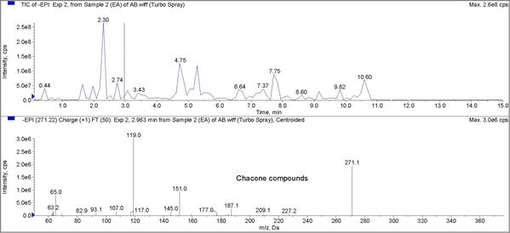

**Fig. 15: LCMS/MS chromatogram and spectrum of Chalcone compounds from ethylacetate extract of *C. filiformis***

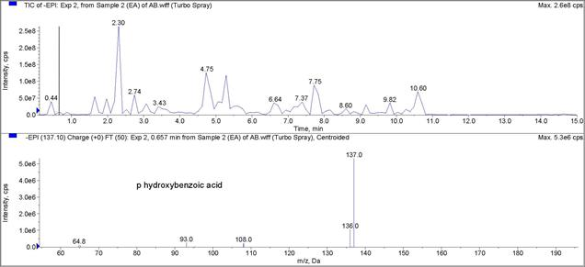

# Fig. 16: LCMS/MS chromatogram and spectrum of p hydroxybenzoic acid from ethylacetate extract of *C. filiformis*

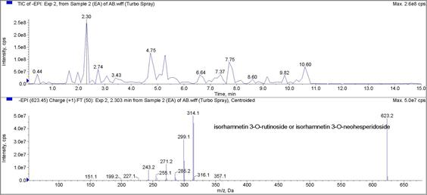

**Fig. 17: LCMS/MS chromatogram and spectrum of isorhamnetin 3-O-rutinoside or isorhamnetin 3-O-neohesperidoside from ethylacetate extract of *C. filiformis***

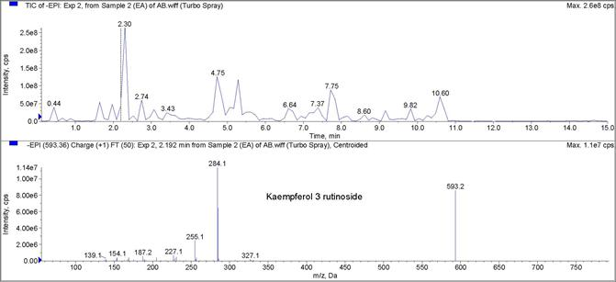

# Fig. 18: LCMS/MS chromatogram and spectrum of kaemferol 3 rutinoside from ethylacetate extract of *C. filiformis*

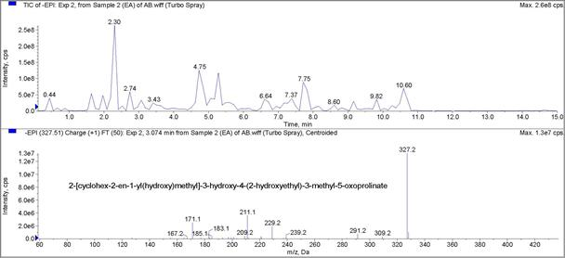

**Fig. 19: LCMS/MS chromatogram and spectrum of 2-{cyclohex-2-en-1-yl(hydroxyl)methyl}-3-hydroxy-4-(2-hydroxyethyl)-3- methyl-5-oxoprolinate from ethylacetate extract of *C. filiformis***

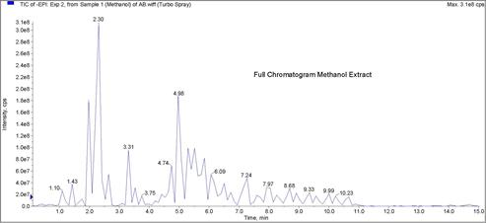

# Fig. 20: LCMS/MS chromatogram from methanol extract of *C. filiformis*

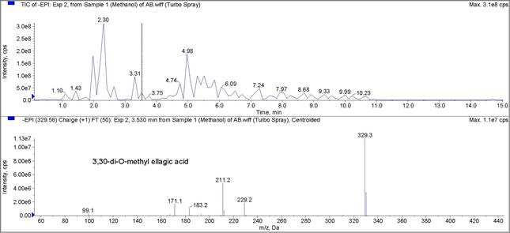

**Fig. 21: LCMS/MS chromatogram and spectrum of 3, 3, O-di-O-methyl ellagic acid from methanol extract of *C. filiformis***

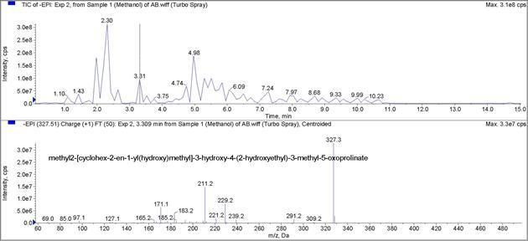

# Fig.22: LCMS/MS chromatogram and spectrum of methy 2-{cyclohex-2-ene-1-y (hydroxyl) methyl}-3-hydroxy-4-(2- hydroxyethyl)-3-methyl-5-oxoprolinate from methanol extract of *C. filiformis*

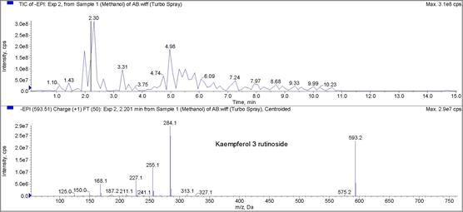

**Fig. 23: LCMS/MS chromatogram and spectrum of kaemferol 3 rutinoside from methanol extract of *C. filiformis***

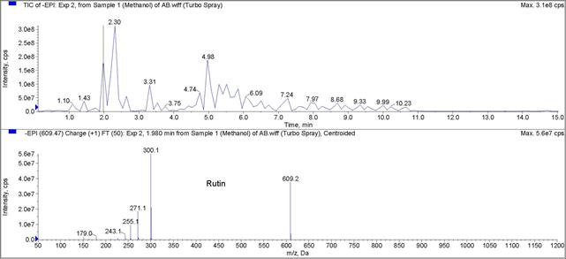

# Fig. 24: LCMS/MS chromatogram and spectrum of rutin from methanol extract of *C. filiformis*

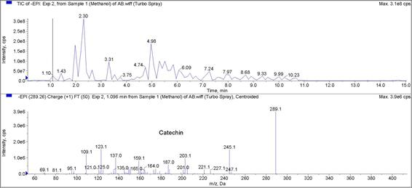

**Fig. 25: LCMS/MS chromatogram and spectrum of catechin from methanol extract of *C. filiformis***

* 1. **Hepatoprotective Studies of *Cassytha filiformis***
     1. **Acute toxicity studies on extracts of *C. filiformis* extracts**

The median lethal dose values of the extracts of *C. filiformis* wouldbe taken to be greater than 5,000 mgkg-1 since all the three animals survived at the end of the 14 days observation period. The animals did not show any sign of toxicity. There was no change in food and water intake. There was also no observed behavioural (jumping, sniffing and scratching) and autonomic changes (pupillary size, lacrimation, salivation, defeacation and urination) in the animals after the treatment.

# 4.9.1 Histopathological studies Table 4.9.2 Histopathology report

|  |  |  |
| --- | --- | --- |
| **Group** | **Treatment** | **Microscopical Observations** |

|  |  |  |
| --- | --- | --- |
| **A1(XII)** | 1500 mgkg-1 ethyl acetate extract + 1500 mgkg-1 paracetamol | Focal areas of degenerated hepatic cells. Intracytoplasmic vacuoles.  Congested blood vessel |
| **A2(XIII)** | 1000 mgkg-1 ethyl acetate extract + 1500 mgkg-1 paracetamol | Signs of degenerated hepatic cells |
| **A3(XIV)** | 500 mgkg-1 ethyl acetate extract + 1500 mgkg-1 paracetamol | Focal areas of degenerated hepatic cells. |
| **B1(XV)** | 1500 mgkg-1 petroleum ether extract + 1500 mgkg-1 | Signs intracytoplasmic vacuoles Congested blood vessel |
| **B2(XVI)** | 1000 mgkg-1 petroleum ether extract + 1500 mgkg-1 paracetamol | Focal areas of degenerated hepatic cells Intracytoplasmic vacuoles |
| **B3 (XVII)** | 500 mgkg-1 petroleum ether extract + 1500 mgkg-1 paracetamol | No observable microscopic lesions. |
| **C1(XVIII)** | 1500 mgkg-1 methanol extract + 1500 mgkg-1 paracetamol | Signs intracytoplasmic vacuoles |
| **C2(XIX)** | 1000 mgkg-1 methanol extract + 1500 mgkg-1 paracetamol | No observable microscopic lesions. |
| **C3(XX)** | 500 mgkg-1 methanol extract  + 1500 mgkg-1 paracetamol | No observable microscopic lesions. |
| **D1(XXI)** | Normal saline only 2 ml | No observable microscopic lesions. |
| **D2(XXII)** | Paracetamol (Hepatotoxic group) 1500 mgkg-1 only + 2ml Normal saline | Focal areas of degenerated hepatic cells. |
| **D3(XXIII)** | Silymarin (standard group) 20 mgkg-1 + 1500 mgkg-1 paracetamol | No observable microscopic lesions. |

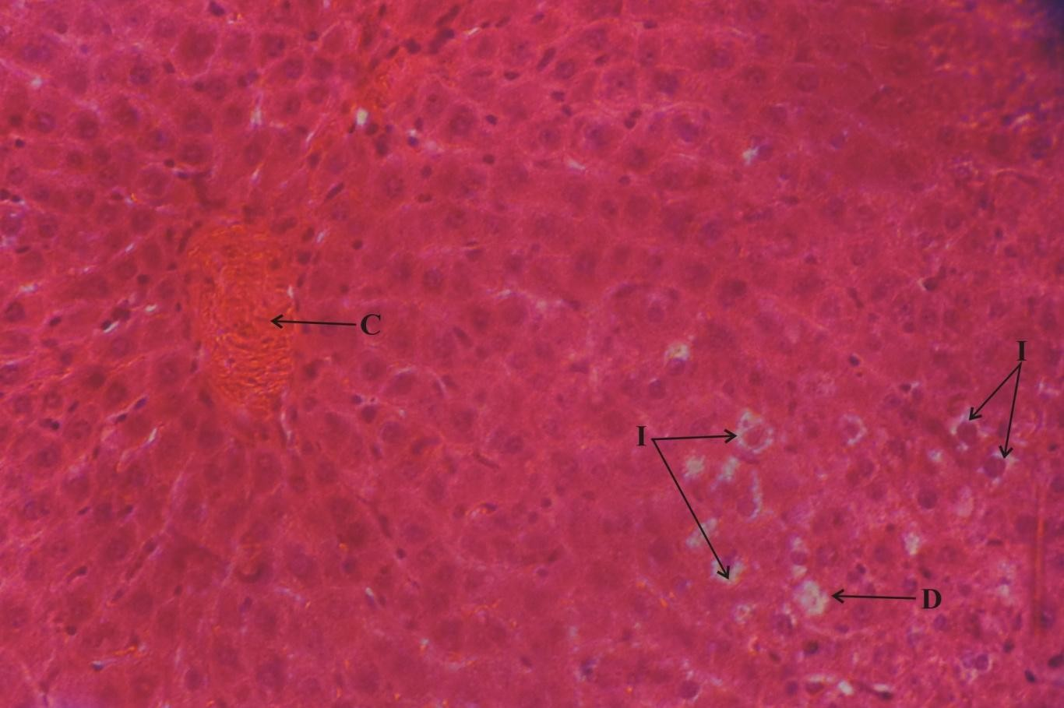

**Plate XII: Photomicrograph of a section of Liver from a rat dosed with 1.5 gkg-1 ethyl acetate extract of *C. filiformis***at **24 hr, 44 hr and 46 hr intervals, followed by a single dose of Paracetamol**

**1.5 gkg-1 at 48 hr. H & E stain. X 400**

The Photomicrograph shows focal areas of degenerated hepatic cells (D), intracytoplasmic vacuoles (I) and congested blood vessel (C).

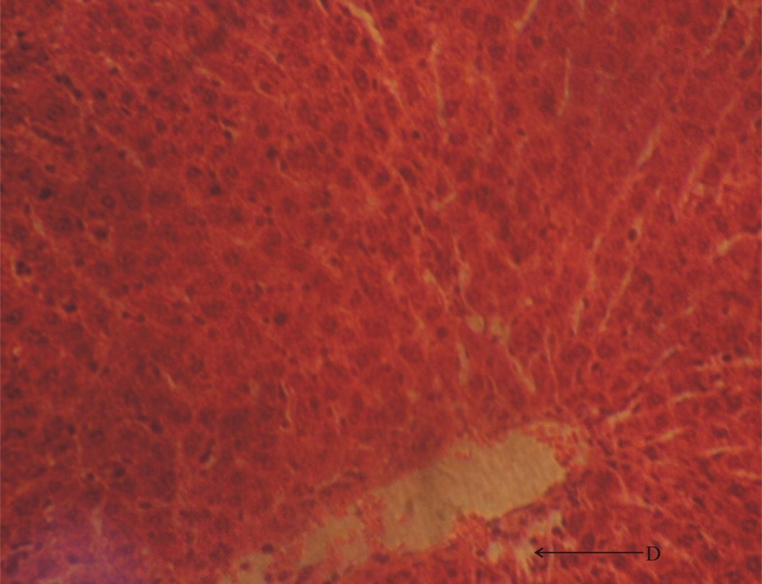

**Plate XIII: Photomicrograph of a section of Liver from a rat dosed with** 1 **gkg-1 ethyl acetate extract of *C. filiformis* at 24 hr, 44 hr and 46 hr intervals, followed by a single dose of Paracetamol 1.5 gkg-1 at 48 hr. H & E stain. X 400**

The Photomicrograph shows some degenerated hepatic cells (D).

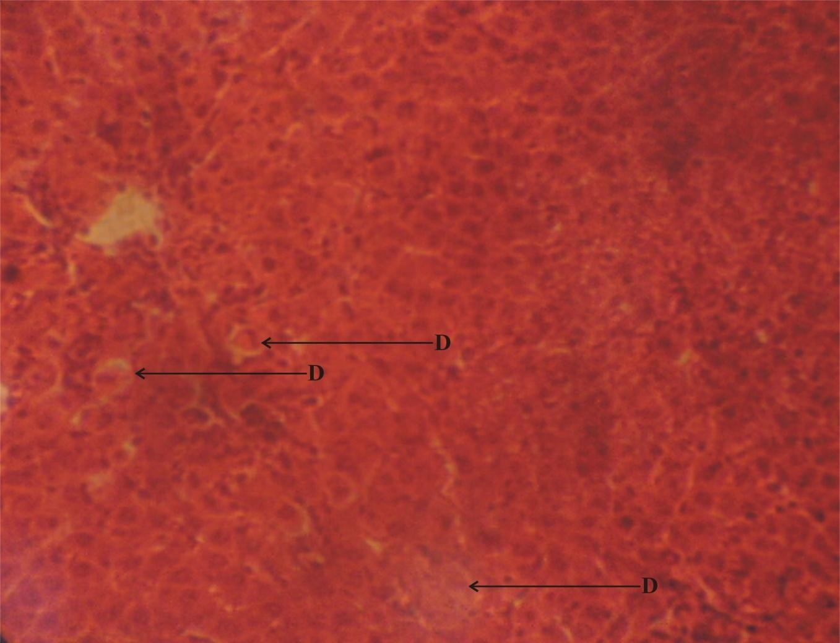

**Plate XIV: Photomicrograph of a section of Liver from a rat dosed with 0.5 gkg-1 ethyl acetate extract of *C. filiformis* at 24 hr, 44 hr and 46 hr intervals, followed by a single dose of Paracetamol**

**1.5 gkg-1 at 48 hr.H & E stain. X 400**

The Photomicrograph shows focal areas of degenerated hepatic cells (D).

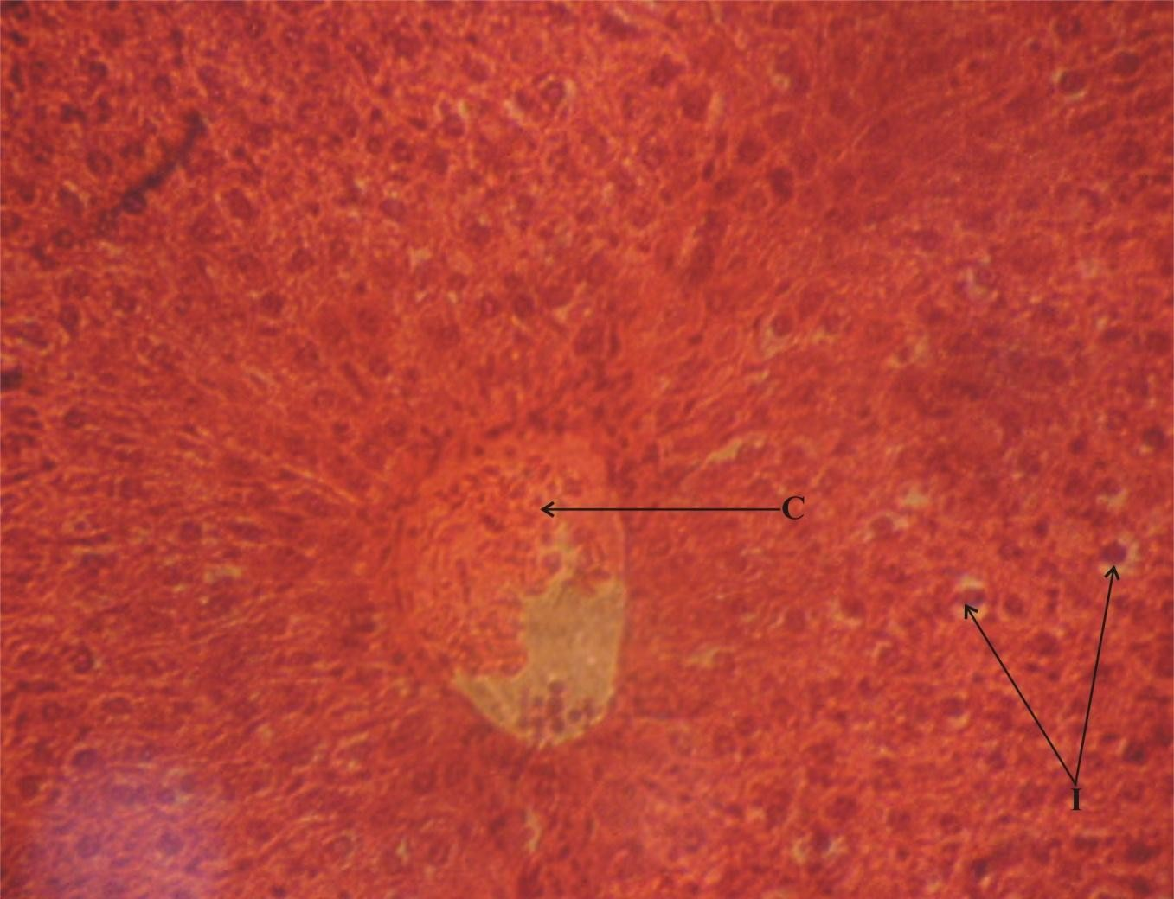

**Plate XV: Photomicrograph of a section of Liver from a rat dosed with1.5 gkg-1 petroleum ether extract of *C. filiformis* at 24 hr, 44 hr and 46 hr intervals, followed by a single dose of Paracetamol 1.5 gkg-1 at 48 hr.H & E stain. X 400**

The Photomicrograph shows some intracytoplasmic vacoules (I) and congested blood vessel (C).

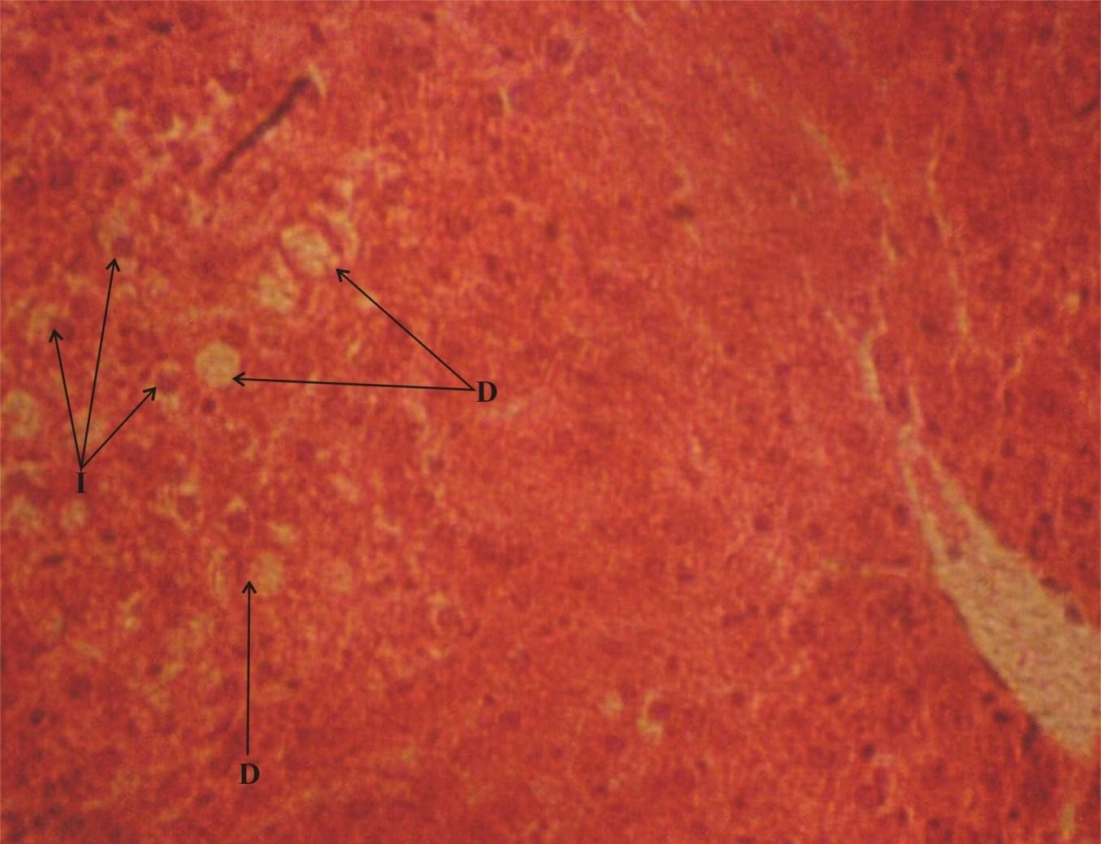

**Plate XVI: Photomicrograph of a section of Liver from a rat dosed with1 gkg-1 petroleum ether extract of *C. filiformis* at 24 hr, 44 hr and 46 hr intervals, followed by a single dose of Paracetamol 1.5 gkg-1 at 48 hr.H & E stain. X 400**

The Photomicrograph shows focal areas of degenerated hepatic cells (D) and intracytoplasmic

vacoules (I).

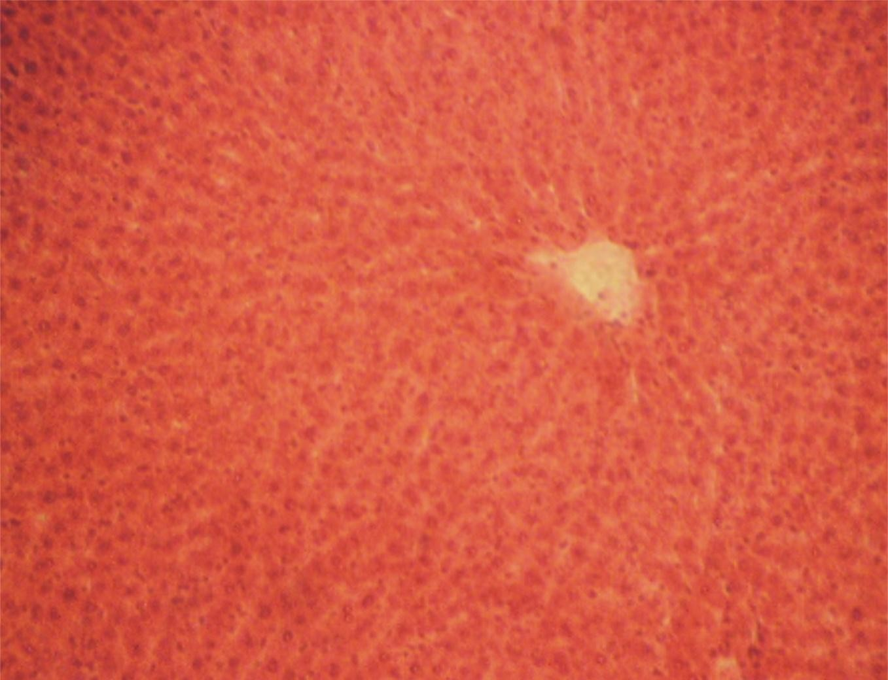

**Plate XVII: Photomicrograph of a section of liver from a rat dosed with0.5 gkg-1 petroleum ether extract of *C. filiformis* at 24 hr, 44 hr and 46 hr intervals, followed by a single dose of paracetamol 1.5 gkg-1 at 48 hr.H & E stain. X 250**

The Photomicrograph shows no observable microscopic lesions.

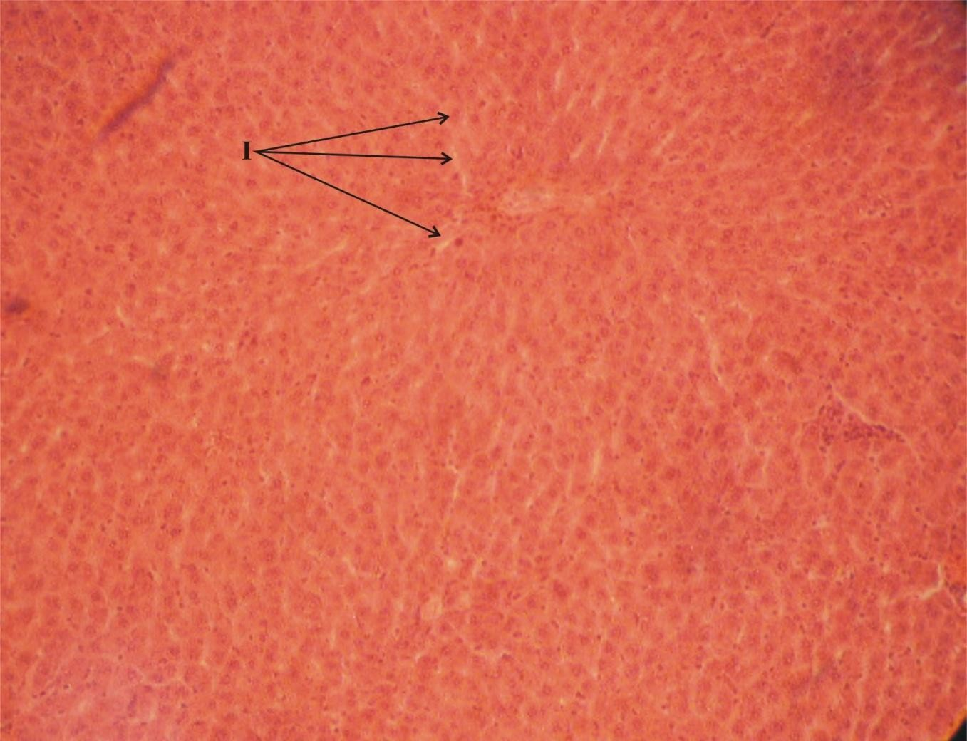

**Plate XVIII: Photomicrograph of a section of Liver from a rat dosed with1.5 gkg-1 methanol extract of *C. filiformis* at 24 hr, 44 hr and 46 hr intervals, followed by a single dose of Paracetamol 1.5 gkg-1 at 48 hr. H & E stain. X 250**

The Photomicrograph shows some intracytoplasmiv vacuoles (I).

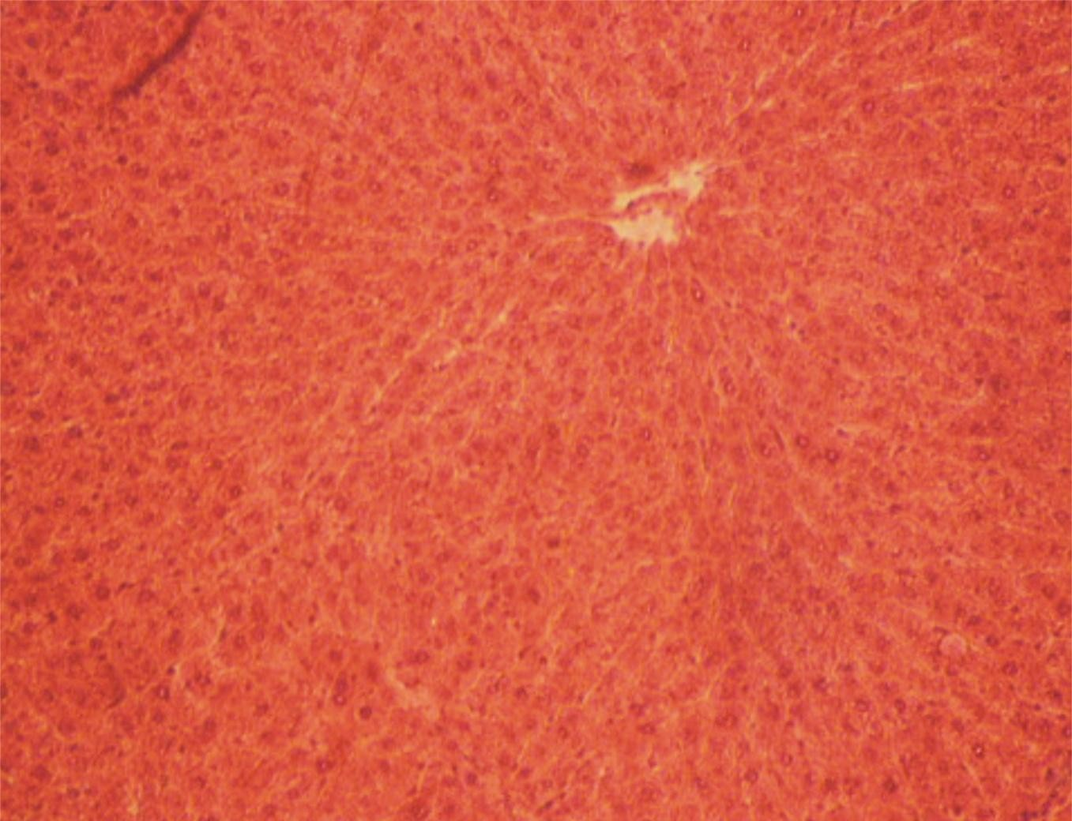

**Plate XIX: Photomicrograph of a section of Liver from a rat dosed with 1 gkg-1 methanol extract of *C. filiformis* at 24 hr, 44 hr and 46 hr intervals, followed by a single dose of Paracetamol 1.5 gkg-1 at 48 hr.H & E stain. X 250**

The Photomicrograph shows no observable microscopic lesions.

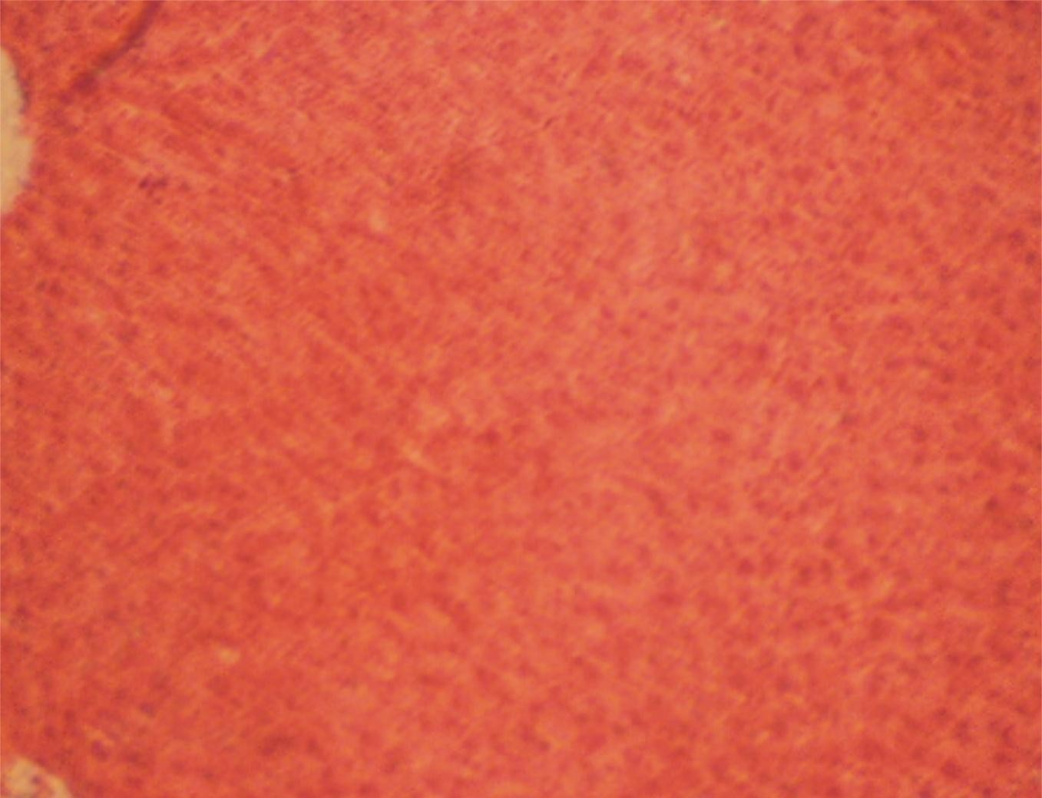

**Plate XX: Photomicrograph of a section of Liver from a rat dosed with0.5 gkg-1 methanol extract of *C. filiformis* at 24 hr, 44 hr and 46 hr intervals, followed by a single dose of Paracetamol 1.5 gkg-1 at 48 hr.H & E stain. X 400**

The Photomicrograph shows no observable microscopic lesions.

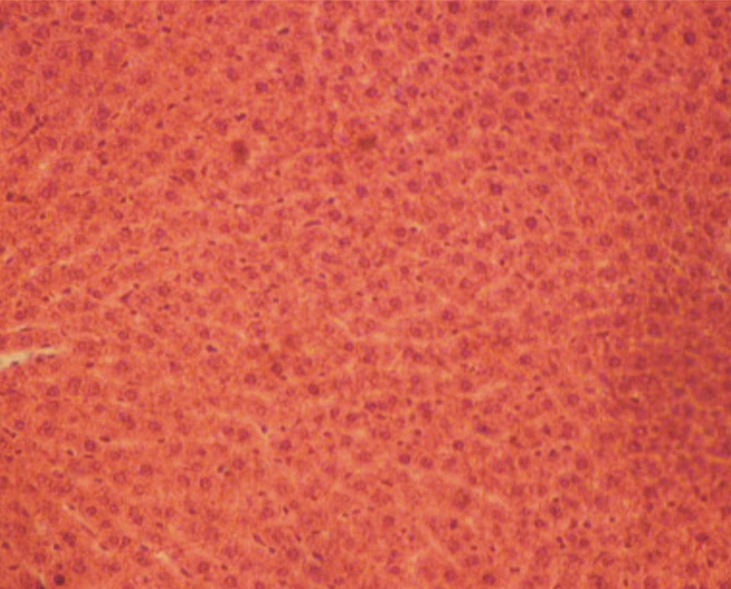

**Plate XXI: Photomicrograph of a section of Liver from a rat dosed with 2 ml normal saline at 24 hr, 44 hr, 46 hr and 48 hr intervals. H & E stain. X 400**

The Photomicrograph shows no observable microscopic lesions.

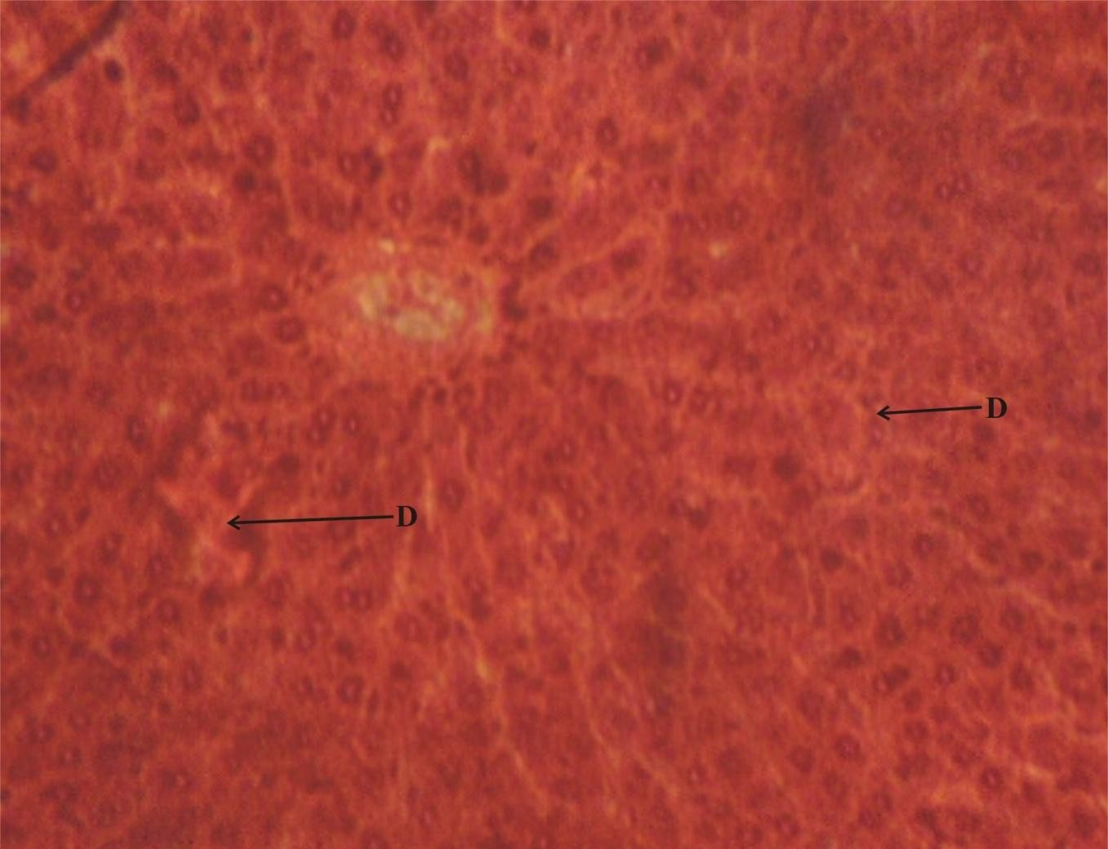

**Plate XXII: Photomicrograph of a section of Liver from a rat dosed with2 ml normal saline at 24 hr, 44 hr and 46 hr intervals, followed by a single dose of Paracetamol 1.5 gkg-1 at 48 hr.H & E stain. X 400**

The Photomicrograph shows focal areas of degenerated hepatic cells.

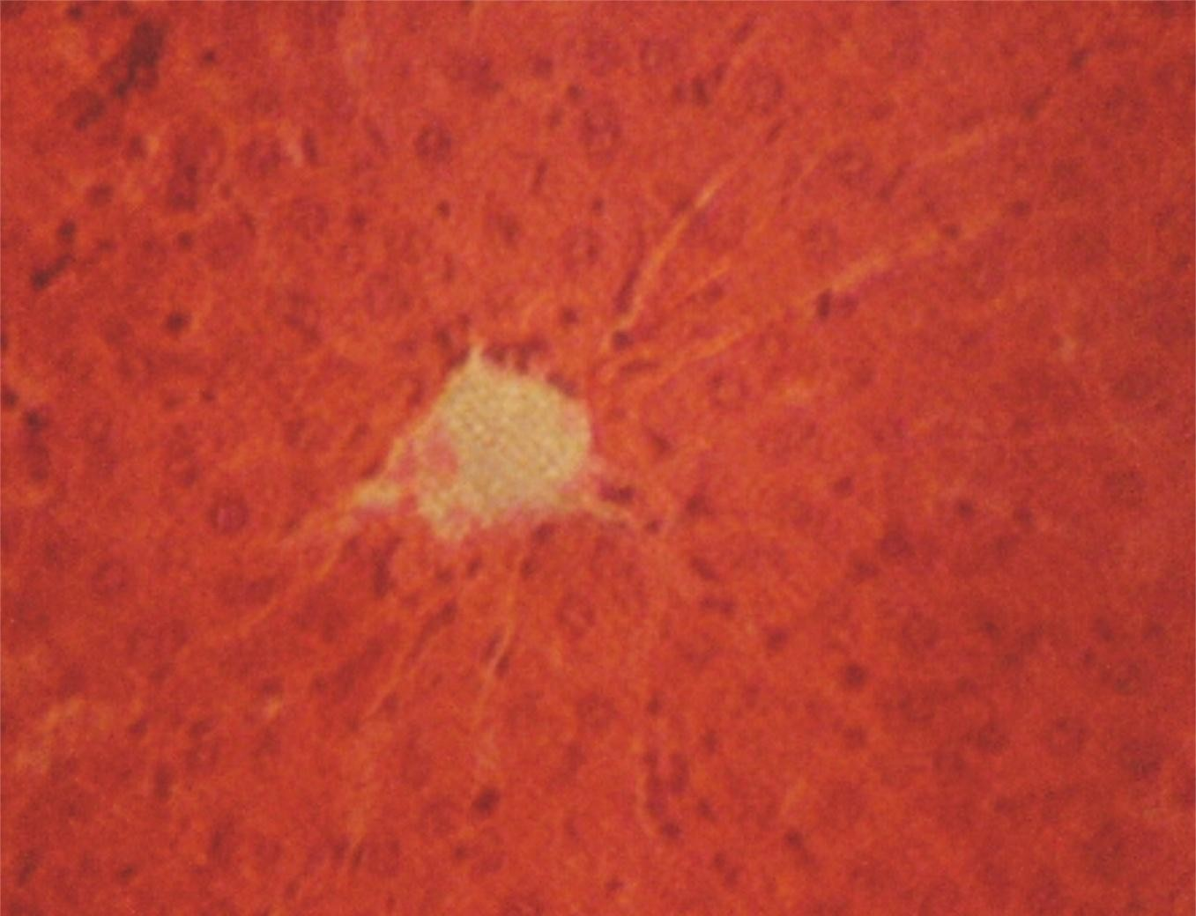

**Plate XXIII: Photomicrograph of a section of Liver from a rat dosed with 20 mgkg-1 silymarin at 24 hr, 44 hr and 46 hr intervals followed by single dose of paracetamol 1.5 gkg-1 at 48 hr. H & E stain. X 400**

The Photomicrograph shows no observable microscopic lesions.

# Chapter 5.0 DISCUSSION

**5.1 Discussion**

*Cassytha filiformis*isused in many cultures for the treatment of various disease conditions including jaundice without standardization. Crude form of *C. filiformis*

has been evaluated with the view to provide useful and diagnostic parameters for the standardization of the drug. The parameters obtained include microscopical features (Plates II, III, IV), chemomicroscopical features (Table 4.3.3) and numerical standards(Table 4.5).

The leafless plant *C. filiformis*was found to have paracytic stomata located in between thin and thick walled parenchymatous cells in the epidermis. This result is in conformity with the previous work by Sharma *et al.,* (2009).The presence of stomata promotes heat dissipation by water loss, maximizing the control of water lossby leaf and increases photosynthetic potential (Woodward, 1998), these features are essential for the plant as the whole of its aerial part is involved in photosynthesis. Prismatic calcium oxalate found scattered in ground parenchymatous cellsare important parameters for identification and standardization of *C. filiformis*and it is a clear indication that the plant is rich in oxalic acid with which higher plants syntheses the crystals and deposit them in specialized in any organ or tissue (Nakata, 2003, Webb, 1999).Presence of unicellular covering trichomeswithcystoliths, (calcium carbonate deposit)is an excellent diagnostic feature for *C. filiformis*. The presence of cystoliths in the base of the trichomes found by this study is reported for the first time. Trichomes are epidermal outgrowths of considerable value for taxonomic purposes for some plants. These outgrowths play a role in plant defense especially with regard to phytophagous insects (Metcalfe and Chalk, 1988). They may also be involved in the regulation of temperature and water repellency as well (Neinhuis and Barthlott, 1997).

Crude drugs owe their biological activity mainly due to active chemical constituents.Extracts from *C. filiformis* contains saponins, flavonoids and tannins, alkaloids and steroids as the major bioactive phyto-constituents(Table 4.4). These constituents are known to exhibit various biological properties includinghepatoprotective properties (Gupta *et al*., 2010; Jager *et al*., 2009; Amarowicz *et al*., 2010, Akroum *et al*., 2009, Dai and Mumper, 2010; Gotteland *et al*., 1997).

Taking into consideration the diversity in chemical nature and properties of contents of drugs, various solvents are used for extractives values. This study found the extractive value of water (20.70 %) to be the highest followed by alcohol (13.60 %) then lipid (oil content) or diethyl ether extract (1.6 %). This is expected as water extracts most polar compounds such as carbohydrates which are the commonest in most plants.The solvent used for extraction is in a position to dissolve appreciable quantities of substances desired (Kokate, 2009).

Studies of physical constants can serve as a valuable source of information and are usually used in judging the purity and quality of the drug(Nisharaj and Radhammany, 2012). The moisture content of *C. filiformis* is exceptionally low compared to the pharmacopoeia (EP, 2011) limit (10 - 12 %).This may not be unconnected to the absence of the leaves and could be essential in preventing decomposition of the crude drug either due to chemical change or microbial contamination during drying and

storing. The ash value and acid insoluble ash value of *C. filiformis* were found to be 17 %, and 1 %, w/w respectively. The acceptable (WHO) limits for total ash and acid insoluble ash vary according to the vegetable drug. Some typical examples includethe total ash should and acid insoluble ash values of *Centella asiatica*which should not be more than 19 % and not less than 6% respectively (WHO, 1999),similarly,in *Pericarpium granati* the total ash should not be more than 4 % and the acid insoluble acid should not be less than 1 % (WHO, 2009). The ash value is a measure of the earthy matter or inorganic composition and/or other impurities present along with the drug such as carbonates, phosphates and silicates of sodium, potassium, calcium and magnesium (Wallis, 2005). The low values of ash in *C. filiformis*are indications that these minerals occur only in trace quantities.The bitterness value of *C. filiformis* was found to be 0.23. The acceptable limit vary according to the vegetable drug. Plant materials that have a strong bitter taste (―bitters‖) are employed therapeutically, mostly as appetizing agents. Their bitterness stimulates secretions in the gastrointestinal tract, especially of gastric juice. The total tannins of *C. filiformis* was found to be 27.30 %. Other pharmacognostic parameters found by these study include swelling index, crude fibre and bitterness value. These parameters are characteristic and are been reported for the first time on this plant. The parameters can be considered as additional indices for the authenticity of the drug. The swelling index of *C. filiformis* found was 165 % of the original volume of the plant material. Many plant materials are of speciﬁc therapeutic or pharmaceutical utility because of their swelling properties − especially gums and those containing an appreciable amount of mucilage, pectin or hemicellulose. Therefore, swelling index

gives an idea on the mucilaginous and pectin content of crude drug. The crude fibre content of *C. filiformis* was found to be 22.40 %. Determination of crude fibre is useful in distinguishing between similar drugs or in the detection of adulteration (Thomas *et al*., 2008). It also helps to remove the more resistant parts of plant organs which can be used for microscopic examination.

Concentrations of minerals in *C. filiformis* determined by this study includeiron (165.429 ppm), manganese (14.4093 ppm) and nickel (1.63 ppm) as against the permissible limit set by FAO/WHO (1984) for edible plants (Table 4.7) However, for medicinal plants, the WHO (2005) limits has not yet been established for Fe, Mn and Ni. The literature, Sheded *et al.* (2006) shows similarity in Fe content (between 261 and 1239 ppm), and wide differences in Mn (44.6 and 339 ppm ) content in selective medicinal plants of Egypt. Trace elements with lower concentration in *C. filiformis* include Zn (0.1094 ppm),Cu (0.0535ppm ), lead (0.0568 ppm), and cadmium (0.0103 ppm ) which are below the permissible limit, Zn (27.4 ppm ), Cu (3.00 ppm), Cd (0.21 ppm) as set by FAO/WHO (1984) for edible plants. However, these results are within the permissible limits for Cu set by China and Singapore as 20 and 150 ppm, respectively and the limit for lead (10 ppm) as set by China, Malaysia, Thailand (WHO, 2005).The overall results indicated clearly the contents of the essential metals such as iron, manganese and nickel were within acceptable limitsof the toxic metals such as lead are within safe limit (Table 4.7) Therefore *C. filiformis* can also be beneficial sources of appropriate and essential trace elements.

The isolated compound (5B) showed positive result with Libermann-Buchard reagent which suggested that the compound contained steroidal nucleus. FT-IR spectroscopic analysis (Fig. 6), showed absorption bands at 3258.8cm‐1 that is characteristic of O‐H stretching, 2927.2 cm‐1and 2852.4 cm‐1 are due to aliphatic C‐H stretching. Other absorption frequencies include 1601.1 cm‐1 as a result C=C stretching, the absorption frequency at 1024.6 cm‐1 signifies cycloalkane. The out of plane C‐H vibration of unsaturated part was observed at 861.6cm‐1. These absorption frequencies resemble that observed for β-sitosterol and stigmasterol (Jamal *et al*., 2009).

The 1H-NMR spectrum (Fig. 2) of compound 5B exhibited clusters of signals at lower field (0.02 ppm) which corresponded to signals of CH3, CH2 and CH of steroids and terpenoids. Analysis of the proton NMR revealed the presence of a signal at 3.52 ppm which is a typical characteristic of a proton at C-3 of steroid. The proton NMR also revealed the presence of a proton at 5.35 broad singlet (br s) which is assigned to proton attached to unsaturated carbon (olefinic) at position H-

8. The appearance of another two olefinic proton signals at 5.12 and 5.15 both double doublet (dd) revealed the presence of stigmasterol in 5B. Thus established that 5B is a mixture of *β*-sitosterol and stigmasterol. All the protons in 5B were assigned as shown in Table 4.4.1 and are similar with the spectral data of *β*- sitosterol and stigmasterol isolated from curcurbitaceae (Anjoo and Ajay, 2011).

The mass spectra (MS) of 5B revealed a strong molecular ion peak at m/z (mass to charge ratio) 414 and a weak peak at m/z 412 which corresponded to the molecular

weights of β-sitosteroland stigmasterol respectively.The two compounds are widely distributed in plants. They have close resemblance in structure but differ in unsaturation at position C-22 and C-23. Based on the results of FT-IR, NMRand MS and comparing the data with that reported in the literatures(Vipin and William, 1984)5B contain compounds with the following structures;

HO HO

**18** stigmasterol **19** β-sitosterol

Sterols such as stigmasterol and β-sitosteroloccur in almost all higher plants and have been found very useful in drug development. They acts as a precursor in the synthesis of progesterone and acts as an intermediate in the biosynthesis of androgens, estrogens, corticoids (Sundararaman and Djerassi, 1977), and in the synthesis of vitamin D3 (Kametani and Furuyama, 1987). Stigmasterol was reported to inhibit cholesterol biosynthesis via inhibition of sterol 24-reductase in human Caco-2 and HL-60 cell lines thus suppressing hepatic cholesterol (Batta*et al*., 2006).

The phenolic compounds found in ethyl acetate fraction as revealed by LC-MS suggest the presence of 3, 3, O-di-O-methyl ellagic acid, catechin, Chalcone compounds, *p*-hydroxybenzoic acid, isorhamnetin 3-O-rutinoside or isorhamnetin 3- O-neohesperidoside, kaemferol-3-rutinoside and 2-{cyclohex-2-en-1-

yl(hydroxyl)methyl}-3-hydroxy-4-(2-hydroxyethyl)-3-methyl-oxoprolinate. That of methanol fraction of *C. filiformis* suggest the presence of 3, 3, O-di-O-methyl ellagic acid, methyl 2-{cyclohex-2-ene-1-yl (hydroxyl) methyl}-3-hydroxy-4-(2- hydroxyethyl)-3-methyl-5-oxoprolinate, kaemferol-3- rutinoside, rutin and cathechin. Whereas some of these compounds *e.g* kaemferol-3-rutinoside, isorhamnetin 3-O- rutinoside and quercetin 3-O-rutinoside (rutin) have been isolated from *C. filiformis*which are flavonoid glycosides and exhibited significant hepatoprotective activity (Yoshinori *et al.,*2008;Samar *et al.,* 2013, Hubert *et al*., 2011), others like 3,3,O-di-O-methyl ellagic acid, *p*-hydroxybenzoic acid, 2-{cyclohex-2-en-1- yl(hydroxyl)methyl}-3-hydroxy-4-(2-hydroxyethyl)-3-methyl-oxoprolinate and its methyl derivative are to the best of my knowledge reported for the first time in this study to be present in *C. filiformis.*

Results of histopathological studies provided supportive evidence for hepatoprotective activity of *C. filiformis*. Histology of liver section of normal control animal (Plate XX) exhibited normal hepatic cells each with well-defined cytoplasm and prominent nucleus showing no observable microscopic lesions whereas that of paracetamol intoxicated animal showed loss of hepatic architecture with focal areas of degenerated hepatic cells (Plate XXI). Treatment with ethyl acetate, methanol and petroleum ether extracts of *C. filiformis* at a dose of 500, 1000 and 1, 500 mgkg-1 showed moderate to weak activity in protecting the liver cells from paracetamol injury (Plates XII, XV, XX). Among these extracts, treatment with methanolextract (500 & 1000 mgkg-1) and petroleum ether extract (500 mgkg-1) were able to protect

the liver (Plates XVI, XVIII, XIX). The petroleum ether extract however shows toxicity at 1000 and 1500 mgkg-1 which implies that it is not safe at higher concentration. Out of nine concentrations of extracts prepared for *C. filiformis*, the crude methanol (500, 1000 mgkg-1) and petroleum ether (500 mgkg-1) extracts had shown very potential heptoprotective activity. This findings agreed with a similar study carried out by Raj *et al* (2013) on methanol extracts but that of petroleum ether extracts is being reported here for the first time.

It is well documented (Maheshwari *et al.,* 2011 Samar *et al*., 2013, Hubert *et al*., 2011) that the compounds kaemferol, quercetin, Catechin, stigmasterol, β-sitosterol are strong antioxidants. It is presumed that the kaemferol, catechin, quercetin and rutin compounds in methano*l* extract of *C. filiformis*, stigmasterol and β-sitosterol of petroleum ether extract may be responsible for the observed hepatoprotective activity. Again, to the best ofmyknowledge, this is the first time a hepatoprotective activity is reported from petroleum ether of *C. filiformis.*

# Chapter 6.0 CONCLUSION AND RECOMMENDATION

* 1. **Conclusion**

The pharmacognostic studies of C*. filiformis* yielded a set of qualitative and quantitative parameters that are useful in ascertaining the identity of the plant and to determine the quality and purity of the drug materials for future studies. The parameters which are reported here especially the bitterness value, total tannins, swelling index and crude fibre which are reported for the first time in this study can be considered distinctive enough to identify and decide the authenticity of the drug.

The chemical content of the petroleum ether extract of *C. filiformis*were identified based on chemical test and through hyphenated spectroscopic techniques such as FT- IR, LC-MS (both chemical ionization CI and electron impact ionization EI) by comparison with relevant libraries. Attempt to isolate some of the chemical constituents provided a mixture of steroids which were identified by NMR as stigmasterol and β-sitosterol**.**

The effects of *C. filiformis* extracts on liver of Wister albino rats have also been established. This work shows that pet ether extract of *C. filiformis* has hepatoprotective properties and this is being reported for the first time to the best of our knowledge. These results has provided some scientific bases for use of the plant in traditional medicine.

# Recommendations

The goals of Drug Development or Ethnophamacological studies should not be restricted to find new prototype pure compounds as drugs. Active extracts, fractions

or mixture of fractions/extracts may prove very effective as drug, hence that area should as well be given more attention.The methanol and petroleum ether extracts of

*C. filiformis* should be developed and purified to serve as a source of herbal drug for liver disorders.

Further studies including clinical trials need to be carried out to ascertain the safety of these plant extracts as a good alternative to conventional drugs in the treatment of liver diseases.

# References

Adewusi E. A. and Afolayan A. J. (2010). A review of natural products with hepatoprotective activity. *Journal of Medicinal Plants Research* Vol. 4(13), pp. 1318-1334.

Akroum S, Satta D and Lalaoui K (2009). Antimicrobial, antioxidant, cytotoxic activities and phytochemical screening of some Algerian plants. *European Journal of Scientific Research*; 31(2):289-295.

Ali, S., Diwakar, G., Pawa, S.,and Jain, S.K.(2002).Attenuation by boron supplementation of the biochemical changes associated with thioacetamide-induced hepatic lesions. *Trace Element in Experimental Medicine*, 15, 47–55.

Amarowicz R, Estrella I, Hernández R. S, Troszynska A, Kosinska A and Pegg R. B (2010). Free radical-scavenging capacity, antioxidant activity, and phenolic composition of green lentil (*Lens culinaris*). *Food Chemistry*; 121: 705-711.

Anjoo Kamboj and Ajay Kumar Saluja (2011). Isolation of stigmasterol and βsitosterol from petroleum ether extract of aerial parts of *Ageratum conyzoides* (Asteraceae). *International Journal of Pharmacy and Pharmaceutica Sciences,* Vol 3, Issue 1, 94-96.

Antipenko, A.Y and Antipenko, Y.N. (1994). Thyroid hormones and regulation of cell reliability systems.*Advances in Enzyme Regulations;* 34, 173–198.

Arthur, S. J. and John, B. (1978); *A colour Atlas of Histopathological Staining Techniques.* Wolfe Med. Pub. Ltd. London, pp. 14-20.

Arias C. A and Murray B. E (2009). Antibiotic-resistant bug in the 21st century – A clinical super-challenge. *New England Journal of Medicine* 360, 439-443.

Bagban, I. M, Roy, S.P. A.Chaudhary, Das, S. K, Gohil, K. J and Bhandari, K. K (2012). Hepatoprotective activity of the methanolic extract of *Fagonia indica* Burm in carbon tetra chloride induced hepatotoxicity in albino rats. *Asian Pacific Journal of Tropical Biomedicine*. S1457-S1460

Balakrishanan N, Balasubaramaniam A, Sangameswaran B and Bhaskar V. H (2011). Hepatoprotective activity of two Indian medicinal plants from Western Ghats-Tamil nadu, *Journal of Natural Pharmaceuticals*, 2(2), 92-98.

Batcioglu, K., Karagozler, A.A., Genc, M., and Celik, S. (2002).Comparison of the chemopreventive potentials of melatonin and vitamin E plus selenium on 7,12- dimethylbenz[a]anthracene-induced inhibition of mouse liver antioxidant enzymes. *European Journal for Cancer Prevention*, 11(1), 57–61.

Batta A. K, Xuab G, Honda A, Miyazaki T and Salen G (2006). Stigmasterol reduces plasma cholesterol levels and inhibits hepatic synthesis and intestinal absorption in the rat. *Journal of Pharmaceutical Sciences*; 55(3): 292-299.

Blazka M. E, Wilmer J. L, Holladay S. D, Wilson R E, and Luster M. I (1995). Role of Pro-inflammatory cytokines in acetaminophen hepatotoxicity. *Toxicology Applied Pharmacology*; 133:43-52.

Bohlin, L.,Göransson, U. and Backlund, A.(2007) Modern pharmacognosy: Connecting biologyand chemistry *Pure Applied. Chemistry.* Vol. 79, No. 4, pp. 763– 774.

Bourdi M, Masubuchi Y,and Reilly T. P (2002). Protection against acetaminophen- induced liver injury and lethality by interleukin 10, role of induciblenitric oxide synthase. *Hepatology*; 35:289-298.

Burkill, H. M. (1995). *The usefull plants of West and Tropical Africa* (Vol. 3). Royal botanic garden Kew (UK). Pp 39-41.

Cascales, M., Martin, Sanz, P., Craciunescu, D.G., Mayo, I., Aquilar, A., Robles, Chillida, E.M., and Cascales, C. (1991).Alterations in hepatic peroxidation mechanisms inthioacetamideinduced tumors in rats. Effect of a rhodium (III) complex. *Carcinogenesis*, 12(2), 233–240.

Chandrasekar V. M, AbdulHaseeb T. S and Nagappa A. N (2004). Hepatoprotective activity of *Writhtia tinctona* in rats. *Indian Drug,* 41:366-371.

Conato, C. (2001). Copper complexes of glycyl-histidyl-lysine and two of its synthetic analogues: chemical behaviour and biological activity. *Biochimica et Biophysica Acta*, 1526(2), 199–210.

Dai J and Mumper R. J (2010). Plant phenolics: Extraction, analysis and their antioxidant and anticancer properties. *Molecules*; 15: 7313-7352.

Dashti, H.M., Mathew, T.C., Jadaon, M.M., and Ashkanani, E. (1997)Zinc and liver cirrhosis: biochemical and histopathologic assessment.*Nutrition*, 13(3), 206–212.

EASL, 2010, European Association for the study of the liver. Clinical practice guide line. 19d80b59a26a03c_file.pdf. Retrieved from: http://www.easl.eu_clinical- practice-guideline.

Edeoga, H.O., Okwu, D.E. and Mbaebie, B.O. (2005). Phytochemical constituents of some Nigerian medicinal plants. *AfricanJournal of Biotechnololgy.* **4:** 685-688.

EP, (2011). European Pharmacopoeia. (7th Edition, supplement 1), council of Europe, Strasbourg France.

Evans W. C (2009); *Trease and Evans’ Pharmacognosy,* 16th Edition. Saunders Elsevier Toronto, Canada. pp. 1-9, 26, 225, 252, 304, 356, 437-440 Doi: <http://tiny.com/3878b3>

FAO/WHO (1984). Contaminants. In Codex Alimentarius, vol. XVII,Edition 1.

FAO/WHO, Codex Alimentarius Commision, Rome.

Farnsworth N. R. (1966) Biological and phytochemical screening of plants *Journal of Pharmaceutical Sciences* 55: **3** 225 – 269

FDA (2010) (Food and Drug Administration): *Dietary Reference Intakes for Vitamin A, Vitamin K, Arsenic, Boron, Chromium, Copper, Iodine, Iron, Manganese, Nickel, Silicon, Vanadium, and Zinc*. Washington DC: Report of the Panel on Micronutrients, Food and Drug Administration. Dietary Supplements. Center for Food Safety and Applied Nutrition, National Academy Press.

Fujimori, K., Mochida, S., Matsui, A., Ohno, A and Fujiwara, K. (2002).Possible mechanisms of elevation of serum transaminase levels during interferon-beta therapy in chronic hepatitis C patients. *Journal Gastroenterol.*, 37(1), 40–46.

Gayatri G, Ramesh Babu J, Sumalatha N, Venkateswarao J, and Vidyadhara S. (2011). Hepatoprotective Activity of Ethanolic extract of Starchetarpeta indica on wistar rats. *International Journal of Comprehensive pharmacy*, 2(1): 1-4

[Gotteland M,](http://www.ncbi.nlm.nih.gov/pubmed?term=Gotteland%20M%5BAuthor%5D&cauthor=true&cauthor_uid=9270374) [Jimenez I,](http://www.ncbi.nlm.nih.gov/pubmed?term=Jimenez%20I%5BAuthor%5D&cauthor=true&cauthor_uid=9270374) [Brunser O,](http://www.ncbi.nlm.nih.gov/pubmed?term=Brunser%20O%5BAuthor%5D&cauthor=true&cauthor_uid=9270374) [Guzman L,](http://www.ncbi.nlm.nih.gov/pubmed?term=Guzman%20L%5BAuthor%5D&cauthor=true&cauthor_uid=9270374) [Romero S,](http://www.ncbi.nlm.nih.gov/pubmed?term=Romero%20S%5BAuthor%5D&cauthor=true&cauthor_uid=9270374) [Cassels B. K](http://www.ncbi.nlm.nih.gov/pubmed?term=Cassels%20BK%5BAuthor%5D&cauthor=true&cauthor_uid=9270374) and [Speisky](http://www.ncbi.nlm.nih.gov/pubmed?term=Speisky%20H%5BAuthor%5D&cauthor=true&cauthor_uid=9270374) [H](http://www.ncbi.nlm.nih.gov/pubmed?term=Speisky%20H%5BAuthor%5D&cauthor=true&cauthor_uid=9270374) (1997).Protective effect of boldine in experimental colitis. *Planta Medica* 63 (4) 311-5.

Gupta V. K, Kumria R, Garg M, and Gupta M (2010). Recent updates on free radicals scavenging Flavonoids: an overview. *Asian Journal of Plant Science*; 9(3): 108-110.

Hinson J. A, Robert D. W and James L. P (2010). Mechanisms of acetaminophen – induced liver necrosis. *Handbook of Experimental Pharmacology* (196) 369-405. doi: 10.1007/978-3-642-00663-0_12.

Hoet S, Stevigny C, Block S, Opperdoes O, Colson P and Baldeyrou B. (2004). Alkaloids from *C. filiformis* and related aporphines: antitrypanosomal activity, cytotoxicity, and interaction with DNAand topoisomerases. *Planta Medica*; 70: 407 - 13

Horowitz, W. (Ed.). (2000). *AOAC official methods of analysis*. (17th ed., sect.

50.1.06 (previous method used in Atlanta Center for Nutrient Analysis). Gaithersburg, MD: Association of Official Analytical Chemists International.

[Hubert D. J](http://www.ncbi.nlm.nih.gov/pubmed?term=Hubert%20DJ%5BAuthor%5D&cauthor=true&cauthor_uid=21088994), [Dawe A,](http://www.ncbi.nlm.nih.gov/pubmed?term=Dawe%20A%5BAuthor%5D&cauthor=true&cauthor_uid=21088994) [Florence N. T,](http://www.ncbi.nlm.nih.gov/pubmed?term=Florence%20NT%5BAuthor%5D&cauthor=true&cauthor_uid=21088994) [Gilbert K. D](http://www.ncbi.nlm.nih.gov/pubmed?term=Gilbert%20KD%5BAuthor%5D&cauthor=true&cauthor_uid=21088994), [Angele T. N,](http://www.ncbi.nlm.nih.gov/pubmed?term=Angele%20TN%5BAuthor%5D&cauthor=true&cauthor_uid=21088994) [Buonocore D,](http://www.ncbi.nlm.nih.gov/pubmed?term=Buonocore%20D%5BAuthor%5D&cauthor=true&cauthor_uid=21088994) [Finzi](http://www.ncbi.nlm.nih.gov/pubmed?term=Finzi%20PV%5BAuthor%5D&cauthor=true&cauthor_uid=21088994)

[P. V](http://www.ncbi.nlm.nih.gov/pubmed?term=Finzi%20PV%5BAuthor%5D&cauthor=true&cauthor_uid=21088994), [Vidari G](http://www.ncbi.nlm.nih.gov/pubmed?term=Vidari%20G%5BAuthor%5D&cauthor=true&cauthor_uid=21088994), [Bonaventure N. T](http://www.ncbi.nlm.nih.gov/pubmed?term=Bonaventure%20NT%5BAuthor%5D&cauthor=true&cauthor_uid=21088994), [Marzatico F](http://www.ncbi.nlm.nih.gov/pubmed?term=Marzatico%20F%5BAuthor%5D&cauthor=true&cauthor_uid=21088994), and [Paul M .F](http://www.ncbi.nlm.nih.gov/pubmed?term=Paul%20MF%5BAuthor%5D&cauthor=true&cauthor_uid=21088994). (2011). *In vitro* hepatoprotective and antioxidant activities of crude extract and isolated compounds from *Ficus gnaphalocarpa*. [*Inflammopharmacology;.*](http://www.ncbi.nlm.nih.gov/pubmed/?term=in%2Bvitro%2Bhepatoprotective%2Band%2Bantioxidant%2Bactivities%2Bof%2Bcrude%2Bextract%2Band%2Bisolated%2Bcompounds%2Bfrom%2BFicus%2Bgnaphalocapa%2BInflammopharmacology%2B2013)(1):35-43. doi: 10.1007/s10787-010-0070-4

Imai, K., Sato, M., Kojima, N., Miura, M., Safo, T., Sugiyama, T., Enomoto, K., and Senoo, H. (2000)Storage of lipid droplets in and production of extracellular matrix by hepatic stellate cells (vitamin A-storing cells) in Long-Evans cinnamon-like colored (LEC) rats. *Anatomical Record*, 258(4), 338–348.

Iqbal Ahmad, Farrukh Aqil, and Mohammad Owais (2006). *Modern Phytomedicine, Turning Medicinal Plants into Drugs.*Published by;WILEY-VCH Verlag GmbH & Co. KGaA, Weinheim. 233-242

Irum Mukhtar, Ibatsam Khokhar and Sobia Mushtaq (2010*)*First report on *Cassytha filiformis*L. (lauraceae), a parasitic weed from Lahore, pakistan. *Pakistani Journal of Weed Scientific Research; 16 (4): 451-457,*

Ishiwata, Y., Yakochi, S., Hashimoto, H., Ninomiya, F., and Suzuki, T. (1998). Protection against concanavalin A-induced murine liver injury by the organic germanium compound, propagermanium.*Scandinavian Journal ofImmunology,* 48(6), 605–614.

Jager S, Trojan H, Kopp T, Laszczyk M. N and Scheffler A (2009). Pentacyclic triterpene distribution in various plants-rich sources for a new group of multi-potent plant extracts. *Molecules*; 14:2016-2031.

Jamal A. K., Yaacob W .A. and Din L. B. (2009). A Chemical study on *Phyllanthus columnaris*. *European Journal of ScientificResearch*.; 28(1): 76‐81.

Jamaluddin F, Mohamed S and Lajis M. N (1994). Hypoglycaemic effect of *Parkia speciosa* seeds due to the synergistic action of β-sitosterol and stigmasterol. *Food Chemistry;* 49(4): 339-345.

Kametani T and Furuyama H (1987). Synthesis of vitamin D3 and related compounds. *Medicinal Research Reviews*; 7 (2): 147–171.

Kaner Eileen, Dorothy Newbury-Birch, Leah Avery, Katherine Jackson, Nicola Brown and Helen Mason (2007). A rapid review of liver disease epidemiology, treatment and service provision in England. (Final report) Institute of Health and Society, Newcastle University

Kavita Suryawanshi, Sanjay Khakre, Ashish Chourasia, Chaurasiya P. K, Pawar R. S and Deenanath Jhade (2011). Hepato-protective activity of stem bark extracts of *Ficus religiosa* Linn in rats, *International Journal of Biomedical Research,* 2(8), 466-475.

Kinghorn, A.D (2001) Pharmacognosy in the 21st century *Journal of Pharmacy and Pharmacology*, 53: 135–148

Kokate, C. K, Purohit A. P and Gokhale S. B (2002). *Pharmacognosy.* 8th Edition. Nirali Prakshan , India. P. 197, 227

Kokate C. K. Purohit A. P and Gokhale S. B (2009). *Pharmacognosy*. 43rd ed. Pune: Nirali Prakashan; p. 6.17-6.20.

Kumar, B. S, Sathyanarayana J, Reddy M. K and Prasad M. S. K (2011). Evaluation of hepatoprotective activity of aqueous Extract from leaves of *Solanum americanum*. *International Journal of Plant, Animal and Environmental Sciences,* 1(2): 150-154

Kumar, G.S., Jayaveera, K.N., Kumar, C.K.A., Sanjay, U.P., Swamy, B.M.V. and Kumar, D.V.K. (2007). Antimicrobial effects of Indian medicinal plants against acne-inducing bacteria. *Tropical Journal of Pharmaceutical Research***6**: 717-723.

Kuppan Nithianantham, Murugesan Shyamala, Yeng Chen, Lachimanan Yoga Latha, Subramanion L. Jothy and Sreenivasan Sasidharan (2011). Hepatoprotective potential of *Clitoria ternatea* leaf extract against paracetamol induced damage in mice, *Molecules*, 16, 10134-10145.

Lynch T and Price A. (2007). The effect of cytochrome P-450 metabolism on drug response, interactions and adverse effects. *American Fam Physi*; 76:391-396.

Maheshwari D.T, Yogendra Kumar M.S., Saroj K. V, Vijay K. S., Som N. S. (2011). Antioxidant and hepatoprotective activities of phenolic rich fraction of Seabuckthorn (*Hippophae rhamnoides* L.) leaves. *Food and Chemical Toxicology;* 49, 2422-2428. doi:10.1016/j.fct.2011.06.061.

Mascolo N, Sharma R, Jain S. C and Capasso F (1998). Ethnopharmacology of

*Calotropis Procera* Flowers. *Journal of Ethnopharmacology,* 22:211-218

Metcalfe C. R and Chalk L (1988). *Anatomy of dicotyledons*, vol. 1. Oxford: Clarendon;

Miraldi E, Ferri S, Granchi GG, Giorgi G (1996) Peumus boldus essential oil: New constituents and comparison of oils from leaves of different origin. *Fitoterapia;* 67, 227-30.

Mohammed A. (2002). *Test book of Pharmacognosy,* 2nd Edition. Satish Kumar Jain for CBS Publishers and Distributors, New Delhi. P 138, 283.

Mohammad N Qureshi, Bhanudansh S Kuchekar, Nadeem A Logade, Majid A Haleem, (2010). *In-Vitro* antioxidant and in-vivo hepatoprotective activity of *Leucas ciliata* leaves, Academy of Chemistry of Globe Publications, 4(2), 124-130.

Musa K. Y (2005). Phytochemical and biological studies of *Dyschoriste perrottetii* (Family Acanthaceae) *Ph. D. Dissertation.* Department of Pharmacognosy and Drug Development, Ahmadu Bello University, Zaria. P. 49.

Mulla W.A, Salunkhe V. R and Bhise S. B (2009). Hepatoprotective Activity of hydroalcoholic extract of leaves of *Alocasia indica* (Linn). *Indian Journal of Experimental Biology*, 47: 816-821

Mythili S., Gajalakshmi S., Sathiavelu A and Sridharan T. B. (2011). Pharmacological Activities of *Cassytha filiformis*: A Review. *Asian Journal of Plant Science and Research,* 1 (1): 77-83

Nadeem M.P.C, Dandiya P.C, K.V., Pasha M., Imran D., Balani K and Vohora S.B (1997). Hepatoprotective activity of *Solanum nigrum* fruits. *Fitoterapia.* 68, 245:51.

Nakata P. A (2003). Advances in our understanding of calcium oxalate crystal formation and function in plants. *Plant Science*; 164: 901-9.

Neinhuis C and Barthlott W (1997). Characterization and distribution of water- repellent, self-cleaning plant surfaces. *Annals of Botany*; 79: 667-77.

Nelson, S. C. (2008); *Cassytha filiformis,* Plant Dis. 42: Published by the Cooperative Extension Service, College of Tropical Agriculture and Human Resources, University of Hawai’i at Manoa. 1-10.

NIH (1996); Guide for the care and use of laboratory animals (Revised), Institute for NIH publication No. 85-23.

Nisharaj, R.S. and Radhammany, P.M. (2012). Pharmacognostic and Physiocochemical Analysis on the Leaves of *Brunfelsia americana* L. Asian Pacific Journal of Tropical Biomedicine S305-S307

OECD 425 guidelines, (2001). Organization of economic co-operation development guidelines for testing animals, 26, 1-26.

Panda S, Jafri M, Kar A and Meheta B. K (2009). Thyroid inhibitory, antiperoxidative and hypoglycemic effects of stigmasterol isolated from *Butea monosperma*. *Fitoterapia*; 80 (2): 123-126.

Pani G., Bedogni B and Anzevino, R (2000) ―Deregulated manganese superoxide dismutase expression and resistance to oxidative injury in p53-deficient cells, *Cancer Research*, 60(16) 4654–4660.

Patil Prakash, Prasad K, Nitin M, Vinay Kumar M Sreenivasa Rao K (2011). Evaluation of hepatoprotective effect of *Calotropis procera* R.Br root extract against CCL4 induced hepato-oxidative stress in albino rats, *International Journal in Ayurveda & Pharmacy,* 2(1), 319-324.

Quetin-Leclercq J, Hoet S, Block S, Wautier M. C and Stévigny C (2004). Studies on *Cassytha filiformis* from Benin: isolation, biological activities and quantification of aporphines. *Proceedings of Bioresources Towards Drug Discovery and Development*

Raj B., Jagadeesh Singh S. D., Vimal John Samu*al.,* Soosamma John and Ayesha Siddiqua (2013) Hepatoprotective and antioxidant activity of Cassytha filiformis againat CCL4 induced hepatic damage in rats. *Journal of Pharmacy Research* 10. 1016

Romaguolo, J, Sadowski, D.C., Lator, E., Jewell, L and Thomson, A.B. (1998). Cholestatic hepatocellular injury with azathioprine: a case report and review of the mechanisms of hepatotoxicity.*Can. J.Gastroenterol.* 12(7), 479–482.

Rupesh Kumar M, Pasumarthi Phaneendra, Surendra Bodhanapu, Fasalu Rahiman O. M, Mohamed oiyas K and Tamizmani T (2011). Antioxidant and Hepatoprotective activity of the aqueous extract of *Myrtus communis* (Myrtle) Linn leaves, *Pharmacologyonline*; 1, 1083-1090.

Sakshy Sharma, Hullatti K.K, Prasanna S. M. and Paras Sharma (2010): Comparative morphoanatomical and preliminary phytochemical studies of *cuscuta reflexa* and *Cassytha filiformis* linn. *International Journal of Pharmacy and Pharmaceutical Sciences* 2(1): 59-64

Saleem T. S, Chetty S. M, Ramkanth S, Rajan V. S. T, Kumar K. M and Gauthaman K (2010). Hepatoprotective herbs a review. *International Journal of Research in Pharmaceutical Sciences*; 1: 1-5

Samar S. Azab, Mohamed Abdel-Deim and Omayma A. Eldahshan (2013). Phytochemical*.,* cytotoxic, hepatoprotective and antioxidant properties of *Delonix regia* leaves extract. *Medicinal Chemistry Research.* doi: 10.1007/s00044-012-0420- 4.

Samir S, (2001). Hepatotprotective.*Natural Products*, 2(5), 110-111.

Samy M. Mohamed, Emad M. Hassan, Khaled A. Abd Elshafeek and Azza M. Mohamed (2011). Investigation of flavonoidal constituents and hepatoprotective activity of *Myoporum lactum, International Journal of Academic Research,* 3(3), 528-533.

Sarkar, B.(1989). Metal-protein interactions in transport, accumulation, and excretion of metals. *Biological Trace Element Research*, 21, 137–144.

Schroeder CA (1967**).** *The stem parasite Cassytha filiformis* a botanical relative of avocado*.* California Avocado Society Yearbook, 51, 159-160.

Schwartz, K., and Foltz, C.M. (1957).Selenium as an integral part of factor 3 against necrotic liver degeneration.*Journal of the American Chemical Society*, 79, 3292– 3293.

Sharma Sakshy, Hullatti K. K, Prasanna S. M, Kuppast I. J, Sharma Paras, (2009); Comparative Study of *Cuscuta reflexa* and *Cassytha filiformis* for Diuretic Activity. *Pharmacognosy Research,* 1, 327-330.

Sheded G. M, Pulford I. D, Hamed I. A (2006). Presence of major and trace elements in seven medicinal plants growing in the South-Eastern Desert. Egypt. *Journal of Arid Environments* 66:210-217.

Skelly M. M, James P.D, Ryde S. D (2001). Findings on liver biopsy to investigate abnormal liver function tests in the absence of diagnostic serology. *Journal of Hepatology*; 35:195–199.

Sofowora A. (1993). *Medicinal and Traditional medicine in Africa.* Spectrum Books Ltd., Ibadan, Nigeria P. 2, 81-85, 152.

Subash K. R, Ramesh K. S, Binoy Vargheese C., FrancisB, Jagan R. N and Vijaya K (2011). Study of Hepatoprotective activity of *Solanum nigrum* and *Cichorium intybus, International Journal of Pharmacology,* 7(4), 504-509.

Suman Pattanayak, Siva Sankar Nayak, Durga Prasad Panda, Subas Chandra Dinda, Vikas Shende and Amol Jadav (2011). Hepatoprotective activity of crude flavonoids extract of *Cajanus scarabaeoides* (L) in paracetamol intoxicated albino rats, *Asian Journa of Pharmacy and Biology Research;* 1(1), 22-27.

Sundararaman P and Djerassi C (1977). A convenient synthesis of progesterone from stigmasterol. *Journal of Organic Chemistry;* 42 (22): 3633–3634.

Thomas S, Patil D. A, Patil A. G and Chandra N (2008). Pharmacognostic evaluation and physicochemical analysis of *Averrhoa carambola* L. fruit. *Journal of Herbal Medicine and Toxicology*; 2(2): 51-54.

Tung-Hu, Guei-Jane Wang and Lie-Chwen Lin (2008): Vasorelaxing alkaloids from

*Cassytha filiformis* Linn. *Journal Natural Product;* 71 (3) 289-291

Varsha Kashaw, Amit Kumar Nema and Abhinav Agarwal (2011). Hepatoprotective Prospective of herbal drugs and their vesicular carriers–A Review. *International Journal of Research in Pharmaceutical and Biomedical Sciences;* 2 (2), 360-374.

Vipin K. Garo and William R. Nes (1984). Codisterol and other ∆s sterols in the seeds of *Cucurbita maxima. Phytochemistry,* Vol 23, No. 12, pp 2925-2929,

Wallis T. E (2005). *Textbook of Pharmacognosy*. 5th ed. New Delhi: CBS publisher & Distributors; p. 561.

Watson [L. and Dallwitz M.J. (1993 onwards). Lauraceae](http://delta-intkey.com/angio/) [The families of flowering](http://delta-intkey.com/angio/) [plants](http://delta-intkey.com/angio/) Retrieved from: delta-intkey.com/angio/

Webb M. A. Cell-mediated crystallization of calcium oxalate in plants. *Plant Cell*; 11: 751-761.

WHO, (1999). *Monograph on selected medicinal plants.* Vol 1. Designed by WHO graphics, Printed in Malta. Pg 295

WHO (2005). Quality Control Methods for Medicinal Plant Materials, Revised, Geneva

WHO, (2009). *Monograph on selected medicinal plants.* Vol 4. Designed by WHO graphics, Printed in Malta. Pg 119.

WHO, (2011); *Quality control methods for herbal materials.* WHO library cataloguing in publication.

Woodward F. I (1998). Do plants really need stomata? *Journal of Experimental Botany*; 49: 471-80

Yoshinori Murai, Goro Kokubugata , Masatsugu Yokota , Junichi Kitajima ,Tsukasa Iwashina, (2008**).** *Biochemical Systematics and Ecology*, 36, 745–748.

# APPENDIX A

**CALCULATION PROCEDURES FORNUMERICAL STANDARDS**

# Moisture Content

Wt. of empty crucible (b) = 44.35 g

Weight of *C. filiformis* (a) = 2 g

Weight of crucible + drug (c) = 46.35 g

Wt. of crucible + drug after drying (d) = 46.26 g

Weight of moisture = c – d = e 46.35 – 46.26 = 0.09 = e

% Moisture = e x 100 = 0.09 x 100 = 4.5 %

a 2

The experiment was repeated three more timesto obtain 5.5 %, 6.5 % and 5.5 % Therefore mean %. = 4.5 + 5.5 + 6.5 + 5.5 = 5.5 %

4

# Total Ash Value

Weight of dried powdered *C. filiformis* (a) = 2 g

Wt. of crucible (b) = 44.35 g

Weight of crucible + drug (c ) = 46.35 g

Wt. of crucible + residual ash (d) = 44.69 g

Weight of ash = c – b = e (44.69 – 44.35) = = 0.34 g

% Ash = e x 100 = 0.34 x 100 = 17 %

a 2

The experiment was repeated three more times to obtain 16.5 %, 18.5 % and 16 %

Therefore mean %. = 17 + 16.5 + 18.5 + 16 = 17 %

4

# Acid – Insoluble Ash Value

Weight of dried powdered *C. filiformis* (a) = 2 g

|  |  |  |
| --- | --- | --- |
| Weight of crucible (b) | = | 51.66 g |
| Weight of crucible + acid insoluble ash (c ) | = | 51.68 g |

Weight of acid insoluble ash – weight of crucible = c – b = d

51.68 – 51.66 = 0.02 g = d

% Acid – insoluble ash = d x 100= 0.02 x 100 = 1 %

a 2

The experiment was repeated three more times to obtain 1 %, 0.5 % and 1 %, 1.5% Therefore mean %. = 1 + 0.5 + 1 + 1.5 = 1 %

4

|  |  |  |
| --- | --- | --- |
| **(d) Alcohol – soluble extractive value** |  | |
| Weight of dried powdered *C. filiformis* (a) | = | 5 g |
| Weight of empty crucible (b) | = | 56.05 g |
| Wt. of crucible + 25 ml residue (c ) | = | 56.22 g |

Weight of residue from 25 ml filtrate = c-b = d

56.22 – 56.05 = 0.17 g

Weigh of residue in 100ml = d x 4 = e

0.17 x 4 = 0.68 g

Alcohol of soluble extractives = e x 100 = 0.68 x 100= 13.6 %



%

a 5

The experiment was repeated three more times to obtain 13.6, 13.6, 12.8 and 14.4 %

Therefore mean %. = 13.6 + 13.6 + 12.8 + 14.4 = 13.6 %

4

# Water – soluble extractive value

Weight of dried powdered *C. filiformis* (a) = 5 g

Weight of empty crucible (b) = 44.64 g

Weight of crucible + 25 ml residue (c ) = 44.90 g

Wt. of residue from ml filtrate = c – b = d

44.90 – 44.64 = 0.26 g

Weight of 100ml residue = d x 4 = e

0.26 x 4 = 1.04 g

|  |  |  |  |
| --- | --- | --- | --- |
| % Water – soluble extractives = e x 100 | = | 1.04 x 100 | = 20.8 % |
| a |  | 5 |  |

The experiment was repeated three more times to obtain 20.0, 21.6 and 20.0 Therefore mean %. = 20 + 21.6 + 20 + 20.8 = 20.6 %

4

# Bitterness value

Concentration of the stock solution in tube with the threshold of bitter concentration (Sc) (mgml-1) = a

Volume of stock (Sc) (in ml) in the tube with threshold bitter concentration = b

Quantity of quinine hydrochloride R (in mg) in the tube with the threshold bitter conc = c

Bitterness value in units per g= 2000 x c= 2000 x 0.054 = 0. 22

a x b 50 x 10

The experiment was repeated three more times to obtain: 0. 24, 0.22 and 0.23 Therefore mean %. = 0.22 + 0.24 + 0.22 + 0.22 + 0.23= 0.23g

5

# Swelling index

Volume (in ml) occupied by 1g of the plant material in 25ml cylinder (**a**) =

2.5 ml

Volumes (in ml) occupied by 1g of plant material after addition of 25 ml of water, shake for 1 hour at 10 minutes interval and kept for 3hours (**b**) =

|  |  |  |
| --- | --- | --- |
| 6.5 ml |  | |
| % Swelling index = (b-a) x 100  a | = (6.5-2.5) x 100 =  2.5 | 160 % |

The experiment was repeated three more times to obtain: 160, 180, and 160 Therefore mean %. = 160 + 180 + 160 + 160 = 165 %

4

# Quantity of Tannins

Amount of plant material that is extractable with water = **T1** = = **5 g**

Weight of crucible = 44.35 g

Weight of crucible + weight of the residue of 50 ml of extract= 44.57 g

**T1 =** 44.57 – 44.35 = 0.22 x 5 = 1.1

Amount of plant material not bound to gelatin = **T2** = **2.88 g**

Weight of crucible = 53.55 g

Weight of crucible + weight of 50 ml residues of Gelatin + Extract =

56.43 g

Solubility of gelatin = **T0** = **2.02 g**

Weight of crucible = 44.35 g

Weight of crucible + Weight of residues of 50 ml gelatin (6 g in 80 ml water)

= 46.37 g Weight of plant material = w

= **5 g**

Quantity of Tannins = {T1 – (T2 – T0)} x 500

w

|  |  |  |  |  |
| --- | --- | --- | --- | --- |
| {1.1 – (2.88 – 2.02)} x 500 | = | 1.1 – 0.88 x 500 | = | 22 |
| 5 |  | 5 |  |  |

Same method was used for other tests. The results include; 22 , 25 and 35 % Therefore mean %. = 22 + 25 + 35= 27.33 %

3

|  |  |  |  |  |
| --- | --- | --- | --- | --- |
| **(i) Crude fibre** | |  | | |
| Weight of dried powdered *C. filiformis* | | = |  | 1.16 g |
| Weight of crucible + dried residue | | = |  | 19.90 g |
| Weight of crucible + Ash (crude fibre) | |  | = | 0.26 g |
| % crude fibre = wt of ash x 100  Sample wt | | = |  |  |
| 0.26 x 100  1.16 | = | 22.41 % | | |

The experiment was repeated three more times to obtain 22.27, 22.50 and 22.48%

Therefore mean %. = 22.41 + 22.27 + 22.50 + 22.48 = 22.42 %

4

# (j) Crude lipid (Oil)

Weight of powdered *C. filiformis* = 0.50 g

Weight of filter paper = 2.0 g

|  |  |  |  |
| --- | --- | --- | --- |
| Initial weight of sample + filter paper |  | = | 0.70 g |
| Final weight of sample + sample after reflux |  | = | 0.692 g |
| Weight of oil |  | = | 0.008 g |
| = Wt of oil x 100  % Oil Wt of sample |  | = |  |
| 0.008 x 100 =  0.50 | 1.6 % |  |  |

The experiment was repeated three more times to obtain 1.6, 1.8 and 1.4 %

Therefore mean %. = 1.6 + 1.6 + 1.8 + 1.4 = 1.6 %

4

# APPENDIX B

**ANALYSIS OF METALS BY ATOMIC ABSORPTION SPECTROPHOTOMETER (AAS)**

**Calibration curve for iron (Fe) flame**

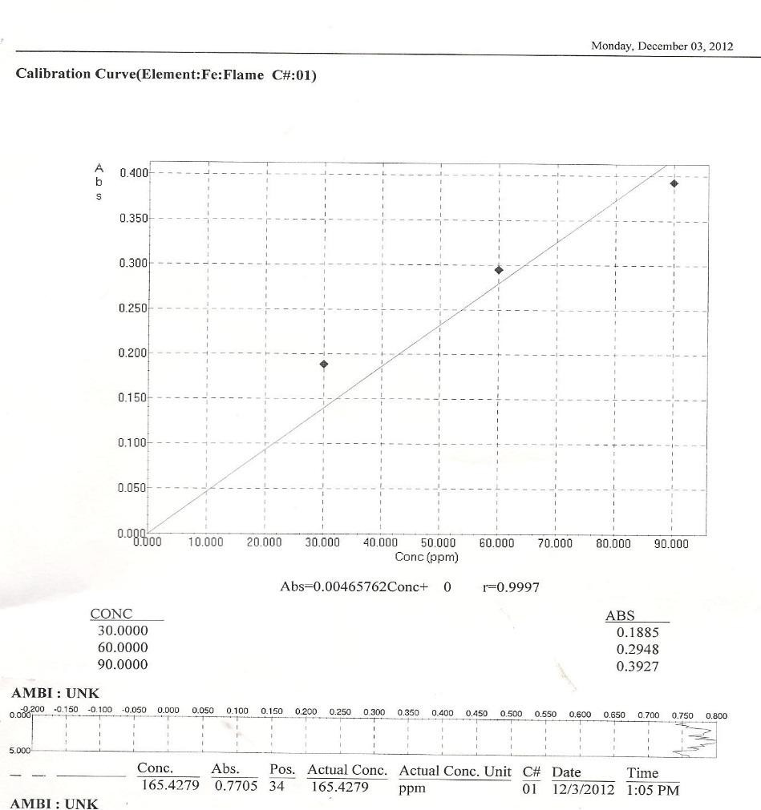

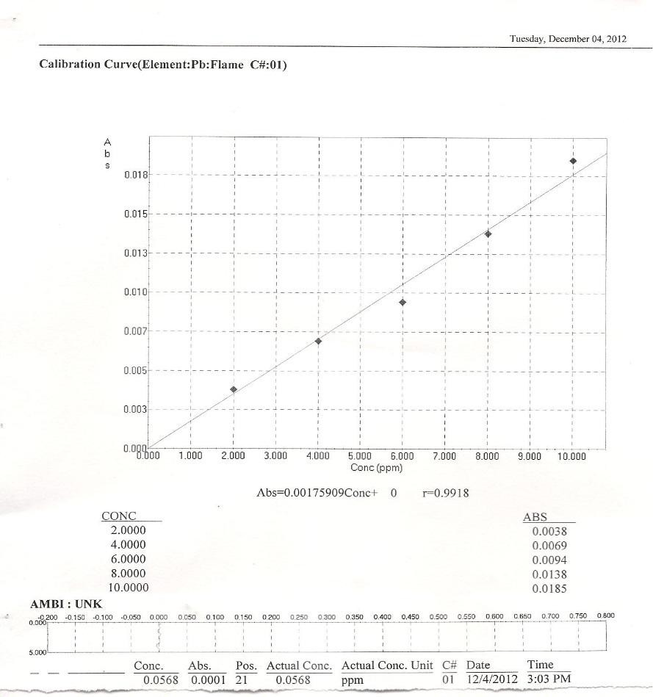

**Calibration curve for lead (Pb) flame**

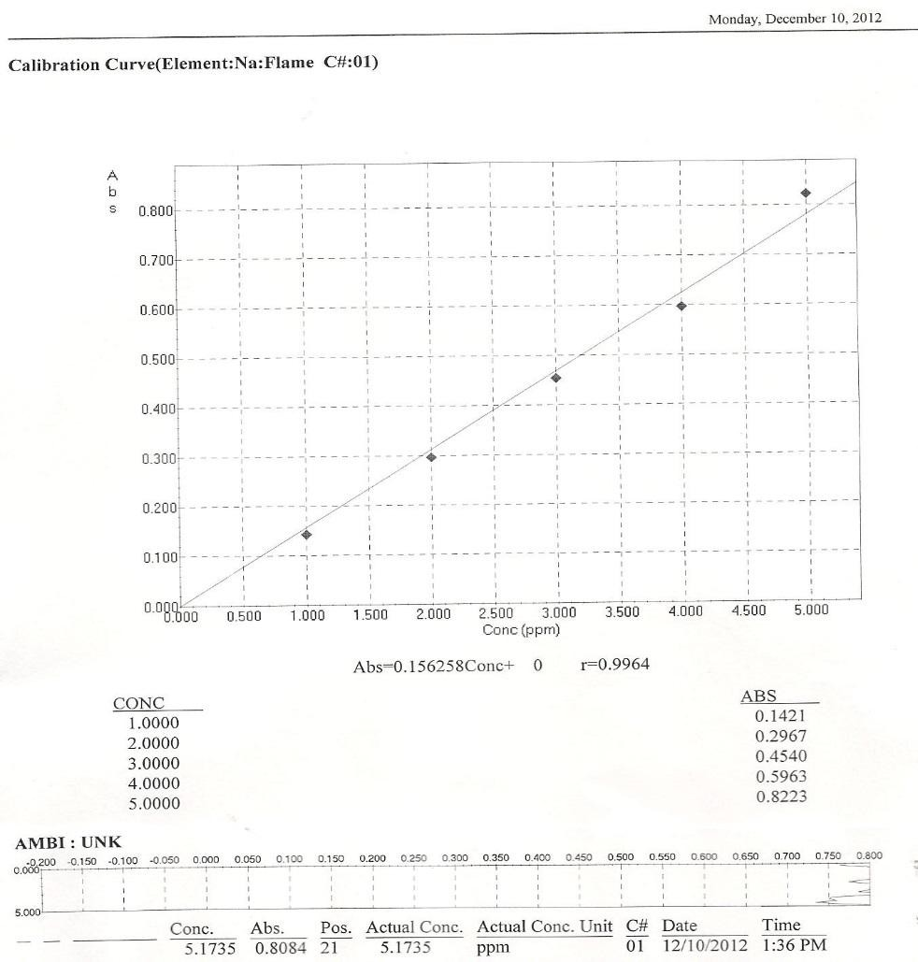

**Calibration curve for sodium (Na) flame**