EVALUATION OF MILLET STARCHES

(*Pennisetum glaucum and Pennisetum americanum)*

**AS TABLET BINDERS AND DISINTEGRANTS**

**BY**

**AMODU YAKUBU**

**M.Sc PHARM.SCI 52550/2005/2006**

**THESIS SUBMITTED TO THE POSTGRAGUATE SCHOOL,AHMADU BELLO UNIVERSITY, ZARIA, IN PARTIAL FULFILMENT FOR THE AWARD OF THE DEGREE OF MASTER OF SCIENCE IN PHARMACEUTICS.**

**DEPARTMENT OF PHARMACEUTICS AND PHARMACEUTICAL MICROBIOLOGY, FACULTY OF PHARMACEUTICAL SCIENCES, AHMADU BELLO UNIVERSITY, ZARIA-NIGERIA**

**MAY, 2011**

# Declaration

I hereby declare that the work reported in this thesis was carried out by me under the supervision of Dr. H. Musa and Dr. (Mrs.) A.R. Oyi. It has not been represented in any previous application for higher Degree. All sources of information are acknowledged by means of reference

AMODU YAKUBU (B.Pharm.)

Dept. of Pharmaceutics and Pharmaceutical Microbiology Faculty of Pharmaceutical Sciences.

Ahmadu Bello University, Zaria.

**Certification**

This thesis entitled:**” EVALUATION OF MILLET STARCHES (*Pennisetum glaucum* and *Pennisetum americanum*) AS TABLET BINDERS AND DISINTEGRANTS” BY AMODU YAKUBU** meets the regulations governing the award of the degree of **Master of science (Pharmaceutics) of Ahmadu Bello University, Zaria** and is approved for its contribution to knowledge and literary presentation.

# Professor Musa Andrew Ibrahim

B.Sc(ABU),M.Sc(London),PhD(ABU)

Faculty of Pharmaceutical Sciences, University of Jos

External examiner

DATE

**Dr. H. Musa** B.Pharm,MBA,M.Sc,PhD(ABU) Reader, Department of Pharmaceutics and Pharmaceutical Microbiology

Ahmadu Bello University,Zaria Internal Examiner

DATE

**Dr.A.R.Oyi** B.Pharm,M.Sc,PhD(ABU) Reader Department of Pharmaceutics and Pharmaceutical Microbiology Ahmadu Bello University, Zaria Internal Examiner

DATE

# Dr. T.S. Allagh

B.Sc(ABU),M.Sc(London),PhD(ABU)

Head of Department of Pharmarceutics and Pharmaceutical Microbiology

Ahmadu Bello University, Zaria

DATE

# Professor Adebayo A. Joshua

B.A,M.A,Ph.D(ABU)

Dean, Postgraduate School Ahmadu Bello University, Zaria

DATE

# Dedication

This work is dedicated to my wife, Mrs. Saidat Amodu and our daughters Fawziya and Hazima Amodu

# Acknowledgement

All thanks and glory goes to my creator ALLAH for sparing my life to the end of this thesis. My gratitude to my late father Mallam Amodu Ameh who made me what I am today may his soul rest in Aljanat firdaus. My supervisors: Dr. H. Musa Dr. A.R. Oyi for supervision and encouragement. To my beloved wife and daughters for their understanding support and encouragement and my mother Mallama Hauwa Amodu.

To Dr. T.S. Allagh, The Head of Department, Prof. J.O. Ehimidu, Prof. Y.K.E. Ibrahim I wish to say a big thank you for all your support.

I very much thank Mr. Innocent Agbo and Elder J.B. Aina for their technical assistance. My appreciation goes to Pharm.Thomas Titus Shekarau and Pharm. Mohammed Achor for all their assistance and the entire staff of the department of pharmaceutics and pharmaceutical microbiology.

My sincere thanks goes to Pharm. (Mrs.). H.I. Bature for her support.

# Table of Contents

Declaration ii

Certification iii

Dedication iv

Acknowledgement v

Table of Contents vi

List of Tables xi

List of Figures xiii

List of Plates xv

Abbreviations xvi

List of Appendices xvii

Abstract xviii

Chapter One 1

Introduction 1

1.1 General introduction 1

* + 1. Starch 2
    2. Starch as tablet excipient 2
    3. Chemical composition of starch. 3
    4. Properties of starch 4
    5. Pregelatinised starch 4
    6. Gelatinization temperature of starch. 5
    7. Uses of starch 6

1.3 Brief Survey of Published literature on local starches 6

* 1. Statement of research problems and objectives 9
  2. Objectives/aims of the study 9
  3. Justification of study 10
  4. Limitation of study 10

Chapter Two. 11

2.0 Literature Review. 11

2.1.0 Tablet and tableting. 11

* + 1. Advantages and disadvantages 11
    2. Tablet properties 12
    3. Types of tablets 14
    4. Compressed tablets 14
    5. Sublingual and buccal tablets. 15
    6. Chewable tablets 15
    7. Effervesccent tablets | 15
    8. Lozenges 16

2.2.0 Implants. 17

* 1. Methods of tablet preparation 22
     1. Granulation 23
     2. Wet granulation method 23
     3. Dry granulation 25
     4. Fluidized bed granulation 25

2. 5 Direct compression: 25

* + 1. Weight variation test 26
    2. Content uniformity test 27
    3. Friability test 27
    4. Crushing strength 27
    5. Disintegration test 27

2.6.6. Dissolution rate test. 28

* 1. Tablet defects 30
     1. Capping 30
     2. Lamination 30
     3. Chipping 31
     4. Picking 31
     5. Weight variation. 32
     6. Compressional characteristics of pharmaceutical powders 32
     7. Sequence of events in compaction of powders 33
     8. Deformation of powder upon application of pressures 33
     9. Transition and particle rearrangement 34
     10. Fragmentation 34
     11. Deformation of solid body 34
     12. Decompression 34
     13. Ejection 35

Chapter Three. 36

* 1. Materials and methods 36
  2. Materials 36
     1. Chemicals 36
     2. Equipment 36
  3. Methods. 37
     1. Collection and identification of millet 37
     2. Extraction of millet starches. 37
     3. Determination of Physico-chemical properties of the millet starch powder samples

................................................................................................................................. 38

* + 1. Solubility test 38
    2. Iodine test 39
    3. Flow properties of millet starches 39
    4. Determination of starch density 40
    5. Microscopy 42
    6. Determination of particle Density 42
    7. Preparation of granules 46
    8. Sieve Analysis of granules 47
    9. Compression of granules. 48

3.4.5 Quality standard of the tablets 48

Chapter Four 51

4.1 Results 51

CHAPTER FIVE 79

* 1. Discussion 79
  2. .0 Physicochemical properties: 79
     1. Flow Rate and Angle of repose 79
     2. Moisture content 80
     3. Moisture Sorption 81
     4. Test on granules 81
     5. : Particle Size analysis 81
     6. : Flow Properties 81
     7. : Consolidation Properties 82
     8. : Test on tablets 82
     9. : Crushing Strength 82
     10. : Friability. 82
     11. : Disintegration Time 82
     12. : Dissolution Time. 84

5.4 Summary, Conclusion and Recommendations 85

References 87

Appendices 91

# List of Tables

Table 3.1: Working formular for studying the disintegrant properties of millet starches 44

Table 3.2: Working formular for studying the binding properties of millet starches 45 Table 4.1: Shows percentage yield of starches of *Pennisetum glaucum and Pennisetum*

*americanum* 51

Table 4.2:Results of identification tests on *Pennisetum glaucum, Pennisetum americanum* and Maize starch BP 52

Table 4.3: Results of physical parameters of *Pennisetum glaucum, Pennisetum americanum* and Maize starch BP 53

Table 4.4: Granule properties for *Penisetum americanum* and maize starch BP used at different disintegrant concentrations in paracetamol tablets 63

Table 4.5: Granule properties for *Pennisetum americnum* starch and maize starch BP used at different binder concentrations in paracetamol tablets. 64

Table 4.6: Granule properties for *Pennisetum glaucum* starch and maize starch BP used at different binder concentrations in paracetamol tablets. 65

Table 4.7: Granule properties for *Pennisetum glaucum* starch and maize starch BP used at different disintegrant concentrations in paracetamol tablets… 66

Table 4.8 : Properties of paracetamol tablets formulated using *Pennistum americanum* starch and Maize starch BP as disintegrants 75

Table 4.9: Properties of paracetamol tablets formulated using *Pennistum americanum* starch and Maize starch BP as Binders 76

Table 4.10: Properties of paracetamol tablets formulated using *Pennisetum glaucum*

starch and Maize starch as disintegrants 77

Table 4.11: Properties of paracetamol tablets formulated using *Pennistum americanum* starch and *Pennisetum glaucum* starch as Binders …………

.78

Table 4.12: Size distribution of granules(cumulative % undersize) of *Pennisetum glaucum* starch used as disintegrant 90

Table 4.13: Size distribution of granules(cumulative % undersize) of *Pennisetum glaucum* starch used as binder 91

Table 4.14: Size distribution of granules (cumulative % undersize) of *Pennisetum americanum* starch used as disintegrant… 92

Table 4.15 : Size distribution of granules (cumulative % undersize) of *Pnenisetum americanum* starch used as binder 93

Table 4.16 : Size distribution of granules (cumulative % undersize) of Maize starch BP used as binder 94

Table 4.17 : Size distribution of granules (cumulative % undersize) of Maize starch BP used as disintegrants. 95

# List of Figures

Fig 4.1: Size *distribution* of granules of *Pennisetum glaucum* starch used as disintegrant in paracetamol tablet formulation. 57

Fig 4.2 Size distribution of granules of *pennisetum glaucum* starch used as binder in paracetamol tablet formulations… 58

Fig 4.3 Size distribution of granules of *pennisetum americanum* starch used as disintegrant in paracetamol tablet formulation. 59

Fig 4.4 Size distribution of granules of *pennisetum americanum* starch used as binder in paracetamol tablet formulation. 60

Fig 4.5: Size distribution of granules of maize starch BP used as binder in Paracetamol tablet formulation… 61

Fig 4.6: Size distribution of granules of maize starch BP used as disintegrant in paracetamol tablet formulation… 62

Fig 4.7: Mean crushing strength (kgF) against disintegrant concentration(%w/w) in paracetamol tablet using *pennisetum glaucum* (A) and *pennisetum americanum*

(D) starch and maize starch BP (MS) as disintegrant. 67

Fig 4.8: Friabilty against disintegrant concentration(%w/w) in paracetamol tablet using *Pennisetum glaucum* (A) and *Pennisetum americanum* (D) starch and maize starch BP (MS) as disintegrant. 68

Fig 4.9: Mean crushing strength (kgF) against binder concentration(%w/v) in paracetamol tablets using *pennisetum glaucum* (A) and *pennisetum americanum* (D) starch and maize starch BP (MS) as binder. 69

Fig 4.10: Friability(%w/w) against binder concentration(%w/v) in paracetamol tablets using *pennisetum glaucum* (A) and *pennisetum americanum* (D) starch and maize starch BP (MS) 70

Fig 4.11: Plot of disintegration time(min) against disintegrant concentration (%w/w) using *pennisetum glaucum* (A), *pennisetum americanum* (D) starch and maize starch BP (MS) 71

Fig 4.12: Plots of disintegration time(min) against binder concentration(%w/v) using *pennisetum glaucum* (A), *pennisetum americanum* (D) starch and maize starch BP (MS) 72

Fig 4.13: Plot of % Drug dissolved from formulations in paracetamol tablets with *Pennisetum glaucum*, *Pennisetum americanum* starch and Maize starch as binders(5%) against time (mins) 73

Fig 4.14: Plot of % Drug dissolved from formulations in paracetamol tablets with *Pennisetum glaucum, Pennisetum americanum* starch and Maize starch BP as( disintegrants(5%) against time (mins) 74

# List of Plates

Plate I: *P. americanum* starch×400 54

Plate II: *P.americanum* starch×100 54

Plate III: *P.glaucum* starch×100 55

Plate IV: *P.glaucum* starch ×400 55

Plate V:MS×100 56

PlateVI:MS×400 56

# Abbreviations

BPC - British Pharmaceutical Codex

BP - British Pharmacopeia

USP - United States Pharmacopeia

mg - Miligram

mm - MIllimetre

Kg - Kilogram

KgF - Kilogram Force

W/W - Weight by Weight

PH - Hydrogen -ion - Concentration

oC *-* Degree Centigrade (Celsius)

% - Percentage

g - Gramme

ml - Millilitre

µm - Micro Metre

V/V - Volume by Volume

*W/V* - Weight by Volume

N - Normal

# List of Appendices

Table 4.12: Size distribution of granules(cumulative % undersize) of *Pennisetum glaucum* starch used as disintegrant 90

Table 4.13: Size distribution of granules(cumulative % undersize) of *Pennisetum glaucum* starch used as binder 91

Table 4.14: Size distribution of granules (cumulative % undersize) of *Pennisetum americanum* starch used as disintegrant… 92

Table 4.15 : Size distribution of granules (cumulative % undersize) of *Pennisetum americanum* starch used as binder 93

Table 4.16 : Size distribution of granules (cumulative % undersize) of Maize starch BP used as binder 94

Table 4.17 : Size distribution of granules (cumulative % undersize) of Maize starch BP used as disintegrants. 95

# Abstract

Starch was extracted from the two varieties of millet (*Pennisetum glaucum and Pennisetum americanum*) by the wet extraction method, the percentage yield was determined. The physicochemical properties investigated includes: flow rate, angle of repose, carr’s index, tapped density, bulk density, moisture content, swelling capacity, particle size, solubility, iodine test, and hausner ratio. Granules were prepared by the wet granulation method of massing and screening using the two varieties of millet starches as disintegrants and binders in one formulation and comparing their physicochemical properties with that of maize starch BP.

Paracetamol tablets were formulated using *Pennisetum glaucum and Pennisetum americanum* starch as binder and disintegrant compared with maize starch and studying the tableting properties of the tablets produced.

The percentage yields of starch from the two varieties of millet were found to be 50% for *Pennisetum glaucum* and 56.8% for *Pennisetum americanum*. The two starches have similar flow, swelling, power and moisture sorption properties. The suitability of millet starches as binders and disintegrants at various concentrations were investigated in tablet formulations using paracetamol as the medicinal substances. The millet starches *(Pennisetum glaucum* and *Pennisetum americanum*) formulations were compared for hardness, friability, disintegration time against maize starch formulations. Using the same concentrations of binders and disintegrants. The results indicated that millet starches were suitable binders and Disintegrants. When the disintegrant and binding properties were analysed and compared with maize starch

There was an increase in tablet crushing strength as the disintegrant concentration

increased. There was also a decrease in the friability of the tablets as binder concentration increased. Disintegration time was found to increase with increase in binder concentration.

# 1.1 General introduction

# Chapter One

# Introduction

Tablets are solid dosage forms containing drug substances with or without suitable diluents and prepared either by compression or molding methods. They have been in widespread use since the later part of the 19th century and their popularity continues, because it offers a means of repeatedly administering accurate dose of drug, is easy to use by the patient, readily amenable to dispensing and less expensive to manufacture than other dosage forms.(Rudnic and Schwartz,1999)

Tablets are formulated to release the active ingredients in a way that will achieve the desired effect, and their quality is controlled by a number of standard tests which may include uniformity of weight and content, hardness, friability, disintegration and dissolution. In addition to the active ingredients, tablets contain a number of excipients. They may be classified according to the part they play in the finished tablet. The first group contains those which help to impart satisfactory processing and compression characteristics to the formulation. These include diluents, binders, glidants and lubricants. The second group of added substances helps to give additional desirable physical characteristics to the finished products. Included in this group are disintegrants, colourants, and in the case of chewable tablets, flavours and sweetening agents and in the case of controlled-release tablets, polymers or waxes or other solubility retarding materials. Although the term inert has been applied to these added materials, it is becoming increasingly apparent that there is an important relationship between the

properties of the excipients and the dosage forms containing them. Preformulation studies

demonstrate their influence on stability, bioavailability and the process by which the dosage forms are prepared. Starch, one of the most widely distributed substances in nature, is the most versatile excipient used in the manufacture of compressed tablets. Starch is used mainly as a binder and disintegrant although it can also be used as a diluent and lubricant. A good knowledge of the effects of starches as excipients on the properties of tablets is important for new starches that are just being developed for use in the pharmaceutical industry. This is because it gives an insight into how they will affect the ability of the tablet to withstand handling and also gives an idea as to how they will affect the *invivo* absorption characteristics and physiological availability of drug contained in the tablet.(Ochu,2009)

# Starch

Starch is one of the most widely distributed substances in nature, occurring abundantly in most plants. It is formed in leaves and other green parts of the plant from carbondioxide in presence of light and chlorophyll by a process known as photosynthesis, which is then stored in several organs such as tuber of cassava, potato, yam and cocoyam; caryopsis of maize, sorgum, fonio, millet and rice.

# Starch as tablet excipient

A joint conference on excipients identified starch as one of the top ten excipients (Adebayo *et al* 2003). Starch is a multipurpose excipient in tablet formulation. It is used as a binder, disintegrant and lubricant. Starch is a principal food reserve in plants. It

formed in large quantities in green leaves as photosynthetic products it is found in large quantities in grains. (Muazu,2008).

# Chemical composition of starch

Starch is a complex carbohydrate, (C6H10O5) x. molecules of starch are made of hundreds or thousands of atoms corresponding to values of x above. Starch granules usually contain two carbohydrates amylopectin(α-amylose) and amylose (β-amylose) the former constitutes over 80% of most starches. Amylose constitutes 20% of ordinary starches. The starch is almost insoluble in cold water and in alcohol, but with boiling water it gives a colloidal suspension that may form a jelly on cooling. Hot water changes starches slowly into smaller molecules called dextrins. Fractionation of the two components can be achieved by selective precipitation involving the formation of an insoluble complex of amylose with such polar organic substances as butanol or thymol. β-amylose consist of linear chains while amylopectin has a branched chain structure. These differences give the two substances different properties and it is this variation in proportion that contributes towards the distinctive characteristics of a starch from a particular biological source.

Amylose although water soluble gives an unstable solution which irreversibly precipitates. It is mainly responsible for the deep blue colouration given by starch in iodine test for starch. The strong affinity of amylose for iodine means that it will take up 19% of it’s weight of iodine, and this figure can be utilized in the determination of amylose in starch. Dilute solutions in water or alkali have an appreciable viscosity and

the molecule is extensively degraded by β-amylase to maltose. The course of the hydrolytic reaction may be followed by:

* + - 1. Treating with iodine and observing the colour changes (starch giving a blue black colouration, Dextrin purple to reddish-brown; maltose and glucose if acid hydrolysis no colour)
      2. Testing portions at intervals with Fehling’s solution (the reduction increases with the amount of sugar formed).
      3. Successive measurements of viscosity (viscosity decreases as hydrolysis proceeds).

On the other hand solutions of amylopectin are relatively stable, the colour given with iodine is purple and iodine bonding is low. β-amylase can only attack the outer linear chains, not be able to by-pass the 1-6 interchain links; as a consequence, amylopectin is hydrolyzed to the extent of 50-60% only by the enzyme, complete hydrolysis is achieved by mineral acids and other enzymes.

# Properties of starch

It is a tasteless, odourless, white amorphous substance. It is insoluble in cold water and alcohol but a soluble starch can be obtained by heating it with 10% HCL for 24hours then it is precipitated by addition of alcohol. If a suspension of starch in cold water is added to boiling water with continuous stirring the opaque granules swell up and eventually rupture to give a translucent solution of substance on cooling down it becomes jelly-like.

# Pregelatinised starch

Pregalatinized starches are excipients that have been processed chemically and or mechanically. The process ruptures all or part of the starch granules in the presence of

water and are subsequently dried. Pregelatinized starches offer a number of benefits both in processing and performance. They enhance flow and compressibility and can be used as binders in direct compression as well as in wet granulation they can easily be processed since they swell in cold water and therefore reduce processing time and cost compared to traditional starch paste preparation. The technology employed in the processing of the pregelatinised starch determines it’s quality such as level of purification, particle size and size distribution, densities and flow properties, which are parameters that can not be ignored by any formulator (Heinze, 2003) .

# Gelatinization temperature of starch.

Starch gelatinization is a process that breaks down the intermolecular bonds of starch molecules in the presence of water molecules and heat, allowing the hydrogen bonding sites (the hydroxyl hydrogen and oxygen) to engage more water. Gelatinization temperature is the point at which this transition occurs. While each individual granule sample gelatinize quite sharply, not all granules in a starch sample gelatinizes at the same temperature but rather over a temperature range of ±8 to 10oC (Okafor *et al,* 1991). This is an indication that there exists a difference in the internal binding forces within the individual granules. Gelatinization temperature indicates the strength of hydrogen bond within the starch granule of the amylose content of the starch. The stronger the hydrogen bond for the amylose content, the higher will be the Gelatinization temperature. When an aqueous suspension of starch is subjected to heat, the micellar network within the granules is weakened by disrupting the hydrogen bonds. The more the resistance to the

influence of this heat, the higher the hydrogen bond (Blanchard, 1987). The higher the amylose content, the higher will be the gelatinization temperature (Sterling, 1978). The differences in the proportion of gelatinised starch granules may be indicative of the differences in the physicochemical properties of the starch samples. For example, gelatinization temperature of maize is between 63-68oC and that of cocoyam between 75- 83oC (Okafor *et al*, 1991).

# Uses of starch

Starch is extensively used in dusting powders, in which it’s absorbent properties are important. In mucilage form it is used as a skin emollient, as a basis for some enemas and as an antidote in the treatment of iodine poisoning.

Sterilized maize starch B.P is used as lubricant for surgeon’s gloves; it is maize starch subjected to physical and chemical treatments so that it does not gelatinise on exposure to moisture of steam sterilization. Unlike Talc, it is completely absorbed by body tissues.

In the manufacture of tablets starch is used as a diluent, binder and disintegrating agent. Commercially it is also used for the manufacture of alcohol. It is used in laundry starching and in large quantity it is used to produce liquid glucose in dextrin and dextrose.

# Brief Survey of Published literature on local starches

A survey of literature shows that the usefulness of starches from various botanical sources as pharmaceutical excipient has formed a subject of interesting study for close to four decades.There have been reports of earlier work done on the use of locally available starches as pharmaceutical raw materials; one of such report was by Nasipuri (1986)

where he evaluated cassava starch (*Manihot utilissima*) as a tablet binder and disintegrant and found it to be as efficient as potato starch. In the same year, Cocoyam starch (*Colocasia esculenta*) was evaluated by Nasipuri as binder and disintegrant and found that the product is a suitable alternative to potato starch. Esezebo and Ambujan (1982) evaluated plantain (*Musa paradisiaca*) starch as tablet binder and disintegrant and compared it with maize starch as standard they concluded that plantain starch has twice the binding and half the disintegrant property of maize starch.

Yam and cassava starches have also been investigated as diluents by Jaiyeoba and Opakunle (1978). They found that these starches were suitable for this purpose. They also investigated these starches as glidants also and found them to be suitable (Jaiyeoba and Opakunle (1978). Deshpande and Panya(1987) investigated sorghum starch as tablet binder and disintegrant . The starch was found to be suitable for such use both in formulation of tablets of organic and inorganic medicinal agents.

Adetunji *et al*,(2006) studied the binding properties of trifoliate yam starch, obtained from *dioscorea dumetorum* (pax), in Cloroquine phosphate tablet formulation in comparison with official corn starch. They analysed the compressional properties using density measurement and compression equation of Heckel and kawakita. The mechanical properties of the tablet were assessed using the crushing strength and friability of the tablets, while drug release properties of the tablets were assessed using disintegration and dissolution times. They discovered that tablet formulations containing trifoliate yam starch exhibited faster onset and higher amount of plastic deformation during compression than those containing corn starch. The crushing strength, disintegration and

dissolution times of the tablets increased with binder concentration while friability value decreased. Trifoliate yam starch produced tablet with stronger mechanical properties and longer disintegration and dissolution times than those containing corn starches. They concluded that trifoliate yam starch would be a better alternative to corn starch in producing uncoated tablets for which high bond strength is essential.

Akande (1988) investigated pearl millet starch as tablet binder and disintegrant using maize starch as standard. He concluded that millet starch can be used as both binder and disintegrant.

# Millet

Millet belongs to the grass family *poacea* formally *gramineae* common millet or proso, is classified as *panicum miliaceum*. Pearl millet is *pennisetum americanum*. Millet is a tall erect annual grass with an appearance like or strikingly similar to maize it can grow anywhere from one to fifteen feet tall. Generally the grains are enclosed in coloured hulls,with colour depending on variety. Because of a remarkably hard, indigestible hull, this grain must be hulled before it can be used for human consumption. Millet is an important staple food throughout large parts of Asia and western Africa containing more protein than rice; it can grow in less fertile soils than many other types of grain and has a comparatively short growing season of 60-80 days.Millet is one of the oldest foods known to humans and possibly the first cereal grain to be used for domestic purposes. Millet has been used in Africa and India as a staple food for thousands of years.

Today millet rank as the 6th most important grain in the world, sustains one third of the world’s population and is a significant part of the diet in northern China, Japan and

various areas of the former Soviet Union, Africa, India and Egypt. Millet is a major crop

in many of these countries, particularly Africa and the India subcontinent where the crop covers almost 100 million acres, and thrives in the hot dry climates that are not condusive to growing other grains such as wheat and rice.

Millet is used in various cultures in many diverse ways. The Hunzas, who live in remote area of the Himalayan foothills, use millet as a cereal, in soups, and for making a deuse, whole grain bread called chapatti. In India flat thin cakes called roti are made from millet flour.

Nigeria produces about 7,000 tones of millet annually. Millet is rich in B vitamins especially niacin, B6, and folic acid, calcium, iron, potassium, manganese and zinc. The seeds are also rich in phytochemicals including phytic acid, which is believed to be associated with reduced cancer risk.

# Statement of research problems and objectives

The importance of sourcing of pharmaceutical raw materials locally cannot be over emphasized. Majority of pharmaceutical raw materials utilized in most developing countries are imported. Therefore, it is necessary to research for more raw materials locally in order to save the foreign exchange spent in importing these items.

# Objectives/aims of the study

Extraction of millet starches and determination of percentage yield. Determination of various physiochemical properties of the starches extracted and comparing with maize starch as standard.

To investigate the excipient properties of varieties of millet starches i.e. the binding and disintegrant properties compared to standards. To study the tabletting behaviours in high

dose tablets. Production of batches of macrodose tablets by wet granulation method of massing and screening in all the batches.

# Justification of study

Despite the huge amount of work and progress achieved in the pharmaceutical industries in the area of tablet manufacture, there is an increasing demand for a wide range of different grade of excipients with better properties that will ensure adequate tablet strength and *in-vitro* biovailability and also ensure that drugs comply with recommended international standards of current good manufacturing practice (CGMP) requirements, hence the need to study and research for better pharmaceutical raw materials and look for ways of sourcing them locally which will conserve our foreign exchange, thereby enhancing raw material availability.

# Limitation of study

The study is limited to the production of macro dose (Paracetamol 500mg) tablets by the wet granulation method of massing and screening only.

# Chapter Two

# 2.0 Literature Review

# 2.1.0 Tablet and tableting

Tablets are solid pharmaceutical dosage forms containing medicinal substances

with or without diluents and are prepared either by compression or molding methods.

They have been in wide spread use since the later part of the 19th century and their popularity continues to the present day. The term compressed tablet is believed to have been used first by John Wyeth and brother of Philadelphia. During this same period, molded tablets were introduced to be used as “hypodermic” tablets for the extemporaneous preparation of solutions for injections. Tablets remain popular as a dosage form because of the advantages afforded both to the manufacturer (e.g. simplicity and economy of preparation, stability and convenience in packaging, shipping and dispensing and the patient e.g. accuracy of dosage, compactness, portability, blandness of taste, and ease of administration).

Although it is possible to manufacture tablets in a wide range of shapes, official tablets are defined as circular discs with flat or convex faces (B.P, 1988). Today, they are the most popular dosage form for administering medicaments.

# Advantages and disadvantages

Tablets are easy and convenient to use. They provide an accurately measured dosage in a convenient portable package, and can be designed to protect unstable medications or disguise unpalatable ingredients. Coatings can be coloured or stamped to aid tablet recognition. Manufacturing processes and techniques can provide tablets special properties; for example enteric coatings or sustained release formulations.

Tablets cannot be used adequately in emergency cases. This is because the rate at which the active ingredient reaches the site to be treated is slow. Other means such as intravenous and intramuscular injections are more effective. Some drugs may be

unsuitable for administration by the oral route. For example protein drugs such as insulin may be denatured by stomach acids.

Such drugs cannot be made into tablets. Some drugs may be deactivated by the liver (the "first pass effect") making them unsuitable for oral use. Drugs which can be taken sublingually bypass the liver and are less susceptible to the first pass effect. Bioavailability of some drugs may be low due to poor absorption from the gastrointestinal tract. Such drugs may need to be given in very high doses or by injection. For drugs that need to have rapid onset, or that have severe side effects, the oral route may not be suitable. For example Salbutamol, used to treat problems in the pulmonary system, can have effects on the heart and circulation if taken orally; these effects are greatly reduced by inhaling smaller doses direct to the required site of action.

# Tablet properties

Tablets can be made in virtually any shape, although requirements of patients and tabletting machines mean that most are round, oval or capsule shaped. More unsusual shapes have been manufactured but patients find these harder to swallow, and they are more vulnerable to chipping or other manufacturing problems.

Tablet diameter and shape are determined by a combination of the set of punches and die. This is called a station of tooling. The thickness is determined by the amount of tablet material and the position of the punches in relation to each other during compression. Once this is done, we can measure the corresponding pressure applied

during compression. The shorter the distance between the punches(thichness), the greater the pressure applied during compression, and sometimes the harder the tablets. Tablets need to be hard enough that they do not break up in the bottle, yet friable enough that they disintegrate in the gastrointestinal tract.

The tablet is composed of the Active Pharmaceutical Ingredient (that is the active drug) together with various excipients. These are biologically inert ingredients which either enhance the therapeutic effect or are necessary to construct the tablet. The filler or diluent (e.g. lactose or sorbitol) is a bulking agent, providing a quantity of material which can accurately be formed into a tablet. Binders (e.g. methyl cellulose or gelatin) hold the ingredients together so that they can form a tablet. Lubricants (e.g. magnesium stearate or polyethylene glycol) are added to reduce the friction between the tablet and the punches and dies so that the tablet compression and ejection processes are smooth. Disintegrants (e.g. starch or cellulose) are used to promote wetting and swelling of the tablet so that it breaks up in the gastro intestinal tract; this is necessary to ensure dissolution of the API. Superdisintegrants are sometimes used to greatly speed up the disintegration of the tablet. Additional ingredients may also be added such as coloring agents, flavoring agents, and coating agents. Formulations are designed using small quantities in a laboratory machine called a **Powder Compaction Simulator** . This can prove the manufacturing process and provide information for the regulatory authorities.

# Types of tablets

Although the basic mechanical approach for the manufacture has remained the same, tablet technology has undergone great improvement. Compression equipment continues to improve both as to production speed and the uniformity of tablets compressed. There are different types of tablets which include the following:

# Compressed tablets

These can be either plain (uncoated tablets). A plain tablet is prepared by compressing a particulate solid in a die by the application of forces via two punches, upper and lower. Coated tablets are those to which, after the normal compression of the tablets, coating materials are applied. The coating material could be sugar coating, film coating or press coating (Hogan, 1983). Advantages in coating tablets includes: protection of ingredients from the environment particularly light and moisture. Many drugs have a bitter or otherwise unpleasant taste; coating provides an efficient method of taste masking tablets which are easier to swallow. It aids patient compliance with the dosage schemes. It aids in the rapid identification of product by the manufacturer, dispensing pharmacists and patients. Coating also facilitates handling in high speed automatic filling and packaging equipment it helps to add mechanical strength to the tablet core. Cross-contamination is also reduced in the manufacturing plant as dust from tablet is eliminated. Functional film coatings are used to impart enteric or controlled release properties to coated tablets.

# Sublingual and buccal tablets

Tablets placed under the tongue sublingually or in the side of the cheek (bucally) can produce an immediate systematic effect by enabling the drug to be directly absorbed through the mucosa. Example is isoprenaline sulphate (Bronchodilator) and glyceryl trinitrate tablets (vasodilator). These tablets are usually small and flat; they do not contain a disintegrant and are compressed, lightly to produce a fairly soft tablet. A sweetening agent like sucrose is used to impact sweetness.

# Chewable tablets

Chewable tablet can be taken at any time or place without water for the patients with difficulty in swallowing or for children who have not yet learnt how to swallow tablet with water. Mannitol is usually used as a chewable tablet diluent, since it gives a pleasant cooling sensation in the mouth and can mask the taste of some objectionable medicaments. Chewable tablets are prepared by wet granulation but the granules are not too hard and normally contain a high proportion of flavoring agent to aid palatability which can include chocolate base. A disintegrating agent is not required, since the teeth perform this function. Examples include antacids.

# Effervesccent tablets |

When tablets containing alkali metal or bicarbonates are combined with tartaric or citric acid, carbon dioxide will be liberated when the tablet is placed in water thus enhancing quick dissolution of the active ingredient. Effervescent tablets can be produced by wet fussion and heat fussion. With wet fussion techniques citric acid is moistened and

added to sodium bicarbonate then granulated in a suitable mix, the moist citric acid acting to partially fuse the powders. The granules are then tableted and dried in an oven at 70oC before being packaged in a moisture-proof container or aluminum foil. The heat fusion technique requires all the powders to be blended dry with citric acid being in the form of citric acid monohydrate. The mixed powders are then heated to liberate the water of crystallization in the citric acid which acts as the granulating agent.

# Lozenges

Lozenges are compressed tablets usually at least 18mm in diameter which do not contain a disintegrant and are sucked to dissolve in the mouth. Generally, there are two types of lozenges depending on the required action. The first type produces a local effect in the mouth or throat. This usually contains antiseptics (for example, Benzalkonium) or an antibiotic. It is palatable and slowly soluble. The formulation thus contains some sucrose in fine powder, lactose and gelatin solution to impart a smooth taste. The formulation is compressed between flat-faced punches to allow greater pressures to be applied. Flavors are normally incorporated to assist palatability. The second type of lozenges produces a systemic effect. An example is the lozenge which contains vitamin supplements. It is also required to be sucked. It is a palatable way of administering vitamins. Flavors are normally included in the lozenges.

# 2.2.0 Implants

Implants are very small pellets composed of drug substances only without excipients they are normally about 2 to 3cm in diameter and are prepared in an aseptic

manner and are therefore sterile. By the use of surgical procedures implants are inserted into the body tissues from where they are absorbed very slowly over a period of months (Campbell *et al*, 1958). Implant pellets are largely used for the administration of hormones such as stilbesterol and testosterone implants are produced on a single station tablet press using the punch and die set which must also be sterilized. The die is filled by the hand since the drug does not flow. Particle size is large to produce slow rate of absorption and to achieve a gradual release.

# Pharmaceutical Excipients

In addition to the active or therapeutic ingredients, tablets contain a number of inert materials. The latter are known as additives or excipients. They may be classified according to the part they play in the finished tablets. The first group contains those which help to impact satisfactory processing and compression characteristics to the formulation. These include diluents, binders, glidants and lubricants. The second group of added substance helps to give additional desirable physical characteristics to the finished tablets. Included in this group are disintegrants, colourants, and in the case of chewable tablets, flavours and sweetening agents and in the case of controlled release tablets, polymers or waxes or other solubility retarding materials.

Although the term inert has been applied to these added materials it is becoming increasingly apparent that there is an important relationship between the properties of the excipients and the dosage forms containing them. Preformulation studies demonstrate their influence on stability bioavailability and the processes by which the dosage forms are prepared.

The compressed tablets have the following components:

# DISINTEGRANTS:-

A disintegrant is a substance, or a mixture of substances, added to a tablet to facilitate break up after administration. The active ingredient must be released from the tablet matrix as efficiently as possible to allow for its rapid dissolution. Materials serving as disintegrants have been classified as starches, clays, cellulose, algins, and gums and cross linked polymers. The mode of disintegrant addition (intragranular or extragranular) normally affects its break up pattern. Disintegration of the tablet matrix into granules and subgranular particles is usually accomplished through one or more of the following processes:

* + - 1. Swelling of the tablet in an aqueous environment as a result of water intake with subsequent bursting.
      2. Hydration leading to the weakening of bonds in the tablets.
      3. Capillary action that is absorption of water by wicking action creating an internal pressure which subsequently breaks the tablets.

Disintegrant efficiency depends on such factors as i.capacity for water uptake by disintegrants

* + - * 1. Disintegrant concentrations.
        2. Wettability of other components of the tablets
        3. Porosity of the system.

V. Size of disintegrant particles in relation to other tablet components (Ringard and Guyot Hirma, 1988).

There are three types of disntegrants (Carter, 1972).

1. Substances that swell up in contact with moisture for example, starches and gums.
2. Substances that react with effervescence, on contact with moisture for example, tartaric acid and sodium bicarbonate each added to half the materials separately granulated and dried before mixing and compression.
3. Substance that melt at body temperature an example of this is cocoa butter which melts below body temperature and is used in the form of a solution in ether.

# SUPERDISINTEGRANTS

Despite a rising interest in controlled-release drug delivery systems, the most common tablets are those intended to be swallowed whole, disintegrating and releasing their medicaments rapidly in the gastrointestinal tract. Such a rapid rupture of the tablet matrix increases the surface area of the tablet particles, thereby increasing the rate of absorption of the active ingredient and producing the desired therapeutic action.

The proper choice of disintegrant and its consistency of performance are critical to formulation development of such tablets. In the past, starch was one of the most widely used, inexpensive, and effective tablet disintegrants. A high concentration of starch is required to bring about effective disintegration. Scientists' search for disintegrating agents with efficient disintegrating properties at relatively low concentrations has led to the development of some new compounds with excellent disintegrating properties.

Superdisintegrants generally are used at a low level in the solid dosage form, typically 1–10% by weight relative to the total weight of the dosage unit. Examples of superdisintegrants are crosscarmelose, crospovidone, and sodium

starch glycolate, which are a crosslinked cellulose, crosslinked polymer, and a crosslinked starch, respectively.

Insoluble grades of Kollidon (crospovidone) are manufactured by a polymerization process that yields crosslinked insoluble polyvinyl-pyrrolidone in the form of a "popcorn" polymer. The polymerization is performed using an aqueous system. No organic solvents are involved at any stage. The crosslinking is of chemical and physical nature, which is mainly achieved by the entanglement of the polymer chains and dominates the product's properties.

# (c ) BINDERS

These are agents used to impart cohesive qualities to the powdered materials. They impart cohesiveness to the tablet formulation which ensures that the tablet remains intact after compression as well as improving the free flowing qualities by the formulation of granules of desired hardness and size.

The quantity of binder used has considerable influence on the characteristics of the compressed tablets. The use of too much binder or too strong a binder will make a hard tablet which will not disintegrate easily and which will cause excessive wear of punches and dies.

Generally increasing the binder concentrate invariably causes a corresponding increase in the disintegration times of tablets (Udeala and Chukwu, 1985). The concentration of binder to be used depends on nature of the binder as well as the powdered material to be granulated (Kunle, 1988). Materials commonly used as binders include: gelatin, cellulose, cellulosederivatives, polyvinylpyrrolidone, starch,sucrose, polyethylene glycol.

Plant gums which are naturally occurring, high molecular weight plant polysaccharides are used as binders in oral dosage forms. Examples are: seed gum of *Cassia tora* evaluated by Pawar and D’Mello(2004)

# DILUENTS :

Frequently the single dose of the active ingredient is small and an inert substance is added to increase the bulk in order to increase the tablet’s practical size for compression. Compressed tablets of Dexamethasone contains 0.75mg steroid per tablet. Hence it is obvious that another material must be added to make tabletting possible. Diluents used for this purpose include: - lactose, cellulose, kaolin, manitol etc.

# LUBRICANTS

Lubricants have a number of functions in tablet manufacture. They prevent adhesion of the tablets materials to the surface of the dies and punches, reduce interparticulate friction facilitate the ejection of the tablets from the die cavity and may improve the rate of flow of the tablet granulation. Commonly used lubricants include talc, magnesium stearate, calcium stearate, stearic acid, hydrogenated vegetable oils and polyethylene glycol (PEG), micronised poloxamers. Poor selection or excessive amounts can result in water proofing the tablets resulting in poor tablets disintegration and/or delayed dissolution of the drug substance.

# GLIDANTS

A glidant is a substance which improves the flow characteristics of a powder mixture. These materials always are added in the dry state just prior to compression (i.e. during the lubrication step).

Glidants are added to increase the flowability of powder mass, reduce interparticulate friction and improve powder flow in the hopper shoe and die of the tableting machine(Apeji, 2010).

# COLOURING AGENTS

Colours in compressed tablets serve functions other than making the dosage form more aesthetic in appearance. Colour helps the manufacturer to control the product during its preparation, as well as serving as a means of identification to the user as well as identification of the active ingredients.These substances are subdivided into dyes(water soluble substances), Lakes(insoluble forms of a dye that results from it’s adsorption onto a hydrous metal oxide), inorganic pigments such as titanium dioxide or iron oxides(Olayemi, 2009).

# Methods of tablet preparation

The main guideline in manufacture of tablet is to ensure that the appropriate amount of active ingredient is equal in each tablet. If a sufficiently homogenous mix of the components cannot be obtained with simple mixing, the ingredients must be granulated prior to compression to ensure even distribution of the active ingredient in the final tablet.

# Granulation

Granulation is the process of collecting particles together by creating bonds between them. There are several different methods of granulation. The most popular, which is

used by over 70% of formulators in tablet manufacture is wet granulation. Dry granulation is another method used to form granules.

# Wet granulation method

Wet granulation is a process of using a liquid binder or adhesive in the powder mixture. The amount of liquid can be properly managed, and over wetting will cause the granules to be too hard and under wetting will cause the granules to be too soft and friable. Aqueous solutions have the advantage of being safer to deal with than solvents.

* + - * Procedure of Wet Granulation

Step 1: Weighing and Blending - the active ingredient, filler, disintegration agents, are weighed and mixed.

Step 2: The wet granulate is prepared by adding the liquid binder/adhesive. Examples of binders/adhesives include aqueous preparations of cornstarch, natural gums such as acacia, cellulose derivatives such as methyl cellulose, gelatin, and povidone. Ingredients are placed within a granulator which helps ensure aggregation of particles into a doughy massscorrect.

Step 3: Screening the damp mass into pellets or granules by passing through a sieve

Step 4: Drying the granulation

Step 5: Dry screening: After the granules are dried, pass through a screen of smaller size than the one used for the wet mass to select granules of uniform size to allow even fill in the die cavity

Step 6: Lubrication - A dry lubricant, antiadherent and glidant are added to the granules either by dusting over the spread-out granules or by blending with the granules. It reduces friction between the tablet and the walls of the die cavity. Antiadherent reduces sticking of the tablet to the die and punch.

Step 7: Tableting: Last step in which the tablet is fed into the die cavity and then compressed between a lower and an upper punch.

Water may be used as the liquid binder, but sometimes many actives are not compatible with water. Water mixed into the powder can form bonds between powder particles that are strong enough to lock them in together. However, once the water dries, the powders may fall apart and therefore might not be strong enough to create and hold a bond. Povidone also known as polyvinyl pyrrolidone (PVP) is one of the most commonly used pharmaceutical binders. PVP and a solvent are mixed with the powders to form a bond during the process, and the solvent evaporates. Once the solvent evaporates and powders have formed a densely held mass, then the granulation is milled which results in formation of granules.

# Dry granulation

Involves the preliminary compression of finely divided powders into large tablets called slugs. Size reduction to optimum size will now give an improved flow and compressibility of granules. The method is used for heat and moisture sensitive drugs.

This method is aimed at solving the problem of segregation associated with direct compression.

# Fluidized bed granulation

It is a multiple step process performed in the same vessel to pre-heat, granulate and dry the powders. It is today a commonly used method in pharmaceuticals because it allows the individual company to more fully control the powder preparation process. It requires only one piece of machinery that mixes all the powders and granules on a bed of air.

# 2. 5 Direct compression:

Direct compression involves little or no preliminary treatment of materials before feeding them into the tableting machine. Materials amenable to direct compression are usually granular, have marked ionic properties, possess crystalline structures with good planes of slippage and are comparatively soft materials. Examples of such materials are Ammonium chloride, Sodium chloride, Acetylsalicylic acid crystals. Direct compression excipients are substances added to impart cohesive strength to particles of a powder mix intended to be compressed by a direct process that by

– passes the granulation stage. They allow production of tablets avoiding two possible sources of decomposition heat and moisture where present(Carter,1972i(v)).

A good direct compression excipient such as avicel gives firm tablets with no tendency to cap (Bangudu, 1982). Other substances that possess direct compression property includes fast-flow Lactose, starch 1500 and Emcompress. Researh has shown that chemically modified form of mucuna gum can be used as a direct compression excipient(Udeala and Chukwu,1986).

# 2.6 Evaluation of tablets.

The purpose of any formulation is to ensure that the active ingredient is delivered at the right time in the desired manner and quantity to elicit it’s pharmacological action. To ensure this, official standards are usually set. Which ever method is used to produce tablets there are certain criteria the tablet must conform to before they are released for marketing. Evaluation tests for tablets include weight variation, uniformity of tablet thickness, uniformity of diameter, drug content, disintegration time and dissolution rate tests, as specified in the monographs.

# Weight variation test

The weight of a given batch of tablets should be uniform, slight variation in weight is inevitable and acceptable as long as it is within the limits of deviation that is specified in the compendia. This test is aimed at minimizing dose variation in the tablets. If the drug is uniformly dispersed through out the tablet mix, variation in tablet weight results in variation in dosage. The variation in weight may arise through poor flow properties of the material, bridging of material, in the die or particle segregation during flow through the hopper

# Content uniformity test

In order to ensure that every tablet contains the amount of drug substances intended, with little variation among tablets within a batch, the USP includes the content uniformity test for certain tablets. Due to the increased awareness of physiological availability, the content uniformity test has been extended to monographs on all coated and uncoated tablets, all capsules intended for oral administration.

# Friability test

This test determines the resistance of tablets to abrasion, handling or transportation and chipping. The test is carried out using an Erweka friabilator test apparatus. It involves subjecting a specified number of tablets to cascading action. After a prescribed time, the tablets are removed and weighed. The loss in weight calculated as a percentage should not be more than 0.8% for the tablets to pass friability test.

# Crushing strength

Tablets must be stable enough to withstand the physical factors to which they are subjected, atmospheric oxygen high humidity, light and microorganisms. They are also expected to be robust enough to maintain their shape during the expected life of the tablets. The mechanical strength should be enough to enable them withstand rough handling right from packaging through transportation and up to administration to the patient.

# Disintegration test

It is recognized that generally the *invitro*-tablet disintegration test does not necessarily bear relationship to the *invivo* action of a solid dosage form. To be absorbed a drug

substance must be in solution and the disintegration test is a measure only of the time reuired under a given set of condition for group of tablet to disintegrate into particles generally this test is a useful quality assurance tool for conventional (non sustained – release) dosage forms. The disintegration test is used as a control for tablets intended to be administered by mouth, except where the tablets are intended to be chewed before being swallowed or where tablets are designed to release the drug substance over a period of time.

Several equipment have been designed for the purpose, but that based on the BP specification is commonly used. The apparatus consists of a basket rack holding six plastic tubes, open at the top and bottom; the bottom of the tubes is covered with a mesh screen. The basket rack is immersed in a bath of suitable liquids held at 370c in a one litre beaker. The rack moves up and down in the liquid at a specified rate. The volume of the fluid is such that on the upward stroke the wire mesh remains at least 2.5cm below the surface of the fluid and descends to not less than 2.5cm from the bottom on the downward stroke. The end point of the test is indicated when any residue remaining a soft mass is having no palpably firm core. For most uncoated tablets the maximum period is 30 minutes. For coated tablets up to two hours may be required.

# Dissolution rate test

For certain tablets the monographs require compliance with limits on dissolution rather than disintegration. Since Drug absorption and physiological availability depend on having the drug substance in the dissolved state, suitable dissolution characteristics is

important property of a satisfactory tablet.

Dissolution rate test measures the rate at which the drug is released from the tablet matrix into solution and is supposed to give an indication of the availability of the active ingredient for absorption from the tablet formulation. It is intended to provide a step towards the evaluation of the physiological availability of the drug substance.

Both the USP and BP (1980) dissolution test apparatus consist of the following main parts:

* + - 1. A water bath
      2. A cylindrical stainless steel basket made of woven wire cloth.
      3. A covered vessel with openings of withdrawing and replacing samples, inserting a thermometer and passing through basket in the medium.
      4. A variable speed motor

The temperature is maintained at 37oC and the dissolution medium and volume is specified in the individual tablet monograph. The dissolution medium is poured into the covered vessel and one tablet is placed in the basket. The basket is lowered into the medium and is situated 2cm above the bottom of the vessel and rotated at the rate specified in the monograph. Samples are withdrawn at fixed time intervals and analyzed for drug content.

# Tablet defects

Tablet production from batch to batch is usually associated with problems, which may manifest immediately or during storage, and these problems or defects include: capping, lamination, chipping, picking, sticking, cracking and weight variation.

# Capping

Gunsel and Kanig (1976) defined capping as an expression which describes the partial or complete separation of the top of the tablet from the main body. This usually occurs where there is air entrapment between granules during compression this makes the fine particles not to lock together during compression. The type and state of both punch and die sets can be responsible for capping. Improper setting of the press can also cause capping. Other factors include high elastic recovery, polymorphic forms of drug, particle size, particularly where there are excess fines leading to air entrapment in the compacts. Inadequate binding and moisture content variations are other possible causes of capping in tableting. Scored tablets are more prone to capping (Rippie et al, 1981).

# Lamination

This occurs when there is separation of tablets into two or more distint layers.

There are many factors that may cause lamination. These includes:

* + - 1. Excess “fines” or powder which trapes air in the powder mixture.
      2. Deep markings on the tablet punches.
      3. Worn and imperfect punches. Punches should be smooth and buffed.
      4. Worn dies. Dies should be replaced or reversed. Dies that are chrome plated or have tungsten carbide inserts take longer to wear and give better results than ordinary steel dies.
      5. Excessive high pressure. By reducing the pressure on the machines the conditions may be corrected.
      6. Unsuitable formula.
      7. Moist and soft granulation. This type of granulation will not flow freely into the dies.

# Chipping

In less severe cases of improper setting of the press, the tablet may merely chip. Another possible cause of chipping is the setting of the sweep off blade. If it is set too high the tablet can chip partially under it and break off. A chip may then enter the feed frame and may affect the other tablets. Tablets with flat faces or beveled edges are more prone to chip when they strike each other than those with convex faces which tend to shingle (inter leave) more readily and reduce the amount of edge contact.

# Picking

Picking describes the removal of materials from the surface of tablets and its adherents to the surface of the punch. Picking in tablets may also result from micro expansion of tablets immediately after compression.

# Weight variation

When granulation is unsatisfactory each tablet made from it may vary in weight beyond acceptable limits. The causes of weight variation in tablet include the erratic size and distribution of granules being compressed where excess large granules interfere with the filling of the void spaces leading to weight variation. Poor flow of granules may lead to incomplete filling of the die in some cases. Poor mixing of the lubricants and glidants with granules lead to inefficient filling of the dies.

Ineffective lubrication is sometimes revealed by the grunting sound of strain during tablet ejection. When the lower punches are of unequal lengths leading to change in volumetric fill of the die, weight variation can also occur.

# Compressional characteristics of pharmaceutical powders

The study of compressional characteristics of pharmaceutical powders provides an insight into the series of events that lead to the formation of strong compacts that will serve as useful dosage forms. Compression is defined as the process of applying pressure to a material. The consolidating process is closely associated with the compression process which describes the resultant increase in mechanical strength due to particle rearrangement and slippage, plastic deformation or fragmentation and particle bonding.(Gambo, 2009)

# Sequence of events in compaction of powders

Granules enhance compatibility of the material. They are porous and contain both inter and intragranular pores. The sequence of events that take place during compaction is as follows:

# Deformation of powder upon application of pressures

Forces are being transmitted through the interparticulate points of contact with the application of extenal force to a powder bed. These force applied will result to stress which will be developed at these points of contact and local deformation of the material follows. This attribute is commonly investigated by measuring stress relaxation in particulate materials when compressed in a die of predetermined pressure and held at constant strain for a specific period of time (Malamataris *et al*, 1984)

When a powder is subjected to a compressive force, the overall bulk of the powder decreases with force exponentially, after the initial consolidation stage, where particles undergo rearrangement. A powder is considered to be undergoing deformation when there is further decrease in porosity which results if the elastic limit is exceeded. This deformation will either be elastic, plastic or destructive depending upon the rate of application of the external force, the magnitude of the force, the duration of the locally induced stress, the physical properties of the material (Wray, 1992).

The point at which the system undergoes an instantaneous and totally irreversible response to an applied force has been defined by Rippie and Danielson (1981) as the stage at which a material yields plastically. Newtonian flow is considered to occur

between this stage and plastic deformation where the strain rate is directly proportional to the applied stress.

# Transition and particle rearrangement

Under pressure, particles get rearranged in such a way that the small ones fill the void created by the larger particles. This leads to closer packing and a decrease in relative volume, thereby increasing the density of the powder bed. The shape of the particles influences such a rearrangement.

# Fragmentation

This is the breaking of particles into smaller parts especially bigger granules. When the applied pressure is high, particles crack and the new cracks expose fresh surfaces which yield potential bonding areas.

# Deformation of solid body

As the applied pressure is increased, the bonded solids consolidate. The deformation can either be elastic of plastic; the ability of formulated powder to form a satisfactory tablet depends on its plastic deformation during compression and elastic recovery during ejection.

# Decompression

This is the series of subsidiary events that occur after applied pressure is removed from the upper punch. As the upper punch is removed from the die cavity, the residual pressure confines the tablet. The ability or otherwise to produce an intact tablet depends on the

pressure exerted by elastic rebound and the associated deformation process during decompression and ejection.

# Ejection

This is the process by which compressed tablet is removed from the die as the lower punch rises and pushes the tablet upward. There is continuous residual die wall pressure and considerable energy may be expended due to die wall friction. When the tablet is removed from the die wall and lateral Pressure is removed, the tablet undergoes plastic recovery with an increase in volume of that portion of the tablet removed from the die.

# Chapter Three

# Materials and methods

# Materials

# Chemicals

The following chemicals and reagents were used in this research.

* + - 1. Paracetamol powder and Maize starch (May & Baker Ltd Dagenham England).
      2. Xylene, Talc, Magnesium stearate (BDH.chem. Ltd Poole, England).
      3. *Penniseteum glaucum* and *Pennisetum americanum* (Samaru and Funtua market respectively).

# Equipment

1. Flowability tester (TYP GD 1, Erweka Apparatebau GMBH, Germany).
2. Tablet disintengration apparatus (type ZT Erwek Apparatebau. GMBH, Germany).
3. Single punch tablet press (type AR 400 Erweka Apparatebau. GMBH, Germany).
4. Tablet friability tester (type, TA 3R Erweka Apparatebau. GMBH, Germany).
5. Blender (moulinex mill MXTHOPN National Electric Co. Ltd,Japan)
6. Endecott Test sieve shaker. (Endecotts London UK).
7. Micrometer screw guage (Moore and Wright England).
8. Digital pH meter (H1991301 Hanna).

(I) Mosanto Hardness Tester (Manesty machines Ltd spoke, Liverpool, England).

1. Hot plate (6B-8547E Gallenhamp Ltd, England).
2. Oven (BS, size 3 Gallenhamp Ltd, England).
3. Waterbath (IM 840 GallenHamp Ltd, England).
4. Weighing balance (types P 163, mettler instrument, Switzerland).
5. Dissolution apparatus (Erweka DT700 HH, made in Germany

# Methods

# Collection and identification of millet

Two varieties of millet were purchased from Samaru and Funtua markets and were taken to the Department of Biological Sciences, Ahmadu Bello University Zaria, for authentication and certification at the herbarium.

# Extraction of millet starches.

The grains of millet were inspected and 2kg of each variety of the cereal were thoroughly washed and all extraneous materials removed. The washed cereals were soaked in water for 24hrs. The steeped grains were then taken to the mill and blended. The blended mass was mixed with enough water, this was then passed through a filter cloth to remove the chaff and 100ml of 0.1N NaOH added to separate the starch and proteineous materials and to neutralize the prevailing slight acidity. Excess sodium hydroxide was removed by washing several times with distilled water. The clear

supernatant fluid was then poured away while the sedimented starches were collected

and a suspension of the starch in distilled water was then centrifuged for 15 minutes at 2800 revolutions per minute to separate the non-starch components from the starch. The starch retrieved was then collected and spread to dry in an oven at 40oC. The dried starch lumps were size reduced to a fine powder using a blender.

# Determination of percentage yield

The resulting starches from each variety were weighed and the percentage yield was determined from the weight of the grains which was noted as W0 and the final starch obtained noted as W1.(Gambo, 2009). The percentage yield Y was then calculated as

Y= W1/W0×100… (1)

# Determination of Physico-chemical properties of the millet starch powder samples

The following physicochemical tests were conducted on the two varieties of starch and maize starch BP as standard.

# Solubility test

One gram of each sample of millet starches were weighed and poured into beakers containing 1ml, 2ml, 10ml, and 50ml of cold distilled water respectively. The mixtures were stirred and the solubility observed. The same procedures were repeated using 95% alcohol as solvent.

# Iodine test

Using BP 2002 starch identification test, 1g of each variety of starch was boiled with 6ml of water and allowed to cool. Few drops of 0.1N Iodine solution were added to 1ml of the mucilage and the colour changes recorded. Same procedure was repeated using maize starch BP.

# Determination of moisture sorption capacity

Samples of 10g each of the two millet starches were weighed onto Petri-dishes whose weights had been predetermined and placed in a dessicator with 98% relative humidity at room temperature. The samples were periodically weighed until a constant weight was attained. The percentage difference in weight was calculated and taken as the moisture sorption capacity. Same was done for granules.

# Flow properties of millet starches

* + - 1. **Angle of repose**

This was determined using a funnel fitted firmly on a laboratory stand at a height of 10cm from the bench. The millet starch(50g) was poured into the funnel with the tip closed. The tip was then opened and the starch was allowed to fall, freely. The height and diameter of the starch heap were measured and the radius (R) obtained. The height of the conical powder heap (H) was measured(Musa*,et al* 2008). The angle of repose θ is given by the equation:

Tanθ = H/R 2

θ = tan-1

The angle of repose for the granules was also determined.

# Flow rate

A sample of 50g of each of the individual starches were poured into the funnel of Erweka flowability tester (type GDT) and the time taken(t) to pass through the Orifice by individual powder was recorded. The flow rate is given as :

50g/t in g/sec

The same procedure was done for the granules also(Musa.*et al* 2008*).*

# Determination of starch density

**Bulk density**

A sample of 50g of each individual millet starch were poured through a short stemmed glass funnel into a 200ml graduated glass cylinder and the volume occupied by the starch granules was read and the bulk density calculated.

# Tapped density

A graduated cylinder containing 50g of the millet starch granules was dropped on a bench 100 times from a height of about 20mm and the respective volumes recorded. The tapped density was the calculated in g/ml

# Carr’s index

The difference between the tapped and bulk density divided by the tapped density was calculated and the ratio expressed as a percentage. This is obtained using the formula below:

CI = ( t- b) x 100… 3



t

CI = Carr’s index

t = Tapped density b = Bulk density

# Hausner ratio

This also predicts the flow characteristics of materials and is the ratio of the tapped density ( t) to bulk density ( b) of the starches.

Hausner Ratio = t/ b… 4

# DETERMINATION OF MOISTURE CONTENT OF STARCH

Three grams of the two millet starch samples were weighed into pre-weighed evaporating dishes and placed in an oven set at 105°C. The starches were weighed periodically (1hr) until constant weight was attained. The difference in weight was calculated and the moisture content determined using the formula

Initial weight-final weight x 100… 5

Initial weight

# Determination of pH

One gram of sample was dispersed in 100ml of distilled water and shaken vigorously for five minutes and allowed to stand. The pH of the supernatant liquid was read using a pH meter. This was repeated for the second sample and maize starch

# Microscopy

The microscope was calibrated using the eye-piece and stage micrometer. A small quantity of the powder sample was mounted on a slide in glycerol. It was viewed under the microscope and one hundred particles were counted to determine the mean particle size

A photomicrograph of the powder sample was taken at different magnifications.This was repeated for all the samples.

# Determination of particle Density

The method described by Odeku, (2005) was adopted. The particlcle density was determined with a pycnometer bottle using xylene as the displacement fluid. An empty 50ml pycnometer bottle was weighed(W),filled with xylene and the excess wiped off. The filled bottle was weighed a second time(W1) and the difference between W1 and W obtained as W2. A 2g quantity of the powder was weighed(W3) and transferred into the pycnometer bottle. The excess solvent was wipped off and the bottle weighed again(W4).The particle density,ρ**t**(g/cm3),was then calculated from the equation given below:

ρ**t** = W2×W3/50(W3 - W4 +W2+W) 6

Where ρ**t** particle density W weight of empty bottle W2 is weight of xylene

W3 is weight of powderW4 is weight of botlle plus sample plus xylene

# Table 3.1: Working formular for studying the disintegrant properties of millet starches

**500 500**

|  |  |  |  |  |  |  |  |  |  |  |  |  |  |  |  |  |  |
| --- | --- | --- | --- | --- | --- | --- | --- | --- | --- | --- | --- | --- | --- | --- | --- | --- | --- |
|  | **Formulations** | | | | | | | | | | | | | | | | |
| **Quantity of ingredients per tablet(mg)** | **F1** | **F2** | **F3** | **F4** | **F5** | **F6** | **F7** | **F8** | **F9** | **F10** | **F11** | **F12** | **F13** | **F14** | **F15** | **F16 F17** | **F18** |

|  |  |  |  |  |
| --- | --- | --- | --- | --- |
| **Paracetamol** | **500 500** | **500** | **500 500** | **500 500 500** |
| **Disintegrants:**  **P.glaucum** | **0.00 16.25** | **32.25** | **48.75 65.0** | **81.25 - -** |

|  |  |  |  |  |  |  |  |
| --- | --- | --- | --- | --- | --- | --- | --- |
| **500** | **500** | **500** | **500** | **500** | **500** | **500** | **500** |
| **-** | **-** | **-** | **-** | **-** | **-** | **-** | **-** |
| **65.00** | **81.25** | **-** | **-** | **-** | **-** | **-** | **-** |
| **-** | **-** | **0.00** | **16.25** | **32.25** | **48.75** | **65.00** | **81.25** |
| **20** | **3.75** | **85** | **68.75** | **52.25** | **36.25** | **20** | **3.75** |

**- -**

**P.americanum - - - - - - 0.00 16.25 32.25 48.75**

**Maize Starch BP - - - - - - - - - -**

**Binder:MS(BP) 85 68.75 52.5 36.25 20 3.75 85 68.75 52.5 36.25**

**50.7 50.7**

**1.3 1.3**

**13.0 13.0**

**7.5 7.5**

|  |  |  |  |  |  |  |  |  |  |  |  |  |  |  |  |  |  |  |  |
| --- | --- | --- | --- | --- | --- | --- | --- | --- | --- | --- | --- | --- | --- | --- | --- | --- | --- | --- | --- |
| **Extragranular** |  | | | | | | | | | | | | | | | | | | |
| **Excipient:(MS)** | **50.7** | **50.7** | **50.7** | **50.7** | **50.7** | **50.7** | **50.7** | **50.7** | **50.7** | **50.7** | **50.7** | **50.7** | **50.7** |  | **50.7** |  | **50.7** |  | **50.7** |
| **Glidant/Lubricant** |  |  |  |  |  |  |  |  |  |  |  |  |  |  |  |  |  |  |  |
| **Magnesium** |  |  |  |  |  |  |  |  |  |  |  |  |  |  |  |  |  |  |  |
| **Stearate** | **1.3** | **1.3** | **1.3** | **1.3** | **1.3** | **1.3** | **1.3** | **1.3** | **1.3** | **1.3** | **1.3** | **1.3** | **1.3** | **1.3** |  | **1.3** |  | **1.3** |  |
| **Talc** | **13.0** | **13.0** | **13.0** | **13.0** | **13.0 13.0 13.0 13.0 13.0 13.0 13.0 13.0 13.0 13.0 13.0 13.0** | | | | | | | | | | | | | | |
| **Compression** |  |  |  |  |  | | | | | | | | | | | | | | |
| **Pressure(KgF)** | **7.5** | **7.5** | **7.5** | **7.5** | **7.5 7.5 7.5 7.5 7.5 7.5 7.5 7.5 7.5 7.5 7.5 7.5** | | | | | | | | | | | | | | |

**Tablet Weight(mg) 650 650 650 650 650 650 650 650 650 650 650 650 650 650 650 650 650 650**

**Note: Batch size 100 Tablets**

**Table 3.2: Formular for studying the binding properties of millet starches**

|  |  |  |  |  |  |  |  |  |  |  |  |  |  |  |  |  |  |  |
| --- | --- | --- | --- | --- | --- | --- | --- | --- | --- | --- | --- | --- | --- | --- | --- | --- | --- | --- |
|  | **Formulations** | | | | | | | | | | | | | | | | | |
| **Quantity of in gradients per tablet(mg)** | **F1** | **F2** | **F3** | **F4** | **F5** | **F6** | **F7** | **F8** | **F9** | **F10** | **F11** | **F12** | **F13** | **F14** | **F15** | **F16** | **F17** | **F18** |
| **Paracetamol** | **500** | **500** | **500** | **500 500** | | **500 500** | | **500** | **500** | **500** | **500** | **500** | **500** | **500** | **500** | **500** | **500** | **500** |
| **Disintegrants:**  **Binder:** | **85** | **68.75** | **52.5** | **36.25 20** | | **3.75 85** | | **68.75** | **52.5** | **36.25** | **20** | **3.75** | **85** | **68.75** | **52.5** | **36.25** | **20** | **3.75** |
| **P.glaucum 0.00** | | **16.25** | **32.25** | **48.75 65.00** | | **81.25 -** | | **- -** | | **-** | **-** | **-** | **-** | **-** | **-** | **-** | **-** | **-** |
| **P.americanum -** | | **-** | **-** | **- -** | | **- 0.00** | | **16.25 32.25** | | **48.75** | **65.00** | **81.25** | **-** | **-** | **-** | **-** | **-** | **-** |
| **Maize Starch BP -**  **Extragranular** | | **-** | **-** | **- -** | | **- -** | | **- -** | | **-** | **-** | **-** | **0.00** | **16.25** | **32.25** | **48.75** | **65.00** | **81.25** |
| **Excipient:(MS) 50.7** | | **50.7** | **50.7** | **50.7 50.7** | | **50.7** | **50.7** | **50.7 50.7** | | **50.7** | **50.7** | **50.7** | **50.7** | **50.7** | **50.7** | **50.7** | **50.7** | **50.7** |
| **Glidant/Lubricant** | | | | | | | | | | | | | | | | | | |
| **Magnesium** |  |  |  |  |  |  |  |  |  |  |  |  |  |  |  |  |  |  |
| **Stearate** | **1.3** | **1.3** | **1.3** | **1.3** | **1.3** | **1.3** | **1.3** | **1.3** | **1.3** | **1.3** | **1.3** | **1.3** | **1.3** | **1.3** | **1.3** | **1.3** | **1.3** | **1.3** |
| **Talc** | **13.0** | **13.0** | **13.0** | **13.0** | **13.0** | **13.0** | **13.0** | **13.0** | **13.0** | **13.0** | **13.0** | **13.0** | **13.0** | **13.0** | **13.0** | **13.0** | **13.0** | **13.0** |
| **Compression** |  |  |  |  |  |  |  |  |  |  |  |  |  |  |  |  |  |  |
| **Pressure(KgF) 7.5 7.5** | | | **7.5** | **7.5** | **7.5** | **7.5** | **7.5** | **7.5** | **7.5** | **7.5** | **7.5** | **7.5** | **7.5** | **7.5** | **7.5** | **7.5** | **7.5** | **7.5** |
| **Tablet weight(mg)650 650** | | | **650** | **650** | **650** | **650** | **650** | **650** | **650** | **650** | **650** | **650** | **650** | **650** | **650** | **650** | **650** | **650** |

**Note: Batch size 100 tablets**

# Preparation of granules

Using the techniques of wet granulation method of massing and screening paracetamol granules were produced based on Table 3.1 and 3.2

Several batches of paracetamol granules with varying concentrations of the *Pennisetum glaucum* and *Pennisetum americanum* and maize starch (MS) were produced to determine the disintegrant properties of the millet starches compared with maize starch. Using the formula in Table 3.1.

Another set of batches were produced using the formula in Table 3.2 to determine the binder properties of the millet starches compared with maize starch.

The procedures used in the granule formulation include:

Weighing: Appropriate amounts of all the ingredients as shown in the formula above with the exception of extra granular excipients/lubricants/glidants were weighed for different batches of the formula.

* + - 1. Mixing: The ingredients weighed were then mixed in a pestle and mortar using doubling up technique.
      2. Wet mixing: A 7.5% binder solution was prepared and used for the formulations in Table 3.1 In Table 3.2 varying concentrations of binder solutions were prepared. This is by dissolving the appropriate weights of binder in small quantities of water in a beaker then making up to 100ml mark with hot boiling water with proper stirring to ensure proper mixing.

Small volumes of the binder solution were added to the dry powder mix gradually until a moist mass was formed. The wet mass was then screened through a 1.7mm mesh using a spatula. The resulting granules were dried in a hot air oven at 40°C for 30mins after which they were re-screened through a 1.6mm mesh size

The stated weights of extragranular excipients as shown in the working formulae were carefully weighed in each case. They were first dry mixed and then incorporated into the dry granules using a tumble mixer for five minutes .

# Sieve Analysis of granules

The sieves were arranged vertically in order of decreasing mesh size(500µm- 75µm). 30g of dried granules was weighed and placed on the top sieve (i.e. 500µm). The lid was replaced and the sieve nest clamped on the sieve shaker which was switched on for 10minutes, to ensure adequate separations.

The sieves were then loosened from the shaker and the weight of particles retained on each sieve was determined and recorded as shown below:

This procedure was repeated for the various formulationsgiven tables 3.1 and

3.2

# Compression of granules

The granules for the various batches were compressed into tablets after incorporation of the stated weights of extragranular excipients as shown in Table 3.1 and 3.2 using a single punch tablet press (Erweka A & 400 Germany). The punch diameter used was 12mm while the compression pressure was 7.5MT.

# Quality standard of the tablets

* + - 1. **Weight uniformity test:**

Ten tablets from each batch of formulation were weighed individually on a Mettler balance (Type 163, Mettler instruments A.G Switzerland). From the mean tablet weight, the deviation of each tablet was calculated, the standard deviation was then found

* + - 1. **Thickness:** Tablets thickness was determined using the micrometer gauge. Ten (10) tablets were picked randomly from each batch. Each tablet was placed in between the micrometer screw gauge, spindle and the thickness reading was obtained in millimeters. The mean tablet thickness and the standard deviation were calculated.
      2. **Hardness:** - The hardness of the tablet given as the crushing strength was determined using Monsanto hardness tester(Manesty machines Ltd, Spoke Liverpool, England). A tablet was held between a fixed anvil and a moving jaw and the load gradually increased until the tablet just fractured. The value of the load at this point gives a measure of the tablet hardness in kg force. For each batch, the hardness of five (5) tablets was determined from which the average was obtained.
      3. **Friability:** Ten tablets were randomly picked from each batch, brushed carefully and lightly until all surface powder was removed. The tablets were weighed (W1) accurately with the mettler balance. They were placed inside the Erewka (TA 3R Germany) friabilator and operated or rotated 100 times in 4mins i.e. 25rpm removed dusted and reweighed (W2). From the two weight values friability (f) for each batch of tablets was determined as the percentage weight loss.
      4. **Disintegration time:**- The time required for six tablets per batch of 100 tablets to disintegrate was determined using a device described in the in United States Pharmacepoeia (USP) and adopted in the British Pharmacopoeia (B.P,1993) Erweka disintegration tester (type ZTS Germany) Distilled water thermostatically maintained at 37°C was used as the disintegration medium. The disintegration apparatus was calibrated to operate at thirty cycles per minute. The time taken for the last tablet or its fragment to pass through the mesh into the disintegration medium was recorded. The mean of five determinations was calculated to be the disintegration time.
      5. **Dissolution rate determination:**- A dissolution test apparatus DGNA multipurpose drug test device was used, it was set at a rotation speed of 100 r.p.m while the temperature was thermostatically maintained at 37°C+ 0.5°C, the medium was 1000ml of 0.1NHcl for paracetamol tablets, The revolution of the basket containing the test tablet 100 rpm.10 ml of the sample was withdrawn at 5 minutes interval .Each volume of sample withdrawn was replaced with an equivalent volume of dissolution medium maintained at the same temperature. A ten fold dilution with the dissolution medium was done for each sample withdrawn before spectrophotometric

determination of drug content at an a wavelenght of 257.00nm. The percentage drug released was plotted against time to generate a dissolution curve.

# Chapter Four

# Results

Table 4.1: shows percentage yield of starches of *pennisetum glaucum* and

*Pennisetum americanum* grains

|  |  |  |  |
| --- | --- | --- | --- |
|  | Starch sample |  | yield (%) |
| *Pennisetum* | *glaucum* | 50% |  |
| *Pennisetum* | *americanum* | 56.2% |  |

**Table 4.2:Results of identification tests on *Pennisetum glaucum*, *Pennisetum americanum* starches and Maize starch BP**

Solubility(water)g/ml insoluble insoluble insoluble

Identification test

*Pennisetum glaucum*

*Pennisetum americanum*

Maize starch BP

Starch

Starch

|  |  |  |  |
| --- | --- | --- | --- |
| Solubility(alcohol)g/ml | insoluble | insoluble | insoluble |
| Iodine test | Blue black | Blue black | Blue black |

pH (1%susp) 4.80 4.87 4.90

Viscosity(1%susp) 1.35 1.35 1.30

**Table 4.3: Results of physical parameters of *Pennisetum glaucum*, *Pennisetum americanum* starches and Maize starch BP**

|  |  |  |  |  |  |
| --- | --- | --- | --- | --- | --- |
| Physicochemical Parameters | *Pennisetum*  Starche | *glaucum* | *Pennisetum*  Starch | *americanum* | Maize starch |
| Flow rate(g/sec) | 0.77 |  | 0.80 |  | 1.20 |
| Angle of repose(o) | 45.00 |  | 42.00 |  | 35.90 |
| Moisture content(%w/w) | 8.43 |  | 10.13 |  | 2.40 |
| Tapped density(g/ml) | 0.50 |  | 0.50 |  | 0.75 |
| Bulk density(g/ml) | 0.33 |  | 0.32 |  | 0.52 |
| Carr’s index(%) | 34.00 |  | 35.00 |  | 31.60 |
| Moisture sorption capacity(%) | 14.80 |  | 15.00 |  | 14.84 |
| Hausner ratio | 1.50 |  | 1.56 |  | 1.26 |
| True density(g/ml) | 1.40 |  | 1.42 |  | 1.40 |
| Swelling capacity(%) | 5.00 |  | 5.30 |  | 20.59 |
| Particle size(µm) | 32.30 |  | 33.10 |  | 35.20 |

The starches exhibited similar values for most of the flow properties. The moisture content of the starch samples are almost five times higher than that for maize starch BP, with flow rate of maize starch BP almost twice that of the *pennisetum glaucum* and *pennisetum americanum*

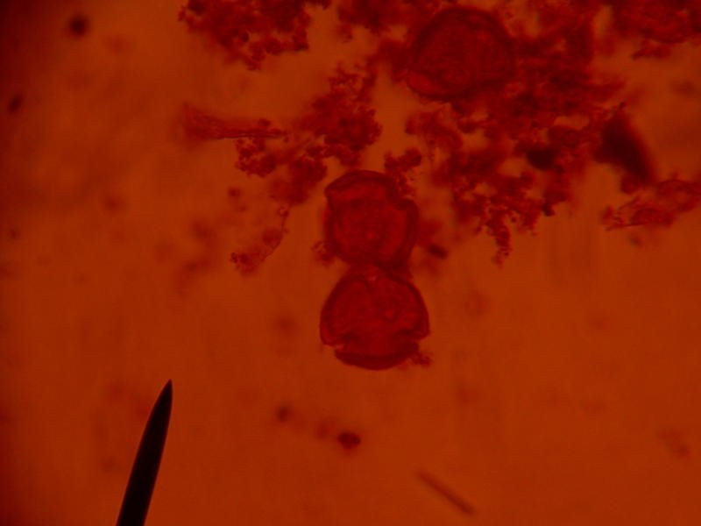

Plate I: *P. americanum* starch×400

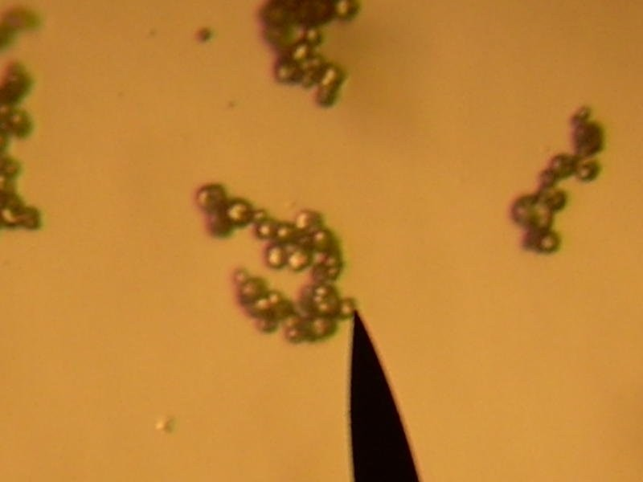

Plate II: *P.americanum* starch×100

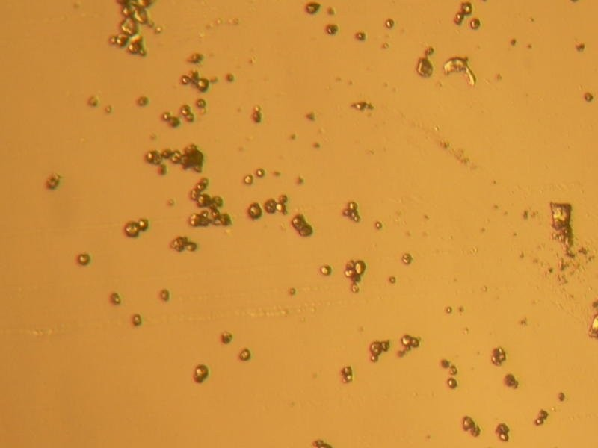

Plate III*: P.glaucum* starch×100

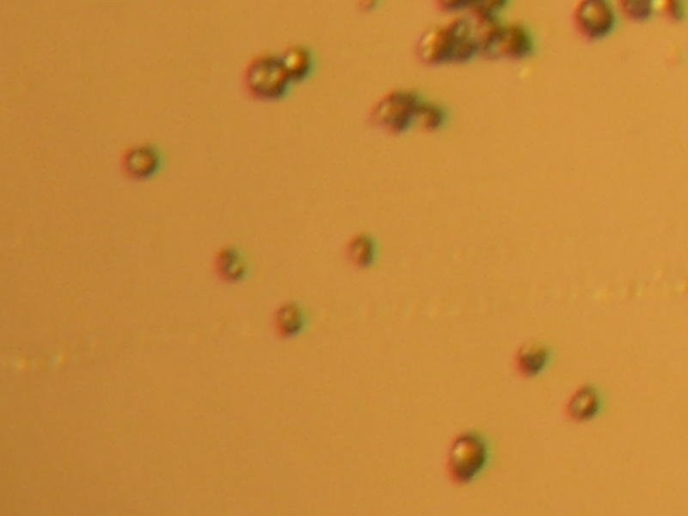

Plate IV*: P.glaucum* starch ×400

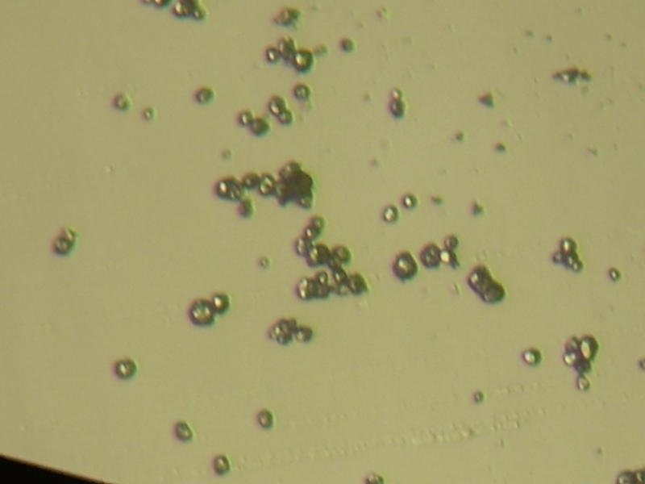

Plate V:MS×100

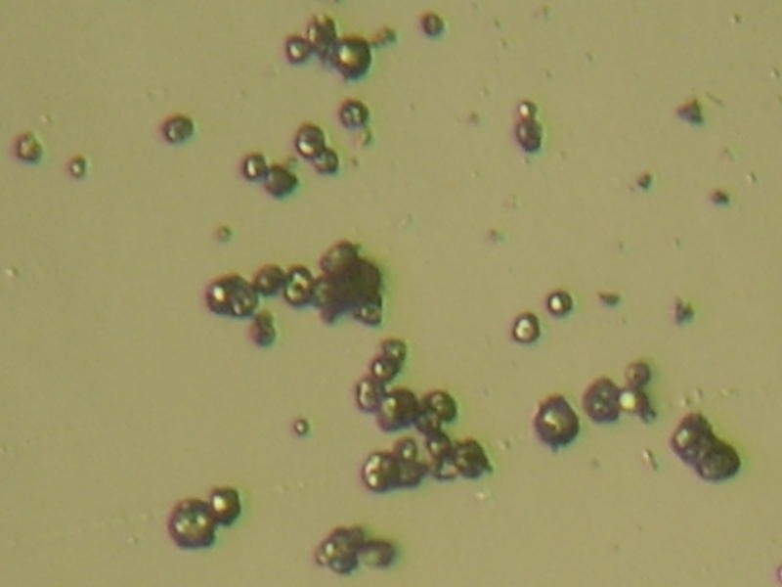

PlateVI:MS×400

# GRANULE ANALYSIS

**sieve analysis**



0.00%

2.50%

5.00%

7.50%

10.00

% 12.50

%

12 0

10 0

80

60

40

20

0

pa n

75

90

150

25 0

500



Cumulative

%under size

SIEVE SIZE( m)

Fig 4.1: Size *distribution* of Paracetamol granules formulated with *Pennisetum glaucum* starch used as disintegrant for compression into tablets.

Cumulati

%

Undersize

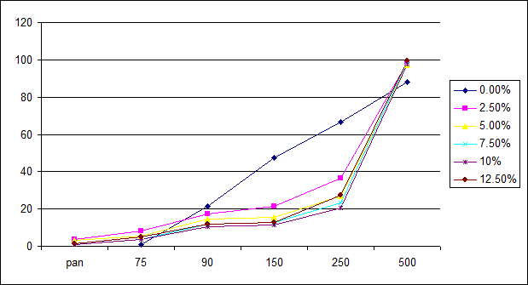sieve Size(µm)

Fig 4.2: Size distribution of Paracetamol granules formulated with *Pennisetum glaucum* starch used as binder for compression into tablets.

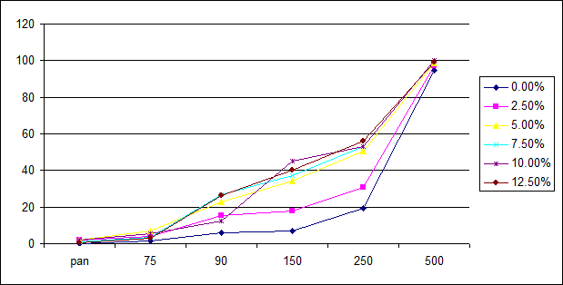Cumul% Under Size

Sieve Size(µm)

.

Fig 4.3: Size distribution of Paracetamol granules formulated with *Pennisetum americanum* starch used as disintegrants for compression into tablets.

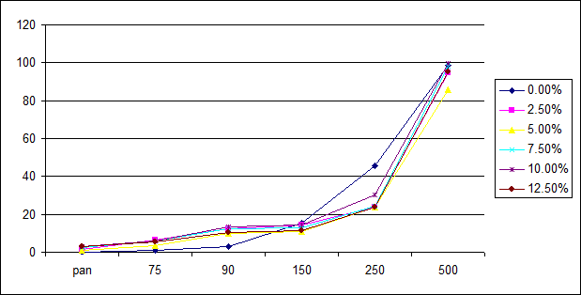Cumulative

%

Undersize

Sieve Size(µm)

Fig 4.4: Size distribution of Paracetamol granules formulated with *Pennisetum americanum* starch used as binder for compression into tablets.

Cumulative

%Undersize

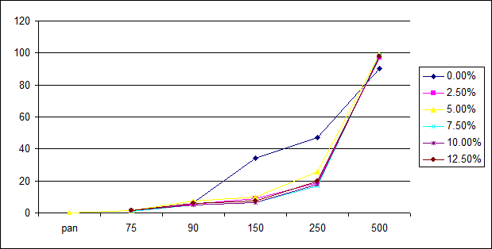Sieve Size(µm)

Fig 4.5: Size distribution of Paracetamol granules formulated with Maize Starch

*BP* used as binder for compression into tablets.

Cumulative% Under size

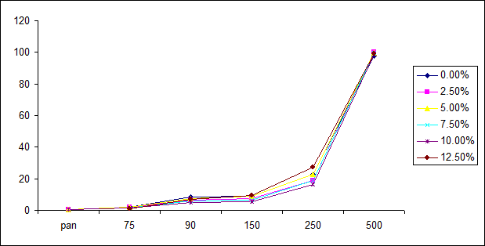Sieve size (µm)

Fig 4.6: Size distribution of Paracetamol granules formulated with Maize Starch

*BP* used as disintegrants for compression into tablets.

# Table 4.4: Granule properties of paracetamol formulations containing *Pennisetum americanum* Starch and maize starch BP used at different disintegrant concentrations .

|  |  |  |
| --- | --- | --- |
| Formulations containing varying concentration(%w/w) of : | | |
| Granule properties starch | *Pennisetum americanum* Starch | Maize Starch BP |

|  |  |  |  |  |  |  |  |  |  |  |  |  |
| --- | --- | --- | --- | --- | --- | --- | --- | --- | --- | --- | --- | --- |
| Disintegrant | 0.00 | 2.50 | 5.00 | 7.50 | 10.00 | 12.50 | 0.00 | 2.50 | 5.00 | 7.50 | 10.00 | 12.50 |
| Conc.(%w/w) |  |  |  |  |  |  |  |  |  |  |  |  |
| Flow rate(g/sec) | 9.20 | 24.87 | 8.06 | 9.40 | 13.75 | 13.17 | 9.09 | 9.28 | 8.72 | 9.07 | 8.80 | 8.64 |
| Moisture content(%) | 23.00 | 24.50 | 24.00 | 28.50 | 24.50 | 27.50 | 18.00 | 21.00 | 24.50 | 25.00 | 25.50 | 25.50 |
| Angle of repose(o) | 33.90 | 32.78 | 32.82 | 32.29 | 33.98 | 33.39 | 31.41 | 28.53 | 33.11 | 28.53 | 26.07 | 23.11 |
| Bulk density(g/ml) | 0.361 | 0.435 | 0.432 | 0.429 | 0.417 | 0.417 | 0.405 | 0.405 | 0.405 | 0.405 | 0.405 | 0.385 |
| Tapped density(g/ml) | 0.435 | 0.509 | 0.526 | 0.546 | 0.456 | 0.546 | 0.492 | 0.492 | 0.484 | 0.484 | 0.500 | 0.484 |
| Carr’s index(%) | 17.01 | 14.54 | 17.30 | 21.43 | 23.63 | 23.63 | 17.68 | 17.68 | 16.32 | 16.32 | 19.00 | 20.46 |
| Hausner ratio | 1.21 | 1.17 | 1.21 | 1.27 | 1.31 | 1.31 | 1.22 | 1.22 | 1.20 | 1.20 | 1.24 | 1.26 |

**Table 4.5: Granule properties of paracetamol formulations containing *Pennisetum americanum* Starch and maize starch BP used at different Binder concentrations .**

|  |  |  |
| --- | --- | --- |
| Formulations containing varying concentration(%w/v) of : | | |
| Granule properties starch | *Pennisetum americanum* Starch | Maize Starch BP |

|  |  |  |  |  |  |  |  |  |  |  |  |  |
| --- | --- | --- | --- | --- | --- | --- | --- | --- | --- | --- | --- | --- |
| Binder conc.(%w/v) | 0.00 | 2.50 | 5.00 | 7.50 | 10.00 | 12.50 | 0.00 | 2.50 | 5.00 | 7.50 | 10.00 | 12.50 |
| Flow rate(g/secs) | 10.53 | 9.49 | 8.34 | 9.11 | 9.15 | 9.11 | 11.33 | 9.31 | 9.41 | 10.13 | 10.22 | 9.60 |
| Moisture content(%) | 27.00 | 26.00 | 24.50 | 25.50 | 27.00 | 26.50 | 27.25 | 26.50 | 26.50 | 25.00 | 24.00 | 26.00 |
| Angle of repose(o) | 33.70 | 31.59 | 33.70 | 31.98 | 31.88 | 32.29 | 31.05 | 25.68 | 39.99 | 32.00 | 32.28 | 31.41 |
| Bulk densities(g/ml) | 0.385 | 0.405 | 0.435 | 0.405 | 0.385 | 0.4000 | 0.420 | 0.380 | 0.375 | 0.380 | 0.380 | 0.395 |
| Tapped densities(g/ml) | 0.462 | 0.484 | 0.500 | 0.476 | 0.462 | 0.469 | 0.588 | 0.492 | 0.441 | 0.448 | 0.462 | 0.479 |
| Carr’s index(g/ml) | 16.67 | 16.32 | 13.00 | 14.92 | 16.67 | 14.71 | 28.57 | 22.78 | 14.97 | 15.18 | 17.72 | 17.20 |
| Hausner ratio | 1.20 | 1.95 | 1.15 | 1.18 | 1.20 | 1.17 | 1.40 | 1.30 | 1.18 | 1.18 | 1.22 | 1.21 |

# Table 4.6: Granule properties of paracetamol formulations containing *Pennisetum glaucum* Starch and maize starch BP used at different Binder concentrations .

|  |  |  |
| --- | --- | --- |
| Formulations containing varying concentration(%w/v) of : | | |
| Granule properties starch | *Pennisetum glaucum* Starch | Maize Starch BP |

|  |  |  |  |  |  |  |  |  |  |  |  |  |
| --- | --- | --- | --- | --- | --- | --- | --- | --- | --- | --- | --- | --- |
| Binder conc.(%w/v) | 0.00 | 2.50 | 5.00 | 7.50 | 10.00 | 12.50 | 0.00 | 2.50 | 5.00 | 7.50 | 10.00 | 12.50 |
| Flow rate(g/secs) | 11.54 | 8.53 | 8.47 | 8.76 | 8.83 | 8.84 | 11.33 | 9.31 | 9.41 | 10.13 | 10.22 | 9.60 |
| Moisture content(%) | 33.00 | 23.50 | 25.00 | 25.50 | 27.50 | 25.00 | 27.25 | 26.50 | 26.50 | 25.00 | 24.00 | 26.00 |
| Angle of repose(o) | 33.13 | 33.11 | 31.95 | 33.40 | 33.70 | 32.80 | 31.05 | 25.68 | 39.99 | 32.00 | 32.28 | 31.41 |
| Bulk densities(g/ml) | 0.423 | 0.423 | 0.435 | 0.435 | 0.435 | 0.406 | 0.420 | 0.380 | 0.375 | 0.380 | 0.380 | 0.395 |
| Tapped densities(g/ml) | 0.588 | 0.526 | 0.536 | 0.536 | 0.536 | 0.509 | 0.420 | 0.380 | 0.375 | 0.380 | 0.380 | 0.395 |
| Carr’s index(g/ml) | 28.06 | 19..56 | 18.84 | 18.84 | 18.84 | 20.24 | 28.57 | 22.78 | 14.97 | 15.18 | 17.72 | 17.20 |
| Hausner ratio | 1.39 | 1.22 | 1.23 | 1.33 | 1.23 | 1.25 | 1.40 | 1.30 | 1.18 | 1.18 | 1.22 | 1.21 |

**Table 4.7: Granule properties of paracetamol formulations containing *Pennisetum glaucum* Starch and maize starch BP used at different Disintegrant concentrations .**

|  |  |  |
| --- | --- | --- |
| Formulations containing varying concentration(%w/w) of : | | |
| Granule properties starch | *Pennisetum glaucum* Starch | Maize Starch BP |

|  |  |  |  |  |  |  |  |  |  |  |  |  |
| --- | --- | --- | --- | --- | --- | --- | --- | --- | --- | --- | --- | --- |
| Disintegrant | 0.00 | 2.50 | 5.00 | 7.50 | 10.00 | 12.50 | 0.00 | 2.50 | 5.00 | 7.50 | 10.00 | 12.50 |
| Conc.(%w/w) |  |  |  |  |  |  |  |  |  |  |  |  |
| Flow rate(g/sec) | 9.62 | 8.63 | 9.63 | 11.56 | 12.52 | 12.42 | 9.09 | 9.28 | 8.72 | 9.07 | 8.80 | 8.64 |
| Moisture content(%) | 24.00 | 23.50 | 26.00 | 26.50 | 24.00 | 20.50 | 18.00 | 21.00 | 24.50 | 25.00 | 25.50 | 25.50 |
| Angle of repose(o) | 33.40 | 30.52 | 30.62 | 33.48 | 32.28 | 31.74 | 31.41 | 28.53 | 33.11 | 28.53 | 26.07 | 23.11 |
| Bulk density(g/ml) | 0.377 | 0.423 | 0.429 | 0.423 | 0.429 | 0.423 | 0.405 | 0.405 | 0.405 | 0.405 | 0.405 | 0.385 |
| Tapped density(g/ml) | 0.462 | 0.509 | 0.577 | 0.577 | 0.600 | 0.588 | 0.492 | 0.492 | 0.484 | 0.484 | 0.500 | 0.484 |
| Carr,s index(%) | 18.40 | 16.90 | 26.69 | 26.69 | 29.50 | 28.06 | 17.68 | 17.68 | 16.32 | 16.32 | 19.00 | 20.46 |
| Hausner ratio | 1.23 | 1.20 | 1.37 | 1.37 | 1.40 | 1.39 | 1.22 | 1.22 | 1.20 | 1.20 | 1.24 | 1.26 |

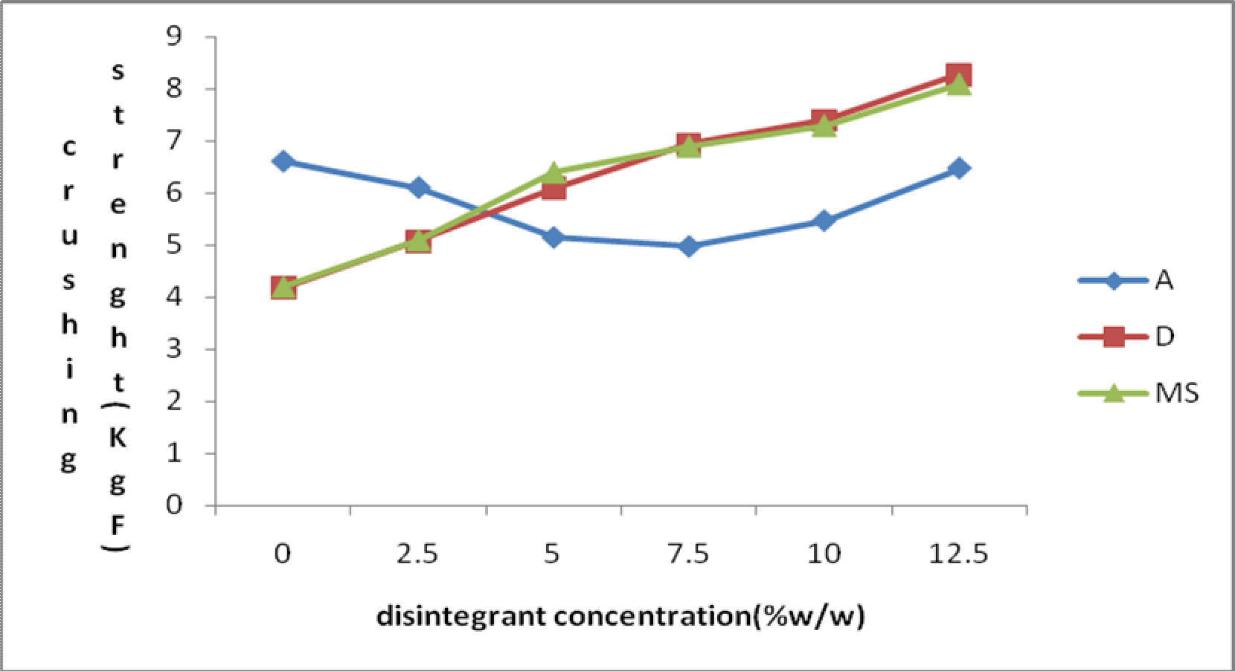

**Fig 4.7:Effect of starch disintegrant content on the crushing strength of paracetamol tablets formulated with *Pennisetum glaucum* Starch*(A),Pennisetum americanum* Starch*(D)* and maize starch BP (MS).**

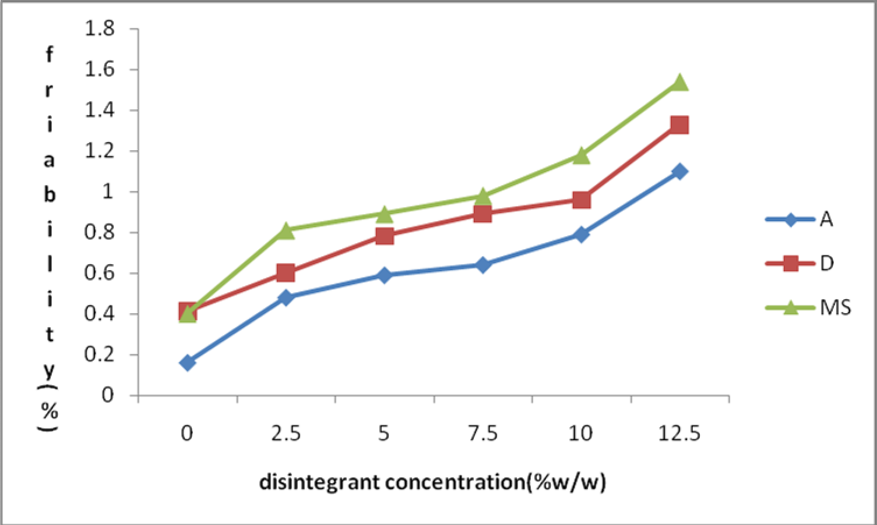

**Fig 4.8:Effect of starch disintegrant content on the Friability of paracetamol tablets formulated with *Pennisetum glaucum* Starch*(A),Pennisetum americanum* Starch*(D)* and maize starch BP (MS).**

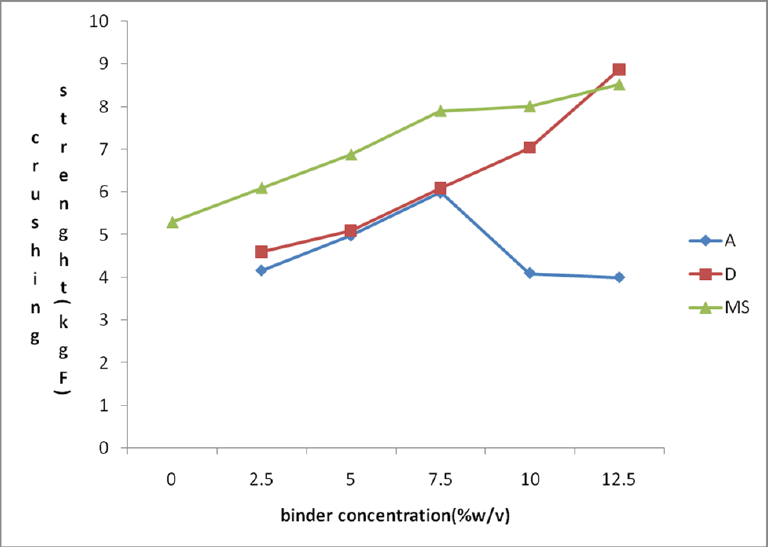

**Fig 4.9:Effect of starch Binder content on the crushing strength of paracetamol tablets formulated with *Pennisetum glaucum* Starch*(A),Pennisetum americanum* Starch*(D)* and maize starch BP (MS).**

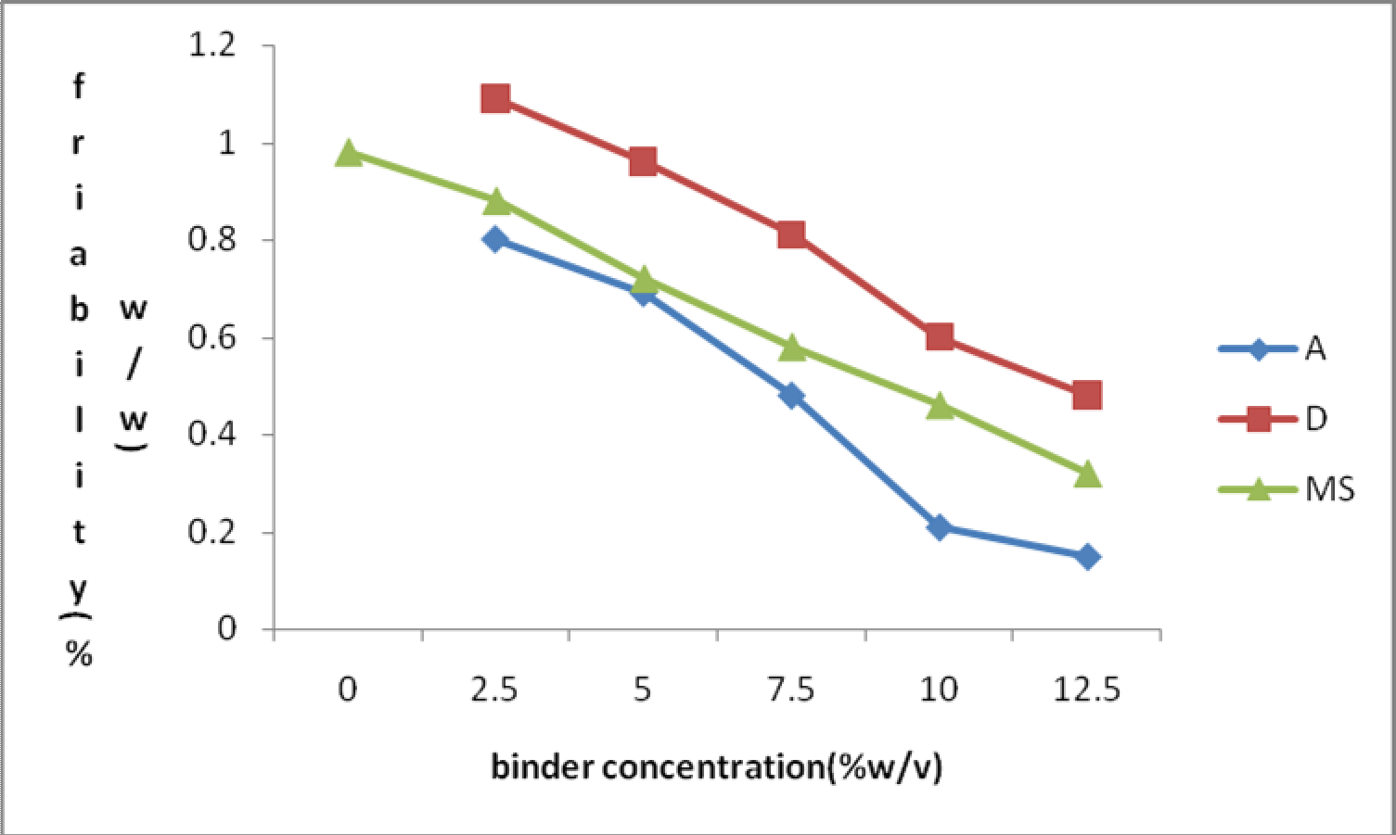

**Fig 4.10:Effect of starch binder content on the Friability of paracetamol tablets formulated with *Pennisetum glaucum* Starch*(A),Pennisetum americanum* Starch*(D)* and maize starch BP (MS).**

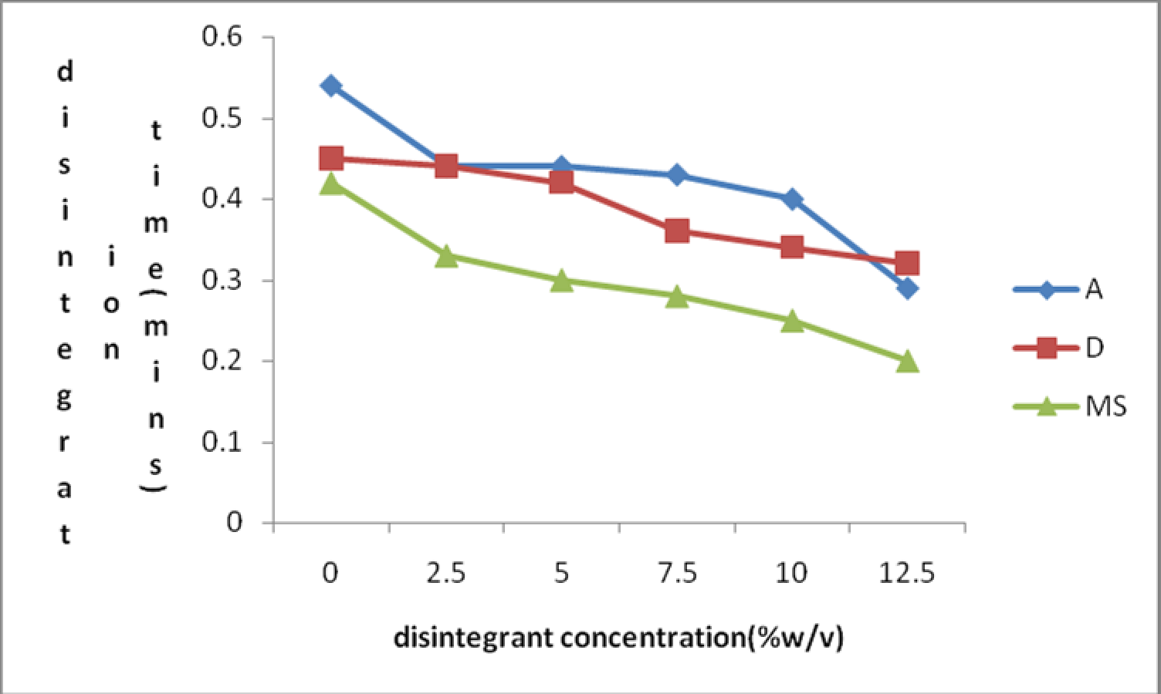

**Fig 4.11:Effect of starch disintegrant content on the disintegration time of paracetamol tablets formulated with *Pennisetum glaucum* Starch*(A),Pennisetum americanum* Starch*(D)* and maize starch BP (MS).**

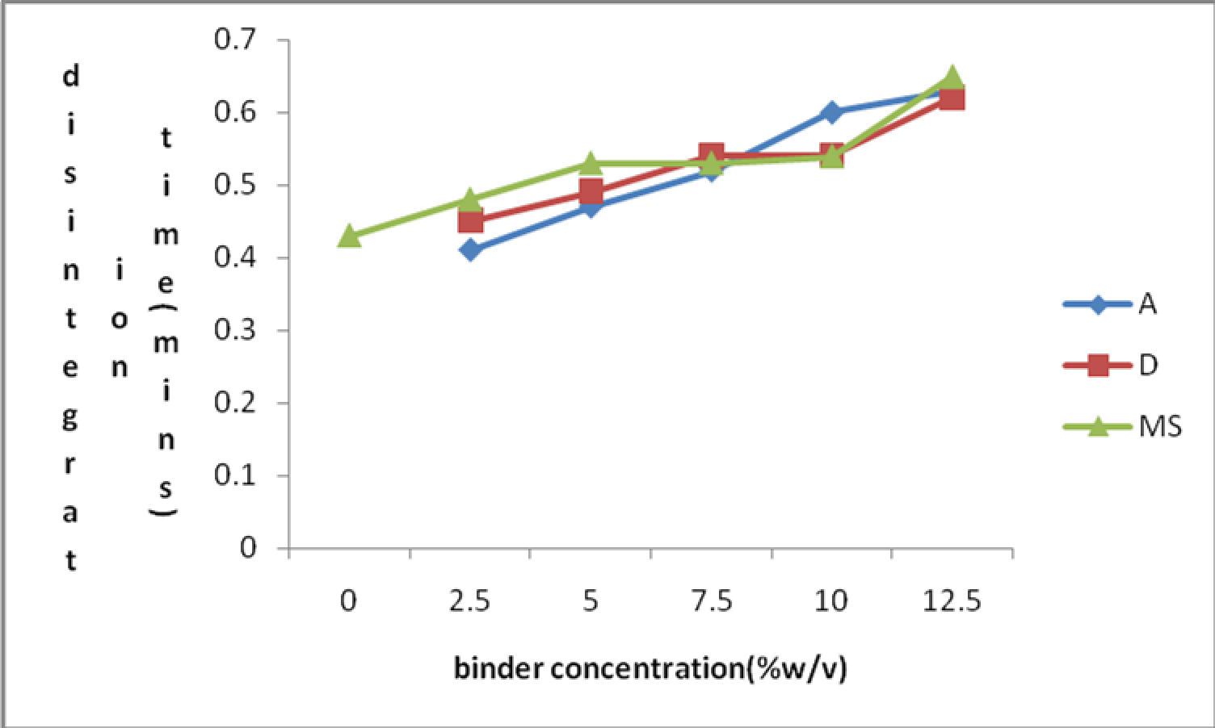

**Fig 4.12:Effect of starch binder content on the disintegration time of paracetamol tablets formulated with *Pennisetum glaucum* Starch*(A),Pennisetum americanum* Starch*(D)* and maize starch BP (MS).**

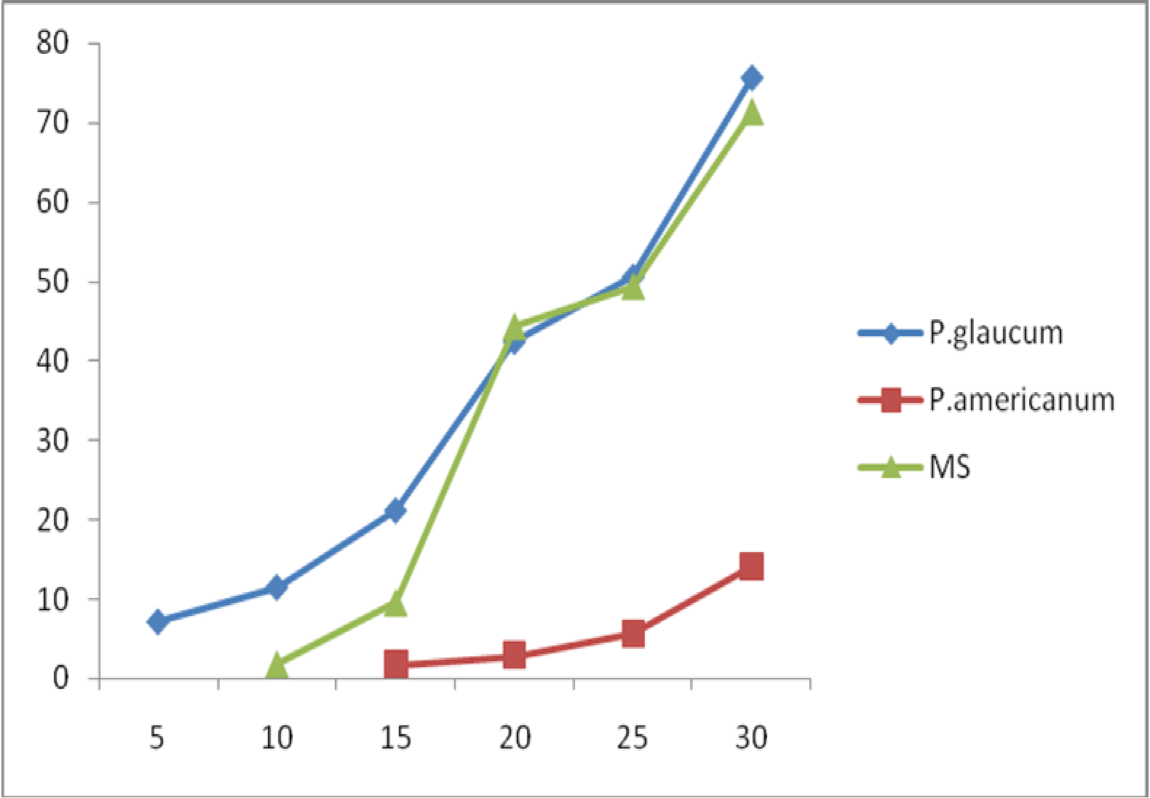

Time(mins)

Percentage drug released

**Fig 4.13:Effect of starch binder content on the Percentage drug released from paracetamol tablets formulated with *Pennisetum glaucum* Starch*(A),Pennisetum americanum* Starch*(D)* and maize starch BP (MS).**

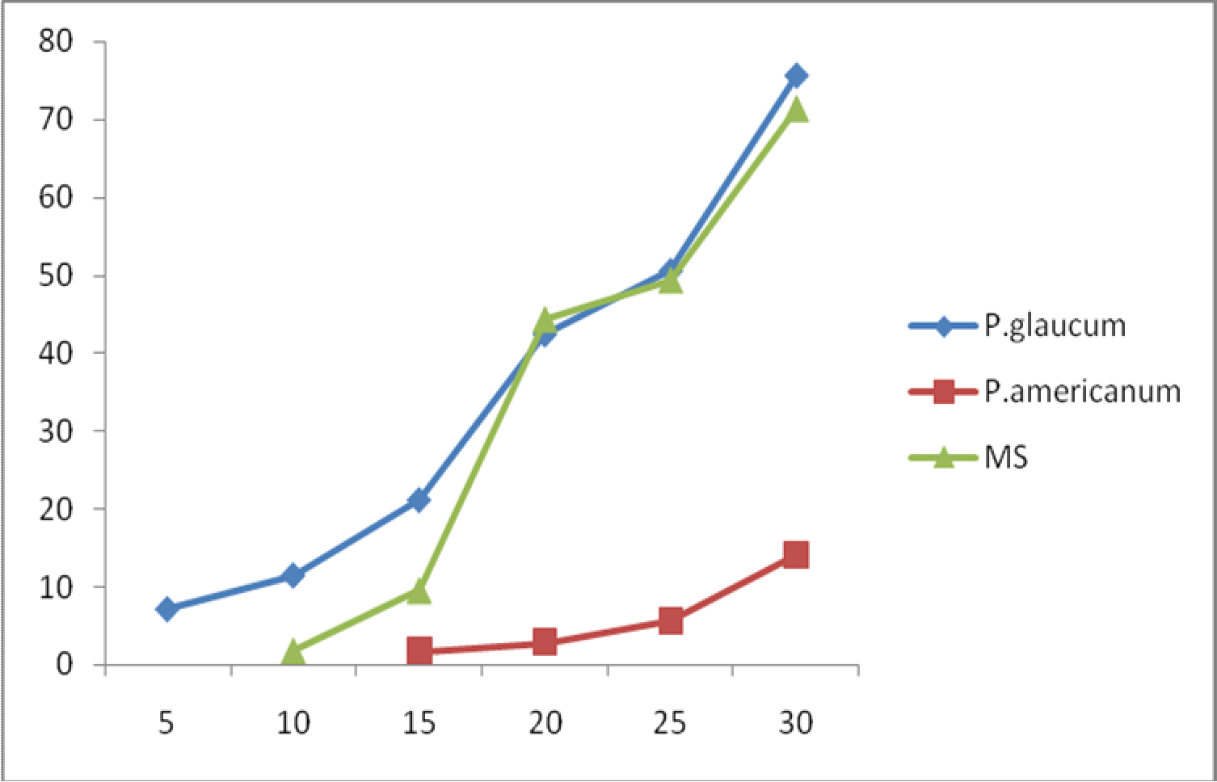

Time (mins)

Percentage drug released

**Fig 4.14:Effect of starch disintegrant content on the Percentage drug released from paracetamol tablets formulated with *Pennisetum glaucum* Starch*(A),Pennisetum americanum* Starch*(D)* and maize starch BP (MS).**

# Table 4.8: Properties of paracetamol Tablets containing *Pennisetum americanum* Starch and maize starch BP used at different disintegrant concentrations .

|  |  |  |
| --- | --- | --- |
| Formulations containing varying concentration(%w/w) of : | | |
| Tablet properties | *Pennisetum americanum* Starch | Maize Starch BP |

|  |  |  |  |  |  |  |  |  |  |  |
| --- | --- | --- | --- | --- | --- | --- | --- | --- | --- | --- |
| Disintegrant conc.(%w/w) | 0.00 | 2.50 | 5.00 | 7.50 | 10.00 | 12.50 | 0.00 | 2.50 | 5.00 7.50 10.00 | 12.50 |
| Crushing strength(Kgf) | 4.18 | 5.08 | 6.10 | 6.94 | 7.40 | 8.28 | 4.20 | 5.10 | 6.40 6.90 7.30 | 8.10 |
| Friability(%) | 0.41 | 0.60 | 0.78 | 0.89 | 0.96 | 1.33 | 0.41 | 0.81 | 0.89 0.98 1.18 | 1.54 |
| Tablet thickness(mm) | 5.428 | 4.810 | 5.534 | 5.598 | 5.728 | 6.088 | 5.384 | 5.656 | 5.796 5.668 5.762 | 5.938 |
| Disintegration time(min) | 0.48 | 0.44 | 0.42 | 0.36 | 0.34 | 0.32 | 0.42 | 0.33 | 0.30 0.28 0.25 | 0.20 |
| Mean weight(mg) | 586 | 625 | 626 | 635 | 644 | 655 | 602 | 615 | 626 636 647 | 656 |
|  | ±5.2 | ±5.3 | ±5.2 | ±5.3 | ±5.2 | ±5.33 | ±4.80 | ±4.70 | ±4.60 ±4.60 ±4.20 | ±4.60 |

**Table 4.9: Properties of paracetamol Tablets containing *Pennisetum americanum* Starch and maize starch BP used at different binder concentrations .**

Formulations containing varying concentration(%w/w) of :

|  |  |  |  |  |  |  |  |  |  |  |  |  |
| --- | --- | --- | --- | --- | --- | --- | --- | --- | --- | --- | --- | --- |
| Tablet properties | | *Pennisetum americanum* Starch | | | | | Maize Starch BP | | | | | |
| Binder conc.(%w/v) | 0.00 | 2.50 | 5.00 | 7.50 | 10.00 | 12.50 | 0.00 | 2.50 | 5.00 | 7.50 | 10.00 | 12.50 |
| Crushing strength(Kgf) |  | 4.6 | 5.10 | 6.10 | 7.04 | 8.88 | 5.30 | 6.10 | 6.88 | 7.90 | 8.01 | 8.52 |
| Friability(%w/w) |  | 1.09 | 0.96 | 0.81 | 0.60 | 0.48 | 0.98 | 0.88 | 0.72 | 0.58 | 0.46 | 0.32 |
| Tablet thickness(mm) |  | 5.624 | 5.638 | 5.630 | 5.514 | 5.74 | 5.162 | 5.404 | 5.352 | 6.186 | 5.782 | 6.068 |
| Disintegratation time(min) | | 0.45 | 0.49 | 0.52 | 0.54 | 0.62 | 0.43 | 0.48 | 0.53 | 0.53 | 0.54 | 0.65 |
| Mean weight(mg) | | 612 | 603 | 623 | 614 | 6.46 | 585.5 | 612.5 | 584 | 647 | 653 | 674 |
|  | | ±7.89 | ±4.83 | ±6.75 | ±5.16 | ±5.16 | ±6.90 | ±7.00 | ±6.90 | ±6.80 | ±6.70 | ±6.90 |

# Table 4.10: Properties of paracetamol Tablets containing *Pennisetum glaucum* Starch and maize starch BP used at different disintegrant concentrations .

Tablet properties

Formulations containing varying concentration(%w/w) of :

Maize Starch BP

*Pennisetum glaucum* Starch

|  |  |  |  |  |  |  |  |  |  |  |  |  |
| --- | --- | --- | --- | --- | --- | --- | --- | --- | --- | --- | --- | --- |
| Disintegrant conc.(%w/w) | 0.00 | 2.50 | 5.00 | 7.50 | 10.00 | 12.50 | 0.00 | 2.50 | 5.00 | 7.50 | 10.00 | 12.50 |
| Crushing strength(Kgf) | 6.60 | 6.10 | 5.15 | 4.98 | 5.47 | 6.47 | 4.20 | 5.10 | 6.40 | 6.90 | 7.30 | 8.10 |
| Friability(%) | 1.16 | 0.48 | 0.59 | 0.64 | 0.79 | 1.10 | 0.41 | 0.81 | 0.89 | 0.98 | 1.18 | 1.54 |
| Tablet thickness(mm) | 5.25 | 5.50 | 5.61 | 5.55 | 5.50 | 5.58 | 5.384 | 5.656 | 5.796 | 5.668 | 5.762 | 5.938 |
| Disintegration time(min) | 0.54 | 0.44 | 0.43 | 0.40 | 0.29 | 0.20 | 0.42 | 0.33 | 0.30 | 0.28 | 0.25 | 0.20 |
| Mean weight(mg) | 534 | 618 | 618 | 613 | 620 | 644 | 602 | 615 | 626 | 636 | 647 | 656 |
|  | ±6.99 | ±6.32 | ±6.32 | ±4.12 | ±4.71 | ±6.99 | ±4.80 | ±4.70 | ±4.60 | ±4.60 | ±4.20 | ±4.60 |

# Table 4.11: Properties of paracetamol tablets formulated using *Pennistum glaucum* starch and Maize starch as Binders

|  |  |  |  |  |  |  |  |
| --- | --- | --- | --- | --- | --- | --- | --- |
| Tablet property *Pennisetum* | *glaucum* |  |  | Maize | starch BP |  | |
| Binder conc.(%w/v) 0.00 2.50 | 5.00 7.50 | 10.00 | 12.50 0.00 | 2.50 | 5.00 7.50 | 10.00 | 12.50 |
| Crushing strength(Kgf) 4.16 | 4.98 5.99 | 4.10 | 4.00 5.30 | 6.10 | 6.88 7.90 | 8.01 | 8.52 |
| Friability 0.80 | 0.69 0.48 | 0.21 | 0.15 0.98 | 0.88 | 0.72 0.58 | 0.46 | 0.32 |
| Tablet thickness(mm) 5.536 | 5.267 5.180 | 5.418 | 5.393 5.162 | 5.404 | 5.352 6.186 | 5.782 | 6.068 |
| Disintegratation time(min) 0.41 | 0.47 0.52 | 0.60 | 0.65 0.43 | 0.48 | 0.53 0.53 | 0.54 | 0.65 |
| Mean weight(mg) 616 | 626 619 | 615 | 623 585.5 | 612.5 | 584 647 | 653 | 674 |
| ±5.16 | ±5.16 ±5.68 | ±7.07 | ±6.75 ±6.90 | ±7.00 | ±6.90 ±6.80 | ±6.70 | ±6.90 |

# CHAPTER FIVE

# Discussion

# .0 Physicochemical properties:

The extracted *Pennisetum glaucum and Pennisetum americanum* starch powder were observed to be off white in colour, odourless and very fine textured. The percentage yield were found to be 50% for *Pennisetum glaucum* and 56.2% for *Pennisetum americanum* (Table 4.1) .

# Flow Rate and Angle of repose

The flow rates were found to be 0.77g/sec for *pennisetum glaucum* and 0.80g/sec for *Pennisetum americanum* as shown in Table 4.2,which was lower than that for maize starch BP with a flow rate of 1.2g/sec. The two starch samples also showed higher angle of repose than maize starch BP(*Pennisetum glaucum*-45o,*Pennisetum americanum*-42o and maize starch BP-35.90o).The angle of repose is an index of flowability of a powder or granular substance. The value of the angle of repose is affected by the cohesive nature of the powder and the value of the angle of repose will be high if the powder is cohesive and low if the powder is non cohesive(Bhimte and Tayade,2007).Powders with angle of repose greater than 45o have unsatisfactory flow properties, whereas angles of repose close to 25o have very good flow properties(Davies, 2009). The high angle of repose reported for the three materials is an indication of poor flow property. Veslasco *et al* (1995) reported

that angle of repose values above 50º is an indication of a poor flow characteristics of a

powder, whereas low angle of repose of 25o is an indication of very good flow properties (Davies 2009).The flow of a powder during manufacturing dictates the quality of the product in terms of weight and content uniformity(Prescott Bernum,2000). Weight variation in tablets can be minimised if the formulation exhibit good flow characteristics

**Hausner ratio** and **Carr’s index are** used to predict the flow of granules and powders Nyqvist and Nicklasson (1985) predicted that values of Hausners quotient and Carr’s compressibility above 1.2 or 23% respectively do not indicate good flow behavior.

# Moisture content

Moisture content for all the materials did not exceed the 15% limit specified by the BP 2002 for starches The result of the moisture content was in the order *Pennisetum americanum* higher than *Pennisetum glaucum* higher than maize starch BP. Moisture content plays a significant role in the stability of a pharmaceutical product. High moisture content tends to encourage bacterial growth and chemical degradation of active ingredients and excipients. High moisture content level in granules affect the flow property of the granules which could affect some parameters of the tablets such as uniformity of the weight and the content uniformity. Formulation scientists generally considered that 3% moisture content as the maximum if chemical stability of hydrolysable drug content in a solid dosage form is to be assured. However it is agreed that it is only the free mobile water fraction rather than the total water content of excipients that is important in chemical stability. These bound fractions do not induce hydrolysis (Khanate *et al,* 1991).

# Moisture Sorption

The result of the moisture sorption was in the order *Pennisetum americanum* 15.0% maize starch BP 14.84 % *Pennisetum glaucum* 14.80% (Table 4.2) the equilibrium moisture content of starch is a measure of its sorption characteristics and this may introduce instability to moisture sensitive drugs.(e.g. aspirin) when such starch is used in drug formulations (Okafor , 1990 ;Preiss and Levy, 1980). All the samples had high moisture content, which makes them less suitable for moisture sensitive drugs.

# Test on granules

# : Particle Size analysis

At lower disintegrant concentration the curves were almost superimposed on each other, indicating that the disintegrants exhibited similar mean particle sizes and size distribution patterns (Fig4.1- 4.6).

# : Flow Properties

The flow properties of the granules were all very good (Table 4.4), they had low angles of repose, high flow rate due to lower cohesive forces, hence good flow and better tabletting properties (Musa, 2002; Martin et al, 1983; Musa, 1999, and Neuman, 1976). This might be due to increase in densities with increase in binder concentration, the lower the density of a material the poorer the flow properties. The flow properties of the granules also indicate that flowability decreases with increase in size of the angle of repose of granules (Neuman, 1976). Both granules exhibited similar characteristics.

# : Consolidation Properties

Low bulk and tapped densities and therefore lower value of Carr’s consolidating indices, these properties increased with increase in disintegrant concentration.

Both granules show that there was decrease in granule bulk and tapped densities with increase in concentration of binder (Table 4.6). Flow properties have been reported to increase as binder concentration increased from low to high(Zayic and Buckton, 1990).

# : Test on tablets

# : Crushing Strength

There was an increase in tablet crushing strength as the disintegrant concentration increased **(**Fig 4.7 and 4.9**)** this effect varied with disintegrant type. The effect was in the order *Pennisetum americanum* greater than Maize starch BP greater than *Pennisetum glaucum*. Statistically there was significant difference between the crushing strengths of maize starch BP and *Pennisetum glaucum* and *Pennisetum americanum*.(P**□**0.05)

# : Friability

There was also a decrease in the friability of the tablets as binder concentration increased this was in the order *Pennisetum americanum* greater than Maize starch BP greater than *Pennisetum glaucum* (Fig 4.8 and 4.10).

# : Disintegration Time

The disintegration time decreased with increase in the disintegrant concentration**(**Fig 4.11) in the order *Pennisetum americanum* greater than *Pennisetum glaucum* greater than

maize starch BP. Statistically there was no significant difference between the

disintegration time of maize starch BP and *Pennisetum glaucum* and *Pennisetum americanum*.(P**□**0.05) The increase in tablet crushing strength with increase in disintegrant concentration implies an increase in tablet hardness. However some authors have suggested that starch disintegrant action in tablets is due to capillary action rather than swelling. One could also state that the intrusion of fluid by capillary forces enlarges the particles. The spherical shape of the starch grains increases the pore size of pores in the tablet. It was shown how spherical particles produced larger size than irregularly sized particles, which reduced the pore sizes (Ojile, 1980). It was also shown that narrower pore sizes of capillaries produced higher capillary forces of sucking in more fluids. Also the decreased disintegration time with increased disintegrant concentration can be as a result of enhanced water penetration by capillary forces into the tablets to cause the swelling of some components in the tablet to break apart. This is in agreement with the work of Metal and Ocean (1968), Nasipuri (1978) and Garr (1988).

Tablets produced with *Pennisetum americanum* as disintegrant had the highest disintegration time this might be due to formation of stronger interparticulate bonds between particles and/or between the excipients. The more compact a tablet is, the less the porosity or the voids between the particles. Therefore less penetration of water into the tablet would tend to cause a longer disintegration time. This is consistent with the work reported by Sagar (1947), Chuwaikowski and Krowozinsk (1968) and Iwuagwu *et al* (1986).

# : Dissolution Time

According to official limit set out in BP2002 for compressed tablet, the tablet should release 75% of the active content in less than 30 minutes, the percentage drug released increased as the dissolution time increased.(Fig 4.13 and 4.14). This is in accordance with the research work conducted by Muazu (2008).

When used as binders tablets whose crushing strength increased with increase in binder concentration were produced (Fig 4.9) in the order *Pennisetum americanum* greater than Maize starch BP greater than *Pennisetum glaucum.* Statistically there was significant difference between the maize starch BP and *Pennisetum glaucum* and *Penisetum americanum* (P**□**0.05).in crushing strength and disintegration time.

The increase in tablet crushing strength with increase in binder concentration implies an increase in hardness (Jacob and Plain 1968, Musa *et al* 2004) this might be due to the fact that the more the concentration of the binder the more the viscosity and stronger the bridges and tablet binding mechanism such binding forces includes mechanical interlocking, plastic deformation, molecular forces, van der waal forces, electrostatic forces, solid and liquid bridges. Similarly friability of the tablets was found to decrease with increase in binder concentration (Fig 4.10) due to increase in tablet hardness. (Esezobo and Ambujam 1982). Disintegration time was found to increase with increase in binder concentration for both binders (Fig 4.12). The interacting forces and bonds between the particles and the binder present are responsible for the strength of the tablets; those forces were also responsible for the increase in disintegration time of the tablets (Nasipuri and Akala, 1986)

York and Pipel (1973) found that the hardness of tablets, depend on the compression force and the amount of binding agent present. The compression force used was same for all the batches therefore the increase in tablet hardness observed can be attributed to the amount and type of binding agents.

# 5.4 Summary, Conclusion and Recommendations

The results of this study conducted to evaluate the tableting properties of two varieties of millet starches*(Pennisetum glaucum* and *Pennisetum americanum*) as binder and disintegrants show that the type of starch used as binder or disintegrant in tablet formulations affects the properties of granules and tablets.

Generally, increasing the concentration of the binder produced an increase in tablet crushing strength, disintegration times and a decrease in friability. These effects were observed with all the starches.

In summary physical properties of the starches ranked as follows; The flow properties ranked in the order:*Pennisetum glaucum* lower than *Pennisetum americanum* lower than Maize starch BP . Increasing the binder concentration of the two varieties of millet starch in granules generally improved their flow properties and compressibility index (bulk and tapped density, Carr’s index and Hausner ratio). Also increase in the disintegrant concentration of the two starches cause increase in the flow rate and angle of repose of the resulting granules.

In general, increasing the concentrations of the millet starches as binder and disintegrant gave Paracetamol tablets of good friability, crushing strength and disintegration time

and 5.00%w/w to 7.50%w/w concentration disintegrant and binder are recommended in the formulation of 500mg Paracetamol tablet.

# References

Akande, O.F. (1988). *Evaluation of millet starch as tablet binder and disintegrant.*

MSc Thesis submitted to Ahmadu Bello University Zaria, Nigeria.

Apeji, Y.E.(2010).*Tableting properties Microcrystalline Starch derived from Cassava* (*Manihot esculenta* Crantz) *Starch by Enzymatic Hydrolysis using α-amylase Enzyme*. MSc Thesis submitted to Ahmadu Bello University Zaria Nigeria.

Bangudu, A.B. (1982). *“*Some factors affecting the compression characteristics of paracetamol tablets”. *Nig. J. Pharm. 13(6), pp 30-34.*

British Pharmacopoeia (1988), Vol. I and II University Press Cambridge. British Pharmacopoeia(2002),Vol.I and II University Press Cambridge .

Camphel,D.I.and Theivagt,J.G.(1958),Determination of Drug Release from Gradual release Preparations. *Drug standard* 26,73-76*.*

Caramela C. Novel methods for disintegrant characterization, Part 1. *Pharm. Technol*.

1991, (March), 48-56.

Carter, S.J. (1972). Coorper *and Gunn’s Tutorial pharmacy*. 6th ed. England: Pitman medical publishing Co. Ltd. pp 211-23.

Chukwu,A.and Udeala,O.K.(1986) *Direct Compression property of musol in ascorbic acid tablets.* An abstract of paper presented at the scientific session of the 59th. Annual National conference of the Pharmaceutical society of Nigeria held at Bauchi.

Chuwaikowski A. and Krowczynski (1968). Acta Poll Pharm 25, - 588 through Review Article by Warner Lowenthal (1972). Disintegration of tablets. J. Pharm Sci. 61 (II), 1692.

Cooper, A.R. and Eaton, L.E. (1962). Compaction Behaviour of Several Ceramic Powders. *J. AM. Ceramics Soc., 45,97.*

Deshpande, A. V. Panya, L.B. ( 1987). “Sorgum Starch as a tablet excipient”*. J. Pharm.*

*Pharmacol. 39: 495.*

Davis, W.L. Gloors, W.T. (1972). Effects of various binders and their concentrations on granulations and compressed tablets*. J .Pharm Sci. II, 618.*

David, S. I, and Augsberger, L. L. (1977). Plastic Flow during compression of directly compressible Fillers and its effect on tablet strength. *J Pharm. Sci 66, 155-159.*

Esezobo, S. and Ambujam, V. (1982). An evaluation of starch obtained from plantain Musa paradisiaca as a binder and disintegrant for compressed tablets. *J. Pharm. Pharmacology. 34: 761.*

Falaki, A.M.(1980) *The performance of malting barley at two locations in Nigeria and the response of selected cultivars to N and D fertilizers*. MSC Thesis, Faculty of Agriculture ABU Zaria.

Fell, J.T. and Newton, J.M. (1971). Effects of Particle size and speed of compaction on density changes intablets of Crystalline and Spray dried Lactose. *J. Pharm. Sci., 60, 1866.*

Gambo, A. (2009). *Evaluation of Digitaria iburua Starch as a binder and disintegrant in a macrodose tablet formulations*. MSc Thesis submitted to Ahmadu Bello University Zaria, Nigeria.

Garr J.S.M (1988). Tabletting properties of sorghum starch. *.M.Sc. thesis, ABU, Zaria, 66.*

Gunsel, W.C. and Kanig, J.C. (1976). *Tablets, in the theory and practice of Industrial Pharmacy*. 2nd ed. Edited by Lachman, L. Lieiberman, H.A. and Kanig, S. Lee and Feigbiger, Philadelphia, 321-358.

Huffine, C.L. and Bonilla, C.F. (1962). Particle size effects in the Compression of Powders. *Amer. Inst. Chem. Engrs.J. 8, 490.*

Ikwele, M.C. (1985). *The performance of barley varieties ( HVL) in the Sudan Savanna zone of Nigeria*. M.Sc thesis Dept of Agronomy A.B.U Zaria Nigeria*.*

Itiola, O.A. (1991) Compressional characteristics of three starches and the mechanical properties of their tablets. *Pharm World J. 8(3) P.91-94.*

Iwuagwu, M.A. et al, (1986). Investigations into the binding and disintegrant properties of starches from selected Dioscoreaceae plants. *Nig. J. Pharm. Sci. 2 (2), 10 – 22.*

Jaiyeoba, K.T and Opakunle, W.O (1978). The diluent properties of yam and cassava starches Mgf chem. *Aerosol News, 49 (5), 60.*

Jacob, T.T. and Plein E.M. (1968). Factors Affecting the Dissolution Rate of Concentration on Tablet Hardness and storage conditions on isolation Rate of Phenobarbitone tablets. *J. Pharm Sci. 57 (5), 802-805.*

Kottler.M.K, Chueh*.* H.R.(1992). Comparism of disintegrant and binder activity of three corn starch products. *Dug development and industrial pharmacy.*

Kawakita, K.J. Ludde, L.H. (1970/71). Some consideration on Powder Compression equations. *Powder Technol.4:61-68.*

Kunle.O.O;Bangudu.A.B.(1990).Effects of some starches on the properties of sulphadimidine tablets*.Pharmacy world journal*

Malamataris, S; Bin-Baie, S. and Pipel, N.(1984). Stress Relaxation in Particulate Material at Predetermined Load .*J Pharm. Pharmacology.*36: 616-617.

Martin A.Swarbrick L. and Cammareta A. (1983) *Physical Pharmacy.* 3rd ed. Led and Febiger, Philadelphia 492.

Mgbahurike, A. and Igwilo, C. (1991). Binding properties of gum from kaya senegalenesis granules. *Nig.J. Pharm., 22, 41-43.*

Mital, H.C. and Ocran, J. (1968). Suitability of Cassava and yam starches as tablet disintegrants. *Pharm. Acta. Helv. 43: 493.*

Muazu, J. (2006) *Evaluation of Fonio* (*Digitaria exilis*) *Starch as binder and disintegrant*. MSc Thesis submitted to Ahmadu Bello Univrsity Zaria, Nigeria.

Musa.H. Gwarzo,M.S., Yakassai,I.A.and Musa.K.Y.(2004),Production of pregelatinised maize starch compared with maize starch as ingredients in Pharmaceutical dosage forms*. Nigeria Journal of Pharmaceutical Research. Vol.3 No.1 PP 66-71*

Musa.H. S.Ochu, P.G.Bhatia, and M.S.Gwarzo(2008),Studies on Physicochemical Properties of Starches from Hordeum vulgare and *Zea mays.West African Journal of Pharmacy Vol. 21 No I PP 46-50.*

Nasipuri, R.N. (1975). “Evaluation of cassava starch as tablet binder and disintegrant”.

*Med. Pharm. Mark. 4: 17.*

Nasipuri, R.N. (1979a). “Evaluation of yam starch as tablet binder and disintegrant”. *Nig.*

*J. Pharm. 10: 162*.

Nasipuri, R.N. and Akala, E.O. (1986). Effect of concentration and Quantity of cassava starch mucilage as a binder on Granule and Tablet properties. *Nig. J.pharm. 17, 13.*

Neumann, B.S. (1976). *The flow properties of powders Advances in Pharmaceutical Sciences 2, 181-221*. London: Academic Press.

Nyqvist,H.,Nicklasson,(1985).Properties of compressible small quantities of drug. SU ind. Pharm. 11:745-759.

Odeku.O.A.(2005),Assesment of *Albizia zygia* gum as abinding agent in tablet formulation*. A1cta Pharm* 263-276*.*

Ochu, S.N. (2009). Evaluation of Barley (*Hordeum vulgare*) Starch as a tablet excipient.

*MSc Thesis submitted to Ahmadu Bello University Zaria, Nigeria*.

Ojile.J.E., 1980.Factors Affecting Drug Distribution in granules PhD Thesis, Robert Gordon University, Aberden Scotland.

Okafor, I.S. (1990). *A Comparative study of modified starches in direct compression tabletting*. M.Sc dissertation Department of Pharmaceutical Technology and Industrial Pharmacy, university of Nigeria, Nsukka, Nigeria.

Okafor, I.S., Udeala, O.K. and Onyechi, J. (1991). A comparative study of modified starches in direct compression tabletting. *I, II and III 1st Nat. Sci Conf. Nig. Ass. Of academic Pharmacists, Ahmadu Bello University Zaria – Nigeria 111 – 115, 130 – 138 and 145 – 153.*

Okhamafe, A.O, Igboechi A.C, and Obaseki, T.O (1991) Cellulose extracted from groundnut shell and rice husk 1. *Preliminary Phsicochemical characterization world journal 8 (4), 120-123.*

Olayemi,O.J.(2009).*Comparative Evaluation of Maize , Rice and Wheat Starches as tableting excipients*. MSc Thesis submitted to Ahmadu Bello University Zaria*,* Nigeria.

Ozumba .J.C. Bangudu .A.B(1992).Tableting properties of Deterium microcarpum seed mucilage. *African journal of Pharmacy and Pharmaceutical sciences*

Paronen, P. and Justlin, M. (1983). Compressed characteristics of four starches. *J.Pharm Pharmactics 35,627.*

Preiss, J. and Levi, C. (1980). *The Biochemistry of plants: A Comprehensive treatise; Carbohydrates: Structure and function*. New York: Academy press. Vol. 3p 371.

Ripple, E.G. and Danielson, D.W. (1981). Viscoelastic stress-strain of pharmaceutical tablets. *J. Pharm Sci, 70,476-482.*

Sagar , H. (1949). Pharm Acta Helv, 24, 334; Through Review Article by Warner Lowenthal (1972). Disintegration of tablet. *J. Pharm Sci, 61 (II), 1697.*

Staniforth, J.N. (1990). Powder flow in: Aulton ME (Ed). Pharmaceutics The Science of Dosage form Design. Church hill Livingston, 1996, pp 223-253.

Velasco,M.V. Mun Ruiz Jimenez-Castellanus M.R.,On Maltodextrins a direct vehicles,

*Dru Dev ind. 1*

Wray,P.E(1992).The Mixing and Segregation in Relation to Pharmaceutical Processing, *Drug Development and Industrial Pharmacy,*18:627-658.

Zayic, R. and Buckton, G. (1990). The use of Surface Energy Values to predict optimum Binder Selection for Granulation Int. *J. pharm 59 155-164.*

# Appendices

**Table 4.12: Size distribution of granules(cumulative % undersize) of *Pennisetum glaucum* starch used as disintegrant**

Sieve size(µm)

Disintegrant concentration (%w/w)

0.00

2.50

5.00

7.50

10.00

12.50

|  |  |  |  |  |  |  |
| --- | --- | --- | --- | --- | --- | --- |
| Pan | 0.23 | 1.53 | 5.60 | 7.07 | 8.00 | 1.67 |
| 75 | 3.03 | 3.10 | 13.20 | 13.97 | 12.23 | 4.90 |
| 90 | 6.63 | 7.00 | 22.13 | 28.40 | 29.26 | 26.57 |
| 150 | 10.56 | 9.80 | 33.16 | 39.03 | 39.76 | 33.30 |
| 250 | 23.73 | 20.53 | 50.43 | 55.53 | 59.46 | 51.97 |
| 500 | 97.73 | 98.56 | 99.50 | 99.36 | 99.53 | 99.00 |

# Table 4.13: Size distribution of granules(cumulative % undersize) of *Pennisetum glaucum* starch used as binder

|  |  |  |  |  |  |  |
| --- | --- | --- | --- | --- | --- | --- |
| Sieve size(µm) Binder concentration (%w/v) | | | | | | |
|  | 0.00 | 2.50 | 5.00 | 7.50 | 10.00 | 12.50 |
| Pan | - | 3.43 | 3.03 | 0.93 | 0.90 | 1.53 |
| 75 | 1.03 | 8.43 | 5.43 | 3.70 | 3.57 | 5.00 |
| 90 | 21.3 | 17.13 | 14.53 | 11.87 | 10.70 | 12.07 |
| 150 | 47.53 | 21.26 | 15.40 | 12.67 | 11.40 | 12.84 |
| 250 | 66.70 | 36.63 | 26.70 | 23.40 | 20.47 | 27.31 |
| 500 | 87.97 | 98.36 | 96.97 | 98.97 | 97.60 | 99.28 |

**Table 4.14: Size distribution of granules(cumulative % undersize) of *Pennisetum americanum* starch used as disintegrant**

Pan 0.23 1.90 1.87 1.00 2.13 0.37

Sieve size(µm)

Disintegrant concentration (%w/w)

0.00

2.50

5.00

7.50

10.00

12.50

|  |  |  |  |  |  |  |
| --- | --- | --- | --- | --- | --- | --- |
| 75 | 1.40 | 3.93 | 6.87 | 3.43 | 5.33 | 3.17 |
| 90 | 5.73 | 15.16 | 22.64 | 26.96 | 12.53 | 26.14 |
| 150 | 6.90 | 17.69 | 33.97 | 37.36 | 45.26 | 40.17 |
| 250 | 19.47 | 30.89 | 50.60 | 52.96 | 53.26 | 56.07 |
| 500 | 94.84 | 97.06 | 98.53 | 100.06 | 100.06 | 99.00 |

# Table 4.15 : Size distribution of granules(cumulative % undersize) of *Pennisetum americanum* starch used as binder

Sieve size(µm)

binder concentration (%w/v)

0.00

2.50

5.00

7.50

10.00

12.50

|  |  |  |  |  |  |  |
| --- | --- | --- | --- | --- | --- | --- |
| Pan | 0.10 | 1.53 | 1.00 | 2.27 | 2.77 | 3.17 |
| 75 | 0.90 | 6.40 | 3.63 | 5.77 | 5.84 | 5.30 |
| 90 | 2.73 | 12.27 | 9.83 | 12.57 | 13.44 | 10.60 |
| 150 | 15.40 | 14.47 | 10.90 | 12.90 | 14.37 | 11.43 |
| 250 | 45.43 | 23.97 | 23.73 | 24.13 | 30.07 | 24.00 |
| 500 | 98.96 | 94.54 | 85.90 | 98.33 | 94.44 | 95.00 |

**Table 4.16 : Size distribution of granules(cumulative % undersize) of Maize starch BP used as binder**

Sieve size(µm)

binder concentration (%w/v)

0.00

2.50

5.00

7.50

10.00

12.50

|  |  |  |  |  |  |  |
| --- | --- | --- | --- | --- | --- | --- |
| Pan | - | - | 0.2 | - | - | - |
| 75 | - | 0.8 | 1.43 | 0.80 | 1.47 | 1.47 |
| 90 | 6.67 | 5.43 | 7.36 | 4.77 | 5.07 | 5.88 |
| 150 | 34.14 | 9.13 | 9.86 | 6.20 | 6.37 | 7.30 |
| 250 | 46.91 | 18.60 | 25.69 | 17.03 | 17.84 | 19.90 |
| 500 | 90.28 | 96.67 | 99.19 | 98.73 | 98.73 | 97.63 |

# Table 4.17 : Size distribution of granules(cumulative % undersize) of Maize starch BP used as disintegrants.

Sieve size(µm)

binder concentration (%w/v)

0.00

2.50

5.00

7.50

10.00

12.50

|  |  |  |  |  |  |  |
| --- | --- | --- | --- | --- | --- | --- |
| Pan | 0.67 | 0.43 | 0.60 | 0.57 | 0.53 | - |
| 75 | 2.10 | 1.96 | 2.10 | 1.57 | 1.70 | 1.13 |
| 90 | 8.23 | 6.63 | 7.63 | 5.80 | 5.10 | 6.96 |
| 150 | 8.93 | 7.40 | 9.06 | 6.50 | 5.60 | 9.43 |
| 250 | 22.83 | 18.90 | 22.86 | 18.77 | 16.47 | 27.20 |
| 500 | 27.63 | 100.27 | 99.86 | 99.74 | 98.50 | 99.10 |