EVALUATION OF LANDSCAPE FEATURES FOR STRESS RELIEF IN HOTEL BUILDINGS IN KADUNA, KADUNA STATE, NIGERIA

BY

IHEABUNIKE, Edomobi MTech/SET/2017/7598

DEPARTMENT OF ARCHITECTURE, FEDERAL UNIVERSITY OF TECHNOLOGY, MINNA

APRIL, 2021

ABSTRACT

The fast growing trend of modernization and urbanization in regions around the world has its shares of dire consequences, which includes stress related problems, and have been on rise all over the world. The increasing economic growth and development has led to an intense densification of cities which have in some cases, led to a sparser availability of open spaces. Nevertheless, the need of spaces with restorative potentials is imperative in order to mitigate the stress related problems. Hence, this thesis is aimed at understanding the role of landscape and its qualities in fostering psychological restoration in outdoor environments, with the objectives of identifying those specific landscape elements that promote a restorative environment. The methodology involved interviews and preference study with the use of photo questionnaires. The preference study involved the selection of 40 coloured images inspired by Ulrich and Kaplan’s restoration theory. The images depicted landscape scenes with some elements of the attention restoration and psycho evolutionary theories. The images included variables such as soft landscape, water elements, colours hard landscape and sporting facilities. Scale 1-5 were given to each participants for each images to be rated with 1 and 5 as the lowest and highest preferences respectively. The rating was based on how positively such scenery will affect them. The results were analysed by factoring out the 15 most preferred images as well as the 15 least preferred images while factoring out the common traits in the images in each selected category. The 15 preferred images were because of the high degree of naturalness, denser landscape with beautiful shrubs and trees. There were presence of water bodies and the colours had brighter colours of plant and general physical environment. While the 15 less preferred images were because the images contained lesser quantities of landscape, low percentages vegetative ground cover, stagnant and unclean water, and lighter shades of the colour of grasses and trees. The result from the findings indicates that the existence of aesthetically pleasing bodies of water, artwork (sculptures and statues), and enhanced vegetative cover (trees, shrubs and flowers) foster restorative qualities of such a place. To achieve this, the thesis recommends the adoption of natural features that can be integrated into landscape designs as a key element for stress relief in hotel designs. In conclusion, the knowledge reflected by this thesis can be referred as guidelines by architects, designers, planners and even policy makers to create or transform outdoor spaces into an environment that supports psychological restoration which in both short and long term will benefit public health and overall wellbeing of individuals.

TABLE OF CONTENTS

CONTENTS Page

Title Page ii
Declaration iii
Certification iv
Acknowledgements v
Abstract vi
Table of Contents vii
List of Tables xii
List of Figures xiii
List of Plates xiv
List of Appendices xv
CHAPTER ONE
  - INTRODUCTION 1
  - Background to the Study 1
  - Statement of Research Problem 3
  - Aim and Objectives of the Study 4
  - Scope of Study 5
  - Limitations of the Study 5
  - Justifications of the Study 6
  - Contributions to Knowledge 6
  - Study Area 7
CHAPTER TWO
  - LITERATURE REVIEW 9
  - Hotel Buildings 9
    - Types of hotels 9
    - Hotel classification systems 14
  - Origin and History of Landscape 18
    - Medieval Europe 19
    - Renaissance Italy 19
    - Landscape definition 21
    - Functions of landscape 21
  - Definition of Stress 21
    - Types and causes of stress 22
  - Theoretical Review of Landscape and Stress 25
    - Restoration theories 26
    - Role of nature in the built environment 28
    - Effect of green spaces on man 29
  - Relationship between Stress, Restoration and Nature 31
  - Landscape and its Qualities 32
  - Restorative Qualities of Landscape 34
    - Role of water 34
    - Role of vegetation 35
    - Role of the senses in perception of landscape (smell, sound and touch) 36
  - Components of Landscape Design 40
    - Space 40
    - Principles of landscape design 41
    - The need to integrate nature into built environment 42
  - Landscape as a Restorative Component for Stress Relief 43
  - Summary of Literature 43

CHAPTER THREE

3.0 RESEARCH METHODOLOGY | 45
3.1 Research Method | 45
3.2 Data Collection and Sources | 45
3.2.1 Case studies | 46
3.2.2 Photo questionnaires | 46
3.2.3 Direct personal observation | 47
3.2.4 Secondary data | 47
3.3 Methods of data collection | 47
3.3.1 Quantitative data | 47
3.3.2 Qualitative data | 48
3.4 Variables of the Study | 48
3.5 Population of the Study | 48
3.6 Sampling Technique and Sample Size | 49
3.7 Method of Data Analysis and Presentation  CHAPTER FOUR | 39
4.0 DATA PRESENTATION AND DISCUSSION | 50
4.1 Introduction | 51
4.2 The Effect of Landscape as a Restorative Element | 50
4.2.1 Common qualities in the most preferred images | 53
4.2.2 The common traits of least preferred images | 54

  - Landscape Features that can be used to Promote Stress Relief in Hotels 54
    - Soft landscape 54
    - Water as a landscape element 56
    - Colour as a landscape element 57
    - Hard landscape 57
    - Sporting facilities 57
  - Landscape Design Parameters for Stress relief in existing Hotels in
Kaduna, Kaduna State 57
    - Therapeutic soft landscape 58
    - Water 60
    - Relaxing colours 61
    - Outdoor sporting activities 63
  - Proposal of a Hotel Landscaped for Stress Relief 64
    - Application of soft landscape features in the proposed design 65
    - Application of water and water elements 65
    - Application of colours to foster stress relief 66
    - Application of hard landscape elements in the design 66
    - Provision of sporting facilities in the design 67
  - Summary of Findings 67

CHAPTER FIVE

CONCLUSION AND RECOMMENDATIONS 69
  - Conclusion 69
  - Recommendations 69

REFERENCES 70

APPENDICES 76

Table | LIST OF TABLES | Page
2.1 | Classification factors of hotels | 15
2.2 | Stress warning signs and symptoms | 25
2.3 | Sources of smell in outdoor environment | 37
2.4 | Sound sources in outdoor environment | 38
2.5 | Sources of touch in outdoor environment | 39
3.1 | Variables of the study | 48
3.2 | Sample for the Study | 49
4.1 | Therapeutic plants and their therapeutic qualities | 55
4.2 | Outdoor sporting facilities in the case studies | 63
4.3 | Summary of landscape features in the case studies | 64

LIST OF FIGURES

Figure Page
  - Location of Kaduna state in Nigeria 7
  - The study area in Kaduna, Kaduna State 8
  - Preference for photos 1-10 51
  - Preference for photos 11-20 52
  - Preference for photos 21-30 52
  - Preference for photos 31- 40 53

LIST OF PLATES

Plate Page

- Vorduma guest house in Paris 12

- Welch motel in Vietnam 13

- Ariel view of Nike Lake resort hotel 14

- Ulrich’s theory; mixed warning sign + refuge 27

- Kaplan’s attention theory 28
- Outdoor seating around green spaces 29

- Landscape with outdoor seating and water fountain, Paris 31

- Landscape around the walkways in Elephant hills resort, in Victoria

falls, Zimbabwe 33

- Paris - Waterfront of the Canal Saint 34

- Prague-Slovanský Island 36
- Prague Alšovo Waterfont 37
- Bolingo hotel soft landscape 58
- Deluxe suit soft landscape 59
- Hamdala hotel soft landscape 59
- Lesham hotel soft landscape 60
- Lesham hotel soft landscape 61
- Colours used in Bolingo hotel 62
- Colours used in Deluxe suite 62
- Colours used in Lesham continental hotel 63

- Ariel view of the landscape in the proposed hotel 65

- Swimming pool and relaxation area in the proposed design 65

- The proposed hotel façade 66
- Picture showing the hard landscape 66

- Outdoor sporting facilities and landscape pattern 67

LIST OF APPENDICES

Appendix Page
- Preference study 76
- Questionnaire 83
- Interview Guide 87

CHAPTER ONE

INTRODUCTION

Background to the Study

A study conducted by the Canadian Public Health Association reported that it costs about 27 times more to curb or achieve a decrease in cardiovascular mortality and other stress related problems such as high-blood pressure, insomnia and some anti-social behaviours, through medical interventions than it does to attain the same result through native public health spending such as outdoor recreation and landscape environment (Sue, 2013). Today, one of the basic demands of the modern society is the opportunity of living in a healthy environment, and this is particular in urban settings where the opportunities of connecting and interacting with green spaces are getting thinner due to the rapid development of infrastructure that tampers with the natural environment and features. People appreciate the features and qualities of nature in their nearby environment in which they find themselves, and preferences are reported to relate to specific physical landscape character of the designed landscapes within the surrounding (Garret et al., 2018).

A hotel is an establishment that is built for the sole purpose of hosting people by providing accommodation, feeding and other facilities for people in need of such services including travellers and tourists (Chan & Mackenzie, 2013). There exist a classification of hotel buildings and is based on its spaces and facilities, this include: Hotel, Motel, Inn, Boarding house, Bed and breakfast establishment and Holiday villages (Lawson & Rawson, 1999). These buildings are popular for the luxury, convention and tourism they provide for in any place because of their conspicuous nature and drive for commercial success. Across the hospitality industry, hotel buildings in recent years have developed far beyond the usual services of accommodation and

feeding, to other extended services and facilities mostly involved in outdoor spaces. Hence, they have great potentials of providing an experience with outdoor spaces due to some services that they have to offer guests and other users compared to other building types (Jeremy et al., N.D).

However, since sustainability in recent years has been a key issue in industries, it is important to view the framework of green natural environment and means of harnessing it to improve health and also add to sustainable development in the hospitality industry (Sue, 2013). It is therefore relatively significant to draw more emphasis on the importance of the natural physical environment in psychological restoration processes and recover from stress. This can be optimally achieved in hotel environments, where there are countless opportunities of experiencing outdoor open spaces, as the daily interaction and blending of people with the elements of the natural physical environment can either ease stress or help people manage it appropriately (Berto, 2014).

Stress can be defined as the condition that occurs when person-environment contacts leads an individual to perceive a discrepancy (whether real or not) between the demands of a situation and the biological, psychological or social resources of the individual (Berto, 2014). Stress possess some negative effects which can be identified based on three categories namely the neuro-physiological or bodily changes in the individual experiencing stress, performance or behavioural changes and self-report of such individuals. Stress is a leading cause of mental and physical problems of health (Sue, 2013). Relaxation is a state of being of low tension, to be less stressed. It is a state in which there is an absence of arousal that could come from anger, anxiety, fear, or other sources. It can be achieved through meditation, autogenetic, progressive muscle relation and other possible means. It helps improve coping with stress.

Hence, it is necessary that the natural environment is brought close to the manmade environment so that there can be a unison of both, and this can be done with the use of relaxation can be promoted. Oyetola et al. (2013) stated that landscape has a powerful influence on individuals as it can positively simulate the minds, being a visually determined concept, which depends on perception, it is in turn deeply connected to the way we think. Therefore, when landscape is well planned and properly designed with the essential features and elements, it can serve as a means of alleviating stress.

Statement of Research Problem

The World Health Organisation (WHO) says stress has become a worldwide epidemic (American Physical Association, 2017). With the current fast economic growth and urbanization in regions around the world, towns and cities are developing continuously. Open spaces are getting sparser as they are being occupied for the purpose of erecting buildings and other urban infrastructure. This gradually reduces the chances of having an outdoor open space where people can socialise, relax and have opportunities of getting engaged and interact with the natural environment. Such an artificial environment can have some harmful consequences on people due to the absence of natural elements (Ruddick, 2015). Furthermore, with the advent of modern technology such as internets, computers, mobiles, televisions and other modern electronic gadgets, people tend to spend more time indoors entertaining themselves with these gadgets. In addition to this, the activities and lifestyle of some urban environments consist of some unfavourable stress inducing factors such as crowding, heavy traffic, chaos, noise, and many other forms of stressors and these stressors could lead to mental fatigue (Silfee et al., 2016).

Van der wees et al. (2013) stated that stress can lead to several health problems; such as impairing of one‘s moods and efficiency, and a decrease in concentration power. It is therefore not surprising that stress and some stress related illnesses have been on increase all around the world in recent times. Hence, with the alarming rate of stress related issues on human health both mental and physical, it is imperative to put in place measures that can alleviate this problem.

According to Berto (2014), physical settings contribute positively in alleviating stress effects on individuals, as the results of an experimental research by Berto (2014) showed strong indication that there exists a relationship between exposure to natural environments and recovery from mental fatigue and physiological stress. Wan & Wan (2015) further stated that natural green spaces encourage relaxation and reduce stress as it protects people against the impact of environmental stressors and offer physiological, emotional and attention restoration and this provides a sense of freedom and exhilaration. In these conditions, landscape could go a long way in reducing stress and its impact by promoting relaxation in hotel environments and at the same time improve the sustainability of hotel building, as it exposes people to the green environment.

Aim and Objectives of the Study

The aim of this study is to evaluate the use of landscape in promoting stress relief in hotel buildings in Kaduna and thereby propose a hotel design where relaxation is heightened with the use of landscaping features and elements.
The objectives of this study are:

    - To assess the effect of landscape as a restorative element for stress relief in hotels

    - To identify the landscape features that can be used to promote relaxation in hotel environment
    - To evaluate the design parameters of the existing features required for stress

    - Relief

    - To incorporate the required stress relief landscape features in the proposed hotel design.

Scope of Study

The scope of this study cover an evaluation of 10 different hotel buildings in Kaduna, which will highlight the theoretical framework necessary to achieve physical and mental wellbeing in hotel designs through the assessment of existing principles and the consideration of the landscape pattern and features, mostly in the outdoor area. Finally, the research will develop theoretical solutions as well as design solutions for sustainable landscape pattern and planning for a well relaxed hotel environment in Kaduna to create a natural stress relieving environment.

Limitations of the Study

Due to the security situation in the country, it was difficult to obtain permissions from the managements of some of the selected hotels to carry out the necessary evaluations and data collections. Some hotels also restrained from releasing some necessary information and also refused access to certain areas of the hotel because of their policy of not infringing on their guest’s privacy and also to protect their guest against the present insecurities happening around in the country.

Justification of the Study

Health challenge is a major concern especially to the adult population. The World Health Organization (WHO) has recorded a high rate of some health related issues that has arisen due to stress (Alison, 2015). Hence, buildings being a very integral part of man‘s daily activity should be designed in such a way that this health challenge of stress can be eased. There is therefore the need to provide an environment where relaxation is ensured. Hotel buildings which are known to provide services for relaxation and other facilities involving outdoor spaces can be designed in a manner that natural environment is harnessed and the natural features and elements are brought close to man to ensure that relief from stress can be attained with the use of landscape as a tool.

Contribution to Knowledge

This study which involves the evaluation of landscape to promote stress relief, would create a better understanding of the need for nature and its benefits in order to relieve stress and other negative effects that emanate from stress on people‘s health. It will also provide landscape designers with the requisite knowledge and necessary information on ways to harness landscape designs and planning in hotel environment to enhance and promote relaxation.

Study Area

The study was conducted in Kaduna, the capital city of Kaduna State, located in the North West Geo political zone of Nigeria. The name of the town was derived from the existence of a nearby river called Kaduna because of an abundance of crocodiles in the river. “Kaduna” is a plural form of crocodile in Hausa language. Kaduna town is located on latitudes 9‘03‘ and 11‘32‘ north and longitudes 6‘48‘ – 8‘48‘ east on the foot slopes of the scarp of the Jos plateau, and is located on the south end of the high plains

of northern Nigeria,. The city itself lies within the territory of the emirate of Zaria, and is situated on a very attractive and easily accessible region, and also share a common border with the Federal Capital, Abuja. Figure 1.1 and Figure 1.2 shows the geographical maps of Nigeria and that of Kaduna State respectively.

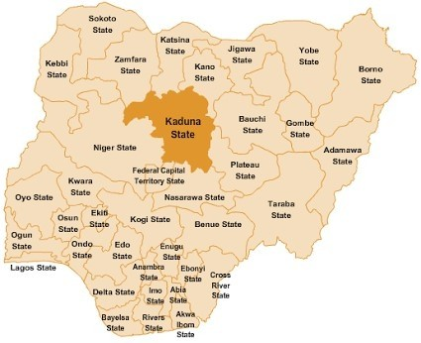

Figure 1.1: Location of Kaduna state in Nigeria (Source: www.nationsonline.org, 2018)

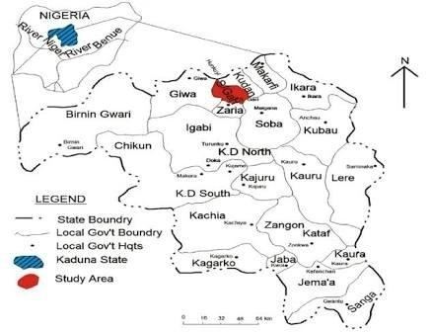
Figure 1.2: The study area in Kaduna, Kaduna State (Source: www.nationsonline.org, 2018)

CHAPTER TWO

LITERATURE REVIEW

Hotel Buildings

Hotel buildings are very important structures of any place as they are very significant in the aspect of hospitality as they provide accommodation and other related services and facilities for guests, visitors, tourists and others in need of the services they have to offer in exchange for payment (Chan and Mackenzie, 2013). According to Tahir and Satinder (2017), A hotel is an establishment that is characterized by the sole purpose of offering lodging and food services to any person able and willing to make payment for the services provided, and who is in a fit to be received by the establishment for this purpose (Diana, 2014). Hotels in recent times have developed beyond offering lodging and feeding with other facilities and services added to them such as outdoor recreation facilities, fitness facilities and a lot of other services.

Types of hotels

Chan and Mackenzie (2013) stated that hotels offer different kinds of services, have different facilities and operate differently to their guests to meet the needs for the period they are logged in such hotels. There are different types of hotels, which could offer accommodation, proximity to places of activities for intended guests, comfort, luxury and function as required by travellers or guests, and the types include; airport hotels, casino hotels, all-suite hotels, resort hotels, boutique hotels, city-centre hotels, guesthouses, convention hotels, sub-urban hotels, highway hotels or motels, commercial hotels, spa hotels, and cabins (Mandali, 2016).

Airport hotels

This hotel type is designed particularly to provide travellers with logging and food services. They are composed of a combination of some basic facilities and amenities (Chan & Mackenzie, 2013). They are therefore the hotels aimed solely at catering for people en-route (traveling) either for business, pleasure or other purpose (Mandali, 2016). The traditional airport hotels offered fewer facilities and had fewer guests compared to their modern counterpart due to the present multi-dimensional facilities available by the modern types.

All-Suite hotels

An all-suite hotel has its rooms larger than the typical hotel rooms, as they are designed and partitioned with a separate area for working, sleeping and other activities (Diana, 2014). There is a living room separate from the bedroom and may include a kitchen space separate from the other spaces in the room (Mandali, 2016). The facilities and services in an all-suite hotel vary extensively, and they can be found in the residential, urban or suburban areas.

Boutique hotels

Boutique hotels provides a more personalized accommodation and are planned to offer special services/facilities to guests as they desire (Rodick, 2012). A boutique hotel is also known as Lifestyle Hotels as they are more intimate and perhaps more luxurious. They tend to have fewer rules and restrictions than bigger, more conventional hotels. Many, perhaps most, boutique hotels are very pet-friendly. A boutique hotel often offers a stylish bar or lounge with a modern cocktail menu and regional wines.

Casino hotels

Casino hotels do not necessarily compete for the lodging demand, they are designed to attract gamers and gamblers. They are more focused on revenue generation with the major facilities of gambling operations and live entertainment. The hotel services constitutes a variety of luxurious amenities including casual dining and shopping centres (Chan & Mackenzie, 2013).

City Centre hotel

City centre hotels are usually located within the heart of a city, and are provided either for business, residential, economic benefits or mid-scale to luxury suite (Rodick, 2012). They are conventional city hotels that are characterised by high rise construction with accommodation, shops, offices and other facilities.

Conference hotels

Conference hotels, provide extensive meeting and function spaces for conventions, meetings and events in addition to accommodation. For this reason, Most of them provide 24-hour room service, banquet spaces within and around the hotel complex, a shopping centre, airport shuttle service and an in-house laundry (Chan & Mackenzie, 2013). They are sometimes located in close proximity to convention centres for easy access of guests. The services provided are of highest standards and conferences are normally charged as packages, which include accommodation and meeting facilities.

Guest houses

According to Tahir et al. (2017), guest houses are small hotels in bigger cities which are similar to breakfast inns. They have limited facilities, but the rooms are all en-suite. They include low-budget rooms and also luxury apartments with the major service of accommodation provision. In some areas of the world, guest houses are the only kind of

accommodation available for visitors who have no local relatives to stay with. Among the features which distinguish a guest house from a hotel is the lack of full-time staff.

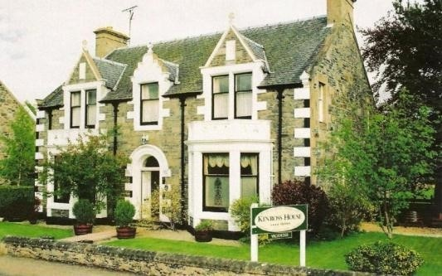

Plate I: Vorduma guest house in Paris (Source: www.kinrosshouse.co.uk)

      - Highway hotels

Highway hotels are popularly called motels. They are provided for short or overnight stays for travellers and motorists with some few basic facilities and their rooms are much smaller than typical hotel rooms. Usually, highway hotels are located on the outskirts of towns and cities for easy access of travellers (Mackenzie, 2009). They are typically constructed in an “I”-, “L”-, or “U”-shaped layout that includes guest rooms, an attached manager‘s office, a small reception, and in some cases, a small diner and a swimming pool. In some highway hotels, a handful of rooms would be larger and contain kitchenettes; these rooms are marketed at higher prices.

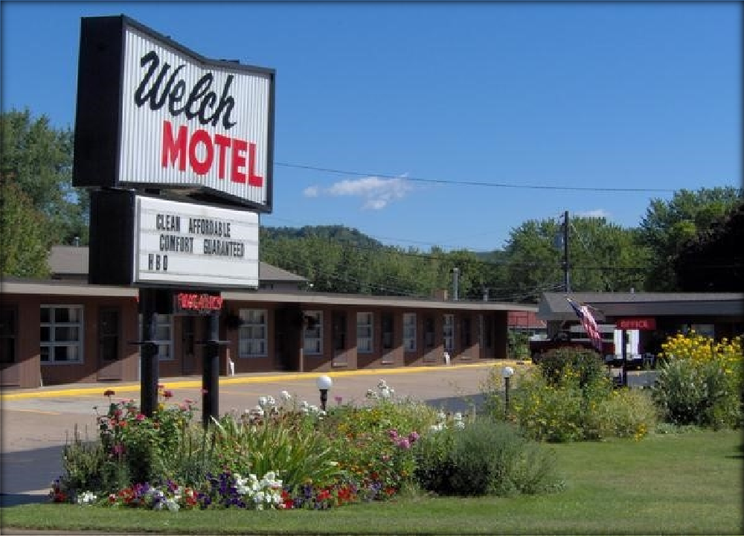

Plate II: welch motel in Vietnam
(Source: www.welchmotel.com/images/motel_front.jpg)

Spa hotels

Spa hotels are hotels with the primary purpose of providing individual services and treatments for spa seeking clients, with a focus on health. Spa hotels are usually located in resort settings or as part of city. They provide accommodation facilities, spa treatments and may also include relaxation/stress management, weight management, weight management and Pilates/yoga (McCormick et al., 2012). Prices Spa hotels are usually higher than a non-Spa hotel or at the average day spa. They might however not full access to all the facilities a hotel guest would have.

Resort hotels

Tahir and Satinder (2017), described resort hotels as hotels designed and built to provide accommodation, leisure facilities, recreational and athletic activities as well as a variety of food & beverage outlets ranging from informal to fine-dining restaurants desired by the guests with the features of natural beauty or interest. Resort hotels are

usually located in seaside or mountain areas, and they cater to tourists and vacationers. Some resort hotels include Spa Resorts, Ski Resorts and Ecotourism Resorts.

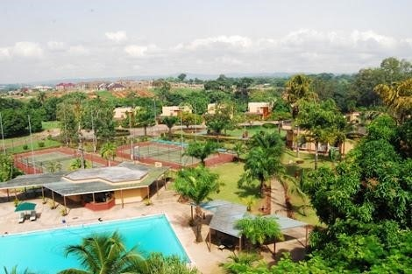

Plate III: Ariel view of Nike Lake resort hotel (Source: www.nationsonline.org, 2019)

Hotel classification systems

According to Desjarlais et al. (1995), hotel classification is based on star ratings and this rating is a subject of the quality of the hotel. Therefore, greater the number of stars, indicates greater luxury. (Chan and Mackenzie, 2013) suggest that the rating system emerged from the Automobile and cycling clubs in Europe, who established hotel rating systems such as the British system and the Automobile Association (AA). According to the AA rating system hotels can be classified based on the star ratings, the lowest rating is one-star hotel to five star hotel and the recent highest rating is the seven star hotel.

According to Chan and Mackenzie (2013), hotels have many systems of classification, and these classifications could either be for evaluation or description. Table 2.1 highlights the criteria often used in the classification of hotels. Through this

classification, travellers are provided with a brief idea of hotels so as to make choices on their reservation based on the experience they anticipate to get from them.

Table 2.1: Classification factors of hotels
S/n | Classification Factor | Examples
1 | Function | Meeting and convention
2 | Market segment | Leisure travellers
3 | Design | Exterior or interior design features
4 | Location | City centre
5 | Hotel size | Number of rooms
6 | Rating | 5(five) star hotels
7 | Price | Budget or luxury
8 | Staff to room ratio | A staff serving 2 rooms
9 | Distinctiveness of property | All-suite hotels
(Source: The Government of the Hong Kong Special Administrative region 2013).

Five star hotels

These are larger hotels with luxurious spaces and special surroundings with facilities that offer the standard quality of accommodation and cleanliness. Ottosson and Grahn (2005) argued that these hotel types are characterised by luxurious and spacious rooms with a more formal and professional style of service, from professional, and well trained staff. They are also characterised by luxurious restaurants and open eating area, with a 24 hours room service of high quality meals, drinks and snacks. Ottosson and Grahn (2005) also argued that five star hotels are defined by luxury that match the best international standards. It is characterised by and immaculate furnishing and high quality impressive interior design. It also provides comfort and elegance, as well as well supervised and flawless services and attention to guests' needs, without being intrusive. The restaurant are organised to producing dishes with high international standards and knowledgeable, helpful, well versed staff with a high level of technical skill.

Four star hotels

These are large formal hotels with facilities and services well above average possessing well furnished rooms, smart reception areas, and front desk service (Menzies et al., 2011). The Restaurant dining is usually 24 hour room service. Fitness centres and pools are often provided, as well as valet parking garage service.

Four star hotels have more spacious spaces with a high standard of cleanliness in the bedrooms and public spaces. They provide superior comfort and quality accommodation with en-suite facilities. They are more formal in style of service, with trained staff catering to guests needs. The restaurants are of high standard and quality of food, as they provide 24 hours room service of all meals, drinks and snacks (Ottosson and Grahn, 2005).

According to Research Department of the Caribbean Tourism Organization, expectations for these hotels include a degree of luxury perceived in the decorations, furnishings, facilities and equipment in every area of the hotel. The bedrooms and bathrooms are larger than at the lower star levels and are properly en-suite with adequate facilities, with a high ratio of staff to guests to provide adequate services and satisfaction of the guests needs such as 24-hour room service, laundry and dry-cleaning (Menzies et al., 2011).

Three star hotels

Chan and Mackenzie (2013) described three star hotels as hotels that are significantly greater in quality and range of facilities than at the lower star classifications as they are designed with more spacious public open spaces, with restaurant that also cater for non- guest that a not lodged in the hotel. The bedrooms are designed to offer a good standard of comfort and quality equipment. In this particular hotel rating, room service is not

available at all hours of the day, except in special situations such as demands from business travellers (Menzies et al., 2011). The restaurant and eating area are of high standard and are usually open for breakfast and dinner.

Two star hotels

This class of hotels are characterised by simple and comfortable accommodation, with a straightforward range of services provided by skilled and friendly staff. The hotel is usually small to medium-sized and conveniently located to moderately priced attractions The Research Department of the Caribbean Tourism Organization argued that hotels with two star ratings are ranged typically from small to medium size rooms and offer more extensive facilities than at the one star level (Menzies et al., 2011). Two star classicisation is usually associated with some business hotels as they provide guests with comfortable overnight accommodation. The staff offer more professional presentation than at the one star level, and offer a wider range of straightforward services, including food and drink.

One star hotels

According to Berto (2005), hotels that are rated the one-star rating are basic and still provide adequate comfort. The hotels are clean and well maintained, although, they offer a limited range of facilities and services. One star hotels are usually small and independently owned, with a family atmosphere and services may be provided by the owner and family on an informal basis (Bone and Ellen, 2005).

Although, the facilities and services offered are limited, as some of the bedrooms are not designed to contain en suite bath/shower rooms, there is a high level of cleanliness, Maintenance, and comfort.

Origin and History of Landscape

Landscape Architecture is as old as Architecture itself (Dorozhkina, 2018). Many countries in ancient times had different styles and methods of planting flowers, shrubs and trees and some were done because of certain purposes as healing(therapeutic), aesthetics, boundary outlining and other reasons. In the primeval period, the Egyptians developed efforts to planting gardens within the walled enclosure surrounding their homes, temples and palace. According to Hotels, Restaurants, and Cafés in Europe [HOTREC] (2013), there is a need to lay out gardens around rectangular fishponds flanked by ordinary rows of trees. In the Mesopotamia, the hanging garden was the most famous Erected in 605 BC during the reign of Nebuchadnezzar II. This garden was featured by full-sized trees planted terraces covered with earth, raised on stone vaults around the palace complex (Wan & Wan, 2015). The Assyrians and Persians likewise developed parks filled with tall trees for hunting on horseback. They planted rectangular walled grades along pools and canals which irrigated the grades, and was shaded by trees which were usually set in vast bare plains. The gardens inspired the design of the Persian carpet as it symbolized paradise (Karolina, 2018).

In Greece, colonnaded gardens were very common, they preserved sacred grooves as the habitats for divinities. In Rome ornamental horticulture first flourished in suburban villas around Room. Open arcades and epistyle were used to weave together dwellings; gardens and pools connived gardens were also used. The rich lavishly laid out pleasure grounds such as Luculent and Meacennas, this included banquets halls, porticoes and sculptures. Also, the vast ground of the Emperors Hadrious villa located close to Tivoli were magnificently landscaped in the hot and dry climate areas of the deserts landscape which was inspired by the presence of oasis and the ancient Persian paradise gardens was centred on water. The courts were enclosed and surrounded by cool arcades, with

trees and shrubs planted and invigorated with coloured tile work, fountains and pools with an inter play of light and shade, with flowers, fruits, trees, water and shade arrange in a unique composition as in the Tajmahal grades (Polačkova, 2012).

In Asia, for example, the Chinese temples, palaces and houses were built around courtyards, with trees and flowers often planted in pots. Likewise, the imperial city in Peking were adorned with elaborate pleasure gardens characterised by trees, artificial lakes hillock, bridges and pavilions. In Japan, the gardens are inspired by Chinese and Korean models of palaces, temples, and private houses. The gardens settings were closely integrated with the buildings. Kyoto was famous for its gardens which included pools, waterfalls, rock stone, evergreen shrubs, stone lanterns sculptures and wooden bridges gates and pavilions. Such tradition continues to some extent in modern Japan and has influenced western landscape architecture ever since then (Tanja, 2006).

Medieval Europe

In the medieval Europe, gardens within the fortified walls of monasteries and castle were enclosed and planned small for protection. Likewise, gardens found in the monasteries were adorned with a well or fountain at the centre, and they were surrounded by cloistered walls believed to have been inspired by Persian gardens which was intended for spiritual purposes such as to enhance meditation (Parinaz et al., 2014).

Renaissance Italy

Houses were usually designed with a landscape setting in the renaissance Italy, where there was a flow of landscape from the outdoor to the indoor, thus creating harmony between the house and the surrounding environment. Avenues, walks and steps from terrace, sculptures and fountains, which were laid out along the central axis, provided

aesthetic views. Some of the 15th and 16th century gardens include the garden of the Medici Palmieri and La Pietra Villas in Florence (Kara, 2013).

By the later part of the 16th century, Rome and its environs contained the finest achievements of Renaissance Landscape architecture. In the hill north of Rome, water was used to cool and ornament the garden of the Villa d, Este at Tivoli, designed by Piro Ligeria in C. 1550, the garden combined cascades, jets and curtains of water with placid pools and channels on hill side terraces through which the visitors walk on ramps and stairways. Later on, France replaced Italy as the primary inspiration of architectural and landscape design during the 17th century, under Louis XIV, French gardeners began to work on a grander scale (Lee, 2012). Andre'Le Natre, a famous architect, used sloping sites to create broad walks. At the palace of Versailles, Natre laid out a vast expanse of basins, fountains, parterres and woodland alleys along a broad central axis whose terminus was the horizon. In the 18th century, French garden design responded to English naturalism with romantic woodland Landscapes dotted with grottos and pseudo antique ruins (Polačkova, 2012).

Romanticism arose in the late 18th century, and it laid emphasis on untamed nature, the picturesque, the past and the exotic, and this brought about changes in landscape architecture and other arts (Lee, 2012). The patterns of romanticism involves a symmetrical arrangement of flowerbeds and walkways, placed with lawns, slopping hills with curved paths along rivers and ponds with a slight contrast of informally planted group of trees and flowers with the aim of to achieving a wilderness effect. The English romantic style spread to other parts of Europe and North America. In the 20th century, architects like Sven Marlilus in Sweden (1889-1977) and Frank Lloyd Wright in the U.S made series of attempts to achieve an integration of the house with its

surroundings. Frank Lloyd defined a building as appropriate to place if it is in harmony with its natural environment and the landscapes were ever possible taking advantage of natural features (Gesler, 2017). The falling water project is a notable example of this.
Other proponents of this landscape technique include Lawrence Halprin, in 1962, at the California Coastal Development Sea Ranch, he revived the traditions of the water garden, in his complex walk through fountains in Portland and San-Francisco.

Landscape definition

Parinaz et al. (2017) defined landscape as an environment in which nature is dominant feature. Landscape is also perceived as the entrance of nature into the life of people.

Functions of landscape

Landscape can serve as various functions in or within built environments or an open space in urban areas, parks and others. Landscape is used to enhance the natural surrounding and create natural settings for buildings, towns and cities. Likewise it can be used to enhance health and comfort of individuals within the surrounding. Also, it can be used to create microclimate within the landscape areas or surrounding. Landscape controls soil erosion in areas with irregular topography. Also, it can be used as wind breakers and also provide screens and demarcation for different functions within a specific area. Furthermore, Landscape can be used to create a buffer on site between quiet and noisy areas and also, it can be used to promote easy access and circulation on site (Andreas, 2016).

Definition of Stress

Prajal (2012) defined stress as a process in form of an adaptation to response to certain challenging or threatening situations. This reactions could be psychological such as fear, dislike, and attention/interest. Hence, stress can be said to be a natural reaction by man

in ancient times for survival. According to Dongying and William (2015), stress is a way of life whereby people react to environmental change that is directly imposed on them. Grahn, et al. (2010) defined stress as a systemic response by an individual to a change (stressor) which may either be internal or external and can be modified in specific situations.

Stress is a physiological response to events that threatens our personal balance in life (Ellen et al., 2007). An individual responds naturally to stress whether physical or emotional in a process known as "fight or flight" response. Oyetola et al. (2013) stated that stress is a biological response, which can either alert, protect or support us. It was a mechanism used by the ancient men to survive life or death situations. In other words, stress is the body‘s way of responding to an external or internal pressure, tension or anxiety (stressors), either by resisting or fighting the stressors, or by running from or giving in to its effects of such stressors.

Types and causes of stress

      - Types of stress

According to the American physical association (APA) (2015), Managing stress can be complicated because there are different types, and each of them have causes, symptoms, duration, characteristics, and method of treatment. Hence it is better to firstly understand the type of stress so as to aid the management or treatment process. Some basic types of stress as highlighted by Lyle & Alma. (1994) are: Acute Stress, Episodic Acute Stress, and Chronic Stress.

Acute stress

This is a short-term stress and is the most experienced. It is due to pressures and demands of the recent, present and past occurrence around us. It is the body‘s reaction

to a perceived or real physical or psychological threat to its wellbeing. Acute stress prepares the body to protect itself from the external conditions and also presents it with a survival function. This stress type in a small dose can be thrilling and exciting, but much of it is exhausting and can cause psychological distress, tension headaches, emotional distress, depression, anxiety, muscular problems, and other symptoms (Karyn, 2012).

Episodic acute stress

This is a type of acute stress but it occurs as a result of the prolonged acute stress, that is by frequently subjecting one perpetually in the clutches of acute stress., causing a disorganised life that often lead to crisis and chaos (Karyn, 2012). It comes from ceaseless worry, and are on a long-term that the sufferer is barely aware of his situation and sometimes leads to a resistance to change (American Psychological Association (APA), 2004).

Chronic stress

Chronic stress, unlike the acute stress is not thrilling and exciting. It is a grinding stress that causes people to be worn out day after day, year after year. On a long-term bases, it has the capacity to destroy people‘s bodies, mind and lives (American Psychological Association (APA), 2004). It is caused by some never ending troubles around us, such as a despised job, an unhappy marriage, and other miserable life situations which the person never sees a way out of. The worst aspect of chronic stress is that people tend to get used to it (Karyn, 2012). It is deadly and may result to suicide, hear attack, stroke and a few other deadly diseases. Treatment may require an extended medical procedure as well as behavioural treatment and stress management.

Causes of stress (stressors)

According to American Psychological Association (APA, 2013) anything, person or situation that causes stress, or is capable of causing stress is referred to as stressors. Stressors can be based on one‘s personal attribute, personal interpretation, coping strategy, and social support. Some stressors are easily identified while some are not easily identified or noticed, thereby creating a long-term adverse effect on people. It is important that in managing stress, the cause of the stress firstly should be identified as it would help know the right techniques and methods to employ in the stress management. According to the American Psychological Association, the major stressors are work, financial burdens, health related issues, worries and thoughts about the future and its outcome, security, marital problems and burden of parents and children (Lyle & Alma, 1994).

Although, some of the stress producing factors have changed compared to ancient times (although the body reacts the same way), the nature of the stressors is quite different from the ancient times, and hence one cannot easily fight it or flee from it. The American Institute of Stress (2002), warned that if reactions to stress are left untreated and allowed to occur frequently, the effects may get severe and lead to some threatening conditions such as cardiovascular problems, strokes, diabetes, hypertension, body pains and other conditions. Kaplan (1995) mentioned that the consequences of stress does not only have physiological effect, but it also has some severe negative impacts on the performance of an individual.

There is an increasing evidence that shows that there exists a strong relationship between stress and physical health (Herman et al., 2005). Stress negatively affects memory processing by creating a short-term memory loss, an increase in blood pressure

as well as heart rate (Collingwood, 2013). Furthermore, there exist some stressors caused by environmental factors that can provoke general stress on a larger population of people and they include crowding, pollution such as air and water (Ulrich et al., 1991). Stress leads to induced anxiety related disorders, which can be linked to certain unfavourable vices such as pernicious peer pressures that lead to substance abuse and other unhealthy life style habits; social isolation and loneliness, violence and increased crime (American Institute of Stress, 2002).

Stress occur gradually in humans and comes with some initial signs. It is important therefore to understand some of these warning signs of stress as highlighted in table 2.2. The symptoms of stress can come in varied dimensions as physical, emotional, mental or social.

Table 2.2: stress warning signs and symptoms
Physical | Emotional | Mental | Social
Headaches | Anxiety | Forgetfulness | Isolation
Teeth grinding | Frustration | Poor concentration | Loneliness
Fatigue | Nervousness | Low productivity | Lashing out
Insomnia | Depression | Negative attitude | Clamming up
Back aches | Worrying | Confusion | Lowered sex drive
Stomach problems | Tension | No new ideas | Nagging
Colds | Mood swings | Lethargy | Fewer contact with friends
Neck aches | Easily discouraged | Boredom | Using people
body pains |  | Crying spells
Increased use of drugs irritability

(Source: Oyetola et al., 2013)

Theoretical Review of Landscape and Stress

This section discusses extant theories established by past literature that links landscape and stress relief. There exist concepts and principles that establishes the role of landscape on man as a stress relieving factor, and how this landscape can be better harnessed to act as a restorative component.

Restoration theories

Hartig (2007) defined restoration as the process in which psychological and social resources that have diminished or have been lost by the body, in an attempt to satisfy the challenging demands that comes with the everyday activities of life is being recovered. In other words, it is a recovery process that initiates renewal and revival from stress. There exist two theories proposed by the landscape scholars Kaplan and Ulrich (1986) that explains the relationship between exposure to landscape and restoration. They are: The Attention Restoration Theory (ART) proposed by Kaplan (Kaplan, 1995) and Stress Reduction Theory (SRT) by Ulrich (Ulrich et al., 1991).

Psycho-evolutionary theory

According to Ulrich et al. (1991), restoration refers to a recovery process that is influenced by an anabolic renewal of energy that is being lost in the body‘s psychophysiological mobilization involved in the response to a stressor. This renewal involves numerous changes, though positive, in the body‘s physiological systems, to a reasonable performance and functioning emotional state. Such positive psychological and emotional changes can be achieved by relaxing natural environment and features such as vegetation and water.

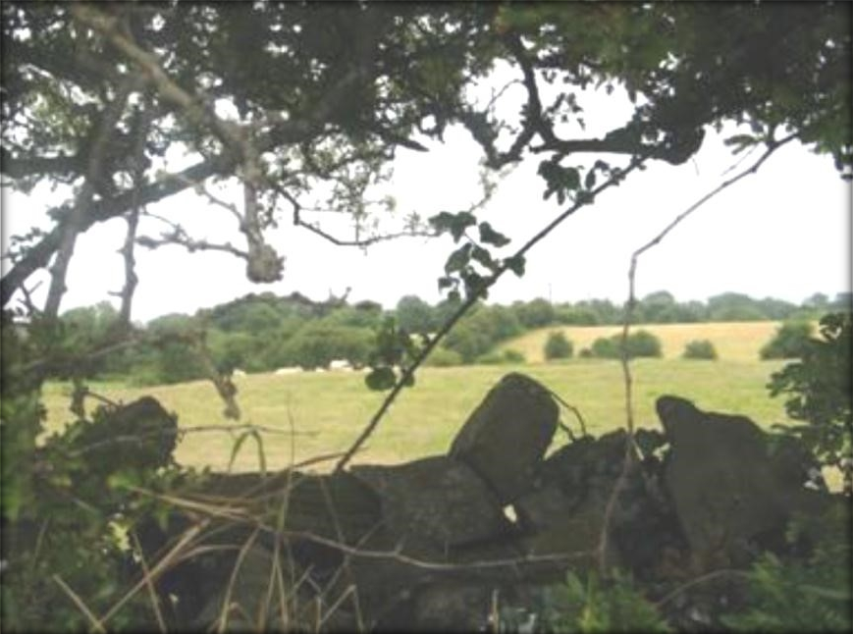

Plate IV: Ulrich’s theory; mixed warning sign + refuge (Source: Herman et al., 2005).

      - Attention restoration theory

This theory is developed by Kaplan and Kaplan (1989), who proposed that landscape can be used to take ones attention of certain factors, commonly stressors, for a particular period of time. According to Kaplan and Kaplan (1989), there exist ways in which landscape can be used to restore attention, which are the directed attention and involuntary attention, which is also referred to as soft fascination. The directed attention is a means of taking advantage of the inhibitory attention mechanism of the brain, in which the brain is able to maintain focus even in the presence of incoming distractions. This task of inhibiting such distractions while maintaining focus is a complex one that requires effort by the brain, and this affects directed attention, thereby resulting in mental fatigue or loss of concentration abilities. Kaplan and Kaplan (1989) therefore suggest that a landscape setting designed to be less demanding in terms of directed attention, or a setting that requires involuntary attention can help recover an individual from this state of mental fatigue.

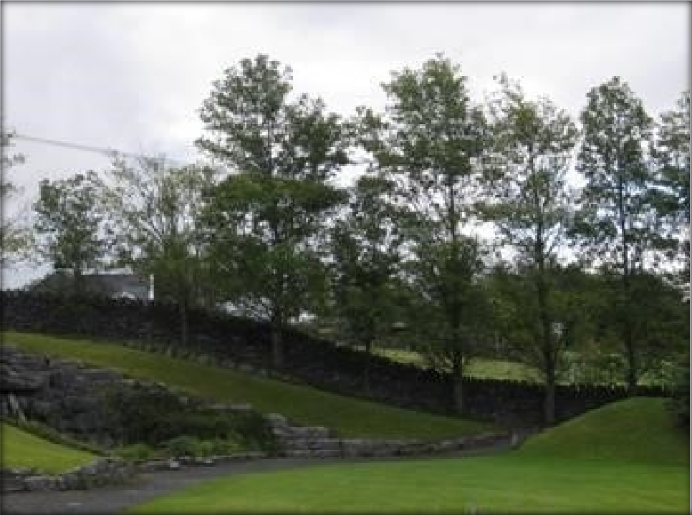

Plate V: Kaplan’s attention theory (Source: Herman et al., 2005)

Role of nature in the built environment

In recent years, research into stress landscapes has expanded due to the insight of the positive impact of nature on man‘s psychology. The natural environment, according to Garret et al. (2018), can affect an individual in different ways. Some of the effects are: Green space that are accessible creates opportunities for individuals to explore as recreation and exercise, thereby improving the health and wellbeing of individuals. Also, it increases creativity in children‘s play as they are able to express themselves freely in such spaces. It also improves social skills and ability of concentration.

Natural green spaces also provides a sense of freedom and exhilaration which stimulates relaxation (William et al., 2017). Also. Natural green spaces can encourage an increase in social interaction within an environment, as the availability of more green spaces within streets and communities contributes to a livelier public realm, as this is one of the keys of urban design objective (In-Kellert et al., 2015). Participating in the design and

creation of green space can help unite and strengthen communities and create life-long learning about nature which is induced by the presence of nature reserves (Garret et al., 2018). Furthermore, Property values can be increased by the presence and adornment of Streets with trees and views of natural landscapes. Also, management costs can significantly be reduced by the use of some natural self-sustaining landscapes. Green environment can help to promote physical activity having an impact on health costs (Mador, 2008).

Effect of green spaces on man

Berto (2014) highlighted four broad effects of the natural environment on man which are the psychological effect, behavioural effect, and self-report measures.
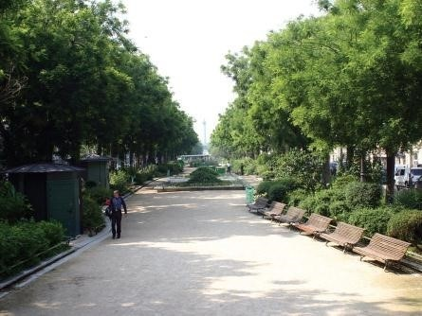

Plate VI: Outdoor seating around green spaces (Source: William et al., 2017)

      - Psychological effects

Natural environments stimulate calming psychological responses and restoration than urban environments (Grahn and Stigsdotter, 2003). People show positive psychological

response independently from the type of exposure. Ulrich (1979) acknowledged this paradigm and encompassed the range of restorative effects of the natural environments on human beings. Results from Ulrich‘s Study showed that the rate of recovery from stress is dependent on type of environmental exposure and natural elements and scenery in which such individual is exposed to. The results also indicated that recovery was more rapid and effective in the natural environment exposure conditions, whereas there was little and slow response to the conditions of the urban settings (Ulrich, 1979). These therefore shows the effects of green spaces on psychology and the importance of creating and providing natural green spaces that are accessible to people.

Behavioural effects

Kaplan (1995) explained that people deprived of nature are most likely to exhibit behaviours caused by weary minds and mental fatigue, and these may lead to loss of focus poor performance, social incivility and irritability. Also, Kuo & Sullivan (2001) deduced from a study carried on some individuals living within the same complex, that there is a relationship between exposure to nature and self-control, as those that had access to greener views displayed better on several tests related to discipline, higher concentration, inhibited impulsivity and ability to delay gratification scored higher than those deprived of nature. Also, the study reported significantly lower levels of aggression and violence in residents with apartments near nature than in those who looked onto barren lands.

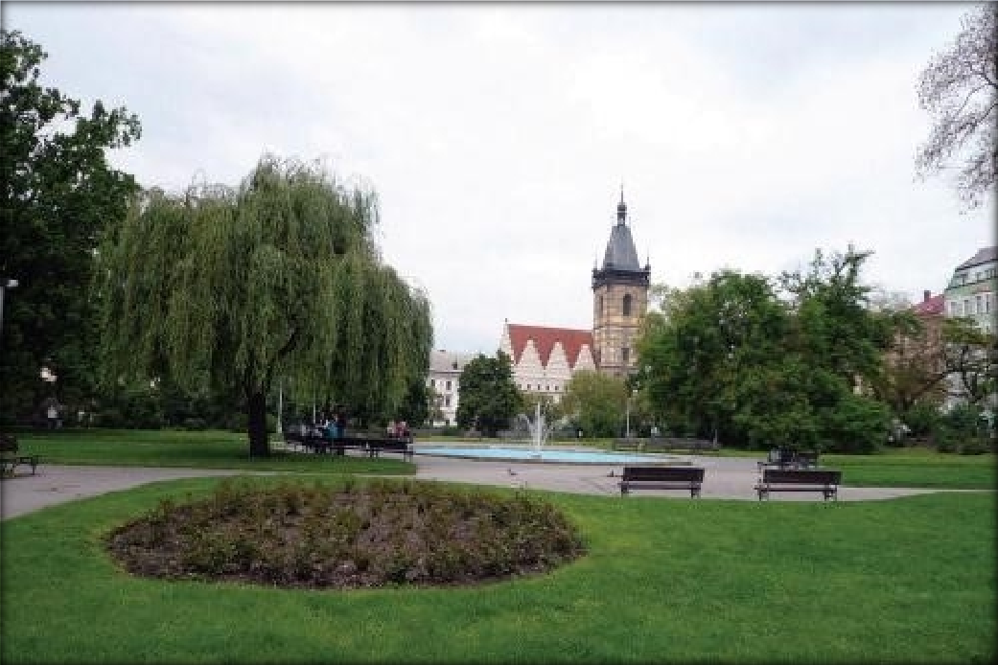

Plate VII: Landscape with outdoor seating and water fountain, Paris (Source: William et al., 2017)

In general, the results above from the study of Ulrich (1979) and Kuo & Sullivan (2001) highlights the importance of incorporating natural landscape around buildings and urban centres for easy interaction and exposure of individuals to nature even amidst execution of their activities, as exposure to nature enhances mental and physical health, social life and behaviour.

Relationship between Stress, Restoration and Nature

Many studies and evidences have suggested and proven that the natural environment is more preferred and psychologically beneficial than built environment (Ulrich, 1986; Kaplan and Kaplan, 1989; Hartig, 1993). Kaplan & Kaplan (1989) explained that environmental settings where humans can thrive and effectively function are more likely preferred by individual, even though there is little awareness by such individuals of the positive effects and restorative qualities of green spaces. Similarly, the natural environment has been found to have more potential for restoration than built

environment (Ulrich, 1981; Ulrich et al., 1991; Hartig et al., 2003; Ottoson and Grahn, 2005).

In a study by Herzog et al. (2003), independent groups undergraduate students rated 66 colour slides of natural settings for the target variables tranquillity, which was defined as how much you think this environment would encourage relaxation, peace of mind, escape from the strains of living and preference, which was defined as how much you like the environment depicted, for whatever reason‘. The result showed high degree of overlap between these two variables. Miller et al. (2007) suggests that human landscape responses are in part and derived from basic biological requirements.

In another such experimental study, Van et al. (2000) tested the mediating role of restoration in environmental preferences. Participants were shown a video of either a natural or a built environment after a frightening movie. Participants’ mood ratings were assessed before and after both the shows. Participants also rated the beauty of the environment shown and performed a test of concentration after viewing the environmental video. The results indicated that participants perceived the natural environments as more beautiful than the built environments. Also, viewing natural environments improved mood and concentration of the participants than viewing built environments. This reveals the relation between positive responses towards potential restorative environment.

Landscape and its Qualities

The perception of a natural environment by people is subject to the features and elements that are present and make up such environment (Prajal, 2012). For instance, elements such as light, colour, texture, pattern and material used in a particular space play an important role in the perception of such space. These elements can be harnessed

to create a direction to the type of perception designers want people to have when exposed to certain spaces. For example, lighter hues or shades of colours and smooth textures softens or lessens the visual density of an element, hence making an environment look spacious and larger. Likewise, water bodies are not left out of this as studies by Prajal (2012) have shown that the perception of water bodies can be made to look larger and more healthy by elements such as its colour, depth visibility, texture, sound and even its animistic qualities.

In recent years, the awareness of the psychological role of natural environment has strengthened the role of landscape design, hence, providing incentive for the creation of places where people can visit to relieve stress, mental fatigue or block out distractions. Landscape is described as an art that creates experiences that uplifts the spirit, expand vision and revitalise lives. It is also an expression of nature, because it incorporates natural elements and features, materials and scenes (Nasar and Lin, 2003)
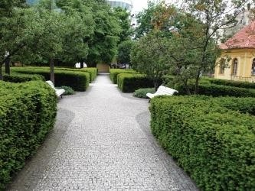

Plate VIII: landscape around the walkways in Elephant hills resort, in Victoria falls, Zimbabwe
(Source: Google image, 2019).

The elements of landscape include:

- Topographical features like hills valleys and water bodies

- Cultivated feature such as trees, grasses flower scrubs

- constructed feature like building , roads bridges fountains and statues

Restorative Qualities of Landscape

To achieve a restorative environment with landscape, the key features of landscape have to be considered and provided in an applicable manner that will boost the restorative qualities of such a place. Hence, it is of importance to understand the role of some of these elements such as water; the qualities, properties and mode of existence in such surrounding and as also the existing vegetation (Ulrich, 1993).

Role of water

In a study by Bulut et al. (2010), it was demonstrated that in terms of waterscape, people prefer Waterfall Scenery. In designing landscape, fascination, have a high significance. Other qualities include harmony between natural and cultural elements within such area, and naturalness of the landscape (Parsons et al., 1998).

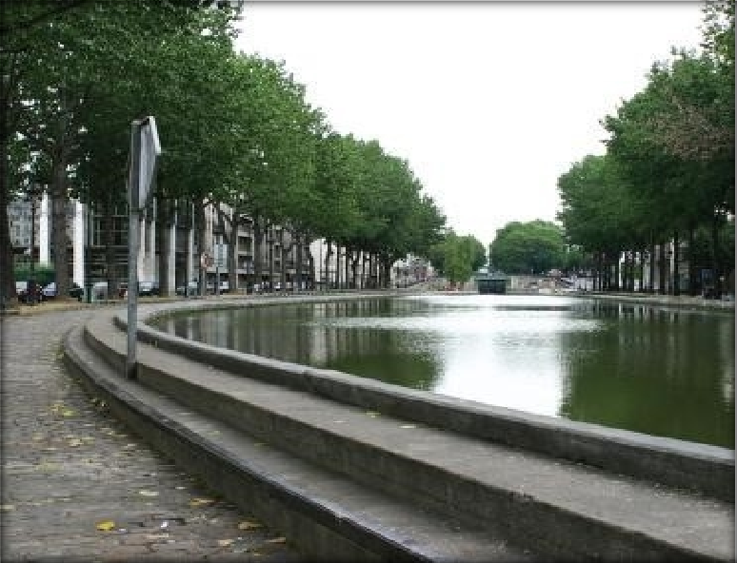

Plate IX: Paris - Waterfront of the Canal Saint M. (Source: Prajal, 2012)

The following factors could play important roles in improving a scene with water feature:
- Presence of greenery and vegetation at the edges of the water and the immediate surrounding (Le Lay et al., 2008).
- Presence of aquatic life in the water such as fishes have a positive effect in stress reduction (White et al., 2010).
- Water edges with organic shapes mimicking a natural form is desirable (SEÇKİN, 2010). This may exist in form of contours that are irregular or curvilinear in shape.
- Motion of water is one interesting quality of water associated with naturalness (Bulut et al., 2010). Although intense motion of water poses a perception of danger and risk.
- The sound of flowing water is also a restorative quality (Alvarsson et al., 2010).

Role of vegetation

Vegetation play related roles in an environment as they are ecological organisms and represents realistic and imagined natural forces (Wan & Wan, 2015). Vegetation improves the aesthetic quality of a place, and creates a pleasant and relaxing scene. Landscape changes the mood of individuals, and creates an atmosphere where aesthetics and elegance become public values (Foley, 2015) Therapeutic plants, with healing properties can also be used to improve the restorative qualities of landscape.

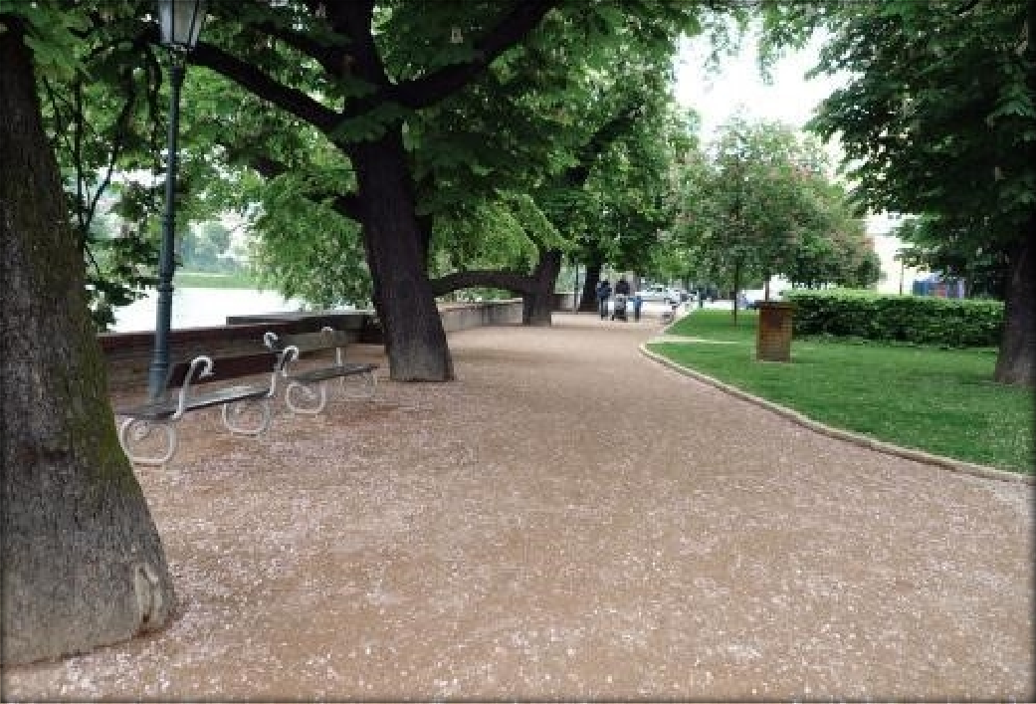

Plate X: Prague- Slovanský Island (Source: Prajal, 2012)

Role of the senses in perception of landscape (smell, sound and touch)

Smell

In a survey conducted by Magdalena et al. (2013), it was determined that an individual‘s perception of landscape, apart from sight, is also perceived by the sense of smell and hearing. The sense of smell is the quality of air we breathe which initiates our consciousness in an environment to potential dangers and informs us of the presence and quality of scent or odour such as the aroma, odour, scents or another individual (Oyetola et al., 2013). The presence of Pleasant odours around us stimulates our mood positively while unpleasant odours does otherwise (Oyetola et al., 2013). Conclusions from the survey by Magdalena et al. (2013) reported that most appreciated aroma in landscape is the smell of fresh air and herbs. Table 2.3 shows the sources of smell in a natural environment.

Table 2.3: sources of smell in outdoor environment Smell Source

Natural Scent of flowers, leaves of trees, grasses, wet soil, dry leaves, and Running water;

Human-body Related
Man-made or Environmental
Perfume, Shampoo, Soap, deodorants

Exhaust from vehicles, dust from construction, smoke, Plant chemical spray, Organic fertilizer, Stagnant water and Cooked food

(Source: Shahhosseini et al., 2014)

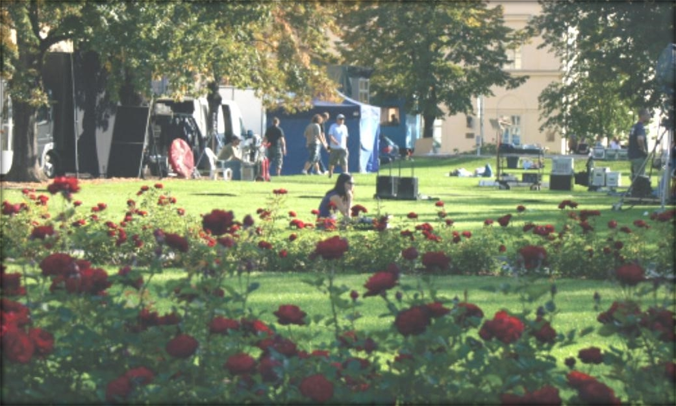

Plate XI: Prague Alšovo Waterfont (Source: Polačkova, 2012

      - Sound
Sounds trigger different impressions; pleasant and unpleasant. The pleasant impressions of sound from the natural environment includes chirping of birds, roars of the sea, rustle of the forest, water, trees. While unpleasant sounds include noises caused by cars and industrial machines and wind (Magdalena et al., 2013). Sound can be soothing or disturbing depending on the source as well as the view point of the listener. Unwanted sounds are often regarded to as noise and may cause annoyance and some psychological effects like aggression, stress, anxiety and even high-blood pressure. Sounds however can also be soothing with positive restoration qualities. A general survey by Magdalena

et al. (2013) concluded that the sounds people enjoy from landscaped environments are the soothing sounds from water and streams, humming of birds, rustle of trees. Table
2.4 shows the various sources of sound in outdoor environments.

Table 2.4: Sound sources in outdoor environment Sound Sources

human Voice of children playing, Sound of people using the exercise equipment, Footsteps, Normal voice.

natural Water fountain, Wind, Dry leaves being crushed, Crickets, Running water, Bird chirping, Rustling leaves, Sound of small manmade waterfall.

instrumental Music from the park audio system, People singing with instruments, Mobile ringtone, Speaker‘s sound of hawker, Music from the people‘s mobile device, Music from vehicles, Azan.

mechanical Car horn, Car engine, Bicycle wheels, Car‘s traffic, Construction vehicles, Motorbike, and Sound of sprinkler.

(Source: Shahhosseini et al., 2014)

Touch

The sense of touch provides humans with the ability to feel the pressure, temperature, depth, and materials and also have information about objects such as texture, shape, and materials it is composed of (Kaplan, 2001). With regard to the evaluation of multi- sensory factors in the landscape, Chen et al. (2009) stated that the people typically appreciate touching features in open spaces because they give them a sense connection and experience with nature as touch have an impact on human feelings that leads to action or changes in behaviour (Kaplan et al., 1993). Table 2.5 shows various elements that constitute touch in outdoor environment.

Table 2.5: Sources of touch in outdoor environment Touch Sources

natural Breeze, Water, Grass, green and Dry leaves, rocks and Stone, Soil, flowers and fruits.

manmade Furniture

(Source: Shahhosseini et al., 2014)

Leisure, recreation and relaxation

For the majority of people recreation and leisure are more or less synonymous terms for things, which are done during free time. The two terms are related but with different definitions and concept. Broadly, recreation is said to encompass the function of relaxation and entertainment, and on the other hand, leisure is concerned with individual‘s personal and social development.

Recreation is a period of rest from mental and physical demands of life. It can exist as a form of entertainment to ease boredom, and as a means of personal and social development: a conduit, which allows the individual to develop along lines which may contrast significantly with the often restrictive thoughts and actions that work and other chores may permit. The time available to the individual when the disciplines of work, sleep and other basic needs have been met is referred to as leisure.

Leisure is a phenomenon, which is the mind of the participant; hence subject. In view of the foregoing, leisure could be defined as free or discretionary time, time over the use of which a person may exercise choice. The objectives of recreation may be categorized under four groups. These include Health development, Human relaxation, Civic development and Self-development.

Components of Landscape Design

In designing for landscape, components of landscape designs have to be properly planned and considered. Traditional components of landscape design includes space, Mass, line or outline, colour, light and shade, texture, and scent.

Space

Space is air or atmospheric volume defined by physical elements and man‘s visual imaginations. Space is an important component of landscape as it as it gives a definition to the extent of landscape and scenery of the natural environment. The fields, meadows, orchard, grooves, dune, forest, plains, lakes, River and oceans have less precise and regular enclosures. Man‘s sense of space results from his interpretation, imagination and organisation of what he sees in the natural environment.

Mass is the opposite of space. Landscape masses may exist in the form of topographical earth forms, trees and shrubs, Buildings and water bodies such as lakes or waterfalls.

Landscape should reflect a combination of with the light and shade as this is another important element. Landscape designers therefore need to have broad knowledge on natural sources of illumination such as the sun, moon, stars and other heavenly bodies, as well as artificial lighting, in the placement of trees, structures and other elements on the land to balance the effects of shadows to provide a balanced proportion of light and shade.

Texture is an element of landscape design that defines the smoothness or roughness of surfaces. It is perceived primarily by Touch.

Scent is a delicate element of landscape. It emanates from flower and fruit in outdoor open spaces and has a great influence on improving the perceived landscape of a place.

Principles of landscape design

The basic principle in landscape design deals with the arrangement of the landscape elements. These principles are, unity and variety, balance and rhythm, accent and Contrast, scale and proportion (Rodick, 2012).

Unity and variety

A variety of elements like colour, texture, height, form, growth habits, Lines and perspectives can all be used to unify a landscape design. Achieving unity in landscape proves difficult as the number of elements and types of materials increase. Natural landscaping allow for greater flexibility because so much of the art comes from nature and does not follow strict geometrical or formal design patterns, while a little controlled chaos is permissible (CPWD, 2013).

Balance and rhythm

In landscape design, balance is one of the most observed principles. Balance simply means that everything on both side of a giving focal point has equal weight. With asymmetrical balance, as the eye moves away from the central focal point everything is exactly the same on both sides. Rhythm result from the precise three-dimensional arrangement of element in the landscape seen on site. It is simply done by repeating or reoccurrence of similar elements such as in a double row of trees or buildings. It aims to focus and direct an individual‘s attention and movement towards a viewpoint or terminus.

Accent and contract

Arrangements that could have been dull and boring are made lively by the application of accent and contract. An accent is an element that contracts other elements around it.
Accent can be achieved by contracts in colour, difficult to achieve (Rodick, 2012).

Scale and proportion

Scale of landscape refers to the apparent size of space within the vicinity or scenery. Proportion is the determined relation among the sizes of all the parts within and element and of all the elements with a space (Hartig et al., 2003). For instance the proportion of a landscape seat or bench as seen in the legs, arms and back determines the space of the seat. And the overall size of the seat, date in proportion to relate with the size of trees around, work way, lawn area, and so on, helps to determine the landscape area. Finally, in designing a landscape, the movement of people, the focus, order and period these activities would be carried out should be pre-empted (CPWD) (2013).

The need to integrate nature into built environment

Several studies have been made and proven to show that nature has a positive effect on people, either by fostering moods, behaviours or emotional states and improving concentration power and efficiency (Hartig et al., 2003; Prajal 2012). Landscape scholars such as, have carried out numerous studies on the effects of landscape on humans as well as the effect of the quality of such landscape. It is also important to understand that exposure to natural scenery and landscape with natural vegetation elements that are healthy significantly have very high tendencies to reduces feelings of fear (United Nations World Tourism Organization [UNWTO], 2003).

In contrast, the urban environments lack enough natural landscape elements and such environments possess danger of aggravated anxiety, depression and other negative effects on human health. Particularly in terms of increased feelings of sadness. It is particularly important to make adequate considerations for providing a substantial extent of natural view and scenery in urban settings to curb the negative effects such environments void of naturalness have on individuals (Vincent et al., 2010).

Landscape as a Restorative Component for Stress Relief

The awakened awareness of the importance of natural landscape and greenery with restorative potentials is much felt as nations are rising to mitigate the stress related problems of urbanites. Restorative experiences can occur in natural environments because they are rich in the characteristics necessary for attention restoration (Kaplan, 1995), and require nominal mental effort.

In recent decades, significant research has been done on restorative environments and their psychological and public health benefits. Restorative environments allow people to take a break from a demanding environment. The conventional understanding of taking a break is to get away from your current situation and location to have restorative experience (Reena, 2015). Many people find, for example, that it is rejuvenating to have a weekend retreat in an exotic place after a long challenging week. Others find it restorative to simply go hiking in a nearby natural area. However, recent studies have found that it is not required to travel to faraway places to have a restorative experience (Peschard et al., 2013). Getting outside typically involves at least a little exercise, and exercise is a proven mood booster (Aspinall et al., 2013, Barton & Pretty, 2010).

Summary of Literature

Hotel Buildings are known to be places where guests are hosted and offered comfort and luxury for profit. The Classification of Hotels is based on the factor to which that classification is based, the hotel classification used for this research was the classification based on location. Hence, the City Centre Hotels was picked and the type of hotels to be researched on. Stress being a dangerous phenomenon due to the adverse effect it has on man, stress reduction in man is as effectual as achievable.

Man needs a place to rest and relax and ease stress as this would increase performance and concentration, reduce sever stress induced diseases such as cardiovascular problems, strokes, diabetes, fatigue, migraine and even death. Landscape can influence stress relief. Hence certain landscape features such as the use of trees, shrubs, water, sculptures, colours and sounds, can be incorporated into the design of hotel buildings for both interior and the exterior areas of the building.

CHAPTER THREE

  - RESEARCH METHODOLOGY

Research Method

The research method employed in this study is the qualitative and quantitative methods, and these were both done to complement each other and collect concrete data to fulfil the objectives of this thesis so as to form a holistic result. A preference study was carried out with the use of photo questionnaires, (quantitative) Case study of existing hotels was also carried out to investigate the presence and method of application of the research variables, and this was done with the aid of observation schedules. Interviews were also carried out (qualitative).

The preference study involved the selection of 40 colour images were, inspired by Ulrich and Kaplan‘s restoration theories. The images Depicted scenes dominated by landscape with some elements of the attention restoration and psycho evolutionary theories. The photographs were also made to include the variables: soft landscape (vegetation), water elements, colours, hard landscape and sporting facilities. The participants were given a scale of 1-5 to rate each image (with 1 and 5 as the lowest and highest preferences respectively) based on their own personal preference or how they feel such scenery will affect them positively.

Data Collection and Sources

Data collection and sources involves the sources from which data was collected and the types of data that was gathered for this study. This was applied in getting data relevant to determining the stress level in people, investigating the relevance of landscape for stress management use and Identifying the landscape pattern so as to integrate them in a hotel building design and achieve stress relief through landscape in Kaduna, Kaduna

State. The primary data used in this research work are data obtained directly by the author from fieldwork in and from hotels in Kaduna. These primary sources were case studies, observation schedules, interviews and administration of photo questionnaires.

Case studies

This encompasses a relative evaluation of some existing hotel buildings in Kaduna, Kaduna State. It involved studying, evaluating and gathering data from these hotel buildings in the form of pictures, evaluation of the landscape pattern and features put in to the design for considerations towards stress relief. Case study was carried out in 5 hotels in Kaduna, and data collection was done with the aid of observation schedules, to have an insight and a better understanding of the hotel design as well as investigate how stress relief landscape features were integrated into the building and its surrounding. The goal was to identify and distinguish the current problems and discover and propose solutions to the problems.

Photo questionnaires

The preference study was carried out with the use of photo questionnaires, which also consisted of a closed questionnaire section, distributed randomly to individuals within Kaduna, especially around hotel environments; guests lodged at the hotels as at the time of visit to the hotels for the 3data collection. The variables derived from many related literatures was used as a guide in selecting compositions of pictures for the questionnaire, while ensuring that the images reflects these variables.

A total of 40 images were selected strategically from the internet. The photographs were selected based on this question: which photographs best represents a mixture of Ulrich and Kaplan‘s theories of psycho-evolution and attention restoration?. The photographs

were made to include the variables: soft landscape (vegetation), water elements, colours, art works, and sporting facilities.

Direct personal observation

Observations were made in the course of the research work to measure some variables of the study such as the existing outdoor sporting facilities, colours used, landscape types and patters, plants used, landscape features as available on the various sample population in the study area. The entire building and landscape design techniques applied concerning their importance for stress relief and promotion of relaxation in the hotel buildings use in Kaduna was also observed.

Secondary data

Extensive review of extant literature was carried out to form the secondary data for this study. The review was done on literatures related to stress, restoration (relief) and natural environments and elements, with emphasis on their relationship to landscape. The review was done to provide insight on stress, its causes and mitigation, restoration processes, and the restorative qualities of nature. The relevant information gotten was analysed and it presented the bases for the factors for observation, planning and design criterion for landscape as a restorative component in hotel environments.

Methods of data collection

    - Quantitative data

This involved the collection of data with questionnaires and the results obtained from this method were analysed, compared, and summarized as appropriate in answering the research questions. Hence, the quantitative method attempted to find out the stress relief landscape pattern in the hotel buildings, study the importance of landscape and physical environment to people as a stress relief element and discover the necessary physical

environment and landscape features can be incorporated to hotel buildings in Kaduna state for stress relief.

Qualitative data

The qualitative method investigated the landscape pattern and general physical environment in hotel buildings in Kaduna, with the use of interviews of the hotel staff.
The findings described and explained the sequence of landscape patterns in the hotels.

Variables of the Study

A structured questionnaire, and observation schedule was prepared based on established variables from reviewed literature related to the research topic. The variables used, shown in Table 3.1, were from variables established by scholarly literatures related to the study. Photographs were also used to capture data from the hotels visited.

Table 3.1: Variables of the study S/N Parameter

- Landscape types used (soft and hard)
- Types of landscape plants
- Existence of outdoor sporting facilities
- Presence of outdoor relaxation area
- Dominating colours used in the outdoor spaces
- Dominating colours used in the indoor spaces
- Position of Landscape areas
- Existing natural elements
- Landscape elements present

Population of the Study

Population of study as defined by Saxena et al. (2008) is the whole mass of observation, which is the main group from which a sample is to be derived from. There are over 226 Hotels in Kaduna (Hotels.ng 2019). Five different hotels were selected purposively from these Hotels in Kaduna, based on the existence of the research variables to and within

the samples. 10 people were interviewed in the five hotels which are the hotel manager and chief of staff. A total of 120 questionnaires was distributed among hotel guests and individuals found within hotel environment. 98 questionnaires were retrieved and a total of 83 was analysed.

Sampling Technique and Sample Size

Bhatnagar (2007) suggested that a sample is a chosen group of some elements derived from the entirety of the population. The study engaged the employment of purposive sampling based on the ease of the researcher. Kothari (2004) suggested that purposive sampling method involves the deliberate choice of stated units of the entire population to get a sample which is a representative of the whole population. Table 3.2 shows the five case studies observed in Kaduna.

Table 3.2: Sample for the Study
S/No | Sample | Location
1 | Royal Blue International Hotel | A & B, Isa kaita road, Kaduna
2 | Crystal Garden Hotel | Ungwan Rimi, Kaduna
3 | Deluxe suite | Ali Akili Road, City Centre, Kaduna
4 | Hamdala hotel | Muhammadu Buhari Way, Kaduna
5 | Lesham continental Hotel | Bama close, Gwarri Avenue, Kaduna
(Source: Author’s field work, 2019)

Method of Data Analysis and Presentation
Questionnaires and observation schedules being the primary means of sourcing information for this study was analysed with the aid of factor analysis and Microsoft excel, through tables, figures, plates and charts. Also evaluation of the current landscape in the hotels and efforts made towards using it to reduce stress in the research region furthermore demonstrated existing condition that put these structures in a position where knowledge about benefit of landscape on human health is limited and actions of harnessing the existing landscape features for stress relief was neglected.

CHAPTER FOUR

  - DATA PRESENTATION AND DISCUSSION

Introduction

The data obtained from the field survey from existing hotel buildings in Kaduna were analysed using statistical package (Excel and SPSS). A total of five randomly selected hotels were surveyed to assess the landscape features and elements that were incorporated in the design and planning of each building for stress relief. The results are discussed with respect to the stated project objectives which are;
    - To assess the effect of landscape as a restorative element for stress relief

    - To identify the landscape features that can be used to promote stress relief

    - To evaluate design parameters of the existing features

    - To incorporate the required stress relief landscape features in the proposed hotel design.

The Effect of Landscape as a Restorative Element

The preference study was carried out to understand the most preferred environment featuring specific landscape with the composition of certain landscape elements, and also observe the specific qualities of landscape and its features that are related with restoration. The landscape components as the amount of vegetation, the colour, texture, and pattern of vegetation, water elements and sculptures or other design elements was put into consideration, and images were carefully selected to isolate these different landscape elements. Some images highlighted water elements, others highlighted plant texture or colour, sand some had a large amount of vegetation, while others had a small amount.

The data collected with the photo-questionnaires was analysed using factor analysis, which is a statistical method, to enable an investigation as to whether there is an underlying structure in the pattern of co relation between the 40 landscape images. From the ratings provided by the participants, the mean was computed for each of the photographs and they were also sorted out on the basis of highest mean values which depicted the most preferred scenes and lowest mean values depicting the least preferred scenes. Fifteen photographs each from the most preferred and least preferred were then observed separately to determine features that are particular to the scenes/photographs.

A total of 120 questionnaires containing 40 images (appendix I) were administered, while 89 were retrieved. Out of these, 19% was rejected/condemned due to non-clarity of response, while some were not completely filled. Hence, a total of 81% was analysed. From this, 47% of the respondents are male while 53% are female.

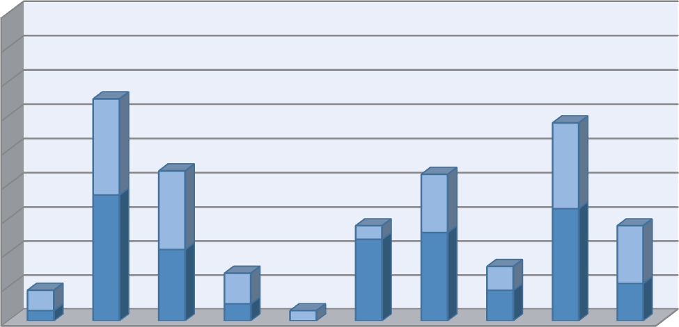
90
80
70
60
50
40
30
20
10
0
men2 women
photo 1 photo 2 photo 3 photo 4 photo 5 photo 6 photo 7 photo 8 photo 9 photo
10

Figure 4.1: preference for photos 1-10 (Source: Author fieldwork, 2019)

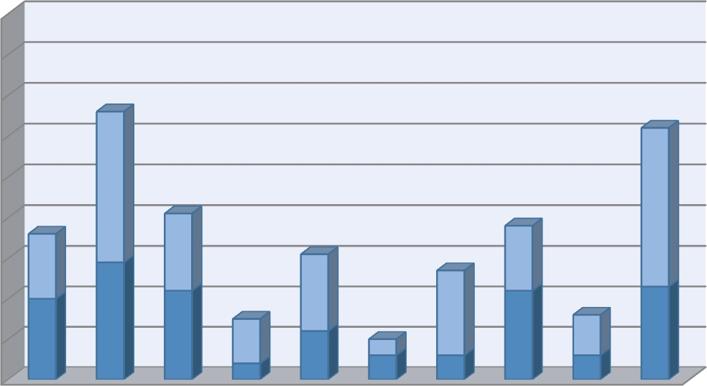
90
80
men2 women
70
60
50
40
30
20
10
0
photo photo photo photo photo photo photo photo photo
11 12 13 14 15 16 17 18 19
photo 20
Figure 4.2: Preference for photos 11-20 (Source: Author fieldwork, 2019)

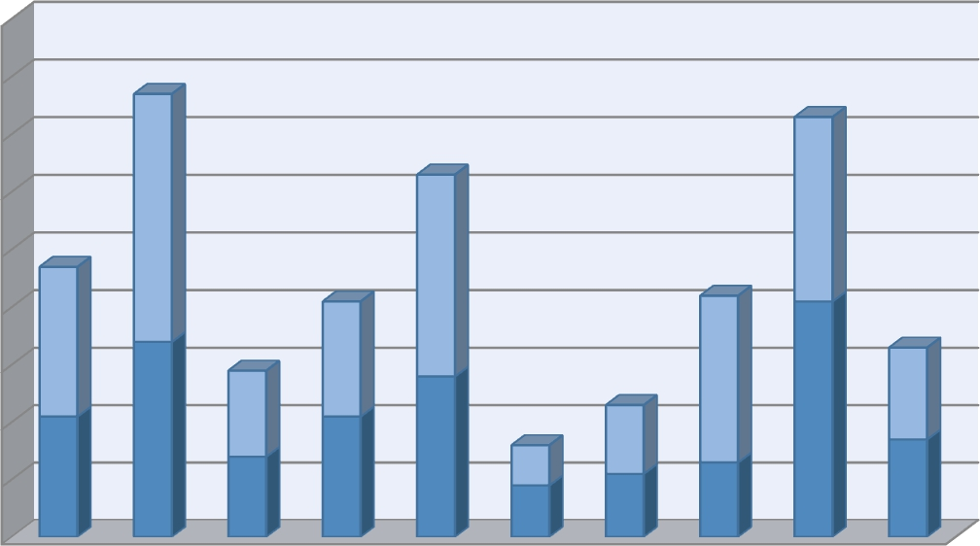
90
80
men2 women
70
60
50
40
30
20
10
0
photo photo photo photo photo photo photo photo photo photo 21 22 23 24 25 26 27 28 29 30

Figure 4.3: Preference for photos 21-30 (Source: Author fieldwork, 2019)

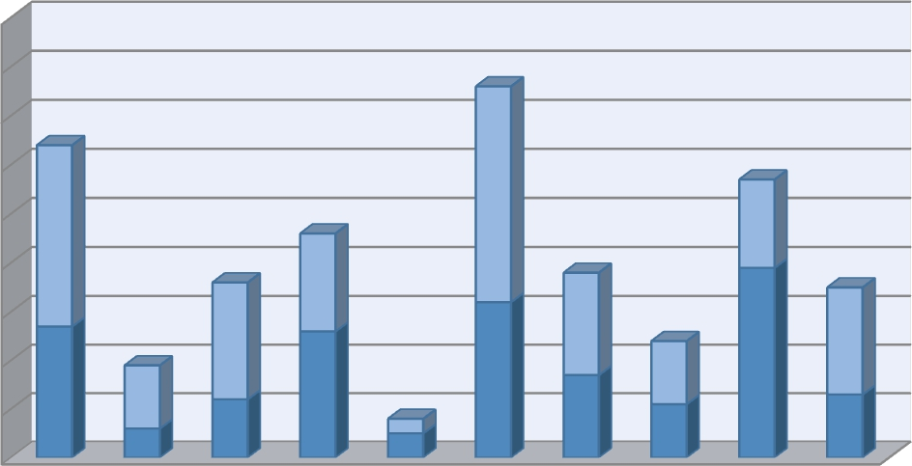
90
80
70
60
50
40
30
20
10
0
men2 women
photo photo photo photo photo photo photo photo photo
31 32 33 34 35 36 37 38 39
photo 40
Figure 4.4: preference for photos 31- 40 (Source: Author fieldwork, 2019)

The above results were analysed by factoring out the 15 most preferred images as well as the 15 least preferred images while factoring out the common traits in the images in each selected category.

Common qualities in the most preferred images

The common features observed among the most preferred images was that the landscape was denser with full well mowed lawns, beautiful shrubs and trees with good shades. Images that had water bodies among the most preferred had the water body visible and was in balance with other features or dominated the scene. The water had darker hues of green and blue and showed reflectivity and was clear. Also, dominating colours in these category were cool colours that is it had brighter colours of plants, structures and the general physical environment. Another characteristics observed in the most preferred photographs was high degree of naturalness as the imaged contained natural and healthy vegetation such as green trees, shrubs and greeneries, well mowed lawns, presence of

large natural rocks and stones in or at the edges of water and strategic points in the environment.

The common traits of least preferred images

The observation made from the least preferred images consist of presence of landscape with lesser qualities. The images were also characterized by low percentage of vegetative ground cover even around the main build features. Those with water bodies looked shallow and unclear water colour and looked stagnant (not flowing) and the surface was less reflective. Water colours either looked brownish or yellowish. Some of the images also contained lighter shades of the colour of grasses and trees, while some images had dry and dead plants. There was also no presence of other natural features as rocks and stones amongst these images.

Landscape Features that can be used to Promote Stress Relief in Hotels

The consideration of stress relief was made with the spotlight on landscape strategies that can be used to improve stress relief. They are soft landscape, water features and elements, stress relieving colours, hard landscape elements to enhance stress relief, and provision of basic sporting facilities.

Soft landscape

Soft landscape can be well harnessed in hotel environments to optimise stress reduction. Soft landscapes may include plants and vegetation, which can be provided in form of good well planned landscape in the exterior environments and also indoor plants on the lobbies and corridors of hotel buildings, as well as in the rooms. Therapeutic plants, having high healing and restorative qualities are suggested to be the most predominant plants to use in both the interior and exterior spaces in planning landscape for stress

relief in hotels. Some soft landscape with therapeutic features and characteristics suitable for this purpose are:

Table 4.1: Therapeutic plants and their therapeutic qualities
S/no Name of plant Image Therapeutic qualities

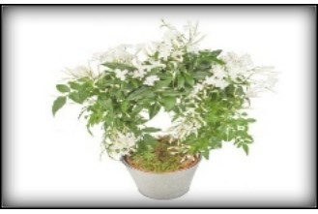
1. Jasmine plant It improves sleep quality due to its sweet fragrance.

2.
Lavender plants

3.
Rosemary plant

4.
Aloe Vera plant

5.
Snake plant
It has a beautiful mint scent which helps to also improve sleep, lower heart rate and calms agitation.

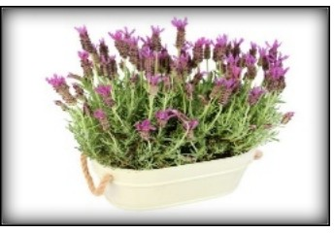

It is a herbal plant that improves air quality, improves the memory function and reduce stress. It also reduces anxiety.

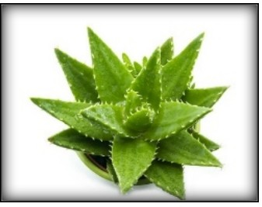
It improves the general air quality of a place, as it removes harmful chemicals from the atmosphere such as formaldehydes and benzene.
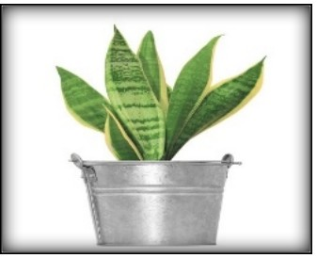

Improves energy levels in homes. It reduces headaches, irritation and breathing problems. It also lowers blood pressure, Improves wellbeing increases concentration and increases productivity, promotes good sleep and lowers anxiety.

6. Gerbera daisy plant
Extremely effective as an air purifier. It also adds colours to a place. It requires lots of light and a fertile well drained soil.

S/no Name of plant Image Therapeutic qualities

7.

8.

9.

10.

Red-edged Dracaena plant

Chrysanthemum plant

Golden Pothos

Areca Palm
Brightens and purifies the atmosphere in interior spaces of houses. It cleanses the air in interior spaces and also purifies it
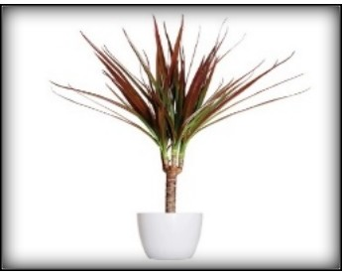
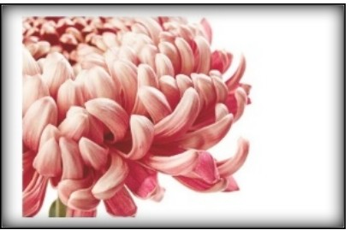
Purifies air from chemicals in the atmosphere, lessens the symptoms of worry and stress. It can also be used to treat high blood pressure, cold, headaches and dizziness.
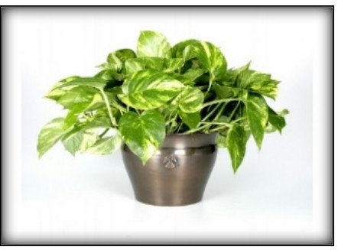
This plant species is another plant that has a good air purification quality. It reduces stress and promotes relaxation. It has the ability to stay green for a long period of time when watered properly.
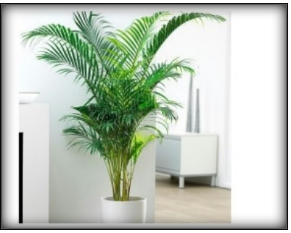The areca palm plant is a good air purifying plant. It adds moisture to the surrounding environment and helps lower anxiety and calms mental and physical state

(Source: serenataflowers.com 2019)

    - Water as a landscape element

Findings from literature (Bulut et al. (2010), Prajal (2012), White et al. (2010), & Alvarsson et al. (2010) and the preference study show that the availability of water or water features around hotels sites and outdoor area improves the restorative qualities of such environment. For the presence of this features to be effective for stress relieve in hotel environments, the water bodies, to a large extent, should possess vegetation around the edges of the water body, presence of natural rocks, stone and boulders around the surrounding, peaceful movement of water such as fountains and streams and surface of water levelled to the ground as characteristics.

Some examples of water bodies and elements that can be included in hotel designs and planning include water fountains, aquariums, lakes, swimming pools, and fishing ponds.

Colour as a landscape element

The effect of colour on man‘s psychology cannot be overemphasised. Therefore the choice of colours that should be made available to hotel environments should be used such as blue colours, which have a stronger effect on reducing stress, green colours that can be included in the surrounding such as the vegetation.

Hard landscape

Hard landscape such as sculptures, well organised walkways should be included to add a sense of direction and good scenery to guests in hotel environments. They include sculptures, which may be incorporated into fountains, well laid walkways with interesting patterns capable of capturing the attention of individuals, provision of outdoor siting areas to promote outdoor sitting and relaxation to allow for a good view of the scenery.

Sporting facilities

Sporting facilities can be provided in hotels to promote relaxation. They include: tennis, basketball, board games, gyms and spa. Also it is important to make provisions for open recreation garden with some outdoor garden gaming facilities included such as garden chess.

Landscape Design Parameters for Stress relief in existing Hotels in Kaduna, Kaduna State
Five case studies were carried out in Kaduna, Kaduna State, namely: Bolingo hotel, Deluxe Hotel, Hamdala hotel and Lesham Continental Hotel. The variables established

from the literature, which are soft landscape, water, colour hard landscape, sporting facilities, was tested using an observation schedule to assess them.

Therapeutic soft landscape

The observation schedule was used to access the degree to which soft landscape was provided and also the presence of therapeutic plants which enhances the stress relieving qualities of the hotel.

Bolingo hotel

The Bolingo hotel landscape is well planned with visible lawns and shrubs, well mowed and trimmed. There are also tall palm trees planted at intervals to act as shading devices along the walkways and also for the building, as well as for aesthetics.
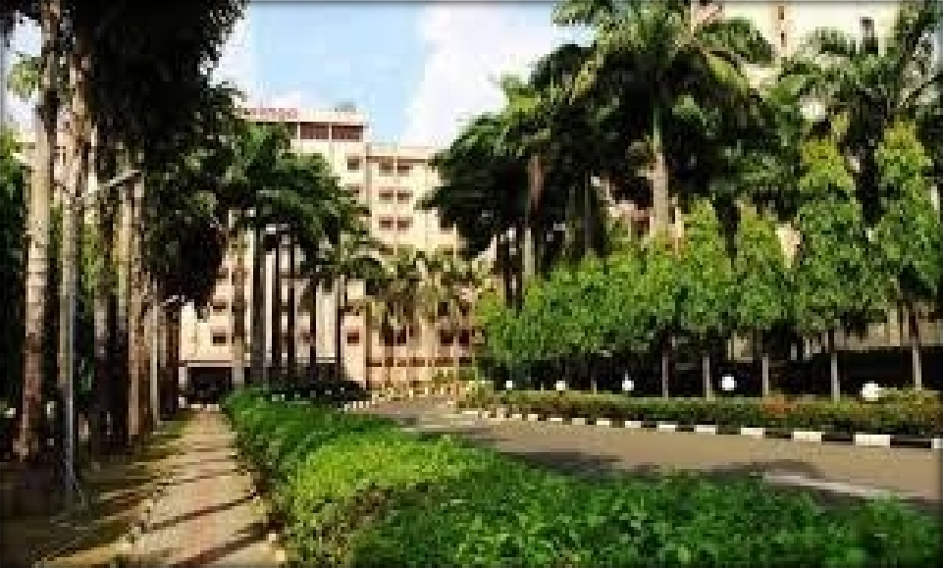

Plate XII: Bolingo hotel soft landscape (Source: Author’s field work, 2019)

      - Deluxe suites

The deluxe suites hotel is characterised by a serene and aesthetically pleasing landscape with tall trees and shrubs.

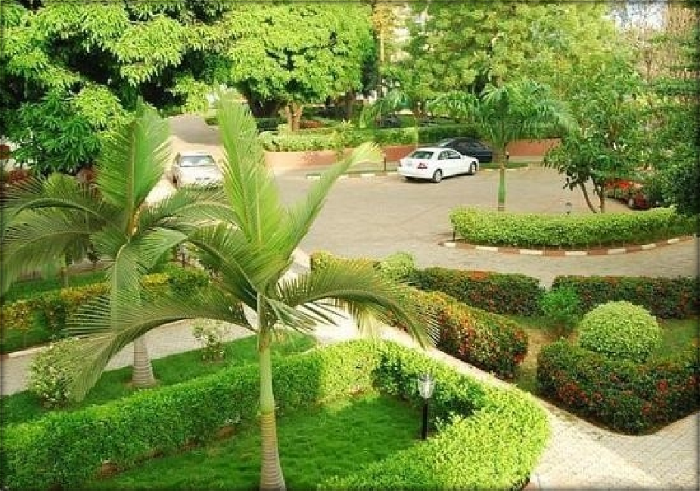

Plate XIII:deluxe suit soft landscape (Source: Author’s field work, 2019)

      - Hamdala hotel

Hamdala hotel is characterised by a few shrubs and lawns. Although there exist a balance of colours for the soft landscape, very little consideration was given to it.
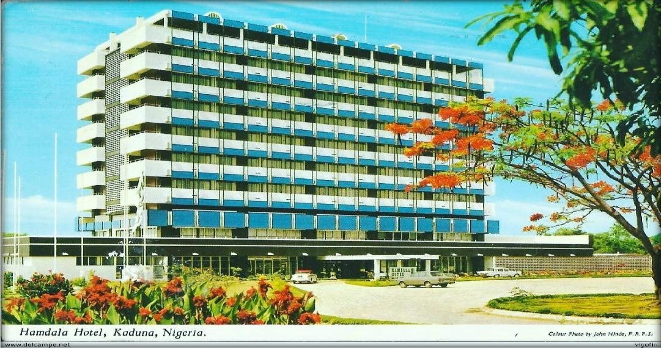

Plate XIV: Hamdala hotel soft landscape (Source: Author’s field work, 2019)

      - Lesham continental hotel

The soft landscape in Lesham hotel is characterised by the use of a variety of plants such as the aloe Vera plant, which is a therapeutic plant and can promote stress relief.
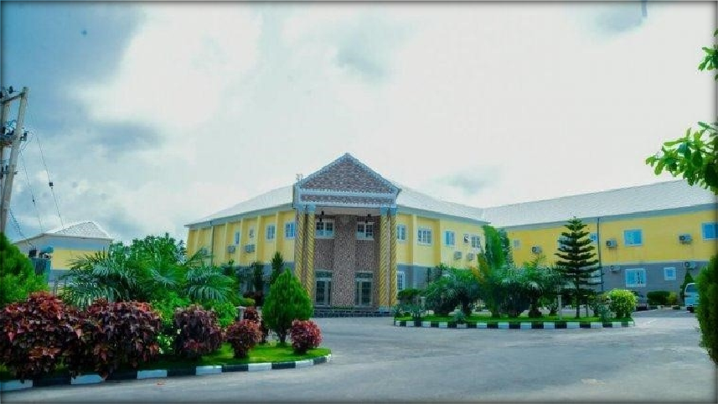

Plate XV: Lesham hotel soft landscape (Source: Author’s field work, 2019)

      - Discussion of findings

From the case studies, it can be deduced that soft landscape was to an extent considered in the planning and design of the hotel environment. However, the landscape plants used were majorly for aesthetics and only Lesham hotel had elements of therapeutic plants.

Water

From the review of literature, it was established that the presence of a water body improves the restorative qualities of a place and fosters stress relief if applied and provided appropriately.

Bolingo hotel

The water bodies that are present in the Bolingo hotel is swimming pool. Although it was provided for the sole purpose of swimming, it also fosters relaxation.

Deluxe suite hotel

Deluxe suite also has a swimming pool as the only water body.

Hamdala hotel

Hamdala hotel has a swimming pool as the only water body present.

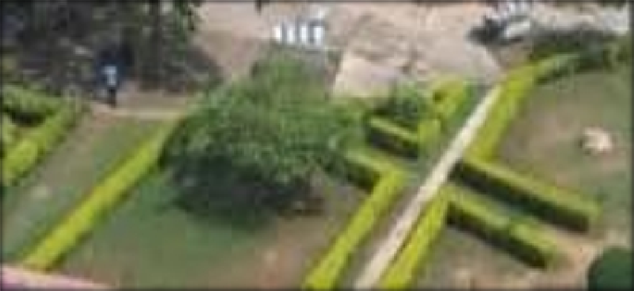

Plate XVI: Lesham hotel soft landscape (Source: Author’s field work, 2019)

      - Lesham continental hotel

Lesham continental hotel has a swimming pool.

Discussion of findings

Findings from the case studies shows that few hotels have swimming pools as the only water body or element present, while others have no feature or element of water.

Relaxing colours

It has been established from the literature that colours have effects on man‘s psychology. Although it is classified under cool colours and warm colours, cool colours have the more tendencies to promote relaxation.

Bolingo hotel

Bolingo hotel has only two main colours, which are cream and red. Although, red is not a colour that promotes relaxation. The presence of landscape which is dominantly green in colour is able to foster relaxation around the hotel.
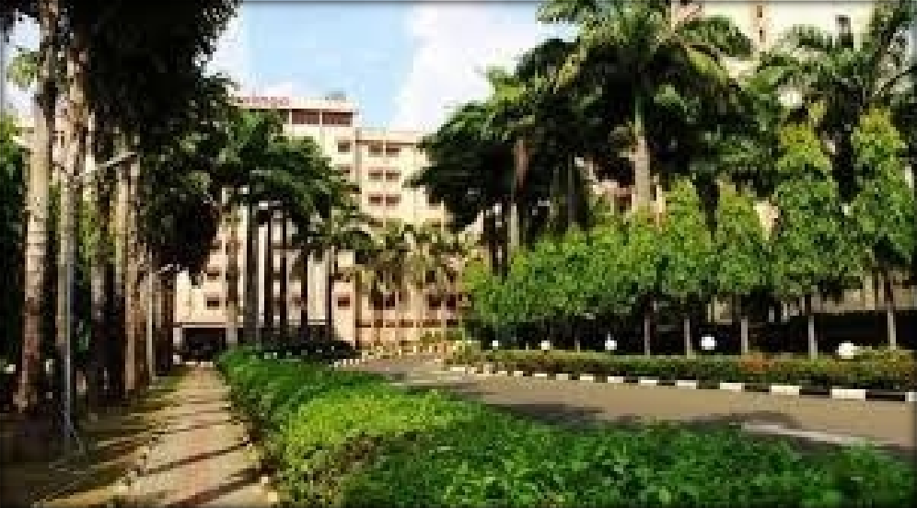

Plate XVII: colours used in Bolingo hotel (Source: Author’s field work, 2019)

      - Deluxe suite hotel

The deluxe hotel has an appealing blend of colours that can promote stress relief. The use of white brings calmness and comfort.
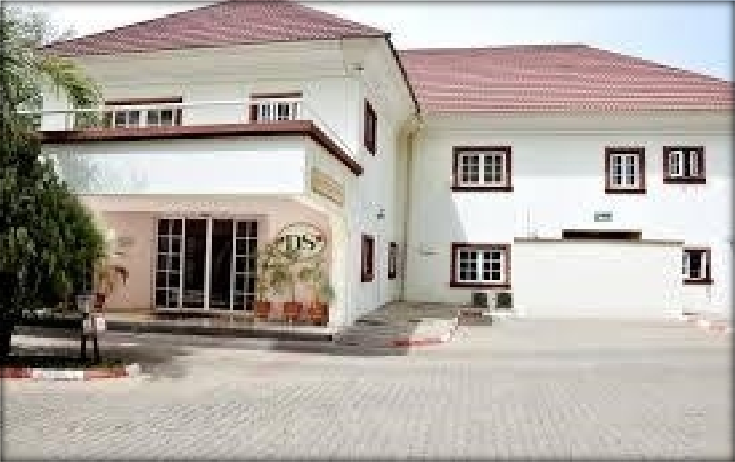

Plate XVIII: colours used in Deluxe suite (Source: Author’s field work, 2019)

      - Lesham continental hotel
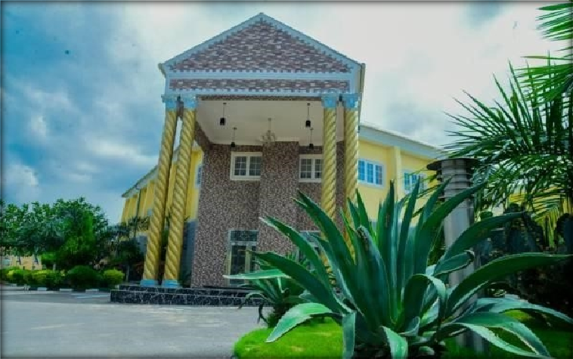

Plate XIX: colours used in Lesham continental hotel (Source: Author’s field work, 2019)

      - Discussion of findings

From the findings from the case studies, it can be deduced that colours used in the hotels were not selected with considerations to stress relieving colours. The buildings were painted to achieve aesthetics. Although, two of the hotels reflected slightly an ability to enhance relaxation with their colours and elements used on the facade.

Outdoor sporting activities

Sports is an active way of relaxing the body and reducing stress. Various sporting facilities can be provided in hotels to promote stress relief as highlighted in table 4.2.

Table 4.2: Outdoor sporting facilities in the case studies
S/no | Name of Hotel | Sporting facilities
1. | Bolingo hotel | gym
2. | Deluxe suite hotel | gym
3. | Hamdala hotel | Tennis court, swimming pool, gym
4. | Lesham continental hotel | Swimming pool, bowling centre, gym

(Source: Author’s field work, 2019)

Discussion of findings

From the case studies, it can be deduced that the hotels paid little attention to providing sporting facilities for relaxation in the hotels.

Table 4.3: Summary of landscape features in the case studies
S/no | Landscape feature | Bolingo hotel | Deluxe suite | Hamdala hotel | Lesham continental
1. | Soft landscape | Shrubs, lawns and flowers | Well maintained lawns and  flowers | Lawns and flowers | Trees, flowers and well mowed  lawns
2. | Water body | Swimming pool | Swimming pool | Swimming pool | Swimming pool
3. | Colours | Relaxing colours used | Cool colours used | Warm colours used | Cool colours used
4. | Hard landscape | Fountain, walkways and  kerbs | Walkways and  sculpture | walkways | Walkways and  sculptures
5. | Sporting facility | gym | gym | Tennis, pool and gym | Pool, bowling and  gym
(Source: Author’s field work, 2019)

Proposal of a Hotel Landscaped for Stress Relief

From the results examined from the photo–questionnaire and literature review, it is evident that Landscape elements like water bodies, artwork and tree canopy are viewed as restorative and would draw people into this area if included. Also, the outdoor spaces, are not frequently utilized for relaxing due to a lack of interesting or restorative elements (such as water features, greenery, or art work). Based on the findings, the following design of a hotel was proposed to be located in Kaduna, Kaduna state. .The special feature of this design is the expansive pathways making it easier to walk around the site and the mixed vegetation plantings of native grasses to add texture to the site as well as the use of therapeutic plants.

Application of soft landscape features in the proposed design

The soft landscape of the proposed design is characterised by therapeutic plants and well laid out to promote relaxation, define walkways and also promote outdoor sitting.
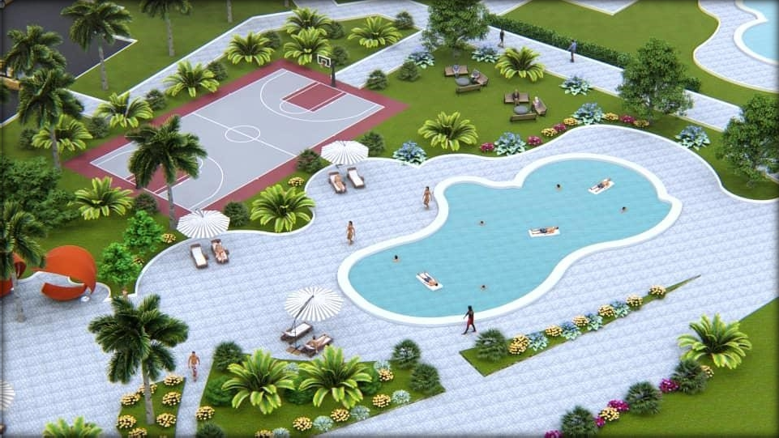

Plate XX: Ariel view of the landscape in the proposed hotel (Source: Author’s design, 2019)

    - Application of water and water elements

Water, being an important feature of landscape, especially in achieving stress relief, was considered and adequately provided in the design. The water elements provided in the design are swimming pool and water fountain.
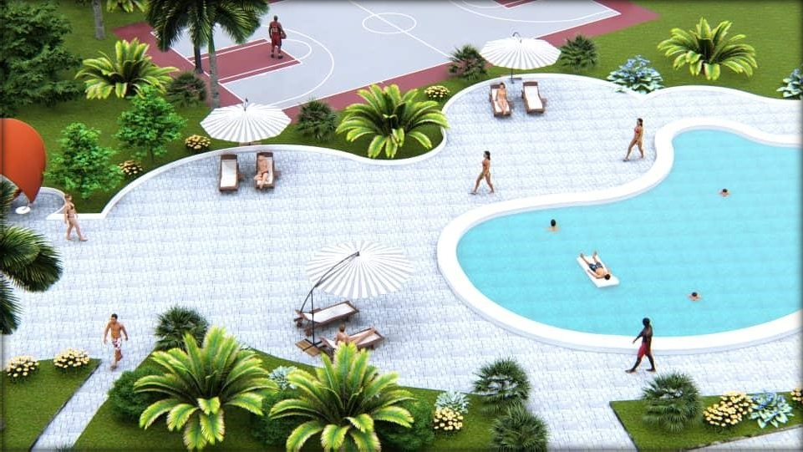

Plate XXI: Swimming pool and relaxation area in the proposed design (Source: Author’s design, 2019)

    - Application of colours to foster stress relief

Cool colours that promote and enhance relaxation were used on the façade of the proposed hotel building.
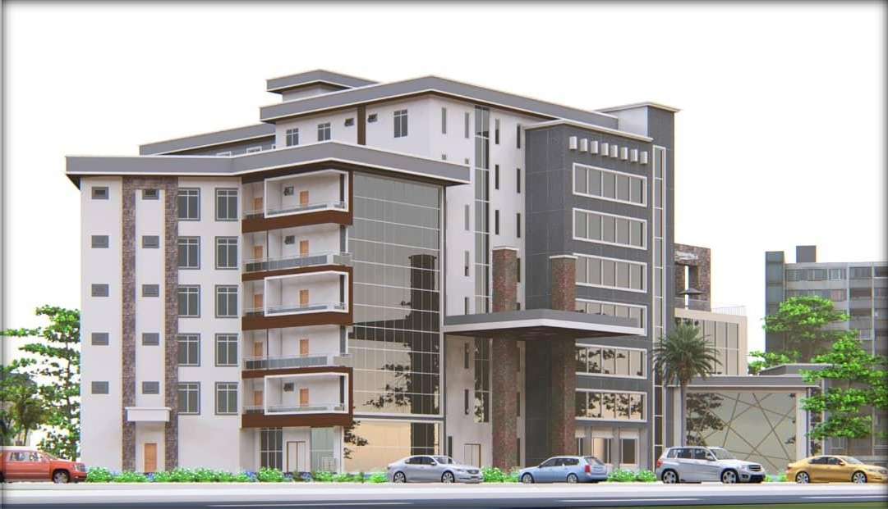

Plate XXII: The proposed hotel facade (Source: Author’s design, 2019)

    - Application of hard landscape elements in the design

The proposed design made provisions for outdoor seating, to encourage the hotel guests to visit the outdoor spaces and have a feel of the nature outdoor and a good view of the scenery. Also, rocks and stones, well laid out, are also present to promote the natural nature of the surrounding. Also, the fountain is composed of sculpture.
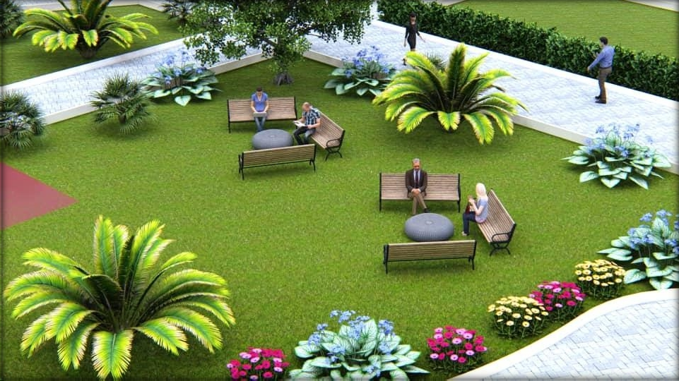

Plate XXIII: Picture showing the hard landscape (Source: Author’s design, 2019)

    - Provision of sporting facilities in the design

The proposed hotel design made provision for sporting facilities such as basketball and tennis courts, a play garden with recreational facilities such as garden chess, board games and outdoor play materials. Also the building has a spa and gym to enhance relaxation and fitness.
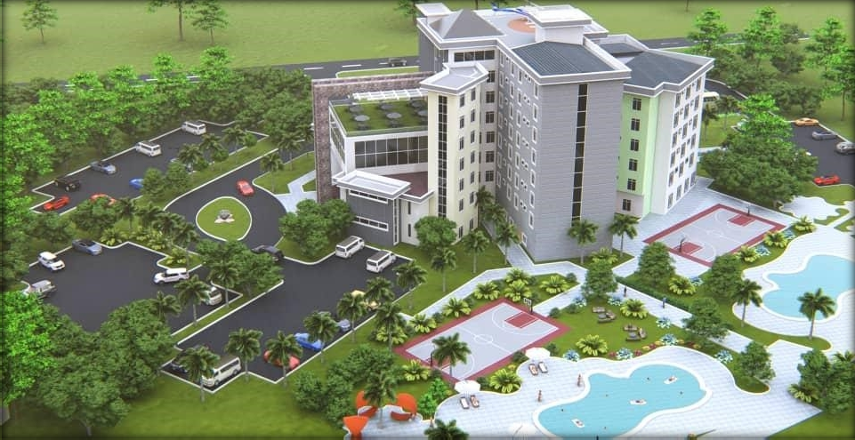

Plate XXIV: Outdoor sporting facilities and landscape pattern (Source: Author’s design, 2019)

  - Summary of Findings

Findings from the studies highlighted some important features of landscape that fosters relaxation and restoration. One key factor to note about of the landscape for restoration is that they possess a higher degree of naturalness, and this is characterised by the presence of quality vegetation or greenery and other natural landscape features including water bodies around the surrounding.

In summary, it was observed that the major components of a landscape environment with restorative qualities are water, tree covers for shade and art works. These may exist in different form and shades but most importantly, it should reflect naturalness like the water bodies being very clear, flowing or moving water(to create texture effect) and also be reflective and have a deeper hue of blue or green to reflect naturalness. The trees and

vegetative cover should possess a deeper hue of green and shrubs may be made up of flower plants with colourful flowers as white, red, yellow/orange and purple. Also art works as sculptures and statues of different images or forms should be used in landscape areas. Hence, these considerations were made in proposing the hotel design for Kaduna.

CHAPTER FIVE

  - CONCLUSION AND RECOMMENDATIONS

Conclusion

This thesis has identify the importance of landscape on people as a tool for stress reduction and also the restorative potentials of outdoor spaces with the existence and presence of natural vegetation features. It has also established people‘s fondness for landscaped environments and the qualities that make them attracted to such sceneries. The knowledge reflected by this thesis hence can serve as a guide to architect, landscape designers, planners, built environment professionals and policy makers to create environments that foster relaxation and also or transform a place to positively influence psychological restoration which will be of utmost benefit to the health and general wellbeing of hotel guests.

Recommendations

This thesis recommends the adoption of some of the basic landscape elements and features that fosters restoration as summarised below:
    - In providing water bodies for landscape, they should come with high with reflective properties, and made to be in constant motion.
    - Landscape should consists of more natural elements like vegetation that are evergreen and easy to maintain, mountains, hills, natural rocks, and water.
    - The greenery of such scenes should be adequately maintained and cared for to ensure it is fresh and looks healthy.
    - Landscape should be designed in a manner where it can be easily accessed, and its features accessible to be touched or physically felt.

REFERENCES

Alison, B. (2015). Landscape and public health: environmental management standard
the EMAS Environmental Management Standard. 4(6), 326-345
Alvarsson, J. J., Wien, S. & Nilsson, M. E. (2010).Stress recovery during exposure to nature sound and environmental noise. International Journal of Environmental Research and Public Health, 7, 1036-1046.
American Institute of Stress (2002). Available on http://www.stress.org, accessed September 20, 2018.
American Physical Association (2015). Stress in America: Paying With Our Health.
Washington: American Physical Association.
American Physical Association (2017). Stress in America: Coping With Change Part 1.
Washington, DC: American Physical Association.
American Psychiatric Association (2013). Depressive disorders. In Diagnostic and Statistical Manual of Mental Disorders DSM-5 (5th ed.). Arlington, Va: American Psychiatric Association., http://www.psychiatryonline.org. Accessed April 12, 2015.
American Psychological Association [APA] (2004). Different Kinds of Stress. Retrieved February OS, 2008, from APA Website http://www.apahelpcenterorg/articies /article.php'?id=21
Andreas, S. H. (2016). Understanding recreational landscapes; developing a knowledge base on outdoor recreation monitoring in Swedish coastal and marine areas. Avdelningen för Kulturgeografi Institutionen för Ekonomi och samhälle Handelshögskolan vid Göteborgs universitet Viktoriagatan 13 405 30 Göteborg
Aspinall, P., Mavros, P., Coyne, R. & Roe, J. (2013). The urban brain: analysing outdoor physical activity with mobile EEG. British Journal of Sports Medicine. 49(4), 272-276.
Barton, J. & Pretty, J. (2010). What is the best dose of nature and green exercise for improving mental health? A multi-study analysis. Environmental Science and Technology. 44(10), 3947–3955.
Berto, R. (2005). Exposure to restorative environments helps restore attentional capacity.
Journal of Environmental Psychology, 25(3), 249-259.
Berto, R. (2014). The Role of Nature in Coping with Psycho-Physiological Stress: a Literature Review on Restorativeness. Journal of Behavioural Sciences. (Behav. Sci.), 4:394–409; doi: 10.3390/bs4040394.
Bhatnagar, R. P. (2007). Fundamentals of Educational Research. New Delhi: Vinay Rakheya.
Bone, P. F. & Ellen, P. S. (2005). Scents in the market place: Explaining a function of olfaction. Journal of Retailing, 75(2), 243-262

Bulut, Z., Karahan, F. & Sezen, I. (2010). Determining visual beauties of natural waterscape: a case study of Tortum Valley (Erzurum/Turkey). Scientific Research and Essay, 5(2), 170–182.
Central Public Works Department (CPWD) (2013). Integrated Green Design: for Urban and Rural Buildings in Hot-Dry Cliate Zone. New-Dehli, India: Director of General, Central Public Works Department.
Chan, B. & Mackenzie, M. (2013). Manual on Module II:Introduction to Hospitality.
Hong Kong: The Government of the Hong Kong Special Administrative Region.
Chen, B., Adimo, O. A. & Bao, Z. (2009). Assessment of aesthetic quality and multiple functions of urban green space from the users' perspective: The case of Hangzhou Flower Garden, China. Landscape and Urban Planning, 93(1), 76-82.
Collingwood, J. (2013). The physical effects of long-term stress. http://psychcentral.com/lib/the-physical-effects-of-long-term-stress/. (Accessed January 26, 2016).
Desjarlais R., Eisenberg L., Good B. & Kleinman A. (1995). World Mental Health: Problems and Priorities in Low Income Countries. New York: Oxford University Press.
Diana, F. (2014). Comparative Analysis of Hotel Classification and Quality Mark in Hospitality. Journal of Tourism and Hospitality Management, 2, (1), 26-39
Dongying, L. & William, C. S. (2015) Impact of views to school landscapes on recovery from stress and mental fatigue. Journal of Landscape and Urban Planning 148:149–158.
Dorozhkina, E. A. (2018). Forms of landscaping modern architectural environment. IOP Conference of Material Science Engineering. 451 012168.
Ellen, J., Smith, M., Larson, H. & Segal, I. (2007). Understanding Stress: Signs, Symptoms, causes and effects. Retrieved on January 12, 2008 from Help guide.org Website. www.helpguide.org/mentallstress signs.html.
Foley, R. (2015). Swimming in Ireland: Immersions in therapeutic blue space. Health & Place, 35, 218-225.
Garrett, F. C., Helene, M. L., Gary, J. B. & Darshan, H. M. (2018). Identifying Stress Landscapes in Boston Neighborhoods. Global Advances in Health and Medicine, 7, 1–9.
Gesler, W. (2017). Commentary on the origin and early development of the therapeutic landscapes concept. Medicine Anthropology Theory, 4(1), 1–9.
Grahn, P. & Stigsdotter, U. A. (2003). Landscape planning and stress. Urban Forestry Urban Green, 2, 1–18.
Grahn, P., Tenngart Ivarsson, C,, Stigsdotter, U. K. & Bengtsson, I. L. (2010). Using affordances as a health-promoting tool in a therapeutic garden. In Ward Thompson, C., Aspinal, P., Bell, S. (eds.) Innovative Approaches To Researching Landscape And Health, 5, 116-154.

Hartig, T. (1993). Nature experience in transactional perspective. Landscape and Urban Planning, 25, 17–36.
Hartig, T. (2007). Three steps to understanding restorative environments as health resources. In C. Ward-Thompson & P. Travlou (Eds.), Open Space: People Space. New York: Taylor and Francis.
Hartig, T., Evans, G. W., Jamner, L. D., Davis, D. S. & Gärling, T. (2003). Tracking restoration in natural and urban field settings. Journal of Environmental Psychology, 23,109–123.
Herrman, H., Saxena, S. & Moodie, R. (2005). Promoting Mental Health: Concepts, Emerging Evidence, and Practice. A Report of the World Health Organization, Department of Mental Health and Substance Abuse in Collaboration with the Victorian Health Promotion Foundation and University of Melbourne. Geneva: WHO.
Herzog, T. R., Maguire, P. & Mary, B. N. (2003). Assessing the restorative components of environments. Journal of Environmental Psychology, 23(2), 159-170.
Hotels, Restaurants, & Cafés in Europe [HOTREC]. (2013). European Hospitality Quality. Retrieved from http://www.hotrec.eu/policy-issues/quality.aspx
In-Kellert, S. R., Heerwagen, J. H. & Mador, M. L. (Eds.). Biophilic Design: The Theory Science, and Practice of Bringing Buildings to Life, 385. New York: Wiley, Chapter 4, 43-58.
Jeremy, D. V., Dries, L., Steven, B., Inge, L., Leo, D. N., Kelian, D. V. & Liesbet, V. (N.D.) Outdoor recreation in various hypothetical landscapes: Which site characteristics really matter?
Kaplan, R. (2001). The Nature of the View from Home Psychological Benefits.
Environment and Behaviour. 33, 4, 507-542.
Kaplan, R. & Kaplan, S. (1989). The Experience of Nature: A Psychological Perspective. New York Cambridge University Press.
Kaplan, S. (1995). The restorative benefits of nature: towards an integrative framework.
Journal of Environmental Psychology, 15:169–182.
Kaplan, S., Bardwell, L. V. & Slakter, D. B. (1993). The museum as a restorative environment. Environmental Behaviour. 25:725–742.
Kara, B. (2013). Landscape design and cognitive psychology, Procedia-Social
Behavioural Science. 82, 288–291.
Karolina, D. (2018). Therapeutic Landscapes. Health & Place, 9, 83–93. Karyn, T. (2012). Stress Education. Training & Counselling. 6, 4, 43-67.
Kothari, C. R. (2004). Research Methodology: Methods and Techniques (second revised edition). New Age International Publishers, New Dheli.
Kuo, F. E. & Sullivan, W. C. (2001). Environment and crime in the inner city: Does vegetation reduce crime? Environment and Behaviour, 33(3), 343-365.

Lawson, F. & Rawson, J. (1999). Hotels. In D. Adler, Metric Handbook: Planning and Design Data (541-553). London: Architectural Press.
Le Lay, Y. F., Pie´gay, H., Gregory, K., Chin, A., Dole´dec, S., Elosegi, A., Mutz, M., Wyzga, B. & Zawiejska, J. (2008).Variations in cross-cultural perception of riverscapes in relation to in-channel wood. Transactions of the Institute of British Geographers, 33:268–287.
Lee, K. D. (2012). Oh, A landscape ecological management system for sustainable urban development, APCBEE Procedia 1, 375–380.
Lyle H. M. & Alma D. S. (1994). Stress Solution http://www.apahelpcenter.org/articles & information /health & emotional wellness /stress: the different kinds of stress, Accessed on July 28, 2018.
Mador, M. L. (2008). Water, Biophilic Design and the Built Environment.
Environmental Behaviour. 72, 34, 679-712.
Magdalena, S., Agnieszka, W., Daria, L. & Joanna, M. (2013) non-visual perception of landscape – use of hearing and other senses in the perception of selected spaces in the city of Poznan. Teka Kom. Arch. Urb. Stud. Krajobr, 9, 2, 68-79
Mandali, S. (2013). Chapter 2 –Classification of Hotels. S.P MANDALI’S WE SCHOOL. Welingkar Education Retrieved from http://elearning.nokomis.in/uploaddocuments
/Front%20office%operations/chp%202%20%E2%80%93%20Classification%20o f%20Hotels/Summary/Chapter%202-Classifications%20of%20Hotels.pdf.
McCormick, D., Sayah, A., Lokko, H., Woolhandler, S. & Nardin, R. (2012). Access to care after Massachusetts’ health care reform: a safety net hospital patient survey. Journal of Genetic Intern Medicine. 27(11), 1548–1554.
Menzies, D., Renata, A. & Whaanga-Schollum, D. (2016). Connecting eco-systems and belief systems through regeneration and innovation. X-Section Journal, 6(1), 98- 105.
Miller, G. E., Chen, E. & Zhou, E. S. (2007). If it goes up, must it come down? Chronic stress and the hypothalamic pituitary- adrenocortical axis in humans. Psychological Bulletin. 133(1), 25–45.
Nasar, J. L. & Lin, Y. H. (2003).Evaluative responses to five kinds of water features.
Landscape Research, 28, 441–50.
Ottosson, J. & Grahn, P. (2005). A comparison of leisure time spent in a garden with leisure time spent indoors: On measures of restoration in residents in geriatric care. Landscape Research, 30(1), 23-55.
Oyetola, S. A., Adebisi, G. O., Onuwe, J. O. & Salihu, S. (2013). Reducing Stress Levels through Landscape; a Study of Senior Staff of the Federal University of Technology, Minna, Nigeria. IOSR Journal of Environmental Science, Toxicology and Food Technology (IOSR-JESTFT), 4(4), 10-17.

Parinaz, M., Mojtaba, P. & Mehdi, S. (2017). Investigating the significance of landscape in designing library by emphasizing on the enhancement of learning. Housing and Building National Research Center HBRC Journal, 13:217–222
Parsons, R., Tassinary, L. G., Ulrich, R. S., Hebl, M. R. & Grossman-Alexander, M. (1998). View from the road. Journal of Environmental Psychology, 18:113–140.
Peschard, T., Karin, K., & Ulrika, K. S. (2013). Associations between park characteristics and perceived restorativeness of small public urban green spaces. Landscape and Urban Planning, 112, 26-39.
Polačkova, L. (2012). Means of landscape architecture in the urban public space of Rome, Paris and Prague. Mende Brun, 60(8), 281–298
Prajal, P. (2012). The role of water as a restorative component in small urban spaces.
Reena, C. (2015). landscape design criteria for creating a restorative environment in outdoor areas of ikenberry commons residence halls. Unpublished M.Sc thesis
Rodick, S. (2012). Influence of an Outdoor Garden on Mood and Stress in Older Persons. Journal of Therapeutic Horticulture, 13:13-21.
Ruddick, S. (2015). Situating the Anthropocene: planetary urbanization and the anthropological machine, Urban Geography, 36(8), 1113-1130
Saxena, N. R., Mishra, B. K. & Mohanty, R. K. (2008). Fundamentals of educational research. New Delhi: Vinay Rakheya.
SEÇKİN, Y. Ç. (2010). Understanding the relationship between human needs and the use of water in landscape design. ITU A|Z, 7(1), 1-17.
Shahhosseini, H., Shariff, M. K. & Maulan, S. (2014) determining sound, smell, and touch attributes in small urban parks using ngt. Alam cipta 7, 2
Silfee, V. J., Rosal, M. C., Sreedhara, M., Lora, V. & Lemon, S. C. (2016). Neighbourhood environment correlates of physical activity and sedentary behaviour among Latino adults in Massachusetts. BMC Public Health, 16, 1, 966.
Sue, I. (2013). Public Health and Landscape: creating healthy places. A publication of the Landscape institute position management.
Tahir, S. & Satinder, P. S. (2017). Hotel Classification Systems: A Case Study.
Prabandhan: Indian Journal of Management, 67(1), 52-64.
Tanja, S. (2006). Urban landscape as a restorative environment: preferences and design considerations. Acta agriculturae Slovenica, 87(2), 325-332
Ulrich, R. S. (1979). Visual landscape and psychological well-being. Landscape Research, 4:17–23.
Ulrich, R. S. (1981). Natural versus Urban Scenes Some Psychological Effects.
Environmental Behaviour. 13:523–556.
Ulrich, R. S. (1986). Human responses to vegetation and landscapes. Landscape and Urban Planning, 13:29-44.

Ulrich, R. S. (1993). Aesthetic and Affective Response to Natural Environment. In Behaviour and the Natural Environment; Altman, I., Wohlwill, J.F., Eds.; Plenum: New York, NY, USA, 1983; 85–125.
Ulrich, R. S., Robert, F. S., Barbara, D. L., Evelyn, F., Mark, A. M. & Michael, Z. (1991). Stress recovery during exposure to natural and urban environments. Journal of Environmental Psychology, 11(3), 201-230.
United Nations World Tourism Organization [UNWTO]. (2003). Quality in tourism. Quality Support Committee at its sixth meeting, Varadero, Cuba. Retrieved from http://sdt.unwto.org/en/content/quality-tourism
Van den Berg, A.E., Hartig, T., Staats, H. (2000). Preference for nature in urbanized societies: stress, restoration, and the pursuit of sustainability. Journal of Social Issues, 63:79-96.
Van der Wees, P. J., Zaslavsky, A. M. & Ayanian, J. Z. (2013). Improvements in health status after Massachusetts health care reform. Milbank Q. 91(4):663–689.
Vincent, E., Battisto, D., Grimes, L. & McCubbin, J. (2010). The effects of nature images on pain in a simulated hospital patient room. Health Environments Research & Design Journal 3(3), 42-55.
Wan, N. M. & Wan, M. R. (2015). Evaluating Natural Elements Potential in Urban Landscape. Sustainable urban landscape. 43(6), 11-23
White, M. P., Smith, A., Humphries, K., Pahl, S., Snelling, D. & Depledge, M. H. (2010). Blue Space: The importance of water for preference, affect and restorative ratings of natural and built scenes. Journal of Environmental Psychology, 30,482– 493.
William, H., Jacqueline, M. & Bruno, M. (2017). Mātauranga Māori and Therapeutic Landscapes the IAFOR International Conference on the City 2017 Official Conference Proceedings.
World Health Organization: World Health Report 2001- available on http://www.who.int/whr/2001/en/whr01_en.pdf, accessed November 15, 2011.

APPENDIX A

EVALUATION OF LANDSCAPE FEATURES FOR STRESS RELIEF IN HOTEL BUILDINGS IN KADUNA, KADUNA STATE, NIGERIA

PREFERENCE STUDY

Section 1

1. Gender………………………………………….
2. Occupation……………………………………

Section 2.

Please kindly rate the following pictures of landscape views in outdoor environments based on how relaxed and good you may likely feel within such environment. Please tick from the scale 1-5 provided where 1 means you are less likely to feel good or comfortable in such environment and where 5 means you prefer such environment highest.
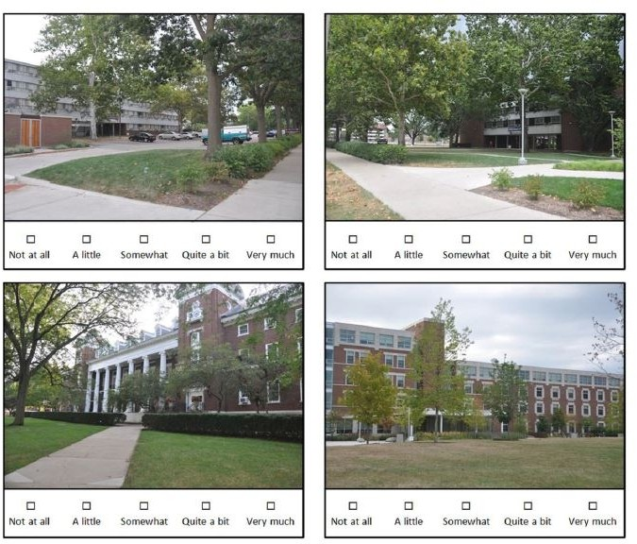

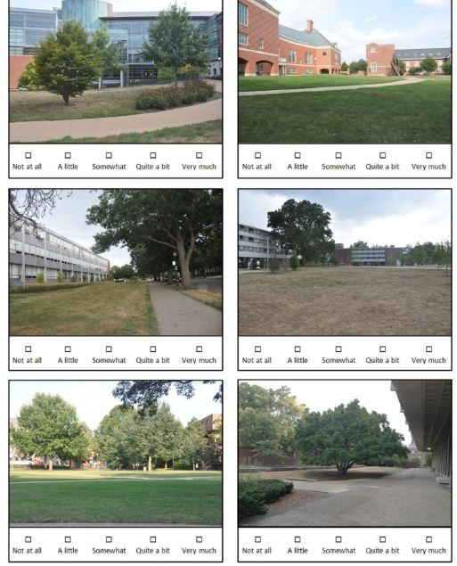

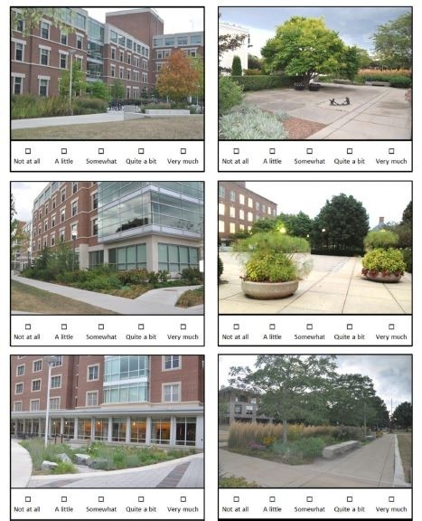

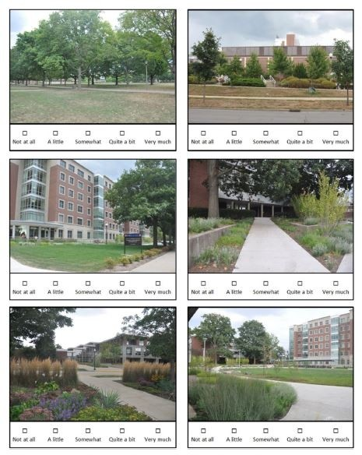

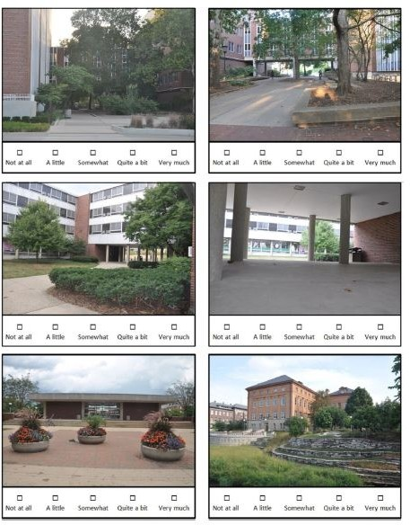

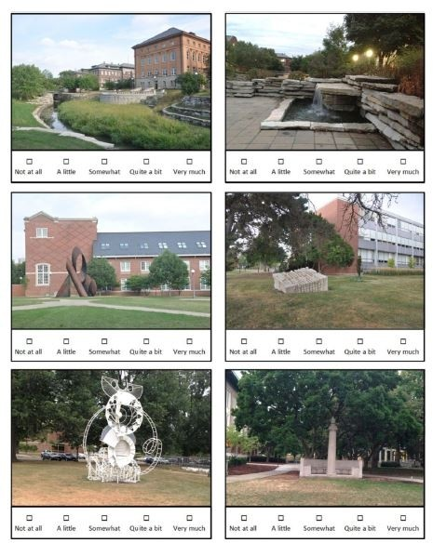

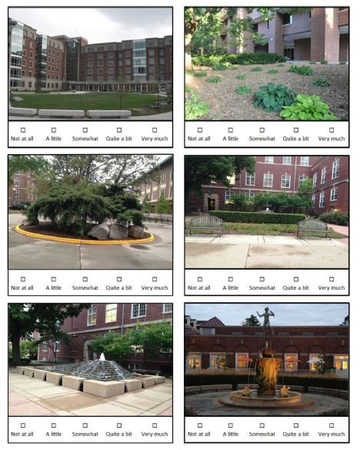

APPENDIX 2

FEDERAL UNIVERSITY OF TECHNOLOGY MINNA

Department of Architecture

Evaluation of landscape features for stress relief in hotel buildings in Kaduna, Kaduna State.

This questionnaire is designed to obtain data for a research on the evaluation of landscape for stress relief in hotel buildings in Kaduna state. For the purpose of this research, I am conducting a survey across selected hotels in Kaduna. I have chosen to contact hotel managers and guests of the hotel buildings within Kaduna state. I would therefore value your participation in this survey.
Your utmost cooperation in this exercise would be greatly appreciated. The information collected is meant for educational use in to aid my research in my Masters thesis. Due to the constraint and deadline of this task, I graciously ask you response as soon as possible.

General information
- Please circle your gender A. Male B. Female C. Prefer not to answer
- Please choose your age group A.18-25 B.26-33 C. 33-40 D. 40yrs above
- Purpose of visit to hotel ……………………………………………….
- How long have you been lodged here? A. 1-3daya B. 4-6days C.1-2 weeks D. 3- 4weeks E. a month and above
- Blood pressure count A. high B. moderate C. low

Part II
- To what extent do you use the area while you are within the hotel surrounding?
Not at all A little moderately Quite a lot Very much

What outdoor activity do you love doing (tennis, swimming, etc.)
……………………………………………………………………………………………
……………………………………………………………………………………………

How likely are you to do the following outdoor activities in this hotel?
  - Exercising (jogging, running, skipping, walking, acrobatics, etc.) Not at all A little Somewhat Quite a bit Very much

  - Relaxing (sitting on the bench, reading, breathing fresh air, watching,) Not at all A little moderately Quite a lot Very much

  - Playing (basketball, tennis, handball, swimming, etc.)
Not at all A little moderately Quite a lot Very much

Just walking to get to know the environment
Not at all A little moderately Quite a lot Very much

If you don’t use the hotel outdoor area can you tell us
why? …………………………………………………………………………………
…………………………………………………………………………………………
…………………………………………………………………………………………
…………………………………………………………………………………………
………

How frequently do you use outdoor areas for activities generally?
  - Daily B. Alternate days C. Once a week D. Once a month E. Never

Which part of the hotel landscape do you admire most (indoor and outdoor)?
And
why …………………………………………………………………………………
…………………………….…………………………………………………………

Which part or features of the landscape do you like the
most? ………………………………………………………………………………
………………………………………………………………………………………
………

Do you like the view of the hotel landscaped area from your room window?
- if yes, what do you like the most -
……………………………………………………………………………………………
…………………………………………………………………………………………

if no, what don’t you like -
……………………………………………………………………………………………
…………………………………………………………………………………

How connected do you feel with nature in this hotel?
Not at all A little moderately Quite a lot Very much

- Do you visit parks in your leisure time? A. Yes B. No

If so
why? …………………………………………………………………………………
………………………………………………………………………………………
………………………………………………………………………………….……
…..

What elements would draw you into the landscape of an outdoor area?
- More greenery (trees, shrubs, flowering plants)
- Artwork (sculptures, abstract installations)
- Water elements (fountains, lakes, streams,)

More seating areas
- Other’s please specify ……………………………………………………………………………………
….…………………………………………………………………………………………
………

As you read each statement below, please indicate your answer using the boxes on the right. When thinking about the landscape in this hotel, how much do you:
 | Not at  all | A little | moderate | Quite  a bit | Very  much
appreciate the look of the landscape
appreciate the look of the parking lots
appreciate the look of the interior landscape (if any)
appreciate the look of the connecting pathways
feel satisfied with the beauty and aesthetics of this place
feel satisfied with the variety of plants
feel satisfied with the biodiversity
feel satisfied with the capacity of the landscape to support social interactions
feel satisfied with the maintenance of

the landscape

- What colours do you feel better relaxed
with? ………………………………………………………………………..

Why do you like the colour?
………………………………………………………………………………

In your opinion, what can you say generally about the landscape and physical environment, including the use of colours in this hotel based on the role it played on your satisfaction and feeling of relaxation during your stay here? ……………………………………………………………………….……
…………………………………………………………………………….………
…………………………………………………………………………….………
……………………………………………………………………….……………
……………………………………………………………………………….……
……………………………………………………………………………………
……….

APPENDIX 3

INTERVIEW GUIDE FOR MANAGER AND STAFF OF HOTEL

- Name and address of
hotel …………………………………………………………………………………
………………………………………………………………………………………
……
- Person being interviewed (manager or
employee) ……………………………………………………………………………
………..
- For how long have you been working at the
hotel? ………………………………..………………………………………………
….…
- What is the occupancy rate per
day/week ……………………………………………………………………………
……….
- The natural environment (elements and features) especially in outdoor spaces are loved by people. What is your view on
this? …………………………………………………………………………………...
.......................................................................................................................................
.......................................................................................................................................
...
- In your own opinion what can u say about landscape designs in hotel environments…………………………………………………………………………
………………………………………………………………………………………
…………………………………………………………………………………….
- What purpose do you think landscape designs are used
for ..................................................................................................................................
....................................................................................................................................
- What purpose is the landscape of this hotel
for? …………………………………………………………………………………
………………………………………………………………………………………
………………………………………………………………………………………
……
- How important do you think the physical environment (landscape) is in hotel buildings?……………………………………………………………………………
………………………………………………………………………………………
………………………………………………………………………………………
……………..
- During your work experience at the hotel did you notice/get any comments about the physical environment and landscape from the customers?

………………………………………………………………………………………
………………………………………………………………………………
- What landscape features/elements and outdoor activities do you have within the hotel surrounding?
………………………………………………………………………………………
………………………………………………………………………………………
……………………………………………………………………………………….
- How often do guests spend time in the outdoor environment? ............................
- At what time do guests spend more time in outdoor
area? …………………………………. ……………………………….
- What part of the outdoor area do guests visit the
most? …………………………………………………………………………………
………………………………………………………………………………………
…………………………………….
- In the hotel’s policy is the physical environment an important part of a customer’s satisfaction? …………………………………………………………………………
………………………………………………………………………………………
………………………………………………………………………………………
…………
- In your opinion what is more important at you hotel: service or physical environment?
………………………………………………………………………………………
………………………………………………………………………………………
………………………………………………………………………………………
- Do you think the physical environment have an effect on customers? And what role?
………………………………………………………………………………………
………………………………………………………………………………………
………………………………………………………………………………………
………………………………………………………………………………………
……………………………………………………………………………………
- Is the hotel flexible to changes in physical environment according to customers’ wishes?
………………………………………………………………………………………
………………………………………………………………………………………
………………………………………………………………………………………
……………………………………………………………………………………
- To what extend is the hotel ready to meet the needs of stressed customers?

………………………………………………………………………………………
………………………………………………………………………………………
………………………………………………………………………………………

- Is the hotel ready to change some features of the surrounding environment for people with special needs such as sporting activities, outdoor relaxation gardens, etc.
………………………………………………………………………………………
………………………………………………………………………………………
………………………………………………………………………………………
………………………………………………………………………………………
……………………………………………………………………

- In your opinion, does the hotel need any changes in the physical environment?
………………………………………………………………………………………
………………………………………………………………………………………
………………………………………………………………………………………
………………………………………………………………………………………
………………………………………………………………………………………
………………………………
- What colours were used on the walls in the following spaces within the hotel
  - Exterior walls………………………………………
  - Lobbies…………………………………………….
  - Rooms………………………………………………
  - Bathrooms………………………………………….
  - Reception…………………………………………….
  - Relaxation area………………………………………
- What outdoor sporting activities were provided for in your
hotel? …………………………………………………………………………………
………………………………………………………………………………………
………………………………………………………………………………………
………………………………………………………………………………………
…….

