# EVALUATION OF INSITU GEOTECHNICAL PROPERTIES OF ROAD PAVEMENT LAYERS MATERIAL: A CASE STUDY OF MINNA–BIDA ROAD.

The intrinsic suitability of some lateritic soils as materials for construction of layers for flexible pavements is evaluated herein. The pavement layers assessed were the base course, sub-base and sub-grade. Laboratory results of samples from these layers show that the CBR values of the sub-grade materials met the requirement while about 40% and 70% of the locations for sub-base and base materials respectively, presented CBR values less than those specified by the local code of Nigeria. Also, the fine proportions as required were significantly absent. This resulted into failure of the road along its profile at many sections, such as the roadway and shoulders. It was noted that the fine proportions would have been leached away due to inadequate drainage facilities at the failed road sections or rather poor quality control during construction. A total reconstruction with adequate drainage facilities is suggested for this road due to its importance in Nigeria, and with the adequate materials.

# CHAPTER ONE INTRODUCTION

## Background to the Study

A road pavement is a structure of superimposed layers of selected and processed materials that is placed on the basement soil or sub-grade. The main structural function of a pavement is to support the wheel loads applied to the carriageway and distribute them to the underlying sub-grade. The term sub-grade is normally applied to both the in-situ soil exposed by excavation and to added soil that is placed to form the upper reaches of an embankment. Modern pavement design is concerned with developing the most economical combination of pavement layers that will ensure that the stresses and strains transmitted from the carriageway do not exceed the supportive capacity of each layer, or of the sub-grade, during the design life of the road. Major variables affecting the design of a given pavement are therefore the volume and composition of traffic, the sub-grade environment and strength, the materials

economically available for use within the pavement layers, and the thickness of each layer.

Pavements deteriorate with age and use, and the engineer needs to identify the type of deterioration and if possible, its cause in order to establish a priority in the highway maintenance programme.

For any road pavement to perform its function of carrying vehicles and passengers in safe, comfortable, and efficient manner from one place to another it must have been well constructed following proper Highway Engineering methods, be adequately maintained and rehabilitated from time to time in order to improve on its service life (Uruaka, 2012).

According to Oguara (2006), the term ‘pavement’ refers to the hard materials constituting the structure of a road that are constructed on top of the natural soil. Pavement here differs from the British definition of pavement which is defined as a paved way at the side of a street for people on foot. While earth roads can be considered as special pavements, modern highway, airfield or parking lot pavements are usually made up of layers of materials of differing quality with the highest quality material at or near the surface. The Civil Engineer is responsible for the planning, design, construction, maintenance and rehabilitation of these pavements.

The design is concerned with the determination of the total thickness of the pavement structure as well as the thickness of the individual material layers, having regard to the quality of the materials in each layer under all climatic conditions and the expected traffic loads over a design period.

With various pavement construction and maintenance equipment, and procedures that

have been developed over the years, the Engineer should be able to construct and maintain pavements that are able to carry traffic safely, conveniently and

economically with materials that are capable of protecting the natural soil from the effects of traffic loads and climatic environment.

## Problem Statement

Pavements deteriorate with age and use, and the engineer needs to identify the type of deterioration and if possible, its cause in order to establish a priority in the highway maintenance programme.

The cause of the incessant and sporadic incidence of road failure in Nigeria today could be attributed to defective design, lack of soil tests, poor soil properties investigation, poor supervision and construction strategies e.t.c. These failures are in form of wavy surface, corrugations, rutting, pot holes, consequent cracking to mention a few.

## Aim and objectives of the Study

The aim of this work is to determine the effects of the in-situ properties of granular pavement layers to the stability of Minna-Bida road. The length of the road is 85km.

The objectives are as follows:-

* + 1. to determine the index properties of lateritic soils that make them suitable for use as layer materials.
    2. to determine the strength of lateritic soils used as subgrade, sub-base and base course for Minna-Bida road in terms of California Bearing Ratio (CBR) considering soaked and unsoaked soil samples.

## Scope of Study

The road has a total length of about 85km of asphalt concrete surfacing. The prevalent

distress mode on this road are wide cracks (longitudinally and transversely), potholes, corrugations at close intervals and failures along the shoulders due to erosion. This was done through a site reconnaissance survey.

The work is limited to the in-situ properties and strength of the pavement layers in terms of California Bearing Ratio (CBR) of the lateritic soils used as sub-grade, sub- base and base course for the construction of Minna-Bida Road. To achieve the objectives of this work, most of the laboratory tests conducted were aimed at determining the index properties and stability in terms of CBR of the sub-grade, sub- base and base course of the road in question.

# CHAPTER TWO LITERATURE REVIEW

## Laterite and Lateritic Soils

Buchanan (1807) first used the term ‘laterite’ to describe soil in India. The word ‘laterite’ describes material with no reasonable constant properties. It signifies a different material to people living in different parts of the world. It was used locally in bricks for building, hence, the name laterite is from latin word “later” meaning brick. (Maignien,1966).

Lyons Associates (1971) used the silica/sesquioxides ratio as basis for definition of

laterite and lateritic soils as shown below:

*SiO*2 *Fe*2*O*3  *A*12 *O*3

(2.1)

Where;

SiO2 is Silicon (IV) Oxide, Fe2O3 is Iron (III) Oxide and Al2O3 is Aluminium Oxide.

If the ratio is:

Less than 1.33, the soil is termed laterite.

Between 1.33 and 2, the soil is termed lateritic soil. Greater than 2, the soil is termed non-laterite.

Pendelton (1936) questioned the use of the silica-alumina ratio suggested by Martin and Doyne (1927) since the original definition by Buchanan (1807) attached special importance to the role iron oxides play in laterite rock formation. Moreover, the hardening process in laterite rocks seems to consist mainly of the crystallization of the amorphous iron oxides and dehydration. The presence of iron in laterite soils is also considered to be the most important factor which influences their engineering behaviors (Gidigasu, 1975).

However, it was contended that the definition given by Lyon Associates (1971) was not convenient from an engineering point of view particularly where there is lack of adequate laboratory facilities. He then defined lateritic soils as all product of tropical weathering with red, reddish brown or dark brown colour, with or without nodules or concentrations and generally (but not exclusively) found below hardened ferruginous land crust (Ola, 1978).

According to Amadi (2011), laterite and Lateritic soils form a group comprising a wide variety of red, brown and yellow fine-grained residual soil of light texture as well as nodular gravel and cement soils. They may vary from a loose material to

a massive rock. They are characterized by the presence of iron and aluminium oxides or hydroxides, particularly those of iron, which gives the colour to the soil. For engineering purposes, the term “laterite” is confined to the coarse grained vermicular concrete materials, including massive laterite. The term “laterite soil” refers to material with lower concentration of oxides.

Wild (2012) describes laterite as hard materials, rich in iron oxides. This hardness is retained even when the material is immersed in water. The iron occurs mainly as goethite, hematite and amorphous iron oxides. The material is usually coloured reddish brown with a moderately high density (2.5 to 3.6g/cc) and usually contain secondary aluminum. The silica content is generally low, but some quartz and sometimes Kaolinite is present. Laterite often occurs on remnants and old land surfaces. Regrettably the word laterite has been used to describe a wide range of materials as noted by Wild (2012).

Furthermore, Fadamiro and Ogunsemi (2010) defined laterite as a porous soil ranging from soft earthly material to hard rock, which ranges in colour from white to dark red depending on the amount of iron in the soil. They explained that it is found below the earth surface and chemically made of silicate and alumina, which is formed by weathering of rocks, hence, giving rise to many variation of laterite in composition and properties.

## Origin and location of laterite

Laterites are the most common reddish tropically pedogenic surface deposits occurring in Asia, Africa and South America. Laterite as a soil group rather than a well defined material and are most commonly found in the leached soils of the

humid tropics where they are first studied.

Laterite and lateritic materials occur frequently throughout the tropics and subtropics. They tend to occur on level or gently sloping terrain that is subject to very little mechanical erosion. Laterite country is usually infertile. However, laterite soils may develop on slopes undulating topography (from residual soils), on alluvial soils that have been uplifted (Osinubi and Nwaiwu, 2006).

## Formation of laterite

Laterite soils are formed in hot, wet, tropical regions with an annual rainfall usually in areas with a significant dry season on a variety of difficult types of rocks with high iron content. They are formed under weathering systems and a product of the process of laterization, whose important characteristics is the decomposition of ferro-allumino silicate minerals and the permanent deposition of sesquioxides (A12O3 and Fe2O3) within the profile to form the horizon of material known to the engineer and builder as laterite.

Another feature of the process of formation of laterite as encountered in the tropics is the leaching (washing) of silica, by an effectively alkaline soil solution part of which may form a complex with sesquioxides to accentuate the formation of a concretionary or massive structure. The remainder of the silica may form secondary clay silicate minerals or be completely removed by soil drainage.

If this leaching of silica is minimal or does not take place, as in the formation of the

soil generally referred to as podsols (high silica-sequioxide ratio) then the process of laterization may be considered to occur under climates other than tropical (e.g chernozem, USSR). For this reason there are many soils which can be classified as having been formed by the process of laterization. Hence other terms as laterites, lateritic and laterized soils have been introduced. The lower the silica-sequioxide ratio of material, the more advanced the laterization process is likely to be.

However, three (3) major stages had been identified in the process of laterization. These are decomposition, leaching, dehydration and dessication.

The first stage (decomposition) is characterized by physicochemical break down of primary minerals and the release of constituent elements such as S1O2, A12O3, Fe2O3, CaO, MgO, K2O, Na2O, etc. The second stage (leaching) involves the leaching under appropriate drainage conditions of combined silica and bases and the relative accumulations of enrichment from outside sources of oxides and hydroxides of sesquioxides (mainly A12O3, Fe2O3, TiO2).

The soil conditions under which the various elements are rendered soluble and removed through leaching or combination with other substances appear to depend mainly on the pH of the ground water and the drainage conditions.

The third stage (dehydration and desiccation) involves partial or complete dehydration (some-times involving hardening) of the sesquioxide-rich materials and secondary minerals.

Laterite is a residual soil formed by the in-situ weathering of intermediate and basic igneous rocks. The process is known in tropical region with alternating wet and dry season. These are leaching of silica and a concentration of iron and aluminium as

oxides and iron ores, while with an increase in alumina, they grade into bauxite, the chief aluminium ore. Laterite tends to have a red colour due to high content of iron oxides. It differs from clay soil in the sense that the aluminium is present as hydroxide instead of silicate (Osinubi and Nwaiwu, 2006, 2008).

Bunnett (1973), describes that in humid tropical regions, soil water contains very little organic matter, and such water does not dissolve iron and aluminium hydroxides. Most other minerals however dissolve and these are carried in solution to the B- horizon where they are deposited. Ultimately as a result of the above process, Bunnett (1973) noted that a soil which is composed mainly of iron and aluminium compounds may be formed. This soil is called laterite and usually red in colour.

## Laterization

Laterization involves the leaching under appropriate drainage conditions, of combined silica and bases and the relative accumulation or enrichment from outside sources of oxides and hydroxides of sequioxides (mainly A12O3, Fe2O3 and TiO2). The soil conditions under which the various elements are rendered soluble and remove through leaching or combination with other substances appear to depend mainly on the pH of the ground water and the drainage conditions.

The level to which laterization is carried depends on the nature and the extent of chemical weathering of the primary minerals. Under conditions of low chemical and soils forming activity, the physico-chemical weathering does not continue beyond the clay forming stage and tends to produce end products consisting of clay minerals predominatly represented by kaolinite and occasionally hydrated or anhydrous oxides of iron and aluminum.

Under conditions of intense and prolonged physico-chemical weathering,

however, even clay mineral are destroyed and silica is leached, the remainder will merely consist of aluminium oxides such as gibbsite or hydrous iron oxides such as goethite derived from iron; this is the process of laterization (Osinubi and Nwaiwu, 2008).

## Geotechnical properties of laterite soils

With the increasing importance of laterite soils in the expanding construction activities in many countries of Africa, there has been an urgent need for an up-to-date review of geotechnical properties of laterite soils. The geotechnical properties and field performance of most laterite soils are influenced considerably by genesis, degree of weathering, monophological characteristics, chemical and mineral composition as well as by the environmental conditions (Osinubi and Nwaiwu, 2006, 2008). Apparent disregard of laterite soils in the field of basic and applied research is mainly responsible for the lack of adequate data on geotechnical properties and field performance of their soils. Consequently, many tropical countries, whose only naturally occurring engineering materials are laterite soils, are unable to utilize these soils successfully in the construction of highways, airfields, earth dams, foundations

and slopes.

The existing chemical, geologic-pedological (understanding soil properties as those of cohesion, resistance to stress, moisture relationships, susceptibility to volume change and reaction to various kinds of additives incorporated for the purpose of moisture or strength stabilization) and geotechnical information concerning laterite soils indicate that the terminology used to describe them is not standardized and, consequently, numerous inconsistencies have developed in the identification, classification and nomenclature of laterite soils.

In summary, the geotechnical characteristics and field performance of laterite soils can be interpreted in the light of all or some of the following parameters: (Osinubi and Nwaiwu, 2006, 2008)

1. Genesis and pedogenic factors,
2. Degree of weathering and
3. Clay mineralogy and clay-size content.

(Osinubi and Nwaiwu, 2006, 2008) presented on exhaustive work in the geotechnical properties of laterite soils in Africa. This laterite commonly contains all size fractions from clay to gravel and sometimes even larger materials. Particles sizes distribution exerts great influence on the geotechnical properties of the soil. The specific gravity of laterite varies not only with the texture of the soil group but also with different fractions. Generally, laterite soils have been found to have high specific gravities of between 2.6 to 3.4. For the same soil, gravel fractions were found to have higher specific gravities than fine fractions due to concentration of iron oxide in gravel

fraction, while alumina is concentrated in the silt and clay fraction.

Furthermore, Amadi (2011) suggested that the specific gravity can thus be used as a degree of laterization. For laterite soils, maximum dry density ranges from 1842 to 2322kg/m3. Cementing agents in laterite help to bind the fine particles together to form larger aggregates. However, as a result of leaching, these aggregates break down, which is shown by increase in liquid limit after leaching. Also on plasticity, classified soils as low, medium, high and very high plasticity. He said the liquid limits of laterite do not exceed 60% and the plasticity indices are less than 30%. Laterite soils have properties of reddish shade which appear to be due to the various degree of iron, titanium and magnesium hydration. The shades also reflect the degree of maturity e.g. with age, Ferruginous laterite soil seems to change from red to brown and are brighter in colour.

## Importance of lateritic soils

Some lateritic soils are important commercially. Lateritic soils that are rich in iron are used as ores. In some tropical areas, laterite is cut into small blocks, which dry out and harden. This block (bricks) have been widely used as a building material, in most parts of the countries of the world.

Lateritic soils are mostly recommended (Amadi, 2011) for use as sub-grade, sub-base and base course materials in highway construction. They work well in pavement construction, particularly when their special characteristics are carefully recognized. As a result of its structural strength, it can be used as a very suitable subgrade in highway construction. The harden type of laterite can be used as a good base course material in highway construction.

## Soil Classification

This is simply placing of a soil sample into a particular class. A soil class is a group of soils having one or more of their characteristics similar. Classification of soils is carried out for the following purposes:

1. To obtain a consistent, unified and internationally recognized description of a soil sample.
2. To provide a mode of uniform and standard communication for describing soils.
3. To avoid extensive testing of a soil sample for obtaining its mechanical properties (once it is classified; a good indication of possible behaviours pattern can be deduced based on experience with soil of the same group).

Wright and Paquette (1979), said the objective behind the use of any soil classification system for highway purpose is to be able to predict the subgrade performance of a given soil on the basis of a few simple tests performed on the soil in a disturbed condition.

Craig (2004), said the object of the soil classification is to divide soils into groups such that all the soils in a particular group have similar characteristics, by which they may be identified, and exhibit similar behaviour in given engineering situations.

Carter and Bently (1991), also said the purpose of a soil classification system is to group together soils with similar properties or attributes.

It is for these reasons that the soils encountered in this work will be adequately classified as required by relevant standards.

## AASHTO Classification System

This is the most widely known and used system for classifying soils for highway purposes. Soils are divided into two major groups, granular material (containing 35% or less material passing through number 200 sieve) and clay and silt clay

materials (containing more than 35% passing number 200 sieve). There are seven (7) groups; A-1 to A-7 based on texture, Atterberg limits and expected performance when used in pavement design.

In general the classification are defined as follows (Wright and Paquette, 1979)

A-1: well graded mixture of stone fragment or gravel, coarse sand and a non-plastic binder as well as soil with no binder.

A-2 border line materials between A-1 and A-3 (they reflect the effect of fines on the behaviour of the composite) groups and the silty-clay materials of group A-4 to A-7. A-3: fine sand

A-4: silt A-7 clay

The evaluation of soils within each group is made by the means of a “group index” (G.I), which is a value calculated from an empirical formular given below (Wright and Paquette, 1979):

G.I = (F-35) {0.2-0.005 (LL-40)} + 0.01 (F-15) (PI-10) (2.2)

F = passing 0.074mm (No. 200) sieve, expressed as a whole number.

This percentage is based only on the material passing the 75mm (3inch) sieve. LL = Liquid Limit and

PI = Plasticity Index.

In summary, Wright and Paquette (1979) said under average conditions of good drainage and thorough compaction, the supporting value of material as subgrade may be assumed as an inverse ratio to its group index, that is, a group index of zero (0) indicate a “good” subgrade material and group index of twenty (20) or greater

indicates a “very poor” sub grade material.

## Public Road Administration (PRA) System

The revised PRA system classifies soils into seven groups A-1 to A-7, as shown in Table 2.1. These groups are sub divided into smaller sub-groups. The classification is based on (i) sieve analysis (ii) liquid limit and plasticity index.

The Table is self explanatory. With the soil data in hand, one should proceed from left to right and by a process of elimination, the correct classification will be found.

Some of the characteristics of soils in the major groups are as follows (Kadyali and Lai, 2008):

**Group A-1:** This group contains material which is a well-graded mixture of stone fragments or gravel, coarse sand, fine sand and a non-plastic or feebly plastic binder. There are two sub groups under this group.

Sub-group A-1-a includes material consisting predominantly of stone fragments or gravel, either with or without a well-graded binder of fine material. Sub-group A-1-b includes materials consisting predominantly of coarse sand, either with or without a well-graded soil binder.

**Group A-2:** This group contains a variety of granular materials, falling as border-line cases between groups A-1 and A-3 and groups A-4, A-5, A-6 and A-7. It is sub divided into 4 sub groups A-2-4, A-2-5, A-2-6 and A-2-7 depending upon the L.L and P.I.

**Group A-3:** This group consists of fine beach sand or fine wind-blown desert sand. Stream-deposited mixtures of poorly graded fine sand with a limited amount of coarse sand gravel are also included in this group.

**Group A-4:** This group covers non- plastic or moderately plastic soil.

**Group A-5:** This group contains material similar to Group A-4, but which are diatomaceous or micacious in character. The material may be highly elastic.

**Group A-6:** This group contains typical plastic clays, exhibiting high volume changes between wet and dry states.

**Group A-7:** This group also covers plastic clays, having high values of LL and PI. The soils could be highly elastic and show high volume changes. There are two sub groups in this group, A-7-5, and A-7-6.

In the PRA system, there is a mention of Group Index which is calculated from the following formula:

GI = 0.2a + 0.005ac + 0.01bd (2.3)

Where;

a = portion of percentage passing 75micron sieve greater than 35% and not exceeding 75% expressed as a positive whole number from 1 to 40.

b = portion of percentage passing 75 micron sieve greater than 15% and not exceeding 55%, expressed as a positive whole number from 1 to 40.

c = proportion of LL greater than 40% and not exceeding 60%, expressed as a positive whole number from 1 to 20.

d = portion of the numerical plasticity index greater than 10% and not exceeding 30%, expressed as a positive whole number between 1 and 20.

The group Index is expressed nearest to the whole number and is written in brackets after the sub-group or group number.

## California Bearing Ratio (CBR)

The California Bearing Ratio (CBR) was developed by the California Division of Highways before World War II. It is a useful tool in evaluating the subgrade (laterite) strength in which the load required to cause a plunger of standard sizes to penetrate a specimen of soil at a standard rate is measured before or after the soil specimens have been soaked for four(4) days. This penetration results to deformation of the soil specimen which is predominantly shear deformation. This means that the CBR can be regarded as an indirect measure of shear strength.

The evaluation of the CBR values for laterite soils has shown that the stability characteristics of laterite soils may be reliably evaluated for highways and airfield construction purpose using the CBR test. It has been found (Osinubi and Nwaiwu, 2006) that the CBR values of some compacted laterite gravels and gravelly soils

which were soaked four(4) days depends on the degree of compaction and

mainly the content of the concretionary particles as well as the plasticity of the fines. Laterite gravels which contain about 75% of concretionary pisoliths (laterite gravel particles), about 25% fines, and with a plasticity index of about 7% generally provide the most satisfactory base course materials for road pavements. These materials give fairly high CBR values of about 80% or more when soaked for 96 hours.

It was also noted by (Osinubi and Nwaiwu, 2006) that gravelly laterite soils with either too much or too little content of fines to act as binder are dusty in dry season and slippery in wet season when used as a base course for gravelly road. Most concretionary gravels appear to have a wide or particles-size characteristics as well as the degree of compaction and moulding moisture contents.

Some laterite gravels are known to give quite high strengths (in terms of the CBR) when dried, but on absorption of water the strength decreases abruptly. For typical laterite gravels heavy compactive efforts generally give a distinct CBR and moisture content relationships with distinct maximum CBR values of between 100 and 200 and about 50% British standard light weight compaction. At a moisture content, only a few percent greater than that corresponding to the optimum for compaction, the CBR values falls drastically to about 20% of the original values. The CBR values of some laterite after immersion in water for four(4) days are usually considerably reduced, but appear to be generally higher than those obtained after compaction at a moisture content equal to that attained after immersion in water.

Indeed, it has been discovered that, some fine grained laterite soils, in fact, gain strength as a result of soaking and curing. The gained strength (CBR) has been attributed to the presence of the iron oxide (geothite) which dehydrates with time to yield the higher strengths. Various genetic and compositional factors influence (CBR)

of laterite soils. The strength (CBR) of laterite soils appear to depend on the

content of fine and clay as well as the plasticity.

These discussions above would suggest that laterite soils are very variable, their strength depend on a wide range of factors including compositional factors, especially particle-size characteristics, degree of weathering and plasticity of the fines as well as on pretest sample moulding conditions.

The CBR value is used to rate the performance of soils primarily for use as bases and sub-grades beneath pavement of roads and airfields. It may be conducted as a specimen prepared in a mould or in situ, in the field.

## TABLE 2.2 A Typical Rating of CBR Values

|  |  |  |  |
| --- | --- | --- | --- |
| **CBR Values** | **General Rating** | **Uses** |  |
| 0-3 | Very Poor | Subgrade |  |
| 3-7 | Poor to Fair | Subgrade |  |
| 7-20 | Fair | Subgrade |  |
| 20-50 | Good | Base/Subgrade |  |
| >50 | Excellent | Base |  |

Source: Bowles, 1992.

## Pavements

* + 1. **Pavement layers**

A pavement consists of one or more layers. The topmost layer is the surfacing, the purpose of which is to provide a smooth, abrasion resistant, dust free,

reasonably water proof and strong layer. The base, which comes immediately next below, is the medium through which the stresses imposed are distributed evenly. Additional help in distributing the loads is provided by the sub-base layer. The sub- grade is the compacted natural earth immediately below the pavement layers. The top of the sub-grade is also known as the formation level. In a concrete road, the concrete slab itself acts as the wearing surface and distributes the load. The slab may be directly placed on the sub-grade, or, in case of weak soils, a base and sub-base may be interposed between the slab and the sub-grade. In American practice, the top course in a flexible pavement is itself composed of the surface course and a binder course beneath it. In U.K practice, the surfacing is similarly composed of the wearing course at top and base course beneath it. The so-called base course in Indian practice corresponds to the road base in British Practice.

The Overseas Road Note 31 (1993) describes ‘surfacing’ as the uppermost layer of the pavement which will normally consist of a bituminous ‘surface dressing’ (spray- and-chip treatment) or a layer of premixed bituminous material.

‘Base’ as the main load-spreading layer of the pavement which will consist of crushed stone or gravel, or of gravelly soils, decomposed rock, sands and sand clays stabilized with cement, lime or bitumen.‘Sub-base’ as the secondary load-spreading layer underlying the base which will normally consist of a material of lower grade than that used in the base, e.g unprocessed natural gravel, gravel-sand or gravel-sand-clay.

‘Sub-grade’ as the upper layer of the natural soil which may be the undisturbed local material or may be soil excavated elsewhere and placed as fill. The simplest classification is given in figure 2.1 below.

Surfacing Base Course

S F

ub Base Course

ormation Level Sub Grade

## Indian Practice

Surfacing Binder Course Base Course

## American Practice

Sub Base Course Formation Level Sub Grade

**British Practice**

Wearing Course Base Course Road Base SubBase Course

Formation level Sub Grade

**Fig 2.1 Pavement Layers (After Kadyali and LaI, 2008)**

* + 1. **Pavement types and Classification**

From the point of view of structural performance, pavements can be classified as (Kadyali and LaI, 2008):

1. Flexible
2. Rigid
3. Semi-rigid
4. Composite.

## Flexible Pavement

A Flexible Pavement is essentially a layered system which has low flexural strength. Thus, the external load is largely transmitted to the sub-grade by the lateral distribution with increasing depth. Because of the low flexural strength, the pavement deflects under load but rebounds to its original level on removal of load. The

pavement thickness is so designed that the stresses on the sub-grade is prevented

from excessive deformations. This implies that in a flexible pavement, the sub-grade plays an important role as it carries the vehicle loads transmitted to it through the pavement. The strength and smoothness of the pavement surface depends to a great extent on the permanent deformation suffered by the sub-grade and its resistance to such deformation. If the pavements itself is very strong, but it is constructed on loose and poor sub-grade, it can fail.

## Rigid Pavement

As a contrast, a rigid pavement derives its capacity to withstand loads from the flexural strength or beam strength (modulus of elasticity), permitting the slab to bridge over minor irregularities in the sub-grade, sub-base or base upon which it rests. This implies that the inherent strength of the slab itself is called upon to play a major role in resisting the wheel load. Minor imperfections or localized weak spots in the material below the slab can be taken care of by the slab itself. This is not to under-rate the role of the sub-grade soil. In fact, a good, stable and uniform support is necessary for a rigid pavement as well. But as long as a certain minimum requirement is met within this regard, the performance of the rigid pavement is more governed by the strength of the slab itself than by the sub-grade support.

## Semi-Rigid Pavement

This is known as a third category of pavements which has become popular during recent times and represents an intermediate state between the flexible and the rigid pavement. It has much lower flexural strength compared to concrete slabs, but it also derives support by the lateral distribution of loads through the pavement depth as in

flexible pavement. Typical examples of a semi-rigid pavement are the lean-

concrete base, soil-cement and lime-pozzolana concrete construction.

## Composite Pavement

A composite pavement is one which comprises of multiple, structurally significant layer of different (sometimes heterogeneous) composition. A typical example is the brick-sandwiched concrete pavement, which has been tried in India. It consists of top and bottom layers of cement concrete which sandwich a brick layer in the neutral axis zone. The design of composite pavements lies outside the well-established fields of flexible or rigid pavement design and is still in its infancy.

## Pavement Strength

In pavement construction, California Bearing Ratio (CBR) test is one of the tests that is commonly used to measure a resistance of compacted pavement layers to penetration. The resistance is correlated with the suitability of the soil for base or sub- base use. A pavement becomes strong when allowed to undergo or pass through the required laboratory tests results as specified (FMW & H, 1997) in Table 2.3 below.

## TABLE 2.3 Federal Ministry of Works and Housing Specification Requirement For Different Layers of Flexible Pavement.

|  |  |  |
| --- | --- | --- |
| Clauses  6201,  6122 | Specification (1997)  Material Suitable for Sub-grade/Fill  % passing sieve 200 > 35% Liquid limit (LL) > 50% Plasticity Index (PI) > 30%  Relative Compaction < 100% of BS | Remark  Specification is silent on CBR. But 3-10% is common. |

|  |  |  |
| --- | --- | --- |
| 6201 | Material Suitable for Sub-base  % passing sieve 200 > 35% Liquid limit (LL) > 35% Plasticity Index (PI) > 12% CBR (24 Hrs Soaking) < 30%  Relative Compaction < 100% of WAS |  |
|  | Type I Sub-base |
| 6201 | Material Suitable for Base-course  % passing sieve 200 > 35% Liquid limit (LL) > 35% Plasticity Index (PI) > 12% CBR (Unsoaked) < 80% |  |
|  | Relative Compaction < 100% of Mod.  AASHTO or WAS |  |

Source: (FMW & H, 1997)

# CHAPTER THREE MATERIALS AND METHODS

## Description of Project Site

The government of Niger State awarded Minna-Bida road in 1978 to two contractors. The road was constructed to a design life span of 20years. The contractors are as follows;

1. Messrs. Alhaji Albishir and Sons and
2. P.W Nigeria Limited.

The construction commenced same year above in two phases with Messrs. Alhaji Albishir and sons handling Minna to Kataeregi while Messrs. P.W Nigeria Limited handling Kataeregi to Bida. In 1992 and 2004, the road was rehabilitated by Messrs.

P.W Nigeria Limited and Triacta Nigeria Limited respectively.

The road starts from Mobil round about in Minna. It passes through such towns and villages as Gurara, Gidan Mangoro, Maizube Farms, Sabon Daga, Sofon Daga, Sabon Eregi, Kataeregi, KakaKpangi and Sabon Gida Before terminating at Minna junction in Bida. It is located between Latitude 10o36’N, longitude 7o33’E(Minna) and latitude 10o04’N, longitude 7o00’E (Bida). It is 85km in length. The existing carriageway is paved with asphaltic concrete with a standard width of 7.3 metres and bounded by surface dressed shoulders of about 1.5m wide on both sides. The road is in various conditions ranging from sections in fair condition (sound sections) to completely failed sections as noted from the reconnaissance survey conducted in this work. Plates 1 and 2 below shows the current condition of the road as at the time of this study.

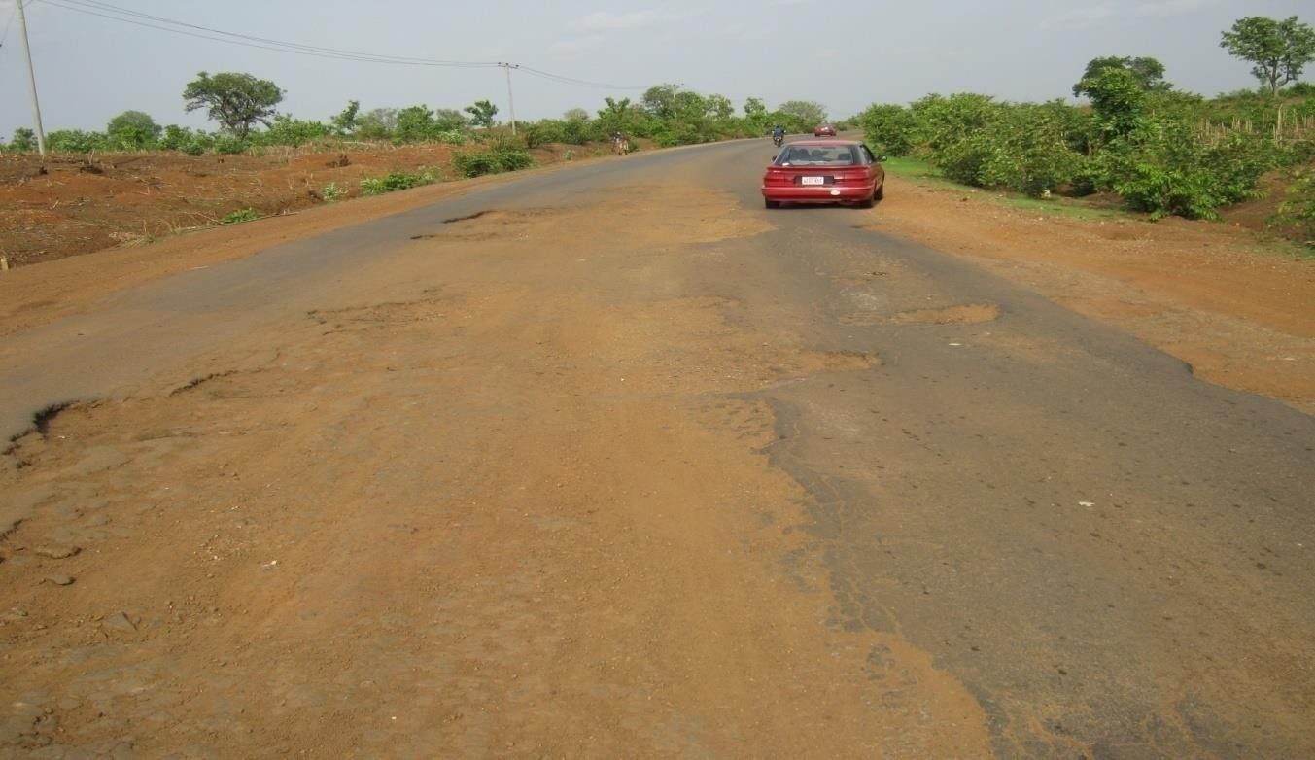

**Plate 1**: Failed section of the roadway at Mai Wayo Village (Sabon Eregi) along the Minna-Bida road.

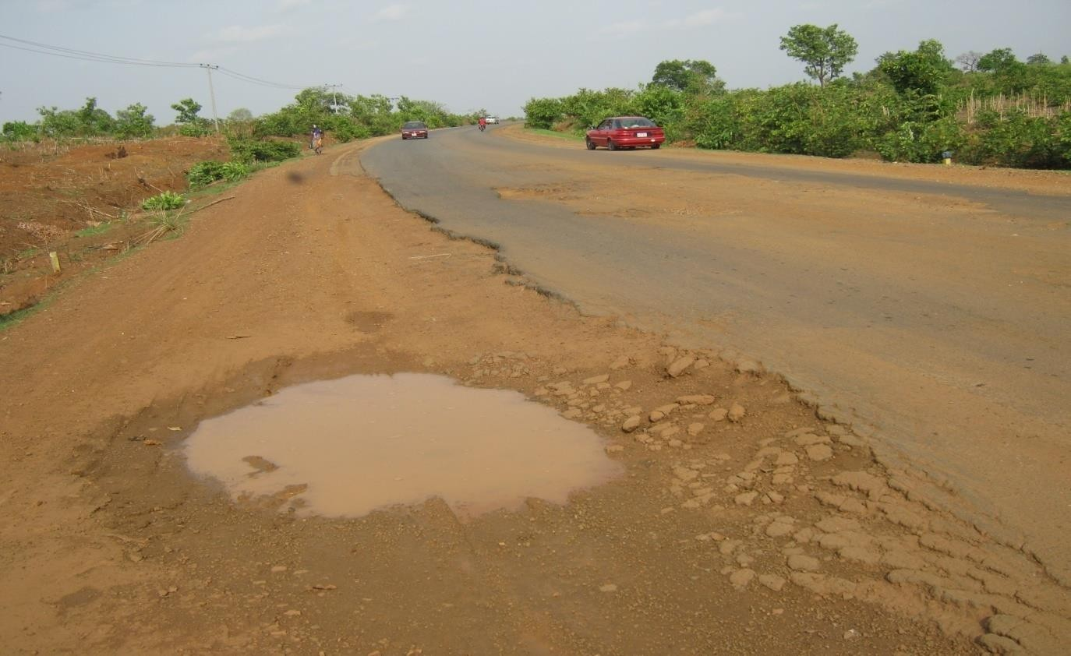

**Plate 2**: Water retained on the failed section of the road shoulder at Mai Wayo Village (Sabon Eregi) along the Minna-Bida road.

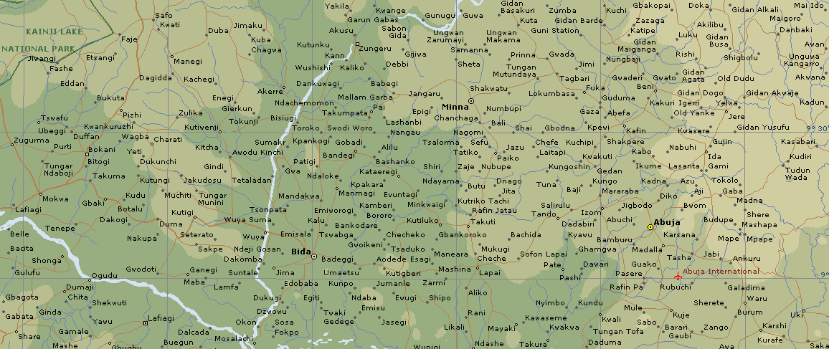

**Fig 3.1 Location Map Showing the Project Road (**Source: Microsoft @ Encarta, 2008)

## Sample Identification

Before the samples were collected, an idea about the properties of lateritic soil was known. This was done so that when samples are collected and taken to the laboratory for further analysis, they can be identified as lateritic soil. In general, the description included items which may be helpful in predicting the behavior of soil as well as those which help in characterizing it.

## Soil Sample Collection

The samples were collected at different locations beginning from 7km and ended at 79km along the Minna – Bida road. A number of three (3) samples, each for base- course, sub-base and sub-grade were collected at location 1 (7km), location 2 (15km), location 3 (23km), location 4 (31km), location 5 (39km), location 6 (47km), location 7 (55km), location 8 (63km), location 9 (71km), location 10 (79km) which makes a total of thirty (30) soil samples.

The base-course, sub-base and sub-grade material were collected at a depth ranging between 0-150mm, 150mm-300mm and 300mm-450mm respectively. About 25kg soil sample each for base-course, sub-base and sub-grade at various locations stated above were put in a moisture-proof bag and tied very well to disallow escape of moisture content in the sample. It was then taken to the Laboratory of the Department of Civil Engineering, Federal University of Technology, Minna, for further analysis. These samples were collected during the rainy Season.

## Storage of Soil Samples

After collection of soil samples, it was taken to the laboratory and the first physical test (i.e determination of natural moisture content) on the soil samples were conducted. Some of the soil samples used for the experiment were placed in different flat plates labeled to ease identification and air dried in the laboratory.

## Experimental Methods

The following laboratory test and experiments were conducted on the soil samples collected. These are natural moisture content determination, determination of particle size distribution (analysis), Atterberg’s limit test (Plastic and Liquid Limit test), compaction test (Dry Density/moisture content relationship) and California Bearing Ratio (CBR) test.

## Natural Moisture Content Determination

The natural moisture content determination of the soil samples was carried out in accordance with BS 1377 (1990), part 2, section 3. The type of test was the standard method (Oven Drying Method). This method covers the determination of the natural moisture content of the soil as a percentage of its dry mass. The apparatus used includes a thermostatically controlled drying oven, capable of maintaining a temperature ranging between 105oC to 110oC, an air tight non- corrodible container (Moisture Content Cans), a balance readable and accurate to 0.1g and a scoop.

The moisture content was calculated as follows:-

|  |  |  |
| --- | --- | --- |
| 𝑀𝐶 = {100 × (  Where; | 𝑤2 − | 𝑤3 )/(𝑤3 − 𝑤1 )} 3.1 |
| 𝑀𝐶 | = | Moisture Content (%) |
| 𝑊1 | = | weight of can (g) |
| 𝑊2 | = | weight of wet soil + can (g) |
| 𝑊3 | = | weight of dry soil + can (g) |
| 𝑤2 − 𝑤3 | = | weight of moisture (g) |
| 𝑤3 − 𝑤1 | = | weight of dry soil (g) |

## Particle Size Distribution Determination

According to BS 1377 (1990), part 2, section 9, the determination of particle size distribution can be carried out in three different ways. These are the standard method by wet sieving, the subsidiary method by dry sieving and the Hydrolysis analysis.

The percentage by mass of material retained on each test sieve was calculated as

follows:-

% 𝑅𝑒𝑡𝑎𝑖𝑛𝑒𝑑 𝑜𝑓 𝑆𝑜𝑖𝑙 𝑆𝑎𝑚𝑝𝑙𝑒 = 𝑊𝑒𝑖𝑔ℎ𝑡 𝑜𝑓 𝑆𝑜𝑖𝑙 𝑆𝑎𝑚𝑝𝑙𝑒 𝑅𝑒𝑡𝑎𝑖𝑛𝑒

𝑇𝑜𝑡𝑎𝑙 𝑊𝑒𝑖𝑔ℎ𝑡 𝑜𝑓 𝑆𝑜𝑖𝑙 𝑆𝑎𝑚𝑝𝑙𝑒 𝑈𝑠𝑒𝑑 (300𝑔)

× 100 (3.2)

## Liquid and Plastic Limits (Atterberg’s Limit Test)

* + - 1. **Liquid Limit**

**Cone Penetration Method** was adopted for this test. The test was carried out in accordance with BS 1377 (1990), part 2, section 4. It is the water content at which the soil changes from plastic to liquid behavior.

## Plastic Limit

The test was carried out in accordance to BS 1377 (1990), part 2, section 5. It covers the determination of the lowest moisture content at which the soil is plastic.

## Determination of Dry Density/Moisture Content Relationship

The 2.5kg rammer method was used, as described by BS 1377 (1990), part 4, section

3. This method covers the determination of the mass of dry soil per cubic meter when the soil is compacted in a specified manner over a range of moisture contents including that giving the maximum mass of dry soil per cubic meter.

The following parameters were used to obtain the OMC and MDD graphically as

presented in Appendix C.

𝑊𝑒𝑡 𝐷𝑒𝑛𝑠𝑖𝑡𝑦 (𝐷𝑤) = 𝑊2−𝑊1

𝑉𝑜𝑙𝑢𝑚𝑒 𝑜𝑓 𝑚𝑜𝑢𝑙𝑑

𝐷𝑟𝑦 𝐷𝑒𝑛𝑠𝑖𝑡𝑦 (𝐷𝑑) = (𝐷𝑤 ×100)

(100 +𝑀𝑐)

(3.3)

(3.4)

Where;

𝑀𝑐 = Moisture Content (%)

𝑊1 = weight of mould (g)

𝑊2 = weight of wet soil + mould (g)

𝑤2 − 𝑤1 = weight of wet soil (g) Volume of Mould = 944cc

## California Bearing Ratio (CBR) Determination

This test was carried out in accordance with BS 1377 (1990), part 4, section 7. It covers the determination of the California Bearing Ratio (CBR) of a soil, which is obtained by measuring the relationship between the force and penetration, when a cylindrical plunger of cross-sectional area 1935mm2 is made to penetrate the soil at a given rate. At any value of penetration, the ratio of force to a standard force is defined as the California Bearing Ratio (CBR).

The CBR values were calculated as follows:

𝐶𝐵𝑅 𝑎𝑡 2.5𝑚𝑚 = (𝐿𝑜𝑎𝑑) × 100 (3.5)

13.2

𝐶𝐵𝑅 𝑎𝑡 5.0𝑚𝑚 = (𝐿𝑜𝑎𝑑) × 100 (3.6)

19.6

# CHAPTER FOUR DISCUSSION OF RESULTS

Observations on the laboratory test results were based on the limits set in Federal Ministry of Works (1997) General Specification and Public Road Administration (PRA). Pavement layers tested for the purpose of this research are Base Course, Sub- Base and Sub-Grade. The results are discussed as follows:-

## Laboratory Test Results

* + 1. **Particle Size Distribution**

The distribution of the particle sizes obtained from the sieve analysis used for Base Course, Sub-Base and Sub-grade materials are presented in figures 4.1, 4.2 and 4.3 below.

100.0

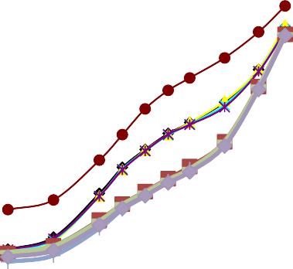

90.0

80.0

**Percentage Passing (%)**

70.0

60.0

50.0

40.0

30.0

20.0

10.0

0.0

0.010 0.100 1.000 10.000

**ParticleSize(mm)**

 Location 1

 Location 2

 Location 3

 Location 4

 Location 5

 Location 6

 Location 7

 Location 8

 Location 9

 Location 10

## Fig. 4.1 Particle Size Distribution for Base Course Materials at all locations

100.0

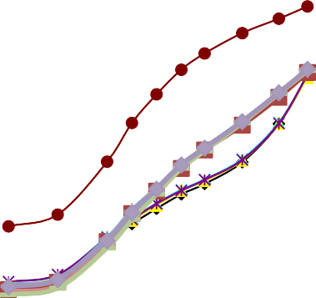

90.0

80.0

**Percentage Passing (%)**

70.0

60.0

50.0

40.0

30.0

20.0

10.0

0.0

0.010 0.100 1.000 10.000

**ParticleSize(mm)**

 Location 1

 Location 2

 Location 3

 Location 4

 Location 5

 Location 6

 Location 7

 Location 8

 Location 9

 Location 10

## Fig. 4.2 Particle Size Distribution for Sub-Base Materials at all locations

100.0

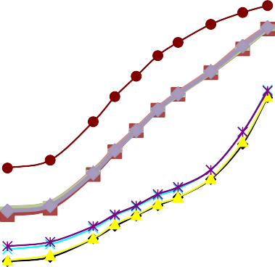

90.0

80.0

**Percentage Passing (%)**

70.0

60.0

50.0

40.0

30.0

20.0

10.0

0.0

0.010 0.100 1.000 10.000

**ParticleSize(mm)**

 Location 1

 Location 2

 Location 3

 Location 4

 Location 5

 Location 6

 Location 7

 Location 8

 Location 9

 Location 10

## Fig. 4.3 Particle Size Distribution for Sub-Grade Materials at all locations

Figures 4.1, 4.2 and 4.3 above show the particle size distribution for base course, sub-base and sub-grade materials at all locations respectively. The range 0.010 to 0.100 indicates silt region while 0.100 to 10.000 indicates gravel/sand region.

The base course and sub-base materials show that only 10% of the soil samples tested fell within the silt region and 90% within the gravel/sand region.

For the sub-grade, 80% of the soil samples tested fell within the silt/clay region and 20% within the gravel/sand region.

Generally, soil samples tested at all locations indicates higher proportion of gravel/sand fractions with moderate or lesser silt/clay fractions in them.

**4.1.1.2 Percent Passing BS Number 200 Sieve**

**Table 4.1 Percent Passing BS Sieve No.200 of Pavement Layers at Various Locations**

**Locations (km)**

|  |  |  |  |  |  |  |  |  |  |  |
| --- | --- | --- | --- | --- | --- | --- | --- | --- | --- | --- |
| **Granular Layers** | **7** | **15** | **23** | **31** | **39** | **47** | **55** | **63** | **71** | **79** |
| Base Course | 28 | 26 | 27 | 28 | 37 | 27 | 25 | 26 | 27 | 25 |
| Sub Base | 32 | 33 | 34 | 34 | 46 | 32 | 33 | 32 | 31 | 33 |
| Sub Grade | 33 | 33 | 36 | 37 | 57 | 45 | 46 | 46 | 46 | 46 |

From Table 4.1 above, test results on the base course soil samples show that the proportion passing sieve No. 200 ranges from 25 – 37% and the FMW & H (1997) specification requirement of percentage passing BS sieve No. 200 not exceeding 35% was met in many locations.

Test results on the sub-base soil samples indicate that the proportion passing sieve No.200 ranges from 31 – 46% and the FMW & H (1997) specification requirement of percentage passing BS sieve No. 200 not exceeding 35% was met in many locations.

Test results on the sub-grade soil samples indicate that the proportion passing sieve No.200 ranges from 33 – 57% and the FMW & H (1997) specification requirement of percentage passing BS sieve No. 200 not exceeding 35% was not met in about 80% of the locations. Sub-grade soils encountered at these locations were generally too fine for any pavement layer.

## Atterberg Limits

**Table 4.2 Atterberg Limits for Base Course Materials at all Locations**

|  |  |  |  |  |
| --- | --- | --- | --- | --- |
|  | **Locations (km)** | **LL** | **PL** | **PI** |
| 7 | 20 | 16 | 4 |
| 15 | 25 | 13 | 12 |
| 23 | 28 | 21 | 7 |
| 31 | 18 | 14 | 4 |
| 39 | 23 | 16 | 7 |
| 47 | 54 | 42 | 12 |
| 55 | 56 | 44 | 12 |
| 63 | 27 | 21 | 6 |
| 71 | 34 | 27 | 7 |
|  | 79 | 34 | 21 | 13 |

Table 4.2 above, shows that Liquid Limit ranges from 18 – 56% for Base Course soil samples and the FMW & H (1997) specification requirement of LL not exceeding 35% was met in many locations. While the plasticity index for Base Course soil samples ranges from 4 – 13% and the FMW & H (1997) specification requirement of PI not exceeding 12% was met in significant number of locations. This implies non-plastic soil was used in almost all locations as base course. Generally the liquid limit here signifies 80% of the soil samples used as Base Course material are within the required specified limit.

## Table 4.3 Atterberg Limits for Sub-Base Materials at all Locations

|  |  |  |  |  |
| --- | --- | --- | --- | --- |
|  | **Locations (km)** | **LL** | **PL** | **PI** |
|  | 7 | 17 | 14 | 3 |
|  | 15 | 20 | 11 | 9 |
|  | 23 | 20 | 15 | 5 |
|  | 31 | 18 | 16 | 2 |
|  | 39 | 62 | 28 | 34 |
|  | 47 | 38 | 22 | 16 |
|  | 55 | 40 | 20 | 20 |
|  | 63 | 34 | 30 | 4 |
|  | 71 | 35 | 24 | 11 |
|  | 79 | 32 | 17 | 15 |

For sub-base soil samples, Liquid Limit ranges from 17 – 62% and the specification requirement of LL not exceeding 35% was met in about 70% of the locations. The plasticity index ranges from 2 – 34% and the FMW & H (1997) specification requirement of PI not exceeding 12% was not met in some locations (i.e sub-base soil was found to be plastic in about 40% of the locations). Such soils undergo much change in volume upon introduction or withdrawal of water from them.

## Table 4.4 Atterberg Limits for Sub-Grade Materials at all Locations

|  |  |  |  |  |
| --- | --- | --- | --- | --- |
|  | **Locations (km)** | **LL** | **PL** | **PI** |
|  | 7 | 25 | 20 | 5 |
|  | 15 | 20 | 13 | 7 |
|  | 23 | 27 | 22 | 5 |
|  | 31 | 17 | 11 | 6 |
|  | 39 | 46 | 40 | 6 |
|  | 47 | 54 | 44 | 10 |
|  | 55 | 46 | 36 | 10 |
|  | 63 | 26 | 14 | 12 |
|  | 71 | 28 | 16 | 12 |
|  | 79 | 36 | 25 | 11 |

Sub-grade soil samples tested shows that the Liquid Limit ranges from 20 – 54% and the FMW & H (1997) specification requirement of LL not exceeding 50% was met in all locations except location 47km. Generally liquid limit here signifies that 90% of the soil samples used as Sub-grade material are within the required specified limit. Plasticity index for sub-grade soil samples ranges from 5 – 12% which implies that the specification requirement of PI not exceeding 30% was met in all the samples tested.

* + 1. **Compaction Test Results**

**Table 4.5 Optimum Moisture Content and Maximum Dry Density for Base Course, Sub-Base and Sub-Grade Materials at all Locations**

**Locations (km) OMC(%) MDD(g/cc)**

# BC SB SG BC SB SG

|  |  |  |  |  |  |  |
| --- | --- | --- | --- | --- | --- | --- |
| 7 | 10.8 | 8.0 | 11.6 | 1.940 | 2.055 | 1.882 |
| 15 | 10.8 | 9.5 | 15.0 | 1.940 | 2.050 | 1.992 |
| 23 | 11.8 | 6.9 | 13.0 | 1.915 | 2.092 | 1.900 |
| 31 | 6.2 | 13.0 | 8.0 | 2.088 | 1.992 | 1.880 |
| 39 | 8.4 | 11.8 | 8.0 | 2.048 | 2.016 | 1.876 |
| 47 | 11.1 | 4.5 | 7.7 | 1.930 | 2.130 | 2.072 |
| 55 | 10.5 | 8.6 | 7.8 | 1.900 | 2.075 | 2.072 |
| 63 | 7.5 | 6.0 | 7.0 | 2.150 | 2.100 | 2.092 |
| 71 | 8.5 | 7.0 | 7.0 | 1.887 | 2.084 | 2.092 |
| 79 | 10.6 | 6.9 | 7.6 | 1.920 | 2.070 | 2.080 |

The Federal Ministry of Works and Housing general specifications (1997) is silent on the MDD and OMC of lateritic soils. However, experience and research had shown that, the maximum dry density of lateritic soil ranges from 1.842 to 2.322 g/cc. Table 4.5 above shows MDD values ranging from 1.887 to 2.150, 1.992 to 2.130 and 1.876 to 2.092 g/cc for the base course, sub-base and sub-grade respectively. This is an indication that the maximum dry density of the soil samples at all locations is within the range for lateritic soils.

* + 1. **California Bearing Ratio (CBR) Values %**

**Table 4.6 California Bearing Ratio of Pavement Layers at Various Locations**

**Locations (km)**

|  |  |  |  |  |  |  |  |  |  |  |
| --- | --- | --- | --- | --- | --- | --- | --- | --- | --- | --- |
| **Granular Layers** | **7** | **15** | **23** | **31** | **39** | **47** | **55** | **63** | **71** | **79** |
| Base Course | 11 | 12 | 20 | 20 | 23 | 49 | 74 | 80 | 85 | 86 |
| Sub Base | 29 | 29 | 28 | 30 | 29 | 30 | 30 | 30 | 31 | 30 |
| Sub Grade | 8 | 7 | 6 | 5 | 9 | 9 | 9 | 9 | 9 | 9 |

Table 4.6 above, shows that the CBR values (un-soaked) for the base course soil samples ranged from 11 – 86% and the specification requirement of CBR values (un-soaked) not less than 80% was not achieved in about 70% of the locations. This indicates poor soil or strong reduction in the strength of the soil materials used in the construction of the base course.

The CBR values (24 hours soaked) of sub-base soil samples ranged from 28 – 31% and the specification requirement of CBR values (24 hours soaked) not less than 30% was not met in about 40% of the locations.

However, for sub-grade soils, specification is silent on CBR but 3 – 10% is common

FMW & H (1997). From the results shown above, about 80% of the locations tested for sub- grade were satisfactory.

From these results it can be suggested that, soil samples that did not meet the specified limit may be stabilized mechanically by blending with coarse sand/gravel in order to improve on their CBR values.

## Soil Classification Results

The Public Road Administration (PRA) system was used to classify the soil as follows;

For the base course, the dominant class of soil was the A-2-4(0) group followed closely by the A-2-6(0), A-2-7(0) and A-4(0).

For the sub-base, the A-2-4(0) group followed closely by the A-2-6(0) and A-7-6(8) were encountered while for the sub-grade, A-4(0,2), A-5(3,5), A-7-6(3) and A-2-4(0) were observed.

These observations indicate that the soil materials in the base course ranged A-4(0) to A-2-4(0) sand.

Also the soil materials in the sub base and sub grade ranged from A-7-8(8) to A-2-4(0).

This explains the reason why there are so many types of failures along the road ranging from wide cracks (longitudinally and transversely), potholes, corrugations at close intervals as well as failures along the shoulders.

This is because of the absence of sand/gravel fractions as depicted in the sieve analysis.

Table 4.7 gives the summary of the laboratory results of soils obtained at various locations along the Minna – Bida road.

# CHAPTER FIVE CONCLUSION AND RECOMMENDATIONS

## Conclusion

From the results and data presentation in this work, the following conclusions were drawn.

* + 1. The CBR values for the Sub-grade layer between locations 7 – 79km were satisfactory and within the specified range of the Federal Ministry of Works and Housing general specification criteria. For the Sub-base layer between locations 7 – 23km and 39km, the CBR values were low and fell outside the specified limit. The majority of the failures observed on this road lies within the Base Course layer, especially between locations 7 – 55km where the CBR values were low and outside the specified range of the Federal Ministry of Works and Housing criteria. The CBR Laboratory test conducted on Base Course layers along the above locations by the contractors during the construction process could be suspected.

1. The liquid limit test conducted on the soil samples indicates 80%, 70% and 90% of the locations met the specification requirement for the base course, sub-base and sub-grade respectively while 90%, 60% and 100% of the locations for the base course, sub-base and sub-grade respectively, met the FMW & H (1997) specification requirement for plasticity index.
2. The Laboratory test results obtained for the maximum dry density of the soil samples, are in conformity with the limits, i.e 1.842 to 2.322 g/cc which is within the range for lateritic soils.
3. From the reconnaissance survey and laboratory work, it can be seen that there

is the absence of fines passing sieve No. 200. However, it is possible that

there fractions have been leached during the rainy season over the years or they were not there in the first place. This is because, the presence of sub-drains was not noticed along the road and also, the drainage facilities on the road in terms of the verges seems inadequate.

## Recommendations

This work recommends the following for the proper improvement or construction of the road:

* + 1. Adequate provision should be made in the BEME for drainage and sub- drainage improvement in the form of intercepting drains, lined drains, turn outs and sub-drains on the entire length of the road in order to discourage percolation of water on the pavement structure and leaching of fine particles.
    2. Adequate supervision of road construction works by relevant professional Engineers should always be encouraged.
    3. Quality control in road construction should always be emphasized at the construction site.
    4. The road requires total reconstruction and not maintenance.

# REFERENCES

Amadi A.A (2011). *Evaluating the Potential use of Lateritic Soil mechanically stabilized with quarry fines for construction of road bases*. Nigeria Journal of Engineering Vol .17, No.2, 1-12

Bowles, J. (1992). *Engineering Properties of Soil and their Measurements*. 4th Edition Mc Grawhill Boston U.S.A

BSI (1990). *Methods of Testing Soils For Civil Engineering Purposes.*

British Standard Institution, BS 1377, London.

Buchanan, F (1807). *A journey from Madras through the countries of Mysore, Canara and Malabar*; 2 East Indian Company, London*,* PP 436 – 460.

Bunnett, R.B. (1973). *General Geography in Diagrams*. 4th Edition. PP 178-179. Carter, M. and Bentley, S.P. (1991). *Correlations Of Soil Properties*. PP 13,

PP 97-98.

Craig, R.F. (2004). *Soil Mechanics*. 7th Edition, Dept. of Civil Engineering, University of Dundee. PP 8.

Martin, F.J and Doyne, H.C (1927). *Laterite and Lateritic Soils in Sierra Leone*.

The journal of Agricultural Science, Vol. 17, PP 530-547

Fadamiro, J.A. and Ogunsemi, O.R (2010). *Fundamentals of Building, Design, Construction and Materials.* Fancy Publication Limited PP80, PP. 82.

FMW & H (1997). *General Specifications (Roads and Bridges)*. Volume II. The Director of Highways, Federal Ministry of Works and Housing Headquarters, Abuja, Nigeria. PP 202-215

Fletcher, G.A. and Smoots, V.A.(2012). *Construction Guide for Soils and foundation*.

pp. 67.

Gidigasu, M.D (1975). *The Formation and General Characteristics of Laterite soils.* Building and Road Research Institute, University Post Office Box 40, Kumasi, Gana.

Kadyali, L.R and LaI, N.B (2008). *Principles and Practices of Highway Engineering*.

Publishers, 2-B, Nath Market, Nai Sarak, Delhi-110006(India).

Lyons Associates (1971). *Laterite and Lateritic Soils and other Problem Soils in Africa*. An Engineering Study for Agency For International Development, AID/CSD – 2164, Lyons Associates/BRRI.

Maignien, R.(1966). *Review of Research on Laterites*. Natural Resources Research iv UNESCO, Paris.

Miller, R.W. and Donahue, R.L. (2011). *An Introduction to Soil and Plant Growth*.

6th Edition. PP. 66.

Ola, S.A (1978). *Geotechnical Properties and Behaviour of some Stabilized Nigerian Laterite Soil.* Quarterly Time Journal Engineering Geology, London, Vol. III, 1978. Pp 145-160

Osinubi K.J. and Nwaiwu C.M.O (2006). *Design of Compacted Lateritic Soil Liners and Covers*. J. Geotech. and Geoenviron. Engrg., ASCE, Vol. 132, No.2, 203-213.

Osinubi K.J. and Nwaiwu C.M.O (2008). *Desiccation Induced Shrinkage in Compacted Lateritic Soil.* J. Geotech. and Geol. Engrg., Springer, Netherlands, ISSN 0960-3182 (Print), 1513-1529 (Online).

Overseas Road Note 31 (1993). *A Guide to the Structural Design of Bitumen*

*Surfaced Roads in Tropical and Sub-Tropical Countries.* Overseas Centre, Transport Research Laboratory, Crowlhorne, Berkshire, United Kingdom, Fourth Edition. PP. 10-11.

Pendelton, R.L (1936). *On the Use of the term Laterite*. American Soil Survey Bull.

17, 102 – 108.

Singh, G. and Singh, J (2010). *Highway Engineering.* Standard Publishment.

Distributors, Nai, Serak. PP. 368, PP. 385-388.

Oguara, T.M. (2006). *Highway Engineering: Pavement Design, Construction*

*and Maintenance*. Dept. of Civil Engineering, River State University of Science and Technology, port Harcourt, Nigeria. PP 3

Uruaka, A.D. (2012). *Pavement Deterioration: Causes and Effect*. Vol.5,No.1 FERMA Digest ,2012.

Wild, A. (2012). *Russels Soil Conditions and Plant Growth*. 11th Edition.

PP. 205-206.

Wright, P.H and Paquette, R.J (1979). *Highway Engineering*. Fourth Edition.

PP. 450, PP. 456, PP. 459, PP. 462.