EVALUATION OF GEOLOGICAL MATERIALS WITH PLASTIC ADDITIVES FOR THE PRODUCTION OF DURABLE PAVEMENT BLOCKS: CASE STUDY OF OFFA, NORTH CENTRAL NIGERIA

BY

FOLORUNSHO, Owolabi Wahab MTech/SPS/2017/7353

DEPARTMENT OF GEOLOGY, SCHOOL OF PHYSICAL SCIENCES,

FEDERAL UNIVERSITY OF TECHNOLOGY, MINNA

July, 2021

# ABSTRACT

The management of plastic waste (whose generation is on the increase) poses a great challenge to environmentalists owning to its non-biodegradability. The research project aims at using waste plastic materials as binding groundmass in place of cement thereby producing pavement blocks that are more durable and more failure resistant than the existing cement derived pavement blocks(whose water absorption rate as well as moderate resistance to acidic condition is a major disadvantages). This also serves as a partial solution to the environmental and ecological challenges associated with the increasing use of plastics. Plastic wastes (PET and LDPE type) were melted at temperatures between 180˚C-250˚C and mixed in different proportions (by volume) with granite dust, sand and clay to produce sample paver blocks. The same mould was used to produce cement paver blocks. The sample blocks were subjected to Flexural test, acid test, test for compressive strength and water absorption test. Based on the four tests, comparison was drawn on plastic paver blocks against concrete paver blocks in terms of durability, corrosion resistance and viability. A fifth test (the oven test) was carried out on the plastic paver blocks to find out how much heat they could withstand before failing. Results obtained from both compressive and flexural tests showed higher strength and durability for plastic paver blocks against those made from cements. Results of water absorption test show abysmally low water absorption. The acid test shows that the plastic derived pavement blocks were more corrosion resistance than that derived from cement. The oven test shows that the blocks failed between 180˚C-220˚C. Based on these, it was be established that plastic paver blocks are more viable, failure resistant, cost effective and sustainable alternative to both cement paver blocks and asphalt paved roads.

# TABLE OF CONTENTS

Title page i

Declaration ii

Certification iii

Dedication iv

Acknowledgement v

Abstract vii

Table of Contents viii

List of Figures xii

List of Tables xiii

CHAPTER ONE

* 1. INTRODUCTION 1
  2. Background to the Study 1
  3. Statement of the Research Problem 4
  4. Aim and Objectives 4
  5. Study Area 6
     1. Location, Extent and Accessibility 6
     2. Relief and Drainage 6
  6. Scope of the Study 8

1.6 Justification 9

chapter TWO LITERATURE REVIEW

* 1. Geology and Structures of the Study Area 10
  2. General Overview of Geological Materials for Road Construction 11
  3. Asphalt Paved Roads 12
  4. Concrete 14
  5. Concrete Pavement Blocks 14
     1. Properties of Concrete Pavement Block 15
     2. Specification Requirements of A Good Concrete Pavement Block 16
  6. Concrete Roads and Asphalt Roads 16
     1. Advantages of Concrete Roadways 17
     2. Disadvantages of Concrete Roadways 17
     3. Advantages of Asphalt (Bitumen) Roads 18
     4. Disadvantages of Asphalt (Bitumen) Roads 18
  7. Polymers 18
     1. Polymer Modified Concrete 20
     2. Polymer Impregnated Concrete 21
     3. Polymer Concrete 22
     4. Interactions between Polymer and Cement 22
  8. Polyethylene Terephthalate (PET) and Low Density Polyethylene (LDPE) 25
     1. Polyethylene Terephthalate (PET) 25

2.8.1.2 Properties of Polyethylene Terephthalate (PET) 26

* + 1. Low Density Polyethelene (LDPE) 26
    2. Polyethylene Terephthalate (PET) and Low Density Polyethelene (LPDE) in Concrete Work 26
  1. Cement and Its Classification 29
  2. Solid Waste Management in Nigeria. 31
     1. Waste Management Methods 32

CHAPTER THREE

* 1. RESEARCH METHODOLOGY 37
  2. Materials 37
     1. Cement 37
     2. Granite Dust 38
     3. Sand 38
     4. Clay ` 41
     5. Polymeric Material (PET and LDPE) 41
        1. Polyethylene Terephthalate 41
        2. Low-density Polyethylene (LPDE) 43
  3. Tools 43
  4. Preparation of Samples 44
     1. Collection/Preparation of Aggregates and Plastic Materials 44
     2. Mix Proportion 44

3.3.4 Mixing, Casting, Curing for Concrete Paver Block 45

3.3.4 Mixing, Casting, Curing for Complete Replacement of Cement With

Plastic Melt 45

* 1. Tests Conducted 46
     1. Compressive Strength 46
     2. Water Absorption Test 47
     3. Flexural Test 47
     4. Oven Test 47
     5. Acid Test 47

CHAPTER FOUR

* 1. PRESENTATION AND DISCUSSION OF RESULTS 48
  2. Compressive Strength Test 48
     1. Result of Compressive Strength Test 48
     2. Discussion of Compression Test 49
  3. Water Absorption Test 49
     1. Result of Water Absorption Test 50
     2. Discussion of Water Absorption Test Result 51
  4. Flexural Test 52
     1. Result of Flexural Test 52
     2. Discussion of Flexural Test Result 53
  5. Oven Test 55

|  |  |
| --- | --- |
| 4.4.1 Result of Oven Test | 55 |
| 4.4.2 Discussion of Oven Test Results | 56 |
| 4.5 Acid Test | 57 |
| 4.5.1 Result for Compressive Strength after Activation with Acid | 57 |
| 4.5.1.1 Discussion of Compressive Strength after Activation with Acid | 63 |
| 4.5.2 Result for Flexural Strength after Activation with Acid | 60 |
| 4.5.2.1 Discussion of Flexural Strength after Activation with Acid | 71 |
| **CHAPTER FIVE**  **5.0 CONCLUSION AND RECOMMENDATION** | 72 |
| 5.1 Conclusion | 72 |
| 5.2 Recommendations | 72 |
| **REFERENCES** | 73 |

# LIST OF FIGURES

**FIGURE PAGE**

1. Map of the Location of the Study Area-Offa Municipality 7
2. Map of the Location of the Study Area-Offa Municipality 8
3. Geological Map of the Southern End of Kwara State, Showing Offa town 11

|  |  |  |
| --- | --- | --- |
| 4.1 | A Cross Section of the Study Area (Offa municipality) | 50 |
| 4.2 | Comparison of Compressive Strength of Sample Blocks | 50 |
| 4.3 | Comparison of Water Absorption Rate of Sample Blocks | 52 |
| 4.4 | Comparison of Flexural Strength of Sample Blocks | 54 |
| 4.5 | Comparison of Flexural Strength of Sample Blocks | 57 |
| 4.6a | Reaction of Block (Granite 50/50) to Activation with Acid | 59 |
| 4.6b | Reaction of Block (Granite 60/40) to Activation with Acid | 60 |
| 4.6c | Reaction of Block (Granite 70/30) to Activation with Acid | 60 |
| 4.6d | Reaction of Block (Sand 50/50) to Activation with Acid | 61 |
| 4.6e | Reaction of Block (Sand 60/40) to Activation with Acid | 61 |
| 4.6f | Reaction of Block (Sand 70/30) to Activation with Acid | 62 |
| 4.6g | Reaction of Block (Clay 50/50) to Activation with Acid | 62 |
| 4.6h | Reaction of Block (Clay 60/40) to Activation with Acid | 63 |

|  |  |  |
| --- | --- | --- |
| 4.6i | Reaction of Block (Clay 60/40) to Activation with Acid | 63 |
| 4.6j | Reaction of cement block to activation with weak acid | 64 |
| 4.7a | Reaction of Block (Granite 50/50) to Activation with Weak Acid | 67 |
| 4.7b | Reaction of Block (Granite 60/40) to Activation with Weak Acid | 67 |
| 4.7c | Reaction of Block (Granite 50/50) to Activation with Weak Acid | 68 |
| 4.7d | Reaction of Block (Sand 50/50) to Activation with Weak Acid | 68 |
| 4.7e | Reaction of Block (Sand 60/40) to Activation with Weak Acid | 69 |
| 4.7f | Reaction of Block (Sand 70/30) to Activation with Weak Acid | 69 |
| 4.7g | Reaction of Block (Granite 50/50) to Activation with Weak Acid | 70 |
| 4.7h | Reaction of Block (Clay 60/40) to Activation with Weak Acid | 70 |
| 4.7i | Reaction of Block (Clay 70/30) to Activation with Weak Acid | 71 |
| 4.7j | Reaction of Cement to Activation with Weak Acid | 71 |

# LIST OF TABLES

**TABLES PAGE**

* 1. Table of Compressive strength of Each of the Sample Paver Blocks 49
  2. Table of Water absorption Rate (%) of Each of the Sample Paver Blocks 51
  3. Table of Flexural Strength of Each of the Sample Paver Blocks 53
  4. Table Showing the Temperature at Which each of the Plastic Paver

Block Fails 56

* 1. Table of the Compressive Strength (N/mm2) of each of the Sample Paver Blocks Before and After Activation with Acid 58
  2. Table of the Forces at Breaking Points (N) of each of the Sample

Paver Blocks before and after Activation with Acid 66

# CHAPTER ONE INTRODUCTION

* 1. **Background to the Study**

Road networks that are of high quality are very important to the socio-economic development of any nation, especially the developing countries like Nigeria. The definition of a "road defect" includes any part of a road, highway, or construction site that does not meet the regulations for a safe road.

The causes of road failure in Nigeria as identified by many researchers include poor construction materials, poor design and specification, road usage, use of non professionals, poor drainage, geological and geotechnical factors (Aghamelu and Okogbue, 2011; Ofonime and Aniekan, 2005; Jegede, 2000;Adeyemi and Oyeyemi, 2000; Gidigasu, 1980).

The surface layer of the pavement structure is the most important layer as it is expected to provide the ultimate function of an economic, safe and comfortable riding surface to users, protecting the sub-structure layers (base, sub-base and subgrade) from infiltration of water and other foreign materials, and distribute stress from axle loads satisfactorily to layers beneath without compromising durability (Airey *et al*., 2002).

The nearness of the saturated zone to the land surface and the manner of fluctuation of this zone has direct effect on the geotechnical properties of the soil. These in turn influence the stability of engineering structures (like houses, bridges, dams and roads) (Brattebo & Booth, 2003).

Majority of the roads in Nigeria are asphalt paved roads. Their durability and frequent need for maintenance raises the question of cost effectiveness. Necessity they say is the mother of invention. Cement paved roads is becoming more popular in Nigeria, especially in Lagos

state. Areas like Lekki and Victoria Island are adorned with roads made from cement paved blocks not because cement paved roads are less expensive but because they are more durable. This “invention” for roads in these waterlogged and sandy areas was born out of necessity. In reality, many private estates have employed the use of paving stones within their estates because of their relative ease of construction and maintenance. They also last longer. Roads in government schemes like the Lekki Scheme 1 and Scheme 2 have also been extensively made from paving stones.

Asphalt roads are expensive to construct, do not last long before they fail in spots and even more expensive to maintain in these areas where the water level can literarily be at the surface in the raining seasons.

The American Concrete Pavement Association (ACPA) did a 90-year comparative cost-life cycle analysis and found out that despite a 15% difference in initial investment on concrete pavement in comparison with asphalted road, the cost differential was over 230% more for the asphalted pavement.

Interlocking pavements are special dry mix precast pieces of concrete commonly used in exterior landscaping pavement applications. It is an attractive engineering and economical alternative to both flexible and rigid pavements in recent times. They are versatile, aesthetically attractive, functional, greener and cost effective and require little or no maintenance if correctly manufactured and laid.

Despite the huge prospects, two areas of concern are occasional failure due to excessive surface wear, variation in the strength of the blocks, disintegration resulting from alternating wet and dry conditions as well as attack of surface by acidic solutions.

In the face of depleting natural resources worldwide, generation of wastes from industrial and residential areas is on a steady increase. Sustainable development (being a core mandate of environmentalists) involves the use of non-conventional and innovative materials, and recycling of waste materials in order to compensate the lack of infinite reserve of mineral resources as well as management of waste.

The economic growth, geometric population growth and changing pattern of consumption are resulting in the rapid increase in the use of plastics in the world. The use of plastic materials has increased from 5 million tons in the 1950s to 100 million tons in the 2000s (Tuffour, 2016). Although, there is little research based information on the amount of plastic waste generated in Nigeria, a report in the BusinessDay Newspaper of January 3, 2019 states that Lagos is estimated to generate about 14 to 15 thousand tons of waste daily. Of that, roughly 30 percent is recyclable, and 50 percent of this is plastic. In essence, about 2,250 tons of plastic waste is generated in Lagos on a daily basis. This is a significant portion of the total waste generated.

The challenge of waste disposal has become one of the most serious environmental problems facing many cities in Nigeria (Amadi *et al.*, 2012). Landfills are becoming scarce and the cost of building landfill sites are increasing. These results in open dump site burning (thereby causing great environmental pollution), blockage of drainages and waterways among other environmental challenges.

Recycling technology has been a solution of choice in the developed countries. Many developing countries including Nigeria are currently experiencing rapid urbanization and industrialization and as a result a lot of infrastructural developments could tap into turning

their environmental problem (abundance of plastic waste) into a source of cheaper and more durable construction materials. Expanded polystyrene (EPS) based waste, High Density Polyethylene (HDPE), Low Density Polyethylene (LDPE), Polyethylene Terephthalate (PET) waste bottles, polypropylene fibers and polyethylene bags have all been used in different forms by researchers in concrete (Kodua *et al.*, 2018).

Plastic wastes pose a greater management challenge because of its non-biodegradability. They are corrosion resistant, have long life, maintenance free and light weighted. All these attributes that makes its waste management difficult could be exploited to replace cement as the binding material for aggregates in the production of paver blocks.

LDPE and PET plastic are major components of Municipal Solid Waste (MSW) could thus be melted and mixed with aggregates to produce more durable, cost effective, corrosion resistant pavement blocks. Polymer modified pavement blocks in essence could be the perfect alternative to the less durable asphalt pavement as well as the cement derived pavement blocks

# Statement of Research Problem

Despite the fact that cement derived paver block roads have been found by various researchers to be a better replacement to asphalt paved roads, there are shortcomings that needs to be addressed especially disintegration caused by extreme wetting and drying, as well as weakening by corrosion. These defects can be overcome by plastic derived paver blocks.

Unlike the biodegradable solid wastes, plastic wastes have a very low degrading pace, making it difficult for waste managers to deal with. Therefore the need for an efficient, effective,

innovative and reliable method for managing plastic waste cannot be overemphasized. This waste management by recycling is a major plus for environmental Geologists

There is need to innovatively address the shortcomings iterated on cement paved roads as well as partially taking care of environmental challenges posed by plastic wastes is equally a target of the present research.

# Aim and Objectives

**Aim**

The research is aimed at producing failure resistant and durable pavement blocks for road construction, using plastic wastes as additives to clay, granite dust and sand.

# Objectives

* + 1. To produce pavement blocks from plastic waste materials (LPDEs and PETs) mixed with three geologic materials (granite dust, sand and clay) in different proportions by volume (50:50; 40:60 and 30:70). Since these materials vary in porosity, permeability, shear strength and corrosion resistance (largely owing to their mineralogical composition)
    2. To carry out flexural, compressive, water absorption, and corrosion test on sample pavement blocks produced from plastic waste.
    3. To compare their engineering properties with pavement blocks produced from cement.
    4. To determine the temperature at which pavement blocks made of plastic fails.
    5. To find out the suitability of plastic paver blocks as an alternative to cement paver blocks in the construction of durable roads, especially where low water absorption rate is desired to mitigate the water logging arising from near surface water table and base flow.
    6. To creatively manage plastic waste and its associated environmental challenges through its application in paver blocks production.

# Study Area

# Location, Extent and Accessibility

The study area is Offa municipality, Offa local government area of Kwara State. The area lies between latitudes 8°6’43”N and 8°8′10’’N and longitudes 4°43′00′′E and 4°44′0′′E and Covers a landmass of about 17 Km2. It is accessible through Ajasse-Oshogbo trunk ‘A’ road from either Oshogbo or Ilorin, both being capitals of Osun and Kwara states respectively. It is also accessible through rail, as the Lagos-Jebba rail line passes through the town. The train station situated in the town served as the terminus before the extension of the rail line to Kano. Offa has a population of about 180,000 inhabitants.

# Relief and Drainage

It has elevations of between 440m to 440m above sea level. The runoffs and streams are drained by Rivers Oyun and Afelele.

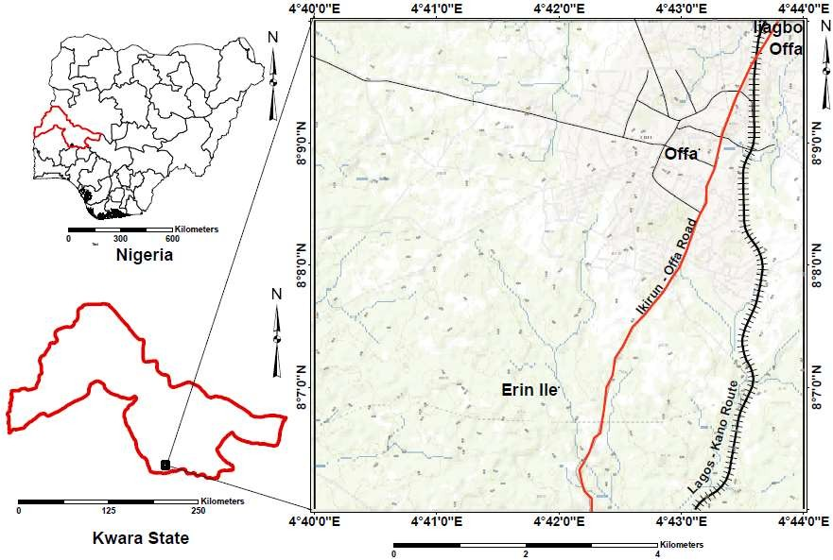

Figure 1: Location of the study area- Offa municipality (Source:Folorunsho and Amadi, 2020)

# Scope of the Study

The study area is about 17km2. The study area (lying between latitudes 8°6’43”N and 8°8′10’’N, and longitudes 4°43′00′′E and 4°44′0′′E) would be mapped. A cross section profile of the area would be produced from the geological map**.** The work will attempt a fair appraisal of the performance of asphalt paved roads, the causes of its failure and reasons why it will be

better to shift to the use of cement pavement blocks for building roads in Nigeria. The work will also try to evaluate the performance of plastic derived paver block as better road builder than the cement derived paver block.

In this research work, LDPE (like plastic grocery bags, squeezable bottles and sachet water nylons) and PET bottles were collected, washed and shredded into flakes, melted and then used to replace cement completely. Clay, granite dust and sand were mixed with the melt in different proportions by volume, so as to have concise engineering properties of the varying mix ratios. The same mould was used to produce cement paver blocks too. Established fundamental and empirical laboratory tests such as compressive strength, acid, water absorption, and flexural tests were carried out on the sample blocks, so as to compare the engineering properties of the various plastic derived blocks to the cement derived blocks. Oven tests were carried out on the plastic derived blocks to determine the heat condition that will make each sample block to fail. The Acid test would also be carried out to compare the corrosion resistance ability of both the plastic derived and cement derived paver blocks.

# Justification of the Study

Since Lagos State as the economic capital of the country has taken the lead in road construction using paver blocks, there is the likelihood of other states doing the same. Hence the urgent need to find solutions to the shortcomings of cement paver blocks.

The study will also reduce plastic waste menace and its associated hazards in the environment. These dual objectives can be achieved by replacing cement paver blocks with plastic paver blocks.

Several studies have been carried out in countries such as Egypt, India, Australia and U.S.A where plastic wastes have been converted to other products. Sadly, Nigeria has very few research efforts as well as published academic work in this direction, hence the need for the present study.

# CHAPTER TWO LITERATURE REVIEW

# Geology and Structures of the Study Area

The study area is Offa at the southern end of Kwara state. The rocks covering the area consists of the Precambrian Basement Fig (3). Radiometric dating indicates that the basement rocks of southwestern Nigeria is polycyclic and has responded to several tectonic events with differing intensities from Archean to late Proterozoic (Pan African) (Adelana *et al*.,2002).

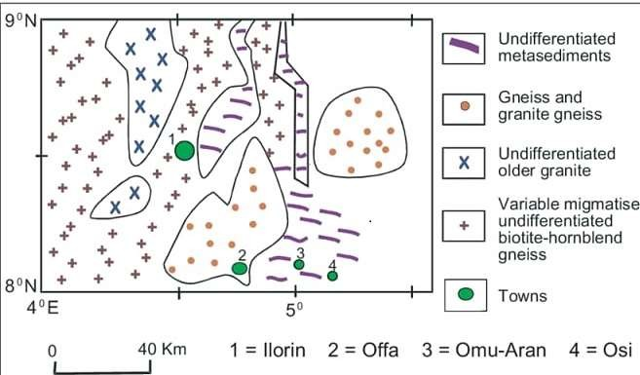

Figure 3: Geological map of the southern end of Kwara State showing Offa town as 2 (Adelana *et al.,* 2002)

Offa town is underlain by the hard rock suite consisting mainly of biotite gneiss with lenses and bands of biotite schists and pegmatite intrusions. Pegmatites in this area, within the Ilorin map sheet (sheet 50) area, occur as veins, dykes and irregular bodies that are ubiquitous in all

other units. Extensive outcrops of pegmatites which occur as irregular bodies have been mapped 14km NE of Offa (Oluyide *et al.,* 1998).

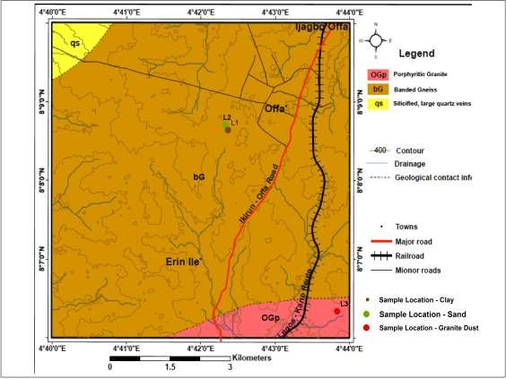

Figure 2: Geological map of the study area- Offa municipality, showing sample points (Folorunsho and Amadi, 2020)

Prominent structural trends (faulting and folding) have been observed in south western Nigeria.(Oyawoye,1972; Rahaman, 1989). Further information from the available borehole lithological logs (Adelana *et al.,* 2002) revealed that weathering is fairly deep and that rock shave been jointed and fractured severely. These joints and fractures have, to a large extent, controlled the flow direction of the rivers in the area (Olasehinde, 2002)

# General Overview of Geological Materials for Road Construction

The major use of geologic materials such rock, gravel, sand and clay is in construction of roads, buildings, dams and embankments. In other to ensure that the structure has permanence, the material used must be of high quality and sufficient durability to withstand the rigours and stresses posed by the environment.

All the major rock types (igneous, sedimentary and metamorphic) are used in construction, either as dimension stone or crushed stone. The rock is used by itself, or in combination with cement or bituminous mix. The rock should withstand repeated wetting and drying, freezing and thawing, chemical attack and abrasion. (Hudec, 2006)

Chemical composition, absorption and adsorption, density, porosity and chemical resistance are the principal properties considered in evaluating the durability of geolologic materials. Various rapid tests have been devised to simulate the environment of use and the rocks’ response to it to ensure that the rock will remain durable when used. Sand and gravel on one hand, and soil and clay on the other are the major geologic materials used in construction. The former is used as crushed stone above, and soil and clay are used as fill in embankments and dams. (Hudec, 2006)

# Asphalt Paved Roads

High-quality road networks are very important to the socio-economic development of any nation, especially the developing countries like Nigeria. According to Akiije and Oyekan (2012).

The World Fact Book of Central Intelligence Agency (2004, as quoted in Ijirshar, 2015) has it that out 193,200 km of total road network in Nigeria, 28,980 km are paved while 164,220 km are not. About 99% of those paved are asphalt paved.

Asphalt refers to a relatively thin high quality bituminous surface material on top of series of granular layers of a flexible pavement. Bitumen is used in producing asphalt because of their excellent cementing power, waterproofing properties and low cost (Airey *et al*., 2002).

Many paved roads are considered unsafe for vehicular movement because of pavement failures arising from the development of potholes and other road stress characteristics in the early life of the road between two to three years (Ogunribido et al, 2015)

According to Akiije and Oyekan (2012), asphalt is a relatively thin high quality bituminous surface material on top of series of granular layers of a flexible pavement. Bitumen is used in producing asphalt because of its excellent cementing power, waterproofing properties and low cost (Airey *et al*., 2002). The surface layer of the pavement structure is the most important layer as it is expected to provide the ultimate function of an economic, safe and comfortable riding surface to users, protecting the sub-structure layers (base, sub-base and sub-grade) from infiltration of water and other foreign materials, and distribute stress from axle loads satisfactorily to layers beneath without compromising durability.

The premature failure of road pavement shortly after construction or rehabilitation without meeting its designed life span has become a major challenge to highway engineers, contractors and the government in Nigeria. A study carried out by Federal Road Safety Corps of Nigeria FRSC, 2011 as quoted in (Olajuyigbe *et al.,* 2014) discovered that out of every

10,000 population, 162 deaths occur as a result of road crashes and Nigeria is currently ranked

191 of 192 countries with unsafe roads. According to CBN (2003), Nigeria road network is about 194,000 km. The Local Governments are in charge of 67%, State Government 16% and Federal Government 17%. The World Fact Book of Central Intelligence Agency (2004) has it that out 193,200 km of total road network in Nigeria, 28,980 km are paved while 164,220 km are not. Governments at all levels in Nigeria are presently embarking on road construction to provide networks of good roads to facilitate the transport of goods and services. However, many highways and roads are considered unsafe for vehicular movement because of pavement failures arising from the development of potholes and other road stress characteristics in the early life of the road between two to three years (Ogunribido *et al.*, 2015)

Road failure is when the infrastructural facility must have collapsed entirely. Road failure has caused set back to Nigerian economy by claiming many lives and property worth millions of naira through road crashes. The causes of roads failure in Nigeria as identified by many researchers include poor construction materials, poor design and specification, road usage, poor drainage, geological and geotechnical factors (Aghamelu and Okogbue, 2011; Ofonime and Aniekan, 2005; Jegede, 2000; Adeyemi and Oyeyemi, 2000; Gidigasu, 1980).

# Concrete

Concrete consist of sand or stone, known as aggregate combined with cement paste to bind it. It consist of binding material called cement, composed of lime, silica, alumina and gypsum, that is mixed with sand, aggregate and water (Pantelides *et al*., 2013).

The aggregates can be of various sizes. It is broadly categorized as fine or commonly sand and coarse (typically crushed stone or gravel).

Concrete is the most widely used construction material in the world due to its low cost, high availability, and simple constructability. However, the use of cement is a main contributor to high-energy usage, CO2 and dust emissions, natural resource depletion, air pollution, ozone layer destruction, global warming, and continuous environmental deterioration (Koo *et al*., 2014).

Concrete is relatively durable and robust building material, but it can be severely weakened by poor manufacture or a very aggressive environment. There are a number of historic concrete structures which exhibit problems that are related to their date of origin. Such problems are being solved by application of polymer in concrete construction (Hing, 2008).

# Concrete Pavement Blocks

Concrete pavement blocks were first manufactured in the Netherlands in 1924. It was probably World War II that led to the growth of concrete pavement blocks. Large areas of the Netherlands were destroyed during the War and, because clay bricks were in short supply, concrete pavement blocks were introduced as an alternative (Concrete Manufacturers Association, 2009).

These blocks are rectangular in shape and have more or less the same size as the brick. Common names for the concrete blocks include paving blocks, pavers, paving stones,

interlocking paving blocks and road stones. Paver sizes are a nominal 4x8 inches (100 x 200mm). Block thickness is specified according to traffic and SABS 1200 MJ specifies standard thicknesses of 50, 60, 80, 100 and 120mm. It is not normally economical to manufacture the last two sizes (Li, 2003).

Concrete pavement blocks (paver) have been used in pavements for more than 50 years in Europe. Pavers have been used in heavy industrial port and airfield pavement since 1970’s in Europe (Gencel *et al*., 2012).This is why recently concrete block pavements have become an attractive engineering and economical alternative to both flexible and rigid pavements. The strength, durability and aesthetically pleasing surfaces have made paving blocks attractive for many commercial, municipal and industrial applications such as parking areas, pedestrian walks, traffic inter- sections, container yards and roads (Gencel *et al*., 2012).Water-retentive concrete block pavements, are also used in areas frequented by many people including sideways, parks, and plazas, and such applications are expected to grow in the future (Qin *et al*., 2018).

# Properties of Concrete Pavement Block

1. Blocks should meet structural requirements for paving (specified in terms of block compressive strength).
2. Blocks should be durable: they should be able to withstand abrasion, impact and chemical attack.
3. Blocks should be of uniform dimensions to facilitate correct and easy placing and ensure good readability.

# Specification requirements of a good concrete pavement block

In some applications concrete blocks are required to be aesthetically attractive. The specification requires that the pavers comply with certain tolerances, and have a compressive

strength of 25MPa, for lightly trafficked situations, or 35MPa, for more severe conditions or where a wheel load greater than 30kN is encountered (cement & concrete institute, 2002).

The average absorption of pavement blocks should not exceed 5%, with no individual unit greater than 7% according to American Society for Testing and Materials (ASTM) specification, 2001.

# Concrete Roads and Asphalt Roads

Asphalt roads wear more than concrete roads, but many countries are replacing concrete roads with asphalt because it is cheaper, despite concrete roads having some major advantages.

# Advantages of Concrete Roadways

* + - * **Durability and maintenance free life:** Concrete roads have a long service life of forty years, whereas asphalt roads last for ten years. Moreover, during this service life concrete road do not require frequent repair or patching work like asphalt roads.
      * **Vehicles consume less fuel:** A vehicle, when run over a concrete road, consumes 15- 20% less fuel than that on asphalt roads. This is because of the fact that a concrete road does not get deflected under the wheels of loaded trucks.
      * **Resistant to automobile fuel spillage and extreme weather:** Unlike asphalt roads, concrete roads do not get damaged by the leaking oils from the vehicles or by the extreme weather conditions like excess rain or extreme heat.
      * **Greener process:** Asphalt (bitumen) produces lots of highly polluting gases at the time of melting it for paving. Also, less fuel consumption by the vehicle running on a

concrete road means less pollution.

# Disadvantages of Concrete Roadways

* + - * **Paving cost:** The paving cost of the concrete road is little higher compared to asphalt paving.
      * **Maintenance Problem:** In case the concrete road breaks, the whole concrete slab needs to be replaced.
      * **Safety features:** In rainy and the winter season vehicles tend to slip or slide on concrete road due to rain and snow.

# Advantages of Asphalt (Bitumen) Road

* + - * **Economical:** Asphalt is still less costly compared to concrete. Moreover, it takes less time to build an asphalt road than a concrete road.
      * **Recyclable:** Asphalt is a recyclable material. It can be reused by melting it.
      * **Easy maintenance:** Repairing just a part of the asphalt road is easily possible. Asphalt roads even can be relayed over the old layer.
      * **Safe:** Asphalt roads provide better traction and skid resistance for vehicles. Asphalt tends to help keep roads free from ice and snow.

# Disadvantages of Asphalt (Bitumen) Road

* + - * **Durability:** heavy rain and other extreme weather conditions damage the asphalt road, and the roads need to be repaired frequently.
      * **Weather Pollution:** Melting asphalt produces lots of harmful green house gases. Also costly petroleum is required to produce asphalt.

Concrete roads are highly durable, more environmentally friendly and cost effective (because of little or no need for maintenance) as compared to asphalt roads. However asphalt paving costs far less than concrete paving. Also, asphalt road provides better safety of the vehicle against snow and skidding.

# Polymers

The word polymer literally means many (poly) units (mer). A small, simple chemical unit appears to repeat itself a (very) large number of times in the structure of a polymer molecule or macromolecule. The so called repeat unit may consist of a single atom or more commonly small groups with the distinctive feature that the repeated units are successively linked to one another on each side by covalent bonds (Ghosh, 2006).

Polymers are substances whose molecules have high molar masses and are composed of a large number of repeating units. Polymers can be natural or synthetic. Some naturally occurring polymers are proteins, starches, cellulose, and latex. Synthetic polymers are produced commercially on a very large scale and have a wide range of properties and uses. The materials commonly called plastics are all synthetic polymers.

Polymers are produced by chemical reactions in which a large number of molecules called monomers are joined sequentially, forming a chain. In many polymers, only one monomer is used. Others too consist of two or three different monomers combined. Polymers are also classified by the characteristics of the reactions by which they are formed. If all atoms in the monomers are incorporated into the polymer, the polymer is called an addition polymer. On

the other hand, if some of the atoms of the monomers are released into small molecules, such as water, the polymer is called a condensation polymer.

Most addition polymers are made from monomers containing a double bond between carbon atoms. Such monomers are known as olefins, and most commercial addition polymers are polyolefin. Condensation polymers, are formed from monomers that have two different groups of atoms which can join together to form, for example, ester or amide links. Polyesters are an important class of commercial polymers, as are polyamides normally known as (nylon) (Shakhashiri, 1983).

The physical and chemical properties of polymers depend on the nature, arrangement of chemical groups of their composition and the magnitude of intra or intermolecular forces that is primary and secondary valence bonds present in the polymer. Degradation process occurs due to the influence of thermal, chemical, mechanical, radioactive and biochemical factors occurring over a period of time resulting in deterioration of mechanical properties and colour of polymers (Venkatachalam *et al*., 2012).

Polymers have a number of vital properties, which exploited alone or together, make a significant and expanding contribution to constructional needs (Tapkire *et al*., 2014).

* Durable and corrosion resistant.
* Good Insulation for cold, heat and sound saving energy
* It is economical and has a longer life.
* Maintenance free (such as painting is minimized)
* Hygienic and clean
* Ease of processing / installation
* Light weight

# Polymer Modified Concrete

Polymers have been used in construction as long ago as the fourth millennium B.C., when the clay brick walls of Babylonia were built using the natural polymer asphalt in the mortar. The temple of Ur-Nina (King of Lagash), in the city of Kish, had masonry foundations built with mortar made from 25 to 35% bitumen (a natural polymer) until in the year 1950’s where synthetic polymers were incorporated in Portland cement mortars and concrete (Hirde & Dudhal, 2016).

The use of polymers in construction works is becoming common in the world. It physical properties and relatively low cost makes it the most widely used construction material than conventional Portland cement concrete. Conventional Portland cement concrete has a number of limitations, such as low flexural strength, low failure strain, susceptibility to frost damage and low resistance to chemicals. These limitations are well recognized by the engineer and can usually be allowed for in most applications. Polymer modified binders also show improved adhesion and cohesion properties (Sulyman *et al*., 2016).

In some situations, these problems can be solved by using materials which contain an organic polymer or resin (commercial polymer) instead of or in conjunction with Portland cement. These relatively new materials offer the advantages of higher strength, improved durability, good resistance to corrosion and reduced water permeability. There are three principal classes of composite materials containing polymers (Yu and Hing, 2008). These are:

# 2.8.1 Polymer Impregnated Concrete

The first type which is the polymer impregnated concrete is made by impregnation of pre-cast hardened Portland cement concrete with low viscosity monomers (in either liquid or gaseous form) that are converted to solid polymer under the influence of physical agents (ultraviolet radiation or heat) or chemical agents (catalysts).

The monomers which are widely used in the impregnation of concrete are the vinyl type, such as methyl methacrylate (MMA), styrene, acrylonitrile, t-butyl styrene and vinyl acetate. The preferred impregnated materials are acrylic monomer systems such as methyl methacrylate or its mixtures with acrylonitrile, because they have low viscosity, good wetting properties, high reactivity, relatively low cost and result in products with superior properties. The applications of concrete impregnated in depth in building and construction include structural floors, high performance structures, food processing buildings, sewer pipes, and storage tanks for seawater, desalination plants and distilled water plants, marine structures, wall panels, tunnel liners, prefabricated tunnel sections and swimming pools (Hing, 2008).

# 2.7.3 Polymer Concrete

Polymer concrete (PC) is a composite material in which the binder consists mainly of a synthetic organic polymer. It is variously known as synthetic resin concrete, plastic resin concrete or simply resin concrete.

The use of a polymer instead of Portland cement represents a substantial increase in cost; polymers should be used only in applications in which the higher cost can be justified by

superior properties, low labor cost or low energy requirements during processing and handling (Yu and Hing, 2008, 2008).

# 2.8.3 Interactions between Polymer and Cement

Polymer modified concrete or mortar is a composite material consisting of two solid phases. These phases are: the aggregates which are discontinuously dispersed through the material and the binder which itself consists of a cementations phase and a polymer phase. According to the volume fraction of the polymer in the binder phase the material shifts from PCC (polymer cement concrete) to PC (polymer concrete). (Gemert *et al*., 2004).

In the case of PCC, the binder consists of a polymer-cement co-matrix. The polymer is added to the fresh mixture as an emulsion or as re-dispersible polymer powders. During hardening and curing, cement hydration and polymer film formation take place resulting in a co-matrix in which polymer film is intermingled with cement hydrates.

Cement hydration in polymer modified material is influenced by the presence of the polymer particles and polymer film in the fresh state, during hydration as well as in the hardened state. The properties such as strength of the fresh mixture are influenced to a large extent by the surfactants present at the surface of the polymer particles. The cement particles are better dispersed in the mixture and a more uniform material is formed. The hydration of the cement is reflected in the strength evolution of the material (Kodua, 2015).

The influence of the polymer modification is in two fold; firstly, due to the polymer and the surfactants, a retardation process of the cement hydration can be observed. This is especially visible in the compressive strength of the mortar beams. On the other hand, due to the film

formation or due to the interaction between the cement hydrates and the polymer particles, the tensile strength of the binder matrix as well as the adhesion strength between the aggregate and the binder increase.

The mutual influences between the cement hydrates and the polymer particles and film are incorporated in an integrated model of structure formation.

Immediately after mixing, the cement particles and polymer particles are dispersed in the water. The first hydration of the cement takes place, which results in an alkaline pore solution. This is indicated as the first stage.

In the second step, a portion of the polymer particles is deposed on the surface of the cement grain and the aggregate. The polymer-cement ratio determines the amount of polymers present in the pore solution and present at the aggregate surface. Part of the polymer particles may coalesce into a continuous film. This preferably takes place at the surface of the cement hydrates where extra forces are exerted on the polymer particles due to the extraction of water for cement hydration. The polymer film can partly or completely envelop a cement grain, which results in a retardation or even a complete stop of the hydration of the cement grain. The final step includes further hydration and final film formation. Through the cement hydrates, a continuous polymer film forms as water is further removed from the pore solution. The part of the polymer particles, that is still present in the dispersion, is restricted to the capillary pores and at the interface of the aggregates and the bulk polymer-cement phase. It is this part which contributes the most to the elastic and final strength properties. The continuity of the polymer phase through the binder matrix is more pronounced in the case of a higher

polymer- cement ratio. If the polymer dispersion is much more elevated than the curing

temperature, the polymer particles may not coalesce into a continuous film, but remain as closely packed polymer particles (Gemert *et al*., 2004).

# Polyethylene Terephthalate (PET) and Low Density Polyethylene (LDPE)

# Polyethylene Terephthalate (PET)

Polyethylene terephthalate (PET) is thermoplastic in nature, meaning it can be recycled after use. It is also known as polyester, which often causes confusion, because polyester resins are thermosetting materials (Tuffour, 2016).

PET is generally produced via two different routes or mechanisms; transesterification of dimethyl terephthalate (DMT) with ethylene glycol (EG) and direct esterification of purified terephthalicacid (TPA) with EG. The first stage of the two routes, known respectively as transesterification (ester interchange) and direct esterification, both produce a mixture of ethylene glycol ester of terephthalic acid. This mixture of linear oligomers (mainly bis- hydroxyethyl terephthalate) is subjected to a further stage known as polycondensation that produces polyethylene terephthalate of fiber-forming molecular weight. Solid state polymerization is required only for the production of bottles (El-Rub *et al.*, 2002). Poly (ethylene terephthalate) known by the trade names Mylar, Dacron , ethylene, recron has high crystalline melting temperature (260°C), and the stiff polymer chains possess in the PET polymer imparts high mechanical strength, toughness and fatigue resistance of 150- 175°C as well as good chemical, hydrolytic and solvent resistance. Poly (ethylene terephthalate) fiber has a very good crease resistance, good abrasion resistance and can be treated with cross- linking resin to impart permanent wash and wear properties. The fiber can be blended with

cotton and other cellulosic fibers to give better feel and moisture permeation. Thus PET fiber is used for applications such as wearing apparel, curtain, upholstery, thread, tire cord filaments, industrial fibers and fabric for industrial filtration (Venkatachalam *et al*., 2012)

# 2.8.1.1 Properties of polyethylene Terephthalate (PET)

PET is hygroscopic, which means that it absorbs water from its surroundings. However, when this "*damp*" PET is then heated, the water hydrolyzes the PET, decreasing its resilience. Thus, before the resin can be processed in a molding machine, it must be dried. Drying is achieved through the use of a desiccant or dryers before the PET is fed into the processing equipment. The polymer is composed of repeating units, each unit having a physical length of about 1.09 nm and a molecular weight of ~200. The aromatic ring coupled with short aliphatic chain makes the polymer a stiff molecule as compared to other aliphatic polymers such as polyolefin or polyamide. The lack of segmental mobility in the polymer chains results in relatively high thermal stability (Venkatachalam *et al*., 2012)

# Low Density Polyethelene (LDPE)

The LDPEs are very healthy plastic that to be both durable and flexible. Low density polyethylene LDPE is ductile and flexible material. It is stable in the temperature range from

−50 to 85°C, the melting point is from 105 to 115°C. In the oxygen absence LDPE is stable up to 290°C. It decomposes within 290 to 350 °C and thermoplastic products of lower molecular weight are formed. Gaseous products are formed in greater quantities above 350 °C and these gases contain as main component rather butene than ethylene. In the oxygen presence LDPE is less stable.

LDPE is insoluble at normal temperature but is soluble at higher temperatures in aliphatic, aromatic and halogenated hydrocarbons.

LDPE has advantageous properties in permeability. It practically does not permeate water and steam, but it has a good permeability to carbon dioxide and oxygen. These characteristics are specially used in packaging (especially of food items)The excellent physical and mechanical properties provide the wide range of applications of this polymer.

# Polyethylene Terephthalate (PET) and Low Density Polyethelene (LPDE) in concrete work.

PET is a transparent polymer, which has good mechanical properties and good dimensional stability under variable load (Sulyman *et al*., 2016).

To date, there are only three major ways which have been identified to recycle waste PET bottles into construction materials. Firstly, waste PET bottles can be depolymerized into unsaturated polyester resin to produce polymer mortar and polymer concrete. It benefits include that, the polymer concrete has higher compressive and flexural strength than conventional Portland cement concrete , and that polymer concrete achieves over 80% of its ultimate strength within 1 day. However, the properties of polymer concrete are sensitive and subjected to temperature and the cost of producing polymer concrete from waste plastic is high (Fan and Zhang, 2016).

The second method employs the use PET fibre to reinforce concrete. The use of PET fibre can enhance the ductility of quasi-brittle concrete and, therefore, reduce the cracking caused by plastic shrinkage. However, the water-resistance and low surface energy of plastic materials

result in a weak mechanical bond between the fibre and the cement matrix. Poor mechanical bond strength may cause internal micro-cracks in the interfacial mechanical bond area between the fibre and the cement matrix

The last recycling method is to substitute PET waste for a portion of the aggregate used in the production of lightweight concrete or asphalt concrete. This method provides the most economical way to accomplish two important goals: to dispose of waste plastic and to produce lightweight concrete. However, the addition of PET waste negatively affects the quality of the concrete by decreasing its compressive strength, splitting tensile strength, and modulus of elasticity Recently, a fourth method has been attempted whereby a recycled PET bottle flakes are directly used as binder. The PET plastics are heated and with two types of soil, clay and sand, to attain a uniform fused mix named plastic-soil. Recycled PET bottles used to produce mortar, have a promising results (Fan and Zhang, 2016).

In short, blocks with PET replacement have the following features as compared to conventional blocks:

* Greater weather resistant due to chemically inert PET and LDPE;
* Less stress or load on foundation (due to lighter blocks)
* Economical foundation (since the stress on foundation is less)
* Less manual labour in making blocks (mixture is lighter)
* Less cost of transportation (due to lighter blocks)
* Good sound insulation
* Variable strengths (dependent on size and nature of plastic aggregate)
* Better shock absorption
* Deduction in the dead load of concrete structure which allows the contractor to reduce the dimension of columns, footing sand other load bearing elements(precast strips with circular gaps) or by executing frames which have led to easy forms ( like caissons, - shaped roof elements).

# Cement and its Classification

Cement is a powdery binding substance that is used for construction; that sets, hardens, and adheres to other materials to bind them together. There are two main forms of cement: Geopolymer cement and Portland cement. Portland cement was used in this study, hence the need to focus on it.

There are different standards for classification of Portland cement. The two major classification standards are the ASTM C150 used primarily in the U.S and the EN-197 used in Europe. The two classifications however have five (5) types each but are not corresponding to the similar names they have.

# ASTM C150 Classification

**-Type I Portland Cement** is known as common or general purpose cement. It is generally assumed unless another type is specified.

**-Type II Portland Cement** is intended to have moderate sulphate resistance with or without moderate heat of hydration.

**-Type III Portland Cement** known for its low heat of hydration. It has relatively high early strength. It is similar to type I, but ground finer.

**-Type IV Portland Cement** is generally strength of the concrete develops slowly and after one or two years, the strength is higher than the other types after curing.

**-Type V Portland Cement** is also used where sulphate resistance is important.

# EN 197 Classifications

**EN 197-1** defines 5 classes of common cement that comprise Portland cement as a main constituent. These classes differ from the ASTM classes.

**-Type I Portland Cement:** composing Portland cement and up to 5% of minor additional constituents.

**Type II Portland Composite Cement:** Portland cement and up to 35% of other single constituents.

-**Type III Blast Furnace Cement:** Portland cement and higher percentages of blast furnace slag

**-Type IV Pozzolonic Cement:** Portland cement and up to 55% of pozzolanic constituents.

-**Type V Composite Cement:** Portland cement, blast furnace slag (impurities that are formed above metal melts) and pozzolana (a fine, sandy volcanic ash) or fly ash

Constituents that are permitted in Portland-composite cements are blast furnace slag, silica furne, natural and industrial pozzolans, silicious and calcareous fly ash (high lime fly ash), burnt shale and limestone.

# Solid Waste Management in Nigeria.

The estimated quantity of Municipal Solid Waste (MSW) generated worldwide is 1.7 – 1.9 billion metric ton (Modak, 2010). With rapid urbanization, the situation is becoming critical. The urban population has grown fivefold in the last six decades with 285.35 million people living in urban areas worldwide as per the 2001 Census (Asnani and Zurbrugg, 2006).Solid waste management is one of the basic essential services provided by municipal authorities in the country to keep urban centers clean. However, it is among the most poorly rendered services in Nigeria .The systems applied are unscientific, outdated and inefficient; population coverage is low; and the poor are marginalized. Solid Waste is littered all over leading to insanitary living conditions in our communities. Municipal laws governing the urban local bodies do not have adequate provisions to deal effectively with the ever- growing problem of solid waste management.

Municipal solid waste” (MSW) is a term usually applied to a heterogeneous collection of wastes produced in urban areas, the nature of which varies from region to region. The characteristics and quantity of the solid waste generated in a region is not only a function of the living standard and lifestyle of the region's inhabitants, but also of the abundance and type of the region's natural resources. Urban wastes can be subdivided into two major components

- organic and inorganic. In general, the organic components of urban solid waste can be

classified into three broad categories: Perishables, fermentable, and non-fermentable.

Perishable wastes tend to decompose rapidly and unless carefully controlled, decompose with the production of objectionable odours and visual unpleasantness. Fermentable wastes tend to decompose rapidly, but without the unpleasant accompaniments of putrefaction. Inorganic waste on the other hand refers to all wastes from non-biological origin. Examples of inorganic wastes are aluminium cans, spoons, plastics, glass and ceramics. They generally take a very long time to disintegrate.

# Waste Management Methods

* + - * **Landfills**

Landfills, being simple and economical, are globally the most common system of waste disposal. It involves the burial of waste materials. Landfills that are not properly designed or managed may create several environmental hazards and diseases due to the dispersion of garbage by wind, the attraction of rats, and other similar reasons. Landfills are normally developed in unused pits located at a distance from the developed areas so that its harmful effects can be avoided. The waste accumulated in the landfill is reduced in size by compaction to permit maximum storage of waste, and is enclosed to avoid rats or mice. Some landfills include systems for the extraction of gas that is used for the generation of electricity.

It is essential that the landfills do not pollute the surface water or the ground water, and this is ensured by lining the landfill, compaction of the upper layer, and selection of sites that are not subjected to floods. Leakage from landfill waste can be minimized by solidification with cement or asphalt.

# Incineration

Incineration is a process in which the waste material is subjected to intense heating in the presence of oxygen inside a incinerator (furnace), resulting in the production of ash, flue, and gas. Incineration doesn't exactly destroy all the waste, instead it decreases the volume of the waste by 60-70%. This compressed waste can then be buried in earth through the process of land filling. After landfills, incineration is the most widely used method to eliminate the solid, liquid, and gaseous waste. Hazardous air contaminants are released by the burning of waste, due to which there are serious public concerns regarding environmental pollution. The combustion is generally not complete in an incinerator, due to which the gaseous emissions contain micro-pollutants that are not safe for the area near the incinerator. Although incinerators are used all over the world, public opposition to these have been growing as new research has claimed that the gases produced during this process pose greater danger to the environment than the waste materials. In countries where adequate space is not available for landfills, incineration is more practicable.

# Recycling

Recycling is probably the most ideal way of managing waste, but it can be costly and difficult to implement. There are numerous products that can be recycled instead of thrown away including aluminium and steel cans, glass bottles, paper, and scrap metal. It is becoming more popular to complete this process and successful marketing is making recycled materials more likely to be purchased. In the long run, recycling can save money and resources as well as keep the environment cleaner.

# Composting

You can create compost in your own house to dispose of organic wastes. Ideally this should be in everyone's homes as waste materials like branches and leaves can be easily disposed off. More importantly, compost is beneficial for the environment as unnecessary refuse is not dumped into a landfill. This goes a long way in ensuring that methane - a greenhouse gas, is produced in lesser volume in the landfills. Rather than throwing away leaves and other household organic matter, you should use them as compost. This will help in replenishment of soil, thereby reducing cost of land reclamation.

# Open Burning

Open burning of solid waste greatly reduces its volume, thereby decreasing the stress on a dumpsite. Open burning has remained one of the widely practiced methods of waste management. However, open burning releases toxic gases directly into the atmosphere and has many negative effects on our environment. The poisonous gases that are released into the atmosphere are harmful for humans as well as other animals. They affect the respiratory and reproductive system, and therefore, this sort of waste management is discouraged and other methods in which the release of poisonous gases in the atmosphere is controlled should be opted for.

# Pyrolysis and Gasification

Pyrolysis works on the same methodology as incineration, i.e. burning solid waste at high temperatures to compress its size. Pyrolysis differs from incineration in the aspect that solid waste is burned in the absence of oxygen. Gasification, on the other hand, allows a low supply

of oxygen to convert waste into combustible and non-combustible gases along with some liquids. The end material can then be used as heat energy, and the leftover waste can then be taken for land filling which will take comparatively lesser space.

# Land filling and Dumps

Landfills and dumps are used to store waste materials beneath the soil. In many cases, remnants of waste material are not disposed even during the process of incineration, pyrolysis, and gasification. These waste materials are transported to landfills and dumps, where these are buried under the soil. Care is taken to ensure that leachate (liquid waste) doesn't permeate through and pose a threat to the environment. Many landfills/dumps are also designed in such a way that energy released during the process of decomposition of waste is tapped and used for generating power. Decomposition of waste takes a lot of time which, in turn, affects the refilling of landfills/dumps. However, with the introduction of bioreactor landfills, this challenge has been tackled to a large extent.

# Disposal of Hazardous Waste Methods

Some of the most common waste disposable methods include incineration, composting and landfills. However, disposal of hazardous wastes in landfills and incinerators has its own concerns, especially leaking of toxins into surrounding groundwater. A major source of drinking water is groundwater and if that becomes contaminated, it becomes extremely costly and difficult to purify it. Ideally, hazardous substances should be converted into non- hazardous form. To achieve this, several new technologies like high-temperature plasma torch

have come up which are able to convert hazardous wastes like low-level radioactive wastes to glass which is environmentally safe.

Incineration is also used to dispose off hazardous wastes, wherein these refuse is changed into inorganic by-products, water and carbon dioxide. However, the cost associated with burning hazardous wastes is high besides, difficulty in disposal of wastes.

Bioremediation is another process which is used to dispose off hazardous wastes and convert them into nontoxic products. The process includes the use of natural degradation processes and microorganisms. However, this process requires a long time and at times it becomes difficult to control the process of natural degradation.

Thus, there are numerous waste disposal methods of which landfills and burning are the most common. We should all try to minimize the amount of wastes we produce every day so that we don't exert pressure on the environment. Moreover, the cost associated with disposing off wastes runs into millions of dollars, so, it is better that we adopt the policy of **reduce, reuse, and recycle**.

# CHAPTER THREE RESEARCH METHODOLOGY

# Materials

The materials used in the production of the pavement blocks used for this study are cement, granite dust, sand and clay.

# Cement

Cement is a powdery binding substance that is used for construction; that sets, hardens, and adheres to other materials to bind them together. There are two main forms of cement: Geopolymer cement and Portland cement. Portland cement was used in this study, hence the need to focus on it.

When water is mixed with Portland, the product sets in a few hours and hardens over a period of weeks. These processes can vary widely depending on the mix used and the condition of curing of the product, but a typical concrete sets (Becomes rigid) in about 6 hours, and develops a compressive strength of 8 MPa in 24 hours. The strength rises to 15 MPa at 3 days, 23 MPa at one week, 35 MPa at 4 weeks, and 41 MPa at three month. In principle, the strength continues to rise slowly as long as water is available for continued hydration, but concrete is usually allowed to dry out after a few weeks, and this causes strength growth to stop.

The formation of water-containing compounds as a result of reactions between cement component and water causes setting and hardening of Potland cement. Usually, cement reacts in a plastic mixture only at water/cement ratios between 0.25 and 0.75. the reaction and the

reaction products are referred to as hydration and hydrates respectively. As a result of the reactions (which starts immediately), stiffening can be observed which is very small aat the beginning and increases with time. Stiffening setting and hardening are caused by the formation of a microstructure of hydration products of varying rigidity which fills the interstitial spaces between the solid particles of the cement paste, mortar or concrete. The behaviour with time of the stiffening, setting and hardening therefore depends to a very great extent on the size of the interstitial spaces that is on the water/cement ratio.

# Granite Dust

Granite is a common and widely occurring type of intrusive , felsic, igneous rock. It is formed from a magma that is particularly high in its amount of sodium, aluminium and potassium, and are composed of more than 65% silica called felsic magma. It is an intrusive ignous rock and the amount of silica present demands a low temperature for cooling (Pidwirney, 2013).

Granite dusts are irregular, angular porous and have rough and crystalline surface texture. The particle size is nearly similar to fine sand. The particles have interlocking characteristics and it has a specific gravity that varies from 2.36 -2.72 depending on its source stone. (Sarbjeet *et al*., 2016). They are sometimes resulting as waste from rock cuttings and crushing and at some other times deliberately grinded to that size to suit construction purpose.

# Sand

Green sand: By green sand we denote sand in its natural, more or less moist state. It is a mixture of silica sand with 18 to 30 percent clay, having a total water of from 6 to 8 percent. The clay and water furnish the bond for green sand. It is fine, soft, light and porous. Being

damped, it retains the shape, the impression given to it under pressure when squeezed in the hand. Molds prepared in this sand are known as green sand molds.

Dry sand: Green sand that has been dried or baked after the mold is made is called dry sand. These are suitable for large castings. Molds prepared in this sand are known as dry sand molds.

Loam sand: It has high clay content, as much as 50 percent and dries hard. This is particularly employed for loam molding usually for large castings.

Molding sand properties:

The properties that are generally required in moulding materials are:

1. Refractoriness:

It is the ability of the moulding material to resist the temperature of the liquid metal to be poured so that it does not get fused with the metal. The refractoriness of the silica sand is highest. Sands with poor refractoriness may burn on to the casting. It is measured by the sinter point of the sand rather than its melting point

1. Permeability or porosity:

During pouring and subsequent solidification of a casting, a large amount of gases and steam is generated. These gases are those that have been absorbed by the metal during melting, air absorbed from the atmosphere and the steam generated by the moulding and core sand. If these gases are not allowed to escape from the mould, they would be entrapped inside the casting and cause casting defects. To overcome this problem the moulding material must be

porous. Proper venting of the mould also helps in escaping the gases that are generated inside the mould cavity.

1. Green Strength: The moulding sand that contains moisture is termed as green sand. The green sand particles must have the ability to cling to each other to impart sufficient strength to the mould. The green sand must have enough strength so that the constructed mould retains its shape.
2. Dry Strength: When the molten metal is poured in the mould, the sand around the mould cavity is quickly converted into dry sand as the moisture in the sand evaporates due to the heat of the molten metal. At this stage the moulding sand must possess the sufficient strength to retain the exact shape of the mould cavity and at the same time it must be able to withstand the metallostatic pressure of the liquid material.
3. Hot Strength:

As soon as the moisture is eliminated, the sand would reach at a high temperature when the metal in the mould is still in liquid state. The strength of the sand that is required to hold the shape of the cavity is called hot strength.

1. Collapsibility:

The molding sand should also have collapsibility so that during the contraction of the solidified casting it does not provide any resistance, which may result in cracks in the castings.

1. Flowability:

The property of the moulding sand to flow and fill the narrow portions surrounding the pattern and the sand should have good flowability.

1. Surface finish:

It should have the ability to produce good surface finish in the casting.

1. Reclamation:

It should be reclaimed and reused. Besides these specific properties the molding material should be cheap, reusable and should have good thermal conductivity.

# Clay

Clay refers to naturally occurring material composed primarily of fine-grained minerals, which is generally plastic at appropriate water contents and will harden when fired or dried." The minerals found in clay are generally silicates less than 2 microns (one millionth of a meter) in size, about the same size as a virus. Clays are very abundant at the earth's surface; they form rocks known as shales and are a major component in nearly all sedimentary rocks. The small size of the particles and their unique crystal structures give clay materials special properties, including cation exchange capabilities, plastic behavior when wet, catalytic abilities, swelling behavior, and low permeabilities.

Clay minerals are used as coatings on paper to produce whiteness and to allow the proper absorption of ink, to extend the life of rubber in tires, in concrete, as catalysts in many industries, to purify oils, in pharmaceuticals, in the ceramic industry to make bricks, chinas

and porcelains, and in many other industries and processes. Clay minerals, and specifically montmorillonite, are used as clay barriers for nuclear and chemical wastes because of their cation-exchange capabilities, low permeability, and long term structural stability.

Clay minerals are commonly phyllosilicates or layer silicates. These minerals have platy morphology because of the arrangement of atoms in the structure.

# Polymeric Material (PET and LDPE)

# Polyethylene Terephthalate

Polyethylene terephthalate (PET) is a multipurpose thermoplastic polymer that belongs to the polyester family of polymers. Polyester resins are known for their excellent combination of properties such as mechanical, thermal, chemical resistance as well as dimensional stability. All these are properties that are exploited for recycling them into very durable pavement blocks.

PET is one of the most recycled thermoplastic, and has the number "1" as its recycling symbol. Examples of PET derived items include water and beverage bottles, medicine jars, ropes, clothing and carpet fibre.

# Key Properties of PET Resin

-It has higher strength and stiffness than PBT

-It is very strong and lightweight and hence easy and efficient to transport

-It is known for its good gas (oxygen, carbon dioxide) and moisture barrier properties

-It exhibits excellent electrical insulating properties

-PET has broad range of use temperature, from -60 to 130°C

-As compared to PBT, it also has higher heat distortion temperature (HDT)

-It has low gas permeability, in particularly with carbon dioxide

-PET is suitable for transparent applications, when quenching during processing

-PET doesn’t not break or fracture. It is practically shatter-resistant and hence, a suitable glass-replacement in some applications

-It is recyclable and transparent to microwave radiation

-PET is approved as safe for contact with foods and beverages by the FDA, Health Canada, EFSA & other health agencies

# Chemical Properties

* Excellent resistance to alcohols, aliphatic hydrocarbons, oils, greases and diluted acids
* Moderate resistance to diluted alkalis, aromatic & halogenated hydrocarbons.

# Low-Density Polyethylene (LPDE)

**LPDE** is a very healthy plastic that tends to be both durable and flexible. It belongs to the family of polymers referred to collectively as a polyolefin. These polymers comprise C and H atoms and are distinguished by their low density (will float on water). LPDE is one of the most recycled thermoplastic, and has the number "4" as its recycling symbol. Examples of items made from LPDE include sandwich bags, squeezable bottles and plastic grocery bags.

LDPE is a high branched PE. Its high ramification confers a low density to the molecule as well as a lower hardness, stiffness and strength than high density polyethylene.

* 1. **Tools**

The equipments/tools used during the course of the pavement blocks are:

* Hand gloves
* nose masks
* safety boots
* 1 melting barrel
* A spade with a metal shaft for staring of hot mix
* Industrial gas as source of heat
* Mould (200mm x 100mm x 75mm)
* Used engine oil for lubrication
* Metal table for mould placement
* Hand trowel
* A Pyrometer

# Preparation of Samples

# Collection/preparation of aggregates and plastic materials

* + - * **Cement:** Ordinary Portland cement was gotten from the open market designated as CEM I in the present Nigeria Industrial Standard for cement NIS 444-1:2003 [3](that is; cement with 95% to 100%blinker and gypsium, and 0%-5%minor additional constituent)
      * **Granite dust:** Granite dust was collected from local stone crushing unit from Offa, Kwara state. It was dry at the point of collection and was sieved by IS: 4.75mm sieve at the civil Engineering department, Federal Polytechnic, Offa.
      * **Sand:** Clean sand was collected along Alagbaa River channel in Offa, Offa Local Government, Kwara State. It was oven dried at the Civil Engineering department of the Federal Polytechnic, Offa.
      * **Clay:** Clay was collected from a hand dug well around Owode market in Offa. The clay was sundried, pounded (to loosen the particles) to a fine powder.
      * **Plastic Materials:** The plastic materials (PET and LDPE) were sourced from restaurants, campuses and Owode market- all in Offa municipality. They were washed and then shredded into very small pieces by a grinder at a local plastic processing outlet.

# Mix proportion

* **Production of pavement blocks from plastic melt and granite dust**

Production of pavement blocks by mixing plastic melt and granite dust in three (3) different proportions by volume in ratios of 50:50, 40:60 and 30:70.

# Production of pavement blocks from plastic melt and sand

Production of pavement blocks by mixing plastic melt and sand in three (3) different proportions by volume in ratios of 50:50, 40:60 and 30:70.

# Production of pavement blocks from plastic melt and clay

Production of pavement blocks by mixing plastic melt and clay in three (3) different proportions by volume in ratios of 50:50, 40:60 and 30:70.

# Production of pavement blocks from cement and aggregates

The concrete mix of 1:2:4 (cement:Sand:stone chips ) by volume was used with water to cement ratio of 0.6.

# Mixing, Casting, Curing for concrete paver block

The materials (cement, sand and stone chips in the ratio 1:2:4 respectively) were mixed thoroughly with a shovel until a uniform mix was obtained. Water was added in a ratio not exceeding 0.6 to cement. The resultant mix was discharged into the moulds and compacted by a metal rammer. The pavement blocks were then demoulded and kept for 24hours under shade. The blocks were then hardened and cured with water to allow moisturization for 14 to 21 days. After curing, the blocks were dried in the natural atmosphere before taking them to the laboratory. A total of 30 pavement blocks were produced.

# Mixing, casting, curing for complete replacement of cement with plastic melt

-A required volume of shredded plastic was measured into the melting barrel.

-Heat was applied steadily and the plastic melted completely into a uniform thick melt.

-The corresponding volumes of geologic material (granite dust, sand or clay) were added.

-The mixture was continuously stirred until a uniform paste was obtained.

-A thin film of used engine oil was applied to the inner walls of the mould to ease the removal of the pavement blocks after hardening.

-The resulting material was transferred to the metallic mould and compacted with a metal rammer.

-After about 1 to 2hours (depending on the prevailing atmospheric temperature), the pavement block would have attained full rigidity and ready for use.

-Twenty samples were produced for each specimen of pavement blocks produced.

# Tests conducted

Four tests were conducted for the study namely; Compression test, Water absorption test, Flexural test and Oven test. Comparison was made based on all except the oven test which was undertaken to determine the temperature at which the products would fail.

# Compressive strength

According to the SNI 03 – 0691 -1989 and British Standard BS 6717:1986, the strength of a paving block can be determined by the maximum carrying capacity under distributed load. The blocks are placed under a compression apparatus, and the compression strength at failure is recorded.

Three samples were tested for each specimen and their average values were taken as the compressive strength of that specimen. The Universal Testing Machine was used to measure the load that crushes each sample. The compressive strength was calculated using the following Formula

Compressive strength=Load/Area; where the surface area for each sample is 200mm×100mm

=20,000mm2

# Water absorption test (W.A.R)

Water absorption test gives a clue on the internal structure of aggregates. Aggregates having more absorption values are more porous in nature and are generally considered unsuitable, unless found to be acceptable based on strength, impact and hardness tests.

The pavement block samples were oven dried for 24hours and weighed, the weight was taken as weightdry. The blocks were then socked in water for 24 hours and the weight taken as weightwet. The water absorbtion rate was calculated as

W.A.R= weightwet. - weightdry x100%

weightdry

# Flexural test

The flexural strength of a material is refers to the maximum bending stress that can be applied to that material. This was measured using a universal testing machine

# Oven Test .

The oven test was carried out to determine the temperature at which the pavement block samples made from plastic wastes will fail. This gives an idea of the heat resistance ability of the blocks. However, the cement blocks were not subjected to the oven test because heat do not cause a change of state in concrete as it does in plastic materials and their derivatives.

# Acid Test

Block samples were digested with a weak sulphuric acid (H2SO4) with pH value of 6. Both compressive and flexural tests were carried out on the block samples after 10, 20, 30, 40, 50, 60,70,80,90 and 100days. These test results were compared to results obtained before activation with acid.

# CHAPTER FOUR RESULTS AND DISCUSSION

The area consists of basement rocks, majorly granite and banded granite gneiss. The area has an undulating topography. The cross section is show in Fig (4.1) below

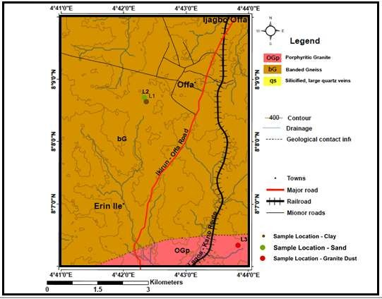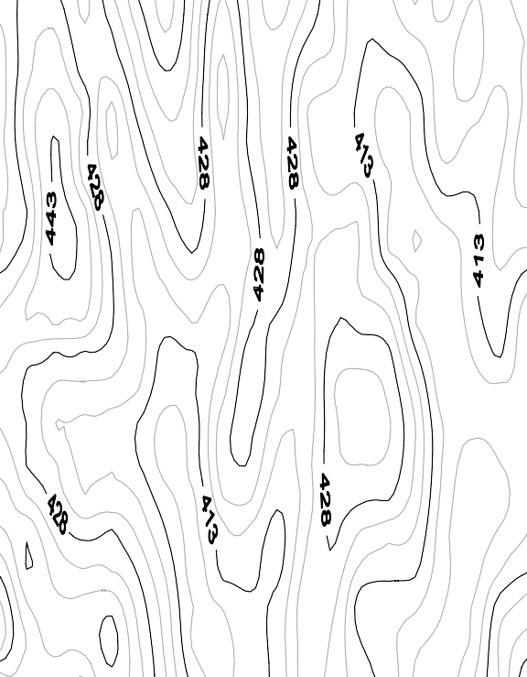

Fig 4.1: A cross section of the mapped area, as produced from the geological mapping

The laboratory test results for individual plastic pavement block samples were compared with that of cement pavement block samples.

# COMPRESSIVE STRENGTH TEST

# Result of Compressive strength Test

**Table 4.1:** Table of compressive strength of each of the 10 sample paver blocks

**Samples Load (N) Compressive Strength (N/mm2 )**

50% Granite dust 300,000 15.00

60% Granite dust 256,000 12.80

|  |  |  |
| --- | --- | --- |
| 70% Granite dust | 154,000 | 7.70 |
| 50% Sand | 251,000 | 12.55 |
| 60% Sand | 180,000 | 9.00 |
| 70% Sand | 110,000 | 7.50 |
| 50% Clay | 198,000 | 9.90 |
| 60% Clay | 118,000 | 8.60 |
| 70% Clay | 168,000 | 8.40 |
| Cement/Concrete mix | 118,000 | 5.90 |

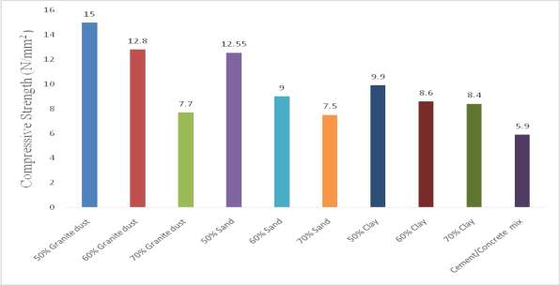

**Figure 4.2:** Comparison of pavers from varying ratio of plastic melts/geological materials and Cement pavers based on their compressive strength.

# Discussion of Compression Test

Granite dust mixed with plastic melt in the ratios 50:50, 60:40 and 70:30 had the compressive strengths of 15.0, 12.8 and 7.7 N/mm2 respectively. This shows a decrease in strength as the plastic component reduces and underscores the fact that the characteristics of plastic plays a significant role in the strengthening of the sample blocks.

Sand mixed with plastic melt in the ratios 50:50, 60:40 and 70:30 had the compressive strengths of 12.55, 9.0 and 7.5 N/mm2 respectively. This shows a decrease in strength as the plastic component reduces and underscores the fact that the characteristics of plastic plays a significant role in the strengthening of the sample blocks.

Clay mixed with plastic melt in the ratios 50:50, 60:40 and 70:30 had the compressive strengths of 9.9, 8.6 and 8.4 N/mm2 respectively. This shows a decrease in strength as the

plastic component reduces and underscores the fact that the characteristics of plastic plays a significant role in the strengthening of the sample blocks.

The mix ratio 50:50 (plastic melt: granite dust) has the highest compressive strength of 15.0N/mm2, a value which is almost three times the 5.9 N/mm2 value of the cement pavement block. In the medium category of compressive strength values are granite 60:40, Sand 50:50, Sand 60:40, clay 50:50 with strength values 12.8, 12.55, 9.0 and 9.9N/mm2 respectively. All these have strength values that are about twice the strength value of the cement pavement block. The samples granite 70:30, sand 70:30, clay 60:40 and clay 70:40 all have vales close to the 5.9N/mm2 strength value of the cement pavement block.

# Water Absorption Test

* + 1. **Result of Water Absorption Test (W.A.R)**

**Table 4.2:** Table of water absorption rate (%) of each of the 10 sample paver blocks

|  |  |
| --- | --- |
| **Samples** | **Water Absorption Rate (%)** |
| 50% Granite Dust | 1.59 |
| 60% Granite Dust | 1.68 |
| 70% Granite Dust | 1.71 |
| 50% Sand | 1.70 |
| 60% Sand | 1.81 |
| 70% Sand | 1.83 |
| 50% Clay | 1.76 |
| 60% Clay | 1.84 |
| 70% Clay | 2.01 |
| Concrete Mix | 17.33 |

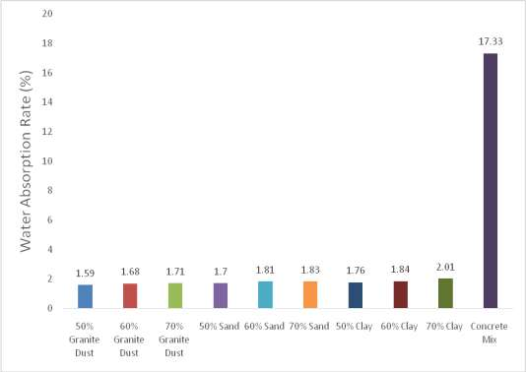

**Figure 4.3:** Comparison of pavers from varying ratio of plastic melts/geological materials and Cement pavers based on their water absorption rate.

# Discussion of Water Absorption Test Result (W.A.R)

All the sample blocks produced from plastic melts have water absorption values ranging from between 1.59% to 2.01%. All these values are abysmally lower than the W.A.R 17.33% value of the cement pavement block. This means disintegration of the cement pavement blocks by alternate wetting and drying is more likely than in the plastic derived pavement blocks.

There is also the likelihood of the surface of the blocks supporting the growth of algae and spirogyra thereby reducing its strength and aesthetic value. The lower W.A.R. recorded by the

plastic derived pavement blocks give them an edge in terms of durability especially in water logged areas

# Flexural Test

# Result of Flexural Test

For the flexural test, the forces at the breaking points of the sample paver blocks were considered as in the following table.

**Table 4.3:** Table showing the flexural strength of each of the 10 sample paver blocks

|  |  |
| --- | --- |
| **Samples** | **Force at Breaking point (N)** |
| 50% Granite Dust | 12,640 |
| 60% Granite Dust | 10,400 |
| 70% Granite Dust | 8,360 |
| 50% Sand | 9,470 |
| 60% Sand | 10,085 |
| 70% Sand | 14,280 |
| 50% Clay | 8,690 |
| 60% Clay | 6,072 |
| 70% Clay | 4,480 |
| Concrete Mix | 1,980 |

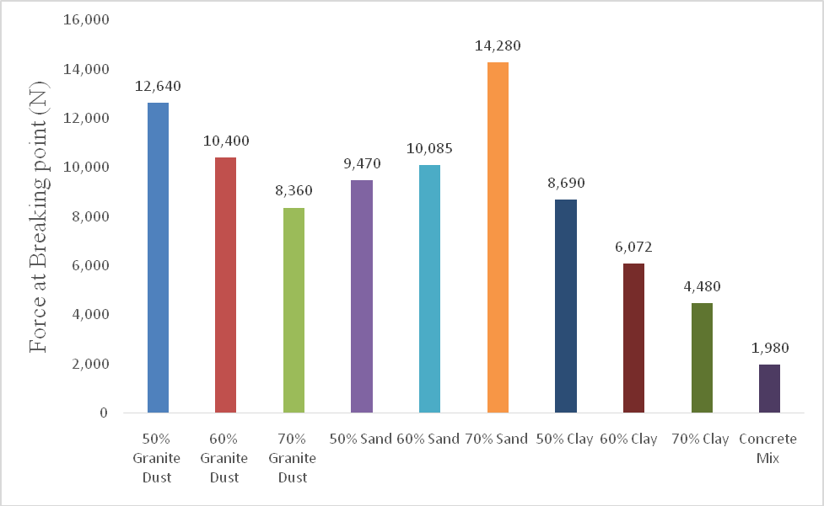

**Figure 4.4:** Comparison of pavers from varying ratio of plastic melts/geological materials and Cement pavers based on the forces at their breaking points.

# Discussion of Flexural Test Result

Granite dust mixed with plastic melt in the ratios 50:50, 60:40 and 70:30 could withstand forces of 12.64, 10.40 and 8.36 kN at their breaking points respectively. This shows a decrease in strength as the plastic component reduces and underscores the fact that the characteristics of plastic plays a significant role in the strengthening of the sample blocks. This is in tandem with decrease in strength as plastic melt decreases as obtained in the compression test result.

Sand mixed with plastic melt in the ratios 50:50, 60:40 and 70:30 could withstand forces of 9.47, 10.09 and 14.28 kN at their breaking points respectively. This shows an increase in

strength as the plastic component reduces. This is in variance with decrease in strength as plastic melt decreases as obtained in the compression test result.

Clay mixed with plastic melt in the ratios 50:50, 60:40 and 70:30 could withstand forces of 8.69, 6.07 and 4.48kN at their breaking points respectively. This shows a decrease in strength as the plastic component reduces and underscores the fact that the characteristics of plastic plays a significant role in the strengthening of the sample blocks. This is in tandem with decrease in strength as plastic melt decreases as obtained in the compression test result.

The mix ratio 70:30 (sand: plastic melt) has the highest flexural strength of 14.28kN, a value which is above seven times the 1.98kN value of the cement pavement block. This strength is closely followed by the mix granite 50:50, with a little above six times that of the cement pavement block. Plastic derived pavement blocks of Granite 60:40, Sand 50:50 and Sand 60:40 all have values that are about five times that of the cement derived pavement blocks. The plastic derived pavement blocks of Granite 70:30 and Clay 50:50 have values that are about four times that of the cement derived pavement blocks. The plastic derived pavement blocks of Clay 60:40 have a value that is about three times that of the cement derived pavement blocks. While the plastic derived clay 70:30 has a value about twice that of the cement pavement block.

The comparisons above show clearly that all the mix ratios of plastic derived pavement blocks could withstand greater forces before breaking than the cement derived pavement blocks.

# Result of Oven Test

**Table 4.4:** Table showing the Temperature at which each of the plastic paver block fails (0C)

Samples Temperature of Failure (˚C)

50% Granite Dust 180.00

60% Granite Dust 185.00

70% Granite Dust 185.00

50% Sand 180.00

60% Sand 185.00

70% Sand 185.00

50% Clay 200.00

60% Clay 205.00

70% Clay 210.00

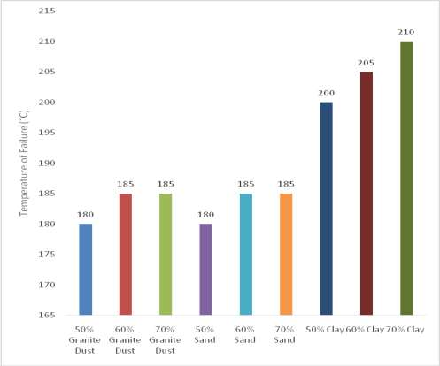

**Figure 4.5:** Comparison of failure temperatures of pavers from varying ratio of Plastic/geological materials

# Discussion of Oven Test Results

The results obtained from the oven test shows that there was no visible change in the shape, size and rigidity of all the plastic derived pavement blocks at a temperature below 180˚C. For the mixes of granite dust, changes were noticed for mix 50:50 at 180˚C while changes were noticed for mixes 60:40 and 70:30 at 185˚C. For the mixes sands, changes were noticed for mix 50:50 at 180˚C while changes were noticed for mixes 60:40 and 70:30 at 185˚C. For the mixes of clay, changes were noticed for mix 50:50 at 200˚C while changes were noticed for mixes 60:40 and 70:30 at 205˚C and 210˚C respectively.

# Acid test

* + 1. **Result for Compressive Strength after Activation with Acid**

Table 4.5: Table of the Compressive Strengths (N/mm2) before and after activation with acid

**SAMPL**

**COMPRESSI**

**COMPRESSIVE STRENGTHS (N/mm2) on activation with acid**

|  |  |  |  |  |  |  |  |  |  |  |  |
| --- | --- | --- | --- | --- | --- | --- | --- | --- | --- | --- | --- |
| **ES** | **VE** | 10 | 20 | 30 | 40 | 50 | 60 | 70 | 80 | 90 | 100 |
|  | **STRENGTHS**  **(N/mm2)** | Day | days | days | days | days | days | days | days | Day | days |
|  | **before**  **activation with** | s |  |  |  |  |  |  |  | s |  |
|  | **acid** |  |  |  |  |  |  |  |  |  |  |
| **50%** | 15.00 | 15.0 | 15.0 | 14.8 | 14.7 | 14.3 | 14.1 | 14.0 | 13.9 | 13.9 | 13.8 |
| **Granite** |  | 0 | 0 | 0 | 8 | 8 | 8 | 5 | 1 | 1 | 8 |
| **dust 60%** | 12.80 | 12.8 | 12.7 | 12.6 | 11.8 | 11.4 | 11.3 | 11.3 | 11.2 | 11.1 | 11.0 |
| **Granite** |  | 0 | 8 | 3 | 0 | 4 | 5 | 0 | 0 | 0 | 5 |
| **dust 70%** | 7.70 | 7.70 | 7.61 | 7.28 | 6.90 | 6.78 | 6.53 | 6.28 | 6.10 | 5.88 | 5.80 |
| **Granite** |  |  |  |  |  |  |  |  |  |  |  |
| **dust**  **50%** | 12.55 | 12.5 | 12.5 | 12.5 | 12.5 | 12.3 | 12.1 | 12.0 | 11.9 | 11.8 | 11.7 |
| **Sand** |  | 5 | 4 | 4 | 4 | 2 | 5 | 5 | 0 | 0 | 5 |
| **60%** | 9.00 | 9.00 | 9.00 | 9.00 | 8.92 | 8.89 | 8.89 | 8.61 | 8.58 | 8.42 | 8.30 |
| **Sand 70%** | 7.50 | 7.50 | 7.50 | 7.48 | 7.44 | 7.42 | 7.42 | 7.18 | 7.04 | 6.90 | 6.80 |
| **Sand 50%** | 9.90 | 9.90 | 9.88 | 9.75 | 9.60 | 9.55 | 9.33 | 9.15 | 9.02 | 8.91 | 8.80 |
| **Clay** |  |  |  |  |  |  |  |  |  |  |  |
| **60%** | 8.60 | 8.60 | 8.60 | 8.48 | 8.36 | 8.32 | 8.05 | 7.80 | 7.63 | 7.42 | 7.20 |
| **Clay** |  |  |  |  |  |  |  |  |  |  |  |
| **70%** | 8.40 | 8.40 | 8.38 | 8.25 | 8.18 | 7.84 | 7.36 | 7.25 | 7.08 | 6.92 | 6.80 |
| **Clay**  **Cement/** | 5.90 | 5.83 | 5.78 | 5.10 | 4.30 | 3.50 | 3.15 | 2.63 | 2.18 | 1.41 | 1.25 |
| **Concrete** |  |  |  |  |  |  |  |  |  |  |  |
| **mix** |  |  |  |  |  |  |  |  |  |  |  |

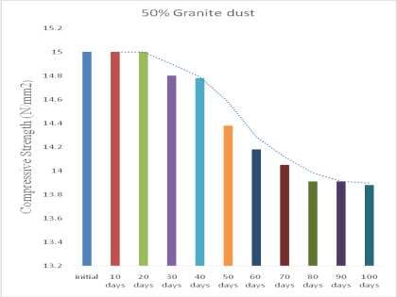

**Figure 4.6a**: Chart of compressive strengths of pavers (Granite 50/50) on activation with weak sulphuric acid for between 0-100days.

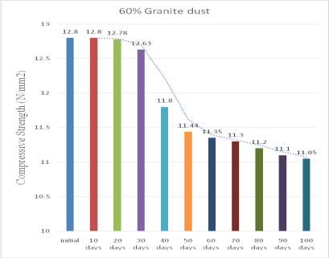

**Figure 4.6b:** Chart of compressive strengths of pavers (Granite 60/40) on activation with weak sulphuric acid for between 0-100days

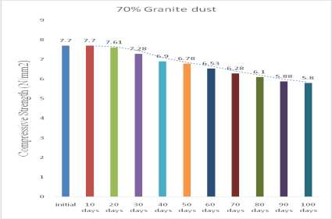

**Figure 4.6c:** Chart showing compressive strengths of pavers (Granite 70/30) on activation with weak sulphuric acid for between 0-100days.

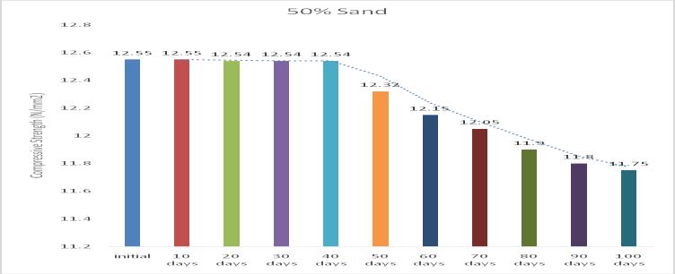

**Figure 4.6d:** Chart of compressive strengths of pavers (Sand 50/50) on activation with weak sulphuric acid for between 0-100days.

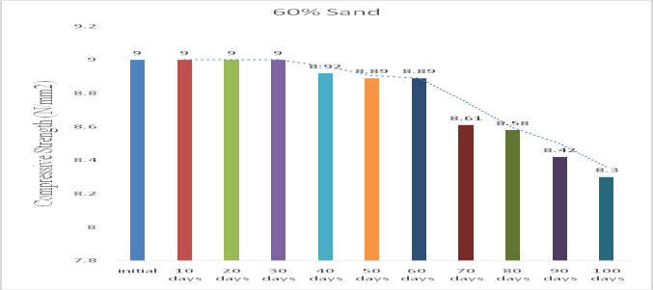

**Figure 4.6e:** Chart of compressive strengths of pavers (Sand 60/40) on activation with weak sulphuric acid for between 0-100days.

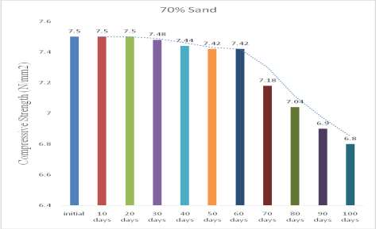

**Figure 4.6f:** Chart of compressive strengths of pavers (Sand 70/30) on activation with weak sulphuric acid for between 0-100days

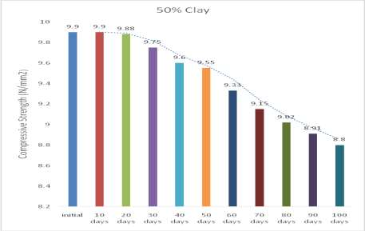

**Figure 4.6g:** Chart of compressive strengths of pavers (Clay 50/50) on activation with weak sulphuric acid for between 0-100days.

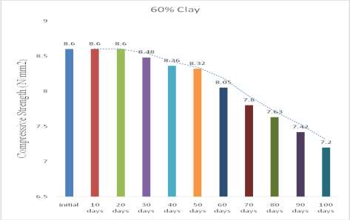

**Figure 4.6h:** Chart of compressive strengths of pavers (Clay 60/40) on activation with weak sulphuric acid for between 0-100days

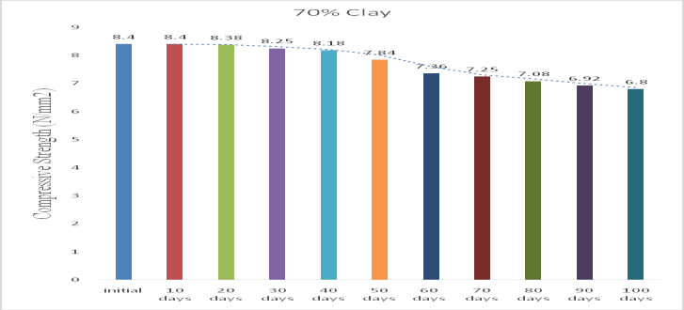

**Figure 4.6i:** Chart of compressive strengths of pavers (Clay 60/40) on activation with weak sulphuric acid for between 0-100days

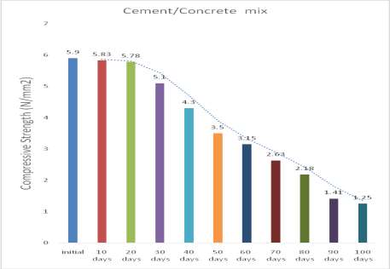

**Figure 4.6j:** Chart of compressive strengths of pavers (cement derived) on activation with weak sulphuric acid for between 0-100days

# Discussion of compressive strength after activation with acid

The compressive strengths of granites (50/50), (60/40) and (70/30) samples showed (1.12,

1.60 and 1.90) N/mm2 drops respectively.

This shows that corrosion resistance decreases with decrease in plastic additive content. The compressive strengths of sands (50/50), (60/40) and (70/30) samples showed (0.8,0.7 and 0.7) N/mm2 drops respectively.

This shows that corrosion resistance decreases with decrease in plastic additive content. The minimal drop in the strength here could be attributed to the mineralogy of sand which is predominantly quartz rich and has high resistance as compared to granite and clay. The compressive strengths of clay (50/50), (60/40) and (70/30) samples showed (1.1, 1.4 and 1.6) N/mm2 drops respectively.

This shows that corrosion resistance decreases with decrease in plastic additive content. However, the cement derived sample shows 4.65 N/mm2 drop in compressive strength after 100days. This difference is about 78% of the initial strength, which is suggestive of a major reason for early failure.

# Result for flexural strength after activation with acid

**Table 4.6:** Table of the Forces At Breaking Points (N) before and after activation with acid

**SAMPLES Force at**

**Breaking**

**Force at Breaking point (N) on activation with acid**

|  |  |  |  |  |  |  |  |  |  |  |  |
| --- | --- | --- | --- | --- | --- | --- | --- | --- | --- | --- | --- |
|  | **point (N)** | **10** | **20** | **30** | **40** | **50** | **60** | **70** | **80** | **90** | **100** |
| **before** | **Days** | **days** | **days** | **days** | **days** | **days** | **days** | **days** | **days** | **days** |
| **activation**  **with acid** |  |  |  |  |  |  |  |  |  |  |
| **50%**  **Granite dust** | 12,640 | 12,640 | 12,640 | 12,630 | 12,600 | 12,600 | 12,600 | 12,600 | 12,570 | 12,520 | 12,480 |
| **60%**  **Granite dust** | 10,400 | 10,400 | 10,400 | 10,400 | 10,400 | 10,395 | 10,370 | 10,330 | 10,290 | 10,240 | 10,200 |
| **70%**  **Granite dust** | 8,360 | 8,360 | 8,360 | 8,360 | 8,350 | 8,350 | 8,270 | 8,220 | 8,190 | 8,130 | 8,090 |
| **50% Sand** | 9,470 | 9,470 | 9,470 | 9,460 | 9,460 | 9,460 | 9,450 | 9,420 | 9,400 | 9,390 | 9,370 |
| **60% Sand** | 10,085 | 10,085 | 10,080 | 10,080 | 10,080 | 10,040 | 10,020 | 10,020 | 10,020 | 10,010 | 9,995 |
| **70% Sand** | 14,280 | 14,280 | 14,280 | 14,260 | 14,260 | 14,260 | 14,260 | 14,230 | 14,230 | 14,210 | 14,190 |
| **50% Clay** | 8,690 | 8,690 | 8,690 | 8,690 | 8,660 | 8,650 | 8,650 | 8,600 | 8,600 | 8,600 | 8,580 |
| **60% Clay** | 6,070 | 6,070 | 6,050 | 6,010 | 6,010 | 6,010 | 5,980 | 5,980 | 5,940 | 5,9420 | 5,890 |
| **70% Clay** | 4,480 | 4,480 | 4,450 | 4,450 | 4,450 | 4,420 | 4,360 | 4,340 | 4,310 | 4,280 | 4,240 |
| **Cement/ Concrete mix** | 1,980 | 1,980 | 1,700 | 1,550 | 1,200 | 1,050 | 850 | 620 | 410 | 320 | 200 |

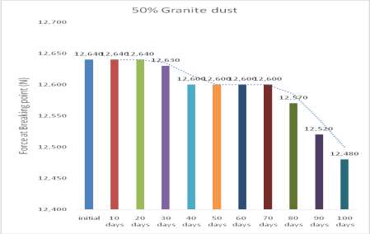

**Figure 4.7a:** Chart **of** forces at breaking points of pavers (Granite 50/50) on activation with weak sulphuric acid for between 0-100days

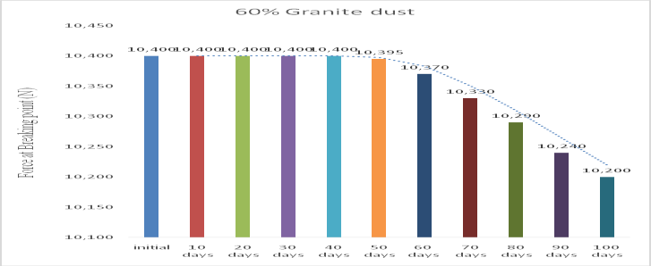

**Figure 4.7b:** Chart of forces at breaking points of pavers (Granite 60/40) on activation with weak sulphuric acid for between 0-100days

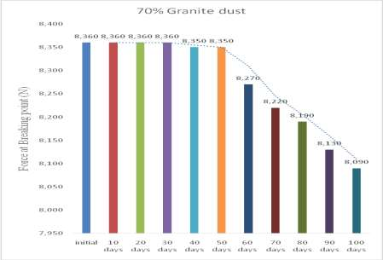

**Figure 4.7c:** Chart showing forces at breaking points of pavers (Granite 50/50) on activation with weak sulphuric acid for between 0-100days

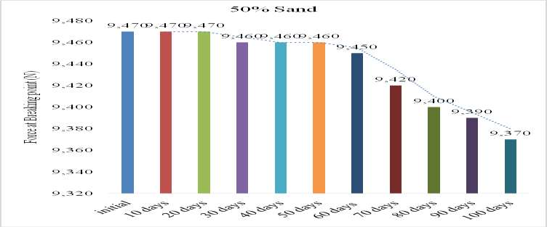

**Figure 4.7d:** Chart of forces at breaking points of pavers (Sand 50/50) on activation with weak sulphuric acid for between 0-100days

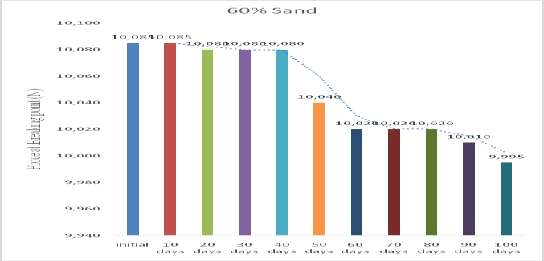

**Figure 4.7e:** Chart showing forces at breaking points of pavers (Sand 60/40) on activation with weak sulphuric acid for between 0-100days

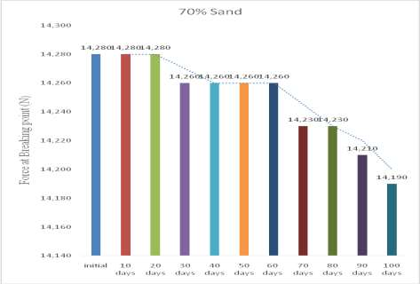

**Figure 4.7f:** Chart showing forces at breaking points of pavers (Sand 70/30) on activation

with weak sulphuric acid for between 0-100days

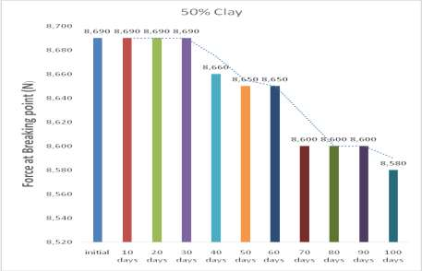

**Figure 4.7g:** Chart showing forces at breaking points of pavers (Granite 50/50) on activation with weak sulphuric acid for between 0-100days

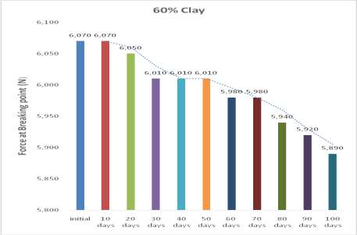

**Figure 4.7h:** Chart showing forces at breaking points of pavers (Clay 60/40) on activation with weak sulphuric acid for between 0-100da

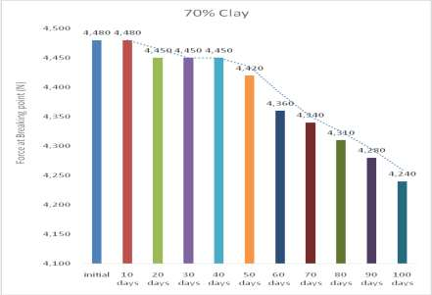

**Figure 4.7i:** Chart showing forces at breaking points of pavers (Clay 70/30) on activation with weak sulphuric acid for between 0-100days

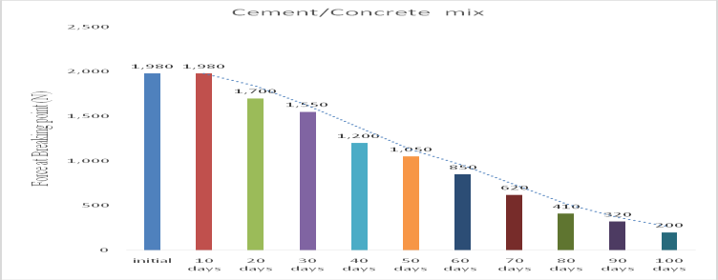

**Figure 4.7j:** Chart showing forces at breaking points of pavers (cement derived) on activation with weak sulphuric acid for between 0-100days

# Discussion of Flexural Strength after Activation with Acid

The forces at breaking points of granites (50/50), (60/40) and (70/30) samples showed (160.0,

200.0 and 270.0) N drops respectively. This shows that corrosion resistance decreases with decrease in plastic additive content.

The Forces at breaking points of sands (50/50), (60/40) and (70/30) samples showed (100.0,

90.0 and 90.0) N drops respectively. This shows that corrosion resistance decreases with decrease in plastic additive content. The minimal drop in the strength here could be attributed to the mineralogy of sand which is predominantly quartz rich and has high resistance to granite and clay.

The Forces at breaking points of clay (50/50), (60/40) and (70/30) samples showed (110.0,

180.0 and 240.0) N drops respectively. This shows that corrosion resistance decreases with decrease in plastic additive content. However, the cement derived sample shows 1,780N drop in compressive strength after 100days. This difference is about 90% of the initial strength, which is suggestive of a major reason for early failure. This is in agreement with the results obtained from the compressive test.

# CHAPTER FIVE CONCLUSION AND RECOMMENDATIONS

* 1. **Conclusion**

Based on the outcome of this study, the plastic paver block is found to be a better alternative to cement paver blocks in the construction of failure resistant roads. All the plastic derived pavement blocks have better engineering properties than the cement derived pavement block which makes it a good alternative for use in any part of the country in terms of sourcing geologic materials in any part of the country.

# Recommendations

The government and individuals in Nigeria should embrace the use of the more durable, cost effective and greener plastic derived pavement blocks for the likes of road construction, walk ways and parks.

It is strongly recommended that Government of developing countries should make and implement legislations that will reduce the use of plastic materials where there are alternatives. The government of developing countries should domesticate innovations that reduces, reuses or recycles plastic waste. The private sector should invest in any innovations that will improve the environment as well as enhance sustainable development

# REFERENCES

Adelana M.& Olasehinde P.I. (2000). Hydrogeology and hydro chemical facies around Offa, Kwara State, South Western Nigeria. 13th Annual conference of the Nigerian Association of Hydrogeologists at Ilorin, book of abstract and proceedings, 43-44

Adelana, S.M.A., Olasehinde, P.I. & Vrbkao, P. (2002). Hydrochemical and environmental isotope properties of shallow ground water of the basement rock aquifer in Offa area, SW Nigeria. *Water Resources,* 14(1), 1-11*.*

Adeyemi, G. O. & Oyeyemi, F. (2000)**.** Geotechnical basis for failure of sections of the Lagos- Ibadan expressway, Southwestern Nigeria. Bulletin of Engineering Geology and Environment, 59(1), 39-45. Doi:http:doi.org/10.1007/s100649900016.

Aghamelu, O. P. & Okogbue, C. O. (2011). Geotechnical assessment of road failure in the Abakaliki Area, Southeastern Nigeria. *International Journal of Civil and Environmental Engineering* 11(2),12 - 24.

Aghimien, E. I., Aghimien, D.O. & Awodele, I. A. (2016). Assessment of the Use of Solid Concrete and Interlocking Stones in the Construction of Walkways in Tertiary Institutions. *Journal of Civil and Environmental Research.* (www.iiste.org). 8(9), 46- 51

Airey, G.D., singleton, T.M., & Collop, A.C.(2002). Properties of polymer modified bitumen after rubber-bitumen interaction. *Journal of Materials in Civil Engineering*, 14(4), 344-354

Akiije, I. & Oyekan, G. L (2012). Stabilization assessment of aggregates in asphalt concrete mixtures. *International Journal of Scientific & Engineering Research*. 3(4), 695-699.

ASTM (American Society for Testing and Materials) (2001). Standard test method for sieve analysis of fine and coarse aggregates. C150. West Conshohocken, PA, USA.

Asnani, P.U. & Zurbrugg, C. (2007). Improving municipal solid waste management in India: A sourcebook for policymakers and practitioners. World Bank Publications.

Brattebo O.B. & Booth D.B. (2003). Long-term storm water quantity and quality performance of permeable pavement systems. *Water Research* 37 (2003), 4369- 4376.Retrieved from <http://www.researchgate.net/publication/9078153_Long_term> Stormwater_Quantity_and_performance –of_permeable_ pavement_systems.

De Belie, N., Monteny, J., Beeldens, A., Vinncke, E., Van Gemert, D., & Verstraete, W. (2004). Experimental research and prediction of the effect of chemical and biogenic sulfuric acid on different types of commercially produced concrete sewer pipes*. Cement and Concrete Research.* 34(12), 2223-2236.

El-Rub, Z.A., Bramer, E.A., & Brem, G. (2002). Tar removal in an Entrained flow cracker(EFC) with application to biomass gasification. *Pyrolysis and gasification of biomass waste. 30(2),* 337-346*.*

Fan, X., & Zhang,M. (2016). Behaviour of inorganic polymer concrete columns reinforced with basalt FRP bars under eccentric compression: an experimental study. *Composites Part B:Engineering*. 8(104), 44-56.

Folorunsho, O.W. & Amadi, A.N. (2020). Production of pavement blocks from plastic waste.

*The Percific Journal of Science and Technology.* 21(2), 36-43

Gencel, O., Ozel, C., Koksal, F., Erdogmus, E., Martinez-Barrera, G., & Brostow, W. (2012). Properies of concrete paving blocks made with waste marble*. Journal of Cleaner Production*. 21(1), 62-70.

Ghosh, S., Basu, S., & Thayumanavan,S. (2006). Simulteneous and reversible Functionalization of copolymers for biological applications. *Macromolecules*. 39(17), 5595-5597.

Gidigasu, M. D. (1980). Geotechnical evaluation of residual gravels in pavement construction. *Bulletin of the International Association of Engineering Geology*, 15(3/4), 173-194.

Hirde, S.K. & Dudhal, O.S. (2016). Review on polymer modified concrete and its application to concrete structures. *International Journal of Engineering Research*. 3(2), 20-26.

Hudec, P. P. (2006). Utilization of Geologic materials. *Encyclopedia of life support systems(EOLSS), Environmental and Engineering Geology-* Vol III*.* Retrieved from htpp:[/www.eolss.net/Eolss](http://www.eolss.net/Eolss-sampleAllChapter.aspx)-[sampleAllChapter.aspx](http://www.eolss.net/Eolss-sampleAllChapter.aspx)

Ijirshar, V.U. (2015). The empirical analysis of oil revenue and industrial growth in Nigeria.

*African Journal of Business Management*. 9(16), 599-607.

Jegede, G. (2000)**.** Effect of soil properties on pavement failure along the F209 highway at Ado-Ekiti, Southwestern Nigeria. *Construction and Building Materials*, 14(6), 311- 315.

Kodua J., Tagbor T.A., Nana B.V. & Boakye A.K. “Influence of Recycled Waste High Density Polyethelene Plastic Aggregate on the Physico-Chemical and Mechanical Properties of Concrete’’ *International Journal of Scientific Engineering and Science.* **2**(8), 22-25.

Koo, B.M., Kim, J.H.J., Kim,S.B. & Mun., S.. (2014). Material and structural performance

evaluations of Hwangtoh admixtures and recycled PET fibre-added eco-friendly concrete for CO2 emmission reduction. *Material.* 7(8), 5959-5981.

Li, V.C. (2003). Engineered cementitious composites (ECC): a review of the materials and its applications. *Journal of Advanced Concrete Technology*. 1(3), 215-230.

Modak, P., Jiemian, Y., Hongyuan, Y., & Mohanty, C.R. (2010). Municipal solid waste management: turning waste into resources. Shanghai manual: a guide for sustainable urban development in the 21st century. Pp1a, 36

Ofonime, A. & Aniekan, E. (2005). Relationship between road pavement failures, Engineering indices and underlying Geology in a tropical environment. *Global Journal of Geological Sciences*, 4(2), 99 - 108.

Ogunribido, T.H.T., Mohammed, M.Z. & Adesuyi, A.R. (2015) Effect of engineeringproperties of soil on pavement failures in Ogbagi-Akoko area, Southwestern Nigeria. *Journal of Environment and Earth Science*. 5(4), 39-42.

Oluyide, P.O., Nwajide, C.S. & Oni, A.O.(1998). The Geology of the Ilorin Area.

*Bulletin*,4(2), 38-97

Oyawoye, M.O. (1972). The basement complex of Nigeria. *African Geology,* 67-99. Pidwirny, M.J., & Soroke, M. (2013). Forecasting the Effects of 21st Century Climate

Change on Eighteen Ski Resorts in the Western United States. *In AGU Fall MeetingAbstracts*. 2013,GC13c-1111

Qin, Y., Hiller, J.E., & Mei, G. (2018). A new water retaining paver block for reducing Runoff and cooling pavement. *Journal of Cleaner Production*. 199(6), 948-956.

Rahaman, M.A.(1989). Review of the basement geology of South-Western Nigeria.Department of geology, University of Ife, Ile-Ife, Nigeria. Geology of Nigeria. *Rock View*, Jos.

Sarbjeet S., Ravindra N. & Vinay Agrawal (2016). A review on properties of sustainable concrete using granite dust as replacement for river sand. *Journal of Cleaner Production.* 12(6), 74-87.

Shakhashiri, B.Z. (1983). Chemical Demonstrations. Chemical Demonstrations: Handbook for Chemistry Teachers. *Univ. of Wisconsin: Madison, Wisconsin, 1, 133-45*

Sulyman, M., Haponiuk,J., & Formela, K. (2016). Utilization of recycled Polyetheleneterephthalate (PET) in engineering materials:a review. *International Journal of Environmental Science and Development.* 7(2), 100

Tapkire, G., Patil, P., & Kumavat, H.R. (2014). Recycled Plastic used in concrete paver block. *International Journal of Scientific Engineering and Science.* 3(8), 22-25.

Tuffour, I.S.B. (2016). Development of pavement blocks using waste PET bottles, Munich, GRIN Verlag Accessed from [https://www.grin.com/document/324198.](https://www.grin.com/document/324198)

Venkatachalam, S., Nayak, S.G.,Labde, J.V., Gharal, P.R., Rao, K. & Kelkar, A.K. (2012).

Degradation and recyclability of poly (ethylene terephthalate). *Polyester.*4(2) 75-98.

Yu, S. & Hing, P. (2008). Thermal and dielectric properties of fibre reinforced polystyrene composites. *Polymer composites*. 29(11), 1199-1202

. .

.