**EVALUATION OF *CHRYSOPHYLLUM ALBIDUM* (G. DON) FRUIT GUM AS A SUSTAINED RELEASE MATRIX IN TABLET FORMULATIONS**

**BY**

**Ephraim Esla MANGA, B. Pharm (ABU) 2007 MSc/Pharm-Sci/04892/2010-2011**

**A THESIS SUBMITTED TO THE SCHOOL OF POSTGRADUATE STUDIES, AHMADU BELLO UNIVERSITY IN PARTIAL FULFILLMENT OF THE REQUIREMENTS FOR THE AWARD OF MASTER OF SCIENCE PHARMACEUTICS**

**DEPARTMENT OF PHARMACEUTICS AND PHARMACEUTICAL MICROBIOLOGY, FACULTY OF PHARMACEUTICAL SCIENCES, AHMADU BELLO UNIVERSITY, ZARIA**

**(May, 2015)**

# DECLARATION

I declare that the work in this thesis entitled ―Evaluation of *Chrysophyllum albidum* (G. Don) fruit gum as a sustained release matrix in tablet formulation‖ has been carried out by me in the Department of Pharmaceutics and Pharmaceutical Microbiology. The information derived from the literature have been duly acknowledged in the text and a list of references provided. No part of this thesis was previously presented for any degree or diploma at this or any other institution.

Name of Student Signature Date

# CERTIFICATION

This thesis entitled ―Evaluation of *Chrysophyllum albidum* (G. Don) fruit gum as a sustained release matrix in tablet formulation‖ by Ephraim Esla MANGA meets the regulations governing the award of the degree of Master of Science, Pharmaceutics of the Ahmadu Bello University, and is approved for its contribution to knowledge and literary presentation.

Dr. T. S. Allagh Signature

B. Pharm (ABU), M. Sc (London), PhD (ABU). Chairperson, Supervisory Committee Department of Pharmaceutics and Pharmaceutical Microbiology,

Ahmadu Bello University, Zaria. Internal Supervisor

Date

Prof. A. B. Isah Signature

B. Pharm., M.Sc., PhD (ABU Member, Supervisory Committee Department of Pharmaceutics and Pharmaceutical Microbiology, Ahmadu Bello University, Zaria. Internal Supervisor

Date

Prof. A. B. Isah Signature

B. Pharm., M.Sc., PhD (ABU

Head, Department of Pharmaceutics and Pharmaceutical Microbiology,

Ahmadu Bello University, Zaria.

Prof. A. H. Zoaka Signature DVM, M.Sc., PhD (ABU)

Dean, Postgraduate School Ahmadu Bello University, Zaria.

Date

Date

# ACKNOWLEDGEMENT

My sincere gratitude goes to God for sustaining and providing for me, making me know that all things are possible through Him.

I want to appreciate with unalloyed gratitude, my supervisors Dr (Mrs) T. S. Allagh and Prof. A. B. Isah for their unwavering support and fervent supervision. The kind of patience you demonstrated is truly second to none. Special thanks to Dr I. S. Okafor for putting me through. Dr T. Olurishe and Dr A. K. Olowosulu, thanks for always asking me ―how far?‖ Thanks to my senior colleagues who have been my untiring guides: Dr (Mrs) Olayemi, Pharm Olorunsola E., Pharm Yonni A., Pharm (Mrs) Mahmud, Pharm Ameh Sunday, and Pharm Danat Isaac.

To the technologists: Mr Innocent A., Mr Goddy, Mal. Umar, Mr Abuh (NIPRD), I cannot thank you enough.

My friends and colleagues on the same path, words cannot describe what you have been to me: Sophie (thanks for stretching me this far), Charles, Zwanzy, Oluwaseun, Nkechi, Asia, Usha, Adigizi, Johnson. God will reward and bless you.

My parents and siblings: there is no greater blessing than being in your midst. You have been a unique source of inspiration and courage. Thanks for investing so much on me and for making sure I didn‘t give up.

I want to say the ―loudest‖ thank you to my lovely wife, Debbie and my son Derrick whose understanding is indescribable. Your fervent prayers pushed me all the way.

To every well wisher: thanks!

# DEDICATION

This work is dedicated to GOD ALMIGHTY, my source of inspiration and courage. His banner over me is love

# ABSTRACT

The goal of designing sustained release or controlled release delivery system is to reduce the frequency of dosing or to increase effectiveness of the drug by localization at the site of action, reducing the dose required or providing uniform drug delivery. Natural gums and polymers have been employed as excipients in modified release dosage forms. The objectives of this study were to extract and determine the percentage yield of *Chrysophyllum albidum* gum, perform physicochemical studies and preliminary phytochemical screening, determine the compatibility of the gum with the active ingredients, formulate sustained release tablets with the gum as the sustaining matrix and compare the release profiles with those of a standard matrix former, hydroxyl propyl methyl cellulose (HPMC), and to determine the release mechanisms and kinetics of the formulations. A percentage yield of 18 ± 4 % w/w was obtained. The gum showed physicochemical properties consistent with natural gums employed as pharmaceutical excipients. Differential Scanning Calorimetry (DSC) and Fourier Transform Infrared (FTIR) spectroscopy studies did not show any incompatibility with chlorpheniramine maleate and theophylline hydrochloride. Tablet parameters were within pharmacopoeial limits. Dissolution studies showed an increase in retardation of drug release with increase in *Chrysophylum albidum* fruit gum (CAG) concentration. Batches containing 30 % CAG showed the most desirable T50% of approximately 12 h. Comparison with HPMC at the same concentration showed that CAG had better sustained release properties. Studies of the kinetics and mechanisms of drug release from CAG batches showed that at higher concentrations, the formulations demonstrated a super case II release kinetics. The mechanism of release combines swelling, erosion, and diffusion. Stability studies

performed on the tablets after one year showed only slight changes in the T50% with no significant change in the drug content and the disintegration times. In conclusion, CAG possesses good pharmaceutical yield and tablets have good pharmacotechnical properties. Varying concentrations of CAG can be employed as a sustaining matrix in the formulation of chlorpheniramine and theophylline sustained release tablets.

# Table of Contents

Title page… i

Declaration ii

Certification iii

Acknowledgements… iv

Dedication v

Abstract… vi

Table of Contents… viii

List of Tables xii

List of Figures… xiii

List of Appendices… xv

CHAPTER ONE

* 1. INTRODUCTION… 1
  2. Natural Gums 4
     1. Advantages of natural gums and mucilages… 6
     2. Disadvantages of natural gums… 7
     3. Classifications of natural gums… 8
     4. General procedures for isolation and purification of gums and mucilages… 11
     5. Characterization/standardization of gums and mucilages… 12
  3. Chrysophyllum albidum (G. Don)… 14
  4. Chlorpheniramine maleate 15
  5. Theophylline hydrochloride 16
  6. Statement of Research Problem 19
  7. Justification of the Study 20
  8. Aim of the Study 21
  9. Objectives 21
  10. Hypothesis 22
      1. Null hypothesis… 22
      2. Alternate hypothesis… 22

CHAPTER TWO

* 1. LITERATURE REVIEW 23
  2. Modified Release Dosage Forms 23
     1. Rationale for formulating modified-release dosage forms 24
     2. Types of Modified Release Dosage Forms… 26
     3. Merits of Modified Release Dosage Forms… 28
     4. Demerits of Modified Release Dosage Forms… 31
     5. Factors affecting sustained release dosage forms 33
     6. Design of Oral Sustained Release Drug Delivery System 38
     7. Approaches to Sustained Release Drug Delivery System 40
     8. Modified Dosage Forms Drug Release Kinetics 43

CHAPTER THREE

* 1. MATERIALS AND METHODS 46
  2. Materials 46
     1. Chemicals/Reagents… 46
     2. Equipment… 46
  3. Methods 48
     1. Gum extraction and purification 48
     2. Determination of percentage yield 48
     3. Physicochemical characterization of the gum 49
     4. Phytochemical screening 52
     5. Flow properties of gum 54
     6. Compatibility studies on *C. albidum* fruit gum using Differential Scanning Calorimetry (DSC) and Fourier Transformed Infrared Spectroscopy 56
  4. Formulation Studies 57
     1. Preparation of granules 57
     2. Flow properties of chlorpheniramine and theophylline granules… 59
     3. Compression of granules 59
     4. Evaluation of tablet properties 59
     5. Comparison with standard 61
     6. Stability studies 62

CHAPTER FOUR

* 1. RESULTS 63
  2. Physicochemical and Properties of Chrysophylllum albidum fruit gum 63
  3. Moisture sorption characteristics 64
  4. Swelling characteristics of gum compact 65
  5. Flow Properties of Chrysophyllum albidum fruit gum (CAG)… 66
  6. Phytochemical Screening 67
  7. Differential Scanning Calorimetry and Fourier Transform Infrared Spectroscopy 68
  8. Formulation Studies 79
     1. Flow Properties of chlorpheniramine and theophylline granules 79
  9. Tablet Properties 81
     1. Chlorpheniramine maleate tablets properties 81
     2. Theophylline tablets properties 83
  10. Dissolution Studies 85
  11. Drug Release Kinetics and Mechanisms 89
      1. Chlorpheniramine drug release kinetics and mechanisms 89
      2. Theophylline drug release kinetics and mechanisms 90
  12. Comparison with hydroxypropylmethyl cellulose (HPMC)… 91
      1. Dissolution studies **91**
      2. Drug release kinetics and mechanisms **92**
  13. Stability Studies of Chlorpheniramine and Theophylline Tablets 94
      1. Chlorpheniramine tablets stability studies 94
      2. Theophylline tablets stability studies 95

CHAPTER FIVE

5.0 DISCUSSION 96

CHAPTER SIX

* 1. SUMMARY, CONCLUSION AND RECOMMENDATIONS 105

References 107

# List of Tables

|  |  |
| --- | --- |
| Table 3.1:  Table 4.1 | Tablet Formula for Chlorpheniramine (C) and Theophylline (T) 58  Physicochemical Properties of *Chrysophyllum albidum* fruit Gum 63 |
| Table 4.2 | Moisture Sorption of CAG 64 |
| Table 4.3: | Flow properties of *C. albidum* gum 66 |
| Table 4.4: | Preliminary Phytochemical Screening of the Gum 67 |
| Table 4.5: | Flow properties of Chlorpheniramine and Theophylline granules 80 |
| Table 4.6: | Chlorpheniramine Tablet Properties 82 |
| Table 4.7: | Theophylline tablet properties 84 |
| Table 4.8: | Chlorpheramine drug release according to different kinetic models 89 |
| Table 4.9: | Theophylline drug release according to different kinetic models 90 |
| Table 4.10 | Comparison of regression values and release kinetics 92 |
| Table 4.11: | Pearson‘s similarity correlations between release profiles 93 |
| Table: 4.12 | Stability studies for Batch C4 94 |
| Table: 4.13 | Stability studies for Batch T4 95 |

# List of Figures

Figure 2.1 Plasma Drug Concentration Versus Time Profiles for Conventional, Sustained Release, and Zero Order Controlled Release Tablet Formulations… 25

Figure 2.2: Drug level versus time profile showing differences between

* + 1. traditional drug dosing and (b) sustained delivery dosing 30

Figure2.3: Plasma drug concentration profile for conventional release, a

sustained release and zero order controlled release formulations 39

Figure 2.4: Comparison of conventional and controlled release profiles… 39

Figure 4.1: Swelling profile of gum compact… 65

Figure 4.2: Thermogram of CAG 69

Figure 4.3: Thermogram of pure chlorpheniramine 70

Figure 4.4: Thermogram of pure chlorpheniramine, chlorpheniramine mixed with

CAG, and CAG alone 71

Figure 4.5: Thermogram of pure theophylline. 72

Figure 4.6: Thermogram of pure theophylline and theophylline mixed with CAG 73

Figure 4.7: FTIR spectrum of *C. albidum* fruit gum… 74

Figure 4.8: FTIR spectrum of pure chlorpheniramine maleate 75

Figure 4.9: FTIR spectrum of physical mixtures of chlorpheniramine and CAG… 76

Figure 4.10: FTIR spectrum of pure theophylline hydrochloride 77

Figure 4.11: FTIR spectrum of physical mixtures of theophylline and CAG… 78

Figure 4.12: Plot of drug release (%) versus time (h) for chlorpheniramine

maleate tablets 86

Figure 4.13: Plot of drug release (%) versus time (h) for theophylline

hydrochloride tablets 88

Figure 4.14 Plot of percentage drug release (%) versus Time (h) of formulations containing CAG and HPMC at 30 % level 88

# List of Appendices

APPENDIX I: Frequency Distribution of Particle size of CAG 116

APPENDIX II: Swelling characteristics of gum compact 117

APPENDIX III: Calibration Curves of Chlorpheniramine and Theophylline 118

APPENDIX IV: Drug dissolution profile of chlorpheniramine tablets 119

APPENDIX V: Drug dissolution profile of theophylline tablets 120

APPENDIX VI: Comparison of drug release profiles with tablets containing HPMC 121

APPENDIX VII: Thermograph of pure chlorpheniramine showing values 122

APPENDIX VIII: Thermograph of pure theophylline showing values 123

APPENDIX IX: Thermogram of CAG with values 124

APPENDIX X: Particle Size Analysis Of *C. albidum* Gum 125

APPENDIX XI: Zero order plot for chlorpheniramine tablet release profile 126

APPENDIX XII: Zero order plot for theophylline tablet release profile 127

APPENDIX XIII: Higuchi‘s plot for chlorphrniramine tablet release profile 128

APPENDIX XIV: Higuchi‘s plot for theophylline tablet release profile… 129

APPENDIX XV: Hixson-Crowel plot for chlorpheniramine tablets drug release profile 130

APPENDIX XVI: Hixson-Crowel plot for theophylline tablets drug release profile 131

APPENDIX XVII: Korsmeyer-Peppas‘ plot for chlorpheniramine tablets release profile 132

APPENDIX XVIII: Korsmeyer-Peppas‘ plot for theophylline tablets release profile…133

# CHAPTER ONE

# INTRODUCTION

Pharmaceutics is the branch of pharmacy that deals with dosage form design and manufacture. Since drugs are rarely administered in their pure chemical form, pharmaceutics deals with formulating a new chemical entity into a form which can be used or taken by patients in a safe and effective manner (Collett *et al.*, 1990). Dosage forms are the means by which the drug reaches the target site to give its actions. It should be in a convenient form to ensure its mission is done (Williams *et al.,* 2013).

The creation and manufacture of dosage forms have been at the center of pharmacy practice for the past thousand years. For pharmacists of the nineteenth century, *secundem artem*, or the acronym ―S.A.‖ in physicians‘ prescriptions, instructed them to use their special skills

―according to the art‖ of their profession to compound a medicine; it was out of this art, rather than science, that almost all of today's major dosage forms arose. Tablets, capsules, injectables, and oral solutions were all known to pharmacists and physicians a century ago. In addition, there were scores of specialized dosage forms that attempted to meet the medical needs of patients, even if the drugs administered in these doses were ineffective or designed to treat symptoms rather than the underlying disease. The origins of most of these dosage forms are lost in history (Zarshenas *et al.*, 2013).

Over the past four decades, as the expenses and complications involved in marketing new drug entities have increased, with concomitant recognition of the therapeutic advantages of controlled drug delivery, greater attention has been focused on development of these controlled release drug delivery systems. The attractiveness of these dosage forms is due to

awareness of toxicity and ineffectiveness of drug when administered or applied by conventional dosage forms (Sathyaraj and Abhinav, 2012).

The goal of designing sustained release or controlled release delivery system is to reduce the frequency of dosing or to increase effectiveness of the drug by localization at the site of action, reducing the dose required or providing uniform drug delivery. Drug substances are seldom administered alone; rather they are given as part of a formulation in combination with one or more non-medicinal agents that serve varied and specialized pharmaceutical functions. Selective use of these non-medicinal agents, referred to as pharmaceutical ingredients or excipients, produces dosage forms of various types. The pharmaceutical ingredients solubilize, suspend, thicken, dilute, emulsify, stabilize, preserve, colour, flavour, and fashion medicinal agents into efficacious and appealing dosage forms (Masteikova *et al.*, 2003).

Today there are a lot of pharmaceutical excipients such as starch, sugar, alginates, carrageenan, gelatin, pectin, chitosan, celluloses, sugars etc., and most of them are from plant origin. These natural products find application in the pharmaceutical industry as binding agents, gelling agents, suppository bases, stabilizers, and coating materials (Phani *et al.,* 2011).

Studies have shown the ability of natural gum matrices obtained from plants to control the release of medicaments from various formulations (Ranjendra *et al.,* 2008), some of which have been employed in the commercial production of drugs. These natural polymers are used to control the release of one or more drugs from a dosage form continuously in a predetermined pattern for a fixed period of time, either systemically or to a specified target

organ. Controlled release dosage forms provide better control of plasma drug levels, less dosage frequency, less side effects, increased efficacy and constant delivery (Kumar *et al.,* 2012). Some future developments may require new delivery systems. For example, new drug delivery systems for oral administration of biotechnology products need new excipients which will avoid the inconvenience of multiple daily injections (Girish *et al.,*2009).

Pharmaceutical excipients are components of dosage forms that enable the formulations to acquire some characteristics which will establish the basic features of the formulated product. These excipients control physicochemical properties as well as the release profiles and availability of the drug in the system. The physicochemical properties of a compound are measurable characteristics by which the compound may interact with other systems. The ability of excipients to provide their intended function, and perform throughout the shelf life of the product, must be established such that the information will justify the choice, concentration and characteristics that may influence the final product (Moreton, 1996).

One of the commonly used group of compounds as excipients are natural polymers. Natural polymers are polysaccharides composed of a large group of polymers with varying chemical composition, large derivitizable groups and a wide range of molecular weights. They are characterized by low toxicity, high stability, and biodegradability. These properties make them appealing as pharmaceutical excipients (Anekant *et al.,* 2007). Since the ability of these polymers to provide their intended action chiefly lies on their physical and chemical properties, such properties as solubility, swelling capacity, pH, effect of temperature, and viscosity among others, should be established for any potential excipient (Vijetha *et al.,* 2010).

# Natural Gums

A large number of plant based pharmaceutical excipients are available today. Gums and mucilages are the most commonly available plant ingredients with a wide range of applications in pharmaceutical and cosmetic industries. They are being used due to their abundance in nature, safety and economy. They have been extensively explored as pharmaceutical excipients. Gums are biocompatible, cheap and easily available. Natural materials have advantages over synthetic ones since they are chemically inert, nontoxic, less expensive, biodegradable and widely available. They can also be modified in different ways to obtain tailor-made materials for drug delivery systems and thus can compete with the available synthetic excipients. Recent trend toward the use of plant based and natural products demands the replacement of synthetic additives with natural ones (Avachat *et al.*, 2011).

The most common theories say that gums are formed as a natural phenomenon of the plant in which internal plant tissues disintegrate through a process called gummosis. This in turn forms cavities, which exude transformed carbohydrates called gums. Secondly, it is caused as a result of injury to the bark or stem. Thirdly, some others attribute it to fungi and bacteria attack to the plant. Majority of the gums are exuded from the stem. Only a few gums are obtained from roots, leaves and other parts of the plant. These gums on heating, decompose completely without melting. Gums are found in large number of families. Notable among them are Leguminosae and Sterculiaceae. Other important gum yielding families are Anacardiaceae, Combretaceae, Meliaceae, Rosaceae and Rutaceae (Goswami and Naik, 2014; Jani *et al.*, 2009).

Gums and mucilages are used interchangeably but they have both similarities and dissimilarities. Gums are pathological products while mucilages are physiological products (Qadry, 2008). They are translucent amorphous substances and polymers of a monosaccharide or mixed monosaccharides and many of them are combined with uronic acids. Gums and mucilages have similar constituents and on hydrolysis yield a mixture of sugars and uronic acids. Gums and mucilages contain hydrophilic molecules, which can combine with water to form viscous solutions or gels. The nature of the compounds involved influences the properties of different gums. Linear polysaccharides occupy more space and are more viscous than highly branched compounds of the same molecular weight. The branched compounds form gels and are more stable because extensive interaction along the chain is not possible (Jani *et al.*, 2009).

True gums are formed from the disintegration of internal plant tissues, mostly from the decomposition of cellulose in a process called gummosis. Gums contain high amounts of sugar and are closely allied to the pectins. They are colloidal and soluble in water, either dissolving entirely or swelling, but they are insoluble in alcohol and ether. They exude naturally from the stems or in response to wounding of the plant. Commercial gums arrive in the market in the form of dried exudations. Gums are especially common in plants of dry regions. They are used primarily as adhesives, and are also used in printing and finishing textiles, as a sizing for paper, in the paint and candy industries and as drugs. Three important commercial plant gums are gum arabic, gum tragacanth and karaya gum (Gonsalves, 2010).

Natural gums are [polysaccharides](http://en.wikipedia.org/wiki/Polysaccharide) of natural origin, capable of causing a large [viscosity](http://en.wikipedia.org/wiki/Viscosity) increase in solution, even at small concentrations. In the food industry they are used as

[thickening agents,](http://en.wikipedia.org/wiki/Thickening_agent) [gelling agents,](http://en.wikipedia.org/wiki/Gelling_agent) [emulsifying agents,](http://en.wikipedia.org/wiki/Emulsion) and [stabilizers](http://en.wikipedia.org/wiki/Food_additive#Categories). In other industries, they are also used as [adhesives,](http://en.wikipedia.org/wiki/Adhesive) [binding agents](http://en.wikipedia.org/wiki/Excipient#Types_of_excipients), [crystan](http://en.wikipedia.org/wiki/Crystal) inhibitors, [clarifying agents](http://en.wikipedia.org/wiki/Brewing#Ingredients), encapsulating agents, [flocculating agents,](http://en.wikipedia.org/wiki/Flocculation) swelling agents, foam stabilizers, etc. Most often, these gums are found in the woody elements of plants or in seed coatings (Enauyatifard *et al.,* 2012).

* + 1. **Advantages of natural gums and mucilages** (Goswami and Naik, 2014; Jani *et al.*, 2009).

There are several merits attributable to natural gums and mucilages. Some of them include:

* + - 1. *Biodegradable*

Naturally available biodegradable polymers are produced by all living organisms. They represent truly renewable source and they have no adverse impact on humans or environmental health (e.g., skin and eye irritation).

* + - 1. *Biocompatible and non-toxic*

Chemically, nearly all of these plant materials are carbohydrates composed of repeating sugar (monosaccharides) units. Hence, they are non- toxic.

* + - 1. *Low cost*

It is always cheaper to use natural sources. The production cost is also much lower compared with that for synthetic material.

* + - 1. *Environmental-friendly processing*

Gums and mucilages from different sources are easily collected at different seasons in large quantities due to the simple production processes involved.

* + - 1. *Local availability*

Plant based gums sources are common and usually available in localities. In some developing countries, governments promote the production of plants like guar gum and tragacanth because of the wide applications in a variety of industries.

* + - 1. *Better patient tolerance as well as public acceptance*

There is less chance of side and adverse effects with natural materials compared with synthetic ones. Natural products are more acceptable to the public than synthetic ones.

* + - 1. *Edible sources*

Most gums and mucilages are obtained from plant sources which are edible and acceptable.

# Disadvantages of natural gums

* + - 1. *Microbial contamination*

The equilibrium moisture content present in the gums and mucilages is normally 10% or more and, structurally, they are carbohydrates and, during production, they are exposed to the external environment and, so there is a chance of microbial contamination. However, this can be prevented by proper handling and the use of preservatives.

* + - 1. *Batch to batch variation*

Synthetic manufacturing is a controlled procedure with fixed quantities of ingredients, while the production of gums and mucilages is dependent on environmental and seasonal factors. The quality and yield of natural gums can be affected by extraction and processing procedures.

* + - 1. *Uncontrolled rate of hydration*

Due to differences in the collection of natural materials at different times, as well as differences in region, species, and climate conditions, the percentage of chemical

constituents present in a given material may vary. There is a need to develop suitable monographs on available gums and mucilages.

* + - 1. *Reduced viscosity on storage*

Normally, when gums and mucilages come into contact with water there is an increase in the viscosity of the formulations. Due to the complex nature of gums and mucilages (monosaccharides to polysaccharides and their derivatives), it has been found that after storage there is reduced viscosity.

# Classifications of natural gums

There are several classification methods for gums and mucilages by different authors. Jani *et al,.* (2009) presented a classification of natural gums based on varied criteria: charge, source, shape, chemical structure, etc.

* + - 1. *According to the charge*

1. Non-ionic seed gums: guar, locust bean, tamarind, xanthan, amylose, arabinans, cellulose, galactomannans.
2. Anionic gums: arabic, karaya, tragacant, gellan, agar, algin, carrageenans, pectic acid.
   * + 1. *According to the source*
3. Marine origin/algal (seaweed) gums: Agar, carrageenans, alginic acid, laminarin.
4. Plant origin:

 Shrubs/tree exudates—Gum arabica, gum ghatti, gum karaya, gum tragacanth, khaya and albizia gums;

 Seed gums—Guar gum, locust bean gum, starch, amylose, cellulose; Extracts—Pectin, larch gum.

1. Animal origin: Chitin and chitosan, chondroitin sulfate, hyaluronic acid.
2. Microbial origin (bacterial and fungal): Xanthan, dextran, curdian, pullulan, zanflo, emulsan, Baker‘s yeast glycan, schizophyllan, lentinan, krestin, scleroglucan.
   * + 1. *Semi-synthetic*
3. Starch derivatives: Hetastarch, starch acetate, starch phosphates.
4. Cellulose derivatives: Carboxy methyl cellulose (CMC), hydroxy ethylcellulose, hydroxypropyl methyl cellulose (HPMC), methylcellulose (MC), microcrystalline cellulose (MCC).
   * + 1. *According to shape*
5. Linear: Algins, amylose, cellulose, pectins.
6. Branched:

 Short branches—xanthan, xylan, galactomanan.

 Branch-on-branch—amylopectin, gum arabic, tragacanth.

* + - 1. *According to monomeric units in chemical structure*

1. Homoglycans: Amylose, arabinans, cellulose.
2. Di-heteroglycans: Algins, carragennans, galactomannans.
3. Tri-heteroglycans: Arabinoxylans, gellan, xanthan.
4. Tetra-heteroglycans: Gum arabic, psyllium seed gum.
5. Penta-heteroglycans: Ghatti gum, tragacanth.

Enauyatifard *et al.,* 2012 classified natural gums according to their origin and also according to whether they are ionic or uncharged polymers. Examples include

* + - 1. *Natural gums obtained from* [*seaweeds*](http://en.wikipedia.org/wiki/Seaweed)*:*

Polyelectrolytes:

* + - * + [Agar](http://en.wikipedia.org/wiki/Agar)
        + [Alginic acid](http://en.wikipedia.org/wiki/Alginic_acid) and [Sodium alginate](http://en.wikipedia.org/wiki/Sodium_alginate)
        + [Carrageenan](http://en.wikipedia.org/wiki/Carrageenan)
      1. *Natural gums obtained from non-marine botanical resources:*

Polyelectrolytes:

* + - * + [Gum arabic](http://en.wikipedia.org/wiki/Gum_arabic) from the sap of [*Acacia*](http://en.wikipedia.org/wiki/Acacia) trees
        + [Gum ghatti,](http://en.wikipedia.org/wiki/Anogeissus_latifolia) from the sap of [*Anogeissus*](http://en.wikipedia.org/wiki/Anogeissus) trees
        + [Gum tragacanth](http://en.wikipedia.org/wiki/Tragacanth) from the sap of [*Astragalus*](http://en.wikipedia.org/wiki/Astragalus) shrubs
        + [Karaya gum](http://en.wikipedia.org/wiki/Gum_karaya) from the sap of [*Sterculia*](http://en.wikipedia.org/wiki/Sterculia) trees Uncharged:
        + [Guar gum](http://en.wikipedia.org/wiki/Guar_gum) from [guar beans](http://en.wikipedia.org/wiki/Guar)
        + [Locust bean gum](http://en.wikipedia.org/wiki/Locust_bean_gum) from the seeds of the [carob tree](http://en.wikipedia.org/wiki/Carob_tree)
        + [Beta-glucan,](http://en.wikipedia.org/wiki/Beta-glucan) from [oat](http://en.wikipedia.org/wiki/Oat) or [barley](http://en.wikipedia.org/wiki/Barley) [bran](http://en.wikipedia.org/wiki/Bran)
        + [Chicle gum](http://en.wikipedia.org/wiki/Manilkara_chicle#Chicle), an older base for [chewing gum](http://en.wikipedia.org/wiki/Chewing_gum) obtained from the chicle tree
        + [Dammar gum,](http://en.wikipedia.org/wiki/Dammar_gum) from the sap of [Dipterocarpaceae](http://en.wikipedia.org/wiki/Dipterocarpaceae) trees
        + [Glucomannan](http://en.wikipedia.org/wiki/Glucomannan) (E425), from the [konjac](http://en.wikipedia.org/wiki/Konjac) plant
        + [Mastic gum,](http://en.wikipedia.org/wiki/Pistacia_lentiscus#Resin) a chewing gum from ancient Greece obtained from the mastic tree
        + [Psyllium seed husks,](http://en.wikipedia.org/wiki/Psyllium_seed_husks) from the [*Plantago*](http://en.wikipedia.org/wiki/Plantago) plant
        + [Spruce gum,](http://en.wikipedia.org/wiki/Spruce_gum) a chewing gum of American Indians obtained from [spruce](http://en.wikipedia.org/wiki/Spruce) trees
        + [Tara gum](http://en.wikipedia.org/wiki/Caesalpinia_spinosa#Uses) (E417), from the seeds of the [tara tree](http://en.wikipedia.org/wiki/Caesalpinia_spinosa)
      1. *Natural gums produced by* [*bacterial*](http://en.wikipedia.org/wiki/Bacteria) [*fermentation*](http://en.wikipedia.org/wiki/Fermentation_%28biochemistry%29)*:*

Polyelectrolytes:

* + - * + [Gellan gum](http://en.wikipedia.org/wiki/Gellan_gum) (E418) Uncharged:
        + [Xanthan gum](http://en.wikipedia.org/wiki/Xanthan_gum) (E415)
    1. **General procedures for isolation and purification of gums and mucilages** Extraction is one of the most crucial procedures to achieve complete recovery of target compounds from plants (Baveja *et al.*, 1988). The fresh plant materials is collected, washed with water to remove dirt and debris, and dried. Plant material is dried in sunlight

(p C to retain its properties unchanged. Then, the powdered

material is soaked in water for 5–6 h, boiled for 30 min, and allowed to stand for 1 h so that all the mucilage is released into the water. The material is then squeezed from an eight muslin bag to remove the marc from the solution. Following this, three volumes of acetone is added to the filtrate to precipitate the mucilage. The mucilage is separated, dried in an

oven at a temperature less than C, and the dried powder is passed through a No. 80

sieve and stored in a desiccator until required (Baveja *et al.*, 1988). Recently, microwave energy has started to be used for the extraction of phytoconstituents from plants (Geetha *et al.*, 2009). It is a simple, fast, clean, eco-friendly and efficient method and saves energy, fuel and electricity. Microwave extraction follows the same principle as maceration or

percolation, but the speed of breaking up of the plant cells and tissues is much higher. Microwave assisted extraction methods require a shorter time and less solvent, and provide a higher extraction rate and better products at a lower cost. Plant material is powdered in a mechanical blender for 5 min and then soaked in distilled water for 24 h in a 1000 ml beaker. It is kept in a microwave oven along with a glass tube to prevent bumping when subjected to microwave irradiation. The beaker is removed from the oven and allowed to stand for 2 h to allow the mucilage to be released into the water. It is then processed in a similar way to the conventional procedure, weighed and stored (Geetha *et al.*, 2009).

Generally, chlorophyll or pigments are present in the plant which should be removed before isolating the mucilage. Plant material must be treated with petroleum ether and chloroform (to remove pigments and chlorophyll) and then with distilled water. Care should be taken when drying the final isolated/extracted mucilage. It must be dried at a very low temperature (not more than 50 oC) or in a vacuum. The dried material is stored carefully in desiccators to prevent further moisture uptake or degradation (Jani *et al.*, 2009).

# Characterization/standardization of gums and mucilages

The characterization of gums and mucilages is initially achieved by a multiple technique approach. For excipient analysis, analytical techniques can be classified according to the type of information generated.

* + - 1. *Structural*

Gums and mucilages are polysaccharides and contain sugars. So, confirmation of the different sugars is carried out by chromatography and structure elucidation can be carried out by NMR and mass spectroscopy.

* + - 1. *Purity*

To determine the purity of the selected gum and mucilage, tests for alkaloids, glycosides, carbohydrates, flavanoids, steroids, amino acids, terpenes, saponins, oils and fats, and tannins and phenols are carried out.

* + - 1. *Impurity profile*

Testing for impurities is usually carried out using suitable analytical techniques.

* + - 1. *Physicochemical properties*

These include color, odor, shape, taste, touch, texture, solubility, pH, swelling index, loss on drying, hygroscopic nature, angle of repose, bulk and true densities, porosity and surface tension. Different ash values are also estimated. Gums and mucilages are highly viscous in nature. So, the rheological properties of excipients are important criteria for deciding their commercial use. The flow behavior of the samples is determined.

* + - 1. *Toxicity*

The acute toxicity of gums and mucilages are determined. A sub-acute toxicity study, determination of the LD50 etc., are carried out in rats and guinea pigs of both sexes. *In vitro* cytotoxicity is also determined.

* + - 1. *Microbiology*

The microbial load and presence of specific pathogens is determined.

* + - 1. *Compatibility*

Gums and mucilages are added to pharmaceutical formulations. So a compatibility study is important. The compatibility studies of gums or mucilages and drugs are performed using spectrophotometry, fourier transform infrared spectroscopy (FTIR), differential scanning calorimetry (DSC).

* 1. ***Chrysophyllum albidum* (G. Don)**

Family: Sapotaceae

Common Name: Africa Star Apple Igbo: Udara

Yoruba: Agbalumo

African star apple (*C. albidum*) is a dominant canopy tree of lowland and mixed rainforests, sometimes, riverine. It is widely distributed in tropical West Africa and other African countries such as Ghana, Nigeria, Kenya, Sierra Leone, Sudan, and Uganda. The tree is about 8-36 m in height, the fruit is seasonal (December –April). The leaves are oval, green above, densely golden pubescent below from which the genus is named.

The plant is propagated by seedlings, wildings, and direct sowing. It is a seasonal fruit- bearing tree. The fruit is fleshy and juicy, producing whitish gummy exudates. It is widely eaten in South Western Nigeria, popular among women and children. The fruit pulp is rich in ascorbic acid and suitable for jams. The fruit can be fermented and distilled for the production of wine and spirits in alcohol making. It is a potential source of soft drinks (Agrofostree specie profile, 2012).

There are several studies carried out on different aspects of African star apple. Examples include the effects of ethanolic bark extract on biochemical and haematological parameters (Adebayo *et al*., 2010). A recent study published in the Journal of Physiology and Pathophysiology by Adeoye *et al.,* (2012) suggested that the methanolic bark extract may provide the next best antimalarial drug. *C. albidum* is good for the treatment of fibroids. Its

content of natural antioxidants have been established to promote health by acting against oxidative stress related disease such as diabetes, cancer and coronary heart diseases (Orijajogun *et al.,* 2013). Researchers have also shown the importance of the components in the food industry: soft drinks, jellies, jams, ascorbic acids, distilleries, and several other applications.

Several studies have shown the importance of natural polymers as binder in pharmaceutical formulations.

# Chlorpheniramine maleate

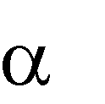Chlorpheniramine [2-[p-chloro-α-(2-dimethylaminoethyl) benzyl] pyridine] is a synthetic [drug](http://www.britannica.com/EBchecked/topic/171942/drug) used to counteract the [histamine](http://www.britannica.com/EBchecked/topic/267004/histamine) reaction, in [allergies](http://www.britannica.com/EBchecked/topic/16262/allergy). Chlorpheniramine, introduced into medicine in 1951, is administered orally or by intravenous, intramuscular, or subcutaneous injection in the form of chlorpheniramine maleate (Sprockel *et al.,* 1989). The sustained release capsule was formerly marketed as *Chor-trimeton* to combat the rapid fall in plasma steady state concentration. It is effective in controlling the symptoms of [hay fever,](http://www.britannica.com/EBchecked/topic/257646/hay-fever) acute skin reactions (such as [hives](http://www.britannica.com/EBchecked/topic/268211/hives)), and contact [dermatitis](http://www.britannica.com/EBchecked/topic/158569/dermatitis) (such as from [poison ivy](http://www.britannica.com/EBchecked/topic/466534/poison-ivy)). The most common side effect is drowsiness, although dryness of the mouth, difficulty in urinating, and vision problems may also occur (Dobozin *et al.,* 2011). Chlorpheniramine competes with histamine at central and peripheral histamine receptor sites, preventing the histamine receptor interaction and subsequent mediator release. Chlorpheniramine is a highly lipophilic molecule that readily crosses the blood brain barrier. It is highly selective for histamine receptors but has little effect on histamine or histamine receptors. Chlorpheniramine also activates 5-hydroxytryptamine (serotonin) and -adrenergic receptors and blocks cholinergic receptors.

Chlorpheniramine maleate is absorbed relatively slowly from the gastrointestinal tract, with peak plasma concentrations occurring about 2.5 to 6 h after oral administration. Chlorpheniramine appears to undergo considerable first pass metabolism. Bioavailability is low, values of 25 to 50 % having been reported. About 70 % of chlorpheniramine in the circulation is bound to plasma proteins. There is wide inter individual variation in the pharmacokinetics of chlorpheniramine; half life values ranging from 2 to 43 h have been reported. Chlorpheniramine is widely distributed in the body and enters the CNS. Chlorpheniramine maleate is metabolised extensively. Metabolites include desmethyl- and didesmethylchlorpheniramine. Unchanged drug and metabolites are excreted primarily in the urine; excretion is dependent on urinary pH and flow rate. Only trace amounts have been found in the faeces. A duration of action of 4 to 6 h has been reported; this is shorter than may be predicted from pharmacokinetic parameters. More rapid and extensive absorption, faster clearance, and a shorter half life have been reported in children compared to adults (Huang *et al.,* 1982).

# Theophylline Hydrochloride

Theophylline is a drug used in medicine as an antiasthmatic, coronary vasodilator, and [diuretic.](http://www.britannica.com/EBchecked/topic/166351/diuretic) Theophylline is a xanthine [alkaloid](http://www.britannica.com/EBchecked/topic/15672/alkaloid), a [methylxanthine](http://www.britannica.com/EBchecked/topic/378687/methylxanthine) chemically related to [caffeine](http://www.britannica.com/EBchecked/topic/88304/caffeine)

and [theobromine.](http://www.britannica.com/EBchecked/topic/590555/theobromine) Along with caffeine, it is an active constituent of [tea](http://www.britannica.com/EBchecked/topic/585115/tea) (*Camellia sinensis*), but it is commercially produced in pharmaceutical manufacture by [chemical synthesis](http://www.britannica.com/EBchecked/topic/108907/chemical-synthesis)

(Wettengel, 1998).

The first analysis of the xanthine derivative, theophylline was made by A. Kossel in 1888. Kossel at that time worked at an institute in Berlin. He was able to demonstrate that apart from caffeine, another xanthine derivative, a dimethylxanthine could be extracted from tea

leaves. He proposed the name theophylline for this basic compound. Synthesis of Theophylline was simultaneously performed at two major pharmaceutical companies around 1900 (Schultze‐Werninghaus and Meier‐Sydow, 1982).

Theophylline has two distinct actions in the airways of patients with reversible obstruction; smooth muscle relaxation (i.e. bronchodilation) and suppression of the response of the airways to stimuli (i.e. non-bronchodilator prophylactic effects). While the mechanisms of action of theophylline are not known with certainty, studies in animals suggest that bronchodilation is mediated by the inhibition of two isozymes of phosphodiesterase (PDE); PDE 3 and, to a lesser extent, PDE 5. While non-bronchodilator prophylactic actions are probably mediated through one or more different molecular mechanisms that do not involve inhibition of PDE 3 or antagonism of adenosine receptors. Some of the adverse effects associated with theophylline appear to be mediated by inhibition of PDE 3 (e.g., hypotension, tachycardia, headache, and emesis) and adenosine receptor antagonism (e.g., alterations in cerebral blood flow). Theophylline increases the force of contraction of diaphragmatic muscles. This action appears to be due to enhancement of calcium uptake through an adenosine-mediated channel (Fredholm, 1985).

Administered orally or rectally in the treatment of [asthma](http://www.britannica.com/EBchecked/topic/39778/asthma), it facilitates breathing by relaxing the bronchioles in the lungs. It is administered by injection for the treatment of congestive heart failure to stimulate the heart and increase the total output of blood by the heart. Given orally, it acts as a diuretic by inhibiting reabsorption in the renal (kidney) tubules (Scott *et al.*, 1981). The dosing of theophylline was usually every 6 h in order to maintain the serum concentration between 10 to 20 µg/ml. However many patients have difficulty adhering to

such a rigorous medication schedule. The development of sustained release theophylline formulation has greatly improved patient compliance by reducing the frequency of administration (Scott *et al.*, 1981).

# Statement of Research Problem

Most of the pharmaceutical raw materials (both active ingredients and excipients) used for manufacturing in Nigeria are imported accounting for huge expenditures due to foreign exchange. This country is endowed with huge biodiversity which can be harnessed for economic emancipation especially of the manufacturing sector. However, these are either underutilized or outrightly wasted. Okafor *et al.,* (2001) opined that the usefulness of natural products to the pharmaceutical industry is continually demonstrated so there is the need to study and source for locally available materials to save the pharmaceutical industry the rigours involved in importation and huge losses through foreign exchange which culminates in the high cost of the drugs.

*C. albidum* tree is abundant in the southern part of Nigeria and several parts of the plant have been studied for medicinal and nutritive values (Adebayo *et al*., 2010; Adeoye *et al.,* 2012; Ofori *et al.,* 2014). However, it has not been given requisite attention in terms of its pharmaceutical uses and applications. In recent times natural gums have been employed in novel dosage delivery systems (NDDS) as suitable alternatives to synthetic or semi-synthetic polymers. Plant gums have been used for the formulation of various dosage forms especially as hydrophilic sustained-release matrices. These gums are still being used today despite efforts to replace them with semi-synthetic polymers. It has been reported that the natural gum exudates provide functions which cannot be equaled economically (Okafor *et al.*, 2001). Acacia, tragacanth, albizia, guar gum are examples of natural polymers that have been used as excipients in pharmaceutical formulations. They are used as binders and disintegrants in tablets and as suspending and flocculating agents.

# Justification of the Study

 Advancement in therapeutics has projected the importance of modified-release dosage forms which targets achievement of specific goals. Any endeavour that would ease manufacturers‘ difficulty regarding to raw materials is encouraged.

 The plant fruit selected for this work, *Chrysophyllum albidum*, is abundant in Nigeria and currently is not employed for any pharmaceutical use. It requires little processing to be converted to pharmaceutical raw materials hence will be cheaper alternative to imported gums and other polymers.

 The use of locally sourced natural polymers will solve the problem of high cost and importation.

 A positive outcome of this study will raise an interest in the cultivation of gum producing plants and thus create job opportunities.

 The use of this natural gum to produce a sustained release dosage form may provide succor from the use of organic polymers which are not always biocompatible.

# Aim of the Study

The aim of this research work is to formulate sustained release chlorpheniramine maleate and theophylline hydrochloride tablets using C*hrysophyllum albidum* (African star apple) fruit gum as matrix.

# Objectives

* + 1. To extract gum from the fruits of *C. albidum* and determine the percentage yield.
    2. To determine the physicochemical and organoleptic properties of the gum and other parameters that relate to its use in tabletting such as particle size, solubility, moisture content, moisture sorption, swelling index, viscosity, ash content, flow properties, compressibility, etc.
    3. To carry out preliminary phytochemical screening of the gum for the presence of secondary metabolites.
    4. To determine the pharmaceutical compatibility of the gum with the active drugs (i.e chlorpheniramine maleate and theophylline hydrochloride) using Differential Scaning Calorimetry (DSC) and Fourier Transform Infrared Spectroscopy (FTIR).
    5. To carry out formulation studies on the gum.
    6. To determine the release profiles of the tablets formulated and compare with those of hydroxypropylmethyl cellulose as a standard sustained release matrix-former.
    7. To determine the mechanisms and kinetics of drug release from the formulations using different kinetic models: zero order, Higuchi, Hixson-Crowel, Korsmeyer- Peppas.

# Hypothesis

# Null hypothesis

The fruit gum obtained from *Chrysophyllum albidum* will not retard the release of drugs when used in sustained release formulations of chlorpheniramine maleate and theophylline hydrochloride tablets.

# Alternate hypothesis

The fruit gum obtained from *chrysophyllum albidum* will retard the release of drugs when used in sustained release formulations of chlorpheniramine maleate and theophylline hydrochloride tablets.

# CHAPTER TWO

# LITERATURE REVIEW

# Modified Release Dosage Forms

With many drugs, the basic goal of therapy is to achieve a steady-state blood or tissue level that is therapeutically effective and non-toxic for an extended period of time. The design of proper dosage regimen is an important element in accomplishing this goal.

The first sustained release dosage form was marketed in the United States in 1952 by Smith Kline & French under the trade name ‗Dexadrin Spansule‘. The Spansule provided a novel form of drug delivery and was a major therapeutic breakthrough. It quickly released the required initial dose and then slowly and gradually released many extremely small doses to maintain a therapeutic level lasting from 10 to 12 h, providing all-day or all-night therapy with one dose. The goal behind the development of oral controlled-release formulations at that time was the achievement of a constant release rate of the entrapped drug. On the basis of that concept, the zero-order osmotic delivery used in Procardia XL became one of the top 10 best-selling medicines in the past century (Das and Das, 2003).

Modified-release dosage forms are defined by the USP (1990) as those whose drug release characteristics of time course and/or location are chosen to accomplish therapeutic or convenience objectives not offered by conventional forms.

A basic objective in dosage form design is to optimize the delivery of medication so as to achieve a measure of control of therapeutic effect in the face of uncertain fluctuations in the *in vivo* environment in which drug release takes place. This is usually accomplished by maximizing drug availability, i.e., by attempting to attain a maximum rate and extent of drug

absorption; however, control of drug action through formulation also implies controlling bioavailability to reduce drug absorption rate (Nicholas, 1986; Sood and Panchagnula, 2003)

Modified-release dosage forms have been developed to deliver drug to the part of the body where it will be absorbed, to simplify dosing schedules, and to assure that concentration of drug is maintained over an appropriate time interval. One type of modified-release dosage form is the enteric coated tablet. Enteric coating prevents irritation of the stomach by the drug and protects the drug from destruction by gastric acids and/or enzymes.

# Rationale for formulating modified-release dosage forms

The basic rationale for sustained and controlled drug delivery is to alter the pharmacokinetics and the pharmacodynamics of pharmacologically active moieties by using novel drug delivery system or by modifying the molecular structure and physiological parameters inherent in the selected route of administration. It is desirable that the duration of action becomes more a design property of a rate controlled dosage form and less or not at all a property of the drug molecules‘ inherent properties. Thus optional design of controlled release systems necessitates a thorough understanding of the pharmacokinetics and pharmacodynamics of the drugs (Chandira *et al.*, 2009).

There are several potential problems inherent in multiple-dose therapy. Firstly, if the dosing interval is not appropriate for the biological half-life of the drug, large `peaks‘, and `valleys' in the drug blood level may result. For example, drug with short half-life may require frequent dosing to maintain constant therapeutic levels (Robinson and Eriksen, 1970; Sood and Panchagnula, 2003). Secondly, the drug blood level may not be within the therapeutic range at sufficiently early times, an important consideration for certain disease states.

Thirdly, patient noncompliance with the multiple dose regimens can result in failure of this approach (Bhadra, 2010).

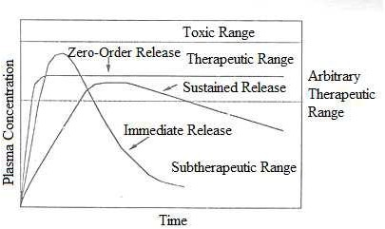

Figure 2.1 Plasma Drug Concentration Versus Time Profiles for Conventional Tablet Formulation, a Sustained Release Formulation and a Zero Order Controlled Release Formulation (Adapted from Manish, 2008)

In general, controlled delivery attempts to:

1. Sustain drug action at a predetermined rate by maintaining a relatively constant, effective drug level in the body with concomitant minimization of undesirable side effects associated with a saw-tooth kinetic pattern (Tungaraza *et al.*, 2013).
2. Localize drug action by spatial placement of a controlled release system (usually rate- controlled) adjacent to or in the diseased tissue or organ (Das and Das, 2003).
3. Target drug action by using carriers or chemical derivatization to deliver drug to a particular "target" cell type.
4. To enhance drug-receptor interaction for some drugs that are specific in nature, for example, certain hormones are extremely specific since they interact with receptor mechanisms, which are present in only one or few cell types.
5. To formulate drugs with very short biological half-life, this ordinarily requires multiple administrations every 24 h, in a way that the frequency of administration is reduced (Tungaraza *et al.,* 2013).

# Types of Modified Release Dosage Forms

Modified release dosage forms are formulations where the rate and/or site of release of the active ingredient(s) is/are different from that of the immediate release dosage form administered by the same route. This deliberate modification is achieved by special formulation design and/or manufacturing methods. Modified release dosage forms may include those administered orally, intramuscularly, subcutaneously, or even transdermal dosage forms (Gundo *et al.,* 2011).

* + - 1. *Prolonged Release Dosage Forms*

In these systems the drug is released for absorption over a prolonged period of time than from a conventional dosage form. Prolonged release dosage forms are modified release dosage forms showing a slower release than that of an immediate release dosage form administered by the same route. The onset of activity of drugs in this type of formulations is often delayed because of an overall slow release rate from the dosage form (Ankit *et al.,* 2011).

* + - 1. *Sustained release form*

In this system, there is an initial release of an amount of drug sufficient to provide a therapeutic plasma concentration immediately after administration, and then a gradual release over an extended period of time (Geraets and Burke, 1990).

* + - 1. *Delayed release dosage form:*

In this type of systems, the drug is not being released immediately following administration but at a later time. The release of the active substance from such modified release dosage forms is delayed for a certain period after administration or application of the dosage. The subsequent release is similar to that of an immediate release dosage form. Examples include pulsatile-release capsules (Conte *et al.*, 1992).

* + - 1. *Multiphasic release dosage forms:*

Biphasic Release

The first phase of drug release is determined by the immediate release dose fraction providing a therapeutic drug level shortly after administration. The second extended release phase provides the dose fraction required to maintain an effective therapeutic level for a prolonged period.

Pulsatile Release:

Pulsatile drug release is intended to deliver a burst of drug release at specific time intervals (Conte *et al.*, 1992).

* + - 1. *Repeat-action*

Repeat action formulations indicate that an individual dose is released fairly soon after administration, and one or several more subsequent doses are released at predetermined intermittent intervals (Skelly *et al.,* 1993).

* + - 1. *Transdermal drug delivery systems (TDDS)*

A TDDS or transdermal patch is a flexible pharmaceutical preparation of varying size containing one or more active substance(s) to be applied on the intact skin for systemic bioavailbility. (Guideline on the pharmacokinetic and clinical evaluation of modified release dosage forms, EMA 2013)

* + - 1. *Multiple-unit*

A multiple unit dosage form contains a plurality of units e.g. pellets or beads each containing release controlling excipients, e.g.in a gelatin capsule or compressed in a tablet (Conte *et al*, 1992).

* + - 1. *Single-unit*

The single-unit dosage forms consist of only one unit, e.g. osmotic tablet (Conte *et al.*, 1992).

# Merits of Modified Release Dosage Forms

* + - 1. *Improved Patient Compliance*

Lack of compliance is generally observed with long term treatment of chronic diseases, as success of drug therapy depends upon the ability of patients to comply with the regimen. Patient compliance is affected by a combination of several factors, like awareness of disease process, patient‘s faith in therapy, and understanding of the need to adhere to a strict

treatment schedule. Others include the complexity of therapeutic regimens, the cost of therapy, and magnitude of local and or systemic side effect of the dosage form. The problem of lack of patient compliance can be resolved to some extent by administering controlled release drug delivery system as they reduce the number and frequency of doses administered. They reduce the total amount of drug needed to obtain the desired therapeutic response, thus maximize availability with a minimum dose. The possibility of missed doses is greatly reduced by these formulations (Ofokansi *et al.*, 2012).

* + - 1. *Reduced 'Peak and Valley' fluctuation in plasma concentration*

Administration of a drug in a conventional oral dosage form often results in ―peak and valley‖ pattern of drug concentration in the systemic circulation and tissue compartments. The magnitudes of these fluctuations depend on drug kinetics such as the rate of absorption, distribution, elimination and dosing intervals. The 'see – saw' or 'peak and valley' pattern is more striking in case of drugs with biological half-lives of less than four hours, since prescribed dosing intervals are rarely less than four hours. A well designed controlled release drug delivery system can significantly reduce the frequency of drug dosing and also maintain a steadier drug concentration in blood circulation and target tissue cells. This will ultimately lead to improved outcomes of pharmacotherapy (Tungaraza *et al.,* 2013). The following figure typifies plasma concentrations obtained with conventional and modified release dosage forms.

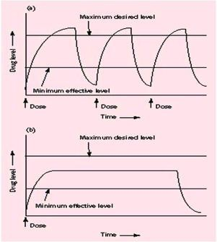

Figure 2.2: Drug level versus time profile showing differences between (a) traditional drug dosing and (b) sustained delivery dosing (Adapted from Tungaraza, 2013).

* + - 1. *Reduced total dose*

Controlled release drug delivery systems have repeatedly been shown to use less amount of total drug to treat a disease condition. By reducing the total amount of drug, decrease in systemic or local side effects are observed. This would also lead to greater economy (Maulding *et al.,* 1986).

* + - 1. *Improved efficiency in treatment*

Optimal therapy of a disease requires an efficient delivery of active drugs to the tissues and organs that need treatment. Very often, doses far in excess of those required in the cells have to be administered in order to achieve the necessary therapeutically effective concentration. This unfortunately may lead to undesirable, toxicological and immunoogical effects in non-

target tissue. A controlled release dosage form leads to better management of the acute or chronic disease condition (Maulding *et al.,* 1986).

* + - 1. *Economy*

In comparison with conventional dosage forms the average cost of treatment over an extended period may be less. Economy may also result from a decrease in nursing time and hospitalization. There is reduction in blood level oscillation characteristic of multiple dosing with conventional dosage forms. There is reduction in the amount of drug administered and availability is maximized with a minimum dose (Brahmanker and Jaiswal, 1995).

* + - 1. *Improved therapy*

1. Sustained blood level: The dosage form provides uniform drug availability / blood levels unlike peaks and valley pattern obtained by intermittent administration.
2. Attenuation of adverse effects: The incidence and intensity of undesirable effects caused by excessively high peak drug concentration resulting from the administration of conventional dosage forms is reduced.
3. It is seldom that a dose is missed because of non-compliance by the patient (Brahmanker and Jaiswal, 1995).

# Demerits of Modified Release Dosage Forms

* + - 1. *Dose dumping*

Dose dumping is a phenomenon where by relatively large quantities of drug in a controlled release formulation is rapidly released, introducing potential toxic quantities of the drug into the systemic circulation. Dose dumping can lead to fatalities in case of potent drug, which

have a narrow therapeutic index e.g. phenobarbital (Hendeles *et al.,*1985; Krajacic and Tucker, 2003) .

* + - 1. *Difficulty in discontinuation of therapy in the event of an adverse drug reaction* Adverse events are frequently encountered during pharmacotherapies. One of the easiest ways to manage incidences includes immediate withdrawal of the medicament. It is very difficult to remove or stop the action of a sustained release tablet unlike in a conventional immediate release dosage form (Bhardwaj *et al.,* 2000).
      2. *Less flexibility in accurate dose adjustment*

In conventional dosage forms, dose adjustments are much simpler e.g. tablet can be divided into two fractions. In case of controlled release dosage forms, this appears to be much more complicated. Controlled release property may get lost, if dosage form is fractured (Kumar *et al.*, 2012).

* + - 1. *Poor in vitro – in vivo correlation*

In controlled release dosage form, the rate of drug release is deliberately reduced to achieve drug release possibly over a large region of gastrointestinal tract. Here the so called

‗Absorption window‘ becomes important and may give rise to unsatisfactory drug absorption *in vivo* despite excellent *in vitro* release characteristics (Kumar *et al.,* 2012).

* + - 1. *Patient variation*

The time period required for absorption of drug released from the dosage form may vary among individuals. Co-administration of other drugs, presence or absence of food and residence time in gastrointestinal tract is different among patients. This also gives rise to

variation in clinical response among the patients (Kumar *et al.,* 2012; Brahmanker and Jaiswal, 1995).

# Factors affecting sustained release dosage forms

* + - 1. Physicochemical properties of the drug affecting sustained release dosage forms:

1. *Dose size*

If the dose of a drug in the conventional dosage form is high, its suitability as a candidate for sustained release is seriously undermined. This is chiefly because the size of a unit dose sustained release formulation would become too big, to administer without difficulty (Kumar *et al.*, 2012). Since dose size consideration serves as a parameter for the safety involved in administration of large amounts with narrow therapeutic range, Conrad and Robinson (1980) suggested that if an oral product has a dose size greater than 500 mg it is a poor candidate for sustained release system. This is because addition of sustaining dose and possibly the sustaining mechanism will, in most cases generate a substantial volume product that is unacceptably large.

1. *Aqueous solubility of the drug*

Most of drugs are weak acids or bases. Since the unchanged form of a drug preferentially permeates across lipid membranes, drug‘s aqueous solubility will generally be decreased by conversion to an unchanged form. Drugs with low water solubility will be difficult to incorporate into sustained release mechanism. The lower limit on solubility for such product has been reported to be 0.1 mg/ml. Drugs with great water solubility are equally difficult to incorporate into sustained release system. pH dependent solubility, particularly in the physiological pH range, would be another problem because of the variation in pH

throughout the GI tract and hence variation in dissolution rate (Follonier *et al.*, 1994; Siepmann and Peppas, 2001).

1. *Stability of the drug*

Orally administered drugs can be subject to both acid-base hydrolysis and enzymatic degradation. Degradation will proceed at a reduced rate for drugs in the solid state. For drugs that are unstable in the stomach; systems that prolong delivery over the entire course of transit in gastrointestinal tract are beneficial. Compounds that are unstable in the small intestine may demonstrate decreased bioavailability when administered from a sustaining dosage form. This is because more drug is delivered in small intestine and hence subject to degradation (Leroux *et al.,* 1996).

1. *Partition coefficient of the drug*

Partition coefficient is generally defined as the fraction of drug in an oil phase to that of an adjacent aqueous phase. Accordingly, compounds with relatively high partition coefficient are predominantly lipid soluble and consequently have very low aqueous solubility. Compounds with very low partition coefficients will have difficulty in penetrating membranes resulting in poor bioavailability. Bioavailability of a drug is largely influenced by the partition coefficient, as the biological membrane is lipophilic in nature. Transport of drug across the membrane largely depends upon the partition coefficient of the drug. Drugs having low partition coefficient are considered poor candidate for the sustained release formulation as it will be localized in the aqueous phase eg: barbituric acid and vice a versa (Fahr *et al.,* 2005*;* Pitt *et al.,* 1979).

1. *Dissociation Constant (pKa) value of the drug*

For a drug to be absorbed it must dissolve in the aqueous phase surrounding the site of administration and then partition in the absorbing membrane. Two of the most important physicochemical properties of a drug that influence its absorptive behavior are its aqueous solubility and if it is a weak acid or base, its pKa. These properties play an influential role in the performance of controlled release systems. The relationship between pKa of a compound and absorptive environment is important. Presenting drug in an unchanged form is advantageous for drug permeation but solubility decreases as the drug is in unchanged form (Fahr *et al.,* 2005).

1. *Protein binding*

It is well known that many drugs bind to plasma proteins with a concomitant influence on the duration of drug action. Since blood proteins are for the most part re-circulated and not eliminated, drug protein binding can serve as a depot for drug producing a prolonged release profile, especially if a high degree of drug binding occurs. Extensive binding to plasma proteins will be evidenced by a long half-life of elimination for drugs and such drugs may not require a sustained release dosage form. However drugs that exhibit high degree of binding to plasma proteins also might bind to bio-polymers in gastrointestinal tract which could have influence on sustained drug delivery. The presence of hydrophobic moiety on drug molecule also increases the binding potential (Patel *et al.*, 2012).

1. *Molecular size and diffusivity*

The ability of drug to diffuse through membranes is called diffusivity and diffusion coefficient is a function of molecular size (or molecular weight). Generally, values of

diffusion coefficient for intermediate molecular weight drugs, through flexible polymer ranges from 10-8 to 10-9 cm 2/sec with values on the order of 10-8 being most common for drugs with molecular weight greater than 500. The diffusion coefficients of many polymers are frequently so small that they are difficult to quantify i.e. less than 16-12 cm2/sec. Thus high molecular weight drugs and/or polymeric drugs should be expected to display very slow release kinetics in sustained release device using diffusion through polymer membrane (Baker and Lonsdale, 1974; Korsmeyer *et al.,* 1983).

* + - 1. *Biological properties of the drug affecting sustained release dosage forms:*

1. *Biological half-life of the drug*

The usual goal of an oral sustained release product is to maintain therapeutic blood levels over an extended period. To achieve this, drug must enter in the circulation at approximately the same rate which it is eliminated. The elimination rate is quantitatively described by half- life (t1/2). Therapeutic compounds with short half-lives are excellent candidates for sustained release preparations, since this can reduce dosing frequency. However, this is limited, in that drugs with very short half lives may require excessive large amounts of drug in each dosage unit to maintain sustained effects, forcing the dosage form itself to become limitingly large (Chung *et al.,* 2012). In general, drugs with half-lives shorter than 3 h are poor candidates for sustained release dosage forms since dose size will increase. Similarly, compounds with long half-lives, more than 8 h are not recommended for use in sustained release forms because their effect is already sustained (Amighi *et al.,* 1998).

1. *Absorption characteristics of the drug*

The absorption rate constant is an apparent rate constant, and should, in actuality, be the release rate constant of the drug from the dosage form. Compounds that demonstrate the absorption rate constant will probably be poor candidates for sustaining systems. If a drug is absorbed by active transport, or transport is limited to a specific region of intestine, sustained release preparations may be disadvantageous to absorption (Chung *et al.,* 2012). The rate, extent, and uniformity of absorption of a drug are important factors when considering its formulation into a sustained release system. The rate limiting step in drug delivery from a sustained-release system is its release from the dosage form, rather than absorption. Rapid rate of absorption of drug, relative to its release is essential if the system is to be successful. Assuming that transit time of drugs in the absorptive areas of the GI tract is about 8-12 h, the maximum half-life for absorption should be approximately 3-4 h. Otherwise device will pass out of potential absorption regions before drug release is complete (Patel *et al.,* 2011).

1. *Distribution characteristics of the drug*

The distribution of drugs into tissues can be an important factor in the overall drug elimination kinetics. Since it not only lowers the concentration of circulating drug but can also be the rate limiting in its equilibrium with blood and extra vascular tissue, consequently apparent volume of distribution assumes different values depending on the time course of drug disposition. For design of sustained/controlled release products, the knowledge of the drug distribution in various tissues and compartments must be acquired (Patel *et al.,* 2011).

1. *Metabolism characteristics of the drug*

Drugs that are significantly metabolized before absorption, either in lumen or the tissue of the intestine, can show decreased bioavailability from slower-releasing dosage forms. Most intestinal wall enzyme systems are saturable. As the drug is released at a slower rate to these regions, less total drug is presented to the enzymatic process during a specific period, allowing more complete conversion of the drug to its metabolite (Pundir, 2013).

*f) Margin of safety of the drug*

Drug with a narrow therapeutic range requires precise control over the blood levels of drug, placing a constraint on sustained-release dosage forms. Drugs with low therapeutic index are unsuitable for incorporation in sustained release formulations. If the system fails in the body, dose dumping may occur, leading to fatalities eg. digitoxin (Kumar *et al.,* 2012).

# Design of Oral Sustained Release Drug Delivery System

The oral route administration is mostly adopted route because of its comfortable dosage form, design and patient care. Several parameters should be kept in mind before formulating sustained release dosage form which includes various pH in GIT, the gastrointestinal motility, the enzyme system and its effect on the dosage form and the drug. Most of sustained release dosage form follows the mechanism of diffusion, dissolution or combination of both, to produce slow release of drug at predetermined rate. Hypothetically, a sustained release dosage form should release the drug by a zero-order mechanism which maintains drug plasma level time similar to intravenous infusion (Ankit *et al.,* 2011). Plasma drug concentration-profiles for conventional tablet or capsule formulation, a sustained release formulation, and a zero order sustained release formulation are as shown in Fig. 2.3 and 2.4.

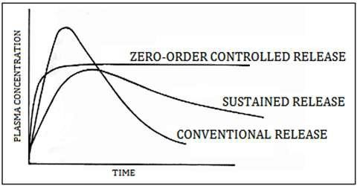

Figure 2.3: Plasma drug concentration profile for conventional release, a sustained release and zero order controlled release formulations (Adapted from Ankit *et al*, 2011).

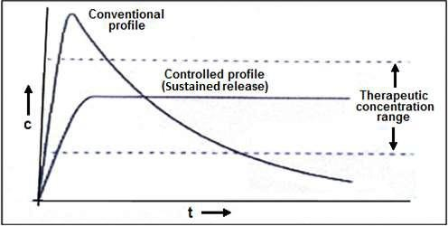

Figure 2.4: Comparison of conventional and controlled release profiles (Adapted from Ankit *et al*, 2011).

# Approaches to Sustained Release Drug Delivery System

* + - 1. *Dissolution controlled release systems*

Drugs which are formulated using this system have slow dissolution rate, produce slow dissolving forms with gastric intestinal fluids (Panwar *et al.*, 2012). Dissolution controlled release system can be classified into two techniques:

* + - * 1. *Matrix dissolution controlled release system*

Matrix dissolution system is known as monolithic because the drug present in the matrix is completely dissolved in the medium which controls the drug release. They are mostly made of waxes like beeswax, carnauba wax, hydrogenated castor oil, etc. and play important role to control the drug release rate by controlling the rate of dissolution, fluid penetration into the matrix by altering the porosity of tablet, decreasing its wettability, or by itself getting dissolved at a slower rate. The drug release generally follows first order kinetics from such matrice system (Panwar *et al.,* 2012).

* + - * 1. *Reservoir dissolution controlled release system*

In reservoir system, the drug particles are coated or encapsulated with one of the several microencapsulation techniques using slowly dissolving materials like cellulose, polyethylene glycol and waxes. This unit can be encapsulated in capsules or may be compressed into tablets. Solubility and thickness of the coating play important role in dissolution rate of drug (Panwar *et al.,* 2012).

* + - 1. *Diffusion controlled release systems*

In diffusion release models, the diffusion of dissolved drug through a polymeric membrane is the rate limiting step. In this system, the drug release rate never follows zero-order kinetics, because the diffusional path length increases with time as the insoluble matrix is

depleted (Uhrich *et al.*, 1999). The mechanism of diffusion process shows the movement of drug molecules from a region of a higher concentration to region of lower concentration. The flux of the drug J (in amount / area -time), across a membrane in the direction of decreasing concentration is given by Fick‘s law.



where,

J=flux of the drug across a membrane in the direction of decreasing concentration D = Diffusion coefficient of the drug, and

dc/dx = Change in the concentration of the drug in the membrane

Whereas, when drug is present in a water insoluble membrane, it must diffuse through the membrane. The drug release rate dm/ dt is given by



where,

A = Area of the diffusion membrane

K = Partition coefficient of drug between the membrane and drug core. L = Diffusion path length (i.e. thickness of coat).

ΔC = Concentration difference across the membrane.

* + - 1. *Dissolution and diffusion controlled release systems*

In this kind of system, the drug is enclosed in a membrane which is partially water soluble. The dissolution of the drug takes place through pores which are formed and allows aqueous medium to enter into the membrane. This results in the dissolution of the drug in membrane followed by the diffusion of the dissolved drug from the system. Example of such coating is combination of ethyl cellulose with polyvinyl pyrolidone (PVP) or methyl cellulose (Ankit *et al.,* 2011).

* + - 1. *Ion exchange resin-drug complexes*

Resins are materials which are insoluble in water. Resin contains anionic groups such as amino or quartenary ammonium groups and cationic groups such as carboxylic groups, or sulfonic groups in repeating positions on the chain.

A drug–resin complex is formed by prolonged exposure of drug to the resin.

The drug from these complexes gets exchanged in gastrointestinal tract and later they are released with excess of Na+ and Cl- present in gastrointestinal tract.

Resin+ – Drug– + Cl– >>> Resin+ Cl– + Drug–

Conversely, Resin– – Drug+ + Na+ >>> resin– Na+ + Drug

Water insoluble cross-linked polymer compounds are used for this system (Panwar *et al.,*

2012).

* + - 1. *pH dependent formulation*

Some drugs on dissolution and absorption in GIT, change the pH present in the gastrointestinal tract, so dosage forms are formulated using sufficient amount of buffering agent like salt of phosphoric, citric or tartaric acids. These salts adjust the pH to the desired value when dosage form move across the gastrointestinal tract. Permeable coating agents are

used to coat the drug and buffer present in the dosage form, which allows the aqueous medium to enter into it and prevent the dispersion of the tablets (Devraj, 2010).

* + - 1. *Osmotic pressure controlled systems*

These types of system are also known as OROS, which follows the mechanism of osmotic pressure where the drug is released at constant zero order rate. The reservoir is made up of the drug and osmotic agent like mannitol or KCl, which is surrounded by semi-permeable membrane. A small orifice is present in the dosage form, which allows the entry of water into the reservoir and helps the dissolved drug to pump out at the determined rate due to osmotic pressure. The release of the drug from the reservoir is unaffected by the conditions of the GIT. The release of drug is dependent on factors like size of orifice, thickness of semi-permeable membrane, permeability of membrane, osmotic properties of core and stability of the drug (Devraj, 2010).

# Modified Dosage Forms Drug Release Kinetics

Theoretically expected rates of release of solid drugs incorporated into solid matrices have been derived for several model systems. Some of these models include zero order, first order, Higuchi, Korsmeyer, Peppas, Hixson etc. Mathematical relations have been obtained for cases:

1. Where the drug particles are dispersed in a homogeneous, uniform matrix which acts as the diffusional medium and
2. Where the drug particles are incorporated in an essentially granular matrix and released by the leaching action of the penetrating solvent. Release from both planar surface and a sphere is considered.

Studies have shown that for the latter system, the time required to release 50 percent of the drug (t50%) would normally be expected to be approximately 10 percent of that required to dissolve the last trace of the solid drug phase in the center of the pellet (Higuchi, 1963). To determine the mechanisms of drug release from formulations, the dissolution data obtained are usually treated with equations and plotted according to zero order (cumulative amount drug release vs time), first order (log cumulative percentage of drug remaining vs time), Higuchi‘s (cumulative % drug release vs square root of time) and Korsmeyer *et al’s* (log cumulative % drug release vs log time) models. A value of n = 0.5 indicates case I (Fickian) diffusion or square root of time kinetics, 0.5 <n <1 anomalous (non-Fickian) diffusion, n = 1 Case-II transport and n > 1 Super Case-II transport (Korsmeyer *et al.,* 1983).

* + - 1. *Zero order kinetics*

The cumulative percentage release of the drug is plotted against time and the correlation coefficient and the slope noted. This model is best fitted for conventional formulations where the drug release is uniform and occurs after disintegration of the formulation (Korsmeyer *et al.,* 1983).

* + - 1. *Hixson – Crowell model*

This is based on the Hixson – Crowell cube root law. Here, the cube root of the cumulative percentage release of the drug is plotted against time. The rate constant, KHC of release and the regression line value can be extracted from the graph. The equation is

Q01/3 – Qt1/3 = KHC t 3

Where Q0 = is the initial amount of the drug in tablet Qt = the amount of drug released in time t

KHC = the rate constant for Hixson-Crowell rate equation (Singhvi and Singh, 2011).

* + - 1. *Korsemeyer-Peppas model*

This simple empirical equation is used to describe general solute release behaviour from controlled release polymer matrices. Here, a plot of the logarithm of the cumulative percentage of the drug released against the logarithm of time and the slope, ‗n‘ and the regression line values are usually extracted from the graph. The equation used is:

F =  = Ktn 4

Where F = fraction of drug released Mt = amount of drug released at time t

M = total amount of drug in dosage form K= kinetic constant,

t = release time

n = the diffusional exponent for drug release (Korsmeyer *et al.*, 1983).

# CHAPTER THREE

# MATERIALS AND METHODS

# Materials

# Chemicals/Reagents

 Concentrated hydrochloric acid (Sigma-Aldrich Laborchemikalien GmbH, Germany)  Theophylline powder (Sigma-Aldrich laborchemikalien GmbH, Germany)

 Chlorpheniramine maleate powder (BDH Chemicals Ltd. Poole England)

 Hydroxypropylmethylcellulose (HPMC) powder (Sigma-Aldrich laborchemikalien GmbH, Germany)

 Acetone (Absolute) (Sigma-Aldrich laborchemikalien GmbH, Germany)

 *Chrysophyllum albidum* ripe fruits (Samaru Market, Zaria)

 Microcrystalline cellulose (BDH Chemicals Ltd. Poole England)  Magnesium stearate (BDH Chemicals Ltd. Poole England)

# Equipment

 Gallenkamp Hot Air Oven Dryer BS Size 3 ( Gallenkamp, England)

 Single Punch Tabletting Unit (Type EKO-400, Erweka-Apparatebau GmbH Heusenstamm, Germany)

 Gallenkamp Regulator Hot Plate (Philipsm Harris Ltd, England)

 Digital Weighing Balance (X0 27555, Denver Instrument Company USA)  Oaklon pH Meter ( pH 1100 Series, Eutech Instruments, Singapore)

 Endecott Sieve Shaker (Endecotts Ltd, England)

 Disintegration Test Unit (Type ZT3, Erweka-Apparatebau GmBH Heusenstamm, Germany)

 Dissolution Test Unit (Type DT, Erweka-Apparatebau GmBH Heusenstamm, Germany)

 Flow Rate Meter (Type GDT, Erweka-Apparatebau GmBH Heusenstamm, Germany)

 Tablet Friabilator (Type TA3R, Erweka-Apparatebau GmBH Heusenstamm, Germany)

 Monsanto Hardness Tester (Monsanto Chemical Company, USA)  Micrometer Screw Gauge ( Moore and Wright Sheffield, England)

 Tumbling Mixer (Erweka-Apparatebau GmBH Heusenstamm, Germany)  Viscometer (Brookfield Viscometer DV-1 Prime, Wisconsin)

 Spetrophotometer (B.Bran Scientific and Instrument Company, England)

 Differential Scanning Calorimeter (Mettler TA 3000 Controller and DSC 821e, Switzerland)

Blender ( MJ-176 NR, Matsushita Electric Industrial Company Ltd. Osaka, Japan)

# Methods

# Gum extraction and purification

The ripe fresh fruits of *Chrysophyllum albidum* (G. Don) were obtained from the local market in Zaria, Nigeria, washed thoroughly and identified at the Herbarium of the Department of Biological Science, Ahmadu Bello University. The fruit was peeled and the seeds removed leaving the pulp. The gum was extracted from the pulp using the method of Onunkwo and Mba (1996) and Tavakoli *et al.,* (2008) with slight modification.

The pulp was soaked in water, allowed to marcerate, then carefully expressed and filtered using a calico cloth. *Chrysophyllum albidum* fruit gum (CAG) was precipitated from the filterate using acetone. CAG was blended with 50 ml acetone in a Matsushita blender in order to remove water and improve drying without discolouration. This blending and washing was repeated 3 times using 50 ml aliquots of acetone until there was no change in the colour of the liquid. The resulting fluffy gum (CAG) collected was left to dry at room temperature for 4 h before taken to the oven for further drying at 50 oC until completely dried.

# Determination of percentage yield

After peeling and removing the seeds, the weight of the pulp was recorded. The percentage yield was calculated based on the weight of the dry gum extracted according to equation 5.





# Physicochemical Characterization of the Gum

* + - 1. *Particle size*

The mean particle size of C*hrysophyllum albidum* gum was determined using an arrangement of a nest of sieve sizes 75, 150, 250, 350 and 500 µm on an Endecott sieve vibrator. A 300 gm quantity was shaken for 10 min and the quantity retained by each mesh weighed. The mean particle size was calculated according to equation 6.







Where,

Fi = Percentage frequency Xi = Class mean

* + - 1. *Solubility tests*

The method of Mahmud *et al.,* (2008) was adopted. The solubility of *Chrysophyllum albidum* gum was determined in cold and hot distilled water, acetone, chloroform, and ethanol. Ten (10) mg sample was weighed and added to each of the above solvents in separate test tubes and left overnight. Five (5) ml of the supernatant liquid for each of the mixtures was measured, transferred to a pre-weighed evaporating dish and heated to dryness over a water bath. The weight of the dried residue with reference to the volume of the solutions was determined using a digital top loading balance.

* + - 1. *Moisture content (Loss on drying)*

The method specified for acacia in BP 2004 was adopted. One gram of sample gum was transferred into each of 3 Petri dishes and then dried in an oven at 105 0C until a constant weight was obtained. The moisture content was determined as the ratio of weight of moisture loss to weight of sample expressed as a percentage.

* + - 1. *Moisture sorption studies*

The method described by Ofokansi *et al., (*2012) was adopted with little modification. Four desiccators were prepared and adjusted to a relative humidity of 33, 53, 75 and 84 % using magnesium chloride, magnesium nitrate, sodium chloride, and potassium chloride respectively. Four dried evaporating dishes were weighed and 2 gm of the gum powder transferred into each. The final weight (both dish and gum) was noted and placed in the desiccators for a period of 5 days. The dishes and their content were weighed daily and the moisture sorbed calculated.

* + - 1. *Swelling index*

A 5.0 gm quantity of the gum was weighed into a 200 ml measuring cylinder and tapped on a table top 200 times. The volume occupied by the gum in the cylinder was recorded. Water was added to up the 100 ml mark of the cylinder and the set-up left to stand for 24 h. The new volume of the gum was recorded. The swelling capacity of the gum was calculated as the ratio of the final volume to the initial volume. The procedure was repeated to obtain duplicate readings and the average taken.

* + - 1. *Hydration capacity*

This was determined according to the method of Kornblum and Stoopak (1973) and Muazu *et al.* (2011). One gram (1 g) of the powder was placed in a pre-weighed centrifuge tube and covered with 10 mls of distilled water. The tube was shaken for 2 min and left to stand for 10 min before centrifuging at 3000 rpm for 10 min. The supernatant was decanted and the weight of the powder and the tube after water uptake and centrifugation was determined. Hydration capacity was calculated from equation 7.



* + - 1. *Determination of apparent viscosity*

The method of Mahmud *et al.* (2008) was adopted. A digital Brookfield viscometer (Model DV-I PRIME) with spindle size S2 was used. The viscosity of 5 % w/v suspension of the gum was determined at a speed of 100 rpm.

* + - 1. *Determination of pH*

The pH of a 5 % w/v suspension of the gum in distilled water was determined using an Oaklon pH meter (Series 1100, Singapore). The pH was determined in triplicate.

* + - 1. *Determination of swelling characteristics of gum compact*

The method of Okafor *et al.* (2001) was adopted with slight modification. Powdered gum was compressed using the Erweka Single Punch Tabletting Machine (Type EKO-400, Erweka-Apparatebau) fitted with 12.0 mm flat-faced punch and die set. The powder was compressed manually into compacts of weight 500 ± 3 mg. After taking the weight and dimensions of the compact it was placed in a beaker containing 100 ml of phosphate buffer, pH 7.4. The weight variations and dimensions (thickness and diameter) of the compacts were determined at varying time intervals between 0 to 3 h by means of an electronic weighing balance (X0 27555, Denver Instrument company USA) and micrometer screw gauge (Moore & Wright Sheffield, England) respectively after removal from the fluid by means of a small pin. Replicate determinations were made and the averages plotted against time.

* + - 1. *Total ash and soluble ash*

The total and soluble ash was determined according to the Association of Official Analytical Chemists, AOAC (1990) method. A 1.0 gm sample of the gum was weighed into a pre- ignited and pre-weighed crucible, and transferred into a furnace. It was ignited at 550 0C for 24 h. The recovered ash was transferred into a desiccator and allowed to equilibrate at room temperature before weighing. The resultant ash from the above was mixed with distilled water (25 ml), boiled and filtered through ash-less filter paper. The filter paper was rinsed until the filtrate volume reaches 60 ml. Both filter paper and residue were transferred to the crucible and ignited for 24 h until a constant weight is obtained. Thereafter, it was cooled in a desiccator and weighed.

Percent ash content and soluble ash was calculated from equations 8 and 9.









# Phytochemical screening

Some phytochemical tests were carried out on the gum according to the B.P. (2004) methods for acacia and tragacanth in an attempt to characterize the gum. These include tests for the presence of tannins, glycosides, alkaloids and reducing sugars.

* + - 1. *Test for alkaloids*

Ten (10) mg of the sample was dispersed in 5 ml distilled water and acidified with 2 ml 2 M hydrochloric acid. To the dispersion, 1 ml iodobismuthane solution was added and any colour change was observed.

* + - 1. *Test for tannins*

Five (5) ml of a 0.5 % w/v dispersion of the gum was prepared. Three drops of freshly prepared Iron (III) chloride solution was added and any colour change was observed.

* + - 1. *Test for lignin*

To a 20 ml portion of a freshly prepared 1 % phloroglucinol solution 10 mg of the gum was added and allowed to stand for 5 h. Colour on the lignin cell wall was observed as bright-red in ethanolic phloroglucinol solution.

* + - 1. *Test for glycosides*

Three (3) drops of sodium nitroprusside solution was added to a dispersion of the gum in a test tube and then mixed with 2 drops of sodium hydroxide solution. Any colour change was noted.

* + - 1. *Test for flavonoids*

To a dispersion of the gum in a test tube, 3 drops of ethanol was added, then, a small piece of magnesium strip dropped inside. Ten (10) ml concentrated hydrochloric acid was poured on the side of the test tube and it was observed for any colour change.

* + - 1. *Test for oils and fats (spot test)*

The supernatant liquid above a dispersion of the gum was spotted on a filter paper and allowed to dry. The filter paper was observed for any translucent spot.

* + - 1. *Test for Polysaccharides*

Controlled hydrolysis and detection of sugars in the hydrolysate was carried out according to the method of Tomoda *et al.* (1977) as modified by Okafor *et al.* (2001). *Chrysophyllum albidum* fruit gum (750 mg) was hydrolysed in a sealed tube for 6 h with 15 ml 2 N sulphuric acid at 100 0C followed by neutralization with barium carbonate while still hot, and filtered. The filtrate was treated with Molisch‘s reagent and sulphuric acid was carefully added down the side of the test tube to form a lower layer. The ring at the interphase was observed for the presence of any colour.

# Flow properties of gum

* + - 1. *Angle of repose*

The static angle of repose, ~~0~~, was measured according to the fixed funnel and free standing cone method. A funnel was clamped on a retort stand with its tip 7.00 cm above a smooth paper placed on a flat horizontal surface. Fifty (50) gm of the gum was carefully poured into the funnel and allowed to flow under gravity. The height of the cone formed, h and the radius of the base, r were carefully measured. The tangent of the angle of repose was calculated using equation 10.

 



* + - 1. *Flow rate*

This was determined using the Erweka Granules Flow Tester (Type – GDT, Erweka- Apparatebau). Fifty grams of the gum was allowed to flow through the orifice of the equipment. The time taken for the whole gum to pass through was noted and the rate of flow per second was calculated as follows:



* + - 1. *Bulk and tapped densities*

A 50 gm quantity of the gum (W0) was placed in a measuring cylinder and the volume (bulk), occupied by each of the samples without tapping was noted. The bulk density was calculated according to Equation 12. The cylinder was tapped on a table top until no change in volume is observed. The volume (tapped) occupied was noted. The tapped density was calculated as the ratio of weight to the tapped volume, V 100 (equation 13).









* + - 1. *Hausners’ index*

This is calculated as the ratio of tapped density to bulk density of the samples.



* + - 1. *Carr’s (Compressibility) index (C %)*

This was calculated using equation 15:





# Investigation of the compatibility of *C. albidum* fruit gum

**Differential Scanning Calorimetry (DSC)**

Mettler TA 3000 Controller and DSC 821e, (Switzerland) was used. Five milligram portion of the sample was weighed into the standard sealed aluminium pan of the apparatus. This was heated from 25 to 300 oC at a heating rate of 5 K/min and flushing with 80 ml N2/min. Holes were made in the lids to allow dehydration of samples. Melting peaks, glass transition, and enthalpies were measured and calculated using the Mettler Star software. This was carried out for samples of the drugs individually, CAG, and the mixture of each drug and the gum.

# Fourier Transformed Infrared Spectroscopy (FTIR)

FTIR spectrophotometer (Shimadzu FTIR 8400S) was employed over the range of 500 - 4,500 cm–1 for compatibility studies using the potassium bromide (KBr) pellet method. Samples from each of drug, gum, and then mixtures of each drug and the gum were prepared in potassium bromide disk in a hydrostatic press at 6-8 ton pressure. Appearance, disappearance or broadening of absorption band(s) on the spectra of the drugs alone and when mixed with the gum were studied for possible interactions.

# Formulation Studies

# Preparation of granules

The method used by Okafor (2001) for the preparation of chlopheniramine maleate tablets was adopted in formulating the various batches of the two drugs (chlorpheniramine and theophylline). The drug was dissolved in a pre-determined volume of distilled water as the granulating solvent to wet-mass the mixture of microcrystalline cellulose and gum in order to form the matrix. A total of six (6) batches were prepared with the gum concentrations ranging from 5 to 50 %w/w (Table 3.1).

In each case, the wet mass was force-screened through a size 1.7 stainless steel sieve, oven- dried for 30 min, and screened through a size 1.6 stainless steel sieve. The granules obtained were dried at 60 0C in a hot air oven (Gallenkamp Hot Air Oven Dryer BS Size 3) until constant weight. Each batch was transferred to a bottle, sealed and kept at ambient temperature for 24 h before evaluation.

The formula for chlorpheniramine and theophylline tablets are as presented in Table 3.1.

# Table 3.1: Tablet Formula for Chlorpheniramine (C) and Theophylline (T)

|  |  |  |  |  |  |  |  |  |  |  |  |  |
| --- | --- | --- | --- | --- | --- | --- | --- | --- | --- | --- | --- | --- |
| **BATCH** | **C 1** | **C 2** | **C 3** | **C 4** | **C 5** | **C 6** | **T 1** | **T 2** | **T 3** | **T 4** | **T 5** | **T 6** |
| **Drug (g)** | 2.4 | 2.4 | 2.4 | 2.4 | 2.4 | 2.4 | 20.0 | 20.0 | 20.0 | 20.0 | 20.0 | 20.0 |
| **Gum (g)**  **(%)** | 3.0  (5) | 6.0  (10) | 12.0  (20) | 18.0  (30) | 24.0  (40) | 30.0  (50) | 3.0  (5) | 6.0  (10) | 12.0  (20) | 18.0  (30) | 24.0  (40) | 30.0  (50) |
| **MCC (g)** | 53.40 | 50.40 | 44.40 | 38.40 | 32.40 | 26.40 | 35.80 | 32.80 | 26.80 | 20.80 | 14.80 | 8.80 |
| **Magnesium stearate (g)** | 1.2 | 1.2 | 1.2 | 1.2 | 1.2 | 1.2 | 1.2 | 1.2 | 1.2 | 1.2 | 1.2 | 1.2 |
| **TOTAL (g)** | **60.0** | **60.0** | **60.0** | **60.0** | **60.0** | **60.0** | **60.0** | **60.0** | **60.0** | **60.0** | **60.0** | **60.0** |

Batch Size: 200 Tablets

KEY

C1 = Chlorpheniramine with 5 % CAG T1 = Theophylline with 5% CAG C2 = Chlorpheniramine with 10 % CAG T2 = Theophylline with 10 % CAG C3 = Chlorpheniramine with 20 % CAG T3 = Theophylline with 20 % CAG C4 = Chlorpheniramine with 30 % CAG T4 = Theophylline with 30 % CAG C5 = Chlorpheniramine with 40 % CAG T5 = Theophylline with 40 % CAG C6 = Chlorpheniramine with 50 % CAG T6 = Theophylline with 50 % CAG

# Flow properties of chlorpheniramine and theophylline granules

Granules were evaluated for angle of repose, flow rate, bulk and tapped densities, Hausner‘s and Carr‘s index as reported for the evaluation of the gum.

# Compression of Granules

The granules were treated with magnesium stearate 2 %w/w as lubricant in a tumbling mixer (Erweka-Apparatebau) for 5 min. The granules were compressed into tablets of 300 + 5 mg weight using a Single Punch Tabletting unit (Type EKO, Erweka-Apparatebau) fitted with

8.0 mm punch and die set using 7 KgF compression pressure. The same pressure was used for all the batches. The compressed tablets were dusted and stored in air-tight glass bottles for 24 h at room temperature before further evaluation.

# Evaluation of Tablet Properties

The tablet properties evaluated include weight uniformity, crushing strength, friability, disintegration time, total drug content, and dissolution profile.

* + - 1. *Weight uniformity test:*

The B.P. (2004) method was used. Twenty tablets were randomly selected from each batch, weighed individually and collectively. The mean weight was computed. The percent coefficient of the tablet weight variation was calculated from this expression:



   

* + - 1. *Crushing strength*

The crushing strength of six tablets randomly selected from each batch was determined using the Monsanto Hardness Tester (Monsanto Chemicals, USA) and the mean calculated.

* + - 1. *Friability test*

Erweka Tablet Friability Tester (Type TA3R) was used. Ten tablets were selected at random and their weight noted. The tablets were placed in the machine and set to rotate at 25 rpm for 4 min. The tablets were collected afterwards, dusted thoroughly and weighed. The difference in weight was determined and the loss expressed as percentage.

* + - 1. *Disintegration test*

An Erweka Tablet Disintegration apparatus (Type ZT3) was used. Six tablets were randomly selected and placed in the tubes of the apparatus. The medium was thermostated at 37 + 2 0C. The average time taken for the tablets to disintegrate was noted.

* + - 1. *Assay*

The drug content of chlorpheniramine and theophylline tablets was determined spectrophotometrically. Ten tablets were selected randomly from each batch and crushed in a glass mortar. A weight of the powder equivalent to 1 tablet (300 mg) was taken and transferred into a 250 ml volumetric flask containing some 0.1N hydrochloric acid and made up to volume. The absorbance of the resulting solution was measured at 265 nm and 275 nm for chlorpheniramine and theophylline respectively using a spectrophotometer (B. Bran, England). The average drug content per tablet in each batch was determined.

* + - 1. *Swelling properties of tablets*

The weight and dimensions of randomly selected tablets were confirmed and the tablets placed in beaker containing 100 ml of phosphate buffer, pH 7.4. The weight variation and dimensions (thickness and diameter) of the compacts were determined at varying intervals between 5 min to 3 h by means of an electronic weighing balance (Denver Instrument Company, USA) and micrometer screw gauge (Moore and Wright Sheffiel, England) respectively, after removal from the fluid by means of a small pin. Replicate determinations were taken and plotted against time.

* + - 1. *Dissolution tests*

The B.P. (2004) dissolution rate test was adopted. An Erweka dissolution test apparatus (Type DT) fitted with a rotating basket moving at 50 rpm was used. The dissolution media were 900 ml 0.1N hydrochloric acid (pH 1.2) maintained at 37 ± 20C for the first 2 h, then phosphate buffer (pH 6.8) for the remaining period.

A 5 ml aliquot of the dissolution medium was withdrawn with a pipette after the first 30 min, then hourly. This was replaced with fresh equivalent volume at each instance and the absorbance read at a wavelength of 265 nm and 275 nm for chlorpheniramine and theophylline respectively.

The equivalent drug concentration was determined using a standard Beer-Lambert‘s plot.

# Comparison with standard

After the dissolution studies, the tablet batches with the desirable release profiles (t50) were compared with tablets formulated with hydroxypropyl methyl cellulose (HPMC) as a standard matrix-forming polymer at the same concentration.

# Stability studies

Tablets from the batches that gave the most desirable release profiles (T50 % ) were stored in amber coloured bottles at room temperature for a period of one (1) year after which, basic tests were performed on the tablets.

Observations were made based on physical appearance, weight, thickness, diameter, crushing strength, friability, disintegration, T50 %, and drug content, and compared with data obtained when the tablets were made.

# CHAPTER FOUR

# RESULTS

* 1. **Physicochemical Properties of *Chrysophyllum albidum* fruit Gum**

Physicochemical parameters observed include percentage yield, organoleptic properties, solubility, ash content, pH, moisture content, swelling index, and viscosity (Table 4.1).

# Table 4.1: Physicochemical and Organoleptic Properties of CAG

|  |  |
| --- | --- |
| **PARAMETER** | **RESULT** |
| **Percentage Yield** | 18 ± 4 % (w/w) |
| **Average Particle Size** | 176.25 µm |
| **Organoleptic** |  |
| Colour | Light Brown |
| Odour | Odourless |
| Taste | Bland |
| **Solubility** |  |
| Water | Slightly Soluble |
| Acetone | Insoluble |
| Ethanol | Insoluble |
| Chloroform | Insoluble |
| **Ash Content** |  |
| Total | 7.39 |
| Water soluble | 6.14 |
| Acid Insoluble | 1.25 |
| **Ph** | 6.0 |
| **Moisture Content** | 6.0 (%) |
| **Swelling Index Hydration Capacity** | 22 ± 0.6  1.44 ± 0.5 |
| **Viscosity at 100 rpm (5%)** | 19.2 ± 0.3 (Pa s) |

# Moisture sorption characteristics

Moisture sorption of CAG increased with increase in relative humidity (Table 4.2).

# Table 4.2 Moisture Sorption of CAG

|  |  |
| --- | --- |
| **Relative Humidity**  **(RH%)** | **Moisture Sorbed**  **(%)** |
| 33  53  75  84 | 16  24  29  36 |

# Swelling characteristics of gum compact

The gum swells in the buffer solution with increase in time. The longer it stays the more it swells (Fig. 4.1).

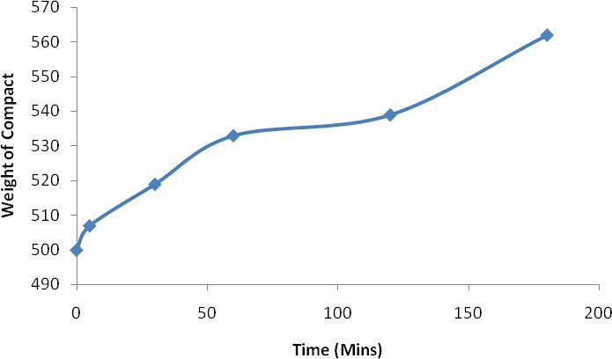

# Fig. 4.1: Swelling profile of gum compact

* 1. **Flow Properties of CAG**

The flow properties of the gum were as given in Table 4.3 (Angle of repose, flow rate, bulk and tapped densities, Hausner‘s ratio, and Carr‘s compressibility index). The gum had fairly good flow properties.

**Table 4.3: Flow properties of *C. albidum* gum**

|  |  |
| --- | --- |
| **Parameter** | **Observation** |
| Angle of repose (o) Flow rate (g/s)  Bulk density (gcm-3) Tapped density (gcm-3) Hausner‘s ratio  Compressibility index | 30.0 ± 1 8.0 ± 0.7  0.61  0.66  1.07  7.6 |

# Phytochemical Screening

The phytochemical screening carried out showed that the gum contains polysaccharides but does not contain alkaloids, lignin, tannins, flavonoids, glycosides, fats and oils (Table 4.4). **Table 4.4: Preliminary Phytochemical Screening of the Gum**

|  |  |  |
| --- | --- | --- |
| **COMPOUNDS** | **TEST** | **RESULT** |
| **Polysaccharides** | **Molisch’s** | +++ |
| **Alkaloids** | **Mayer’s** | - |
| **Lignin** | **Lignin** | - |
| **Tannin** | **Ferric chloride** | - |
| **Flavonoids** | **Shinoda’s** | - |
| **Glycosides** | **Glycosides** | - |
| **Oils and Fats** | **Spot test** | - |

**KEY**

+ Present

- Absent

# Differential Scanning Calorimetry and Fourier Transform Infrared Spectroscopy

Melting peaks, glass transition, and enthalpies were measured and calculated using the Mettler Star software. CAG demonstrated an endothermic glass transition with onset at 44.4

°C, an inflection at 72.1 °C, and the end point at 92.1 °C (Fig. 4.2). Pure sample of chlorpheniramine maleate showed an initial endothermic peak at 137.9 °C (Fig. 4.3). After mixing with CAG, chlorpheniramine thermogram maintained its sharp symmetrical peak at

137.4 °C (Fig. 4.4). Thermogram of pure sample of theophylline hydrochloride also showed a sharp symmetrical glass transition peak at 274.4 °C, then a less symmetrical peak at 355.1

°C (Fig. 4.5). After mixing with CAG peaks were obtained at 271.3 and 313.5 °C respectively (Fig. 4.6).

Figure 4.8 shows the FTIR spectrum of pure chlopheniramine with characteristic peaks at 3393.86 cm-1 indicating an amine group and 1588 cm-1 indicating amine bending bands, 1472.7 cm-1 indicating C=C double bond in benzene ring, 761.91 cm-1 and 866.07 cm-1 indicating aromatic C–H deformation. Figure 4.9 shows the spectrum of chlorpheniramine in a physical mixture with CAG where there is disappearance of some peaks but all the characteristic peaks representing the main functional groups of the drug were maintained at the same position.

Figure 4.10 is the spectrum for pure theophylline hydrochloride with characteristic amine bands at 3343.71 cm-1 and 3317.67 cm-1, there is a band with peak at 1455.34 cm-1 indicating a C=C ring breathing. After mixing theophylline with CAG, the spectrum (Fig. 4.11) reveals that all the characteristic band and their peaks were still visible and maintained their positions. There is however disappearance of some peaks.

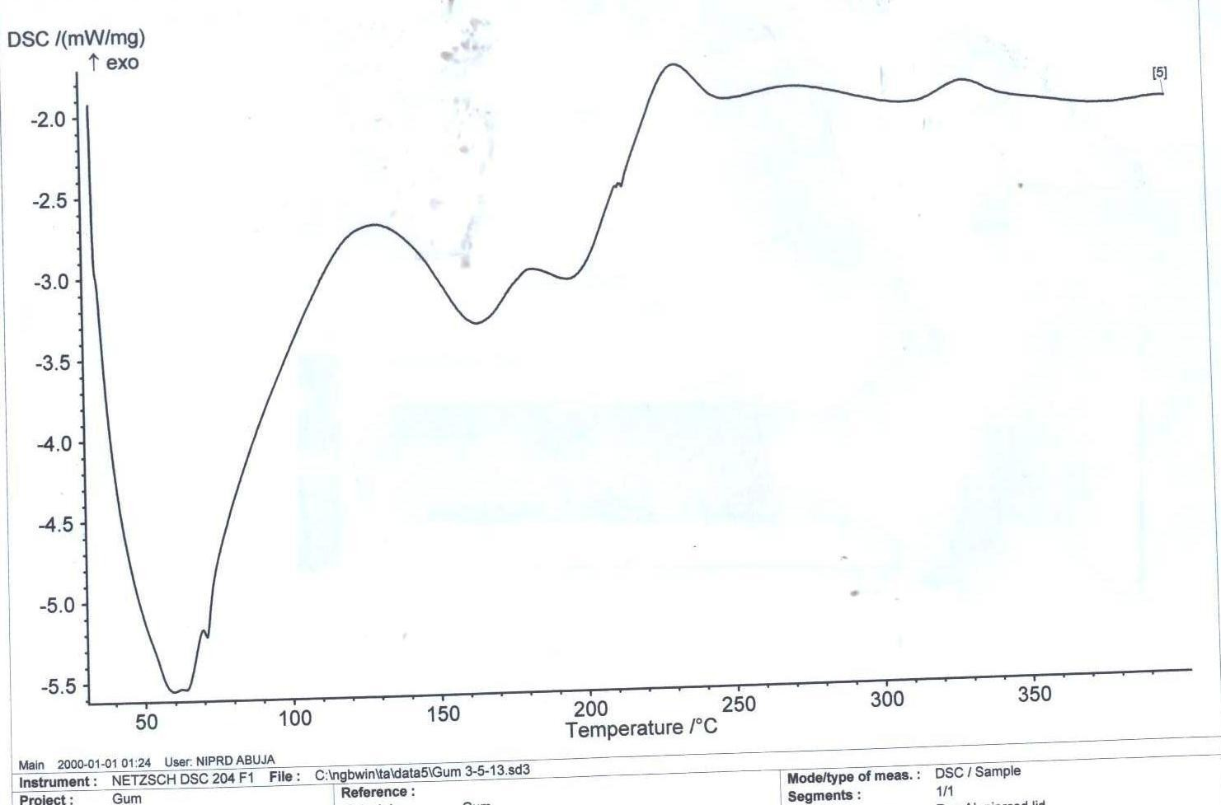

# Fig. 4.2: Thermogram of CAG

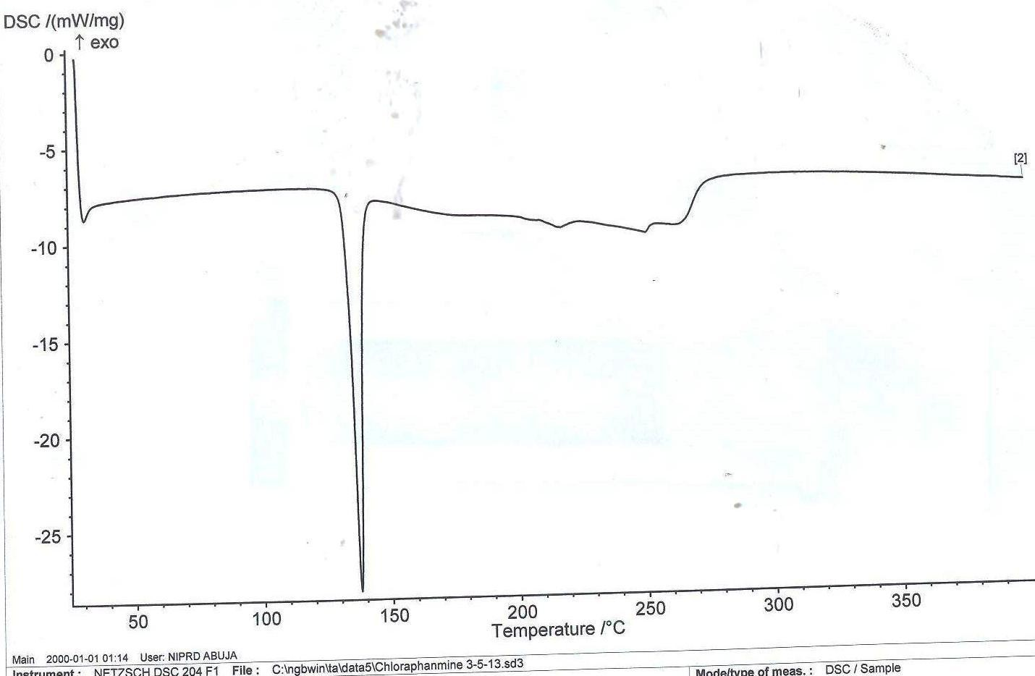

**Fig. 4.3: Thermogram of pure chlorpheniramine**

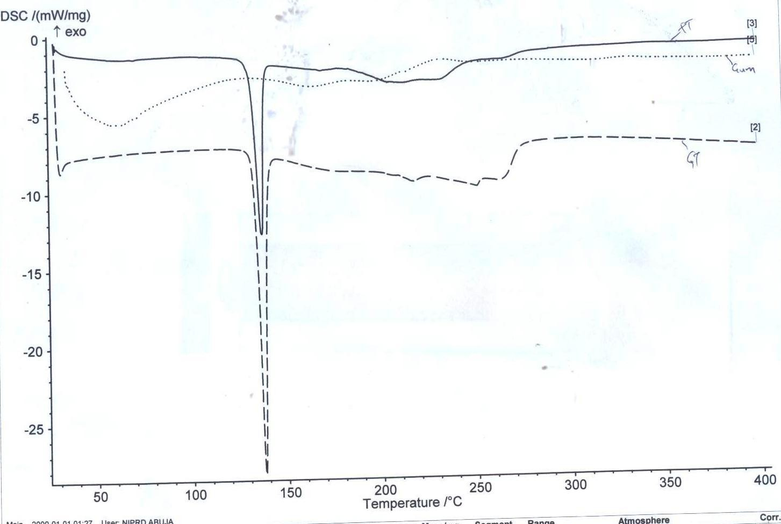

# Fig. 4.4: Thermogram of pure chlorpheniramine, chlorpheniramine mixed with CAG, and CAG alone

Key

………….. CAG

Mixture of Chlorpheniramine and CAG

-------------- Pure Chlorpheniramine

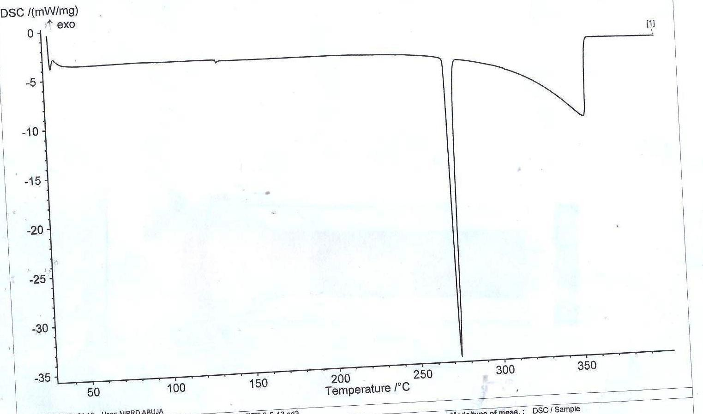

# Fig. 4.5: Thermogram of pure theophylline

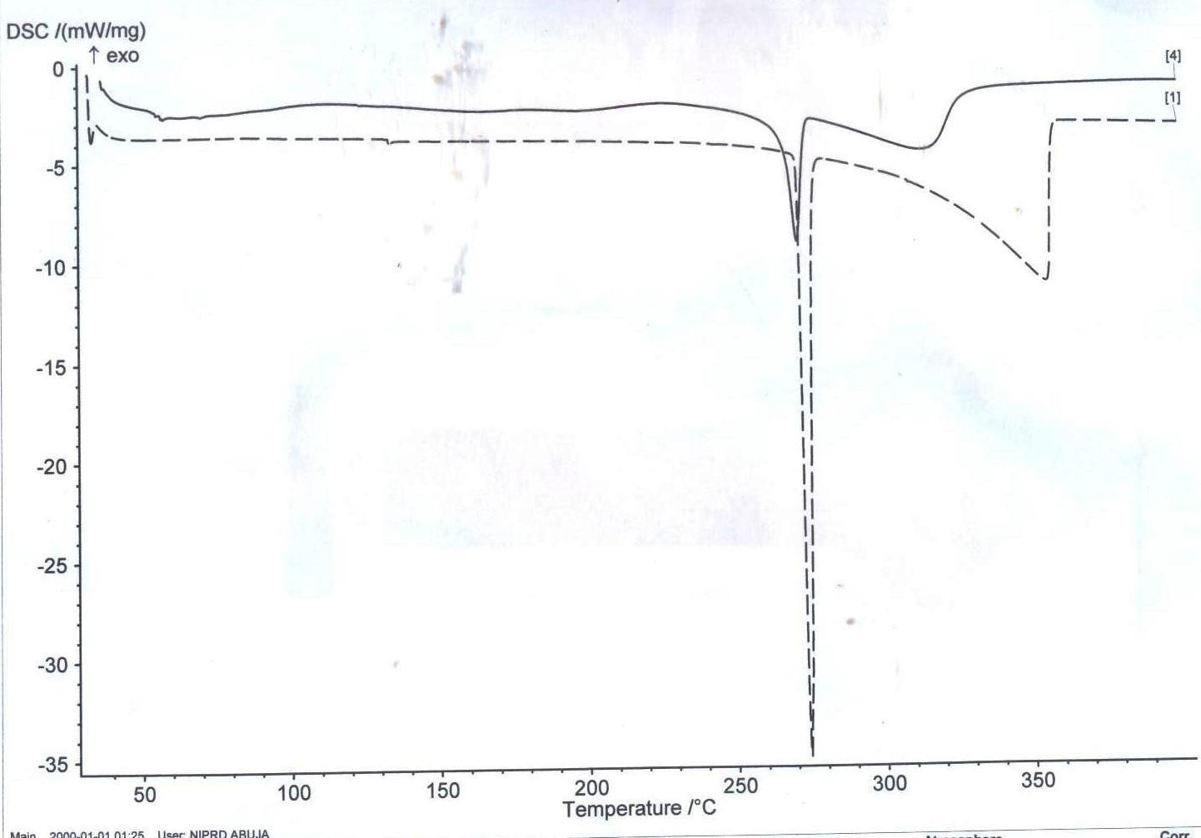

**Fig. 4.6: Thermogram of pure theophylline and theophylline mixed with CAG**

Key

Mixture of Chlorpheniramine and CAG

-------------- Pure Chlorpheniramine

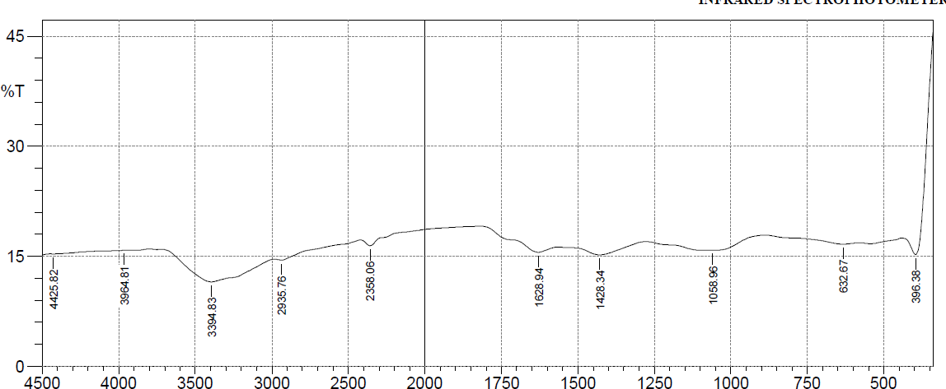

**Fig. 4.7: FTIR spectrum of *C. albidum* fruit gum (CAG)**

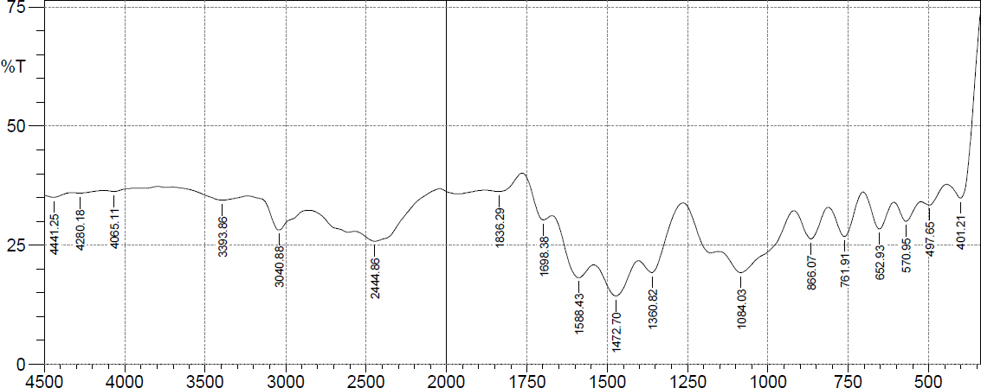

**Fig. 4.8: FTIR spectrum of pure Chlorpheniramine maleate**

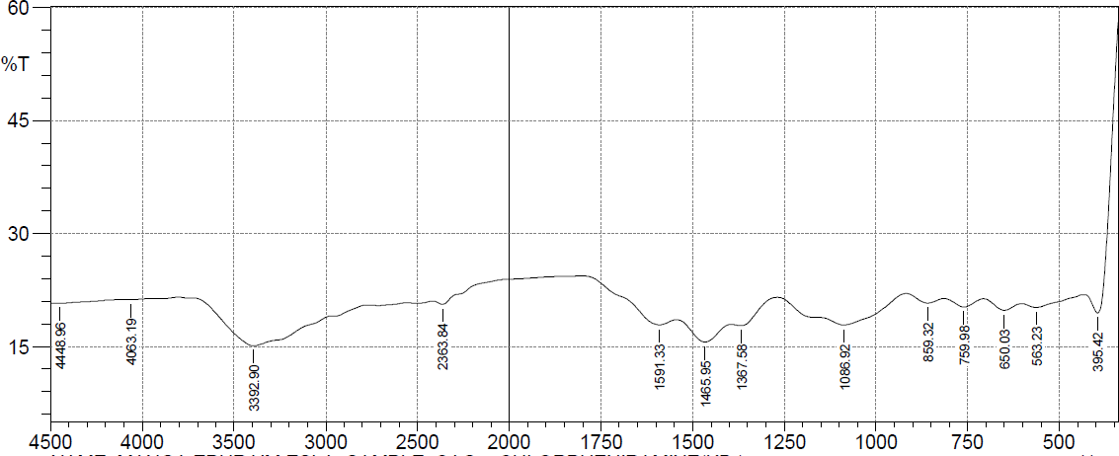

# Fig. 4.9: FTIR spectrum of physical mixture of chlorpheniramine and CAG

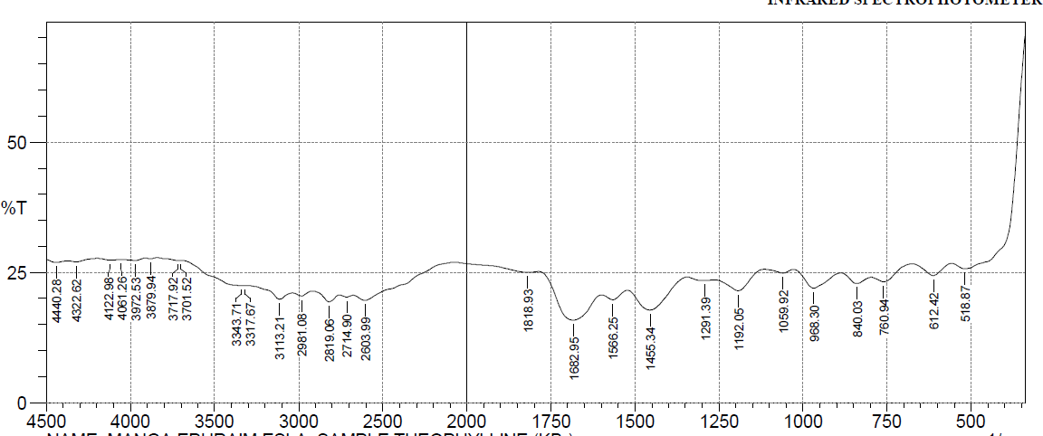

**Fig. 4.10: FTIR spectrum of pure theophylline**

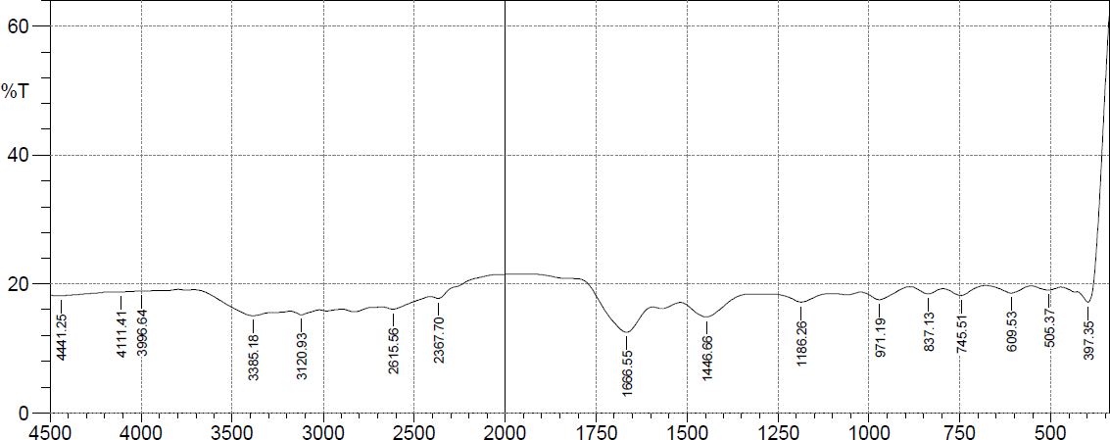

# Fig. 4.11: FTIR spectrum of physical mixture of theophylline and CAG

# Formulation Studies

# Flow properties of chlorpheniramine and theophylline granules

The flow properties of chlorpheniramine and theophylline granules are given in Table 4.5. The angle of repose and Hausner‘s ratio increased with increase in gum concentration while the flow rate showed slight decrease with increase in gum concentration.

# Table 4.5: Flow properties of Chlorpheniramine and Theophylline granules

|  |  |  |  |  |  |  |  |  |  |  |  |  |
| --- | --- | --- | --- | --- | --- | --- | --- | --- | --- | --- | --- | --- |
| **BATCH** | | | | | | | | | | | | |
| **PARAMETER** | **C 1** | **C 2** | **C 3** | **C 4** | **C 5** | **C 6** | **T 1** | **T 2** | **T 3** | **T 4** | **T 5** | **T 6** |
| Angle Of Repose (o) | 27.4 | 29.6 | 31.6 | 33.5 | 33.8 | 34.1 | 25.2 | 27.2 | 27.6 | 29.7 | 30.3 | 34.4 |
| Flow Rate (g/s) | 4.2 | 4.15 | 3.89 | 3.67 | 3.41 | 3.11 | 4.05 | 3.88 | 3.67 | 3.42 | 3.24 | 3.05 |
| Bulk Density (cm-3) | 0.62 | 0.66 | 0.65 | 0.59 | 0.64 | 0.67 | 0.79 | 0.71 | 0.57 | 0.62 | 0.71 | 0.73 |
| Tapped Density (cm-3) | 0.78 | 0.86 | 0.86 | 0.77 | 0.82 | 0.86 | 0.97 | 1.06 | 0.78 | 0.82 | 0.92 | 0.96 |
| Hausner‘s Ratio | 1.26 | 1.30 | 1.32 | 1.31 | 1.28 | 1.28 | 1.23 | 1.49 | 1.37 | 1.32 | 1.30 | 1.32 |
| Compressibility  Index(%) | 20.5 | 23.3 | 24.4 | 23.4 | 22.0 | 22.1 | 18.6 | 33.0 | 26.9 | 24.4 | 22.8 | 24.0 |

KEY

C1 = Chlorpheniramine with 5 % CAG T1 = Theophylline with 5% CAG C2 = Chlorpheniramine with 10 % CAG T2 = Theophylline with 10 % CAG C3 = Chlorpheniramine with 20 % CAG T3 = Theophylline with 20 % CAG C4 = Chlorpheniramine with 30 % CAG T4 = Theophylline with 30 % CAG C5 = Chlorpheniramine with 40 % CAG T5 = Theophylline with 40 % CAG C6 = Chlorpheniramine with 50 % CAG T6 = Theophylline with 50 % CAG

# : Tablet Properties

* + 1. **Chlorpheniramine maleate tablet properties**

The chlorpheniramine tablet properties are given in Table 4.6. The crushing strength and disintegration time increased with increase in CAG concentration while the friability decreased.

# Table 4.6: Chlorpheniramine Tablet Properties

|  |  |  |  |  |  |  |
| --- | --- | --- | --- | --- | --- | --- |
|  |  |  | **BATCH** |  |  |  |
| **PARAMETER** | **C 1** | **C 2** | **C 3** | **C 4** | **C 5** | **C 6** |
| **Gum content (%)** | 5.0 | 10.0 | 20.0 | 30.0 | 40.0 | 50.0 |
| **Weight Variation (mg)** | 304 ± 7 | 300 ± 9 | 300 ± 11 | 306 ± 3 | 302 ± 7 | 298 ± 8 |
| **Thickness (mm)** | 4.92 ± 0.02 | 4.70 ± 0.02 | 4.5 ± 0.01 | 4.3 ± 0.03 | 4.18 ± 0.02 | 4.1 ± 0.03 |
| **Diameter (mm)** | 8.0 | 8.0 | 8.0 | 8.0 | 8.0 | 8.0 |
| **Crushing Strength (KgF)** | 6.0 | 6.5 | 7.0 | 7.5 | 8.0 | 8.0 |
| **Friability (%)** | 0.6 | 0.4 | 0.2 | 0.1 | 0.04 | 0.04 |
| **Disintegration Time (mins)** | 6.0 | 21.0 | 90.0 | 282.0 | > 480.0 | > 480.0 |
| **Drug Content**  **(mg)** | 98.8 ± 0.67 | 99.1 ± 0.34 | 99.7 ± 0.5 | 97 ± 0.92 | 100 ± 0.06 | 97.4 ± 0.02 |

KEY

C1 = Chlorpheniramine with 5 % CAG C2 = Chlorpheniramine with 10 % CAG C3 = Chlorpheniramine with 20 % CAG C4 = Chlorpheniramine with 30 % CAG C5 = Chlorpheniramine with 40 % CAG C6 = Chlorpheniramine with 50 % CAG

# : Theophylline tablets properties

The theophylline tablet properties are given in Table 4.7. The crushing strength and disintegration time increased with increase in CAG concentration while the friability decreased.

# Table 4.7: Theophylline tablet properties

|  |  |  |  |  |  |  |
| --- | --- | --- | --- | --- | --- | --- |
| **PARAMETER** |  | **BATCH** |  |  |  |  |
|  | **T 1** | **T 2** | **T 3** | **T 4** | **T 5** | **T 6** |
| **Gum content (%)** | 5.0 | 10.0 | 20.0 | 30.0 | 40.0 | 50.0 |
| **Weight Variation**  **(mg)** | 303 ± 7 | 298 ± 4 | 301 ± 7 | 303 ± 6 | 306 ± 7 | 300 ± 10 |
| **Thickness (mm)** | 4.12 ± 0.02 | 4.00 ± 0.07 | 4.1 ± 0.01 | 4.1 ± 0.03 | 3.9 ± 0.04 | 3.9 ± 0.02 |
| **Diameter (mm)** | 8.0 | 8.0 | 8.0 | 8.0 | 8.0 | 8.0 |
| **Crushing Strength**  **(KgF)** | 6.5 | 6.5 | 7.5 | 8.5 | 8.0 | 9.0 |
| **Friability (%)** | 0.6 | 0.4 | 0.2 | 0.04 | 0.01 | 0.01 |
| **Disintegration**  **Time (min)** | 12.0 | 30.0 | 198.0 | 390.0 | > 480.0 | > 480.0 |
| **Drug Content (mg)** | 97 ± 0.05 | 101 ± 0.06 | 98.3 ± 0.07 | 102 ± 0.05 | 98 ± 0.03 | 99.4 ± 0.09 |

KEY

T1 = Theophylline with 5% CAG T2 = Theophylline with 10 % CAG T3 = Theophylline with 20 % CAG T4 = Theophylline with 30 % CAG T5 = Theophylline with 40 % CAG T6 = Theophylline with 50 % CAG

# Dissolution Studies

* + 1. **Tablet release profiles**
       1. *Chlorpheniramine Tablet Release Profiles*

Dissolution studies results are given in Fig. 4.12. Drug release from the matrix decreased with increase in CAG concentration. C1 and C2 gave a T 90 % of approximately 1 h and 3 h

respectively. C3 has an approximate T50% and T90% of 6 and 12 h respectively. C4 has a T50% of approximately 12 h while C5 and C6 have their T50% above 12 h.

**Percentage Drug Release (%)**

# Figure 4.12: Plot of Drug Release (%) versus time (h) For Chlorpheniramine Maleate tablets



120

100

80

60

40

20

0

0

2

4

6

8

10

12

14

**Time (h)**

C1 (5%)

C2 (10%)

C3 (20%)

C4 (30%)

C5 (40%)

C6 (50%)

* + - 1. *Theophylline Tablets Release Profiles*

Dissolution studies results are given in Fig. 4.13. Drug release from the matrix decreased with increase in CAG concentration. T1 and T2 gave a T 90% of approximately 1 h and 3 h respectively. T3 and T4 have approximate T50% of 6 and 12 h respectively while T5 and T6 have their T50% above 12 h.

**Percentage Drug Released (%)**

# Figure 4.13: Plot of Drug Release (%) versus time (h) For Theophylline Hydrochloride tablets



120

100

80

60

40

20

0

0

2

4

6

8

10

12

14

**Time (h)**

T1 (5%)

T2 (10%)

T3 (20%)

T4 (30%)

T5 (40%)

T6 (50%)

# Drug Release Kinetics and Mechanisms

# Chlorpheniramine drug release kinetics and mechanisms

Dissolution data from all the batches of chlorpheniramine tablets were fitted into different kinetic models: zero order, Higuchi, Hixson-Crowell, and Korsmeyer-Peppas. Regression values varied between 0.916 to 0.999. The exponent of drug release (n) for C1 was less than 0.5, C2 approximately 0.5 while C3, C4, C5, and C6 all have values above 1.0 (Table 4.8).

# Table 4.8: Chlorpheramine drug release according to different kinetic models

|  |  |  |  |  |  |
| --- | --- | --- | --- | --- | --- |
| Batch | Zero Order  (r2) | Higuchi  (r2) | Hixson-  Crowell (r2) | Korsmeyer-  Peppas (r2) | N |
| C1 | 0.990 | 0.999 | 0.925 | 0.990 | 0.2 |
| C2 | 0.952 | 0.952 | 0.988 | 0.971 | 0.5 |
| C3 | 0.973 | 0.973 | 0.916 | 0.979 | 1.02 |
| C4 | 0.977 | 0.977 | 0.943 | 0.993 | 1.05 |
| C5 | 0.983 | 0.983 | 0.927 | 0.991 | 1.02 |
| C6 | 0.984 | 0.984 | 0.889 | 0.978 | 1.02 |

KEY

C1 = Chlorpheniramine with 5 % CAG C2 = Chlorpheniramine with 10 % CAG C3 = Chlorpheniramine with 20 % CAG C4 = Chlorpheniramine with 30 % CAG C5 = Chlorpheniramine with 40 % CAG C6 = Chlorpheniramine with 50 % CAG

# Theophylline Drug Release Kinetics And Mechanisms

Dissolution data from all the batches of theophylline tablets were fitted into different kinetic models: zero order, Higuchi, Hicxon-Crowell, and Korsmeyer-Peppas. Regression values varied between 0.9101 to 0.999. The exponent of drug release (n) for T1 was less than 0.5, T2 approximately 0.5 while T3, T4, T5, and T6 all have values above 1.0 (Table 4.9).

# Table 4.9: Theophylline drug release according to different models

|  |  |  |  |  |  |
| --- | --- | --- | --- | --- | --- |
| Batch | Zero Order  (r2) | Higuchi  (r2) | Hixson-  Crowell (r2) | Korsmeyer-  Peppas (r2) | N |
| T1 | 0.990 | 0.999 | 0.955 | 0.991 | 0.04 |
| T2 | 0.959 | 0.959 | 0.962 | 0.978 | 0.5 |
| T3 | 0.977 | 0.977 | 0.901 | 0.988 | 1.02 |
| T4 | 0.934 | 0.934 | 0.969 | 0.967 | 1.10 |
| T5 | 0.966 | 0.966 | 0.943 | 0.989 | 1.04 |
| T6 | 0.967 | 0.967 | 0.944 | 0.990 | 1.03 |

KEY

T1 = Theophylline with 5% CAG T2 = Theophylline with 10 % CAG T3 = Theophylline with 20 % CAG T4 = Theophylline with 30 % CAG T5 = Theophylline with 40 % CAG T6 = Theophylline with 50 % CAG

# Comparison with hydroxypropylmethyl cellulose (HPMC)

# Dissolution studies

CAG showed better sustaining properties compared to HPMC as shown in Fig. 4.4

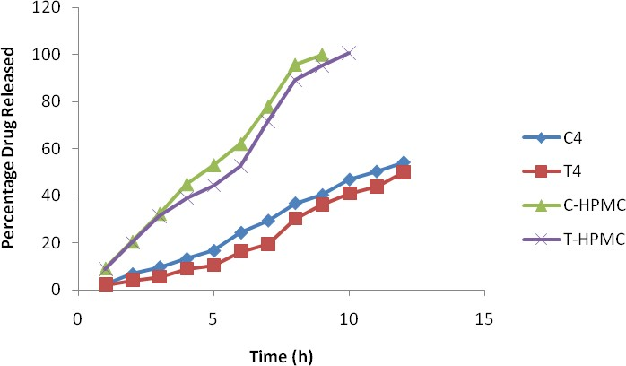

# Figure 4.14 Plot of Percentage drug release (%) versus Time (h) of formulations containing CAG and HPMC at 30 % level

KEY

T4 = Theophylline with 30 % CAG

C4 = Chlorpheniramine with 30 % CAG

C-HPMC = Chlorphenirmine with 30 % HPMC T-HPMC = Theophylline with 30 % HPMC

# Drug release kinetics and mechanisms

Studies of release kinetics and mechanisms reveal that the HPMC batches (C-HPMC and T- HPMC) follows Korsmeyer-Peppas‘ release kinetics with an n value that depicts a non- fickian mechanism (0.5 < n < 1). The CAG batches (C 4 and T 4) also follow the Korsmeyer-Peppas‘ kinetics but a super case-II mechanism, where n > 1 (Table 4.10). Pearson‘s correlation assessed the relationship between the release profiles of the batches in comparison and showed significant positive correlation with time (Table 4.11).

# Table 4.10 Comparison of regression values and release kinetics

|  |  |  |  |  |  |
| --- | --- | --- | --- | --- | --- |
| **BATCH** | **Zero Order** | **Higuchi** | **Hixson- Crowell** | **Korsmeyer- Peppas** | **N** |
|  |  |  | **R2** |  |  |
| **C 4** | 0.977 | 0.977 | 0.943 | 0.993 | 1.05 |
| **T 4** | 0.934 | 0.934 | 0.969 | 0.967 | 1.10 |
| **CHPMC** | 0.992 | 0.967 | 0.950 | 0.996 | 0.992 |
| **THPMC** | 0.981 | 0.948 | 0.959 | 0.989 | 0.991 |

KEY

T4 = Theophylline with 30 % CAG

C4 = Chlorpheniramine with 30 % CAG

C-HPMC = Chlorphenirmine with 30 % HPMC T-HPMC = Theophylline with 30 % HPMC

# Table 4.11: Pearson’s similarity correlations between release profiles

|  |  |  |  |  |  |  |
| --- | --- | --- | --- | --- | --- | --- |
| **Pearson’s Correlations** | | | | | | |
|  |  |  | **C4** | **T4** | **CHPMC** | **THPMC** |
| **C4** | Pearson Correlation |  | 1 |  |  |  |
|  | Sig. (2-tailed) |  |  |  |  |  |
|  | N |  | 12 |  |  |  |
| **T4** | Pearson Correlation |  | .991** | 1 |  |  |
|  | Sig. (2-tailed) |  | .000 |  |  |  |
|  | N |  | 12 | 12 |  |  |
| **CHPMC** | Pearson Correlation |  | .965** | .935** | 1 |  |
|  | Sig. (2-tailed) |  | .000 | .000 |  |  |
|  | N |  | 12 | 12 | 12 |  |
| **THPMC** | Pearson Correlation |  | .981** | .962** | .994** | 1 |
|  | Sig. (2-tailed) |  | .000 | .000 | .000 |  |
|  | N |  | 12 | 12 | 12 | 12 |
| **. Correlation is significant at the 0.01 level (2-tailed). | | | | |  |  |

KEY

T4 = Theophylline with 30 % CAG

C4 = Chlorpheniramine with 30 % CAG

C-HPMC = Chlorphenirmine with 30 % HPMC T-HPMC = Theophylline with 30 % HPMC

# Stability Studies of Chlorpheniramine and Theophylline Tablets

# Chlorpheniramine tablets stability studies

After 1 year of storage, tablets of Batch C4 did not show significant changes in physical appearance, dimensions, and drug content. However, there were slight changes in the drug content, crushing strength and friability values. The changes in disintegration time and drug release profile (T50%) are significant (Table 4.12).

# Table: 4.12 Stability studies for Batch C4

|  |  |  |  |
| --- | --- | --- | --- |
| **PARAMETER** | **Initially** | **After 1 year** | **\*p Value** |
| **Physical Appearance** | Smooth | Smooth |  |
| **Weight Variation (mg)** | 306 ± 6 | 303± 2 | > 0.05 |
| **Mean Thickness (mm)** | 4.30 ± 0.03 | 4.30 ± 0.7 | > 0.05 |
| **Diameter (mm)** | 8.0 | 8.0 | > 0.05 |
| **Crushing Strength (KgF)** | 7.5 ± 1 | 6.5 ± 1 | > 0.05 |
| **Friability (% w/w)** | 0.1 | 0.4 | < 0.05 |
| **Disintegration Time (Min)** | 282 | 240 | < 0.05 |
| **Drug Content (% w/w)** | 97± 0.92 | 97 ± 1.0 | > 0.05 |
| **T50 (h)** | 12 h | 10 h | < 0.05 |
| *p < 0.05 is significant |  |  |  |

KEY

C4 = Chlorpheniramine with 30 % CAG

# Theophylline tablets stability studies

After 1 yr of storage, tablets of Batch T4 did not show significant changes in physical appearance, dimensions, and drug content. However, there were slight changes in the drug content, crushing strength and friability values. The changes in disintegration time and drug release profile (T50%) are significant (Table 4.13).

# Table: 4.13 Stability studies for Batch T4

|  |  |  |  |
| --- | --- | --- | --- |
| **PARAMETER** | **Initially** | **After 1 year** | **\*p Value** |
| **Physical Appearance** | Smooth | Smooth |  |
| **Weight Variation (mg)** | 303 ± 2 | 306± 6 | > 0.05 |
| **Mean Thickness (mm)** | 4.10 ± 0.03 | 4.10 ± 0.03 | > 0.05 |
| **Diameter (mm)** | 8.0 | 8.0 | > 0.05 |
| **Crushing Strength (KgF)** | 8.5 ± 2 | 7.5 ± 1 | > 0.05 |
| **Friability (% w/w)** | 0.04 | 0.6 | < 0.05 |
| **Disintegration Time (Min)** | 390 | 282 | < 0.05 |
| **Drug Content (% w/w)** | 102± 0.05 | 99 ± 9.0 | > 0.05 |
| **T50 (h)** | 12 | 10 | < 0.05 |
| *p < 0.05 is significant |  |  |  |

KEY

T4 = Theophylline with 30 % CAG

# CHAPTER FIVE

# 5.0 DISCUSSION

Pharmaceutical excipients are components of dosage forms that enable the formulations to acquire some characteristics which will establish the basic features of the formulated product. These excipients control physicochemical properties as well as the release profiles and availability of the drug in the system. The physicochemical properties of a compound are measurable characteristics by which the compound may interact with other systems. The ability of excipients to provide their intended function and perform throughout the shelf life of the product must be established such that the information will justify the choice, concentration and characteristics that may influence the final product (Mahmud *et al.*, 2008).

This study was undertaken to further the search for local pharmaceutical excipients that can be used in formulation of novel/modified dosage forms. The gum from the fruits of *C. albidum* was studied to determine its usefulness and applicability in this sense. There is a need to harness the huge biodiversity for national gains (Kayode *et al.*, 2009) especially as it concerns the emerging pharmaceutical manufacturing industry in the country.

The extraction method readily extracted gum from the fruits of *C. albidum* (*CAG*) with a yield of 18+ 4%. The percentage yield of natural gums is as varied as the gums themselves: can be very low or high depending on the material and the method. Emeje *et al.* (2011) reported widely varied percentage yield for gum extracted from *Abelmoschus esculentus* with different extraction techniques. The extraction techniques gave the following yields: 20.01, 0.10 and 6.77% w/w for water, acid and alkaline extractions respectively. The percentage yield of gum from the leaves of *Sasemum indicum,* a tropical plant was reported

by Ndidi *et al.* (2012) as 1.96% which can be expected from a plant extract. Phani *et al. (*2011) obtained a 78% (w/w) yield of the polysaccharide from tamarind seeds purified using water and precipitated with acetone. After purification, the yield of *Ficus glumosa* gum obtained was 68%w/w (Ameh, 2013). Olayemi *et al.* (2010) reported a gum yield of 64% from the bark of *Khaya senegalensis.*

Organoleptics indicated that CAG is brownish, odourless, with a bland taste and has properties consistent with most plant gums.

The particle size analysis using the sieve method showed an average particle size of 176.25 µm. The water soluble ash and insoluble ash values of *CAG* were found to be 6.14 and 1.25% w/w respectively. Ash values reflect the level of adulteration or handling of the gum. More direct adulteration by sand or earth is immediately detected as the total ash which is normally composed of inorganic mixtures of carbonates, phosphates, silicates and silica. The low acid insoluble ash value obtained is an indication that the gum had low levels of contamination (Emeje *et al.,* 2011).

Moisture sorption has been reported to be one of the most sensitive techniques for assessing variation in the amorphous or crystalline content of polymers (Manek *et al*., 2005). The moisture sorption result shows that the gum sorped 16, 24, 29, and 36% moisture at 33, 53, 75, and 84% relative humidities respectively. Such knowledge is essential for designing and optimizing many processes involved in production using this gum like drying, packaging, and storing. It is also important in maintaining the quality of formulated drug using the gum throughout its supposed shelf-life as the moisture sorping-up may lead to stability problems such as dissolution and degradation of the active principles, and growth of microrganisms.

This implies that drug formulations with the gum should be stored in air tight, moisture impermeable containers (Emeje *et al.*, 2009).

The assessment of solubility, swelling index, and swelling characteristics of the gum compact showed that the gum is a slightly soluble hydrogel, having the capacity to absorb many times its size of water while maintaining its physical structure. The gum swelled 2.3 times its initial volume within 24 h while there was 12% increase in the weight of the gum compact within 3 h. This implies that CAG has capacity to sustain drug release in formulations (Talukdar and Kingnet, 1995).

Angle of repose (θ) is a function of the internal friction or cohesion of the gum particles. The angle of repose of CAG was 30o. This is moderate and implies a fairly good flow (Emeje *et al.*, 2011). It also means that CAG has considerable cohesive properties as the angle of repose has been shown to be high if the powder is cohesive and low if the powder is non- cohesive. Adding formulation additives, such as flow activators (glidants), alteration of processing conditions or using vibration-assisted hoppers or feeders, can improve the flowability of the gum (Emeje *et al.*, 2011). The knowledge of angle of repose, bulk and tapped density, Hausner‘s ratio, and compressibility index is important in scale-up processes involving any material as an excipient in pharmaceutical formulations. The bulk and tapped densities of CAG were measured and the Hausner‘s ratio and Carr‘s compressibility index determined to be 1.07 and 7.60 % respectively. Materials with Hausner‘s ratio of less than

1.25 have good flow, while above this value may require lubrication (Abdullah and Geldart, 1999). Lower values for compressibility index indicate materials that are readily compressible. Bulk and tapped densities of a gum gives an insight into its flow properties, packaging and arrangement of particles and hence the compactability of the granulation

(Vinod, 2013). It was found that the bulk and tapped densities of CAG were very low. This may explain the higher swelling and hydration capacity of the gum. Water rises by capillary action through pores of the gum powder. This wicking movement of water through pores of the gum has been found to activate swelling of the outer layer to form a hydrogel and the diffusion of the active ingredient from the formulation (Shoaib *et al.*, 2006).

Preliminary phytochemical studies revealed the absence of secondary metabolites such as alkaloids, lignin, tannins and flavonoids. Controlled hydrolysis and detection of polysaccharides in the hydrolysate carried out by modifying the method of Okafor *et al* (2001) indicated that the gum contain polysaccharides which is the major component of pharmaceutical gums (Jani *et al.,* 2009; Jain *et al.,* 2007).

Differential Scanning Calorimetry (DSC) measured the heat loss or gain, resulting from physical or chemical changes within the sample as a function of temperature. When polymers are exposed to heat at different temperatures, they show behaviors that are characteristic and related to their crystalline and amorphous composition. The DSC technique is essentially useful in characterizing polymers based on their thermal transitions (Phani *et al.*, 2011). The output of a DSC is a plot of heat flux versus temperature at a specified rate. A sharp symmetric melting endotherm can indicate relative purity, whereas broad asymmetric curve suggests impurities or more than one thermal process. The initial endothermic peak usually indicates the loss of water present in the compound. DSC provides information about the physical properties of the sample as crystalline or amorphous nature and demonstrates a possible interaction between drug and polymers in formulations (Phani *et al.,* 2011). CAG demonstrated an endothermic glass transition with onset at 44.4 °C, an inflection at 72.1 °C, and the end point at 92.1 °C. Pure sample of chlorpheniramine maleate

showed an initial endothermic peak consistent with loss of moisture then a glass transition peak at 137.9 °C. After mixing with CAG, chlorpheniramine thermogram maintained its sharp symmetrical peak at 137.4 °C showing no significant shift or disappearance of peak. This indicates that there is no interaction between chlorpheniramine and *CAG* that could affect its pharmacological activity (Schawe, 1995; Vippagunta *et al.*, 2001). Thermogram of pure sample of theophylline hydrochloride also showed an initial moisture loss followed by a sharp symmetrical glass transition peak at 274.4 °C, then a less symmetrical peak at 355.1

°C. After mixing with *CAG* there was no flattening or disappearance of peak but a slight change in transition peaks 271.3 and 313.5 °C respectively. This change in temperature is however, not significant to suggest a change in chemical structure or lattice of theophylline that could affect its intrinsic activity (Schawe, 1995; Vippagunta *et al.*, 2001).

Fourier transform infrared spectroscopy (FTIR) measures the vibrational spectrum which is considered to be a unique physical property and characteristic for any molecule. The FTIR spectrum for chlorpheniramine shows bands and peaks consistent with the primary functional groups of the molecule. The spectrum obtained for physical mixture of chlorpheniramine and CAG shows that all the major peaks are still present indicating that there is no major interaction between the drug and the polymer. However, there is the disappearance of some peaks that do not represent any major functional group. This is consistent with the fact that in solid dispersions there is usually an overlapping of peaks of the different components which may manifests as disappearance. The FTIR compatibility study of theophylline and CAG also revealed that the major functional groups remained intact with disappearance of some peaks due to overlapping.

Both chlorpheniramine and theophylline granules formulated with CAG showed good micromeritic properties. Tablet properties show consistent diameters with decrease in thickness as the gum concentration increased. Tablets were not friable, while there was a gradual increase in crushing strength with increase in gum concentration. Assay of tablets showed that the drug content was within acceptable limits. Disintegration time for both drugs increased with increase in gum concentration. Chlorpheniramine tablets disintegrated between 6 min (at 5% gum concentration) and above 8 h (at 50% gum concentration). Theophylline tablets showed a similar trend (11 min at 5% and above 8 h at 50% gum concentration). This demonstrates that at higher concentration the gum particles will coalesce and gel to form an outermost layer thus preventing disintegration and acting as a retardant. When the polymer comes in contact with fluid, it forms a gelatinous layer which acts as a barrier to the penetration of fluid into the tablet thus increasing the disintegration time. The higher the gum concentration, the thicker the gelatinous layer formed and the longer the disintegration time.

Plot of drug release versus time profiles from chlorpheniramine and theophylline tablets gave an insight into the drug release characteristics. There was a steady retardation of drug release as the gum concentration increased in the formulations (Figs. 4.2 and 4.3). Batches C4 and T4 (each containing 30 % CAG) gave the most desirable release profiles with a T50 of approximately 12 h. Since each tablet contain multiple doses, a T50 of 12 h means the formulation is likely to sustain the drug for a period of 24 h making a daily single dose feasible (Costa and Sousa, 2001).

The dissolution data fitted into different kinetic model equations, reveal that at higher concentration of CAG drug release mechanism became more complex. Plots were obtained

for Zero order, Higuchi, Hixson-Crowel, and Korsmeyer-Peppas. Regression, r2 values obtained show more linearity in the Korsmeyer-Peppas model. The coefficients of drug release, n were obtained from the plots. A value of n ≤ 0.5 indicates case I (Fickian) diffusion or square root of time kinetics, 0.5 < n < 1 anomalous (non-Fickian) diffusion, n = 1 Case-II transport and n > 1 Super Case-II transport. The n values for batches containing 5 and 10% CAG (C1, C2, T1, T2) were ≤ 0.5 indicating that the mechanism of drug release in these systems is Fickian diffusion or a square root of time kinetics (Patel *et al.*, 2011). At higher concentration of CAG, the n values were all ≥ 1 indicating a Super Case-II transport mechanism.

It has been shown that drug release from hydrophilic matrices is a complex interaction between swelling, diffusion and erosion (Siepmann and Peppas, 2001). The gradual penetration of water produces swelling and forms a hydrated gel through which the drug has to pass by dissolution and diffusion across the ever-increasing diffusion path length. Swelling has been shown to follow square root of time kinetics. However, drugs contained in certain systems are released at rates approaching zero order. It is apparent, therefore, that other mechanisms, in addition to diffusion, must take place at the interface between the gel and the surrounding medium. The polymer chains will gradually disentangle from the interface (erosion). This polymer chain relaxation will increase the rate of drug release by decreasing the diffusional path length for the drug (Munday and Cox, 2001).

HPMC (viscosity 80-120, Sigma-Aldrich) was used as the standard matrix-former at the same concentration as CAG that gave the best dissolution profiles (30 %) to formulate chlorpheniramine (C-HPMC) and theophylline (T-HPMC) tablets. Dissolution profiles of batches C4 and T4 both containing 30 % of CAG demonstrating desirable release properties

(i.e. T50 of approximately 12 h), was compared with tablets containing HPMC (30 %) as sustaining matrix (Fig. 4.4). The HPMC batches had a T50 of approximately 5 hours each as against 12 h for CAG. Formulations with CAG at 30 % showed better sustaining action on drug release than HPMC. In a similar study, Nep and Conway (2010) demonstrated that Grewia gum had better sustaining properties than HPMC; *Cissus refescence* also performed better as a sustaining matrix than sodium carboxy methyl cellulose, NaCMC (Emeje *et al.,* 2009). Hydrophilic matrices from natural polysaccharide gums such as xanthan gum, guar gum and karaya gum have been shown to provide varying degrees of sustained release for medicaments. These natural hydrophilic colloids are widely used in pharmaceutical dosage forms because of their biocompatibility, low cost and availability (Nep and Conway, 2010). Pearson‘s correlation is used for quantitative variables which are normally distributed and this analysis is presented in a correlation matrix form (Table 4.11). The 1 in the diagonal means each variable correlated with themselves and is symmetrical along the diagonal. The interval for correlation is -1< X <1. A correlation with a value less than 0.7 implies a weak correlation while above 0.7 implies a strong correlation. Pearson‘s correlation presented in a matrix form demonstrated that the similarity between the batches in comparison is significant (< 0.001). However, CAG showed a higher similarity factor between themselves than with the HPMC batches. HPMC batches also show more significant similarity to each other than to the CAG batches.

Stability studies show that there was no significant change in the physical appearance, mean weight, diameter, thickness, crushing strength, and drug content for both chlorpheniramine and theophylline after 12 months. There were significant changes in friability, disintegration

time, and T50% (p < 0.05). The insignificant change in drug content indicates that there was little or no degradation of the drugs.

# CHAPTER SIX

**6.0 SUMMARY, CONCLUSION AND RECOMMENDATION**

This study evaluated *Chrysophyllum albidum* fruit gum (CAG) as a matrix-former in the formulation of chlorpheniramine and theophylline sustained-release tablets. The percentage yield of gum was 18 ± 4 %w/w and the gum obtained is a brownish granular powder with a bland taste. Hydration and swelling characteristics of the gum shows its capacity to retain moisture and gel in aqueous medium. The gum was slightly soluble in water and insoluble in organic solvents. The gum demonstrated good pharmaceutical and micromeritic properties while the flow rate and angle of repose indicate a good flow. Study also shows good compressibility. Phytochemical tests reveal the presence of polysaccharides. Differential Scanning Calorimetry (DSC) and Fourier Transform Infrared spectroscopy (FTIR) thermographs did not show any incompatibility between CAG and the drugs (Chlorpheniramine and Theophylline).

Tablet properties (hardness, friability, weight variation, and drug content) were all within acceptable limits. Disintegration times were prolonged with increasing CAG concentrations.

Dissolution studies revealed that the batches containing 30 % CAG (C 4 and T 4) have a T50% of approximately 12 h. The drug dissolution data were treated to different kinetic models (zero order, Higuchi, Hixson-Crowell, and Korsmeyer-Peppas.) The release follows the Korsmeyer-Peppas kinetic model with higher regression values. The mechanism of drug release for both chlorpheniramine and theophylline at lower concentration was Fickian diffusion, while at higher concentration the mechanism became a super-case II mechanism (n > 1). HPMC also retarded the release of the active drugs from the tablets but with a much

lower T50 of approximately 5 hours each. The release kinetics also follows the Korsmeyer‘s model while the mechanism of release is non-fickian diffusion. Pearson‘s correlation reveals a significant similarity in the drug release profiles of all the batches (both CAG and HPMC) in relation to time. More significant similarity was however observed between C 4 and T 4 than with the HPMC batches. Similarly, C-HPMC and T-HPMC show greater similarity to each other than with the CAG batches.

Stability studies on the CAG tablets did not show significant change in the physical appearance, weight and diameter, crushing strength, and drug content. Significant changes were observed in the friability values, disintegration times, and the T50. Importantly, the T50 decreased from 12 hours to 10 hours. CAG performed better as a sustaining matrix than HPMC (viscosity 80-120) at 30%.

In conclusion, *Chrysophyllum albidum* fruit gum (CAG) can be used at 30 % in the formulation of chlorpheniramine maleate and theophylline hydrochloride sustained release tablets for once-daily dosing.

# RECOMMENDATIONS

Further studies should be carried out to fully characterize the gum. CAG should also be assessed as a binder, emulgent, suspending agent, and other delivery systems.

Attempt should also be made to bleach the gum for aesthetic gains.

# REFERENCES

Abdullah, E. C., and Geldart, D. (1999). The use of bulk density measurements as flowability indicators. *Powder Technology*, *102*(2): 151-165.

Adebayo A. H., Bolaji A. O., Opata T. K., and Adegbenro I. K. (2010). Effects of Ethanolic leaf Extract of *Chrysophyllum albidum* on Biochemical and Haematological Parameters of Albino Wistar Rats. *African Journal of Biotechnology.* 9(14): 2145- 2150.

Adeoye EO, Salami A. T., Taiwo V. O., (2012). Anti-plasmodial and toxicological effects of methanolic bark extract of *Chrysophyllum albidum* in albino mice; *Journal of Physiology and Pathophysiology.* 15:85-91

Agrofostree Specie Profile: *Chrysophyllum albidum* [www.worldagroforestry.org](http://www.worldagroforestry.org/) accessed on 21st March, 2012.

Ameh, P. O. (2013). Physicochemical properties and rheological behaviour of *Ficus glumosa* gum in aqueous solution. *African Journal of Pure and Applied Chemistry*, *7*(1): 35-43.

Amighi, K., Timmermans, J., Puigdevall, J., Baltes, E., and Moes, A. J. (1998). Peroral sustained-release film-coated pellets as a means to overcome physicochemical and biological drug-related problems. In: In vitro development and evaluation. *Drug Development and Industrial Pharmacy*, *24*(6), 509-515.

Anekant J., Yashwant G., and Sanjay K., (2007). Perspectives of Biodegradable Natural Polysaccharides for Site-Specific Drug Delivery to the Colon. *Journal of Pharmacy and Pharmaceutical Science*. 10(1):86–128.

Ankit, B., RPS, R., Tanwar, Y. S., Gupta, S., and Bhaduka, G. (2011). Oral Sustained Release Dosage Form: An Opportunity To Prolong The Release of Drug. *International Journal of Advanced Research in Pharmaceutical and Biosciences*. 3(1): 7-14.

AOAC (Association of Official Analytical Chemist) 1990: *Official Methods of Analysis*.

15th ed. Washington DC. 1096-1098

Avachat, A. M., Dash, R. R., and Shrotriya, S. N. (2011). Recent investigations of plant based natural gums, mucilages and resins in novel drug delivery systems. *Indian Journal of Pharmacy Education and Research*, *45*(1): 86-99.

Baker, R. W., and Lonsdale, H. K. (1974). Controlled release: mechanisms and rates. In

*Controlled release of biologically active agents*. Springer US. (15-71)

Baveja, S. K., Ranga, K. V., and Rao, J. A. (1988). Examination of natural gums and mucilages as sustaining materials in tablet dosage forms. *Indian Journal of Pharmaceutical Science*, 50: 89-92.

Bhadra, S. (2010). Nitroglycerin Sustained Release Tablet. *Formulation Design and Evaluation.* 88-92

Bhardwaj, T. R., Kanwar, M., Lal, R., and Gupta, A. (2000). Natural gums and modified natural gums as sustained-release carriers. *Drug Development and Industrial Pharmacy*, *26*(10): 1025-1038.

Brahmankar, D. M., and Jaiswal, S. B. (1995). Controlled release medication. *Biopharmaceutics and pharmacokinetics-A Treatise.* 1st edition. Vallabh Prakashan: New Delhi, 347-353.

British Pharmacopoiea. Her Majesty‘s Stationery Office. London: 2004. 1094-1123 Chandira, M., Sandip, V. M., Debjit, K., and Jayakar, B.(2009): Formulation and evaluation

of sustained release matrix tablets of zidovudine. *International Journal of Current*

*Pharmaceutical Research*. 1(1):11-14

Chung Isha, Seth Nimrata, Rana A.C., and Gupta Surbhi (2012): Oral sustained release drug delivery system: an overview. *International Research Journal of Pharmacy*, 3 (5):33-39

Collett, D. M., Aulton, M. E., & Cooper, J. W. (1990). *Pharmaceutical practice*. Churchill Livingstone.409-464.

Conrad M. J., and Robinson J. R. (1980). *Pharmaceutical Dosage Forms (Tablets),* Herbert Liebermann and Lenn Lach. Edition. (3):149-211

Conte, U., Giunchedi, P., Maggi, L., Sangalli, M. E., Gazzaniga, A., Colombo, P., and La Manna, A. (1992). Ibuprofen delayed release dosage forms: a proposal for the preparation of an *in-vitro/in-vivo* pulsatile system. *European Journal of Pharmaceutics and Biopharmaceutics*, 38(6): 209-212.

Costa, P., and Sousa Lobo, J. M. (2001). Divisability of diltiazem matrix sustained-release tablets. *Pharmaceutical Development and Technology*, 6(3): 343-351.

Das, N. G., and Das, S. K. (2003). Controlled release of oral dosage forms. *Pharmaceutical Technology*, 15:10-17.

Devraj, B. D., (2010). Studies on enteric coated sustained timed-release tablets of Metronidazole. *Journal of Chemical and Pharmaceutical Research*, *2*(2): 226-232.

Dobozin, B. S., Dobozin, B. S., and Young, S. H. (2011). *Allergies: The Complete Guide to Diagnosis, Treatment, and Daily Management*. Xlibris Corporation. 232-241.

Emeje, M., Isimi, C., Byrn, S., Fortunak, J., Kunle, O., and Ofoefule, S., (2011). Extraction and Physicochemical Characterization of a New Polysaccharide Obtained from the Fresh Fruits of *Abelmoschus esculentus*. *Iranian Journal of Pharmaceutical Research. 10*(2):237.

Emeje, M., Nwabunike, P., Isimi, C., Fortunak, J., Mitchell, J. W., Byrn, S., and Ofoefule, S. (2009). Isolation, characterization and formulation properties of a new plant gum obtained from *Cissus refescence*. *International Journal of Green Pharmacy*, *3*(1):16.

Enauyatifard, R., Azadbakht, M., and Fadakar, Y. (2012). Assessment Of *Ferula gummosa* Gum As A Binding Agent In Tablet Formulations. *Acta Poloniae Pharmaceutica*, *69*(2):291-298.

Fahr, A., Hoogevest, P. V., May, S., Bergstrand, N., and S Leigh, M. L. (2005). Transfer of lipophilic drugs between liposomal membranes and biological interfaces: consequences for drug delivery. *European Journal of Pharmaceutical Sciences*, 26(3):251-265.

Fredholm, B. B. (1985). On the mechanism of action of theophylline and caffeine. *Acta Medica Scandinavica*, 217(2):149-153.

Follonier, N., Doelker, E., and Cole, E. T. (1994). Evaluation of hot-melt extrusion as a new technique for the production of polymer-based pellets for sustained release capsules containing high loadings of freely soluble drugs. *Drug Development and Industrial Pharmacy*, *20*(8):1323-1339.

Geetha, B., Shivalinge, K. P., Gowda, and Kulkarni G. T., (2009). Microwave assisted fast extraction of mucilages and pectins. *Indian Journal of Pharmacy Education and Research*, 43: 260-265.

Geraets, D., and Burke, T. (1990). Sustained-release dosage forms. *Iowa medicine: journal of the Iowa Medical Society*, *80*(3):141-146.

Girish, K. J., Dhiren, P. S., Vipul, D. P., and Vineet, C. J. (2009). Gums and Mucilages: versatile excipients for pharmaceutical formulations. *Asian Journal Of Pharmaceutical Sciences* 4(5):308-322.

Gonsalves, J. (2010). *Economic botany and ethnobotany*. Mittal Publications. 273-280.

Goswami, S., and Naik, S. (2014). Natural gums and its pharmaceutical application. *Journal of Scientific and Innovative Research*, *3*(1):112-121.

Guideline on the pharmacokinetic and clinical evaluation of modified release dosage forms, EMA 2013 Committee For Medicinal Products For Human Use (CHMP), London, 21st February, 2013. (EMA/CPMP/EWP/280/96 Corr1)

Gundo, R. K., Dabre, R. S., and Jain, G. K. (2011). Modified Release Dosage forms. *U.S. Patent Application 13/582,449*.

Hendeles, L., Weinberger, M., Milavetz, G., Hill, M., and Vaughan, L., (1985). Food- induced dose-dumping from a once-a-day theophylline product as a cause of theophylline toxicity. *CHEST Journal*, *87*(6):758-765.

Higuchi, T. (1963). Mechanism of sustained‐action medication. Theoretical analysis of rate of release of solid drugs dispersed in solid matrices. *Journal of Pharmaceutical Sciences*, *52*(12):1145-1149.

Huang, S. M., Athanikar, N. K., Sridhar, K., Huang, Y. C., and Chiou, W. L. (1982).

Pharmacokinetics of chlorpheniramine after intravenous and oral administration in normal adults. *European Journal of Clinical Pharmacology*, *22*(4): 359-365.

Jain, A., Gupta, Y., and Jain, S. K. (2007). Perspectives of biodegradable natural polysaccharides for site-specific drug delivery to the colon. *Journal of Pharmaceutics and Pharmaceutical Science*, *10*(1):86-128.

Jani, G. K., Shah, D. P., Prajapati, V. D., and Jain, V. C. (2009). Gums and mucilages: versatile excipients for pharmaceutical formulations. *Asian Journal of Pharmaceutical Science*, *4*(5):309-323.

Kayode, J., Ige, O. E., Adetogo, T. A., and Igbakin, A. P. (2009). Conservation and Biodiversity Erosion in Ondo State, Nigeria:(3). Survey of Plant Barks Used in Native Pharmaceutical Extraction in Akoko Region. *Ethnobotanical Leaflets*, (5):13.

Kornblum, S. S. and Stoopak, S. B. (1973). A new tablet disintegrant agent: Crosslinked Polyvinylpyrollidone. *Journal of Pharmaceutical Science*; 62(1): 43-49.

Korsmeyer, R. W., Gurny, R., Doelker, E., Buri, P., and Peppas, N. A. (1983). Mechanisms of solute release from porous hydrophilic polymers. *International Journal of Pharmaceutics*, 15(1):25-35.

Krajacic, A., & Tucker, I. G. (2003). Matrix formation in sustained release tablets: possible mechanism of dose dumping. *International Journal of Pharmaceutics*, 251(1):67- 78.

Kumar, V., Prajapati, S. K., Soni, G. C., Singh, M., and Kumar, N. (2012a). Sustained release matrix type drug delivery system: a review. *World Journal of Pharmacy and Pharmaceutical Sciences*, *1*(3):34-960.

Kumar, K. S., Bhowmik, D., Srivastava, S., Paswan, S., and Dutta, A. S. (2012b). Sustained release drug delivery system potential. *Terminology*. 1:2.

Leroux, J. C., Allémann, E., De Jaeghere, F., Doelker, E., and Gurny, R. (1996).

Biodegradable nanoparticles—from sustained release formulations to improved site specific drug delivery. *Journal of Controlled Release*, 39(2):339-350.

Mahmud, H. S., Oyi, A. R., and Allagh, T. S. (2008): Studies on Some Physicochemical properties of *Khaya senegalensis* gum. *Nigerian Journal Of Pharmaceutical*

*Sciences.* 7(1):146-152

Manek, R. V., Kunle, O. O., Emeje, M. O., Builders, P., Rao, G. V. R., Lopez, G. P., and Kolling, W. M., (2005). Physical, thermal and sorption profile of starch obtained from Tacca leontopetaloides. *Starch‐Stärke*, 57(2):55-61.

Manish Shivadas W. (2008). Controlled Released System - A Review. *Pharmainfo.net*.

Accessed on 26 July, 2012.

Masteikova, R., Chalupova, Z., and Sklubalova, Z., (2003). Stimuli-sensitive hydrogels in controlled and sustained drug delivery. *Medicina*, *39*(2):19-24.

Maulding, H. V., Tice, T. R., Cowsar, D. R., Fong, J. W., Pearson, J. E., and Nazareno, J. P. (1986). Biodegradable microcapsules: acceleration of polymeric excipient hydrolytic rate by incorporation of a basic medicament. *Journal of Controlled Release*. 3(1):103-117.

Moreton, R. C. (1996). Tablet excipients to the year 2001: a look into the crystal ball. *Drug Development and Industrial Pharmacy*, *22*(1):11-23.

Muazu, J., Musa, H., Isah, A. B., Bhatia, P. G., and Tom, G. M. (2011). Extraction and characterization of Kaffir Potato Starch: A potential Source of pharmaceutical raw material. *Journal of Natural Product Plant Resources*, *1*(2):41-49.

Munday, D. L., and Cox, P. J. (2000). Compressed xanthan and karaya gum matrices: hydration, erosion and drug release mechanisms. *International Journal of Pharmaceutics*, *203*(1):179-192.

Nep, E. I., and Conway, B. R. (2010). Polysaccharide gum matrix tablets for oral controlled delivery of Cimetidine. *Journal of Pharmaceutical Sciences and Research*, *2*(11):708-716.

Ndidi C. N., Munirat A., Inalegwu A., and Onyinye J. U., (2012). Characterization of gum from *sesamum indicum* Leaves as a suspending agent in a pediatric Pharmaceutical suspension. *World Journal of Pharmaceutical Research* 1(4):909-924

Nicholas G. Lordi (1986): Sustained release dosage forms. In: Theory and Practice of Industrial Pharmacy. 3rd edition. Lea & Febiger, Washington square, Philadelphia, USA

Ofokansi K.C., Kenechukwu F.C., Isah A.B., Allagh T.S. and Anumeka O. O., (2012). Formulation and evaluation of solid dispersions based on Eudragit RS 100 and PEG 8000 for improved delivery of trandolapril. *Africa Journal of Pharmaceutical Research and Development*. 4(1): 38-42.

Ofori, D. A., Gyau, A., Dawson, I. K., Asaah, E., Tchoundjeu, Z., & Jamnadass, R. (2014). Developing more productive African agroforestry systems and improving food and nutritional security through tree domestication. *Current Opinion in Environmental Sustainability*, *6*:123-127.

Okafor I. S., Chukwu A, and Udeala, K,. (2001): Some Physicochemical Properties of Grewia Gum. *Nigerian Journal of Polymer Science and Technology.* 2(1): 161- 167.

Olayemi, O. J., Mahmud, H. S., and Apeji, Y., (2010). Effect of concentration on the release property of *Khaya senegalensis* gum In chloroquine phosphate tablet formulation. *International Journal of Applied Pharmacy*, *2*(3):22-26.

Onunkwo G. C., and Mba O. C., (1996). Physical Properties of Sodium Salicylate Tablets Formulated with *Abelmoschus esculentus* Gum as Binder. *Acta Pharm* 46:101-107.

Orijajogun, O. J., Olajide, O. O., Fatokun, A. O., Orishadipe, A. T., and Batari, M. L. (2013). The preliminary chemical constituents and free radical scavanging activities of the exocarp of the fruit extract of african star apple (*Chrysophyllum albidum*, G. Don). *International Journal of Research in Pharmaceutical Science*, 3(3):72-80.

Panwar, P., Chourasiya, D., Jain, G., and Sheorey, R. V., (2012). Formulation and evaluation of oral floatable in-situ gel of diltiazem HCl. *International Journal of Novel Drug Delivery Technology*, *2*:264-270.

Patel, R. P., Patel, M. H., Prajapati, B. G., and Baria, A. H., (2011). Formulation and evaluation of sustained release matrix tablet of Tizanidine Hydrochloride by direct compression technique. *Journal of Science & Technology*, *1*(06):69-81.

Patel, P. N., Patel, M. M., Rathod, D. M., Patel, J. N., and Modasiya, M. M. K., (2012). Sustained Release Drug Delivery: A Theoretical Perspective. *Journal of Pharmacy Research*, *5*(8):87-91

Phani Kumar G., Gangarao Battu, Kotha N. S. Lova Raju (2011): Isolation and Evaluation of Tamarind Seed Polysaccharides being used as a polymer in Pharmaceutical Dosage Form*. Research Journal of Pharmaceutical, Biological, and Chemical Sciences*. 2:2.

Pharmacopeia, U. S., & Revision, X. X. I. I. (1990). US Pharmacopoeial Convention.

*Rockville, Md*, 1911.

Pitt, C. G., Gratzl, M. M., Jeffcoat, A. R., Zweidinger, R., and Schindler, A. (1979). Sustained drug delivery systems II: Factors affecting release rates from poly (ε‐caprolactone) and related biodegradable polyesters. *Journal of Pharmaceutical Sciences*, *68*(12):1534-1538.

Pundir, S., Ashutosh, B., and Deepak, S., (2013). Sustained release matrix technology and recent advance in matrix drug delivery system: a review. *International Journal of Drug Research and Technology 3*(1), 12-20.

Qadry, J. S. (2008). Shah and Qadry‘s Pharmacognosy, Ahmedabad, India. B S Shah Prakashan. 117-129.

Ranjendra K., Vishun P., Harsha P., (2008): Comparative Evaluation Of Matrix Properties Of Natural Gums and Semi-synthetic Polymers*. Journal Of Pharmaceutical Research*, Vol 1(2):208-214.

Robinson, J. R., and Eriksen, S. P., (1970). Theoretical approach to sustained‐release multiple‐dose therapy: Noncumulative attainment of desired blood level. *Journal of Pharmaceutical Sciences*, *59*(12):1796-1800.

Sathyaraj, A., and Abhinav, K., (2012). Formulation and evaluation of metoprolol succinate controlled release tablets using natural and synthetic polymer. *International journal of Pharmaceutical Sciences and Research*, *3*(1):247-256.

Schawe, J. E. K. (1995). Principles for the interpretation of modulated temperature DSC measurements. Part 1. Glass transition. *Thermochimica Acta*, *261*:183-194.

Schultze‐Werninghaus, G., and Meier‐Sydow, J. (1982). The clinical and pharmacological history of theophylline: first report on the bronchospasmolytic action in man by SR Hirsch in Frankfurt (Main) 1922. *Clinical & Experimental Allergy*, *12*(2):211-215.

Scott, P. H., Tabachnik, E., MacLeod, S., Correia, J., Newth, C., and Levison, H., (1981). Sustained-release theophylline for childhood asthma: evidence for circadian variation of theophylline pharmacokinetics. *The Journal of Pediatrics*, *99*(3):476- 479.

Shoaib, M. H., Tazeen, J., Merchant, H. A., and Yousuf, R. I. (2006). Evaluation of drug release kinetics from ibuprofen matrix tablets using HPMC. *Pakistan Journal of Pharmaceutical Sciences*, *19*(2):119-124.

Siepmann, J., and Peppas, N. A. (2001). Modeling of drug release from delivery systems based on hydroxypropyl methylcellulose (HPMC). *Advanced Drug Delivery Reviews*, *48*(2):139-157.

Singhvi, G., and Singh, M. (2011). Review: *in vitro* drug release characterization models.

*International Journal of Pharmaceutical Studies and Research*, *2*:77-84.

Skelly, J. P., Van Buskirk, G. A., Arbit, H. M., Amidon, G. L., Augsburger, L., Barr, W. H., and Wheatley, T. (1993). Scaleup of oral extended-release dosage forms. *Pharmaceutical Research*, *10*(12), 1800-1805.

Sood, A., and Panchagnula, R. (2003). Design of controlled release delivery systems using a modified pharmacokinetic approach: a case study for drugs having a short elimination half-life and a narrow therapeutic index. *International Journal of Pharmaceutics*, *261*(1): 27-41.

Sprockel, O. L., Price, J. C., Jennings, R., Tackett, R. L., Hemingway, S., Clark, B., and Laskey, R. E. (1989). *In vitro/in vivo* evaluation of a liquid sustained release dosage form of chlorpheniramine. *Drug Development and Industrial Pharmacy*, *15*(9):1393-1404.

Talukdar, M. M., and Kinget, R. (1995). Swelling and drug release behaviour of xanthan gum matrix tablets. *International Journal of Pharmaceutics*, *120*(1):63-72.

Tavakoli N., Ghasseni D. N., Teimouri R., and Heimishehkar H. (2008): Characterization and Evaluation of Okra Gum As Tablet Binder. Jundishapur *Journal of Natural Pharmaceutics Products.* 3(1):33-38.

Tomoda M, Satoh N, Suzuki Y (1977). Plant Mucilages XV. The Main Structural Features Of the Backbone Chains of Peniculatan*. Chemical and Pharmaceutical Bull*, 25:968-973

Tungaraza, T. E., Talapan-Manikoth, P., and Jenkins, R. (2013). Curse of the ghost pills: the role of oral controlled-release formulations in the passage of empty intact shells in faeces. Two case reports and a literature review relevant to psychiatry. *Therapeutic Advances in Drug Safety*, *4*(2):63-71.

Uhrich, K. E., Cannizzaro, S. M., Langer, R. S., and Shakesheff, K. M. (1999). Polymeric systems for controlled drug release. *Chemical Reviews*, *99*(11):3181-3198.

Vijetha Pendyala, Chandu Baburao, and K.B Chandrasekhar (2010): Studies On Some Physicochemical Properties Of *Leucaena Leucocephala* Bark Gum. *Journal of Advanced Pharmaceutical Technology & Research* 1(2): 253–259.

Vinod, R. (2013). Formulation and Evaluation of Nicorandil Sustained Release Matrix Tablets Using Natural Gum Mangifera Indica as Release Modifier. *Asian Journal of Biomedical and Pharmaceutical Sciences*, *3*(18): 54-60.

Vippagunta, S. R., Brittain, H. G., and Grant, D. J. (2001). Crystalline solids. *Advanced drug delivery reviews*, *48*(1): 3-26.

Wettengel, R. (1998). Theophylline: past, present, and future. *Arzneimittel-Forschung*,

*48*(5A): 535.

Williams, R. O., Taft, D. R., and McConville, J. T. (Eds.). (2013). *Advanced drug formulation design to optimize therapeutic outcomes*. CRC Press. 26-27.

Zarshenas, M. M., Zargaran, A., Müller, J., and Mohagheghzadeh, A. (2013). Nasal Drug Delivery in Traditional Persian Medicine. *Jundishapur Journal of Natural Pharmaceutical Products*, *8*(3):144.

# APPENDIX I: Frequency Distribution of Particle size of CAG

40

35

30

25

20

15

10

5

0

01.0 - 75.0

76 - 150

151 - 250

**Size Range (μm)**

251 - 350

351 - 500

**Percentage Frequency (%)**

**APPENDIX II: Swelling characteristics of gum compact**

|  |  |  |  |
| --- | --- | --- | --- |
| **Time (mins)** | **Width (mm)** | **Thickness (mm)** | **Weight (mg)** |
| 0  5  30  60  120  180 | 13.00  13.43  13.65  13.95  14.76  15.91 | 3.10  3.67  4.59  5.61  5.93  6.77 | 500  507  519  533  539  562 |

# APPENDIX III: Calibration Curves of Chlorpheniramine and Theophylline

1

0.9

0.8

0.7

0.6

0.5

0.4

0.3

0.2

0.1

0

0

0.005

0.01

0.015

0.02

0.025

**Concentration (mg/ml)**

Chlorpheniramine

Theophylline

**Absorbance (λ)**

**Calibration curves for chlorpheniramine and theophylline**

# APPENDIX IV: Drug dissolution profile for chlorpheniramine tablets

|  |  |  |  |  |  |  |
| --- | --- | --- | --- | --- | --- | --- |
| **TIME** |  | **Percentage of Chlorpheniramine Released** | | | |  |
|  | C1 (5%) | C2 (10%) | C3 (20%) | C4 (30%) | C5 (40%) | C6 (50%) |
| 5 Mins | 6.32 | 6.19 | 0.3 | 0.04 | 0.02 | 0.01 |
| 30 Mins | 56.8 | 21.68 | 3.24 | 1.94 | 1.52 | 1.34 |
| 1 Hr | 92.3 | 36.33 | 9.38 | 2.2 | 1.78 | 1.42 |
| 2 Hrs |  | 57.91 | 14.1 | 6.7 | 5.96 | 4.96 |
| 3 Hrs |  | 96.6 | 23.76 | 9.64 | 8.84 | 8.34 |
| 4 Hrs |  |  | 32.49 | 13.2 | 12.41 | 11.88 |
| 5 Hrs |  |  | 46.69 | 16.63 | 14.89 | 14.42 |
| 6 Hrs |  |  | 59.8 | 24.31 | 20.42 | 18.83 |
| 7 Hrs |  |  | 67.4 | 29.43 | 25.38 | 23.9 |
| 8 Hrs |  |  | 71.27 | 36.82 | 28.61 | 25.58 |
| 9 Hrs |  |  | 75.32 | 40.32 | 34.76 | 27.15 |
| 10 Hrs |  |  | 78.41 | 46.9 | 38.87 | 29.41 |
| 11 Hrs |  |  | 86.4 | 50.34 | 40.17 | 31.43 |
| 12 Hrs |  |  | 89.13 | 54.24 | 43.92 | 33.82 |

**APPENDIX V: Drug dissolution profile for theophylline tablets**

|  |  |  |  |  |  |  |
| --- | --- | --- | --- | --- | --- | --- |
| **TIME** |  | **Percentage of Theophylline Released** | | | |  |
|  | T1 (5%) | T2 (10%) | T3 (20%) | T4 (30%) | T5 (40%) | T6 (50%) |
| 5 Mins | 4.62 | 5.20 | 0.4 | 0.04 | 0.03 | 0.03 |
| 30 Mins | 51.42 | 22.8 | 2.12 | 2.07 | 1.91 | 1.01 |
| 1 Hr | 100.3 | 30.66 | 6.82 | 2.12 | 1.20 | 1.39 |
| 2 Hrs |  | 52.03 | 12.91 | 4.14 | 4.62 | 3.69 |
| 3 Hrs |  | 90.43 | 20.67 | 5.48 | 7.14 | 5.56 |
| 4 Hrs |  | 100.32 | 28.49 | 8.84 | 10.16 | 7.48 |
| 5 Hrs |  |  | 42.05 | 10.34 | 11.92 | 11.38 |
| 6 Hrs |  |  | 47.36 | 16.31 | 17.57 | 17.12 |
| 7 Hrs |  |  | 54.8 | 19.39 | 23.93 | 20.57 |
| 8 Hrs |  |  | 65.75 | 30.27 | 27.62 | 26.87 |
| 9 Hrs |  |  | 71.47 | 36.17 | 34.81 | 28.37 |
| 10 Hrs |  |  | 73.78 | 40.94 | 36.73 | 31.35 |
| 11 Hrs |  |  | 76.75 | 43.67 | 39.19 | 32.82 |
| 12 Hrs |  |  | 78.31 | 49.92 | 41.54 | 34.49 |

# APPENDIX VI: Comparison of drug release profiles between the desired CAG tablet batches with HPMC tablet at 30% level

|  |  |  |  |  |
| --- | --- | --- | --- | --- |
| **Time (h)** |  | **Percentage Drug Released** | | |
|  | **C IV** | **T IV** | **C-HPMC** | **T-HPMC** |
| 1 | 2.2 | 2.12 | 9.2 | 8.91 |
| 2 | 6.7 | 4.14 | 20.61 | 20.23 |
| 3 | 9.64 | 5.48 | 32.38 | 31.38 |
| 4 | 13.2 | 8.84 | 44.92 | 39.21 |
| 5 | 16.63 | 10.34 | 53.08 | 44.54 |
| 6 | 24.31 | 16.31 | 62.07 | 52.84 |
| 7 | 29.43 | 19.39 | 77.93 | 71.59 |
| 8 | 36.82 | 30.27 | 95.72 | 89.4 |
| 9 | 40.32 | 36.17 | 100 | 95.46 |
| 10 | 46.9 | 40.94 |  | 100.8 |
| 11 | 50.34 | 43.67 |  |  |
| 12 | 54.24 | 49.92 |  |  |

**APPENDIX VII: Thermograph of pure chlorpheniramine showing values**

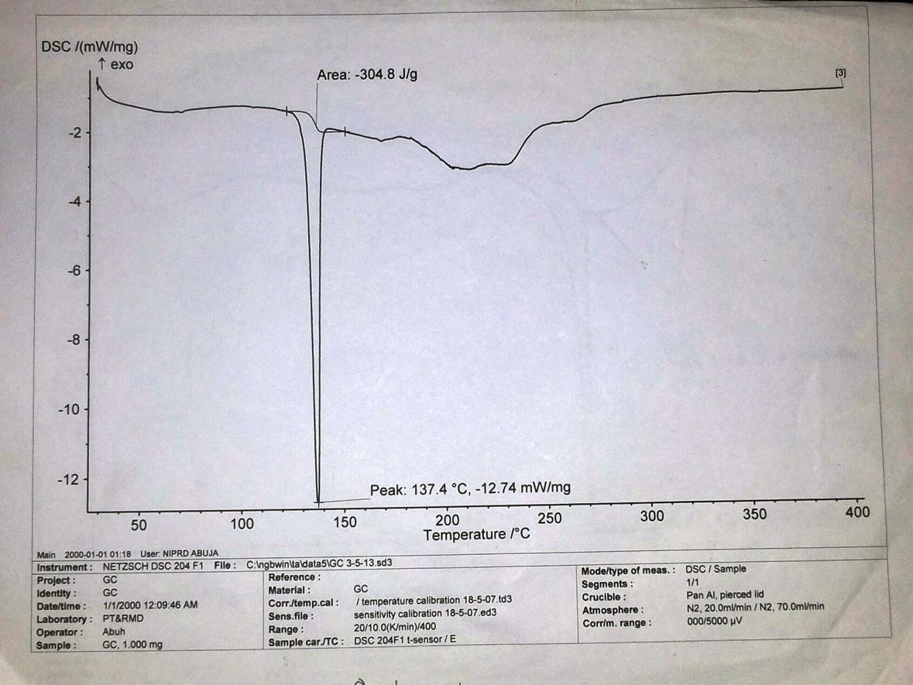

# APPENDIX VIII: Thermograph of pure theophylline showing values

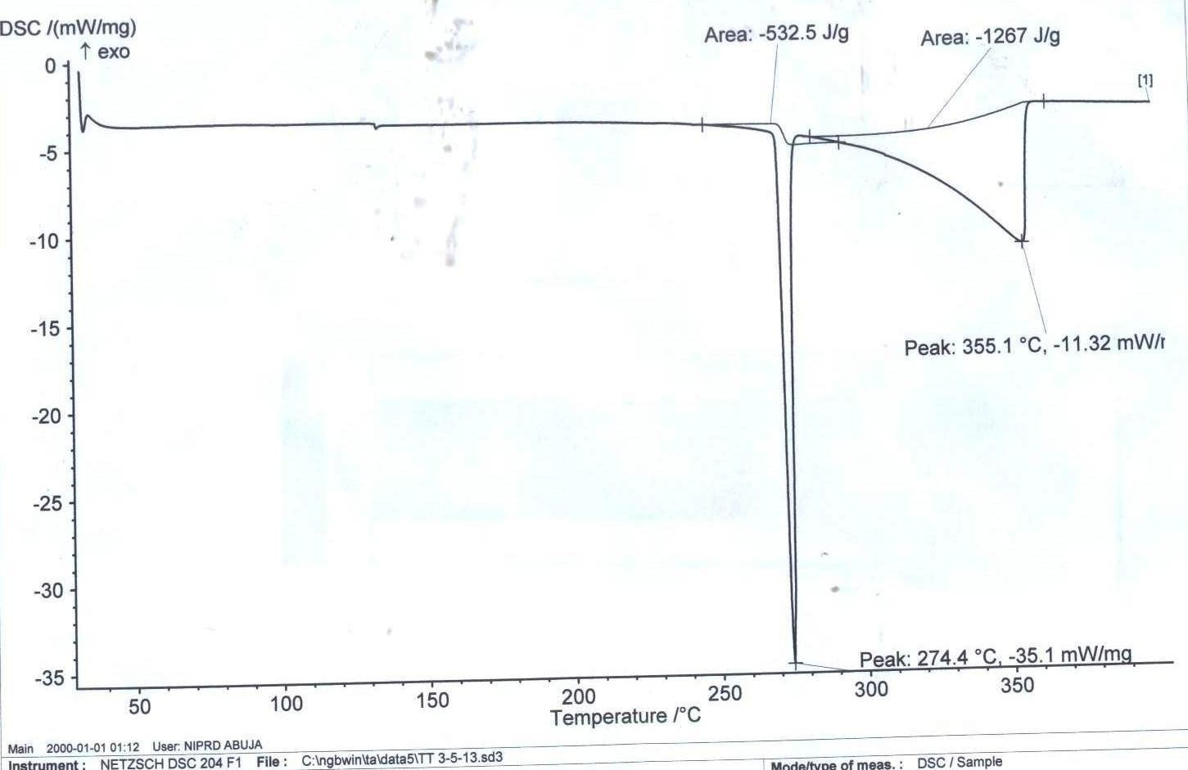

**APPENDIX IX: Thermogram of CAG with values**

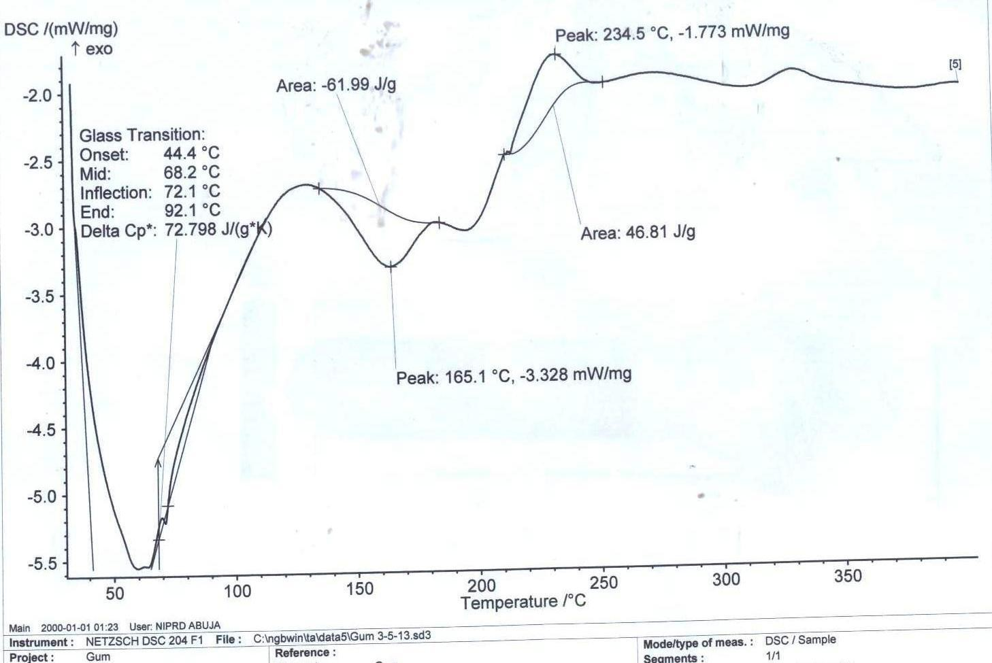

**APPENDIX X: Particle Size Analysis Of *C. Albidum* Gum**

|  |  |  |  |  |  |
| --- | --- | --- | --- | --- | --- |
| **Size Range (μm)** | **Weight**  **Retained (g)** | **%**  **Frequency Fi** | **Class**  **Mean Xi** | **FiXi** | **%**  **Cumulative Frequency** |
| 1 -75 | 24 | 8 | 38 | 304 | 8 |
| 76 – 150 | 114 | 38 | 113 | 4294 | 46 |
| 151 – 250 | 96 | 32 | 200.5 | 6416 | 78 |
| 251 – 350 | 66 | 22 | 300.5 | 6611 | 100 |
| 351 – 500 | 0 | 0 | 425.5 | 0 | 100 |
|  | **300** | **100** |  | **17625** |  |

Mean Particle Size = Σ FiXi = 17625 = 176.25 μm

Σ Fi 100

# APPENDIX XI: Zero order plot for chlorpheniramine tablet release profile



120

100

80

60

40

20

0

0

2

4

6

8

10

12

14

**Time (h)**

C1 (5%)

C2 (10%)

C3 (20%)

C4 (30%)

C5 (40%)

C6 (50%)

**Cumulative percentage drug released (%)**

**APPENDIX XII: Zero order plot for theophylline tablet release profile**



120

100

80

60

40

20

0

0

2

4

6

8

10

12

14

**Time (h)**

T1 (5%)

T2 (10%)

T3 (20%)

T4 (30%)

T5 (40%)

T6 (50%)

**Percentage Drug Released (%)**

# APPENDIX XII: Higuchi’s plot for chlorpheniramine tablets drug release profile



120

100

80

60

40

20

0

0

1

2

3

4

**Square root of time**

C1 (5%)

C2 (10%)

C3 (20%)

C4 (30%)

C5 (40%)

C6 (50%)

**Percentage cumulative drug release (%)**

**APPENDIX XIV: Higuchi’s plot for Theophylline tablets drug release profile**



120

100

80

60

40

20

0

0

0.5

1

1.5

2

2.5

3

3.5

4

**Square root of time (√)**

T1 (5%)

T2 (10%)

T3 (20%)

T4 (30%)

T5 (40%)

T6 (50%)

**Cumulative percentage drug released (%)**

# APPENDIX XV: Hixson-Crowell plot for chlorpheniramine tablets drug release profile



5

4.5

4

3.5

3

2.5

2

1.5

1

0.5

0

0

2

4

6

8

10

12

14

**Time (h)**

C1 (5%)

C2 (10%)

C3 (20%)

C4 (30%)

C5 (40%)

C6 (50%)

**Cube root of cumulative percentage drug release**

**APPENDIX XVI: Hixson-Crowell plot for Theophylline tablets drug release profile**



5.00

4.50

4.00

3.50

3.00

2.50

2.00

1.50

1.00

0.50

0.00

0

2

4

6

8

10

12

14

**Time (h)**

T1 (5%)

T2 (10%)

T3 (20%)

T4 (30%)

T5 (40%)

T6 (50%)

**Cube root of cumulative percentage drug release**

# APPENDIX XVII: Korsmeyer-Peppas’ plot for chlorpheniramine tablets drug release profile



2.5

2

1.5

1

0.5

0

-0.4

-0.2

0

0.2

0.4

0.6

0.8

1

1.2

**Log Time**

C1

C2

C3

C4

C5

C6

**Log cumulative percentage drug released**

**APPENDIX XVIII: Korsmeyer-Peppas’ plot for theophylline tablets drug release profile**



2.5

2

1.5

1

0.5

0

-0.4

-0.2

0

0.2

0.4

0.6

0.8

1

1.2

**Log Time**

T1

T2

T3

T4

T5

T6

**Log cumulative percentage drug release**