EVALUATION OF CERVICAL SPONDYLOSIS USING 0.2 TESLA AXIAL T2 AND AXIAL 3D FIESTA MAGNETIC RESONANCE IMAGING SEQUENCES

ABSTRACT

The purpose of this study was to compare the accuracy of axial T2 and axial 3D FIESTA magnetic resonance imaging (MRI) sequences in the evaluation of cervical spondylosis.The specific objectives were to: (i) compare the accuracy of axial T2 and axial 3D FIESTA MRI sequences in the diagnosis of cervical spondylosis, (ii) compare the quality of images (signal-to-noise ratio, contrast-to-noise ratio and artefact due to flow) produced from both sequences and

- ascertain the association of cervical spondylosis with sex and age in the studied population. This was a cross sectional study carried out at radiology department of Usman Danfodiyo University Teaching Hospital,Sokoto. Eighty subjects from 30 years and abovewere selected using convenience sampling method. Images of axial T2, axial T1, sagittal T1, sagittal T2 and axial 3D FIESTA sequences were acquired for each subject usinga General Electric 0.2 Tesla closed magnet MRI scanner with serial No: GE Signal “R” profile “M” HD5177477-100sS. Axial T2 and axial 3D FIESTA images were read and were assessed qualitatively using the five point Likert scale. The images were assessed for visibility of anatomical structures, quality of image in terms of signal-to-noise ratio, contrast-to-noise ratio and sensitivity to artefacts due to flow of fluid (blood and cerebrospinal fluid). Also indicators of cervical spondylosis were assessed qualitatively. Statistical Package for Social Science version 21 was used in the analysis of the generated data. Wilcoxon Sign Rank Test was used to compare the quality of images produced by both sequences. Regression analysis was used to assess the association of indicators of cervical spondylosis with sex and age. The median scores for axial T2 and axial 3D FIESTA sequences with respect to visibility of anatomical structures were 25.00 and 25.00,Wilcoxon Sign Rank Test showed no significant difference between them at 0.168 (p<0.05). There was no significant difference between the median score of images produced by both sequences with respect to signal-to-noise ratio, contrast-to-noise ratio and artefact due to cerebrospinal fluid (3.00, 3.00 and 3.00 respectively) (p<0.05). However, axial T2 sequence was less sensitive to artefacts (due to flow of blood) than axial 3D FIESTA with a significance difference of 0.00 (p<0.05) in their median value. In conclusion, axial 3D FIESTA is as accurate as axial T2 sequence in visibility of anatomical structures, image quality and prediction of cervical spondylosis (p<0.05). Disc tear is not a good predictor of cervical spondylosis. As age increases the tendency to have cervical spondylosis increases and males are more prone to it than female (p<0.05).

 |  | TABLE OF CONTENTS
Title page |  | i
Approval page |  | ii
Dedication |  | iii
Acknowledgement |  | iv
Abstract |  | v
Table of Content |  | vi
Lists of Tablesix
Lists of Figures |  | xi
Chapter One: Introduction
1.1 | Background of the study | 1
1.2 | Statement of Problem | 4
1.3 | Purpose of the Study | 5
1.4 | Significant of Study | 5
1.5 | Scope of the Study | 6
1.6 | Hypothesis | 6
1.7 | Definition of Terms | 6
Chapter Two: Literature Review
2.1 Theoretical frame work |  | 9
2.2 | Empirical Review | 20
Chapter Three: Research Methodology
3.1 | Research Design | 26
3.2 | Population of the Study | 26
3.3 | Sampling Technique | 26
 |  | 6

3.4 | Sample Size | 26
3.5 | Inclusion Criteria | 27
3.6 | Exclusion Criteria | 27
3.7 | Ethical Clearance/Informed Consent | 28
3.8 | Equipment | 28
3.9 | Scanning Technique | 28

3.9.1 | Patient Preparation |  | 28
3.9.2 | Patient Positioning |  | 28
3.10 | Image Assesment |  | 29
Chapter Four: Results
4.1 Data Presentation and Analysis |  |  | 31
Chapter Five: Discussion and Conclusion
5.1 Discussion |  |  | 41
5.1.1 Visibility of anatomical structure in cervical spine
5.1.2 | Image Quality of Cervical Spine |  | 47
5.1.3 | Accuracy of 3D FIESTA and Axial T2 in evaluation of cervical
 | spondylosis |  | 49
5.1.4 | Indicators of cervical Spondylosis |  | 50
5.2 | Conclusion |  | 52
5.3 | Recommendations |  | 53
5.4 | Limitations of study |  | 53
5.5 | Area of further study |  | 54
 | References | 55
 |  |  | 7

Appendices | 59
Appendix 1 | Imaging Parameters | 59
Appendix ii Lists of tables |  | 60
Appendix iii Result Output of axial T2 and axial 3D FIESTA
based on anatomical structure of cervical spine |  | 61

Appendix ivResult Output of axial T2 and axial 3D FIESTA Based on image quality due to SNR and CNR62

Appendix v Result Output of axial T2 and axial 3D FIESTA based on image quality due to CSF artefact and

blood flow artifact | 63

Appendix viResult Output of axial T2 and axial 3D FIESTA based on indicators of cervical spondylosis 64

Appendix viiComparison of the sequence based on Image
Quality due to SNR and CNR | 65

Appendix viiiVariables in Equation for axial 3D FIESTA 67

Appendix ixCorrelation Matrix for age and sex in Axial 3D FIESTA 68

Appendix xVariables in Equation for Axial T269

Appendix xi |  | Questionnaire70
Appendix xii | Consent Form74
Appendix xiii | Declaration of the Research |  | 75

Appendix xiv Ethical Clearance

Appendix xiii Raw data

8
LIST OF FIGURES

Figure 1: | Cervical Vertebrate | 11
Figure 2.1: | Sagittal plane of vertebral column | 11
Figure 2.2: | Sagittal T2 image of cervical spine (Radiology department
 | UDUTH sokoto) | 12
Figure 2.3 | Sagittal MR image of cervical spine | 13
Figure 2.4: | Cross sectional anatomy of the cervical intervertebral disc at the
 | Level between C5 and C6 | 14
Figure 2.5: | Axial T2 MR Image at the level of C5/C6
(Radiology department UDUTH, Sokoto) |  | 16

Figure 2.6:Sagittal T2 image of cervical spine (Radiology department

 | UDUTH, Sokoto) 18
Figure 2.7: | Axial T2 MR Image of cervical spine
(Radiology department UDUTH, Sokoto) |  | 19
Figure 3.1: | Axial T2 cervical spine MR image (0.2 Tesla MRI unit,
 | Radiology Department, UDUTH, Sokoto). |  | 24
Figure 3.2: Axial 3D FIESTA cervical spine image |  |  | 2
Figure 4.1 Bar chart for Total Axial T2 of Cervical spine |  |  |  | 32
Figure 4.2Bar chart for Total Axial 3D FIESTA of Cervical spine |  |  |  | 32
Figure 4.3Bar chart for Total image quality of Axial T2 Cervical spine |  |  |  | 35
Figure 4.4 | Bar chart for Total image quality ofAxial 3D FIESTA35
Figure 4.5 | Bar chart for Total image quality due to artefacts of Axial T2 |  |  | 37
 | 9

Figure 4.6 | Bar chart for Total image quality due to artefacts Axial 3D FIESTA | 37
Figure 4.7 | Bar chart for Total indicators of cervical spondylosis in Axial T2 | 39
Figure 4.8 | Bar chart for Total indicators of cervical spondylosis in Axial 3D | 39

10
 | LIST OF TABLES
Table 1: | Mean score of Axial T2 and Axial 3D fiesta based on Anatomical
 | structure of cervical spine | 31
Table II: | Comparison of both sequences based on visibility of structures
of Cervical spine |  | 32
Table III: | Mean score of Axial T2 and Axial 3D FIESTA based on image
 | Quality due to SNR and CNR | 33
Table IV: | Mean Score of Axial T2 and Axial 3D FIESTA based on image
 | Quality due to CSF artifact and Blood Flow artifact | 34
Table V: | Mean score of Axial T2 and Axial 3D FIESTA based on
 | indicators of cervical spondylosis | 35
Table VI: | Comparison of both sequences based on indicators of cervical
 | spondylosis | 36
Table VII: | Distribution of Gender and Age of Respondents | 37
Table VIII: | Linear regression for indicators of cervical Spondylosis on Age
 | and Sex for Axial T2 | 38
Table IX: | Linear regression for indicators of cervical Spondylosis on Age
 | and Sex for Axial 3D FIESTA | 39
Table X: | percentiles on visibility of Anatomical structures and Quality
 | of cervical spine image from axial T2 and Axial FIESTA | 40

11
CHAPTER ONE

INTRODUCTION

1:1 Background of the Study

In contemporary clinical practice, neck pain according to Rana et al., (2011), is prevalent in approximately 15% of the general population. Cervical spondylosis is a disorder of the cervical spine and it is a common cause of neck pain (Takagi et al, 2001). It is characterized by chronic intervertebral disc degeneration, abnormal wear on the cartilage and bones of the cervical spine.

According to Okada et al., (2009), cervical spondylosis is categorized into three clinical syndromes:
- Cervical radiculopathy due to compression, stretching or angulations of the cervical nerve root.
- Cervical myelopathy due to compression, compromised blood supply or recurring minor trauma to the cord.
- Axial joint pains.

They also state that both sexes are affected equally from the age of 50 years but the problems begin earlier in males.
Sutton (2004) opines that cervical spondylosis is indicated as radial (anterior) tearing of the annulus fibrosus, loss of disc height, dehydration and fissuring of the disc and osteophytes development anteriorly in association with anterior annular tear and nerve root compression. However, the tearing of the annulus fibrosus of the intervertebral disc occurs from about30 years to 40 yearsof age (Sutton 2004). At times, the diseased condition may be asymptomatic, since there are such conditions as pain, myelopathy and radiculopathywhich may be asymptomatic but later degenerate to a complicated state, there is need therefore for early detection of this disease

12
condition. Early diagnosis aids better patient management. This may overcome the challenge of asymptomatic cases of cervical spondylosis.

Axial T2 sequence is a Fast spin echo sequence. Fast imaging employing state acquisition (FIESTA) is a steady state gradient echo sequence in which residual transverse magnetization is refocused so that a steady magnitude of longitudinal and transverse magnetization is achieved after a few repetition (TR) periods. Once a steady state is reached it produces free induction decay signal and spin echo signal. It is called FIESTA–Fast imaging employing steady state acquisition or SSFP (Balanced steady state free precision sequence) or FISP-(Fast Imaging with Steady State Precision) (Bhosale et al., 2008). The image contrast in FIESTA is determined by the T2: T1 ratio of the tissue. Tissues with long T2 relaxation time and short T1 relaxation time (for example water and fat) have high signal intensity. This is the reason for excellent contrast between cerebrospinal fluid and other structures. Advantages of FIESTA include: Short imaging time, high signal–to–noise ratio (SNR), better contrast–to-noise ratio (CNR) and high spatial resolution. (Scheffler et al,2003;Meindi et al, 2009).

The cervical spine is located between the head and the thoracic spine. It consists of seven vertebrae. The vertebrae are surrounded by anterior longitudinal ligament, posterior longitudinal ligament and muscles. The articulating surfaces of adjacent vertebrae are connected by intervertebral discs as well as the ligaments. The disc comprises of annulus fibrosus surrounding a gelatinous nucleus pulposus. The first two vertebrae are called the axis and atlas and do not have a disc between them but are closely related by a ligament. The spinal canal is widest between the first cervical vertebra and the third cervical vertebra (AP diameter is about 16-30mm) and it narrows as it progresses gradually (14-23mm). The cervical spine has foramina on each side which all vertebral arteries passes through (Binder et al., 2007).
13
The cervical spines contain and protect the spinal cord, support the weight of the skull and enable diverse movement with the aid of the ligaments and muscles around it. Imaging modalities used for evaluation of cervical spondylosis include plain radiography, computed tomography, computed tomographic myelography, magnetic resonance imaging, discography and radionuclide imaging.
Plain radiography demonstrates ageing changes such as loss of disc height and bone spurs. However, it is a two dimensional imaging technique which cannot display the acquired images in coronal, axial and sagittal plane.
Computed tomographic myelography evaluates the spinal canal, cerebrospinal fluid and nerve root, but it has the risk of contrast morbidity and at times the procedure may not be successful (Orthol, 2009). Computed tomography can be used to assess the bone and the spinal canal.

Magnetic resonance imaging is a non-invasive medical imaging modality that uses strong magnetic field, radio frequency waves, body coils and computer display unit. Magnetic resonance imaging has been widely accepted as the gold standard in diagnosis of cervical spondylosis. This could be due to better soft tissue characterization that allows direct evaluation of ligaments, spinal cord, disc contents and vasculature around the neck. Also, it uses non-ionizing radiation.These advantages make it the preferred modality for diagnosis of cervical spondylosis. However, MRI has some limitations;it is expensive and it is always not readily available, it also takes longer scan time, and patients with metallic implant cannot undergo the investigation. (Holmes et al, 2002;Mansfield2003; RSNA 2006 and Newman et al, 2013).

Over the years, sagittal T1, T2 and axial T1, T2 have been used as the standard MRI protocols for diagnosis of cervical spondylosis. Sagittal protocol only shows reduction in disc height, disc herniation, dehydration of disc content and spikes.Axial MRI protocol on the other hand, is the

14
gold standard to evaluate disc tear (of annulus fibrosus and nucleus polposus),disc prolapse, disc protrusion, disc herniation and nerve root compression(Morishita et al,2005;Al-Shatoury et al, 2009;Newman, et al, 2013). Axial 3D fast imaging employing steady state acquisition (FIESTA) is an additional protocol which gives images of high signal-to-noise ratio within a short time and produces better contrast due to its insensitivity to motion.
In UsmanuDanfodiyo University Teaching Hospital (UDUTH), the number of patients referred for MRI scan of the cervical spine due to cervical spondylosis has been on the increase. This study is intended to compare the accuracy of axial T2 with axial 3D FIESTA protocols in diagnosis of cervical spondylosis. This may help in deciding which protocol to use in investigating cases of cervical spondylosis.

1.2 Statement of Problem

Although axial T2 MRI protocol has remained the gold standard for better assessment of the structures affected by cervical spondylosis (Newman et al, 2013), T2 is subject to artefacts (flow artefact). An MRI protocol that is insensitive to flow artefacts with high signal to noise ratio and shorter scan time (compare with axial T2) might be more accurate than axial T2 in detecting structures affected by cervical spondylosis. Is axial 3D FIESTA really subjective to less artefacts and increased image quality when compared with axial T2 MRI sequences?

1.3 Purpose of the Study

The purpose of this research is to compare axial T2 MRI protocol with axial 3D FIESTA

MRI protocol in cervical spondylosis.

The specific objectives of the study are:

15
- To compare the accuracy of axial T2 MRI and axial 3D FIESTA MRI in the diagnosis of cervical spondylosis.
- To compare the image quality(signal-to-noise ratio, contrast -to-noise ratio and image artefact) produced from both protocols.
- To ascertain the association of the magnetic resonance imaging findings of cervical spondylosis with age and sex.

1.4 Significance of the Study

- The outcome of the study will define MRI protocol that could aid early and more accurate diagnosis of cervical spondylosis even in asymptomatic cases. Early diagnosis of the disease will enable early and better treatment.
- The outcome of this study will help to establish which magnetic resonance sequence gives better image quality in cases of cervical spondylosis.
- The association of the occurrence of cervical spondylosis with age and sex will establish which sex and age group are more prone to the disease. This will help in early detection and better patient management.

1.5 Scope of the Study

This prospective study on cervical spondylosis was carried out at MRI unit in the Department of Radiology, UsmanuDanfodiyo University Teaching Hospital, Sokoto.

16
1.6 Hypothesis

H_{O}: Axial 3D FIESTA is as accurate as Axial T2 in the evaluation of cervical spondylosis

H₁: Axial 3D FIESTA is not as accurate as Axial T2 in the evaluation of cervical spondylosis

1.7 Definition of Terms

T1 Recovery

T1 Recovery is the recovery of 63% of original value of longitudinal magnetization following an excitation pulse by radiofrequency wave (Allisy et al., 2008).
T1 Time

T1 Time is the time it takes for excited spin to recover and be available for the next excitation(Allisy et al., 2008;Jagon et al., 2008).

T2 Relaxation

T2 Relaxation is the decay of transverse magnetization to 37% of its initial value immediately after excitation(Allisy et al., 2008).
T2 Time

T2 Time is the time it takes for magnetic resonance signal to fade after excitation(Allisy et al., 2008; Jagon et al., 2008).
Time of Echo (TE)

Time of echo or echo time is the interval between application of the excitation pulse and collection of the magnetic resonance signal. It controls T2(Chavan et al, 2007).

17
Repetition Time (TR)

Repetition time is the interval between two successive excitation of the same slice. It controls T1(Allisy et al., 2008).
Proton Density (PD)

Proton density is the number of excitable spins per unit volume (Mansfiield, 2003). T1 Weighting (T1W)
T1 Weighting involves eliminating T2 effect/contrast in order to enhance T1 effect/contrast (Bushberg 2001).
T2 weighting (T2W)

T2 weighting involves eliminating T1 effect to enhance T2 effect (Bushberg 2001).

Signal-to-Noise ratio (SNR)

Signal-to-Noise ratio is the ratio of useful signal to the noise generated during magnetic resonance

scan(Jagon et al., 2008).

Contrast-to-Noise ratio

Contrast-to-Noise ratio is the difference in SNR between two adjacent areas(Jagon et al., 2008). Number of Excitation (NEX)
Number of excitation is the number of times a signal from a given slice is measured(Allisy et al., 2008).
Saturation Band

Saturation Band is used to suppress undesired signal from the tissue within the imaging volume(Allisy-Roberts et al., 2008).

18
Gradient Echo (GRE) Sequence

This is a sequence that employs the gradient coil for producing an echo rather than pairs of radiofrequency pulses(Chavan et al., 2007).
Spin Echo (SE)

SE pulse sequence utilizes 90⁰ excitation pulse to flip the net magnetic vector into the transverse plane(Chavanet al., 2007).

Fast or Turbo Spin Echo Sequence

This is a modified spin echo sequence with considerably shorter scan times (Jagon et al.,2008;Allisy et al., 2008)

19
CHAPTER TWO

LITERATURE REVIEW

2.1 Theoretical Framework

A vertebra has a body anteriorly and a neural arch posteriorly (Fig. 1). The neural arch surrounds the spinal canal and consists, on each side, of a pedicle laterally and a lamina posteriorly. A transverse process extends laterally and the laminae fuse posteriorly to form the spinous process. The intervertebral canals transmit the segmental spinal nerves between adjacent pedicles.The vertebral body consists of central cancellous (spongy) bone with a rim of dense cortical bone.(Fig 2.1) (Ryan et al., 2013).
Cervical spines are readily identified by the foramen transversariumperforating the transverse processes (Fig 1). This foramen transmits the vertebral artery, the vein, and sympathetic nerve fibers. The spines are small and bifid (except C1 and C7 which are single) and the articular facetsare relatively horizontal (Fig 3.1,Fig 2.2). The atlas (C1) has no body. Its upper surface bears a superior articular facet on a thick lateral mass on each side which articulates with the occipital condyles of the skull. Just posteriorly to this facet, the upper aspect of the posterior arch of the atlas is grooved by the vertebral artery as it passes medially and upwards to enter the foramen magnum.The axis(C2) bears the dens (odontoid process) on the superioraspect of its body, representing the detached centrum of C1 (Ryan et al., 2013).

Nodding and lateral flexion movements occur at the atlanto-occipitaljoint, whereas rotation of the skull occurs at the atlanto-axial joint aroundthe dens, which acts as a pivot. The vertebral artery enters its vertebral course nearly always at the foramen transversarium. The vertebral laminae are linked by the ligamentum flavumof elastictissue, along the anterior and posterior aspects of the

20
spine are the tough longitudinalligaments.(Fig 2.1,fig 2.2). The vertebral bodies and associated structures are suppliedby the ascending cervical arteries. Venous drainage of the vertebral bodies is by a pair of basivertebral veins that emerge from the posterior surface of the body to drain to the internal vertebral venous plexus,which in turn drains to the segmental vein (Fig 3.1).The vertebral bodies are also joined by the extremely strong intervertebraldiscs.The intervertebral disc is a cartilaginous cushion between adjacentvertebral bodies (Fig 2.1). Each disc consist of a peripheral annulus fibrosuswhich adheres to the thin cartilage plate on the vertebral body above and below, and surrounds gelatinous semifluidnucleus pulposus (Ellis, 2006; Ryan et al., 2013).
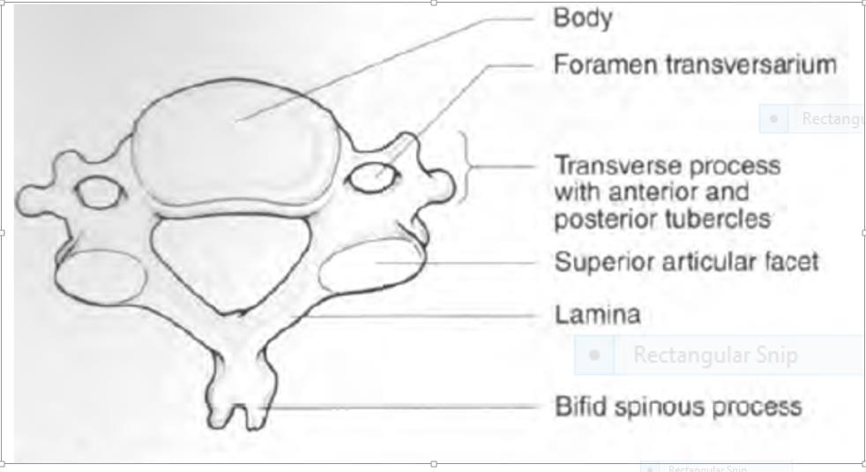

Fig 1 Axial plane of cervical vertebrate.

Source: {(Clinical anatomy: a revision and applied anatomy for clinical studentsHarold E. (2006)}

21
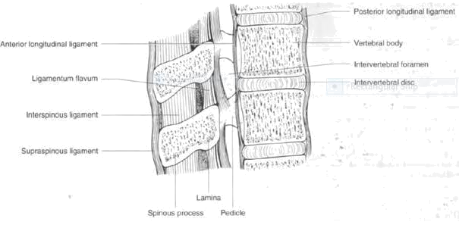

Fig 2.1Sagittal plane of vertebral column. Source: {(Clinical anatomy: a revision and applied anatomy for clinical studentsHarold E. (2006)}

22
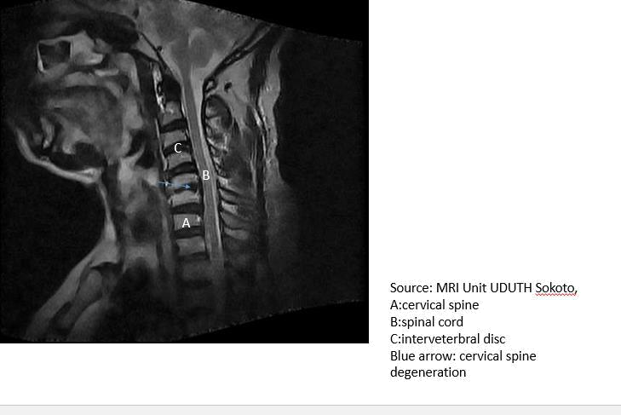

Fig 2.2 Sagittal T2 MR image of cervical spine (Radiology department UDUTH sokoto).

23

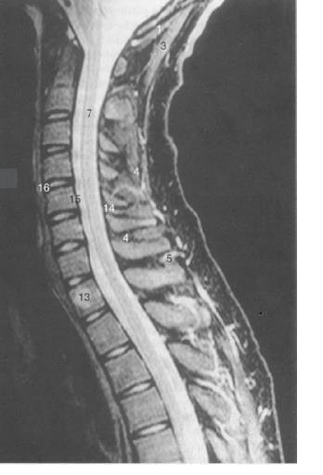

Fig 2.3 Sagittal MR image of cervical spine. Source:

{(Clinical anatomy: a revision and applied anatomy for clinical students,Harold E. (2006)}
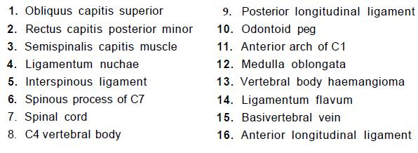

24
Fig 2.4: Cross sectional anatomy of the cervical intervertebral disc space between C5 /C6
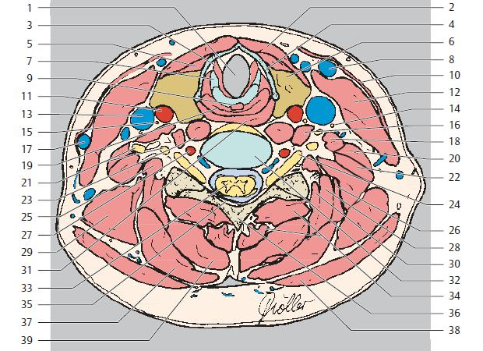

Source:{Clinical anatomy: a revision and applied anatomy for clinical students,Harold E. (2006)}

25
1 | Larynx |  | 21 | Spinal nerves (C4 and C5)
2 | Sternohyoid muscle |  | 22 | Posterior scalene muscle
3 | Vocalis muscle (vocal cord) |  | 23 | Longus colli muscle
4 | Thyroid cartilage (lamina) |  | 24 | Spinal nerve root (C6)
5 | Thyrohyoid muscle |  | 25 | Longissimus capitis muscle
6 | Thyroid gland |  | 26 | Longissimus cervicis muscle
7 | Arytenoid cartilage |  | 27 | Vertebral artery
8 | Anterior jugular vein |  | 28 | Splenius cervicis muscle
9 | Transverse arytenoid muscle |  | 29 | Levator scapulae muscle
10 |  | Platysma | 30 | Semispinalis capitis muscle
11 |  | Common carotid artery | 31 | Inferior constrictor muscle of
12 |  | Sternocleidomastoid muscle | pharynx
13 |  | Internal jugular vein | 32 | Intervertebral space (C5/C6)
14 |  | Phrenic muscle | 33 | Spinal cord
15 |  | Vagus nerve (X) | 34 | Spinaliscervicis muscle and
16 |  | Longus capitis muscl | multifidus muscle
17 |  | External jugular vein | 35 | Ligamentum flavum
18 |  | Anterior scalene muscle | 36 | Posterior vertebral arch
19 |  | Hypopharynx/esophagus | 37 | Splenius capitis muscle
20 |  | Middle scalene muscle | 38 | Trapezius muscle
 |  |  | 39 | Semispinalis cervicis muscle

26
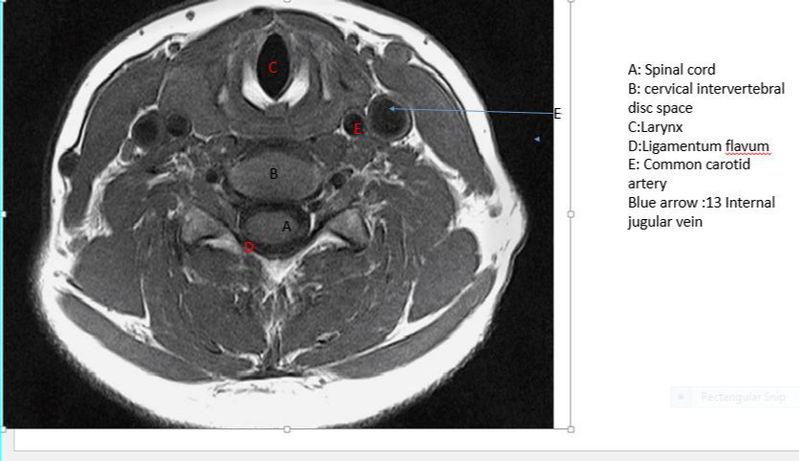

FIG 2.5: Axial T2 MR Image at the level of C5/C6.

Source: MRI unit UDUTH, Sokoto.

During childhood the discs are highly vascular but, by the age of 20 years, the normal disc is avascular.In old age, the discs atrophy, with resulting shrinkage in height and return of the curvature of the spine to the C shape of the newborn. The cervical vertebrae (particularly C7), may be fractured or more commonly, dislocated. This could be due to a fall on the head with acute flexion of the neck or sudden forward jerk during a motorcar or aeroplanecrashes. Intervertebral facets of the cervical vertebrae allow dislocation to take place without their being fractured. The comparatively thin posterior part of the annulus fibrosus may rupture, either due to trauma or to degenerative change. When it occurs the nucleus pulposus protrudes posteriorly into the vertebral canal—the socalled‘prolapsed intervertebral disc’. This may sometimes occur at the lower cervical intervertebral discs (C5/6 and C6/7). Disc material may herniate into the canal

27
centrally, peripherally or into the exit foramina or laterally at all these sites causing nerve compression which can result in radiculopathy.
The diagnosis of this and other spinal conditions has been greatly facilitated by the introduction of MRI scans which give excellent anatomical details of this region. Occasionally, the disc prolapse may be directed backwards. If this is extensive, it may compress the whole cauda equina, producing paraplegia. At each intervertebral foramen the anterior and posterior nerve roots unite to form a spinal nervewhich immediately divides into its anterior andposterior primary rami, each transmitting both motor and sensory fibres(Ellis 2006; Ryan et al, 2013).

The length of the roots increases progressively from above downwards.Complete transection of the cord is followed by total loss of sensationin the regions supplied by the cord segments below the level ofinjury together with flaccid muscle paralysis. As the cord distal to thesection recovers from a period of spinal shock, the paralysis becomesspastic, with exaggerated reflexes.

The predisposing factor for cervical spondylosis include aging, over-weight, lack of exercise, smoking, jobs that require lifting heavy weight and frequent bending, twisting of the neck, post neck injury depression, ruptured or slipped disc, severe arthritis and small fractures to the spine from osteoporosis (Urban et al 1995; Matsumoto et al., 2010).

The disease condition is based on typical clinical signs and radiological findings. The clinical manifestations of cervical spondylosis include gait disturbance, numbness and paresthesia of the hand and pyramidal tract signs. There are posterior column dysfunction, numbness or abnormal sensation in the shoulder (Bunt et al., 2000; Chen et al., 2003; Sutton, 2004; Morishita et al.,2005; Orth, 2009; Takagi et al “a”.,2011).

Rana et al., (2001) from his study on diagnosis and management of cervical spondylosis, established that only a small percentage of patients with radiographic evidence of cervical

28
spondylosis are symptomatic. Indicators of spondylosis include: radial anterior tearing of the annulus fibrosis, loss of disc height, dehydration and fissuring of the disc, osteophytes development anteriorly in association with anterior annular tear, spinal cord narrowing and ischemia (Sutton, 2004). Incidentally, annulus fibrosus appears as a subtle and peripheral region of lower signal intensity.

On T1Weighted images the CSF is hypointense and, in general, this sequence showsthe anatomy of the cervical spine. On T2Weightedimages the CSF appears hyperintense and thus there is a myelographic effect. T2Weighted sequences, in general, demonstrate pathology (Sutton, 2004).
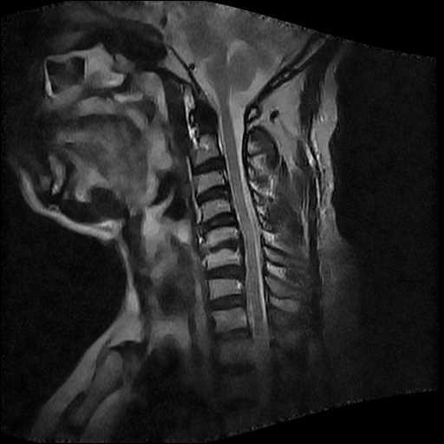

Fig 2.6: Sagittal T2 image of cervical spine (MRI Unit, UDUTH,sokoto).

The sagittal T2 image shows cervical spondylosis at the level of C3/C4 intervertebral disc and at the level of C4/C5and C5/C6.

29
On axial T2 sequence, the nucleus pulposus appears as a region of higher signal intensity. The ligamentum flava appear hypointense and are inseparable from the cortical bone. The vertebral body appears to have lower signal due to lack of mobile protons. The spinal canal narrowing on sagittal sequence T2 is caused by the thickening of bony and ligamentous structures as well as protrusion of intervertebral disc material. Spinal cord ischemia occurs due to compression of degenerative elements on blood vessels that supply the Spinalcord (Gross et al., 1999; Morishita et al., 2005). Magnetic resonance imaging also demonstrates disc protrusion accurately and is the preferred imaging modality in showing the nature of the cord compression. It also reflects the pathological changes in the spinal cord (Sutton, 2004; Morishita et al., 2005).
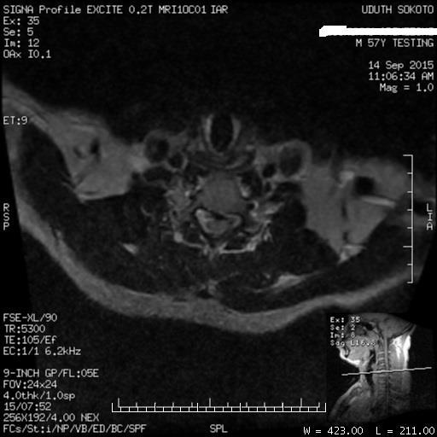

Fig 2.7 Axial T2 MR Images of cervical spine (0.2 Tesla MRI unit, Radiology Department, Usmanu Danfodiyo University Teaching Hospital, Sokoto).

Magnetic resonance imaging scan of the cervical spine for cervical spondylosis conventionally employs localizer, sagittal T1, sagittal T2, axial T2 fast spin echo and axial T1 sequences. Axial

30
T2 sequence and 3D FIESTA sequence were utilized to arrived at the findings of the research (comparison of axial T2 sequence and axial 3D FIESTA in evaluation of cervical spondylosis). Axial 3D FIESTA was used due to its higher signal-to-noise ratio (SNR) per unit time, improved speed of acquisition and reduced motional artefacts. In addition, the contrast of the axial 3D FIESTA images is not simple T1 or T2 weighted but is rather related to the T2:T1 ratio of the tissue.

2.2 Empirical Review

Girism (2003) compared images of T2 – weighted 3D gradient echo sequence and T2 weighted 3D turbo spin echo using a 1.5 tesla magnet. He calculated quantitatively the SNR of the spinal cord, contrast-to-noise ratio of the cerebrospinal fluid in the MRI images and graded the detectability of neural foramina, spinal nerve roots, uncinate process andligamentum flava on a 5 points Likert scale (which are: 0- minimum,4-maximum).The presence of artefacts were graded on 4 points Likert scale as follows; 3: maximum, 0: minimum. He concluded that T2-3D-SF/SPIR was superior to other sequences (P<0.01) in evaluation of the structures affected by cervical spondylosis.

Kwon et al., (2002) compared sagittal 3D T2 weighted MRI sequence and sagittal 2D T2 weighted sequence images of cervical spine using 3 Tesla magnet. He assessed the visibility of anatomical structures in cervical spine protocol quantitatively using the 5 points Likert confidential scale. In their scale, 1- represented none visible anatomical structure 2-barely visible, 3-adequately visible, 4-good visibility and 5-excellent visibility. He further carried out comparison of sequence using a Wilcoxon paired sign-rank test with Statistical Package for Social Sciences version 12,USA.The presence of artefacts and overall image quality were graded as

31
follows: 3- no artefact, 2- moderate artefact and 1-extensive artefact. Their study showed that 3D T2Weighted has higher SNR and less sensitivity to CSF flow artefacts. It also reported that 3D T2Weighted is superior in delineation of intradural nerve rootlet and neural foramina compared to 2D T2 weighted MRI sequence

Meindi et al., (2009) compared visibility of ten anatomical structures of normal cervical spine in images of T2 weighted axial 3D sequence and T2 weighted axial 2D sequence. With a similar method of data collection as Kwon (2010) but with a 3Tesla scanner, he arrived at the conclusion that, T2 weighted axial 3D sequence has superior delineation of anatomical structures than T2 weighted axial 2D sequence

On his assessment of the anatomical structures of cervical spine using T2 weighted three dimensional volume fast spin echo sequence compared with standard imaging protocol;Maldjian et al., (1999) notes the similarity between both protocols. Both protocols provide comparable information about spinal cord, spinal canal, disc and neural foramina with 1.5T MR unit.

Swainson et al., (1997) compared 3D fast spin echo using real–time multiplanar reconstruction with standard 2D imaging protocol in the evaluation of cervical spine and discovered that single 3D sequence cannot satisfactorily replace the 2D combination routinely, because the contrast-to-noise ratio was better on 2D images when compared with 3D images.

Mogy et al., (2011) study (on comparison of 3D FIESTA protocol and conventional MR imaging protocol in brachial plexus root injury) reveals that conventional MR imaging yields suboptimal information regarding the fine details of nerve roots injury but FIESTA combined with conventional MR depicts nerve segments in greater detail and provides important information on

32
the relationship between the surrounding structures. It also provides high contrast resolution between cerebrospinal fluid and solid structure.

Chavez et al (2005) reports that Fast Imaging Employing Steady – State Acquisition (FIESTA) MRI supplies improved contrast and more precise imaging in the trigeminal nerve region: further research has shown that FIESTA provides higher contrast resolution between cerebrospinal fluid in cerebellopontine angle and the adjacent structure (Matsuda et al .,2008; Oh et al (2008).

Furthermore, there are disparities with regards to age at which cervical spondylosis starts appearing. Wang et al., (2011) opines that spinal cord dysfunction is most common in patients above the age of 55 years while Morishita et al., (2005) claims that it starts from age 50years then increases with passage of time. However, Nordqvist (2009) and Okada et al., (2009), postulate that the condition appears in patients that are above forty years and men develop it at an earlier age than their female counterparts. Vyas et al., (2004) and Sutton (2004) contradict this. According to them the disorder starts appearing as early as the third decade and itinvolves 75-100% of the population by the seventh decade.

In their study to ascertain the level at which intervebral disc degeneration of the cervical spine often occur,Abdulkarim et al.,(2003) reveals that as age increases, the process of degeneration becomes more generalized with less variability between discs.

Furthermore, Bogduk (2012) notes that degeneration changes of the spine is an expression of metabolic stress in spinal joints, which have some predisposing factors such as genetics, gender and age (which is the strongest).

Axial images with less artefact and high SNR will give better image display for improved diagnostic output, this will bridge the gap of stressful assessment, report and diagnosis of cervical

33
spondylosis using axial cervical spine images. The sequence that has a short imaging time compared with axial T2 sequence will overcome the challenge of long imaging time of axial T2 especially with 0.2 Telsa scanner which is predominant in our locality.This study used 0.2T magnetic field strength to compare images of axial 3D FIESTA sequence and conventional axial T2 spin echo sequence and also assessed the detectability of the structures and indicators of cervical spondylosis. The research seek to verify any variation from the above finding in terms ofvisibility of anatomical structures and quality of the cervical spine MR images(SNR,CNR and flow artefacts) using 0.2 Tesla in our locality.This study is also aimed at addressing the disparity in the age of occurrence of magnetic resonance imaging findings of cervical spondylosis, establish any sex related factor at the onset of the disease condition in our locality and ascertain the magnetic resonance sequence that best evaluates cervical spondylosis.

34
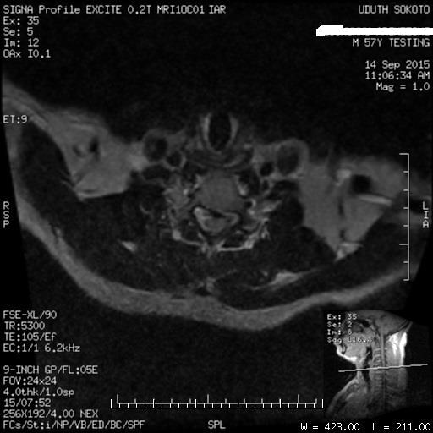

Fig 5:Axial T2 cervical spine image.(0.2 Tesla MRI unit, Radiology Department, Usmanu

Danfodiyo University Teaching Hospital, Sokoto).

35
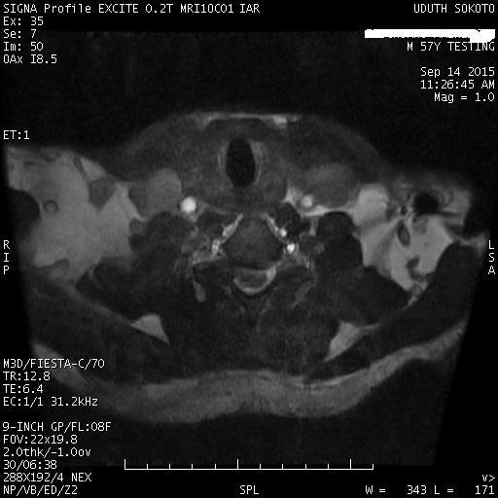

Fig 6 Axial 3D FIESTA cervical spine image. (0.2 Tesla MRI unit, Radiology Department,

Usmanu Danfodiyo University Teaching Hospital, Sokoto).

36

CHAPTER THREE

RESEARCH METHODOLOGY

3.1 Research Design

This is a prospective cross sectional study involving patients referred to UsmanuDanfodiyo University Teaching Hospital, Sokoto for Magnetic resonance imaging scan of cervical spine,

3.2 Population of the Study

The population of this study include all patients referred to MRI unit in the Department of Radiology, UsmanuDanfodiyo University Teaching Hospital, Sokoto for cervical spine MRI scan with clinical suspicion of cervical spondylosis during the period of the study.

3.3 Sampling Technique

A convenience sampling method was adopted. This was because only patients that satisfiedinclusion criteria were included.

3.4 Sample Size

A sample of 100 patients that met the selection criteria were selected using the formula.

= | 1 −
Where Z = Standard Deviation responding to 5% level of significance with a critical value of 1.96.

- = Degree of accuracy desired (0.05)

37
- = the prevalence of MRI in cervical spondylosis is 15%.(Rana et al., 2011). Yaro Yamane (1992)

- All patients with suspicion of cervical spondylosis referred to the MRI unit for cervical spine scan that had no metallic implant around the head, neck and chest region.

- Axial MRI scan images that useda field of view of 24-26mm and all axial 3D FIESTA images that used the same field of view.
- All such patients, as in 2 (above), referred for MRI cervical spines that were in stable condition and not restless.
- Patients who were able to lie in supine position for 40-50 minutes, which was the duration of the entire investigation for MRI of the cervical spine.

3. 6 Exclusion Criteria

- Patients who were unstable and restless.

- Patients with metallic implants around the head, neck and chest region.

- Patients who were pregnant.

- Patients below the age of 30 years because some researchers opine that disc tear occurs between age 30 and 40 (Sutton, 2004).
- Patients with only axial scans

- Patient with only axial 3D FIESTA scans.

38

3.7 Ethical Clearance / Informed consent

Ethical clearance for the study was obtained from the Health Research Ethics Committee of UsmanuDanfodiyo University Teaching Hospital (UDUTH)Sokoto, and informed consent wereobtained from the patients prior to the examination.

3.8 Equipment

The patients were scanned with General Electric 0.2 Tesla Closed Magnet MRI scanner manufactured in 2006, with serial no: GE Signal “R” Profile “TM”…HD5177477-100. Along with the magnet were diagnostic console and other accessories such as work station, electrical power generating set, amplifier coil cabinet, uninterrupted power supply (10KVA capacity), Bright star printer and 9 inches neck coil with foam pad and knee support.

3.9 Scanning Technique

3.9.1 Patient Preparation

The procedure was explained to the patients before they filled the consent form. The patients were instructed to remove all metallic objects and change into an examination gown. The weight of each patient was taken and the patients screened for ferromagnetic objects using metal detector.

3.9.2 Patient Positioning

The 9 inches coil was connected to the scanner and the laser light centered to its midline. The patient was made to lie supine. The neck was placed on the cervical (9 inches) coil and the head rested on a foam pad for support. A knee pad was placed under both knees for patient

39
comfort.The laser was centered to the level of the fourth cervical spine which forms the reference point. The couch was then advanced such that the reference point moved to the isocentre of the magnet to scan (Saindane, 2015).
Images were acquired on Localizer, sagittal T2, sagittal T1 and Axial T2, Axial T1 and Axial 3D

FIESTA.

Sequences were planned with initial localizer images in three orientations. For sagittal images, the field of view included base of skull, the whole cervical spine and the thoracic spine. Axially acquired sequences covered the disc level from C2-C3 to C7 – T1. For all sequences an anterior saturation band (pulse) covering the laryngo– pharynx was applied in order to reduce artefacts caused by swallowing.
The imaging parameters are shown in appendix 1

3.10 Image Assessment

The MRI images from 10 patients (including Axial T2 and Axial 3D sequences) were collectively read by a group of four (4) Consultant Radiologists. Thereafter, the images of the other 70 patients were shared and read among the 4 consultant Radiologists. Visibility of anatomical structures was qualitatively assessed using a 5 points Likert scale for each sequence: 0- not visible; 1- poorly visible; 2- adequately visible; 3- good visibility and 4- excellent visibility. The cerebrospinal fluid flow artefacts and blood flow artefacts of both sequences were evaluated on a three point Likert scale: 1- extensive artefact; 2- moderate artefact and 3- no artefact. The signal-to-noise ratios were evaluated on 3 points Likert scale: 1-low, 2-moderate and 3- high. The degree of disc tear, nerve root compression and cord compresswere assessed based on 4 points Likert scale: 0- none, 1-mild, 2-moderate and 3-severe artefacts .The figures obtained from the report were presented in a tabular form and Statistical Package for Social Science package

40
version 21 was used for analysis of the generated data. Mean, median, standard deviation etc were calculated. Wilcoxon Sign Rank Test was applied to compare the quality of images produced from both sequence. Regression analysis was carried out to assess the association of cervical spondylosis with age and sex.
The standard deviation and other analysis were calculated with critical value (CV) of t of 1.96 at 95% level of significant, (p<0.05) (Nwabuoke, 2001).

41
CHAPTER FOUR

RESULT

Following the result obtained from the analysis of data generated from the report of images acquired on axial T2 and axial 3D FIESTA , the outcome are presented below:

Table I Result Output of axial T2 and axial 3D FIESTA based on anatomical structure of cervical spine

 |  | Total axial | Percentage | Total Axial | Percentage
 |  | T2 | of Axial T2 | 3D FIESTA | Axial | 3D
 |  |  |  |  | FIESTA
Mean |  | 24.4 | 76.4 | 25.1 | 78.3
Std error |  | .3 | - | .5 | -
Median |  | 25.0 | 78.1 | 25.0 | 78.1
Mode |  | 25 | 78.1 | 24 | 75.0
St deviation |  | 2.3 | 7.3 | 3.7 | 11.5
Skewness |  | -2.4 | -2.4 | -0.9 | -0.9
Std error | of | .3 | .3 | .3 | .3
skewness
Kurtosis |  | 13.3 | 13.3 | 2.2 | 2.2
Std error | of | .5 | .5 | .5 | .5
Kurtosis
Range |  | 19 | 59.4 | 20 | 62.5
Interquartile |  | 2 | - | 4 | -
range
Minimum |  | 11 | 34.4 | 11 | 34.4
Maximum |  | 30 | 93.8 | 31 | 96.9
Variance |  | 5.5 | - | 13.5 | -

Table 1 shows mean, median and modal scores on the visibility of anatomical structures of 80

images produced from axial T2 and 80 images produced from axial 3D FIESTA. There is no

significant difference between the two protocols. The median scores of total axial T2 and total

axial 3D FIESTA are 25.00 and 25.00 respectively at(p<0.05).

42
Table II Comparison of both sequences based on vsibility of structures in cervical spine

Sequence Structures

Axial T2 PV AV

G V

E V

N V

Axial 3D FIESTA PV AV GV

E V

NV

Soft Tissue | 4 | - | 62 | 14 | - | 9 | - | 57 | 14 | -
Vascular | 1 | - | 71 | 8 | - | 1 | 3 | 22 | 54 | -
structure
Spinal | 2 | 1 | 70 | 7 | - | 3 | 2 | 44 | 31 | -
Cord
Nerve root | 1 | - | 75 | 4 | - | 6 | 2 | 54 | 18 | -
Disc Tear | - | - | - | - | - | - | - | - | - | -
Ligament | 25 | 5 | 50 | - | - | 43 | 2 | 30 | 5 | -
Neural | 4 | 1 | 73 | 2 | - | 6 | 2 | 65 | 7 | -
foramen
CSF | 2 | 1 | 71 | 6 | - | 4 | - | 46 | 30 | -
P V = Poor Visibility |  |  | A V = Adequate Visibility |  |  |  | GV = Good Visibility |  |  | Ex V =
Excellent Visibility |  |  | N V = Not Visible

Table II shows the distribution of the grading based on the visibility of anatomical structures of 80 images produced from axial T2 and 80 images produced from axial 3D FIESTA. The visibility of CSF, nerve root, neural foramen, in both Axial T2 MRI sequence and axial 3D FIESTA MRI sequence were the same. However, disc tear was not observed in both sequences, as both sequences showed none visibility of disc tear in table II. Axial 3D FIESTA sequence shows poor visibility of ligament when compared with axial T2 sequence. Also, the study revealed excellent visibility of vascular structures and spinal cord on axial 3D FIESTA images when compared with axial T2 MR Images.
Generally, the two protocols revealed good/excellent visibility of soft tissue, vascular structure, spinal cord, nerve root, CSF, neural foramen with poor visibility of ligament and

43

non-visible disc tear.

Table III Result Output of axial T2 and axial 3D FIESTA based on image quality due to SNR and CNR

SNR on

T2

axial

CNR Axial T2

on

SNR on Axial 3D FIESTA

CNR on Axial

3D FIESTA

Mean |  | 2.9 | 2.9 | 2.8 | 2.8
Median |  | 3. | 3.0 | 3.0 | 3.0
Mode |  | 3 | 3 | 3 | 3
Skewness |  | -3.9 | -3.6 | -2.7 | -2.7
Std error | of | .3 | .3 | .3 | .3
skewness
Kurtosis |  | 14.9 | 12.3 | 5.7 | 5.7
Std error | of | .5 | .5 | .5 | .5
Kurtosis
Range |  | 2 | 2 | 2 | 2
Minimum |  | 1 | 1 | 1 | 1
Maximum |  | 3 | 3 | 2 | 3

Table III shows the total mean, median and modal scores of quality of images (in terms of SNR and CNR) produced from 80 images of axial T2 and 80 images produced from axial 3D FIESTA.

44

The median score of signal- to- noise ratio (SNR) on axial T2 protocol is 3.00 and for axial 3D FIESTA protocol is 3.00. This showed that there is no significant difference in the SNR and CNR of both protocols at (p<0.05). The median score of CSF flow artefact is 3.00 for both protocols.

45

Table IV Result Output of Mean score of axial T2 and axial 3D FIESTA based on image quality due to CSF artefact and blood flow artifact

CSF | flow | Blood | flow | CSF flow artefact | Blood flow
artefact on | axial | artefact-of | Axial | Axial 3D FIESTA | artefact
T2 |  | T2 |  |  | Axial 3D
 |  |  |  |  | FIESTA

Mean |  | 3.0 | 2.8 | 3.0 | 2.3
Median |  | 3.0 | 3.0 | 3.0 | 2.0
Mode |  | 3 | 3 | 3 | 2
Skewness |  | -- | -3.1 | -- | .5
Std error | of | .3 | .3 | .3 | .3
skewness
Kurtosis |  | -- | -3. | -- | -10
Std error | of | .5 | .5 | .5 | .5
Kurtosis
Range |  | 0 | 3 | 0 | 2
Minimum |  | 3 | 0 | 3 | 1
Maximum |  | 3 | 3 | 6 | 3

Table IV shows comparison of the total mean, median and mode value of quality of images (artefact due to CSF and blood flow) produced from 80 images of axial T2 and 80 images produced from axial 3D FIESTA. The median score of artefacts due to CSF is 3.0 for both sequences thus, no significant difference between both protocols in terms of artefacts due to CSF. There is significant difference between the median score obtained from blood flow artefacts of axial T2 protocol (3.0) and median score obtained from blood flow artefacts of axial 3D FIESTA protocol (2.0)(p<0.05).

46
Table V Result Output of axial T2 and axial 3D FIESTA based on indicators of cervical spondylosis

 |  | Total Axial | Percentage | Total Axial | Percentage
 |  | T2 | of Axial T2 | 3D FIESTA | Axial | 3D
 |  |  |  |  | FIESTA
Mean |  | 1.9 | 21.1 | 2.2 | 24.9
Std error
Median |  | 1.0 | 11.1 | 2.0 | 22.2
Mode |  | 0 | 0 | 0 | 0
St deviation |  | 2.1 | 23.0 | 2.2 | 24.2
Variance
Skewness |  | 1.0 | 1.0 | .7 | .7
Std error | of | .3 | .3 | .3 | .3
skewness
Kurtosis |  | .4 | .4 | -.4 | -.4
Std error | of | .5 | .5 | .5 | .5
Kurtosis
Range |  | 9 | 100. | 100.0 | 100.0
Minimum |  | 0 | 0 | 0 | 0
Maximum |  | 9 | 100.0 | 9 | 100.0

Table V shows comparison of the total mean, median and mode values of indicators of cervical spondylosis from 80 images of axial T2 and 80 image from axial 3D FIESTA. There is a significant difference between the median scores of axial T2 (11.1) and axial 3D FIESTA (22.2) (p<0.05).

47

Table VI
Comparison of both sequences based on indicators of cervical spondylosis

Sequences

Axial T2

Axial 3D FIESTA

Indicators

None

Mild

Moderate

Severe

None

Mild

Moderate

Severe

Degree | of | 78 | 1 | - | 1 | 71 | 7 | 1 | 1
Disc Tear
Degree | of | 30 | 24 | 18 | 8 | 30 | 18 | 17 | 15
Nerve | root
Compression
Degree | of | 45 | 15 | 11 | 9 | 43 | 14 | 13 | 10
Cord

Compression

Table VI shows the grading of indicators of cervical spondylosis from 80 images produced from axial T2 and 80 images produced from axial 3D FIESTA. The level of prediction of cervical spondylosis using degree of nerve root compression and degree of cord compression by both protocol were graded almost the same. However, axial 3D FIESTA protocol showed a higher degree on the use of degree of nerve root compression to predict cervical spondylosis. Almost 90% -95% of the disc tear were not visible.

48

Table VII Linear regression for indicators of cervical spondylosis on age and sex for axial T2

Model

Unstandardized

Coefficient

t

B

Std error

Sig

Constant |  | -2.5 | 1.0 | -2.4 | .02
Age | of | .07 | .0 | 3.1 | .0
Respondent
Gender | of | 1.2 | .5 | 2.3 | .0
Respondent

Table VIIshows regression analysis for indicators of cervical spine on age and sex of 80 subjects that were scanned with axial T2 sequence.

Table VIII Linear regression for indicators of cervical spondylosis on age and sex for

49

axial 3D FIESTA

Model

Unstandardized

t

Sig

Coefficient

B

Std error

Constant |  | -1.4 | 1.1 | -1.3 | .2
Age | of | .1 | .0 | 2.0 | .1
Respondent
Gender | of | 1.8 | .5 | 3.4 | .0
Respondent

Table VIII shows regression analysis for indicators of cervical spine on age and sex of 80 subjects that were scanned with axial 3D FIESTA sequence.
As age increase by 1 year the possibility of having cervical spondylosis increase by 1.787 at significant level of 0.001.
The gender was grouped into female (represented by 0) and male (represented by 1). From the above table as gender increases from 0 to 1, the possibility of having cervical spondylosis increase. As the age increase by 1year, the tendency to have cervical spondylosis increase by 0.072 at a significant level of 0.003.
Males are prone to the disease at 0.24 significant difference

50

Table IX Percentiles onvisibility of anatomical structures and quality of cervical spine images from axial T2 and axial 3D FIESTA

Weighted average Percentiles

 | 5
Total axial T2 for Anatomical | 21.0
structures of Cervical Spine
Total axial 3D FIESTA for | 17.0
Anatomical structures of
cervical Spine
Total Image quality for axial T2 | 4.0
Total image quality for axial 3D | 2.0
FIESTA
Total Image Quality due to | 5.0
artefact Axial T2
Total Image Quality due to | 5.0
artefact in Axial 3D FIESTA

10 25 50 75 90 95

23.0 23.0 25.0 25.0 27.0 27.0

21.0 24.0 25.0 28.0 29.0 31.0

6.0 | 6.0 | 6.0 | 6.0 | 6.0 | 6.0
4.0 | 6.0 | 6.0 | 6.0 | 6.0 | 6.0

5.0 6.0 6.0 6.0 6.0 6.0

5.0 5.0 5.0 6.0 6.0 6.0

Table IX shows the percentage on visibility of anatomical structures and quality of 80 cervical spine Images from axial T2 and 80 cervical spine Images from axial 3D FIESTA.

51

CHAPTER FIVE

DISCUSSION AND CONCLUSION

5.1 Discussion

The data generated from images of axial T2 and axial 3D FIESTA MRI sequences were subjected to statistical analysis. The outcome of the analysis was compared with previous study for similarities and differences. Conclusion was drawn and recommendations were made based on the finding of this research.

5.1.1 Visibility of anatomical structure in cervical spine

In this study 5% ofaxial T2 sequence images have poor visibility of soft tissue, 77.5% of axial T2 images have good visibility and 17.5% hadof soft tissue. While axial 3D FIESTA sequence produced images of which 11% have poor visibility, 71.3% have good visibility and 17.5% showed excellent visibility of soft tissue (table I& II). This indicates that both protocols are similar in the expression of soft tissue on images they produce, although axial 3D FIESTA expresses it more than axial T2 protocol.

Also, images produced by axial T2 sequence in present study showed 88% good visibility and 10% excellent visibility of vascular structures. Images produced from axial 3D sequences showed 27.5% good visibility and 67.5% excellent visibility of vascular structure(table I& II). This indicates that axial 3D FIESTA is superior to axial T2 in detectability of vascular structures. This could be as a result of its insensitivityto artefacts due to flow of fluid which makes the vascular structures more prominent. Among images produced from axial T2 sequence 87.5% have good visibility of the spinal cord and 8.8% of the images have excellent visibility of the spinal cord.

52
From axial 3D FIESTA,88% images produced from the sequence showed good visibility of the spinal cord and 38% of the images showed excellent visibility of the spinal cord. This indicates that images produced from axial 3D FIESTA sequence have better expression of the spinal cord compared with images produced from axial T2 sequence.

Among the images produced from axial T2 sequence 93.8% showed good visibility of nerve root and 50% showed excellent visibility of the nerve root. Also, 67% of images produced from axial 3D FIESTA showed good visibility of the nerve root and 38% of the axial 3D FIESTA images showed excellent visibility of the nerve root. This shows that axial 3D FIESTA has slight superiority over axial T2 protocol in terms of its ability to detect nerve root. More so, it is in line with the findings ofMogy, et al (2011) that FIESTA depicts nerve segment in greater detail.

The ligamentum Flavum have 31% poor visibility on axial T2 images and 62.5% good visibility while axial 3D images have 53% poor visibility, 37.5% good visibility and 6% excellent visibility. This suggests that both protocols provide similar information about ligament within cervical spine MR images.

The images produced from axial T2 showed 5% poor visibility, 91.3% good visibility and 2.5% excellent visibility of neural foramina. Mean-while, images produced from axial 3D FIESTA sequence showed 7.5% poor visibility, 81.3% good visibility and 8.8% excellent visibility of neural foramina. This reveals that axial T2images and axial 3D FIESTA images have good visibility of neural foramen. The neural foramina of cervical spine is particularly challenging for MRI due to their small dimension, their lack of fat content and their oblique orientation (Melhem, 2000)

53
Axial T2 weighted spin Echo sequences (Axial T2) provides high contrast between anatomical structures and has proven to reliably visualize spinal lesions. However, 3D T2 weighted sequences combines its high resolution and T2 contrast with long echotrend, echo spacing and parallel imaging. This explains reason for similarity of images produced by both sequence.

The expression of cerebrospinal fluids in axial T2 images showed 2.9% poor visibility, 88.8% adequate visibility, 57.5% good visibility and 37.5% excellent visibility. This reveals that cerebrospinal fluid is more expressed in images produced by axial 3D FIESTA than images produced by axial T2 sequence. This could be based on the fact that, axial 3D FIESTA is insensitive to fluid flow artefacts therefore it suppresses the artefacts that would have interfered with the expression of the cerebro-spinal fluid image thereby giving more excellent visibility than images of axial T2 protocol (Kwon et al, 2010).

Generally, there is no significant difference between axial T2 sequence and axial 3D FIESTA sequence in their visibility of anatomical structures of the cervical spine and intervertebral discs. This is confirmed by the total median scores of 25.0 for both protocols(table 1). This indicates that 3D FIESTA sequence is as accurate as axial T2 sequence in the evaluation of anatomical structures in MRI of cervical spine and cervical spondylosis. This is in line with Kwon et al; (2010) findings that 3D images are comparable to axial 2D T2 weighted spin echo sequences regarding cord visibility, cord anatomy, CSF, foraminal fat tissue and intra foraminal neurovascular bundle.Meindi (2009) agrees with the findings but have a contrary opinion on the visibility of cord anatomy. He states that cord anatomy is more visible with 3D sequence when compared with 2D sequence. Mogyet al; (2011) disagrees with the above finding but rather argues that the conventional T2 MR imaging yield suboptimal information regarding fine details of nerve root when compared with 3D sequences.

54
Axial 3D FIESTA images were found to be comparable to axial 2D images regarding the visibility of soft tissue vascular structure, spinal cord, nerve root, disc tear, ligament, neural foramen and CSF. As a result of the higher spatial resolution in this study, the vascular structure and spinal cord images produced by axial 3D FIESTA showed more excellent visibility compared with Axial T2.

5.1.2 Image quality of cervical spine

On evaluation of images produced from axial T2 sequence, 92.5% had high signal-to-noise ratio while images produced from axial 3D FIESTA sequence recorded 88.8% with high signal-to-noise ratio. Meanwhile, 92.5% of images produced from axial T2 sequence hadhigh contrast-to-noise ratio while 88.5 % of images from axial 3D FIESTA had high contrast-to-noise ratio. This indicates that images produce from both axial T2 sequence and axial 3D FIESTA sequence have similar contrast-to-noise ratio. This is further confirmed by their total median score of 3.00 +

0.95 (axial T2) and 3.00 + 1.30 (axial 3D). The slight increase in percentage of CNR of axial T2 supports Swaison (1997) findings that CNR is better on 2D images when compared with 3D image.
Despite the slight increase, statistically the total median score shows that there is no significant difference in SNR and CNR of both protocols,indicating that images produced by 3D FIESTA protocol were as accurate as images produced by axial T2 protocol in terms of image quality.Meindi (2010) recorded similar outcomes.
The same similarity was noted in the total median scores of CSF flow artefacts of both protocols where the two protocols have similar sensitivity to CSF flow. On assessment of images produced by both protocols there is no artefact due to cerebrospinal fluid (CSF) and both sequences have the same median score of 3.0.This proves that both protocols produce images that display CSF

55
and structures that surrounds CSF very well without interference of artefacts from CSF. Therefore both protocols can provide accurate information needed in terms of CSF and the structures that surround CSF in cervical spine images.

Up to 16.3% of images produced from axial T2 sequence have moderate blood flow artefacts and 82.5% of the images have no artefacts, while 66.3% images produced from axial 3D FIESTA show moderate artefact and 32.5% have no artefact. From table V, there is significant difference between total median score of axial T2 (3.0± 0.49) and total median score of axial 3D FIESTA (2.0 ± 1.17) in terms of artefacts due to flow of blood, revealing that axial T2 is less sensitive to blood flow artefacts than 3D axial FIESTA.In this case, axial T2 has a higher percentage of images without artefacts (that is due to flow of blood) compared with axial 3D FIESTA. Based on this outcome axial T2 still remains the preferredoption for cervical spine protocol instead of axial 3D FIESTA with 0.2T MRI unit. This is contrary to the results of studies by Swainsonet al.,(1997); Girism (2003); Meindiet al.,(2009) and Kwon et al.,(2010). These state that axial 3D FIESTA is insensitive to blood flow artefacts but in this study axial 3D FIESTA is sensitive to blood flow artefacts. The outcome of this study implies that; artefacts from flow of blood would interfere with the display of blood vessels and structures surrounding the blood vessels, this could degrade the quality of images produced in axial 3DFIESTA,although the image of blood vessel will be enhanced (Fig 6). On the contrary, images from axial T2 have less blood flow artefacts. This makes axial T2the preferred cervical spine protocol (in terms of its insensitivity to blood flow artefacts) in evaluation of cervical spondylosis. But axial 3D FIESTA is preferred when enhancement of blood vessels is necessary.The long examination time of axial 3D FIESTA sequence compared with axial T2 sequence makes axial T2 still the preferred option for cervical spine protocol.

56
5.1.3 Accuracy of axial 3D FIESTA and axial T2 in evaluation of cervical spondylosis

Reinstatement of null and alternate hypothesis, and the analysis that was performed for the testing of the hypothesis

H₀: Axial 3D FIESTA is as accurate as Axial T2 in the evaluation of cervical spondylosis

H₁: Axial 3D FIESTA is not as accurate as Axial T2 in the evaluation of cervical spondylosis

Hypothesis Ho:

There is no significant difference between axial 3D FIESTA and Axial T2 MRI protocol in the Evaluation of cervical spondylosis at p<0.05.

The median difference between contrast-to-noise ratio in axial T2 and axial 3D FIESTA using Wilcoxon Sign Rank Test was significant by 0.258 at p<0.05. Therefore the null hypothesis is retained, that MR images produced by axial 3D FIESTA protocol gives same image quality as axial T2 protocol in terms of contrast-to-noise ratio.

There was a significant difference of 0.206 between the median scores of signal-to-noise ratio of axial T2 and axial 3D FIESTA at p<0.05. Therefore the null hypothesis which states that both protocols produce images that have the same quality in terms of signal-to-noise ratio is retained.

The difference between the median score of Axial T2 and the median score of axial 3D FIESTA in terms of sensitivity to CSF flow artefacts was1.00 at p<0.05. The null hypothesis which states that both protocols have similar sensitivity to CSF flow artefact is retained.

57
There was no significant difference in the median scores between blood flow artefact in axial T2 protocol and in axial 3D FIESTA. Therefore, the null hypothesis is rejected and the alternate hypothesis (which states that there is significant difference between axial T2 and axial 3D MRI protocol in terms of their sensitivity to blood flow artefact) is accepted.

5.1.4 Indicators of cervical spondylosis

On evaluation of indicators of cervical spondylosis based on degree of disc tear 97.5% of images from axial T2 sequence showed that disc tear was not visible, 1.3% of images showed that the disc tear was mildly visible while 85.8% of the images from axial 3D FIESTA showed that the disc tear was not visible. Also, 8.8% of the images showed that disc tear was mildly visible. Both sequences had similar prediction of none visibility of disc tear.This implies that disc tear may not be a strong or good predictor of cervical spondylosis. This could be due to the small diameter of the cervical spine.

When the degree of nerve root compression was assessed, 37.5% of images produced from axial T2 sequence had “none”, 30% had mild, 22.5% had moderate and 10% had severe nerve root compression. On axial 3D FIESTA images, 37.5% had “none”, 22.5% had mild, 21.3% had moderate and 18.8% had severe nerve root compression.

The images from both sequences have similar degrees of prediction of cord compression as such they are comparable in their evaluation of cervical spondylosis. There is asignificant difference between the total median score of axial T2 1.0+ 2 and axial 3D FIESTA 2.00 + 2.18 respectively, this implies that axial 3DFIESTA sequence is as accurate as axial T2 in the diagnosis of cervical spondylosisusing degree of nerve root compression and degree of cord compression. Considering

58
the difference in their median scores, axial 3D sequence may be a little more accurate than axial T2 in the diagnosis of cervical spondylosis

As the age increases by year, the tendency to have cervical spondylosis increases by 0.072 at significant level of 0.003. This fact is in line with Abdulkarimet al; (2003) findings: that as age increases the process of degeneration becomes more generalized with less variability between discs. Related studies by Okada et al; (2009) andBogduk (2012) confirms that age is the strongest predisposing factor of cervical spondylosis.

From this study males are prone to the disease with 1.15 possibility of having the disease for being a male at 0.24 significant difference. This is in line with Matsymotoet al., (1998) and Okada et al; (2009) findings, that males are more prone to cervical spondylosis than females and is further confirm by Norquist (2009), that men develop the disease at an earlier age than females. This could be as a result of the strenous work most men are involved in than female. Emphatically, in the locality where this study was conducted most females are housewives and most men single handedly fend for the family of two to four wives per man. Also, greater population of men are smokers compared with women. Strenous work and smoking is a predisposing factor to cervical spondylosis(Urban et al 1995; Matsumoto et al., 2010).

5.2 Conclusion

Axial 3D FIESTA images and axial T2 images have similar image quality in terms of visibility of anatomical structure, signal-to-noise ratio, contrast-to-noise ratio and sensitivity to CSF flow.However, axial T2 is less sensitive to artefacts due to blood flow than axial 3D FIESTA with 0.2 Teslamagnetic scanner. Axial 3D FIESTA magnetic resonance protocol may be useful alternative to axial T2 magnetic resonance protocol because it is as accurate as axial T2 in the

59
evaluation of cervical spondylosis. Also,during diagnosis of cervical spondylosis using axial images, nerve root compression and spinal cord compression should be the preferred predictors for cervical spondylosis. Disc tear may not be visible or well demonstrated in axial images perhaps, due to the small diameter of the spine or the magnetic field strength of the equipment. However disc tear could be used as predictor of lumbar spondylosis. Rather, indicators of cervical spondylosis from sagittal MRimages of cervical spine could complement the diagnosis.

The frequency of degenerative findings on MR images of cervical spondylosis increase with age and men are susceptible to this disease. This should be considered when reporting MR images of patients with cervical spondylosis.

Men are likely to develop cervical spondylosis earlier than female of the same age group. This should be taken into consideration along diagnosis of the disease in male and female.

5.3 Recommendations

Disc tear is rarely demonstrated in axial images of cervical spine and as such, it is not a preferred predictor of cervical spondylosis. Rather,the degree of nerve root compression and degree of cord compression arebetter indicators of cervical spondylosis.

Both axial T2 sequence and axial 3D FIESTA have similarquality of images as such either of them can be used as cervical protocol in the evaluation of cervical spondylosis. However, the long examination time of axial 3D FIESTA makes axial T2 sequence the preferred sequence in situation where a patient may not be able to stay for a long time for the investigation especially with 0.2 Tesla magnetic scanner.

60
5.4 Limitations of study

- The 0.2Tesla MRI scanner used for the study developed fault for two (2) years before it became functional. During this period of breakdown, a similar 0.2 Tesla MRI scanner that could have been used for the completion of study was located in an area of high insurgency in the North east of Nigeria. As a result of the insurgency in the area, the researcher could not continue with the study in such placebut had to hold on and continued with the study after the MRI scanner in UDUTH,Sokoto was repaired.

5.5 Areas of Further study

- Further study could be carried out using a magnet with higher magnetic field strength.

- A larger population could be studied to further assess indicators of cervical spondylosis in gender, age etc.

61
REFERENCES

Abdulharim, J.A., Dhingsa, R., Finlay, D. B. (2003). Magnetic resonance imaging of the cervical spine: frequency of degenerative changes in the intervertebral disc with relation to age. Clinical Radiology; 53(12): 980-984.

Alisy R., Jerry W., (2008). Farr`s physics for medical imaging Second edition, Saunder – Elsevier, Edinburgh: Pp169-195.

Bhosale P., Ma J., Choi H. (2009). Utility of the FIESTA pulse sequence in body oncologic imaging review. American Journal of Roentgenology; 192 (6): 83-95

Binder, A.1. (2007). Cervical Spondylosis and Neck Pain. British Medical Journal; 334(7592):527-531.

Boutin R. D., Steinbuch L. F., Finnesey K. (2002). Magnetic resonance imaging of degenative disease in cervical spine: Magnetic Resonance imaging clinical; 8 (3): 471 – 490.

Chavan, G.B., Babyn, P.S., Jankharia, B.C., Cheng, M., Shroff, M. (2008). Steady – state magnetic resonance imaging sequences: Physic, classification and clinical applications. Radiological Society of North America; Radiographics: The Journal of Continuing Medical Education in Radiology; 28(4).Toronto

Chen, C.J., Hsu,H. L. Niu,C.J, Chen, T.Y, Min-Chi Chen, Ying-Chi Tseng, Yon-Cheong Wong, and Li-Jen Wang(2003). Cervical degenerative disease at flexion, extension MR imaging: prediction criteria. Radiology; 227(1):136 -142.

T. Song, W. J. Chen, B. Yang et al., “Diffusion tensor imaging in the cervical spinal cord,” European Spine Journal, pp. 1–7, 2010.

Feller J.F., (2002). Comparative Imaging of Cervical Spine. British Journal ofRadiology; Medicare Publisher.

ACR Appropriateness Criteria® Chronic Neck Pain EVIDENCE TABLE * See Last Page for Key 2013 Review Newman Page 1 Reference Study Type Patients/ Events Study Objective (Purpose of Study) Study Result

Girism T. (2003). Comparison of 3D gradient echo, turbo spin echo and steady state gradient echo sequence in axial MRI examination of the cervical spine.Diagnostic and Interventional Radiology; 9(4) 432 – 438.

Harold E. (2006).Clinical anatomy: a revision and applied anatomyfor clinical students. Eleventh edition. Blackwell Publishing Ltd, Malden, Massachusetts 02148-50202, USA PP 324-328.

Holmes J.F., Mirvis S.E., PanacekE.A. (2002). Variability in computed tomography and magnetic resonance imaging in patient with cervical Injuries;Journal of Trauma 53:524-530.

62
Ichihara D., Okada E., Chiba K. (2009). Longitudinal magnetic resonance imaging study on whiplash injury patients:Minimum of 10years follow-up. JointOrthopedics Science; 14(5): 602 – 610.

Jagon J., Reddy M., Prasacl V. (2008). Step by step magnetic resonance imaging.

Japee Brothers Medical publishers (P) Ltd. EMCA House Ansari Rd, Doryagon, New Delhi, 11002, India.Pp, 105 -123

Kwon J.W., Yoon V.C., Choi S.H, (2010).Three dimensional isotropic T2-weighted cervical spine at 3T compare with two dimensional T2 weighted sequence. Clinical Radiology; 67(2): 106-113.

Lee J., segel S., Stanley R., Heiken J. (2006) Computed Body Tomography with Magnetic Resonance Imaging Correlation. Magnetic Resonance in Medicine; 11(1):132–133.

Lwanga S.K., Tyre C.Y. (1986). Teaching health statistics: twenty lessons and seminar

outlines. WHO; Geneva: 157-158.

Maldjian, C., Adam, R.J., Akhtor, N., Banakdar P. A., and Broyko, O.B. (1999) Volume fast spin -echo imaging of the cervical spine. Academic Radiology, 6:84 – 88.

Mansfield S. (2003). Basics of magnetic resonance imaging. Radiology 155: 807 -813.

Matsumoto M., Toyama Y., Ishikawa M.,ChibaK., Suzuki N., and FujimuraY. (2000). “Increased signal intensity of the spinal cord on magnetic resonance images in cervical compressive myelopathy: does it predict the outcome of conservative treatment?” Spine, 25 (6):677–682.

Meindi, T., Wirth S., Weckbach S., Dietorich O., Reiser M., Scheoenberge S.O. (2009). Magnetic resonance imaging of the cervical spine. EuropeanRadiology; 19 (3): 713-21.

E. R. Melhem, R. Itoh, and P. J. M. Folkers, “Cervical spine: three-dimensional fast spin-echo MR imaging—improved recovery of longitudinal magnetization with driven equilibrium pulse,” Radiology, vol. 218, no. 1, pp. 283–288, 2001

Mogy S.A., Mazroa J.A., Kassem M., Mogy I.S. (2011). The role of FIESTA combine with conventional magnetic resonance imaging in the evaluation of traumatic brachial plexus root injury. The Egyptian Society of Radiology and Nuclear Medicine; 42 (1): 57-67.

Morishita V., Hida S., Naito M., Matsushima W.(2005). Evaluation of spondylotic myelopathy using somato sensory-evoked potentials. SpringersInternationalOrthopaedics; 29(6): 243 - 346.

Newman, J.S., Weissman, B.N., Angevine, P.D., Appel, M., Arnold, E., Bencardino, J.T., Fries, I.B., Hayes, C.W., Hochman, M.G., Holly, L.T., Jacobson, J.A., Math, K.R., Murphey, M.D., O'Toole, J.E., Rubin, D.A., Scharf, S.C., Small, K.M.(2013). Expert panel on

63
musculoskeletal imaging: Appropriateness criteria® chronic neck pain.American College of Radiology; P14.

Nikolai B. (2012). Degenerative joint disease of the spine. RadiologicClinics Journal; 50(4): 613-628.

Nordqvist C. (2009). What is cervical spondylosis? Bone and orthopedics: Medical New

Today:Nov. 24.http://www.medicalnewstoday.com/articles/172015.php.

Nwabuokei P.O. (2001). Fundamentals of statistics. Koruna books, Enugu, Pp 241-266.

Okada E., Matsumoto M., Ichihara D., Chiba K, Toyama Y, Fujiwara H, Momoshima S, Nishiwaki Y, Hashimoto T, Ogawa J, Watanabe M, Takahata T. (2009). Aging at the cervical spine in healthy volunteers; a 10 year longitudinal magnetic resonance imaging study. Spine; 34(7):706-12.

Paik, N.C., Wooldol A., Nam-gu W. (2010). Bilateral cervical spondylosis of CT. The spine Journal;10 (11): e10-e13.

Paulo S. (2011). The Role of 3D volumetric magnetic resonance sequence in diagnosing intraventricular neucysticercosis: Preliminary result. Arquives de Neuro Psiquiatna; 69(1): 74-78.

Rana M., Voorhies M.D. (2001). Cervical spondylosis; recognition differentials diagnosis and management. The Ochsner journal; 3(2): 78-84.

Raval M., Kumari R., Dung A.A., Guglani B. (2010). Magnetic resonance imaging feature of hirayana disease on 3T magnetic resonance imaging scanner: Indian Journal of Radiological Imaging; 20(4): 245-9.

Radiology Society of North America (RSNA)(2006). 92ndScientific assembly and annual meeting.
McCormick Place Chicago.

Ryan S., McNicholas M., Eustace S. (2013).Anatomy for diagnostic imaging. Third edition Saunder, London. Pp 91-10.

Saindane M.D. (2015). Recent advance in brain and spine imaging. Radiologic clinic; 53:

477-495.

Scheffler K., Lehnhordt S. (2003). Principles and applications of balanced SSFP technique:

European Radiology; 13:2409 -2418.

Sridhar R. (1999). Imaging features of cervical spondylosis with emphasis on Magnetic Resonance Appearance. Journal of Spinal Surgery. 9(1):27-38.

64
Swainson, C.I., Hutchinson C.E., Watson Y. (1997) . AComparism of 2-D and 3D FIESTA imaging in magnetic resonance of the cervical spine. Clinical Radiology; 52 (3): 194 – 197.

Sutton D. (2004). Text book of radiology and imaging. Seventh edition, Churchill Livingstone, London: Volume 2, Pp1645-1660.

Takagi I., Eliyas, K., Stadlan, N., (2011). Cervical spondylosis: An update on pathophysiology,

clinical manifestation, and management strategies57, (10): 583-591.

Takagi I., Eliyas, K.,Stadlan, N. (2011). Cervical spondylosis: an update on pathophysiology, clinical manifestation, and management strategies. 57:583-91. PMID:22036114www.ncbi.nlm.nih.gov/pubmed/22036114.

Tani T., Vamamoto, H., kimura J. (1999). Cervical spondylosis myelopathy in elderly people. A high incidence of conduction block at C3 – C4 or C4-5. Joint NeuroNeurosurgery Psychiatry: 66: 456 -64.

VyasKH, Deepu Banerji, Behari S.,Jain S., Jain V. K., Chhabra D .K. (2004). C3-4 level cervical spondylotic myelopathy Neurology India, 52(2): 215-219.

Weishaupt D., Kochi V., Marincek B. (2006) . How does magnetic resonance imaging work? Second edition; Wiley, United Kingdom. Pp 1-19.

Wang Lushun, Hwan TakHee, Hee Kit Wong, (2011). Cervical spondylotic myelopathy: a brief review of its pathophysiology, presentation, assessment, natural history and management.
Orthopaedics and Trauma, 25 (3): 181–189.

Westbrook C., Kout C. (1993). Magnetic resonance imaging in practice.Wiley-Blockwell, USA second edition: pg17-4.

65

APPENDIX

Appendix 1

Sequence | TE | TR | FOV | Slice | Spacing | Flip | SNR | Time | Band | NEX | Matrix |  | Echo | Mad | LOC Per
 |  |  | MM | Thickness |  | Angle |  |  | Width |  |  |  | Trend |  | Slab
 |  |  |  |  |  |  |  |  |  |  |  |  |  |  | /Slices
Localizer | 4.9 | 179 | 30/30 | 11 | 5 | 2 |  |  |  | 1 | 256/128 |  |  |  | 11
Sagittal | 11 | 3740 | 28/28 | 4 | 1.0 | 90 | 100 |  |  | 6 | 288/192 |  |  |  | 15
T2
Sagittal | 20 | 460 | 28/28 | 4 | 1.0 | 90 | 100 |  |  | 4 | 256/192 |  |  |  | 11
T1
Axial T2 | 100 | 5300 | 24 | 4 | 1.0 |  | 100 | 5.45 | 6.25 | 3 | 256 | x | 9 | 20 | 9
 |  |  |  |  |  |  |  |  |  |  | 192
Axial T1 | 15 | 500 | 24/24 | 4 | 1.0 | 90 | 100 |  |  | 5 | 224/160 |  |  |  | 6
Axial BD | 6.4 | 12.6 | 24 | 2.0 | None | 70 |  | 10.56 | 31.25 | 4 | 286 | x | - | 30 | 76
Fiesta |  |  |  |  |  |  |  |  |  |  | 192


Imaging Parameters

66
Appendix II

Sample Size

A sample of 100 subjects that met the selection criteria was selected using the formula.

= | 1 −
Where Z = Standard Deviation responding to 5% level of significance with a critical value of 1.96.

d | = | Degree of accuracy desired (0.05)
p | = | the prevalence of MRI in cervical spondylosis (15%)(Voorhies 2001)
 |  | = | 1.96 0.15 1 − 0.15
 |  | = | 0.025
n = 99.96 = 100

Taro Yamane (1992)

67
Appendix III

Comparison of the sequence based on Image Quality due to SNR and CNR

Sequence

Axial T2

Low

Medium

High

Axial 3D FIESTA Low Medium

High

SNR | 3 | 3 | 74 | 7 | 2 | 71
CNR | 3 | 4 | 73 | 7 | 2 | 71

68

Appendix IV

Comparison of the both sequences based on Image Quality due to Artefact

Sequence

Axial T2

Low

Medium

High

Axial 3D FIESTA Low Medium

High

SNR | 80 | - | - | 80 | - | -
CNR | 66 | 13 | - | 26 | 53

69

Appendix V

Variables in Equation for axial 3D FIESTA
Step 1 | B | S E | Wald | d | Sig | Exp B | 95%CI for Exp
 |  |  |  | f |  |  | B
 |  |  |  |  |  |  | lower | Upper
Q1-age | 0.0 | 0.3 | .7 | 1 | .4 | 1.0 | 1.0 | 1.1
Q2-sex | 19.9 | 7709.3 | .0 | 1 | 1.0 | 45825.0 | .0

Constant | -22.3 | 7709.3 | .0 | 1 1.0 | .0

70
Appendix VI

Correlation Matrix for age and sex in Axial 3D FIESTA

Step1 Constant Q1 age Q2 sex

Constant | 1.0 | .0 | -1.0
Q1-age | .0 | 1.0 | .0
Q2-sex | -1.0 | -1.0 | 1.0

71

Step

Appendix VII

Variables in Equation for Axial T2

B S E Wald df Sig

Exp B

95%CI for Exp B

 |  |  |  |  |  |  | lower | upper
Q1-age | -.0 | .0 | .1 | 1 | .8 | 1.0 | .9 | 1.1
Q1-sex | 19.4 | 7732.4 | .0 | 1 | 1.0 | 267883415.8 | .0
Constant | - | 7732.4 | .0 | 1 | 1,0 | .0
 | 20.815

72

Appendix VIII

Correlation Matrix for age and sex in Axial T2

Step1 | Constant | Q1 age | Q2 sex
Constant | 1.0 | .0 | -1.0
Q1-age | .0 | 1.0 | .0
Q2-sex | -1.0 | .0 | 1.0

73
Appendix IX

Questionnaire for research on Comparison of the Conventional Axial T2 and Axial 3D FIESTA Magnetic Resonance Imaging Sequences in Evaluation of Cervical Spondylosis.

August, 2015.

Dear Sir/Madam,

Questionnaire on the Above Topic
Kindly assist in answering the questions in this questionnaire. It is a research work for the award of Masters in Medical Imaging.

Your prompt cooperation in answering the question would be highly appreciated. Also response to the questions would be treated with utmost secrecy.

Completed questionnaire should be returned to Essiet Grace, Department of Radiology, UDUTH, Sokoto.

Thank you for your anticipated cooperation.

74
SECTION A

Social Demographics Information

- Age
- Sex
- Weight
- Marital status

- Tribe
- Educational qualification

 |  | SECTION B
Protocols for cervical spine structures in Axial T2
Structures | Excellent | Good | Adequate | Poor | Not
 | Visibility | Visibility | Visibility | Visibility | Visible
 | 4 | 3 | 2 | 1 | 0
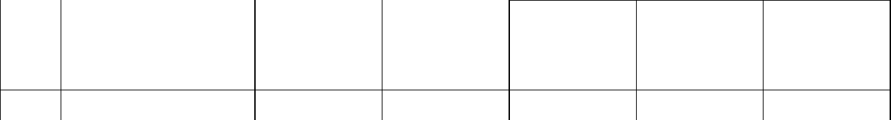
7. Soft tissues
- Vascular structures
9. | Spinal cord
10. | Nerve root
11. | Disc tear
12. | Ligament
13. | Neural foramen
14. | CSF
Axial 3D FIESTA
 | Structures | Excellent | Good | Adequate | Poor | Not
 |  | Visibility | Visibility | Visibility | Visibility | Visible
15. | Soft tissues | 4 | 3 | 2 | 1 | 0


- Vascular structures
17. | Spinal cord
18. | Nerve root
19. | Disc tear
20. | Ligament
21. | Neural foramen
22. | CSF

75
SECTION C

IMAGE QUALITY

I | AXIAL T2 PROTOCOL
 | High | Moderate |  | Low
 | 3 | 2 |  | 1
23. | Signal-to-noise ratio
24. | Contrast-to-noise ratio
 | No. Artefact | Moderate |  | Extensive
25. | CSF flow artefact | Artefact |  | Artefact
26. | Blood vessel flow artefact
AXIAL 3D FIESTA
 | High | Moderate |  | Low
 | 3 | 2 |  | 1
27. | Signal-to-noise ratio
28. | Contrast-to-noise ratio
 | No. Artefact | Moderate |  | Extensive
29. | Cerebrospinal fluid flow artefact | Artefact |  | Artefact
30. | Blood vessel flow artefact
 | SECTION D
Radiological Findings (Indicators)
I | AXIAL T2 PROTOCOL
 | Severe Moderate |  | Mild | None
 | 3 | 2 | 1 | 0



31. Degree of Disc tear
- Degree of nerve root compression
33. Degree of cord compressor

76
II AXIAL 3D FIESTA

Severe
3

Moderate

2


Mild
1


None

0


34. Degree of Disc tear
- Degree of nerve root compression
36. Degree of cord compression

Purpose of the Study

The purpose of this research is to compare axial T2 MRI protocol with axial

3D FIESTA MRI protocol in cervical spondylosis.
The specific objectives of the study are:

- To compare the accuracy of axial T2 MRI and axial 3D FIESTA MRI in detecting structures affected by cervical spondylosis.

- To ascertain signal-to-noise ratio and contrast of images produced from both protocols.

- To correlate the radiological findings of cervical spondylosis with age and sex and weight.

(What are the factors that are associated with Radiological findings of cervical spondylosis).

77

Appendix X

Consent Form

Consent by patient to take part in the study on Comparison of Axial T2 sequence with Axial 3D FIESTA Sequence in Evaluation of Cervical Spondylosis.

I, …………………….. ……………………. of ……………………………..

here by consent that the result of my cervical MRI scan be assessed and used for the above research.

The Radiographer, Grace Essiet has explained the procedures to me and I understand/ acknowledge that the primary purpose of the scan is for my wellbeing and that the result can be used for the purpose of this research. I recognize that the result of this research will be of benefit to mankind.

Date……………………………… Name/Sign……………………………….

78
Appendix XI

Declaration by Researcher

I confirm that I have explained to the patient the nature of this research and that his refusal to participate will not affect his normal relationship with me as a client.

Date……………………………… Name/Sign……………………………….

79

Table IX Linear regression for indicators of cervical spondylosis on age and sex for axial

3D FIESTA

Model Unstandardized t Sig

Coefficient

B Std error

Constant |  | -1.4 | 1.1 | -1.3 | .2
Age | of | .1 | .0 | 2.0 | .1
Respondent
Gender | of | 1.8 | .5 | 3.4 | .0
Respondent

80
ABSTRACT

To compare the accuracy of axial T2 magnetic resonance imaging sequence and axial 3D FIESTA magnetic resonance imaging sequence in the evaluation of cervical spondylosis. The cross sectional study was carried out at Magnetic resonance imaging unit of Usman Danfodiyo University Teaching Hospital Sokoto. 80 subjects were selected from 30 years and above using convenience sampling method. Images of axial T2, axial T1, sagittal T1, Sagittal T2 and axial 3D FIESTA were acquire for each subject using 0.2 Tesla and 9 inches coil. Axial T2 and axial 3D FIESTA images were read and were assessed qualitatively using Likert scale. The images were assessed based on visibility of anatomical structure, quality of image in terms of signal-to-noise ratio, contrast-to-noise ratio, sensitivity to artefact due to flow of fluid (blood and cerebrospinal fluid). Also indicatorsof cervical spondylosis were assessed qualitatively. SPSS version 21 was used in the analysis of the generated data, Wilcoxon sign rank test was applied to compare the quality of images produced by both sequences. Regression analysis was conducted to assess the relationship between indicators of cervical spondylosis with sex and age.

81
The total median scores for axial T2 and axial 3D FIESTA sequences in respect to visibility of anatomical structures were 25.00 and 25.00 at P < 0.05 indicating that there was no significant difference. There was no significant difference between the total median score of images produce by both sequence (3.00 and 3.00) at P<0.05 in respect to signal-to-noise ratio, contrast-to-noise ratio and artefact due to cerebrospinal fluid. However, axial T2 sequence was less sensitive to artefact (due to flow of blood) than axial 3D FIESTA with difference of 1.00 in their total median value.
Axial 3D FIESTA is as accurate as axial T2 sequence in visibility of anatomical structures, image quality and prediction of cervical spondylosis and disc tear is not a good predictor of cervical spondylosis.
As age increases the tendency to have cervical spondylosis increases and
male Appendix VII
Variables in Equation for Axial T2

Step B S E Wald df Sig Exp B 95%CI for Exp

B

82

 |  |  |  |  |  |  | lower | upper
Q1-age | -.0 | .0 | .1 | 1 | .8 | 1.0 | .9 | 1.1
Q1-sex | 19.4 | 7732.4 | .0 | 1 | 1.0 | 267883415.8 | .0
Constant | - | 7732.4 | .0 | 1 | 1,0 | .0
 | 20.815

are more prone to it than female.

Appendix VII
 | Variables in Equation for Axial T2
Step | B | S E | Wald | df | Sig | Exp B | 95%CI for Exp
 |  |  |  |  |  |  | B
 |  |  |  |  |  |  | lower | upper
Q1-age | -.0 | .0 | .1 | 1 | .8 | 1.0 | .9 | 1.1
Q1-sex | 19.4 | 7732.4 | .0 | 1 | 1.0 | 267883415.8 | .0
Constant | - | 7732.4 | .0 | 1 | 1,0 | .0
 | 20.815

83

