## EVALUATION OF AQUIFER PROTECTIVE CAPACITY AND SOIL CORROSIVITY USING VERTICAL ELECTRICAL SOUNDING METHOD IN BADEGGI VILLAGE, NIGER STATE, NIGERIA.

**BY**

## UMAR, Muhammad Alhaji MTech/SPS/2017/6947

**DEPARTMENT OF PHYSICS**

## FEDERAL UNIVERSITY OF TECHNOLOGY, MINNA

**NOVEMBER, 2021**

## EVALUATION OF AQUIFER PROTECTIVE CAPACITY AND SOIL CORROSIVITY USING VERTICAL ELECTRICAL SOUNDING METHOD IN BADEGGI VILLAGE, NIGER STATE, NIGERIA.

**BY**

## UMAR, MunhammadAlhaji MTech/SPS/2017/6947

**A THESIS SUBMITTED TO THE POSTGRADUATE SCHOOL FEDERAL UNIVERSITY OF TECHNOLOGY, MINNA NIGERIA**

## IN PARTIAL FULFILLMENT OF THE REQUIREMENTS FOR THE AWARD OF THE DEGREE OF MASTER OF TECHNOLOGY IN PHYSICS

**(APPLIED GEOPHYSICS)**

## NOVEMBER, 2021

***Abstract***

A geoelectric survey was carried out in Badeggi under Katcha Local Government area of Niger State with the aim of evaluating the aquifer protective capacity and soil corrosivity of the overburden units in the study area using vertical electrical sounding method. G41 Resistivity meter was employed to obtain forty VES points within ten profiles, with the interval of 50 m between the profiles.The Schlumberger electrode array was employed to obtain the data which was further modelled using computer iteration (Winresist software). The information obtained from modelling was used toevaluate longitudinal conductance and transmissivities of the layers. The results show generally low resistivities across the survey area and an average longitudinal conductance variation from 0.1171 Siemens to 0.925 Siemens and the average transmissivity values ranges between 91.62 Ωm to 1339.4 Ωm. The ﬁeld data gives a resolution with 4–5 geoelectriclayers and the observed frequencies in curve types include: 40% of QH, 35% of Q, 17.5% of QHK and 7.5% of QKH. Classifying the longitudinal unit conductance (S)andthe protective capacities of the study area as 20% weak, 0% poor, 72.5% moderate, and 7.5% as good,the corrosivity ratings of the study area showsthat 42.5% is slightly corrosive and 57.5% is practically non-corrosive. The results reasonably provide information on areas where any form of agricultural and industries activities can be in order to safeguard the hydrological setting sited for laid and iron pipes for resident’s safety within the study area.

## TABLE OF CONTENTS

**TITLE PAGE i**

DECLARATION**ii** CERTIFICATION**iii**

DEDICATION iv

ACKNOWLEDGEMENTS**v** ABSTRACT**vi**

TABLE OF CONTENTS vii

LIST OF TABLES xi

LIST OF FIGURES xii

CHAPTER ONE1 1.0INTRODUCTION1

* 1. Background of the Research1
  2. Statement of the Research 5

|  |  |  |  |
| --- | --- | --- | --- |
| * 1. Aim and Obgjectives of the Study   2. Justification of the Study | 5 |  | 5 |
| * 1. Climate   2. Location of the Study Area | 6 | 6 |  |
| **CHAPTER TWO**8  2.0Literature Review8 2.1Geology of Nigeria8  2.2 Geology of the Study Area |  | 10 |  |

|  |  |  |  |  |
| --- | --- | --- | --- | --- |
| 2.3 Ground Water 12 |  | | | |
| 2.4 Aquifer |  |  | 12 |  |
| 2.5 Surface Investigation |  |  |  | 12 |
| 2.6 Empirical Review  **CHAPTER THREE** | 23 |  |  | 13 |
| 3.0Materials and Method23 |  |  |  |  |
| 3.1Materials23 |  |  |  |  |
| 3.1.1Equipment23 |  |  |  |  |
| 3.2.Methodology |  | 23 |  |  |
| 3.2.1Resistivity Surveying24 |  |  |  |  |
| 3.3 Vertical Electrical Sounding32 |  |  |  |  |

3.4 Soil Corrosivity Evaluation 33

|  |  |  |
| --- | --- | --- |
| 3.5Overburden Protective Capacity Evaluation34 |  | |
| 3.6 The Longitudinal Conductance35 |
| 3.7 The Schlumberger Array37 |
| 3.8 Data Collection Procedure |  | 38 |
| 3.9 Data Analysis |  | 38 |
| **CHAPTER FOUR40**  4.0 Results and Discussion40 |  |  |
| 4.1 Field Topography and Survey Layout40 |  |  |
| 4.2Geoelectric Parameters Interpretation40 |  |  |
| 4.3 Summary of the Geoelectric Parameters | 50 |  |
| 4.4 Isoresistivity Interpretations52 |  |  |

|  |  |  |  |
| --- | --- | --- | --- |
| 4.4.1 Isoresistivity of first geoelectric layer52 |  |  |  |
| * + 1. Isoresistivity of second geoelectric layer 52     2. Isoresistivity of third geoelectric layer54 |  |  |
| 4.4.4 Isoresistivity of fourth geoelectric layer54 |  |  |
| 4.4.5 Isoresistivity of fifth geoelectric layer54 |  |  |
| 4.5 Depth to Geoelectric Layers Interpretations |  | 57 |
| 4.5.1 Depth of the first geoelectric layer57 |  |  |
| 4.5.2 Depth of the second geoelectric layer57 |  |  |
| 4.5.3 Depth of the third geoelectric layer57 |  |  |
| 4.5.4 Depth of the fourth geoelectric layer |  |  | 60 |
| 4.5.5 Depth of the fifth geoelectric layer | 60 |  |  |
| 4.6 Thickness of Geoelectric Layers Interpretations |  | 60 |  |
| 4.6.1 Thickness of the first geoelectric layer |  | 60 |  |
| 4.6.2 Thickness of the second geoelectric layer |  | 62 |  |
| 4.6.3 Thickness of the third geoelectric layer |  | 62 |  |
| 4.6.4 Thickness of the fourth geoelectric layer |  |  | 62 |
| 4.7 Ground Water Potential |  | 62 |  |

## CHAPTER FIVE67

* 1. Conclusion and Recommendations 67
  2. Conclusion67
  3. Recommendations69

REFERENCES**70**

Appendices 76

## LIST OF TABLES

|  |  |  |
| --- | --- | --- |
| Table 3.1 Classification of soil resistivity in terms of corrosivity  Table 3.2Longitudinal conductance/aquifer protective capacity rating | 36 | 36 |
| Table 4.1 Summary of the interpretation of all profiles |  | 44 |
| Table 4.2Summary interpretation of soil corrosivity and aquifer protective | capacity |  |
| of all the profiles | 49 |  |
| Table 4.3 Geometry and percentage of resistivity curve types | 51 |  |
| Table 4.4 Delineated aquifer potentials of the study area | 65 |  |

**LIST OF FIGURE**

|  |  |  |
| --- | --- | --- |
| Figure: 1.1 Location map of the study area |  | 7 |
| Figure 2.1 Geology map of Nigeria | 9 |  |
| Figure 2.2 Geological map of Niger State showing the study area | 11 |  |
| Figure 3.1 Electrode configuration |  | 25 |
| Figure 4.1 Field layout showing profiles lines and VES points |  | 41 |
| Figure 4.2 VES4 profile 1 QH curve type |  | 42 |
| Figure4.3 Soil corrosivity rating of the study area 48 |  |  |
| Figure 4.4Frequency curve type |  | 51 |
| Figure 4.5Iso-resistivity contour map of the first layer |  | 53 |
| Figure 4.6Iso-resistivity contour map of the second layer |  | 53 |
| Figure 4.7Iso-resistivity contour map of the third layer |  | 55 |
| Figure 4.8Iso-resistivity contour map of the fourth layer |  | 55 |
| Figure 4.9Iso-resistivity contour map of the fifth geoelectric layer | 56 |  |
| Figure 4.10 Depth map of the first geoelectric layer |  | 58 |
| Figure 4.11Depth map of the second geoelectric layer |  | 58 |
| Figure 4.12Depth map of the third geoelectric layer |  | 59 |
| Figure 4.13 Depth map of the forth geoelectric layer |  | 61 |
| Figure 4.14Thickness map of the first geoelectric layer |  | 61 |
| Figure 4.15Thickness map of the second geoelectric layer |  | 63 |
| Figure 4.16Thickness map of the third geoelectric layer | 63 |  |
| Figure 4.17 Thickness map of the fourth geoelectric layer  Figure 4.18 Groundwater Potential Map of the Study Area 66 |  | 64 |

## CHAPTER ONE

* 1. **INTRODUCTION**

## Research Background

The growth of any community is hinged on the availability of basic amenities such as water, good road network and electricity. The search for sustainable, clean and portable water is a struggle that will never end as it aids in the growth of any community (Salako *at al.,* 2009).Water is a gift of nature and it is in a bounteous proportion, noticeable by its presence (surface, rain, and underground), with a quality of transformation through recurrent hydrological evaporation, condensation, and precipitation (Abdullahi *et al.,* 2017). NigerStatein northcentralNigeriaexperiences an annual rainfallwhich ranges from 1200 mm to 1600 mm from the southern part of the state to the northernregion.The duration of the rainy seasonranges from 120 to 150 days or more from the north to the south (baimba, 1978).

Water resources are one of the most important materials in community development. Understanding the hydrogeological and hydro-chemical characteristics of an area is crucial for groundwater planning and development. Groundwater had immensely become important water supply in urban and rural areas in both developed and developing nations for domestic, industrial and agricultural purpose (Durowaye*et al.,* 2014). Portable and safe drinking water is a necessary requirement for the health and productive life of humans in any society. Ground water is a valuable source of portable drinking water in most of our urban and rural communities, and for industrial and agricultural applications. However, maintaining a portable ground water supply that is free from microbial and chemical contaminants is far from reality in most of our urban centers, due to poor waste disposal and management practices (Chernicoﬀ and Whitney, 2009).

Groundwater is that water found within the saturated voids beneath the ground. The source of groundwater is chiefly from precipitating atmospheric moisture which has percolated down into the soil and subsoil layers. The availability, quantity, and exploitability of groundwater depend on the porosity and permeability of the host rocks (Obiora *et al.,* 2015). Both parameters play important roles in ground water movement and recovery. The porosity of a geologic material is the amount of water (fluid) the material can hold (Abdullahi *et al.,* 2017). It is the volume ratio of the pore spaces to the total volume of soil, rock or sediment (Obiora *et al.,* 2017).

Groundwater as the main source of potable water supply for domestic, industrial and agricultural uses has been under intense pressure of degradation and contamination due to urbanisation, industrial and agricultural related activities (Belmonte *et al.,* 2004). However, the present social demands are notonly to detect new groundwater resources but to protect them. The potability of groundwater can be contaminated by leachate from dumpsites, salt intrusion, oil spillage, mining activities, sewage (from latrines, underlined petroleum pipes and septic tanks) (Makeig,1982). Dumpsites and latrines are sited without considering the hydrogeological settings of the area, thereby rendering the future of groundwater at risk (Ugbaja and Edet,2004). The widespread use of chemical products, coupled with the disposal of large volumes of waste materials, poses the potential for widely distributed groundwater contamination. Hazardous chemicals, such as pesticides, herbicides, and solvents, are used ubiquitously in everyday life. These and a host of other chemicals are in widespread use in urban, industrial, and agricultural settings. Whether intentionally disposed of accidentally spilled, or applied to the ground for agricultural reasons, some of these chemicals can eventually reach the groundwater and contaminate it. Because of the volumes of toxic wastes and because of their stability in groundwater, such contamination can pose a serious threat to public health. Almost

every major industrial and agricultural site has in the past disposed of its wastes on site, often in an inconspicuous location on the property. Every municipality has had to dispose of its waste at selectedlocations within its proximity. Past waste- disposalpractices and dealing with spills have not always been considered as potential for groundwater contamination.

The rate of groundwater contamination depends on permeability, porosity, and overburden thickness of geologic formations. When the underlying geologic material is unconsolidated and uncompacted, such as coarse sand, the polluting inﬂuent are capable of escaping into the subsurface to contaminate groundwater, rendering the soil corrosive and forming a polluting plume that extends hundreds of meters (Keswick *et al.*,1982). Using electrical resistivity method and borehole lithologic logs,(Dan-Hassan 2001) found out that the aquifers of the basement complex rocks of north–central Nigeria are predominantly weathered overburden aquifers.

Corrosion is the degradation of a substance or its properties due to a reaction with the environment (Ahmad *et al.,* 2016). It exists in virtually all surface and subsurface materials. However, it is most often associated with metals. Soil corrosion is a natural or artificial occurring process where the soil structure is oxidised or reduced to a corrosion product such as “contaminated soil” by chemical or electrochemical reaction with the environment (Revie and Uhlig, 2008).

Generally, corrosive soils contain large concentrations of soluble salts, especially in the form of sulphates, chlorides and bicarbonates and may thus be characterised by high acidity (low pH) or high alkalinity (high pH) (Ahmad *et al.,* 2016). Soils with high clay and silt contents are usually characterised by fine texture, high water-holding capacity and consequently, are usually poorly aerated and drained (Bullard *et al.,* 2004). Thus, they are also prone to be potentially more corrosion than coarse-textured soils like sands

and gravels where there is greater circulation of air (Bullard *etal*., 2004). Some recent researchers had employed electrical resistivity method in investigating aquifer protective capacity and soil corrosivity in Nigeria (Adeniji *et al.,* 2014). Corrosive soils contain chemical constituents that can react with construction materials, such as concrete and ferrous metals, which may damage foundations and buried pipelines(George *et al.,* 2014). The electrochemical corrosion processes that take place on metal surfaces in soils occur in the groundwater that is in contact with the corroding structure (Muraina*et al.,* 2012).

Today, we are witnessing an increasing number of boreholes drilled by government, non-governmental organisations, and individuals. This shows clearly that groundwater effectively complementing other sources of water supply in the badeggi. This is due to the rate of contamination of rivers, lakes and stream that is not save. Surface water is found to be grossly degraded in quality because of its physical, biological, or chemical contaminants (Edet and Worden, 2009).

The demand for water in town has been on the increase due to the growing demand in the commodity for domestic and agricultural uses. Managing existing water supplies to fully satisfy all uses has proven difficult, particularly in dry season. Groundwater is therefore, the likely source that can ameliorate the problem and hence the need to find genuine and effective way of harnessing it.Despite this seemingly important relief, there could be threats of contamination to groundwater

occasioned by soil corrosivity and infiltration of contaminants from the surface through the migration paths into the aquifers. It is in trying to monitor the quality of groundwater that we used the VES method to decipher the structure layering of the subsurface in BadeggiunderKatcha local government area with a view to finding the depth to water bearing formations.

## Statement of the Research

Badeggi village forms part of the Bida basin. As a sedimentary area, the potential of aquifer bearing formation is high. However, the growing demand for portable drinking water for domestic use is threatened by agrarian activities, with increasing application of organic and synthetic fertilizers as the years go by. Hence, investigating the soil corrosivity level and aquifer protective capacity will be of great help to the environment for safe drinking water and any other forms of activities.

## Aim and Objectives of the Study

The aim of the study is to evaluate aquifer protective capacity and soil corrosivity using VES method to decipher the structure layering of the earth inBadeggi with a view to finding the depth to water bearing formation. The objectives are to:

* + 1. determine the geo-electrical and hydrological characteristics of the aquifer present in the study area
    2. evaluate soil corrosivity level
    3. evaluate longitudinal conductance and determine aquifer protective capacity

## Justification of the Study

The study was carried out to enhance safe and healthy approach of prospecting for portable drinking water to future settlers, by determining the soil corrosivity level and aquifer protective capacity within the study area and provide background geophysical information for prospective researchers.

## Climate

The area experiences two distinct seasons: the dry and wet seasons. The annual rainfall varies from about 1,600mm in the south to 1,200mm in the north. The duration of the rainy season ranges from 150 to 210 days or more from the north to the south

(<http://www.onlinenigeria.com/links/nigeradv.asp?blurb=330>). Mean maximum

temperature remains high throughout the year, hovering about 32°C, particularly in March and June. The lowest minimum temperatures occur usually between December and January when most parts of the area come under the influence of the tropical continental and dry season in Badeggi commences in October.

## Location of the Study Area

The study area is situated withinBadeggi along Agaie-Suleja road.It is located between latitude 9⁰3′28.039″to 9⁰2′47.5″ and longitude 6⁰8′14.245″ to 6⁰8′10.7″with land space extent of 20 km2. The areal distance estimate is about 5 km from National Cereal ResearchInstitute, Badeggi of which the site is about 3 km from Government Day Secondary School Badeggi and it is spanned by a well accessible road either by foot or by vehicle. The area has a gentle topography that is covered with vegetation, trees, farms land and grasses (Figure 1.1).

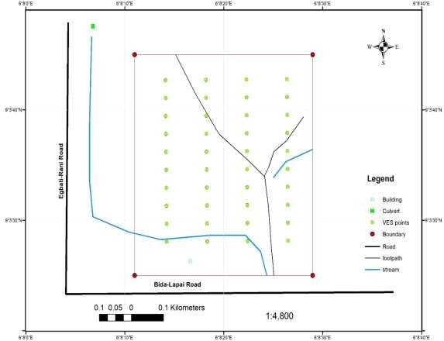

Figure 1.1 Location map of the study area

## CHAPTER TW0

* 1. **LITERATURE REVIEW**

This chapter reviews past literatures in relation to the present research work that is carried out and tends to correlate the various methods and findings to either improve on them or develop new theories.

## Geology of Nigeria

Nigeria is situated in the West African sub-region and located between latitude 4o and 14o N and longitudes 3o to 15o E (Obaje, 2009).It is bounded by Niger republic to the north and the Atlantic Ocean to the south. Benin and Cameroun Republic flank it to the west and east respectively. A small strip borders the Chad Republic to the northeast. It has a landmass of 923,768 sq. km. The geology of Nigeria is made up of three major litho-petrological components, namely, the Basement Complex, Younger Granites, and Sedimentary Basins. The Basement Complex, which is Precambrian in age (Pan-African and older, greater than 600 million years), is made up of the Migmatite-Gneiss Complex, the Schist Belts and the Older Granites. The Younger Granites comprise several Jurassic (200 – 145 million years) magmatic ring complexes centered around Jos and other parts of north-central Nigeria (Figure 2.1). They are structurally and petrologically distinct from the Older Granites. The Sedimentary Basins, containing sediment fill of Cretaceous to Tertiary ages (less than 145 million years), comprise the Niger Delta, the Anambra Basin, the Lower, Middle and UpperDahomey Basin (Obaje, 2009). Solid mineral deposits of economic significance that include Benue Trough, the Chad Basin, the Sokoto Basin, the Mid-Niger (Bida-Nupe) Basin and thegold, iron ore, cassiterite, columbite, wolframite, pyrochlore, monazite, marble, coal, limestone, clays, barites and lead-zinc occur in the different geologic segments of Nigeria and indeed each of the 36 federating states and the Federal Capital Territory. Oil and gas on the

other hand occur prolifically in the Niger Delta Basin with opportunities to add to the national reserve asset existing in the other sedimentary basins. (Obaje, 2009)

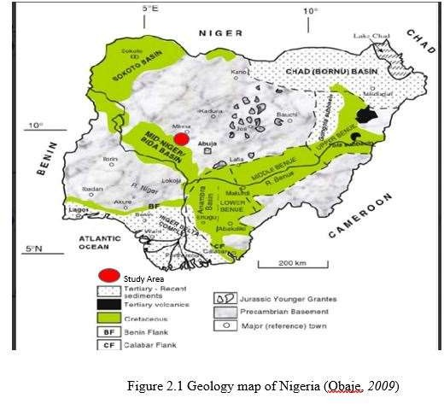

## Geology of the study Area

The study area is located in Badeggi which falls within the northern Bida basin. Bida basin consists of five major rock units called formations which are successively as follows (beginning from the oldest to the youngest rock): The basal conglomerates (at the base), the Bida sandstone, the Sakpe ironstone, the Enagi Siltstone and the Batati formation (at the top). The area is underlain directly by the second to the uppermost formation of the Bida basin called the Enagi Formation. This is probable due to denudation activities in the area which had strip off the uppermost Batati formation. The Enagi Siltstone consists mainly of siltstones. Other subsidiary lithologies include sandstone-siltstone admixture with some claystone. The formation ranges in thickness between 30 and 60m. Mineral assemblage consists mainly of quartz, feldspars and clay minerals. as well as geophysical data suggest that the basin is bounded by a field in different sections of the basin showed that the average depth to basement is about 3.4 km, with sedimentary thicknesses of up to 4.7 km in the central and southern parts of the basin (Fadele*et al.,* 2013).

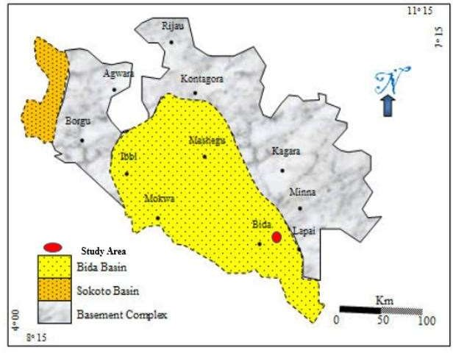

# Figure 2.2 Map of Niger State, Nigeria. Showing the study area (Obaje, 2006)

## Groundwater

Groundwater as the main source of potable water supply for domestic, industrial and agricultural uses has been under intense pressure of degradation and contamination due to urbanisation, industrial and agricultural related activities. The impact of this trio on soil and groundwater is alarming with years of devastating effects on humans and the ecosystem. Groundwater is said to be contaminated when it is unfit for the intended purpose and therefore constitute a nuisance to the user (Ehirim*et al.,* 2010).

## Aquifer

An aquifer is a layer of relatively porous substrate that contains groundwater, which can flow directly between the surface and saturated zone of an aquifer then the aquifer is unconfined. The deep parts of unconfined aquifers are generally more saturated since the gravity causes the water to flow downwards. If a confined aquifer is following a downward grade from its recharge zone, then the groundwater can become pressurized. (Tsepav*et al.,* 2014).

## Surface Investigation

Surface investigation gives information about the type, porosity, water content and the density of subsurface creation. It is usually done with the help of electrical and seismic characteristics of the earth and without any drilling on the ground. The data supplied by this technique are partly reliable and it is less expensive. It gives only indirect sign of groundwater which interpretation requires additional data from the subsurface investigations to confirm surface findings. It is generally achieved by geophysical method, electrical resistivity and seismic refraction method (Tsepav*et al.,* 2014)

## Empirical Review

Mogaji*etal.,* (2007) used Geo-electrical to investigate the Dape phase III Housing Estate FCT Abuja, North central Nigeria. A geo-electrical investigation of fifty schlumberger vertical electrical sounding were carried out along transverses to evaluate the aquifer protective and corrosivity of the near surface materials. The eastern, southeastern parts and parts of the southwestern end of the estate are characterised by slightly corrosive to moderately corrosive materials (< 50 Ωm < 150 Ωm) and moderate overburden thickness(> 20 m). Using the total longitudinal unit conductance S, the estate is classified in to zones of weak (0.1 − 0.19) and poor (< 0.1) protective capacity and the results reasonably provide a basis for which ground water potential zones are appraised for safety in case of industrial facilities are planned for the area under study.

Abiola *et al.,* (2009) worked on the groundwater potential and aquifer protective capacity of overburden units in Ado Ekiti and delineated three groundwater potential zones (high, medium, and low) and aquifer protective capacity (good, moderate, weak and poor) in the study area. The results of this study have provided reliable information for an elaborate groundwater abstraction and environmental factors necessary for planning and development of residential and industrial estates by the urban planning authorities. The interpretation revealed three distinct geoelectric layers overlying the resistive basement, the topsoil, the weathered layer and the partially weathered/fractured basement. The depth to the top of basement (overburden thickness) varied from 1.0 to

74.8 m across the study area. The characteristic longitudinal unit conductance (ranging from 0.004 to 2.11 mhos) of the area enabled the overburden protective capacity rating into good, moderate and weak. About 60% of the area falls within the good/moderate rating, suggesting a generally good overburden protective capacity around the study area.

Oladapo *et al.,* (2009) investigated Hydro-geophysical study of the groundwater potential of Ilara-Mokin South western Nigeria. Geo-electric study of the groundwater potential of Ilara-Mokin in Ondo State Southwestern Nigeria was carried out using electrical resistivity (Vertical Electrical Sounding) method with the view to providing adequate information on the different sub-surface geoelectric layers. Forty-one Schlumberger vertical electrical soundings (VES) were conducted across the study area. The computer assisted VES data interpretation enabled generation of geoelectric curves, sections and overburden thickness map which were used in the delineation of key hydrogeologic features like the topsoil, weathered basement, fractured basement and the fresh basement. Resistivity values range from 21 Ωm to 798 Ωm in the topsoil, 14 Ωm to 209 Ωm in the weathered basement, 51 Ωm to 209 in the partially weathered/fractured basement and 312 Ωm to ∞ within the fresh basement. Layer thickness values also vary from 0.3 m to 6.1 m in the topsoil and 0.9 m to 28.6 m in the weathered basement. The depth to the resistive bedrock ranges from 0.3 m to 29.3 m across the study area. The study revealed that greater part of Ilara-Mokin town is underlain by marginally thick overburden thus constituting shallow aquifer units with poor to marginal groundwater potential. The results reasonably provide basic information that is expected to assist in the future development of groundwater resources in Ilara-Mokin.

Arabi *et al.,* (2009) conducted VES survey around Gombe and environs employing Schlumberger array with a maximum electrode separation of AB/2 = 200 m to determine locations favourable for sitting boreholes. The result shows that 21 of the VES points are three layers while 12 are four layers. The first layers have thicknesses ranging from 0.8m to 16.1m, the second and third layer have thicknesses ranging from 0.994 m to 149 m and 11.7 m to 108.2 m, respectively while the fourth layer had a

thickness that extended beyond the probing depth. A correlation of the curves with existing lithologic log from boreholes in the area suggests that the major lithologic units penetrated by the sounding curves were laterite, clay, shale, sandstone and sandy clays. The sandy clay and sandstone constitute the aquifer zones with resistivity range of 28 to 84 Ωm for clay, 240 to 501 Ωm for sandstone, 967 to 1008 Ωm for sandy clay. Others are 2069 to 9607 Ωm for the calcareous and the laterite units and 17456 Ωm for the compacted sands.

Ayolabi *et al.,* (2009) seismic Refraction and Resistivity Studies of part of Igbogbo Township, South-West Nigeria. A total of eighteen vertical electrical sounding using the schlumberger array of 500 m maximum spread and twenty-seven seismic refraction data using forward and reverse shooting methods of lateral distance 42 m along each profile were acquired within the study area. The results indicate the presence of three seismic refraction layers with the first layer having velocity 150 - 366 m/s and thickness 1.0 -

3.3 m, representing topsoil. The second refraction layer is composed of lateritic clay with thickness 4.5 - 10.5 m and velocity 578 - 878 m/s. The third refraction layer consists of sandy clay with velocity 10250 m/s. The delineated refraction layers are characterised by increase in velocity with depth. The geo-electric sounding clearly show that the subsurface layers are characterized by topsoil, laterite, sandy clay, clayey sand, sand and clay with sand acting as aquifer units. The two thick aquifer units mapped are capable of sustainable industrial development in the area.

Emmanuel *et al.,* (2011) carried out Geo-electric investigation of the groundwater potential of Moniya Area, Ibadan. Seventeen profiles were carried out using the Schlumberger array configuration. The data was interpreted using the conventional curve matching and computer iteration methods. Results show that four major curve types were identified, namely: A, H, KH and HA. The top layer has resistivity value

ranging from 61.8 to 504.3 ohm-m showing that it consists of clayey sand and sandy clay, with maximum layer thickness of 3.5 m. The resistivity of the second layer which is the weathered zone ranges from 19.7 to 724.6 ohm-m while the thicknesses vary between 0.7 to 30.3 m. These VES stations: 9, 11, 16, and 17 are fourth layer region. The third layers constitute the weathered layer which has resistivities from 13.7 to 95.3 ohm-m while its layer thicknesses vary from 12.6 to 44.6 m the layer will be good for well sitting. The results of geoelectric investigation carried out over part of Moniya, Akinyele Local Government Area revealed maximum of four subsurface layers: thin top layer, the alluvium, the aquifer and the bedrock respectively.

Muraina *et al*., (2012) used a total of 160 VES data collected at the corners of a 225 x 225 m square grid network. Topsoil resistivity and topsoil longitudinal unit conductance maps were generated from the first and second order geoelectric parameters respectively. Areas considered as high corrosivity are the northcentral, southwestern, southern and northern parts with resistivity values less than 180 Ωm. Part of the study area characterised by materials of poor to weak protective capacity has longitudinal conductance values of less than 0.1 and 0.1 - 0.19 Ωm respectively. Values between

0.2 - 0.79 Ωm are sandy clay cover, and 0.8 - 4.9 Ωm most likely clay cover which corresponds to moderate and good protective capacity respectively.

Ayuk *et al.,* (2013) worked on groundwater potential and aquifer protective capacity assessment at Tutugbua-Olugboyega area, off Ondo road, Akure Southwestern Nigeria. The result concluded that the use of geoelectric technique in evaluating the aquifer system and its risk has been established in the study area. The aquifer types delineated are the weathered/partially weathered layer, the weathered basement/fractured and basement/fractured bedrock. These aquifer types are mostly marked by series of depressions, relative thick overburden and high λ values. In the study area, the materials

above the aquifers are relatively low to moderate layer resistivity and of thin thickness (< 15 m) thus making the aquifer vulnerable. The S value ranges from 0.0035 to 0.17 mhos. Therefore, the basement aquifer is vulnerable to infiltration.

Ajibade and Ogungbesan (2013) worked on Prospects and quality indices for groundwater development in Ibadan metropolis, southwestern Nigeria. Interpreted results of vertical electrical sounding data revealed three to four geo-electric layers; top soil (22.1 - 441.4 Ωm), lateritic horizon (402.1 - 712.2 Ωm), clayey/sandy clay layer (2.95 - 66.0 Ωm) and weathered/fractured bedrock (66,316.7 Ωm). Hydrogeochemical study indicates that groundwater in the study area is generally fresh, soft- moderately hard, slightly acidic and dominated by Na, Ca, Mg, Cl and HCO3 ions. The dominant hydrochemical facies is Na-Cl type with minor mixed Ca-Na-Cl and Ca-Cl types. Many of the analysed parameters fall within recommended limits and thus, most of the groundwater in the study area are chemically suitable for drinking.

Mohammed *et al.,* (2014) used Geo-electrical data analysis to demarcate groundwater pocket zones in Kaltungo and environs, north eastern Nigeria. Investigation have been made for groundwater exploration using Vertical Electrical Sounding (VES) data acquired from 6 (six) locations distributed in Kaltungo and Environs with a maximum electrode spread of AB/2 = 100 m. This is an attempt to obtain useful information on the aquifer distribution within the area and hence delineate possible areas for groundwater development. Based on Iso-resistivity maps, geo-electric section. The geophysical method used in this study has assisted as a good alternative to investigate the groundwater potential of some selected areas in Kaltungo area of Gombe State. The study revealed Kaltungo town and her environs as basement area with reasonable weathered formation ranging from a total depth of 18.1 m to 54.7 m which make it possible to demarcate thick soil pockets followed by considerable thickness of aquifers

as recharge pockets. Interpretation of the VES, Iso-resistivity Maps and profiles identified some conductive zones which were considered as priority areas for groundwater exploration.

Muraina *etal.,* (2014) carried out geoelectric Evaluation of Subsoil for Optimum Cocoa Yield in Parts of Ondo State, Southwestern Nigeria. The study involved reconnaissance geological mapping, Schlumberger vertical electrical resistivity sounding and direct pitting techniques. Eight sounding data were collected with ABEM SAS 1000 resistivity meter. The layer resistivity’s range were 126 – 2306, 37 – 1453 and ∞ohm-m respectively while the thickness values of the upper two layers were 0.6 – 1.9 m, 1.9 -

25.2 m respectively. The weathered/fractured column and cretaceous sediments constituted the dominant water saturated unit. Resistivity and thickness thresholds of 37

– 511 Ωm and 1.9 - 19.8 m are suggestive of a significant proportion of clay and sand in the soil identified with Idanre, Oda-Akure and Ondo farm sites that usually gave optimum yields. However, other farm sites as Arimogija, Ikpemen and Ago Panu in Owo, Ibulesoro-Akure and Ile-Oluji soil profiles graded into more sandy soils with resistivity and thickness/depth thresholds of the topsoil and weathered layers between 126 – 2306 Ωm and 5.3 – 35.2 m respectively. It was concluded that the relatively thick column of the weather able products of the gray gneiss/charnockitic rocks as sandy clay/clayey sand of the upper two layers may have remained the most important underlying geologic units for optimal growth of cocoa in the state.

Adeniji *et al.,* (2014) worked on evaluation of soil corrosivity and aquifer protective capacity using geo-electrical investigation in Bwari, Abuja. A total of 20 vertical electrical soundings using schlumberger electrode array with a maximum of half current electrodes separation of 300 m was employed. The results show that the area is characterized by 3 - 5 geoelectric subsurface layers. The measured overburden thickness

ranges from 1.0 to 24.3 m, with a mean value of 7.4 m. The resistivity and longitudinal conductance of the overburden units range from 18 to 11,908 Ωm and 0.047 to 0.875 mhos, respectively. Areas considered as high corrosivity are the central part with 𝜌<180 Ωm. The characteristic longitudinal unit conductance was used to classify the area into zones of good (0.7 - 4.49 mhos), moderate (0.2 - 0.69 mhos), weak (0.1 - 0.19 hs), and poor (<0.1) aquifer protective capacity. Zones characterised by materials of moderate to good protective capacity serve as sealing potential for the underlying hydrogeological system in the area. Surface geo-electrical investigation has been applied to environmental study of Bwari basement complex area and the result also revealed the efficiency of electrical resistivity survey in delineating different zones of soil corrosivity of the topsoil units and the aquifer protective of the overburden units.

Mohammed et *al.,* (2014) used applied geo-electrical data to demarcate groundwater pocket zones in Kaltungo and environs, north eastern Nigeria. The study revealed Kaltungo town and its environ as basement area with reasonable weathered formation ranging from a total depth of 18.1 m to 54.7 m which makes it possible to demarcate thick soil pockets followed by a considerable thickness of aquifers as recharge pockets. Interpretation of the VES, Iso-resistivity maps and profiles identified some conductive zones which were considered as priority areas for groundwater exploration.

Tsepav*etal.,*(2015) carried out evaluation of Aquifer Protective Capacity and Soil Corrosivity Using Geoelectrical Method. A geoelectric survey was carried out in some parts of AngwanGwari, an outskirt of Lapai Local Government Area on Niger State which belongs to the Nigerian Basement Complex, with the aim of evaluating the soil corrosivity, aquifer transmissivity and protective capacity of the area from which aquifer characterisation was made. The results show generally low resistivities across the survey area and an average longitudinal conductance variation from 0.0237 Siemens

in VES 6 to 0.1261 Siemens in VES 15 with almost the entire area giving values less than 1.0 Siemens. The average transmissivity values range from 96.45 Ω𝑚2 in VES 4 to 299070 Ω𝑚2 in VES 1. All but VES 4 and VES 14 had an average overburden greater than 400Ω𝑚2, these results suggest that the aquifers are highly permeable to fluid movement within, leading to the possibility of enhanced migration and circulation of contaminants in the groundwater system and that the area is generally corrosive.

Ekpo *et al.,* (2016) researched on evaluating the protective capacity of aquifersinUyoAkwaIbom State, Southern Nigeria, using vertical electrical sounding (VES) techniques which was carried out on 17 VES points at various locations within the study area for evaluating the protective capacity of the aquifer. The VES assess the vulnerability of aquifers using resistivity parameters of the uppermost geoelectric materials layer overlying the aquifer. The result of the study shows that the longitudinal unit conductance values obtained from the study area range from 0.003864 to 0.059655 mhos. The study revealed that aquifers within the area are susceptible to pollution since the protective capacities of the aquifers are generally poor. The results provided reliable information about the protective capacity of the materials overlying the aquifer units which should be considered for planning, development, siting of prospective water resource projects, and serves as a guide for groundwater pollution control.

Abdullahi *et al.,* (2017) researched on evaluation of soil corrosivity and aquifer protective capacity using secondary geo-electric parameters across Gombe metropolis in North-eastern Nigeria. A geo-electric survey was carried out in parts of Gombe metropolitan area, in the north-eastern part of Nigeria, as a means of evaluating both the soil corrosivity and aquifer protective capacity. 26 Vertical Electrical Sounding data were collected at the study area with AB/2 of 1–100 m. OhmegaTerrameter was used to generate the data and interpretations were made by WinResist and surfer10 programs.

Areas considered as slightly too very strongly corrosive are the north–eastern, central, south–eastern, and eastern parts of the study area with resistivity values less than 180 Ωm. The longitudinal conductance values are between 0.2 – 0.79 mhos (sandy clay cover) and 0.8 – 14.8 Ωm (clay cover) corresponding to moderate and excellent protective capacity respectively. The western part is practically non–corrosive having resistivity values greater than 180 Ωm. Part of the study area characterised by materials of poor to weak protective capacity has longitudinal conductance values of less than 0.2 Ωm. The aquifers are characterized by thick overburden, moderate to good protective capacity and exhibit moderate to relatively high-value coefficients of anisotropy, and a transverse unit resistance which suggests that the materials above the aquifers act as seals.

Oyedele *et al.,*(2017) carried out research on soil corrosivity and aquifer protective capacity of overburden units in Ado-Ekiti, Southwestern Nigeria. Vertical electrical sounding, well inventory and physicochemical analysis were conducted to evaluate soil corrosivity and aquifer protective capacity of overburden units in the basement complex terrain of Ado-Ekiti, southwestern Nigeria. The topsoil is composed of slightly corrosive materials at the eastern, southern and north eastern flanks and the central portion with resistivity values ranging from 60 to 180 Ωm. Moderately corrosive/slightly corrosive materials (with resistivity values of 10 < ρ < 60 Ωm) constitute the second layer around the eastern, southern and north eastern flanks. Pockets of areas in the north western, south eastern, eastern and central parts of the metropolis are practically non-corrosive with resistivity values in excess of 200 Ωm. Zones of good, moderate, weak and poor overburden protective capacity were delineated, with longitudinal conductance (S) values of 0.7 < S < 4.9, 0.2 < S < 0.69, 0.1

< S < 0.19 and S < 0.1 mhos, respectively. On a regional consideration, 23.31%,

18.80% and 57.9% of the study area is characterised by overburden materials of poor, weak and moderate protective capacity, respectively. Only 6.02% of the area indicates good overburden protective capacity.

## CHAPTER THREE

* 1. **MATERIALS AND METHODS**

## Materials

Materials used for this research project comprises of;

* + 1. Geotron Resistivity Metre
    2. Electrodes
    3. Geologic Hammer
    4. Global Position System (GPS)
    5. Measuring tapes
    6. Ribbons
    7. Pegs
    8. Microsoft Excel 2010

# WinResist and Golding Suffer11

## Methodology

Forty vertical electrical soundings were made on ten profiles (A – J) using Getron (G41) model Terrameter and its accessories. Schlumberger array electrode configuration pattern with half inter current electrode spacing (AB/2) varying from 1 to 100 m was adopted. The apparent resistivity values obtained were plotted against the AB/2 using the winResist software. From the plots, layer resistivity, depth and thickness; number of layers and curve types were deduced, also, geologic cross sections and iso-resistivity maps were made.

## 3.2.1 Resistivity Surveying

Resistivity survey investigates horizontal and vertical variations of electrical resistance (or conductivity, the inverse of resistivity) of the subsurface by causing an electrical current to flow through the ground, using wires connected to it. The procedure is to

measure potentials at other electrodes in the vicinity of the current as shown in(Figure 3.1). Since the current is also measured, the apparent resistivity of the subsurface can be effectively determined (Telford *et al.,* 2011).

Electrical resistivity surveys are based on Ohm’s Law which holds for simple circuits as well as earth materials. Resistivity by definition, is the product of the resistance, R and the unit cross sectional area, a of a material divided by a unit length of the material through which the current passes. i.e.

𝜌 = 𝑅𝐴

𝐿

(3.1)

𝜎 = 𝐼 = 𝐿

(3.2)

𝜌 𝑅𝐴

But, V = IR (Ohms Law)

where V=potential difference, L=current electrode separation, A=cross sectional area, I=current and R= resistant

1 = 𝐼

(3.3)

𝑅 𝑉

Therefore,

𝜎 = 𝐼 = 𝐿𝐼

(3.4)

𝜌 𝑉𝐴

𝜎 = 𝐼 = 𝐿 𝐽 (3.5)

𝜌 𝑉

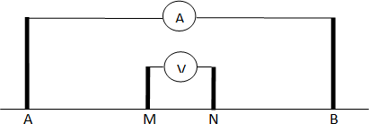

Figure 3.1 electrode configuration

𝐽 = 𝑉 𝜎 (3.6)

𝐿

𝐽 = 𝐼 = 𝜎𝑑𝑣but, 𝑉 = *E;* 𝐼 = 𝐽

𝐴 𝑑𝑙 𝐿 𝐴

where J is the current density (current divided by area). Three dimensional in electrical resistivity in the direction of J.

E = – ∇V (3.7)

This implies that:

J = –𝜎 (𝑖 𝜕𝑣 + 𝑗 𝜕𝑣 + 𝑘 𝜕𝑣) = – σ∇V (3.8)

𝜕𝑥

𝜕𝑦

𝜕𝑧

The electrical resistivity method is an active geophysical method that employs an artificial source which is introduced in to the ground through a pair of electrodes. The procedure involves measurement of potential difference between other two electrodes in the vicinity of current flow.

Apparent resistivity ρα is defined as the resistivity of an electrically homogeneous and isotropic half-space that would yield the measured relationship between the applied current and the potential deference for a particular arrangement and spacing of electrodes (Stummer, *et al.,* 2004). An equation giving the apparent resistivity in terms of applied current, distribution of potential, and arrangement of electrodes can be arrived at through an examination of the potential distribution due to a single current electrode. The effect of an electrode pair (or any other combination) can be found by superposition.

Consider a single point electrode, located on the boundary of a semi-infinite, electrically homogeneous medium, which represents a fictitious homogeneous earth. If the electrode carries a current I, measured in ampere (A), the potential at any point in the medium or on the boundary is giving by:

*U =* 𝜌𝐼

2𝜋𝑟

where

U = potential, in V,

𝜌 = resistivity of the medium, r = distance from the electrode.

(3.9)

For an electrode pair with current I at electrode A, and –I at electrode B, the potential at a point is giving by the algebraic sum of the individual contributions:

*U =* 𝜌𝐼 𝜌𝐼

= 𝜌𝐼 [ 1

− 1 ] (3.10)

2𝜋𝑟𝐶1 2𝜋𝑟𝐶2

where

2𝜋𝑟 𝑟𝑐1

𝑟𝑐2

𝑟𝐶1 and 𝑟𝐶2 = Distance from the point to electrode c1 and c2

These distances are always actual distances between the respective electrodes, whether or not they lie on a line. The quantity inside the brackets is a function only of the various electrode spacing’s.

Whether measurements are made over a real heterogeneous earth, as distinguished from the fictitious homogeneous half-space, the symbol ρ is replaced by ρ*a* for apparent resistivity. The resistivity surveying problem is then reduced to its essence, the use of apparent resistivity values from field observation at various locations and with various electrode configurations to estimate the true resistivities of the several earth materials present at a site to locate their boundaries spatially below the surface of the site (Tsepav, *et al.,* 2014). An electrode array with constant spacing is used to investigate lateral changes in apparent resistivity reflecting lateral geologic variability or localized anomalous features while the electrode spacing is varied if the changes in resistivity with depth are to be investigated.

The types of electrode arrays that are most commonly used are Schlumberger and Wenner as illustrated in Figure 1. In each case, direct current is passed into the earth ground 𝑐1 and received at 𝑐2. The potential generated in the earth as a result of this current is measured between the potential electrodes 𝑃1 and 𝑃2. The electrical resistivity, ρ of the material medium through which current is given by:

𝜌 = 𝑅𝐴

𝐿

(3.11)

*V = I R*

*R =* 𝑉

𝐼

If the voltage applied across the potential electrodes is V volts due to the current flow, I (amperes) then from Ohm’s Law:

*R =* − ∆𝑉

𝐼

(3.12)

where ∆V is potential difference across the ends of the conductor and the negative sign means that potential decreases in the direction of electric field current flow (i.e. current flow from high to low potential).

Putting equation (3.11) in (3.10)

𝜌 *=* − ∆𝑉 . 𝐴

(3.13)

𝐿 𝐼

But

*J =* 𝐼 = current density and E *=* 𝑉= electrical field resistivity in the direction of J.

𝐴 𝐿

Equation 3.13 becomes

J = E

ρ

(3.14)

Since the electric field is the gradient of a scalar potential i.e. Eqn. 3.13 can be written as:

*J =* 𝐼

𝜌∇𝖴

(3.15)

It should be noted that the electric potential distribution for D.C. that flows in homogeneous medium satisfies the Laplace’s equation.

∇2 𝖴 = 0

Current flows readily away from the electrodes so that the current distribution is uniform over hemispherical shell has a surface in the lower medium. At a distance, r from the electrode, the hemispherical shell has a surface area A = 2πr2, so that the current density J is given by:

J = I

2πr2

(3.16)

From the symmetry of the system, the potential will be a function of r only. Under these conditions, Laplace’s equation in spherical coordinates simplify to:

∇2 𝖴 = d

dr

r2du

(

dr

) = 0 (3.17)

Integrating equation (3.17)

∫ 2𝑟

𝑑𝑢

𝑑𝑟

𝑑2

+ 𝑟2 𝑑𝑟

𝑑𝑟2

2∫ 𝑟 𝑑𝑢 + ∫ 𝑟2 𝑑2 𝑑𝑟

𝑑𝑟

𝑑𝑟2

But,

𝑑𝑢

=

𝑑𝑟

𝐴

𝑟2

𝑑2

; 𝑟2 = 𝑎

𝑑𝑟2

2∫ 𝑟 𝐴 + ∫ 𝑟2 𝑎 𝑑𝑟

2

𝑟

2∫ 𝐴 𝑑𝑟 + ∫ 𝑟2 𝑎 𝑑𝑟

𝑟

2A∫ 𝑟−1 𝑑𝑟 + ∫ 𝑟2 𝑎 𝑑𝑟

𝑎𝑟3

𝑑𝑟

+ 𝑏

Let 𝑟2𝑑𝑢

𝑑𝑟

𝑟3

(

3

) = − 𝑎

𝑟

Therefore:

𝑢 = − 𝑎 + 𝑏 (3.18)

𝑟

where *a* and *b* are constants as 𝑟 → ∞, 𝑢 → 0 𝑎𝑛𝑑 𝑏 = 0

𝑢 = − 𝑎

𝑟

(3.19)

Since the current flows radically outward in all directions from the electrode, the total current crossing a spherical surface is given equation (3.15) by:

𝐼 = 2𝜋𝑟2

Using equation (3.13 and 3.14)

𝐽 =

𝐼

𝜌∇ 𝖴

𝐼 = 2𝜋𝑟2

But

𝐽 = 𝐼 ; 𝐴 = 2𝜋𝑟2

𝐴

𝐼 = 𝜌 𝑑𝑢 = 2𝜋𝑟2𝐼

𝑑𝑟

𝐼𝜌 𝑑𝑢

𝐼 = 2𝜋𝑟2 (𝑑𝑟)

𝐼 2𝜋𝑟2

𝜌 𝑑𝑢

( )

1 𝑑𝑟

𝐼 𝑑𝑢

2𝜋𝑟2𝜌−1 (𝑑𝑟)

Recall that 𝑑𝑢 = 𝐴

𝑑𝑟

𝑟2

Therefore

𝐼 = −

𝐼

𝜌2𝜋𝐴

Or

𝐴 = − 𝐼𝜌

2𝜋

(3.20)

Substituting for *a* in equation (3.17)

𝑈 = 𝐼𝑃

2𝜋𝑟

(3.21)

For a four electrode system,

∆ 𝖴= 𝐼𝜌 ( 1 − 1 − 1 1 ) (3.22)

2𝜋 𝑟1 𝑟2 𝑟3 𝑟4

where 𝑟𝑖 are geometrical parameters that depend on the electrode spacing, if the earth is non uniform.

𝜌 = 𝜌𝑎

Where 𝜌𝑎 = apparent resistivity

𝜌𝑎 = 2𝜋𝑈 ( 1 − 1 − 1

1 )−1

(3.23)

𝐼 𝑟1

𝑟2

𝑟3 𝑟4

𝜌𝑎 = 𝐾∆𝑈

𝐼

(3.24)

where

𝐾 = 2𝜋( 1

− 1 − 1

1 )−1

(3.25)

𝑟1

𝑟2

𝑟3 𝑟4

Equation (3.24) is known as the geometric factor.

In usual field operations, the potential electrodes remain fixed, while the current electrodes are adjusted to vary the distance *s*. The spacing *a* is however, adjusted when decreasing sensitivity of measurement is noticed. An electrode array with a constant spacing is used to investigate lateral changes in apparent resistivity reflecting lateral geologic variability or localized anomalous features (Tsepav and Israel, 2011).

## Vertical Electrical Sounding

Vertical electrical sounding (VES) was made with a four electrode configuration commonly referred to as the Schlumberger array (Bullard *et al.,* 1966). The method uses four in-line electrodes; the inner pair for recording electrical potential as a current is passed through the outer pair. Measurements will be made in a series of readings involving successively larger current electrodes separations. The data is plotted on a logarithmic scale to produce a sounding curve representing apparent resistivity variations as a function of half current-electrode separation (AB/2). For Schlumberger sounding the greater the current, or outer electrode separation, the greater the depth of exploration. Each sounding curves has been inverted by use of a computer program to give a one-dimensional layered model (Zohdy, 1973). Interpretation of the sounding data assumes homogeneous, horizontal layering; therefore, where lateral heterogeneities in resistivity exist within the influence of the energizing current field, the sounding may exhibit distortions which, when present, the computer will model as horizontal layering. Data distortions resulting from lateral variations in rock resistivity are not always recognizable from shape of the field curve.

Vertical electrical sounding (VES) also called depth sounding or sometimes electrical drilling is used when the subsurface approximates to a series of horizontal layers, each

with a uniform but different resistivity. The essence of VES is to expand the electrode array from a fixed center. Though some current spreads down into all layers, nearly all is on the top layer, so the resistivities of lower layers have negligible effect on the current paths or, therefore, on the readings. This is no longer true when the separation has been expanded to be comparable to, or larger than, the depth to the second layer and then the presence of the second layer is detected (Telford *et al.,* 2011).

## Soil Corrosivity Evaluation

The first layer resistivity values can be used in generating corrosivity map which is used in the evaluation of the degree of soil corrosivity at shallow depth, in the area, should metal pipes/buried utilities be required for reticulation works in the groundwater development and other engineering utilities. Areas characterized by relatively low resistivity values are considered corrosive while areas with high resistivity values are considered non-corrosive (Rahaman, 1988).

## Overburden Protective Capacity Evaluation

The ability of an earth medium to retard and filter percolating fluid is the measure of its protective capacity (Olorunfemi, *et al.,*1999). Henriet, (1975) further described the protective capacity of an overburden exerted by retardation and filtration of percolating pollutants as being proportional to its thickness and inversely proportional to its hydraulic conductivity. Clayey material content is generally characterized by low permeability, low resistivity, low hydraulic conductivity, and longitudinal unit conductance values. Hence, the protective capacity can be considered as being proportional to the longitudinal conductance (S). Therefore, the higher the overburden longitudinal conductance of an area, the higher its protective capacity.

According to Braga (2008), the electrical resistivity reflects some of the major characteristics of material different types in the geological environment, allowing the

estimation of their states, regarding to the alteration, fracturing and water saturation degree. Besides, it is possible to identify the lithologies without the need for excavation or perforations, which are commonly costly and time consuming. Additionally, the author points out that the resistivity method(direct current)and the VES- Schlumberger array - offer products extremely important to preliminary steps of environmental studies, as the electrical resistivity, the depth of the ground water level and the Dar Zarrouk parameter Longitudinal Conductance. DarZarrouk Parameter - Longitudinal Conductance the resistivity method is applied to establish relations between electrical resistivity and hydrogeological parameters, such as porosity, permeability, transmissivity and hydraulic conductivity. This way, the correlations are grounded in existing analogies between equations that govern the groundwater flow through a permeablemedium and the electric current in a conductive medium. Starting at geoelectric measurements taken at the surface, hydrodynamic characteristics of an aquifer can be estimated (Porsani*et al.,* 2012).

These relations can be established using the Dar Zarrouk parameters, obtained by the division and multiplication operations between the resistivities and thicknesses of each layer of the geoelectrical model (Maillet, 1947). Fora sequence of n horizontal, homogeneous and isotropic layers with resistivity ρi and thickness hi, the Dar Zarrouk parameter Longitudinal Conductance (S) unitary and total, respectively, are defined

according to𝑠 = ℎ1siemens (longitudinal conductance) and 𝑠 = ∑𝑛 ℎ𝑖siemens

𝑖 𝜌1 𝑙=1 𝜌𝑖

(transvers resistance) for obtaining longitudinal conductance and transvers resistance

## The Longitudinal Conductance

In granular and unconfined aquifers, the main natural protection against the contamination is related to the presence of overlapping clay layers, whose protection capability comes down to the infiltration time lag of solutions, due to their low

permeability (Braga *et al*., 2006) demonstrated that the protection degree of an aquifer may be considered directly proportional to the ratio between the thickness and resistivity. Determining the geo-electric characteristics of the aquifers and using this information to determine the soil corrosivity and aquifer protective capacity. Clay soils, especially those contaminated with saline water are on the opposite end of the spectrum. Classification of soil resistivity in terms of corrosivity is presented in Table 3.1. While high longitudinal conductance value corresponds to excellent, very good and good aquifer protective capacity (APC), low longitudinal conductance values are associated with poor and weak APC are presented inTable 3.

## Table 3.1 Classification of soil resistivity in terms of corrosivity [after Baeckmann and Schwenk (1975), Agunloye (1984), and Oladapo *et al.* (2004)]

Soil resistivity (ohm-m) Soil corrosivity

10 Very Strongly Corrosive (VSC)

10 – 60 Moderately Corrosive (MC)

60 – 180 Slightly Corrosive (SC)

>180 Practically Non – Corrosive(PNC)

## Table3. 2. Longitudinal conductance/aquifer protective capacity rating [after Oladapo *et al.* (2004) and Adeniji *et al.* (2014)

Longitudinal conductance (mhos) Aquifer protective capacity rating

> 10 Excellent

5 – 10 Very good

0.7 – 4.49 Good

0.2 – 0.69 Moderate

0.1 – 0 .19 Weak

< 0.1 Poor

The Longitudinal Conductance (S), which it enables to define the protection degree of ground water front of contaminants migrating vertically. However, it was necessary to modify the term degree of protection for vulnerability, in order to fit this new method to the terminology used by those already existing. In this manner, a overlying layer with high longitudinal conductance (generally greater than 1.0) offers a high protection degree to contamination, therefore the bigger the thickness of this layer, the greater the infiltration time of the contaminants (large filter) and the lower the resistivity, the more clayey and less permeable the material is less than 1.0 (Braga *et al*., 2006).

To establish the vulnerability classes of the (S) method (Table 3.1 and 3.2), which correspond to the values ranges oflongitudinal conductance, it sought relationships betweenthickness andresistivity that couldbe consideredrepresentative of each class, in terms of hydraulic accessibility to the saturated zone and pollutant attenuationcapacity of the unsaturated zone.

## The Schlumberger Array

The schlumberger array method has over the years proved useful in delineation of groundwater and aquifer characteristics due to its better depth interpretation. Electrical resistivity methods can be applied for study in variations of resistivity with depth or for lateral profiling. These variations arise due to the difference in electrical properties of rocks in the lithologic units of the subsurface and fluid content. The resistivity of coarse-grained, well-consolidated sandstone saturated with fresh water is higher than that of unconsolidated silt of the same porosity, saturated with the same water (Keller and frischknecht1996).

## Data Collection Procedure

The geophysical investigations entails resistivity techniques: Vertical electrical sounding is employed for collection of data and traversing provides a means of studying

lateral variations in the ground, while electrical sounding investigates the way in which the resistivity of the ground varies with depth.

The principle of the resistivity method is that an electric current is passed in to the ground through two electrodes, and the resulting potential difference is measured across two or more electrodes; the ratio of the potential difference to the current is display by the resistivity meter as a resistance. The electrode is arranged in a straight line, symmetrically about a centre point. A geometric factor is calculated as a function of the electrode spacing and the resistivity readings multiplied by two give an apparent resistivity value. The electrode spacing is progressively increased, keeping the centre point of the electrode array fixed.

Resistivity measurements in the field is carried out by the Geotron G41 Geotron Resistivity Meter. (AB between 1 and 100 meters and potential electrode separation MN between 0.5 and 15 meters) while a global positioning system (GPS) device is used to obtain the coordinates of each VES point

## Data Analysis

Vertical electrical sounding results is initially obtained by curve matching with standard master curves and their auxiliaries. These is improved upon by usingwinResist Inversion methods and is presented in appendix as field and digitized curves.A computer assisted one dimensional inversion algorithm of the Schlumberger sounding was carried out for quantitative interpretation followed by the production of geoelectric section of the area to enable an understanding of the subsurface. The iterated model converges within 3 to 5 iterations demonstrating that the data quality is decent and reliable which is also appreciated from the root mean square (RMS) value which ranged from 2.9 to 8.9 for the individual model results.

## CHAPTRE FOUR

* 1. **RESULT AND DISCUSSION**

The primary results of the geophysical investigation are presented and discussed in this chapter while some of the field data are shown in the appendices 1.

## Field Topography and Survey Layout

The VES modeling was carried out on 10 profiles lines with interval of 50 m between the profileslines and four VES stations on each profile amounting to a total of 40 VES stations within an area coverage of 187,500 m2 (i.e 500 m x 375 m). The elevation of the area above sea level ranges from 62 m to above 84 m, which indicates that the area is generally a low laying area which can support the growth of various agricultural produce if water is made available all year round. (Figure 4.1).

## Geoelectric Parameters Interpretation

Detailed description of the VES geoelectric layers including their respective resistivity, thickness, and depths are presented in Table (4.1). The VES is limited to the vertical distribution of electrical resistivity within the subsurface of the study area. Representative VES curve from the research area are displayed in Figure (4.2). This was made possible by geophysical software called WinResist which involves a forward and inverse modelling approach to generate a computer modelled curve as shown in Figure

4.2 The layer parameters, resistivity and thickness for each VES points were obtained after a series of iteration to matchthe field curve with theoretical curves. This iteration activity continued until the RMS error between the field data and the model data is reduced to the maximum percentage, showing different geoelectric curve type. Iso– parametric maps are also shown in Figures (4.5 to 4.9). The plot of VES data of all otherVES points are presented in Appendix.1

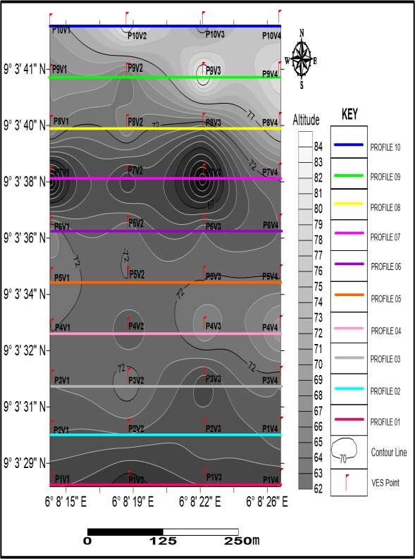

Figure 4.1 Field layout showing profiles lines and VES points

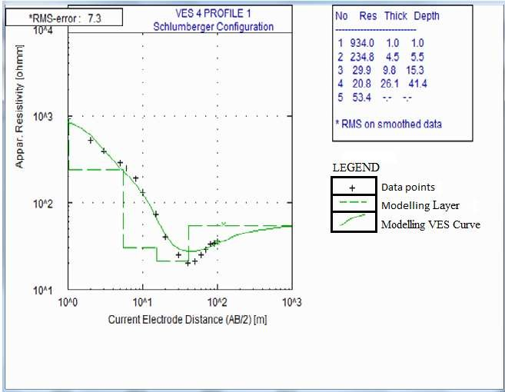

Figure 4.2VES4 Profile 1QH curve type

A specialized geophysical contouring software known as surfer 11 was also used to contour layer resistivity as shown in Figure 4.1 which shows the iso-resistivity contour map of the layers in the study area. From the modelled VES data, it was observed that all the 40 VES points were having five layers, in most of the VES points where the QH, Q, QHK, and QKH curve types are dominates. The minimum and maximum resistivities obtained in the study area ranges from 5.0 Ωm to 1640 Ωm, representing clayey soil, silty-sand, sandstone and sandstone intercalated with gravel. There exist a resistivity overlapping values between moderately resistive and highly conductive geomaterials. The apparent thickness and depths of the geoelectric layer were established with the depth of the first geoelectric layer ranging between 0.3 m and 2.3 m, the second layer depth ranges from 2 m to 58 m, the third- and fourth-layer depths ranges from 6 m to 66m and 25 m to 90 m respectively. The thickness of the geoelectric layers also varies as the first geoelectric layer expresses a thickness range of 0.3 m to 2.3 m, the second layer thickness ranges from 2 m to 32 m, the third layer ranges from 2 m to 62 m while the thickness of the fourth layer ranges between 12 m to 52 m. The depth and thickness of the fifth geoelectric layer extends beyond the probe depth of this investigation. The depth of the fifth layer in proposed to be infinite in extent.

## Table 4.1 Summary of the interpretation of all profiles

|  |  |  |  |  |  |  |  |  |  |  |  |  |  |
| --- | --- | --- | --- | --- | --- | --- | --- | --- | --- | --- | --- | --- | --- |
| **VES**  **Stations** | **Latitude (°)** | **Longitude (°)** | **No. of Layers** | **Layer resistivity, p (Ωm)** | | | **Layer depth d (m)** | | | **Layer thickness h (m)** | | | **Curve Types** |
|  | | | | ***ρ*1 *ρ*2** | | ***ρ*3** | ***d*1** | ***d*2** | ***d*3** | ***h*1** | ***h*2** | ***h*3** |  |
| **A1** | **9.0577861** | **6.1372889** | **3** | **606.0** | **57.7** | **20.5** | **2.2** | **5.4** | **18.8** | **2.2** | **3.2** | **13.4** | **QH** |
| **A2** | **9.0506633** | **6.136425** | **3** | **637.9** | **117.6** | **30.7** | **1.2** | **4.3** | **12.0** | **1.2** | **3.0** | **7.8** | **Q** |
| **A3** | **9.0577639** | **6.1386139** | **3** | **686.2** | **49.0** | **33.0** | **1.0** | **8.1** | **26.7** | **1.0** | **7.1** | **18.6** | **Q** |
| **A4** | **9.0567111** | **6.1399389** | **3** | **934.0** | **234.8** | **9.9** | **1.0** | **5.5** | **15.3** | **1.0** | **4.5** | **9.8** | **QH** |
| **B1** | **9.0498222** | **6.138025** | **3** | **739.3** | **208.2** | **15.2** | **0.7** | **5.0** | **24.3** | **0.7** | **4.3** | **19.2** | **QH** |
| **B2** | **9.0500058** | **6.1371111** | **3** | **742.4** | **158.4** | **16.8** | **1.3** | **4.6** | **14.9** | **1.3** | **3.3** | **10.3** | **QH** |
| **B3** | **9.050305** | **6.1362861** | **3** | **889.1** | **156.8** | **21.1** | **0.8** | **4.6** | **15.6** | **0.8** | **3.8** | **11.0** | **QHK** |
| **B4** | **9.0602778** | **6.1323194** | **3** | **954.9** | **98.3** | **132.5** | **1.1** | **4.0** | **7.2** | **1.1** | **2.9** | **3.2** | **QH** |
| **C1** | **9.0499733** | **6.1351833** | **3** | **561.8** | **47.0** | **26.0** | **2.3** | **4.8** | **12.7** | **2.3** | **2.5** | **8.0** | **QHK** |
| **C2** | **9.0574336** | **6.1351833** | **3** | **615.1** | **76.4** | **29.3** | **1.5** | **5.0** | **38.0** | **1.5** | **3.4** | **33.0** | **Q** |
| **C3** | **9.04963** | **6.1371278** | **3** | **1654.5** | **175.1** | **11.0** | **0.9** | **6.2** | **21.2** | **0.9** | **5.3** | **15.1** | **QHK** |
| **C4** | **9.0583219** | **6.1479528** | **3** | **671.5** | **63.9** | **42.6** | **1.6** | **11.4** | **30.1** | **1.6** | **9.8** | **18.7** | **QH** |
| **D1** | **9.0551728** | **6.1379028** | **3** | **417.9** | **62.3** | **18.0** | **1.8** | **9.7** | **60.4** | **1.8** | **7.9** | **50.7** | **Q** |
| **D2** | **9.0367156** | **6.1486361** | **3** | **414.2** | **168.6** | **20.2** | **1.1** | **4.5** | **32.2** | **1.1** | **3.4** | **27.7** | **QH** |
| **D3** | **91340833** | **6.1519667** | **3** | **291.4** | **26.6** | **5.7** | **1.5** | **21.6** | **38.5** | **1.5** | **20.0** | **169** | **QKH** |
| **D4** | **9.0461128** | **6.1374167** | **3** | **788.8** | **148.2** | **25.4** | **1.0** | **8.5** | **56.8** | **1.0** | **7.4** | **48.3** | **Q** |
| **E1** | **9.04828** | **6.13467** | **3** | **586.2** | **232.8** | **39.7** | **1.7** | **4.7** | **38.8** | **1.7** | **3.0** | **34.1** | **Q** |
| **E2** | **9.0490617** | **6.13487** | **3** | **1415.5** | **86.9** | **19.4** | **0.7** | **3.3** | **11.2** | **0.7** | **2.7** | **7.8** | **QHK** |
| **E3** | **9.0490617** | **6.1358533** | **3** | **964.8** | **41.3** | **173.2** | **0.7** | **3.5** | **10.8** | **0.7** | **2.8** | **7.2** | **QKH** |
| **E4** | **9.04884** | **6.1367722** | **3** | **538.7** | **158.2** | **23.0** | **0.7** | **7.1** | **32.2** | **0.7** | **6.4** | **25.1** | **Q** |
| **F1** | **9.0483** | **6.1367667** | **3** | **906.3** | **121.7** | **16.0** | **0.6** | **4.9** | **13.7** | **0.6** | **4.3** | **8.9** | **QHK** |
| **F2** | **9.0485533** | **6.1357617** | **3** | **895.1** | **151.4** | **7.9** | **0.7** | **8.1** | **32.7** | **0.7** | **7.4** | **24.6** | **QH** |
| **F3** | **9.0486533** | **6.1347867** | **3** | **336.2** | **155.7** | **75.8** | **1.9** | **2.9** | **14.6** | **1.9** | **1.0** | **11.7** | **QH** |
| **F4** | **9.048545** | **6.1431028** | **3** | **260.9** | **548.1** | **24.3** | **0.5** | **5.3** | **67.4** | **0.5** | **4.8** | **62.1** | **QKH** |
| **G1** | **9.0581381** | **6.1369583** | **3** | **1192.0** | **175.1** | **49.6** | **0.6** | **5.4** | **22.1** | **0.6** | **4.8** | **16.6** | **Q** |

|  |  |  |  |  |  |  |  |  |  |  |  |  |
| --- | --- | --- | --- | --- | --- | --- | --- | --- | --- | --- | --- | --- |
| **VES**  **Stations** | **Latitude (°)** | **Longitude (°)** | **No. of Layers** | **Layer resistivity, p (Ωm)** | | **Layer depth d (m)** | | | **Layer thickness h (m)** | | | **Curve Types** |
|  | | | | ***ρ*1 *ρ*2** | ***ρ*3** | ***d*1** | ***d*2** | ***d*3** | ***h*1** | ***h*2** | ***h*3** |  |

|  |  |  |  |  |  |  |  |  |  |  |  |  |  |
| --- | --- | --- | --- | --- | --- | --- | --- | --- | --- | --- | --- | --- | --- |
| **G2** | **9.048065** | **6.1355633** | **3** | **527.2** | **111.7** | **171.3** | **0.9** | **4.1** | **8.6** | **0.9** | **3.2** | **4.6** | **QH** |
| **G3** | **9.0478967** | **6.1364361** | **3** | **875.7** | **48.0** | **16.0** | **1.0** | **12.4** | **35.2** | **1.0** | **11.4** | **22.8** | **Q** |
| **G4** | **9.0468839** | **6.1375472** | **3** | **554.8** | **521.1** | **36.8** | **1.3** | **4.6** | **35.2** | **1.3** | **3.3** | **30.6** | **Q** |
| **H1** | **9.04716** | **6.1375444** | **3** | **763.1** | **259.7** | **65.0** | **0.8** | **3.7** | **15.2** | **0.8** | **2.9** | **11.5** | **QH** |
| **H2** | **9.0467083** | **6.1374278** | **3** | **780.9** | **50.7** | **27.3** | **1.6** | **24.5** | **45.5** | **1.6** | **22.9** | **20.9** | **Q** |
| **H3** | **9.0473733** | **6.1364417** | **3** | **872.1** | **76.9** | **73.2** | **0.6** | **5.9** | **11.9** | **0.6** | **5.3** | **6.0** | **Q** |
| **H4** | **9.0475833** | **6.1355** | **3** | **823.2** | **295.3** | **29.8** | **0.5** | **4.3** | **21.2** | **0.5** | **3.8** | **16.9** | **Q** |
| **I1** | **9.0477222** | **6.1345278** | **3** | **1339.4** | **196.2** | **30.4** | **0.5** | **3.6** | **25.0** | **0.5** | **3.1** | **21.4** | **QH** |
| **I2** | **9.04725** | **6.134444** | **3** | **1167.3** | **331.8** | **16.5** | **0.5** | **4.2** | **21.3** | **0.5** | **3.7** | **17.1** | **QH** |
| **I3** | **9.0471389** | **6.1355** | **3** | **1120.5** | **192.5** | **19.7** | **0.6** | **5.0** | **28.5** | **0.6** | **4.4** | **23.5** | **QH** |
| **I4** | **9.0468889** | **6.1365556** | **3** | **1647.5** | **169.1** | **93.7** | **0.4** | **6.4** | **9.7** | **0.4** | **6.0** | **3.3** | **QKH** |
| **J1** | **9.0458889** | **6.13825** | **3** | **620.5** | **115.5** | **26.7** | **2.1** | **12.5** | **37.1** | **0.4** | **6.0** | **3.3** | **QHK** |
| **J2** | **9.0450833** | **6.1400556** | **3** | **880.6** | **282.7** | **17.1** | **0.4** | **5.0** | **23.8** | **0.4** | **4.7** | **18.8** | **QH** |
| **J3** | **9.0462778** | **6.1374167** | **3** | **372.4** | **118.9** | **61.1** | **0.7** | **6.6** | **19.4** | **0.4** | **4.7** | **18.8** | **QH** |
| **J4** | **9.0465278** | **6.1363056** | **3** | **1031.6** | **220.2** | **37.4** | **0.4** | **3.6** | **32.7** | **0.4** | **3.2** | **29.1** | **Q** |

In order to ascertain the aquifer protectivity, transmissivity and soil corrosivity of the area under consideration, the longitudinal conductance and transverse resistance values were evaluated from the measured resistivity values andthe thicknesses of the layers using table 3.1 and 3.2 respectively as shown in Table (4.2).

The longitudinal conductance also shows a variation from 0.001 Siemens in VES 4 to

4.465 Siemens in VES 23. On average, all the VES points show values of longitudinal conductance that are less than 1.0 Siemens, suggesting that the overburden rock materials have no significant quantity of impermeable clay overlying strata which demonstrates high infiltration rates of surface contaminants into the aquifer.

The resistivity values as obtained from the measurements show that overburden resistivity values are relatively low in VES 6, 7, 9, 12, 17, 18, 21 and 28. This indicates that the areas are generally corrosive, having weak conductance and aquifer protective capacity.

This corrosivity could be attributed to the chemical constituents of the area and may cause disease if any form of agricultural activities is done and consumed.

The information obtained from geophysical investigation (Table 4.1) reveals that the study area with geoelectric parameter shows Five subsurface geoelectric units were delineated beneath the VES sections. The lithological variability of the subsurface lithology of the study area is characterised by the variability in the geoelectric properties of these geomaterials. The resistivities obtained in the study area ranges from 5.0 Ωm to 1640 Ωm, representing clayey soil, silty-sand, sandstone and sandstone intercalated with gravel. There exist resistivity overlapps values between moderately resistive and highly conductive geomaterials. The apparent thickness and depths of the geoelectric layer were established with the depth of the first geoelectric layer ranging between 0.3 m and 2.3 m, the second layer depth ranges from 2 m to 58 m, the third- and fourth-

layer depths ranges from 6 m to 66m and 25 m to 90 m respectively. The thickness of the geoelectric layers also varies as the first geoelectric layer expresses a thickness range of 0.3 m to 2.3 m, the second layer thickness ranges from 2 m to 32 m, the third layer ranges from 2 m to 62 m while the thickness of the fourth layer ranges between 12 m to 52 m. The depth and thickness of the fifth geoelectric layer extends beyond the probe depth of this investigation. The depth of the fifth layer is proposed to be infinite in extent. Forty VES points, which is in (Table 4.2). The three distinct zones deﬁned are weak, moderate, and good aquifer protective capacity, based on the numerical values assigned to each point. VES 6, 7, 9,12, 17, 18, 21 and 28. The area with weak aquifer protective capacity covering 20% of the mapped area. Moderate protective capacity at VES 1, 2, 3, 4, 5, 8, 10, 11, 13, 14, 16, 19, 24, 25, 26, 27, 29, 30, 31, 32, 33, 34, 35, 36,

37, 38, 39 and 40; which constitute 72.5% of the study area and good aquifer protective

capacity at VES 15, 20, 22 and 23 is 7.5%. Using the inferred layer resistivities and thicknesses, longitudinal conductance (a Dar Zarrouk parameter) was used as a criterion for the aquifer protective capacity rating. The soil corrosivity in the study area was also determined from table (4.6 to 4.25), using the ﬁrst layer resistivity and comparing with that of (Table 3.1). VES 4, 5, 6, 7, 8, 11, 12, 16, 18, 19, 21, 25, 27, 29, 31, 32, 33, 34,

35, 36, 38 and 40 suggest that the subsurface (soil) is practically noncorrosive. VES 1,

2, 3, 9, 10, 13, 14, 15, 17, 20, 23, 24, 26, 28, 30, 37 and 39 suggest slightly corrosive material. Figure 4.3 shows the corrosivity rating of the study area.

**Good Moderate Weak Poor**

Figure 4.3Soil corrosivity rating of study area.

## Table 4.2 Summary Interpretation of soil corrosivity and aquifer protective capacity of all the profiles.

**Average Transverse**

**Soil Corrosivity Average Conductance**

**Aquifer Protective**

|  |  |  |  |  |  |
| --- | --- | --- | --- | --- | --- |
|  | **Resistance Per VES Points**  **(Ωm2)** |  | **Per Points** | **VES** | **Capacity Rating** |
| **1.** | 174.32 | **Slightly Corrosive (SC)** | **0.215** |  | **Moderate** |
| **2.** | 165.82 | **Slightly Corrosive (SC)** | **0.348** |  | **Moderate** |
| **3.** | 166.56 | **Slightly Corrosive (SC)** | **0.420** |  | **Moderate** |
| **4.** | 254.58 | **Practically Non-Corrosive (PNC)** | **0.321** |  | **Moderate** |
| **5.** | 255.62 | **Practically Non-Corrosive (PNC))** | **0.333** |  | **Moderate** |
| **6.** | 233.00 | **Practically Non-Corrosive (PNC)** | **0.169** |  | **Weak** |
| **7.** | 234.84 | **Practically Non-Corrosive (PNC)** | **0.171** |  | **Weak** |
| **8.** | 257.68 | **Practically Non-Corrosive (PNC)** | **0.399** |  | **Moderate** |
| **9.** | 148.36 | **Slightly Corrosive (SC)** | **0.117** |  | **Weak** |
| **10.** | 153.02 | **Slightly Corrosive (SC)** | **0.388** |  | **Moderate** |
| **11.** | 417.78 | **Practically Non-Corrosive (PNC)** | **0.280** |  | **Moderate** |
| **12.** | 186.78 | **Practically Non-Corrosive (PNC)** | **0.118** |  | **Weak** |
| **13.** | 105.22 | **Slightly Corrosive (SC)** | **0.589** |  | **Moderate** |
| **14.** | 128.96 | **Slightly Corrosive (SC)** | **0.278** |  | **Moderate** |
| **15.** | 91.62 | **Slightly Corrosive (SC)** | **0.902** |  | **Good** |
| **16.** | 199.66 | **Practically Non-Corrosive (PNC)** | **0.288** |  | **Moderate** |
| **17.** | 174.14 | **Slightly Corrosive (SC)** | **0.175** |  | **Weak** |
| **18.** | 3470.90 | **Practically Non-Corrosive (PNC)** | **0.167** |  | **Weak** |
| **19.** | 244.62 | **Practically Non-Corrosive (PNC)** | **0.205** |  | **Moderate** |
| **20.** | 148.92 | **Slightly Corrosive (SC)** | **0.648** |  | **Good** |
| **21.** | 244.84 | **Practically Non-Corrosive (PNC)** | **0.198** |  | **Weak** |
| **22.** | 232.40 | **Practically Non-Corrosive (PNC)** | **0.732** |  | **Good** |
| **23.** | 121.82 | **Slightly Corrosive (SC)** | **0.925** |  | **Good** |
| **24.** | 170.08 | **Slightly Corrosive (SC)** | **0.513** |  | **Moderate** |
| **25.** | 293.30 | **Practically Non-Corrosive (PNC)** | **0.582** |  | **Moderate** |
| **26.** | 173.94 | **Slightly Corrosive (SC)** | **0.457** |  | **Moderate** |
| **27.** | 189.70 | **Practically Non-Corrosive (PNC)** | **0.333** |  | **Moderate** |
| **28.** | 224.50 | **Slightly Corrosive (SC)** | **0.168** |  | **Weak** |
| **29.** | 242.34 | **Practically Non-Corrosive (PNC)** | **0.248** |  | **Moderate** |
| **30.** | 173.32 | **Slightly Corrosive (SC)** | **0.244** |  | **Moderate** |
| **31.** | 209.12 | **Practically Non-Corrosive (PNC)** | **0.483** |  | **Moderate** |
| **32.** | 239.98 | **Practically Non-Corrosive (PNC)** | **0.233** |  | **Moderate** |
| **33.** | 336.20 | **Practically Non-Corrosive (PNC)** | **0.323** |  | **Moderate** |
| **34.** | 326.70 | **Practically Non-Corrosive (PNC)** | **0.209** |  | **Moderate** |
| **35.** | 284.08 | **Practically Non-Corrosive (PNC)** | **0.243** |  | **Moderate** |
| **36.** | 415.38 | **Practically Non-Corrosive (PNC)** | **0.236** |  | **Moderate** |
| **37.** | 170.24 | **Slightly Corrosive (SC)** | **0.374** |  | **Moderate** |
| **38.** | 253.18 | **Practically Non-Corrosive (PNC)** | **0.332** |  | **Moderate** |
| **39.** | 123.76 | **Slightly Corrosive (SC)** | **0.443** |  | **Moderate** |
| **40.** | 268.38 | **Practically Non-Corrosive (PNC)** | **0.603** |  | **Moderate** |

The curve type derived from the VES plots in the order of their percentages includes the QH curve type with 40%, the Q curve type with 35%, QHK with 17.5% and the QKH which represent 7.5% and shows in (Figure 4.4). The shape or geometry of the curve types is as a result of the function of the undulating, increase or decrease in the resistivity of the subsurface lithologic layers. Considering the morphology of the VES field curves and the variation in the resistivity values, the following curve types are evident in study area (Table 4.3).The earth’s medium acts as a natural ﬁlter to percolating ﬂuid. The ability of the earth to retard or accelerate and ﬁlter percolating ﬂuid is a measure of its protective capacity (Barker *et al.,*2001).

## Summary of the Geoelectric Parameters

The geoelectric sections show that the depth to the different lithologies varies across the sounding stations. The fourth and fifth layers are proposed to represents an important aquifer in the study area. The sandstone which occurs as either the fourth or fifth layer in different parts of the study area has relatively low to moderate resistivity values ranging from 5.6 Ωm to 150 Ωm.

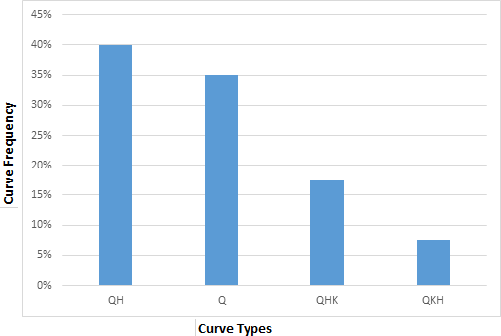

Figure 4.4 Frequency curve type

## Table 4.3 Geometry and percentage of resistivity curve types

|  |  |  |  |
| --- | --- | --- | --- |
| SN | Curve Type | Resistivity alteration | Percentage (%) |
| 1 | QH | ℓ1 > ℓ2 > ℓ3 ≥ ℓ4 < ℓ5 | 40% |
| 2 | Q | ℓ1 > ℓ2 > ℓ3 > ℓ4 > ℓ5 | 35% |
| 3 | QHK | ℓ1 > ℓ2 < ℓ3 > ℓ4 > ℓ5 | 17.5% |
| 4 | QKH | ℓ1 > ℓ2 < ℓ3 ≥ ℓ4 < ℓ5 | 7.5% |

* 1. **Isoresistivity Interpretations**

Iso-resistivity map of each of the geoelectric layers as derived from the geoelectrical parameters is presented and interpreted to show the trend of resistivity of each geoelectric layer.

## Isoresistivity of first geoelectric layer

The apparent resistivity distribution of the first geoelectric layer subsurface lithology shows a relatively high resistivity at the northern, the north-western and the eastern segments of the mapped area. The lowest resistivity zone of the first layer is situated at the eastern segment of the area of study. Areas with lesser resistivity which are also highly conductive zones are decent signal of porous lithological unit. The resistivity at the eastern section might be attributed to the effect of unsaturated loess soil or pure clay lithology. The resistivity shows an elevated increase range of 250 Ωm to 1650 Ωm (Figure 4.5).

## Isoresistivity of second geoelectric layer

At the second geoelectric layer, bulk of the map area display low to moderate resistivity values. With the low apparent resistivity as seen in the central and southern portion of the mapped area, this may suggest that the depth at the second geoelectric layer is composed of clay lithology. The variation in the resistivity may be attributed to pure clay with silt matrix. The lowest apparent resistivity (about 20 Ωm) in the area is indicated around the central section, suggesting that pure clay is underlying the area at that portion (Figure 4.6). The elevated resistivity as indicated in the eastern portion of map suggest that the area in underlain by non-conductive earth materials which may be laterite.

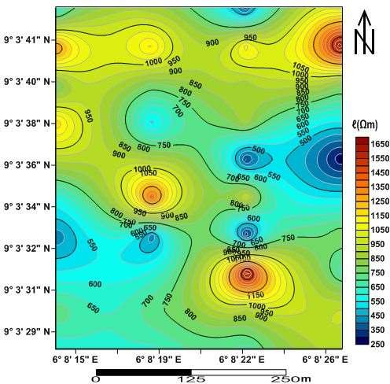

Figure 4.5 Iso-resistivity contour map of the first layer

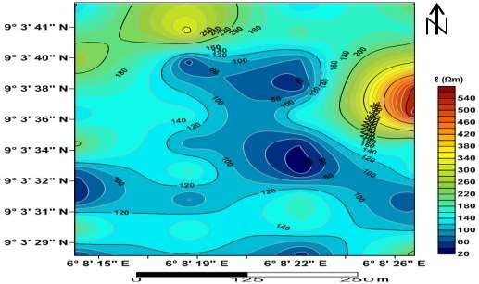

Figure 4.6 Iso-resistivity contour map of the second layer

## Isoresistivity of third geoelectric layer

The lowest resistive zone is situated at the southern to south-western section and part of the northern section of the map. Areas with lesser resistivity which are also highly conductive zones are decent signal of porous lithological unit which might be wet clay or saturated sandstone. The resistivity at the southern, south-western and northern section might be attributed to the effect of pure clay at shallow depths and silty-sand or sandstone at greater depths. The resistivity this layer shows an elevated increase in the range of 10 Ωm to 170 Ωm (Figure 4.7).

## Isoresistivity of fourth geoelectric layer

The Isoresistivity map of the fourth geoelectric layer is indicative of the presence of saturated geomaterials. Saturated sandstone with matrix of silt might be the dominant lithology across the eastern to western portion of the map. The southern portion of the layer is indicative of sandstone/gravel intercalation with resistivity values range of 100 Ωm to 240 Ωm. The potential for groundwater might be visible at this layer (Figure 4.8).

## Isoresistivity of fifth geoelectric layer

The non-uniqueness of the apparent resistivity at the fifth layer of the mapped area suggest a slight variation in the lithological properties underlying the subsurface at this layer (Figure 4.9). The areas with low resistivity range of 5 Ωm to 55 Ωm could be indicative of saturated sandstone while the western quota of the area with variable apparent resistivity may be attributed to the possible occurrence of relatively lithology of sandstone intercalated with gravel. The degree of groundwater saturation combined with the lithological variation and chemical composition of the subsurface material might be responsible for the variation in the resistivity of this layer.

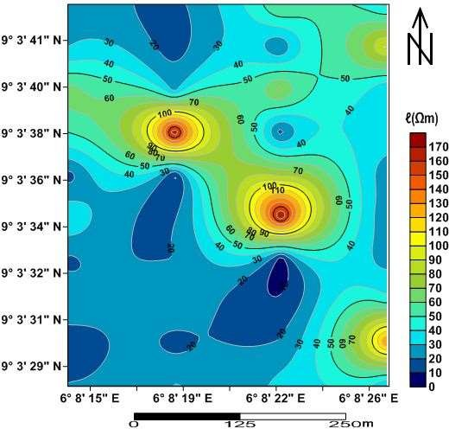

Figure 4.7 Iso-resistivity contour map of the third layer

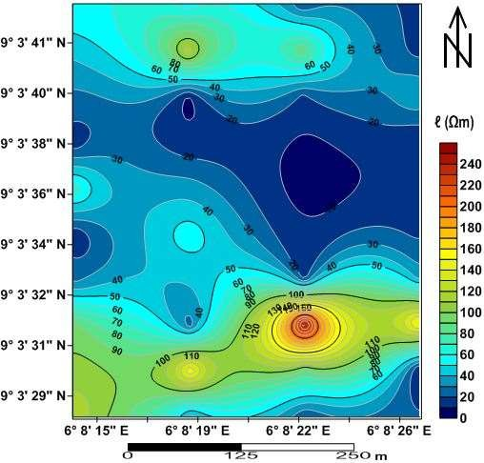

Figure 4.8 Iso-resistivity contour map of the fourth layer

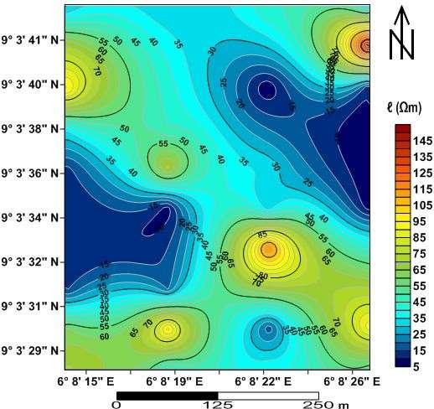

Figure 4.9 Iso-resistivity contour map of the fifth geoelectric layer

## Depth to Geoelectric Layers Interpretations

* + 1. **Depth of the first eoelectric layer**

The depth map of the first geoelectric layer was constructed with the contour interval of 0.2m. The depth range of the first layer is between 0.3 m and 2.3 m. The northern, north-eastern and part of the north western portion of the map shows the minimum depth value of the range of 0.3 m to 1.1 m. The central and southwestern part of the first layer is characterized by approximately higher depth value of the range of 1.3 to 2.3 with respect to the northern, north-eastern and the north western portion of the shallow first geoelectric layer map (Figure 4.10).

## Depth of the second geoelectric layer

The depth to the second geoelectric layer ranges between 2 m to > 58 m below ground level. The second layer almost expresses an approximately uniform depth range throughout the layer except for the south-eastern portion of the area. It is suggested that the part of the map with depth range of 30 m to 58 m might possess groundwater to a certain degree. Shallow wells might produce groundwater in the south-eastern part of the study area (Figure 4.11).

## Depth of the third geoelectric layer

Groundwater can be exploited from the eastern, north-western and part of the south- western portion of the mapped area owing to the expression of elevated depths encountered in these areas. The depth of this layer ranges from 6 m to 66 m below ground level (Figure 4.12). This layer is inferred to produce groundwater in sufficient quantity when exploited for domestic or agricultural purpose.

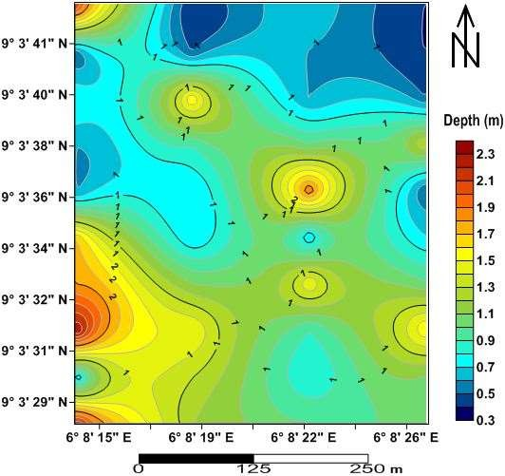

Figure 4.10 Depth map of the first geoelectric layer

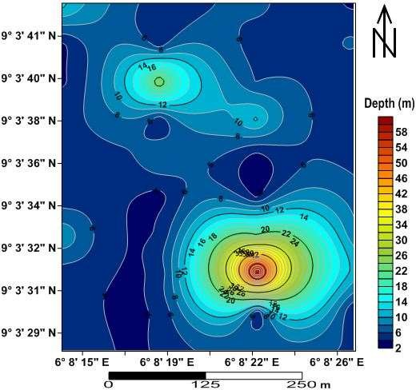

Figure 4.11 Depth map of the second geoelectric layer

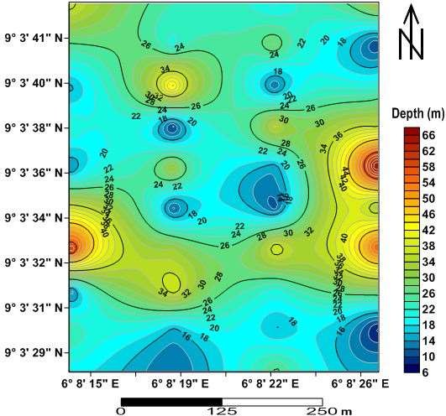

Figure 4.12 Depth map of the third geoelectric layer

## Depth of the fourth geoelectric layer

The forth geoelectric layer is encountered with the depth range of 25 m to 90 m below ground level. This layer is considered a saturated layer due to the correspondent depth in relation to the apparent resistivity readings obtained from the layer (Figure 4.13). Greater depth of about 90 m of this layer are located within the north-western portion of the area, while moderate depth ranges of 50 m to 75 m are located within the northern, eastern and south-western portion of the area. The shallow depth in relation to this layer are located within the far south-eastern, south-western and part of the north-eastern portion of the mapped area. This layer is considered to be fully saturated with groundwater.

## Depth of the fifth geoelectric layer

The depth to the fifth geoelectric layer extends beyond the probe depth of this investigation. The depth of the fifth layer in proposed to be infinite in extent.

## Thickness of Geoelectric Layers Interpretations

* + 1. **Thickness of the first geoelectric layer**

The thickness of the first geoelectric layer might be considered negligible in relation to groundwater abstraction. The thickness of this layer ranges from an almost near surface depth of 0.3 m to 2.3 m (Figure 4.14). The thickness of this layer suggest it might be good enough for agricultural activities.

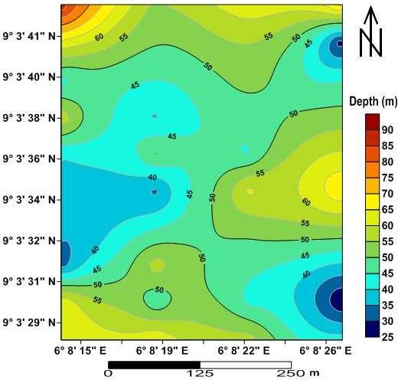

Figure 4.13 Depth map of the forth geoelectric layer

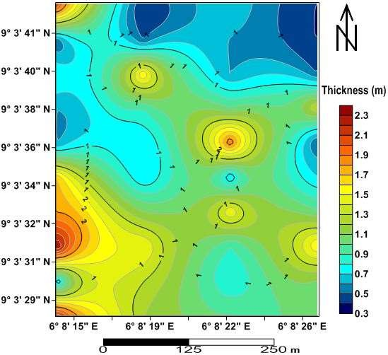

Figure 4.14Thickness map of the first geoelectric laye

## Thickness of the second geoelectric layer

The thickness of the second geoelectric layer ranges from 2 m to 32 m. Depth to the second layer is more extensive at the north-south end of the map. The thickness of the second layer is more pronounced at the south-western and north-eastern portion of the map ranging from 18 m to 32 m (Figure 4.15).

## Thickness of the third geoelectric layer

The thickness range of 26 m to 62 m is expressed on the south-western and eastern part of the mapped area while the shallow depth of 2 m to 22 m is shown on the southern, central, western and northern portions of the mapped area (Figure 4.16). The third layer thickness might be good enough for groundwater accumulation in some section of the mapped area.

## Thickness of the fourth geoelectric layer

The fourth layer thickness ranges from 12 m to 52 m. The layer is thicker toward the northern and eastern axis of the mapped area (Figure 4.17). The thickness of this layer is expected to support the accumulation of groundwater in sufficient quantity.

## Groundwater Potential

Generally, the petrophysical properties of the subsurface lithology of study area has a good groundwater potential as revealed by the geoelectric parameters (Table 4.4). The geoelectrical properties of the subsurface lithologies was used to classify the area into low, medium and high groundwater potential zones. The north-eastern and south- western zones of the area are indicative of high groundwater potential, while the remaining portion of the mapped area are characterized by low to medium groundwater potential zones (Figure 4.18)

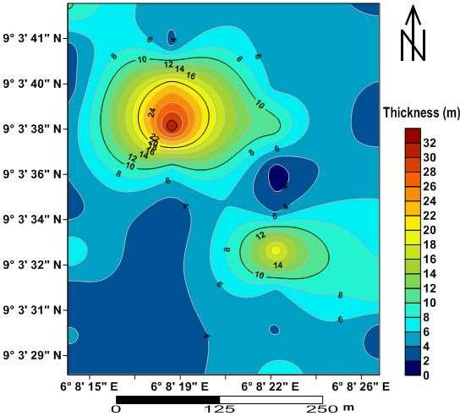

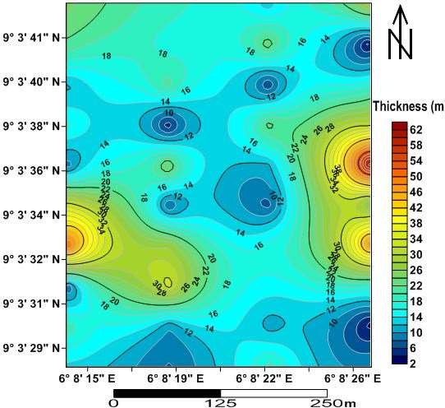Figure 4.15Thickness map of the second geoelectric layer

Figure 4.16Thickness map of the third geoelectric layer

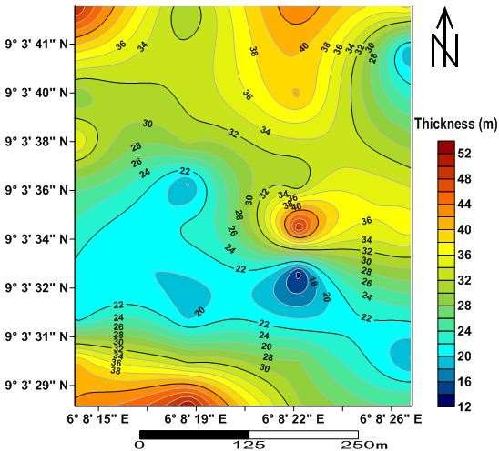

Figure 4.17 Thickness map of the fourth geoelectric layer

## Table 4.4 Delineated aquifer potentials of the study area

**VES**

## No. of

**Layer Resistivity *ρ* (Ωm) Layer Depth (m) Layer Thickness**

## Stations

**Layers**

|  |  |  |  |  |  |  |  |  |  |  |  |  |  |  |
| --- | --- | --- | --- | --- | --- | --- | --- | --- | --- | --- | --- | --- | --- | --- |
| P2V3 | 5 | ***ρ*1**  889.1 | ***ρ*2**  156 | ***ρ*3**  21.1 | ***ρ*4**  90.7 | ***ρ*5**  ∞ | ***d*1**  0.8 | ***d*2**  4.6 | ***d*3**  15.6 | ***d*4**  43.7 | ***d*5**  ∞ | ***h*1**  0.8 | ***h*2**  3.8 | ***h*3**  11.0 |
| P4V1V2 | 5 | 417.9 | 62.3 | 18.0 | 27.9 | ∞  ∞ | 1.8 | 9.7 | 60.4 | ∞ | ∞ | 1.8 | 7.9 | 50.7 |
|  | 5 | 414.2 | 168.6 | 20.2 | 41.8 |  | 1.1 | 4.5 | 32.2 | ∞ | ∞ | 1.1 | 3.4 | 27.7 |
| P5V1V2 | 5 | 586.21 | 232.8 | 39.7 | 12.0 | ∞ | 1.7 | 4.7 | 38.8 | ∞ | ∞ | 1.7 | 3.0 | 34.1 |
|  | 5 | 1415.5 | 86.9 | 19.4 | 57.1 | 7.4 | 0.7 | 3.3 | 11.2 | 34.0 | ∞ | 0.7 | 2.7 | 7.8 |
| P7V3V4 | 5 | 875.5 | 48.0 | 16.0 | 8.8 | ∞ | 1.0 | 12.4 | 35.2 | ∞ | ∞ | 1.0 | 11.4 | 22.8 |
|  | 5 | 554.8 | 521.1 | 36.8 | 9.8 | ∞ | 1.3 | 4.6 | 35.2 | ∞ | ∞ | 1.3 | 3.3 | 30.6 |
| P8V3V4 | 5 | 872.1 | 76.9 | 73.2 | 17.8 | 5.6 | 0.6 | 5.9 | 11.9 | 52.1 | ∞ | 0.6 | 5.3 | 6.0 |
|  | 5 | 823.2 | 295.3 | 29.8 | 39.7 | 11.9 | 0.5 | 3.8 | 16.9 | 23.3 | ∞ | 0.5 | 4.3 | 21.2 |

Table 4.27 contains the VES points delineated as aquifer potential of the study area, the range of resistivity, depth and thickness of these aquifers are 17.8 to 90.7 Ωm, 11.9 to

60.4 m and 6.0 to 50.7 m respectively.

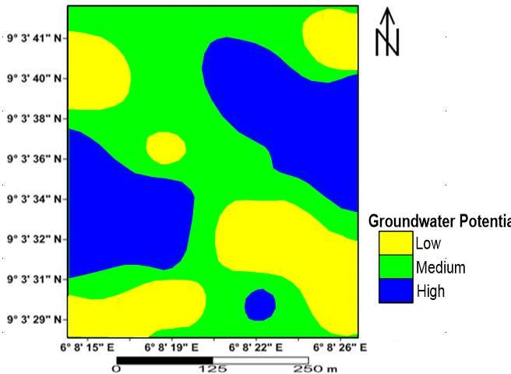Figure 4.18Groundwater potentialmap of the study area

## CHAPTER FIVE

* 1. **CONCLUSION AND RECOMMENDATIONS**

## Conclusion

Water is key to daily human activities hence, without water, there cannot be human, animal or plant life. It is in view of this that the geoelectric investigation for the evaluation of the subsurface for optimal groundwater production was undertaken in the study area.

The electrical resistivity (Vertical Electrical Sounding) method is an efficient tool for most groundwater studies. It was used in this study to investigate the protective capacity and corrosivity of overburden units in the study area. The curve types indicate regular presence of QH and Q curves. This indicates the translation of layers with limited hydrologic signiﬁcance into proliﬁc units in which the selection of the best near surface and economic groundwater aquifer repository is, based on thickness and its degree of exposure to surface contaminants. Areas of thick depth units and low resistivity values constitute zones of high longitudinal conductance. Regions with poor protective capacity if there is any within the study area are vulnerable to pollution and contamination if there is oil spillage, leakage in buried storage tank, petroleum pipelines, and inﬁltration of leachate from decomposed dump or waste site. Regions of weak protective capacity (VES 6, 7, 9,12, 17, 18, 21 and 28) are less vulnerable to groundwater pollutant or contaminant but can be more vulnerable with time as pollutant persists. Moderate protective capacity regions (VES 1, 2, 3, 4, 5, 8, 10, 11, 13, 14, 16,

19, 24, 25, 26, 27, 29, 30, 31, 32, 33, 34, 35, 36, 37, 38, 39 and 40) and good protective

capacity (VES 15, 20, 22 and 23) will forever serve as a sealing potential for the underlying hydrologeological system. This makes the contamination of groundwater in

such regions almost impossible. Areas that are slighgly corrosive (VES 1, 2, 3, 9, 10,

12,13, 14, 15, 17, 20, 23, 24, 26, 28, 30, 37 and 39) are characterized by low resistivity values and high moisture content of the soil. Underground iron storage tanks are not to be buried in these areas. Reticulation of water, transmission of oil and gas using galvanized pipes could deteriorate, rupture or leak due to the reactions of corrosive materials with buried pipes, which can cause serious hazards to mankind and its environment. Practically non-corrosive areas (VES 4, 5, 6, 7, 8, 11, 12, 16, 18, 19, 21,

22, 25, 27, 29, 31, 32, 33, 34, 35, 36, 38 and 40) are absolutely good for burying of iron underground tanks without deterioration which has a good groundwater potential as revealed by the geoelectric parameters. The geoelectrical properties of the subsurface lithologies was used to classify the area into low, medium and high groundwater potential zones and save for drinking without no effect to human and animals and also save for any form of agricultural activities within the study area.

Five subsurface geoelectric units were delineated beneath the VES sections. The lithological variability of the subsurface lithology of the study area is sponsored by the variability in the geoelectric properties of these geomaterials. The minimum and maximum resistivities obtained in the study area ranges from 5.0 Ωm to 1640 Ωm, representing clayey soil, silty-sand, sandstone and sandstone intercalated with gravel. There exist a resistivity overlapping values between moderately resistive and highly conductive geomaterials. The apparent thickness and depths of the geoelectric layer where established with the depth of the first geoelectric layer ranging between 0.3 m and 2.3 m, the second layer depth ranges from 2 m to 58 m, the third- and fourth-layer depths ranges from 6 m to 66m and 25 m to 90 m respectively. The thickness of the geoelectric layers also varies as the first geoelectric layer expresses a thickness range of

0.3 m to 2.3 m, the second layer thickness ranges from 2 m to 32 m, the third layer

ranges from 2 m to 62 m while the thickness of the fourth layer ranges between 12 m to 52 m. The depth and thickness of the fifth geoelectric layer extends beyond the probe depth of this investigation. The depth of the fifth layer in proposed to be infinite in extent.

## Recommendations

* + 1. Government, individuals or estate developers who wish to site borehole within the study area are strongly advisedto consider the VES points VES 3 on profile 2 VES 1 and VES 2 on profile 4 and profile 5, VES 4 on profile 7 VES 3 and VES 4 on profile 8
    2. Laboratory checks can be conducted in order to access the protective capacity of aquifers within regions described as poor and weak before carry any form of activity there.
    3. Areas with poor aquifer protective capacity should be avoided for sinking borehole to reduce leachates infiltration to the groundwater.
    4. Plastic pipes are more preferable in the areas of good and moderate aquifer protective capacity.

**REFERENCE**

Abdullahi A., Shehu, A.D., & Muhammad A.U. (2017). Evaluation of soil corrosivity and aquifer protective capacity using secondary geoelectric parameters across Gombe metropolis in North-eastern *Nigeria Agricultural Business and Technology*. Vol. 15, pp 29-51 (2017)

Abiola, O., Enikanselu, P.A., & Oladapo, M.I. (2009). Groundwater potential and aquifer protective capacity of overburden units in Ado-Ekiti, southwestern Nigeria; *International Journal of Physics Sciences.* 4(3) 120–132.

Adeniji, A.E., Omonona, O.V., Obiora, D.N., &Chukudebelu, J.U. (2014). Evaluation of soil corrosivity and aquifer protective capacity using geo-electrical investigation in Bwari basement area; Abuja. *Journal of Earth System Sciences.* 123(3) 491–502.

Agunloye, O. (1984). Soil aggressivity along steel pipeline route at Ajaokuta southwestern Nigeria. *Journal of Mining Geology,* 21, 97-101.

Ahmad, D.S., Abdullahi, A., & Victor E.G. (2016). Assessment of the extent of soil corrosivity using vertical electrical sounding: a case study of Mbat-Odukpani, Cross River, Nigeria *JOLORN* VOL. 17 No. 1, 2016

Ajibade, O.M., &Ogungbesan, G.O. (2013). “Prospects and Quality Indices for Groundwater Development in Ibadan Metropolis, Southwestern, Nigeria, *InternationalJournalofDevelopmentandsustainability*, 2(1): 398 – 414.

Arabi, A., Nur, A., &Dewu, B. (2009). Hydro geo-electrical investigation in Gombe town and environs, northeastern Nigeria. *Journal of Applied Sciences and Environmental Management,* vol. 13, No 3

Ayolabi, E.A., Adeoti, L., Oshinlaja, N.A., Adeosuni, I.O., & Idowu, O.I. (2009). Seismic Refraction and Resistivity Studies of part of Igbogbo Township, Southwest Nigeria: *JournalofScienceResearchDevelopment*, v. 11, p. 42–61.

Ayuk, M.A.,Adelusi, A.O.,& Adiat, K.A.N. (2013).Evaluation of groundwater potential and aquifer protective capacity assessment at Tutugbua-Olugboyega area, off Ondo road, Akure Southwestern Nigeria. *International Journal of Physical Sciences Vol. 8(1), pp. 37-50, 9 January, 2013*

Baeckmann, W., & Schwenk, W. (1975). Handbook of Cathodic protection. The theory and practice of electrochemical corrosion protection techniques. Portcullis Press, Ltd. Surrey, England. 1975, 396 (Book).

Baimba, A.A (1978) Resistivity and refraction methods for groundwater exploration at Zango, Kaduna state.

Barker R, Rao T V & Thangarajan M 2001 Delineation of contaminant zone through electrical imaging technique; *Current ofScienhces.* 81(3) 277–283.

Belmonte, S.J Enrigueze, J.O., & Zamora, M.A. (2004).Groundwater resource evaluation in the western part of Kushtia district of Bangladesh using vertical electrical sounding technique [Journal of *Hydraulic Engineering*](https://www.researchgate.net/journal/0971-5010_ISH_Journal_of_Hydraulic_Engineering) 21(1):97-110

Braga, A. C. O., Dourado, J. C., &Malagutti Filho, W. (2006). Resistivity (DC) method applied to aquiferprotection studies. *Brazilian Journal of Geophysics,* 24(4), 573-581.

Braga, A. C. O. (2008). Estimation of the natural vulnerability of aquifers: a contribution from the resistivity andlongitudinal conductance. *Brazilian Journal of Geophysics,* 26(1), 61-68.

Bullard, S.J., Covino, J.R.B.S., Cramer, S.D., Holcomb, G.R., Ziomek-Moroz, M.,

Locke, M.L., Warthen, M.N., Kane, R.D., Eden, D.A., & Eden, D.C. (2004). Electrochemical noise monitoring of corrosion in soil near a pipeline under cathodic protection. Albany Research Center (ARC), Albany,

Chernicoﬀ A.E & Whitney I.K (2009). An introduction to physical planning; Houghton Miﬄin Company, New York.Dahlin T 2001 The development of DC resistivity imaging techniques*; Computer Geosciences.* 27(9) 1019–1029.

Dan-Hassan, M.A. (2001). Determination of geo-electric sequences and aquifer units in part of the basement complex of north–central Nigeria; Water Resource*. Journal of NigeriaAssociation of Hydrogeology.* 12 45–49.

Durowaye, S.I., Alabi, A.G.F., Sekunowo, O.I., Bolasodun, B., & Rufai, I.O. (2014). Effects of pH Variation on Corrosion of Mild Steel in Bore-hole Water using 1M Sodium Hydroxide Solution, *International Journal of Engineering and Technology Volume 4 No. 3.*

Edet, A., & Worden, R.H. (2009). Monitoring of the physical parameters and evaluation of the chemical composition of river and groundwater in Calabar (southeastern Nigeria); *Environmental Monitoring Assessment* 213(1–3) 243–258.

Ehirim, C.N., Ebeniro, J.O., &Ogwu, D.A. (2009). A geophysical and hydro- physiochemical study of the contaminant impact of a solid waste landfill (SWL) in Port Harcourt Municipality, Nigeria. *The Pacific Journal of Science and Technology. Volume 10. Number 2.*

Ehirim, C.N., Ebeniro, J.O., &Ogwu, D.A. (2010). Evaluation of aquifer characteristics and groundwater quality using geoelectric method in Choba, Port Harcourt *Archives of Applied Science Research,* 2 (2):396-403

Ekpo, A., Orakwe, L., Ekpo, F., &Eyeneka, F. (2016). Evaluating the Protective Capacity of Aquifers Uyo in akwaIbom State, Southern Nigeria, using the Vertical Electrical Sounding (VES) Technique*. International Advanced ResearchJournal in Science, Engineering and Technology* Vol. 3, pp 4-8

Emmanuel, O., Joshua, Olayinka O., Odeyemi, &Oladotun, O.F. (2011). Geoelectric investigation of the groundwater potential of Moniya Area, Ibadan. *Journal of Geology and Mining Research* Vol. 3(3), pp. 5462,

Fadele, S.I., Sule, P.O., &Dewu, B.B.M. (2013). The Use of Vertical Electrical Sounding (VES) for Groundwater Exploration around Nigerian College of Aviation Technology (NCAT), Zaria, Kaduna State, Nigeria*. Pacific Journal of Science and Technology* 14: 549-555.

George, N.J., Nathaniel, E.U., & Etuk, S.E. (2014). Assessment of economical accessible groundwater reserve and its protective capacity in eastern Obolo local government area of Akwa Ibom State, Nigeria, using electrical resistivity method; *International Journal of Geophysics. 7(3) 693–700.*

Henriet, J. P. (1975). Direct applications of the Dar Zarrouk parameters in ground water surveys. *Geophysical Prospecting*, 24 (3): 44–353.

Kalinski, K.J., Kelly, W.E., &Bogardi, I. (1993). Combined use of geoelectric sounding and proﬁling to quantify aquifer protection properties; Groundwater 31(4) 538– 544.

Keller G., & Frischknecht, F.C. (1996). Electrical Methods in Geophysical Prospecting. Toronto, Sydeney, Braunsckweig. [***International Journal of Geosciences***](https://www.scirp.org/(S(351jmbntvnsjt1aadkposzje))/journal/Home.aspx?JournalID=209)***,*** [Vol.4](https://www.scirp.org/(S(351jmbntvnsjt1aadkposzje))/journal/Home.aspx?IssueID=4151) [No.10,](https://www.scirp.org/(S(351jmbntvnsjt1aadkposzje))/journal/Home.aspx?IssueID=4151)

Keswick, B.H., Wang, D., & Gerba, C.P. (1982). The use of micro-organisms as groundwater tracers – A review; Groundwater 20(2) 142–149. Kogbe A C 1989 Geology of Nigeria; Elizabethan Publishing Company, Lagos, Nigeria

Maillet, R. (1947). The fundamental equations of electrical prospecting. Geophysics, 12, 529-556.

Makeig, K.S.(1982). National buﬀers for sludge leachate stabilization of groundwater; G*eophysics*20(4) 420–429.

Miller, R. (2006). Hydrogeophysics: Introduction to this special section. The Leading Edge. P. 713.

Mogaji, K.A., Adiat, K.A.N., & Oladapo, M.I. (2007). Geoelectric investigation of the Dape Phase III Housing Estate F.C.T Abuja, north–central Nigeria; *Journal of Earth Sciences* 1(2) 76–84.

Mohamed, A.S. (1975). Vertical electrical soundings to locate ground water resources: A feasibility study, Virginia water resources research center Bulletin.;73:7. New York.

Mohammed, G., Ibrahim, A., Hassan, A. A., Ibrahim, S. H., Mahdy, A. M., Ibrahim, M.

G. & Bektas, S. (2014). Geo-Electrical Data Analysis to Demarcate Groundwater Pocket Zones in Kaltungo and Environs, Northeastern Nigeria. *International Journal of Engineering, 4, 8269.*

Mohammed. (2007). Hydrogeophysical Investigation of parts of the River Jama are Floodplain, West Chad Basin, and Northeastern Nigeria (pp. 1-289). Unpubl. Ph.D Thesis Obafemi Awolowo University, Ile - Ife. Nigeria.

Muraina Z.M., Martins O.O., & Alex I.I. (2012). Geoelectric Sounding for Evaluating Soil Corrosivity and the Vulnerability of Porous Media Aquifers in Parts of the Chad Basin Fadama Floodplain, Northeastern Nigeria. *Journal of Sustainable Development;* Vol. 5, No. 7;

Muraina, Z., Mohammed, Isaac, R., & Ajayi. (2014). Geoelectric Evaluation of Subsoil for Optimum Cocoa Yield in Parts of Ondo State, Southwestern Nigeria *Civil and Environmental Research* Vol.6, No.1, 2014

Neriaria: Physical setting –Niger State. Online Nigeria: Available: http//[www.onlinenigeria.com/links/nigeradv.asp?blurb=330](http://www.onlinenigeria.com/links/nigeradv.asp?blurb=330)

Oastridge, J.W., & Trent, S. (1999). Why is fresh water an issue for business?

Background Paper Can 176-Qatr UN-CDS (p. 9).

Obaje, N, G. (2009). Geology and Mineral Resources of Nigeria, Lecture Notes in Earth Sciences 120, DOI 10.1007/978-3-540-92685-6_1.

Obaje, N.G., Lar, A., Nzegbuna, A., Moumouni, A., Chaanda, M., &Goki, N. (2006). Geology and mineral resources of Nasarawa State; An investor’s guide. *NasarawaScientifique,* 2, no.1 pp23-30

Obiora, D.N., Ajala, A.E., &Ibuot, J.C. (2015). Evaluation of aquifer protective capacity of overburden unit and soil corrosivity in Makurdi, Benue state, Nigeria, using electrical resistivity method. *Journal of Earth System Science, 124, 125-135.*

Ogungbemi, O. S., &Ademilua, O. L. (2013). Integrated geophysical studies for post- foundational investigation in part of Afe Babalola University, Ado-Ekiti, Nigeria. *Journal of Emerging Trends in Engineering and Applied Sciences, 4, 654-660.*

Oladapo, M., Mohammed, M., Adeoye, O., & Aetolia, B. (2004). Geoelectrical investigation of the Ondo State Housing Corporation Estate IjapoAkure, southwestern Nigeria*. Journal of Mining and Geology, 40, 41-48.*

Oladapo, M.I., Adeoye-Oladapo, O.O., and Mogaji, K.A. (2009). Hydrogeophysical study of the groundwater potential of Ilara-Mokin southwestern Nigeria, *Global Journal of Pure and Applied Sciences vol 15, no. 2: 195 - 204*

Olorunfemi, M. O., Ojo, J. S. and Akintunde, O.M. (1999). Hydrogeophysical evaluation of the groundwater potential of the Akure metropolis, southwestern Nigeria. *Journal of mining and geology.* 35(2):207-228

Omosuyi, G.O.J.S., Ojo., & M.O. Olorunfemi. (2006). Geoelectric Sounding to Delineate Shallow Aquifer in the Coastal Plain Sands of Okitipupa Area, South Western Nigeria. *Pacific Journal of Science and Technology*, 9(2): 562-577.

Omoyoloye, N.A., Oladapo, M.I., & Adeoye, O.O. (2008). Engineering geophysical study of Adagbakuja Newtown development, southwestern Nigeria; *Journal of Earth Sciences.* 2(2) 55–63.

Osagie, O.E. (2010). Geoelectric ground water investigation, Southwestern Nigeria.

*Journal of Environmental Hydrology.*

Oyedele, A.A., Olayanju, G.M., Talabi, A.O., Ogunyebi, S.N., & Ojo, O.F. (2017). Soil corrosivity and aquifer protective capacity of overburden units in Ado-Ekiti, southwestern *Nigeria Original Scientific paper* vol. 64 pp 045-058

Rahaman, M.A. (1988). Recent Advances in the Study of the Basement Complex of Nigeria: Precambrian Geology of Nigeria, G.S.N, p. 11-41. Odeyemi, I.B., (1978).

Revie, R.W. & Uhlig, H.H. (2008). Corrosion and corrosion control: an introduction to corrosion science and engineering, Hoboken New Jersey. John Wiley & Sons, Inc.

Salako, K.A., Adetona, A.A., Rafiu, A.A., Ofor N.P., Alhassan U.D.,& Udensi, E.E. (20 09). Vertical electrical sounding investigation for groundwater at the southweste rn part (site A) of Nigeria Mobile Police barracks (MOPOL 12), David Mark roa d, Maitumbi, Minna. *Journal of Sciences and Educational Technology.* 2:350- 362

Schwartz, F.W., & Mc-Clymont, G.L. (1975). Applications of surface resistivity methods. Groundwater, 15(3): 197-202.

Sikander, P., Bakhsh, A., Arshad, M., & Rana, T. (2010). The use of vertical electric sounding resistivity method for the location of low salinity groundwater for irrigation in Chaj and Rana Doabs. Environmental Earth Science., 60: 1113- 1129.

Stummer, P., Maurer, H., & Green, A.G. (2004). Experimental design: electrical resistivity data set that provide optimum subsurface information, *geophysics, vol. 69, no. 1 pp. 120-139*

Telford, W.M., Geldart, L.P., & Sheriff, R.E. (2011). Applied Geophysics, 2nd ed. Cambridge University

Press;.a[blehttp:](http://www.onlinenigeria.com/links/nigeradv.asp?blurb=330)//[www.onlinenig](http://www.onlinenigeria.com/links/nigeradv.asp?blurb=330)e[ria.com/links/nigeradv.asp?blurb=330](http://www.onlinenigeria.com/links/nigeradv.asp?blurb=330)

Tsepav, M.T., Adamu, Y., & Umar, M.A. (2015). Evaluation of Aquifer Protective Capacity and Soil Corrosivity Using Geoelectrical Method World Academy of Science, Engineering and Technology, *International Journal of Mathematical, Computational, Physical, Electrical and Computer Engineering Vol:9, No:11,*

Tsepav, M.T., and Isrel, M.O. (2011). Preliminary Investigation of Some Area of Ibgranhim Badamasi Babangida University, Lapai Using D.C Resistivity Method*Journal of basic physical research ISSN: 2141-8403 prints, 2141-8411 online vol. 2. No. 1 pp 57-65*

Tsepav, M.T., Bello, A., &Gbedako, A.A. (2014). Geoelectric Investigation of Some Parts of Ibrahim BadamasiBabangida University, Lapai*, Nigeria Physical Science International Journal* 4(4): 623-635,

Ugbaja,A.N.,& Edet, M. O. (2004). Groundwater pollution near shallow waste dumps in Southern Calabar, Nigeria; Global *Journal of Sciences*. 2(2) 199–206.

Van, Overmeeren R.A. (1989). Aquifer boundaries explored by geoelectric measurement in the coastal plain of Yamen. A case equivalence. *Journal of Geophysics vol 54; 39-48*

Ward, R.C., & Robinson, E.A. (1990). Principles of Hydrology. Whitsable Litho. Ltd, London, page156.

Wightman, W.E., Jalinoos, F., Sirles, P., & Hanna, K. (2003). Application of geophysical methods to Highway related problems. Federal Highway administration, central federal lands Highway division, Lakewood, co, publication no. fhwa-if-04-021. <http://www.cflhd.gov/resources/agm>

Yahaya, N., Mat-Din, M., Noor, M., & Husna, S. (2009). Prediction of CO2 corrosion growth in submarine pipelines; *Malaysian Journal of Civil Engineering. 21(1) 69–81.*

Yusuf, S., Joseph, M., Alkali, S., & Kuku, A. (2011). Determination of porous zones using Vertical electrical sounding data from basement rocks of Hussara, Askira UBA, North-eastern Nigeria. Ozean*Journal of Applied Sciences,* vol. 4, pp 182- 189.

Zohdy, A. A. (1989). A new method for the automatic interpretation of Schlumberger and Wenner sounding curves. Geophysics, 54, 245-253.

Zohdy, A.AR. (1973). A computer program for automatic interpretation of schlumberger sounding curves over horizontal stratified media. PB-232703, National technical information service. Spring field, Virginia. 25 pp

## APPENDIX

