CHAPTER ONE INTRODUCTION
  - Background of Study

The Nigeria climate favours a great array of plant species many of which have varied medicinal and antimicrobial potentials (Adewusi, 1997; Adeuse-Poku et al., 2003; Ajebesone and Aina, 2004, Agyili et al., 2006). It is estimated that there are over 65,000 species of flowering plants that have medicinal properties (Akpulu et al., 1994; Akoachere et al., 2002, Akinpelu and Kolawole 2004). The vast medicinal use of plants is attributed to the abundant quantity of phytochemicals they contain (Farombi et al., 2005). Again, staining of microorganisms has been an important aspect of Medical Microbiology as it assists in identification, isolation and characterization of these organisms. Dyes, from which stains are made, are either natural or synthetic products. Most of the dyes used for bacterial and fungal smears are synthetic (Ochei and Kolhatkar, 2008). However, synthetic dyes cause skin allergies and other harms to human body on exposure and produce toxic waste (Goodarzian and Ekrami, 2010). The use of non-allergic and non-toxic stains has become a matter of importance due to the increased environmental awareness in order to avoid some hazardous synthetic ones. Research has shown that extracts obtained from natural sources such as plants, animal, vegetable sources, insects and soil hold promise as a potential source of cheaper stains (Ihuma et al., 2012). The medicinal plants of interest are Garcinia kola, Vitex doniana, Lantana aculeate, Lawsonia inermis, Cnestis ferruginea and Pterocarpus soyauxii.
Garcinia kola Heckel (Clusiaceae), commonly known as bitter kola is a widespread tree of evergreen forest valued in Nigeria for its medicinal nuts which has led to its exploitation in the natural forests (Farombi et al., 2005). Garcinia kola stem bark has been shown to contain a complex mixture of phenolic compounds such as tannins, guttiferin

(Etkin, 1981), biflavonoids, xanthenes, benzophenone, kolaflavanone and Garcinia flavanone (Iwu and Igboko, 1982) all of which have antimicrobial activity. Its mesocarp (fruit part) also contains alkaloids, anthocyanins, quinines and anthraquinones (Morabandza et al., 2013). Garcinia kola exhibits purgative, antiparasitic, anti-inflammatory, antibacterial and antiviral activity (Akintonwa and Essien, 1990). Terpenoids (phytochemical present in G. kola) have exhibited antimicobial activity against Escherichia coli, Pseudomonas aeruginosa, Proteus mirabilis, Klebsiella pneumoniae, methillin-resistant Staphylococcus aureus, S. epidermidis, Listeria monocytogenes, Enterobacter cloacae, Candida albicans and Aspergillus flavus (Santo et al., 2008; Nero and Moreira, 2010; Piera et al., 2011; Leandro and Vargas, 2012). The ethanolic fruit extract of the plant also demonstrated a potent antioxidant action better than the aqueous extract in a concentration dependent manner (Ogunmoyole et al., 2012).
Vitex doniana (Verbanaceae) is a tropical fruit bearing tree widely distributed in West Africa and high rainfall areas. It is commonly known as Fon or Ewe oyi by traditional healers and plants sellers in Bénin (Atawodi et al., 2003). It is also widely distributed in eastern, western and northern parts of Nigeria as a perennial tree, the plant commonly called black plum or African olive (English). It is locally called Mbembe or Uchakoro (Igbo), Ori nla (Yoruba) and Dinyar (Hausa), (Adejumo, et al., 2013). It is an erect branched evergreen tree of 20-60m high with a pronounced trunk of grey-brown, fissured bark (Keay et al., 1964). Chemical constituents of the plant include glycosides, flavonoids, alkaloids, essential fatty acid (Arokiyaraj et al., 2009). The presence of flavonoids in this plant extract explains its antioxidant activity. Flavonoids are potent water-soluble antioxidants and free radical scavengers which prevent oxidative cell damage and have strong anticancer activity. Flavonoids also lower the risk of heart diseases (Salah et al., 1995; Del-Rio et al., 1997; Okwu and Okwu, 2004). Previous study has demonstrated that 70% ethanolic, methanolic and ethyl acetate extracts of stem bark of V. doniana have proved an activity against S.

aureus organism (Ouattara et al., 2013). Methanolic, ethanolic and acetone leaves extracts of

V. doniana inhibited E. coli, S. aureus, B. subtilis and S. typhi organisms at varying concentrations of the extracts. Leaf extracts of V. doniana also inhibited sporulation and mycelia development of Aspergillus flavus, A. parasiticus, A. terreus, A. ochraceus, A.nidulans and A. fumigatus (Lagnika et al., 2012).
Lantana aculeata is a well known medicinal plant in traditional medicinal system and recent scientific studies have emphasized the possible use of L. aculeata in modern medicine (Kalita et al., 2012). It is a flowering ornamental plant belonging to the family, Verbenaceae. Different parts of L.aculeata are reported to possess essential oils, phenolic compounds, flavonoids, carbohydrates, proteins, alkaloids, glycosides, iridoid glycosides, phenyl ethanoid, oligosaccharides, quinine, saponins, steroids, triterpens, sesquiterpenoides and tannin as major phytochemical groups (Bhakta and Ganjewala, 2009; Kensa, 2011). Several previous reports have described antifungal, anti-proliferative and antimicrobial activities of L. aculeata (Saxena et al., 1992; Kasali et al., 2002; Nagao etal., 2002; Rajakaruna et al., 2002; Tripathi and Shukla, 2002; Kumar et al., 2006). The extracts of L. aculeata exhibited antimicrobial activity against S. aureus, Proteus vulgaris, P.aeruginosa, Víbrio cholerea, E. coli and two multi resistant strains E. coli and S. aureus (Barreto et al., 2010).
Lawsonia inermis (Henna) is a medicinal plant that is widely distributed across the Northern and Southern parts of Nigeria (Emin and Mehmet, 2012). It is used as a kind of natural dye and is used as a raw material for natural hair dye (Kok et al., 2005). The use of L. inermis as counter stain has been reported (Chukwu et al., 2011). The naturally available L. inermis could be a potential alternative to antimicrobials that become less effective or ineffective against certain pathogenic microorganisms (Dinesh Babu and Subhasree, 2009). The plant contains substances such as lawsone (principal colouring matter), gallic acid, glucose, mannitol, fats, resin, mucilage and traces of an alkaloid. The leaves extract of L.

inermis also contain phytochemicals such as glycosides, phytosterol, tannins, steroidal compounds and flavonoids (Raja et al., 2013). The presence of flavonoids explains the antioxidant property of this plant extract. L. inermis leaves, flower, seeds, stem bark and roots have been found to exhibit antioxidant, antidiabetic, hepatoprotective, hypoglycemic, antimicrobial, anticancer and wound healing properties (Hema et al., 2010). The extract of L. inermis was shown to have promising antibacterial properties against S. aureus and P. aeruginosa (Santhamari et al., 2011). It was also reported that methanol, aqueous, chloroform and acetone leaves extracts of L. inermis inhibited the activity of S. aureus, B. subtilis, S. typhi, S. epidermidis, E. coli, Klebsiella species and Shigella species (Gull et al., 2013).
Cnestis ferruginea (Connaraceae) is a shrub or climber of deciduous forest and widely dispersed in West Africa and other tropical parts of Africa and bears orange-red fruits with velvety hairs on the follicle (Irvin, 1961; Margaret, 1965; Ronal, 1974, Burkill, 1995). Common names of the plant in Nigeria include “Fura amarya”, “otito” (Hausa); “Okpu nkita”, “amunkita” (Igbo); and “Akara oje”, “Bonyin bonyin” (Yoruba); “Ukpo-ibieka” (Edo) and “Usiere ebua” (Efik) (Burkill, 1995). The plant is about 3.0-3.6m high with densely, rusty brown, pubescent branches, indecidous leaves with more or less alternate or sometimes opposite, ovate to narrowly oblong leaflets. The ovoid follicles are 1-5 in fruit, often united at base (Garonn et al., 2007). The plant has an ornamental value and is used across Tropical Africa to treat diverse ailments (Ishola and Ashorobi, 2007). Different parts and preparations of C. ferruginea have been reported to be used in traditional African medicine for the treatment of various conditions (Burkill, 1985; Ishola and Ashorobi, 2007).
Pterocarpus soyauxii is a 30-55 feet high rain forest tree. It belongs to the Papilionaceae family, branch of spermaphytes (Burkill, 1995). The plant stem bark, greyish brown to brown-colour, scales off in fine irregular scales and contains a red sap. It is commonly known as African Padauk and has a high hygroscopic stability, and good natural

durability due to its extractives (Deon et al., 1980). Other common names are mukwa or narra. The scientific name is Latinized Ancient Greek and means “wing fruit”, referring to the unusual shape of the seed pods in this genus. It contains about 13% extractives, which were abundantly used as a dye-source in the 19th century (Rajalakshi et al., 2013). In previous report attempt has been made to investigate the feasibility of employing the natural dye extracted from P. soyauxii as a sensitizer for Titanium dioxide (TiO₂) thin films. This is because natural dyes enable efficient sensitization without complex synthetic and purification process. Titanium dioxide is a non toxic and inexpensive material with appropriate photoelectrochemical properties for solar cells application (Rajalakshmi et al., 2013). Various parts of this plant are used in Africa for the treatment of different diseases and this is attributed to the presence of phytochemicals and minerals in the plant extract (Oteng-Gyang and Mbachu, 1987; Kimpouni, 1999; Okafor, 1999; Sarah, 1999).

STATEMENT OF PROBLEM

Due to increase in development of resistance of microorganisms to antimicrobial drugs in recent time, search for plants with antimicrobial activity have gained increasing importance. Globally, the last two decades have witnessed an unprecedented increase of drug resistance by pathogenic organisms as well as the appearance of undesirable side effect of certain antibiotics (Akunyili et al., 1991; Anegbeh et al., 2006). Other limitations of modern chemotherapeutic drugs are their high cost and non-availability especially in the rural area.The research into the discovery of new potent drugs from plant is based on the use of plant bio principle from extracts and essential oil to treat infections or diseases caused by pathogenic organisms (Elaezu et al., 2012).
Current Stains in use in our laboratories are chemically synthesized besides being expensive they are hazardous to human health as some dye components are carcinogenic.

Others have strong allergy resulting in their withdrawal as their hazards become recognised (Avwioro et al., 2005).

JUSTIFICATION OF STUDY

Different parts of plants contain phytochemicals and minerals as well as antioxidants which are responsible for its medicinal and pharmacological functions (Ogunmoyole et al., 2012). Many countries from the developing world still depend on medicinal plants for treating the sick among them.
Some medicinal plants possess natural dye, as recorded in Lawsonia inermis (Raja et al., 2013). However, most current dyes in use in the laboratory are chemically synthesised. Besides being expensive, they are hazardous to human health as some dye components are carcinogenic and have strong allergy (Avwioro et al., 2005). Research has shown that extract obtained from natural sources such as plants, animal, vegetable, insects and soils hold promise as potential source of cheaper stains (Ihuma et al., 2012). There is paucity of information on the possibility of use of plants‟ extracts of Lawsonia inermis, Pterocarpus osun. There is also no study on the staining properties of G. kola mesocarp, Vitex doniana fruit, Lantana aculeata fruit, Cnestis ferruginea fruit and Pterocarpus soyauxii stem extracts as substitute stains for the staining of microorganisms.

AIM OF THE STUDY

This study is aimed at determining the antimicrobial, antioxidant and staining properties of six indigenous plants‟ parts collected from Edo, Delta, and Anambra states.

SPECIFIC OBJECTIVES

- To determine the phytochemical constituents and the bioactive compounds of the n- hexane, n-butanol and ethylacetate fractions of G. kola mesocarp, V. doniana stem, fruit and leaf, L. aculeate leaf and L. inermis leaf, C. ferruginea fruit and P. soyauxii stem.
- To determine the proximate constitunts of G. kola mesocarp, V. doniana stem, fruit and leaf, L. aculeata leaf, L. inermis leaf, C. ferruginea fruit and P. soyauxii stem.
- To evaluate the antioxidant properties of ethanolic extracts of G. kola mesocarp, V. doniana stem, fruit and leaf, L. aculeata leaf and L. inermis leaf, C. ferruginea fruit and P. soyauxii stem.
- To evaluate the antimicrobial activities of ethanolic extracts of G. kola mesocarp, V. doniana stem, fruit and leaf, L. aculeata leaf, L. inermis leaf, C. ferruginea fruit and
P. soyauxii stem on Escherchia coli, Staphylococcus aureus, Pseudomonas aeruginosa, Klebsiella pneumoniae, Proteus mirabilis, Candida albicans and Aspergillus niger.
- To demonstrate the potential use of G. kola mesocarp, V. doniana fruit, L. aculeata fruit, L. inermis leaf, C. ferruginea fruit and P. soyauxii stem extracts as microbiological stains on Escherichia coli, Staphylococcus aureus, Pseudomonas aeruginosa, Klebsiella pneumonia, Proteus mirabilis, Candida albicans, Aspergillus niger and human appendix tissue.

SIGNIFICANCE OF THE STUDY

Free radicals are central cause of disease. Knowledge of the antimicrobial and antioxidant properties of plants extracts will help pharmaceutical companies formulate products that will combat the menance of multidrug resistant clinical isolates and reduce the

incidence of diseases associated with free radicals thereby reducing the rate of motality and morbidity.
Possible findings from the use of extracts as Stains will provide useful alternative that will be readily accessible and cheap which will translate to lower cost of laboratory stains for better management of patients.

RESEARCH HYPOTHESIS

Null Hypothesis (Ho): There is no difference in the antimicrobial, antioxidant and staining pattern of these plants‟extracts and conventional Stains used on clinical isolates.
Alternative Hypothesis (Hi): There is difference in the antimicrobial, antioxidant and staining pattern of study plants‟ extract and conventional stains used on clinical isolates.
Decision: Reject Ho and accept Hi.

RESEARCH QUESTIONS

- Do these plants‟ extracts have staining properties?

- Are these stains acidic or basic?

- Are the stains from plants‟ extracts‟ simple or differential stains?

- Do the plants‟ extracts have good antimicrobial activities?

- Are the plants‟ extracts good antioxidants?

CHAPTER TWO LITERATURE REVIEW

  - Medicinal Plants

Plant-derived substances have recently attracted great research interest owing to their versatile applications (Ncube et al., 2008). Specifically, medicinal plants are the richest bio- resource of drugs of traditional systems of medicine, modern medicines, nutraceuticals, food supplements, folk medicines, pharmaceutical intermediates and chemical entities for synthetic drugs (Ncube et al., 2008). This is due to the presence of secondary metabolites which accumulate in the various parts of these plants conferring on them their pharmacological relevance (Farombi et al., 2005). In African, medicinal plants such as Garcinia kola, Vitex doniana, Lantana aculeata, Lawsonia inermis, Cnestis ferruginea and Pterocapus soyauxii and others constitute a rich pool of natural products because of the chemicals and mineral elements in them. Some of these plants‟ extracts have antioxidant property because of the presence of phytochemicals such as flavonoids.
Many countries from the developing world are still dependent on medicinal plants for treating the sick among them. Globally, the last two decades has witnessed an unprecedented increase of drug resistance by pathogenic microorganisms (such as Staphylococcus species, klebsiella pneumonia, Pseudomonas aeruginosa, Proteus species, Escherichia coli, Mycobacterium tuberculosis, Bacillus species, Candida albicans and others) as well as the appearance of undesirable side effect of certain antibiotics (Akunyili et al., 1991; Anegbeh et al., 2006). Other limitations of modern chemotherapeutic drugs are their high cost and non-availability, especially in rural areas. The research into the discovery of new potent drugs from plants is based on the use of plant bio principles from extracts and essential oils to treat infection or diseases caused by pathogenic organisms (Eleazu et al., 2012). Researches on antimicrobial

activities of medicinal plants such as G. kola, V. donaina, L. aculeata, L inermis, C. ferruginea and P. soyauxii has emerged and previous reports have shown that plants‟ extracts have the property of inhibiting these microorganisms. Furthermore, medicinal plants have been reported to contain dye, for example, Lawsonia inermis contains a principal colouring matter called lawsone (2- hydroxy-1:4 napthaquinone) which is used as a natural dye (Raja et al., 2013). It can be inferred that these natural dye from plant extracts can serve as source of Stains for microorganisms in the presence of appropriate mordant.

Garcinia kola

Garcinia kola Heckel (Clusiaceae), commonly known as bitter kola (English) and orogbo (Yoruba) and akinu (Igbo) is a widespread tree of evergreen forest valued in Nigeria for its medicinal nuts which has led to its exploitation in the natural forests in recent times (Farombi et al., 2005). It is also grown in tropical rainforest of other parts of West Africa. The height of the plant is approximately 14m and it produces a reddish yellowish or orange coloured fruits containing 2-4 seeds. Garcinia kola is endemic in the humid rain forest vegetation in the coastal areas and lowland plains up to 300 m above sea level, average of 2500mm of rainfall per annum (Iwu et al., 1987). Different parts of the plant contain phytochemical and minerals as well as antioxidants which are responsible for its medicinal and pharmacological functions (Ogunmoyole et al., 2012). Although the seed is bitter, it is used as snack and stimulant due to the high content of caffeine in the seeds of the plant. The plant is used in folk medicine to treat infection caused by Gram positive bacteria, Ebola virus infections, Flu, dysentery and diarrhoea (Iwu, 1993). The plant‟s bark, seeds and stem are traditionally used in the treatment of throat infections, acute fever and inflammation of the respiratory tract (Chinyere and Ebakota, 2013). The leaves are also used to treat stomach problems and a remedy for anthelmintic and typhoid (Irrine, 1981; Gill, 1992). Previous

research showed that Garcinia kola nut possesses some inhibitory effects against

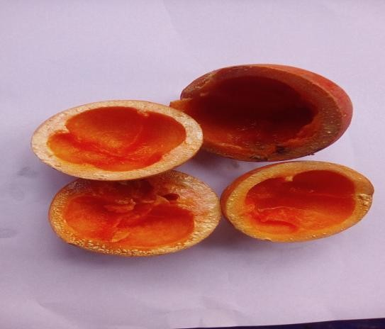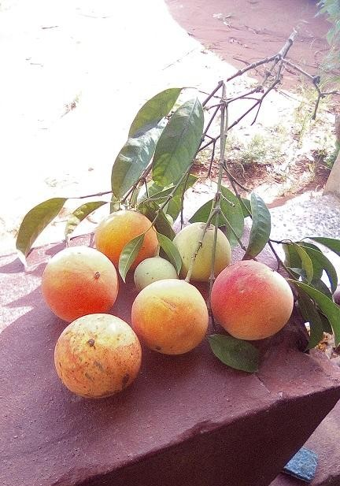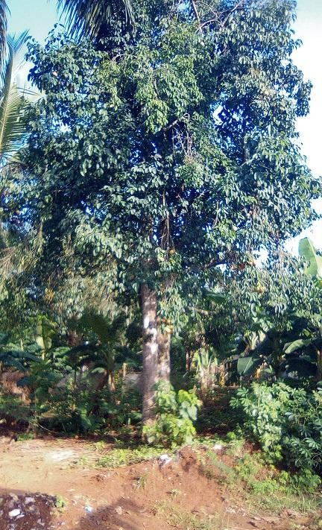Staphylococcus aureus and E. coli (Amalu et al., 2014).

Plate 2.1 Garcinia kola Plant with Fruits (Ripe and Unriped)

    - Phytochemicals Constituents of Garcinia kola

Some parts of the Garcinia kola have been reported to contain compounds and elements responsible for the medicinal properties of the plant. Garcina kola stem bark has been shown to contain a complex mixture of phenolic compounds such as tannins, guttiferin (Etkin, 1981), biflavonoids, xanthenes, benzophenone, kolaflavanone and garcinia flavanone (Iwu and Igboko, 1982) all of which have antimicrobial activity. In order to explore the mechanisms involved in the antioxidant properties of G. kola, several in vitro antioxidant parameters such as reducing property, metal chelating ability, free radical scavenging properties and inhibitory effect on lipid peroxidation were employed. G. kola ethanolic fruit extract exhibited potent antioxidant action better than the aqueous extract in a concentration dependent manner (Ogunmoyole et al., 2012). The ethanolic seed extract of G. kola has also been reported to contain phytochemicals such as tannins, saponins, flavonoids, glycosides, trepernoids and alkaloids. However, steroids and phenols were reported to be absent in the seed extract (Jackie et al., 2014). At different stages of growth and maturation (flowering, cores formation, cellular elongation, physiological maturity, gustatory maturity and merchandising) of G. kola, the mesocarp of the fruit showed the presence of alkaloids, anthocyanins, quinons, anthraquinones, flavonoids, saponins, tannins, steroids and reducing substances in Congo. These chemicals were found to be present at different levels in the various stages of development: very abundant (+++), abundant (++) and traces (+). Anthocyanins and quinones were reported to be absent in all the stages of growth and maturation (Moranbandza et al., 2013). Quantitative analysis also revealed amounts of carbohydrate, lipid, protein, potassium, copper, zinc, calcium, phosphorus, magnesium, manganese, sodium, nitrogen and ash content (Morabandza et al., 2013).
These minerals and phytochemicals play important roles in treatment and management of infectious diseases. For instance, alkaloids have been documented to possess analgesic,

antisplasmodic and bactericidal effects. Saponins are capable of neutralizing some enzymes in the intestine that can become harmful, building the immune system and promoting wound healing. Tannins hasten the healing of wounds and inflamed mucous membrane (Okwu and Okwu, 2004). Mineral such as calcium fluxes are important mediators of hormonal effects on target organs through several intracellular signaling pathways (FAO/WHO, 1998). Magnesium functions as a co-factor of many enzymes involved in energy metabolism, protein synthesis, RNA (ribonucleic acid) and DNA (deoxyribonucleic acid) synthesis, and maintenance of the electrical potential of nervous tissue and cell membranes. It also plays an important role in the metabolism of calcium (Al- Ghamdi et al., 1994).

    - Medicinal Importance of Garcinia kola

Garcina kola exhibits purgative, antiparasitic, anti-inflammatory, antibacterial and antiviral activities. In addition, the plant possesses hepatoprotective (Akintonwa and Essien, 1990), analgesic and hypoglycemic activities (Odeigah et al., 1999; Olaleye et al., 2000). G. kola enjoys a folk reputation in the management of sickle cell disease (SCD), as poison antidote (Kabangu et al., 1987, Egunyomi et al., 2009) and in the preservation of lipid food products prone to rancidity (Farombi et al., 2003).
Terpenoids have shown a great potential in treatment of disease causing microorganisms. Terpenoids have exhibited antibacterial activity against E.coli, Staphylococcus, Pseudomonas aeruginosa, Proteus mirabilis, Klebsiella pneumoniae (Piera et al., 2011 & Santo et al., 2008), methillin-resistant Staphylococcus aureus, Staphylococcus epidermidis (Santo et al., 2008), Listeria monocytogenes (Nero and Moreira, 2010), Enterobacter cloacae, yeast; Candida albicans and fungi, Aspergillus flavus (Leandro and Vargas, 2012). Methanolic seed extract of G. kola inhibited Bacillus cereus and E. coli but had no inhibitory effect on Serratia marcescens, Proteus vulgaris and Salmonella spp. as reported by Jackie et al., 2014. Antimicrobial activity of ethyl acetate, acetone, ethanol, and

methanol extract of G. kola seed was demonstrated and Streptococcus pyogenes, Staphylococcus aureus, Plesiomonas shigelloides and Salmonella typhimurium were inhibited. However, no inhibitory activity was demonstrated by the aqueous extract of G. kola seed on the tested microorganisms (Seanego and Ndip, 2012). The antimicrobial screening of the crude ethanol extract of Garcinia kola Heckel seeds showed significant activity against Staphylococcus aureus, Streptococcus mutans and Streptococcus viridans with mean zones of inhibition in comparable range with that of gentamicin (2.5μgml) used as a reference standard (Ajayi et al., 2014).

Vitex doniana

Vitex doniana (Verbanaceae) is a perennial shrub widely distributed in tropical West Africa, extending eastward to Uganda, Kenya and Tanzania in savanna and high rainfall areas. It is commonly known as Fon or Ewe oyi by traditional healers and plants sellers in Bénin; utchakiri or Mbembe (Eastern Nigeria); dinyar (Northern Nigeria) and ori nla (Western Nigeria) (Atawodi et al., 2003). It is a tree of 10 to 15 m (32 to 49 feet) in height and the leaves consist of 5 sepals. Flowers are white and sometimes stained with purple. Fruit are stone fruit which is green – dark and black when mature (looking like black olives). The fruits are also referred to as black-plum or African olive (Glew et al., 1997). V. doniana is used by traditional healers alone or in a combination with stem bark of Adansonia digitata to treat diarrhoea, leprosy and dysentery (Adjanohoun et al., 1989). The leaves are used as antiseptic and anti-diabetic, the aerial parts are used in Mali as diuretic, tonifiant, aphrodisiac and bactericide (Ouattara, 2005; Goetz, 2006). The plant has been reported to be rich in chemicals and mineral elements which are responsible for its medicinal properties.

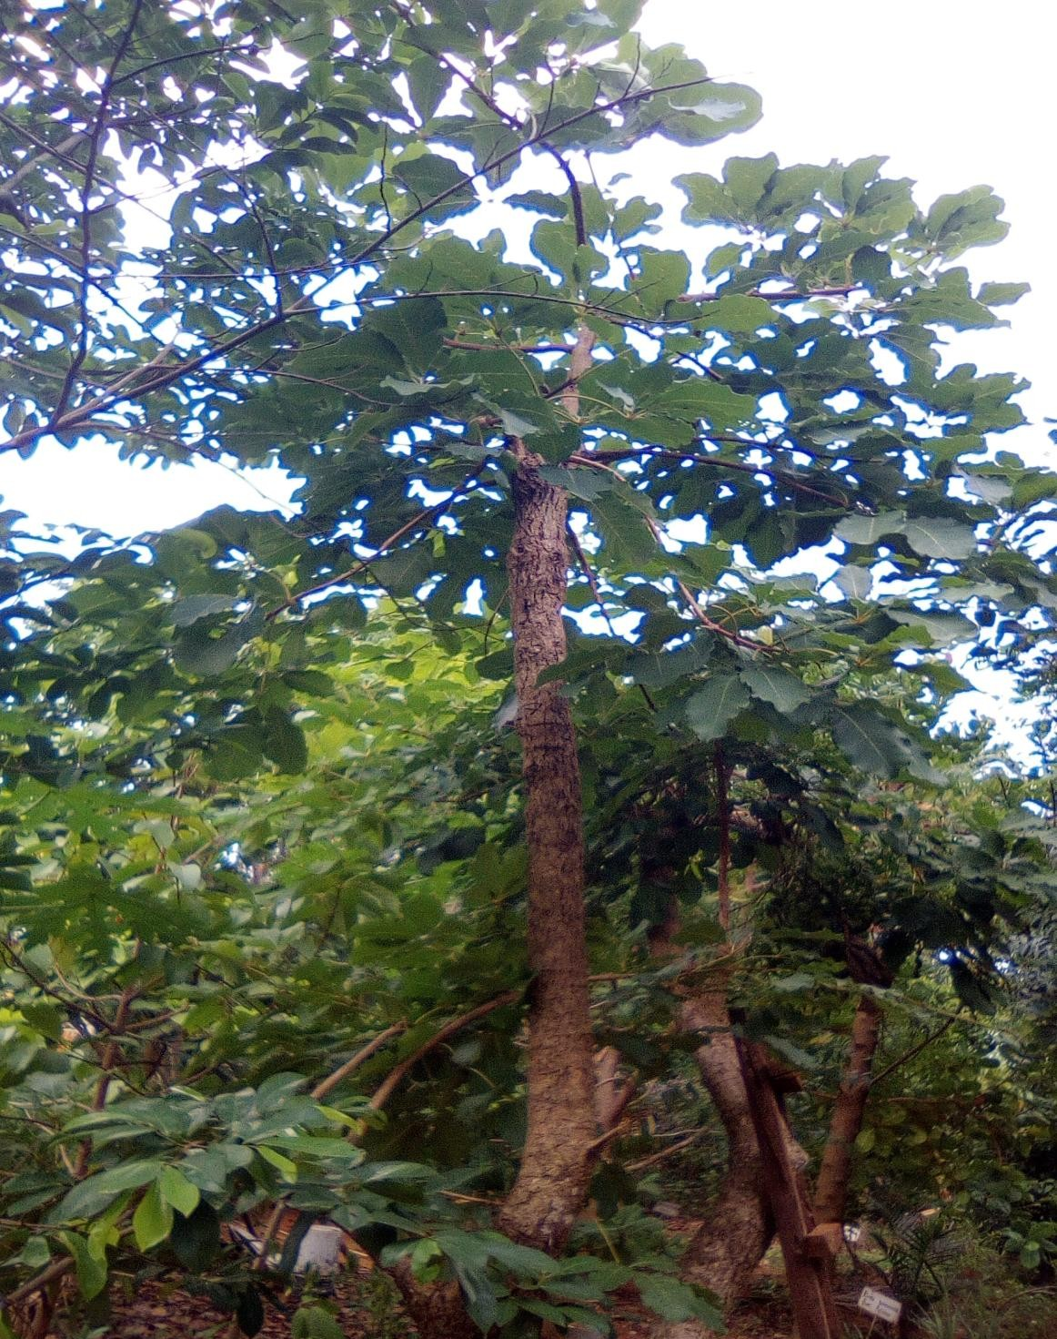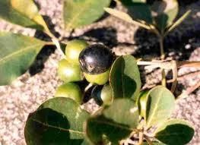

Plate 2.2: Vitex doniana Plant with Fruits (Ripe and Unripe)

    - Phytochemicals constituents of V. doniana

According to Adejumo (2013), though the bulk of the weight of V. doniana is water, leafy vegetables represent a veritable natural pharmacy of mineral, vitamins and phytochemicals. Chemical constituents of the plant include glycosides, flavonoids, alkaloids, essential fatty acid (Arokiyaraij et al., 2009). Phytochemical screening of leaves stem bark and root bark extracts of V. doniana showed the presence of glycosides, cardiac glycosides, flavonoids, saponin and tannin while the test for alkaloids, anthraquinone and steroid and Tritepenes showed negative results (James et al., 2013).

The phytochemical screening of the leaves of V. doniana on thin layer chromatography (TLC) has been performed (Lagnika et al., 2012). Thin Layer Chromatography of leaves of V. doniana revealed the presence of flavonoids, anthracene derivatives, essential oil, pigments, tannins, terpenes glycosides and triter-penes (Lagnika et al., 2012).

The presence of alkaloids, glycosides, tannin, saponins, flavonoids, carbohydrates and proteins were tested by Nwachukwu and Uzoeto, 2010 in different of V. doniana solvents (methanol, ethanol, acetone, hot water and cold water) of extract of leaves which showed their presence in various amounts. The presence of flavonoids in this plant extract explains its antioxidant activity. Flavonoids are potent water-soluble antioxidants and free radical scavengers which prevent oxidative cell damage and have strong anticancer activity. Flavonoids also lower the risk of heart diseases (Salah et al., 1995; Del-Rio etal., 1997; Okwu and Okwu, 2004).

    - Medicinal Uses of V. doniana

In ethnomedicine, V. doniana is employed in the treatment of a variety of diseases. Hot aqueous extracts of the leaves are used in the treatment of stomach and rheumatic pains,

inflammatory disorders, diarrhoea and dysentery (Irvine, 1961; Etta, 1984). The aqueous methanol extract has also exhibited anti-diarrhea activity (Agunu et al., 2005). The roots and leaves are used for nausea, colic and in epilepsy ((Bouquet et al., 1971; Iwu, 1993). In eastern parts of Nigeria, the young leaves are used as vegetable for sauces and porridge for meals. The anti-hypertensive effect of extract of the stem bark of V. doniana has been reported (Olusola et al., 1997). The extract exhibited a marked dose-related hypotensive effect in both normotensive and hypertensive rats (Olusola et al., 1997).

Extracts of stem bark of V. doniana have also demonstrated some level of in vitro trypanocidal activity against Trypanosoma brucei brucei (Atawodi, 2005). Previous study has demonstrated that 70% ethanolic, methanolic and ethyl acetate extracts of stem bark of V. doniana has proved an activity against S. aureus organism (Ouattara et al., 2013). Antimicrobial activity of leaves extract of V. doniana has been reported. Methanolic, ethanolic and acetone leaves extracts of V. doniana inhibited E. coli, S. aureus, B. subtilis and
S. typhi organisms at varying concentrations of the extracts. Hot water extract of V. doniana inhibited S. typhi even at a low concentration but had inhibitory activity against E. coli and S. aureus at a high concentration of the extract while B. subtilis was not inhibited. Furthermore, the cold water extract had no inhibitory activity against B. subtilis and S. typhi but inhibited
E. coli and S. aureus at high concentration of the extract (Nwachukwu and Uzoeto, 2010).

In another study, the antibacterial and antifungal activities of leaves extract of V. doniana were investigated and from the results obtained all extracts (methanolic, dichloromethane and water/ethanolic) inhibited the growth of E. coli, S. faecalis and S. ebony. Only water/ethanolic extract inhibited P. aeruginosa but none of the extracts inhibited S. aureus and S. epidermidis (Lagnika et al., 2012).

For the fungi, methanolic, dichloromethane and water/ethanolic leaves extracts of V. doniana inhibited sporulation and myceria development of Aspergillus flavus, A parasiticus,
A. terreus, A. ochraceus, A.nidulans and A. fumigatus (Lagnika et al., 2012).Antimicrobial activity of the V. doniana extract could be attributed to the presence of phenolic compounds that have been liked with antimicrobial properties (Kilani, 2006).

Lantana aculeata

Lantana aculeata (Lantana aculeate Linn.) is a flowering ornamental plant belonging to family Verbenaceae. L. aculeata is also known as Lantana, Wild Sage, Surinam Tea Plant, Spanish flag and West Indian lantana. The plant grows up to 1 to 3 meters and it can spread to 2.5 meter in width. Leaves are ovate or ovate oblong, acute or sub-acute, crenate serrate, rugose above, scabrid on both sides. L. aculeata whole plant and plant parts namely leaves, flowers, and essential oils have been thoroughly studied for their chemical compositions. L. aculeata is a well known medicinal plant in traditional medicinal system and recent scientific studies have emphasized the possible use of L. aculeata in modern medicine (Kalita et al., 2012). Several previous reports have described antifungal, (Tripathi and Shukla 2002; Kumar et al., 2006), anti proliferative (Saxena et al., 1992; Nagao etal., 2002) and antimicrobial activities of L. aculeata (Kasali et al., 2002; Rajakaruna et al., 2002) including germicidal activity (Verma and Verma, 2006). Moreover, the hydroalcoholic extracts of the leaves have shown an effect on fertility, general reproductive performance, and teratology in rats (Mello et al., 2005).
1

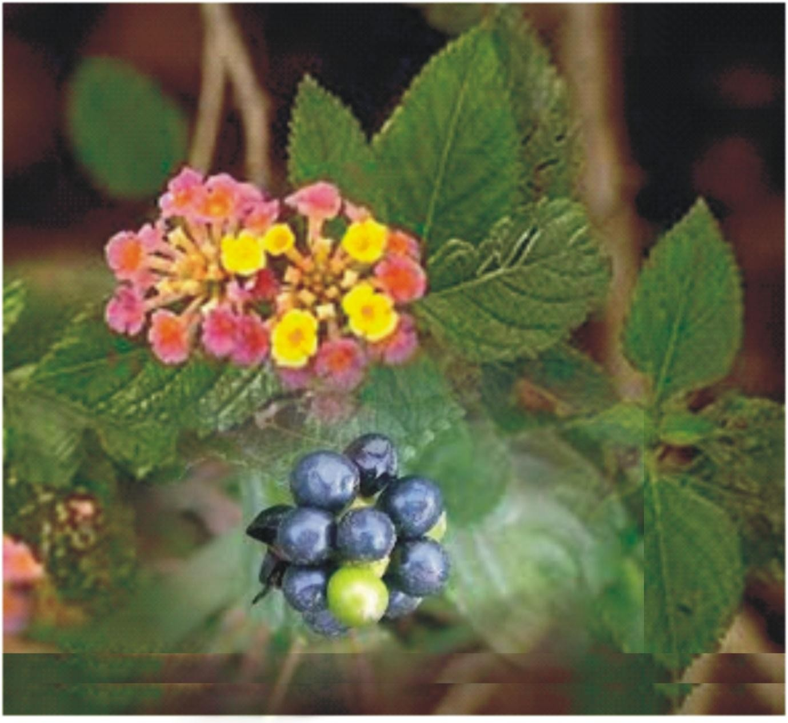

Plate 2.3: Lantana aculeate Plant (Ripe and unripe fruits)

    - Phytochemicals present in L. aculeata

Phytochemical composition of L. aculeata has been extensively studied in last few decades. Different parts of L.aculeata are reported to possess essential oils, phenolic compounds, flavonoids, carbohydrates, proteins, alkaloids, glycosides, iridoid glycosides, phenyl ethanoid, oligosaccharides, quinine, saponins, steroids, triterpens, sesquiterpenoides and tannin as major phytochemical groups (Bhakta and Ganjewala, 2009; Kensa, 2011). Sesquiterpenes with mainly ß-caryophyllene, zingiberene, -humulene, arcurcumene, gemacrene-D and bisabolene were reported as major leaf and flower essential oil constituents (Singh et al., 2002; Nagassoum et al., 1999; Khan et al., 2002; Andersson and Dobson, 2003). Chemical composition of the whole plant and plant parts and essential oils were reported to be influenced by genetic, geographical and seasonal factors as well as the developmental stages of the concerned plant and its parts/tissues (Rajakaruna et al., 2002; Bhakta and Ganjewala, 2009).

    - Medicinal importance of L. aculeata

L. aculeata is an important medicinal plant with several medicinal uses in traditional medication system. It is been used to cure many health problems in different parts of the World. Leaves are used to treat cuts, ulcers, catarrh infection, tetanus, rheumatism, malaria, cancer, chicken pox, asthma, ulcer, swelling, eczema, tumour, high blood pressure, fever, sores, measles, fevers, cold and high blood pressure. In Ghana, infusion of the whole plant is used to cure bronchitis and the powdered root in milk was given to children for stomach-ache and as a vermifuge. Lantana oil is used in the treatment of skin itches and as an anticeptic for wounds. In leprosy and scabies decoctions prepared from the plant were applied externally (Chopra et al., 1956; Kirtikar and Basu, 2006; Khare, 2007).
Different varieties of L. aculeata plants leaves and flowers were reported for antibacterial activity. Three different solvent extract of leaves and flowers of four different

varieties of L. aculeata exhibited significant antibacterial activity against E. coli, B. subtilis and P. aeruginosa whereas poor antibacterial activity was observed against S. aureus (Ganjewala et al., 2009). Ethanolic extracts of L. aculeata leaves and roots have also been reported for antibacterial activity. The extracts exhibited antimicrobial activity against S. aureus, Proteus vulgaris, P.aeruginosa, Víbrio cholareae, E. coli and two multiresistant strains E. coli and S. aureus (Barreto et al., 2010). In another report, the leaves extract of L. aculeata showed highest activity against Gram positive B. cereus and Gram negative S. typhi as compared to other bacteria tested.
Antifungal potential of L. aculeata was screened against Alternaria spp. which causes different plant diseases especially in vegetable plants. The antifungal activity was performed by food poison plate method at three different concentrations of extract which were 10 mg/ml, 15 mg/ml and 20 mg/ml. At 20mg/ml dose L. aculeata exhibited significant antifungal activity against Alternaria spp (Srivastav and Singh, 2011). Antifungal activity of ethanol and hot water extract of L. aculeata was screened against wood destroying white and brown rot fungi. Both extracts exhibited efficient antifungal activity against white and brown rot fungi, however ethanol extract had high potential at very low concentration (Tripathi et al., 2009).

Lawsonia inermis

Lawsonia inermis (Henna) is a perennial shrub native to North Africa, Asia and Australia. It is naturalized and cultivated in the tropics of America, Egypt, India and parts of the Middle East (Abdelraouf et al., 2011). It is widely distributed across the Northern and Southern parts of Nigeria (Emin and Mehmet, 2012). Henna is mostly grown in home gardens and commercial production is limited to a few places in India, Pakistan, Iran, Egypt, Libya, Niger, Nigeria and Sudan (Awek and TapapulLekoyiet, 2005). The henna plant belongs to family Lythraceae, also known as the loosestrife family and the species is

sometimes classified as Lawsonia alba Lam or Lawsonia ruba L. The plant reaches a height of up to 6 meters, and it has a fragrant white or rose-red flower (Simon et al., 1984). Several researchers have reported the different biological actions of L. inermis in various in-vitro and in-vivo test models. Henna leaves, flower, seeds, stem bark and roots have been found to exhibit antioxidant, antidiabetic, hepatoprotective, hypoglycemic, antimicrobial, anticancer and wound healing properties (Hemaet al., 2010). Due to its natural and harmless characters,
L. inermisis used as a kind of natural dye, and is used as a raw material for natural hair dyes.

In addition, Henna can be used as dyes for textile and tattoo material (Kok et al., 2005).

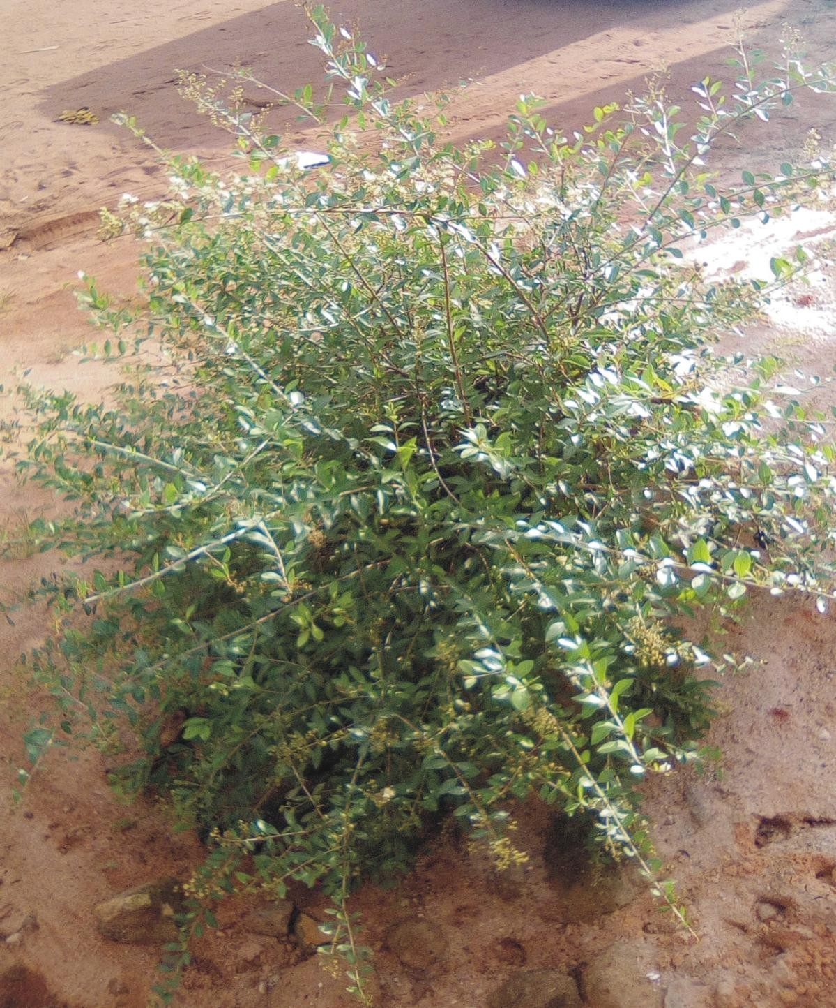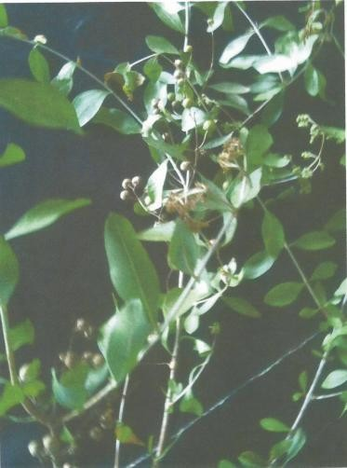

Plate 2.4: Lawsonia inermis Plant

    - Phytochemicals present in L. inermis

The principal colouring matter of henna is lawsone, 2- hydroxy-1:4 napthaquinone (C₁₀H₆O₃, m.p.190º). Besides lawsone other constituents present are gallic acid, glucose, mannitol, fats, resin, mucilage and traces of an alkaloid. Leaves yield hennatannic acid and an olive oil green resin, soluble in ether and alcohol. The leaves extract of L. inermis also contain phytochemicals such as glycosides, phytoosterol, tannins, steroidal compounds and flavonoids (Raja et al., 2013). In alcoholic extract and aqueous extract carbohydrate, glycosides, tannins, phenolic compounds and gums and mucilage were present in good quantity and saponins, alkaloids, phytosterols, fixed oils, fats, proteins, amino acids, volatile oils were absent (Arunmugam and Murugesh,1995; Mukherjee, 2002; Agrawal, 2007). The quantitative analysis of the chemical composition of aerial part of lawsonia inermis was evaluated. Total amount of flavonoids, in henna ethyl acetate extract, was higher compared to other phytochemicals. The presence of flavonoids explains the antioxidant property of this plant extract. The anthocyanins were present in higher content in ethanol extract. Tannins were present in all extracts, that is, ethyl acetate, ethanol and hot water extracts (Babili et al., 2013).
In another report, the preliminary phytochemical qualitative screening of the leaves of

L. inermis revealed the presence of 10 secondary metabolites namely; alkaloids, flavonoids, glycosides, saponins, tannins, quinines, carbohydrates, resins, sterols and lipid/fat in the fractions of both Nigerian and Egyptian henna. The various phytochemical compounds detected are known to have beneficial importance in industrial and medicinal sciences (Wagini et al., 2014).

    - Medicinal importance of L. inermis

In traditional medicine, L. inermis plant is used to treat many diseases like oedema, bronchitis, menstrual disorder, rheumatism, hemorrhoids and even in jaundice, leprosy, pain, spleen enlargement, and dysentery and skin problems (Warrier et al., 1995; Bhuvaneshwari et al., 2002; Cuong et al., 2009; Rahmoun et al., 2010). Henna can also be used as an astringent and antihaemorragic agent and is also known for its hypotensive, cardio inhibitory and sedative effects (Rahmoun et al., 2010). In addition, henna is reported to show some other properties including hypoglycemic (Syamsudin and Winarno, 2008), immunostimulant (Mikhaeil et al., 2004), hepatoprotective (Chaudary et al., 2012), anti-inflammatory (Singh et al., 1982), tuberculostatic (Sharma, 1990), anti-cancer and antioxidant properties (Kamal and Jawaid, 2010).
The extracts of Lawsonia inermis (Henna) was shown to have promising antibacterial properties against S. aureus and P. aeruginosa (Santhamari et al., 2011). The naturally available Lawsonia inermis could be a potential alternative to antimicrobials that become less effective or ineffective against certain pathogenic microorganisms (Dinesh Babu and Subhasree, 2009). Ethanol extracts of 20 plants species used by Yemeni traditional healers to treat infectious diseases were screened for their antibacterial activity against both gram positive and gram negative bacteria. The ethyl acetate extract of L. inermis leaf was found to be the most active against all the bacteria in the test system (Ali et al., 2001). Quinonic compounds from henna were studied in-vitro for antimicrobial properties (Dama et al., 1999). Genotoxic studies on lawsone suggested that it was a weak bacterial mutagen for Salmonella typhimurium strain TA98 and was more clearly mutagenic for strain TA2637. Overall, the weight of evidence suggested that henna and hydroxyl napthaquinone possess no genotoxic risk to the consumer (Kirkland and Marzin, 2003). Aqueous, methanol and chloroform crude extracts of leaf showed the in-vitro antimicrobial activity to inhibit the growth of 6 human

pathogenic fungi and 4 types of bacteria in dose dependent manner (Malekzadeh, 1968; Habbal et al., 2005; Saadabi, 2007). Another research work showed that aqueous and chloroform leaves extracts of henna were capable of inhibiting the growth of microorganisms such as S. aureus, P. aeruginosa, Streptococcus spp, Aspergillus niger and Fusarium oxysporum that are involved in causing burn wound infections. This inhibitory activity of the extract against the test organisms occurred at varying concentrations (low, mild or high concentrations of the extract) (Muhammad and Muhammad, 2005). It was also reported that methanol, aqueous, chloroform and acetone leaves extracts of L. inermis inhibited the activity of S. aureus, B. subtilis, S. typhi, S. epidermidis, E. coli, Klebsiella sp and Shigella spp (Gull et al., 2013).
During screening of barks of 30 plant species against Microsporum gypseum and Trichophyton mentagrophytes, only L. inermis Leaf extract exhibited absolute toxicity. The extract showed broad fungitoxic spectrum when tested against 13 ring worm fungi. Furthermore, the fungitoxicity of the extract remained unaltered at high temperature on autoclaving and after long storage (Singh and Pandey, 1989). Ethanol, methanol and aqueous extract of leaf of L. inermis are involved in defensive mechanism against spore germination of Drechslera oryzae (Natarajan and Lalithakumar, 1987). Ethanol leaves extract of L. inermis showed significant antifungal effect against phytopathogenicfungi. Ethanol extract could be used as alternative source of antifungal agents for protection of plants or crops against fungal infection (Anwar et al., 2007).

Cnestis ferruginea

C. ferruginea (Connaraceae) is a shrub or climber of deciduous forest and secondary scrubled widely dispersed in West Africa and other tropical parts of Africa and bears orange- red fruits with velveting hairs on the follicle (Burkill, 1995; Irvin, 1961; Margaret, 1965; Ronal, 1974). Common names of the plant in Nigeria include “Fura amarya”, “otito” (Hausa);

“Okpu nkita”, “amunkita” (Igbo); and “Akara oje”, “Bonyin bonyin” (Yoruba); “Ukpo- ibieka” (Edo) and “Usiere ebua” (Efik) (Burkill, 1995). The plant is about 3.0-3.6m high with densely, rusty brown, pubescent branches, indecidous leaves with more or less alternate or sometimes opposite, ovate to narrowly oblong leaflets. The ovoid follicles are 1-5 in fruit, often united at base and contain one see ach (Garonn et al., 2007). The plant has an ornamental value and is used across tropical Africa to treat diverse ailments. Different parts and preparations of C. ferruginea have been reported to be used in traditional African medicine for the treatment of various conditions (Ishola and Ashorobi, 2007; Burkill, 1985).

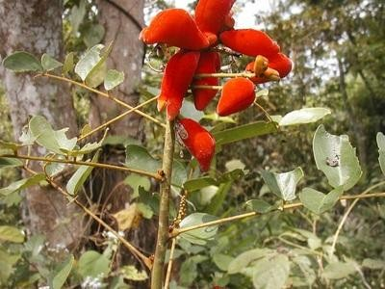

Plate 2.5: Cnestis ferruginea Plant with Fruits

    - Phytochemicals present in C. ferruginea

C. ferruginea is rich in bioactive-constituents. The petroleum ether fraction of C. ferruginea fruit has been shown to contain constituents such as octacosanyl stearate and 1- myristo-2-stearo-3-palmitin (Ogbechie et al., 1987) and a novel isoflavone glycoside, aformosin-7-O-beta-D-galactoside with antimicrobial activity was isolated in the fruit testa (Parvez and Rahman, 1992). Other compounds such as squalene, myricyl alcohol, β- sitosterol, cyaniding, delphinidin and apigenidin (Ogbede et al., 1986) have been isolated from the plant. Studies have shown that aqueous root extract of C. ferruginea contained alkaloids (24.6 mg/L), flavonoids (14.6 mg/L) and saponins (4.6 mg/L) (Yakubu et al., 2011).

    - Medicinal uses of C. ferruginea

C. ferruginea has been acclaimed in herbal medicine and some literatures to have diverse therapeutic uses such as the management of conjunctivitis, bronchitis, tuberculosis, migraines, sinusitis, and oral infection (fruits); snakebite, dysentery, syphilis, gonorrhea, cough, dysmenorrheal, anaemia, ovarian troubles and aphrodisiac (roots); abortion, constipation, fever and pain (leaves) (Gill, 1992; Okafor and Ham, 1999). The fruits are used locally for the treatment of tooth-ache, mouth and skin infections (Boakye-Yiadom and Konning, 1975). The fruits have been reported to have antimicrobial effects especially against Gram-positive bacteria, (Lewis and Elvin-Lewis, 2003), while the aqueous root extract has been reported to possess anti-stress and laxative activities (Ishola and Ashorobi, 2007; Yakubu et al., 2011). The methanolic root extract has been reported to possess analgesics and anti-inflammatory activity (Ishola et al., 2011). The stem bark (commonly used as chewing stick in Nigeria) and fruit extracts of C. ferruginea have been shown to possess antibacterial activity against S. aureus, S. sublitis, E. coli and P. aeruginosa (Kizito et al.,2005)

In another report, treatment with C. ferruginea ethanol leaf extract recovered the injured liver of mice to normal after 72 hours at dose of 400mg/kg body weight. This indicated that C. ferruginea has anti-hepatotoxic effect. The possible antihepatotoxic mechanism of C. ferruginea has not been reported yet. It was assumed that the effect of C. ferruginea ethanol leaf extract on liver protection is related to glutathione-mediated detoxification as well as free radical suppressing activity (Akharaiyi et al., 2012). Antibacterial efficacy of crude aqueous, ethanol and petroleum ether extracts of Cnestis ferruginea leaf, stem bark and roots were assayed against nine clinical bacterial isolates namely P. aeruginosa, E. coli, S. aureus, K. pneumoniae, B. cereus, Shigella dysenteriae, Campylobacter jejuni, a β-hemolytic group, A. Streptococcus, and S. typhi. The leaf extracts had higher inhibitory effects at various degrees than the stem bark and root extracts. Considerable antioxidant activities were found in the plant extracts (Akharaiyi et al., 2012; Oke and Hamburger, 2002).
Treatment with C. ferruginea extract reversed the hyperandrogenaemia and attenuated the irregular estrous cycle in Polycystic Ovarian Syndrome (PCOS)-induced rats. Saponins and flavonoids present in the plant are considered responsible for the clinical benefits of C. ferruginea roots in the management of PCOS (Yakubu and Ibiyo, 2013). It has also been suggested that C. ferruginea leaves contain a highly potent hypoglycaemic principle and could be a potential source for isolation of new orally active antihyperglycaemic compounds for attenuating secondary complications of diabetes such as atherosclerosis, liver and renal dysfunction (Adisa et al., 2010). The aqueous extract of C. ferruginea root at the doses of 13, 26 and 52mg/kg body weight restored sexual competence at least to a reasonable extent in sexually impaired/sluggish male rats with the highest dose producing the best efficacy (Yakubu and Nurudeen, 2012). It has also been suggested that prolonged administration of crude root extract of C. ferruginea may induce anaemia.

Pterocarpus soyauxii

Pterocarpus soyauxii is a 30-55 feet high rain forest tree. It belongs to the Papilionaceae family, branch of spermaphytes (Burkill, 1995). The plant stem bark, grey- brown to brown-coloured, scales off in fine irregular scales and contains a red sap. It is commonly known as African Padauk and has a high hygroscopic stability, and good natural durability due to its extractives (Deon et al., 1980). Other common names are mukwa or narra. The scientific name is Latinized Ancient Greek and means “wing fruit”, referring to the unusual shape of the seed pods in this genus. It contains about 13% extractives, which were abundantly used as a dye-source in the 19th century (Deon et al., 1980) In previous report, attempt has been made to investigate the feasibility of employing the natural dye extracted from P. soyauxii as a sensitizer for Titanium dioxide (TiO₂) thin films. This is because natural dyes enable efficient sensitization without complex synthetic and purification process. Titanium dioxide is most commonly used as photoanode in dye sensitized solar cells, which is nontoxic and possesses good optical and electrical properties thus can be efficiently sensitized by a dye (Rajalakshmi et al., 2013). Various parts of this plant are used in Africa for the treatment of different diseases and this is attributed to the presence of phytochemicals and minerals in the plant extract (Oteng-Gyang and Mbachu, 1987; Kimpouni, 1999; Okafor, 1999; Sarah, 1999).

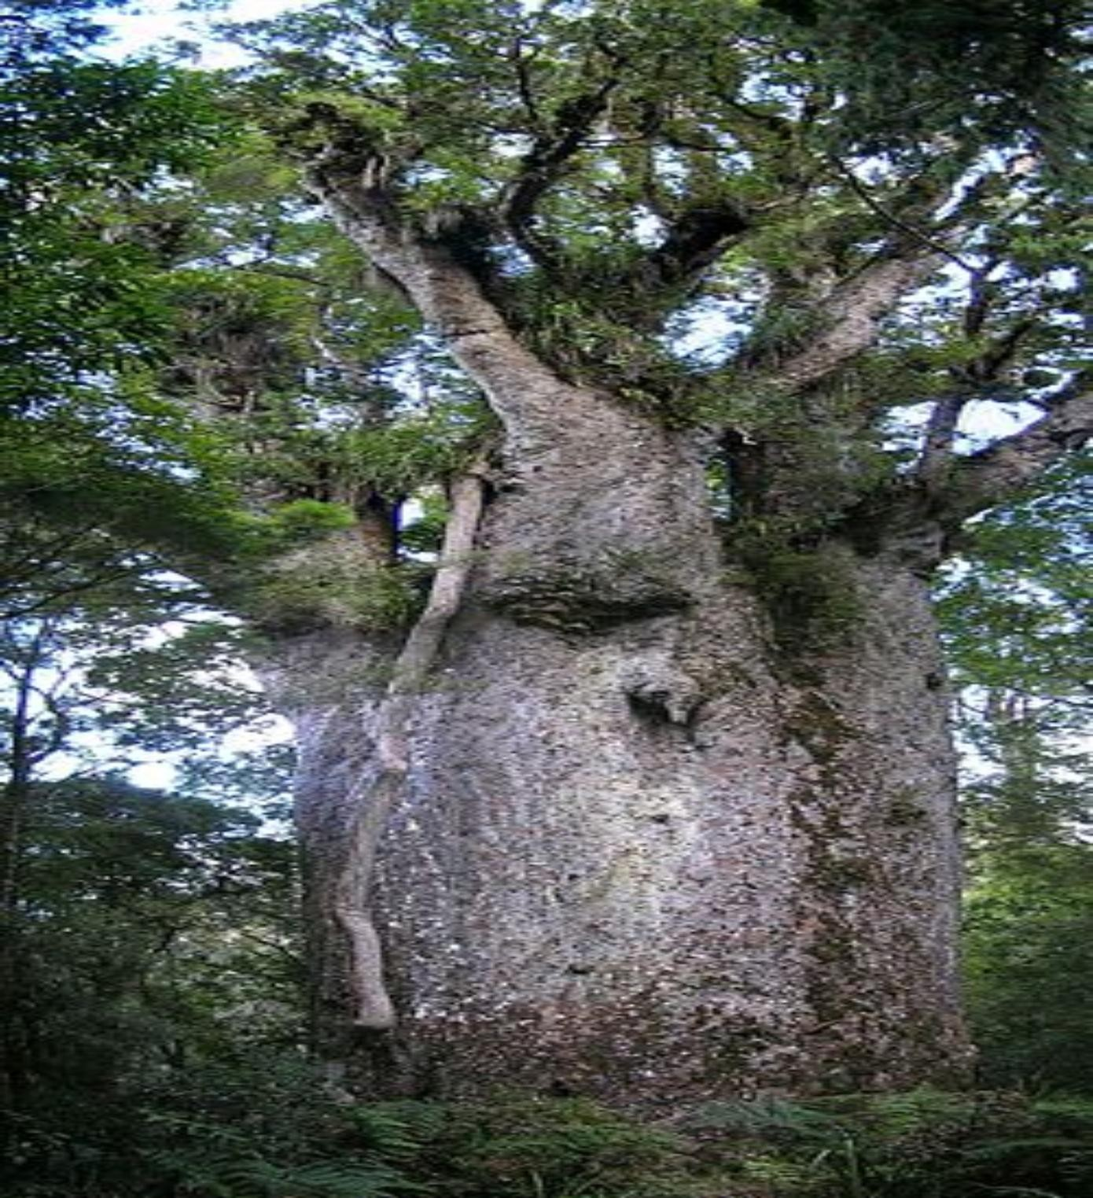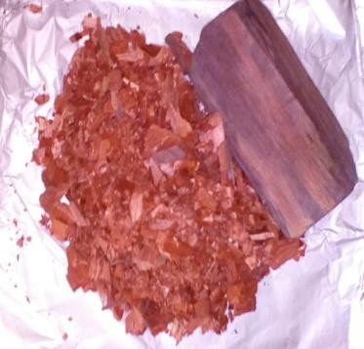

Plate 2.6 Pterocarpus soyauxii tree and stem.

    - Phytochemicals in Pterocarpus soyauxii

The usefulness of plant based products in medicine is due to the presence of bioactive substances such as alkaloids, tannins, flavonoids, phenolic compounds, steroids, resins and other secondary metabolites which they contain and are capable of producing definite physiological action in the body. Pterocarpus soyauxii contains various compounds such as biflavonoids (Santalin A, Santarubins A and B), isoflavonoids (pterocarpin, formononetin and prunetin) an isoflavone, quinine (claussequinone), isoflavanes (vestitol and mucronulatol), tannins, ascorbic acid, glucosides, triterpenes, xanthones (Banerjee and Mukkherjee, 1981; Bezuidenhoudt et al., 1987; Kiec-Swierczynska et al., 2004).

    - Medical importance of Pterocarpus soyauxii

Leaves, wood, stem bark, seed and flowers are used in African traditional medicine, especially in the Cameroonian pharmacopoeia, for treating various diseases including hypertension, diabetes, intestinal parasites, renal and cutaneous diseases. Bark is used as diuretic in Gabon and fresh leaves are also used as food in Nigeria (Oteng-Gyang and Mbachu, 1987; Kimpouni, 1999; Okafor, 1999; Sarah, 1999). The leaves of P. soyauxii are also used as vegetables in food preparation and the plant‟s fruit is edible (F.A.O, 1990; Osuagwu, 2008). Previous reports have shown that P. soyauxii possess antimicrobial activity. The ethanolic fresh and older leaves extract of this plant inhibited E. coli, S. typhi, S. flexneri,
S. aureus, K. pneumonia, and C. albicans with zone of inhibition range of 3.00-11.75mm (Osuagwu and Akomas, 2013). It was also reported that Listeria monocytogenes was isolated from P. soyauxii leaves. However, the frequency of occurrence of L. monocytogenes in Solanum macrocarpon and Telferia occidentalis plant is greater than that of P. soyauxii. It is not commonly in contact with the soil, unless during harvesting, handling. Generally, the presence of the pathogen in the test vegetables raises enough concern due to its recorded high pathogenicity (Nwachukwu et al., 2010).

Susceptibility of Plant Extracts on Pathogenic Microorganisms

The research into the discovery of new potent drugs from plants is based on the use of plant bio principles from extracts and essential oil to treat infection or diseases caused by pathogenic organisms (Eleazu et al., 2012). Though pharmacological industries have produced a number of new antibiotic and antifungal agents in the last three decades, resistance to these drugs by microorganisms has also increased. In general, bacteria and fungi have the genetic ability to transmit and acquire resistance to drugs, which are utilized as therapeutic agents. This increasing prevalence of multi-drug resistant strains of microbes has led to the presence of strains with reduced susceptibility to antimicrobial agents which has raised the specter of „untreatable‟ microbial infections and adds urgency to the search for new infection-fighting strategies (Zy et al., 2005). Research on antimicrobial activity of medicinal plants including G. kola, L. aculeata, V. doniana, L. inermis C. ferruginea and P. soyauxii has emerged and previous reports have shown that plant extracts have the property of inhibiting these microorganisms.
Plant also contains pigment which can serve as a natural source of dye for staining of microorganisms, thus, aiding in their identification and characterization. Some of the pathogenic microorganisms are discussed briefly.

Escherichia coli

Escherichia coli as a commensal organism inhabiting human and animal intestinal tract can cause a variety of extra-intestinal infections when it enters into unnatural sites (Sharma et al., 2007). The ability of E. coli to cause extra-intestinal infections depends largely on several virulence factors which help to survive under adverse conditions (Banu et al., 2011). Escherichia coli strains that induce extra-intestinal infections are termed as extra- intestinal pathogenic E. coli (ExPEC) (Russo and Johnson, 2000). Several variants have been

demonstrated to cause infection of the gastrointestinal system (intestinal pathogenic E. coli) while others cause infections outside the gastrointestinal system (extra-intestinal pathogenic
E. coli or ExPEC) (Kaper et al., 2004).

    - Pathogenicity of E. coli

The presence of several putative virulence genes has been positively linked with the pathogenicity of ExPEC. Phylogenetic analyses have shown that intestinal E. coli and ExPEC falls into four main phylogenetic groups namely A, B1, B2, and D (Herzer, 1990). ExPEC isolates exhibit considerable genome diversity and possess a broad range of virulence- associated factors including toxins, adhesions, lipopolysaccharides, polysaccharide capsules, proteases, and invasions that are frequently encoded by pathogenic islands and other mobile DNA islands. It is involved in the production of enterotoxins, haemolysins, colicins, haemagglutinins, colonization factors and cell surface hydrophobicity (Kausar et al., 2009). It seems that these putative virulence factors contribute to fitness (for instance iron-uptake systems, bacteriocins, proteases, adhesins) of ExPEC and increase the adaptability, competitiveness, and ability to colonize the human body rather than being typical virulence factors directly involved in infection (Mulvey et al., 2005).

Susceptibility and Resistance of E. coli to Antibiotics

The treatment of E. coli infections is increasingly becoming difficult due to development of resistance against antibiotics (Mathur et al., 2002). Until the late 1990s ExPEC were relatively susceptible to first line antibiotics. However, several surveillance studies during the 2000s across Europe, North and South America have shown that between 20 and 45% of ExPEC are resistant to first line antibiotics including the cephalosporins, fluoroquinolones, and trimethoprim–sulfamethoxazole (Foxman, 2010). It is necessary to know the antibiotic susceptibility pattern of pathogenic E. coli to select the correct

antibiotic(s) for the proper treatment of the infections (Sharma et al., 2007). Previous studies have shown that E. coli is susceptible to nitrofurantoin, norflaxocin, gentamicin and ciprofloxacin antibiotics (Kibret and Abera, 2011). There is also need to search for newer, more effective, affordable and readily available sources, in particular, from local medicinal plants (Okunola et al., 2012). Plants are the most naturally effective and cheapest sources of drugs. Extract from G. kola has been reported to have inhibitory activity against E. coli and this was attributed to the presence of terpenoids (phytochemical) in the plant extract (Piera et al., 2011). Methanolic, ethanolic and acetone leaf extracts of V. doniana inhibited E. coli, at varying concentrations of the extracts (Nwachukwu and Uzoeto, 2010).

Pseudomonas aeruginosa

Pseudomonas aeruginosa is a gram negative, asporogenous, obligate aerobic, motile and oxidase positive bacilli that belongs to the group of γ-Proteobacteria. It possesses a remarkable metabolic versatility and is categorized as a facultative anaerobe, achieving anaerobic growth by using nitrogen as a terminal electron acceptor in the absence of oxygen. It is usually found in the intestinal tract, water, soil and sewage (Kerr and Snelling, 2009; Kung and Ozer, 2010; Rice et al., 2012). It is an opportunistic pathogen that is a common cause of hospital-acquired infections, particularly infecting patient with predisposing factors, such as burn victim, immunocompromised hosts or those with metabolic disorders. Infections as a result of P. aeruginosa are rare in otherwise healthy individuals but common in the compromised, such as patients with cystic fibrosis (CF), severe burns, or those with impaired immunity as seen in patients infected with human immunodeficiency virus (HIV) or in cancer patients undergoing chemotherapy (Wagner et al., 2008).

    - Pathogenicity of Pseudomonas aeruginosa

The pathogenesis of Pseudomonas aeruginosa is multi-factorial and depends on numerous virulence factors, including the secreted factors such as elastase, alkaline protease, exotoxin, pyocyanin, pyoverdine, hydrogen cyanide, rhamnolipid and cell associated factors, such as lipopolysaccharide, flagella and pili (Kung and Ozer, 2010). Another factor contributing to pathogenesis of P. aeruginosa is its tendency to form organized communities, known as biofilms. Expression levels are dependent on a variety of determinants, particularly environmental stimuli (such as iron and nitrogen availability, temperature, osmolarity and cell density) (Balasubramanian et al., 2013). These virulence factors have a predominant role in colonization, where they help bacteria to adhere and invade the host by damaging their immune responses and forming a barrier to antibiotics (van Delden and Iglewski, 1998).

    - Susceptibility and Resistance of P. aeruginosa to Antibiotics

Pseudomonas aeruginosa is also associated to antibiotic resistance phenomena, as a significant number of strains show innate and acquired resistance against a wide range of antimicrobial agents (for example: β-lactams, aminoglycosides, fluoroquinolones, cationic peptides), leading to difficulty in treating infections (Piña and Mattingly, 1997). As few new drugs are available to combat P. aeruginosa infections, there has been a return to the use of older drugs such as polymyxins that had previously fallen out of favour due to wide reports of toxic side effects (Livermore, 2002). Given its ubiquitous habitat, metabolic versatility, and complex regulatory controls, it is unlikely that P. aeruginosa will ever be completely eliminated from hospital settings; hence, tried and true methods of prevention and early intervention are likely to remain the most effective methods of treatment for at least the foreseeable future (Gellatly and Hancock, 2013). A safer and perhaps, more effective source of therapy against P. aeruginosa bacterium have been reported. The source of the emerging choice of therapy is plant extract. Plants have the major advantage of being the most effective

and cheaper alternative sources of drugs (Pretorious and Watt, 2001). Antibacterial activity of plant extracts against P. aeruginosa has been investigated. For instance, extract from G. kola has been reported to have inhibitory activity against P. aeruginosa (Piera et al., 2011).

Staphylococcus aureus

The genus Staphylococcus is composed of Gram-positive bacteria with diameters of 0.5-1.5 μm, characterized by individual cocci that divide in more than one plane to form grape-like clusters (Kloos and Bannerman, 1994). These bacteria are non-motile, non-spore forming facultative anaerobes, featuring a complex nutritional requirement for growth (Kloos and Schleifer, 1986; Wilkinson, 1997; Plata et al., 2009). The genus Staphylococcus is traditionally divided into two groups based on the bacteria ability to produce coagulase, an enzyme that causes blood clotting: the coagulase-positive staphylococci (CoPS), which includes the most known species Staphylococcus aureus; and the coagulase-negative staphylococci (CoNS), which are common commensals of the skin. Staphyloccocus aureus is the most frequently occurring bacterial pathogen among clinical isolates from hospital inpatients in the United States and is the second most prevalent bacterial pathogen among clinical isolates from outpatients (Styers et al., 2006). It often, asymptomatically, colonizes the skin and mucous membranes of healthy individuals, in particular the anterior nares (Harris et al., 2002; Wertheim et al., 2005). Due to the importance of S. aureus infections and the increasing prevalence of antibiotic-resistant strains, this bacterium has become the most studied staphylococcal species (Costal et al., 2013).

    - Pathogenicity of S. aureus

Various virulence factors contribute to the ability of S. aureus to cause infection; enzymes (catalase, coagulase, hyaluronidase, nuclease protease and staphylokinase), toxins, adhesion proteins, cell-surface proteins, factors that help the bacteria to evade the innate

immune defense, and antibiotic resistance mediate survival of the bacteria and tissue invasion at the site of infection (Zecconi and Scali, 2013). The survival of S. aureus in the host is important for pathogenesis. The bacteria may be protected by a polysaccharide capsule that inhibits opsonization by complement and thereby escapes phagocytosis (O'Riordan and Lee, 2004). It may also secrete cytolytic toxins and tissue-cleaving enzymes (Dinges et al., 2000).
S. aureus has developed strategies against the antimicrobial peptides, the complement system, and the recruitment and actions of phagocytes (Chavakis et al., 2007) all of which are strategies against the innate immune response of the host (Foster, 2005; Rooijakkers et al., 2005).

Susceptibility and Resistance of S. aureus to Antibiotics

A key factor for the success of S. aureus as a pathogen is its remarkable capacity to acquire antibiotic resistance. Therefore, from a clinical point of view, the major problem that physician has to face when treating S. aureus infections is antibiotic resistance, due to the likelihood of therapeutic failure and consequently poor prognostic (Otto, 2012). Staphylococcus aureus is resistant to cephalosporins, methicillin, vancomycin, and linezolid (Jansen et al, 2006).
Numerous guidelines for the prevention and management of S. aureus exist, but these are not uniform in their recommendations. A combination of aggressive antibiotic therapy and removal of the source of infection are central to the management of S. aureus The appropriate antibiotic for S. aureus is determined by numerous factors, including the antibiotic susceptibility of the infecting strain, the source of infection, the presence of endocarditis or other metastatic sites of infection, and patient factors, including underlying co morbidities, concurrent medication, and antibiotic allergies (Mitchell and Howden, 2005). It has been demonstrated that S. aureus is susceptible to ampicillin and co-trimoxazole antibiotics (Kitara et al., 2011). These synthetic drugs have some side effects that can cause damage to organs

or tissues of the body. There is need therefore, to seek for alternative source of therapy (Aruljothi et al., 2014). The local use of natural plants as primary health remedies, due to their pharmacological properties, is quite common in Africa, Asia, and Latin America (Bibitha et al., 2002).These plants have been proven to possess antimicrobial properties against pathogenic organisms. For example, antimicrobial activity of ethyl acetate, acetone, ethanol, methanol extract of G. kola seed was demonstrated and Staphylococcus aureus was inhibited (Seango and Ndip, 2012; Ajayi et al., 2014). Piera et al., 2011 reported that G. kola has inhibitory activity against P. aeruginosa.

Klebsiella pneumoniae

Klebsiella pneumoniae is part of the family Enterobacteriaceae and is a rod-shaped, Gram-negative bacterium most commonly encountered by physicians worldwide as a community-acquired and a hospital-acquired pathogen. Unique biochemical characteristics that enable identification of this bacterium in clinical and environmental samples are production of urease and citrate, lack of ornithine decarboxylase and motility, inability to produce indole, and ability to ferment glucose and lactose (Mehling et al., 2007).

    - Pathogenicity of K. pneumoniae

Pathogenesis of K. pneumoniae is multifactorial and contains several well studied virulence factors that include capsular polysaccharide, lipopolysaccharide, type 1 and type 3 fimbriae, and siderophores.The presence of the capsule is critical for the virulence of K. pneumoniae (Macpherson, 2000). The capsule inhibits phagocytosis by macrophages and neutrophils and binding of serum anti-microbial factors such as complement to the bacterial membrane (Hornick, 1991; Podschun, 2001).

    - Susceptibility and Resistance of K. pneumoniae to Antibiotics

Treatment of serious infection with extended-spectrum β-lactamase (ESBL) producing K. pneumoniae is difficult because the organisms are frequently resistant to multiple antibiotics. Strains of Klebsiella including K. pneumoniae are naturally resistant to aminopenicillins (ampicillin and amoxicillin) and carboxypenicillins (carbenicillin and ticarcillin) and other penicillins. However, in vitro, ESBL-producing organisms may sometimes appear to be susceptible to combination therapy with β-lactams or β-lactamase inhibitor. Klebsiella isolates remain generally susceptible to quinolones, trimethoprim- sulfamethoxazole, and aminoglycosides (Watanabe et al., 1980; Stock and Wiedemann, 2001; Bouza and Cercenado, 2002). A new source of therapy has also been reported to possess antibiotic activity against K. pneumoniae. This new source of therapy which is medicinal plants is cheap and has reduced side reactions compared to synthetic drugs during treatment. The medicinal properties of plants have been attributed to the presence of phytochemicals and mineral elements. Plant extract has been reported to inhibit microorganisms including klebsiella species. Previous research has shown that extract from
G. kola inhibited K. pneumoniae (Piera et al., 2011).

Proteus mirabilis

The genera Proteus are motile, Gram-negative rods with peritrichous flagella and are assigned to the Enterobacteriaceae family. They are characterized by their ability to oxidatively deaminate phenylalanine and in most cases hydrolyze urea (Moltke, 1927; Wenner and Retger, 1919; Farmer et al., 1977). Unusual features include the ability of Proteus species to differentiate into swarmer cells upon colonization of solid surfaces. P. mirabilis is the type species of the genus Proteus and by far the most extensively studied member of this genus probably because it the most pathogenic. Proteus mirabilis is widely

distributed in the environment and has been isolated from the intestinal tract of mammals, birds and reptiles. It is a common inhabitant of the human gastrointestinal tract. Proteus mirabilis may also colonize the urinary tract under certain circumstances, where it is considered an opportunistic pathogen and one of the principal causes of UTIs in hospital patients with indwelling urinary catheters (Manos and Belas, 2006).

    - Cell Differentiation and Swarming P. mirabilis

One significant phenotypic characteristic shared by members of the genus Proteus is the ability to transform into a distinctive “swarmer” cell when cultured on a solid agar- containing medium (Allison and Hughes, 1991; Belas, 1992; Williams and Schwarzhoff 1978). When grown in liquid media, the cells exist as 1.5–2.0μm rods with 6–10 peritrichous flagella (called “swimmer”cells) and exhibit characteristic swimming and chemotactic behaviour, moving away from repellents and towards attractants (Allison et al., 1993; Lominski and Lendrum, 1947). Transfer of swimmer cells onto a solid growth medium, such as that containing agar, results in a remarkable physiological and morphological transformation of the bacteria. Shortly after contact with the surface, the swimmer cells begin to differentiate into a morphologically and biochemically unique cell known as “the swarmer cell”.

    - Pathogenicity of P. mirabilis

Several potential virulence factors of Proteus had been studied in relation to its virulence and pathogenicity of urinary tract, including hydrolysis of urea by urease, cell invasiveness, cytotoxicity induced by hemolysins, cleavage of immunoglobulin (Ig) A and IgG by proteolytic enzyme and adherence to the uroepithelium mediated by fimbriae (Coker et al., 2000). Virulence factors of P. mirabilis bacterium (adhesins, toxins, invasins, protein secretion systems, iron uptake systems, and others) may be encoded on chromosomal DNA,

bacteriophage DNA, plasmids, or transposons (Johnson et al., 2003) in particular regions of the prokaryotic genome termed pathogenicity islands (PAIs).There were many proposed mechanisms and influencing factors for the invasive properties of P.mirabilis (Korn et al., 1995). Microbial invasion could be facilitated by the various virulence factors, microbial adherence, and resistance to antimicrobials. Bacterial proteins with enzymatic activity (for instance; protease, hyaluronidase, neuraminidase, elastase, and collagenase) facilitated local tissue spread in the pathogenicity of P. mirabilis. Microbial adherence to surfaces helps microorganisms such as P. mirabilis establish a base to penetrate tissues and this is facilitated by the pilli. The ability of P. mirabilis to express virulence factors, including urease and haemolysin, and to invade human urothelial cells, is coordinately regulated with swarming differentiation (Allison et al., 1992; Liaw et al., 2000, 2001 and 2004).

    - Susceptibility and Resistance of P. mirabilis to Antibiotics

Proteus mirabilis is intrinsically resistant to nitrofurantoin and tetracycline, but it is naturally susceptible to β-lactams, aminoglycosides, fluoroquinolones, and trimethoprim- sulfamethoxazole (O‟Hara et al., 2000). Drug resistance has been increasingly reported for this species, and the diffusion of resistance to extended β-spectrum cephalosporins due to the production of extended-spectrum -lactamases (ESBLs) has become of great concern (Spanu et al., 2002). Studies from the United States, Canada, United Kingdom, and other European countries revealed that susceptibility of P. mirabilis isolated from different sources can vary widely. For example, susceptibility to β-lactam/β-lactamase inhibitors (ampicillin/sulbactam or amoxicillin/clavulanate), ciprofloxacin, and third generation cephalosporins (cefotaxime, ceftriaxone, or ceftazidime) ranged 74 to 94%, 60 to 90%, and 90 to 99%, respectively, depending on patient population and specimen type (Bouchillon et al., 2013; Horner et al., 2014; Sader et al., 2014).A new source of therapy has been reported to be active against P. mirabilis, being the most extensively studied species of Proteus and probably the most

pathogenic. Ethanolic extracts of L. aculeata leaves and roots have also been reported for antibacterial activity. The extracts exhibited antimicrobial activity against Proteus species and other bacteria such as S. aureus, P. aeruginosa, Víbrio cholareae and E. coli (Barreto et al., 2010). Terpenoids (phytochemical present in G. kola) have shown a great potential in treatment against disease causing microorganisms such as Proteus mirabilis (Piera et al., 2011).

Candida albicans

Candida species are asexual yeasts of the genus ascomycetes and genetically diploid with the presence of eight chromosomes. Out of more than 200 species of Candida, the most commonly encountered in medical practices are C. albicans, C. dubliniensis, C. glabrata, C. krusei, C. parapsilosis, and C. tropicalis. About 8-15% of nosocomial blood stream infections are reported to be caused by Candida species (Pfaller and Diekema 2002). Candidal infections are a serious problem in individuals with weakened immune defense. Interestingly, C. albicans differs from other medically important fungi such as Histoplasma capsulatum, Aspergillus fumigatus, and Cryptococcus neoformans in rarely being isolated from soil. Therefore, infections caused are categorized as endogenous and not exogenous as with others. C. albicans and related species have been isolated from several body locations as a carrier in the oral cavities, gastrointestinal tract, anus, groin, vaginal canal, and vulva of healthy people, and may attain sufficiently high density without symptoms of disease. Among these, C. albicans was predominant at all body locations (70%) while C. glabrata and C. tropicalis make up 7% (Odds, 1988).

    - Pathogenicity of C. albicans

Like other fungal pathogens, C. albicans also regulates expression of certain genes and their products as virulence factors to produce disease. This is the most common

opportunistic pathogen, utilizing several kinds of virulence factors. Some of the commonly studied virulence factors in C. albicans are adhesins, morphogenesis, phenotypic switching, the action of secreted enzymes (such as phospholipases and proteinases) and biofilm formation.
Adherence of candidal cells to host tissues is a complex multi-factorial phenomenon utilizing several types of adhesins expressed on morphogenetically changing cell surfaces (Hawser and Douglas, 1994; Hoyer, 2001). Morphogenesis in C. albicans is defined as transition from unicellular yeast form to filamentous form (pseudohyphae or hyphae). Of all the species only
C. albicans and C. dubliniensis are able to undergo morphogenesis. Unlike other pathogens, phenotypic switching in Candida is pleitropic by affecting several phenotypic and metabolic parameters, with subsequently a number of virulence traits such as secreted aspartyl proteinases (SAP) gene regulation. This allows Candida to adapt to a different host environment during infection (Soll, 1992; Soll, 2002). Enzymes such as Phospholipases (PL) hydrolyze ester linkages of glycophospholipids and hence impart tissue invasiveness to Candida cells. Secretion of proteinases by pathogen is also mandatory in order to degrade the tissue barriers and obtain nutrition at the infection site. Secreted aspartyl proteinases (SAPs) from Candida have been reported and shown to be involved in hydrolysis of many proteins such as albumin, hemoglobin, keratin, collagen, laminin, fibronectin, mucin, salivary lactoferin, interleukin1b, cystatin A, and Ig A (Hube et al., 1998).
Biofilm is also a virulent factor found in Candida species. Biofilm formation is initiated by irreversible adherence of microbial cells to tissues or devices and followed by growth and maturation to form a mesh of cells with altered phenotype, growth rate, and gene expression compared to planktonic cells. Biofilms are the organized structures involving microbial communities that are attached to some inanimate surfaces or tissues and circumvented in a matrix of exopolymeric materials. Studies with scanning electron microscopy of biofilms

revealed the presence of both adherent yeast cells and invasive hyphal forms constructing basal and upper layers respectively, enclosed in an extracellular polymer matrix consisting of polysaccharides and proteins and forming a three-dimensional structures with water channels (Dominic et al., 2007). These forms differ in ultra-structure, physiological behaviour and composition of cell walls, and are required for candidal pathogenicity, as mutants lacking genes for any one became less virulent both in vitro and in vivo (Chandra et al., 2001). Heterogenecity of these biofilms depends on the substrate composition, environmental conditions, and type of strains involved.

Susceptibility and Resistance of C. albicans to Antifungal Drugs

Diseases caused by Candida species are generally referred to as candidiasis. There are different types of candidiasis; oral, cutaneous, Vulvovaginal and systemic candidiasis. Management of candidiasis depends on the site of infection (Dabas, 2013). Oropharyngeal candidiasis may be treated with either topical azoles (clotrimazole troches), oral azoles (fluconazole, ketoconazole, or itraconazole), or oral polyenes (such as nystatin or oral amphotericin B (Shokohi et al., 2010). Topical agents including azoles, over-the counter (OTC) clotrimazole, OTC butoconazole, OTC miconazole, OTC tioconazole, terconazole, nystatin, oral azoles (ketoconazole), itraconazole and fluconazole (Nyirjesy, 2008). Boric acid administered vaginally is also effective for the treatment of Vulvovaginal candidiasis. Cutaneous candidiasis infections may be treated with any number of topical antifungal agents (clotrimazole, econazole, miconazole, ketoconazole, ciclopiroxolamine sulconazole and oxiconazole). Oral itraconazole is the drug of choice as a pulse therapy (Mistiaen and van Halm-Walters, 2010). In the management of Systemic candidiasis, starting treatment with either an echinocandin or fluconazole is recommended for clinically stable patients. Amphotericin B deoxycholate or a lipid-associated formulation of amphotericin B may be used in acutely ill patients or patients with refractory disease (Eggimann et al., 2011). The in

vitro susceptibility of some fungi to different concentrations of extract from both fresh and dried leaves of Carica papaya was investigated. Only the aqueous extract of the fresh leaves was potent against the fungi isolates used in the study. Candida albicans, Aspergillus flavus and Trichophyton metagrophytes were the only fungi inhibited by the aqueous extract of the fresh leaves with the plate of A. flavus producing the widest zone of inhibition (Alabi et al., 2012).
Antimicrobial drug resistance is an important biological phenomenon that has a considerable impact on animal and human health. The prevalence of clinical drug resistance has increased in recent decades with the greater use, and abuse, of otherwise efficacious antimicrobial agents. Antimicrobial resistance is not restricted to bacteria, however, and in the 1990s fluconazole treatment failure emerged due to the development of resistance by the fungal pathogen Candida albicans (White et al., 1998). The mechanisms by which C. albicans can become resistant to antifungal drugs have been reviewed (Sanglard and Bille, 2002; Akins, 2005). Resistance of clinical isolates to 5-FC most often correlates with mutations in the enzyme uracil phosphoribosyltransferase that prevent the conversion of 5- fluorouracil to 5-fluorouridine monophosphate. Resistance of C. albicans to polyenes is rare and can be caused by a reduction in the amount of plasma membrane ergosterol, to which polyenes bind. Mutations in ERG3, which lower the concentration of ergosterol in the membrane, cause amphotericin B resistance and also confer resistance to azoles (Cannon et al., 2007). A new source of therapy has also been reported to possess antifungal activity against Candida albicans species. This new source of therapy which is medicinal plants is cheap and has reduced side reactions compared to synthetic drugs during treatment. Plant extract has been reported to inhibit microorganisms including fungi. Previous research has shown that Terpenoids (phytochemical present in G. kola) have shown a great potential in

treatment against disease causing microorganisms. Terpenoids have exhibited antifungal activity against Candida albicans and Aspergillus flavus (Leandro and Vargas, 2012).

Aspergillus niger

Aspergillus species are saprophytic moulds which live in the environment without causing disease. Aspergillus niger, exist freely in nature but causes a lot of death and sickness and can be dangerous agent to man as it cause opportunistic infections in HIV infected individuals (Sumathy et al., 2010). Other species causing infection include Aspergillus fumigatus and A. flavus. Diseases caused by Aspergillus include allergic bronchopulmonary aspergillosis. Allergic bronchopulmonary aspergillosis (ABPA) is a pulmonary disorder caused by immunologic reactions to antigens released by A. fumigatus which colonizing the airways of patients with asthma and cystic fibrosis. Invasive aspergillosis occurs mainly in immunocompromised patients, and is often life-threatening. Aspergillus infection of nasal sinuses is very common in some parts of the world, for example, Indian sub-continent. Aspergillus species can also cause superficial infections of the external ear and occasionally infect the eye (Tillie-Leblond and Tonnel, 2005; Cheesbrough, 2006; Agarwal, 2009).

    - Pathogenicity of A. niger

The primary route of infection with Aspergillus is via the inhalation of airborne conidia and deposition in the bronchioles or alveolar spaces. The average size of A. fumigatus conidia (2 to 3µm) is ideal for infiltrating deep into the alveoli, whereas larger conidia of other human pathogens including A. flavus and A. niger could be removed more easily by mucociliary clearance of the upper respiratory tract. Furthermore, A. fumigatus is more thermotolerant than other disease-causing species, growing well at 37°C and withstanding temperatures above 50°C, such as those encountered in decaying vegetation, a frequently inhabited niche. It has been speculated that growth at high temperatures may induce the

expression of unique stress response genes that confer additional virulence benefits, although evidence for this theory is lacking (Dagenais and Keller, 2009).

    - Susceptibility and Resistance of Aspergilus niger to Antifungal Drugs

Therapeutic options for aspergillosis are limited, particularly for oral formulations, with azole drugs forming the backbone of therapy (Walsh et al., 2008). Many patients that develop resistant infections fail treatment, so resistance is an important factor in the outcome of these cases (Howard et al., 2009). Azole resistance has predominantly been reported for A.fumigatus, the species which accounts for approximately 80% of invasive infections (Messer et al., 2006). The majority of azole resistant A. fumigatus isolates studied to date have been found to contain an alteration in the target protein sterol 14 α-demethylase (Cyp51), potentially inhibiting drug binding. These structural changes are as a result of single nucleotide polymorphisms in the gene (cyp51A) encoding the protein leading to amino acid substitutions. It has become necessary to search for other source of antifungal drugs because of increased resistance of the available convectional drugs used over the years. Plant extracts have been reported to possess antifungal activity as demonstrated by other researchers. For instance, methanolic, dichloromethane and water/ethanolic leaves extracts of V. doniana inhibited sporulation and myceria development of Aspergillus flavus, A parasiticus, A. terreus, A. ochraceus, A.nidulans and A. fumigatus (Lagnika et al., 2012).

Natural Source of Stain for Microorganisms

Stains are generally used to add colour to microbes, spores, plant tissues and animal tissues to make them optically distinct and the technique is known as staining. Most stains in current use are chemically synthesized from petroleum sources and are widely available at an economical price and produce wide variety of colour (Ihuma et al., 2012). However, they cause skin allergies and other harms to human body on exposure and produce toxic waste.

The use of non-allergic and non-toxic stains has become a matter of significant importance due to the increased environmental awareness in order to avoid some hazardous synthetic ones. Despite the biotechnological advance in medical science today, biological stains are vital in laboratory diagnosis and different staining methods remains an important simple diagnostic tool in diagnostic and research laboratories (Goodarzian and Ekrami, 2010). Extracts obtained from natural sources such as plants, animal, vegetable sources, insects and soil hold promise as a potential source of cheaper stains. Over 2000 dyes are synthesized from various parts of more than 500 dye-yielding plant species, of which only about 150 have been commercially exploited (Ihuma et al., 2012). Stains are mostly salts, comprising a base and an acid. They are classified into acid, base and neutral stains. The theory of staining reaction is not fully understood but it is generally believed to be a combination of chemical and physical reactions. Microbial cell which is rich in nucleic acid has affinity for basic stains and so it is stained by the basic stain. The acid stain is useful for basic components and as a background stain to give a good contrast. There are basically three methods of staining: simple, differential and special staining. Gram and Acid-fast Staining techniques are examples of differential staining methods (Ochei and Kolhatkar, 2008).

CHAPTER THREE MATERIALS AND METHODS
  - SAMPLING TECHNIQUE

Six indigenous plants were used which were collected across three different states in the Southern region of Nigeria, namely: Edo, Delta and Anambra states. The plants are Garcinia kola, Vitex doniana, Lantana aculeata, Lawsonia inermis, Cnestis ferruginea and Pterocarpus soyauxii. The six plants were collected as follows: Lawsonia inermis leaf and Lantana aculeata leaf were collected from Benin- city in Edo State, Cnestis ferruginea fruit was obtained from Obiarukwu town in Delta State, Garcinia kola fruit, Pterocarpus soyauxii stem and Vitex doniana leaf, stem and fruit were collected from Agulu and Nnewi in Anambra State. The six plants‟ parts were collected from the month of July to December, 2014. The mesocarp of G. kola was obtained from the G. kola fruits purchased from Mr Godwin Okafor‟s compound in Okofia, Otolo, Nnewi, in Anambra State. The Vitex doniana fruit was also purchased from Afor Mbaukwu, Awka South Local Government Area while the stem and leaf was purchased from a farmer in Nneogidi (Anaocha Local Government Area). Pterocarpus soyauxii stem was purchased at Ogbaru market in Onitsha. These locations are in Anambra state. Cnestis feruginea fruit was collected from the forest located along Amai road, Obiarukwu in Ukwuani Local Government Area of Delta State. Lawsonia inermis leaves was collected in Benin City. Lantana aculeata leaf and fruit were collected locally from the University of Benin premises, Ekenwan Campus, Benin City. The plant parts were labelled with their local names and were transported in a sack bag to Plant Biology and Biotechnology Department, University of Benin for proper identification. Plants were washed in clean water and distilled water and were kept on the table in laboratory for eight weeks to dry and were ground into powder form using a grinding machine.

Plant Identification And Authentication

Plants collected were identified and authenticated by Plant Taxonomists (Prof J. F. Bamidele and Dr H. A. Akinibosun) at Plant Biology and Biotechnology Department University of Benin using their local names and standard texts. Samples of plants were deposited in the herbarium of the Department of Plant Biology and Biotechnology University of Benin. Their Voucher numbers are as follows: UBH365 (Garcinia kola), UBH366 (Vitex doniana), UBH367 (Lantana aculeata), UBH368 (Lawsonia inermis), UBH369 (Cnestis ferruginea) and UBH370 (Pterocarpus soyauxii).

Ethical Approval

Ethical approval was sought for and obtained from the Ethical Committee, Hospitals Management Board, Benin City, Edo state and Ethical Committee, Faculty of Health Sciences and Technology, Nnamdi Azikiwe University, Nnewi Campus, Nnewi.

Study Area:

The study was carried out in Nnewi Campus of the Nnamdi Azikiwe University, Awka, Anambra State. Nnewi which is located on latitude 6º 01‟ 10.63” N and Longitude 6º 55‟ 2.24 E, is the second largest city in Anambra State, South Eastern Nigeria. Their population is 193,987 dwellers. The ethnic group in the area is majorly Igbo and the people are known for trading and manufacturing of cars and motocycles.

Study Site

Analysis of the plants‟ parts was carried out in the Faculty of Pharmaceutical Sciences premises, Nnamdi Azikiwe University, Awka, Nigeria.

Extraction

Fully automated Soxhlet solvent extraction technique was used for the extraction of the six plants using ethanol and methanol.
Procedure: 500 g of each pulverized plants were weighted and wrapped in a filter paper no. 42 (120 mm) and is placed inside the timble, the timble was placed in the soxhlet extractor. The organic solvents ethanol is heated to reflux, and as it boiled, the solvent vapour travel up the distillation arm and flood into the chamber housing the timble containing, the pulverized plant when the chamber is filled with warm solvent, some of the desired compound dissolved in the warm solvent (ethanol) when the soxhlet chamber is almost full, the chamber, automatically emptied by a siphon side arm with the ethanol solvent running back down the distillation flask. The cycle was repeated many times over hours and days. During each cycle, a portion of the non-volatile compounds dissolves into the solvent. After many cycles, the desired compounds are concentrated in the distillation flask. After extraction, the solvent was removed and concentrated using a Rotary evaporator yielding the extracted compound.
The filtrates were evaporated using rotary evaporator and were finally concenterated to dryness using water bath at a temperature of 50ºC (Dada and Ikuerowo, 2009). The crude extracts were weighed after extraction, placed in an air-tight and water-proof container and kept in a refrigerator at 4ºC.

Fractionation

Solvent-Solvent fractionation technique was done using Ethylacetate, N-hexane and N-butanol.
Procedure: 120 g of the plant crude extract was dissolved in small quantity of water (20 ml) and water and then made up to 250 ml with organic solvent (methanol). The extract was partitioned exhaustively stating with Non polar (N – hexane) 250 ml for four times, followed

by 250 ml of moderately polar solvent (Ethyl acetate) for three times and the 250 ml of polar solvent (N-butanol) for two times. The remaining fraction is the aqueous extract. After the partitioning, the whole fractions were concentrated using water bath and then preserved in the refrigerator at 4ºc.

Phytochemical Analysis

Qualitative Analysis of Constituents as reported by (Okwu and Omodamiro 2005) was followed in the analysis.

Test for Tannins

To 2 g of the pulverized plants‟ of G. kola, V. doniana, L. aculeata and L. inermis, C. ferruginea and P. soyauxii, 20 ml of water was added in separate tests tubes and boiled for 5min and filtered. A few drops of 0.1% ferric chloride was added and observed. A brownish green precipitate developed.

Test for Saponins

Two grams (2 g) of the powdered G. kola, V. doniana, L. aculeata and L. inermis, C. ferruginea, and P. soyauxii respectively was boiled in 20 ml of distilled water in a water bath and filtered. Ten mililiters of (10 ml) of the filtrate was mixed with five mililiter (5 ml) of distilled water and shaken vigorously for a stable resistant froth. The frothing was mixed with three (3) drops of olive oil, shaken vigorously and then observed on standing. There was a stable froth with formation of emulsion.

Test for Flavonoids

Five mililiters (5 ml) of ten per cent (10%) ammonia solution was added to a portion of the aqueous filtrate of pulverized plants of G. kola, V. doniana, L. aculeata, L. inermis, C. ferruginea, and P. soyauxii,1ml of 1% concentrated sulphuric acid (H₂SO₄) was added, a yellow colour developed.

Test for Cardiac Glycosides

Five grams (5 g) of extracts of G. kola, V. doniana, L. aculeata, L. inermis, C. ferruginea, and P. soyauxii respectively was treated with two mililiters (2 ml) of glacial acetic acid containing one (1) drop of ferric chloride solution (0.1%). This was underlayed with one mililiter (1ml) of concentrated sulphuric acid (H₂SO₄₎. Brown ring was formed on the interface indicating the presence of deoxysugar characteristics of cardenolides.

Test for Terpenes

The Lichermann-Burchard method was used for the test. The plants samples of G. kola, V. doniana, L. aculeata, L. inermis, C. ferruginea and P. soyauxii respectively was mixed in different test tubes with one mililiter (1ml) of acetic anhydride and one mililiter (1 ml) of concentrated Sulphuric acid (H₂SO₄₎ was dropped down the wall of the test tube, a layer was formed underneath the tube. A reddish violet colour developed indicating the presence of terpenes (Sofowora, 1993).

Test for Sterols `

The Salkowski‟s method was used to test for sterols. The plants extracts of G. kola, V. doniana, L. aculeata, L. inermis, C. ferruginea, and P. soyauxii respectively was mixed with one mililiter (1 ml) of concentrated sulphuric acid (H₂SO₄) carefully dropped by the side of the test tube to form a thin layer underneath. A reddish brown colour developed indicating the presence of a steroidal ring (Sofowora, 1993).

Quantitative Analysis of the Constituents

    - Determination of Alkaloid (Harbone, 1973).

The gravimetric method of Harborne (1973) was used in the determination of total alkaloid content of the samples. Five gram (5 g) of the dried plants was dispersed into fifty mililiters of (50 ml) of ten per cent (10%) acetic acid solution in ethanol. The mixture was

thoroughly mixed, and allowed to stand for four (4) hours before filtering. It was evaporated to one quarter of its original volume, drops of concentrated ammonium hydroxide was added to precipitate the alkaloids. The precipitate was filtered off with a pre-weighed filter paper and washed with one per cent (1%) of ammonium hydroxide solution. The precipitate was oven dried for thirty (30 min) minutes at sixty degree (60⁰C) and reweighed. The alkaloid contents of the samples were determined by difference using the equation:
Percentage of Alkaloid = W₂-W₁ × 100

W

Where W = weight of sample; W₁ = Weight of empty filter paper; W₂ = Weight of paper + precipitate.

Determination of Saponin Content (AOAC 2000)

Saponin determination was done using the method of AOAC (2000). Saponin extraction was done using two different solvents. The first solvent, acetone, was used to extract crude lipid from the samples while the second solvent (methanol) was used for the extraction of the saponin. Two gram (2 g) of the sample was folded into a thimble and put in a soxhlet extractor and a reflux condenser fitted on top. Extraction was done with acetone in a two hundred and fifty centimetre cubic (250 cm³) capacity round bottomed flask for three hours (3 h), after which the apparatus was dismantled and another one hundred and fifty (150 cm³) capacity round bottomed flask containing one hundred mililiters (100 ml) of methanol was fitted to the extractor and extraction was carried on for another three (3 h) hours. The weight of the flask was taken before and after the second extraction in order to make the change in weight. At the end of the second extraction, the methanol was recovered by distillation and the flask was oven-dried to remove any remaining solvent in the flask. The flask was then allowed to cool and the weight of the flask taken. The saponin content of the sample was calculated as shown below:

% Saponin = Weight of Saponin × 100

Weight of Sample

Determination of Tannin Content (AOAC, 2000).

The percentage composition of tannin in the plant extracts was determined using the AOAC methods (2000). Folin-Denis reagent and saturated Na₂CO₃ were prepared in accordance with the procedure to analyze the tannin content. Standard solution of tannic acid was freshly prepared by dissolving ten milligram (10 mg) of tannic acid in one hundred mililiters (100 ml) of water. A series of tannic acid standard were prepared in the range of zero to two point five (0-2.5 ml) aliquots in twenty five (25 ml) volumetric flasks. Folin- Denis reagent (1.25 µl) and Na₂CO₃ solution were then added. The mixture was made up to the volume and the colour was measured after thirty minutes (30 min) at seven hundred and sixty nanometer (760 nm) using a spectrophotometer (Perkin Elmer). The samples were prepared by boiling one gram (1 g) of their dried powder in eighty mililiters (80ml) of water for thirty (30 min) minutes. The samples were cooled, transferred into an hundred mililiters (100 ml) volumetric flask and diluted to mark. The solution was filtered to get a clear filtrate and analyzed as the standard. Tannin content was determined by a tannic acid standard curve and expressed as milligrams of tannic acid equivalence (TAE) per hundred grams (100 g) of dried sample.

Determination of Flavonoid Content (Boham and Kocipai, 1994).

Ten grams (10 g) of pulverized plants parts were extracted repeatedly with a hundred mililiter (100 ml) of eighty per cent (80%) aqueous methanol at room temperature. The whole solution was filtered through Whatman filter paper number forty-two (no.42; 125 mm). The filtrate was later transferred into a crucible and evaporated to dryness over a water bath and weighed (Boham and Kocipai, 1994).

Proximate Analysis A.O.A.C. (2000).

Proximate analysis of the six indigenous plants‟ parts was carried out according to the procedure of the Association of Analytical Chemist (A.O.A.C., 2000). This constitutes the measurement of different classes of food such as carbohydrate, protein, fat, fiber, ash content and moisture content.

Determination of Ash Content (A.O.A.C., 2000)

Procedure: A gram (1 g) of the pulverized six plants was transferred into hot weighed crucible (W₁). This was place in a muffle furnace (Gallenkamp modex sxl) and Ash the material at 500ºC over night.The hot crucible with ash (W₃). Calculation:
Ash% = (W₃ + C₂) – (W₂ + C₁) x 100 W₁ x DM%

Where: W₁ = Weight of air dried sample W₂ = weight of empty dried same crucible W₃ = Weight of crucible + ash
C₁ = Correction for W₂, read from the balance (due to hot weight) C₂ = Correction for W₃ from that balance (due to hot weight).

Determination of Moisture Content (A.O.A.C., 2000)

Procedure: Hot empty crucibles were weighed (W2) and 10 g of pulverised plant parts respectively was transfered into it. The samples were placed in the crucible in an oven (Gallenkamp) at 105ºC over night. The weights of hot crucibles with dried plants matter were taken (W3).
Calculation: Dry matter % = (W₃ + C₂) – (W₂ + C₁) x 100
W₁
Where W₁ = Weight of air dried plants powder W₂ = Weight of empty dried crucible

W₃ = Weight of crucible + oven dried plant powder
C1 = Correction for W2, read from the balance (due to hot weighing) C2 = Correction for W3 (due to hot weighing)

Determination of Carbohydrate
Glucose stock standard solution was dissolved in 400 g of anhydrous glucose in 500 ml Prepared glucose standard solutions include 0, 2.5, 5.0, 7.5, 10 and diluted to 50ml with distilled water.
Procedure: Two mililiters (2 ml) of carbohydrate extract was added to two mililiters (2 ml) of glucose working standard solution into test tubes. 10 ml of anthrone reagent was added to samples and the standard was mixed thoroughly by shaking. The tubes were loosely covered with a glass stopper and were immediately placed in a boiling water bath for 20 min. It was allowed to cool and read at absorbance of 620 nm.
Calculation of percentage carbohydrate

CHO% = 20 (Ab – a)
b x w x Dm%

CRUDE PROTEIN DETERMINATION (A.O.A.C., 2000)

- Reagents (a) Kjeldahl catalyst (9K₂SO₄:ICuSO₄)

(b) H₂SO₄ (c) 40% NaOH

(d) 0.2N HCL (e) Tashiro indicator

- Method: Plants samples were placed in a digestion flask, 5 g of Kjeldahl catalyst was added to 200 ml of conc. H₂SO₄. A tube containing the aforementioned chemicals except the sample (as blank) was prepared and heated in an inclined position until frothing ceased. The mixture was boiled briskly until solution became clear and then cooled. Six hundred mililiters (600 ml) of distilled water was then added cautiously. The flask was connected to the

digestion bulb on a condenser and with the tip of the condenser immersed in standard acid, 5- 7 drops of mixed indicator was added into the receiver, the flask was rotated to mix the content thoroughly. The content of the flask was heated until all the NH₃ was distilled. The receiver was removed. The tip of the condenser was washed. Excess standard acid distilled with NaOH was titrated.

Calculations:

Protein = (%)

Where, A= volume (ml) of 0.2N HC1 used in sample titration B Volume (ml) of 0.2N HC1 used in blank titration
N= Normality of HC1 W= weight of sample 14.007= atomic weight of nitrogen
6.25 = the protein conversion factor

Analytical HPLC

Pump: P 580A LPG Dionex

Autosampler: ASI-100T (injection volume = 20 μL) Dionex

Detector: UVD 340S (Photodiode array detector) Dionex

Column oven: STH 585 Dionex

Column: Eurospher 100-C18, [5 μm; 125 mm × 4 mm] Knauer Pre-column: Vertex column, Eurospher 100-5 C18 [5-4 mm] Knauer
Software: Chromeleon (V. 6.30)

HPLC-MS

Analytical HPLC: Agilent 1100 series (Photodiode array detector) Agilent

MS: Finigan LCQ-DECA Thermoquest

Ionizer: ESI and APCI Thermoquest

Vacuum pump: Edwards 30 BOC

Column: Eurospher 100-C18, [5 μm; 227 mm × 2 mm] Knauer Pre-column: Vertex column, Eurospher 100-5 C18 [5−4 mm] Knauer

METHOD

Analytical High Pressure Liquid Chromatography (HPLC)

The fractions were subjected to analytical HPLC. In the HPLC an efficient separation is achieved by passing a mobile phase through a column using high pressure pumps. Analytical HPLC was used to identify peaks from fractions, and to evaluate the purity of isolated compounds. The different components in the mixture were passed through the column at different rates due to differences in their partitioning behaviour between the mobile liquid phase and the stationary phase. The solvent gradient used started with 10:90 (MeOH: nanopure water (adjusted to pH 2 with phosphoric acid) increasing to 100% MeOH in 45 min and run till 60 min. The compounds were detected by an UV-VIS diode array detector (UVD340S, Dionex Softron GmbH, Germering, Germany).
About two miligram (2 mg) of each of the dried fractions were reconstituted with 2 ml of HPLC grade methanol sonicated for ten minutes (10 min), centrifuged and filtered. One hundred microliter (100 μL) of the filtrate containing dissolved samples was each transferred into HPLC vials containing 500 μL of HPLC grade methanol. HPLC analysis was carried on the samples with a Dionex P580 HPLC system coupled to a photodiode array detector (UVD340S, Dionex Softron GmbH, Germering, Germany). Detection was at 235, 254, 280

and 340 nm. The separation column (125 × 4 mm; length × internal diameter) was prefilled with Eurospher-10 C18 (Knauer, Germany), and a linear gradient of nanopure water (adjusted to pH 2 by addition of formic acid) Methanol was used as eluent.

Electron Spray Ionisation Mass Spectrometry (LC-ESI-MS)

Fractions which showed presence of high concentration of phenolic compounds and pigments from the HPLC results were subjected to Liquid Chromatography-Electrospray ionization Mass Spectroscopy (LC/ESI-MS) using a ThermoFinningan LCQ-Deca mass spectrometer (Germany) connected to an UV detector. The samples, prepared in the same way as for HPLC analysis, were injected to the HPLC/ESI-MS set up. A solution of the sample is then sprayed at atmospheric pressure through a 2-5 kV potential. HPLC was run on a Eurospher C-18 (6 x 2 mm, i.d.) reversed phase column. The mobile phase was 0.1% Formic acid solution in nanopure water (A), to which MeOH (B) was added by a linear gradient. The flow rate was at 400 µL/min and the absorbance detected at 254 nm. ESI (electrospray ionization) was performed at a capillary temperature of 200⁰C and drift voltage of 20eV. MS/MS experiments were also carried out on the molecular ion to obtain daughter ions which are diagnostic of the compounds. The constituents were determined by comparison of the molecular and fragments ions with literature values.

Estimation of Total Phenolic Content (Kim et al., (2003) with modification)

Total phenolic content in the extracts were determined using Folin-Ciocalteu (F-C) method with gallic acid as standard. The various absorbances were measured at 760nm of different concentrations of the gallic acid standard (Table in Appendix IV), The absorbance values obtained at the different concentrations were used to plot a calibration curve (Figure in Appendix IV). Total phenolic content of the extracts were calculated from the regression

equation of the calibration curve (Y = 0.00705x+0.02878; R2 = 0.997) and expressed as mg gallic acid equivalents (GAE) per gram of sample in dry weight (mg/g).
The total phenolic content of the extract were determined using the method described by Kim et al., (2003) with modification. 1 ml of the extract (0.1 mg/ml) was mixed with 0.2ml of Folin-Ciocalteu‟s phenol reagent. After 5 min, 1 ml of 7.6% Na₂CO₃ solution was added to the mixture followed by the addition of 2ml of deionised distilled water. The mixtures (in triplicate) were incubated at 40ºC for 30 min after which the absorbance were read at 760nm. The total phenolic content was determined from extrapolation from calibration curve which was made by preparing gallic acid solution and expressed as milligrams of Gallic acid equivalents (GAE) per g of the extract.

Test for Antioxidant Property

DPPH (2, 2-diphenyl-1-picrylhydrazyl) Radical Scavenging Activity Method

This was carried out according to the DPPH spectrophotometric method of Mensor et al. (2001). The concentration of extract and standards (gallic acid and ascorbic acid) used was 300μg/ml. One ml of a 0.3 mM DPPH methanol solution was added to 2.5 ml solution of the extract or standards and allowed to react at room temperature for 30 minutes. The absorbance (Abs) of the resulting mixture was measured at 518 nm and converted to percentage antioxidant activity (AA%) using the formula:
AA% = 100 – [(Abs of extract/Abs of control) × 100]

Methanol (1.0 ml) plus extract solution (2.5 ml) was used as a blank. 1 ml of 0.3 mM DPPH plus methanol (2.5 ml) was used as a negative control. Solutions of ascorbic acid and gallic acid served as positive controls.

Isolation of Bacteria and Fungi from Clinical Samples

Isolates of Morganella morganii, Staphylococcus aureus, Escherichia coli, Pseudomonas aeruginosa, Streptococcus pneumoniae, Proteus mirabilis, Klebsiella pneumoniae, Candida albicans and Aspergillus niger were all clinical isolates obtained from the Central Hospital and Stella Obasanjo Hospital Benin City, Edo State. Pure isolates were obtained by culturing on the respective selective media. Biochemical tests were performed to identify tests isolates. Fresh plates of test bacteria were made from the isolate cultures obtained on agar slants. Discrete colonies of fresh cultures of the different bacterial isolates were then picked and suspended in 5 ml Nutrient broth in well labelled sterile bottles and incubated at 37°C prior to antimicrobial susceptibility testing. Fungal species namely C. albicans and A. niger were similarly treated, but cultured on Sabouraud dextrose medium.

Test Organisms

Ten (10) strains of both Gram negative and Gram positive bacteria (Morganella morganii, Pseudomonas aeruginosa, Klebsiella pneumoniae, Bacillus subtilis, Staphylococcus aureus, Streptococcus pneumonia Escherichia coli, Proteus mirabilis, Staphylococcus aureus (ATCC 25923) and Salmonella typhi (ATCC 14028) and three fungal strains (Aspergillus niger, Candida albicans and Candida albicans (ATCC 10231) were used in this study.

Test for Antimicrobial Activity

Antimicrobial activity of the ethanolic plants extracts of G. kola mesocarp, V. doniana stem, fruit and leaf, L. aculeata leaf, L. inermis leaf, C. ferruginea fruit and the methanolic extract of P. soyauxii stem respectively were determined by agar diffusion method (Perez et al., 1990). Six hundred milligram (600 mg) of each of the plant of the extracts was reconstituted using three mililiters (3 ml) of dimethylsulphoxide (DMSO) to obtain a

concentration of 200 mg/ml stock solution. A two fold dilution process was used to obtain different concentrations up to 6.25mg/ml (12.5 mg/ml, 25 mg/ml, 50 mg/ml 100 mg/ml from 200 mg/ml). Twenty mililiter (20ml) of molten Muller-Hinton Agar (MHA) and Sabouraund Dextrose Agar (SDA) (for bacterial and fungal isolates respectively) plates were put into sterile petri dishes ninety milimeter (90 mm) and allowed to set. Standard concentration (McFaland 0.5) of overnight cultures of test isolates were swabbed aseptically on the agar plate and six milimeter (6 mm) wells were made in the agar plates using a sterile metal cork- borer. Twenty microliter (20 µl) of the various dilutions of plants extracts and controls were poured in each well aseptically. This was left for an hour (1h) to allow the extract to diffuse into the agar and incubate accordingly. Ciprofloxacin (5µg\ml) and Miconazole (50 µg\ml) were used as positive controls in the antibacterial and the antifungal evaluation respectively; while DMSO was used as the negative control.The MHA plates were incubated at 37ºC for 24 h while the SDA was incubated at 25ºC for 48 hrs. The inhibition zone diameter IZDs was measured and recorded. This procedure was conducted in triplicate and the mean IZDs was calculated and recorded.

Determination of Minimum Inhibitory Concentration (MIC) of the Crude Extracts on Test Isolates
Minimum Inhibitory Concentration (MIC) is defined as the lowest concentration of the antimicrobial agent that inhibits bacterial growth. The MICs of the plants‟ extracts on the test isolates were determined by the agar dilution method as described by Russell and Furr (1977). The stock solution (1000 mg/ml) was further diluted in a 2-fold serial dilution to obtain the following concentrations: 500, 250, 125, 62.5, 31.25, 15.62,7.81. Agar plates were prepared by pouring 4 ml of molten double strength MHA and SDA (for bacterial and fungal isolates respectively) into sterile Petri plates containing 1ml of the various dilutions of the

extract making the final plate concentrations to become 200, 100, 50, 25, 12.5, and 6.25, 3.12

and 1.56 mg/ml.

The test isolates which were grown overnight in broth were adjusted to McFarland 0.5 standard and streaked onto the surface of the agar plates containing dilutions of the extract. The MHA plates were then incubated at 37ºC for 24 h and the SDA plates were incubated at room temperature (25-27ºC) for 48-72 h, after which all plates were observed for growth. The minimum dilution (concentration) of the extracts completely inhibiting the growth of each organism was taken as the MIC.

Standardization of Test Organisms.

All test isolates were inoculated onto SDA and MHA plates, incubated at 25°C for 48- 72 h and at 37°C for 48 h accordingly to obtain a young, actively growing culture which was then aseptically inoculated into sterile tubes containing Sabouraud Dextrose Broth and Muller Hinton Broth respectively. The tubes were then incubated at 25°C for 48 h and 37°C for 24 h. After incubation, the concentrations of organisms in the tubes were standardized by adjusting them to McFarland 0.5 standards (i.e. a concentration of about10cfu/ml). Young cultures of test organisms obtained were adjusted to 0.5 McFarland standard.

Preparation of Mcfarland Standard.

This standard was prepared as described by Cheesbrough (2010). First, 1% solution of sulphuric acid was prepared by adding one millilitre (1ml) of concentrated sulphuric acid to 99 ml of distilled water and mixed. Also, 1% solution of Barium Chloride was prepared in another test tube by adding 0.5 g of dehydrated Barium chloride to 50 ml of distilled water. Then slowly add with constant agitation, (0.6 ml of Barium chloride solution was added to
99.4 ml of sulphuric acid solution).The turbidity of Barium sulphate standard mixture is

compared with the turbidity of the test inoculum. This was stored in a corked test tube in a dark cupboard and is ready for use.

3.19 Histological Staining

Three sections of human appendix tissues already processed using standard histological procedures (see Appendix) were stained with methanolic extract of P. soyauxii as follows. Prepared tissue slides were deparafinized by putting in xylene. This was done repeatedly until tissue became bare on slide. Tissues were then hydrated by passing through decreasing concentration of alcohol baths and water (100%, 90%, 80%,70%). Slides were stained with Gill‟s heamatoxylin dye for 10 min and washed in running water until section became blue. Tissues were differentiated in 1% acid alcohol briefly. Section was then washed in running water.
Slides were counterstained with 5% of P. soyauxii extract for 5 minutes. Slides were washed in water for 3 minutes and dehydrated in increasing concentration of alcohol and cleared in xylene. The slides were mounted with DPX and observed under the Microscope.
Duplicate section of appendix tissue were stained using the conventional Gill, Harris and Mayers Heamatoxylin and Eosin staining Technique.

3.20.1 Preparation of Extract of P. soyauxii as counter stain

Pterocarpus soyauxii stem extract (0.5 g) was dissolved in 10 ml of methanol to for 5% of extract and 0.2 ml of HCL was added to the extract solution, this enhanced the intensity of the redness colour of the extract.

Preparation of Extract Solution for Staining:

    - Lawsonia inermis Extract Preparation

One gram (1 g) of L. inermis leaf extract was reconstituted with ten mililiters (10 ml) of distilled water. This was filtered with Whatman filter paper and transferred into a universal container and stored in the fridge at 4ºc ready for use.
    - Garcinia kola Extract Preparation

One gram (1 g) of Garcinia kola mesocarp extract was dissolved in 100 ml of 70% ethanol. This was filtered and transferred into a clean universal bottle and stored at 4ºc in the fridge ready for use.
    - Cnestis ferruginea fruit Extract Preparation

One gram (1 g) of C. ferruginea fruit extract was dissolved in ten mililiters (10 ml) of seventy percent (70%) alcohol and 0.2 ml of HCL was added to increase the intensity of the colour. It was filtered with Whatman filter paper No 1 and stored in a clean universal bottle ready for use.
    - Pterocarpus soyauxii Extract Preparation

One gram of P. soyauxii extract was dissolved in one hundred mililiters (100 ml) of seventy percent (70%) alchohol and 0.2 ml was added to increase the intensity of the colour. This was filttered and transferred into screw capped bottle ready for use.

Staining of Bacteria Isolates.

Smears of S. aureus, E. coli, P. aeruginosa, P. mirabilis, K. pneumoniae were made on twenty-five sets of clean grease free slide and heat fixed (Beishir, 1987; Cheesbrough, 2000; Baker et al., 2001). Gram staining reagents (crystal violet, Lugols iodine and acetone) were used except for the counter stain (neutral red). These slides were counterstained with the solutions made from extracts of G. kola mesocarp, Lawsonia inermis leaf, Cnestis ferruginea

fruit and Pterocapus soyauxii stem respectively. Control slides were also prepared and stained by Grams method using neutral red as counter stain. (Prescott et al.,1999).

Staining of Fungi

A drop of the prepared solutions of the extracts was placed on clean grease free microscopic slides. Fungal isolates (C. albicans and A.niger) grown on Sabouraud dextrose agar (SDA) medium and the cover slips from the slide cultures were placed on a pool of the staining reagents on the slides (Beishir, 1987; Harrigan and McCance, 1990). The slides were allowed to stand for 3 minutes and the morphology of the organism viewed at X40 magnification. Control slides were prepared and stained with lactophenol cotton blue.

Statistical Analysis.

Data obtained were analysed using student t- tests and Anova as well as Pearson Correllation with the statistical software INSTAT. Statistical significance was set at P < 0.05. Bivariate analysis of mean zone diameter was done with student t– test. Comperative analysis of antimicrobial effect of six indigenious plants‟ extracts on microbial isolates was done with ANOVA while the relationship between antioxidant activity of extracts and the total phenolic content was determined with Pearson Correlation.

Limitations

This equipment, HPLC–MS used in this study only identified the bioactive compounds present in plants‟ extracts and their structural elucidations were obtained from the library attached to the device using their molar masses and molecular weights. It could not isolate the various bioactive compounds individually.

CHAPTER FOUR RESULTS
  - Phytochemical Analysis of Sampled Plants

Phytochemical analysis of all sampled plants‟ extracts indicated the presence of alkaloids, tannin, cardiac glycoside and flavonoids in all the plants. Only L. aculeata leaf extract contained steroids while terpenes were detected only in L. inermis leaf extract. G. kola mesocarp extract expressed very low quantity of flavonoids (Table 4.2).The highest concentrations of alkaloids, saponin, tannin, flavonoid, were observed in C. ferruginea fruit,
L. aculata leaf, V. doniana leaf and C. feruginea fruit respectively (Table 4.3).

The HPLC analysis of L. inermis leaf extract from n-hexane solvent fraction yielded five major compounds identified as Luteolin-5-0-glucopyranoside, Apigenin-5-0- glucopyranoside, Kaemferol-3-0-glucoside, Leuteotine and Apigenin (Figure 4.1). Pterocarpus soyauxii analysis revealed four major compounds namely: Malvidin 3- phydroxybenzoylsophoroside, Malvidin 3-acetylatedsophoroside, Malvidin and Tectoridine (Figure 4.2). Vitex doniana fruit analysis exhibited five major compounds identified on HPLC as Tectorigenin, Peonidin 3-(6”-p-hydroxybenzoyl) glucoside, Tectorigenin 3-p- phydroxybenzoyl-5-frulate, Peonidin 3-(6”-p-methoxybenzoyl) glucoside, and Tectorigenin 3-(6”-p-methoxybenzoyl glucoside (Figure 4.3).

Table 4.1ː Qualitative Analysis of Phytochemical Composition of Six Tested Indigenous Plants Parts‟

S/N Plant Part/Extract Alkaloid Saponin Tanin Flavonoid Steroids Terpenes Cardia glycosides

s

Ethanolic solvent
- G. kola mesocarp
+ | + | + | + | – | – | ++
+ | + | ++ | ++ | – | – | ++
++ | ++ | ++ | ++ | – | – | ++
++ | ++ | ++ | ++ | – | – | ++
+ | +++ | ++ | ++ | ++ | – | +
+ | ++ | ++ | + | – | + | +
++ | – | ++ | + | – | – | ++
+ | +++ | ++ | ++ | – | – | +

- V. doniana stem
- V. doniana leave
- V. doniana fruit mesocarp
- Lantana aculata
- Lawsonia inermis
- Cnestis ferruginea fruit

Methanolic solvent.
- Pterocarpus soyauxii
stem.

Table 4.2ː Quantitative analysis of Phytochemical Screening and Nutritional Composition of Six Tested Indigenous Plant Parts

S/N | Plant Extract | Alkaloid (%) | Saponin (%) | Tanins (%) | Flavonoids (%) | Total Ash (%) | Moisture content  (%) | Crude fibre (%) | Lipid (%) | Carbohydrate (%) | Protein  (%)
1 | G. kola | 11.4 | 5.3 | 2.94 | 1.2 | 2.5 | 12.5 | 51.4 | 15.4 | 4.5 | 1.0
2 | V. doniana stem | 2.4 | 15.0 | 2.27 | 2.7 | 1.5 | 8.3 | 82.4 | 2.8 | 5.5 | 8.4
3 | V. doniana leaves | 0.2 | 3.79 | 4.91 | 9.5 | 8.5 | 6.0 | 41.8 | 3.2 | 12.4 | 1.4
4 | V. doniana fruit | 9.4 | 10.2 | 3.31 | 11.4 | 13.0 | 7.8 | 51.4 | 5.2 | 15.4 | 16.8
5 | L. aculeta leaf | 7.8 | 17.5 | 3.18 | 6.9 | 17.5 | 4.2 | 35.0 | 10.0 | 74.9 | 2.5
6 | L. inermis leaf | 4.2 | 11.2 | 3.2 | 9.1 | 6.5 | 4.0 | 28.6 | 10.6 | 46.3 | 2.10
7 | C. ferruginea fruit | 24 | 1.28 | 1.28 | 12.8 | 3.5 | 9.0 | 30.2 | 4.8 | 45.4 | 1.75
8 | P. soyauxii stem | 21 | 10.7 | 2.14 | 9.6 | 2.5 | 5.0 | 79.2 | 3.6
 |  |  |  |  |  |  |  |  |  | 52 | 1.4

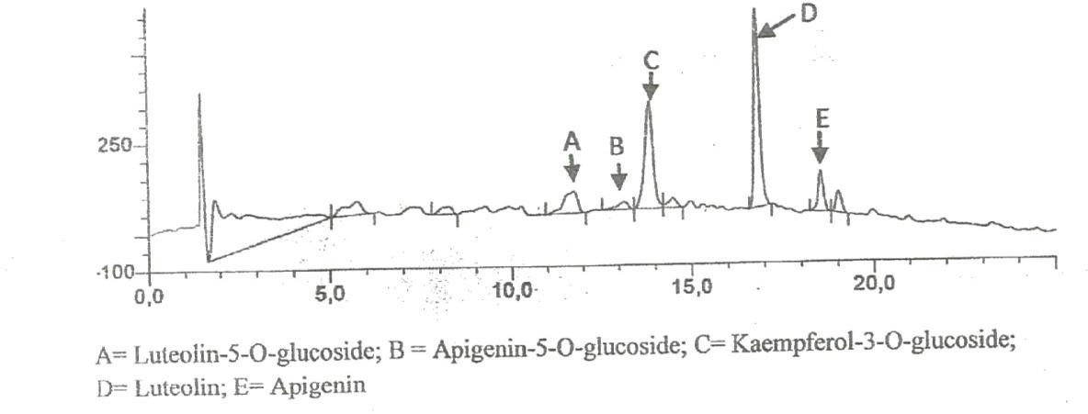

Figure 4.1: Components of L. inermis on HPLC

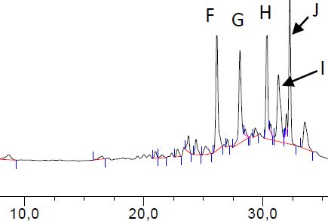

K= Malvidin 3-phydroxybenzoylsophoroside; L= Malvidin 3-acetylatedsophoroside; N= Malvidin; O= Tectoridine

Figure 4.2: Components of P. soyauxii on HPLC

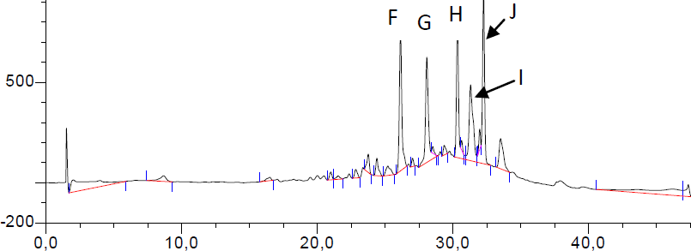

F=Tectorigenin, G=Peonidin 3-(6”-p-hydroxybenzoyl) glucoside, H=Tectorigenin 3-p- hydroxybenzoyl-5-frulate, I=Peonidin 3-(6”-p-methoxybenzoyl) glucoside, J=Tectorigenin 3-(6”-p- methoxybenzoyl glucoside.

Figure 4.3: Components of V. doniana fruit on HPLC

Analysis of total phenolic content of plant extracts as shown in Table 4.3 indicated that V. doniana methanolic leaf extract had the highest phenolic content (2684.47±55.62 mg/g) in terms of gallic acid equivalents (GAE), while the next higher value was found in G. ferruginea (971.47±15.03 mg/g), P. soyuaxii stem (728.92±13.40 mg/g), L. aculeata (670.76±5.37 mg/g), L. inermis (517.57±14.49 mg/g), G. kola (406.93±17.85 mg/g), V. doniana fruits (261.30±2.83mg/g), and V. doniana stem (189.91±17.10 mg/g).
From all extracts assayed, V. doniana leaf extract was observed to have the highest antioxidant activity with IC₅₀ value of 94.48. The least antioxidant activity was observed with extracts of V.doniana stem with IC₅₀ value of 34375.52, as presented in Table (4.15).
The correlation between antioxidant activity and total phenolic content (TPC) in Figure 4.4, obtained by plotting 1/IC₅₀ (ml/mg) against TPC (mg/g) showed that the phenolic compounds are responsible for DPPH free radical scavenging activity of the extracts.

TABLE 4.3: Total Phenolic Content of Six Tested Indeginous Plant Extracts

Plant Extracts Total Phenolic Content (mgGAE/g extract)

Ethanolic solvent
G. kola mesocarp | 406.93 | + 17.85
V. doniana stem | 189.91 | + 17.10
V. doniana fruit | 261.30 | + 2.83
V. doniana leaf 2684.47 + 55.0
L. aculeata leaf | 670.76 | + | 5.37
L. inermis leaf | 817.57 | + | 14.49
C. ferruginea fruit | 971.47 | + | 15.03
Methanolic solvent

P. soyauxii stem 728.92 + 13.40

Table: 4.4 Plant Extracts and Their Corresponding IC₅₀ and PH Values

Plant Extracts | Ph | IC₅₀ (µg/ml)
Ethanolic solvent  G. kola | 4.2 | 3749.45
V. doniana stem | 5.9 | 34375.52
C. ferruginea | 4.8 | 154117.6
V. doniana leaf | 5.8 | 94.48
L. aculaeta | 6.4 | 1033.38
L. inermis | 5.0 | 6188.84
Methanolic solvent | 4.6 | 15966.02
P. soyauxii | 5.6 | 7983.63

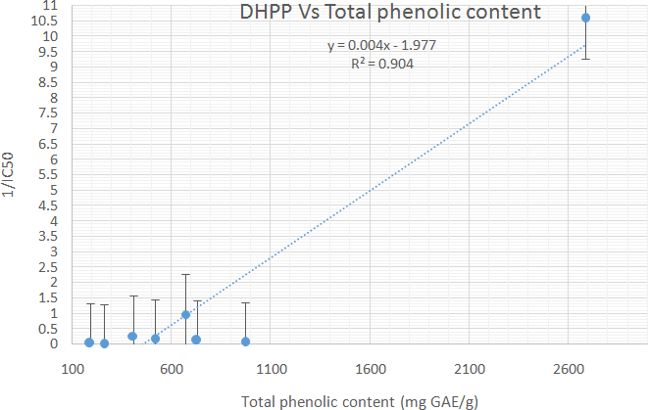

Figure 4.4: Correlation between Antioxidant Activity and Total Phenolic Content.

Antibacterial Activity

The mean zone diameter of 200 mg/ml Garcinia kola mesocarp extract had good antibacterial activity against all Gram-positive test isolates used in this study and some Gram- negative ones (M. morgani, E. coli and P. mirabilis,). No antibacterial activity was recorded against P. aeruginosa, K. pneumoniae and S. typhi (ATCC 14028). However, antibacterial activity was recorded in 100mg/ml up to 6.25mg/dl concentration. Although the mean zone diameter reduced as the concentration of the extracts reduced. (200, 100, 50, 25, 125 and 6.25mg/ml, (Appendix VII)).The mean zone diameter of 200 mg/ml concentration of G. kola mesocarp extract and 5µg/l ciprofloxacin in agar diffusion susceptibility testing of bacterial isolates used in this study had no significance difference (P>0.05). Garcinia kola mesocarp extract had no anti-fungi activity (Table 4.5).
The 200mg/ml concentration of V. doniana ethanolic stem extract had very low antibacterial activity on B. subtilis and S. aureus (ATCC 25923) used in this study (Table 4.6). No antibacterial activity was recorded in 100mg/ml concentration down to the least concentration 6.25mg/ml (Appendix Vll). No antifungal activity was recorded with V. doniana ethanolic stem extract. The 200mg/ml pilot concentration of V. doniana ethanolic fruit and leaf extract did not have any antibacterial or antifungal activity on all isolates used in this study, (Table 4.7 and Table 4.8).
The 200 mg/ml ethanolic extract concentration of L. aculaeta leaf, had antibacterial activity against all Gram positive isolate used but a very low antibacterial activity in two Gram negative isolates (E. coli and P. mirabilis table 4.9). L. aculeata ethanolic extract showed antibacterial activity on Gram-positive isolates in 100 mg concentration up to 6.2mg/dl on both Gram positive and Gram negative organism used earlier mentioned; only that the activity reduced with the concentration (200 mg/ml, 100 mg/ml, 50mg/ml, 25mg/ml,12.5 mg/ml and 6.25 mg/ml).

Table 4.5. Mean Zone Diameter of Bacterial Isolates to 200mg/ml of Methanolic Extract of
Garcina kola Mesocarp.

Bacterial/Fungal Isolates | N | 200mg/ml Garcima kola mesocarp  Mean zone diameter (mm ± SD) | 5ug/l ciprofloxacin Mean zone diameter (mm ±SD) | P.  Value
M. morgani | 3 | 17.6 ± 1.128 | 19.8 ± 0.72 | 0.223
P. aeruginosa | 3 | 0 | 0 | N/A
K. pneumomae | 3 | 0 | 0 | N/A
B. subtilis | 3 | 13.0 ± 1.000 | 10.56 ± 1.250 | 0.245
S. aureus | 3 | 13.0 ± 1.000 | 9.6 ± 0.590 | 0.245
S. pneumoniae | 3 | 11.3 ± 1.155 | 15.3 ± 0.570 | 0.195
E. coli | 3 | 10.5± 0.55 | 19.8± 0.72 | 0.368
P. mirabilis | 3 | 8.0± .44 | 17.3± 1.85 | 0.053
S. aureus (ATTC  25973) | 1 | 10.6 ± 1.155 | 12.6 ± 1.555 | 0.5
S. typhii (ATTC  14028) | 1 | 0 | 0 | N/A
 |  |  | 50ug/ml miconazole Mean zone diameter (±SD | )
C. albicans | 3 | 0 | 18.3 ± 1.528 | N/A
A. niger | 3 | 0 | 9.0 ± 1.000 | N/A
C. albicans (ATTC  10231) | 1 | 0 | 20.3 ± 1.528 | N/A

KEY

N/A = Not applicable,

N = number of sampling, SD = Standard deviation 00 = No activity

Table 4.6. Mean Zone Diameter of Bacterial Isolates 200mg/ml of Methanolic Extract of
Vitex doniana stem.

Bacterial/Fungal Isolates | N | 200mg/ml V.donianna stem  Mean zone diameter (mm ± SD) | 5ug/l ciprofloxacin Mean diameter (mm ± SD) | P. Value
M. mongani | 3 | 0.0 | 19.8 ± 0.72 | N/A
P. aerugimosa | 3 | 0.0 | 17.3 ± 1.155 | N/A
K.pneumoniae | 3 | 0.0 | 10.56 ± 01.250 | N/A
B. subtilis | 3 | 2.3 ± 0635 | 9.6 ± 0.59 | 0.9
S. aureus | 0 | 0 | 12.6 ± 1.155 | N/A
S. pneumoniae | 3 | 0.0 | 15.3 ± 0.57 | N/A
E. coli | 3 | 0.0 | 0.0
P. mirabilis | 3 | 0.0 | 0.0
S. aureus (ATTC  25973) | 1 | 2.3 ± 0635 | 0.0 | N/A
S. typhi (ATTC  14028) | 1 | 0.0 | 12.6 ± 1.577 | N/A
50ug/ml miconazole
Mean zone diameter (±SD)
C. albicans | 3 | 0 | 17.6 ± 0529 | N/A
A. niger | 3 | 0 | 9.2 ± 1.058 | N/A
C. albicans (ATTC  10231) | 1 | 0 | 19.2 ± 0.346 | N/A

KEY

N/A = Not applicable,

N = number of sampling, SD = Standard deviation 00 = No activity

Table 4.7 Mean Diameter of Bacterial Isolates to 200mg/ml of Ethanolic Extract of Vitex doniana fruit.

Bacterial/Fungal Isolates | N | 200mg/ml V. donianna fruit  Mean zone diameter (mm ± SD) | 5ug/l ciprofloxacin  Mean diameter (mm ± SD) | P. Value
M. mongani | 3 | 0.0 | 19.8 ± 0.72 | N/A
P. aerugimosa | 3 | 0.0 | 17.3 ± 1.155 | N/A
K.pneumoniae | 3 | 0.0 | 10.56 ± 1.250 | N/A
B. subtilis | 3 | 0.0 | 9.6 ± 0.59 | N/A
S. aureus | 3 | 0.0 | 15.3 ± 0.59 | N/A
S. pneumonae | 3 | 0.0 | 12.6 ± 0.57 | N/A
E. coli | 3 | 0.0 |  | N/A
P. mirabilis | 3 | 0.0 |  | N/A
S. aureus (ATTC  25973) | 1 | 0.0 | 0.0 | N/A
S. typhii (ATTC 14028) | 1 | 0.0 | 12.6 ± 1.577 | N/A
50ug/ml miconazole
Mean zone diameter (±SD)
C. albicans | 3 | 0 | 17.6 ± 0.529 | N/A
A. niger | 3 | 0 | 9.2 ± 1.058 | N/A
C. albicans (ATTC  10231) | 1 | 0 | 19.2 ± 0.346 | N/A

KEY

N/A = Not applicable,

N = number of sampling, SD = Standard deviation 00 = No activity

Table 4.8 Mean Zone Diameter of Bacterial Isolates to 200mg/ml Ethanolic Extract of Vitex doniana Leaf.

Bacterial/Fungal Isolates | N | 200mg/ml Vitex doniana leaf  Mean diameter (mm ± SD) | 5ug/l ciprofloxacin  Mean diameter (mm ± SD) | P. Value
M. morganii | 3 | 0.0 | 19.8 ± 0.77 | N/A
P. aeruginosa | 3 | 0.0 | 19.8 ± 1.155 | N/A
K. pneumoniae | 3 | 0.0 | 10.56 ± 1.250 | N/A
B. Subitilis | 3 | 0.0 | 9.6 ± 0.59 | N/A
S. aureus | 3 | 0.0 | 15.3 ± 057 | N/A
S. pneumoniae | 3 | 0.0 | 12.6 ± 1.155 | N/A
E. coli | 3 | 0.0 |  | N/A
P. mirabilis | 3 | 0.0 |  | N/A
S. aureus (ATIC  25923) | 1 | 0.0 | 0.0 | -
S. typhi (ATCC  14028) | 1 | 0.0 | 12.6 ± 1.577 | N/A
50ug/ml miconazole
Mean zone diameter (±SD)
C. albicans | 3 | 0.0 | 17.6 ± 0.52 | N/A
A. niger | 3 | 0.0 | 9.2 ± 1.05 | N/A
C. albicans (ATTC 10231) | 1 | 0.0 | 19.2 ± 0.3 | N/A

KEY

N/A = Not applicable,

N = number of sampling, SD = Standard deviation 00 = No activity

Table 4.9: Mean Zone Diameter of Bacterial Isolates to 200mg/ml of Ethanol Extract of L. aculaeta Leaf.

Bacterial / fungi isolates. | N | 200mg/ml L. aculeata  Mean diameter(mm ± SD) | 5ug/l ciprofloxacin  Mean diameter(mm ± SD) | P. Value
M. morganii | 3 | 0.0 | 19.8 ± 0.72 | N/A
P. aeruginosa | 3 | 0.0 | 17.3 ± 1.155 | N/A
K. pneumoniae | 3 | 0.0 | 10.56 ± 1.250 | N/A
B. subtilis | 3 | 8.6 ± 1.520 | 9.6 ± 0.59 | 0.12
S. aureus | 3 | 7.67 ± 1.128 | 15.3 ± 0.57 | 0.12
S. pneumoniae | 3 | 9.6 ± 2.517 | 12.6 ± 1.155 | 0.17
E. coli | 3 | 3.75±.25 | 19.8±.72 | 0.078
P. mirabilis | 3 | 4.0 ± 0.37 | 17.3±0.18 | 0.265
S. aureus (ATIC  25923) | 1 | 7.0 ± 1.732 | 0.0 | N/A
S. typhi (ATCC 14028) | 1 | 0 | 12.6 ± 1.577 | N/A
50ug/ml miconazole
Mean zone diameter (±SD)
C. albicans | 3 | 0 | 17.6 ± 0.529 | N/A
A. niger | 3 | 0 | 9.2 ± 1.058 | N/A
C. albicans (ATTC  10231) | 1 | 0 | 19.2 ± 0.346 | N/A

KEY

N/A = Not Applicable, N =number of sampling, SD= Standard deviation 00 = No activity

In comparison with the antibacterial agent, ciprofloxacin had higher mean zone diameter on both Gram-positive and Gram-negative isolate used, although there was no difference statistically. No antifungal activity was recorded with L. aculeaeta extract (Table 4.9).
L. inermis had antibacterial activity against both the Gram negative and Gram positive isolates used in this study, (Table 4.10). The 200mg/ml ethanolic extract of L. inermis had the highest antibacterial activity (mean zone diameter) on some Gram-negative isolates used in this study. L inermis leaf extract showed antibacterial activity with 100mg/dl up to 6.25mg/dl, although, antibacterial activity of L. inermis was found to reduce with concentration (200, 100, 50, 25, 125, 6.25mg/ml), ciprofloxacin was observed to have a better performance than the 200mg/ml ethanolic extract of L. inermis leaf on P. aeruginosa, K. pneumoniae, E. coli and P. mirabilis. No antibacterial activity was recorded with L. inermis ethanolic leaf extract.
Cnestis ferruginea fruit extract, demonstrated low antibacterial activity on all isolates even with the pilot concentration of 200mg ethanolic fruit extract. 100mg concentration of C. ferruginea fruit extract had also low activity on fewer organisms (M. morgani, S. pneumonia,
E. coli, P. mirabilis and S. aureus (ATCC 25923), while at 50 mg concentration, it only showed little antibacterial activity on S. aureus (ATCC 25925). No antibacterial activity was recorded with 25 mg/dl, 12.5 mg/dl and 6.25 mg/dl). The control antibacterial agent, (ciprofloxacin), had a better mean zone diameter on all bacterial isolates used in this study. 200mg/ml concentration of C. ferruginea ethanolic fruit extract had antifungal activity on all fungal isolates used in this study. It‟s antifungal activity reduced with concentration. At 25mg/ml, no activity was recorded against Aspergillus niger isolates and no activity was recorded against all fungal isolate at 12.5 mg/ml concentration. The performance of 200mg/ml extract of Cnestis ferruginea fruit and control antibacterial agent on all bacterial isolates used in this study with respect to mean zone diameter did not differ from each other,

though the latter was observed to have a generally better mean zone diameter. Similarly a higher but statistically insignificant mean zone diameter was observed with the use of 50µg/ml Miconazole on all fungi isolates used in this study (Table 4.11).
All isolates of M. morgani, E. coli and P. mirabilis were resistant to the pilot concentration of 200 mg/ml of P. soyauxii methanolic stem extract. The performance (mean zone diameter) of 200 mg/ml of P. soyauxii extract to B. subtilis, S. aureus, S. pneumonia and
S. aureus (ATCC 25923) were lower than value obtained with 5 ug ciprofloxacin to the respective bacteria isolate. Statistic however failed to show any significant difference between the mean zone diameter of 200mg/ml. Very low activity was recorded with 100 mg/ml on 50 mg/ml concentration on S. aureus, S. pnuemonae and E. coli. S. aureus (ATCC 25923) was the only isolate used that had very low activity with 25mg/ml concentration.
P. soyauxii had no effect on all fungi isolates used in this study (Table 4.12).

With respect to MIC (Table 4.15) the most potent antibacterial extract ( reference to inhibitory capacity), was Garcinia kola ethanolic extract, as the concentration inhibited seven
(7) out of the nine (9) bacterial isolates used in this study with a range of 1.56 - 6.25 mg/ml.

Table 4.10 Mean Zone Diameter of Bacterial Isolates to 200mg/ml of Ethanol Extract of
Lawsonia inermis Leaf.

Bacterial / fungi isolates. | N | 200mg/ml L. inermis _ Mean diameter (mm ± SD) | 5ug/l ciprofloxacin  Mean diameter (mm ± SD) | P. Value
M. morganii | 3 | 14.33 ± 3.51 | 19.8 ± 0.72 | 0.04
P. aeruginosa | 3 | 12.3 ± 3.51 | 17.3 ± 1.15 | 0.098
K. pneumoniae | 3 | 5.30 ± 0.57 | 10.56 ± 1.25 | 0.172
B. subtilis | 3 | 10.0 ± 2.00 | 9.6 ± 0.59 | 0.067
S. aureus | 3 | 14.0 ± 1.000 | 15.3 ± 0.57 | 0.571
S. pneumoniae | 3 | 11.6 ± 2.51 | 12.6 ± 1.155 | 0.276
E. coli | 3 | 3.50 ±0.16 | 19.8±.72 | 0.047
P. mirabilis | 3 | 3.25 ± 0.35 | 17.3± 1.85 | 0.035
S. aureus (ATIC  25923) | 1 | 15.6 ± 1.15 | 0.0 | N/A
S. typhi (ATCC  14028) | 1 | 2.6 ± 1.153 | 12.6 ± 1.577 | 0.366
50ug/ml miconazole
Mean zone diameter (±SD)
C. albicans | 3 | 0 | 17.6 ± 0.529 | N/A
A. niger | 3 | 0 | 9.2 ± 1.058 | N/A
C. albicans (ATTC 10231) | 1 | 0 | 19.2 ± 0.346 | N/A

KEY

N/A = Not applicable,

n- = number of sampling, SD = Standard deviation 00 = No activity

Table 4.11 Mean Zone Diameter of Bacterial Isolates to 200mg/ml of Ethanolic Extract of
Cnestis ferruginea fruit extract.

Bacterial / fungi isolates. | N | 200mg/ml Cnestis ferruginea fruit  Mean zone diameter (mm ± SD) | 5ug/l ciprofloxacin  Mean zone diameter(mm ± SD) | P.  Value
M. mongani | 3 | 3.3 ± 1.15 | 19.8 ± 0.72 | 0.34
P. aeruginosa | 3 | 2.0 ± 0.93 | 17.3 ± 1.15 | 0.39
K. pneumoniae | 3 | 2.0 ± 0.93 | 10.56 ± 1.25 | 0.35
B. subtilis | 3 | 3.3 ± 1.15 | 10.56 ± 1.25 | 0.19
S. aureus | 3 | 2.0 ± 0.93 | 9.6 ± 059 | 0.27
S. pneumonia | 3 | 3.3 ± 1.15 | 12.6 ± 1.55 | 0.50
E coli | 3 | 2.5±0.12 | 19.8 ± 0.72 | 0.027
P. mirabilis | 3 | 2.5± 0.23 | 17.3± 1.85 | 0.0152
S. aureus (ATTC  25973) | 1 | 5.3 ± 1.15 | 0.0 | N\A
S. typhi (ATTC  14028) | 1 | 3.6 ± 1.555 | 12.6 ± 1.577 | 0.37
50ug/ml Miconazole
Mean zone diameter (±SD)
C. albicans | 3 | 9.3 ± 1.528 | 18.3 ± 1.528 | 0.50
A. niger | 3 | 5.3 ± 1.155 | 9.0 ± 1.000 | 0.43
C. albicans (ATTC  10231) | 1 | 12.3 ± 1.128 | 20.3 ± 1.528 | 0.35

KEY

N/A = Not applicable,

N = number of sampling, SD = Standard deviation
0.0 = No activity

Table 4.12 Mean Zone Diameter of Bacterial Isolates to 200mg/ml of Methanol Extract of P. soyauxii stem extract.

 | Bacterial / fungi isolates. | N | 200mg/ml. soyauxii  Mean diameter(mm ± SD) | 5ug/ml ciprofloxacin  Mean diameter(mm ± SD) | P. Value
 | M. morganii | 3 | 0.0 | 19.8 ± 0.72 | N/A
 | P. aeruginosa | 3 | 12.0.03 ± 3.51 | 17.3 ± 1.15 | 0.09
 | K. pneumoniae | 3 | 5.30 ±0.0 0.57 | 10.56 ± 1.20 | 0.17
 | B. subtilis | 3 | 4.6 ± 0.577 | 9.6 ± 0.59 | 0.50
 | S. aureus | 3 | 6.6 ± 1.155 | 15.3 ± 0.57 | 0.19
 | S. pneumoniae | 3 | 3.6 ± 0.577 | 12.6 ± 1.155 | 0.19
 | E. coli | 3 |  | 0.0
 | P. mirabilis | 3 |  | 0.0
 | S. aureus (ATIC 25923) | 1 | 9.3 ± 1.55 | 0.0 | N/A
 | S. typhi (ATCC 14028) | 1 | 0.0 | 13.2 ± 1.43 | N/A
50ug/ml Miconazole
Mean zone diameter (±SD)
 | C. albicans | 3 | 0 | 17.6 ± 0.529 | N/A
 | A. niger | 3 | 0 | 9.2 ± 1.058 | N/A
 | C. albicans (ATTC 10231) | 1 | 0 | 19.2 ± 0.346 | N/A

KEY

N/A = Not applicable,

n- =number of sampling, SD =Standard deviation
0.0 = No activity

TABLE 4.13: COMPARISON OF ANTIBACTERIAL ACTIVITY OF THE SIX INDIGENOUS PLANT EXTRACTS ON TESTED BACTERIAL ISOLATES

Isolates | N | G. kola mesocarp mean zone diameter (mm ± SD) | V. donianna stem mean  zone diameter (mm ± SD) | V.  donianna fruit mean zone diameter  (mm ± SD) | V.  donianna leaves mean zone diameter  (mm ± SD) | L. aculata leaves mean  zone diameter (mm ± SD) | L. inermis leaves mean zone diameter (mm ± SD) | Cnestis ferruginea fruit mean zone diameter  (mm ± SD) | P. soyauxii stem mean  zone diameter (mm ± SD) | P. value
M. morgani | 3 | 17.6 + 1.128 | 0.0 | 0.0 | 0.0 | 0.0 | 14.33 + 3.51 | 3.3 + 1.15 | 0.0 | 0.0003
P. aeruginosa | 3 | 0.0 | 0.0 | 0.0 | 0.0 | 0.0 | 12.3 + 3.51 | 2.0 + 0.93 | 12.0 + 3.51 | 0.008
K. pneumoniae | 3 | 0.0 | 0.0 | 0.0 | 0.0 | 0.0 | 5.30 + 0.57 | 2.0 + 0.93 | 5.30 + 0.93 | 0.002
B. subtilis | 3 | 13.0 + 1.00 | 2.3 + 0.63 | 0.0 | 0.0 | 8.6 + 1.52 | 10.0 + 2.00 | 3.3 + 1.15 | 4.6 + 0.57 | P<0.001
S. pnuemoniae | 3 | 11.3 + 1.151 | 0.0 | 0.0 | 0.0 | 9.6 + 2.52 | 11.6 + 2.51 | 3.3 + 1.15 | 3.6 + 0.57 | 0.0002
S. aureus | 3 | 13.0 + 1.001 | 0.0 | 0.0 | 0.0 | 7.6 + 1.12 | 14.0 + 1.00 | 2.0 + 0.93 | 6.6 + 1.15 | 0.0001
E. coli | 3 | 10.5 + 0.55 | 0.0 | 0.0 | 0.0 | 10.5 + 0.55 | 3.5 + 0.16 | 2.3 + 0.12 | 0.0 | 0.0001
P. mirabilis | 3 | 3.25 + 0.35 | 0.0 | 0.0 | 0.0 | 8.0 + 0.44 | 3.25 + 0.35 | 2.5 + 0.23 | 0.0 | 0.0001
S. aureus (ATCC  25973) | 3 | 10.6 + 1.16 | (2.3 + 0.63) | 0.0 | 0.0 | 7.0 + 1.73 | 15.6 + 1.15 | 5.3 + 1.15 | 9.3 + 1.55 | 0.0001
S. typhi (ATCC  14028) | 3 | 0.0 | 0.0 | 0.0 | 0.0 | 0.0 | 2.6.0 + 1.53 | 3.6 + 1.55 | 9.3 + 1.55 | 0.003

KEY
SD= Standard deviation 0.0= No activity

Table: 4.14 COMPARISON OF ANTIFUNGAL ACTIVITY OF THE SIX INDIGENOUS PLANTS PARTS EXTRACTS ON TESTED FUNGAL ISOLATES

Isolates | N | G. kola mesocarp mean zone diameter (mm ± SD) | V. donianna stem mean  zone diameter (mm ± SD) | V.  donianna fruit mean zone diameter  (mm ± SD) | V.  donianna leaves mean zone diameter  (mm ± SD) | L. aculata leaves mean  zone diameter (mm ± SD) | L. inermis leaves mean zone diameter (mm ± SD) | Cnestis ferruginea fruit mean zone diameter  (mm ± SD) | P. soyauxii stem mean  zone diameter (mm ± SD) | P. value
C. albicans | 3 | 0.0 | 0.0 | 0.0 | 0.0 | 0.0 | 0.0 | 9.3 + 1.52 | 0.0 | -
A. niger | 3 | 0.0 | 0.0 | 0.0 | 0.0 | 0.0 | 0.0 | 5.3 + 01.16 | 0.0 | -
C. albicans (ATCC  10231) | 3 | 0.0 | 0.0 | 0.0 | 0.0 | 0.0 | 0.0 | 12.3 + 1.13 | 0.0 | -

KEY

SD= Standard deviation

0.0 = No activity

Table: 4.15 MINIMUM INHIBITORY CONCENTRATIONS OF THE PLANTS’ EXTRACTS DETERMINED AGAINST TESTED BACTERIAL AND FUNGAL ISOLATES.

Test  Organisms | MICs (mg/ml)
 | Garcinia Vitex Vitex Vitex Lantana Lawsonia Cnestis Pterocarpus kola donniana donniana donniana aculaeta Inermis ferruginea soyauxii mesocarp stem leaves fruits leaf leaf fruit Stem
M. morganii 3.125 - - - - 6.25 100 -

P. aeruginosa - - - - - - 200 -

K. pneumonia - - - - - - 200 -
B. subtilis 3.125 200 - - 3.125 - 100 50
S. aureus 3.125 - - - 6.25 3.125 200 50
S. pneumoniae 6.25 - - - 3.125 - 100 50
E. coli 1.562 100 200 - 3.125 12.5 50 1.562
P. mirabilis 1.56 50 - - 12.51 2.5 100 25
S. aureus 6.25 200 - - 3.125 1.562 25 25

(ATCC 25923)

S. typhi - - - - - 200 100 - (ATCC 14028)
C. albicans - - - - - - 25 - A. niger - - - - - - 50 - C. albicans - - - - - - 6.25 -
(ATCC 10231)
KEY

- No activity

Plates: 4b,c and d show the modified Gram stain slide of Staphylococus aureus isolate prepared with P. soyauxii stem, L. inermis leaf, and G. kola mesocarp extracts as counter stains respectively. Staining pattern of S. aureus observed with the use of L. inermis and P. soyauxii as counter stains compared favourably with that obtained with the use of conventional Neutral red dye displayed in Plate: 4a
Uptake of C. ferruginea, G. kola, P. soyauxii and L. inermis by isolate of Escherichia coli as seen in (Plate 5b), was generally poorer than that observed with the use of conventional Neutral red (plate 5a).
Plate 6a, b and c demostrate the staining of fungi (Candida albicans) with extracts of C. ferruginea and P. soyauxii respectively comparable with standard mycology stain, Lactophenol cotton blue stained fungi (Plates 6b and 6c).
Plates 7b, c and d show the uptake of mould by the extracts of G. kola mesocarp,

L. inermis leaf and P.soyauxii stem extracts are in comparison with standard Lactophenol cotton blue stain Plate 7a.
Appendix in control reveals well differentiated staining extending from the muscularis externa through the submucosa to the mucosa. The germinal center and lymphoid follicles appear well differentiated and stained (black arrow)
The APP (M), APP (H) and APP (G) show more intense staining at five percent (5%) concentration. The lymphoid follicles are stained and fairly differentiated. The APP (G) gave the best intensified and differentiated staining compared to the APP (M) and (H).

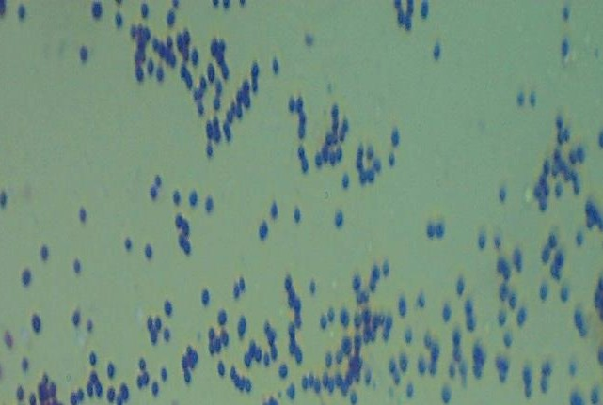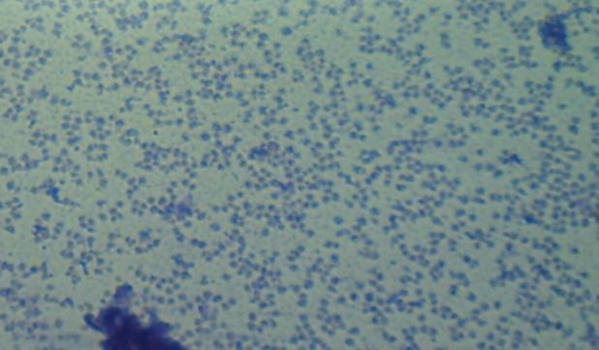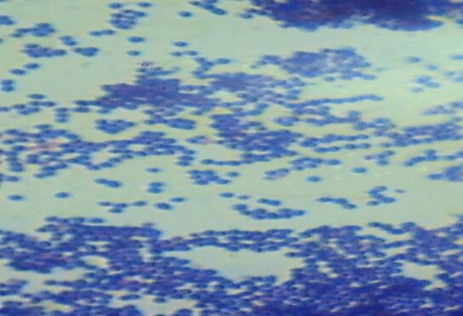

4a 4b

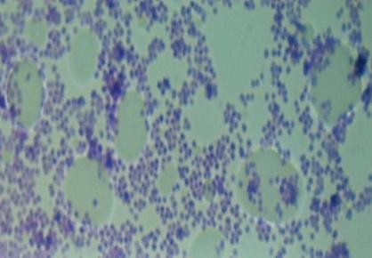

4c 4d
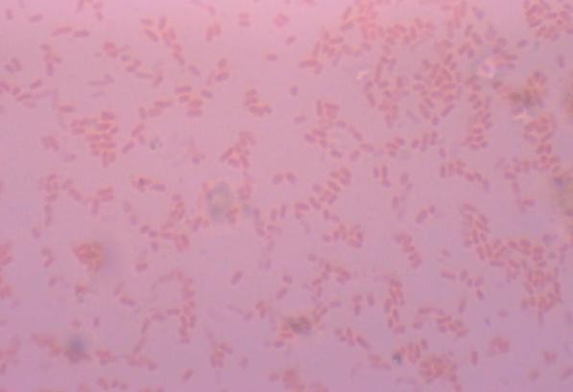
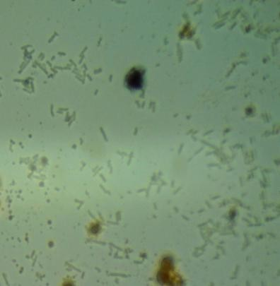
5a 5b

Plate 4 (a): S. aureus Grams staining method with Neutral Red as counter stain.
(b): S. aureus Grams staining with P. soyauxii methanolic stem extract as counter stain. (c): S. aureus Grams staining with L. inermis ethanolic leaf extract as counter stain. (d): S. aureus Grams staining with C. ferruginea ethanolic fruit extract as counter stain.
Plate 5a: E. coli stained with Grams staining method with neutral red as counter stain (control). 5b: E. coli stained with Grams staining method with G. kola mesocarp ethanolic extract as counter stain.

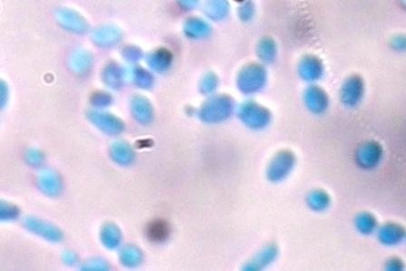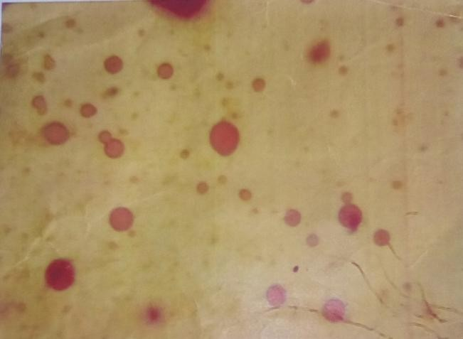

a b

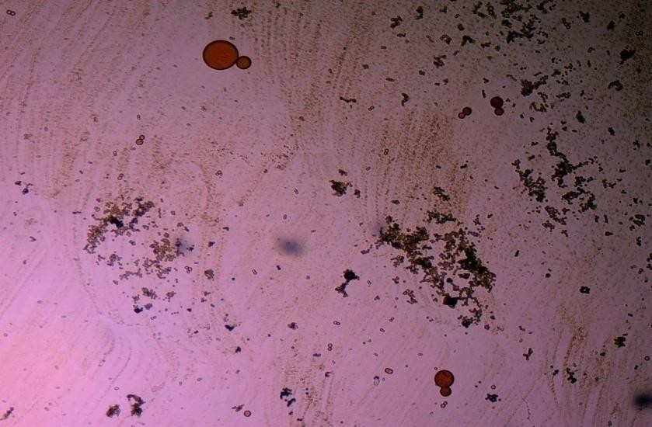
c

Plate 6 a: Candida albicans stained with Lactophenol cotton blue (control)
b: Candida albicans stained with C. ferruginea fruit ethanolic extract c: Candida albicans stained with P. soyauxii methanolic stem extract

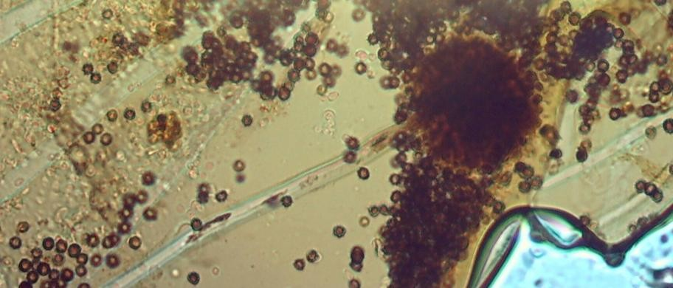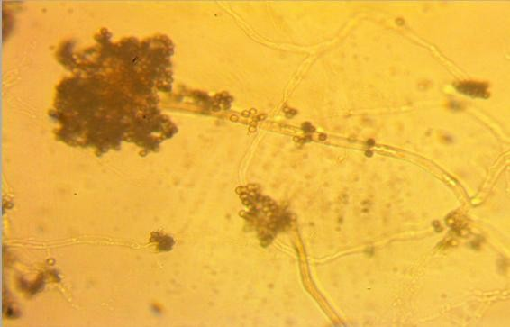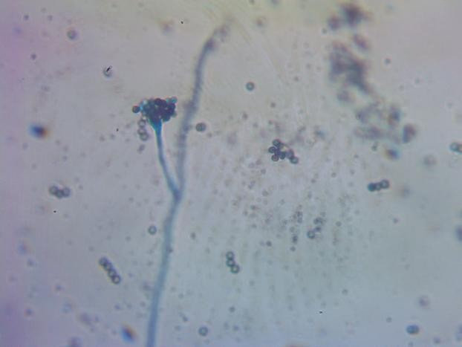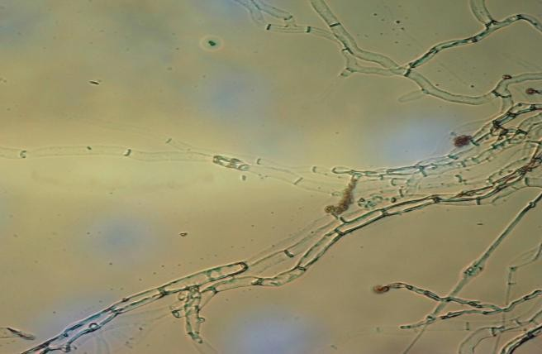

a b

c d

Plate 7a: Aspergillus niger hyphae with spores stained with Lactophenol cotton blue (control slide),
b: Aspergillus niger hyphae stained with G. kola mesocarp ethanolic extract,
c: Aspergillus niger hyphae and spores stained with L.inermis ethanolic leaf extract, d: Aspergillus niger hypae with spores stained with P. soyauxii stem ethanolic extract.

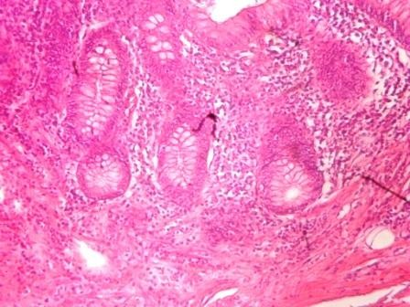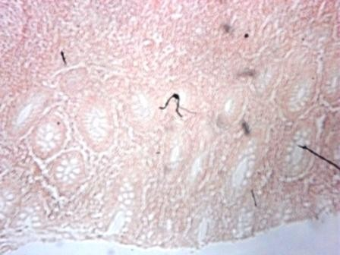

a b

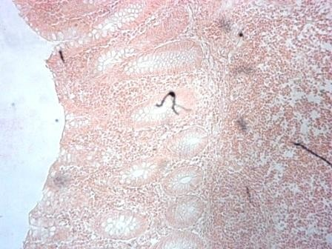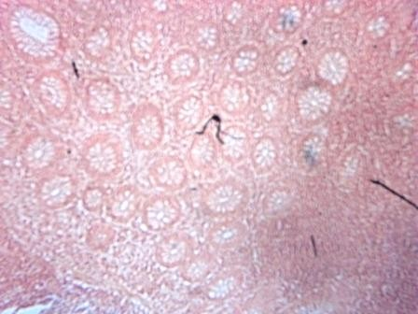

c d

Plate 8a: Human appendix tissue stained with Gills Haematoxylin & Eosin [APP(G)](Control]

b: Human appendix tissue stained with Mayers Haematoxylin & P. soyauxii
methanolic stem extract.
[APP (M)],

c: Human appendix tissue stained with Harris Haematoxylin & P. soyauxii methanolic stem extract. [APP (H)],
d: Human appendix tissue stained with Gills Haematoxylin & P. soyauxii methanolic stem extract.

CHAPTER FIVE

  - DISCUSSION

Phytochemical analysis of G.kola mesocarp revealed alkaloids, saponins, tannins and cardiac glycoside as constituent parts. The findings in this study are in agreement with Morabanda et al., (2013), except cardiac glycoside which was found in this study. This may be as a result of differences in geographical location where these studies were undertaken. Phytochemical composition indicated that G. kola mesocarp has good chemotherapeutic value. Nutritional composition of G. kola mesocarp extract indicated very low protein content (1.0%) and crude fibre. The low protein content observed in
G. kola mesocarp in this study and that of (Morabandza et al., 2013) showed that G. kola mesocarp is not a good source of protein. Low concentrations of saponin (5.3%) and flavonoid (1.29%) were recorded in extract of G. kola mesocarp in this work.

Various parts of V. doniana studied included leaf, stem and fruit with the fruit indicating the highest protein content of 16.8%. This finding has great implication for its use as a rich protein source. All parts of V doniana (stem, leaf, and fruit) used in this study were observed to contain alkaloids, flavonoids saponin, tannins, and cardiac glycoside. Dawang et al., (2015) also reported the presence of alkaloids, cardiac glycoside and flavonoids but didn‟t detect saponins and terpenes in their work. Contrasting findings have also been reported by study conducted by Dauda et al., (2011), who did not detect saponin and terpenes as counstituent parts of V. doniana stem and leaf. The low concentration of alkaloids and tannins reported and this present study among V. doniana parts is responsible for the low antimicrobial activity. However the marked absence of saponins and terpens in the study conducted by (Dauda et al., 2011), and (Dawang et al., 2015), may be related to differences in atmosphere and soil characteristics as these studies were done in North Central part of Nigeria in contrast to this study undertaken in Eastern Nigeria.
A vast array of phytochemical constituents was detected in the extract of L. aculeata leaf. Indeed it is the only plant extract that Terpenes was found in out of the eight extracts assayed. In a study carried out on L. aculeata leaf, a host of compounds were detected ranging from flavonoids,

tannins, alkaloids, saponins, steroids among others, (Hemalath et al., 2015). Interestingly in this study, L. aculeata leaf was found to have the highest carbohydrate and saponin content of all plants extracts assayed making it a good source of energy.
The phytochemical analysis of L. inermis leaf revealed alkaloids, saponin, tannins, flavonoids, terpenes, and cardiacglycoside. No Steroid was reported in this study. However, Raja et al., (2013) reported the presence of cardiac glycosides, steroids, saponin, tannins and flavonoids, contrary to findings in this study. In the nutritional composition, Protein was present (Table 4.2) in the study but was not detected by Raja et al., (2013).

Phytochemical analysis of C. ferruginea fruit extract in this study revealed alkaloids, cardiac glycosides, flavonoids, and tannins. Similar constituents were detected in root and stem extract of C. ferruginea in a study conducted in Nigeria by (Emenor et al., 2005). The presence of alkaloids, tannins and flavonoids suggests that C. ferruginea fruit have antibacterial, healing and anti cancer activities (Raina et al., 2014). The presence of these constitutents in the fruit extract of C. ferruginea in this study indicated that it has good pharmacological and therapeutic value. In herbal medicine and some literatures, the fruit extract has diverse therapeutic uses against infections like snakebite, dysentery, syphilis, gonorrhea, cough, dysmenorrhea, ovarian troubles and aphrodisiac. The root and fruit extracts however, prevents abortion, constipation, fever and pain (Gill 1992, Okafor and Ham 1999). The fruit extract is used locally for the treatment of tooth-ache, mouth and skin infections (Boakye-Yiadom and Konning 1975).
Phytochemical analysis of P. soyauxii stem revealed alkaloids, saponins, tannins, flavonoids and cardiacglycosides. This is in agreement with a study conducted by (Tchamaduru et al., 2011 and Erhenbi 2016) on medicinal plants used for treatment in Edo state. Pterocarpus soyauxii had a high alkaloid content of 21%, crude fibre 79.2%, saponins

content of 10.7% and 9.6% flavonoids but low moisture content of 5.0% and tannins of 2.14%.
In the HPLC analysis of the six different plants‟ part extracts, the ethyl acetate solvent fraction of the V. doniana fruit, revealed five compounds which were identified to be Tectorigenin,Peonidin3–(6-parahydroxybenzyl)glucoside,Tectorigenin–3–p– hydroxybenzyl– 5–frulate, Peonidin–3–(6”– p – methoxybenzoyl) glucoside and Tectorigenin –3– (6”–p– methyoxybenzoyl) glucoside (figure 4.3). These compounds are called flavonoids but fall into two subgroups: namely; isoflavones and anthocyanins. tectorigenin, tectorigenin (3–p– hydroxybenzoyl–5–frulate) and Tectorigenin 3–(6”–p– methydoxybenxoyl) glycoside are Isoflavones while Peonidin 3–(6”–p–hydroxybenzol) glucoside and Peonidin 3(6”– p– methoybenzoyl) glucoside are Anthocyanins.

Isoflavones are found in a class of plants known as phytoestrogens because of their similar chemical structure and function to the female sex hormone estrogen (Priya Batra and Anil 2013). Vitex doniana fruit is rich in isoflavones and the three types of isoflavones discovered have 13.15%, 11.70% and 14.62% respectively as peak area (Appendix).
Isoflavones are widely appreciated and are currently the subject of intense research and discussion, this is because it protects against hormone related disorders such as breast cancer prostate cancer, osteosarocoma, lung carcinoma, and ovarian cancer, (Kapor 2013, Yang et al., 2012). Isoflavonoids act against cancer cells in a way similar to many common cancer treating drugs. Isoflavones have potent antioxidant properties comparable to that of vitamin E Wang et al., (2012) which reduce long term risk of free radical damage to DNA.
Anthocyanins are polyphenols and generally accepted as the most important group of water soluble pigment in nature (Horborne 1998). They are responsible for the blue, purple, red or orange colour of many fruits and vegetables (Seeram 2008). They are distinguished

from other flavonoids due to their capacity to form flavylium cations (Mazza 2007). They are about seventeen anthocynanidins found in nature but only six are most common (Miguel 2011). One of them is Peonidin found in this study which is responsible for the colour found in V.doniana fruit (purplish blue colour) and this is also influenced by the abundance of hydroxyl group. The hydroxyl is responsible for the bluish shade while the methoxyl influence the redish colour (Heredia et al., 1998, Horboweiz et al., 2008). Anthocyanins are polyphenols with known antioxidant activity which is responsible for some biological activities including the prevention or lowering the risk of cardiovascular diseases, diabetes, arthritis and cancer, (Vauzour et al., 2010). Anthocyanins can exert a major chemopreventive activity due to their antioxidant property (Kampa et al., 2007) by scavenging reactive oxygen and reactive nitrogen species or by chelating trace metals involved in free radical production (Cotelle, 2001).
In the analysis of Lawsonia inermis leaf extract, the ethylacetate solvent fraction yielded five major compounds identified as Luteolin–5–glucopyranoside, Apigenin–5–0– glucopyranoside, Kaemferol – 3- 0 – glucopyranoside, Luteoline and Apigenin.
These five compounds are flavones (a type of flavonoids). Leutolin mono glycoside peak area is 5.13% in Lawsonia inermis. Flavonoid present in plants is usually in form of glycosides and exhibit anti-inflamatory activity (Middleton et al., 2000, Mori et al., 2002).
Apigenin monoglycosides is also a flavone present in form of glycosides in L. inermis with peak area of 1.35% concentration. Apigenin suppresses cancer cells, by altering a very specific step in gene regulation making cancer cells to die like normal cells. Apigenin also binds a very important protein called HnRNPA2 and this connection thus inhibit breast cancer cells and so cells die in programmed way {restores the single splitting of cells instead of double splitting which is a characteristics of breast cancer cells (induces apoptosis)}

(Beecher 2003). It also has anti-inflammatory properties (Patel et al., 2007, Bokung et al., 2016). It blocks the production of uric acid. It has anti depressant-like effect. Some other sources of Apigenin are found in thyme, peppermint, chamomile herbs, red wine and tomatoes sauce (Beecher 2003).
Kaempferol monoglucoside, (a flavones) is present at a high percentage (peak area) as 14.87% in L. inermis leaf extract, it is a natural flavonol a type of flavonoid, and appear as a yellow crystalline solid. This contributes to the yellow colour exhibited by L. inermis leaf extract. Kaempherol is also found in apples, grapes, tomatoes, broccoli, cucumbers, letuce, green beans and moringa. It is a strong antioxidant and it combines with quecitin to reduce proliferation of cancer cells (Luo et al., 2008, Somerset and Johannot 2008). It is a potent promoter of apoptosis (Ramos 2007). In chemotherapy, it is much less toxic to normal cells in comparison with standard chemotherapy drugs (Zhang et al, 2008). The total average intake of flavonols and flavones in a normal diet is estimated as 23mg/day to which Kaempferol contributes approximately seventeen percent (17%) as reported by (Allen et al., 2013).
Luteolin had the highest concentration with peak area of (18.78%) in L. inermis leaf HPLC analysis, this forms part of our daily nutrition in a relatively low amount (<1mg/day, Gunter et al., 2008). It is a flavone that has a yellow crystalline appearance and is usually referred to as bioflavonoid in plants. It is a powerful antioxidant and has anti inflammatory acitivity (Seelinger et al 2008). It also inhibits the growth of tumours and so it is used for the treatment of cancer (Seelinger et al., 2008). Other sources of Luteolin are thyme, chamomile tea, carrots, olive oil, rosemary leaf, green pepper and lemon. This also contributes to the yellow colour exhibited by the plant and why it is used as cosmetic on skin and nails and also the yellow-like colour seen when used as a counter stain in Gram staining technique for bacteria as demonstrated in Plate 4c.

The n-hexane solvent fraction of P. soyauxii yielded six different compounds. The four compounds identified were: Malvidin 3-p-hydroxylbenzolsophoroside, Malvidin 3- acetylatedsophoroside, Malvidin and Tectoridine.
Malvidin is an anthocyanin (flavonol) in the group of flavonoid (polyphenol) found abundantly in berries (bilberry and blueberry). The diversity of anthocyanins are due to the number and position of hydroxyl and methoxyl groups on the basic anthocyanidin skeleton; the number and positions at which sugars are attached, and also the extent of acylation and the identity of the acylating agent. The intensity and type of the colour of anthocynins is affected by the number of hydroxyl groups: if more methoxyl prevail, then redness increases [Herodia et al., (1998), Delgodo – Vargas, and Paredeslopez, (2003), Horboweiz et al., (2008)]. Malvidin is contributory to the reddish colour exhibited by Pterocarpus soyauxii as stated also by Jing (2006). There are so many health benefits of malvidin: they have antiradical activity, it is a potent superoxide anion radial scavenger and to a lesser extent hydroxyl anions radical activity Wang et al., (2012). They poseses chlorogenic acid thus induces antiproliferation of colon and liver cancer cells, Wang et al., (2012). Exhibits estrogenlike effect through the production of NO by the vessels acting as ERs and also reduces cardiovascular diseases. It inhibits neurotoxicity by inhibiting lipid peroxidase in mouse forebrain Wang et al., (2012).
Tectoridine is an isoflavone, a type of flavonoid it is the 7-glucoside of tectorigenin and usually found in plants as glycosides. They are antioxidants because of their ability to trap siglet oxygen, reduce or lower the rate of post monoposal cancer. Tectoridine possesses anestrogenic and thyroid hormone-like agent by activiating estrogen and thyroid hormone receptors. It has antioxidant and anti inflammatry activities. Tectoridine and its five metabolites inhibit the activity of lens aldose reductase in rat (IC₅₀ 1.4 – 15.5µm) in a study carried out by Paul Theleri et al., (2005).

With reference to antioxidant activity, their activities increased with increasing concentration of extracts and standard (Vitamin C). The IC50 values of the extracts and Vitamin C were calculated from the percentage inhibitions at various concentrations. The IC50values are presented in table four point six (Table 4.4). The DPPH radical scavenging activity decreased in the order vitamin C >V. doniana leaf>L. aculata leaf>G. kola mesocarp>L. inermis>P. soyuaxii stem>C. ferruginea fruit>V. doniana stem> V. doniana fruit.
The correlation between antioxidant activity and TPC (figure 4.4) obtained by plotting 1/IC50 (ml/mg) against TPC (mg/g) showed that the phenolic compounds are responsible for DPPH free radical scavenging of the extracts.

Extract of G. kola mesocarp was observed to have a significantly higher antibacterial activity (highest mean zone diameter) on isolates of M. morgani, B. subtilis, E coli and P. mirabilis. No activity was recorded against Pseudomonas aeruginosa and Klebsiella pneumonia. The Gram positive bacteria were observed to have a higher resistance to extract of G. kola mesocarp compared to the Gram negative bacterial isolate used in this study. This has not been previously documented. Increased permeability of bacterial cell wall to bioactive compounds of antibiotics aids its action on bacterial life. Perhaps differences in cell wall permeability of Gram positive and Gram negative bacteria to bioactive compounds of G. kola mesocarp may be responsible for this observation.
The extract of V.doniana (Leaf, stem, and fruit) had generally poor activity against bacterial isolates used in this study. Indeed extract of V. doniana (leave and fruits) were observed to have no activity against all tested bacterial and fungal isolates. In the study conducted by (Osuwagu and Eme 2013), extract of V. doniana was observed to have good antimicrobial effect on bacterial isolates, contrary to findings in this study. The difference in

reported performance of V. doniana leaves in this study may be related to variation in antimicrobial resistance profile of test isolates used, as multidrug resistance strains were used in this study. Again the phytochemical analysis of V. doniana in this study showed very little alkaloid content, which is suggestive of low antimicrobial activity. However, moderate susceptibility was observed with ethanolic stem extract of V. doniana against isolates of B subtilis and typed strain of S. aureus (ATTC 2597). This could be attributed to higher concentration of the bioactive compounds found in the stem.
No activity was recorded by L. aculeata leaf extract against isolate of P. aeruginosa and K. pneumonia in this study. Isolates of P. aeruginosa and K. pneumonia have been reported to harbour resistant genes to several antimicrobial agents. This may also explain the high resistance profile of P. aeruginosa and K. pneumonia to extracts of L. aculeata in this study. Generally, a better antimicrobial activity was recorded against Gram positive bacterial than Gram negative ones. This may be related to differences in extract permeability to cells, as there are marked differences in the cell wall components of Gram negative and Gram positive organism.
The antimicrobial effect of L. inermis extract compared favourably with that of standard ciprofloxacin on bacterial isolates used in this study. The mean zone inhibition observed ranged from 2.6 to 14.33 mm with best performances generally recorded against Gram positive bacterial. In Gram negative bacterial isolates, a better antimicrobial activity was recorded against P. aeruginosa and M. morganni. Leaf extract of L. inermis have been reported to display noteworthy antimicrobial activity against both Gram positive and Gram negative bacterial strains in an earlier study (Gull et al., 2013). Findings from other researchers like (Bhuwaneshwari et al., 2002, Habbal et al., 2005 and Hussain et al., 2011) support the finding from this study. However in a study conducted by Papageorgiou et

al.,(1999), L. inermis leaf extract exhibited antimicrobial activity only against Gram positive bacteria while ineffective against Gram negative bacteria.
The extract of C. ferruginea fruit was observed to have a generally low antibacterial activity against both Gram negative and Gram positive bacterial isolates in this study. However, in a study conducted by (Emenor et al., 2015) on stem extract of C. ferruginea on bacterial isolates, a generally low activity was observed against Gram negative bacterial isolates. Similarly, low sensitivity of Gram negative bacteria was reported of aqueous stem extract of C. ferruginea by (Ndukwu et al., 2005 and Akharaiyi et al., 2012). The fruit was reported to have antimicrobial effects especially against Gram-positive bacteria (Lewis and Elvin-Lewis, 2003). In this study fruit extract was found to inhibit isolates of S. aureus and B. Substilis although, the effect was low. There is paucity of information on antibacterial study on C. ferruginea fruit. An interesting finding in this study is that among all plant extracts used, C. ferruginea was the only extract observed to have activity against fungal isolates.
Extract of P. soyauxii was observed to have moderate antimicrobial activity against most of the bacterial isolates used ranging from 3.6-12.0 mm. (Table 4.10). Particularly no activity was recorded against isolate of M. Morgani. Similar findings have however been reported in a study conducted by (Osuagwu and Akomas 2013) who observed good antimicrobial activity of P. soyauxii leaves on human isolates of Escherichia coli, Staphylococus aureus, Salmonella typhi, Klebsiella pneumonia. Nguyah and his colleagues also reported an excellent antimicrobial activity (zone diameter) of extract of P. soyauxii on major Gram negative human bacterial isolates. However, P. soyauxii stem extract was reported to have anti-fungal activity against C. albicans by (Osuagua and Akoma 2013), contrary to findings in this study where no antifungal activity was recorded against C. albicans. The observed performance of P. soyauxii isolates on bacterial isolates in this study

and those of (Osuagwu and Akomas 2013 and Ngumah et al., 2013), provides a strong basis for its use as antibacterial agent in clinical practice.
In the use of plant extracts as stains on clinical bacterial isolates, fungal and tissue cells, the pH of the six plants extracts ranged from 4.2 to 6.4. All extracts had acidic pH and so have affinity for cytoplasm which is basic in nature. (Baker et al., 2001) that is why extracts act as counter stains and not as primary stains. Alkaline or basic stains have affinity for the nucleus because of the nuleic acid. The stain prepared from G. kola mesocarp was not soluble in water but was only soluble in organic solvents (methanol and ethanol). This is so because of the high lipid content 15.4% of G. kola mesocarp (Table 4.2). Vitex doniana fruit extract was soluble in water and methanol but colour was not fast. Lantana aculeata seed extract did not yield significant colour during extraction with organic solvent (ethanol) as well as with water. Lawsonia inemis was moderately soluble in water and more soluble in organic solvent (ethanol), although after some days extract colour appear darker. The chemistry behind the colour change was not understood. Cnestis ferruginea fruit extract was slightly soluble in water and more soluble in organic solvent (ethanol).
Pterocarpus soyauxii dissolved poorly in water probably because of the oil base nature but was very soluble in organic solvent like methanol. Methanolic extracts of four plants namely: G. kola, L. inermis, C. ferruginea, and P. soyauxii stained Gram - negative bacteria poorly without proper differentiation, this is because a suitable accentuator was not discovered in this study to enhance their staining ability. The poor staining could also be attributed to chemical composition of the stains from extracts and its ability to penetrate the cell walls of the organisms. They can therefore be regarded as simple stains like neutral red and lactophenol cotton blue used for staining bacterial and fungal morphology respectively, without demonstrating internal organnelles of the organism.

The stains from ethanolic extracts of C. ferruginea fruit and methanolic stem extract of P. soyauxii showed stronger affinity for fungi than bacteria. The extracts of C. ferruginea and P. soyauxii treated with inorganic acid, (Hydrochloric acid) increased the intensity of their colours from red to deep red colour.

CONCLUSION AND RECOMMENDATIONS

In this study, the six indigenous plant extracts used contain some bioactive compounds namely: flavonoids, alkaloids, steroids, tannins, cardiacglycosides saponins, terpenes and nutrients such as carbohydrate, protein, crude fibre, lipid, total ash moisture, and have relatively strong antibacterial properties, antioxidant activities, hence the need to explore the potentials of these plants in traditional medicine and pharmaceutical industries.
The extracts have staining properties comparable with the conventional mycological stain Lactophenol cotton blue and as counter stain but stained poorer with Gram negative bacterial and human appendix tissue with little differentiation compared with conventional stains, neutral red and Gill‟s haematoxylin respectively, used in the laboratory. It is, therefore, recommended that isolation of individual staining compounds in the various plants‟ extracts be used to improve staining abilities.

CONTRIBUTION TO KNOWLEDGE

- This study also revealed that V.doniana fruit contained flavonoids which where characterized for the first time as: Tectorigenin, Peonidin 3 - (6”-p-hydroxybenzoyl) glucoside,Tectorigenin-3–p-phydroxybenzoyl-5-frulate,Peonidin3-(6”p- methoxybenzoyl) glucoside and Tectorigenin 3-(6”-p-methoxybenzoyl) glucoside.
- It was also discovered that P. soyauxii contained antioxidants characterized for the first time to be: Malvidin-3–phydroxybenzoylsophoroside,-Malvidin-3- acetylatedsophoroside, Malvidin and Tectoridine.
- L. inermis ethanolic extract had good antibacterial activity on both Gram positive and Gram negative clinical isolate used in the study.
- C. ferruginea ethanolic fruit extract exhibited antifungal activity against clinical isolates, Candida albicans and Aspergillus niger.
- C. ferruginea ethanolic fruit extract served as good stain for Candida albicans and Aspergillus niger. P. soyauxii methanolic extract served as good mycological stain on Candida albicans and Aspergillus niger as well as histological stain on human appendix tissue (stained lymphoid follicles but with little differentiation).

REFERENCES

Abdelraouf, A. A. and Nedaa, A., (2011), “Antibacterial, Antifungal and Synergistic Effect of Lawsonia inermis, Punicagranatum and Hibiscus sabdariffa و” Annals of Alquds Medicine 7: 33-41.

Adebayo, A.C., Oloke, J.K. and Aladesanmi, A.J. (1989), Antimicrobial activities of the leaf of Eugenia uniflora Phytotherapy Research 3(6): 258-259.

Adejumo, A. A., Alaye, S.A., Ajagbe, R. O., Abi, E.A., and Adedokun, F.T. (2013), Nutritional and Anti – Nutritional Composition of Black – Plum (Vitex Doniana). Journal of Natural Science Research 3(12):144-148.
Adeuse-Poku, k., Nyinaku, F., Atise, V.Y., Awuah, R., Mensah, E.O., Nyantakyi, D., Owusu,
H.K and Agyenim-Boateng, B., (2003): Improving rural livelihoods within the context of sustainable development: case study of Goaso forest district, Tropenbos International Ghana, University of Amsterdam and Institute of Renewable Natural Resources p4.
Adewusi, H.A. (1997). The African star apple Chrysophyllumalbidum indigenous knowledge from Ibadan, south western Nigeria, In proceeding of a National workshop on the potentials of the star apple in Nigeria.Pp 25-33.
Agarwal, R., (2009) Allergic bronchopulmonary aspergillosis. Chest 135:805–826

Agyili, J., Sacande, M and Kouame, C., (2006), Garcinia kola Heckel Seed leaflet. Aiyelaagbe, I.O., and Adeola, A. O. (1993), Fruit trees for future agroforestry initiation in the humid zone of Nigeria: the farmer priority list. Paper presented at the ICRAF meeting on prioritization of MPTs for humid lowlands of West Africa, IITA, Ibadan Nigeria.

Agrawal, S.S and Paridhavi, M., (2007), Herbal Drug Technology,Universities Press Private Ltd, India, Pp625-638.

Aida, P., Rosa, V., Blamea, F., Tomas, A. and Salvador, C., (2001), Paraguyan plants used in traditional medicine, Short communicaton, Journal of Ethnopharmacology 16:93-98.
Ajayi, T.O., Moody, J.O., Fukushi, Y., Adeyemi, T.A. and Fakeye, T.O. (2014).Antimicrobial Activity of Garcinia kola (Heckel) Seed Extracts and Isolated Constituents Against Caries-causing Microorganisms ,African Journal of Biomedical Research 17: 165- 171.
Ajebesone, P.E. and Aina, J.O. (2004), Potential African Substances for Hops in Tropical Beer Brewing, Journal of Food Technology in Africa 9(1):13-16.

Akinpelu, D.A. and Kolawole, D.O., (2004). Phytochemistry and Antimicrobial Activity of leaf Extract of Piliostigmathonningli (Schum), Science focus 7:64-70.
Akins, R. A. (2005). An update on antifungal targets and mechanisms of resistance in
Candida albicans, Medical Mycology 43:285–318.

Akintonwa A. And Essien, A.R. (1990), Protective Effect of Garcinia kola seed extract against Paracetamol–induced hepatoxicity in rats. Journal of Ethnopharmacology 29:207-211.
Akoachere, J.F., Ndip, R.N. and Chenwi, E.B. (2002), Antibacterial Effect of Zingiber Officinale and Garcinia kola on respiratory Tract pathogens, East African Medical Journal 79:588-592.
Akpulu, I. N ., Dada, J.D., Odama, E. l. and Galadima, M. (1994). Antibacterial Activities of Aqueous Extracts of Some Nigeria Medicinal plants, Nigerian Journal of Botany 7:45-48.
Akunyili, A.N., Houghton, D.J. and Romana., (1991). Antibacterial activities of the stem bark of Kigeliapinnata. Journal of Ethnopharmacology 2:173-177.
Alabi, O.A., Haruna, M.T., Anokwuru, C.P., Jegede, T., Abia, H., Okegbe, V. and Esan, E. (2012).Comparative studies on antimicrobial properties of extracts of fresh and dried leaves of Carica papaya (L) on clinical bacterial and fungal isolates. Pelagia Research Library 3 (5):3107-3114.

Al-Ghamdi, S.M., Cameron, E.C. and Sutton, R.A. (1994), Magnesium deficiency: pathophysiological and clinical overview American Journal of Kidney Disease. 24:737-754.

Allen, N. E., Appleby, P. N., Key, T. J., Buenode – Mesquita, H. B., Ros, M. M., Kiemency,
L. A., Tjonneland, A., Roswall, N., Overvad K., Weikeit, S., Boeing, H., Chang- claude, J., Teucher, B., Penico, S., Sacerdote, C., Tumino, R., Palli, D, Seiri, S., Pecteria, P. Quiros, J, R., Jakszyn, P., Molina-Montes, E., Chirlaque M., D., Ardanaz, E., Dorronsoro, M., Khaw, K. T., Wareham, N., Ljungberg, B., Hallmans, G., Ehrnstrom, R., Ericson U., Gram, I.T, Parr, C. L., Trichopaulou, A., Karapetyam, T., Dalis, V., Clavel-Chapelon, F., Boutron-Ruault, M. C., Fagherrazzi, G., Romieu, I, Gunter, M. J and Riboli, E. (2013) Macronutrient intake and risk of Urothelial cell carcinoma in the European perspective investigation into cancer and nutrition International Journal of Cancer 132:635 – 644.
Ali, N.A.A., Julich, W.D., Kusnick, C. and Lindequist, U., (2001) Screening of Yemeni medicinal plants for antibacterial and cytotoxic activities. Journal of Ethnopharmacology 74(2):173-179.

Allison, C. and Hughes, C. (1991), Bacterial swarming: An example of prokaryotic differentiation and multi-cellular behaviour. Science Progress.75:403–422.

Allison, C., H. Lai, C., Gygi, D. and Hughes, C. (1993), Cell differentiation of Proteus mirabilis is initiated by glutamine, a specific chemoattractant for swarming cells. Molecular Microbiology, 8: 53–60.
Allison, C., Lai, H.C. and Hughes, C. (1992), Co-ordinate expression of virulence genes during swarm-cell differentiation and population migration of Proteus mirabilis Molecular Microbiology 6:1583-1591.

Amalu, P.C.,Chukwuezi, F.O and Ugwu, O.P.C., (2014), Antimicrobial Effects of Bitter Kola (Garcinia Kola) Nut on Staphylococcus Aureus, Eschererichia Coli and Candida albicans. Journal of Dental and Medical Sciences 13(4):29-32.
Andersson, S. and Dobson, H.E.M. (2003). Behavioral foraging responses by the butterfly Heliconius melpomene to Lantana camara floral scent. Journal of Chemical Ecology 29:2303-2318.

Anegbeh, P.O., Iruka, C. and Nkirika, C. (2006). Enhancing germination of bitter cola (Garcinia kola) Heckel, prospects for Agroforestery farmers in the Niger Delta Science Africana.(5)1:1118-1131.
Anwar, M.N., Begum, J., Yusuf, M., Chowdhury, J.U., Khan, S. and Nural, M. (2007). Antifungal activity of forty higher plants against phytopathogenic fungi. Bangladesh Journal of Microbiology.24(1):76-78.

A.O.A.C. (ASSOCIATION OF ANALYTICAL CHEMIST) official methods of analysis17thedition, Gaithersburg, Maryland, U.S.A. A.O.A.C International.
Arokiyaraj, k., Perinbam, P., Agastian, R. and Mohan, K. (2009), Phytochemical analysis and antibacterial activity of Vitex agnus-castus, International Journal of Green Pharmacy 34:162-164.

Aruljothi, S., Uma,C., Sivagurunathan, P. and Bhuvaneswari, M. (2014).Investigation on Antibacterial Activity of Carica Papaya Leaf Extracts against Wound Infection- Causing Bacteria. International Journal of Research Studies in Biosciences.2(11):8- 12.

Arunmugam, K.R. and Murugesh, N., (1995),Textbook of Pharmacognosy, SathiyaPublishers p12.

Association of Official Analytical Chemists (2000) Official analytical methods 17th edition volume 1 .AOAC Washington D C, Dr. George W. Latimer, Jr.

Atawodi, S.E., Bulus, T., Ibrahim, S., Ameh, D.A., Nok A.J., Mamman, M and Galadima, M., (2003) In vitro trypanocidal effect of methanolic extract of some Nigerian savannah plants, African Journal of Biotechecnology 2(9):317-321.
Ausubel, F. M., Brent, R., Kingston, R.E., Moore, D.D., Smith, J. A., Seidman, G. and Struhl,
K. (1987) Escherichia coli, Plasmids and Bacteriophages, Current Protocols in Molecular Biology Greene Publishing and John Wiley and Sons,New York, NY. p112.

Avwioro, O.G., Aloamaka, P.C., Ojianya, N.U., Oduola, T. and Ekpo, E. (2005), Extracts of Pterocarpus osun as a histological stains for collangen fibres. African Journal of Biotechnology 4(5):460-462.

Awek, G. and TapapulLekoyiet, S. (2005).“Lawsonia inermis L”. National Museums of Kenya, Nairobi, Kenya. p722.

Babili, F.E., Valentin, A. and Chatelain, C. (2013). Lawsonia Inermis: Its Anatomy and its Antimalarial, Antioxidant and Human Breast Cancer Cells MCF7 Activities.Pharmaceutical Analysis Acta.4:1-6.

Badakhshan, M.P. (2009). A comparative study: antimicrobial activity of methanol extracts of Lantana camara various parts. Pharmacognosy Research.1(6):348-351.

Baker J. R (1962) Experiments on the action of mordants. 2. Aluminium-haematein
Quarterly Journal of Micropical Science. 103: 493-517.

Baker, F.J., Silverton, R.E. and Palister, C.J. (2001). Introduction to Medical Laboratory. 7th edition. Bounty Press Limited, Ibadan, Nigeria.p 258-261.

Balasubramanian, D., Schneper, L., Kumari, H and Mathee, K. (2013). A dynamic and intricate regulatory network determines Pseudomonas aeruginosa virulence. Nucleic Acid Research 41:1-20.

Banu, A, Kabbin J, and Anand M. (2011). Extra intestinal infections due to 2. Escherichia coli: An emerging issue. Journal of Clinical Diagnosis Research. 5 :486- 490.

Barreto, F.S. (2010). Antibacterial activity of Lantana camara Linn and Lantana montevidensisBrig extracts from Cariri-Ceará, Brazil. Journal of Young Pharmacists.2(1):42-44.

Beecher, G.R, (2003) Overview of diatary flavonoids: nomenclature, occurance and intake
Journal of Nutrition 133:3248 – 3254.

Beishir, l (1987). Microbiology in Practice. A Self- Instructions Laboratory Course 4th edition, Harper and Row Publishers, New York. p96-272.

Belas, R. (1992). The swarming phenomenon of Proteus mirabilis. American Society of Microbiology. News.58:15–22.

Bermudez, L.E. and Goodman, J. (1996). Mycobacterium tuberculosis invades and replicates within type II alveolar cells. Infectious Immunology. 64:1400–1406.
Bhakta, D. and Ganjewala, D. (2009). Effect of leaf positions on total phenolics, flavonoids and proantho-cyanidins content and antioxidant activities in Lantana camara (L). Journal of Scientific Research.1(2):363-369.

Bhuvaneshwari, K., Poongothai, S.G., Kuruvilla, A. (2002). Appala raju B: Inhibitory concentrations of Lawsonia inermis dry powder for urinary pathogens. Indian Journal of Pharmacology. 34:260–263.

Bibitha, B., Jisha, V.K., Salitha, C.V., Mohan, S. and Valsa, A.K. (2002). Antibacterial activity of different plant extracts. Short Communiaction. Indian Journal. Microbiology.42: 361-363..
Block, G. Patterson, B and Subar, A. (1992) Fruit, Vegetable and Camcer Prevention: Journal of Nutrition and Cancer: 18\,1-29.
Boakye – Yiadom K, Konning G. H. (1975) Incidence of antibacterial activity in Connaraceae. Planta medica 28 (4): 397 – 400.
Bokyung S., Hae Y.C. and Nam D, K (2016): Role of Apigenin in Cancer Prevention via the Indusction of Apoptosis and Autophagy. Journal of Cancer Prevention: 21:216 – 226.
Boham, A.B. and Kocipai, A.C. (1994). Flavonoid and condensed tannins from leaves of Hawaiian vaccininum vaticulum and vicalycinium. Pacific Science.48:458-463.
Bouchillon, S.K., Badal, R.E., Hoban, D.J. and Hawser, S.P. (2013). Antimicrobial susceptibility of inpatient urinary tract isolates of gram-negative bacilli in the United States: results from the Study for Monitoring Antimicrobial Resistance Trends (SMART) program: 2009–2011. Clinical Therapeutics. 35:872–877.

Bouquet, A., Cave, A. and Paris, R. (1971). Plantes medicinales du Congo- Brazzaville (III) plantes medicinales et phytotherapie. Tome.5(2):154-158.
Bouza, E. and Cercenado, E. (2002). Klebsiella and Enterobacter: Antibiotic resistance and treatment implications. Seminar in Respiratory Infection. 17(3):215–230.

Burkill, H. M. (1985), The use of plants of West tropical Africa. Vol. 1 p 1055.

Cannon, R. D., Lamping, E., Holmes, A.R., Niimi, K., Tanabe, K., Niimi, M. and Monk, B.C.(2007). Candida albicans drug resistance – another way to cope with stress. Microbiology. 153:3211–3217.

Chandra, J., Kuhn, D.M., Mukherjee, P.K., Hoyer, L.L., McCormik, T. and Ghannoum,
M.A. (2001). Biofilm formation by the fungal pathogen Candida albicans: development, architecture and drug resistance. Journal of Bacteriology.18:5385– 5394.

Chaudary, G.D., Poonia P, Kamboj, P. and Kalia, A.N. (2012). Hepatoprotective protection of Lawsonia inermis L, (seeds). International Journal of phytopharmacology. 3:66– 73.

Chavakis, T., Preissner, K.T. and Herrmann, M. (2007). The anti-inflammatory activities of Staphylococcus aureus. Trends Immunology.28:408-418.

Cheesbrough, M. (2000). Medical Laboratory Manual for Tropical Countries, Part 2. Low price edition. Gopsons Paper Limited, Noida, India. p9-70.

Cheesbrough, M. (2006). Fungal Pathogens. District Laboratory Practice in Tropical Countries Part 2. 2nd edition. Cambridge University press, New York. p 434.

Chinyere, C.E. and Ebakota, O.D. (2013). Antibacterial activity of Garcinia kola seed and leaf extract on some selected clinical isolates. Science Journal of Microbiology 9:1-8.

Chukwu O.O.C., Odu, C.E., Chukwu, D.I., Hafiz, N.1., Chidozie, V.N. and Onyimba, I. A. (2011). Application of extracts of Henna (Lawsonia inamis) leaves as a counter stain. African Journal of Microbiology Research.5(21):3351-3356.

Coker, C., Poore, C.A., Li, X. and Mobley, H.L. (2000). Pathogenesis of Proteus mirabilis
urinary tract infection. Microbes Infection. 2:1497-1505.

Costa1, A.R., Batistão, D.W. F., Ribas, R.M., Sousa, A.M., Pereira, M.O. and Botelho, C.M. 2.(2013). Staphylococcus aureus virulence factors and disease. Microbial pathogens and strategies for combating them: Science, technology and education. Méndez-Vilas,
A. edition. FORMATEX. 710.

Cotelle, N. (2001) Role of flavonoids in oxidative stress. Current Topics Medicinal Chemistry.1:569 – 590.

Cuong, N.X., Binh, P.T., Thuy, M.T.T., Nami, N.H., Anh, H.L.T., Dati, N.T., Thao, N.P.,
Kiem, P.V. and Huong, L.M. (2009). Isolation of Lawsonia inermis leaves and synthesis of its dimer derivative by cyclic voltammetry. Journal of Chemistry.47:228– 232.

Dabas, S.P. (2013). An approach to etiology, diagnosis and management of different types of
candidiasis.Journal of Yeast Fungal Research. 4(6): 63-74.

Dada, A. A. and Ikuerowo, M. (2009). Effects of ethanolic extracts of Garcinia kola seeds on growth and haematology of catfish (Clarias gariepinus) Broodstock.African Journal of Agriculture and Research. 4(4):344-347.

Dagenais, T.R.T. and Keller, N.P. (2009). Pathogenesis of Aspergillus fumigatus in Invasive
Aspergillosis. Clinical Microbiology Reviews. 447–465.

Dama, L.B., Poul, B.N. and Jadhav, B.V. (1999). Antimicrobial activity of Napthoquinonic compounds. Journal of Ecotoxicol and Environ. Monitoring.8:213-215.

Dauda, B.E.N., Oyeleke S. B, Jigam A. A, Salihu, S. O and Balogun, M. M.(2011).
Phytochemical and In-vitroantibacterial investigation of Vitex doniana leaves stem Bark and Root bark Extracts. Australian Journal of Basic and Applied Science.5(7):523-528.

Debeaupuis, J.P., Sarfati, J., Chazalet, V. and Latge, J.P. (1997). Genetic diversity among clinical and environmental isolates of Aspergillus fumigatus. Infection and Immunity. 65:3080–3085.
Del-Rio, A., Obdulio, B.G\., Castillo, J., Marin, R.R. and Ortuno, A. (1997). Uses and properties of citrus flavonoids. Journal of Agriculture and Food Chemistry.45:4505- 4515.

Deon, G., Chadenson M and Hauteville, M. (1980) Influence des extraits naturels du bois sur sa resistance a la pouriture. Bois et Forests des Tropiques 191:75 – 90.

Dinesh Babu, P. and Subhasree, R.S. (2009).Antimicrobial Activities of Lawsonia inermis - A Review. Academic Journal of Plant Science. 2(4): 231-232.

Dinges, M.M., Orwin, P.M., and Schlievert, P.M. (2000). Exotoxins of Staphylococcus aureus. Clinical Microbiology. Review.13:16-34.

Dominic, R.M., Shenoy, S. and Baliga, S. (2007). Candida biofilms in medical devices: evolving trends. Kathmandu University Medical Journal.5:431–436.

Eggimann P, Bille J, and Marchetti O (2011). Diagnosis of invasive candidiasis in the ICU.
Annals of Intensive Care. 1:(37):2110-5820
Egunyomi, A., Moody, J.O. and Eletu, O.M. (2009). Antisickling activities of two ethnomedicinal plant recipes used for the management of sickle cell anaemia in Ibadan. Nigeria. African Journal of Biotechnology.8:20-25.

Eleazu, C.O., Eleazu, K.C., Awa, E and Chukwuma, S.C. (2012).Comparative study of the phytochemical composition of the leaves of five Nigerian medicinal plants. Journal of Biotechnology and Pharmaceutical Research.3(2):42-46.
Emin, Z. and Mehmet, O. (2012).“A Miracle Plant for the Herbal Pharmacy; Henna (Lawsonia inermis)”, International Journal of Pharmacology.8:Pp483-489.

Enechi, O.C., Oluka, I. H. and Ugwu, O. P.C. (2014).Acute toxicity, lipid peroxidation and ameliorative properties of Alstonia boonei ethanol leaf extract on the kidney markers of alloxan induced diabetic rats.African Journal of Biotechnology.13(5):678-682.

Erhenbi, A. H. (2016) Medicinal plants used for the treatment of Rhamatism by Amahor people of Edo State, Nigeria. International Journal of Plant Research, 6:(1) 7 – 12.
Etkin, N.L. (1981).An Hausa herbal pharmacopoeia: Biomedical evaluation of commonly used plant medicines. Journal of Ethnopharmacology 4:75-98.

Etta, E.N. (1984). Preliminary investigation into the anti-diarrhoeal activity of extracts of the leaves of Vitex doniana Sweet. B. Pharm. Thesis, Pharmacology, University of Nigeria, Nsukka, Nigeria.

FAO/WHO. (1998). Vitamin and Mineral Requirements in Human Nutrition. A Report of a joint FAO/WHO expert consultation, Bangkok, Thailand. Pp113.

Farmer, J.J., Hickman, F.W., Brenner, D.J., Schreiber, M. and Rickenbach, D.G. (1977). Unusual Enterobacteriaceae: “Proteus rettgeri”, that “changes” into Providencia stuartii. Journal of Clinical Microbiology. 6:373–378.

Farombi, E.O., Nwankwo, J.O. and Emerole, G.O. (1997).Possible modulatory effect of brown yam flour diet on chemically induced toxicity in the rat.Food and Chemical Toxicology.35:975-979.
Farombi, E.O., Adepoju, B.F., Ola-Davies, O.E. and Emerole, G.O. (2005). Chemoprevention of aflatoxin B1-induced genotoxicity and hepatic oxidative damage in rats by kolaviron, a natural bioflavonoid of Garcinia kola seeds. European Journal of Cancer Preview.14:207-214.
Ferguson, J. S., Voelker, D. R., McCormack, F. X.and Schlesinger, L. S. (1999). Surfactant protein D binds to Mycobacterium tuberculosis bacilli and lipoarabinomannan via carbohydrate-lectin interactions resulting in reduced phagocytosis of the bacteria by macrophages. Journal of Immunology.163:312–321.
Foster, T.J. (2005). Immune evasion by staphylococci. Nature Reviews Microbiology.3:948- 958.

Foxman, B. (2010).The epidemiology of urinary tract infection. Nature Reviews Urology.
7:653–660
Ganjewala, D., Sam, S. and Khan, K.H. (2009). Biochemical compositions and antibacterial activities of Lantana camara plants with yellow, lavender, red and white flowers. European Asian Journal of BioSciences. 3:69-77.

Garon, D. Chosson, E., Rioult, J.P., Eldin des Pecoulas., P., Brasseur, P. and Verite, P. (2007) Poisoning by Cnestis ferruginea in Casamance (Senegal): An etiological approach. Toxicon 50(2):189 – 195.
Gellatly, S.L. and Hancock, R. E.W. (2013). Pseudomonas aeruginosa: new insights into pathogenesis and hostdefenses. Pathogens and Disease.67:159–173.
Geo, F., Brooks, J.S.B. and Stephen, A.M. (2001). Jawetz, Melnick and Adelberg‟s Medical Microbiol. 22nd edition. p607.

Gill L, S. (1992). Ethno medicinal use of plants in Nigeria. University of Benin Press Benin City, Nigeria. p 276.
Glew, R. H., Vanderjagt, D. J., Lockett, C., Grivetti, L. E., Smith, G. C., Pastuszyn, A. and Millson, M. (1997). Amino Acid and Mineral Composition of 24 Indigenous Plants in Burkina Faso. Journal of Food Composition and Analysis.10 (3):205 -217.

Goetz, P. (2006). Traitement des troubles de la libido masculine. Phytothér. Clinique.1:9-14.

Godwin Avwioro (2011). Histochemical Uses Of Haematoxylin - A Review. Journal of physics Conference Series.1:24-34.
Goodarzian, H. and Ekrami E. (2010). “Extraction of Dye from Madder Plant (Rubia Tinctorium L.) and Dyeing of Wool.”World Application of Science Journal.9(4):434- 436.
Gunter, S., Irmgard, M., Ute, W and Christopher, M. S (2008) Anti-carcinogenic effects of the flavonoid Luteolin, Molecules 13:2628 – 2651.
Gull M, Maria S, Muhammad, S. A. and Muhammad, A. A. (2013) Phytochemical, toxicological and antimicrobial evaluation of lawsonia inermis extracts against clinical isolates of pathogenic bacteria. Annals of Clinical Microbiology and Antimicrobials 12(1):1-36.
Gull, I, Sohail, M., Aslam, M.S. and Athar, M.A. (2013). Phytochemical, toxicological and antimicrobial evaluation of lawsonia inermis extracts against clinical isolates of pathogenic bacteria. Annals of Clinical. Microbiology and Antimicrobiology.12(1):1- 36.

Habba, O.A., Ai-Jabri, A.A., El-Hag, A.H., Al-Mahrooqi, Z.H. and Al- Hashmi, N.A. (2005). Inivitro antimicrobial activity of Lawsonia inermis Linn (henna) - A pilot study on the Omani henna. Saudi Medicine Journal.26:69-72.

Habbal O. A, Al-Jabri A. A, El-Hag A. H, Al-Mahrooqi Z. H, and Al-Hashmi N. A.(2005).In-vitro antimicrobial activity of lawsonia inermis Linn (henna): a pilot study on the Omani henna. Saudi Medicine Journal.26:69–72.
Harborne, J.B. (1973). Phytochemical methods. London: Chapman and Hall, Ltd. p113. Harrigan, W.F. and McCance, M.E. (1990). Laboratory Methods in Food and Dairy
Microbiology, 8th edition. Academic Press Inc. London. p286-723.

Harris, L., Foster, S. and Richards, R. (2002). An introduction to Staphylococcus aureus, and techniques for identifying and quantifying S. aureus adhesins in relation to adhesion to biomaterials: review. European Cells and Materials4:39-60.
Hawser, S.P. and Douglas, L.J. (1994). Biofilm formation by Candida species on the surface of catheter materials in vitro. Infection and Immunity. 62:915–921.

Hema, R., Kumaravel, S. and Gomathi, N. (2010)“Gas Chromatography Mass Spectroscopic analysis of Lawsonia inermis Leaves” New York Science Journal. 3(12):99-101.

Heredia F.J., Francis-Aricha E.M., Rivas-Gonzalo J.C, Vicario J.M., and Santos-Buelga C.(1998) Chromatic characterization of anthocynins from red grapes and pH effect. Food Chemistry 63(4):491-498.

Herzer, P.J., Inouye, S., Inouye, M., and Whittam, T.S. (1990), Phylogenetic distribution of branched RNA-linked multi-copy single-stranded DNA among natural isolates of Escherichia coli. Journal of Bacteriology. 172:6175–6181.

Horbowiez M., Kosson R., Grzesiuk A, Debski H.(2008):Anthocynanins of fruits and vegetables-their occurrence, analysis and role in human nutrition, Vegetable and Crops Research. Bulletin. 685-722.

Horner, C.S., Abberley, N., Denton, M. and Wilcox, M.H. (2014), Surveillance of antibiotic susceptibility of Enterobacteriaceae isolated from urine samples collected from community patients in a large metropolitan area, 2010–2012.Epidemiology and Infection.142:399–403.

Hornick, D.B. 63(1991), Fimbrial types among respiratory isolates belonging to the family
Enterobacteriaceae Journal of Clinical Microbiology 29(9):1795-1800.

Howard, S.J., Cerar, D. and Anderson, M.J. (2009).Frequency and evolution of azole resistance in Aspergillus fumigatus associated with treatment failure Emerging Infectious Diseases 15:1068 –1076.
Hoyer, L.L (2001), The ALS gene family of Candida albicans Trends Microbiology, 9:176– 180.
Http://en.m.wikipedia.com/wiki.nnewi

Hube, B., Ruchel, R., Monod, M., Sanglard, D. and Odds, F.C. (1998), Functional aspects of secreted Candida proteinases, Advances in Experimental Medicine and Biology 436:339–344.

Hussain T, Arshad M, Khan S, Sattar and H, Qureshi M.S.(2011): In vitro screening of methanol plantextracts for their antibacterial activity. Pakistan Journal of Botany.43:531–538.

Ihuma, J., Asenge, G., Abioye, K. and Dick, S. (2012),“Application of Methanolic Extracts from Hibiscus Sabdariffa line As a Biological Staining Agent for Some Fungal Species.” International Journal of Plant, Animal & Environmental Science, 2(3):543- 549.

Irrine, F. (1981), Woody plants of Ghana. Oxford University Press, London. p300.

Irvine, F.R. (1961). Woody plants of Ghana, Oxford University press, London, p761-762.

Ishola I.O., Akindele, A.J. and Adeyemi O.O. (2011), Analgesic and anti-inflammatory activities of Cnestis ferruginea Vahl ex DC (Connaraceae) methanolic root extract. Journal Ethnopharmacol 135(1):55-62.

Ishola, I. O. and Ashorobi, R. B. (2007) Anti-stress potential of Aquevin Riot Extract of
Cnestis ferruginea International Journal of Pharmacology, 3:(3) 295 – 298. Iwu, M (1993) A hand book of Africa medicinal plants, CRC Press, Florida. Pp230.
Iwu, M.M. and Igboko, O. (1982), Flavonoids of Garcinia kola seeds Journal of Natural Products. 45 (5) 650-651.

Iwu, M.M., Onwuchekwa, U.A. and Okuni, C.O. (1987), Evaluating the antihepatotoxic activity of the bioflavonoids of Garciniakola seed, Journal of Ethnophamacology:127-136.

Jackie, O., Swamy, T.A. and Mutuku, N.C. (2014), Preliminary phytochemical and in vitro control of selected pathogenic organisms by ethanolic extract of Garcinia kola seeds, International Journal of Current Microbiology Application of Science, 3(4):183-196.
James, D.B., Kadejo, O.A., Nwochiri, C. and Luca, C.D. (2013), Determination of Phytochemical Constituents of the Aqueous Extracts of the Leaves, Stem Bark and Root Bark of Vitex doniana and its Effects on Lipid Profile of Albino Rats. British Journal of Pharmacology and Toxicology 4(6):210-214.
Jansen, W.T., Beitsma, M.M., Koeman, C.J., Van Wamel, W.J., Verhoef, J. and Fluit, A.C. (2006), Novel mobile variants of staphylococcal cassette chromosome mec in Staphylococcus aureus Antimicrobial Agents Chemotherapy.50:2072–2078.

Johnson, J.R., Kuskowski, M.A., Owens, K., Gajewski, A. and Winokur, P.L. (2003), Phylogenetic origin and virulence genotype in relation to resistance to fluoroquinolones and / or extended – spectrum cephalosporins and cephamycins among Escherichia coli isolates from animals and humans, Journal of Infectious Diseases 188:759-768.

Kabangu, L., Galeffi, C., Aonzo, E., Nicoletti, M and Messana (1987) New biflavone from the bark of G. kola, Planta Medica 11:275-277.

Kalita, S., Kumar, G., Karthik, L., and Rao, K.V.B (2012) A Review on Medicinal Properties of Lantana camara Linn Research Journal of Pharmacy and Technology 5(6):711- 715.

Kamal, M. and Jawaid T. (2010, Pharmacological activities of lawsonia inermis Linn: a review. Journal of Biomedical Research.2:62–68.

Kampa, M. Nifli A. P, Notas G and Castonas, E. (2007) Polyphenols and cancer cell growth.
Review of Physiology, Biochemistry Pharmacology 159:79-113

Kaper, J.B., Nataro, J.P and Mobley, H. L (2004) Pathogenic Escherichia coli Nature Reviews, Microbiology 2:123–10.

Kapor S. (2013) Tectorigenin and its inhibitory effects on tumor growth in systemic malignancies, Immunopharmacol, Immunotoxicology. 35(4): 336-340.

Kasali, A.A., Ekundayo, O. and Oyedeji, A.O. (2002). Antimicrobial activity of the essential oil of Lantana camara (L.) leaves. Journal of Essential Oil Bearing Plants .5:108- 110.

Kausar, Y., Chunchanur, S.K., Nadagir, S.D., Halesh, L.H., and Chandrasekhar, M.R (2009), Virulence factors, serotypes and antimicrobial suspectibility pattern of Escherichia coli in urinary tract infections, Al. Ameen. Journal of Medical Science.2:47-51.

Keay, R.W.J., Onochie C.F.A and Standfield, D. P (1964) Nigerian Trees Vol 11 Department of Forest Research Ibadan Nigeria p 495.
Kensa, V.M. (2011), Studies on phytochemical screening and antibacterial activities of
Lantana camara Linn. Plant Sciences Feed, 1(5):74-79.

Kerr, K.G and Snelling, A.M (2009), Pseudomonas aeruginosa: a formidable and ever- present adversary, Journal of Hospital Infection 73(4):338–344.

Khan, M., Srivastava, S.K., Shyamsundar, K.V., Singh, M and Naqvi, A.A (2002), Chemical composition of leaf and flower oil of Lantana camara from India Flavour and Fragrance Journal.17:75-77.

Kibret, M. and Abera, B (2011) Antimicrobial susceptibility patterns of E. coli from clinical Sources in northeast Ethiopia African Journal of Health Sciences.44:1711-1718

Kim, D., Chun, O, Kim, Y., Moon and Lee, C (2003) Quantification of phenolics and their antioxidant capacity in fresh plums, Journal of Agriculture and Food Chemistry 52: 6509 – 6515.

Kirkland, D and Marzin, D (2003), An assessment of the genotoxicity of 2- hydroxy-1, 4- naphthoquinone, the natural dye ingredient of Henna, Mutation Research 537(2):183- 199.

Kitara,, L.D., Anywar, A.D., Acullu, D., Odongo-Aginya, E., Aloyo, J and Fendy, M (2011). Antibiotic susceptibility of Staphylococcus aureus in supportive lesions in Lacor Hospital, Uganda African Health Sciences 11(1):S34-S39.

Kloos, W.E. and Lambe, D.W.J. (1991) Staphylococcus Manual of Clinical Microbiology Barlows, A., Hausler, W.J., Hermann, K.L., Isenberg, H.D. and Shadomy, H.Jeditions. American Society of Microbiology, Washington D.C p 222-237.

Kok, A.N., Ertekin, V., Bilge, Y. and Işik, A.F. (2005). An unusual cause of suicide: henna (Lawsonia inermis Linn.). Journal of Emergency Medicine.29:343-344.

Korn, A., Rajabi, Z., Wassum, B., Ruiner, W. and Nixdorff, K (1995), Enhancement of uptake of lipopolysaccharide in macrophages by the major outer membrane protein OmpA of Gram-negative bacteria Infection and Immunology, 63:2697-2705.

Kumar, ,V.P., Neelam, S.C. and Harish, P. (2006), Search for antibacterial and antifungal agents from selected Indian medicinal plants, Journal of Ethnopharmacology. 107: 182-188.

Kung VL, Ozer EA, and Hauser AR (2010) The accessory genome of Pseudomonas aeruginosa, Microbiology and Molecular Biology Reviews 74:621-641.

Lagnika, L., Amoussa, M., Adjovi, Y and Sanni, A (2012) Antifungal, antibacterial andantioxidant properties of Adansonia digitata and Vitex doniana from Bénin pharmacopeia, Journal of Pharmacognosy and Phytotherapy, 4(4):44-52.

Leandro, L.M and Vargas, F.S (2012), Chemistry and Biological activities of terpenoids from Copaiba (Coparfera SPP) Oleoresins 17:3866-3889.

Liaw, S.J., Lai, H.C and Wang, W.B (2004), Modulation of swarming and virulence by fatty acids through theRsbA protein in Proteus mirabilis, Infection and Immunology, 72:6836-6845.

Liaw, S.J., Lai, H.C., Ho, S.W., Luh, K. T and Wang, W. B (2001) Characterisation of p- nitrophenylglycerol-resistant Proteus mirabilis superswarming mutants Journal of Medicine and Microbiology 50:1039-1048.

Liaw, S.J., Lai, H.C., Ho, S.W., Luh, K. T and Wang, W.B. (2000), Inhibition of virulence factor expression and swarming differentiation in Proteus mirabilis by p- nitrophenylglycerol Journal of Medical Microbiolgy. 49:725-731.

Livermore, D. M (1995), Beta-lactamases in laboratory and clinical resistance Clinical Microbioliology Review, 8(4): 557–584.

Lominski, I and Lendrum, A.C. (1947), The mechanism of swarming of Proteus, Journal of Pathology and Bacteriology 59:688–691.

Luo, H, Jiang, B., H, King, S., M and Chen, Y., C. (2008) Inhibition of cell growth and VEGF expression in ovarian cancer cells by flavonoids, Journal of Nutrition and Cancer, 60(6):800-809.

Macpherson, A.J (2000) A primitive T cell-independent mechanism of intestinal mucosal IgA responses to commensal bacteria Journal of Science 288(5474):2222-2226.

Malekzadeh, F (1968), Antimicrobial activity of Lawsonia inermis L. Applied Microbiology16:663-664.

Manos, J and Belas, R. (2006). The Genera Proteus, Providencia and Morganella.
Prokaryotes.6:245–269.

Mathur, P., Kapil, A., Das, B and Dhawan, B (2002), Prevalence of ESBL producing Gram negative bacteria in a tertiary care hospital, Indian Journal Medical Research 115:153-157.

Margaret, S.N., (1965), “Introduction of flowering plants of West Africa” University of London Press, London p205 – 206.
Mazza, G., (2005), Compositional and Functional properties of saskaton berry and blue berry,International Journal of fruit science 5 (3)99 – 115.

Mehling, J.S., Lavender, H. and Clegg, S., (2007), A Dam methylation mutant of Klebsiella pneumoniae is partially attenuated Federation of Europe Microbiology Letter. 268(2):187-93.

Mehta, P.K., King, C.H., White, E.H., Murtagh, J.J. Jr. and Quinn, F.D., (1996), Comparison of invitro models for the study of Mycobacterium tuberculosis invasion and intracellular replication, Infection and Immunity 64:Pp2673–2679.

Mell, F.B., Jacobus, D., Carvalho, K and Mello, J.R.B., (2005), Effects of Lantana camara (Verbenaceae) on general reproductive performance and teratology in rats. Toxicology 45:459-466.

Mensor, L.I., Menezes, F.S., Leitao, G.G., Reis, A.S., dos Santos, T., Coube, C.S and Leitao, S.G. (2001), Screening of Brazillian plant extracts for antioxidant activity by the use of DPPH free radical method, Phytotherapeutic Research 15:127-130.

Messer, S.A., Jones, R.N and Fritsche, T.R., (2006), International surveillance of Candida specie and Aspergillus specie: report from the SENTRY Antimicrobial Surveillance Program (2003), Journal of Clinical. Microbiology 44 :1782–1787.
Mikhaeil, B.R., Badria, F.A and Maatooq, G.T. (2004), Amer MMA: Antioxidant and immunomodulatory constituents of henna leaves, Journal of Bioscience 59:468–476.

Mitchell, D.H. and Howden, B.P. (2005), Diagnosis and management of Staphylococcus aureus bacteraemia, Internernational Journal of Medicine, 35(2):17–24.

Moltke, O (1927), Decomposition of urea by Proteus, Proceedings of the Society for Experimental Biology and Medicine, 47:108–112.

Morabandza, C.J., Ongoka, R.P., Matini,L., Epa, C., Nkounkou, L.C. and Abena, A.A.(2013), Chemical Composition of the Mesocarp of Garcinia kola Heckel (Clusiaceae) Fruit, Journal of Recent Science, 2(1)53 -58.
Mori, A., Nishino, C., Enoki, N., Tawata, S. (1988) Cytotoxicity of plant flavonoid against HeLa cells phytochemistry 27:1017 – 1020.
Muhammad, H.S and Muhammad, S., (2005), The use of Lawsonia inermis linn. (henna) in themanagement of burn wound infections African Journal of Biotechnology, 4(9): 934-937.
Mukherjee, P.K., (2002), Quality Control of Herbal Drug, Business Horizons p. 187-191.

Mulvey, M.R., Bryce, E., Boyd, D. A., Ofner-Agostini, M., Land, A. M., Simor, A.E and Paton, S., (2005), Molecular characterization of cefoxitin-resistant Escherichia coli from Canadian hospitals, Antimicrobial Agents Chemotherapeutics 49:358–365.

Nagao, T., Abe, F. and Kinjo, J. (2002). Antiproliferative constituents in plants: Flavones from the leaves of Lantana montevidensis Briq. and consideration of structural relationship. Biochemistry Pharmaceutical Bulletin 25:875-879.

Nagassoum, M.B., Yonkeu, S., Jirovetz, L., Buchbauer, G., Schmaus, G. and Hammerschmidt, F.J. (1999). Chemical composition of essential oils of Lantana camara leaves and flowers from Cameroon and Madagascar. Flavour and Fragrance Journal.14:245-250.

Nakayama, M, Roh, M.S, Uchida, K and Yamaguchi, M., (2000) Mavidin-3-rutinoside as the pigment responsible for bract colour in curcuma alismatifollia, Bioscence Biotechology and Biochemistry, 64(5):1093 – 1095.

Natarajan, M.R. and Lalithakumar, D. (1987), Leaf extracts of Lawsonia inermis as antifungal agent. Current Science 56:1021-1022.

Ncube, N.S., Afolayan, A. J and Okoh, A.I., (2008), Assessment techniques of antimicrobial properties of natural compounds of plant origin: current methods and future trends. African Journal of Biotechnology 7(12):1797-1806.

Ndukwe, K.C., Okeke I. N., Lamikara, A, Adesina, S.K and Abdorin, O., (2005), Antibacterial Activity of Aquous Extracts of Selected Chewing Sticks, Journal of Contemporary Dentistry Practice 6(3):086-094.

Nero, L. A and Moreira, M. A .S., ( 2010), Antimicrobial activity of autoclaved and non- autoclaved Capaiba oil on Listeria monocytogenes Ciencia Rural 40:1797-1801.

Ngumah C., Umeh S., Chinakwe E., Onyemekara N.,Ngumah J and Ngumah M., (2016), Antibacterial Activities of Dried Leaf Extracts of Carica Papaya,Pterocarpus Soyauxii, and Vernonia Amygdalina on clinical isolates of Escherichia Coli, Klebsiella Pneumoniae, Staphylococcus aureus and Bacillus Subtilis. Annals of West University of Timişoara, ser. Biology, vol. 19 (1), 35-40.

Nwachukwu, E and Uzoeto, H.O., (2010), Antimicrobial Activities of Leaf of Vitex doniana
and Canjanus Cajan on Some Bacteria Researcher 2(3):37-47.

Nyirjesy, P. (2008). Vulvovaginal Candidiasis and Bacterial Vaginosis. Infectious Disease.
Clinic of North America.22:637-652.

O‟Hara, C. M., Brenner, F. W. and Miller, J. M. (2000), Classification, identification, and clinical significance of Proteus, Providencia, and Morganella, Clinical Microbiolgy Review13:534–546.

Obadoni, B.O and Ochuko, P.O., (2001), Phytochemical studies and cooperative efficacy of the crude extract of some homeostatic plant in Edo and Delta State of Nigeria, Global Journal of Pure and applied science 8:203-208.

Ochei, J. and Kolhatkar, A., (2008), Microscopic Examination of Bacteria, Medical Laboratory Science, theory and Pratice, 7th ed. Tata MacGraw-Hill Publishing company Ltd, New Delhi. p1338.
Odds, F.C., (1988), Candida and Candidiasis: a review and bibliography. Bailliere Tindall, London p 67.
Odeigah, P.G., Taiwo, I.O., Akomolafe, E.O and Durojaiye, O.O., (1999), Hypoglycemic action of medicinal plants with tolbutamide in the Albino rats, Diabetes Internatonal Journal 9:71-73.
Ogunmoyole, T., Olalekan, O.O., Fatai, O., Makun, J. O and Kade, I.J. (2012), Antioxidant and phytochemical profile of aqueous and ethanolic extract of Garcinia kola.Journal of Pharmacognosy and Phytotherapy 4(5):66-74.

Okunola, A. A., Muyideen, T.H., Chinedu, P.A., Tomisin, J., Harrison, A., Victor, U.O. and Babatunde, E. E., (2012). Comparative studies on antimicrobial properties of extracts of fresh and dried leaves of Carica papaya (L) on clinical bacterial and fungal isolates, Advance and Applied Science Research 3(5):3107-3114.

Okafor, J and Ham, R., (1999), Identification, utilization et conversation des plantes medicinales dans le sud-est du Nigeria, Themes de la biodiversite africaine. 3:1-8.

Okwu, D.E and Okwu, M.E., (2004), Chemical composition of Spondias mombin plant parts.
Journal of Sustaining Agricultural Environment 6:140-147

Olaleye, S. B., Farombi, E.O., Adewoye, E.A., Owoyele, V.B and Onuasanwo, S.A., (2000). Analgasic and anti inflammatory effect of kolaviron (A G. kola seed extract), African. Journal of Biomedical Science 3(3):171-174.
Olusola, L., Zebulon, S.C and Okoye, F.U., (1997), Effects of Vitex doniana stem bark on blood pressure, Nigerian Journal of Natural Product and Medicine, 1:19-20.

O'Riordan, K and Lee, J.C. (2004), Staphylococcus aureus capsular polysaccharides, Clinical Microbiology Review 17:218-234.

Osuagwu,G. G. E and Eme, C. F., (2013), The phytochemical composition and antimicrobial activity of Vitex doniana and Dennetitatripetala leaves. Asian Journal of Natural and Applied Science, 2(3)169-181.

Otto, M., (2012), MRSA virulence and spread, Cell Microbiolgy 14(10):1513-1521.

Quattara, A., Coulibaly, A., Adima, A.A and Ouattara, K., (2013), Exploration of the antistaphylococcic activity of Vitex doniana (Verbenaceae) stem bark extractism Sch. Acadamic Journal of Pharmacy 2(2):94.

Papageorgiou, V. P. Assimopoulou A. N., Couladouros, E. A and Nicolaou, K. C. (1999), The chemistry and biology of alkannin shikonin and related naphthazarin natural products, Angewendte Chemie 38:270–300.
Patel, D., Shukla, S and Gupta, S. (2007), Apejinin and Cancer Chemoprevention:
International Journal Oncology 30:233 – 246).

Paul, T., Jens – Gerd, S., Peter, B., Bernhard, Wolf, W., Barbara, S., Volker C., Rolf- Hermann., R and Dana, S. (2005), Tectorigenin and other phytochemicals extracted from Leopard Lilly Belamcanda Chinesis new and established target for therapy in Prostate Cancer, Carcinogenesis 26:1360 – 1367.
Perez, C.,Pauli, M and Bazerque, P., (1990), Antibiotic assay by agar-well diffuse method,
Acta Biological Medical Experiment 15:113-115.

Pfaller, M.A and Diekema, D.J., (2002), Role of sentinel surveillance of candidemia: trends in species distribution and antifungal susceptibility, Journal of Clinical. Microbiogy 40:3551–3557.

Piera, F.A., Souza, C.F., Costa, J.C.M., Barreto, M.A.O., Espescheit, I.F., Silva, V.O and Moreira, M.A.S., ( 2011), Inhibition of E.coli from mastitic milk by Agrarias, 32:1929-1934.
Piña, S.E and Mattingly, S.J., (1997), The role of fluoroquinolones in the promotion of alginate synthesis and antibiotic resistance in Pseudomonas aeruginosa, Current Microbiolgy 35(2):103-108.

Plata, K., Rosato, A and Wegrzyn, G., (2009), Staphylococcus aureus as an infectious agent: overview of biochemistry and molecular genetics of its pathogenicity, Acta Biochimica Polonica 56(4):597-612.

Prescott,L.M., Harley,J.P and Klein, P.A., (1999), Microbiology, 4thedition, WCB/McGraw-Hill Publisher, New York, USA p17- 35.

Pretorius, C.J and Watt, E., (2001), Purification and identification of active components of
Carpobrotus edulis, Journal of Ethnopharmacology 76:87-91.

Priya, K, Neha, B and Rabinka, K., (2014) Flavonoids and their Therapeutic potential as Anti Cancer Agents: Biosynthesis, metabolism and regulation, Journal of Pharmacy and Pharmaceutical science 3(3) 2188 - 2216

Rahmoun, M.N., Benabdallah, M., Villemin, D., Boucherit, K., Mostefa-Kara, B., Ziani- Cherif, C and Choukchou-Braham, N., (2010), Antimicrobial screening of the Algerian Lawsonia inermis (henna), Der Pharma Chemica 6:320–326.

Raina, H, Soni G., Jauhari, N, Sharma, N and Bharadvaja N., (2014), Phytochemical importance of medicinal plants as potential sources of anticancer agents, Turkish Journal of Botany 38:1027 – 1035.

Raja, W., Ovais, M and Dubey, A., (2013), Phytochemical Screening and Antibacterial Activity of Lawsonia inermis Leaf Extract, International Journal Microbiolgy Research 4(1):33-36.
Rajakaruna, N., Harris, C. S and Towers, G., H., N., (2002), Antimicrobial actvity of plants collected from serpentine outcrops in Sri Lanka Pharmaceutical Biology 40:235-244.

Ramos, S., (2007), Effects of dietary flavonoids on apoptotic pathways related to cancer chemoprevention, Journal of Nutrutional Biochemistry 18(7):427-42.

Rice, S. A., Van den Akker, B., Pomati, F and Roser, D., (2012), A risk assessment of Pseudomonas aeruginosa in swimming pools: a review Journal Water and Health 10(2):181–196.

Rooijakkers, S. H., van Kessel, K. P and van Strijp, J, A., (2005), Staphylococcal innate immune evasion, Trends Microbiolgy 13:596-601.

Russell, A. D.and Furr, J.R., (1977), The antibacterial activity of a new chloroxylenon preparation containing ethylene diamino tetraacetic acid, Journal of Applied Bacteriology,43:253-260

Russo, T.A and Johnson, J.R.(2000), Proposal for a new inclusive designation for extra- intestinal pathogenic isolates of Escherichia coli ExPEC, Journal of Infectious Diseases, 181:1753-1754.

Saadabi, M.A.A., (2007), Evaluation of Lawsonia inermis L., (Sudanese Henna) Leaf extracts as an antimicrobial agent, Research Journal of Biological Sciences, 2(4):419-423.

Sader, H.S., Farrell, D.J., Flamm, R. K and Jones, R. N., (2014), Antimicrobial susceptibility of Gram-negative organisms isolated from patients hospitalized in intensive care units in United States and European hospitals (2009–2011), Diagnostic Microbiolgy of Infectious Disease 78:443–448.

Salah, W., Miller, N.J., Pagauga, G., Tijburg, B., G.P, Rice, E and Evans, C., (1995), Polyphenolic flavonols as scavenger of aqueous phase radicals and chainbreaking antioxidants Archives of Biochemistry and Biophysis 2:339-346.

Sanglard, D and Bille, J., (2002), Current understanding of the modes of action of and resistance mechanisms to conventional and emerging antifungal agents for treatment of Candida infections, Candida and Candidiasis, American Society for Microbiology, Washington, DC 349–383.

Santhamari, T., Meenakshi, P.R. and Velayutham, S., (2011), Vitro Antibacterial Activity of Extracts of Lawsonia inermis and Punicagrantum Against Clinically Isolated Antibiotic Resistant Pseudomonas aeruginosa and Staphylococcus aureus, Asian Journal of Pharmaceutical and Clinical Research, 4(1):974-2441.

Santo, A. O., Ueda-Nakumura, T., Dias- Fiho, B. P., Veiga, V. F. Jr., Pinto, A. C and Nakamwa, C. V., (2008), Antimicrobial activity of Brazilian Copaipa oils obtained from different species of the Copalifera genes, Memorias Do Instituto.Oswaldo Cruz. 103:277-281.
Saxena, R. C., Dixit, O. P and Harsttan, V., (1992), Insecticidal action of Lantana camara against Callosobruchus chinensis (Coleoptera Bruchidae), Journal of Stored Products Research 53:230-235.

Seanego, C. T. and Ndip, R. N (2012), Identification and Antibacterial Evaluation of Bioactive Compounds from Garcinia kola (Heckel) Seeds, Molecuoles 17:6569-6584.
Seelinger, G., Merfort, I and Schrempf, C. M., (2008) Anti-carcinogenic effect of the flavonoid luteotin, Planta medica 74(14):1667 – 16677.

Seeram, N. P., (2008) Berry fruits for Cancer prevention: Current Status and future prespects.
Journal of Agriculture and Food Chemistry, 56:630 – 635

Sharma, S., Bhat, G.K and Shenoy, S. (2007). Virulence factors and drug resistance in Escherichia coli isolated from extra-intestinal infections, Indian Journal Medical Microbiology,2:369-373.

Sharma, V.K., (1990), Tuberculostatic activity of henna (Lawsonia inermis Linn.) Tubercle.
71:293–295.

Shokohi, T., Bandalizadeh, Z., Hedayati, M. T, and Mayahi, S., (2010), In vitro antifungal susceptibility of Candida species isolated from oropharyngeal lesions of patients with cancer to some antifungal agents, Jundishapur Journal of Microbiology 4(1)19-26.

Simon, J. E., Chadwick, A. F and Craker, L. E ., (1984), “The scientific Literature on selected herbs”, Aromatic and Medicinal plants of the Temperate Zone, Archon Books, Hamden city herbs: An indexed bibliography, p770.

Singh, S., Shrivastava, N. M., Modi, N. T and Saifi, A. Q., (1982), Antiinflammatory activity
of Lawsonia inermis, Current Science 51:470–471.

Singh, V.K and Pandey, D.K., (1989), Fungitoxic studies on bark extract of Lawsonia inermis
against ringworm fungi. Hindusthan Antibiotics Bulletin, 31(1-2)

Sofowora, E.A., (1993),Medicinal plants and traditional in Africa (2nd edition), Spectrum Book Ibadan, Nigeria, p261-265.
Soll, D. R., (1992), High frequency switching in Candida albicans, Clinical Microbiology Reviews 5:183–203.

Soll, D.R. (2002), Candida commensalism and virulence: the evolution of phenotypic plasticity Acta Tropica 81:101–110.

Somerset, S. M and Johannot, L (2008), Dietary flavonoid sources in Australian adults.
Nutrition Cancer, 60:442-449.

Spanu, T., Luzzaro, F., Perilli, M., Amicosante, G., Toniolo, A., Fadda, G and The Italian ESBL Study Group, (2002), Occurrence of extended-spectrumβ-lactamases in members of the family Enterobacteriaceae in Italy: implications for resistance to beta-lactams and other antimicrobial drugs. Antimicrobial Agents and Chemotherapy, 46:196–202.

Srinivasan, H., (1993), Prevention of disabilities in patients with leprosy, A practical guide
Available from WHO Publications,WHO, 1211 Geneva, 27-Switzerland.

Srivastava, D and Singh, P., (2011), Antifungal potential of two common weeds against plant pathogenic fungi- Alternaria spps. Asian Journal of Experimental Biological Science 2(3):525-528.

Stark, L. (2013), Staphylococcus aureus aspects of pathogenesis and molecular epidemiology, LiU-Tryck, Linköping p78.

Stock, I and Wiedemann, B., (2001), Natural antibiotic susceptibility of Klebsiella pneumoniae, K oxytoca, K. planticola, K. ornithinolytica and K. terrigena strains, J. Medical Microbiogy 50(5):396–406.

Styers, D., Sheehan, D. J., Hogan, P and Sahm, D.F., (2006), Laboratory-based surveillance of current antimicrobial resistance patterns and trends among Staphylococcus aureus: 2005 status in the United States. Annual Clinical Microbiology and Antimicrobial 5:2-7.

Sumathy, V., Jothy, L. S., Zuraini, Z. and Sasidharan, S., (2010), Effects of Stenochlaena palustris leaf extract on growth and morphogenesis of food borne pathogen, Aspergillus niger, Malaysia Journal of Nutrition 16(3):439-446.

Syamsudin, I and Winarno, H., (2008), The effect of Inai (Lawsonia inermis) leaves extract on blood sugar level: an experimental study, Research Journal of Pharmacology, 2:20–23.

Tchamaeu, M. C., Dzeufiet, P. D., Nana, D., Kouambou Nouga, C. C. Ngueguim, T, F and Allard, J., (2011), Acute and Sub-chronic oral toxicity studies of an aqueous stem
bark extract of Pterocapus soyauxii Taub (papillonaceac) in rodents Journal of Ethnopharmacology 133:329 – 335.

Tillie-Leblond, I and Tonnel, A. B., (2005), Allergic bronchopulmonary aspergillosis,
Allergy, 60:1004–1013.

Tripathi, S., (2009), Potential of Lantana camara Linn, Weed against wood destroying fungi,
Indian Forest, 135(3):403-411.

Tripathi, A. K and Shukla, B. N., (2002), Antifungal activity of some plant extracts against Fusarium oxysporum specie causing wilt of linseed, Journal of Mycology and Plant Pathology, 32:266-267.

Van Delden, C and Iglewski, B. H., (1998), Cell-to-cell signaling and Pseudomonas aeruginosa infections, Emerging Infectious Diseases, 4:551-560.

Vauzour, D., Rodriguez – Mateos, A., Corona, G., Oruna-Concha, M. J and Spence, J., P. E., (2010), Polyphanol and human health: Prevention of disease and mechanisms of action Nutrients 2:1106 – 1131.

Verma, R. K. and Verma, S. K., (2006), Phytochemical and termiticidal study of Lantana camara var. aculeata leaves, Fitoterapia, 77:466-468.

Wagini, N. H., Soliman, A. S., Abbas, M.S., Hanafy, Y. A and Badawy, E. M (2014), Phytochemical analysis of Nigerian and Egyptian henna (Lawsonia inermis L.) leaves using TLC, FTIR and GCMS, Plant, 2(3):27-32.

Wagner, V. E., Filiatrault, M. J, Picardo, K. F and Iglewski, B. H., (2008), Pseudomonasaeruginosa virulence and pathogenesis issues, Pseudomonas genomics and molecular biology, 1st edition, Caister Academic Press, Norfolk, p129–158.

Walsh, T.J., Anaissie, E.J. and Denning, D.W. (2008),Treatment of aspergillosis: clinical practice guidelines of the Infectious Diseases Society of America. Clinical Infectious Disease.46:327 – 360.
Wang, L., Liu, L., Shi, Y., Cao, H and Chaturvedi, R., (2012), Independent cell death in colon tumor cells through activation of Apoptosis – induced factor, Nutrition Cancer: 36 418.
Wang, M., Zhang, P., Li, Y., Liu, G., Zhou, B., Zhou, Z and Sun, X., (2012), The quantitative analysis by Stem – loop real – time PCR revealed the micro RNA – 200c

overexpression in human colorectal cancer. Journal of Medical Oncology 29(5): 3113
– 3118.

Warrier, P. K., Nambiar, V. P and Ramankutty, C (1995), Indian medicinal plants a compoundium of 500 species, Chennai: Orient Longman Pvt. Ltd. 3:p303.

Watanabe, H., Hashimoto, H., Tanaka, T and Mitsuhashi, S., (1980), Different patterns of drug resistance and R plasmids between indole-positive and -negative strains of Klebsiella pneumoniae, Microbiology and Immunology 24:169–171.

Wenner, J. J and Retger, L. F., (1919), A systematic study of the Proteus group of bacteria,
Journal of Bacteriology 4:331– 353.

Wertheim, H. F. L., Melles, D.C., Vos, M.C., van Leeuwen, W., van BelKum, A., Verbrugh,
H.A. and Nouwen, J.L., (2005), The role of nasal carriage in Staphylococcus aureus
infections, The Lancet Infectious Diseases, 5(12):751-762.

White, T. C., Marr, K. A and Bowden, R. A., (1998), Clinical, cellular, and molecular factors that contribute to antifungal drug resistance, Clinical Microbiology Reviews, 11:382- 402.

Wilkinson, B.J., (1997), Biology, The Staphylococci in Human Diseases, Crossley, K.B. and Archer, G.L. edition. Churchill Livingston, London. p1-38.

Williams, F. D and Schwarzhoff, R. H., (1978), Nature of the swarming phenomenon in Proteus, of Annual Review Microbiology32:101–122.

Xican, L, Xiaoting, W and Ling, H (2009), Correlation between Antioxidant Activities and Phenolic contents of Radix Angelicae Sinesis (Danggin), Molecules, 14:5349 - 5361

Yang Y.I, Lee K.T, Park H.J, Kim T.J, Choi Y.S, Shih L. and Choi J.H., (2012), Tectonigenin sensitizes paclitaxel-resistant human ovarian cancer cells through donwregulation of the Akt and NFkB pathway. Carcinogenesis 33:2488-2498.
Zecconi, A and Scali, F., (2013), Staphylococcus aureus virulence factors in evasion from innate immune defenses in human and animal diseases, Immunology Letters 150:12-22.
Zhang, Y., Chen, A.Y., LiM., Chen, C., Yao, Q and Ginkgo (2008), Extract Kaempferol Inhibits Cell Proliferation and Induces Apoptosis in Pancreatic Cancer Cells, Journal of Surgical Research 148(1):17-23.
Zy, E.A., Area, A and Aam, K., (2005), Antimicrobial activity of some medicinal plant extracts in Palestine, Pa6kistan Journal Medical Science 21:187-193.

APPENDIX I

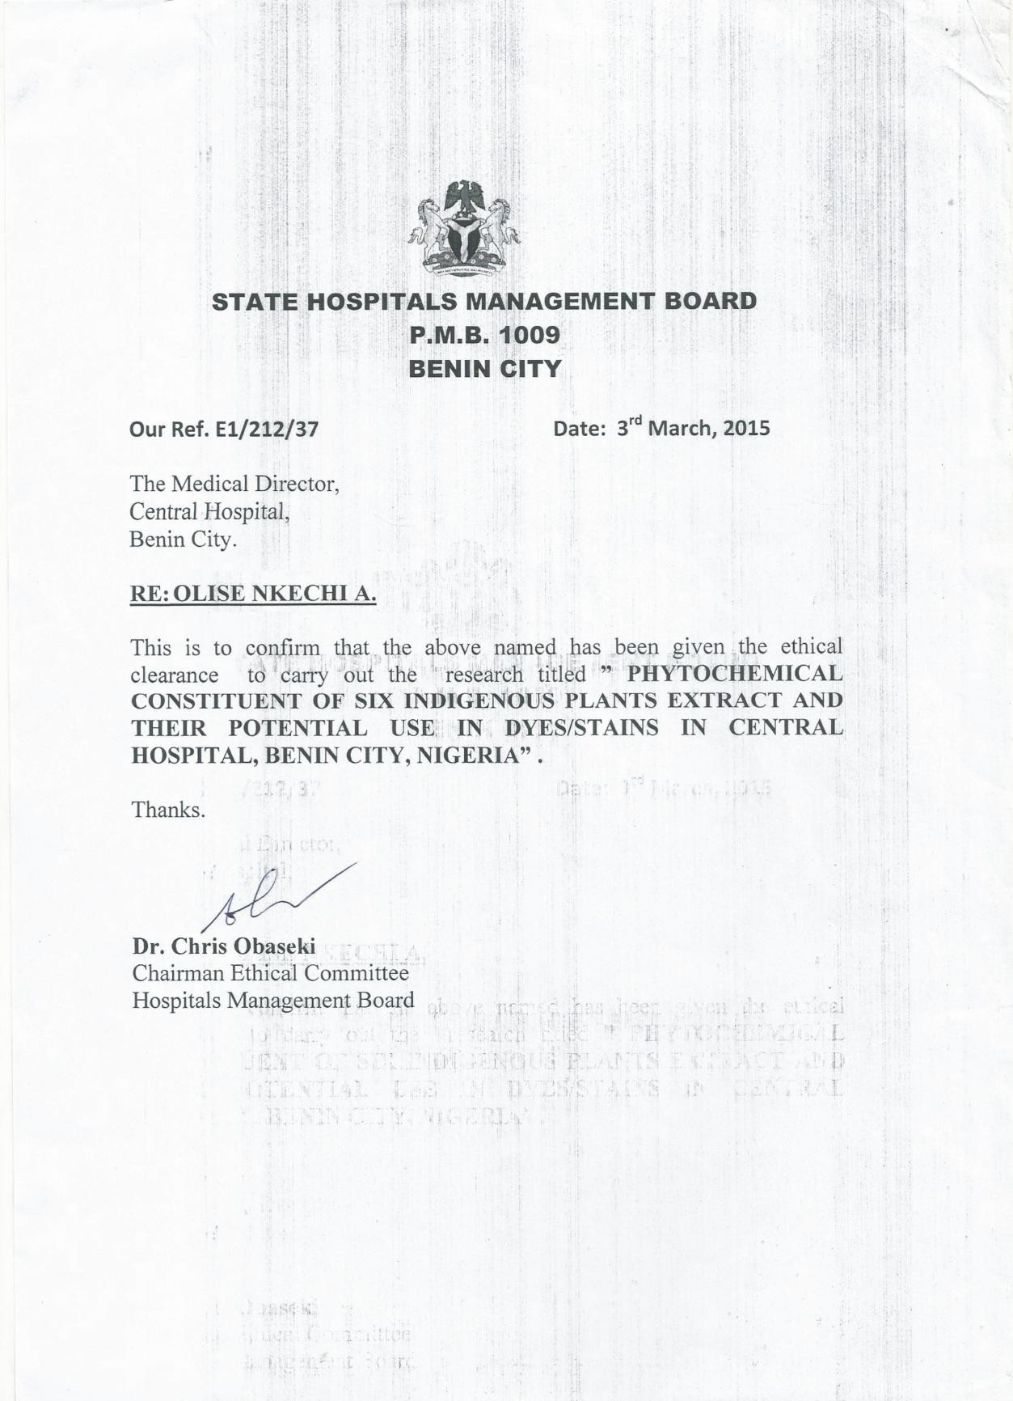

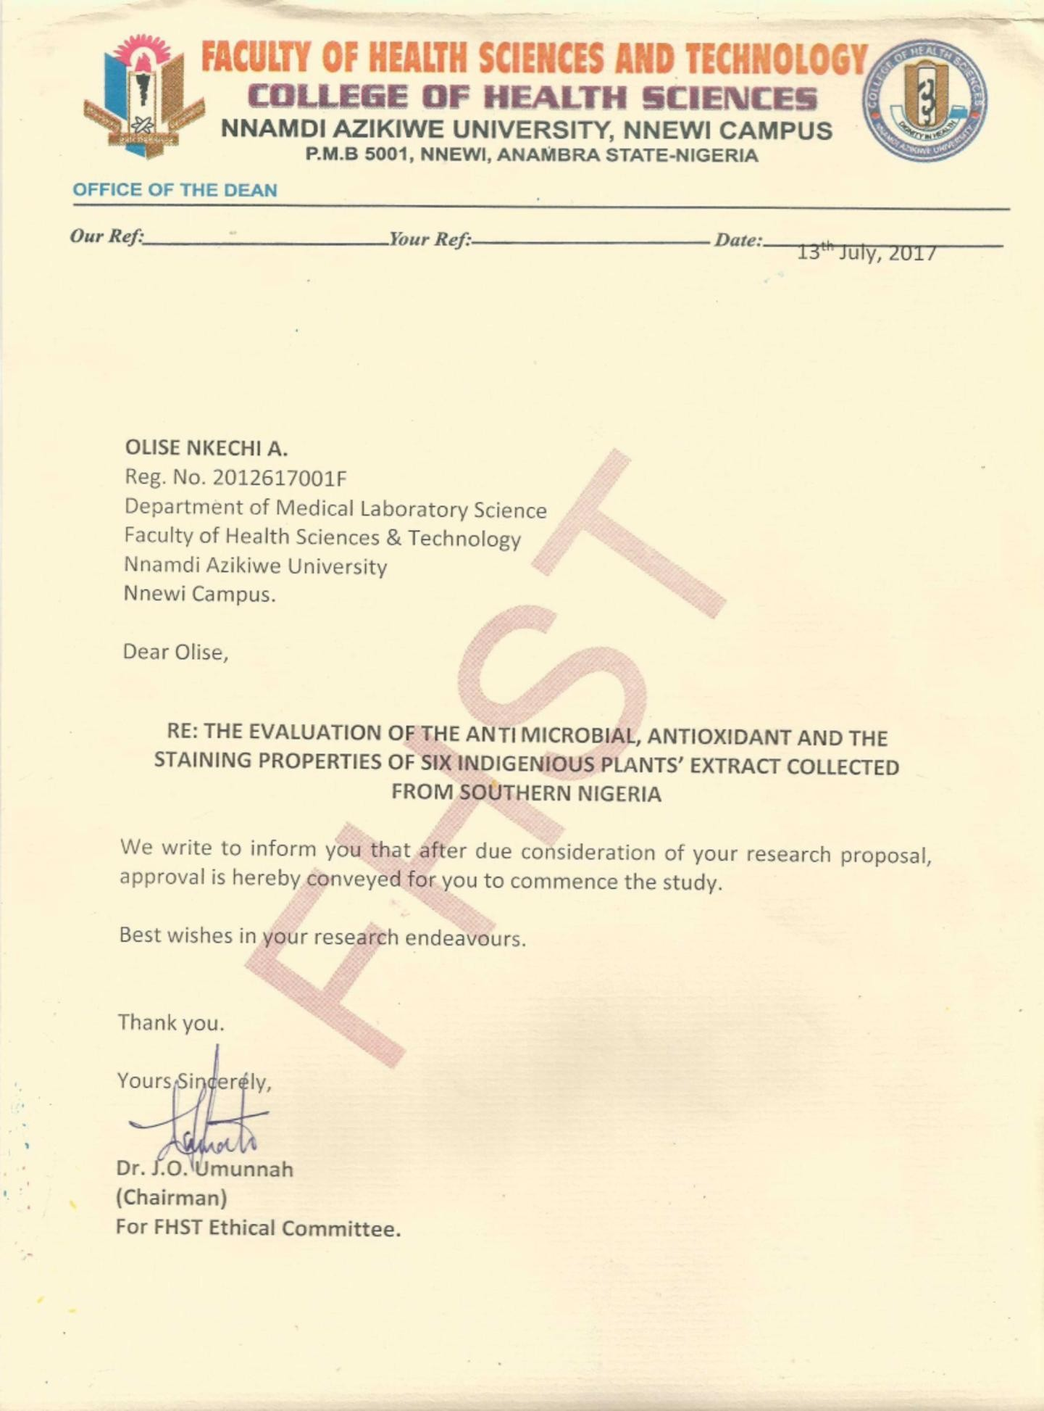

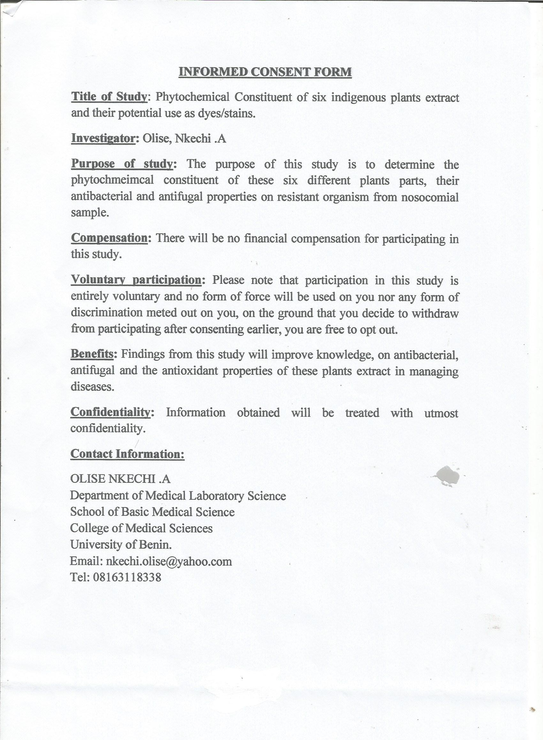

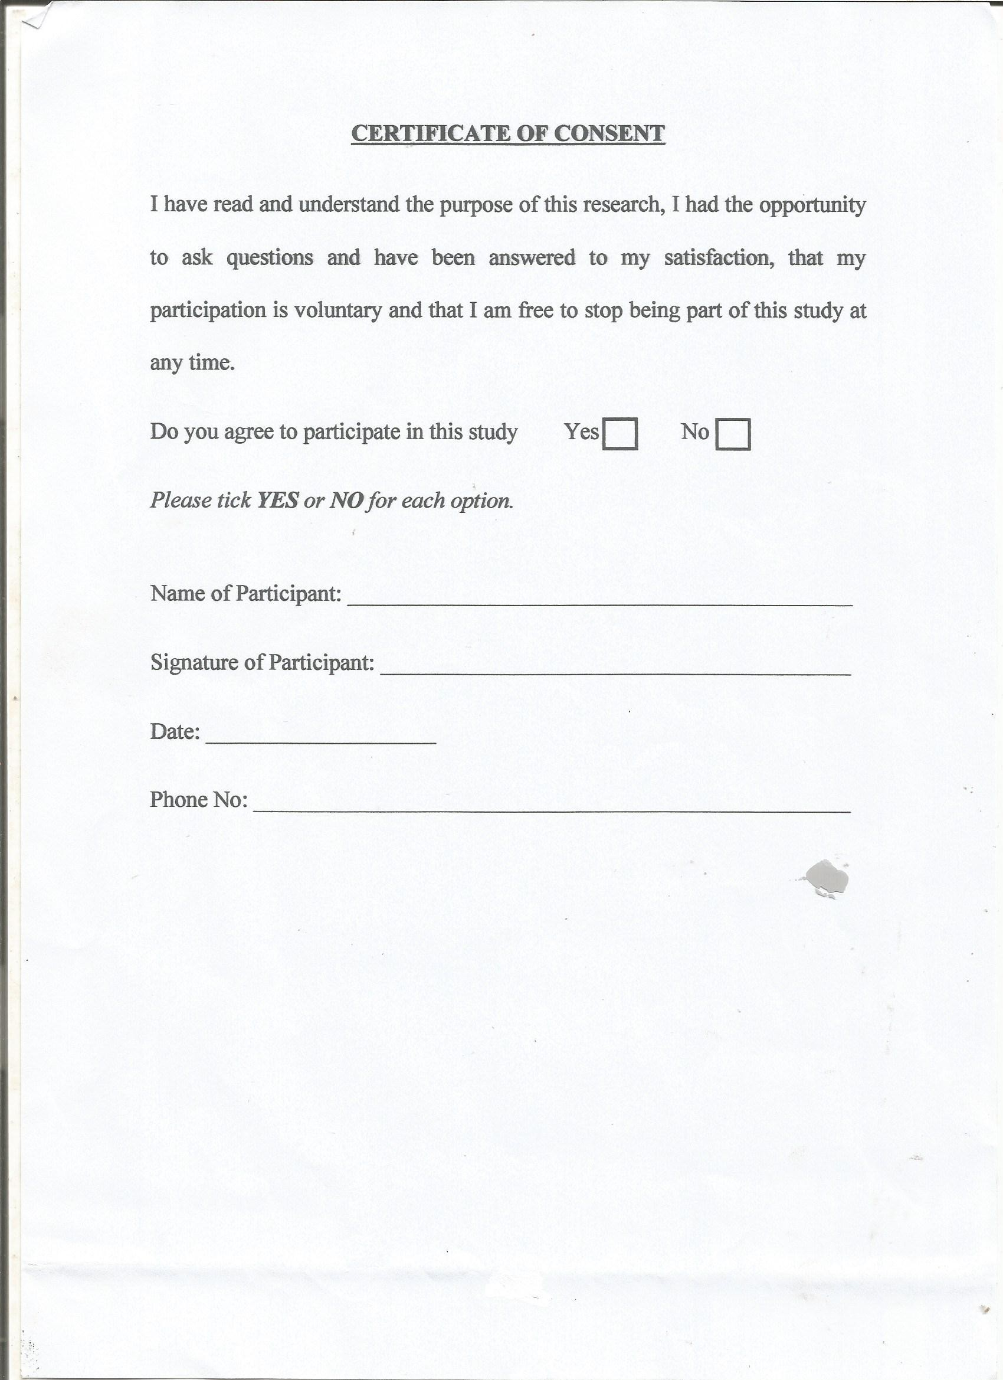

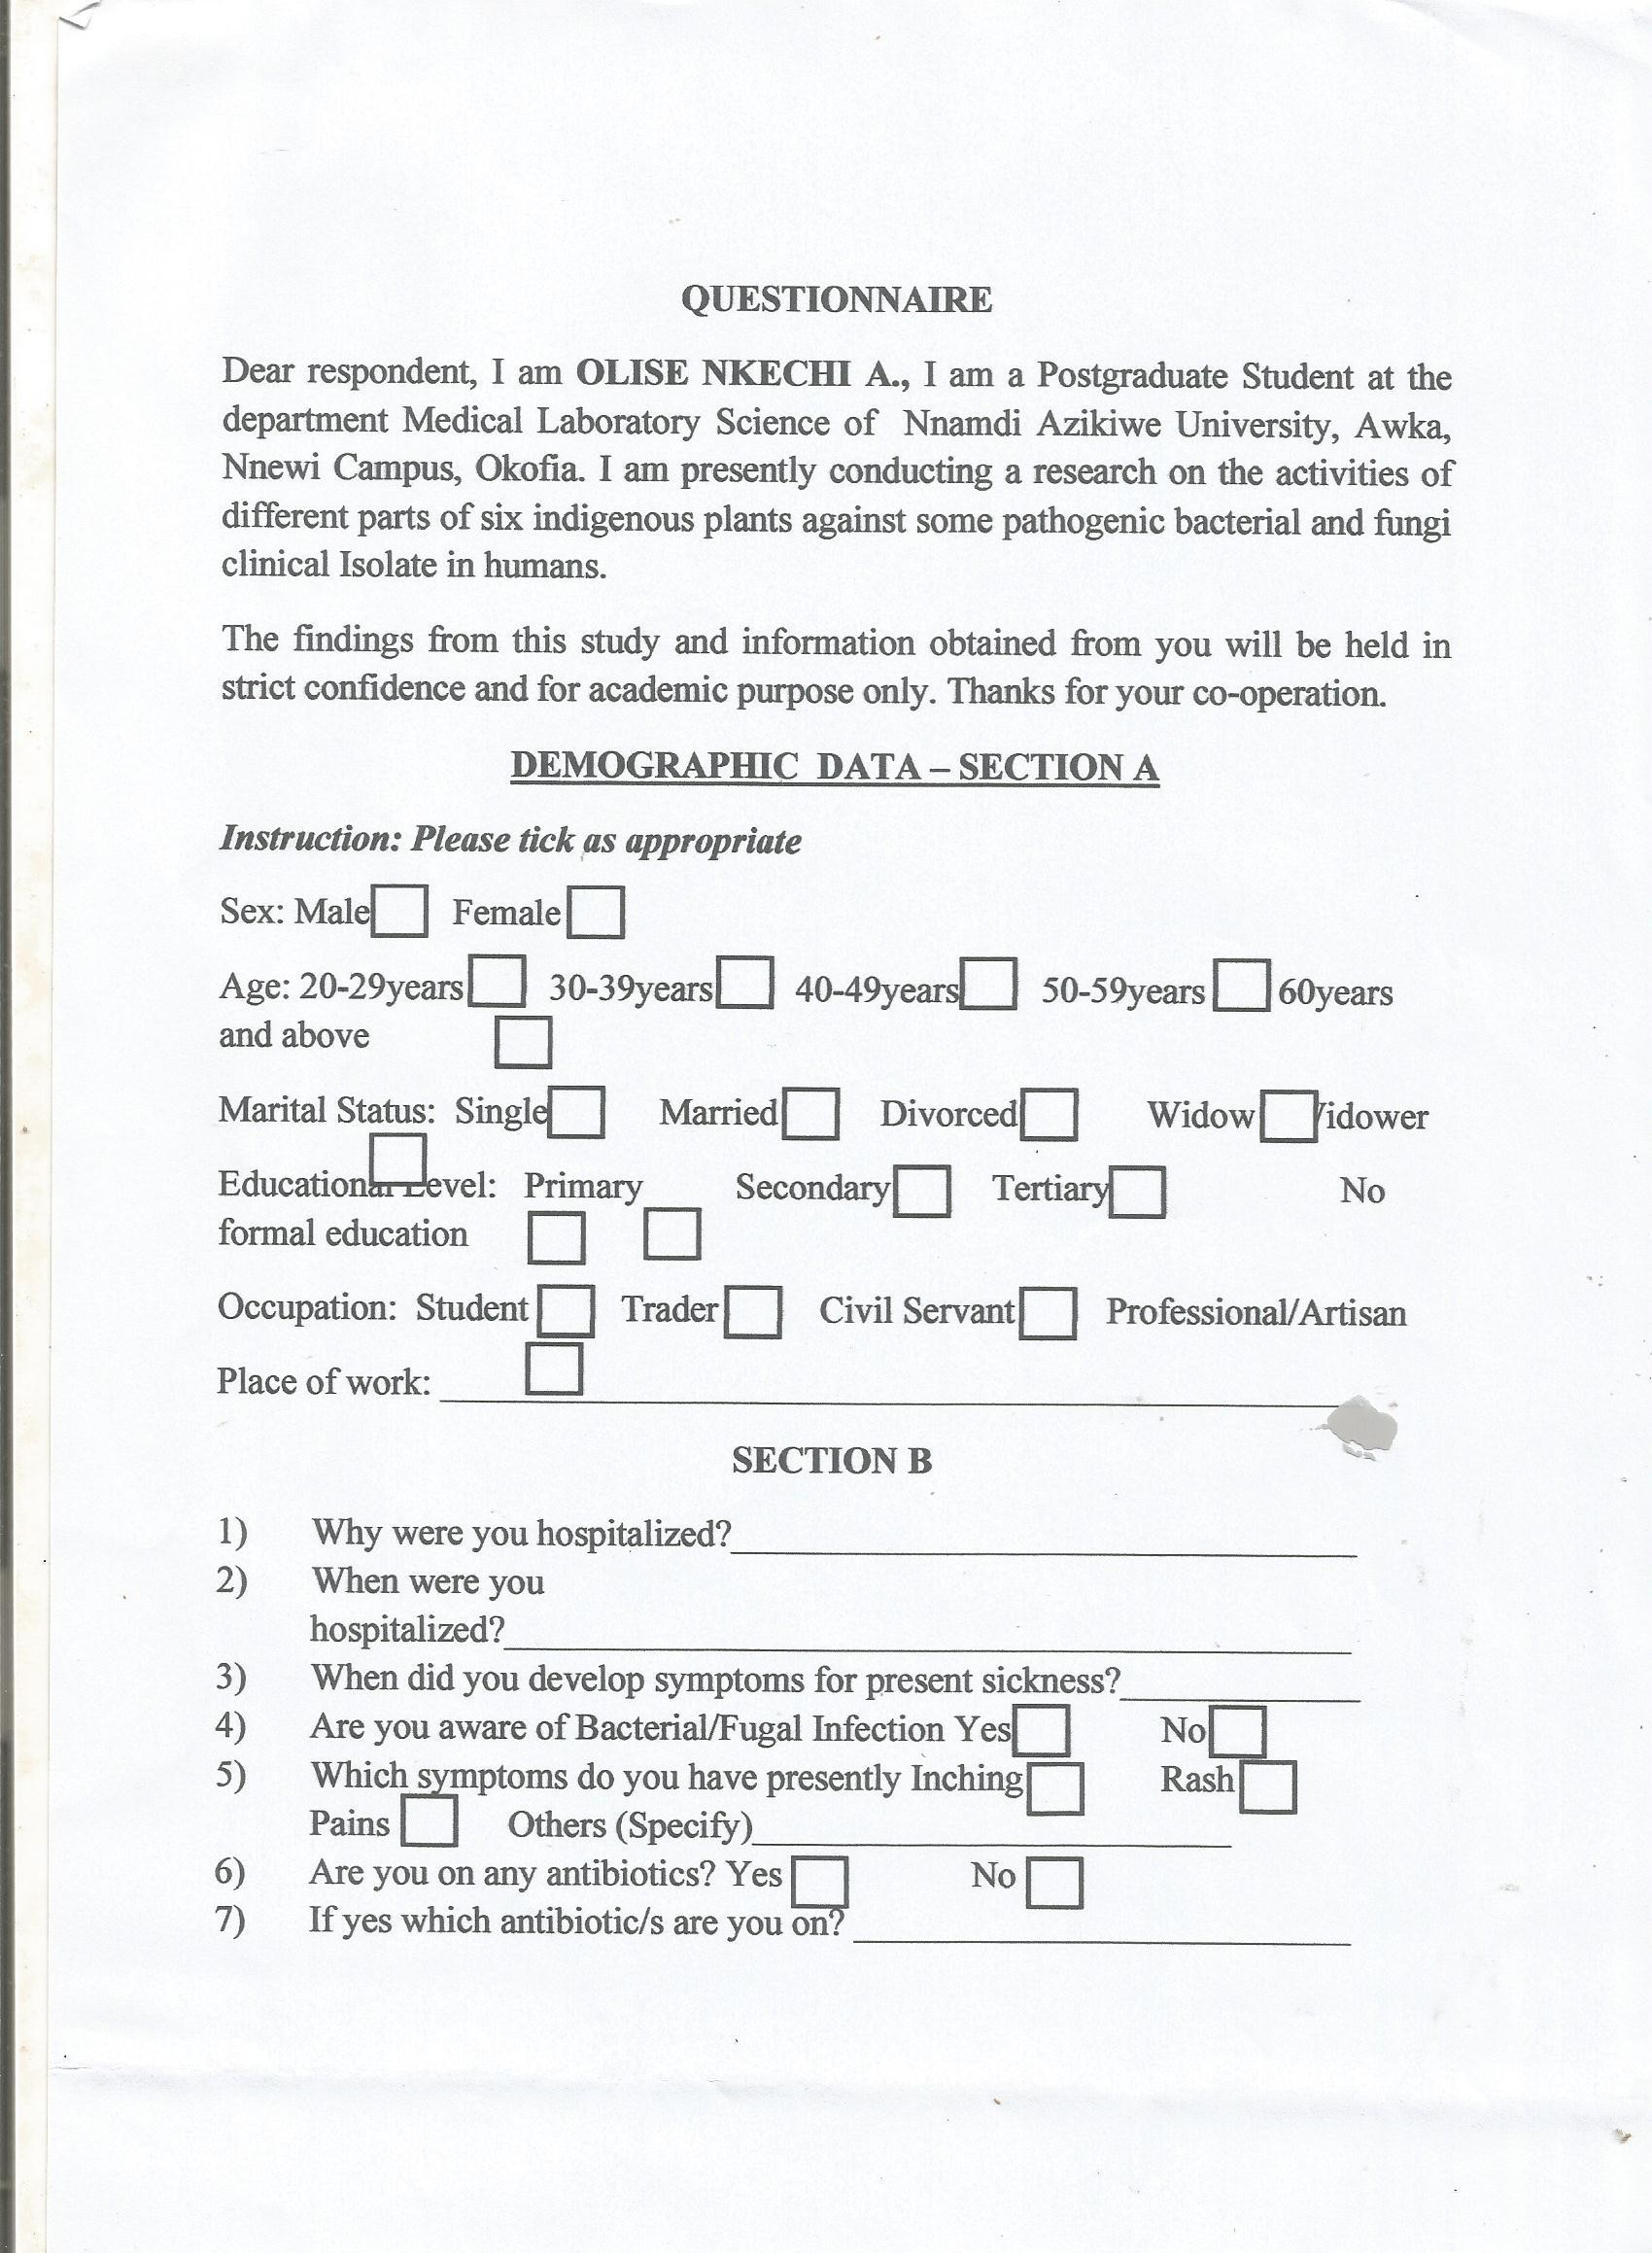



APPENDIX II

Equipments and Instrument Used

These include Incubator (Genlab, UK), Autoclave (EQUITRON Partially Automatic Autoclave, by Medical Instrument Manufacturing Co., India), Hot Air Oven (Genlab, UK), Soxlet extractor, Frationating flask, Spectrophotometer (523A Technical and Techmel USA, Weighing balance (Mettle H80, England), Electronic weighing balance (Ohaus Corp., USA), Rotary evaporator (Technical and Techmel, USA), Milling Machine (British Milling Machine (British Milling Machine, Sigma, ULC), Water bath (H.H.W, constant temperature water bath B. Brain Scientific and instrument company, England), Refrigerator, pH meter (Genway model 3505).

Glass Wares and Other Materials

These include Petri dishes, test tubes, McCartney and bijou bottles, beakers, conical flasks, glass slide and coverslip, measuring cylinders, meter rule, funnels, syringes, micropipettes, etc.

APPENDIX III

COMPOSITION AND PREPARATION OF MEDIA USED

BLOOD AGAR BASE (LAM 28 LAB)
Composition | Grams/Litre
Beef extract | 10.00
Balanced peptone no1 | 10.00
Sodium chloride | 5.00
Agar | 15.00
Final pH (at 25ºC) | 7.3 + 0.2
Directions

This was prepared by Suspending 40g in 100ml of distilled water. The medium was heated to dissolve completely. It was then sterilized by autoclaving at 121ºC for 15 minutes. Cooled to 50ºC and aseptically 5% sterile defibrinated blood was added. The medium was well mixed and poured into sterile Petri dishes.

MACCONKEY AGAR
Composition | Grams/Litre
Peptone | 20.00
Sodium chloride | 5.00
Lactose | 10.00
Bile chloride | 5.00
Neutral red | 0.05
Agar | 13.50
Directions

This was prepared by weighing 52g of agar in the weighing balance in 100ml of distilled water. This was dissolved with stirring. It was then sterilized by autoclaved at 121ºC for 15 minutes. The agar was allowed to cool to about 45ºC before poured into the sterile Petri dishes to solidify.

NUTRIENT AGAR
Composition | Grams/Litre
Peptone | 5.00
Beef extract | 1.00
Yeast extract | 2.00
Sodium chloride | 5.00
Agar | 15.00
Final pH (at 25ºC) | 7.4 + 0.2
Directions

This was prepared by weighing 28g in the weighing balance in 1000ml of distilled water. This was dissolved with stirring. It was then sterilized by autoclaved at 121ºC for 15 minutes. The agar was allowed to cool to about 45ºC before poured into the sterile Petri dishes to solidify.

MANNITOL SALT AGAR  Composition | Grams/Litre
Peptone | 10.00
Meat extract | 1.000
Sodium chloride | 75.000
D-Mannitol | 10.000
Phenol red | 0.025
Agar | 15.000
Final pH (at 25ºC) | 7.4 + 0.2
Directions

This was prepared by weighing 110g in agar in the weighing balance in 1000ml of distilled water. This was dissolved with stirring. It was then sterilized by autoclaved at 121ºC for 15 minutes. The agar was allowed to cool to about 45ºC before poured into the sterile Petri dishes to solidify.

Preparation of McFarland Standard

One percent volume by volume (1% v/v) solution of sulphuric acid was prepared by adding 1ml concentrated sulphuric acid to 99ml of water and mixed. 1% w/v solution of barium chloride was prepared by dissolving 0.5g of dehydrate barium chloride in 50ml of distilled water. 0.6ml of the barium chloride solution was subsequently added to 99.4ml sulphuric acid, and properly mixed. A small volume of turbid solution was transferred into screw capped bijou bottles and store at room temperature (Cheesbrough, 2003).

AMIES TRANSPORT MEDIUM
Composition | Grams/Litre
Charcoal pharmaceutical | 10.0
Sodium chloride | 3.0
Sodium hydrogen phosphate | 1.15
Potassium dihydrogen phosphate | 0.2
Potassium chloride | 0.2
Sodium thioglycollate | 1.0
Calcium chloride | 0.1
Magnesium chloride | 0.1
Agar | 4.0
Final pH (at 25ºC) | 7.2 + 0.2
Directions

This was prepared by suspending 20g in 1 liter of distilled water. It was then allowed to boil in order to dissolve the agar completely. This was distributed into small, screw cap bottles, while stirring to keep the charcoal evenly suspended. Screw down the caps firmly on the completely filled bottles. It was then sterilized by autoclaving at 121ºC for 15 minutes. Bottles were inverted while cooling to distribute the charcoal uniformly and stored in a cool place.

MUELLER-HINTON AGAR
Composition | Grams/Litre
Beef extract | 300.0
Casein hydrolysate | 17.5
Starch | 1.5
Agar | 17.0
Final pH (at 25ºC) | 7.3 + 0.1
Directions

This was prepared by weighing 38g in the weighing balance in 1000ml of distilled water. This was dissolved with stirring. It was then sterilized by autoclaved at 121ºC for 15 minutes. The agar was allowed to cool to about 45ºC before poured into the sterile Petri dishes to solidify.

Preparation of Harris Haematoxylin:

Haematoxylin - 1g Absolute alcohol - 10ml Ammonium alum - 20g Distilled water - 20ml
Mecuric oxide - 05g

The alum was dissolved in hot water and the haemaloxylin was dissolved in absolute achohol. The dissolved alum was added to the solution of the Haematoxylin and was boiled, then the mercuric oxide was added. This was cooled and stored in a black brown bottle and was filtered before use.

APPENDIX III BIOCHEMICAL IDENTIFICATION TEST

MOTILITY TEST

The Hanging drop method were used for the motility test. A ring of platicine of about 2cm in diameter was made on a clean grease free glass slide. A loopful of test broth culture was transferred onto the center of a 22mm square cover slip. The slide was inverted quickly to prevent the displacement of the plastacine and this was examined microscopically at X 10 and X 40 objective.

GRAM’S REACTION

A loopful of the suspected organism was emulsified on a sterile grease free slide, fixed and air-dried. Smear were covered with crystal stain for 60 seconds and then washed off with clean tap water. Smear was covered with Lugol‟s iodine solution for 1 minute and was washed off with clean tap water, decolorized with acetone alcohol for 20 seconds and washed with clean tap water. Smear was covered with neutral red stain for 1 minute and then washed with clean tap water. It was allowed to air dry on a rack and then viewed microscopically using the oil-immersion objective (X100). The organisms that appeared red in color indicates Gram-negative organism and those with purple colour indicate Gram positive organisms.

OXIDASE TEST

A strip of Whatman No. 1 filter paper was soaked with a freshly prepared solution of 1% Tetramenthyl para-phenylene-diamine-dihydrochloride and with a clean slide edge, colonies of suspected organisms were streaked on it. Development of a blue purple colour within a few seconds indicated a positive test while no colour change indicated a negative test.

INDOLE TEST

The test organism was inoculated in sterile bijou bottles containing 3ml of sterile peptone water and incubated for 24 hours at 37oC. Half mill (0.5ml) of Kovac‟s reagent was added and it was shaken gently. A red ring colour was observed in the surface layer within 1 minute, which indicated a positive test while a yellow colour indicates a negative test.

CATALASE TEST

2ml of 3% hydrogen peroxide into a test tube and using a glass rod, colonies of each isolate were removed and immersed in the hydrogen peroxide solution. The occurrence of immediate bubbles (within 10 seconds) was recorded as a positive result.

COAGULASE TEST

A drop of normal saline was placed on microscopic slide and a colony of the test organism was emulsified. A loopful of plasma was added to the suspension and mixed gently. This was then observed for clumping within 10 seconds. Clumping within 10 seconds indicates a positive coagulase test.

CITRATE UTILIZATION TEST

The test is one of the several techniques used to assist the identification of enterobacteria. This is based on the ability of an organism to use citrate as its only sources of carbon. A slope of the medium was prepared in bijou bottles. A sterile straight wire loop was used to pick the colonies and stab to the bottom of the bottle. The slopes were incubated for 24 hours at 37ºC. After incubation a bright blue colour indicated a positive citrate test.

UREASE TEST

The test organism was inoculated into bijou bottles containing 3ml sterile urea slopes. It was incubated at 37ºC for 24 hours. Pink colour in the medium indicated a positive urea test.

SUGAR UTILIZATION TEST

The following sugars namely; glucose, mannitol, lactose and sucrose were tested separately to observe the ability of the isolates to utilized them. The isolates were inoculated into separate sugar broth (that is glucose broth, sucrose broth, mannitol broth and lactose broth) and incubated at 37oC for 24 hours, phenol red indicator was added to the tubes and Durham tubes immerse in them before inoculation and incubation. Sugar utilization was indicated by colour change from red to yellow with the production of acid. While in the Durham tube the presence of gas showed that the reaction was accompanied by gas.

CYSTINE LACTOSE ELECTROLYTE DEFICIENT AGAR (LAB 6 LABMTM)

Composition | Gram/Litre
Balanced peptone No. 1 | 40.0
Beef extract | 30.0
Tryptone | 4.0
Lactose | 10.0
L-Cystine | 0.128
Bromathymol blue indicator | 0.02
Andrade‟s indicator | 0.08
Agar No. 1 | 15.0

This was prepared by dissolving 36.25g in 1000ml of distilled water and heated gently to dissolve completely, and the autoclaved at 15psi (121ºC) for 15 minutes and then allowed to cool to 45ºC and was poured 20 into Petri dishes.

CHOCOLATE AGAR

Blood was added to sterile molten blood agar base as above. This was then placed in water bath at 70o until colour turns chocolate. It is removed mixed and poured ascetically into sterile petri-dishes. It was allowed to set.

PEPTONE WATER (CM9 OXIOD)

Composition | Gram/Litre
Peptone (oxoid L37) | 10.0
Sodium chloride | 5.0
Phenol red indicator | 0.025

KOSLER CITRATE MEDIUM (CM 65 OXOID)

Composition | Gram/Litre
Sodium ammonium phosphate | 1.5
Potassium dihydrogen phosphate | 1.0
Magnesium sulphate | 0.2
Sodium citrate | 2.5
Bromothymol blue | 0.016

MOTILITY MEDIUM
Composition | Gram/Litre
Lab-Lemco powder | 1.0
Yeast extract | 2.0
Peptone | 5.0
Sodium chloride | 5.0
Agar | 5.0g
Distilled water | 1000ml
PEPTONE WATER SUGARS

From a 10% sugar solution of the different sugars – glucose, maltose, sucrose mannitol and lactose the sugar solution is added to the phenol red

Identification Tests for Microorganisms Gram Staining Technique (Cheesbrough, 2006)
The Gram staining reaction was used to identify isolates by their Gram reaction (Gram positive or Gram negative), their morphology and morphology of yeast form of C. albicans. Method:
- A loopful of the test organism was smeared on a clean glass slide and fixed by passing it 2 times through flame from Bunsen burner.
- The fixed smear was covered with crystal violet stain for 60 seconds.

- The stain was rapidly washed off with clean water.

- Excess water was drained off and the smear was covered with Lugol‟s iodine for 60 seconds.
- The iodine was rapidly washed off with clean water.

- The smear was decolorized rapidly with acetone and then washed immediately with clean water.
- The smear was covered with neutral red stain for 2 minutes.

- The stain was washed off with clean water.

- The back of the slide was wiped clean and placed in a draining rack for the smear to air-dry.
- The smear was examined microscopically, first with the 40 objective to check the staining and to see the distribution of material, and then with the oil immersion objective to report the bacteria staining reaction.

Catalase Test (Cheesbrough, 2006)

This test was used to differentiate those bacteria that produce the enzyme catalase, such as

Staphylococci, from non-catalase producing bacteria such as Streptococci.

Principle

Catalase acts as a catalyst in the breakdown of hydrogen peroxide to oxygen and water. An organism is tested for catalase production by bringing it into contact with hydrogen peroxide. Bubbles of oxygen are released if the organism is a catalase producer.
Method

- 2–3ml of the hydrogen peroxide solution was poured into a test tube.

- Using a sterile glass rod several colonies of the test organism was taken and immersed in the hydrogen peroxide solution.
- The set was then observed for immediate bubbling. Both positive and negative controls were included.
Coagulase Test (Cheesbrough, 2006)

This test was used to identify S. aureus which produces the enzyme coagulase.

Principle

Coagulase causes plasma to clot by converting fibrinogen to fibrin. Two types of coagulase are produced by most strains of S. aureus: free and bound coagulase. Free coagulase converts fibrinogen to fibrin by activating a coagulase-reacting factor present in plasma. Free coagulase is detected by clotting in the tube test. Bound coagulase (clumping factor) converts fibrinogen directly to fibrin without requiring a coagulase reacting factor. It can be detected by the clumping of bacterial cells in the rapid slide test.
Slide test method (detects bound coagulase)

- A drop of distilled water was placed on two separate slides.

- A colony of the test organism was emulsified in each of the drops to make two thick suspensions. The colony was cultured on nutrient agar from where it was taken for the test.
- A loopful of plasma was added to one of the suspensions, and mixed gently. Clumping of the organism was observed within 10 seconds, as No plasma was added to the second suspension. This was used to differentiate any granular appearance of the organism from true coagulase clumping.

Tube test method (detects free coagulase)

- Three small test tubes were labelled: T (Test organism), Pos (Positive control) and Neg (Negative control).
- 0.2ml of plasma was dispensed into each tube.

- 0.8ml of the test broth culture (Nutrient broth) was added to tube T, 0.8 ml of the S. aureus culture was added to the tube labelled „Pos‟ and another 0.8 ml of sterile broth to the tube labelled „Neg‟.
- After mixing gently, the three tubes were incubated at 37⁰C and examined for clotting after 1 hour.

Oxidase Test (Cheesbrough, 2006)

The oxidase test was used to assist in the identification of Pseudomonas which produces the enzyme cytochrome oxidase. However, other microorganisms such as
Neisseria, Vibrio, Brucella, and Pasteurella species also give a positive test.

Principle

A piece of filter paper is soaked with a few drops of oxidase reagent. A colony of the test organism is then smeared on the filter paper. When the organism is oxidase-producing, the phenylenediamine in the reagent will be oxidized to a deep purple colour.

Method (fresh reagent)

  - A piece of filter paper was placed in a clean petridish and 2 drops of freshly prepared oxidase reagent was added.
  - Using a piece of glass rod a colony of the test organism was smeared on the filter paper.
  - The set up was observed for the development of a blue-purple colour within a few seconds. Both positive and negative controls were included in the test procedure.

Motility testing (Cheesbrough, 2006)

This test was used to differentiate motile bacteria such as P. aeruginosa, E. coli, from non- motile bacteria such as K. pneumoniae.

Hanging drop preparation

- A drop of suspension from the broth containing the test organism was placed on a cover glass and inverted over a normal slide.
- The preparation was examined microscopically for motile organisms, using the 10- and 40- objectives.

Oxidation-Fermentation (O-F) Test (Ochei and Kolhatkar, 2008)

This test was used to differentiate those bacteria that ferment carbohydrates (anaerobic utilization) such as E. coli, from those that oxidise carbohydrates (aerobic utilization) such as
P. aeruginosa.

Principle

The utilization of glucose (or any other carbohydrates) by oxidation or fermentation is critically different. Fermentation is anaerobic and results in the formation of acids whereas oxidation is aerobic and results in the formation of alkaline products.

Method

- Using a straight wire the test organism was inoculated to the bottom of a pair of tubes containing sterile10% glucose solution.
- The inoculated medium in one of the tubes was covered with 1.5ml of sterile paraffin oil. The other tube was left uncovered.
- The tubes were incubated at 37⁰C for 5 days.

- The tubes were then examined daily for carbohydrate utilization (acid production) which was indicated by colour change in the medium. Both positive and negative controls were included.

Carbohydrate Utilization Test (Ochei and Kolhatkar, 2008)

Some non-fermentative bacteria such as E. coli can utilize carbohydrates as a sole source of carbon for growth.
Method

- The test organism was inoculated on a carbohydrate free medium.

- A filter paper disc impregnated with 1% solution of the carbohydrate (dried before use) was placed on the medium.
- The medium was incubated at 37⁰C for 48 hours.

- The medium was then observed for growth around the disc.

Citrate Utilization Test (Ochei and Kolhatkar, 2008)

This test is one of several techniques used occasionally to assist in the identification of enterobacteria. E. coli is citrate negative.

Principle

The test is based on the ability of an organism to utilize citrate as its only source of carbon, and ammonium as its only source of nitrogen. The citrate is metabolized to acetoin and CO₂.

Method

- A light suspension of the test organism was made in saline.

- Using a straight wire, saline suspension was inoculated in Koser‟s citrate medium.

- The medium was then observed for growth which is indicated by turbidity.

Urease Test (Cheesbrough, 2006)

Testing for urease enzyme activity is important in differentiating enterobacteria. E. coli is urease negative.

Principle

The enzyme urease is possessed by some bacteria. The urease is able to decompose urea by hydrolysis to give ammonia and CO₂. The reaction turns the medium alkaline which is shown by a change in colour of the indicator to red-pink.

Method

- The entire surface of the Christensen‟s urea slope was inoculated with the test organism and incubated in an incubator at 37⁰C for 24 hours.
- The medium was then observed for the presence of red-pink colour of urease positive test. Both positive and negative controls were included.

Indole Test (Cheesbrough, 2006)

Testing for indole production is important in the identification of enterobacteria. Most strains of E. coli break down the amino acid tryptophan with the release of indole.

Principle

The test organism is cultured in a medium which contains tryptophan. Indole production is detected by Kovac‟s or Ehrlich‟s reagent which contains 4-para-dimethylaminobenzaldehyde. This reacts with the indole to produce a red coloured compound.

Method
- The test organism was inoculated in a bijou bottle containing 3 ml of sterile tryptone water and incubated at 37⁰C for 48 hours
- Indole was tested by adding 0.5 ml of Kovac‟s reagent and examined for ared colour in the surface layerwithin 10 minutes. Positive and negative controls were included.

Potassium cyanide (KCN) Test (Ochei and Kolhatkar, 2008)

Principle

KCN inhibits some enzymes involved in aerobic respiration and therefore, some bacteria are inhibited while others are able to resist. The test is based on this difference whereby bacteria are challenged to grow in nutrient broth with a concentration of KCN.

Method

- KCN medium was inoculated with a loopful of an overnight broth culture of the test organism.
- The cap of the bottle was screwed tightly to prevent air exchange and incubated at 37⁰C for 48 hours.
- The bottle was then examined for the presence of turbidity which indicates a positive test for KCN. Both positive and negative controls were included.

Swarming of Proteus (Cheesbrough, 2006)

This test was used to differentiate proteus from other organisms. All species of proteus have a characteristic swarming appearance when cultured on blood agar or chocolate agar.

Method

- The test organism was cultured on blood agar medium using a sterile wire and then incubated for 24 hours.

- The medium was examined for swarming. Both positive and negative controls were added alongside the test organism.
Indole test was also done to differentiate P. mirabilis from other species of proteus.

Germ Tube Test (Cheesbrough, 2006)

- 0.5 ml of rabbit serum was placed into a small test tube.

- Using a sterile wire loop the serum was inoculated with a yeast colony from the culture plate and the tube was incubated at 37 ºC for 3 hours in an incubator.
- Using a Pasteur pipette, a drop of the serum yeast culture was transferred to a glass slide and covered with a cover glass.
- A drop of lactophenol cotton blue was added to the preparation to stain the yeast cells.

- The preparation was examined using the 10- and 40- objectives with the condenser iris diaphragm closed sufficiently to give good contrast.

Preparation of Stains/Dye For Histological Studies:

Ehrlichs Haemetoxylin:

This is a very useful all purpose nuclear stain.

Components:
Amonium alum | 3g
Haematoxylin | 2g
Ethyl alcohol 95% | 100ml
Glycerol | 100ml
Distilled water | 100ml
Glacial acetic acid | 10ml
Preparation:

The haematoxylin was dissolved in the alcohol before adding all other ingredients. The stain ripens naturally in a large container, loosely stopped with cotton wool. The flask was shaken

frequently. It was oxidized using 0.3g of sodium iodate to ripen it fast for immediate use. This was filtered with whatman no. 1 filter paper into a big brown bottle and is ready for use. This same preparation was done using P. Soyauxii extract (2g) replacing haematoxylin powder in the above preparation.

Cole’s Haematoxylin

This is also used to demonstrate general stain ing effect, although not so popular. Haemetoxylin 15g
1% iodine in 95% alcohol 50mls Saturated aqueous ammonium alum 700mls Distilled water 250mls

Preparation of Stain

The haematoxylin powder was dissolved in 95% alcohol containing 1% iodine and the alum was added and was brought to boil, then cooled, filtered and ready for use.
This same preparation was done using 1.5g of P. soyauxii extract powder to replace the 1.5 haematoxylin in the Cole‟s method.

APPENDIX IV

Table 4.14: Absorbance of Standard Compound (Gallic Acid)

Concentration (mg/ml) | Absorbance (Mean)  Λmax = 760nm
1.6 | 0.0448
3.12 | 0.0500
6.25 | 0.787
12.5 | 0.1129
25 | 0.1930
50 | 0.3874

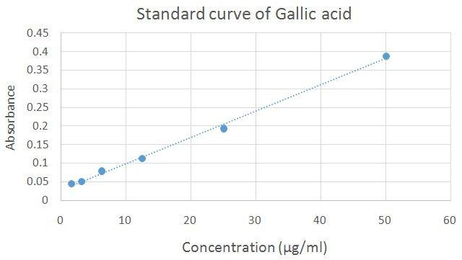
Garlic acid caliberation curve

To calculate the total phenolic content (TPC), we use the formulae, C = ^{CV}/_{M}. Where;
C = TPC

C = calculated x = Gallic acid concentration in the extract. V = volume of the extract in the curette (usually 1ml)
M = dried weight of extract dissolve in 1ml of diluent (In this work is 0.1mg). With all this information we can calculate the TPC of the vitex leaves as thus: C = ^{CV}/_{M}.
= 0.2691mg/ml x 1ml 0.0001g
= 2691mgGAE/g extract.

Summary

Vitex Leaves

Absorbances of Extract | TPC (MgGAE/g Extract) | x + SD
1.926 | 2691.09 | 2684.77
1.958 | 2736.48 | + 55.62
1.880 | 2625.84

  - Vitex Leaves Absorbances (760nm) 1.926
1.958

1.880

X = v – 0.02878
0.00705

v = 1.926.

1.926 – 0.02878
0.00705

x = 269.11ug/m = 0.2691mg/ml

Table 1: Absorbance of Standard Compound (Gallic Acid)

Concentration (Mg/ml) | Absorbance (Mean)  Λmax = 760nm
1.6 | 0.0448
3.12 | 0.0500
6.25 | 0.787
12.5 | 0.1129
25 | 0.1930
50 | 0.3874

From the curve, we have the equation: y = 0.00705 x 0.02878 X = y – 0.02878
0.00705

Where:

Y = absorbance (for each extract) X = concentration of gallic acid
Repeat all the steps above for all extracts. Table 2 shows a summary of the results.

Table 2:

Plants | Abso (760nm) | TPC (mgGAE/9 | Means + SD
Vitex doniana Leaves | 1.926 | 2691.09 | 2684.47
 | 1.958 | 2736.48 | + 55.62
 | 1.880 | 2625.84
Pterocarpus soyauxii | 0.550 | 739.32 | 728.92
Stem | 0.546 | 733.64 | + 13.40
 | 0.532 | 713.79
Lawsona inermis | 0.382 | 501.02 | 517.57
Leaves | 0.398 | 523.72 | + 14.49
 | 0.401 | 527.97
Lantana aculata | 0.506 | 676.91 | 670.76
Leaves | 0.500 | 668.40 | + 5.37
 | 0.499 | 666.98
G. kola mesocarp | 0.314 | 404.57 | 406.93
 | 0.304 | 390.38 | + 17.85
 | 0.329 | 425.84
Gnestis ferruginea | 0.704 | 957.76 | 971.47
Fruits | 0.712 | 969.11 | + 15.03
 | 0.725 | 987.55

Vitex doniana stem | 0.174 | 205.99 | 189.91
 | 0.150 | 171.94 | + 17.10
 | 0.164 | 191.80
Vitex doniana fruit | 0.213 | 261.30 | 261.30
 | 0.215 | 264.14 | + 2.83
 | 0.211 | 258.49

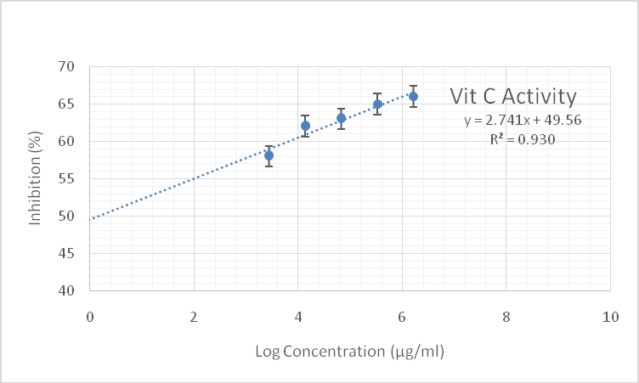

Fig. Showing antioxidant activity of Vit. C

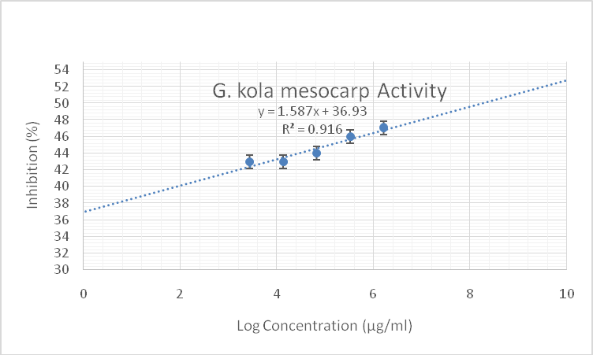

Fig. Showing relationship between concentration of kola mesocarp extract and antioxidant activity

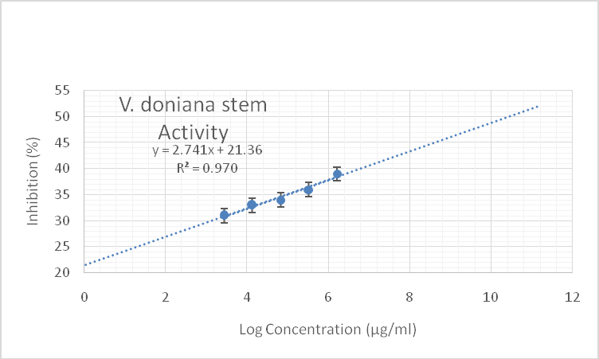

Fig. Showing relationship between concentration of V. doniana stem extract and antioxidant activity

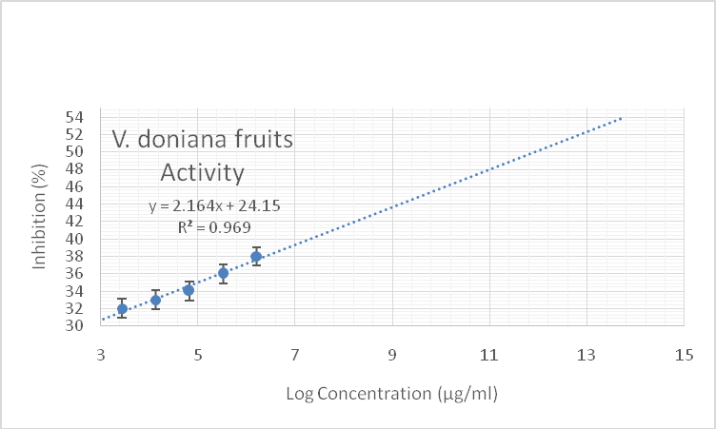

Fig. Showing relationship between concentration of V. doniana fruit extract and antioxidant activity

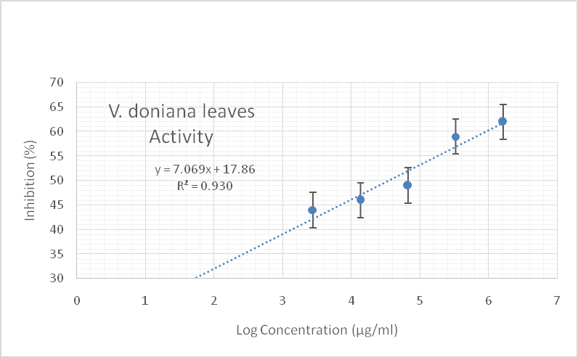

Fig. Showing relationship between concentration of V. doniana leaves extract and antioxidant activity

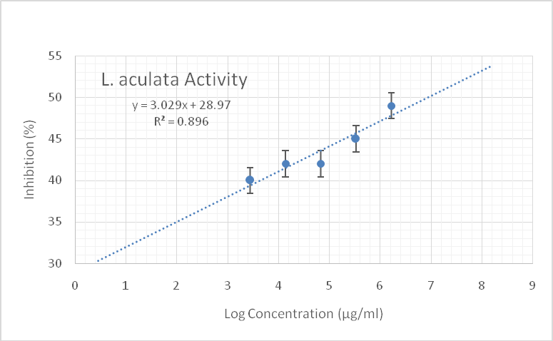

Fig. Showing relationship between concentration of L. aculata extract and antioxidant activity

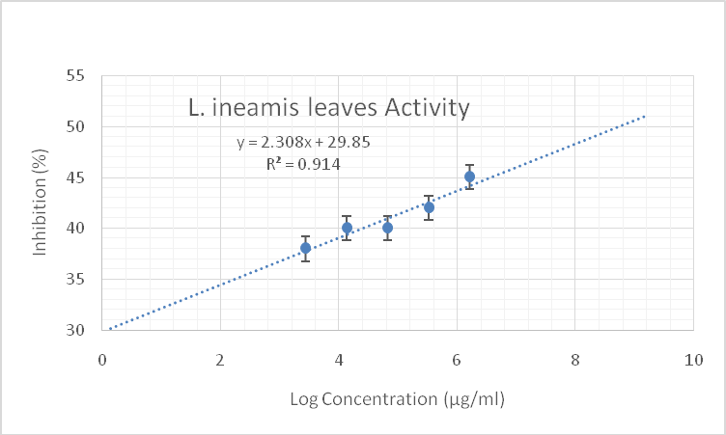

Fig. Showing relationship between concentration of L. ineamis extract and antioxidant activity

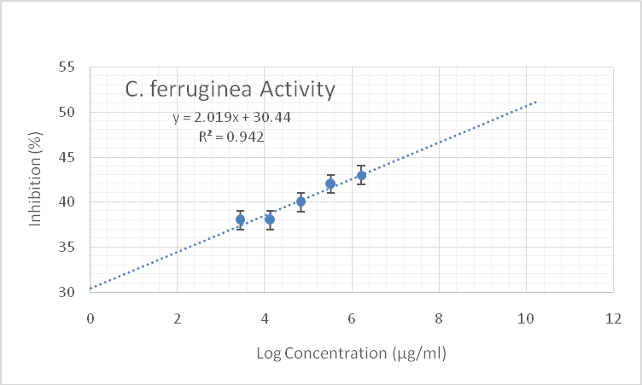

Fig. Showing relationship between concentration of C. ferruginea extract and anti=oxidant activity

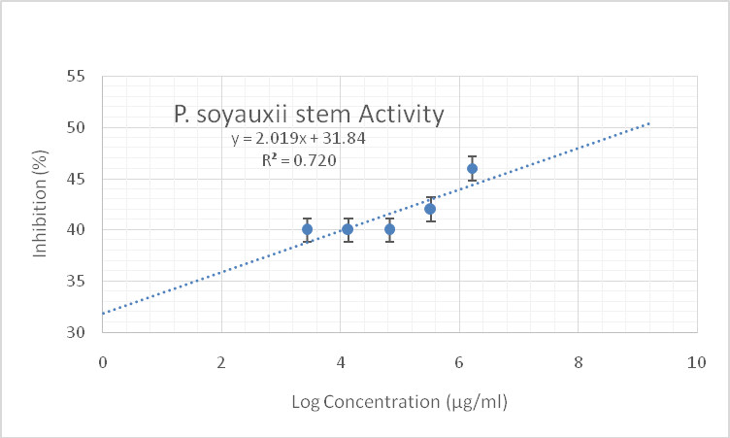

Fig. Showing relationship between concentration of P. soyauxii extract and antioxidant actvity

APPENDIX V

Table showing Chromatography, UV and ESI-MS data of marker compounds from L. inermis

Peak No. | Peak Label | T_{R}  (min) | UV  λmax (nm) | [M+H]+  (m/z) | Fragment ions (+) | [M- H]  (m/z) | Fragment ions (-) | Molar mass  (g/mol) | Compound | Peak Ref Area (%)
1 | A | 11.75 | 252.5,  350.2 | 448.9 | 287.2 | 447.4 | 285.5 | 448 | Luteolin  monoglucoside | 5.13%
2 | B | 13.17 | 268.7,  334.1 | 433.2 |  | 431.3 |  | 432 | Apigenin  monoglucoside | 1.35%
3 | C | 13.88 | 268,  340 | 449.1 | 287.2 | 447.3 | 285.4 | 448 | Kaemferol  monoglucoside | 14.87%
4 | D | 16.84 | 254.9,  349.1 | 287.2 |  | 285.5 |  | 286 | Luteolin | 18.78%
5 | E | 18.57 | 268.1,  337.1 | 271.3 |  | 269.4 |  | 270 | Apigenin | 3.58%

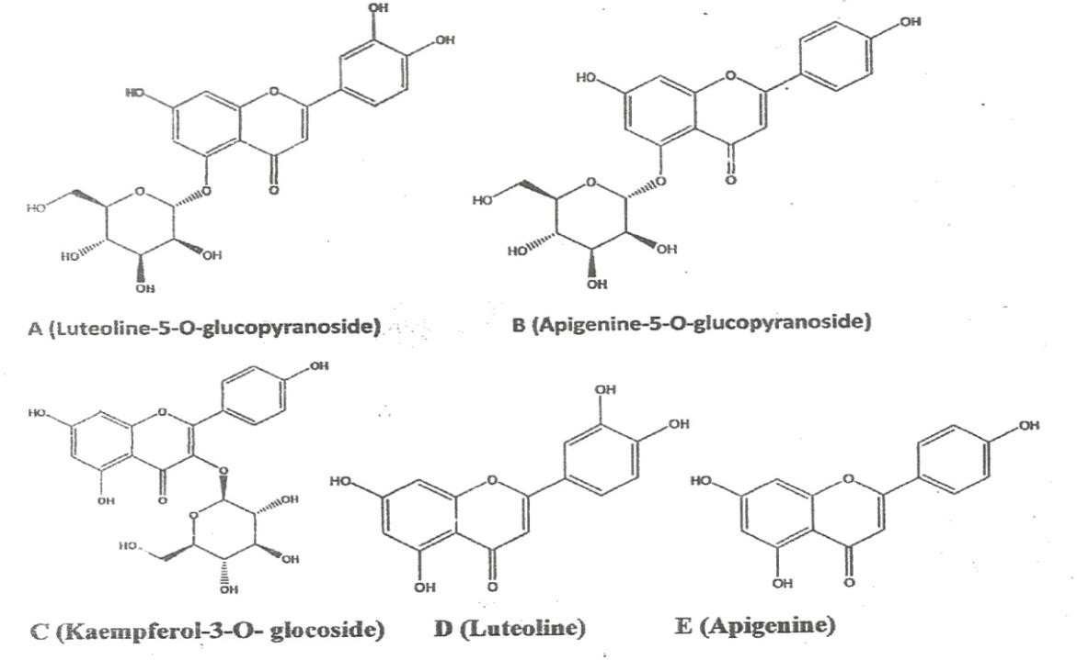

Table showing Chromatography, UV and ESI-MS data of marker compounds from
P.soyauxii

Peak No. | Peak label | t_{R} (min) | UV  λmax (nm) | [M+H]+  (m/z) | Fragment ions (+) | [M-H]ˉ  (m/z) | Fragment ions  (-) | Compound | Peak Ref Area (%)
1 | K | 10.06 | 232,  280,  354 | 775.4 | 331.2 |  | 329.3 | Malvidin 3-p- hydroxybenzoyls  ophoroside | 13.15%
2 | L | 12.45 | 236,  264,  360,  390 | 696.7 | 331.2 |  | 329.3 | Malvidin 3- acetylatedsophor oside | 7.62%
3 | M | 13.97 | 248,  300 | 315.2 |  | 313.4 |  | ND | 15.72%
4 | N | 15.80 | 258,  354,  372 | 331.1 | 285.2,  196.9,  164.7 | 329.4, | 283.6,  183.5 | Malvidin | 3.04%
5 | M | 16.28 | 226,  280 | 330.9 | 167.1 | 329.4 | 299.3,  183.2 | ND | 7.21%
6 | O | 17.73 | 262,  350,  396 | 301.2 |  | 299.3 |  | Tectoridine | 4.00%

Peak Label | Name of Compound | Chemical Structure
K | Malvidin 3-p- hydroxybenzoylsophoroside |  |  |  |  | O | OH
 |  | HO |  | O
 |  |  |  |  |  |  | O |  |  |  | OH
 |  |  |  |  | O
 |  |  | OH | HO
 |  |  |  |  |  | O
 |  |  |  |  |  |  | O | O
 |  |  |  | HO |  |  |  |  |  | O |  | O
 |  |  |  |  | OH
 |  |  |  |  |  |  | HO |  | OH
 |  |  |  |  |  |  |  | OH
L | Malvidin 3-acetylatedsophoroside

O

OH

HO O
O

O

OH HO
O

O O
HO O O

OH
HO OH

OH
M | Irisilodone
N | Malvidin | O  OH  HO O  O  OH  OH
O | ND | ND
P | Tectoridine | O  OH  HO O  OH  OH

Table showing Chromatography, UV and ESI-MS data of marker compounds from V. donaiana fruit

Peak No. | Peak label | t_{R} (min) | UV  λmax (nm) | [M+H]+  (m/z) | Fragment ions (+) | [M-H]ˉ  (m/z) | Fragmen t ions  (-) | Compound | Peak Ref Area  (%)
1 | F | 26.13 | 262.8 | 301.2 | 622.7  (2M+23) | 299.4 | 598.9  (2M-1) | Tectorigenin | 13.15%
2 | G | 28.07 | 241.8,  279.0,  470.0,  510.0 | 583.3 | 301.2 | 581.3 | 299.4 | Peonidin 3-(6''-p- hydroxybenzoyl) glucoside | 11.96%
3 | H | 30.33 | 234,  306 | 597.2 | 301.2 | 595.5 | 299.4 | Tectorigenin 3-p-  hydroxybenzoyl-5- frulate) | 11.70%
4 | I | 31.30 | 241.6,  278.9,  318,  470,  510 | 597.2 |  | 595.2 | 299.4 | Peonidin 3-(6''- p- methoxybenzoyl) glucoside | 11.33%
5 | J | 32.26 | 212,  230,  286 | 597.2 |  | 595.4 | 299.4 | Tectorigenin 3-(6''- p-methoxybenzoyl)  glucoside | 14.62%

Peak Label | Name of Compound | Chemical Structure
F |  | HO O  O  OH O  OH

G |  | O  OH  HO O  O  OH HO  O  O O  HO  OH  OH
H |  | OH  O  O  O O  O  OH O  O  O  OH
I |  | O  OH  HO O  O  OH HO  O  O O  HO  OH  O

J |  | HO O  O  OH O  O  HO  O  O O  HO  OH  O

APPENDIX V1

Extraction Of Dye Stuff From Six Indigenous Plant And Parts

 | Sources of dye stuff | Extraction solvent | Color of extract | Degree of extraction.
1 | Garcinia kola Mesocarp | Water  Absolute Methanol Absolute Ethanol | Dark brown Deep orange  Deep orange | +  +++  ++
2 | Vitex donianna stem | Water  Absolute Ethanol Absolute Methanol | Nil | –  +  +
3 | Vitex donianna fruit | Water  Absolute Methanol Ethanol | Brown  Deep yellow Golden | +  ++  +++
4 | Vitex donianna leave | Water  Absolute Ethanol Absolute Methanol | Dark green  Very dark green Dark green | +  ++  +++
5 | Lantana aculata fruit | Water  Absolute Ethanol Absolute Methanol | Nil  Blue tinge  - | –  +  +
6 | Lawsonia inermis | Water  Absolute Ethanol Absolute Methanol | Orange  Deep orange Deep orange | ++  ++  +++
7 | Cnestis ferrugea | Water Methanol  Ethanol | Light red Deep red  Deep red | +  +++  +++
8 | Pterocarpus soyauxii | Water  Ethanol Methanol | Light red  Deep red Deep red | +  +++  +++

APPENDIX VII ANTIMICROBIAL ASSAY

MATERIALS AND METHODS

Test organisms

Ten (10) strains of both Gram negative and Gram positive bacteria (Morganella morganii, Pseudomonas aeruginosa, Klebsiella pneumoniae, Bacillus subtilis, Staphylococcus aureus, Streptococcuspneumonia Escherichia coli, Proteus mirabilis, Staphylococcus aureus (ATCC 25923) and Salmonella typhi (ATCC 14028)and three fungal strains (Aspergillus niger, Candida albicans and Candida albicans (ATCC 10231) were used in this study.

Culture Media

Culture media used include Mueller Hinton Agar (Titan Biotech Ltd., India) and Sabouraud Dextrose Agar (Guandong Huankai Microbial Sci. and Tech. Co. Ltd., China).Culture media were prepared according to the manufacturer‟s instructions.

Equipment and Instruments

These include Incubator (Genlab, UK), Autoclave (EQUITRON Partially Automatic Autoclave, by Medica Instrument Manufacturing Co., India), Hot Air Oven (Genlab, UK), Electronic weighing balance (Ohaus Corp., USA), etc.

Preparation of Stock Solutions

For the primary antimicrobial screening of the plant extracts, stock solutions of the respective plant extracts were prepared by dissolving 600 mg of the extract in 3 mL of DMSO to obtain a final concentration of 200 mg/mL. For determining the MICs, stock solutions of the plant extracts were prepared by dissolving 4000 mg of the extract in 4 mL of DMSO to attain a

final concentration of 1000 mg/mL. These were transferred to a screw capped bottle and stored at 4°C.

Primary Screening of Plant Extracts for Antibacterial and Antifungal Activity

The antibacterial and antifungal activity of the plant extracts were determined by the agar well diffusion method. Dilutions of 100, 50, 25, 12.5, and 6.25, 3.12 mg/mL were prepared from the 200 mg/mL stock solution of each plant extract in a 2-fold dilution process. Twenty
(20) mL of molten Mueller Hinton Agar (MHA) and Sabouraud Dextrose Agar (SDA) (for bacterial and fungal isolates respectively) were poured into sterile Petri dishes (90 mm) and allowed to set. Standardized concentrations (McFarland 0.5) of overnight cultures of test isolates were swabbed aseptically on the agar plates and holes (6 mm) were made in the agar plates using a sterile metal cork-borer. Twenty (20µl) of the various dilutions of the plant extract and controls were put in each hole under aseptic condition, kept at room temperature for 1 hour to allow the agents to diffuse into the agar medium and incubated accordingly. Ciprofloxacin (5 μg/mL) and miconazole (50 µg/mL) were used as positive controls in the antibacterial and antifungal evaluations respectively; while DMSO was used as the negative control. The MHA plates were then incubated at 37ºC for 24 hours, and the SDA plates were incubated at room temperature (25-27ºC) for 2-3days. The inhibition zones diameters (IZDs) were measured and recorded. The size of the cork borer (6mm) was deducted from the values recorded for the IZDs to get the actual diameter. This procedure was conducted in triplicate and the mean IZDs calculated and recorded.

Table 1:`Antimicrobial activity of ethanol Extract of Garcinia kola showing the Mean Inhibition Zone Diameters (IZDs) produced against test organisms.

Test Organism | Mean Inhibition Zone Diameters (IZDs)(mm)
 | Concentration (mg/mL) |  |  |  |  |  | Positive control | Negative control
 |  |  |  |  |  |  | Ciprofloxacin  (5 µg/mL) | DMSO
 | 200 | 100 | 50 | 25 | 12.5 | 6.25
M. morganii | 18 | 11 | 9 | 7 | 5 | 3 | 20 | 0
P. aeruginosa | 0 | 0 | 0 | 0 | 0 | 0 | 16 | 0
K. pneumoniae | 0 | 0 | 0 | 0 | 0 | 0 | 10 | 0
B. subtilis | 13 | 12 | 10 | 8 | 6 | 4 | 10 | 0
S. aureus | 13 | 12 | 10 | 8 | 6 | 4 | 15 | 0
S. pneumoniae | 11 | 10 | 8 | 6 | 4 | 2 | 12 | 0
E. coli | 11 | 10 | 8 | 8 | 4 | 2 | 19 | 0
P mirabilis | 8 | 6 | 4 | 2 | 1 | 1 | 17 | 0
S. aureus (ATCC 25923) | 11 | 10 | 8 | 6 | 4 | 2 | 0 | 0
S. typhi (ATCC 14028) | 0 | 0 | 0 | 0 | 0 | 0 | 13 | 0
 |  |  |  |  |  |  | Miconazole  (50 µg/mL) | DMSO
C. albicans | 0 | 0 | 0 | 0 | 0 | 0 | 18 | 0
A. niger | 0 | 0 | 0 | 0 | 0 | 0 | 8 | 0
C. albicans (ATCC  10231) | 0 | 0 | 0 | 0 | 0 | 0 | 19 | 0

Table 2:`Antimicrobial activity of ethanol extract of Vitex donniana stem showing the Mean Inhibition Zone Diameters (IZDs) produced against test organisms.

Test Organism |  |  | Mean Inhibition Zone Diameters (IZDs)(mm)
 | Concentration (mg/mL) |  |  |  |  |  | Positive control | Negative control
 |  |  |  |  |  |  | Ciprofloxacin  (5 µg/mL) | DMSO
 | 200 | 100 | 50 | 25 | 12.5 | 6.25
M. morgani | 0 | 0 | 0 | 0 | 0 | 0 | 20 | 0
P. aeruginosa | 0 | 0 | 0 | 0 | 0 | 0 | 17 | 0
K. pneumoniae | 0 | 0 | 0 | 0 | 0 | 0 | 11 | 0
B. subtilis | 2.3 | 0 | 0 | 0 | 0 | 0 | 10 | 0
S. aureus | 0 | 0 | 0 | 0 | 0 | 0 | 15 | 0
S. pneumoniae | 0 | 0 | 0 | 0 | 0 | 0 | 15 | 0
E. coli | 0 | 0 | 0 | 0 | 0 | 0 | 0 | 0
P mirabilis | 0 | 0 | 0 | 0 | 0 | 0 | 0 | 0
S. aureus (ATCC 25923) | 2.3 | 0 | 0 | 0 | 0 | 0 | 0 | 0
S. typhi (ATCC 14028) | 0 | 0 | 0 | 0 | 0 | 0 | 13 | 0
 |  |  |  |  |  |  | Miconazole  (50 µg/mL) | DMSO
C. albicans | 0 | 0 | 0 | 0 | 0 | 0 | 18 | 0
A. niger | 0 | 0 | 0 | 0 | 0 | 0 | 8 | 0
C. albicans (ATCC  10231) | 0 | 0 | 0 | 0 | 0 | 0 | 19 | 0

Table 3:`Antimicrobial activity of ethanol Extract of Vitex donniana fruits showing the Mean Inhibition Zone Diameters (IZDs) produced against test organisms.

Test Organism |  |  | Mean Inhibition Zone Diameters (IZDs)(mm)
 | Concentration (mg/mL) |  |  |  |  |  | Positive control | Negative control
 |  |  |  |  |  |  | Ciprofloxacin  (5 µg/mL) | DMSO
 | 200 | 100 | 50 | 25 | 12.5 | 6.25
M. morganii | 0 | 0 | 0 | 0 | 0 | 0 | 20 | 0
P. aeruginosa | 0 | 0 | 0 | 0 | 0 | 0 | 17 | 0
K. pneumoniae | 0 | 0 | 0 | 0 | 0 | 0 | 11 | 0
B. subtilis | 0 | 0 | 0 | 0 | 0 | 0 | 10 | 0
S. aureus | 0 | 0 | 0 | 0 | 0 | 0 | 15 | 0
S. pneumoniae | 0 | 0 | 0 | 0 | 0 | 0 | 13 | 0
E. coli | 0 | 0 | 0 | 0 | 0 | 0 | 0 | 0
P mirabilis | 0 | 0 | 0 | 0 | 0 | 0 | 0 | 0
S. aureus (ATCC 25923) | 0 | 0 | 0 | 0 | 0 | 0 | 0 | 0
S. typhi (ATCC 14028) | 0 | 0 | 0 | 0 | 0 | 0 | 13 | 0
 |  |  |  |  |  |  | Miconazole  (50 µg/mL) | DMSO
C. albicans | 0 | 0 | 0 | 0 | 0 | 0 | 18 | 0
A. niger | 0 | 0 | 0 | 0 | 0 | 0 | 8 | 0
C. albicans (ATCC  10231) | 0 | 0 | 0 | 0 | 0 | 0 | 19 | 0

Table 4:`Antimicrobial activity of ethanol Extract of Vitex donniana leaves showing the Mean Inhibition Zone Diameters (IZDs) produced against test organisms.

Test Organism |  |  | Mean Inhibition Zone Diameters (IZDs)(mm)
 | Concentration (mg/mL) |  |  |  |  |  | Positive control | Negative control
 |  |  |  |  |  |  | Ciprofloxacin  (5 µg/mL) | DMSO
 | 200 | 100 | 50 | 25 | 12.5 | 6.25
M. morganii | 0 | 0 | 0 | 0 | 0 | 0 | 20 | 0
P. aeruginosa | 0 | 0 | 0 | 0 | 0 | 0 | 20 | 0
K. pneumoniae | 0 | 0 | 0 | 0 | 0 | 0 | 11 | 0
B. subtilis | 0 | 0 | 0 | 0 | 0 | 0 | 10 | 0
S. aureus | 0 | 0 | 0 | 0 | 0 | 0 | 15 | 0
S. pneumoniae | 0 | 0 | 0 | 0 | 0 | 0 | 13 | 0
E. coli | 0 | 0 | 0 | 0 | 0 | 0 | 0 | 0
P mirabilis | 0 | 0 | 0 | 0 | 0 | 0 | 0 | 0
S. aureus (ATCC 25923) | 0 | 0 | 0 | 0 | 0 | 0 | 0 | 0
S. typhi (ATCC 14028) | 0 | 0 | 0 | 0 | 0 | 0 | 13 | 0
 |  |  |  |  |  |  | Miconazole  (50 µg/mL) | DMSO
C. albicans | 0 | 0 | 0 | 0 | 0 | 0 | 18 | 0
A. niger | 0 | 0 | 0 | 0 | 0 | 0 | 9 | 0
C. albicans (ATCC  10231) | 0 | 0 | 0 | 0 | 0 | 0 | 19 | 0

Table 5:`Antimicrobial activity of Methanol Extract of Lantana aculeata leaves showing the Mean Inhibition Zone Diameters (IZDs) produce against test organisms.

Test Organism |  |  | Mean Inhibition Zone Diameters (IZDs)(mm)
 | Concentration (mg/mL) |  |  |  |  |  | Positive control | Negative control
 |  |  |  |  |  |  | Ciprofloxacin  (5 µg/mL) | DMSO
 | 200 | 100 | 50 | 25 | 12.5 | 6.25
M. morganii | 0 | 0 | 0 | 0 | 0 | 0 | 20 | 0
P. aeruginosa | 0 | 0 | 0 | 0 | 0 | 0 | 17 | 0
K. pneumoniae | 0 | 0 | 0 | 0 | 0 | 0 | 11 | 0
B. subtilis | 9 | 6 | 6 | 5 | 5 | 4 | 10 | 0
S. aureus | 8 | 5 | 4 | 4 | 2 | 2 | 15 | 0
S. pneumoniae | 10 | 6 | 5 | 4 | 4 | 3 | 13 | 0
E. coli | 4 | 4 | 3 | 3 | 2 | 2 | 20 | 0
P mirabilis | 4 | 4 | 3 | 3 | 2 | 2 | 17 | 0
S. aureus (ATCC 25923) | 7 | 4 | 4 | 4 | 3 | 3 | 0 | 0
S. typhi (ATCC 14028) | 0 | 0 | 0 | 0 | 0 | 0 | 13 | 0
 |  |  |  |  |  |  | Miconazole  (50 µg/mL) | DMSO
C. albicans | 0 | 0 | 0 | 0 | 0 | 0 | 18 | 0
A. niger | 0 | 0 | 0 | 0 | 0 | 0 | 8 | 0
C. albicans (ATCC  10231) | 0 | 0 | 0 | 0 | 0 | 0 | 19 | 0

Table 6:`Antimicrobial activity of ethanol extract of Lawsonia inermis leaves showing the Mean Inhibition Zone Diameters (IZDs) produced against test organisms.

Test Organism |  | Mean Inhibition Zone Diameters (IZDs)(mm)
 | Concentration (mg/mL) |  |  |  |  |  | Positive control | Negative control
 |  |  |  |  |  |  | Ciprofloxacin  (5 µg/mL) | DMSO
 | 200 | 100 | 50 | 25 | 12.5 | 6.25
M. morganii | 14 | 9 | 7 | 5 | 3 | 1 | 20 | 0
P. aeruginosa | 12.3 | 6 | 4 | 1 | 0 | 0 | 17 | 0
K. pneumoniae | 5.3 | 3 | 0 | 0 | 0 | 0 | 11 | 0
B. subtilis | 10 | 5 | 3 | 1 | 0 | 0 | 10 | 0
S. aureus | 14 | 11 | 9 | 8 | 6 | 4 | 15 | 0
S. pneumoniae | 11 | 7 | 5 | 3 | 1 | 0 | 13 | 0
E. coli | 4 | 3 | 2 | 1 | 1 | 0 | 20
P mirabilis | 3 | 3 | 2 | 1 | 0 | 0 | 17
S. aureus (ATCC 25923) | 16 | 13 | 11 | 9 | 7 | 5 | 0 | 0
S. typhi (ATCC 14028) | 3 | 0 | 0 | 0 | 0 | 0 | 13 | 0
 |  |  |  |  |  |  | Miconazole  (50 µg/mL) | DMSO
C. albicans | 0 | 0 | 0 | 0 | 0 | 0 | 18 | 0
A. niger | 0 | 0 | 0 | 0 | 0 | 0 | 8 | 0
C. albicans (ATCC 10231) | 0 | 0 | 0 | 0 | 0 | 0 | 19 | 0

Table 7:`Antimicrobial activity of ethanol extract of Cnestis ferruginea fruit showing the Mean Inhibition Zone Diameters (IZDs) produced against test organisms.

Test Organism |  |  | Mean Inhibition Zone Diameters (IZDs)(mm)
 | Concentration (mg/mL) |  |  |  |  |  | Positive control | Negative control
 |  |  |  |  |  |  | Ciprofloxacin  (5 µg/mL) | DMSO
 | 200 | 100 | 50 | 25 | 12.5 | 6.25
M. morganii | 3.3 | 2 | 0 | 0 | 0 | 0 | 20 | 0
P. aeruginosa | 2 | 0 | 0 | 0 | 0 | 0 | 17 | 0
K. pneumoniae | 2 | 0 | 0 | 0 | 0 | 0 | 11 | 0
B. subtilis | 3.3 | 2 | 0 | 0 | 0 | 0 | 11 | 0
S. aureus | 2 | 0 | 0 | 0 | 0 | 0 | 10 | 0
S. pneumoniae | 3.3 | 2 | 0 | 0 | 0 | 0 | 13 | 0
E. coli | 2.5 | 2 | 0 | 0 | 0 | 0 | 20 | 0
P mirabilis | 2.5 | 2 | 0 | 0 | 0 | 0 | 17 | 0
S. aureus (ATCC 25923) | 5.3 | 4 | 2 | 0 | 0 | 0 | 0 | 0
S. typhi (ATCC 14028) | 3.6 | 0 | 0 | 0 | 0 | 0 | 13 | 0
C. albicans | 9.3 | 6 | 4 | 2 | 0 | 0 | 18 | 0
A. niger | 5.3 | 4 | 2 | 0 | 0 | 0 | 9 | 0
C. albicans (ATCC  10231) | 12.3 | 11 | 8 | 5 | 3 | 0 | 20 | 0

Table 8:`Antimicrobial activity of Methanol extract of Pterocarpus soyauxii stem showing the Mean Inhibition Zone Diameters (IZDs) produced against test organisms.

Test Organism |  |  | Mean Inhibition Zone Diameters (IZDs)(mm)
 | Concentration (mg/mL) |  |  |  |  |  | Positive control | Negative control
 |  |  |  |  |  |  | Ciprofloxacin  (5 µg/mL) | DMSO
 | 200 | 100 | 50 | 25 | 12.5 | 6.25
M. morganii | 0 | 0 | 0 | 0 | 0 | 0 | 20 | 0
P. aeruginosa | 12 | 0 | 0 | 0 | 0 | 0 | 17 | 0
K. pneumoniae | 5.3 | 0 | 0 | 0 | 0 | 0 | 11 | 0
B. subtilis | 4.6 | 2 | 1 | 0 | 0 | 0 | 10 | 0
S. aureus | 6.6 | 4 | 2 | 0 | 0 | 0 | 15 | 0
S. pneumoniae | 3.6 | 2 | 1 | 0 | 0 | 0 | 13 | 0
E. coli | 0 | 0 | 0 | 0 | 0 | 0 | 0 | 0
P mirabilis | 0 | 0 | 0 | 0 | 0 | 0 | 0 | 0
S. aureus (ATCC 25923) | 9.3 | 6 | 4 | 2 | 0 | 0 | 0 | 0
S. typhi (ATCC 14028) | 0 | 0 | 0 | 0 | 0 | 0 | 13 | 0
 |  |  |  |  |  |  | Miconazole  (50 µg/mL) | DMSO
C. albicans | 0 | 0 | 0 | 0 | 0 | 0 | 18 | 0
A. niger | 0 | 0 | 0 | 0 | 0 | 0 | 8 | 0
C. albicans (ATCC  10231) | 0 | 0 | 0 | 0 | 0 | 0 | 19 | 0

PICTURES OF CULTURE PLATES

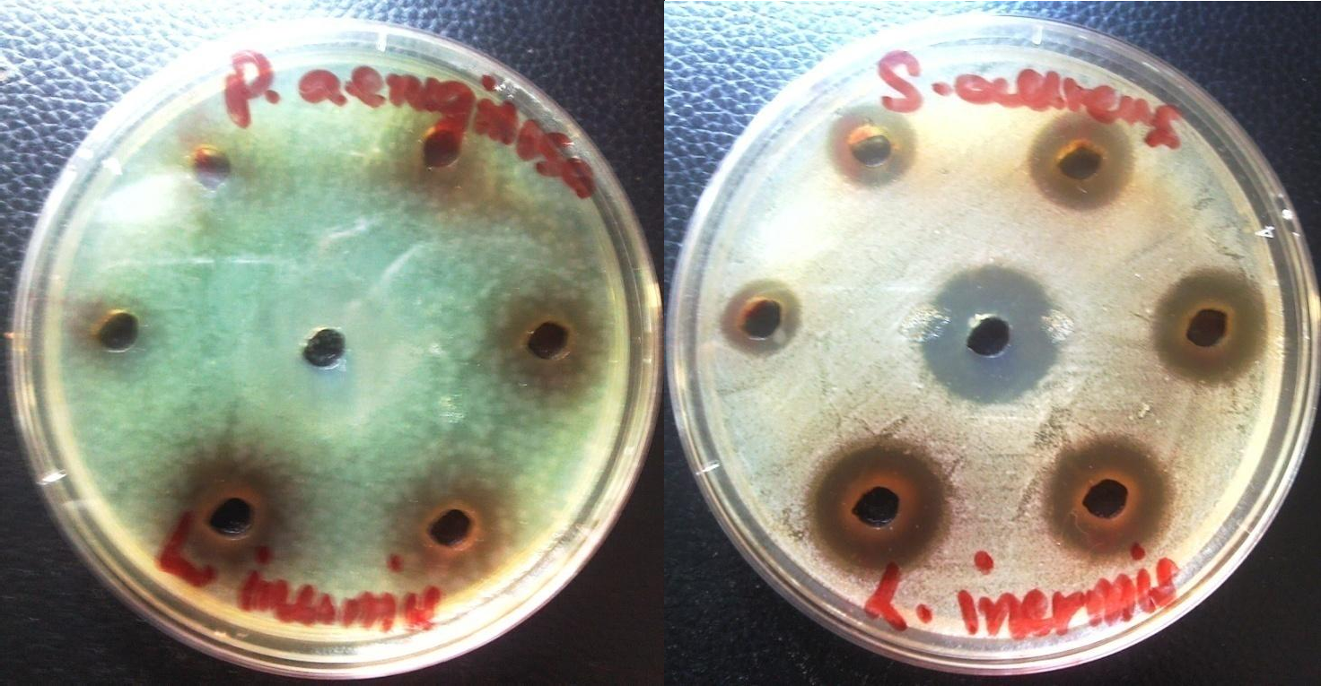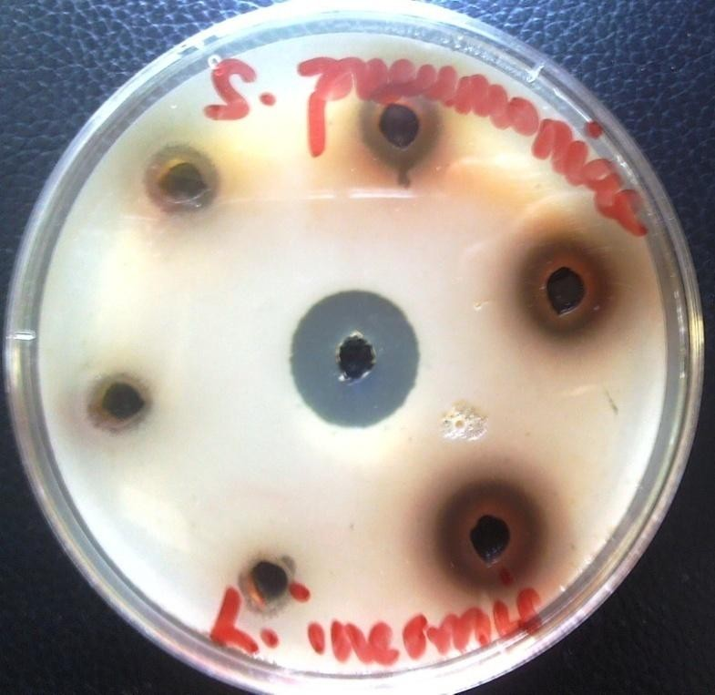

Figure showing Antimicrobial activity of Methanol Extract of Lawsonia hermis leaves showing the Inhibition Zone Diameters (IZDs) produced against test organisms.

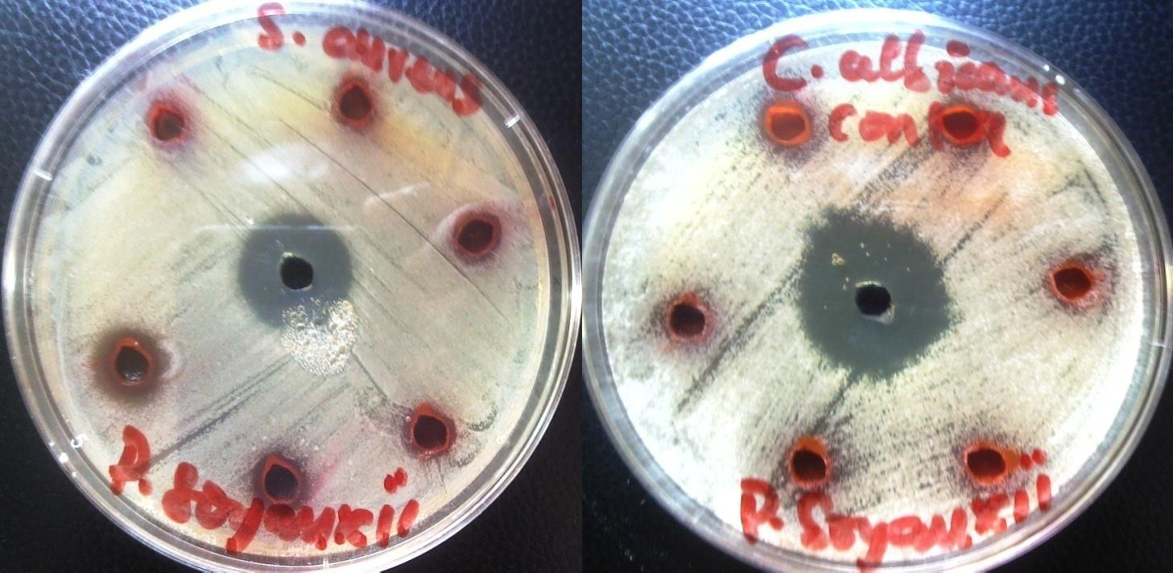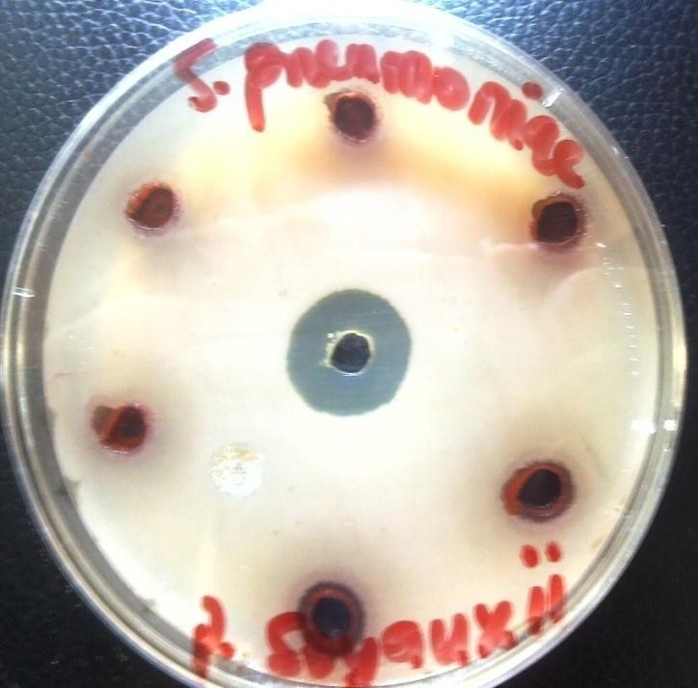

Figure showing Antimicrobial activity of Methanol Extract of Pterocarpus soyauxii stem showing the Inhibition Zone Diameters (IZDs) produced against test organisms.

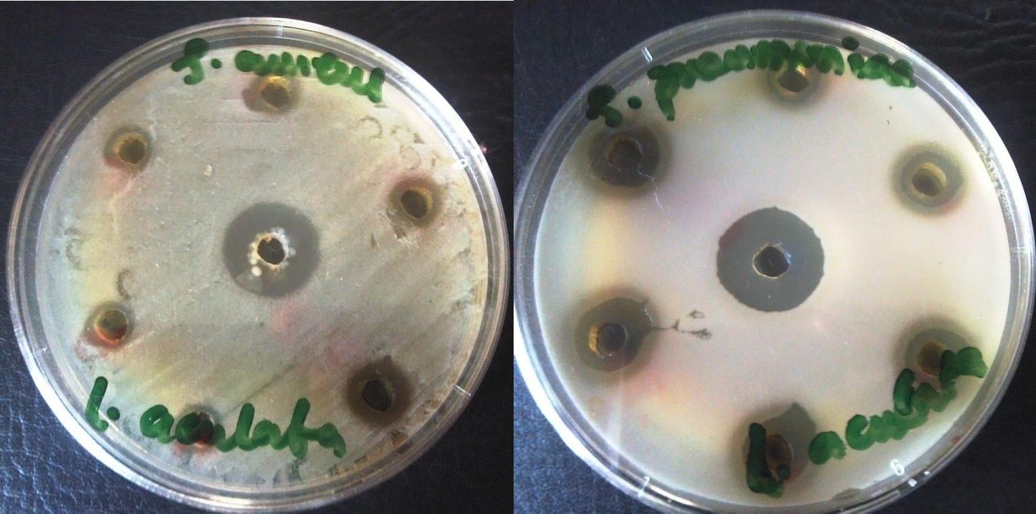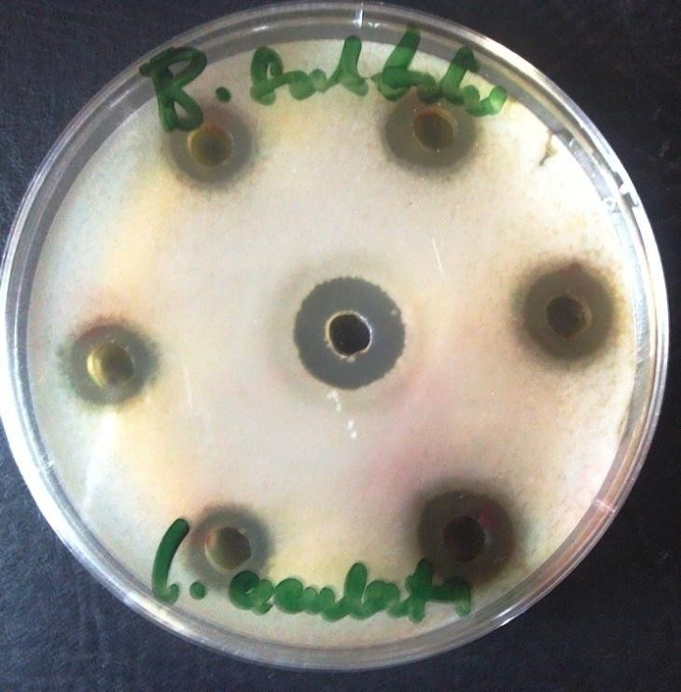

Figure showing Antimicrobial activity of Methanol Extract of Lantana aculata leaves showing the Inhibition Zone Diameters (IZDs) produced against test organisms.

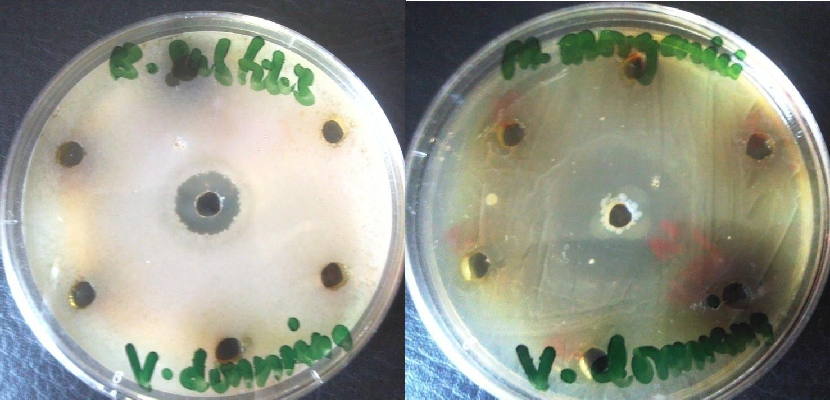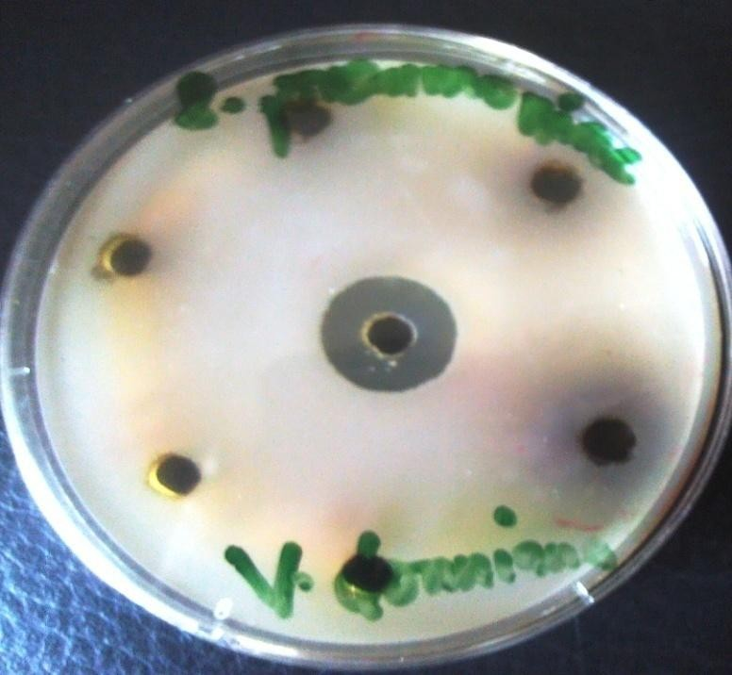

Figure showing Antimicrobial activity of Methanol Extract of Vitex donniana leaves showing the Inhibition Zone Diameters (IZDs) produced against test organisms.

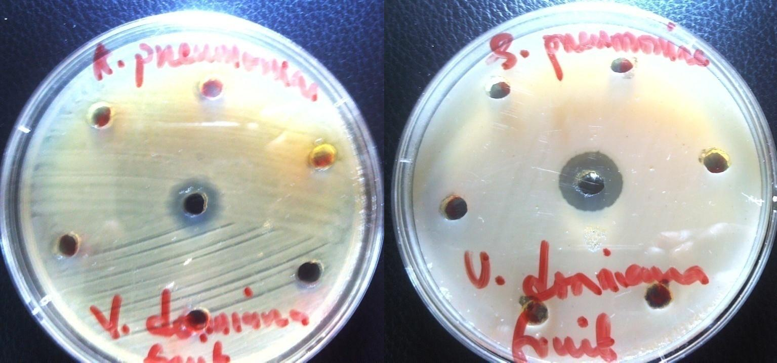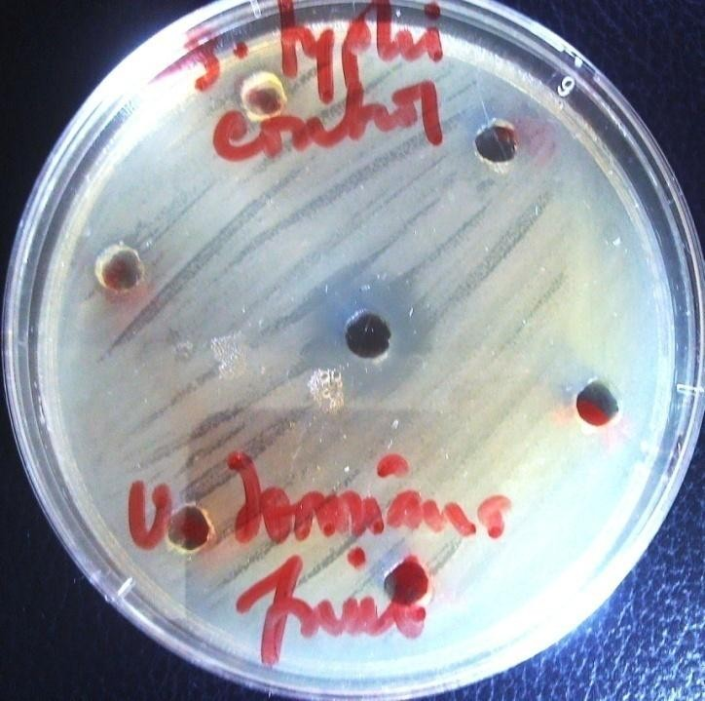

Figure showing Antimicrobial activity of Methanol Extract of Vitex donniana fruits showing the Inhibition Zone Diameters (IZDs) produced against test organisms.

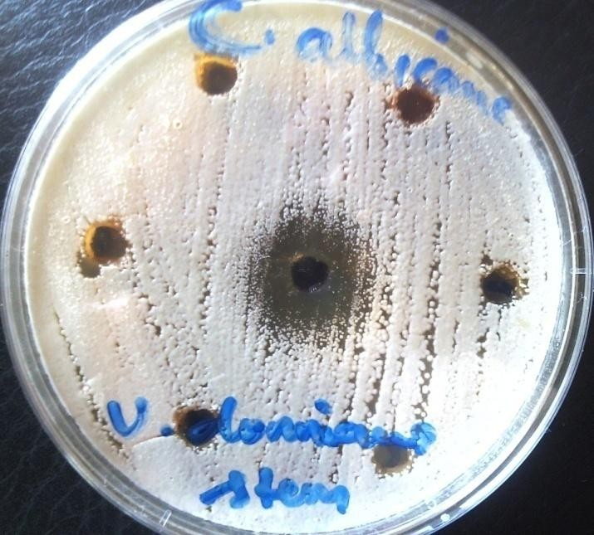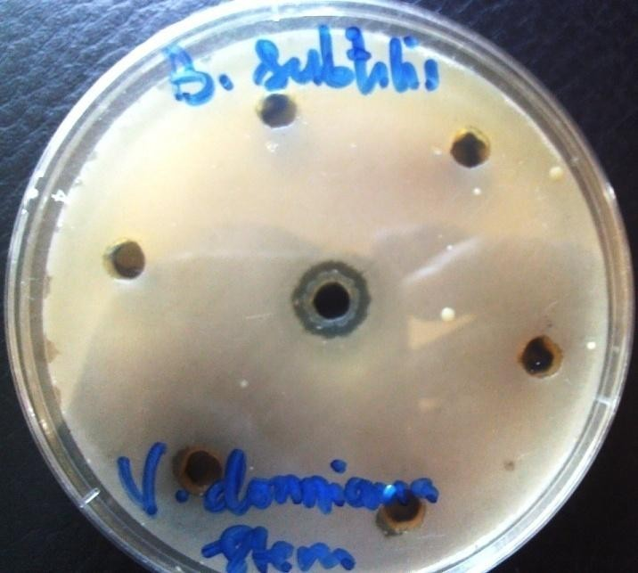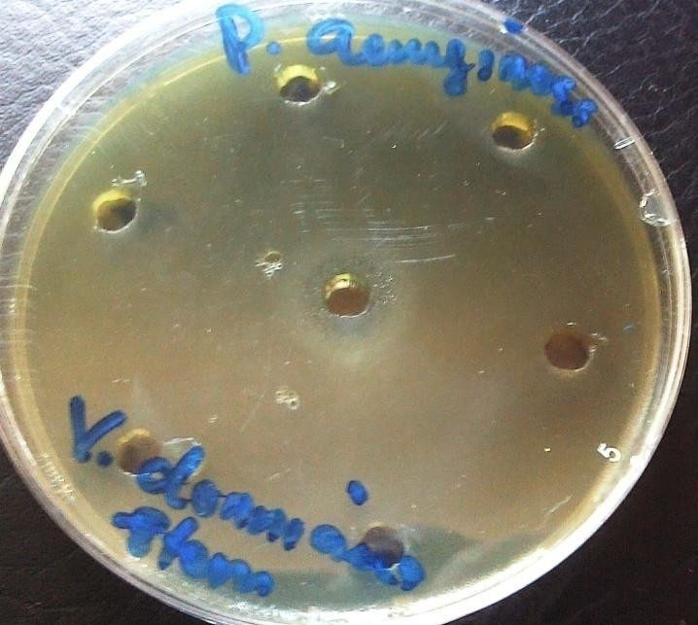

Figure showing Antimicrobial activity of Methanol Extract of Vitex donnianastem showing the Inhibition Zone Diameters (IZDs) produced against test organisms.

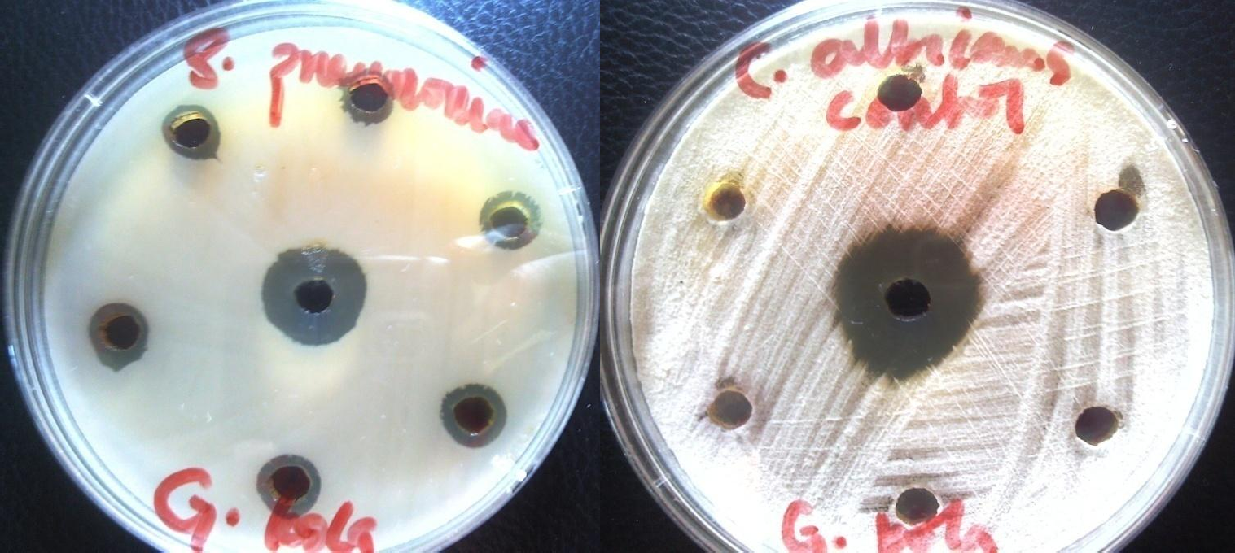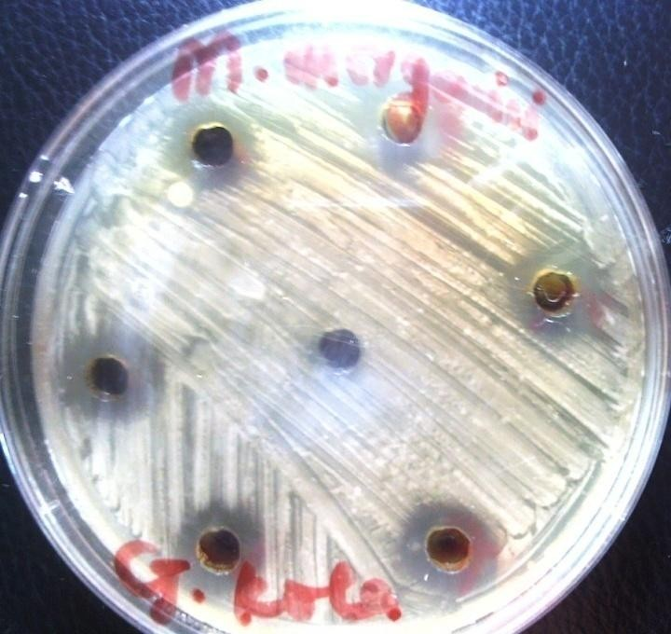

Figure showing Antimicrobial activity of Methanol Extract of Garcinia kola mesocarp showing the Inhibition Zone Diameters (IZDs) produced against test organisms.

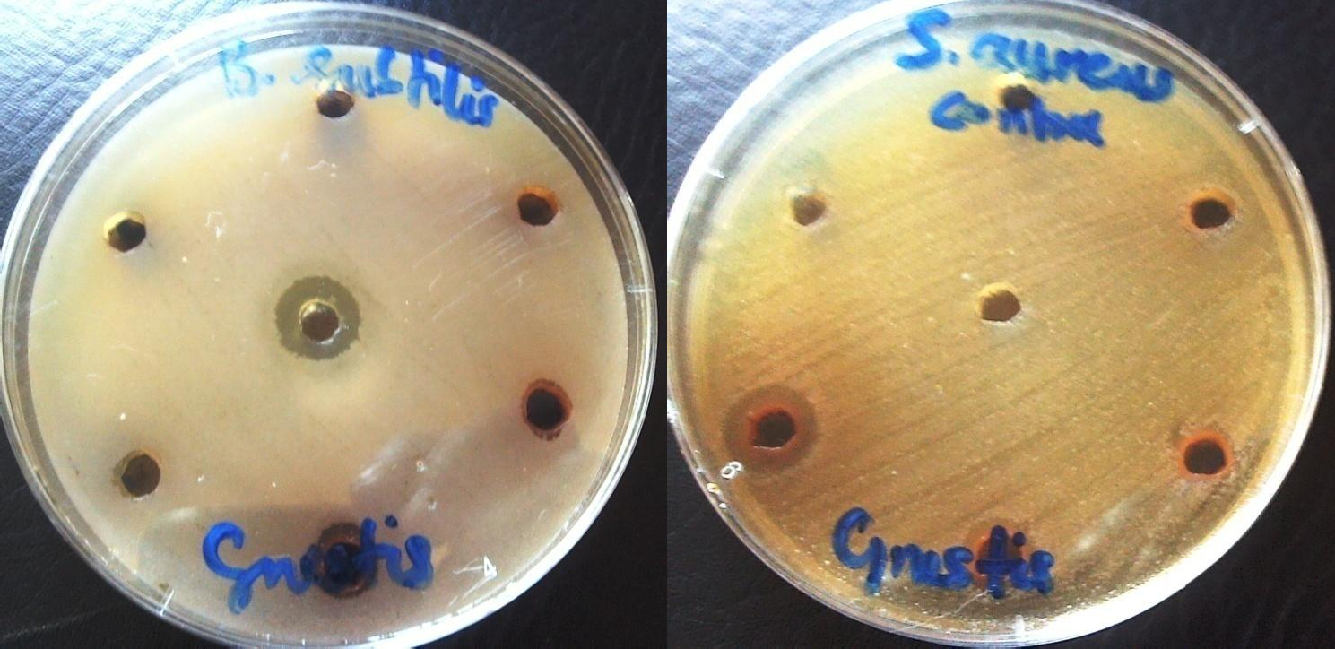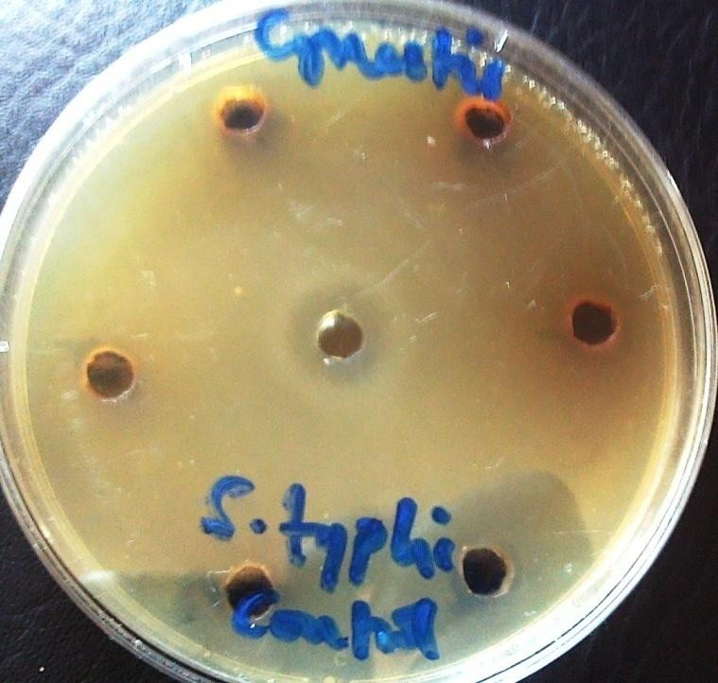

Figure showing`Antimicrobial activity of Methanol Extract of Cnestis ferruginea fruit showing the Inhibition Zone Diameters (IZDs) produced against test organism

