# ETHNOMEDICAL SURVEY AND BIOLOGICAL STUDIES OF SOME EVAPORITES (*KANWA*) USED IN HAUSA AND FULANI TRADITIONAL MEDICINE IN SOME SELECTED LOCAL GOVERNMENT AREA IN KADUNA STATE, NIGERIA

**ZAKIR ABDULHAMID**

# DEPARTMENT OF PHARMACOGNOSY AND DRUG DEVELOPMENT FACULTY OF PHARMACEUTICAL SCIENCES,

**AHMADU BELLO UNIVERSITY, ZARIA NIGERIA**

# SEPTEMBER, 2016

**ETHNOMEDICAL SURVEY AND BIOLOGICAL STUDIES OF SOME EVAPORITES (*KANWA*) USED IN HAUSA AND FULANI TRADITIONAL MEDICINE IN SOME SELECTED LOCAL GOVERNMENT AREA IN KADUNA STATE, NIGERIA**

# BY

**Zakir ABDULHAMID BSc. H. Physio. (ABU, 2009) MIAD (ABU, 2011) PDGHM (ABU, 2014) PGDE (NTI, 2014)**

# (P13PHPD8003)

**A DISSERTATION SUBMITTED TO THE SCHOOL OF POSTGRADUATE STUDIES, AHMADU BELLO UNIVERSITY, ZARIA**

# IN PARTIAL FULFILMENT OF THE REQUIREMENTS FOR THE AWARD OF MASTER OF SCIENCE DEGREE IN PHARMACOGNOSY

**DEPARTMENT OF PHARMACOGNOSY AND DRUG DEVELOPMENT, FACULTY OF PHARMACEUTICAL SCIENCES,**

# AHMADU BELLO UNIVERSITY, ZARIA NIGERIA

**SEPTEMBER, 2016**

# DECLARATION

I declare that the work in the dissertation “**Ethnomedical survey and biological studies of some evaporites (*kanwa*) used in Hausa and Fulani traditional medicine in some selected local government area in Kaduna state, Nigeria**” has been carried by me in the Department of Pharmacognosy and Drug Development, Ahmadu Bello University, Zaria under the supervision of Dr. A. Ahmed and Dr. G. Ibrahim. The information derived from the literature has been duly acknowledged in the text and a list of references provided. No part of this thesis was previously presented for the award of another diploma or degree at any Institution.

# ……………………………… …………………….. Zakir ABDULHAMID Date

# CERTIFICATION

This dissertation entitled “**ETHNOMEDICAL SURVEY AND BIOLOGICAL STUDIES OF SOME EVAPORITES (KANWA) USED IN HAUSA AND FULANI TRADITIONAL MEDICINE IN KADUNA STATE, NIGERIA**” by Zakir ABDULHAMID meets the

regulations governing the award of the master degree of science in pharmacognosy and drug Development of the Ahmadu Bello University, Zaria and is approved for its contribution to knowledge and literary presentation.

# ……………………………………… ……………………… Dr. A. Ahmed; B.Sc., M.Sc., Ph.D. Date

**Chairman, Supervisory Committee** Department of Pharmacognosy Ahmadu Bello University, Zaria

# ………………………………………. ………...…………… Dr. G. Ibrahim; B.Sc., M.Sc., Ph.D. Date

**Member, Supervisory Committee** Department of Pharmacognosy Ahmadu Bello University, Zaria

# ……………………………………….. ……………………… Dr. G. Ibrahim; B.Sc., M.Sc., Ph.D. Date

Head of Department Department of Pharmacognosy Ahmadu Bello University, Zaria

# ………………………………………… ……………………… Prof. Kabir Bala Date

Dean, School of Postgraduate Studies

# DEDICATION

This research work is dedicated to the loving memories of my generous and caring parents. May Almighty Allah (SWA) bless, guide, uplift and grant them Al- jannatul Firdaus (amin).

# ACKNOWLEDGEMENTS

All praises are due to Allah, the Beneficent, and the Merciful for making this thesis a reality. I would like to express my deep gratitude to Dr. A. Ahmed and Dr. G. Ibrahim, for their patience, guidance, enthusiastic encouragement and useful critiques of this research work. Their timely advice, meticulous scrutiny and scholarly advice helped me to a very great extent to accomplish this task.

I would also like to extend my deepest thanks to Dr. A. Ahmed from who I received immense guidance, unending encouragement, shaping my academic career, academics, constant supervision, providing necessary information and financial assistance in keeping my progress on schedule. He also provided the most valuable information on conceptual, theoretical clarity, setting and logical arrangement of my research. His oral discussion on research methodology gave me lot of insight in carrying out research.

I would like to thank PG coordinator Dr. U.H Dan Malam, Prof. K.Y musa, Prof. M.S Abubakar, Prof. Hajara Ibrahim, Dr. U. Katsayal, Dr. N. Hadiza, Dr. M. Zainab, Dr. Ambi, Pharm. I. Mansur, Pharm salisu, Pharm Umar, Pharm Abdur Rahman and Pharm Abdulmuamin for their efforts and immense contributions and suggestions.

I would like to thank my parents and all my family members for bearing my absence for two long years. I wholeheartedly thank them all for sending me abundant love, encouragement and support.

I will always remain indebted and loyal to mention with deepest gratitude, to my caring sister Shafiqah Abdullah Ahmed who showed great zeal toward the success of this research, I remain loyal for your unending encouragement, providing dual support, guidance, finding time to share

her ideas proved very useful in completing my study in time and I would like to convey my earnest thanks to her.

I would also like to extend my thanks to the lab technicians of the Department of Pharmacognosy, Pharmacology and Geology Mal. Kabir Ibrahim, Mal. Kamilu, mal. Mustapha, Mal Salihu for their help in offering me the resources to do the research.

My thanks to my caring, loving, and supportive wife, Zarruk S, my deepest gratitude. Your encouragement when the times got rough was well appreciated and duly noted.

I would like to express my very great appreciation to Dr. Aminu Yusuf Zakari for his unfailing valuable support and constructive suggestions during the planning and development of this research work. His willingness to give his time, financial aid so generously has been very much appreciated and duly noted.

My gratitude goes to my colleagues in Department, Pharm. Sani Shehu, Nuhu Aliyu, Pharm. Musa Dibal, Pharm.Troy, Pharm. uncle Sanusi, Aunty Khadijat Isa Imam, pharm. Pharm Aunty Nafisa Nana, Aunty Aisha I. Barau ( Maman Nasar), Aunty S.A Mariya, Aunty Nafisat Salihu (Maman Ameer), Pharm. Aunty Hassatu Isa (Maman Biyu), Pharm. Aunty Tabitha Musa Lubo and Aunty Pharm Enneh,

# ABSTRACT

‘*Kanwa*' is the local trade name for varieties of evaporites that are formed from evaporation and precipitation of minerals containing body of water. They are locally used extensively by the traditional healers, nomads and house wives of Northern Nigeria to treat diseases, as supplement to animal feeds and as additive to some foods and herbs concoctions. This research was aimed to document medicinal information through field survey in five selected local government area of Kaduna state and validate the claims through some biological studies. A survey was carried out on five most commonly used evaporites namely *farar kanwa, jar kanwa, ungurnu, manda* and *duste danlibya* with the view to establish characteristic features which may be useful for their correct identification and to validate their medicinal uses. The ethnomedical survey had shown that all the samples were well known by the respondents and were largely used for medicinal purpose as indicated by high informant consensus factor, use values and fidelity levels. The elemental analysis revealed the presence of Ca, Mg, K, Na, Fe, Zn, Pb, Cl, PO4, SO4, HCO3,and NO3 at various concentrations in ppm. Na content was greater in *farar kanwa, jar kanwa,* and *ungurnu* and all pH values were found to be between 8.7 to 10.6. Therefore, evaporites are classified as natron and *dutse danlibya* and *manda* as polyhalite. The acute oral toxicity (LD50 ) had shown neither mortality nor sign of toxicity at 2000 mg/kg. Biochemical parameters namely aspartate amino transferase (AST), alanine amino transferase (ALT), alkaline phosphatase (ALP), total bilirubin, conjugate bilirubin and total proteins were all found to have no significant differences (p > 0.05) from the control group. *Jar kanwa* and *dutse danlibya* were found to be very soluble in water and non-hygroscopic, u*ngurnu* was found to be very soluble in water, slightly hygroscopic. *Farar kanwa* and *manda* were found to be soluble in water and hygroscopic. Significant (p < 0.05) and dose dependent analgesic activities were observed when

compared with control group. *Jar kanwa* showed the highest percentage (83.66%) protection of animals from abdominal writhes, followed by *farar kanwa* (76.73 %), *Dutse danlibya* (75.74 %), u*ngurnu* (72.77 %) while *manda* (56.93 %) had the least activities. *Farar kanwa, jar kanwa and ungurnu* inhibited the growth of *Staphylococcus aureus, Escherichia coli, Bacillus subtilus and Salmonella typhi*. The result of the antimicrobial activity indicated by zone of inhibition of growth ranged from 10 mm to 23 mm. *Farar kanwa* was more potent against *Bacillus subtilus* (Zone of inhibition = 18 mm)*, jar kanwa* was more potent against *Staphylococcus aureus* (23 mm) and u*ngurnu* was more potent against *Staphylococcus aureus* (Zone of inhibition = 22 mm). The *farar kanwa* showed the lowest minimum inhibitory concentration (MIC) value of 25 mg/ml on *Staphylococcus aureus, Escherichia coli, Bacillus subtilus* and 50 mg/ml on *Salmonella typhi* and minimum bactericidal concentration (MBC) value 50 mg/ml and 100 mg/ml. *jar kanwa* and u*ngurnu* showed lowest minimum inhibitory concentration (MIC) value of 50 mg/ml on *Staphylococcus aureus,* and *Salmonella typhi*, 25 mg/ml on *Salmonella typhi*. And 12.5 mg/ml on *Bacillus subtilus.jar kanwa and ungurnu* showed minimum bactericidal concentration (MBC) value of 25 to 100 mg/ml. In conclusion the present studies had established the physical characters; analgesic and antimicrobial properties of the five evaporites evaluated which justified their uses in Hausa and Fulani traditional medicine as pain killer and antimicrobial agents.

# TABLE CONTENTS

Title page ii

Declaration iii

Certification iv

Dedication… v

Acknowledgements… vi

Abstract viii

Table Contents… x

List of Tables xv

List of Figure xvi

List of Plates xvii

Abbreviations xviii

CHAPTER ONE

* 1. INTRODUCTION 1
  2. Minerals in Traditional Medicine 1
  3. Minerals in Orthodox Medicine: The Past and the Present 2
  4. Evaporites in Medicine 3
  5. Hausa and Fulani Traditional medicine… 3
     1. Hausa and Fulani Perception on Illness and Medicine 4
     2. Materials and Methods of Hausa Traditional Medicine 5
        1. Talisman / amulet (laya/danmmara)… 5
        2. Imbinbing the words (rubutun sha) 6
        3. Astrologer or Numerologist (bugun alkalami) 6
        4. Divine healingor Sooth sayers (bugun kasa / yan duba) 6
        5. Prayer (rukiyya) 6
        6. Incantation (surkulle) 7
        7. Spiritualist or magician-healer (*boka*) 7
        8. General herbalist (magori) 7
        9. Traditional Birth Attendants (unguwan zoma/ sarguwa) 8
        10. Traditional Surgeon (wanzami) 8
  6. Source, distribution and uses of *kanwa* 9
     1. Source and Distribution of *kanwa* in Nigeria 9
     2. Local uses of Kanwa 9
  7. Statement of Research Problem 11
  8. Justification 11
  9. Aim and Objectives 12
     1. Aim of the study 12
     2. Objectives of the study 12

CHAPTER TWO

* 1. LITERATURE REVIEW… 13
  2. Common evaporites… 13
  3. Compositions of evaporites… 13
  4. kanwa as food additives… 14
  5. kanwa as medicinal agent… 15

CHAPTER THREE

* 1. MATERIALS AND METHODS 16
  2. Materials 16
  3. Collection, Identification and Authentication of Evaporites 17
  4. Ethnomedical survey 17
     1. Sampling design… 17
     2. Study area 18

3.3.3. Sampling technique 20

* + 1. Study population 20
    2. Sample size 20
    3. Procedure for data collection 20
    4. Administration of questionnaire (instrument for data collection) 21
    5. Quantitative analysis 22
  1. Physical constant determination… 24
     1. Organoleptic identification… 24
     2. Determination of cleavage/ fracture, luster and hardness… 24
     3. Solubility test… 24
     4. Extractive value of evaporites *(kanwa)* 24

3.4. 5 Hygroscopicity test 24

* 1. Elemental analysis of evaporites (*kanwa*) 26
  2. Biological Assay 26
     1. Acute oral toxicity study (LD50) 26
     2. Body weight determination 27
     3. Collection of blood and organ samples 27
     4. Histopathological assay 28
     5. The biochemical analysis 29
     6. Test for Analgesic Properties 29
     7. Antimicrobial Assay 30

3.14 Statistical analysis 30

CHAPTER FOUR

* 1. RESULTS 33
  2. Ethnomedical Survey information… 33
  3. Elemental Analysis of some Cations and Anions 56
  4. Physical properties of evaporites 60
  5. Median Lethal Dose (LD50)… 63
  6. Biochemical analysis 64
  7. Histopathological Assay 65
  8. Analgesic Properties of *kanwa* 72
  9. Antimicrobial activities of kanwa samples… 77

CHAPTER FIVE

5.0 DISCUSSION 81

CHAPTER SIX

* 1. SUMMARY, CONCLUSION AND RECOMMENDATION 95
  2. Summary 95
  3. Conclusion… 97
  4. Recommendations… 97

References… 98

Appendices 98

# LIST OF TABLES

# Table Title Page

Table 4.1 Distribution of respondent's occupation in the ethnomedical survey 38

Table 4.2 Responses based on correct identification 41

Table 4.3 Responses based on Traditional uses of *farar kanwa* 45

Table 4.4 Responses based on Traditional uses of *jar kanwa* 46

Table 4.5 Responses based on Traditional uses of *ungurnu* 47

Table 4.6 Responses based on Traditional uses of *dutse danlibya* 48

Table 4.7 Responses based on Traditional uses of *manda* 49

Table 4.8 Responses based on Mode of Traditional uses… 50

Table 4.9 Responses based on benefit of using evaporites… 51

Table 4.10 Responses based on changes on storage of evaporites… 55

Table 4.11 Concentration of Major Cations and Anions (ppm) 56

Table 4.12 pH value of evaporites 56

Table 4.13 Organoleptic properties of the evaporites 60

Table 4.14 Solubility properties of five different evaporites 61

Table 4.15 Cleavage/ fracture, luster and hardness of evaporites 62

Table 4.16 Hygroscopicity of evaporites 63

Table 4.17 Effect of samples on body weight of mice at 2000 mg/kg body weight 63

Table 4.18 Effect of *kanwa* on liver enzymes activities… 64

Table 4.19 Effect of *kanwa* on liver and kidney of mice at acute toxicity level… 65

Table 4.20 Analgesic Properties of different doses of *fararkanwa* Sample 72

Table 4.21 Analgesic Properties of different doses of *Jar kanwa* Sample 73

Table 4.22 Analgesic Properties of different doses of *ungurnu* Sample 74

Table 4.23 Analgesic Properties of different doses of Dutse *Dan libya* Sample 75

Table 4.24 Analgesic Properties of different doses of *manda* Sample 76

Table 4.25 Zones of inhibition (mm) of evaporites samples 77

# LIST OF FIGURE

**Figure Title Page**

Fig. 3.1 Map of Nigeria showing Kaduna state 18

Fig. 3.2 Map of study areas… 19

Fig. 4.1 Distribution of respondents based on their gender 33

Fig.4.2 Distribution of respondent’s age 34

Fig. 4.3 Distribution of respondent’s marital status… 35

Fig.4.4 Distribution of respondent's tribes… 36

Fig.4.5 Distribution of respondent's educational status 37

Fig.4.6 Responses based on common names of the evaporites… 39

Fig.4.7 Responses based on the methods of identification… 40

Fig.4.8 Responses based on duration of using evaporites 42

Fig.4.9 Responses based on Major Traditional uses of evaporites 43

Fig.4.10 Responses based on geographical source as obtained from survey 52

Fig.4.11 Responses based on method of processing evaporites… 53

Fig.4.12 Responses based on storing method of evaporites 54

Fig.4.13 Major Cations and Anions of *ungurnu* 57

Fig. 4.14 Major Cations and Anions of *Jar Kanwa* 58

Fig. 4.15 Major Cations and Anions of *Manda* 59

Fig. 4.16 MIC and MBC of *farar kanwa* 77

Fig. 4.17 MIC and MBC of *jar kanwa* 78

Fig. 4. 18 MIC and MBC of *ungurnu…* 78

# LIST OF PLATES

**Plate Title Page**

Plate I: ×400 Micrograph of the liver tissue section from untreated mice (control) 66

Plate II: ×400 Micrograph of the kidney tissue section from untreated mice (control) 66

Plate III: ×400 Micrograph of liver tissue from mice treated with 2000 mg/kg of *farar kanwa* 67

Plate IV: ×400 Micrograph of kidney from mice treated with 2000 mg/kg of *farar kanwa* 67

Plate V: ×400 Micrographs of liver tissue from mice treated with 2000 mg/kg of *jar kanwa* 68

Plate VI: ×400 Micrograph of kidney from mice treated with 2000 mg/kg of *jar kanwa* 68

Plate VII: ×400 Micrograph of liver tissue from mice treated with 2000 mg/kg of *ungurnu* 69

Plate VIII: ×400 Micrograph of kidney from mice treated with 2000 mg/kg of *ungurnu* 69

Plate IX: ×400 Micrograph of liver from mice treated with 2000 mg/kg of *dutse dan Libya* 70

Plate X: ×400 Micrograph of kidney from mice treated with 2000 mg/kg of *Dutse Dan Libya* 70

Plate XI: ×400 Micrograph of liver tissue from mice treated with 2000mg/kg of *Manda* 71

Plate XII: ×400 Micrographs of kidney tissue from mice treated with 2000mg/kg of *manda* 71

# ABBREVIATIONS AND SYMBOLS

The following abbreviations and symbols were used in the course of writing this dissertation: TM- Traditional Medicine

WHO - World Health Organization ANOVA- Analysis of variance

EDTA- Ethylene diamine tetraacetic acid MIC- Minimum Inhibitory Concentration MBC- Minimum Bacteriocidal Concentration LD50 - Median lethal dose

OECD - Oganisation for Economic cooperation and development ALP - Alkaline phosphatase

ALT - Alanine aminotransferase AST - Aspartate aminotransferase BW - Body weight

g - Gram

kg - Kilogram L - Litre

LD50 - Lethal dose mg - Milligram ml - Millilitre

mm - Millimetre

SEM - Standard error of the mean Na+ - Sodium ion

Ca2+ - Calcium ion K+ - Potassium ions

# CHAPTER ONE

# INTRODUCTION

# Minerals in Traditional Medicine

Minerals are inorganic substances, present in all body fluids and tissues and their presence is necessary for the maintenance of certain physicochemical processes which are essential to life (Soetan, *et al.,* 2010). Minerals and their products have constituted part of the inventory of medicinal substances used in various cultures since ancient times (Riddle, 2002; Lev, 2003; Stapleton, 2007; Hamarneh, 1980). The ancient Egyptians had been using natron and other sodium salts, for 7000 years, both as an important part of the momification process and for salting food (Warren, 2005).

Recent publications (Demirhan, 2014) have shown the importance of minerals in various socio- cultural environments around the world, and examples of the use of minerals-derived remedies can currently be found in many urban, semi-urban and more remote localities in all parts of the world (Walston, 2005).The use of a complete range of natural resources containing chemicals including plants, animals and mineral components is a common practice in traditional medicine. Across the world, there is great awareness on the importance of medicine and healing based on natural ingredients rather than synthetic chemical ingredients (Jegede, 2012). Majority of people treat various diseases and promoted health using mineral substances (Razak *et al.,* 2011). Minerals are used in variety of form, for example, it is gargle for earache and throat ache (Abdül Wahid, 2004). Salt mixed with water is rubbed on skin to treat dandruff and wart. Onion and salt is pounded and this mixture is rubbed on the wound in the form of poultice to ease healing and prevent blood loss (Parman, 2002).

# Minerals in Orthodox Medicine: The Past and the Present

Minerals are chemical constituents used by the body in uncountable ways. Although they provide no energy, they have important roles to play in both traditional and orthodox medicines (Soetan, *et al.,* 2010; Eruvbetine, 2003). Elements being the basic building blocks of our lives are involved in all life processes and have been recognized as beneficial and useful in the medical field (Sekhon and Gandhi, 2006). Every living matter requires inorganic elements or minerals at different quantity for their normal life processes (Ozcan, 2003). Minerals or inorganic substances (minerals, metals, and stones) were used for medicinal purposes from early times and in many different cultures (Carretero *et al.,* 2006, Lev, 2002). Most minerals may contain macro (major) or micro (trace) and ultra-trace elements. The macro-minerals are required in amounts greater than 100 mg/dl and the micro-minerals are required in amounts less than 100 mg/dl (Soetan, *et al.,* 2010). Other complexes which are inorganic in origin that made impact on modern medicine include aluminum for the treatment of syphilis in Early 1900s (Bhupinder, 2011) and are still in used. A large number of minerals are used as active ingredients in pharmaceutical preparations as well as in cosmetic products (Carretero and Pozo, 2010). Modern manuals of *materia medica*, pharmacopeias and other historical records state that minerals have been used extensively in medicine over the years to treat a number of disease conditions (Thompson, 2010; Gordon, 2000; Kremers and Urdang, 1996). Halite is a major feedstock to the pharmaceutical and other chemical manufacturing industries, as are several other varieties of minerals (Warren, 2005). Some constituents in minerals are important ingredient for treatments of epilepsy and migraine (Demirhan, 2014).

# Evaporites in Medicine

Recently, there is a growing interest and preference in many areas of human health care for treatments involving natural means. This involves distinct methodologies, such as: phytotherapy, hydrotherapy, mudtherapy, thermotherapy, *etc*. Whenever naturotherapy involves minerals for instance, special clays, special sands and rock salt or other mineral resources it could be named geomedicine (Gomes and Silva, 2001). Prominent among useful medicinal minerals are evaporites (*kanwa*). Evaporites are defined as salt rocks that were originally precipitated from a saturated surface or near surface brine by solar evaporation (Warren, 2005). This encompasses a wide range of chemically precipitated salts and includes alkali earth carbonates.

# Hausa and Fulani Traditional Medicine

Hausa people are the dominant inhabitant of the northern Nigeria. The Hausa tribe is a heterogeneous group with various ethnic origins, mainly *Habe* (‘non-Fulani’ is a Fulani term, used for describing the ruling group in Hausa land before the Fulani jihad), this shows a close relationship between Hausa and Fulani (Ulrika, 2002). The Hausa and Fulani people, who today exceed twenty million are found mainly in the northern part of Nigeria and southern part of Niger republic (Echard 1991), an area referred to as Hausa land.

The Hausa and Fulani of Northern Nigeria have organized system of traditional medicine which is closely related and originated from Islamic prophetic medicine. The practices of traditional medicine in these cultures utilize both natural products (plants, animal parts and minerals) and spiritual/metaphysical aspects.

# Hausa and Fulani perception on illness and medicine

Hausa believe that *ciwo* (illness) may be attributed to a variety of etiological factors. In a general sense, any illness may be attributed to God, the ultimate source of all that happens. Certain environmental factors, most importantly *sanyi* (cold) and *rana* (heat), are believed to cause much illness. Illness may be attributed to personal attack, either by *mayu* (witches), *iskoki* (spirits), or a rival who has obtained harm inducing medicines (Stock, 1981). The Hausa conception of health (*lafiya*) involves far more than the absence of disease. *Lafiya* is a general state of physical and social well-being (Stock, 1981).

The Hausa term for medicine (*magani)* is used to represent the totality of ways in which man attempts to manipulate his disorganized, conflict-ridden real world to bring it closer to health (*lafiya)*, the organized ideal universe. The charms containing Qur’anic verses *(laya*) used to bring good fortune and protection against spirit-induced illness are as much medicine *(magani)* as any herbal remedy used to treat the symptoms of a particular illness (Stock, 1981). Traditional health practitioners from northern Nigeria especially Hausaland are referred to as *mai maganin gargajiya* (traditional medicine men) or *yan tsibbu (dibbu )*, the word *dibbu* is of Arabic origin meaning “medicine or curing diseases” *yan tsibbu* includes those people using some verses or chapters from the holy book either recites to expirate (*tofi*), write to drink *(rubutun sha), hatimi* and *dalamusai* (specific writings facular to them), *surkulle* (incantation), and *laya* (talisman) (Yahaya, 1991). The spiritualist “*bokaye*” and the *yan bori* are the most commonly known practitioners in Hausa society before the arrival of Islamic culture. The *boka* was a herbologist and subsisted on collecting and selling medical herbs, advice and others. It was common for the *boka* to be a farmer of his own medicinal herbs (Mussein, 1981). The *boka* was not a spiritual

healer; medicine relied on herbs and was only used for minor ailments such as headaches or upset stomachs. Spiritual healing was carried out by a '*yan bori*. The '*yan bori*, on the other hand, is another window into the Hausa past, but is a spiritual rather than an herbal healing practitioner. The '*yan bori* would pray and perform rituals to spirits based on the patient’s ailment. The '*yan bori* believed in spiritual possession and though they had many named spirits to govern over the world, they also believed in nameless spirits which could possess a man and must be cleansed from his body (Last, 2011).

# Materials and Methods of Hausa and Fulani Traditional Medicine

* + - 1. **Talisman / amulet** (*laya/danmmara*):

*Layu* are leather pouch charms containing folded pieces of paper on which Koranic verses and symbols have been written. Individual charms are made for protection from specific illnesses or other types of misfortune. in particular, *laya* are used to ward off *iskoki* (spirits). Infants, children and even adults often wear as many as a dozen *layu*, reflecting the need for protection or the aim of bring good fortune curing diseases, protection or any other purposes like fast and easy business boom, financial success, wealth creation, and upliftment from poverty to riches, luck, love issue, seeking husband/wife and marriage matters, competition, court case, exams issue etc. The word *laya* comes from a word *al-aya* meaning verse from holy Qur’an but not necessary what was written must be from the holy book, sometimes *hatimi* or *dalamusai* can be used including powdered plant materials (Abdullahi, 2014). Talismans have been used for thousands of years and were believed to ward off evil and heal certain medical conditions. (Robert, 2006).

* + - 1. **Imbibing the words** (*rubutun-sha*)

*Rubutun-sha* or simply *rubutu* ("writing") is an ink solution prepared by washing a writing board *(Allo)* inscribed with therapeutic verses from the Qur’an. After washed clean with water and the afflicted person drinks the resulting liquid to cure diseases sometimes spiritual stuff included (Abdullahi, 2014). *Rubutu* may be drunk or applied topically as treatment for almost any illness, or taken as a preventative medicine. It is routinely used as a general tonic and as a "social medicine" by people striving for popularity, traders seeking commercial success, the pious striving for enlightenment, and so on (Last, 2005).

* + - 1. **Astrologer or Numerologist (***bugun alkalami***)**

These are people that study movements and relative positions of celestial bodies and their supposed influence on human affairs. They use stars to read and predict on the major events of one’s life like education, health, trips, career, financial prospects, marriage, children, and many others (Abdullahi, 2014).

* + - 1. **Divine healing or Sooth sayers (***bugun kasa / yan duba*)

They are form of healers, who predict the future (Last, 2005). The diviners use sacrifices to appease the gods and goddesses in order to proffer solutions on same one (Oriji, 2015).

***1.5.2.*5 Prayer (***rukiyya***)**

This is a method of healing people possessed by spirit *(iska)* in their body through quranic recitation. They have their special clinics (Abdullahi, 2014).

* + - 1. **Incantation (***surkulle***)**

This is a charm or spell created using words. An incantation may take place during a ritual, either a hymn or prayer, and may invoke or praise a deity (Abdullahi, 2014).

# Spiritualist or magician-healer (*boka*)

The *boka* also referred to euphemistically as diviner or *mai tsafi*. They are well known and respected traditional healers in Hausaland. They use spirits in their medications, control communication between spirits and mankind, they give advice to people and they give medicine for many ailment etc. is regarded as a very powerful healer, but one who is as liable to use his powers for evil purposes as for good (Fleischer, 1974). These medicines may be ingested for the treatment of illness, or made into a *laya* (talisman) which is worn as a protective device. The illnesses treated by the *boka* are generally serious ones believed to be caused by supernatural forces and that management of these illnesses is beyond the competence of amateurs.

* + - 1. **General herbalist (***magori***)**

*Magori* is believed to be known traditional medicine practitioners specialized in herbs, minerals, animal part. They also incorporate *laya, rubutu, prayer etc.* they are normally move around within town and villages with their bag and stick selling medicines, they always flattering their medication. They are known by saying “*magani saida gwaji”* (medicine needs trial) etc. (Abdullahi, 2014).

* + - 1. ***Traditional Birth Attendants (****unguwan zoma / sarguwa****)***

The *unguwan zoma* is an old woman who specializes in all aspects of child delivery and the post- partum care of the mother and infant. Hausa tradition prescribes forty days of special care under the supervision of the *unguwan zoma*, during which the mother must stay inside on a heated bed, regularly take very hot baths, and eat specially prepared foods containing much *kanwa* (natron) (Stock, 1981). This treatment is designed to ensure the production of sufficient good quality breast milk, and that protection from *sanyi* (cold) is afforded at this time of maximum danger (Darrah, 1997). The *unguwan zoma* may have to perform various surgical procedures during delivery or in the treatment of certain neonatal conditions such as heart palpitations. She usually has a considerable knowledge of herbal medicines used in the treatment of women's and children's illnesses. In northern part of the country, TBAs are usually females. TBAs occupy a prominent position in Nigeria today as between 60-85% of births delivered in the country and especially in the rural communities are by TBAs (Oriji, 2015).

***1.5.2.*10 Traditional Surgeon (***wanzami***)**

The *wanzami* performs a number of minor surgical tasks like circumcision (*kaciya*), removal of whitlow (*dan kankare*)*,* cutting of uvular (*belu),* removes bad blood by cupping (*kaho)*,lancing (*sakiya*),spulls teeth, tribal marks, and treats specific infant diseases for which blood-letting is perceived to be necessary like ear-piercing (Stock, 1981). It is even one of the ugly cultural practices in the community as it can easily result to infections.

# Source, Distribution and Uses of *Kanwa*

# Source and Distribution of *kanwa* in Nigeria

In Nigeria, *kanwa* deposits are found in some locations around North eastern part of Nigeria particularly at Boga and Manga in Borno state, Gashua, Machina, Nguru and Yumusari in Yobe state, Zuno Song, Mayo-Balwa in Taraba state, and Alkaleri, Gamawa, Kirfi in Bauchi State, extending to border countries like Chad and Niger (Omajali, 2010). The deposit in the basins was found in many forms as hard beds at the middle and bottoms of the old lakes or disseminate through the sand in the upper part. Also it is found as efflorescence crust on the surface of the soil, and can be found in brine water at some basins (Abdelaati *et al.,* 2014). The deposit is recoverable depending on the availability of rainfall and underground water (Idris *et al.,* 1996).

* + 1. **Local uses of *kanwa***

*Kanwa* has become a multipurpose as a major food supplement in most rural and urban home areas including food industries in Nigeria, as well as medicine (Omajali*et al.,* 2010). Every home uses kanwa as food supplement or as medicine in human and animals. It had significance for use as medicines, culinary purposes, tanning of leather, and other uses (Paul, 2011). It has been taken as a medicine in humans for many ailments long time ago in Northern Nigeria, like gastrointestinal problem, skin infection, respiratory problem, reproductive problem, endocrine disturbances *etc* (Alawa *et al.,* 2000).

The deposits of *kanwa* are used as salt licks for animals and the salt earth could be marketed for animal’s nutrient supplements (Paul, 1986). It is mostly taken orally by nursing mothers in pap to boost breast milk (Ekanem, 1977). Traditionally, these *kanwa* is used by TBS as an aid in

childbirth, postnatal care and employed in the treatment of menstrual disorders (Alawa *et al.*, 2000). It is used in decoctions for the treatment of reproductive ailments such as retained placenta and difficulty in urination (Paul, 1986).

Local medicinal knowledge credited the different types of *kanwa* with specific properties: some were milder and better for children and elders, while others were useful in pregnancy. In addition, *farar kanwa, jar kanwa* and varieties of it were used in various mixtures to treat dandruff, problems related to pregnancy, eye disorders, infertility, and as an ingredient in herbal concoctions (Paul, 2011).

The standard Hausa millet porridge, for example, could be made with various grades of *farar kanwa, ngurnu*, and jar *kanwa* salt (Stemler, 1975). *Kanwa* is extensively used in the tanning industry and in the preparation and enhancement of flavor of local beverages and snuff (Buchanan and Pugh, 1969). The main domestic use of these indigenous salts is cooking tough food materials such as beans and maize utilizing their ability to fasten the softening and the digestive property of the food (Omajali, *et al.,*2010). In addition, the salts are extensively used in food preservative to hinder growth of microorganisms that cause food spoilage (Uzogara *et al.,* 1990). Boiling leafy vegetable with *kanwa* minimizes losses of importance minerals and tenderise the leaves and make it more attractive by conserving the attractive green colour found in the fresh vegetable (Richard, *et al.,* 2000). It is used extensively in ethnoveterinary practices for the treatment of skin diseases and digestive problems (Alawa *et al.*, 2000). However, *farar kanwa* was also used in making local soap known as “*sabulunsalo*” that is used in bathing.

# Statement of Research Problem

* + - 1. Evaporites (*kanwa*) are used in traditional medicine with little or no scientific validation.
      2. Evaporites have complex/ambigous identities
      3. The safety of using evaporites as food/medicine is not fully established

# Justification

Natural inorganic compounds with biological activities are extensively used in treatment of many diseases and are of great interest both as natural products and precursors for synthetic compounds (Suárez*et al*., 2011). In Nigeria, many species of minerals have been used for medicinal purposes since colonial times, with widely disseminated therapeutic alternatives available throughout the country (Moura and Marques, 2008). Many people still use mineral- derived medicines as an alternative or supplement to western health care. Modern medicine utilizes a variety of Earth materials for ingestion, ranging from alum to zeolites, for palliative and curative purposes. Human consumption of salt and pulverized limestone are quite common. The purpose for taking in these natural materials includes ameliorating nutrient deficiency, illness, and detoxification (Ulli, 2011). Therefore, scientific validation of the ethnomedical claims on some evaporites and evaluation of their potentials are of great significance.

# Aim and Objectives

# Aim of the Study

The overall aim of this study is to validate the use of some evaporites *(kanwa)* in traditional medicine through ethnomedical survey and some biological studies.

# Objectives of the Study

* + - 1. To document the perception of Hausa and Fulani tribes on some commonly used evaporites namely *farar kanwa, jar kanwa, ngurnu, dutse danlibya* and *manda*.
      2. To establish the safety or otherwise of the different evaporites*(kanwa)* using animal experimental model.
      3. To provide rationale for the local use of evaporites as medicinal agents for management of pains, stomach problems and antimicrobials

.

# CHAPTER TWO

# LITERATURE REVIEW

# Common evaporites

” Evaporites” is the term applied to extremely soluble salt minerals that form in the precipitation stage immediately before total dryness. The most common evaporite minerals found include halite (NaCl), thenardite (Na2SO4), and mirabilite (Na2SO4.10H2O) (Kenneth *et al.,* 1992). More others including gypsum (CaSO4.2H2O), calcite (CaCO3), bloedite (Na2Mg(SO4)2.4H2O), burkeite (Na2CO3(SO4)2), and nahcolite (NaHCO3) also exist (Kenneth *et al.,* 1992). All evaporites are ionic salts containing the major ions Na, Ca, Mg, K, Cl, SO4, and CO3 in varying proportions, along with other less common ionic constituents such as B, Ba, Sr, Br, Li and I in varying amounts (Warren, 2009). Mineralogy and order of salts precipitating in concentrating brine is controlled by the ionic make-up of the parent water (Hardie and Eugster, 2000).

* 1. **Composition of Evaporites *(kanwa)***

*Kanwa* occurs as complex mixtures of different substances with sodium constituting about 30% and other minerals such as, carbonates, sulphate *etc.* in varying proportions (Palmer *et al.,* 1997), with trace amounts of calcium, magnesium, iron, zinc, sulphur, chlorine, silicon, phosphorus, potassium and aluminum (Makanjuola & Beetlestone, 1975). Some *kanwa* contain over 60% of sodium carbonate (RMRDC, 2008).

The composition of the *kanwa* varies widely since it is a naturally occurring mixture of salts, but mostly contains Na2CO3, NaHCO3, NaCl and Na2SO4, in varying proportions. (Sanderson *et al.,*2000; Ikram and Dodson 1998). It has been shown (Paul, 2011) that *kanwa* salts from Nigeria

are rich in Na+, Cl-, NaSO4, Na2CO3, KCl, CaCO3, Na3PO4, K2SO4, and CaSO4 invarious concentrations. Some *kanwa* salts contain virtually no sodium carbonate or sodium sulfate and consists primarily of sodium chloride and potassium chloride, with smaller amounts of calcium carbonate, potassium sulfate, and calcium sulfate (William, 1999). Edwards *et al* (2007) analyzed eight samples by the Raman spectroscopic analyses. The analysis clearly indicates that the *kanwa* specimens are of indefinite composition, comprising sodium sulfate and sodium carbonate, with several containing Na2CO3 and gypsum.

* 1. ***Kanwa* as Food Addictive**

Unless otherwise noted, *gishiri* and *manda* are translated as salts and the mixtures with predominant sodium carbonate content as 'natron'. The tastes of these salts differ, and this property was probably the basis of the most important distinctions between the various salts which were used in food and medicine (Paul, 1986). Unlike the distinction between sea salt and commercial salt in western cuisine where taste is not usually considered. Hausa proverb demonstrates the taste factor by saying: “*hanci bai san dadin gishiri ba”*, 'the nose does not know the taste of salt. The smell and taste of the various salts were subtle and important. Because the various kinds of salt were not always available, consumers could not always choose one salt over another. *Kanwa* is used in preparing *kunu* and *tuwo,* and there were many special dishes as well which required *kanwa* rather than salt (*gishiri*) (Paul, 1986). The best quality white *kanwa* from Borno and Yobe (*farin kanwa* or *kwaras kwaras*) was used in making ground bean cakes thickened with water and mixed with pepper (*dan wake*). A slightly poorer quality *kwaras kwaras* could be used in making pap (*kunun kanwa*), usually made of millet or sorghum. *Kunun kanwa* was thought to be healthy for nursing mothers. Also *kanwa* could be added to

*zogale, rama* leaves to diminish the sour test. *Kunu, danwake* and other dishes could also be made with red natron (*jar kanwa*). Bean dishes in particular were made with *kanwa*, rather than salt, because, it is believed that *kanwa* takes the fat out of the beans. The best quality *kanwa* which came from the eastern shores of Lake Chad is used in making *birabisko* millet, wheat, rice, or sweet potatoes boiled in water. *Kayan yaji*, (spices), is prepared from pepper, *citta* (ginger), *mai koko, kimba* pepper, and red *kanwa*, which were ground up. *Fankaso* (Katsina: *algaragis*) was a wheat cake boiled in oil and seasoned with tamarind and *kanwa*. It was estimated an adult consumes an average of 4.5 kg per person per year of *kanwa* (Paul, 1986).

* 1. ***Kanwa* as Medicinal Agent**

Minerals are used in a wide range of everyday healthcare products. Common products such as kaolin, calcite, magnesite, talc, quartz, calcium supplement all rely on minerals for their beneficial health properties. In addition, various clays are used in antacids, gypsum in Plaster of Paris. Pumice is the abrasive in natural pumice stone and Lava soap, extracts from coal are used in dandruff shampoos, fluorine in fluoridated water and toothpastes, and salt (halite) has been used as an antibacterial agent and as a food preservative for millennia. Epsom salt (epsomite) is found in most every household. Baking soda (trona) is a well-known antacid used medically (Robert, 2006).

# CHAPTER THREE

# MATERIALS AND METHODS

# Materials

1. Questionnaire: Opened and closed ended
2. Digital camera: Samsung Cullmann 420
3. Tape recorder: LG 221 and Field notebooks
4. Atomic Absorption spectrometer (Thermo. Fisher Scientific)
5. Mohs Hardness Scale: available in Geological survey institute Kaduna
6. Swiss albino mice: One hundred and forty (140) Healthy male and female Adult mice (17- 25g) obtained from Department of Pharmacology and Therapeutics.
7. Evaporite samples: *farar kanwa, jar kanwa ungurnu, duste Danlibya, manda.*
8. Clinical isolates: *Bacillus subtilis, Staphylococcus aureus, Escherichia coli* and *Salmonella typh*i obtained from Department of Microbiology, Ahmadu Bello University Zaria..
9. Reagents and Drugs: Formalin 10 %, 0.6% Acetic acid (Searle Essex, England), methylated spirit (Premium Castel Chemical Company Limited), distilled water, normal saline, Aspirin 300 mg/kg (Sigma chemical Co. St Louis, USA) and ciprofloxacin 10 µg.

# Collection, Identification and Authentication of Evaporites

Evaporites (*kanwa*) samples (*farar kanwa, jar kanwa, ungurnu, duste danlibya and manda*) were purchased at Sabon Gari main markets from minerals (*kanwa)* seller. They were re-identified by different mineral (*kanwa)* seller (*dankoli*) who have been in practice for many years. The *kanwa* samples were transported in polythene bags in hygienic way. The samples were then authenticated at minerals laboratory by a Mineralogist of the Department of Geology, Ahmadu Bello University Zaria.

# Ethno-medical survey

The survey was conducted during the period from 18th January, 2015 to 14th August, 2015. Before commencement of the survey, general information was collected about the study area as well as types of TMPs available and general people around and their cultures. The data was collected following the standard guidelines of ethno-medical survey. A total of 384 people were selected according to Kreijie and Morgan (1972). All respondents were permanent residents of the study area. Respondents were selected on the basis of whether they gave an affirmative imformation when asked about medicinal use of evaporites (*kanwa*).

# Sampling Design

Kaduna state was selected for the study, it has a population of 6,066,562 (NPC, 2006) with twenty three (23) local government areas (LGA’s) out of which five (Zaria, Sabon Gari, Kudan, Makarfi, Ikara) were selected based on the availability of traditional practitioners and culture of the people.

# Study area

Kaduna State is located in the North of Nigeria, and lies between Latitudes11o 34’ and 9o 01’North of the equator and longitude 6o11’ and 8o49’ east of the Greenwich meridian. Kaduna State shares its boundary with Katsina State to the North, Niger and Abuja at the West, Plateau State to the South and Kano State to the East as shown by the map below (fig. 1).

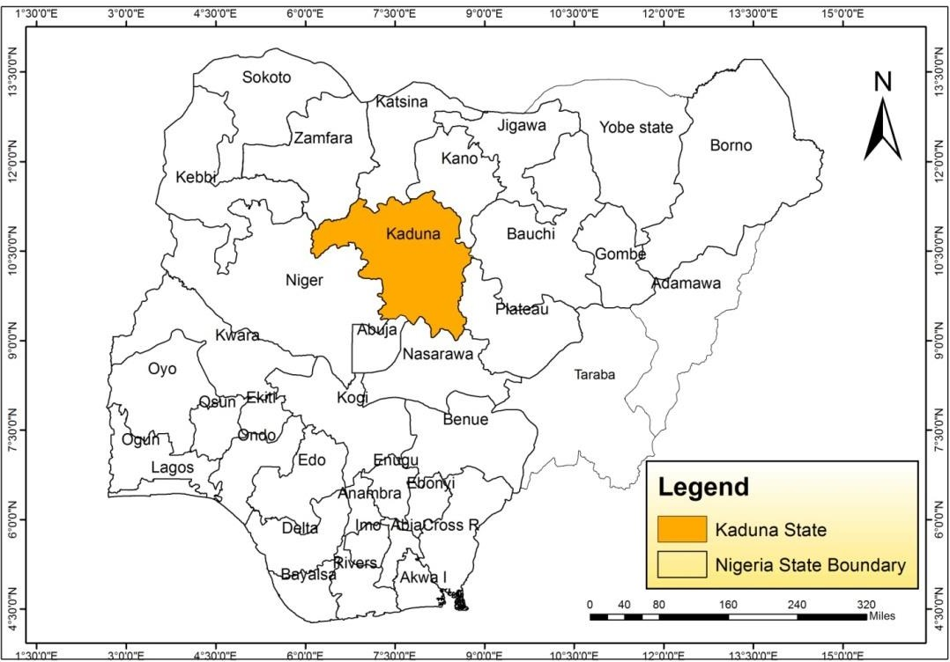

**Figure 1** Map of Nigeria showing Kaduna State. **Source:** Modified from Administrative Map of Nigeria 2015

The survey was conducted in five (5) selected Local Government Areas (LGAs) of Kaduna State, Nigeria as shown by the map below (fig. 2). The Local Governments were selected based on: unique in terms of common language (Hausa and Fulani being the dominant ethnic groups), traditional medical practitioners and cultural values.

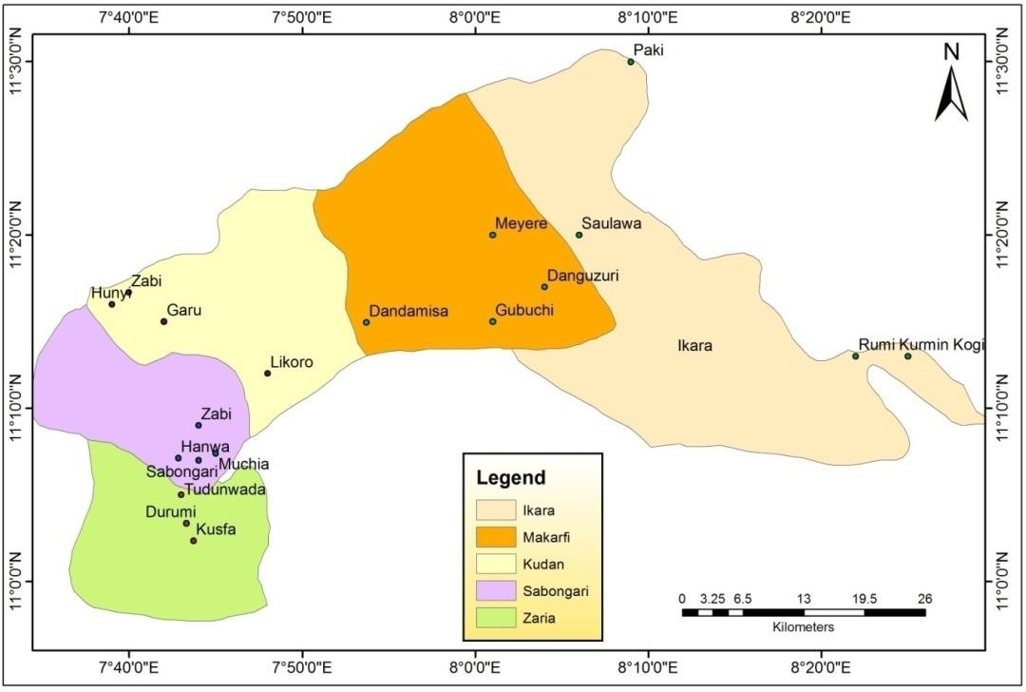

**Figure 2:** Map of the Study Areas. **Source:** Modified from Administrative Map of Nigeria 2015

The predominant tribes in all these areas were *Hausa* and *Fulani* and others *(ZEMDA, 2015).* Both LGAs are in the guinea savannah region with temperature range of 22.7° December to January during the Harmattan to as high as 28-30° in April.

# 3.3.3. Sampling technique

The sampling procedure used is multistage and purposive sampling. From the selected five Local Government Areas (LGAs), four villages were randomly selected from each LGA to make a total of 20 villages. At least nineteen respondents were selected from each village and four other people were also selected. Therefore a total numbers of respondents interviewed were (384).

# Study population

The study population constitutes mainly herbalist, farmers, nomads, traditional surgeon, traditional barber, bone setters, spiritualist, blacksmith, minerals sellers, traditional birth attendance, hunters, house wife, *sarkin ruwa, yan tauri* traditional items sellers, and other traditional healers.

# Sample size

Since the study areas have total population of more than 100,000, a total of 384 sample size was selected based on Kreijie and Morgan (1972) sample size selection table.

# Procedure for data collection

At the commencement of the survey permission was obtained from each village head. A clear understanding was made with the people surveyed that their intellectual property rights as to the information supplied will not be violated if the results lead to any economic benefits. A brief view of the objectives of the study in the local language of the respondents was given.

As the survey proceeded, confidence was built to the respondents so that the person interacted spontaneously and also snowball was used to identify other medical practioners. During the survey period, the ethno-medicinal information was collected through the open and closed ended questionnaire according to (Maundu, 1995 and Cotton, 1996) and through recording some of the conversation. The information of each evaporite (*kanwa*) was recorded along with the local name, nature, mode of usage, medicinal uses, mode of preparation, routes of administration etc. Each respondent was visited two to three times in order to verify the authenticity of the information obtained. Socio demographic data was also recorded which include: sex, age, marital status, tribe, educational status and occupation. All information in relevant to data collection was carefully written down. During the survey, the respondents were also requested to pick the evaporites (*kanwa*) from our container best on their knowledge for clear and proper identification.

# Administration of questionnaire (instrument for data collection)

The questionnaire was translated and back translated into Hausa (local language) before administration. The instrument was validated by an expert in public health department. Reliability was established by administering the instrument on respondents in samara community with the same social background, norms and values using test re-test procedure. Ethno-medicinal information on the evaporites (*kanwa*) was obtained by consulting the above mentioned study population. In depth interviews were carried out with some traditional medical practitioners to support information obtained from the questionnaires. The questionnaire was divided into two sections. Section (A) socio-demographic data such as: sex, age, marital status, tribe, educational status and occupation. Section (B) information on ethnomedicinal uses, local names, identity and

type of diseases cured. The questionnaire was translated and interpreted orally in the local language and responses filled into the questionnaire after each interview. Participants were assured of confidentiality and their responses only meant for research purposes.

# Quantitative analysis

The identity, local names, nature, ethno-medicinal uses, mode of preparation, and route of administration of various evaporites (*kanwa*) were mentioned. The results were presented and analyzed further on the basis of data collected. The uses of evaporites (*kanwa*) were evaluated by calculating use value (*UV*), informant consensus factor (*ICF*), and fidelity level (*FL*).

* + - 1. ***Use values UV***: are computed for each evaporites (*kanwa*) to provide a quantitative measure of its comparative significance to the informants or a quantitative method demonstrating the relative importance of each evaporites, (Arip *et al.,* 2015). *UV* was determined by the equation:



where, ‘UVe ’ indicates the use value of a particular evaporites, ‘UV is the number of uses mentioned by the informants for that particular evaporites (*kanwa*) , ‘ns ’ is the total number of informants participated in our study, ‘i ’ informants

The main objective of UV determination is to find out the degree of ethnomedical uses for a particular evaporites (*kanwa*). High UV value indicates the broad acceptance of those particular evaporites (*kanwa*) for a particular therapeutic use. Application of the use-value of each type is based objectively on the importance attributed by the respondents and does not depend on the opinion of the researcher.

* + - 1. ***Informant consensus factor (ICF)*** was used to measure the homogeneity of the information for a specific evaporites (*kanwa*) to cure a specific diseases or to estimate the level of agreement between respondents over which evaporites (*kanwa*) to use for each disease category (Canales, 2005). The lowest and highest values of ICF can be 0.00 and 1.00, respectively. A value near zero indicates a high variation in the use of evaporites, if minerals are chosen randomly, or if respondents do not exchange information about their use. Values near 1 indicate a high intra-cultural consensus. ICF was determined using the equation:



Where, ‘Nur’ refers to the total number of use reports for a particular ailment category, and ‘Nt’ is the total number of items used for this ailment category. Several diseases were sorted out into a broad ailment category depending on similarity for the ease of the distribution of the evaporites (*kanwa*).

* + - 1. ***Fidelity level (FL)*** expresses the priority of an evaporites over the others in the management of a particular ailment and was determined using the following formula:

***FL*=*Ip*/*Iu*×100 3**

Where, **‘*Ip*** ’ is the number of informants stating the use of a particular evaporites (*kanwa*) for a particular ailment category while**‘*Iu*’** is the number of informants stating the use of those particular evaporites (*kanwa*) for any sort of ailment category.

Higher *FL* value indicates more frequent use of a given evaporites (*kanwa*) for treating a particular ailment category by the informants.

# Physical Constants Determination

# Organoleptic Identification

Samples of *kanwa* were examined under day light with the aid of hand lens, the shape and colour were noted. The samples of *kanwa* were crushed into powder and placed in a small beaker with a continuous inhalation of the air over it to perceive and the distinct odor or smell were noted. The samples of *kanwa* were then masticated for at least 10 to 30 second and the taste was noted.

# Determination of cleavage/fracture, luster and hardness

The cleavage/ fracture was determined by breaking the evaporites while hardness was determined according to Moh’s-scale method

# Solubility Test

Solubility was determined according to European Pharmacopoeia (2005), for this test a maximum of 111 mg of substance and a maximum of 30 ml of deionized water was used. This involved vigorous shaking of the mixture for 1 min and placed in a constant temperature device (water bath), and maintained at a temperature of 25.0 ± 0.5 °C for 15 min. Careful observation was made on the substance if completely dissolved or not, shaken was repeated for 1 min and tube kept on the constant temperature device for 15 min (European Pharmacopoeia, 2005). The sample was described as *very soluble* if 100 mg completely dissolved in 0.1 ml, *freely soluble* if 100 mg is completely soluble in 1.0 ml, *soluble* if 100 mg is completely soluble in 3 ml, *sparingly soluble* if 100 mg is completely soluble in 10 ml, *slightly soluble* if 10 mg of powdered samples was completely soluble in 10 ml of solvent, *very slightly soluble* if 1 mg of sample was soluble in 10 ml of solvent.

# Extractive Value of Evaporites *(kanwa)*

The method described by Abdelaati *et al.* (2014) was adopted with modification. Sample (100 g) was accurately measured and dissolved in 3 liters of deionized water and left for 24 hrs for the soluble part to dissolve, the solutions was clarified with filtration to remove silica and insoluble materials. The clear solutions were evaporated in a hot water bath to produce pure evaporites crystals.

# Hygroscopicity Test

According to European Pharmacopoeia (2005), this method was carried out on a substance that complied with the test for loss on drying or water content of the monograph. The method gives an indication of the degree of hygroscopicity rather than a true determination.

* + - 1. Vessel and stopper was measured to a constant weight which was noted as **m1**.
      2. Sample (2g) was introduced into the vessel and weighed as **m2**.
      3. The vessel without stopper was placed in a desiccator at 25 °C containing NH4Cl solution. It was allowed to stand for 24 h. then stoppered and weighed as **m3**.

Percentage increase in mass Δm% was determined using the expression below:



The result was interpreted as *deliquescent*if sufficient water was absorbed to form a liquid,

*very hygroscopic* if increase in mass was equal to or greater than 15%, *hygroscopic* if increase in mass was less than 15% and equal to or greater than 2%, *slightly hygroscopic* if increase in mass was less than 2% and equal to or greater than 0.2%.

# Elemental Analysis of Evaporites (*kanwa*)

Determination of *kanwa* constituents was carried out according to the standard methods of analysis, analytical reagent and standard solutions. This elemental analysis was carried out on the powdered samples to determine the major anions and cations with their concentrations that may be present in the evaporites (*kanwa*). The analysis was carried out using atomic absorption spectra (AAS) and titration method for anions at department of soil sciences, division of agricultural college (DAC) Ahmadu Bello University Zaria.

# Biological Assay

# Acute oral toxicity study (LD50)

Acute toxicity studies were conducted using organization for economic cooperation and development (OECD) guideline in mice (OECD Test Guideline 425) (AOT), 2001). The limit dose test, up and down procedure was adopted to evaluate the acute toxicity of the evaporites (*kanwa*) samples following oral administration in mice. A total of thirty (30) mice were randomly selected and divided into six groups each of five mice. They are maintained in the laboratory for 7 days to allow for acclimatization to the laboratory conditions. Group 1: control, Group 2-6: treated with 2000 mg/kg each of *farar kanwa, jar kanwa, ungurnu, dutse danlibya,* and *manda* respectively.

Prior to treatment, mice were fasted 4 h but allowed free access to water. A mouse from each group was picked, weighed and dosed orally with a limit dose of 2000 mg/kg body weight of the freshly prepared evaporites (*kanwa*) then food was further withheld for 2 h. Another animal from

the same group was given the same dose of the evaporites (*kanwa*) until all the animals in the group were fed with the same dose of the evaporite (*kanwa*).

Observations was done on each animal for every 15 min in the first 4 h after dosing, every 30 min for 6 h and daily for 48 h for the short-term outcome each time for instant death and then watched for the successive 24 h for the short-term toxicity outcome and finally for the next 13 days for any delayed toxic effects. The toxicity observed include increased motor activities, rolling, writhing, depression, behavior pattern, diarrhea, sleep, coma, etc. the time of onset, disappearance and length of recovery period from toxic symptoms were systematically recoded if any. At the end of the test surviving mice are weighted the then scarified using shape blade, blood, liver and kidney were carefully removed for further analysis.

# Body weight determination

Individual weight of animalwas determined shortly before the test substance is administered and at least weekly thereafter. Weight changes were calculated and recorded.

# Collection of blood and organ samples

The mice were sacrificed on the fourteen day of the experiment and blood samples were collected via carotid artery into non EDTA (ethylenediaminetetraacetic acid) bottles, the blood samples were centrifuged at 3000 rpm for 5 min to obtain serum for biochemical analysis (biochemical analysis). The vital organs kidneys and liver were carefully excised and fixed in 10% formalin for histopathological examinations.

# Histopathological assay

Formalin (10 %) was used to preserved hepatic and renal tissue samples of kanwa dosed mice and controls were processed in the same way. The processing consisted of an initial 2 step fixation comprising tissue immersion in 10 % buffered formalin for two hours each, followed by removal of fixative in distilled water for 30 minutes. Dehydration was then carried out by running the tissues through a graded series of alcohol (70 %, 90 %, and 100 %). The tissue was initially exposed to 70% alcohol for 30 minutes followed by 90 % alcohol for 1 hour and then two cycles of absolute alcohol, each for one hour.

Dehydration was then followed by clearing the samples in several changes of xylene. It consisted of tissue immersion for an hour in a mixture comprising 50 % alcohol and 50 % xylene, followed by pure xylene for one and a half hours. Samples were then impregnated with molten paraffin wax, then embedded and blocked out. Paraffin sections (4–5 µm) were stained with hematoxylin and eosin, the conventional staining technique (Underwood, 2000).

Stained sections were examined for necrosis, apoptosis, inflammation and vascular changes in renal tissue. The hepatic tissue was evaluated for any alterations in the architecture, portal or lobular inflammation, sinusoidal dilatation and congestion along with presence of granulomas, degeneration, necrosis and fatty change.

# The biochemical analysis (liver enzymes activities)

For biochemical analysis, the parameters determined were aspartate aminotransferase (AST), alanine aminotransferase (ALT), alkaline phosphatase (ALP), total bilirubin, conjugate bilirubin and total protein using commercially available kits (RANDOX, United Kingdom) and an auto biochemical analyzer machine (Rayto). The analyses were carried out at department of chemical pathology, Ahmadu Bello University Teaching Hospital (ABUTH) Zaria.

# Tests for Analgesic Properties

* + - 1. **Acetic acid-induced writhing in mice (abdominal constrictions)**

The evaporites and the standard drug were administered to the animals orally in all the experiments. This test was conducted employing the method described by Koster *et al.* (1959). This involved six groups of five mice each. Group 1 was administered 10 ml/kg orally with distilled water (negative control). Group 2 was administered 300 mg/kg of body weight orally with aspirin (positive control). Groups 3, 4, 5, and 6 were administered 1000, 500, 250, 125 mg/kg orally sample dissolved in distilled water respectively.

One hour after each evaporites administration, each mouse was injected with 10 ml/kg of body weight intraperitoneally (*i.p*) aqueous solution of acetic acid (0.6 %). The number of writhes occurring between 5 and 20 min after acetic acid injection was recorded. The analgesic effect was expressed as the percentage reduction of writhes in treated mice compared to those in the control.

The percentage of writhing (abdominal constrictions) was calculated using the following formula:

The percentage inhibition of writhing (abdominal constrictions) was calculated using the following formula:



# Antimicrobial Assay for evaporites

* + - 1. **Test Organisms**

The test organisms used for this analysis were clinical isolates of bacteria isolated from the stool of human which were obtained from Department of Microbiology, Ahmadu Bello University, Zaria. The clinical isolates used were; *Bascillus subtilis, Staphylococcus aureus, Escherichia coli* and *Salmonella typh*i.

# Culture Media

The culture media used for the analysis were Mueller Hinton agar (MHA), Mueller Hinton broth (MHB) and nutrients agar. The media were used for sensitivity test, determination of minimum inhibitory concentration (MIC), minimum bactericidal concentration (MBC). All media were prepared according to manufacturer’s construction and sterilized by auto cleaving at 121oC for 15 minutes.

# Inhibitory activity (Sensitivity) test of the *kanwa* using agar well diffusion method.

The standard inoculate of the bacterial isolates were streaked on sterilized Mueller Hinton agar with the aid of a sterile swab stick. Four well were punched on each inoculated agar mate with a sterile cock borer. The wells were properly labeled according to different concentration of the *kanwa* prepared which was 100, 50, 25 and 12.5 mg/ml respectively. Each well was filled up with approximately 0.2 ml of the *kanwa*. The inoculated plates with the *kanwa* were allowed to stay on the bench for about one hour; this is to enable the *kanwa* to diffuse on the agar. The plates were then incubated at 37oC for 24 hours. At the end of the incubation period, the plates were observed for any evidence of inhibition which will appear as a clear zone that was completely devoid of growth around the wells (zone of inhibition). The diameter of the zones was measured using a transparent ruler calibrated in millimeter and the result was recorded (Cheesbrough, 2006).

# Determination of minimum inhibitory concentration (MIC) of the *kanwa*.

The minimum inhibitory concentration of the kanwa was determined using the dilution method with the Mueller Hinton broth used as a diluent. The lowest concentration of the kanwa showing inhibition for each organism when the *kanwa* was tested during the sensitivity test was serially diluted in the test tubes containing Mueller Hinton broth. The organisms were inoculated into each tube containing the broth and the *kanwa*. The inoculated tubes were then incubated at 37oC for 24 hours (Cheesbrough, 2006).

At the end of the incubation period, the tubes were examined / observed for the presence or absence of growth using turbidity as a criterion, the lowest concentration on the series without

visible sign of growth (turbidity) was considered to be the minimum inhibitory concentration (MIC) (Cheesbrough, 2006).

# Determination of minimum bactericidal concentration (MBC) of the *kanwa*

The result from the MIC was used to determine the minimum bactericidal concentration (MBC) of the extract. A sterilized wire loop was dipped into the test tubes that did not show turbidity (clear) on the MIC test and aloopfull was taken and streaked on a sterile nutrient agar plates. The plates were incubated at 37oC for 24 hours (Cheesbrough, 2006).

At the end of incubation period, the plates were examined / observed for the presence or absence of growth. This is to determine whether the antibacterial effect of the *kanwa* is bacteriostatic or bactericidal (Cheesbrough, 2006).

# 3.7 Statistical analysis

The Data gathered during ethno-medical survey using a questionnaire were analyzed using descriptive statistical tools such as tables, Percentages, multiple bar chart and pie chart. The data obtained from pharmacognostic studies were expressed using mean ± standard error of mean (mean ± SEM). The data obtained from biological studies were expressed as the mean ± SEM using the SPSS statistical packages. One-way analysis of variance (ANOVA) was used to detect further differences between groups and (P < 0.05) was considered significant.

# CHAPTER FOUR

# RESULTS

# Ethnomedical Information

* + 1. **Response rate from respondents**

From the survey carried out it showed that the majority (77.3 %) of the respondents were male while only (22.7 %) were female.

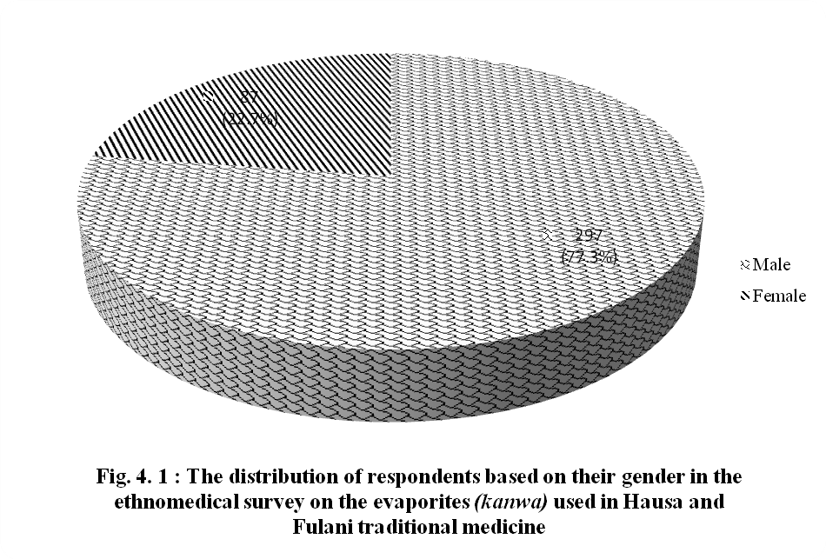

# Respondent's age brackets

Majority of the respondents were elders within the age of 41-70 years as shown in Figure 4.2 With the highest rate fall within 41-50 (35.50 %) then 51-60 years (21.6 %), 61-70 (20.1 %). From 20 to 50 years the practice rate is increasing while from 51 to 70 years the practice rate is decreasing, at 81 years above the rate is minimal.

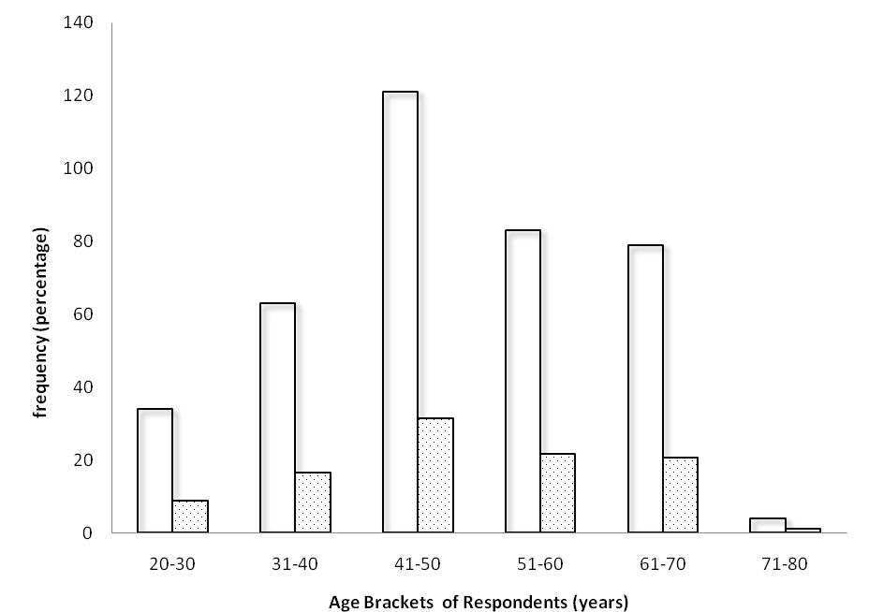

# Fig.4.2: Distribution of respondent’s age in the ethnomedical survey of evaporites *(kanwa)*

**used in Hausa and Fulani traditional medicine.**

# Respondent’s marital status

Majority (73.2 %) of the respondent are married while (26.8 %) were single as shown by fig. 4.3.

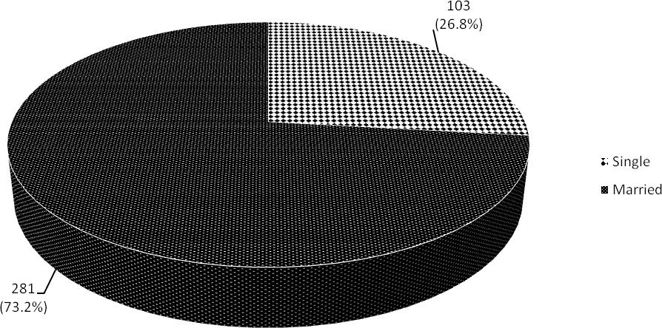

# Fig. 4.3: Distribution of respondent’s marital status in the ethnomedical survey of evaporites used in Hausa and Fulani traditional medicine in Kaduna state

**4.1.4 Responses by tribes**

Hausa represent the highest respondents during survey (52.9 %) followed by Fulani (23.2 %) and others with (24.0 %).

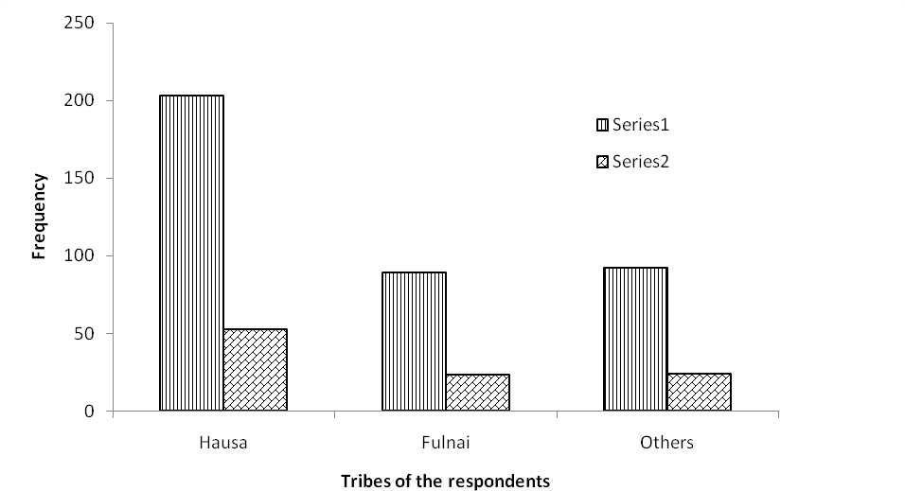

Frequency Percentage (%)

# Fig. 4.4: Distribution of respondent's tribes in the ethnomedical survey of evaporites used in Hausa and Fulani traditional medicine in Kaduna state

**4.1.5. Educational status of the Respondents**

Majority (42.7 %) of the respondents have Arabic/Islamic education as their highest qualification, followed by primary education (29.7 %), secondary education (14.1 %), tertiary education (7.8 %) and others with least (5.7 %) as shown by Fig 4.5

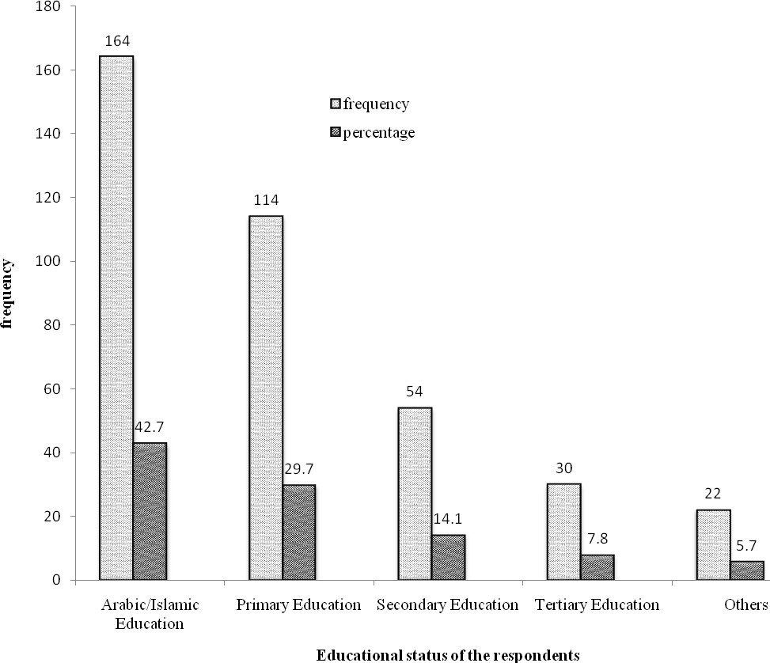

# Fig.4.5: Distribution of respondent's educational status in the ethnomedical survey of evaporites *(kanwa)* used in Hausa and Fulani traditional medicine in Kaduna state

**4.1.6 Occupation of the Respondents**

# Table 4.1: Distribution of respondent's occupation in the ethnomedical survey of evaporites

***(Kanwa)* used in Hausa and Fulani traditional medicine in Kaduna state**

|  |  |  |
| --- | --- | --- |
| **Occupations** | **Frequency** | **Percentage (%)** |
| Herbalists *(maimagani)* | 45 | 11.7 |
| Farmers *(manoma)* | 12 | 3.1 |
| Herb retailers*(‘yan ganye)* | 17 | 4.4 |
| Hunters *(mafarauta)* | 20 | 5.2 |
| Fishermen*(‘yan su)* | 8 | 2.1 |
| Nomands (*makiyaya)* | 41 | 10.7 |
| Spiritualists*(bokaye)* | 14 | 3.6 |
| bone setters*(madora)* | 19 | 4.9 |
| Blacksmiths*(makera)* | 16 | 4.2 |
| Traditional barbers *(ma aska)* | 17 | 4.4 |
| Traditional surgeons*(wanzamai)* | 12 | 3.1 |
| Traditional medicine practitioner *(maimagani)* | 45 | 11.7 |
| Mineral retailers*(‘yan kanwa)* | 19 | 4.9 |
| Traditional items sellers*(‘yan koli)* | 31 | 8.1 |
| *Sarkin ruwa* | 8 | 2.1 |
| *Yan tauri* | 13 | 3.4 |
| Traditional birth attendant*(unguwan zoma)* | 31 | 8.1 |
| House wives*(matan gida)* | 16 | 4.2 |
| Total | 384 | 100 |

# 4.1.7. Knowledge of the respondents on evaporites *(kanwa)*

All the respondents (100 %) have knowledge of the evaporites samples shown to them. According to majority (66.1 %) of the respondents *kanwa* is the common name of evaporites. Others names include *uwargami* (14.6 %), *gishiri*(10.4 %) and *tahnateka* (8.9 %) as shown by Fig.4.6 below

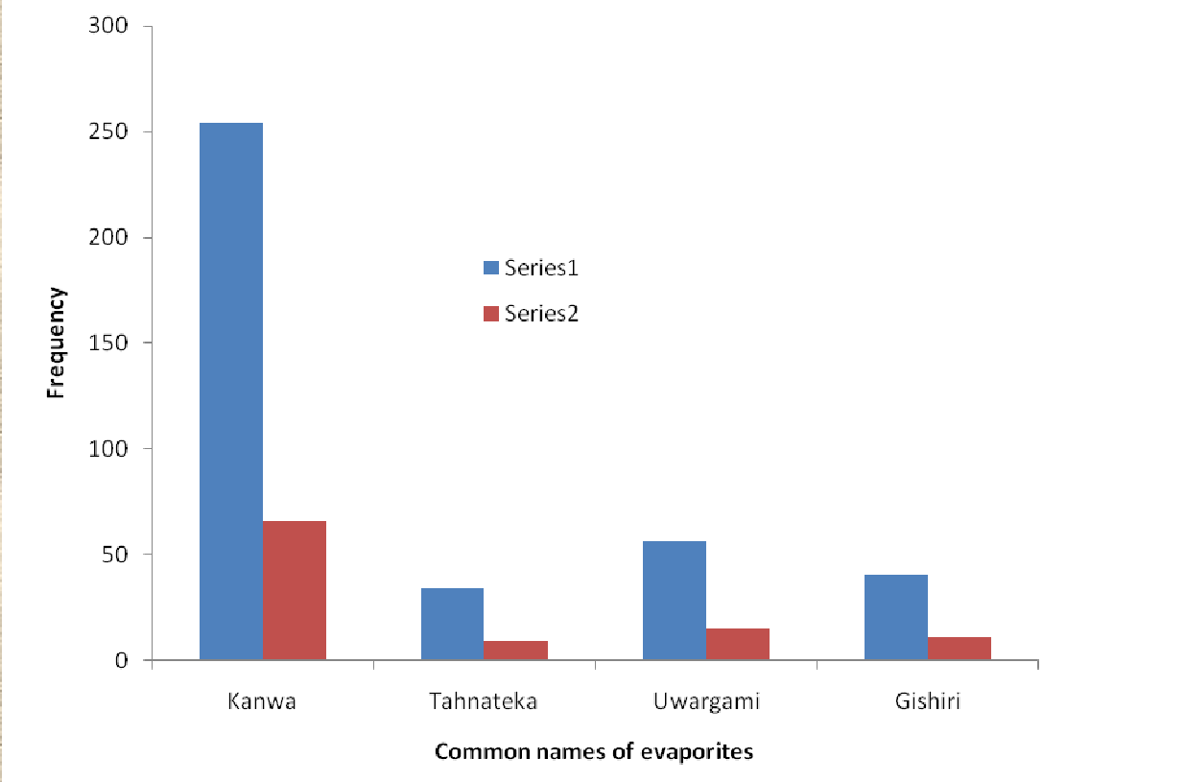

Frequency Percentage (%)

# Fig. 4.6: Responses based on common names of the evaporites in their ethnomedical survey of evaporites used in Hausa and Fulani traditional medicine in Kaduna state.

* + 1. **Physical Identification of Evaporites**

Most of the respondents (65.9 %) identified the evaporites from their physical appearance, then (22.7 %) with their colour, then (8.1 %) with their shape and (3.4 %) through taste as shown by Fig. 4.7 below.

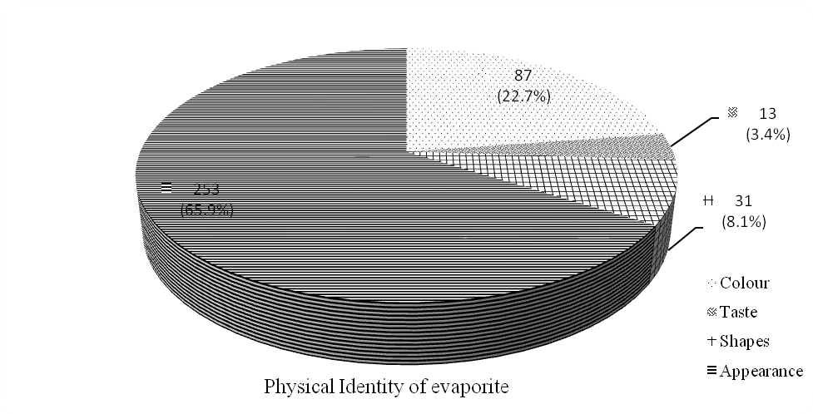

# Fig. 4.7: Responses based on the methods of identification in the ethnomedical survey of evaporites used in Hausa and Fulani traditional medicine in Kaduna state.

* + 1. **Show and Tell Correct Identity of each Evaporites**

Majority of the respondents have correctly show and tell the identity of each evaporites with exact common names as follows: *farar kanwa* (97.9 %), *jar kanwa* (95.8 %), u*ngurnu* (96.4 %), *manda* (90.1 %) and *dutse dan libya* (92.2 %) as shown by Table 4.2 below.

# Table 4.2: Responses based on correct identification of each evaporites in their ethnomedical survey as used in Hausa and Fulani traditional medicine in Kaduna state stated as

|  |  |  |  |
| --- | --- | --- | --- |
| Response | Correct ID | Wrong ID | Total |
| *Farar kanwa* | 376(97.9 %) | 8(2.1 %) | 384(100.0 %) |
| *Jar kanwa* | 368(95.8 %) | 16(4.2 %) | 384(100.0 %) |
| *ungurnu* | 370(96.4 %) | 14(3.6 %) | 384(100.0 %) |
| *Manda* | 346(90.1 %) | 38(9.9 %) | 384(100.0 %) |
| *Duste dan libya* | 354(92.2 %) | 30(7.8 %) | 384(100.0 %) |

**Source: Field survey, 2015**

# Duration of using evaporites

Majority (58.6 %) of the respondents used these evaporites for a long time while 41.4 % reported I don’t know as shown by Fig. 4.8 below.

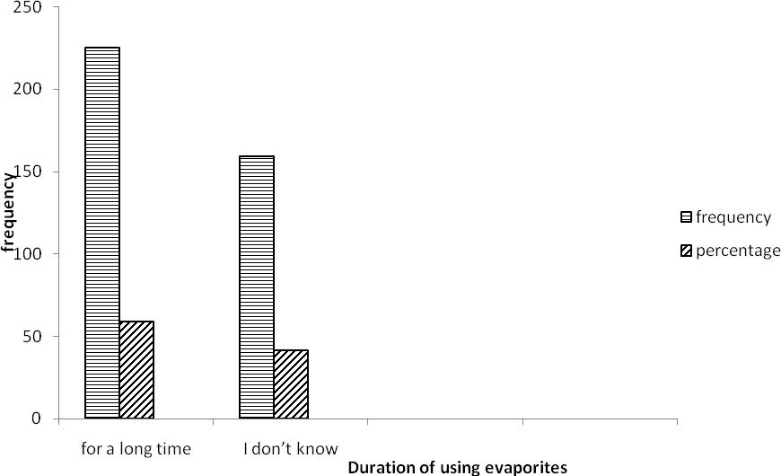

# Fig. 4.8: Responses based on duration of using evaporites in their ethnomedical survey used in Hausa and Fulani traditional medicine in Kaduna state

* + 1. **Major Traditional Uses of Evaporites**

In response to the question *“Specify the use of each items”,*most of the evaporites are highly used in medicine, veterinary practices, preservatives, cosmetics, food additives and others.

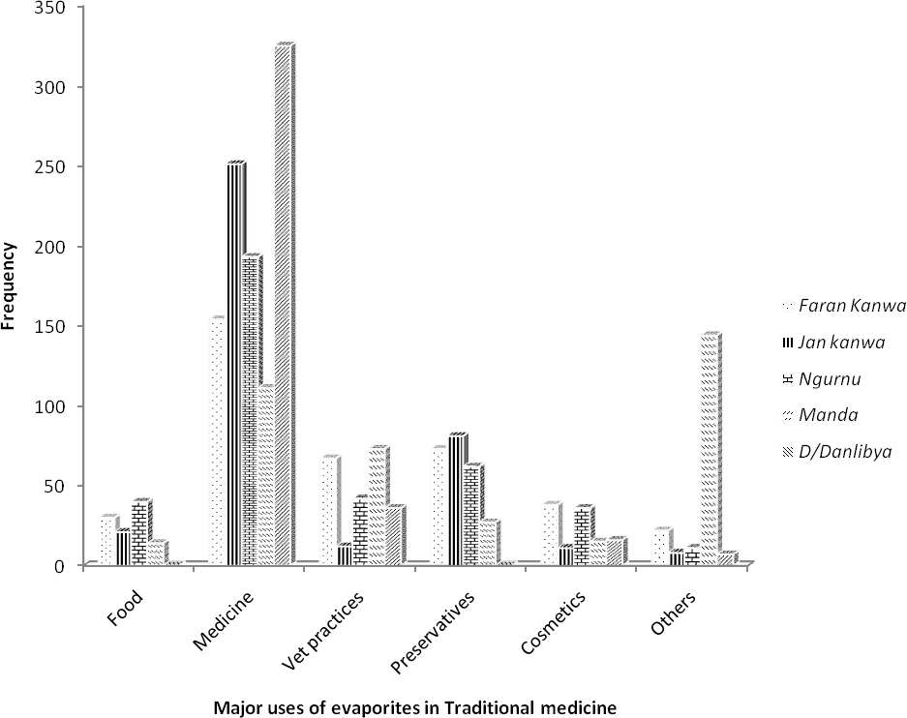

# Fig. 4.9: Responses based on Major Traditional uses of evaporites in their ethnomedical survey used in Hausa and Fulani traditional medicine in Kaduna state.

* + 1. **Specific Medicinal Uses of Evaporites**

Majority of the respondents utilized more of *farar kanwa* and *Dutse dan Libya* in treatment of GIT (34.1 % and 63.3 %). *Jar kanwa* (15.1 %) and *Manda* (15.4 %) were utilized more for skin treatment. *Farar Kanwa* (6.8%), *Jar kanwa* (6.2%) and *Manda* (6.2 %) were observed to be used by respondents in the treatments of fever. *Jar kanwa* (18.5 %) and *ungurnu* (18.0 %) were observed to be involve in treating infections. *Dutse dan Libya* (15.6 %) and *Jar kanwa* (23.4 %) were mostly reported by respondents as pain relievers. *Ngurnu* (7.8 %) and *Manda* (7.2 %) were used by most of the respondent in wound healing.

# Ethnomedical uses of *farar kanwa* in Hausa and Fulani traditional medicine as obtained from survey of some LGA in Kaduna state

**Table 4.3. A response based on Traditional uses of *farar kanwa* on specific disease in their ethnomedical survey in Hausa and Fulani traditional medicine in Kaduna state.**

|  |  |  |  |  |  |
| --- | --- | --- | --- | --- | --- |
| **Conditions** | **Responses** | **Percentage (%)** | **UV** | **ICF** | **FL (%)** |
| GIT | 131 | 34.1 | 0.98 | 0.99 | 34.1 |
| Skin problem | 44 | 11.5 | 0.90 | 0.98 | 11.5 |
| Fever | 26 | 6.8 | 0.89 | 0.80 | 6.8 |
| Infection | 65 | 16.9 | 0.93 | 0.87 | 16.9 |
| Pain reliever | 51 | 13.3 | 0.97 | 0.98 | 13.3 |
| Wound healinhg | 7 | 1.8 | 0.88 | 0.90 | 1.8 |
| Others | 60 | 15.6 | 0.90 | 0.84 | 15.6 |

# Source field survey, 2015

**UV=used value, ICF=informant consensus factor, FL=fidelity level, GIT= gastrointestinal tract**

# Ethnomedical uses of *jar kanwa* in hausa and Fulani traditional medicine as obtained from survey of some LGA in Kaduna state

**Table 4.4. A response based on Traditional uses of *jar kanwa* on specific disease in their ethnomedical survey in Hausa and Fulani traditional medicine in Kaduna state.**

|  |  |  |  |  |  |
| --- | --- | --- | --- | --- | --- |
| **Conditions** | **Responses** | **Percentage (%)** | **UV** | **ICF** | **FL (%)** |
| GIT | 98 | 25.5 | 0.95 | 0.98 | 25.5 |
| Skin problem | 58 | 15.1 | 0.89 | 0.91 | 15.1 |
| Fever | 24 | 6.2 | 0.90 | 0.88 | 6.25 |
| Infection | 71 | 18.5 | 0.95 | 0.87 | 18.5 |
| Pain reliever | 90 | 23.4 | 0.98 | 0.98 | 23.4 |
| Wound healinhg | 20 | 5.2 | 0.91 | 0.94 | 5.2 |
| Others | 23 | 6.0 | 0.92 | 0.84 | 5.9 |

# Source field survey, 2015

**UV=used value, ICF=informant consensus factor, FL=fidelity level, GIT= gastrointestinal tract**

# Ethnomedical uses of *ungurnu* in Hausa and Fulani traditional medicine as obtained from survey of some LGA in Kaduna state

**Table 4.5. A response based on Traditional uses of *ungurnu* on specific disease in their ethnomedical survey in Hausa and Fulani traditional medicine in Kaduna state.**

|  |  |  |  |  |  |
| --- | --- | --- | --- | --- | --- |
| **Conditions** | **Responses** | **Percentage (%)** | **UV** | **ICF** | **FL (%)** |
| GIT | 83 | 21.6 | 0.94 | 0.95 | 21.6 |
| Skin problem | 51 | 13.3 | 0.91 | 0.90 | 13.3 |
| Fever | 22 | 5.7 | 0.88 | 0.80 | 5.7 |
| Infection | 69 | 18.0 | 0.93 | 0.92 | 18.0 |
| Pain reliever | 60 | 15.6 | 0.97 | 0.97 | 15.6 |
| Wound healinhg | 30 | 7.8 | 0.90 | 0.90 | 7.8 |
| Others | 69 | 18.0 | 0.92 | 0.86 | 18.0 |

# Source field survey, 2015

**UV=used value, ICF=informant consensus factor, FL=fidelity level, GIT= gastrointestinal tract**

# Ethnomedical uses of *dutse danlibya* in hausa and Fulani traditional medicine as obtained from survey of some LGA in Kaduna state

**Table 4.6. A response based on Traditional uses of *dutse danlibya* on specific disease in their ethnomedical survey in Hausa and Fulani traditional medicine in Kaduna state.**

|  |  |  |  |  |  |
| --- | --- | --- | --- | --- | --- |
| **Conditions** | **Responses** | **Percentage (%)** | **UV** | **ICF** | **FL (%)** |
| GIT | 233 | 63.3 | 0.99 | 1.00 | 60.7 |
| Skin problem | 47 | 12.2 | 0.92 | 0.97 | 12.2 |
| Fever | 8 | 2.1 | 0.90 | 0.93 | 2.1 |
| Infection | 9 | 2.3 | 0.96 | 0.96 | 2.3 |
| Pain reliever | 60 | 15.6 | 0.97 | 0.98 | 15.6 |
| Wound healinhg | 0 | 0.0 | 0.84 | 0.93 | 0.0 |
| Others | 17 | 4.4 | 0.95 | 0.84 | 4.4 |

# Source field survey, 2015

**UV=used value, ICF=informant consensus factor, FL=fidelity level, GIT= gastrointestinal tract**

# Ethnomedical uses of *manda* in hausa and Fulani traditional medicine as obtained from survey of some LGA in Kaduna state

**Table 4.7. A response based on Traditional uses of *manda* on specific disease in their ethnomedical survey in Hausa and Fulani traditional medicine in Kaduna state.**

|  |  |  |  |  |  |
| --- | --- | --- | --- | --- | --- |
| **Conditions** | **Responses** | **Percentage (%)** | **UV** | **ICF** | **FL (%)** |
| GIT | 73 | 19.0 | 0.91 | 0.94 | 19.0 |
| Skin problem | 59 | 15.4 | 0.92 | 0.95 | 15.4 |
| Fever | 24 | 6.2 | 0.83 | 0.80 | 6.3 |
| Infection | 61 | 15.9 | 0.86 | 0.77 | 15.9 |
| Pain reliever | 48 | 12.5 | 0.90 | 0.82 | 12.5 |
| Wound healinhg | 29 | 7.6 | 0.93 | 0.87 | 7.5 |
| Others | 90 | 23.4 | 0.92 | 0.80 | 23.4 |

# Source field survey, 2015

**UV=used value, ICF=informant consensus factor, FL=fidelity level, GIT= gastrointestinal tract**

# 4.1.16. Mode of Using Evaporites

During the ethnomedical survey, *dutse dan libya* (84.9 %) and *farar kanwa* (54.9 %) were found to be used to drink in solution form by most of the respondents. *Jar kanwa* (61.5 %) and *ungurnu* (50.5 %) were mostly used with herbs. *Farar kanwa* (22.7 %) and *jar kanwa* (20.3 %) were highly drink with pap compare to other evaporites as shown by Table 4.8 below.

# Table4.8: Responses based on mode of traditional uses of evaporites in their ethnomedical survey of Hausa and Fulani traditional medicine in Kaduna state.

|  |  |  |  |  |  |  |
| --- | --- | --- | --- | --- | --- | --- |
| **Response** | **drink solution** | **chew solid** | **mix with herbs** | **bath with solution** | **mix with pap** | **others** |
| *Faran kanwa* | 211(54.9 %) | 0(.0 %) | 68(17.7 %) | 18(4.7 %) | 87(22.7 %) | 0(.0 %) |
| *Jan kanwa* | 48(12.5 %) | 7(1.8 %) | 236(61.5 %) | 15(3.9 %) | 78(20.3 %) | 0(.0 %) |
| *Ungurnu* | 96(25.0 %) | 0(.0 %) | 194(50.5 %) | 40(10.4 %) | 54(14.1 %) | 0(.0 %) |
| *Manda* | 103(26.8 %) | 0(.0 %) | 72(18.8 %) | 63(16.4 %) | 0(.0 %) | 146(38.0 %) |
| *D/Danlibya* | 326(84.9 %) | 0(.0 %) | 43(11.2 %) | 9(2.3 %) | 6(1.6 %) | 0(.0 %) |

**Source: Field survey, 2015**

# Benefits of using Evaporites

All the *kanwa* samples surveyed were found to be used in treatment, prevention, cure of diseases in addition they have other domestic uses.

# Table 4. 9:Responses based on benefit of using evaporites in their ethnomedical survey of Hausa and Fulani traditional medicine in Kaduna state.

|  |  |  |  |  |
| --- | --- | --- | --- | --- |
| **Reponses** | **Treatment** | **Prevention** | **Cure** | **Others** |
| *Farar kanwa* | 136(35.4 %) | 98(25.5 %) | 94(24.5 %) | 56(14.6 %) |
| *Jan kanwa* | 156(40.6 %) | 56(14.6 %) | 113(29.4 %) | 59(15.4 %) |
| *Ungurnu* | 122(31.8 %) | 41(10.7 %) | 98(25.5 %) | 123(32.0 %) |
| *Manda* | 87(22.7 %) | 56(14.6 %) | 95(24.7 %) | 146(38.0 %) |
| *D/Danlibya* | 208(54.2 %) | 50(13.0 %) | 78(20.3 %) | 48(12.5 %) |

**Source: Field survey, 2015**

# Geographical Sources of Evaporites

Ethnomedical survey showed that evaporites *(kanwa)* were found and mined around Yobe, Borno, Adamawa, Gombe and Bauchi in Nigeria. Chad and Niger Republics as shown below.

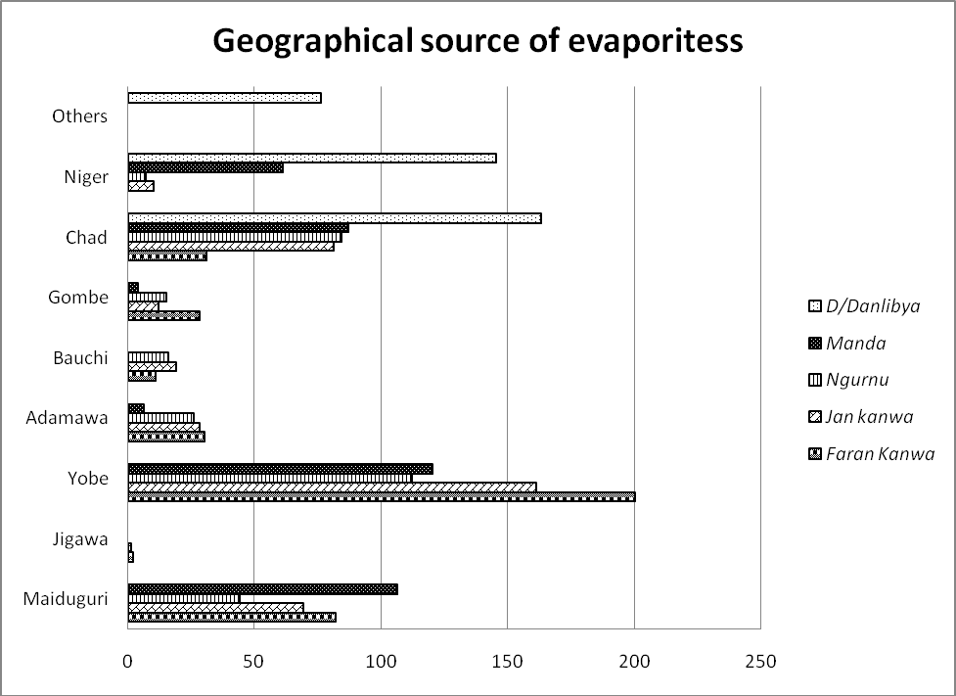

# Fig. 4.10: Responses based on geographical sources of evaporites as obtained from ethnomedical survey of Hausa and Fulani traditional medicine in Kaduna state.

* + 1. **Processing Methods of Evaporites**

Majority of the respondents (48.7 %) showed that *kanwa* was produced and mined without further processing, (6.2%) indicated that *kanwa* undergoes heating, (9.4 %) indicated drying process while (35.7 %) do not have knowledge on processing method as shown by Fig. 4.11 below

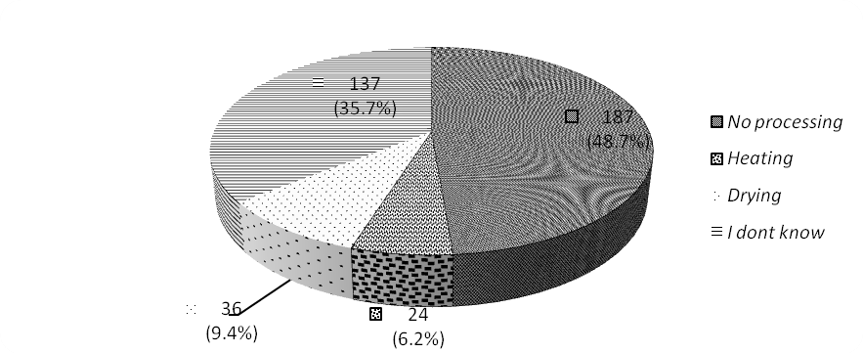

# Fig.4.11: Responses based on method of processing evaporites as obtained from ethnomedical survey of Hausa and Fulani traditional medicine in Kaduna state.

* + 1. **Preservation (storage) method of evaporites**

From the ethnomedical survey (40.9 %) of the respondent store *kanwa* in polythene bags, (22.7

%) stored in silo, (13.8 %) stored in plastic containers while some respondents store their *kanwa*

in metallic containers and pot.

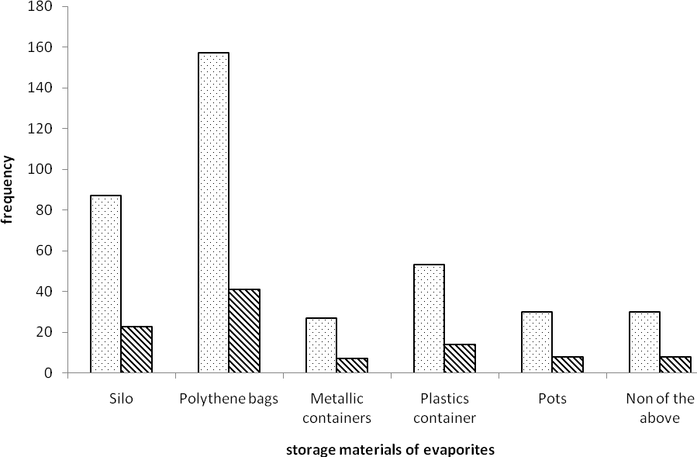

# Fig.4.12: Responses based on storing method of evaporites in the ethnomedical survey of evaporites used in Hausa and Fulani traditional medicine in Kaduna state.

* + 1. **Change of Evaporites on Storage**

Majority (96.9%) of the respondents reported that *kanwa* samples do not change much on storage except Manda that changes on storage with percentage support of (3.1 %) as shown by table 4.10.

# Table 4.10: Responses based on changes on storage of evaporites as obtained from the ethnomedical survey of evaporites used in Hausa and Fulani traditional medicine in Kaduna state.

|  |  |  |
| --- | --- | --- |
| **Response** | **Frequency** | **Percentage (%)** |
| *Farar kanwa* | 0 | 0 |
| *Jan kanwa* | 0 | 0 |
| *ungurnu* | 0 | 0 |
| *Manda* | 12 | 3.1 |
| *D/danlibya* | 0 | 0 |
| None | 372 | 96.9 |
| Total | 384 | 100.0 |

**Source: Field survey, 2015**

# Elemental Analysis of some Cations and Anions

Elemental analysis revealed that the evaporites contained some major cations and anions. All evaporites used during ethnomedical survey revealed the present of these cations: Ca, Mg, K, Na, Fe, Zn, and Pb while the anions include Cl, PO4, SO4, CO3, HCO3 and NO3 except *dutse danLibya* and *manda* which show the absent of CO3 (Table 4.11)

**Table 4.11: Concentration of Major Cations and Anions (ppm)**

|  |  |  |  |  |  |  |  |  |  |  |  |  |  |
| --- | --- | --- | --- | --- | --- | --- | --- | --- | --- | --- | --- | --- | --- |
| **Evaporites** | **Ca** | **Mg** | **K** | **Na** | **Fe** | **Zn** | **Pb** | **Cl** | **PO4** | **SO4** | **CO3** | **HCO3** | **NO3** |
| *Fararkanwa* | 41845 | 10314 | 24403 | 147669 | 8140 | 51 | 105 | 17 | 1171 | 2478 | 88 | 17 | 280 |
| *Jar kanwa* | 2608 | 2860 | 5006 | 450514 | 2097 | 31 | 568 | 50 | 391 | 1511 | 290 | 50 | 438 |
| *Ungurnu* | 115 | 892 | 13766 | 118886 | 1786 | 28 | 6 | 141 | 585 | 2297 | 156 | 27 | 140 |
| *DanLibya* | 598 | 19219 | 59067 | 205234 | 444 | 40 | 181 | 133 | 488 | 3022 | 0 | 11 | 140 |
| *Manda* | 21592 | 6422 | 13515 | 13766 | 7589 | 18 | 10 | 631 | 391 | 785 | 0 | 2 | 385 |

# Table 4.12. pH values of evaporites

|  |  |
| --- | --- |
| **Evaporites** | **pH** |
| *Farar kanwa* | 10.2 |
| *Jar kanwa* | 10.4 |
| *Ungurnu* | 10.4 |
| *DanLibya* | 8.7 |
| *Manda* | 10.6 |

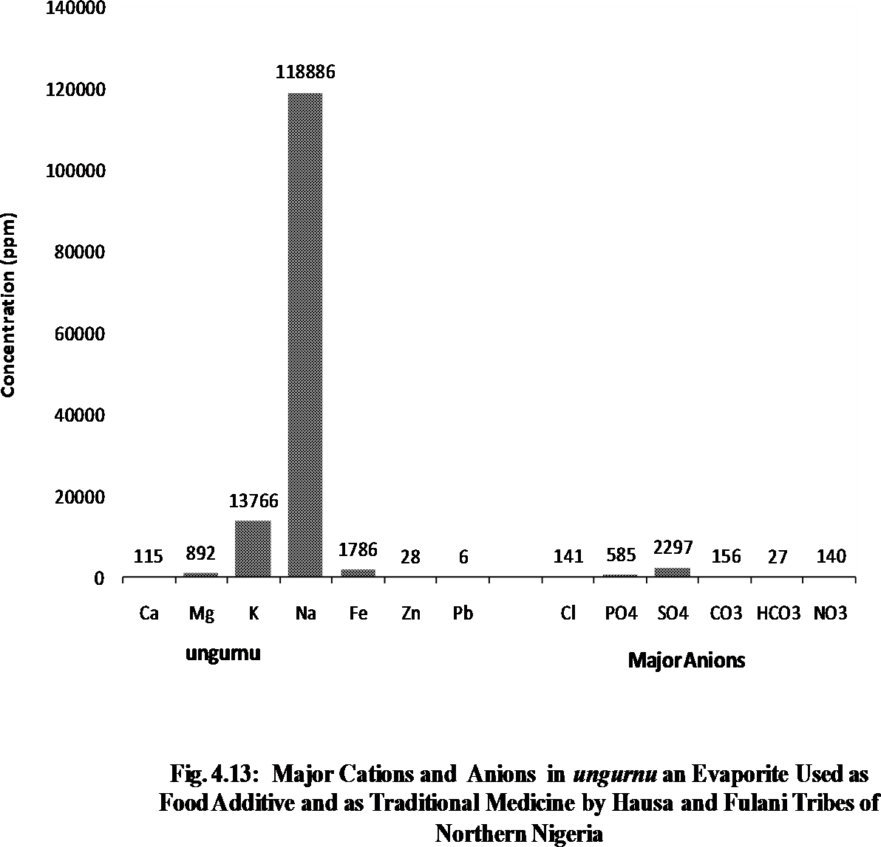



500000

450514

450000

400000

350000

300000

250000

200000

150000

100000

50000

2608 2860 5006

2097 31 568

50 391 1511 290 50 438

0

Ca

Mg

**Major**

K Na Fe Zn Pb

Cl PO4 SO4 CO3 HCO3 NO3

**Major Anions**

**Fig. 4.14: Major Cations and Anions of *Jar Kanwa* an Evaporite Used as**

**Food Additive and as Traditional Medicine by Hausa and Fulani Tribes of Northern Nigeria**

**Concentration (ppm)**

25000

21592

20000



13515 13766

7589

6422

631

785

18

10

391

0

2

385

15000

**Concentration (ppm)**

10000

5000

0

Ca Mg K Na Fe Zn Pb Cl PO4 SO4 CO3 HCO3 NO3

**Major Major**

**Fig. 4.15 : Major Cations and Anions of *Manda* an Evaporite Used as Food Additive and as Traditional Medicine by Hausa and Fulani Tribes of Northern Nigeria**

# 4.3. Physical Properties of Evaporites

**4.3.1. Organoleptic Properties and Chemical Formula of the Evaporites**

Based on physical identification by special senses and elemental analysis organoleptic properties of evaporites were identified.

# Table 4.13. Organoleptic properties of the evaporites

|  |  |  |  |  |  |
| --- | --- | --- | --- | --- | --- |
| **Kanwa** | **Appearance** | **Colour** | **Odour** | **Test** | **category** |
| *Farar Kanwa* | Mixed of large to micro crystals | White grey with black gray patches | metallic | salty | Natron |
| *Jar Kanwa* | Aggregates mass of Crystals | Light pink | metallic | salty | Natron |
| *Ungurnu* | Aggregatesmass with layered crystals | off white | odourless | salty | Natron |
| *D/danlibya* | Transparent, aggregates layered crystals | White with colourless patches | odourless | Salty | Polyhilite |
| *Manda* | crystal Mixed with earthy mass | Blackish grey | metallic | Salty | Polyhilite |

* + 1. **Solubility of evaporites**

These results indicated that *jar kanwa, ungurnu* and *dutse dan libya* samples were found to be very soluble while *farar kanwa* and *manda* were found to be soluble as shown by Table 8 below

# Table 4.14. Solubility properties of five different evaporites

|  |  |  |  |  |
| --- | --- | --- | --- | --- |
| Evaporites | Test | Observation | Extractive Value |  |
| *Fara kanwa* | 100mg dissolved in 3ml of solvent | soluble | 81.60 |  |
| *Jar kanwa* | 100mg dissolved in 0.1ml of solvent | very soluble | 92.76 |  |
| *ungurnu* | 100mg dissolved in 0.1ml of solvent | very soluble | 91.73 |  |
| *Duts danlibya* | 100mg dissolved in 0.1ml of solvent | very soluble | 96.10 |  |
| *Manda* | 100mg dissolved in 3ml of solvent | soluble | 60.83 |  |

* + 1. **Cleavage/fracture, luster and hardness nature of evaporites Table 4.15 cleavage/fracture, luster and hardness of evaporites**

|  |  |  |  |
| --- | --- | --- | --- |
| **Evaporites** | **cleavage/fracture** | **luster** | **hardness** |
| *Farar kanwa* | Fracture | Dull | 1- 2.5** |
| *Jar kanwa* | Fracture | Glassy | 2.5 - 3* |
| *ungurnu* | Fracture | Glassy | 2.5 - 3** |
| *Dutse danlibya* | Fracture | Glassy | 2.5- 3*** |
| *Manda* | Fracture | Dull | 1- 2* |

# 1-5= soft, 6-8 =hard, 9-10= hardest *more hard

**4.3.4. Hygroscopicity of evaporites Table 4.16: Hygroscopicity of evaporites**

|  |  |  |  |  |  |
| --- | --- | --- | --- | --- | --- |
| **Evaporites** | **M1** | **M2** | **M3** | **% increase in mass** | **Nature of Evaporites** |
| *Farar kanwa* | 62.20 | 64.20 | 64.26 | 6 | Hygroscopic |
| *Jar kanwa* | 71.51 | 73.51 | 73.51 | 0 | Not hygroscopic |
| *ungurnu* | 64.00 | 66.00 | 66.02 | 1 | Slightly hygroscopic: |
| *Dutsedan libya* | 61.36 | 63.36 | 63.36 | 0 | Not hygroscopic |
| *Manda* | 64.46 | 66.46 | 66.49 | 3 | Hygroscopic |

**M1 = mass of empty beaker M2= Mass of beaker and sample. M3= Mass of beaker and sample after storage.**

# 4.4 Acute toxicity studies

LD50 of the *kanwa* samples were obtained and found to be greater than 2000mg/kg for all the samples. No death or sing of toxicity was observed. Except *dutse danlibya* where Tremor and diarrhea occurred in 1/5 at initial stage (15 -30 minute). Sleep was observed in 1/5 animals treated with *manda* at 30-45 minutes*.* The relatively high oral median lethal dose (LD50) in mice suggests that the *kanwa* is relatively nontoxic when taken orally (Lorke, 1983).

# 4.4.1 Effect of *kanwa* on body weight of mice at 2000 mg/kg.

All animals were treated with 2000 mg/kg body weight and the results revealed not significant before and after treatment (Table 12)

# Table 4.17 Effect of *kanwa* on body weight of mice at 2000 mg/kg body weight. (n=5)

**Mean Body Weight ±SEM**

|  |  |  |  |  |
| --- | --- | --- | --- | --- |
| **Group** | **Treatment** | **Before** | **After** | **Remark** |
| 1(Control) | Normal saline | 19.00 ±1.00 | 20.00 ±0.58 | Not significant |
| 2 | *Farar kanwa* (2000 mg/kg) | 18.33 ±1.20 | 19.00 ±1.53 | Not significant |
| 3 | *Jar kanwa* (2000 mg/kg) | 19.66 ±0.88 | 20.33 ±0.67 | Not significant |
| 4 | *ungurnu* (2000 mg/kg) | 16.67 ±0.33 | 17.33 ±0.35 | Not significant |
| 5 | *D/dan libya* (2000 mg/kg) | 20.00 ±0.00 | 21.00 ±0.58 | Not significant |
| 6 | *Manda* (2000 mg/kg) | 19.33 ±1.20 | 20.53 ±1.20 | Not significant |

# 4.5. Biochemical Parameters

Table 13 shows the effect of *kanwa* samples at acute toxicity on aspartate amino transferase (AST) activity, alanine amino transferase (ALT) activity, alkaline phosphatase (ALP) activity and conjugate bilirubin. The results showed that AST, ALT and ALP activity at acute level for all samples were not significantly different (P>0.05) when compared with the control respectively. Meanwhile, total bilirubin values significantly increased (P<0.05) for all samples respectively. when compared with the control.

# Table 4.18: Effect of *kanwa* on liver enzymes activities(n=5)

|  |  |  |  |  |
| --- | --- | --- | --- | --- |
| **Total Protein**  **Grp (g/dl)** | **AST (u/l)** | **ALT (u/l)** | **ALP (u/l)** | **Bilirubin**  **Total Conjugated (mg/dl) (mg/dl)** |
| Contro 5.37 ±0.03 | 32.67 ±0.33 | 19.00 ±0.58 | 88.33 ±0.33 | 232.00 ±1.16 18.00 ±0.00 |

8.33 ±0.88

|  |  |  |  |  |  |
| --- | --- | --- | --- | --- | --- |
| FK | 5.00 ±0.00 | 27.00 ±0.58 | 19.33 ±0.33 | 95.00 ±0.67 | 263.67 ±1.45a |
| JK | 6.17 ±0.08 | 22.67 ±1.45 | 17.00 ±0.56 | 95.33 ±0.67 | 361.33 ±0.88a |
| NGR | 5.27 ±0.03 | 29.00 ±0.58 | 23.33 ±0.88 | 87.33 ±0.67 | 379.67 ±2.60a |
| DDL | 4.50 ±0.09 | 32.00 ±0.58 | 18.00 ±0.58 | 75.00 ±1.73 | 283.33 ±1.76a |
| MD | 4.67 ±0.03 | 33.67 ±0.33 | 17.33 ±0.67 | 97.33 ±0.67 | 361.33 ±0.88a |

10.67 ±1.20

15.00 ±058

11.00 ±1.00

15.33 ±0.38

Values are mean determinants ±SEM, (n=5) p<0.05, a= significant compare to controls:

aspartate amino transferase, ALT: alanine amino transferase; ALP: alkaline phosphatase; FK (*farar kanwa*) JK (*Jar kanwa*) NGR (u*ngurnu*) DDL (*dutse danlibya*) MD (*Manda*)

# Histopathological Assay

The histopathology of liver and kidney of the treated mice was compare with control as shown by Table 4.17 below.

# Table 4.19: Effect of kanwa on liver and kidney of mice at acute toxicity level

***kanwa* liver kidney**

Control Show normal hepatocytes Show normal tubules and glomerulus

FK Show normal features Show slight vacoulation of glomerulus and tubules

JK Shoe slight sinusoidal congestion Shows moderate lymphocyte infiltration

NGR Show lymphocyte infiltrations, Show moderate tubular and glomerular vacoulation and Slight necrosis infiltration and slight necrosis

DDL Show normal features Show slight vacoulation of glomerulus

MD Show normal features Show normal features

FK=*farar kanwa* JK= *jar kanwa*, NGR= u*ngurnu*, DDL= *dutse danlibya*, MD= *manda*

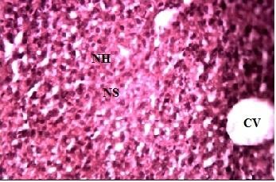

Plate I: ×400 Micrograph of the liver tissue section from untreated mice (control) NH= Normal Hepatocytes, NS = Normal Sinusoid, CV = Central Vein

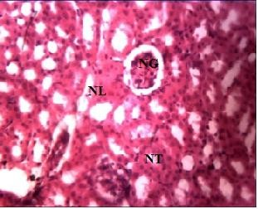

Plate II: ×400 Micrograph of the kidney tissue section from untreated mice (control) NG= Normal Glomerulus, NL= Normal Lymphocytes, NT= Normal Renal Tubules

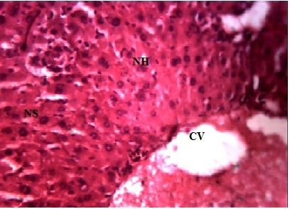

Plate III: ×400 Micrograph of liver tissue from mice treated with 2000 mg/kg of *farar kanwa*

NH= Normal Hepatocytes, NS = Normal Sinusoid, CV = Central Vein

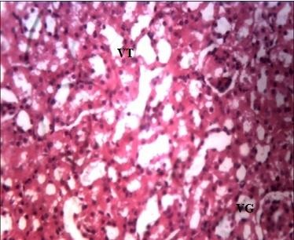

Plate IV: ×400 Micrograph of kidney tissue from mice treated with 2000 mg/kg of *farar kanwa*

VT= Slight Vacuolation of renal tubules, VG= Vacuolation of Glumerulus

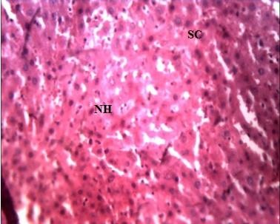

Plate V: ×400 Micrograph of liver tissue from mice treated with 2000 mg/kg of *jar kanwa*

SC= Slight Sinusoidal congestion, NH= Normal Hepatocytes

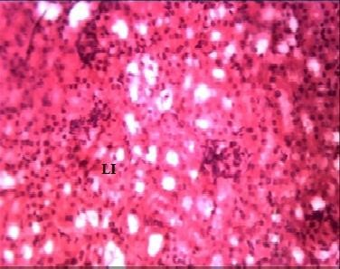

Plate VI: ×400 Micrograph of kidney tissue from mice treated with 2000 mg/kg of *jarkanwa*

LI= Moderate Lymphocyte Infilteration

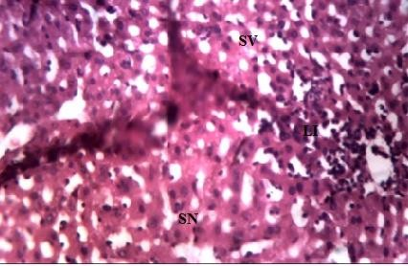

Plate VII: ×400 Micrograph of liver tissue from mice treated with 2000 mg/kg of u*ngurnu* SV= Slight Vacuolation, LI= Lymphocytes infiltration, SN= Slight Necrosis

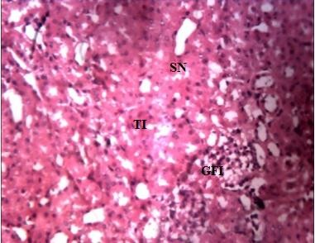

Plate .VIII: ×400 Micrographs of kidney tissue from mice treated with 2000 mg/kg of u*ngurnu*. SN= Slight Necrosis, TI= Moderate Tubular Infiltration, GFI= Moderate Tubular Fatty Infiltration.

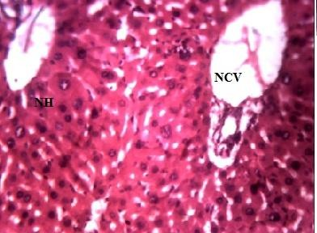

Plate IX: ×400 Micrograph of liver tissue from treated mice with 2000 mg/kg of *dutse dan Libya*

NCV= Normal Central Vein, NH= Normal Hepatocyte

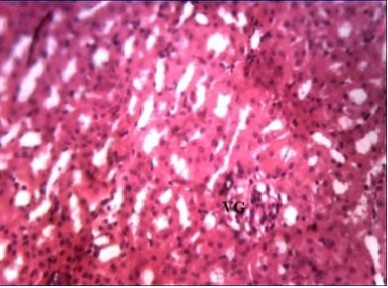

Plate X: ×400 Micrograph of kidney tissue from mice treated with 2000 mg/kg of *Dutse Dan Libya*

VG= Slight Vacuolation of Glumerulus

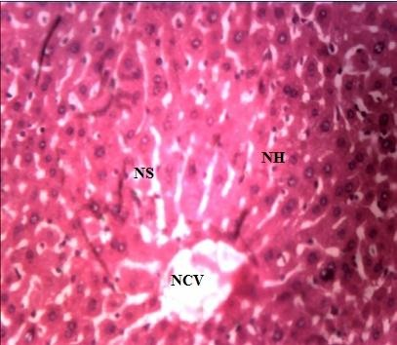

Plate XI: ×400 Micrograph of liver tissue from mice treated with 2000 mg/kg of *manda*

NH= Normal Hepatocytes, NS = Normal Sinusoid, CV = Normal Central Vein

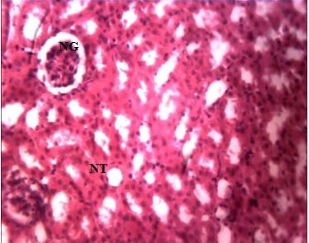

Plate XII: ×400 Micrograph of kidney tissue from mice treated with 2000 mg/kg of *manda*

NG= Normal Glomerulus, NT= Normal Renal Tubules

* 1. **Analgesic Properties of *farar kanwa* Samples**

# Table 4.20: Analgesic Properties of different doses of *farar kanwa* Sample (n=5)

|  |  |  |  |  |
| --- | --- | --- | --- | --- |
| Animal groups | dose (mg/kg) | number of writhing Mean ±SEM | % writhing | % inhibition |
| NC | 0 | 40.40 ±0.93 | 100.00 | 0.00 |
| PC | 300 | 22.22 ±5.85 | 55.00 | 45.00 |
| FK | 1000 | 21.80 ±0.86 | 53.96 | 46.04 |
| FK | 500 | 22.00 ±2.28 | 54.46 | 45.54 |
| FK | 250 | 18.80 ±1.24b | 46.53 | 53.46 |
| FK | 125 | 9.40 ±0.51b | 23.27 | 76.73 |

Values expressed as mean ±SEM b= significant compare to negative control (P > 0.05), NC = Negative control, PC = Positive control, FK= *farar kanwa.*

* 1. **Analgesic Properties of *Jar kanwa* Sample**

# Table 4.21: Analgesic Properties of different doses of *jar kanwa* Sample (n=5)

|  |  |  |  |  |
| --- | --- | --- | --- | --- |
| Animal groups | dose (mg/kg) | number of writhing  **Mean ±SEM** | % writhing | % inhibition |
| NC | 0 | 40.40 ±0.93 | 100.00 | 0.00 |
| PC | 300 | 22.22 ±5.85 | 55.00 | 45.00 |
| JK | 1000 | 14.20 ±1.90b | 35.00 | 64.85 |
| JK | 500 | 13.40 ±1.2b | 33.17 | 66.83 |
| JK | 250 | 12.40 ±1.57b | 30.69 | 69.31 |
| JK | 125 | 6.60 ±0.75b | 16.33 | 83.66 |

Values expressed as mean ±SEM b= significant compare to negative control (P > 0.05), NC = Negative control, PC = Positive control, JK= *jar kanwa*

* 1. **Analgesic Properties of *ungurnu* Sample**

# Table 4.22: Analgesic Properties of different doses of *ungurnu* Sample (n=5)

|  |  |  |  |  |
| --- | --- | --- | --- | --- |
| Animal groups | dose (mg/kg) | number of writhing Mean ±SEM | % writhing | % inhibition |
| NC | 0 | 40.40 ±0.93 | 100.00 | 0.00 |
| PC | 300 | 22.22 ±5.85 | 55.00 | 45.00 |
| NGR | 1000 | 23.60 ±0.75 | 58.42 | 41.58 |
| NGR | 500 | 19.00 ±0.44b | 47.03 | 52.97 |
| NGR | 250 | 15.80 ±1.24b | 39.11 | 60.89 |
| NGR | 125 | 11.00 ±1.05b | 27.23 | 72.77 |

Values expressed as mean ±SEM b= significant compare to negative control (P > 0.05)

NC = Negative control, PC = Positive control, NGR= u*ngurnu*

* 1. **Analgesic Properties of *Dutse Dan libya* Sample**

# Table 4.23: Analgesic Properties of different doses of *dutse danlibya* Sample (n=5)

|  |  |  |  |  |
| --- | --- | --- | --- | --- |
| Animal groups | dose (mg/kg) | number of writhing  Mean ±SEM | % writhing | % inhibition |
| NC | 0 | 40.40 ±0.93 | 100.00 | 0.00 |
| PC | 300 | 22.22 ±5.85 | 55.00 | 45.00 |
| DDL | 1000 | 20.20 ±0.20b | 50.00 | 50.00 |
| DDL | 500 | 19.40 ±1.9b | 48.02 | 51.98 |
| DDL | 250 | 16.60 ±0.60b | 41.09 | 58.91 |
| DDL | 125 | 9.80 ±1.3b | 24.26 | 75.74 |

Values expressed as mean ±SEM, b= significant compare to negative control (P > 0.05)

NC = Negative control, PC = Positive control, DDL= *Dutse Danlibya*

# Analgesic Properties of *Manda* Sample

**Table 4.24: Analgesic Properties of different doses of *manda* Sample (n=5)**

|  |  |  |  |  |
| --- | --- | --- | --- | --- |
| Animal groups | dose (mg/kg) | number of writhing Mean ±SEM | % writhing | % inhibition |
| NC | 0 | 40.40 ±0.93 | 100.00 | 0.00 |
| PC | 300 | 22.22 ±5.85 | 55.00 | 45.00 |
| MD | 1000 | 31.60 ±0.75 | 78.22 | 21.78 |
| MD | 500 | 23.80 ±0.86 | 58.91 | 41.09 |
| MD | 250 | 20.00 ±0.89b | 49.50 | 50.49 |
| MD | 125 | 17.40 ±0.51b | 43.07 | 56.93 |

Values expressed as mean ±SEM,b= significant compare to negative control (P > 0.05) NC = Negative control, PC = Positive control, MD= *Manda*

# Results of antimicrobial activities of *kanwa* samples Table 4.25: Zones of inhibition (mm) of evaporites samples

|  |  |  |  |  |  |  |
| --- | --- | --- | --- | --- | --- | --- |
| **Isolates** | **FK** | **JK** | **NG** | **DL** | **MD** | **Cip.** |
| *Staphylococcus aureus* | 10 | 23 | 22 | Nil | Nil | 42 |
| *Escherichia coli* | 12 | 10 | 13 | Nil | Nil | 38 |
| *Bacillus subtilis* | 18 | 13 | 16 | Nil | 10 | 32 |
| *Salmonella typhi* | 14 | Nil | 10 | Nil | Nil | 40 |

FK (*farar kanwa*) JK (*Jar kanwa*) NG (*ungurnu*) DDL (*Dutse danLibya*) MD (*Manda*), Cip (Ciprofloxacin)

# Fig. 4.16: Minimum Inhibitory Concentration (MIC) and Minimum Bactericidal Concentration (MBC) of *Farar kanwa*



**MIC & MBC of *Farar kanwa***

120

100

MIC MBC

80

60

40

20

0

S. aureus

E. coli

B. subtilis

S. typhi

**Organism**s

**Concentration of Evaporites**

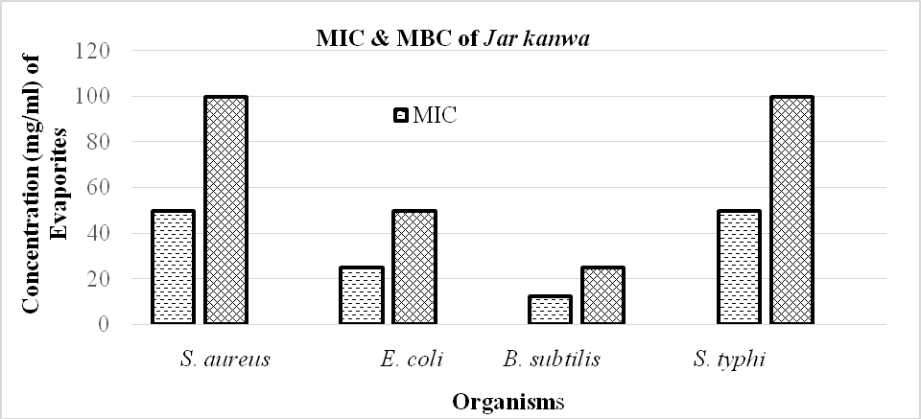

**Fig. 4.17: Minimum Inhibitory Concentration (MIC) and Minimum Bactericidal Concentration (MBC) of *Jar kanwa***

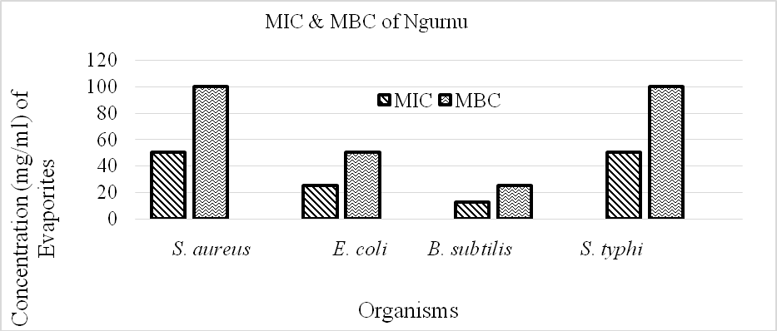

# Fig. 4.18: Minimum Inhibitory Concentration (MIC) and Minimum Bactericidal Concentration (MBC) of un*gurnu*

# CHAPTER FIVE

# DISCUSSION

* 1. **Ethomedical survey**

The societies that make up the Nigerian State have for long relied on the indigenous health system which was developed as a response to their environment and it involves the use of locally available resources to prevent and cure diseases. It is a natural health care system which many generations of Nigerians have used (Egharevba *et al.,* 2015). To date there is continued utilization of traditional medicine among Hausa and Fulani people despite the availability of modern medicine. According to Konno (2004), easy accessibility, efficacy on treatment and affordable cost in getting health services are main reasons in preferring traditional medicine to modern medication. It is estimated that about 86% of Nigerians use traditional medicine, and over 200,000 traditional medicine practitioners (TMPs) are believed to be in Nigeria (Egharevba *et al.,* 2015). At the center of this practice are health professionals called *mai maganin gargajiya* (Hausa), and among whom different experts in healing have emerged. These include our target population indicated by (Table 4.1) among several others. They usually rely on vegetables, mineral substances, animal parts and certain other methods such as prayers, incantations etc.

People from Northern Nigeria significantly employed *kanwa* based traditional medicine to get cured from different diseases as well as major ingredients in domestic uses such as food additives. Therefore, the present study was carried out to validate the claims by traditional medical practitioners and other users of the minerals. From the present study most of the traditional healers were rural residents. This is partly because modern medical services are either unaffordable or unavailable to the vast majority of the rural people. These traditional healers

found to play an important role in the primary health care system of the rural people as they treat people who had little access and could not afford the cost of modern medication. The knowledge of medicinal minerals among male is higher. That is most of the traditional healers are males (77.3 %) and married (73.2 %). This showed that the medicinal information are passed to male from their parents and they have family to support with the income realized from the sale and administration of the medicine. The study revealed that majority of the traditional healers was older than 40 years. Few youths were involved in the sale and administration of concoction in the study area. In Nigeria, it is very difficult to obtain traditional medicinal information as they considered their indigenous knowledge as a professional secret, only to be passed orally to their older son, at their oldest age (Adekeye, 2000). Derogatory attitudes towards traditional medicine practitioners had forced healers to keep their knowledge and practices to themselves. Survey revealed that most of the respondents were speakers of Hausa language having the highest percentage of (52.9%), followed by Fulani (23.2%) and others with (24.0%). According to Ulrika (2002), the northern part of Nigeria is mostly Muslim with the population predominantly being Hausa. Majority of them have Islamic and Arabic education constituting about 37.5%, because northerners are believed to involve in many religious knowledge like *tsangaya* system of education (Zakir *et. al.,* 2013).

Majority of the respondents (66.1%) identified the evaporites locally as *kanwa* and this is in agreement with the local name identified by Davidson, *et al.,* (1974), Makanjuola (1975), Ekanem (1977), Ankrah and Dovlo (1978), Ekanem and Harrison (1997), Sanderson *et al.,* (2000), Paul (2005) and Alawa *et al.,* (2002). The local name *“kanwa”*originated from where local miners keep evaporites after mining before sale, the dealers usually said “*kanwa”* means

“whose head” (personal communication, 2015). 14.6 % were found to call these evaporites as *uwargami,* (homogenizer), it could be because in majority of foods and herb concoction *kanwa* was added to achieve a desired need. 10.4 % of the respondents identified the evaporites as *gishiri,* this may be it has salty taste similar to table salt while only 8.9 % were found to identified the evaporites as *tahnateka,* this word is Fulfulde.

From the survey about 97.9 % were able to identified *farar kanwa* correctly as looking at it directly this may be because of its availability or the respondents are using it frequently in food preparation. Respondents 95.8 %, 96.4 % were able to identified *jar kanwa* and un*gurnu respectively* because of frequent used in food and medicines. *Dutse-dan-Libya* was identified by

92.2 %, this is because it has resemblance with other varieties of *kanwa* or *gishiri*. While *manda* was identified by 90.1 %, this may be contributed that this variety resemble other varieties, as all respondents used physical appearance as a first line for identification. In general, more than 90 % of the study population has the ability to identify each of *kanwa* correctly. The Fulani proverb, “*manda resatake ndei takai lamma”*, "if the salt or *kanwa* is stored, the soup will not be good”, accurately reflects a universal appreciation of that property in *kanwa* which brings out the flavour of food.

The results had shown that various forms of *kanwa* are important in medicines. It was found that all five different samples were used in gastrointestinal problems in which *dutse-dan-Libya* and *farar kanwa* showed the highest response 63.3 % and 34.1 %. While 25.5 %, 21.6 % and 19.0 % were observed for *jar kanwa, ungurnu and manda* respectively for treating GIT problem. These results were in agreement with early reports by (Makanjuola, 1975; Ekanem, 1977; Ankrah and

Dovlo, 1978; Paul, 2005; Alawa *et al.,* 2002). It is believed that *jar kanwa* can be used to “wash the stomach” but in higher dose it induces diarrhea and when dissolved in water and drunk, it also considered particularly effective in the relief of cramps (Paul, 2009). The studies revealed that all the *kanwa* samples were used in skin problem, this agreed with the report of Paul (2009) that *kanwa* was used as a preparation for scalp diseases and other scaly skin problems. It is used as active principles in cosmetics, especially in face, due to their high absorbency level of substances such as greases, toxins, etc. Therefore, they are recommended for inflammatory processes such as boils, acne, ulcers, *etc*. (Sana and Asia, 2012). They are also used in creams, powders, emulsions, *etc*., as antiperspirants and to give the skin opacity, remove shine and cover blemishes (Sana and Asia, 2012). Minerals are used in aesthetic medicine in cosmetic products, as active principles or excipients, generally in the cold direct application on the skin to treat dermatological diseases as blackheads, spots, acne, seborrhea, etc., this is due to the fact that it promotes perspiration and sebaceous secretions which flow more easily in a fluid state, while it also opens the pylosebaceous orifices. Moreover, during the perspiration urea is eliminated, which activate the metabolic change and the excretion of catabolites (Sana and Asia, 2012). Various literature confirmed the use of *kanwa* in gonorrhea and gastritis. In the case of gonorrhea, *kanwa* is also used in considerable quantities to produce diuresis. This is in agreement with information collected during the survey. All but except *dutse-dan-Libya* that has confirmed less effective on some microbes during anti-microbial studies. From the survey it was shown that *jar kanwa* has the highest number of respondent (23.4%) for pain relive, *ungurnu* and *dutse-dan- Libya* 15.6 % each. *Farar kanwa* followed with 13.3 % and least to *manda* with only 12.5 %., this is in agreement with research carried out by Regina (2008) and Vormann, (2001).

Use values (UV) is an index that provides a quantitative measure of its comparative significance to the informants or a quantitative method demonstrating the relative importance of each evaporites (Arip *et al.,* 2015), it takes value from 0.00 to 1.00. The higher the value then the higher the degree of usage. The used value for all evaporites showed that *dutse danlibya* (0.96), *jar kanwa* (0.94), *farar kanwa* (0.84), *ungurnu* (0.82) and *manda* (0.77)

Informant consensus factor (ICF) was used to measure the homogeneity of the information for a specific evaporites (*kanwa*) to cure a specific diseases or to estimate the level of agreement between respondents over which evaporites *(kanwa)* is used for each disease category (Canales, 2005). From the results all evaporites have higher ICF values this indicates the information given were all homogenous. The lowest and highest values of ICF can be 0.00 and 1.00, respectively. A value near zero indicates a high variation in the use of species, if minerals are chosen randomly, or if informants do not exchange information about their use. Values near 1 indicate a high intra-cultural consensus.

Fidelity level (FL) expresses the priority of a species over the others in the management of a particular ailment. *Jar kanwa* and *dutse danlibya* showed FL of 100, then *farar kanwa* (98 %), followed by *ungurnu* (93 %) and *manda* (77 %). These results show that *Jar kanwa* and *dutse dan-Libya* Higher FL value indicates more frequent use of an evaporites (*kanwa*) for treating a particular ailment category by the respondents.

Oral application was the highest and most commonly used route of application of *kanwa* followed by dermal. WHO, (2002) indicated that oral is the main route of traditional medicine application. oral and dermal routes permit rapid physiological reaction of the prepared medicines with the pathogens and increase its curative power (Fisseha, 2007). From the ethnomedical survey it was observed that *dutse-dan-Libya* is frequently been used in solution (84.9 %) this could be due to its solubility, then followed by *farar kanwa* (54.9 %), *manda* (26.8 %), u*ngurnu* (25.0 %) and least for *jar kanwa*. None of the *kanwa* surveyed was found to be chewed solid except *jar kanwa* this is because it was used in toothache. The report made by Paul (2009) confirmed that *jar kanwa* was chewed by Asante people after finishing the tobacco. *Jar kanwa* was found to be involve (50.5%) in combination with other herbs concoction for medication, *ungurnu* could be used (50.5%) this could be due to closed relation in their nature and constituents. Also *manda* and *ungurnu* were found to be used in bath for treating some diseases with (16.4%) and (10.4%) while *dutse-dan-Libya* has the least (2.3%) in bath. *Farar kanwa* has higher number of respondents in postnatal care uses during lactation. Nursing mothers consume large quantities of *farar kanwa* daily in a pap as part of the forty-day postpartum practice in the belief that it increases the quantity and quality of breast milk (Sanderson *et al.,* 2000). *Jar kanwa* were reported to be used in *salala* (porridge) and other herbs concoctions. All five different evaporites were used for treatment, prevention and cure. Yobe and Borno state were the origin of all these evaporites, this study was in agreement with finding of Paul, (1986). Majority of respondents reported that evaporites undergo no processing and they keep them in polythene bag because it is the most commonly available packaging material.

The ions (cations and anions) and their concentrations are the chemical constituents which allow the evaporites deposits to be formed. The proportion of chemicals within the brine determines the formation of specific evaporites. Five diverse chemical types also exist identified viz Na- CO3-Cl; Na-CO3-SO4-Cl; Na-SO4-Cl; Na-Mg-SO4-Cl and Ca-Mg-Na-Cl (Warren, 1997). These typical mineral formulations show that in all instances halite is produced, these could be the reason behind the salty taste of the evaporites under study. Minerals such as thenardite are only produced in a handful of cases. From the analysis carried out Na, Ca, Mg, K, Fe, CO3, SO4, Cl, CO3, HCO3, NO3 and PO3 were present as indicated in table 4.11 with sodium as the most dominant then others at various concentration.

Evaporitic deposits containing sodium carbonates are natron and those containing sodium carbonate and sodium bicarbonates are classified as trona (sodiumsesquicarbonate) (Andrew *et al.,* 2006). From the results *kanwa* have significant proportions of sodium carbonate, sodium sulphate and other salts. Therefore, *farar kanwa, jar kanwa* and *ungurnu* have both sodium, carbonate and bicarbonate present and are probably classified as “natron”. Many local areas erroneously referred to *kanwa* as potash. The term “potash” is synonym for a wide variety of potassium-rich minerals and rocks (Greta *et al.,* 2010). Natron, Na2CO3.10H2O, refers to a specific mineral, known chemically as sodium carbonate decahydrate (Shortland, 2004). From the analysis no HCO3 present, but other constituent are significantly present. Therefore, *dutse dan Libya* and *manda* are Polyhalites.

Evaporites have been exploited as a good source of alkali for millennia. The present results had shown that all the samples were highly alkaline in nature, *farar kanwa*, *jar kanwa, ungurnu* and *manda* having pH of 10.2, 10.4, 10.4 and 10.6 respectably while *dutse-dan-Libya* has lowest pH

* 1. therefore less alkaline compare to other four evaporites, this could be the reason of inducing diarrhea in animal during acute toxicity studies. The pH values are in accordance to study carried out by Jones *et al.,*(1998) as the pH value of evaporites is typically between 8 and 12. The differences in pH could be due to the concentration of sulphates (SO4) that indicate the higher concentration of sulphates the lower the pH value.

There have been few studies into the solubility of *kanwa*. But specifically the solubility of natron is less than that of common salt at 30 g per 100 ml of water at the temperature of around 20°C. (Melanie, 2009). The study had shown that *jar kanwa, ungurnu* and *dutse-dan-Libya* were very soluble while *farar kanwa* and *manda* were soluble in deionized water. These could be the contributed upon the force that held the atoms in positions.

From the study all the samples were dissolved in deionized water and recrystallized to give pure

*kanw*a. *Farar kanwa* give 81.60 %, *jar kanwa* 92.76 %, *ungurnu* 92.73 %, *dutse-dan-Libya* 96.12

% and *manda* 60.83% yield respectably. It could be observed that *jar kanwa* and *ungurnu* are relatively pure, while *farar kanwa* and *manda* because they contained more of inclusions. By appearance it looks like 'black' it means that the impurities were so great that the colour was influenced, hence *farar kanwa* that was scraped from the ground was referred to according to its appearance. From the results, *farar kanwa* and *manda* have the ability to absorb moisture, and u*ngurnu* were found to be slightly hygroscopic while *jar kanwa* and *dutse danlibya* are not hygroscopic.

As per the OECD Guidelines 423 using limit dose test of Up and Down method, the acute oral toxicity studies revealed that there were no deaths or any sign of toxicity within the short and long term effect in mice dosed 2000 mg/kg body weight of the *kanwa* samples. The LD50 of *farar kanwa*, *jar kanwa*, u*ngurnu*, *dutse-dan-Libya* and *manda* was found to be greater than 2000 mg/kg body weight orally. Careful observations were made in the experimental animals, in the first 30 min of observation, 1/5 tremor, 4 hours of observation 1/5 diarrhea and 48 hours of observation 1/5 sleep were observed for *dutse-dan-Libya*. For *farar kanwa*, *jar kanwa*, u*ngurnu* and *manda* all observed parameter: skin, fur, eyes, mucous membrane, behavioral pattern, salivation of the treated as well as the control animals were found to be normal. Tremors, lethargy, diarrhea and coma did not occur in any of the animal. At limit dose of 2000 mg/kg body weight, no significant changes were observed in body weight in the treated group compare to control group, changes of the body weights were found to be statistically insignificant. Insignificant increase in body weight of test animals indicates that the administration of the *kanwa* samples does not affect the growth of the animals. Since the oral administration of the some *kanwa* samples at limit dose of 2000 mg/kg did not produce any sign of acute toxicity or instant death in any of the five mice tested each during the period of observation. This, however, at acute oral toxicity it was suggested that *kanwa* are relatively safe. According to Clerke and Clerke (1977), substances with LD50 of 1000 mg/kg body weight given orally are considered being safe or of low toxicity. Similarly, according Organization for Economic Cooperation and Development (OECD) toxicity recommended based on oral LD50 are: less than 5 mg/kg: very toxic, greater than 5 but less than 50 mg/kg: toxic, greater than 50 but less than 500 mg/kg: harmful, and, greater than 500 but less than 2000 mg/kg: no label. Therefore, the high acute toxicity greater than 2000 mg/kg body weight of the *kanwa* samples obtained is an indication

that the *kanwa* sample could be considered relatively safe especially when administered orally at acute level where absorption may not be complete due to inherent factors limiting absorption in the gastrointestinal tract (Sani *et al.,* 2009). But may be repeated administration of *kanwa* sample could result in toxicity which may give adverse effect originally not presented in acute administration. Thus, high LD50 observed, may not be a conclusive finding about the safety of the *kanwa* until chronic toxicity was carried out.

Histological investigation of some vital organs revealed slight distortion of histo-architecture of the liver and kidney which were not seen in the control. The liver plays a central role in transforming and clearing chemicals and is susceptible to toxicity from these agents (Adesina *et al.,* 2015). Hepatotoxicity is an entity not as extensively explored as nephrotoxicity as it does not manifest itself as a dose limiting factor (Avci *et al.,* 2008). The liver and kidneys are among the primary organs affected by the metabolic reactions induced by toxicants (Dybing *et al.,* 2002). The micrograph of the kidney and liver section in the control group showed normal histological features. The kidney section indicated a detailed normal renal tubules and clear glomeruli surrounded by a narrow Bowman's spaces (plate II).While liver section indicated a detailed normal architectures of hepatocytes. This is the fact that animals in this group were fed with distilled water and conventional feed for this reason no any observable abnormal effects on the organs. The micrograph of *farar kanwa* on kidney shows slight vacuolation of glumerulus and tubules. But liver section indicated a detailed normal architecture of hepatocytes. The micrograph of *jar kanwa* on kidney sections showed moderate lymphocyte infiltration. While the micrograph of liver showed slight sinusoidal congestion from histology. The micrograph of u*ngurnu* on kidney showed moderate tubular and glomerular fatty infiltrations and slight

necrosis. While the micrograph of the liver showed lymphocyte infiltrations, vacoulation and slight necrosis were pathologically observed. For *dutse-dan-Libya* the micrograph of the kidney showed slight vacuolation of glumerulus only. While liver section indicated a detailed normal architecture of hepatocytes. For *manda*, the micrograph of the kidney and liver section showed normal histological features. The kidney section indicated a detailed normal renal tubules and clear glomeruli surrounded by a narrow Bowman's spaces.

Biochemical analysis of AST, ALT, alkaline phosphatase and total bilirubin and conjugate bilirubin are also carried out. They are often used to determine the physiological and pathological status of man and animal. The normal ranges of these parameters can be altered by some substance (Sani et al., 2009). Previous studies reported that the increase in the activity of these enzymes in the plasma is often observed as a consequence of liver damage. It can however, be noticed that there is no significant difference in the levels of AST, ALT, ALP, total bilirubin and conjugate bilirubin comparatively to the control group (p>0.05). The results revealed no significant different observed between test group and control group.

The method of acetic acid induced abdominal writhes (constriction) by using 0.6% acetic acid solution. For testing analgesic, abdominal writhes were selected such that the peripherally mediated effects were investigated. The *kanwa* sample tested were *farar kanwa, jar kanwa, ungurnu, dutse-dan-Libya* and *manda* at a dose of 1000 mg/kg, 500 mg/kg, 250 mg/kg and 125 mg/kg each administered orally, they produced significant inhibition of the acetic acid-induced abdominal writhes in dose-dependent manner. This inhibition was greater than that produced by aspirin. These results suggest that *kanwa* can produce peripheral analgesic effect by inhibiting

the chemical mediators. This shows that the dose is inversely proportional to activity. At high dose, activities were observed but at the lowest dose it significantly reduces the pain. It has been reported that acetic acid irritates the peritoneal cavity leading to stimulation of local nociceptors located at the surface of the peritoneal cavity (Bently *et al.,* 2009). This leads to the release of prostaglandins E2 and F2 in peritoneal fluid and other algogens with subsequent stimulation of pain nerve endings (Deradt,*et al.,* 2014). Acetic acid is a pain stimulus and causes localized pain as writhing after *intraperitoneal* administration in mice. Acetic acid stimulates the release of free arachidonic acid from tissue phospholipids by the action of phospholipase A2 (Faizul *et al.,* 2007). Synthesis of prostaglandins from arachidonic acid via the cyclooxygenase pathway is one of the major causes of pain sensation (Faizul *et al.,* 2007). The agent that reduced the number of writhing will demonstrate analgesia by inhibition of prostaglandin synthesis. It could be that *kanwa* may have interfered with these peritoneal receptors to bring about analgesia by inhibiting PGE2 production (Semaghiul *et al.,* 2005). Inhibition of the pain induced by acetic acid, by the *kanwa*, suggests that they can probably work by suppressing the release of inflammatory mediators like prostaglandin, bradykinin and histamine (Mehemet, 2002). The writhes induced are related to increase in the peritoneal level of prostaglandins and leukotrienes (Sharma *et al.,* 2010). The result strongly suggests that the mechanism of action of *kanwa* may be linked to lipoxygenase and/or cyclooxygenase. The reduced pain sensation can also be explained to alkaline nature of evaporites, as pain receptors are sensitive to acidic medium that mediate pain, therefore increase in pH could reduce the acidity level thereby decrease the pain (Regina, 2008). Reports show that taking an alkaline supplement could reduce daily steroid or NSAID dosage also supports the view that a reduction in latent metabolic acidosis has a positive effect on pain sensation. Secondly, pain can be reduced by the significant elevation of plasma ir-EP levels

following alkaline supplementation. The ir-EP binds predominantly to the mu opioid receptors which play a role in the pathophysiology of local inflammatory and pain processes that are present in several peripheral tissues.

Evaporites *(kanwa)* are important source of potentially useful agents for the development of new chemotherapy against microorganism (Tona *et al.,* 2003). Many reports are available on antibacterial activities of minerals compounds (Udemezue, 2014). Researches have significantly helped in identifying the active ingredients responsible for such activities that is useful for the therapeutic use in human beings. Antimicrobial activities were carried out on five the most commonly used sample of *kanwa* namely *farar kanwa*, *jar kanwa, ungurnu*, *dutse-dan-Libya* and *manda* on gram positive bacteria (*Staphylococcus aureus* and *Bacillus subtilis*) and gram negative bacteria (*Escherichia coli* and *Salmonella typhi*).

Antibacterial activity was expressed as diameter zone of inhibition. A zone of observable inhibition of growth of each micro-organism served as a criterion for declaring an evaporites*(kanwa)* sensitive and was indicated by a clear zone around the well. The diameter of zone of inhibition of *kanwa* against test microorganisms (in mm) was highest for *jar kanwa*, followed by u*ngurnu* and the least *farar kanwa*. The zones of inhibition for the *kanwa* are in the ranges of 10-23mm in diameter against the various test microbes. A wider dimension for the zones of inhibition of 13 mm and 23 mm were observed for *jar kanwa* against *Staphylococcus aureus* and *Bacillus subtilis* respectively which strongly support the ethnomedical usage of *kanwa* against infections. The sensitivity of the test microbes to the *kanwa* is within similar ranges.

However, antimicrobial capacity is attributed to the inorganic components and has the ability to absorb the fluid content of the cell to shrink (Chadzopulu *et al.,* 2011). Since *farar kanwa*, *jar kanwa* and u*ngurnu* inhibited the growth of all the bacteria tested, this suggests that these *kanwa* is broad spectrum in activity. The results could be responsible for the popular use of *kanwa* to relieve many types of gastrointestinal irritations caused by bacteria, respiratory tract and skin diseases (Cheesbrough, 2006). Also alkaline pH affects the activities of many microbes (Molan, 1992) and for that the activity of *jar kanwa* is higher due to the higher pH.

Minimum Inhibitory Concentration (MIC) is defined as the highest dilution or least concentration of a sample that inhibit the growth of microorganisms. Determination of the MIC is important in diagnostic laboratories because it helps in confirming resistance of microorganism to an antimicrobial agent and it monitors the activity of new antimicrobial agents. The concentrations of *kanwa* that completely killed the bacteria was taken as MBC. Moreover, it was noted that most of the antimicrobial properties in different *kanwa* samples showed, MBC value that is almost two fold higher than their corresponding MICs (Omar*et.al*, 2010). The MIC for *farar kanwa* was (25 mg/ml) while the MBC was (50 mg/ml). However, *jar kanwa* and u*ngurnu* show highest MBC value of (100mg/ml) against *S aureus* and *S.typhi.*

# CHAPTER SIX

**SUMMARY, CONCLUSION AND RECOMMENDATIONS**

# Summary

Little attention has focused on the beneficial health effects of rocks, minerals, and geologic Materials. The medicinal effects have been recognized as long as beginning of man. Some of the earliest known medicines were derived from rocks and minerals and still in use today. The study aimed to validate the use of some evaporites*(kanwa)* in Hausa and Fulani traditional medicine through ethnomedical survey and some biological studies with the view to document the perception of Hausa and Fulani tribes on five different Evaporites namely *farar kanwa, jar kanwa, ungurnu, dutse danlibya* and *manda*, to establish the safety or otherwise of the different Evaporites *(kanwa)* using animal experimental model and to justify the uses of the five different Evaporites *(kanwa)* as agents for abdominal pains and antimicrobials. The ethnomedical survey was carried in five selected Local Government of Kaduna State, during the study period, majority of the respondents were male, married and elder people within the age range of 40 – 50 years with practitioners’ educational level ranges from non-formal education to tertiary educational level of which Arabic and Islamic education prevailed. Northern Nigeria, has several forms of traditional medical practitioners, which could not be found in many places in the world. They include Herbalists (*maimagani*), Farmers (*manoma*), Herb retailers (‘*yan ganye*), Hunters (*mafarauta*), Fishermen (‘*yan su*), Nomands (*makiyaya*), Spiritualists (*boka*ye), Bone Setters (*madora*), Blacksmiths (*makera*), Traditional barbers (*ma’aska*), Traditional surgeons (*wanzan*), Traditional Medicine practitioner (*mai magani*), Mineral retailers (*yan kanwa*), Traditional items sellers (*yan koli*), *Sarkin ruwa, Yan Tauri*, Traditional birth attendant (*unguwan zoma*) and other traditional healers. They are highly recognized by their community in the study area. The

investigation revealed that most respondents have vast knowledge of this evaporites *(kanwa)* and locally known as *kanwa* or *gishiri* in Hausa Language. They differentiate these evaporites by their appearance and colour as *farar kanwa, jar kanwa, ungurnu, manda* and *dutse-dan-Libya* respectively. The inhabitants used the evaporites *(kanwa)* as medicine, food additives, preservatives, cosmetics and veterinary practices. A number of Medicare were described by the respondents this include abdominal pains, skin diseases, fever, pain relive, wound healing and they were administered in solution, in pap, chew solid and mix with herbs to drink or bath to treat and cure diseases. Most of these evaporites were found abundantly around North-east of Nigeria like Borno and Yobe state where it is mined by local people and sold to consumers. However, the normalcy and insignificant changes in wellness parameters and body weights reveals the safety of *kanwa* at a dose of 2000 mg/kg body weight. This, however, suggest that they are considered being safe at acute level. Histopathology of the liver and kidney tissues show no significant chronic damage on the tissue. Elemental analysis revealed the presence of Ca, Mg, K, Na, Fe, Zn, Pb, Cl, PO4, SO4, HCO3, and NO3 in all the samples and were soluble in water but *dutse-dan-Libya, jar kanwa* and *ngurnu* are very soluble. *Manda* and *farar kanwa* were found to be hygroscopic while *dutse-dan-Libya, jar kanwa* and u*ngurnu* are non-hygroscopic. Biological activities show all the evaporites were good as analgesic as effectively reduced the number of abdominal contractions induced by 0.6 % acetic acid solution in dose-dependent manner and antimicrobial revealed that *farar kanwa, jar kanwa* and ungurnu inhibited the test microorganisms (in mm) and highest for the *jar kanwa*.

# Conclusion

The present studies established:

* + 1. Hausa and Fulani tribes of Kaduna State strongly believes that evaporites have culinary band medicinal values to both humans and animals
    2. The margin of safety of evaporites is relatively wide (oral LD50 > 2000 mg/kg.)
    3. Biochemical parameters of tested groups show no significant difference (p<0.05) compare to control group at acute oral administration except total bilirubin
    4. No significant hepatic or renal damage compare to control group.
    5. Analgesic properties revealed that : all kanwa studied had % inhibition at lower dose
    6. The evaluated analgesic and antimicrobial property of the *kanwa* supports the ethnomedical usage for pain management and anti bacteria.
    7. *Farar kanwa, jar kanwa, ungurnu,* are suggested to be natron while *manda* and *dutse danlibya* are suggested to be Polyhalites respectively.

# Recommendations

1. Sub chronic and chronic toxicity studies should be carried out in other to elucidate the safety profile of these kanwa
2. Elemental analysis should be carried out on heavy metals that can cause effect on human health since they are continuously consumed
3. Further studies should be carried out in order to justify other uses such as anti inflammatory, anti ulcer etc.
4. Although, the study has shown some degrees of biological efficacies, the minerals should be used with caution.

# REFERENCES

Abdelaati, M. A., Abdalla, B. E., Siddig, M. H. and Gurashi, A. G. (2014). Production of Caustic Soda from Natural Local Trona. *Journal of Applied and Industrial Sciences,***2**(1): 19-23.

Abdül Wahid, H. (2004). *A Survey of Drugs,* Hamdard Research*.* Institue Press, Delhi. p.47. Abdullahi, S. G. (2014). Magani a ma’aunin karin Magana. P.h.D Thesis, Department of

Nigerian Languages Usmanu Danfodiyo University, Sokoto, Nigeria.

Adekeye, F.(2000). The Malaria Scourge. Newswatch: Nigeria’s weeklynewsmagazine, October 23, pp. 19-23.

Adesina A. O. Ladoja, F. and Murtala A. A. (2015). Toxicological profile of hydro-ethanolic extract of the leaf of Solenostemon monostachyus (P. Beauv.) (Lamiaceae) in rats. *Advancement in Medicinal Plant Research*, **3**(3): 126-136.

Alawa N. J., Kwanashie O. H., Singh S. P. and Alawa B. I. C. (2000). Effects of Natron (Kanwa) varieties on murine virgin uterine contractility. *Journal of Agriculture and Environment,***1**(2): 35 – 42.

Andrew, S., Lukas, S., Ian, F. and Michael, T. (2006). Natron as a flux in the early vitreous materials industry: sources, beginnings and reasons for decline. *Journal of Archaeological Science,***33**: 521-530.

Andrews, M. and Gallagher-Allred, C. (1999). The role of zinc in wound healing. *Advances in Wound Care,***12**: 137–138.

Ankrah, E. K. and Dovlo, F. E. (1978). Properties of Trona and its effect on cooking time of Cowpeas. *Journal of Science, Food and Agriculture,***50**: 345 – 349.

Arif, K., Khirul I., Afjalus S., Sanjib S., Apurba K.B., Khalijah A., Mustafizur R., Jamil, A. S., Rownak, J., Erena, I. and Mohammed, R. (2015). Ethnomedicinal survey of various communities residing in Garo Hills of Durgapur, Bangladesh. *Journal of Ethnobiology and Ethnomedicine,***11**: 44.

Avci, A., Cetin, R., Erguder, I. B., Devrim, E., Kilicoglu, B., et al. (2008) Cisplatin Causes Oxidation in Rat Liver Tissues: Possible Protective Effects of Antioxidant Food Supplementation. *Turkish Journal of Medical Sciences.***38**(2): 117–120.

Batra J, Seth PK (2002). Effect of iron deficiency on developing ratbrain. *Indian Journal of Clinical Biochemistry.* **17**(2): 108-114.

Bently, G. A., Newton, S. H. and Stan, J. (2009). Studies on the antinociceptive action of α agonist drugs and their interaction with opioid mechanisms, *British Journal of Pharmacology,* **79**: 125-134.

Bercowy, G.M. Peile, R. (1996). GFAA determination of phosphorus in food oils. *Food Testing Analysis,***10**: 15, 41.

Bhupinder, S. S. (2011). Inorganics/bioinorganics: Biological, medicinal and pharmaceutical uses. *Journal of Pharmaceutic and Educational Research,***2**(1): 1-20.

Bryan, C. P. (1995). *Ancient Egyptian Medicine.* The Papyrus Ebers, Geoffrey Blessed, London. Buchanan, K.M. and Pugh, J.C. (1969).*Land and People in Nigeria*.7th Edition. University of

London Press, 120 to 125.

Canales, M., Hernandez, T., Caballero, J., Romo, D., Vivar, A., Avila, G., Duran, A., et al.. (2005). Informant consensus factor and antibacterial activity of the medicinal plants used by the people of San Rafael Coxcatlan, Puebla, Mexico.*Journal of Ethnopharmacology*, **97**:429-39.

Carretero, M.I., Gomes, C., Tateo, F.(2006). Clays and human health. In: *Bergaya, F., Theng, B.K.G., Lagaly, G. (Eds.), Handbook of Clay Science.* Elsevier, Amsterdam,pp. 717–741.

Carretero, M.I., Pozo, M.(2010). Clay and non-clay minerals in the pharmaceutical and cosmetic industriesPart II. Active ingredients. *Journal of Applied Clay Science***47** : 171–181.

Census (2006) National Population Commision. Available at: <http://www.population.gov.ng/index.php/censuses>.

Chadzopulu, A., Adraniotis J., Theodosopoulou, E. (2011). The therapeutic effects of mud.*Progress in Health Sciences,***1**(2): 132-136.

Charlotte, S. and Mohamed, E. (2000). Deposition and early alteration of evaporites.*Journal of SedimentoIogy.* **47** (1): 215-238.

Cheesbrough, M. (2006). *Medical Laboratory Manual for Tropical Countries.* Vol. 11, first edition. Printed and bond in Great Britain by the university Press, Cambridge. pp. 372- 391.

Clarke, E. G and Clarke, M. L. (1977). *Veterinary Toxicology*. Cassel and Collier Macmillan Publishers, London. pp 268-277.

Cotton, C. M. (1996). *Ethnobotany: Principles and applications*. John Wiley and Sons Ltd, Chichester.

Darrah, Α. (1997). *A hermeneutic approach to Hausa therapeutics: the allegory of the living flame*. Ph. D. thesis Northwestern University.

Davidson, N., Trevitt, L. and Parry E. (1974). Peripartum Cardiac Failure. *Bulletin of World Health Organization*, **51**: 203 – 208.

Demirhan, A. (2014) The Place of Salt in the History of Turkish.*Turkish journal of Ottoman,***8**(5): 70-79.

Deradt, R., Jougney, S., Delevalcee, F. and Falhout, M. (2014). Release of prostaglandin E and F in an algogenic reaction and its inhibition. European Journal of Pharmacology, 51: 17-24.

Dunn, K. and Edwards, V. (2004). The role of Acticoat with nanocrystalline silver in the management of burns, *Burns an issue*. **30**: 1–9.

Duyff, R. (1998). *The American Dietetic Association’s Complete Food & Nutrition Guide*.

Chronimed Publishing, Minneapolis, MN.

Dybing, E., Doe, J., Groten, J., Kleiner, J. O. and Brien, J. (2002). Hazard characterization of chemicals in Food and diet: doses response, mechanism and extrapolation issues, *Food Chemicals and Toxicology*,**42**: 237-282.

Echard, N. (1991). The Hausa bori possession cult in the region of Niger: its origins and present- day function. I. M. Lewis, Ahmed Al-Safi & Sayyid Hurreiz (eds.), *Women’s Medicine:The Zar-Bori Cult in Africa and Beyond*. Edinburgh: Edinburgh University Press.

Egharevba, H. O., Ibrahim, J. A., Kassam, C. D., and Kunle, O. F. (2015). Integrating Traditional Medicine Practice into the Formal Health Care Delivery System in the New Millennium,The Nigerian Approach: A Review. International Journal of Life Sciences, 4(2): 120-128.

Ekanem, E.J. (1977). A preliminary analysis of samples of ‘Kanwa’ for sodium, potassium and their minerals. *M.Sc Analytical Chemistry Dissertation*, Chemistry Department, A.B.U., Zaria, Nigeria.

Ekanem, E.J. and Harrison G.F.S. (1997). Assessment of Lake salt for sourcing dietary minerals.

*Nigerian Journal of Chemical Research,***2**: 33 - 38.

Engstrom, A., Tobelmann, R. C. and Albertson, A. M. (1997). Sodium intake trends and food choices. *American Journal of Clinical Nutrition*, **65**: 704–707.

Eruvbetine D (2003). Canine Nutrition and Health. A paper presented atthe seminar organized by

*Kensington Pharmaceuticals Nig. Ltd*.,Lagos on August 21, 2003.

European Pharmacopoeia (2005). *Characters section in monographs* 5.0 5.11.

Faizul. H., Razina, R., Juwel, B., Shaikh, J. and Jamil, A. S. (2007). Analgesic activity of the ethanolic extract of Aphanamixis polystachya. *Bark Oriental Pharmacy and Experimental Medicine,* **7**(4): 444-446.

Feynman, N. (1991). Evaporites and its application. *Journal of applied science.***6**:3.34-3.

Fisseha, M. (2007). An ethnobotanical study of medicinal plants in Wonago oreda,SNNPR, *Msc thesis Addis Abeba University,* Ethiopia.

Fleischer, L. M. (1974). Crises of life and how they are handled: a case study among Hausa women in Jos, *Nigeria. M. Phil, thesis* Edinburgh University.

Food and Nutrition Board (1989). *Recommended Dietary Allowances*, 10th ed. National Academy Press, Washington, D.C.

Fortes, C. and Messer, H. (2001). The effect of zinc and vitamin A supplementation on immune response in an older population. *JAMA* 279:726.

Gajjar, P., Pettee, B., Britt, D.W., Huang, W., Johnson, W.P., and Anderson, J. (2009). Antimicrobial activities of commercial nanoparticles against an environmental soil microbe, Pseudomonas putida K T 2440, *Journal of Biological Engineering.***3**: 9-22.

Gennari, F. J. (1998). Hypokalemia. *New England Journal of Medicine,***339**: 451–458.

Gomes, C. and Silva, J. (2001) Beach sand and bentonite of Porto Santo island*:* potentialities for applications in geomedicine. Gomes, C and Silva, J (editors), *O Liberal – Empresa de Artes Gráficas,* Lda, Câmara de Lobos, R. A. M., pp. 112.

Gordon, B. L. (2000). *Medicine Throughout Antiquity*, F. A. Davis Co., Philadelphia. pp. 255- 390, 355-390.

Greta, J., Orris, M. D., Cocker, P. D., Jeff, W., Gregory, T. and Spanski, D.A. (2010). Potash A Global Overview of Evaporite Related Potash Resources, Including Spatial Databases of Deposits, Occurrences, and Permissive Tracts U.S.*Global Mineral Resource Assessment. Scientific Investigations Report* 2010–5090.

Gutierrez, F. M., Olive, P. L., Banuelos, A., Orrantia, E., Nino, N., Sanchez, E.M., Ruiz, F., Bach, H. and Gay, Y.A. (2010). Synthesis, characterization, and evaluation of antimicrobial and cytotoxic effect of silver and titanium nanoparticles, Nanomedicine. **6**: 681-688.

Hamarneh, S. (1980). Climax of Chemical Therapy in 10th Century Arabic Medicine. *Der Islam*

**38**: 283–288.

Hardie, L. A., Eugster, H. P., (2000). The evolution of closed-basin brines. *Mineralogical Society America Special Paper* **3**: 273–290.

Hong, J. H., Yasumoto, K. (1996). Near infrared spectroscopic analysis of heme and nonheme iron in raw meats. *Journal of Food Comparartive. Analysis.***9**: 127–134.

Idris, M. A., Abakar, M. and Tag, E. S. R. (1996). Evaluation and Geological Study of Trona Deposit NW Sudan, *a study carried out by geological Research Authority of the Sudan*.

Ikram, S., Dodson A., (1998).*The mummy in ancient Egypt* (equipping the dead for enterity), Cairo.*Implication for Ancient Exploitation. Archaeometry.* **46**:497-516.

Jegede, C. O. (2012) Indigenous Methods of Processing Materia Medicaamong Selected Traditional Medical Practitioners in Ibadan, Nigeria. *Journal of Ethno Medicine,* **6**(3): 187-195.

Jones, B. E., Grant, W. D., Duckworth, A. W. and Owenson, G. G. (1998) Microbial diversity of soda lakes. *Extremophiles.* **2:** 191-200.

Kenneth, K., Tanji, D., Colin, G. H., Ong, D., and Randy, A., Dahlgren, D. and Mitchell, J. (1992). Salt deposits in evaporation ponds: an environmental hazard. *Californian journal of agriculture,* **20**(10): 34-3.

Kolar, M., Urbanek, K. and Latal, T. (2001). Antibiotic selective pressure and development of bacterial resistance, *International Journal Antimicrobial Agent*, **17**: 357–363.

Konno, B. (2004). Integration of traditional medicine with modern medicine. *EHNRI, Addis Ababa.*pp*.* 3-9.

Koper, O., Klabunde, J., Marchin, G., Klabunde, K. J., Stoimenov, P. and Bohra, L. (2001). Nanoscale Powders and Formulations with Biocidal Activity Toward Spores and Vegetative Cells of Bacillus Species, Viruses, and Toxins. *Journal ofCurrent Microbiology.***44**: 49-55.

Koster, O. (1959). Determination of Analgesic properties. *African Journal of Reproductive Health.* **3**(1): 13-26.

Kotchen, T. A. and Kotchen, J. M. (1997). Dietary sodium and blood pressure: interactions with other nutrients, *American Journal of Clinical Nutrition,* **65**: 708–711.

Krejie, M and Morgan, S. (1972). Method for determining sample size of a population.*journal of scientific research.* **6**(4): 47-56.

Kremers, E. and Urdang G. (1976). *History of Pharmacy*, PA: Lippincott. Philadelphia. pp. 3-5, 14-27.

Larson, D, R. (2007). *The American Dietetic Association’s Complete Food and Nutrition Guide.*

Chronimed Publishing.

Last, D. M. (2005): Some Hausa ideas concerning sickness. *unpublished M.Sc. thesis* Ahmadu Bello University.

Last, M. (2011). Another geography: risks to health as perceived in a deep-rural environment in Hausaland, *Anthropology and Medicine.* **18**(2): 217–229.

Lev, E. (2002). Medicinal Exploitation of Inorganic Substances in the Levant in the Medieval and Early Ottoman Periods, *Adler Museum Bulletin*. **28**: 11-16.

Lev, E. (2003). Traditional healing with animals (zootherapy): medieval to present-day Levantine practice, *Journal of Ethnopharmacology.* **85**(1): 107–118.

Libowitzky, E. and Giester, G. (2003). Washing soda (natron), Na2CO3.10H2O, revised: crystal structures at low and ambient temperatures. *Mineralogy and Petrology.* **77**: 177-195.

Liu, Y., He, L., Mustapha, A., Li, H., Hu, Z. Q and Lin, M. (2000). Antibacterial activities of zinc oxide nanoparticles against Escherichia coli O157:H7. Journal of Applied Microbiology, **107**: 1193–1201.

Lonnerdal, B. (1996). Bioavailability of copper. American *Journal of Clinical Nutrition.* **63**: 821–829.

Lui, S. L., Poon, V. K., Lung, I and Burd, A. (2006). Antimicrobial activities of silver dressings: an in vitro comparison, *Journal of Medical Microbiology,* **55**: 59–63.

Macknin, M. L., Piedmonte, M., Calendine, C., Janosky, J., Wald E. (1998). *Zinc gluconate*

9thed. W. B. Saunders, Philadelphia.

Mahan, L. K. (1996). *Krause’s Food, Nutrition, & Diet Therapy*. 9th ed. W. B. Saunders, Philadelphia.

Makanjuola, A.A. and Beetlestone, J. G. (1975). chemical mineralogical notes on Kaun (Trona).

*Mining and Geology*, **10** (2): 31-41.

Martin, G. J. (2004). *Ethnobotany: A methods manual*, Earthscan Publications Ltd. New York.

Matsumura, Y., Yoshikata, K., Kunisaki, S. and Tsuchido, T. (2009). Mode of bactericidal action of silver zeolite and its comparison with that of silver nitrate, *Applied Environmental Microbiology*. **69**: 4278-4281.

Maundu, P. (1995). Methodology for collecting and sharing indigenous knowledge: a case study,

*Indigenous Knowledge Development Monitoring*, **3**: 3-5.

Mehemet, E. B (2002). Anti-inflammatory and antinociceptive properties of Dantrolene sodium in rats and mice. *Pharmacology Research,* **15**: 127-130.

Melanie, S. (2009). The use of sodium salt deposits in medical and medically associated industries in Ancient Egypt a *thesis submitted to Department of Applied Science*, Security and Resilience Cranfield University, Egypt.

Moghimi, S. M. (2005). Nanomedicine: prospective diagnostic and therapeutic potential. *Asia Pacific Biotech News,* **9**: 1072-1077.

Molan, P. C. (1992). The antibacterial activity of honey and the nature of antibacterial activity.

*Bee World,* **73**: 59 – 76.

Mossad, S. B., Macknin, M. L., Medendorp, S. V., Mason, P. (1996). Zinc gluconate lozenges for treating the common cold. An Internatinal Medicine. **125**: 81–88.

Moura, F. D. B. P. and Marques, J. G. W. (2008). Folk medicine using animals in the Chapada Diamantina: incidental medicine, *Ciência and Saúde Coletiva*, **13**(2): 2179–2188.

Nelson, J. K., Moxness, K. E., Jensen, M. D., Gastineau, C. F. (1994). *Mayo Clinic Diet Manual*.7th ed. Mosby-Year Book, St. Louis.

Ode, O. J., Sanni, S. and Oladele, G. M. (2015). The Global Relevance of Traditional Medicine and Herbal Plants, The Nigerian Perspective, *International Journal of Applied Biology and Pharmaceutical Technology.*

Olivares, M. and Uauy, R. (1996). Copper as an essential nutrient. *American Journal of Clinical Nutrition.***63***:* 791– 796.

Omajali, B. and sanni, M.(2010). Effects of kanwa on rat gastrointestinanl phosphatases.*International journal of pharmaceutical sciences and nano technology*. **3**(3): 1147-1152.

Omar, C. P., Folliri,J. M. and Banerjee, I. A. (2010). Bio mimetic Synthesis and Antibacterial Characteristics of Magnesium Oxide–Germanium dioxide Nano-composite Powders *Journal of composite materials,* **43** (8), 897-910.

Organization for Economic Development (OECD) (2001). Guideline *for testing of chemicals.*

*Guideance no 425*. Up and Down procedure, Adopted: 17th December 2001.

Oriji, C. C. (2015) improving the practice of traditional medicine practitioners: the sine qua non for effective healthcare in Nigeria. *Reiko International Journal of Social and Economic Research,* **64**(8): 1-20.

Ozcan, M. (2003). Mineral Contents of some Plants used as condimentsin Turkey. *Food Chemistry.* **84**: 437-440.

Parman, S. (2002). Lot's wife and the Old Salt: Cross-cultural comparisons of attitudestoward salt in relation to diet. *Cross-Cultural Research.* **36**:123-150.

Paul, E. (1986) *A History of Salt Production and Trade in the Central Sudan.* Cambridge University Press York New Rochelle Melbourne Sydney.

Paul, E. (2009). Treatment of systemic/topical infection with drugs that have selective toxicity for invading pathogens without harming the host cells. Journal of biology, **23**(6): 123- 129.

Paul, E. L. (2005). *African Contributions to Science,* Technology and Development Collective Volume. The Slave Route Project, UNESCO.

Paul, E. L. (2011). Salt and people of Africa, Technology and Development Collective Volume.

*The Slave Route Project*, UNESCO.

Pennington, J. A. T. (1996). Intakes of minerals from diets and food: is there a need for concern?

*Journal of Nutrition*, **126**: 2304–2308.

Pomeranz, Y. and Meloan, C. E. (1994). *Food Analysis*, Theory and Practice, **3rd** ed. Chapman & Hall, New York.

Rai, M., Yadav, A. and Gade, A. (2009). Silver nanoparticles as a new generation of antimicrobials, Biotechnology Advance. **27**: 76–83.

Raw materials research andDevelopment council (2008). Non – metallic mineralEndowments in nigeria. *Repot of federal ministry of science and technology, Abuja.*

Razak, M. G., Charlotte, M. M., Prince, O. A and Seth, A. (2011). Public Perceptions of the Role of Traditional Medicine in the Health Care Delivery System in Ghana, *Global Journal of Health Science* **3**(2): 45-49.

Regina, M. C., Istvan, B., Tamas, B. and Jürgen, V. (2008). Alkaline Mineral Supplementation Decreases Pain in Rheumatoid Arthritis Patients: A Pilot Study, *The Open Nutrition Journal.* Reinhold Pub. Corp., New York.

Richards, R., Li, W., Decker, S., Davidson, C., Koper, O., Zaikovski, V., Volodin, A., Rieker, T. and Klabunde, K. (2000). Consolidation of Metal Oxide Nanocrystals. *Reactive Pellets*.

Riddle, J. M., (2002). Folk Tradition and Folk Medicine: Recognition of Drugs in Classical Antiquity, In: Journal of Scarborough (ed.), *Folklore and Folk Medicine. American Institute of the History of Pharmacy,* Madison, Wis. pp. 33–61.

Robert, B. (2006). Finkelman Health Benefits of Geologic Materials and Geologic Processes.

*International Journal of Environmental Research and Public Health*,**3**(4): 338-342.

Rush, E. (2000) Diagnostic Raman spectroscopy for the forensic detection of biomaterialsand the preservation of cultural heritage. *Analytical and Bioanalytical Chemistry.* **382**:1398- 1406.

Russell, A. D. and Hugo, W. B. (1994). Antimicrobial activity and action of silver. *Progressive Medicine and Chemical.* **31**: 351-370.

Sana, A. and Asia, A. (2012). The use of Clay Minerals of the Dead Sea as Drugs,*Science Journal,* **5**(1): 112.

Sanderson, J. E., Adesanya, C. O., Anjorin, F. I. and Parry, E. H. O. (2000). Post–partum Cardiac Failure – Heart Failure due to Cardiac Overload. *American Heart Journal,* **97**: 613 – 621.

Sani, D., Sanni, S. and Ngulde, S. I. (2009). Phytochemical and antimicrobial screening of the stem aqueous extract of Anisopus mannii. *Journal of microbiology,* **3**(3): 112-115.

Sekhon, B. S. and Gandhi, L. (2006). Medicinal uses of inorganic compounds. *Resonance;* **11**: 75-89.

Semaghiul, B. and Dobrinas, S. (2005). Analytical characterization of the sapropelic mud from Salt Lake, *Environmental Engineering and Management Journal,* **4**(2): 219-222.

Sharma, A., Bhatia1, S., Kharya, M. D., Gajbhiye, V. Ganesh, N., Namdeo, A. G. and Mahadi,

K. R. (2010) Anti-inflammatory and analgesic activity of different fractions of Boswellia serrata,*International Journal of Phytomedicine.* **2**: 94-99.

Shortland, A.J. (2004) Evaporites of the Wadi Natrun: *Seasonal and Annual Variation. Review reports* **4**: 88-92

Smith, A. (1971). The early states of the Central Sudan. J. F. Ade Ajayi & Michael Crowder (eds.), *History of West Africa:* Volume one. London: Longman Group Limited.

Soetan, K. O. Olaiya, C. O. and Oyewole, O. E. (2010). The importance of mineral elements for humans, domestic animals and plants.*African Journal of Food Science.* **4**(5) pp. 200-222.

Sojo, A. (1995). Chloride deficiency as a presentation or complication of cystic fibrosis. *jama*

273:441.

Stapleton, H. E. (2007). Chemistry in Iraq and Persia in the Tenth Century, *Memoris Asiatic Society of Bengal,* 7: 317–418.

Stock, R. (1981). Traditional Healers in Rural Hausaland. *Geography Journal,* **5**(4): 363-368.

Suarez, I. J. (2000). Use of hypertonic saline solutions in treatmentof cerebral edema and intracranial hypertension. *Critical Care Medicine.* **28**: 3301-3313.

Thompson, K.H. (2010). *Medicinal Inorganic Chemistry: An Introduction*. Encyclopedia of Inorganic Chemistry, Wiley.

Tona, L., Kambu, N., Ngimbi, K. (2003). Evaluation of theantidiarrhoeal effects and screening of some Congolese medicinal plants. *Journal of Ethnopharmacology*, **61**: 57-65.

Uauy, R., Olivares, M. and Gonzalez, M. (1998). Essentiality of copper in humans. American

*Journal of Clinical Nutrition,* **67**(l): 952–959.

Udemezue, O (2014). Screening of potash compounds for treatment of Cutaneous candidiasis using albino mice model, *thesis submitted to department of medical Microbiology*.

Ulli, G. L. (2011). Ingestion of Earth materials for health by humans and animals, *International Geology Review*. **52**: 7-8.

Ulrika, A. (2002). Working with Spirits among Muslim Hausa in Nigeria: A Study of Bori in Jos.*Working Papers in Cultural Anthropology,*No **11**.

Underwood EJ (1985). *Trace Elements in Human and Animal Nutrition*, 3rd Edition, Academic Press, New York p. 116.

Uzogara S.G., Morton, I.D., Daniel, J.W. (1990). Changes in some antinutrients of cowpeas (Vigna unguiculata) processed with 'kanwa' alkaline salt*. Journal Plant Foods*. **40**(4): 249-58.

Vormann, J., Worlitschek. M., Goedecke, T., Silver, B. (2001). Supplementation with alkaline minerals reduces symptoms in patients with chronic low back pain. *Journal of Trace Elemental Medical Biology.* **15**: 179-83.

Walston, N. (2005). An overview of the use of Cambodia's wild plants and animals in traditional medicine systems, *Traffic Southeast Asia*, Indochina.

Warren J. K. (2009). *Evaporites Sediments, Resources and Hydrocarbons*. Springer Berlin HeidelbergNew York. Pp 154-201.

Warren, J. K. (2007). Evaporites through time: Tectonic, climatic and eustatic controls inmarine and nonmarine deposits*. Earth-Science Reviews.* **98:** 217–268.

Warren, J. K. (2005) *Evaporites.* springer science, Germany. Pp 175-222.

Whitesides, G.M. (2003). The right size in Nanobiotechnology, *Nature Biotechnology,* **21**: 1161- 1165.

WHO, (2006). Country Health System Fact Sheet: Nigeria[.http://who.int](http://who.int/)/ countries/nga/en.

William, S. (1999). *The Gullah People and Their African Heritage Athens*, GA: University of Georgia Press.

Wood, R. J., Suter, P. M., Russell, R. M. (1995). Mineral requirements of elderly people.

*American Journal Clinical Nutrition*, **62**: 493–505.

Yahaya, H. (1991). The Contributions of Ulama Toward Ilmul Tibbi. A case of Katsina Town. *Unpublished B.sc. project submitted to Department of Islamic Studies,* Usman Dan Fodio University Sokoto.

Yip, R., Dallman, P. R. (1996). *Iron. In: Present Knowledge in Nutrition,* 7th ed., Ziegler, E. E., Filer, L. J., Jr. (Eds). ILSI Press, Washington, D.C., pp. 277–292.

Zakir, A., Abubakar, U., Lawal, U. S., Imrana, H., Habibu, I. T., Hassan, I. H.and Harande, M.

M. (2014). The practice of Almajiri: Prospect and socio-medicalchallenges in Northern part of Nigeria. *Journal of African Studies andDevelopment,* **6**(7), pp. 128-131.

ZEMDA. (2015). Zazzau Emirate Development Association.

Zhang, L. L., Jiang, Y. H., Ding, Y. L., Povey, M. and York, D. (2007). Investigation into the antibacterial behaviour of suspensions of ZnO nanoparticles (ZnO nanofluids). *Journal.Nanoparticles Research,* **9:** 479–489.