**ERROR ANALYSIS OF THE SPOKEN ENGLISH OF STUDENTS**

**ABSTRACT**

This study examines the errors present in the English Language spoken by students. This aim is to know the causes and effects of these errors. The data gotten was scrutinized well to understand these errors, their causes, effects, and how to deal with them. The data were analyzed using the theoretical framework of communicative effect taxonomy. The data explains that majority of these speakers are second language learners of English which makes errors an inevitable occurrence. The research recommends that more studies should be done on recognizing the errors made, their causes and ways to subsequently eradicate them from second language learners of English language.

|  |  |  |
| --- | --- | --- |
|  | **TABLE OF CONTENTS** |  |
|  |  | Pages |
| Project Title | | i |
| Faculty Approval | | ii |
| Dedication | | iii |
| Declaration | | iv |
| Acknowledgement | | v |
| Abstract | | vi |
| Table of Contents | | vii |
| **CHAPTER ONE: INTRODUCTION** | |  |
| 1.0 | Introduction | 1 |
| 1.1 | Background of the Study | 1 |
| 1.2 | Statement of Research Problem | 5 |
| 1.3 | Objective of the Study | 5 |
| 1.4 | Research Question and Hypothesis | 5 |
| 1.5 | Significance of the Study | 6 |
| 1.6 | Scope of the Study | 6 |
| 1.7 | Limitation of the Study | 7 |
| 1.8 | Definition of Terms | 7 |
| **CHAPTER TWO: REVIEW OF LITERATURE** | |  |
| 2.0 | Introduction | 9 |
| 2.1 | Conceptual Framework | 9 |
| 2.1.1 | The Concept of Error | 9 |
| 2.1.2 | Differences between Error and Mistake | 10 |
| 2.1.3 | The Concept of Error Analysis | 11 |
| 2.1.4 | Types of Error | 19 |
| 2.1.5 | Causes of Error | 20 |
| 2.1.6 | Sources of Errors | 21 |
| 2.1.7 | The Significance of Error Analysis | 25 |
|  | 7 |  |

|  |  |  |
| --- | --- | --- |
| 2.1.8 | Underlying Theories | 27 |
| 2.2 | Theoretical Framework | 29 |
| **CHAPTER THREE: RESEARCH METHODOLOGY** | |  |
| 1.0 | Introduction | 32 |
| 1.1 | Research Design | 32 |
| 1.2 | Area of Study | 33 |
| 1.3 | Population of Study | 33 |
| 1.4 | Population Sample | 34 |
| 1.5 | Method of Data Collection | 34 |
| 1.6 | Method of Data Analysis And Presentation | 34 |
| 1.7 | Instrument for Data Collection | 35 |
| **CHAPTER FOUR: DATA PRESENTATION AND ANALYSIS** | |  |
| 4.0 | Introduction | 36 |
| 4.1 | Presentation of Data and Analysis | 36 |
| **CHAPTER FIVE: DISCUSSION OF FINDINGS, CONCLUSION AND** | | |
| **RECOMMENDATIONS** | |  |
| 5.0 | Introduction | 43 |
| 5.1 | Discussion of Findings | 43 |
| 5.2 | Conclusion | 43 |
| 5.3 | Recommendations | 44 |
|  | References | 46 |

8

**CHAPTER ONE**

**1.0 INTRODUCTION**

This chapter presents the background to the study, statement of the problem, objectives of the study, research questions, significance of the study, scope of the study, delimitation, limitation and the definition of terms that concerns error analysis in spoken English.

**1.1 Background to the Study**

This study deals with Errors in spoken English committed by students at the university level. Language is considered to be the key that opens the door to all areas of collaboration. Despite The distinctiveness of languages and dialects, the common language for communicative use is English. The most often used language is English. it‟s taught in institutions and used as the governmental Language in most nations such as Nigeria. Making mistakes when producing the language is inevitable because it is the second language in Nigeria.

Error Analysis (EA), a not-new method, is one of the most significant areas in learning and speaking English. One of the main subjects in the study of spoken and written English is error analysis.According to research, students who speak English make lots of errors when production is made and based on this, the study will examine why it is so and also the way out.

9

Speaking is an essential aspect to human living because by Speaking people can convey their feelings, share their ideas and opinions. Speaking is occasionally underrated as a language skill or, in some settings, taken for granted. In other words, the utilization of speaking English as a talent demonstrates the People's greater proficiency with the language. Or, some individuals assess someone's proficiency in English based just on their ability to speak the language, rather than any other language abilities. In addition, student‟s languages are considered successful if they can communicate effectively in their second or a foreign language. There is a clear need for many students to speak and interact in the language in a variety of situations, including formal and informal ones as well as for business, international travel, and other professional reasons, as English has recently become more popular in Nigeria as an international language of communication.

Speaking means a lot in communication. So it means that speaking is an activity that people can communicate what they want directly and the others can grasp and give responses in a short time.

English has a huge significance and is a crucial part of our everyday lives as a global language. As a foreign language in Nigeria, it plays a major role in many aspects such as education, economy, international relationship, technology, sports, politics, religion, etc. Relating to the problem in teaching English, Nigeria introduces English since in

10

elementary school as a local content, to give English to children as early as possible in order to shape them in such a way that they would be able to face the globalization era. English becomes a compulsory subject especially in vocational schools. Gaining skillful and great knowledge in English cannot be acquired in a short time because it is not our language. There are many factors influencing English learning in Nigeria. One of them is the difference between English and other Nigeria Languages in many elements, either lexically or grammatically. The difference in the structure and vocabulary between Nigeria languages and English is what propels error in student‟s production of words.

The earlier theory of the (SLA) second language acquisition considered any kinds of error as a result of first language (L1) or native language Interference when speakers transfer L1 habits into second language (L2) systems (Ellis, 2008; Poulisse & Bongaerts, 1994). The SLA development hypothesis, which contends that mistake is a signal of second language processing growth and is not always brought on by interferences from the first language (L1), refuted this idea.

The study of Sabzalipour (2012), which focused on the analysis of students' errors shows that 31% of those mistakes were due to L1 transfer. Other significant mistakes included 68% intra-lingual errors.

In another study done by Sanusi (1988) it focused on the semantic inter-lingual errors in the performance which is a case study of negative

11

transfer in language learning of Yoruba speakers of English as a second language. The study offered examples of lexico-semantic inter-lingual errors made by certain Yoruba students learning English as a second language in various chosen institutions in Ilorin, Nigeria, using errors analysis (EA) as a theoretical framework. As evident from the findings, errors committed by Yoruba native speakers obtaining a second language like English, reveals some of the strategies employed by the learners. Such strategies include direct translation of Yoruba ideas and expressions into English. An awareness of one of the strategies discussed earlier will afford an English language teacher the opportunity of working out ways of overcoming such errors through improved teaching methods. Another pedagogical advantage of such findings is that they may be used to form a basis for planning for future group of learners with the same or similar background. Language learners must practice their target language extensively over time to get gratifying outcomes in their attempts to communicate spontaneously and effectively. Every language learner's ultimate objective is to become communicatively competent. Fluency and accuracy must be balanced in order to be considered communicatively competent. In other words, a language learner has to understand how to use the language both responsibly and accurately.

12

**1.2 Statement of Research Problem**

Based on the research in teaching English language at university level, it is observed that some students are unable to construct well-formed English sentences explicitly with regards to the spoken aspect of English language. The research is therefore exploring more on the causes and effect of these errors.

The problem of this research is as follows:

1. What kinds of mistakes can be spotted in students' conversational speech?
2. Which grammatical mistakes do students make the most frequently?
3. What are the causes of the errors committed?

**1.3 Objectives of the Study**

Examining university students' spoken English for grammatical faults is the study's principal goal. The specific objectives of this study are;

1. To recognize the types of errors in students conversations.
2. To know the most frequent grammatical errors committed by students during speech production.
3. To explore the causes of errors committed by students and deliver

solutions to them.

**1.4 Research Question/ Hypothesis**

The study attempts to provide answers to the following questions:

13

1. What are the most common language errors made by English language speakers at the University?
2. How frequent do these errors occur in their construction of English sentences?
3. What are the causes of errors in spoken English?

Nevertheless, the most common errors made by the University students relates to; Subject-verb agreement, Tense errors, Preposition, and pronunciation of words. Certain types of errors also occur at very high rate in spoken English.

**1.5 Significance of the Study**

1. The research will be useful to other researchers in the future, lecturers, students and book editors.
2. The research shall also play an important role in the development of the [inter language hypothesis.](http://www.glottopedia.org/index.php?title=Interlanguage_hypothesis&action=edit&redlink=1)
3. For English teachers, hopefully this research can give a reference to select the better ways in teaching process.
4. For students, they can know what they should do after knowing their speaking competence, so that they can be better in learning English.

**1.6 Scope of the Study**

The study is delineated to examine the errors in the spoken English of University students. The geographic range of the study will be focused on

14

30 students from the selected University. It covers students of different Departments.

**1.7 Limitation of the Study**

**Financial constraint**- Lack of funding often makes it more difficult for researchers to collect data effectively and find the necessary resources, books, or information (internet, questionnaire and interview).

**Time constraint**- The researcher will do this research in addition to other academic activity at the same time. As a result, less time will be spent on the research project.

**Administration of questionnaires:** Administering the questionnaire to the respondents was not easy for the researcher, because of the inability of meeting the right respondents.

**1.8 Definition of Terms**

**Error**:

In linguistics, it is the Part of a statement that is not correct. A mistake, especially one that impacts outcomes or creates issues. A mistake is an erroneous or improper activity. An error is often used interchangeably with the word mistakeThe term "error" in statistics describes the discrepancy between the computed result and the correct value. Failure or a deviance from the anticipated performance or behavior might come from an error.

**Analysis:**

15

Analysis is an investigation of the component parts of a whole and their relations in making up the whole. Analysis is the process of breaking a complex topic or substance into smaller parts in order to gain a better understanding of it.

**Error analysis:**

This is a branch of [applied linguistics.](http://www.glottopedia.org/index.php?title=Applied_linguistics&action=edit&redlink=1) It is concerned with the compilation, study and analysis of [errors](http://www.glottopedia.org/index.php?title=Errors&action=edit&redlink=1) made by [second language learners](http://www.glottopedia.org/index.php?title=Second_language_learners&action=edit&redlink=1) and aims at investigating aspects of [second language acquisition.](http://www.glottopedia.org/index.php/Second_language_acquisition)

**Spoken English:**

The spoken English has to do with the ways in which the [English](https://www.thoughtco.com/what-is-the-english-language-1690652) [language](https://www.thoughtco.com/what-is-the-english-language-1690652) is transmitted through a conventional system of sounds, Compared to [written English.](https://www.thoughtco.com/written-english-1692517)

**Students:**

A student is primarily a person enrolled in a school or other educational institution. Pupils are those enrolled in primary and elementary schools in the United Kingdom and the majority of Commonwealth nations; students are those enrolled in secondary schools and above.

**University:**

A University is an [institution](https://en.wikipedia.org/wiki/Educational_institution) of [higher](https://en.wikipedia.org/wiki/Higher_education) or [tertiary](https://en.wikipedia.org/wiki/Tertiary_education) [education](https://en.wikipedia.org/wiki/Education) and [research](https://en.wikipedia.org/wiki/Research) which awards academic degrees in several academic disciplines. University typically offers both undergraduate and post graduate program.

16

**CHAPTER TWO**

**2.0** **REVIEW OF LITERATURE**

**2.1 Conceptual Framework**

**2.1.1 The Concept of Error**

Errors‟ in linguistics are the defects of a learner‟s speech or writing. They are those parts of conversation or composition/writing that do not align with the norms of mature language performance. Teachers and mothers who have fought long and patient battles against their students or children„s language errors have realized that making errors is inevitable in language learning and speaking. People can‟t learn a language without first systematically committing errors. Errors could occur i.e. English skills such as listening, speaking, writing, and reading.

Errors are one of the important keywords that are studied, which could be used interchangeably with „slips‟ and „mistakes‟. Defining „errors‟, at the very beginning, and distinguish „errors‟ from „slips‟ and „mistakes‟ has been of great importance. Dulay et al. (1982: 138). In a simple way defines Errors in linguistics as the flawed side of learner speech or writing. Ghadessy (1980: 96) in his studies describes errors as deviations

17

which reveal the underlying knowledge of language to-date from „slips‟ and „mistakes‟, which are product of chance circumstances. On a standardized note, "mistakes must be carefully differentiated from errors of a second language learner". Brown (2000: 217) in his definition of an error, which also reflects the proficiency of a student, is "a noteworthy variation from the adult grammar of a native speaker." He goes on to explain that "mistakes, when attention is given to them, can be self-corrected. A mistake refers to a performance defect that is either a random guess or a 'Slip,' in that it is a failure to utilize a recognized system correctly. Errors, on the other hand, frequently signify a learner's ability in the target language and might serve as "proof" of that proficiency.

Speakers of English make errors in both comprehension and production. "It is exceedingly difficult to trace the source of failures in comprehension to an inadequate knowledge of a particular grammatical aspect of a misinterpreted speech," Corder (1974, p. 25) stated in his research. An error is, in fact, a departure from the rules of the target language in terms of pronunciation, spelling, subject-verb agreement, etc. The discovery that learners make mistakes and that these mistakes can be seen, evaluated, and classed to reveal information about the system at work within the learner led to a surge in study into learner's errors, also known as error

18

analysis (ibid.: 218). The following parts will examine this as the next

subject.

**2.1.2 Differences between Error and Mistake**

Contrary to popular belief, mistakes and errors are not the same things. It is important to distinguish between errors and mistakes in error analysis since they are two conceptually quite distinct occurrences. Its objective is to examine the learner's language from the appropriate angle. According to H. Douglas Brown, a performance fault is a mistake if it uses a known system incorrectly or a mistake if it uses a known system incorrectly or if it makes a random guess. A mistake is a clear departure from the person's adult grammar of a native speaker; and reveals the learner's competence; the error, on the other hand, is the learner's temporary obstacle or flaw in the usage of the language. This indicates that error shows the learner's mastery of the target language. According to Jack Richards et al., a student makes a mistake when writing or speaking as a result of inattention, exhaustion, carelessness, or other performance-related factors. A mistake can affect a student's ability to perform well and be brought on by a number of factors, including exhaustion, a lack of focus and motivation, carelessness, and other factors. However, mistakes can be self-corrected because, when students pay attention, they are aware of the rules of the language.

**2.1.3 The Concept of Error Analysis**

19

Error Analysis (EA) appeared to be the next model that replaced Contrastive Analysis (CA). To examine how the first language system interferes with the second language system, CA was founded on a structural approach. The prevailing view in CA throughout the 1940s and 1950s was that the issue of teaching these languages could be resolved by stating the parallels and contrasts between different languages. (Ghadessy 1980 ).

In Contrastive Analysis (CA), By detecting the linguistic disparities between learners' first language (L1) and the target language, the errors they will make are anticipated (TL). When learners brought their native language habits into their target language(TL), interference was thought to be the major cause of mistake creation.This is why behaviorism and structuralism are fundamental to CA. The result of this is the behaviorist theory of language, which is based on the idea that language is basically a collection of habits and that when new habits are formed, the old ones will interfere. This phenomenon is also known as "mother tongue interference" (Norrish, 1983:22). In order to understand the new set of replies, it is necessary to drill out the old habits in language classes. Error Analysis (EA) has drawn a lot of attention from second language acquisition researchers throughout the world for many years. The following are several definitions of error analysis (EA) offered by various academics. According to Dulay, Burt, and Krashen (1982), error analysis

20

is the process of examining mistakes produced by English language learners who are learning the language for the first time or for the second time. It not only helps disclose the methods that language learners employ, but it also enables instructors and other concerned parties to better understand the challenges that language learners face. According to James (1998), error analysis (EA) is the study of mistakes made by learners by contrasting what they have learnt with what they lack.

In order to correctly eliminate mistakes, it also deals with explaining them. Error Analysis (EA), according to Crystal (1999), also refers to the study of language learner forms that differ from those of the target language.

Error analysis is described as a set of procedures for identifying, describing and explaining the learner‟s errors (Ellis & Barkhuizen, 2005: 51). It is important to note that Error Analysis is not only centered on identifying and detecting errors but also trying to explain why they occur or are made by the users of language. When investigating second language learners‟ material there are several methods that one can use to collect data for the research. The best technique to look into second language acquisition and competence is by collecting the samples of user‟s productive English. The spoken and written production uncovers the learner‟s grammatical knowledge and puts up evidence of how well the learner knows and can use it, this makes speaking and writing perfect samples.

21

Error Analysis (EA), according to Corder (1974; referenced in Mungungu, 2010), has two goals. One is a theoretical goal that focuses on what and how language learners should learn.

The second is a practical one that deals with how to assist language learners in learning a language by utilizing the information they already possess. Therefore, it is asserted by Corder (1974, referenced in Mungungu, 2010) that error analysis (EA) is beneficial. He also suggests the Error Analysis (EA) five-stage approach, which includes;

1. The collection of errors.
2. The identification of errors.
3. The description of errors.
4. The explanation of errors.
5. The evaluation of errors (Corder, 1974 cited in Wu & Garza, 2014).

. These procedures have been used to examine learner mistakes in several research on learner language from the 1970s. In fact, according to Ellis (ibid. ), contrastive analysis was replaced in the 1970s by EA, which was one of the first techniques used to study learner language.

More significantly, EA research saw a surge. Many scholars have made an effort to understand more about second language acquisition through

22

the analysis of learners' mistakes, particularly in an effort to enhance pedagogy. Now let's discuss each of the EA research phases individually.

**2. The collection of errors:**

The initial step in the EA process is to gather learner language sample examples.

The size of the study sample might be enormous, precise, or accidental. In order to create a thorough list of mistakes that is typical of the entire community, a gigantic sample is a collection of examples of language usage from a large number of learners. A particular sample is one sample of language use that has been gathered from a small group of students. A single learner's accidental sample is one instance of language use.

**3. The identification of errors**:

The second step is identifying the errors. At this stage, the most crucial question which needs to be answered is „What is an error?‟. Corder (1967) distinguishes „errors of competence‟ from „mistakes in performance‟ and puts forth the argument that EA should investigate only errors. James (1998: 62-89) has an extensive chapter on the definition of „error‟ whereby he even measures deviance (using these four categories: „grammaticality‟, „acceptability‟, „correctness‟, and „strangeness and

23

felicity‟) and classifies them into „slips‟, „mistakes‟, „errors‟ and „solecisms‟.

Generally, most EA research will keep to a clear definition of error.

**4. The description of errors:**

"One of the main reasons of describing errors was that this technique indicates which errors are the same and which are distinct, and this was a vital step in grouping them into categories," states the third phase of the description of errors (James, ibid.: 97). Studies on the various categories of mistakes are widely available in the EA literature. Dulay et al. The most helpful and widely used foundation for the descriptive classification of mistake in these four main taxonomies is presented by (1982: 146–197):

a) Linguistic Category Taxonomy:

The linguistic item that is impacted by a mistake is the basis for several error taxonomies. These linguistic taxonomies categorize error based on the language component or the specific linguistic components of error impact, but not both.

Along with phonology (pronunciation), syntax, and morphology (grammar), semantics and lexicon (meaning and vocabulary), and discourse are all parts of language (style). For example in linguistic category of morphology: Third person singular verb incorrect: The bird help man. In that sentence is failure to attach –s, it must be helps.

b) Surface Strategy Taxonomy:

24

The surface strategy taxonomy places an emphasis on how surface structures function as processes. Analyzing errors from the viewpoint of a surface approach focused with locating cognitive mechanisms that support the learner's reconstruction of the new language. Dulay et al. so categorize the mistake based on the surface approach taxonomy into four groups. Omission, Addition, Misformation, and Misorder are all possible.

c) Comparative Taxonomy:

The classification of errors in comparative taxonomy is based on the comparison between the structure of second language errors and certain other types of construction. In the research literature, second language errors have most frequently been compared to errors made by children learning the target language at their first language and two equivalent phrases or sentences in the learners‟ mother tongue.

d) Communicative Effect Taxonomy:

Comparative taxonomy classifies mistakes depending on how second language errors compare structurally to certain other forms of construction.The most common comparison in the study literature is between two learners' comparable phrases or sentences and errors made by children learning the target language in their first language(native language)

**4. The explanation of errors:**

25

The next stage is an effort to explain the errors based on the cause and sources of errors. In order to find out why the error was made in the first place one has to try to explain it. This is the most important part of Error Analysis as it really describes which factor has affected the learner to make such an error. . It is intended that through identifying the sources, new discoveries will emerge that will assist instructors in moving closer to developing a comprehensive knowledge of the process of learning a second language and how the cognitive and emotional processes of the learners connect to the linguistic system (Brown, 2000). He has roughly divided the causes of mistakes into four categories: "context of learning," "interlingual transfer," and "communication techniques." (ibid.: 223-227). James, ibid., lists four primary diagnosis-based categories of learner mistakes (interlingual, intralingual, strategy-based, and induced errors), which he then further breaks down into numerous sub-categories. This is quite similar to Brown's list. However it is not easy to make a distinction between an error and a mistake which makes the explanation of errors more difficult.

**5. The evaluation of errors:**

The fifth step, which involves evaluating mistakes, has an impact on the students who make the mistakes. It entails assessing the data collected and coming to judgments about them.

26

The many faults are compared in this stage to determine which one needs greater emphasis and instruction in the classroom. The output of this last phase should be pedagogically driven: improved teaching and learning resources should be produced in order to aid both instructors in their teaching and learners in their learning.

Before the development of computer-aided error analysis, learner language was investigated using the EA approach for 20 years Computer-aided Error Analysis(CEA). EA is still regarded as "conventional" after 20 years since computer-aided error analysis (CEA) is a novel method for analyzing learner faults (Granger et al., 1998). We'll examine what CEA is in the following section and how it differs from EA.

**2.1.4 Types of Error**

Dulay in Kuntjara (2013; 2-5) divides errors into 5 types. They are Omission, Addition, Misformation, Misordering, and Blends.

**a. Omission:**

When a word is omitted from a sentence, for example, omission is signified by the lack of that item. Early on in learning a second language, this frequently occurs. For example: “***My uncle good driver*.”** It should be, ***“My uncle is a good driver.”***

**b. Addition:**

Any inclusion of extraneous language into a sentence is known as addition. When a sentence contains a "unwanted" component, addition

27

has occurred. A well-formed speech does not contain the undesired components. When a student adds a grammatically wrong term or ending to another word, this is referred to as an addition mistake.

When learners abuse particular grammar rules in the target language, this occurs. For example: ***“He does* not to come.”** It should be, ***“He does***

**not come.”**

**c. Misformation:**

Misformation is any incorrect variation of a certain morpheme or structure. The use of incorrect morphemes or structural forms is a sign of misformation. When they use the wrong preposition in a sentence such as ***“Me don’t like.”*** It should be, ***“I don’t like.”***

**d. Misordering:**

Misordering is any misuse of a particular morpheme in a sentence. When the learner places a morpheme incorrectly in a grammatical construction or arrangement such as “She eats all the time the food”. For example: ***“they cleaned the all regularly rooms.”*** It should be ***“they cleaned all the rooms regularly.”***

**e. Blends:**

Blends occur when a sentence has two or more morphemes with the same function. When a student is unsure about the best term to employ, they may combine two words. For example: ***“The only one thing I desire.”*** It should be ***“The only thing I desire.”***

28

**2.1.5 Causes of Errors**

Norrish in Hasyim (2006; 6) classifies causes of error into three types that is carelessness, interruption from the first language and translation. Below, the three categories of mistake sources will be briefly described. **a. Carelessness**: It frequently has a tight connection to a lack of

motivation. Many educators would concede that if a student loses interest, it may not necessarily be his fault; instead, it may be that the course materials or presentation style are unsuitable for him.

1. **First language**: According to Norrish, developing new habits is key to learning a language, whether it is your native tongue or a foreign language. The old habits will get in the way of new ones when someone tries to develop new ones. First language interference is the term for this error's cause.
2. **Translation**: This is one of the reasons why people talk or write incorrectly.This happens when a pupil translates a statement or an

idiom from their native tongue into the target language word for word.

Probably the most frequent source of inaccuracy is this.

**2.1.6 Sources of Errors**

The errors that learners make can be influenced by a variety of factors. Here are further explanations of the error in sources dealing with linguistic factors by two different linguists.

29

Selinker in Nzama (2010; 22) states that there are five major sources of errors. They are as follows:

**a. Language transfer:**

There is a positive transfer that helps the learning and use of a second language. There is also negative transfer, which hinders the learning and use of a second language. Language transfer involves pronunciation, word order, and grammar, semantic transfer, transfer in writing, pragmatic transfer, and culture transfer.

**b. Transfer of training:**

Anytime the results of earlier learning have an impact on how later tasks are performed, there has been a transfer of training. The impact of past knowledge on performance in a fresh setting is known as transfer of training.

**c. Strategies of second language learning:**

Developing linguistic and sociolinguistic proficiency in the target language is the goal here.

**d. Strategies of second language communication:**

This includes of initiatives to address interactivity-related communication

issues.

**e. Overgeneralization of the target language (TL):**

30

This happens when a second language learner uses a grammatical rule across all members of a grammatical class without making the appropriate exception.

Another linguist Brown, explained the sources in a more detailed and understandable way there are sources of error frequently spoken by the students of ESL and EFL. They are:

**A. Inter-lingual Transfer:**

Interlingua transfer is a substantial cause of mistake for all learners, as we have previously observed. Interlingua transfer from the original language, or interference, is particularly dangerous while learning a second language in its early stages.

The student can only draw on their original language at this point since they are still unfamiliar with the second language's grammatical structure. The learner's mother language affects the interlingual transmission of mistakes.

**B. Intra-lingual Transfer:**

An interlingual transfer is one of the mistake causes that must be identified while learning a second language, but it is now evident that the transfer is occurring within the target language (intralingual). According to Douglas Brown's "principles of language acquisition and instruction," intra-lingual transfer (inside the target language itself) is a crucial aspect of learning a second language. The early phases of language acquisition

31

are marked by a preponderance or interference (inter-lingual transfer), but after learners have started to learn a part of the new system, more and more intra-lingual transfer-generalization inside the target language is shown, according to writers. This implies that the intricate structure of the target language itself affects intralingual transfer mistakes. Richards expressed a similar viewpoint, he distinguishes intralingual transfer into;

1. Overgeneralization.
2. Ignorance of rule restriction
3. Incomplete application of rules
4. False concepts hypothesized.

To make it clear, the four classifications above are explained briefly below.

**1) Overgeneralization:**

The redundancy reduction is linked to overgeneralization. For instance, it could happen with objects that are opposed in the language's syntax but don't convey a strong and evident contrast for the learner. In most cases, one deviant structure is built in place of two conventional structures.

**2) Ignorance of rule restriction:**

Ignorance to rule restriction is applying rules to situations where they do not apply is closely connected to the generalization of deviant structures as failing to observe the restrictions of existing structures apply.

**3) Incomplete Application of rules:**

32

The existence of a structure whose deviation signifies the level of rule development necessary to provide appropriate speech. In other words, if a student discovers that they can achieve good communication by utilizing relatively simple norms, they are less likely to learn the more complicated sorts of structure.

**4) False concepts hypothesized:**

False conceptions are occasionally theorized as a result of subpar instructional materials. It speaks about mistakes that result from a poor comprehension of the differences in the target language.

**C. Context of Learning :**

The context of learning is the third possible source of mistake. The term "context" can refer to a variety of different things, such as the social setting in the case of untutored second language acquisition or the classroom with the instructor and its materials. As is common knowledge, a teacher or textbook may mislead students regarding the language in a classroom setting. Students sometimes make mistakes as a result of a teacher's deceptive explanation, a term from a textbook, or even a pattern that was poorly recalled in a drill but contextualized incorrectly.

**D. Communication Strategy:**

The learning style is connected to the communication strategy. Evidently, learners utilize production techniques to improve the clarity of their

33

communications. However, occasionally these methods themselves might turn into a cause of inaccuracy.

**2.1.7 The Significance of Error Analysis**

According to S.P. Corder stated that: “Error analysis is acceptable because it provides several significances which are beneficial for the linguists and language teacher. It equips validation of the findings of contrastive linguistic studies. Furthermore, error analysis aims to reveal something about the psycholinguistic process of language learning.” It means that error analysis provides us with evidence of how language is learned or acquired, and what strategies or procedures the learner is employing in the discovery of language. In this sense, error analysis is part of the methodology of the psycholinguistic investigation of language learning. At least Dulay Burt and Kranshen stated the following two fundamental goals of error analysis: a. Error analysis gives data from which it is possible to draw conclusions about the nature of the language acquisition process.

b. It also lets instructors and curriculum designers know which parts of the target language students have the greatest trouble using appropriately and which mistakes they tend to make because they lack the necessary communication skills.

Error analysis may be seen as a constructive evaluation in the teaching and learning process in this way. Through the connections that are made,

34

either the authors who are speaking, the instructors who can evaluate their classroom practices, or something new in the teaching and learning process that ultimately leads to new teaching and learning process which then lead to brand new teaching and learning innovations, or to the learners themselves where they could discover the nature the language.

**2.1.8 Underlying Theories**

**1. Speech Production:**

Clark and Clark stated that „Speaking, therefore, appears to be divided into two types of activity-planning and execution‟ (Clark and Clark, 1977:224). Planning and execution have processes. There are five processes. The first is ***discourse plan***. The speaker decides the discourse that they want to take. A good example is telling a story. The second is ***sentence plan***. The speaker should select the appropriate sentence to discourse. The next is the ***constituent plan.*** The speaker decides the sentence, and then the speaker plans the constituent. The fourth is the ***articulatory program***. The speaker puts the sentence into an articulatory program. The last ***is articulation***. The speaker executes the contents.

**2. Component of Speaking:**

According to Brown (2001:272), speaking involves the following micro-skills: create language chunks of various durations, create disparities between English phonemes and allophonic variants orally, create English

35

stress patterns, stressed and unstressed word locations, rhythmic structure, and intonational contours, employ a sufficient amount of lexical units to achieve the pragmatic goal, develop reduced forms of words and phrases, speak fluently at various delivery speeds, Keep an eye on your own oral production and employ various techniques (pauses, fillers, self-correction, backtracking) to improve the message's intelligibility. employ elliptical forms, grammatical word classes, systems, word order, patterns, and rules. generate speech using its natural components, including suitable phrases, pauses, breaths, and sentences, and communicate a specific meaning in various grammatical forms, and use cohesive devices in spoken discourse.

**3. Speech Error:**

Clark and Clark (1977:263) there are common types of error. Clark and Clark classified speech errors into nine types.

**Name of speech errors**

**Example**

•

Silent pause

Turn on the // heater

switch

•

Filled pause

Turn

on,

uh,

the

heater switch

•

Repeats

Turn

on

the

heater/the

heater switch

36

|  |  |  |  |  |
| --- | --- | --- | --- | --- |
| • | False start (unretraced) | | Turn | on |
|  | the stove/heater switch |  |  |  |
| • | False start (retraced) Turn | | on | the |
|  | stove/the heater switch |  |  |  |
| • | Corrections | |  | Turn |
|  | on the stove switch-I mean the heater switch | |  |  |
| • |  | Interjections |  |  |
|  | Turn on, oh, the heater switch |  |  |  |
| • | Stutters | Turn on the h-h-h heater | | |
|  | switch |  |  |  |
| • | Slip of tongue | |  | Turn |
|  | on the sweeter hitch |  |  |  |

**2.2 Theoretical Review**

**Communicative effect taxonomy:**

The communicative impact taxonomy examines mistakes in terms of how they affect the reader or listener. It focuses on separating mistakes that appear to lead to misunderstandings from those that do not. The writer will focus on surface strategy taxonomy in this study. Additionally, it will emphasize the modifications made to surface structure: Students could omit important details**(omission),** misformation items **(selection),** add unnecessary ones **(addition)** or misorder them **(misordering).**

37

**1. Omission:**

The hallmark of an omission mistake is the lack of a component that is necessary for a well-formed utterance. While each morpheme or word in a phrase has the potential to be omitted, some morphemes are omitted more frequently than others. Verb inflection omitted: For example: *She feel that her speech is correct*. Omission of – s, it simple present tensewhich is must, *“She feels that her speech is correct”*

**2. Addition:**

Opposite of omission mistakes are addition errors. They can be identified by the existence of a component that is required for an utterance to be well-formed. Addition mistakes come in three different flavors: double marking, regularization**,** and basic addition. a) Double Marking:

Many addition mistakes are actually better characterized as the failure to remove certain things that are necessary for various language constructions. For example: *He doesn’t know my name*. Which the correction of the sentence above is; *He doesn’t know my name.* b) Regularization:

Regularization mistakes that occur under the addition category are those in which exceptional items of the given class that don't accept a marker are mistakenly added with a marker that is generally applied to a linguistic item. In other words, when students add morphemes to the exceptional

38

words, regularization error occurs. For example: *Sheeps → Sheep, Putted → Put*

c) Simple Addition:

Double marking or regularization are errors in addition. All addition mistakes that include the usage of an item shouldn't exist in formal utterances have no unique characteristics. For example: *The fishes doesn’t live in the water*. Here, the student makes a wrong sentence. Headds “does” for fishes. The well-formed sentence is *the fishes don’t live in the water.*

**3. Misformation**

The incorrect usage of the morphemes or structure is what defines misformation mistakes. While they are completely absent in omission mistakes, pupils who make mis-formation errors do provide something, albeit incorrectly.There three types of mis-formation namely: a) Regularization errors

When a regular marker is used instead of an irregular one, it falls under the category of misformation. Example:

*runned* instead of *ran* or *gooses* for *geese*.

b) Archi forms:

All phases of second language learning have the tendency to choose one number from a class of forms to stand in for the others in the class. The shape that the pupils chose is what we refer to as an archi-form. For

39

instance, a student could choose one personal pronoun from the class to stand in for numerous others. Example: *me hungry, give me that!* c) Alternating forms

The employment of such forms frequently gives way to the seeming pretty free alternation of different students in a lesson as the student's vocabulary and grammar develop. For example: *Those dog. I seen her yesterday*.

**4. Misordering:**

A morpheme is missing during an utterance, which is a sign of a misordering issue. The word-for-word translation of a native language's surface structure can result in these kinds of inaccuracies.

For Example: *I didn’t get what is that*. Here, the learner misorders the word “*is*” and the well-formed sentence is *I didn’t get what that is*.

**CHAPTER THREE**

**3.0 RESEARCH METHODOLOGY**

**3.1 Introduction**

This chapter provides a systematic, comprehensive and organized description on how the research was conducted. The method employed includes the method used in the collection of data, the process of the analysis of the data, the instruments used for providing data.

**3.2 Research Design**

Procedures for gathering, analyzing, interpreting, and reporting data in research investigations are known as a study design (Creswell & Plano

40

Clark 2007, p. 58). It is the overarching strategy for linking conceptual research issues with appropriate and doable empirical research. Research design addresses a logical issue rather than a logistical issue (Yin, 1989: 29). An interior designer must first identify the sort of event (wedding, birthday, anniversary, etc.), the decorating style, or the needs of the client before creating a work plan or ordering supplies for the project. Similar to this, in social research, the question of "What evidence do I need to collect?" overrides all other concerns regarding sampling, data collecting methods (such as questionnaires, observation, and document analysis), and question design. The research design is the general approach you decide to use to integrate the various study components in a logical and consistent manner, ensuring that the research problem is properly and effectively addressed. It also serves as the guide for the data collection, measurement, and analysis processes. An error-free research design is one that has few or no mistakes. The extent to which the study question is stated is reflected in the research aim. To get the desired result, a variety of design techniques must be combined depending on the study challenge.

The qualitative design technique, which is descriptive, was chosen for this study because it tends to provide explanations for the whys and hows of the research topics. The purpose of this study is to evaluate and characterize the English use errors made by college students.

41

**3.3 Area of Study**

The target demographic is the study region. It may be peculiar to a region, profession, sex, age, etc. This study focuses on students in the English, Mass Communication and Accounting departments of Mountain Top University in Nigeria.

**3.4 Population of Study**

The population study are elements either persons or objects that the researcher intends to cover. The study population is also an abstraction of the target population available for the study. In this research work, 30 students are interviewed from the Mountain Top University.

**3.5** **Population Sample**

Breaking it down for a better understanding, a population is the total group that the researcher is drawing conclusion from and about. A sample is the specific group that you will collect data from. The size of the sample is always less than the total size of the population

This is to note that the researcher made use of random sampling techniques. The researcher randomly chose the students from the departments. This study covers a part of the Mountain Top University in Nigeria (The department, English, mass communication and Accounting). 30 students are interviewed at the university from the department of English, Mass communication and Accounting, 15 students from the

42

department of English and 10 from the department of Mass communication and 5 from the Accounting Department.

**3.6 Method of Data Collection**

The researcher made use of both online and physical method (text books, interview, voice recording, interaction with students etc) to gather information and materials needed for the success of this research.

**3.7 Method of Data Analysis And Presentation**

To analyze this data Descriptive analysis method is used to analyze the spoken words and sentences of the students and their errors. The descriptive analysis method is used most importantly for its ability to point out any analytic reflection, to answer the question of what the errors. It does this by ordering, manipulating, and interpreting raw data from various sources to turn it into valuable insights for your organization.

**3.8 Instrument for Data Collection**

The study was done using the following basic tools; interview, observations, and recorder.

43

**CHAPTER FOUR**

**4.0 DATA PRESENTATION AND ANALYSIS**

**4.1 Introduction**

This chapter gives a comprehensive analysis of the data of in respect of error analysis on the spoken English of students in Mountain Top University, Makogo-Oba, Ogun State. The main instrument used for data collection was interview, observation, and recorder which was administered by the researcher in the selected departments. The findings were represented below:

**4.2 Data Presentation and Analysis**

**Section A**

44

**4.2 Departments and Number of Students**

|  |  |  |
| --- | --- | --- |
| **Name of Department** | **Students** | **Percentage** |
|  |  |  |
| Department of English Language | 15 | 50% |
|  |  |  |
| Department of Mass Communication | 10 | 35% |
|  |  |  |
| Accounting | 5 | 15% |
|  |  |  |
| **TOTAL** | **30** | **100%** |
|  |  |  |
| ***Source: Field Survey, 2022*** |  |  |

The above table shows the total number of departments selected for this study and the respondents. In each of the department, 15 students representing 50%, 10 students representing 35% and 5 students representing 15% were chosen totaling 30 respondents that is, 100%.

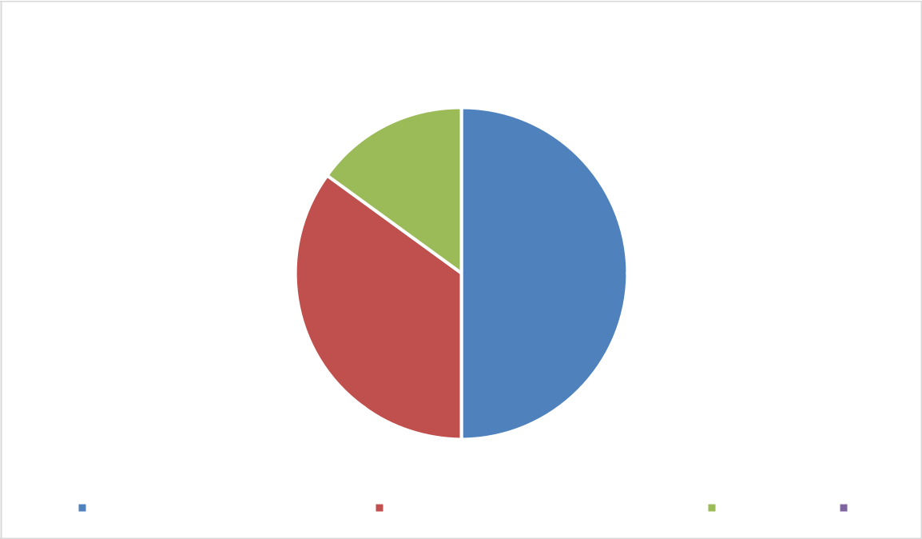

**Departments and Number of Students**

15%

50%

35%

|  |  |  |
| --- | --- | --- |
| Department of English Language | Department of Mass Communication | Accounting |

***Source: Field Survey, 2022***

**4.3 Data of students Based on Sex**

45

|  |  |  |
| --- | --- | --- |
| **Sex** | **Students** | **Percentage** |
|  |  |  |
| Male | 6 | 20% |
|  |  |  |
| Female | 24 | 80% |
|  |  |  |
| **Total** | **30** | **100%** |
|  |  |  |
| ***Source: Field Survey, 2022*** |  |  |

The above shows the number of male and female students in the selected departments used in this study. 6 male representing 20%, while 24 females representing 24% making 30 respondents that is, 100%.

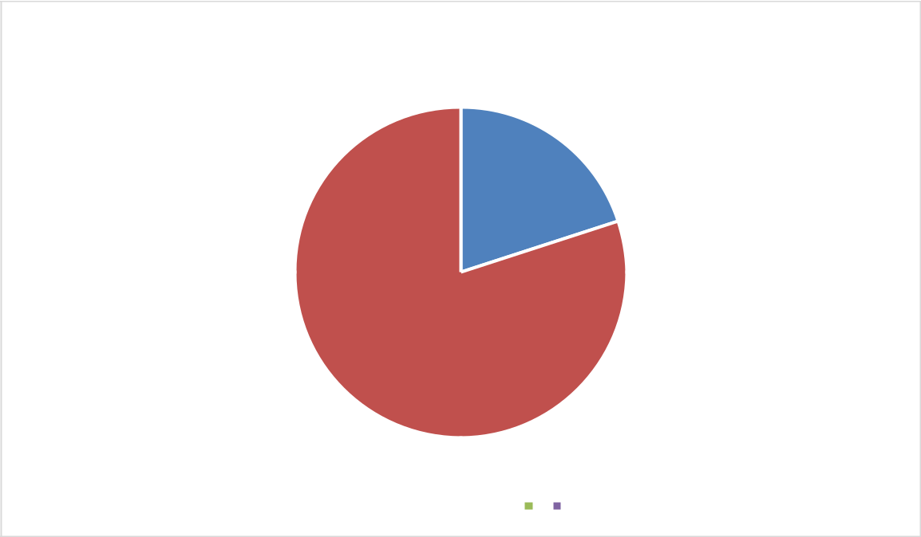

**Data of students Based on Sex**

20%

80%

 Male  Females

***Source: Field Survey, 2022***

**4.4 Sources of Lexical Errors**

|  |  |  |  |
| --- | --- | --- | --- |
| **Sources of Lexical Errors** | **NO.** |  | **Percentage** |
|  |  |  |  |
| 16-20 | 2 |  | 5% |
|  |  |  |  |
|  |  | 46 |  |

|  |  |  |
| --- | --- | --- |
| 21 and above | 28 | 95% |
|  |  |  |
| **Total** | **30** | **100%** |
|  |  |  |
| ***Source: Field Survey, 2022*** |  |  |

The above table shows the age distribution of the respondents in the selected departments. 2 representing 5% of the respondents were in the age bracket of 16-20 while 28 representing 95% of the respondents were in the age bracket of 21 and above making a total of 100%.

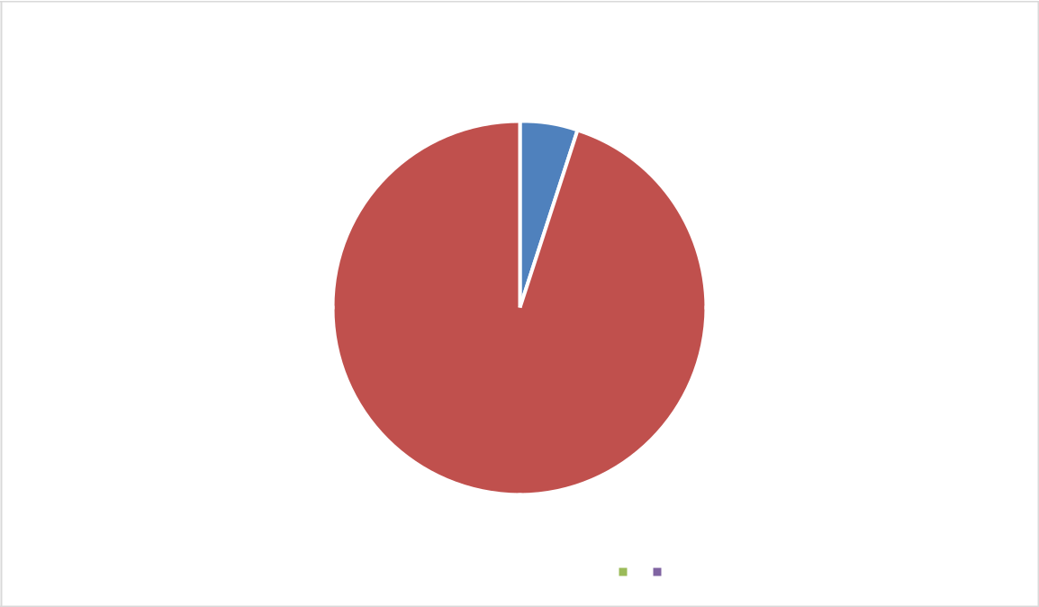

Sources of Lexical Errors

5%

95%

 16-20  21 and above

***Source: Field Survey, 2022***

**4.5 Results of the Error Analysis**

|  |  |  |  |  |  |  |  |  |  |  |
| --- | --- | --- | --- | --- | --- | --- | --- | --- | --- | --- |
| **s/n** |  |  | **Sentence/word** |  | **Error Identified** | | | **Type of Error** | **Correction** |  |
|  |  | | |  |  | |  |  |  | |
| **1** | A: Put your head down. | | |  | Down | |  | Misformation | B: How low do you | |
|  | B: how down do you want it? | | |  |  |  |  |  | want it? |  |
|  |  |  |  |  |  | |  |  |  |  |
| **2** | The | people | announcing |  | The | | people__ | Omission | The people | are |
|  | something but we can‟t hear it. | | |  | announcing… | | |  | announcing |  |
|  |  |  |  |  |  |  |  |  | something but | we |
|  |  |  |  |  |  | |  |  |  |  |
|  |  |  |  |  | 47 | |  |  |  |  |

|  |  |  |  |  |  |  |  |  |  |  |  |  |  |  |  |
| --- | --- | --- | --- | --- | --- | --- | --- | --- | --- | --- | --- | --- | --- | --- | --- |
|  |  |  |  |  |  |  |  |  |  | can‟t hear it. | | | |  |  |
|  |  |  |  |  | |  |  |  |  |  |  | |  | |  |
| **3** | You were able to withdraw |  | You were… | | | | | | Misordering | Were | you | | able | | to |
|  |  |  |  |  |  |  |  |  |  | withdraw? | | |  |  |  |
|  |  |  |  |  | | |  |  |  |  | | | | | |
| **4** | I‟m trying to be fast and carry it |  | …Big big. | | | | | | Misformation | I‟m trying to be fast | | | | | |
|  | big big. |  |  |  |  |  |  |  |  | and carry it well. | | | | |  |
|  |  |  |  |  | | |  |  |  |  | | | | | |
| **5** | If you are a senior officer there |  | There | is__kind | | | | | Omission | If you are a senior | | | | | |
|  | is kind of a post they will give |  | … |  |  |  |  |  |  | officer, | there | | | is | a |
|  | you. |  |  |  |  |  |  |  |  | kind of post they will | | | | | |
|  |  |  |  |  |  |  |  |  |  | give you. | |  |  |  |  |
|  |  |  |  |  |  |  |  |  |  |  | | | | | |
| **6** | Please snap the hair style Me I |  | Me I |  |  |  |  |  | Addition | Please snap the hair | | | | | |
|  | don‟t want stress. |  |  |  |  |  |  |  |  | style, | I | don‟t | | want | |
|  |  |  |  |  |  |  |  |  |  | stress. |  |  |  |  |  |
|  |  |  |  |  | | |  | |  |  | | |  |  | |
| **7** | They have brought the light. |  | Brought the light | | | | | | Misformation | Electricity | | | has | been | |
|  |  |  |  |  |  |  |  |  |  | restored. | |  |  |  |  |
|  |  |  |  |  | | |  | |  |  | | | | | |
| **8** | This is where we will have our |  | …have our fight. | | | | | | Misformation | This is where we will | | | | | |
|  | fight. |  |  |  |  |  |  |  |  | have |  |  |  |  | a |
|  |  |  |  |  |  |  |  |  |  | disagreement. | | | |  |  |
|  |  |  |  |  |  |  |  |  |  |  | |  |  |  | |
| **9** | Peculiar I have pay. |  | …pay. |  |  |  |  |  | Misformation | Peculiar, | |  | I | have | |
|  |  |  |  |  |  |  |  |  |  | paid. |  |  |  |  |  |
|  |  |  |  |  | | |  | |  |  | | | | |  |
| **10** | There is fruit? |  | There is fruit? | | | | | | Misordering | Is there ordering? | | | | |  |
|  |  |  |  |  |  |  |  |  |  |  | | | | | |
| **11** | Me I don‟t understand. |  | Me I. |  |  |  |  |  | Addition | I don‟t understand. | | | | | |
|  |  |  |  |  | | |  | |  |  |  |  |  | |  |
| **12** | Who is the best in coming late? |  | Best in … | | | | | | Misformation | Who | is |  | best | | at |
|  |  |  |  |  |  |  |  |  |  | coming late? | | | |  |  |
|  |  |  |  |  | | |  | |  |  |  |  | |  | |
| **13** | Finish you said you acted the |  | ….Finish …. | | | | | | Omission | When |  | you | | were | |
|  | most. |  |  |  |  |  |  |  |  | finished, | | you | | stated | |
|  |  |  |  |  |  |  |  |  |  | that you | | acted | | | the |
|  |  |  |  |  |  |  |  |  |  | most. |  |  |  |  |  |
|  |  |  |  |  | | |  | |  |  | | | | |  |
| **14** | You become over it. |  | Become. | | | | | | Misformation | You get over it. | | | | |  |
|  |  |  |  |  | | |  | |  |  | | | | | |
| **15** | As she‟s openinging it. |  | Openinging it. | | | | | | Addition | As she‟s opening it. | | | | | |
|  |  |  |  |  |  |  |  |  |  |  | | | | | |
| **16** | It never reach our side. |  | Reach… |  |  |  |  |  | Omission | It never reaches our | | | | | |
|  |  |  |  |  |  |  |  |  |  | side. |  |  |  |  |  |
|  |  |  |  |  | | |  | |  |  |  |  | |  |  |
| **17** | Deborah saw me, she was my |  | Weakness… | | | | | | Misformation | …she |  | was | |  | my |
|  | weakness that day. |  |  |  |  |  |  |  |  | withness. | | |  |  |  |
|  |  |  |  |  | | | | |  |  |  | |  | | |
| **18** | I took a particular examples. |  | Addition | of „s‟ in | | | | | Addition | I took | a | | particular | | |
|  |  |  | Examples | | | | | |  | example. | | |  |  |  |
|  |  |  |  |  | | |  | |  |  | | | | |  |
| **19** | Give us note. |  | Us _ note. | | | | | | Omission | Give us a note. | | | | |  |
|  |  |  |  |  |  |  |  |  |  |  | | | | |  |
| **20** | Are you baffing? |  | Baffing |  |  |  |  |  | Misformation. | Are you bathing? | | | | |  |
|  |  |  |  |  |  |  |  |  |  |  |  |  |  |  |  |
|  |  |  | 48 |  |  |  |  |  |  |  |  |  |  |  |  |

|  |  |  |  |  |  |  |  |  |  |  |  |  |  |  |
| --- | --- | --- | --- | --- | --- | --- | --- | --- | --- | --- | --- | --- | --- | --- |
| **21** | Onyinye you are not going to |  | ...you | | | | | are | Misordering | Onyinye, | | are | you |  |
|  | chapel? |  | going... | | | | |  |  | going to the chapel? | | | |  |
|  |  |  |  |  |  |  |  |  |  |  | | | |  |
| **22** | It happened Since during the |  | during | | | | |  | Misformation. | It has occurred since | | | |  |
|  | covid. |  |  |  |  |  |  |  |  | the COVID. | | |  |  |
|  |  |  |  |  |  |  |  |  |  |  | | | |  |
| **23** | A: when I ask you this question |  |  |  |  |  |  |  | Misformation. | A: when I ask you | | | |  |
|  | can you respond? |  | I cannot do. | | | | | |  | this | question | | can |  |
|  | B: There is nothing they want to |  |  |  |  |  |  |  |  | you respond? | | |  |  |
|  | ask me that I cannot do. |  |  |  |  |  |  |  |  | B: There is nothing | | | |  |
|  |  |  |  |  |  |  |  |  |  | they want to ask me | | | |  |
|  |  |  |  |  |  |  |  |  |  | that | I | cannot | |  |
|  |  |  |  |  |  |  |  |  |  | answer. | |  |  |  |
|  |  |  |  |  |  |  |  | |  |  | | | |  |
| **24** | It is very worse that I thought. |  | Very worst | | | | | | Addition. | It is worse than I | | | |  |
|  |  |  |  |  |  |  |  |  |  | thought. | |  |  |  |
|  |  |  |  |  |  | |  | |  |  | | | |  |
| **25** | I saw it since after the break. |  | Since after… | | | | | | Addition | I saw it since after | | | |  |
|  |  |  |  |  |  |  |  |  |  | the break, | |  |  |  |
|  |  |  |  | |  | | | |  |  |  |  |  |  |
| **26** | are they still not around? |  | Still not… | | | | | | Misformation | They | are | still | not |  |
|  |  |  |  |  |  |  |  |  |  | around? | |  |  |  |
|  |  |  |  | | | | | |  |  |  |  |  |  |
| **27** | They ate it since before the |  | Since before | | | | | | Addition | They ate it before the | | | | game |
|  | game. |  |  |  |  |  |  |  |  |
|  |  |  |  |  |  |  |  |  |  |  |  |  |  |
|  |  |  |  | | | | | |  |  | |  |  |  |
| **28** | Favour you are not going to |  | b. To __chapel? | | | | | | mission | Favour, | | are | you |  |
|  | chapel? |  |  |  |  |  |  |  |  | going to the chapel? | | | |  |
|  |  |  |  | | | | | |  |  |  |  |  |  |
| **29** | The kind of a post they will give |  | ...kind of a… | | | | | | Addition | The | kind | of | post |  |
|  | you will be the best for you. |  |  |  |  |  |  |  |  | they will give you will | | | |  |
|  |  |  |  |  |  |  |  |  |  | be the best for you. | | | |  |
|  |  |  |  | | | | |  |  |  | | | |  |
| **30** | The reason why I did it doesn‟t |  | The | | | | | Reason | blending | The reason I did it | | | |  |
|  | matter. |  | why… | | | | |  |  | doesn‟t matter. | | |  |  |
|  |  |  |  |  |  |  |  |  |  |  |  |  |  |  |

**Section B**

This section presents the data analysis of the types of errors. The Table

presents the errors of students and number of speakers.

**4.6 Errors and numbers of students**



**S/N**

**Types of errors**

**No. of students**

**Percentage**

49

|  |  |  |  |
| --- | --- | --- | --- |
| 1 | Omission | 6 | 6% |
|  |  |  |  |
| 2 | Addition | 8 | 8% |
|  |  |  |  |
| 3 | Misformation | 12 | 12% |
|  |  |  |  |
| 4 | Misordering | 3 | 3% |
|  |  |  |  |
| 5 | Blending | 1 | 1% |
|  |  |  |  |

***Source: Field Survey, 2022***

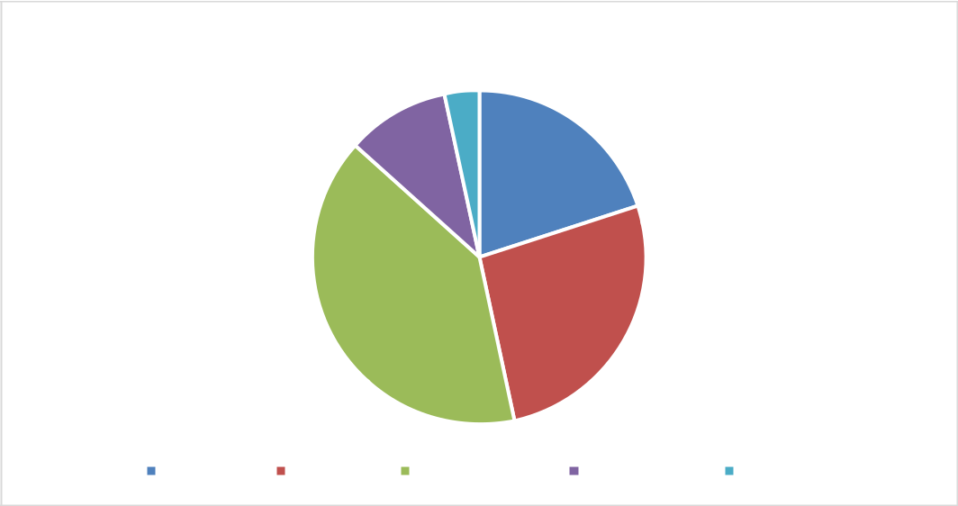

**Errors and numbers of students**

1%

3% 6%

12% 8%

|  |  |  |  |  |
| --- | --- | --- | --- | --- |
| Omission | Addition | Misformation | Misordering | Blending |

***Source: Field Survey, 2022***

*The Table 1 and pie chart above shows analysis on the errors that are present in the conversational speech of students.*

**Item 1:** shows that the omission error was spoken by 6% of the students.

**Item 2:** 8% spoke the error of addition.

**Item 3:** 12% the misformation error. A high percentage is recorded for students whose speech contained the misformation. **In item 4:** 3% the misordering type of error.

50

**In item 5:** 1% the blending type of error. The lowest percentage was

recorded for the blending type of error.

**CHAPTER FIVE**

**5.0 DISCUSSION** **OF** **FINDINGS,** **CONCLUSION** **AND**

**RECOMMENDATIONS**

**5.1 Introduction**

This chapter, focused on the discussion of findings, conclusion and recommendation.

**5.2** **Discussion of Findings**

From the analysis carried out in chapter four, the results show that errors are inevitable especially as a second language learner of English. The study examined the errors in the spoken English of the students and showed that most errors are also as a result of limited and efficient learning materials for studies. It was also discovered that some errors where of higher frequency than the others.

**5.3 Conclusion**

51

This research was a qualitative descriptive study investigated on students‟ Errors in using English Language. The researcher adopted the random sampling technique to gather her data from 30 students. The data were collated and analysed using pie chart and simple percentage scores.

The researcher randomly chose the students from the departments. This study covered a part of the Mountain Top University in Nigeria (The department, English, Mass communication and Accounting). 30 students are interviewed at the university from the department of English, Mass communication, and Accounting. 15 students from the department of English, 10 from the department of Mass communication and 5 from the department of Accounting.

One of the findings of this research shows that students make most of these errors unintentionally because they are second language learner.

**5.4 Recommendations**

According to the findings of the study, the researcher advises students to engage in activities like these to help them develop their advanced grammatical context and, as a result, enhance their speaking. the researcher also highlighted other suggestions.

1. If English is the language whose grammar you desire to improve, then speak it. The majority of the world's population can communicate in English, and its significance in daily life is growing. If we don't really know how to speak English, learning grammar might be challenging. By

52

regularly practicing, you can improve your grammar. The rest will come together after your speech reflects the patterns you hear. Move on after finding a friend who can communicate with you in English. If you ever feel stuck, get assistance!

1. Identify typical errors. English grammatical errors are frequently made by speakers of the same language. For instance, using "e" in English might be challenging for many Yoruba speakers, they substitute 'e' for 'h'. Find out which grammatical concepts native speakers frequently struggle with. Pay close attention to those grammatical rules as you learn them. Grammar mistakes are unacceptable; thus, they have a big impact on how we live our lives. A grammatical mistake distorts meaning and creates a negative impression.
2. The teacher may utilize a strategy that involves explaining when to use the verb's past and present tenses, providing examples of usage, and testing the students' comprehension to ensure that they have a firm grasp of the material. Otherwise, as this is the very first stage in learning English, pupils would have trouble telling the difference between how to utilize verbs in the past and the present.
3. The lecturer should clearly explain the grammar's components while providing sufficient tasks.
4. In addition to presenting grammar theory, the speaker should include additional tasks that demonstrate how to use grammar. Because,

53

according to the data, the pupils don't really comprehend how to identify

whether to utilize the verbs' past or present tense.

1. To increase the students' interest in studying English, particularly the grammar, the lecturer should provide more straightforward explanations while teaching English as it relates to its grammar.
2. The communicative approach to teaching languages might also be used by the lecturer. particularly if they are teaching English grammar.
3. The teacher in the speaking class needs to offer the pupils additional speaking practice.

**References**

Ahmed, M. (2015). *Analysing Errors Made by the Students in Constructing Well Formed sentence in English language* (Doctoraldissertation, Sudan University of Science and Technology).

Al-Khresheh, M. H. (2016). A Review Study of Error Analysis Theory. International Journal of Humanities and Social Science Research, 49-59.

Al-Sobhi, B. M. (2018). Teaching English Speaking Skills to the Arab Students in the Saudi School in Kuala Lumpur: Problems and Solutions. International Journal of Education & Literacy Studies, 1-11.

Björkegren, D. (2018, March 20). Inter- and intralingual errors in Chinese students‟ compositions. Karlstad, Varmland, Sweden.

Brown, D. (2000). Principles of Language Learning and Teaching . New York: Addison Wesley Longman.

Corder, S. (1974). Error analysis and Interlanguage. Britain: Oxford University Press.

Dulay, Burt, Krashen. (1982). Language Two. New York: Oxford University Press.

Idegbekwe, D., Aikoriogie, A. M., & Ugwu, E. N. An Error Analysis Of The Grammatical Features Of The English Spoken By Testifiers In The Living Word And Fire Church.

Islamiyah, M., & Al Fajri, M. S. (2019). Error Analysis and Its Implications for the English Classroom: A Case Study of an Advanced English

54

Learner. *Indonesian EFL Journal: Journal of ELT, Linguistics, and Literature*, *5*(2), 1-13

Sabzalipour, B. (2012). Error analysis on students' Persian-English translation. *Asian journal of social sciences & humanities*, *1*(4), 71-76

Sanusi, I. O. (1988). Semantic Interlingual Errors in the Performance of Yoruba Learners of English as a Second Language: A Case of Negative Transfer. *Linguistics and Nigerian Languages, University of Ilorin, Ilorin, Nigeria.*

Pasaribu, A. N. (2021). A Common Error Analysis in Students‟ English Narrative Writing. *Linguistic, English Education and Art (LEEA) Journal*, *4*(2), 436-445.

Sabzalipour, B. (2012). Error analysis on students' Persian-English translation. *Asian journal of social sciences & humanities*, *1*(4), 71-76.

Sanusi, I. O. (1988). Semantic Interlingual Errors in the Performance of Yoruba Learners of English as a Second Language: A Case of Negative Transfer. *Linguistics and Nigerian Languages, Universitof Ilorin, Ilorin, Nigeria*.

Pasaribu, A. N. (2021). A Common Error Analysis in Students‟ English Narrative Writing. *Linguistic, English Education and Art (LEEA) Journal*, *4*(2), 436-445

Brown, H. D. (2000). *Principles of language learning and teaching* (Vol.

4). New York: Longman.

O'brien, I., Segalowitz, N., Freed, B., & Collentine, J. (2007). Phonological memory predicts second language oral fluency gains in adults. *Studies in second language acquisition*, *29*(4), 557-581

Abied, A. A., Ali, A., & Ashfello, M. M. Error Analysis of the Written English Essays by Libyan EFL Learners: Case study.

Khansir, A. A. (2012). Error Analysis and Second Language Acquisition. *Theory & Practice in Language Studies*, *2*(5).

SÜSLÜ, Ş. (2011). DO ERRORS TAKE THE REINS INTO THEIR HANDS?. *Muğla Üniversitesi Sosyal Bilimler Enstitüsü Dergisi*, (18).

55

Sermsook, K., Liamnimit, J., & Pochakorn, R. (2017). An Analysis of Errors in Written English Sentences: A Case Study of Thai EFL Students. *English Language Teaching*, *10*(3), 101-110.

Amiri, F., & Puteh, M. (2017). Error Analysis in Academic Writing: A Case of International Postgraduate Students in Malaysia. *Advances in Language and Literary Studies*, *8*(4), 141-145

Ananda, M. L., Jeyaseelan, S., Alejandrino, K. J., & Rochat, M. Panel 1:

Language and Literature.

Hamed, M. (2018). Common linguistic errors among non-English major Libyan students writing. *Arab World English Journal.*

Mahmood, A. H., & Murad, I. M. A. (2018). Approaching the Language of the Second Language Learner: Interlanguage.

Benidir, S., & Hamlaoui, N. (2017). *The impact of corrective feedback on learners’ written productions* (Doctoral dissertation).

Branch, I. www. mjltm. com submit@ mjltm. com hamedghaemi@ ymail.com.

Saidah, S. (2018). ANALYZING THE EIGHTHGRADE

STUDENTS‟ERRORS IN CONSTRUCTING RECOUNT PARAGRAPH IN SMPN 1 GONDANGWETAN, PASURUAN. *Jurnal Ilmiah Edukasi & Sosial*, *8*(1), 67-72.

Bedmar, M. B. D. (2009). Written learner corpora by Spanish students of English: An overview. *A Survey on Corpus-based Research Panorama of Corpus-based Research*, 920-933.

Myles, J. (2002). Second language writing and research: The writing process and error analysis in student texts. *Tesl-Ej*, *6*(2), 1-20.

Hafiz, S. M., Omar, A. M. A., & Sher, K. M. (2018). Analysis of syntactic errors in English writing: A case study of Jazan University preparatory year students. *Journal of Education and Practice*, *9*(11), 113-120.

LUBIS, D. S., & SIMANJUNTAK, E. S. (2022). AN ANALYSIS OF

STUDENTS‟ERRORS IN PRONOUNCING ENGLISH CONSONANTS (A CASE STUDY OF THE ELEVENTH GRADE OF SMA NEGERI 1 SUMBUL.

Sari, U. N., Ritonga, H., & Mahmudah, F. (2021). *MORPHOLOGICAL ERROR IN WRITING ESSAY AT FIFTH SEMESTER OF ENGLISH EDUCATION STUDY PROGRAM IN ISLAMIC UNIVERSITY OF*

56

*SULTHAN THAHA SAIFUDDIN JAMBI* (Doctoral dissertation, UIN Sulthan Thaha Saifuddin Jambi.

Nzama, M. V. (2010). *Error analysis: a study of errors committed by isiZulu speaking learners of English in selected schools* (Doctoraldissertation).

Corder, S. P. (1967). The significance of learner's errors.

[https://doi.org/10.1515/iral.1967.5.1-4.161.](https://doi.org/10.1515/iral.1967.5.1-4.161)

Fadhila, H., Fauziati, E., & Haryanti, D. (2013). *Errors In Speaking English Made By Students Ofenglish Department Of Muhammadiyah University Of Surakarta* (Doctoral dissertation, UniversitasMuhammadiyah Surakarta.

Fitriana, D. (2012). Improving the speaking skills through guessing games of the seventh grade students of SMP Muhammadiyah 1 Seyegan Yogyakarta in the academic year of 2012/2013. *PublishedThesis). Universitas Negeri Yogyakarta, Yogyakarta*

Fadhila, H., Fauziati, E., & Haryanti, D. (2013). *Errors In Speaking English Made By Students Ofenglish Department.*

Zadrozny, J., McClure, C., Jinhee, L. E. E., & Injeong, J. O. (2016). Designs, techniques, and reporting strategies in geography education: A review of research methods. *Review of International Geographical Education Online*, *6*(3), 216-233.

Hind, D. (2018, September 23). A qualitative study on problems in speaking English as L3 The case of Arab immigrants in Sweden. Västerås, Eskilstuna, Sweden.

James, C. (2013). Errors in Language Learning and Use. New York:

Routledge.

Jonsson, E. (2015, May 29). Slips or errors? A study of the grammatical mistakes in Swedish. Smaland.

Mathe, C. (2017). Error Analysis: Written Work of Final Year Mainstream vs. CLIL Students” . Vienna.

MUIA, M. J. (2015). Cross-Linguistic Influence in Foreign Language Learning. Nairobi, Nairobi, Kenya.

Rass, R. A. (2015). Challenges Face Arab Students in Writing Well-Developed Paragraphs in English. Canadian Center of Science and Education, 49-59.

Richards, J. (1973). Error Analysis Prospective on Second Language Acquisition . Canada: Longman.

Suhono. (2016, November 2). Surface Strategy Taxonomy On The Efl Students‟ Composition: A Study Of Error Analysis . Metro, Lampung, Indonesia.

57

Tarone, E. (2012). Inter language. Minnesota: Oxford University Press. Yaseen, A. A. (2018). Syntactic Errors in an Arab EFL Postgraduate

Student‟s Spoken English during a Thesis Supervision Session.

Arab World English Journal AWEJ, 392- 406.

58

59