# EFFECTS OF VITAMIN B COMPLEX THERAPY ON TEMPORAL VARIATION IN GENTAMICIN NEPHROTOXICITY IN WISTAR RATS

**By**

# JAMES ISMAILU FATIKA

**DEPARTMENT OF PHARMACOLOGY AND THERAPEUTICS FACULTY OF PHARMACEUTICAL SCIENCES**

# AHMADU BELLO UNIVERSITY, ZARIA NIGERIA

**DECEMBER, 2017**

# EFFECTS OF VITAMIN B COMPLEX THERAPY ON TEMPORAL VARIATION IN GENTAMICIN NEPHROTOXICITY IN WISTAR RATS

**By**

# James Ismailu FATIKA, B. Pharm (A.B.U.) 2011 MSc/Pharm-Sci/37742/12-13

**A DISSERTATION SUBMITTED TO THE SCHOOL OF POSTGRADUATE STUDIES, AHMADU BELLO UNIVERSITY, ZARIA**

# IN PARTIAL FULFILMENT OF THE REQUIREMENTS FOR THE AWARD OF A MASTER DEGREE IN PHARMACOLOGY

**DEPARTMENT OF PHARMACOLOGY AND THERAPEUTICS FACULTY OF PHARMACEUTICAL SCIENCES**

# AHMADU BELLO UNIVERSITY, ZARIA NIGERIA

**DECEMBER, 2017**

# DECLARATION

I declare that the work in this dissertation titled “EFFECTS OF VITAMIN B COMPLEX THERAPY ON TEMPORAL VARIATION IN GENTAMICIN

NEPHROTOXICITY IN WISTAR RATS” has been carried out by me in the Department of Pharmacology and Therapeutics, Ahmadu Bello University, Zaria. The information derived from the literature has been duly acknowledged in the text and by a list of references provided. No part of this thesis has been previously presented for another degree or diploma at this or any other institution.

|  |  |  |
| --- | --- | --- |
| James Ismailu Fatika |  |  |
| Name of Student | Signature | Date |

# CERTIFICATION

This dissertation entitled “EFFECTS OF VITAMIN B COMPLEX THERAPY ON TEMPORAL VARIATION IN GENTAMICIN NEPHROTOXICITY IN WISTAR

RATS” by JAMES ISMAILU FATIKA meets the regulations governing the award of the degree of Master of Science in Pharmacology of the Ahmadu Bello University, Zaria and is approved for its contribution to knowledge and literary presentation.

|  |  |  |
| --- | --- | --- |
| Prof. T. O. Olurishe |  |  |
| Chairman, Supervisory Committee | (Signature) | (Date) |

|  |  |  |
| --- | --- | --- |
| Prof. H.O. Kwanashie |  |  |
| Member, Supervisory Committee | (Signature) | (Date) |

|  |  |  |
| --- | --- | --- |
| Dr. M.G. Magaji |  |  |
| Head of Department | (Signature) | (Date) |

Prof. S. Z. Abubakar

Dean, School of Postgraduate (Signature) (Date) Studies

# ACKNOWLEDGEMENT

My profound gratitude goes to God almighty for giving me the grace to carry out this work. My sincere gratitude and appreciation goes to my supervisors, Prof. T.O. Olurishe and Prof. H.O. Kwanashie for their support, sacrifices and words of encouragement during the course of this research work.

Words cannot express my gratitude to my parents Mr. and Mrs. Ismailu Musa Fatika for their moral, spiritual and financial support throughout the progress of this work and also for their parental love and care. I am very much grateful to my siblings, Maryam, Musa and Ibrahim for their encouragement.

I acknowledge the support and help of my lecturers and the technical staff in the Department of Pharmacology and Therapeutics. I cannot forget to appreciate my friends and colleagues, too many to mention who stood by me throughout the duration of this study, I am very grateful for your support.

# ABSTRACT

The efficacy and toxicity of several drugs is circadian-rhythm dependent, and this can be exploited as a guide to ameliorate such drug toxicity. Gentamicin is an aminoglycoside antibiotic used in treatment of a variety of infections. Its use is however limited by its associated nephrotoxicity. This nephrotoxicity is ameliorated by reduction in dosing frequency to once a day dosing, use of antioxidants and exploration of circadian variation in gentamicin nephrotoxicity. Temporal variation in gentamicin nephrotoxicity and the use of antioxidants at the time of highest nephrotoxicity are alternative ameliorative strategies for this established toxicity. This study compares the effect of concurrent administration of vitamin B complex and gentamicin based on its temporal variation in nephrotoxicity, with alternative approaches of use of a single strategy alone. Young wistar rats of both sexes were used in this study. A nephrotoxic dose of gentamicin was determined from a ten day study with 80, 100 and 120 mg/kg intraperitoneal gentamicin administration using selected biomarkers as indices. Nephrotoxicity was accessed by elevation of serum urea and serum creatinine which are biomarkers of nephrotoxicity and histological changes of the kidney. Administration of 100 mg/kg of gentamicin at 0800, 1200, 2000 and 0000 hours resulted in nephrotoxicity with maximal toxicity observed at 1200 hours where the level of serum urea and creatinine differed significantly (p≤0.05) from the normal saline control and minimal toxicity was seen at the 0000 hour. Histology of the kidneys showed lymphocyte hyperplasia, interstitial haemorrhages, tubular and glomerular necrosis in the 1200 hour group which was observed to be mild in the 0000 hour group. No significant change was seen in the levels of serum electrolytes (Na+, K+, Cl+, Ca2+) and liver function enzymes (ALT, AST and ALP) irrespective of time of treatment. Concurrent administration of

gentamicin and vitamin B complex at 1200 and 0000 hours resulted in amelioration of gentamicin nephrotoxicity. However, the amelioration produced by the administration of gentamicin alone at the time of minimal toxicity (0000 hour) was greater than that produced by concurrent administration of gentamicin and vitamin B complex at this time point. The administration of gentamicin based on its temporal variation in nephrotoxicity offers better amelioration of nephrotoxicity than concurrent administration of gentamicin at the time of highest toxicity with vitamin B complex in wistar rats.

# TABLE OF CONTENTS

TITLE PAGE i

DECLARATION ii

CERTIFICATION iii

ACKNOWLEDGEMENT iv

ABSTRACT v

TABLE OF CONTENTS vii

LIST OF FIGURES xiii

LIST OF TABLES xiv

LIST OF PLATES xvi

ABBREVIATIONS, GLOSSARY AND SYMBOLS xviii

CHAPTER ONE 1

INTRODUCTION 1

* 1. Background 1
  2. Statement of Research Problem 4
  3. Justification 4
  4. Aim and Objectives of the Study 5
     1. Aim of the Study 5
     2. Specific Objectives 5
  5. Research Hypothesis 6

CHAPTER TWO 7

* 1. LITERATURE REVIEW 7
  2. Chronobiology 7
     1. Chronobiology and Biological Rhythms 9
     2. Chronopharmacology 11
     3. Chronotherapy 12
     4. Chronotoxicity 12
  3. Circadian Rhythms 13
     1. Circadian Rhythms and Disease States 15
     2. Circadian Rhythms and Pharmacology of Drugs 18
     3. Zeitgebers 22
  4. Aminoglycoside Antibiotics 22
     1. Gentamicin 24
     2. Therapeutic Uses 24
  5. Gentamicin Nephrotoxicity 24
     1. Risk Factors for Gentamicin Nephrotoxicity 25
     2. Biomarkers for Gentamicin Nephrotoxicity 26
  6. Strategies for Amelioration of Gentamicin Nephrotoxicity 26
     1. Once Daily Dosing 26
     2. Dietary Measures 27
     3. Time of Administration 27
     4. Use of Antioxidants 28
     5. Therapeutic Drug Monitoring 29
  7. Temporal Variation of Gentamicin Nephrotoxicity 30

CHAPTER THREE 31

* 1. MATERIALS AND METHODS 31
  2. Animals 31
  3. Drugs and Chemicals 31
  4. Equipment and Sundry Consumables 31
  5. Determination of Nephrotoxic Dose of Gentamicin to be used 32
  6. Determination of Least Toxic Time for Administration of Gentamicin 32
  7. Comparative Assessment of Vitamin B Complex Therapy Against Time of Administration as Ameliorative Strategies in Gentamicin Nephrotoxicity 33
  8. Biochemical Analysis 33
     1. Determination of Serum Creatinine 33
     2. Determination of Serum Urea 34
     3. Determination of Total Protein 34
     4. Determination of Total Bilirubin 34
  9. Determination of Electrolytes 35
  10. Determination of Liver Function Enzymes 35
      1. Determination of Alanine Amino Transferase (ALT) 35
      2. Determination of Aspartate Amino Transferase (AST) 35
      3. Determination of Alkaline Phosphatase (ALP) 36
  11. Determination of Oxidative Stress Markers 36
      1. Determination of Lipid Peroxidation 36
  12. Determination of Body Weights and Kidney Weights 36
  13. Kidney Histology 37
  14. Data Analysis and Presentation of Results 37

CHAPTER FOUR 38

4.0 RESULTS 38

* + 1. The Effect of Graded Doses of Gentamicin Administration on Serum Nephrotoxic Biomarkers in Wistar Rats 38
    2. : The Effect of Graded Doses of Gentamicin Administration on Total Protein, Total Albumin and Triglycerides in Wistar Rats 40
    3. The Effect of Graded Doses of Gentamicin Administration on Liver Function Biomarkers in Wistar Rats 42
    4. The Effect of Graded Doses of Gentamicin Administration on Serum Electrolyte levels in Wistar Rats 44
    5. : Histopathology of Effect of Graded Doses Gentamicin Administration on Kidney in Wistar Rats 46
    6. : The Effect of Ten-day Chronomodulated Gentamicin (100 mg/kg) Administration on Serum Renal Biomarkers in Wistar Rats 51
    7. : The Effect of Ten-day Chronomodulated Gentamicin (100 mg/kg) Administration on Serum Electrolytes in Wistar Rats 53
    8. : The Effect of Ten-day Chronomudulated Gentamicin (100 mg/kg) Administration on Liver Enzymes in Wistar Rats 55
    9. : The Effect of Ten-day Chronomudulated Gentamicin (100 mg/kg) Administration on Relative Kidney Weights in Wistar Rat 57

4.2.8: Histopathology of Effect of Ten-day Chronomudulated Gentamicin

(100 mg/kg) Administration on Wistar Rats 59

* + 1. : The Effect of Ten-day Chronomudulated Gentamicin (100 mg/kg) and Vitamin B Complex (3 ml/kg) on Renal Biomarkers in Wistar

Rats 64

* + 1. : The Effect of Ten-day Chronomudulated Gentamicin (100 mg/kg) and Vitamin B Complex (3 ml/kg) Administration on Liver

Enzymes in Wistar Rats 66

* + 1. : The Effect of Ten-day Chronomudulated Gentamicin (100 mg/kg) and Vitamin B Complex (3 ml/kg) Administration on Oxidative

Stress Markers in Wistar Rats 68

* + 1. : The Effect of Ten-day Chronomudulated Gentamicin (100 mg/kg) and Vitamin B Complex (3 ml/kg) on Serum Electrolytes in Wistar

Rats 70

* + 1. : The Effect of Ten-day Chronomudulated Gentamicin (100 mg/kg) and Vitamin B Complex (3 ml/kg) Administration on Relative

Kidney Weight in Wistar Rats 72

* + 1. : Histopathology of Effect of Ten-day Chronomudulated Gentamicin

(100 mg/kg) and Vitamin B Complex (3 ml/kg) on Wistar Rats 74

CHAPTER FIVE 79

5.0 DISCUSSION 79

CHAPTER SIX 84

* 1. SUMMARY, CONCLUSION AND RECOMMENDATION 84
  2. Summary 84
  3. Contribution of the current Research to the body of Knowledge 84
  4. Conclusion 85
  5. Recommendation 85
  6. Suggestions for Further Studies 85

REFERENCES 87

**LIST OF FIGURE**

Figure 1: Human Circadian Rhythm Structure 10

# LIST OF TABLES

Table 4.1: The Effect of Graded Doses of Gentamicin Administration on Serum Urea, Creatinine and Total Bilirubin in Wistar Rats 39

Table 4.2: The Effect of Graded Doses of Gentamicin Administration on Serum Total protein, Total Albumin and Triglycerides in Wistar Rats 41

Table 4.3: The Effect of Graded Doses of Gentamicin Administration on Liver function Biomarkers in Wistar Rats 43

Table 4.4: The Effect of Graded Doses of Gentamicin Administration on Serum Electrolyte levels in Wistar Rats 45

Table 4.5: The Effect of Ten-day Chronomodulated Gentamicin (100 mg/kg) Administration on Serum Renal Biomarkers in Rats 52

Table 4.6: The Effect of Ten-day Chronomodulated Gentamicin (100 mg/kg) Administration on Serum Electrolytes in Wistar Rats 54

Table 4.7: The Effect of Ten-day Chronomudulated Gentamicin (100 mg/kg) Administration on Liver Function Biomarkers in Wistar

Rats 56

Table 4.8: The Effect of Ten-day Chronomudulated Gentamicin (100 mg/kg) Administration on Relative Kidney Weights in Wistar

Rats 58

Table 4.9: The Effect of Ten-day Chronomudulated Gentamicin (100 mg/kg) and Vitamin B Complex (3 ml/kg) Administration on Serum Nephrotoxic Biomarkers in Wistar Rats 65

Table 4.10: The Effect of Ten-day Chronomudulated Gentamicin (100 mg/kg) and Vitamin B Complex (3 ml/kg) Administration on Liver Enzymes in Wistar Rats 67

Table 4.11: The Effect of Ten-day Chronomudulated Gentamicin (100 mg/kg) and Vitamin B Complex (3 ml/kg) on Oxidative Stress Markers in Wistar Rats 69

Table 4.12: The Effect of Ten-day Chronomudulated Gentamicin 100 (mg/kg) and Vitamin B Complex (3 ml/kg) on Serum Electrolytes in Wistar Rats 71

Table 4.13: Effect of Ten-day Chronomudulated Gentamicin (100 mg/kg) and Vitamin B Complex (3 ml/kg) on Relative Kidney Weight

in Wistar Rats 73

# LIST OF PLATES

Plate I: Photomicrograph of a section of rat kidney treated with 10 ml/kg

of normal saline for 10 days (×250). 47

Plate II: Photomicrograph of a section of a rat kidney treated with 80 mg/kg of gentamicin for 10 days (×250). 48

Plate IIІ: Photomicrograph of a section of a rat kidney treated with 100 mg/kg of gentamicin for 10 days (×250). 49

Plate IV: Photomicrograph of a section of a rat kidney treated with 120 mg/kg of gentamicin for 10 days (×250). 50

Plate V: Photomicrograph of a section of a rat kidney treated with 100 mg/kg of gentamicin at 0800 hours for 10 days (×250). 60

Plate VI: Photomicrograph of a section of a rat kidney treated with 100 mg/kg of gentamicin at 1200 hours for 10 days (×250). 61

Plate VII: Photomicrograph of a section of a rat kidney treated with 100 mg/kg of gentamicin at 2000 hours for 10 days (×250). 62

Plate VIII: Photomicrographs of a section of a rat kidney treated with 100 mg/kg of gentamicin at 0000 hours for 10 days (×250) 63

Plate IX: Photomicrograph of a section of a rat kidney treated with gentamicn 100 mg/kg concurrently with 3 ml/kg of vitamin B Complex at 1200 hours for 10 days (×250) 75

Plate X: Photomicrograph of a section of a rat kidney treated with 100 mg/kg of gentamicin at 1200 hours for 10 days (×250) 76

Plate XI: Photomicrograph of a section of a rat kidney treated with 100 mg/kg of gentamicin concurrently with Vitamin B complex 3 ml/kg at 0000 hours for 10 days (×250) 77

Plate XII: Photomicrograph of a section of a rat kidney treated with 100 mg/kg of gentamicin at 0000 hours for 10 days (×250) 78

|  |  |
| --- | --- |
|  | **ABBREVIATIONS, GLOSSARY AND SYMBOLS** |
| ABUTH | Ahmadu Bello University Teaching Hospital |
| ACTH | Adrenocorticotropic Hormone |
| AM | Ante Meridian |
| ANOVA | Analysis of Variance |
| ALP | Alkaline Phosphatase |
| ALT | Alanine Transaminase/ Alanine Amino Transferase |
| AST | Aspartate Transaminase/ Aspartate Amino Transferase |
| AUC | Area Under the Curve |
| CL | Clearance |
| DNA | Deoxyribonucleic Acid |
| EDP | Energy Dependent Phase |
| FEV | Forced Expiratory Volume |
| FRP | Free Running Period |
| FSH | Follicle Stimulating Hormone |
| g/dl | gram per decilitre |
| GPT | Glutamic Pyruvic Transaminase |
| H & E | Hematoxylin and Eosin |
| LH | Luteinizing Hormone |
| MDA | Malondialdehyde |
| NAD | Nicotinamide Adenine Dinucleotide |
| NADH | Nicotinamide Adenine Dinucleotide Hydride |
| Nm | Nanometer |
| PEF | Peak Flow Rate |
| Pm | Post Meridian |

|  |  |
| --- | --- |
| PPI ROS SCN  SPSS | Proton Pump Inhibitor Reactive Oxygen Species Suprachiasmatic Nuclei  Statistical Packages for Social Sciences |
| tmax | Time to reach Peak Plasma |
| TSH | Thyroid Stimulating Hormone |
| t1/2 | Elimination half life |
| Vd | Volume of Distribution |
| WBC | White Blood Cell |

# CHAPTER ONE INTRODUCTION

# Background

Gentamicin an aminoglycoside antibiotic is widely used in the treatment of a variety of infections, especially infections caused by gram negative bacteria (Buabong *et al*., 1999; Martin *et al*., 2012). Gentamicin remains a first line antibiotic for many infections because, in addition to its clinical effectiveness, the rate of resistance is very low and it is inexpensive (Pavle *et al*., 2012). The major limitation to the routine use of gentamicin and other aminoglycoside antibiotics is their potential nephrotoxicity, which can develop even with normal therapeutic doses (Randall and Terrell, 1987). Approximately 8 to 26% of hospitalized patients receiving gentamicin will develop renal impairments (Kahlmeter and Dahlager, 1984; Badreldin *et al*., 2011).

Various strategies have been elucidated for the amelioration of gentamicin nephrotoxicity. The goal of reducing or protecting against its nephrotoxicity has attracted much effort and attention because gentamicin nephrotoxicity constitutes a major drawback to its use in clinical settings (Ali, 2003; Yasin *et al*., 2003; Bello and Chika, 2009; Khan *et al*., 2009). Research aimed at obtaining intrinsically less toxic compounds has met with only modest success, and only few of the approaches proposed to reduce the toxicity of gentamicin have reached practical clinical applications (Mingeot-Leclerq and Tulkens, 1999). It is therefore important to develop newer, simpler and effective strategies that will effectively ameliorate or eliminate the nephrotoxicity of gentamicin in experimental animals, and be clinically applicable. The need for newer and more effective strategies for ameliorating the

nephrotoxicity of gentamicin has led scientists and clinicians to the science of chronobiology.

Chronobiology is the study of mechanisms and alterations of each organism’s temporal structure under various situations (Halberg and Carandante, 1997). Biological systems possess a very prominent temporal structure. The most important rhythm in chronobiology is the circadian rhythm. Circadian rhythm is a biological process that displays an endogenous, entrainable oscillation of about twenty four hours. Circadian rhythms in the effects of various chemical agents have been documented (Koppisetti *et al*., 2010). A temporal variation in the renal toxicity of gentamicin has been reported in experimental animals and man (Prins *et al.,* 1997; Lebrun *et al*., 1999).

Chronobiological observations have led to the development of the scientific discipline of chronopharmacology. Chronopharmacology is concerned with the activity, toxicity and kinetics of drugs as a function of time of administration, in relation to synchronization of the organism, and investigates alterations of the temporal structure of the organism receiving the drug (Reinberg and Smolensky, 1983). Nearly all functions of the body, including those influencing pharmacokinetic parameters, such as drug absorption, drug metabolism and renal elimination, display significant daily variations and the effectiveness and toxicity of many drugs vary depending on dosing time. These observations call for a circadian time-specified drug treatment (Lemmer, 2000). Several risk factors for aminoglycoside associated nephrotoxicity have been identified. These risk factors include; the presence of co-morbidities, volume depletion, liver dysfunction, sepsis, renal dysfunction, hypokalemia and

hypomagnesemia (Paterson *et al*., 1998; Raveh *et al*., 2002). Other risk factors are prolonged therapy, frequency of aminoglycoside dosing, an elevated serum aminoglycoside concentration, the timing of aminoglycoside administration and simultaneous interaction with other nephrotoxic drugs (Mingeot-leclerq and Tulkens, 1999).

Studies have shown that renal damage due to gentamicin is associated with oxidative stress, and demonstrated that reactive oxygen species including free radicals, superoxide, hydroxyl radical anion and hydrogen peroxide are important mediators of tissue injury (Fanton and Ward, 1982). Co-administration of antioxidants along with gentamicin has been shown to significantly ameliorate nephrotoxicity associated with gentamicin (Pedraza-chaverri *et al.*, 2000; Ali, 2003; Badreldin *et al.,* 2011; Chetankumar *et al.*, 2013).

Gentamicin is excreted by glomerular filtration and is partially reabsorbed by renal proximal tubules, the tubules also accumulate the antibiotic, and are the primary sites of nephrotoxicity. The intra-cortical accumulation of gentamicin enhances its nephrotoxicity and limits its use (Gomes *et al*., 2002). Serum creatinine and serum urea, are potent indicators of renal dysfunction (Polat *et al*., 2006; Saleemi *et al*., 2009). Increase in serum creatinine and serum urea in renal dysfunction results from reduction in renal functions, accompanied by impairment in glomerular functions (Karahan *et al*., 2005). Body weight is also an important indicator of nephrotoxicity. Increased catabolism seen in acute renal failure, results in acidosis which is accompanied by anorexia, hence food intake decreases and a significant decrease in body weight is observed (Erdem *et al*., 2000). Histopathological examination of the

kidney shows morphological changes in renal cortex due to nephrotoxicity (Derakhshanfar *et al*., 2007). Electrolyte abnormalities are also observed in gentamicin induced nephrotoxic models and patients (Fukuda *et al*., 1991).

# Statement of Research Problem

Gentamicin is widely prescribed in clinical practice because of its role in the treatment of severe gram negative infections, concentration dependent killing, significant post antibiotic effect and its low cost (Lucena *et al*., 1995; Pedraza- Chaverri *et al*., 2000). Its use is however limited by its potentially serious adverse effects, most notably its nephrotoxicity (Oliveira *et al*., 2009). There is need to devise new strategies that will preserve the antimicrobial activity and reduce or eliminate the nephrotoxicity associated with gentamicin therapy.

Temporal variations in the nephrotoxicity of gentamicin has been observed in experimental animals as well as in humans (Prins *et al*., 1997; Lebrun *et al*., 1999). Antioxidants have been used as protective agents for gentamicin nephrotoxicity (Yasin *et al*., 2003; Badreldin *et al*., 2011). These two strategies of ameliorating gentamicin nephrotoxicity need to be investigated to determine if one is superior to the other in ameliorating gentamicin nephrotoxicity, or if the two strategies combined, offer better nephroprotection than either strategy alone, so as to develop newer, simpler and more cost effective protocols for ameliorating gentamicin nephrotoxicity.

# Justification

Since the effectiveness and toxicity of many drugs depend on dosing time associated with twenty four hours rhythm of biochemical, physiological and behavioral

processes under the control of the circadian clock, a dependence of a drug on circadian rhythm can be used as a guide to ameliorate the toxicity of that drug (Paranjpe and Sharma, 2005). Several strategies have been proposed for ameliorating the nephrotoxicity associated with gentamicin (Beauchamp *et al.,* 1996). There is need for scientists as well as clinicians to explore these strategies, for ameliorating the nephrotoxicity of gentamicin in comparison with the amelioration offered by temporal variation of gentamicin. Results from experimental and clinical studies, can be used for optimizing therapy, in order to maximize the antimicrobial effects and ameliorate the nephrotoxicity of this drug.

Strategies for ameliorating the nephrotoxicity of gentamicin in experimental animals may be used to optimize therapy in humans. It is expected that at the end of this study new insights into the temporal variation of gentamicin in comparison with the use of antioxidants will be demonstrated and strategies that will preserve the antimicrobial activity, and reduce or eliminate the nephrotoxicity of gentamicin might be developed.

# Aim and Objectives of the Study

# Aim of the Study

The aim of this study is to investigate the effect of temporal variation and vitamin B complex administration on gentamicin nephrotoxicity in wistar rats.

# Specific Objectives

* + - 1. To establish a time of administration for gentamicin, that offers significant amelioration of its nephrotoxicity in wistar rats.
      2. To determine if the employment of both time of gentamicin administration based on its temporal variation in toxicity, with concurrent use of vitamin B complex for nephroprotection, offers superior amelioration of nephrotoxicity than either protocol.

# Research Hypothesis

Time of administration of gentamicin based on its temporal variation offers superior amelioration against gentamicin associated nephrotoxicity, than concurrent use of vitamin B complex with gentamicin at the time of least toxicity in wistar rats.

# CHAPTER TWO

# LITERATURE REVIEW

# Chronobiology

Every living organism from the simple protozoan to the most complex plant or animal has an inherent clock mechanism that dictates its place and function in time (Roenneberg and Merrow, 2003). Chronobiology is the science that deals with the study of biologic structure of organisms, its alterations and the mechanisms responsible for its control and maintenance. It is a wide discipline encompassing a broad range of sciences (Halberg *et al*., 1977). This science basically refers to the process by which organisms time physiology and behavior, so that everything takes place in a rhythmic fashion. Nearly every function of a living organism is a product of chronobiology (Smolensky and D’Alonzo, 1988).

Although humans have always been aware of how their own bodies and that of other life forms are affected by natural rhythms such as the day-night cycle, the seasons and the tides, science paid little attention to such phenomena for most of human history. In the 18th century, curious scientists such as the Swedish naturalist Carl Linnaeus and French astronomer Jean-Jacques d’Ortous de Mairan noted how certain plants responded to different times of day and observed how the behavior of animals varied with light and dark (Kuhlman *et al*., 2008). No one entertained the idea of an actual biological clock within the body. By the 20th century however, it had become clear that there were important connections between the ticking of a clock and the workings of life, even within our own bodies. Scientists discovered that blood pressure varies naturally with time of the day and began to think about issues such as sleep, hormonal cycles and work schedules (Portaluppi and Hermida, 2007). Chronobiology began to

be recognized as a scientific field of study around the 1960s, with the work of scientists such as Franz Halberg, who coined the word “circadian” (meaning about twenty-four hours) to refer to daily rhythms that are truly endogenously generated, and Collin Pittendrigh who organized the first dedicated scientific symposium on biological clocks at Cold Spring Harbour Laboratory in 1960 (Pittendrigh, 1961; Chandrashekaran, 1998).

Like all living organisms, the human body has an internal ability of measuring time within the body (Roenneberg and Merrow, 2007). There is a biologic clock that generates and maintains circadian rhythms in mammals. This clock governs not only sleeping habits, but all body functions such as blood pressure, hormone levels and body temperature. In humans the master clock is the suprachiasmatic nuclei (SCN), located bilaterally in the anterior hypothalamus, above the optic chiasm (Weaver, 1998). In addition to the master pacemaker in the SCN there is convincing evidence for the existence of peripheral circadian oscillators in the human body. Independent peripheral oscillators are found in several organs, including the liver, skeletal muscle, and testes and all are under the control of the SCN (Lamont *et al*., 2007). The SCN rather than obtruding its own rhythm to the organism serves as a coordinating agent exerting influence on numerous circadian clocks in the body, throughout several systems, down to a cellular level. When the SCN is lesioned, sleep-wake circadian rhythms are found to become entirely erratic in experimental animals (Lee *et al*., 2009).

# Chronobiology and Biological Rhythms

Biological rhythms have been identified in most organisms, from single cell organisms to man (Aschoff, 1965). Rythmicity is a fundamental characteristic of all living organisms. Life itself appears to be profoundly rhythmic, with every living organism having its own individual arrangements of activity times and rest times (Reinberg *et al*., 1989; Roenneberg, 2010). In human beings, these rhythms include heart rate, respiratory rate, blood pressure, ovarian cycle, hormone secretion and sleep phases (Moser *et al*., 2006).

Halberg introduced the word “circadian” (from the Latin word “circa” meaning about “and dies” meaning a day) to describe biological rhythms (Halberg, *et al*., 2003). These rhythms rather than being perfect are “Circa-rhythms” corresponding roughly with the earth’s rhythm of moon and sun. Chronobiology investigates these biological rhythms which may be circaannual (rhythms of approximately one year), circalunar (rhythms of approximately one lunar cycle), infradian rhythms (rhythms with a period longer than twenty four hours), ultradian rhythm (rhythms with a period shorter than twenty four hours) or circadian rhythm (rhythms of approximately twenty hours), (Halberg *et al*., 2003).

The result of numerous biological rhythm studies help to define the temporal organization of human beings. A means of illustrating the human circadian time structure is to depict the peak time of twenty hours rhythm on a clock like diagram as shown in Figure 1.

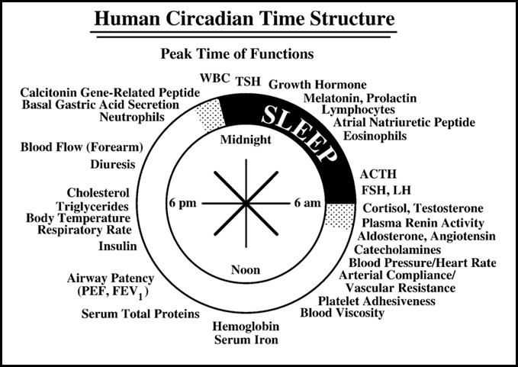

# Figure 1: Human Circadian Rhythm Structure (Kalsbeek *et al*., 2008).

The figure shows the peak time of a select number of human circadian rhythms in relation to the typical synchronizer routine of most human beings who sleep in darkness from 10.30 pm to 06.30 am and are active during the day between 06.30 am and 10.30 pm.

The peak gastric acid secretion, white blood cell count (WBC) and calcitonin gene related protein, occurs late at night or early in sleep. Growth and thyroid stimulating hormones (TSH), blood lymphocyte, eosinophil number, atrial natriuretic peptide, plasma melatonin, prolactin, and adrenocorticotropic hormone (ACTH) crest during sleep. Follicle stimulating (FSH), luteinizing (LH) hormone, cortisol, plasma renin activity, angiotensin, aldosterone, arterial compliance, vascular resistance, platelet aggregation and blood viscosity peak in the morning. Haemoglobin, insulin concentration, the spirometric measures of airways caliber, FEV (forced expiratory

volume in 1second) and PEF (peak flow rate) peak at noon. The circadian rhythms of serum cholesterol, triglycerides and urinary diuresis crest early in the evening (Brahma and Gali, 2012).

# Chronopharmacology

Chronopharmacology is the study of changes in the pharmacology of drugs with reference to the time of administration (Lemmer 2005). It investigates the effects/side effects of drugs on temporal changes in biologic function and evaluates drug effect as a function of biological timing (Lemmer, 1994). Chronopharmacology is useful in designing strategies that enhance the desired effect of drugs and ameliorates or eliminate the undesired effects. It has been shown in humans that the metabolic fate of a pharmacologic agent is not a constant but is a function of time of day it is administered (Rajkumar *et al*., 2010).

The pharmacokinetics and pharmacodynamics of a medication and nutrients are directly affected by biological rhythm, as such chronopharmacological approaches can be used to reduce side effects and make the drugs more bio available (Belge *et al*., 2012). The knowledge of a twenty-four hour rhythm in the pathophysiology and symptoms of diseases and an evidence of a twenty-four hour rhythm in the pharmacokinetics, efficacy and toxicity of drugs constitute the rationale for chronopharmacology (Ohdo, 2010). Chronopharmacological strategies are used in the treatment of various diseases such as myocardial infarction, hypertension, bronchial asthma, arthritis, hypercholesterolemia, stroke and peptic ulcer disease (Rohan *et al*., 2012).

# Chronotherapy

Chronotherapy is the optimization of drug effects and/or minimization of toxicity by timing medication with regards to biological rhythms. It refers to a treatment strategy in which drug availability is timed to match rhythms of diseases in order to optimize therapeutic outcomes and ameliorate side effects (Devdhawala and Seth, 2010; Patel *et al*., 2011). The specific time that patients take their medication is important as it has impact on the outcome of drug therapy. The effectiveness and toxicity of many drugs vary depending on their dosing time (Brahma and Gali, 2012). Chronotherapy takes into account predictable administration time dependent variation in the pharmacokinetics of drugs as well as the susceptibility of target tissues due to temporal organization of physiochemical processes and functions of the body (Lemmer and Labrecque 1987). Chronotherapy helps to optimize therapy especially in cases where patients are already having compromised kidneys, hearts, livers or any other organ dysfunction (Koppisetti *et al*., 2011).

# Chronotoxicity

Chronotoxicity is the study of the adverse effects of chemical agents on living organisms in relation to their circadian rhythms. It examines periodic changes in sensitivity of living organisms to toxicants. The chemicals that people come in contact with can be more or less toxic depending on the time of exposure (Motohashi and Miyazaki, 1990; Harabuchi *et al*., 1993). In cancer chemotherapy the maximization of the antitumor effects to tumor cells and the minimization of toxicity to normal cells are important, as such the use of chronotoxicological strategies can improve tumor response and reduce toxicity, by administration of highly toxic anticancer agents at the times in which they are best tolerated (Ohdo *et al*., 1997). Classes of medications

that have high risk of adverse effects and relatively narrow therapeutic range, in particular are likely to show significant dosing-time differences in safety and toxicity (Brahma and Gali, 2012).

# Circadian Rhythms

Circadian rhythms are self-sustaining endogenous oscillations occurring in a period of twenty-four hours (Aschoff, 1981). Studies have demonstrated that there is apparently no organ and no function in the body which does not exhibit a daily rhythmicity. If measured hour by hour; the number of dividing cells in any tissue, the volume of urine excreted, the reaction of a drug, or the accuracy and speed with which arithmetic problems are solved, it is found that there is a maximum value at one time of day and a minimum value at another (Aschoff, 1965). These rhythms are expressions of a physiological clock which is considered as a basic feature in all living systems, including unicellular organisms. The rhythms are controlled by suprachiasmatic nuclei (SCN) that is situated in the hypothalamus. The SCN is the master clock that regulates all the circadian clocks located in the cells, tissues, organs and systems of the body (Pittendrigh, 1961; Silver and Schwartz, 2005; Lamont *et al*., 2007).

Brain lesion studies in animals have shown that neurons in the suprachiasmatic nuclei (SCN) are involved in this time keeping (Stephen and Zucker, 1974; Schwartz and Zimmerman, 1990). Studies have extensively demonstrated that the SCN lesions can disrupt the temporal pattern of the sleep wake cycle and core body temperature (Cohen and Albers, 1991; Grosse *et al*., 1995). Research has also shown that transplanting fetal SCN tissue in a SCN lesioned animal can restore its rhythmic behavior and isolated SCN neurons preserve the circadian control of their neuronal

firing rate (Lehman *et al*., 1987; Reppert and Weaver, 2002). Explants of mammalian organs such as heart, skin and retina revealed the existence of oscillators and each peripheral oscillator is known to have tissue specific differences in circadian phase and period (Yamazaki *et al*., 2000; Abe *et al*., 2002).

The circadian system can be conceived as comprising a central circadian clock or pacemaker (SCN), a set of input pathways mediating the effects of various environmental synchronizers on the pacemaker (such as light and darkness) and a set of output pathways conveying pacemaker signals to other regulatory systems of the brain and body (Rosenwasser, 1992). Circadian rhythms are generated by an internal clock or pacemaker. As such, these rhythms persist even in the absence of cues indicating the time or length of the day. Although circadian rhythms are endogenous (self-sustained) they are adjusted (entrained) to the environment by external cues called zeitgebers, the primary one which is daylight (Kosobud *et al*., 2007). Circadian rhythms exhibit four main characteristics which are:

* + - 1. The rhythms repeat themselves, once in an approximate twenty four hour period.
      2. The rhythms persist in constant condition in the absence of external cues.
      3. The rhythms are entrainable, that is, they can be adjusted to match local time.
      4. The rhythms exhibit temperature compensation (Tosini and menaker, 1996; Reyes *et al*., 2008).

Nearly all functions of the body, including those influencing pharmacokinetic parameters such as drug absorption and distribution, drug metabolism and renal elimination show significant variations within the day. These functions include hepatic metabolism, hepatic blood flow, first pass effect, glomerular filtration, renal

plasma flow, urine volume, urine PH, blood pressure, heart rate, organ perfusion rates, acid secretion in the GIT and gastric emptying time (Lemmer, 2007). Drugs have also been shown to display significant variations in their effects throughout the day even after chronic administration or constant infusion (Koppisetti, 2010).

# Circadian Rhythms and Disease States

Most physiological systems in the human body show a circadian dependent pattern in their functions; as such, disease patterns also show time differences in their manifestations and severity. In the cardiovascular system, most activities show a circadian rhythm. Under the influence of both external stimuli and endogenous homeostatic mechanisms, cardiac electrophysiological mechanisms change diurnally and enable the cardiovascular system to adapt to rest-exercise cycles (Belanger, 1993). Also the hepatic, gastrointestinal, and renal systems show a circadian dependent pattern in their physiological functions (Koppisetti *et al*., 2011). Hepatic blood flow and liver enzyme activity show circadian variations. Gastric acid secretion, gastric emptying time and gastrointestinal blood flow vary with time of the day (Brahma and Ghali, 2012). Examples of diseases that show circadian rhythm in their manifestation are:

* + - 1. Cardiovascular Diseases: Cardiovascular functions such as blood pressure, heart rate, cardiac output and stroke volume, are subject to circadian rhythm. Capillary resistance and vascular reactivity are higher in the morning and decrease later in the day. Platelet aggregability is increased and fibrinolytic activity is decreased in the morning leading to a state of relative hyper coagulability of the blood (Portaluppi and Hermida, 2007). Modification of these circadian triggers by pharmacologic agents may lead to the prevention of adverse cardiac events. Numerous studies have shown an increase in the

incidence of early-morning myocardial infarction, sudden cardiac death, stroke and episodes of ischemia (Baumgart, 1991). Both systolic and diastolic blood pressures are highest in the late afternoons and gradually decrease in the evenings to attain the lowest values at nights which can be attributed to circadian rhythms in the nervous and endocrine systems (Dodt and Breckling, 1997; White, 2001).

* + - 1. Bronchial Asthma: Chronic airway inflammation and limitation of airflow in the airways characterize bronchial asthma. Symptoms of airway resistance, bronchoconstriction, paroxysms of coughing, wheezing, and dypsnoea increase progressively at night. Chronopharmacological studies statistically show that the development of asthma symptoms and many types of bronchospastic attacks is clearly more common from midnight to early morning (Martain, 1988; Yoan, 2004; Smolensky, 2007).
      2. Pain: Pain threshold does not follow the same pattern in all tissues, for example the sensitivity threshold of the gingival to a cold stimulus was maximal at 1800 hours. (Brahma and Gali, 2012). Circadian rhythms in acute pain have been recorded. The peak demand for morphine or hydromorphone occurred in the early morning and was lowest during the night in postoperative gynecologic patients (Bruguerolle and Labrecque, 2007).
      3. Arthritis: Patients with osteoarthritis tend to have less pain in the morning and more at night. Conversely those with rheumatoid arthritis have pain that usually peaks in the morning and decrease throughout the day. Ankylosing

spondylitis is characterized by swelling and discomfort of the joints of the back. The overall back stiffness and pain were a problem throughout the twenty four hours, but pain intensity was rated two to three times higher and stiffness about eight times greater between noon and 1500 hours (Lee *et al*., 1997; Ohdo, 2010; Prasanthi, 2011).

* + - 1. Cancer: The tumor cells and the normal cells differ in their chronobiological cycles. This fact is the basis for the chronopharmacology of cancers. Based on studies which suggested that the DNA synthesis in the normal human bone marrow cells has a peak around noon while the peak of DNA synthesis in lymphoma cells is near midnight (Hruchesky, 1994).
      2. Hypercholesterolemia: Cholesterol synthesis is generally higher during the night than during daytime. Studies with HMG COA reductase inhibitors have suggested that evening dosing was more effective than morning dosing (Mandall, 2010).
      3. Allergy: Both local and systemic allergic reactions are mediated through interactions of immune and inflammatory responses. Scientists have discovered that the symptoms of allergic rhinitis and even the skin testing results can vary according to the time of day (Lee *et al*., 1997). For sufferers of allergic rhinitis the major symptoms of sneezing, runny nose and stuffy nose are typically worsened in the evenings (Ohdo, 2010). Studies in animals and man have shown that the time of day at which an antigen is encountered has an influence on the expression of any subsequent cell-mediated immunity,

when the responses are measured after a fixed interval. This suggests that immune processes are modulated by intrinsic biological rhythms (Smolensky *et al*., 2007).

* + - 1. Peptic ulcer disease: When a histamine antagonist is given at night it produces better relief of peptic ulcers, unlike when given at regular intervals around the clock. This is because; more acid secretion, more pain and perforation of gastric and duodenal ulcers occurs at night than in the day time as the rate of stomach acid secretion is highest at night. The timing of ulcer medications has a significant impact on their therapeutic effect (Moore, 1970).
      2. Sleep disorders: Sleep consists of a rhythmic combination of the changes in physiological, biochemical and psychological processes. When the circadian rhythm is disturbed or when the individual processes are abnormal during sleep, it may result in a variety of disorders. The ability to cope with circadian rhythm disturbances also differs from person to person (Kumar, 2008).

# Circadian Rhythms and Pharmacology of Drugs

The efficacy and toxicity of many drugs vary with time of administration, associated with twenty-four hour rhythm of biochemical, physiological and behavioral processes, under the control of the circadian clock (Maurya *et al*., 2012; Satwara *et al*., 2012). The human body is not static in its functions over time, thus not only the dosage but also the timing of administration influences a drug’s therapeutic and toxic effects (Baraldo, 2008). Pharmacokinetic parameters including the peak drug plasma concentration (Cmax), the time to reach peak plasma concentration (tmax), the area

under the concentration curve (AUC), volume of distribution (Vd), protein binding, elimination half-life, (t1/2) and clearance (cl) which are conventionally considered constants are circadian time dependent (Shiga *et al*., 1991). Tissues responsiveness to a drug, which may reflect the number of receptors or binding sites, on target cells or their metabolic activity, also exhibits circadian rhythms. Changes in the effects of a drug when administered at different times over the course of a twenty-four hour period stem from the circadian variation in pharmacokinetics and tissue responsiveness (Lemmer, 1991). Examples of drugs that show circadian variation in their therapeutic effects and toxicities are:-

* + - 1. Anti-asthmatics: Theophyline has a greater peak concentration (Cmax) when it is administered in the evenings than at other times of the day (Reinberg *et al*., 1987).
      2. Antibiotics: Aminoglycoside antibiotics have been found to be most toxic when administered at the resting phase and less toxic when given at the active phase of animals and humans (Nakano *et al*., 1998). Circadian variations have also been shown in the pharmacokinetics of several antibiotics in humans. Amikacin, netilmicin, ciprofloxacin, sulphamethoxazole and cefodime have all shown circadian variations in their pharmacokinetics (Lemmer, 1991).
      3. Anti-cancer: The activity of dehydropyrimidine dehydrogenase in human mononuclear cells increases by 40% around midnight. This enzyme brings about the intracellular catabolism of 5-fluorouracil and contributes to improved tolerability of this drug between 0000 hours and 0400s hour. In

contrast cisplatin is better tolerated between 1600 hours and 2000 hours, this seems to contribute to the decreased renal toxicity of cisplatin during evening administration. Other anticancer drugs like doxorubicin, etoposide, and methotrexate have all been shown to exhibit circadian variations in their toxicities (Chawla and Chawla, 2012).

* + - 1. Anti-ulcer: Histamine receptor blockers (ranitidine, cimetidine, famotidine and roxatidine), are more effective when taken in the late afternoon to early night when acid secretion is increasing. In contrast proton pump inhibitors (PPI’s) should be dosed in the morning because lansoprazole and omeprazole related increase in intragastric PH is more pronounced after morning than evening administration (Moore and Halberg, 1986).
      2. Anti-hypertensives: Drugs such as nifedipine, oral nitrates and propranolol have peak plasma concentrations that are twice as high after morning dosing as against evening dosing. Atenolol, a hydrophilic β blocker has a poorer absorption following morning administration compared with evening administration. In contrast, propranolol a lipophilic β blocker is more absorbed after morning administration compared with evening administration. This confirms that the absorption rate of lipophilic but not hydrophilic drugs is faster after morning dosing (Santini *et al*., 1999; Bruguerolle and labrecque, 2007).
      3. Anti-inflammatory drugs: Non-steroidal anti-inflammatory drugs (NSAIDs) like indomethacin and ketoprofen have shown that they have a greater rate of

absorption and extent of bioavailability when they are given in the morning than when administered in the evening (Youan, 2004).

* + - 1. Opioid Analgesics: Stronger analgesic effects were observed when tramadol and dihydrocodeine were administered in the evening to relieve pain. Peak morphine use occurred at 0900 hours and least use at 0300 hours in postoperative patients undergoing elective cholecystectomies (Rohan *et al*., 2012).
      2. Local Anesthetics: The duration of local anesthesia was longest when amide type local anesthetics (lidocaine, mepivacaine, ropivacaine and betoxycaine), were applied around 1500 hours. A 60% change was found in the twenty-four hour plasma clearance of bupivacaine, the clearance being greatest at 0600 hours (Rohan *et al*., 2012).
      3. General Anesthetics: Barbiturates like pentobarbital and hexobarbital have higher brain concentrations when injected during the dark phase, midazolam a benzodiazepine was found to have a shortest elimination half-life at 1400 hours and longest at 0200 hours. Actions of ketamine, etomidate and propofol were found to be longer at night than during the day (Rohan *et al*., 2012).

Other drugs like sumatriptan an anti-migraneous agent, cyclosporine an immunosuppressant and anticholesteraemic medications have all been found to exhibit circadian dependent variation in their activity (Rohan *et al*., 2012).

# Zeitgebers

The term zeitgeber is a German word for “time giver”. It is used to describe environmental or external cues that can entrain or reset human circadian rhythms, such as light and darkness (Refinetti and Menaker, 1992). The time needed for one circadian oscillation to occur under constant conditions is known as the free running period (FRP). Under normal conditions a rhythm is said to be circadian if the oscillation has a period of approximately twenty-four hours and continues in constant conditions, such as constant light or darkness. The inability of a rhythm to continue under constant condition implies that the rhythm is driven by external time cues (zeitgeber), rather than generated internally (Kuhlman *et al*., 2008). The process by which a rhythm synchronizes to an external cue is called entrainment. To establish that a zeitgeber cycle has indeed entrained a rhythm, it is necessary to show that the period of the rhythm equals the period of the zeitgeber cycle and after releasing the organism from a zeitgeber cycle, the free running period (FRP) resumes with a phase determined by the zeitgeber cycle (Johnson *et al*., 2003). Circadian rhythms are likely entrained by zeitgebers in our environment in order to yield a period of almost exactly twenty four hours even though the inherently free running cycle is about twenty five hours (Moore-Ede *et al*., 1983).

# Aminoglycoside Antibiotics

The Aminoglycosides are a group of semi-synthetic polycationic compounds, typified by the presence of amino-sugars glycosidically linked to aminocyclitols. The individual members are distinguished by the type of amino sugars attached in glycosidic linkage to a hexose nucleus (Mingeot-Leclerq and Tulkens, 1999). The aminoglycosides have potent antibacterial activity and also share similar

pharmacokinetic properties and toxicity profiles. They generally have more activity against gram negative aerobes (Kahlmeter and Dahlager, 1984). The aminoglycosides are gentamicin, streptomycin, amikacin, tobramycin, netilmicin, kanamicin and neomycin. Gentamicin is the aminoglycoside most commonly used, although amikacin has the widest spectrum of action (Gonzalez and Spencer, 1998).

Aminoglycosides are bactericidal, they act by diffusing through aqueous channels into the periplasmic space of the gram negative bacteria and interfere with bacterial protein synthesis by binding to the 30s ribosomal unit. Subsequent movement of the drug into the bacterial cytoplasm is dependent on electron transport. This phase of drug transport has been termed an energy dependent phase (EDP) and it is the rate limiting step of aminoglycosides transport into the bacterial cell. This rate limiting step can be inhibited by decrease pH, divalent cations, anaerobiosis and hyperosmolarity. This explains the reduction of antibacterial activity of aminoglycosides under anaerobic condition and in acidic pH (Neu, 1992). They are poorly absorbed from the gastrointestinal tract and are administered by intramuscular or intravenous routes. They are highly polar compounds and do not enter cells readily and are largely excluded from the central nervous system and the eye, however high concentrations are achieved in the renal cortex, perilymph and endolymph of the inner ear, which may account for their nephrotoxic and ototoxic properties. They are eliminated unchanged by glomerular filtration in the kidney, with almost 99% being eliminated (Lortholary *et al*., 1995). All aminoglycosides cross the placenta barrier and may accumulate in fetal plasma and amniotic fluid, making them contraindicated in pregnancy. They are used for the treatment of urinary tract infections, complicated skin and soft tissue infections, intra-abdominal infections and endocarditis in

combination with other antimicrobial agents (Kahlmeter and Dahlager, 1984; Gilbert, 1991). Aminoglycosides are often combined with a beta lactam antibiotic in the treatment of infections. This combination enhances bactericidal activity where monotherapy may be ineffective (Lebrun *et al*., 1999).

# Gentamicin

Gentamicin is the most important of the aminoglycosides and is widely used for the treatment of moderate to severe infections. It has a wide spectrum of antimicrobial activity against gram negative aerobes, but its effectiveness is reduced in infections due to anaerobes (Kalava and Menon, 2012). Despite its nephrotoxic potential, gentamicin is still considered to be an important agent against life threatening infections. It is bactericidal and exhibits a concentration dependent killing and has a significant post antibiotic effect (Ali, 2003).

# Therapeutic Uses

Gentamicin is indicated in the treatment of serious infections caused by susceptible strains of gram negative organisms. Gentamicin is useful for treating septicemia and neonatal sepsis, central nervous system infections, acute pyelonephritis and prostatitis. It is also used for treating respiratory tract infections, urinary tract infections, soft tissue infections including peritonitis and burn complications in combination with penicillin, it is effective in endocarditis (Lebrun *et al*., 1999).

# Gentamicin Nephrotoxicity

Gentamicin causes renal failure in up to 10 - 30% of patients treated with the drug and is the cause of the largest proportion of drug induced acute nephrotoxicities (Leehey

*et al*., 1993). The renal impairment due to gentamicin administration is as a result of marked accumulation and retention of the drug in proximal tubular cells. The cells get damaged resulting in proteinuria, hyaline and granular casts. Glomerular filtration rate is reduced after several days (Nakai and Takano, 2004). The toxic mechanisms include uptake of the drug by proximal tubular cells where it is first sequesterated within lysosomes and development of a lysosomal phospholipidosis, which is rapidly associated with cell necrosis and various alterations to subcellular structure and function (Tulkens, 1989).

The clinical manifestation of gentamicin nephrotoxicity is non oliguric or polyuric dysfunction of renal excretion accompanied with increase in plasma creatinine, urea and other metabolic products of the organism, such as proteinuria, enzymuria, aminoaciduria, glycosuria, and electrolyte alterations like hypercalciuria, hypermagnesuria, hypocalcemia and hypomagnesemia (Lopez-Novoa *et al*., 2011).

# Risk Factors for Gentamicin Nephrotoxicity

Several risk factors for aminoglycoside associated nephrotoxicity have been identified, including the presence of co-morbidities, volume depletion, liver dysfunction, sepsis, renal dysfunction, hypokalemia and hypomagnesemia. Other risk factors include; advanced age, prolonged therapy, frequency of aminoglycoside dosing, and simultaneous administration of other medications like vancomycin or frusemide (Oliveira *et al*., 2009; Selby *et al*., 2009).

# Biomarkers for Gentamicin Nephrotoxicity

A biomarker is a parameter that is objectively measured and evaluated as an indicator of normal biologic processes, pathogenic processes, or pharmacologic responses to a therapeutic intervention (Strimbu and Tavel, 2011). The best biomarkers are obtained non-invasively, are easy to measure and can be detected in body fluids (Han and Bonventre, 2004). Several biomarkers of renal injury can be obtained and evaluated. Changes in the levels of a number of biomarkers in the serum and urine is reflected as nephrotoxicity (Vaida *et al*., 2008). Routinely used biomarkers for detection of gentamicin nephrotoxicity are serum creatinine, serum urea, albumin and total protein. New novel biomarkers include kidney injury molecule-1 and N-acetyl-β-D- glucosamidase (Deravarashan, 2007).

# Strategies for Amelioration of Gentamicin Nephrotoxicity

Various strategies have been elucidated for the amelioration of gentamicin nephrotoxicity. These strategies include once daily dosing of gentamicin, dietary measures, administration of gentamicin at time of lowest toxicity (temporal variation), use of antioxidant and therapeutic drug monitoring (Bailey *et al*., 1997; Paranjpe *et al*., 2005).

# Once Daily Dosing

Traditionally, gentamicin has been administered in two or three divided doses per day by intermittent infusion. Studies in man have shown that once daily administration of aminoglycosides has a predictably lower probability of causing nephrotoxicity in patients treated with gentamicin (Ali and Goetze, 1997). Studies have demonstrated that the correlation between the nephrotoxic effects of aminoglycosides and the

accumulation of the drug in the cortex of the kidney may be related to dosing schedule. Administration of larger doses less frequently may reduce the level of drug accumulation in the kidney cortex and thereby may reduce the nephrotoxicity of the drug. It has also been shown that once daily dosing offers an equal or more favorable clinical outcome compared to multiple dosing (Bailey *et al*., 1997). Also, the added convenience of once daily dosing makes it an attractive alternative to conventional dosing.

# Dietary Measures

Experimental studies on the role of feeding schedule on circadian rhythm in mice has demonstrated that feeding schedule can alter gentamicin nephrotoxicity by changing the rhythm of gentamicin kinetics (Song *et al*., 1993). Studies have shown that minimal toxicity of gentamicin occurs during the period of maximal food intake. Effects of fasting on the nephrotoxicity of gentamicin showed that fasted rats are more susceptible to the renal toxicity of gentamicin (Beauchamp *et al*., 1996). These suggest that food intake may be responsible in part for the temporal variations in the nephrotoxicity of gentamicin. It is well acknowledged that periodic access to food synchronizes several circadian rhythms.

# Time of Administration

It has been demonstrated that gentamicin injected in the middle of the rest period induced a higher renal toxicity than gentamicin injected in the middle of the activity period. The effectiveness and toxicity of many drugs vary depending on dosing time associated with twenty four hour rhythms of biochemical, physiological and behavioral processes under the control of the circadian clock (Paranjpe *et al*., 2005).

Numerous studies in man and animal models have shown that gentamicin exhibits a temporal variation in its nephrotoxicity (Prins *et al*., 1997; Nakano *et al*., 1998).

# Use of Antioxidants

The aminoglycoside antibiotic gentamicin elicits renal tubular toxicity and cell death. *In-vivo* and *in-vitro* studies demonstrated the mediation of reactive oxygen species in the tubular effects of gentamicin. Reactive oxygen species have been identified as mediators of proximal tubular necrosis and acute renal failure caused by gentamicin. Gentamicin inhibits phosphorylation and reduces ATP levels in renal tubular cells. Oxidative stress has also been reported in the tubular toxicity of gentamicin, thus gentamicin enhanced reactive oxygen species (ROS) formation. ROS induced cell death was found to have a role in gentamicin mediated acute renal failure. Therefore, concurrent administration of antioxidants during gentamicin therapy might ameliorate the damage caused by ROS (Walker *et al*., 1999).

The specificity of gentamicin for renal toxicity is apparently related to its ability to increasingly facilitate the generation of radical species, including superoxide anions, hydrogen peroxides and hydroxyl radicals in mitochondria, a few of which appear to be a crucial part of the antioxidant deficiency associated oxidative stresses in the renal proximal convulated tubules (Maldonado *et al*., 2003; Yanagida *et al*., 2004). Studies have demonstrated that treatment of laboratory animals with vitamin E before administration of gentamicin can prevent both the functional and histological changes induced by gentamicin in rats (Derakhshanfar *et al*., 2007). Also various alternatives possessing antioxidant properties have been used in order to minimize gentamicin induced oxidative stress in animal models. Plant extracts have been reported to be

effective in ameliorating gentamicin nephrotoxicity. Examples include, grape seed extract amelioration of nephrotoxicity in rat, which might be due to the presence of polyphenolic compounds (Safa *et al*., 2010). Green tea extract which contains catechin and other polyphenolic compounds has also been documented to prevent gentamicin induced nephrotoxicity in rats (Khan *et al*., 2009; Abdel-Raheem *et al*., 2010). Other plant extracts that have been shown to ameliorate gentamicin nephrotoxicity in animal models are *Momordica dioca* extract, curcumfin obtained from *Curcuma longa* and erdosteine (Farrombi *et al*., 2006; Reiter *et al*., 2009; Jain *et al*., 2010).

# Therapeutic Drug Monitoring

Therapeutic monitoring service involves measuring drug concentrations, generating individual patient’s pharmacokinetic data and interpreting such data together with other information about the patient’s clinical conditions to optimize his/her drug therapy (Schumacher and Barr, 1998). Studies that have evaluated the effects of therapeutic drug monitoring on patient outcomes have shown favorable outcomes which include decreases in adverse effect, mortality rates and length of hospital stay. Therapeutic drug monitoring in gentamicin therapy has resulted in reduced incidence of nephrotoxicity, duration of therapy and length of hospital stay (Abdelrahman *et al*., 2012). In addition, studies have demonstrated a faster resolution of infection in patients who received clinical pharmacokinetic consultation compared to patients who did not, particularly in vulnerable patients such as the elderly (Triggs and Charles, 1999).

# Temporal Variation of Gentamicin Nephrotoxicity

Studies in animal models and man have demonstrated that the renal toxicity of gentamicin is circadian dependent (Pariat *et al*., 1990). The clearance of gentamicin depends on the time of day of drug administration, showing a lower clearance at night and a peak clearance during the day in man (Nakano *et al*., 1998). In a prospective study conducted on two hundred and twenty one patients with severe infections and treated once daily with gentamicin at a dose of 40 mg/kg at three different time periods, it was found out that serum trough and peak drug levels were not significantly different among the three time periods, but nephrotoxicity, assessed by a rise in serum creatinine, occurred significantly more often when the gentamicin was given at the resting period compared to the other two periods (Prins *et al*., 1997). Changes in the susceptibility of renal cells according to the time of the day, circadian variations of endogenous hormones secretion and changes in the serum and intracortical pharmacokinetics of gentamicin are among the mechanisms proposed to explain the temporal variation in the nephrotoxicity of this drug (Lin *et al*., 1994; Beauchamp *et al.,* 1995).

# CHAPTER THREE

# MATERIALS AND METHODS

# Animals

Seventy-six adult albino wistar rats of either sex, weighing between 120 to 170 g were used for this study. Animals were obtained from the animal house of the Department of Pharmacology and Therapeutics, Ahmadu Bello University Zaria. The animals were maintained in a well-ventilated room in the department’s animal house under standard conditions of natural light and day cycle. They were placed on vital grower feeds (vital feeds) and water *ad libitum*. Ethical approval was obtained from the departmental ethics committee and all experiments performed on laboratory animals in this study were done following “The Principles on Laboratory Animal Care” (NIH Publication, 1985).

# Drugs and Chemicals

Gentamicin (Taylek), Vitamin B Complex (Laborate) which contains 25 mg of Vitamin B1 (thiamine), 2 mg of Vitamin B2 (riboflavin), 50 mg of Vitamin B3 (Nicotinamide) 5 mg of Vitamin B5 (D-panthenol) and 2.5 mg of Vitamin B6 (Pyridoxal Phosphate) per 10 ml vial, Chloroform (Sigma Chemical Co, U.S.A.), distilled water, formaldehyde, picric acid, 0.9% W/V sodium chloride solution, phosphate buffered saline.

# Equipment and Sundry Consumables

Animal cages, digital weighing balance, pestle and mortar, syringe (1 ml, 2 ml, 5 ml, 10 ml), needles, hand gloves, beaker, cotton wool, dissecting kit.`

* 1. **Determination of Nephrotoxic Dose of Gentamicin to be used** Graded doses of gentamicin were administered to the animals for ten days to determine a working nephrotoxic dose of gentamicin. Gentamicin at doses of 80, 100, and 120 mg/kg were administered to three groups of wistar rats of both sexes at 1200 hours daily for ten days. A fourth group received normal saline at 10 ml/kg as control for the same duration. All drugs were administered intraperitoneally. The experiment was terminated on the tenth day, eight to fourteen hours after the last treatment, using chloroform anaesthesia. Blood samples were collected from the jugular vein in sterile labeled plain sample tubes and centrifuged at 3000 rpm for ten minutes to obtain a clear serum using a centrifuge (Ogunsanmi *et al*., 1994). The serum obtained was used for biochemical analysis of serum urea, creatine, protein, bilirubin, electrolytes and liver function biomarkers. Kidneys were harvested and weights were taken. The kidneys were fixed in 10% buffered formalin solution and used for histological examination.
  2. **Determination of Least Toxic Time for Administration of Gentamicin** Thirty wistar rats of both sexes, weighing between 120 – 170 g were divided into five groups of six rats based on their weights. Group 1 served as control and received 10 ml/kg of normal saline at 1200 hours. Groups 2, 3, 4 and 5 received 100 mg/kg of gentamicin at 0800 hours, 1200 hours, 2000 hours and 0000 hours respectively for ten days. All drugs were administered intraperitoneally. The experiment was terminated on the tenth day, eight to fourteen hours after the last treatment using chloroform anaesthesia and blood samples were collected from the jugular vein and procedures as previously stated in section 3.4 were followed. The left kidney was weighed, fixed in 10% buffered formalin solution and processed for histological examination. A time of

maximal toxicity of gentamicin nephrotoxicity and a time of minimal toxicity was established.

# Comparative Assessment of Vitamin B Complex Therapy Against Time of Administration as Ameliorative Strategies in Gentamicin Nephrotoxicity

Thirty wistar rats of both sexes weighing between 120 to 170 g were divided into five groups of six rats. . Group 1 served as control and received 10 ml/kg of normal saline at 1200 hours. Group 2 and 4 received 100 mg/kg of gentamicin at 1200 and 0000 hours respectively for ten days. Group 3 and 5 received gentamicin 100 mg/kg concurrently with vitamin B complex 3 ml/kg at 1200 and 0000 hours respectively daily for 10 days. All drugs were administered intraperitoneally. The experiment was terminated on the tenth day, eight to fourteen hours after the last treatment using chloroform anaesthesia and blood samples were collected from the jugular vein and procedures as previously stated in section 3.4 were followed. Kidneys were removed, weighed and the left kidney fixed in 10% buffered formalin solution and processed for histological examination.

# BIOCHEMICAL ANALYSIS

# Determination of Serum Creatinine

Serum creatinine was determined with a biochemical auto analyzer using the alkaline picrate method. This method is based on the reaction of creatinine in the serum with alkaline picrate to form a coloured complex. The formation of the colored complex is directly proportional to the creatinine concentration. The intensity of color produced

is measured photometrically at 510 nm and is compared with that of the standard (Henry *et al*., 1974).

# Determination of Serum Urea

Serum urea was determined with a biochemical auto analyzer using the modified Berthelot method. This method is based on the reaction between ammonia and hypochlorite with salicylate in alkaline medium to form dicarboxyindophenol, a colored compound. The reaction is catalyzed by sodium nitroprusside. The intensity of color produced is measured photometrically at 570 nm (Fawcett and Scott, 1960).

# Determination of Total Protein

Protein was determined using the Biuret’s method. In an alkaline medium, protein reacts with copper in the biuret reagent causing an increase in absorbance. The increase in absorbance is directly proportional to the coloured complex formed at 540 nm (Gornall *et al*., 1949).

# Determination of Total Bilirubin

Serum bilirubin was determined by reaction with diazotized sulfanilic acid, obtained from sodium nitrite and sulfanilic acid solutions. Bilirubin forms a pink coloured azo compound when it reacts with diazotized sulfanilic acid at 540-600 nm (Watson and Rogers, 1961).

# Determination of Electrolytes

Serum electrolytes which include sodium, potassium, chloride, calcium and bicarbonate were determined using the flame photometry method (Bassir, 1971).

# Determination of Liver Function Enzymes

Serum alanine transferase (ALT), aspartate transaminase (AST), alkaline phosphatase (ALP) were determined using colorimetric kits of standard analytical grade.

# Determination of Alanine Amino Transferase (ALT)

L-Alanine and α-ketoglutarate react in the presence of glutamic pyruvic transaminase (GPT) in the sample to yield pyruvate and L-glutamate. Pyruvate is reduced by lactate dehydrogenase to yield lactate with oxidation of NADH to NAD. The reaction was monitored by measurement of the absorbance of NADH at 340 nm. The rate of reduction in absorbance is proportional to GPT activity in the sample (Reitman and Frankel, 1957).

# Determination of Aspartate Amino Transferase (AST)

In this reaction, L-Aspartate and α-Ketoglutarate react in the presence of (glutamic oxaloacetic transaminase) GOT in the sample to yield oxaloacetate and L-glutamate. The oxaloacetate is reduced by malate dehydrogenase (MDH) to yield L-malate with the oxidation of NADH to NAD. The reaction was monitored by measurement of the decrease in absorbance of NADH at 340 nm. The rate of reduction in absorbance is proportional to GOT activity in the sample (Reitman and Frankel, 1957).

# Determination of Alkaline Phosphatase (ALP)

Alkaline phosphatases reacts with esters of phosphoric acid and catalyze hydrolysis and phosphate group release. A colourless solution which turns yellow on hydrolysis is formed. The coloured complex was measured at 405 nm (Kind *et al*., 1980).

# Determination of Oxidative Stress Markers

Glutathione peroxidase (GSH) (Ellman, 1958), superoxide dismutase (SOD) (Beauchamp and Fridovich, 1971) and lipid peroxidation (Lowry *et al*., 1951) were determined using an automated auto analyzer.

# 3.10.1 Determination of Lipid Peroxidation

Lipid peroxidation generates peroxide intermediate which upon cleavage release MDA. MDA reacts with thiobarbituric acid to give a coloured complex which absorbs light at 532 nm. The MDA levels of samples were determined from the calibration graph (Lowry *et al*., 1951).

# Determination of Body Weights and Kidney Weights

Body weights of animals was taken daily throughout the duration of the study. The kidneys of the animals were removed and weighed after euthanization at each phase of the study. Relative kidney weights were determined using the formular below:

RKW = Absolute organ weight (g)

Body of rat on day of euthanization(g)

# Kidney Histology

Animals were euthanized at the end of each phase of the study and kidneys were removed and weighed. The left kidney was fixed in 10% buffered formalin solution, thereafter they were dehydrated with graded doses of xylene, embedded in molten paraffin wax and sectioned at 5µm with a microtome. The sectioned tissues were placed on glass slides and stained with haematoxylin and eosin (H and E) stain (Tulpule and Ghaji, 1987). The tissues were observed under light microscope for pathological changes in structure. Detailed histopathological examination was carried out by a histopathologist. Photomicrographs of the kidney were taken at a magnification of ×250.

# Data Analysis and Presentation of Results

Data are expressed as mean ± standard error of mean and subjected to Levene’s homogeneity of variance test followed by one way analysis of variance (ANOVA). Dunnett’s post hoc test was carried out for phase 1 while Bonferroni’s post hoc test was carried out for phase ІІ and ІІІ of the study. P values of p≤0.05 were considered statistically significant. Data analysis was done using SPSS version 20 by IBM. Results were presented as tables. Kidney sections were presented as photomicrographs.

# CHAPTER FOUR

# 4.0 RESULTS

# The Effect of Graded Doses of Gentamicin Administration on Serum Nephrotoxic Biomarkers in Wistar Rats

Graded doses of gentamicin 80, 100 and 120 mg/kg administered to wistar rats weighing between 120 to 170 kg for ten days to determine a working nephrotoxic dose for gentamicin produced statistically significantly (p≤0.05) higher levels of serum urea, serum creatinine and total bilirubin compared to the control group at doses of 100 and 120 mg/kg. Gentamicin at 80 mg/kg did not produce significant changes in serum urea, creatinine and total bilirubin compared to the control.

# Table 4.1: The Effect of Graded Doses of Gentamicin Administration on Serum Urea, Creatinine and Total Bilirubin in Wistar Rats

|  |  |  |  |
| --- | --- | --- | --- |
| Treatment | Urea  (mMol/L) | Creatinine  (µMol/L) | Total Bilirubin  (mMol/L) |
| Saline 10 ml/kg | 4.20±0.23 | 72.23±5.25 | 9.60±0.69 |
| Gent 80 mg/kg | 12.42±5.31 | 95.50±7.32 | 15.20±1.08 |
| Gent 100 mg/kg | 22.02±5.29 ⃰ | 248±45.81* | 26.13±3.83* |
| Gent 120 mg/kg | 32.45±5.75* | 385±8.50* | 37.35±1.15* |

Values are presented as mean ± SEM; n = 4; *= P≤0.05 when compared to saline control group; One way ANOVA followed by Dunnett’s post hoc test; Gent = Gentamicin

# : The Effect of Graded Doses of Gentamicin Administration on Total Protein, Total Albumin and Triglycerides in Wistar Rats

Administration of graded doses of gentamicin 80, 100 and 120 mg/kg for ten days produced higher levels of total protein, total albumin and triglycerides compared to the control. The gentamicin 100 and 120 mg/kg treated groups resulted in statistically significantly (p≤0.05) higher levels in serum triglycerides when compared to the control group.

# Table 4.2: The Effect of Graded Doses of Gentamicin Administration on Serum Total protein, Total Albumin and Triglycerides in Wistar Rats

|  |  |  |  |
| --- | --- | --- | --- |
| Treatment | Total Protein g/L | Total Albumin g/L | LDH  g/L |
| Saline 10 ml/kg | 64.50±1.55 | 33.75±1.43 | 138.00±1.58 |
| Gent 80 mg/kg | 68.00±2.10 | 33.75±0.85 | 134.50±2.50 |
| Gent 100 mg/kg | 61.50±1.79 | 37.50±1.04 | 164.00±4.35* |
| Gent 120 mg/kg | 66.50±1.50 | 35.50±2.50 | 215.50±11.50* |

Values are presented as mean ± SEM; n = 4;

*= P≤0.05 when compared to the saline control group; One way ANOVA followed by Dunett’s post hoc test; LDH = Triglycerides; Gent = Gentamicin

# The Effect of Graded Doses of Gentamicin Administration on Liver Function Biomarkers in Wistar Rats

Gentamicin 80 mg/kg produced no significant differences in serum liver enzymes (AST, ALT and ALP) compared to the control. Gentamicin 100 and 120 mg/kg produced statistically significantly (p≤0.05) higher levels of AST, ALT and ALP levels in comparison with saline control group.

# Table 4.3: The Effect of Graded Doses of Gentamicin Administration on Liver function Biomarkers in Wistar Rats

|  |  |  |  |
| --- | --- | --- | --- |
| Treatment | AST IU/L | ALT IU/L | ALP IU/L |
| Saline 10 ml/kg | 20.00±1.63 | 34.00±1.63 | 54.25±2.86 |
| Gent 80 mg/kg | 28.00±1.95 | 47.50±4.34 | 69.00±2.73 |
| Gent 100 mg/kg | 59.50±9.91 ⃰ | 64.50±6.58 ⃰ | 112.25±17.92 ⃰ |
| Gent 120 mg/kg | 63.00±2.20 ⃰ | 108.00±7.00 ⃰ | 143.50±10.55 ⃰ |

Values are presented as mean ± SEM; n = 4; *= P≤0.05 when compared with saline control group; One way ANOVA followed by Dunett’s post hoc test; AST, Aspartate Amino Transferase; ALT, Alanine Amino Transferase; ALP, Alkaline Phosphatase, Gent = Gentamicin

# The Effect of Graded Doses of Gentamicin Administration on Serum Electrolyte levels in Wistar Rats

Gentamicin 80, 100 and 120 mg/kg for ten days did not produce any statistically significant change in the levels of serum electrolytes (Na+, K+, Cl+, and Ca2+) when compared to the control group in rats.

# Table 4.4: The Effect of Graded Doses of Gentamicin Administration on Serum Electrolyte levels in Wistar Rats

|  |  |  |  |  |
| --- | --- | --- | --- | --- |
| Treatment | Na+ mMol/L | K+  mMol/L | Cl+ mMol/L | Ca2+  mMol/L |
| Saline 10 ml/kg | 138.75±1.65 | 4.15±0.14 | 98.75±1.37 | 2.42±0.06 |
| Gent 80 mg/kg | 140.25±0.85 | 3.95±0.10 | 101.00±1.91 | 2.21±0.05 |
| Gent100 mg/kg | 135.75±3.01 | 4.27±0.16 | 95.25±3.35 | 2.15±0.13 |
| Gent 120 mg/kg | 135.50±1.50 | 4.55±0.25 | 97.92±0.50 | 2.10±0.11 |

Values are presented as mean ± SEM; n = 4; One way ANOVA did not show significant differences in electrolyte levels, Gent = Gentamicin; Na+ = Sodium; K+ = Potassium; Cl+ = Chloride; Ca2+ = Calcium.

# : Histopathology of Effect of Graded Doses Gentamicin Administration on Kidney in Wistar Rats

The administration of gentamicin at doses of 80, 100 and 120 mg/kg produced pathological changes in structure of the renal cortex. Photomicrographs of sections of the renal cortex were taken at a magnification of ×250.

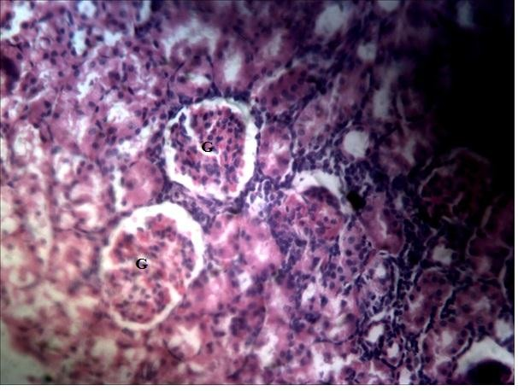

**Plate I: Photomicrograph of a section of rat kidney treated with 10 ml/kg of normal saline for 10 days (×250)** showing normal malphigian renal corpuscle containing glomerulus (G) surrounded by Bowman space and distal convoluted tubules (pointed arrows). H and E stain.

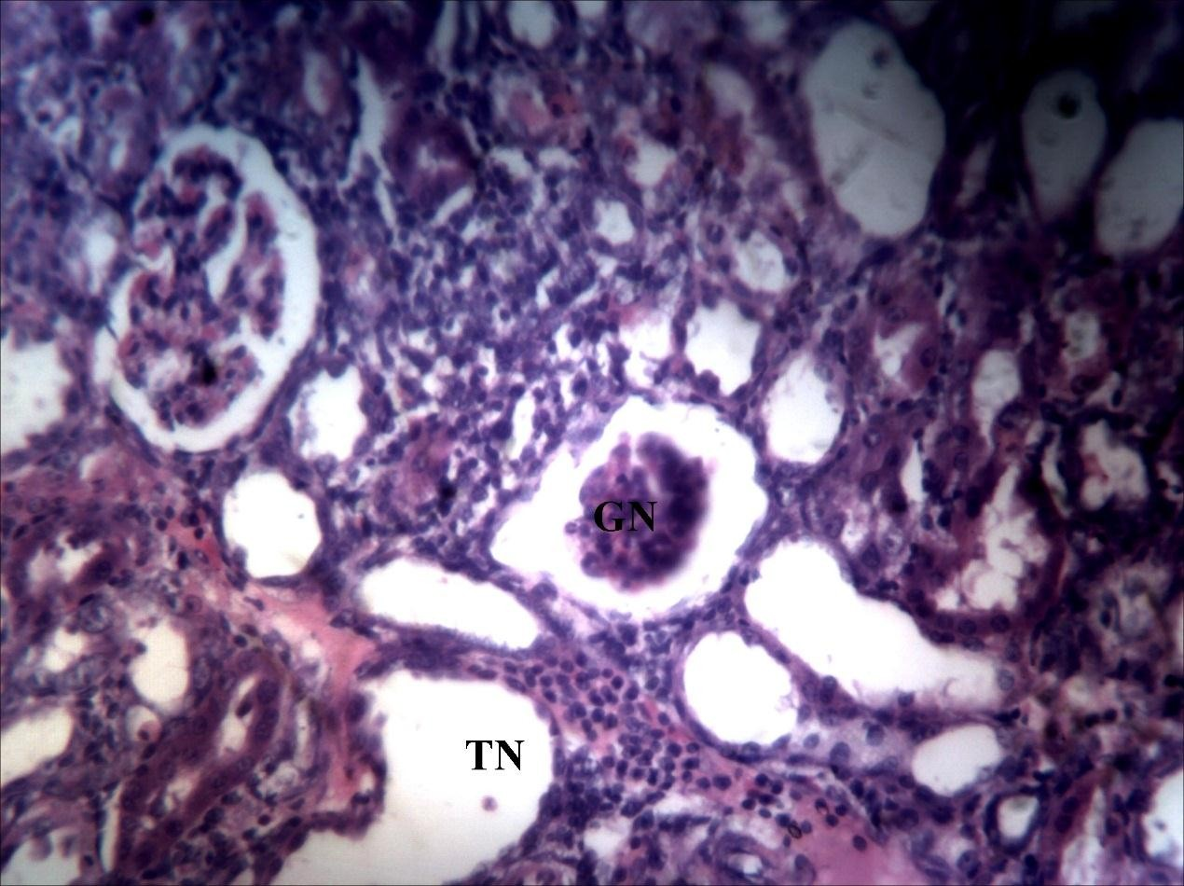

**Plate II: Photomicrograph of a section of a rat kidney treated with 80 mg/kg of gentamicin for 10 days (×250)** showing intense lymphocyte hyperplasia (pointed arrow) with tubular (TN) and glomerular necrosis (GN). H and E stain.

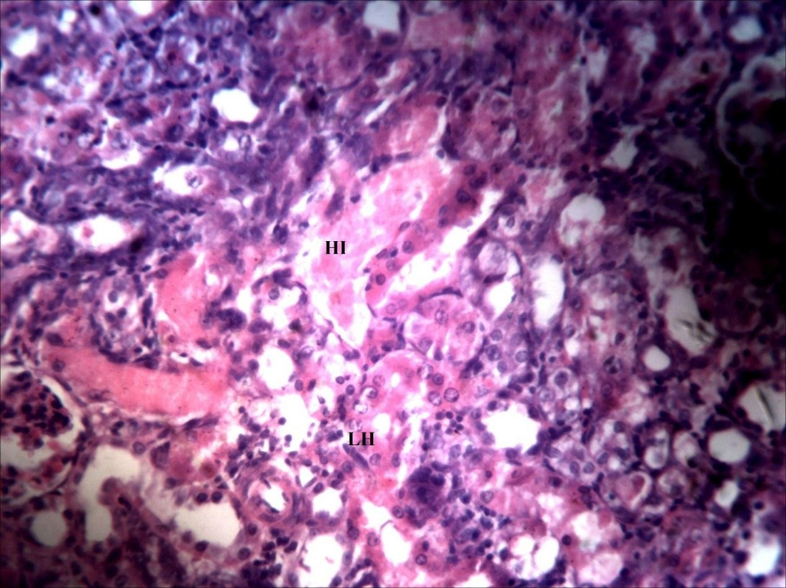

**Plate IIІ: Photomicrograph of a section of a rat kidney treated with 100 mg/kg of gentamicin for 10 days (×250)** showing intense lymphocyte hyperplasia (LH) with haemorrhagic interstitium (HI) and tubular degeneration (pointed arrow). H and E stain.

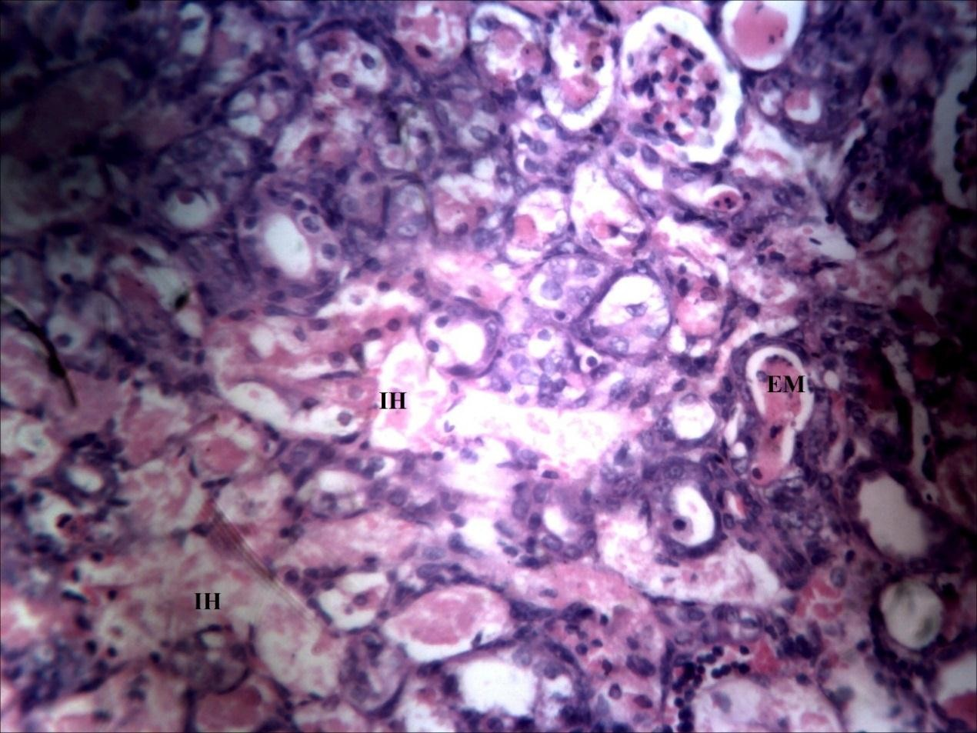

**Plate IV: Photomicrograph of a section of a rat kidney treated with 120 mg/kg of gentamicin for 10 days (×250)** showing interstial haemorrhage (IH) with tubular atropy (pointed arrow) and filled eosinophilic material (EM). H and E stain.

# : The Effect of Ten-day Chronomodulated Gentamicin (100 mg/kg) Administration on Serum Renal Biomarkers in Wistar Rats

Gentamicin administered at 1200 hrs produced significantly (p≤0.05) higher levels in serum urea and creatinine compared to the control. There was also statistically significantly (p≤0.05) higher level in serum creatinine at 0800 hrs compared to the control. There were minimal changes at 0000 hrs for both urea and creatinine compared to the control. There was no significant change in the levels of total protein, albumin and total bilirubin between the normal saline control and the four different administration time points.

# Table 4.5: The Effect of Ten-day Chronomodulated Gentamicin (100 mg/kg) Administration on Serum Renal Biomarkers in Rats

|  |  |  |  |  |  |
| --- | --- | --- | --- | --- | --- |
| Treatment | Urea  mMol/L | Creatinine  µMol/L | Total Protein  g/L | Albumin  g/L | Total Bilirubin  g/L |
| Saline 10 ml/kg | 5.80±0.41 | 69.16±10.46 | 66.50±2.03 | 35.16±0.60 | 17.93±5.45 |
| Gent 0800 hrs | 35.41±10.00 | 502.67±135.87* | 65.66±1.39 | 33.16±1.85 | 27.11±5.38 |
| Gent 1200 hrs | 40.24±11.20* | 515.60±147.14* | 67.80±1.46 | 35.80±0.37 | 21.48±4.91 |
| Gent 2000 hrs | 21.78±6.03 | 314.67±87.31 | 65.00±1.31 | 35.00±0.93 | 14.65±2.17 |
| Gent 0000 hrs | 14.06±3.62 | 141.80±38.25 | 66.16±1.97 | 35.33±1.22 | 13.73±1.60 |

Values are presented as mean ± SEM; n = 6; *= P≤0.05 when compared with saline control group; One way ANOVA followed by Bonferroni post hoc test; hrs = hours; Gent = Gentamicin

# : The Effect of Ten-day Chronomodulated Gentamicin (100 mg/kg) Administration on Serum Electrolytes in Wistar Rats

Gentamicin 100 mg/kg did not produce any significant change in the levels of serum electrolytes between the four different time points and the normal saline control.

# Table 4.6: The Effect of Ten-day Chronomodulated Gentamicin (100 mg/kg) Administration on Serum Electrolytes in Wistar Rats

|  |  |  |  |  |  |
| --- | --- | --- | --- | --- | --- |
| Treatment | Na+ mMol/L | K+  mMol/L | Cl+ mMol/L | Ca2+  mMol/L | HCO3  mMol/L |
| Saline 10 ml/kg | 136.50±1.87 | 4.55±0.30 | 109.50±10.94 | 2.35±0.71 | 22.50±0.88 |
| Gent 0800 hrs | 137.17±1.77 | 4.51±0.25 | 101.33±1.14 | 2.22±0.67 | 23.66±0.95 |
| Gent 1200 hrs | 136.00±1.04 | 4.77±0.52 | 100.80±2.13 | 2..13±0.34 | 21.60±1.60 |
| Gent 2000 hrs | 136.00±1.00 | 4.61±0.43 | 99.50±0.50 | 2.33±0.34 | 23.33±1.60 |
| Gent 0000 hrs | 138.33±1.11 | 4.06±0.12 | 99.16±1.35 | 2.30±0.57 | 23.00±1.52 |

Values are presented as mean ± SEM; n = 6; hrs = hours;

One way ANOVA did not show any statistically significant difference between the test groups; Na+ = sodium; K+ = Potasium; Cl+ = Chloride; Ca2+ = Calcium; HCO3 = Bicarbonate; hrs = hours; Gent = Gentamicin

# : The Effect of Ten-day Chronomudulated Gentamicin (100 mg/kg) Administration on Liver Enzymes in Wistar Rats

Gentamicin (100 mg/kg) produced higher levels in liver enzymes at the four time points with the highest level at 1200 hrs and the lowest level at 0000 hrs. There was a statistically significantly (p≤0.05) higher level of serum ALT at 0800 hrs when compared with the saline control group.

# Table 4.7: The Effect of Ten-day Chronomudulated Gentamicin (100 mg/kg) Administration on Liver Function Biomarkers in Wistar Rats

|  |  |  |  |
| --- | --- | --- | --- |
| Treatment | AST IU/L | ALT IU/L | ALP IU/L |
| Saline 10 ml/kg | 33.50±2.02 | 37.66±2.17 | 66.66±9.91 |
| Gent 0800 hrs | 66.66±12.36 | 77.16±16.94* | 110.83±30.40 |
| Gent 1200 hrs | 58.00±13.47 | 69.20±12.81 | 126.00±28.28 |
| Gent 2000 hrs | 34.33±2.67 | 41.35±5.42 | 87.16±13.90 |
| Gent 0000 hrs | 41.00±9.07 | 40.83±4.35 | 73.30±8.98 |

Values are presented as mean ± SEM; n = 6;

*= P≤0.05 when compared with the saline control group; One way Anova followed by Bonferroni post hoc test; AST, Aspartate Amino Transferase; ALT, Alanine Amino Transferase; ALP, Alkaline phosphatase; hrs = hours; Gent = Gentamicin

# : The Effect of Ten-day Chronomudulated Gentamicin (100 mg/kg) Administration on Relative Kidney Weights in Wistar Rat

Gentamicin 100 mg/kg resulted in statistically significantly (p≤0.05) higher relative kidney weights at the 0800, 1200 and 0000 hrs time points compared with saline control group. The highest level in relative kidney weight was seen in the 0800 and 1200 hrs groups while the 2000 hrs treated group had values closest to the normal saline control.

# Table 4.8: The Effect of Ten-day Chronomudulated Gentamicin (100 mg/kg) Administration on Relative Kidney Weights in Wistar Rats

|  |  |  |  |  |  |  |
| --- | --- | --- | --- | --- | --- | --- |
|  | Treatment |  | RLKW |  | RRKW |  |
|  | Saline 10 ml/kg |  | 0.41±0.71 |  | 041±0.24 |  |
|  | Gent 0800 hrs |  | 0.62±0.36* |  | 0.65±0.37* |  |
|  | Gent 1200 hrs |  | 0.60±0.04* |  | 0.62±0.46* |  |
|  | Gent 2000 hrs |  | 0.54±0.27 |  | 0.54±0.28 |  |
|  | Gent 0000 hrs |  | 0.57±0.04* |  | 0.59±0.33* |  |

Values are presented as mean ± SEM; n = 6;

*= P≤0.05 when compared with the saline control group; One way ANOVA followed by Bonferroni post hoc test; RLKW = Relative Left Kidney Weight; RRKW = Relative Right Kidney Weight; hrs = hours; Gent = Gentamicin

# 4.2.8: Histopathology of Effect of Ten-day Chronomudulated Gentamicin (100 mg/kg) Administration on Wistar Rats

The administration of gentamicin at different time points (0800, 1200, 2000 and 0000 hrs) resulted in structural damage to the renal cortex of the kidney. The structural damage was observed to be maximal in the 0800 and 1200 hour groups and minimal in the 2000 and 0000 hour groups. Photomicrographs were taken at a magnification of

×250.

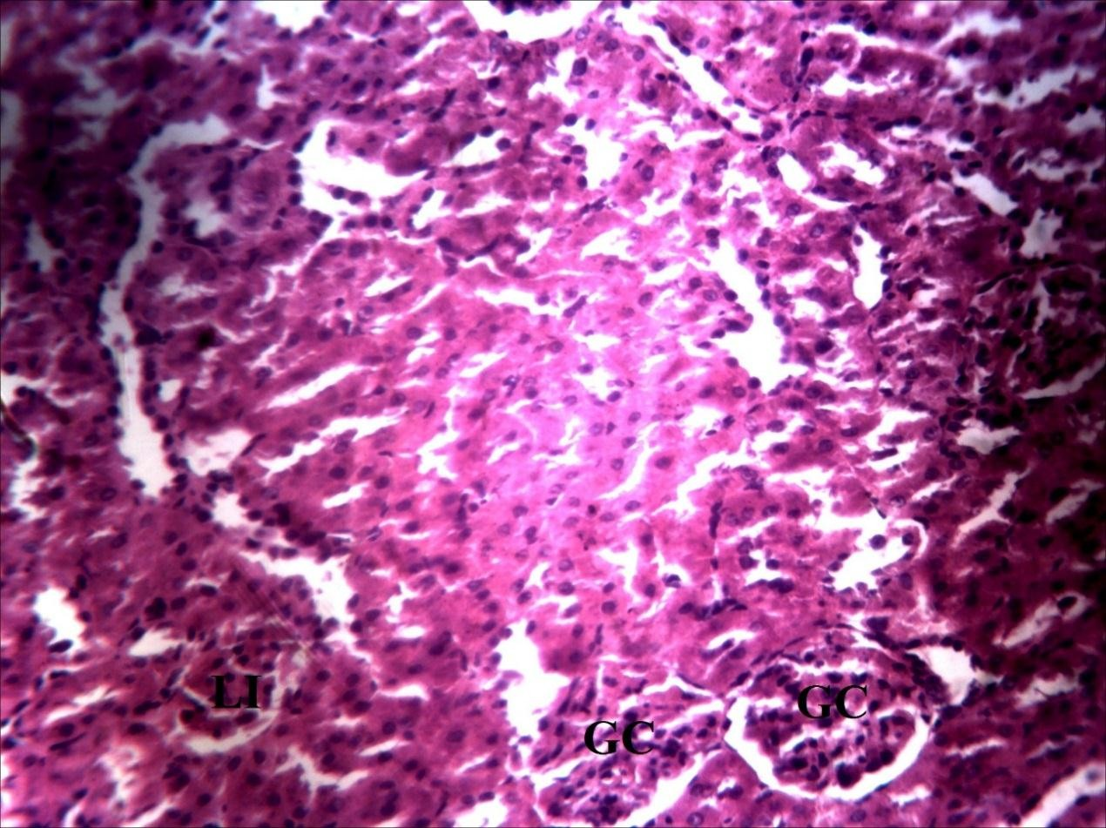

**Plate V: Photomicrograph of a section of a rat kidney treated with 100 mg/kg of gentamicin at 0800 hours for 10 days (×250)** showing massive lymphocyte infiltration (LI) and glomerular congestion (GC) with tubular degeneration (pointed arrows). H and E stain.

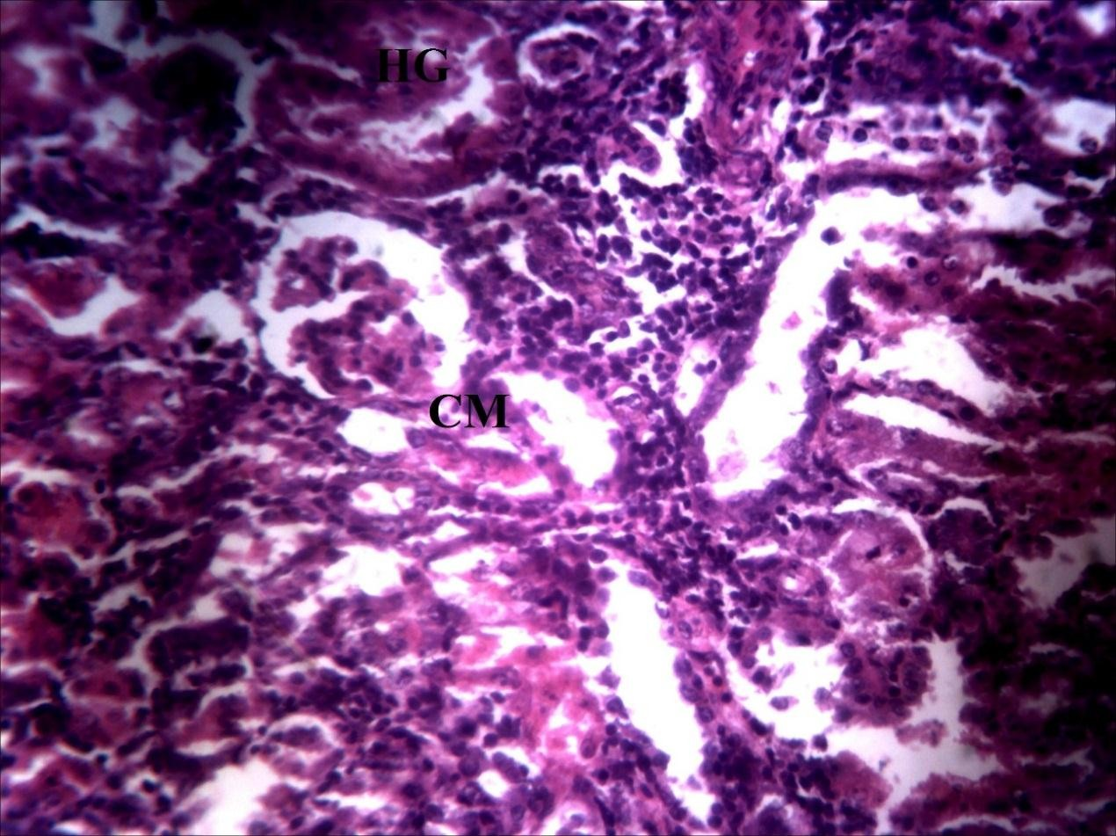

**Plate VI: Photomicrograph of a section of a rat kidney treated with 100 mg/kg of gentamicin at 1200 hours for 10 days (×250)** showing hyalinized glomerulus (HG) and congested macular denser area (CM) with lymphocyte hyperplasia (pointed arrows). H and E stain.

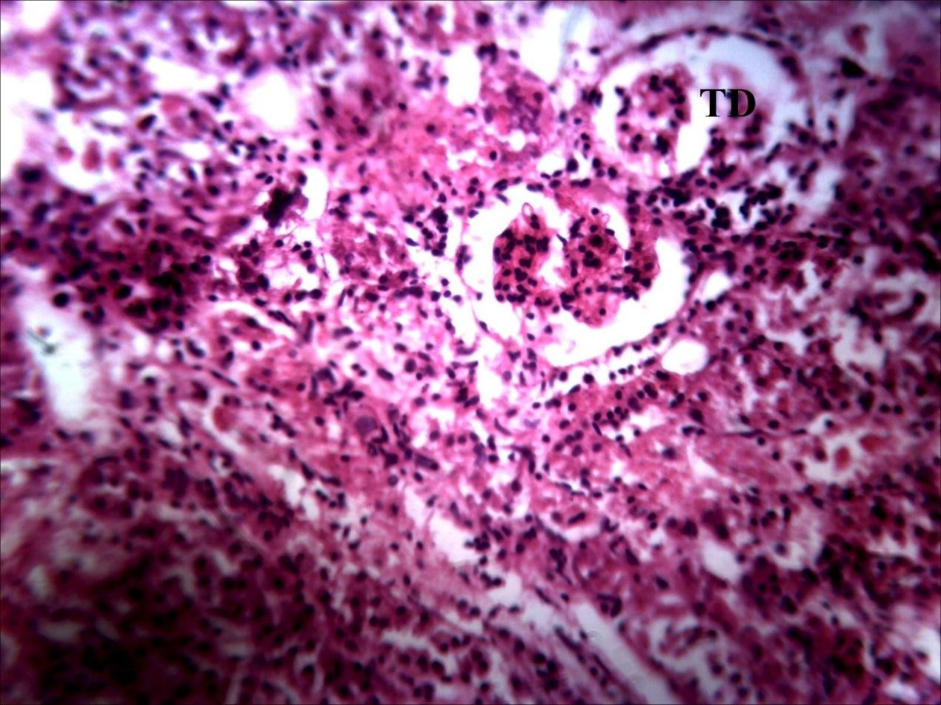

**Plate VII: Photomicrograph of a section of a rat kidney treated with 100 mg/kg of gentamicin at 2000 hours for 10 days (×250)** showing intense tubular degeneration (TD) and intense haemorrhage (pointed arrows). H and E stain.

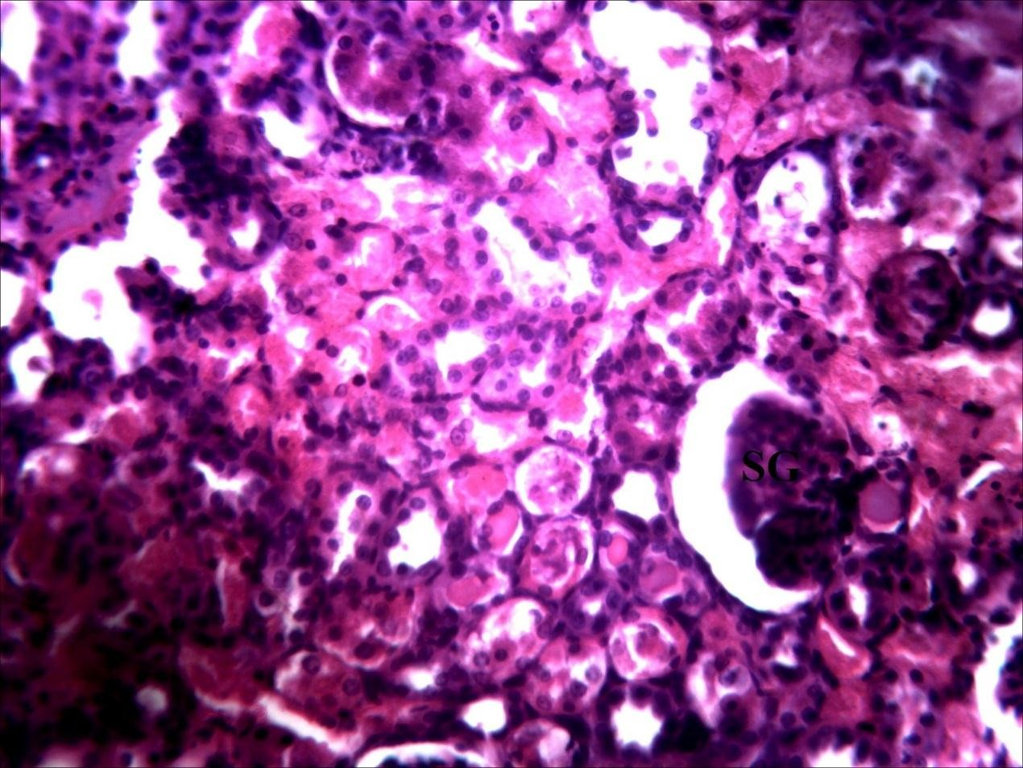

**Plate VIII: Photomicrographs of a section of a rat kidney treated with 100 mg/kg of gentamicin at 0000 hours for 10 days (×250)** showing moderate tubular degeneration (pointed arrows) and shrunken glomerulus (SG). H and E stain.

# : The Effect of Ten-day Chronomudulated Gentamicin (100 mg/kg) and Vitamin B Complex (3 ml/kg) on Renal Biomarkers in Wistar Rats

Administration of gentamicin (100 mg/kg) concurrently with vitamin B complex (3 ml/kg) at different time points produced an amelioration of gentamicin nephrotoxicity observed at the time of maximal toxicity. Serum urea and creatinine were statistically significantly (p≤0.05) higher at 1200 hours for the gentamicin alone group. This elevation was ameliorated in the group that received gentamicin concurrently with vitamin B complex at the same time point. There was no significant change in total protein and albumin between the four groups and the normal saline control.

# Table 4.9: The Effect of Ten-day Chronomudulated Gentamicin (100 mg/kg) and Vitamin B Complex (3 ml/kg) Administration on Serum Nephrotoxic Biomarkers in Wistar Rats

|  |  |  |  |  |
| --- | --- | --- | --- | --- |
| Treatment | Urea  mMol/L | Creatinine  µMol/L | Total Protein  g/L | Albumin  g/L |
| Saline 10 ml/kg | 7.04±0.58 | 98.40±9.33 | 66.00±0.84 | 36.00±2.01 |
| Gent 1200 hrs | 23.90±1.90* | 352.60±29.34* | 65.60±1.03 | 37.00±1.04 |
| Gent  1200 hrs/Bco | 13.56±3.68 | 190.80±5.35a | 63.80±1.52 | 34.20±1.36 |
| Gent 0000 hrs | 10.54±2.20a | 150.20±31.40a | 64.20±1.93 | 32.00±0.55 |
| Gent  0000 hrs/Bco | 17.16±3.01 | 251±45.32 | 63.20±1.16 | 33.60±1.03 |

Values are presented as mean ± SEM; n = 6; *= P≤0.05 when compared with saline control group; a = p≤0.05 when compared to Gentamicin 1200 hrs group; One way ANOVA followed by Bonferroni post hoc test; Gent = Gentamicin; BCO = Vitamin B Complex; hrs = hours.

# : The Effect of Ten-day Chronomudulated Gentamicin (100 mg/kg) and Vitamin B Complex (3 ml/kg) Administration on Liver Enzymes in Wistar Rats

The levels of liver function enzymes (ALT, AST, ALP) did not differ significantly between the saline control group and the four treatment time points following administration of gentamicin (100 mg/kg) alone and concurrently with vitamin B complex (3 ml/kg).

# Table 4.10: The Effect of Ten-day Chronomudulated Gentamicin (100 mg/kg) and Vitamin B Complex (3 ml/kg) Administration on Liver Enzymes in Wistar Rats

|  |  |  |  |
| --- | --- | --- | --- |
| Treatment | ALT  IU/L | AST  IU/L | ALP  IU/L |
| Saline 10 ml/kg | 76.80±7.78 | 73±5.64 | 107.20±10.34 |
| Gent 1200 hrs | 79.40±3.55 | 78.40±2.89 | 122.4±9.04 |
| Gent 1200 hrs/Bco | 72.60±6.96 | 69.80±9.09 | 118.60±10.78 |
| Gent 0000 hrs | 73.40±6.96 | 67.80±1.82 | 125.20±12.11 |
| Gent 0000 hrs/Bco | 79.80±8.39 | 63.00±10.04 | 141.60±6.53 |

Values are presented as mean ± SEM; n = 6; *= P≤0.05 when compared with saline control group; Gent = Genamicin; One way ANOVA; AST, Aspartate Amino Transferase; ALT, Alanine Amino Transferase; ALP, Alkaline phosphatase; Gent = Gentamicin; hrs = hours; Bco = Vitamin B Complex

# : The Effect of Ten-day Chronomudulated Gentamicin (100 mg/kg) and Vitamin B Complex (3 ml/kg) Administration on Oxidative Stress Markers in Wistar Rats

Gentamicin administered alone or concurrently with vitamin B complex did not produce any statistically significant change in the levels of oxidative stress markers between the normal saline control and the four different time points. There was higher level of serum MDA at 1200 hrs for both the gentamicin alone group and the group administered gentamicin concurrently with vitamin B complex compared to the 1200 hrs treatment groups.

# Table 4.11: The Effect of Ten-day Chronomudulated Gentamicin (100 mg/kg) and Vitamin B Complex (3 ml/kg) on Oxidative Stress Markers in Wistar Rats

|  |  |  |  |
| --- | --- | --- | --- |
| Treatment | MDA  µMol/L | GPX  IU/L | SOD  IU/L |
| Saline 10 ml/kg | 1.20±0.44 | 49.60±1.81 | 2.12±0.86 |
| Gent 1200 hrs | 1.48±0.13 | 48.00±2.17 | 2.16±0.74 |
| Gent 1200 hrs/Bco | 1.48±0.67 | 46.40±1.07 | 2.20±0.13 |
| Gent 0000 hrs | 1.46±0.12 | 54.20±0.96 | 2.38±0.07 |
| Gent 0000 hrs/Bco | 1.20±0.89 | 52.60±1.28 | 2.58±0.05* |

Values are presented as mean ± SEM; n = 6; *= P≤0.05 when compared with saline control group; One way Anova followed by Bonferroni post hoc test, MDA, Malonidialdehyde; SOD, Superoxide dismutase; GPX, Gluthathione Peroxidase; Gent = Gentamicin; Bco = Vitamin B complex; hrs = hours

# : The Effect of Ten-day Chronomudulated Gentamicin (100 mg/kg) and Vitamin B Complex (3 ml/kg) on Serum Electrolytes in Wistar Rats

There was no statistically significant change in the levels of serum electrolytes between the control group and the four treatment groups.

# Table 4.12: The Effect of Ten-day Chronomudulated Gentamicin 100 (mg/kg) and Vitamin B Complex (3 ml/kg) on Serum Electrolytes in Wistar Rats

|  |  |  |  |  |  |
| --- | --- | --- | --- | --- | --- |
| Treatment | Na+  mMol/L | K+  mMol/L | Cl+  mMol/L | Ca2+  mMol/L | HCO3  mMol/L |
| Saline 10 ml/kg | 139.80±1.39 | 4.24±0.19 | 102.20±1.85 | 2.36±0.02 | 24.40±0.15 |
| Gent 1200 hrs | 137.20±2.03 | 4.64±0.20 | 96.80±1.71 | 2.45±0.08 | 21.60±1.72 |
| Gent 1200 hrs/Bco | 136.80±1.80 | 4.36±0.42 | 98.20±1.68 | 2.49±0.04 | 22.80±1.95 |
| Gent 0000 hrs | 138.60±1.88 | 4.26±0.11 | 95.00±1.00 | 2.38±0.04 | 23.80±0.48 |
| Gent 0000 hrs/Bco | 137.80±0.73 | 4.60±0.30 | 97.40±1.77 | 2.44±0.69 | 21.60±1.33 |

Values are presented as mean ± SEM; One way ANOVA did not show any statistically significant difference between the groups. n = 6; Gent = Gentamicin; Na+ = sodium; K+ = Potasium; Cl+ = Chloride; Ca2+ = Calcium; HCO3 = Bicarbonate; Gent = Gentamicin; Bco = Vitamin B Complex; hrs = hours

# : The Effect of Ten-day Chronomudulated Gentamicin (100 mg/kg) and Vitamin B Complex (3 ml/kg) Administration on Relative Kidney Weight in Wistar Rats

Gentamicin 100 mg/kg administered alone or in combination with vitamin B complex did not produce any significant change in relative kidney weights between the control and the treatment groups.

# Table 4.13: Effect of Ten-day Chronomudulated Gentamicin (100 mg/kg) and Vitamin B Complex (3 ml/kg) on Relative Kidney Weight in Wistar Rats

|  |  |  |
| --- | --- | --- |
| Treatment | RLKW | RRKW |
| Saline 10 ml/kg | 0.29±0.01 | 0.30±0.01 |
| Gent 1200 hrs | 0.37±0.01 | 0.39±0.01 |
| Gent 1200 hrs/Bco | 0.33±0.04 | 0.34±0.04 |
| Gent 0000 hrs | 0.44±0.61 | 0.40±0.20 |
| Gent 0000 hrs/Bco | 0.39±0.02 | 0.37±0.01 |

Values are presented as mean ± SEM; One way ANOVA did not show any statistically significant difference between the groups. n = 6; Gent = Gentamicin; RLKW = Relative Left Kidney Weight; RRKW = Relative Right Kidney Weight; Bco = Vitamin B Complex; hrs = hours.

# : Histopathology of Effect of Ten-day Chronomudulated Gentamicin (100 mg/kg) and Vitamin B Complex (3 ml/kg) on Wistar Rats

The administration of gentamicin 100 mg/kg alone and gentamicin 100 mg/kg concurrently with vitamin B complex 3 ml/kg at two different time points (1200 and 0000 hours) produced a pathological structural damage in the renal cortex of the rat kidney. Photomicrographs were taken at a magnification of ×250.

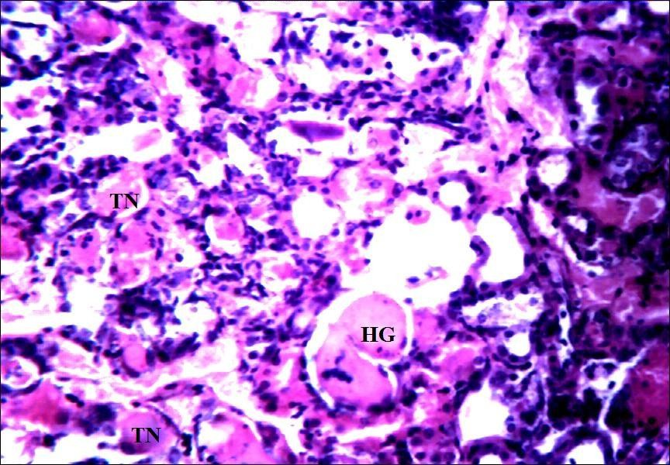

**Plate IX: Photomicrograph of a section of a rat kidney treated with gentamicn 100 mg/kg concurrently with 3 ml/kg of vitamin B Complex at 1200 hours for 10 days (×250)** showing lymphocyte hyperplasia (pointed arrow) with moderate tubular necrosis (TN) and hyalinized glomerulus (HG). H and E stain.

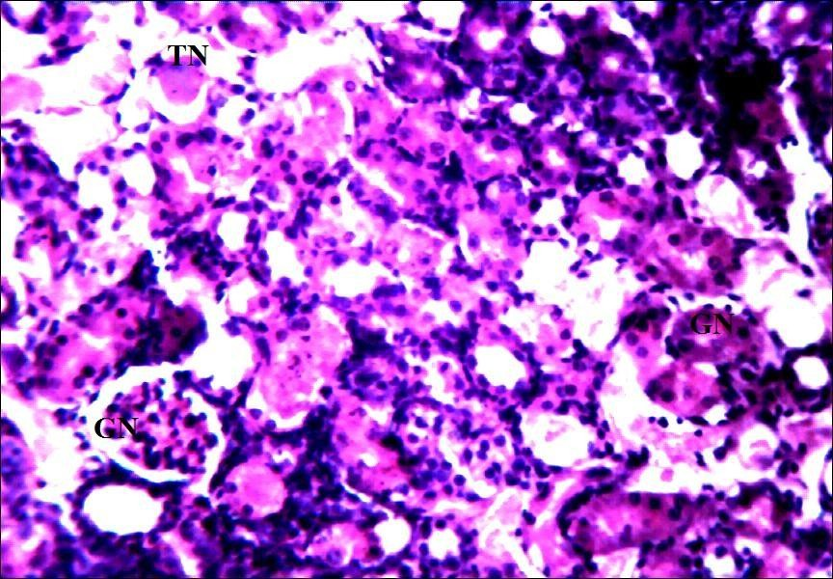

**Plate X: Photomicrograph of a section of a rat kidney treated with 100 mg/kg of gentamicin at 1200 hours for 10 days (×250)** showing lymphocyte hyperplasia (pointed arrow) with intense glomerular (GN) and tubular necrosis (TN). H and E stain.

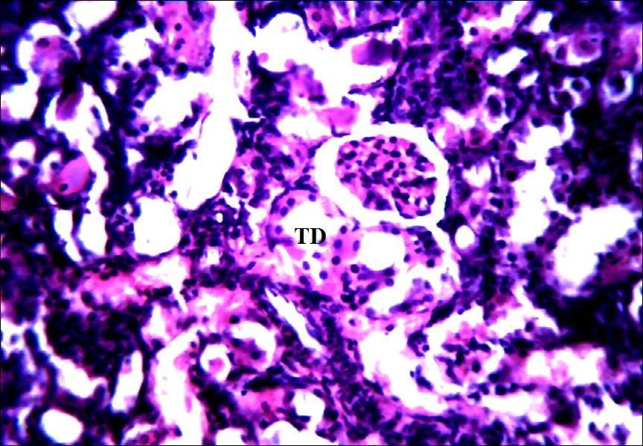

**Plate XI: Photomicrograph of a section of a rat kidney treated with 100 mg/kg of gentamicin concurrently with Vitamin B complex 3 ml/kg at 0000 hours for 10 days (×250)** showing intense lymphocyte hyperplasia (pointed arrows) and diffuse tubular degeneration (TD). H and E stain.

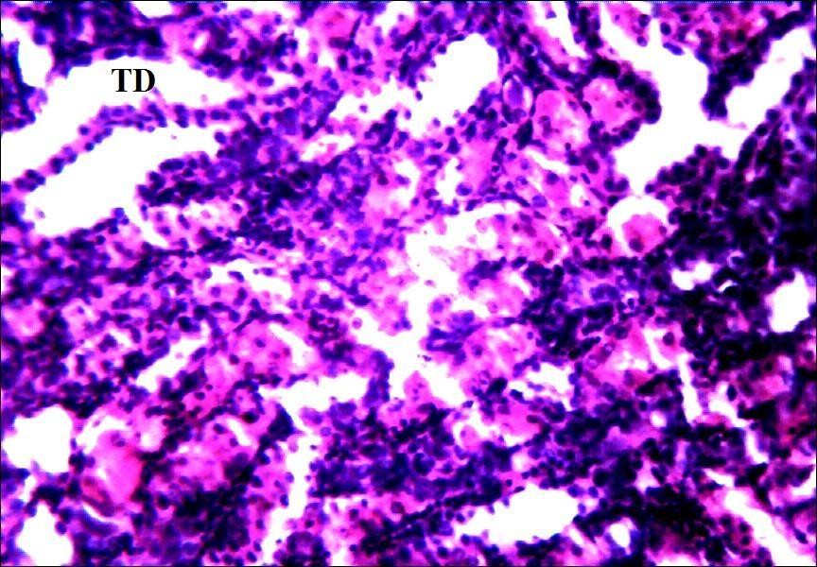

**Plate XII: Photomicrograph of a section of a rat kidney treated with 100 mg/kg of gentamicin at 0000 hours for 10 days (×250)** showing tubular degeneration (TD) with lymphocyte hyperplasia (pointed arrows). H and E stain.

# CHAPTER FIVE

# 5.0 DISCUSSION

Gentamicin is widely used for treatment of a wide variety of infections caused by susceptible gram negative bacteria. Its use is however limited by its potential nephrotoxicity (Yasin *et al*., 2003). High doses of gentamicin are required to produce nephro toxicity in rodents (Mingeot-Leclercq and Tulkens, 1999). This nephrotoxicity manifests as decreased glomerular filtration, extended cortical necrosis, loss of proximal brush border membrane and renal dysfunction. In this study 100 and 120 mg/kg of gentamicin resulted in significant nephrotoxicity shown by a significant elevation in levels of serum urea, serum creatinine and total bilirubin. This corroborates the work of previous studies (Yoshiyama *et al*., 1992; Gamaledin and Abo-Salem, 2012) where gentamicin nephrotoxicity and renal damage manifested as marked elevation in the levels of serum biomarkers of nephrotoxicity. Tubular necrosis and proximal tubular damage occurs with gentamicin administration causing a reduction in glomerular filtration rate and a marked elevation in the level of biochemical parameters in the serum (Decker *et al*., 2012). Gentamicin induced renal damage is associated with marked increase in lipid peroxidation, nitro-tyrosine formation and protein oxidation in the renal cortex (Balakumar *et al*., 2010). In the present study higher levels of blood urea nitrogen and serum creatinine among other sensitive biomarkers of nephrotoxicity was observed which was similar to studies by Ali, 2003 thus validating the rodent model of gentamicin-induced nephrotoxicity.

The hepatotoxic effects observed in the higher doses of gentamicin in this study are similar to findings by Beauchamp and Labrecque, 2001 who reported hepatotoxicity following gentamicin administration. Although the administration of high dose

gentamicin has been associated with elevated levels of electrolytes (Asif *et al*., 2012), the same was not observed in this study. This may be due to the species of animals used for the present study. Also electrolytes abnormalities induced by gentamicin nephrotoxicity occur very early during therapy with gentamicin (Giuliano *et al*., 1984). The levels reported in this study were at the termination of the protocol.

This study showed that there is dose related histoarchitectural damage of the renal cortex with gentamicin administration. Gentamicin accumulates in epithelial tubular cells causing loss of brush border membrane in epithelial cells and overt tubular necrosis (Ali *et al*., 2011). Histology of the kidney showed tubular necrosis, hyalinized glomerulus and lymphocyte hyperplasia. This is in agreement with Tulkens, 1989 who showed that gentamicin nephrotoxicity results in development of a lysosomal phospholipidosis, which results in cell necrosis and alterations to the sub cellular structure of the kidney.

The administration of gentamicin 100 mg/kg at different time points demonstrated a temporal variation in nephrotoxicity. This is in agreement with other studies which show that time of day gentamicin is administered is a basic determinant of nephrotoxicity (Pariat *et al*., 1988; Yoshiyama, 1992). Maximal toxicity is observed when gentamicin is administered during the rest phase and minimal toxicity is observed when gentamicin is administered during the active phase of rodents (Beauchamp and Labrecque, 2001).

Gentamicin nephrotoxicity was highest at 1200 hours and lowest at 0000 hours. Similar findings in temporal variation in nephrotoxicity following gentamicin

administration have been reported (Lin *et al*., 1996; Beauchamp *et al*., 1996). Changes in the susceptibility of renal cells according to time of the day the drug is administered, circadian variations of endogenous hormones secretion, and changes in serum and intracortical pharmacokinetics of gentamicin are among the mechanisms proposed to explain the temporal variation in gentamicin nephrotoxicity (Beauchamp *et al*., 1996; Nakano *et al*., 1998). The rhythmic pattern of food and water ingestions might be a factor that modifies the temporal variation of gentamicin nephrotoxicity. Minimal toxicity to rodents was consistently observed during the dark (activity) period, which corresponds to the maximal food and water intake of these animals (Yoshiyama *et al*., 1992; Prins e*t al*., 1997). It has been demonstrated in rodents that circadian changes are influenced by access to food. Rats anticipated the period of food intake by increasing loco motor activity, movement, agitation and running (Beauchamp *et al*., 1996). The time of minimal toxicity observed in the present study (0000 hrs) was the peak time of activity of the rodents used for the study while the time of maximal toxicity (1200 hrs) was the peak time of rest of the rodents.

Relative kidney weights were observed to be highest at the times of maximal toxicity (0800 and 1200 hours). Gentamicin nephrotoxicity manifests as tubular hypertrophy, progressive nephropathy and tubular necrosis resulting in an increase in relative organ weight (Ali, 1995).

The establishment of a time of least toxicity and maximal toxicity in this study was necessary because studies have suggested a seasonal variation in nephrotoxicity of gentamicin. Pariat *et al*., 1990 suggested that renal toxicity of gentamicin exhibits

circadian as well as seasonal variations. They showed that the time of maximal toxicity shifts at different times of the year.

The administration of vitamin B complex 3 ml/kg concurrently with gentamicin 100 mg/kg at the time of maximal and minimal toxicity was seen to ameliorate gentamicin nephrotoxicity. This is evident in the fact that vitamin B complex which comprises of three major B vitamins, B1-thiamine, B2-riboflavin and B6-pyridoxal phosphate of which Pyridoxal phosphate is a free radical mopper and riboflavin is an antioxidant.

Reactive oxygen species (ROS) have been identified as mediators of proximal tubular necrosis and acute renal failure caused by gentamicin and ROS induced cell death was found to have a role in gentamicin mediated acute renal failure (Walker *et al*., 1999). Studies have demonstrated that pre-treatment of laboratory animals with vitamin E and followed by subsequent gentamicin administration resulted in amelioration of both the functional and histological damages to the kidneys (Derakhshanfar *et al*., 2007). Vitamin B complex has also been demonstrated to significantly ameliorate the nephrotoxicity of gentamicin (Bello and Chika, 2009).

Administration of gentamicin 100 mg/kg showed higher levels of serum urea and creatinine at 1200 hours, while the administration of gentamicin concurrently with vitamin B complex at the same time point produced no significant changes in the level of serum urea and creatinine. Administration of gentamicin 100 mg/kg at 0000 hours produced amelioration as there was no significant change in the levels of serum urea and creatinine from the normal saline control. However the amelioration obtained from administration of gentamicin 100 mg/kg alone at the 0000 hour time point was

seen to be greater than that produced by concurrent administration of gentamicin and vitamin B complex at the same time point.

The present study demonstrated temporal variations in gentamicin nephrotoxicity ameliorates gentamicin induced nephrotoxicity in wistar rats. Also concurrent administration of gentamicin with vitamin B complex was shown to ameliorate gentamicin induced nephrotoxicity at both the rest and activity time points of the rats. The amelioration offered by concurrent administration of gentamicin and vitamin B complex was observed to be less than the amelioration offered by temporal variation of gentamicin nephrotoxicity when administered at 0000 hour time point. The data presented in this study strengthens the working hypothesis that temporal variation of gentamicin nephrotoxicity offers superior amelioration of gentamicin nephrotoxicity than concurrent use of gentamicin and antioxidant. However from the findings in this research it is evident that it is more beneficial to administer gentamicin concurrently with vitamin B complex at the time of maximum toxicity (rest) of the rats, while concurrent administration of gentamicin and antioxidant at time of least toxicity (activity time) is not necessary.

# CHAPTER SIX

# SUMMARY, CONCLUSION AND RECOMMENDATION

# Summary

The present study confirmed the literature indicating a temporal variation in gentamicin induced nephrotoxicity with a maximum toxicity observed when the drug was administered at the resting period and minimum toxicity observed when the drug was administered at the activity period of rats. This finding further supports other findings that recommend gentamicin should be administered at the activity period to ameliorate or prevent its nephrotoxicity.

The administration of vitamin B complex concurrently with gentamicin ameliorated gentamicin induced nephrotoxicity at both the resting (1200 hours) and activity period (0000 hours). Vitamin B complex administered concurrently with gentamicin at 0000 hours which was the time of least nephrotoxicity did not offer a better amelioration of gentamicin induce nephrotoxicity than the administration of gentamicin alone at this time point. This shows that even though vitamin B complex ameliorates gentamicin nephrotoxicity, the amelioration offered by exploring selecting a least toxic time based on temporal variations of gentamicin may be better than concurrent use of gentamicin with antioxidant at the time of administration that produces least toxicity.

# Contribution of the current Research to the body of Knowledge

1. Temporal variation of gentamicin nephrotoxicity is important, as administration of gentamicin at the time of least toxicity produces a significant amelioration in gentamicin induced nephrotoxicity.
2. The use of vitamin B complex ameliorates the nephrotoxicity of gentamicin at the time of maximum toxicity than use of gentamicin alone.
3. Administration of gentamicin based on its temporal variation in toxicity at the time resulting in least toxicity provides a superior amelioration of nephrotoxicity than concurrent use of gentamicin and Vitamin B complex at the time of least toxicity.

# Conclusion

The present study supports the working hypothesis that administration of gentamicin based on its temporal variation in toxicity offers a better amelioration of gentamicin induced nephrotoxicity than the use of gentamicin concurrently with an antioxidant at the time of least toxicity in wistar rats.

# Recommendation

It is recommended that when gentamicin is to be administered during the time of least toxicity (activity time) concurrent administration of antioxidant is not necessary, this will reduce medication burden.

# Suggestions for Further studies

1. It is important that this study be conducted in human subjects at the rest and activity time of humans, so as to apply this research in clinical practice.
2. It is postulated that aminoglycosides might have a circa-annual variation in toxicity, it is therefore recommended that the present study be conducted at a different

time of the year to determine if the findings will be the same as this particular study or if circa annual variations will be observed in this region.

# REFERENCES

Abdelrahim, H.E.A., Rahman, A.B.F. and Ibrahim, M.I.M. (2012). Therapeutic Drug Monitoring of Gentamicin in Patients with Bronchopneumonia: Cost Considerations and Patient Outcomes. *The Eurasian Journal of Medicine*, 44:1-5.

Abe, M., Herzog, E.D., Yamazaki, S., Straume, M., Tei, H., Sakaki, Y., Menaker, M. and Block, G.D. (2002). Circadian Rhythms in Isolated Brain Regions. *The Journal ofNeuroscience*, 22(1):350-356.

Ali, B.H. (1995). Gentamicin Nephrotoxicity in Humans, Some Recent Research.

*General Pharmacology*, 26:1477-1487.

Ali, B.H. (2003). Agents Ameliorating or Augmenting Experimental Gentamicin Nephrotoxicity: Some Recent Research. *Food and Chemical Toxicology*, 41(11): 1447-1480.

Ali, B.H., Bashir, A.K., Mugamer, I.T. and Tanira, R.O. (1996). Gentamicin Nephrotoxicity in the Rat: Influence of Age and Diabetes Mellitus. *Human Experimental Toxicology,* 1:51-55.

Ali, M.Z. and Goetze, M.B. (1997). A Meta Analysis of the Relative Efficacy and Toxicity of Single Daily Dosing Versus Multiple Daily Dosing of Aminoglycosides. *Clinical Infectious Diseases*, 24:796-809.

Ali, B.A., Al Zaabi, M., Blunden, G. and Nemmar, A. (2011). Experimental Gentamicin Nephrotoxicity and Agents that Modify it: A Mini-Review of Recent Research. *Basic and Clinical Pharmacology and Toxicology,* 109 (4): 225-232.

Aschoff, J. (1965). Circadian Rhythms in Man. *Science,* 148:1427-1432.

Aschoff, J. (1981). Handbook of Behavioral Neurobiology, Biological Rhythms, New York NY Plenum Press 4:1-8.

Asif, A.H., Rasool, S. and Khan, T.M. (2012). Pyridoxal Phosphate a Possible Intervention to Prevent Aminoglycoside Induced Electrolyte Inbalance. *Journal of Clinical Research and Bioethics*, 3:124-127.

Badreldin, H.A., Mohammed, A.Z., Gerald, B. and Abderrahim, N. (2011). Experimental Gentamicin Nephrotoxicity and Agents that modify it: A Mini Review of Recent Research. *Basic and Clinical Pharmacology and Toxicology,* 109:225-232.

Bailey, T.C., Little, R.C., Littenberg, B., Reichley, R.M. and Dunagan, C.W. (1997). A Meta Analysis of Extended Interval Dosing Versus Multiple Daily Dosing of Aminoglycosides. *Clinical Infectious Diseases*, 24(5):758-759.

Balachandar, M.S. and Pavkovi, P. (2002). Kidney Infections in Diabetes Mellitus.

*Diabetologia Croatica*, 31:82-85.

Balakumar, P., Rohilla, A. and Thangathirupathi, A. (2010). Gentamicin Induced Nephrotoxicity: Do we have a Promising therapeutic approach to blunt it? *Pharmacology Research*, 62:179-186.

Balsalobre, A., Brown, S.A., Marcacci, L., Tronche, F., Kellendorik, C., Reichardt, H.M., Schutz, G. and Schibler, U. (2002). Resetting of Circadian time in Peripheral Tissues by Glucocorticoid Signalling. *Science*, 289:2344-347.

Banfield, T., Jensen, J.S. and Nordestgaard, B.G. (2007). Influence of Diabetes and Hyperglycemia on Infectious Disease Hospitalization and Outcome. *Diabetologia*, 50(3):549-554.

Baraldo, M. (2008). The Influence of Circadian Rhythms on the Kinetics of Drugs in Humans. *Expert Opinion on Drug Metabolism and Toxicology*, 4(2):175-192.

Baumgart, P. (1991). Circadian Rhythm of Blood Pressure: Internal and External Time Triggers. *Chronobiology International*, 8:444-450.

Bassir, O. (1971). Handbook of Practical Biochemistry. Ibadan University Press Ibadan, Nigeria. 53-84.

Beauchamp, D., Collin, P., Grenier, L., Lebrun, M., Labreque, G. and Bergeron, R.G. (1996). Effects of Fasting on Temporal Variations in Nephrotoxicity of Gentamicin in Rats. *Antimicrobial Agents and Chemotherapy,* 40:670-676.

Beauchamp, D. and Labreque, G. (2001). Aminoglycoside Nephrotoxicity: Do Time and Frequency of Administration Matter? *Current Opinion in Critical Care*, 7 (6): 401-408.

Belanger, P.M. (1993). Chronopharmacology in Drug Research and Therapy.

*Advances in Drug Research*, 24:1-80.

Belge, A.R., Talokar, O.W. and Belge, R.S. (2012). Critical Study of Aushadhi Sevena kala With Special Reference to Chronopharmacology. *Journal of Pharmacy and Biological Sciences*, 4(4):45-53.

Bello, O.S. and Chika, A. (2009). Dose Dependent Amelioration of Gentamicin Induced Nephrotoxicity in Adult Swiss Albino Rats by Vitamin B-Complex, A Preliminary Study. *Tropical Journal of Pharmaceutical Research*, 8(2):111- 116.

Brahma, C.K. and Gali, V.S. (2012). Chronotherapeutics Drug Delivery Systems Challenges to Pharmaceutical Field. *Journal of Global Trends in Pharmaceutical Sciences,* 3(3):778-791.

Bruguerolle, B. and Simon, N. (2002). Biologic Rhythms and Parkinsons disease: A Chronopharmacologic Approach to Considering Fluctuations in Function.

*Clinical Neuropharmacology*, 25:194-201.

Bruguerolle, B. and Labrecque, G. (2007). Rhythmic Pattern in Pain and their Chronotherapy. *Advance Drug Delivery Reviews*, 59:883-895.

Buabong, K.O., Mackenzie, A.R., Laing, R.B., Cook, I.C., Jappy, B.A. and Gould

I.M. (1999). Assessment of the Efficacy, Safety and Quality of Gentamicin Use in Aberdeen Royal Infirmary. *Journal of Antimicrobial Chemotherapy*, 44(6):843-845.

Chandrashekaran, M.K. (1998). Biological Rhythms Research: A Personal Account.

*Journal of Biosciences*, 23:545.

Chawla, V. and Chawla, P. (2012). Chronopharmacokinetics: An Overview.

*International Journal of Pharmacy and Pharmaceutical Sciences*, 4(4):43-45. Chetankumar, R.A., Hetal, N.T. and Vajpeyee, S.K. (2013). A Study of Oxidative

Stress in Gentamicin Induced Nephrotoxicity and Effect of Antioxidant Vitamin C in Wistar Rats. *National Journal of Physiology, Pharmacy and Pharmacology,* 3:14-20.

Cohen, R.A. and Albers, H.E. (1991). Disruption of Human Circadian and Cognitive Regulation Following a Discrete Hypothalamic Lesion: A Case Study. *Neurology*, 41(5):726-729.

Decker, B.S., Mohamed, A.N., Chambers, M., Kraus, M.A., Moe, S.M. and Sowinski,

K.M. (2012). Gentamicin Pharmacokinetics and Pharmacodynamics During Short-Daily Hemodialysis. *American Journal of Nephrology,* 36:144-150.

Derakhshanfar, A., Bidadkosh, A. and Kazeminia, S. (2007). Vitamin E Protection Against Gentamicin Induced Nephrotoxicity in Rats: A Biochemical and Histopathologic Study. *Iranian Journal of Veterinary Research,* 8(3):231-238. Deravarashan, P. (2007). Emerging Biomarkers of Acute Kidney Injury.

*Contributions to Nephrology*, 156:203-212.

Devdhawala,M.G. and Seth, A.K. (2010). Current Status of Chronopharmatherapeutic Drug Delivery System: *An Overview. Journal of Chemical Research*, 2(3):312-328.

Dodt, C. and Breckling, U. (1997). Plasma Epinephrine and Norepinephrine Concentrations of Healthy Human Associated with Night time and Morning Arousal. *Journal of Hypertension*, 30:71-76.

Ellman, G.L. (1959). Tissue Sulfuhydryl Groups. *Archives of Biochemistry and Biophysics*, 82:70-77.

Erdem, A., Gundogan, N.U., Usubutun, A., Kilinc, K., Erdem, S.R., Kara, A. and Bozkurt, A. (2000). The Protective Effect of Taurine against Gentamicin- Induced Acute Tubular Necrosis in Rats. *Nephrology Dialysis and Transplantation*, 15(8):1175-1182.

Fanton, J.C. and Ward, P.A. (1982). Role of Oxygen Derived Free Radical and Metabolites in Leucocytes Dependent Inflammatory Reaction. *American Journal of Pathology*, 107:379-384.

Farombi, E.O. and Ekor, M. (2006). Curcumin Attenuates Gentamicin Induced Renal Damage in Rats*. Journal of Food and chemical toxicology*, 4:143-148.

Fawcett, J.K., and Scott, J.E. (1960). A Rapid and Precise Method for the Determination of Urea. *Journal of Clinical Pathology*, 13:156-159.

Flohe, L. and Gunzler, W.A. (1984). Assays of Glutathione Peroxidase Methods.

*Methods in Enzymology*, 105:114-121.

Fujimura, A., Sudoh, T. and Ebihara, A. (1994). Time Dependent Change in the Toxic Effects of Amikacin on Renal Functions. *Journal of Life Sciences*, 55:367- 372.

Fukuda, Y., Malmborg, A.S. and Asperia, A. (1991). Gentamicin Inhibition of Na+/K+ ATpase in rat Kidney Cells. *Acta Physiologica Scandinavica*, 141:27-34.

Gameldin, I.H. and Abo-Salem, O.M. (2012). Benfotiamine Ameliorate Gentamicin Induced Nephrotoxicity: Effect on Renal Oxidative Stress Markers and Plasma Platelets Activating Factor Acyl Hydrolase Activity. *International Journal of Pharmacology,* 8 (5): 364-372.

Giuliano, R.A., Paulus, G.J., Vepooten, G.A., Pattyn, V.M., Pollet, D.E., Nouwen, E.J., Laurent, G., Carimer, M.B., Maldaque, P., Tulkens, P.M., and Bree, M.E. (1984). Recovery of Cortical Phospholipidosis and Necrosis after Acute Gentamicin Loading in Rats. *Kidney International*, 26:838-847.

Gomes, N.G., Sato, H., Aihara, A.I., Cavanal, M.F. and Gil, Z.F. (2002). Malnutrition as an Additional Risk Factor to Gentamicin Nephrotoxicity. *Journal of the Brazilian Societyof Urology*. 28(3):265-270.

Gonzalez, U.I.S. and Spencer, J.P. (1998). Aminoglycosides a Practical Review.

*American Family Physician*, 58(8):1811-1820.

Gornall, A.G., Bardawill, C.S. and David, M.M. (1948). Determination of Serum Proteins by Means of the Biuret Reactions. *Journal of Chemistry*, 177:551.

Grosse, J., Loudon, A.S. and Hastings, M.H. (1995). Behavioral and Cellular Responses to Light of the Circadian System of Tau Mutant and Wild Type Syrian Hamsters. *Neuroscience* 65:587-597.

Guide for the Care and Use of Laboratory Animals. (1985). *NIH Publication,* 85-23. Halberg, F. and Carandante, G.C. (1997). Glossary of Chronobiology,

*Chronobiologia,* 4(1):1-17.

Halberg, F., Cornelissen, G., Katinas, G., Syutkina, E.V., Sothern, R., Zaslavskaya, R., Watanabe, Y., Schwartzkopff, O., Otsuka, K., Tarquini, R., Frederico, P.

and Siggelova, J. (2003). Transdisplinary Unifying Implications of Circadian Findings in the 1950s. *Journal of Circadian Rhythms,* 1(2):1-61.

Han, K.W. and Bonventre, J.V. (2004). Biologic Markers for the Early Detection of Acute Kidney Injury. *Current Opinion in Critical Care*, 10:476-482.

Harabuchi, I., Kishi, R., Ikeda, T., Kiyosawa, H. and Miyake, H. (1993). Circadian Variations of Acute Toxicity and Blood and Brain Concentrations of Inhaled Toluene in Rats. *British Journal of Industrial Medicine*, 50:280-286.

Henry, R.J., Cannon, D.C. and Win, J.W. (1974). Method of Protein Determination in Plasma. *Clinical Chemistry,* 20:1362-1363.

Hruchesky, W.J.M. (1994). Circadian Cancer Therapy, Boca Raton, FL:CRC Press. Ibu, J.O. and Adeniyi, K.O. (1989). A Manual of Practical Physiology (1st edn). Jos

University Press Ltd, Jos-Nigeria, 17-32.

Jain, A. and Singhai, A.K. (2010). Effect of Momodica dioica Roxb on Gentamicin Model of Acute Renal Failure. *Natural Product Research Journal*, 20: 1379- 1389.

Joshi, N., Caputo, G.M., Weitekamp, M.R. and Karchmer, A.W. (1999). Infections in Patients with Diabetes Mellitus. *The New England Journal of Medicine*, 341:1906-1912.

Kahlmeter, G. and Dahlager, J.I. (1984). Aminoglycoside Toxicity a Review of Clinical Studies. *Journal of Antimicrobial Agents Chemotherapy*, 13:9-22.

Kalava, S.V. and Menon, S. (2012). Ameliorative Effect of Volvariella Volvacea Aqueous Extract on Gentamicin Induced Renal Damage. *International Journal of Pharma and Biosciences*, 3(3):105-117.

Kalsbeek, A., Palm, I.F., La Fleur, S.E., Scheer, F.A., Perreau-Lenz, S., Ruiter, M., Keier, F., Cailotto, C. and Buils, R.M. (2006). SCN Outputs and the Hypothalamic Balance of Life, *Journal of Biological Rhythms*, 21:458-469.

Karahan, I., Atessahin, A., Yilmaz, S., Ceribasi, A.O. and Sakin, F. (2005). Protective Effect of Lycopene on Gentamicin Induced Oxidative Stress and Nephrotoxicity in Rats. *Toxicology*, 215:198-204.

Khan, S.A., Priyamvada, S., Farooq, N.S., Khan, M.W. and Yusufi, A.N. (2009). Protective Effect of Green Tea Extract on Gentamicin-Induced Nephrotoxicity and Oxidative Damage in Rat Kidney. *Journal of Pharmacological Research*, 54(4): 254-262.

Kind, P.R.N., King, E.J., Varley, H., Gowenlock, A.H., and Bell, M. (1980). Method of Practical Clinical Biochemistry, Heinemann, London, 899-900.

Koppisetti, V.S., Chandra, N. and Raju, M.B. (2010). Vital Role of Chronopharmacology and Chronopharmacotherapy in Human Life. *International Journal of Research in Pharmaceutical and Biomedical Sciences*, 1(2):36-41.

Koppisetti, V.S., Shree, H. and Sunalaha, S. (2011). Chronopharmacology and Chronopharmacotherapy-A Guide to Better Health. *The Research Journal of Pharmaceutical, Biological and Chemical Sciences*, 2:266-272.

Kosobud, A.E.K., Gillman, A.G., Leffel, J.K., Pecoraro, N.C., Rebec, G.V. and Timberlake, W. (2007). Drugs of Abuse can Entrain Circadian Rhythm. *The Scientific World Journal*, 7(52):203-212.

Kuhlman, S.J., Mackey, S.R. and Duffy, J.F. (2008). Biological Rhythms Workshop : Introduction to Chronobiology. *Cold Spring Harbor Symposia on Quantitative Biology*, 72:1-6.

Kumar, V.M. (2008). Sleep Disorders. *Indian Journal of Chest Diseases and Allied Sciences*, 50:129-136.

Lebrun, M., Grenier, L., Gourde, P., Bergerun M.G., Labrecque, G. and Beauchamp,

D. (1999). Effectiveness and Toxicity of Gentamicin in an Experimental Model of Pyelonephritis: Effect of the Time of Administration. *Antimicrobial Agents Chemotherapy*, 43(3):1020-1026.

Lee, R.E., Smolensky, M.H., Leach, C.S. and Mc Govern, J.P. (1997). Circadian Rhythms in Cutaneous Reactivity Rhythm to Histamine and Selected Antigen Including Phase Relationship of Urinary Cortisol Excretion. *Annals of Allergy, Asthma and Immunology*, 38:231-236.

Leehey, D.T., Braun, B.I., Tholl, D.A., Chung, I.S., Gross, C.A., Roback, J.A. and Lentino, J.R. (1993). Can Pharmacokinetic Dosing Decrease Nephrotoxicity Associated with Aminoglycoside Therapy. *Journal of the American Society of Nephrology*, 4:811-90.

Lehman, M., Silver, R., Gladstone, W., Khan, R., Gibson, R., and Bittman, E. (1987). Circadian Rhythmicity Restored by Neural Transplant Immunocytochemical Characterization of the Graft and its Integration with the Host Brain. *The Journal of Neuroscience*, 7(6):1626-1638.

Lemmer, B. (1991). Circadian Rhythms and Drug Delivery. *Journal of Controlled Release*, 16:63-74.

Lemmer, B. (1994). Chronopharmacology: Time a Key in Drug Treatment. *Annales de Biologie Clinique*, 52(1):1-7.

Lemmer, B. (2000). Institute of Pharmacology and Toxicology, Ruprecht-Karis University Heidelberg, Mannheim, Germany. *Semin Perinatol*, 24(4):286- 2904.

Lemmer, B. and Labrecque, G. (1987). Chronopharmacology and Chronotherapeutics Definations and Concepts. *Chronobiology International*, 4(4):45-53.

Lin, L., Grenier, L., Lebrun, M., Bergamon, M.G., Thibault, L., Labreque, G. and Beauchamp, D. (1996). Day-Night Treatment Difference of Tobramycin Serum and Intra Renal Drug Distribution and Renal Drug Distribution and Nephrotoxicity in Rats; Effects of Fasting. *Chronobiology International,* 13:113-121.

Lopez-Novoa, J., Quiros, Y., Vicente, A.M. and Lopez-Hernandez, F.J. (2011). New Insights into the Mechanism of Aminoglycoside Nephrotoxicity, *Kidney International*, 79(1):33-45.

Lortholary, O., Tod, M., Cohen, Y. and Petitjean, O. (1995). Aminoglycosides.

*Medical Clinics of North America*, 79:761-787.

Lowry, O.H., Rosebrough, N.J., Fair, A.L., and Randall, R.J. (1951). Protein Measurement with the Folin Phenol Reagent. *Journal of Biological and Chemical Research*, 193:265-275.

Lucena, M.I., Andrade, J.K., Carbello, M.R., Gonzalez-Corea, J.A. and Cuesta, F.S. (1995). Aminoglycoside–Associated Nephrotoxicity in Extrahepatic Obstructive Jaundice. *Journal of Hepatology*, 222:189-196.

Maldonado, P., Barrera, D., Rivero, D., Mata, I., Medina-Campos, O.N., Hernandez- Pando, R. and Pedraza-Chaverri, J. (2003). Antioxidant S-allylcysteine Prevents Gentamicin Induced Oxidative Stress and Renal Damage. *Free Radical Biology and Medicine*, 35:317-324.

Mandall, A.S. (2010). Drug Delivery System Based on Chronobiology-A Review.

*Journal of Controlled Release*, 147:314-325.

Martain, R.J.S., (1988). Chronobiology of Asthma. *American Journal of Respiratory and Critical Care Medicine*, 158:1002-1007.

Martin, J., Norris, R. and Barras, M. (2012). Gentamicin Use-More Clinical Outcome Evidence Needed. *Journal of Clinical Toxicology*, 2(8):100-110.

Matsumoto, A., Motoshige, T., Murata, T., Tomioka, K., Tanimura, T. and Chiba, Y. (1994). Chronobiological Analysis of New Clock Mutant, Toki in Drosophila Melanogaster. *Journal of Neurogenetics*, 9:141-155.

Matzke, G.R., Lucarotti, R.L. and Shapiro, H.S. (1983). Controlled Comparison of Gentamicin and Tobramycin Nephrotoxicity. *American Journal of Nephrology*, 3:11-17.

Maurya, K.K., Semwal, B.C., Neelam, S., Srivastava, V. and Rugsana, K. (2012). Chronopharmacology: A Tool for Therapy of Diseases. *International Research Journal of Pharmacy*, 3(5):128-132.

Mayfield, J. (1998). Diagnosis and Classification of Diabetes Mellitus: New Criteria.

*Family Physician*, 58(6):1355-1362.

Mingeot-Leclerq, M.P. and Tulkens, P.M. (1999). Aminoglycosides: Nephrotoxicity,

*Antimicrobial Agents Chemotherapy,* 43(5):1003-1012.

Moore, J.G. and Englert, E. (1970). Circadian Rhythm of Gastric Acid Secretion in Man. *Nature*, 226:71-76.

Moore, J.G. and Halberg, F. (1986). Circadian Rhythm of Gastric Acid Secretion in Men with Active Duodenal Ulcer. *Journal of Digestive and Science*, 31:1185- 1191.

Mormont, M.C. and Levi, F. (2003). Cancer Chronotherapy, Principles, Applications and Perspectives. *Cancer*, 97:155-169.

Moser, M., Penter, R., Fruewirth, M. and Kenner, C. (2006). Why Life Oscillates- Biological Rhythms and Health. *Conference Proceedings IEEC Engineering in Medicine and Biology Society Conference*, 1:424-428.

Motohashi, Y. and Miyazaki, Y. (1990). Time Dependent Effects of Trichloroethylene on Motor Activity in Rats. *Chronobiology International*, 7(3):193-201.

Nagai, J. and Takano, M. (2004). Molecular Aspects of Renal Handling of Aminoglycosides and Strategies for Preventing the Nephrotoxicity. *European Journal of Drug Metabolism and Pharmacokinetics*, 19:159-170.

Nakano, S. and Ogawa, N. (1992). Chronotoxicity of Gentamicin in Mice. *Medical Science Biochemistry,* 10:592-593.

Nakano, S., Nakashina, H., Matsuki, S. and Umetsuki, N. (1998). Temporal Variation in the Pharmacokinetics of Gentamicin in Man. *Japanese Journal of Clinical Pharmacology and Therapeutics*, 29(6):855-861.

Neu, H.C. (1992). The Crisis in Antibiotic Resistance. Science:257:1064-1073. Ogunsami, A.O., Akpavie, S.O. and Anosa, V.O. (1994). Hematological Changes in

Ewes Experimentally Infected with *Trypanosoma brucei*. *Journal of Tropical Livestock Science,* 47 (1): 53-57.

Ohdo, S. (2010). Chrono-Drug-Delivery Focused on Biological Clock: Intra and Inter Individual Variability of Molecular Clock. *Advanced Drug Delivery Reviews*, 62(9):946-955.

Ohdo, S., Innoue, K., Yukawa, E., Higuchi, S., Nakano, S. and Ogawa, N. (1997). Chronotoxicity of Methotrexate in Mice and its Relation to Circadian Rhythm of DNA Synthesis and Pharmacokinetics. *Japanese Journal of Pharmacology*, 75:283-290.

Oliveira, J.F.P., Silva, C.A., Barbieri, C.D., Oliveira, G.M., Zanetta, D.M.T. and Burdmann, E.A. (2009). Prevalence Risk Factors for Aminoglycoside Nephrotoxicity in Intensive Care Units. *Antimicrobial Agents Chemotherapy*, 53(7):2887-2891.

Pandit, V. and Suresh, S. (2009). Emerging role of Biorhythms in Optimizing Treatment of Diseases. *Indian Journal of Novel Drug Delivery*, 1(1):2-10.

Paranjpe, D.A. and Sharma, V.K. (2005). Evaluation of Temporal order in Living Organisms. *Journal of Circadian Rhythms*, 3(7):11-13.

Pariat, C.P., Courtois, P., Camber, A., Piriou, A. and Bosquet, S. (1988). Circadian Variation in Renal Toxicity of Gentamicin in Rats. *Toxicology Letters* 40: 175-182.

Pariat, C.L., Ingrand, P., Cambar, J., Denlemus, E. and Courtors, P.H. (1990). Seasonal Effects on Daily Variation of Gentamicin-Induced Nephrotoxicity. *Archives of Toxicology*, 64(3):205-209.

Patel, B., Prajapati, P. and Patel, C. (2011). Chronopharmacology and Chronopharmaceutical of Cardiovascular diseases. *The Research Journal of Pharmaceutical, Biological and Chemical Science*, 2(2):740-748.

Paterson, D.L., Robson, J.M. and Wagener, M.M. (1998). Risk Factors for Toxicity in Elderly Patients Given Aminoglycosides Once Daily. *Journal of General Internal Medicine*, 13:735-739.

Pavle, R., Slavimir, V., Nenad, S., Ljubinka, J., Dusan, S., Milan, S. and Ivan, I. (2012). Salicylic Acid Attenuates Gentamicin Nephrotoxicity in Rats. *Science World Journal*, doi/10.1100/2012/390613.

Pedraza-Chaverri, J., Maldonado, P.D., Medina-Campos, O.N., Olivares-Corrichi, I.M., Granados-Silvestre, M.A., Hernandez-Pando, R. and Ibarra-Rubio,

M.E. (2000). Garlic Ameliorates Gentamicin Nephrotoxicity: Relation to Antioxidant Enzymes. *Free Radical Biology and Medicine*, 29(7):602-611.

Pittendrigh, C.S. (1961). Circadian Rhythms and the Organization of Living Systems.

*Cold Spring Harbor Symposia on Quantitative Biology*, 25:159.

Polat, A., Parlakpinar, H., Tasdemir, S., Colak, C., Vardi, N. and Ucar, M. (2006). Protective Role of Aminoguanidine on Gentamicin-Induced Acute Renal Failure in Rats. *Acta Histochemica*, 108:365-371.

Portaluppi, F. and Hermida, R.C. (2007). Circadian Rhythms in Cardiac Arrhytmias and Opportunities for their Chronotherapy. *Advance Drug Delivery Reviews*, 59:940-951.

Prasanthi, N.I. (2011). Chronotherapeutic: A new Vista in Novel Drug Delivery Systems. *International Journal of Pharmaceutical Sciences Review and Research*, (6):66-75.

Prins, J.M., Weverling, G.J., Van Ketel, R.J. and Speelman, P. (1997). Circadian Variations in Serum Levels and the Renal Toxicity of Aminoglycosides in Patients. *Clinical Pharmacology and Therapeutics*, 62:106-111.

Rajkumar, P.L., Kumar, V.S., Nalini, G., Gayathri, T. and Lakshminarayanan, B. (2010). Evaluation of Chronosensitivity and Chronopharmacology of some Centrally Acting Potential Drugs in Albino Wistar Rats. *Annals of Biological Research*, 1(4):1427-1432.

Randall, S.E. and Terrell, C.L. (1987). The Aminoglycosides, Streptomycin, Kanamycin, Gentamicin, Tobramycin, Amikacin, Netilmicin and Sisomicin. *Mayo Clinic Proceedings*, 62:916-9

Raveh, D., Kopyt, R., Hite, Y., Rudensky, B., Somnenblick, M. and Yinnon, A.M. (2002). Risk Factors for Nephrotoxicity in Elderly Patients Receiving Once Daily Aminoglycosides. *Quarterly Journal of Medicine*, 95:291-297.

Refinetti, R. and Menaker, M. (1992). The Circadian Rhythm of Body Temperature.

*Physiology and Behaviour*, 51:613-637.

Reinberg, A. and Smolensky, M.H. (1983). Introduction to Chronobiology, Biological Rhythms and Medicine. *Topics in Environmental Physiology and Medicine*, 1- 21.

Reinberg, A., Pauchet, F., Ruff, F., Gervars, A., Smolensky, M.H., Levi, F. and Gervais, P. (1987). Comparison of Once Daily Evening Versus Morning Sustained Release Theophylline Dosing for Nocturnal Asthma. *Chronobiology International*, 4:409- 419.

Reinberg, A., Motohashi, Y., Bourdeleau, P., Andlauer, P. and Levi, F. (1989). Internal Desynchronization of Circadian Rhythms and Tolerance of Shift Work. *Chronobiologia*, 16:21-34.

Reitman, S. and Frankel, S. (1957). A Colorimetric Method for Determination of Serum Glutamate Oxaloacetate and Glutamic Pyruvate Transaminase. *American Journal of Clinical Pathology*, 28:56-58.

Reiter, M., Rupp, k., Baumeister, P., Zieger, S. and Harreus, U. (2009). Antioxidant Effects of Quercetin and Co-Enzyme Q10 in Mini Organ Cultures of Human Nasal Mucosa Cells. *Anticancer Research*, 29:33-40.

Reppert, S.M. and Weaver, D.R. (2002). Coordination of Circadian Timing in Mammals. *Nature*, 418(6901):935-941.

Reyes, B.A., Pendergast, J.S. and Yamazaki, S. (2008). Mammalian Peripheral Circadian Oscillators are Temperature Compensated. *Journal of Biological Rhythms*, 23(1):95-98.

Rheney, C.C. and Kirk, K.K. (2000). Performance of three Blood Pressure Meters.

*Annals of Pharmacotherapy*, 34(3):317-321.

Roenneberg, T. and Merrow, M. (2003). The Network of Time: Understanding the Molecular Circadian System. *Current Biology*, 13(5):198-207.

Roenneberg, T., Merrow, M. and Remi, J. (2010). A Circadian Surface of Entrainment: Varrying T, T, and Photoperiod in Newrospora crassa. *Journal of Biological Rhythms*, 25(5):318-328.

Rohan, S., Parul, P.K., and Farhatjahan, S. (2012). Chronotherapeutical Approach: Circadian Rhythm in Human and its Role in Occurance and Severity of Diseases. *International Journal of Pharm Tech Research*, 4(2):765-777.

Rosenwasser, A.M. (1992). Animal Models, Light Treatment and Biological Rhythms. *Circadian Rhythms*, 4:35-39.

Safa, J., Argani, H., Bastani, B., Mezani, N., Ardebili, B.R., Ghorbanihaghjo, H.K., Amirfirouzi, A., Mesgari, M., and Rad, J.S. (2010). Protective Effect of Grape Seed Extract on Gentamicin Induced Acute Kidney Injury. *Iranian Journal of Kidney Diseases*, 4:285-291.

Saleemi, M.K., Mohammad, Z.K. and Ahrarkhan, I.J. (2009). Pathological Effects of Gentamicin Administered Intramuscularly to Day Old Broiler Chicks. *Experimental and Toxicologic Pathology*, 61(5):423-432.

Santini, S.T., Cima, M.J. and Langer, R. (1999). A controlled Release Microchip.

*Nature,* 397:335-338.

Satwara, R.S., Patel, P.K. and Shaikh, F. (2012). Chronotherapeutical Approach: Circadian Rhythm in Human and its role in Occurrence and Severity of Diseases. *International Journal of Pharm Tech Research*, 4(2):765-777.

Schwartz, W.J. and Zimmerman, P. (1990). Circadian Timekeeping in BALB/c and CS7BL/6 Inbred Mouse Strains. *The Journal of Neuroscience*, 10:3685-3694.

Shah, B.R. and Hux, J.E. (2003). Quantifying the Risk of Infectious Diseases for People with Diabetes. *Diabetes Care*, 26:510-513.

Shiga, F., Tateishi, T., Ohashi, K. and Ebihara, A. (1993). Differences of Chronopharmacokinetics Profile between Propranolol and Atenolol in Hypertensive Patients. *Journal of Clinical Pharmacology*, 33:766-771.

Schumacher, GE. And Barr, J.T. (1998). Outcome issues for Therapeutic Drug Monitoring in Medicine*. Therapeutic Drug Monitoring*, 20:539-542.

Silver, R. and Schwartz, W.J. (2005). The Suprachiasmatic Nucleus is a Functionally Heterogenous Timekeeping Organ. *Methods in Enzymology*, 393:203-212.

Smolensky, M.H. (2001). Circadian Rhythms in Medicine CNS Spectrums. *The International Journal of Neuropsychiatric Medicine*. 6(6):467-482.

Smolensky, M.H. and D’Alonzo G.E. (1988). Biologic Rhythms and Medicine.

*American Journal of Medicine*, 85(1B):34-46.

Smolensky, M.H., Lemmer, B. and Reinberg, A.E. (2007). Chronobiology and Chronotherapy of Allergic Rhinitis and Bronchial Asthma. *Advance Drug Delivery Reviews*, 59:852-882.

Stephen, F.K. and Zucker, I. (1972). Circadian Rhythms in Drinking Behaviour and Locomotor Activity of Rats are Eliminated by Hypothalamic Lesions. *Proceedings of the National Academy of Sciences*, 69:1583-1586.

Tavati, M. (2012). Inhibition of Gentamicin Induced Tubular Cell Necrosis. *Journal of Nephropathology*, 1(2):83-86.

Triggs, E. and Charles, B. (1999). Pharmacokinetics and Therapeutic Drug Monitoring of Gentamicin in the Elderly. *Clinical Pharmacokinetics*, 37(4):331-341.

Tulpule, S.S. and Ghaji, A. (1987). Light Microscope and Histology Staining Procedures. Handbook for Laboratory Technologists and Medical Students, Ahmadu Bello University Press, Zaria, Nigeria, 22-34.

Vaida, V.S., Ferguson, M.A. and Bonaventre, J.V. (2008). Biomarkers of Acute Kidney Injury. *Annual Review of Pharmacology and Toxicology*, 48:463-493.

Waldhausl, W. (1989). Circadian Rhythms of Insulin Needs and Actions. *Diabetes Research and Clinical Practice*, 6:517-524.

Waleed, M.S., Ansam, F.S. and Adham, S.A. (2010). Diabetes Mellitus, Type 2 is not a Risk Factor for Aminoglycoside Induced Renal Injury. *Diabetologia Croatica*, 40:17-22.

Walker, P.D., Barri, Y. and Shah, S.V. (1999). Oxidant Mechanisms in Gentamicin Nephrotoxicity. *Renal Failure*, 21:433-442.

Watson, D. and Rogers, J.A. (1961). A Study of Six Representative Methods of Plasma Bilirubin Analysis. *Journal of Clinical Pathology*, 14:271-278.

Wheat, L.J. (1980). Infection and Diabetes Mellitus. Diabetes Care, 3(1):187-197. White, W.B. (2001). Blood Pressure Monitoring in Cardiovascular Medicine and

Therapeutics. Totowa, New Jersey: Humana Press, Inc.

Yamazaki, S., Numano, R., Abe, M., Hilda, R., Takashi, I., Ueda, M., Block, G.D., Sakaki, Y., Menaker, M. and Tei, H. (2000). Resetting Central and Peripheral Circadian Oscillators in Transgenic Rats. *Science*, 288:682-685.

Yanagida, C., Kousei, I., Izumi, K. and Toshiharu, H. (2004). Protective Effect of Fosfomycin on Gentamicin-Induced Lipid Peroxidation of Renal Tissue. *Chemico-Biological Interactions*, 148:139-147.

Yasin, K.F., Sabir, M., Sherwani, M. K., Zafar, M., Yasmin, S. and Alam, M.I., (2003). Amelioration of Gentamicin by Vitamin B6-A Generalised Histochemical Profile. *Pakistan Journal of Medical Research,* 42(2):161-166

Yoshiyama, Y., Kobayashi, T., Tomonaga, F., and Nakano, S. (1992). Chronotoxicological Study of Gentamicin Induced Nephrotoxicity in Rats*. Journal of Antimicrobial Chemotherapy*, 45:806-808.

Youan, B.C. (2004). Chronopharmaceutics: Gimmick or Clinically Relevant Approach to Drug Delivery. *Journal of Controlled Release*, 98:344-345.