### EFFECTS OF OXYGENATES ON NEEM AND TIGERNUT OIL METHYL ESTER



**School of Arts & Sciences**

### A project submitted in fulfilment for the degree of Bachelor of Science in Petroleum Chemistry

**By**

### MARTIN UWIRINGIYIMANA

**December, 2015**

### EFFECTS OF OXYGENATES ON NEEM AND TIGER OIL METHYL ESTER BY

**MARTIN UWIRINGIYIMANA (A00015910)**

### A project report submitted in partial fulfillment for the degree of Bachelor of Science (Petroleum Chemistry)

**Approved by:**

### Supervisor: Dr. Linus Okoro

**Department Chair: Dr. Linus Okoro**

# Abstract

Biodiesel is a biodegradable, environment friendly, renewable and energy efficiency fuel. It is becoming the most prominent alternative to petro-diesel. Due to current environmental concerns, quality and properties of biodiesel have to be optimized to remove its limitations. The use of oxygenates additives have proved to play such important role. The purpose of this research work was to compare the effects of oxygenates on biodiesel properties such as viscosity, heat content, density, specific gravity, and flash point, pour and cloud point. Tiger and neem oil were extracted from tiger and neem seed and were used to produce biodiesel. The properties of produced biodiesel were studied and compared to ASTM standards. Oxygenates additives (methanol, ethanol and diethyl ether) were added to the biodiesel at different ratios (10%, 20% and 30%) to study their effect on the quality of biodiesel produced. The kinematic viscosity of pure Neem Oil Methyl ester (NOME) and Tiger oil Methyl Ester (TOME) at 400C were found to be 5.582mm2s-1 and 4.317mm2s-1 respectively. The lowest value of kinematic viscosity was seen to be 1.582mm2s-1 for NOME70:30DE and 1.5537mm2s-1 for TOME70:30 DE. The densities of the blends biodiesel were found to be in range of 0.82932- 0.8783g/ml. The heat content and flash point of biodiesel blends were also studied in the experiment. We observed that blending biodiesel with oxygenates can be a very good way to improve the quality and properties of biodiesel.

# Table of Contents

Abstract i

CHAPTER1.0 Introduction 1

* 1. Biodiesel 1
  2. Biodiesel over biofuels 2
  3. Tigernut 2
  4. Neem seed 3
  5. Biodiesel production 3
  6. Oxygenates 5
     1. Physical properties of oxygenates 6

1.7 Aims and significance 7

CHAPTER2. Literature review 8

* 1. Free Fatty Acids 8
  2. Optimization by two-step transesterification 9
  3. Emissions of particulates 10
  4. Density and Viscosity 12
  5. Octane and cetane number 13
  6. Cloud and pour points 13

CHAPTER 3.0 Materials and Methods 14

* 1. Extraction of Tiger oil from Tigernut 14
  2. Set up for oil solvent extraction 15
  3. Neem oil extraction process from Neem seed 15
  4. Biodiesel production from Tigernut and Neem seed 16
     1. Transesterification reaction 16
     2. Acid esterification 16
     3. Base transesterification 16
     4. Characterization of biodiesel from Tiger and Neem oil 17
     5. GC-MS and infrared spectroscopy of the oil extracted and biodiesel produced from oil 17

3.4.6. Gas Chromatograph Mass Spectroscopy (GC-MS) 17

3.4.7 Infrared spectroscopy (IR) 18

* 1. Blending of biodiesel from tiger and neem oil with oxygenates 18
     1. Heat content 18
     2. Density 18
     3. Specific gravity 19
     4. Viscosity Error! Bookmark not defined.
     5. Flash point 19
  2. The percentage yield 20
  3. GC-MS of extracted tiger oil 21
  4. Infrared spectroscopy 23
  5. Characteristics of biodiesel produced 26
     1. GC-MS of Neem Oil Methyl Ester 26
     2. GC-MS Tiger Oil Methyl Ester 27
  6. Kinematic Viscosity 27
     1. Effect of oxygenates on viscosity Tiger Oil Methyl Ester (TOME) 28
     2. Effects of oxygenates on viscosity of Neem Oil Methyl Ester (NOME) 29
  7. Effects of oxygenates on density of TOME 30
  8. Effects of oxygenates on density of Neem Oil Methyl Ester (NOME) 31
  9. Effects of oxygenates on specific gravity 32

References 35

### Table of charts

Chart: 1 Density of TOME 31

Chart: 2 Density of NOME 32

Chart: 3 Specific gravity TOME 33

Chart: 4 Specific gravity for NOME 33

### List of tables

Table 1: Composition of dried Tigernut 3

Table 2: Physical properties of oxygenates 6

Table 3: The percentage yield 21

Table 4: Composition of oil extracted by GC-MS 22

Table 5: IR peaks range for NOME 24

Table 6: IR peaks for TOME 25

Table 7: TOME AND NOME Properties 26

Table 8: NOME GC-MS 27

Table 9: TOME GC-MS 27

**Table of figures**

Figure 1: Schematic of biodiesel production 4

Figure 2:Emission particulates 11

Figure 3: Density and specific gravity 12

Figure 4: Pour&cloud point 14

Figure 5 solvent extraction 15

Figure 6: IR OF NOME 23

Figure 7: IR FOR TOME 24

Figure 8 : Viscosity against Temperature 28

Figure 9: Effect of oxygenates on Tiger Oil Methyl Ester (TOME) 29

Figure 10:Effects of oxygenates on Neem Oil Methyl Ester (NOME) 30

### Acknowledgement

First, I would like to express my special thanks to Almighty God for his guidance and protection throughout this project. Big thanks to my family for giving me constant encouragement and support until the completion of my project; I really thank you very much. I am extremely grateful for Rwandan Government for providing everything needed to make this project a success.

My appreciation goes to Dr. Linus Okoro for remarkable assistance until the finalization of this project. Without him I would not have been able to get at the completion of my project work. My big thanks go to all my Petroleum Chemistry department instructors for giving me the outstanding education and constructive criticism. I would not forget to thank my special lab technicians Mr. Mohammed, Mr. Sylvester and Mr. Joshua for their assistance during my experimental session.

Lastly, I am thankful to my Rwandans brother here in AUN, to my Nigerians friends and to everyone who has helped me in one way or another. I would like to express my sincere regards to AUN’s staff for providing such unimaginable support. “THANK YOU TO AUN AND TO THOSE WHO HELPED ME!”

# CHAPTER 1.0 Introduction

Depletion of fossil fuels, increasing in greenhouse effects and evolution in energy demands have led to the search for new alternatives to fossil fuels. Researchers proved that many sources of fossil-fuels around the world are nearly close to their maximum production. This simply means that fossil-fossil is not a sustainable source of energy and there is a limited supply of it (Sivalakshmi, 2011).The only solution to this issue was to look and develop alternatives sources of energy (biofuel). Among biofuels alternatives, biodiesel was found to be the most effective one. Many researches have studied on advantages of biodiesel as biofuel, its production and characterization.

## Biodiesel

Biodiesel is a biodegradable, environment friendly, renewable, energy efficient fuel that is used as a substitute of fossil fuel to solve the crisis in fossil fuel diminution and environmental degradation. It is known that biodiesel has ability to be used as pure (Vijayan V, 2013). However, due to the current concerns on the environment; properties of biodiesel have to be improved in order to reduce problems related to its fuel properties. Because of this, recent researches are not only interested in biodiesel production, but maximization of the biodiesel quality and characteristics.

Therefore, in this project, we will look at how biodiesel properties can be improved. Recent researches have proved that compounds which contain oxygen in their structure can be used to improve the properties of biodiesel. Oxygenates are among the compounds with oxygen in their chemical structure.

## Biodiesel over fossil fuel

Currently, production of biodiesel is getting much consideration worldwide. This consideration is due to the fact that it is non-toxic, biodegradable and produces less emission of particulates to the atmosphere. It was reported that any fatty acid sources such as vegetable oil or animal fat oil can be used to produce biodiesel (Elkady, 2009).

It was confirmed that biodiesel is more environmental friendly than fossil fuel. Due to the current issue of climate change, today’s world is more caring on environment. To use biodiesel effectively, its environmental hazards have to be minimized as much as possible, as well as its heat content as an alternative source of energy has to be improved. To match these requirements, oxygenates were found to play such roles (Barminas JT, 2013)

## Tigernut

Tigernut oil is a type of oil extracted from tigernut seed. Tigernut was discovered 400 years ago and since then it has been used as human consumption and livestock. Tigernut (plant of Cyperus esculentus) can be found in almost every part of Nigeria. This plant is now cultivated in Northern Nigeria and it can be found in the markets throughout the year. It is known in Nigeria as Aya in Hausa, Ofio in Yoruba and Akihausa in Ibo. It can be found in three different varieties (black, brown and yellow). Yellow variety is the most preferable one because it can be gotten in bigger size and attractive color. Tigernut has many applications including flavoring agent, in ice cream making and others. Most importantly, its composition such as high fiber and starch content makes it to be a good feedstock for biodiesel production. (Gambo, 2014).

### Composition of dried Tigernut

|  |  |  |
| --- | --- | --- |
| **Constituents** | **Yellow variety (%)** | **Brown variety (%)** |
| Moisture | 3.50 | 3.78 |
| Crude Protein | 7.15 | 9.70 |
| Lipid | 32.13 | 35.43 |
| Crude Fibre | 6.26 | 5.62 |
| Carbohydrates | 46.99 | 41.22 |
| Ash | 3.97 | 4.25 |
| Energy (KJ) | 1343 | 1511 |

**Table 1: Composition of dried Tigernut**

## Neem seed

Neem oil is type of oil extracted from neem seed. Neem oil is composed of many biologically active compounds. Neem oil has numerous applications such as in soap making (Neem soap), making drugs and so on (Vinod Vijayan, 2013).

## Biodiesel production

Biodiesel is produced by the reaction of transesterification. Transesterication is the process whereby fat or oil reacts with an alcohol in the presence of a base catalyst to form the mixture of esters and glycerol. The presence of excess alcohol as catalyst drives the production of large amount of biodiesel. After the production of methyl ester and glycerol, the next step is filtration

where upper layer is collected as methyl ester and lower layer is glycerin. Biodiesel produced

contains much content of alcohol and base. Therefore, this biodiesel must be washed with hot water to obtain pure biodiesel (Singh Yadav, 2013)

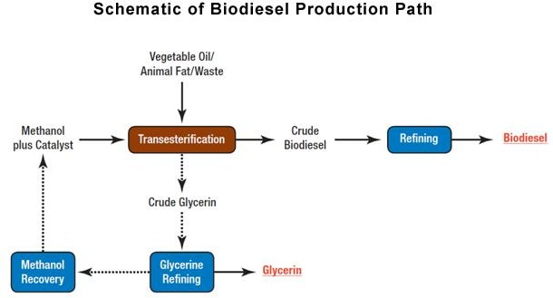

**Figure 1: Schematic of biodiesel production**

The following is the reaction for biodiesel production

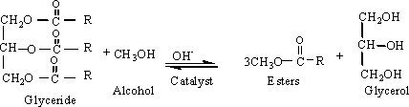

## Oxygenates

This project is mainly looking at how biodiesel properties can be improved. Recent researches have proved that oxygenates can be used to improve the properties of biodiesel. Oxygenates are among the compounds with oxygen in their chemical structure. These are usually used as additives to reduce carbon monoxide and soot that is created during the burning of fuel. Traditionally, in USA oxygenates were used to increase energy efficiency of gasoline because they have relatively high octane rating. During energy crisis in 1974, Oxygenates such as ethanol and Methyl-Ter-Butyl ether were used to improve properties of gasoline.

According to American Petroleum Institute, oxygenates have been used to primarily improve gasoline octane number and to reduce carbon monoxide emission and greenhouse effects. Several experimental researches have proven that oxygenates improve octane rating of biodiesel and reduce particulate emissions to the atmosphere. “These studies have proved that this reduction does not only depend on the oxygen content but also on the molecular structure and the different oxygen functional groups”.

* + 1. **Physical properties of oxygenates**

The following table illustrates some physical properties of oxygenates

|  |  |  |  |  |  |  |
| --- | --- | --- | --- | --- | --- | --- |
| Oxygenates | Blending octane | Blending RVP | Boiling point(F) | Energy content(MBTU/gal) | Oxygen content | Water  solubility (%) |
| Methyl Ter- Butyl  Ether(MTBE) | 110 | 8.0 | 131 | 93.5 | 18.2 | 4.3 |
| Ethyl Ter- Butyl  Ether(ETBE) | 112 | 4.0 | 161 | 96.9 | 15.7 | 1.2 |
| Ethanol | 115 | 18 | 173 | 76 | 34.8 | Infinite |
| TBA | 100 | 9.0 | 181 | 94.1 | 21.6 | Infinite |
| Propanol | 106 | 14.0 | 180 | 87.4 | 26.7 | Infinite |
| Butanol | 102 | 5.0 | 226 | 95.1 | 21.6 | 10 |

**Table 2: Physical properties of oxygenates**

By Jose Gomez etal, 2011

## 1.7 Aims and significance

The purpose of this research is to develop new alternative source of energy (biofuel). This research is also designed to upgrade biodiesel by improving its properties (Viscosity, heat content). Additionally, this project will compensate for energy consumption and protection of environment by using clean fuels. All these aims will be achieved by using oxygenates as additives to improve biodiesel properties.

In this project, two different biodiesels are synthesized from different vegetable oil by solvent extraction method using ethanol as a solvent. First biodiesel is synthesized from tiger oil and another is synthesized from Neem oil. The research will also look at the essential fuel properties of biodiesel such as density, flash point, viscosity, and acid number.

# CHAPTER 2. Literature review

Everyone is aware that without energy, human beings cannot be able to survive. Until Today, crude oil is still the major source of energy worldwide. Different statistics show there is an increase in population growth and this correlates with growth in energy consumption. Different factors including volatility in oil price, issue of climate change and increase in energy consumption have made scientists and researchers to look for alternative sources of energy. To become more efficient and sustainable in energy demand, biodiesel was well researched and developed (A. Jimoh, 2011)

## Free Fatty Acids

The issue of high FFAs in neem oil was well researched by different producers of biodiesel. The higher amount of FFAs in oil reduces the yield of biodiesel. According to American standards and testing materials (ASTM), they recommend FFA in biodiesel to be not more than 0.5%.

A study conducted (H. Muthu, 2010) on *Synthesis of Biodiesel from Neem Oil Using Sulfated zirconia via Transesterification Process* had a better economic analysis. The main purpose of their research was to investigate the performance of sulfated Zirconia as heterogeneous catalysts in the production of biodiesel from neem oil. Most varieties of neem seed produce oil of high Free Fatty Acid (FFA) content .This high content of Free Fatty Acids (FFA) can sometimes lead to the formation of soap due to high affinity of neem oil towards alkali. Consequently, neem oil has to be pretreated before transesterification process to reduce FFA. In this research, they reported that the most efficient molar ratio of methanol to oil to be used to produce biodiesel from neem oil has to be 6:1 and 1% volume of a strong acid.

After the synthesis and characterization of biodiesel obtained from neem oil, they concluded that FFA’s of crude neem oil can be reduced (minimized) in pretreatment of neem oil by using sulfated zirconia with methanol as catalyst at 650C. The yield of biodiesel produced from their research was found to have 95% of the same properties as of petroleum diesel with ASTM standards (Satya, 2011).

Another study on free fatty acid was conducted by (Prithviraj Bhandare, 2015) . In his research titled *Physico-Chemical Properties of Biodiesel Produced from Neem Oil*; he found that neem oil has potential to be a good feedstock for biodiesel production. This research was aimed at studying the effects of different level of FFA on biodiesel production. In his study, he used varieties of neem oil from different places. These neem oils used had different level of acidic content. After extraction of oil from neem seed, he found that high FFA content (>2%w/w) favors soap formation and it makes the separation of products to be very difficult. Then, he confirmed that neem oil with high content of FFA is not suitable feedstock for production of biodiesel. From his results, he concluded that high quantity of FFA in oil give low quality biodiesel while neutralized oil with low quantity of FFA give high quality biodiesel.

## Optimization by two-step transesterification

Many researchers have proven that biodiesel is economically competitive, technically feasible and environmentally acceptable. To maximize its production, optimization by two step- transesterification was found to be efficient.

In the research conducted by (Olugbenga Olufemi Awolu, 2013) which titled *Optimization of Two-step Transesterification of Biodiesel from Neem (Azadirachta indica) Oil*, they found that optimization of biodiesel efficiency can be met through two main processes. Those processes are

pretreatment of neem oil with 0.6w/w of methanol in the presence of 1%w/w H2SO4 (catalyst). This process was carried out at 500c in 1h.

The second step was to perform transesterification of the pretreated oil with NaOH .This transesterification process was conducted at temperature of 650C, reaction time of 45 to 65 min and catalyst amount of 0.45% to 1.45w/w. The results from their research show biodiesel yield of 89.69%. From their study, they concluded that maximum neem oil methyl ester (biodiesel) can be obtained through the optimization of two-step transesterification of biodiesel from neem oil by using acid-catalyzed transesterification process, followed by transesterification process by base- catalyst.

## Emissions of particulates

Biodiesel has the ability to be used as pure fuel and it can still be effective. However, to reduce the emission particulates from it, its properties need to be improved. Current studies have shown that oxygenates such as ethanol, methanol, diethyl ether and n-butanol can help to improve the quality and properties of biodiesel by reducing amount of greenhouse gases.

(Nagdeote, 2012) conducted experiments *to investigate Effects of Diethyl Ether and ethanol to Biodiesel and Diesel blends on Performance*, combustion and particulate emissions of a diesel engine. In their experiment, they used diethyl, ethanol, biodiesel and diesel. Their first trial (T1) was mixture of (30% biodiesel and 70% diesel) second trial (T2) was (5% diethyl ether, 25% biodiesel and 70% diesel) and the third trial (T3) was (5% ethanol, 25% biodiesel and 70% diesel).

After their experiment, they concluded that there was a significant reduction in smoke for the second and third trials due to the presence of oxygenate. They also claimed the presence of higher emissions of Nitrogen oxide NOX and CO in the first trial which has no oxygenate in the

mixture. The second trial which contained 5% of diethyl ether was found to have better engine performance and combustion characteristics than other 2 trials (T1 and T3).

Another research conducted (Imtenan etal, 2014) in their research *on Impact of Oxygenated Additives to Palm and Jatropha Biodiesel Blends in the Context of Performance and Emissions Characteristics of a Light-duty diesel engine*; they studied the effects of oxygenated biodiesel on engine performance. In their study, they used 3 oxygenates (ethanol, n-butanol and diethyl ether). They found that biodiesel blended by using diethyl ether and n-butanol has low CO and NOx emissions while biodiesel blended by ethanol has slight low emissions of CO and NOx. Regarding performance, diethyl ether and n-butanol were found to be very good additives. Additionally, all additives were reported to significantly reduce smoke and improve the performance of engine.

The following graph shows how oxygenates in reduction of emissions particulate to the atmosphere

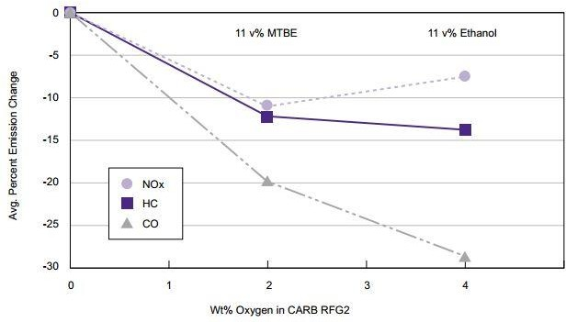

**Figure 2: Emission particulates**

## Density and Viscosity

Density and viscosity are also important properties of fuels and biofuels. Viscosity is the measure of internal friction of liquid or the resistance to a flow. Low viscosity fluids flow easily (water, alcohol); high viscosity fluids pour slowly. Viscosity changes with temperature and sometimes with pressure. For a biodiesel, the kinematic viscosity will decrease with higher temperature.

The study by (Obed M. Ali, 2013) about *Effects of Diethyl Ether Additives on Palm Biodiesel Fuel Characteristics and Low Temperature Flow Properties*, characterized the effects of diethyl ether on palm biodiesel. In this research, they used 2%, 4%, 6% and 8% of the volume of diethyl ether. They found that blending of biodiesel with diethyl ether improve viscosity and density. From their results, they reported that addition of diethyl ether and ethanol results in the decrease in density and viscosity of the blended biodiesel.

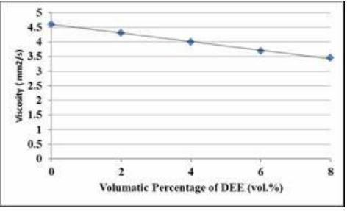

**Figure 3: Density and specific gravity**

## Octane and cetane number

According to Satya, etal in their research about *Effective Utilization of Biodiesel Blend with Oxygenated Additives*, they studied effects of diethyl ether and ethanol to biodiesel. They found that addition of oxygenates have improved the combustions process and lower emissions such as NOx. In their research, they also claimed that blends with oxygenates improve octane and cetane rating of biodiesel.

## Cloud and pour points

The cloud and pour points are among the important physical properties of oil. The cloud point of a fluid is the temperature at which dissolved solids are no longer completely soluble. In crude or heavy oils, cloud point is the same as wax appearance temperature (WAT) and wax precipitation temperature (WPT). Pour point is the lowest temperature at which oil is observed to flow under the conditions of the test. It indicates the amount of long-chain of paraffins found in a crude oil. The research conducted by (Obed, M etal) in their study on the *Effects of Diethyl Ether Additives on Palm Biodiesel Fuel Characteristics and Low Temperature Flow Properties Addition of Diethyl Ether*, they found that the addition of diethyl ether to biodiesel does not have an effect on the cloud points. Unlike cloud point, in this research, it was found that the addition of diethyl ether decrease the pour point of blended biodiesel. The bar chart below illustrates the effects of addition of diethyl ether to pour point

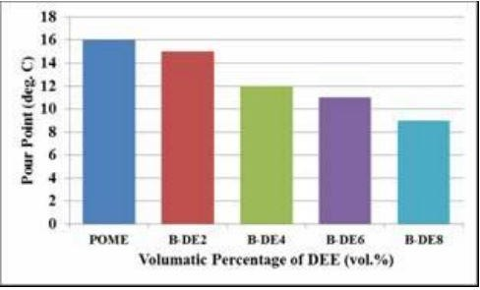

**Figure 4: Pour&cloud point**

# CHAPTER 3.0 Materials and Methods

## Extraction of Tiger oil from Tigernut

The 300g tigernut fruits were bought from Yola market. These tigernut were heated in an oven for 4 hours at about 71°C (that is the optimum temperature for roasting tubers) for 3 hours.

The next step was to grind tigernut seed into grains by using Blender and this was to create more surface area for the solvent to extract enough oil. After obtaining small grains, 100 ml of hexane was collected and poured in a round flask. Then, the grains were placed in a solvent extractor and hot plate was used to heat the solvent. Condenser was also used to condense solvent vapors and takes it back to the grains of tigernut to extract oil.

## Set up for oil solvent extraction

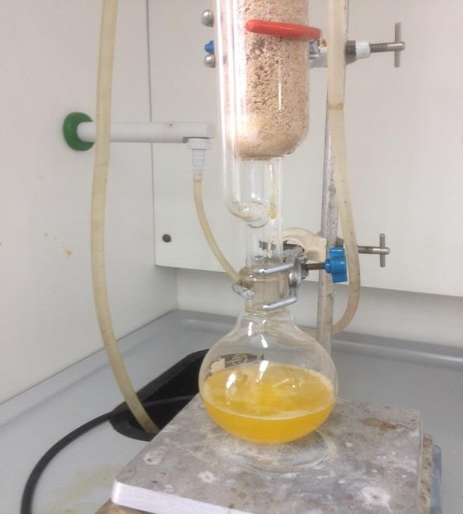

**Figure 5: solvent extraction**

## Neem oil extraction process from Neem seed

Neem seeds were gathered from neem tree inside American University of Nigeria (AUN).The same procedure was used to produce neem oil and tiger oil. There was found different methods for extraction of neem oil from neem seed. Solvent extraction method was used to extract

oil from the seeds. After oil to be extracted, it was heated at 700C to evaporate hexane (solvent). Then, neem and tiger oil extracted were analyzed using GC-MS to investigate its composition.

## Biodiesel production from Tigernut and Neem seed

## Transesterification reaction

A two-step transesterification reaction was used in this research to produce biodiesel. The essence of two-step transesterification is to reduce the amount of free fatty acid in neem and tiger oil. Two-step transesterification process is basically divided into two main reactions that are acid esterification and base transesterification.

## Acid esterification

This process is also called pre-treatment of oil. This process started by mixing 25 ml of methanol and 0.2ml of concentrated H2SO4 together inside a 250-ml conical flask. The experiment went ahead by inserting the conical flask into a water bath at 50°C. The experiment proceeded by warming 100 ml of neem and tiger oil in hot plate and later adds the mixture of methanol and sulfuric acid. It was required to place a magnetic stirrer in the conical flask and stir continuously at 700C for 45 minutes. The process was done for both neem and tiger oil samples.

## Base transesterification

The base transesterification process is actually used for the production of biodiesel. After acid pretreatment, the esterified oil was taken into the flask and heated up to 60˚C. Then, 1.78g KOH was dissolved in 30ml methanol and was added in the pre-treated oil and the mixture was heated and stirred at 700C for 1h. On completion of the reaction, the mixture was poured into separating funnel and left for 12 hrs. After 12hs, there was a separation of two layers. The upper

layer is biodiesel and the lower layer is glycerin. The lower layer was taken out and the upper layer (methyl ester) was collected, and washed.

Washing is the process of removing the remaining methanol and KOH in biodiesel. Washing was done by using warm water. This warm water was poured into biodiesel, gently shaken and allowed to separate from water. This process was repeated 5 times until lower layer, water became clearer and the biodiesel was collected. The next step was to heat biodiesel for 10 minutes to evaporate the moisture and then the produced biodiesel was taken for characterization.

Percentage yield of oil extracted (%) =𝑊𝑒𝑖𝑔ℎ𝑡 𝑜𝑓 𝑜𝑖𝑙 𝑝𝑟𝑜𝑑𝑢𝑐𝑒𝑑x100

𝑊𝑒𝑖𝑔ℎ𝑡 𝑜𝑓 𝑠𝑒𝑒𝑑 𝑢𝑠𝑒𝑑

Percentage yield of biodiesel (%) = 𝑉𝑜𝑙𝑢𝑚𝑒 𝑜𝑓 𝑝𝑟𝑜𝑑𝑢𝑐𝑡 x100

𝑉𝑜𝑙𝑢𝑚𝑒 𝑜𝑓 𝑜𝑖𝑙 𝑠𝑡𝑎𝑟𝑡𝑒𝑑 𝑤𝑖𝑡ℎ

## Characterization of biodiesel from Tiger and Neem oil

After production of biodiesel from neem and tiger oil, we characterized this biodiesel by analyzing different parameters such as viscosity, density, heat content, ash content, specific gravity, flash point, and pour and cloud point.

## GC-MS and infrared spectroscopy of the oil extracted and biodiesel produced from oil

GC-MS and infrared spectroscopy were used to determine the composition of oil as well as to analyze the produced biodiesel.

## 3.4.6. Gas Chromatography Mass Spectroscopy (GC-MS)

A GC-MS from Agilent technologies with specifications, column: Agilent109015- 433:3250C max, 30mx250µmx0.25µm was used. The separation started with an inlet volume of

0.2µl at a temperature of 500C with increase in temperature by 100C per minute to 2000C with a hold time of 1 minute; which was then increased from 600C per minute to 2800C with a hold time of 2 minutes. The total run time was 44 minutes.

## 3.4.7 Infrared spectroscopy (IR)

A Nicole FT-IR using a potassium bromide plate was used to analyze the functional groups present in the oil extracted sample and in biodiesel produced.

## Blending of biodiesel from tiger and neem oil with oxygenates

Biodiesel produced from neem and tiger oil was blended with different oxygenates. The oxygenates used are methanol, ethanol, diethyl ether and n-butanol. The ratio of biodiesel blended with methanol, ethanol, diethyl ether and n-butanol are 9:1, 4:1, 7:3, and2:3 respectively. The biodiesel blended was then characterized by analyzing the parameters such as specific gravity, viscosity, density, flash point and heat content.

## Heat content

Heat content of the produced biodiesel was determined in bomb calorimeter. 0.12g for Neem and Tiger oil biodiesel were weighed and placed in a bomb calorimeter and then the bomb calorimeter was allowed to analyze heat content of the samples within 20 minutes.

## Density

The density of Neem and Tiger Biodiesel at different ratios of oxygenates were determined by using the formula below:

*Density=Mass/Volume*

## Specific gravity

The specific gravity of the produced biodiesel at different ratios of oxygenates were determined by using the below formula:

*Specific gravity=Density of biodiesel/Density of water at 40C*

## Viscosity

The Viscosity of Neem and Tiger biodiesel at different ratios of oxygenates were studied experimentally. A Rheotech TCB-7 Viscometer bath was used to study kinematic viscosity of the different samples. For each sample, 15 ml of biodiesel with ratios of oxygenates was measured and transferred into a glass capillary viscometer. The Viscometer was set to start collecting data at 300C and the observations were recorded at 300C, 350C, 400C, 450C and 500C. Time at this different temperatures were recorded and used to calculate kinematic viscosity at different temperature

*ν = Kt,*

Where ν = kinematic viscosity (m2 s-1), K = calibration constant, and t = average time of flow(S), (for 75-viscometer, K = 2.825)

## Flash point

The flash points of Neem oil and Tiger oil biodiesel were determined by using flash point analyzer. 90ml of Tiger oil and Neem oil biodiesel were placed in a flash point analyzer, for flash point determination.

# CHAPTER 4.0 Results and Discussions

* 1. The percentage yield

|  |  |  |
| --- | --- | --- |
|  | **Neem seed** | **Tigernut** |
| Weight of seed | 700g | 700g |
| Weight obtained | 116g | 98g |
| Volume of oil started | 110ml | 98ml |
| Volume of biodiesel  produced | 72ml | 86ml |

|  |  |  |
| --- | --- | --- |
| % yield of extracted oil | 16.57% | 14% |
| % yield of biodiesel | 65.45% | 87.75% |

**Table 3: The percentage yield**

The percentage yield for neem oil was found to be 16.57% and the one tiger oil was calculated to be 14%.

The volume of Tiger Oil Methyl Ester (TOME) obtained was 86ml and the volume of tiger oil used was 98 ml. For Neem Oil Methyl Ester, the volume of product obtained was 72ml while the starting volume was 110ml. From these data, percentage yield for TOME was calculated to be 87.75% and the percentage yield for NOME was calculated to be 65.45%.

## GC-MS of extracted tiger oil

|  |  |  |
| --- | --- | --- |
| **Composition** | **Percentage** | **Structure** |
| Oleic acid | 52.35% | C18H34O2 |
| Octadecanoic acid | 18.115% | C18H36O2 |
| Ethyl methyl benzene | 7.327% | C6H6(CH3)(CH2CH3) |
| Hexadecanoic acid, methyl ester | 7.924% | C17H34O2 |

|  |  |  |
| --- | --- | --- |
| Trimethyl benzene | 0.39 | 1,2,3 CH3 C6H6 |
| Other chemical compounds | Remaining percent | |

**Table 4: Composition of oil extracted by GC-MS**

Table 4 shows the compounds present in Tiger oil extracted. From this GC-MS result, oleic acid was found to be in the highest ratio, which is always at the highest content in Tiger oil.

## Infrared spectroscopy

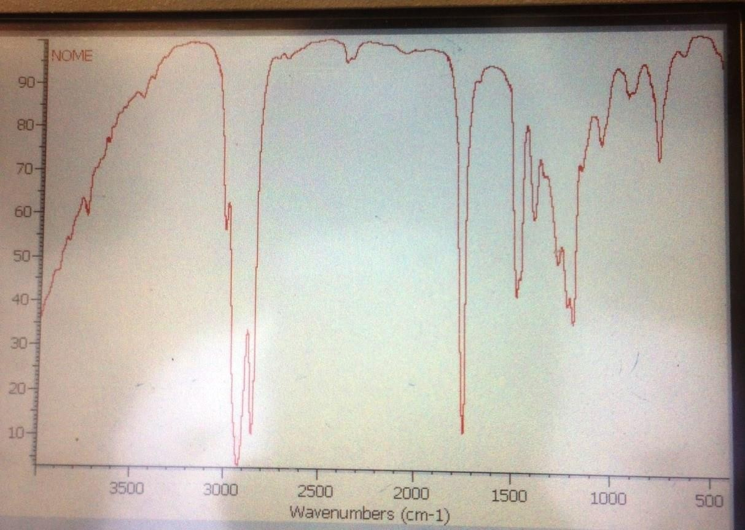

Figure 6: IR OF NOME

The fig 6 illustrates IR-spectroscopy of Neem Oil Methyl Ester (NOME), the wavelength against transmittance. This was done to determine the presence of carbonyl group bond(C=O) which shows the presence of ester compound (biodiesel). The C=O stretch peak was observed at 1700- 1750 cm-1.

|  |  |  |  |
| --- | --- | --- | --- |
| Sample | Peaks | Bonds | Functional group |
| Neem Oil Methyl  Ester(TOME) | 2800-3000 cm-1 | sp3 C-H | Alkanes |
|  | 1700-1750 cm-1 | C=0 stretch | Esters |
|  | 1430-1470 cm-1 | -CH2-CH2- | Alkanes |
|  | 1100 cm-1 | C-O-C Stretching | Esters |
|  | 725cm-1 | C-H Stretching | Saturated carbon |

**Table 5: IR peaks range for NOME**

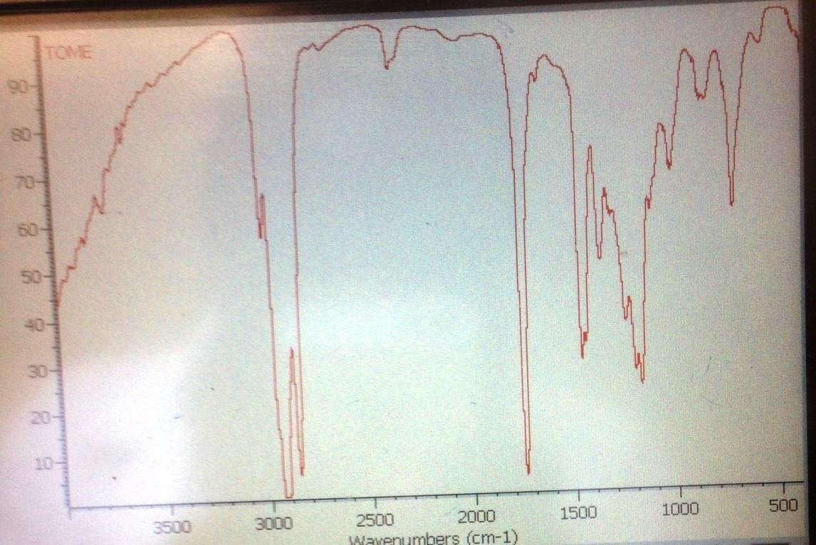

**Figure 7: IR FOR TOME**

The fig 7 illustrates IR-spectroscopy of Tiger Oil Methyl Ester (TOME), the wavelength against transmittance. The main objective of conducting IR-spectroscopy experiment was to determine

the presence of carbonyl group bond(C=O) which shows the presence of methyl ester compound (biodiesel). The C=O stretch peak was observed at 1745 cm-1.

|  |  |  |  |
| --- | --- | --- | --- |
| Sample | Peaks | Bonds | Functional group |
| Tiger Oil Methyl  Ester(TOME) | 2900 cm-1 | sp3 C-H | Alkanes |
|  | 1745 cm-1 | C=0 stretch | Esters |
|  | 1460 cm-1 | -CH2-CH2- | Alkanes |
|  | 720 cm-1 | C-O-C Stretching | Esters |
|  | 1300cm-1 | C-H Stretching | Alkanes |

**Table 6: IR peaks for TOME**

## Characteristics of biodiesel produced

|  |  |  |  |
| --- | --- | --- | --- |
| Properties | TOME | NOME | ASTM specifications |
| Kinematic viscosity at 400C  (mm2s-1) | 3.7325 | 5.085 | 1.9-6.0 |
| Heat content  (MJ/L) | 39.33 | 33.10 | 37 |
| Flash point (0C) | 136.4 | 128.6 | 60 to 190 |
| Cloud point (0C) | 15 | 13 | −3 to 12 |
| Pour point (0C) | 8 | 9 | −15 to 10 |
| Ash content (%) | <0.00 | <0.00 | <0.01 |

**Table 7: TOME AND NOME Properties**

Table 7 illustrates the properties of Neem and Tiger oil biodiesel after analyzing different parameters such as heat content, viscosity, flash point and many others. After analyzing each property, it was found that the values obtained for both TOME and NOME are in range of ASTM standards.

* + 1. **GC-MS of Neem Oil Methyl Ester**

|  |  |
| --- | --- |
| Compounds | % quality |

|  |  |
| --- | --- |
| 17-octadecenoic acid, methyl ester | 31.88 |
| 6-octadecenoic acid, methyl ester | 28.19 |
| Hexadecanoic acid, methyl ester | 18.67 |
| 9-octadecacenoic acid, methyl ester | 2.16 |
| 10-Octanedenoic acid, methyl ester | 4.56 |
| Pentadecanoic acid, methyl ester | 0.93 |

**Table 8: NOME GC-MS**

Table 8 and 9 illustrate the compounds present in TOME and NOME and their percentage quality after GC-MS analysis. It was seen that all compounds present in Tiger and Neem biodiesel are of methyl ester group.

* + 1. **GC-MS Tiger Oil Methyl Ester**

|  |  |
| --- | --- |
| Compounds | % Quality |
| 17-Octadecennoic acid, methyl ester | 27.26 |
| Hexadecenoic acid, methyl ester | 27.15 |
| 10-Octanecenoic acid, methyl ester | 17.3 |
| 9-octadecenoic acid, methyl ester | 15.24 |
| 7-Octadecenoic acid, methyl ester | 10.41 |
| 17-Octadecenoic acid, methyl ester | 0.74 |
| 6-Octadecenoic acid, methyl ester | 0.13 |

**Table 9: TOME GC-MS**

## Kinematic Viscosity

The fig 8 below illustrates the kinematic viscosity against temperature of the Neem and Tiger biodiesel. From the plot, it can be seen that the kinematic viscosity (ν = Kt) of Neem biodiesel is

higher than that of tiger biodiesel at temperature range of 25-500C. The higher viscosity of Neem biodiesel is due to the higher amount of free fatty acids in this feedstock and this affects the quality of biodiesel produced from it (Prithviraj Bhandare, 2015).



NOME

TOME

7

6

5

4

3

2

25

45

**Temperature**

**Kinematic viscosity(mm2S-1**

**Figure 8 : Viscosity against Temperature**

# Effect of oxygenates on viscosity of Tiger Oil Methyl Ester (TOME)

The fig 9 shows the effects of oxygenates (methanol, ethanol, and diethyl ether) on Tiger Oil Methyl Ester. From the graph, the viscosity of pure Tiger biodiesel is higher than the one of Tiger biodiesel with oxygenates. It can also be seen that the viscosities of each Tiger biodiesel blend decreases with the increase in oxygenates percentage. For the Tiger biodiesel blends, TOME 90:10 ET shows the highest viscosity while TOME70:30 DE has the lowest viscosity compared to other blended Tiger biodiesel. From the graph, we can also notice that diethyl ether improves kinematic

viscosity of Tiger biodiesel more than ethanol and methanol. The lowest value of viscosity was found to be 1.5537mm2s-1 for TOME70:30 DE whereas the highest value was found to be 5.14151.5537mm2s-1 for TOME90:10 ET.



6

5

4

3

2

Pure TOME

TOME90:10MET TOME80:20MET TOME70:30MET TOME70:30ET TOME90:10ET TOME80:20ET TOME70:30ET TOME90:10DE TOME80:20DE

TOME70:30 DE

1

30

35

40

**Temperature**

45

50

**Kinematic viscosity**

**Figure 9: Effect of oxygenates on Tiger Oil Methyl Ester (TOME)**

# Effects of oxygenates on viscosity of Neem Oil Methyl Ester (NOME)

Fig 10 shows the effects of oxygenates on Neem biodiesel. From the plot, the overall kinematic viscosity of pure Neem Biodiesel is higher than the Neem biodiesel blends. The blend with the highest viscosity is NOME 90:10MET while the blend with the lowest viscosity is NOME70:30DE. The lowest viscosity value was found to be 1.582mm2s-1 and the highest viscosity

was 7.7685mm2s-1. As it stated previously, this graph also supports the fact that diethyl ether improves kinematic viscosity of Neem biodiesel better than methanol and ethanol.

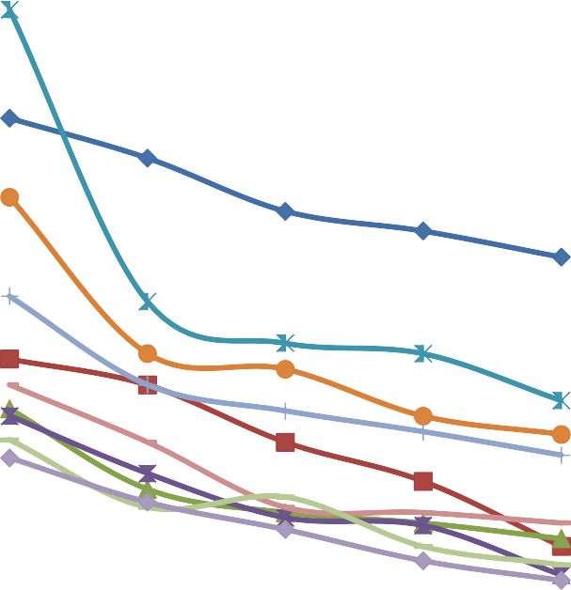

8

PURE NOME

7

NOME90:10ET

NOME80:20ET

6

NOME70:30ET

5

NOME90:10MET

NOME80:20MET

4

NOME70:30MET

3

NOME90:10DE

NOME80:20 DE

2

NOME70:30DE

1

25

35

45

**Temperature**

55

**Kinematic viscosity**

**Figure 10: Effects of oxygenates on Neem Oil Methyl Ester (NOME)**

## Effects of oxygenates on density of TOME

Chart 1 illustrates the effects of oxygenates on Tiger biodiesel. As the percentage of oxygenates increases, there was a decrease in density. It can also be noticed that pure TOME has the highest density than the blended TOME. The lowest density was seen for TOME70:30MET (0.8296g/cm3).

**Density**



**Chart: 1 Density of TOME**



0.89

0.88

0.87

0.86

0.85

0.84

0.83

0.82

0.81

0.8

## Effects of oxygenates on density of Neem Oil Methyl Ester (NOME)

Chart 2 shows the effects of oxygenates on Neem Oil Methyl Ester. It can be seen that the density of blended Neem biodiesel decreases as the percentage of oxygenates increase. Pure Neem biodiesel has the highest density value compared to the blended biodiesel. A Biodiesel blend with methanol in the ratio of 70:30 is found to have the lowest density value.

**Density**

 



**Chart: 2 Density of NOME**



1

0.95

0.9

0.85

0.8

0.75

0.7

## Effects of oxygenates on specific gravity

The specific gravity is found as density of substance over density of water. In this experiment, the specific gravity of the substances is found after calculating density of those samples. From chart 3&4 which illustrate the effects of oxygenates on specific gravity, the specific gravity of biodiesel blends decrease with increase in the proportion of oxygenates. Pure Neem and Tiger biodiesel present highest values of specific gravity compared to the blended biodiesels.

**Specific gravity**



**Chart: 3 Specific gravity TOME**



0.89

0.88

0.87

0.86

0.85

0.84

0.83

0.82

0.81

0.8



1

0.95

0.9

0.85

0.8

0.75

0.7

**Specific gravity**

  

**Chart: 4 Specific gravity for NOME**

## Summary and conclusion

This study has shown that the addition of oxygenates such as methanol, ethanol and diethyl ether has a significant effects on Neem and Tiger Oil Methyl Ester physiochemical properties such as density, specific gravity, kinematic viscosity, heat content and Flash point.

The results obtained showed that the increase in percentage of oxygenates ethanol, methanol and diethyl ether reduce kinematic viscosity, density, specific gravity, flash point and it increase heat content.

The density and specific gravity decrease with the increase in ratio of oxygenates and this is an advantage. Diethyl ether was found to be effective oxygenate than methanol and ethanol because it reduces the density of both Neem and Tiger biodiesel to match the ASTM standards of biodiesel.

The Kinematic viscosity of blended biodiesel was found also to be relatively low and it is an advantage too. The heat content of Neem and Tiger biodiesel were found to be in range of ASTM. Tiger oil Methyl Ester was found to have more heat content than Neem Oil Methyl Ester. For flash point, TOME flashed at higher temperature than NOME.

In summary, the addition of oxygenates improves the quality of biodiesel. Based on obtained results, the addition of diethyl ether at ratio of 70:30 improves the properties of biodiesel to meet that of ASTM biodiesel.

### References

A. Jimoh, J. O. U. O. A. A. A. A., 2011. Production and Characterization of Biofuel from Refined Groundnut Oil.

Anon., 2014. S. Imtenan, H Masjuki, M. Varman, Ashrafur Rahman. *Energy Conversion and Management.*

Barminas JT, M. H. K. D. T., 2013. A Preliminary Investigation into the Biofuel Characteristics of tigernut(Cyperus esculentus).

Elkady, M. Z. A. &. B., 2009. Different techniques for the production of biodiesel. *Journal of Chemistry.*

Gambo, A. a. D. A., 2014. Tigernut (CYPERUS ESCULENTUS): Composition, products, Uses and heath benefits. *Journal of Pure and Applied Sciences.*

H. Muthu, S. K. V. K. S. N., 2010. SYNTHESIS OF BIODIESEL FROM NEEM OIL USING SULFATED ZIRCONIA VIA TRANESTERIFICATION. *Brazilian Journal of chemical engineering,* Volume I, pp. 2-7.

Nagdeote, D. D., 2012. Effects of Diethyl Ether and ethanol to Biodiesel and Diesel blends on Performance. *International Journal of Emerging Technology and Advanced Engineering.*

Obed M. Ali, R. M. C. K. M. F., 2013. Effects of Diethyl Ether Additives on Palm Biodiesel Fuel characteristics and low temperature flow properties. *International Journal of Advanced Science and Technology.*

Olugbenga Olufemi Awolu, S. K. L., 2013. Optimization of two-step transesterification production of Biodiesel from Neem((Azadirachta indica) Oil. *International Journal of Energy and Environmental enginneering,* pp. 2-9.

Prithviraj Bhandare, G. N., 2015. Physico-Chemical Properties of Biodiesel Produced from Neem Oil. *Journal of sustainable Energy,* pp. 9-10.

Prithviraj Bhandare, G. R. N., 2015. Physico-Chemical Properties of Biodiesel Produced. pp. 2- 4.

Romero, S. P., 2011. Dielectric Spectroscopy in Biodiesel Production and characterization.

*Green Energy and Technology.*

Satya, V. M. K., 2011. Effective Utilization of B20 blend With Oxygenated Tdditives',. *Thermal Science.*

Singh Yadav, V. K. K. T. D. A. S. D. &. S., 2013. Performance Analysis and Exhaust Emissions of Neem methyl ester Operated Compression Engine. *Journal of Renewable & sustainable energy.*

Sivalakshmi, S., 2011. Experimental Investigation on a Diesel Fuel Engine With Neem Oil and Its Methyl Ester.

Vijayan V, T., 2013. 'Inhibitory effects of neem seed oil and its extract on various direct acting and activation-dependent mutagens-induced bacterial mutagenesis', Pharmaceutical Biology.

Vinod Vijayan, P. K. T. a. G. P. M., 2013. Inhibitory effects of neem seed oil and its extract on various direct acting and activation dependent mutagens-Induced bacterial.