# EFFECTS OF LANGUAGE EXPERIENCE APPROACH ON LITERACY SKILLS OF LEARNERS WITH INTELLECTUAL DISABILITIES IN JOS METROPOLIS, PLATEAU STATE

**NENROT VICTOR GOMWALK B.Ed., M.Ed. (Jos)**

# UJ/ 2012/PGED/0342

**A Thesis in the Department of SPECIAL EDUCATION AND REHABILITATION SCIENCES,**

# Faculty of Education,

**Submitted to the School of Postgraduate Studies, University of Jos, in Partial Fulfillment of the Requirements for the Award of the Degree of DOCTOR OF PHILOSOPHY in SPECIAL EDUCATION AND REHABILITATION SCIENCES (LEARNING DISABILITIES) of the**

# UNIVERSITY OF JOS

**NOVEMBER 2018**

**DECLARATION**

I hereby declare that this work is the product of my own research efforts undertaken under the supervision of **Dr. Abu Egwa Ozegya**, and has not been presented elsewhere for the award of a degree or certificate. All sources have been duly distinguished and appropriately acknowledged.

**NENROT VICTOR GOMWALK (/UJ/ 2012/PGED 0342)**

**DATE:**

**CERTIFICATION**

This is to certify that this thesis and the subsequent preparation of this thesis by **Nenrot Victor Gomwalk (/UJ/ 2012/PGED /0342)** were carried out under my supervision.

**DR. ABU E. OZEGYA Date**

**Supervisor**

**PROFESSOR ISUWA J. JURMANG Date**

**Head of Department**

_

**PROFESSOR MARY P. HAGGAI Date**

**Dean, Faculty of Education**

**ACKNOWLEDGEMENTS**

For every achievement in an individual’s life, there are always destiny helpers. I wish to therefore offer my sincere thanks to those who helped me.

The late Professor Charity A. Andzayi (my first academic mentor) as well as my first thesis Supervisor, late Professor Mark M. Lere both deserve special mention for providing the initial encouragement and momentum for the writing of the first drafts of this thesis. I wish also wish to acknowledge with gratitude my present thesis supervisor, Dr. Abu E. Ozegya, for providing continuous guidance and constructive criticisms of subsequent versions of the thesis. My gratitude also goes to my Head of Department, Professor Isuwa J. Jurmang for his tremendous contribution and support. Similarly, I appreciate the academic contributions and responses from Professor Joanne J. Umolu, Professor Alphonsus F. Yakubu, Professor John I Ihenacho, Professor Mary P. Haggi, Professor Christopher M. Vandeh, Professor Timothy O. Oyetunde and Dr Isaiah S. Elemukan, Dr Emmanuel A. Owobi, Dr. Bolchit A. Dala, Dr. Elizabeth Ugo, Dr Gladys D. Babudoh, and Dr Georgina C. Imo. Others are Dr Yakubu G. Kajang, Dr Augustine F. Azi, Dr Judith M. Patrick, Dr Sylvester M. Yakwal, Dr Mary M. Aiyeleso.

I also acknowledge with much fraternal appreciation the contributions of my elder brother, Dr. Philemon V. Gomwalk, for painstakingly reading through various draft versions of my chapters and also providing me with valuable academic guidance on the way forward with my work. Professor Sabina H. Gomwalk also deserves my gratitude for being so tolerant of my numerous questions on thesis writing and academic documentation in general. I am also

appreciative of the fatherly advice and encouragement offered by Professor Nenfort E. Gomwalk, former Vice –Chancellor of the University of Jos, in the course of pursuing my desire for academic upliftment. My other siblings within the Victor Gomwalk family also deserve my deep gratitude for the family love and warmth they showed me while undertaking my project write up.

Finally, I appreciate the comradeship and spirit of togetherness of all staff members at University of Jos Model Teaching Centre, Abattoir, Jos as well as staff members at the Department of Special Education and Rehabilitation Sciences. Within the Faculty of Education, I wish to make special mention of the valuable advisory assistance offered to me by Dr. Abbas Y. Mustapha, in the course of preparing this work.

**DEDICATION**

This work is dedicated to CHRIST JESUS, the risen LORD

# TABLE OF CONTENTS

**CONTENT PAGE**

TITLE PAGE i

DECLARATION CERTIFICATION DEDICATION ACKNOWLEDGEMENTS TABLE OF CONTENTS LIST OF TABLES LIST OF FIGURES LIST OF APPENDIXES ABSTRACT

ii iii iv vii vii x xi xii xiii

# CHAPTER ONE INTRODUCTION

1.1 BACKGROUND TO THE STUDY------------------------------------------- 1

1.2 STATEMENT OF THE PROBLEM 7

1.3 AIM AND OBJECTIVES OF THE STUDY--------------------------------- 9

* 1. RESEARCH QUESTIONS 9
  2. HYPOTHESES 10

1.6 SIGNIFICANCE OF THE STUDY------------------------------------------ 11

1.7 THEORETICAL FRAMEWORK-------------------------------------------- 12

1.8 SCOPE OF THE STUDY 14

1.9 OPERATIONAL DEFINITION OF TERMS------------------------------- 14

# CHAPTER TWO LITERATURE REVIEW

2.1 CONCEPT, NATURE AND CLASSIFICATION OF

INTELLECTUAL DISABILITY------------------------------------------ 16

2.2 LITERACY SKILLS DEVELOPMENT--------------------------------- 23

* 1. LANGUAGE, READING AND READING DEVELOPMENT------- 39
  2. FACTORS INFLUENCING READING COMPREHENSION

DEVELOPMENT 63

2.5 LANGUAGE EXPERIENCE APPROACH----------------------------- 70

2.6 REVIEW OF EMPIRICAL STUDIES----------------------------------- 83

2.7 SUMMARY OF LITERATURE REVIEW----------------------------- 113

# CHAPTER THREE METHOD AND PROCEDURE

3.1 RESEARCH DESIGN 116

3.2 POPULATION AND SAMPLE------------------------------------------- 117

* + 1. Population
    2. Sample

117

117

3.3 SAMPLING TECHNIQUE----------------------------------------------- - 119

3.4 INSTRUMENTS FOR DATA COLLECTION-------------------------- 119

3.4.1 Description of the Instruments-------------------------------------------- - 119

3.4.2 Procedure for Development of Instruments----------------------------- - 122

* 1. VALIDITY AND RELIABILITY OF THE INSTRUMENT--------- 122
     1. Validity
     2. Reliability

- 123

- 123

3.6 PROCEDURE FOR DATA COLLECTION----------------------------- 124

3.6.1 Training of Research Assistants------------------------------------------- 124

3.6.2 Administration of Pre-Test------------------------------------------------ - 125

3.6.3 Administration of Intervention------------------------------------------- - 126

3.6.4 Administration of Post Test---------------------------------------------- - 128

3.6.5 Scoring of the Instruments------------------------------------------------ - 128

3.7 METHOD OF DATA ANALYSIS--------------------------------------- 129

CHAPTER FOUR RESULTS AND DISCUSSION

* 1. RESULTS - 131
  2. DISCUSSION 160

CHAPTER FIVE

SUMMARY OF FINDINGS, CONCLUSION, AND RECOMMENDATIONS

5.1 SUMMARY OF FINDINGS --------------------------------------------- 165

5.2 CONCLUSION 166

5.3 RECOMMENDATIONS --------------------------------------------------- 167

5.4 LIMITATIONS OF THE STUDY ----------------------------------------- 168

5.5 SUGGESTION FOR FURTHER STUDY ------------------------------ 169

5.6 CONTRIBUTION TO KNOWLEDGE ----------------------------------- 169

REFERENCES 171

APPENDIXES 188

# LIST OF TABLES

**TABLE PAGE**

1 Distribution of Study Sample----------------------------------------------- 118

1. Summary Table of Basic Literacy Levels of Level Six Learners with

Intellectual Disabilities. 132

1. Summary Table of Receptive Language Skill of Level Six Learners with Intellectual Disabilities

134

1. Summary Table of Expressive Language Skill of Level Six Learners with Intellectual Disabilities
2. Summary Table of Sight Vocabulary Skill of Level Six Learners

with Intellectual Disabilities

136

138

1. Summary Table of Literal Reading Comprehension Skill of Level

Six Learners with Intellectual Disabilities----------------------------------- 140

1. Summary Table of Writing Skill of Learners with Intellectual Disabilities

142

1. Summary Table of t-Test on Literacy Skill of Learners with Intellectual Disabilities

144

1. Summary Table of ANOVA on Literacy Skills Scores 146
2. Summary Table of ANOVA on Receptive Language Skill Scores 148
3. Summary Table of ANOVA on Expressive Language Skill Scores 150
4. Summary Table of ANOVA on Sight Vocabulary Skill Scores 152
5. Summary Table of ANOVA on Writing Skill Scores---------------------- 154
6. Summary Table of ANOVA on Literal Reading Comprehension Skill

Scores 156

1. Summary Table of ANOVA on Literacy Skills Scores based on degrees

158

# LIST OF FIGURES

**FIGURES PAGE**

1 Typical Distribution of IQ Scores------------------------------------------- 22

1. Visual Representation of the Bottom-Up Model of Reading--------------- 48
2. Visual Representation of the Top-Down Model of Reading 49
3. Visual Representation of the Integrative-Dynamic Process Model of

Reading 51

1. Hierarchical Sketch of Basic Language Elements in LEA 73
2. Key Procedural steps involved in LEA 126

# LIST OF APPENDIXES

**APPENDIX Page**

|  |  |  |
| --- | --- | --- |
| A1 | Letter of Introduction for Main Study----------------------------------- | 189 |
| A2 | Letter of Approval to Conduct of Main study-------------------------- | 190 |
| A3 | 100 High Frequency Words------------------------------------------------ | 191 |
| A4 | Umolu’s Informal Reading Inventory (U-IRI) -------------------------- | 192 |
| A5 | Scale for Developmental Milestone--------------------------------------- | 197 |
| A6 | Teacher-Made Test on Language Experience Approach ---------------- | 200 |
| A7 | Learners’ Dictated Stories (Edited) --------------------------------------- | 205 |
| B1 | Intervention Schedules using the Language Experience Approach------ | 214 |
| B2 | Lesson Plans for the Training of Research Assistants-------------------- | 217 |
| B3 | Performance Level of Learners with Intellectual Disabilities on Literacy Skills | 223 |
| B4 | Instrument Validation Reports----------------------------------------------- | 224 |
| B5 | Analyses of Research Hypotheses------------------------------------------ | 242 |
| B6 | Analyses of Reliability Results--------------------------------------------- | 268 |
| B7 | Samples of Learners’ Written Work---------------------------------------- | 271 |

# ABSTRACT

The problem of this study stemmed from the observation of issues surrounding the literacy development of learners with intellectual disabilities. Research has it that those learners who fall into this group have sub-average intellectual functioning (between less than 20 < 70 IQ range). Due to the nature of the configuration of their brain, they have some challenges which are manifest in limited vocabulary, poor reading comprehension, weak expressive and receptive skills and limited writing skills. As a result of these challenges, learners with intellectual disabilities hardly can go beyond grade six in academic functioning. Though they may be opportuned to observe or listen to literacy information, they often remain limited in their ability to retain the essential information and express and retell events in logical sequence. This research was designed to examine the effects of Language Experience Approach on literacy skills of learners with intellectual disabilities (ID) in Jos metropolis, Plateau State. The study was an experimental research that employed randomized pretest- posttest control group design. The research design involved formation of sample (two sets of learners with identical characteristics – experimental and control groups), and assignment of subjects to groups was through randomization (R). The population of the study focused on level six (primary one) learners with intellectual disabilities. The sample for intervention comprised of twenty learners adopted as a purposive sample. They were essentially non-readers and had mild and moderate degrees of intellectual disabilities. The instruments were the Sight Word Vocabulary Test, Umolu’s Informal Reading Inventory (U-IRI) and Scale for Developmental Milestone. The treatment consisted of language experience intervention program involving sight vocabulary, literal reading comprehension, writing, receptive and expressive language skills. The test re-test reliability index was used to estimate the stability and internal consistency

of the instruments. The Sight Word Vocabulary Test had a reliability index of 0.87, Umolu’s Informal Reading Inventory had an index of 0.86, while the Scale for Developmental Milestone had an index of 0.93 respectively. The statistical techniques used were descriptive and inferential statistics involving mean scores, standard deviation, t-Test and analysis of variance (ANOVA). The results showed that language experience approach enhanced the literacy skills of learners with intellectual disabilities. The receptive and expressive language skills of learners with intellectual disabilities improved after treatment and learners with mild degree of intellectual disabilities comprehended better than those with moderate degree of intellectual disabilities. The implication of this study is that language experience approach can be used to enhance the literacy development of learners with intellectual disabilities.

# CHAPTER ONE INTRODUCTION

* 1. **BACKGROUND TO THE STUDY**

Literacy activities are avenues through which individuals are ultimately guided towards developing better and efficient reading skills. Reading plays a vital role in the Nigerian society. The ability of an individual to read is critical to success in one’s life. It creates a good foundation and inspiration for a child’s development and education. It is an important foundation skill that influences success across the school curriculum and an indicator for overall school achievement. Oyetunde and Umolu (1990) opined that reading is a complex process, which cannot be simply captured by a single definition. The authors further explained that reading is communication between the writer and the reader. The most important communicative objective behind the activity of reading is understanding and mental comprehension. A literal comprehension refers to a situation where the reader is able to recognize or locate main ideas that are explicitly stated in a reading passage, while the inferential comprehension deals with the interpretation of the text. Learners with intellectual disabilities have comprehension problems (Lere, 2013). Reading proficiency is necessary for effective knowledge and success in academic subjects. Learning depends largely upon one’s ability to interpret the printed page accurately and fully.

Reading instruction activities often tend to be an exercise in reciting passages from books with little comprehension (Andzayi, 2004). Again, delay in language development, which is a characteristic of learners with intellectual disabilities, often has negative influence on ability of such individuals to effectively comprehend what they come across in the course of reading. Similarly, Fletcher, Scott, Blair and Bolger (2004)

lamented that learners with intellectual disabilities often show significant delay in the development of receptive and expressive language skills. Receptive skill is the activity of paying attention to, and trying to get meaning from something one hears. It is the process of interpreting and negotiating meaning. Expressive skill, on the other hand, is the verbalization of thoughts. Expressive language essentially involves the existence and deployment of ideas, feelings, commands and questions in the course of verbal communication or written expression. It is in this sense that expressive language skills form an important complementary dimension to the hidden, underlying receptive skills in all human beings. Writing skills are basic mechanical abilities which help learners put their thoughts into words in meaningful ways and to mentally interact with the message. Word recognition development is an outcome of comprehension and a precondition to it, with word meaning making up to as much as seventy to eighty percent (Bouthman, 2000).

In order to satisfactorily develop the literacy and reading comprehension skills of learners with intellectual disabilities, Landis, Umolu and Mancha (2010) have advocated the use of ‘psycholinguistic’ approach to literacy and reading development, particularly recommending the adoption of the ‘Language Experience Approach’ (LEA) instructional methodology. This method represents an innovative and holistic means of teaching reading comprehension which lays much emphasis on the acquisition of basic literacy skills, as a gateway for teaching other related ‘higher-order’ reading comprehension skills. The Language Experience Approach begins with focus on early language experience in listening and speaking, then, proceeds to reading and writing skills within the classroom setting as a foundation for further language and communication development. Thus, the pupils’ beginning ideas about print, writing and reading are combined using participatory activities. Andzayi (2008) emphasized the fundamental

relevance of ‘first interest’ words in early literacy development in all learners, including those with intellectual disabilities. The author asserted that instructional activities with learners who have intellectual disabilities can move easily from listening, speaking, seeing or using print scripts to begin reading attempts from passive to active participation.

The Philosophy of Education for learners with intellectual disabilities is derived from the general philosophy on special needs education. Sections 2 and 3 of the National Policy on Special Needs Education (2015) specifically, itemized as the purpose and objectives of special needs education as follows: take care of total service delivery of the physical, mental and emotional disabilities of the Nigerian child, irrespective of the setting (school, home and hospital); provide adequate and qualitative education for all learners with special needs in all aspects of national developmental endeavors; ensure that all learners with special needs develop at a pace commensurate with their abilities and to contribute to the nation’s socio-economic and technological development.

The main goal of the National Policy on Special Needs Education (2015) is to ensure inclusion of learners with special needs, provide equal opportunity, equity and access to education in a barrier free environment. The philosophy in section 2.4 is to: identify the dignity and worth of the human person and to utilize the residual strength to overcome the weakness; enable the Nigerian child acquire appropriate skills for global competitiveness in the world of ICT; develop the child into a sound, effective and productive citizen; ensure full inclusion of the individual into the community; provide equal access to educational and other service opportunity for all citizens of the country at the primary, secondary and tertiary levels and also those outside the formal school system. Hence, learners with intellectual disabilities would require special education intervention, if need be the individualized educational programme to achieve maximally.

Intellectual disability is a condition that can occur in isolation but is more apt to be associated with related disabilities. Decreased intellectual capacity renders learners less able to adapt to their environment especially if other developmental difficulties are present. Intellectual disability is a constellation of syndromes it is not a disease. It is described as a condition that affects 2 – 4 percent of the total world population (WHO, 2011). Its primary characteristic is retarded intellectual development and reduced ability to adapt to demands of society. Learners with intellectual disabilities exhibit limited abnormal intellectual functioning which deviates so far from the intellectual functioning of the other “normal” learners that it calls attention to itself, interferes with learning and causes the learner or his teacher to be distressed. Based on these divergent behavioural characteristics, educational programmes need to be tailored towards individualized learners’ needs. Learners with intellectual disabilities are generally characterized as those in whom the intellectual functioning show marked limitations. The (American Association on Mental Deficiency [AAMD], 1973) described such learners as those with significantly sub – average general intellectual functioning existing concurrently with deficits in adaptive behaviour and these traits are manifested during the developmental period (0-18) years. For degrees of intellectual disability, the ranges provided by (AAMD, 1973) on assessment of learners with intellectual disabilities are follows: Mild Intellectual Disability IQ 50 to 70, Moderate Intellectual Disability IQ 35 to 49, Severe Intellectual Disability IQ 20 to 34, Profound Intellectual Disability IQ less than 20.

On the basis of this classification, the mild and moderate group are referred to as ‘educable’ group, severe group are ‘trainable’ while profound group are the ‘custodian’ group. Out of these four categories, the study focused only on the first two, namely, learners with mild and moderate degrees of intellectual disabilities. These categories of learners exhibit varied characteristics ranging from receptive and expressive language

deficiency; inability to read; poor identification of sight vocabulary and slower than typical development in literacy skills.

Receptive language skill covers the ability of a learner to understand and react appropriately what is communicated to the child through the use of speech language. Essentially, the acquisition of this language skill depends on the use of words, sign language, gestures and body movements by a learner for purposes of communication and the corresponding ability of a listener to understand the use of such words, gestures and movements. Expressive language skill, on the other hand, covers the ability of a learner to respond verbally to what the child hears from others around him . The acquisition of this skill enables a learner to actively use words and utterances to respond and communicate ideas, thoughts and feelings effectively to others within the immediate environment.

The inability to read refers to the situation whereby the learner is unable to recognize, interpret and to make meanings out of printed words. It also covers the learner’s failure to show adequate understanding or awareness of the general interpretive processes that underlie basic communicative reading activity. This process operates at different levels of mental activity. Similarly, poor identification of sight vocabulary is the inability of the learner to recognize words automatically. The learner seems to process the words in the same way one visually recognizes a familiar face. Sight words are the collection of words that are found in the learner’s vocabulary.

From the educational point of view, learners with intellectual disabilities can be classified into four categories based on degree of intellectual disability as thus: mild, moderate, severe, and profound intellectual disability. These classifications show that those with mild disability have intelligent Quotient (IQ) of between 50 to70; they are able to learn practical life skills, while those with moderate disability have 1.Q of between 35

to 49 and have noticeable developmental delays. Those with severe disability have 1Q of between 20 to 34, have delay in literacy development, while those with profound disability have 1.Q less than 20, and have trouble in engaging in self-reliant living outside of their immediate family surroundings.

Lere (2013) has shown that the degree of disabilities account for significant difference in reading performance of learners with disabilities. For example, the higher the degree the poorer the performance is expected to be (Ozegya, 2015). The researcher is only interested in learners with mild- and moderate- degrees of intellectual disabilities. Learners who fall within these categories of disabilities are likely to be significantly delayed in learning to read.

It has become a generally acceptable notion that the ability to use a language effectively is a function of the four macro skills of listening, speaking, reading and writing. These skills are considered paramount in acquisition of literacy. The first two skills, listening and speaking are concerned with spoken language. The third and fourth skills, reading and writing are concerned with the written language. All these skills are interrelated and are meant to be demonstrated, practiced and developed. The learner’s first contact with language is through receptive skill of listening. It is the learner’s sole contact for approximately the first years of life and it remains a major factor in all the child’s activities throughout life.

In the process of social growth however, the learner also needs to acquire other critical language skills, which are expressive in nature. In expressive language, which first involves the deployment of speaking and, subsequently, writing skills, the learner actively tries to communicate his intended message to an intended audience, in such a way that it can be easily understood (Maduekwe, 2007).

Language Experience Approach (LEA) is a method that allows the child to learn to read from his own dictated material. The reading material is based on the child’s language and experiences. Andzayi (2008) emphasized that language experience approach is used with pupils who cannot read at all or those who could only read book one. The approach has five essential steps. These include: (i) talk (ii) learner dictates, teacher writes (iii) read the story together (iv) learner illustrates the story (v) learner practices reading the story. Therefore, the quality of a story dictated by the learner and the material the child learns to read from is automatically personally meaningful to him. This avoids the problem of the learner “calling words” without understanding. The Language Experience Approach is a method of teaching beginning reading. Pupils that have reading problems are particularly likely to find the approach meaningful. Umolu and Oyetunde (1997a) stated that the approach is useful in developing reading skills and at the same time it holds promise to promote the language and culture of Nigerian learners. The authors assert that the situation in Nigeria today is that most primary schools are failing to teach literacy skills. Many learners enter secondary schools unable to read. One way of improving the standard of reading, literacy development and general instruction at the primary level is the use of LEA.

It is against this background that the researcher specifically investigated and reported on the treatment-effects of LEA on literacy skills of learners with intellectual disabilities in Open Doors for Special Learners Center, Jos, Plateau State.

# STATEMENT OF THE PROBLEM

The problem of this study stemmed from the observation of issues surrounding the literacy development of learners with intellectual disabilities. AAMD (1973) has it that this group of learners have sub-average intellectual functioning (between less than 20

< 70). Due to the nature of the configuration of their brain, they have some characteristic

issues which manifest in the form of – limited in vocabulary, reading comprehension, expressive skill, receptive skill and writing skill. As result of all these issues, learners with intellectual disabilities hardly can go beyond grade level six in academic functioning. Though they might be opportuned to observe or listen to literary information, they often remain limited in their ability to retain the essential information and express and retell events in logical sequence.

The limited vocabulary skills have significant effect either on their ability to express themselves orally or in written form. The learners have poor reading comprehension skills. Karig and Wenar (2006) have critically observed that poor attention skill of individuals with intellectual disabilities may lead to poor literacy development. Thus, reading comprehension must align to good teaching method, which is an interesting activity. Unfortunately, learners with intellectual disabilities have reading problems. Some of them can identify few vocabulary items but find it difficult to comprehend texts of their own class level.

Furthermore, Ozegya (2010) has shown that the onset as well as the degree of intellectual disabilities account for significant language delay which may affect literary acquisition. Thus, the higher the degree of disability the poorer the reading performance and more instructional intervention is required (Jensema, 1975, Ozegya, 2015). This means that effective intervention is needed to develop literacy skills among learners with intellectual disabilities. The range of literacy difficulties faced by many learners with intellectual disabilities is illustrated with reference to the school records data sourced by the researcher.

A critical observation of the achievement of learners with intellectual disabilities in sight vocabulary, expressive language, receptive language, comprehension skills and vocational skills shows that their literacy performance was poor. The percentage analysis

of the learners in each of the literacy skills examined shows that majority of them failed as compared to those who passed. This suggests that literacy skills need to be developed among the learners with intellectual disabilities within the study area (see Appendix B3). It is with this set of problems in mind that the researcher used LEA to investigate the nature and extent of basic literacy skills development exhibited among learners with intellectual disabilities within the setting of Jos metropolis, Plateau state.

# AIM AND OBJECTIVES OF THE STUDY

This research is designed to examine the effects of the LEA methodology on literacy skills of learners with intellectual disabilities in Jos metropolis. The specific objectives are to:

* + 1. Establish the basic literacy skills of Level Six learners with educable intellectual disabilities, before the commencement of treatment.
    2. Determine the effect of using LEA on the receptive language skill of Level Six learners with educable intellectual disabilities.
    3. Ascertain the effect of using LEA on the expressive language skill of Level Six learners with educable intellectual disabilities.
    4. Determine the effect of using LEA on the sight-word recognition skill of Level Six learners with educable intellectual disabilities.
    5. Examine the effect of using LEA on the literal reading comprehension skill of Level Six learners with educable intellectual disabilities.
    6. Ascertain the effect of using LEA on the writing skill of Level Six learners with educable intellectual disabilities.
    7. Establish the effect of using LEA on the literacy skills of Level Six learners with educable intellectual disabilities, based on degree of disabilities.

# RESEARCH QUESTIONS

The following research questions were advanced for investigation:

* + 1. What are the basic literacy levels of Level six learners with educable intellectual disabilities, before the commencement of treatment?
    2. To what extent would the use of LEA affect the receptive language skills of Level six learners with educable intellectual disabilities, after treatment?
    3. To what extent would the use of LEA affect the expressive language skill of Level six learners with educable intellectual disabilities, after treatment?
    4. To what extent would the use of LEA affect the sight-word recognition skill of Level six learners with educable intellectual disabilities, after treatment?
    5. To what extent would the use of LEA affect the literal reading comprehension skill of the Level six learners with educable intellectual disabilities, after treatment?
    6. To what extent would the use of LEA affect the writing skill of Level six learners with educable intellectual disabilities, after treatment?

# HYPOTHESES

The following hypotheses were tested at 0.05 level of significance:

* + 1. There is no significant difference between the literacy skill mean scores of learners with educable intellectual disabilities in the experimental and control groups, before treatment.
    2. There is no significant difference between the literacy skill mean scores for learners with educable intellectual disabilities in the experimental and control groups, after treatment.
    3. There is no significant difference between the pretest and posttest receptive language skill mean scores of learners with educable intellectual disabilities in the experimental and control groups.
    4. There is no significant difference between the pretest and posttest expressive language skill mean scores of learners with educable intellectual disabilities in the experimental and control groups.
    5. There is no significant difference between the pretest and posttest sight vocabulary recognition skill mean scores of learners educable with intellectual disabilities in the experimental and control groups.
    6. There is no significant difference between the pretest and posttest writing skill mean scores of learners with educable intellectual disabilities in the experimental and control groups.
    7. There is no significant difference between the pretest and posttest literal reading comprehension mean scores of learners with educable intellectual disabilities in the experimental and control groups.
    8. There is no significant difference between the literacy skills’ pretest and posttest mean scores of learners with mild and those with moderate degrees of intellectual disabilities in the experimental and control groups for the respective skills.

# SIGNIFICANCE OF THE STUDY

The findings of the study is of importance to learners with intellectual disabilities, their parents, reading specialists and teachers, curriculum planners and researchers. This study will benefit learners with intellectual disabilities in the sense that their vocabulary as well as reading comprehension ability would be developed. This is important in order to facilitate better receptive and expressive language skills of the learners, thus,

facilitating better literacy acquisition, as well as improvement in their oral communication skills for better conversation.

Parents of learners with intellectual disability will find the outcome of this study informative. The outcome of this study will expose them to better alternative teaching approaches which they can use to help develop the literacy skills of their children.

Reading specialists and teachers also stand to benefit from the findings of this study by exposing them to more innovative strategies and techniques for improving the literacy skills of learners with intellectual disabilities. The findings from the study can also help in ensuring greater success in the development of literacy skills among learners with intellectual disabilities in both inclusive and non-inclusive learning settings

Curriculum planners and other educational research professionals can equally take advantage of the outcomes of this study to positively impact on the design and execution of more innovative curriculum programmes affecting learners with educable intellectual disabilities. Findings from the study will add to relevant existing literature to which future researchers can make reference in their quest to improve the overall teaching of literacy skills to learners with educable intellectual disabilities.

# THEORETICAL FRAMEWORK

This study was based on the ‘Psycholinguistic Theoretical Model’, as adapted and expounded in Smith (1973). This approach focuses on development of literacy and improvement of reading comprehension skills. Smith believes that literacy is that ability to use information to solve problems, to make informed decision, to participate actively in the society, to engage in continuous learning and to shape the course of one’s life. The psycholinguistic theoretical model seeks to establish critical links between various dimensions and aspects of language and social psychology for the ultimate purpose of

improving the literacy and reading capabilities of children, including those with intellectual disabilities.

The theory is built around three basic analytical principles, namely, structural use of language, variable mechanism of human behaviour and psychomotor nature of the reading process. Language is a system that is available to its users, through its major structural components (such as sound, syntax, semantics & lexicon). This includes the set of rules that determine how words are acquired and organized in sentences. Psychology, on the other hand, is concerned with dynamic range of human behavior and with the various social conditions under which such behavior is learned. This is concerned with the manner in which humans acquire, interpret, organize, store, retrieve and employ knowledge to develop language. Similarly, the nature of reading is considered as a complex process that comprises of visual and non-visual information. It is visual because the reader can see the words, sentences and information coming through the eye as one reads. In contrast, the non - visual information are those derived from behind the eyeball, print or sentences. Thus, information known through prior experience is required for identifying a letter, a word or a meaning from the text.

This theory is synchronic with this study because, it lays emphasis on use of language, human behavior and, specifically, on reading comprehension, which lies at the heart of the present study. It recognizes the use of acquired vocabulary items as well as the teaching of a child to appreciate the fact that reading involves the use of visual and non-visual cues. The theory recognizes the personalized element in the art of teaching reading and the researcher utilized this individualized instructional dimension of teaching literacy and reading in interacting with the study participants. Therefore, this theory clearly fits into the characteristics of this study since it encourages the use of language to boost literacy development.

# SCOPE OF THE STUDY

This study focused on the development of literacy skills of learners with educable intellectual disabilities. It was limited to receptive and expressive language skills, vocabulary acquisition, writing skills and literal reading comprehension skills, using the methodology of LEA. This study was further restricted to learners at Level six at the Open Doors for Special Learners Center, Jos, Plateau State. The school is located at Liberty Boulevard, Jos, Plateau state. The school provides different services for different categories of learners with special needs, including those with intellectual disabilities.

Only variables of degree of intellectual disability in the range of mild and moderate were examined. Other conditions such as Severe to Profound Intellectual Disabilities, Autism, Cerebral Palsy and Down’s Syndrome were outside the scope of this study.

# OPERATIONAL DEFINITION OF TERMS

Technical terms used in this study were operationally defined:

**Degree of Intellectual Disabilities:** This refers to the level of intellectual disabilities of learners which ranges from mild (between 50-70 IQ) and moderate (between 35-49 IQ) only

**Intelligent Quotient (IQ):** A measure of a person’s intelligence as indicated by an intelligence test, the ratio of a person’s mental age to their chronological age (multiply by 100).

**Intellectual Disability:** Refers to a significantly sub average general intellectual functioning, existing concurrently with deficit in adaptive behavior and manifested during the developmental period (0- 18 years old).

**Learners with Intellectual Disabilities:** These are learners who have limitation in their intellectual ability, usually characterized by adaptive behavior. They involve only those

with mild and moderate degrees of intellectual disability that are regarded as an ‘educable group’

**Level Six:** This specifically refers to the category of ‘educable’ learners with intellectual disabilities who are not functioning academically at regular Primary six level

**Language Experience Approach:** This is the particular instructional method utilized in the study to improve the literacy skills of learners with intellectual disabilities.

**Literacy Skills:** The development of sight vocabulary, receptive and expressive language skills from the passages used for treatment with individuals who have intellectual disabilities.

**Mild Intellectual Disability:** The category of those with Intelligent Quotient (IQ) of between 50-70, and where 100 represent the I.Q score of an average, typically developing learner.

**Moderate Intellectual Disability:** The category of those with Intelligent Quotient (IQ) of between 35-49, and where 100 represent the IQ score of an average, typically developing learner.

**Reading Comprehension:** The process of silently decoding the expressed view of the writer of a reading text, using Language Experience Approach. It is also the ability of learners with intellectual disabilities to comprehend at literal level.

**Sight Vocabulary:** Words the learner is able to recognize instantly at sight. They are words the reader uses in his or her spoken or written language. These words are cut on flash cards to form his/her word bank.

# CHAPTER TWO LITERATURE REVIEW

This section provides details of the review of literature considered relevant to the topic of this study. They include the following: the concept, nature and classification of intellectual disabilities; literacy skills development; language, reading and reading development; factors affecting reading comprehension development of pupils with intellectual disabilities. Others include language experience approach, review of empirical studies and summary of literature review.

# CONCEPT, NATURE AND CLASSIFICATION OF INTELLECTUAL DISABILITIES

* + 1. **Concept of Intellectual Disabilities**

The term intellectual disabilities refer to a condition in which a learner has certain limitations in intellectual functions like communicating, taking care of oneself, academic retardation or has impaired social skills (Lere, 2013). These limitations cause a learner to intellectually develop more slowly than the typical, normal learner. In the past, experts and mental health professionals used the term “mental retardation” to describe a learner’s disabilities. It was the term most widely used in the diagnostic manual of mental disorders before its gradual replacement with the newer and more current term, intellectual disabilities. This term better describes the scope and reality of an intellectual developmental disorder and replaces the term, mental retardation, in the new Diagnostic Statistical Manual (DSM-V) for mental health.

The (AAMD,1973) defined mental retardation as significantly sub average general intellectual functioning, existing concurrently with deficits in adaptive behaviour and manifested during the developmental period (Grossman, 1973). Referring to the main defining traits of learners with intellectual disabilities (as reported by the Diagnostic and Statistical Manual for Mental Health, Fourth Edition), Babudoh (2008) asserted that

intellectual functioning refers to a collection of skills which are considered to be important in any particular situation (such as reasoning, problem solving, writing, use of past experience etc). The author further stated that a learner’s intelligence is said to be sub-average when his ‘mental age’ is lower than his chronological age, while the mental age is the functioning level of that particular learner. Real age is the chronological age of the learner. When a learner is unable to meet the basic standards of personal self-reliance within the family circle as well as inter-group interaction within the immediate social community, such a learner is said to have deficits in adaptive behaviour. Similarly, when a learner’s behaviour does not correspond to what is expected of him by the norms of the immediate social environment, such a person may be said to have problems of adaptation (Babudoh, 2008).This means that acquiring literacy skills of expressive and receptive language, sight vocabulary and reading comprehension will be difficult for them within the learning environment without appropriate and meaningful methodology. Since learners with intellectual disabilities often show significant delay in the development of receptive and expressive language, writing, reading comprehension and vocabulary, there is need to carefully tailor their learning to suit their learning conditions. In order to satisfactorily develop the literacy skills of this specific category of learners, psycholinguistic approach, particularly LEA instructional methodology is employed.

In a related context, Scott (2013) observed that learners with intellectual disability are those who have both academic and social limitations. They are grouped according to their degree of intellectual disabilities. One of the most obvious types of cognitive disability involves reading. Two types of intellectual disability occur in reading development. While one type often manifests in difficulty in understanding basic orthographic relationships between sounds, alphabetic letters, and lexical words, the other type frequently shows up as problems with reading comprehension, whereby learners

have issues with grasping the fundamental meanings associated with words, sentences and paragraphs in reading texts.

Intellectual disability is one of the most distressing handicaps in any given community. The condition is a generalized disorder that appears before adulthood and it is characterized by significantly impaired cognitive functioning and manifests deficits in two or more adaptive behaviors. The development of any learner with intellectual disabilities depends on the type and extent of the underlying disorder, the associated disabilities, environmental factors, psychological factors, cognitive abilities and psycho- pathological conditions. Cognitive abilities are the most readily recognized functions of learners with intellectual disabilities. Processing information may be less automatic for the learners and problems may emerge in integrating or generalizing processes, or information (Ashman, 1983).

When deeper levels of cognitive processing are required, learners with intellectual disabilities have been observed to become progressively slower in their ability to process and manipulate information about their immediate family educational setting and social environments. As learners demonstrate more severe mental retardation, they tend to expend more energy towards coding and processing information. Both Schultz (1983) and Ellis and Wooldridge (1985) reported that learners with intellectual disabilities retain pictures better than words when processing more complex and abstract information. Problems emerge in changing from one mode of processing to another, from pictures to written word or spoken word to written word.

Similarly, Beitchman and Peterson (1986) asserted that many of the adaptive behaviour problems in learners with intellectual disabilities may be due to problems in language and communication strategies. These learners have been found to focus more on the formal sequential processes of language than do their non-identified peers. Though

learners with intellectual disabilities may be proficient in using language in simple contexts, they became more challenged in terms of transfer of knowledge learnt to new situations as well as in the use of other pragmatic language skills. Learners with intellectual disabilities also demonstrate more social, behavioural and emotional problems than do their peers with other forms of disabilities (Polloway, Epstein, Cullinan, 1985; Koetting & Rice, 1991; Abbeduto & Nuccio, 1991).

Ysseldyke, Thurlow, Christenson and Muyskens (1991) reported that the home environments of learners with intellectual disabilities were less conducive to academic achievement than those of their non-identified peers, particularly in the areas of stress and valuing of education. The authors further observe that the presence of individuals with intellectual disabilities may bring about the development of tensions and stress among family members, giving rise to negative reactions of guilt, grief, denial, overprotection and social avoidance.

Lere (2014) observed that social development, for most learners with intellectual disabilities, is largely dependent on the degree of moral and family support that they get and these have serious implications for their pace of literacy development and the degree of their subsequent social integration in the community. Such family and social integration contribute significantly to overall quality of life. The low intellectual functioning associated with most learners with intellectual disabilities, as compared to their normal IQ counterparts, has also been observed to affect their academic performance, mode of social functioning with others in their immediate communal surrounding. Such functioning has also been found to be closely related to the degree of disability of an affected individual.

# Classification of Intellectual Disabilities

(AAMD, 1973), Babudoh (2008) WHO (2011) and Lere (2013) have offered different classifications of learners with intellectual disabilities. Most of these classifications are common in terms of variables affecting the education, adjustment and social life of the individual. For example, from an educational point of view, Lere (2013) classified learners with intellectual disabilities into mild, moderate, severe and profound disabilities. These classifications are discussed below:

# Mild Intellectual Disability

These are regarded as the educable group with Intelligent Quotient (IQ) of 50 to

1. They are usually slower than typical in all developmental areas, have no unusual physical characteristic and are able to learn practical life skills. Many of them attain reading skills up to grades 3 to 6.

# Moderate Intellectual Disabilities

These are equally educable groups with IQ of 35 to 49 and have noticeable developmental delays (i.e. speech, motor skills). Learners belonging to such groups may have physical signs of impairment (i.e. thick tongue) but can communicate in basic, simple ways. They are able to learn basic health and safety skills, complete self-care activities in any situation and can live in independent situation but some need support and intense classroom instructions. Babudoh (2008) stated that many learners with moderate intellectual disabilities perform academically lower than their “normal” counterparts. They equally exhibit deficiencies in adaptive behavior and often need to be taught reading, writing and mathematics at the functional level, based on their presumed lower IQ level. These two groups, the mild and the moderate, constituted the primary focus of this study.

# Severe Intellectual Disabilities

They are referred to as the trainable group of learners with intellectual disabilities with IQ range of 20 to 34 standard deviation. They manifest considerable delay in speech, but little ability to communicate. They are able to learn daily routines but need directed supervision in social situations. Most learners in this category cannot successfully live an independent life and will need to live in a group home setting.

# Profound Intellectual Disabilities

This group is popularly referred to as the custodian with IQ of less than 20. They have obvious physical and congenital abnormalities. They require close supervision, attendant to self-care activities. They may respond to physical, educational and social activities after intensive programme. They are not capable of independent living. Babudoh (2008) described learners with intellectual disabilities as exhibiting deficiencies in physical ability in addition to their mental deficiency. They also exhibit severe deficits in adaptive behavior. They are easily recognized as retarded at birth or shortly after. They are frequently institutionalized because of their extremely demanding developmental needs. They are highly dependent on others for daily living (such as eating, dressing, toileting) and cannot benefit from meaningful education.

Commenting on learners with intellectual disabilities, Shea and Bauer (1994) asserted that such learners vary in terms of cognition, language, behavior and social skills. In cognitive skills, the most readily recognized characteristics of learners with mild or moderate intellectual disabilities are those related to processing of information, integrating or general living information. Furthermore, Taylor, Richards and Brady (2005) also reported that learners who are identified with moderate intellectual disabilities lag significantly behind their grade-level peers in developing academic skills. Thus, their condition of significantly lower intellectual abilities has implications on their levels of reading comprehension and other related aspects of language achievement.

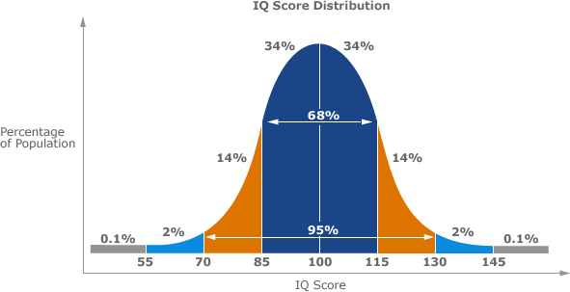

Figure 1: Typical Distribution of IQ Scores (Source: Encarta Encyclopedia, 2010)

The distribution of scores (commonly called IQ scores) on the Wechsler Adult Intelligence Scale, as shown in Figure 1 above, follows an approximately normal curve, an average distribution of values. The test is regularly adjusted so that the median score is 100—that is, so that half of the scores fall above 100, and half fall below. In Special Education, those who fall above are regarded as gifted and talented, while those who fall are learners with intellectual disabilities.

# LITERACY SKILLS DEVELOPMENT

* + 1. **Literacy skill and Literacy Development**

Literacy is a crucial step to acquire the basic skills needed to cope with the many challenges that children, youth and adults constantly face throughout their lives. The essence of global movement of literacy for all, as captured within the Dakar Framework, is amply captured in the following assertion associated with the UNESCO Decade for Literacy, 2000-2010 (Dakar Framework :Education for All, 2000):

Together, we can make a difference in this world so that everyone has access to literacy in ways that are relevant and meaningful. Literacy is about more than reading and writing-it is about how we communicate in society. It is about social practices and relationships, about knowledge, language and culture. Literacy-the use of written communication- finds its place in our lives alongside other ways of communicating. Indeed, literacy itself takes many forms: on paper, on the computer screen, on TV, on posters and signs. Those who use literacy take it for granted- but those who cannot use it are excluded from much communication in today’s world. Indeed, it is the excluded who best appreciate the notion of ‘literacy as freedom’ (p. 26).

Literacy connotes ability to read and write. It is an essential catalyst for the efficient functioning of every learner in the school system. It is also essential for the scientific and technological growth of a nation. Learners with intellectual disability therefore need to acquire literacy in order to succeed in their different skill development. Unfortunately, children who do not do well in any field are those who cannot read. The International Reading Association (2005) in association with the Rotary Clubs worldwide on literacy projects estimate that in developing countries alone, 10 million individuals with intellectual disability are not in school and so are unable to read. Again, worldwide, approximately 15 million individuals with intellectual disability are illiterate making up two-thirds of children population that cannot read.

Adzongo and Swande (2014) defined literacy as the ability of a person to read or write. Literacy, in their consideration, also refers to the ability of the teacher to use appropriate methods to teach reading, in order for learners to acquire the ability to read functionally. UNESCO (2012) characterized literacy as the ability to identify, understand, interpret, create, communicate and compute using written materials associated with varying contexts. In this sense, literacy involves a continuum of learning in enabling individuals to achieve their goals, to develop their knowledge and potential and participate fully in their community and wider society.

In Nigeria as in other countries, a considerable number of learners with intellectual disabilities do not have the level of literacy skills that is required for active participation in the community, the economy and in lifelong learning. This therefore means that literacy skills for individuals with intellectual disabilities are an indispensable tool for learning. Rattanarich (2008) observed that there are many reasons why many people, particularly those with intellectual disability cannot read and write adequately. Some of these reasons include insufficient funding for basic literacy and elementary

education; shortage of appropriate learning materials; scarcity of reading specialists; high incidence of school-drops involving children; cultural biases owing to gender stigma; sizeable number of persons with intellectual disability; and problem with the use of inappropriate method by many teachers of reading. There is also the failure of the present system to develop in children, good reading habits and love for reading (Ogunyemi, 2007). This notwithstanding, many children in Nigeria are taught to read in English without having to first learn how to speak English (Awoniyi, 2002).

In an increasingly complex world, poor reading comprehension condemns most learners to the lowest rungs of society. This particularly applies to learners with intellectual disability who have little opportunity to learn to read. In practical terms, learners who cannot recognize words on paper can hardly compete in an environment that requires high-level reading comprehension skills to master contents of school curriculum. Hence, the goal of reading should not only be the basic literacy; it should also be proficiency in reading. Bodang (2013) opined that reading liberates individuals from the ‘poverty trap’, which afflicts many third world nations and communities. Economic poverty is generally known to breed crime and aid the spread of diseases in communities with low basic literacy levels.

Literacy is a public policy issue within the context of citizenship, human resources development and lifelong learning. The National Policy on Education (2009) states that one of the basic aims of education is to read and write and to become productive and contributing member of the society. Literacy is fundamental to citizenship in a democracy to inform decision making, to personal empowerment, to enhance academic proficiency and for active and positive participation in the state and global, social and academic community. It is the foundation for basic education and lifelong

learning. Those without adequate literacy skills cannot participate in the new mode of learning how to live (Padak & Rasinski, 2000).

Researchers such as Walker, Rattanarich and Oller (1992) noted that the use of good reading method has been found to be effective in teaching and boosting reading skills and literacy development. Learners with intellectual disability earnestly require good reading methodology to facilitate the development of better literacy skills. The current curricula at both pre-primary and primary levels of the school system in the Nigerian setting needs to be redesigned to ensure that all categories of learners, including those with intellectual disabilities, are able to acquire and develop good literacy skills.

# Development of Sight Vocabulary

Sight vocabularies are words recognized immediately in the course of reading. The logic behind building automatic word-recognition skills as a foundation for reading is based on the fact that words are recognized by thinking about them. Building word recognition skills among pupils with intellectual disabilities basically involve helping them to develop the ability to recognize effortlessly as many common vocabularies as possible. Messina (2007) confirmed the truth in the view that word recognition by sight greatly increases reading fluency and reading comprehension.

Similarly, Bodang (2013) defined basic sight words as those vocabularies that the reader recognizes automatically. The author explained that the human brain seems to process the words in the same way one recognizes a familiar face. That sight words is the body of high frequency words that populate children’s text. An idea of sight word recognition was developed in helping pupils learn language and literacy. Wood (2006) expressed the view that pupils need to learn to recognize the letters of the alphabet before they are ready to learn to recognize whole words. The author further stresses the fact that pupils need to learn to recognize personally significant words such as their names and

environmental print before they learn to recognize the more abstract letters that make up their words. Therefore, recognizing sight words means figuring out the words in the sense of the whole body instead of a collection of alphabet letters.

In countries where pupils learn to read in their mother tongue, by the time the learners approach first year of school, they would already have acquired 6,000 words in spoken language (Mills, 2005). In the learners’ early primary school years, they are expected to learn to recognize most of these words in print. When the learners learn to read words in print instantly and confidently, the words will be their sight vocabulary. The author further observes that pupils in lower primary encounter one hundred high frequency words in their class text and as they move-complicated words through practice. Bodang (2013) emphasized that many of the high frequency words are link words such as “about, in, for and of”. They can be difficult for children to learn because they are meaningless in isolation. The others, such as “home, house and mother” are easier for children to learn because they have special meaning linked to children daily activities. According to Dahl (1981), learners begin to learn information receptively from the environments much earlier than they start to express and demonstrate it through their words and actions. The following seven ways to develop early sight skills have been suggested:

# Read, Re-Read, and Some More

This involves the teacher reading to the pupils every day. For beginning readers, like primary one in Nigerian public schools, picture books that pair words with depictions of those words as well as books with short sentences and colorful illustrations should be used. There should be many appropriate books to use that teach colors, numbers, size, animals, flowers, plants, objects, language and sounds, and many other concepts.

# Increase the Pupils Visual and Language Skills

Teachers need to provide opportunities to printout objects in picture, and say the name of the object to the pupils. Use picture of familiar objects, magazines photos, and so on. This activity helps the pupils develop vocabulary, verbal reasoning skills, visual processing, image recognition and memory development.

# Label Objects in the Environment for the Pupils

Print names of objects, including household objects, the pupils can touch on index cards. Attach the index cards to the objects they represent. As the pupils use these objects, the teacher cuts them out, and glues them to index cards for more reinforcement. If the child needs help, the teacher shows the child the label and says, “this is a”, the teacher has to be positive and smile. Making it fun for both the teacher and pupils is important way to help the pupils enjoy learning.

# Make Sensory Label for Environmental Objects

The teacher can use the index card above this time around, the words are decorated. Allow the pupils to choose decorations to glue over the times of the letters. Once dry, the cards with raised ridges of glue will form the letters. The pupils can trace over the letters with fingers as they learn them if they choose to do so. The cards are placed on the matching objects.

# Play the “Name” Game

This game also uses labels. Have the pupils choose which label matches which object. At first, pick two cards one that matches an object and other that does not match. Ask a pupil to choose which card matches the object help the pupil if need arises. The teacher stays positive, even when the pupil chooses the wrong answer and cheerfully gives the pupil the correct card to place on the

object. As the pupils develop their skills, they could be allowed to choose from three, four, or more cards to identify the object.

# Reading the Labels and Matching

Once the pupils recognize words on the labels and can say the words aloud, they can begin to read them aloud. Prompt the children to read the cards. Wait for about five seconds to allow thinking time. If a word is missed, the answer should be given and set the missed card aside. The teacher should create a pile of the missed cards, and go over them again with the pupils, having them say the name with the teacher. Practice the mixed cards by matching them to the objects and saying the names. Make the activity “game-like”, and praise the pupil’s efforts.

# 7 Make New Cards without Pictures

Once the pupils set of cards with pictures, a new set of cards without pictures is created. The games listed above can be played with the new cards. If the pupils have difficulty with the new cards, simply place them on objects beside the cards with pictures. Go through the games listed above while pairing the cards with the cards already mastered. Gradually remove the cards with pictures, as pupils gain familiarity with the new words without pictures (Dahl, 1981; Ikwen, 2013).

Furthermore, Shanker and Cockrum (2009) observed that learners’ vocabularies are not usually at their grade level. These pupils may need some form of direct intervention to help bring their sight vocabulary up to grade level. The writers further expressed confidence that in advancing from grade to grade, pupils should increase their sight vocabularies at each grade level. Pupils’ sight vocabularies are not up to grade level unless they can correctly pronounce 95% of the words in books written at their grade

level. Pupils who have not mastered an adequate number of sight words are greatly at disadvantage and may be having reading disability because they must analyze many more words than normal readers must. According to Oyetunde (2002), learners acquire some sight words by selecting words from their language experience stories and from storybooks read to them to practice as sight words. The words are written on flash cards and are exposed to the pupils repeatedly. Similarly, exposing pupils to activities that encourage them to identify words in isolation and in context, using a word in isolation and in context, using a word window cards, can help to enhance the development of sight word vocabularies of beginning readers.

It is important to give priority attention to sight vocabulary development. One reason for this is that vocabulary knowledge is critical to reading. Words are the building blocks of comprehension. This explains why recognition is the foundation of reading process and literacy development. It is true that the overall goal of reading is comprehension, but without the ability to recognize words in continues text quickly and correctly, this goal cannot be achieved (Ikwen, 2013; Ozegya, 2015). One would then say that sight vocabulary is the glue that holds stories, ideas and content together thereby making comprehension accessible for children. Combs (2006) noted that meaningful words are easier for readers to remember. The first words pupils are able to read are usually familiar words in their environment because they have connected the distinguishing features of these words with personal experience through repeated exposure. After pupils identify the unknown word, they may predict its possible meaning from the context. The context enables pupils to make an inquisitive stance toward word meaning and to monitor and verify predictions (Greenwood & Flannigan, 2007; Nelson 2008).

# Assessing Sight Vocabulary

One way of determining if a word is in a learner’s sight vocabulary is to show the child the word for less than two seconds. The child is expected to say what the word is as soon as the learner sees it. Hauser (1993) explained that this can be done by covering the word with a card, moving the card so that word is exposed for a brief moment only and then covering the word again. This covering and uncovering of the word is known as ‘flashing the word’. When one is assessing sight words, it is important to expose the word to the learners for a limited amount of time. A quick showing of the word for a second or less is desirable so that the reader is not using phonics or structural analysis to decode the words.

If during a lesson the teacher wants to know if a specific word is in the learner’s sight vocabulary, the teacher may write the word on the board or a piece of paper and quickly flash the word to the learner if the child can instantly tell the teacher what the word is, it is part of the learner’s sight vocabulary. Umolu (1985) emphasized that graded word lists are used to determine the overall level of a learner’s sight vocabulary. These usually begin at the pre-primary (PP) level and move up in class level to primary six. Some lists cover more levels, going up to the secondary level. A learner’s sight recognition can be tested by flashing the words on the graded lists, moving from the lowest level to higher levels. The last level where the learners can successfully read most of the words on the list is the pupil’s overall sight word level.

# Development of Receptive and Expressive Language Skills of Learners with Intellectual Disabilities

Receptive and Expressive language skills acquisition involves a two-way process between the speaker and the listener. Communication cannot take place unless the two skills listening and speaking are developed adequately. Dahl (1981) defined receptive and

expressive language skills as the combined abilities to communicate with other people. However, receptive and expressive language skills development across the curriculum does not mean teaching learners to talk. Rather, it focuses on improving their ability to talk more effectively. Oyetunde and Muodumogu (1999) observed that learners will be able to read and write English easily if their receptive and expressive language skills have been adequately developed. That is, learners are potentially able to read and write what they are able to understand and say. Speech involves thinking, knowledge and skills, as well as practice and training. Gomwalk (1999) also affirmed that learning to speak in ways that are more effective requires particular attention and practice.

The two most important language skills to develop, particularly with learners with intellectual disabilities, are listening and speaking abilities. Research shows that learners gain valuable skill in reading and writing through talking as well as listening to teachers and peers (Oyetunde & Muodumogu, 1999; Gomwalk, 1999; Ikwen, 2013). Similarly, Dahl (1981) argued that receptive and expressive language skills enable learners to first form hypotheses about the relationship between speech and print. The visual images, letters and words must come to represent sounds and meanings stored in the learner’s brain. It will seem, then that comprehension of written passages will be higher if the passages are similar to the learner’s oral language experience. Dahl concludes that there is a close link between the receptive and expressive language skills of learners and the pattern of language structure in written materials, which such learners are exposed to in the course of learning to read.

According to Oyetunde and Muodumogu (1999), some of the activities that the teacher can use to achieve the goals of receptive and expressive language skills development include the following:

1. News sharing – guiding or leading learners to talk about their experiences, events object within and outside the classroom. The teacher should share some interesting news with learners and should write them to share their own news-all in a friendly, non-threatening atmosphere.
2. Telling the learners simple stories, and asking them to tell stories.
3. Reading aloud to them and inviting their reaction and stories read.
4. Talking about pictures.
5. Retelling-listening and retelling stories.
6. A learner telling other learners a story or describing something or somebody.
7. Pairs of learners or small groups with learner telling a story.
8. The teacher discussing a topic or event with a group of learners to comment upon, add to, or ask questions about what has been said.
9. Members of a group are allocated tasks and each having to explain each responsibility and task to others.

This is concerned with the manner in which learners with intellectual disabilities acquire, interpret, organize, store, retrieve and employ knowledge to develop literacy skills. Thus, information known through prior experience is required for identifying a letter, a word or a meaning encountered in the course of reading a text.

Dahl (1981) further provided important activities that can help develop and expand receptive and expressive language skills of learners with intellectual disabilities. These include the following:

1. engaging learners in conversation throughout the day.
2. reading aloud to, and encouraging, learners to predict what will happen in the story, to comment on the story, and to make connections between the story and their personal experiences.
3. playing games that will focus a learner’s attention on the importance of listening carefully.
4. gently reinforce the rules of good listening and speaking throughout the day.
5. capitalize on routine opportunities to have learners follow or give directions.
6. playing the games, singing the songs, and having the kinds of choral speaking which helps learners to pattern standard dialect without coercion.
7. developing questioning strategies which go beyond the simple fact retrieval or literal comprehension level and which challenges learners to think.
8. expanding the learning environment by establishing interest centres in the classroom, with activities designed to build skill in both receptive and expressive language. Furthermore, Literacy Awareness Programme (LAP), Language Experience

Approach (LEA) and News on the Board (NOB) have also been identified as specific activities and strategies suitable for developing receptive and expressive language skills and print competence of beginning readers (Boison, 1997; Hughes, 1997). Literacy Awareness Programme is necessary in school because it helps the learners become better readers. It involves the teacher reading stories aloud to learners every day. This helps the learners become good listeners as well as learn about reading and language. Simple books are read to learners on a regular basis, while their reactions to the stories are often invited in a non-threatening way. Learners are required to tell the stories read to them. Thereafter, they are encouraged to engage in carrying out follow-up creative activities, including illustrating and drawing pictures of parts of the story that they like best and dramatizing key aspects of the story.

In using the Language Experience Approach (LEA), learners are encouraged to dictate stories about their experience or event that they want recorded and these are written in cardboard papers or back of old wall calendar. Both Oyetunde (2002) and

Andzayi (2004) affirmed that stories should be read with, not to, learners regularly. The basic philosophy underlying the LEA method is that learners who can think, talk, and listen can equally learn to read and write. In other words, what learners can talk about can also be expressed in writing and what learners write can be read. This makes reading very interesting and meaningful to the learners (Umolu & Oyetunde, 1997).

News on the Board (NOB), on the other hand, provides the teacher with the opportunity of leading the learners into a discussion of what they have been doing in the last couple of days. After the discussion, about two or three learners are nominated to dictate a sentence each, telling about something of interest to them. As each learner dictates the sentence, the teacher writes the learner’s sentence on the chalkboard. As the teacher writes, he/she orally say it aloud. When the teacher finished writing the “news”, the whole class now read the “news” aloud. The teacher and the learners read together as the teacher points to each word. Subsequently, the teacher picks some words from the news and writes them on flashcards while the learners take turns finding similar words in the big book or from words written on the chalkboard (Ikwen, 2013).

Matter and Goldstein (2005) affirmed that receptive and expressive language skills can be developed by teachers encouraging open discussion and free expression of ideas in an interactive environment. Teachers need to adopt the use of such leading, inquisitive questions as “tell me about the things you saw while coming to school?” and “what interests you more from this story?” The authors emphasized the fact that learners need to be encouraged to respond to questions by means of simple, complete sentences, in order to help them understand sentence structure more easily. The learners need to be encouraged to talk freely, for example, about the events and experiences that they observe and participate in their daily lives. The teacher may choose to describe the key characteristics of specific objects and, thereafter, allow the learners to identify it by name,

if they know. The teacher can also show pictures and allow them to select the ones they like and describe the picture(s) in complete sentences. Ikwen (2013) emphasized that direct oral discussion will help the learners to increase their use of different sentence patterns. For instance, taking learners on walks in and around the school premises or on visits to new places provide opportunities for discussing what they see; thereby encouraging their learning of new vocabulary card and board games also provide an opportunity for conversations about the game and other topics.

Building receptive and expressive language skills is a central ingredient to success in learning how to read and write among learners. It also aids in improving verbal expression, while further building analytical and critical thinking processes. Most learners with intellectual disabilities have inadequate sight and expressive vocabulary stocks, thereby inhibiting their overall ability to understand and retell basic information relayed to them through reading. A learner’s vocabulary skills can generally be assessed and measured in terms of both receptive and expressive vocabulary words. Building vocabulary skills improve reading comprehension and reading fluency (Time 4 Learning, 2006).

Receptive and expressive language skills instruction, especially as it affects learners with intellectual disabilities, should strive at achieving two main objectives. To help learners to acquire a stock of words they can instantly recognize, understand and relate to their overall background; to teach learners how to independently determine the meaning of words they have not been taught (Cooper, 1986). There are three types of words that primary and secondary school learners will need to learn. These words require different instructional strategies, it is important therefore that teachers choose methods that are appropriate for the type of words they want to teach. Teachers may need to teach words that are already in the learners’ oral vocabulary. These are words whose meanings

learners know if spoken. They only need to learn to associate the meaning with the graphic symbols for the words. Such words may simply be taught by giving learners to attempt to pronounce them with little attention given to meaning (Atii, 2013).

Oyetunde (1987) revealed that there are words that may not be in a learner’s active oral or reading vocabulary, but for which the learner has an existing mental understanding. Words in this category may stand for objects, ideas or concepts, which are found within the learner’s background experiences. In order to teach this category of words, the teacher would need to perform two important teaching tasks, namely, (i) to help the learners activate or call up from their past experiences the background needed for learning these words, and (ii) to help the learners learn the written symbols (such as words) that express these ideas or concepts. For many learners, especially those with intellectual disability in the primary school, words like escape, purchase, pardon, overlook, painting, blisters, stranded, tickets, burned, and conductors may fall within this category. Similarly, the author stated that there are words that are new or difficult and for which the learners have no available concepts or prior experiences. In teaching words in this category, the teacher will need to build up in pupils the necessary background experience. Instructional efforts will first of all be directed at helping learners get acquainted with these words at the oral level before they are exposed to their written symbols.

# Receptive Dimension of Language (Listening skill competency)

Receptive language skills acquisition essentially involves being able to listen successfully to spoken language and making meaning of particular words and expressions on a particular occasion. Receptive language development occurs when a learner listens to people around him over a period of time. Through this process, the learner comes to understand that language listening is the most natural channel for the reception of

language. Listening is one of the two language skill that makes the learner to pay attention to what is said so that he does not misinterpret the message. Different situations require different skills of listening. Listening could primarily be concerned with understanding a material. Tirsing (2006) asserted that much of our learning comes from informative listening. When a learner listens to teaching, what he learns depends on how he listens. If learners listen poorly, not much information will be gained. Listening could be discriminative by being sensitive to changes in a speaker’s speech rate, volume, force, pitch and emphasis. The listener can detect differences in meaning, by sensing the impact on certain responses.

# Expressive Dimension of Language (Speaking skill Competency)

Expressive language skills development has to do with the learner’s ability to correctly and adequately express himself in speech. This ability starts with sound recognition and eventually progresses into sound production. What follows is reading of material that has been taught orally, paying attention to the correspondence of sounds and symbols. The reading texts are practiced over and over until the learner is able to read. Roach (1993) stated that expressive language development has to do with how language is pronounced in the accent normally chosen as the standard for learners learning the particular spoken language.

Expressive spoken language is different from expressive writing language. In spoken language, learners often omit words that would have been included in expressive written language. In spoken expression, a learner may start a sentence, then go back and recast it as he thinks of a better way to express the thought. Expressive spoken language skill is a skill that needs to be deliberately taught and learnt by learners with intellectual disabilities as part of literacy to be acquired for school functioning. Experts in the field of

intellectual disabilities see this skill as one of the necessary skills to be enhanced amongst learners with learning disabilities, particularly those in school settings (Tirsing, 2006).

# LANGUAGE, READING AND READING DEVELOPMENT

**2.3.1. Language and Language Development Processes**

Language is often defined and understood as a string of words as well as sets of interactive mechanisms used by a particular speech community for purposes of verbal interpersonal and in-group social communication. Reading, on the other hand, is often defined and understood in terms of the process of deriving and interpreting meanings from written texts. While spoken language is essentially a socio-cultural form of behavior that is acquired over time through imitation and experiences, reading is a secondary derivative of spoken language. It is an art of interacting with the written text depending on what the text means to the reader.

According to Chomsky (1989), all learners have an innate structure known as Language Acquisition Device (LAD), which once they have acquired considerable vocabulary, enables them to integrate words to produce verbalization and comprehend stimulus reaching their auditory system. Due to the universalistic nature of LAD, it can enable learners to capture varying and complex languages. Feldman (2009) noted that the nativist approach to language development refers to the theory that a genetically determined, innate mechanism directs language development. Whereas structured child training approaches used by parents are viewed by behaviorists as being critical issues in early language learning in children, the nativists argue that it is the LAD that facilitates early language learning.

There is an emerging view that verbal or speech patterns can influence some aspects of our thought processes. The preeminence given to LAD in early language learning is not acceptable to other theorists of language development such as the

integrationist theorists (Mmegwa, Ejikeme & Ejikeme, 2014). The possession of native capacity to learn language emphasized by Chomsky is desirable for early language learning and development to take place. However, without adequate parental supervision, good teaching materials and effective language lessons by the teachers, the learner’s vocabulary may not be ripe enough to permit effective language learning and reading comprehension.

Natsopoulos and Zeromeriton (1990) investigated the use and knowledge of language structures of learners with mild disabilities. They found no real problem in the use of syntactic mechanisms for encoding, processing and expressing semantic information, in that typical learners of equivalent verbal mental age used the same processes as learners with mild disabilities. However, learners with mild disabilities were more challenged than their normal peers when asked to describe the process they applied to manipulate information. It appears that learners with mild disabilities, in general, vary only quantitatively, rather than qualitatively from normal typical peers in terms of their expressive capabilities. The instructional characteristics of both groups are similar with regards to frequency, intensity, and duration. Learners with mild disability tend to be more impulsive and display limited attention problems in the areas of focusing, vigilance and selectivity (Bauer & Shea, 1989).

The study, Allor, Mathes, Robert, Cheatham and Champlin (2010) in a fairly detailed intervention programme carried out on reading comprehension instruction for learners with mild to moderate intellectual disabilities. The study used the curriculum that includes multiple skills strands including concepts of print, phonological and phonemic awareness, letter knowledge, decoding, word identification, fluency, comprehension, vocabulary, and oral language development. At the end of the intervention, results revealed that, in general, learners showed significant gains in phonological awareness and

oral reading fluency compared to the control group. However, there were notable variations in learner- outcomes. Learners with higher IQs tended to make greater gains compared to learners with lower IQs. These results demonstrate that learners with mild to moderate intellectual disabilities can learn basic reading skills given consistent, explicit, and comprehensive reading instruction across an extended period of time.

Ezeanochie (2014) stated that literacy is the ability to read and write which involves language skills. It is a crucial life skill that needs to be developed over time through interaction within a variety of different reading materials. The author further emphasizes that reading is a process involving word recognition, comprehension and motivation. It requires that the reader identifies the words in print (word recognition); constructs understanding in print (comprehension) and uses effective reading habits to gain understanding of the text (motivation) so that reading becomes automatic and accurate. It is important to note however that the amount of time required to achieve basic literacy skills is substantially longer than the time required for typically developing students. Many learners also experienced difficulty transferring and applying skills in other contexts, and required extensive instruction and motivation to develop and maintain appropriate behavior required to participate in reading instruction.

# Components of Language

Spoken human language is composed of sounds that do not, in themselves, have meaning. Thus, /c/, /u/, and /p/ do not in themselves have any meaning, but the combination /cup/ does have a meaning. Language also is characterized by complex syntax whereby elements, usually words, are combined into more complex constructions, called phrases, and these constructions in turn play a major role in the structure of sentences.

# The Sounds of Language

Many languages are primarily spoken. An important part of the overall understanding of language involves the study of the sounds of language.Phonetics is the field of language study concerned with the physical properties of sounds and it has three subfields. Articulator phonetics explores how the human vocal apparatus produce sounds. Acoustics phonetics studies the sound waves produced by the human vocal apparatus. Auditory phonetics examines how speech sounds are perceived by the human ear. Phonology, in contrast, is concerned not with the physical properties of sounds, but rather with how they function in a particular language.

# Units of Meaning

While many learners, influenced by writing, tend to think of words as the basic units of grammatical structure, linguists recognize a smaller unit, the morpheme. The word ‘cats’ for instance, consist of two elements, or morphemes. The study of these smallest grammatical units, and the ways in which they combine into words, is called morphology (Encarta, 2009).

# Word order and Sentence Structure

Syntax is the study of how words combine to make a sentence. The order of words in sentences varies from language to language. English-language syntax, for instance, generally follows a subject-verb-object order, as in the sentence “The dog (subject) bit (verb) the man (object)”. “The dog the man bit” is not a correct construction in English, and the sentence “The man bit the dog” has a very different meaning. A general characteristic of language is that words are not directly combined into sentences, but rather into intermediate units, called phrases, which are then combined into sentences.

# Meaning in Language

While the fields of language study mentioned above deal primarily with the form of linguistic elements, semantics is the field of study that deals with the meaning of these elements. A prominent part of semantics deals with the meaning of individual morphemes. Semantics also involves studying the meanings of such smaller units of language as morphemes, words and phrases which are combined into various patterns to form simple, compound and complex sentences. For instance, the sentences “The dog bit the man” and “The man bit the dog” contain exactly the same morphemes, but they have different meaning. This is because the morphemes enter into different constructions in each sentence, reflected in the different word orders of the two sentences (Encarta, 2009). Understanding the contexts of these sentences by learners with intellectual disabilities requires strategic instruction to enable them appreciate the context of the sentence.

# The Reading Process

The process of reading comprehension essentially involves mapping an author’s messages into reader memory (Tierney & Pearson, 1994). The identification and understanding of words and sentence patterns within a text serve to bring order and meaning to the text as well as contributing to the overall social interpretations that can be derived from the text. Oyetunde and Muodumogu (1999) characterized reading comprehension as a process of obtaining information from print, a conversation between a reader and the writer. Reading comprehension process is thus an active fluent process that involves a reader actively interacting with a text. It involves the readers constructing meaning from the ideas put forth by the text according to a reader’s prior knowledge, conceptual knowledge, visual information, purpose, available strategies, and understanding of the task and settings itself. Readers actively contract meaning from text by interpreting words on page and interplay new information with pre-existing

knowledge structure that is relevant. Langer (1984) emphasized that readers build their own elaborations; read situational demands, review personal knowledge, and select what seems most appropriate and useful for the task at hand. They build expectations and predict meanings by making use of contextual clues and combining these clues with their background knowledge.

According to Langer (1984), this mental representation of what the text passage is all about occurs across multiple levels of language: at the level of sound; at the level of word formation; at the level of meaning; and at the level of contextual interaction. Across these levels, phonic and word identification, sentence phrasing, semantic referential mapping, and a variety of other inferential processes continue to interact with the reader’s conceptual knowledge, to produce a mental model of the text passage.

Umolu (1997) stated that reading is a process of perceiving, interpreting and evaluating printed Braille symbols. The writer further explained that, reading is one of the four words of communication i.e. listening, speaking, reading and writing. The author emphasized that reading is a complex process that cannot be pinned down to a single definition. In a related development, Andzayi and Umolu (2004) saw reading as the “interpretation and comprehension of printed or signed message”. It involves the evaluation of the writer’s mind from the reader’s background experiences with a view to adding or subtracting from the writer’s opinion.

Reading comprehension is a process of constructing meaning from a text. The goal of all reading instruction is ultimately targeted at helping the reader comprehend text. Comprehension is an active, intentional thinking process through which the reader constructs meaning. Ojo (2011) described reading comprehension as involving at least two people: the reader and the writer. The process of comprehending involves decoding the writer’s words and using background knowledge to construct an appropriate

understanding of the writer’s usage. Andzayi and Umolu (2004) viewed reading as the interpretation and comprehension of printed or signed message. It involves the evaluation of the writer’s mind from the reader’s background experiences, with a view to adding or subtracting from the writer’s opinion. The authors concluded that only those who have successfully learnt to read can read to learn. They further contend that achievement in content area reading is largely dependent upon the child’s ability to make meaning from the contents of a reading text.

Kirk, Gallagher, Anastasiow and Coleman (2005) emphasized that reading is an active, cognitive process, which may be somewhat demanding for the child with intellectual disability. In fact, for this type of child, it may even be difficult for him to fully understand and appreciate what reading is about. However, this situation may be remedied through the innovative use of conventional reading materials and application of teaching strategies that promote word-by-word reading of materials that is within the carefully assessed cognitive level of a child.

Furthermore, Wilson and Charmers (1988) stressed that reading entails the processing of information in written and printed materials. From the above definition, it can be deduced that, reading is one of the highest functions of the human brain and necessary in achieving academic excellence, since virtually all learning is based on the ability to read. Consequently, reading has become an important factor for successful living in any society. Achievement in content area reading is dependent upon the child’s ability to make meaning from the content of a text. Recognizing the importance of content area reading, Andzayi and Umolu (2004) noted that reading in content area refers to the same thing as teaching, reading in the school subjects. Its purpose however, is to help students to locate and comprehend information and to retrieve information as expressed in different styles of writing. Andzayi and Umolu concludes that content area

reading instruction is carried out to develop skills needed for textbooks or other books in various subject areas.

Again, Hunter-Carsh (1989) defined reading as an active, thinking process… or should be. The author quickly observed that what happens in schools may not give a child this view. The learner with intellectual disabilities may indeed be said not to know what reading is all about. This is more so, when hearing loss occurred at birth. It means that, the natural process of listening to sound, the natural process of listening to sound and reading instruction is impaired. However, this situation may be reinforced by conventional tests and teaching strategies which tend to promote word-by-word reading of material that is beyond the linguistic competence of the child.

Similarly, the reading process involves all the activities that go on when one is reading. Yusuf (2005) described the reading process as complex activities made up of both simple and difficult tasks. In reading, a child must be able to perceive the symbols set before him and this sensory aspect involves ability to interpret what he/she sees as symbols or words, follow the linear, logical and grammatical connections between symbols and words, words and what they represent (sequential aspect); relate words back to direct experiences so as to give the words meaning (experiential aspect); remember what was learned in the past and new ideas and factors (learning aspect); make inferences from and evaluate the materials read (thinking aspect); and deal with personal interest and attitudes that affect the task of reading (Smith, 1971).

Commenting on the reading process, Widdowson (1979) remarked that reading is the realization of a general interpretative process that underlines all communicative activity. This process operates at different levels of mental activity. The first level is the immediate apprehension of information and second, the discrimination of this information into patterns of conceptual significance, extracting meaning from a text

depends on two things: the reader’s knowledge and his purpose that depends on the writer’s effectiveness in giving the reader the necessary pointers to activate and absorb new knowledge from the text. However, written discourse is non-reciprocal so that, the reader must assume the dual role of addresser and the addressee and reconstitute the dialogue (Widdowson, 1979).

In a related development, Gowon (2005) stated that the reading process is divided into pre- and main- reading activities. The pre-reading activity involves defining the purpose for reading by determining the relevance of the text through studying and asking questions while reading. The second process of reading is the main activity. This involves reading through the written text while trying to answer questions that arose during the previewing activity during the previewing activity, noting how details are related to main ideas, reread difficult passage, recall task in one’s mind and review of information at regular intervals.

# Psycholinguistic Models of Reading

The process of reading comprehension can be further exemplified using either of three complimentary reading models, namely the Bottom–Up Model; the Top-Down Model and the Integrative-Dynamic Process Model. The first model assumes a rather, passive, bottom-up view which is essentially text-driven. It asserts that readers analyze and synthesis different types of information principally in order to get an authors’ obvious or implied meaning. In other words, almost all the information needed to make sense of what is being read is largely embedded in structure of the text. Thus, all that the reader needs to do is to pay enough attention to textual clues, or graphic symbols, beginning from lower units such as letters and words, moving progressively to such higher levels as phrases, clauses, sentences, paragraphs, and whole passages (Gough, 1985). The underlying assumption that is presumably made in this model of reading comprehension is that, if a reader is having reading problems, the text characteristics are most likely to be the causative agents.



SENTENCE

MEANINGS

LEXICAL-WORD

RELATIONSHIPS

SOUND-SYMBOL

RELATIONSHIPS

# Figure 2: Visual Representation of the Bottom-Up Model of Reading

(Adapted from Perfetti & Stafura, 2013)



Knowledge

Experience Emotions

Reader’s

Intentions

Meanings

# Figure 3: Visual Representation of the Top-Down Model of Reading

(Adapted from Perfetti & Stafura, 2013)

The Top-Down Model operates on the assumption that reading is primarily driven by a reader’s conceptual experience and, so, gives prominence to what a reader brings to the reading task. This, by implication, is that meaning does not lie in the text as such but in the reader’s mind. From this viewpoint, comprehension is largely determined by either the volume or quality of information or input which a reader manages to bring to bear on the reading task. Reading is therefore a sort of psycholinguistic guessing game in which readers merely sample enough text information to confirm or disprove what is already in their minds. In this case, reading problems are traced to such ‘reader-factors’ as reader purpose, scale of language knowledge or the extent of familiarity with the topic or concept being discussed in the text (Oyetunde, 2015).

While the two models outlined have held a great deal appeal to scholars of reading comprehension in the past, they have failed in many significant respects to fully explain the true nature and complexity of the reading phenomenon and its associated psychomotor processes, especially as these have continuously evolved over time. Attention has now gradually shifted to a more holistic and intuitively appealing theoretical model of reading comprehension. This is the ‘Interactive-Dynamic Process’ Model (see Figure 4), which combines both the advantages and strengths of the Top- Down and Bottom-Up Models of reading.



**Experience**

**Knowledge Emotions**

**MEANINGS**

**LEXICAL**

**Selection of**

**Appropriate Print Symbols**

**TEXT**

**PARAGRAPHS**

**SENTENCES**

(

**PRINT**

**SYMBOLS**

**WORDS**

**WORDS**

**Reader’s Intentions**



# Figure 4: Visual Representation of the Integrative-Dynamic Process Model of Reading

(Adapted from Perfetti & Stafura, 2013)

The Integrative-Decoding Model projects reading comprehension as neither a passive textual-retrieval activity nor a strict reader-determined cognitive form of behavior. Instead, reading comprehension takes the shape of a network of processes that involve interactions between a reader and a text being read, both contributing to the production and unfolding of meanings and information. The assumption of this model is that reading involves selective, yet simultaneous processing of diverse kinds of information (Oyetunde, 2015). The researcher adopted the Integrative-Decoding model because it is more applicable to the group of learners under investigation. This is because the learners told their stories after which the stories were written down and later read accordingly.

The researcher holds the view that in helping beginning readers (or non-readers) to develop effective literacy skills in English, it is appropriate to be guided by the basic principles of the interactive reading model that is inherently embedded in the LEA methodology. This particular reading model provides ample room for effective utilization of the series of instructional strategies and activities used in the study intervention.

# 2.3.5 Reading Readiness Skills

Readiness for reading is largely predicated on the assumption that there are skills and traits that pupils must have before they can learn to read. Umolu and Oyetunde (1997b) affirmed the correctness of this viewpoint in the following words:

If we as teachers go ahead and try to teach children to read before they have acquired reading readiness, our efforts are likely to fail. Just as a builder cannot put up the wall of a house until he has laid the foundation, a teacher cannot successfully teach a child to read if he does not have a strong reading readiness foundation (p. 57).

Both Lerner (1976a) and Lerner (1976b) characterized reading readiness in terms of such developmental skills as those of listening, speaking, motor development, visual discrimination of symbols, cognitive thinking and ability to attend and concentrate in activities. Smith and Johnson (1976) also identified five key aspects of reading readiness to include those of background social experience, auditory perception, visual discrimination and well-developed cognitive processing skills. In a similar vein, Umolu (1985a) subcategorized and linked reading readiness skills into the following specific abilities: to use verbal language; to classify related objects; to identify the letters of the alphabet; to recognize similarities and differences in print; to work with sequence; and to write one’s own name.

# Assessment of Reading Readiness Skills

This is an attempt to evaluate the child’s ability to perform certain skills, which either facilitate or are predictors of success in beginning reading instruction. Instructional learning activities designed to help the child develop the skills he/she cannot perform are included in the instructional programme.

**SKILL 1:** Ability to Use Verbal Language.

Researcher asks the learner to tell a story on any topic of his choice, for instance, his birthday celebration. Verbal language is widely recognized as the foundation of reading and probably the most important. If a child is unable to read, he will need comprehensive verbal language assessment and probably an intensive language development programme (Lerner, 1976; Harris & Smith, 1980, Umolu, 1985a).

**SKILL 2:** Ability to Classify Related Objects.

Researcher asks the learner to group given objects according to colors, shapes, size and weight. An important cognitive skill basic to reading is the ability to organize information into categories. If the child is unable to group the pictures correctly or explain, different classification activities are provided during instruction (Gibson, 1975; Walker, 1977, Umolu, 1985a).

**SKILL 3:** Ability to Identify the Letters of the Alphabet.

Researcher asks the learner to name letters handed to him according to upper and lower cases, name letters in different mediums. Children who are slow to recognize letters and name them are more likely to have difficulty in learning to read than children who learn this quickly (Jansky & De-Hirsh, 1972).

**SKILL 4:** Ability to Recognize Similarities and Differences in Print.

The researcher presents the learner with two objects that are similar but with visible differences and asks him to spot the differences and similarities in the objects. Visual discrimination is essential to the reading process (Brown, 1982).

**SKILL 5:** Ability to Work with Sequences.

Researcher presents leaner with objects in different sizes and ask him to arrange them in sequence in the order of smallest to the biggest. There are two parts to this assessment, namely; temporal (auditory) and spatial (visual) sequencing. Both attempt to test a child’s serial ordering skills. Studies indicate that a child with poor sequencing skills may have considerable difficulties in learning how to read Pupils who have not learnt to move from left to right experience confusion and difficulty later (Gibson, 1975, Umolu, 1985a).

In order to develop adequate reading readiness, an average child would need to be exposed to ample opportunities for learning, guidance, motivation and practice. In many developed countries like Britain, America and Canada, reading readiness is structured

into early learning activities. In a developing country such as Nigeria where many children come from illiterate homes, the lack of a well-structured reading awareness programme in the schools is a serious disadvantage to the pupils. When reading instruction is in English, the need for reading readiness is even more acute (Umolu, 1997). Unfortunately, Nigerian children go through a complex process of learning to read in English fraught with traumatic experiences. It is for this reason that Mayo (1971) stressed that parents and teachers need to think about what homes are for, and what schools are for, when they meet at the Parents – Teachers Association (PTA) meetings. In this connection, Durojaiye (1977) observed that many parents and teachers often make learners to learn letters and numbers so that they will be ahead on entering primary school. For this reason, such parents and teachers require very young pupils to undertake literacy tasks for which they are not yet ready.

Aboki (1991) also recommended that reading specialists should be posted to pre- primary schools to help stimulate children’s creativity and imagination. Such specialists can also read storybooks to the pupils regularly, in order to help them further develop their listening comprehension skills and have interest in reading. Milaham (1991) highlighted the harmful effects of parental illiteracy in the home setting on the eventual educational aspirations of children. Most of the children studied by Milaham had parents who were illiterate and belonged to low income, socio-economic groups. The findings from his study indicates that very few of such children regularly attend schools and could not afford to regularly buy prescribed school textbooks, exercise books. The findings also established that most parents covered by the research sample had very limited or nonexistent formal school attendance. The study was ultimately able to provide strong evidence of a close relationship between home setting and the rate of school success among children from low-income, family backgrounds.

Karlin (1971) reported that both home and family factors significantly influence the level of educational success of children in the school setting. The study by Karlin also established that there are proportionally many more reading failures among children who come from poor home, than there are among affluent age peers. This partially gives credence to the commonplace assumption that children who come from high socio- economic class as a group are far better readers than their contemporaries who come from low-income families and have limited literacy exposure in the home setting. Other comparable studies, including (Reid, 1977; Travers, 1977), also showed that most adults who have had above-average school experience are in a much better position to help their children learn to read at home.

Travers (1977) further observed that individuals belonging to educated, middle class backgrounds were in a better position to make provisions for the education of their children at home. This shows that uneducated, economically disadvantaged parents might be unable to help their children in this respect. It is true therefore, that how successful the education of the child will be in future is determined to a large extent by how well his parents have been educated and the level of incentives provided for that child at an early stage. This is usually the case if the parents make efforts to read to the child and perhaps teach simple sight words. The implication is that a child who has not developed reading readiness skills will definitely experience reading problems.

# The Writing Process

Writing skills are basic mechanical abilities which help writers put their thoughts into words in a meaningful way and to mentally interact with the message. They help the learner gain independence, comprehensibility, fluency and creativity in writing. According to Hampton (1989), when learners master these skills, they will be able to write and read what they have written and other speakers of the same language can also

read and understand what they have written. Writing is communicating messages or information which has to be understood by the reader. Basic writing skills include: recognizing alphabet scripting and the linear sequence of sounds; vocabulary development; sentence formation; recognizing the need space between words and paragraph outlining. Creativity skills for writing include the ability to write freely anything the learner wants to write. The teacher needs to approach writing in a motivational way to enable the learners acquire those skills that enhances writing.

Writing is an art which needs to be learned and practiced. It is a reflection of a learner’s desires, thoughts and speech. The written expression may be clear or clouded. Some learners write in words, phrases and short sentences, some write in long and clumsy sentences, while others write simply and coherently. According to Lock (2010), writing is the manner in which a writer addresses a subject matter. The style of writing reveals the writer’s personality. Style here means the way in which the individual puts words together when writing. It portrays the choices the writer makes in syntactical structures, diction and figures of thoughts.

The relationship between reading and writing are two separate yet interrelated skills that are intricately linked and are extremely complex. They share similar underlying processes. According to Paul and Quigley (1994), good writers are almost always good readers and good readers have the potential to become good writers. Writing is a way of expressing one’s self, while reading on the other hand, is the process of understanding written language. Both reading and writing are built on the experiential knowledge base and the grammatical base of a spoken language; hence there is a very strong link between listening and reading skills.

According to Goodman, Watson and Burke (1987), reading and writing are part of the world of learners. The important influence reading has on writing is that learners’

write what they observe during reading. The interaction between reading and writing is not on equal proportion. Readers do not necessarily write during reading, but writers must read and re-read during writing particularly as texts gets longer and their purpose get more complex: In a similar vein, Tindal and Parker (1989) opined that written expression of the learner can be assessed using a holistic judgment of communicative effectiveness. This can be achieved through direct counting of the total number of words used in the write-up, the number of words written legibly and number of words spelled correctly. It entails the counting of sentences used which are written in correct sequence of words, the calculation of the percentage of words correctly spelled and the calculation of the percentage of words correctly sequenced. Within a planned whole school approach, teachers should gather assessment information based on contributions from a variety of sources. For example, collecting samples of learners writing carefully selected over time, to provide evidence of progress. Criteria for assessing need to cover the whole text, sentence-level and word-level aspects of the text, observing learners’ behavior and interacting with them as they engage in the process of writing during modeled, guided and independent writing.

The phoneme is a basic building block for spoken words. Phonemic awareness is typically described as an insight about oral language and in particular about the segmentation of sounds that are used in speech segmentation (International Reading Association, IRA 1998). Phonemic awareness is characterized in terms of the ability of the language learner to manipulate the sounds in words and blend strings of isolated sounds together to form recognizable word forms. To be precise, phonemic awareness refers to an understanding about the smallest units of sound that make up the speech stream; phoneme (IRA 1998). It is the ability to identify and manipulate the sounds that are representative of graphemes in the English Language. Such manipulative tasks

include segmentation, deletion, substitution and addition of sounds. Phonemic awareness also included the synthesis (blending) of those segmented words (Powell, 2004).

Reading experts say phonic awareness is essential because any writing system is a representation of speech sounds which are represented by the symbols on a page. For this reason, pupils who have reading problems usually display a weakness in detecting and identifying speech sounds because printed symbols appear arbitrary to such learners who do not possess phonemic awareness. For over 50 years, discussions have continued regarding the relationship between a pupil’s awareness of the sound of spoken words and his/her ability to read. According to Powell (2004), in the 1940s, some psychologists noted that pupils with reading disabilities were unable to differentiate spoken words into their component sounds. Psychological research intensified during the 1960s and 1970s which led to new findings which pointed eventually to the important relationship between phonemic awareness and learning to read.

Some recent longitudinal studies of reading acquisitions have also demonstrated that acquisition of phonemic awareness is highly predictive of success in learning to read; in particular, in predicting success in learning to In fact, phonemic awareness abilities in kindergarten through grade one appears to be the best single predictor of successful reading acquisition decode. Some scholars have also opined that faced with an alphabet script, pupils’ level of phonemic awareness on entering school may be the single most powerful determinant of the success he/she will experience in learning to read ( Juel, 2001; National Reading Panel, 2000). In order to benefit from reading instructions, developing readers need to understand that words are made up of discrete sounds. Once pupils understand the basic principle that words can be divided into individual phonemes and that those phonemes can be blended into words, they can use such knowledge of letter-sound relationships to read and build words (Chard & Dickson, 2001)

In another related study (Kirby, Parrila & Pfeiffer, 2003), learners’ level of phonemic awareness and naming speed in kindergarten were found to be strong predictors of reading achievement in first and second grades. They concluded that learners with sufficient phonemic awareness had a better understanding of “low words work” and were therefore able to identify and read words by sounding them out. Those learners who did not possess sufficient phonemic awareness skills had to rely on memorization of words by sight. As these learners entered second grade, the text they read grew less patterned and predictable and so as a result, their reading skills began to suffer. These results prove that the difficulty of phonemic awareness persist over time. If not rectified, it will continue to affect reading performance in higher classes.

More recently, there have been similar studies of phonemic awareness training approaches that include interaction with print during the training. At least one of such studies (Rosenberg, 2006) has suggested that programs that encourage high levels of learners’ engagement and interaction with print (for example, through read aloud, shared reading and invented spelling) yield as much growth in phonemic awareness abilities as programs that offer only a focus oral language teaching. This study also suggests that the greatest impact on phonemic awareness is achieved when there is combined interaction with print as well as explicit attention to phonemic awareness activities. In other words, interaction with print combined with explicit attention to sound structure in spoken words, is the best vehicle for promoting phonemic awareness.

# The Design and Use of Informal Reading Inventory (IRI)

IRI was carefully constructed to take into account the peculiarities of the Nigerian literacy and educational setup (Umolu & Mallam, 1985). IRI is essentially designed to be a structured approach to the informal assessment of reading. Reading ability level 1, the independent level, refers to when a learner can read a text accurately with understanding.

Level 2, the instructional level, refers to when the learner is likely to need support from the teacher in order to benefit from the text is too demanding, is difficult for the particular learner and it is probably best to discontinue using it for the time being.

Beard (1990) explained that an IRI is usually administrated by asking a learner to read aloud a carefully chosen text, making a note of the learner’s accuracy in reading and asking some questions to assess comprehension, both in recall and interpretation. Johnson and Kress (1965) states that the criteria for assessing a learner are reading level in relation to a specific text are follows:

* + - 1. independent reading level, which refers to oral reading accuracy of 99% and comprehension of 90% or more;
      2. frustration reading level, which refers to oral reading accuracy of 90% or less and comprehension of 50% or less.

However, the criteria for assessing a learner’s reading level in relation to a specific text, as applicable to the Nigeria educational setting, is that provided in Umolu (1985a) as follows:

1. independent reading level, which refers to oral accuracy 95% and above and comprehension of 3-5-4 (70 - 80%);
2. instructional reading level, which refers to oral reading accuracy of 90%-94% and comprehension of 2-3 (40 - 60%).
3. frustration reading level, which refers to oral reading accuracy of 90% or less and comprehension of less than 2 (less than 40%).

The IRI is an effective assessment instrument especially as it is appropriate for assessment after the learners begin to read enough in Nigerian schools. An IRI consists of graded oral reading passages representing a range of reading levels. The main function of IRI is to indicate to the teacher the level of difficulty of reading material that is neither

too easy nor too difficult for a particular learner. This is considered the instructional reading level of the learner. That is, the level at which the learner can best benefit from reading instruction (Umolu, 1985a). The learner reads orally the series of progressively more difficult passages while the examiner records the word recognition errors the child makes during reading. After reading, the learner is asked questions about the passage to test comprehension skill and these are recorded. The learner’s word recognition and comprehension performance of each reading level are then compared with the criteria being used with the test to determine the instructional level. The most widely used criteria are those of Betts and Welch (1964), according to this criterion, a learner’s instructional level is 95%-word recognition and 75% correct comprehension. Unfamiliar passages to the learner are used to avoid memorization.

A fog readability index could be used to determine the readability level of the passages to enable one to grade the passage into 1a, 1b to 6a, 6b. Preferably the passages should be typed. The learner’s copy could have bolder print, while the teacher’s copy has the normal print with recording box for word recognition and comprehension performance. Errors are then analyzed and normally, the pattern of error will show the need for instruction is used in planning the child’s instructional programme. Umolu (1991) has however advised that instead of using Informal Reading Inventory (IRI), modified and simpler variants of the original IRI (Umolu, 1986) may be fashioned and used by classroom teachers. Passages from old English textbooks can be cut and glued to the pages of an exercise book. A teacher can then set questions to test all aspects of reading comprehension: literal, inferential, critical and main idea. The pictures in U-IRI can also be replaced with drawn pictures to prevent the learners being tested from memorizing the passages from the book.

# FACTORS INFLUENCING READING COMPREHENSION DEVELOPMENT

There are several factors influencing reading comprehension development of learners. These include the following:

# Levels of Reading Comprehension

There are different opinions and categorization of the levels of reading comprehension as provided by experts. Learners with intellectual disability equally function within these levels. Gowon (2005), for example, noted that reading comprehension is known to operate at three basic levels namely: literal/factual; inferential/ evaluative and critical/analytic levels. The literal level of comprehension refers to the situation where the reader merely recognizes or locates main ideas, sequence, comparisons, cause effects and character traits that are explicitly stated in the passage. The reader recalls the factual information given in the text or stories. This is however the lowest level of comprehension. The inferential comprehension deals with the interpretation of the text. The reader applies a higher thought process involving analysis and the making out conclusion or making generalization. Babudoh (2010) further explained that the reader usually sees logical connections between and among the ideas in the reading text. The result is that the learners re-construct and express the facts in alternative ways. On the other hand, critical comprehension is regarded as the highest level of comprehension involving evaluation or critical analysis or judgment of what is being read in terms of adequacy, solidity, reality and opinion in relation to the person’s past experiences.

# Reading Comprehension Instructional Strategies

Comprehension is the essence of reading, since reading facilitates acquisition of good literacy skills; comprehension of text by learners with intellectual disability is of utmost importance. According to Califee, Arnold and Drum (1976), there is a strong relationship between the ability to read individual words and the ability to comprehend texts. The writers are of the view that pupils who are good in identifying individual words are also likely to be good at text comprehension as well. Similarly, learners who are poor at word identification are very likely to be poor at comprehending texts. The authors also agree that there is a small minority of learners whose comprehension of text lags significantly behind their ability to identify individual words in the text. In line with the observations made above, Jorm (1985) observed that adequate reading comprehension has remained a major problem area for empirical investigation that is yet to be properly addressed. This gap in study particularly applies to learners with intellectual disability, who may be able to identify individual words in the course of reading but still have difficulties with overall text comprehension. Therefore, both teachers and researchers in reading need to further explore how they can identify, utilize and employ comprehension strategies within the elementary school curriculum to develop pupils’ basic literacy and reading skills.

Ojo (2011) noted that the most successful way to teach comprehension strategies to learners with limited reading proficiency is to use very direct and explicit instructional methods. The author believes that teaching of comprehension instruction must follow certain stages. These include:

1. orienting learners to key concepts, assess, and ask students to make a commitment to learn.
2. describing the purpose of the strategies, the potential benefit and the steps of the strategy.
3. modeling (think-aloud) the behaviors and cognitive steps involved in using the strategy.
4. providing for guide and control practice of the strategy with detailed feedback from the teacher and/or knowledgeable peers.
5. moving gradually to more independent and advanced practice of the strategy with feedback from the teacher or knowledgeable peer and;
6. applying the strategy, from time to time, after short breaks, in order to help learners to become familiar with its use.

Once the strategy is learnt, the teacher then ensures that learners begin to transfer or generalize the strategy to new and different situations. The last stage, according to Ojo (2011) included four (4) interrelated phases, namely:

* 1. orientation and awareness of situation in which the strategy can be used;
  2. activation by preparing for the practicing strategies in content areas classes;
  3. adaptation of the strategies for use in other tasks and;
  4. maintenance of the strategy for continued application in a variety of real-life learning and work place setting

# Age and Onset of Disabilities

The age of learners with intellectual disabilities can be categorized into upper and lower ranges. This is based on the learner’s chronological age. However, it is said that intellectual disabilities occur mainly during the developmental periods (0-18 years). It is instructive to note that, though the developmental period stops at 18 years, the learner’s chronological age could exceed this range. These variations in age can be subject to experimentation and/or intervention (Jatau, Uzor & Lere, 2009). Onset refers to the

period at which intellectual disability set in a learner. In special education, this process connotes the time a learner either acquires or develops any form of intellectual disability. This is usually at birth or after birth due to different sorts of incidences.

Information from the Office of Demographic Studies, Gallaudet University (1975) revealed that one of the most important considerations related to age at onset of intellectual disability is the period at which the disability occurred. It is general knowledge that the learner’s grasp of language fundamentals is partly determined by the nature of the learner’s educational environment. Ozegya (2015) classified the onset of disability into congenital and adventitious. While the congenital has to do with issues related to occurrences before birth, the adventitious has to do with after birth. Ojile (1986) also observed that the adventitiously impaired exhibit difference in intellectual and educational characteristics from those of their counterparts who are congenitally impaired.

One of the factors that affect the reading ability of learners with disabilities is the period at which impairment set in a learner. Usually, learners are either born with impairment condition or acquire it later in life through accident, diseases or sicknesses. Ozegya (2014) reported on findings derived from a comparative study of reading comprehension of learners who are born with hearing disability and those who acquired the disability later in life. After extensive reading intervention, the findings indicated that the onset of disability has significant influence on the reading performance of the learners. Those who acquired the disability later in life performed better in the posttest reading intervention than their counterparts who were born with the disability. Logically when a learner is born with an intellectual disability, the tendency for acquisition of language and reading skills will be limited because of the intellectual dysfunction.

# 2.4.4. Degrees of Intellectual Disabilities

Degree of intellectual disabilities connotes the extent to which the disability has affected the learner. The Centre for Disease Control (1994) categorized degrees of intellectual disability, based on the following ranges: (a) mild cognitive disabilities – IQ of 50 to 70; (b) moderate cognitive disabilities – IQ of 35 to 55; (c) severe cognitive impairment – IQ of 20 to 40; (d) profound cognitive disabilities – below 20. CDC (1994) further reports that signs of cognitive impairment can be recognized as early as 2 years of age. The following are symptoms that occur at varying levels, depending on the severity of the disorder: (a) delays on reaching early childhood developmental milestones; (b) difficulty retaining information and learning simple routines; (c) confusion and behavior problems in new situation or places; (d) lack of curiosity; (e) difficulty understanding social roles ; (f) sustained infantile behavior into toddlerhood or pre-school years; (g) difficulty understanding consequences of actions; (h) limited and or inconsistent communication skills;(i) lack of age appropriate self-help and self-care skills (CDC, 1994)

Similarly, Abang (2005) noted that the degree of intellectual disabilities range from mild, moderate, severe and profound respectively. The author contends that learners with mild disabilities are able to achieve what most average learners without disabilities are capable of achieving but at a much slower pace. They can complete their elementary school education successfully in a regular setting. On the other hand, those with moderate disabilities are known to have problems with interpersonal relationships, social skills, emotional stability and communication. Their deficiencies become more obvious when they grow older because they lag behind further and further in social, emotional and academic development.

The learners with severe intellectual disabilities may demonstrate such behaviors as poor speech, inadequate social skills, poor motor development and non-ambulation, psychiatric imbalance and aggressive behaviour. On the other hand, learners with profound intellectual disabilities have little or no adaptive behaviors and exist in a medically fragile state (Abang, 2005). Similarly, Davis (1988) also posited that the mean age deviation of learners with severe intellectual disabilities steadily declines as the degree of disability becomes more severe. Thus, it can be deduced that the reading comprehension and language development of learners with intellectual disabilities may be affected academically, depending on the degree of disability.

These degrees are in ranges, based on the intellectual functioning of learners. Some are educable, some are trainable while others are dependent popularly referred to as the custodian. It has been noted that the mean age deviation scores of learners with intellectual disability steadily declines as the degree of disability become more severe (Cruickshank, 1971). Thus, it is logical that a learner’s reading performance and literacy development will be affected, depending on the degree of intellectual disabilities sustained. Davis (1988) also agreed with the widespread viewpoint that the personal characteristics of learners with varying degrees of intellectual disabilities invariably influence either the academic achievement or social adjustment levels (or sometimes both) of such learners.

In a specific study on learners with mild and moderate intellectual disability, Kernan and Sabsay (1993) reported that in appropriate and conducive social contexts, learners with intellectual disabilities can understand and produce stories that are essentially the same in structure as those produced by learners without intellectual disabilities. In the course of conducting their study, Kernan and Sabsay found that learners with intellectual disabilities were able to recognize the main points in stories,

judge the importance and relevance of information, and make inferences based on prior knowledge. Kernan and Sabsay also contended that when understood in the context of the social situation in which it occurs, the communication and literacy development of learners with intellectual disabilities often demonstrates sensitivity and creativity, not otherwise recognized.

Kerig and Wenar (2006) expressed the view that degree of disabilities affects cognitive performance of learners with intellectual disabilities. The writers further state that learners with intellectual disabilities are known to suffer from general delays in cognitive development that influence the acquisition of language and academic skills. Deficits in specific cognitive skills areas also contribute to this delay. Kerig and Wenar also revealed that three of the most important cognitive skills deficits exhibited by learners with mild intellectual disabilities are limitations of attention span, lapses in extended memory and reduced ability to generalize from specific experiences. Such learners also often experience difficulties with initiating and sustaining cognitive orientation towards assigned tasks. For instance, a teacher demonstrating an activity in a reading passage may require the learner to pay specific attention to certain relevant aspects of a reading task (e.g. identification of vocabulary) and not to unimportant ones.

Sustained attention also requires that the learner continue to attend to a task for a period of time. It has also been observed and reported in some past studies that learners with mild intellectual disabilities have difficulty remembering information. These learners may have difficulty remembering the main idea of paragraph, or spelling words, or if they remember this information one day, they may forget it the next. To some degree, memory problems are also known to be influenced by difficulties in attention span (Kirk et al, 2005).

Apart from attention–span problems, learners with mild intellectual disability are known to also have difficulty with generating and using strategies based on short-term memory. For instance, when ‘normal learners’ attempt to remember information, they often make use of a ‘recital-like’ strategy of repeating information over and over, in order to ensure short-term retention and learning. According to Smith, Holloway, Patton, and Dowdy (2004), a well-known strategy for addressing short-time memory deficits involves focusing on specific vocabulary items and other meaningful content elements in the course of reading text materials.

Kerig and Wenar (2006) observed that learners may learn new words when reading material in one subject area but still experience difficulty in understanding how these same words are deployed and interpreted in other subject areas. In the particular case of learners with mild intellectual disabilities, it has been observed and recorded in past studies that such pupils have considerable difficulty with generalizing and applying knowledge and information learned in one setting to another comparable setting (such as from the home to school settings). Strategies that may be used to address cognitive difficulties involving generalization include teaching materials in relevant context, reinforcing learners for generalizing information across material or setting, reminding learners to apply information they learned in one setting to another, and teaching information in multiple settings (Smith, et al., 2004).

# LANGUAGE EXPERIENCE APPROACH

Language Experience Approach (LEA) is the ‘brain child’ of Sylvia Ashton- Warner’s 26 years teaching experience (1938-1964) with the Maori children of New Zealand. Warner sought to build a bridge to European culture that would enable them to take hold of the great joy of reading. Language Experience Approach is both method and an instructional strategy of teaching that can be used with both “normal” students and

learners with intellectual disability. This approach is widely recognized in special education research circles as one of the most efficient ways to initiate early literacy, reading and writing development. It is child-centered and shows that the learner’s thoughts and language are valued.

Language Experience Approach is centered on the child, his first words, first books, first reading which must be made out of the learner’s own words as the basis for beginning literacy. The first working material is the learner’s resources which forms the foundation of his learning. The learner will generate and learn to read material that stems from his own experience as the method uses the learner’s own words as the basis for beginning reading and then for writing. This material will be predictable and readable as the learners begin to read words they already know and use. The Language Experience Approach demonstrates to learners the link between what they say and its written form. It is the bridge from the known to the unknown, from native culture to a new one. In this methodology, teachers use the learner’s existing language and prior experiences to develop listening, reading and writing skills. This strategy could create a natural bridge between spoken language and written language.

This strategy begins with the learner’s ability to think with words. The level of language at which the beginner functions is not highly significant. The learner’s progress in language development is an individual matter, which is gradually nurtured as the teacher helps to develop a wider and deeper skill with words. The plan for reading instruction is dependent not on some series of books, but rather upon the oral and written expression and identified needs of the learner. The basic motivation for a learner to learn to read is the realization that the learner’s oral language, based on his thoughts and experiences as well as the ideas of others, can be written and recalled. This self- realization may be expressed in the words of Ashton-Warner: “First words must have an

intense meaning. First word must be already part of the dynamic life. First books must be made of the stuff of the child himself, whatever and wherever the child” (Ashton-Warner, 1963). A sketch of the basic elements of the Language Experience Approach is provided in Figure 5:

**Language Skills Areas Basic Dimensions of Language**

Expressive

WRITING Written Language

Receptive

READING Written Language

Expressive

SPEAKING Spoken Language

Receptive Spoken

LISTENING Language

**Experiential Base**

**Figure 5: Hierarchical Sketch of Basic Language Elements** (within the framework of Language Experience Approach) (Adapted from Ashton-Warner, 1963).

The Language Experience Approach is a literacy development method that combines all four language skills: listening, speaking, reading and writing, working on the four language skills side by side aids fluency. The key underlying principles that guide the LEA, including the following:

1. The instructor has a conversation with the learner.
2. From the conversation, the instructor selects one or more sentences to be used for instruction.
3. The instructor prints the sentence(s)/word(s) on paper in the learner’s own language (Manuscript-upper and lower case)
4. The instructor and the learner read the sentence(s)/word(s) together
5. The learner reads the sentence(s)/word(s) aloud with assistance
6. The learner practices reading the sentence(s)/word(s) several times
7. The learner copies the sentence(s)/word(s) onto paper (Patel & Jain, 2008)

# Group Experience Variation of LEA (News on the Board)

News on the board is essentially a group activity-based variation of the Language Experience Approach for teaching beginning reading. This has been introduced in Nigerian schools successfully (Umolu & Oyetunde, 1997; Oyetunde, 1997). This method involves asking learners to dictate an event that has happened to them when coming to school or event at home or in the past or elsewhere. Such news is written on the board for everyone to see. The teacher may ask about three learners everyday to dictate their news and the teacher writes it on the board. At least each learner may be asked to give a sentence each based on her experiences. News on the board is similar to language experience approach in that learners learn to read from what they have dictated. News on the board serves as transition between reading readiness and beginning reading.

# Personal Experience Variation of LEA

Literacy Awareness Programme (LAP) it is a personal experience variation of Language Experience Approach. It is a programme of regular reading aloud of children’s story books to the learner at home. There is evidence that the practice of reading aloud is the single most important activity parents can do to encourage their children in day-to- day activities. It is important that every opportunity to teach is utilized to lay the foundations for learning how to read. This is because it stimulates a love for books. This also gives the learner the awareness and the connection between print and spoken language. This is a link to preparing learners for reading success.

Literate adults and peers do and can read aloud to children or non-literates. In selecting books to be read, it is important that the books are enjoyed by the reader as well as the children. Literacy awareness programmes basically involves reading interesting stories to learners on daily basis. Books are selected in advance. Usually they are short stories with interesting and attractive pictures. The teacher or parent reads the stories aloud. Learners are allowed to sit near the reader while he/she reads. Learners could sit under shade on mats in a semi-circle arrangement. The learners are shown the pictures found in the storybook to be read for that day. Probing questions may also be asked before the story book is eventually read. After the reading session, learners are asked to react to various aspects of the story, depending on their respective levels of understanding of the meanings of the story.

# Basic Steps in LEA Instructional Approach

**STEP 1:** The instructor has a conversation with the learner(s). This is to generate a topic to be used for instruction. This can be based on a previous field trip, educational visit, a story that was read to the class, a video, or some other experiences shared by the class. Andzayi (2008) emphasized the place of

conversation in literacy class with learners, and encouraging them to narrate personal stories on topics of their own choice.

**STEP 2:** From the conversation, the instructor selects one or more sentences, phrase, or word to be used for instruction. The selection is done by both instructor and learners. The learners are directly and actively involved in selection because it is their theory.

The instructor is serving as a guide. This is also an aspect of effective and direct instruction which can be used for teaching different reading skills to small groups of learners as well as individual learners across various grades and diverse needs (Meyer, 1984; Adams & Englemann, 1996).

**STEP 3:** The instructor writes the sentence, phrase, word on board or flipchart paper in the learner’s own language. Print every word neatly. Do not use cursive handwriting and do not write upper case letters. Only use upper case letters at the beginning of a sentence, names of people and places only. Say each word as you write it. Say sentences only in grammatically correct form.

**STEP 4:** The instructor and the learner read the sentences phrase, or word together. It has been well established that frequent active student responding contributes to high academic achievement. The instructor lets the learner know that their dictated words are the prints they both read, together at the same time (Greenwood, Delquadri, & Hall, 1984).

**STEP 5:** The learner reads the sentence(s), phrase or word aloud with assistance. When instructors provide plenty of opportunities for learners to read and engage in repeated practice of reading skills, learners are more likely to acquire, maintain, and generalize skills. More, learners’ rate of responses is increased when frequent opportunities to give responses are provided.

**STEP 6:** The learner practices reading the sentence(s) several times. Incorporating judicious review of skills and content that has previously been taught is one way to prompt learners to repeatedly practice skills so they are maintained overtime. They must ensure that students are repeatedly practicing emitting correct reading responses as all too often emitting the inaccurate reading of words becomes habit. Having learners engage in repeated reading of text helps them improve their skills in reading accurately, quickly, and with expression (i.e. fluency). Across grade levels, ages, and reading levels of learners repeated reading have consistently been found to improve fluency.

**STEP 7:** The learner(s) copies the sentence(s), phrase or word on paper. After which he/they can illustrate it if need be. The instructor can assist if there is a need for that (Patel & Jain, 2008). In discussing the key mechanics of writing development, the following key steps need to taken into consideration: making strokes with proper hand movement; writing letters of appropriate size and proper space; writing letters in words with proper space; writing words in sentence with proper space; writing words in paragraph with proper space; writing correct spelling in words; writing capital letters correctly; writing legibly and neatly.

# Rationale for Adoption of Language Experience Approach (LEA)

Language Experience Approach focuses on the relationship between language acquisition, reading and writing (Warner, 1963; Freire, 1972; Umolu & Oyetunde 1997; Andzayi, 2001; Landis, Umolu & Mancha, 2010). These researchers have noted that reading is easier when the text closely matches the learners’ own oral language patterns and is aligned with the learner’s experiences. These perspectives provide justification for choosing LEA as the foundation for literacy instruction for all learners and suggest its

particular strength for learners with intellectual disability who do not make good progress when paced through a standard published program. Language Experience Approach is a natural way of helping learners of any age acquire language, reading, and writing skills and one that is particularly well suited to the needs of English language learners. The intellectually impaired also stands to benefit from literacy skills. The interventions that are effective for other struggling learners could also be effective for the population with intellectual disability. This is because the same skills involved in successful reading are also for learners with disabilities. Language Experience Approach begins where the learner thinks with words. The plan for literacy instruction is dependent upon the oral and written expression and identified needs of the learner. The basic motivation for a learner to learn to read is his realization that his oral language based on his thoughts and experiences as well as the ideas of others can be written and recalled. Language Experience Approach shares the same basis for this recognition (Boison, 1997; Hughes, 1997; Reed & Railsback, 2003).

Language Experience Approach combines all of the language arts skills: listening, speaking, reading and writing. In using creative teaching method, one need not to be concerned about whether the material being read is in the learners’ background and will be too difficult to comprehend or whether the pupil will be interested in the subject. One also needs not to be concerned about whether the reading material will appear too “babyish” for the pupil. This is because in the LEA method, the reading material is generated by the child. Shank (2014) expressed support for the open discussion of suitable literature materials with children, concentrating on those possible themes and contexts that may appeal to the pupils and thus offer some natural points of connection.

Language Experience Approach can also be used with either a single learner or with a group of learners. It uses the language already possessed by learners as the basis

for writing materials that will later be read by those same learners. When a learner dictates something to the teacher or writes something, it will naturally be something in which he is interested and will understand with little or no difficulty. Furthermore, it will be written at a reading level appropriate for the learner, and its content will not be difficult for the learner, regardless of age. Oyetunde (2015) buttressed this point in the following words:

Reading skills are basic tools of learning. Since books provide a great majority of pupils with the situations, in which learning takes place, it is obvious that learning will depend to a large extent on the ability to interpret the printed page accurately and fully, p.5.

Language Experience Approach is used in teaching beginning reading to learners that are non-readers and those that have reading problems that are likely to find the approach meaningful. The approach is useful in developing reading skills and at the same time it holds promise to promote the languages and cultures of Nigerian children. Umolu and Oyetunde (1997a) explained that LEA is used in teaching reading whereby the child’s language and experience are used as basic ingredients for promoting greater understanding. Doing so helps the learner to begin to read through the medium of his own stories, which have emerged from his own social experiences in life.

The prevailing situation in the most primary schools in Nigeria today is that learners are hardly given effective instruction in the reading component of the school curriculum. As a result, many learners end up entering secondary school being unable to read effectively. One way of improving the standard of reading and general language instruction at the primary level is through the active use of the LEA methodology. Umolu and Oyetunde (1997a) stated that this particular instructional methodology lays emphasis on the child’s own oral language experiences which, in turn, serve as basic

building blocks for the child to learn how to read effectively in English. The following principles have been identified by Umolu and Oyetunde to be embedded within the pedagogical fabric of LEA:

1. what children think about they can talk about.
2. what they can talk about can be expressed in print, writing or some other form.
3. anything they write can be read.
4. they can read what they write and what other people write.
5. as they represent their speech sound with symbols, they use the same symbols (letters) over and over.
6. each letter in the alphabet stands for one or more sounds that they make when they talk.
7. every word begins with a sound that they can write down.
8. most words have an ending sound.
9. many words have something in between.
10. some words are used over and over in our language (Beard, 1990).

This approach is suitable for use with the whole class, small groups or with individuals. Andzayi (2001), for example, highlighted the key advantages of this approach to include the fact that children’s oral language grows and is used in language acquisition, production, recognition and prediction abilities – learner’s vocabulary acquisition is quickened through developing on an understanding of words and language. Vocabulary control happens naturally, rather than mechanically through drills learner are able to learn naturally that ideas can be spoken, written or read and their child’s awareness of their environment and language is increased. Stauffer (1970) is one of the early advocates of the Language Experience Approach. Stauffer stressed the close

relationships between reading, spelling and writing that are incorporated into language experience activities and the ability of the teacher to take advantage of the linguistic, intellectual, social and cultural wealth a child brings to school to promote transfer from and to written language.

This approach is found to be useful in developing reading readiness skills and present beginning reading skills in both kindergarten and first grade. It is difficult to determine when reading readiness skill ceases and initial reading skill begin. In order to encourage these skills, the child should be stimulated and motivated to supply topics for experience stories and charts especially for children who may come from an impoverished environment (Miller, 1977). Initially, the teacher should use individually dictated language-experience stories, small group dictated experience charts. Within few days, children learn to read the story back to the teacher. To help learners retain the sight words learned, the stories after being typed are read to them. The words are written on cards for the child and encouraged to review the word cards in the word-bank on a regular basis. Later on, words are placed in alphabetical order by putting all of the words cards in alphabetical order by putting all words beginning with same letter in an envelope with the letter written on the front (Stauffer, 1970).

The initial phonic analysis skills can be taught individually using each child’s dictated language experience stories. Here, the child learns that letters are used to represent sounds. Dictated language experience stories and experience chats are one way of developing reading readiness and initiating reading instruction. The basal reader approach, phonic approach or individualized reading may be used later in first grade to teach or reinforce some of the word recognition or comprehension skills. At this stage, the language approach relates to creative writing. Here, children can write their own stories instead of dictating them to the teacher. The story content should be considered

most important in first and second grades, with spelling accuracy and only becoming more important at around the third grade level.

Miller (1977) explained that when spelling accuracy is emphasized at the early stages of writing language experience stories, they naturally become interested in spelling accuracy, even though the informational content of a story may be sacrificed in the process. The use of this approach has been found to be valuable with several readers with disability in the intermediate grade, secondary school and illiterate adults (Miller, 1977). The approach is similar to that used with beginning readers. However, the experiences on which the dictated stories are based are much mature than the experience of younger pupils. The language experience approach is so effective in teaching beginning reading skills to older non-readers done in any of the conventional beginning reading approaches. This approach also lays considerable emphasis on the comprehension aspect of reading. Learners read for meaning when they read about their own experiences. The creativity of learners that use this approach is highly enhanced. Even the covers of the language experience booklets reflect their creativity. The approach uses writing as an aid to word recognition. A kinesthetic or tactile reinforcement is added to the recognition of the word, thus aiding in its retention. It appears to stimulate the love for independent; out- of-school reading activities since the experience stories capitalize on the children’s own experiences and are written in their own patterns (Miller, 1977). An added advantage of this approach, according to Umolu and Oyetunde (1990b) is that it affords the opportunity to begin initial reading instruction in a situation where books are in short supply. Since the learner is learning to read through his own dictated stories, it is

expected that comprehension will be facilitated.

# REVIEW OF EMPIRICAL STUDIES

* + 1. **Studies from other countries**

Cohen (1968) examined the effects of literature on vocabulary and reading achievement. The study found out that when children’s narrative literature was read aloud to children with intellectual disability, such stories made them more sociable and communicative of their inner feelings and personal experiences. The study also found out that when story-telling sessions were accompanied with meaningful follow-up activities, many children with low intellectual disability (who had not previously been exposed to literature) showed an appreciable increase in their quality of socially communicative behavior. In addition, they displayed an increase in word knowledge. Cohen’s study confirms the importance of reading to children, especially to those with intellectual disability as well as socially disadvantaged backgrounds.

The purpose, research questions, study hypotheses, research design, population, sample, sampling technique, instrument and procedure were not reported. Though the findings reported in the study are relevant to the present study, the replication of Cohen’s study will be difficult for an interested researcher because of the gap existing in the structure of the study itself.

Minardi (1994) carried out a study on using children’s literature to teach reading. The purpose of the study was to develop a thematic unit of children’s literature that combines skills-based and meaning-based reading instruction. A curriculum guide was designed. Lessons concentrated on relating each story to previously read stories through guided questioning. Emphasis was placed well as the integrating of reading, writing, listening and speaking. The curriculum was reviewed by seven third and fourth grade in- service teachers from two schools. Both quantitative and qualitative data were collected using a researcher-designed questionnaire.

Results indicated that the teachers surveyed found the curriculum guide to be successful in combining children’s literature into a thematic unit and that such a unit is an effective means of teaching reading. In addition, the researcher concluded that the curriculum would be useful for teachers desiring to move toward a more holistic instructional approach. In addition, it was found that the curriculum effectively encouraged learners’ involvement and foster high-level thinking skills. Furthermore, the researcher emphasized that the curriculum effectively integrated the four language art components in meaning-centered reading experiences that, in turn, enabled children to read, write, listen and speak more often and at a higher level.

Furthermore, Eldredge, Reutzel and Hollingsmorth (2000) compared the effectiveness of two oral reading practices: Round-Robin reading and the Whole Language shared book experience. The purpose of the study was to enhance reading comprehension among the Anglo-American middle class families. Seventy-eight second graders from two elementary schools in a community of approximately 85, 000 people in the Rocky mountain region participated in the study. The treatment and control groups for the experiment were formed by random assignment. Pupil’s scores in both schools were listed from high to low from the previous year’s reading achievement test. These scores were divided to form three blocks of above average and below average readers. A total number of 78 pupils and 4 teachers were randomly assigned to two groups. Thirty- nine pupils were randomly assigned to the Round-Robin Reading (RRR) group and 39 pupils were randomly assigned to the WLA group. The instruments used for the study consisted of a norm-reference standardized achievement test, the 10WA test of Basic skills (ITBS), and the researcher instructed oral Retelling Test (ORRT). The method of data analysis used was a multivariate analysis of variance (MANOVA) to test for overall treatment, book and treatment by block interactive effects. The researchers reported that

pupils in the whole language approach group out-performed pupils in the RRR group in all measures of reading growth: Vocabulary, word analysis, word recognition, reading fluency and reading comprehension.

The findings in Eldredge, et al (2000) were interesting and significant because they were able to use shared book experience in a whole language classroom to improve reading comprehension of second graders. Nevertheless they did not address language skill problems of these pupils that is one of the basic and important skills in meaningful reading. In addition, they did not indicate the area of comprehension skills they treated with the shared book experience in WLIA to help other teachers know where to focus their research studies using the WLA Strategy such as literal and inferential comprehension skills, receptive and expressive language skills. They also failed to work with specific group of pupils. These are the gaps that this study intends to fill.

In another study, Condy and Donald (2005) conducted and a developed a reading treatment programme for teachers of grades two and three in schools in South Africa. The study evaluated the impact of two years of CLE reading treatment in schools in the Western cope region in South Africa. The schools involved in the study were 173 of the most disadvantaged and needy schools, in terms of literacy development. The participating teachers were exposed to an overview of the theory of reading embodied in the CLE programme; demonstrations of the specific teaching processes involved in the relevant stages and phases as mediation, scaffolding and peer-group learning, all of which are central to all the stages of the programme. Participants were provided follow-up support, such as essential classroom materials, ‘starter books’, teachers’ manual and a copy of training video, for each participating school.

The study adopted a quasi-experimental comparison group design and was evaluative in nature. The sample consisted of four experimental schools and four control

schools each with 156 and 150 pupils, and 157 and 151 pupils respectively. Instruments were developed and applied in the two commonly used first languages of the samples; namely, Afrikaans and Xhosa. Four instruments were developed as indicators of the relevant outcomes: cloze reading test (grade 3), dictation test (grade 3), language and creativity test (grades 2 & 3), and word test (grade 2). The results were generally positive for all the four variables tested. The experimental groups performed better than the control groups in each of the hypotheses tested.

Similarly, Hazel (2005) carried out a study on the reading preferences of junior secondary school two ESL learners in the Eastern Cape, South Africa, in order to provide information to writers, publishers, teachers, and parents, with a view to helping in redressing reading deficiencies in schools. Specifically, the study sought to establish whether attitude and reading materials could account for poor reading performance of the pupil: comparing reading materials of boys and girls; gender effect on reading preferences; on preferred topics; preferred languages and language effect. English, Xhosa and Afrikaans languages were used.

The researcher used a descriptive survey to collect data for the study. The sample of the study was 649 students from eight public schools where English was taught as a second language. Both a focus group interview and questionnaire instruments were used to collect data that was used to construct some highly structured closed and open-ended questionnaires. The study revealed that both male and female students had preference for different reading materials and topics. However, they had no access to appropriate reading materials in schools.

The study reported in Nicholas (2007) investigated the impact of picture book illustration on the comprehension skills and vocabulary development of emergent readers. The purpose of the study was to observe emergent readers as they demonstrate

comprehension and some retelling skills both with and without the aid of the illustrations that would accompany a story. The population of the study consisted of two elementary schools in Parish in the North-west part of Louisiana. The first school with a population of 450 students and the second had 850 students. The sample for the study was students drawn from the two schools’ descriptive case study and data was gathered through observations. Simple percentage was used for the data analysis. Findings from the research revealed that illustrations act as reinforcement tools in the developmental reading process for the young readers, hence their comprehension and vocabulary skills were enhanced. This study is deficient because the author failed to report the design and procedures used in the administration and collection of the data. As it is, it will be difficult for subsequent researchers to adopt the strategies for replication of further study. Similarly, Scharlach (2008) designed, implemented and tried to evaluate an innovative instructional framework entitled START (Students and Teachers Actively Reading Text) to enhance reading comprehension instruction among the whites. The study was conducted in five third – grade classrooms in the south – eastern United States. A total of 5 teachers with 81 students were randomly assigned to one of three groups (control, strategy and START classroom). The instrument used were ART of comprehension recording sheets, START study questionnaires and the Gates – MacGinitie comprehension test involving self – selected passages. The method of data analysis included the percentile ranking, average gain scores and one-way analysis of variance (ANOVA). Results indicated that the students who participated in the START motivation performed better than those in the control groups. The author affirmed the students in the START classroom including advanced average and struggling readers significantly had better reading comprehension gains than students not participating in the entire intervention. Also students had more positive feelings about reading and

viewed themselves as better readers after participating in the START classroom develop a more strategic meta – cognitive awareness of strategies to use while reading rather than looking at the passage. Scharlach concluded that START comprehending framework is effective in teaching reading comprehension skills.

Allor, Mathes, Roberts, Jones and Champlin (2010), in their own study, reported on an intervention programme that focused on the reading comprehension performance of pupils with moderate intellectual disabilities. The main purpose of the study was to determine if a comprehension, phonics’ based, direct instruction reading programme would be effective in teaching early reading and language skill to students with moderate intellectual disabilities. 28 participants were selected from elementary students, from 10 public schools in an urban district and one Urban private school were randomly placed into treatment and contrast groups. Student with treatment received daily, comprehensive reading instruction in small groups of 1-4 students for approximately 40ms per session. Broad arrays of measures were studied, including phonemic awareness, phonics, word recognition, comprehension and oral language.

Findings from the study revealed that the intervention group established appreciable gains on all measures, including, phonemic awareness, phonics, vocabulary, and comprehension. These findings demonstrated that students with moderate intellectual disabilities can learn basic reading skills, giving consistent, explicit, and comprehensive reading instruction across an expanded period of time. Though the title of the study suggests that it is experimental in nature, the design used was not explicitly mentioned. Similarly, the class in which the intervention took place was not reported.

In another study, Ertem (2010) investigated the differences in struggling readers’ comprehension of story book. The researcher used 77 subjects in grade 4 from 5 elementary schools in Alachua, Florida out of which are 48 females and 29 males. The

research was experimental and the data collected took 8 weeks. The one way analysis of variance (ANOVA) was used to compare the group at 0.05 level of significance. The results of the research showed that story telling scores were higher for struggling readers, reading the electronic story books without animation. The purpose, research questions and hypotheses, instruments and procedure were not mentioned. The replication of Ertem’s study by any interested researcher would be very difficult since these important aspects of the reportage structure are missing.

# Studies from Nigeria

Hughes (1982) carried out a study on spoken English of seven-year-old in a private primary school in Jos Plateau state. The purpose of the study was to produce some concrete information on how children really do talk when they are in social situations that demand the use of Standard English and when they are already familiar with Nigerian dialect of Standard English. The purpose of the study was to, find out how Nigerian children in an ethnically mixed urban environment actually speak English. The study compared the utterances of the children in three classroom situations which can be designated formally, loosely structured (or semi-formal) and informal, to see whether there are any difference in the kind of speech being used in different situations. Two hypothesis and six research questions were generated for the study. Twelve children were assigned into three social situations, representing three different degrees of formally and non-formally within a school situation.

The utterances of children in the three groups studied were compared for mean length, and for proportion of non-standard English forms. The instruments used were written questionnaires and a tape recorded transcription. The purposive sampling was used. The method of data analysis used was mean length of utterance (MLU), a method of analyzing children’s speech. Findings from the study revealed that there were

significant differences between the mean lengths of utterances in the three social situations

Umolu and Boison (1985) conducted a study in English reading with the Hearing Impaired. The purpose of the study was to examine the pupils reading ability, syntactic and semantic cues. The subjects were 35 pupils from primary three, four and five drawn from a residential school here in Jos. All the pupils had hearing loss of 70 db or greater in the better ear. The Informal Reading Inventory (IRI) was used to test the reading comprehension of the hearing impaired. Again close test was used as an instrument in the study. The result showed that only two out of thirty – five pupils were able to read the passage levels appropriate for their class. Eighty percent of the pupils were reading at least two years below their class level. The authors concluded that the general poor performance reflects not only the pupils’ limited access to English synthetic cues but also indicated a serious problem with semantic processing.

In another study, Oyetunde (1988) reported findings on the reading performance and processing strategies of selected secondary school students in Plateau State Nigeria. The purpose of the study was to determine the students’ reading performance level on the cloze version of the narrative and expository texts, to determine the relationship between students reading performance and school type; determine the relationship between sex and students’ reading performance; determine the relative use of the three language cueing system by students while reading two text types among others. Ten hypotheses were generated for the study and fifty students were randomly selected from eighteen secondary schools in Plateau State. The instrument used was a set of cloze test drawn from grade 8 (form two) readability level. The instrument was administered and results analyzed using simple percentage and chi – square statistics.

Findings from this particular study revealed that, text type was found to affect students’ use of syntactic cues, text type was also found to have a significant effect on students’ use of grapho-phonic cues. In addition, there was a significant between school type and students reading achievement. On the basis of the findings, the researcher concluded that the ability to read to learn is a pre- requisite for successful performance in all school subjects. Unfortunately, the researcher failed to indicate the research design used for the study. This makes it difficult for subsequent researchers to identify the methodology adopted for the study. These are the gaps that this study intends to fill.

In another study, Agu (1989) focused on diagnosing predicators of reading readiness skills of primary 1 pupils of St-Anne’s Private School, Jos. The major purpose of the study was to identify among the subjects those who are not yet ready to read. In the study, ten Primary 1 pupils were chosen through parents’ and teachers’ nominations. They were engaged for a period of 16 months within the premises of faculty of education, special education department, for the research work. In undertaking the study 6 basic assumptions and 3 hypotheses were conceived.

The diagnosis was conducted using a master plan of activities in which each characteristic trait understudy was represented. A systematic data collection chart known as “Frequency counting” was used in recording performance of each subject at both pre/post testing. Data collected were analyzed, using Ihenacho’s formula, standard deviation, Z –scored and F-ratio and the results in some cases plotted on normal curve. The finding revealed that those children have reading readiness problem. Some recommendations and suggestions for further study were also made.

The study reported in Asuku (1989) examined the effect of two comprehension facilitating conditions on students’ recall. A total of one hundred and fourteen students selected from two secondary schools in Kaduna metropolis were involved in the study. A

cloze test, word recognition test, as abilities were employed for the purpose of classification of students into good and bad readers retelling procedure was used to assess students reading performance on the two expository passages. The t-statistics was also used to test for significance of the micro and macro comprehension facilitating conditions on good and poor readers. Results show that there is a significant effect of micro and macro conditions on good readers. From the finding, it would appear that poor readers are likely to benefit from more micro condition while good readers are likely to benefit more from macro condition. The purpose and procedure were not captured in the study. This creates gaps in the study.

In another study, Aboki (1998) conducted a reading readiness training programme for parents and teachers of pre-primary and primary one pupils. The study was designed to prepare parents and teachers for effective teaching of reading to their pupils. The participants were exposed to the nature of reading process, reading readiness skills and concepts. Pupils need to profit from formal reading instruction. The strategies employed included literacy awareness programme (LAP), news on the board (NOB), and language experience approach (LEA).

This research was partly descriptive and evaluative in nature while the sample consisted of 35 participants: 33 teachers and two parents, drawn from four primary schools in Jos metropolis: they were taught for four weeks, after which they were given opportunity to demonstrate what they had been taught. Two instruments (instructional questions and observations) were used for data collection.

The instructional questions were designed to test the participants understanding of the nature of the reading process; the reading readiness skills and concepts they felt pupils needed to have; why they thought pupils had reading problems and how they would teach their pupils to read. The second instrument, classroom observations,

involved observing teachers at the schools and parent at home as they were taught reading. The data analysis involved the use of descriptive (simple percentage) statistics of responses of the study participants on the effectiveness of reading lessons given to them. The findings showed a marked improvement in the respondents understanding of the reading process, reading readiness and how initial reading could effectively be taught both at home and in the classroom.

Gotom (1998) carried out experiments using the language experience approach in mother tongue to remediate reading problems in English. The main purpose of the study was to use the language experience approach, with selected Ngas speaking pupils in primary four who were non-readers, the purpose was to teach them to read in Ngas. It was non-readers, it was also intended to find out the extent to which children can transfer the skills acquired through language experience approach in Ngas to remediate reading problems in English. The study postulated three research questions and one research hypothesis. Pretest-Post test control group design was employed. The population of the study was primary four pupils in rural public primary schools. Sixteen pupils made up of eight boys and girls were selected through stratified sampling technique. The instrument used for data collection in the study was English 100 high frequency word list. The data were analyzed using simple graphs, means and t-test for unrelated samples for the two groups.

Findings from the study revealed that there was significant difference of (0001) between the experimental mean score as the observed t value was 7.013 which is numerically greater than 2.145. Therefore, the researcher concluded that using the language experience approach in mother tongue to remediate reading problems in English had a lot of effect on the children. This study is instructive even though the procedure for data administration was not reported. The study was conducted among regular primary

school pupils without disability. This present study shall focus on learners with intellectual disability with variables different the one reported above.

Similarly, Gomwalk (1999) conducted a case study on the language intervention with a child who had Down syndrome in Plateau state, Nigeria. The purpose of the study was to develop and implement language intervention programme suitable for a Nigerian Down syndrome child, to investigate the effect of such intervention on the language performance of the child. Four research questions were advanced to determine the extent of meaningful environmental interactive approach on expressive language, receptive language, improve social use of language and increase the length of utterances of the child with Down syndrome. There was no hypothesis generated for the study and only one child was adopted for the study in Plateau State.

The design was a short-term case study of a single child with Down syndrome and his responses to the language intervention programme. The sample was a 7-year old Down syndrome male child, attending a regular nursery school. Opportunity sampling technique was used. There were two instruments used for data collection in the study namely: Reynell developmental language scales and a tape recorder transcription. The instruments were administered and results analyzed using graphs and simple percentages. The main gain of post test minus pre-test was compared in order to determine whether the intervention had a differential effect on the child.

Findings from the study revealed that for research question one; there was improvement of 11 items over the pre-test figure of 7 items that show substantial growth in the child’s expressive language. There was also a rise from 13 to 19. Out of 23 items that show an improvement in the behavior, an appreciable level of growth in the child’s receptive language was recorded. The child improved in his ability to recognize and interact meaningfully with objects, persons, and activities within the immediate

environment and impressive progress in the use of language within social context. In addition, the child was able to produce three, four and five word utterances as against the initial one and two word utterances. In summary, this means that with adequate instructional interventions, learners with intellectual disability could improve in their ability to receive and express language.

Similarly, Andzayi (2001) conducted an intervention programme using language conditioning to facilitate reading among primary four non – readers. The main objective of that study was to compare the effectiveness of remediation using the LEA in Hausa alone (LI) English alone (L2) and a combination of Hausa and English (L1 /L2) in helping primary school children who are non – readers in English vocabulary. A subsidiary objective was to compare the progress of the children in English sentence comprehension through semantically acceptable sentences. Five research questions were investigated. The study utilized a combination of single subject experimental and qualitative designs. The population of the study was the Hausa – speaking non – readers in multilingual environment in Jos Metropolis of Plateau State. The sample of the study comprised of six Primary 4 children, who are non – readers selected through stratified random sampling techniques. Instruments used included sight word recognition test in English, Hausa, and new interest words; the sentence comprehension test and attitude rating scale. The instruments were administered and results obtained using descriptive statistics made up of bar chart and frequency polygon.

Findings from this particular study revealed that each child learned new English high frequency and interest words during each of the treatment conditions. Nevertheless, they learn more during the treatment in which a combination of Hausa and English were used correctly. In addition, each child learned to comprehend new sentence in Hausa and English during each of the three treatment conditions among others. Based on these

findings, the researcher recommended the use of LEA in teaching reading to non – readers and recommended an urgent need for the training of reading specialist in primary schools in Nigeria.

In another study, Muodumogu (2001) investigated the effects of three methods of instruction on senior secondary school students’ vocabulary achievement in Nigeria. The study compared the effectiveness of instructions involving individual words meaning only; instruction in deriving meanings from context only; and instruction involving a combination of the two (integrated methods). Solomon four-group experimental design was used for conduct of the study.

The group for instruction in individual word meaning only began its treatment with a general instruction that served to create awareness of the need to learn vocabulary. The lessons for the group focused on providing word-meaning. The group was guided to give meaning of words used within contexts and to explain what gave them clues to their correct meaning. Words that lent themselves to different meanings in different contexts were used to highlight how context gives different meanings to the same word. Instruction in deriving word meaning, using only contextual clues and not morphological clues, was given to the two experimental groups. The third group received instruction individual word meanings and in deriving the meaning of words from context simultaneously.

A total of 900 students were randomly assigned to three major groups that were further sub-grouped into four in each major group, for the purpose of applying Solomon four-group design experiment. The major instruments used for data collection were researcher made tests. The tests consisted of 20 vocabulary items given to all the groups, which also tested students’ knowledge of words in isolation and in contexts.

The research findings indicated an increase in the reading gains of the students, pointing to the effectiveness of the investigated reading methods. The results indicated that the combination of methods, the interactive method was the most effective.

Yusuf (2005) documented findings on the effectiveness of language development and vocabulary methods in teaching reading comprehension in primary schools in Kaduna State. The purpose was to determine the effectiveness of language development and vocabulary methods in teaching reading comprehension. However, the design of the study was not mentioned, though the author suggested the use of thematic integrated approach in teaching reading comprehension skills to learners.

The population of the study comprised of 30 primary school pupils selected through random sampling technique. Three reading comprehension passages were selected from Macmillan Primary English text and served as instrument alongside close text, word recognition, and retelling tests. The intervention took six weeks. Data were collected and analyzed using t-test statistic. The findings showed that, there were no significant differences in the gain scores of pupils taught reading comprehension using the language development method and those taught using the vocabulary method. However, differences were recorded in the gain scores of pupils taught using language development method and vocabulary method in favor of the former. The author concluded that teachers and future researchers are encouraged to adopt a thematic integrated approach (combining language and vocabulary methods) in teaching reading comprehension skills to pupils.

The study reported by Osuorji (2006) examined the empirical validation of beginning reading skills for Nigeria primary school using three structure methodologies. Specifically, the study was designed to find out whether there would be reading gains on the part of the pupils following the application of the three methods and their level of

effectiveness the pupils’ performance on the test. The sample was made up of two hundred and seventy pupils of primary four classes, three primary school in Jos metropolis, Plateau State. The sample was divided into three major groups of ninety pupils each. The methods (phonic, whole language, and interactive) respectively, and were given instruction using the structured methodologies simultaneously.

The reading Achievement Assessment instrument was used for data collection. The instruction using the three structured methodologies took fourteen weeks simultaneously for the three groups. Statistical tools that include: t-test, analysis of variance (ANOVA), and post hoc test were used for data analysis. The findings revealed that the three structured methodologies were effective in the development and acquisition of beginning reading skills among the children. The instrument involving phonics method proved most effective followed by interactive method before whole – language method.

Andzayi, Ozegya, Attah and Bodang (2009) investigated the reading levels of students with special needs (Learning disabled, hearing impaired, and visually impaired) in Jos Plateau State. The purpose of the study was to ascertain the reading level of the students and find out whether relationship exist between content area reading and academic performance of the students in English, Mathematics and social studies. Two research questions and a hypothesis were formulated. A sample of seventy- nine was adopted from JSS 1 for the study. Three set of instruments were use for data collection. They included the 100 high frequency words; Informal Reading Inventory (IRI) and teacher- designed test instrument. Data were collected and analyzed using simple percentage and chi- square statistics. Result indicated that majority of the students in special needs read at frustration level, while few read at independent level. In addition, a significant relationship was found between content area reading and academic performance of the students in the programme.

Furthermore, Landis, Umolu and Mancha (2010) reported on the power of language experience for cross-cultural reading and writing. The approach used in the study focused on creating opportunities for learning that bridge different languages, cultural expectations, and values about diverse events and life experiences, of students with disabilities. A classroom-based adaptation of Language Experience Approach (LEA) (known as “news on the board”) was utilized to draw on the experiences and spoken language of students as they dictate their news to the teacher, who transcribes what students say in the form of news bulletins.

The major findings of the study by Landis, Umolu and Mancha show that life experience narrative and informational texts produced by pupils can be used to clarify students’ own ideas while also extending their reading vocabulary through class-wide discussions of what to include in their transcriptions. Re-reading the stories and the “news on the board” informational texts also provides useful opportunities for teachers to demonstrate and discuss with their students normal reading prosody, meanings of new vocabulary, making inferences from written text, and letter-sound relationships. Students also are introduced to reading and writing as shared activities through the composing of their stories and informational descriptions. The Landis, Umolu and Mancha’s study was also able to establish that applications of LEA in the special education setting can help to create a richer collection of written texts for students’ reading and writing. Although LEA has been criticized for contributing to a lack of variety in reading materials, it is noticed that collecting student-composed texts over time actually introduces numerous narrative and expository texts incorporating various topics, vocabulary and translations in different languages. Side-by-side versions of stories in two languages can draw students’ attention toward vocabulary, reading prosody, and spelling concerns. In addition, the various

“news on the board” announcements encourage students and teachers to notice a variety of topics, and types of expressions, which other classmates adopt when telling their news. Although LEA has been criticized for requiring too much flexibility, Landis,

Umolu and Mancha’s study also established that teachers recognized that LEA actually helps students gain valuable experience with reading and writing from multiple vantage points and perspective within and outside of stories and “news on the Board” announcements. Drawing on individual students’ life events help every student to develop familiarity with complex social, cultural, political, and economic contexts in and out of school. The study also concluded that LEA provides an accessible and appropriate way for students to learn about reading as the target or focus of instruction while providing cross-cultural opportunities for learning through reading about a multitude of interesting topics and their related social and cultural contexts through the stories and information described by their classmates. Teachers and students who participate in LEA reading and writing activities are introduced to the power of language to create opportunities for learning that bridge different languages, cultural expectations, and values about diverse events and life experiences.

In another study, Abimiku (2011) researched on the language of instruction and its effects on achievement of learners in lower primary schools in Nassarawa Eggon. The purpose of the study was to determine whether language of institution used in teaching affects academic achievement. Five research questions and three hypotheses were raised for the study. The study used two designs namely survey and quasi-experimental. The sample consisted of 132 respondents that were made up of 99 pupils and 33 teachers. Data were collected using questionnaires, interview schedule and achievement test which were all designed by the researcher. Data obtained were analyzed using the percentage for all the research questions and the t-test of correlated samples for the three hypotheses.

Results obtained shared’ that the language of instruction affected pupils achievement in the school subject. Specifically, the study found out that the use of mother tongue was more helpful in improving achievement than second language. The study recommended that teachers at the lower primary schools were endeavored to use the mother tongue in instruction. The study concludes therefore that the effective use of mother tongue especially at the lower primary level is helpful in improving learners’ achievement.

Babudoh (2011) investigated the reading comprehension and writing skills of students with congenital and profound hearing impairment, using Concentrated Language Encounter (CLE) method. The main purpose of the study was to determine the effects of CLE method on the development of both the sight word reading comprehension and writing skills of JSS 2 students. Four research questions and three hypotheses were postulated for the study. The research design used was the single group pretest – posttest quasi-experimental design and the target population of the study was made up of 35 students with profound hearing impairment in Plateau School for the Deaf, Bassa, Jos. The sample size of this research was 10 students with profound hearing impairment (90 decibels (dB) ad above) from JSS 2. The age range of the students was 14years to 20 years. Multistage sampling technique, which involved two or more levels of units, was used to select sample for the study. The instruments used for data collection were five tests, the treatment methodology and the Students’ Dossiers (SD). The tests consisted of Audiological Assessment (AAT), Word Recognition Test (WRT), the Umolu Informal Reading Inventory (UIRI), Continuous Writing Ability Test (CWAT), and Formative Assessment Test (FAT). The instruments were validated and administered using the intervention programme. The data collected were analyzed using simple percentages. The

concentrated language encounter (CLE) was found to be good for continuous writing for students with congenital and profound hearing impairment.

Similarly, Wuju (2012) investigated the effects of oral English instruction on junior secondary students’ spoken English performance. The purpose of the study was to investigate the effect of oral English instruction on spoken English performance of students in junior secondary class two in Nassarawa state. Six research question and one research hypothesis was advanced for investigation experimental and control groups design were employed in the study. The target population comprised twenty five (25) public, private and voluntary agency schools in Akwanga local government area of Nassarawa state, the population of students was 4,867 and the sample size was not clearly stated. Using a test (pre-test and post test) were administered to the students at the beginning and at the end of the series of lessons for four weeks. Data collected were analyzed using t-statistic observed at 0.05 alpha level.

Findings from the study indicated that the experimental group performed significantly better and had a longer retention level than the control group. The researcher concluded that the study has implications for improving instructional strategies to affect the spoken fluency at the secondary school level.

Yiljep (2012) conducted a study on effectiveness of instruction in legible handwriting on the writing performance of primary school pupils in Mangu Local Government Area of Plateau State. The purpose of the study was to investigate whether instruction in writing readiness activities, letter formation skills, and letter spacing would help improve primary school pupils’ handwriting. Three research questions and three hypotheses were formed for the study, using pretest-posttest experimental design in which intact groups were assigned to the experimental groups. The population of the study totaling two hundred and eighty eight (288) public primary schools in Mangu LGA.

The sample consists of eighteen (18) primary two pupils from one sampled school. The intact group technique was employed. One instrument was used for data collection. T-test for dependent samples was used to analyze data collected.

The major findings were that the pupil got pass marks in the pre-test, the posttest score still superseded that of pre-test. And the implication of the overall results shows that instruction in hand writing legibility skills has positive effect on pupils writing performance

Bodang (2013) determined the use of the Concentrated Language Encounter method to address proficiency, sight vocabulary acquisition, reading comprehension skills, as well as acquisition of literacy and vocational skills among street urchins in Jos metropolis. The main purpose of the study was to determine the effectiveness of CLE method on the facilitating of the placement of street Urchins in vocational skills, reading levels, sight vocabulary, comprehension skills, tailoring skills, hairdressing skills, beads making skills, and literacy skills. Five research questions and six hypotheses were advanced for the study. The study adopted the pretest – posttest control group design. The population involved was 333 mid-adolescent street urchins, who were school drop outs between the ages of 18–22 years in four separate locations in Jos metropolis. The study sample comprised 15 male and 15 females (30 for each location). The samples were selected through simple random sampling technique.

The instrument for data collection were profile and vocational skills, needs assessment questionnaire, sight word recognition test of 100 high frequency word in English, comprehension test, vocational skill assessment tool in hair dressing, vocational assessment tool monitoring tool. The instruments were validated and administered using the intervention programme. The data were analyzed using bar chart and t-test independent (unrelated) sample.

Findings from this particular study revealed that the experimental groups who were exposed to literacy and vocational skills performed higher on the tests than control groups who had vocational training. The researcher concluded that there was improvement in the mid-adolescent. It was found out that the general performance levels of the study sample were significantly influenced by the nature of the intervention programme given to them.

Bitrus (2013) conducted a study on effects of workshop method of teaching writing on composition skills of senior secondary students In Sabon Tasha Zone, of Kaduna State. The purpose of the study was to determine the effects of workshop method of teaching writing on senior secondary students. Seven specific objectives were outlined, six research questions were raised and ten hypotheses were postulated to be tested at 0.05 level of significance. True experimental pre-test, post-test control group design was used. The target population was all SS 2 students in government secondary schools in

Sabon Tasha Zone of Kaduna state ministry of education. The sample comprise of four research groups, with a total number of 100 students, with 50 for control group and fifty for experimental group. A combination of stratified random and cluster sampling techniques was employed. The student composition writing competence test (SCWCT) instrument was used for data collection. Data obtained were analyzed using both descriptive and inferential statistics.

The study was able to establish that the writers’ workshop for students was effective in teaching writing on the composing skills of senior secondary students in Sabon Tasha zone of Kaduna State. The study revealed that students in the experimental group performed significantly higher than those in the control group

Ikwen (2013) carried out a study to determine the effects of Concentrated Language Encounter method on the development of reading skills among primary school

pupils drawn from rural primary schools in Obudu Local Government Area in Cross River State. Specifically, the study sought to determine the effects of CLE on the pupils’ oracy skills, English sight word skills, print awareness skills, phonemic awareness skills and comprehension skills. Six research questions and hypotheses were formulated for the study, using the pre-test – post-test experimental design, in which intact groups were assigned to the experimental and control groups. The population of the study, totaling 2,848 pupils from the 57 primary schools, was Bette-speaking. They were beginning readers. A sample of 35 pupils served as the experimental group, while another 35 pupils served as the control group. A total sample of 70 pupils was used for the study. Cluster sampling technique was employed for the sample selection.

The instrument used for data collection were oracy test (OT), sight word recognition test (SWRT) print awareness test (PAT), letter recognition test (LRT), Phono-phonemic Awareness Test (PPAT) and Comprehension Test (CT) all totaling six instruments. The instruments were validated and administered using the intervention programme; the data were analyzed using frequency counts and percentages presented in bar graphs. The study yielded positive outcomes. The study confirmed the overall effectiveness of the CLE method during the intervention programme, as evidenced by the positive post-test performances of members of the control group on the six skills areas covered. The pupils responded positively to the treatment in all the six skills and their attitude towards reading change positive, as shown by their enthusiastic participation in classroom reading instructional activities.

The study reported in Atii (2013) essentially focused on the mode of vocabulary instruction and development of reading skills among struggling readers at the primary school level in Ushongo Local Government Area in Benue State. The purpose of the study was to determine the effects of vocabulary instruction strategy on the acquisition of

context clue skill, categorization skill, sight-word recognition and comprehension skills. Four research questions and hypotheses where postulated for the study. The study adopted the pre-test posttest quasi- experimental design. The population of the study was primary four struggling readers in rural public primary schools. Thirty-two pupils made up of sixteen boys and sixteen girls were selected through stratified sampling technique. The instruments for data collection were word recognition test skill, comprehension skill test and Umolu informal reading inventory. The instruments were validated and administered using the intervention programme. The data were analyzed using bar chart and t-test unrelated sample. Findings from this particular study revealed there was a significant difference in the posttest context clue skill, categorization skill, sight word recognition skill and comprehension skill, between the experimental and control group in favour of the former. On the bases of this finding the researcher concluded that vocabulary instruction had significant influence on the acquisition of reading skills among struggling readers.

In another study, Ofojekwu (2014) examined text structure instruction on SS2 students’ comprehension of expository texts in Jos North Area Directorate of Education in Plateau State. The purpose of the study was to establish whether one group of SS2 students who were exposed to text structure instruction can comprehend expository texts at three levels of comprehension better than those who did not receive the treatment. It also sought to determine whether those in the experimental group of the study can identify text structure types, text signal words and main ideas much faster and better than those in the control group. Six research questions and six hypotheses were postulated for the study. The theoretical framework adopted the schema theory that emphasized knowledge of text structure that facilitates construction of meanings. The study adopted the experimental research that employed the randomized pretest – posttest control group

design. The population comprised nine co- education Government Secondary Schools in Jos North Area Directorate Education. A sample of one hundred was drawn through simple random sampling technique for the study. Four instruments were used for data collection. They include Comprehension Level Text (CLT), Structure and Signal words Identification Test (TS – SWIT), Main Idea and supporting Details Identification Test (MI-SDIT) and Retelling Test (RT). The instruments were administered, graded and analyzed using simple percentage, standard deviation and t- test unrelated sample.

Findings from the study indicated that there was a relationship between text structure instruction and different comprehension tasks of the students. Post–test findings indicated that structure sensitive students performed comprehension tasks better than structure-unaware students after the instructional treatment. Similarly, compared to the control group, the experimental group was able to produce better retellings. On the bases of the findings the researcher recommended the use of text structure instruction in teaching comprehension to students.

Adzongo and Swande (2014) reported in a study targeting on how teachers utilized classroom teaching and management strategies in developing reading comprehension skills in pre-primary schools in Makurdi Local Government Area of Benue State, Nigeria. The purpose of the study was to identify teacher management techniques in the teaching reading and determine how such techniques affect pupils’ reading ability. Two research hypotheses were posited for the study. The study adopted a survey research design due to the large number of schools and teachers accessed. The study was carried out in Makurdi Local Government Area of Benue State, Nigeria. The population consisted of 210 government-owned pre-primary and primary schools and 1,897 teachers in the study area. 280 teachers from 20 schools were randomly sampled. A 20-item self-designed questionnaire titled Teachers’ Teaching Methods Questionnaire

(TTMQ) was contend-validated by experts in research methodology and structured on 4- point modified rating scale of Strongly Agree (SA), Agree (A), Disagree (D) and Strongly Disagree (SD) with the following points of 4, 3, 2, and 1 respectively. The research questions were answered using mean score and standard deviations. Chi-square (X2) was used for testing the hypotheses at 0.05 level of significance.

Findings from this study revealed that the judicious utilization of appropriate teacher management strategies had significant effect on the development of appropriate reading comprehension skills in primary schools. It also revealed that the methods employed by teachers to teach pre-primary and primary school pupils can have significant impact on their reading ability. The authors therefore concluded that, it is important for all stakeholders of education to consider adopting suitable classroom management techniques in teaching pupils to read effectively. The study recommended that for effective reading to take place, teachers must apply appropriate teaching methods and use adequate instructional materials as outlined in the curriculum and education programme.

Furthermore, Ezeanochie (2014) investigated the use of comprehension habits instruction strategy in the acquisition of literacy and entrepreneurial skills among struggling readers. The purpose of the study was to find out the effects of comprehension habits instruction strategy on struggling readers’ acquisition of literacy and entrepreneur skills of computer in secondary schools in Jos North Local Government Area. One research question and two hypotheses were formulated and tested at 0.05 level of significance. The study utilized the true experimental design. Specifically, the pretest- posttest control group design. The proportional stratified sampling technique was used to select and conduct the study in Bassa Local Government Area of Plateau State, Nigeria. All the JSS 3 struggling readers in the public secondary schools in the Local Government

Area constituted the population. The sample for the study was a total of 16 students for the intervention; 8 students in the experimental and 8 in the control groups respectively. They were all nearly adolescents, aged between 12-17 years old.

Four instruments were used for collection of data in the study. These are Umolu Informal Reading Inventory (UIRI), Entrepreneurial Assessment Tools in Company (EATCS), Organizing Test Information Skill Test (PTST). After 10 weeks of interventions, the students’ overall progress was graded. Data obtained on the basis of the research questions were presented using descriptive statistic. Hypotheses were analyzed using t-test. The reliability indexes for all the tools showed positive relationship ranging from moderate to very high.

The study revealed that JSS 3 struggling readers benefit immensely from the use of comprehension habits instruction strategy on development of literacy and entrepreneurial (computer) skill in public schools in Jos North Local Government. It also showed that the use of comprehension habits instruction strategy was effective as was evident from the difference in the performances of the students after the intervention programme in organization of text information and prediction skills. The training in computer skills was more effective with the group that received intervention (experimental group) in both literacy and entrepreneurial skills of computer. The analysis revealed that, JSS 3 struggling readers made significant gains in literacy skills of organizing text information, prediction skills and entrepreneurial skills of computer skills in favor of the experimental group. It was concluded that comprehension habits instruction strategy is a good method for improving the literacy and entrepreneurial skills of JSS 3 struggling readers. The strategy encouraged the struggling readers to learn to organize the main ideas in a text and use predictions to improve the reading comprehension skills of struggling readers.

Wuyep (2014) examined the effects of storytelling and discussion methods on language development of pupils with hearing impairment at Otana, Jos. The purpose of the research work was to examine the effect of storytelling and discussion methods on language development of primary five pupils with hearing impairment at Otana. Four (4) research questions and three (3) hypotheses were postulated and tested at 0.05 level of significance.

The population of the study consisted of primary five pupils with hearing impairment at Otana Special School, Jos, a private school. It was made up of fifteen (15) male and female pupils. A sample of ten(10) pupils with hearing loss were selected through simple random sampling procedure proportional stratified sampling technique was adopted comprehension strategy test, school records and word problem achievement test were employed as instruments for data collection. The researcher adopted both descriptive and inferential statistics in analyzing the data collected. The summary of findings revealed; story telling/discussion methods in teaching pupils with hearing impairment enhanced their language development; there was no remarkable relationship between remediating language deficits of pupils with hearing impairment and their language development using story telling/discussion methods; the poor language development of pupils with hearing impairment is not influenced by gender using storytelling/discussion method. The researcher concluded thus.

On the basis of the results obtained from the data analysis; for any learning- teaching process to be effective, there is the need for an instructional method that could be employed and utilized for all ages, gender, abilities, socio-economic and cultural background of learners. The study discovered that since storytelling/discussion methods enhanced language development of other learners with language difficulty. Learners with

intellectual disability can also improve their literacy skills through effective Language Experience Approach.

In the same vein, Babudoh and Ihenacho (2015) adopted the use of Quantum Magnetic Resonance Image Analyzer to determine the effect of trace element levels, on special needs children with reading disabilities. The purpose of this study was to find out the trace element levels and the effect of the provision of supplements to remedy the trace element deficiencies of special needs children with reading disability. Three research questions and two research hypotheses were posed. The study used the causal comparative research design. A sample of ten pupils was drawn from the population of 35 pupils located in Jos metropolis in primary 4 with congenital and profound hearing impairment. All the pupils were assessed using 100 high frequency words and the Umolu informal reading inventory to determine their specific reading needs. They were also assessed using the quantum magnetic resource digital body analyzer to determine their individual trace element levels. Afterwards, 10 pupils with similar reading problems and similar trace element deficiencies were selected. Five of the pupils (experimental group) were supplied with the supplements of the observed reduced trace elements. Thereafter, both the experimental and control groups were exposed to 10 weeks of treatment on reading and writing. The instruments used for this study were exercised, and the trace element supplements provided. The assessment tests that were given to establish the baseline were made up of word recognition tests, comprehension tests and continuous writing ability tests. The researchers concluded by saying that the children in the experimental group in the study are still undergoing treatment because the treatment lasts for a year, six months in order to get the full effect of the turnaround. However, it could be said that the progress observed in this study is encouraging bearing in mind that the pupils still have up to 12months to take their supplements as at the time of reporting.

Ozegya (2015) investigated the efficacy of Students and Teachers Actively Reading Text (START) strategy on reading comprehension of students with hearing impairment in Bassa, Plateau State. The purpose of the study was to examine the effect of START on literal and inferential comprehension, and determine whether or not differences exist in reading performance of students with hearing impairment based on the onset as well as degree of hearing loss. The study adopted the experimental research which utilized single subject two – way quasi-experimental design Twenty-four students with hearing impairment constituted the sample for the study. They were selected through stratified sampling technique. The participants comprised of those who are born deaf and those who acquired deafness later in life, as well as those with moderate and severe degree of hearing loss. 100 high interest words and teacher made achievement test were used as instruments for data collection. The participants were grouped into experimental and control groups. Data were administered, graded, and analyzed using simple percentage, bar chart and t-test unrelated sample.

The key finding from this study revealed that there was a significant effect of START on reading comprehension skills of students with hearing impairment in the study area. Those who acquired deafness later in life performed better than those who were born with hearing impairment. Consequently, those with moderate hearing impairment performed better in the reading comprehension skills than those with severe hearing impairment. Based on these findings the researcher recommended the use of the START strategy for teaching reading comprehension to students with hearing impairment. These empirical studies will serve as basic theoretical issues, variables and procedures that the researcher can capitalize upon for this study.

# SUMMARY OF LITERATURE REVIEW

The main purpose of this summary is three fold; to provide a proper understanding of the nature and dynamics involved in literacy and reading comprehension development in general; to stress the significance of using different instructional strategies in the acquisition of literacy and reading comprehension skills among pupils with moderate intellectual impairments; to highlight a cross section of past empirical studies which have been carried out on the area of literacy and reading development in Nigeria and elsewhere in the world. Particular attention was paid to studies that used the modality of the Language Experience Approach (LEA) for investigating relevant pedagogical issues connected to the topic of our study. In doing so, focus was laid on the unique pedagogical relevance of the Language Experience Approach (LEA) to the learning needs of pupils with moderate intellectual disability, in the specific area of literacy and reading development.

From the literature reviewed, it has been shown that a number of relevant studies, from both theoretical and pedagogical points of view, had been carried out in the past on various issues considered central to the subject matter of the proposed study. It has also been shown specific studies on the literacy attainments of individuals with intellectual disability have been documented by different authors in different areas. In the course of the review, three important themes were comprehensively explored, in order to better answer the previously outlined research purpose and questions of the study.

The first theme explored the basic cognitive process underlying both literacy and reading development among early-grade primary school pupils. Since both literacy and reading are ultimately tied to literal comprehension, pupils need to be made aware of the basic cognitive mechanisms involved in phonic awareness and sight vocabulary development as a necessary condition for reading and understanding simple narrative

passages and other simple class text materials. Some of the authors cited in sections of the literature reviewed above have advocated that phonic awareness and sight vocabulary skills are essential prerequisites for attaining other kinds of higher-order reading comprehension in latter grades at the primary school level of education. They also affirm that phonic awareness and sight vocabulary development can be best developed and refined through the use of explicit strategy instruction, particularly as it relates to pupils with intellectual and forms of learning disabilities.

The second theme addressed in the review of literature undertaken above relates to the ways in which strategy instruction has been used to improve reading comprehension for an array of readers. A number of studies cited in the review highlighted specific instructional methods and materials that can be, and indeed have been , used by teachers in order to support early- primary pupils as well as older students in developing reading strategies and ultimately, improving their overall comprehension of text.

The last theme covered in the review has to do with specific instructional techniques that some researchers have studied closely and a few innovative teachers are currently experimenting with in order to help improve their students’ level of literacy development and reading comprehension skills. Ultimately, the reviewed literature highlights the effectiveness of one specific type of instructional approach (i.e. Language Experience Approach: LEA) in improving comprehension, and calls attention to the noticeable gaps between current research and practices in the field.

Although there is no one “super method” for language teaching, it would appear that LEA does offer a useful and effective method for beginning literacy instruction by linking the students’ language and experience in learning. While LEA was initially created and used for one-on-one mother tongue (L1) literacy instruction, its adoption in a

number of recent empirical studies in Nigeria has shown that it can also be readily applied to second language (L2) as well as small-group learning environments. A few of these studies have been covered in the last section of the review above. When used judiciously, LEA can effectively help beginning as well as struggling readers to regain a sense of pride and accomplishment as they become active readers, writers, and contributing members in any target language community. Most of the related literature reviewed in the preceding sections of this study focused mainly on literacy and reading, with only few which adopted Language Experience Approach as a method used in developing various sub-categories of literacy skills. Furthermore, none of the studies reviewed specifically focused on the use of LEA as a methodology in developing the literacy sub-skills of receptive, expressive, literal reading comprehension, writing and sight word recognition among learners with intellectual disabilities.

The knowledge gap that this study was able to ultimately fill was that learners with intellectual disabilities had the opportunity of being taught literacy development through their own thoughts and experiences. While the researcher did scaffold the literacy activities with them, the scaffold was gradually withdrawn as their literacy abilities were perceived to be improving with the passage of time.

# CHAPTER THREE METHOD AND PROCEDURE

The research method and procedure used in this study are presented under the following sub-themes: research design, population and sample, sampling technique, instruments for data collection, validity and reliability of the instruments, procedure for data collection, and method of data analysis.

# RESEARCH DESIGN

This study was an experimental research that employed pretest-posttest control group design. The research design involved formation of sample (two sets of learners with similar matched characteristics – experimental and control groups). Awotunde, Ugodulunwa and Ozoji (2002) stated that the pretest-posttest control groups design features two groups drawn from the same population. The assignment of subjects was through randomization (R). This design was applied to both mild and moderate learners with educable intellectual disabilities in the experimental and control groups.

The main components of this design are (a) comparison (i.e. compare results of the experimental group to those of the control group); (b) manipulation (i.e. exposing experimental group to treatments or experiences and with holding the treatments from the control group); and (c) control (i.e. ruling out factors that might threaten the validity of the instruments). Awotunde, Ugodulunwa and Ozoji (2002) provided the schematic outline of this particular type of research design as follows:

|  |  |  |  |  |
| --- | --- | --- | --- | --- |
| R | O1 | X | O2 | Experimental group |
| R | O3 |  | O4 | Control group |

O1 and O3 stand for the pretest scores for experimental and control groups, O2 and O4 stand for the posttest scores for the experimental and control groups, while X stands for treatment. In the context of this study the independent variable is defined as language

experience approach while the dependent variable is the literacy skills among learners with intellectual disabilities in the study area.

# POPULATION AND SAMPLE

The population and sample components of this study were discussed as follows:

# Population

The population of this study was made up of all the learners with intellectual disabilities in Level six in all the five Special Learning Centers in Jos, Plateau state. They are primary school-age learners, characterized by mental age far below their chronological age due to their disabilities and specifically have impoverished literacy base. Only learners with mild and moderate degrees of intellectual disabilities were involved in this study.

# Sample

Open Doors for Special Learners Center, Jos was sampled purposively for the study. It has adequate number of learners with mild and moderate degrees of intellectual disability. Twenty (20) learners in Level Six in Open Doors for Special Learners’ Center, Jos made up the sample for the study. The sample comprised of ten (10) in the experimental and ten (10) in the control groups. The selection of this sample was taken in order to provide for individualized educational program and control for short-attention span of the learners due to significantly sub-average functioning of the learners. The sample was made up of those with mild and moderate degrees of intellectual disabilities. Table 1 shows the distribution of the sample.

|  |  |
| --- | --- |
| **Table 1**  **Distribution of Study** |  |
| **Experimental** | **Control** |
| Mild | 10 |
| Moderate | 10 |
| **Total** | **20** |

# SAMPLING TECHNIQUE

Purposive sampling technique was employed in sampling one Special Learning Center out of five centers available in Jos metropolis. This center has the largest number of learners with intellectual disabilities that are within the target groups of mild and moderate degrees. No sampling of learners was done since all the learners with intellectual disabilities in the sampled center were involved in the study. The researcher assigned the learners into experimental and control groups by simple lottery method. Thus, twenty (20) pieces of paper was cut out and the words, “experimental” or “control” was written on each and presented to the learners. Those who picked pieces with the word “experimental” formed the experimental group, while those who picked pieces with the word “control” formed the control group.

# INSTRUMENTS FOR DATA COLLECTION

Three main instruments were used for collection of data in this study. The instruments are Sight Vocabulary Test of 100 High Frequency Words (HFW), Umolu’s Informal Reading Inventory (U-IRI) and Scale for Developmental Milestone (SDM) were used for the study. The first two instruments, namely, 100 High Frequency Words (HFW) and Umolu’s Informal Reading Inventory (U-IRI) were adopted (with no changes effected), while the third instrument, Scale for Developmental Milestone (SDM) was adapted from Open Doors for Special Learners Center, Jos (with minor modifications)

# Description of the Instruments

1. **100 High Frequency Words**

The Sight Vocabulary Test of 100 high frequency words is a structured tool consisting of 100 words. This instrument was used to measure sight word recognition. The choice of this tool was informed by the fact that the words are the ones most commonly occurring in the English language literatures and used by individuals with

intellectual disabilities. Recognition of these words lays the foundation for beginning reading instruction and literacy development. The instrument is comprised of four major sections; an introductory section, a section on the child individual record, a section containing different sight-words, ranging from 1-100 and, finally, a section containing the method of calculation of score obtained by each client. The learners were required to identify each word in preparation for reading and development of literacy skills.

# Umolu’s Informal Reading Inventory (U-IRI)

The Umolu Informal Reading Inventory (U-IRI) is a more structured approach to the informal assessment of reading. This instrument was used to measure literal reading comprehension and receptive language skills. The main function of the U-IRI is to indicate to the teacher the level of difficulty of reading material, which is neither too easy nor too difficult for learners. It is also to assess the reading language ability of the pupils. The instrument is structured in graduated level of difficulties into 1a, 1b, 2a, 2b to 6a, 6b with a total of 12 passages. The researcher focused on only Passages 1 and 2 because of the nature and degree of intellectual disability of the learners. Both teachers and learners had individual copies of the tested passages. The pupil’s copy was produced in bold print for ease of reading, while the teacher’s copy was produced in normal print, with appropriate boxes provided at suitable points in the test passages for purposes of recording scores for word recognition and comprehension performance. Errors are then analyzed, and normally, the pattern of errors will show the need for instruction in specific skill areas.

The learners orally read the series of progressively more difficult passages while the researcher recorded the word recognition errors that the learners made during the course of oral reading. After the reading was completed, the learners were usually asked

questions about the passage in order to test either literal or inferential comprehension and these were recorded.

Reading ability is normally expressed at one of the three levels. Level 1, the independent level, which refers to when a learner can read a text accurately with understanding. Level 2, the instructional level, refers to when the learner is likely to need support from the teacher in order to benefit from the demands or difficulty for the particular learner and it is best to discontinue using the text that is at the learner’s frustration level or seem too difficult for him/her to comprehend, which is Level 3.

# Scale for Developmental Milestone

The Scale for Developmental Milestone is an adapted rating scale created for assessing learners with intellectual disabilities. It was used to determine the degree of intellectual disability, in addition to measuring expressive language and writing skills. The instrument is divided into two sections. Section “A” seeks to record demographic data in terms of name, age, date of birth, onset of disability, degree of disability, home language, date of assessment, and name of the assessor.

Section “B” is devoted to issues concerning the literacy development of learners with intellectual disabilities. This includes pre-reading activities, concept about print, number skills and concepts, language skills, cognitive skills as well as adaptive skills. The essence of incorporating these concepts and skills is because the variables of this study are tied to the enhancement of literacy skills. Thus, cognition, reading, language and social interaction cannot be excluded.

The modification made to this instrument consisted of adding one new item related to personal data, namely, ‘degree of disability’ to Section A.

# Development of Instruments

1. **100 High Frequency Word Vocabulary**

The Sight Vocabulary Test of 100 frequency words was adopted from Umolu (1985) published tools. The development procedure was not discussed as the instrument was not developed by the researcher.

# Umolu’s Informal Reading Inventory (U-IRI)

This particular instrument was first developed and published by Umolu (1985) as an instrument for assessing the reading levels of children, including learners with intellectual disabilities. The instrument was used in the study to measure literal reading comprehension and receptive language skills of learners with intellectual disabilities. The development procedure was equally not discussed as the instrument was not developed by the researcher.

# Scale for Developmental Milestone

The Scale for Developmental Milestone is an adapted instrument from Open Doors for Special Learners Center, Jos and it was used for base-line assessment. The instrument was, in addition, also used in this study to determine the degree of intellectual disability as well as to measure expressive language and writing skills of learners with intellectual disabilities. The development procedure was not discussed as the instrument was not developed by the researcher.

# VALIDITY AND RELIABILITY OF THE INSTRUMENTS

The validity and reliability of the instruments were determined through the conduct of the pilot study. The results of the validation and reliability of the instruments were ascertained and reported during the pilot study. These results are represented respectively below:

# Validity

In order to validate the instruments, they were subjected to scrutiny of experts. The instruments were given to three experts, the first two drawn from the Department of Special Education and Rehabilitation Sciences of the Faculty of Education, University of Jos and the third drawn from the Department of Linguistics and English Language Studies of the Faculty of Arts, University of Jos. Both structural and language content aspects were separately examined by each of the experts in order to arrive at the validity of each instrument. Each instrument was vetted in terms of its level of adequacy for measuring the level of the learners’ understanding as well as the variables of the research questions and hypotheses. All comments and observations in this respect were corrected appropriately. The assessment was carried out using the respective templates of the three study instruments, namely, 100 High Frequency Word Vocabulary, Umolu’s Informal Reading Inventory and Scale for Developmental Milestone. The essence of the validation was to ensure that the instruments actually measure what they were designed to measure. The researcher had trial-tested the three study instruments before commencement of the pilot study. This trial testing was done in order to re-establish the validity and reliability of the instrument, considering the year of its initial development. Consequently, the instruments were adjudged to be valid for literacy development by professionals (see Appendix B4).

# Reliability

The instruments were subjected to test-retest reliability method. This was necessary in order to ascertain the stability of the instruments for the study. Hence, the 100 High Frequency Word (HFW), the Umolu Informal Reading Inventory (U-IRI) and Scale for Developmental Milestone (SDM) instruments were subjected to the reliability tests. The researcher administered the instruments among learners with intellectual

disabilities from the Model Teaching Centre (MTC), University of Jos, for a period of six weeks. After the administration of the instruments, the researcher used the Pearson Product Moment Correlation Coefficient (PPMCC) to obtain the reliability index for each instrument. Thus, the 100 High Frequency Word had a reliability of 0.87 while Umolu’s Informal Reading Inventory had an index of 0.86 and Scale for Developmental Milestone had an index of 0.93 in that order. These indexes were found to be reliable and consistent for the study. Ugodulunwa (2008) noted that when the magnitude of correlation coefficient is between 0.40 – 0.60, it is to be regarded as ‘medium’ and when the correlation coefficient is between 0.80 – 1.00, it is regarded as ‘very high’.

# PROCEDURE FOR DATA COLLECTION

A letter of introduction was obtained from the researcher’s supervisor to the school management of Open Doors for Special Learners Center, in Jos, Plateau State. This letter solicited for the permission and cooperation of the school management as well as the learners, with the researcher. Upon acceptance of the school authority, the researcher embarked on a familiarization visit to the school in order to become acquainted with the teachers in the school as well as to establish rapport with the learners, before the commencement of the intervention.

# Procedure for Training Research Assistants

Two (2) teachers of learners with intellectual disabilities were selected and trained as research assistants. The teachers comprised one male and a female, who are both degree holders and trained on the use of Language Experience Approach programme and administration of the instruments. The training programme lasted for five (5) days, during which they were exposed to the application of the intervention programme at various stages.

Specifically, the research assistants were trained on the modalities for administration of the three instruments as well as the application of LEA (see Appendix B2).

# Administration of Pretest

The instrument used for placement of learners is Scale for Developmental Milestone (SDM). Before the intervention began, each learner was assessed to determine the nature of intellectual disabilities as well as the degree of disabilities. Only learners with mild and moderate degrees of intellectual disabilities were involved in the study.

The adopted 100-High Frequency Words (100 HFW), Umolu’s Informal Reading Inventory (U-IRI) and an adapted Scale for Developmental Milestone (SDM) were used to assess expressive language and writing skills of learners as well as reading comprehension and receptive language skills of learners. SDM was used for both pretest and intervention. Again the sight vocabulary skills of the learners were accessed before intervention.

# Administration and Scoring of 100 HFW

The researcher administered the instrument to the learners and conducted the test in the centre. After the administration, the answer sheets were collected assessed and the final scores later collated, based on simple percentages. The test exercises were applied to all learners in both experimental and control groups.

# Administration and Scoring of U-IRI

The researcher and the research assistants administered the instrument in order to ascertain the reading comprehension and receptive skill of each learner before intervention. Thereafter, the answer sheets were collected assessed and the final scores later collated, based on simple percentages. The test exercises were applied to all learners in both experimental and control groups.

# Administration and Scoring of SDM

The researcher and the research assistants administered the instrument in order to examine the expressive and writing skill of each learner before intervention. Thereafter, the answer sheets were collected assessed and the final scores later collated, based on simple percentages. The test exercise was applied to all learners in both experimental and control groups.

# Administration of Intervention

The LEA methodology, which was used for the intervention, has a number of key procedural steps as outlined in Figure 6.

# STEP 1

Generate story topic

Select story topic

Dictate story

Write story

Read story

Illustrate story

Practice reading story

**STEP 2**

# STEP 3

**STEP 4**

# STEP 5

**STEP 6**

# STEP 7

**Figure 6: Key Procedural steps involved in LEA**

The use of these interactive procedural steps helped in the gradual improvement of sight vocabulary, basic literacy awareness, reading comprehension as well as other basic language skills of learners with intellectual disabilities involved in the study.The intervention focused on providing treatment to the experimental group only in the recognition of sight words, receptive and expressive skills, and literal reading comprehension and writing skills using the LEA. The pupils later answered the comprehension questions and recognized key sight words provided in the course of test administration. Steps in the application of LEA were used during the intervention.

In Step one, the learners were scaffolded to generate a topic used for story telling or conversational exchange. This is usually based on the learner’s background experiences about any particular event(s) of his/her own choice. Step two involved the selection of words, phrases or sentences which were done by the learner with the assistance of the researcher. This served as a preparatory stage for the eventual teaching of basic reading skills to the learners. In Step three, the learners were required to dictate phrases, words or sentences related to their experiences. In Step four, the researcher helped the learners to write down their dictated words, phrases or sentences. The learners were subsequently guided to recognize and understand that the words being repeated to them actually represent their own words, although they are reproduced in print.

In Step five, the learners were encouraged to read the words, phrase or sentences, aloud with the assistance of the researcher. In Step six the learners were encouraged to copy out the story already dictated and provide some form of sketch drawings or illustrations for the story. In Step seven, the learners were further motivated and encouraged to practice reading their own stories aloud and, sometimes, silently. All of these steps were actively applied during the course of the intervention. The treatment

lasted for one hour between 10:00am-11:00am on Tuesdays, Wednesdays and Thursdays. Twenty minutes was used to explain the high frequency words while forty minutes will be devoted to reading comprehension and answering questions. The control group received instruction using the conventional, direct method. The entire intervention schedule covered 12 weeks (See Appendix B1)

# Administration of Posttest

After three months of intervention using the Language Experience Approach programme, both the experimental and control groups were re-tested using the same instruments. The posttest focused on the same skills on which pretest was carried out, namely, sight word recognition, writing, literal reading comprehension, receptive and expressive language skills and answering reading comprehension questions.

# Scoring of the Instrument

The scoring procedure for each instrument is hereby presented:

The assessment tool for developmental milestone was recorded according to the four sections composed in the instrument. Each section attracted 25 marks, thus 25 × 4 = 100%. The word recognition abilities of learners with mild and moderate degrees of intellectual disabilities were judged on the basis of the prompt identification of each word presented; thereafter, marks were awarded. Each correctly pronounced word was scored one (1), = 1 × 100 = 100%. Similarly, in scoring the comprehension of the pupils on UIRI, a tick (✓) and 20 marks were awarded for every correct answer while wrong answers attracted a mark (x) representing 0%. This means that only passages 1a, 1b, 2a, 2b and three other passages from the learners’ stories were used, thus making a total of five (5) comprehension stories. Hence 20 × 5 = 100%.

# METHOD OF DATA ANALYSIS

Research Question 1 was answered using simple percentage, while research questions 2-6 were answered using mean gain scores.

Hypothesis 1 was tested using t-test, while Hypotheses 2-8 were tested using two-way analysis of variance. The formula for calculation of mean gain score is defined as:

Mean =  Pretest C Score(experimental or control)

N =10

The formula for calculation of t-test of independent is defined as: t =

X1 – X2

S2 S2

1

2

+

N1 N2

*Where*:

X1 will represent the mean score of high group

X2 will represent the mean score of high group

S1 and S2 = will represent the two sample variances N1 and N2 = will represent the two sample sizes Level of significant or alpha = .05

Degree of freedom (df) = (N1 + N2 - 2)

The formula for calculation of two-way analysis of variance (ANOVA) is defined as:

http://sphweb.bumc.bu.edu/otlt/mph-modules/bs/bs704_hypothesistesting-anova/lessonimages/equation_image35.gif

Where;

* X = individual observation,

• http://sphweb.bumc.bu.edu/otlt/mph-modules/bs/bs704_hypothesistesting-anova/lessonimages/equation_image44.gif= sample mean of the jth treatment (or group),

http://sphweb.bumc.bu.edu/otlt/mph-modules/bs/bs704_hypothesistesting-anova/lessonimages/equation_image45.gif• = overall sample mean,

* k = the number of treatments or independent comparison groups, and N = total number of observations or total sample size

All the calculated values of F were subjected to table value and inferences were drawn to either accept or refute the hypotheses.

# CHAPTER FOUR RESULTS AND DISCUSSION

This study was conducted to examine the effects of Language Experience Approach on enhancement of literacy skills among learners with intellectual disabilities who are non – readers but provided intervention. Six research questions were posed and the demands of the questions were addressed through data generated in the course of the main study. Eight hypotheses were formulated and tested during the main study at 0.05 level of significance. The SPSS statistical package version 17 was used for data analysis.

A total of twenty (20) respondents were grouped into two. (10), each were assigned to experimental and control groups for the study. The experimental group was taught using Language Experience Approach, while the control group was taught using a conventional language teaching method. The results derived from conduct of the main study data have been synthesized and displayed in appropriate tabular forms. The results, organized respectively according to research questions and hypotheses, are presented:

# RESULT

* + 1. **Research Questions Research Question One**

What are the basic literacy levels of Level Six learners with intellectual disabilities before the commencement of treatment?

Table 2 presents the data for Research 1

# Table 2

**Summary Table on Basic Literacy levels of Level Six Learners with Intellectual Disabilities**

|  |  |  |
| --- | --- | --- |
| S/N | EXPERIMENTAL GROUP | CONTROL GROUP |
|  | Pretest | Pretest |
| 1 | 21 | 20.80 |
| 2 | 8.60 | 8.40 |
| 3 | 6 | 6.20 |
| 4 | 14.80 | 16.60 |
| 5 | 5.20 | 5 |
| 6 | 21.40 | 17 |
| 7 | 2.80 | 5.40 |
| 8 | 10 | 7.60 |
| 9 | 21.80 | 21.60 |
| 10 | 15.40 | 16.20 |
| http://sphweb.bumc.bu.edu/otlt/mph-modules/bs/bs704_hypothesistesting-anova/lessonimages/equation_image45.gif | 12.70 | 12.48 |

Table 2 shows the results from the test on basic literacy skills of level six learners with intellectual disabilities with respect to expressive, literal comprehension, receptive, sight vocabulary and writing skills. The table also shows that the pretest cumulative score for experimental group is 12.70, while the control group shows pretest a cumulative score of 12.48. These scores demonstrate that the two groups are relatively equivalent in terms of test performance. This implies that majority of the learners in both experimental and control groups were approximately at the same level, except for a few, before treatment **Research Question Two**

To what extent would the use of LEA develop Receptive Language skills of level six learners with intellectual disabilities after treatment?

Table 3 presents the data for Research Two

# Table 3

**Summary Table on Receptive Language skill of Level Six Learners with Intellectual Disabilities**

|  |  |  |  |  |  |  |
| --- | --- | --- | --- | --- | --- | --- |
| S/N | EXPERIMENTAL GROUP | | | CONTROL GROUP | |  |
|  | Pretest | Post Test | Gain Score | Pretest | Post Test | Gain Score |
| 1 | 20 | 88 | 68 | 20 | 44 | 24 |
| 2 | 14 | 50 | 36 | 14 | 25 | 11 |
| 3 | 5 | 33 | 28 | 5 | 11 | 6 |
| 4 | 17 | 80 | 63 | 17 | 41 | 24 |
| 5 | 8 | 18 | 10 | 8 | 20 | 12 |
| 6 | 21 | 100 | 79 | 21 | 46 | 25 |
| 7 | 2 | 6 | 4 | 2 | 3 | 1 |
| 8 | 15 | 35 | 20 | 15 | 30 | 15 |
| 9 | 26 | 100 | 74 | 22 | 50 | 28 |
| 10 | 16 | 66 | 50 | 16 | 32 | 16 |
| http://sphweb.bumc.bu.edu/otlt/mph-modules/bs/bs704_hypothesistesting-anova/lessonimages/equation_image45.gif |  |  | 43.20 |  |  | 16.20 |

Table 3 shows the results derived from test on receptive language skill. The table also shows that the mean gain scores for the experimental group is 43.20, while the control group shows a mean gain score of 16.20. This result implies that the experimental group had significantly better mean gain scores on receptive language skill than the control group after treatment.

# Research Question Three

To what extent would the use of LEA develop Expressive Language skills of level six learners with intellectual disabilities after treatment?

Table 4 presents the data for Research Question Three

# Table 4

**Summary Table on Expressive Language skill of Level Six Learners with Intellectual Disabilities**

|  |  |  |  |  |  |  |
| --- | --- | --- | --- | --- | --- | --- |
| S/N | EXPERIMENTAL | |  | CONTROL | |  |
|  | Pretest | Post Test | Gain Score | Pretest | Post Test | Gain Score |
| 1 | 25 | 100 | 75 | 25 | 55 | 30 |
| 2 | 5 | 35 | 30 | 5 | 25 | 20 |
| 3 | 10 | 30 | 20 | 10 | 20 | 10 |
| 4 | 25 | 75 | 50 | 25 | 45 | 20 |
| 5 | 5 | 35 | 30 | 5 | 20 | 15 |
| 6 | 25 | 100 | 75 | 25 | 60 | 35 |
| 7 | 5 | 25 | 20 | 5 | 15 | 10 |
| 8 | 15 | 50 | 35 | 15 | 20 | 5 |
| 9 | 25 | 80 | 55 | 25 | 40 | 15 |
| 10 | 25 | 100 | 75 | 25 | 45 | 20 |
| http://sphweb.bumc.bu.edu/otlt/mph-modules/bs/bs704_hypothesistesting-anova/lessonimages/equation_image45.gif |  |  | 46.50 |  |  | 18.00 |

Table 4 shows the results derived from test on Expressive Language skills. The table also shows that the mean gain score for experimental group is 46.50, while the mean gain score of the control group is 18.00.These results reveal that the experimental group had significantly better gain scores than the control group after treatment. This implies that the experimental group had significantly better mean gain scores on Expressive language skill than the control group after the treatment.

# Research Question Four

To what extent would the use of LEA enhance the sight vocabulary skills of level six learners with intellectual disabilities after treatment?

Table 5 presents the data for Research Question Four

# Table 5

**Summary Table on Sight Vocabulary skill of Level Six Learners with Intellectual Disabilities**

|  |  |  |  |  |  |  |
| --- | --- | --- | --- | --- | --- | --- |
| S/N | EXPERIMENTAL | |  | CONTROL | |  |
|  | Pretest | Post Test | Gain Score | Pretest | Post Test | Gain Score |
| 1 | 20 | 88 | 68 | 19 | 45 | 26 |
| 2 | 14 | 50 | 36 | 13 | 20 | 7 |
| 3 | 5 | 33 | 28 | 6 | 15 | 9 |
| 4 | 17 | 80 | 63 | 18 | 44 | 26 |
| 5 | 8 | 18 | 10 | 7 | 19 | 12 |
| 6 | 21 | 100 | 79 | 20 | 43 | 23 |
| 7 | 2 | 6 | 4 | 15 | 36 | 21 |
| 8 | 15 | 35 | 20 | 3 | 7 | 4 |
| 9 | 22 | 100 | 78 | 21 | 44 | 23 |
| 10 | 16 | 66 | 50 | 20 | 37 | 17 |
| http://sphweb.bumc.bu.edu/otlt/mph-modules/bs/bs704_hypothesistesting-anova/lessonimages/equation_image45.gif |  |  | 43.60 |  |  | 16.80 |

Table 5 shows the results derived from test on sight vocabulary skill. The table also shows that the mean gain score for experimental group is 43.60, while the mean gain score of the control group is 16.80. This implies that the experimental group had significantly better mean gain scores on sight-word recognition skill than the control group after treatment.

# Research Question Five

To what extent would the use of LEA enhance Literal Reading Comprehension skill of Level Six learners with Intellectual Disabilities after treatment?

Table 6 presents the data for Research Question Five

# Table 6

**Summary Table on Literal Reading Comprehension Skill of Level Six Learners with Intellectual Disabilities**

|  |  |  |  |  |  |  |
| --- | --- | --- | --- | --- | --- | --- |
| S/N | EXPERIMENTAL | | |  | CONTROL | |
|  | Pretest | Post Test | Gain Score | Pretest | Post Test | Gain Score |
| 1 | 20 | 100 | 80 | 20 | 50 | 30 |
| 2 | 0 | 40 | 40 | 0 | 20 | 20 |
| 3 | 0 | 40 | 40 | 0 | 20 | 20 |
| 4 | 0 | 80 | 80 | 0 | 40 | 40 |
| 5 | 0 | 20 | 20 | 0 | 15 | 15 |
| 6 | 20 | 100 | 80 | 20 | 50 | 30 |
| 7 | 0 | 20 | 20 | 0 | 10 | 10 |
| 8 | 0 | 40 | 40 | 0 | 20 | 20 |
| 9 | 20 | 100 | 80 | 20 | 50 | 30 |
| 10 | 0 | 60 | 60 | 0 | 30 | 30 |
| http://sphweb.bumc.bu.edu/otlt/mph-modules/bs/bs704_hypothesistesting-anova/lessonimages/equation_image45.gif |  |  | 54.00 |  |  | 24.50 |

Table 6 shows the results derived from test on literal reading comprehension skill. The table also shows that the mean gain scores for experimental group is 54.00, while the mean gain score of the control group is 24.50. This implies that the experimental group had significantly better mean gain scores on literal reading comprehension skill than the control group after treatment.

# Research Question Six

To what extent would the use of LEA develop Writing skill of Level Six learners with intellectual disabilities, after treatment?

Table 7 presents the data for Research Six

# Table 7

**Summary Table on Writing Skill of Learners with Intellectual Disabilities**

|  |  |  |  |  |  |  |
| --- | --- | --- | --- | --- | --- | --- |
| S/N | EXPERIMENTAL | |  | CONTROL | |  |
|  | Pretest | Post Test | Gain Score | Pretest | Post Test | Gain Score |
| 1 | 20 | 80 | 60 | 20 | 40 | 20 |
| 2 | 10 | 40 | 30 | 10 | 20 | 10 |
| 3 | 10 | 25 | 15 | 10 | 20 | 10 |
| 4 | 15 | 75 | 60 | 15 | 45 | 30 |
| 5 | 5 | 25 | 20 | 5 | 15 | 10 |
| 6 | 20 | 100 | 80 | 20 | 50 | 30 |
| 7 | 5 | 25 | 20 | 5 | 15 | 10 |
| 8 | 5 | 50 | 45 | 5 | 30 | 25 |
| 9 | 20 | 100 | 80 | 20 | 45 | 25 |
| 10 | 20 | 75 | 55 | 20 | 50 | 30 |
| http://sphweb.bumc.bu.edu/otlt/mph-modules/bs/bs704_hypothesistesting-anova/lessonimages/equation_image45.gif |  |  | 46.50 |  |  | 20.00 |

Table 7 shows the results derived from the test on Writing skill. The table also shows that the mean gain scores for experimental group is 46.50, while the mean gain score of the control group is 20.00. This implies that the experimental group had significantly better mean gain score in Writing skill than the control group, after treatment.

# Hypotheses

Eight hypotheses were formulated to guide conduct of the main study. They were tested at 0.05 level of significance.

# Hypothesis One

There is no significant difference between the basic literacy skills mean scores of learners with intellectual disabilities in the experimental and control groups before treatment.

Table 8 presents the data for Hypothesis One:

# Table 8

**Summary Table of t-Test on Literacy Skills of Learners with Intellectual Disabilities**



**Group**

**∑n**

**SD**

**df**

**t-cal.**

**P-value**

Experimental 10 12.70 7.17

Control 10 12.48 6.58

18 .072 .944

P > 0.05

The data in Table 8 on the pretest basic literacy skill of Level Six Learners with intellectual disabilities in the experimental and control groups, before treatment, was analyzed. The SPSS output shows that students in the experimental group had a mean score of 12.70 and a standard deviation of 7.17, whereas the control group had a mean score of 12.48 and a standard deviation of 6.58. This shows that there is no significant difference in the mean literacy skill scores of learners with intellectual disabilities in the experimental and control group, before treatment. In addition, the calculated value of t is

0.07 while the P-value is 0.94. Since the P-value is greater than 0.05, it means that there was greater than 94.4% chance that the difference between the experimental and control group mean scores of learners with intellectual disabilities in literacy skills occurred by chance.

Therefore, we accept the null hypothesis and conclude that there was no significant difference between the experimental and Control group on literacy skill of learners with intellectual disabilities.

# Hypothesis Two

There is no significant difference between the pretest and posttest literacy skills mean scores of learners with intellectual disabilities in the experimental and control groups after treatment.

Table 9 presents the data for Hypothesis Two:

# Table 9

**Summary Table of ANOVA on Literacy Skills Scores**

|  |  |  |  |  |  |  |
| --- | --- | --- | --- | --- | --- | --- |
| **Group** | **∑n** |  | **SD** | **df** | **f-cal.** | **P-value** |
| **Experimental Group (pretest)** | 10 | 63.50 | 38.09 |  |  |  |
|  |  |  |  | 1, 18 | 0.001 | 0.98 |
| **Control Group (pretest)** | 10 | 63.70 | 38.28 |  |  |  |
| **Experimental Group (posttest)** | 10 | 297.60 | 148.88 | 1, 18 | 171.22 | 0. 000 |
| **Control Group (posttest)** | 10 | 160.10 | 70.82 |  |  |  |

P < 0.05

The data in Table 9 on the pretest and posttest Literacy Skills mean scores of learners with intellectual disabilities in the experimental and control groups was analyzed. The SPSS output shows the experimental group pretest had a mean score of

63.50 and a standard deviation of 38.09, whereas the posttest for the same group had a mean score of 297.60 and a standard deviation of 148.88. The output pretest also showed the mean score of control group as 63.70 and a standard deviation of 38.28, whereas the posttest for the same group had a mean score of 160.10 and a standard deviation of 70.82. This shows that there was a significant difference in the mean literacy skill scores of learners with intellectual disabilities after treatment. In addition, the calculated value of f- test is 171.22 while the P-value is 0.000. Since the P-value is less than 0.05, it means that there was less than 1% chance that the difference between the experimental group pretest and posttest mean scores of learners with intellectual disabilities in Literacy Skills occurred by chance.

Therefore, we failed to accept the null hypothesis and conclude that there was a significant difference between the pretest and posttest Literacy Skill mean scores of learners with intellectual disabilities in the experimental and control groups after treatment.

# Hypothesis Three

There is no significant difference between the pretest and posttest receptive language skill mean scores of learners with intellectual disabilities in the experimental group and control groups.

Table 10 presents the data for Hypothesis Three:

# Table 10

**Summary Table of ANOVA on Receptive Language Skill Scores**

|  |  |  |  |
| --- | --- | --- | --- |
| **Group** | **∑n** |  | **SD** |
| **Experimental Group (pretest)** | 10 | 14.40 | 7.47 |
| **Control Group (pretest)** | 10 | 14.00 | 6.86 |
| **Experimental Group (posttest)** | 10 | 57.60 | 34.15 |
| **Control Group (posttest)** | 10 | 30.20 | 15.60 |
|  |  | P < 0.05 |  |

|  |  |  |
| --- | --- | --- |
| **Df** | **f-cal.** | **P-value** |
| 1, 18 | 0.03 | 0.87 |
| 1, 18 | 9.68 | 0. 006 |

The data in Table 10 on the pretest and posttest receptive language skill mean scores of learners with intellectual disabilities in the experimental and control group was analyzed. The SPSS output shows the experimental group pretest had a mean score of

14.40 and a standard deviation of 7.47, whereas the posttest for the same group had a mean score of 57.60 and a standard deviation of 34.15. The SPSS pretest output also showed the mean scores of the control group as 14.00 and a standard deviation of 6.86, whereas the posttest for the same group had a mean score of 30.20 and a standard deviation of 15.60. This shows that there is a significant difference in the mean scores of learners with intellectual disabilities in literacy skills, after treatment. In addition, the calculated value of f-test is 9.68 while the P-value is 0.006. Since the P-value is less than 0.05, it means that there was less than 1% chance that the difference between the experimental group pretest and posttest mean scores of learners with intellectual disabilities in receptive language skills occurred by chance.

Therefore, we failed to accept the null hypothesis and conclude that there was a significant difference between the pretest and posttest receptive language skill mean scores of learners with intellectual disabilities in the experimental and control groups, after treatment.

# Hypothesis Four

There is no significant difference between the pretest and posttest expressive language skill mean scores of learners with intellectual disabilities in the experimental group and control groups.

Table 11 presents the data for Hypothesis Four:

# Table 11

**Summary Table of ANOVA on Expressive Language Skill Scores**



|  |  |  |
| --- | --- | --- |
| **Group** | **∑n** | **SD** |
| Experimental Group (pretest) | 10 16.50 | 9.44 |
| Control Group (pretest) | 10 16.50 | 9.44 |
| Experimental Group (posttest) | 10 63.00 | 31.29 |
| Control Group (posttest) | 10 34.50 | 16.40 |
|  | P < 0.05 |  |

|  |  |  |
| --- | --- | --- |
| **df** | **f-cal.** | **P-value** |
| 1, 18 | 0.000 | 1. 000 |
| 1, 18 | 12.72 | 0. 002 |

The data in Table 11 on the pretest and posttest expressive language skill mean scores of learners with intellectual disabilities in the experimental and control group was analyzed. The SPSS output shows the experimental group pretest had a mean score of

16.50 and a standard deviation of 9.44, whereas the posttest for the same group had a mean score of 63.00 and a standard deviation of 31.29. The SPSS pretest output also showed the mean scores of control group as 16.50, a standard deviation of 9.44, whereas the posttest for the same group had a mean score of 34.50 and a standard deviation of

16.41. This shows that there is a significant difference in the expressive language skill mean scores of learners with intellectual disabilities, after treatment. In addition, the calculated value of f-test is 12.72 while the P-value is 0.002. Since the P-value is less than 0.05, it means that there was less than 1% chance that the difference between the experimental group pretest and posttest mean scores of learners with intellectual disabilities in expressive language skills occurred by chance.

Therefore, we fail to accept the null hypothesis and conclude that there was a significant difference between the pretest and posttest expressive language skill mean scores of learners with intellectual disabilities in the experimental and control groups, after treatment.

# Hypothesis Five

There is no significant difference between the pretest and posttest sight vocabulary mean scores of learners with intellectual disabilities in the experimental group and control group.

Table 12 presents the data for Hypothesis Five:

# Table 12

**Summary Table of ANOVA on Sight Vocabulary skill scores**

|  |  |  |  |  |
| --- | --- | --- | --- | --- |
| **Group** | **∑n** | **SD** | **Df** | **f-cal. P-value** |
| Experimental Group (pretest) | 10 | 14.00 6.86 | 1, 18 | 0.92 0. 010 |
| Control Group (pretest) | 10 | 14.20 6.65 |  |  |
| Experimental Group (posttest) | 10 | 57.60 34.15 |  | 0. 004 |
|  |  |  | 1, 18 | 11.18 |
| Control Group (posttest) | 10 | 31.00 14.28 |  |  |

P < 0.05

The data in Table 12 on the pretest and posttest sight vocabulary mean scores of learners with intellectual disabilities in the experimental and control group was analyzed. The SPSS output shows the experimental group pretest had a mean score of 14.00 and a standard deviation of 6.86 whereas the posttest for the same group had a mean score of

57.60 and a standard deviation of 34.15. The SPSS pretest output also showed the mean scores of control group as 14.20 and a standard deviation of 6.65, whereas the posttest for the same group had a mean score of 31.00 and a standard deviation of 14.28. This shows that there is a significant difference in the mean scores of learners with intellectual disabilities in sight vocabulary, after treatment. In addition, the calculated value of f-test is 11.18 while the P-value is 0.004. Since the P-value is less than 0.05, it means that there was less than 1% chance that the difference between the experimental group pretest and posttest mean scores of learners with intellectual disabilities in sight vocabulary skill occurred by chance.

Therefore, we failed to accept the null hypothesis and conclude that there was a significant difference between the pretest and posttest sight vocabulary mean scores of learners with intellectual disabilities in the experimental and control groups after treatment.

# Hypothesis Six

There is no significant difference between the pretest and posttest writing skill mean scores of learners with intellectual disabilities in the experimental and control groups.

Table 13 presents the data for Hypothesis Six:

# Table 13

**Summary Table of ANOVA on Writing Skill scores**

|  |  |  |  |  |
| --- | --- | --- | --- | --- |
| **Group** | **∑n** | **SD** | **df** | **f-cal. P-value** |
| Experimental Group (pretest) | 10 | 13.00 6.75 | 1, 18 | 0.000 1. 000 |
| Control Group (pretest) | 10 | 13.00 6.75 |  |  |
| Experimental Group (posttest) | 10 | 59.50 30.23 |  | 0. 003 |
| Control Group (posttest) | 10 | 33.00 14.57 | 1, 18 | 11.56 |

P < 0.05

The data in Table 13 on the pretest and posttest writing skill mean scores of learners with intellectual disabilities in the experimental and control group was analyzed. The SPSS output shows the experimental group pretest had a mean score of 13.00 and a standard deviation of 6.75, whereas the posttest for the same group had a mean score of

59.50 and a standard deviation of 30.23. The SPSS pretest output also showed the mean scores of control group as 13.00 and a standard deviation of 6.75, whereas the posttest for the same group had a mean score of 33.00 and a standard deviation of 14.57. This shows that there is a significant difference in the mean scores of learners with intellectual disabilities in writing skills, before and after treatment. In addition, the calculated value of f-test is 11.56 while the P-value is 0.003. Since the P-value is less than 0.05, it means that there was less than 1% chance that the difference between the experimental group pretest and posttest mean scores of learners with intellectual disabilities in writing skills occurred by chance.

Therefore, we failed to accept the null hypothesis and conclude that there was a significant difference between the pretest and posttest mean writing skill scores of learners with intellectual disabilities in the experimental and control groups, after treatment.

# Hypothesis Seven

There is no significant difference between the pretest and posttest literal reading comprehension mean scores of learners with intellectual disabilities in the experimental and control groups.

Table 14 presents the data for Hypothesis Seven:

# Table 14

**Summary Table of ANOVA on Literal Reading Comprehension skill scores**

|  |  |  |  |  |  |
| --- | --- | --- | --- | --- | --- |
| **Group** | **∑n** |  | **SD df** | **f-cal.** | **P-value** |
| Experimental Group (pretest) | 10 | 6.00 | 9.66 |  |  |
|  |  |  | 1, 18 | 0.000 | 1. 000 |
| Control Group (pretest) | 10 | 6.00 | 9.66 |  |  |
| Experimental Group (posttest) | 10 | 60.00 | 32.66 |  |  |
|  |  |  | 1, 18 | 8.75 | 0. 008 |
| Control Group (posttest) | 10 | 30.50 | 15.71 |  |  |

P < 0.05

The data in Table 14 on the pretest and posttest literal reading comprehension skill mean scores of learners with intellectual disabilities in the experimental and control group was analyzed. The SPSS output shows that the pretest for the experimental group had a mean score of 6.00 and a standard deviation of 9.66, whereas the posttest for the same group had a mean score of 60.00 and a standard deviation of 32.66. The SPSS pretest output also showed the mean scores of the control group as 6.00 and a standard deviation of 9.66, whereas the posttest for the same group had a mean score of 30.50 and a standard deviation of 15.71. This shows that there is a significant difference in the mean scores of learners with intellectual disabilities in literal reading comprehension skills, before and after treatment. In addition, the calculated value of f-test is 8.75 while the P- value is 0.008. Since the P-value is less than 0.05, it means that there was less than 1% chance that the difference between the experimental group pretest and posttest of literal reading comprehension skill mean score of learners with intellectual disabilities occurred by chance.

Therefore, we failed to accept the null hypothesis and conclude that there was a significant difference between the pretest and posttest literal reading comprehension skill mean scores of learners with intellectual disabilities in the experimental and control groups after treatment.

# Hypothesis Eight

There is no significant difference between the literacy skills’ pretest and posttest mean scores of learners with mild and those with moderate degree of intellectual disabilities in the experimental and control groups after treatment.

Table 15 presents the data for Hypothesis Eight:

# Table 15

**Summary Table of ANOVA on Literacy Skills Scores based on degrees**

|  |  |  |  |  |
| --- | --- | --- | --- | --- |
| **Group Degree** | **∑n** | **SD df** | **f-cal.** | **P-value** |
| Experimental Mild | 5 87.68 | 1.99 |  |  |
|  |  | 4 | 1.35 | 0.279 |
| Control Mild | 5 45.20 | 3.55 |  |  |
| Experimental Moderate | 5 31.36 | 2.91 |  |  |
|  |  | 4 | 0.93 | 0. 362 |
| Control Moderate | 5 18.84 | 2.11 |  |  |
|  |  | P < 0.05 |  |  |

The data in Table 15 on the posttest literacy skill mean scores of learners with intellectual disabilities in the experimental mild degree (EMD) and control mild degree (CMD), after treatment was analyzed. The SPSS output shows that learners with mild degree of disability in the experimental group had a mean score of 87.68 and a standard deviation of 1.99, whereas learners with mild degree of disabilities in the control group had a mean score of 45.20 and a standard deviation of 3.55. This shows that there is a significant difference in the mean scores of learners with mild intellectual disabilities in the experimental and the control groups, with respect to literacy skills, after treatment.

For learners with mild degree of intellectual disabilities in both experimental and control groups, the calculated value of f-test is 1.351 while the P-value is 0.279. Since the P-value is greater than 0.05, it means that there was greater than 27.9% chance that the difference between the mean scores of learners with mild intellectual disabilities within both experimental and control groups, with respect to literacy skills, occurred by chance.

Similarly, for learners with moderate degree of intellectual disability in both experimental and control groups, the calculated value of f-test is 0.933, while the P-value is 0. 362. Since the P-value is greater than 0.05, it also means that there was greater than 36.2% chance that the difference in mean scores between learners with moderate intellectual disabilities within both experimental and control groups, with respect to literacy skills, occurred by chance.

The summary table (Table 15) shows that there is a significant difference in the mean scores of learners with mild degree of intellectual disabilities in the experimental group and those with mild degree of intellectual disability in the control group after treatment.

Arising from the results contained in Table 15, we failed to accept the null hypothesis and conclude that there is a significant difference between the mean literacy

skills’ pretest and posttest mean scores of learners with mild and those with moderate degree of intellectual disabilities in the experimental and control groups after treatment.

# DISCUSSION

The results obtained in the course of the main study are discussed taking into consideration the eight hypotheses postulated for the study.

# Basic Literacy Levels of Level Six Learners with Intellectual Disabilities before Exposure to LEA.

In analyzing the basic literacy levels of level six learners with intellectual disabilities in both the experimental and control groups before exposure to LEA, the findings as presented in Table 8 showed that both experimental and control groups are at the same level. The basic literacy levels of learners should be given priority attention in order to prepare them for the acquisition of literacy skills which is very crucial in learning. Both Bodang (2013) and Ozegya (2015) emphasized that literacy skills are key to effective learning in learners with reading comprehension challenges such as those who are direct subjects of this study.

# Basic Literacy Levels of Level Six Learners with Intellectual Disabilities after Exposure to LEA

In analyzing the literacy skills of level six learners with intellectual disabilities in both the experimental and control groups after exposure to LEA, the study findings as presented in Table 9 revealed a significant difference between the two groups. This significant difference in performance confirms that the treatment package enhanced the literacy skills of learners with intellectual disabilities in the experimental group. Ikwen (2013) earlier supported that literacy activities when engaged meaningfully by learners will help increase their literacy skills. Matter and Goldstein (2005) also affirmed that literacy skills can be developed by teachers encouraging open discussion and free

expression of ideas in an interactive environment, which LEA as a methodology is known for.

# Receptive Language Skills of Learners with Intellectual Disabilities

In Hypothesis Three, the researcher investigated the receptive language skill of learners with intellectual disabilities after exposure to intervention. The results of the experimental group when compared to that of the control group revealed a significant difference in level of performance in the sense that the experimental group performed better than the control group. This is reflected in the data contained in Table 10. This further confirms the view that LEA is an effective means of helping learners with receptive language difficulty to acquire the skill for meaningful literacy activity. This revelation is in line with the view advanced by Gomwalk (2016) which found out that learners with receptive language difficulties need to be actively and meaningfully engaged in listening communication for them to be able to improve on their overall language receptive skills. According to Gomwalk, such learners would need a lot of language activities in the form of stories, games and discussions in order to further widen their communicative and receptive language experiences.

# Expressive Language Skill of Learners with Intellectual Disabilities

In Hypothesis Four, the researcher tested both the experimental and control groups, after exposing only the experimental group to intervention, using LEA. Table 11 showed performance in expressive language skill of the learners. The experimental group demonstrated better expressive skills than the control group. From the study results, it can be said that the LEA has had positive and beneficial effects on the experimental group. Gotom (1998) corroborated this study and upheld the use of interactive environment in developing literacy skills. The author reported that when learners are provided with

plenty of experiences to talk about, such learners are encouraged to acquire expressive skill that helps them to learn. Matter and Goldstein (2005) also affirmed that expressive language skills can be enhanced by teachers through the encouragement of open discussions and free expression of thoughts within an interactive environment.

# Sight Vocabulary skill of Learners with Intellectual Disabilities

In Hypothesis Five, the researcher sought to find out the effects of LEA on the sight word – recognition skill of learners with intellectual disabilities. After comparing the performance levels of both experimental and control groups, it was discovered that there was significant differences between the two groups as revealed in Table 12. The experimental group was exposed to intervention using LEA, while the control group through conventional method. The difference could be attributed to the exposure to LEA methodology. Umolu (1985b) had identified sight vocabulary skill as a central ingredient to success in learning how to read generally among learners, including those with various types of disabilities. Atii (2013) also suggested that teachers need to teach words that are already in learners’ oral vocabulary. These are words which learners are able to recognize if spoken out aloud. The results from Table 12 also suggested that the use of LEA with learners with intellectual disabilities seem to significantly help such learners to improve on their sight vocabulary skills.

# Writing skill of Learners with Intellectual Disabilities

In Hypothesis Six, the researcher sought to find out the effects of LEA on the writing skills of learners with intellectual disabilities. After comparing the performance levels of both experimental and control groups, it was discovered that there was significant difference between the two groups as revealed in Table 13. The results showed that the writing skill of learners with intellectual disabilities in the experimental group was enhanced by the use of LEA methodology after intervention. It was observed

that the performance of learners in the experimental group was significantly higher than those of the control group. This means that LEA gave the experimental group experiential background which aided their improvement in writing skill. This agrees with the view expressed by Time 4 Learning (2006) that receptive and expressive language skills are central ingredients for bringing about success in learning how to read and write among learners generally. Lock (2010) asserted that learners’ writing skills can improve progressively as he practices writing regularly. In other words, regular writing practice serves to further improve overall writing skills with the passage of time. Miller (1977) further attested to the fact that when writing is emphasized at the early stage of language experience stories, learners naturally become interested in writing.

# Literal Reading Comprehension skill of learners with intellectual Disabilities

In Hypothesis Seven, the researcher sought to find out the effects of LEA on the literal reading comprehension skill of learners with intellectual disabilities. After comparing the performance levels of both experimental and control groups, it was discovered that there was a significant difference between the two groups as revealed in Table 14. The data revealed that the literal reading comprehension skill of learners with intellectual disabilities in the experimental group was enhanced. After treatment, there was significant difference in the performance between the experimental and control groups. Those in the experimental group performed better than those in the control groups. The difference in the performance could be attributed to the intervention received using LEA. This finding agreed with the conclusions of Landis, Umolu, and Mancha (2010) who reported on the power of language experience of cross –cultural reading and writing. The finding in the Landi et al study showed that life experience narrative and information texts produce by learners can be used to clarify learners own ideas while also extending their reading vocabulary through class –wide discussion of what to

include in their transcriptions. Additionally, Umolu and Oyetunde (1990) explained that this approach affords the opportunity to begin initial reading instruction in a situation where books are in short supply. Since the learner is leaning to read through his own dictated stories, it is expected that comprehension will be facilitated.

# Literacy skills based on Mild and Moderate Degrees of Learners with Intellectual Disabilities.

In Hypothesis Eight, the researcher sought to find out the effects of LEA on the literacy skills of learners with intellectual disabilities, based on mild/moderate degrees of disabilities. The study as shown in Table 15 indicated that there was a significant difference in the acquisition of literacy skills amongst learners with mild and those with moderate intellectual disabilities. Those in the experimental group performed better than those in the control group. The experimental group acquired more literacy skills than the control group after intervention. The experimental group of learners with mild intellectual disabilities gained more than those in the control group. In addition, the experimental group of learners with moderate intellectual disabilities gained more than those in the control group. The experimental group did acquire more literacy skills than the control group after treatment.

From these results relating to the experimental and control groups, it can be concluded that the LEA methodology improved literacy skills of both the mild and moderate learners with intellectual disabilities. Abang (2005) noted that learners with intellectual disabilities are able to learn and acquire literacy skills at varying degrees. Lere (2013) further observed that the low intellectual functioning associated with most learners with intellectual disabilities, affect their academic performance and closely related to the degree of disability of an affected learner. The research findings from Allor et. al. (2010) had also demonstrated that the learners with mild and moderate intellectual disabilities can learn basic literacy skills given consistent, explicit and comprehensive literacy instruction across an expanded period of time.

# CHAPTER FIVE

**SUMMARY OF FINDINGS, CONCLUSION AND RECOMMENDATIONS**

# SUMMARY OF FINDINGS

* + 1. There was no significant difference in literacy skills performance between the experimental and control groups before the intervention using the Language Experience Approach.
    2. Learners with intellectual disabilities who were exposed to literacy skills instruction using the Language Experience Approach performed better than those who were not exposed.
    3. The receptive language skill of learners with intellectual disabilities in the experimental group significantly improved after being exposed to the Language Experience Approach.
    4. Finding revealed that the expressive language skill of learners with intellectual disabilities in the experimental group significantly improved after being exposed to the Language Experience Approach instruction.
    5. The study found that the sight vocabulary of the learners with intellectual disabilities in the experimental group significantly improved better than control group after being exposed to the Language Experience Approach.
    6. Furthermore, the study revealed better improvement in writing skill of learners with intellectual disabilities who were in the experimental group better than the control group after intervention using the Language Experience Approach.
    7. Similarly, learners with intellectual disabilities who were exposed to the Language Experience Approach comprehended better in literal comprehension skill than those who were not exposed.
    8. Learners with mild intellectual disabilities equally performed better than those with moderate intellectual disabilities after exposure to the Language Experience Approach.

# CONCLUSION

From the analysis of the table which were used to answer the research questions and hypotheses formulated to guide the study, it was observed that the Language Experience Approach (LEA) was found to be a good method for enhancing literacy skills of learners with intellectual disabilities. This was because of the basic steps in LEA instructional process which improved their literacy performance in receptive and expressive language, literal reading comprehension, sight vocabulary and writing skills of learners with intellectual disabilities.

Comprehension is the most important motivator in literacy. For the learners with intellectual disabilities, who have sub-average intellectual functioning, the need to acquire literacy skills within the limit of their potential and via a meaningful experience is necessary. Learner’s personal experience which serves as basic building blocks for the learner leads to effective acquisition of the literacy skills. This is because these group of learners finds it difficult to relate to abstract objects, but can relate to things that are concrete and personal in experience. It implied therefore that learners with sub-average intellectual disabilities need good methods of teaching to acquire literacy skills.

From the results of this study therefore, it is reasonable to believe that given personal experiences, and opportunities using the LEA, learners with intellectual disabilities will improve in the acquisition of literacy skills.

# RECOMMENDATIONS

* + 1. Learners with intellectual disabilities should be encouraged to practice listening skills each time they are engaged in class discussions. This is necessary because the researcher observed in the course of study that the learners hardly pay attention to what is been taught to them.
    2. Teachers, especially those of learners with intellectual disabilities, should adopt the Language Experience Approach instructional procedure, as outlined in the present study, as a means of improving literacy and reading comprehension performance of the learners.
    3. Teachers need to deliberately engage the learners with intellectual disabilities in meaningful conversations capitalizing on their areas of interests and strength. They should be given enough opportunities to talk about their experiences.
    4. Each learner should be given opportunities of practicing reading his own words/stories and making his words –bank. Such practice would increase his word reservoir and hence build the child’s vocabularies.
    5. Teachers should be careful to encourage learners read from their own materials which are suitable and easy for comprehension. Since it is their words and experiences that are expressed in writing. This is a sure way of making reading easy for learners with intellectual disabilities.
    6. Teachers of learners with intellectual disabilities should provide their pupils with more opportunities to carryout simple writing-practices, especially copying out simple sentence derived from their own individually- composed stories. This may involve providing such learners with more writing materials.
    7. Parents of learners with intellectual disabilities should deliberately and earnestly be engaged in the programmes and activities of their children in the development

of literacy skills. Language Experience Approach should be used by parents even at home at leisure and non –formal situation to promote acquisition of literacy skills.

* + 1. Government should make deliberate effort at ensuring equal educational opportunities as enshrined in the national policy on education, which seeks to provide free and compulsory education for children with special needs (intellectual disabilities) inclusive.

# LIMITATIONS OF THE STUDY

* + 1. In the course of carrying out this study, the researcher was confronted with a number of challenging situations. Prominent among which was the discouraging attitudes of many school administrations, parents and teachers towards the academic and curricular needs of learners with intellectual disabilities, with specific regards to the lukewarm and ambivalent attitude towards literacy and writing proficiency of the learners. Though the inherent potential for literacy of learners with intellectual disabilities appears to be limited in the short term; yet such limited potential can be recognized, carefully nurtured and further encouraged through strategic reading approach, such as LEA.
    2. Another major constraints to the study, was the feeding habits of the learners with intellectual disabilities. Sometimes the researcher has to provide feeding to ensure that the learners stay during the intervention. Similarly, there were instances where the researcher had to provide reinforcements (sweets, biscuits and drinks) just to keep the learners emotionally stable and behaviourally adjusted during the interventions, considering the nature of the learners.
    3. One other limitation faced by the researcher had to do with the unwanted behaviour of the learners. This has to do basically with the attitude of lateness to

school. In other to significantly control such behavior the researcher has to reschedule some of the instructional and intervention sessions to take place after the regular classroom hours. In such cases the researcher had to arrange for transportation of the learners back to their various homes after the intervention sessions.

# SUGGESTION FOR FURTHER STUDY

The study focused on the effects of Language Experience Approach (LEA) on literacy skills of learners with intellectual disabilities in Jos Metropolis, Plateau State. The following are hereby suggested for further studies:

* + 1. Future researchers can carry out similar research studies using other special and regular learning centres across Nigeria for the purpose of replication with other categories of learners with special needs.
    2. This study was limited to copying task of writing skill; a similar study should be carried out on learners with intellectual disabilities in other writing tasks like tracing, drawing etc using Language Experience Approach.

# CONTRIBUTION TO KNOWLEDGE

* + 1. This study has demonstrated the effectiveness of the Language Experience Approach (LEA) among learners with intellectual disabilities in the enhancement of literacy skills. This study contributed in the development of instructional manual and programme that can be adopted in training learners with intellectual disabilities on the step-by-step acquisition of literacy skills.
    2. The critical skills of literacy such as receptive and expressive language, literal reading comprehension, sight vocabulary and writing skills of learners with intellectual disabilities can be improved through the use of LEA. Due to the fact

that learners with intellectual disabilities have limited vocabulary and poor literacy skills, the use of LEA can fill the gap for better comprehension.

* + 1. The present study has shown that personal language and experience are good raw- materials for story creation and background knowledge expansion leading to interest in literacy development. Learners with intellectual disabilities have improved in their acquisition of language, use of the language through storytelling and comprehension of stories.

# REFERENCES

Abang, T. (2005). *Handbook on special education*. Jos: Andex Press.

Abang, T. (2005). *The exceptional child: Handbook of special education.* Jos: Fab Anieh Nig. Ltd.

Abbeduto, L., & Nuccio, J. B. (1991). Relation between receptive language and cognitive maturity in persons with mental retardation. *American Journal on Mental Retardation*, 96, 143-149.

Abimiku, A.A. (2011*). A study on the language of instruction and its effects on achievement in lower primary schools of Nassarawa State*. Unpublished M. Ed Thesis, University of Jos.

Abiodun, K. (2006). Speech and language disorders. In J.N. Onwuchekwa (Ed.). *A comprehensive textbook of special education.* Ibadan: Agboareo.

Aboki, F. A. (1991). Developing pre-reading skills in children: Parents and teachers can be partners in progress. In T.O. Oyetunde, J. Aliyu, and Y. Aboderin (Eds.). *Literacy and reading in Nigeria,* 5, 31-37. Zaria: Nigerian Educational Research and Development Council in Association with Reading Association of Nigeria.

Aboki, F.A. (1998). *Developing a reading readiness training programme for parents and teachers of pre-primary and primary one pupils.* Unpublished Ph.D., dissertation, University of Jos, Jos Nigeria.

Adams, G. L., & Englemann, S. (1996). *Research on direct instruction: 25 years beyond*.

DISTAR, Seattle, WA: Educational Achievement Services.

Ademokoya, J. A. (1995*). Effects of direct and indirect strategies on reasoning skills in some secondary hearing impaired students.* An unpublished Ph.D Dissertation. Department of Special Education, University of Ibadan.

Adzongo, P. I., & Swande, V. S. (2014). How teachers utilize classroom teaching and management strategies in developing reading comprehension skills in pre-primary schools. *International Journal of Literacy and Development, 1, (1)*, 5-10.

Agu, I. N. (1989*). Diagnosis of predictors of reading readiness skills of primary one pupils at St. Anne’s Private School Jos.* Unpublished M.Ed thesis, University of Jos.

Allen, R. V. (1976). *Language experiences in communication*. Boston: Houghton Mifflin.

Allor, J. H., Mathes, P. G., Roberts, J. R., Cheatham, J. P. & Champlin, J. M. (2010). Comprehensive reading instruction for students with intellectual disabilities: Finding from the first three years of a longitudinal study. *Psychology in the School, 47*(5), 445-466.

Allor, J. H., Mathes, P. G., Roberts, J. R., Cheatham, J. P. & Al-Otaiba, S. (2014). Is scientifically based-reading instruction effective for students with below average I.Q.? . *Exceptional Children*, *80 (3)*, 287-306.

American Association on Mental Deficiency (AAMD). Washington DC; USA, Retrievable at [http://www.aard.org/mental_retardation.](http://www.aard.org/mental_retardation)

Andima, G. M. (2014). Creating a link between school and home literacy practices: The case of rural primary school in Kisii Central District, Kisii County, Kenya. *International Journal of Literacy and Development, 1 (1)*, 11-16

Andzayi, C. A. (2001*). An intervention method using language experience approach under three language conditions to facilitate reading among primary four non- readers.* Unpublished Ph.D dissertation, University of Jos.

Andzayi, C. A. (2004). *Research in second language reading using a single subject experimental design. Some fruitful findings for teaching beginning reading.* Jos: LECAPS Publishers.

Andzayi, C. A. (2008). Methods for teaching reading to special need students. In S. Gomwalk (Ed.), *Workshop manual on continuing teachers’ professional development for primary school teachers in Plateau State 6-10.* Jos: SUBEB

Andzayi, C. A. & Umolu, J. J. (2004). *Reading instruction in primary and secondary school* (Revised Edition). Jos: Department of Special Education, University of Jos.

Andzayi, C. A., Ozegya, A. A., Attah, B. G., & Bodang, J. E. (2009). Developing of content area reading skills: implication for academic performance of children with special needs in an inclusive educational setting. In S. Andima & K. Adoo-Adeku (Eds.). *Literacy for development in Africa: some issues and concerns.* Ghana: Ghana Reading Association

Ashman, A. F. (1984). Exploring the cognition of retarded persons: a brief report.

*International Journal of Rehabilitation Research*, *6*, 55-356

Asuku, O.A (1989). The effect of two facilitating conditions on reading comprehension.

M.Ed. thesis, University of Jos.

Atii, T. P. (2013). *Effects of vocabulary instruction on the acquisition of reading skills among struggling readers in primary schools in Ushongo local government area of Benue State.* Unpublished PhD Dissertation, University of Jos.

Awoniyi, A. (2002). The status of the mother tongue in primary education with particular reference to Yoruba language. *The Nigerian Language Teacher, 3 (2),* 28-34.

Awotunde, P. O., Ugodulunwa, C. A., & Ozoji, E. D. (2002). *Practical steps to research in education.* Jos: Deka Enterprises Nig.

Babudoh, G. B. (2008*). Mental retardation*. Unpublished lecture notes, University of Jos.

Babudoh, G. B. (2010*). Using concentrated language encounter to improve reading comprehensive and writing skills of students with congenital severe hearing impairment in Jos metropolis.* Unpublished M.Phil/Ph.D. Proposal, University of Jos.

Babudoh, G. B. (2011). *Using concentrated language encounter method to improve reading comprehension and writing skills of students with congenital and profound hearing impairment.* Unpublished Ph.D dissertation, University of Jos.

Babudoh, G. B., & Iheanacho, J. I. (2015). The use of quantum magnetic resonance image analyzer to determine the effect of trace element levels on special needs children with reading disabilities. *International Journal of Literacy and Development, 1, (1)*, 137-146

Bader, L. A., Veatch, J., & Eldredge, J. L. (1987). Trade books or basal readers.

*Reading Improvement,* 24. 62-67.

Bauer, A. M., & Shea, T. M. (1989). *Teaching exceptional students in our classroom.*

Boston: Allyn & Bacon.

Beard, R. (1990). *Developing reading 3-13.* London: Hodder & Stoughton.

Beithman, J. H., & Peterson, M. (1986). Disorders of language, communication and behavior in mentally retarded children: some ideas on their co-occurrence. In *Psychiatric Clinics of North America*, *9*, 689-698

Betts, E. A., & Welch, C. (1964). *Informal Reading Inventory.* New York: American Book Company.

Bitrus, C.K. (2015). *Effects of Workshop method of Teaching Writing on Composition skills of Senior Secondary students in Sabon Tasha zone of Kaduna State, Nigeria*. Unpublished Ph.D dissertation, University of Jos

Bodang, J. R. (2013). Effectiveness of concentrated language encounter method in acquisition of literacy and vocational skills among street urchins in Jos metropolis. Unpublished PhD dissertation, University of Jos.

Boison, C. (1997). Using LAP with very simple story books. In T. O. Oyetunde (Ed). *Helping pupils become good readers: A guide to parents and teachers.* Jos: Reading Association of Nigeria.

Brown, D. A. (1982). *Reading diagnosis and remediation.* Eaglewood Cliff, N.J.: Prentice Hall Inc.

Brugelmann, H., & Brinkmann, E. (2013). Combining openness and structure in the initial literacy curriculum. A language experience approach for beginning teachers. Retrieved [http://www.academia.edu/4274824/Combining-Structure-](http://www.academia.edu/4274824/Combining-Structure-and-%20Openess-in-initial-literacy-curriculum) [and- Openess-in-initial-literacy-curriculum](http://www.academia.edu/4274824/Combining-Structure-and-%20Openess-in-initial-literacy-curriculum) .

Bulgren, J., Deshler, D. D., Schumaker, J. B., & Lenz, B. K. (2000). “The use of and effectiveness of analogical instruction in diverse secondary content classrooms”. *Journal of Educational Psychology, 92 (3)*, 426-441.

Bums, M.; Griffin, P., & Snow, C. (1999). *Starting out right: A guide to promoting children reading success.* Washington, Dc: National Academy Press.

Burns, M. S., Griffins, P. & Snow, C.E. (1999). *Prevention of reading difficulties in young children. Commission on Behavioral and social sciences and education. National research council.* Washington, DC: National Academic Press..

Calfee, R. C., Arnold, R. & Drum, P. (1976). Review of the psychology of reading. In

E.J. Gibson and H. Levin (Eds.). *Proceeding of the National Academic of Education, 3.* London: National Academic Press.

Centre for Disease Control (1994). Cognitive impairment in children. Retrieved from http://www.siskinorg/downloads/factsoncognitiveimpairment.pdf.

Chard, D.J., & Dickson, S.V. (2001). Phonological awareness, instructional assessment guidelines. Treatment in school and clinics, *34(5)*, 261-270

Chomsky, N. (1989). Stages in language development and reading exposure. *Harvard Educational Review*, *42*, 1-34

Chomsky, N. (1997). Language and mind: Current thoughts on ancient problems.

Retrieved from [http://fccl.ksu/ru/papers/chomsky.htm](http://fccl.ksu/ru/papers/chomsky.htm%20on%2025/11/2015)

Cohen, D. (1968). The effects of literature on vocabulary and reading achievement.

*Elementary English, 45*, 209-213.

Combs, M. M. (2006). *An observational survey of early literacy achievement* (2nd ed.).

Portsmouth, N.H: Heinemann.

Condy, J., & Donald, D. (2005). The impact of two years of CLE Literacy treatment in schools in South Africa. In C. Onokaogu, K. Parry, S. Andema, and L. Tumusiime (Eds.). *Literacy for all in Africa: Teaching Reading in African schools*. Kampala: International Reading Association in association with Fountain Publishers.

Cooper, J.D. (1986). *Improving reading comprehension.* Boston: Houghton Mifflin Company.

Crandall, J. A., & Kaufman, D. (Eds.). (2004). *Content-based instruction in higher education settings.* Alexandria, VA: TESOL.

Crandall, J. A., & Peyton, J. K. (Eds.). (1993). *Approaches to adult ESL literacy instruction.* Washington, DC: Center for Applied Linguistics and Delta Systems.

Cruickshank, K. (1971). *Psychology of exceptional children and youth.* USA: Prentice Hall, Inc.

Cullinan, B. E., Jagger, A. M. & Strickland, D. (1974). Language expansion for black children in the primary grades: A research report. *Young Children,* 29, 98-112.

D’Alessandro, M. (1990). Accommodating emotionally handicapped children through a literature-based reading program. In: *The Reading Teacher,* 44, 288-293.

Dahl, S. (1981). Oral language and its relationship to success in reading. In V. Frose and

S. B. Straw (Eds.). *Research in language arts: Language and schooling.*

Baltimore, M.A.: University Park Press.

Davis, J. M. (1988). Management of the school age child: A psychosocial perspective.

In: F. H. Bess (Ed.). *Hearing impairment in children.* Parton, MD: York Press.

Dembo, M. H. (1991). *Applying educational psychology in the classroom* (4th Edition).

New York: Longman Publishing Group.

Dorr, R. E. (2006). Something old is new again: Revisiting language experience. In: *The Reading Teacher*, *60, (2)*, 138-146.

Diedetrach, M., & Chiang, B. (1997). Instructional strategies used by general educators and teachers of students with learning disabilities: A survey. *Remedial and Special Education, 18 (3)*, 174-181.

Durojaiye, S. M. (1977). *Practical methods for nursery schools.* Ibadan: Oxford University Press.

Eldredge, J.I., Reutzel, D.R., & Hollingsmorth, P.M (2000). Comparing the effectiveness of two oral reading practices: Round-Robin Reading and the whole language shared Book Experience. *Journal of Literacy Research*, *28*, 201 – 225.

Elbaum, B., Vaughn, S., Hughes, M. T., Moody, S.W., & Schumm, J.S. (2000). How reading outcomes of students with disabilities are related to instructional grouping formats: A meta-analytic review. In: R. M. Gersten, E. Schiller, S. Vaughn (Eds.). *Contemporary special education research: Synthesis of the knowledge base on critical instructional issues*. Mahwah, NJ: Lawrence Erlbaum Associates, Publishers.

Ellis, N. R., & Wooldridge, P. W. (1985). Short –Term memory for pictures and words by mentally retarded and non-retarded peers. *American Journal of Mental Deficiency*, *89*, 622-626.

*Encarta Encyclopedia* (2010) [DVD]. Redmond, WA.

Erten, I. H., & Karakas, M. (2007). Understanding the divergent influences of reading activities on the comprehension of short stories*. The reading Matrix*. 7(3), 113- 133.

Ertem, I.S (2010). The effect of electronic story books on struggling fourth-grade reading Comprehension. *Journal of Educational Technology*, 9 (4), 140 – 155.

Ezeanochie, B. C. (2014). Effect of comprehension habits instructional strategy in acquisition of literacy and entrepreneurial skills for struggling readers. *International Journal of Literacy and Development,* 11(1), 93-98.

Federal Republic of Nigeria (2015). *National policy on education.* Lagos: NERDC Press.

Feilson, D., Kita, B., & Goldstein, Z. (1986). Effects of listening to series stories on first graders comprehension and use of languages. *Research in the Teaching of English,* 20, 339-355.

Feldrian, R. S. (2009). *Understanding psychology.* Boston: McGraw Hill Higher Education.

Fisher, D., & Frey, N. (2008). Comprehension instruction in action: The secondary classroom. Research on teaching comprehension. In C. C. Block & S. G. Parris (Eds.). *Comprehension instruction: Research-based best practices.* New York, NY: Guilford Press.

Fletcher, K., Blair, C., Bolger, K., & Scott, M. (2004). Specific patterns of cognitive abilities in young children with mild mental retardation. *Education and Training in Developmental Disabilities*, *39*, 270- 278.

Freire, P. (1972). *Pedagogy of the oppressed.* Penguin: Harmondsworth.

Gajria, M., Jitendra, A. K., Sood, S., & Sacks, G. (2007). Improving comprehension of expository text in students with learning disabilities: A research synthesis. *Journal of Learning disabilities, 40 (3)*, 210-2 25.

Gersten, R., Fuchs, L. S., Williams, J. P., & Baker, S. (2001). Teaching reading comprehension strategies to students with learning disabilities: A review of research. *Review of Educational Research, 71*(2), 279-320.

Gibson, E. J. (1975). *The psychology of reading.* Cambridge: MIT Press

Gomwalk, N. V. (1999). *Language intervention in Downe Syndrome Child: a case study of a seven- year old boy.* Unpublished M. Ed thesis, University of Jos.

Gomwalk, N. V. (2003). My experience using concentrated language encounter to develop literacy skills in persons with learning handicaps. In A. E. Arua (Ed.). *Reading for all in Africa*. Newark: International Reading Association, 161-163.

Gomwalk, P. V. (2014). *Components of Language.* Unpublished lecture notes, University of Jos.

Gotom, Esther (1998*). Using the Language Experience Approach in mother tongue to remediate reading problems in English. An experimental study using Ngas.* Unpublished M. Ed thesis, University of Jos.

Goodman, K. S. (1989). Whole-language research: Foundations and development. In:

*The Elementary School Journal*, *90*. 207-221.

Goodman, Y.M., Watson, D.J., and Burke, C.J. (1987). *Reading miscues inventory: Alternative procedures*. Newark: Richard C Publishers, Inc

Goodman, Y. M. (1989). Roots of the whole-language movement. In: *The Elementary School Journal, 90.* 113-129.

Goodman, Y. M., & Goodman, K.S. (1994). To err is human: Learning about processes by analyzing miscues. In: R.B. Ruddell, M.R. Rudell & H.Singer (Eds.). *Theoretical models and processes of reading* (4th ed.).Newark, Delaware: International Reading Association

Gough, P. J. (1985). One second of reading: A post script. In: H. Singer & R. B. Ruddell (Eds.). *Theoretical models and processes of reading* (3rd ed.) Newark, Delaware: International Reading Association.

Gowon, R. P. (2005). Reading comprehension. In J.O. Ojoade, J.A. Adeiyongo and D.E. Musa (Eds.) *The use of English.* Jos: Deka Publications.

Gray, B. (1992). *Effects of concentrated language encounter method*. Bristol: Macmillan Education Limited.

Greenwood, C. R., Delquadri, J., & Hall, R. V. (1984). Opportunity to respond and student academic performance. In: W. Heward, T. Heron, D. Hall & J. Trap- Porter (Eds.). *Behavior analysis in education.* Columbus, OH: Merrill.

Greenwood, S. C., & Flanigan, K. (2007). Overlapping vocabulary and comprehension: Context clues complement semantic gradients. *The Reading Teacher,* 61 (3), 249- 254.

Hampton, R.S. (1989). *Community involvement in alphabet and materials development*.

Retrieved from [www.sil.org/lingualinks/literacy/../whatarewritingskills.htm](http://www.sil.org/lingualinks/whatarewritingskills.htm)

Halaham, D. P., & Kauffman, J. M. (1978). *Exceptional children: Introduction to special education.* New York: Prentice Hall.

Harris, L. A., & Smith, C. B. (1980). *Reading instruction: Diagnostic teaching in the classroom.* New York: Holt, Rinehart & Winston.

Hauser, J. (1993). *Growing up reading: Learning to read through creative play.*

Charlotte, Vermont: Willing Publishing.

Hazel, Z.C. (2005). *The reading first programmes grant application process: final inspection report*. Washington, DC: Alliance for Excellent Education.

Heller, R., & Greenleaf, C. L. (2007). Literacy *instruction in the content areas: Getting to the core of middle and high school improvement.* Washington DC: Alliance for Excellent Education.

Hughes, J. (1982). *Spoken English of seven-year-old children in a private primary school setting.* Unpublished M.Ed. thesis, University of Jos

Hughes, J. O. (1997). Using LAP with very simple story books. In T.O. Oyetunde (Eds.). *Helping children become good readers: A guide for parents and teachers.* Jos: Reading Association of Nigeria.

Ikwen, E. U. (2013). *Effects of concentrated language encounter methods in developing beginning reading skills in primary school pupils in Cross-River State.* Unpublished Ph.D. Dissertation, University of Jos.

International Reading Association (1998). *Phonemic awareness and the teaching of reading: A positive statement.* Newark, Delaware, IRA. Retrieved from [www.reading.org](http://www.reading.org/)

Jansky, J., & De-Hirsch, K. (1972). *Preventing reading failure: Prediction, diagnosis and intervention.* New York: Harper & Row.

Jatau, M. N., Uzor, C. C. & Lere, M. M. (2009*). Elements of special education: for prospective teachers*. Jos: Deka Publishers.

Jensema, M. C. (1975). *The relationship between academic achievement and the demographic characteristics of hearing impaired children and youth.* Washington D.C.: Office of Demographic Studies.

Jitendra, A. K., Cole, C. L., Hoppes, M. K., & Wilson, B. (1998). Effects of a direct instruction, main idea, summarization program and self-monitoring on reading comprehension of students with learning disabilities. *Reading and Writing Quarterly,* 14 (4), 379-396.

Johnson, M. S., & Kress, R. A. (1965). *Informal Reading Inventories.* Newark, D.E.: International Reading Association.

Jorm, A.F. (1985). *The psychology of reading and spelling disabilities.* London: Routledge and Kegan Paul.

Juel, G.H. (2001). *Teaching reading in the 21st century* (2nd ed.). Boston: Allyn & Bacon Karlin, R. (1971). *Teaching elementary reading principles and strategies.* New York:

Houghton Mifflin Co.

Kernan, K. T., & Sabsay, S. (1993). Discourse and conversational skills of retarded adults. In: A. M. Bauer (Ed.). *Children who challenge the system.* Boston: Ablex.

Kerig, P. K., & Wenar, C. (2006). *Developmental Psychopathology: from infancy through adolescence*. New York: McGraw Hill.

Kim, A., Vaughn, S., Wanzek, J., & Wei, S. (2004). Graphic organizers and their effects on the reading comprehension of students with LD: A synthesis of research. *Journal of Learning Disabilities, 37(2)*, 105-118.

Kirby, J.R., Parrila, R.K., Pfeiffer, S.L. (2003). Naming speed and phonological awareness as predictors of reading development. *Journal of Educational Psychology*, *95(3)*, 453-464

Kirk, S. A. (1972). *Educating exceptional children.* USA: Houghton Mifflin Company.

Kirk, S. A., Gallagher, J. J., Anastasiow, N. J. & Coleman, M. R. (2005). *Educating exceptional children*. New York: Wadsworth Publishing.

Koetting, J. B., & Rice, M. L. (1991). Influence of the social context on pragmatic skills of adults with mental retardation. *American Journal of Mental Retardation*, *95*, 435-443.

Lambers, J. (2003). *Ready, set, read.* Cambridge, MA: Harvard University Press.

Landis, D.; Umolu, J. & Mancha, S. (2010). The power of Language Experience for cross-cultural reading and writing. *The Reading Teacher, 63*, 580-589*.*

Langer, J. A. (1984). Examining background and text comprehension. *Reading Research Quarterly, 19 (4)*, 468-481.

Lere, M. M. (2013). *Mental retardation.* Unpublished Postgraduate Lecture Notes.

Faculty of Education, University of Jos

Langer, J.A. (1984). Examining background and text comprehension. *Reading Research Quarterly, 19 (4)*, 468-481.

Larrick, N. (1987). Illiteracy starts too soon. *Phi Delta Kappa, 69*, 184-189.

Lerner, J. W. (1976a). *Children with learning disabilities.* Boston: Houghton Mifflin. Lerner, J. W. (1976b). *The slow learner in the classroom.* Columbus: Ohio Charles E.

Merrill.

Lin, C. (2001). Early literacy instruction. *Research applications in the classroom.* Washington, DC: ERIC Digest, ERIC Clearinghouse on Reading English and Communication.

Locke, C. (2010). *What is writing style and how do you develop it?* Retrieved from <http://www.teach-nology.com/articles/teaching/style>

Mahan, M. (2005*). A comparative study of performance of male and female students in mathematics SSCE in Bokkos LGA.* Unpublished B.Sc. Project, University of Jos.

Malone, L. D., & Mastropieri, M. A. (1991). Reading comprehension instruction: Summarization and self-monitoring training for students with learning disabilities. *Exceptional Children, 58 (3),* 270-279.

Mastropieri, M. A., & Scruggs, T. E. (1997). Best practice in promoting reading comprehension in students with learning disabilities: 1976 to 1996. *Remedial and Special Education, 18 (4),* 197-213.

Matther, N., & Goldstein, S. (2005). *Thinking with language, image, and strategies.*

Chicago, IL: Contemporary Books Publishing Group.

Mayo, J. G. (1971). *Beginning to learn.* London: Longman Publishers.

McGee, L. M., & Richgels, D. J. (2012). *Literacy’s beginnings: Supporting young readers and writers.* (6th ed). Boston: Allyn & Bacon.

McMillan, J. H. (2000). *Educational research: Fundamentals for the consumer.*

Wisconsin: Addison Wesley Longman.

Messina, A. M. (2007). *Reading instructing that works: The case for balanced teaching.*

New York: The Guilford Press.

Meyer, L. A. (1984). Long-term academic effect on direct instruction project follow through. *Elementary School Journal, 84*, 380-394.

Milaham, S. (1991). *An investigation into the causes of learning disabilities among primary school pupils in Ampang-West, Mangu LGA, Plateau State*. Unpublished B.Ed. Project, University of Jos, Jos.

Miller, W. H. (1977). *The first elementary reading today.* New York: Holt Rinehart and Winton Inc.

Mills, B. (2005). *Hey! I am reading.* New York: Random House.

Minardi, K. S. (1994*). Using Children’s literature: An approach to teaching reading.*

Unpublished M. Ed thesis, University of North Florida.

Mmegwa, P. U., Ejikeme, T. U., & Ejikeme, G. G. (2014). The determinants of effective approaches to early English language teaching and learning that enhances children’s success in school. *International Journal of Literacy and Development, 1(1),* 83-93.

Muodumogu, C.A (2001). *The effect of three methods of instruction on senior secondary school students’ vocabulary achievement*. Unpublished Ph.D dissertation, University of Jos, Jos Nigeria.

Nasto Paulos, D., & Zeromeritou, A. (1990). Language behavior by mildly handicapped and non-retarded children on complement clauses. *Research in Development Disabilities, 11(2),* 199-216.

National Reading Panel (2000). *Report of the National Reading Panel. Teaching pupils to read: An evidence-based assessment of scientific research literature on reading and its implication for reading instructions. Reports of the sub-groups*. Washington, DC: National institute of pupil health and Human development.

Nelson, D. L. (2008). A context-based strategy for teaching vocabulary. *English Journal, 97 (4),* 33-37.

Nengel, S. J. (2015). *Reading and language development*. Unpublished lecture notes, Faculty of Education, University of Jos.

Nicholas, J.L. (2007). *An exploration of the impact of Picture Book Illustration on the comprehension skills and vocabulary development of emergent readers.* Unpublished M.A. Dissertation, Graduate Faculty of the Louisiana State University and Agricultural and Mechanical College.

Nnamdi, K.A. (2005). *Guide to teaching reading at the primary school level.* France: UNESCO.

Office of the Demographic Studies. (1975). *The relationship between academic achievement and the demographic characteristics of children and youth*. Washington, D.C.: Gallaudet Office of Demographic Studies.

Ofojekwu, O. V. (2014*). Effects of text structure instruction on SS2 students, comprehension of expository texts.* Unpublished Ph.D Thesis, University of Jos.

Ogunyemi, C. O. (2007a*). Effectiveness of concentrated language encounter method in acquisition of literacy and vocational skills among street urchins in Jos metropolis.* Unpublished Ph.D. Dissertation, University of Jos

Ogunyemi, C. O. (2007b). Reading prose problems: Strategies and practical suggestions. In C.O. Ogunyemi and S.O. Unoh (Eds.). *Reading for literacy awareness. 1,* 25-

47. (Monograph Series D). Reading Association of Nigeria*,*

Ojile, E. (1986). Hearing loss, its effect and misunderstanding. *Canadian Journal of the Deaf, 2 (2*), 61-67.

Ojo, G. (2011). *Reading in content area.* Unpublished Monograph, Department of Arts Education, University of Jos.

Oller, J. (1992). Testing literacy and related language skills. In R. Walker; S. Rattanavich, & J. Oller (Eds). *Teaching all the pupils to read: Concentrated language encounter techniques*. Buckingham, England: Open University Press.

Onoja, P. O. (1997*). Demographic characteristics and academic achievements of hearing impaired children and youths in Plateau state of Nigeria*. Unpublished M.Ed Thesis, University of Jos.

Osuorji, I.P. (2006*). An empirical validation of beginning reading skills for Nigerian primary schools using three structured methodologies*. Unpublished Ph.D. thesis, university of Jos.

Oyetunde, T. O. (1987). The teaching of reading in Nigeria secondary schools: A preliminary investigation. In S.U. Unoh, R.A. Omojuwa and E.A. Abe (Eds.). *Literacy and reading in Nigeria*, *3*, 266-286. Zaria: Institute of Education, ABU.

Oyetunde, T.O. (1988). *Reading performance and processing strategies of selected Secondary school students in Plateau State of Nigeria*. Unpublished Ph.D dissertation, University of Jos.

Oyetunde, T.O. (1997a). The why, the what and the how of helping children learn to read. In T. O. Oyetunde, *Helping children become good readers: A guide for parents and teachers*. Jos: Reading Association of Nigeria.

Oyetunde, T. O. (2002). Second language reading: Insight from Nigeria primary school.

*The Reading Teacher, 55 (8)*, 748-755.

Oyetunde, T. O. (2015). Olu, Musa & Eze, cannot read: Arresting the drift toward basic and higher illiteracy. *University of Jos Inaugural Lecture Series, 69.* Jos: University Press

Oyetunde, T.O., & Muodumogu, C. A. (1999). *Effective English teaching in primary and secondary schools: Some basic considerations and strategies.* Jos: LECAPS Publishers.

Ozegya, A.E. (2002). *Onset of deafness and academic achievement of hearing impaired persons in five Northern States of Nigeria*. Unpublished M.Ed Thesis, University of Jos.

Ozegya, A.E. (2004). *Handbook on communication process for the hearing impaired.*

Unpublished Manuscript, Faculty of Education, University of Jos.

Ozegya, A.E. (2007). Effect of onset of deafness on academic performance of hearing impaired pupils in Lagos State. *Journal of Educational Studies, 13(1),* 67-72.

Ozegya, A.E. (2008). Nature/Nurture controversy in the determination of intelligent quotient (I.Q.) in gifted and talented children. *Jos Journal of Education, 1(1),* 95- 100.

Ozegya, A.E. (2010). Total communication as classroom strategy for learners with hearing impairment in inclusive education setting. *Journal of Childhood and Primary Education, 7(2)*, 111-117

Ozegya, A.E. (2015*). Effect of students and teachers actively reading text strategy on reading comprehension of students with hearing impairment in Jos, Plateau State.* Unpublished Ph.D Dissertation, University of Jos.

Padak, N. D., & Rasinski, T. V. (2000). Effective reading strategies: Teaching children who find reading difficult. Columbus, Ohio: Merrill/Prentice Hill.

Parrish, B. (2004). *Teaching adult ESL: Practical introduction.* New York: McGraw Hill.

Patel, M.F., & Jain, P.M. (2008). *English language teaching (Methods & Tools, & Techniques).* Vaishali Nagar: Sunrise Publishers & Distributors.

Paul, P., & Quigley, S. (1994). *Language and deafness*. San Diego. California. Singular Publishing Group, Inc

Perfetti, C., & Stafura, J. (2013). *Word knowledge in a theory of reading comprehension*.

London: Routledge.

Polloway, E. A., Epstein, M. H., & Cullinan, D. (1985). Prevalence of behavior problems among educable mentally retarded students. *Education and Training of the Mentally –Retarded*, *20*, 218-221.

Powell, E.R. (2004). *Ideas and activities for developing phonological awareness skills: A teacher resource supplement to the Virginia early treatment reading initiative.* Richmond, VI, State Department of Education

Rattanavich, S. (2008). *Methods of other kinds.* Buckingham: Open University Press. Reed, B., & Railsback, J. (2003). Strategies *and resources for mainstream teachers of*

*English language learners.* Portland: Northwest Regional Education Laboratory.

Reid, I. (1977). *Social class differences in Britain: A source book.* London Open Book Publishing Ltd.

Reid, R. (1996). Research in self-monitoring in students with reading disabilities: The present, the prospects and the pitfalls. *Journal of Learning Disabilities, 29 (3)*, 317-331.

Riegels, D. J. (2001). Invented spelling, phonemic awareness, and reading and writing instruction”. In S.B. Newman and D. Dickson (Eds.). (2001). Handbook *on Research in Early Literacy for the 21st Century.* New York: Guilford Press.

Roach, P.J. (1983). *English phonetics and Phonology*. Cambridge: Cambridge University Press

Robert, G., Torgesen, J., Boardman, A., & Scaminacca, N. (2008). Evidence-based strategies for reading comprehension of older students with learning disabilities. *Learning Disabilities Research and Practice, 23(2),* 63-69.

Roe, B. D., Stoodt, B. D., & Burns, P. C. (1978). *Reading instruction in the secondary schools in Chicago.* Chicago: Rand McNally College Publishing Company.

Rosa’s Law (2010: 111th Congress S. 2781). *A bill to change references in federal law from mental retardation to references to an intellectual disability*. Retrieved from <https://www.govttrack.us/congress/bills/111/S2781>.

Rosenberg, M. (2006*). Sound and letter time: Building phonemic awareness and alphabet recognition through purpose play*. Haifa: The Gordon Teachers College.

Roser, N. L., Hoffman, J. V., & Farest, C. (1990). Language, literature and at-risk children. In *The Reading Teacher, 43*, 554-559.

Scharlach, T. D. (2008). START Comprehending: Students and Teachers’ Actively Reading Text. *The Reading Teacher: Journal of Research-based Classroom Practice*, *62* (1). International Reading Association.

Schultz, E. E. (1983). Depth of processing mentally retarded and mental age, matched non-retarded individuals. *American Journal of Mental Deficiency*, *88,* 307-313.

Scott, P. S. (2013). *Mild cognitive impairment*. Retrieved from http://www.caring. com/articles/mild-cognitiveimpairment-MC1

Shanker, J. L., & Cockrum, W. (2009). *Locating and correcting reading difficulties,*

New York: Prentice Hall

Shank, M. (2014). Literacy for liberation: use of literature circles in Kenyan primary schools. In *International Journal of Literacy and Development*, *1(1),* 119-129

Shea, T.M., & Bauer, A .M. (1994). *Learners with disabilities: A social systems perspective of special education*. Dubuque: Brown Communication Inc.

Skinner, B. F. (1968). *The technology of teaching.* New York, NY: Meredith Corporation.

Smith, F. (1971). *Understanding reading: A psycholinguistic analysis of reading and learning to read.* New York: Holt, Rinehart and Winston.

Smith, R. S. & Johnson, D. (1976). *Teaching children to read.* New York: Addison Wesley.

Smith, T. E., Polloway, E. A., Patton, J. R. & Dowdy, C. A. (2004). *Teaching students with special needs in inclusive settings*. New York: Allyn and Bacon.

Stauffer, R. G. (1970). *The language experience approach to the teaching of reading.*

New York: Harper and Row Publishers.

Strang, R. (1978). *The nature of reading: Reading from process to practice.* London: Rutledge & Kegan Paul.

Taylor, R. L., Richards, S. B., & Brady, M. P. (2005). *Mental retardation: Historical perspectives, current practices and future directions.* Boston: Allyn & Bacon.

*The Dakar Framework for Action.* (2000). Retrieved from <http://unesco.org/images/0012/> 001211/121147e.pdf

Tierney, R. J., & Pearson, P. D. (1994). Learning to learn from text: A framework for improving classroom practice. In R. B. Ruddel, M. R. Rudder and H. Singer (Eds.). *Theoretical models and process of teaching* (4th ed.), Newark, Delaware: International Reading Association, Inc.

Tierney, R. J., Readence, J., & Dishner, E. (1995). *Reading strategies and practice.*

Boston: Allyn Bacon.

Time 4 Learning (2006). *Learning reading comprehension skills.* Retrieved from [http://www.time4learning.com/readingpyramid/comprehension.htm..](http://www.time4learning.com/readingpyramid/comprehension.htm)

Tindal, G., & Parker, R. (1989). Assessment of written expression for students in compensatory and special education programs. *Journal of Special Education, 23, (2)*, 169-183

Tirsing, J.G. (2006). *Effects of listening skills on the performance of SS 2 students of GSS Anglo Jos in oral English Language test. University of Jos, Jos, Plateau State.* Unpublished M.A. thesis, University of Jos.

Torgesen, J. K. (1982). The learning disabled child as an inactive learner. *Topics in Learning and Learning Disabilities, 2(1),* 45-52.

Travers, R.M.W. (1977). *Essentials in learning.* New York: Macmillan Publishing Co.

Inc.

Ugodulunwa, C. A. (2008). *Fundamentals of educational measurement and evaluation.*

Jos: Fab Anieh Nig. Ltd.

Umolu, J., & Oyetunde, T. O. (1991). Using the Language Experience Method in the home. *Helping children become good readers: A guide for parents and teachers.* Jos: Reading Association of Nigeria.

Umolu, J. (1985a). Reading assessment in Nigerian schools. In J. Umolu, R. Omojuwa, and N. Ikonta (Eds.). *Literacy and reading in Nigeria. 6 (1)*, 15-28.

Umolu, J. (1985b). A high frequency list for Nigerian children. *Nigerian Educational Forum*, *8 (1)*.

Umolu, J. (1998). Whole language literacy instruction in primary schools: An innovative response to widespread reading failure. In C. T. O. Akinmade and T. O. Oyetunde (Eds.). *Journal of Educational Improvement.* Nigeria: West African Council for Educational Improvement.

Umolu, J. (2001). Strategies for teaching reading to children with special needs: The Nigerian perspective. In S. Manaka (Ed.). *Proceedings of the 1st Pan-African Reading for All Conference*, August 1999, Pretoria, South Africa.

Umolu, J. J., & Boison, K. B. (1985). English reading for deaf. In I.G. Tailor (Ed.). *The education of the deaf: current perspective. 2,* 2054-2059. Kent: Croom Helm

Umolu, J. J., & Mallam, W. (1985). Use of an informal reading inventory for reading assessment of primary school pupils in Nigeria. *Reading Journal of U.K. Reading Association (UKRA), 19(13),* 173-176.

Umolu, J. J., & Oyetunde, T. O. (1997a). Reading readiness and the role of the teacher. In: T.O. Oyetunde, (Ed). *Helping pupils become good readers: A guide for parents and teachers.* Zaria: Institute of Education, A.B.U. (in association with Reading Association of Nigeria).

Umolu, J. J., & Oyetunde, T. O. (1997b). The how of teaching reading without books: The Language Experience Method. In: T.O. Oyetunde (Ed.). *Helping children become good readers: A guide for parents and teachers*. Zaria: Institute of Education, A.B.U. (in association with Reading Association of Nigeria).

Umolu, J. J. (1998). Whole language literacy instruction in primary schools. An innovative response to widespread reading failure. In: C. T. O. Akinmade and T.

O. Oyetunde (Eds.). *Journal of Educational Improvement.* Nigeria: West African Council for Educational Improvement.

Umolu, J. J., & Oyetunde, T. O. (1990b). Matching text with readers beyond readability formulas. In T.O. Oyetunde, J. Aliyu and Y. Aboderin (Eds.). *Literacy and reading in Nigeria.* Zaria: Institute of Education, ABU (in association with the Reading Association in Nigeria).

UNESCO (2000). *Dakar Framework for action: Education for All.* Retrieved from http:

//[www.unesdoc.unesco.org/images/0012/001202/120240/e.pdf](http://www.unesdoc.unesco.org/images/0012/001202/120240/e.pdf)

UNESCO (2012). *Education for all global monitoring report: factsheet*, *October 2012*. from http: //[www.unesco.org/new/fileadmin/multimedia/hq/ed/pdf/nigeria](http://www.unesco.org/new/fileadmin/multimedia/hq/ed/pdf/nigeria) factsheet.pdf.

Vaughan, S., Linan-Thompson, S., Kouzekanani, K., Bryant, D.P., Dickson, S., & Blozis,

S.A. (2003). Reading instruction grouping for students with reading difficulties.

*Remedial & Special Education, 24 (5),* 301-315.

Walker, R. S., & Rattanavich, S. & Oller, C. (1992). *Teaching all the children to read.*

Buckingham: Open University Press.

Waller, T. U. (1977). *Think first, read later: Piagetian prerequisites for reading.*

Newark, Delaware: International Reading Association. Warner, S.A. (1963). *Teacher.* New York: Simon & Schuster.

Watson, S., Gable, R., Gear, S., & Hughes, K. (2012). Evidence-based strategies for improving the reading comprehension of secondary students. Implications for students with learning disabilities. *Learning Disabilities Research and Practice, 27(2),* 79-89.

WHO (2011). <http://www.who.int/disabilities/world-report/2011/report/en/>

Wood, D. (2006). *How pupils think and learn* (2nd Ed.) Oxford: Blackwell Publishing. Wuju, Z.S (2012*). Effect of oral English instruction on junior secondary school students’*

*performance in spoken English.* Unpublished M.Ed Thesis, University of Jos.

Wuyep, N.J (2014). *Effect of storytelling and discussion methods on language development of primary five pupils with hearing impairment at Otana, Jos.* Unpublished M.Ed Thesis, University of Jos.

Yiljep, J.L. (2012) *Effectiveness of instruction in eligible handwriting on the writing performance of primary school pupils in Mangu Local Government Area of Plateau State*. Unpublished M.A. thesis, University of Jos.

Yono, N. E. (1992). *Home gender affects teachers’ performance at work: The case of primary school women in Tanzania:* Unpublished M.A. Thesis, University of Dares Salaam.

Ysseldyke, J. E., Thurlow, M. L., Christenson, S. L. & Muyskens, P. (1991). Classroom and home learning differences between students labeled as educable mentally retarded and their peers. *Education and Training in Mental Retardation,* 26, 3-17**.**

Yusuf, H. O. (2005*). A* ***c****omparative study of the effectiveness of language development and vocabulary methods in teaching reading comprehension*. Unpublished Ph.D dissertation, University of Abuja**.**

# APPENDIX A1: LETTER OF INTRODUCTION FOR MAIN STUDY

Faculty of Education,

Department of Special Education and Rehabilitation Sciences,

University of Jos.

The Coordinator, Special Class Unit,

Open Doors for Special Learners Center, JOS,

PLATEAU STATE.

19th May, 2017.

Dear Sir,

# LETTER OF INTRODUCTION

The bearer, Gomwalk, Nenrot Victor is a Post-Graduate student of the above mentioned institution with Matriculation Number PGED/UJ/2012/0342. She is currently undertaking a study on “Effects of Language Experience Approach on Developing Literacy Skills among Individuals with Intellectual Disability in Jos, Plateau State”.

Kindly permit her access to all information as well as administering instruments on the individuals with intellectual disability in your school. You are duly assured that all information collected shall be treated confidentially and for the purpose of this study only.

Thanks.

Yours faithfully,

# Dr. A. Egwa Ozegya

(Supervisor)

# APPENDIX A2: LETTER OF APPROVAL TO CONDUCT MAIN STUDY



**APPENDIX A3: 100 High Frequency Words**

# SIGHT WORD RECOGNITION OF UMOLU LIST OF 100 HIGH FREQUENCY WORDS FOR NIGERIAN CHILDREN

**Child’s Individual Record**

Name of Child Age

School Class

Assessed by Degree of Disability

**OBJECTIVE**: To enable the child identify sight vocabulary.

When a child can read a word, enter the date he first read it in the box where the word is located.

|  |  |  |  |
| --- | --- | --- | --- |
| 1. the | 26. food | 51. him | 76. bush |
| 2. and | 27. rat | 52. on | 77. kill |
| 3. a | 28. children | 53. some | 78. meat |
| 4. he | 29. house | 54 came | 79. of |
| 5. is | 30. me | 55. this | 80. stone |
| 6. to | 31. we | 56. about | 81. their |
| 7. I | 32. cat | 57. once | 82. two |
| 8. my | 33. when | 58. see | 83. big |
| 9. one | 34. it | 59. upon | 84. can |
| 10. was | 35. so | 60. with | 85. flower |
| 11. then | 36. her | 61. bird | 86. let |
| 12. said | 37. time | 62. book | 87. live |
| 13. lion | 38. will | 63. brother | 88. no |
| 14. in | 39. are | 64. do | 89. take |
| 15. there | 40. dog | 65. have | 90. when |
| 16. they | 41. far | 66. mother | 91. from |
| 17. eat | 42. saw | 67. them | 92. our |
| 18. day | 43. come | 68. after | 93. story |
| 19. man | 44. monkey | 69. buy | 94. all |
| 20. boy | 45. tree | 70. going | 95. all |
| 21. his | 46. father | 71. home | 96. king |
| 22. went | 47. say | 72. not | 97. snake |
| 23. go | 48. school | 73. want | 98. what |
| 24. that | 49. she | 74. woman | 99. friend |
| 25. tortoise | 50. you | 75. table | 100. told |

# APPENDIX A4: UMOLU’S INFORMAL READING INVENTORY (U-IRI)

**OBJECTIVE: For Assessing Word Recognition and Reading Comprehension**

**STUDENTS’ RECORD SHEET**

Level 1a

School Pupil’s class Pupil’s Pupil’s number

Number of errors Pupil name



1a Word recognition

|  |  |
| --- | --- |
| Cup Cat Rat | Ball Stall Book |
| Shirt Arm Hand | Chair Tree Cock |
| Stone Goat Bottle | Lizard Box Table |
| Box Cup Cap | Yam Banana Cow |
| Father Mother  Boy | Lizard Ladi  Ibrahim |

# Pupil’s Number Number of Errors

1a Comprehension

|  |  |
| --- | --- |
| The dog is running The cat is running The dog is sitting |  |
| The hen is under the table The hen is running  The hen is on the box |  |
| A ball is on the chair  A man is reading the book A Man is holding a ball |  |
| Ibrahim is digging Father is sitting The girl is walking |  |

Level 1a

Use pupil response cards to complete the response summary below.

# Word Recognition 10

- Errors

1. correct word recognition (b) comprehension

|  |  |  |  |
| --- | --- | --- | --- |
| **Level 1a** | | | |
|  | Independent | Instructional | Frustration |
| (a) % word recognition | 95+ | 90+ | below 90 |
| (b) % comprehension | 3.5+ | 3/2.5 | 2 or less |

Level 1b

* Look at Ladi. She is going to the market. She is carrying a basket. See Ibrahim. He is running. He can see a snake near Ladi. He is holding a big stone.

What is father doing? He is coming. See father pick up a stick. He is running after the snake.

# Word Recognition 1b 50

-

errors

correct x 2

1. % correct word recognition

# Comprehension Questions (1b)

1. What is Ladi doing?
2. What did Ibrahim see? 3a. What do you think will happen to the snake? 3b. Why do you think so?

4. What name can you give to the story to tell us what it is about?

# comprehension correct

|  |  |  |  |
| --- | --- | --- | --- |
|  | **Level 1b** |  |  |
| Independent | Instructional | Frustration |
| (a) % word recognition | 95+ | 90+ | below 90 |
| (b) % comprehension | 3.5+ | 3/2.5 | 2 or less |

**Level 2a**

Bitrus * has a new ball. See the ball in the cupboard. Usman wants to play. He is looking for a ball. He is taking a ball from the cupboard. See Usman. He is running away. Now Bitrus wants his ball. He can’t see it. Usman has it. Bitrus does not know. *

# Word Recognition 2a 50

-

errors

correct x 2

1. % correct word recognition

# Comprehension Questions 2a

1. Where did Usman take the ball from?
2. Who is the owner of the ball? 3a. What do you think Bitrus will do next? 3b. Why do you think so?

4. What name can you give to the story to tell us what it is about?

# 2a comprehension correct

(a)

(b)

**Level 2a**

Independent

% word recognition 95+

% comprehension 3.5+

Instructional

90+

3/2.5

Frustration below 90

2 or less

**Level 2b**

* A farmer had a donkey. His child is riding on it. He is riding along the road. A lorry came and went. It carried many tomatoes. A bus came. The child saw many men in it. Now the child and the donkey are not on the road. It is * time to eat food at home.

# Word Recognition 2b 50

-

errors

correct x 2

(a) % correct word recognition

# Comprehension Questions 2b

1. Name 2 things the child saw on the road.
2. Who is the owner of the donkey?

3a. Where do you think the child and the donkey will go after they leave the road?

3b. Why do you think so?

4. What name can you give to the story to tell us what it is about?

(a) 2b comprehension correct

# Level 2b

(a)

(b)

Independent

% word recognition 95+

% comprehension 3.5+

Instructional

90+

3/2.5

Frustration below 90

2 or less

**APPENDIX A5: SCALE FOR DEVELOPMENTAL MILESTONE**

# OBJECTIVE: To Assess the Literacy Awareness of Learners with Intellectual Disability.

**SECTION A: PERSONAL DATA**

Name: Age: Sex: Date of Assessment: Onset: At Birth [ ] After Birth [ ] Degree of Disability Language used during Assessment: Assessed by:

# SECTION B: ISSUES RELATED TO LITERACY AWARENESS

**Pre-reading**

Showed an interest in picture books

Listened to a story in (L1, English)

Made predictions when prompted during story

Retold a story about the picture (L1, L2) (*sequencing, fluency, vocab, clarity*)

Holds a book correctly and turns pages

Can write his/her name independently

Can write the letters of the alphabet in alphabetical order

Can identify the following capital letters presented randomly

Can identify the following capital letters presented randomly

# Concepts about print

|  |  |  |
| --- | --- | --- |
| (a) | Concepts about books |  |
|  |  | “Show me the cover” |
|  |  | “Touch the title (name) of the book” |
|  |  | “Open the book” |
|  |  | “Let’s turn the pages and look at the pictures together” |
| (b) | Print direction |  |
|  |  | “Point to where we start reading on this page” |
|  |  | “Point to where we stop reading on this page. |

“Find a sentence. Point to where the sentence begins”.

“Point to where the sentence ends”.

1. Knowledge about words

“Find any letter in this word. Touch it”.

“Now touch two letters in this word”.

“Touch two words on this page”.

“Touch a word that starts with a capital (big) letter”.

“Touch a word that starts with a small letter”.

# Language

## Receptive

When shown pictures in a book he pointed to the correct pictures as named by the examiner.

Pointed to his/her own *eye, nose, ear, mouth* when instructed.

## Expressive

When shown pictures in a book he can answer *what is this? Tell me about the picture.*

Answered: “What is your name?”

Answered: “Are you a boy or a girl?”

Named the following colours when shown objects

Retold a story (L1, L2) *(sequencing, fluency, vocabulary, clarity)*

Sample of spontaneous language: (Free scribbling or writing) work space

# Cognitive

Grouped objects by shape

Grouped objects by size

Grouped objects by color

Identified correct place for shapes on a form board

*Draw a person:* parts drawn: head, body 2 legs, 2 arms

*Visual sequencing*

Copied a pattern of different colored beads on string

Copied this pattern correctly and from left to right

# 00 0 X

*Auditory sequential memory*

Repeated clapped rhythms (*short long*) *(long short short)* (*long short long short)* (*short long short long long)*

Correct number 2, 3, 4, 5

Correct rhythm 2, 3, 4, 5

Repeated a series of digits

276

4895

694

# Body Image

Correctly placed parts of a face

Correctly placed parts of a body

# Imitation

Imitated rolling of plasticine.

Imitated placing of blocks

Imitated actions with hand puppet after demonstration. *Feeding the puppet, brushing teeth, wiping nose*

# APPENDIX A6: Teacher-Made Test on Language Experience Approach

**STORY ONE: HOW NENROT SPENT HER CHRISTMAS DAY**

*On Christmas day, Nenrot went to church. She listened to the Christmas story. She sang Christmas songs and prayed. After church service, she went back home. At home, she ate rice and meat. She drank Coke and Fanta.

In the afternoon, Nenrot went to her friend’s house. They watched Television and played some games. After playing for a long time with her friend, Nenrot went back home in the evening.

(a)

(b)

Independent

% word recognition 95+

% comprehension 3.5+

Instructional

90+

3/2.5

Frustration below 90

2 or less

# Word recognition

Errors

Correct

% of correct word recognition

# Comprehension Questions

1. Where did Nenrot go on Christmas day in the morning?
2. What did Nenrot do in church?

3a. Was there Coke and Fanta in Nenrot’s house?

3b. Why do you think so?

4a. What title/name can you give to this story?

4b. Why do you think this is a good title/name for the story?

# STORY TWO: IBRAHIM AND HIS ANIMALS

This is Ibrahim’s dog This is Ibrahim’s cat The is Ibrahim’s hen The dog is running The cat is sleeping

The hen is under the tree

Ibrahim is holding his dog Ibrahim is holding his cat Ibrahim is feeding his hen

Independent

Instructional

Frustration

|  |  |  |  |
| --- | --- | --- | --- |
| (a) % word recognition | 95+ | 90+ | below 90 |
| (b) % comprehension | 3.5+ | 3/2.5 | 2 or less |

# Word recognition

Errors

Correct

% of correct word recognition

# Comprehension Questions

* 1. What is Ibrahim’s dog doing?
  2. What is Ibrahim’s cat doing?
  3. Where is Ibrahim’s cat?
  4. What is Ibrahim doing with his dog?
  5. What is Ibrahim doing with his cat?

# STORY THREE: LADI AND THE SNAKE

*Look at Ladi. She is going to the market. She is carrying a basket. See Ibrahim. He is running. He can see a snake near Ladi. He is holding a big stone.

What is father doing? He is coming. See father pick up a stick. He is running after the snake.

# Word Recognition 50

-

errors

correct x 2

% of correct word recognition

# Comprehension Questions

1. What is Ladi doing?
2. What did Ibrahim see?
3. What do you think will happen to the snake?
4. Why do you think so?
5. What name can you give to the story to tell us what it is about?

% of comprehension questions answered correctly

|  |  |  |  |
| --- | --- | --- | --- |
|  | Independent | Instructional | Frustration |
| (a) % word recognition | 95+ | 90+ | below 90 |
| (b) % comprehension | 3.5+ | 3/2.5 | 2 or less |

# STORY FOUR: BITRUS’S CUPBOARD

Bitrus * has a new ball. See the ball in the cupboard. Usman wants to play. He is looking for a ball. He is taking a ball from the cupboard. See Usman. He is running away. Now Bitrus wants his ball. He can’t see it. Usman has it. Bitrus does not know. *

# Word Recognition 50

-

errors

correct x 2

% of correct word recognition

# Comprehension Questions

* 1. Where did Usman take the ball from?
  2. Who is the owner of the ball?
  3. What do you think Bitrus will do next?
  4. Why do you think so?
  5. What name can you give to the story to tell us what it is about?

% comprehension questions answered correctly

|  |  |  |  |
| --- | --- | --- | --- |
|  | Independent | Instructional | Frustration |
| (a) % word recognition | 95+ | 90+ | below 90 |
| (b) % comprehension | 3.5+ | 3/2.5 | 2 or less |

# STORY FIVE: A FARMER AND THE DONKEY

*A farmer had a donkey. His child is riding on it. He is riding along the road. A lorry came and went. It carried many tomatoes. A bus came. The child saw many men in it. Now the child and the donkey are not on the road. It is * time to eat food at home.

# Word Recognition 50

-

errors

correct x 2

(b) % correct word recognition

# Comprehension Questions

* 1. Name 2 things the child saw on the road?
  2. Who is the owner of the donkey?
  3. Where do you think the child and the donkey will go after they leave the road?
  4. Why do you think so?
  5. What name can you give to the story to tell us what it is about?

% comprehension questions answered correctly

(b) % comprehension

3.5+

3/2.5

2 or less

|  |  |  |
| --- | --- | --- |
| Independent | Instructional | Frustration |
| (a) % word recognition 95+ | 90+ | below 90 |

# APPENDIX A7: LEARNERS’ DICTATED STORIES (Edited)

School: Level

Name Disability

OBJECTIVES: Read and answer comprehension questions INSTRUCTION: Read and answer the questions from the passages below

**PASSAGE 1: The New Born King**

Once upon a time, there was a man called Joseph. There was also a woman called Mary.

Joseph and Mary had a baby boy called Jesus.

Mary held the baby, Jesus, in her hands and Joseph stood close to them. Mary and Joseph looked down smiling at baby, Jesus.

Mary and Joseph sang a song to the baby, Jesus, as he was sleeping.

Then, Mary and Joseph laid down the baby, Jesus, and kissed him good night

# Comprehension Questions

1. Joseph and Mary had a?
2. The child’s name was?
3. Who held the child?
4. They both him good night

**PASSAGE 2: Mary Has a Baby**

Once upon a time, there was a man called Joseph. One day, an angel appeared to Joseph.

The angel told him to help a woman called Mary. Joseph was afraid.

But the angel told him not to be afraid. The angel also appeared to Mary.

The angel told Mary that she was going to give birth to a baby boy. The baby boy was to be given the name, Jesus.

Mary soon became pregnant.

After some time, Joseph and Mary went to Jerusalem. In Jerusalem, Mary gave birth to a baby boy.

Joseph and Mary named the baby, Jesus.

# Comprehension Questions

1. Who appeared to Joseph?
2. Who gave birth to a baby?
3. Who was afraid?
4. Where did Joseph and Mary go to?

**PASSAGE 3: A Man Called Joseph**

This story is about three people.

The name of the man was Joseph. The name of the woman was Mary. The name of the baby boy was Jesus.

The baby, Jesus, was born in a town called Bethlehem. The baby, Jesus was born in a manger.

After his birth, Joseph and Mary sang sweet songs to the baby, Jesus, at night

After falling asleep, Mary and Joseph laid down the baby, Jesus and kissed him good night

# Comprehension Questions

1. The name of the man was ?
2. The name of the woman was ?
3. The name of the baby boy was ?
4. The baby boy was born in which town?

**PASSAGE 4: Mary and Joseph**

Joseph is the father of the baby boy, Jesus. Mary is the mother of the baby boy, Jesus. Joseph and Mary loved their baby boy, Jesus.

Joseph and Mary sang sweet songs for the baby, Jesus.

After the baby Jesus fell asleep, they lay him down and kiss him good night.

# Comprehension Questions

1. Who did Mary and Joseph sing sweet songs to?
2. Who did Mary and Joseph kiss?
3. Who did Mary and Joseph lay down to sleep?
4. Who fell asleep?

**PASSAGE 5: The Man Jesus**

Jesus had twelve disciples.

One of the disciples was named Judas

Judas betrayed Jesus and brought soldiers to arrest him.

Jesus was praying to God when the soldiers came to arrest him. After Jesus finished praying, Judas kissed him.

The soldiers then arrested Jesus and took him away.

A crown of thorns was made and placed put on the head of Jesus They took Jesus and hung him on a cross in the middle of two thieves. The first thief insulted Jesus.

The second thief begged Jesus remember him in paradise Jesus told the second thief “I promise you I will not fail you”. Thereafter, Jesus died.

But Jesus came back to life on the third day.

# Comprehension Questions

1. How many disciples did Jesus have?
2. Who brought soldiers to arrest Jesus?
3. Who was crowned with thorns?
4. Jesus was hung in the middle of thieves

**PASSAGE 6: The Rich Man**

Once upon a time, there was a rich man. The rich man went on a journey.

During the journey, some thieves stopped him and beat him up. The thieves robbed him of his belongings.

They left the rich man wounded by the roadside.

Some travelers found the wounded man, but did not help him. However, one kind traveler came by and stopped.

The kind traveler helped the wounded man.

He took him to a hospital and paid money for his treatment.

# Comprehension Question:

1. What happened to the rich man during his journey?
2. Which kind of people attacked the traveler and stole from him?
3. Who helped the wounded man?
4. Where was the wounded man taken to?

**PASSAGE 7: Disability day**

I love ‘disability day’.

Yesterday, we all learnt how to sing nice songs and to dance. I am preparing for ‘disability day’.

I am learning how to dance

I am learning how to sing songs I am learning how to make beads

It is going to be fun!! It is going to be fun!!

I want my parents to come and see all the things I can do.

I want all the TV stations, PRTV, NTA, and Silverbird TV, to come and cover the event. I want many people to come and buy our beads,

I want many people to come and watch us dance and sing. Thank you and God bless you.

# Comprehension Questions

1. What did the children do in preparation for ‘disability day’?
2. What are parents invited to do during the celebration of ‘disability day’?

**PASSAGE 8: On Disability Day**

On disability day,

We are going to sing and dance our tribal dance. We are going to act drama.

People will clap for us.

We are going to sell our beads.

And we are going to do a lot of other things.

We are going to enjoy ourselves.

After everything, we are all going to be tired

Our parents will be there to watch us.

Our teachers will also be there to watch us.

PRTV and NTA will also be there to put us on TV.

# Comprehension Question

1. Who ------- and who are going to be part of the ‘disability day’

celebrations?

1. You will yourselves
2. What do you think people will do for you?.

**PASSAGE 9: Watch Us**

Yesterday was 22nd November 2016. We acted a drama.

We danced Calabar, Igala and Berom dances. We also made beads.

We were celebrating World Disability Day. NTA, PRTV and Silver bird TV came.

Our parents and many other people came to celebrate with us. We also sang some songs and our parents clapped for us

# Comprehension Question

1. What particular traditional dances did the children perform?
2. What did the children do, apart from dancing?

**PASSAGE 10: Looking for My Mother**

Simi went in search of her mother.

On a farm, she met a hen picking grains. Simi stopped to ask the hen:

“Hey, there! Are you my mother? I am looking for her.”

The hen paused to take a look at Simi. Thereafter, the hen went:

‘Cluck, Cluck,-Cluck’.

Simi knew that her mother would not answer her, ‘cluck, cluck, and cluck’. Then, Simi thought to herself:

“Since the hen is not my mother, I better move on to look for her”. So, she left in further search for her real mother.

# Comprehension Question

1. Simi went in search of her ?
2. Simi went to a ?
3. On the farm, Simi met a --------
4. Did Simi find her mother?

# APPENDIX B1: INTERVENTION SCHEDULE USING THE LANGUAGE EXPERIENCE APPROACH

FROM WEEK 1-12

DURATION SCHEDULE OF ACTIVITIES TEACHER’S/ LEARNER’S

ROLE

Week 1 Pretest Activities

Week 2 & 3 Reading Passage 1 Learners narrated their experiences, gain new words

, made sentences and copied them out.

Week 4 & 5 Reading Passage 2 Learners narrated their experiences, gained new words, made sentences and copied them out

Week 6 & 7 Reading Passage 3 Learners narrated their experiences, gained

new words, made sentences , copied them out and answered questions on the story

Week 8 & 9 Reading Passage 7 Learners talked about their experiences, made sentences, copied them out and answered questions on the story

Week 10 & 11 Reading Passage 10 Learners talked about their experiences, made sentences, copied questions on them

out and answered the story

Week 12 Posttest Activities

|  |  |  |  |  |  |  |
| --- | --- | --- | --- | --- | --- | --- |
| **Duration** | **Topics** | **Objectives** | **Teacher’s Activities** | **Learners’ Activities** | **Materials** | **Evaluation Guide** |
| Week 1-  (1 hr * 3 periods per week) | Pretest | By the end of the week, the teacher had administered the pretest on the learners | To determine the literacy skills level of level six learners with intellectual  disabilities | The learners participated in the pretest activities | 1.  100-HFW  2.  U-IRI 3.  SDM |  |
| Week 2 & 3 | Passage 1- | By the end of the | 1.  teacher asked probing questions about the passage;  2.  explained the meaning of key words in the passage;  3.  demonstrated the action- words and guided learners to use them in simple sentences. | 1.  learners shared their experience on the passage;  2.  shared their new gained words;  3.  used them in making simple sentences;  4.  copied out their own sentences | 1.  learners’ experiences 2.  new words on flash cards  3.  pencils, pens, cleaners, sheets of paper | 1.  Learners identify new words displayed on the flash cards on the board;  2.  read out the sentences they had made up during their activities |
| (2 hrs * 3 periods per  week) | The New- Born King | period, the learners were  expected to be |
|  |  | able to: |
|  |  | 1. |
|  |  | share their |
|  |  | experiences about |
|  |  | the passage; |
|  |  | 2. |
|  |  | gain new words; |
|  |  | 3. |
|  |  | explain the |
|  |  | meaning of the |
|  |  | new words; |
|  |  | 4. |
|  |  | use the new words |
|  |  | in simple |
|  |  | sentences; |
|  |  | 5. |
|  |  | identify the new |
|  |  | words from their |
|  |  | story; |
|  |  | 6. |
|  |  | answer |
|  |  | comprehension |
|  |  | questions from the |
|  |  | story and copy out |
|  |  | their responses to |
|  |  | the questions |
| Week 4 & 5 | Passage 2- | By the end of the | 4. | 1.Learners | 4.  learners’ experiences 5.  new words on flash cards  3.  Pencils, pens, cleaners, sheets of paper | 1.  Learners identify new words displayed on the flash cards on the board;  2.  read out the sentences they had made up during  their |
| (2 hrs * 3 periods per week) | Mary Has A Baby | period, the learners were expected to be  able to: | teacher asked probing questions about  the passage; | shared their experience on the  passage; |
|  |  |  | 5. | 2. |
|  |  | 7. | explained the | shared the |
|  |  | share their | meaning of key | new words |
|  |  | experiences about | words in the | they learnt; |
|  |  | the passage | passage; | 3. |
|  |  | 8. |  | used them in |
|  |  | gain new words; | 3. | making |
|  |  | 9. | demonstrated | simple |
|  |  | explain the | the action- | sentences; |
|  |  | meaning of the | words ; | 7. |
|  |  | new words; | 4. | copied out |

|  |  |  |  |  |  |  |
| --- | --- | --- | --- | --- | --- | --- |
|  |  | 10.  use the new words in simple sentences;  11.  identify the new words from their story;  6.  Answer Comprehension questions from the story and copy out their responses to the  questions | guided | their own |  | activities |
| learners to | sentences |  |
| use them in |  |  |
| simple |  |  |
| sentences |  |  |
| Week 6 & 7 | Passage 3- | By the end of the period, the learners were expected to be able to:   1. share their experiences about the passage 2. gain new words; 3.explain the   meaning of the new words;   1. use the new words in simple sentences; 2. identify the new words from their story; 3. answer comprehension questions from the story and copy out their responses to the   question | 1.  teacher asked probing questions about the passage;  2.  teacher explained the meaning of key words in the passage;  3.  teacher demonstrated the action- words  4. teacher guided learners to use them in simple sentences | 1. Learners |  |  |
| (2 hrs * 3 | A Man | share their |
| periods per | Called | experience |
| week) | Joseph | on the |
|  |  | passage; |
|  |  | 2.shared the |
|  |  | new words |
|  |  | they learnt; |
|  |  | 3.used them |
|  |  | in making |
|  |  | simple |
|  |  | sentences; |
|  |  | 4.copied out |
|  |  | their own |
|  |  | sentences |

The intervention was repeated for four additional weeks; Week 8, 9, 10, 11

Week 12 was utilized for posttest Treatment was three months

**APPENDIX B2: LESSON PLANS FOR THE TRAINING OF RESEARCH ASSISTANTS**

**LESSON 1**

# Topic: Purpose and Objective of Research Time: 8:30 – 9:30 am

**Objective:**

By the end of the lesson, the research assistants will be able to

* 1. Explain the purpose of the research.
  2. Discuss the necessity for the research
  3. Mention and explain the objectives of the research.

# Presentation:

**Step 1:**

The researcher explains that the research is about finding out how effective it

would be learners to acquire literacy skills through L.E.A. This is because proficiency in literacy skills helps learners to:

1. What learners think about they can talk about
2. What they can talk about can be expressed in print, writing or some form.
3. Anything they write can be read
4. They can read what they write and what other people write the same symbols (letters) over and over
5. As they represented their speech sound withsymbols, they use the same symbol
6. (Voice when they talk) each letter in the alphabet stands one or more sounds that they make
7. Every word begins with a sound that they can write down
8. Most words have an ending sound
9. Many words have something in between
10. Some words are used over and over in our language

The researcher explained what happened what prompted her need for the research.

1. Due to learners’ inability to read materials of their level
2. Poor receptive and expressive language skills
3. Poor sight word vocabulary
4. Poor writing skill
5. Poor literal reading comprehension skill
6. The need to use LEA as means for effective enhancement of literacy skills for meaningful learning

# Step 2:

The researcher listed the objectives of the research. These are to examine the effects of LEA on:

1. Enhancement of receptive language skill
2. Enhancement of expressive language skill
3. Enhancement of writing language skill
4. Enhancement of sight word recognition language skill
5. Enhancement of literal reading comprehension skill

The researcher also explained how to get the learners basic literacy level and what was done to achieve each of these objective. The researcher tested learners’ skills on

1. Receptive (listening) language skill
2. Expressive (speaking) language skill
3. Writing language skill
4. Sight word vocabulary skill
5. Literal reading comprehension skill

This help to find out if there was only change in the learner’s literacy skills level

# Evaluation:

The Researcher evaluated the training session by asking the research assistants to

1. Mention and explain the purpose of the research
2. Discuss the reason for the research
3. Mention and explain in the objectives of the research

This was done to ensure that the research assistants understood the purpose and objectives of the research and expectations of the researcher.

# Objective:

**LESSON 2 & 3**

# Topic: Receptive and Expressive (Oral) Language Time: 8:30 – 9:30

By the end of the lesson, the research assistants would be able to:

1. Identify activities that can be used for enhancing receptive and expressive language skills of learners. For example tell and retell stories discuss picture books.
2. Narrate experiences from educational visits with learners

The researcher discussed how this could be used enhance language skills for effective literacy activities

# Presentation:

**Step 1:**

The researcher discussed how to help learners acquire language skills with the research assistants. This was done by explaining the steps and materials to be used. Research assistants were actively involved in the activities. They encourage them to talk about what they see. All discussion were carried out in English.

# Step 2:

The researcher explained to the research assistants why acquisition of receptive and expressive Language skills is literacy skills amongst learners.

* 1. Learners learn that what they experience, they can think about
  2. What they think about they can talk about
  3. Leaners learn to read in the language they can speak

# Step 3:

The researcher discussed some literacy skills used to help learners acquire literacy skills with the research assistants. For example

1. Educational Visits
2. Sharing time
3. News on the board
4. Story telling or retelling Research assistants served as the learners. **Evaluation:**

The research assistants are asked to;

* 1. Mention and explain each of the receptive and expressive language activities mentioned above.
  2. Discuss the steps they will take in providing receptive and expressive language skills for learners with poor literacy skills who are learning to acquire literacy skills using LEA mentioned

# Objective:

**LESSON 4**

# Topic: Sight Vocabulary Time: 8:30 – 9:30 am

By the each of the sessions, the research assistants would be able to use the sample lesson plan that was developed on sight vocabulary activities to:

1. Match words correctly
2. Sort words correctly
3. Match words on flashcards to samples in a story or in their stories

# Instruction:

The researcher explains the activities that can be used to teach recognition skills to learners.

For example;

1. Find the word game
2. Name the word game
3. Recognition of individual words in a distorted background presentation

# Step 1:

The research assistants were asked to tell a story. The researcher wrote out words from their dictated stories into flash cards. The words were flashed back to them by the researcher individually to read at sight. Different literacy activities were used to introduce the words to them in different context.

For example;

1. Match the words on flash cards to those on the flashcard.
2. Find word game
3. Name the word game.

# Step 2:

The research assistants were each given opportunities to demonstrate how to use any literacy activities to help learners recognize their sight words.

# Evaluation:

The researcher asked the research assistants to say the importance of recognition activities to the learner’s acquisition of literacy skills.

**LESSON 5**

**Topic: Literal reading comprehension Time: 8:30 – 9:30 am**

# Objective:

By the end of the lesson the research assistant will be able to:

1. Recognize literal information
2. Answer literal comprehension questions

# Instruction:

The researcher introduces the lesson by carrying out a brief mock teaching exercise on how to identify literal information and answer comprehension questions, using literacy activities.

# Presentation:

**Step 1:**

The research assistants were given lesson plan to engage learners on how to identify literal information and answer comprehension question from a passage.

# Step 2:

The research assistants were asked to state literal information given in the passage.

# Evaluation:

The researcher evaluates the lesson by bringing out some observations and corrections observed during the presentation by the research assistants.

**LESSON 6**

**Topic: Writing (copying) and eligible handwriting Time: 8:30 – 9:30 am**

# Objective:

By the end of the session, the research assistants would be able to:

1. Recognize the need for learners to copy their stories eligibly and correctly.

# Instruction:

The researcher introduces the lesson by presenting samples of writing of learner presentation.

# Step 1:

The research assistants were given the lesson plan prepared on writing (copying) and eligible

hand writing activities and use the materials to help the learners to:

* 1. Copy their stories correctly
  2. And eligibly

# Steps 2:

The researcher assistants took turns to demonstrate how to help learners copy correctly and eligibly

# Evaluation:

The researcher asked the research assistants some oral questions on the writing activities they had demonstrated.

# APPENDIX B3: PERFORMANCE LEVEL OF LEARNERS WITH INTELLECTUAL DISABILITIES ON LITERACY SKILLS

|  |  |  |  |  |
| --- | --- | --- | --- | --- |
| **Literacy Skills** | **No. of Pass** | **%** | **No. of Fall** | **%** |
| Sign Vocabulary | **4** | **40** | **6** | **60** |
| Expressive Language | **3** | **30** | **7** | **70** |
| Receptive Language | **3** | **30** | **7** | **70** |
| Comprehension | **3** | **30** | **7** | **70** |
| Vocational | **4** | **40** | **6** | **60** |

**(Open Doors for Special Learners Centre, Jos: School Record, 2015)** The data above was compiled from the assessment results of learners with intellectual disabilities in the study area

# APPENDIX B4: INSTRUMENT VALIDATION REPORTS

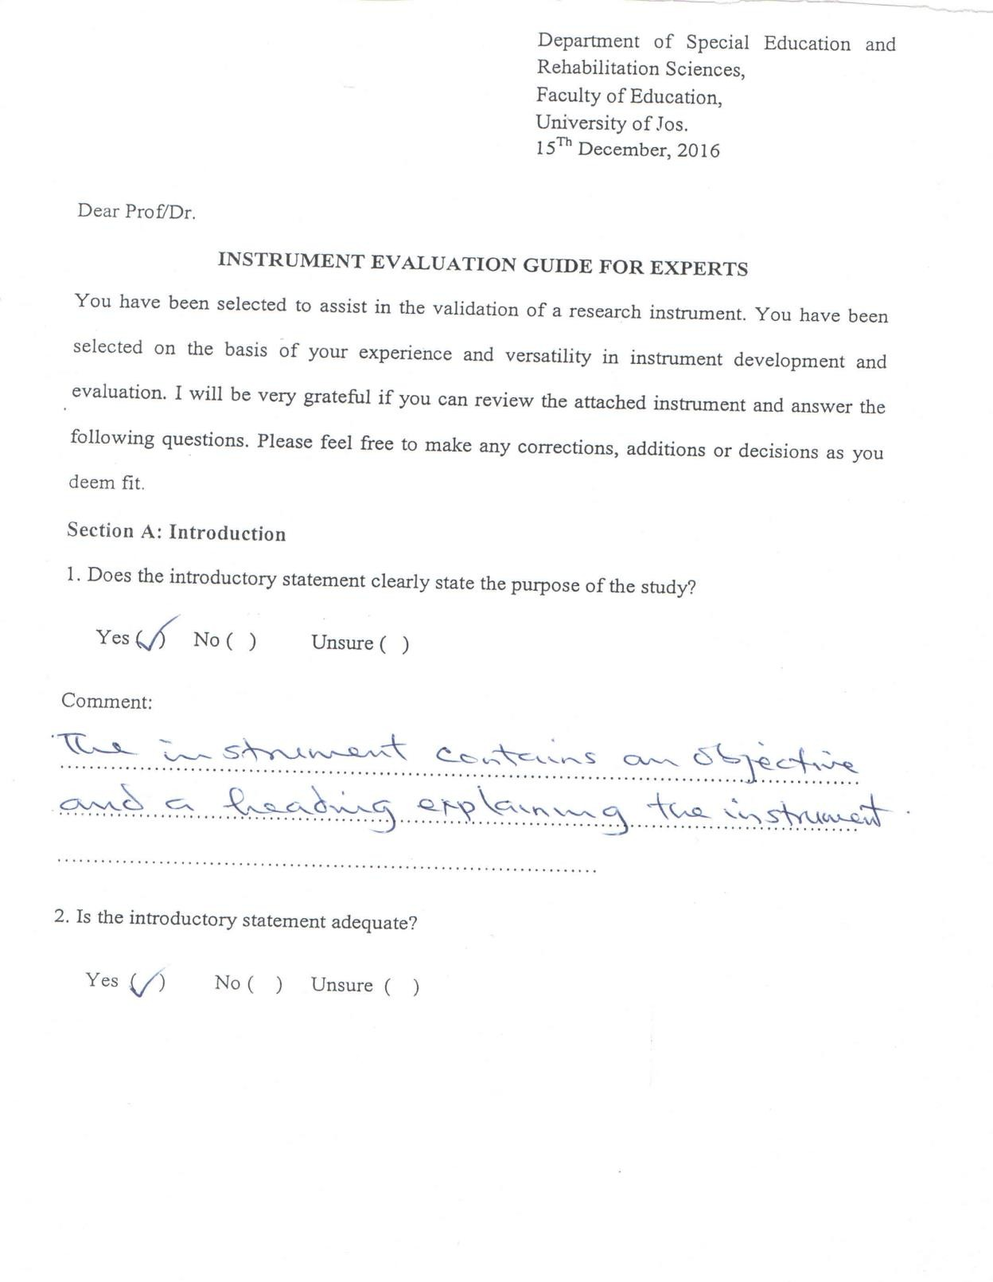

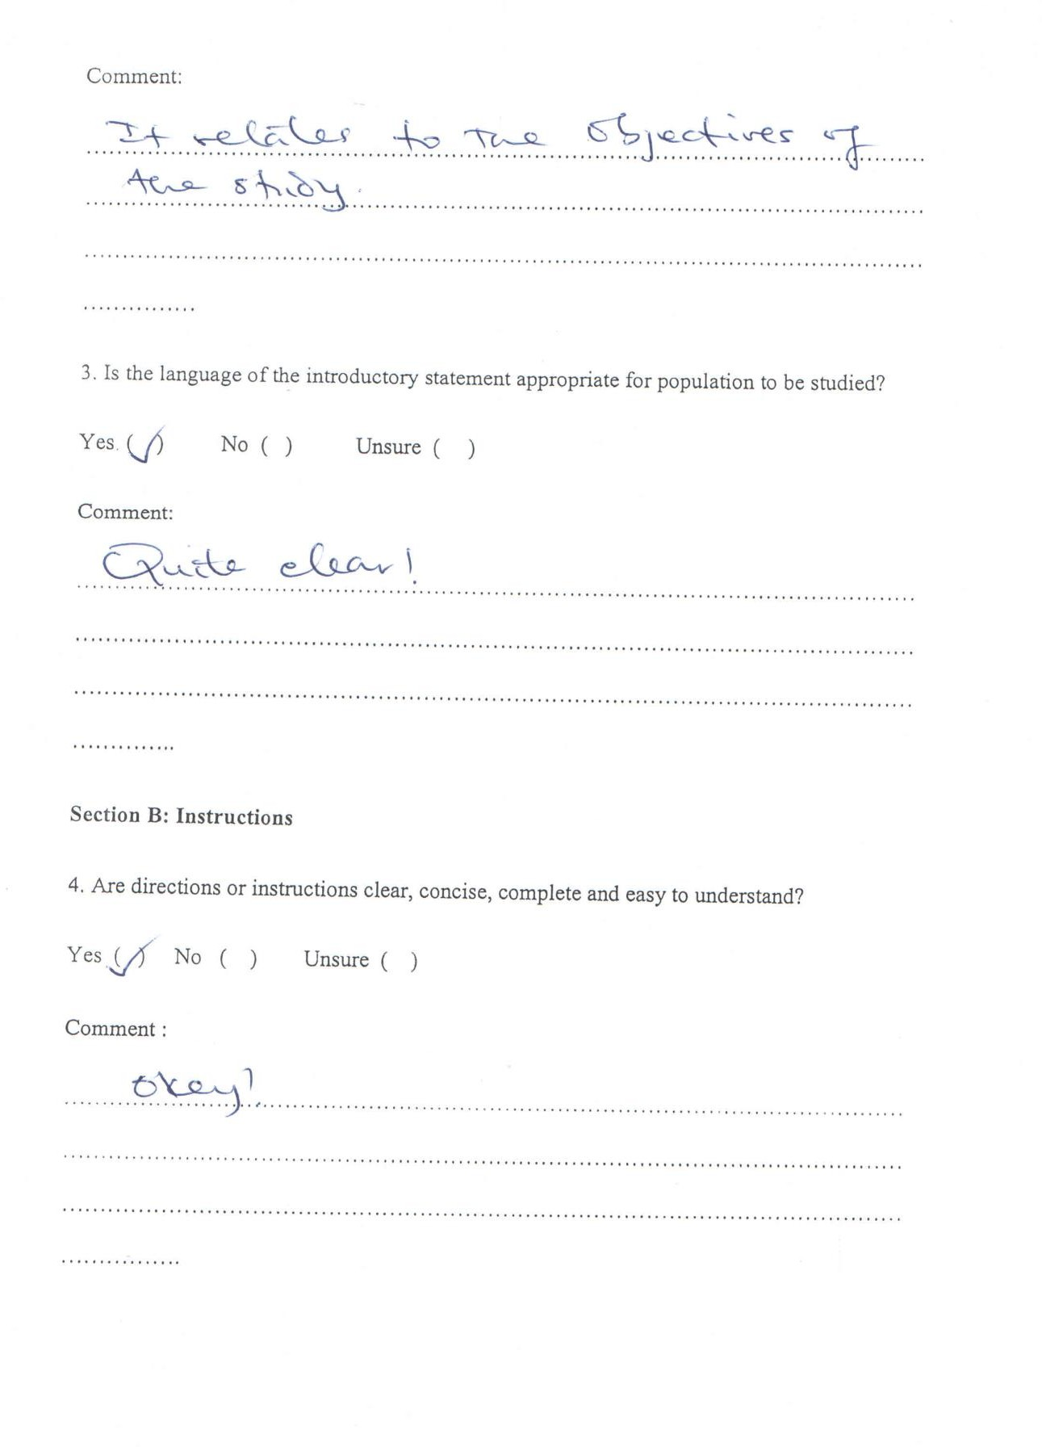

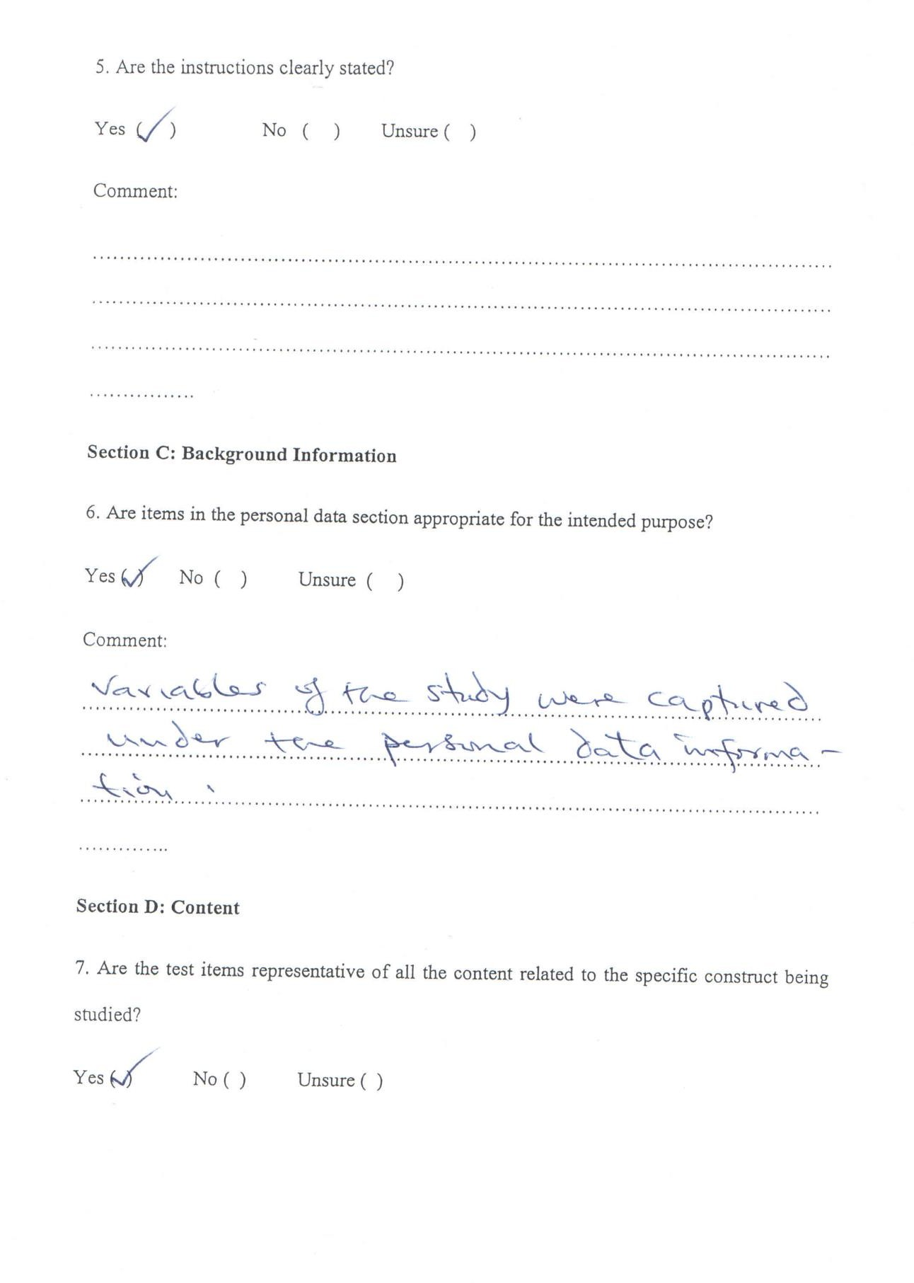

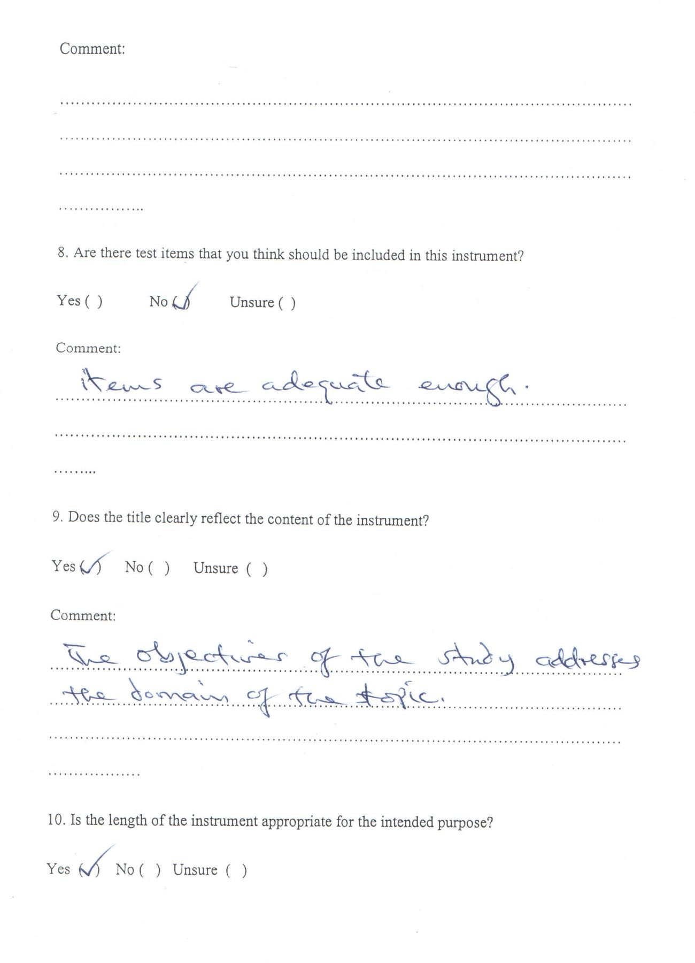

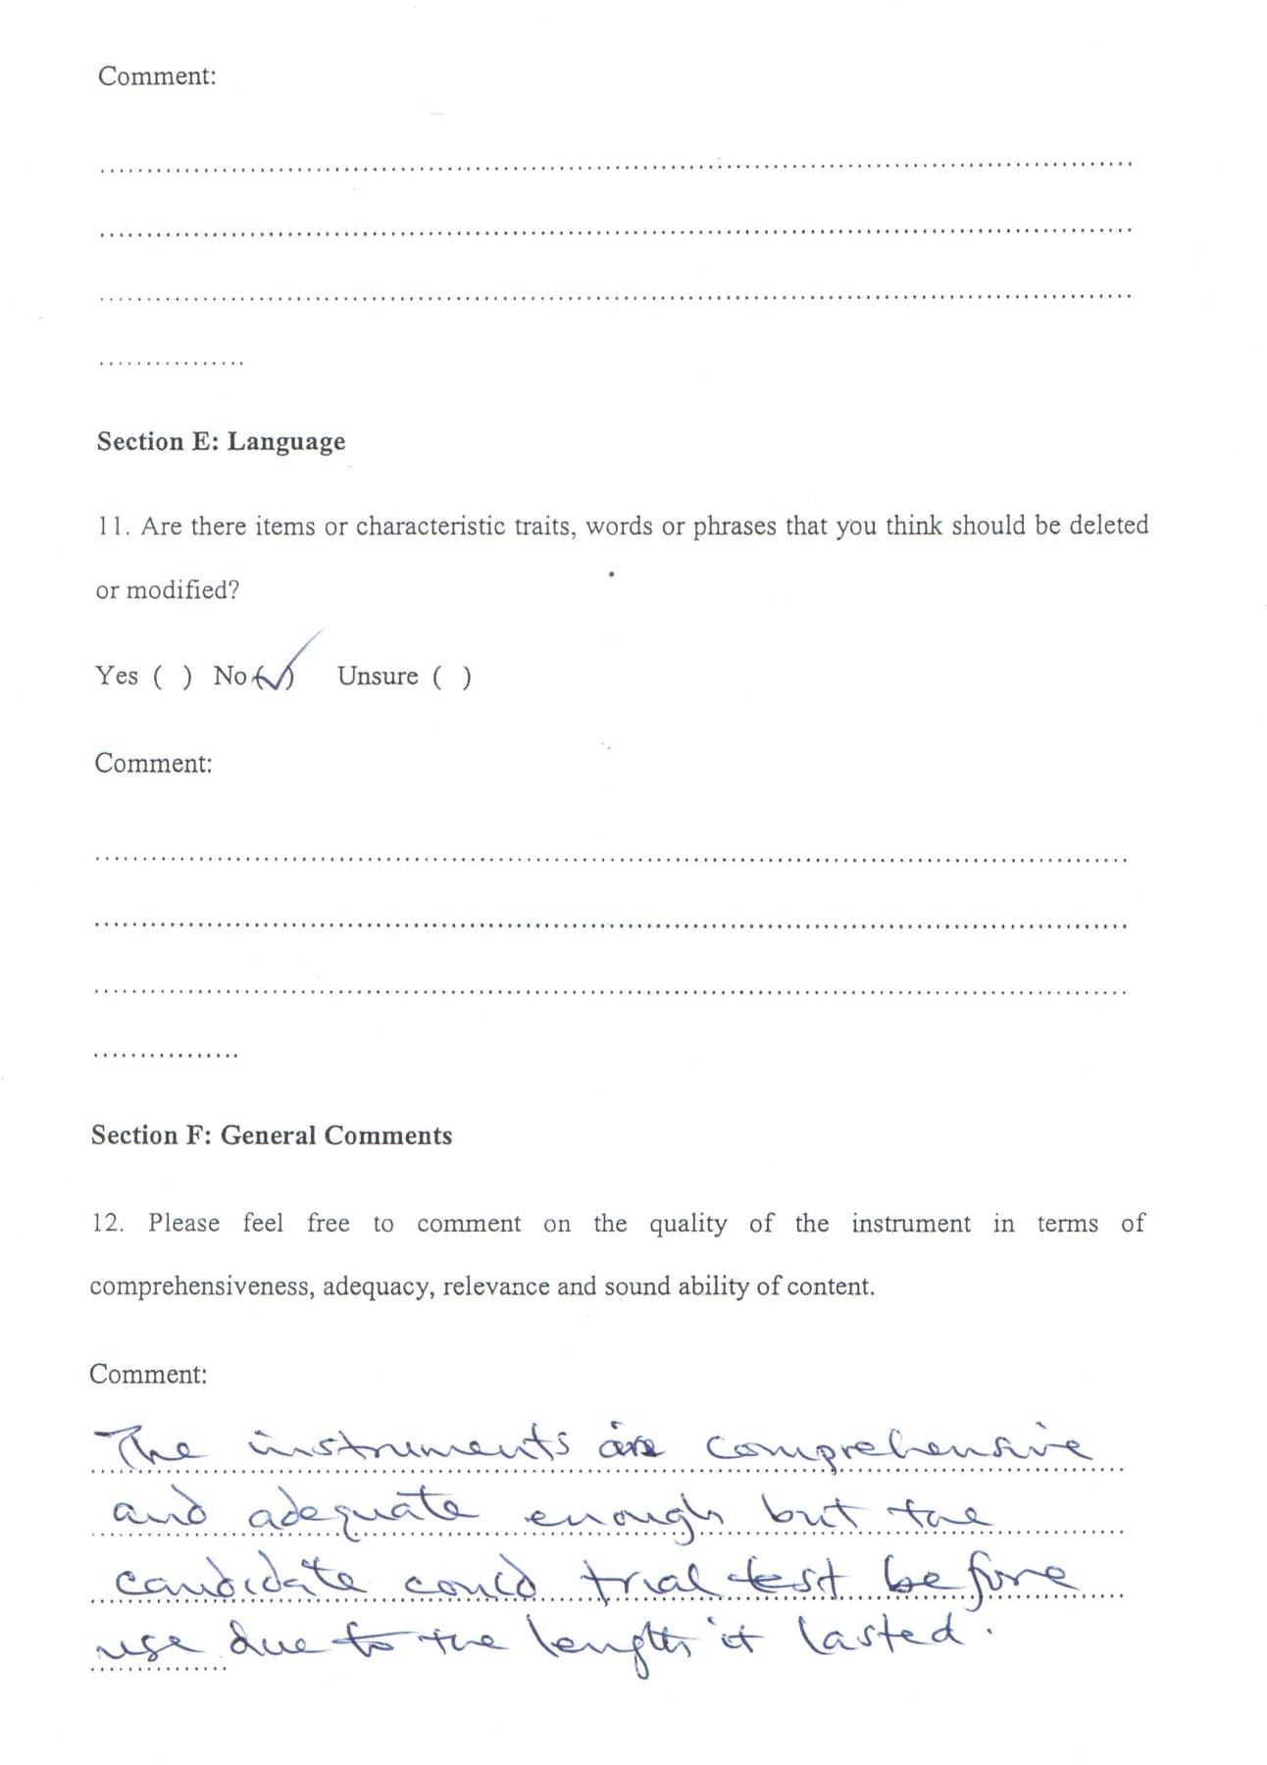

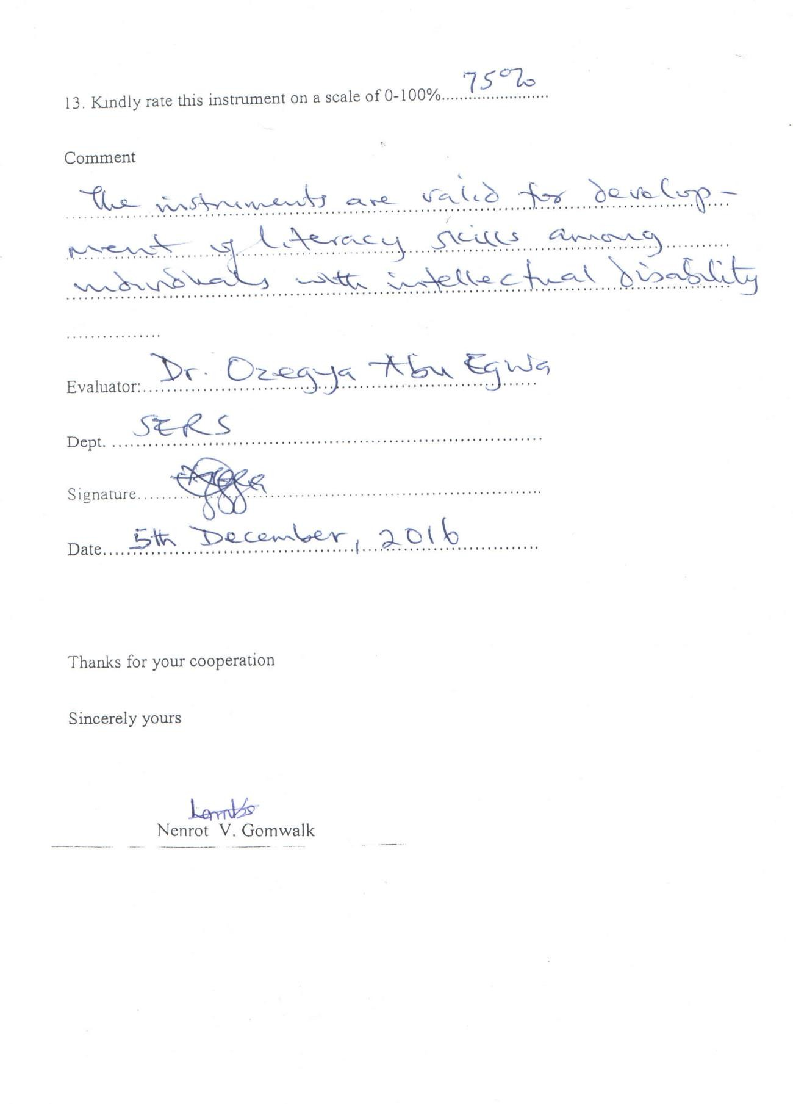

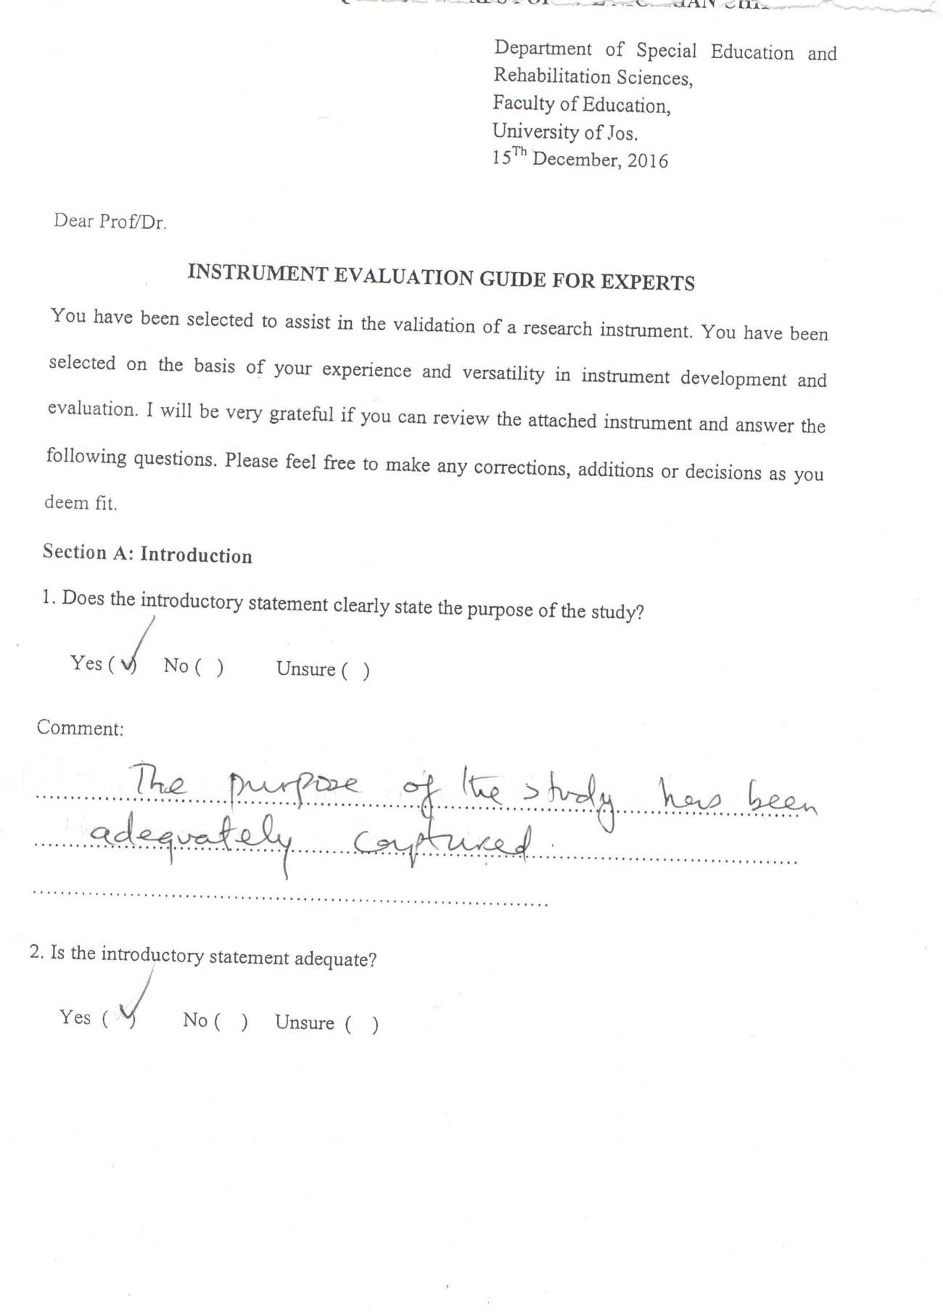

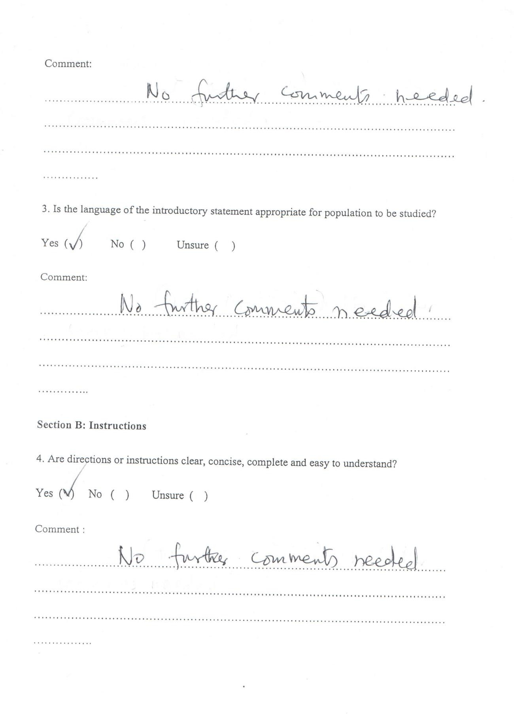

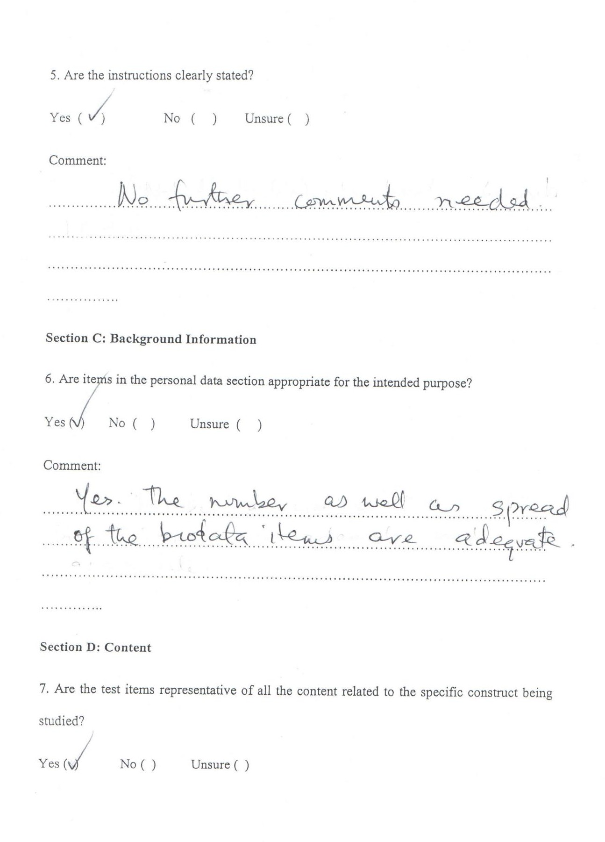

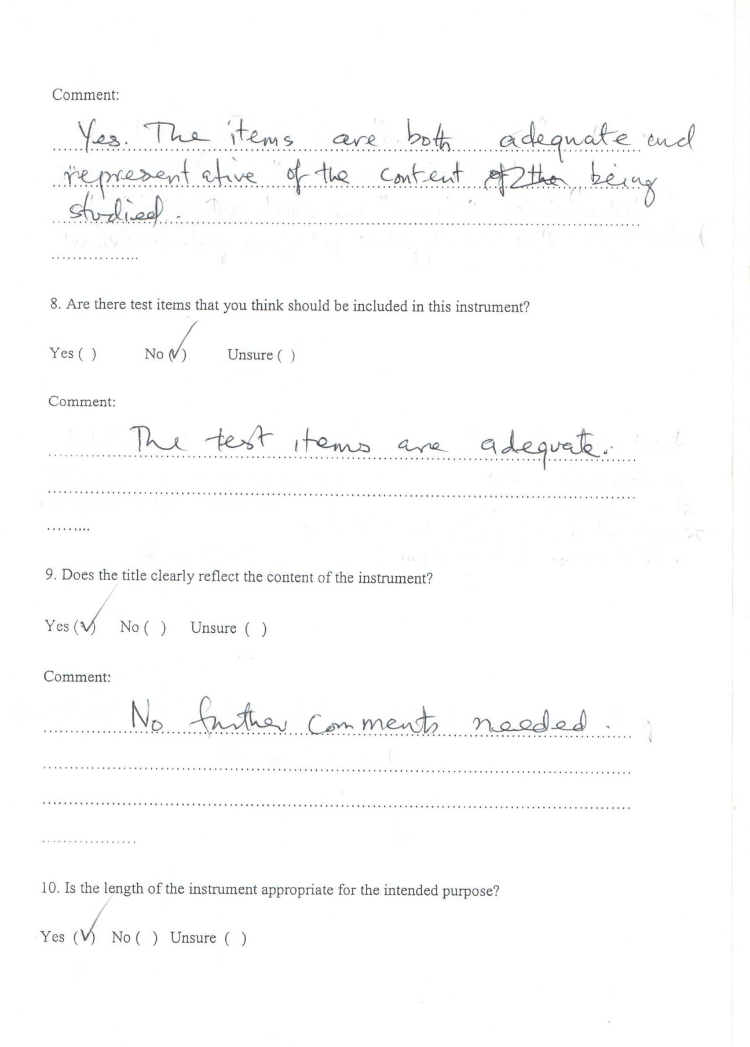

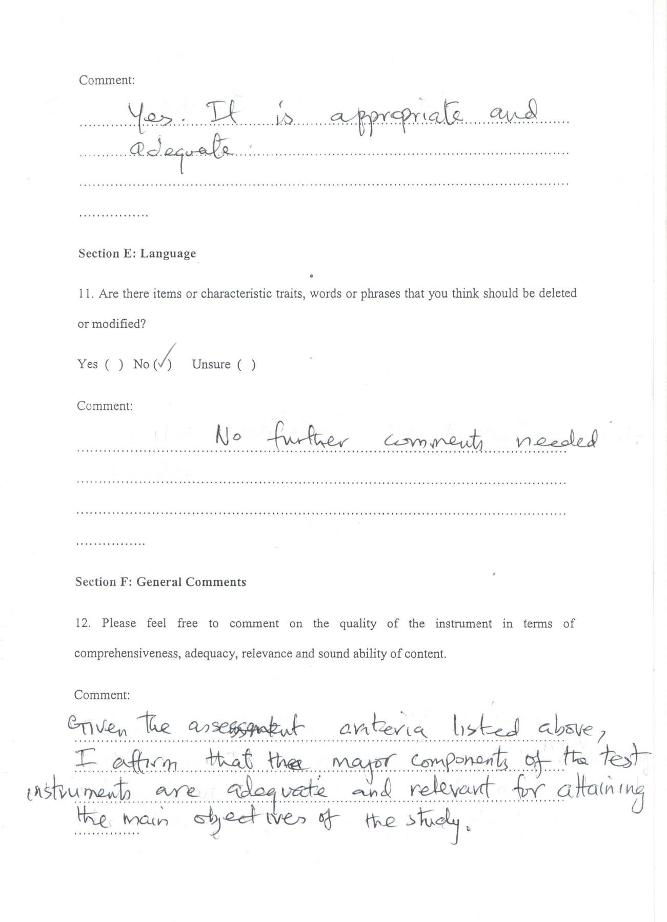

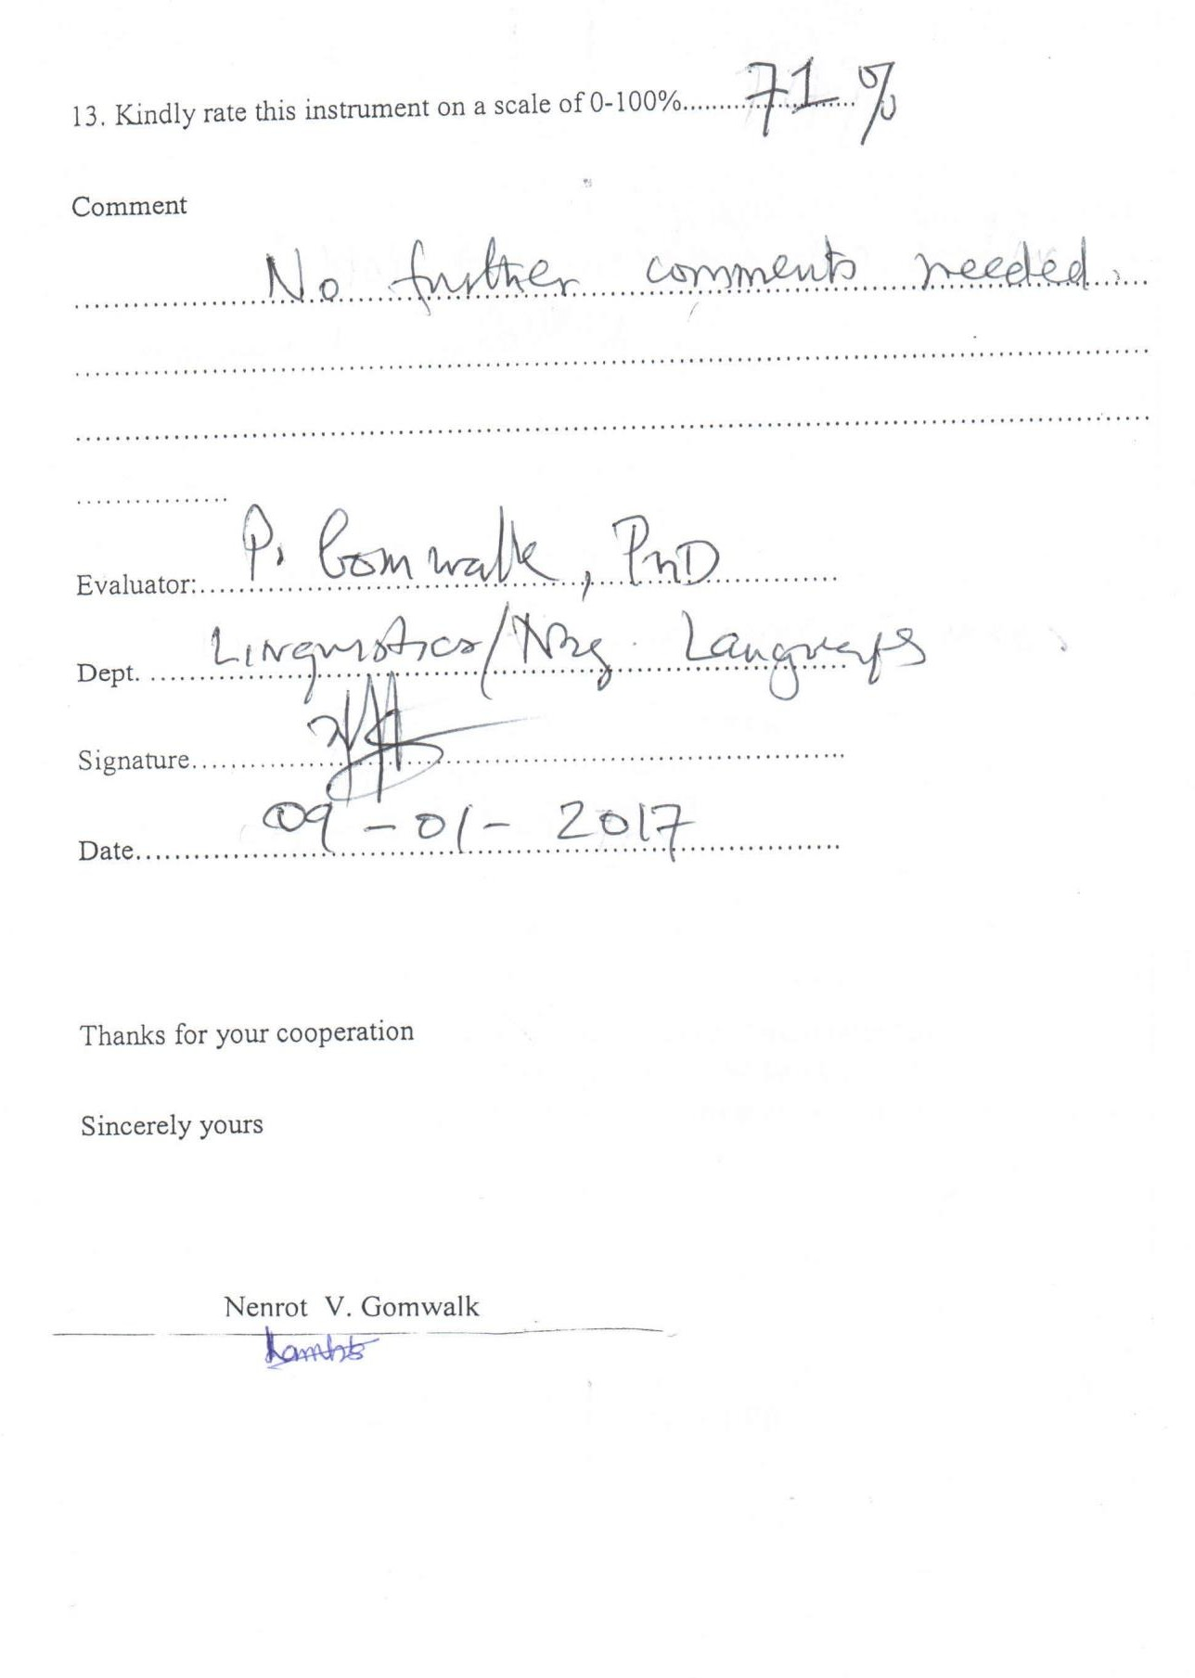

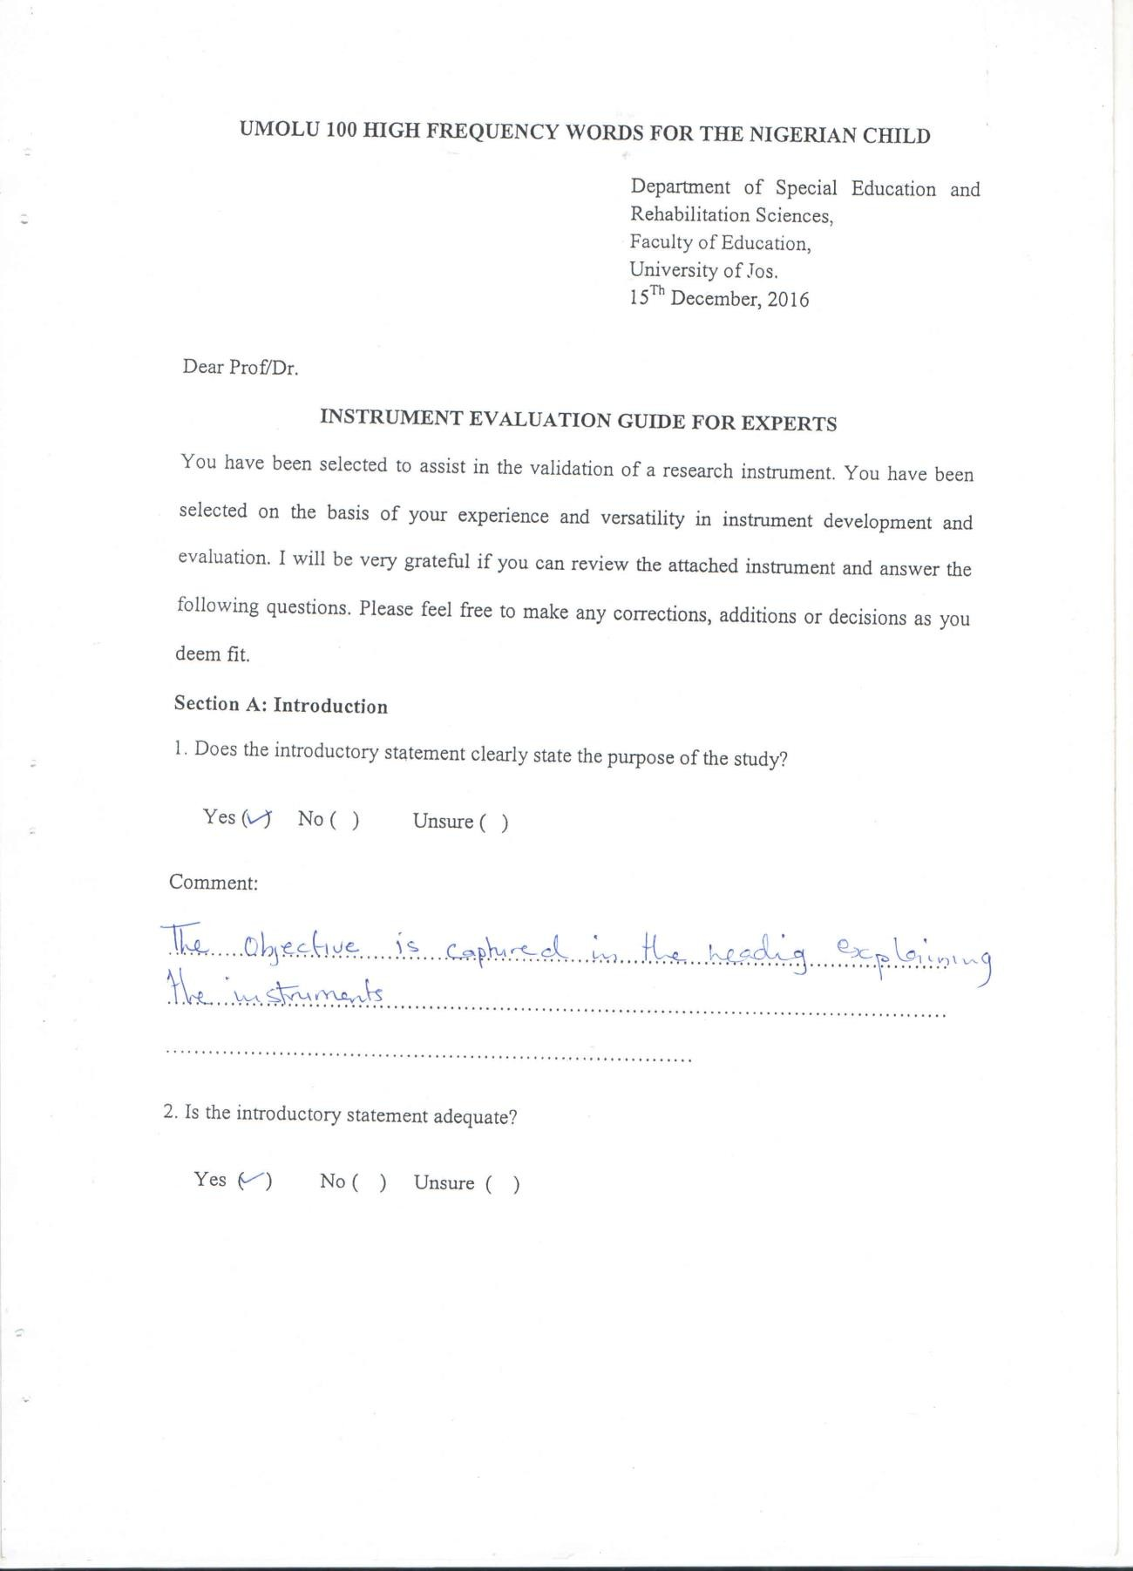

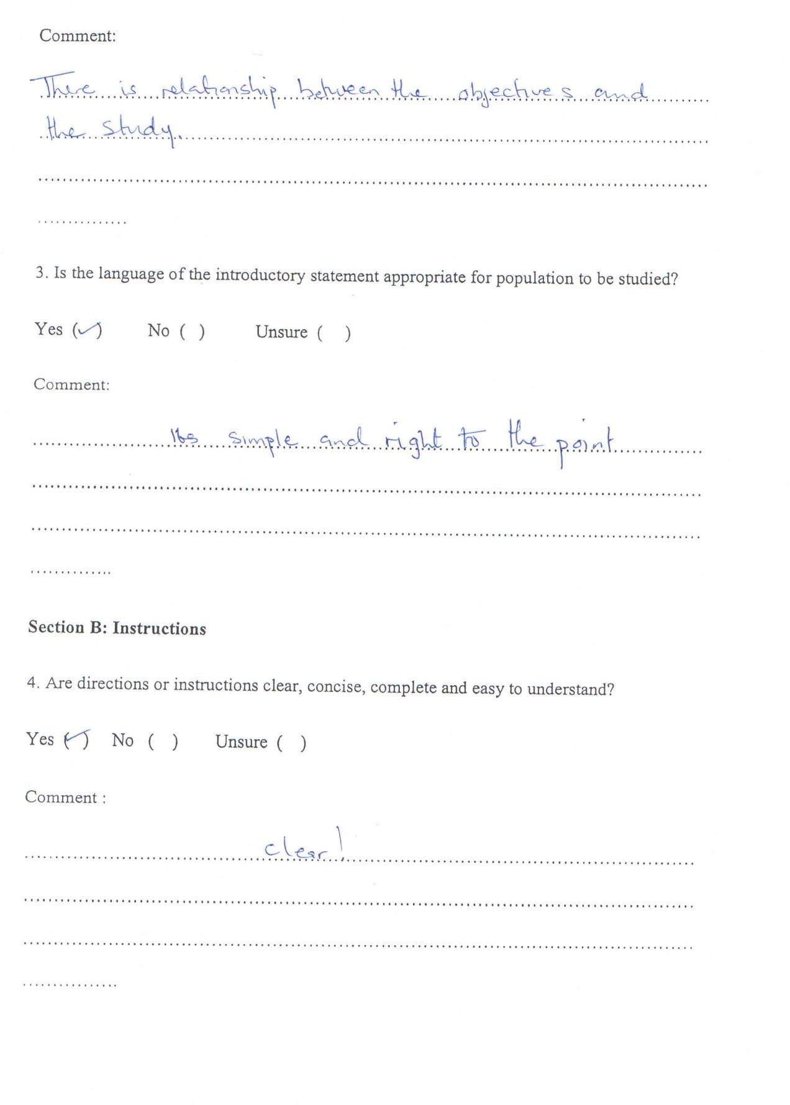

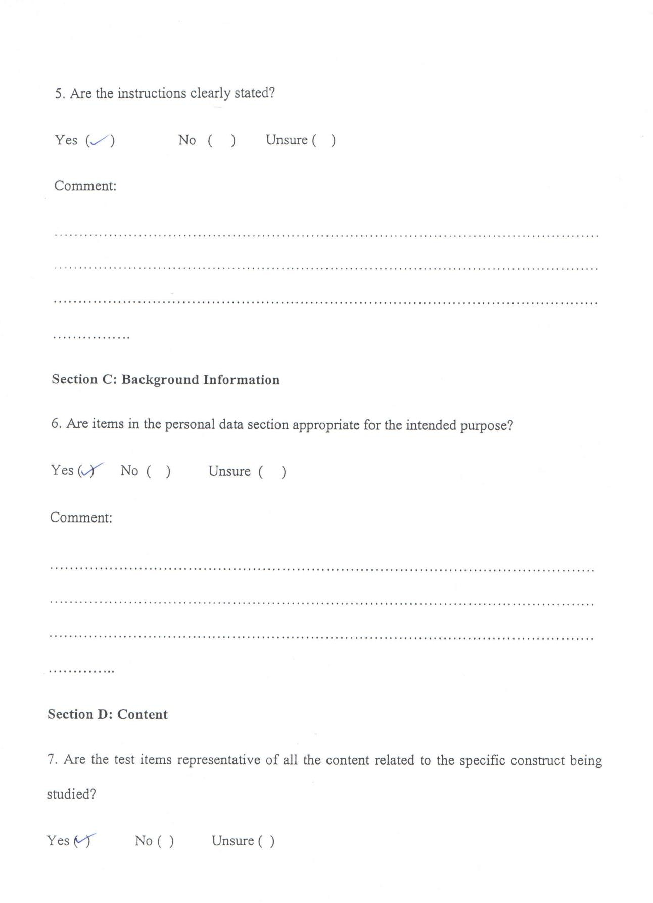

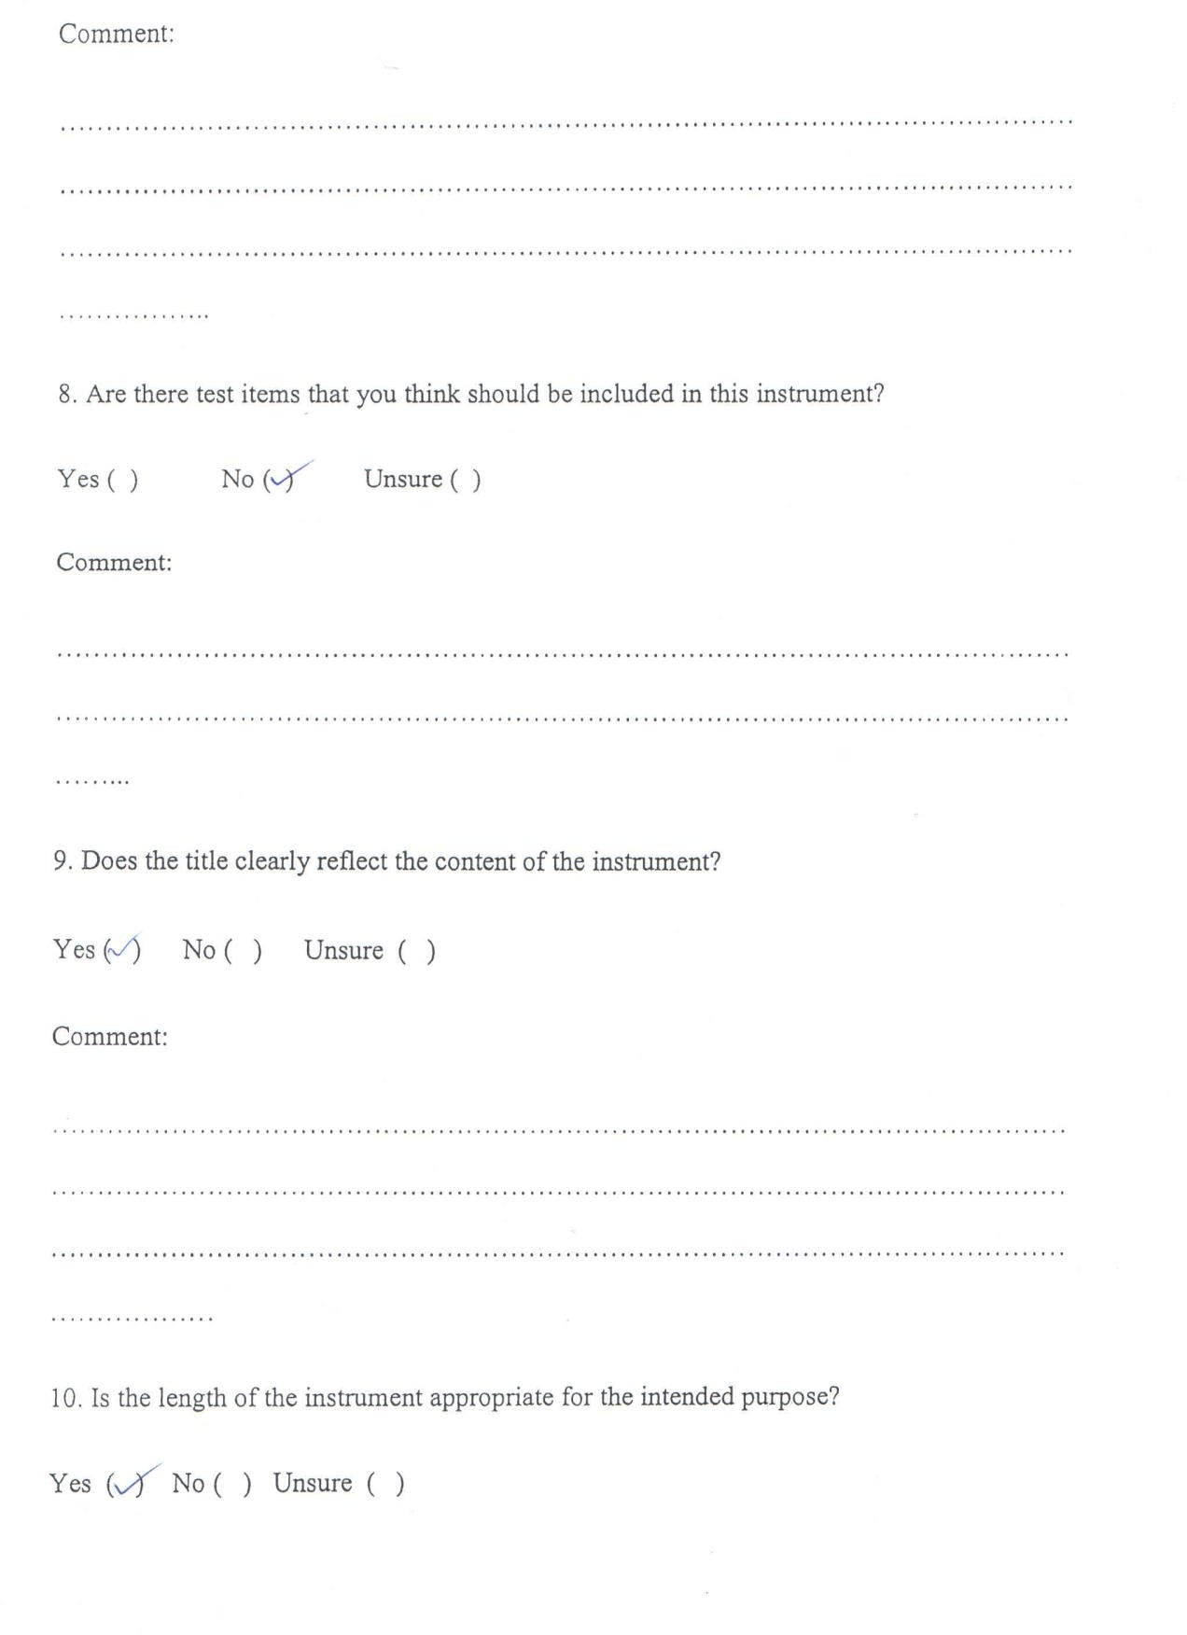

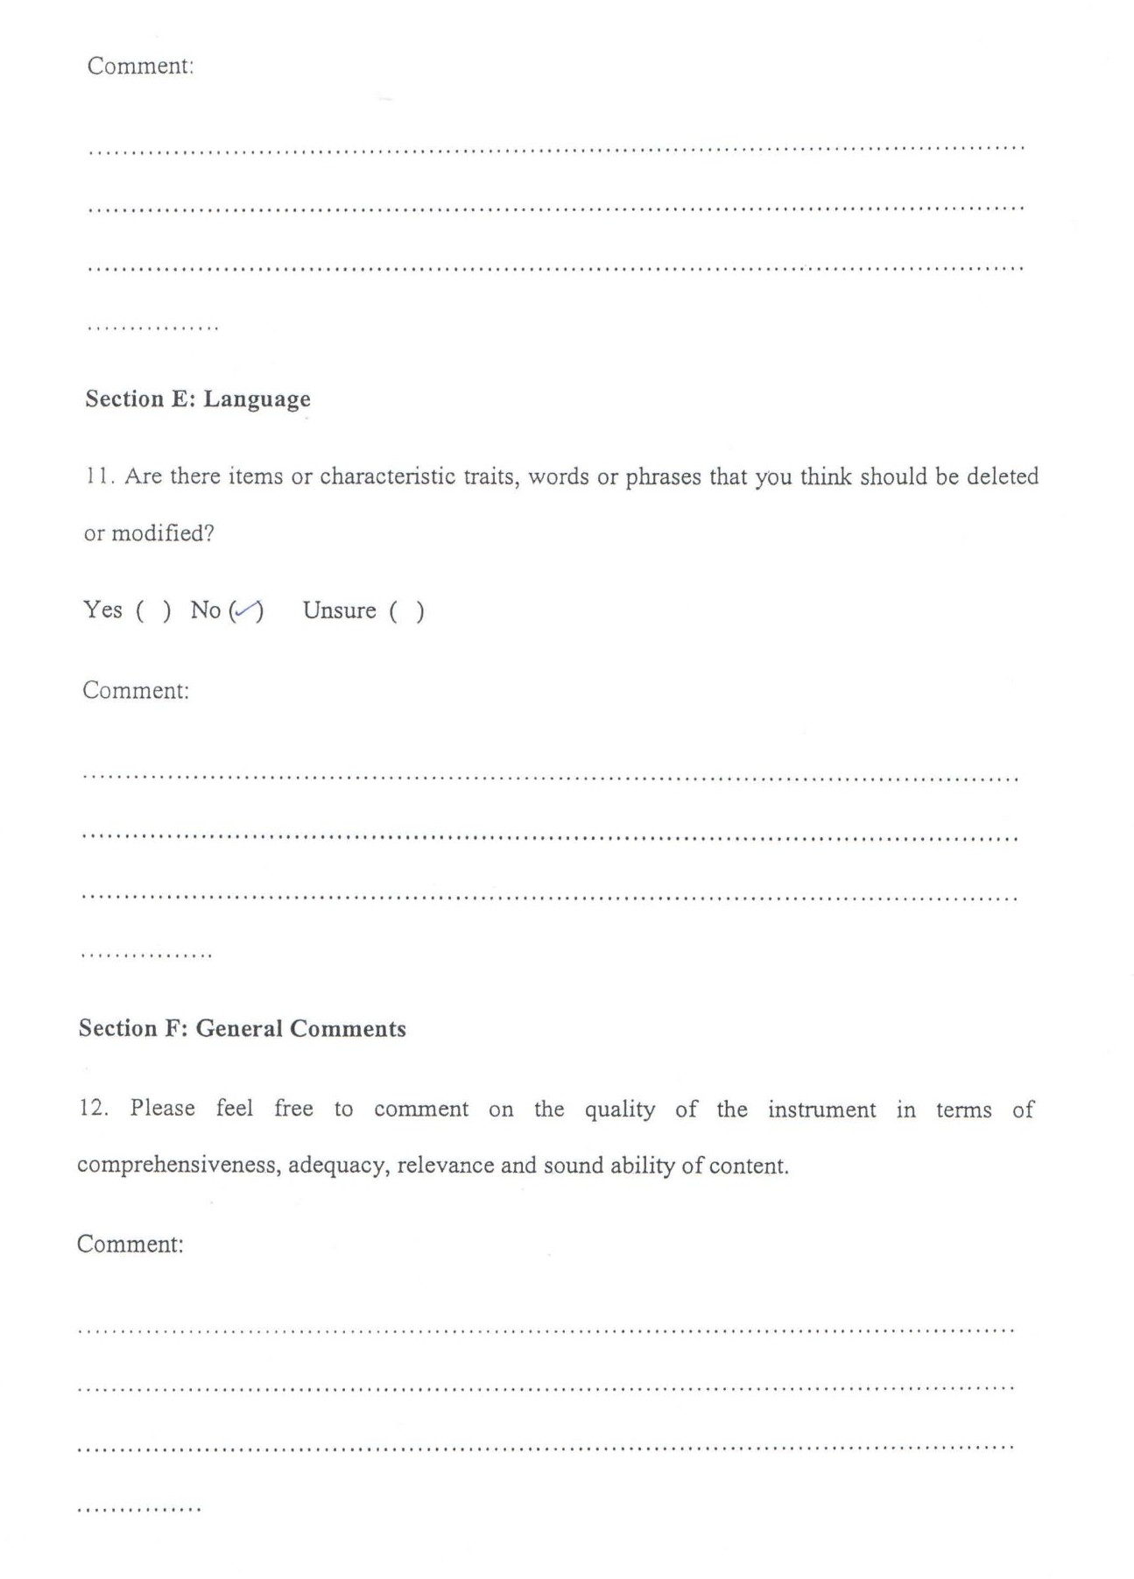

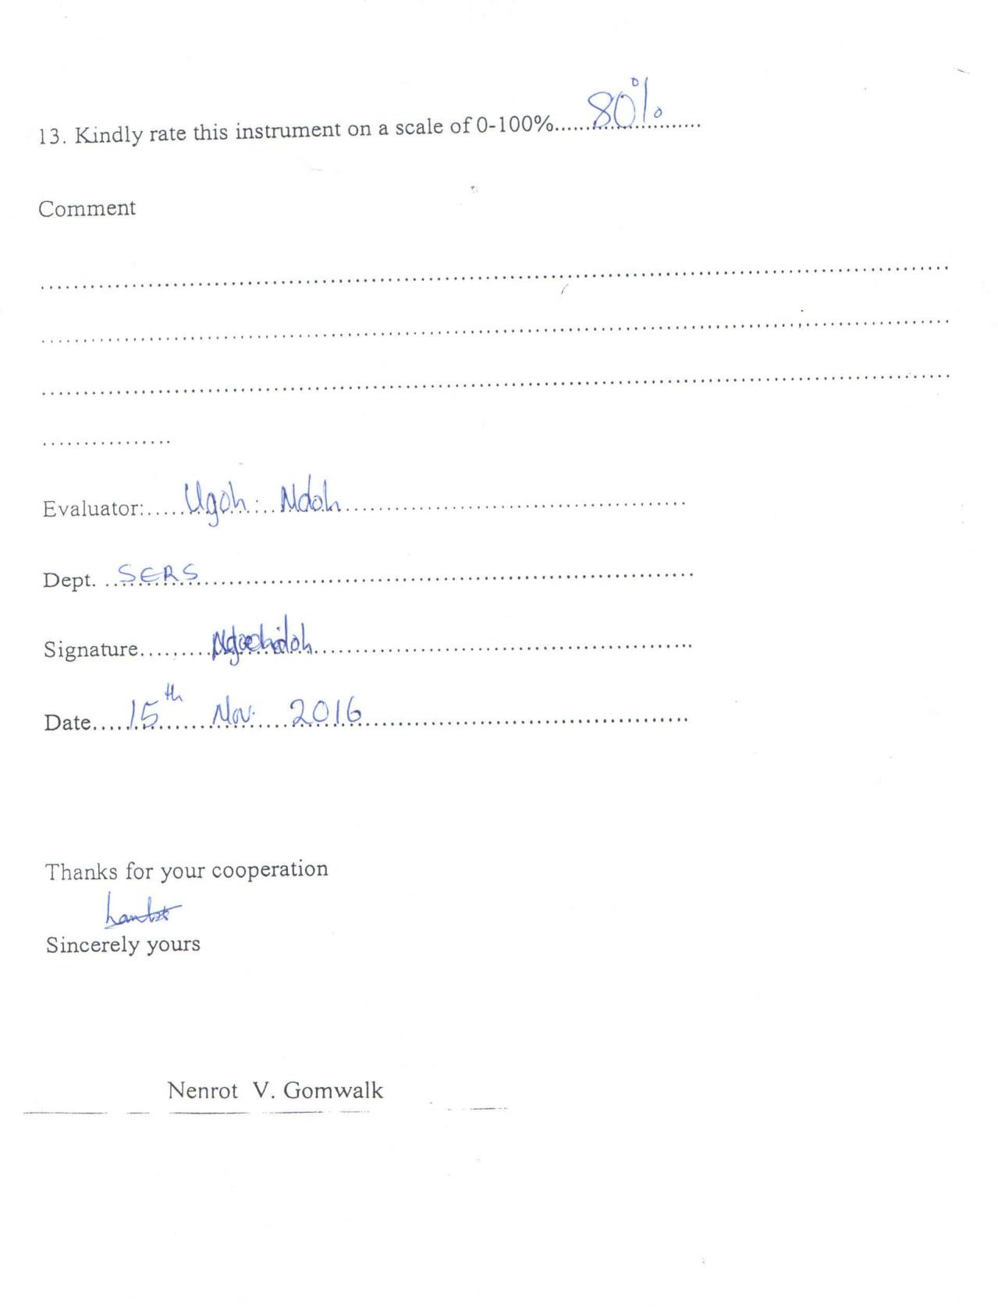

**APPENDIX B5: ANALYSES OF RESEARCH HYPOTHESES**

# Summary of Hypothesis One

**Group Statistics**

|  |  |  |  |  |  |
| --- | --- | --- | --- | --- | --- |
| experimental and control | | N | Mean | Std. Deviation | Std. Error Mean |
| Mean_scores | Experimental Group | 10 | 12.7000 | 7.16736 | 2.26652 |
|  | Control Group | 10 | 12.4800 | 6.57956 | 2.08064 |

# Independent Samples Test

|  |  |  |  |  |  |  |  |  |  |  |
| --- | --- | --- | --- | --- | --- | --- | --- | --- | --- | --- |
|  | | Levene's Test for Equality of Variances | | t-test for Equality of Means | | | | | | |
|  | |  | | | | | 95% Confidence Interval of the Difference | |
| F | Sig. | T | df | Sig. (2-  tailed) | Mean Difference | Std. Error Difference | Lower | Upper |
| Mean_ scores | Equal variances assumed | .038 | .848 | .072 | 18 | .944 | .22000 | 3.07672 | -6.24394 | 6.68394 |
|  | Equal variances not assumed | .072 | 17.870 | .944 | .22000 | 3.07672 | -6.24732 | 6.68732 |

**Summary of Hypothesis Two**

# Within-Subjects Factors

Measure:TEST_SCORE S

|  |  |
| --- | --- |
| factor1 | Dependent Variable |
| 1 | pretest_score |
| 2 | posttest_score |

# Between-Subjects Factors

|  |  |  |  |
| --- | --- | --- | --- |
|  | | Value Label | N |
| experimental and control | 1.00 | Experimental Group | 10 |
|  | 2.00 | Control Group | 10 |

**Descriptive Statistics**

|  |  |  |  |  |
| --- | --- | --- | --- | --- |
| experimental and control | | Mean | Std. Deviation | N |
| pretest score | Experimental Group | 63.5000 | 38.08835 | 10 |
|  | Control Group | 63.7000 | 38.28272 | 10 |
|  | Total | 63.6000 | 37.16733 | 20 |
| posttest scores | Experimental Group | 297.6000 | 148.88116 | 10 |
|  | Control Group | 160.1000 | 70.81502 | 10 |
| Total | 228.8500 | 133.60479 | 20 |

# Multivariate Testsb

|  |  |  |  |  |  |  |  |
| --- | --- | --- | --- | --- | --- | --- | --- |
| Effect | | Value | F | Hypothesis df | Error df | Sig. | Partial Eta Squared |
| factor1 | Pillai's Trace | .796 | 70.246a | 1.000 | 18.000 | .000 | .796 |
|  | Wilks' Lambda | .204 | 70.246a | 1.000 | 18.000 | .000 | .796 |
|  | Hotelling's Trace | 3.903 | 70.246a | 1.000 | 18.000 | .000 | .796 |
|  | Roy's Largest Root | 3.903 | 70.246a | 1.000 | 18.000 | .000 | .796 |
| factor1 * group | Pillai's Trace | .404 | 12.194a | 1.000 | 18.000 | .003 | .404 |
| Wilks' Lambda | .596 | 12.194a | 1.000 | 18.000 | .003 | .404 |
|  | Hotelling's Trace | .677 | 12.194a | 1.000 | 18.000 | .003 | .404 |
|  | Roy's Largest Root | .677 | 12.194a | 1.000 | 18.000 | .003 | .404 |

a. Exact statistic

|  |  |
| --- | --- |
| **Within-Subjects Factors** | |
| Measure:TEST_SCORE S | |
| factor1 | Dependent Variable |
| 1 | pretest_score |
| b. Design: Intercept + group Within Subjects Design: factor1 | |

# Mauchly's Test of Sphericityb

Measure:TEST_SCORES

|  |  |  |  |  |  |  |  |
| --- | --- | --- | --- | --- | --- | --- | --- |
| Within Subjects Effect | Mauchly's W | Approx. Chi- Square | df | Sig. | Epsilona | | |
| Greenhouse- Geisser | Huynh-Feldt | Lower-bound |
| factor1 | 1.000 | .000 | 0 | . | 1.000 | 1.000 | 1.000 |

Tests the null hypothesis that the error covariance matrix of the orthonormalized transformed dependent variables is proportional to an identity matrix.

1. May be used to adjust the degrees of freedom for the averaged tests of significance. Corrected tests are displayed in the Tests of Within-Subjects Effects table.
2. Design: Intercept + group Within Subjects Design: factor1

# Tests of Within-Subjects Contrasts

Measure:TEST_SCORES

|  |  |  |  |  |  |  |  |
| --- | --- | --- | --- | --- | --- | --- | --- |
| Source | factor1 | Type III Sum of Squares | df | Mean Square | F | Sig. | Partial Eta Squared |
| factor1 | Linear | 273075.625 | 1 | 273075.625 | 70.246 | .000 | .796 |
| factor1 * group | Linear | 47403.225 | 1 | 47403.225 | 12.194 | .003 | .404 |
| Error(factor1) | Linear | 69973.650 | 18 | 3887.425 |  |  |  |

# Levene's Test of Equality of Error Variancesa

|  |  |  |  |  |
| --- | --- | --- | --- | --- |
|  | F | df1 | df2 | Sig. |
| pretest score | .001 | 1 | 18 | .977 |
| posttest scores | 171.222 | 1 | 18 | .000 |

|  |
| --- |
| Tests the null hypothesis that the error variance of the dependent variable is equal across groups. |
| a. Design: Intercept + group Within Subjects Design: factor1 |

**Tests of Within-Subjects Effects**

Measure:TEST_SCORES

|  |  |  |  |  |  |  |  |
| --- | --- | --- | --- | --- | --- | --- | --- |
| Source | | Type III Sum of Squares | df | Mean Square | F | Sig. | Partial Eta Squared |
| factor1 | Sphericity Assumed | 273075.625 | 1 | 273075.625 | 70.246 | .000 | .796 |
|  | Greenhouse-Geisser | 273075.625 | 1.000 | 273075.625 | 70.246 | .000 | .796 |
|  | Huynh-Feldt | 273075.625 | 1.000 | 273075.625 | 70.246 | .000 | .796 |
|  | Lower-bound | 273075.625 | 1.000 | 273075.625 | 70.246 | .000 | .796 |
| factor1 * group | Sphericity Assumed | 47403.225 | 1 | 47403.225 | 12.194 | .003 | .404 |
| Greenhouse-Geisser | 47403.225 | 1.000 | 47403.225 | 12.194 | .003 | .404 |
|  | Huynh-Feldt | 47403.225 | 1.000 | 47403.225 | 12.194 | .003 | .404 |
|  | Lower-bound | 47403.225 | 1.000 | 47403.225 | 12.194 | .003 | .404 |
| Error(factor1) | Sphericity Assumed | 69973.650 | 18 | 3887.425 |  |  |  |
|  | Greenhouse-Geisser | 69973.650 | 18.000 | 3887.425 |
|  | Huynh-Feldt | 69973.650 | 18.000 | 3887.425 |
|  | Lower-bound | 69973.650 | 18.000 | 3887.425 |

# Tests of Between-Subjects Effects

Measure:TEST_SCORES Transformed Variable:Average

|  |  |  |  |  |  |  |
| --- | --- | --- | --- | --- | --- | --- |
| Source | Type III Sum of Squares | df | Mean Square | F | Sig. | Partial Eta Squared |
| Intercept | 855270.025 | 1 | 855270.025 | 76.631 | .000 | .810 |
| group | 47128.225 | 1 | 47128.225 | 4.223 | .055 | .190 |
| Error | 200896.250 | 18 | 11160.903 |  |  |  |

# Summary of Hypothesis Three Descriptive Statistics

|  |  |  |  |  |
| --- | --- | --- | --- | --- |
| experimental and control | | Mean | Std. Deviation | N |
| pretest score | Experimental Group | 14.4000 | 7.47143 | 10 |
|  | Control Group | 14.0000 | 6.86375 | 10 |
|  | Total | 14.2000 | 6.98570 | 20 |
| posttest scores | Experimental Group | 57.6000 | 34.15065 | 10 |
|  | Control Group | 30.2000 | 15.60484 | 10 |
|  | Total | 43.9000 | 29.41697 | 20 |

**Levene's Test of Equality of Error Variancesa**

|  |  |  |  |  |
| --- | --- | --- | --- | --- |
|  | F | df1 | df2 | Sig. |
| pretest score | .030 | 1 | 18 | .865 |
| posttest scores | 9.680 | 1 | 18 | .006 |

Tests the null hypothesis that the error variance of the dependent variable is equal across groups.

a. Design: Intercept + group Within Subjects Design: factor1

# Tests of Between-Subjects Effects

Measure:TEST_SCORES Transformed Variable:Average

|  |  |  |  |  |  |  |
| --- | --- | --- | --- | --- | --- | --- |
| Source | Type III Sum of Squares | df | Mean Square | F | Sig. | Partial Eta Squared |
| Intercept | 33756.100 | 1 | 33756.100 | 61.482 | .000 | .774 |
| group | 1932.100 | 1 | 1932.100 | 3.519 | .077 | .164 |
| Error | 9882.800 | 18 | 549.044 |  |  |  |

|  |  |
| --- | --- |
| **Box's Test of Equality of Covariance Matricesa** | |
| Box's M | 24.028 |
| F | 7.045 |
| df1 | 3 |
| df2 | 58320.000 |
| Sig. | .000 |
| Tests the null hypothesis that the observed covariance matrices of the dependent variables are equal across groups. | |
| a. Design: Intercept + group  Within Subjects Design: factor1 | |

# Multivariate Testsb

|  |  |  |  |  |  |  |  |
| --- | --- | --- | --- | --- | --- | --- | --- |
| Effect | | Value | F | Hypothesis df | Error df | Sig. | Partial Eta Squared |
| factor1 | Pillai's Trace | .703 | 42.549a | 1.000 | 18.000 | .000 | .703 |
|  | Wilks' Lambda | .297 | 42.549a | 1.000 | 18.000 | .000 | .703 |
|  | Hotelling's Trace | 2.364 | 42.549a | 1.000 | 18.000 | .000 | .703 |
| Roy's Largest Root | | 2.364 | 42.549a | 1.000 | 18.000 | .000 | .703 |
| factor1 * group | Pillai's Trace | .328 | 8.791a | 1.000 | 18.000 | .008 | .328 |
|  | Wilks' Lambda | .672 | 8.791a | 1.000 | 18.000 | .008 | .328 |
|  | Hotelling's Trace | .488 | 8.791a | 1.000 | 18.000 | .008 | .328 |
| Roy's Largest Root | | .488 | 8.791a | 1.000 | 18.000 | .008 | .328 |

1. Exact statistic
2. Design: Intercept + group Within Subjects Design: factor1

# Mauchly's Test of Sphericityb

Measure:TEST_SCORES

|  |  |  |  |  |  |  |  |
| --- | --- | --- | --- | --- | --- | --- | --- |
| Within Subjects Effect | Mauchly's W | Approx. Chi- Square | Df | Sig. | Epsilona | | |
| Greenhouse- Geisser | Huynh-Feldt | Lower-bound |
| factor1 | 1.000 | .000 | 0 | . | 1.000 | 1.000 | 1.000 |

Tests the null hypothesis that the error covariance matrix of the orthonormalized transformed dependent variables is proportional to an identity matrix.

1. May be used to adjust the degrees of freedom for the averaged tests of significance. Corrected tests are displayed in the Tests of Within-Subjects Effects table.
2. Design: Intercept + group Within Subjects Design: factor1

# Tests of Within-Subjects Effects

Measure:TEST_SCORES

|  |  |  |  |  |  |  |  |
| --- | --- | --- | --- | --- | --- | --- | --- |
| Source | | Type III Sum of Squares | df | Mean Square | F | Sig. | Partial Eta Squared |
| factor1 | Sphericity Assumed | 8820.900 | 1 | 8820.900 | 42.549 | .000 | .703 |
|  | Greenhouse-Geisser | 8820.900 | 1.000 | 8820.900 | 42.549 | .000 | .703 |
|  | Huynh-Feldt | 8820.900 | 1.000 | 8820.900 | 42.549 | .000 | .703 |
|  | Lower-bound | 8820.900 | 1.000 | 8820.900 | 42.549 | .000 | .703 |
| factor1 * group | Sphericity Assumed | 1822.500 | 1 | 1822.500 | 8.791 | .008 | .328 |
| Greenhouse-Geisser | 1822.500 | 1.000 | 1822.500 | 8.791 | .008 | .328 |
|  | Huynh-Feldt | 1822.500 | 1.000 | 1822.500 | 8.791 | .008 | .328 |
|  | Lower-bound | 1822.500 | 1.000 | 1822.500 | 8.791 | .008 | .328 |
| Error(factor1) | Sphericity Assumed | 3731.600 | 18 | 207.311 |  |  |  |
|  | Greenhouse-Geisser | 3731.600 | 18.000 | 207.311 |
|  | Huynh-Feldt | 3731.600 | 18.000 | 207.311 |
|  | Lower-bound | 3731.600 | 18.000 | 207.311 |

# Tests of Within-Subjects Contrasts

Measure:TEST_SCORES

|  |  |  |  |  |  |  |  |
| --- | --- | --- | --- | --- | --- | --- | --- |
| Source | factor1 | Type III Sum of Squares | Df | Mean Square | F | Sig. | Partial Eta Squared |
| factor1 | Linear | 8820.900 | 1 | 8820.900 | 42.549 | .000 | .703 |
| factor1 * group | Linear | 1822.500 | 1 | 1822.500 | 8.791 | .008 | .328 |
| Error(factor1) | Linear | 3731.600 | 18 | 207.311 |  |  |  |

# Summary of Hypothesis Four Within-Subjects Factors

Measure:TEST_SCORES

|  |  |
| --- | --- |
| factor1 | Dependent Variable |
| 1 | pretest_score |
| 2 | posttest_score |

# Between-Subjects Factors

|  |  |  |  |
| --- | --- | --- | --- |
|  | | Value Label | N |
| experimental and control | 1.00 | Experimental Group | 10 |
|  | 2.00 | Control Group | 10 |

**Descriptive Statistics**

|  |  |  |  |  |
| --- | --- | --- | --- | --- |
| experimental and control | | Mean | Std. Deviation | N |
| pretest score | Experimental Group | 16.5000 | 9.44281 | 10 |
|  | Control Group | 16.5000 | 9.44281 | 10 |
|  | Total | 16.5000 | 9.19096 | 20 |
| posttest scores | Experimental Group | 63.0000 | 31.28720 | 10 |
|  | Control Group | 34.5000 | 16.40630 | 10 |
|  | Total | 48.7500 | 28.37136 | 20 |

|  |  |
| --- | --- |
| **Box's Test of Equality of Covariance Matricesa** | |
| Box's M | 10.030 |
| F | 2.941 |
| df1 | 3 |
| df2 | 58320.000 |
| Sig. | .032 |
| Tests the null hypothesis that the observed covariance matrices of the dependent variables are equal across groups. | |
| a. Design: Intercept + group  Within Subjects Design: factor1 | |

# Multivariate Testsb

|  |  |  |  |  |  |  |  |
| --- | --- | --- | --- | --- | --- | --- | --- |
| Effect | | Value | F | Hypothesis df | Error df | Sig. | Partial Eta Squared |
| factor1 | Pillai's Trace | .795 | 69.822a | 1.000 | 18.000 | .000 | .795 |
|  | Wilks' Lambda | .205 | 69.822a | 1.000 | 18.000 | .000 | .795 |
|  | Hotelling's Trace | 3.879 | 69.822a | 1.000 | 18.000 | .000 | .795 |
|  | Roy's Largest  Root | 3.879 | 69.822a | 1.000 | 18.000 | .000 | .795 |
| factor1 * group | Pillai's Trace | .431 | 13.632a | 1.000 | 18.000 | .002 | .431 |
|  | Wilks' Lambda | .569 | 13.632a | 1.000 | 18.000 | .002 | .431 |
|  | Hotelling's Trace | .757 | 13.632a | 1.000 | 18.000 | .002 | .431 |
|  | Roy's Largest  Root | .757 | 13.632a | 1.000 | 18.000 | .002 | .431 |

* 1. Exact statistic
  2. Design: Intercept + group Within Subjects Design: factor1

# Tests of Within-Subjects Effects

250

|  |  |  |  |  |  |  |  |
| --- | --- | --- | --- | --- | --- | --- | --- |
|  | | Measure:TE | ST_SCOR | ES |  |  |  |
| Source | | Type III Sum of Squares | df | Mean Square | F | Sig. | Partial Eta Squared |
| factor1 | Sphericity Assumed | 10400.625 | 1 | 10400.625 | 69.822 | .000 | .795 |
|  | Greenhouse-Geisser | 10400.625 | 1.000 | 10400.625 | 69.822 | .000 | .795 |
|  | Huynh-Feldt | 10400.625 | 1.000 | 10400.625 | 69.822 | .000 | .795 |
|  | Lower-bound | 10400.625 | 1.000 | 10400.625 | 69.822 | .000 | .795 |
| factor1 * group | Sphericity Assumed | 2030.625 | 1 | 2030.625 | 13.632 | .002 | .431 |
| Greenhouse-Geisser | 2030.625 | 1.000 | 2030.625 | 13.632 | .002 | .431 |
|  | Huynh-Feldt | 2030.625 | 1.000 | 2030.625 | 13.632 | .002 | .431 |
|  | Lower-bound | 2030.625 | 1.000 | 2030.625 | 13.632 | .002 | .431 |
| Error(factor1) | Sphericity Assumed | 2681.250 | 18 | 148.958 |  |  |  |
|  | Greenhouse-Geisser | 2681.250 | 18.000 | 148.958 |
|  | Huynh-Feldt | 2681.250 | 18.000 | 148.958 |
|  | Lower-bound | 2681.250 | 18.000 | 148.958 |

**Mauchly's Test of Sphericityb**

Measure:TEST_SCORES

|  |  |  |  |  |  |  |  |
| --- | --- | --- | --- | --- | --- | --- | --- |
| Within Subjects  Effect | Mauchly's W | Approx. Chi- Square | Df | Sig. | Epsilona | | |
| Greenhouse- Geisser | Huynh-Feldt | Lower- bound |
| factor1 | 1.000 | .000 | 0 | . | 1.000 | 1.000 | 1.000 |

Tests the null hypothesis that the error covariance matrix of the orthonormalized transformed dependent variables is proportional to an identity matrix.

1. May be used to adjust the degrees of freedom for the averaged tests of significance. Corrected tests are displayed in the Tests of Within-Subjects Effects table.
2. Design: Intercept + group Within Subjects Design: factor1

# Tests of Within-Subjects Contrasts

Measure:TEST_SCORES

|  |  |  |  |  |  |  |  |
| --- | --- | --- | --- | --- | --- | --- | --- |
| Source | factor1 | Type III Sum of Squares | Df | Mean Square | F | Sig. | Partial Eta Squared |
| factor1 | Linear | 10400.625 | 1 | 10400.625 | 69.822 | .000 | .795 |
| factor1 * group | Linear | 2030.625 | 1 | 2030.625 | 13.632 | .002 | .431 |
| Error(factor1) | Linear | 2681.250 | 18 | 148.958 |  |  |  |

|  |  |  |  |  |
| --- | --- | --- | --- | --- |
| **Levene's T** | **est of Equ** | **ality of Er** | **ror Varian** | **cesa** |
|  | F | df1 | df2 | Sig. |
| pretest score | .000 | 1 | 18 | 1.000 |
| posttest scores | 12.715 | 1 | 18 | .002 |

Tests the null hypothesis that the error variance of the dependent variable is equal across groups.

a. Design: Intercept + group Within Subjects Design: factor1

**Tests of Between-Subjects Effects** Measure:TEST_SCORES Transformed Variable:Average

|  |  |  |  |  |  |  |
| --- | --- | --- | --- | --- | --- | --- |
| Source | Type III Sum of Squares | df | Mean Square | F | Sig. | Partial Eta Squared |
| Intercept | 42575.625 | 1 | 42575.625 | 75.457 | .000 | .807 |
| group | 2030.625 | 1 | 2030.625 | 3.599 | .074 | .167 |
| Error | 10156.250 | 18 | 564.236 |  |  |  |

# Summary of Hypothesis Five

Measure:TEST_SCO RES

|  |  |
| --- | --- |
| factor 1 | Dependent Variable |
| 1 | pretest_score |
| 2 | posttest_score |

# Between-Subjects Factors

|  |  |  |  |
| --- | --- | --- | --- |
|  | | Value Label | N |
| experimental and control | 1.00 | Experimental Group | 10 |
|  | 2.00 | Control Group | 10 |

**Descriptive Statistics**

|  |  |  |  |  |
| --- | --- | --- | --- | --- |
| experimental and control | | Mean | Std. Deviation | N |
| pretest score | Experimental Group | 14.0000 | 6.86375 | 10 |
|  | Control Group | 14.2000 | 6.64664 | 10 |
|  | Total | 14.1000 | 6.57667 | 20 |
| posttest scores | Experimental Group | 57.6000 | 34.15065 | 10 |
|  | Control Group | 31.0000 | 14.28286 | 10 |
|  | Total | 44.3000 | 28.90110 | 20 |

|  |  |
| --- | --- |
| **Box's Test of Equality of Covariance Matricesa** | |
| Box's M | 19.614 |
| F | 5.751 |
| df1 | 3 |
| df2 | 58320.000 |
| Sig. | .001 |
| Tests the null hypothesis that the observed covariance matrices of the dependent variables are equal across groups. | |
| a. Design: Intercept + group Within Subjects Design: factor1 | |

# Multivariate Testsb

|  |  |  |  |  |  |  |  |
| --- | --- | --- | --- | --- | --- | --- | --- |
| Effect | | Value | F | Hypothesis df | Error df | Sig. | Partial Eta Squared |
| factor1 | Pillai's Trace | .706 | 43.134a | 1.000 | 18.000 | .000 | .706 |
|  | Wilks' Lambda | .294 | 43.134a | 1.000 | 18.000 | .000 | .706 |
|  | Hotelling's Trace | 2.396 | 43.134a | 1.000 | 18.000 | .000 | .706 |
| Roy's Largest Root | | 2.396 | 43.134a | 1.000 | 18.000 | .000 | .706 |
| factor1 * group | Pillai's Trace | .321 | 8.492a | 1.000 | 18.000 | .009 | .321 |
|  | Wilks' Lambda | .679 | 8.492a | 1.000 | 18.000 | .009 | .321 |
|  | Hotelling's Trace | .472 | 8.492a | 1.000 | 18.000 | .009 | .321 |
| Roy's Largest Root | | .472 | 8.492a | 1.000 | 18.000 | .009 | .321 |

1. Exact statistic
2. Design: Intercept + group Within Subjects Design: factor1

# Mauchly's Test of Sphericityb

Measure:TEST_SCORES

|  |  |  |  |  |  |  |  |
| --- | --- | --- | --- | --- | --- | --- | --- |
| Within Subjects Effect | Mauchly's W | Approx. Chi-Square | df | Sig. | Epsilona | | |
| Greenhouse- Geisser | Huynh-Feldt | Lower-bound |
| factor1 | 1.000 | .000 | 0 | . | 1.000 | 1.000 | 1.000 |

Tests the null hypothesis that the error covariance matrix of the orthonormalized transformed dependent variables is proportional to an identity matrix.

1. May be used to adjust the degrees of freedom for the averaged tests of significance. Corrected tests are displayed in the Tests of Within-Subjects Effects table.
2. Design: Intercept + group Within Subjects Design: factor1

# Tests of Within-Subjects Effects

Measure:TEST_SCORES

|  |  |  |  |  |  |  |  |
| --- | --- | --- | --- | --- | --- | --- | --- |
| Source | | Type III Sum of Squares | df | Mean Square | F | Sig. | Partial Eta Squared |
| factor1 | Sphericity Assumed | 9120.400 | 1 | 9120.400 | 43.134 | .000 | .706 |
|  | Greenhouse-Geisser | 9120.400 | 1.000 | 9120.400 | 43.134 | .000 | .706 |
|  | Huynh-Feldt | 9120.400 | 1.000 | 9120.400 | 43.134 | .000 | .706 |
|  | Lower-bound | 9120.400 | 1.000 | 9120.400 | 43.134 | .000 | .706 |
| factor1 * group | Sphericity Assumed | 1795.600 | 1 | 1795.600 | 8.492 | .009 | .321 |
| Greenhouse-Geisser | 1795.600 | 1.000 | 1795.600 | 8.492 | .009 | .321 |
|  | Huynh-Feldt | 1795.600 | 1.000 | 1795.600 | 8.492 | .009 | .321 |
|  | Lower-bound | 1795.600 | 1.000 | 1795.600 | 8.492 | .009 | .321 |
| Error(factor1) | Sphericity Assumed | 3806.000 | 18 | 211.444 |  |  |  |
|  | Greenhouse-Geisser | 3806.000 | 18.000 | 211.444 |
|  | Huynh-Feldt | 3806.000 | 18.000 | 211.444 |
|  | Lower-bound | 3806.000 | 18.000 | 211.444 |

# Tests of Within-Subjects Contrasts

Measure:TEST_SCORES

|  |  |  |  |  |  |  |  |
| --- | --- | --- | --- | --- | --- | --- | --- |
| Source | factor1 | Type III Sum of Squares | Df | Mean Square | F | Sig. | Partial Eta Squared |
| factor1 | Linear | 9120.400 | 1 | 9120.400 | 43.134 | .000 | .706 |
| factor1 * group | Linear | 1795.600 | 1 | 1795.600 | 8.492 | .009 | .321 |
| Error(factor1) | Linear | 3806.000 | 18 | 211.444 |  |  |  |

|  |  |  |  |  |
| --- | --- | --- | --- | --- |
| **Levene's T** | **est of Equ** | **ality of Er** | **ror Varian** | **cesa** |
|  | F | df1 | df2 | Sig. |
| pretest score | .010 | 1 | 18 | .920 |
| posttest scores | 11.179 | 1 | 18 | .004 |

Tests the null hypothesis that the error variance of the dependent variable is equal across groups.

a. Design: Intercept + group Within Subjects Design: factor1

# Tests of Between-Subjects Effects

Measure:TEST_SCORES Transformed Variable:Average

|  |  |  |  |  |  |  |
| --- | --- | --- | --- | --- | --- | --- |
| Source | Type III Sum of Squares | Df | Mean Square | F | Sig. | Partial Eta Squared |
| Intercept | 34105.600 | 1 | 34105.600 | 65.672 | .000 | .785 |
| group | 1742.400 | 1 | 1742.400 | 3.355 | .084 | .157 |
| Error | 9348.000 | 18 | 519.333 |  |  |  |

# Summary of Hypothesis Six

**Within-Subjects Factors**

Measure:TEST_SCORES

|  |  |
| --- | --- |
| factor1 | Dependent Variable |
| 1 | pretest_score |
| 2 | posttest_score |

# Between-Subjects Factors

|  |  |  |  |
| --- | --- | --- | --- |
|  | | Value Label | N |
| experimental and control | 1.00 | Experimental Group | 10 |
|  | 2.00 | Control Group | 10 |

**Descriptive Statistics**

|  |  |  |  |  |
| --- | --- | --- | --- | --- |
| experimental and control | | Mean | Std. Deviation | N |
| pretest score | Experimental Group | 13.0000 | 6.74949 | 10 |
|  | Control Group | 13.0000 | 6.74949 | 10 |
|  | Total | 13.0000 | 6.56947 | 20 |
| posttest scores | Experimental Group | 59.5000 | 30.22600 | 10 |
|  | Control Group | 33.0000 | 14.56785 | 10 |
|  | Total | 46.2500 | 26.79724 | 20 |

# Box's Test of Equality of Covariance Matricesa

|  |  |
| --- | --- |
| Box's M | 10.578 |
| F | 3.101 |
| df1 | 3 |
| df2 | 58320.000 |
| Sig. | .026 |

Tests the null hypothesis that the observed covariance matrices of the dependent variables are equal across groups.

a. Design: Intercept + group Within Subjects Design: factor1

|  |  |  |  |  |  |  |  |
| --- | --- | --- | --- | --- | --- | --- | --- |
|  | | **M** | **ultivariate** | **Testsb** |  |  |  |
| Effect | | Value | F | Hypothesis df | Error df | Sig. | Partial Eta Squared |
| factor1 | Pillai's Trace | .784 | 65.220a | 1.000 | 18.000 | .000 | .784 |
|  | Wilks' Lambda | .216 | 65.220a | 1.000 | 18.000 | .000 | .784 |
|  | Hotelling's Trace | 3.623 | 65.220a | 1.000 | 18.000 | .000 | .784 |
|  | Roy's Largest  Root | 3.623 | 65.220a | 1.000 | 18.000 | .000 | .784 |
| factor1 * | Pillai's Trace | .365 | 10.357a | 1.000 | 18.000 | .005 | .365 |
| group | Wilks' Lambda | .635 | 10.357a | 1.000 | 18.000 | .005 | .365 |
| Hotelling's Trace | .575 | 10.357a | 1.000 | 18.000 | .005 | .365 |
| Roy's Largest  Root | .575 | 10.357a | 1.000 | 18.000 | .005 | .365 |

1. Exact statistic
2. Design: Intercept + group Within Subjects Design: factor1

# Mauchly's Test of Sphericityb

Measure:TEST_SCORES

|  |  |  |  |  |  |  |  |
| --- | --- | --- | --- | --- | --- | --- | --- |
| Within Subjects Effect | Mauchly's W | Approx. Chi- Square | df | Sig. | Epsilona | | |
| Greenhouse- Geisser | Huynh-Feldt | Lower-bound |
| factor1 | 1.000 | .000 | 0 | . | 1.000 | 1.000 | 1.000 |

Tests the null hypothesis that the error covariance matrix of the orthonormalized transformed dependent variables is proportional to an identity matrix.

a. May be used to adjust the degrees of freedom for the averaged tests of significance. Corrected tests are displayed in the Tests of Within-Subjects Effects table.

|  |  |  |  |  |  |  |  |
| --- | --- | --- | --- | --- | --- | --- | --- |
|  | | **M** | **ultivariate** | **Testsb** |  |  |  |
| Effect | | Value | F | Hypothesis df | Error df | Sig. | Partial Eta Squared |
| factor1 | Pillai's Trace | .784 | 65.220a | 1.000 | 18.000 | .000 | .784 |
|  | Wilks' Lambda | .216 | 65.220a | 1.000 | 18.000 | .000 | .784 |
|  | Hotelling's Trace | 3.623 | 65.220a | 1.000 | 18.000 | .000 | .784 |
|  | Roy's Largest  Root | 3.623 | 65.220a | 1.000 | 18.000 | .000 | .784 |
| factor1 * | Pillai's Trace | .365 | 10.357a | 1.000 | 18.000 | .005 | .365 |
| group | Wilks' Lambda | .635 | 10.357a | 1.000 | 18.000 | .005 | .365 |
| Hotelling's Trace | .575 | 10.357a | 1.000 | 18.000 | .005 | .365 |
| Roy's Largest  Root | .575 | 10.357a | 1.000 | 18.000 | .005 | .365 |

1. Exact statistic
2. Design: Intercept + group Within Subjects Design: factor1

# Tests of Within-Subjects Effects

Measure:TEST_SCORES

|  |  |  |  |  |  |  |  |
| --- | --- | --- | --- | --- | --- | --- | --- |
| Source | | Type III Sum of Squares | Df | Mean Square | F | Sig. | Partial Eta Squared |
| factor1 | Sphericity Assumed | 11055.625 | 1 | 11055.625 | 65.220 | .000 | .784 |
|  | Greenhouse-Geisser | 11055.625 | 1.000 | 11055.625 | 65.220 | .000 | .784 |
|  | Huynh-Feldt | 11055.625 | 1.000 | 11055.625 | 65.220 | .000 | .784 |
|  | Lower-bound | 11055.625 | 1.000 | 11055.625 | 65.220 | .000 | .784 |
| factor1 * group | Sphericity Assumed | 1755.625 | 1 | 1755.625 | 10.357 | .005 | .365 |
| Greenhouse-Geisser | 1755.625 | 1.000 | 1755.625 | 10.357 | .005 | .365 |
|  | Huynh-Feldt | 1755.625 | 1.000 | 1755.625 | 10.357 | .005 | .365 |
|  | Lower-bound | 1755.625 | 1.000 | 1755.625 | 10.357 | .005 | .365 |
| Error(factor1  ) | Sphericity Assumed | 3051.250 | 18 | 169.514 |  |  |  |
| Greenhouse-Geisser | 3051.250 | 18.000 | 169.514 |
|  | Huynh-Feldt | 3051.250 | 18.000 | 169.514 |
|  | Lower-bound | 3051.250 | 18.000 | 169.514 |

# Tests of Within-Subjects Contrasts

Measure:TEST_SCORES

|  |  |  |  |  |  |  |  |
| --- | --- | --- | --- | --- | --- | --- | --- |
| Source | factor1 | Type III Sum of Squares | Df | Mean Square | F | Sig. | Partial Eta Squared |
| factor1 | Linear | 11055.625 | 1 | 11055.625 | 65.220 | .000 | .784 |
| factor1 * group | Linear | 1755.625 | 1 | 1755.625 | 10.357 | .005 | .365 |
| Error(factor1) | Linear | 3051.250 | 18 | 169.514 |  |  |  |

# Levene's Test of Equality of Error Variancesa

|  |  |  |  |  |
| --- | --- | --- | --- | --- |
|  | F | df1 | df2 | Sig. |
| pretest score | .000 | 1 | 18 | 1.000 |
| posttest scores | 11.551 | 1 | 18 | .003 |

Tests the null hypothesis that the error variance of the dependent variable is equal across groups.

a. Design: Intercept + group Within Subjects Design: factor1

# Tests of Between-Subjects Effects

Measure:TEST_SCORES Transformed Variable:Average

|  |  |  |  |  |  |  |
| --- | --- | --- | --- | --- | --- | --- |
| Source | Type III Sum of Squares | df | Mean Square | F | Sig. | Partial Eta Squared |
| Intercept | 35105.625 | 1 | 35105.625 | 79.975 | .000 | .816 |
| group | 1755.625 | 1 | 1755.625 | 4.000 | .061 | .182 |
| Error | 7901.250 | 18 | 438.958 |  |  |  |

# Summary of Hypothesis Seven

**Within-Subjects Factors**

Measure:TEST_SCORE S

|  |  |
| --- | --- |
| factor1 | Dependent Variable |
| 1 | pretest_score |
| 2 | posttest_score |

# Between-Subjects Factors

|  |  |  |  |
| --- | --- | --- | --- |
|  | | Value Label | N |
| experimental and control | 1.00 | Experimental Group | 10 |
|  | 2.00 | Control Group | 10 |

**Descriptive Statistics**

|  |  |  |  |  |
| --- | --- | --- | --- | --- |
| experimental and control | | Mean | Std. Deviation | N |
| pretest score | Experimental Group | 6.0000 | 9.66092 | 10 |
|  | Control Group | 6.0000 | 9.66092 | 10 |
|  | Total | 6.0000 | 9.40325 | 20 |
| posttest scores | Experimental Group | 60.0000 | 32.65986 | 10 |
|  | Control Group | 30.5000 | 15.71447 | 10 |
|  | Total | 45.2500 | 29.17619 | 20 |

|  |  |
| --- | --- |
| **Box's Test of Equality of Covariance Matricesa** | |
| Box's M | 9.134 |
| F | 2.678 |
| df1 | 3 |
| df2 | 58320.000 |
| Sig. | .045 |
| Tests the null hypothesis that the observed covariance matrices of the dependent variables are equal across groups. | |
| a. Design: Intercept + group  Within Subjects Design: factor1 | |

# Multivariate Testsb

|  |  |  |  |  |  |  |  |
| --- | --- | --- | --- | --- | --- | --- | --- |
| Effect | | Value | F | Hypothesis df | Error df | Sig. | Partial Eta Squared |
| factor1 | Pillai's Trace | .829 | 87.167a | 1.000 | 18.000 | .000 | .829 |
|  | Wilks' Lambda | .171 | 87.167a | 1.000 | 18.000 | .000 | .829 |
|  | Hotelling's Trace | 4.843 | 87.167a | 1.000 | 18.000 | .000 | .829 |
| Roy's Largest Root | | 4.843 | 87.167a | 1.000 | 18.000 | .000 | .829 |
| factor1 * group | Pillai's Trace | .406 | 12.310a | 1.000 | 18.000 | .003 | .406 |
|  | Wilks' Lambda | .594 | 12.310a | 1.000 | 18.000 | .003 | .406 |
|  | Hotelling's Trace | .684 | 12.310a | 1.000 | 18.000 | .003 | .406 |
| Roy's Largest Root | | .684 | 12.310a | 1.000 | 18.000 | .003 | .406 |

1. Exact statistic
2. Design: Intercept + group Within Subjects Design: factor1

# Mauchly's Test of Sphericityb

Measure:TEST_SCORES

|  |  |  |  |  |  |  |  |
| --- | --- | --- | --- | --- | --- | --- | --- |
| Within Subjects Effect | Mauchly's W | Approx. Chi- Square | df | Sig. | Epsilona | | |
| Greenhouse- Geisser | Huynh-Feldt | Lower-bound |
| factor1 | 1.000 | .000 | 0 | . | 1.000 | 1.000 | 1.000 |

Tests the null hypothesis that the error covariance matrix of the orthonormalized transformed dependent variables is proportional to an identity matrix.

1. May be used to adjust the degrees of freedom for the averaged tests of significance. Corrected tests are displayed in the Tests of Within-Subjects Effects table.
2. Design: Intercept + group Within Subjects Design: factor1

# Tests of Within-Subjects Effects

Measure:TEST_SCORES

|  |  |  |  |  |  |  |  |
| --- | --- | --- | --- | --- | --- | --- | --- |
| Source | | Type III Sum of Squares | df | Mean Square | F | Sig. | Partial Eta Squared |
| factor1 | Sphericity Assumed | 15405.625 | 1 | 15405.625 | 87.167 | .000 | .829 |
|  | Greenhouse-Geisser | 15405.625 | 1.000 | 15405.625 | 87.167 | .000 | .829 |
|  | Huynh-Feldt | 15405.625 | 1.000 | 15405.625 | 87.167 | .000 | .829 |
|  | Lower-bound | 15405.625 | 1.000 | 15405.625 | 87.167 | .000 | .829 |
| factor1 * group | Sphericity Assumed | 2175.625 | 1 | 2175.625 | 12.310 | .003 | .406 |
| Greenhouse-Geisser | 2175.625 | 1.000 | 2175.625 | 12.310 | .003 | .406 |
|  | Huynh-Feldt | 2175.625 | 1.000 | 2175.625 | 12.310 | .003 | .406 |
|  | Lower-bound | 2175.625 | 1.000 | 2175.625 | 12.310 | .003 | .406 |
| Error(factor1) | Sphericity Assumed | 3181.250 | 18 | 176.736 |  |  |  |
|  | Greenhouse-Geisser | 3181.250 | 18.000 | 176.736 |
|  | Huynh-Feldt | 3181.250 | 18.000 | 176.736 |
|  | Lower-bound | 3181.250 | 18.000 | 176.736 |

# Tests of Within-Subjects Contrasts

Measure:TEST_SCORES

|  |  |  |  |  |  |  |  |
| --- | --- | --- | --- | --- | --- | --- | --- |
| Source | factor1 | Type III Sum of Squares | Df | Mean Square | F | Sig. | Partial Eta Squared |
| factor1 | Linear | 15405.625 | 1 | 15405.625 | 87.167 | .000 | .829 |
| factor1 * group | Linear | 2175.625 | 1 | 2175.625 | 12.310 | .003 | .406 |
| Error(factor1) | Linear | 3181.250 | 18 | 176.736 |  |  |  |

# Levene's Test of Equality of Error Variancesa

|  |  |  |  |  |
| --- | --- | --- | --- | --- |
|  | F | df1 | df2 | Sig. |
| pretest score | .000 | 1 | 18 | 1.000 |
| posttest scores | 8.750 | 1 | 18 | .008 |

Tests the null hypothesis that the error variance of the dependent variable is equal across groups.

a. Design: Intercept + group Within Subjects Design: factor1

# Tests of Between-Subjects Effects

Measure:TEST_SCORES Transformed Variable:Average

|  |  |  |  |  |  |  |
| --- | --- | --- | --- | --- | --- | --- |
| Source | Type III Sum of Squares | df | Mean Square | F | Sig. | Partial Eta Squared |
| Intercept | 26265.625 | 1 | 26265.625 | 45.807 | .000 | .718 |
| group | 2175.625 | 1 | 2175.625 | 3.794 | .067 | .174 |
| Error | 10321.250 | 18 | 573.403 |  |  |  |

# Summary of Hypothesis Eight

**Within-Subjects Factors**

Measure:TESTING

|  |  |
| --- | --- |
| factor 1 | Dependent Variable |
| 1 | MILD_SCORES |
| 2 | MODERATE_SCORES |

# Between-Subjects Factors

|  |  |  |  |
| --- | --- | --- | --- |
|  | | Value Label | N |
| GROUP | 1.00 | EXPERIMENTAL GROUP | 5 |
|  | 2.00 | CONTROL GROUP | 5 |

**Descriptive Statistics**

|  |  |  |  |  |
| --- | --- | --- | --- | --- |
| GROUP | | Mean | Std.  Deviation | N |
| MILD_SCORES | EXPERIMENTAL GROUP | 87.6800 | 1.99299 | 5 |
|  | CONTROL GROUP | 45.2000 | 3.54683 | 5 |
|  | Total | 66.4400 | 22.55262 | 10 |
| MODERATE_SCOR ES | EXPERIMENTAL GROUP | 31.3600 | 2.90998 | 5 |
|  | CONTROL GROUP | 18.8400 | 2.11376 | 5 |
|  | Total | 25.1000 | 7.02076 | 10 |

|  |  |
| --- | --- |
| **Box's Test of Equality of Covariance Matricesa** | |
| Box's M | 6.141 |
| F | 1.492 |
| df1 | 3 |
| df2 | 11520.000 |
| Sig. | .214 |
| Tests the null hypothesis that the observed covariance matrices of the dependent variables are equal across groups. | |
| a. Design: Intercept + GROUP  Within Subjects  Design: factor1 | |

# Multivariate Testsb

|  |  |  |  |  |  |  |  |
| --- | --- | --- | --- | --- | --- | --- | --- |
| Effect | | Value | F | Hypothesis df | Error df | Sig. | Partial Eta Squared |
| factor1 | Pillai's Trace | .998 | 4427.450a | 1.000 | 8.000 | .000 | .998 |
|  | Wilks' Lambda | .002 | 4427.450a | 1.000 | 8.000 | .000 | .998 |
|  | Hotelling's Trace | 553.431 | 4427.450a | 1.000 | 8.000 | .000 | .998 |
|  | Roy's Largest Root | 553.431 | 4427.450a | 1.000 | 8.000 | .000 | .998 |
| factor1 * GROUP | Pillai's Trace | .986 | 581.348a | 1.000 | 8.000 | .000 | .986 |
| Wilks' Lambda | .014 | 581.348a | 1.000 | 8.000 | .000 | .986 |
|  | Hotelling's Trace | 72.669 | 581.348a | 1.000 | 8.000 | .000 | .986 |
|  | Roy's Largest Root | 72.669 | 581.348a | 1.000 | 8.000 | .000 | .986 |

1. Exact statistic
2. Design: Intercept + GROUP Within Subjects Design: factor1

# Mauchly's Test of Sphericityb

Measure:TESTING

|  |  |  |  |  |  |  |  |
| --- | --- | --- | --- | --- | --- | --- | --- |
| Within Subjects Effect | Mauchly's W | Approx. Chi- Square | Df | Sig. | Epsilona | | |
| Greenhouse- Geisser | Huynh-Feldt | Lower-bound |
| factor1 | 1.000 | .000 | 0 | . | 1.000 | 1.000 | 1.000 |

Tests the null hypothesis that the error covariance matrix of the orthonormalized transformed dependent variables is proportional to an identity matrix.

1. May be used to adjust the degrees of freedom for the averaged tests of significance. Corrected tests are displayed in the Tests of Within-Subjects Effects table.
2. Design: Intercept + GROUP Within Subjects Design: factor1

# Tests of Within-Subjects Effects

Measure:TESTING

|  |  |  |  |  |  |  |  |
| --- | --- | --- | --- | --- | --- | --- | --- |
| Source | | Type III Sum of Squares | df | Mean Square | F | Sig. | Partial Eta Squared |
| factor1 | Sphericity Assumed | 8544.978 | 1 | 8544.978 | 4427.450 | .000 | .998 |
|  | Greenhouse- Geisser | 8544.978 | 1.000 | 8544.978 | 4427.450 | .000 | .998 |
|  | Huynh-Feldt | 8544.978 | 1.000 | 8544.978 | 4427.450 | .000 | .998 |
|  | Lower-bound | 8544.978 | 1.000 | 8544.978 | 4427.450 | .000 | .998 |
| factor1 * GROUP | Sphericity Assumed | 1122.002 | 1 | 1122.002 | 581.348 | .000 | .986 |
|  | Greenhouse- Geisser | 1122.002 | 1.000 | 1122.002 | 581.348 | .000 | .986 |
|  | Huynh-Feldt | 1122.002 | 1.000 | 1122.002 | 581.348 | .000 | .986 |
|  | Lower-bound | 1122.002 | 1.000 | 1122.002 | 581.348 | .000 | .986 |
| Error(factor1) | Sphericity Assumed | 15.440 | 8 | 1.930 |  |  |  |
|  | Greenhouse- Geisser | 15.440 | 8.000 | 1.930 |
|  | Huynh-Feldt | 15.440 | 8.000 | 1.930 |
|  | Lower-bound | 15.440 | 8.000 | 1.930 |

# Tests of Within-Subjects Contrasts

Measure:TESTING

|  |  |  |  |  |  |  |  |
| --- | --- | --- | --- | --- | --- | --- | --- |
| Source | factor1 | Type III Sum of Squares | df | Mean Square | F | Sig. | Partial Eta Squared |
| factor1 | Linear | 8544.978 | 1 | 8544.978 | 4427.450 | .000 | .998 |
| factor1 * GROUP | Linear | 1122.002 | 1 | 1122.002 | 581.348 | .000 | .986 |
| Error(factor1) | Linear | 15.440 | 8 | 1.930 |  |  |  |

# Levene's Test of Equality of Error Variancesa

|  |  |  |  |  |
| --- | --- | --- | --- | --- |
|  | F | df1 | df2 | Sig. |
| MILD_SCORES | 1.351 | 1 | 8 | .279 |
| MODERATE_SCOR ES | .933 | 1 | 8 | .362 |

Tests the null hypothesis that the error variance of the dependent variable is equal across groups.

a. Design: Intercept + GROUP Within Subjects Design: factor1

# Tests of Between-Subjects Effects

Measure:TESTING Transformed Variable:Average

|  |  |  |  |  |  |  |
| --- | --- | --- | --- | --- | --- | --- |
| Source | Type III Sum of Squares | df | Mean Square | F | Sig. | Partial Eta Squared |
| Intercept | 41897.858 | 1 | 41897.858 | 3269.694 | .000 | .998 |
| GROUP | 3781.250 | 1 | 3781.250 | 295.087 | .000 | .974 |
| Error | 102.512 | 8 | 12.814 |  |  |  |

# APPENDIX B6: ANALYSES OF RELIABILITY RESULTS

1. **Correlations score for the reliability coefficient of the Umolu - Informal Reading Inventory (U-IRI)**

|  |  |  |
| --- | --- | --- |
| S/N | U-IRI | |
| PRETEST | POSTTEST |
| 1. | 25 | 56 |
| 2. | 25 | 58 |
| 3. | 25 | 60 |
| 4. | 20 | 50 |
| 5. | 20 | 50 |
| 6. | 25 | 68 |
| 7. | 25 | 64 |
| 8. | 20 | 50 |
| 9. | 25 | 65 |
| 10. | 25 | 65 |
| r | 0.858 | |

# Descriptive Statistics

|  |  |  |  |
| --- | --- | --- | --- |
|  | Mean | Std. Deviation | N |
| Pretest | 23.5000 | 2.41523 | 10 |
| Posttest | 58.6000 | 6.91536 | 10 |

**Correlations**

|  |  |  |  |
| --- | --- | --- | --- |
|  | | pretest | posttest |
| pretest | Pearson Correlation | 1 | .858** |
|  | Sig. (2-tailed) |  | .001 |
|  | N | 10 | 10 |
| posttest | Pearson Correlation | .858** | 1 |
|  | Sig. (2-tailed) | .001 |  |
|  | N | 10 | 10 |

**. Correlation is significant at the 0.01 level (2-tailed).

# Correlations Score for the reliability coefficient of the 100 High Frequency Word

|  |  |  |
| --- | --- | --- |
| S/N | 100-HFW | |
| PRETEST | POSTTEST |
| 1. | 10 | 26 |
| 2. | 10 | 29 |
| 3. | 15 | 45 |
| 4. | 20 | 38 |
| 5. | 15 | 45 |
| 6. | 20 | 35 |
| 7. | 15 | 40 |
| 8. | 25 | 72 |
| 9. | 25 | 67 |
| 10. | 25 | 75 |
|  | 0.865 | |

**Descriptive Statistics**

|  |  |  |  |
| --- | --- | --- | --- |
|  | Mean | Std. Deviation | N |
| Pretest | 18.0000 | 5.86894 | 10 |
| Posttest | 47.2000 | 17.81260 | 10 |

# Correlations

|  |  |  |  |
| --- | --- | --- | --- |
|  | | pretest | posttest |
| Pretest | Pearson Correlation | 1 | .865** |
|  | Sig. (2-tailed) |  | .001 |
|  | N | 10 | 10 |
| Posttest | Pearson Correlation | .865** | 1 |
|  | Sig. (2-tailed) | .001 |  |
|  | N | 10 | 10 |

**. Correlation is significant at the 0.01 level (2-tailed).

# Correlation scores for the reliability coefficient of the Scale for Development Milestone.

|  |  |  |
| --- | --- | --- |
| S/N | Scale for Developmental Milestone (SDM) | |
| PRETEST | POSTTEST |
| 1. | 55 | 131 |
| 2. | 50 | 128 |
| 3. | 55 | 150 |
| 4. | 50 | 124 |
| 5. | 60 | 158 |
| 6. | 50 | 127 |
| 7. | 65 | 150 |
| 8. | 60 | 161 |
| 9. | 65 | 189 |
| 10. | 75 | 227 |
| R | 0.930 | |

**Descriptive Statistics**

|  |  |  |  |
| --- | --- | --- | --- |
|  | Mean | Std. Deviation | N |
| Pretest | 58.5000 | 8.18196 | 10 |
| Posttest | 154.5000 | 32.45938 | 10 |

# Correlations

|  |  |  |  |
| --- | --- | --- | --- |
|  | | pretest | posttest |
| Pretest | Pearson Correlation | 1 | .930** |
|  | Sig. (2-tailed) |  | .000 |
|  | N | 10 | 10 |
| Posttest | Pearson Correlation | .930** | 1 |
|  | Sig. (2-tailed) | .000 |  |
|  | N | 10 | 10 |

**. Correlation is significant at the 0.01 level (2-tailed).

# APPENDIX B7: SAMPLES OF LEARNERS’ WRITTEN WORK

