EFFECTS OF FINANCIAL DEEPENING ON ECONOMIC GROWTH: EVIDENCE FROM NIGERIA

BY

OKAFOR VICTORIA ISIOMA 16PAF01383

BEING

A DISSERTATION SUBMITTED TO THE DEPARTMENT OF ECONOMICS AND DEVELOPMENT STUDIES
IN PARTIAL FULFILMENT OF THE REQIUIREMENTS FOR THE AWARD OF MASTER OF SCIENCE (M.Sc.) DEGREE IN ECONOMICS

COLLEGE OF BUSINESS AND SOCIAL SCIENCES, COVENANT UNIVERSITY, OTA, OGUN STATE, NIGERIA

2018

DECLARATION

I, OKAFOR Victoria Isioma hereby declare that this dissertation is my original work and that no portion of this work has been or will be submitted in support of an application for another degree or qualification of this or any other Universities or other institution of learning.

OKAFOR Victoria Isioma ……………..................................
Signature and Date

CERTIFICATION

This is to certify that this research work, written by OKAFOR, Victoria Isioma was supervised and approved in partial fulfilment of the requirements for the award of Master of Science (M.Sc.) Degree in Economics of the Department of Economics and Development Studies, Covenant University, Ota, Ogun State, Nigeria.

Dr. Ebenezer BOWALE ...............................
(Supervisor) Signature and Date

Prof. Evans OSABUOHIEN ..................................
(Head of Department) Signature and Date

Prof. Okerhe J. Macaver …………………….
(External Examiner) Signature and Date

Prof. Samuel WARA ..................................
(Dean, School of Postgraduate Studies) Signature and Date

DEDICATION

I dedicate this research work to the glory of the Most high and faithful God who had brought my humble self this far in my academic pursuit despite the challenges faced.

TABLE OF CONTENTS
TITLE PAGE | i
DECLARATION | ii
CERTIFICATION | iii
DEDICATION | iv
ACKNOWLEDGEMENTS | v
TABLE OF CONTENTS | vi
LIST OF TABLES | ix
LIST OF FIGURES | x
ABSTRACT | xi
CHAPTER ONE: INTRODUCTION | 1
1.1 Background to the Study | 1
1.2 Statement of Research Problem | 3
1.3 Research Questions | 5
1.4 Objectives of the Study | 5
1.5 Research Hypotheses | 6
1.6 Scope of the Study | 7
1.7 Significance of the Study | 7
1.8 Method of Analysis | 8
1.9. Outline of the Study | 8
CHAPTER TWO: LITERATURE REVIEW | 10
2.1 Review of Conceptual Issues | 10
2.1.1 Economic Growth | 11
2.1.2 Financial Repression | 11
2.1.3 Financial Liberalization and Financial Deepening | 12
2.1.4 Financial Sector Reforms and Financial Deepening | 16
2.1.5 Financial Deepening and Financial System | 17
2.2 Theoretical Review | 17
2.3 Theories of Economic Growth | 21
2.3.1 Harrod-Domar Growth Theory | 21
2.3.2 Solow Growth Model | 22
2.3.3 Endogenous Growth Theory | 23

PROPOSED MODERN BUS TERMINAL AT OBALENDE INTERCHANGE, LAGOS

BY

FEMI-OKE OLUTOBI OPEYEMI ( Matric No: 16PCA01301)

PROPOSED MODERN BUS TERMINAL AT OBALENDE INTERCHANGE, LAGOS

(THE USE OF THIN-SHELL CONCRETE STRUCTURE FOR SPACE MAXIMIZATION IN TRANSPORT INTERCHANGE BUILDINGS)

BY

FEMI-OKE OLUTOBI OPEYEMI (Matric No: 16PCA01301)
B. sc

A Dissertation Submitted to the School of Post Graduate Studies in Partial Fulfillment of the Requirements for the Award of Master of Science (M.Sc.) Degree in Architecture, Covenant University, Ota, Ogun State, Nigeria

DECLARATION
I, Femi-Oke Olutobi of the Department of Architecture, Covenant University, Ota, Ogun State, Nigeria hereby declare that the information provided in this thesis work is the result of an academic research undertaken by me.
All information and data sources used are duly acknowledged.

……………………………………………………………………… Student Signature and Date

CERTIFICATION
This is to certify that this dissertation written by Femi-Oke Olutobi was done under my supervision and submitted to the Department of Architecture, College of Science and Technology, Covenant University, Ota.

Supervisor

Dr. Aduwo Egidawo ……………………………

Name Signature & date

Head of Department

Dr. Oluwole Alagbe ……………………………

Name Signature & date

.

ACCEPTANCE
This is to attest that this design thesis is accepted in partial fulfilment of the requirements for the award of the degree of Masters of Science (M.Sc.) in the Department of Architecture, College of Science and Technology, Covenant University, Ota, Ogun State, Nigeria.

Mr Philip John Ainwokhai ……………………………

(Secretary, School of Postgraduate Studies) Signature & date

Professor Samuel T. Wara ……………………………

(Dean, School of Postgraduate Studies) Signature & date

DEDICATION
This design thesis is dedicated to the glory of God and to the service of humanity.

ACKNOWLEDGEMENT
My dearest appreciation goes to God for His Direction, Grace, Provision, Strength, Wisdom and Guidance in this research.
I am really thankful to my supervisor Dr. E. B Aduwo and studio coordinators Dr. A. A Oluwatayo and Dr. Ola Izobo-Martins who were available to advise and guide me step by step throughout the work.
I appreciate all my friends and course mates for their help, support and love. My thanks go to everyone who showed interest in this research and contributed in any way.

TABLE OF CONTENTS

DECLARATION i
CERTIFICATION ii
ACCEPTANCE iii
DEDICATION iv
ACKNOWLEDGEMENT v
LIST OF FIGURES xi
LIST OF PLATES xvi
LIST OF TABLES xx
ABSTRACT xxi
CHAPTER ONE - INTRODUCTION 1
  - BACKGROUND OF STUDY 1
  - STATEMENT OF PROBLEM 3
  - AIM 4
  - JUSTIFICATION OF STUDY 5
  - THE CLIENT 5
    - THE USERS 6
    - MOTIVATION 6
  - SCOPE OF STUDY 6
  - LIMITATION OF STUDY 6
  - LOCATION 7
  - RESEARCH METHODOLOGY 7
CHAPTER TWO - LITERATURE REVIEW 9
  - DEFINITIONS AND DESCRIPTIONS 9
  - HISTORY OF TRANSPORTAION 11
    - TRANSPORTAION IN NIGERIA 11
    - HISTORY OF THE BUS TERMINALS 12
  - TYPES OF BUS TRANSPORT BUILDINGS AND SERVICES 25
  - FUNCTIONS, SPACES AND RELATIONSHIPS BETWEEN SPACES COMMON IN THE BUILDING TYPE 31
    - PLANNING CRITERIA 31
    - PASSENGER ATTITUDE TO INFORMATION, SECURITY AND WAITING AT BUS TERMINALS 33
    - SPACE REQUIREMENT 33
    - PEDESTRIAN DESIGN FOR PASSENGER TERMINALS 36
    - BUS PLATFORM 41
    - FACTORS AFFECTING SIZE OF BUS TERMINALS 43
  - UNIQUE SOLUTIONS TO SPECIFIC PROBLEMS IN THE BUS TERMINAL BUILDING TYPE 46
    - VENTILATION, COOLING AND HEATING IN BUS TERMINAL DESIGN 48
    - FIRE HAZARD IN SMALL NEWS AGENTS IN TRANSPORT TERMINAL HALLS 53
  - COMMON TECHNOLOGICAL AND ENVIRONMENTAL SOLUTIONS IN THE BUILDING TYPE 54
  - CONCEPTUAL APPROACHES TO THE DESIGN OF THE CHOSEN BUILDING TYPE 57
    - CONCEPTUAL APPROACH TO BE EMPLOYED IN MY DESIGN 60
  - MAJOR DESIGN PROBLEMS IN THIS TYPE OF BUILDING FACILITY 60
CHAPTER THREE - DETAILED STUDY OF THIN-SHELL CONCRETE 63
  - INTRODUCTION: LESSONS LEARNED THROUGH LITERATURE REVIEW IN CHAPTER TWO 63
  - DISCUSSION OF THE ISSUE OF INTEREST 68
    - INTRODUCTION TO THE THIN SHELL CONCRETE STRUCTURES 68
    - HOW HYPERBOLIC PARABOLOID IS USED A STRUCTURAL COLUMN BUILDING ELEMENT 77
    - FELIX CANDELA THE CHAMPION OF HYPERBOLIC PARABOLOID AND THE INVERNTOR OF HYPER UMBRELLA 81
    - MERITS AND DE-MERITS OF THIN-SHELL CONCRETE STRUCTURES 82
    - TYPE OF CONCRETE TO USE FOR THIN-SHELL CONCRETE STRUCTURES 83
    - CONSTRUCTION OF THIN-SHELL CONCRETE STRUCTURE 83
  - RELATIONSHIP BETWEEN ISSUE OF INTEREST AND BUILDING TYPE 91
CHAPTER FOUR - CASE STUDIES 92
  - INTRODUCTION 92
4.1.2 FOREIGN CASE STUDY 92
  - ROSA PARKS TRANSIT CENTER 100
  - TRANSBAY TRANSIT TERMINAL 107
    - LOCAL CASE STUDY 114
    - OSHODI TERMINAL 114
    - IKEJA BUS TERMINAL 120
CHAPTER FIVE - SITE AND ENVIRONMENTAL ANALYSIS 125
  - CRITERIA FOR CHOOSING A SITE 125
  - BRIEF HISTORY OF LAGOS STATE 126
  - BRIEF HISTORY OF ETI-OSA 127
  - BRIEF HISTORY OF OBALANDE 127
  - THE PROPOSED SITE 128
  - FEATURES OF THE SITE 129
  - SITE ANALYSIS 130
    - SOIL CONDITION 131
    - VEGETATION 131
    - RAINFALL 131
    - TEMPERATURE 132
    - PREVAILING WIND 133
CHAPTER SIX - DESIGN CRITERIA 134
  - PROJECT GOALS AND OBJECTIVES 134
  - FUNCTION AND SPACE CRITERIA 134
    - PUBLIC/PASSENGERS FACILITIES 135
    - ADMINISTRATIVE FACILITIES 138
    - STAFF FACILITIES 139
    - SUPPORT FACILITIES 140
  - EQUIPMENT AND OPERATIONAL REQUIREMENTS FOR ALL CIRCULATION ELEMENTS 142
  - TECHNOLOGICAL AND ENVIRONMENTAL CRITERIA 144
    - Materials and finishes 144
    - General requirements of materials 144
  - LEGAL AND PLANNING REGULATIONS 146
  - BEHAVIOURAL AND AESTHETICS CRITERIA 146
CHAPTER SEVEN - APPROACH TO THE DESIGN 147
  - DESIGN PHILOSOPHY 147
  - DESIGN CONCEPT 147
  - DESIGN DEVELOPMENT PROCESS 148
    - SITE ZONING 149
    - FREE HAND SKETCHES 153
    - FLOW CHART 155
    - CIRCULATION PATTERN (PEDESTRIAN AND VEHICULAR) Error! Bookmark not defined.
References 156
APPENDICES 167

LIST OF FIGURES

FIGURES PAGES

Figure 2. 1: Evolution of vehicular means of transport 11

Figure 2. 2: This is a map obtained from ‘insight mapping’ by Nottinghasm! (2016) 15

Figure 2. 3: On the left-hand side is intercity bus terminal, on the right-hand side is airport-city bus terminal 28

Figure 2. 4: On the lefthand side is urban-suburban commuter terminal, on the righthand side is suburban 29

Figure 2. 5: Flow diagram 32

Figure 2. 6: Calculation for maximum number of seats in a public seating 34

Figure 2. 7: Typical length and width of a bus 41

Figure 2. 8: Shows a 10 m bus making a turn of 90 degrees 41

Figure 2. 9: A bus of length 12 m making a turn of 180 degrees 42

Figure 2. 10: Types of bus loading platform 42

Figure 2. 11: The way buses approach platforms a) shunting, b) drive-through c) sawtooth 44

Figure 2. 12: Dimension and angles in sawtooth configuration 45

Figure 2. 13: All-Air central system diagram of the category variable air volume (VAV) 50

Figure 2. 14: On the left side is a drive-through with semi-enclosed platform, on the right is a fully enclosed waiting room with sawtooth gates. 52

Figure 2. 15: This is the newspaper shop and its geometry where the fire test was performed. .53 Figure 3. 1: Slabs on hyper umbrellas 78
Figure 3. 2: On the left is the hyper umbrella on its foundation and on the right is its frontal view
.....................................................................................................................................................78
Figure 3. 3: Transverse section of a hyper umbrella 79
Figure 3. 4: Perspective partial cutaway view of several layers of forms and reinforcement materials usable in hyper umbrella 79
Figure 3. 5: Section of a three-story structure employing hyper umbrella 80
Figure 3. 6: Perspective view of the hyper of umbrella without the slab 80
Figure 3. 7: Bolt connection joint in concrete 87
Figure 3. 8: Detailed connection between thin-shell prefab elements using bolted connection .87
Figure 3. 9: Section of fixation of precast element to existing structure using post-tension connection 88
Figure 3. 10: Connection location between thin-shell concrete elements 90
Figure 4. 1: Site Plan of Nils Ericson terminal and Central Station 93
Figure 4. 2: Schematic floor plan of the Nils Ericson Terminal 94
Figure 4. 3: Section of the Nil Ericson terminal, showing the large hall and the basement garage
.....................................................................................................................................................95
Figure 4. 4: Location of entrances and gates in NET 100

Figure 4. 5: Top view plan 103
Figure 4. 6: 2nd floor plan 103
Figure 4. 7: 1st floor plan 104
Figure 4. 8: Section showing the canopy structure 105
Figure 4. 9: Structural detail of canopy structure 105
Figure 4. 10: Location map of Transbay terminal 108
Figure 4. 11: Sectional zoning 109
Figure 4. 12: Ground floor plan 110
Figure 4. 13: Plan at -30’ 110
Figure 4. 14: Plan at +40’ 110
Figure 4. 15: 3d section showing bus terminal 111
Figure 4. 16: Section looking toward north 111
Figure 4. 17: Section looking toward east 112
Figure 4. 18: Site plan Oshodi terminal three 116
Figure 4. 19: Proposed ground level plan 117
Figure 4. 20: Ground floor plan of terminal three 118
Figure 4. 21: First floor plan of terminal three 118
Figure 4. 22: Second floor plan terminal three 119

Figure 4. 23: Third floor plan of terminal three 120
Figure 4. 24: Site plan of Ikeja bus terminal 121
Figure 4. 25: Ground floor of Ikeja bus terminal building 122
Figure 4. 26: Mezzanine floor plan of Ikeja bus terminal 123
Figure 4. 27: Ikeja bus terminal control room 123
Figure 4. 28: Ikeja bus terminal lower roof plan / first floor plan 124
Figure 4. 29: Ikeja bus terminal upper roof plan 124
Figure 7. 1: Actual site 148
Figure 7. 2: Rough drawing for site zoning 149
Figure 7. 3: Rough drawing for site zoning 149
Figure 7. 4: Rough drawing for site zoning 150
Figure 7. 5: Rough drawing for site zoning 150
Figure 7. 6: Rough drawing for site zoning 151
Figure 7. 7: Rough drawing for site zoning 151
Figure 7. 8: Rough drawing for site zoning 152
Figure 7. 9: Proposed site zoning 152
Figure 7. 10: Bus terminal passenger flow chart 155
Figure 7. 11: Detailed site plan showing vehicular circulation 167

Figure 7. 12: Detailed ground floor plan 168
Figure 7. 13: Mezzanine floor plan 168
Figure 7. 14: First floor plan 169
Figure 7. 15: Second floor plan 169
Figure 7. 16: Roof floor plan 170
Figure 7. 17: Approach elevation 170
Figure 7. 18: Left side elevation 170
Figure 7. 19: Rear side elevation 171
Figure 7. 20: Right side elevation 171

LIST OF PLATES

PLATES PAGES

Plate2. 1: This is Tallinn bus station from the year 1965 13

Plate2. 2: This is a bus station that was first used on 1st January 1930 14

Plate2. 3: In the background is the façade Transbay terminal of 1959 19

Plate2. 4: On the left is the picture of Transbay terminal façade before the year 2010 and on the right is the picture of the façade being demolished in December 2010 20

Plate2. 5: Picture of The Port Authority bus terminal 1950. 21

Plate2. 6: Picture of The Port Authority bus terminal after 1980 21

Plate2. 7: Picture of Tietê bus terminal at São Paulo, Brazil 22

Plate 2. 8: the Nils Ericson terminal in in Swedish 47

Plate 3. 1: Chapel Loma de Cuernavaca 68

Plate 3. 2: 3d Image Chapel Loma de Cuernavaca 69

Plate 3. 3: Cylinders have curvature in one direction only 69

Plate 3. 4: Domes have double curvature in one direction 70

Plate 3. 5: Saddle forms have double curvature in opposite directions 70

Plate 3. 6: Parabolic curve shaped extruded along a hyperbolic curve 71

Plate 3. 7: Pizza held flat flops. Pizza folded does not flop. 72
Plate 3. 8: The lining showing the flat and bend direction when flopped and when bent 73
Plate 3. 9: Zarzuela race track, By Torroja 73
Plate 3. 10: The pringle chip is another example of a double curvature surface 75
Plate 3. 11: View of the parabolic shape on the hyperbolic paraboloid 75
Plate 3. 12: Ruler laid flat on the surface of hyperbolic paraboloid 76
Plate 3. 13: Hyperbolic paraboloid thin-shell structure can be casted on straight surfces 76
Plate 3. 14: The red arrow represents compression and the black arrow represent tension 77
Plate 3. 15: Felix Candela hyperbolic umbrella column 81
Plate 3. 16: The interior of Newark airport employed the use of hyper umbrella column 91
Plate 4. 1: Arial view of the Nils Ericson and the central station 92
Plate 4. 2: One of serval entrances at the terminal 96
Plate 4. 3: Facade drawing of NET viewed from north-west direction 97
Plate 4. 4: Roof insulation material 97
Plate 4. 5: The shops are each in insulation boxes and part of it is in and outside of the terminal
.....................................................................................................................................................98
Plate 4. 6: The staff office of the Nils Ericson terminal 98
Plate 4. 7: Picture showing the gate numbers 99

Plate 4. 8: Top view of Rosa Park Transit Centre 101
Plate 4. 9: Roof over drop off area of Rosa Park Transit Centre 102
Plate 4. 10: Different view of the canopy structure 104
Plate 4. 11: View of Transbay terminal 107
Plate 4. 12: Different views of the structure 113
Plate 4. 13: Pictured of terminal two under construction 114
Plate 4. 14: Terminal Two under construction 115
Plate 4. 15: Oshodi transport Interchange 3-dimensional image 117
Plate 4. 16: Ikeja bus terminal building 122
Plate 5. 1: Image showing the water canal under the bridge 129
Plate 5. 2: Image showing the communication mask on site 130
Plate 5. 3: Image showing the remains and debris of the demolished filling station 130
Plate 7. 1: Initial hand sketch of proposed ground floor plan 153
Plate 7. 2: Initial hand sketch of proposed first floor plan 153
Plate 7. 3: Initial hand sketch of the proposed structure of the building 154
Plate 7. 4: Initial hand sketch of the roof structure divided into three bays 154
Plate 7. 5: Initial hand sketch of how the roof bays unite 155
Plate 7. 6: 3d virtual model of the proposed bus terminal 171

Plate 7. 7: 3d virtual model of the proposed bus terminal 172
Plate 7. 8: 3d virtual model of the proposed bus terminal 172
Plate 7. 9: 3d virtual model of the proposed bus terminal 172

LIST OF TABLES

TABLES PAGES

Table 2. 1: Summary of pedestrian flow into levels-of-service. (Note: level 3 and 8 is omitted)
.....................................................................................................................................................37

Table 2. 2: Summary of pedestrian flow into levels-of-service. (Note: only levels 1 and 3 included) 38

Table 2. 3: Nominal capacity of escalator and moving walks (note: fpm means feet per minute)
.....................................................................................................................................................40

ABSTRACT
The design of proposed Modern Bus Terminal at Obalende employs the use of thin-shell concrete structures in order to provide maximum space use. The study adopts a combination of primary and secondary data which were obtained through review of relevant literature and case studies and also interview of stakeholders at the intended site. The obtained data were properly analyzed and infused into the proposed design for a properly functional bus terminal with proper circulation. This is expected to reduce travel time. Thereby serving as a solution to transportation challenges experienced by commuters at Obalende Area of Lagos Nigeria.

Keywords: bus, hyperbolic, Obalende, paraboloid, terminal, thin-shell

CHAPTER ONE - INTRODUCTION

BACKGROUND OF STUDY
The frequency of road transportation use is high when compared to other mode of transportation in Lagos. Heavy traffic congestion is a big issue within the city of Lagos. This is because of the lack of infrastructural expansion to cope with it, coupled with the high population. According to Lagos Metropolitan Area Transport Authority (2018) Lagos State is facing the challenge of ensuring that the public transport system is suffice to contain the present and future travel needs of the lagosians. Now the time spent on travelling within Lagos can be unbearably frustratingly long.
Lagos Metropolitan Area Transport Authority Lagos Metropolitan Area Transport Authority (2018) has made it clear that road congestion have a negative bearing on productivity and efficiency. This can be quantified by the time spend in traffic, vehicular emissions and fuel wastage. All these are calculated to be billions of Naira down the drain annually. Conclusively, all these makes the cost of transaction in Lagos to be on the high side and sometimes impossible. As a decisive measure Lagos Metropolitan Area Transport Authority has developed a “strategic long-term” plan to re-assess and carry out innovative strategies in the “Lagos transport sector” for it to be far ahead of its on-going challenges. Transport infrastructures and services have been pinned as part of the requirement needed to accommodate the transportation demands by 2032, which is 14 years from now. Thus the modern bus terminal to be proposed for the road interchange at Obalende is in line with the identified infrastructure.
Botha (2014) explained bus terminal as a center put forward for transport routes and also where diverse mode of transport link together. These centers a mostly observed to be located at central location for vehicular access where similar development obtains. The success of public transport is largely dependent on it’s supportive infrastructure such as terminals, depot, etc. To understand

the effects of infrastructure on bus operations and services, one must have a clear understanding of terminal infrastructure.
According to Priyanka Vasudevan (2015) a terminal is a location that is the beginning or end of a vehicular trajectory or sometimes can be both. It must be strategically placed where various vehicular trajectory converge or diverge.
According to Jean-Paul (2017) a terminal is building or place marked out for passengers and goods to be assembled or dispersed. Passengers can only travel in batches rather than individually. To this effect passengers go to bus terminals to be arranged into buses in order to get to their final trajectory and be dispersed. In another word, he went further to explain that bus terminals are focal areas for the purpose of interchange between buses. This interchange could be between buses uses and other modes. Which is not the case of this study. So, terminal is an important concept in when matters of passenger movement arise.
A terminal can also be referred to as any location where freight and passengers either originates, terminates, or is handled in the transportation process. Terminals often require specific facilities and equipment to accommodate the traffic they handle (Jean, Claude , & Brian, 2017). Wikimedia (2017) explains it to be a station for passengers and goods to be changed from one same mode to the same mode of transport or different mode to different mode of transport. Now about passenger transport, the building facility could include different mode or same mode of transport. The terminals can more simply be regarded as a parking lots for buses and even taxis for passengers to avail. Though in some cases buses can operate from simple stops.
Bus transportation is a very important mode of transportation in a city. A bus terminal is defined as an area way from the general flow of road vehicle, which gives buses and coaches the freedom of movement to set down and pick up passengers in safety and comfort. Intercity, inter-district and sometimes international buses use this structure for the pickup and drop off of passengers. The terminal may be intended as a terminal station for a number of routes, or as a transfer station
where routes continue. The number of bays for arrival and departure, number of bus parking all

depends on the number of buses that terminal is serving and the per hour departure and arrival rate. Bus terminal platforms may be assigned to fixed bus lines, or variables in combination with a dynamic passenger information system. Sometimes this structure comes along with other commercial facilities which serve as a revenue generating source.
The objective of the project is to design a bus terminal at Obalende area with proper passenger facility, a bus terminal facility, which is able to handle more buses per hour and can accommodate more bus parking, along with a commercial facility. The focus of the research is on the use of thin-shell concrete structure for space maximization in transport interchange buildings.

STATEMENT OF PROBLEM
“With more than 23 million inhabitants, Lagos is one of the largest cities in the world, and its population is growing rapidly, at a rate of nearly 3.2% per annum. The poor condition of the road network and of the public transport system affects severely, the development of the city and the working and living conditions of the population, particularly the most vulnerable. Rapid growth of private vehicle fleet, combined with reliance on commercial vehicles and motorcycles including Danfo, Shared Taxis, motor bike, tricycle and ferries has resulted in extreme traffic congestion throughout the city, and poor quality public transport outlook (Oshodi, Transportation And Mobility System in Lagos, 2016).”
With the metropolitan nature of Lagos, its population traffic cannot be entirely eradicated; only reduced. However, Lagos need a more effective mass transit system to reduce traffic. Trains, buses, ferries should be made available round the clock. Congestion charges can then be introduced to discourage people from using their car and taking public transport.
Though Obalende presently has a bus lay-by, where buses pull off the road out of the flow of traffic to pick up and drop off passengers. It hardly meets up with the growing transport demand of the commuters of Obalende. The passengers have to wait, at times for unbearable period of time under the sun as there are no bus depot nearby. As a result, most passengers consider the

option of patronizing the readily available commercial vehicles parked just beside the Obalende interchange road. Even though no proper terminal facility is available to accommodate the commercial vehicles and the services offered. It is also worthy of mention that Obalende is an area where most lagosians on the island have to go, to get on buses going to the main land.
To this effect, the need to design a modern and well befitting bus terminal arose, to accommodate all the various functions a bus station ought to serve.
Therefore, by way of definition, the research questions are as follow

    - What are the physical characteristics of a well-designed bus terminal?

    - What are the advantages of using thin-shell concrete structure in the design of bus terminal?
    - What are the current trends in the design of bus terminal?

    - What are the factors required in designing efficient bus terminal using thin-shell structure to maximize space?

AIM
This research is aimed at designing a bus terminal with a view to using thin-shell concrete structure for space maximization.
Objectives

The following are the objectives of the study

    - To examine the physical characteristics of some existing bus terminals in Nigeria and abroad.
    - To investigate the advantages of using thin-shell concrete structure in the design of bus terminal
    - To investigate current trends in modern bus terminal design.

    - To design efficient bus terminal using thin-shell structure to maximize space

JUSTIFICATION OF STUDY
According to Oshodi (2016), “In the past few decades, African cities have been experiencing huge population increase. This is mainly due to galloping urbanization and rural exodus. It is estimated that by 2020 some 55% of the African population will be living in urban areas. Such fast‐growing cities face enormous challenges in terms of infrastructure provision and the need to cope with the increasing demand for transport. The public transport sector has suffered many years of neglect and this, combined with escalating urban populations growth has resulted in chaotic, unsustainable, time‐ and money‐wasting transport systems in most African cities. With more than 23 million inhabitants, Lagos is one of the largest cities in the world, and its population is growing rapidly, at a rate of nearly 3.2% per annum. The transport network in the state of Lagos is predominantly road based with 90% of total passengers and goods moved through that mode (Oshodi, Transportation And Mobility System in Lagos, 2016).”
As gathered from journals and newspaper, Lagos Metropolitan Area Transport Authority (2018) has made these statements, “There is a plan developed by the Lagos Metropolitan Area Transport Authority (LAMATA). It is a strategic long-term path aimed at transforming the Lagos transport sector beyond its current challenges. The plan identifies possible transport infrastructure and services required for meeting travel demand by 2032, 7 years above the projections of Lagos State Development Plan 2012 – 2025.”
Therefore, there is a need for the development of a modern bus terminal at suitable road interchanges in areas of Lagos, such as Obalende to boost the transportation of people, goods and services.

THE CLIENT
The client for this proposed modern bus terminal is the Lagos State Government. The Lagos State Government will be responsible for the modern bus terminal, however there could be engagement of Private Sector Partners as part of the Public Private Partnership initiative of the present Government.

THE USERS
The bus as a mode of transport is an open transportation, which implies in this manner that the facility is planned to be utilized by the entire public. Hence in this design a few considerations would be checked for all ages and sexual orientation and unique considerations for the physically challenged individuals.

MOTIVATION
Reliable bus terminal at appropriate locations will contribute to the Lagos economic advancement. To achieve this there is need to put in place an efficient transport network especially as it affects the bus transport system. Therefore, the need of a reliable bus system that will improve on the speed of movement of people and goods, devoid of delay, overcrowding and menace constituted by destitute for such Area as Obalende, is the motivating factor for this project.

SCOPE OF STUDY
This study is focused mainly on the use of thin-shell concrete structure for space maximization in bus terminal buildings. This would be achieved by studying the works of the likes of Felix Candela and focusing on the various advantages of thin-shell concrete structure such as minimum material, minimum cost, and aesthetic intention for bus terminal building. If there be any dis- advantages, how to mitigate it in the design of bus terminals.
Specifically, the research intends to address issues related with space maximization in bus terminal buildings through the use of thin-shell concrete structure on the area of land under the Obalende road interchange Lagos, Nigeria.

LIMITATION OF STUDY
During the course of the research, I was unable to get some vital information related to the intent of the research. Information such as survey plans, floor plans, etc. of the local bus terminals visited. This was largely due to the happenings of terrorism occurring in the country. Also, it was

really difficult, if not next to impossible, to find buildings in which thin-shell concrete structure is employed in the Nigerian terrain. These has made me to look to the works of foreigners in other countries for information. Lack of funds, made it impossible to visit foreign case studies.

LOCATION
“Obalende is located in Eti-Osa LGA within the heart of the Lagos Island City centre. Infact Obalende had the distinction of being the seat of government until 1991 when the capital was moved to Abuja (Oladipo, 2012).” Thus, steps should be taken to restore its values which appear to be fading by the day.

“Obalende is strategically located between Lagos Island and Ikoyi, it is one of the most popular bus stops in Lagos. Obalende is a major transportation hub in Lagos. It is a major terminus for buses coming from the mainland to the Island via the 3rd Mainland Bridge which is Africa's longest bridge, 11.8km long (Olatunji, Major Bus Stops in Lagos: Obalende, 2015).”
The term Island refers to influential area not within the Lagos capital, Ikeja. Obalende has the advantage of being strategically located. This fact makes it easily dedicated to being an essential transportation focal point. According to (Olatunji, Major Bus Stops in Lagos: Obalende, 2015), it is not difficult to find vehicular transport to anywhere within the Lagos city from Obalende. I guess for this reason even many traders not based in Lagos come to the Island traversing through Obalende. He also pointed out that buses on voyage to southern Nigerian cities can be obtained in this same Obalende of Lagos.

“During the tenure of Governor Babatunde Raji Fashola, greater effort was being made to remove street traders and restrict commercial bus drivers to their parks. There is still a lot of work to be done. (Olatunji, Major Bus Stops in Lagos: Obalende, 2015)”

RESEARCH METHODOLOGY
For the purpose of this research, both primary and secondary sources will be employed for

information gathering and relevant data to the research.

PRIMARY SOURCE

    - Interviews: interviews will be conducted with the users of bus station as well as the management and staff of bus terminals in Lagos State.
    - Case studies: this involves the field survey of local and foreign existing bus transport interchange stations.

SECONDARY SOURCE

- Books: extract from textbooks related to the research articles.

- Journals: wide consultation on journals related to the research focus will be carried out.

- Internet searches for relevant documents.

CHAPTER TWO - LITERATURE REVIEW

A REVIEW OF THE STATE OF THE DESIGN OF BUS TERMINALS INTRODUCTION
This chapter informs on the bus terminal as a building type in architecture design. It studies the various definitions that have been given to bus terminal. The history of bus terminal and the types of bus terminals that obtains will be treated. The vital reason that gives that gives terminals it’s importance will also be treated.
“Transport is argued to be one of the most important human activities worldwide and an indispensable component of the economy. Transport provides an integral function in the forming of spatial relations between locations (Botha, 2014)”.
For a society to function properly transportation is indispensable. Through the analysis of a transport system one can ascertain the social, economic, industrial, and commercial level of progress of a society. Transportation determines the direction of growth and it can transform the society into an organized one. A desired transport balance, with its efficient can be achieved by providing some organized facilities in the system. Of which, one of such is a bus terminal.
Movement of people and goods is a transport system, most importantly needs an access point. This access point is the terminal. Which is a fixed facility. Terminal is one of the most essential component of any know mode of transport.
Inter-city and Intra-city movement for the most part lean itself to bus terminals, given its high accessibility.

DEFINITIONS AND DESCRIPTIONS

A terminal can be a more complex facility than just a bus station, which can allow passengers to transfer from one public transport line or form to another or same public transport line or form. In large urban areas limited number of trips by public transport can be achieved straight, without

a change from one method of transport to another. Hence the use of terminal is a daily regular experience for almost all city inhabitants. “Blow (2005) considers terminal to be a place or zone away from the known road movement of vehicles, which offers buses and coaches the reason to move freely and take up passengers in safety and comfort. Blow further explained that it is worth mentioning that terminals provide best services when setup near shopping centers or other transport terminals of most likely different modes of transport.”
“Lindstrom (2013) understands a terminal to be basically a public transport facility which functions as a center in the a public transport system for buses, coaches or airplanes as the case may be, stressing that the terminal should be able to accommodate high passengers volumes and their inherent requirements. He also made it clear that site specific conditions dictate terminal design irrespective of the intended mode of transportation.”
“Turnbull (2013) reasons a terminal to be a place where passengers interchange from one form of transport to another or same transport.” Logically, it can be accepted to be a facility where passengers join or leave a public transport system on foot, by bicycle, motorcycle, or car. Thus a terminal is a major component in a transport system, that is a major interaction points people have with the public transport system. It is the largest and most physical component of the transport system, aside the vehicle fleets. Consequently, it has a considerable impact on the people’s perception of the public transport system. On a lighter note, a terminal can be considered to be a suitable place for a journey to be broken to avail of the facilities within or close to the terminal of which can be retail, commercial services or childcare facilities. “Hoque ( 2011) expressed the fact that a terminal is larger than a bus stop. Bus stop is something which is usually simply a place on the sidewalk, where buses can stop.” But a terminal is something which may have broader issues, regarding departing & arrival of passengers. “Private (2012) summarized it by saying a terminal is an interface between passengers and the public transport system. He propound that a terminal should be organized as it is always desirable, both from the economic

stand point and the passengers safety.” A terminal in a city can make or break the city’s image/outlook, along with it’s infrastructure.

HISTORY OF TRANSPORTAION

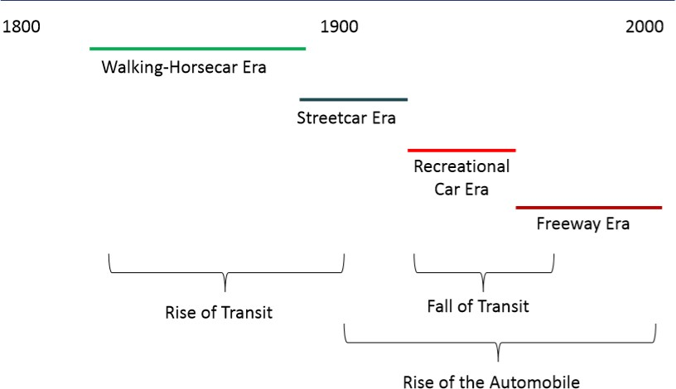
First of all, below is a graphical illustration the successive evolution of vehicular mode of transportation.

Figure 2. 1: Evolution of vehicular means of transport Source: Handy (2016)

TRANSPORTAION IN NIGERIA

The role of transportation in Nigeria as a country cannot be underestimated. From the birth of the country Nigeria, the transportation system has had a negative start. This is largely due to poor design and inability to meet up with the greater demand. Globally this country is considered lowly ranked, when we talk about infrastructure, that impact the ease of getting business done (Igwe, Oyelola, Ajiboshin, & Raheem, 2013).

      - URBAN TRANSPORTATION IN NIGERIA

Agunloye (2011) pointed out that there was global depression in the 1980’s and Nigeria had a fair share of it. It affected the Nigerian transport system. Some years back transport authorities

or experts showed concern over the increasing haphazard pattern settlement without increasing corresponding development of complementary public transport facilities (Lagos Metropolitan Area Transport Authority, 2010)
According to Igwe (2013), in the early 1980’s cars vary cheap to buy but Nigerians had serious challenges in buying cars. Nigerians are buying used cars that are imported from other countries. To be able to buy cheaper cars, people buy discarded cars and fix it for sell. Still according to him Nigeria’s public transportation system is a failure. In my opinion, it is improving, especially in Lagos, Nigeria. He went further to point out that, because of this Nigerians without private vehicles have to resort to the private sector such as taxis, and “danfos”. Danfos are locally improvised small van. The cost of transportation is also influenced by the cost of fuel. The two major explanations are the reduce production capacity of the Nigerian refineries and how the government go about controlling the price. The country has had to import fuel to meet up with demands. Fuel scarcity has been making the black market in fuel to thrive.

HISTORY OF THE BUS TERMINALS

In those days in first world countries, city and regional buses had to occupy empty area of lands, with their respective boundaries. This was what made up bus stations back then. In Nigeria this has not changed much as we can still see areas of empty land being occupied by bus to various destination. According to Enne de Boer (2009), he clarified that it is quite hard to put together the world history of how urban bus stations evolved to its present state. Below I have looked at the development of some early bus stations in some countries with the view that other bus stations of such contemporary could have evolve in the same manner.

BUS STATION HISTORY AT ESTONIA

It was May 23, 1922, in a country called Estonia. A business man called F. Kangro and an unknown architect received authorization to start up five bus lines in the country. From 1922 to

1939, they started intercity lines along with city lines form Vene Turg. Vene Turg is a square located at the epicenter of the capital of Estonia, Tallinn. The buses had to be arranged in front of a building facility, which later was used to be used and is still used as an hotel. That is the Viru Hotel. The officials that sold the bus tickets were using an office at the angle between Pärnu road and the Vene market. The Viru square later became known as the Stalin square by the 1940. As the Vene market close to the square was leveled to the ground by 1949, the intercity bus line departure for reason not give had to be relocated to another square adjoining the Estonia theater. And the market was also relocated to Tartu road. In 1950 an appropriate land was allocated for the intercity bus line and this land was adjacent to the another square, also known as the Huge Stalin square. For references, it is close to the present-day Radisson hotel. Eventually the bus station was completed 1965 as a two-story building. Though, it started as a wooden one-story building in between 1959 to 1961. All these information is according to Bus station history (2016)

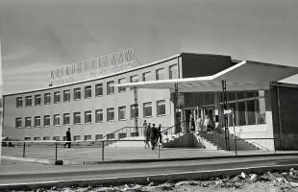
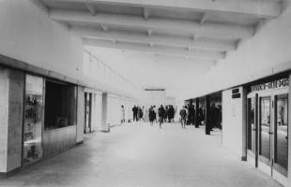

Plate2. 1: This is Tallinn bus station from the year 1965 Source: Bus station history (2016)
My inference on the above information on the Tallinn Bus station as at 1922 to 1965 is that, bus station or terminals evolved as a large bus parking area with little or no supportive facility, except for the office where the tickets are sold to the passengers. I also see that bus station initially start close to a market. When the market was demolished, the bus station was moved close to another

market as the present day permanent site or location. Today Tallinn Bus Station is serves the people of Tallinn as the main bus station

LOCAL HISTORY OF THE FORGOTTEN BUS STATION AT NOTTINGHAM

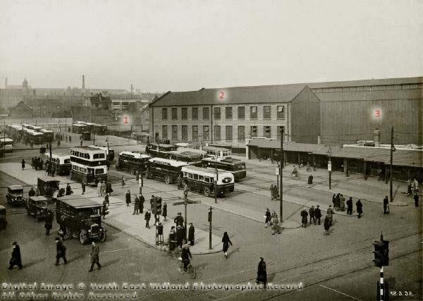

Plate2. 2: This is a bus station that was first used on 1st January 1930 Source: Nottinghasm (2016)
The plate 2.2 above shows the picture of a bus state that was first used in the 1930’s. This terminal was located at Nottingham, United Kingdom. It is mostly referred to as the Nottinggham’s lost bus station. In the picture we can notice the early use of traffic lights. As time went on the station gradually went out of use for reason not stated by Nottinghasm (2016) If you look closely at plate 2.2 you will notice that some of the buildings are numbered. One of the street close to the numbered buildings was King Edward Street. The corresponding buildings in plate 2.2 are also numbered on the figure 2.2. With this picture and the map, is becomes obvious where exactly the bus station is located

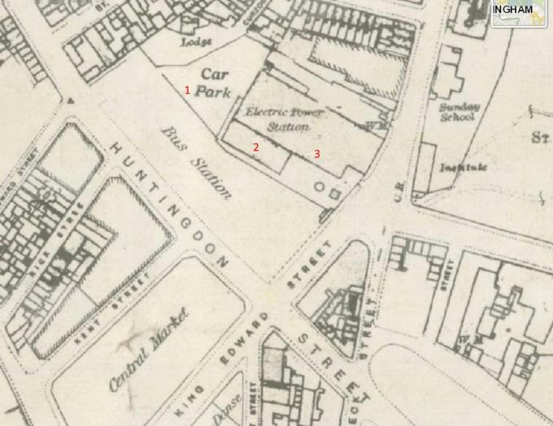

Figure 2. 2: This is a map obtained from ‘insight mapping’ by Nottinghasm! (2016).
Source: Nottinghasm (2016)

Look at this figure and plate above, one would say the early bus station were without supportive facilities. They are just large empty lands with roads and buses park. Though this particular one has a car park.

OVERVIEW OF BUS TRANSPORTATION IN THE UNITED STATE OF AMERICA

According to Chiara (1990), the expansion of the national highway network in the united states of America followed by the advances in automotive technology dictated the growth and development of bus transportation in the United State of America. Individual entrepreneurs, due to necessity to do business, used passenger vehicles to originate the first bus routes. The routes originated by them was not the type of route needed to for a growth of bus transportation because

to was of a small distance and the services were evaluated to be unreliable. Thanks to the expansion of the highway network and the availability of bus equipment, the small distanced routes were merged into longer distance routes that proved to be more reliable in terms of services over longer distances. For the fact that bus transportation is the leading means of public transport in the United State, all the credit goes to the modern express highway system and the efficient high-speed buses.
According to Dearborn (2004), the use of automobiles or bus travels made bus terminal buildings and motor lodge a necessity. Since the 1930s the architecture of bus terminals has changed variably, but he functions and spatial programing relatively has remained constant. The bus terminals of those days borrowed the features of rail station, e.g., waiting room and ticketing offices. As years drew nearer, bus terminals had to include well designed platforms for the arriving and departing buses. 1930 to 1950, the bus terminal architectural style employed were basically art modern style or better known as streamlined style and sometimes as Deco. In the mid-20th century the architects or designers of bus terminals paid more attention to the bus platform canopies to achieve elaborate canopies and to give sculptural quality. This attention made that area the only means of architectural expression while the waiting area received less attention. This observation can be seen in New York City’s George Washington Bridge Bus Terminal among others.
Brudevold (1957) gave his own version of an overview of bus transportation in the United State of America as far back as 1930. According to him people living at residential areas bordering the cities lived a life of over dependence on private vehicles and their vehicles were flooding the parking facilities of the American cities. This was causing congestion, especially for those who lived in the cities. In quick response to this, the shopping outlets were identifying and relocating to the suburbs or to areas closer to the suburbs. This in turn was taking a toll on the nature of the central business districts, which were now taking on the nature of central office district. To fight
this phenomenon, experts of that time suggested the replacement of over-dependence on private

vehicle with large scale commuter service. Large cities in the United Stated took heed to the advice of the experts and started building terminal or station facilities. A good example of such cities is San Francisco. Brudevold (1957) went ahead to single out bus transportation and explained its development. During this period, bus transportation seemed to be more favorable. This was due to its flexibility and less expensive facilities and equipment, when compared to other means of transportation such as the railway etc. Let us take a closer look at the development of bus transportation in the United State of America. The process by which bus transportation evolve in this place is not as celebrated as that of the railroad. Early small bus companies randomly mushroomed in different place, especially during the first World War and years after that. This sporadic springing of small bus companies helped many businesses to develop. Especially business in areas, that didn’t have the luxury of being accessible by railroad means of transportation. This areas that were far from the railroad, tend to be where the elite and the well- to-do did not live in. The bus stations, that emanated from these small bus companies, were established with little or almost no capital. They were more of provisional bus station than permanent building and were mostly around corner drug store, cheap restaurants or mostly areas of very low commercial nature or characteristics. Still in the 1920’s, bus operation expanded the more and big organizations pushed the small bus companies out of the business. This was due to mass automobile production and the development of national highway network. It was recorded that during the year 1935 to 1944, the bus operation business waxed stronger than before, capturing businesses from railroads and railroad commuter service.
Brudevold (1957) made us to understand that it was around this time of the 1940’s that bus terminals were about to or being considered as a building type. Even though its reputation was most time below second-rate commercial reputation back then. This reputation was owing to the fact that, back then bus terminals were mostly located in the dreariest of surroundings. To the fore-mentioned fact is the exceptional developments of bus terminals of the likes of New
York Port Authority and the new Chicago Greyhound Bus Terminal. Back then Brudevold

(1957) emphasized that bus transportation should be intentionally converted to an attractive location. Attractive to the point of luring many commuters from constant use of their privatly owned vehicles. I believe to achieve this; quality architecture and urban relationship has a meaningful role to play in this.

TERMINAL HISTORY OF SAN FRANCISCO’S FORMER TRANSBAY TERMINAL

The terminal, Transbay Terminal is located in San Francisco, California, United States. Timothy

L. Pflueger designed it. He used the Art Modern style in the design of it. The construction started 29 July 1937. The construction materials used are steel and concrete. The San Francisco-Oakland Bay Bridge Railway was officially dedicated 1939. The facility was designed to serve minimum of 60,000 passengers (Wikipedia, San Francisco Transbay Terminal, 2018). Basically, this structure is intermodal in nature. Meaning it serves both buses and trains. This terminal was built before and officially opened in 1939. It was built for the East Bay trains that avail of the Bay Bridge. So, it officially started as train station. The source of funding for the terminal was from the bridge tolls. As at 1939 automobiles plied the upper deck of the bridge and trains and trucks moved on the lower deck of the bridge. This is a terminal that could accommodate 35 million people during peak hours. Due to less unavailability of gas after the world war II ended rail passengers declined. Consequently in 1958, the Bay Bridge was totally used for road vehicular use only (TJPA, 2017).

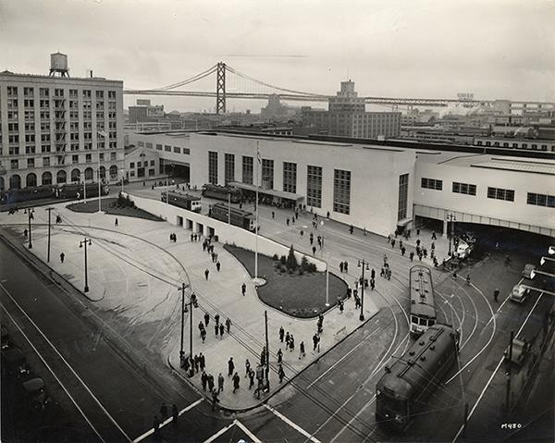

Plate2. 3: In the background is the façade Transbay terminal of 1959 Source: TJPA (2017)

At the coming of 1959, Transbay Terminal was full changed into a bus terminal and a depot. This was for the more reason that the bus route in the surrounding communities happen to terminate there. Thus, it can be considered a bus terminus. In 1974, passengers gradually stopped using the bus service and preferably started using the Bay Area Rapid Transit, which is basically another form of train service. Unfortunately for the terminal building itself, the Bay Area Rapid Transit mostly referred to as the Tube did not pass through the terminal. This put the building facility into disuse and many homeless folks decided to start living in the area. While the homeless made used to the building in lieu of the actual use of the terminal, polices office, cocktail lounge, newsstand and diner where accommodated in the building till 1990.
In 2010, the terminal building was officially closed down, demolition commenced and the terminal service was relocated to a temporary site, referred to as the Temporary Transbay Terminal. During the demolition, The Transbay Joint Powers Authority (TJPA) started to take
over the building. The building demolition was officially completed 2011. The homeless still

avail of the demolished terrain without fear (Wikipedia, San Francisco Transbay Terminal, 2018).

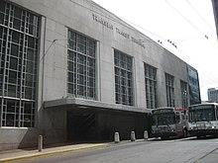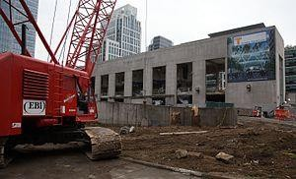

Plate2. 4: On the left is the picture of Transbay terminal façade before the year 2010 and on the right is the picture of the façade being demolished in December 2010
Source: Wikipedia, San Francisco Transbay Terminal (2018) and Wikipedia, Transbay Transit Center (2018)

TRANSBAY TERMINAL REPLACEMENT PROJECT

The new terminal to replace Transbay Terminal, came to be referred to as the Transbay Transit Center terminal. It will replace the former in the same location. This was proposed because the former was underutilized.

HISTORY OF PORT AUTHORITY BUS TERMINAL

In 1939 bus traffic in New York City was chaotic, due to congestion. This pose a big problem for the city. The then Mayor Fiorello LaGuardia had to seek help from the Port Authority of New York and New Jersey to see how all the smaller bus stations can be merged into one terminal. Eventually this was done and by late 1946 a midtown bus terminal was built. Later into the future on January 27, 1949, within a space of two years, the Port Authority Bus Terminal was completed. Plate 2.6 shows the picture of the building as at 1950. In 1960, the building was later expanded to include three (3) additional parking levels for spaces of one thousand cars. This expansion was completed 1963. In 1966 as life would have it, the bus terminal swung into full function. In 1970, the terminal had problem of congestion.

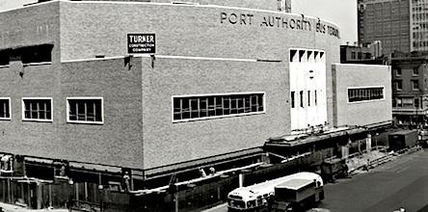

Plate2. 5: Picture of The Port Authority bus terminal 1950.

Source: The Port Authority of New York (2018)
The Port Authority came up with a solution to this problem. To solve this, they had to build another lane that is referred to as the exclusive bus lane. This lane facilitated or better still, facilitated the buses and commuters to reach the city faster than before as compared to the Route 495 lanes. In the 1980s, the terminal had to expand to cater for the increasing volume of traffic. As a result, new bus-loading platforms were added including a mall with up to 70 shops. The plate 2.6 below shows how the building look after the year 1980.
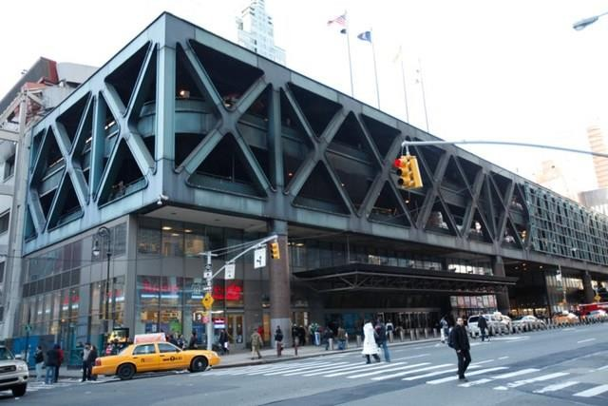
Today the terminal facility can boast of many things, among which is the Lincoln Tunnel that still help to reduce the surface street traffic etc.

Plate2. 6: Picture of The Port Authority bus terminal after 1980 Source: Carlson (2014)

HISTORY OF TIETÊ BUS TERMINAL OF BRAZIL

The Tietê Bus Terminal indisputably the biggest in the countries of Latin America and reputably the third to none in the world. It is just behind Port Authority Bus terminal of New York in ranking. The Tietê Bus Terminal is an initiative of a former Governor of São Paulo. The terminal was first opened 9th May 1982. It is actually owned by São Paulo Metro.
Details about the terminals are as follows:

- Covers an area of 120,000 square meters

- Houses 65 bus companies with 135 ticket counter and 304 bus lines

- It renders service to five countries

- It’s waiting parking lot is for 70 vehicles

- It accommodates 70 boarding platforms

- The terminal capacity at peak hours is for 90,000 people to 3,000 buses.

- The total number of staff is 295.

- Electronic display panels area employed for the platform. Both departure and arrival.

- It’s supportive facilities are 53 shops, not including the 11 kiosk, post office, the travel agency, pharmacy, a number of ATM and a clinic to mention a few.
- The terminal allows free wireless connections, free laptop and cell phone charging points.

All the above information is obtained from (Wikipedia, Tietê Bus Terminal, 2018).
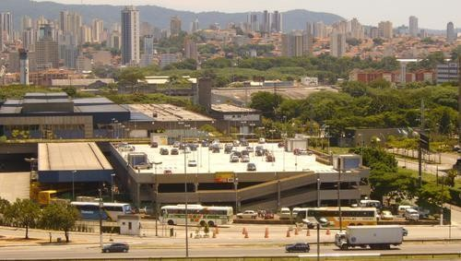

Plate2. 7: Picture of Tietê bus terminal at São Paulo, Brazil Source: Wikimapia (2018)

The design of Tietê Bus Terminal is highly considerate to the plight of the disable with respect to mobility (Buscaonibus, 2017). I came to this conclusion about the terminal based on the following facilities and services the obtains in the terminal:
- Public convenience for persons with special needs both in the upper and lower floor, making a total of four.
- Shower facility is provided.

- Ramps are strategically placed, mostly for loading and unloading areas.

- A total of nine (9) elevators are provide at the various arrival area for vertical circulation and a total of seven (7) stairs are also employed to assist in the circulation.
- ATMs are provided.

- Public phones specially for people with mobility challenge are provided.

- Wheelchairs and special wheel chairs for corpulent folks.

- A total of 68 parking space.

- Steps were eliminated in the design for obvious reasons.

All the above information is from BuscaOnibus (2017). The following are spaces worthy of mentioning in this terminal facility:
- Restrooms: The restrooms are design differently for man and female. Each include adapted toilets. The restrooms a strategically placed around the departure area and the second floor included. The restrooms also include shower facility which is a service to be paid for use. Baby changing facility is also included. But as for this one is free of charges.
- Central Information Desk for Client: This facility in integrated into the terminal for supplying information as needed by the client. Each information desk represents the other bus terminals in São Paulo.

- Arrival and Departure: At the arrival and departure area, information is well divulged to the passenger through matrix screen. The information gives the schedule of arrival and departure time, including the bus company and the cities of destination. In the space there are service desk for people with special needs.
- Information Desk: Located on the upper floor. It offers 24 hours service.

- Parking Area: It is accessible round the clock.

- Baggage Room: Service offered round the clock.

- ATMs: Different bank have their ATM in the terminal. It is functional round the clock.

- Shops: Shop of all types a obtainable in the terminal. Ranging from newspapers to gift shops and finally kiosks.
- Lost-Property Office: This is located close to the information desk at the upper floor. It is open specific hours of the day. Properties kept for 60 days are donated to institutions dedicated to philanthropy. While documents are sent to the nearest post office.
All the above information is from Buscaonibus (2017).

THE DEVELOPMENT OF URBAN BUS STATIONS IN THE NETHERLANDS.
With respect to the history of urban bus station and its development in the Netherlands, I will expound on the accounts given by Enne de Boer (2009). The idea and manifestation of bus station in the third decade of the 20th century actually arrive late relative to that of the railway networks and the tramways. In the early times, as the concept of bus stations unfold, cities had to restrict the operations of concessionary companies. Thus, stopping them from competing with the indigenous, local buses that obtain within the cities. As a result, terminuses had to be established at the border of the cities. This could be considered as the initiation of bus terminal in the Netherlands. Situations compelled tramway companies to switch over to road vehicular means of transport. So automatically major railway stations belonging to the tramway companies were
converted to major bus stations in the 1970s. The buses around the stations were so much that

they had to be sorted into local and regional bus. This gave birth to local stations and regional stations. Local stations were for buses shuttling within the city and regional stations were for bus shuttling between cities.
In the Netherlands, in the early times of the development of bus station and in the times of the decline in the used of railway networks and tramways, the major bus stations were fashioned in similar manner. For instance:
        - Use of a set of parallel platforms to the central waiting area.

        - Use of a system whereby approaching buses are tagged to a particular platform.

        - Use of an electronic central display showing planned departure, location and time, for a calculated period.
        - Use of overhead display at each platform showing departure time.

TYPES OF BUS TRANSPORT BUILDINGS AND SERVICES

    - TYPES OF BUS SERVICES

Bus services are of different types. This grouping into types is a function local tradition. This grouping can be pivoting on the type of bus used, route length, purpose of use and frequency of use (Wikipedia, Public Transport Bus Service, 2017). Below are types of bus services according to Wikipedia.
      - Urban / suburban services: This is a public bus service that transports people in batches in urban areas, away from or to the suburbs.
      - Express bus services: This bus service is the fastest, compared to other bus services. This bus service has either ply traffic free roads or avoids busy bus stops.
      - Park and ride bus services: This is actually an express bus service provided to public parking lots

      - Feeder bus services: This is a bus service planned to transfer commuters from designated pick up point in an area to a specific point on a major route where passengers can alight and continue with another bus or another means of transport. This bus service is more popular.
      - Bus rapid transit (BRT) service: These are put in place infrastructures and measures put in place to ensure the set of selected feeder buses have a right of way. Thus, fully harnessing the maximum capacity of rapid transit system.
      - Long distance bus transport services: This service is for buses planned to ply road between cities, that could be close or far apart. Especially for if there are no reliable or existing railway infrastructure.
Though there are other types of bus services, but these are the major ones.

TYPES OF BUS TRANSPORT BUILDINGS

Buses need certain space dimension to be able to operate properly. Any area that is separated from the flow of vehicular traffic, that can offer buses the required freedom to park and pick up commuters in safety and comfort can be considered a bus station, terminal or a bus stop (Blow, 2005). Though bus terminals have bus facilities for passenger than a bus stops.

TYPES OF BUS TRANSPORT BUILDING ACCORDING TO MANJURALI (2016) FROM BRT POINT OF VIEW

First of all, Bus Rapid Transit (BRT) is a system that ensures rapid movement of buses. Thus giving them right of way. This is achieving by basically providing a secure segregated bus way for the franchise buses along with other major elements, e.g., running way (as afore-mentioned), stations, vehicles, off-bus fare collection, service and operation plan. The station type for BRT are simple stop, interchange stations, and main line stations or terminals.

Simple Stops: This are mostly located by the side of the road or 500 m from road intersection for the boarding and alighting commuters along the corridor. It includes a ticket sell point and queuing rail.
Interchange Stations: These are the points where passengers are dropped off and / or picked by feeder buses or buses.
Main Line Stations/Terminals: These stations are located at the start and finishing point of major bus route in the road network. These stations are dedicated to offer services to feeder buses and buses, that ply the major road network. Among the other stations, these type of terminal is built with more infrastructure facilities. These could be facilities such as parking area, depot and maintenance workshops.

TYPES OF BUS TRANSPORT BUILDING ACCORDING TO CHIARA (1990)

According to Chiara (1990), bus services have developed over time into operational categories and characteristic terminal types. The terminal types are explained below.

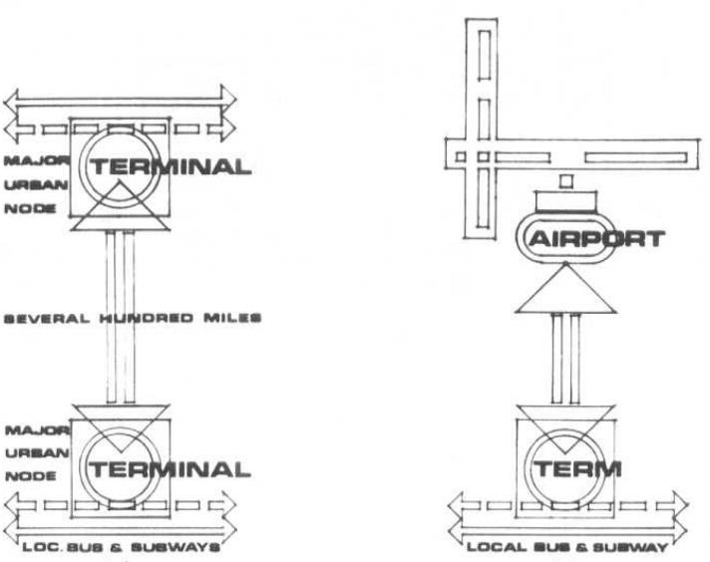

Figure 2. 3: On the left-hand side is intercity bus terminal, on the right-hand side is airport-city bus terminal Source: Chiara (1990)
Intercity Bus Terminal: These are terminals located in the core of the city. Taxis, autos, and local transit easily access it. It separates itself from other types of bus terminals, in the sense that it provides long-distance transport services to commuters in the central business district. It also provides parceling services. Land cost in the city core can be a constrain to the design of an intercity terminal. For this reason, the terminal design tends to be more of vertical expansion than horizontal expansion in denser city areas (Chiara, 1990).
Airport-City Bus Terminal: This bus terminal provides bus service to the closest airport terminal, by transporting airline passengers from or to the urban center. Of course, for the bus terminal to effectively serve the airport terminal, the bus the terminal should be fed with arrival and departure flight information. This type of bus terminal has some facilities the other bus terminals do not, i.e., pre-ticketing and check-in facilities amongst others. Local transit systems, taxis, and autos are permitted to access this type of bus facility (Chiara, 1990).

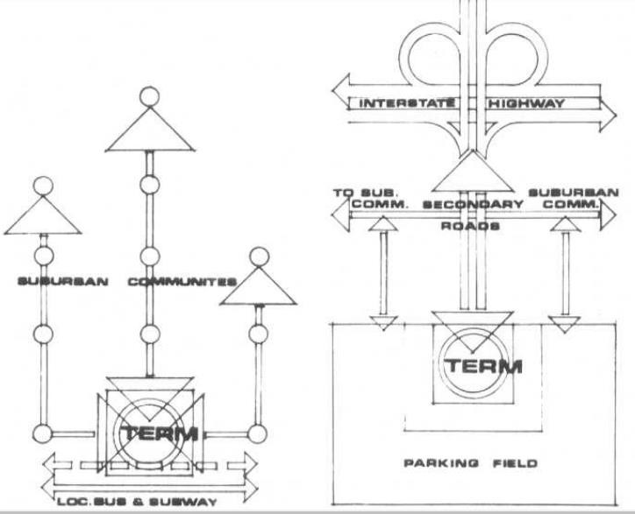

Figure 2. 4: On the lefthand side is urban-suburban commuter terminal, on the righthand side is suburban Source: Chiara (1990)
Urban-Suburban Commuter Terminal: This is a terminal type usually built within the city core or sometimes at the periphery of the city core.. It serves as a rapid transit feeder station. The terminal is linked to a diversity of well-structured bus routes and serves a high turnover of commuters. The grade overpass or underpass and exclusive bus lanes are necessary for the bus terminal to maintain schedule efficiency (Chiara, 1990).
Suburban Interstate Terminal: This type of terminal is located at the outskirt of the city and also usually close to road interchange or road highway that connects major cities. The bus terminal mostly serves commuters that dwell far from the city core. Here passengers tend to park their vehicles at the bus terminal and ride on the buses to the city and back. This makes some suburban interstate terminals a park-and-ride lot. This type of bus terminal facility does not invest much in waiting area but rather invests in paved parking spaces for private vehicles. The design and construction is mostly simple (Chiara, 1990).

TYPES OF BUS TRANSPORT BUILDING ACCORDING TO ENNE DE BOER (2009)

(Enne & Joost , 2009) pointed out that the design of bus terminals did not vary much from one to the other. In spite of this, there is no laid down process or standard to make a design of a bus terminal integrate to the available location for the bus terminal. He grouped bus stations into three by their degrees of separation of bus circulation and pedestrian movement. As below:
        - A bus station, that bus pick up and drop off passenger by departing from the road side.

This ranges from side walk to a full-fledged terminal building.

        - A bus station with a central island, surrounded by bus lanes.

        - A bus station with parallel platforms surrounded and separated by bus lanes.

Enne de Boer (2009) concluded this classification by pointing out that conflict free road concept should be employed in bus terminal design.
“According to Enne de Boer (2009) bus stations can be divided into three families, characterized by different degrees of separation of bus circulation and pedestrian movement :
- one with buses departing from the roadside, varying from a sidewalk to a full grown terminal building,
- one with a central island, surrounded by bus lanes,

- one with parallel platforms surrounded and separated by bus lanes.”

“These concepts each have typical qualities, which should be subjected to a systematic assessment, before selecting one of those for application in a specific situation. Two essential ones, being the incidence of conflicts between bus and pedestrian movements and the space required for each type, including geometrical manipulation (Enne & Joost , 2009).”

FUNCTIONS, SPACES AND RELATIONSHIPS BETWEEN SPACES COMMON IN THE BUILDING TYPE

Generally, the passenger and bus traffic circulation, the site configuration, and the type of bus operation, all dictate the functional organization of a bus terminal. All bus terminal building types have some similar planning problem, but a great deal of difference can be seen in each of their design principles.

PLANNING CRITERIA

Chiara (1990) considers intercity bus terminal to be the most intricating, owing to the fact that it is mostly located in city core. He inferred that the design of an intercity bus terminal has many constrain, such as existing construction, and high cost of land among other things. He made an assertion that the design principle should ensure minimum lines of flow and communication between the following functions: ticketing, baggage and the bus interface.
Space configuration of a bus terminal should be done in a way that allows for maximum efficiency. Chiara (1990) proposed a plan which he referred to as the island plan. The advantage here is that the functional elements radiate from the core. The core here is the waiting area and it becomes the central focal point. As oppose to island plan, the linear plan is a disadvantage because the functional elements might be too far apart. Thus, requiring duplication of the functional elements to achieve cohesiveness.

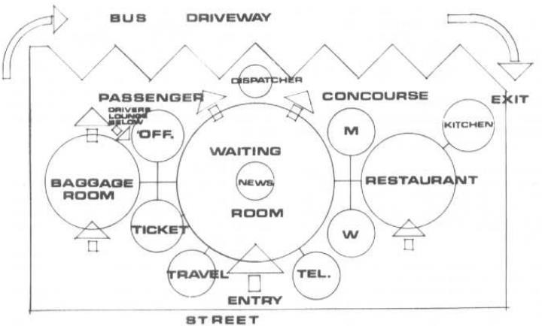

Figure 2. 5: Flow diagram
Source: Chiara (1990)
For airport-city bus terminal the most important planning consideration is providing efficient check in facilities, baggage handling, conveyor for handling baggage, extensive counter space with weigh-in provision, and flight information. For the suburban interstate terminal, it seems to be the easiest terminal type to design. In this case more attention will go into the planning of the parking area, because passengers will have to park their private cars there till they return from the city core. Thus, there should be minimum walking distance between the parking facility and the terminal building. Also, the road egress and road ingress to the interstate bus terminal site should be planned in such a way to prevent the occurrence of traffic congestion along the main route nearby and the walk ways should be protected from rain and provide sun shade. The circulation of the vehicles and passengers must be separated if they are at the same level. In the terminal design provisions must be made for storeroom and / or baggage, toilet facilities, ticket sales, offices, and vending machines and / or small snack bar. All these can be seen in the flow diagram of figure 2.5.

PASSENGER ATTITUDE TO INFORMATION, SECURITY AND WAITING AT BUS TERMINALS

David (2017) analyzed passengers point of view, using Moncloa terminal as a case. This analysis was undertaken for a better insight into the critical aspects of bus terminal service process. His research finding shows that safety and security is one variable and information at the disposal of passenger at the bus terminal is another variable. These variables are not linked. These are the determining factor of customer satisfaction. The research paper’s findings show that women generally feel less safe than men in bus terminal facilities. This could partly due to the way the media have programmed them think and also their parental brought up.

SPACE REQUIREMENT

Spaces requirements are the spaces that ought to in the space program of a bus terminal in order for it to function effectively as a bus terminal. Each of the spaces requirement are explained below.
Public Seating: In any bus terminal, public seating could be a separate room referred to as waiting room or an area set aside in a large public space as a seating area. The public seating must be linked to the concourse area. It should have trash baskets, drinking fountains, clocks and ash urns.
The key determinant of seat required in a public seating varies upon the economic priorities, individual circumstances, and terminal type. There is a general way of estimating the number people the seats in the public seating will serve. The general way is by designating one seat to every three passengers in the intercity bus terminal.

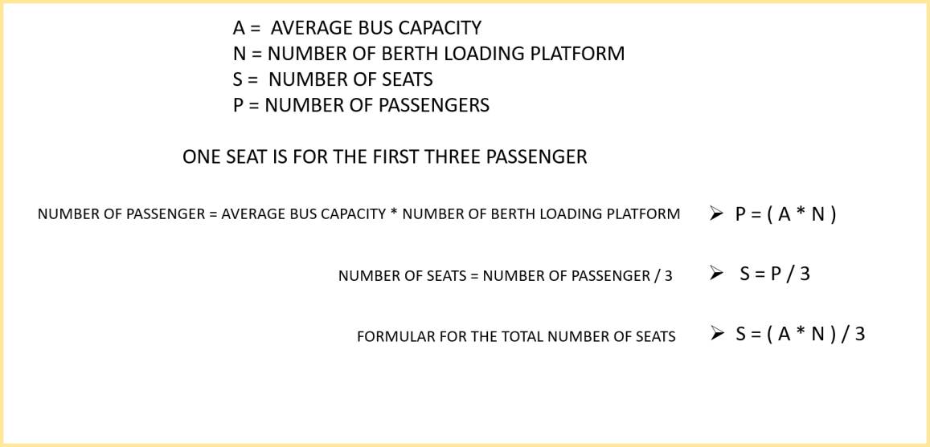

Figure 2. 6: Calculation for maximum number of seats in a public seating Source: Author’s work (2018)
To calculate the passenger quantity in a bus terminal, one must know the average capacity of a bus. Multiply the average bus capacity by the number of loading berth and divide it by three. This will give us the terminal seating.
Ticketing Facilities: In the early times, the ticketing counter was a space enclosed by walls with a small window. But in recent time, the is more of an open counter. In an intercity bus terminal, you can have more than one counter each in self-contained glass-wall for sales of ticket. The operating policy of the particular bus terminal type is what determine the number and position of ticket selling points. For an intercity terminal the selling point is the high, relative to other terminals. One ticket selling can sell ticket to 25 to 30 waiting room seats. The ticket counter usually occupies a linear space of 910 mm to 1500mm per position or about 4600sq mm to 5500sq mm per position. It is usually 1000 mm of height.
For the airport-city terminal, the ticketing facilities are a little bit complex. It is usually a continuous counter with a number of ticket selling point’s position for each airline. The electronic equipment, TV equipment and the weighing scales all determine the length of each ticket selling point’s position and a range of 1200 mm to 1500 mm is alright.
Baggage room / staging area: The requirement for this space is not fixed but flexible according

to the type of terminal and operations to be carried out. For intercity and airport-city terminal the

handling of baggage is taken more seriously. This is where the baggage will be sent to, when once separated from the passenger. At the airport-city terminal the passengers give in their baggage at the ticketing counter. The baggage is then sent to the loading platform, or better still to the baggage room for storage till the bus arrives for loading.
For intercity bus station, no need for a conveyor as in the airport-city terminal. The baggage is either carried into the bus or to the baggage room till the bus arrives for loading. It is important that the baggage room be linked to both the public area and the loading platform or concourse. The area of the space must be equal to 10 percent of the total building area or could be 4700sq mm multiplied by the number of the loading berth. Choose the highest. The equipment in the baggage room is just metal racks, which can be five rows high. If the baggage room is big enough, a part of it could be useful for package express service. But it should not interfere with the traffic at the concourse. If it does, then a separate space should be provided.
Public Lockers and Telephones: Public lockers can be provided as a revenue generating service, if it has the capacity to generate it. Public telephones are not necessary, because everybody has it today.
Dispatch Office: This office must be located at the concourse for two reasons. It controls all the movement of the buses and observes the loading berths. The minimum area for a dispatch office is 4600sq mm to a maximum of 14000sq mm.
Offices: All types of terminal require office space. To determine the office area, you must know the terminal size and type. Minimum of three offices can suffice. These are switchboard office, passenger agent’s office, terminal manager’s office. Though, in larger terminals more offices maybe required.
Rental Space: Earning potential is what determine the amount of rental space. Rental spaces are shops, concessions, store etc. Where there are a lot of people gathered and waiting, there will be a need for business facilities and catering facilities (Blow, 2005).

Public Toilet and Staff toilet: There should be public toilet and adept restroom for the special need.

PEDESTRIAN DESIGN FOR PASSENGER TERMINALS

One cannot design pedestrian facilities for passengers without knowing the category of the terminal and the pedestrian traffic patterns that will occur at the terminal. The design of pedestrian facilities for a commuter passenger terminal is different for that of a long-distance terminal. This difference is based on the fact that commuter passenger terminals experience short peak traffic patterns and are mostly user by repetitive users. While for long-distance terminals the standard of pedestrian design for passengers is higher than that of commuter passenger terminals, because the terminal experience hours of sustained peak traffic levels and the terminal is mostly used by users not too familiar with the facility. It is important the architect or designer of the bus terminal with regards to the space requirement establish an adequate mean balance between the comfortability along with the aesthetics of the terminal against the space constraints, owing to the terminal’s configuration and cost.
According to (Chiara, 1990), there is a concept that can be applied to the design of pedestrian space. This concept can be regarded as an approach. That concept is referred to as the level-of- service concept. This concept involves the study of traffic concentrations through qualitative evaluation, which will be converted into design parameters. According to (Roger & Elena , The Highway Capacity Manual: A Conceptual and Research History, 2014), it is also a concept used in highway capacity analysis and according to (Templer, 1994), the concept was brought up to be used by traffic engineers. When this concept is applied to pedestrian design and planning for passengers, it came to the conclusion that a mean value of 3,200sq mm per person is adequate for persons in a corridor. This is because it allows persons to walking at normal speed without conflict with other pedestrians. This concept is very appropriate for the well-being and convenience of

passengers in the waiting areas in bus terminals and is also applicable to human movement on stairs.

2.4.4.1 CORRIDOR DESIGN IN A BUS TERMINAL

Understanding of corridor design is very important of a proper circulation in a bus terminal. As an introduction to corridor design, it is vital to know that, window shoppers, columns, stairways, and newsstands are all disruptive traffic elements. The optimum corridor width is determined by the pedestrian traffic flow volume and the allowances for the disruptive traffic elements.
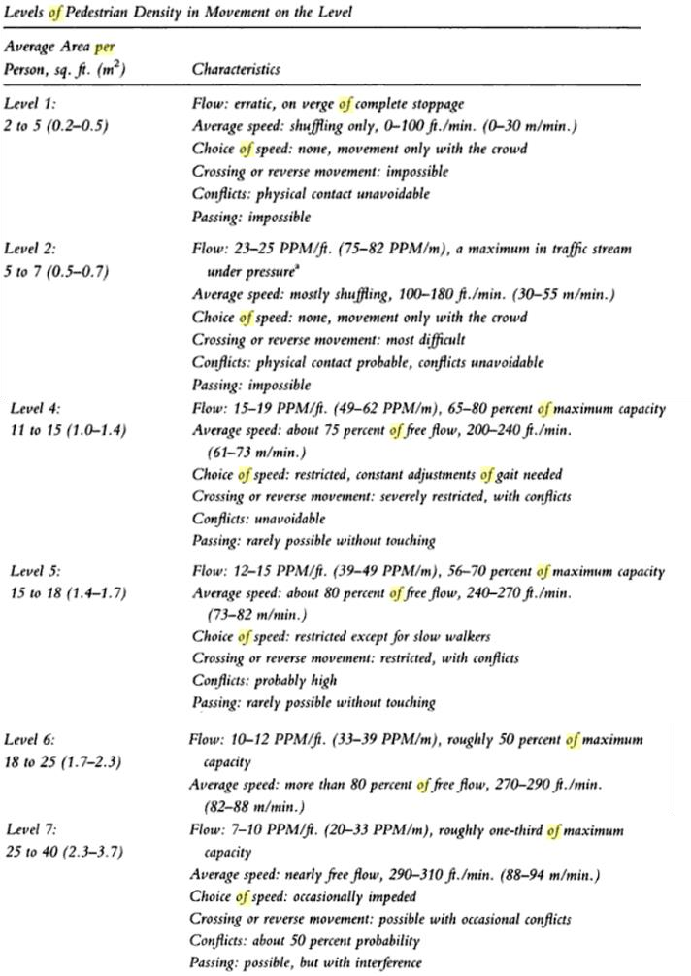
Table 2. 1: Summary of pedestrian flow into levels-of-service. (Note: level 3 and 8 is omitted) Source: Templer (1994)

Though the corridor is used for horizontal circulation, it proves useful as a waiting area for standing pedestrians. For this use to be functional, it will be a must to determine the safe human occupancy and maximum potential accumulation of the corridor. PFM is an acronym, which means persons per foot width of corridor per minute. This is the unit use to measure the flow through a pedestrian corridor. 25 persons per foot width of corridor per minute (PFM) is the maximum practical flow through a corridor. Templer (1994) understands this unit as pedestrian per minute per foot of walkway. The acronym for this is PPM/f. The value 7 PFM or 7 PPM/f, as can be seen in the figure 2.6 above, ensures avoidance of traffic conflict and gives freedom to the pedestrian to walk at normal walking speed. Templer (1994) propose the afore-mentioned value (7 PFM) as a standard that should be use in passenger terminals that have lenient peaking patterns and abundant space. The value 7 PFM, implies 3.7 m² per pedestrian. But where the reverse is the case for commuter terminal bus type, he proposed a standard of 10 to 15 PFM. This value implies 1.7 m² per pedestrian.
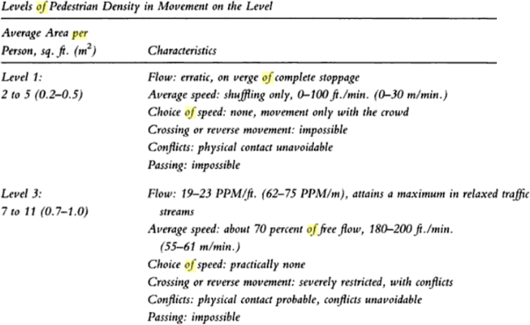
Entrances: The concept used for corridor design can also be used for the design of door entrance. Chiara (1990) established that a free-swinging door can let in up to 60 persons per minute.

Table 2. 2: Summary of pedestrian flow into levels-of-service. (Note: only levels 1 and 3 included) Source: Templer (1994)

If this is actually what obtains on the door, the queue will be unbearable. Going down to 40 persons per minute will still not be feasible. To achieve a free-flowing traffic through the free- swinging door, 20 persons per minute will be ideal. We can now use this figure to determine the width of the door. Checking table 2.2 above, it is observed that the value 20 persons per minute falls within the range of 19 to 23 PPM/f, if we assume 20 persons per minute to be equivalent to 20 persons per minute per foot. According to the table this value will fall on level 3 as the level- of-service. With this, the door swing will be a minimum of 0.7 m and a maximum of 1.0 m wide. But if it is assumed, that 20 persons per minute is equivalent to 20 persons per minute per meter, then 20 falls within the range of 7 to 10 PPM/f. This is level 7 according to table 2.1. With this, the door swing will be a minimum of 2.3 m to 3.7 m wide.
Stairs: These are elements of vertical circulation. The dimensional configuration of the stairs can determine if it is safe and comfortable for the pedestrian use. The same concept of level-of- services used in corridor design can be applied to determining the width is the stair. It is important to get the right combination of riser height to tread depth, so as to not wear out the user of the stair at the bus terminal. The pedestrian speed over the stair is inversely proportional to the riser height. That is to say, for 7 in (177.8 m) or below, the pedestrian speed over the stair is more. This has a positive bearing on the circulation efficiency or traffic through the stair. Pedestrians with special needs a better disposed to stairs of far lower riser height.
Queuing Areas: If the terminal is not planed, taking into consideration the queuing areas, the terminal might not be functional as expected. The queue is always in linear form, one person after the other, when purchasing tickets. This can easily be disrupting to other functions. The architect or terminal designer must plan the length of the linear queue by estimating that an average person will occupy a linear space of 500 mm (20 in). This linear spacing is not taking into consideration the baggage. There may be situations where the passengers might have to wait longer than usual for the arrival of the buses or other services. At this point bulk queuing may occur. If there are
no circulation through the queue, the passengers cannot endure a lower area occupancy of less

than 3.4sq m (5sq ft). But they can endure exactly 0.45 sq m (5sq ft) for a certain period of time. At this area occupancy, physical contact can be avoided. For the concourse area, this area occupancy will not work. The area occupancy that will work is an average of 10 or more square feet (0.93sq m).
Escalators and Moving Walks: These are very costly element of circulation and their specified operating capacities practical not 100% but an approximation. This is actually due to the way the manufacturers rate their product. They rate it based on uniform space occupancies. But in practice pedestrians don’t use it like that. When architects or designer make decisions about escalators and moving walk, they should take these into consideration. If not, these can cause unforeseen queue and obstruct the terminal functions. The advice given to architect and designers is to use 75 percent of the theoretical design capacity of the escalator. Refer to table 2.3 for theoretical design capacity.
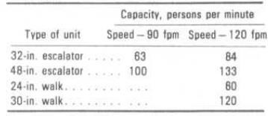
Table 2. 3: Nominal capacity of escalator and moving walks (note: fpm means feet per minute) Source: Chiara (1990)
Al-Sharif (1996) concluded in his research that, the practical handling capacity of actual escalator is 42 percent of the theoretical capacity found in the BSI and CEN standards. He gave reason similar to the one given by (Chiara, 1990).
Static stairs must be in the proximity of escalator and moving walk in the bus terminal building, as an alternative element of vertical circulation. It should be noted that passengers will pay some attention to the use of stair even when an escalator is available, if the vertical distance is less than 6 m. But if it is more a lot of the passenger will still prefer to use the escalator, thus causing

unwanted queue. One should never locate stair, escalator and moving walk without providing space for pedestrian traffic circulation and queuing at the landing area.

BUS PLATFORM

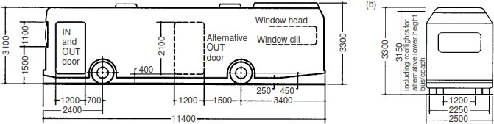
To understand the bus platform design, there is need to understand the bus geometry, maneuverability of the bus, ceiling heights, width of roadways, column spacing, ceiling heights, shapes of platforms, the turning of buses etc.

Figure 2. 7: Typical length and width of a bus Source: Blow (2005)

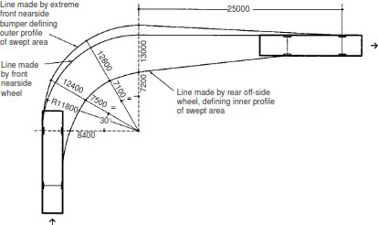

Figure 2. 8: Shows a 10 m bus making a turn of 90 degrees Source: Blow (2005)

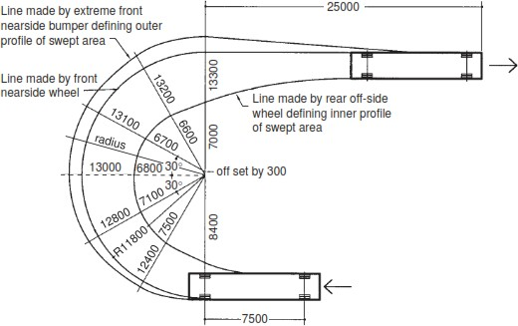

Figure 2. 9: A bus of length 12 m making a turn of 180 degrees Source: Blow (2005)

Any design that has to do with bus design cannot overlook the detail of right side loading, which is a restriction in the design of bus terminal. There are different types of bus terminal platform according to Chiara (1990) as explained below.
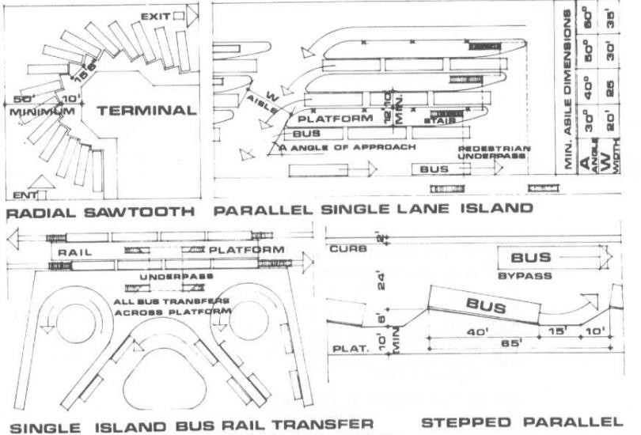

Figure 2. 10: Types of bus loading platform
Source: Chiara (1990)
Parallel Loading: This type of loading is not recommended for bus terminal facilities with not

enough space. Large spaces a required for this type of loading platform. Not always, but the other

bus normally has to wait for the first bus to exit the platform. This all depends on the design and space allocated to the platform. As for large terminals, underpass or overpass facilities should be provided for the protection of the passenger. This will enable the passenger to cross the lanes to the right-side loading of the bus. If this is beyond the budget, then zebra cross can be used instead. Figure 2.10 graphically illustrates the common types of parallel loading that obtains in the design of bus terminals with excessive amount of space. The parallel loading types are, parallel single lane island, and stepped parallel.
Right-Angle Loading: This type of loading platform is almost never used. Its disadvantage is more than the advantage. At this position, the swinging of the bus door disrupts passengers’ circulation flow and it is very unwieldy for bus maneuvering. This is not a very practical type of bus platform its use should be discouraged.
Straight Sawtooth Loading: This is one of the most preferred type of bus platform. It is mostly used in parking spaces that are narrow and deep. It is ideal because the baggage truck and the loading door are easily accessed by the passenger without obstruction to passenger circulation flow. This is illustrated in figure 2.10.
Radial Sawtooth Loading: This type of platform is by far the most efficient. It has more advantage than a Straight Sawtooth Loading platform. The bus easily parks into position following a natural arc trajectory. Because of the tapping nature of its form, the wide space angle at the back makes bus maneuvering very easy. Figure 2.10 illustrates this.

FACTORS AFFECTING SIZE OF BUS TERMINALS

Architects complain about physical constraint of site. This is common for all building type, including bus terminals. The following below are reasons that affect the size of bus terminal building.

      - The number of bus platform to be incorporated in the bus terminal design, is responsible for the number of bus services to be operating in the terminal. This determines the size of the terminal.
      - The manner selected for the buses to approach the bus platform are categorized into three according to Blow (2005). These are sawtooth shunting and drive-through. In shunting, the bus drops off the passenger and goes off to park elsewhere. In drive-through, passenger can be picked up and dropped off in the platform. This platform is in a linear form. In sawtooth, passengers can be picked and dropped off. The boundary between the platform and the concourse is in a zig-zag pattern. All these categories can be observed in figure 2.13. The angles employed in the sawtooth can be from 1 to 90 degrees. But angles between 20 to 50 degrees are pragmatic.
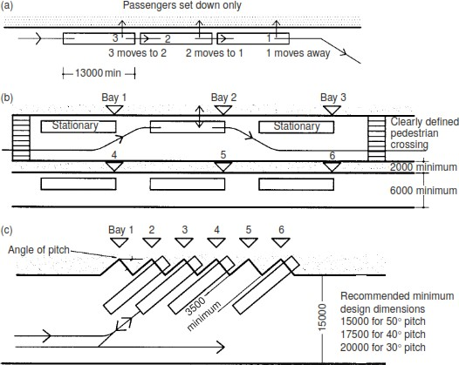

Figure 2. 11: The way buses approach platforms a) shunting, b) drive-through c) sawtooth Source: Blow (2005)

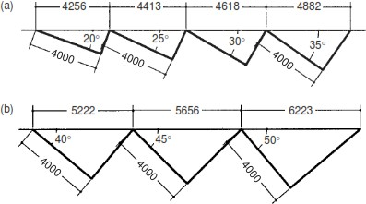

Figure 2. 12: Dimension and angles in sawtooth configuration
Source: Blow (2005)

From the proportion and size of the site, you can choose any of the category that takes advantage of the nature of the site.
      - All the facilities in the bus terminal for passenger have a role in determining the size of the terminal. For each type of bus terminal and the intensity of its use, study should be done to know the required passenger facilities. But waiting room, information counter, ticketing area and toilet most be provided.
      - Facilities for the terminal staff have a role in determining the size of the terminal. For each type of bus terminal and the intensity of its use, study should be done to know the required staff facilities.
      - Some bus terminals have bus maintenance facilities and some do not. Those that do not are still functioning well. Bus maintenance facilities are important space requirements in a bus depot. The maintenance facilities go hand in hand with repair workshop, bus washing and fueling. It will make a lot of sense to have a bus workshop, which is not a big as a maintenance facility, in a bus terminal. Especially if the bus terminal is very far from the closest depot.
The combination of these factors has a great role to play in determining the size of the bus terminal.

UNIQUE SOLUTIONS TO SPECIFIC PROBLEMS IN THE BUS TERMINAL BUILDING TYPE

The challenges of circulation, safety, energy use and security are issues that require solutions. As for circulation, easily adapted mechanical means for both vertical and horizontal movement has been employed. This mechanical means refer to elevator and escalators. Passengers should be able to easily circulate the interior of the bus terminal without being confuse, frustrated and lose precious time. More often than not, movement of passengers in the bus terminal is basically a progression through four main zones of the station – access and entrance, information and tickets, waiting, then platform and buses. These zones and the circulation needs to be well defined. The use of escalators in a building type such as bus terminal cannot be under estimated. It can connect different floors, transport large number of standing people within the terminal vertically and guaranties hitch free traffic flow. Employing the use of escalator is a unique solution to the problem of efficient and safe circulation within the bus terminal building.
The term green energy or green building is a common place in our world today. The world today is striving to shift completely to green and sustainable approach, due to symptoms of climatic changes plaguing the global economy. As we know most first world countries have put in place plans to ban sales and used of petrol and diesel vehicles (Chrisafis & Vaughan, 2017). There are two main types of electric buses. They are autonomous and non-autonomous. Autonomous electric buses have the energy stored in the vehicle and non-autonomous electric buses get their energy from outside the buses system (Wikipedia, Electric bus, 2018). Imagine using such buses in a bus terminal. It will reduce the carbon footprint of the bus loading area and proof to be healthy for the passengers.

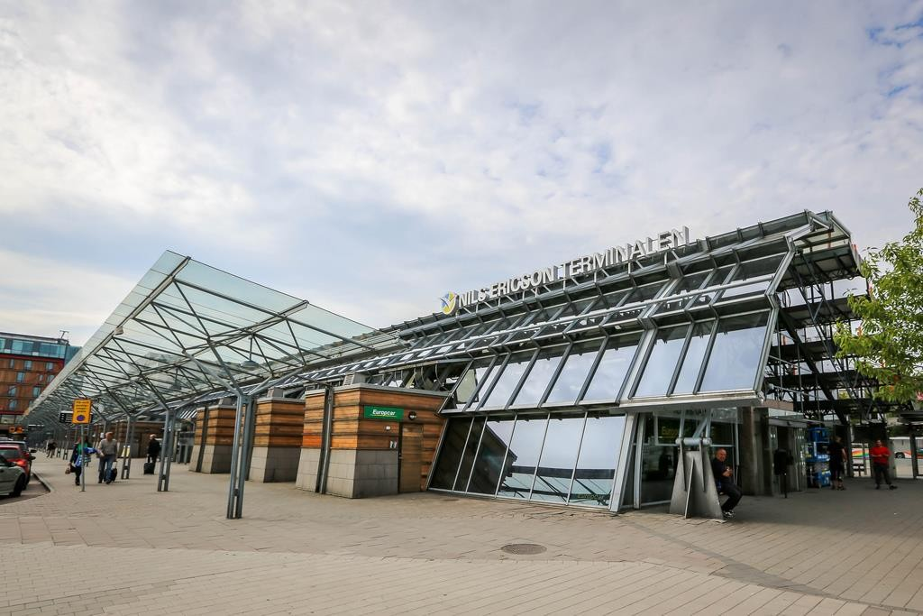

Plate 2. 8: the Nils Ericson terminal in in Swedish

Source: Lindstrom (2013)
The wait hall needed by the number of passengers must be kept safe, convenient and comfortable for all the time the passenger will be in it. Maintaining a comfortable indoor air temperature, supplying the energy required for the escalators, elevators and illumination can be a challenge in terms of monetary cost and sometimes a technological feat. One of the ways this is dealt with in developed world is by installing highly efficient solar panels on the roof top of the bus terminal buildings. Even though, the bus terminal could still be on grid. An example of a bus terminal where this is employed is the Nils Ericson terminal in in Swedish (Lindstrom, 2013). This can be seen in plate 2.8.
Security is among the most disturbing issues of discussion in the world of today. Terrorists have made public places such as bus terminals their target points. In the resent years there have been lots of such attacks reported and even recorded on CCTV cameras. For instance, the bomb blast attack at the Nyana Motor Park, Abuja, Nigeria, that occurred April 2014. This bomb blast destroyed 16 luxury coaches and 24 minibuses. Some of these vehicles were packed full with commuters (Whrton, 2014). There are many instances of such occurrence round the world.

Internationally administrators are coming up with new measures to strengthen the security strategies. Measures such as controlled access, metal detection gadgets etc., improved CCTV, emergency help points and well-designed lighting systems within the bus terminal and its environ. Many security systems are coming up and also being improved upon. Security system such as Aegis UFLED white light illuminator. This is a system that issues voice notices to intruders, takes pictures and automatically sends alerts to staff through instant messages and email. When it is evening time, the illuminator floods the zone with light to enable colored picture to be taken. The long and short security gadgets such as these is that they can coordinate different cameras, lighting and communications innovation in way that prove to be useful to security in public places (Bosch, 2013). All these are the unique solutions to the specific problems of security in a bus terminal.

    - VENTILATION, COOLING AND HEATING IN BUS TERMINAL DESIGN According to American Society of Heating, Refrigerating and Air-Conditioning Engineers (2011) most terminals are divided into two main sections, which are departure and arrival. The sections can be further subdivided. The departure section is divided into:
- Entrance concourse

- Check-in and ticketing

- Security and passports

- Shops, restaurants, banks, medical service, conference and business facilities, etc.

- Departure lounge

- Departure gates

The arrival section is divided into:

- Arrival lounge

- Baggage claim

- Customs, immigration, and passport control

- Exit concourse

Some of the subsections are not pertinent to bus terminal design. Loading characteristic of a bus terminal refers to the capacity and frequency of use of the terminal by the passenger. Terminals or bus terminals operate round the clock. The intensity of the operation is reduces during late night and the early morning hours. It can be really hard to understand the loading characteristics of a bus terminal. Because of these computer-based building energy modeling and simulation tools are employed. To understand load characteristic of a bus terminal, it is important to also understand the level-of-service as discussed earlier. American Society of Heating, Refrigerating and Air-Conditioning Engineers (2011) understands bus terminal to be a facility made up of two main areas. That are the terminal (consisting of passenger circulation, ticketing booths and stores), and bus loading area. The waiting room or area and the passenger concourse area cannot have a fixed occupant load. The occupant load density ideally could be 1 m² per person or in worst case scenario 0.3 to 0.5 m², depending on what occupant load frequency the terminal is designed for.

VENTILATION, COOLING AND HEATING IN BUS TERMINAL DESIGN

Heating and cooling in terminal building facilities are generally centralized for each building. This is the fundamental design concept for terminal facilities as far as heating, ventilating and air-conditioning is concerned (HVAC). Terminal buildings tend to have open circulation areas. In these areas an all-air system with zone control can be employed. Commercial Energy Library (2013) stated that an all-air system is “a Systems that supplies latent and sensible cooling capacity with cold air ducted to the conditioned space and that heating is also accomplished by the same airstream, either in the central system or in each zone controlled by a thermostat.” There are two categories of all-air systems. They are constant volume and variable air volume (VAV).

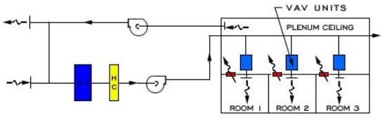

Figure 2. 13: All-Air central system diagram of the category variable air volume (VAV) Source: Commercial Energy Library (2013)
The advantage of this system for a bus terminal as follows:

        - The equipment used for this system is in a centralized location, so maintenance is not a problem.
        - The area or zone of the building being cooled of heated will not have the presence of compressors, drain piping, or power wiring, as they are all located in the same place.
        - It has the capability to heat and cool at the same time different areas in a large open space.

The disadvantage of this system for a bus terminal as follows:

- The installers and designers must work hand in hand for the system to be practically functional.
- In a very large bus terminal facility, it might be hard to achieve a proper air balance due to cooling and heating at the same time in a large open space.
- Duct spaces will be too much in the bus terminal facility and could eat into usable space.

It all depends on how the terminal is designed.

The all-air system as a cooling and heating solution should be encouraged in the design of bus terminal. The duct for heating or cooling of the spaces can be installed into the ceiling. In cases where the ceiling is too high, it can be installed along the side of the wall at a proper height to concentrate air conditioning where desired. American Society of Heating, Refrigerating and Air- Conditioning Engineers (2011) emphasis that bus terminals usually have lower ceiling height

relative to airport terminal and the perimeters in a bus terminal are usually bordered by store and offices. Because of these characteristics all-air system is practical for bus terminal design and also ceiling air distribution is practical.
Another favorable solution for bus terminal heating and cooling is radiant hydronic or electric ceiling panel system. It can handle high-occupancy latent loads and also uses smaller duct size than all-air system. It is advisable to use it from above the first-floor level, especially where bus- loading areas are on a level other than the ground floor. This is also for the sake of the structural beam used. This type of cooling and heating system does not add to the volume of building as does the all-air system. American Society of Heating, Refrigerating and Air-Conditioning Engineers (2011) proposed a solution on how to prevent the entrance of vehicular fumes from the platform loading bay. He explained that the terminal area, which includes the passenger circulation, ticketing booths and stores, should be under positive pressure to ensure that no fumes and odors infiltrate from the bus areas. Bus terminals should not employ the use of enclosed bus loading areas. If it must be so proper ventilation should be ensured.

VENTILATION IN BUS TERMINAL BUILDINGS

Terminals all have different physical configuration and the variation from one to the other is high. In a quick summary, terminals are mostly completely enclosed or semi-enclosed spaces consisting of ticketing counters, some retail areas, passenger waiting areas and bus loading and unloading outside the terminal building. The loading and unloading area is usually protected from the weather using some form of canopy or the like. Whatever the configuration of the bus terminal is, it is important for the waiting rooms / areas and consumer spaces to be a controlled environment in terms of ventilation and air-conditioning. Terminals are mostly to be located at bus busy areas. For this reason, the interior spaces should be pressurized against infiltration. As passenger go in and out of the building, contaminant could affect the air quality of the space.

Because of this, vestibules must be installed at each door entrances. The vestibule should also be pressurized.
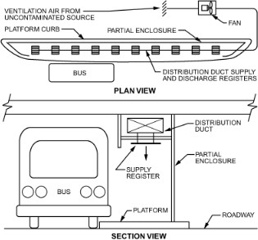
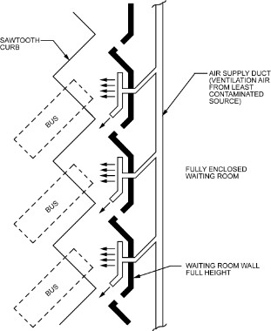
The physical characteristic given to the bus terminal and the level of airflow for optimum air quality are the two factors to be analyzed in choosing between mechanical and natural ventilation. In the case of natural ventilation, it is pragmatic that the four sides of the terminal at each let be open. The head room of each level should also be high enough for free air movement. Use of energy efficient jet fans can aide in improving natural air flow. This can be observed in figure 2.14.

Figure 2. 14: On the left side is a drive-through with semi-enclosed platform, on the right is a fully enclosed waiting room with sawtooth gates.
Source: American Society of Heating, Refrigerating and Air-Conditioning Engineers (2011)

VENTILATION AT THE BUS PLATFORMS

Platform design to speed up the loading and unloading process for passenger, so as to minimize their exposure to the exhaust fumes from the vehicles. For instance, in drive-through platforms that is naturally ventilated, passenger suffer from the inclement weather and strong winds. As a measure against this suffering, a partial enclosed platform incorporated with mechanical ventilation can be considered. By partially enclosed, I mean three sides are closed, but the drive in for the buses are opened up to the air. The problem with partially enclosed platform is it can trap contaminated air. Thus, reducing the level of air quality. In this case mechanical ventilation
in necessary.

Multi-level bus platform that have limited headroom, cannot experience 100 percent natural ventilation system performance. It is advised that such platforms be partially or fully enclosed and at the same time employ mechanical form of ventilation. The mechanical ventilation system should avoid circulating contaminated air from the busway environment to the platform. Figure
2.14 show a semi-enclosed platform with a pragmatic mechanical ventilation system.

Any terminal that has heavy bus traffic, most likely is a large terminal, it is recommended that it adopts a fully enclosed platform that depends on mechanical ventilation. In Nigeria, this idea of dependency on mechanical ventilation is a problem in itself.

FIRE HAZARD IN SMALL NEWS AGENTS IN TRANSPORT TERMINAL HALLS

Chow (2005) did a research on fire safety of small shops located in crowded bus terminal. He did a careful evaluation on the effect of heat release during burning under flashover conditions and came to the conclusion that fire suppression systems should be used in shop or kiosk located at bus terminals.
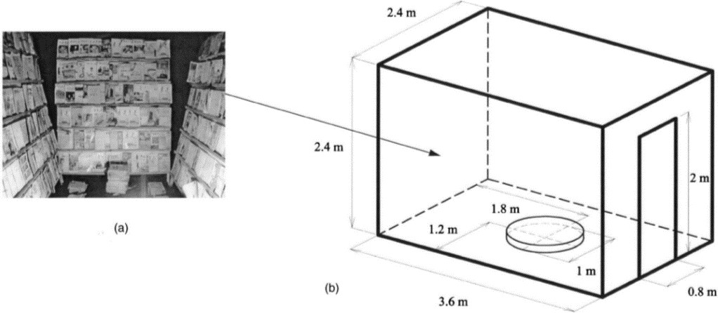
Shops located at bus terminals are usually small in size. This is because land is expensive. Fire load density (FLD) is the unit used to calculate the quantity of things that are combustible in a retail shop. Fire load density is the amount of heat given out by burning combustibles thing per floor area. So, for a newspaper shop the fire load density will be high.

Figure 2. 15: This is the newspaper shop and its geometry where the fire test was performed.
Source: Chow (2005)

COMMON TECHNOLOGICAL AND ENVIRONMENTAL SOLUTIONS IN THE BUILDING TYPE

Florinda Boschetti (2014) explained that air quality, noise pollution, energy use, road safety and space use are some of the challenges associated with the movement of good and people. With respect to collective transport, like bus terminal transport, recent technological issues have risen over the years. Issues such as:
    - security systems;

    - vertical transport systems;

    - park-and-ride facilities;

    - integration of public transport with cycling;

    - use of ramp metering system, improved accessibility for people with impaired mobility;

    - and integrated multi-modal ticketing system.

Public transport communication system in Tallinn, Estonia has proved effective. This system comprises of driver communication unit installed in the buses and operator workstation installed in the terminal building. This technology is based on 3G mobile communication standard. This technology enabled better traffic management and rapid communications. (Florinda Boschetti, 2014)
According to International Road Transport Union (2009) bus terminal is a place where car drivers are converted to passengers. This source further claims the location of bus terminal is very important. Because if it is well located, it serves as a hub for passenger logistics. It is advantageous if a bus terminal is situated close to a trade center, cultural center, administrative center, educational center and other modes of terminals. An example of this type of terminal is the Riga international Coach Terminal at Latvia. It is located 0.9km from the city core. Near this terminal building are hotels, bus station, central train station and other services.

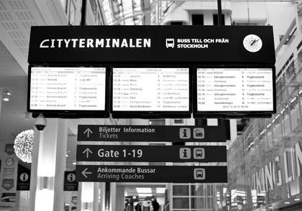

Plate 2.10: LCD passenger information display at cityterminalen Source: Appelgren (2018)
International Road Transport Union (2009) emphasized the importance of making information

readily available to current and potential passenger through publications, websites, information counter and stands. Because services that nobody is aware of nor know how to use, is worthless. This information could be bus routes, schedules, options of payment, cost compensation in case of travel cancellation, travel cost, destination, luggage storage, use of waiting lounges, duration of travel, and possible reductions. An example of this is the presence of LCD passenger information display at Cityterminalen, located at Stockholm. See plate 2.9. Departing and arriving buses communicate to the traffic control at the control or dispatch room. The traffic control ensure that the buses are allocated the correct gate numbers. And that correct information is displayed on the LCD screen. Cash machines (ATM), hotspot and web terminals, post offices, luggage lockers, and the lost and found are all services and facilities that will add to the passenger’s satisfaction in the bus terminal. As for the drivers, toilets, showers, lounges etc. are to be provided for them and the bus terminal staff.
Park-and-ride facilities is a common service alongside bus terminal facilities at the outskirt of the cities. This facility attracts people from the outskirt to park their privately-owned vehicles and get on the public bus to their destination. An example of this is at Cambridgeshire where this
strategy was introduced in 2001.

Availability of real time information to passenger pertaining to current traffic situation, can help the passenger make the right transport choice. This can be by way of station announcements, electronic displays and information screens. Online planning is another option for passengers to use the internet to make the best decision based on the services available and the current traffic situation.
Considering the accessibility of people with reduces mobility, lower ticketing machines, elevator, escalators and low floor buses all added facilities that will encourage passengers of special needs to patronize the bus terminal. This is an approach mostly used by developed countries with a high population of aged people. For this approach to be more effective, information about it should be available on the terminal’s website, display screen and service centers. So that this passenger can make their traveling arrangements.
Another common technological solution to terminals, is the creation of integrated ticketing system. This integrates different operators and mode of transports in such a way that the passenger can pay for the service of a bus and train for instance in one transaction for an entire journey.
Use of bright lights and permanently installed security camera in the bus terminal is also another common technological solution in bus terminal building. This will help to make passengers feel safe because they know that there will be rapid response un any case of emergency.
Passengers that are visually impaired should not be discriminated against in bus terminals. The visually impaired use their senses to mobility and orientation in a space without vision. These senses include smell, sound texture etc... They are taught to use tool such as guide dogs and canes. The question is how can technology help these people in navigating a bus terminal. The virtually impaired can use Narrative Map. This Narrative Map is an application on a smartphone, that gives pre-recorded information about landmark. This information be in audio form or braille text for the visually impaired. There are many other tools of such that can help the visually impair in a bus terminal (Alekhya & Pei, 2014).

CONCEPTUAL APPROACHES TO THE DESIGN OF THE CHOSEN BUILDING TYPE

When starting a design, the initial phase of the design process is the conceptual design. At this phase the designer begins to articulate the functions of the required zones or spaces with the form. This phase encapsulates the strategies, design of interactions, experience and processes. Of course, these processes cannot be embarked upon without understanding the needs of the people that will be using it. The products of conceptual design are usually concept sketches and models. Everything written in the paragraph above is according to (Wikipedia, 2017).
No design project is the same in experience, magnitude etc. There are projects that may call for an in-depth process than other. In spite of this fact, they all have some form of common issues and design problems that should be considered. The first step in the finding of a conceptual approach is defining clearly the problem to be solved by the design. The second step is collecting information about the site, about the stakeholders, about any government regulations etc. The third step is analyzing the information and brainstorming. The fourth is coming up with a solution. The fifth step is presenting your ideas. Then, the sixth step is improving the design based on the criticism (Emma, 2018).
Still according to Emma (2018), conceptual approach is a term use to refer to how a design respond to a design circumstance. Better still, it is a way of interpreting an intangible design challenge into a physical building product. For a building type such as a bus terminal, the intangible design challenge could be categorized into the following:
- Functional zoning

- Architectural space

- Circulation and building form

- Response to concept

- Building envelope

Many elements and factor fall under these broad categories.

There are many conceptual approaches to the design of a bus terminal. These approaches always are intended to address the design of a bus terminal with a view to solving a particular problem relating to several factors such as:
    - The location of the bus terminal: for example, if a bus terminal is to be build close to one or more other terminal like train station, airport terminal, cable car station, and ferry terminal, this will encourage the designer or architect to employ an Intermodal concept or any other concept that will harness the virtue of the location of the bus terminal. Intermodal conceptual approach is clearly described by Muller (1999) as “the concept of transporting passengers and freight on two or more different modes in such a way that all parts of transportation process, including the exchange of information, are efficiently connected and coordinated.”
    - Availability of power supply: In this case, let’s assume that the site designated for a bus terminal is connected to a power grid that is 75 percent of the time not reliable. The designer or architect will be encouraged to lean the design towards a more self-sustaining building facility such as the use of solar panels, use of appropriate insulating material depending on the climate, passive ventilation etc.
    - An area with high traffic congestion: In this case, let’s assume that the bus terminal is in a city where the people are overly dependent on the use of private vehicles and this is causing unbearable congestion. The designer or architect can conduct a research on the people of the city and study what they consider an attraction in public building facilities. Based on these, the designer or architect can make the bus terminal building facility inherently luring to the large population of private vehicle owner. This could also be a conceptual approach to this particular design problem.
    - Concept: At times the architect might be constrained to base his or her design on a concept proposed by the sponsor or the client. A concept such as ‘park and ride’ could
be proposed by the sponsor or client of the project.

The concept Park and Ride (P & R) has been a common place for the past 50 years. Governments in developed countries have encouraged it because it is a way of curbing increasing traffic congestion and traffic-related pollution (Stuart Meek, Stuart , Stephen
, & Marcus , 2008). A park-and-ride lot is a type of terminal or bus terminal where passengers can park their vehicle, pay for ticket and get on the bus to their intended destination. In other words, it is another form of intermodal concept (Spillar, 1997). This concept of park-and-ride is very broad and is defined based on the functional characteristics of the intended park-and-ride lot. There are several types of park-and-ride facility. Below are some park-and-ride concepts:
      - Informal Park-and-Ride Lots concept: This is not more than a transit stop where vehicle owners park along the road to later patronize a public transport service. This is type of park-and-ride lot could sometimes be hard to identify within an urban fabric. When this form of park-and-ride lot occur, the government are usually prompted to provide a high order facility for it (Spillar, 1997).
      - Opportunistic or Joint Use Lots concept: In this type of park-and-ride, the site is usually shared with other activity, e.g., church, theater, shopping mall, or special events center. It a preferred choice for park-and-ride concept running on a low budget in an area where there exists land that is not in use at commuting peak hours. Thus, it is mostly referred to as opportunistic lots (Spillar, 1997).
    - Choice of structural system: The structural system to be employed in a bus terminal design could be the conceptual design approach. For a public building types as bus terminal, the structural system should be able to accommodate long span between the major supports and also a relatively high headroom. In such a way that, natural ventilation
and natural lighting can be adapted into the design.

CONCEPTUAL APPROACH TO BE EMPLOYED IN MY DESIGN

The conceptual approach to be employed for the design of the Obalende bus terminal will be based on the choice of the structural system to be used. This structural system is the area of focus of the paper. The structural system to be employed is thin-shell concrete structure. The thin-shell concrete structure to be used will be the hyperbolic paraboloid structure. This structure is adequate for a public build such as bus terminal, for four basic reasons. This reasons are:
      - It employs minimum material

      - It is cost effective

      - It has Aesthetic intention.

      - Curved form work is not required for the casting. Rather planar form work is used.

  - MAJOR DESIGN PROBLEMS IN THIS TYPE OF BUILDING FACILITY Major design problem Architects or designer face in planning and designing bus terminal has a lot to do with the designer or architect not doing proper research into this building type at the start of the design. There are different types of bus terminals. The architect must first understand the location and determine what type of terminal is to be design for such location. Else the design will be useless. As a reiteration of what a bus terminal is, I will like to re-emphasize these points from World Bank Group et al (2006) point of view.
    - It is the end or start of bus route

    - It is a place where buses can reverse, turn, stop, and wait till it is time to depart for the next journey.
    - It is a place for boarding and alighting of passengers from buses.

    - It is a place for the control of bus services.

The nature and size of bus terminals vary. These variations range from a bus station built of the road with facilities for passengers to a roadside bus stop without facilities for passengers. These are due to many factors. In a location where arrival and departure of number of bus is low, the

design or architect cannot propose a full bus station / terminal with full facilities for passenger. Else the architect has created a problem of under-used of the bus station facilities. Rather he should provide a roadside bus stop for such location and a full bus station for a location with a large number of buses arriving and departing. If the location actual is meant for a bus terminal with full facilities for passenger. The architect must determine which type of bus terminal to be design for the appropriate bus service to be offered to the passengers. This is another design problem. The types of bus terminals are:
- Simple Stops

- Interchange Stations

- Main Line Stations/Terminals

- Intercity Bus Terminal

- Airport-City Bus Terminal

- Etc...

The designer is expected to know about the physical geometry buses and also understand the different parking configuration for bus. This will enable him to choose the appropriate bus parking and arrival / departure platform for the terminal type and location. This is another design problem. The bus platform to choose form are:
- Radial sawtooth

- Parallel dingle land island

- Single island bus rail transfer

- Stepped parallel

- Etc.…
The architect is expected to know how to calculate the maximum capacity of passengers for the proposed terminal design. First the architect must determine the zone for bus parking and the zone for the terminal building itself. The number of people the waiting area can contain is determined by the number of seats and the value of passenger occupancy density the design is

employing in the bus terminal design. A general rule of thumb is the three first passengers to one seat. For the value of passenger occupancy density, a value of 1m² per passenger. But at extreme congestion a values range of 0.3 m² to 0.5 m² can be used (American Society of Heating, Refrigerating and Air-Conditioning Engineers, 2011).
Another design problem is, the architect must know the details of the use and placement of stairs and escalator. In the case of escalator, he should know how to calculate the practical design capacity from the theoretical design capacity given by the manufacturer.

CHAPTER THREE - DETAILED STUDY OF THIN-SHELL CONCRETE

INTRODUCTION: LESSONS LEARNED THROUGH LITERATURE REVIEW IN CHAPTER TWO

In the previous chapter, light was shed on the meaning, importance and benefits of bus terminals in a broad view point. A simple summary definition of bus terminal facilities according to the previous chapter is: a bus terminal facility is a necessity in the form of a building structure that offers the population in an environment, the service of transporting goods and also transporting people together in batches by buses to a predestined consented destination under a stipulated fee, with an assurance of safety, security and comfortability. This a brief meaning of bus terminal, thought in the previous chapter more details was given on the meanings and descriptions of bus terminals by different people.
The last chapter, also touched on the general picture of transportation in Nigeria, how important it is to Nigerians, the challenges facing the Nigerian populace from the area of transportation, the causes of the challenges according to some writers and how Nigerians have been coping with it. The chapter elucidated on how bus terminal came into being what it is in the presented.
According to the literature review in chapter two, bus terminal as a building did not start as a building type. It started as a necessity coming from the need of transportation. In the very beginning of the evolution of bus terminal, bus terminals were basically large empty space with buses park according to their various destinations. These locations were characterized to be close to the focal points of the city, where people love to go for work, business, and leisure. To study the history of bus terminal on a global scale was a challenge. Rather it was possible to study the evolution of bus terminals according to cities in the environment of the pertinent counties. In chapter two, the cities chosen were Tallinn in Estonia, Nottingham in England, New York city in United State of America, Tiete in Brazil and finally a very broad view of bus terminals in the Netherlands.

Chapter to look in-dept into the major types of bus terminals with respect to their characteristic location and services. As a run through of the types according to services offered, they are suburban service bus terminal, express bus services, park and ride bus services, feeder bus services, bus rapid transit services, and long-distance bus transport services. As a run through of the types of bus terminal from the Bus rapid transit (BRT) point of view they are simple stop, interchange stations, and main line stations. Another writer classified bus terminal types into intercity bus terminal, airport bus terminal, urban-suburban commuter terminal, and suburban interstate terminal
Through the review in chapter two, it was discovered that bus terminals have same planning problems in common as much as then they have different design principals. One of the writer encouraged that in the design of bus terminal, the waiting room should be the central focal point. This same writer considered the suburban interstate terminal to be the easiest to design.
Another writer expressed the findings in his research, that the safety, security and the level of information available to the passenger is what determine customer satisfaction. He also emphasized that women feel less safe in bus terminal facilities than men.
The space found in most bus terminals are public seating, Ticketing facilities, baggage room, public locker, dispatch office, offices, rental spaces and public toilet. Generally, for public seating, it is one seat to the first three passengers at the terminal. To calculate the number of seats in the terminal waiting area, multiply the number of loading platform to be provides by the average bus capacity to be used, then divide the product by three. This calculation will give you the number of seats to be provided. For every 25 to 30 seats in the waiting area one ticketing counter is to be provided. The ticketing area occupies a linear space of 910 mm to 1500 mm and 4600 mm² to 5500 mm² per position. It should be a minimum of 1000 mm high. The baggage room should be close to the loading platform. It should be 10 percent of the total building area. Alternatively, it could be 4700m² multiplied by the number of loading platform. Choose the
highest figure from the two calculations. Public lockers optionally can be provided to generate

revenue. The dispatch office or the control room must be located close to the concourse and the loading platform. It could be a minimum of 4600 mm² to 14000 mm². For the offices a minimum of three office will be enough. These offices are passenger agent’s office, terminal manager’s office and the switchboard office. For bigger terminals, more offices are required. Rental spaces could be provided is the terminal is big enough.
As far as bus terminal building is concerned, a lot of design has to go in to pedestrian facilities. To get a pedestrian friendly bus terminal facility, the concept of level-of-service has to be applied, even more for commuter passenger terminals than for long-distance terminal. It is during the peak hours; the terminal can be put to test to know if it is actually pedestrian friendly. The width of corridor, width of the stairways and width of the main entrance can be ascertained using the concept of level-of-service. The level-of -service concept also can help in determining the queuing area. The queuing form is linear. A passenger queuing can conveniently occupy a linear space of 500 mm without the baggage inclusive. But a congested space lower than 340 mm² is will be unbearable for the passenger. 450 mm² can be acceptable. For the concourse area, 930 mm² per person will be comfortable enough.
Escalator and moving walk area circulation elements that make bus terminals of a story building or more, friendly to pedestrians or passengers. But the architect must know how to position this elements to this effect and combine it with stair. He also must know how to calculate the practical actual capacity from the theoretical capacity.
The bus platform cannot be designed without knowing about the physical geometry and maneuverability of buses. Bus manufacturers have placed a limitation to the platforms design for buses. This limitation is the problem of right side loading for the buses. There are different types of platform. These are parallel loading, right-angle loading, straight sawtooth loading, and radial sawtooth loading. These are the major one. There more types of each of these major ones.
There are quite a number of factors affecting the size of the bus terminals. These are the

number of platform proposed for the terminal; the platform is design for the buses to approach it;

the facilities in the terminal for the passengers and staff; and the bus terminal maintenance facilities. The combination of these factors plays a determining role of the size of the terminal.
Under unique solution to specific problems in the bus terminal building type. Different problems and corresponding solutions were mentioned. Issue of safety, security, circulation, lighting and other were treated. The connection between heating, ventilating and air-conditioning (HVAC) and occupancy load was established. The ideal occupancy load density is 1m² per person. The cooling systems ideal for bus terminal facilities are all-air system and radiant hydronic or electric ceiling panel system. Chapter two gave the advantages and dis-advantages of this systems. Natural and artificial ventilation for bus terminal was also treated. Fires safety and prevention was also looked into in chapter two.
About the common technological and environmental solutions in bus terminal buildings the following was dealt with:
    - The 3G mobile communication system used by the driver and the operator workstation to communicate;
    - The strategies and logistics use to convert car owners into passenger;

    - The technologies used to make information readily available to passengers;

    - Other addition services such as cash machines, free hotspot with internet service etc…;
    - The technologies used in park-and-ride services;

    - How passenger can access real time information on current traffic situation;

    - Provision of accessibility for people with reduced mobility;

    - The technology of integrated ticketing system;

    - Technologies that are designed to help passengers that are visually impaired;

The conceptual approaches to the design of the design of bus terminal was also treated in chapter two. From the literature review I learnt about the steps to take before embarking on the design of

bus terminal. The approaches to the design according to writers cited in chapter two are based on:
- The location of the bus facility to be designed;

- The availability of constant power supply;

- If it is a zone with very high traffic congestion

- Use of different concept such as the different concepts of park-and-ride and choice of structural system to use for the building.
The concept to be employed for the proposed bus terminal design at Obalende was clearly spelt out. The concept is the use of a thin-shell concrete structure as the structural system and the reasons was given.
The major design problems and the solutions to it in this type of building facility was dealt with at length in chapter two. They are:
- The choice of bus platform to use for the design

- How to determine before the initiation of the design the maximum passenger occupancy load under an ideal passenger occupancy density.
- How to place the stairs alongside the escalator and also calculate it practical design capacity from the theoretical design capacity.
- How to incorporate the ideal type of artificial and natural ventilation system into the design, to ensure seamless installation on the construction site and easy maintenance on the long run use of the bus terminal facility.
All of the above are the lessons learnt from the literature review of chapter two, which I will apply to my proposed design of bus terminal facility at Obalende, Lagos, Nigeria.

DISCUSSION OF THE ISSUE OF INTEREST

INTRODUCTION TO THE THIN SHELL CONCRETE STRUCTURES

The issue of interest here is the thin-shell concrete structure. I chose the material to be concrete, because complex curvature can be achieved use A concrete example of this is Chapel Loma de Cuernavaca, build in 1958 by Felix Candela he Spanish architect.
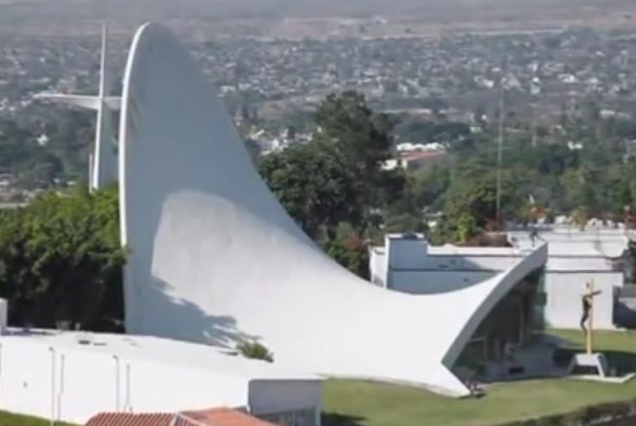

Plate 3. 1: Chapel Loma de Cuernavaca Source: Ressler (2017)

This building a chapel. It is formed by parabolic arc. It covers a sectional space of 100 feet (30 m). it has a height of 70 feet (21 m). The thin-shell is made of concrete. It has a thickness of 1.5 inches (0.038 m). According to Ressler (2017), “a thin shell is a structural element that attains both strength and stiffness primarily from its curvature.”

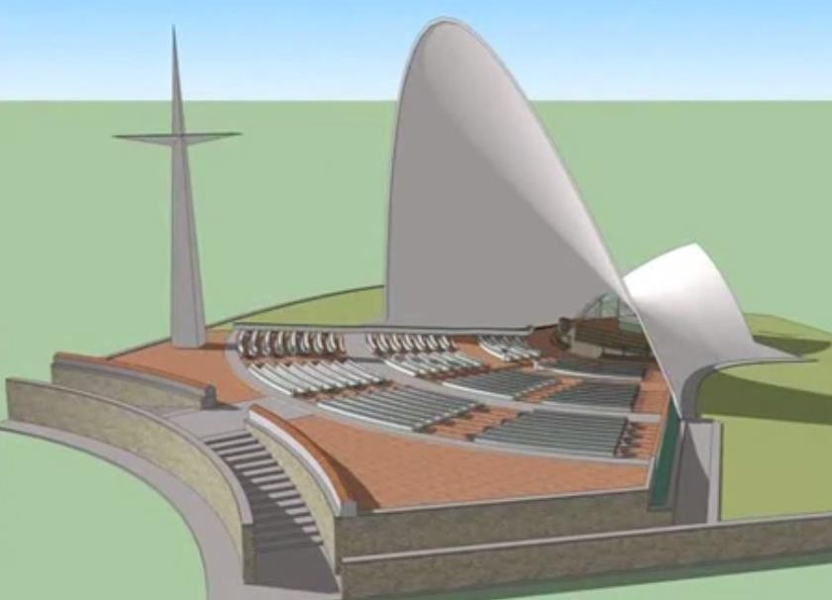

Plate 3. 2: 3d Image Chapel Loma de Cuernavaca Source: Ressler (2017)

      - TYPES OF THIN SHELL SURFACES

Carl Friedrich Gauss is a mathematician. He grouped curved surface according to their characteristics in three groups: cylinder form; dome form; and saddle form. This form are the only forms that define the planar and 3-dimensional shape of thin-shell structures.
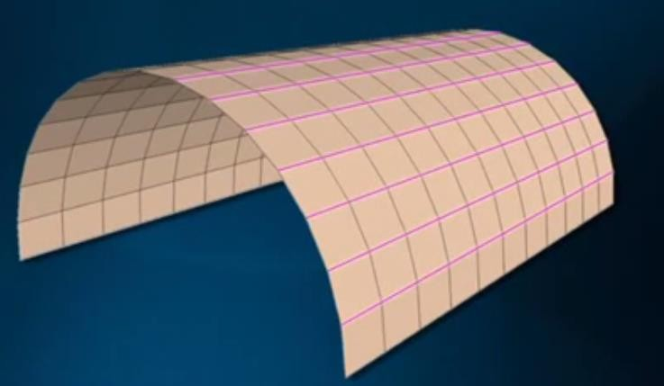

Plate 3. 3: Cylinders have curvature in one direction only Source: Ressler (2017)

A cylinder is basically a semi-circle extruded in one direction. This type of surface is referred to as monoclastic surface. Cylinders have curvature in one direction and flat in the other direction. To confirm this, put a ruler in the longitudinal direction of the cylinder surface. The ruler will stay flat on it. There are many cylinder types, depending on what curve is extruded. There are

also parabolic cylinder amongst other. Geometry tells us that parabolic curve is far efficient than semi-circular curve.
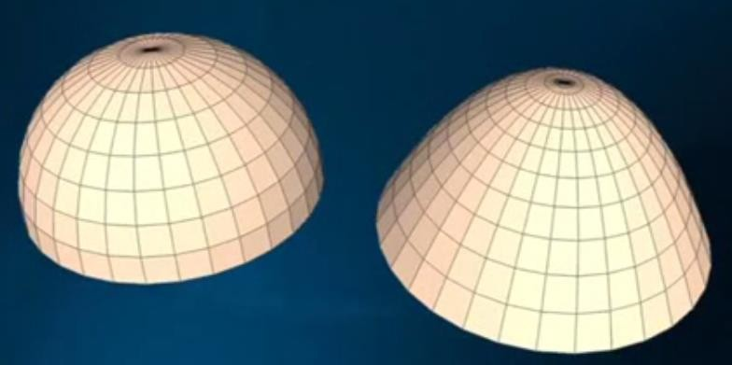

Plate 3. 4: Domes have double curvature in one direction Source: Ressler (2017)

A dome forms are made from curves that are oriented in the same direction. This type of surface is referred to as synclastic surface. Dome form can semi-circular or parabolic. They can either be concaved up or concaved down. In a dome form there is no room for a straight line.
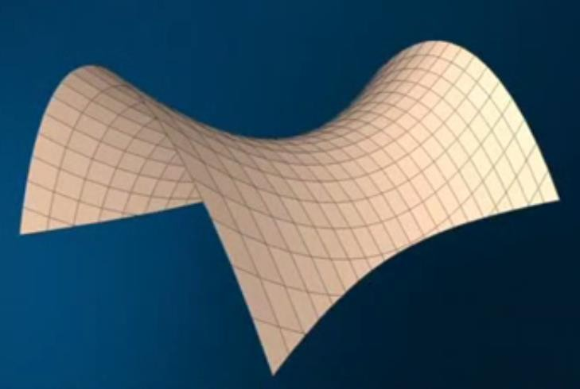

Plate 3. 5: Saddle forms have double curvature in opposite directions Source: Ressler (2017)

A saddle form as double curvature. This type of surface is referred to as anticlastic surface. The curve is orient in two different direction, opposite each other. If one of the curvature is concaved up, the other curvature will be concave down. In mathematics this shape is called hyperbolic paraboloid. It is basically geometrically an extrusion of a parabolic shape through a hyperbolic
path.

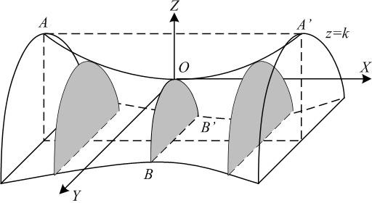

Plate 3. 6: Parabolic curve shaped extruded along a hyperbolic curve Source: Naveen (2018)

This shape is ideal for roof structures, owing to the double curves steeped in opposite direction. These curves give it stiffness and strength. What is most notable or important about this form, is the fact that it can be generated by very straight lines.

EXPLANATIONS ON HOW THIN-SHELL STRUCTURES SUPPORT AND TRANSMIT FORCES

The question is why should a thin-shell structure have such strength and stability to cover such distance without intermediate support. The answer to this is simple. It is the curvature of the thin shell that is giving it such ability. Before the material used is give importance, it is the form the thin- shell assumes that gives the whole structure the ability to cover such span and height.

EXPLANATIONS USING A PIECE OF PIZZA AS AN EXAMPLE

Bhatia (2014) explain the fact that when holding a piece of pizza, one has to hold it in a folded way in order to eat it or else it flops. Carl Friedrich Gauss expressed this penomenon in is



Plate 3. 7: Pizza held flat flops. Pizza folded does not flop.

Source: Bhatia (2014)

Theorema Egregium. Through this theorem Carl Friedrich Gauss defined the curvature of a surface. Going by his theorem, a flat surface or paper has a zero Gaussian curvature. A cylinder also has zero Gaussian curvature. Because a flat surface or paper can be rolled into a cylinder. A sphere has a positive number of Gaussian curvature. Because a flat surface or paper cannot be rolled into a sphere. Back to the case of the pizza. Even when the pizza is flopping, the theorem makes us to understand tha one direction of the slice will always remain flat and the other direction will bent. But by folding the pizza, one is making the other direction flat and the other bent. When a flat surface or a sheet of paper is curved in on direction, while the other direction remains flat, the one direction that is flat is forced to become stiff. This can be observed in the shape of the blade of grass. As it folde along the center, thus making the sections across the center stiff.

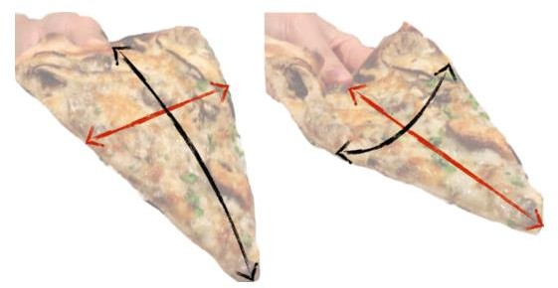

Plate 3. 8: The lining showing the flat and bend direction when flopped and when bent Source: Bhatia (2014)

This idea of using curvature to add stiffness and strength to structures is used a lot by architects and engineers. A perfect example is the design done by Torroja Eduardo. It is the Zarzuela race track in Madrid. Torroja Eduardo is a Spanish structural engineer. This concrete canopy span
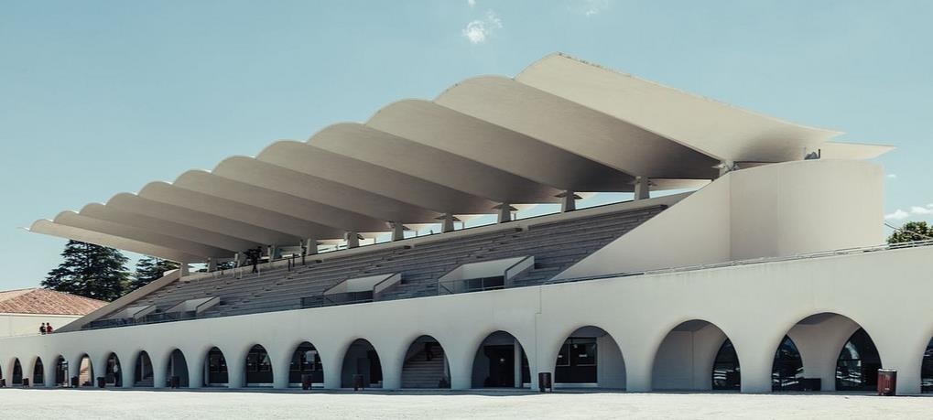

Plate 3. 9: Zarzuela race track, By Torroja Source: Michavila (2018)

over 40 feet (12 m). The base is 5 inches (127 mm) thick and 2 inches (50 mm) at the cantilever edges. The structure experienced bombardment and explosions during the Spanish civil war. The concrete canopy still remain in position.

The thin-shell structure I just finished explaining about is a flat surface that curves in one direction and remains flat in another direction in order to gain stiffness. This type of thin shell according to Carl Friedrich Gauss theorem has a a value of zero Gaussian curvature.

EXPLANATIONS USING AN EGG AS AN EXAMPLE

Take an egg and try to squash it in your palms. You will experience it is hard to squash. Why is the egg so impossible to squash in the palm? And what makes the egg surface different from the other thin-shell from we started explaining earlier? Well, according to Gaussian theorem the egg shell surface has double curvature. It has a value other than zero Gaussian curvature. Meaning that the egg shape cannot be formed by a flat surface without tearing it in pieces. The egg owes its strength to its double curvature. Thin shell structures are considered strong, when they are able to carry load without failing. They are also considered stiff, when they don’t deform under load. The egg was not squashed also because uniform load was subjected to it. If concentrated or point load was subjected to it, it will crack open. The egg shape and volume is an epitome of thin-shell structure. We can equate the egg shell to a shell shaped roof surface, that will not deform under uniformly distributed loading.

EXPLANATIONS USING PRINGLES POTATO CHIPS AS AN EXAMPLE

Apart from the egg example, another double curvature surface is the Pringles potato chips. It has the shape of hyperbolic paraboloid. It looks like a saddle, the leather seat put on a horse. Almost any type of material can be used in thin-shell structures. The most successful material that has been use is concrete. This material called concrete meets up with the demands of the structure that characterize thin-shells. The term versatility of form is one of the singular quality the make concrete very suitable for thin-shell.

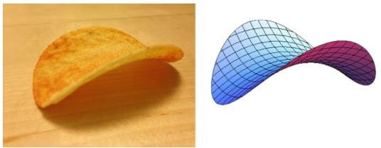

Plate 3. 10: The pringle chip is another example of a double curvature surface Source: Bhatia (2014)

EXPLANATIONS USING A CONCRETE MODEL AS AN EXAMPLE

Let us look at a model of the hyperbolic paraboloid made from concrete, as can be seen in plate

3. 11. In the hyperbolic paraboloid, the extruded parabolic shape is almost the overall shape of this
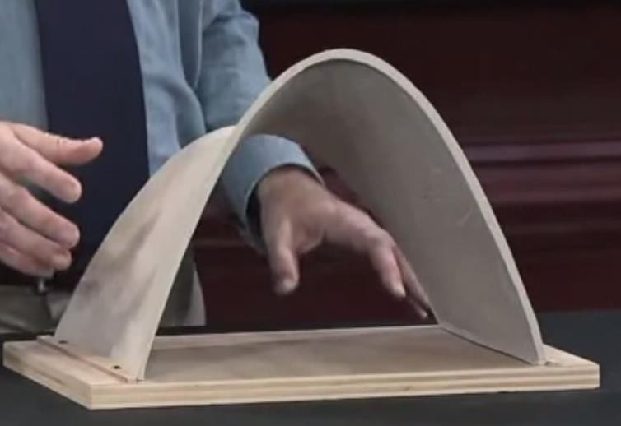

Plate 3. 11: View of the parabolic shape on the hyperbolic paraboloid Source: Ressler (2017)

3-dimensional volume. A section across the volume of the hyperbolic paraboloid is a paraboloid. This section of the form behaves structurally like an arch. It works based on compression.

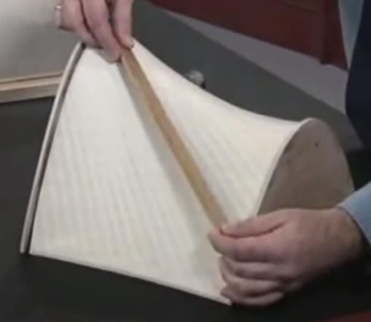

Plate 3. 12: Ruler laid flat on the surface of hyperbolic paraboloid Source: Ressler (2017)

Generally, all thin-shell structures experience almost no bending force, because of their thinness. A ruler can be laid on the surface of a hyperbolic paraboloid and it will stay flat on it.
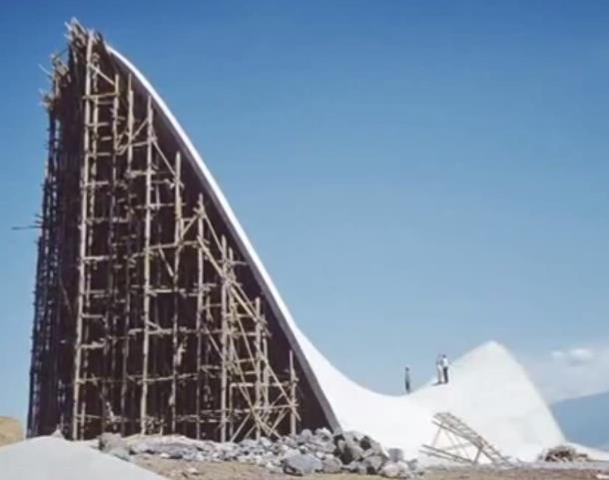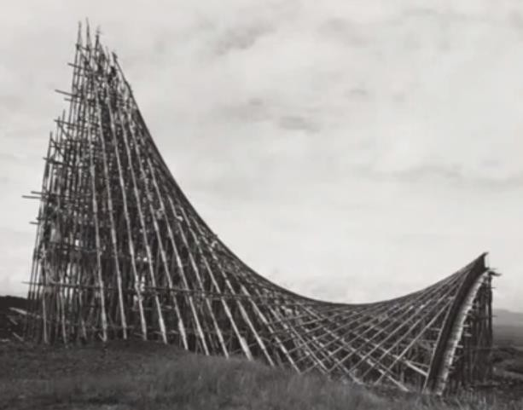

Plate 3. 13: Hyperbolic paraboloid thin-shell structure can be casted on straight surfces Source: Ressler (2017)

Even though it has double curvature in opposite directions. This is to show that the surface of a hyperbolic paraboloid is made up of straight lines. This is a good fact to know, because this means that this type of thin-shell concrete structure can be casted without using curved surfaces.
The hyperbolic paraboloid shape is very strong. Structural elements are known to support weight and finally transfer all the load to the ground. Compression and tension are the ways structural

element s support and transfer load. The hyperbolic paraboloid achieves a balance between compression and tension.

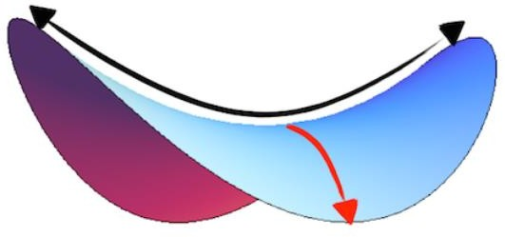

Plate 3. 14: The red arrow represents compression and the black arrow represent tension Source: Bhatia (2014)

The upward curvature is in tension and the downward curvature is in compression. This is how the hyperbolic paraboloid balances between compression and tension. Among the thin-shell concrete structure the easiest form of it to build is the hyperbolic paraboloid.

HOW HYPERBOLIC PARABOLOID IS USED A STRUCTURAL COLUMN BUILDING ELEMENT

Another use of the hyperbolic paraboloid is in the hyper umbrella column. It is often referred to as Candela’s umbrella. Tully (1979) defined the hyper umbrella as “ a building unit which comprises a column adapted to be fitted to a foundation and supporting aplurality of identical, doubly-curved umbrella, hyperholic paraboloid shells inverted so that their top edges form a plane figure, and a continuous, horizontal member integrated with said edges.”
In detail the hyperbolic paraboloid umbrella as a building unit is a structural combination of a set of four pieces of inverted thin-shell concrete hyperbolic paraboloid to a column’s top and another diminutive set to the column’s base as foundation. The edges of these inverted thin-shell concrete hyperbolic paraboloid in the set form a plane figure. On these edges will be integrated a slab to provide a surface such as a floor. The load to be exerted on the floor will cancel the shearing
forces of the shells. A single unit of hyper umbrella can span 6 m to 60 m (20 feet to 200 feet).

Plate 3.15, shows a cutaway partial view of an underground building. In this underground building you can see the hyper umbrellas. You can also see the perspective view of the hyper umbrella in plate 3.16.

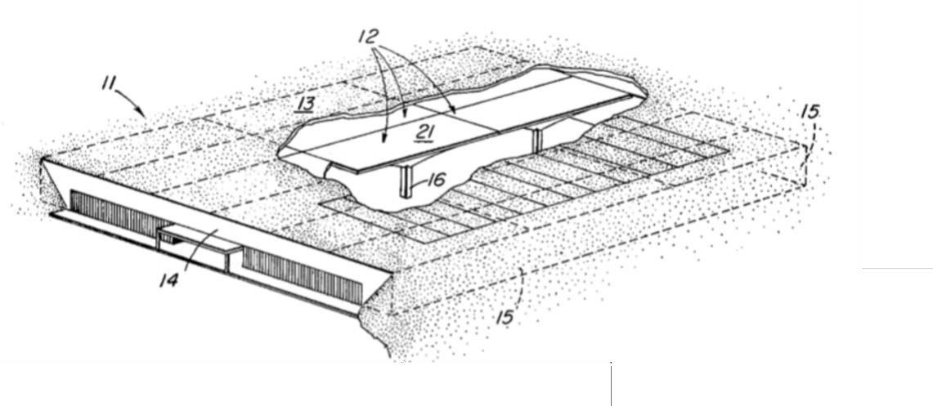

Figure 3. 1: Slabs on hyper umbrellas Source: Tully (1979)

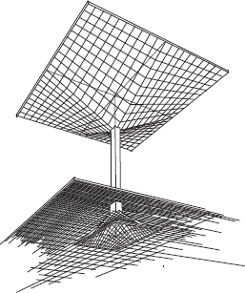
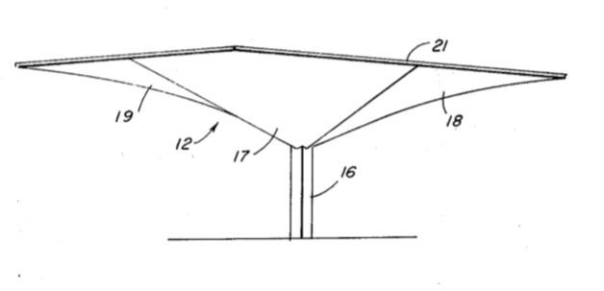

Figure 3. 2: On the left is the hyper umbrella on its foundation and on the right is its frontal view Source: Tully (1979)

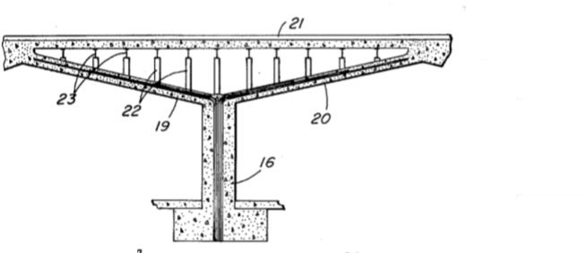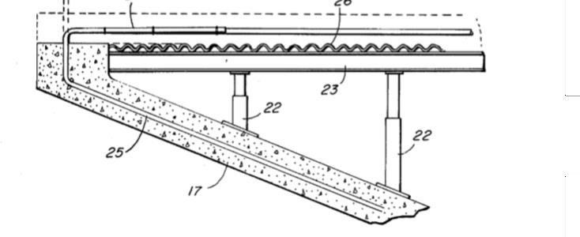

Figure 3. 3: Transverse section of a hyper umbrella Source: Tully (1979)
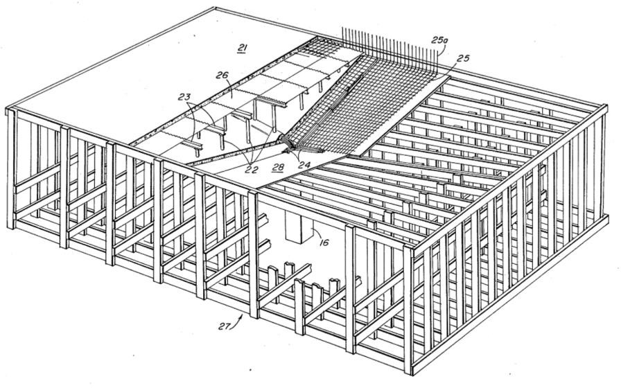

Figure 3. 4: Perspective partial cutaway view of several layers of forms and reinforcement materials usable in hyper umbrella

Source: Tully (1979)

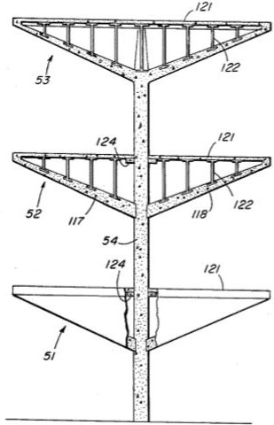
Figure 3. 5: Section of a three-story structure employing hyper umbrella Source: Tully (1979)
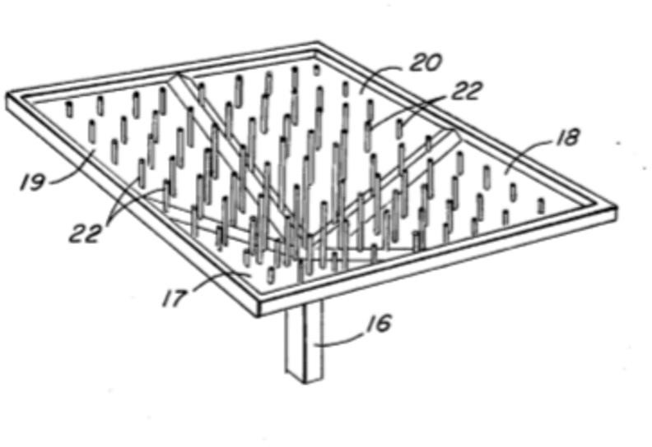

Figure 3. 6: Perspective view of the hyper of umbrella without the slab Source: Tully (1979)

Thin-shell concrete construction was trend seven decades ago. But for some reasons this declined due to some difficulties. But presently there is a resurgence in the use of thin-shell concrete because of the advances analysis method that has been developed and the development of innovative construction methods.
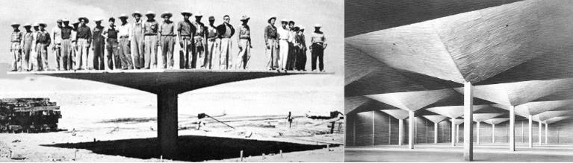

Plate 3. 15: Felix Candela hyperbolic umbrella column Source: Cabello (2015)

FELIX CANDELA THE CHAMPION OF HYPERBOLIC PARABOLOID AND THE INVERNTOR OF HYPER UMBRELLA

Felix Candela is a Spanish Architect. Most of his work was done in Mexico. He was a student of Eduardo Torroja. He employed the used of the hyperbolic paraboloid in all of his design and his design always has different forms based on the hyperbolic paraboloid geometry. For him to do that, it means he understands the principle behind the use of hyperbolic paraboloid. This man achieved one of the highest level of using thin-shell concrete structure. The admirable achievement was the way he allowed the hyperbolic paraboloid shape to express the minimum thickness of 1.5 inches (38 mm). Even when the structure was covering an incredible span without intermediate support. For achieving this he is referred to as innovative builder and a structural artist, in spite of being professionally trained as an architect. He also invented the use of hyperbolic umbrella column. I believe Candela used the hyperbolic paraboloid because with minimum material the structure is still able to support the imposed load. The building constructed using the hyperbolic paraboloid are considered sustainable. This is because the it requires

minimal cost of construction and also minimal cost of maintenance. On top of that, when used in building facilities, it is elegant.

MERITS AND DE-MERITS OF THIN-SHELL CONCRETE STRUCTURES

The major advantaged of thin-shell structures are:

- It is very string for its thickness

- It covers a wide area without internal support.

- It is cost saving during construction

- Uses very minimal concrete. This can be observed in the thickness

- It is easy to maintain after construction

- It is very easy to cast without using curved form work.

- It can withstand natural disaster.

The primary disadvantage of thin-shell structure is the challenge of preventing rainwater from seeping through it. Another problem is the buildup of condensation in the underside of the thin- shell. A solution to this is the use of sealant and also proper ventilation (Wikipedia, Concrete Shell, 2017). The coating to be used on the exterior surface of the thin-shell concrete must be easily applied by roller, spray, or brush. It must be durable, lightweight, thin resilient, elastic and attractively colored. It must be sunlight resistant, weather resistant, abrasion resistant, and resistant to water and a host of other chemicals. The coating of the surface of the thin-shell structure is considered to be the only practical answer to the problem of weatherproofing of thin- shell concrete structure.
Another disadvantage is that a depth of 20 percent of the span is required for the roof structure to become efficient and economic (Tully, 1979).

TYPE OF CONCRETE TO USE FOR THIN-SHELL CONCRETE STRUCTURES

The type of concrete to be used for this design will be Ultra High Performance Concrete (UHPC). This is a good choice of material for thin-shell concrete structure due to its advanced properties. Below are the reasons for choosing this type of concrete.
- Steel fibers are tough and can withstand concentrated forces. This is what will be used for the reinforcement of the Ultra High Performance Concrete.
- Ultra High Performance Concrete is resistant to water seepage.

CONSTRUCTION OF THIN-SHELL CONCRETE STRUCTURE

This material used in the construction is reinforced concrete. It will be cast on site as a three- dimensional surface or it can be prefabricated using a new technology of Ultra-high Performance Fibre Reinforced Concrete (UHPFRC). It has a high compressive strength. UHPFRC should be done an a controlled precast environment, because of this the used of this material is perfect for precast construction (Maten, 2011). UHPFRC is expensive when compared to conventional concrete. But it will become less expensive as soon as it becomes wide spread. Using UHPFRC in shell construction can give an overall economic savings of the project in the area of material and foundation, transport and hoisting.
The key words in the design of thin-shell concrete structure are span and scale (Pereira, 2015). The ideal span for thin-shell concrete structure is 30m. A higher span than 30m will have a proportional increase in the structures height. If the span is more than 30m, then special formwork will be needed. This will increase the risk and make the construction expensive. A balance between economizing material and overall economy should be striked. To economically achieve bigger span ribbed shells and prestress can be used.
To embark on the construction of thin-shell concrete, the following must be considered.

- Formwork and framework

- Reinforcement

- placement of concrete

- finishing

- prefabrication.

The most difficult in the process of thin-shell concrete construction is the formwork and framework. These two have a strong bearing on the economy of the construction. The three different ways to reduce cost in thin-shell concrete construction are:
- Improving traditional wood formwork;

- Using standardized measures;

- Implementing new construction techniques.

Depending on the way cost is reduced, form work is divided into:

- Conventional formwork: this form of formwork is expensive and time consuming relative to others, but with it any shape can be done
- Prefabricated moulds: example of this is the use of ferrocement mould as permanent formwork or a reinforced steel base that serves as formwork and reinforcement.
- Airform shells: this entails the use of prestress for membranes to be in shape.

- Stressed membrane

Reinforcement is very important in reinforced concrete. It ensures transfer of tensile stresses. There are different types of reinforcement. They are:
- Conventional reinforcement: this involves the use of steel bars in the form of wire mesh

- Airform mould: here reinforcement is placed and then inflation takes place.

- Monolithic dome: reinforcement bars are place in the underside of the dome.

The placement of concrete in the construction of thin-shell structure is in two ways:

- Conventional placement: this method employs the used of skip and a tower crane with a jib. This placement starts from the support to the top of the structure
- Sprayed concrete: This involves spraying concrete mixture with air pressure

The surface of the thin-shell concrete is treated as soon as the cement content is impermeable and durable.
As far as prefabrication is concerned, the thin-shell structure should be divided into part, prefabricated and assembled on site. Though if the structure is a small one, it can be prefabricated as a whole. The choices in the prefabrication process should be made considering transportation and erection. Tolerance and joint should be taken into consideration.

CONNECTIONS IN THE PREFABRICATION OF THIN-SHELL CONCRETE STRUCTURES ACCORDING TO MATEN (2011)

The structural integrity of precast shell structures needs a the precast elements to be well connected owing to the three dimensional mechanical behavior of the thin shell structure. Connections that do not meet up with the following requirements below is useless:
- Fast and durable connections

- Connections with sufficient strength to meet erection sequence

- Connections with sufficient strength support requirements

- Connections with sufficient strength to maintain compression of the sealing gaskets Connection of prefabricated element are known to be labor demanding. To cover up for the we need to take advantage of the other advantages that prefabrication has to offer.

REQUIREMENTS OF JOINT CONNECTIONS

It is expected that joint connections should be tight, durable and have enough strength to meet multiple structural, physical requirements.
The physical requirements the joint connections in precast thin-shell concrete are:

          - Provisions (ducts, weld plates, etc.)

          - Tolerance (thermal expansion/size divergence)

          - Prevent water accumulation in connections

          - Water tight

The structural requirements of the joint connections in precast thin-shell concrete varies according to the location of the connection. But universally connections suffer the following:
- Shear forces

- Normal forces

- Bending moments

Normal forces pertain to curves thin shells, because of their membranes behavior. Types of joint connections in thin shells:
- Wet connection: In this conventional connection. It can be placed within the joints or sticking out of the prefabricated elements. This connection should be filled with shrink- resistant mortar. Below are its merits:
  - It is good of tolerance

  - It equally distributes forces into the prefabricated elements

  - It uses conventional assemble to assemble the prefabricated elements Below are its de-merits:
- The weather must be right for in-situ concrete placement to be done.

- It normally requires extra finishing, because to joint is visible.

- Formwork must be used and not removed until the connection is hardened. It is then that force can be applied.
- Bolted connection: Here bolts are used in the joint connection. It is embeded within the precast elements.

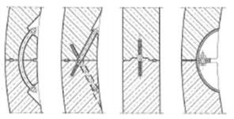

Figure 3. 7: Bolt connection joint in concrete Source: Maten (2011)

Below are the merits of bolted connection:

  - It is fast and very simple

  - The joints can be adjusted after the connection is done.

Below are the de-merits of bolted connection:

- It is very costly

- It is a complex connection especially if the shell is not structurally grided.

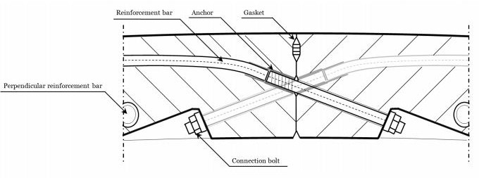

Figure 3. 8: Detailed connection between thin-shell prefab elements using bolted connection Source: Maten (2011)

- Post-tensioning connection: There are two types of post-tensioning connections:

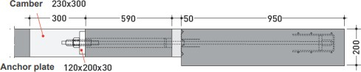

Figure 3. 9: Section of fixation of precast element to existing structure using post-tension connection Source: Maten (2011)

- Continuous post-tensioning connection: Here the continuous strands are passed through a duct embeded into multiple precast elements. The strands are tensioned by hydraulic jacks and fixed in place.
Below are the merits of continuous post-tensioning connection:

  - It is a very strong connection

  - It is also very durable

Below are the de-merits of continuous post-tensioning connection:

- The precast element must be thick enough for this type of connection to be applied
- There must be a continuous duck thought out all the elements

- Local post-tensioning connections: This is mostly use to attach precast cantilever element to existing buildings or structures. But in this case the duct for the strand is nor necessarily continuous. It is actually based on the principle of Norm-teq Heli system.
Below are the merits of Local post-tensioning connections:

  - It is simple

  - It is a quick assemble method

Below are the de-merits of Local post-tensioning connections:

I. There must be a continuous duck thought out all the elements Glue connection
- Fiber joint: This makes use of thicker fibers than the one in the Ultra-high Performance Fibre Reinforced Concrete (UHPFRC). This fiber serve as formwork for the prefabricated elements
Below are the merits of fiber joint:

  - Equally distributes the forces to the prefabricated elements

  - Using fiber joints, you easily assemble the prefabricated elements Below are the de-merits of fiber joint:
- The connection joint between the prefabricated element most be dried and hardened before forces can be applied.
- How durable it is, is not known.

- No recorded success of its application

- Glue connection: This employs the use of plastic or liquid adhesive that harden by chemical or physical processes. It is only effective between prefabricated elements of under permanent compression. But its success in the presence of fire is in recorded. Below are the merits of Glue connection:
  - Equally distributed forces to the connected prefabricated elements.

Below are the de-merits of Glue connection:

- No record of its behavior

- Slows down the construction

- Welded connection: When permanent connection between precast element is need, use welded connections. In this case steel needs to be imbedded into the precast element in the mould before casting.
Below are the merits of welded connection:

  - Strong connection is achievable

  - Connection between the prefabricated elements can be adjusted Below are the de-merits of welded connections:
- A professional qualified welder should do the welding

- You can apply conservation and protection coating to the welded part.

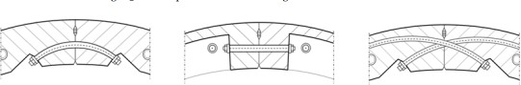

Figure 3. 10: Connection location between thin-shell concrete elements Source: Maten (2011)

FORMWORK IN THE CONSTRUCTION OF THIN-SHELL CONCRETE STRUCTURES

The cost of formwork in the construction of thin-shell is a major percentage of the total cost of the construction. There are different types of formwork:
- Single use forms: This is used for small thin-shells. It is not reusable.

- Demountable panel: This involves the use of panels and shores

- Movable forms: This is used in Hyper umbrellas thin-shell structure.

- Precast shells: This option should be used for small units of precast element

- Earth: heap of earth can be used as form for casting thin shell concrete structures

- Form surface: this involves the use of plywood. Plywood can be twisted to get a determined curvature.

  - RELATIONSHIP BETWEEN ISSUE OF INTEREST AND BUILDING TYPE The relationship between thin-shell concrete structure and bus terminal design in this thesis paper is the maximum of interior space that the structural system permits. (National Research Council (U.S.), Building , 1961). The type of thin shell form that will be used is the hyperbolic paraboloid and also the Felix Candela’s hyper umbrella.
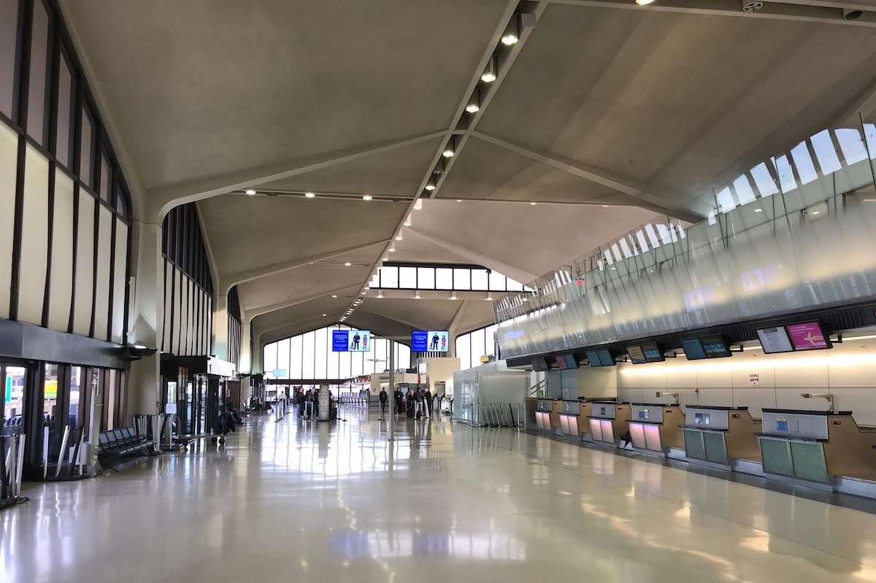

Plate 3. 16: The interior of Newark airport employed the use of hyper umbrella column Source: www.google.com (2014)

CHAPTER FOUR - CASE STUDIES

4.1 INTRODUCTION
According to Eero Saarinen, it is necessary to analyze the architecture of other times, in order to ascertain the degree of fulfilment of our architecture against the then architecture. Architectural case studies are aimed at evaluating the existing structures relevant to the proposed design. The case studies will investigate existing condition and practices of train station within and outside Nigeria in order to understand current trends in the design of train station. The proposed design for the bus terminal will be aimed at improving the ideal qualities in the cases studied and solving the problems that have been identified in the study.

FOREIGN CASE STUDY
      - THE NILS ERICSON TERMINAL

The Nils Ericson Terminal is in Gothenburg, Sweden. It is right in the center of Gothenburg. It was erected in 1995. It was designed by Niels Torp architects at Oslo, Norway. This structure received the European Award for steelstructures 1997
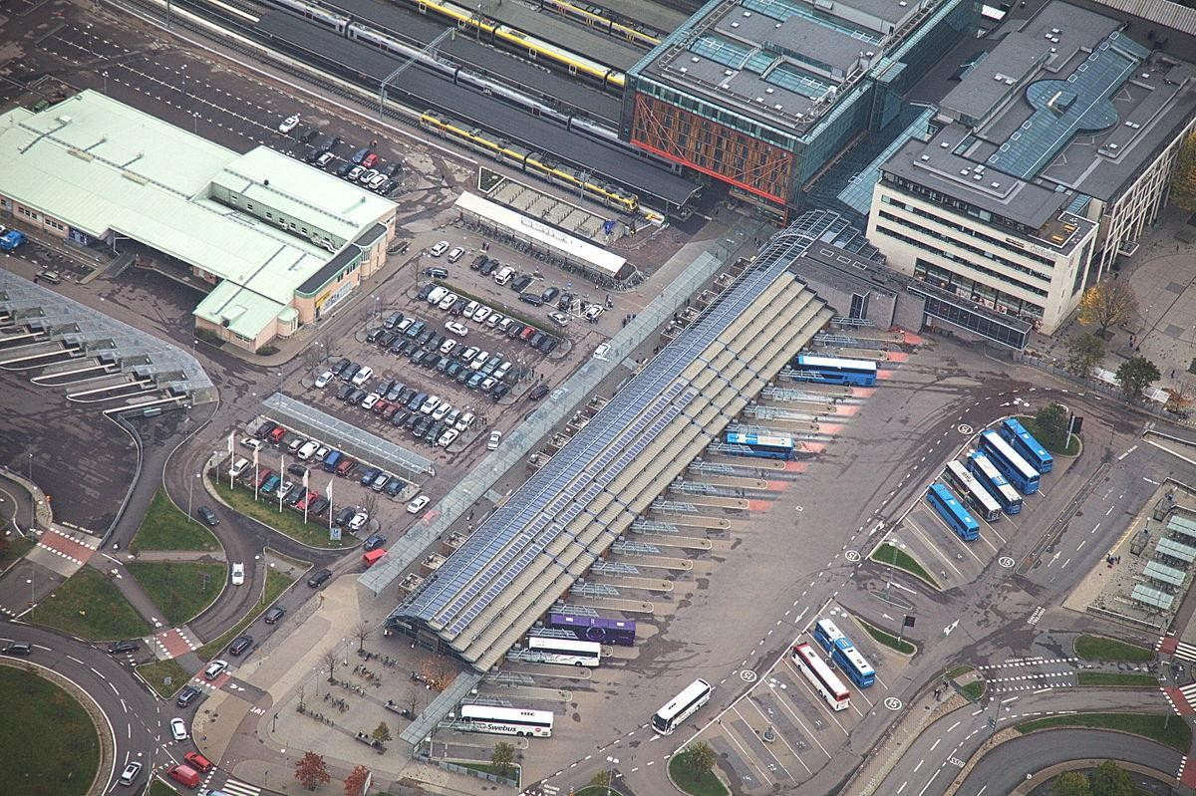

Plate 4. 1: Arial view of the Nils Ericson and the central station Source: Lindstrom (2013)

This Bus terminal facility is linked to the Gothenburg’s train station. The facility on function throughout the year for 24 hours this includes weekends. It is the largest bus terminal facility in Sweden, especially in the region of Västra Götaland (Lindstrom, 2013).

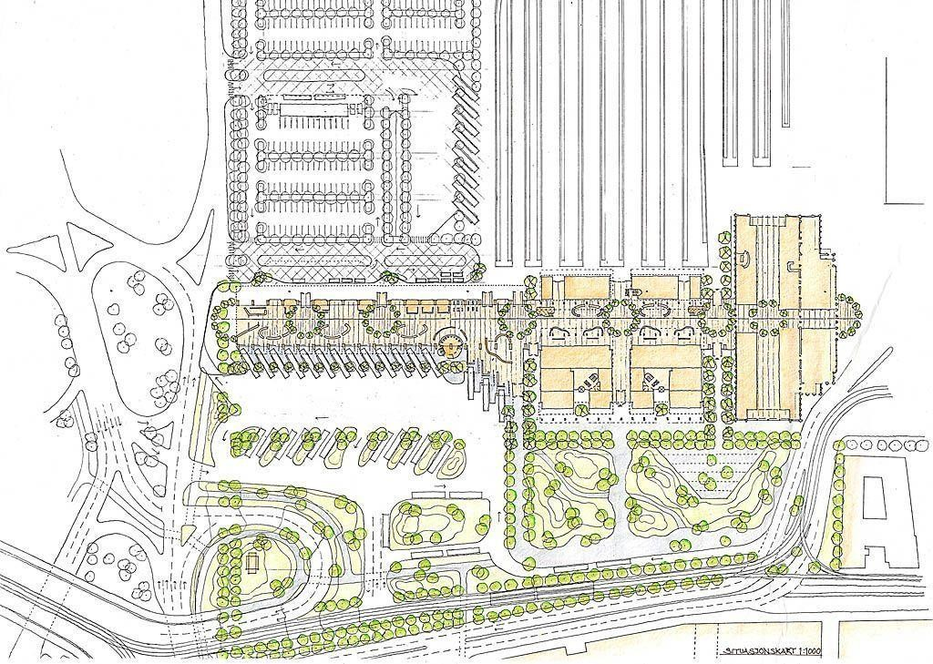

Figure 4. 1: Site Plan of Nils Ericson terminal and Central Station Source: Nielstrop (2017)

The Nils Ericson terminal close to Nordstan shopping center. Passenger can easily walk to serval hotels in the city center from the terminal.
The bus terminal can boast of 500 buses departing from the terminal in a day. The Nils Ericson Terminal is an excellent intermodal transport interchange. Passengers can get of the buses and decide to take the train, by simply moving from the bus terminal to the central train station through the passage way linking the two building facilities. So, travelers can change from bus to train and verse versa.

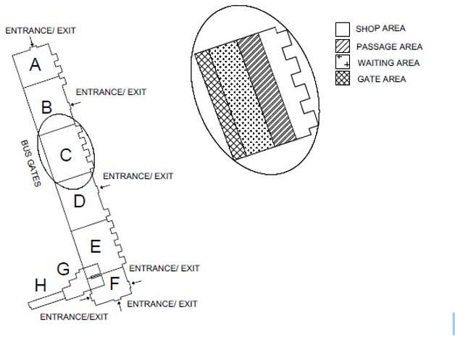
Figure 4. 2: Schematic floor plan of the Nils Ericson Terminal Source: Lindstrom (2013)

The Nils Ericson terminal is actually divided into eight sections. According to figure 4.2, they are labeled A – H. The large hall in the schematic plan is divided into six sections. They are labeled A – F. The large hall is in itself zoned into seating zone and movement zone. The seating area is just opposite the street, that passengers use to approach the terminal. The part of the schematic plan labeled A -F comprises of shops, waiting areas, passage areas and boarding areas. The large hall is connected to the central station or railway hall. A part of the railway hall is actually a mirrored version of the large hall of the Nils Ericson terminal. In other words, the large hall protrudes into the old railway’s hall. Thus, bringing the new into the old. The total area of the bus terminal is 7200 m². Out of this total area 4160 m² is heated. Sweden must be a cool place. Under this large hall is a garage. It has inclusive a technical hall way. The technical room is below the section H – G.

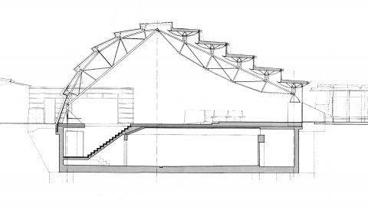

Figure 4. 3: Section of the Nil Ericson terminal, showing the large hall and the basement garage Source: Lindstrom (2013)

Shops are all located on the ground floor of the parts of the schematic plan labeled G – H. The staff facilities are at the second floor of the part of the schematic plan labeled G -H. In clearer terms the A – F is functioning as the terminal building and G -H is functioning as the office building.
The terminal’s interior spaces are:

- Offices

- Waiting hall

- Shops

- basement

BUILDING ENVELOPE

Steel frame structures was used in the terminal. It is covered by glass. Glass can be seen on the roof and the exterior walls.
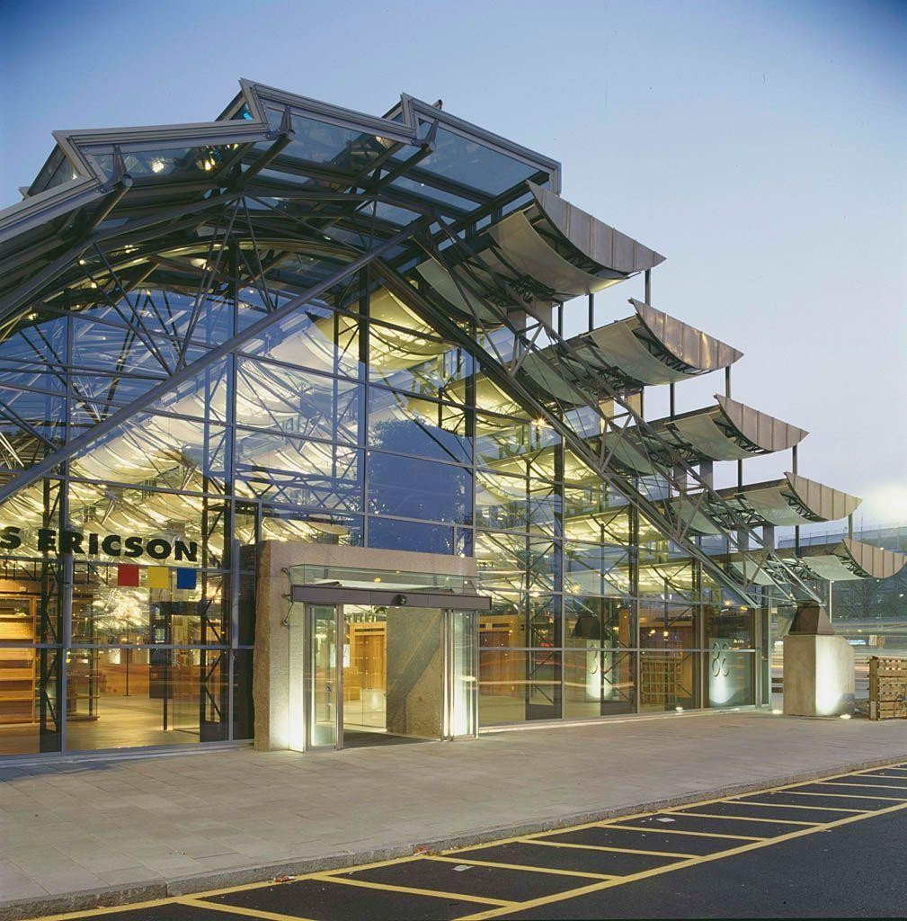

Plate 4. 2: One of serval entrances at the terminal Source: Nielstrop (2017)

The shorter side of the building faces the north-east and has a curved profile with a stair-case shaped wall on one side. The glass façade of 26% g-value was used. The glass also has an exterior reflection rate of 14%.

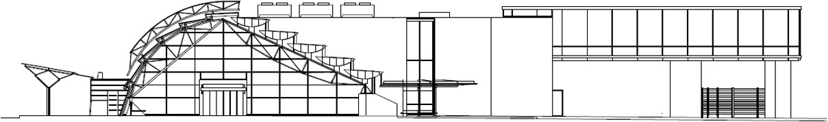

Plate 4. 3: Facade drawing of NET viewed from north-west direction Source: Lindstrom (2013)
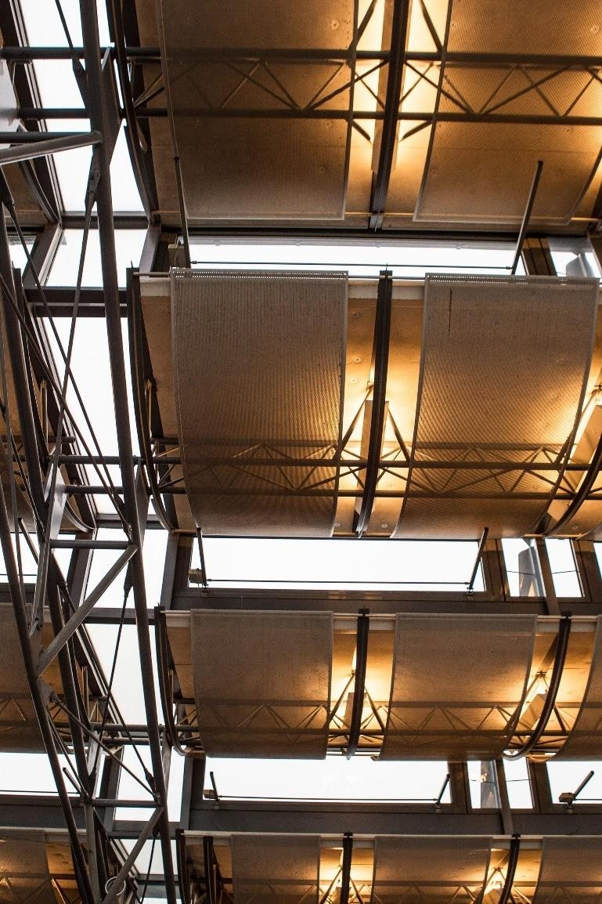

Plate 4. 4: Roof insulation material

Source: Nielstrop (2017)

In the large waiting hall, there are five roof components, that are insulated with foam glass insulator.

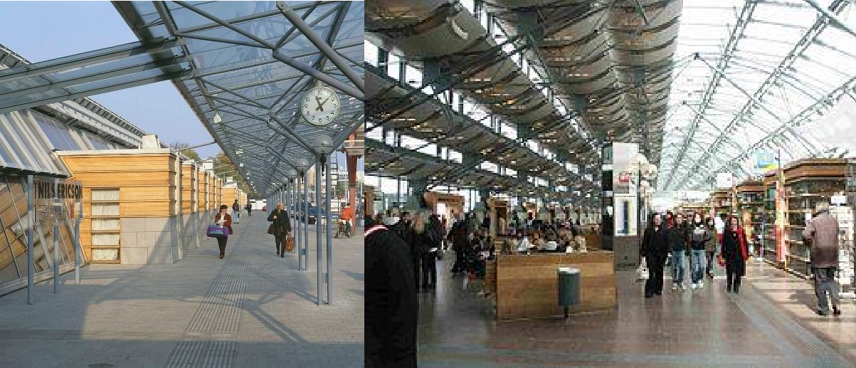
Plate 4. 5: The shops are each in insulation boxes and part of it is in and outside of the terminal Source: Nielstrop (2017)

The shops in the terminals are located in such a way that a part of it is in the terminal and the other part is outside of it. The terminals are boxed in wooden framed walls. They are also insulated with mineral wool. The part of the shops protruding outside each has mineral wool and foam glass mounted on steel frames as insulators. The part of each shops that is inside the terminal is also insulated with mineral wool and wooden frame structure.
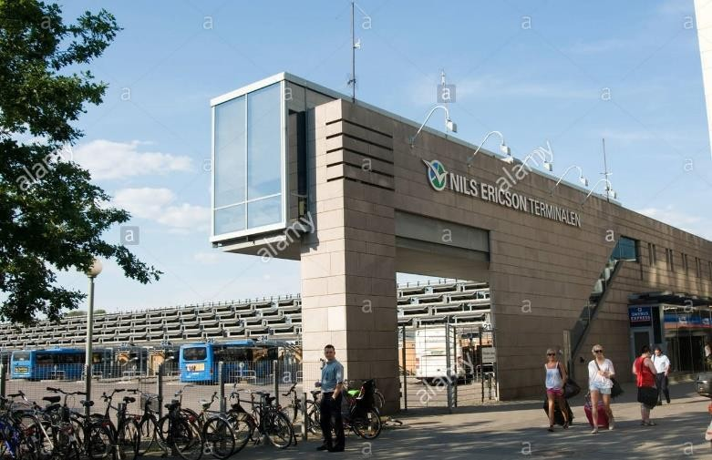

Plate 4. 6: The staff office of the Nils Ericson terminal Source: Nielstrop (2017)

The office building is located on the second floor. Concrete structure is the material used for it. If not for the concrete structure, it would have been a cantilever. The exterior wall and roof of the office are of foam glass insulators.

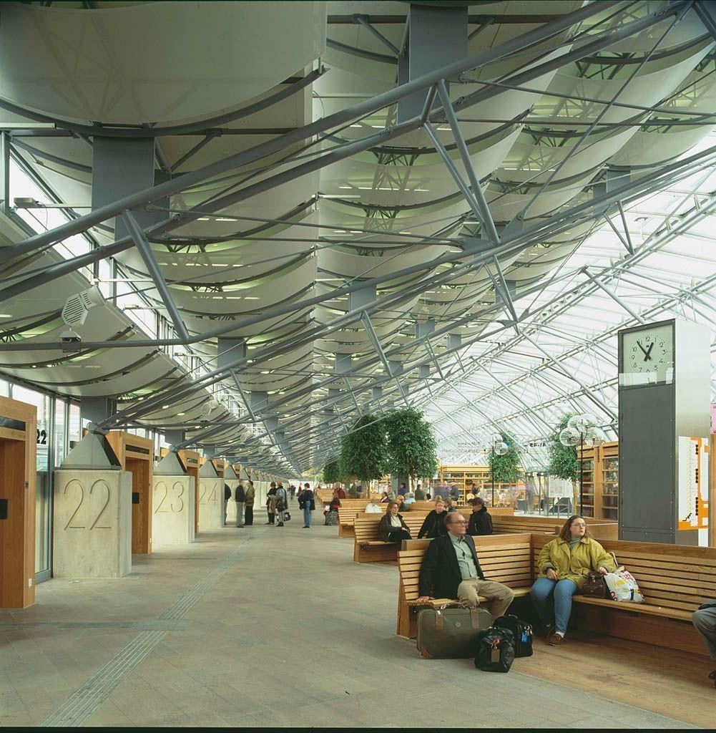

Plate 4. 7: Picture showing the gate numbers Source: Nielstrop (2017)

The two types of entrances used at Nils Ericson Terminal are single sliding door and sliding dor with vestibule. This door entrances are all located at the four sides of the building in their numbers. The designer of the terminal allocated 18 gates to be used to access the bus platform using sliding doors. This gate are allocated gate numbers. The gate leading to the bus platforms are numbered 21 to 38. These gates use single sliding doors and air curtains are employed to eliminate heat leakages. This terminal is design in such a way that passenger move from an air- conditioned terminal through the gate to an air-conditioned bus.

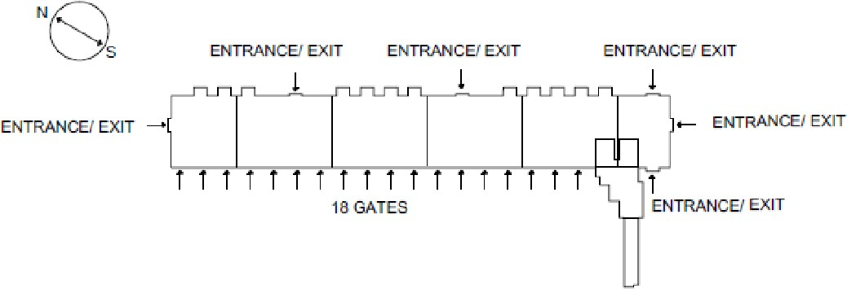

Figure 4. 4: Location of entrances and gates in NET Source: Lindstrom (2013)

TECHNICAL SYSTEMS AND INDOOR TEMPERATURE
“NET is ventilated by a heat recovery system located in the basement. The system is designed with constant air volume, CAV. The supply- and exhaust air is distributed by diffusers on floor level in the waiting hall and in the ceilings for the shops and the office areas. Exhaust air from shops, office areas and the waiting hall goes back to the air handling unit for heat recovery. The same air is then lead to the garage. Separate exhaust fans are used for exhaust air and smoke evacuation in the garage. Exhaust fans also evacuates air from restaurants and similar. (Lindstrom, 2013)”

  - ROSA PARKS TRANSIT CENTER Architects: FTL Design Engineering Studio Location: Detroit, USA (United States of America) Project Architect: Parson Brikerhoff
Project area: 4,645 sqm Budget: $22.5 Million USD Project year: 2009
Fabric: PTFE glass (Polytetrafluoroethylene)

Photographs: FTL Design Engineering Studio

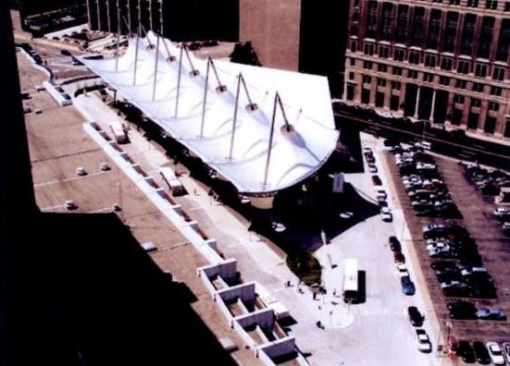

Plate 4. 8: Top view of Rosa Park Transit Centre Source: www.archdaily.com (2013)
FTL Design Engineering Studio is the architectural firm the designed this Transit facility. They used a single sustainable skin to define the space at the bus platform, These skins simulate sculpture and harvest the rain. There is a terminal building as part of the facility. Beside the terminal building, there is an out door drop off and waiting area. The brief for the project was to provide roof structure that can withstand the inclement of weather, that is cheap, unique and easily maintained

PLANNING

The focal point in this terminal facility is the outdoor roofing structure over the drop off area in front of the terminal building.

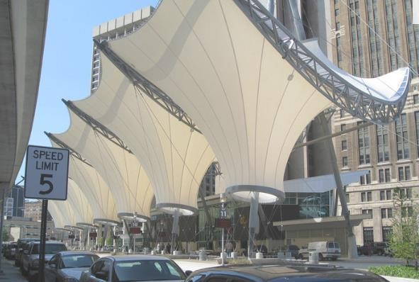

Plate 4. 9: Roof over drop off area of Rosa Park Transit Centre Source: www.archdaily.com (2013)
This outdoor roofing structure was broken down into seven bays to simulate rhythm. The size for each bay is roughly 50 feet wide by 110 feet long. Each of the roof structure as a single unit is made up of special fabric. What is special about them each is they transform rhythmically from roof to wall and stylishly have courtyard incorporated. It also serves as concourse for the passengers and bus platform. The main terminal building serves as or accommodates the driver’s toilets and shower, retail spaces, offices, waiting area, taxi stand etc.

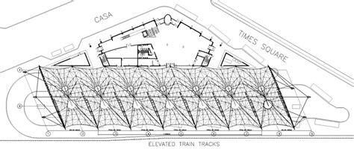

Figure 4. 5: Top view plan

Source: www.archdaily.com (2013)
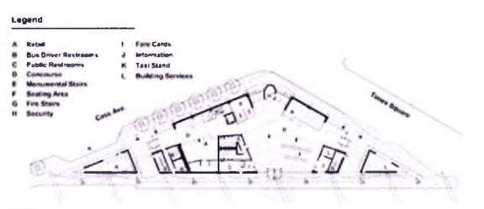

Figure 4. 6: 2nd floor plan

Source: www.archdaily.com (2013)

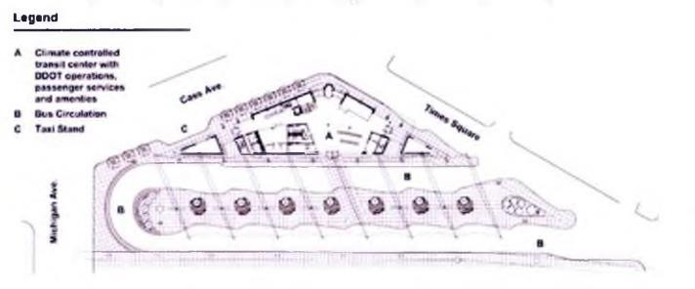

Figure 4. 7: 1st floor plan

Source: www.archdaily.com (2013)

STRUCTURE

This canopy is visually attractive. The canopy is some how poetic. In that in one part of the canopy it seems as if it is floating in the air and in another part it is close to the ground. It also collects water into a court yard there. The canopy is 50 feet up in the air.
The PTFE fabric is supported on steel truss and tension cord.
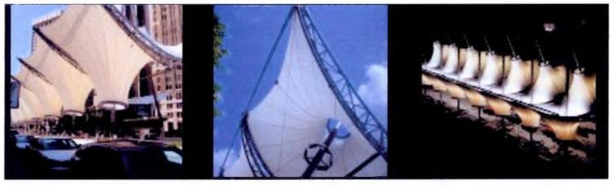
Plate 4. 10: Different view of the canopy structure Source: www.archdaily.com (2013)

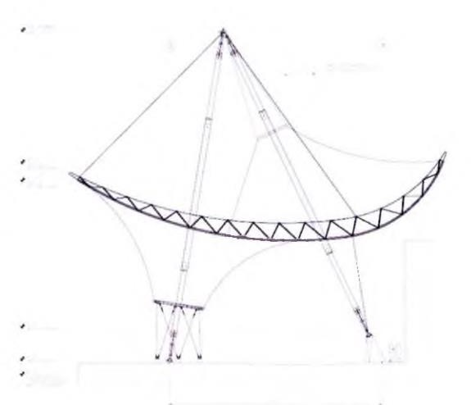
Figure 4. 8: Section showing the canopy structure Source: www.archdaily.com (2013)

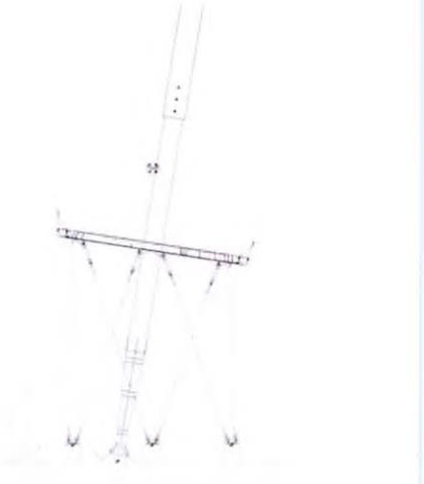

Figure 4. 9: Structural detail of canopy structure Source: www.archdaily.com (2013)

MATERIAL
Structural system: Reinforced concrete Steel frame

- Exterior cladding Metal/glass curtain wall: Vistawall

- Concrete: St. Mary’s Cement

- Roofing Elastomeric: Carlisle

- Metal: Firestone

- Windows Aluminum: Vista Wall

- Glazing Glass: PPG Industries

- Fire Glass: Safti

- Skylights: Action Bullet Resistant

FINDINGS

It has a simple functional flow in systematic way

- The bus terminal has separate layovers for departing & arriving buses

- Terminal uses most of the time glasses as partition to achieve clarity between the spaces.
- To create ventilation for openness the bus terminals is shaded by the use of canopy which creates a dynamic shaded space.
- The ticket counters is in the building adjacent to passengers course.

- The circulation pattern for buses entry and exit follows one-way rule

- There is no provision for overnight parking.

- There is waiting & resting facilities to ensure the passengers comfort.

- The public vehicle facilities like taxi, auto-stand, and private car are is present to facilitate the passengers in terminal.

TRANSBAY TRANSIT TERMINAL

LOCATION: San Francisco ARCHITECT: Pelli Clarke Pelli Architects AREA: 5.4 acre
BUDGET: $170 million given by the Transportation Infrastructure Finance and Innovation Act Completion date: 2014
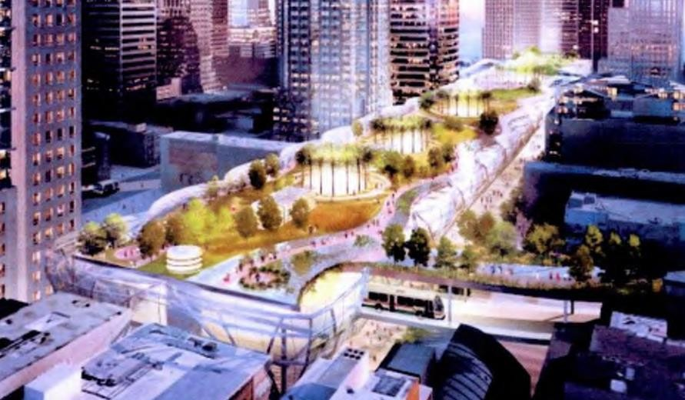

Plate 4. 11: View of Transbay terminal Source: www.archdaily.com (2013)
The terminal is design and tailored to the mode of living and working of the people. The design responds emerging needs of the passengers. It is a futuristic design. The words in the terminal design is forward-looking and generous. The terminal is befitting of the city.
The terminal will be self-sustaining. The concept green architecture is well harness in the design of this transport interchange. The terminal has grey water recycling system, wind turbines and geothermal heating methods. It is blazing the trail in combining green technology with modern transport.

PLANNING

The terminal is well located. It is close to mixed-income housing, new hotels, high rise, downtown conference, education facilities and office spaces in the neighborhood. At this terminal, you can get anywhere by any means of transport. Passengers will be very willing to come and used the services available at the terminal. Services like restaurant, retail.

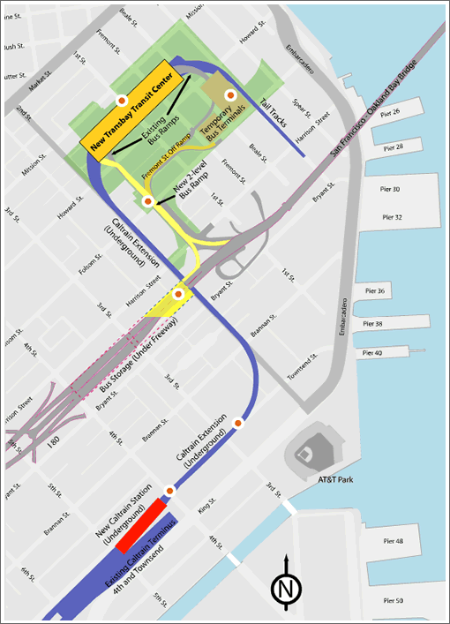

Figure 4. 10: Location map of Transbay terminal Source: www.archdaily.com (2013)

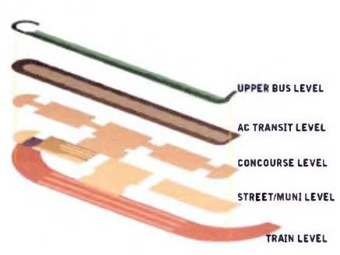

Figure 4. 11: Sectional zoning

Source: www.archdaily.com (2011)

envisioning a one -bio ck-wide by three - bIock - long terminal near the heart of San Francisco’s Financial District , the “ Great Expectation s "concept design effectively integrates the existing modes of regional public transportation and accommodates future system expansion s .Two bus levels served by ramps directly connected to the Bay Bridge provide an efficient design for transit operators , while strategic bus storage locations and connected ramps avoid conflict on city streets
. “An underground rail facility welcomes the extension of Caltrain to down town and provides space for future East Bay com muter rail and California’s high-speed intercity rail. (Hoque, 2011)”

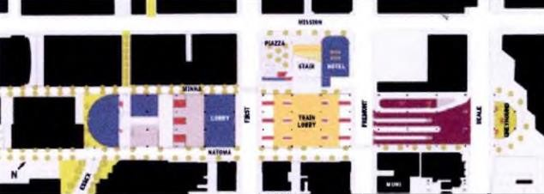

Figure 4. 12: Ground floor plan

Source: www.archdaily.com (2011)

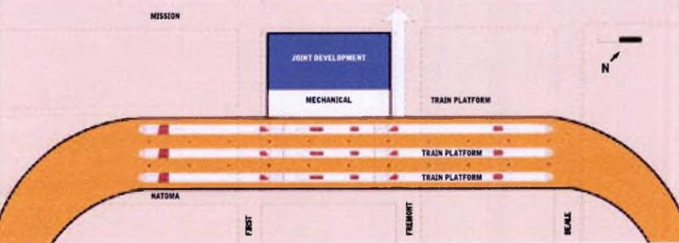

Figure 4. 13: Plan at -30’

Source: www.archdaily.com (2011)

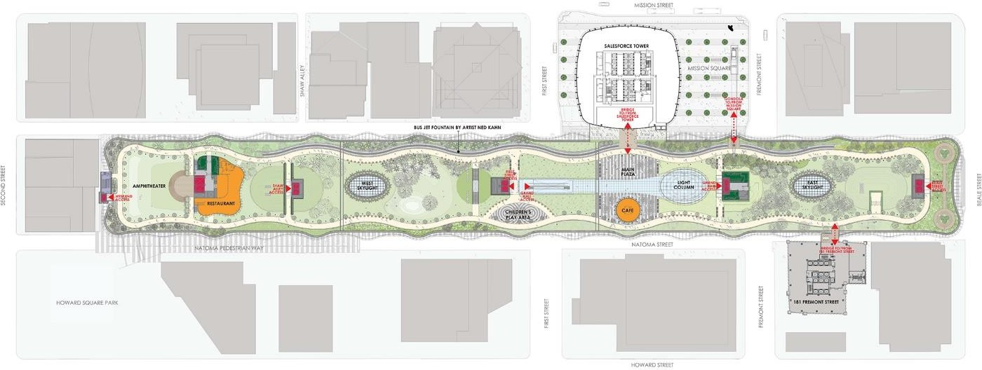

Figure 4. 14: Plan at +40’

Source: www.archdaily.com (2011)

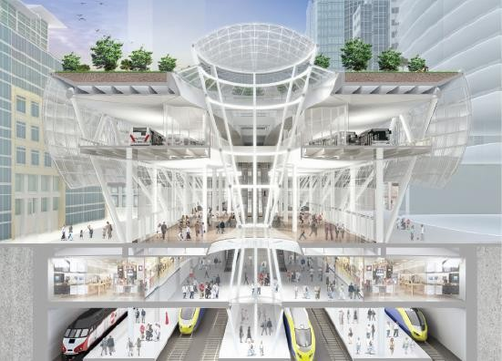

Figure 4. 15: 3d section showing bus terminal Source: www.archdaily.com (2011)
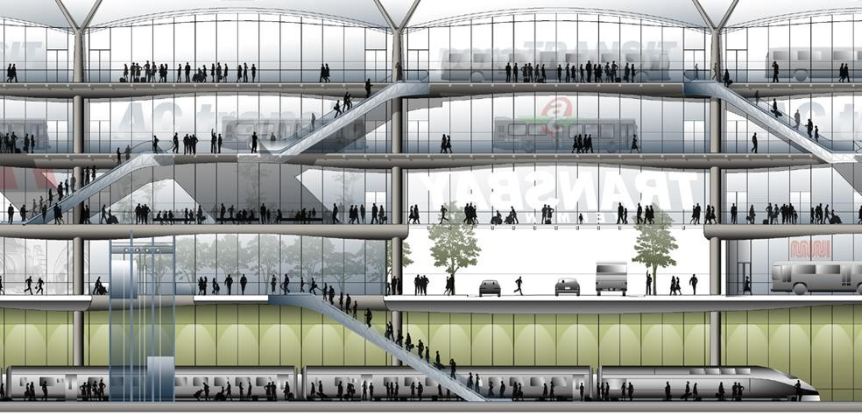

Figure 4. 16: Section looking toward north Source: www.archdaily.com (2011)

STRUCTURE & ENVIRONMENTAL CONSIDERATION
Structure : Steel, reinforced concrete

Environmental section : Daylight, natural ventilation, geothermal energy, green roof and water reuse are integrated into the building.
Water reuse strategies The proposed strategy achieves a 54% reduction in domestic, mechanical, and irrigation water use. The roof park is designed to biologically filter greywater, storm water is captured and reused for toilet flushing.
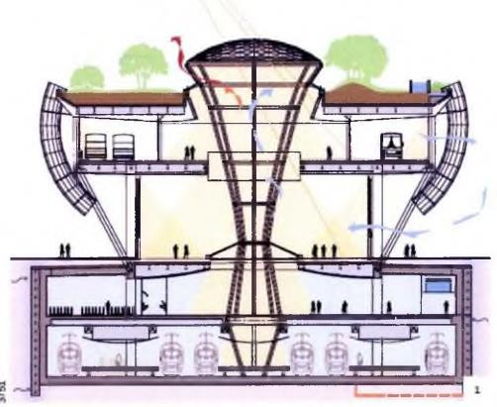

Figure 4. 17: Section looking toward east Source: www.archdaily.com (2011)

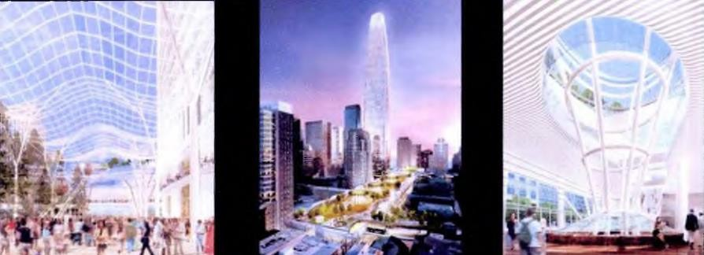

Plate 4. 12: Different views of the structure Source: www.archdaily.com (2011)

FINDINGS
- It is integrated transport system containing subway and bus terminal

- The building has public function like shops & other commercial facilities.

- The bus terminal has separate layovers for departing & arriving buses

- The terminal building is highly energy efficient as it has Daylight, natural ventilation; geothermal energy, green roof and water reuse are integrated into the building.
- The entire terminal is landscaped on the roof, which provides public space for the entire community.
- The Terminal uses as partition to achieve clarity between the spaces.

- The circulation pattern for buses entry and exit follows one-way rule

- There is no provision for overnight parking.

- There is waiting & resting facilities to ensure the passengers comfort.

- The public vehicle facilities like taxi, auto-stand, and private car are present to facilitate the passengers in terminal.

LOCAL CASE STUDY

OSHODI TERMINAL

The Oshodi Transport Interchange or bus terminal is a world-class transportation center. It is located in Lagos, Nigeria. The overall cost of the building facility is $70m. Now as at the time this paper was being written the facility was under construction.

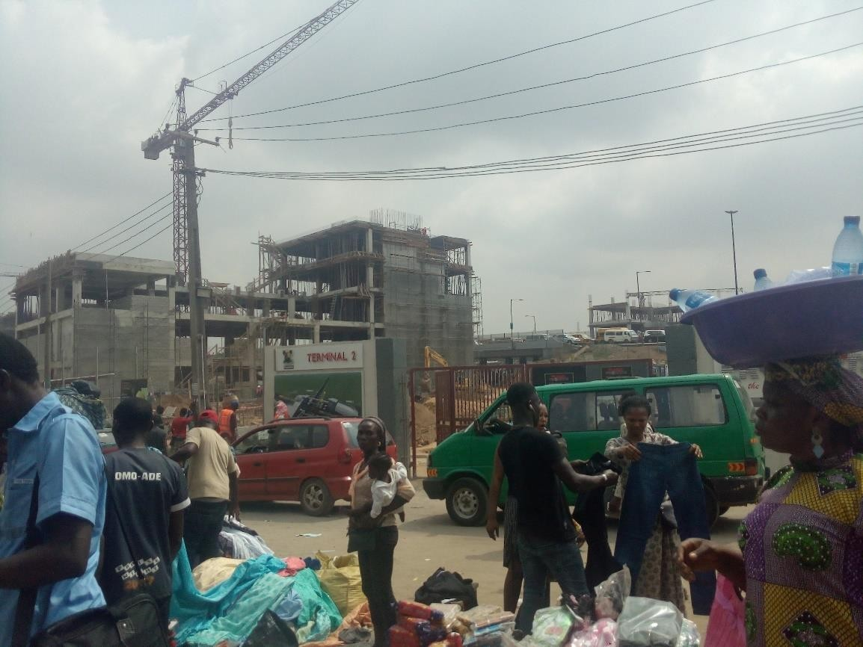

Plate 4. 13: Pictured of terminal two under construction Source: Author’s Field Work (2018)

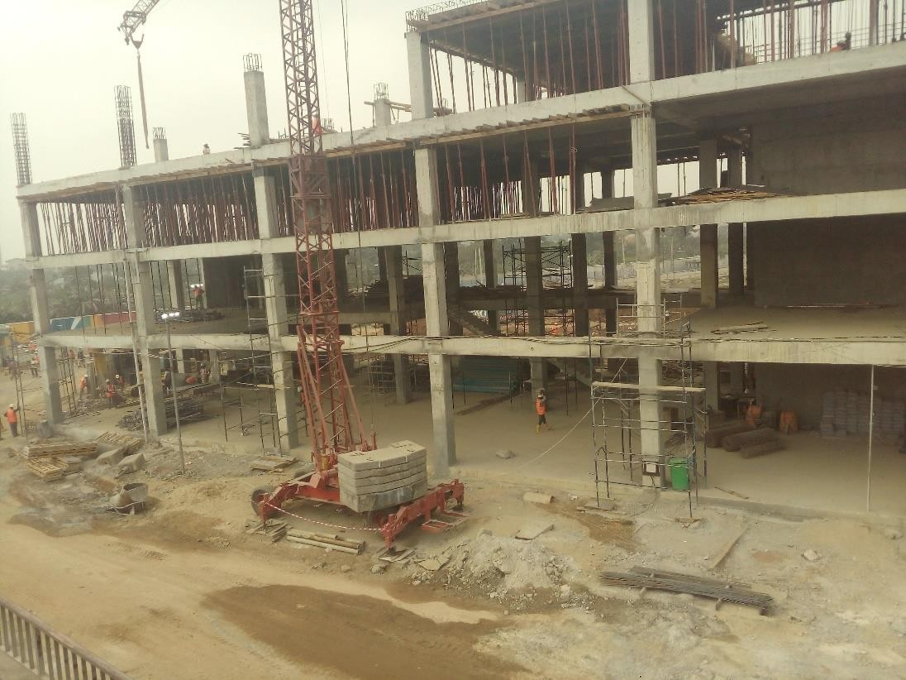

Plate 4. 14: Terminal Two under construction Source: Author’s Field Work (2018)

The transport facility was financed jointly by the government and the public-private partnership (PPP) arrangement. The private-partnership are Ibile Holdings, Translink Capital Development Limited and Planet Projects Limited.
The construction of this world-class transport interchange is part of the plan to regenerate Oshodi into a world class Central Business District ((CBD). The is a 3 multi-story bus terminal. It will consolidate the 13 city.

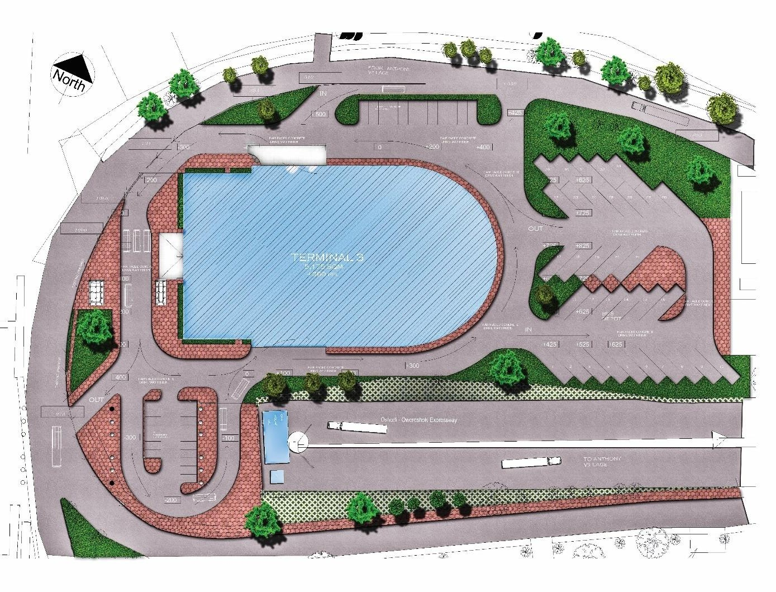

Figure 4. 18: Site plan Oshodi terminal three Source: Plant Project Limited (2018)

The terminals are constructed into three units. Terminal One is for interstate transport activities. It starts from Mosafejo Market Axis. The Terminal Two is for intra-city transport activities, it state its operations from Owonifari Market. He Terminal Three is also an intra city bus terminal facility. It is close to NAFDAC.
Each of the terminal occupy an area of 30,000 m². They each will take care of parking and the passengers’ demands.
All the terminal have the facilities such as waitjng area, loading bay, ticketing stands, driver lounge, parking area, rest rooms and much more. There are 13 parks at Oshodi and one million pedestrians and 100,00 passengers use it on a daily basis.

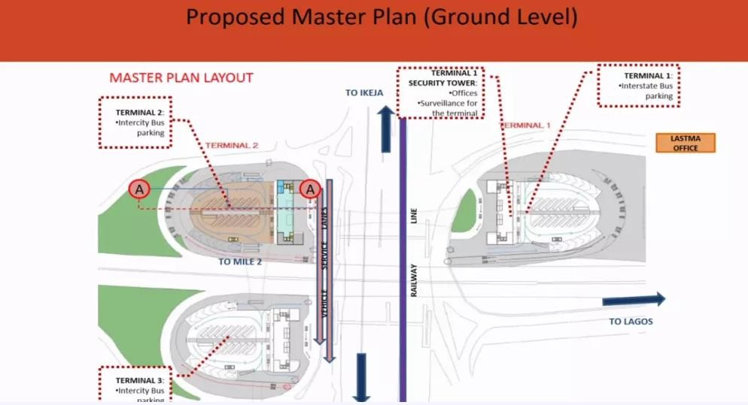
Figure 4. 19: Proposed ground level plan

Source: http://www.skyscrapercity.com/showthread.php?t=1927740

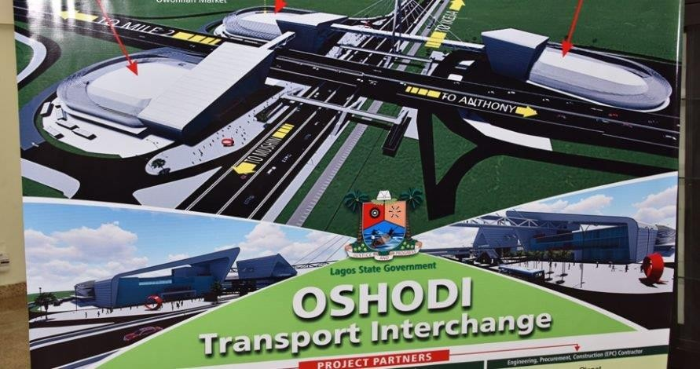

Plate 4. 15: Oshodi transport Interchange 3-dimensional image Source: Plant Project Limited (2018)

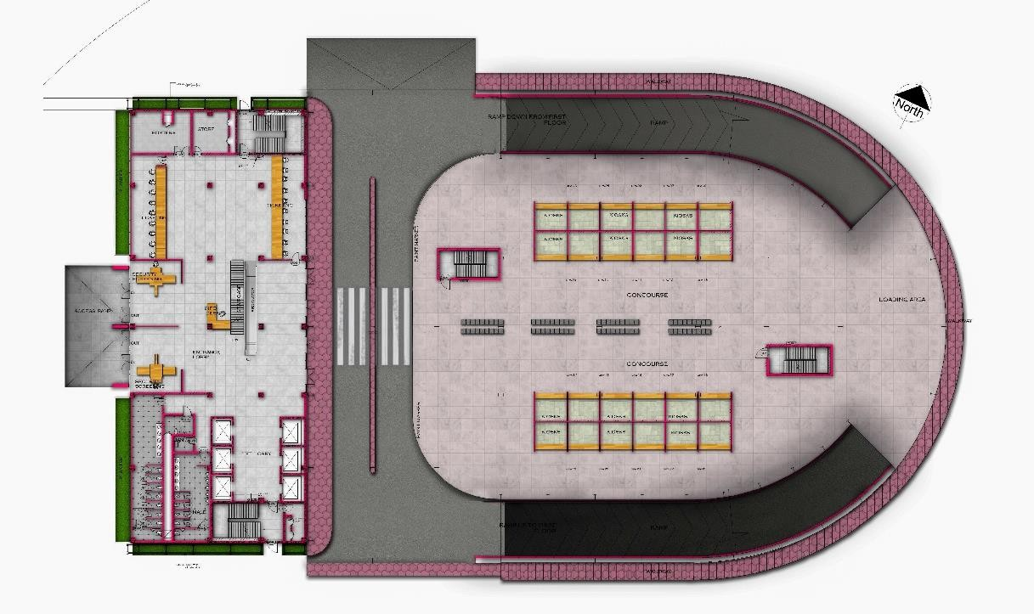

Figure 4. 20: Ground floor plan of terminal three Source: Plant Project Limited (2018)

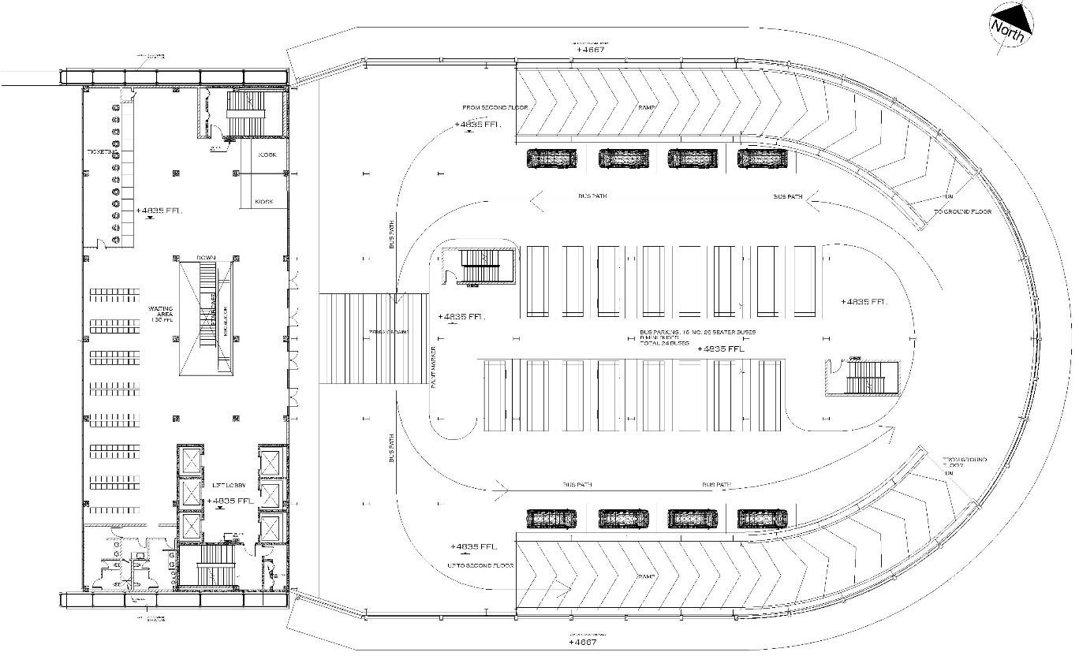

Figure 4. 21: First floor plan of terminal three Source: Plant Project Limited (2018)

The concept of Oshodi regeneration plan will be giving three solutions: Transformation and Security; Urban Renewal; and Environmental Regeneratin.
Ambode also explained that the project was in line with his administration’s determination to transform Oshodi into a world class CBD with business, travel and leisure activities conducted in a serene, secure, clean, orderly and hygienic environment. (Akinsanmi, 2016)”
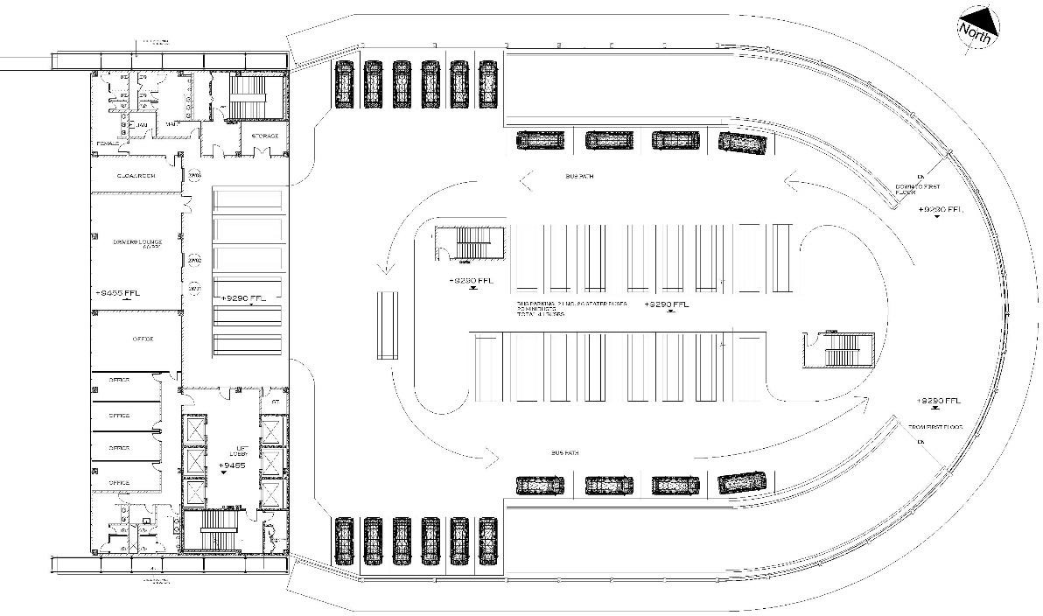

Figure 4. 22: Second floor plan terminal three Source: Plant Project Limited (2018)

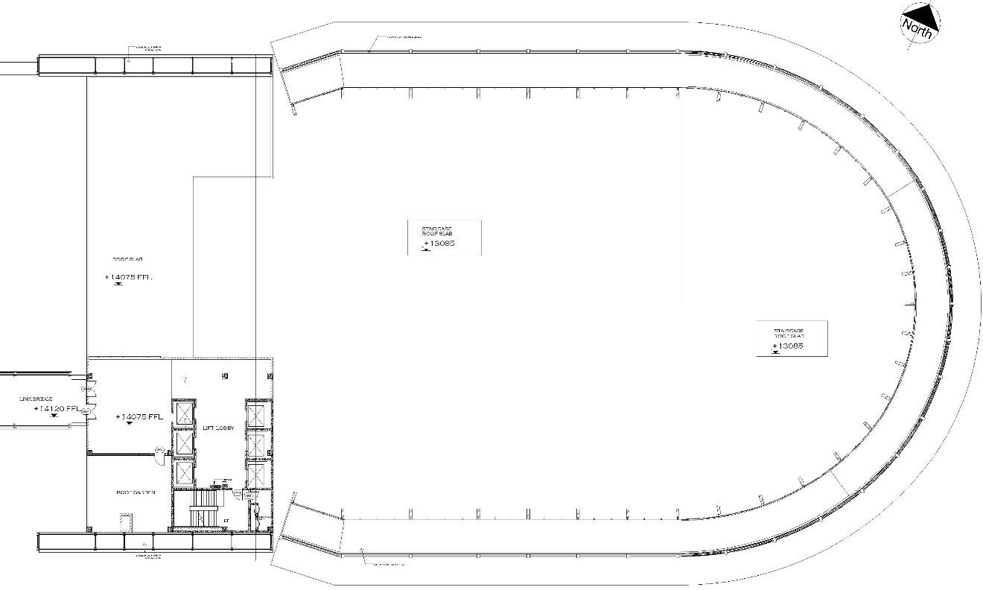

Figure 4. 23: Third floor plan of terminal three Source: Plant Project Limited (2018)

IKEJA BUS TERMINAL

The newly built Ikeja bus terminal is a world class bus terminal. It is the first of its type in Nigeria. It was built as a government and public private partnership initiative. It is located at Ikeja, Lagos, Nigeria. It was developed as part of the infrastructure for Lagos Bus Reforms Project.
The Ikeja Bus terminal Was design by Plant Project Limited. The bus terminal facility contain the following spaces:
      - waiting area

      - ticketing booth

      - information center

      - food court

      - taxi rank

      - passenger convenience

      - operations

      - control center

      - ATM gallery

The site area is 10007 m². The bus parking area accommodates a maximum of 80 buses. The taxi parking area and the private parking are located in the same location. This location is separated from the bus parking area. There are a total number of 47 parking lot for both the taxis and private parking altogether.
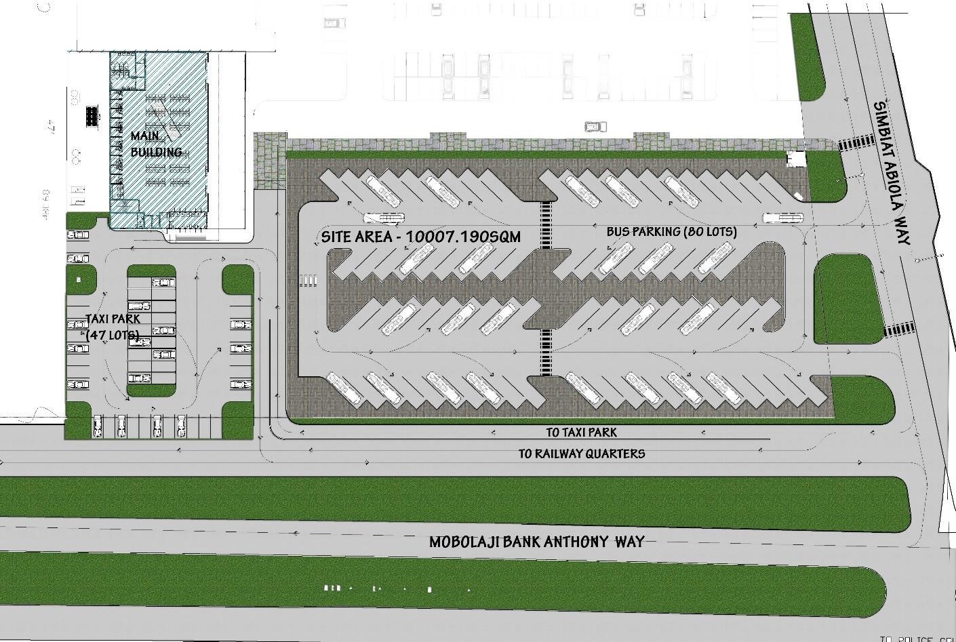
Figure 4. 24: Site plan of Ikeja bus terminal Source: Plant Project Limited (2018)

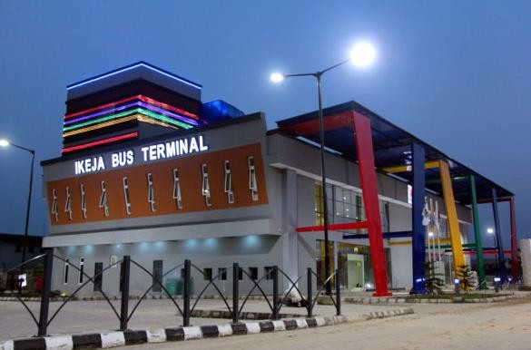
Plate 4. 16: Ikeja bus terminal building Source: Plant Project Limited (2018)

The terminal provides a safe secure. Comfortable environment. Before the bus terminal was built, the land was a bus park. Transport services took place in the sun and the rain in an unhygienic environment with no facility what so ever. Presently, this is the situation of many bus parks and garrages in Nigeria.
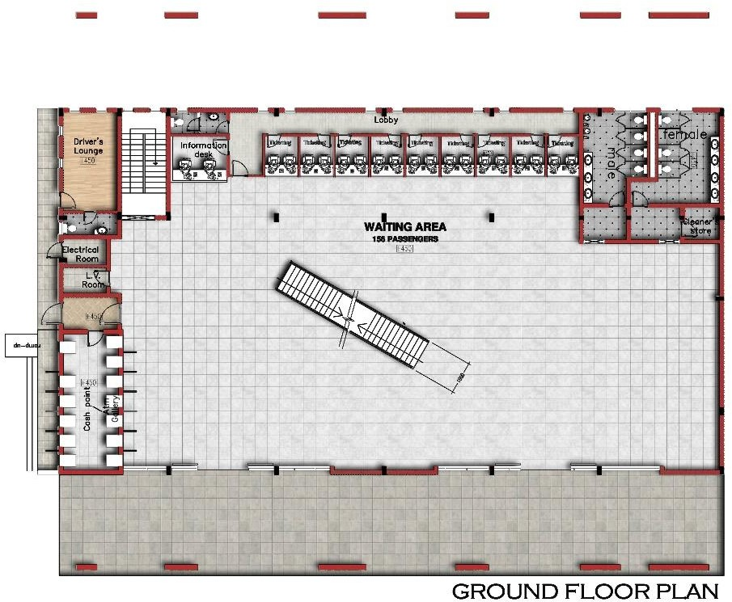

Figure 4. 25: Ground floor of Ikeja bus terminal building Source: Plant Project Limited (2018)

The Ikeja bus terminal is a hub for all transport activities within the Ikeja zone. It was designed to serve over 50,000 passengers daily. I t provides access to destinations such as Oshodi, Ojota, Iyana-Ipaja, Maryland, Agega, Ogba, CMS, Obalende etc.
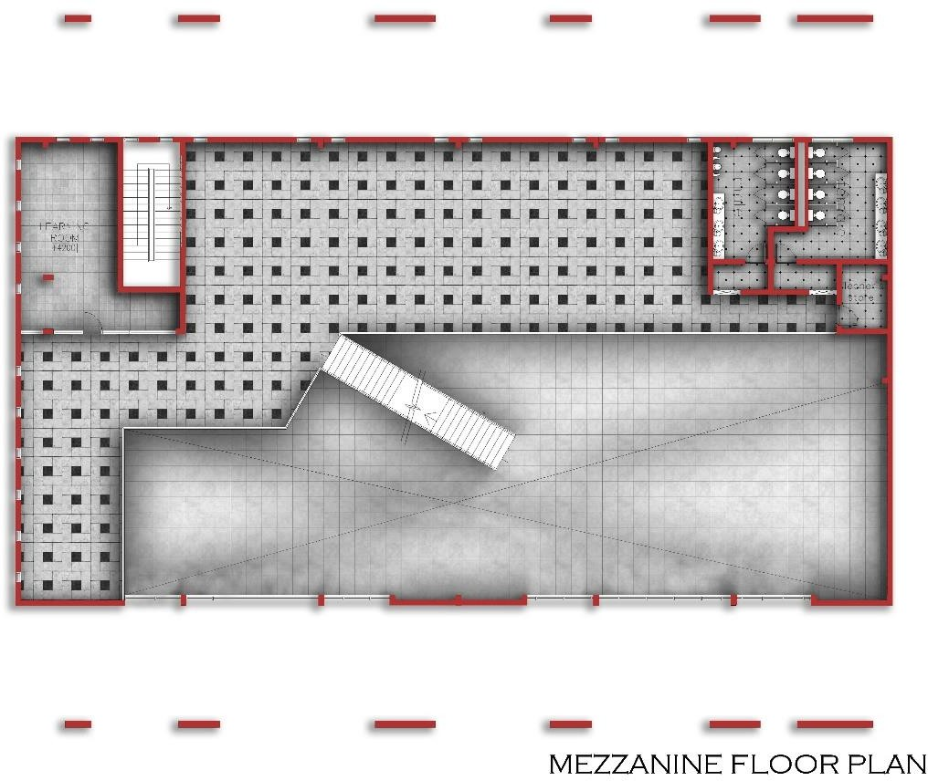
Figure 4. 26: Mezzanine floor plan of Ikeja bus terminal Source: Plant Project Limited (2018)
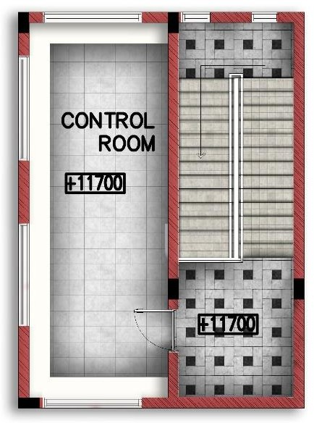
Figure 4. 27: Ikeja bus terminal control room Source: Plant Project Limited (2018)

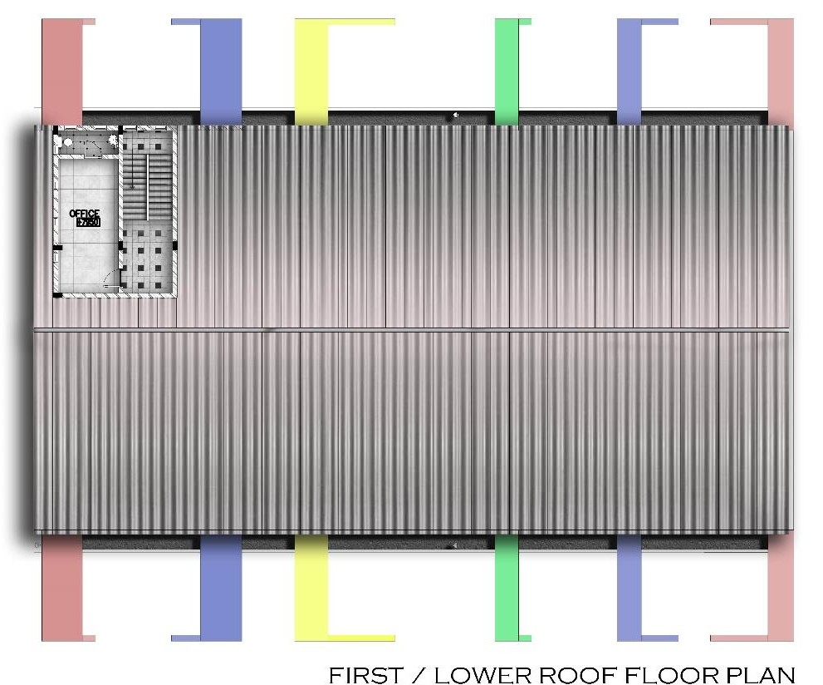

Figure 4. 28: Ikeja bus terminal lower roof plan / first floor plan Source: Plant Project Limited (2018)

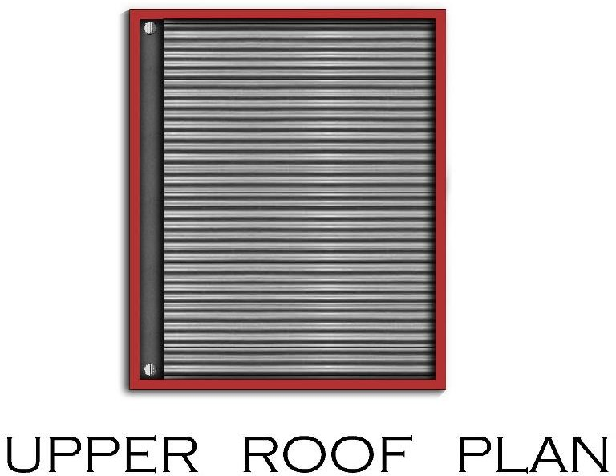
Figure 4. 29: Ikeja bus terminal upper roof plan Source: Plant Project Limited (2018)

CHAPTER FIVE - SITE AND ENVIRONMENTAL ANALYSIS
This chapter comprises a study of the site in context, as well as its opportunities and constraints, including ways that the proposal can be configured and oriented on the site to provide amenity while minimizing impacts on neighboring elements and the public realm.
Important considerations in site analysis include proximity to other key buildings in the community; to public transportation and parking; access for technical functions; and other site conditions that may affect the complexity of the construction process.

CRITERIA FOR CHOOSING A SITE

The proposed site was selected after reaching a balance between competing interests for the public good. After careful analysis the site was selected based on the following criteria
Presence of basic infrastructure: the propose site is the land mass at Obalende interchange. The proximity of road interchange to the site is a basic infrastructure in situating a bus terminal on the site.
Furthermore, the size of the land will also adequately meet the essential requirements or demands of the intended design. Also, the existence of commercial buses at the current location evidently show the need for a bus terminal facility on the site. Thus, the location supports the proposed building type.

Accessibility: the proposed site is located at Obalende, Lagos Nigeria. The site is easily accessible via the ring road interchange and the Obalende road.
Furthermore, the site is surrounded by major transport road. It serves as a major junction to several roads.
Location: Strategically placed between Lagos Island and Ikoyi is one of the most popular bus stops in Lagos- Obalende. It is one of the major gateways into what is now referred to as 'The Island ', a term used to describe the most important and influential districts in Lagos outside of

its capital on the mainland, Ikeja. These are Lagos Island, Ikoyi, Victoria Island and Lekki. It is a major terminus for buses coming from the mainland to the Island via the 3rd Mainland Bridge which is Africa's longest bridge, 11.8km long.
This strategic location makes Obalende one of the most important transportation hubs in Lagos where you can find buses to practically every location in the city. Many people from outside Lagos coming to trade enter the Island via Obalende. Hence, there are many interstate buses especially to other cities in Southern Nigeria.
“Another reason for Obalende's popularity is its proximity to the former seat of political power in Nigeria, Dodan Barracks, the former Federal Secretariat and Police Baracks. This made it a must for many civil servants to commute through it to and from work when Lagos was still the political capital of Nigeria. Lagos stopped being the political capital of Nigeria on 14th November, 1991 when Abuja became the new capital. However, this move did not really affect the vibrancy of Obalende and by extension Lagos as commercial interests ensure their importance and continued influence. (Olatunji, Major Bus Stops in Lagos: Obalende, 2015)”

BRIEF HISTORY OF LAGOS STATE

Before the Portuguese name of Lagos had been adopted, Lagos' initial name was Eko which referred mainly to the Island. The first to settle in Eko were the Aworis.
Lagos State was created on 27 May 1967 according to the State Creation and Transitional Provisions Decree No. 14 of 1967, which restructured Nigeria into a Federation of 12 states.
Lagos is the largest city and former capital of Nigeria and the largest megacity on the African continent in terms of population,
Lagos, sometimes referred to as Lagos State to distinguish it from Lagos Metropolitan Area, is a state located in the southwestern geopolitical zone of Nigeria. The smallest in area of Nigeria's
36 states, Lagos State is arguably the most economically important state of the country, containing Lagos, the nation's largest urban area. It is a major financial centre and would

be the fifth largest economy in Africa, if it were a country. It is located in the south-western part of the Nigerian Federation. On the North and East it is bounded by Ogun State. In the West it shares boundaries with the Republic of Benin. Behind its southern borders lies the Atlantic Ocean. 22% of its 3,577 km2 are lagoons and creeks.

BRIEF HISTORY OF ETI-OSA

Eti-Osa is a Local Government Area of Lagos State in Nigeria. Lagos State Government administers the council area as Ikoyi-Obalande LCDA, Eti-Osa East LCDA, and Iru Victoria Island LCDA. Within Eti-Osa are several important areas of Lagos State, including Lagos' Victoria Island and Lekki's port. Before the Nigerian capital moved to Abuja, Eti- Osa Local Government Area served alongside Lagos Island Local Government Area as the seat of the national capital.
Eti-Osa Local Government Area has a population of 283,791, which represents 3.11% of the state’s population. 158,858 of the total population are male while the remaining 124,933 are female.
There is little industry within Eti-Osa. Most residents work in fishing, farming, and trading. However, due to it being the former location of the nation's capital, Eti-Osa is home to many large domestic and international businesses.
Before the Nigerian capital moved to Abuja, Eti-Osa was the seat of the national capital.

BRIEF HISTORY OF OBALANDE

“The Royal West African Frontier Force (RWAFF) made up of predominantly Hausa men were initially camped on the land where King's College, Lagos is situated. Then, a need arose for the use of the land and the Oba of Lagos pressured the Governor of Lagos to resettle the RWAFF men, and sold virgin land in what is now Obalende to the British Colonial Government. (Wikipedia, Obalende, 2018)”

After resettlement in the purchased land, the RWAFF men named the place Ibi ti Oba le wa de, which translated from Yoruba means "the land the Oba of Lagos drove us to".
Obalende, an adulteration of the Yoruba saying Ibi ti Oba le wa de, is a neighborhood of Lagos, located in Eti-Osa LGA, close to Lagos Island. Eti-Osa was split by the Lagos state government into local Community development Areas (LCDA) which Ikoyi - Obalende is one. “It contains many schools Holy Child College Obalende, St Gregory's College, Aunty Ayo International school and Girls Secondary Grammar School. It is bordered by the police barracks and Army barracks. Obalende is extremely crowded and congested. Obalende is famous for its night life, its red light district and for its suya with a junction popularly called Suya junction. (Wikipedia, Obalende, 2018)”
Obalende is located in Eti-Osa LGA within the heart of the Lagos Island City centre. In fact Obalende had the distinction of being the seat of government until 1991 when the capital was moved to Abuja. Thus I believe steps should be taken to restore its values which appear to be fading by the day.
Obalende is an important area of Lagos which have registered steady growth in the past decade. “This area have high influx of economic activities which have a positive correlation with travel demand. One of the important components to meet the travel demand needs of a city is well- organized transport infrastructure including public transport buses, bus terminals, bus stops, roads and intelligent transport systems. (Limited Deloitte Touche Tohmatsu India , 2012)”

THE PROPOSED SITE

The site is located within Obalende which features a range of residential dwellings, school, as well as infrastructure and supporting utilities. These include the existing Obalende ultra-Modern 300-seater bus-stop which is basically a bus lay-by.

FEATURES OF THE SITE

The proposed site was characterized by a filling station (connoil), which has been demolished. The debris of the demolition is still heaped on the site.
The Third Mainland Bridge is 11.8km-long. It is the longest in West Africa. The Obalende Ring road is actually a part of the Third Mainland Bridge. The west of the site is bounded by the Obalende Ring road, which is a bridge. From the west of the site to the east, the site is bounded by the ring road’s flyover. and the Obalende road. Under the bridge is a water canal that is known as the MacGregor canal dug by Sir William MacGregor. Presently, the canal is being cleaned up and the areas around the canal is also being cleaned up. Not far from the west boundary in the site is a communication mask of roughly 8m by 8m. Any time it rains, the site is usually ponded with water just around the elevated communication mask. As a measure to this water ponding, there exist a drainage gutter on the site. There are two entrance gates. One to the extreme west and the other to the extreme east of the site. Each facing the south and opens up the Obalende road. There exist a drainage gutter from the entrance to the east, that drains into the MacGregor water canal.
On the site, there is an area demarcated by stones to serve a mosque.

The site at present is basically occupied by commercial bus drivers, and mechanics.
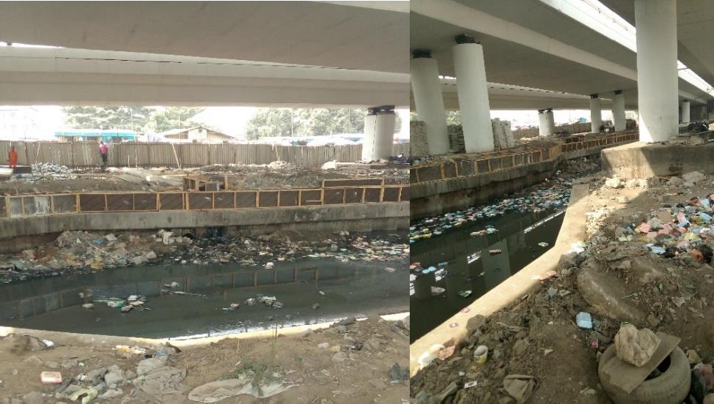

Plate 5. 1: Image showing the water canal under the bridge Source: Author’s field work (2018)

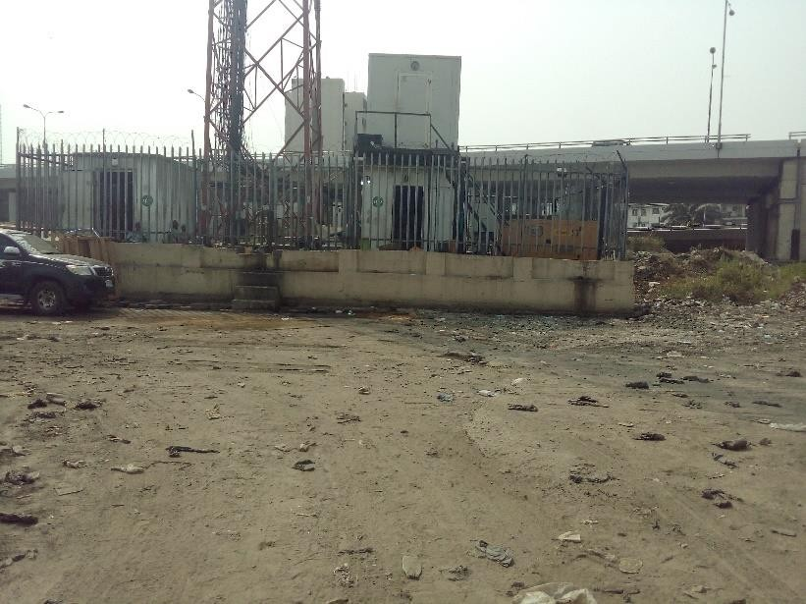

Plate 5. 2: Image showing the communication mask on site Source: Author’s field work (2018)
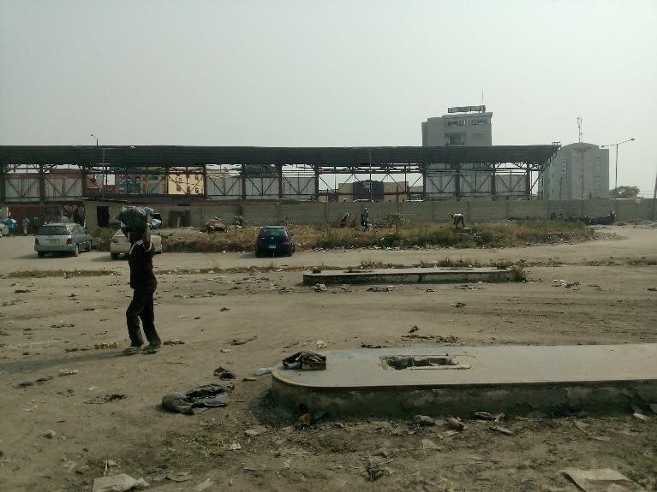

Plate 5. 3: Image showing the remains and debris of the demolished filling station Source: Author’s field work (2018)

SITE ANALYSIS

Site analysis investigates noise levels in different areas of the site, building and solar orientation, drainage possibilities, adjoining and existing structures on the site, possible circulation outlets routes, wind directions and physical characteristics of the site which includes soil conditions, topography and vegetation.

The site analysis will examine these physical features in order to determine the effectiveness of the site in relation to design. This goes with the confirmation that every design begins with the collection of relevant data with regard to the site and its surroundings.

SOIL CONDITION

Soil condition is very important factor to consider when determining the type of activities or structure to be located on a particular site. The site location is a major determinant to the nature of the soil peculiar to a particular area which in turn influences the type of foundation to be use or the structural stability of the structure. The proposed site is at Obalende, Eti-Osa local government Lagos state with no vegetation. Expect for over grown grasses on the demolished debris.

VEGETATION

“The dominant vegetation of the State is the tropical swamp forest consisting of fresh water and mangrove swamp forests both of which are influenced by the double rainfall pattern of the State, which makes the environment a wetland region, hence, the reference to Lagos as an environment of aquatic splendor. (Akomeno & Rasheed, 2016)”

RAINFALL

“Lagos has a tropical wet and dry climate. It experiences two rainy seasons, with the heaviest rains falling from April to July and a weaker rainy season from September to November. There is a brief relatively dry spell in August and a longer dry season from December to March. Rainfall varies from one location to the other in Lagos Megacity. Data obtained at six different locations in the megacity in Table 1 illustrates the variation. The average rainfall for the years 2000 to 2012 is shown in Figure 3 (Akomeno & Rasheed, 2016)”

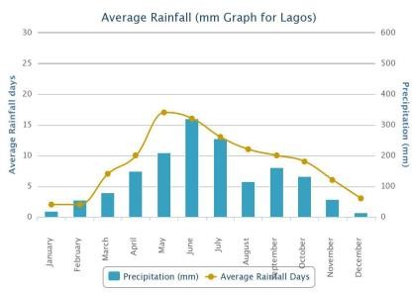

Figure 5. 1: Average rainfall graph of Lagos, Nigeria

Source: https://www.yr.no/place/Nigeria/Lagos/Lagos_Island/statistics.html

TEMPERATURE

“The average monthly temperature ranges from 23°C in July to 32°C in February. The temperature in the tropics is always high this is attributed to the length of sunshine caused by biannual changes and perhaps the atmospheric conditions. The sun rises in the east between 6.30am and 7.30am, it is overhead between 11.30am and 12.30pm, and it finally sets in the west between 5.00pm to 6.00pm. Undoubtedly the sunshine period without rain increases the temperature of the surroundings thereby causing discomfort during the afternoon period; this however will necessitate various measures to prevent direct sun impact. Usually heat brings great discomfort both to human beings and materials.

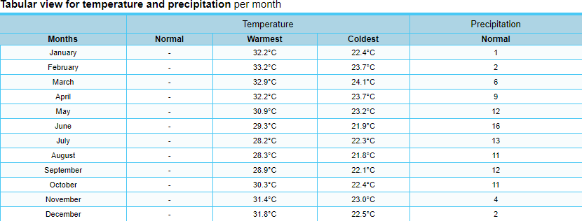

Figure 5. 2: Table showing tabular view for temperature and precipitation per month in Lagos Island Source: https://www.yr.no/place/Nigeria/Lagos/Lagos_Island/statistics.html

PREVAILING WIND

“Two dominant prevailing winds blow over the region depending on the seasons. In the dry season between October and April, the harmattan wind (North-East trade wind), blows from the Sahara and brings about a dry, dusty and uncomfortable atmosphere; while in the rainy season, the South-West trade monsoon wind blows from the Atlantic Ocean area carrying warm, humid air which brings about comforting effect after the long dry season. These winds are desirable for comfort if properly considered at the conceptual stage of design, such that proper orientation of the building will enhance the design internally and externally. The wind is undesirable in situations of violent or dusty wind. This can be controlled by planting of trees, foliages, grasses and good quality floor furnish in interior spaces.”

CHAPTER SIX - DESIGN CRITERIA

PROJECT GOALS AND OBJECTIVES

    - To design a modern bus terminal that will use minimum material, minimize cost and express aesthetic intention using thin-shell concrete structure in the design.
    - To design a modern bus terminal that will incorporate the current trends in the design of bus terminal
    - To design a modern bus terminal that will not only be aesthetically pleasing but also maximize the space use.

FUNCTION AND SPACE CRITERIA

Bus terminal are designed to execute certain travel related functions or activities which will require spaces to carry out such activities adequately. In the design of a functional configuration of a bus terminal the following factors have to be considered.
    - Site orientation

    - Type of bus terminal

    - Passenger and bus traffic circulation

Segregation of pedestrian and vehicular movement is also an important consideration to ensure safety and convenience of the users of the train station. Arrival and departure are to be separated in order to avoid confusion and also to enhance proper circulation. There are two major principal circulation activities to be considered in bus terminal planning, they include:
- Passenger processing

- Baggage handling

Other facilities that are provided in a train station are treated with considerations of their functions and functional relationships. It is important to note that not all the facilities and components of a train station listed here are present in all cases. The inclusion of any of the components depends

on the size, scope and type of operation of the bus terminal. The proposed station bus terminal will however contain virtually all the facilities that would be enumerated.
The facilities to be provided in the train station includes the following

- Public/passengers facilities

- Administrative facilities

- Staff facilities

- Maintenance and service facilities

- Support facilities

PUBLIC/PASSENGERS FACILITIES

these include all facilities associated with all passengers and members of the public during their interaction with the bus terminal building.
The facilities include:

      - Bus terminal building entrance

      - Information system

      - Ticketing facilities

      - Waiting area

      - Baggage handling section

      - Parcel collection office

      - Left and lost luggage room

      - Shops

      - Restaurant/kitchen

      - Public toilet

Bus terminal building entrance: The bus terminal entrance is a space that provides formal entry into the bus. The entrance is designed to evoke a welcoming effect and accessibility to other vital

areas of the bus terminal. Facilities provided within this space include enquiry, security check, phone booths and toilets etc.
The entrance doors are to be incorporated into the façade of the entrance hall in way that it becomes the central point for easy identification. Also the size of the door should be adequate enough to cater for the unusual human traffic during peak periods.
Information system: These are facilities that are provided for the dissemination of vital information to passengers. The information are basically travel schedule announcement of arrival and departure of trains and any other information that might be necessary. They are usually done through the use of
- Loudspeakers situated at strategic locations

- Display of maps, charts and other systems

- Help desk

- Signage

- Computers and television screens

Ticketing facilities: These are facilities provided for the sale of travel tickets to passengers as well as collection of payments form passengers. They should be the most prominent of all passengers’ facilities. They are located away from the circulation paths and queuing areas. Open counter ticketing facilities are more predominant in modern bus terminal as opposed to outdated cage windows. Necessary supporting office are to be provided for this area.
Waiting area: The waiting are is generally a public space where passengers can wait for various reasons ranging from information, waiting for bus, transit, etc. they may be in form of lounges or in basic form of seating area within a large public space. The waiting area should have ease and convenient access to the boarding bay and should be provided with waste bins, ash urns, wall clocks as well as televisions or screens for entertainment.

Baggage handling area: This area accommodates facilities for handling and sorting of passenger’s baggage. It comprises of the parcel weighing office, conveyors, and temporary storage space. They should be accessible from the loading bay. Large space should be created at the weighing office for temporary storage as well as labelling.
Parcel collection office: This is an office which handles the discharge of parcels sent to people through the bus to their owners. The office should be designed in such a way that it is linked to the loading bay. Also accessibility from a vehicle accessible area should be created outside the building for easy carting away of goods and luggage. An adequate space for storage should be provided for the collection office with necessary furniture such as shelves and racks.
Left and lost luggage room: This is a room where un-attended to luggage also termed as left luggage and misplaced baggage (lost baggage) are stored for repossession by rightful owners. It is necessary the room is linked with the parcel collection office. From information gathered, minimal storage space is required as most articles are reclaimed within a few hours. This room should be furnished with storage racks and shelves a well as counter. A reasonable passenger waiting space is required in front of the counters.
Shops: Shops and other forms of concessions for the sale of magazines, newspaper and other articles are usually provided in the bus terminal and are often rented out to private operators. The shops should be situated at strategic places that will catch the attention of the passengers and every other user of the bus terminal. In relation to the nature of the item displayed for sale, necessary furnishing should be provided.
Rental offices: There are generally located at obvious positions preferably near the entrance. Such spaces will be rented for use by postal agencies, banks, air travel agencies, car rental agencies, insurance companies etc.
Restaurant/kitchen: Basically, This is where meals and drinks are sold and served to passengers and other users of the bus terminal. For efficient functioning of the kitchens that service these
restaurants, pantry space and stores should be provided for the kitchen. The restaurants should

have access to the waiting room and should have a variety of seating arrangements. Access for customers should be situated so as not to conflict with the service traffic.
Public toilets: The public toilet should be easily accessed by members of the public and passengers. The location of the toilets should consider the disposition of passengers within the bus terminal. At each location, different toilets should be provided for male and female passengers.

ADMINISTRATIVE FACILITIES

These are facilities provided to help in the efficient running of the bus terminal. They generally consist of office spaces for various personnel (depending on the size and type of bus terminal). They can located preferably at the upper floors of the bus terminal building.
In consideration of the nature of the bus terminal to be designed the following could make up the administrative facilities
      - Offices

      - Signal/communication tower

      - Conference

      - Police post

Offices

Office space should be provided for the key department necessary for efficient running of the terminal. They include, managers and deputy manger’s offices, account office, public relation office, maintenance engineer’s office etc. the manager’s office should be provided with secretary’s office and a toilet. Also general office that will handle miscellaneous functions should be provided. This office should be large (in form of an open hall) to provide enough working space for at least 20 staff.

Signal/communication tower

The communication tower is more or less a high structure where proper monitoring of bus is been done. The tower should be high enough so as to overlook the bus traffic access area.
The space inside the tower should be large enough so as to accommodate communication equipment’s for proper monitoring of the trains. The main function of this unit is to locate the position of the buses to achieve efficiency of schedule and service.

Conference room

As it goes for every conference room, the space is provided for the purpose of conducting meetings and conference organized by the management of the terminal. It should be secluded and zoned in a quiet area preferably with easy access to the manager and staff. It should be adequately lit and naturally ventilated.

STAFF FACILITIES

These are facilities provided for the exclusive use of staff of the bus terminal. There is a need for a proper grouping of all this facilities in a particular zone but could be distributed in response to necessary demand with close access to the category of staff they were created for.
The facilities includes:

      - Senior and junior staff lounge

      - Staff rest room

      - Staff restaurant

      - Staff locker room

      - Staff toilet

      - Training/lecture room

Staff lounge

The staff lounge is a room in which the staff gets to relax and for recreation activities. Various forms of board games should be provided for relaxation. It should not be too far from the staff restaurant and the staff rest room. The size of the lounge is dependent on the staff strength.

Staff cafeteria

This cafeteria is essentially created for the staffs of the bus terminal. This is done in order to save time lost by movement of staff in and out of the premises for refreshment during break time. Meal sold at the cafeteria are usually subsidized by the authorities as a form of incentive to workers. The cafeteria is serviced from the kitchen via the pantry.

Staff locker room

This are temporal storage space in form of separate locker units mainly use by cleaners and bus operators. This room is generally best situated in the maintenance and service with the inclusion of staff toilets bathrooms located within the room for both sexes.

Staff toilets

The number of toilets to be provided will be dependent on the staff strength of the station. There should be proper zoning of these facilities in relation with the staff offices. The toilets have the same planning consideration as the public toilets.

Training/lecture room

As the name implies this room is provided for learning and relearning for staff. This space should be adequate enough for the use of machines for demonstrations and should have good ventilation and lighting.

SUPPORT FACILITIES

These facilities differ in types and functions and are provided to boost the operational standard of the bus terminal they include
      - Car parks

      - Security disposal facilities

      - Generator house

Parking

The number of parking lots to be provided will be dependent on the expected number of passengers during peak periods. A car occupancy rate of 7 passengers per car will be considered appropriate.
The staff car park should be secluded away from the general parking and it should be near the staff entrance and the number to be provided is determined by the staff strength. The recommended angles should be 45 and 90 degrees.

Security facilities

Security in a bus terminal is provided in two forms. Firstly in the form of security service or officers to ensure proper conduct of every bus terminal user and secondly in the form of security facilities against certain risks e.g. fire, burglary etc. the security services/officer ensure orderliness, the non-existence of tout activities and the safety of both passengers and their luggage against theft and pilferage.
The security facilities include fire points strategically located within the bus teminal.

Generator house

This houses the power generating plant. It could be detached and provided with an operator’s office and a store. Proper acoustic solution and vibration damping measures should be taken in to consideration. A fuel storage tank is to be provided with good access for maintenance and discharge of fuel.

EQUIPMENT AND OPERATIONAL REQUIREMENTS FOR ALL CIRCULATION ELEMENTS

The general requirements for all circulations elements are to enable and orderly sequence of flow for both arriving and departing passengers without disruption from queues and passenger cross flows.

Walkways

They include all horizontal circulation spaces providing access or egress to and from the bus terminal. Walkway can be define as circulation medium with a gradient less than 1:20 and are only acceptable to a maximum rise of one meter. This is done to reduce the travel distance in order to prevent passengers fatigue and inequity.

Ramps

Ramps are sloping surfaces that allows access from one level to a higher or lower level. It is a circulation space with a gradient 1:20 or greater. Generally ramps to busterminal must have a constant gradient with a maximum gradient of 1:10 with landings at nominally every 9m except on accessible path. Also landings to ramps are to have a setback of about minimum 900mm from any cross circulation.

Stairs

Stairs are series of steps leading to or from one level to another. They are common means of access between changes in level. One of the major advantage they have over mechanical medium of vertical circulation is that they are continuously available and not subjected to mechanical failure. They must be designed and constructed to be safe for both regular circulation and emergency exit.
For uniformity around the circulation systems and to achieve comfortable stairs, they should be designed to meet some specific details such as:
The stair width must accommodate normal passengers’ movement in two directions. The minimum width should be of about 1.8mm-2.0mm clear between handrails. There should be

provision for emergency exit and in a case where the width of the stairs exceeds 2meters a center double handrail is to be provided.
Stair flight: the design of the stair flight must not include winding, curved and spiral designs. In a case where the height of stairs rises above 5.3m there should be provision of at least 2 landings. The landing should have a minimum width of about 1500mm, although at wider stairs it is preferred that the stair landings increases in length to match the stair clear width.
Stair details: the stair detail must be designed with the following considerations.

The riser and the tread of the stairs should be of 150mm and 300mm dimension respectively. Open risers are not permitted and a solid barrier in the vertical plane with no gaps in the horizontal plane is required to prevent objects from falling off the edge of stairs.
Handrails: handrails are provided on stairs, ramps and walkways to assist people’s passage from one level to the other. Generally, handrail is to be of a height of about 900mm from the finished floor level they are to be fabricated out of stainless steel and should be of luminance contrast with the background. Handrails must project beyond the end of stairs

Escalators

Escalators are mechanical stairs i.e. a set of moving steps attached to a continuously circulating belt that conveys people up or down between levels in a building. Escalators are to be considered instead of stairs where the vertical height is above 4m or where the passenger capacity cannot be satisfactorily accommodated by stairs, lifts or ramps.
The general requirement for escalators includes:

- They should be reversible i.e. up and down

- Heavy-duty to meet the operating bus terminal requirements of 20hrs per day, 365 days per year
- Minimum of 1m step width (minimum 2 people width) with a standard escalator angle of 30degree

Maximum speed should be 0.65m per second

TECHNOLOGICAL AND ENVIRONMENTAL CRITERIA

Materials and finishes

The right selection of materials and finishes is critical in achieving a calm, bright, light and clean station. Materials, finishes, fixtures and fittings to be considered for selection must be durable i.e. must posse properties to withstand extreme wear and tear, be highly resistant to vandalism, be non-combustible, self-finished where possible, easily cleaned and maintained with minimal disruption to station operations.
The selection of the finishes must include a proper assessment of each element’s form, size, material composition, fixing system and detail. The finish of each floor, wall, column, ceiling and soffit elements must be selected with regards to:
      - Fitness for purpose within the rail environment. Considerations must be given to materials resistance to ultra-violent light, high humidity, corrosive environments and exposure to stray electrical currents.
      - Durability (with emphasis on vandal resistance and moisture resistance)

      - Structural integrity (particularly resistance of materials, fastening devices and support systems to train-generated vibrations)
      - Ease of construction

      - National Building code of Nigeria

      - Station category and user requirements brief

General requirements of materials

Finishes will be non-combustible, easily cleaned, and durable and be replaceable with minimum disruption to station operations.

Floor finishes

Floor finishes in public areas where water or wash down water is present will have a non-slip textured finish.

Ceiling and Soffit Lining Selection

Ceiling design requires a high level of coordination between the bus terminal architecture and services design. A suspended, modular ceiling system with mechanical fixings, access panels and secure fastenings to withstand uplift and downdrafts is preferred.
The ceiling design requirements vary with each bus terminal. For example:

      - Where there are high ceiling volumes or areas where people move through a station quickly, it may be appropriate to have a very open ceiling, with minimal screening to any ceiling voids beyond. An open ceiling may be beneficial for smoke management, acoustics, maintenance and cost.
      - Other bus terminal areas may demand high quality, fully opaque ceiling linings. This may be required to conceal services, unsightly ceiling voids and absorption panels.
Full ceilings may also be required to integrate ceiling services and fixtures, provide a reflective surface to assist bus terminal luminance, form a smoke plenum or to achieve a clean and low maintenance finished surface.

SERVICES

This section discusses the standards and performance requirements for the building services.

General

A building management system shall be provided for control and monitoring of E&M services at bus terminal.

Electrical services

The electrical power design shall comply with the relevant current International standards, local codes and statutory requirements.

LEGAL AND PLANNING REGULATIONS

Preliminary investigation of land required for bus terminal purposes

- Whenever it appears that a land in any locality is likely to be needed for any purposes of a bus terminal, it will be necessary to gather workmen, enter upon any land in such locality and-
  - Survey and take levels of such land;

  - Dig or bore under the sub-soil;

  - Do all other acts necessary to ascertain whether the land is adequate for such purposes; Provided that no such servant, agent or workman shall enter into any building or upon any enclosed court or garden attached to a dwelling-house (except with the consent of the occupier thereof), unless at least seven days' notice of the intended entry shall have been given to such occupier.
- In case of dispute as to the amount of any compensation payable under this section, the amount of the compensation may be determined in the manner provided by the Land Use Act for determining the compensation payable, where a right of occupancy is revoked.

BEHAVIOURAL AND AESTHETICS CRITERIA

The design of the bus terminal is aimed at creating a functional, user friendly and attractive terminal with efficient and safe circulation pattern.
The behavioral criteria of a bus terminal is in such that the terminal is designed to meet its primary functions without any compromise on aesthetics, structural stability as well as user’s safety. The choice of materials, structural systems and circulation component are to be specified and designed to meet the passengers’ traffic.
Aesthetics of bus terminals are very important considerations in the design of train stations. Bus terminals often times are iconic buildings with strong architectural character. This is achieved through the use of context appropriate, durable, low maintenance materials which are sustainable. Materials considered for usage includes materials that are difficult to deface, damage and remove.

CHAPTER SEVEN - APPROACH TO THE DESIGN

DESIGN PHILOSOPHY
Bus terminal are often design to be monuments to architectural design and style. Impressive shapes are combined with sustainable materials with enhanced passenger and transportation flow concepts to make these buildings great work of architecture.
The rationale of the design has to do with simplicity in design approach using thin-shell concrete structure with functional requirements being the main focus with due regard to climatic parameters, especially the indoor climate, ventilation and natural light are of paramount importance considering the deficiencies in some basic infrastructure in the country. The design philosophy is to perfectly unify building space to create an efficient circulation system, technology and material. Materials with long service life with new technology will be applied, to encompass sustainable development concepts as ecology, greening and environmental protection.

DESIGN CONCEPT

The design concept is based on the axiom “function follows form” i.e. the shape of the building was primarily designed for its functions to serve, due to the following reasons
    - Location of the Bus terminal building area for the site plan to function properly is constrained.
    - The structural system employed for the building type, is such that for every square meter occupied by the structural element, volume is unbelievably maximized. Given that the thin-shell structure that will be employed will be the hyperbolic paraboloid.

DESIGN DEVELOPMENT PROCESS

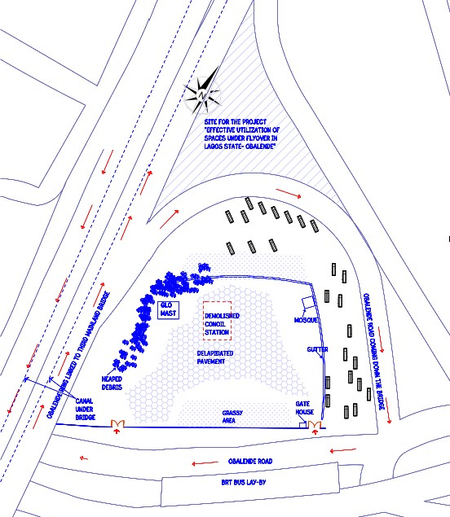

Figure 7. 1: Actual site Source: Author’s field work (2018)

SITE ZONING
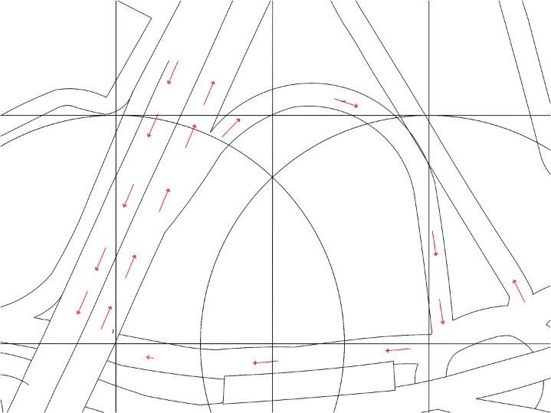

Figure 7. 2: Rough drawing for site zoning Source: Author’s work (2018)

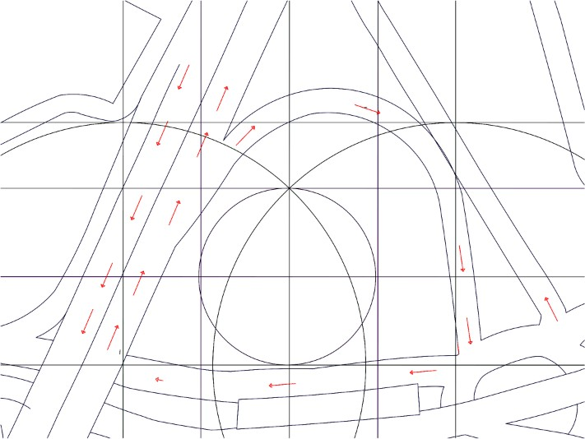

Figure 7. 3: Rough drawing for site zoning Source: Author’s work (2018)

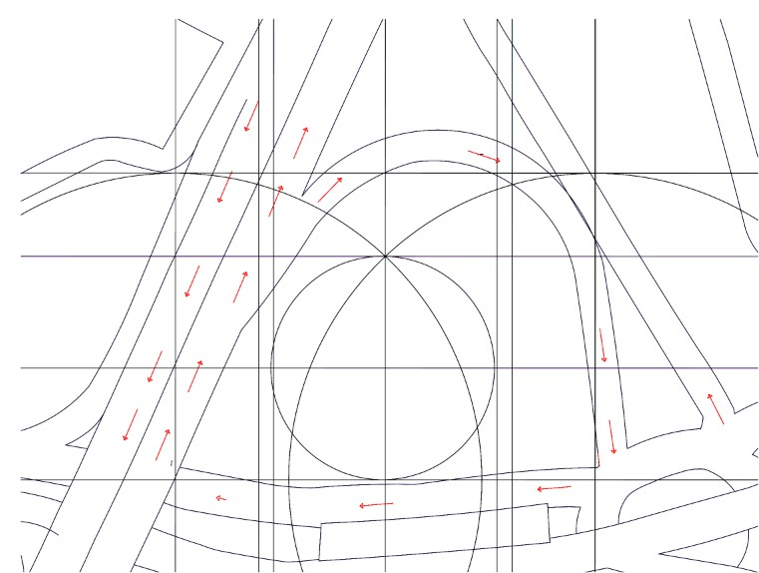

Figure 7. 4: Rough drawing for site zoning Source: Author’s work (2018)

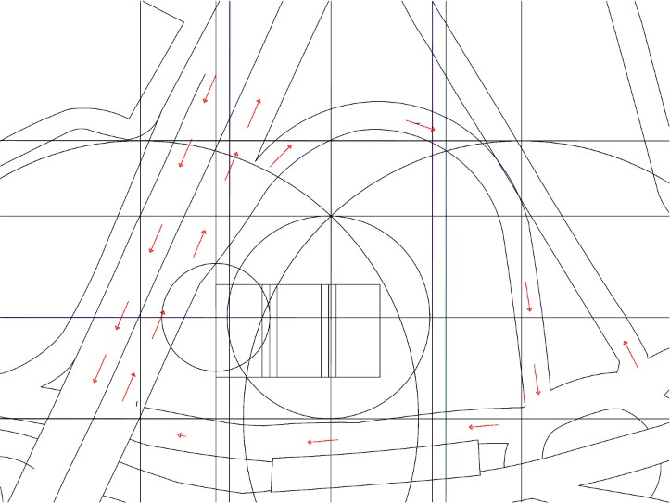

Figure 7. 5: Rough drawing for site zoning Source: Author’s work (2018)

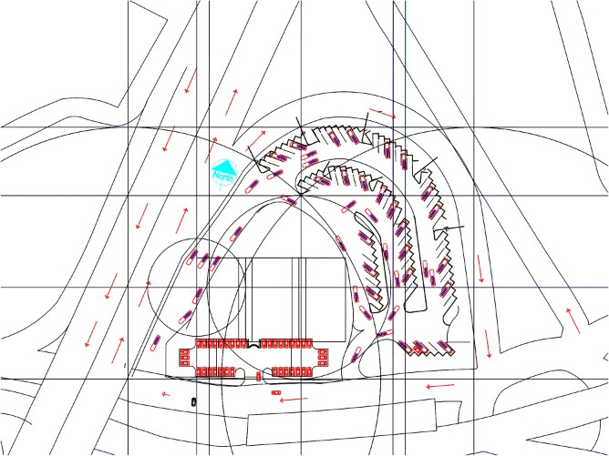

Figure 7. 6: Rough drawing for site zoning Source: Author’s work (2018)

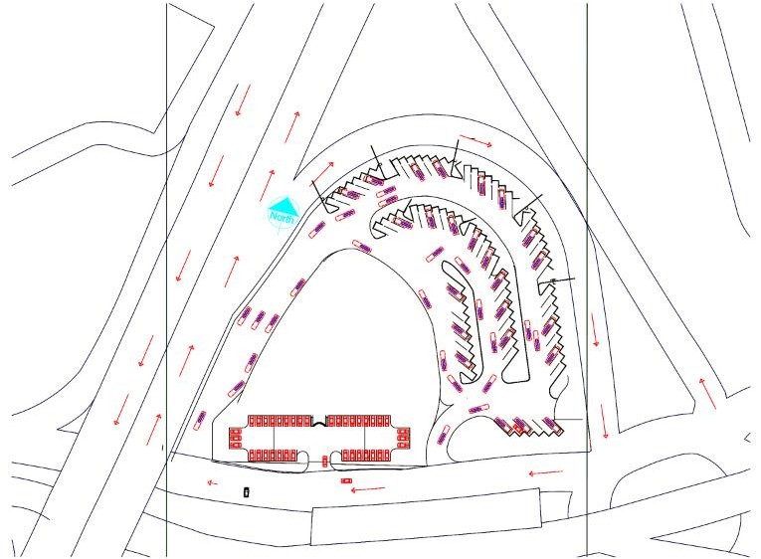

Figure 7. 7: Rough drawing for site zoning

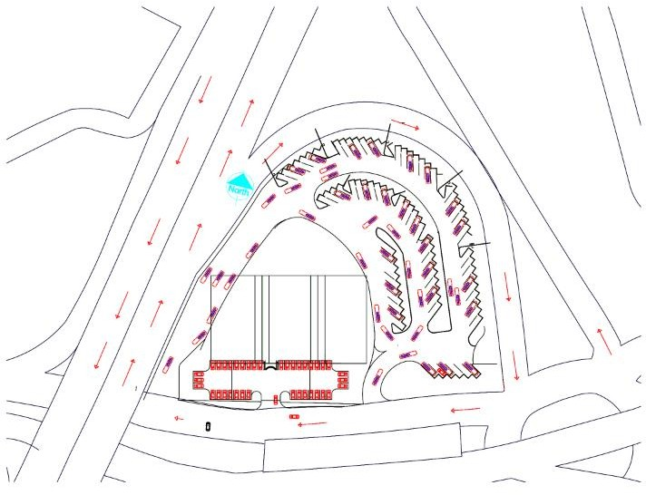

Figure 7. 8: Rough drawing for site zoning Source: Author’s work (2018)

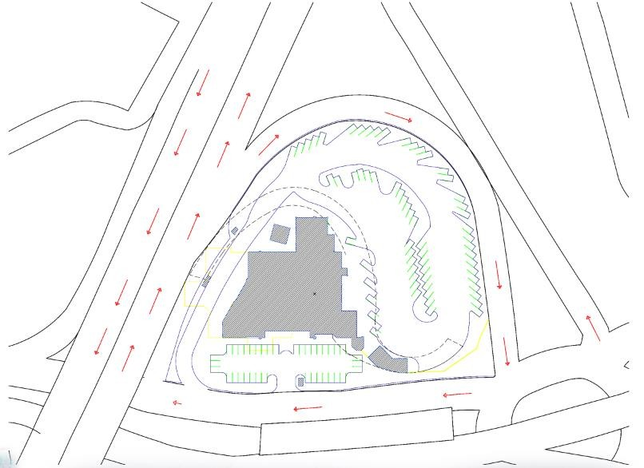

Figure 7. 9: Proposed site zoning

FREE HAND SKETCHES

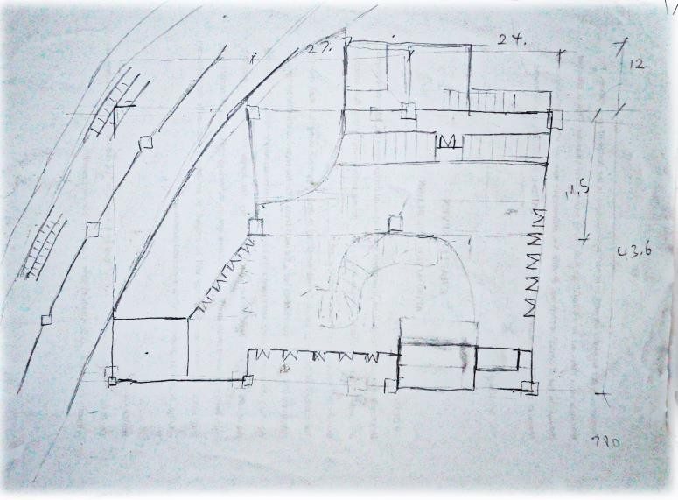

Plate 7. 1: Initial hand sketch of proposed ground floor plan Source: Author’s work (2018)
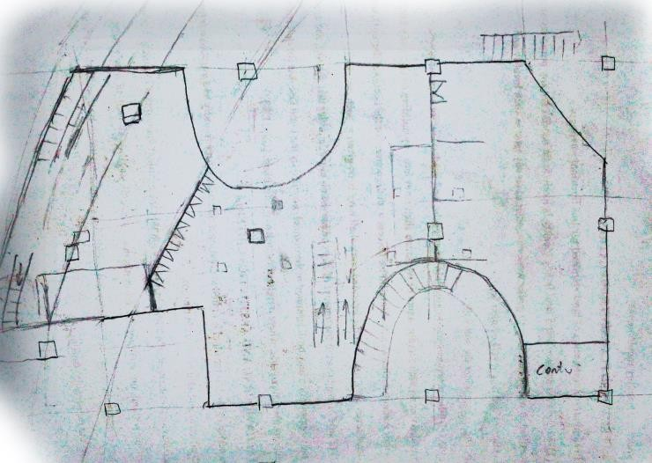
Plate 7. 2: Initial hand sketch of proposed first floor plan

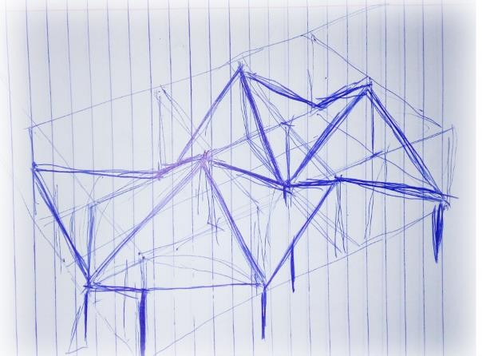

Plate 7. 3: Initial hand sketch of the proposed structure of the building Source: Author’s work (2018)
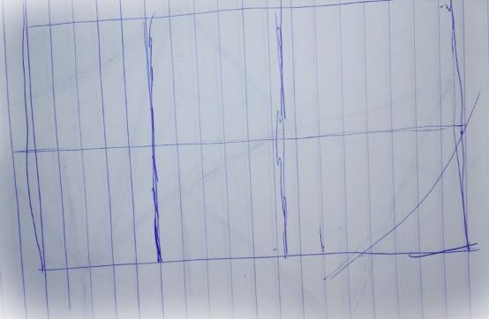
Plate 7. 4: Initial hand sketch of the roof structure divided into three bays Source: Author’s work (2018)

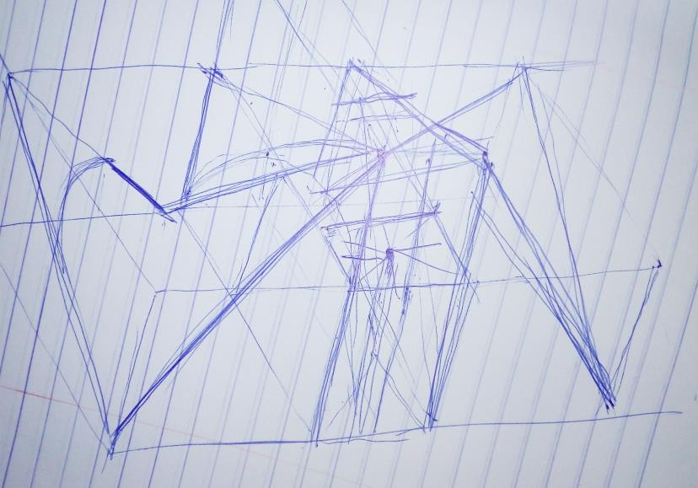
Plate 7. 5: Initial hand sketch of how the roof bays unite Source: Author’s work (2018)

FLOW CHART

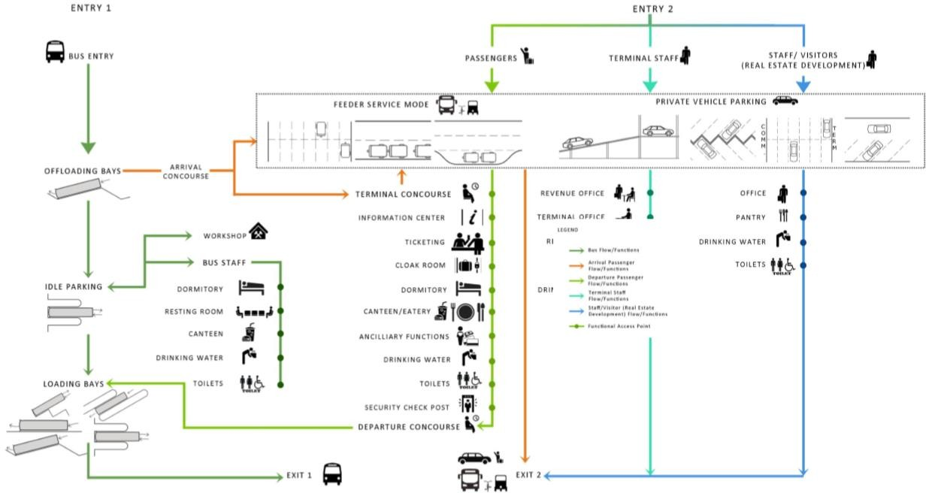

Figure 7. 10: Bus terminal passenger flow chart Source: Sandeep, et al (2015)

References

Adler, D. (2000). Metric Handbook Planning and Design Data. Woburn: Reed Educational and Professional Publishing Ltd.
Agunloye, O. O. (2011). Analysis of the travels of public transport passengers (road) in Ikorodu, Lagos, Nigeria . Journal of Geography and Regional Planning , 443 - 448.
Akinsanmi, G. (2016). Ambode Unveils $70 million Oshodi Transport Interchange. Lagos: ThisDay.
Akomeno , U. O., & Rasheed, A. A. (2016). The Lagos Megacity. Lagos: Director, Akute Geo- Resource Ltd, Director, Hanorado Global Solutions Nig Ltd.
Alekhya, J., & Pei, L. (2014). Enhancing the Safety of Visually Impaired Travelers. Pittsburgh: TechBridgeWorld.
Al-Sharif, L. (1996). Escalator Handling Capacity: Standards Versus Practice. London: Elevator World.
American Society of Heating, Refrigerating and Air-Conditioning Engineers. (2011). 2011 ASHRAE Handbook: Heating, Ventilating, and Air-conditioning Applications. Alanta: ASHRAE.
American Society of Heating, Refrigerating and Air-Conditioning Engineers. (2012). 2012 ASHRAE Handbook: Heating, Ventilating, and Air-conditioning Applications. Atlanta: ASHRAE.
Andres, M., & Hernandez, S. (2016). Efficient urban interchanges: the City-HUB model. 6th Transport Research Arena (pp. 1124 - 1133). Barcelona: Elsevier B.V.
Appelgren, P. (2018, March 14). Departure and Arrival. Retrieved from Cityterminalen: http://www.cityterminalen.com/en/Departures-and-arrivals/
Archdaily. (2009, August 4). Rosa Parks Transit Center / FTL Design Engineering Studio.

Retrieved from Archdaily: www.archdaily.com

Ashim , K. D., Hoong , C. C., Mazharul , H., & Belinda , Y. (2014). A Methodological Frame for Benchmarking Smart Transport Cities. Elsevier, 47 - 56.
Bakry, O. M. (2008). An Approach to Sustainable Design of Intermodal Stations in Greater Cairo Region. Cairo: Ain Shams University.
Banks, J. H. (2002). Introduction to Transportation Engineering. London: McGraw-Hill. Barney, G. C. (2003). Elevator Traffic Handbook Theory and Practice. New York: Taylor &
Francis Routledge.

Bhatia, A. (2014, May 9). How a 19th Century Math Genius Taught Us the Best Way to Hold a Pizza Slice. Retrieved from Get Wired: https://www.wired.com/2014/09/curvature-and- strength-empzeal/
Blow, C. (2005). Transport Terminals and Modal Interchange. Burlington: An imprint of Elsevier Linacre House, Jordan Hill, Oxford OX2 8DP 30 Corporate Drive, Burlington MA 01803.
Bosch. (2013). AEGIS UFLED Intelligent-IR Illuminator. Berlin: Bosch Security Systems.

Botha, A. G. (2014). Integrative transport and modal interchanges: A social sustainable approach towards urban migration. Journal of Civil Engineering and Construction Technology, 49-62.
Botha, B., Adendorff, C., Gericke, G., & Adendorff, G. L. (2014). Integrative transport and modal interchanges: A social sustainable approach towards urban migration. Journal of Civil Engineering and Construction Technology, pp. 49-62.
Brudevold, & Sigmund , A. (1957). A Bus Terminal Study for Tacoma. Washington: Department of Architecture.
Buscaonibus. (2017). Sao Paulo Bus Station-Tiete. Retrieved from Buscaonibus: https://www.buscaonibus.com.br/en/bus-stations/sao-paulo-tiete
Cabello, A. (2015, September 4). The secret of Candela’s umbrellas. Retrieved from

ResearchGate:

https://www.researchgate.net/publication/281457323_The_secret_of_Candela's_umbrell as
Caner, C. (2005). Design Criteria of High Capacity Bus Transportation Systems. İzmir: İzmir Institute of Technology.
Carlson, J. (2014, October 22). A Look Back At The Brief Glory Days Of Port Authority Bus Terminal, One Of NYC's Ugliest Buildings. Retrieved from Gothamist: http://gothamist.com/2014/10/22/port_authority_once_nice.php#photo-1
Charles , K. J., Charles, P., & Donald, D. R. (1965). Highway Capacity The Level of Service Concept. 35th Annual Meeting of the Institute of Traffic Engineers "A World Traffic Engineering Conference" (p. 1 to 56). Texas: Texas Transportation Institute.
Chiara, J. D. (1990). Time-Saver Standard for Building Types. Oklahoma City: Mcgraw-Hill Professional Publishing.
Chow, W. K. (2005). Assessment of Fire Hazard in Small News Agents in Transpart Terminal Halls. Journal of Architectural Engineering, 35 - 38.
Chrisafis, A., & Vaughan, A. (2017, July 6). France to ban sales of petrol and diesel cars by 2040. Retrieved from The Guardian: https://www.theguardian.com/business/2017/jul/06/france-ban-petrol-diesel-cars-2040- emmanuel-macron-volvo
Commercial Energy Library. (2013). All-Air Central Systems. Retrieved from Apogee Interactive: https://c03.apogee.net/contentplayer/?coursetype=ces&utilityid=duquesnelight&id=132 1
Dearborn, F. (2004). Encyclopedia of The 20th Century Architecture. New York: Taylor and Francis Group.

Emma. (2018, March 9). How To Develop Architectural Concepts. Retrieved from First In Architecture : http://www.firstinarchitecture.co.uk/how-to-develop-architectural- concepts/
Enne , D. B., & Joost , V. R. (2009). Towards Systematic Design of Urban Bus Stations, Reinforcing a Weak Link in a Public Transport Chain. European Transport Conference, 2009 (pp. 1-2). Leiden Leeuwenhorst: Association for European Transport and contributor.
Eric , M. H., & Billington, P. D. (2004). Anton Tedesko and The Introduction ot Thin Shell Concrete Roofs in The United States. Journal of Structural Engineering, 1639 - 1650.
Feedback Infrastructure Services Pvt. Ltd., India. (2012). Prefeasibility Study for Developing Bus Terminal-Cum-Commercial. Karnataka: Government of Karnataka, Infrastructure Development Department.
Florinda Boschetti, I. M. (2014). Innovation Urban Transport Solutions. Europe: Local Governments for Sustainability, European Secretariat.
Fruin, J. J. (1971). Design for Pedestrians: A Level-of-Service Concept. 50th Annual Meeting of the Highway Research Board (pp. 1 - 15). Washington District of Columbia: Committee on Pedestrians.
Fruin, J. J. (1971). Pedestrian planning and design. New York : Metropolitan Association of Urban Designers and Environmental Planners.
Garlock, Moreyra, M. E., & Billington, D. P. (2008). Félix Candela: engineer, builder, structural artist. Princeton: Princeton University Art Museum.
Handy, S. (2016, March 30). A little history of urban transportatio. Retrieved from TTP 220: http://www.des.ucdavis.edu/faculty/handy/TTP220/TTP220_History1.pdf
Hieu, K. (2015). An Approach Towards The Integration of Bus Information Systems in Vietnam.

Ho Chi Minh: Lahti University of Applied Science.

Hoque, A. M. (2011). BRTC International Bus Terminal. Dhaka: Department of Architecture.

Igwe, C. N., Oyelola, O. T., Ajiboshin, I. O., & Raheem, S. (2013). A Review: Nigeria’s Transportation System and the Place of Entrepreneurs. Journal of Sustainable Development Studies, 168-180.
International Road Transport Union. (2009). Doubling The Use of Collective Passenger Transport by Bus and Coach. Europe: Busworld.
Jaiswal, S. K. (2010). Busway Platform Bus Capacity Analysis . Queensland: Queensland University of Technology.
Jean, P., Claude , C., & Brian, S. (2017). The Nature of Transport Terminals. London and New york: Routledge. Retrieved from THE GEOGRAPHY OF TRANSPORT SYSTEMS: The Nature of Transport Terminals
Kanta, N. (2015). Design of a Thin Concrete Shell Roof for a Basketball Arena of 20,000 spectator capacity. Delft: Faculty of Civil Engineering and Geosciences · Delft University of Technology.
Kiggundu, A. T. (2009). Financing public transport systems in Kuala Lumpur, Malaysia: challenges and prospect. Transportation, 275 - 294.
Lagos Metropolitan Area Transport Authority. (2010). Bus Rapid Transit (BRT) in Lagos Metropolis. Retrieved from LAMATA: www.lamata-ng.com
Lagos Metropolitan Area Transport Authority. (2018, March 5). Road. Retrieved from LAMATA: http://lamata-ng.com/road/
Limited Deloitte Touche Tohmatsu India . (2012). Pre-Feasibility Report for Development of Bus Terminals. Karnataka: Directorate of Urban Land Transport, Government of.
Lindstrom, C. (2013). Energy Efficient Design of Bus Terminals. Gothenburg, Sweden: Chalmers University of Technology.
Loisa, D., Monzonb, A., & Hernandez, S. (2017). Analysis of satisfaction factors at urban transport interchanges: Measuring travellers’ attitudes to information, security and
waiting. Transport Policy, 1 -8.

Manjurali, I. B., Ajay , R. P., & Kirankumar , P. P. (2016). Bus Rapid Transit System (BRTS) - A Sustainable Approach - Literature Review. GRD Journals | Global Research and Development Journal for Engineering | Recent Advances in Civil Engineering for Global Sustainability, 368 - 373.
Maten, R. N. (2011). Ultra High Performance Concrete in Large Span Shell Structure. Delft: Delft University of Technology.
Mathew, T. V. (2017). Capacity and Level of Service LOS. Bombay: Department of Civil Engineering .
Michavila, X. (2018, March 17). Eduardo Torroja, Carlos Arnic. Retrieved from Flickr: https://www.flickr.com/photos/ximo_michavila/sets/72157634270369442
Muller, G. (1999). Intermodal Freight Transportation. Northwestern: Eno Transportation Foundation.
National Research Council (U.S.), Building . (1961). Requirements for Weatherproofing Thin Shell Concrete Roofs Research Institute. Washington D. C.: Nationa Academy of Science.
Naveen , K. S., & Dinesh , K. (2018, March 17). Hyperbolic Paraboloid. Retrieved from mathumatiks: http://mathumatiks.org/subpage-533-Hyperbolic-Paraboloid.htm
Nekabari, L. (2010). Port Harcourt Boat Terminal. Enugu, Nigeria: University of Nigeria, Enugu Campus.
Nielstrop. (2017). Nils Ericcon Terminal. Retrieved from NielsTorp: https://nielstorp.no/project/nils-ericson-terminal/
Nottinghasm. (2016, January 28). On forgotten bus stations and taking local history personally.

Retrieved from nottinghasm: https://nottinghasm.wordpress.com/2016/01/28/on- forgotten-bus-stations-and-taking-local-history-personally/
Oladipo, O. (2012, December 20). Nigeria: Obalende - a Lagos Community Losing Its Rich

Past. Retrieved from allafrica: http://allafrica.com/stories/201212311024.html

Olatunji, A. (2015, may 11). Major Bus Stops in Lagos: Obalende. Retrieved from Cool stuff you can use.: http://www.coolstuff49ja.com/search?q=obalende#.WgTT_WhSy00
Olatunji, A. (2015, May 11). Major Bus Stops in Lagos: Obalende. Retrieved from Cool stuff you can use: http://www.coolstuff49ja.com/2015/05/major-bus-stops-in-lagos- obalende.html?cv=1#.Wp6Ba-jwa00
Oshodi, L. (2016). Transportation and Mobility System in Lagos. Retrieved from Lookman Oshodi International Development, Urban Infrastructure and Governance: https://oshlookman.wordpress.com/2016/08/12/transportationandmobilitysysteminlagos/
Oshodi, L. (2016). Transportation And Mobility System in Lagos. Retrieved from Transportation Hub at Lagos Island CBS: https://www.researchgate.net/profile/Lookman_Oshodi/
Paul, S. (2017, January 23). Shell structure. Retrieved from SlideD=Share: https://www.slideshare.net/SusmitaPaul12/shell-structure?qid=f1a7d255-1d9b-49d8- afdb-8be5cd226ee0&v=&b=&from_search=6
Pereira, V. V. (2015). Design and Applications of Ultra-thin Free-form Shell Structures.

Lisboa: Technico Lisboa.

Pickard, Q. (2002). The Architects’ Handbook. UK: Blackwell Publishing Company. Pitsiava-Latinopoulou, M., & Iordanopoulos, P. (2012). Intermodal Passengers Terminals:
Design standards for better level of service. Procedia - Social and Behavioral Sciences

(pp. 3297 - 3306). Thessaloniki: Elsevier.

PPIAF. (2006). Bus Station and Terminals. Retrieved from Urban Bus Toolkit Tools and Options for Reforming Urban Bus Systems: https://ppiaf.org/sites/ppiaf.org/files/documents/toolkits/UrbanBusToolkit/assets/3/3.1/3 5(vii)a.html
Private, L. D. (2012). Pre-Feasibility Report for Development of Bus Terminals at Belgaum and

Hubli on PPP. Karnataka: Directorate of Urban Land Transport.

Priyanka , V., & Naresh , K. (2015). A Methodology to Incorporate Infrastructure into Public Transport Planning in Constrained Urban Areas. Wadala: Urban Transport EMBARQ India.
Reid, E. (1984). Understanding buildings: a multidisciplinary approach. Massachusetts : MIT Press.
Ressler, S. (2017, January 20). Amazing Thin Shells—Strength from CurvatureLecture no. 21 from the course: Understanding the World's Greatest Structures. Retrieved from The Great Courses Plus: https://www.thegreatcoursesplus.com/understanding-the-worlds- greatest-structures/amazing-thin-shells-mdash-strength-from-curvature
Roess, R. P. (1990). Level of Service Concepts: Development, Philosophies, and Implications.

Transportation Research Record, 1 to 6.

Roger , P. R., & Elena , S. P. (2014). The Highway Capacity Manual: A Conceptual and Research History. Switzerland: Springer International Publishing.
Roger , P. R., & William , R. M. (1987). Capacity and Level-of-Service Concepts in the Highway Capacity Manual. ITE Journal, 27 - 30.
Sandeep, G., Satyajit , G., Ruchi , V., Shruti , K., Rajat , K., & Nilesh , B. (2015). Bus Terminal Design Guidelines. New Delhi: SGArchitects.
Spillar, R. J. (1997). Park-and-ride Planning and Design Guidelines. New York: Parsons Brinckerhoff Incorporated.
Srinivas, K., Kailashnathan, K., Anil, M., Pujari, P. J., & Jayant, P. (2005). Bus Rapid Transit System. Ahmedabad: Centre for Environmental Planning & Technology University, Ahmedabad.
Stuart Meek, S. I., Stuart , M., Stephen , I., & Marcus , E. (2008). Role of Bus-Based Park and Ride in the UK: A Temporal and Evaluative Revie. Transport Reviews, 781-803.
T grupp AS. (2016). Bus station history. Retrieved from Tallinna bussijaama:

http://bussijaam.ee/en/about-the-company/history/

Templer, J. (1994). The Staircase: Studies of Hazards, Falls, and Safer Design. Cambridge: Massachusetts Institute of Technology.
The Port Authority of New York. (2018). Terminals History. Retrieved from Port Authority Bus Terminal: https://www.panynj.gov/about/history-terminals.html
The Princeton University Art Museum. (2008). Experiencing Candela Structures. Retrieved from Felix Candela: http://artmuseum.princeton.edu/legacy- projects/Candela/experiencing.html
TJPA. (2017). Terminal History. Retrieved from Transbay Transit Center: http://tjpa.org/project/terminal-history
Tom V. Mathew, K. V. (2007). Introduction to Transportation Engineering. NPTEL . Transportation Research Board. (2000). Highway Capacity Manual 2000. Washington DC:
National Academy of Sciences.

Tully, D. F. (1979, February 6). Inverted, Doubly-Curved Umbrella, Hyperbolic Paraboloid Shells with Structurally Intergerated Upper Diaphradm. Uniteed States Patent.
Turnbull, R. (2013). Public Transport Interchange Design Guidelines . Auckland: National Specialist – Public Transport .
Whrton, J. (2014, April 14). At least 71 DEAD, 124 injured in suspected terror attack in Nigeria. Retrieved from Express, Home of the Daily and Sunday Express: https://www.express.co.uk/news/world/470345/Dozens-killed-in-terror-attack-at-bus- station-in-Abuja-Nigeria
Wikimapia. (2018). Tietê Bus Station (São Paulo). Retrieved from Wikimapia The map created by people like you: http://wikimapia.org/48789/Tiet%C3%AA-Bus-Station
Wikipedia. (2017, August). Bus. Retrieved from Wikipedia The Free Encyclopedia: https://en.wikipedia.org/w/index.php? title=Bus&oldid=793881256
Wikipedia. (2017, November 4). Conceptual design. Retrieved from Wikipedia The Free

Encyclopedia: https://en.wikipedia.org/wiki/Conceptual_design

Wikipedia. (2017, August 12). Concrete Shell. Retrieved from Wikipedia The Free Encyclopedia: https://en.wikipedia.org/w/index.php?title=Concrete_shell&oldid=795099039
Wikipedia. (2017, October 6). Land transport. Retrieved from Wikipedia. The Free Encyclopedia: https://en.wikipedia.org/wiki/Land_transport
Wikipedia. (2017, July 11). Level of service. Retrieved from Wikipedia The Free Encyclopedia: https://en.wikipedia.org/wiki/Level_of_service
Wikipedia. (2017, October 20). Public Transport Bus Service. Retrieved from Wikipedia The Free Encyclopedia: https://en.wikipedia.org/wiki/Public_transport_bus_service
Wikipedia. (2017, July). Transport hub. Retrieved from Wikipedia The Free Encyclopedia: https://en.m.wikipedia.org
Wikipedia. (2018, March 8). Electric bus. Retrieved from Wikipedia The Free Encyclopedia: https://en.wikipedia.org/wiki/Electric_bus
Wikipedia. (2018). Obalende. Retrieved from Wikipedia The Free Encyclopedia: https://en.wikipedia.org/wiki/Obalende
Wikipedia. (2018). San Francisco Transbay Terminal. Retrieved from Wikipedia The Free Encyclopedia: https://en.wikipedia.org/wiki/San_Francisco_Transbay_Terminal
Wikipedia. (2018). Tietê Bus Terminal. Retrieved from Wikipedia free encyclopedia: https://en.wikipedia.org/wiki/Tiet%C3%AA_Bus_Terminal
Wikipedia. (2018, March 2). Transbay Transit Center. Retrieved from Wikipedia The Free Encyclopedia: https://en.wikipedia.org/wiki/Transbay_Transit_Center
Wood, A. (2016). Multiple Temporalities of Policy Circulation: Gradual, Repetitive and Delayed Processes of BRT Adoption in South African Cities. International Journal of Urban and Regional Research, 568 - 580.

WSP USA. (2017). Rosa Parks Transit Center. Retrieved from WSP USA: http://www.wsp- pb.com/en/WSP-USA/What-we-do-USA/Transportation-- Infrastructure/PROJECTS/Rosa-Parks-Transit-Center/

APPENDICES

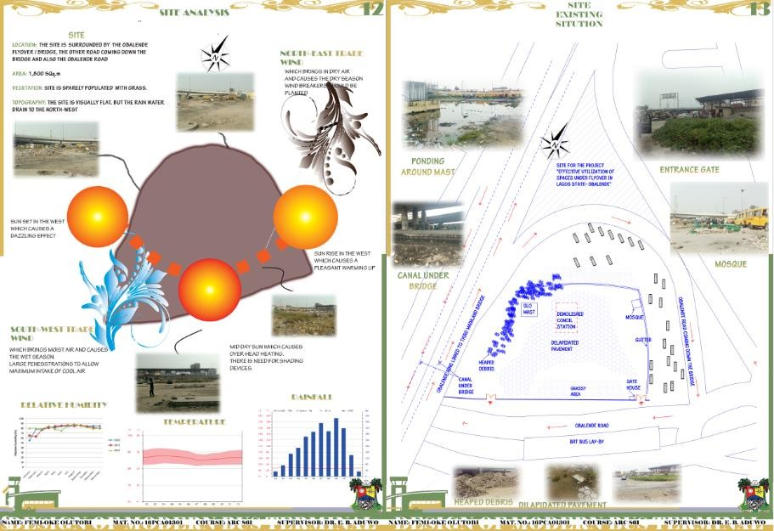

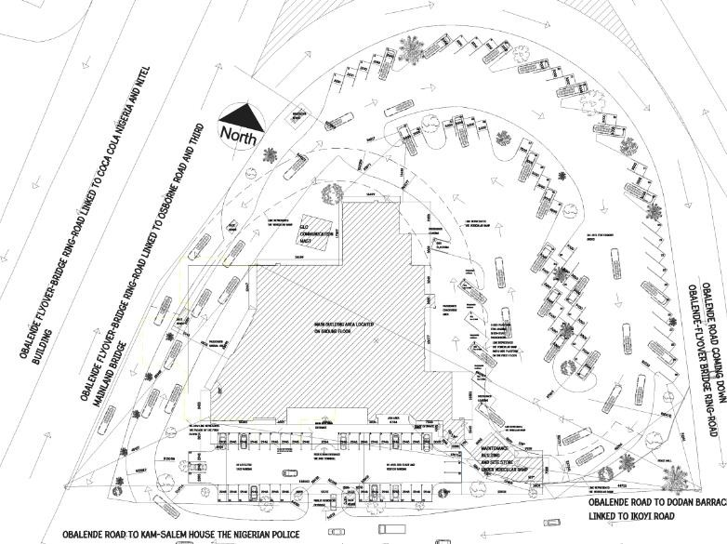
Figure 7. 11: Detailed site plan showing vehicular circulation

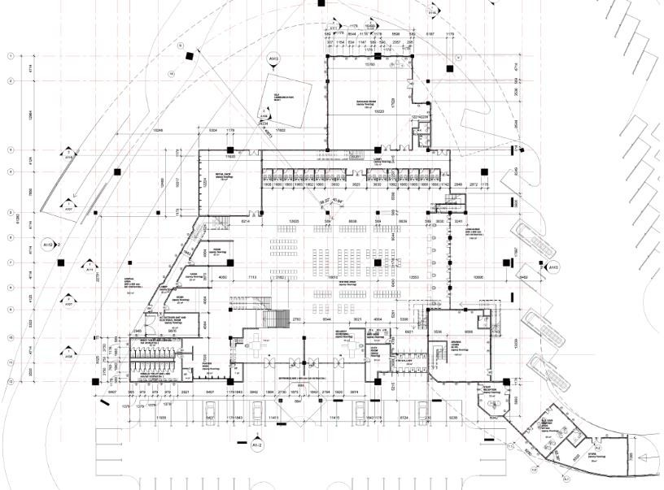
Figure 7. 12: Detailed ground floor plan Source: Author’s work (2018)
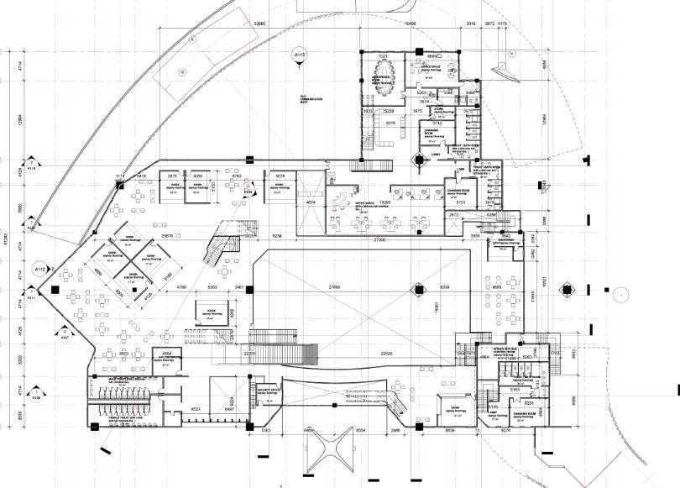
Figure 7. 13: Mezzanine floor plan

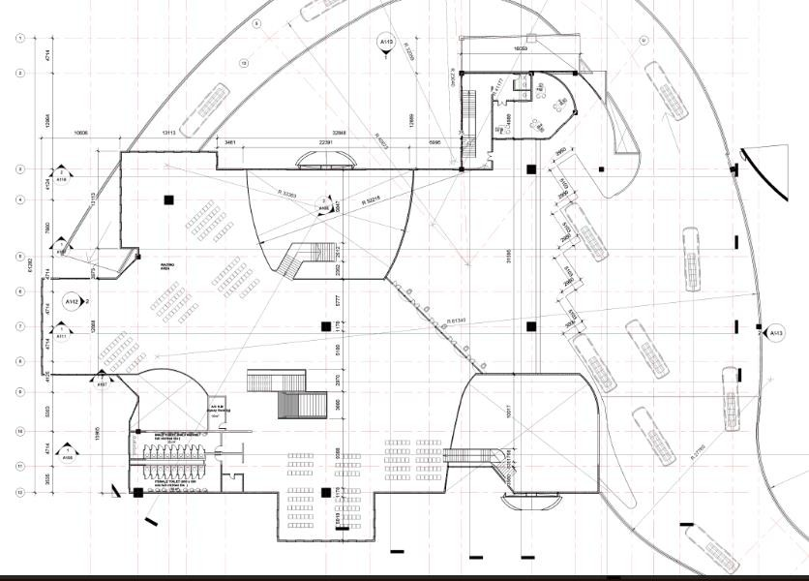
Figure 7. 14: First floor plan Source: Author’s work (2018)
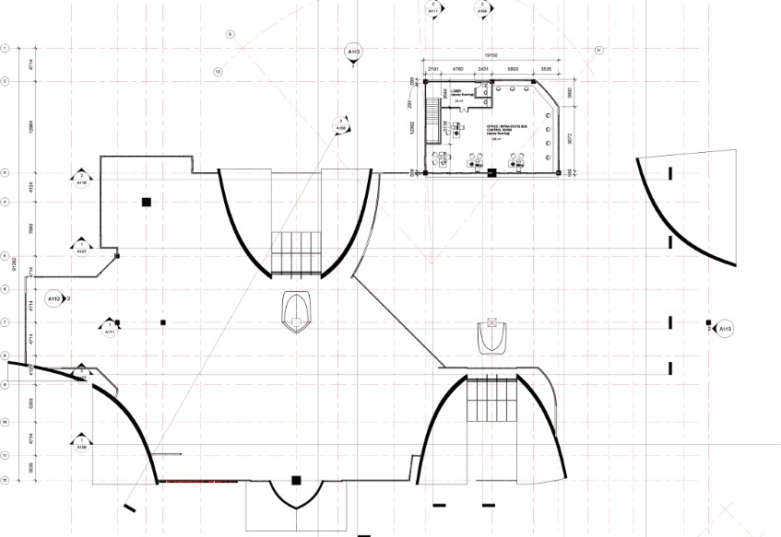
Figure 7. 15: Second floor plan Source: Author’s work (2018)

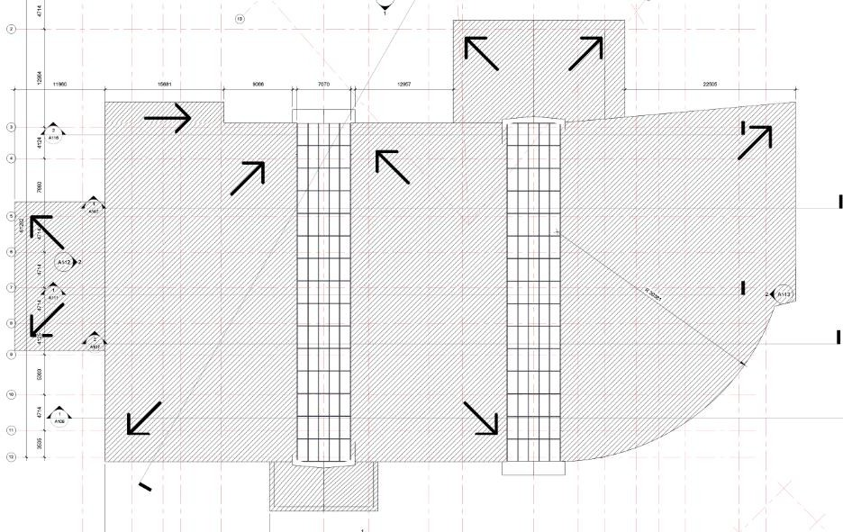

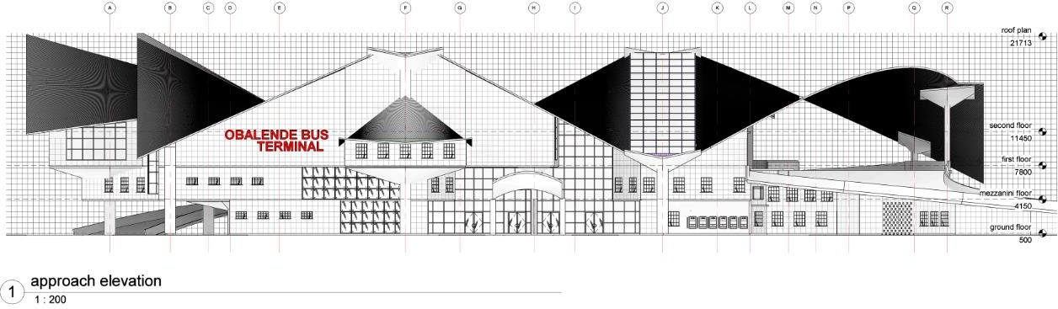
Figure 7. 16: Roof floor plan Source: Author’s work (2018)
Figure 7. 17: Approach elevation Source: Author’s work (2018)
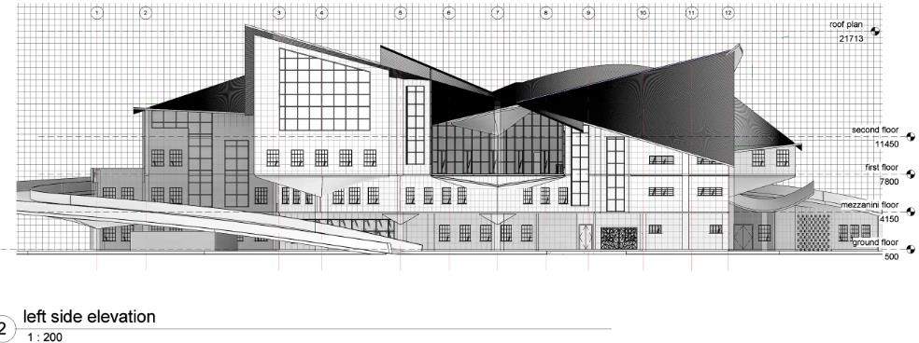
Figure 7. 18: Left side elevation Source: Author’s work (2018)

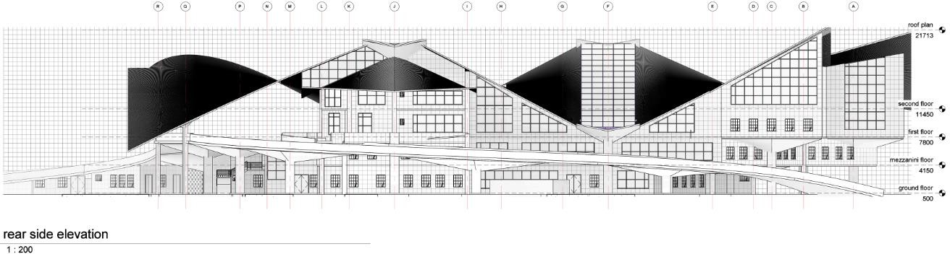

Figure 7. 19: Rear side elevation Source: Author’s work (2018)
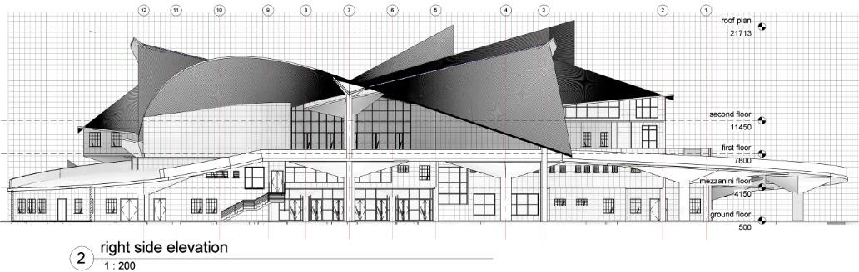
Figure 7. 20: Right side elevation Source: Author’s work (2018)
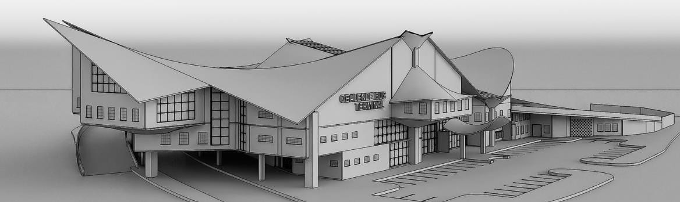
Plate 7. 6: 3d virtual model of the proposed bus terminal Source: Author’s work (2018)

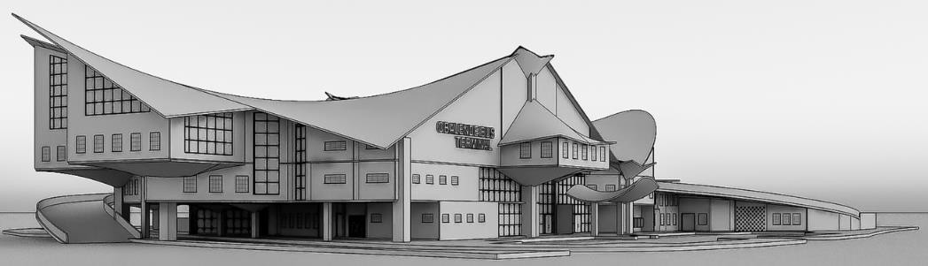

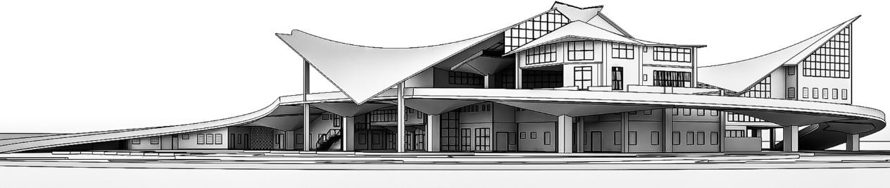
Plate 7. 7: 3d virtual model of the proposed bus terminal Source: Author’s work (2018)
Plate 7. 8: 3d virtual model of the proposed bus terminal Source: Author’s work (2018)

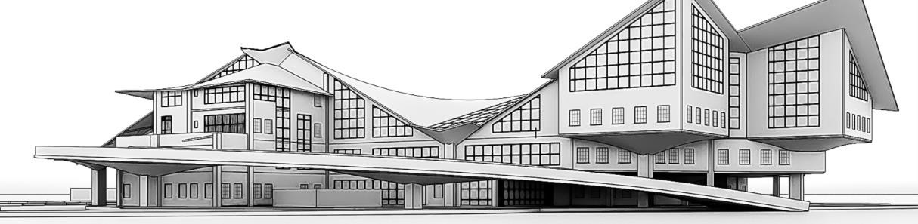
Plate 7. 9: 3d virtual model of the proposed bus terminal Source: Author’s work (2018)

  - Empirical Review 23
    - Cross Country Empirical review 23
    - Single Country Empirical review 27
    - Review of Empirical Evidence from Nigeria 30
  - Summary of Some Empirical Analysis 34
  - Summary of Gaps 37
CHAPTER THREE: STYLISED FACTS 38
  - Overview of the Financial Systems 38
  - Financial System Evolution 38
    - Foundation Phase 38
    - Expansion Phase 39
    - Consolidation Reform Phase 39
  - Evolution of Banking System in Nigeria 39
  - Financial Sector Reforms 41
    - Financial Sector Reforms for year 1986 42
3.4.2. Financial Sectors Reforms for year 2004 43
3.4.3 Financial Sector Reforms for year 2009 45
  - The Nigerian Financial Market 46
  - TREND ANALYSIS IN FINANCIAL DEEPENING 48
    - Trend Analysis of Money Supply 49
    - Trend Analysis of Economic Growth 53
    - Trend Analysis of the Market Based Financial Deepening 54
CHAPTHER FOUR: METHODLOGY 58
  - Theoretical Framework 58
    - Endogenous Growth Theory 58
  - Method of Data Analysis 59
    - Model Specification 60
    - Techniques of Estimation 62
    - Data Sources and Measurement of Variables 63
CHAPTER FIVE: RESULTS AND DISCUSSION 65
  - Descriptive Statistics 65
  - Results from Econometric Analysis 68
    - Unit Root Test 68

    - Johansen Cointegration 69
    - Error correction Model (ECM) 73
    - Granger Causality 75
  - Implication of Findings 79
CHAPTER SIX: CONCLUSION AND RECOMMENDATIONS 81
  - Summary of Findings 81
  - Conclusion 82
  - Recommendations 82
  - Contributions to Knowledge 83
  - Suggestions for Further Research 84
REFERENCES 85
APPENDIX A 92
APPENDIX B 96
APPENDIX C 98
APPENDIX D 99
APPENDIX E 100

LIST OF TABLES

Table 4.1: Description of Variables and Sources of Data 63

Table 5.1: Summary Statistics of the Variables 65

Table 5.2: ADF unit root test 67

Table 5.3: Johansen Cointegration test (Trace Statistic) 69

Table 5.4: Johansen Cointegration test (Max-Eigen statistic) 70

Table 5.5: Normalised Cointegration coefficients 71

Table 5.6: Summary of Error Correction Model 73

Table 5.7: Pairwise Granger causality test 75

LIST OF FIGURES
Figure 3.1: Credit to Private Sector Percentage of GDP 41
Figure 3.2: Money supply to GDP 49
Figure 3.3: Financial deepening and Economic growth 51
Figure 3.4: Economic growth in Nigeria 52
Figure 3.5: Market Capitalisation in the Nigeria Stock Market 54
Figure 3.6: All Share index of the Nigeria Stock Market 55
Figure 3.7: Lending interest rate 56

ABSTRACT
The quest to understand the relationship between finance and economic growth has been the cause of topical debates among academicians, policy makers, international agencies and government bodies. More specifically, the argument is centred on whether finance leads to growth and vice versa or if the relationship is uni-directional. A well-developed financial system is essential for economic growth and development as it creates the availability of increased financial resources that can be channelled to productive uses which aids economic growth in the long run. This study attempted to ascertain the relationship between financial deepening and economic with emphasis on the development of the financial intermediaries, financial markets and financial sector reforms and how these developments affect economic growth. The study used time series post-SAP (Structural Adjustment Programme) data since notable financial reforms began with SAP. The broad objective of the study was to examine the nexus between financial deepening and economic growth in Nigeria. The variables contained in the model include ratio of credit to private sector to gross domestic product (CPS) which proxy bank based financial deepening, ratio of market capitalisation to gross domestic product (MCAP) which proxy for stock market development, lending interest rate and other growth variables like labour participation and capital formation. The model was analysed using the Johansen cointegration and the error correction model techniques. While the Granger causality test was engaged to examine the direction of influence between finance and economic growth. The overall result of estimation holds that Nigeria economic growth is positively and significantly impacted by financial deepening which validates the initial assertion that finance is necessary for growth in the long run. A key recommendation that emerged from the study is that policies aimed at the simultaneous improvement of both the financial intermediaries and financial markets should be encouraged.

