EFFECTS OF ACUTE EXPOSURE TO GENERATOR EXHAUST FUMES ON LEARNING, MEMORY AND MOTOR COORDINATION IN ALBINO MICE

By

Musa Kurawa, IBRAHIM MSc/MED/00002/2008-09

A THESIS SUBMITTED TO THE POSTGRADUATE SCHOOL OF AHMADU BELLO UNIVERSITY, ZARIA, NIGERIA.

IN PARTIAL FULFILMENT OF THE REQUIREMENTS FOR THE AWARD OF THE DEGREE OF MASTER OF SCIENCE IN HUMAN PHYSIOLOGY

DEPARTMENT OF HUMAN PHYSIOLOGY, AHMADU BELLO UNVERSITY, ZARIA, NIGERIA

August, 2012

DECLARATION

I declare that the work in the thesis, entitled: “EFFECTS OF ACUTE EXPOSURE TO GENERATOR EXHAUST FUMES ON LEARNING, MEMORY AND MOTOR
COORDINATION IN ALBINO MICE” has been performed by me in the Department of Human Physiology under the supervision of Drs. A.B. Adelaiye and R.A. Magaji.

The information derived from the literature has been duly acknowledged in the text and a list of references provided. No part of this thesis was previously presented for another degree or diploma at any other university.

Musa Kurawa IBRAHIM |  | 25th July, 2012.
Name of Student | Signature | Date

CERTIFICATION

This thesis, titled “EFFECTS OF ACUTE EXPOSURE TO GENERATOR EXHAUST FUMES ON LEARNING, MEMORY AND MOTOR COORDINATION IN ALBINO
MICE” by Ibrahim, Musa Kurawa meets the regulations governing the award of the degree of Master of Science of Ahmadu Bello University, Zaria, and is approved for its contribution to knowledge and literary presentation.

Dr. A. B. Adelaiye, M.B.B.S., Ph.D.
Chairman, Supervisory Committee | (Signature) | (Date)

Dr. R. A. Magaji, BSc., MSc., Ph.D.
Member, Supervisory Committee | (Signature) | (Date)

Dr. Yusuf Tanko, BSc., MSc., Ph.D.
The Head,  Department of Human Physiology, | (Signature) | (Date)
Faculty of Medicine,
Ahmadu Bello University, Zaria

Prof. A. A. Joshua, B.A., M.A., Ph.D.
Dean, Postgraduate School | (Signature) | (Date)

DEDICATION

To my beloved parents and dear wife.

ACKNOWLEDGEMENT

To ALLAH, the Almighty is the glory, who taught man that which he knew not, may His peace and blessings be upon His noble prophet Muhammad (S.A.W), his household, companions, and all those who follow his righteous path, (Ameen).

My parents will always be the first to receive my appreciation in all that I accomplished in life. My father Alhaji Ibrahim Bello, my beloved mother Hajiya Sa’adatu and my step mother Malama Khadija for raising me through thick and thin to accomplish this study. I am most grateful to ALLAH for keeping them alive to witness yet another achievement in my life. Only the Almighty in His infinite mercy can reward them, hopefully with Jannatul Firdaus (Ameen).

My profound gratitude goes to my supervisors; Drs. A. B. Adelaiye and R. A. Magaji for their continuous support, understanding and guidance; I am sincerely grateful. My special regards goes to the Head of Department of Human Physiology, Ahmadu Bello University, Zaria, Dr Yusuf Tanko; and all my lecturers, including Prof. M. A. Mabrouk, Prof. J. O. Ayo, Prof. J. A. Anuka, Prof. A. A. Dikko, and Dr K. V. Olurunshola. I am also grateful to Dr. M. Y. Gwarzo of Biochemistry Department of Bayero University, Kano and Prof. A. Dare of Radiography Department of Bayero University, Kano who have made significant contribution in my thesis. I really enjoyed the time we spent together with my colleagues, most especially I. A. Sheriff, U. Abdullahi, A. A’isha and Drs A. Isma’il and M. A. Abbas, to mention a few. I am indeed mindful of the roles played by M. P. Philemon and S. M. Okey in helping me conduct the laboratory work.

I am duly grateful to my family and colleagues like Drs. A. I. Salisu, W. Nafisa and M.

A. Salim. Finally, I sincerely want to thank Mr A. Olu of Chemical pathology, Ahmadu Bello University, Teaching hospital, Zaria and anybody who has contributed to this success.

Musa Kurawa IBRAHIM 25th July, 2012.

ABSTRACT

The study involved assessment of the effects produced by exposure of mice to generator exhaust fumes on the learning, memory and motor coordination. Carbon monoxide (CO) which is produced from combustion of any carbonaceous substance is among the toxic contents and was studied in detail. Twenty four animals were grouped into two major groups; the first group was tested for motor coordination using beam walk; and the other group for learning and memory, using elevated plus maze (EPM). Mean transfer latencies (TL) were measured in seconds. Gasoline powered generator (TIGER, TG950, 220v/24 0v) manufactured by Suzhou Tiger Power Machine Co., Ltd., China served as the source of CO. Carbon monoxide monitor (Amprobe, CM100) was used to record the dose of CO in parts per million (ppm). The dose of 100–150 ppm of CO exposure was maintained throughout the study. Values of P< 0.05 were considered to be statistically significant. Each of the two major groups was subdivided into control group, which was exposed to room air, and experimental group that was placed into a partially enclosed gas chamber and exposed directly to the exhaust fumes of the generator for 30 minutes, 1 hour and 2 hour periods before the neurobehavioural tests. During the learning task (Day 1), experimental animals showed significant decrease in the mean TL of 13.4 ± 1.5 seconds and an increase of 73 ± 8.4 seconds at 30 minutes and one hour, respectively, when compared to their controls (28.6 ± 5.2 seconds) and (21.8 ± 4.4 seconds). However, there was no significant change in the mean TL during the 2-hour exposure. The memory task (Day 2), recorded significant increase in the mean TLs during the 30 minutes (48.4 ± 12.8 seconds) and two hour exposures (66.8 ± 15.3 seconds), when compared to the corresponding controls (13.6 ± 1.9 seconds) and (22.6 ± 6.6 seconds), respectively. This result suggests decreased ability of the exposed mice to learn (Day 1) and also to recall (Day 2) the learned behaviour. Results of the motor coordination did not show any significant difference in the mean TLs and foot slips in all the three periods of exposure, when compared to the controls. Therefore, CO at this range and periods of exposure could have minimal or no effect on motor coordination in the exposed animals. The blood carboxyhaemoglobin (COHb) measured at the end of the study showed significant increase in the mean percentage COHb levels of the experimental groups (2.06 ± 0.012 %) as compared to those of the control groups (0.76 ± 0.089 %). The results also suggest that impairment in the motor coordination

may occur at higher exposure periods to CO. The results corroborate other acute CO exposure studies where neuronal cell death and functional impairment of learning and memory were recorded. In conclusion, exposure to generator exhaust fumes that produced 100 – 150 ppm of CO resulted in enhanced learning behaviour during the 30 minutes exposure, impaired learning at 1 hour; memory at 30 minutes and 2 hours, respectively. Motor coordination deficits may be affected at higher CO concentration and blood COHb suggested exogenous intake in the experimental mice.

TABLE OF CONTENTS

TITLE PAGES

Title page I

Declaration III
Certification IV
Dedication V
Acknowledgements VI
Abstract VIII
Table of contents X
List of Figures XIV
List of Tables XV
List of Appendices XVI
Abbreviations XVII
CHAPTER ONE 1
  - INTRODUCTION 1
  - COMPONENTS OF AN EXHAUST 4
  - STATEMENT OF RESEARCH PROBLEM 9
  - JUSTIFICATION 12
  - AIM AND OBJECTIVES 13
  - RESEARCH HYPOTHESIS 13
CHAPTER TWO 14
  - LITERATURE REVIEW 14
  - NEUROTOXICITY OF CARBON MONOXIDE 14
    - Factors rendering the Nervous system susceptible to toxic injuries 15
  - MECHANISMS OF CARBON MONOXIDE TOXICITY 16
    - Alterations in blood flow 16
    - Mitochondrial dysfunction and altered production of high-energy Intermediates 16
    - Vascular insults associated with exposure to carbon monoxide 17
  - CARBON MONOXIDE AND OXIDATIVE DAMAGE 18
  - EFFECTS OF CARBON MONOXIDE ON LEARNING AND MEMORY 20
  - CARBON MONOXIDE TOXICITY 24
    - Neurological effects 25
    - Developmental effects 28
    - Hypoxia and related compensatory responses 29
CHAPTER THREE 32
  - MATERIALS 32
    - Source of carbon monoxide 32
    - Portable carbon monoxide gas analyser 32
    - Gas chamber 32
  - METHODS 36
    - Animals 36
    - Exposure of animals to carbon monoxide from the generator
exhaust fumes 36
    - NEUROBEHAVIOURAL ASSESSMENT 37
      - Assessment of the motor coordination using beam walk test 37
      - Assessment of learning retention behaviour using the elevated plus
maze 41
      - Determination of blood carboxyhaemoglobin level in animals 43
      - DATA ANALYSIS 45
CHAPTER FOUR 46
  - RESULTS 46
  - Effects of 30-minute carbon monoxide exposure on learning/acquisition
and retention/memory test 46
    - Effect of 1-hour of carbon monoxide exposure on learning and retention/memory test 48
    - Effect of 2-hours carbon monoxide exposure on learning and retention/memory test 50
    - Influence of carbon monoxide exposure on
learning/acquisition test (Day-1) 52
    - Influence of carbon monoxide exposure on memory/recall test (Day-2) 54
    - Control group 56
    - Effects of 30 minutes, 1 hour and 2 hours of carbon monoxide
exposure on the experimental group 58
  - ASSESSMENT OF MOTOR COORDINATION 60
    - Effects of carbon monoxide exposure on beam walk performance test 60
    - Foot-slips in the control and experimental groups 62
  - ANALYSIS OF BLOOD CARBOXYHAEMOGLOBIN 64
  - SUMMARY OF RESULTS 66
CHAPTER FIVE 68
  - DISCUSSION 68
  - LEARNING/ ACQUISITION AND MEMORY/ RECALL 68
    - Learning/acquisition 69
    - Memory/recall 71
  - BEAM WALK 74
  - BLOOD CARBOXYHAEMOGLOBIN LEVEL 75
CHAPTER SIX 78
  - SUMMARY 78
  - CONCLUSION 79
  - RECOMMENDATION 79
REFERENCES 81
APPENDICES 95

LIST OF FIGURES

Figure 1.1: Diagrammatic presentation of carbon monoxide uptake and

elimination pathways and carbon monoxide in body stores 8

Figure 1.2: Oxyhaemoglobin dissociation curve of normal human blood, of blood containing 50% carboxyhaemoglobin, and of blood with only
50% haemoglobin because of anaemia 31

Figure 3.1: Gas chamber 33

Figure 3.2: Portable gasoline-powered generator 34

Figure 3.3: Digital carbon monoxide monitor, Amprobe CM100 35

Figure 3.4: Beam walk 40

Figure 3.5: Elevated plus maze 42

Figure 3.6: Calculated values of A_{R} at various proportions of

carboxyhaemoglobin 102

Figure 4.1: Transfer latencies of control and experimental groups

during the acquisition/learning test 53

Figure 4.2: Transfer latencies of the control and experimental groups

during the recall/memory Task (Day-2) 55

Figure 4.3: Transfer latencies in Day-1 and Day-2 tests of the control group 57

Figure 4.4: Transfer latencies in Day-1 and Day-2 tests of experimental group 59

Figure 4.5: Transfer latencies of the control and experimental groups

during beam walk performance test 61

Figure 4.6: Mean foot-slips during beam walk test 63

Figure 4.7: Percentage carboxyhaemoglobin in control and experimental groups 65

LIST OF TABLES
Table 1.1: Nigerian ambient air quality standards 2
Table 1.2: Nigerian ambient air tolerance limits, guidelines for convectional Pollutants 3
Table 1.2: Blood Carboxyhaemoglobin levels as predicted from the
Coburn-Forster-Kane (CFK) model 103
Table 4.1: Transfer latencies of control and experimental groups after
30 minutes of exposure 47
Table 4.2: Transfer latencies of the control and experimental groups
after 1 hour of exposure 49
Table 4.3: Transfer latencies of the control and experimental groups
after 2 hours of exposure 51
Table 4.4: Mean transfer latencies during the acquisition/learning task (Day-1) 95
Table 4.5: Mean transfer latencies during the recall/memory task (Day-2) 96
Table 4.6: Transfer latencies during acquisition and recall tasks in the control
group 97
Table 4.7: Transfer latencies during acquisition and recall tasks in the
experimental group 98
Table 4.8: Mean transfer latencies to cross the beam walk 99
Table 4.9: Foot-slips of the control and experimental groups after the 30 minutes,
1 hour, and two hours of exposure 100
Table 4.10: Percentage Carboxyhaemoglobin in the control and experimental
groups 101

LIST OF APPENDICES

APPENDIX I: Transfer latencies during the acquisition/learning task (Day-1) 95

APPENDIX II: Transfer latencies during the recall/memory task (Day-2) 96

APPENDIX III: Transfer latencies during acquisition and recall tasks in the

control group 97

APPENDIX IV: Transfer latencies during acquisition and recall tasks in the experimental group 98
APPENDIX V: Transfer latencies to cross the beam walk 99

APPENDIX VI: Mean foot-slips during beam walk test 100

APPENDIX VII: Percentage carboxyhaemoglobin of the control and

experimental groups 101

APPENDIX VIII: Calculated values of A_{R} at various proportions of Carboxyhaemoglobin 102
APPENDIX IX: Blood Carboxyhaemoglobin levels as predicted from the

coburn-forster-Kane (CFK) model 103

ABBREVIATIONS

AQS Air Quality Standard

BBB Blood-Brain-Barrier

BNB Blood-Nerve-Barrier

CDC Centre for Disease Control CMRO₂ Cerebral Metabolic Rate for O₂ CNN Cable Network News
CNS Central Nervous System

COHb Carboxy Haemoglobin

CO₂ Carbon dioxide

CO Carbon monoxide

CDC Centre for Disease Control

CPSC Consumer Product Safety Commission DWI Diffusion Weighted Images
⁰C Degree Centigrade

EDTA Ethylene Diamine Tetra acetic Acid EPA Environmental Protection Agency
EPM Elevated Plus Maze

FEPA Federal Environmental Protection Agency g Gram
Hb Haemoglobin

H₂O₂ Hydrogen Peroxide

IAQ International Air Quality

kg Kilogram

kW Kilowatt

m Metre

m³ Metre cube

mEq/L Milli-equivalent per litre

mg Milligram

ml Milliliter

µg Microgram

µl Microlitre

MRI Magnetic Resonance Images

NAAQS National Ambient Air Quality Standards NO Nitrogen oxide
- NO Nitric oxide free radical NO-Hb Nitrosyl-Haemoglobin NO-Mb Nitrosyl-Myoglobin
nmol Nanomole

O₂ Oxygen

pmol Picomole

ppm Parts per million

Po₂ Partial pressure of Oxygen

Pco₂ Partial pressure of Carbon dioxide

Pco Partial pressure of Carbon monoxide

PG Prostaglandins

RBC Red Blood Cells

SEM Standard Error of mean

STP Standard Temperature and Pressure

USEPA | United States Environmental Protection Agency
Vs | Versus
V | Volts
WHO | World Health Organization
% | Percentage
> | Greater than
< | Less than
± | Plus or Minus

CHAPTER ONE

INTRODUCTION

Human beings, animals and other living things exist and interact among themselves in a common environment. These environmental constituents are interdependent on each other, thus maintaining the natural balance of the ecosystem. As a result of over- population, rapid industrializations, and other human activities, earth became loaded with diverse pollutants that were released into the environment, giving rise to pollution. Environmental pollution can be defined as the undesirable change in physical, chemical and biological characteristics of air, land and water (Partha, 2009). Significant sources of air pollution in urban areas, towns and cities of the developing countries like Nigeria may include but are not limited to emissions from motor vehicles (Mayer, 1999) and generator exhaust (Stanley et al., 2010). Environmental characteristics such as topography, altitude, and anthropogenic activity such as traffic, industrial effluents and proximity to sources of pollution, have considerable influence on the abundance, residence time and retention of tropical trace gases over an area (Stanley et al., 2010). Criteria air contaminants (CAC), or criteria pollutants, are set of air pollutants that cause smog, acid rain and other health hazards. History of CO as a criterion pollutant dated back to 1971 when the United States Environmental Protection Agency (USEPA) set the first national ambient air quality standards (NAAQS) for CO. In Nigeria, CO was identified as CAC after the formation of Federal Environmental Protection Agency (FEPA) in 1992 and Nigerian Ambient Air Quality standards was set (Table 1 and 2). Carbon monoxide became a major air pollutant

Table 1.1: Nigerian ambient air quality standards
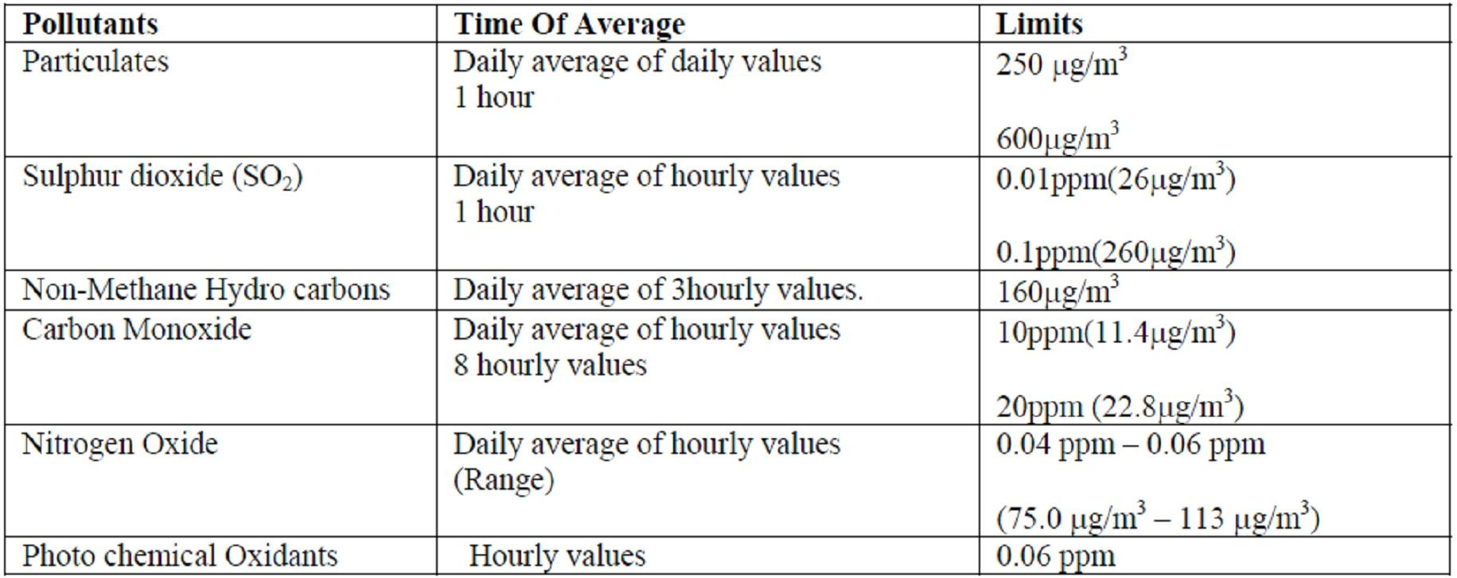

Table 1.2: Nigerian ambient air tolerance limits, guidelines for convectional pollutants
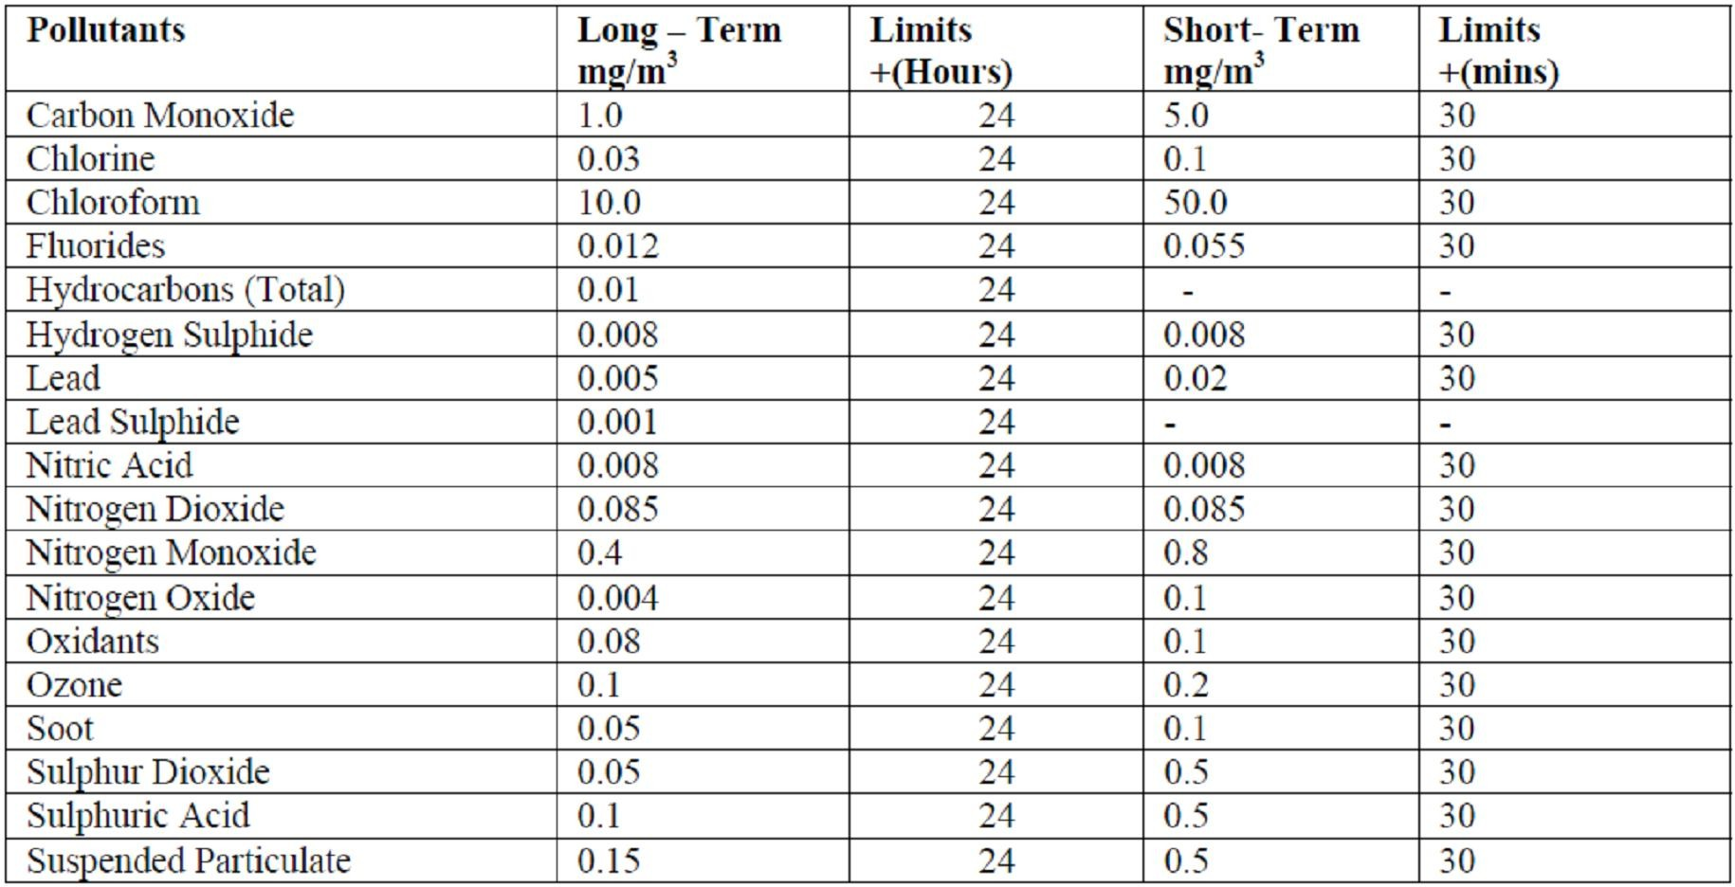

both indoors (Ayodele, 2007) and outdoors (Ajayi et al., 2002) because of increased use of bio fuel as a major source of energy for cooking, electricity generation and transportation. In addition 80% of carbon monoxide and 40% of the nitrogen oxides are produced when gasoline and diesel fuels were burnt (Ajayi et al., 2002) and Petrol creates 28 times more CO than diesel (Campbell, 2009). The air we breathe should normally contain 21% oxygen, 78% nitrogen and 1% trace amounts of rare gases (Augustine, 2012). Air pollution introduces abnormal gases like nitrogen oxides (NO2), sulphur oxides (SO2), carbon monoxide (CO), particulate matter (PM), and Lead (Pb) into the atmosphere at a much higher concentration than normal. Most of these pollutants are emitted from incomplete combustion of hydrocarbons in internal combustion engines like electric generators.

COMPONENTS OF AN EXHAUST

Gasoline and diesel fuels are mixtures of hydrocarbon compounds which contain hydrogen and carbon atoms. In a "perfect" engine, oxygen in the air would convert all the hydrogen in the fuel to water and all the carbon in the fuel to carbon dioxide. Nitrogen in the air would remain unaffected. Although in reality, the combustion process cannot be "perfect," and automotive engines emit several types of pollutants. Typically, engine combustion results in the following:
FUEL + AIR → UNBURNED HYDROCARBONS + NITROGEN OXIDES + CO +

CO₂ + WATER (United States Air and Radiation, 2011).

The production of CO is also subject to the engine maintenance and nature of the fuel used (United States Air and Radiation, 2011). It was observed that properly maintained engines and modern vehicle engines have reduced CO production as newer gasoline

formulations and better, more efficient exhaust emission controls are always found (Mott et al., 2002).

Carbon monoxide (CO) is one of the most common and widely distributed air pollutants in the world. It is a colourless, odourless, and tasteless gas with poor solubility in water and a slightly lower density than air (United States AQC, 2000). Carbon monoxide was known since ancient times, when Greeks and Romans used it to execute criminals. The death of two Byzantine emperors was related to CO produced by the burning of coal in braziers, the usual method of indoor heating during the epoch (Lascaratus et al., 1998). The gas was first prepared by the French chemist de Lassone in 1776, who mistakenly considered it to be hydrogen because of its blue flame. In 1880, William Cruikshank identified it as a compound containing carbon and oxygen. In the middle of 19th century, Claude Bernard recognized that CO causes hypoxia due to its interaction with Haemoglobin (Hb). He poisoned dogs with the gas, noticing the scarlet appearance of their blood. Later, Haldane demonstrated that a high partial pressure of O₂ can counteract the interaction between Hb and CO, despite the high affinity. There were a lot of cases of CO poisoning during World War II, many of which were due to the rampant use of wood as fuel (Tvedt et al., 1997).

Carbon monoxide is the diatomic oxide of carbon that exists as colourless and odourless gas at temperatures above - 190°C. It has a density of 1.25 g/l at standard temperature and pressure and specific gravity of 0.967 relative to air. The molecule is chemically stable. That is why chemical reduction usually requires temperatures higher than 100°C. At standard temperature and pressure, CO is poorly soluble in water (354 ml/dl; 44.3 ppm by mass), requiring a lot of activation energy (Allen, 1977). Redox reaction is rare

(Allen, 1977) and is greatly enhanced by transition metals (Shriver, 1981). Once formed, metal carbonyls are relatively stable until CO is displaced by molecular O₂.

Generally, the two main sources of CO are the natural sources and the man-made (anthropogenic) sources. The natural sources include volcanic eruption, releasing poisonous gases, forest fire, natural organic and inorganic decays or vegetation decay. Anthropogenic sources are CO that originates from incomplete combustion of any organic matter. These sources include exhaust of internal combustion engines, especially motor vehicles and gasoline-powered generators, various industrial processes, power plants using coal, and waste incinerators (Lindell et al., 2007). Indoor sources include partial combustion of oils, coal, wood or kerosene (Leon, 2007). In Nigeria, the most important sources are exhaust from motor vehicles and gasoline- powered generators; kerosene stoves, wood burning and cigarette smoke (Ayodele et al., 2007). At rest and without exogenous exposure, minute quantity (0.4 - 0.7%) of CO in form of Carboxyhaemoglobin (COHb) is produced endogenously in the body from catabolism of Hb and acts as physiologic smooth muscle relaxant, neurotransmitter and cytoprotector against oxidative stress (Ryter et al., 2004; USEPA, 2011).

Although CO is not among the normal respiratory gases, its physico-chemical similarities with O₂ permit an extension of the kinetics of transport to that of O₂. The mass transport of CO between the airway opening (mouth and nose) and the red blood cell (RBC) Hb is predominantly controlled by physical processes. Therefore, absorption of CO to form COHb requires the transfer of CO in a gas phase between the airway opening and the alveoli; and the transfer in liquid phase, across the air-blood interface, including the RBC. In the gas phase, CO is transported by convective flow and ultimate

diffusion in the acinar zone of the lung; (Lingyun et al., 2005). Subsequent molecular diffusion of CO across alveolo-capillary membrane, along the pressure gradient, plasma, and RBC involves the liquid phase, and it is a very rapid process (Figure 1.1).

Acute, mild exposure to CO results in headache, myalgia, dizziness, or neuropsychological impairment (Amitai et al., 1998). Severe exposures result in confusion, loss of consciousness, or death. Long-term, sub-acute exposure, lasting more than 24 hours generally occur intermittently and may span weeks or even years. The incidence of long-term exposure is unknown (WHO, 2000). Symptoms of chronic poisoning may differ from those of acute poisoning and can include chronic fatigue, affective conditions and emotional distress, memory deficits, difficulty in working. It may also include sleep disturbances, vertigo, neuropathy, paresthesias, recurrent infections, polycythemia, abdominal pain and diarrhoea (Penney, 2008).

Carbon monoxide poisoning was defined as any case of accidental or deliberate exposure, with a history suggestive of CO exposure and exhibiting symptoms and signs of CO intoxication as well as an elevated blood COHb level.

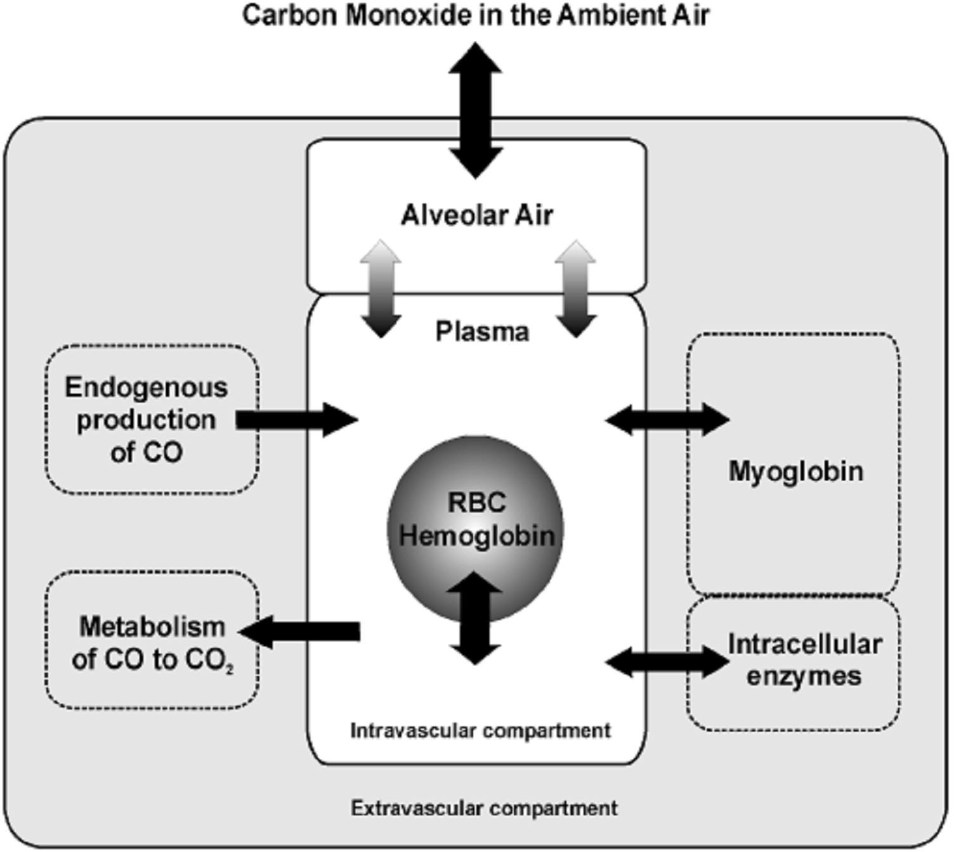

Figure 1.1: Diagrammatic presentation of carbon monoxide uptake and elimination pathways and carbon monoxide in body stores (Coburn, 1965).

An elevated COHb level was defined as greater than 2% for non-smokers and greater than 9% for smokers (Radford et al., 1982). Responses to CO poisoning are variable.

Exposed children often become symptomatic earlier, and recover faster than similarly exposed adults. This is because of their lesser blood volume and increased minute ventilation per unit of body mass as compared with adults (Sunny, 2008).

Toxicity occurs mostly in cases of exposure to acutely high CO as in fire accidents, but chronic exposures usually result in subtle and delayed onset of neuropsychiatric symptoms, which may not necessarily be attributed to only CO intoxication (Mimura et al., 1999). Toxicity also depends on the concentration of the gas, but typically poisoning can occur from any form of CO exposure (Weaver et al., 2007). Neurotoxicity is the most prominent symptoms in any CO poisoning, other symptoms are those due to heart affectation (Samuel et al., 2007).

STATEMENT OF RESEARCH PROBLEM

The annual global emissions of CO into the atmosphere has been estimated to be as high as 2600 million tonnes, out of which about 60 % are from human activities and 40% from natural processes (USEPA, 1991). The largest proportion of human emissions is produced by exhausts of internal combustion engines, especially motor vehicles with petrol engines (United States NAAQS, 2011). The trend now is global decrease in CO₂ production from various human sources, as the major world producers (USA and China) cut down their production (Lindsay, 2001). As a result of increased human activity, the ambient concentrations measured especially in urban areas are high, and depend greatly on the density of vehicles, topography and weather conditions. In the streets, CO concentration varies greatly according to the vehicle density on the road and distance from the traffic (Rudolf, 1994).

As the world is going green, and transition to cleaner sources of energy and less polluting vehicle engine is showing promise, decrease in the ambient levels is expected, but the reverse is the case in Nigeria (Sunny et al., 2008). Here, increase in the importation of used vehicles and use of gasoline-powered generators as the main source of power are among the highest contributing factors to the increasing trend in ambient CO level (Akinbami et al., 2001). There is general over reliance on biomass as source of energy in the developing countries (Bruce et al., 2000). In Nigeria, people rely on coal and biomass in the form of wood, dung and crop residues for domestic energy supply. These materials are burnt indoors in an open fires or poorly functioning stoves (WHO, 2004). Exposure to indoor pollution may be responsible for nearly 2 million deaths in developing countries and 4 % of the global burden of disease (Bruce et al., 2000).

Carbon monoxide poisoning accounts for 50,000 emergency department visits per year in the United States and is the most common cause of death due to poisoning in the country (Hampson et al., 1996). Even with paucity of data (Ajayi et al., 2002), high amounts of CO were recorded in some cities in Nigeria. Ambient levels in Ibadan city alone were between 3 and 55 ppm with a mean value and standard deviation of 20.12 ±
1.40 ppm (Sunny et al., 2008). The highest value (55 ppm) was observed on the highways. Carboxyhaemoglobin (COHb) concentrations were between 0.7 and 6.5 % with a mean value and standard deviation of 2.0 ± 0.68 % (Sunny et al., 2008). The above values are by far beyond the United States National Ambient Air Quality Standards (United States NAAQS) for outdoor air; which is 9 ppm for 8 hours, and 35 ppm for 1 hour. The average indoor CO values measured in Kano State of Nigeria were between 4.93 µg/m³ in the municipality and 5.49 µg/m³ in Sabon Gari area of the State

(Ayodele et al., 2007). There is yet no standard for CO that has been agreed upon for indoor air (United States NAAQS, 2011) to make comparison.

There was paucity of reported data on the incidence of acute or that of chronic toxicity in Nigeria. The few suspected cases of acute CO poisoning brought to hospitals were grossly underestimated (Augustine, 2002). This is because the symptoms for CO poisoning are general symptoms (Samauel et al., 2007) and mimic that of other common illnesses like flu (United States NAAQS, 2011). Chronic CO exposure may be associated with diseases like dementia, depression, and psychosis (Leon et al., 2007; Samuel et al., 2007). The combined effect of increased atmospheric temperature, as experienced in the tropics, and CO poisoning can impair exercise performance and make daily chores like driving, climbing of stairs and long walks, a great task (Walker et al., 2001). This means people could be manifesting some of the symptoms of chronic CO toxicity while simply ignoring them as the usual daily chores.

The United States Consumer Product Safety Commission (CPSC) of 2001 stated that every home should have a CO alarm and every major road junction must have at least one CO monitoring station situated within 30 meters from the road (United States EPA, 1991); this is not the case in Nigeria where CO monitoring stations are not available, not to talk of personal CO monitors and CO alarms. Some hospitals in Nigeria are poorly equipped with CO-oximeter to make diagnosis easier, and poisonings are often grossly under-reported or misdiagnosed by medical practitioners. Environmental criteria for CO and other gaseous pollutants are poorly implemented, if at all they exist in Nigeria (Ayodele et al., 2007).

JUSTIFICATION

Carbon monoxide was described by the U.S. Environmental Protection Agency as a “silent or invisible killer”. Its colourless and odourless nature makes it difficult to detect without the use of special equipment. The use of portable generators in the United States of America is only circumstantial, during power outages (e.g. from winter storms, camp grounds or new building construction) (Neil et al., 2005) but in Nigeria it is the usual source of power. The possible reasons speculated by Neil et al., (2005) in the use of generator indoors, often without adequate ventilation were: (1) lack of awareness of the risk of CO poisoning; (2) concern for electric shock by use in wet conditions; (3) fear of theft if the device is left outdoors; and (4) lack of a long enough extension cord to operate the generator outdoors. Aside the above reasons, Ayodele et al., (2008) in Kano suggested tiny, poorly constructed housing and overcrowding. Acute high CO exposures are sometimes encountered in different microenvironments (USEPA, 1991), under various circumstances, in most of these cases toxicity is certain and usually fatal. Aside sequelae from acute poisoning, chronic sequelae are yet to be determined.

AIM AND OBJECTIVES

    - Aim: The aim of this study was to assess the effects of acute exposure to generator exhaust fumes, producing 100 – 150 ppm of CO on learning, memory and motor coordination in albino mice.

Specific Objectives included the following

      - To assess the learning retention task of the CO-exposed and non-exposed animals using the elevated plus maze (EPM).

      - To assess the motor coordination of the CO-exposed and non-exposed animals using the beam walk test.
      - To compare the blood Carboxy-Hemoglobin (COHb) level with the exposure Dose in the animals using the spectrophotometric method.

RESEARCH HYPOTHESIS

Acute exposure to generator exhaust fumes does not affect learning, memory and motor coordination in Albino mice.

CHAPTER TWO

LITERATURE REVIEW

  - NEUROTOXICITY OF CARBON MONOXIDE

Toxins are among the many causes of neurological diseases from antiquity to contemporary times (Hunter, 1978). Although CO has long been known to cause acute central nervous system (CNS) damage, it is only recently that delayed CNS injury in people poisoned by this molecule was noticed (Kwon et al., 2004). Toxins and environmental conditions are important and under-recognized causes of neurological diseases; in addition to extremes of cold, heat, and altitude. In 1980s, the acknowledged estimate was about 8 million people who worked full-time with substances known to be neurotoxic (Anger, 1986). At that time, about 750 chemicals were suspected to be neurotoxic to humans based on available scientific evidence (Anger, 1984, 1986). Today when most countries are boasting on industrial revolution to show their power, an unadventurous estimate might therefore suggest more than 1000. The level of evidence for whether a substance is truly toxic to the human nervous system varies from substance to substance. Some evidences are purely experimental, where as others are based on strong clinical association (Myrtill et al., 2010).

Although the CNS is partially protected by the blood–brain barrier and the peripheral nervous system by the blood–nerve barrier, the nervous system remains susceptible to toxic injury (Carl-johan et al., 2012). This is because non-polar highly lipid–soluble substances generally have easier access to cross most membranes in the body (Friis et al., 1980). The effects of neurotoxic agents on the CNS present with wide-ranging

disturbances which may include mental status disturbances (mood disorders, psychosis, encephalopathy, and coma), myelopathy, focal cerebral lesions, seizures, movement disorders, and many peripheral nerve deficits. Yet, some neurotoxic disorders are not easily definable as being caused by a single, specific toxin, such as toxic axonopathies and encephalopathies seen with exposure to mixed organic solvents. Most neurotoxins manifest their effects on a single, specific part of the nervous system; including the cortex, spinal cord, extrapyramidal neurones peripheral nerves, and the syndromes can be somewhat defined by these presentations. However, the effect of some toxins may be generalized on the nervous system (Kwon et al., 2004).

Factors rendering the Nervous system susceptible to toxic injuries

There are various factors rendering brain most susceptible to injury, despite the presence of blood-brain barrier. The neurones and their processes have high surface area which increases their exposure risk. High lipid content of their neuronal structures result in accumulation and retention of liphophilic substances and lipid soluble molecules easily cross. Neurones generally have high metabolic demands and are strongly affected by energy or nutrient depletion. High blood flow in the central nervous system increases effective exposure to circulating toxins. Some chemical toxins can interfere with normal neurotransmission by mimicking structures of endogenous molecules. Following toxic injury, recovery of normal, complex interneuronal and intraneuronal connection is typically imperfect. Neurones are typically post-mitotic and do not divide (Anger, 1986).

  - MECHANISMS OF CARBON MONOXIDE TOXICITY

Alterations in Blood Flow

Exposure to high concentration (500 - 2,000 ppm) of CO causes vasodilation, which is due to impairment of O₂ delivery (MacMillan, 1975; Kanten et al., 1983). However, some of the observed increases in cerebral blood flow were independent of perturbations in O₂ supply (Koehler et al., 1982). The rate of synthesis of CO varies widely for nerve cells. Cerebellar granule cells generate approximately 3 Pmol/mg protein/min, olfactory nerve cells produce 4.7 pmol/mg protein/min., and rat cerebellar homogenates can generate as much as 56.6 pmol/mg protein/min (Maines, 1993; Ingi and Ronnett, 1995; Nathanson et al., 1995). In a situation where cellular oxidative metabolism was not impaired by CO, elevations in cerebral blood flow appeared to be mediated by nitric oxide free radical (•NO) (Meilin et al., 1996). Although cerebral vasodilation mediated by •NO was reported with exposure to 1,000 ppm of CO, that level of exposure did not alter pulmonary vasoconstriction in an isolated-perfused rat lung model (Cantrell, 1996). In animals exposed to high CO concentrations (e.g., 3,000 to 10,000 ppm), diminished organ blood flow was observed (Ginsberg, 1974; Okeda et al., 1981; Song et al., 1983; Brown and Piantadosi, 1992; Thom, 1999).

Mitochondrial dysfunction and altered production of high-energy intermediates.
Exposure to 2, 500 ppm and above of CO shows impaired high-energy phosphate synthesis and production of hydroxyl free radicals due to mitochondrial dysfunction (Piantadosi, 1996; Piantadosi et al., 1997). Evidence of mitochondrial dysfunction was not observed at lower CO concentrations, although under conditions of high metabolic

demand, exposure to even 1,000 ppm of CO in the absence of an overt hypoxic stress will result in impaired energy production in the brain (Meilin et al., 1996). Studies in mice indicate that high CO concentrations inhibit synthesis of high-energy phosphates during exposure to 5,000 ppm CO for 15 minutes and these changes do not persist following removal to fresh air (Matsuoka et al., 1993).

Vascular Insults Associated with Exposure to Carbon Monoxide

The concentration and duration of CO exposure are the two primary variables determining COHb level and ultimately the severity of the pathology. Substantial body of literature suggests that, at least with regard to vascular effects, the duration of exposure has a greater impact on the magnitude of CO pathophysiology than what is predicted based on the concentration of CO that is inspired (Fein et al., 1980; Penney et al., 2008).

In light of the physiological role of CO in vasomotor control, protracted exposures may be prone to disturb vascular homeostasis, giving rise to pathophysiological responses (Thomsen, 1974). Carbon monoxide may cause vascular insults through leakage of albumin. Leucocyte sequestration has been shown following exposures of rats to 50 ppm or more for 1 h, and the process is mediated by •NO-derived oxidants (Thom, 1990; Ischiropoulos et al., 1996; Thom et al., 1999). Brain oxidative stress associated with this mechanism has been shown in rats exposed to 1,000 to 3,000 ppm CO for 1 hour (Thom, 1990; Ischiropoulos et al., 1996).

  - CARBON MONOXIDE AND OXIDATIVE DAMAGE

Studies on laboratory animals show endogenous production of nitrogen and oxygen- based free radicals after CO exposures at concentrations of greater than or equals to 20 ppm for varying periods of time. Exposure to 20 ppm for 1 hour leads to production of nitric oxide free radical (•NO) in the systemic circulation of rats, with platelets as the main source (Thom et al., 1999). In another study by the same author; exposure of cultured bovine pulmonary endothelial cells to as low as 20 ppm cause cells to release
- NO, which may lead to death in 18 to 24 hours (Thom, 1990). The mechanism involved steady-state elevation of •NO concentration and production of peroxynitrite (Thom et al., 1999). Peroxynitrite is a strong oxidant with relatively longer half-life produced by the reaction between •NO and superoxide radical (Huie et al., 1993).

Carbon monoxide concentration of ≥ 11 nmol is enough to cause the steady-state increase in •NO level through alteration in the intracellular “routing” of •NO in endothelial cells and platelets. Gibson et al. (1986) documented that the rate constant for association and dissociation of •NO with haemoproteins exceeds the rate constants for O₂ or CO. Moore and Gibson (1976) had earlier found that CO slowly displaced the
- NO from nitrosyl-myoglobin (•NO-Mb) or nitrosyl-haemoglobin (•NO-Hb), and that the displacement occur even in the presence of excess •NO-haeme proteins. The presence of CO in high concentration or substances that will combine with the •NO, like thiol speed up the rate of displacement. It is worthy to note that these conditions exist in cells exposed to environmentally relevant concentrations of CO. Though concentrations up to 1.070 nmol of CO did not seem to alter the rate of production of •NO by platelets and endothelial cells, yet liberation of •NO was enhanced (Thom et al., 1999). Exposure to 50 - 100 ppm CO increases hydrogen peroxide (H₂O₂) production in the lungs of rat,

a phenomenon which depended on •NO production (Thom et al., 1999). The possible explanation to the enhanced H₂O₂ production is by disturbance of mitochondrial function; where peroxynitrite inhibits electron transport at complexes I through III, and a •NO targeted cytochrome oxidase (Cassina et al., 1996; Lizasoain et al., 1996; and Poderoso et al., 1996). Another possible alternative mechanism for mitochondrial dysfunction is through inhibition of antioxidant defences, where elevations in •NO could be responsible for inhibiting one or more enzymes in the electron transport cascade. Both manganese superoxide dismutase and glyceraldehyde-3-phosphate dehydrogenate can be inhibited by nitric-oxide-derived oxidants and also cause the depletion of reduced glutathione (Luperchio et al., 1996).

Exposure to higher CO concentrations in the range of 2,500 to 10,000 ppm causes mitochondria in brain cells to generate hydroxyl-like radicals (Piantadosis et al., 1997). An additional source of partially reduced O₂ species found in animals exposed to high CO (approximately 3,000 ppm) is xanthine oxidase. Conversion of xanthine dehydrogenase, the enzyme normally involved with uric acid metabolism, to xanthine oxidase, the radical-producing form of the enzyme, occurred in rats’ brains (Thom, 1990). Since enzyme conversion was not a primary effect of CO; and that higher CO exposure is required, xanthine radical was not considered to be the ambient source of free radicals (Thom, 1990). Prenatal exposure to CO at concentrations expected in poorly ventilated environment resulted in oxidative stress and impaired development of rat cochlea (Lopez et al., 2008). Ischiropoulous et al., (1996) were able to prove that perivascular reactions mediated by peroxynitrite were important in the cascade of events which lead to brain oxidative stress in CO poisoning.

EFFECTS OF CARBON MONOXIDE ON LEARNING AND MEMORY

Recent studies have implicated the vital role played by nitric oxide in neurophysiological processes of learning and memory (Thomas et al., 2000). Inhibition of NO synthesis impaired memory in rats (Kopt et al., 2001; Reddy et al., 2002); whereas, stimulation of NO production improved cognitive functions in Alzheimer's patients (Thomas et al., 2000).

Even though CO is toxic to cytochrome, this mechanism plays a minor role in clinical CO poisoning, since the amount of CO required to poison cytochrome is 1000 times higher than the lethal dose. Carbon monoxide-induced tissue hypoxia may be followed by re-oxygenation injury to the CNS. Hyperoxygenation facilitates the production of partially reduced O₂ species, which in turn can oxidize essential proteins and nucleic acids, resulting in typical reperfusion injury. In addition, CO exposure has been shown to cause lipid peroxygenation, i.e. degradation of unsaturated fatty acids leading to reversible demyelination of the CNS lipids.

Disturbances in brain function predominate in acute CO intoxication. Delayed neurological effects may also occur (Choi, 2000). Brain regions showed varying sensitivity to hypoxic damage, in particular the second and third layers of cerebral cortex; the white matter, the basal nuclei, and Purkinje cells of the cerebellum. Attempts have been made to relate this “selective vulnerability” to the cause of hypoxia, but the nature and distribution of the lesions appear to depend on the severity, suddenness, and duration of the oxygen deprivation, as well as on its mechanism (hypoxia or ischaemia) rather than on the its cause.

In acute cases, petechial haemorrhages of the white matter involving in particular the corpus callosum occur; in cases surviving more than 48 hours, there is multifocal necrosis involving globus pallidus, hippocampus, pars reticularis of the substantia nigra, laminar necrosis of the cortex and loss of Purkinje cells in the cerebellum, along with white matter lesions. Carbon monoxide intoxication usually spears the hypothalamus, walls of the third ventricle, thalamus, striatum, and brain stem. Myelin damage was constant and involved discrete, perivascular foci in the Corpus Callosum, internal-external capsule and the optic tracts, usually seen in comatose patients who died within one week. Extensive periventricular demyelination sometimes with plaques of demyelination and axonal destruction was also observed in comatose subjects with longer survival. Responses to cellular hypoxia vary depending on the premorbid condition of victims; those with underlying heart and lung diseases will have little tolerance to even mild hypoxia. In the brain, hypoxia leads to increased intracranial pressure and cerebral oedema, which is partially responsible for decreased level of consciousness, seizure, coma and varying degrees of cognitive impairment (Prockop, 2007). The classic cherry-red discoloration of the skin and cyanosis are rarely seen (Lapresle et al., 1967). Significant apoptotic cell death in the cortex and hippocampus occurred after rats inhaled 200 or 500 ppm of CO (Clayton et al., 2001).

Headache is one of the most common presenting features of CO poisoning (Handa et al., 2005). It is generally described as frontal, dull, sharp, continuous, throbbing, and intermittent in patients with mean COHb level of 21.3%. However there is no clear correlation between pain intensity and COHb levels (Hampson, et al., 1996). Headache is a frequent complaint not only with acute, but with chronic CO poisoning. Headaches, generalized weakness, fatigue and sleepiness, are part of the vague symptomatology

observed in subjects with COHb levels below 20%. Dizziness is a frequent companion of headache and can be seen in about 92% of victims of CO poisoning. In one report, 76% of the 38 victims reported weakness with COHb levels greater than 30 - 40% (Abelsohn et al., 2002).

A delayed neuropsychiatric syndrome may occur in patients from 3 - 240 days after acute CO exposure. Even those victims without neurological and psychiatric symptoms immediately after an exposure accident may demonstrate features of delayed impairment ranging from subtle abnormalities such as personality changes or mild cognitive deficit to severe dementia, psychosis, Parkinsonism, incontinence or others (Mimura, et al., 1999; Choi, 2000).

Carbon monoxide encephalopathy may cause a number of behavioural functional impairments, including alterations in attention, executive function, verbal fluency, motor abilities, visuospacial skills, learning, short-term memory, and mood and social adjustment. Formal neuropsychological testing usually confirms these impairments (White, et al., 1992). The expert Panel on Air Quality Standards of World Health Organization (WHO) in 1994 reported that COHb levels between 2 - 20% can cause effects on visual perception levels, audition, motor, and sensory-motor functions.

According to WHO guidelines, exposures to levels of ambient air CO should conform to the following durations of exposure: 87.1 ppm (100 mg/m³) for 15 minutes; 52.3 ppm (60 mg/m³) for 30 min; 26.1 ppm (30 mg/m³) for 60 min; 8.7 ppm (10 mg/m³) for 80 min (United States AQS, 1994). Any exposure to ambient air CO levels greater than 100 ppm is dangerous to human health (White, et al., 1992; Townsend, et al., 2002).

Very high levels of S100B protein, a structural astroglial protein, have been found in patients who died from CO poisoning; elevated levels occur in unconscious patients, and normal levels in those without loss of consciousness. It was proposed that the S100B protein levels could be used as a biochemical marker of brain injury in CO poisoning (Townsend, 2002).

Patients may also present with neuropsychological sequelae long time after CO poisoning (Weaver et al., 2007). In one randomized trial, 46% of poisoned patients treated with normobaric oxygen had cognitive sequelae 6 weeks after poisoning (Weaver et al., 2002) and 45% had affective sequelae (Jasper et al., 2005). Other sequelae include gait and motor disturbances; peripheral neuropathy; hearing loss and vestibular abnormalities; and dementia and psychosis (Choi, 2000), which can be permanent.

Diffusion Weighted Images (DWI) in brain Magnetic resonance imaging (MRI) shows white matter high signal intensities consistent with restricted diffusion in acute CO poisoning. Most unconscious patients present with abnormalities of Globus Pallidus or the entire lentiform nucleus (Globus Pallidus and Putamen), putamen alone, caudate nucleus, thalamus, periventricular and subcortical white matter, cerebral cortex hippocampus and cerebellum. Brain MRI may appear to be normal in some victims who have suffered CO brain damage (O’Donnell et al., 2000). Extensive bilateral cerebellar white matter signal change, with sparing of the overlying cortex, consistent with demyelination was reported 6 years after CO poisoning (Maschalchi et al., 1996).

CARBON MONOXIDE TOXICITY

The Centre for Disease Control and Prevention (CDC) estimated that during the period of 1999–2004, CO was listed as a contributing cause of death on 16,447 death certificates in the United States, of which 2,631 deaths were categorized as unintentional and unrelated to fire (CDC, 2007). Typically, fatal exposures to CO produce coma, convulsions, and cardio-respiratory arrest (Wolf et al., 2008). Symptoms preceeding death can include headache, dizziness, weakness, nausea, vomiting, mental confusion, visual disturbances and loss of consciousness (Choi, 2000). Clinical signs of life-threatening toxicity can include cardiac arrhythmia, myocardial ischaemia, hypotension, pulmonary oedema, and seizures (Kao and Nañagas, 2006).

Over 400 cases of CO poisoning were evaluated at hospitals across United States. Of the 100 poisoned patients who presented to four hospitals, electric generators were involved in 74% of cases (Neil et al., 2005). Electric generators were the CO source in 15 of the 55 exposure incidents, in which a source could be identified. Of the 40 deaths resulting from Hurricane Isabel in September 2003, eight were due to CO poisoning, at least two of which resulted from improperly ventilated electric generators (CNN, 2003). The significance of this problem is apparent. People find generators useful when conventional power is lost or in remote areas not otherwise supplied by electricity. In Nigeria the use of generators is the routine, due to incessant power failures. Certain occupations like commercial motor-drivers, traffic police, cooks in restaurants and fire fighters are at increased risk of poisoning (Sunny et al., 2008). It was documented that exhaust from burning wood alone can raise the average levels at home (0.5 - 5 ppm) by about 1000 times (USEPA, 1991). Exhaust from automobiles was estimated in the Mexico City central area to be 100 - 200 ppm. Cigarette smoking has been shown to

have a dominant influence on increased CO exposure (Whincup et al., 2006, Fidan et al., 2007). During pregnancy, increased maternal COHb levels of 0.7 – 2.5 % have been reported, and the foetuses of non-smoking mothers have also shown elevated levels of
0.4 – 2.6 %. Hyper-metabolism, certain drugs and haemolytic anaemia can increase endogenous COHb levels by up to 4 – 6 % (Leon et al., 2007).

Neurological effects

Acute, high level exposure produces symptoms of CNS toxicity such as headache, dizziness, drowsiness, weakness, nausea, vomiting, confusion, disorientation, irritability, visual disturbances, convulsions, and coma (USEPA 1991; Ernst and Zibrak, 2004). Symptoms vary depending on the degree of exposure and concentration; headache and dizziness are the most commonly reported symptoms (Ernst and Zibrak, 2004). Poisoned patients show Basal ganglia (primarily of the globus pallidus) and white matter lesions after neuroimaging (Hopkins et al., 2006; Kao and Nañagas, 2006; Lo et al., 2007).
Delayed development of neuropsychiatric impairment may occur within one month of exposure, and symptoms such as inappropriate euphoria, impaired judgment, poor concentration, memory loss, cognitive and personality changes, and psychosis were estimated to have occurred in up to 68% of patients with acute poisoning (Ernst and Zibrak, 2004; Kao and Nañagas, 2006; Wolf, et al., 2008). The relationship between initial symptom severity and the likelihood of developing of delayed neuropsychiatric impairment has not been established. However, Kao and Nañagas (2006) concluded that patients with more severe initial symptoms are more likely to develop delayed neuropsychiatric impairment.

Mechanisms of acute and delayed adverse nervous system effects have not been conclusively established. Tissue hypoxia, in association with high levels of blood COHb (> 60%); direct cellular effects of CO (e.g., ATP depletion, excitotoxicty, oxidative stress, and immunological responses) and post-ischaemic reperfusion injury were all contributing factors to neurotoxicity (Gorman et al., 1992; Ernst and Zibrak, 2004; Kao and Nañagas, 2006). Compensatory mechanisms such as cerebrovascular vasodilation and increased cardiac output occur in order to maintain O₂ delivery to the brain, especially under hypoxia induced by COHb formation (Gorman et al., 1992; Helfaer and Traystman, 1996; WHO 2000; Raub and Benignus, 2002). In healthy individuals, cardiovascular compensation effectively maintains whole brain O₂ delivery up to COHb levels of approximately 60% (USEPA, 1991). However, there was heterogeneous blood flow among different brain regions based on studies in animals. Despite these cardiovascular compensatory actions, Raub and Benignus (2002) reported that cerebral O₂ consumption declines as blood COHb levels increase, with statistically significant decreases at COHb levels of 30 – 50%. Results of an analysis conducted by USEPA (1991) of data obtained from goats (Doblar et al., 1977) and sheep (Langston, et al. 1996) show that the cerebral metabolic rate for O₂ (CMRO₂) decreased 10% at a blood COHb of approximately 23%. These results are consistent with data obtained from humans, showing no statistically significant decline in CMRO₂ at COHb levels up to 20% (Paulson et al., 1973).

It is generally accepted, though not conclusive, that CNS symptoms are associated with acute exposures that produce blood COHb levels greater than or equals to 20% as opposed to results of clinical studies associating CO exposure and CO-induced CNS effects at blood COHb levels of 5 - 20% which are more difficult to interpret (Raub et

al., 2000; WHO, 2000; Raub and Benignus, 2002). Numerous clinical studies were able to show CNS effects at COHb levels of < 20%, including visual and auditory sensory effects (decreased visual tracking, visual and auditory vigilance, visual perception), fine and sensorimotor performance, cognitive effects (altered time discrimination, learning, attention level, driving performance), and brain electrical activity (Benignus, et al., 1990; USEPA, 1991; Raub, et al., 2000; Raub and Benignus, 2002). Although there are evidences of human CNS effects in association with CO exposures that result in COHb levels less than 20%, dose-response relationships for the effects have not been firmly established (USEPA, 2010). Most of the clinical studies on low CO (blood COHb levels
< 20%) exposure have focused on its potential to induce behavioural effects, but few studies that were able to evaluate the effects on alterations in sensory perception (i.e., visual and auditory) were equivocal (USEPA, 1991).
Studies conducted in mature rats provide evidence that acute exposure (< 10 hours) to higher levels of CO (500–1,500 ppm) potentiates noise-induced hearing loss, including noise-induced elevation of compound action potential threshold and auditory threshold shifts (Fechter, et al., 2000). Results were found to be consistent with impaired mechanisms to repair noise-induced damage to outer hair cells. In marked contrast to above results, developmental studies in animals show that gestational and early postnatal exposure to low levels of CO (i.e., 12 – 25 ppm) may lead to altered development of the auditory system (Stockard-Sullivan et al., 2003; Webber et al., 2003; Lopez et al., 2009). In another study where adult rats received parenteral doses of CO on depressed auditory thresholds and increased cochlear blood flow, Fechter et al., (2000) assessed the auditory thresholds by measuring the compound action potential recorded at the round window, which remained stable up to COHb levels of at least 30%. Transient impairments of the compound action potential threshold were observed

only among subjects that attained COHb levels of approximately 50%. Cochlear blood flow measured using laser Doppler flowmetry also increased following CO exposure, reaching a maximum of 140% of control values at approximately 50% COHb. In those instances of high COHb production that produced impairment of auditory threshold, recovery of function was observed as COHb levels declined.

Developmental Effects

Epidemiological studies have examined possible associations between exposure to ambient air CO concentrations and various developmental outcomes, including pre-term birth, birth weight, congenital anomalies, and neonatal and infant death. Results of these studies have been mixed and, collectively, do not provide strong evidence for developmental effects in association with exposures to ambient levels of CO. Studies carried out on animals provide evidence of adverse developmental effects of gestational and early postnatal CO exposure, including decreased fetal weight, adverse CNS development, altered peripheral nervous system development, cardiac effects, altered sexual behaviour, immunological, and haematological effects. In addition, some studies showed that developmental effects persisted beyond the postnatal period (Anger, 1984; Ischiropoulos et al., 1996; Andrea et al., 2001; Huynh et al., 2006).

Several studies have examined possible associations between ambient air CO concentrations and risk of pre-term birth (Huynh et al., 2006; Jalaludin et al., 2006; Leem et al., 2006; Ritz et al., 2007; Liu et al., 2009; Wilhelm and Ritz, 2011). Results of these studies have been mixed and have included estimates of significantly elevated risk or lower risks of pre-term birth (Jalaludin et al., 2006). Mean air CO concentrations

evaluated in these studies ranged from 0.8 to 2.7 ppm, with the highest values less than 10 ppm (Ritz et al., 2007).

Hypoxia and Related Compensatory Responses

Inhalational exposure to CO results in the formation of a stable complex between CO and Hb (COHb). Relatively low partial pressure of CO (P_{a}CO), having much higher affinity for Hb than O₂ can displace it from Hb (Fig. 2.1). The complex formed contributes to impaired O₂ delivery to tissues in two ways: (1) in the presence of CO, the amount of O₂ that can be stored in Hb for delivery to tissues decreases; and (2) binding of CO to Hb impairs release of O₂ from Hb for its diffusion into tissues. At sufficient levels of COHb, the combined effects of impaired O₂ storage and transport results in tissue hypoxia, the principal mechanism of many adverse effects of CO poisoning. In order to maintain normal O₂ delivery to tissues under conditions of hypoxia, compensatory haematological responses such as increased erythrocyte count, haematocrit, and Hb levels occur. The dose-response relationship for CO-induced compensatory haematological responses in humans has not been established as opposed to animal models. The notable effects, including increased blood volume, Hb, haematocrit, and erythrocyte count and volume, have been observed following acute and intermediate duration of CO exposure (WHO, 2000).

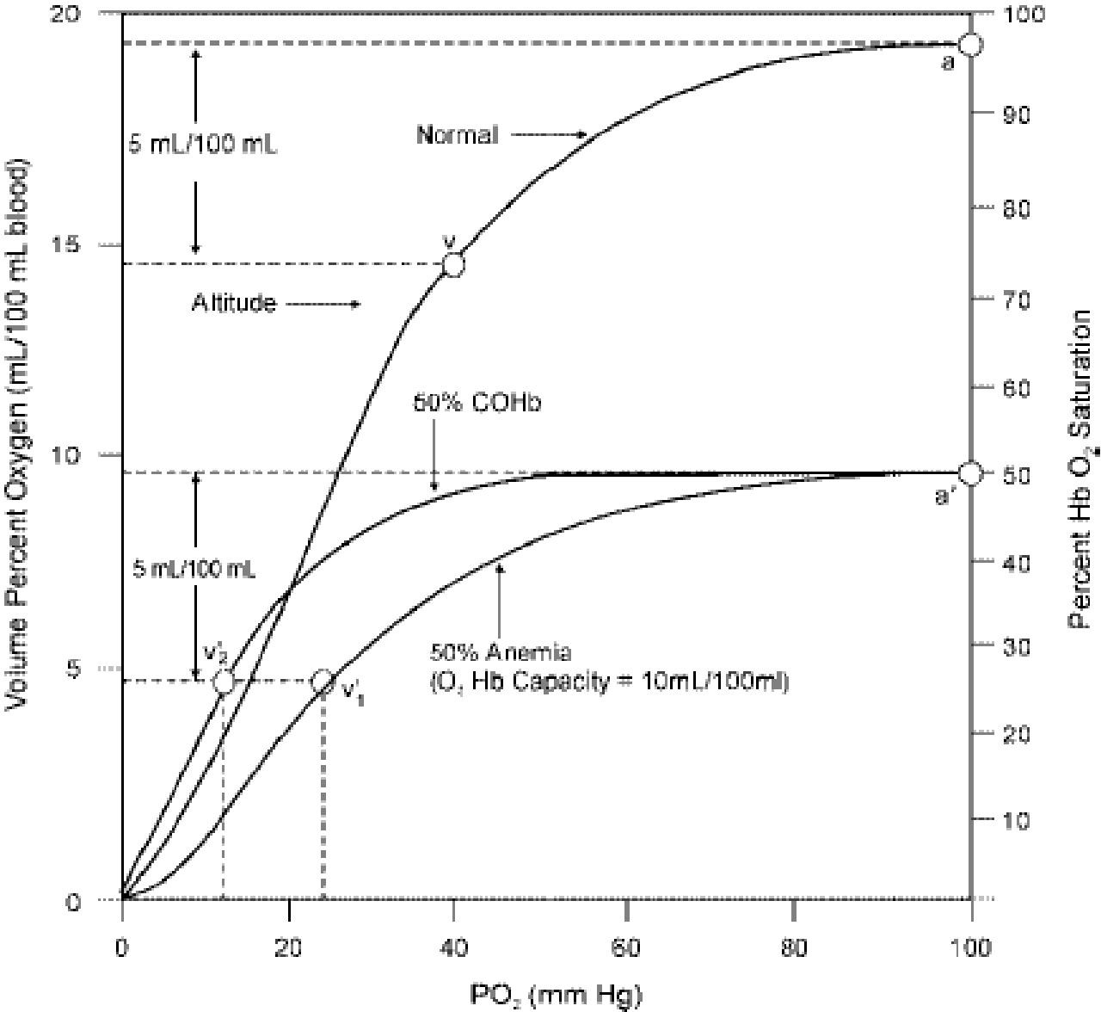

Figure 2.1: Oxyhemoglobin dissociation curve of normal human blood, of blood containing 50% COHb, and of blood with only 50% Hb because of anaemia (USEPA, 1991).

The figure above shows decreased capacity of the blood containing 50% COHb and 50% Hb to carry enough oxygen as compared to the normal. It also shows impaired

release of oxygen by the blood containing 50% COHb and 50% Hb due to the high affinity to oxygen when compared to the normal blood.

CHAPTER THREE

MATERIALS

Source of carbon monoxide

The source of CO will be from the exhaust fumes of a gasoline-powered generator (TIGER, TG950, 220v/240v).

Portable carbon monoxide gas analyser

The carbon monoxide meter CM100 from Amprobe, China, with serial number 10060391 was used. The meter has the following technical specifications; carbon monoxide range is 0 – 999 ppm (parts per million); error resolution of 1 ppm and accuracy of +/- 15% at 100 – 500 ppm. The meter has a screen and a backlight for operation in the dark.

The dose in parts per million (ppm) of CO exposure was recorded by the digital CO gas analyser placed inside the gas chamber together with the experimental animals. The exposure dose was in the range of 100 - 150 ppm for 30, 60, and 120 minutes.

Gas chamber

It was an improvised chamber that was not air tight, but constructed in such a way that it provided partial ventilation to fresh air. Transparent polythene bag was used to cover a plastic frame measuring 150 cm x 100 cm x 100 cm to make it air tight with an opened window for ventilation.

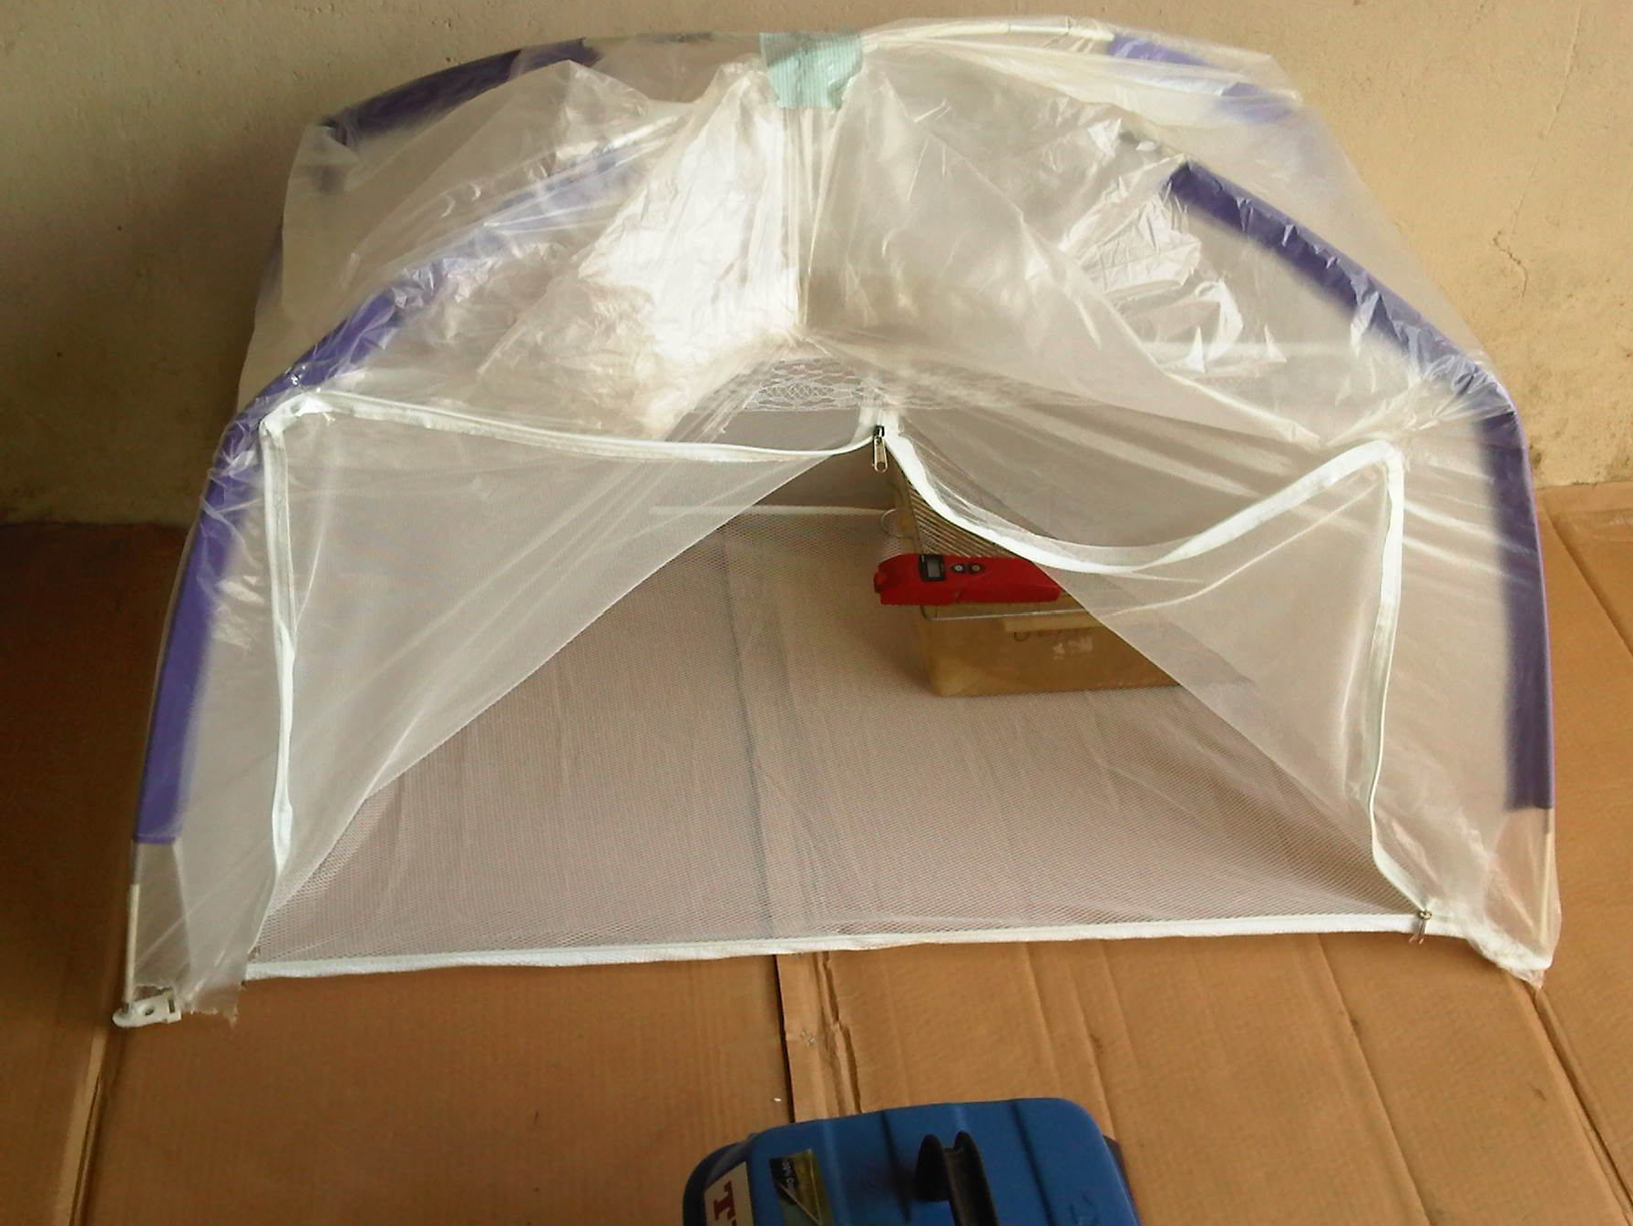
Fig. 3.1 Gas chamber.

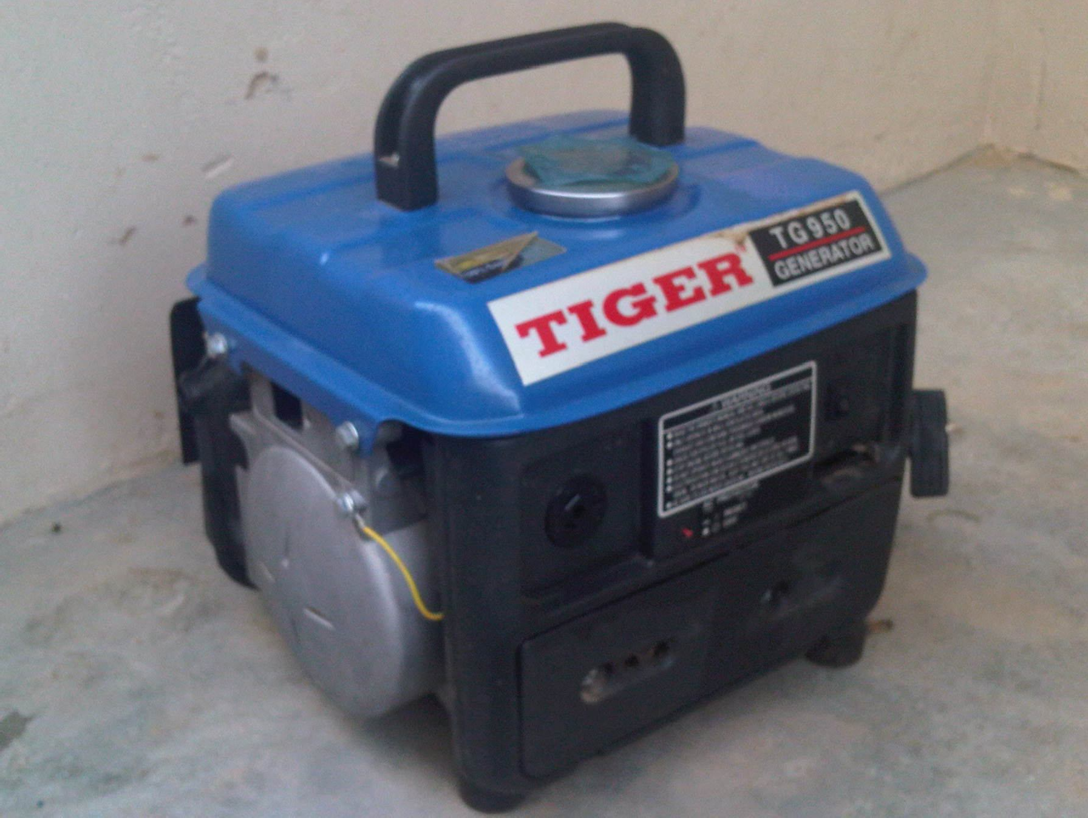

Fig. 3.2 Portable gasoline-powered generator, TIGER, TG950.

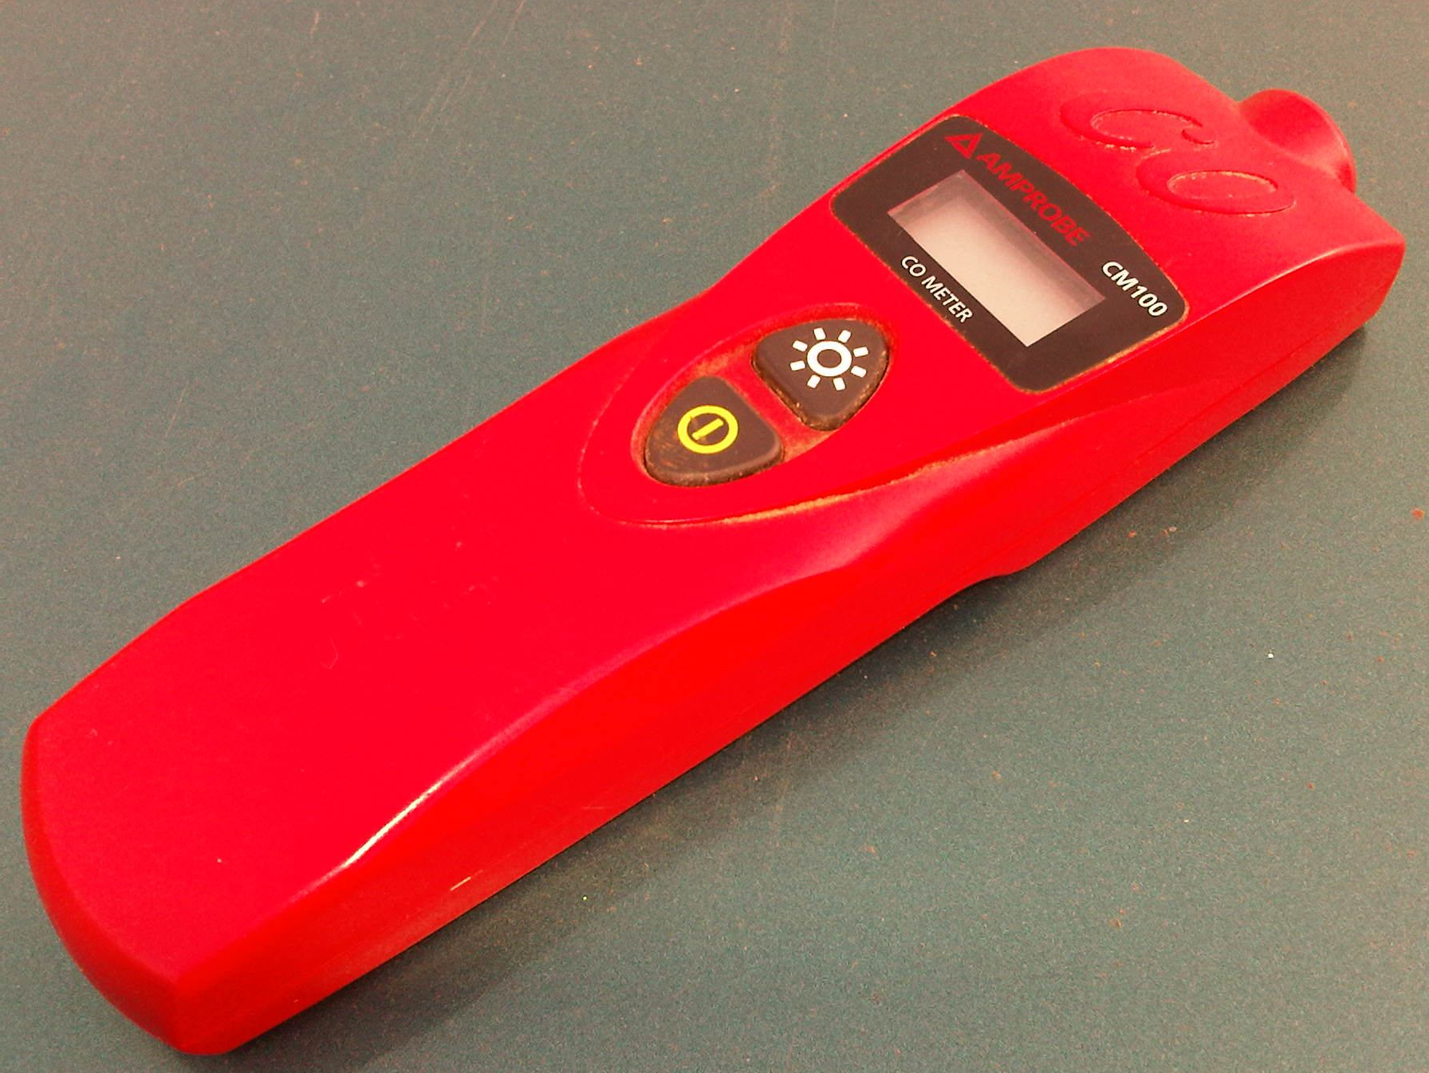

Fig. 3.3 Digital CO monitor, Amprobe CM100.

METHODS

Animals

Twenty five adult Swiss albino mice of both sexes were used in the study. They weighted between 18-32 g and were obtained from the animal house of Department of Pharmacology and Therapeutics of Ahmadu Bello University, Zaria. The animals were randomly divided into two major groups; each containing twelve mice for beam walk and elevated plus maze (EPM) respectively. Group I underwent Beam walk test, and group II-the EPM test. Each of the two groups (Group I & II) was further divided into two sub-groups, the experimental and control groups. Female mice were tested without monitoring the oestrous cycle. Animals were maintained at room temperature, fed on standard feed and allowed access to tap water ad libitum. They were allowed to acclimatize with the environment for at least two weeks before commencement of the study.

    - Exposure of animals to carbon monoxide from the generator exhaust fumes The cage was placed inside the gas chamber and the mice were exposed to the exhaust fumes of the gasoline-powered generator (TIGER, TG950, 220v/240v). The exposure allowed partial ventilation to fresh air; similar to that adopted by Samuel et al. (2007), in which human subjects were accidentally exposed to a gasoline-powered generator (5 kW, 3000 U/min) directly adjacent to a long stable where they were sleeping. The experimental groups were exposed to the generator exhaust fumes containing 100 - 150 ppm of CO for 30, 60 and 120 minutes before the tests, while the control groups were maintained on fresh air. The CO monitor had an inbuilt alarm system that made different noise depending on the CO concentration in air.

NEUROBEHAVIORAL ASSESSMENTS

Assessment of motor coordination using beam walk test

In the beam-walk test (also known as the raised-beam or raised-bridge test), mice were trained to traverse an elevated, narrow ruler beam to reach an enclosed escape goal box. The protocol described here measures foot-slips and latency to traverse the beam, although a number of other parameters of motor coordination and balance can also be measured. The protocol described here is for testing on mice (Stanley, 2005).

The materials used were methylated spirit, cotton wool, and the beam walk apparatus which was made up of 75 cm strips of two smooth woods. One beam was flat like a ruler of 25 mm width by 10 mm thickness. The other strip is round with a diameter of 20 mm. Narrow support stands to hold up the start part of the raised beam (15 mm cross-section, 40 cm high) was also used, together with the Goal box (30 cm x 20 cm x 25 cm with a 5 x 6 cm entrance hole), secured on top of a support.

The latency and foot-slip measurements were taken as the mouse traverse the beam. The starting point of the beam was mounted on the narrow support stand on a stable laboratory bench in the neurobehaviour room and a goal box was attached to the other end. A 30W lamp was also hanged by the ceiling to provide lightening and also created an aversive stimulus (bright light) to encourage mice to traverse the beam to the dark enclosed goal box.

The animals in their home cages were transferred, from the animal house to the neurobehaviour laboratory. They were allowed to habituate to the laboratory for about 15 minutes. A trial session was conducted where one of the investigators noted and recorded the latency to traverse the beam to the goal box, while the other investigator placed the mice on the beam at the start of each trial, removed them and also recorded the foot-slips afterwards. A mouse was placed at the starting point and the latency to traverse the beam (up to a maximum of 60 seconds) was timed. Each mouse was given few consecutive trials in order to avoid the possible influence of learning and returned to its home cage. The flat beam was used for training mice, while the round-beam for the actual test. During the first few trials, some animals had to be given encouragement (in form of an occasional nudge with a finger) in order to traverse the full length of the beam. However, they soon learnt to cross rapidly to the enclosed goal box without any additional encouragement. Methylated spirit was used to clean the apparatus and allowed to evaporate fully after each trial before re-using the apparatus. This was done to avoid bias and also wash off the stained urine, which may serve as a guide to most mice and, therefore, alter the accuracy of data. At the end of the trials, animals were allowed to rest before the testing while the experimental groups are exposed to the fumes of generator exhaust containing CO. At the end of the day’s session, animals were returned to their home cages and the apparatus was thoroughly cleaned with methylated spirit.

Experimental animals in Group I were exposed to the CO for thirty minutes. Thereafter each of the animals in the group underwent beam walk test sequentially. After the study group had completed the test, the control group then underwent the same Beam walk test. Beam walk was conducted in order to detect any neurological deficits in sensory,

balance, or motor performance. The actual test involved measurement of the latency to traverse each beam, and the number of times the left and right hind feet slip-off the beam for each test. Each mouse was allowed up to a maximum of 60 seconds to traverse the beam. Occasionally mice may fall from the beam, and that was recorded as a failure. The number of failures was analyzed separately. At the end of testing session, animals were returned to their home cages in the animal house. The apparatuses were thoroughly cleansed with methylated spirit.

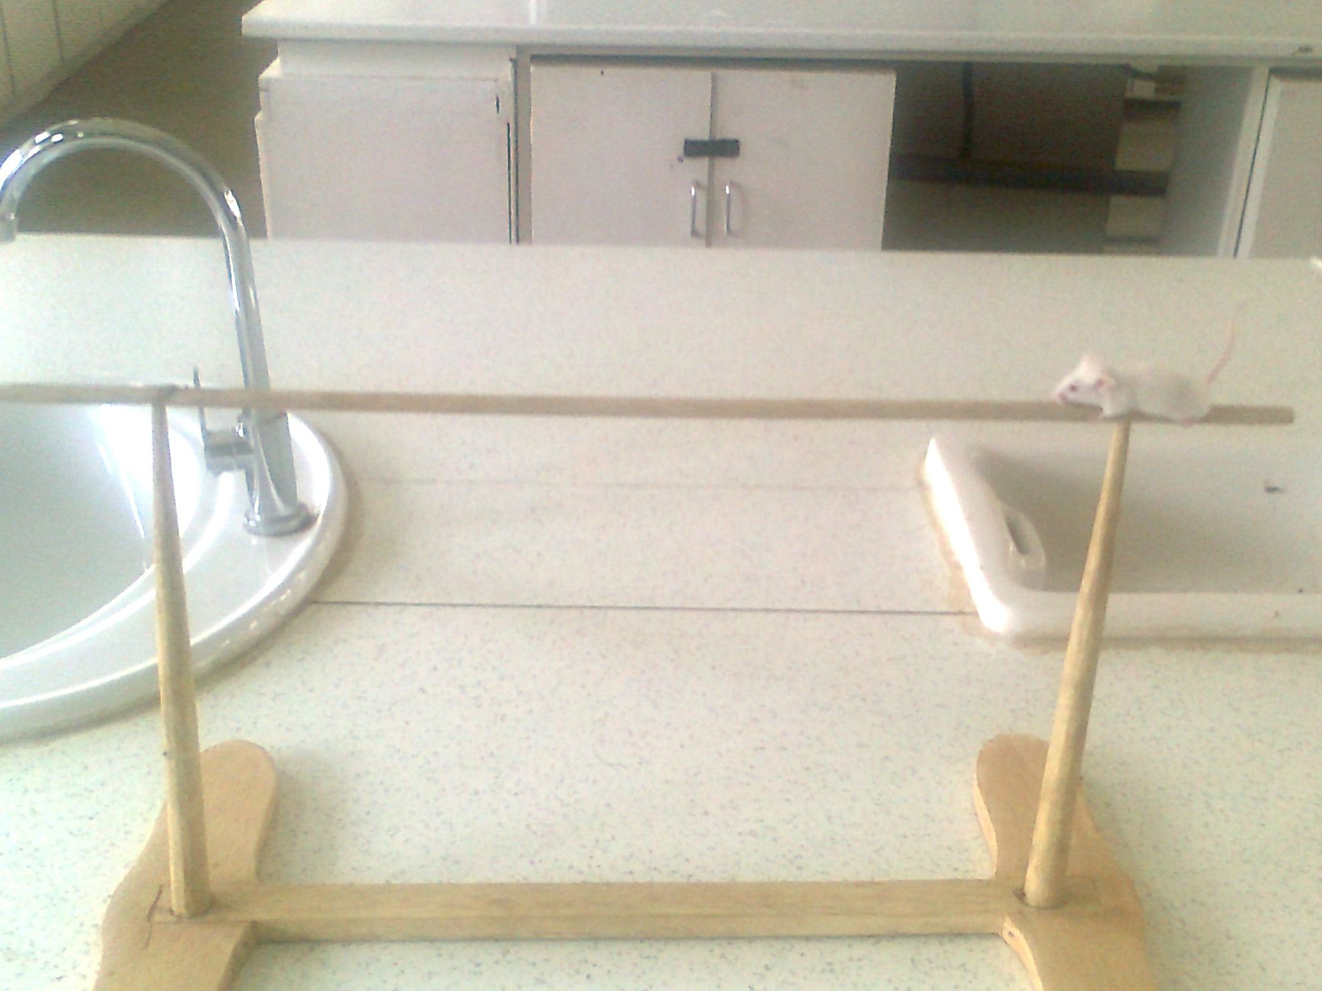

Fig. 3.4 Beam walk

      - Assessment of Learning Retention Behaviour using the Elevated Plus Maze The EPM apparatus was made of plywood and consisted of two open arms (25 x 5 cm) and two closed arms (25 x 5 x 15 cm) which extended from a central 5 x 5 cm platform.

The plus maze was elevated 50 cm above the floor and the whole apparatus was painted black (Itoh et al., 1990).

The experimental animals in Group II were exposed to CO. Immediately after exposure, each animal in the group underwent EPM test sequentially. After the experimental group had completed the test, the control group also underwent the same EPM test.

The procedure for the test as described by Itoh et al. (1990) was used. On the first day (learning test) a mouse was placed at the end of one of the open arms, facing away from the central platform. Latency for the mouse to enter one of the closed arms was recorded in seconds. Following entry into the arm, the animal was allowed to explore the apparatus for 30 seconds. All the paws were required to be in the arm before being counted as an entry. Twenty four hours later, the second trial (retention test) was performed. Mice appear unwilling to venture onto the open arms of the maze because of a general aversion to open spaces and to the elevation of the maze; this induced learning responses in the animal (Lister, 1990). The experimental group was exposed to CO just before (30 min., 1 hour and 2 hours) the trials, while the control group was exposed to room air. After each trial, the plus maze was thoroughly cleansed with methylated spirit and allowed to dry before the next trial. The time taken for a mouse to move from the starting point of the open arm to



Fig. 3.5 Elevated plus maze

any of the closed arms was measured (in seconds) to indicate learning (first day) and memory (second day) (Itoh et al., 1990). The hippocampus links the nervous system to

the endocrine system through neurohormones and is highly susceptible to hypoxic injury. Passive-avoidance task used in the EPM test is a hippocampal and amygdala- dependent test which evaluates long-term (24 hour) emotional memory (Holland et al., 1999). Elevated plus maze test also has a spatial component since the animals should remember the configuration of the open and closed arms and should escape from the unsafe open arm on the second trial.

On the first day of the study, mouse placed on the open arm of the EPM was expected to quickly move towards and enter one of the closed arms because of its natural aversion to open space and height. Such behaviour served as the learning or acquisition test, in which the mouse should on re-exposure (after 24 hours) be able to remember that a closed arm of the EPM exists. The time taken by the animal to move from the open to a closed arm of the EPM was recorded as transfer latency and exemplifies learning (Reddy, 1997). The cognitive processing of spatial information took place when the animal navigated the maze during the first exposure. Re-exposure to the maze enabled the animal to recall places and things reflecting explicit memory.

Determination of blood Carboxyhaemoglobin level in animals

At the end of the neurobehavioural tests, mice were sacrificed and blood sample obtained by cardiac puncture was used for COHb analysis by means of spectrophotometric method (Ernest and Carol, 1984). This method for estimating carboxyhaemoglobin was based on the production of two-pigment mixture by reducing oxyhaemoglobin and methaemoglobin with sodium hydrosulfite. Absorbances of the pigment were measured at 420 and 432 nm. Protecting the solutions against exposure to

air was unnecessary. Values are stable and reproducible when the solutions are buffered at pH of 6.85.

Materials required for this analysis included (1) Buffer: KH₂PO₄/K₂HPO₄, 0.1 mol/L, pH 6.85. The buffer was stable indefinitely when kept refrigerated (2) Hemolyzing solution: Buffer diluted 10-fold with water, (3) CO-Hb diluting solution: prepared by adding about 25 mg of sodium hydrosulfide to 20 mL of buffer just before used.

Blood samples from the sacrificed animals were collected in test tubes containing ethylene diaminetetraacetic acid (EDTA, potassium salt) of 1.5 mg/mL of blood. About 25 µL of blood was added to 3 mL of the hemolyzing solution in a small test tube and mixed by inverting two or three times. After 5 minutes, about 0.1 mL of this mixture was pipetted into a cuvette having a critical volume of less than 1.2 mL, which already contained 1.15 mL of the CO-Hb diluting solution. Alternatively, 0.2 mL of the haemolysate was added to 2.3 mL of the CO-Hb diluting solution in a larger cuvette having a critical volume of less than 2.5 mL. Cuvette was covered with Parafilm, mixed by inverting gently several times, and allowed to stand at room temperature for 10 minutes. The absorbance was read at 420 and 432 nm against a matched cuvette containing only CO-Hb diluting solution. The following equation was used to compute the fraction of CO-Hb (S_{co}) in blood.

S_{co} = 1 – (A_{R} x F₁)

A_{R} (F₂ – F₁) – F₃ + 1

A_{R} is the ratio A₄/A₂ of the sample in CO-Hb diluting solution. The three constants, F₁, F₂, and F₃ may be computed from the published molar absorption of reduced haemoglobin and CO-Hb at 420 and 432 nm: F₁ = 1.3330, F₂ = 0.4787 and F₃ = 1.9939 (Rodkey et al., 1979).

DATA ANALYSIS

Data obtained from the study were expressed as means ± standard error of mean (SEM). Student’s t-test was used to compare the means between experimental and control groups, as well as between Day-1 and Day-2 of the study using independent and paired sample student’s t-test, respectively. For all evaluations, values of P < 0.05 were considered to imply statistical significance. Microsoft Office Excel version 2007 and Statistical Package for Social Sciences (SPSS) version 15.0 soft ware were employed in analyzing the data.

CHAPTER FOUR

RESULTS

The parameters measured in this study were transfer latencies (TL) and number of foot- slips in the neurobehavioral tests, and percentage blood COHb level.

Effects of 30 minutes of Carbon monoxide exposure on learning/acquisition and retention/memory test
Table 4.1 compares the TLs of the control and experimental groups during learning (Day-1) and memory (Day-2) tests after 30 minutes of exposure of the experimental group to CO. There was decreased latency (13.4 ± 1.5 sec.) of the experimental group, when compared to the control (28.6 ± 5.2 sec.) in Day-1. The decrease was statistically significant with P value of 0.023 and suggested enhanced ability of mice to learn new behaviour. In day-2 however, there was significant (P < 0.05) increase in the TL of 48.4
± 12.8 sec. in the experimental group when compared to 13.6 ± 1.9 sec. of the control group. This shows impaired retention ability of the mice to recall the learned behaviour. Day-2 test recorded impaired recall despite the enhanced learning recorded previously (Day-1).

Table 4.1: Transfer latencies of control and experimental groups after 30 minutes of exposure

Groups Treatment Transfer Latency (Mean ± SEM) (Seconds)

 |  | Day- 1 | Day- 2
Control | Room air | 28.6 ± 5.2^{b} | 13.6 ± 1.9^{b}
Experimental | Carbon monoxide | 13.4 ± 1.5ª | 48.4 ± 12.8ª

^{a,} ^{b} = values with different superscript letters indicate significance at P < 0.05 n = 5

Effect of 1 hour of Carbon monoxide exposure on learning and retention/memory test
During the 1 hour exposure to CO, increases in the TLs of the experimental group in Day-1 (73 ± 8.4 sec.) and Day-2 (51.6 ± 16.5 sec.) were recorded when compared to their controls (21.8 ± 4.4 sec.) and (14.4 ± 2.0 sec.), respectively. However, highly significant (P = 0.001) difference was recorded only during the Day-1 test (Table 4.2). The above result may suggest impaired ability of the exposed mice to learn new behaviour, but not the recall (Table 4.2).

Table 4.2: Transfer latencies of the control and experimental groups after 1 hour of exposure.

Groups Treatment Transfer Latency (Mean ± SEM) (Seconds)

 |  | Day- 1 | Day- 2
Control | Room air | 21.8 ± 4.4^{b} | 14.4 ± 2.0
Experimental | Carbon monoxide | 73.0 ± 8.4ª | 51.6 ± 16.5

^{a,} ^{b} = values with different superscript letters indicate significance at P < 0.05 n = 5

Effect of 2 hours of CO exposure on learning and retention/memory test

Although there were increases in the TLs of the exposed mice during the learning (54.0

± 15.1 sec.) and memory (66.8 ± 15.3 sec.) tests when compared to their controls (26.0

± 10.5 sec.) and (22.6 ± 6.6 sec.), only day-2 recorded significant difference (P = 0.029). Two hours of CO exposure could therefore only impair the ability of the exposed mice to recall, while sparing the learning ability (Table 4.3).

Table 4.3: Transfer latencies of the control and experimental groups after 2 hours of exposure

Groups Treatment Transfer Latency (Mean ± SEM) (Seconds)

 |  | Day- 1 | Day- 2
Control | Room air | 26.0 ± 10.5 | 22.6 ± 6.6^{b}
Experimental | Carbon monoxide | 54.0 ± 15.1 | 66.8 ± 15.3ª

^{a,} ^{b} = values with different superscript letters indicate significance at P < 0.05 n = 5

    - Influence of Carbon monoxide exposure on learning/acquisition test (Day-1) When TLs of the control and experimental groups were compared in the three exposure periods, only the 30 minutes and 1 hour exposure periods showed significant change with P values of 0.023 and 0.001, respectively since P < 0.05. Although latency of the experimental group drop to 13.4 ± 1.5 seconds during the 30 minutes of CO exposure, that of 1 hour exposure period increases to 73 ± 8.3 seconds when compared to their controls (28.6 ± 5.2 sec.) and (21.8 ± 4.4 sec.) respectively. It may thus suggest improvement of learning at shorter period of CO exposure (30 minute) as opposed to impairment of learning ability at longer period of CO exposure (1 and 2 hours) (Fig. 4.1).

90
*
*
b
a
a
b
control experimental

80

70

60
Transfer Latency (seconds)

50

40

30

20

10

0
30 minutes 1 Hour 2 Hours
Duration of exposure

Figure 4.1: Transfer latencies of control and experimental groups during the acquisition/learning test
^{a,} ^{b} = values with different superscript letters indicate significance at P < 0.05 and its absence imply insignificance. n = 5

Influence of CO exposure on memory/recall test (Day-2)

There were significant increases in the TLs of the experimental group during the 30 minutes (48.2 ± 12.8 sec.) and 2 hours (66.8 ± 15.3 sec.) of exposure when compared to the controls (13.6 ± 1.9 sec.) and (22.6 ± 6.6 sec.), respectively. Results suggest impaired recall of the learned behaviour in virtually all the three exposure periods (Fig. 4.2).

90
b
b
a
a
control
experimental

80

70

60
T ra n sfe r L a ten cy (se co n d s)

50

40

30

20

10

0
30 minutes 1 Hour 2 Hours

Figure 4.2: Transfer latencies of the control and experimental groups during the recall/memory task (Day-2).
^{a,} ^{b} = values with different superscript letters indicate significance at P < 0.05 and its absence imply insignificance. n = 5

Control group

The outcome here, reveal how mice in the control group were able to easily recall (Day- 2) the learned (Day-1) behaviour under normal circumstances, thus having reduced latencies on the second day (Fig. 4.3).

40
Day-1
Day-2

35

30

25
T r a n s fe r L a te n c y (se c o n d s)

20

15

10

5

0
30 minutes 1 hour 2 hours

Figure 4.3: Transfer latencies of Day-1 and Day-2 tests of the Control group.

    - Effects of 30 minutes, 1 hour and 2 hours of Carbon monoxide exposure on mice
Figure 4.4 showed TLs in Day-1 (acquisition/learning) and Day-2 (recall/memory) of the

experimental group. Thirty minutes and 2 hours of exposure recorded an increase in the TLs on the second day (48.4 ± 12.8 sec. and 66.8 ± 15.3 sec. respectively) when compared to the first (13.4 ± 1.5 sec. and 54 ± 15.1 sec.). There was however a reduction in the TL during the 1 hour exposure in Day-2 (51.6 ± 16.5 sec.) when compared to Day- 1 (73 ± 8.4 sec.) (Fig. 4.4).

90
Day-1
Day-2
b
a
b
a

80

70

60
T r a n s fe r L a te n c y ( s e c o n d )

50

40

30

20

10

0
30 minutes 1 hour 2 hours

Figure 4.4: Transfer latencies of Day-1 and Day-2 tests in the experimental group.

^{a,} ^{b} = values with different superscript letters indicate significance at P < 0.05 and its absence imply insignificance. n = 5

ASSESSMENT OF MOTOR COORDINATION

Effects of CO exposure on beam walk performance test

Although there were increases in the latency of the experimental group during the 30 minutes (9.4 ± 0.9 sec.), 1 hour (20.8 ± 2.1 sec), and 2 hours (11.4 ± 1.5 sec.) of exposure to CO when compared to their controls (8 ± 0.9 sec., 15.4 ± 2.7 sec. and 10 ± 0.8 sec.) respectively; none was significant (Fig. 4.5).

25

20

15
T r a n sfer L a ten c y (se c o n d s )
control
experimental
10

5

0
30 minutes 1 Hour 2 Hours

Figure 4.5: Latencies of the control and experimental groups during beam walk performance test

Foot-slips in the control and experimental groups

There was no any significant change (P > 0.05) in the mean frequency of foot-slips of the experimental animals (Table 4.9) when compared to their controls in all the three periods of exposure (Fig. 4.6).

3
control
experimental

2.5

2
T r a n sf er L a t en c y (se c o n d s)

1.5

1

0.5

0
30 minutes 1 Hour 2 Hours

Figure 4.6: Mean foot-slips during beam walk test.

ANALYSIS OF BLOOD CARBOXYHAEMOGLOBIN

Percentage COHb was found to be significantly higher in the exposed (2.06 ± 0.12%) than in the control group (0.78 ± 0.089%) with P < 0.05 (Table 4.10).

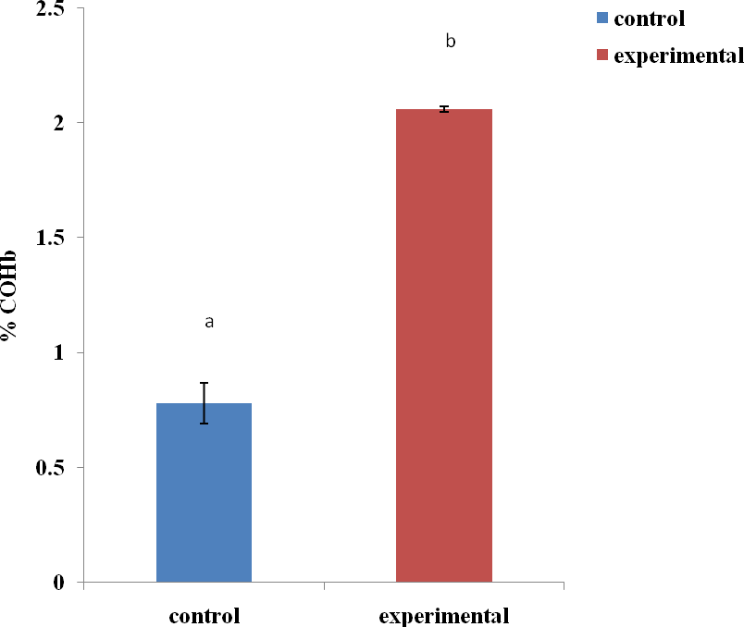

Figure 4.7: Percentage carboxyhaemoglobin in the control and experimental groups
^{a,} ^{b} = values with different superscript letters indicate significance at P < 0.05 and n = 5

SUMMARY OF RESULTS

Learning

When TLs of the control and experimental groups were compared in the three exposure periods, only the 30 minutes and 1 hour exposure periods showed significant change with P values of 0.023 and 0.001, respectively at P < 0.05. Although latency of the experimental group drop to 13.4 ± 1.5 seconds during the 30 minutes of CO exposure, that of 1 hour exposure period increases to 73 ± 8.3 seconds when compared to their controls (28.6 ± 5.2 sec.) and (21.8 ± 4.4 sec.) respectively. It may thus suggest improvement of learning at shorter period of CO exposure (30 minute) as opposed to impairment of learning ability at longer periods of CO exposure (1 and 2 hours) (Fig. 4.1).

Memory

There were significant increases in the TLs of the experimental group during the 30 minutes (48.2 ± 12.8 sec.) and 2 hours (66.8 ± 15.3 sec.) of exposure when compared to the controls (13.6 ± 1.9 sec.) and (22.6 ± 6.6 sec.), respectively. Results suggest impaired recall of the learned behaviour in virtually all the three exposure periods (Fig. 4.2).

Motor coordination

There were no statistically significant differences between the control and experimental groups to suggest any motor coordination deficits in all the three periods of CO exposure.

Blood Carboxyhaemoglobin

There was significant (P = 0.0001) increase in the percentage COHb of the experimental group (2.06 ± 0.12) when compared to the control (0.78 ± 0.089), thus suggesting additional exogenous exposure.

CHAPTER FIVE

DISCUSSION

Several studies in humans confirm neurotoxicity to be the most prominent symptoms in any CO poisoning (Samuel et al., 2007; USEPA, 2010). Animal studies also suggest foetal susceptibility, and that the developing brain has the highest sensitivity of all organs (Longo et al., 1977). It was estimated that as high as 50% of individuals with CO poisoning will develop neurologic, neurobehavioural, or cognitive sequelae. Carbon monoxide-related cognitive deficits included impaired memory, attention, executive function, motor, visual spatial, and slow mental processing speed (Hopkins et al., 2006).

Depicting real CO toxicity in human subjects through experiments may not be possible, but laboratory animal models have been instrumental in shaping our understanding of some of these toxic gases. Simple but explicable models such as the EPM, Morris water maze and the open field are of value in the evaluation of learning and memory modulation.

LEARNING/ACQUISITION AND MEMORY/RECALL

The hippocampus is a part of the limbic system that plays a part in memory and spatial navigation. Although scientists believe that no single brain centre stores memory, hippocampus plays an essential role in the formation of new memories and form part of a larger medial temporal lobe memory system responsible for long-term memory.

Comparison between control and experimental groups, and also between the first day task (learning/acquisition) and the second day task (memory/recall) will be assessed. A significant increase in the TLs of the experimental group when compared to the control group suggests CO exposure was able to distort either the acquisition of or recall of the learned behaviour or both. While having significant decrease in the TLs of the experimental group when compared to the control may suggest enhancement/ positive effect of CO on learning and memory. Lack of any significant difference between the two groups however does not rule out affectation. Another assessment was to compare the TLs between Day-1 (acquisition) and Day-2 (recall) in the control and experimental groups separately. The control groups were expected to be normal animals, and therefore had decreased TLs on the second day task when compared to the first day. This is because the animal should normally be able to easily recall the acquired behaviour. So when Day-1 was compared with Day-2 of the control group, the mean TLs were found to be lower in the second days. Meaning there was no affectation of either the ability to learn or to recall the learned behaviour. The finding proved the expected normality that should be recorded in the control group as opposed to impaired behaviour of the experimental groups.

Learning/acquisition

In this study, there was significant reduction rather than increase in the mean TL of the experimental group during the 30 minutes CO exposure in Day-1. It was proper to say that 30 minutes partial exposure to CO at concentration ranging from 100 - 150 ppm may enhance the ability of mice to learn new behaviour. This finding is in agreement with recent findings which suggest CO, together with NO acting as gaso-transmitters in the CNS at physiological concentrations in the body (Boeihning et al., 2003); as the

exposure increased, poisoning results (Mannoin et al., 2006). Even though the WHO recommended level of exposure is < 100 ppm, exposure to 50 - 100 ppm of CO was found to increase Hydrogen peroxide (H₂O₂) production in the lungs of rat, a phenomenon which depended on •NO production (Thom et al., 1999). The possible explanation to the enhanced H₂O₂ production is by disturbance of mitochondrial function; where Peroxynitrite inhibits electron transport at complexes I through III, and a •NO targeted cytochrome oxidase (Cassina et al., 1996; Lizasoain et al., 1996; and Poderoso et al., 1996).

Previously, Karim et al. (2001) have established the role played by CO produced in the body as a retrograde synaptic messenger with a prominent position in the long-term potentiation (LTP) of certain areas of the brain. In a similar study also CO produce long-term enhancement when paired with low-frequency stimulation and results were found to be consistent with the hypothesis that NO and CO, either alone or in combination, serve as retrograde messengers that produce activity-dependent presynaptic enhancement during LTP (Zhuo et al., 1993; Hawkins et al., 1994). The possible mechanism proposed by Pineda et al. (1996) was that NO and CO activate noradrenergic neurones of Locus Coereleus (LC) via a cGMP-dependent protein kinase and a non-selective cationic channel. It was also proposed that these effects occur at the postsynaptic level and that there may be a tonic regulation of LC neuronal firing by the cGMP pathway.

Memory/recall

Increased deterioration of the recall capacity was found to be directly proportional to the duration of CO exposure. Previous data suggested a specific toxicity of CO on memory functions in animals and also delayed neuronal death in areas involved in memory process (Piantadosi et al., 1997; Nabeshima et al., 1991). In another research, hypoxic ischaemia was found to cause damage and cell loss to the pyramidal cells in the CA1 region of the hippocampus. Equally Katoh et al. (1990) reported a 17% decrease in pyramidal cells in the CA1 region of mice, who received pure CO compared to normal controls. The findings here were in line with the above suggesting significant deterioration in learning/acquisition after 1 hour of partial CO exposure. In a recent study conducted by Mereu et al., (2000), functional changes observed at CA3-CA1 synapses in the hippocampus could underlie learning and memory deficits produced in rat offspring by a prenatal exposure model (150 ppm) simulating the CO exposure observed in human cigarette smokers.

Though 30 minutes of partial CO exposure enhanced the learning/acquisition task, the same 30 minutes exposure produced significant deterioration in the memory/recall task after 24 hours. It can therefore be deduced that any CO exposure may impair recall in mice. Similarly, CO poisoned subjects were found to have impaired ability to remember new temporal, linquistic, and spatial information while previous knowledge for temporal, linquistic, and spatial information was intact (Hopkins et al., 1993). Short- term memory loss, lack of spontaneous movements and infarctions in bilateral hippocampi, temporal poles, occipital cortex, globus pallidus, cerebellum, and brainstem were apparent in an elderly man after deliberate CO poisoning. Although he was ambulatory Six months later with normal communication; he suffered residual

anterograde amnesia (Gottfried et al., 2001). A case of delayed encephalopathy and cognitive sequelae were observed 4 weeks after acute CO poisoning, following which the patient regained some improved memory and other cognitive function after 4 weeks of treatment, including hyperbaric oxygen therapy (HBOT) (Tapeantong et al., 2009). It was observed that chronic cerebrolysin (CL)-treatment enhances recovery of hippocampal tissue after hypoxic damage of intermediate severity induced by CO (Koroleva et al., 1999).

Exposure to CO was found to produce deterioration of memory due to neuronal cell death. In another research, hypoxic ischaemia was found to cause damage and cell loss to the pyramidal cells in the CA1 region of the hippocampus (Volpe and Petitio, 1985). Similarly, Katoh et al. (1990) reported a 17% decrease in pyramidal cells in the CA1 region of mice who received pure CO compared to normal controls. The finding here is in line with the above, suggesting significant deterioration in learning/acquisition after 1 hour of partial CO exposure. A study conducted by Mereu et al. (2000), suggested functional changes at CA3-CA1 synapses in the hippocampus as the possible cause of learning and memory deficits produced in rat offspring by a prenatal exposure model (150 ppm), simulating the CO exposure observed in human cigarette smokers. Brain regions showed varying sensitivity to hypoxic damage. Attempts have been made to relate this “selective vulnerability” to the cause of hypoxia, but the nature and distribution of the lesions appear to depend on the severity, suddenness, and duration of the oxygen deprivation, as well as on its mechanism (hypoxia or ischaemia), rather than on its cause. In the brain, hypoxia leads to increased intracranial pressure and cerebral oedema which is partially responsible for decreased level of consciousness, seizures and coma (Lapresle et al., 1967).

Though 30 minutes of partial CO exposure enhanced the learning/acquisition task, the same 30 minutes exposure produced significant deterioration in the memory/recall task after 24 hours. It can therefore be deduced that any CO exposure may impair recall in mice. Similarly CO poisoned subjects were found to have impaired ability to remember new temporal, linquistic, and spatial information while previous knowledge for temporal, linquistic, and spatial information was intact (Hopkins et al., 1993). Results of the study conducted by Andrea et al. (2001) also suggested that altered developmental profile of hippocampal neuronal NO synthase (nNOS) and haem-oxygenase (HO-2) activities could be involved in cognitive deficits and long-term potentiation dysfunction exhibited by rats prenatally exposed to CO (150 ppm from days 0 to 20 of pregnancy) levels resulting in COHb levels equivalent to those observed in human cigarette smokers.

It can also be inferred from the result that maximum effect of CO on mice was reached during the 1-hour exposure, which could possibly be that time when the maximum saturation point of COHb in the body was reached. As Coburn et al. (1965) has pointed out that the most important determinants of COHb level are CO concentration in inhaled air, duration of exposure and alveolar ventilation. The maximum CO effect reached triggered homeostatic responses such as increased respiratory rate and heart rate to return the body to normal; a possible reason why the mean TL during the 2 hours exposure was less than that of the 1 hour exposure in the experimental group, even though the duration of exposure was higher. Substantial body of literature also suggested that at least with regard to vascular effects, the duration of exposure has a

greater impact on the magnitude of CO patho-physiology than what is predicted based on the concentration of CO that is inspired (Fein et al., 1980; Penney et al., 2008).

BEAM WALK

There were marginal increases in the TLs of the experimental groups in all the three periods of exposure, which mean CO exposure does not affect the TLs in beam walk task. This finding corroborates other studies since the level of COHb in humans that will grossly affect movement is above this exposure concentration of 100 - 150 ppm (2.06 %). World Health Organization’s Expert Panel on Air Quality Standards in 1994 reported that levels between 2 – 20 % can cause effects on visual perception levels, audition, motor, and sensory-motor functions, and behaviour. However, headaches, generalized weakness, fatigue and sleepiness were part of the vague symptomatology observed in human subjects with COHb levels below 20 % (Hampson et al., 2002). Dizziness is a frequent companion of headache and can be seen in about 92 % of victims of CO poisoning (Abelsohn et al., 2002). In a recent literature re-evaluation, however, the best estimate was that COHb would have to rise to 15 – 20 % before a 10
% reduction in any behavioural or visual measurement could be observed.

There were no statistically significant differences between the control and experimental groups throughout the periods of exposure to CO. Absence of any difference between the control and the experimental groups could mean CO affect the performance in beam walk task only at higher/longer durations of exposure. Walker et al. (2001) suggest that the combined effect of increased atmospheric temperature, as experienced in the tropics, and CO poisoning can impair exercise performance and make daily chores like driving, climbing of stairs and long walks, a great task. Recently, a battery of ocular motor tasks was evaluated using the basic metrics of movements, and the higher-order cognitive

control processes governing movement and the findings suggest subclinical deficits potentially reflecting damage to the Globus Pallidus not only attributed to necrosis but also to subsequent demyelination of the cerebral white matter as the principal driver of these deficits (Lang et al., 2010). It was further shown by the same authors that ocular motor measures sensitively characterize cognitive deficits that may otherwise be overlooked after CO poisoning, and that may benefit from intervention. In another study which examined the influence of exposure to ambient CO, resulting in final COHb levels of approximately 5.0 % on the ability to process information during motor performance, where five levels of tapping difficulty and digit manipulation were evaluated; motor performance was not influenced by exposure to CO and task difficulty was a significant factor mediating behavioural effects of CO exposure (International Archives of Occupational and Environmental Health (IAOEH), 1983).

BLOOD CARBOXYHAEMOGLOBIN LEVEL

The blood COHb was estimated in both groups at the end of the study. Mean COHb level estimated was found to be higher in the exposed group than the control. Only a small amount of CO in the body was from endogenous production, larger percentage of CO was from exogenous sources. The estimated blood COHb level found in the experimental group was comparable to CO exposure of 15 ppm deduced from the CFK table (Appendix IX). Even though dose of CO exposure in this study was in the range of 100 - 150 ppm, lower blood COHb levels were recorded. This might not be far from the fact that the method of exposure used in the study was partial, providing some fresh air ventilation to the experimental animals. Prolonged time between exposure to CO and blood collection could have contributed also to the low % COHb in the blood sample when compared to the exposure dose. It will be stressed here that, if at this level of

COHb (2.06 %) such effects were recorded, higher doses may likely produce more effects.

Non-smokers living away from urban areas have COHb levels of 0.4 – 1.0%, reflecting endogenous CO production, whereas levels up to 5% may be considered normal in a busy urban or industrial setting (Craig et al., 2010). A value in compliant with the endogenous production was found in the control group of this study. However, in the experimental group, a value up to 2.06% was found, which reflects values equivalent to that of smokers (2 - 15%) or urban dwellers (2 - 5%). Prenatal low-level exposure of rats to 150 ppm resulted in COHb levels equivalent to those observed in human cigarette smokers (Andrea et al., 2001). The use of % COHb as a measure of severity of CO poisoning, or to predict treatment options, was limited because COHb levels are affected by a lot of factors like ventilation, partial pressure of O₂ in the air and other co- morbidities like heart disease (Craig et al., 2010). Attempts made in the past to equate symptoms and signs to different COHb levels failed, but it was generally accepted that COHb levels in an acutely poisoned person only roughly correlate with clinical signs and symptoms, especially those relating to neurological function (USEPA, 2007). Earlier studies also attempted to differentiate between smokers and non-smokers based on their % COHb levels in blood (AQG, 2000). No clear clinical consensus was reached when, attempts were made to categorize CO poisoning into mild, moderate, and severe based on the % COHb levels and clinical symptoms (Hampson et al., 2008). Degrees of poisoning were rather described as mild when there is greater than 10% COHb without clinical signs or symptoms of poisoning; moderate when the level is between 10 – 25%, with minor clinical signs and symptoms of poisoning, such as headache, lethargy, or

fatigue; and severe when the level is above 20 – 25%, with loss of consciousness, and confusion or signs of cardiac ischaemia or both (Hampson et al., 2008).

CHAPTER SIX

SUMMARY

The study was conducted with the aim of assessing the effects of acute exposure of generator exhaust fumes on learning, memory, and motor coordination in mice. Carbon monoxide was among the contents of the exhaust fumes and was studied in detail because of its toxicity. It is a colourless and odourless gas that is produced when ever carbon containing substance is burnt. In Nigeria, the main sources include but are not limited to gasoline powered generator, vehicles exhaust, fire wood, and kerosene stoves. Generally, people are at risk of CO poisoning, but certain occupations like the traffic police, cooks in restaurants and fire fighters are affected the most. Gasoline-powered generator (TIGER, TG950, 220v/240v), was the source of CO and digital CO monitor (Amprobe, CM100) was used to record the dose of CO in parts per million (ppm). The gas chamber employed was an improvised one that measured 150 cm x 100 cm x 100 cm (lxbxh) that was not air-tight, but rather provided partial ventilation to fresh air through the opened window.

Two groups of mice (control and experimental) were used to assess each neurobehavioural test. They were subjected to the same conditions and treatments except for the exposure. The experimental group was exposed to between 100 - 150 ppm dose of CO from the generator exhaust fumes for 30 minutes, 1 hour, and 2 hours periods at intervals of one week each. Mice were subjected to neurobehavioural tests of learning and memory using the EPM and motor coordination using the Beam walk. At the end of the study, mice were sacrificed and their blood were analysed for COHb concentration. Results obtained showed significant differences between control and

experimental groups in performing the EPM test. Carbon monoxide exposure from the generator exhaust fumes was found to reduce the ability of the exposed mice to learn new behaviour and also recall the learned behaviour. Carbon monoxide exposure had either minimal or no effect on the motor coordination of the exposed mice when compared to the control. The level of percentage COHb in blood was higher in the experimental than the control group, thus signifies additional intake from external sources. Our findings were in line with previous studies, where acute CO exposure resulted in neuronal cell death and functional deficits in learning and memory. However, CO exposure at physiological level was beneficial to learning process.

CONCLUSION

In conclusion, CO at this range and period of exposure was found to adversely affect acquisition and recall but not motor coordination in mice. The result was in agreement with previous studies which had suggested CO, together with NO acted as gaso- transmitters in the CNS at physiological concentrations. Carbon monoxide might have significant effect on the motor coordination at much higher dose than the one used here. It is important to note that, various effects presented here might not be attributed to only CO, since several other contents of the generator exhaust fumes might perhaps be toxic.

RECOMMENDATION

Based on the study conducted and the results obtained, the following recommendations will be made.
    - Studies should be conducted using pure CO gas to specifically ascertain its effects.

    - Sample size should be increased in subsequent studies, in order to enhance sensitivity and allow justifiable generalisation of the results.
    - Similar studies using lower doses of CO could specifically be conducted on humans to ascertain its neurobehavioural effects.
    - Similar studies should be encouraged utilising standard, modern equipments to enhance sensitivity and reliability of the results.
    - People should be aware of CO toxicity and avoid frequent exposure in order to safe guard their health.
    - Government should be more concerned about environmental pollution and ways of managing it.

REFERENCES

Abbaspour, M. and Soltaninejad, A. (2004). Design of an environmental assessment model on the effect of vehicle emissions. International Journal of Environmental Science Technology, 1(1): 27-38.

Abelsohn, A., Sanborn, M.D., Jessiman, B.J., and Weir, E. (2002). Identifying and managing adverse environmental health effects, Canadian Medical Association Journal, 166(13): 1685-1690.

Akinbami, J.F.K. (2001). Renewable Energy resources and Technologies in Nigeria: Present situation, future prospects and policy frame work. Mitigation and Adaptation strategies for global change. Kluwer Academic Publishers, Neitherlands, 6: 155-181.

Allen, E.R. (1977). Properties and reactions of carbon monoxide, in Carbon Monoxide (National Research Council—Subcommittee on Carbon Monoxide). National Academy of Sciences, 4–27.

Amitai, Y., Zlotogorski, Z., Golan-Katzav, V., Wexler, A. and Gross, D. (1998). Neuropsychological impairment from acute low-level exposure to carbon monoxide. Archives of Neurology, 55: 845-8.

Andrea, V., Stefania, R., Pierluigi, S., Mauro, F., Raffaele, C., Addolorata, C., Giampaolo, M., Luca, S., Maria, T., Luigia, T. and Vincenzo, C. (2001). Prenatal low-level exposure to CO alters postnatal development of hippocampal nitric oxide synthase and haem-oxygenase activities in rats. International Journal of Neuropsychopharmacology, 4: 219-222.

Anger, W.K. (1984). Neurobehavioral testing of chemicals: impact on recommended standards. Neurobehavior Toxicology and Teratology, 6: 147–153.

Ajayi, A. and Dosunmu, O. (2002). Environmental hazards of importing used vehicles into Nigeria. Proceedings of International Symposium on Environmental Pollution Control and Waste Management, Tunis (EPCOWM’2002), 521-532.

Augustine, M.K., Choi., Leo, E. and Otterbein. (2002). Antioxidant and Redox Signaling. Emerging role of carbon monoxide in physiologic and pathophysiologic states. Mary Ann Liebert, Inc. Journal, 4(2): 227-228.

Augustine C. (2012). Impact of air pollution on the environment in Port Harcourt, Nigeria. Journal of Environmental Science and Water Resources, 1(3): 46 – 51.

Ayodele, J.T., Adekiya A.O. and Yakubu, I. (2007). Carbon Monoxide as Indoor Pollutant in Kano Metropolis. Journal of Applied Science and Environmental Management, 11(3): 27 -30.

Bannerman, D.M., Chapman, P.F., Kelly, P.A.T., Butcher, S.P. and Morris, R.G.M. (1994). Inhibition of Nitric Oxide synthase does not impair spatial learning. Journal of Neuroscience, 14: 7404–7414.

Benignus, V.A., Muller, K.E. and Malott, C.M. (1990). Dose-effects functions for carboxyhemoglobin and behavior. Neurotoxicology and Teratology, 12(2): 111- 118.

Bruce, N., Rogelio, P. and Albalak, R. (2000). Indoor air pollution in developing countries: a major environmental and public health challenge. World Health Organization, Environment and Health, 78(9).

Brown, S.D. and Piantadosi, C.A. (1992). Recovery of energy metabolism in rat brain after carbon monoxide hypoxia. Journal of Clinical Investigation, 89: 666-672.

Brunekreef, B. (2005). Out of Africa. Occupational and Environmental Medicine. 62: 351-352.

Boehning, D., Moon, C. and Sharma, S. (2003). Carbon monoxide neurotransmission activated by CK2 phosphorylation of haeme oxygenase-2. Neuron, 40: 129-37.

Campbell, M.G. (2009). Diesel exhaust fumes, an overview. Carbon monoxide headquarters report. 02 102009/1.

Cantrell, J.M. and Tucker, A. (1996). Low-dose carbon monoxide does not reduce vasoconstriction in isolated rat lungs. Experimental Lung Research, 22: 21-32.

Cassina, A. and Radi, R. (1996). Differential inhibitory action of nitric oxide and peroxynitrate on mitochondrial electron transport. Archives of Biochemistry and Biophysics, 328: 309-316.

Centers for Disease Control and Prevention (CDC). (1996). Carbon monoxide poisonings associated with snow-obstructed vehicle exhaust systems- Philadelphia and New York City. Morbidity and Mortality Weekly Report, 45(1): 1-3.

Cable Network News (CNN). (2003). Isabel death toll creeps higher. fallen trees, drowning, carbon monoxide killed most victims. Available at: www.cnn.com/2003/WEATHER/09/22/isabel/.

Carl-Johan, C., Hans, H. and Gunnar, H. (2012). Effect of Carbon Dioxide Inhalation on the Blood-Brain Barrier. Nature, 178: 915.
Clayton, C.E., Carraway, M.S., Suliman, H.B., Thalmann, E.D., Schmechel, D.E. and Piantadosi, C.A. (2001). Inhaled carbon monoxide and hyperoxic lung injury in rats. American Journal of Physiology Lung Cell Molecular Physiology, 281(4): 949-957.

Coburn, R.F. (1965). Considerations of the physiological variables that determine the blood Carboxy-hemoglobin concentration in man. Journal of clinical investigation, 44: 1899–1910.

Choi, I.S. (2000). Delayed neurologic sequelae in carbon monoxide intoxication.
Archives of Neurology, 40: 433-5.

Dasgupta, S. (2001). Environmental regulation and development: A cross-country empirical analysis. Oxford Development Studies, 29(2).

Dosunmu, O. (1998). Emission Inventory for Lagos City, 1980 – 2010. Journal of the Nigerian Society of Chemical Engineers, 17 (1&2): 95-102.

Dobler, D.D., Santiago, T.V. and Edelman, N.H. (1977). Correlation between ventilator and Cerebrovascular responses to inhalation of CO. Journal of Applied Physiology, 43: 455-62.

Ernst, A. and Zibrak, J.D. (2004). Carbon monoxide poisoning. New England Journal of Medicine, 339: 1603-8.

Ernest, B. and Carol, W. (1984). Simplified Determination of Carboxyhemoglobin.
Clinical Chemistry, 30(6): 871-874.

Enemari, E. (2001). Vehicular emissions: environmental and health implications. National Conference on the Phase-out of Leaded Gasoline in Nigeria, 14: 585- 89.

Fidan, F. and Arif, C. (2007). Tobacco smoke exposure in coffee house can be a potential threat for public health. Turkish Respiratory Journal, 8(3): 81-84.

Fein, A., Grossman, R.F., Jones, J.G., Hoeffel, J. and McKay, D. (1980). Carbon monoxide effect on alveolar epithelial permeability. Chest, 78: 726-731.

Fechter, L.D., Chen, G. and Rao, D. (2000). Characterising conditions that favour potentiation of noise induced hearing loss by chemical asphyxiants. Noise and Health, 3(9): 11-21.

Friis, M.L., Paulson, O.B. and Hertz, M.M. (1980). Carbon dioxide permeability of the blood-brainbarrier in man; The effect of acetazolamide. Microvascular Reseach, 20(1): 71–80

Fu, L. (2001). Assessment of vehicle pollution in China. Journal of the Air and Waste Management Association, 51(5): 658-68.

Gibson, Q.H., Olson, J.S., McKinnie, R.E. and Rohlfs, R.J. (1986) A kinetic description of ligand binding to sperm whale myoglobin. Journal of Biology and Chemistry. 261: 10,228-10,236.

Ginsberg, M.D. and Myers, R.E. (1974). Experimental carbon monoxide encephalopathy in the primate I. Physiologic and metabolic aspects. Archives of Neurology, 30: 202-208.

Gorman, D.F., Clayton, D. and Gilligan, J.E. (1992). A longitudinal study of 100 consecutive admissions for carbon monoxide poisoning to the Royal Adelaide Hospital. Anaesthesia and Intensive Care, 20: 311–16.

Gottfried, J.A. and Anjan Chatterjee. (2001). Carbon monoxide–mediated hippocampal injury. Neurology, 57(1): 17.

Goyal, S. (2006). Understanding urban vehicular pollution problem vis-a-vis ambient air quality - case study of a megacity (Delhi, India). Environmental Monitoring and Assessment. 119: 557-569.

Hampson, N.B. (1996). Carbon monoxide poisoning at an indoor ice arena and bingo hall – Seattle. Morbidity and mortality weekly report, 45: 65–267.

Hampson, N.B. and Hauff, N.M. (2008). Carboxyhemoglobin levels in carbon monoxide poisoning: do they correlate with the clinical picture? American Journal of Emergency Medicine, 26(6): 665-669.

Han, X. and Naeher, L. (2006). A review of traffic-related air pollution exposure assessment studies in the developing world. Environment International, 32(1): 106-120.

Handa, P.K. and Tai, D.Y. (2005). Carbon monoxide poisoning: a five year review at Tan Tock Seng Hospital, Singapore. Annals of Academic Medicine, Singapore, 34(10): 611-614.

Hawkins, R.D., Zhuo, M. and Arancio, O. (1994). Nitric oxide and carbon monoxide as possible retrograde messengers in hippocampal long-term potentiation. Journal of Neurobiology, 25(6): 652-65.

Helfaer, M.A. and Traystman, R.J. (1996). Cerebrovascular effects of carbon monoxide. In: Penny, D.G. (Ed) Carbon monoxide poisoning. CRC Press, New York, U.S.A., pp. 69-86.

Henry, C.R., Satran, D., Lidgren, C., Adkinson, C., Nicholson, C.I. and Henry, T.D. (2006). Carbon Monoxide Poisoning, Myocardial Injury, and Mortality. Journal of the American Medical Association, 295(22): 2601-3.

Holland, P.C. and Bouton, M.E. (1999). Hippocampus and context in classical conditioning. Current Opinion in Neurobiology, 9: 195-202.

Hopkins, R.O. and Woon, F.L. (2006). Neuroimaging, cognitive, and neurobehavioral oytcomes following CO poisoning. Behavioral and Cognitive Neuroscience Review, 5(3): 141-155.

Hopkins, R.O., Weaver, L.K. and Kesner, R.P. (1993). Longterm memory impairments and Hippocampal Magnetic Resonance Imaging in Carbon monoxide poisoned subjects. The Undersea and Hyperbaric Medical Society, Inc. Annual Scientific Meeting. World Trade and Convention Centre, Halifax, Nova Scotia, Canada.

Hopkins, R.O., Howe, S., Ershler, L., Walker, J., Weaver, L.K. and Kesner, R.P. (1992). Hippocampal neuronal cellular death due to carbon monoxide poisoning in rats. Abstract of the Undersea and Hyperbaric Medical Society, Inc. Annual Scientific Meeting held June 23-27, 1992. Hyatt Regency Bethesda Hotel, Bethesda, Maryland (http://www.uhms.org).

Huie, R.E. and Padmaja, S. (1993). The reaction of NO with superoxide. Free Radical Research Communications, 18: 195-199.

Hunter, D. (1978) The Diseases of Occupations. 6th Ed. London: Hodder and Stoughton, P. 251.

Huynh, M., Woodruff, T.J. and Parker, J.D. (2006). Relationships between air pollution and preterm birth in California. Paediatric Perinatal Epidemiology, 20: 454- 461.

Ingi, T. and Ronnett, G.V. (1995). Direct demonstration of a physiological role for carbon monoxide in olfactory receptor neurons. Journal of Neuroscience, 15: 8214-8222.

International Archives of Occupational and Environmental Health. (1983). Carbon monoxide, 51(4): 355-363.

Itoh J., Nabeshima, T. and Kameyama, T. (1990). Utility of an Elevated Plus Maze for the Evaluation of memory in mice: effects of narcotropics, scopolamine and electroconvulsive shock. Psychopharmacology, 101: 27-33.

Ischiropoulos, H., Beers, M.F., Ohnishi, S.T., Fisher, D., Garner, S.E. and Thom, S.R. (1996). Nitric oxide production and perivascular tyrosine nitration in brain after carbon monoxide poisoning in the rat. Journal of Clinical Investigation, 97: 2260-2267.
Jalaludin, B., Morgan, G. and Lincoln, D. (2006). Associations between ambient air pollution and daily emergency department attendances for cardiovascular disease in the elderly (65+ years). Journal of Exposure Science and Environmental Epidemiology, 16: 225-237.

Jasper, B.W., Hopkins, R.O., Duker, H.V. and Weaver, L.K., (2005). Affective outcome following carbon monoxide poisoning: a prospective longitudinal study. Cognitive Behavioural Neurology, 18: 127-34.

Kanten, W.E., Penney, D.G., Francisco, K. and Thill, J.E. (1983). Hemodynamic responses to acute carboxyhemoglobinemia in the rat. American Journal of Physiology, 244: 320-327.

Kao, L.W. and Nanagas, K.A. (2006). Toxicity associated with carbon monoxide.
Clinics in laboratory Medicine, 26(1): 99-125.

Karim, A.A., Reem, S.A., Kahkashan, M. and Yvonne, H.H. (2001). Retrograde Carbon Monoxide Is Required for Induction of Long-Term Potentiation in Rat Superior Cervical Ganglion. The Journal of Neuroscience, 21(10): 3515-3520;

Katoh, A., Nabeshima, T. and Ishimaru, H. (1991). Carbon monoxide-induced delayed amnesia, delayed neuronal death and change in acetylcholine concentration in mice. Journal of Pharmacology and Experimental Therapeutics, 256: 378–84.

Koehler, R.C., Jones, M.D., Jr. and Traystman, R.J. (1982). Cerebral circulatory response to carbon monoxide and hypoxic hypoxia in the lamb. American Journal of Physiology, 243: 27-32.

Kopt, S.R., Benton, R.S., Kalfin, R., Giovannini, M.G. and Pepeu, G. (2001). Nitric oxide synthesis inhibition decreases cortical acetylcholine release and impairs retention of a conditioned response. Brain Research, 894(1): 141–144.

Koroleva, V.I., Korolev, O.S., Mares, V., Pastalkova, E. and Bures, J. (1999). Hippocampal damage induced by carbon monoxide poisoning and spreading depression is alleviated by chronic treatment with brain derived polypeptides. Brain Research, 816(2): 618-27.

Kwon, O.Y., Chung, S.P., Ha, Y.R., Yoo, I.S. and Kim, S.W. (2004). Delayed postanoxic encephalopathy after carbon monoxide poisoning. Emergency Medicine Journal, 21(2): 250–251.

Lang, Wendy, M.A., White and Owen, B. (2010). Carbon Monoxide Poisoning: Impact on Ocular Motility. Cognitive and Behavioural Neurology, 23(4): 256–261.

Langston, P., Gorman, D. and Runciman, W. (1996). The effect of carbon monoxide on oxygen metabolism in the brains of awake sheep. Toxicology, 114: 223-232.

Lapresle, J. and Fardeau, M. (1967). The central nervous system and carbon monoxide poisoning II. Anatomical study of the brain lesions following intoxication with carbon monoxide. In: Bour, H. and Ledingham, I.M., (Ed) carbon monoxide poisoning. Progress in Brain Research, 24: 31-74.

Lascaratos, J.G. and Marketos, S.G. (1998). The Carbon monoxide Poisoning of two Byzantine emperors. Journal of Toxicology-Clinical Toxicology, 36(1-2): 103- 107.

Leon, D.P. and Rossitza, I.C. (2007). Carbon monoxide intoxication: An updated review. Journal of the Neurological Sciences, 262: 1-2, 122-130.

Leem, J.H., Kaplan, B.M. and Shim, Y.K. (2006). Exposures to air pollutants during pregnancy and preterm delivery. Environmental Health Perspective, 114(6): 905-910.

Lindsay, H.E. (2001). Global warming and the Kyoto protocol. Environmental policy Issues,

Lingyun, W.U. and Wang, R. (2005). Carbon Monoxide: Endogenous Production, Physiological Functions, and Pharmacological Applications. Pharmacology Review, U.S.A. 57(457): 585–630.

Liu, Q., Zhou, L., Zheng, N., Zhuo, L., Liu, Y. and Liu, L. (2009). Poisoning Deaths in China: type and prevalence detected at the Tongji Forensic Medical Centrein Hubei. Clinical Toxicology, 47(2): 137-41.

Lizasoain, I., Moro, M.A., Knowles, R.G., Darley-Usmar, V. and Moncada, S. (1996). Nitric oxide and peroxynitrate exert distinct effects on mitochondrial respiration which are differentially blocked by glutathione or glucose. Biochemistry Journal, 314: 877-880.

Lister, R.G. (1987). The use of plus-maze to measure anxiety in the mouse.
Sychopharmacology, 92: 180-185.

Lindell, K. and Weaver, L.K. (2007). Carbon monoxide poisoning, risk factors for cognitive sequaelae and the role of hyperbaric oxygen. American Journal of Respiratory and Critical care medicine, 176.

Luperchio, S., Tamir, S. and Tannenbaum, S.R. (1996). NO-induced oxidative stress and glutathione metabolism in rodent and human cells. Free Radical Biology Medicine, 21: 513-519.

Lo,C., Chen, S., Lee, K., Chen, W., Chen, C., Hsueh, C. and Huang, G. (2007). Brain Injury After Acute Carbon Monoxide Poisoning: Early and Late Complications. American Journal of Radiology, 189.

Longo, Lapresle J. and Fardeau M., (1967). The central Nervous system and Carbon monoxide poisoning II. Anatomical study of brain lesions following intoxication with Carbon monoxide (22 cases). In: Bour, H. and ledingham, I.M. (Ed) Carbon monoxide poisoning. Progress in Brain Research, Elsevier Vol.24, P. 31- 74.

Longo, L.D. (1977). The biological effects of carbon monoxide on the pregnant woman, fetus, and newborn infant. American journal of obstetrics and gynecology, 129: 69–103.

Lopez, I.A., Acuna, D., Beltran-Parrazal, L., Espinosa-Jeffrey, A. and Edmond, J. (2008). Oxidative stress and deleterious consequences to the rat cochlea after prenatal chronic mild exposure to carbon monoxide in air. Neuroscience, 151(3): 854-867.

Lopez, I.A., Acuna, D., Beltran-Parrazal, L., Lopez, I.E., Amarmani, A., Cortes, M. and Edmond, J. (2009). Evidence for oxidative stress in the developing cerebellum of the rat after chronic carbon monoxide exposure (0.0025% in air). Neuroscience, 10: 53.

MacMillan, V. (1975). Regional cerebral blood flow of the rat in acute carbon monoxide intoxication. Canadian Journal of Physiology and Pharmacology, 53: 644-650.

Maines, M.D., Mark, J.A. and Ewing, J.F. (1993). Heme oxygenase, a likely regulator of cGMP production in the brain: induction in vivo of HO-1 compensates for depression in NO synthase activity. Molecular Cell Neuroscience, 4: 398-405.

Mannaioni, P.F., Vannacci, A. and Masini, E. (2006). Carbon monoxide: the bad and the good side of the coin, from neuronal death to anti-inflammatory activity. Inflammation Research, 55: 261-73.

Mascalchi, M., Petruzi, P. and Zampa, V. (1996). MRI of cerebellar white matter damage due to carbon monoxide poisoning: case report, Neuroradiology, 38(1): 73-74.

Matsuoka, M., Igisu, H., Tanaka, I., Hori, H. and Koga, M. (1993). Brain energy metabolites in mice after an acute exposure to carbon monoxide. Research Communication in Chemical Pathology and Pharmacology, 81: 15-20.
Mayer, H. (1999). Air pollution in cities. Atmospheric Environment, 33: 4029-4037. Meilin, S., Rogatsky, G.G., Thom, S.R., Zarchin, N., Guggenheimer-Furman, E. and
Mayevsky, A. (1996). Effects of carbon monoxide on the brain may be mediated
by nitric acid. Journal of Applied Physiology, 81: 1078-1083.
Mereu, G., Cammalleri, M., Fà, M., Francesconi, W., Saba, P., Tattoli, M., Trabace, L., Vaccari, A. and Cuomo, V. (2000). Prenatal exposure to a low concentration of carbon monoxide disrupts hippocampal long-term potentiation in rat offspring. Journal of Pharmacology and Experimental Therapeutics, 294(2): 728-734.

Mimura, K., Harada, M. and Sumiyoshi, S. (1999). Long term follow-up study on sequelae of carbon monoxide poisoning; serial investigation 33 years after poisoning. Seishin Shinkeigaku Zasshi, 101: 592-618.

Mott, J.A., Wolfe M.I. and Alverson, C.J. (2002). National vehicle emissions policies and practices and declining U.S. carbon monoxide-related mortality. Journal of the American Medical Association, 288: 988 –95.

Moore, S.J., Norris, J.C. and Walsh, D.A. (1987). Antidotal use of methemoglobin forming cyanide antagonists in concurrent carbon monoxide/cyanide intoxication. Journal of Pharmacology and Experimental Therapeutics, 242(1): 70-73.

Myrtill, S., Ulrich, F., André, G. and Michael, N. (2010). Can nanoparticles end up in the brain?. The NanoTrust Dossiers, No. 014en, ISSN: 1998-7293

Nabeshima, T., Katoh, A. and Ishimaru, H. (1991). Carbon monoxide-induced delayed amnesia, delayed neuronal death and change in acetylcholine concentration in mice. Journal of Pharmacology and Experimental Therapeutics, 256: 378–84.

Nathanson, J.A., Scavone, C., Scanlon, C. and McKee, M. (1995). The cellular Na⁺ pump as a site of action for carbon monoxide and glutamate: a mechanism for long-term modulation of cellular activity. Neuron, 14: 781-794.

National Institute for Occupational Safety and Health. (1977). National Occupational Hazard Survey, 1972–74. Designing Healthy Environment at Work, Publication No. (NIOSH) 78-114. Cincinnati, Ohio: NIOSH.

Neil, B., Hampson, M.D., Jennette, L. and Zmaeff. (2005). Carbon Monoxide Poisoning from Portable Electric Generators. American Journal of Preventive Medicine, 28(1): 123–125

O’Donnell P. Buxton, P.J., Pitkin, A. and Jarvis, L.J. (2000). The magnetic resonance imaging appearances of the brain in acute carbon monoxide poisoning. Clinical Radiology, 55(4): 273-280.

Okeda, R., Funata, N., Takano, T., Miyazaki, Y., Higashino, F., Yokoyama, K. and Manabe, M. (1981). The pathogenesis of carbon monoxide encephalopathy in the acute phase—physiological and morphological correlation. Acta Neuropathologica, 54: 1-10.

Partha, D.S. (2009). Environmental pollution, problems and control measures – Overview. Safer environment, 1: 2.

Paulson, O.B., Parving, H.H. and Olesen, J. (1973). Influence of carbon monoxide and of hemodilution on cerebral blood flow and blood gases in man. Journal of Applied Physiology, 35(1): 111-116.

Penney, D.G. (2008) Chronic carbon monoxide poisoning: a case series. In: Penney
D.G. (Ed) Carbon monoxide poisoning. Boca Raton, FL: CRC Press, U.S.A., 551-67.

Peterson, J.E. (1970). Post exposure relationship of carbon monoxide in blood and expired air. Archives of environmental health, 21: 172–173.

Piantadosi, C.A., Zhang, J., Levin, E.D., Folz, R.J. and Schmechel, D.E. (1997). Apoptosis and delayed neuronal damage after carbon monoxide poisoning in rat. Experimental Neurology, 147: 103-14.

Piantadosi, C.A. (1996). Toxicity of carbon monoxide: hemoglobin vs. histotoxic mechanisms. In: Penney, D.G. (Ed) Carbon monoxide. Boca Raton, FL: CRC Press, U.S.A., 163-86.

Pineda, J., Kogan, J.H. and Aghajanian, G.K. (1996). Nitric oxide and carbon monoxide activate locus coeruleus neurons through a cGMP-dependent protein kinase: involvement of a nonselective cationic channel. The Journal of Neuroscience; 16(4): 1389-1399;

Poderoso, J.J., Cerreras, M.C., Lisdero, C., Riobó, N., Schöpfer, F. and Boveris, A. (1996). Nitric oxide inhibits electron transfer and increases superoxide radical production in rat heart mitochondria and submitochondrial particles. Archives of Biochemistry and Biophysics, 328: 85-92.

Prockop, L.D. and Chichkova, R.I. (2007). Carbon monoxide intoxication: An updated review. Journal of the neurological sciences, 262(1-2): 122-130.

Radford, E.P. and Drizd, T.A. (1982). Blood carbon monoxide levels in persons 3-74 years of age: United States, 1976-80a. Advanced Data, 76: 1-24.

Raub, J.A. and Benignus, V.A. (2002). Carbon monoxide and the nervous system.
Neuroscience and Biobehavioural Review, 26(8): 925-940.

Raub, J.A., Mathieu-Nolf, M. and Hampson, N.B. (2000). Carbon monoxide poisoning
- a public health perspective. Toxicology, 145(1): 1-14.

Ritz, B., Wilhelm, M., Katherine, J., Hoggatt, Jo, K. and Ghosh, C. (2007). Ambient Air Pollution and Preterm Birth in the Environment and Pregnancy Outcomes Study at the University of California, Los Angeles. American Journal of Epidemiology, 166:9.

Reddy, P.L., Rajasekaran, K. and Paul, V. (2002). Evidence for an involvement of nitric oxide in memory of shock avoidance task in rats. Indian Journal of Physiology and Pharmacology, 46(1): 119–122.

Reddy, D.S. (1997). Assessment of nootropic and amnestic activity of centrally acting agents. Indian Journal of Pharmacology, 29: 208–221.

Rudolf, W. (1994). Concentration of air pollutants inside cars driving on highways and in downtown areas. The science of the total environment, 146: 433-444.

Ryter, S.W., Morse, D. and Choi, A.M. (2004). Carbon Monoxide: To boldly go where NO has gone before. Science’s Signal Transduction Knowledge Environment, 230: RE6.

Rodkey, F.L., Hill, T.A., Pitts, L.L. and Robertson, R.F. (1979). Spectrophotometric measurement of carboxyhaemoglobin and methaemoglobin in blood. Clinical Chemistry, 25: 1388-1393.

Samuel, H. and Micha, M. (2007). Prospective study of accidental carbon monoxide poisoning in 38 Swiss soldiers. Swiss Medical Journal, 135: 398-406.

Schwela, D. (2000). Air pollution and health in urban areas. Reviews on Environmental Health. 15(1-2): 13-42.

Shriver, D.T. (1981). Activation of carbon monoxide by carbon and oxygen coordination, in Catalytic Activation of Carbon Monoxide (Ford PC ed). American Chemistry Society, Washington, DC. PP. 1–18.

Song, S.Y., Okeda, R., Funata, N. and Higashino, F. (1983) An experimental study of the pathogenesis of the selective lesion of the globus pallidus in acute carbon monoxide poisoning in cats: with special reference to the chronologic change in the cerebral local blood flow. Acta Neuropathologica, 61: 232-238.

Stanley, A.M., Mbamali, I. and Abdulsalam A.D. (2010). Effect of fossilfuel electricity generators on indoor air quality in Kaduna Nigeria. Department of Building, Ahmadu Bello University, Zaria, Nigeria.

Stockard-Sullivan, J.E., Korsak, R.A., Webber, D.S. and Edmond, J. (2003). Mild carbon monoxide exposure and auditory function in the developing rat. Journal of Neuroscience Research, 74(5): 644-54.

Sunny, O., Banjoko, Olatunde, O., Masheyi, Isaiah O., Ogunkola, Mynapelli, K.C. and Sridhar. (2008). Ambient carbon monoxide and carboxy-haemoglobin levels in Ibadan City, Nigeria: A source of health inequality between developed and developing nations? Journal of Environmental Health Research (JEHR), 7: 1.

Suliman, H.B., Carraway, M.S., Tatro, L.G. and Piantadosi, C.A. (2007). A new activating role for CO in cardiac mitochondrial biogenesis. Journal of Cell Science, 120: 299-308.

Taille, C., Almolki, A. and Benhamed, M. (2003). Heme oxygenase inhibits human airway smooth muscle proliferation via a bilirubin dependent modulation of ERK1/2 phosphorylation. Journal of Biological Chemistry, 278: 27160-8.

Tapeantong, T. and Poungvarin, N. (2009). Delayed encephalopathy and cognitive sequelae after acute carbon monoxide poisoning: report of a case and review of the literature. Journal of the Medical Association of Thailand, 92(10): 1374-9.

Thom, S.R. (1990). Carbon monoxide-mediated brain lipid peroxidation in the rat.
Journal of Applied Physiology, 68: 997-1003.

Thom, S.R., Fisher, D., Xu, Y.A., Garner, S. and Ischiropoulos, H. (1999). Role of nitric oxide-derived oxidants in vascular injury from carbon monoxide in the rat. American Journal of Physiology, 276: 984-992.

Thomas, T. (2000). Monoamine oxidase-B-inhibitors in the treatment of Alzheimer's disease. Nuerobiology of Aging, 21(2): 343–348.

Thomsen, H.K. (1974). Carbon monoxide-induced atherosclerosis in primates: an electron-microscopic study on the coronary arteries of Macaca irus monkeys. Atherosclerosis, 20: 233-240.

Townsend and Maynard R.I. (2002). Effects on health of prolonged exposure to low concentrations of carbon monoxide. Occupational and Environmental Medicine, 59(10): 708-711.

Tvedt, B. and Kjuus H. (1997). Chronic Carbon monoxide poisoning. Use of generator as during the second World War and recent research. Tidsskr Nor Laegeforen, 117(17): 2454-2457.

United States Air Quality Guidelines (AQG). (2000). Chapter 5.5 Carbon monoxide; World Health Organization (WHO) Regional Office for Europe, Copenhagen, Denmark, Second Edition.

United States National Ambient Air Quality Standards (NAAQS). (2011). Air quality criteria for carbon monoxide: Office of Research and Development, Washington, DC: Environmental Protection Agency (EPA).

United States Environmental Protection Agency (EPA). (2011). Outomobiles Emissions: An Overview. In Air and Radiation; Fact Sheet OMS- 5; 400-F-92- 007.

United States Air Quality Criteria, EPA. (1991). Carbon monoxide. Washington, DC. Air Quality Criteria (AQC), Office of Research and Development. Publication no. EPA-600/B-90/045F.

UNFPA. State of world population 2007: unleashing the potential of urban growth. < http://www.unfpa.org/swp/2007/english/introduction.html>.

United States Consumer Products Safety Commission (CPSC) (2002). Incidents, deaths, and in-depth investigations associated with carbon monoxide and engine driven tools, CPSC Release No. 01-069. Available at: www.cpsc.gov/library/foia/foia03/os/weather.pdf.

United States Environmental Protection Agency. (2007). "Mobile Source Emissions - Pollutants". <http://www.epa.gov/otaq/invntory/overview/pollutants>.

Walker, S.M., Ackland, T.R. and Dawson, B., (2001). The combined effects of heat and carbon monoxide in the performance of motor sport athletes comparative Biochemistry and Physiology Part A. Molecular and Integrative Physiology, 128
(4): 709-18.

Weaver, L.K., Hopkins, R.O. and Chan, K.J. (2002). Hyperbaric oxygen for acute carbon monoxide poisoning. New England Journal of Medicine, 347: 1057-67.

Weaver, L.K., Valentine, K.J. and Hopkins, R.O. (2007). Carbon monoxide poisoning: risk factors for cognitive sequelae and the role of hyperbaric oxygen. American Journal of Respiration and Critical Care Medicine, 176: 491-7.

Webber, D.S., Korsac, R.A., Sininger, L.K., Sampogna, S.L. and Edmond, J. (2003). Mild carbon monoxide exposure impairs the developing auditory system of the rat. Journal of Neuroscience Research, 74: 655-665.

Whincup, P., Papacosta, O., Lennon L. and Harnes, A. (2006). Smoking cigarette is the dominant influence on COHb. BioMed Central, Public Health, 6(1): 189.

White, R.F., Feldman, R.G. and Proctor, S.P. (1992). Neurobehavioral effects of toxic exposure. In: white, R.F. (Ed) Clinical syndrome in adult neuropsychology. The practitioner’s handbook. Elsevier, New York, PP. 1-51.

Wilhelm, M., Ghosh, J.K., Su, J., Cockburn, M., Jerrett, M. and Ritz, B. (2011). Traffic- Related Air Toxics and Term Low Birth Weight in Los Angeles County, California. Environmental Health Perspective, 120:132-138.

Williamson, A.M. and Feyer, A.M. (2000). Moderate sleep deprivation produces impairments in cognitive and motor performance equivalent to legally prescribed levels of alcohol intoxication. Occupational Environmental Medicine, 57(10): 649–655.

Wolf, S.J., Lavonas, E.J. and Sloan, E.P. (2008). Clinical policy: Critical issues in the management of adult patients presenting to the emergency department with acute carbon monoxide poisoning. Annals of Emergency Medicine, 51(2): 138- 152.

World Bank. (2004). World Bank East Asia and the Pacific Urban Business Directions.
Washington, DC: World Bank, East Asia Department.

World Health Organization, (2000). Chapter 5.5 Carbon monoxide; Air Quality Guidelines (AQG), Second Edition. WHO Regional Office for Europe, Copenhagen, Denmark.

World Health Organization, (2004). Carbon monoxide. Environmental Health Criteria, Geneva. No. 13.

World Health Organization. (2000). Air quality guidelines for Europe. WHO Regional Office for Europe, Copenhagen.

Zhuo, M., Small, S.A., Kandel, E.R. and Hawkins, R.D. (1993). Nitric oxide and carbon monoxide produce activity-dependent long-term synaptic enhancement in hippocampus,260(5116):1946-1950.

APPENDICES

APPENDIX I: The table below compares the TLs as it relates to the duration of exposures between control and experimental groups.

Table 4.4: Mean Transfer latencies during the Acquisition/ learning Task (Day-1).

Groups | Treatment | Transfer Latency (Mean ± | SEM) (Seconds)
 |  | 30 minutes 1 Hour | 2 Hours
Control | Room air | 28.6 ± 5.2 21.8 ± 4.4 | 26 ± 10.5
Experimental | Carbon monoxide | 13.4 ± 1.5 73 ± 8.4 | 54 ± 15.1

APPENDIX II:

Table 4.5: Mean transfer latencies during the recall/memory task (Day-2)

Groups Treatment Transfer Latency (Mean ± SEM) (Seconds)

 |  | 30 minutes | 1 Hour | 2 Hours
Control | Room air | 13.6 ± 1.9 | 14.4 ± 2.0 | 22.6 ± 6.6
Experimental | Carbon monoxide | 48.4 ± 12.8 | 51.6 ± 16.5 | 66.8 ± 15.3

APPENDIX III:

Table 4.6: Transfer latencies during acquisition and recall tasks in the control group.

Duration of Transfer latency (Mean ± SEM) (Seconds)

exposure | Day- 1 | Day- 2
30 minutes | 28.6 ± 5.2 | 13.6 ± 1.9
1 hour | 21.8 ± 4.4 | 14.4 ± 2.0
2 hours | 26.0 ± 10.5 | 22.6 ± 6.6

APPENDIX IV:

Table 4.7: Transfer latencies during acquisition and recall tasks in the experimental group.

Duration of Transfer Latency (Mean ± SEM) (Seconds)

exposure | Day- 1 | Day- 2
30 minutes | 13.4 ± 1.5 | 48.4 ± 12.8
1 hour | 73 ± 8.4 | 51.6 ± 16.5
2 hours | 54 ± 15.1 | 66.8 ± 15.3

APPENDIX V:

Table 4.8: Mean transfer latencies to cross the beam walk.

Groups | Treatment | Transfer Latency (Mean ± | SEM) (Seconds)
 |  | 30 minutes 1 Hour | 2 Hours
Control | Room air | 8 ± 0.9 15.4 ± 2.7 | 10 ± 0.8
Experimental | Carbon monoxide | 9.4 ± 0.9 20.8 ± 2.1 | 11.4 ± 1.5

APPENDIX VI:

Table 4.9: Foot-slips of the control and experimental groups after the 30 minutes, 1 hour, and two hours of exposure.

Groups | Treatment | Foot-slips (Mean ± SEM)
 |  | 30 minutes 1 Hour | 2 Hours
Control | Room air | 0.4 ± 0.4 0.4 ± 0.4 | 1.4 ± 0.9
Experimental | Carbon monoxide | 0.4 ± 0.4 1.2 ± 0.4 | 2.4 ± 0.4

APPENDIX VII

Table 4.10: Percentage COHb in the control and experimental groups.

Groups Percentage COHb in blood (Mean ± SEM)

Control 0.76 ± 0.089

Experimental 2.06 ± 0.012

APPENDIX VIII

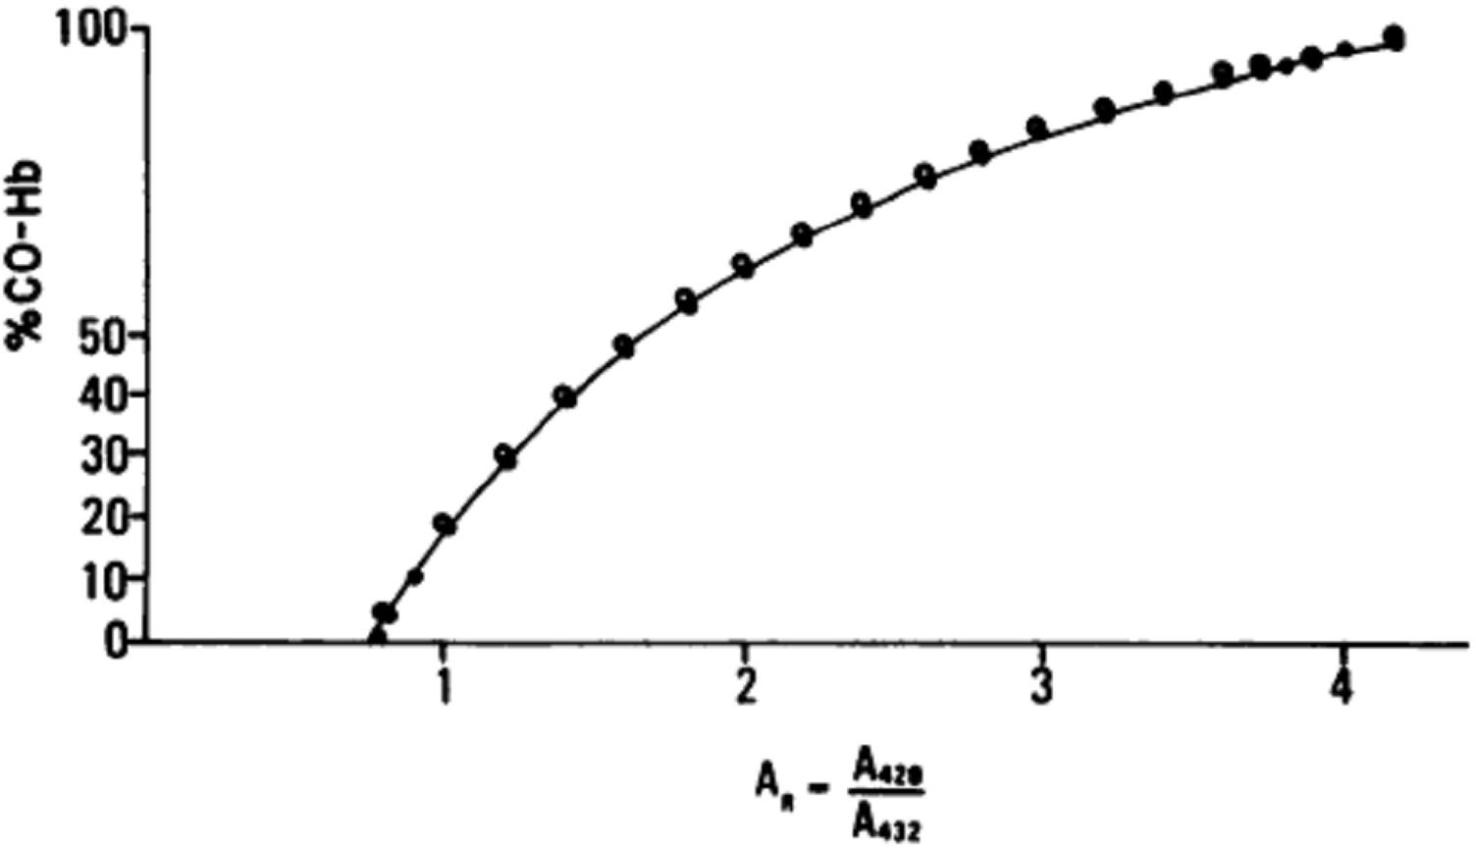

Figure 3.6: Calculated values of A_{R} at various proportions of carboxyhaemoglobin. A_{R} calculated with values for F1, F2, and F3 computed from the published absorptivities for Hb and CO-Hb at 420 and 432 nm. A_{R} calculated from values for F1, F2, and F3 derived experimentally. The curve shown in Figure 1 represents the calculated value of AR at various proportions of CO-Hb. The curve formed when AR was calculated from values for F1, F2, and F3 derived experimentally closely approximated that formed when AR was calculated from values of F1, F2, and F3 computed from the published molar absorptivities.

APPENDIX IX

Table 1.1: Blood carboxyhaemoglobin levels as predicted from the Coburn- Forster-Kane (CFK) model (Coburn, 1965).

Carbon monoxide exposure concentration (ppm)
Steady-state blood Carboxy-hemoglobin (%)

0.1

0.5

1

2

5

10

15

20

40

60

80

100

200

400

600

800

1,000
0.25

0.32

0.39

0.5

1

1.8

2.5

3.2

6.1

8.7

11

14

24

38

48

56

61

