# EFFECT OF SPROUTING ON AMYLASE ACTIVITIES AND FUNCTIONAL PROPERTIES OF TEN (10) INBRED RICE VARIETIES IN NIGERIA

**ABSTRACT**

The aim of this study was to determine the effect of sprouting on the amylases activity and functional properties of ten FARO rice varieties. The FARO rice samples selected randomly were used for this study, and these include FARO 15, 16, 20, 22, 30, 45, 47, 55, 61 and 62. They were sprouted for twelve (12) days according to standard procedures, in order to determine the amylase activities and their functional properties. The alpha, beta and glucoamylase activities of the FARO rice samples were determined daily during sprouting. The correlation coefficient and linear regression equations between amylose content of FARO rice samples and functional properties were determined. The result showed that α-amylase activity of the FARO rice samples increased from the 3rd to 10th day of sprouting. The highest α-amylase activity was attained on 5th and 6th day which ranges from 46.18 x10 -3 - 50.17 x 10-3U/ml. The β-amylase activity for the FARO rice samples increased from 3rd to 8th day of sprouting. The highest β-amylase activity was attained on day 5 and 6, which range from 44.01 x 10-3 - 46.07 x 10-3U/ml. The glucoamylase activity for most of the FARO rice sample increased from 3rd to 7th day of sprouting; with the highest activity 100 x10-3 was recorded on day 5. Result also revealed that as the number of days of sprouting increased the amylose content, swelling capacity, gelling temperature decreased, while solubility and gelling time increased. The result showed a strong positive correlation between amylose content of the FARO rice samples and swelling capacity, gelling temperature for most of the FARO rice samples. There is a strong negative correlation between amylose content and solubility, gelling time for most of the FARO rice samples. From this study, sprouting has shown to be a cheap and economical way of improving amylase yields and modifying the functional properties of FARO rice samples for better application in food industries and confectioneries. The linear regression of the equation developed could be used as a predictive tool, to determine the amylose content of the FARO rice samples in functional parameters.

# CHAPTER ONE

* 1. **INTRODUCTION**

## Background to the Study

Rice also known as *Oryza sativa* is one of the top most important grains because of its dietary and nutrition roles in human. Rice is ranked the third most important cereal grain, after wheat and maize. It is reported to constitute to feeding about a half of the population of the world as an important staple food (Alaka, 2011). In developing countries, rice plays a vital role in diets through the provision of about 27 percent dietary energy and 20 percent of protein (Saint, 2004). Rice is good source of carbohydrate, protein, vitamins as well as minerals, (Mondal, 2010). These nutrients are said to exist in the germ and bran layer of the rice, which is almost removed during milling to produce the white rice which is consumed. Rice has high amino acid content in comparison with other grains, because of its high lysine content. The demand for rice is high because of the high consumption rate in most countries and this would continue in the nearest future. Rice is grown in different ecological zones of Nigeria and this has given rise to different varieties, adaptation in each zone (Sanni *et al*., 2005). Niger state where different varieties of rice are being cultivated, is said to be the third largest rice producing state in Nigeria (Merem, 2017).

Moreover, amylases on the other hand are known as hydrolytic enzymes which are involved in the breakdown of glycosidic bonds in starch (Van der Maarel *et al.,* 2000; Gupta *et al.,* 2003). Different types of amylases breaks down rice starch to oligosaccharides with specific lengths of glucose units. These enzymes are also required in the production of malt, brewing and confectionery industries to carry out certain processes that requires its use. Sources of these enzymes include plant, animals and

micro-organisms (Aiyer, 2005). Wheat is a crop, which has proven to be a good source of amylases and are required in the food industry for malt production, confectioneries etc. It is grown in the temperate region of the world, due to the favorable conditions such as the soil texture and climatic factors. The tropical climates are not favorable for the growth of wheat, hence, the tropic region relies on the importation of wheat for their food industry. Developing countries in the tropical region spend huge amount of money on the importation of wheat (Ohimain, 2014). Furthermore, it will be of great economic benefit, if wheat importation is greatly reduced and substituted with locally produced cereals grains. Locally produced cereals grains such as rice had been shown to have different amylase activity, which could be utilized in the food industry (Ayernor, 2007).

## Statement of Research Problem

Nigeria is known to have developed different varieties of rice (Danbaba, 2017), these rice varieties have not been fully characterized to determine their utilization in the food and starch industries since they are being cultivated locally. Cereals such as Barley are good sources of amylases which are required in malt production, brewing and confectionery industries in the world. The cultivation of Barley has not been successful in Nigeria; this has led to huge demand on importation of barley for the food industry. However recent studies have shown that locally produced cereals such as rice, are good sources of amylases that could be employed in the food industry (Egwim and Oloyede, 2006).

Sprouting is a process of germination, where seeds experience further growth by producing new leaves or buds (Gupta, 2016). Sprouting is a cheap and economical technique of improving amylase activities in cereals. Amylases are of great important in the food industry and it is said to be produced in a very high amount during sprouting as a result of the breakdown of carbohydrate constituent of the seeds (Rumiyati, 2013).

However, since sprouting technique could be used to increase the amylase activities, it is important to know the amylases activity in some of the rice varieties developed in Nigeria and determine how these rice varieties can be used as raw materials in the food industries. This could help to reduce the demand on the importation of barley for our local food industry, and also enhance economic value for farmers not only for food but also for the starch and food industry.

## Justification for the Study

Rice is grown in different ecological zones of Nigeria and this has given rise to different varieties, adaptation in each zone such as Niger state (Sanni *et al.,* 2005). In Nigeria varieties of rice has been developed, these rice varieties are said to be genetically modified and have been proven to have better qualities compared to their local counterpart (Danbaba, 2017). Since sprouting increases the enzyme activities of cereals, it is important to establish the effects of sprouting on amylase activities and functional properties of some rice varieties developed in Nigeria. There are limited work on the functional properties and amylases activity of sprouted rice varieties developed in Nigeria.

This study seeks to investigate some functional properties of rice developed in Nigeria, in order to determine their utilization in the food industry as raw materials. It also seeks to establish effects of sprouting on amylases activity of some rice variety in order to utilize these enzymes in malt production and reduce the importation of enzyme from wheat as sources for the food industries. Furthermore, this will enhance economic value for farmers, improve the agricultural sector and may reduce over dependency on the oil sector of the economy.

## Aim of the Study

The aim of this study is to determine the Effect of sprouting on some of the physicochemical properties and amylases activity of ten rice varieties developed in Nigeria.

## Objectives of the Study

The objectives to the study is as follows:

* + 1. To determine the effect of sprouting on the amylase (α-amylase, β-amylase and Glucoamylase) activities of ten rice varieties developed in Nigeria.
    2. To determine the effect of sprouting on some functional properties of ten rice varieties developed in Nigeria.
    3. To determine the effect of sprouting on the cooking and pasting qualities of the selected rice varieties.
    4. To determine the correlation between the swelling capacity, solubility, gelatinization time, gelatinization temperature and develop a regression equation to determine the relationship between the parameters.

# CHAPTER TWO

* 1. **LITERATURE REVIEW**
  2. **Rice (*Oryza sativa*)**

Rice describes the seeds of the grass from family Gramineae and of the genus *Oryza.* It is a monocotyledonous plant. Wheat, rye, corn, oats and Barley also belongs to the grass family. Rice cultivation has a long history and people living in China's Yangtze River Valley area are believed to have begun about 9,000 years ago (Liu *et al.,* 2007; Fuller *et al.,* 2010). Rice is a widely grown staple and it is a major food source for about a half the world's population, especially those living in high density countries like China and India. The cultivation of rice is undertaken mainly in three ecological zones: lowland rain-fed, irrigated plains and rain-fed upland (Sarla and Swanmy, 2005). From Plate 1 below, it shows the picture of rice grown in Nigeria.

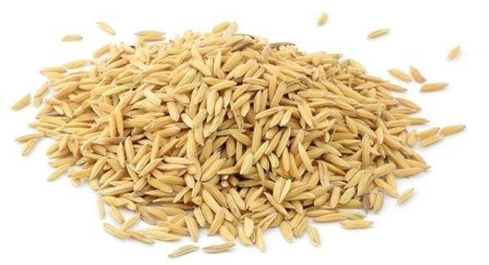

**Figure 1.1**: FARO rice sample (Merem, 2017)

Rice is grown in different ecological zones of Nigeria, and each ecological zone has different adaptability of the rice species in each zone (Sanni *et al*., 2005). *Oryza sativa* and *Oryz*a *glabbermia* (Abulude, 2004) are the two main commonly cultivated varieties of rice grown in Nigeria. Rice is a universal crop which could be used as a household food security, for ceremonies, nutritional value, as a source of income (Marshell and Wadsworth, 1993). This is primarily used at the level of a household where it is eaten by boiling or grounding rice and taken with stew or soup. Preparation of rice can be through boiling and washing in water which can result in the loss of certain vital nutrients (Ihekoronye and Ngoddy, 1985; Perez *et al.,* 1987). Unlike other cereals, rice has to pass through dehulling and milling processes before it is being cooked for consumption. The cooking method is a process of heating raw foods to make them ready for consumption and cooking contribute a large amount of household’s energy. The tenderness of cooked rice a well as stickiness is determined by the cooking time. (Mondal, 2010).Presoaking of rice before cooking in excess water (cold or hot) reduces the time of cooking from 20 to 10 minutes and causes an increase in the dimensions of rice due to cooking (Hirannaiah *et al*., 2001). High volume cooking expansion is thought to be of higher quality by people in the working class, who don't know if the expansion is longitudinal or crosswise. People living in the urban region, on the other hand, prefer rice varieties which increase in length as compared to those that in breadth (Choudhury, 1979).

There are so many varieties of rice and these varieties vary in their sensory and cooking properties. Sanni *et al*. (2005) reported that rice grown in different ecology zones varies in their properties, different zones with different characteristic properties of rice. *Oryza sativa* (Ma and Bennetzen, 2004) and *Oryza glaberrima* (African rice) are believed to have been cultivated by West African ancestors along the Niger River in Mali, over 3,500 years ago (Carney, 2001). *Oryza sativa* is present everywhere but in Asia it is more

concentrated, which lead to more diverse as compared to *Oryza glaberrima*. Two subspecies of rice are largely cultivated. These include the sticky, short grained sativa form or japonica or sinica and the long-grained and non-sticky types called indica. Oryza glaberrima is a predominant rice in West Africa (McCough and Sweeney, 2007; Nayar, 2010; Ogwu and Oko, 2010). This specie is cultivated in countries like Liberia, Mali, Mauritania, Ghana, Nigeria, Senegal, Sierra Leone and Togo Benin, Burkina Faso, Cameroon, Cape Verde, Chad, Guinea-Bissau, Cote d'Ivoire, Gambia, Guinea (Vernet, 2002).

The key forms of this rice species are the light-sensitive and grows early erect or straight in deep water. It also grows both in upland and lowland areas (Ghesquiere *et al.,* 1997). The African rice has some attributes that are both special and useful including its ability to favourably compete with weeds for nutrients (Jones *et al.,* 1997). It is also resilience to drought conditions and has ability to thrive under hazardous soil conditions (Maji *et al.*, 2001; Swanmy and Sarla, 2005). The African rice is also immune to other diseases such as Nematodes, rice yellow mottle virus (Ndjiondjop *et al.,* 1999) and stem borers (Plow-Right *et al.,* 1999). The physiological processes occurring within the plant are affected by climatic conditions, methods of cultural management, and crop genetics. These factors also influence the time taken for the stages of development, such as germination, vegetative, reproductive, and grain filling. Rice cultivars vary in so many physical properties, such as seed length, kernel size, seed length to width ratio, kernel form, and kernel hardness (Pomeranz and Webb, 1985). Rice grains, whether rough rice or paddy consist of an outer cover that forms a protective layer (husk) and an edible inner portion. Rice is known as paddy, brown or polished rice. Rice hull is about 16-28 percent of rough rice, 1-2 percent is pericarp, aleurone, nucleus, and 4-6 percent is seed skin, 1

percent is germ, 2 percent is scutellum, and 90-91 percent is brown rice endosperm (Juliano, 1972).

White or polished rice is the commonest type of rice consumed by most people worldwide (Nanri *et al.,* 2010), and it is obtained when rice is subjected to a series of mechanized processing operations during milling which removed components such as the testa, embryo, pericarp, seed-coat, and aleurone layers. This process lead to significant loss of essential nutrients such as vitamins, fat, and polyphenols, protein, food, ash, leaving the mainly starch endosperm (Shobana *et al.,* 2011). The white rice has a low level of dietary fiber (0.7-2 percent) compared to brown rice with fiber of about 3-4 percent and this is the result of the removal of the bran layers. The amylose content can be used as a basis for categorizing rice, milled rice cultivars into waxy (0-2 percent), very low (2-12 percent), medium (12-20 percent), moderate (20-25 percent) or high (25-33 percent) (Lawal *et al.,* 2011). Based on their length, the International Standards Organisation classifies milled rice: width ratio, asslender (> 3.0), medium (2.1-3.0), bold (1.1-2.0) or round (albeit 1.1.0).

## Botanical Classification of Rice

|  |  |
| --- | --- |
| **Kingdom** | **Plantae** |
| Subkingdom | Tracheobionta |
| Superdivision | Spermatophyte |
| Division | Magnoliophyta |
| Class | Lilopsida |
| Subclass | Commelinidae |
| Family | Poaceae |
| Genus | Oryza |
| Species | Oryza sativa |

* 1. **Cultivation of Rice in Nigeria**

There are different methods use for rice cultivation in Nigeria depending on the land terrain and what the farmer’s wants.

## Upland rice system

On free-drying soils, upland rice is grown so that the water table level is everlastingly below the roots of the rice plant. There are various conditions in Nigeria in which upland rice is cultivated. However, to get a good crop, sufficient soil moisture reserves must be available, and soil fertility during plant growth periods is important. The upland rice environments for rice cultivation are established on the basis of soil, climatic conditions, the availability of micro-level water bodies and the cultivation land (Rashid-Noah, 1995). Upland Rice Systems (URS) are two styles which are practiced in Nigeria. They are:

1. The Rainfed Upland
2. Irrigated Upland.

## Rain-fed upland rice system

In Nigeria, the rain-fed upland system of rice cultivation is dominant. It is found in almost all environmentally friendly agricultural zones. In this method the rice is totally dependent on rainfall. Excessive rainfall may result in erosion of top soil, leaching of nutrients and flooding which poses a risk during crop cultivation. Because of drought the question of weak grain filling is also very high. This system is found in Ado-Ekiti, Abakaliki, Gombe, Yauri, Zamfara river, Southern Borno, Yola, Abeokuta and Ogoja. The upland in many areas is a slope.

Rice planting on hills is a consequence of the pressure on the available arable lands. Planting rice on hills is becoming common in places such as Ilesha of Osun State, the local government areas along the Effun ridge of South-Nigeria's Ekiti State (Effun-Alaya,

Ekiti-, Igbemo-Ayedere) and South-Nigeria (Obudu hills in Cross River State). Lands in Ilesha / Ekiti area are cleared during February for hill rice cultivation. The land is being prepared by hoe for seed planting with an intercrop spacing of about 20 cm by the month of March / April, as the rainy seasons arrive. The plants grow very fast and provide cover for the soil before the rain becomes very heavy and leads to soil erosion.

Harvesting of rice is mostly completed in the month of July. Other crops such as cassava, maize, are also grown on the hill besides rice in this zone. Sometimes, rice is intercropped with cocoyam at the foot of the hills as opposed maize because of the assumption that the pollen grains maize tassels are harmful to the growth of rice. On Obudu hills, the upland rice is planted after the early yams are harvested. During the month of July/August, the heaps are scattered across frontiers and then planted with upland rice. More popular here is the rice variety known locally as Jango. Crops are harvested in advance of the deep fadama rice in October / November. The time arrangement helps farmers to make sale of their produce at a better price.

## Irrigated upland rice

In certain areas the length or period of rice growth is very short; there is a need for additional irrigation during important growth stages of the rice crop to compensate for the drought conditions. This upland rice irrigation system is located in the state of Jigawa southern region (Local Government Area of Birnin Kudu). This system is also seen in areas where they receive a 150-500 mm rainfall and the growing period for the crop is between 0 and 90 days. This occurs in the states of Borno, Jigawa, Kano and Katsina in the Northern part of Nigeria. The period of growth in the Sudan-Sahel flat-land areas is about three months (Dugje, 2000). The soils found in these areas are mostly sandy soil, which have a very low water retention capacity. Water used for producing rice in Borno

state is supplied through two main schemes: Lau Irrigation Scheme and Southern Chad Irrigation Project under the government irrigation schemes.

## Hydromorphic rice

A hydromorphic condition refers to a situation where, within the plant roots, supply of water to rice crop is shallow due to low ground water table (Jones, 1995). Hydromorphic rice is found in the terrain series on lower slopes, or where soil layer is impermeable and water percolation is reduced. Tarok land (state of the Plateau) in Nigeria has an impermeable layer known as alam in vernacular words. Twenty years ago it was classified as a marginal property. Rice is cultivated in recent times, however, even on an alam. Another phenomenon that may contribute to the conditions of hydromorphic is the sluggish flow of water through grassed waterways or even highway ditches. Rice growing in this climate within the Savannah of northern and southern Guinea is very common.

About twenty years ago, ditches were left in Tarok land in the state of Plateau, and allowed to go fallow for sometimes, but today they are continuously used for rice planting due to high demand for agricultural lands. Hydromorphic land is a topo sequence transition zone or fringe from the bottom inland to upland of the valley. It may also arise as topographic depression of flatland whose soils have good water retention capacity (Singh *et al.,* 1997). Stream or rivulet fringes are good zones for this rice production system. This system may also be described with wet uplands. The areas down to hydromorphic rice depend on how much rainfall is distributed. It is said that hydromorphic rice yields higher and higher than upland rice (Dugje, 2009).

## Rainfed lowland rice

Roughly 25 percent of rice area in Nigeria is projected to be under rain-fed lowland for rice cultivation. It has been estimated that this ecology owes about 43 to 45 per cent of the nation's rice production (Singh *et al.,* 1997; Imolehin and Wada, 2000). Although hydromorphic rice had been classified into this category, there are two subtypes of lowland ecologies which are also known as wetlands, the shallow and deep fadama also known as deep inland valleys. A distinction between the Rain-fed lowland rice system and hydromorphic rice is that at some point in the rice's developmental stage the soil has to be fully covered by rainfall. During cultivation the field is submerged in deep fadamas, or the main part of the cropping seasons. Farmers typically change planting and transplanting dates to avoid early stage of rice growth from flooding the land (Moormann *et al.,* 1986). This network governs the tributaries of the Benue, Niger, Katsina Ala, Kaduna and Yobe rivers as well as their plains (Carney, 2001).

The shallow fadamas are never overflowing. The problems associated with the swarmp lowland rice cultivation in Abakaliki region of Ebonyi state; where severe flooding, iron toxicity and lnadequate water management systems. Farmers in the state of Ebonyi (Abakaliki areas) have an extremely interesting system of farming. Huge mounds are made when the rain season finishes or starts. At the top of each mound is the yam plant. Groundnuts are planted lower down the mound during early rainy seasons. Rice is grown in a nursery bed for around 4 weeks in May. The mound is broken down by hand as the yams and groundnuts are harvested and puddled. The farms are flooded at this point, and rice is transplanted from the bed of the nursery. The Giant Mounds are a precaution taken to avoid waterlogging of the yams and groundnuts.

## Irrigated lowland rice cultivation system

The established River Basin Development Authorities (RBDAs) had helped to improve the Rice Schemes in the 1980s, and irrigated lowland rice production. Rivers, streams, dams, boreholes, wash bores, wells and other sources provide water for irrigation practices to supplement inadequate rainfall for the production of rice crops (Imolehin and Wada, 2000). This lowland irrigation rice cultivation program accounts for only 18 per cent of rice cultivated land and 10-12 % of national rice production. Irrigation is by gravity in some parts of Ogoja, established by the farmers to promote their production of rice. They use rice bran as an organic fertilizer in their farming system. Most of irrigation practices for rice production are done in the Northern Guinea Savannah, Sudan Savannah and Sahel. Although Adani, Enugu state and Bida, Niger state practice this system of rice production.

## Deep inland water rice cultivation

Production of rice inside water is called a deep floating rice system. Most of the water paths are rivers which has receded before the rain sets in. The land is being prepared, and rice is transplanted from the nursery bed directly into the seeding or seedlings transplantation. The rice grows for about 4 weeks in sufficient humidity condition, after which the water level from the river begins to rise, gradually overflowing its banks. The fields where the rice is sown are flooded to allow the plants roots penetrate deep down as the vegetative parts of the rice plants float on the water. The plant has capability of floating on the water and not being submerged. It grows in the flooded condition to a point of harvesting and can be harvested using a canoe just like in Sokoto. The system has been in use for some years now. This program is estimated to constitute about 5-12 percent of the country's rice production and 10-14 percent of national rice outputs (Imolehin and Wada, 2000). This method is associated with the low yield because of the use of conventional *Oryza glaberrima* rice, rather than improved rice varieties.

## Mangrove swamp rice cultivation

The Tidal Wetland rice system is also known as the mangrove swamp rice cultivation system (Singh *et al.,* 1997). Coastal swampy areas in places like Lagos, Rivers, Bayelsa, Delta, Ondo, Akwa-Ibom and Cross River states, Nigeria, which have been suitable for swamp lands for growing of rice. The system covers approximately one million ha of land, although currently no more than 1000 ha are being used for cultivation (Imolehin & Wada, 2000). The tidal wetland rice is grown primarily in Warri and Bayelsa state on fields of the Shell Company. The creation of rice mangrove swamps is a long-term project focused on appropriate technology, hydrology, analysis of soil and social or economic survey (Singh *et al.,* 1997). Under WARDA the development of Mangrove Swamp Rice is no longer a significant ecosystem (WARDA, 1999b).

NCRI will have to overcome this big challenge. Rice is grown in Nigeria, from the Niger Delta mangrove swamps to arable regions close to Lake Chad. The cultivation zone was previously along the Niger-Benue river, with the valley-bottoms naturally flooded. Rice cultivation is either in the mangrove swamps or on residual moisture. With few exceptions such as Ogoja and villages in Benue and Cross River states, dry-season rice cultivation is rare today. Rice cultivation has been extended to too many dry regions as a result of the introduction of hardy upland rice varieties, particularly in the' Middle Belt' which was previously used to grow dry land cereals such as sorghum and millet.

The rice growing environment (RGEs) is defined by the drainage systems of Nigeria. According to 1990 report by Federal Department of Agricultural Land Resources (FDALR), the drainage system includes the Niger, Benue, Chad, Cross Rivers and the Atlantic system. Most Atlantic River Systems are short coastal streams of north-south that flows through less regular courses. These courses continued at other rivers including Ogun, Osun, Shasha-Yewa and Oluwa Rivers. The Nsukka-Okigwe Cuesta is the main

river divides that drains into the Niger and Imo into the Cross drains. There is a radial drainage pattern in the North created by the central highlands and Jos Plateau, with streams flowing into Chad, the Zamfara and Sokoto Basin whose main rivers include the Ngade, Mbudi, Goma and Yobe Rivers. The Tiga, also drains Hadejia into the Chad Basin.

## Rice Development in Nigeria

The history of rice development started from the period of rice cultivation in Nigeria. Crop variety selection was done by farmers. The farmers are said to be the pioneer of plant breeders. Two major problems have affected rice cultivation in Nigeria, they include climatic factor and the other is specific to rice (Danbaba, 2017). Biotechnology and genetic engineering has helped in developing improved rice species. For instance, in 1970, rice research program developed FARO (Federal Agricultural Research Oryza sativa) 14, 15 and these were the first variety developed in Nigeria. The rice developed in Nigeria, is formed from the crossbreeding of African rice species and interspecifics (Udemeze, 2010).

Nigeria Cereals Research Institute (NCRI) in conjunction with other research bodies is currently participating in the development of hybrid rice (Danbaba, 2017). Recent research in rice, has resulted in the development of genetically modified rice with superior cooking qualities, stress tolerant and resistance to pest and diseases.

## Table 2.1: Different Varieties of FARO Rice Developed in Nigeria (Danbaba, 2017)

|  |  |  |  |  |  |  |
| --- | --- | --- | --- | --- | --- | --- |
| **Faro Rice** | **Origin** | **Where they**  **are Grown** | **Year Developed** | **Duration of Growth (days)** | **Height of Plant (cm)** | **Yields (ton/ha)** |
| Faro 1 | Guyana | Shallow swampy | 1954 | 135-174 | 105-120 | 3.0-5.0 |
| Faro 2 | Guyana | Shallow swampy | 1957 | 135-145 | 100-115 | 3.0-4.5 |
| Faro 3 | Nigeria | Upland | 1958 | 93-120 | 95-100 | 1.5-2.5 |
| Faro 4 | India | Deep water | 1959 | 189-220 | 145-150 | 2.0-4.0 |
| Faro 5 | Madagascar | Shallow swampy | 1960 | 135-154 | 111-115 | 2.0-4.5 |
| Faro 6 | E/Guinea | Deep water | 1961 | 176-198 | 156-160 | 2.0-3.0 |
| Faro 7 | Thailand | Deep water | 1962 | 160-217 | 160-165 | 2.5-3.5 |
| Faro 8 | Indonesia | Shallow swampy | 1963 | 155-160 | 156-160 | 3.5-4.5 |
| Faro 9 | Malaysia | Shallow swampy | 1963 | 189-220 | 160-165 | 2.5-3.5 |
| Faro 10 | Kenya | Shallow swampy | 1963 | 115-162 | 120-125 | 3.5-4.5 |
| Faro 11 | Kong/Zaire | Shallow swampy | 1966 | 115-120 | 115-120 | 1.5-2.5 |

|  |  |  |  |  |  |  |
| --- | --- | --- | --- | --- | --- | --- |
| Faro 12 | Surname | Shallow swampy | 1969 | 145 | 135-140 | 3.0-4.0 |
| Faro 13 | Philippines | Shallow swampy | 1970 | 135-140 | 90-100 |  |
| Faro 14 | NCRI Nigeria | Deep water | 1971 | 170-198 | 150-160 | 2.5-4.0 |
| Faro 15 | NCRI Nigeria | Shallow swampy | 1974 | 145-160 | 115-120 | 3.5-4.5 |
| Faro 16 | NCRI Nigeria | Shallow swampy | 1974 | 140-160 | 90-100 | 2.5-3.5 |
| Faro 17 | NCRI Nigeria | Shallow swampy | 1974 | 145-160 | 110-120 | 2.0-3.0 |
| **Faro Rice** | **Origin** | **Where they**  **are Grown** | **Year Developed** | **Duration of Growth (days)** | **Height of Plant (cm)** | **Yields (ton/ha)** |
| Faro 18 | Indonesia | Shallow swampy | 1974 | 179 | 145-150 | 2.0-3.0 |
| Faro 19 | Philippines | Shallow swampy | 1974 | 135-140 | 90-100 | 2.0-3.0 |
| Faro 20 | -do- | Shallow swampy | 1974 | 125-130 | 90-100 | 2.5-4.0 |
| Faro 21 | -do- | Shallow swampy | 1974 | 90-110 | 80-90 | 2.5-4.0 |
| Faro 22 | -do- | Shallow swampy | 1974 | 145-150 | 90-100 | 2.0-3.0 |

|  |  |  |  |  |  |  |
| --- | --- | --- | --- | --- | --- | --- |
| Faro 23 | -do- | Shallow swampy | 1974 | 145-150 | 90-100 | 2.0-3.0 |
| Faro 24 | Vietnam | Shallow swampy | 1974 | 135-145 | 135-145 | 2.5-3.5 |
| Faro 25 | NCRI Nigeria | Upland | 1974 | 115-120 | 105-100 | 2.5-3.5 |
| Faro 26 | NCRI Nigeria | Shallow swampy | 1982 | 130-135 | 105-100 | 2.5-3.5 |
| Faro 27 | NCRI Nigeria | Shallow swampy | 1982 | 110-115 | 90-100 | 3.0-4.0 |
| Faro 28 | NCRI Nigeria | Shallow swampy | 1982 | 135-140 | 125-130 | 3.0-4.0 |
| Faro 29 | NCRI Nigeria | Shallow swampy | 1984 | 125-135 | 100-115 | 2.5-3.5 |
| Faro 30 | NCRI Nigeria | Shallow swamp | 1986 | 110-115 | 120-125 | 4.0-5.0 |
| Faro 31 | NCRI Nigeria | Shallow swamp | 1986 | 110-115 | 120-125 | 4.0-5.0 |
| Faro 32 | NCRI Nigeria | Shallow swamp | 1986 | 110-115 | 110-120 | 4.0-5.0 |
| Faro 33 | NCRI NIgeria | Shallow swamp | 1986 | 105-115 | 115-125 | 4.0-5.0 |
| Faro 34 | NCRI Nigeria’ | Shallow swamp | 1986 | 120-135 | 115-120 | 4.0-5.0 |
| Faro 35 | IITA Nigeria | Shallow swamp | 1986 | 125-140 | 115-125 | 4.0-5.0 |

|  |  |  |  |  |  |  |
| --- | --- | --- | --- | --- | --- | --- |
| Faro 36 | IITA Nigeria | Shallow swamp | 1986 | 100-105 | 100-115 | 4.0-5.0 |
| **Faro Rice** | **Origin** | **Where they are Grown** | **Year Developed** | **Duration of Growth (days)** | **Height of Plant (cm)** | **Yields (ton/ha)** |
| Faro 37 | IITA Nigeria | Upland | 1986 | 100-110 | 100-115 | 2.0-3.0 |
| Faro 38 | Cote d’ivoire | Upland | 1986 | 100-110 | 100-115 | 2.0-3.0 |
| Faro 39 | Cote d’ivoire | Shallow swamp | 1986 | 120-125 | 100-110 | 1.5-2.5 |
| Faro 40 | NCRI Nigeria | Upland | 1986 | 90-100 | 95-105 | 2.0-3.5 |
| Faro 41 | Cote d’ivoire | Upland | 1986 | 110-120 | 115-120 | 2.0-3.0 |
| Faro 42 | IAR&T Nigeria | Upland | 1986 | 115-120 | 80-90 | 2.5-3.5 |
| Faro 43 | IITA Nigeria | Upland | 1986 | 115-120 | 110-115 | 2.5-3.5 |
| Faro 44 | Taiwan | Shallow swampy | 1992 | 90-100 | 110-115 | 3.0-4.0 |
| Faro 45 | IITA Nigeria | Upland | 1992 | 90-100 | 110-115 | 2.0-3.0 |
| Faro 46 | IITA Nigeria | Upland | 1992 | 100-110 | 90-100 | 2.0-3.0 |

|  |  |  |  |  |  |  |
| --- | --- | --- | --- | --- | --- | --- |
| Faro 47 | IITA Nigeria | Upland | 1992 | 115-120 | 110-120 | 2.0-3.0 |
| Faro 48 | IITA Nigeria | Shallow swampy | 1992 | 120-125 | 90-100 | 2.0-3.0 |
| Faro 49 | IITA Nigeria | Shallow swampy | 1992 | 120-125 | 90-100 | 3.3-3.5 |
| Faro 50 | IITA Nigeria | Shallow swampy | 1992 | 125-135 | 90-115 | 3.0-4.0 |
| Faro 51 | Indonesia | Shallow swampy | 1992 | 125-135 | 90-110 | 3.0-4.0 |
| Faro 52 | WARDA | Shallow swampy | 1997 | 125-135 | 100-120 | 3.5-5.0 |
| Faro 53 | WARDA | Upland | 2003 | 120-130 | 100-115 | 2.0-2.5 |
| Faro 54 | WARDA | Upland | 2003 | 100-110 | 100-115 | 1.5-2.0 |
| **Faro Rice** | **Origin** | **Where they**  **are Grown** | **Year Developed** | **Duration of Growth (days)** | **Height of Plant (cm)** | **Yields (ton/ha)** |
| Faro 55 | WARDA | Upland | 2003 | 100-110 | 100-115 | 2.0-3.0 |
| Faro 56 | WARDA | Upland | 2003 | 100-110 | 100-115 | 1.5-2.5 |
| Faro 57 | WARDA | Shallow swampy | 2003 | 125-135 | 110-120 | 3.5-5.0 |

|  |  |  |  |  |  |  |
| --- | --- | --- | --- | --- | --- | --- |
| Faro 58 | AFRICARICE | Shallow swampy | 2011 | 100-110 | -- | 5.0 |
| Faro 59 | AFRICARICE | Shallow swampy | 2011 | 100-110 | - | 8.0 |
| Faro 60 | AFRICARICE | Rain-fed Upland | 2011 | _ | - | 7.0 |
| Faro 61 | AFRICARICE | Shallow swampy | 2011 | _ | - | 7.0 |
| Faro 62 | NCRI | Shallow swampy | 2011 | _ | - | 4.0 |
| FUNNAB O R-1 | FUNAAB & NCRI | Upland | 2011 | _ | - | 2.5 |
| UPIA1 | FUNAAB/NCRI | Uplamd | 2013 | _ | - | 6.6 |
| UPIA2 | IRR/AFRICANRICE/NCRI | Shallow swampy | 2013 | _ | - | 8.0 |
| UPIA3 | IRR/AFRICARICE/NCRI | Shallow swampy | 2013 | _ | - | 7 |
| Faro 63 | AFRICARICE/NCRI | Rain-fed upland | 2014 | _ | - | 6.2 |
| Faro 64 | AFRICARICE/NCRI | Rain-fed upland | 2015 | _ | - | 5.2 |
| Faro 65 | AFRICARICE/NCRI | Rain-fed upland | 2015 | - | = | 6.4 |

(Source: Danbaba, 2017).

## Proximate Composition of Rice

Milled rice has been reported to contain crude protein content of approximately 6 % for most rice sample and carbohydrate content of more than 80 %, which is considered major determining factor of some of the characteristics such as the texture, pasting property and sensory characteristics of rice (Oko *et al*., 2012). The Rice protein is said to include glutelin (80 %), prolamin (3 %), globulin (12 %), albumin (5 %) and (Alaka, 2011). The Rice contained about 15 % lipid in the bran layer, which can be up to 15 %, but only about 1.5-1.7 % is found in the rice when milled (Mondal, 2010). The B vitamins present in the milled rice are mainly thiamine, folate, riboflavin, niacin and B6 are concentrated in the layers of the bran. Vitamins A, D, or C are absent in rice grains (Alaka, 2011). Minerals are available in a large amount in rice grains including calcium, phosphorus and magnesium as well as traces of iron, copper, manganese and zinc (Yousaf, 1992).

## Table 2.2: Proximate Composition of Rice Samples Developed and Grown Nigerian.

|  |  |  |  |  |  |  |
| --- | --- | --- | --- | --- | --- | --- |
| **Rice samples** | **Carbohydrate (%)** | **Moisture (%)** | **Fat (%)** | **Crude Protein (%)** | **Crude Fibre (%)** | **Ash (%)** |
| Faro 14 | 83.45 | 7.33 | 0.5 | 6.22 | 1.5 | 1.0 |
| Faro 15 | 86.03 | 6.33 | 1.0 | 4.64 | 1.5 | 1.0 |
| Canada | 85.09 | 3.67 | 3.5 | 4.74 | 2.0 | 2.0 |
| China | 85.69 | 5.33 | 2.5 | 2.98 | 2.5 | 1.0 |
| Faro 14 (II) | 83.45 | 7.33 | 0.5 | 6.22 | 1.5 | 1.0 |
| Faro 15 (11) | 84.25 | 6.0 | 2.0 | 2.98 | 2.5 | 1.0 |
| E 4077 | 85.33 | 5.67 | 3.0 | 4.00 | 1.5 | 0.5 |

(Source: Oko *et al*., 2012)

## Rice Starch

Rice is reported to contain high level of starch with about 20-30% amylose and 70-80% amylopectin (Pérez and Bertoft, 2010). Their crystalline structures show diffraction pattern of an A-type X-ray. The scale of the rice starch granule is said to be amongst the smallest grains of cereal origins (Vandeputte and Delcour, 2004). Starch from rice has unique features that include bland tastes (lack flavor or taste), creaminess, smooth texture, acid resistance, consistency of the freeze-thawing paste, hypoallergenicities and a variety of amylase to amylopectin ratio. Such qualities made rice very useful in the food industry for food products formulation and development (Mitchell, 2009; Lawal *et al.,* 2011).

Rice starch contains both amylose and amylopectin, the amylose content of rice is very important because it is an indicator of the utility of rice. For instance, the *indica* type of rice contains high amylose and gelatinize faster, this property makes it useful in making rice noodle. High amylose starch tends to show a higher retrogradation rate, while low amylose starch has a lower retrogradation rate after gelatinization (Zhan, 2009).

## Morphology of rice starch granule

Rice starch granule is a polyhedral, oval, circular, angular, smooth granulate with a range of 3 to 8 μm (micrometers) in thickness. The rice starch granules are located securely packed in an amyloplast of the endosperm cells (Poochinya *et al.,* 2008). Various techniques such as field flow fractionation, microscopy (electron microscopy and light microscopy scanning) and laser light scattering can be used to quantify starch granules (Lindeboom *et al.,* 2004). SEM (scanning electron microscopy) electron microscopy scanning is the most commonly used microcopy technique; it provides information on rice granule size, morphology and characteristics (Chmelik, 2001). The granule characteristics of ten Chinese rice cultivar were studied, using the SEM technique and it was reported that the rice granule has a dimension of 3-8 μm and the shapes were angular and polygonal (Wang *et al*., 2012). The granule scale for various starches of rice also

exhibited a unimodal shape and about 10 μm in diameter. Zhang *et al.* (2010) utilized the technique of scanning electron microcopy to determine the physico-chemical and morphological property of mechanically activated starch from three *indica*, japonica and glutinous rice cultivars grown in China. The analysis showed the average size of granule is about 4.2-5.0 microns. The granules of rice starch are in polyhedron shape and have a pronounced edge with smooth surfaces.

Sodhi and Singh studied some rice starch samples grown in India (2003 they showed the presence of hexagonally shaped starch granules, ranging in size from 2.4 μm. Scanning electron microscopy technique was also utilized to establish the morphology of rice starch granule obtained from five improved varieties of rice in West Africa. The rice starches were usually in the form of a polyhedral, irregular in shape and ranged from 1.5 to 6.1 μm in starch granule sizes. The values were comparable to those reported by Sodhi *et al.* (2003); Singh *et al.* (2006) but differed significantly from the values reported in the work of Li and Yeh (2001).

## Rice starch structures

Starch granules consist primarily of alternating structures of amorphous or semi- crystalline shells of thickness ranging between 100-400 nm (Gallant *et al.,* 1997). These structures are generally called "growth rings" when calculated by atomic force microscopy, with approximately 400 nm apart in rice starch (Dang and Copeland, 2003). The X-ray diffraction studies of these structures showed a periodic repetition in around 9 to10 nm in the granule. Blanshard *et al.* in 1984 established that this periodicity is attributed to amorphous or the crystalline lamellae in semi-crystalline shells. Starches of cereal origins which are rich in amylose and tubers such as potato rhizomes give a B-type crystalline pattern. Cereals which are low on amylose given an A-type pattern, leguminous starch give C-patterns (Pérez and Bertoft, 2010). Starch molecules are made

up of two major macromolecules which are amylose and amylopectin. Figure 2.5 showed the structures of starch with the amylase and amylopectin components.

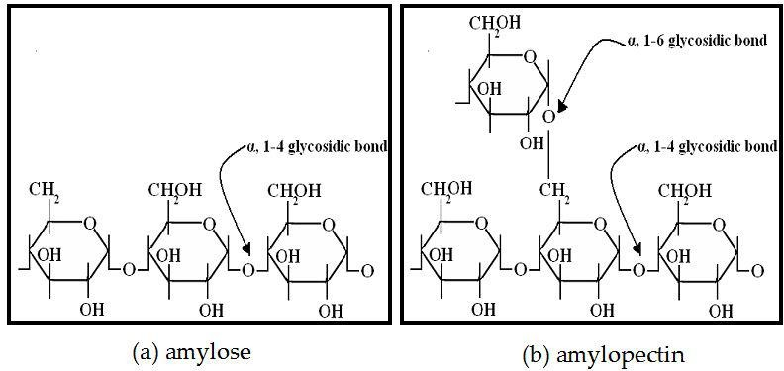

## Figure 2.1: (a) Amylose (b) Amylopectin structures

According to Tester *et al.* (2004) amyloses are composed of multiple units of glucose bound by α-1, 4 glycosidic bonds. Starch contains about 15-35 percent of amylose and its origin varies botanically. In solution, amyloses readily crystallize to form a left-handed double helical structure which is packed in a fashion rather parallel to form allomorphic A-or B-type (Imberty *et al.,* 1991). Amylose appears to form ligand complexes including iodine, alcohols and fatty acids (Bail *et al.,* 1999). The dimension of the single stranded helices that have been formed depends solely on the type of ligand molecules. The V- types are single helices which are crystallized.

Amylopectins are branched molecules with linear α-(1,4) glucose-related molecules and an approximated 5 % of branched α-(1,6) glucose-related molecules (Pérez and Bertoft, 2010). There are about four types of amylopectin structure; they include amylopectin type 1, which has very few long B-chains and a wide distribution of short B-chains. Type 2 is said to have longer B-chains (especially B2-chains) and the short chains have a narrow

size distribution. Type 3 is longer in B-chain than type 2 while type 4 has longer B-chains (especially B3-chains) (Bertoft *et al.,* 2008). Cereals such as barley, oat and rye belong to type 1 and type 2 includes maize and rice while legumes, roots and tubers of type 3group. Amylopectin type 4 includes potatoes and cannas (Bertoft *et al.,* 2008). It is said that these structural properties correlate with starch thermal properties (Vamadevan *et al.,* 2013). The internal amylopectin structure, defines the arrangement of chains. The internal chain structure is derived from dextrins, primarily dextrins β-limit and ÿ, β-limit. The β- amylase enzyme cleaves the outer chains of amylopectins resulting in very short stubs of the A-chain in the form of maltosyl or maltotriosyl residues.

Different models have emerged to study the cluster structure of amylopectin over time. The most popular model is the Hizukuri model (Hizukuri, 1985), also known as the "classical" model; in this model it is said that long chains interconnect clusters. Such long chains help to form the crystalline and amorphous lamellae. A cluster is a group of chains, where the branches are separated by segments of the internal chain shorter than nine residues of glucosyl (Bertoft, 2007).

## Cooking characteristics of rice

Characterization of the various varieties of rice is important for improving the quality of rice/rice related product. The quality of eaten and cooking are important attributes of rice to consumers and breeders, as most rice is directly cooked and consumed. Several physico-chemical parameters are used to calculate the quality of rice eating and cooking. These parameters include temperature of gelatinisation, time of gelatinisation, solubility, capacity of swelling and amylose contents (Singh *et al.,* 2005; Bao, 2012). The amylose contents are commonly used as key determinant for various rice products. Rice has similar amylose content and variation in the consistency of its eating; this can be due to their variations in amylopectin structures. Rice cultivars such as indica have high amylose

content; when cooked, they are typically warm, fluffy, and separate and become hard to cool.

Low-amylose cultivars such as japonica are soft and sticky while soft but not sticky intermediate-amylose rice cultivars (Bao, 2012). Other components which are proteins, lipids, amylopectin may also affect the cooking quality of rice (Cai *et al.,* 2011). The physical appearance and texture of cooked rice can differ depending on the method of cooking (Leelayuthsoontorn and Thipayarat, 2006). The texture of the rice being cooked depends on the amount of amylose and amylopectin. Rice texture is often influenced by the interaction of the intra/inter-molecular within the starch and other rice components such as lipids, proteins and non-starch polysaccharides (Prasert and Suwant toporn, 2009). Mohapatra and Bal (2006) establish that the cooking qualities and textural attributes of *indica* rice cultivars are affected by factors such as rice milling degree, amylose content and rice grain thickness.

More so, the rice cultivars ' grain thickness correlates negatively with optimum cooking time, adhesively. There is also a strong association with the ratio of grain thickness and water absorption, the ratio of volume and length expansions, hardness as well as cohesion. The time taken to cook 23 milled Indian rice cultivars showed a negative correlation with amylose while a positive correlation was found in milled Indian rice cultivars with bulk density.

Gruel solid loss revealed a strong association between amylose content and negative cooking time association. The rice cultivars have a lower gruel solid loss with a longer cooking time. Textural parameter also has a positive correlation between amylose content and cooking time. Rashmi and Urooj (2003) researched the impact of processing in six different rice cultivars on the nutritionally important starch fractions, concluding that

cooking methods such as pressure cooking, boiling, straining and steaming can influence the nutritionally important starch fractions (rapidly digestible starch, slowly digestible starch, resistant starch) in the various rice cultivars.

## Thermal properties of rice starch

Starch undergoes an inevitable transition called gelatinization in the presence of excess heated water. This method is endothermic and results in molecular destruction within the starch granules. During the gelatinisation process, the double helical and crystalline structures of the starches are disrupted. As the temperature increases it allows the crystalline to break apart, then it undergoes hydration resulting in many changes such as starch granulate swelling, crystalline melting, birefringence loss, and starch solubilization (Atwell *et al.,* 1988). The starch molecules, when cooled, appear to return to it in a crystalline shape, i.e. recrystallize (retrogradation), and this process may cause water to separate from the gel (syneresis) (Yeh and Yeh, 1993; Hoover and Manuel, 1995).

Some techniques were employed during gelatinisation to study the changes. These techniques include (DSC), NMR X-ray scattering spectroscopy, light dispersion, optical microscopy, thermo-mechanical analysis (TMA) (Jenkins and Donald, 1998). Differential calorimetry scanning (DSC) is used to measure melting transition temperatures and gelatinisation enthalpy; it involves heating starch (or flour) in excess water. Temperature range and heating rate are configured. For a reference, the thermograms are recorded using an empty pan.

Thermal properties reported using DSC include: initiation of gelatinization (To), peak (Tp), final temperature (Tc), peak height index (PHI), gelatinization range (R) and enthalpy (H). The starch's crystalline consistency is calculated by peak temperature (Tp) and gelatinization enthalpy (Hg) (Tester and Morrison 1990). The temperature of onset

(To) and the temperature of conclusion (Tc) define the limits of the various phases in a semi-cristalline substance (starch) (Biliaderis *et al.,* 1986).

Gelatinization enthalpy (al-Hg) is obtained by integrating the area below the endothermal peak formed by the amylopectin crystallite melting in starches. ØHg is represented as J / g, suggesting the breakdown of the relations between and inside the double helices of amylopectin (Cooke and Gidley, 1992). During gelatinisation the double helical and crystalline starch structures are disrupted. This transformation process includes the melting of crystals for different native starches as demonstrated by DSC endotherms (Jacobs *et al*., 1995). Li and Yeh (2001) studied the relationships between thermal, rheological, and swelling power of starch from various sources, such as Taiwanese rice- isolated starch. The report shows 57.7 oC and 65.1 oC respectively for To and Tp and 11.5 J / g for upper and lower hg. In 2003, Sodhi and Singh conducted a study using DSC for starches obtained from five indica rice cultivars with amylose content that varies. Temperature ranges of 66.33-67.26, 69.74-71.94, and 74.08-78.04 are observed representing To, Tp, and Tc respectively, were registered while Hg ranged from 8.16 to

11.88 J / g. A high degree of crystallinity provides stability to the structure due to the high transition temperatures, makes the granule more resistant to gelatinisation (Barichello *et al.,* 1990). They also suggested that the differences from the different rice cultivars between the transition temperatures and starches could be due to the variations in amylose content and their granulate structures.

In addition, they indicated that starch samples with higher To, Tp, Tc values could be due to the high molecular order degree and compact existence of starch granules. In addition, the presence of amylose decreases the melting point of crystalline regions and the energy to induce gelatinization, since amylopectin is responsible for crystallinity of starch

granules. In the absence of amylose-rich regions more energy is required to initiate melting (Kreuger *et al.,* 1987).

Recrystallization of amylopectin branch chains is reported to occur more organizedly in native starches than in stored starch gels, and this may be causes of H (retrogradation) at temperatures below H (gelatinisation) (Ward *et al*., 1994). Differences in the amylose- amylopectin ratios, granular structures and phosphate esters (Kasemsuwan *et al.,* 1995) may cause differences in the values of different native starches (retrogradation). It is also claimed that amylopectin and intermediate materials play a significant role in starch retrogradation during refrigerated storage, and that the intermediate materials tend to have longer chains than amylopectin. They can also form double helices longer during reassociation, under refrigerated storage conditions (Yamin *et al.,* 1999).

## Pasting properties of rice starch

If starch is continually heated with stirring over water, the granules appear to swell irreversibly and burst as a result of breakage in the structure of native starch. The substance of amylose then leaches out and the granules disintegrate to form a viscous material called paste (BeMiller, 2007). Starch's Pasting properties are indicators of how a given starch sample will behave during processing. The starch's functionality is related to its property of gelatinisation and pasting. This property can be used to determine the suitability of a starch sample in foods and other items as a functional ingredient (Wani *et al*., 2012).

Starch material with good pasting properties are used as thickening agents in fruit filling production (blueberry cheese cakes). They can also be used to increase the quality of soup. Rice starch with good pasting properties acts as an emulsion stabilizer, they are also able to improve gelling properties when mixed with hydrocolloids (Propyl

methylcellulose, Carboxymethylcellulose) (Nurulain *et al.,* 2018). Starch's physico- chemical properties, such as amylose: amylopectin ratio, granule size distribution, average granule size and mineral content affect starch properties (Madsen and Christensen, 1996; Wani *et al*., 2010). The amylose/amylopectin ratio plays an important role in the gelatinization and collection of rice starch properties which affect the physicochemical properties with amylose content. Starch swelling is a feature of amylopectin; amylose appears to limit the ability to swell starch (Tester and Morrison, 1990).

Pasting characteristics of starch are generally calculated by the use of a Brabender visco amylographer, Rapid Visco Analyzer (RVA), rotational rheometer or other viscometer capable of constantly measuring viscosity changes in temperature (Park *et al.,* 2007; Li *et al*., 2008; Wickramasinghe and Noda, 2008; Tukomane and Varavinit, 2008; Lin *et al.,* 2009). The important measured parameters include pasting of temperature, final viscosity (FV), viscosity setback (SB), and viscosity breakdown (BD), peak time, peak viscosity (PV), and viscosity troughs. Wani *et al.,* (2012) stated that the Pasting Temperature is a temperature at which the rice beginning to rise and its viscosity provides the minimum required temperature for cooking. Peak viscosity shows that the water-binding ability of the starch correlates with the quality of final product, as the swollen starch granules begin to collapse contributing to the texture of the cooked starch. The viscosity of Breakdown is a measure of the ease of disrupting swollen starch granules and the degree of stability during starch cooking (Adebowale and Lawal, 2003). The viscosity at the RVA test's maximum temperature is due to viscosity, or viscosity of hot pastes. Setback viscosity is a measure of the ability of starch paste to retrograde as an indicator of the final texture of a product. This can also be used to describe the difference in viscosity that occurs when

a pasted starch is cooled (Wani *et al.,* 2012); final viscosity indicates the ability of the starch content to form a paste or gel after cooking and cooling.

Lawal *et al.* (2011) studied the functional properties of starches obtained from five improved rice varieties cultivated in West Africa. The peak viscosities of the starches of the different rice varieties ranged from 147.48 RVU to 209.17 RVU while the hot paste or trough viscosity ranged from 123.83-157.08 RVU. The high breakdown viscosities 23.75-65.75 RVU and high setback values 58.83-122.42 RVU found in the analysis is due to the high amylose content of starch rice samples from NERICA. We researched the physicochemical and the functional properties of flours and starches obtained from African rice cultivars. For two African rice starches, the study recorded a high setback value of 150-174 RVU and breakdown viscosities 115.6-162.3 and also attributed it to high starch amylose content (Falade *et al.,* 2014). If the breakdown of starch content is high, the viscosity of the sample and the sample’s heat withstanding ability as well as shear stress during cooking will be very low (Adebowale *et al.,* 2005).

## Characteristic swelling and solubility of rice starch

Swelling potential refers to the capacity of starches to absorb water under various conditions of temperature and availability of water (Lawal *et al.,* 2011). The swelling of starch occurred causing loss of birefringence and leading to solubilization (Singh *et al.,* 2004). Amylose-lipid complex limit starch granule swelling as well as swelling properties of starch that are linked to starch Tester and Morrison's amylopectin structure (1990a). Swelling power and solubility have been documented to be used to calculate the degree to which the starch granule interacts between the amorphous and crystalline domains and starch chains (Ratnayake *et al.,* 2002). A high swelling potential is an indicator that the starch granules have weaker binding forces (Hoover *et al.,* 1996). Vandeputte *et al*. (2003 studied the structure-function relationships of five waxy and ten normal rice starches. He

stated that the swelling potential of one waxy and three normal rice starches depends on temperature. The first swelling stage involved a temperature range of 55-85 oC, amylose content did not affect normal rice starch swelling, but amylopectin short chains (DP 6 to 9) increased the granules swelling.

The second swelling stage involved a 95-125 oC temperature range; it was affected by leaching of the amylose content (with a swelling power that is reduced). Lawal *et al.* (2011) stated that increase in ability to swell and to be soluble, with an elevation in starch temperature of the five improved rice varieties cultivated in West Africa. The movement of starch molecules increased as temperature rose in the presence of water, resulting in weakening of the binding forces. This method facilitated the diffusion of water into the starch granules and the leaching of the starch granules ' soluble components thereby enhancing the starch's solubility. The starch's amylose region is said to contain the greater percentage of the starch granules ' amorphous component, where the penetration of water into the granule is more pronounced. Consequently, NERICA starch sample's highest swelling and solubility was said to result from its high amylose content in this study. In an analysis of functional and physico-chemical properties of flours and starches isolated from two African rice cultivars conducted by Falade *et al.* (2014). The study showed swelling power values of 5.72 percent and 8.24 percent for two rice cultivars, of 12.35 ml

/ g and 18.56 ml /g and solubility values.

## *In vitro* Digestibility and Glycemic Attributes of Rice

Relevant indicators are the glycemic index (GI) and resistant starch (RS) material, which indicates starch digestively. Glycemic index is a numerical measure, which shows the blood glucose reaction of a carbohydrate-rich test food after meal. It demonstrates how a carbohydrate-rich diet can increase blood glucose levels (Jenkins *et al*., 1987).

It is said that a GI value greater than 70 is high whereas values between 56 and 69 are perceived as medium. Values below 56 indicate low value of the glycemic index. Glycemic load (GL) is known as a function of the consumption of carbohydrates and the Glycemic Index. Glycemic Load is the sum of carbohydrate grams and the glycemic index of a food serving (Willett *et al*., 2002). When the glycemic load in a serving food is greater than 20, it is considered extreme while a glycemic load of 11-19 is considered average. There is a small Glycemic Load of 10 or less. Starch is categorized into three using in- vitro digestion as the basis for starch classification (Englyst *et al.,* 1992). The three forms of starch include: Quickly Digestible Starch (RDS), Slowly Digestible Starch (SDS), and RS. Rapidly digestible starches are starches that are digested 20 minutes later while slowly digestible starches are digested 20 minutes to 120 minutes later. Rice varieties with rapidly digestible starches are considered to have low amylose content, whereas those with slowly digestible starch are known to have greater amylose content (Frei, 2003).

Starches which are resistant remain undigested even after 120 minutes. Some factors, such as morphological, textural and rheological properties of the starch material, affect the enzyme digestion of starch. The existence of proteins, lipids, anti-nutrients / inhibitors, and non-starch polysaccharides are other factors that can influence starch digestion (Singh *et al.,* 2010). Non-starchy content, such as proteins and lipids, can restrict enzyme hydrolysis levels by preventing adsorption and thus influence enzyme binding (Oates, 1977). Studies have shown that protein fractions such as albumins, globulins and glutenins can bind to the bodies of proteins and form a matrix around starch granul3es, thus acting as a barrier to the enzyme amylases preventing hydrolysis (Hamaker and Bugusu 2003).

Amylose appears to form complexes with lipids; this complex has the ability to alter the behavior of starches considerably. The amylose-lipid complex is considered to be resistant to enzymatic hydrolysis (Holm *et al*., 1983). Studies have shown that rice starch with different amylose content in vitro has an amylose content of 27% for rice starch from long grain and 39% for resistant digestible starch, while glutinous rice starch has 4% for amylose and 71% for resistant digestible starch (Chung *et al*., 2011).

Sato *et al.* (2010) published a Glycemic Index of 89 for rice cultivar obtained from Koshikari, Japan. In waxy rice cultivars, Frei *et al.* (2003) registered higher GIs (> 90) compared to non-waxy cultivars. Research has also shown that enzymatic hydrolysis is higher in rice varieties which have a low amylose content and lower amylose content in rice varieties. The amylose content is a major determinant of the digestibility of starch and the glycemic index. Ranawana *et al.* (2009) reported that longer-term cooking of basmati rice results in a greater glycemic response.

## Amylases

Amylases are enzymes that break up starch molecules into products like maltose, restrict dextrins, and increasingly smaller glucose units (Tiwari, 2017). The family α-amylase is composed of a number of amylases. These have different substrate and metal ion specificities that function on being glucose residues connected to a glycosidic bond (α-1- 1, α-1-4, α-1-6). It has also been documented that amylase family members possess a number of common properties (Van der Maarel *et al.,* 2002). Two classes of amylases exist namely: exoamylases and endoamylases. The endoamylases randomly breakdown starch molecule to create simpler sugars of different lengths, linear branching and oligosaccharides. Exoamylases catalyze breakdown of starch molecules from the non-

reducing end resulting successively in short-term glucose chain length products (Gupta

*et al.,* 2003).

Amylases are an important class of industrial enzymes that account for about 25 percent of the enzyme market (Rao *et al.,* 1998). α-amylases active at high gelatinization (100- 110 ° C) and liquefaction (80-90 °C) temperatures are desirable with a view to reducing the cost of industrial processes. Sprinkled seed of pulses including *Cicer arietinium, Ceci neriand Pisum sativum* have been found to have strong amylase activity (rRani *et al.,* 2014). Moreso, the amylases which play an important role in the starch industry are the most widely used enzymes (Poonam and Dalel, 1995; Crab and Mitchinson, 1997; Sarikaya *et al.,* 2000).

Amylases uses have grown in many different fields such as clinical, scientific, and analytical chemistry, starch processing, textiles, food production, fermentation, paper manufacturing, and brewing (Pandey *et al*., 2000). Most species of Bacillus and thermo stable Actinomycetes, Thermoactinomyces are Thermomonospora are strong amylases producers (Ben *et al*., 1999). The Bacillus genus produces various extracellular enzymes, for example amylases and protease.

## Types of amylases

* + - 1. **α-amylase (EC 3.2.1.1)**

Amylase (glycogenase, 1,4-α-D-glucan glucanohydrolase) is metallo-enzyme that functions at random positions in the starch chain resulting in the breakdown of starch into maltotriosis and amylose maltose, or amylopectin maltose, glucose and limit dextrin. A "α-amylase appears to act faster compared to β-amylase. In animals, it functions as enzymes of digestion with an optimal pH of 6.7-7.0. In human physiology, α-Amylases

are found in the saliva and pancreas. Often present in plants including cereals, seeds, fungi (basidiomycetes and ascomycetes) and species of bacteria (Rani, 2012b; Rani, 2012d; Rani, 2012e).

## β-amylase (EC 3.2.1.2)

The alternative names of glycogenase; 1,4-α-D-glucan maltohydrolase; saccharogen amylase is the β- Amylase. β- Amylases are synthesized mostly by bacteria, fungi, pulses seeds and cereal plants. They catalyze the breakdown of the second α-1,4 glycosidic bond resulting in the cleavage of two glucose units or maltose at the time. In the fruit ripening stage, β-amylase breakdown starch molecules into sugar resulting to the sweetening of ripen fruit. β-amylase is present before the process of germination begins, while proteases and α-amylase appear at the beginning of germination. In animal tissues, β-amylase is absent, but it can be found in microbes contained in their digestive tract (Rani, 2012).

**2.8.3 γ-amylase** (EC 3.2.1.3)

The alternative names for glucoamylase; Glucan 1,4-α-glucosidase; amyloglucosidase; Exo-1,4-α-glucosidase; lysosomal α-glucosidase; 1,4-α-D-glucan glucohydrolase is γ- Amylase. γ- Amylase cleaves the last α-(1-4) glycoside bond, at the non-reducing end of amylopectin and amylose, giving out glucose molecule along with α(1-6) glycosidic bond linkage. In contrast to the other amylases, γ-amylase thrives in an acid environment and it has ph optimum of 3(Rani, 2012c).

## Functional and Structural Characteristics of Amylases

The O-Glycosyl hydrolases (EC: 3.2.1) of a wide group of enzymes that breakdown the glycoside bond linking two or more carbohydrates or carbohydrate to a non-carbohydrate molecule. Most starch hydrolytic enzymes belong to α-amylase or 1, 3 glycosyl

hydrolases family which is based on the sequence of amino acid homology (Henrissat, 1991).

## Mechanism of reaction of amylases

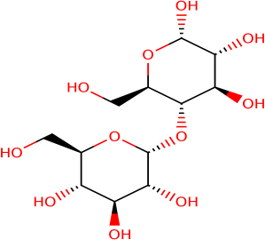Amylases catalyze the breakdown of glycosidic bonds in starch and other related oligosaccharide and polysaccharide. These enzymes are found in higher plants, animals and microbes. Amylases in cereals are important in the food industry in malt production, alcoholic beverages, and in confectioneries.

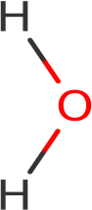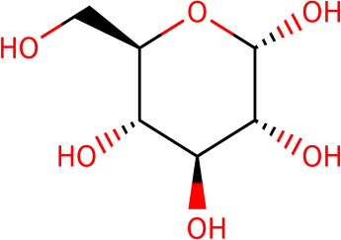

+

## Figure 2.2: Reaction mechanism of amylases

From the reaction, an intermediate is formed which attacks the sugar anomeric center via a 179 side chain of the nucleophilic Aspartate. A general acid catalysis of Glu 204 and Asp 289 assists in this. The covalent glycosyle intermediate undergoes general base catalyzed hydrolysis through the anomeric center attack by the nucleophile water. Glucose 204 and Aspartate 289, which are side chain deprotonates the water, triggering a nuclear attack. That leads to a state of transition that forms a deglycosylated product.

## Kinetic Properties of Amylases

Amylases are known to be generally stable over a wide range of pH (pH 4 to 11) Rani, 2012a; Rani, 2012c; Rani, 2012d; Rani, 2012e) Moreover, there are also amylases with pH stability in a narrow range (Rani *et al.*, 2014). A novel calcium ion independent α- amylase enzyme has been isolated form haloalkaliphilic marine *Streptomyces (*strain A3).

This type of amylase, does not have need of calcium ion for starch hydrolysis (Chakraborty *et al.,* 2012). The optimum temperature for the activity of α- amylase is a function of the growth rate of the microorganism. The temperature stability of amylase is known to be affected by other factors such as the presence of calcium, substrate and other stabilizers (Vihinen *et al.,* 1989; aRani, 2012; bRani, 2012cRani, 2012 dRani, 2012,

eRani, 2012; rRani *et al.*, 2014).

* 1. **Engineered Commercial Amylases for Improved Catalytic Stability** Engineering of the commercially available enzymes has been advocated and hybrids α- amylases have been produced (Suzuki *etal.,* 1989). Structural and mutagenic studies on archeae, mammalian and bacterial alpha-amylases have been carried out on their mechanism of catalysis. The biochemical engineered α-amylase was reported to have stable pH profiles as compared to free amylase (Nielsen and Borchert, 2000). Kinetic properties of α-amylase have been studied extensively and the industrial applications of α-amylases after immobilization and entrapment of the enzyme with improved thermal stability, pH resistant and stability during storage (Van der Maarel *et al.* 2000; Gupta *et al.* 2003).

Researches are being carried out to develop new methods or techniques to immobilize the important commercial enzymes into nanoparticles in order for them to be more thermostable and stored up to remarkable level (Rani & Chauhan, 2014). In recent times, amylase was also immobilized on tannin sepharose, silica, alumina, chitin, Ionic binding on Amberlite IR-120, Dowex50W, DEAE-Cellulose DE-52, calcium alginate beads by physical adsorption (Ricardo *et al.,* 2013; Demirkan, 2011).

Immobilization of amylases from sprouted pulse such as *Vigna radiata, Phaselous vulgaris, Glycine*max and *Cicer arietinum* was done on chlorinated and nitrated woven

*Bombyx mori* silk fabric and enhancement of thermal and storage stability were also studied as compared to free amylases (Rani, 2012a; Rani & Jenamoni, 2012, Rani and Saxsena, 2012 and Rani, 2012b; Rani, 2013). In the encapsulation and entrapment of pulses on amylase, it was done in a chemically modified bovine serum albumin by emulsification and covalent coupling to make the bound amylases more thermal and storage stable as compared to free sprouted pulses amylases (Rani, 2012k; Rani, 2012j; Rani, 2012m).

Chemically activated bovine serum albumin nanoparticles and micro particles were loaded with biochemically modified amylases (Rani, 2014; Rani *et al.*, 2015). The egg albumin micro-particles loaded with Amylase was prepared by chemical modification with n-butanol and glutaraldehyde to enhance it thermo-viability and ensure storage stability of the encapsulated enzyme, when compared to free amylases (Rani, 2014; Rani, 2015). The effects of immobilizing amylase in calcium alginate beads were also studied for alginate concentration, Calcium chloride concentration on enzyme activity, amount of loading enzyme, size of bead and amount of beads on enzymatic activity in order to utilize immobilized amylases in industrial processes (Ertan *et al.,* 2007)

## Industrial Applications of Amylases

Amylases play very significant role in carbohydrate metabolism and hydrolysis of starch into maltose and limit dextrins (Sivaramakrishnan *et al.,* 2006; Rani *et al.,* 2014; Van der Marrel *et al.,* 2002). In recent times, various immobilization techniques have been used to bind amylase as an immobilized enzyme. Entrapment was considered a more preferable technique because it reduces excessive loss of enzyme activity and increases the enzyme stability in microenvironment of matrix which also protects enzyme from contamination by microbes (Demirkan, 2011; Om and Nivedita, 2011). Immobilized amylases are

widely used in various industrial processes such as in food, fermentation processes, detergent, paper making and textile industries. In the entrapment or encapsulation of enzymes onto a matrix polymeric nanoparticles were selected and the matrices of choice are chitosan, gelatin, sodium alginate and albumin. It was used for the controlled release of the drugs, which made them ideal for cancer therapy, delivery of vaccines, and delivery of targeted antibiotics to the target site (Urrusuno *et al.,* 1999; Farrugia *et al,* 1999).

Studies have shown the breakdown of modified amylase loaded in bovine serum albumin and egg albumin micro-preparation and Nano preparation, which was achieved by alkaline protease for controlled and sustained release of bound amylase to make the bound amylase to be utilize in industrial processes as compared to free amylases (Rani, 2012; Rani and Chauhan, 2014; Rani and Mehta, 2014; Rani *et al*., 2015;).Amylases bound to Bovine serum albumin and egg albumin which were investigated, to study their applications in washing of dry tough stained fabrics are reported to be environmental friendly, less expensive and bio-active detergent additive (Rani, 2012; Rani and Chauhan, 2014; Rani and Mehta, 2014; Rani *et al*., 2015).

There are various applications of amylases in the industry such as;

1. In liquefaction which is a process of insoluble starch in a starch in a solution, using thermostable amylase (Aiyer, 2005). This brings about hydrolysis of starch.
2. In the manufacture of fructose syrups, the starch is being converted to glucose first by enzymatic hydrolysis before being converted to fructose by isomerization.
3. In the production of Oligosaccharide mixtures such as maltooligomer mix,
4. In the manufacture of maltotetraose syrup
5. Removal of starch sizer from texile which is known as desizing. After weaving a fabric the starch is removed before it is dyed. Amylase helps to remove the starch.
6. In the direct fermentation of starch to alcohol in the brewing industries.
7. Treatment of starch waste water (Bergman *et al*., 1988).
8. Alpha amylase is used to aid digestion, in making detergents, as supplements to flour and to improve digestibility of some food ingredients (Aiyer, 2005).
9. Glucoamylase is used in the production of glucose syrup, corn syrup, starch hydrolysis and brewing of low calorie beer (Jennylynd, 2007).
10. Beta amylase is used in the production of high maltose syrups, brewing (Suriya, 2016).

## Sprouting of Grains

Sprouting is a process, by which seeds or spores germinate and produce new leaves or buds or form new parts. In nutrition, the term refers to the practice of germinating seeds such as cereals, mung beans, sunflower seeds, to be eaten raw or cooked, this is considered very nutritious to the body (Guelph, 2013). Seed sprouting or germination at a microscopic level, involve various reactions such a hydration, respiration, cellular structural changes, macromolecular synthesis, enzymatic reaction (Rani *et al.,* 2001). Moreover, several environmental conditions are required for germination such as water, oxygen and temperature. A three phase process of water uptake takes place during germination. Phase 1 occurs in the seeds, there is an attraction for water by the matrices, which leads to release of gases by the seed. A lag period occurs during phase 2; the seed undergoes the process of germination, using the water absorbed. Phase 3, radicle begins to elongate, which is responsible for an increase in water uptake. Temperature and moisture are important for the sprouting of rice; they play an essential role in germination and activating amylases. The starch contained in the rice grain is broken down into simple sugar, which is used as energy for the germination process. Studies have shown germinated cereals has better nutritional values sure as more free amino acids, higher dietary fibre, increase in mineral content (Mg, Na, Ca, K) than ungerminated cereals

(Hung *et al.,* 2012). Sprouting has been shown to reduce the content of phytic acid contained in grains, converting it to Inositol and phosphate in bioavailable form (Wung, 2009). There is also an increase in the biosynthesis of vitamin C, E, carotene.

During sprouting most of the nutrients stored in the seeds such as carbohydrates are mobilized to be broken down by endogenous enzymes. The enzymes are present in seeds, there activity are increased upon sprouting. Alpha –amylase is considered as the most important enzyme for starch breakdown in sprouting grains. It is not present in some resting cereals but upon sprouting a gibberillin (plant hormone) stimulate the production of the enzyme in the aleurone layer or scutellum in the rice grain (Nirmala, 2005).

Sprouting has a profound effect of starch properties, because the increase in the amylase activity degrade starch granules which lowers swelling capacity, increases the solubility, high digestibility of the starch (Guelph, 2013).

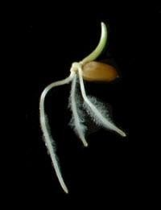

**Figure 2.3**: Sprouted grain (Guelph, 2013)

# CHAPTER THREE

* 1. **MATERIALS AND METHODS**

Ten different rice varieties are developed in Nigeria were collected from National Cereals Research Institute (NCRI) Badeggi, Niger State, Niger State. They include the following FARO (Federal Agricultural Rice *Oryza sativa*) varieties which were selected randomly:

## Table 3.1 : FARO Rice Samples used for the study

**S/No Rice Sample**

1 FARO 15

2 FARO 16

3 FARO 20

4 FARO 22

5 FARO 30

6 FARO 45

7 FARO 47

8 FARO 55

9 FARO 61

10 FARO 62

## Equipment and Laboratory Apparatus

* + 1. RC-16M refrigerated centrifuge Sherwood Medical, China.
    2. Biochrom (Biochrom Ltd) UV 2800 Double beam; UV/VIS scanning spectrophotometer, Biochrom Ltd, UK.
    3. Haier Thermocool refrigerator chest Med- HTF203, Sherwood Medical England
    4. pH meter-Crison micro pH 2000, Fisher Scientific laboratory, USA
    5. Weighing balance- Scout pro OHAUS-200g and Bran Weigh B-300 OHAUS,

Acrotech Scientific Limited, New Delhi

* + 1. Water bath WTB, United State Laboratory, USA.
    2. Thermometer WIKA-250, Changzhou meters Co. Ltd, China
    3. General glass wares, Regent Scientific, Nigeria

## Reagents and Preparation

All reagents were of analytical grades

* + 1. Citrate buffer (Laboratory technology chemicals, pH 5.0, 3.0)
    2. Phosphate buffer (pH 7.0)
    3. Dintrosalicyclic Acid (DNSA)
    4. Potassium iodide and Iodine (5 mM)
    5. Hydrochloric Acid (0.5 M)
    6. Dimethylsulfoxide (90 %)
    7. Distilled water

## Sprouting of FARO Rice Samples

Hundred grams (100 g) of the FARO rice samples were sprouted for 12 days. The grains were first cleaned thoroughly; foreign materials were removed from it. The rice varieties were soaked overnight in distilled water. The excess water was removed in the morning,

and further rinsed with distilled water. The samples were then spread on clean sack made from jute in plastic trays and covered by another jute sack. They were sprayed water, twice each day and kept in a favorable condition (dark environment) to ensure sprouting.

Each day 20 g of the rice were dried at room temperature of 25 oC. They were ground using electric blender. The powder was sieved using a mesh size of 600 microns, and kept in containers for further analysis

## Extraction of Amylases

Amylases were extracted from the ground samples, according to the method described by Egwim and Oyelode (2006). Αlpha amylase was extracted using the citrate buffer at pH of 5.0. One (1 g) of each sprouting rice variety, which has been ground was added to 5 ml of prechilled citrate buffer. The resulting homogenate was centrifuged for 10 minutes at 3200 rpm. The supernatants were pipetted into sample bottles, for the enzyme assay.

The β-amylase was extracted using citrate buffer at pH 3.0. one gram (1 g) of each sprouting rice variety which has been ground was added to 5 mL of prechilled (0.05 m) citrate buffer. The resulting homogenate was centrifuged for 10 minutes at 3200 rpm. The supernatants were pipette into sample bottles, for the enzyme assay. The glucoamylase were extracted using phosphate buffer at pH 7.0. 1g of each sprouting rice variety, which has been ground was added to 5 mL of prechilled (0.05 m) citrate buffer. The resulting homogenate was centrifuged for 10 minutes. The supernatants were pipetted into sample bottles.

## Enzyme Assay

The α and β-amylases were assayed according to the method described by Egwim and Oyelode (2006). Soluble starch slurry (2 %) was prepared by dissolving 2 g of starch in 100 ml of distilled water. The enzyme was extracted from the rice varieties using a citrate

buffer of pH 3.0 for β-amylase and pH 5.0 for α- amylase. 0.9 ml of the starch slurry was added to each of the test tubes, containing the enzyme extracted from the different variety of rice. The supernatant of 0.1 mL which were pipetted into the sample bottles during the enzyme extraction, were placed each in different test tubes labeled with the names of the different rice variety. The test-tubes containing the starch slurry and enzyme extracted were incubated in a shaking water bath at 50 oC for 30 minutes. The blank was also prepared which contains the starch slurry, without the enzyme extracted.

The reaction, after 30 minutes was stopped by adding 3 ml of 3, 5-dinitrosalicylic acid to each of the test tubes, including the blank. They were then boiled for 3minutes for colour development. The absorbance was read at a wavelength of 550 nm, using UV spectrophotometer. The absorbance was read and converted to amylase activity, as described by Asante *et al*. (2013). The Enzyme activity is defined as the amount of glucose produced per ml of the amylase solution per minute under the necessary conditions This was done from the day 0 to 12, for each of the rice variety to assay for both α and β-amylase.

Standard glucose curve was prepared from glucose concentration of 0.0, 0.2, 0.4, 0.6, 0.8,

1.0 mg/ ml. The regression equation of the standard curve was given as Y= 0.128 X, R2

= 0.72

Where Y= absorbance at 550 and X= Enzyme activity (mg/ml glucose/min)

Enzyme activity (U/ml) = 𝑥 (mg/ml (glucose) x103 )

𝑡𝑖𝑚𝑒( 𝑠𝑒𝑐𝑜𝑛𝑑𝑠)

3.1

Glucoamylase is an enzyme, which degrades starch by removing glucose monomers from the non-reducing ends. Its thereby reducing the mass of starch (polymeric unit of glucose), available for iodine binding. The method used for glucoamylase assay is known as the

starch iodine method, described by Zhizhuang (2006). The sprouted rice sample was ground using phosphate buffer of pH 7.0. Soluble starch of 0.9 ml of slurry (2 %), which have been prepared were added to test tubes labeled with the names of different rice variety. 0.1ml of the enzyme extracted, which were pipette into the sample bottles, were also added to the various test tubes containing the names of each of the rice variety. The test tubes were then incubated in a water bath at 50 oC for 10 minutes. After 10 minutes, it was taken away from the water bath. 0.5 ml of 1 m of HCl was added to each of the test-tubes to stop the reaction. 2 ml of iodine prepared from 5mM of iodine and 5 mM of potassium iodide, for color development. The absorbance was read at a wavelength of 580nm, using the UV spectrophotometer.

Standard starch curve, was prepared from different concentration of starch, 0.0, 0.2, 0.4, 0.6, 0.8, 1.0 mg/ml Corresponding concentration of iodine 1.0, 0.8, 0.6, 0.4, 0.2, 0.0 mg/ ml of iodine was added to the different concentration of starch. The absorbance was read at wavelength of 580 nm. The enzyme activity is the amount of starch broken down per ml of the glucoamylase solution per minute under the necessary conditions. The starch curve of absorbance versus starch concentration was plotted to generate the standard equation from the starch curve. The regression equation of the standard curve was given as Y= 2.8727 X, R2 = 0.78. Where Y= absorbance at 580 and X = Enzyme activity (mg/ml starch/min)

Enzyme activity (U/ml) = 𝑥 (mg/ml( starch) x103 )

𝑡𝑖𝑚𝑒( 𝑠𝑒𝑐𝑜𝑛𝑑𝑠)

3.2

## Determination of Swelling Capacity of FARO Sprouted Rice Samples

The swelling capacity was determined by placing 2.5 g of each of the sprouted rice sample in a measuring cylinder. Distilled water of 15 mL was added and allowed to stand for 4

hours, after 4hours the weight of the wet sediment in the cylinder was noted to determine the swelling power (Leach *et al*., 1959).

Swelling capacity =1/4 𝑤𝑒𝑖𝑔ℎ𝑡 𝑜𝑓 𝑤𝑒𝑡 𝑔𝑒𝑙 X 100 3.3

𝑤𝑒𝑖𝑔ℎ𝑡 𝑜𝑓 𝑠𝑎𝑚𝑝𝑙𝑒

Weight of wet gel = wet rice sample after 4 hours Weight of sample = dry rice sample

X100 = conversion to percentage

1/4 = reciprocal of the number of hours allowed to swell.

## Determination of Solubility of FARO Rice Samples

In a shaker, 2.5 g suspensions of the native samples were agitated in 20 mL of distilled water for 30 minutes. The suspension was poured into a centrifuge tube which had been pre-weighed. Then 10 mL of distilled water was used to rinse starch from the beaker which was applied at 3000 rpm for 10 minutes to the centrifuge tube and centrifuge. To assess binding power, the supernatant was decanted and wet starch was weighed (Anderson *et al*., 1969).

Solubility =𝑤𝑒𝑖𝑔ℎt of wet starcℎ

𝑤eight of dry starcℎ

3.4

## Determination of Cooking and Pasting Property of FARO Sprouted Rice Samples

The cooking and pasting property of the rice were analyzed on the basis of their gelatinization time and temperature, amylose and amylopectin ratios of the 10 varieties of rice samples.

To determine the gelatinization time and temperature, one gram (1 g) of each rice variety was weighed and added to 10 ml of water. They were then placed over the water bath for

the solution to heat. As the temperature of the water bath increased, the solution began to form gel. The temperature at which the solution starts forming gel was recorded as the initial temperature. The final temperature and time taken to form the gel was also recorded (Onwuka, 2005). This was done from day 0 to the 12th day of the sprouting, for each of the FARO rice samples.

The Amylose and amylopectin ratios of the variety of rice used for this study were determined from the day 0 to 12th day of the sprouting. The method used for the determination of amylose content was described by Saeed (2010). The different rice samples (0.32 g) were dispersed into 8ml of 90 % DiMethysulfoxide reagent. The solution was placed in the water bath for 10 minutes at 80 oC. Then cooled to room temperature for 30 minutes. After cooling, an aliquot of 1.0 ml of each of the solution was mixed with

5.0 ml of freshly prepared iodine reagent and 44 ml of distilled water in a volumetric flask. The freshly prepared iodine was used for the color development. (Saeed, 2010). The absorbance of each of the color development from the rice samples were read from the spectrophotometer set at 600 nm. The value gotten was extrapolated from a standard curve of pure potatoes amylose (Saeed, 2010).

The regression equation of the standard curve was given as: Y = 0.0168X + 0.2138, R2 = 0.9998

Where Y = absorbance at 600 and X = % Amylose.

# CHAPTER FOUR

* 1. **RESULTS AND DISCUSSION**

## Results

* + 1. **Sprouting of Rice Variety**

The sprouting of the FARO rice varieties was from day 0 to day 12; this is shown below in Plate 4.1 to 4.4. The rice varieties started sprouting from day 2 for most of the FARO rice varieties as can be seen in Plate 1. From day 3 all the FARO rice samples had developed a hair-like structure as can be seen in Plate II, III, and IV. The sprouting of the FARO rice samples began on day 3.

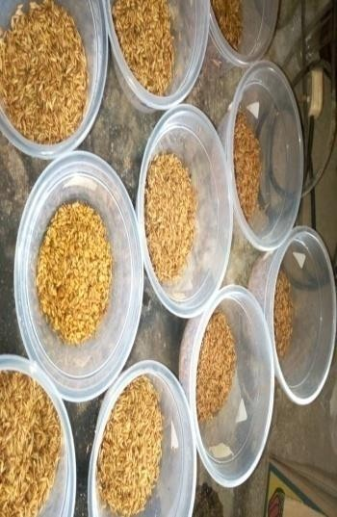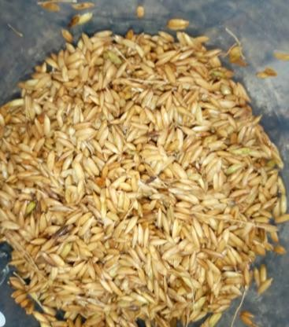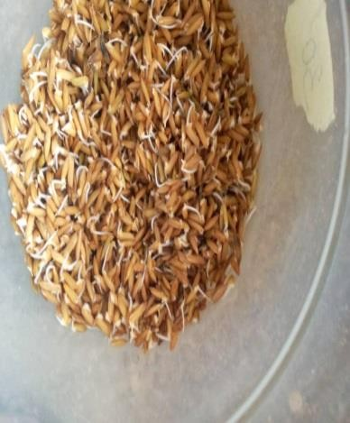

DAY 0

DAY 2

DAY 1

**Plate I:** Sprouted rice varieties from day 0 to day 2

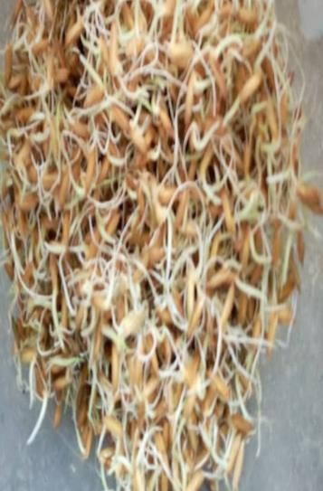

DAY 3

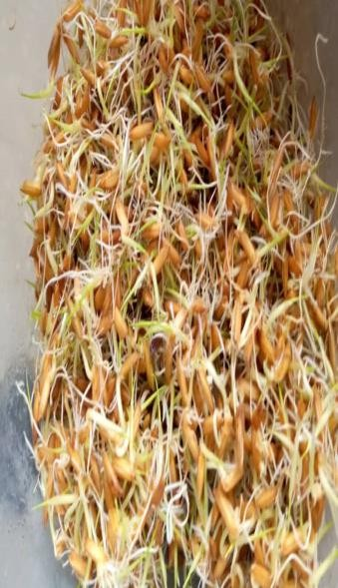

DAY 4

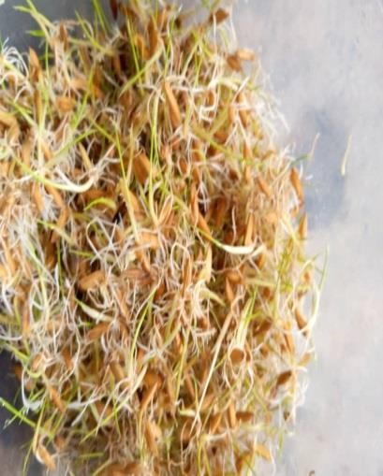

DAY 5

**Plate II:** Sprouted rice varieties from day 3 to day 5.

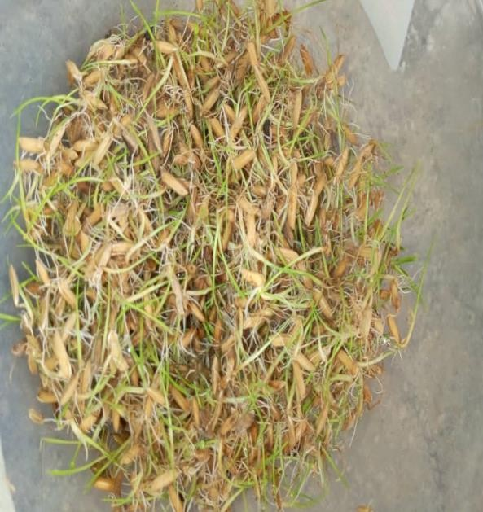

DAY 6

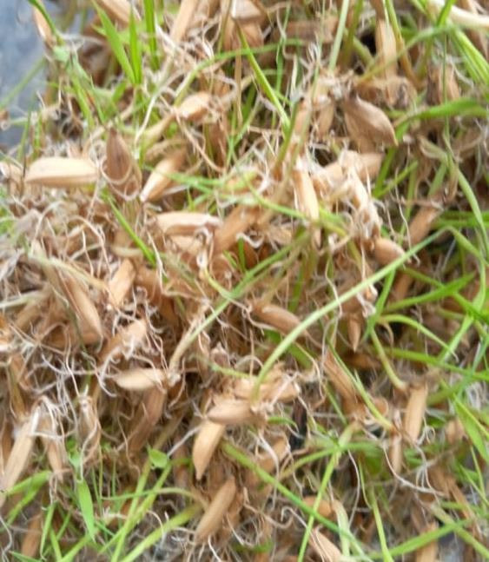

DAY 7

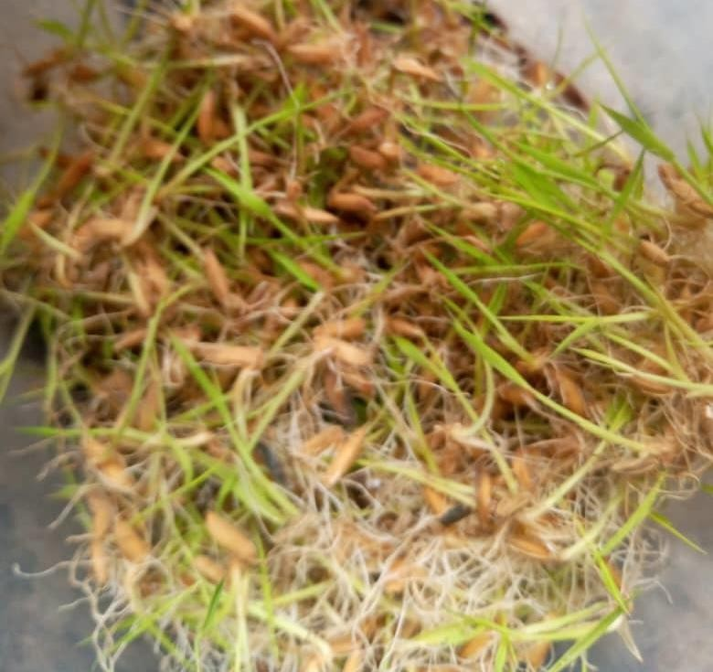

DAY 8

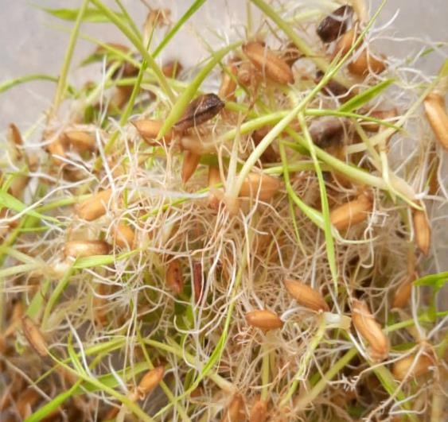

DAY 9

## Plate III: Sprouted rice varieties from day 6 to day 9.

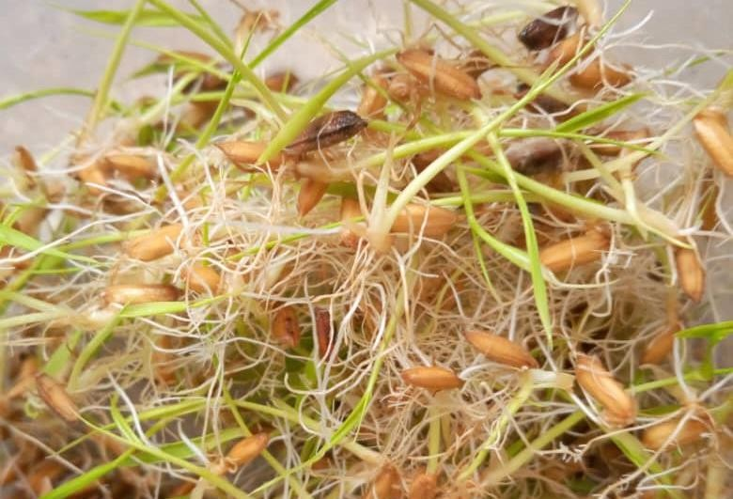

DAY 10

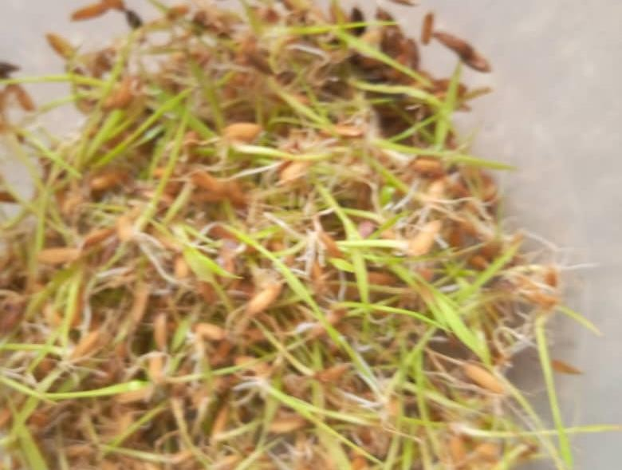

DAY 11

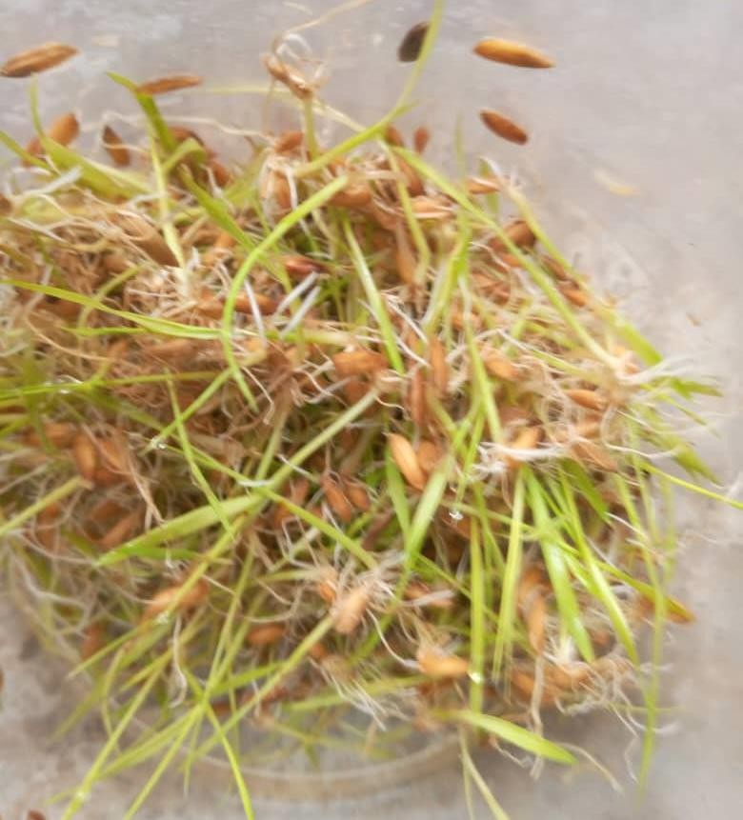

DAY 12

**Plate IV:** Sprouted rice varieties from day 10 to day 12

## Amylases activity in FARO rice varieties

* + - 1. **α-Amylase activity in FARO rice varieties**

The alpha amylase activity of sprouted FARO rice samples is presented in Figure 4.1. The result showed that most of the FARO rice samples showed good enzyme activity. Sprouting had a good effect on the alpha amylase activity of the rice samples. The enzyme activity for most of the FARO rice sample started increasing from day 3 to day 10. FARO 55 rice sample showed increased from day 5 to day 10. The highest enzyme activity was attained by FARO 20, 61, 62 from day 3 to day 10. Most of the FARO rice samples fall within the same range of enzyme activity from day 4 to day 9.

60

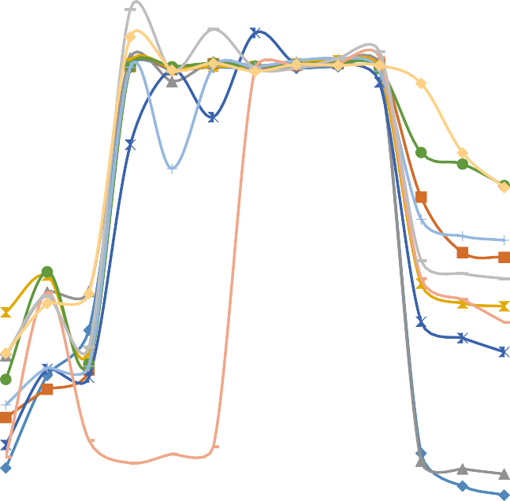

55

50  FARO 15

45  FARO 16

40  FARO 20

**α-Amylase activity (U/ml)**

35  FARO 22

 FARO 30

30

 FARO 45

25

 FARO 47

20  FARO 55

15  FARO 61

10  FARO 62

5

0

0 1 2 3 4 5 6 7 8 9 10 11 12 13

**Sprouting time (Days)**

## Figure 4.1: Alpha-amylase activity in ten FARO rice varieties

* + - 1. **β-amylase activity of FARO rice samples**

The amylase activity of the sprouted FARO rice samples is shown in Figure 4.2. The result showed that sprouting of the FARO rice sample increased the enzyme activity. Most of the FARO rice samples showed increase in β-amylase from day 3 to day 9 of the sprouting. The highest enzyme activity was seen on day 5 and day 6 of the sprouting days, for most rice samples. FARO 61, 62, 16, 20, 45, 55 had their highest β- amylase activity on the 5th day of sprouting.

50



45

40

FARO 15

35  FARO 16

**β-amylase activity (U/mL)**

FARO 20

30

FARO 22

25 FARO 30

FARO 45

20 FARO 47

FARO 55

15

FARO 61

10  FARO 62

5

0

0 1 2 3 4 5 6 7 8 9 10 11 12 13

**Sprouting time (Days)**

## Figure 4.2: β-amylase activity of FARO rice samples.

* + - 1. **Glucoamylase activity of FARO rice samples**

The Glucoamylase activity of FARO rice samples, during sprouting is presented in Figure

4.3. The graph shows that sprouting causes an increase in the enzyme activity. Most of the FARO rice samples, showed an increase in enzyme activity from day 3 to 6. FARO 15 showed the highest glucoamylase activity on day 6 followed by FARO 62, 61, 55, 47 &16, they gave a good enzyme activity.

120



100

80

**Glucoamylase activity (U/ml)**

60

40

20

0

0 1 2 3 4 5 6 7 8 9 10 11 12 13

**Sprouting time (days)**

 FARO 15

FARO 16

 FARO 20

 FARO 22

 FARO 30

 FARO 45

 FARO 47

 FARO 55

 FARO 61

 FARO 62

**Figure 4.3: Glucoamylase activity of FARO rice samples**

* + 1. **Effect of Sprouting on the functional properties of FARO rice varieties**
       1. **Effect of Sprouting on the solubility of FARO rice samples**

The effect of sprouting, on the solubility of FARO rice samples is shown in Figure 4.4. The result shows that sprouting increases the solubility of the rice sample. Sprouting caused an increase in the amount of soluble material, thereby increasing the solubility of the rice samples. The increase in the solubility for most of the FARO rice samples began from day 3and continues to day 12, without a decline. FARO 45, 15, 55, 61, 62 showed a high increase in solubility during sprouting

1



0.8

0.6

**Solubility (in mg/L)**

0.4

0.2

 FARO 15

FARO 16

 FARO 20

 FARO 22

 FARO 30

 FARO 45

 FARO 47

 FARO 55

 FARO 61

 FARO 62

0

0 1 2 3 4 5 6 7 8 9 10 11 12 13 14

**Sprouting time (days)**

**Figure 4.4.: Effect of sprouting on the solubility of FARO rice samples**

* + - 1. **Effect of sprouting on the swelling capacity of the FARO rice samples**

The effect of sprouting on FARO rice samples is shown in Figure 4.5. As the number of sprouting days’ increases, the swelling capacity of the rice samples decreases for most of the FARO rice sample. The swelling capacity for most of the FARO rice samples starts decreasing from day 5 to day 12. Form day 0 to 4, sprouting had a little effect on most FARO rice samples such as FARO 45, 20, 16, 62, 22,55. From day 5, there is a drastic decrease in the swelling capacity for all the FARO sample as the sprouting days increased

90



80

70

 FARO 15

60  FARO16

**Swelling capacity (%)**

 FARO 20

50  FARO 22

 FARO 30

40

 FARO 45

30  FARO 47

 FARO 55

20  FARO 61

 FARO 62

10

0

0 1 2 3 4 5 6 7 8 9 10 11 12

**Sprouting time (days)**

## Figure 4.5: Effect of sprouting on the swelling capacity of FARO rice samples

* + - 1. **Effect of sprouting on the amylose content of the FARO rice samples**

The effect of sprouting on the amylose content of FARO rice samples is shown in Figure

4.6. The amylose content of the rice samples gradually reduces as the sprouting increases.

Sprouting of the FARO rice samples from day 0 to day 4 had higher amylose content as compared to day 5 to day 12 of the sprouting days. From day 0 to day 4 of sprouting FARO 62, 22, 20, 45, 16 had the highest amylose content compared to other FARO rice samples, from day 5 there was a decreased in amylose content for all the FARO rice samples used.

70



60

50  FARO 15

 FARO 16

**Amylose content (%)**

 FARO 20

40

 FARO 22

 FARO 30

30

 FARO 45

 FARO 47

20  FARO 55

 FARO 61

10  FARO 62

0

0 2 4 6 8 10 12 14

**Sprouting time (days)**

## Figure 4.6: Effect of sprouting on the amylose content of FARO rice samples

* + - 1. **Effect of Sprouting on the Gelatinization Time and Temperature of the FARO rice samples.**

The effect of sprouting on the gelatinization time and temperature of FARO rice samples is represented in Figures 4.7 and 4.8 respectively. Increase in the number of sprouting days, caused an increase in time taken to form gel as shown in figure 4.8a and a decrease in gelatinization temperature as shown in Figure 4.8b. As the number of the sprouting days increased, the time taken for the FARO rice samples to form gel also increased. From day 0 to day 4, the time taken to form gel was within the range of 36 seconds to 77 seconds for most of the FARO rice samples. From day 5, there was a rapid increase in the time taken to form gel, as the sprouting number of days increased.

150



120

**gelatinization time (in seconds)**

90

60

 FARO 15

 FARO 16

 FARO 20

 FARO 22

 FARO 30

 FARO 45

 FARO 47

 FARO 55

 FARO 61

 FARO 62

30

0 1 2 3 4 5 6 7 8 9 10 11 12 13

**Sprouting in time(days)**

## Figure 4.7: Effect of sprouting on the gelatinization time of the FARO rice sample

The effect of Sprouting of the FARO rice samples on the gelatinization temperature is shown in Figure 4.8b. As sprouting number of days increased, the temperature at which the gel forms decreased for all the FARO rice samples. From day 0 to day 4, the temperature at which the gel was formed for the FARO rice samples was within the range of 83 0C to 63 0C. From day 5 to day 12 of the sprouting, the temperature range was within 73 0C to 52 0C for all the FARO rice samples. Faro rice samples such as FARO 55, 30, 22, 61, 20, 47 attained the highest gel temperature during sprouting from day 0 to day 4.

The lowest temperature from day 5 to day 12 was shown by FARO 30, 61, 62, 47 (52 0C

– 57 0C)

85



80

 FARO 15

**Gelatinization Tmperature (in oC)**

75  FARO 16

 FARO 20

70

 FARO 22

65  FARO 30

 FARO 45

60

 FARO 47

55  FARO 55

 FARO 61

50

 FARO 62

45

0 1 2 3 4 5 6 7 8 9 10 11 12 13

**Sprouting Time (Days)**

## Figure 4.8: Effect of sprouting on the gelatinization temperature of the FARO rice samples.

* + 1. **Correlation and Regression of the Functional Properties**

The correlation and regression of Amylose and various parameters are shown below: Amylose has a strong negative correlation with solubility. An increase in the amylose content also causes a decrease in solubility. From the regression equation below, Y= solubility and X= amylose for each FARO rice variety. Figure 4.9a shows the regression line equation of the FARO rice samples.

There is a strong negative correlation between amylose and solubility, as shown in the table below. This shows that as the amylose content of the FARO rice varieties decreases the solubility increases and vice versa, showing a negative relationship between the two parameters. The summary of the correlation and regression analysis is shown below in Table 4.1.

## Table 4.1: Correlation between Amylose and Solubility of FARO Rice Varieties.

|  |  |  |
| --- | --- | --- |
| **RICE VARIETY** | **R2** | **r (correlation value)** |
| FARO 15 | 0.952 | -0.93 |
| FARO 16 | 0.843 | -0.97 |
| FARO 20 | 0.459 | -0.68 |
| FARO 22 | 0.798 | -0.89 |
| FARO 30 | 0.785 | -0.89 |
| FARO 45 | 0.877 | -0.94 |
| FARO 47 | 0.543 | -0.74 |
| FARO 55 | 0.793 | -0.89 |

|  |  |  |
| --- | --- | --- |
| FARO 61 | 0.130 | -0.36 |
| FARO 62 | 0.899 | -0.81 |

* + - 1. **Correlation Between Amylose and Swelling Capacity**

Amylose has a strong positive correlation with swelling capacity. An increase in amylose content of the rice varieties cause an increase in the swelling capacity. From the regression equation below, Y = swelling capacity and X = amylose for each FARO rice variety. There is a strong positive correlation between amylose and swelling capacity. As the amylose content of the rice varieties increased the swelling capacity of the FARO rice varieties also increased. Most of the FARO rice varieties showed a strong correlation as shown in Table 4.2.

## Table 4.2: Correlation Values Between Amylose and Swelling Capacity

|  |  |
| --- | --- |
| **FARO Rice Varieties R2** | **r (correlation value)** |
| FARO 15 0.82 | 0.91 |
| FARO 16 0.45 | 0.68 |
| FARO 20 0.73 | 0.86 |
| FARO 22 0.46 | 0.68 |
| FARO 30 0.38 | 0.61 |
| FARO 45 0.75 | 0.87 |
| FARO 47 0.47 | 0.69 |
| FARO 55 0.79 | 0.89 |
| FARO 61 0.47 | 0.68 |
| FARO 62 0.93 | 0.97 |

* + - 1. **Correlation and regression analysis of amylose and Gelatinization temperature**

Amylose has a strong positive correlation with gelatinization temperature. An increase in the amylose content also causes an increase in temperature for forming gel. From the regression equation below, Y = Gelatinization temperature and X = amylose for each FARO rice variety.

From the result below in Table 4.3, shows there is a positive correlation between amylose content and gel temperature for most of the FARO rice varieties. This shows that as the amylose content increased the gel temperature also increased.

## Table 4.3 Summary of the Correlation Between Amylose and Gel Temperature of the FARO rice varieties.

|  |  |  |
| --- | --- | --- |
| **Rice variety** | **Correlation value** | **R2** |
| FARO 15 | 0.79 | 0.63 |
| FARO 16 | 0.85 | 0.72 |
| FARO 20 | 0.93 | 0.86 |
| FARO 22 | 0.91 | 0.82 |
| FARO 30 | 0.80 | 0.64 |
| FARO 45 | 0.50 | 0.21 |
| FARO 47 | 0.78 | 0.62 |
| FARO 55 | 0.86 | 0.75 |
| FARO 61 | 0.39 | 0.15 |
| FARO 62 | 0.89 | 0.79 |

* + - 1. **Amylose and gelatinization time.**

Amylose content of the FARO rice varieties has a strong positive correlation with solubility. An increase in the amylose content also

causes a decrease in time taken for forming gel. From the regression equation below, Y= Gelatinization time and X= amylose for each FARO rice variety. From Table 4.4 below, the correlation between the amylose content of rice and gel time is negative. Increase in amylose content causes a decrease in the gel time of the FARO rice varieties.

## Table 4.4: Summary of Correlation Values Between Amylose Content Rice Variety and Gelatinization Time.

|  |  |  |
| --- | --- | --- |
| **FARO Rice Samples** | **Correlation Values (r)** | **R2** |
| FARO 15 | -0.87 | 0.76 |
| FARO 16 | -0.79 | 0.63 |
| FARO 20 | -0.96 | 0.91 |
| FARO 22 | -0.89 | 0.79 |
| FARO 30 | -0.90 | 0.82 |
| FARO 45 | -0.84 | 0.81 |
| FARO 47 | -0.86 | 0.74 |
| FARO 55 | -0.94 | 0.87 |
| FARO 61 | -0.55 | 0.30 |

|  |  |  |
| --- | --- | --- |
| FARO 62 | -0.86 | 0.74 |

* 1. **Discussion**

Sprouting increased the enzymatic activities such as the α, β and glucoamylase activities of each of the FARO rice samples used for this study. The assay for the amylases activities is shown in Figure 4.1, 4.2 and 4.3 respectively.

Amylases in cereals play an important role in the breakdown of starch and during germination of cereals. Plant hormones such as gibberellic acid are responsible for the synthesis of this enzyme (Saleh, 2009). Amylases are distributed in the pericarp and germ part of the cereals, when the cereals are soaked in water they move to areas with high amount of starch (endosperm) where the hydrolysis process can begin. The hydrolysis by the amylases generates simpler sugar units and affects the morphology of the starch. The process of sprouting causes an increase in the amylases activity of the cereals such as rice, wheat, oats, millets. During sprouting the amylases activity are higher than any other enzyme activity, and it extends during the period of sprouting until they get to a peak when the activity of the amylases starts reducing (Uvere, 2000). This accounts for the increase of amylases activities during the extended period of sprouting and its decrease after some days.

However, the effect of sprouting on amylases activities depends on the type of cereals (Fabiola, 2018). Research has shown that the alpha amylase activity in rice (Wita 7), increased from day 3, the trend continued to day 8, before a drop in the amylase activity decreased (Asante, 2013). According to Egwim and Oloyede (2006), who studied the effect of sprouting on alpha amylase activity of cereals such as sorghum, acha and rice. They reported that highest amylase activity for acha, sorghum, and rice was attained on day 3 to day 5 of sprouting. Saleh *et al.,* (2009) reported that during the germination of locally variety of wheat (Balady), the amylase activity increase from day 1 to day 6 of sprouting before a decline in the amylase activity. FARO rice samples in the present study

has shown a remarkable increase in amylases activities, which extended for a longer period of sprouting (3-10 days), unlike some other rice samples which enzyme activity would only last for few days of sprouting. The increase in the enzymatic activities over a longer period of sprouting could be as a result of the genetic modification of the rice, which is a hybrid. The use of sprouting is a very promising resource, which could provide enzymes for use in the food industry. This process is simple and economical.

The trend established by the FARO rice samples in the present study, showed an increase in amylases synthesis which continue to the 8th day for most of the samples was as a result of the increase in the demand for simple sugars for the tissue development. After the 9th day, there was a declined in the production of the enzyme, which could be attributed to the fact that most of the starch reserved in the endosperm has been broken down to simple sugars; hence the biosynthesis of amylases was reduced. This trend in the amylase agrees with Asante *et al*., (2014). He studied the production of amylase of malted rice, the report shows that the amylase production rose from day 3 and continued to day 8, where a decline in amylase activity began.

Β-amylase is also a very important enzyme used for malt production. It is a heat labile enzyme and can easily be in activated by heat. The germination of barley as reported by Janaina *et al.,* 2001), yield a high activity of β-amylase from the day 2, the highest activity was attained on day 4 of germination. Savitha and Chandra (2013)studied the effect of β- amylase activity of cereals such as rice, wheat and ragi, they reported that during the sprouting the β-amylase activity increased significantly, which agrees with the trend of this present study. The highest enzyme activity was attained on day 4 of sprouting for rice samples, ragi and day 6 for wheat sample. Wheat had the minimum enzyme yield and declined on day 8 of sprouting. Glucoamylase is an enzyme, which is needed in the food industry for the production of high fructose corn syrup, glucose syrup. The FARO rice

samples in this study showed an increased in glucoamylase activity during sprouting, which makes it suitable for the food industry. Studies have also shown that glucoamylase could be used in the production of low calorie beer (JJennylynd and Bryong, 2007).

Most of the FARO rice sample showed good enzyme activity from the day 3 to day 9. Therefore, the sprouting of these FARO rice samples can be employed for malt production

The functional properties of starchy materials play a very important role in the food industry. Functional properties such as solubility, swelling capacity, amylose content, gelling time and temperature. Solubility of the FARO rice samples, increased as the sprouting number of days’ increase. The graphical representation is shown in Figure 4.2. The increase in solubility is as a result of the increase in the enzyme activities during sprouting. As the enzyme activities such as amylases increases, there is breakdown of the starch molecules in the rice into simpler units of sugar which are soluble (Ocheme, 2015; Otutu, 2014). Otutu reported a continuous increase in the solubility of cereals (Maize) as the sprouting day’s increases; the same trend is observed in the FARO rice samples studied. Increase in the amount of soluble components in the FARO rice samples increases the solubility of the samples during sprouting. FARO 15, 55, 45 showed the highest solubility compared to other FARO rice samples studied. It can be deduced that increase in days of sprouting increases the solubility of the FARO rice samples. FARO rice samples with remarkably high solubility such as FARO 15, 45 & 55 could be used in the production of thickener, binding agent, emulsifier, stabilizer where their solubility property will be utilized.

The swelling property of the FARO rice samples, decreases as the number of sprouting increases as shown in the graph in Figure 4.3. Swelling capacity is defined as the increase

in the starch granules as they absorb water. The unsprouted FARO rice samples, has a higher swelling capacity than the sprouted FARO rice samples. This could be as a result of the disruption of the starch granules by the enzymes produced as the sprouting days’ increases. The sprouting FARO rice samples, whose granules have been disrupted, cannot swell. Oluwalana, (2014) reported that during sprouting the swelling capacity of grains reduces, which could be attributed to the enzymatic activities as the sprouting days increased. The FARO rice samples showed different variation to the swelling capacity because each rice samples were modified by the enzyme being produced during sprouting. Most of the FARO rice samples used for this study showed reduction in swelling capacity on day 5, this could be because the amylase activities for most of the samples were highest on day 5. FARO 45, showed a continuous increase in the swelling capacity, until day 5 where it declined. Day 5, which is known to have the highest activity of enzyme, most of the FARO rice samples showed a decrease in the swelling capacity. Decrease in swelling capacity in starchy material is a property which is applied in the production of creamers, free flowing products used in the pharmaceuticals like food tablets. FARO rice samples used in this study can be modified using sprouting in order to utilize them in the food industry for the production of free flowing products.

Amylose is a major determinant of the cooking quality of rice. Rice with high amylose content are known to be soft and sticky, while low amylose content rice is dry, fluffy and separated when cooked (Bao, 2012). The FARO rice variety with high-amylose content before sprouting include FARO 62, 22, and intermediate 45, 20, 16, 15, 61 and low- amylose content 30, 47, 55. The amylose content of the FARO rice samples decreased as the sprouting increased. Yong *et al* (2011) reported a decrease in the amylose content of rice after germination; this may be as a result of the production of enzymes in the rice during germination. Sprouting decreases, the amylose content and increases amylopectin

content, as the amylose content decrease the amylopectin content of the rice also increases. From the result is shown graphical in Figure 4.4 the amylose content decreased during sprouting. Most of the FARO rice samples showed a sharp decline in amylose content between the 5th -6th day of sprouting. This could be as a result of the increase in the amylases activity during this period of sprouting, as the enzymatic activity of the FARO rice samples increase, the amylose content decreases (Zubair, 2012; Rocha, 2010). The sprouting of cereals such as maize caused a decrease in the amylose content as the number of sprouting days increased which was reported by Otutu *et al*., (2014). It could be deduced that sprouting of cereals causes a reduction in the amylose content in cereals as a result of the increase in the starch hydrolysis, by the enzyme produced during sprouting. Increase in the rice enzyme content, causes a decrease in the amylose content. The decrease in the amylose content decreases the pasting property of the FARO rice samples in this study. The low amylose content of FARO rice sample makes it suitable for the production of noodles, low pasting food product.

Moreover, the decrease in the amylose content of the rice varieties during sprouting is said to give them a better cooking quality (Makanjuola, 2018).

Gelatinization is a process of breaking down the intermolecular bonds of starch molecules by heat in presence of water. Gelatinization is a reaction that cannot be reversed that dissolves the starch granule. Gelatinization temperature is the temperature taken for starch molecules to form gel while gelatinization time, is the time taken for the starch molecule to form gel.

The FARO rice samples showed a decrease in the temperature taken to form gel and increase in the time taken as shown in Figure 4.4 and 4.5 respectively. The time taken for the gel to form from day 0 to day 4 was 36 secs- 77secs for the FARO rice samples, from

day 5 the time taken increased up to 130 seconds for most of the FARO samples. The temperature taken to form the gel was decreased as the sprouting days increased. The decrease in temperature and increase in gel time of the FARO rice samples may be as a result of decrease in the amylose content during sprouting of the FARO rice samples. Studies have shown that high amylose starchy materials require more energy to break the bonds in order for the starches to gelatinize (Robert and Daniel, 2008). As a result of the decrease in the amylose content during sprouting, a less energy or temperature is required to break the bonds of the FARO rice samples in order to form gel and more time is taken for the gelling process.

Decrease in amylose content, decrease the temperature at which the FARO rice samples forms gel and increases the time taken for the gel to form. The degree of starch gelatinization decreases in temperature as time taken increases (Chung, 2012). Sprouting cause in amylose content, decrease in gelling temperature and increase in time taken for the FARO rice samples; this enhances the cooking quality of the FARO rice sample and enhances digestibility. This further suggests it application in the food industry in making roux, sauce, and soup based products, it can also be given to children because of its easy digestibility.

Correlation coefficients were calculated to determine the relationship between amylose and other functional properties. The regression line equations for each of the FARO rice sample were determined, which could serve as a tool to predict the value of one variable when the other variable is known. The result in Table 4.4.1 showed the summary of the correlation coefficient between amylose and solubility. The result shows a negative correlation between amylose content of the FARO rice samples and solubility, which implies that an increase in the amylose content of the FARO rice samples causes a decrease in the solubility of the FARO rice samples. Starch contains polymers of amylose

and amylopectin. When amylose is broken down by the action of the amylolytic enzymes, it increases the amount of monomers which are soluble components and decreases the amount of polymer of amylose present in the starch. This could be the reason why a decrease in the amylose content of the FARO rice samples causes an increase in soluble component of the rice thereby enhancing solubility. Kawaljit *et al.,* (2007) also reported that there is a negative correlation between amylose content and solubility of starches from maize, which also supports the result in this study

The regression line equation between amylose content and solubility for each of the FARO rice sample was determined. This could be used to predict the amylose content when the solubility value is given or vice versa.

From Table 4.4.2, the summary of the correlation coefficient between amylose and swelling capacity. The result showed that there is a positive correlation between the amylose content and the swelling capacity of the each of the FARO rice samples. An increase in the amylose content of the FARO rice samples also causes an increase in the swelling capacity. During sprouting there is an increase in amylotic enzymes which leads to the reduction of amylose content of the rice and also affect the integrity of the rice structure, thereby affecting the capacity of the rice starch to swell. The breakdown of the amylose structure of the FARO rice samples affects the structure of the starch granule preventing the granules from absorbing water and swelling. A decrease in the amylose content of the FARO rice samples also caused a decreased in the swelling capacity of the starch granules and vice versa. This further suggests the positive correlation between amylose content and swelling capacity of the FARO rice samples used for this study. The regression line equation between the amylose content and swelling capacity of the FARO rice samples is shown in figure 10a and 10b, which could be used a predictive tool for each of the FARO rice samples used for this study.

The correlation coefficient between amylose and gelling time and temperature shows that there is a positive correlation between amylose and gelatinization temperature and negative correlation between amylose and gelatinization time. The result is represented in Table 4.4.3 and 4.4.4 respectively. Decrease in amylose content of FARO rice samples causes a decrease in gelatinization temperature and vice versa. Decrease in amylose content of the FARO rice samples causes an increase in the time for gelatinization and vice versa. As a result of the decrease in the amylose content during sprouting, a decrease in temperature is required to break the bonds of the FARO rice samples hence the decrease in the gelatinization temperature and more time is taken for the gelling process. Figure

4.11a and b shows the regression line equation between amylose content and gel temperature for each of the FARO rice samples, while figure 4.12a and b shows the regression line equation between the amylose content and gel time of each of the FARO rice samples. This could be used as a predictive tool to determine the gel time and temperature when the amylose content of any of the FARO rice samples are given.

# CHAPTER FIVE

* 1. **CONCLUSION AND RECOMMENDATIONS**

## Conclusion

The alpha, beta and glucoamylase activities of FARO rice samples increased during sprouting, which could be employed in the industries for malt production, confectioneries.

The replacement of barley will reduce the cost of importation of barley and increase the production of rice for the industry, which will be of economic value to the farmers.

The functional properties such as swelling capacity, amylose content, gelatinization temperature of the FARO rice samples decreased, while the solubility, gelatinization time increased during sprouting of the FARO rice samples. These properties can be employed in the industry depending on the need.

Sprouting has a positive effect on the cooking properties of the rice varieties, as a result of the decrease in amylose content of rice during sprouting.

The regression line equation gotten can be used as a predictive tool, to determine the amylose content from the functional properties of the FARO rice samples used in this study.

Furthermore, sprouting can be used as a low cost bio-processing technique to enhance the functional properties of FARO rice varieties without the use of chemicals or genetic engineering.

## Recommendation

FARO rice varieties developed in Nigeria, have shown to have good enzymatic activities, which could be employed in the industries for malt production. Further research has to be carried out using these rice varieties, to extract the enzymes (amylases) and determine if their characteristics meet the prerequisite of the industries to know if they can replace barley in the production of malt and utilization in the food industries.

# REFERENCES

Abulude, F. O. (2004). Effect of Processing on Nutritional composition, Phytate and functional properties of rice (*Oryza sativa*) flour. *Nigeria food Journal,* 22, 97- 108.

Adebowale, K. O. & Lawal, O. S. (2003). Microstructure, physicochemical properties and retrogradation behavior of Mucuna bean (*Mucunapruriens*) starch on heat moisture treatments. *Food Hydrocoll*, 17, 265-272.

Adedeji O. E., Oyinloye, O. D. & Ocheme, O. B. (2014). Effects of Germination on the Functional properties of Maize flour and degree of gelatinization of its cookies. *Africa Journal of Food Science,* 8(1), 42-47.

Agbale M. C., Adamafio N. A., Agyeman K. O. G. & Sackey S. T. (2015). Malting and brewing Properties of Selected cereals cultivated in Ghana. *Journal of Ghana Science Association*, 9 (2), 146-155

Alaka, I. C., Ituma, J., O. & Ekwu, F. C. (2011). Physical and Chemical Properties of Some Selected Rice Varieties in Ebonyi State. *Nigeria Journal of Biotechnology*, 22, 40-46.

Anonymous (1997), Annual Report for 1997. Bangladesh Rice Research Institute, Gazipur, 24-25.

Asante, E., Adjaottor, A. A. & Woode M. Y. (2013). Isolation of α-amylases from malted rice (Wita 7) extract using cassava starch column procedure. *African Journal of Biotechnology* 12 (23), 3738-3744.

Atwell, W. A., Hood, L. F., Lineback, D. R., Varriano-Marston, E. & Zobel, H. F. (1988). The terminology and methodology associated with basic starch phenomena. *Cereal Foods World* 33, 306-311.

Ayernor, G. S. & Ocloo, F. C. K. (2007). Physico-chemical changes and diastatic activity associated with germinating paddy rice*. African Journal of Food Science*. 01, 037- 041.

Bail, P. L., Bizot, H., Ollivon, M., Keller, G., Bourgaux, C. & Buléon, A., (1999). Monitoring the crystallization of amylose-lipid complexes during maize starch melting by synchrotron Xray diffraction. *Bio-polymerization*, 50, 99-110.

Bao, J. S. (2012). Toward understanding the genetic and molecular bases of the eating and cooking qualities of rice. *Cereal Foods World,* 57, 148-156.

Barichello, V., Yada, R. Y., Coffin, R. H. & Stanley, D. W. (1990). Low-temperature sweetening in susceptible and resistant potatoes - Starch structure and composition. *Journal of Food Science,* 55, 1054-1059.

BeMiller, J. N. (2007). Carbohydrate chemistry for food scientists. 2nd ed. St. Paul, Minn.: *AACC International*, 389.

Ben, A. M., Mezghani, M. & Bejar, S. (1999). A thermostable α-amylase producing maltohexaose from a new isolated *Bacillus sp*. US100: study of activity and molecular cloning of the corresponding agent. *Enzyme Microbial Technology*; 24, 548-9.

Bertoft, E. & Koch, K. (2000). Composition of chains in waxy-rice starch and its structural units. *Carbohydrate Polymerization*; 41: 121-132.

Bertoft, E. (2007). Composition of clusters and their arrangement in potato amylopectin.

*Carbohydrate Polymerization*, 68, 433-446.

Bertoft, E. (2013). On the building block and backbone concepts of amylopectin structure.

*Cereal Chemistry*, 90, 294-311.

Bertoft, E., Koch, K. & Åman, P. (2012). Building block organization of clusters in amylopectin from different structural types. *International Journal of Biology and Macromolecules*, 50, 1212- 1223.

Bertoft, E., Piyachomkwan, K., Chatakanonda, P. & Sriroth, K. (2008).Internal unit chain composition in amylopectins.*Carbohydrates Polymerization*, 74, 527-543.

Biliaderis, C. G., Page, C. M., Maurice, T. J. & Juliano, B. O. (1986). Thermal characterization of rice starches: a polymeric approach to phase transitions of granular starch. *Journal of Agricultural Food Chemistry*, 34, 6-14.

Blanshard, J. M. V., Bates, D. R., Muhr, A. H., Worcester, D. L. & Higgins, J. S. (1984). Small-angle neutron-scattering studies of starch granule structure. *Carbohydrates Polymerization*; 4, 427-442.

Boel, E., Brady, L., Brzozowski, A. M., Derewenda, Z., Dodson, G. G., Jensen, V. J., Petersen, S. B., Swift, H., Thim, L., & Woldike, H. F. (1990). Calcium binding in alpha-amylases: an X-ray diffraction study at 2.1Å resolution of two enzymes from Aspergillus. *Biochemistry*, 29, 6244.

Cai, Y., Liu, C., Wang, W. & Cai, K. (2011). Differences in physicochemical properties of kernels of two rice cultivars during grain formation. *Journal of Science Food Agriculture*, 91, 1977-1983.

Carney, J. A. (2001). Black rice: the African origins of rice cultivation in the Americas.

*Harvard University Press*, Cambridge, Massachusetts.

Chakraborty, S., Raut, G., Khopade, A., Mahadik, K. & Kokare, C. (2012). Study on calcium ion independent α-amyalse from haloalkaliphilic marine steptomyces strain A3. *Indian Journal Biotechnology*, 11, 427-437.

Champagne, E. T., Bett, K. L., Vinyard, B. T., McClung, A. M., Barton, F. E., II, Moldenhauer, K., Linscombe, S. & McKenzie, K. (1999). Correlation between cooked rice texture and Rapid Visco Analyser measurements. *Cereal Chemistry*, 76, 764-771.

Chinma, C. E., Lata, L. J., Chukwu T. M., Azeez, S. O., Ogunina B. S., Ohuoba, E. U. & Yakubu C. M. (2017). Effect of Germination time on the Proximate composition and functional properties of moringa seed flour, *International Journal of Food Science and Nutrition,* 3 (6), 90-94.

Chmelik, J. (2001). Comparison of size characterization of barley starch granules determined by electron and optical microscopy, low-angle laser light scattering and gravitational field flow fractionation. *Journal of Instant Brewing,* 107,11-17.

Chouclhury, N. H. (1979), *Studies on quality of rice in Bangladesh*. In proc. Workshop on chemical Aspects of rice Grain quality, 123-127. IRRI, Los Banosi, Philippines.

Chung, H. J., Liu, Q., Lee, L. & Wei, D. (2011). Relationship between the structure, physicochemical properties and *in vitro* digestibility of rice starches with different amylose contents. *Food Hydrocoll*, 25, 968-975.

Cooke, D. & Gidley, M. J. (1992). Loss of crystalline and molecular order during starch gelatinisation: Origin of the enthalpic transition. *Carbohydrate Research*, 227, 103-112.

Crab, W. & Mitchinson, C. (1997). Enzymes involved in the processing of starch to sugars. *Trends Biotechnology*, 15, 349-352.

Danbaba N. (2017). RICE; History, Research &Development in Nigeria. National Cereal Research Institue (NCRI), Badeggi Niger State

Dang, J. M. C. & Copeland, L. (2003). Imaging rice grains using atomic force microscopy. *Journal of Cereal Science,* 37, 165-70.

Demirkan, E. (2011). Immobilization of B. amyloliquefaciens α-amylase and comparison of some of its enzymatic properties with the free form. Romanian Biotechnology Letters *Tukish Journal Biology*, 35, 705-712.

Dugje, Ibrahim Y. (2000). Rice production and technology transfer in Borno state. A situation report presented at the Multi-Agency Partnerships (M-APs) Workshop on Rice production in Nigeria, held at Jos, March 21-22, pp. 8

Merem, E. C., Twumasi, Y., Wesley, J. & Isokpehi P. (2017). Analysing Rice Production issues in Niger State Area of Nigeria. *Food and Public Health*, 7(1), 7-22

Egli, I., Davidson, L., Juilerat, M. A., Barclay, D., Hurrel, R. F. (2002). The Influence of Soaking and Germination on Phytase Activity and Phytic content of Grains and Seed potentially useful for complementing feeding. *Journal of Food Science,* 67(9), 3484-3488

Egwim, E., C. and Oloyede O. B. (2006). Comparism of amylase activity in some sprouting Nigeria Cereals. *Biokemistri,*18 (1), 15-20.

Englyst, H. N., Kingman, S. & Cummings, J. (1992). Classification and measurement of nutritionally important starch fractions. *European Journal of Clinical Nutrition,* 46, 33-50.

Ertan, F., Yagar, H. & Balkan, B. (2007). Optimization of alpha-amylase immobilization in calcium alginate beads. *Preparative Biochemistry and Biotechnology*, 37, 195- 204.

Falade, K. O., Semon, M., Fadairo, O.S., Oladunjoye, A. O. & Orou, K. K. (2014). Functional and physico-chemical properties of flours and starches of African rice cultivars. *Food Hydrocoll*, 39, 41-50.

FAO. (1954). Rice and rice diets-a nutritional survey, revised edition. Rome, FAO: 78. Fogarty, W. M. & Kelly, C. T. (1979). Developments in microbial extracellular enzymes.

In: Wiseman A, editor. *Topics in Enzyme and Fermentation biotechnology*, 3, 45-

108.

Frei, M., Siddhuraju, P. & Becker, K. (2003). Studies on the *in vitro* starch digestibility and the glycemic index of six different indigenous rice cultivars from the Philippines. *Food Chemistry*, 83, 395-402.

Fuller, D., Sato, Y., Castillo, C., Qin, L., Weisskopf, A., Kingwell-Banham, E., Song, J., Ahn, S. & Etten, J. (2010). Consilience of genetics and archaeobotany in the entangled history of rice. *Archaeology and Anthropological Science*, 2, 115-131.

Gallant, D. J., Bouchet, B. & Baldwin, P. M. (1997). Microscopy of starch: evidence of a new level of granule organization. *Carbohydrates Polymerization*, 32, 177-191.

Ghesquière, A., Albar, L., Lorieux, M., Ahmadi, N., Fargette, D., Huang, N., McCouch,

S. R. & Notteghem, J. L. (1997). A Major Quantitative Trait Locus for Rice Yellow Mottle Virus Resistance Maps to a Cluster of Blast Resistance Genes on Chromosome12. *Phytopathology*, 87, 1243-1249.

Gupta, R., Gigras, P., Mohapatra, H., Goswami, V. K., & Chauhan, B. (2003). Microbial α-amylases: a biotechnological perspective. *Process Biochemistry*, 38, 1599- 1616.

Hamaker, S. & Bugusu, A. M. (2003). A universal feature in the structure of starch granules from different botanical sources. *Starch/Stärke*, 45, 417-420.

Hanashiro, I., Matsugasako, J., Egashira, T. & Takeda, Y. (2005). Structural characterization of long unit-chains of amylopectin. *Journal of Applied Glycosciences*, 52, 233- 237.

Henrissat, B. (1991). A classification of glycosyl hydrolases based on amino acid sequence similarities. *Biochemistry Journal*, 280, 309-316.

Hirannaiah, B. V., Bhashyam, M. K. & Ali, S. Z. (2001). An Improved cooking quality test for Basmati rice. J*ournal of Food science and Technology*, 38(2),116-119.

Hizukuri, S. & Takagi, T. (1984). Estimation of the molecular weight for amylase by the low angle laser-light-scattering technique combined with high-performance chromatography. *Carbohydrates Research*, 134, 1-10.

Hizukuri, S. (1985). Relationship between the distribution of the chain length of amylopectin and the crystalline structure of starch granules. *Carbohydrate Research*, 141, 295-306.

Holm, J., Bjorck, I., Ostrowska, S., Eliasson, A., Asp, N. & Larsson, K. (1983). Digestibility of amylose-lipid complexes *in-vitro* and *in- vivo*. *Starch/Stärke*, 35, 294-297.

Hoover, R. & Manuel, H. (1995). A comparative study of the physicochemical properties of starches from two lentil cultivars. *Food Chemistry*, 53, 275-284.

Hoover, R., Sailaja, Y. & Sosulski, F. W. (1996). Characterization of starches from wild and long-grain brown rice. *Food Research International*, 29, 99-107.

Horikoshi, K. (1996). Alkaliphiles from an industrial point of view. *FEMS Microbiology Review*, 18, 259-270.

Ihekoronye, A. I. & Ngoddy, P. O. (1985). *Integrated Food Science and technology for the Tropic Macmillan education* Ltd. London and Oxford pg 115-117, 253-257.

Imberty, A., Buléon, A., Tran, V. & Péerez, S. (1991). Recent advances in knowledge of starch structure. *Starch/Stärke*, 43, 375-384.

Imolehin, E. D. & A. C. Wada (2000). Meeting the rice production and consumption demands of Nigeria with improved technologies. *International Rice Commission Newsletter*; 49, FAO, Rome, 23-41.

Jacobs, H., Eerlingen, R. C., Clauwaert, W. & Delcour, J. A. (1995). Influence of annealing on the pasting properties of starches from varying botanical sources. *Cereal Chemistry*, 72, 480-487.

Jenkins, P. J. & Donald, A. M. 1998. Gelatinization of starch: a combined SAXS/WAXS/DSC and SANS study. *Carbohydrate Research*, 308, 133-147.

Jenkins, P. J., Cameron, R. E., & Donald, A. M. (1993). A universal feature in the structure of starch granules from different botanical sources. *Starch/Stärke*, 45, 417-420.

Jennylynda, A. J. & Byong L. (2007). Glucoamylases: Microbial sources, Industrial Application and Molecular Biology- A review. *Journal of food Biochemistry*, 21 (6), 1-52.

Jones, M. P., Dingkuhn, M., Aluko, G. K. & Semon, M. (1997). Interspecific *Oryza sativa*

L. and *O. glaberrima* Steud. progenies in upland rice improvement. *Euphytica,*

92, 237-246.

Jones, M. P. (1995). The rice plant and its environment. WARDA Training Guide 2.

WARDA, *Bouaké*, 27-30.

Juliano, B. O. & Goddard, M. S. (1986). Cause of varietal difference in insulin and glucose responses to ingested rice. *Plant Foods Human Nutrition*, 36, 35-41.

Juliano, B. O. (1985). Criteria and tests for rice grain qualities in: Rice: Chemistry and Technology, 3rd Ed. St Paul, MN, USA. *American Association of Cereal Chemistry*, 443-524.

Juliano, B. O. (1998). Varietal impact on rice quality. *Cereal Foods World*, 43, 207-222.

Juliano, B. O., Perez, C. M., Alyo-Shin, E. P., Romanov, V. B., Blakeney, A. B., Welsh,

L. A., Choudhury, N. H., Lilia Delgado, L., Iwasaki, T., Shibuya, N., Mossman,

A. P., Siwi, B., Damardjati, D. S., Suzuki, H. & Kimura, H. (1984). International cooperative test on texture of cooked rice. *Journal Texture Studies*, 15, 357-376.

Kalinga, D. N., Waduge, R., Liu, Q., Yada, R. Y., Bertoft, E. & Seetharaman, K. (2013). On the differences in the granular architecture and starch structure between pericarp and endosperm wheat starches. *Starch/Stärke*, 65, 791-800.

Kasai, M. A., Leis F., Marica, S., Ayabe, K., Hatae C.A., Levs F. Marica, Ayabe, K. Hatea & Fyfe, C. A. (2005) NMR *Imaging Investigational of rice cooking food Research international*, 38, 403-410.

Kasemsuwan, T., Jane, J., Schnable, P., Stinard, P. & Robertson, D. (1995). Characterization of the dominant mutant amylose-extender (Ae1–5180) maize. *Cereal Chemistry*, 75, 457-464.

Kawaljit S., S. & Narpinder S. (2007). Relationship between selected properties of starches from different corn lines. *International Journal of Food Properties*, 8(3), 481-491

Kennedy, J. F. (1987). Enzyme technology. In Biotechnology; Kennedy, J. F., Cabral, J.

M. S., Eds.; VCH Publ.- VerlagsgesellschaftmbH: Weinheim, Germany 1987, 7a.

Khoo, S. L., Amirul, A. A., Kamaruzaman, M., Nazalan, N. & Azizan, M. N. (1994). Purification and characterization of α-amylase from *Aspergillus flavus*. *Folia Microbiology*, 39, 392- 398.

Khush, G. S. (1997). Origin, dispersal, cultivation and variation of rice.*Plant and Mo lecular Biology*, 35, 25-34.

Klucinec, J. D. & Thompson D. B. (2002). Structure of amylopectins from ae-containing maize starches. *Cereal Chemistry*, 79, 19-23.

Kolawale, I., Scoores, M. D., Awogbade D. & Voh, J. P. (2014). Strategies for sustainable use of Fadama lands in Northern Nigeria. FACU, Abuja.

Kong, X., Corke, H. & Bertoft, E. (2009). Fine structure characterization of amylopectins from grain amaranth starch. *Carbohydrate Research*, 344, 1701-1708.

Krueger, B. R., Knutson, C. A., Inglett, G. E. & Walker, C. E. (1987). A differential scanning calorimetry study on the effect of annealing on gelatinization behavior of corn starch. *Journal Food Science*, 52, 715-718.

Kuriki, T. & Imanaka, T. (1999). The concept of the α-amylase family: structural similarity and common catalytic mechanism. *Journal Biosciences and Bioengineering*, 87, 557-565.

Laohaphatanaleart, K., Piyachomkwan, K., Sriroth, K., Santisopasri, V. & Bertoft, E. (2009). A study of the internal structure in cassava and rice amylopectin. *Starch/ Stärke*, 61, 557-569.

Lawal, O. S., Lapasin, R., Bellich, B., Olayiwola, T. O., Cesàro, A. & Yoshimura, M. (2011). Rheology and functional properties of starches isolated from five improved rice varieties from West Africa. *Food Hydrocoll*, 25, 1785-1792.

Leelayuthsoontorn, P. & Thipayarat, A. (2006). Textural and morphological changes of Jasmine rice under various elevated cooking conditions. *Food Chemistry*, 96, 606- 613.

Lehmann, N. & Robin O. (2007). Grain qualities and their genetic derivation of 7 New Rice for Africa (NERICA) varieties.*Journal Agricultural and Food Chemistry*, 56, 4605-4610.

Li, J. & Yeh, A. (2001). Relationships between thermal, rheological characteristics and swelling power for various starches. *Journal of Food Engineering,* 50, 141-148.

Li, L., Lin, Q., Xiao, H., Zhao, J. & Yu, F. (2009). Characterization of the pasting, flow and rheological properties of native and phosphorylated rice starches. *Starch/Stärke*, 61, 709-715.

Lindeboom, N., Chang, P. R. & Tyler, R. T. (2004). Analytical, biochemical and physico- chemical aspects of starch granule size, with emphasis on small granule starches: a review. *Starch/Stärke*. 56, 89-99.

Liu, L., Lee, G., Jiang, L., & Zhang, J. (2007). Evidence for the early beginning (c. 9000 cal. BP) of rice domestication in China: a response. *The Holocene,* 17, 1059-1068.

Ma, J. & Bennetzen, J. L. (2004). Rapid recent growth and divergence of rice nuclear genomes. *Processing National Academic of Science,* U.S.A. 101, 12404-12410.

Madsen, M. H. & Christensen, D. (1996). Changes in viscosity properties of potato starches during growth. *Starch/Stärke*, 48, 245-249.

Maji, A. T., Gana, A. S. & Ukwungwu, M. N. (2010). Responses of *Oryza glaberrima* accessions to rice stresses and their morphological characteristics. *African Journal of General Agriculture*, 6, 229-234.

Maji, T., Singh, B. N. & Akenova, M. E. (2001). Vegetative stage drought tolerance in

*O. glaberrima Steud* and *O. sativa L.* and relationship between drought parameters. *Oryza*, 38, 17-23.

Makanjuola, O. M. & Makanjola J.O. (2018). Chemical Properties of corn starch as influenced by sprouting period*. Internat*nd and Radical Scavenging Activity of Germinated Australian Sweet Lupin Flour.*Plant Food for Human Nutrition,* 68(4), 352-357

Marshell, W.F. &Wadsworth, J.I. (1993). *Introduction In rice Science and Technology* (edited by W.E. Marchell and J.I. Wadsworth). Marcel Dekker Incorporated. New York, 2, 5-6.

Masahiro, K., Keitaro, S., Sumiko, N. & Ken’ichi, O. (2008). Grain qualities and their genetic derivation of 7 New Rice for Africa (NERICA) varieties. *Journal of Agricultural Food Chemistry,* 56, 4605-4610.

Matsuura, Y., Kusunoki, M., Harada, W. & Kakudo, M. (1984).Structure and possible catalytic residues of taka-amylase.*Asian Journal of Biochemistry*, 95, 697.

Miller, J. B., Pang, E. & Bramall, L. (1992). Rice: a high or low glycemic index food?

*American Journal Clinical Nutrition,* 56, 1034-1036.

Mitchell, J. R. (2009). Rice starches: production and properties. In: BeMiller, J., and Whistler, R. Editors. *Starch chemistry and technology*. New York: Academic Press 569-579.

Mohapatra, D. & Bal, S. (2006). Cooking quality and instrumental textural attributes of cooked rice for different milling fractions. *Journal Food Engineering*, 73, 253- 259.

Mojsov K. (2012). Microbial α-amylases and their industrial applications: a review.

*International Journal of Management, IT and Engineering*, 2(1), 583-609

Mondal S., C., Azizul M. & Mahomud M., S. (2010). A comparative study on the physicochemical properties of selected varieties of rice grains in Bangladesh. *Journal of Agricultural and Food Chemistry*, 50(19), 5326-5332.

Moormann, F. R. & A. S. R. Juo, (1986). *Present land use and cropping systems in Africa.*In: The wetlands and rice in Sub-Saharan Africa, eds. A.S.R. Juo and J.A. Lowe, IITA, Ibadan, pp.191-194.

Morgan, F. J. & Priest, F. G. (1981). Characterization of a thermostable α-amylase from Bacillus licheniformis NCIB6346.*Journal of Applied Bacteriology*, 50, 107-114.

Nanri, A., Mizoue, T., Noda, M., Takahashi, Y., Kato, M. & Inoue, M. (2010). Rice intake and type 2 diabetes in Japanese men and women: The Japan Public Health Center- based prospective study. *American Journal of Clinical Nutrition*, 92, 1468-1477.

Nayar, N. M. (2010). The history and genetic transformation of the African rice, *Oryza glaberrima* Steud.(Gramineae).*Current Sciences,* 99, 1681-1689.

Ndjiondjop, M. N., Manneh, B., Cissoko, M., Drame, N.K., Kakai, R. G., Bocco, R., Baimey, H., & Wopereis, M. (2010). Drought resistance in an interspecific backcross population of rice (*Oryza* spp.) derived from the cross WAB56-104 (*O. sativa*) × CG14 (*O. glaberrima*). *Plant Science*, 179, 364-373.

Nirmala, M., Muralikrishna G. (2005). Three α-amylases from malted finger millet (Ragi, *Eleusine coracona*, Indaf-15). Purification and Partial characterization. *Phytochemistry,* 62, 21-30

Oates, S. I. (1997). The proximate and mineral compositions of five major rice varieties in Abakaliki, South-Eastern Nigeria. *International Journal of Plant Physiology and Biochemistry*, 3, 25-27.

OC (2005). Physicochemical properties of early and medium maturing and Nigeria rice varieties. *Nigeria Food Journal*, 23, 148-152.

Ocheme O. B., Adedeji O. E., Lawal G. & Zakari U. M. (2015). Effect of Germination of Functional Properties and Degree of Starch Gelatinization of Sorghum Flour. *Journal of Food Research*, 4, 25-28

Oko, A. O. & Ugwu, S. I. (2010). The proximate and mineral compositions of five major rice varieties in Abakaliki, South-Eastern Nigeria. *International Journal of Plant Physiology and Biochemistry*, 3, 25-27.

Oluwalana, I. B. (2014). Comparative Effect of sprouting on Proximate, Mineral Compoxition and Functional Properties of White and Yellow Sweet Maize. *Journal of Emerging Trend in Engineering and Applied Sciences,* 5(7), 111-115.

Om, P. & Nivedita, J. (2011). Immobilization of a Thermostable -Amylase on Agaroseand Agar Matrices and its Application in Starch

Ong, M. H. & Blanshard, J. M. V. (1995). Texture determinants in cooked, parboiled rice. I: Rice starch amylose and the fine structure of amylopectin. *Journal of Cereal Science,* 21, 251- 260.

Otutu, O.L., Ikuomola, D. S. & Oluruntoba, R. O. (2014). Effect of Sprouting days on the Chemical and Physicochemical Properties of Maize starch. *America Journal of Research Communication,* 2(6), 34-37

Pandey, A., Nigam, P., Soccol, C. R., Soccol, V. T., Singh, D. & Mohan, R. (2000). Advances in microbial amylases. *Biotechnology and Applied Biochemistry*, 31, 135-52.

Park, I. M., Ibanez, A. M., Zhong, F. & Shoemaker, C. F. (2007). Gelatinization and pasting properties of waxy and non-waxy rice starches. *Starch/ Stärke,* 59, 388- 396.

Peat, S., Whelan, W. & Thomas, G. J. (1952). Evidence of multiple branching in waxy maize starch. *Journal of Chemistry and Society*, 4546-4548.

Perez, C. M., Juliano, B. O., Paschal, C. G. & Novenario, V. G. (1987). Extracted lipids and carbohydrates during washing and boiling of milled rice. *Journal of Starch,* 39, 386-390.

Pérez, S. & Bertoft, E. (2010). The molecular structures of starch components and their contribution to the architecture of starch granules: A comprehensive review. *Starch/Stärke*, 62, 389-420.

PlowRight, R. A., Coyne, D. L., Nash, P. & Jones, M. P. (1999). Resistance to the rice nematodes *Heteroderasacchari, Meloidogynegraminicola and M. incognita* in *Oryza glaberrima* and *O*. *glaberrima*× *O. sativa* interspecific hybrids. *Nematology*, 1, 745-752.

Pomeranz, Y. & Webb, B.D. (1985). Rice hardness and functional properties. *Cereal Foods World*, 30, 784-788.

Poochinya, P., Onanong, N., Yupadee, P. & Patcharee, U. (2008). Morphological changes of rice starch during grain development. *Journal Microscopy Sociology* Thailand. 22, 76-79.

Poonam, N. & Dalel, S. (1995). Enzyme and microbial systems involved in starch processing. *Enzyme Microbiological Technology*, 17, 770-778.

Prasert, W. & Suwannaporn, P. (2009). Optimization of instant jasmine rice process and its physicochemical properties. *Journal of Food Engineering*, 95, 54-61.

Ranawana, D. V., Henry, C. J. K., Lightowler, H. J. & Wang, D. (2009). Glycemic index of some commercially available rice and rice products in Great Britain. *International Journal of Food Science and Nutrition,* 60, 99-110.

Rani, K. & Chauhan, C. (2014). Biodegradation of *Cicerarietinum* amylase loaded coconut oil driven emulsified bovine serum albumin nanoparticles and their

application in washing detergents as eco-Friendly Bio-Active addictive. *World Journal of Pharmacy & Pharmaceutical Science*, 3(12), 924-936.

Rani, K. & Jemamoni, K. (2012). Immobilization of *Vignaradiata* β-amylase onto sodium nitrate treated and chlorinated woven *Bombyxmori* silk fabric. *IOSR Journal Pharmacy*, 2(3), 512-519.

Rani, K. & Mehta, V. (2014). Preparation, biodegradation of coconut oil driven chemically modified bovine serum albumin micro-particles of encapsulated *Cicerarietinum* amylase and study of their application in washing detergents. *International Journal of Pharmaceutical Science and Drug Research* 6(4), 351- 355.

Rani, K. (2012a). Aqueous two phase purification of sprouted amylases & study its application in desizing of fabrics. *Asian Journal Biochemistry and Pharmaceutical Research*, 2(3), 215-221.

Rani, K. (2012b). Aqueous two phase purification of *Vignaradaita* amylase and its characterization. *International Journal of Current Pharmaceutical Review Research*, 3(3), 47-53.

Rani, K. (2012c). Comparative study of kinetic parameters of bacterial and fungal amylases. *Journal Bio-Innovation*, 3, 48-57.

Rani, K. (2012d). Emulsified encapsulation of *Vigna radiate* amylase into chemically activated bovine serum albumin and its application in detergents. *International Journal of Drug Targets*, 4(2), 135-140.

Rani, K. (2012e). Emulsified entrapment of *Glycine max* β amylase into chemically modified bovineserum albumin and study its applications indetergents. *International Journal of Advance Biotechnology Research*, 3(2), 591-595.

Rani, K. (2012f). Immobilization of *Vignamungo* amylase into chemically modified bovine serum. *International Journal of Microbiology and Bioinformatics*, 5(1), 1- 5.

Rani, K. (2012g). Immobilization of *Vignamungo* β-amylase onto NaCl and NaNO3 treated woven *Bombyxmori* silk fabrics. *Asian Journal Biology and Life Science*, 1(2), 96-100.

Rani, K. (2012h).Production of amylase and alkaline phosphatase. Verlag: *Lambert Academic Publishing* Gmbh & Co. KG, Germany, 1-56.

Rani, K. (2013). Immobilization of *Glycine max* amylase onto variety of chlorinated and nitrated fabrics (silk, nylon and cotton). *GSTF International Journal of Biosciences*; 2(2), 8-12.

Rani, K. (2015). Applicative biodegradation study of egg albumin nanospheres by alkaline protease for release of encapsulated *Cicerarietinum* amylase in washing as bio-active detergent additive. *World Journal Pharmaceutical Research*, 4(1), 1-13.

Rani, K., Kant, S., Goyal, S., Saini, A. & Gupta, C. (2014). A novel comparative assessment of extracted amylase activity in germinating and germinated seeds of

*Cicerarietinum*, *Cecineri* and *Pisumsativum*. *International Journal of Pure & Applied Sciences*, 2(2), 191-193.

Rani, K., Pant, N. & Chauhan, C. (2015). Biodegradation of chemically modified egg albumin micro-preparation for controlled release of bound *Vignamungo* amylase and their application in fabric desizing as cost effective bio-active preparation. *International Journal of Pharmaceutical & Biological Science,* 6 (1), 1101-1111.

Rao, M. B., Tanksale, A. M., Gathe, M. S. & Deshpande, V. V. (1998). Molecular and biotechnological aspects of microbial proteases. *Microbiological and Molecular Biology Review*, 62(3), 597-635.

Rashid-Noah, A. B. (1995). Survey and development of lowlands for rice production*.*

WARDA Training Guide 4. WARDA, *Bouaké*, 6.

Rashid-Noah, A. B. (1995). Survey and development of uplands for rice production*.*

WARDA Training Guide 3. WARDA, *Bouaké*, 9-10.

Rashmi, S. & Urooj, A. (2003). Effect of processing on nutritionally important starch fractions in rice varieties. *International Journal of Food Science and Nutrition,* 54, 27-36.

Ratnayake, W. S., Hoover, R. & Warkentin, T. (2002). Pea starch: composition, structure and properties-a review. *Starch/Stärke,* 54, 217-234.

Ricardo, R., Morais, H., Aline, M., Pascoal, S., Samantha, S., Caramori, F. M., Lopes, L. & Kátia F. (2013). Immobilization of -Amylase onto Luffaoperculata Fibers. *Enzyme Research*, 13(2), 134-140

Robert, J. H. & Daniel, L. E (2008). Gelatinization temperature Manipulation, assigned to Southern Cross University, Rural Industries Research and Development corporation.

Rumiyati, J. & James, A. (2013). Total Phenolic and Phytosterol Compound. Protein Data Bank archives of three dimensional macromolecular structures. *Methods Enzymology*, 277, 556-571.

Saeed T., Fereshteh, M., Eilya S. & Ali A. (2010). Effect of Amylose/Amylopectin ratio on Physico-mechanical properties of rubber compounds filled by starch*. Journal of Applied Chemical Researches*, 4, 14

Saleh A.H., Taha, K. & Abdulrahman L. (2009). Partial Purification and Characterization of Five amylases from wheat local variety (Balady) during germination. *Austrialian Journal of Basic and Applied Sciences,* 3(3), 1740-1748.

Sano, Y., Sano, R. & Morishima, H. (1984). Neighbour effects between two occurring rice species, *Oryza sativa* and *Oryza glaberrima*. *Journal of Applied Ecology*, 21, 245–254.

Sarikaya, E., Higassa, T., Adachi, M. & Mikami, B. (2000). Comparison of degradation abilities of α- and β-amylases on raw starch granules. *Process Biochemistry*, 35, 711-715.

Sarla, N. & Swamy, B. P. M. (2005). *Oryza glaberrima*: A source for the improvement of *Oryza sativa*. *Current Sciences*, 89, 955-963.

Sato, S., Fukumura, K., Nishiyama, A., Inoue, Y. & Konishi, T. (2010). Glycemic index and glucose utilization of rice vermicelli in healthy subjects. *Biology and Pharmaceutical Bulletin,* 33, 1385-1393.

Sauphanor, B. (1985). Some factors of upland rice tolerance to stem borers in West Africa. *Insect Science Applications*, 6, 429-434.

Savitha G.& Chandra K. (2013). Evaluation of Changes in α-amylase, β-amylase and protein during germination of cereals. *International Journal of Agricultural science and Research,* 3(3), 52-62

Shobana, S., Malleshi, N. G., Sudha, V., Spiegelman, D., Hong, B., Hu, F. B., Willett, W. C., Krishnaswamy, K. & Mohan, V. (2011). Nutritional and sensory profile of two Indian rice varieties with different degrees of polishing. *International Journal Food Science Nutrition*, 62, 800-810.

Sindhu, G. S., Sharma, P., Chakrabarti, T. & Gupta, J. K. (1997). Strain improvement for the production of a thermostable α-amylase. *Enzyme Microbiological Technology*, 24, 584-589.

Singh, B. N. & O. O. Fashola (1994). Sustainable wetland rice production in Northern Nigeria. In eds. A.

Singh, B. N., S. Fagade, M.N. Ukwungwu, C. Williams, S.S. Jagtap, O. Oladimeji, A. Efisue, & O. Okhidievbie, (1997). Rice growing environments and biophysical constraints in different agro-ecological zones of Nigeria. *Metrological Journal,* 2(1), 35-44

Singh, N., Kaur, L., Sandhu, K. S., Kaur, J. & Nishinari, K. (2006). Relationships between physicochemical, morphological, thermal, rheological properties of rice starches. *Food Hydrocoll,* 20, 532-542.

Singh, N., Kaur, L., Sodhi, N. S. & Sekhon, K. S. (2005). Physicochemical, cooking and textural properties of milled rice from different Indian rice cultivars. *Food Chemistry*, 89, 253-259.

Sivaramakrishnan, S., Gangadharan, D., Nampoothiri, K. M., Soccol, C. R. & Pandey, A. (2006). Alpha-amylase from microbial sources-an overview on recent developments. *Food Technology and Biotechnology*, 44, 173- 184

Sodhi, N. S., Singh, N., Singh, J., Kaur, L. & Gill, B. S. (2003). Morphological, thermal and rheological properties of starches from different botanical sources. *Food Chemistry*; 81, 219-231.

Sodhi, S. N. & Singh, N. (2003). Morphological, thermal and rheological properties of starches separated from rice cultivars grown in India. *Food Chemistry*, 80, 99- 108.

Sundarram A. & Krishna T. P. (2014). α-amylase Production and application: A review.

*Journal of Applied and Environmental Microbiology*, 2(4), 166-175.

Sussman, J. L., Lin, D., Jiang, J., Manning, N. O., Prilusky, J., Ritter, O. & Abola, E. E. (1998). Protein *Data Bank (PDB): database of three dimensional structural information of biological macromolecules. *Acta Crystallographica D Biological Crystallography*, 54, 1078-1084.

Suzuki, Y., Ito, N., Yuuki, T., Yamagata, H. & Udaka, S. (1989). Amino acid residue stabilizing Bacillus α-amyalse against irreversible thermoinac albumin and its biodegradation. *Global Journal of Biotechnology and Biochemistry Research*, 2(1), 17-20.

Sweeney, M., & McCouch, S. (2007). The complex history of the domestication of rice.

*Annual Botany*, 100, 951-957.

Stanley P. C. & Linda S.Y. (2001). Baking problems solved, woodhead Publishing page 25-26

Takeda, Y., Hizukuri, S. & Juliano, B. O. (1987). Structures of rice amylopectins with low and high affinities for iodine. *Carbohydrate Research*, 168, 79-88.

Tan, Y. & Corke, H. (2002). Factor analysis of physicochemical properties of 63 rice varieties. *Journal of Science Food and Agriculture*, 82, 745-752.

Tester, R. F., Karkalas, J. & Qi, X. (2004). Starch composition, fine structure and architecture (review). *Journal of Cereal Science*, 39, 151-165.

Tukomane, T. & Varavinit, S. (2008). Classification of rice starch amylose content from rheological changes of starch paste after cold recrystallization. *Starch/Stärke,* 60, 292-297.

Urrusuno, R., Calvo, P., Remunan, C. & Alonso, M. J. (1999). Enhancement of nasal absorption of insulin using chitosan nanoparticles *Pharmaceutical Research*, 16, 1576-1581.

Vamadevan, V., Bertoft, E. & Seetharaman, K. (2013). On the importance of organization of glucan chains on thermal properties of starch. *Carbohydrates Polymerization* 92, 1653-1659.

Van’der Maarel, M. J. E. C., Van der Veen, B., Uitdehaag, J. C. M., Leemhuis, H. & Dijkhuizen, L. (2002). Properties and applications of starch converting enzymes of the α-amylase family. *Journal of Biotechnology*, 94, 137-155

Vandeputte, G. E. & Delcour, J. A. (2004). From sucrose to starch granule to physical behaviour: a focus on rice starch. *Carbohydrates Polymerization*, 58, 245-266.

Vandeputte, G. E., Vermeylen, R., Geeroms, J. & Delcour, J. A. (2003). Rice starches structural aspects provide insight into crystallinity characteristics and gelatinization behavior of granular starch. *Journal Cereal Sciences*, 38, 43-52.

Vernet, R. (2002). Climate during the late holocene in the Sahara and the sahel: evolution and consequences on human settlement. In droughts, food, and culture: ecological change and food security in Africa’s later prehistory (ed. Hassan, F. A), *Plenum press*, New York, 47-63.

Wani, A. A., Singh, P., Shah, M. A., Schweiggert-Weisz, U., Gul, K. & Wani, I. A. (2012). Rice starch Diversity: Effects on structural, morphological, thermal, and physicochemical properties-A review. *Comprehensive Reviews in Food Science and Food Safety*, 11, 417-436.

Wani, I. A., Sogi, D. S., Wani, A. A., Gill, B. S. & Shivhare, U. S. (2010). Physico- chemical properties of starches from Indian kidney bean (Phaseolus vulgaris) cultivars. *International Journal Food Science Technology*, 45, 2176-2185.

Ward, K. E. J., Hoseney, R. C. & Seib, P. A. (1994). Retrogradation of amylopectin from maize and wheat starches. *Cereal Chemistry*, 71, 150-155.

WARDA, 1999b.Technology generation and dissemination: the role of agro-ecological characterisation*.* WARDA Annual Report 1998, *Bouaké,* 23-31.

Wickramasinghe, H. A. M. & Noda, T. (2008). Physicochemical properties of starches from Sri Lankan rice varieties. *Food Science and Technology Research*, 14, 49- 54.

Willett, W., Manson, J. & Simin, L. (2002). Glycemic index, glycemic load, and risk of type 2 diabetes. *American Journal Clinical Nutrition*, 76, 274-280.

Windish, W. W. & Mhatre, N. S. (1965). Microbialamylases. *Advances in Applied Microbiology*, 7, 273-304.

Wolfenden, R., Lu, X. & Young, G. (1998). Spontaneous hydrolysis of glycosides.

*Journal of American Chemical Society*, 120, 6814-6815.

Yamin, F. F., Lee, M., Pollak, L. M. & White, P. J. (1999). Thermal properties of starch in corn variants isolated after chemical mutagenesis of inbred lines B73. *Cereal Chemistry,* 76, 175-181.

Yeh, A. & Yeh, L. (1993). Some characteristics of hydroxylpropilated and cross-linked rice starch. *Cereal Chemistry*, 70, 273-276.

Yousaf J. N. (1992). Carbohydrate chemistry for food scientists. St. Paul, Minnesota: Eagan Press.

Zhang, Z., Zhao, S. & Xiong, S. (2010). Morphology and physicochemical properties of mechanically activated rice starch. *Carbohydrates Polymerization*, 79, 341-348.

Zhu, F., Corke, H. & Bertoft, E. (2011). Amylopectin internal molecular structure in relation to physical properties of sweet-potato starch. *Carbohydrates Polymerization*, 84, 907- 918

Zubair, A.B. & Osundahunsi, O.F. (2016). Effect of Steeping Period on Physicochemical and Pasting Properties of Sorghum Starch. *Applied Tropical Agriculture,* 21(3)

**APPENDICES**

**Absorbance 540nm**

**APPENDIX A: STARCH CURVE CONCENTRATION**



**Starch concentration (mg/ml)**

1.2

1

0.8

0.6

0.4

0.2

0

0

0.5

1

Abs 540nM

Linear (Abs 540nM)

1.5

2

y = 2.8727x

R² = 0.9774

2.5

3

3.5

**APPENDIX B**

**GLUCOSE CURVE CONCENTRATION**



**Concentration of glucose (mg/ml)**

15

10

5

0

0.2

0

abs 540

Linear (abs 540)

0.8

0.6

0.4

y = 0.128x

R² = 0.9906

1.4

1.2

1

**Absorbance 540nm**

**APPENDIX C**



**0.8**

**0.6**

**0.4**

**y = -0.0089x + 0.7368**

**0.2 R² = 0.7938**

**0**

**0 20 40**

**60**

**FARO 22**

**AMYLOSE(%)**



**0.6**

**y = -0.0112x + 0.4955**

**R² = 0.7855**

**0.4**

**0.2**

**0**

**0**

**FARO 30**

**10**

**AMYLOSE(%)**

**20**

**SOLUBILITY(mg/l)**

**SOLUBILITY(mg/l)**

**The regression line equation between solubility and amylose content of the FARO samples**



**0.7**

**0.6**

**0.5**

**0.4**

**0.3**

**0.2**

**0.1**

**0**

**y = -0.0106x + 0.5877**

**R² = 0.8439**

**0 10 20 30**

**AMYLOSE**

**FARO 16**



**1**

**0.8**

**0.6**

**0.4**

**0.2**

**0**

**y = -0.0208x + 0.8475**

**R² = 0.9529**

**0**

**FARO 15**

**10**

**20**

**30**

**AMYLOSE(%)**

**SOLUBILITY(mg/l)**

**SOLUBILITY**

**SOLUBILITY(mg/l)**

**SOLUBILITY(mg/l)**

**SOLUBILITY(mg/l)**

**SOLUBILITY(mg/l)**

|  |  |
| --- | --- |
| **1 y = -0.0188x + 0.8057** |  |
| **0.8 R² = 0.8771**    **0.6** |  |
| **0.4**    **0.2** |  |
| **0** |  |
| **0 20** | **40** |
| **FARO 45 AMYLOSE(%)** |  |
| **0.6** |  |
| **0.5**    **0.4** |  |
| **0.3 y = -0.0182x + 0.654**  **0.2 R² = 0.5434** |  |
| **0.1** |  |
| **0** |  |
| **0 10** | **20** |
| **FARO 47 AMYLOSE(%)** |  |

|  |  |  |  |  |  |
| --- | --- | --- | --- | --- | --- |
|  | **y = -0.0075x + 0.6037** |  |  |  |  |
| **0.7** | **R² = 0.1306** |  | **1** | **y = -0.0479x + 0.8718** |  |
| **0.6**  **0.5**  **0.4**  **0.3**  **0.2**  **0.1** |  |  | **0.8**  **0.6**  **0.4**  **0.2** | **R² = 0.7938** |  |
| **0** |  |  | **0** |  |  |
| **0** | **10 20** | **30** | **0** | **5 10** | **15** |
|  | **AMYLOSE(%)** |  |  | **AMYLOSE (%)** |  |
| **FARO 61** |  |  | **FARO 55** |  |  |

# APPENDIX D

**SWELLING CAPACITY (%)**

**Regression line equation of FARO rice varieties the amylose contents and swelling capacity of FARO rice samples**



**AMYLOSE (%)**

**FARO 16**

**30**

**y = 1.2997x + 27.774**

**80 R² = 0.4586**

**60**

**40**

**20**

**0**

**0 10 20**

**AMYLOSE (%)**

**30**

**20**

**10**

**0**

**FARO 15**

**y = 1.2208x + 26.389**

**R² = 0.8249**

**80**

**60**

**40**

**20**

**0**

**SWELLING CAPACITY (%)**



**50**

**45**

**40**

**35**

**30**

**25**

**20**

**15**

**10**

**5**

**0**

**y = 0.6258x + 33.185**

**R² = 0.3775**

**0 FARO 30 5**

**10**

**AMYLOSE (%)**

**15**

**20**

**SWELLING CAPACITY (%)**

**SWELLING CAPACITY (%)**

**SWELLING CAPACITY (%)**

|  |  |  |
| --- | --- | --- |
| **y = 1.0959x + 15.225** |  |  |
| **80 R² = 0.7329** |  |
| **60**    **40** |  |
| **20** |  |
| **0** |  |
| **0 20 40** | **60** |
| **FARO 20 AMYLOSE (%)** |  |
| **80y = 0.8063x + 17.208**  **60 R² = 0.4644**  **40**  **20** |  |  |
| **0** |  |  |
| **0 20 40** | **60** |  |
| **AMYLOSE (%)** |  |  |
| **FARO 22** |  |  |



**AMYLOSE (%)**

**70**

**60**

**50**

**40**

**30**

**20**

**10**

**FARO 62**

**0**

**70**

**60**

**50**

**40**

**30**

**20**

**10**

**0**

**y = 0.7097x + 20.371**

**R² = 0.9363**

**SWELLING CAPACITY (%)**



**y = 2.4188x + 16.144**

**100 R² = 0.7522**

**80**

**60**

**40**

**20**

**0**

**0**

**FARO 45**

**20**

**AMYLOSE (%)**

**40**



**y = 3.2111x + 29.971**

**80 R² = 0.7914**

**60**

**40**

**20**

**0**

**0 5 10**

**15**

**FARO 55**

**AMYLOSE (%)**

**SWELLING CAPACITY (%)**

**SWELLING CAPACITY (%)**

**SWELLING CAPACITY (%)**

**SWELLING CAPACITY (%)**

|  |  |  |
| --- | --- | --- |
| **y = 0.927x + 36.227** | |  |
| **80 R² = 0.4717** | |
| **60**    **40** | |
| **20** | |
| **0** | |
| **0 10 20 30** | |
| **FARO 61 AMYLOSE (%)** | |
| **80**  **60 y = 2.3241x + 6.7666**  **R² = 0.4789**  **40**  **20**  **0**  **0 10**  **AMYLOSE (%)**  **FARO 47** | **20** |  |

# APPENDIX E

**y = 0.2944x + 61.987**

**75 R² = 0.7227**

**70**

**65**

**60**

**0**

**TEMPERATURE (0C)**

**10 20 30**

**FARO 16 AMYLOSE(%)**

**y = 0.459x + 52.127**

**100 R² = 0.8145**

**50**

**0**

**TEMPERATURE (0C)**

**0 20 40 60**

**FARO 22 AMYLOSE (%)**

**y = 0.861x +**

**100 R² = 0.64**

**50**

**0**

**TEMPERATURE (0C)**

**0 1**

**AMYL**

**FARO 30**

**.704**

**9**

**20**

**E (%)**



**100**

**y = 0.3865x + 58.649**

**R² = 0.1533**

**60**

**0**

**y = 1.347x + 60.422**

**R² = 0.7449**

**50**

**0**

**0**

**10**

**20**

**30**

**FARO 61**

**AMYLOSE (%)**

**0**

**OS**

**100**

**80**

**60**

**40**

**20**

**0**

**FAR0O 55**

**A5MYLOSE (1%0)**

**15**



**80**

**60**

**40**

**20**

**0**

**y = 1.8793x + 34.633**

**R² = 0.6126**

**0**

**10**

**AMYLOSE (%)**

**20**

**FARO 47**



**80**

**60**

**40**

**20**

**0**

**y = 0.2251x + 63.371**

**R² = 0.2085**

**0 20 40**

**FARO 45 AMYLOSE (%)**

**TEMPERATURE (0C)**

**TEMPERATURE (0C)**

**TEMPERATURE (0C)**

**TEMPERATURE (0C)**

**regression line equation between amylose content and gel temperature for the FARO rice varieties.**



**80**

**75**

**70**

**65**

**60**

**y = 0.4563x + 54.105**

**R² = 0.857**

**0**

**FARO 20**

**20**

**40**

**60**

**AMYLOSE (%)**



**y = 0.1292x + 67.936**

**R² = 0.6252**

**74**

**72**

**70**

**68**

**66**

**0**

**10**

**20**

**30**

**FARO 15AMYLOSE (%)**

**TEMPERATURE(0C)**

**TEMPERATURE(0C)**



**100**

**y = 0.2846x + 51.342**

**R² = 0.7933**

**50**

**0**

**0**

**50**

**AMYLOSE (%)**

**100**

**FARO 62**

**TEMPERATURE (0C)**

# APPENDIX F

**TIME (SECONDS)**

## Regression line equation between amylose content and gel time for the FARO rice varieties.

.



**AMYLOSE (%)**

**60**

**40**

**20**

**0**

**FARO 20**

**y = -1.677x + 127.8 150R² = 0.9117**

**100**

**50**

**0**

**AMYLOSE (%)**

**FARO 15**

**30**

**20**

**10**

**0**

**100**

**50**

**0**

**y = -1.2179x + 96.278**

**R² = 0.7644**

**150**

**TIME (SECONDS)**



**20**

**10**

**AMYLOSE (%)**

**0**

**FARO 30**

**0**

**y = -2.2111x + 104.53**

**R² = 0.8151**

**200**

**100**

**AMYLOSE (%)**

**30**

**20**

**10**

**0**

**FARO 16**

**y = -1.071x + 101.89**

**R² = 0.6307**

**150**

**100**

**50**

**0**



**40**

**30**

**20**

**AMYLOSE (%)**

**10**

**0**

**0**

**FARO 45**

**50**

**100**

**y = -1.8697x + 125.4**

**R² = 0.8059**

**150**

**TIME (SECONDS)**

**TIME (SECONDS)**

**TIME (SECONDS)**



**150**

**y = -1.8403x + 121.55**

**R² = 0.304**

**100**

**50**

**0**

**0**

**FARO 61**

**10**

**20**

**30**

**AMYLOSE (%)**



**140 y = -1.3427x + 129.5**

**120**

**100**

**80**

**60**

**40**

**20**

**0**

**R² = 0.7888**

**0**

**FARO 22**

**20**

**40**

**60**

**AMYLOSE (%)**



**AMYLOSE (%)**

**15**

**10**

**5**

**0**

**FARO 55**

**0**

**50**

**100**

**y = -4.0485x + 118.51**

**R² = 0.8744**

**150**



**AMYLOSE (%)**

**20**

**15**

**10**

**5**

**0**

**0**

**FARO 47**

**50**

**100**

**y = -4.206x + 148.41**

**R² = 0.742**

**150**

**TIME (SECONDS)**

**TIME (SECONDS)**

**TIME (SECONDS)**

**TIME (SECONDS)**

**TIME (SECONDS)**

**160 y = -1.456x + 152.8**

**140 R² = 0.7441**

**120**

**100**

**80**

**60**

**40**

**20**

**0**

**0**

**FARO 62**

**50**

**AMYLOSE (%)**

**100**