**EFFECT OF *Phyllanthus amarus* AND N-HEXADECANOIC ACID ON**

**BLOOD COAGULATION PARAMETERS OF LIPOPOLYSACCHARIDE-**

**INDUCED INFLAMMATION IN WISTAR RATS**

**TABLE OF CONTENTS**

Title page

Declaration…………………………………………………………………………..i

Certification…………………………………………………………………………...ii

Dedication…………………………………………………………………………….iii

Acknowledgement………………………………………………………………..….iv

**Table of Contents v**

List of Tables………………………………………………………………………..viii

List of Figures……………………………………………………………………….ix

Abstract……………………………………………………………………………….x

|  |  |  |
| --- | --- | --- |
| **CHAPTER ONE** | | 1 |
| INTRODUCTION | | 1 |
| 1.1 Background to the study | | 1 |
| 1.2 | Statement of the problem | 2 |
| 1.3 | Aims and objectives | 3 |
| 1.4 | Scope of the study | 3 |
| 1.5 | Significance | 3 |
| 1.6 | Definition of terms | 3 |
| **CHAPTER TWO** | | **5** |
| LITERATURE REVIEW | | 5 |
| 2.1 | General overview of *Phyllanthus amarus* | 5 |
| 2.2 | Taxonomy | 6 |
| 2.3 | N-hexadecanoic acid | 7 |
| 2.4 | Inflammation | 8 |
| 2.4.1 | Mediators and biomarkers of inflammation | 8 |
| 2.5 | Blood coagulation | 9 |

2.5.1 Extrinsic pathway…………………………………………………………10

2.5.2 Intrinsic pathway………………………………………………………….11

2.5.3 Common pathway………………………………………………..……..11

5

|  |  |  |
| --- | --- | --- |
| 2.5.4 Coagulation cascade………………………………………….…………11 | |  |
| 2.6 Coagulation factors……………………………………………………….12 | |  |
| 2.6.1 Factor I………………………………………………………..…………13 | |  |
| 2.6.2 Factors II and III………………………………………………..………14 | |  |
| 2.6.3 Factors IV and V……………………………………………………….14 | |  |
| 2.6.4 Factors VII and VIII…………………………………………………….15 | |  |
| 2.6.5 Factors IX,X,XI and XII………………………………………………15 | |  |
| 2.6.6 Factor XIII………………………………………………………………16 | |  |
| 2.7 Clotting disorders………………………………………………………….16 | |  |
| 2.8 Classes of blood coagulation disorders……………………………………17 | |  |
| 2.9 Coagulation biomarkers…………………………………………………17 | |  |
| 2.9.1 C-reactive protein……………………………………………………..18 | |  |
| 2.9.2 D-dimer ………………………………………………………………..18 | |  |
| 2.9.3 APTT and PT……………………………………………………………18 | |  |
| 2.9.4 Fibrinogen……………………………………………………………….18 | |  |
| 2.10 Naturally occuring anticoagulants in the body…………………………18 | |  |
| 2.11 Tissue factor plasminogen inhibitor……………………………………..19 | |  |
| 2.12 Protein C pathway………………………………………………………..19 | |  |
| 2.13 Association between blood coagulation and inflammation………………20 | |  |
| 2.14 Ibuprofen…………………………………………………………………21 | |  |
| 2.14.1 Mechanism of action…………………………………………………22 | |  |
| 2.15 Lipopolysaccharides……………………………………………………..22 | |  |
| **CHAPTER THREE**…………………………………………………….……24 | |  |
| METHODOLOGY | | 24 |
| 3.1 | Materials and Reagents | 24 |
| 3.3 | Experimental animals | 24 |
| 3.4 | Induction of inflammation | 25 |
| 3.5 Preparation of plasma and organ sample collection | | 25 |
| 3.6 Assay methods | | 26 |

3.7 Waste dispoosal………………………………………………………………27

3.8 Statistical analysis……………………………………………………………27

6

**CHAPTER FOUR**………………………………………………………...…….28

Results and Discussion………………………………………………………..…28

4.1 Effect of *P. amarus* extract and *n-hexadecanoic acid* on body weight of

experimental rats…………………………………………………………………….28

4.2 Effect on *P.amarus* extract and *n-hexadecanoic acid* on packed cell volume of wistar rats…………………………………………………………………………….29

4.3 Effect of oral administration of *P.amarus* extract and *n-hexadecanoic acid* on fibrinogen concentration of lipopolysaccharide- induced inflammation in wistar rats……………………………………………………………………………………30

4.4 Effect of *P.amarus e*xtract and *n-hexadecanoic acid* on activated Partial thromboplastin time in experimental rats…………………………………………..31

4.5 Effect of *P.amarus* extract and pure compound on Prothrombin time in experimental rats…………………………………………………………………...32

4.6 Discussion…………………………………………………………………….…33

**CHAPTER FIVE**………………………………………………………………..…..35

Conclusion and Recommendation…………………………………………………35

5.1 Conclusion…………………………………………………………………..…35

5.2 Recommendation……………………………………………………………..…35

|  |  |
| --- | --- |
| REFERENCES | 36 |
| Appendices |  |

7

**LIST OF TABLES**

2.1 Compounds detected in *Phyllanthus amarus*………………..16

3.1 Serial dilution of Fibrinogen…………………………………. 38

8

**LIST OF FIGURES**

2.1 *Phyllanthus amarus* ………………………………………………………….16

2.2 Chemical structure of *n-hexadecanoic acid*…………………………………..17

2.3 Coagulation cascade…………………………………………………………..22

2.4 Central role of tissue factor in interplay between coagulation and inflammation………………………………………………………………………31

2.5 Molecular structure of Ibuprofen………………………………………………32

4.1 Effect of *Phyllanthus amarus* ethanol extract on body weight of experimental rats……………………………………………………………………………………39

4.2 Effect of *Phyllanthus amarus* extract and *n-hexadecanoic acid* on packed cell

volume of lipopolysaccharide induced inflammation in wistar rats………………….40

4.3 Effect of *Phyllanthus amarus* and *n-hexadecanoic acid* on Fibrinogen concentration in inflammed rats……………………………………………………41

4.4 effect of oral administration of *Phyllanthus amarus* extract and *n-hexadecanoic aci*d on activated partial thromboplastin time………………………………………. 42

4.5 Effect of ethanol extract of *Phyllanthus amarus* extract and *n-hexadecanoic acid* on Prothrombin time………………………………………………………………….43

9

**ABSTRACT**

Blood clotting is a complex sequence of processes involving multiple proteins (factors) that must operate in a specific order to create a clot. The procedure is rapid and effective, but it must be monitored because uncontrolled clotting can lead to thrombosis. A shift in the balance of blood coagulation and coagulation inhibition, favoring either pro- or anticoagulation, can result in life-threatening thromboembolism or bleeding. This study evaluated the effect of ethanol *Phyllanthus amarus* extract and *n-hexadecanoic acid* on blood coagulation parameters oflipopolysaccharide-induced inflammation in Wistar rats. Thirty rats were used for the study and were divided into six different groups with each group containing five rats. Oral administration of plant extract lasted for twenty-one days after which inflammation was induced in the rats with a single dose of lipopolysaccharide (1 mg/kg) intraperitoneally. Blood coagulation parameters like prothrombin time (PT), activated partial thromboplastin time (aPTT) and fibrinogen concentration were parameters considered in testing clotting time. The packed cell volume (PCV) of the experimental rats was also determined. The result of the study showed there was significantly shorter (*p <* 0.05) PT, and increased fibrinogen concentrations in the treatment groups compared with the negative and normal control groups. Fibrinogen concentration in the experimental animals showed a shortened clotting time that was more pronounced in the negative control group. There was no significant difference in the PCV of the experimental animals. The aPTT is shortened in the positive control when compared with the normal control (*p*=0.0226). This indicates the procoagulant activity of the *Phyllanthus amarus* extract and *n-hexadecanoic acid*.

**Keywords**: Blood coagulation, Fibrinogen concentration, Lipopolysaccharides, *N-hexadecanoic acid*, *Phyllanthus amarus*.

10

**CHAPTER ONE**

**INTRODUCTION**

**1.1 BACKGROUND TO THE STUDY**

Globally and universally, herbal plants are used to cure a variety of human ailments, especially in third-world nations because they are inexpensive and easy to get (Haque et al., 2016; Petrovska, 2012). Most rural or tribal communities in remote places effectively use medicinal plants today as well as in ancient communities from prehistoric times (Aboelsoud. 2010; Petrovska 2012)

Medicinal plants have been found to be relevant sources of novel therapeutic agents due to their ease of access and low cost when compared to sophisticated Western medications, the use of herbal plants to cure a variety of human diseases is universal and cosmopolitan, particularly in third world countries (Haque et al., 2016; Petrovska 2012).

The majority of rural and/or tribal tribes in distant places effectively use medicinal plants today as well as in ancient cultures from prehistoric times (Aboelsoud 2010; Gismondi et al., 2018; Petrovska 2012;). They have great reverence in some tribal cultures as a result of urban legends about them being a tonic of life (Manjula and Norman 2017).

In higher species, inflammation has evolved as a defense mechanism against harmful assaults such as microbial infection, tissue damage, and other toxic situation (Medzhitov 2008). Inflammations are immunological reactions to any disruption in stressed cells or tissues. Persistent illnesses can develop because of chronic inflammation brought on by exposure to these diverse stimuli, including infections, toxins, UV radiation and pollution, etc. Medical discussions on inflammation and pain, which often occur when tissue is harmed, are quite common (Wagle et al., 2016)

Inflammation is a cellular and vascular biological reaction to a variety of foreign or endogenous stimuli, such as physical injury, chemicals, viruses, toxic pollutants, as well as natural elements like intense heat and cold (Schirrmacher, 2021). At the same time, it is recognized as the starter of the process of tissue healing and a mechanism of an organism's defense against the pathology of many diseases (Carrero and Stenvinkel 2009; Entok et al.,2014)

1

Bacterial endotoxins have created numerous models of inflammation. In gram-negative bacteria, lipopolysaccharide (LPS), an endotoxin, plays a significant role in the formation of the cell wall (Entok et al., 2014)

Blood coagulation is a chain of events that slows or stops blood flow in an effort to maintain the equilibrium of the vascular system. These reactions include fibrinolysis (clot dissolving),spontaneous vasoconstriction, platelet aggregation, blood clotting, and others.(Karch, 2012). The procedure is quick and efficient, but it must be controlled. This is because a shift in the balance between blood coagulation and coagulation inhibition, favoring either pro- or anticoagulation, can lead to life-threatening thromboembolism or hemorrhage (bleeding) (Ovanesov., 2015).

Hemostasis is defined as a process where the blood's liquid plasma is changed into a soft, viscous gel that traps the cellular components of the red blood cells and platelets, preventing the blood from leaking out of the blood vessels (Winter *et al*., 2020). It is therefore of great importance to investigate the effects of *Phyllanthus amarus* leaf extract on lipopolysaccharide-induced inflammation in rats.

**1.2 STATEMENT OF THE PROBLEM**

Majority of critically ill patients with a systemic inflammatory response have coagulation abnormalities (Levi and Opal 2006). Coagulation mediators are majorly inflammatory cytokines (Levi et al., 2010).

When the Inflammation-coagulation interactions overpower the body's natural defenses, leading to catastrophic consequences, as seen in severe sepsis or inflammatory disorders.(Esmon, 2005).

Pathophysiology of vascular disease includes aberrant coagulation and inflammation, which are both crucial. There is growing evidence that these two systems interact strongly and that inflammation not only stimulates coagulation but also significantly affects inflammatory activity. (Stenmark et al., 2021).

2

This project therefore aims at evaluating the possible effect of *Phyllanthus amarus* extract of blood coagulation parameters on lipopolysaccharide-induced inflammation in Wistar rats.

**1.3** **AIMS AND OBJECTIVES**

This study aims at investigating the effect of ethanol extract of *Phyllanthus amarus and n-hexadecanoic acid* on blood coagulation parameters oflipopolysaccharides- induced inflammation in wistar rats. The specific objectives are to:

1. determine the effects of ethanol extract of *P. amarus* and *n-hexadecanoic acid* on prothrombin time and activated partialthromboplastin time of lipopolysaccharide-induced inflammation in rats.
2. determine the effects of *P.amarus* and *n-hexadecenoic acid* on plasma fibrinogen concentration of the experimental rats.
3. determine the effects of *P. amarus* and *n- hexadecenoic acid* on packed cell volume of experimental animals.

**1.4 SCOPE OF THE STUDY**

This project work is carried out to check if the crude extract of *Phyllanthus amarus* and *n-hexadecanoic* will affect blood coagulation in rats induced with lipopolysaccharide. Blood coagulation and systemic inflammation are factors considered in the study.

**1.5 SIGNIFICANCE**

It is important to confirm the potential effect of *Phyllanthus amarus* in the treatment of inflammation and other related diseases. This study would also shed more light to the effect of *Phyllanthus amarus* on blood coagulation.

**1.6 DEFINITION OF TERMS**

Blood coagulation: Blood coagulation involves a series of chemical processes that reduce or stop blood flow in order to keep the vascular system in equilibrium.

3

Lipopolysaccharides: This is an endotoxin obtained from bacteria (gram –ve bacteria). It is seen in complex carbohydrates and elicits a toxic effect when it gets to a person.

Inflammation: Inflammation is a natural defense mechanism in the body. It is the process through which the immune system detects and eliminates harmful and foreign stimuli, allowing the body to heal. Acute or chronic inflammation can occur.

Ibuprofen: NSAIDs, such as ibuprofen, are used to treat inflammation (NSAID). It functions by lowering hormones in the body that lead to pain and inflammation. Hemostasis: This is the mechanism that causes a blood vessel to stop bleeding. It's a multi-step procedure with several interconnected steps. This cascade culminates in the development of a "plug" that seals off the injured blood vessel and stops the bleeding. It all starts with a laceration of the blood vessel lining.

4

**CHAPTER TWO**

**LITERATURE REVIEW**

**2.1 General overview of *Phyllanthus amarus***

One of the biggest genera in the family *Phyllanthaceae* is *Phyllanthus*, which has 11 subgenera and more than 700 well-known species. Its range is global, with the tropics and subtropics making up the majority of its habitat (Mao et al., 2016). *Phyllanthus amarus* Schum and Thonn, is called eyinolobe by the Yoruba tribe in Nigeria andDukunganak in Malaysia. It belongs to the Euphobiaceae family. It is known in Nigerian Efik as "Oyomokeisoamankedem," and Bini as "Ebebenizo" (Etta 2008).

Tropical America is where *Phyllanthus amarus* originated, and it later spread as a weed to other tropics and subtropics. It is a tropical annual herb plant that thrives in moist, humid wastelands as a weed (Adeneye and Senebo 2008). More than 500 different species of *Phyllanthus*, including *Phyllanthus amarus*, are found throughout regions with both temperate and tropical climates (Iizuka et al., 2007).

It reaches a height of 30 to 40 cm, has tiny leaves, and blooms in yellow. The stem bears a green capsule, and the flowers have five white petals and a sharp apical anther. The fruit has longitudinally rugose seeds, smooth and fruiting pedicels, and green capsules (Obianime and Uche 2009).

The presence of tannins, saponins, flavonoids, and alkaloids was confirmed by the phytochemical examination of the *P. amarus* extract (Krithika and Verma 2009). Its hepatoprotective, anti-diabetic, anti-hypertensive, analgesic, anti-inflammatory, and antibacterial characteristics are employed in conventional medicine (Adeneye et al., 2006).

5

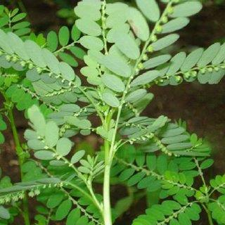

Figure 2.1 Diagram of *Phyllanthus amarus* (medicalnewstoday.com)

**2.2** **Taxonomy**

Kingdom: plantae

Division: Angiospermae

Class: Dicotyledoneae

Order: Tubiflorae

Family: Euphorbiaceae

Genus: *Phyllanthus*

Species: *Amarus*

The plant's leaves have historically been utilized for their antidiarrheal, anti-diabetic, antioxidant, analgesic, anti-inflammatory, anti-hypertensive, antibacterial, and hypolipidemic effects (Adeneye 2006; Anonymous 2011; Odetola and Akojenu 2000; Odukoya et al.,2007)

The GC-MS analysis of *P. amarus* leaf ethanolic extract identified different compounds (Table 1). These include 3, 5-di-t-butyl phenol (1.2%), methyl 14-methyl

6

pentadecanoate (4.1%),(Hexadecanoic acid) acids (11.8%),10–octadecanoate (5.5%), 9–hexadecenal (9.0%), glycerol 1, 3-dipalmitate (5.7%), 2, 13-octadecadiene-1-ol (8.2%), Dioctyl ester (10.1%) and Heptanoic acid (9-dece-1-yl ester) (4.6%). and palmitic acid were the most prevalent substances.

Table 2.1: Some Components detected in *P. amarus* leaf extract

|  |  |  |
| --- | --- | --- |
| S/n | Name of compound | Nature of compound |
|  |  |  |
| 1 | 3, 5-di-t-butyl phenol | Phenolic compound |
|  |  |  |
| 2 | Methyl 14-methylpentadecanoate | Ester |
|  |  |  |
| 3 | Palmitic acid (Hexadecanoic acid) | Fatty acid |
|  |  |  |
| 4 | 10-octadecanoate | Ester |
|  |  |  |
| 5 | 9-hexadecena | Aldehyde |
|  |  |  |
| 6 | Glycerol 1, 3-dipalmitate | Ester |
|  |  |  |
| 7 | 2, 13-octedecadiene – 1 –ol | alcoholic compound |
|  |  |  |

(Zubair et al., 2017)

**2.3 N-HEXADECANOIC ACID**

N-hexadecanoic acid (C16H32O2), which can be received from diet or synthesized spontaneously from other fatty acids, carbohydrates, and amino acids, is the most frequent saturated fatty acid in the human body. (Carta et al., 2015). It is one of the most abundant compounds found in *Phyllanthus amarus* after the phytochemical characterization using the Gas chromatography mass spectrometry (GC-MS)

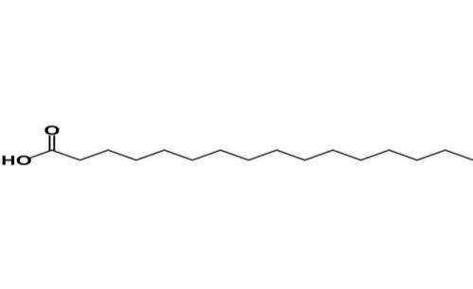

**Figure 2.2 Chemical structure of *n hexadecanoic acid*** (researchgate.net)

7

**2.4 Inflammation**

The immune system responds to adverse stimuli including pathogens, damaged cells, poisonous substances, or radiation by inducing inflammation (Medzhitov 2010) and functions by eliminating harmful stimuli and starting the healing process (Ferrero-Miliani et al., 2007). Thus, inflammation is a defense mechanism that is essential for maintaining health (Nathan and Ding 2010).

Typically, cellular and molecular actions and interactions during acute inflammatory reactions effectively reduce the risk of harm or infection (Zhao et al., 2021). The acute inflammation is reduced, and tissue homeostasis is restored as a result of this mitigation mechanism. However, unchecked acute inflammation may develop into chronic inflammation, which can lead to several chronic inflammatory illnesses (Zhou et al., 2016).Local immunological, vascular, and inflammatory cell responses to infection or damage cause inflammation at the tissue level, which is characterized by redness, swelling, heat, discomfort, and loss of tissue function. (Takeuchi and Akira 2010). Inflammation's objective is to repair tissues that have been compromised or injured by trauma or pathogenic microorganisms. In contrast, hemostasis is a physiological defense mechanism to stop bleeding brought on by injury to the vessel wall (Bonar et al., 2010)

Inflammation-induced activation of the hemostatic system (IL) is primarily mediated by proinflammatory cytokines such tumor necrosis factor-alpha (TNF-), interleukin 1 (IL-1), and interleukin 6 (Levi and van der Poll 2005). A number of mechanisms, including endothelial cell dysfunction, increased platelet activation, tissue factor (TF)-mediated activation of the plasma coagulation cascade, dysfunctional physiologic anticoagulant pathways, and suppressed fibrinolytic activity, are used by inflammatory mediators to cause hemostatic system disturbance (Kwaifa et al., 2020). Tissue factor mediates the primary mechanism of plasma coagulation cascade activation in inflammation (Cimmino et al., 2011).

8

**2.4.1 Mediators and biomarkers of inflammation**

Our knowledge of inflammation and its function in pathology has been improved as a

result of the identification of cellular and molecular inflammatory mediators and the

creation of sensitive biomarkers (Brenner et al., 2014). These biomarkers include:

1. Reactive oxygen and reactive nitrogen oxide species (ROS and RNOS)
2. Formation of DNA adducts
3. Cytokines (e.g., IL-6 and TNF-alpha) and chemokines
4. Acute-phase proteins (e.g., C-reactive protein or CRP)
5. Prostaglandins
6. Cyclooxygenase (COX)-related metabolites
7. Growth factors and transcription factors connected to inflammation (e.g., NF-kappaB)
8. Principal immunological cell types

**2.5 BLOOD COAGULATION**

The 1960s saw the development of the idea of blood coagulation when Davie, Ratnoff, and Macfarlane introduced the "cascade" and "waterfall" theories, which outlined the basic idea of the cascade of proenzymes activating downstream enzymes (Achneck et al., 2010).

Activation of the innate immune system and inflammation can both have an impact on coagulation, which is the consequence of a complex series of enzymatic processes that are regulated by both positive and negative influences (Schulz et al., 2013)Blood coagulation is a quick and effective process that leads to the formation of clots that need to be managed (Guo et al., 2021). Blood coagulation is a chain of events that slows or stops blood flow in order to maintain the balance of the vascular system. These reactions include fibrinolysis (clot dissolving), platelet aggregation, spontaneous vasoconstriction, and blood clotting (Karch, 2012)

Blood clotting is a complex series of processes involving several proteins (factors)

that must act in a precise order to form a clot. The process is quick and efficient, but it

must be regulated because uncontrolled clotting might lead to thrombosis. A change

in the balance between blood coagulation and coagulation inhibition, favoring either

pro- or anticoagulation, can lead to life-threatening thromboembolism or hemorrhage

(Ovanesov, 2015). Serine proteases, which work by cleaving downstream proteins,

are the most common coagulation factors. Excepted from this rule are tissue factor,

FV, FVIII, and FXIII. In contrast to tissue factor, FV, and FVIII, which are

glycoproteins, factor XIII is a transglutaminase (Pallister and Watson, 2010).

9

Blood vessel injury is typically a starter of the intrinsic coagulation system. The coagulation cascade is frequently separated into intrinsic and extrinsic routes (Kosmalska et al., 2020).

The extrinsic clotting pathway can be started by tissue factor (TF), a transmembrane glycoprotein that can be expressed on cell surfaces or circulated inside of microparticles. Its function in thrombosis is well known (Mackman, 2006). It is carried out through two independent pathways—intrinsic and extrinsic—which combine to form a single common pathway. The tissue factor route is a name for the extrinsic pathway. The endothelial cells' release of tissue factor is what triggers the coagulation process. The touch activation route is the intrinsic pathway. Exposure of certain coagulation factors to subendothelial collagen is the triggering event for the beginning of this pathway (Palta et al., 2014).

Extrinsic or intrinsic coagulation cascade activation can result in the formation of a stable fibrin clot. Inappropriate clot formation can cause blood vessel occlusion, which can result in thrombotic pathologies such as deep vein thrombosis (DVT), pulmonary embolism (PE), stroke, or myocardial infarction (MI), depending on the location and size of the clot (MI) (Hasanpour et al., 2021)

**2.5.1 Extrinsic pathway**

It is thought to be the initial stage of plasma-mediated hemostasis. TF, which is expressed in the subendothelial tissue, activates it (Lane et al., 2006). Under physiologically normal conditions, the normal vascular endothelium reduces contact between TF and plasma procoagulants; nevertheless, vascular injury exposes TF, which interacts with factor VIIa and calcium to promote the conversion of factor X to factor Xa (Owens 2010).

**2.5.2 Intrinsic pathway**

It is a different method by which factor XII activates thrombin. Factor XI is activated by factor XII, HMW kininogen, pre kallekerin, and factor XI in the beginning. Factor

10

IX is further activated by factor XI, and factor IX in turn activates factor X by forming a tenase complex on a phospholipid surface with its cofactor, factor VIII (Hall, 2010; Kumar et al., 2010)

**2.5.3 Common pathway**

The prothrombinase complex, which changes prothrombin into thrombin, is composed of calcium, tissue phospholipids, platelet phospholipids, activated factor X, and its cofactor, factor V. It also activates factor XIII, which covalently links the fibrin polymers present in the platelet block, and breaks down the bloodstream's fibrinogen into insoluble fibrin. By doing so, a fibrin network is formed, stabilizing the clot and forming a permanent secondary hemostatic plug (Hall, 2010; Kumar et al., 2010). The liver is one of the organs directly engaged in the coagulation process. Factors I, II, V, VII, VIII, IX, X, XI, XIII, and proteins C and S are all made in the liver. Vascular endothelium is responsible for producing factor VII. Lack of coagulation factors brought on by liver disease may result in bleeding the liver can cause lack of coagulation factors and lead to hemorrhage (Chaudhry et al., 2018). When coagulation factors drop, liver injury is usually severe. Because Factor VII has the shortest half-life, liver illness first causes high PT (Chaudhry et al., 2018).

**2.5.4 COAGULATION CASCADE**

The coagulation process is often controlled by several inhibitors, which restrict clot formation and prevent the spread of thrombin. This delicate balance is disturbed whenever the procoagulant activity of the coagulation factors is increased or the activity of naturally occurring inhibitors is decreased (Previtali et al., 2011).

11

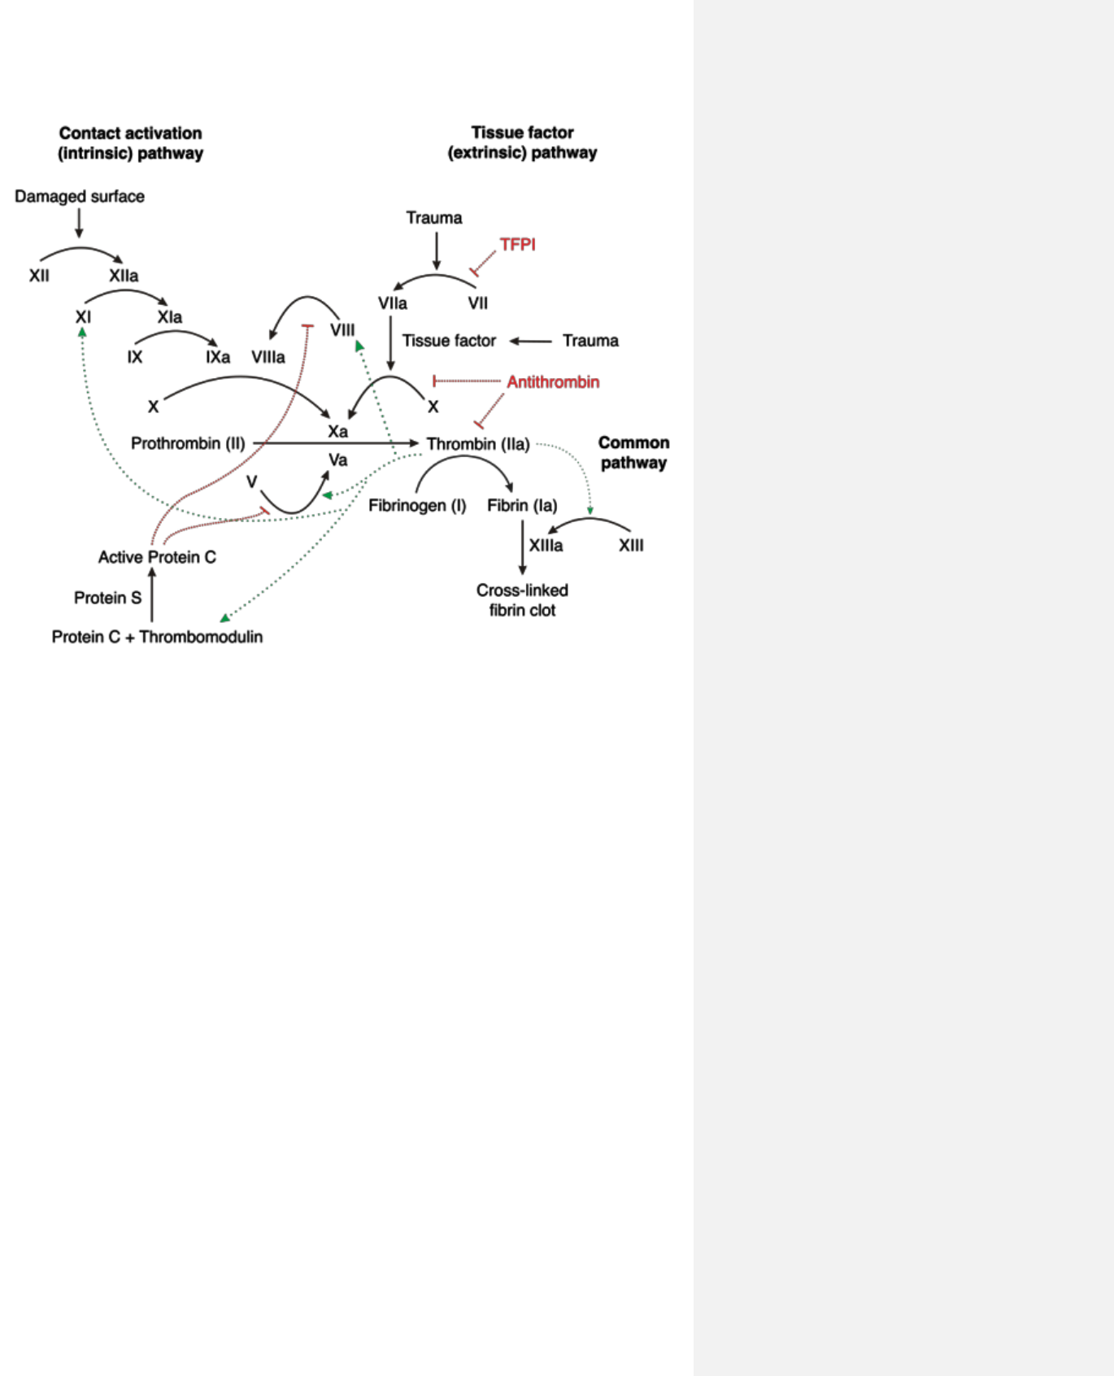

**Figure 2.3 Diagram showing Coagulation cascade** (Medbullets team, 2019)

**2.6 COAGULATION FACTORS**

Most clotting factors are zymogens, inactive proteolytic enzyme precursors that circulate in the body. Each zymogen's activation is indicated by adding the letter "a" to the Roman numeral designating that specific zymogen. With the exception of factors III, IV, and VIII, the liver produces the majority of the procoagulants and anticoagulants. These proteins undergo a post-translational modification (vitamin K dependent carboxylation of glutamic acid residues) that enables them to bind calcium and other divalent cations and participate in the clotting cascade. (Monroe et al., 2010).

The first four of the original twelve factors are identified by their common names, i.e., fibrinogen, prothrombin, tissue factor (TF), and calcium, and are not assigned Roman numerals. There is no longer an FVI. Roman numbers have not been allocated to the more modern clotting factors (such as prekallikrein and high-molecular-weight kininogen). Some factors go under multiple names. Because their coagulant activity is

12

not stable in preserved blood, factors V and VIII are also known as labile factors (Hall, 2010).

A plasma protein called thrombin is created by the liver (MW 68700). It is an unstable protein that breaks down into smaller proteins, thrombin being one of them (MW33700). The pro-inflammatory effects of thrombin, which is produced from prothrombin, are also mediated through protease activating receptors found on monocytes, lymphocytes, endothelium, and dendritic cells (Hall, 2010).

Blood plasma contains the glycoprotein known as von Willebrand factor, which is also produced naturally by megakaryocytes, subendothelial connective tissue, and the endothelium as ultra-large vWf. The adherence of platelets to the subendothelial surface is mediated by it. Additionally, it serves as a protein carrier for Factor VIII's coagulant activity and is referred to as VIII (Barash et al., 2006).

The liver produces fibrinogen, an important coagulation protein, which is the precursor to fibrin, the protein that ultimately determines the clot's strength. Factor III, also known as TF, is a membrane-bound procoagulant glycoprotein (MW47-kDa) that is found in fibroblasts and subendothelial tissue but is not accessible to blood until the artery wall is damaged (Monroe, 2010).

It is the main coagulation initiator in vivo. Monocytes have a little quantity of circulating TF, but the majority of TF is concentrated in the tunica media and tunica adventitia of blood vessels. Physical injury (activation of artery wall TF), direct vascular injury, functional injury (activation of circulating TF), hypoxia, sepsis, malignancy, or inflammation can all lead to tissue factor activation direct vascular injury, functional injury (activation of circulating TF), hypoxia, sepsis, cancer, or inflammation (Mackman et al 2007; Manly et al., 2011).

**2.6.1 Factor 1**

The liver produces fibrinogen, also referred to as Factor I of the coagulation cascade, which is a protein. The body produces 2 to 5 g of fibrinogen every day, resulting in plasma levels of 1.5 to 4 g/L (Weisel and Litvinov 2020; Winter et al., 2020). Fibrinogen is a soluble macromolecule that ultimately transforms into insoluble fibrin following activation of the coagulation cascade. The transformation is brought about by the enzymatic protein Thrombin, which does so by cleaving the N terminal peptide

13

of the A and B chains. This allows for strong non-covalent interaction between the fibrinogen peptide cleaved molecules, resulting in insoluble fibrin strands (Winter et al., 2020).

**2.6.2 Factors II AND III**

The coagulation factor II is prothrombin, a protein of 622 amino acids and a molecular weight of 72 kDa that is produced by hepatocytes (Winter et al., 2020). Prothrombin can be activated to become the active enzyme thrombin by proteolytic cleavage at either the 271st or the 320th amino acid residue (Davie and Kulman 2006; Krishnaswamy, 2013). Factors V, VIII, XI, and XIII as well as fibrinogen are some of the substrates that thrombin interacts with in the coagulation cascade (Winter et al., 2020).

Prothrombin to thrombin conversion is accelerated by the enzyme complex known as thromboplastin, which is made up of tissue factor and phospholipids. This compound is also referred to as coagulation factor III. The intrinsic pathway is activated by thromboplastin, which has been used to measure the prothrombin time (PT) (Van den Besselaar et al., 2010). Phospholipid-only partial thromboplastin, which is utilized in the activated partial thromboplastin time (aPTT) test, can also be used to gauge the efficiency of the intrinsic coagulation pathway. (Palta et al., 2014)

**2.6.3 Factors IV and V**

Calcium, commonly referred to as Factor IV, takes part in the coagulation cascade at various stages. Due to its positive charge, it interacts with negatively charged phospholipids and makes it easier for Factors II, VII, IX, and X to bind to the surface of platelets via carboxylated glutamic acids. It also assists in the activation of factors X and V (Palta et al., 2014).

Additionally, it has been demonstrated that calcium works with factor XIII to stabilize the coagulation protein C synthesis (Singh et al., 2019). It serves as a cofactor in the prothrombinase complex and is a component of the common coagulation pathway. It forms in conjunction with Factor X. The enzyme prothrombinase turns prothrombin into active thrombin. It should be emphasized that the produced thrombin is what ultimately converts Factor V into Factor Va. Protein C often degrades factor V after being stimulated by thrombin and thrombomodulin (Palta et al., 2014).

14

Factor V Leiden, a variation, is characterized by resistance to protein C degradation and results in a thrombophilic state, which causes consequences such deep vein thrombosis and pulmonary embolization (Montagnana et al., 2017).

**2.6.4 Factors VII and VIII**

Factor VII is a molecule belonging to the serine protease class of enzymes. It cannot express its proteolytic action unless associated with tissue factor, which acts as an allosteric activator (Butena, 2012). It can be activated by a number of moieties, including factor Xa and thrombin, once it has been attached to the tissue factor. When activated, it facilitates the conversion of factors IX and X to their respective active states (Wajima et al., 2009). When factor VIII is activated by thrombin, it dissociates from vWF and functions as a cofactor for factor IXa. They work together to activate factor X. Factor VIII is ultimately inactivated by protein C and other factors since the protective function of vWF has been lost after dissociation (Palta et al., 2014). Hemophilia A, the most prevalent severe inherited coagulopathy in humans, is caused by a deficiency of this clotting factor (Castaman and Matino 2019).

**2.6.5 Factors IX, X, XI and XII**

A clotting factor known as Factor IX or Christmas Factor, like many others, has serine protease activity. The mature form of the protein, which is produced within hepatocytes, is 415 amino acid residues long (Winter et al., 2020). The primary action of Factor IXa occurs in conjunction with Factor VIII as they produce "tenase," a protein complex that acts on Factor X to activate it. Sufficient quantities of this clotting factor result in hemophilia B (Castaman and Matino 2019).

The Stuart Power factor is another name for Factor X. It is a liver-produced molecule with a structural formula of 448 amino acids (Winter, 2020).

The involvement of Factor X in the coagulation cascade signifies the beginning of the so-called common pathway, i.e., where the intrinsic and extrinsic pathways culminate. Factors VIIIa-IXa and factor VIIa-tissue factor can cleave the polypeptide chain at specific sites causing activation. The main prothrombinase enzyme complex responsible for transforming prothrombin into active thrombin is then composed of factor Xa and factor Va (Palta et al., 2014). Coagulation factor, Factor XI, also known as Plasma thromboplastin Antecedent, is a homodimer with a molecular weight of 160 kDa (Emsley et al., 2010; Wu et al., 2008). The intrinsic coagulation pathway

15

component factor XI can be triggered by thrombin, factor XIIa, or factor XI itself.

Factor IX is its starting material, and it transforms into Factor IXa (Palta et al., 2014).

Factor XII, also known as Hageman factor, is an 80 kDa protein consisting of multiple domains. It acts as the beginning of the intrinsic or contact pathway of coagulation because it is activated when in touch with negatively charged biologic surfaces (Maas and Renne 2018). Because it produces bradykinin and starts the Kallikrein-Kinin pathway, active Factor XII also regulates inflammation in addition to coagulation (Palta et al., 2014).

**2.6.6 Factor XIII**

Factor XIII or Fibrin Stabilizing Factor is an enzymatic protein with transglutaminase activity (Dorgalaleh and Rashidpanah, 2016). It is made up of two "A" subunits that are active enzymatically and two "B" subunits that serve as carrier proteins (Winter et al., 2020). It is changed into its active form by thrombin. It covalently binds fibrin monomers while acting as a transglutaminase, giving the clot that has formed stability. A rare but potentially serious hemorrhagic condition is caused by deficiency, particularly of the A subunit. On the other hand, a relatively mild coagulopathy is brought on by the paucity of the B subunits (Karimi et al., 2009).

**2.7 Clotting disorders**

When an injury occurs, the body has built-in mechanisms to limit bleeding. To identify and diagnose bleeding diseases, it is essential to comprehend these fundamental physiological processes. With the aid of prostacyclin, antithrombin III, and nitric oxide found in the endothelial cells, the hemostatic system keeps blood fluid and free of platelet aggregation and thrombus formation. These naturally occurring components of blood help to prevent clots by converting plasminogen to plasmin, which encourages fibrinolysis (Qiu et al., 2019). The endothelium's damage or injury will set off a series of actions intended to stop the bleeding. Local vasoconstriction will first occur as a result of endothelium disruption, restricting blood flow to the area (Wang et al., 2015). Von Willebrand factor (vWF), a large plasma glycoprotein produced and maintained in endothelial cells and megakaryocytes, is released by platelets to begin primary hemostasis. At the site of

16

the damage, platelets and vWF will unite to create a plug. The platelet plug might

stick to the site of injury because circulating vWF continues to bind with collagen,

Factor VIII, and other endothelial components (Ruggeri, 2007)

**2.8 Classes of blood coagulation disorders**

**Hyper-coagulation:** The hemostatic cascade serves as a control and defense

mechanism for hemorrhage. Sometimes, this procedure is unintentionally

started with the blood still inside the blood vessel and no bleeding (Smith et al.,

2015).

**Hypo-coagulation:** Any malfunction in the operation of any part of this hemostatic

cascade can result in inadequate hemostasis and the inability to control

hemorrhage, which can cause serious blood loss, hemorrhage, and problems that

may follow when the blood supply to essential organs is impeded. Von

Willebrand disease, hemophilia, disseminated intravascular coagulation, lack of

clotting factors, platelet abnormalities, collagen vascular disorders, etc. are a

few examples.

Cellular components involved in blood clotting process

Endothelium: Clotting factors IV and VIII come from the plasma, whereas clotting

factors III and VIII come from endothelial cells (Holthenrich and Gerke 2018).

Factor III, IV, and VIII all undergo K-dependent gamma-carboxylation of their

glutamic acid residues in the coagulation cascade, enabling interaction with

calcium and other ions (Palta et al., 2014).

Hepatocytes: The majority of the proteins that serve as clotting factors and

anticoagulants are made by the liver.

**2.9 Coagulation Biomarkers**

Numerous coagulation indicators are utilized in daily life. In hematologic illnesses, liver disease, disseminated intravascular coagulation (DIC), and anticoagulant drug monitoring, coagulation function has long been assessed using prothrombin time (PT), activated partial thromboplastin time (APTT), and fibrinogen. Because of recent advancements in measuring methods, more minute coagulation biomarkers can now be measured and classified as coagulation systems and fibrinolytic systems.Examples of fibrinolytic systems include fibrin degradation product (FDP) and D-dimer, whereas examples of coagulation systems include thrombin-antithrombin complex (TAT), soluble fibrin (SF), and soluble fibrin monomer complex (SFMC). They are

17

relatively new coagulation biomarkers that can quickly increase during the acute phase (Lee et al., 2017; Mitani et al., 2015).

**2.9.1 C-reactive protein (CRP)**

C reactive protein is a plasma protein that is induced by inflammatory mediators like IL-6 and produced by the liver (Valkanova et al., 2013). Despite its no specificity, this acute phase protein is used in clinical settings as a biomarker for a variety of inflammatory states. The increased level of CRP is associated with disease severity in this process. CRP is a plasma protein that is induced by inflammatory mediators like IL-6 and produced by the liver. Despite its non-specificity, this acute phase protein is used in clinical settings as a biomarker for a variety of inflammatory states. In this case, an elevated CRP level is linked to disease severity (Gong et al., 2020).

**2.9.2 D-dimer**

D-dimer and other Fibrin degradation products (FDPs) are fibrin degradation products that appear in the blood after blood clot destruction due to fibrinolysis. D-dimer concentrations in the blood can aid in the diagnosis of thrombosis (Hong et al., 2021).

**2.9.3 aPTT and PT**

aPTT (activated partial thromboplastin time) and prothrombin time (PT) are coagulating system factors that characterize blood coagulation (Thongtonyong and Chinthammitr 2020).

**2.9.4 Fibrinogen**

Fibrinogen is a glycoprotein found in the blood that is produced by the liver. Thrombin converts fibrinogen to fibrin in tissue and vascular damage, and blood clots form (Tang et al., 2020).

**2.10 Naturally occurring anticoagulants in the body**

The procoagulant activity in blood is regulated by the anticoagulant system, which pinpoints where thrombus formation occurs (Colvin, 2004). The major thrombin inhibitor is antithrombin (AT), formerly AT III. Thrombin, factor IXa, Xa, XI, and XIIa are all bound and rendered inactive by this serine protease inhibitor. When heparin is present, AT's enzymatic activity is increased. Heparin's low plasma concentration, however, means that it has a minimal impact on the in vivo activation of AT. Heparin sulphate that is on the surface of endothelial cells binds to AT, activating it. Reticuloendothelial cells eliminate this complex, which AT 1:1 binds to

18

coagulation factors. The heparin cofactor II, 2 macroglobulin, and 1-antitrypsin are further thrombin inhibitors (Ejiofor, 2013).

**2.11 Tissue factor plasminogen inhibitor**

It is a polypeptide that endothelial cells manufacture. By preventing the TF-VIIa complex, it functions as a natural inhibitor of the extrinsic route (Ejiofor, 2013; Price et al., 2004). Factor Xa interacts more favorably with protein S when phospholipids and calcium are present (Dahm et al., 2008).

**2.12 Protein C pathway**

The Protein C pathway, which is made up mostly of four essential components, inhibits the propagation phase of coagulation.

* 1. Serine protease Protein C has strong anti-inflammatory, fibrinolytic, and anticoagulant effects. It functions by blocking activated factors V and VIII after being triggered by thrombin to create activated protein C (APC) (with Protein S and phospholipids acting as cofactors)
  2. By binding to thrombin, thrombomodulin, a transmembrane receptor on endothelial cells, suppresses the production of clots in healthy endothelium.

1. The endothelial protein C receptor is a

different transmembrane receptor that assists in the activation of Protein C.

4)Protein S is a vitamin K-dependent glycoprotein that is made by hepatocytes and endothelial cells. Plasma contains both free (40%) and bound (60%) versions (bound to C4b-binding protein). Free form exhibits anticoagulant activity, but bound form, which inhibits the complement system and is up-regulated in inflammatory situations that lower Protein S levels, exhibits procoagulant activity. It works with APC as a cofactor to inactivate

FVa and FVIIIa. Additionally, it directly and temporarily inhibits the prothrombinase (FVa-FXa) complex (Rigby and Grant 2004).

The protein C pathway is triggered when thrombin binds to thrombomodulin on the endothelial cell surface (Esmon, 2003)

**2.13 Association between blood coagulation and inflammation**

Inflammation and hemostasis are closely associated pathophysiologic processes that have a significant impact on one another. In this bidirectional link, inflammation activates the hemostasis system, which in turn increases inflammatory activity

19

significantly (Verhamme and Hoylaerts*,* 2009). Local hemostasis system activation is a critical component of host defense in both infectious and non-infectious inflammatory conditions. However, inflammation-induced increased and inadequately regulated hemostasis activity may contribute significantly to disease severity (Margetic, 2012).

The close relationship between inflammation and hemostasis helps to explain why these two clinical states have a prothrombotic tendency (Margetic, 2012). Amplification of the hemostasis dysfunction can lead to thrombosis and organ damage if the hemostasis system is activated in inflammatory situations. In turn, unchecked hemostasis system activation can aggravate the initial inflammatory response, leading to additional organ damage (Davidson, 2013). The tissue pathway is the essential participant and pathway that connects these two pathways (TF). The host response to damage or pathogen invasion is triggered by the tissue factor (TF), which is located at the intersection of coagulation and inflammation (Foley and Conway, 2019). The embryonic lethality seen in TF knockout mice emphasizes the tissue factor's essential relevance to normal physiology (Jiang et al., 2022).

TF pathway inhibitor is the major endogenous inhibitor of the TF pathway, binding to and neutralizing TF–factor VIIa in a factor Xa–dependent manner (Maroney et al., 2010) It is constitutively expressed by microvascular endothelial cells and is also found in monocytes, smooth muscle cells, platelets, fibroblasts, cardiomyocytes, and plasma (Ellery and Adams 2014).

It is well established that the key trigger for activation of coagulation is TF, and that initiating events that lead to its exposure to blood drives an escalating circle of events in which inflammation and coagulation positively feedback on each other (Foley and Conway, 2016). Tissue damage with vascular thrombosis and inflammation results if therapeutic interventions or natural inhibitory systems are not used to stop the process.(Conway, 2012).

20

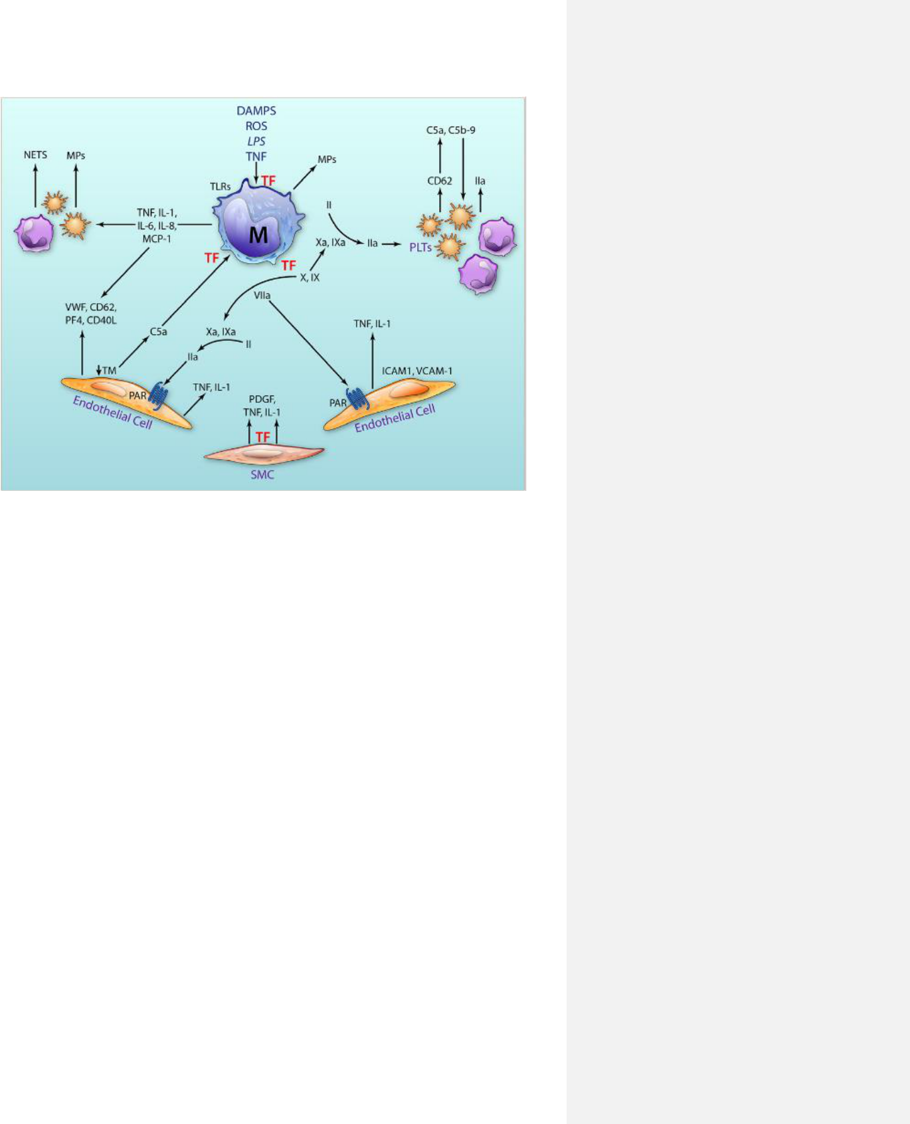

**Figure 2.4 Central role of tissue factor in the interplay between coagulation and inflammation** (Foley and Conway, 2016)

**2.14 Ibuprofen**

Ibuprofen is a popular non-steroidal anti-inflammatory drug (NSAID) (Rainsford 2009). Ibuprofen is used to treat minor pain and inflammation, such as headaches, muscular aches, toothaches, fever, backache, and dysmenorrhea (Rainsford, 2009).

21

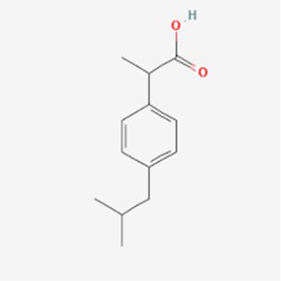

**Figure 2.5: Molecular structure of ibuprofen (chemspider.com)**

**2.14.1 Mechanism of action**

Ibuprofen's mechanism of action is unknown. Ibuprofen is a non-steroidal anti-inflammatory drug (NSAID) and thus a non-selective inhibitor of cyclooxygenase, an enzyme involved in prostaglandin (pain and fever mediators) and thromboxane (blood clotting stimulators) synthesis via the arachidonic acid pathway (Alturki et al., 2018).

As a non-selective COX inhibitor, ibuprofen blocks the activity of both COX-1 and COX-2. In contrast, COX-1 inhibition is hypothesized to result in some ibuprofen side effects such GI ulcers, whereas COX-2 inhibition decreases the synthesis of prostaglandins involved in mediating inflammation, pain, fever, and edema (Rao and Knaus 2008).

Ibuprofen's anti-inflammatory and analgesic effects are primarily mediated by inhibiting the formation of these prostanoids. Another important mediator of pyresis is PGE2, and pyrogens including cytokines, endotoxins, and byproducts of active leukocytes cause the hypothalamus to produce PGE2 (Rainsford, 2003).

**2.15 Lipopolysaccharides**

The main component of Gram-negative bacteria's cell walls, lipopolysaccharide (LPS), can elicit an acute inflammatory response by causing the production of a variety of inflammatory cytokines in different cell types (Ngkelo et al., 2012).

Due to the large number of inflammatory effects that bacterial LPS produces through TLR4 signaling, it has traditionally been employed to research

22

inflammation. Extracellular proteins, such as LBP and CD14, which are involved in the transmission of LPS to a signaling complex made up of MD2 and MyD88, are necessary for cellular activation brought on by LPS (Borzęcka et al., 2013).

A bacterial endotoxin called lipopolysaccharide (LPS) activates macrophage TLR4 receptors and promotes the recruitment of cytoplasmic MyD88 and TRIF adaptor proteins. Nuclear factor-B (NF-B) and mitogen-activated protein kinase (MAPK) pathways will be activated as a result of the adaptor proteins binding to the TLR4 complex (Haque et al., 2018).

23

**CHAPTER THREE**

**METHODOLOGY**

**3.1 Materials and Reagents**

Materials and equipment used in this study include: Beaker, weighing balance, volumetric flask, measuring cylinder, filter paper, micro pipette, dropper, hand gloves, nose mask, sample bottles, Eppendorf tubes, oven (Heratherm), plain bottles, water bath(Stuart), centrifuge (Heraeus Magafuge 8), capillary tubes, dissecting kit, homogenizer, test tubes.

Reagents and chemicals used include 0.9% Normal saline, 3.2% tri-sodium citrate, phosphate buffer saline. Lipopolysaccharide obtained from Sigma Aldrich

Kits used include: activated Partial thromboplastin Time reagent kit (Fortress diagnostics) Fibrinogen kit (Fortress diagnostics) and prothrombin time kit (Agappe).

**3.2 Collection and preparation of plant materials**

*P. amarus* was obtained within the premises of Mountain Top University. The roots of the weed plants were removed, and the leaves of the plant was dried in the hot air oven at 40˚C. The dried aerial parts were pulverized using a blender into a fine powder. The powdered *P. amarus* was stored in airtight container then kept in a refrigerator at 4˚C until further use. Eighty grams (80 g) of pulverized *P.amarus* were weighed into an airtight jar and soaked in 70% ethanol (8:1 w/v) for 72 hours with intermittent shaking.

A sterile muslin cloth was used to filter with ethanol and plant sample mixture over an empty beaker. The filtrate was then concentrated in a rotary evaporator under reduced pressure at 40˚C. The percentage yield of the extract was calculated.

**3.3 Experimental animals**

A total number of 30 albino rats (10 female and 20 male) were obtained from the Mountain Top University animal facility. Animals were grouped into six different cages with each cage containing five rats. The animals were housed in well-ventilated cages in the animal house. Animals were fed daily and were kept under a 12-hour light and dark cycle.

Grouping of animals are as follows:

24

Group 1- Normal control (phosphate buffer saline)

Group 2- Positive control; ibuprofen (40 mg/kg) + LPS

Group 3- Negative control; phosphate buffer saline + LPS

Group 4- Crude extract of *Phyllanthus amarus* 100 mg/kg + LPS

Group 5- Crude extract of *Phyllanthus amarus* 200 mg/kg + LPS

Group 6*- n-hexadecanoic acid* (most abundant compound from *Phyllanthus amarus*) + LPS

**3.4 Induction of inflammation**

Oral administration of drug and plant extract lasted for 21 days. Inflammation was induced intraperitoneally with Lipopolysaccharide (1 mg/kg body weight) on the 21st day after oral administration ended. Animals were observed to see any physical changes before sacrifice under anesthesia

**3.5 Preparation of plasma and organ sample collection**

Animals were put under anesthesia using chloroform and blood samples were collected through ocular puncturing. Blood sample was collected into an Eppendorf tube containing 3.2% sodium citrate (1:9) and was immediately centrifuged at 1500 rpm for 10 minutes to obtain pure platelet plasma. Plasma was separated into a clean, dry plain tubes and kept overnight at -4˚C.

Liver sample was collected and kept in phosphate buffer saline before homogenization. Organ was homogenized at the ratio of 1:5 with phosphate buffer saline. Homogenized organs were then centrifuged at 2500 rpm for 15 minutes and the supernatants were collected into plain tubes using a dropper and kept in the refrigerator at -4˚C before use for further analysis.

**3.6 Assay methods**

**3.6.1 Activated Partial Thromboplastin Time**

The Activated partial thromboplastin time was determined in the plasma of the sacrificed rats according to manufacturer’s method and instruction, using Fortress diagnostics kit. The aPTT assay is a highly reliable measurement of the intrinsic coagulation mechanism.

25

Procedure: calcium chloride was pre-incubated at 37˚C for 10mins. Plasma sample of rats (0.2 mL) was pipetted into a clean and dry test tube and incubated in a water bath. After which 0.2 mL of the aPTT reagent was added to the plasma, mixed gently, placed in the water bath and incubated for 5mins at 37˚C. To initiate clotting, pre-incubated calcium chloride (0.1 mL) was forcibly dispensed into the content of the tube while simultaneously starting the stopwatch. Test tube was gently tilted at regular intervals until a clot is formed. The timer was stopped, and clotting time was recorded in seconds.

**3.6.2 Prothrombin time**

Prothrombin time in experimental animals was determined following instruction provided in manufacturer’s kit from Agappe.

Procedure: PT reagent was reconstituted and prewarmed at 37˚C for 10 minutes. Plasma sample was pipetted into a dry test tube and incubated at incubated at 37°C for 3 minutes. Then, 0.2 mL of pre warmed PT reagent was forcibly added while timer was set simultaneously, and clotting time recorded in seconds.

**3.6.3 Fibrinogen test**

Dilution of fortress fibrinogen reagent was done with plasma and imidazole buffer using the table below:

**Table 3.1: Serial dilution for fibrinogen**

|  |  |  |  |
| --- | --- | --- | --- |
|  | Normal plasma(µl) | Imidazole buffer(µl) | Total volume (µl) |
|  |  |  |  |
| 1/10 | 25 | 225 | 250 |
|  |  |  |  |
| 1/15 | 25 | 350 | 375 |
|  |  |  |  |
| 1/25 | 25 | 600 | 625 |
|  |  |  |  |
| 1/35 | 25 | 850 | 875 |
|  |  |  |  |
| 1/45 | 25 | 1100 | 1125 |
|  |  |  |  |

Procedure: Serial dilution of 1/10 from the table above was made, then incubated at 37˚C for 10 mins. The prewarmed and diluted sample (0.1 mL) was dispensed into a clean and dry test tube. After which 0.05 mL of thrombin reagent was added while

26

starting a stopwatch simultaneously and waiting for a clot. Clotting time was recorded in seconds.

**3.6.4 Packed cell volume**

Blood from experimental animals was collected through ocular puncturing into a capillary tube and then sealed with plastin to avoid spillage. Then centrifuged at 3000 rpm for 10 min. Packed cell volume of each experimental animal was read with an haematocrit reader and result was recorded in percentage.

**3.7 Waste disposal**

Experimental wastes were incinerated and rats’ carcasses were buried in designated locations.

**3.8 Statistical analysis**

The statistical analysis was carried out using Graph Pad Prism Software version 9.0.0. Results were reported as mean ± standard error of mean (SEM). The data was then subjected to One- way ANOVA variance with Turkey’s multiple comparison test.

27

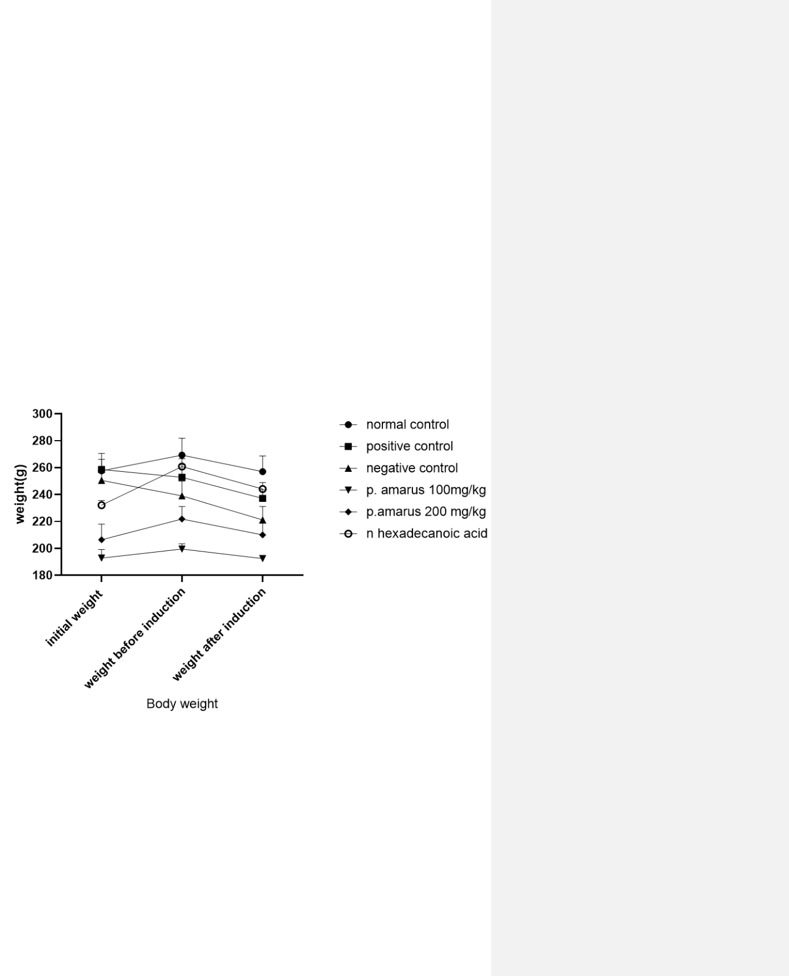

**CHAPTER FOUR**

**RESULT AND DISCUSSION**

**4.1 Effect of *P. amarus extract and n-hexadecanoic acid* on body weight of animals**

The results showed a significant decrease in the weight of experimental animals after a single induction dose intraperitoneally of lipopolysaccharides.

**Figure 4.1 Body weight of experimental animals at different intervals** Data are presented as Mean ± SEM: n=5

28

**4.2 Effect of *P. amarus* ethanol extract and n hexadecenoic acid on packed cell volume of lipopolysaccharide induced inflammation in rats.**

Figure 4.2 shows no difference in the packed cell volume of experimental animals after induction of lipopolysaccharide and administration of *P. amarus* extract when compared to the control group.

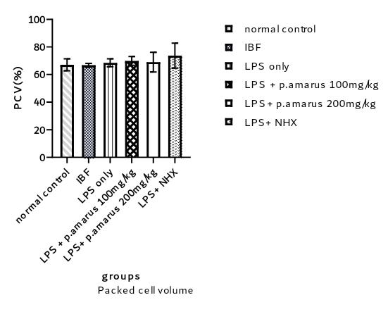

**Figure 4.2: Packed cell volume of experimental rats**

Data and mean ± SEM; n=5

IBF: Ibuprofen; LPS: Lipopolysaccharide; NHX: n- hexadecenoic acid

29

**4.3 Effect of *P. amarus extract* and *n hexadecenoic acid* on fibrinogen concentration in inflammed rats.**

There was a significant decrease (*p=*0.0027) of fibrinogen concentration in the negative control when compared with the normal control. The concentrations were significantly lower in *P. amarus* 100 mg/kg, *P. amarus* 200 mg/kg*, n- hexadecanoic acid* group when compared with the normal control.

There was a significant decrease in the negative control when compared with the positive control (*p=*0.001). Significant increase was recorded in the positive control when compared with *P. amarus*100 mg/kg (*p*=0.0301). A significant decrease was observed in n-hexadecanoic group when compared with the negative control group (*p*=0.0017) – Figure 4.3.

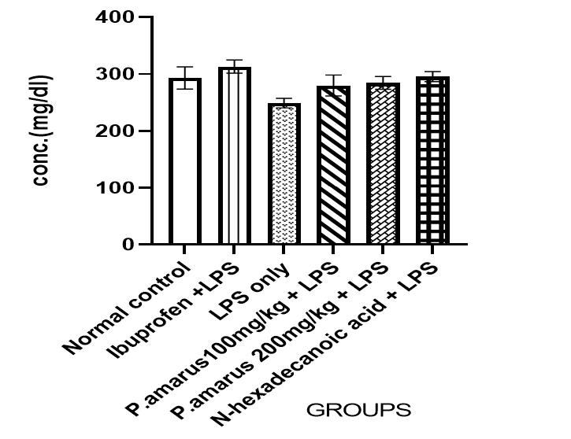

**Figure 4.3: Fibrinogen level in lipopolysaccharide induced and normal control**

**rats.**

Data and mean ± SEM; n=5

LPS: Lipopolysaccharides, conc.: concentration

30

**4.4 Effect of oral administration of *P. amarus* extract on activated Partial Thromboplastin Time(aPTT)**

There was a shorter clotting time in the negative group when compared to the normal control group. A prolonged clotting time was observed in the 200 mg/kg treatment group when compared to the negative control group. No significant difference was observed in the 100 mg/kg treatment group and *n-hexadecanoic acid* group when compared to the negative control group.

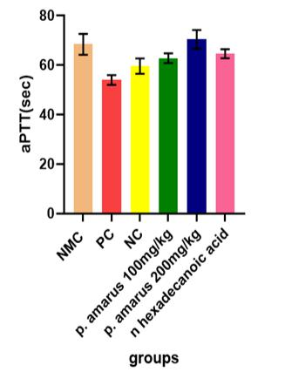

**Figure 4.4: Activated Partial Thromboplastin Time of lipopolysaccharide**

**induced inflamed rats pretreated with *P. amarus*.**

Values are mean ± SEM; n=5

NMC: normal control; PC: positive control; NC: negative control

31

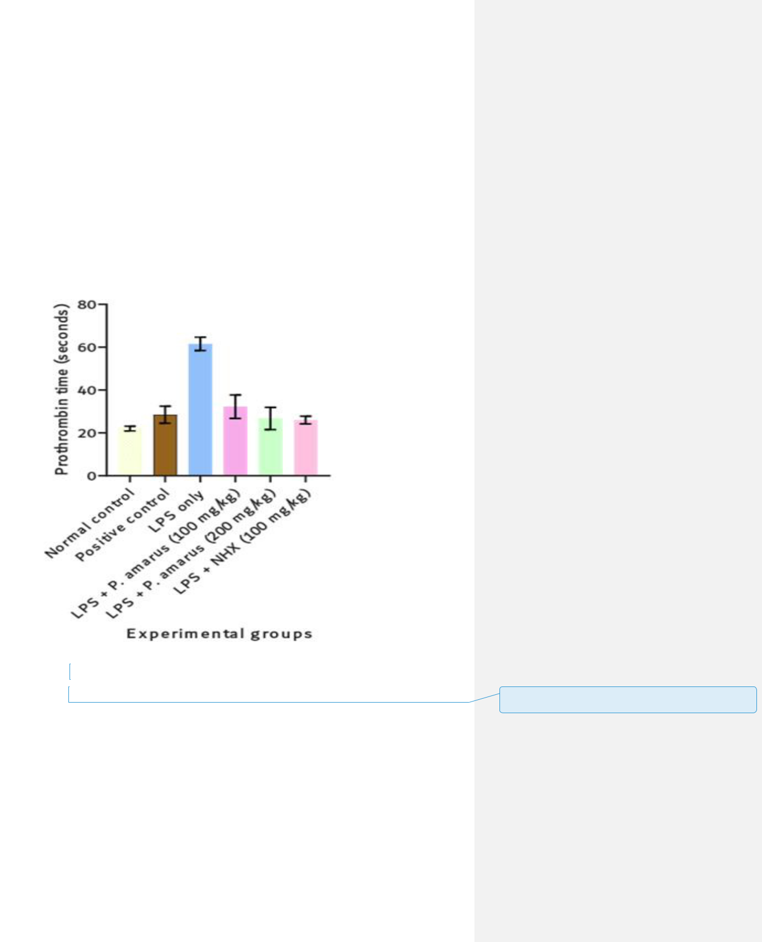

**4.5 Effect of *P.amarus* extract and *n-hexadecanoic acid* on Prothrombin time in experimental rats**

There was a significant (*p*< 0.05) increase in the negative control (LPS only) when compared with the normal control. The prothrombin time were shorter in the test groups *(P. amarus* 100 & 200 mg/kg) and positive control group compared to the negative control (Figure 4.5). This indicates procoagulant activity of *P. amarus.* There was significant difference in the treated groups compared with the normal control.

**Figure 4.5 Prothrombin time in lipopolysaccharide-induced inflammation in Wistar rats**.

Values are mean± SEM; n=5LPS: Lipopolysaccharide; NHX: n-hexadecanoic acid

**4.6 Discussion**

Medicinal plants have become vital to major populations of the world for treatment and management of diseases. *P. amarus* is a promising herbal resource with

32

**Commented [u1]:** Recast in line with the caption of previous figure (s)

therapeutic potential against various diseases due to the presence of numerous active and secondary metabolites (Sharma et al., 2020). The effects of the plant extract and pure compound were investigated in this study.

The prothrombin time is a coagulation measure that is used to assess the tissue factor route and, consequently, the activities of the factors of the extrinsic coagulation pathway, whereas the aPTT assesses the activities of factors engaged in the contact (intrinsic) and common pathways. Standard tests for assessing the effectiveness of coumarin and heparin treatments, respectively, are the PT and aPTT (Ayodele et al., 2019; Achneck et al., 2010).

In clinical evaluation, a long aPTT and/or PT indicates an anomaly in activities of specific clotting factors; for example, abnormally long aPTT but normal PT indicate a need to assay factors VIII, IX, and XI of the contact pathways (Ayodele et al., 2019). If both the PT and aPTT are affected, this points to factors V, X and prothrombin (factor II) of the common pathway (Benson et al., 2019). The prothrombin time in the treatment groups (*P. amarus* 100 mg/kg ,200 mg/kg and *n-hexadecanoic acid)* when compared with the negative control group showed a shortened clotting time which suggests a procoagulant activity in the *P. amarus* plant and thus possible activation of the extrinsic pathway activated through tissue factor released by endothelial cells after external damage.

Thus, the shortened PT and aPTT by *Phyllanthus amarus* treatment suggests the activation of factors V, X and prothrombin of the common coagulation pathway.

Due to the fact that prothrombin time is an extrinsic clotting system screening test for factor VII and can also detect deficiencies in factor V, X, prothrombin, and fibrinogen, the decrease in prothrombin time caused by the extract suggests that the pathway is activated.

The observed reduced fibrinogen concentrations in the treatment groups compared to the control groups similarly indicate the procoagulant activity of *P. amarus* and the pure compound, *n-hexadecanoic acid*. It demonstrates the action of the Phyllanthus amarus leaf extract in procoagulant impact by selectively stimulating the extrinsic pathway, which leads to the release of the tissue factor, which then activates factor VII and factor VIIa. The clotting time of fibrinogen decreased as the concentration of fibrinogen increased. Similar results was reported by Li et al., (2020) where

33

procoagulants activities was investigated on Astragalin, isolated from *Rosa chinensis* flowers.

In terms of prothrombin time and fibrinogen concentration, the group that received the higher concentration from most abundant compound extracted from the *Phyllanthus amarus* plant extract had a shorter clotting time than the negative controlgroup. Its procoagulant action is more apparent in these two groups because the extrinsic route is engaged as a result. It is well known that the Phyllanthus amarus plant contains certain chemicals that are accountable for the procoagulant effects on experimental animals such as the N-hexadecanoic acid.

**CHAPTER FIVE**

34

**CONCLUSION AND RECOMMENDATION**

**5.1 Conclusion**

The ethanol extracts of the *Phyllanthus amarus* showed procoagulant activities and had a shortened clotting time on the blood coagulation parameters whilst the abundant compound (*n-hexadecanoic acid*) detected in the plant showed similar activities.

**5.2 Recommendation**

Further research on *Phyllanthus amarus* should be carried out to validate its procoagulant activities and explore its production of novel therapeutic procoagulants.

35

**REFERENCES**

Aboelsoud, N. H. (2010). Herbal medicine in ancient Egypt. *Journal of Medicinal Plants Research*, 4(2), 082-086.

Achneck, H.E., Sileshi B, Parikh A, Milano C.A., Welsby, I.J., Lawson, J.H. (2010). Pathophysiology of bleeding and clotting in the cardiac surgery patient: from vascular endothelium to circulatory assist device surface*. Circulation*, 122:2068-77.

Adeneye, A. A., &Benebo, A. S. (2008). Protective effect of the aqueous leaf and seed extract of Phyllanthus amarus on gentamicin and acetaminophen-induced nephrotoxic rats. *Journal of ethnopharmacology*, 118(2), 318-323.

Ajayi, G. O., Olorunrinu, T. J., & Shittu, M. A. (2020). Elucidation of bioactive compounds in hydroalcohol extract of Phyllanthus amarus Schum. and Thonn. leaf using GC-MS analysis. *Journal of Scientific and Innovative Research,* 9(2), 40-47.

Alturki, M., Beyer, I., Mets, T., &Bautmans, I. (2018). Impact of drugs with anti-inflammatory effects on skeletal muscle and inflammation: a systematic literature review. Experimental gerontology, 114, 33-49.

Ayodele, O. O., Onajobi, F. D., &Osoniyi, O. (2019). In vitro anticoagulant effect of Crassocephalum crepidioides leaf methanol extract and fractions on human blood. *Journal of experimental pharmacology*, 11, 99.

Barash, P.G., Cullen, B.F., Stoelting R.K. (2006). editors. 5th ed. Philadelphia:

Lippincott Williams and Wilkins; *Clinical Anesthesia*; pp. 224–6.

Benzon, H. T., Park, M., McCarthy, R. J., Kendall, M. C., & Lindholm, P. F. (2019). Mixing studies in patients with prolonged activated partial thromboplastin time or prothrombin time. *Anesthesia & Analgesia*, 128(6), 1089-1096.

Borzęcka, K., Płóciennikowska, A., Björkelund, H., Sobota, A., &Kwiatkowska, K. (2013). CD14 mediates binding of high doses of LPS but is dispensable for TNF-α production. Mediators of inflammation, 2013.

Bombeli T, Spahn D.R. (2004) Updates in perioperative coagulation: Physiology and management of thromboembolism and haemorrhage*. Br J Anaesth* ;93:275-87.

Bonar, R., Favaloro, E. J., & Adcock, D. M. (2010). Quality in coagulation and haemostasis testing. *Biochemia Medica*, 20(2), 184-199.

Brenner, D. R., Scherer, D., Muir, K., Schildkraut, J., Boffetta, P., Spitz, M. R., ... & Hung, R. J. (2014). A Review of the Application of Inflammatory Biomarkers in Epidemiologic Cancer ResearchInflammation and Cancer. *Cancer Epidemiology, Biomarkers & Prevention*, 23(9), 1729-1751.

Carmeliet P, Mackman N, Moons L, Luther T, Gressens P, Van Vlaenderen I, Demunck H, Kasper M, Breier G, Evrard P, Müller M, Risau W, Edgington T,

36

Collen D. (1996). Role of tissue factor in embryonic blood vessel development. *Nature.*;383:73–75.

Carrero, J. J., &Stenvinkel, P. (2009). Persistent inflammation as a catalyst for other risk factors in chronic kidney disease: a hypothesis proposal. *Clinical Journal of the American Society of Nephrology*, S49-S55.

Carta, G., Murru, E., Lisai, S., Sirigu, A., Piras, A., Collu, M., ... &Banni, S. (2015). Dietary triacylglycerols with palmitic acid in the sn-2 position modulate levels of N-acylethanolamides in rat tissues. *PLoS One*, 10(3), e0120424.

Castaman, G., & Matino, D. (2019). Hemophilia A and B: molecular and clinical similarities and differences. *Haematologica,* 104(9),1702.

Chaudhry, R., Usama, S. M., &Babiker, H. M. (2018). *Physiology*, coagulation pathways.

Cimmino, G., Ciccarelli, G., &Golino, P. (2015, October). Role of tissue factor in the coagulation network. *In Seminars in Thrombosis and Hemostasis* (Vol. 41, No. 07, pp. 708-717).

Colvin BT. Physiology of haemostasis. *Vox Sang.* ;8743–6.

Conway EM. (2012). Thrombomodulin and its role in inflammation. *Semin Immunopathol,* 34:107–125.

Davidson, S. J. (2013). Inflammation and acute phase proteins in haemostasis. *Acute Phase Proteins*, 31-54.

Dahm, A.E, Sandse,t P.M, Rosendaal, F.R. (2008). The association between protein S levels and anticoagulant activity of tissue factor pathway inhibitor type 1. *J ThrombHaemost,* 6:393-5.

Dahm, A. E., Jacobsen, E. M., Wik, H. S., Jacobsen, A. F., Mollnes, T. E., Kanse, S. M., &Sandset, P. M. (2019). Elevated complement C3 and C4 levels are associated with postnatal pregnancy-related venous thrombosis. *Thrombosis and Haemostasis*, 119(09), 1481-1488.

Davie, E. W., &Kulman, J. D. (2006). An overview of the structure and function of thrombin*. In Seminars in thrombosis and hemostasis* (Vol. 32, No. S 1, pp. 003-015, Inc., 333 Seventh Avenue, New York, NY 10001, USA.

Ejiofor, J.A. (2013) Anticlotting mechanisms I: Physiology and pathology. *Contin Educ Anesth Crit Care Pain,* 13:87-92.

Ellery P.E, Adams M.J. (2014). Tissue factor pathway inhibitor: then and now. *Semin Thromb Hemost*, 40:881–886

Entok, E., Ustuner, M. C., Ozbayer, C., Tekin, N., Akyuz, F., Yangi, B., ... &Gunes, H. V. (2014). Anti-inflammatuar and anti-oxidative effects of Nigella sativa L.: 18FDG-PET imaging of inflammation. *Molecular biology reports*, 41(5), 2827-2834.

37

Esmon, C. T. (2005). The interactions between inflammation and coagulation. *British journal of haematology*, 131(4), 417-430.

Etta, H. E., Eneobong, E. E., &Okon, E. A. (2012). Modifications in sperm quality of Wister Albino rats by ethanol extract of *Phyllanthus amarus* (Schum. and Thonn). *Nigerian Journal of Biotechnology*, 24.

Ferrero-Miliani, L., Nielsen, O. H., Andersen, P. S., & Girardin, S. (2007). Chronic inflammation: importance of NOD2 and NALP3 in interleukin-1β generation. *Clinical & Experimental Immunology*, 147(2), 227-235.

Foley, J. H., & Conway, E. M. (2016). Cross talk pathways between coagulation and inflammation*. Circulation research*, 118(9), 1392-1408.

Gong, J., Tai, Q. H., Xu, G. X., Wang, X. T., Zhu, J. L., Zhao, X. Q., ... & Gao, W. (2020). Ac2-26 alleviates brain injury after cardiac arrest and cardiopulmonary resuscitation in rats via the eNOS pathway. *Mediators of Inflammation*, *2020*.

Guo, B., Dong, R., Liang, Y., & Li, M. (2021). Haemostatic materials for wound healing applications. *Nature Reviews Chemistry*, 5(11), 773-791.

Guo, K., Fu, X., Zhang, H., Wang, M., Hong, S., & Ma, S. (2021). Predicting the postoperative blood coagulation state of children with congenital heart disease by machine learning based on real-world data. *Translational Pediatrics,* 10(1), 33.

Habib, A., Petrucci, G., & Rocca, B. (2020). Pathophysiology of thrombosis in peripheral artery disease. *Current Vascular Pharmacology*, 18(3), 204-214.

Hall J.E. (2010). Hemostasis and blood coagulation. In: *Guyton and Hall Textbook of Medical Physiology*, 457-9

Haque, M.S., Khan, M.M & Chowdhury, M.S.I. (2016). Medicinal use of the unique plant Tinospora cordifolia: evidence from the research. *Asian Journal of Medical and Biological Research* ,2(4), 508-512.

Harikrishnan H, Jantan I, Haque M.A, Kumolosasi E. (2018). Anti-inflammatory effects of hypophyllanthin and niranthin through downregulation of NF-κB/MAPKs/ PI3K-Akt signaling pathways. *Inflammation*. 41(3):984–95

Hasanpour, A., Esmaeili, F., Hosseini, H., & Amani, A. (2021). Use of mPEG-PLGA nanoparticles to improve bioactivity and hemocompatibility of streptokinase: In-vitro and in-vivo studies. *Materials Science and Engineering*: C, 118, 111427.

Hong, L. Z., Shou, Z. X., Zheng, D. M., &Jin, X. (2021). The most important biomarker associated with coagulation and inflammation among COVID-19 patients. *Molecular and Cellular Biochemistry*, 476(7), 2877-2885.

Hood J.L, Eby C.S. (2008). Evaluation of a prolonged prothrombin time. *Clin Chem*.

54(4):765–768.

38

Jiang, B., Wu, X., Meng, F., Si, L., Cao, S., Dong, Y., ... & Cao, L. (2022). Progerin modulates the IGF-1R/Akt signaling involved in aging. *Science advances*, 8(27), eabo0322.

Karch, A.M. (2012). “Pharmacological review: drugs that alter blood coagulation, *American Nurse Today*. 26–31.

Kosmalska, M., Znajewska-Szulc, K., & Bronowski, A. (2020). Hemostasis– compendium for students. *Journal of Education, Health and Sport*, 10(12), 214-227.

Krishnaswamy, S. (2013). The transition of prothrombin to thrombin. *Journal of Thrombosis and Haemostasis,* 11, 265-276.

Krithika, R., & Verma, R. J. (2009). Ameliorative potential of *Phyllanthus amarus* against carbon tetrachloride induced hepatotoxicity. *Acta Pol Pharm,* 66(579), e83.

Kumar V, Abbas A.K, Fausto N, Aster J.C. (2010) Hemodynamic disorders, thromboembolic disease and shock. In: *Robbins and Cotran Pathologic Basis of Disease.* 118-20.

.

Kwaifa, I. K., Bahari, H., Yong, Y. K., & Noor, S. M. (2020). Endothelial dysfunction in obesity-induced inflammation: molecular mechanisms and clinical implications. *Biomolecules,* 10(2), 291.

Lasne, D, Jude, B, Susen, S. (2006). From normal to pathological hemostasis. *Can J Anesth* 53: S2-11.

Levi, M., Opal, S.M. (2006). Coagulation abnormalities in critically ill patients. *Crit Care* 10: 222–228

Lee. A. Y. Khorana, A. A., Kamphuisen, P. W., Meyer, G., Bauersachs, R., Janas, M. S., Jarner, M. F., & (2017). Tissue factor as a predictor of recurrent venous thromboembolism in malignancy: biomarker analyses of the CATCH trial. *Journal of Clinical Oncology*, *35*(10), 1078-1085. Khorana, A. A., Kamphuisen, P. W., Meyer, G., Bauersachs, R., Janas, M. S., Jarner, M. F., & Lee, A. Y. (2017). Tissue factor as a predictor of recurrent venous thromboembolism in malignancy: biomarker analyses of the CATCH trial. *Journal of Clinical Oncology*, *35*(10), 1078-1085.

Li, C., Hu, M., Jiang, S., Liang, Z., Wang, J., Liu, Z., Wang, H. M.D et al. (2020). Evaluation procoagulant activity and mechanism of astragalin. *Molecules*, 25

(1), 177.

Mackman, N, Tilley, R.E., Key, N.S. (2007). Role of the extrinsic pathway of blood coagulation in hemostasis and thrombosis. *ArteriosclerThrombVasc Biol.* 27:1687–1693

39

Mackman, N. (2006). Role of tissue factor in hemostasis and thrombosis. *Blood cells, molecules, and diseases*, 36;(2), 104-107.

Manjula, V., & Norman, T. S. J. (2017). Skin healing activity of Naringicrenulata and Phyllanthus reticulatus. *The Pharma Innovation*, 6(9, Part F), 376.

Manly, D.A., Boles, J., Mackman, N.92011). Role of tissue factor in venous thrombosis*. Annu Rev Physiol* 73:515-25.

Margetic, S. (2012). Inflammation and hemostasis. Biochemia medica, 22(1), 49-62.

Maroney, S.A, Ellery, P.E, Mast, A.E. (2010). Alternatively spliced isoforms of tissue factor pathway inhibitor. *Thromb Res.* 125S52–S56.

Martinelli I, Bucciarelli P, Mannucci P.M. (2010). Thrombotic risk factors: Basic

pathophysiology. *Crit Care Med.* 38: S3–9.

Medzhitov, R. (2010). Inflammation 2010: new adventures of an old flame. *Cell*, 140(6), 771-776.

Meybohm P, Zacharowski K, Weber C.F. (2010). Point-of-care coagulation management in intensive care medicine. *Crit Care.* 2013; 17:218.

Miller D.L, Welty-Wolf K, Carraway M.S. (2002). Extrinsic coagulation blockade attenuates lung injury and proinflammatory cytokine release after intratracheal lipopolysaccharide. Am J *Respir Cell Mol Biol* 26: 650–658

Monroe, D. M., Mackman, N., & Hoffman, M. (2010). Wound healing in hemophilia B mice and low tissue factor mice. *Thrombosis research*, 125, S74-S77.

Montagnana, M., Lippi, G., & Danese, E. (2017). An overview of thrombophilia and associated laboratory testing. *Hemostasis and Thrombosis*, 113-135.

Nathan, C., & Ding, A. (2010). Nonresolving inflammation. *Cell,* 140(6), 871-882.

Ngkelo, A., Meja, K., Yeadon, M., Adcock, I., & Kirkham, P. A. (2012). LPS induced inflammatory responses in human peripheral blood mononuclear cells is mediated through NOX4 and Giα dependent PI-3kinase signalling. Journal of inflammation, 9(1), 1-7.

Obianime, A. W., & Uche, F. I. (2009). The Phytochemical constituents and the effects of methanol extracts of Phyllanthus amarus leaves (kidney stone plant) on the hormonal parameters of Male guinea pigs. *Journal of Applied Sciences and Environmental Management*, 13(1).

Odetola, A. A., &Akojenu, S. M. (2000). Anti-diarrhoeal and gastro-intestinal potentials of the aqueous extract of Phyllanthus amarus (Euphorbiaceae).

Odukoya, O. A. (2007). Antioxidant activity of selected Nigerian green leafy vegetables. Am. J. *Food Technol*., 2, 169-175.

Opal, S.M, Kessler C.M, Roemisch J, Knaub S. (2002). Antithrombin, heparin, and heparan sulfate. *Crit Care Med* 30: S325-31.

40

Ovanesov, M.V. (2015). Study of the regulation of blood coagulation by factors VIIa and IXa. *U.S food & Drug Administration*.

Owens A.P, 3rd, Mackman N. (2010). Tissue factor and thrombosis: The clot starts here. *ThrombHaemost.* 104:432–9

Palta S, Saroa R, Palta A. Overview of the coagulation system. *Indian J Anaesth*.

2014 Sep;58(5):515-23.

Petrovska, B. B. (2012). Historical review of medicinal plants’ usage.

*Pharmacognosy reviews*, 6(11), 1.

Previtali E, Bucciarelli P, Passamonti S.M, Martinelli I. (2011). Risk factors for venous and arterial thrombosis. *Blood Transfus* 9:120-38.

Price G.C, Thompson S.A, Kam P.C. (2004). Tissue factor and tissue factor pathway inhibitor. *Anaesthesia* 59:483-92.

Qiu, Y., Myers, D. R., & Lam, W. A. (2019). The biophysics and mechanics of blood

from a materials perspective. *Nature Reviews Materials*, *4*(5), 294-311.

Rao, P., &Knaus, E. E. (2008). Evolution of nonsteroidal anti-inflammatory drugs (NSAIDs): cyclooxygenase (COX) inhibition and beyond. Journal of pharmacy & pharmaceutical sciences, 11(2), 81s-110s.

Rainsford, K. (2019). Dr. Stewart Sanders Adams (16 April 1923 to 30 January 2019).

Inflammopharmacology, 27(1), 1-4.

Rigby AC, Grant M.A. (2004). Protein S: A conduit between anticoagulation and

inflammation. *Crit Care Med* 32: S336-41.

Ruggeri, Z. M. (2007). The role of von Willebrand factor in thrombus formation.

*Thrombosis research*, 120, S5-S9.

Schirrmacher, V. (2021). Less can be more: The hormesis theory of stress adaptation

in the global biosphere and its implications. *Biomedicines.* 2021; 9: 293.

Schulz, C., Engelmann, B., &Massberg, S. (2013). Crossroads of coagulation and innate immunity: the case of deep vein thrombosis. *Journal of thrombosis and haemostasis*, 11, 233-241.

Sharma, P., Manchanda, R., Goswami, R., & Chawla, S. (2020). Biodiversity and therapeutic potential of medicinal plants. In Environmental Concerns and Sustainable Development*. Springer* (pp. 27-44).

Singh, S., Dodt, J., Volkers, P., Hethershaw, E., Philippou, H., Ivaskeviius, V., & Biswas, A. (2019). Structure functional insights into calcium binding during the activation of coagulation factor XII A. *Scientific reports*, 9(1), 1-18.

Stenmark, K. R., Frid, M. G., Gerasimovskaya, E., Zhang, H., McCarthy, M. K., Thurman, J. M., & Morrison, T. E. (2021). Mechanisms of SARS-CoV-2-induced lung vascular disease: potential role of complement. *Pulmonary Circulation*, 11(2), 20458940211015799.

41

Takeuchi, O., & Akira, S. (2010). Pattern recognition receptors and inflammation.

Cell, 140(6), 805-820.

Tang, S., Lin., Cheng, J., Zhao, J., Xuan, Q., Shao, J., & Zhang, Y. (2020). “The prognostic value of preoperative fibrinogen -to-prealbumin ratio and a novel FFC score in patients with resectable gastric cancer. *BMC cancer*, 20(1), 1-10.

Thongtonyong, N., &Chinthammitr, Y. (2020). Sensitivity and specificity of 20-minute whole blood clotting test, prothrombin time, activated partial thromboplastin time tests in diagnosis of defibrination following Malayan pit viper envenoming. *Toxicon,* 185, 188-192.

Toomey J.R, Kratzer K.E, Lasky N.M, Stanton J.J, Broze G.J Jr (1996). Targeted disruption of the murine tissue factor gene results in embryonic lethality. *Blood*. 1996; 88:1583–1587

Triplett D.A. Coagulation and bleeding disorders: Review and update. *Clin Chem.* 2000; 46:1260–9.

Tutwiler, V., Singh, J., Litvinov, R. I., Bassani, J. L., Purohit, P. K., &Weisel, J. W. (2020). Rupture of blood clots: *Mechanics and pathophysiology.* Science advances, 6(35), eabc0496.

Verhamme P, Hoylaerts M. F. (2009). Haemostasis and inflammation: two of a kind? *Thromb*J.;7:15

Wagle, N., Nagarjuna, S., Sharma, H., Dangi, N.B., Sapkota, H.P., Naik, B.S., & Padhaya, R.R. (2016). Evaluation of antinociceptive and anti-inflammatory activity of phytosterol present in chloroform etract of Phyllanthus maderaspatensis. *Indian J. Physiol. Pharmacol*, 60(1), 90-95.

Wang, Y., Reis, C., Applegate II, R., Stier, G., Martin, R., & Zhang, J. H. (2015). Ischemic conditioning-induced endogenous brain protection: Applications pre-, per-or post-stroke. *Experimental neurology,* 272, 26-40.

Zhao, H., Wu, L., Yan, G., Chen, Y., Zhou, M., Wu, Y., & Li, Y. (2021). Inflammation and tumor progression: Signaling pathways and targeted intervention. *Signal transduction and targeted therapy*, 6(1), 1-46.

Zhao, M., Wang, Y., Li, L., Liu, S., Wang, C., Yuan, Y., ... & Liu, J. (2021). Mitochondrial ROS promote mitochondrial dysfunction and inflammation in ischemic acute kidney injury by disrupting TFAM-mediated mtDNA maintenance. *Theranostics,* 11(4), 1845.

Zhou, Y., &Zhi, F. (2016). Lower level of bacteroides in the gut microbiota is associated with inflammatory bowel disease: a meta-analysis. *BioMed research international.*

42

**Appendices**

**Appendix I: Weight of animals.**

|  |  |  |  |  |
| --- | --- | --- | --- | --- |
| Groups of rats | Description | Initial | Weight before | Weight after 18 |
|  |  | weight (g) | LPS induction | hours 30 minutes of |
|  |  |  | (g) | LPS induction (g) |
| Group 1 (Normal | H | 275 | 275 | 261 |
| control) | T | 285 | 307 | 293 |
|  | B | 210 | 230 | 220 |
|  | L | 262 | 275 | 261 |
|  | UM | 256 | 260 | 250 |
| Group 2 (Positive | H&T | 259 | 264 | 239 |
| control; IBF 40 Mg) | LA | 280 | 274 | 252 |
|  | B | 265 | 226 | 213 |
|  | UM | 233 | 235 | 241 |
|  | H | 256 | 265 | 241 |
| Group 3 (Negative | UM | 252 | 223 | 205 |
| control) | RL | 245 | 276 | 255 |
|  | H | 275 | 240 | 223 |
|  | B | 252 | 244 | 225 |
|  | T | 228 | 212 | 198 |
| Group 4 (Crude | B | 183 | 200 | 186 |
| extract; | T | 215 | 202 | 195 |
| 100 Mg/kg) | UM | 180 | 187 | 195 |
|  | H | 187 | 211 | 196 |
|  | RL | 199 | 198 | 190 |
| Group 5 (Crude | RL | 195 | 223 | 211 |
| extract; | B | 223 | 223 | 209 |
| 200 Mg/kg) | T | 185 | 195 | 186 |
|  | H | 185 | 215 | 204 |
|  | UM | 244 | 253 | 240 |
| Group 6 (pure | T | 223 | 252 | 241 |

43

|  |  |  |  |  |
| --- | --- | --- | --- | --- |
| compound; 100 | B | 236 | 275 | 256 |
| Mg/kg) | UM | 234 | 273 | 252 |
|  | L | 239 | 259 | 243 |
|  | H | 219 | 245 | 229 |

**Appendix II**

**Result for assays**

|  |  |  |  |  |  |
| --- | --- | --- | --- | --- | --- |
| Groups | Description | aPTT(sec) | PT (sec) | Fibrinogen | PCV |
|  |  |  |  | (sec) | (%) |
|  | Head | 59 | 2:59 |  |  |
| Group one (normal | Tail | 65 | 25 | 9 | 67.86 |
| concentration) PBS |  |  |  |  |  |
|  | Back | 83 | 21 | 4 | 76.92 |
|  | Unmarked | 72 | 20 | 8 | 72.13 |
|  | Right leg | 63 |  | 6 | 51.43 |
|  | Head | 55 | 25 | 4 | 66.67 |
|  | Tail | 59 |  | 5 | 70 |
| Group two (positive | Back | 49 | 27 | 3 | 64.81 |
| control |  |  |  |  |  |
|  | Unmarked | 50 | 40 | 6 | 69.64 |
|  | Left leg | 57 | 22 |  | 62.71 |
| Group three | Head | 54 | 54 | 12 | 72 |
| (negative control) |  |  |  |  |  |
| PBS |  |  |  |  |  |
|  | Tail | 69 | 69 | 11 | 61.54 |
|  | Back | 52 | 52 | 13 | 67.74 |
|  | Unmarked | 60 | 60 | 11 | 64.10 |
|  | Right leg | 63 | 63 |  | 77.33 |
|  | Head | 63 | 46 | 6 | 70.13 |
| Group four (crude | Tail | 62 |  | 10 | 81.67 |
| plant |  |  |  |  |  |
| extract100mg/kg) |  |  |  |  |  |
|  | Back | 70 | 22 | 7 | 61.97 |
|  | Unmarked | 59 | 36 | 10 | 68.66 |
|  | Right leg | 60 | 25 |  | 67.14 |

44

|  |  |  |  |  |  |
| --- | --- | --- | --- | --- | --- |
|  | Head | 75 | 18 | 8 | 54.67 |
|  | Tail | 78 | 41 | 8 | 72.73 |
| Group five(crude | Back | 59 | 28 | 9 | 93.75 |
| plant extract |  |  |  |  |  |
| 200mg/kg) |  |  |  |  |  |
|  | Unmarked | 76 | 20 | 6 |  |
|  | Right leg | 64 |  |  | 55 |
|  | Head | 62 | 24 | 5 | 96.10 |
|  | Tail | 65 | 26 | 7 | 50 |
| Group six(n- | Back | 71 |  | 7 | 93.75 |
| hexadecanoic acid) |  |  |  |  |  |
|  | Unmarked | 65 | 23 | 7 | 63.64 |
|  | Right leg | 60 | 31 |  | 65.08 |
|  |  |  |  |  |  |

**Appendix III**

**Daily administration**

|  |  |  |  |  |  |
| --- | --- | --- | --- | --- | --- |
| Selected Dose | Animal body | Average | Stock solution | Daily dose in |  |
|  | weight (g) | weight (g) | (conc.) | ML |  |
| Group 1 | 275-H |  | 1 mL of PBS | 1.0 |  |
| (Normal | 285-T |  | daily; 105mL | 1.0 |  |
| control) | 210-B | 258 | for 21 days | 1.0 |  |
|  |  |  |  |  |  |
|  | 262-L |  |  | 1.0 |  |
|  | 256-UM |  |  | 1.0 |  |
| Group 2 | 259-H&T |  | 1088mg of IBF | 1.0 |  |
| (Positive | 280- LA |  | in 105mls PBS | 1.1 |  |
| control; IBF 40 | 265-B | 259 | for 21 days | 1.0 |  |
| Mg) | 233-UM |  |  | 0.9 |  |
|  | 256-H |  |  | 1.0 |  |
| Group | 252-UM |  | 1ml of PBS | 1.0 |  |
| 3(Negative | 246-RL |  | daily; 105mls | 1.0 |  |
| control) | 275-H | 251 | of PBS for 21 | 1.0 |  |
|  |  |  | days |  |  |
|  | 252-B |  | 1.0 |  |
|  | 288-T |  |  | 1.0 |  |
| Group 4 | 183-B |  | 2027mg of | 0.9 |  |
| (Crude extract; | 215-T |  | crude extract in | 1.1 |  |
| 100 Mg/kg) | 180-UM | 193 | 105mls PBS | 0.9 |  |
|  | 187-H |  |  | 1.0 |  |
|  | 199-RL |  |  | 1.0 |  |
| Group 5 | 195-RL |  | 4326mg of | 0.9 |  |
| (Crude extract; | 223-B |  | crude extract in | 1.1 |  |
| 200 Mg/kg) | 185-H | 206 | 105mls PBS | 0.9 |  |
|  | 185-T |  |  | 0.9 |  |
|  | 244-UM |  |  | 1.2 |  |
| Group 6 (pure | 233-T |  | 2436mg of n- | 1.0 |  |
| compound; 100 | 236-B |  | hexadecenoic | 1.0 |  |

45

|  |  |  |  |  |
| --- | --- | --- | --- | --- |
| Mg/kg) | 234-UM | 232 | acid in 105mls | 1.0 |
|  | 239-L |  | PBS | 1.0 |
|  | 219-H |  |  | 1.0 |

**Appendix IV**

**Dosage of single intraperitoneal induction**

|  |  |  |  |
| --- | --- | --- | --- |
|  | Animal body | Average weight (g) | Doses (ml) |
|  | weight (g) |  |  |
| Group 1 (Normal | 275-H |  | ---- |
| control) | 285-T |  | ---- |
|  | 210-B | 258 | ---- |
|  | 262-L |  | ---- |
|  | 256-UM |  | ---- |
| Group 2 (Positive | 259-H&T |  | 0.5 |
| control; IBF 40 | 280-LA |  | 0.5 |
| Mg) | 265-B | 259 | 0.5 |
|  | 233-UM |  | 0.5 |
|  | 256-H |  | 0.5 |
| Group 3 | 252-UM |  | 0.5 |
| (Negative control) | 246-RL |  | 0.4 |
|  | 275-H | 251 | 0.5 |
|  | 252-B |  | 0.5 |
|  | 228-T |  | 0.4 |
| Group 4 (Crude | 183-B |  | 0.4 |
| extract; | 215-T |  | 0.4 |
| 100 Mg/kg) | 180-UM | 193 | 0.4 |
|  | 187-H |  | 0.4 |
|  | 199-RL |  | O.4 |
| Group 5 (Crude | 195-RL |  | 0.4 |
| extract; | 223-B |  | 0.5 |
| 200 Mg/kg) | 185-T | 206 | 0.4 |
|  | 185-H |  | 0.4 |
|  | 244-UM |  | 0.5 |
| Group 6 (pure | 233-T |  | 0.5 |
| compound; 100 | 236-B |  | 0.5 |

46

Mg/kg)

234-UM

239-L

219-H

232

0.5

O.5

0.4

**Appendix V**

**Fibrinogen standard curve**

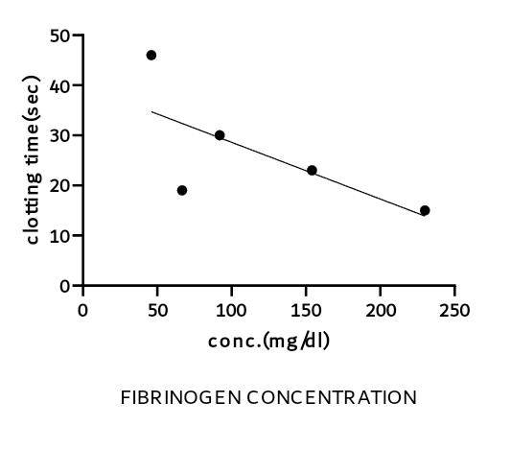

47