EFFECT OF PROCESSING CONDITIONS ON PHYSICAL, CHEMICAL, COOKING, AND SENSORY PROPERTIES OF OFADA RICE(Oryza sativa L) GRAIN AND FLAKES

BY

ADEKOYENI OLUDARE OLUMUYIWA

BSc.Food Science and Technology (FUNAAB),MSc. Food Technology (Ibadan)
(MNIFST)

A thesis in the Department of Food Technology Submitted to the Faculty of Technology in partial fulfillment of the requirements for the Degree of
DOCTOR OF PHILOSOPHY

of the UNIVERSITY OF IBADAN

November, 2014.

i

ABSTRACT

Rice is a staple food in Nigeria with consumer preference for imported varieties due to good quality. Ofada rice (OS6) is a local variety characterised with unpleasant smell and unappealing appearance. Previous researches to improve Ofada rice quality have not satisfactorily solved the problem. This study was designed to determine effect of processing conditions on physical, chemical, cooking and sensory properties of Ofada rice and flakes.
Trial experiments were done to determine variables and responses of experimental design. The variables (storage, soaking, parboiling and drying) were interacted using response surface methodology and responses (physical, chemical, cooking, and pasting properties) for each experimental combination were analyses. Physical (length, width, breadth, head rice yield, brokenness, chalkiness and colour) properties of the samples were determined using ASABE methods. Chemical (protein, fat, ash, carbohydrate, metabolisable energy, free fatty acids, and amylase, zinc, iron, magnesium, copper, potassium and calcium) properties were determined using AOAC methods. Methods of AACC were used for determination of cooking (cooking time, water uptake ratio, solid loss and elongation) and pasting properties. Ready-to-eat rice flakes were produced by pressing and roasting pressure-cooked rice dough. Proprietary software was used to model and optimise process parameters for both grain and flakes. Predicted optimum conditions for rice grain and flakes processing were validated using experimental values. Adsorption isotherm of flake was determined at 25, 35 and 45 ⁰C for 14 days using gravimetric method. Sensory characteristics of cooked rice and flake produced at optimised condition were determined using panelists.Data were analysed using regression and ANOVA at p=0.05.
The ranges of length, width, breadth, head rice yield, brokenness, chalkiness and colour lightness of the rice grain were 5.5-6.3 mm, 2.5-3.0 mm, 1.9-2.4 mm, 50.7-76.5
%, 0.8-83.1 %, 0-49.6 %, and 66.0-78.8 respectively. The rice contained protein (8.4-
10.4%), fat (0.7-3.8%), ash (0.1-1.0%), carbohydrate (78.6-84.4 %), metabolisable

energy (390.3-395.2 kcal/100g), free fatty acid(1.2-4.8%) and amylase (18.5-26.5 %). Storage, soaking, parboiling and drying temperature significantly influenced cooking properties of rice grain. Iron (24.0-75.0 mg/kg), zinc (13.0-42.5 mg/kg) and magnesium (234.3-366.2 mg/kg) were the major minerals found in the rice grain. Drying temperature and storage duration significantly influenced pasting properties of the grain. Coefficient of determination (R²) of predicted models ranged from 0.1 to
0.8. The best rice grain was obtained at grain storage for eight months and 19 days, soaked for one day and 20 h, parboiled at 113.0 °C, and dried at 43.2 °C while most acceptable flakes were obtained at grain storage of nine months, soaked for four days and 17 h, parboiled at 106 °C and dried at 30 °C. Deviation between experimental and predicted values ranged between 0.9 and 0.93 % for rice grain and flakes. Adsorption isotherms of the flakes best fitted into Guggenheim Anderson De Boer model (R²=0.96). Flavour and appearance of the rice and flake produced at optimised condition were acceptable to panelists.
Appropriate storage duration and processing conditions have been established and found to successfully eliminate unpleasant odour and improved appearance of Ofada rice grain. Ofada rice was found suitable for production of ready-to-eat flakes which is an alternative means of harnessing potential of Ofada rice.
Keywords: Ofada rice, OS6 processing conditions, Sensory characteristics, Rice flakes
Word count: 495 words

ACKNOWLEDGEMENT

Foremost, I am very grateful to God for the gift of life and attainment of this new academic stratification. My profound gratitude goes to my supervisor Dr. R. Akinoso for his immense contribution through his wealth of knowledge to the success of this research work. Infact, this piece of work is a product of his consistency, patience and motivation. My sincere appreciation goes to the Head of the Department, and all the lecturers in the Department like Prof. O.C Aworh, Prof. G.O. Adegoke, Prof. K. Falade, Dr. Olapade, Dr. G.L. Arueya, Dr. Ezekiel, just to mention a few for their technical advice and constructive criticisms that saw the project to laudable conclusion. All the lecturers in the Faculty of Technology are also appreciated.
Special thank to Prof. I.A. Adeyemi, Vice Chancellor, Bells University and Technology, Ota for his technical input and encouragement, Dr. Olu Malomo (Director), Central Teaching and Research Laboratory, Bells University of Technology, Ota for allowing me to use the laboratory, I am deeply thankful to Prof. A.O. B. Ogunmoyela for his support, and Mr. Alamu (IITA) for his assistance and advice. I also say thank you to all staff of Bells University of Technology, Ota.
My special thanks goes to my lovely mother Mrs. Maria Adekoyeni and my siblings Adebayo, Adebowale, Idowu, Bosede, and Gbenga. Special regards to my wife Mrs. Omolade Adekoyeni and my lovely children (Jesutofunmi and Jesumayowa). I am also deeply indebted to my friends like Adekola Adegoke, Akamo Lukmon, Salako Gbolahan, Sofela Abayomi, Akintunde Akinlolu, Adebesin Tunde, Adeboye Olumide, Sobande Fatai, Olatunbosun Bunmi, Ogunbina Clement, Solomon Giwa, Yinka Ladipo, Late Mrs. Oluwalademi, Mr and Mrs. Ayano, Fagbemi Akin, too numerous to mention for their moral support and encouragement. I also appreciate Redeemed Christian Church of God (Christ Embassy), Obantoko, Abeokuta for their prayers and support.
Lastly, a very big thank to Sen. Iyabo Obasanjo Bello for her inestimable encouragement and assistance. God who will never forget your labour of love will reward you all abundantly, Amen.

CERTIFICATION

I certify that this work was carried out by Adekoyeni Oludare Olumuyiwa in the Department of Food Technology, University of Ibadan.

………………………………………………………………………

Supervisor

Dr. Rahman Akinoso B.Sc., M.Sc., Ph.D. (Ibadan)
MNSE, MNIAE, MASABE, MNIFST, R. Engr (COREN)

Department of Food Technology, University of Ibadan, Nigeria.

DEDICATION

This work is dedicated to the ever memory of my loving father Pa Johnson Folorunso Adekoyeni

TABLE OF CONTENT

Title page i
Abstract ii
Acknowledgement iv
Certification v
Dedication vi
Table of contents vii
List of Tables xiii
List of Figures xvi
List of Plates xxi
List of abbreviations and symbols xxii

CHAPTER ONE: INTRODUCTION 1
  - Background information 1
  - Objectives 5
  - Justification for the study 5

CHAPTER TWO: LITERATURE REVIEW 7
  - General background of rice production 7
  - Ofada rice 9
  - Economic importance of rice in Nigeria 13
  - Nutritional profile and utilisation of rice 14
  - Physical properties of quality rice 16

  - Chemical composition of rice 18
  - Mineral profile of rice 20
  - Physical and chemical properties related to processing and eating quality 22
  - Grading requirements for paddy and milled rice 24
  - Methods of processing rice 24
    - Effect of parboiling on quality of rice 28
  - Recent frontier technology in rice processing 30
  - Production of rice flakes 30
    - Quality characteristics of flakes 32
  - Response surface methodology 34
CHAPTER THREE: MATERIALS AND METHODS 36
  - Experimental design and paddy processing 36
  - Production of Ofada rice flakes 40
  - Determination of physical properties 42
    - Size characteristics 42
    - Thousand grain weight 42
    - Head rice yield 42
    - Percentage chalky rice 42
    - Percentage broken grain 43
    - Determination of colour of rice flour 43

  - Determination of chemical composition of Ofada rice 44
    - Determination of moisture content 44
    - Determination of protein content 44
    - Determination of fat content 45
    - Determination ash content 46
    - Determination of crude fibre 46
    - Determination of carbohydrate 47
    - Determination of free fatty acid 47
    - Determination of amylose content 47
    - Estimation of metabolizable energy 48
    - Determination of phytate 48
  - Determination of mineral element 49
  - Determination of cooking properties on rice 50
    - Cooking time 50
    - Water uptake ratio 50
    - Elongation ratio 50
    - Solid loss 51
  - Pasting properties 51
3.8. Volatile and non volatile compounds in rice 52
  - Analysis on flakes 52

    - Chemical quality of rice flakes 53
3.8.2 Water absorption capacity 53
  - Data analysis 53
  - Modelling and optimization 53
  - Sensory evaluation on rice flakes 54
  - Sorption isotherm characteristics of Ofada flakes 54

CHAPTER FOUR: RESULTS AND DISCUSSION 57
  - Physical characteristics of Ofada rice 57
    - Size characteristics of Ofada rice 57
    - 1. Length 57
      - Width 59
      - Breadth 70
    - Head rice yield (HRY) 75
    - Thousand Gain Weight 76
    - Brokenness 81
4.1.5. Chalkiness 86
4.1.6 Colour assessment of Ofada rice 90
4.17 Effect of storage and processing conditions on colour value of Ofada rice 91
4.1.8 Optimisation of physical characteristics of Ofada rice 92
  - Chemical quality of Ofada rice 94

    - Moisture content of Ofada rice 94
4.2.2 Protein content of Ofada rice 99
    - Fat content of Ofada rice 104
    - Ash content of Ofada rice 110
    - Crude fibre content of Ofada rice 110
    - Carbohydrate content of Ofada rice 111
    - Free fatty acid content of Ofada rice 112
    - Metabolizable Energy of Ofada rice 113
    - Amylose content of Ofada rice 114
    - Optimisation of chemical qualities of Ofada rice 119
  - Cooking properties of Ofada rice 121
4.3.1 Cooking time 121
    - Water uptake ratio 122
    - Solid loss 134
    - Elongation 135
    - Optimisation of cooking qualities of Ofada rice 135
  - Mineral quality of Ofada rice 137
    - Zinc composition of Ofada rice 137
    - Iron composition of Ofada rice 138
4.4.3 Magnesium composition of Ofada rice 143

    - Copper composition of Ofada rice 143
    - Potassium composition of Ofada rice 144
    - Calcium composition of Ofada rice 145
    - Optimisation of mineral quality of Ofada rice 146
  - Pasting properties of Ofada rice 148
4.5.1 Optimisation of pasting properties of Ofada rice 155
  - Overall optimisation and validation of storage and processing conditions ofOfada rice 158
  - Volatile and non volatile components of optimised Ofada rice 160
  - Chemical and functional qualities of ready-to-eat Ofada rice flakes 164
    - Moisture composition of ready-to-eat Ofada rice flakes 164
    - Protein composition of ready-to-eat Ofada rice flakes 169
    - Fat composition of ready-to-eat Ofada rice flakes 170
    - Ash contents of ready-to-eat rice flakes Ofada rice flakes 170
4.7.5 Carbohydrate contents of ready-to-eat Ofada rice flakes 175
4.7.6. Water absorption of ready-to-eat Ofada rice flakes 175
    - Phytate composition of ready-to-eat Ofada flakes 176
    - Metabolization energy of ready to eat Ofada rice flakes 181
4.8. Optimisation and validation of chemical quality of ready-to-eat Ofada rice flakes 181
  - Sensory evaluation of ready-to-eat Ofada rice flakes 184

  - Moisture adsorption of Ofada rice flakes 184

CHAPTER FIVE: CONCLUSIONS AND RECOMMENDATIONS 189
  - Conclusions 189
  - Recommendations 191
  - Contribution to knowledge 191
REFERENCES 192
APPENDICES 215
    - Sensory evaluation questionnaire 215
    - Sensory analysis print out 216

LIST OF TABLES

2.1 Agronomic characteristics of released rice varieties in Nigeria |  | 11
2.2 Grade requirements for paddy |  | 26
2.3 Grade requirements for milled rice |  | 27
3.1 Independent variables and levels of Ofada rice processing |  | 37
3.2 Experimental design for treatment combination |  | 39
3.3 Experimental values of glycerol concentrations for different relative
humidity at different temperatures | 56
4.1 Physical properties of Ofada rice |  | 60
4.2 ANOVA of regression of physical properties as a function of storage
and processing conditions |  | 61
4.3 Coefficient of model on effect of storage and processing conditions
on physical qualities of Ofada rice |  | 62
4.4 Predicted solutions for optimisation of physical qualities of Ofada rice |  | 93
4.5 Chemical composition of Ofada rice |  | 96
4.6 ANOVA of regression of chemical properties as a function of storage
and processing conditions |  | 97
4.7 Coefficient of model on effect of storage and processing conditions
on chemical qualities of Ofada rice |  | 98
4.8 Predicted solutions for optimisation of chemical qualities of Ofada rice |  | 120

  - Cooking properties of Ofada rice 123
  - ANOVA of regression of cooking properties as a function of storage
and processing conditions 124
  - Coefficient of model on effect of storage and processing conditions
on cooking qualities of Ofada rice 125
  - Predicted solutions for optimisation of cooking qualities of Ofada rice 136
  - Mineral composition of Ofada rice 140
  - ANOVA of regression of mineral composition as a function of storage
and processing conditions 141
  - Coefficient of model on effect of storage and processing conditions
on mineral qualities of Ofada rice 142
  - Predicted solutions for optimisation of mineral qualities of Ofada rice 147
  - Pasting properties of Ofada rice 151
  - ANOVA of regression of pasting properties as a function of storage
and processing conditions 152
  - Coefficient of model on effect of storage and processing conditions
on pasting properties of Ofada rice 153
  - Predicted solutions of pasting properties for boiled Ofada rice 156
  - Predicted solutions of pasting properties for stiff mash Ofada rice 157
  - Optimisation and validation of storage and processing conditions of Ofada rice 159

  - Volatile and non volatile compounds in Ofada rice 163
  - Chemical and functional properties of Ofada rice flakes 166
  - ANOVA of regression of chemical and functional qualities of flakes as a
function of storage and processing conditions 167
  - Coefficient of model on effect of storage and processing conditions
onOfada rice flakes 168
  - Optimization of chemical and functional properties of
Ofada rice flakes 183
  - Sensory evaluation of Ofada rice flakes 186
  - Equation and statistical values of sorption Isotherm models of flakes 188

 |  | LIST OF FIGURES
2.1 | Preparation of fish flakes |  | 33
3.1 | Processing of Ofada rice |  | 38
3.2 | Production of rice flakes |  | 41

4.1-4.6 Response surface graphs showing effect of storage and processing
conditions on length of Ofada rice 63-65
4.7-4.12 Response surface graphs showing effect of storage and processing conditions on width of Ofada rice 67-69
4.13-4.18 Response surface graphs showing effect of storage and processing
conditions on breadth of Ofada rice 72-74
4.19-4.24 Response surface graphs showing effect of storage and processing conditions on head rice yield of Ofada rice 78-80
4.25-4.30 Response surface graphs showing effect of storage and processing conditions on brokeness of Ofada rice 83-85
4.31-4.36 Response surface graphs showing effect of storage and processing
conditions on chalkiness of Ofada rice 87-89
4.37-4.42 Response surface graphs showing effect of storage and processing
conditions on protein contents of Ofada rice 101-103
4.43-4.48 Response surface graphs showing effect of storage and processing
conditions on fat contents of Ofada rice 106-108

4.49-4.54 Response surface graphs showing effect of storage and processing
conditions on percentage amylose of Ofada rice 116-118
4.55-4.60 Response surface graphs showing effect of storage and processing
conditions on cooking time of Ofada rice 126-128
4.61-4.66 Response surface graphs showing effect of storage and processing
conditions on water uptake of Ofada rice 131-133
4.67-4.72 Response surface graphs showing effect of storage and processing
conditions on protein contents of Ofada rice 172-174
4.73-4.78 Response surface graphs showing effect of storage and processing
conditions on water absorption of Ofada rice 178-180
4.79 Experimental adsorption isotherms of Ofada flakes at three working temperatures 187

LIST OF PLATES

A11.1 | Ofada rice products as affected by storage and processing
 | conditions |  | 225
A11.2 | Optimised Ofada rice |  | 228
A11.3 | Ofada ready-to eat-flakes | 229
A11.4 | Optimised ready-to-eat Ofada rice flakes |  | 231

LIST OF ABBREVIATIONS

Symbol/Abbreviation | Meaning | Unit
AACC | Analytical Association of Cereal Chemists
AOAC | Association of Official Analytical Chemists
ARI | American Rice Incorporation
ASABE | American Society of Agricultural and Biological Engineers
BET | Brunauer Emmett and Teller
CHO | Carbohydrates |  | %
DOM | Degree of Milling
E | Percentage Deviation |  | %
EMC | Equilibrium Moisture Content
EME | Emerging market Economy
FAO | Food and Agricultural Organisation of United Nations
FFA | Free Fatty Acids |  | %
GAB | Guggenheim Anderson De-Boer
HRY | Head Rice Yield |  | %
IDP | International Development Programme
L | Length |  | mm
LPL | Lysophospholipid
L/W | Length/Width | Unit less
ME | Metabolisable Energy | kcal/kg
NCRI | National Cereal Research Institute
NERICA | New Rice for Africa
r.p.m | revolution per minute

SPSS Statistical Package for Social Sciences

TGW Thousand Grain Weight g USAID United States Agency for international Development
USARF United States of America Rice Federation

WARDA African Rice Center (formerly West African Rice Development Association)
WHO World Health Organisation

CHAPTER ONE

INTRODUCTION

  - Background information

Rice (Oryza spp) is the second leading cereal after wheat and staple food of half of the World‟s population (Abbas et al., 2011). It is grown in at least 114 countries with global production of 645 million tonnes (IRRI, 2008). It is one of the most important crops in Nigeria and its production represents a significant part of the government strategy to overcome food shortage and improve self-sufficiency for both local consumption and export. The growing importance of rice in the diet of Nigerians is evidenced by the importation of processed rice despite increase in local production (Enwerem and Ohajianya, 2013; NCRI and WARDA, 2007; Adeyemi et al.,1985).
Nigeria is the highest importer of rice in Africa, and the second highest in the World (Sowunmi et al., 2014). Nigeria is West Africa‟s largest producer of rice, producing an average of 3.2 million tons of paddy rice (~ 2million tons of milled rice) for the past 7-years (Enwerem and Ohajiaya, 2013; Daramola, 2005). Domestic supply has not kept pace withdemand as imports have steadily increased faster than domestic supply by accounting forclose to 60% of total supply. However, consumer preference for imported rice is high because of its quality compare to local rice.
Rice, although a later food in average Nigerian diet, has now become an important staple to such extent that the annual per capita of milled rice stands at 25kg per person (NCRI and WARDA, 2007). A combination of factors seems to trigger the increase; according to Nwanze et al., (2006) and Akanji, (1995), this was attributedto population growth and consumer preference associated with opportunity cost of their time and cooking convenience of rice. Rice is now a daily item on Nigerian‟s menu unlike in the past when Nigerian consumed rice only during ceremonies or festivals such as Christmas, Easter, Idel-filtri and Idel-Kabir, today rice is hawked on the street of cities and villages.

Nutritionally, it is a wholesome cereal grain that is ideal for diverse nutritional needs. It contains predominantly carbohydrate, low in fat and the protein content is comparable to that of wheat, corn and sorghum (URF, 2002). Digestibility is high compared to other cereals and provides an excellent source of vitamin E, B (thiamine, Niacin) and potassium (Ngoddy and Ihekoronye, 1985). Rice accounts for about 60-70
% of total food intake and about 90-95 % Nigerians consume rice and this cut across all economic class where it is eaten in different recipes (Wudiri, 1992). It is a traditional food plant in Africa, with the potential to improve nutrition, boost food security, foster rural development and sustainable landrace (NRC, 1996). More demand for rice may also be as a result of its ability to cope with disorders like diabetes (Bandara et al., 2007).
There are two cultivated species of rice, the Oryza glaberrima Steud and the Oryza sativa L. TheOryza glaberrima known as West African wild rice were cultivated in most part of Nigeria, namely Abakaliki, Bida, Abeokuta, Markudi, Mokwa, Sokoto, Nasarawa, and Benue trough where it was mainly for human consumption (Adebowale et al., 2010). With the introduction of O. sativa from Asia, the indigenous rice species O. glaberrima Steud was pushed to the marginal areas. Rice cultivation is widespread within the country extending from the northern to southern zones with most rice grown in the eastern (Enugu, Cross River and Ebonyi States) and middle belt (Benue, Kaduna, Niger and Taraba States) of the country (Daramola, 2005).
Observations have shown that there is preference for imported rice rather than for locally processed rice with the former possessing better processing and cooking qualities (Adeyemi et al., 1985). The non competitiveness of Nigerian rice with imported rice is majorly as a result of obsolete and inefficient processing technology (especially parboiling) which lead to smelling and unappealing products, presence of stones, uneven grainsand non uniformity in the quality characteristics of same variety of locally processed rice due to variation in processing operations (Daramola, 2005). WARDA, (2003) reported that although imported rice is on average 30% more

expensive than local rice, consumers preference for imported rice is high because it is cleaner and has a better appearance.
One of the popular indigenous rice varieties in Nigeria is Ofada rice. The original Ofada rice is short grain robust rice believedto be OS6 and ITA 150 varieties.They are named after Ofada, a small rural community in Obafemi Owode Local Government Area of Ogun State (NCRI and WARDA, 2007). It is unpolished short grain with red kernels which researchers say is not related to any other rice known in Nigeria. Ofada rice could be likened to the popular “basmatic rice” from India and Pakistan. The rice is processed traditionally by parboiling method that involves three stages of treatment (soaking, parboiling and drying).This rice is specially relished because of its characteristics flavour that develops during soaking as a result of fermentation activities of some microorganisms (Adeniran et al., 2012).
The aromatic nature of Ofada rice is offensive to many people which may be as a result of processing conditions; fermentation due to several days of soaking (7 days) and production of oxidation products caused by degradation of fatty acid content of the rice during storage and processing. Presence of inherent enzymes especially lipase also result in splitting of triglyceridecomponents of rice into free fatty acids and produces objectionable odour (Ramezanzadeh et al., 2000).It is recognised that quality of parboiling and drying operations have a great influence on the technical performance of milling and hence the quality of rice. Poor condition of paddy storage and ageing also affect the quality of milled rice.
Generally, parboiled rice produced from rough rice leads to increase yellowness, undesirable smell during soaking and retarded heat transfer to the kernel because the siliceous husk does not wet easily and resists water movement into the kernel (Bhattacharya and Subba rao, 1996). There is also problem of uniformity in the variety of rice cultivated and processing hence, the frequency of broken and uneven grains. Other factors like soil, environment, cultural and agronomic practices have also been mentioned to have effects on the grain quality characteristics. Most of the

highlighted defects can be upgraded through proper unit operation monitoring and control in term of process optimisation.
A lot of research has been carried out on various aspects of rice processing technology to improve quality and sensory characteristics but this study focussed on local cultivar “Ofada-OS6‟‟ to explore its potential. One of the major insight of this research work is to investigate the effect of the processing unit operations involved; soaking time, parboiling temperature, drying temperature and storage duration to provide a very rough guide to positioning the optimum processing conditions in terms of factors varied towards production of quality grain of enhanced organoleptic taste and improved characteristics for various end uses of local rice. Optimisation is an act of making the best combination of elements or variables selected to synthesis a system in order to yield the best result. Optimum conditions are those that produce the best, most favourable or most beneficial result from a system or process (Olaoye and Oyewole, 2012).
Response surface methodology (RSM) is important in designing experiment, formulating, developing and analysing new and existing scientific studies cutting the cost, and measures several effects by objective test (Akinoso and Adeyanju, 2010; Montogomety, 2005). The method of response surface deals with the problem of seeking the conditions which are optimum. Therefore, the application of response surface is a veritable tool at determining various optimum processing conditions of local rice for various end uses. Presently, there is little or no information on the use of response surface methodology in optimum determination of processing condition of local rice in Nigeria.
However, rice produced in Nigeria is consumed mostly in form of boiled rice and as mashed porridge rolled into round balls both eaten with soup. There is little or no utilisation of rice flour in Nigeria in pastry production, however, production of breakfast cereals from maize, sorghum, millet is common, and the production method varies with locality. The use of rice for preparation of breakfast cereal such as noodles,

flakes is common in United States and Europe. Efforts are therefore required to utilise Nigeria local rice for production of ready-to-eat flakes as another way of harnessing the potential of local rice.
  - Objectives

The main objective of the research work is to optimise processing conditions of milled rice and flake from Ofada paddy.
The specific objectives of the study are to:

    - determine the effect of soaking time, parboiling temperature, drying temperature and storage duration of paddy on physical, chemical, cooking, pasting and sensory properties of milledOfada rice.
    - evaluate the quality of ready-to-eat flakes produced from Ofada rice.
    - derive suitable conditions for processing of paddy rice and flakes through optimisation in order to capture current reward for quality.
    - study the moisture adsorption characteristics of Ofada flakes.
    - determine the goodness of fit of mathematical models for the storage stability predictions.
  - Justifications for the study

Nigeria is reputable to have comparative resource advantage in rice production (Nkanget al., 2011). Rice imports in Nigeria have represented a good proportion of total food imports overtime (Diagne et al. 2011; Nkanget al., 2011) and there exists a threat to the Nigerian economy due to large volume of milled rice imports into Nigeria, with an import bill currently exceeding US$2 billion (IFPRI, 2013).The poor quality of the local rice was revealed as a deterrent to its consumption by households (Bamidele et al., 2010) and paddy processing is considered as a critical point for the determination of the rice quality. Therefore, to reverse the ugly trend an effort should be made to upgrade rice processing conditions coupled with the provision of

standard processing facilities. This would help to make the local rice sufficiently more competitive thereby increasing its demand.
According to FAO (2008), it is better to upgrade local technology towards achieving food security and stability. The traditional processing method of Ofada rice was studied with intention to upgrade and optimise the processing operations for better product quality and acceptability. Several investigations have been conducted on effect of specific unit operation (soaking time, parboiling temperature, drying temperature and storage duration) on the quality of rice (Adekoyeni et al., 2012; Chukwu and Oseh, 2009; Patindol et al., 2008; Otegbayo et al.,2001; Zhouet al., 2001 and Danielset al., 1998).In their experiment, single or two of these processing operations were considered.The present study was aimed at investigating the effect of interactions of these various operation units on rice quality. The results of this study would make relevant technical data available on optimum soaking, parboiling, drying, and storage duration for milled rice processing for present and prospective investors that would have relied on “trial and error” method in processingOfada rice and its utilisation for flake production.
Production of ready-to-eat flakes as a breakfast cereal from Ofada rice would serve as a new way of harnessing the potential of Ofadarice considering its unique taste and aroma. This strategy would bring about nutritional diversification, income generation and poverty alleviation. According to Alakali etal., (2009), adsorption characteristics of moisture isotherm are best for prediction of storage stability of foods rather than desorption. Therefore, adsorption characteristics of ready-to-eat flakes produce from Ofada rice is used for moisture isotherm determination.

CHAPTER TWO

  - LITERATURE REVIEW

  - General background of rice production

Rice is one of the most important cereal crops and feeds more than a third of the World‟s population (Jouki and Khazaei, 2012). It is a cereal of the family poaceae or tufted grass (Kassali et al., 2010), and a monocarpic annual plant that usually grows between 1 and 1.8 m tall with long slender leaves 50-100 cm long and 2-25 cm broad. It‟s small, wind pollinated flowers which are characteristics of grasses. According to Chang (1976) as reported by Hongyi et al., (2011), rice is believed to have evolved around 130 million years ago, its cultivation started within the last nine thousand years.
Freshly harvested rice is called paddy grain or rough rice. The pearly white starch grain used for cooking is the centre of the rice seed and is covered and protected by the hull. Inside the hull, the familiar white grain is covered by a layer called bran layer. Rice grain with bran is called brown rice and when the bran layer is removed it is called polished rice. According to Abbas et al., (2011), the genus Oryza comprise about 25 species, distributed in tropical and sub-tropical regions of Asia, Africa, South America, China and Northern Australia. However, there are three major varieties of rice, namely, Oryza sativa (Asian rice), Oryza glaberrima (African rice) and the WARDA‟s hybrids rice. Oryza sativa is a common specie grown throughout the Asia, Australia, Americas and Africa; the O. glaberrima originated from the wild rice O. Barthil some 3500 years ago (Selbut, 2003).
Rice can be grown in a wide range of environmental and soil conditions and is produced in over 100 countries except Antarctica. About 95 % of World‟s rice is produced in developing countries, 92 % of it in Asia (Abbas et al., 2011). However, O. glaberrima is grown in small scale in Western Africa especially in the inland of Niger Delta; the Sokoto-Rima Valley and other flood-plains of the extreme north of Nigeria.

It is also a common rice type on the flood-plains of the Benue. O. glaberrima is known by different local names as „Hakorin Montol’(literally, the tooth of Montol people because of its grain size) in the Plateau/Nasarawa area; and Jatau (red) throughout Hausa land and the Chad Basin. Indigenous African rice is one of the least-known major cereals (Murray, 2004) until only recently when scientists using biotechnology techniques began to unlock its great genetic potentials (WARDA, 1999).
Oryza sativa has been cultivated on almost all continents and has been consumed by humans for at least 5,000 years (Bao and Bergman, 2004). The main varieties of Oryza sativa include;
Indica- Long grain rice notably on the India sub-continent.

Japonica- A short grained and high in amylopectin (sticky when cooked). Javanica-This is a broad grained and grown in tropical climates.
China, India and Indonesia were believed to be where rice was first cultivated, and thus the origin of these three races of rice – japonica, indica, and javanica (Juliano, 1993).
Japonica and indica types are considered the two sub-species of rice, and each sub speciecomprised of genotypes with varying cooking and processing properties (Bao and Bergman, 2004; Hizukuri et al., 1989). The short and wide japonica rice typically cook soft, moist and sticky (Bao and Bergman, 2004) and retrograde slowly (Hizukuri et al., 1989), whereas the long and thin indica rice usually cook firm, dry and fluffy (Bao and Bergman, 2004) and retrograde rapidly (Hizukuri et al., 1989). Javanica rice belongs to the japonica race (IRRI, 2007). The characteristics of the different rice are controlled by their starch composition.
Portuguese traders introduced Asian rice from East Africa to West Africa some 450 years ago (Jones, 1995). It could have also spread across the Sahara and to northern Nigeria via the oases and the Trans-Saharan trade (Selbut, 2003). According

to Selbut, the history of rice cultivation assigned the spread of Asian rice to 1850s at Abeokuta through missionary activities; to 1970s when it spread to Lagos area in Epe and Okitipupa; to after the Second World in Ogoja and Abakaliki provinces; to 1945 in Shaki area of Oyo state; to early 1960s in the Niger Delta area; and to 1954 extended Oshogbo area. Western Nigeria played an important role in the introduction of Asian rice in Nigeria.
The story of rice in West Africa is becoming more interesting in view of the technological breakthrough in the development of hybrid rice by WARDA and other partners (WARDA, 1998;Ng et al., 1991; Jennings et al., 1979). The rice inter-specific hybridisation project has produced NERICA (New Rice for Africa). This is literally at the verge of a rice revolution in Africa as WARDA's Participatory Varietal Selections and Community Seed Production programmes become full-blown. NERICA is a progeny which exhibits a hybrid vigour which has the advantages of both O. glaberrima and O. sativa surpassing both in many regards (WARDA, 1999).There are large numbers of varieties of rice cultivated in Nigeria. The varieties are distributed based on climate, agricultural practice, and ecology (Table 2.1).
  - Ofada rice

Ofada rice is a generic name used to describe all rice produced and processed in the rice producing clusters of South West Nigeria named after Ofada, a small rural community in Obafemi Owode Local Government area of Ogun State (Danbaba et al. 2011). As a niche and special product originating from certain geographical areas, one of the earliest released varieties was the upland variety FARO 3 (Agbede), which was selected from a complex collection of upland varieties believed to have been introduced by veterans returning from the First World War. As breeding effort continued, OS 6 was introduced from Zaire (Democratic Republic of Congo) and released as FARO 11 to replace Agbede. Additional varieties such as ITA 150 and NERICA 1 have been released as FARO 46 and FARO 55 respectively and are in cultivation in the South West region of Nigeria (NCRI and WARDA, 2007).

Ofada rice could be likened to the popular "basmati rice" from India and Pakistan. It is a unique, unpolished, short grain with red kernel. The unique taste and the aroma of Ofada rice have made it to be popular more than other local varieties. There are white and red kernels varieties of Ofada rice. The red kernels vary from red to deep red (NCRI and WARDA, 2007). According to NCRI and WARDA (2007) in their investigation on definition of Ofada rice qualities through varietal identification and testing discovered that there is a large variation between real Ofada and other varieties.
Ofada rice is upland rice grown on free-draining soils where the water table is permanently below the roots of the riceplant. The ecological conditions under which upland rice grows in Nigeria are diverse. However, to obtain successful crop, adequate and assured soil moisture reserves and fertility during key periods of plant growthare essential. The upland rice environments are defined on the basis of soils, climate, water resources, waterregime at the micro level (Rashid-Noah, 1995) and topography. There are two types of Upland Rice Systems (URS) in Nigeria. These are Rainfed upland and Irrigated upland. The rainfed system is common where Ofada rice is produced. It is a system common in Abeokuta, Ado-Ekiti, Abakaliki, Ogoja in the south right up to Yauri, Zamfarariver, Gombe, southern Borno and Yola.

Table 2.1: Agronomic characteristics of released rice varieties in Nigeria

Variety | Cultivar source | Ecology | Year of release
FARO 1 | BG-79 | SS | 1955
FARO 2 | D-114 | SS | 1958
FARO 3 | AGBEDE | UPLAND | 1958
FARO 4 | KAV-12 | DS | 1959
FARO 5 | MAKALIOKA | SS | 1960
FARO 6 | I.G.B | DS | 1961
FARO 7 | MALIONG | DS | 1962
FARO 8 | MAS-2401 | SS | 1963
FARO 9 | SIAM-29 | SS | 1963
FARO 10 | SINDANO | SS | 1963
FARO 11 | OS-6 | UPLAND | 1966
FARO 12 | SML-140/10 | SS | 1969
FARO 13 | IR-8 | SS | 1970
FARO 14 | FRRS-43 | DS | 1971
FARO 15 | FRRS-162-B | SS | 1974
FARO 16 | FRRS-168-11-2-B | SS | 1974
FARO 17 | FRRS-148 | SS | 1974
FARO 18 | TJINA | SS | 1974
FARO 19 | IR-20 | SS | 1974
FARO 20 | BPA-76(BICOL) | SS | 1974
FARO 45 | ITA 257 | UPLAND | 1992
FARO 46 | ITA 150 | UPLAND | 1992
FARO 51 | CISADANE | IS&SS | 1998
SS-Shallow Swamp, DS-Deep Swamp, IS-Irrigated Swamp Source: NCRI and WARDA (2007

Ofadarice has recently gained prominence and is fast gaining international attention. United Kingdom, the department for International Development Programme (IDP), has revealed that a massive potential exists for export of Ofada rice to Europe and USA. Ofada rice grain quality has assumed much greater importance as its demand for local and export consumption are on increase and consumers placing much emphasis on the quality of the milled rice (Idris et al., 2013). The study presented by CMRG - a market research agency, and Emerging Market Economics Limited (EME) based in the U.K, showed that among cities and towns in the South West, Abeokuta in Ogun State recorded a significantly higher consumption level with 58 %, followed by Ilesa in Osun State (38 %), Ado-Ekiti in Ekiti State (34 %), Ibadan in Oyo State (34
%) and Lagos (31 %). Abuja generated 18 % score in this regard thus suggesting that prevalence ofOfada rice consumption is in the South-West. Members of the trade and professional buyers also confirm the South-West as the dominant producing and consuming areas for Ofada rice (Eme and Nathan, 2007).
Indications from the study established no linkage between Ofada rice consumption and any particular traditional/cultural practices. Only a few who eat Ofada rice at special periods do so at parties and commemorative events. Choice at such times was due mainly to the "natural" and "local" taste/flavour of the rice (Eme and Nathan, 2007). The average household consumer of Ofada rice buys 6.46kg of the product per month. Abeokuta (11.62kg) and Ibadan (7.04kg) recorded remarkably higher household volume purchases compared with other locations (Eme and Nathan, 2007). Retailers in the local markets account for the bulk (90 %) of all purchases even though, average quantity bought from this source seldom exceeds 5.09kg. Average monthly expenditure on Ofada rice stands at ₦871.70 per household. However, consumers in Lagos far exceeded this limit with average monthly spend of ₦1, 264.00, followed by Ado-Ekiti and Abeokuta with ₦1, 205 and ₦1, 079 respectively (Eme and Nathan, 2007).
However, processing of Ofada rice is characterised with various deficiencies ranging from poor production and post harvest practices, poor physical and cooking

qualities, presence of foreign materials, and unappealing (Otegbayo et al., 2001). These problems should be eliminated to enhance good market for the product. There are about 340,000 Nigerians living in the UK and a potential demand for 120 tonnes of Ofada rice. The fast food companies in Nigeria are hungry for Ofada. The market in the US, however, seems to have an even greater potential for growth than the one in the UK.
  - Economic importance of Nigeria rice sector

Rice is the leading food crops in World and a favoured cereal in the diet appearing in different forms (Otegbayo et al., 2001). A large array of food and cash crops are cultivated in Nigeria. However, rice has emerged as the fastest growing sector. It is cultivated in virtually all of Nigeria‟s agro-ecological zones, from the mangrove and swampy ecologies of the River Niger delta in the coastal areas to the dry zones of the Sahel in the North. The land mass used for rice cultivation increased from 150,000 hectares in the 1960s to about 1.8 million hectares currently. Nigeria has depended largely on increasing land area for rice cultivation to improve production (Akande, 2001).
The Nigeria rice sector has witnessed some remarkable developments, particularly in the last ten years bothin rice production and consumption. The demand for rice in Nigeria is, however, growing faster than for any other major staples, with consumption broadening across all socio-economic classes, including the poor. Substitution of rice for coarse grains and traditional roots and tubers fuelled growth in demand at an annual rate of 5.6% between 1961 and 1992 (Osiname, 2002).
The Food and Agricultural Organisation of the United Nations projected growth in rice consumption for Nigeria to remain high at 4.5 % per annum beyond year 2000. The United States Agency for International Development, USAID, in a report entitled “Nigeria rice value chain analysis,” had put rice importation at three million metric tonnes annually with a total value of N468 billion ($3 billion). In addition, rice production and marketing in the country contribute to food security, job

creation, poverty reduction and national productivity. For instance, the economic impacts of rice production in terms of income and employment are at five main levels production, processing, marketing, food vending and external (import) trade levels (USAID, 2009).
Rice is an economic crop, which is important for household food security, ceremonies, nutritional diversification, income generation and employment (USAID, 2009). The Nigerian rice industry is dominated by small- medium scale processor (Adeyemi etal., 1986). However, in October (2011), Aganga, the Nigerian minister for Trade and Investment announced that rice importation in Nigeria will end in 2014 (Ujah, 2011). Nigeria has used various trade policy instruments such as import restrictions, and outright ban on rice import at various times from 1978 to 1995. This policy will task the resourcefulness of Nigerian rice producers, processors and researchers to improve the quality of local rice to match the current quality of the foreign rice which are found desirable because of their better processing.
  - Nutritional profile and utilisation of rice

Rice is an excellent source of energy. It is comprised of 77.5% carbohydrate. Like other cereals, the carbohydrate in rice is mainly in the form of starch- a complex carbohydrate. Starch exists as either amylose or amylopectin and comprises units of glucose (Fennema, 1996). Amylopectin contains branches and is less resistant to digestion whereas amylose is a straight chain molecule and harder for the digestive system to break up. This means that rice varieties with a greater proportion of starch in the form of amylose tend to have a lower glycaemic index. Rice also contains a range of important nutrients, including B and E vitamins; protein;and minerals –especially potassium which helps the body reduce toxins. Rice cancontribute significantly to vitamin and mineral intake, although the contribution tomicronutrient intake will depend on the proportion of germ, bran and endospermconsumed (ie the balance between brown and white rice).

An interesting reason for it being so popular is because of its ease of digestion. Even the sick, elderly and babies can digest this grain very well when cooked. Even people who are allergic to lots of other foods can eat rice. Besides, rice provides 21% of global human per capita energy and 15% of per capita protein. It is low in fat and protein, compared with other cereal grains. Recent studies by the modern nutritionists have compared the easily digestible organic rice protein, a highly digestible and non- allergenic protein to mother‟s breast milk in the aspect of its nutritious quality and also for the high quantity of amino acid that is common in both rice protein and breast milk. Rice also provides minerals, vitamins and fibre although; all constituents except carbohydrates are reduced by milling. No matter how plausible the reasons by nutritionist for rice consumption, they do not explain the reason behind increasing demand for rice in Nigeria (Erhabor and Ojogho, 2011).
AnOryzanols, a mixture of three different phytosterols have been the main focus of research into the cholesterol-lowering properties of rice. Researchers developed an animal model using hamsters that led to the successful lowering of plasma cholesterol. In this study oryzanol decreased low density lipoprotein (LDL) or "bad" cholesterol by 24 percent when fed at levels consumed by humans. Furthermore, the LDL/HDL cholesterol ratio improved at 37 percent (USDA and USA Rice Federation, 2007).
Rice is mostly eaten steamed or boiled, mashed as porridge, especially for weaning children or cooked rice which is mashed and rolled into balls with soup but it can also be dried and ground into flour in the several pastry preparations such as noodles, flakes (Gayin et al., 2009). Like most grains, rice can be used to make beer and liquors. Rice straw is used to make paper and can also be woven into mats, hats, and other products. The main by-products of rice milling are rice hulls or husk, rice bran, and brewer‟s rice. Rice hulls are generated during the first stage of rice milling, when rough rice or paddy rice is husked. Rice bran is generated when brown rice moves through the whiteners and polishers. When paddy is hand-pounded or milled in a one-pass Engleberg steel huller, rice bran is not produced separately but mixed with

rice hulls. Brewer‟s rice is separated or produced when milled rice is sifted (USDA and USA Rice Federation, 2007).
  - Physical properties of quality rice

Physical dimensions of rough rice are used for calculating power requirement during milling. Also physical properties of rough rice could affect its milling quality parameters like head rice yield (HRY) and degree of milling (DOM) (Liu et al., 2009). They investigated the relationships between physical properties (length, width, thickness, aspect ratio, equivalent diameter, sphericity, surface area, volume, bulk density, true density, porosity, and thousand-seed weight) and degree of milling of brown rice varieties during milling process. During rice milling, kernels are exposed to different compressive, bending, shear and frictional forces, and breakage can consequently occur (Shitanda et al., 2002). This breakage causes HRY reduction and economic losses.

The grain length, weight and width determine the physical quality of rice grain. The classification of rice quality is based on the length of grain i.e. short, medium and long grain. Arborio rice grains are high in width and Basmati rice grains are high in length (Adu-Kwarteng et al., 2003). According to Adeyemi (2009), two factors contributing to appearance of grain are its length and shape and studies have indicated that minor changes in the length and breadth occur in the grains as a result of parboiling. The ratio of length to width is an important aspect to determine the shape of rice variety (Normita and Cruz, 2002), and grain weight gives the information about the size and density of the grain. The densities of different rice grains affect the cooking quality. It is very important for grain weight to be uniform because it is one of vital determinants of grain quality (Adeyemi, 2009, CRC, 2003).

The appearance always appeal to consumers hence the size, shape and width should be the top criteria to determine the quality of rice and breeders are also consistent to develop new varieties for commercial point of view (Adair et al., 1966).

The length to breadth ratio ranging from 2.5 to 3.0 is widely acceptable and the grain length > 6mm is preferred. The size and shape of rice grain may vary from one group to another group of different regions. Some groups prefer short grains; some prefer medium grains while mostly people like long slender grains in Indian sub-continent regions. Medium short grains are preferred by the peoples of South Asian regions but the long grain rice has also acquired the leading position in International market (Normita and Cruz, 2002).

Appearance, eating, cooking and milling qualities comprise the primary components of rice grain quality and these have shown to be affected by parboiling operations (Saeed et al., 2011). The grain length of milled rice ranged from 4.53mm to 5.07mm and width from 2.43 to 2.62mm. The length to width ratio ranged from 1.84 to
2.09. However, size characteristic obtained by Adekoyeni et al.,(2012) using variation of parboiling temperature were 6.31 – 5.48mm, 2.37 – 2.02mm, and 3.05 – 2.85 for length, breadth and width respectively. The varietal characteristics such as shape, size and density affect the quality of rice grain as reported by Juliano and Duff (1989).

Investigation of physical characteristics of aromatic and non aromatic commercial rice varieties grown in Pakistan revealed 7.3 mm as average length for aromatic (basmati), whereas lowest value of 5.8 mm was recorded in JP-5 rice variety (Sagar et al., 1988). According to FAO (2005), the type of milled rice is classified according to the length of the whole grain, thus;

- Extra long - milled rice of which 80 % of the whole milled rice kernels have a length of 7.0 mm. or more.
- Long -milled rice of which 80 % of the whole milled rice kernels have a length of 6.0 mm. or more but shorter than 7.0 mm.
- Medium -milled rice of which 80% of the whole milled rice kernels have a length of 5.0 mm. or more but shorter than 6.0 mm.
- Short -milled rice of which 80 % of the whole milled rice kernels are shorter than 5.0 mm.

The physical and mechanical properties of rice, which are important in the design and selection of storage structures and processing equipment, depend on grain moisture content. Therefore, the determination and consideration of properties such as bulk density, true density, angle of internal friction and static coefficient of friction of grain has an important role (Jouki and Khazaei, 2012).

Chemical composition of rice
The rice grain consists of 75-80 % starch, 12 % water and only 7 % protein with a full complement of amino acids. Its protein is highly digestible with excellent biological value and protein efficiency ratio owing to the presence of higher concentration (~ 4 %) of lysine (FAO/WHO, 1998). Minerals like calcium, magnesium and phosphorus are present along with some traces of iron, copper, zinc and manganese (Oko et al., 2012).
In addition to being a rich source of dietary energy, rice is a good source of thiamine, riboflavin and niacin. Although the nutritional values of rice varies with different varieties, soil fertility, fertilizer application and other environmental conditions, the following trend still exist by comparison with other cereals: low fat content after the removal of the bran, low protein content (about 7-10 %), and higher digestibility of the protein. Freshly harvested rice grains contain about 80 % carbohydrates which include starch, glucose, sucrose, dextrin, etc. Varieties of rice with high protein and vitamin (vitamin A) content have been obtained through genetic engineering (Yousaf, 1992).
The most important quality criterions based on chemical characteristics are moisture, crude protein, crude fat, crude fibre and ash contents. The grain may absorb moisture in storage depending on the storage condition and this might affect the keeping quality of rice (Danielset al., 1998). The colligative properties of rice also depend on the amount of moisture available for hydration in the grain and also determine shelf life stability because all grains have to be stored for a certain period before their end use. The grains having high moisture content are difficult to store safely because these are more susceptible to attack a pests and diseases. The moisture

content can be measured by oven drying (AOAC, 2000) and it is expected to keep paddy at 14 % moisture content for longevity and milling quality (Adeyemi, 2009).
Chemical compositions of cereals are characterized by protein content. Micro- kjeldahl analysis and different methods are used to determine the protein content in rice. The protein content is affected by environmental conditions, such as soil and applicability of nitrogen fertilizer. Protein in cereals is mainly present in bran and periphery of the endosperm.
Rice protein contains most of the essential amino acids which provides the well balanced proportion for humans. It is evident that the amount of protein in rice is not very high but the quality of rice protein is far better than other cereals because it is more nutritious (about 4-5%) lysine which is higher than wheat, corn and sorghum (James and McCaskill, 1983; Janick, 2002). Araullo et al.,(1976) as reported by Muhammad (2009) stated that the edible portion of brown rough rice consists of about 8% protein and milled rice contains 7% protein. The protein content in Pakistani rice ranged from 7.38 to 8.13% as reported by Awan (1996).
Fat is the main source of food energy. Rather than giving energy it also helps in the absorption of fat soluble vitamins. The body requires fatty acids and these can be synthesized from carbohydrates, proteins and fats except one fatty acid known as linoleic acid. Linoleic acid contains almost 30% of the total amount of fatty acids in rice. Rice contains very low amount of fat but cooked brown rice contains higher fat contents than white rice (American Rice Inc, 2004). The fat content ranged from 0.50 to 2.23% in rice (Taira and Lee, 1988; Sotelo et al., 1990; Tufail, 1997).
The professionals recommend the 25 g of fibre per day for the reduction of chronic diseases. The foods rich in fibre enhance the stomach functions and also reduce the intestinal dilemma. The half cup of cooked brown rice contains 1.8g dietary fiber which is higher than cooked white rice that contains 0.3g dietary fiber (American Rice Inc, 2004). The fiber content in different Pakistani rice varieties varied from 0.20 to 0.35% (Awan, 1996; Tufail, 1997). The fibre content in brown rice after milling was found to be 1.9±0.6% (Sotelo et al., 1990).

The purity of flour is evaluated by the content of ash in flour. The ash content ranged from 0.57-0.82% in Pakistani five fine varieties of rice and one coarse variety (Awan, 1996). The ash content ranged from 0.55 to 0.78% (Sotelo et al., 1990). The chemical and nutritional compositions of rice are usually affected by various processing and storage conditions as concluded by authors in their various findings. Ibukun (2008), in its work on effect of prolonged parboiling duration on proximate composition of rice indicated that there was a decrease in vital constituents such as proteins, and mineral elements as a result of prolonged parboiling duration. Variation in the parboiling temperature leads to variation in the nutritional contents of rice as demonstrated by protein which showed a decrease from 6.61 to 5.29 % after the parboiling operation (Chukwu and Oseh, 2009).
The result obtained for vitamins A and C also showed decrease in values after parboiling at different temperatures of 80, 100, and 120°C. Digestible protein and crude fibre contents are the major determinants of metabolizable energy contents (Ambreen et al., 2006). They study chemical composition of rice polishing from different sources available in Pakistan. It wasdeduced from their investigation that among the plant protein feedstuffs and mill by-products, the highest gross energy is from corn gluten meal, followed by rice polishingused in poultry rations as an energy source. Inverse correlation of ether extract was found with crude fiber, calcium and phosphorus. In polished rice, the metabolisable energy calculated was 2237 kcal/kg. Ether extract had an inverse significant correlation with crude fibre (p<0.01), calcium (p<0.01) and phosphorus (p<0.05). High fat content in the rice polishing, especially of unsaturated nature tends to develop rancidity quite readily (Singh and Panda, 1988).

Mineral profile of rice
There are two forms of minerals: macro and trace minerals. Macro means “large” which are required in larger quantity by the body as compared to trace minerals which are required in small quantities. The examples of macro minerals are i.e. calcium, phosphorus, magnesium, sodium, potassium, chloride, and sulphur. However, the human body also requires trace minerals including copper, iron, cobalt, manganese,

iodine, zinc and selenium. The mineral composition of rice may be affected by the environmental and area locations (Malomo et al., 2012).
Watt et al., (1989)reportedthe following mineral contents in 12 samples of Canadian wild rice; Phosphorus 0.28%, potassium 0.30% Magnesium 0.11 %, Iron 17ppm, Manganese 14ppm, Zinc 51ppm and Copper 13ppm. Chukwu and Oseh, (2009), investigatedresponse of nutritional content of rice to parboiling temperatures. The result showed that the Zn, Fe, Ca contents of rough IR- 8, long-grained variety are
1.62 ppm, 1.75 ppm, and 3.29 ppm respectively but on parboiling the contents varied with degrees of parboiling temperatures.
Comparative analysis of the mineral contents of local and newly introduce rice varieties grown in Ebonyi State, Nigeria revealed that the phosphorus content varied widely from 0.50 – 0.55 %, the newly introduced had the highest value of phosphorus (0.55 %), followed by “Sipi”, “Canada”, “FARO 15(II)”, “Chinyereugo” and “E4077” (all of which had a mean phosphorus content of 0.54 %), while “MASS II” had the least value of phosphorus (0.50 %) among the rice cultivars. The potassium, sodium, calcium and magnesium values obtained in the 20 rice cultivars ranged from 0.15 – 0.23 %, 0.09 – 0.17 %, 0.07 – 0.25 %, and 0.07 – 0.25 %, respectively (Oko et al.,
2012).
The variability observed in the mineral composition was neither restricted to the ecological zones from which they were collected nor peculiar to the newly introduced rice cultivars, though the mineral content was also high in most of the newly introduced rice varieties. Significant correlations (p = 0.001) were found only between Na and P, though the correlation coefficient was only moderate (42.1 %) (Oko et al., 2012).
Sotelo et al., (1990) determined the mineral contents of 12 Mexican varieties of rice after milling. Polishing of the rice significantly reduced the potassium, Iron and zinc contents. Significant variation was found between varieties of brown and white rice in mineral contents. Noreen et al., (2009), conducted a research on chemical composition of rice cultivars (Swat-1 (S-1), Basmati- 385 (B-385), Dilrosh- 97 (D-97), JP-5 and Fakhr-e- malakand (FkM) ) subjected to common cooking processes and

were assessed for their comparative nutrition. Analysis of rice grain showed appreciable amount of sodium (155mg/ kg), zinc (37.5 mg/kg), phosphorus (381 mg/kg), potassium (1908 mg/kg) and copper (3.29 mg/kg). Variation among varieties in respect of nutrients and phytic acid was found non- significant.
Soaking and boiling processes caused significant decrease in phytic acid, sodium and phosphorus contents in all varieties. Cooking process decreased the concentration of phytic acid,potassium and zinc. Phytic acid was reduced by 26% due to boiling and 21% due to soaking for 30 minutes. Marr (1995) analyzed ninety samples of brown rice (Australian) for P, K, S, Mg, Ca, Na, Al, Cu, Fe, Mn, Mo, and Zn. The manganese content in Australian rice was higher in brown rice grown in other countries. Other elements concentrations were in a similar range to those reported for overseas rice. Highly significant correlations were found between levels of P, K, Mg, and S of rice varieties.
Mostly the iron is present in the form of haemoglobin in human body. The function of haemoglobin is to carry oxygen to the body tissues for the oxidative reactions in the body cells. Iron is also an essential constituent for so many enzymes to perform their function especially for the breakdown of glucose and fatty acids to release energy. Half cup of cooked brown rice provides 8% of iron as compared to white rice which gives 7% (American Rice Inc, 2004). Potassium plays very vital role for the synthesis of proteins and cell functions. The cooked brown rice provides greater intake of Potassium as compared to cooked white rice because cooked white rice contains low content of potassium (American Rice Inc, 2004).

  - Physical and chemical properties related to processing and eating quality of rice
Milled rice contains about 90% starch. In rice starch, amylose has a greater effect on the processing properties and eating quality. Amylose is directly correlated to the hardness, whiteness and dullness of cooked rice and volume expansion and water absorption during cooking. Varieties with a low amylose level have a soft and sticky

cooked texture while those with high amylose content have flaky and hard texture (Juliano, 1985). Rice varieties are usually classified in terms of amylose content as waxy (1-2% amylose), very low (2-9%), low (10-20%), intermediate (20-25%), and
high (25-30%) (IRRI, 2007).

Waxy rice occurs in both japonica and indica rice sub-species (Bao and Bergman, 2004). Amylose content is the most important physicochemical property of rice related to its cooking and eating quality, gelatinisation temperature also affects consumer preference and acceptance of a rice variety because gelatinisation temperature is directly associated with cooking time (Juliano, 1993). Heat energy needed to completely gelatinize starch, on the other hand, is important for food processors, because this determines the heat input, cooking time, and temperature of processing (Bao et al., 2007).
In rice, the ratio of the starch fractions (amylose to amylopectin) along with the protein was established to have the major influence on cooking and eating quality of the grain (Zhou et al., 2001). According to Desikachar (1975), high gelatinization temperature in rice has been considered as an undesirable property, because it prolongs the cooking time of rice during processing. Rice granules, on average, are the smallest of the commercial starch granules (1.5-9µm), although the small granules of wheat starch are almost of the same size. All starches retain small amount of protein, ash, lipid (Fennema, 1996).The poor viscosity, high rate of retrogradation and poor clarity may be due to absence of phosphate ester groups in cereal starch. Cereal starch contains endogenous lipids in the granules. These internal lipids are primarily free fatty acids (FFA) and lysophospholipid (LPL), with ratio of FFA to LPL varying from one cereal starch to the other (Fennema, 1996).

Grading requirements for paddy and milled rice

Grading of milled rice either for foreign or domestic consumption is usually done after milling. Periodic inspection, however, is conducted during milling to check if the resulting product meets the required standard specifications. This makes possible the immediate restoration of a good process and prevents production of too many defective grains or rejects. However, the grading is based mostly on physical characteristics of rice. Grade requirement for paddy and milled rice as provided by FAO (2005) are presented in Table 2.2 and 2.3 respectively.

Methods of processing rice

Processing of rice started from farm gate where rice is sorted according to variety. The rice paddy is separated from the stalk by the process known as threshing. This operation can be performed either manually or mechanically. The traditional method of threshing is achieved by human trending on the panicles or flailing the stalks by hand (Adeyemi et al., 1986). Pounding of rice stalks in bags is also practiced in some locality. This operation is followed by winnowing to remove the shafts and other foreign materials present. There are two methods in the processing of paddy; the non-hydrothermal (non parboil) and hydrothermal (parboil) methods.
The non hydrothermal processing of rice requires direct milling of paddy to obtain milled rice. This is the most common method in rice processing. Before milling the paddy, grains must be dried to decrease the moisture content to between 18 – 22 %. This is usually done with artificial heated air or with the help of naturally occurring sunshine (Daniel et al., 1998). They recorded the effect of pre-drying and drying condition on the head rice yield, cooking properties and starch functionality of processed rice. The study revealed that delay in drying of paddy affect the quality characteristics of the rice starch.
Rice that has been subjected to hydrothermal treatment prior to milling is termed parboiled rice (Patindol et al., 2008). Parboiling account for about 15 % of the World‟s milled rice (Bhattacharya, 2004), and its market has been increasingespecially in industrialized countries (Patindol et al., 2008). It belong to the

most popular rice products in Europe and there is also a high demand for parboiled rice in Saudi Arabia, Turkey, Thailland, Ghana while Nigeria is known majorly for the consumption of parboiled rice (Vegas, 2008; Tomlin et al., 2005; Otegbayo et al., 2001).

Table 2.2: Grade requirements for paddy

Grading factors | Grade premium :1:2:3
Purity (Min. %) | 98.00: 95.00: 90.00: 85.00
Foreign Matter (Max. %) | 2.00: 5.00: 10.00: 15.00
a) Weed Seeds and other Crop seed(Max. %) | 0.10: 0.10: 0.25: 0.50
b) Other Foreign Matters | 1.90: 4.90: 9.75: 14.50
Defectives:
Chalky and Immature Kernels (Max. %) | 2.00: 5.00: 10.00: 15.00
Damaged Kernels (Max. %) | 0.25: 1.00: 3.00: 5.00
Contrasting Types (Max. %) | 3.00: 6.00: 10.00: 18.00
Red Kernels (Max. %) | 1.00: 3.00: 5.00: 10.00
Discoloured Kernels (Max. %) | 0.50: 2.00: 4.00: 8.00
Moisture Content (Max. %) | 14.00: 14.00: 14.00: 14.00
Source: FAO, 2005

Table 2.3: Grade requirements for milled rice

Grading factors | Grade premium: 1: 2: 3
Head rice (min. %) | 95.00:80.00:65.00:50.00
Big broken (max. %) | 3.00: 10.00: 10.00:20.00
Broken other than big broken (max. %) | 1.90: 9.75:24.00:29.00
Brewers (max. %) | 0.10: 0.25: 0.50: 1.00
Defectives:
Damaged kernels (max. %) | - : 0.25:0.50: 2.00
Discoloured kernels (max. %) | 0.50: 2.00: 4.00: 8.00
Chalky and immature kernels (max. %) | 2.00: 5.00: 10.00: 15.00
Contrasting types (max. %) | 3.00: 6.00: 10.00: 18.00
Red kernels (max. %) | - : 0.25: 0.50: 2.00
Red streaked kernels (max. %) | 1.00: 3.00: 5.00: 10.00
Foreign matter (max. %) | - : 0.10: 0.20: 0.50
Paddy (Max. No. Per 1000 grams) | 1 : 8 :10 :15
Moisture content (max. %) | 14.00: 14.00: 14.00: 14.00
Source: FAO, 2005

Processing of rice using parboil method include the soaking, steaming/parboiling, drying and milling.Paddy is usually soaked in either cold or warm water depending on the traditional practice of the area with the main purpose of hydration of paddy (Adeyemiet al, 1985). Ayelogun and Adegoyega(2000) suggested that soaking should not be prolonged to avoid fermentation which affects colour, taste and odour of rice. Igbeka et al., (1991) reported that soaking parameters like soaking time, degree of hotness and moisture content after soaking influence translucency, colour and deformed grains.Adeniran et al., (2012) suggested inoculation of certain microorganism during soaking to prevent growth of microorganisms which may induce bad characteristic flavour into the paddy during soaking.
Drying is traditionally done under the sun. Sun drying involves spreading of the paddy on ground, road side on a raised platform in thin layers of 2 - 3 cm to expose it to solar radiation. This method is low cost but suffers from various drawbacks. It is labour intensive, entirely weather dependent and in rainy or damp weather, drying is unduly delayed causing spoilage, exposure of paddy to birds, rodents and contaminations with foreign materials, also drying is not uniform (Bhattacharya and Ali, 1990; Singhal and Thiersten, 1982). Mechanical drying is a better option which entails forcing heated air through the parboiled rice to evaporate and remove moisture (Ray, 1999). The system consist of an air heating device (electrical heater, furnace or burner) a fan and drying chamber with appropriate air duct. The drying can be carried out in batches or continuous flow system. Solar dryer uses solar energy collector for heating the air and is been adopted as alternative to mechanical dryers. Adeyemi et al.,(1985) recommended low drying temperature for better rice quality.

Effect of parboiling on quality of rice

Parboiling as rice processing method is recently popular especially in Africa and it is the usual rice processing method widely practiced in Nigeria (Adeyemi et al., 1986). The parboiling method of rice processing varies from locality to locality but the same trend of processing units. Parboiling is a process developed for improving rice

quality. It consists of soaking, steaming and drying of the rough rice. The major reasons for parboiling rice include higher milling yields, higher nutritional value and resistance to spoilage by insects and mould (Cherati et al., 2012). The parboiling process is applied to rice with a preliminary objective of hardening the kernel in order to maximize head rice yield in milling. Besides milling yield, it alsobrought about the realization of the nutritional and health benefits of parboiled brown rice compared to raw brown rice that created the awareness and importance of parboiling among consumers and manufacturers. Also, nick percentage is reduced significantly, yield percentage increases, and because of leakage and penetration of bran into the rice seed, bran percentage is reduced significantly and crust percentage is reduced slightly to, which justifies yield percentage improvement (Saeed et al., 2011).
Traditionally, parboiling involves soaking the paddy in cold or warm water with the duration of steeping varying from 4 to 5 days for cold steeping or overnight for warm steeping. During soaking, water penetrates the endosperm of paddy and forms hydrates by hydrogen bonding. The grain swells which causes increase in the volume of the paddy. Steaming of paddy is carried out in metal drums or earth ware pots until splitting of the husks is observed which takes between 15 and 20 min. The surface area exposed to hydration is increased and the granules swell in an irreversible manner, a phenomenon known as gelatinization. The paddy is then drained and sundried on raffia mats or concrete floors. Drying is completed when grains selected at random give a sharp cracking sound on breaking with teeth. Milling is mostly in Grantex dehuller after which the milled rice packaged and ready for sale (Bhattacharya, 2004; Adeyemi et al., 1986).
Recently, more sophisticated procedures such as dry-heat parboiling and pressure parboiling have been applied (Bello et al., 2004). Patindol et al., (2008), used laboratory scale autoclave at different temperatures (100, 110 and 120°C). Parboiling brings about gelatinization of rice starch, elimination and filing rice seed chaps, which results in improved resistance of seeds against exerted tensions, during paddy threshing or milling operations (Cherati et al., 2012).

Recent frontier technology in rice processing

Recently the traditional processing of rice has received certain technological improvement. Pressure parboiler and warmer for soaking are commonly employed in modern processing time. The use of fluidisation techniques (Soponronnarit et al., 2006) and ohmic heating (Sivashanmugan and Arivazhagan, 2008) have been documented. Kaasova et al., (2001) reported the effect microwave treatment on physical and chemical changes in rice. The result revealed that microwave treatment of rice before processing reduced drying time of rice and the stability of total starch content.
The gelatinisation of rice starch is progressing faster during microwave treatment than during conventional treatment. Effect of varying the degree of parboiling temperature on quality of rice using a fabricated parboiler was recorded by Islam et al.,(2003). The use of low steaming temperature was recommended to both household and commercial parboiling plants in their production of a good quality product. Enzymatic polishing of rice using xylanase and cellulose produced from Aspergillus sp. and Trichoderma sp. was also investigated and found effective in rice polishing (Mithu et al., 2008).

Production of rice flakes

The basic commodity of most diets of the World is the grains which are made into cereals, flours and “value added “products. Flakes are generally referred to as breakfast cereals and there are two main classes: those requiring cooking, common in China, Japan and many African countries, and those precooked, ready-to-eat flakes, common in Europe and USA (Matz, 1970). A number of different processes are used in the preparation of ready to eat cereals, including flaking, puffing, shredding, and granule formation (Lu and Walker, 1988). In the ready-to-serve category of such products wheat, rice and oat are used at 30%, 11%, and 22% respectively. Ready-to- cook cereals are generally cracked or crushed or may be rolled or flaked grains. The finer the particle processed the shorter the cooking period required.

Methods for production of flakes vary with culture and food habit of people in a particular area. Information on manufacturing of flake is scarce unless those that are patent. Rice flakes are prepared from paddy. It is also popularly known as "Poha". It is a fast moving consumer item and generally eaten as breakfast item. It can be fried with spices and chilly to make hot and tasty food item or milk or curd is mixed with it and then eaten. It is also usedin large quantities for making 'Chevda' (a farsan item) and many caterers use it for thicknessof gravy. Since it is made from paddy, it is easily digestible. Most of its preparations can bemade at a short notice and hence bulk of the households stores it on regular basis. With proper storage, its shelf life is 2-3 months. This is a common product and can be produced anywhere in the country.
Another method of producing rice flakes was reported by Beston and Kirk (1978) involves dehydration of aqueous slurry of substantially completely gelatinized rice starch granules and dehydration of a minor proportion of admixed ungelatinized rice starch granules. The dehydration is concurrently effected with a drum dryer. The dried sheet of substantially completely gelatinized rice material from the dryer is then subdivided into flakes or small platelets which require only the addition of hot water to quickly rehydrate to form a cooked rice product having the appearance and textural quality approaching that of freshly cooked mashed potatoes.
Recently, fish flake is another desert in most places. It is an Intermediate Moisture (IM) fish product which is made from stingray meat, tapioca starch and curing ingredients. In their preparation, tapioca starch is used as a binder in order to achieve a good texture product. Tapioca starch contributes to texture enhancement, binding properties and improved mouth feel to meat products. It is relatively simple to process, it has own characteristic taste and stable without refrigerator (Mardiah et al., 2010). Preparation of fish flake from fresh stingray (Himantura gerrardi) was described in the flow chart below by Mardiah et al., (2010).
A number of different processes are used in the preparation of ready-to-eat cereals, including flaking, puffing, shredding, and granule formation- generally of

wheat, corn and rice (Lu and Walker, 1988). Lu and Walker, (1988), in laboratory preparation of ready-to-eat breakfast flakes from grain sorghum flour, the manufacturing processes include, mixing the ingredients and hydration to form paste, extrusion, cutting to pellets, cooking, tempering, flaking using heavily spring object, roasting, cooling, and packaging.

Quality characteristics of flakes

Recently, more demand can be seen in the present market for rice based products than for wheat based products and the reason for this could be seen as that the people are even more aware of the peculiar nutritional values of rice as well as its ability to cope with the disorders like diabetes, and also of the qualitative aspects of rice than before. Along with the new trends in rice processing, rice based products of similar quality could be obtained in the near future and, in the present day context, some of the traditional rice processing methodologies are being modernized (Bandara et al., 2007).
Very limited literature is available on the organoleptic evaluation and instrumental (objective) methods of measuring texture of flakes. Sensory evaluation of the rice flake-based products showed that colour, texture, rice flavour, and rice aroma were attributes of the rice flakes which contributed to the general acceptability of the products. Blanshard and Mitchell (1988) found a high correlation between textural preferences and sensory crispness, indicating that the acceptability of a food's texture increased with increasing crispness.

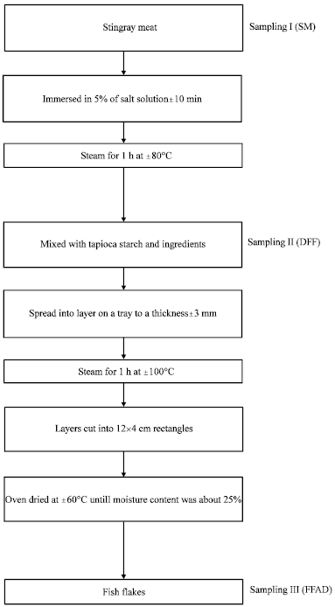
Fig.2.1 Preparation of fish flake Source: Mardiah et al., (2012)

Sensory evaluation and consumer study of flakes prepared from grain sorghum flour indicated that they were palatable and acceptable to many people (Lu and Walker, 1988). Vickers (1983) observed that crispness was closely associated with the pleasantness of biting sounds. Vickers (1985) has used a bite test cell in an Instron Universal Testing Machine to determine the force – deformation behaviour of eight ready-to-eat breakfast cereals and potato chips. Seymour (1985) used a Kramer shear cell in an Instron to crush samples of several dry crisp foods altered in crispness by humidification. The measurements of peak force, slope and area under the force - deformation curve had small negative correlations with sensory crispness (Vickers 1987).
However, a combination of the physical, chemical, and sensory data revealed that the rice flakes made from waxy rice harvested at 100 day of maturity is better since it has the highest protein and dietary fibre content as well as the lower phytate content.

Response surface methodology

Response Surface Methodology, an experimental strategy initially developed and described by Box and Wilson, has been employed with considerable success in a wide variety of situation (William and William, 1966). In statistics, response surface methodology (RSM) explores the relationships between several explanatory variables and one or more response variables. The main idea of RSM is to use a sequence of designed experiments to obtain an optimal response (Akinoso et al., 2010). Box and Wilson suggest using a second-degree polynomial model to do this. They acknowledge that this model is only an approximation, but use it because such a model is easy to estimate and apply, even when little is known about the process.
Optimization is an act of making the best combination of elements or variables selected to synthesize a system in order to yield the best result (Olaoye and Oyewole, 2012). Optimization techniques also adjust parameters so as to attain a desired result.An optimization problem requires the determination of the optimal (maximum

and minimum) values of a given function called the objective function under a given set of constraints. One of the most widely used optimization techniques is the response surface methodology (Akinoso and Adeyanju, 2010). Olayemi (1998) described a regression analysis as an attempt to measure the amount of change (in value) of the dependent variable which is derived from a unit change (in value) of the independent variable. In other words, a regression analysis is an attempt to find out, in a specific way, how one variable is related to the other and it involves a one way cause and effect relationship.
Response surface methodology has an effective track-record of helping researchers improve products and services. To determine the factor levels that will simultaneously satisfy a set of desired specifications. To determine the optimum combination of factors that yields a desired response and describes the response near the optimum.

CHAPTER THREE

MATERIALS AND METHODS

Experimental design and paddy processing

Ofada paddy (OS 6) was purchased at farm gate in Mokolokin, Obafemi Owode, a renowned area for Ofada rice production. The processing unit operations (soaking, parboiling, drying) used as treatment was adopted from the methods of processing of paddy adopted by the rice farmers in the area. D-Optimal response surface methodology was used for the design of the experiment (Montgomery, 2005). The independent and levels of variables were decided mainly from literatures (Adeniran et al., 2012, Chukwu and Oseh, 2009, Patindol et al., 2008, Otegbayo et al., 2001) and on the preliminary investigation on the processing of rice in the area (Table 3.1). The paddy wascleaned within 12 hours, mixed thoroughly and stored in a dry cool place for processing at 1, 5 and 9 months as described in the experimental design.
The major processing operations in the processing of rough rice are soaking, parboiling/steaming, drying, and milling (Fig. 3.1). The paddy was cleaned by winnowing to remove the chaffs and immature rough rice. Paddy (4kg) was soaked in cold water at ambient (28 ±2°C) for typically 1, 3 and 5 day(s) to hydrate the kernels. The soaked paddy were parboiled at varied temperatures (80, 100, and 120°C) at constant pressure using autoclave for 15minutes. The parboiled paddies were tempered for 30 min to cool and air dried in oven at 30, 50 and 70°C. The rice samples were milled (hulling and debranning) in grantex cono disc milling machine. The rice obtained were subsequently ground in a hammer mill, sieved (200 micron size) and analysed.The design of the experiment of the treatment combinations is presented in Table 3.2.

Table 3.1: Independent variables and levels of Ofada rice processing

Variables |  | Levels
Soaking time (days) | 1 | 3 | 5
Parboiling temperature (ᵒC) 80 100 120
Drying temperature (ᵒC) 30 50 70
Storage duration (months) 1 5 9

Paddy rice

↓

Soaking

↓ Parboiling
↓ Drying
↓

Milling

↓ Cleaning/Winnowing
↓ Bagging

Fig. 3.1 Processing of Ofada rice (Otegbayo et al., 2001)

Table3.2:Experimental design for the treatment combinations
Run | A:Soaking time | B: Parboiling temp. | C:Drying temp | D:Storage  duration
 | Day | °C | °C | Month
1 | 1 | 120 | 70 | 1
2 | 1 | 80 | 70 | 1
3 | 5 | 80 | 30 | 5
4 | 5 | 80 | 30 | 1
5 | 3 | 80 | 30 | 9
6 | 5 | 80 | 50 | 5
7 | 1 | 120 | 30 | 5
8 | 5 | 80 | 70 | 1
9 | 3 | 120 | 70 | 9
10 | 3 | 120 | 50 | 5
11 | 5 | 120 | 30 | 9
12 | 1 | 100 | 50 | 5
13 | 3 | 120 | 70 | 5
14 | 1 | 100 | 50 | 9
15 | 5 | 120 | 50 | 9
16 | 1 | 120 | 70 | 1
17 | 3 | 100 | 50 | 5
18 | 5 | 100 | 50 | 5
19 | 1 | 80 | 30 | 1
20 | 1 | 120 | 30 | 1
21 | 5 | 100 | 30 | 9
22 | 1 | 80 | 70 | 5
23 | 5 | 80 | 70 | 9
24 | 1 | 80 | 30 | 9
25 | 1 | 120 | 30 | 1

Production of Ofada rice flakes

The production of the flakes was carried out as described by Lu and Walker (1988). The milled rice was cleaned and ground into flour. The flour was sifted with sieve (60-mesh testing sieve) and the coarse residues were discarded. Flour (400g) was mixed with 300 ml of water, 25g of sugar, and 4g of salt in a kitchen KENWOOD mixer for 5 min. The dough was placed in a pasta extruder attachment and forced through a die with 5-mm hole. After the extrusion, it was cut 0.5 cm long pellets, and steamed using a pressure cooker for 15 min. After cooking, the pellets were tempered and pressed through a heavily spring roller. The resulting flakes were toasted on pans at 200°C for 20 min, cooled, and packaged in plastic as shown in Figure 3.2.

Rice flour
↓
Mixing( sugar, salt, water)
↓
Extrusion (3mm thick; 5mmhole)
↓ Cutting
↓ Steaming
↓
Tempering (overnight at 5ºC)
↓
Flaking (pressing)
↓
Roasting (200ºC, 20min)
↓ Cooling
↓ Storage
↓
Ofada rice flake
Fig.3.2 Production of rice flakes (Lu and Walker, 1988)

Determination of physical properties

Physical properties of the rice appraised were size characteristics (length, width, and breadth), head rice percentage, percentage chalkiness, brokenness, and colour. These were analysed as described below.

Size characteristics

Size characteristics were determined as described by Patindol et al., 2008 and Gayin et al., 2009. Linear dimensions (length, breadth and the width) of 100 grains were measured with digital vernier callipers with accuracy of 0.05mm.The mean of the 20 measurements were recorded.

Thousand grain weight

This was carried out by counting 100 kernels and weighing them on an electronic balance weighing machine and then multiplied by 10 to give the mass of 1000 grains as show in equation 1(Nalladulai et al., 2002 and Gayin et al., 2009).
TGW= Weight of 100 grains of rice x 10 (1)

Head rice yield

The parboiled rice was shelled and milled using laboratory miller, which separates whole and broken grains. The head rice yield (HRY %) was calculated (equation 2) as percentage of whole milled grains respect to parboiled rough rice, the average value of the duplicates was calculated (Patindol et al., 2008).

Head rice (%) = Weight of whole grains
Weight of paddy samples
x 100 (2)

Percentage chalky rice

The percentage rice chalkiness was calculated from five replicates of 100g samples, according to the method outlined by WARDA (1995) (equation 3).

Chalkiness (%) = Weight of chalky grain
100g

x 100(3)

Percentage broken grain

Percentage broken grain was determined by the method of WARDA (1995). 10g of milled rice was sampled from the lot and the broken kernel was separated from the whole grains. The percentage of the broken grains was computed using the equation 4:

Broken grain (%) = Weight of broken grains
Weight of paddy samples
x 100(4)

3.3.6. Determination of colour of rice flour

The colour was determined by the method described by Akintunde and Tunde- Akintunde (2013) using a portable PCMTM colour Tee colorimeter (SM3002421). The instrument was first standardized with a white A4 paper. The instrument software was configured to read the desired scale or index. Three grams of the sample was weighed into a transparent bag and the reflected rays sent the signal to the tri-stimulus filter which was connected to the phototubes. The colour measurement circuit records L, a, and b coordinates which were then converted to colour coordinates L*, a* and b* values which were recorded and the lightness and colour values were calculated using equation 5:

Colour value, B = √(𝑎 ∗)² + (𝑏 ∗)²(5)

The L,a,b type of scales simulate this as:

L (lightness) axis – 0 is black, 100 is white

a(red-green) axis – positive values are red; negative values are green and 0 is neutral

b(yellow-blue) axis – positive values are yellow; negative values are blue and 0 is neutral

Determinationof chemical composition of Ofada rice

The chemical composition of rice determined include proximate composition (protein, fat, ash, crude fibre, carbohydrate, moisture) and other chemical constituents were amylose, metabolisable energy, free fatty acids, and phytate. The methods for the analyses were described below:
    - Determination of moisture content

The moisture content was determined by the method described by AOAC (2000). Five grams of each sample was weighed into pre – weighed clean drying dish. The dish was placed in a well ventilated laboratory hot air oven (Surgifriend Medicals, England. SM9053) maintained at 105⁰C. The weight of the sample plus the drying dish was checked at hourly interval after the first two hours until the decrease in mass between successive weighing did not exceed 0.05mg per g of sample. The loss in weight was reported as the moisture content and calculated using equation 6:
% Moisture content = Moisture Content, (%) = M1−M2 x100(6)
M1−M0

Where M₀ ₌ weight of the empty dish before drying

M₁ = weight of the dish and the sample before drying M₂ = weight of the dish and the sample after drying.
    - Determination of protein content

The crude protein was determined using micro Kjedhal method as described by AOAC (2000). Approximately 1g of the sample was weighed into the digestion tube of Kjeltec 2200 FOSS Tector Digestion unit (Foss Tecator Analytical AB Hoganas, Sweden). Two tablets of catalyst (containing 5g of K₂SO₄ and 5mg of Se) were added

and also 12ml of concentrated H₂SO₄ added. Digestion was done for one hour at 420⁰C. The distillation was done using 2200 FOSS distillation unit with addition of 80mls of water, 40 ml NaOH (40%). The distillate was collected in 4% boric acid prepared with bromocresol green and melthyl red indicators. The distillate was titrated with 0.1 M HCl. Equation 7 was applied.
Nitrogen, (%) = (Titre −Blank )x 14.007 x 0.1 x 100(7)
1000 x sample weight (mg )

Crude Protein, % = %N multiplied by 5.95

    - Determination of fat content

The fat contents were determined using the method described by AOAC (2000). The principle of Soxhlet fat extraction method was used but with a modern fat extractor with automated control unit (Foss Soxtec 2055, Foss Tecator Analytical AB Hoganas, Sweden). The equipment has the advantage of analysing the fat contents of six samples in 1h: 15min compared to the conventional Soxhlet which takes up to 8 h.The equipment has six extraction units with each unit having thimble for loading the samples and aluminium cups where the extracted fat are collected. The differences in the weight of the pre-weighed cups and after extraction are estimated as the percentage of fat in the samples. 1 g of the sample is weighed into the thimble and the mouth of the thimble is plugged with defatted cotton wool, and inserted into the extraction unit.
The extraction cups were cleaned, dried, weighed and 80ml of petroleum ether were measured into each cups and the heating temperature adjusted to 135°C which is the extraction temperature for fat using petroleum ether as stated in the manual. The cups were set into the Soxtec unit with each cup aligning with its respective thimble. There are three stages involved; the boiling/extraction, rinsing and the drying. The extraction stage was for 30minutes in „boiling‟ position and 30 min in „rinsing‟ position after which it was aerated for 15 min. The cups were removed, cooled in a dessicator and weighed. Equation 8 was used for the calculation of crude fat.

Fat, (%) = W 3−W 2 x100(8)
W 1

Weight of the cup with the extracted oil = W₃ Weight of the empty cup = W₂
Weight of sample =W₁

    - Determination of ash content

The ash content was determined using the method described by AOAC (2000). Crucibles were washed and dried in the laboratory hot air oven (Surgifriend Medicals, England. SM9053) maintained at 105⁰C for 30 min. It was allowed to cool in a dessicator and weighed. 2.5 g of the samples were then weighed into the crucible and charred on a heater inside a fume cupboard to drive off most of the smoke. The samples were transferred into a pre-heated muffle furnace (Surgifriend Medicals, England. SM9080) maintained at 550⁰C until a light grey ash was observed. The crucibles were transferred directly into a dessiccator, cooled and weighed immediately.The ash content was calculated using equation 9.

Ash content,%=(weight of crucible +ash )−(weight of empty crucible
weight of sample
x 100

(9)

    - Determination of crude fibre

Crude fibre was determined using the method described by AOAC (2000). Two grams of sample was weighed into 250 ml conical flask. 100 ml of 1.25 % H₂SO₄ was added and boiled under reflux for 30 min. The sample was filtered and completely rinsed with distilled water. The residue was transferred with spatula back into the conical flask, 100 ml of 1.25 % NaOH added and again boiled under reflux for another 30 min. The residue was filtered and rinsed thoroughly after which the residue was transferred into a crucible and dried in oven at 180 ⁰C for 3 h, then cooled and

weighed. The sample was returned to muffle furnace and ash for 2 h at 550 ⁰C until completely ashed. It was cooled and weighed. The calculation of crude fibre was done using equation 10.
Crude fibre, (%) = W 2−W 3(10)
W 1

W₁ = weight of the sample

W₂ = weight of the crucible + sample after oven drying W₃ = weight of the crucible after ashing
    - Determination of carbohydrate

Carbohydrate was estimated by difference using equation 10:

Carbohydrate= [100 - %(moisture+ protein+ fat+ ash+ crudefibre) (11)

    - Determination of free fatty acid

The general titrimetric method for the determination of free fatty acid (FFA) as described by AOAC, (2000); Akinoso and Adeyanju,(2010) were used. The principle involvespreparation of a mixture of 25ml diethyl ether and 25ml alcohol and 1ml phenolphthalein solution (1 %), and carefully neutralised with 0.1 M sodium hydroxide. 1 g of oil sample was put in the mixed neutral solvent and titrated with aqueous 0.1 M sodium hydroxide with the warm solution shaken continuously until a pink colour which persists for 15 s is obtained. The FFA was calculated as oleic acid (1ml 0.1M sodium hydroxide equals 0.0282g oleic acid).
    - Determination of amylose content

Amylose content of the rice was estimated as described by Adeyemi, (2009). This involves digestion of 100mg of rice flour with 1ml of 95% ethanol and 9ml of 1N NaOH, the sample was heated for 10 min in a boiling water bath, and diluting the gelatinized starch with distilled water, 5ml of the starch solution was pipetted into a

100 ml volumetric flask, 1ml of 1N acetic acid and 2ml of iodine solution added, and made up to volume and absorbance was read at 620nm. Amylose content was determined by reference to a standard curve.
    - Estimation of metabolizable energy

The metabolizable energy of the rice and flakes were calculated from the three basal nutrients in the samples (protein, fat, and carbohydrate) using Atwater factor as described by FAO (2002). To calculate the ME, the percentage of fat, protein, and carbohydrate eelier estimated in the rice and flakes are then multiplied by their respective Atwater factors, added together, and multiplied by 10. Equation 12 was applied in the calculation of metabolizable energy
ME (kcal/kg) = 10 (3.82 x CP) + (8.37 x CF) + (4.16 x CHO) (12)

Where ME= Metabolizable energy CP= % crude protein CF=% crude fat
CHO= % carbohydrates

    - Determination of phytate

The method for evaluation of phytic acid was carried out as described by Garcia-Estepa et al., 1999. The ground samples (5.0±0.5 g) were extracted under magnetic agitation with 40.0 ml of extraction solution (10 g/100 g Na₂SO₄ in 0.4 mol/l HCl) for 3 h at room temperature. The suspension was centrifuged at 5000 rpm for 30 min and the supernatant was filtered using whatman no. 1. 10ml of supernatant (containing between 3.3 and 9.0 mg of phytic acid) waspipetted into a 100 ml centrifuge tube together with 10.0 ml of 0.4 mol/l HCl, 10.0 ml of 0.02 mol/l FeCl₃ and 10.0 ml of 20 g/100 g sulphosalicylic acid, shaked gently and the tube used was

sealed with a rubber cork through which passes a narrow 30 cm long glass tube, to prevent evaporation.
The tube was placed in a boiling water bath for 15 min, and then allowed to cool. The sample was centrifuged at 5000 rpm for 10 min, decanted, filtered and the residue was washed several times with small volumes of distilled water. The supernatant and washed fractions were diluted (100.0 ml). One aliquot (20.0 ml) adjusted to pH 2.5.0.5 by addition of glycine was diluted to 200 ml. The solution was heated at 70 °C and, whilst still warm, titrated with 50 mmol/l EDTA solution. The 4:6 Fe/P atomic ratios was used to calculate phytate content.
  - Determination of mineral element

Mineral analysis Fe, Mg, Cu, Zn, Pb and Ca were conducted using Atomic Absorption Spectrophotometer (Buck 210). Dry digestion method was used in the preparation of the sample for mineral analysis. One gram of the dried samples was weighed into crucibles, charred in a fume cupboard and ashed in muffle furnace at 550ºC for 3h (AOAC, 2000). The ash was dissolve using 0.1M H2SO4 and filtered into a 100 ml volumetric flask and filled to the mark with deionised water. De-ionised water was used as a blank to zero the equipment for the analysis. Atomic Absorption Spectrophotometer Buck Scientific Model 210A with air/acetylene was used for the analysis of metals. Standards for each element under investigation was prepared in part per million (ppm) and the limit standard concentration for each element was adhered to according to the BUCK Scientific instruction.
The standard solutions were aspirated and the graph obtained. The samples concentrations of various metals were read and calculated using equation 13.
Specific mineral (i.e Zn, Fe) ppm= Machine reading (ppm ) x dilution factor(100)(13)
Weight of sample

  - Determination of cooking properties on rice

The cooking parameters that were estimated include the cooking time, elongation ratio, water uptake ratio and solid loss.
    - Cooking time

Rice was cooked in excess water. Twenty grains rice was cooked with a colander in boiler placed on an electric heater (100ºC) and timer for cooking time. The cooking time of the rice was recorded after complete absence of white chalk when the rice grain was pressed with spoon against the pot or rubbed in between the fingers (Danbaba et al., 2011).
    - Water uptake ratio

Rice was cooked in excess water. Two grains rice was cooked with 20ml water in a 100 ml beaker placed on the electric cooker heater (Sareepuang et al., 2008). Samples were removed at cooking time, weighed and calculated using equation 14:
𝑊𝑎𝑡𝑒𝑟𝑢𝑝𝑡𝑎𝑘𝑒(%) = weight of cooked rice (14)
weight of raw rice

    - Elongation ratio

Rice was cooked in excess water. Two grains rice was cooked with 20 ml water in a 100 ml beaker placed on an electric heater. Samples were removed at cooking time to measure with length and wide (before and after cooked) and calculated using equation 15 (Sareepuang et al., 2008):

𝐸𝑙𝑜𝑛𝑔𝑎𝑡𝑖𝑜𝑛𝑟𝑎𝑡𝑖𝑜 = Length of cooked rice (15)
Length of raw rice

    - Solid loss

Rice was cooked in excess water. Two grains rice was cooked with 20 ml water in a 100 ml beaker placed on an electric heater. Twenty five ml sample of the cooked rice water (previously well agitated) was placed in a reweighed flask and air dried in an oven at 105ºC for 1 h. After that, the sample was fully dried at the same temperature until a constant weight in the presence of P₂O₅ desiccant. The amount of solids leached was calculated as kilogram of solids per kilogram of dry grain (Bello et al., 2004).
  - Pasting properties

Pasting properties of rice flour were determined using the method as described by IITA (2001) laboratory manual.The rheological properties of 8% rice flour slurries (approximately 40g, corrected to 14% moisture, in 240 ml deionised water) were measured with a Newport Scientific Rapid Visco Analyser Model RVA-SUPER 3 with thermoclin for windows soft. (Brabender® OHG, Duisburg, Germany). The slurry was heated from 50 to 95ºC at a rate of 1.5ºC/ min, held at 95ºC for 15min, cooled to 50ºC at 1.5ºC/min and finally held at 50ºC for 15min. The following parameters were determined on RVA curve:
- Peak viscosity (maximum viscosity during heating)
- Hot paste viscosity (trough)
- Cold paste or final viscosity ( viscosity at end of cooling period)
- The breakdown was calculated as the difference between peak and trough viscosities.
- The setback was calculated as the difference between the cold paste or final viscosity and the peak viscosity.
- Pasting temperature.
- Pasting time.

  - Volatile and non volatile compounds analyses

The volatile and non volatile compounds of rough, parboiled and cooked rice at optimum storage and processing conditions were analysed by Gas Chromatography Mass Spectrometry (GC-MS) as described by Wen-Chieh et al., (2007). The samples were milled, sieved (60-mesh testing sieve), and 5 g of the samples were weighed into
100 ml flask. The volatileand non volatile compounds were extracted with dicloromethane (1:2) mixture by liquid-liquid extraction in separatory.This analysis was performed using a Shimadzu GCMS-QP2010s Gas Chromatograph/Mass- Spectrometer (GCMS) and an OI 4660 “Eclipse” Purge and Trap Concentrator with an OI 4551A autosampler.
These results were obtained using a 30m X 0.25mm X 1.4μ RTX-VMS fused silica capillary column (Restek Corporation). A temperature profile of 35-220°C was utilized, and the advanced flow control (AFC) was programmed to provide a constant linear velocity of 35cm/sec. A total analysis time of 12.5 minutes gives a GC cycle time that corresponds approximately to the cycle time of the purge and trap concentrator. The mass spectrometer was scanned in the full-scan mode from m/z 36 to
260 in 0.5sec scan intervals.The volatile components of unknown samples were identified by computer through searching and matching NIST and Weily MS libraries. The volatile components were quantified using peak area normalization. The detector (electron multiplier) was adjusted to give adequate response at the lowest calibration level and avoid saturation at the highest calibration level.
  - Analysis on flakes

The two major analyses carried out on flakes were proximate composition (protein, moisture, fat, ash and carbohydrate), metabolisable energy, antinutritional content (phytate), andwater absorption as a functional parameter.

    - Chemical quality of rice flakes

Moisture, crude protein, ether extract, ash, carbohydrates, metabolizable energy and phytate were carried out as discussed in the analysis of rice with the same methodology and reagents.
3.9.2 Water absorption capacity

Water absorption capacity of Ofada rice flakes was measured by weighing the water uptake of flakes at room temperature for 15 min. A Sample of 2 g of flakes was weighed into the centrifuge tubes with 10 ml of distilled water. These were allowed to stay for 15 min, followed by centrifugation at 400 rpm for 15 min. The excess water was decanted and the values of absorbed water were expressed as g per 100g of flake (Lu and Walker, 1988).
  - Data analysis

Data from each analysis were subjected to analysis of variance at test of significance 5%, regression analysis and lack of fit test at 5%. This was followed by the optimisation of the processing parameters for the best production of Ofada rice and its flakes.
  - Modelling and optimisation

Response surface methodology was applied to the experimental data using commercial statistical package (Design expert, 7.0, Stat Ease Inc., Minneapolis) for the generation of response surface plots and modelling equations for each of the response estimated. Optimisation was conducted on experimental data on physical, chemical, cooking and pasting properties of rice and functional and chemical quality of flakes followed by combined optimisation process for all the parameters analysed. Optimisation of the process variables was based on the selection of the indicator that best determined the product quality acceptability.

  - Sensory evaluation on rice flakes

Sensory attributes: colour, crispiness, taste, aroma, and overall acceptability based on a nine point hedonic scale, where 1 is dislike extremely and 9 is like extremely was assessed. The result was subjected to statistical analysis.
  - Sorption isotherm characteristics of Ofada flakes

The moisture isotherm of the flakes with best characteristic indices as generated by optimisation process was studied using static equilibrium method as described by Alam and Singh(2011).Hot air oven was used as temperature control chamber and the dessicators as humidity control chamber. The desired level of humidity was controlled through preliminary study on appropriate concentrations of aqueous glycerol solution for attaining a particular relative humidity in the dessicator with experimental tabulated data recorded by Alam and Singh (2011) as guide. The relative humidity and temperature were monitored with the help of digital thermo- hygrometer (Brannan, England).
Experiments were conducted to standardise the concentrations of glycerol to relative humidity (40, 60, 70, 80, and 90%) at 25, 35 and 45ºC (Table 3.3). Glycerol of desired concentration was transferred into the dessicators, covered and kept at control temperature for 12h to allow the glycerol to saturate the dessicator. For adsorption, the sample was dried to 1.4% (d.b) and 5g taken in petri dish. This was placed over the wire mesh in the dessicator, covered and then transferred into the oven set at 25, 35 and 45ºC respectively. The weight of the sample was noted periodically until the change in weight reached a constant value presumed to be equilibrium moisture content (EMC).
Non linear regression module of Statistical Package for Social Sciences, (SPSS version 17.0 was used for analysis of the good fitness of the models. The modelsinclude Guggenheim Anderson De-Boer (GAB), Oswin, Brunauer Emmett and Teller (BET), and Halsey. The goodness of fit of the models were evaluated using root

meansquare error (RMSE), percentage deviation (%E), and coefficient of determination (R²).

Table 3.3: Experimental values of glycerol concentrations for different relative humidity at different

temperatures
Glycerol concentrations (%)
 | Temperature (⁰C)
RH (%) | 25 ⁰C | 35 ⁰C | 45 ⁰C
20 | 96.3 | 93.7 | 94
40 | 88.5 | 84.5 | 85.6
60 | 74.7 | 71.6 | 71.8
70 | 62.8 | 64.4 | 65.1
80 | 48.1 | 53.5 | 54.7
90 | 29.3 | 32.7 | 33.2
RH-relative humidity

CHAPTER FOUR

RESULTS AND DISCUSSION

  - Physical characteristics of Ofada rice

The effect of processing condition on physical characteristics of Ofada rice (length, width, breadth, thousand weight, head rice yield, brokenness, chalkiness, lightness and colour value) of Ofadawere shown in Table 4.1.

    - Size characteristics of Ofada rice

The size characteristics (length, width and breadth) of Ofada rice as affected by the processing parameters were presented (Table 4.1). There existed significant differences at p<0.05 in sizes of the Ofada rice after treatments which revealed how effective processing conditions can affect quality of rice.

    - 1. Length

The length of rice were significantly affected (p<0.05) by the processing conditions of the paddy. The maximum and minimum values obtained were 6.29 and
5.53 mm respectively with an average value of 5.88 mm. The maximum value was obtained from the rice stored for 1 month and processed by soaking for 5 days, parboiled at 120°C, and dried at 50°C while the minimum value was as a result of storage of paddy for 1 month, soaked for 1 day, parboiled at 80°C, and dried at 70°C. The result revealed that the lack of fit was significant which is not good enough for the model. The R², adjusted R², predicted R², and adjusted precision values for the length characteristics of Ofada rice were shown (Table 4.2). High multiple correlation coefficient (R²⁾, low standard deviation and predicted residual sum of square identify the best model. However, low standard deviation and predicted residual sum of

square(PRESS) values of 0.12 and 0.45 respectively indicated that the model may still be relevant. The coefficient of the model is presented (Table 4.3).

The response surface graphs showing the effect of processing conditions on the elongation of Ofada rice were presented (Figs. 4.1 - 4.6). Observations from the figures revealed that steady increase in soaking time and parboiling temperatures favoured elongation of the processed Ofada rice. The positive coefficient of soaking time and parboiling temperature as shown in Table 4.3 supported this. The response surface plots shown inward concave curves for the effect of drying temperatures with the mid temperature 50°C producing the highest increase (Figs. 4.3, 4.4, 4.6) while storage effects curves were concave inward.

According to Kurien et al., (1964) as reported by Roy et al., (2011), parboiling contributes to the expansion ratio of rice. This could be due to water absorption capacities of the rice varieties and the parboiling process. An investigation into the effect of parboiling on physico-chemical qualities of two local rice varieties in Nigeria by Otegbayo et al. (2001) revealed that parboiled rice kernel has a short length and broader breadth when compared with the non parboiled rice sample. The dimension of parboiled rice could be influenced by the amylose content of the rice (Roy et al., 2011). Otegbayo et al. (2001) recorded length and breadth range of 6.66 - 7.04 mm and 2.91- 3.0 mm respectively.

The consumers judge the quality of rice on the basis of size and shape of rice grain. The preference for grain size and shape can vary from one group of consumer to another group of consumers (Roy et al., 2011). It is generally noted that consumers usually preferred long grain rice compare to short rice. The grain length, weight and width determine the physical quality of rice grain. The classification of rice is based on length such as short, medium and long grain. Ofada rice is believed to be short grain rice but the influence of certain processing conditions could reclassify it to medium or long grain rice (Adu-Kwarteng et al., 2003).

The shape (ratio of length/width) influences the prices of rice in different countries survey by Laurian (1986). Long rice is usually favoured in term of price compare to intermediate or short grain rice. The average shape characteristic (length/width) of rice samples from Philippines, Indonesia and Thailand were given at 3.2, 2.5 and 3.5 mm respectively (Laurian, 1986). The result of the experiment is against the report of Juliano and Duff (1989), which claimed that processing method did not affect the size of rice but the varietal factors.
      - Width

Width is another renounced part of size characteristics of the rice. Length – width ratio is a very stable varietal property for determining grain size and shape. The minimum value of 2.50 mm was recorded when the paddy was stored for 5 months, soaked for 5 days, parboiled at 120 ⁰C, dried at 30 ⁰C while the maximum value of
3.03 mm was recorded from paddy stored for one (1) month, soaked for 1 day, parboiled at 120 ⁰C, and dried at 30 ⁰C dried.
There were significant differences (p<0.05) in rice width in relation to the treatments. The mean width value of Ofada rice was 2.80 mm and the lack of fit was not significant which was also good for the model. The low standard deviation and PRESS values of 0.084 and 1.73 respectively demonstrated that the model was more reliable. The R², adjusted R², predicted R², and adjusted precision values for the length characteristics of Ofada rice were shown (Table 4.2). Negative predicted R² (-3.3437) revealed that mean is the best descriptor of the effect of processing conditions and storage duration on rice width. The quadratic coefficient of the model showing the effect of processing conditions (soaking, parboiling, drying, and storage) and their interactions on rice width were shown (Table 4.3).

Table 4.1: Physical properties of Ofada rice
Run | Soaking | Parboiling | Drying | Storage | Length | Width | Breadth | HRY | Brokenness | Chalkiness | Lightness | Colour value
 | day | ᵒC | ᵒC | Month | mm | mm | mm | % | % | % | %
1 | 1 | 120 | 70 | 1 | 6.28 | 2.86 | 2.08 | 72.98 | 24.95 | 0 | 66 | 702.45
2 | 1 | 80 | 70 | 1 | 5.54 | 2.92 | 2.18 | 50.74 | 83.08 | 47.18 | 69.59 | 1887.19
3 | 5 | 80 | 30 | 5 | 5.55 | 2.84 | 1.98 | 71.25 | 33.81 | 1.91 | 71.26 | 1859.97
4 | 5 | 80 | 30 | 1 | 5.7 | 2.82 | 2.12 | 58.63 | 68.08 | 42.37 | 74.09 | 1846.93
5 | 3 | 80 | 30 | 9 | 5.87 | 2.83 | 1.97 | 64 | 3.72 | 0 | 72.55 | 3888.24
6 | 5 | 80 | 50 | 5 | 5.72 | 2.9 | 2 | 58 | 18.65 | 36.42 | 74.82 | 1975.67
7 | 1 | 120 | 30 | 5 | 6.01 | 2.5 | 2.18 | 65.25 | 2.17 | 0 | 75.08 | 2014.02
8 | 5 | 80 | 70 | 1 | 5.53 | 2.94 | 2.17 | 52.61 | 71.92 | 49.64 | 69.56 | 1868.81
9 | 3 | 120 | 70 | 9 | 6.13 | 2.7 | 2.03 | 65.25 | 3.93 | 0 | 66.97 | 2002.6
10 | 3 | 120 | 50 | 5 | 5.94 | 2.82 | 2.04 | 70 | 9.06 | 1.04 | 78.8 | 1947.36
11 | 5 | 120 | 30 | 9 | 6.04 | 2.67 | 2.1 | 70.75 | 0.81 | 0 | 71.04 | 2106.4
12 | 1 | 100 | 50 | 5 | 5.72 | 2.92 | 2.02 | 75.5 | 16.75 | 1.79 | 74.74 | 2021.72
13 | 3 | 120 | 70 | 5 | 5.81 | 3.02 | 1.98 | 65.5 | 45.93 | 0.18 | 77.33 | 1967.56
14 | 1 | 100 | 50 | 9 | 5.87 | 2.7 | 2.18 | 74.25 | 2.71 | 0 | 69.02 | 1964.7
15 | 5 | 120 | 50 | 9 | 6.17 | 2.67 | 1.93 | 74.75 | 19.3 | 0 | 70.75 | 2013.56
16 | 1 | 120 | 70 | 1 | 6.29 | 2.88 | 2.15 | 67.48 | 19.34 | 0 | 70 | 560.81
17 | 3 | 100 | 50 | 5 | 5.88 | 2.88 | 2.06 | 72.5 | 20.67 | 1.18 | 77.96 | 2006.34
18 | 5 | 100 | 50 | 5 | 5.94 | 2.96 | 2.08 | 70.96 | 6.61 | 1.62 | 71.06 | 1986.27
19 | 1 | 80 | 30 | 1 | 5.73 | 2.83 | 2.11 | 53.8 | 55.57 | 43.31 | 74.03 | 1850.32
20 | 1 | 120 | 30 | 1 | 5.97 | 3.03 | 2.34 | 69.88 | 2.83 | 0 | 77.37 | 1817.13
21 | 5 | 100 | 30 | 9 | 5.73 | 2.8 | 2.16 | 76.5 | 4.76 | 3.78 | 67.91 | 1992.57
22 | 1 | 80 | 70 | 5 | 5.96 | 2.84 | 2.08 | 54.75 | 70.81 | 33.21 | 77.25 | 2078.07
23 | 5 | 80 | 70 | 9 | 5.77 | 2.93 | 1.93 | 60.25 | 51.35 | 0.42 | 71.16 | 2103.06
24 | 1 | 80 | 30 | 9 | 5.9 | 2.67 | 2.03 | 70.25 | 57.69 | 44.35 | 73.72 | 2078.07
25 | 1 | 120 | 30 | 1 | 6.02 | 3.02 | 2.36 | 76.45 | 2.88 | 0 | 77.49 | 1738.57

Table 4.2: ANOVA of regression of physical properties as a function of storage and processing conditions
Parameters | p-value | R2 | Adjusted R² | Predicted R² | Adequate precision
Length (mm) | 0.0051 | 0.8852 | 0.7244 | -0.4408 | 8.348
Width (mm) | 0.0303 | 0.8243 | 0.5782 | -3.3437 | 6.699
Breadth (mm) | 0.0015 | 0.9131 | 0.7915 | -1.0044 | 10.887
HRY (%) | 0.0013 | 0.9148 | 0.7956 | -0.1564 | 9.976
Brokenness(%) | 0.0053 | 0.884 | 0.7217 | 0.1441 | 7.257
Chalkiness (%) | 0.0174 | 0.8467 | 0.632 | -0.5108 | 5.933
Lightness | 0.0082 | 0.8716 | 0.6919 | -0.4182 | 6.907
Colour value | 0.0909 | 0.7658 | 0.4379 | -0.1151 | 7.152

Table 4.3: Coefficient of the model on effect of storage and processing parameters on physical qualities of Ofada rice

 | Length mm | Width mm | Breath mm | HRY⁵ (%) | TGW (%) | Brokenness (%) | Chalkiness (%) | Lightness | Colour Value
Intercept | 6.47 | 1.01 | -0.77 | -70.72 | 188.87 | 280.32 | 229.71 | 69.6 | 119.01
S | 0.03 | 0.18 | 0.06 | -8.38 | 22.46 | 12.82 | 16.16 | 95 | 215.57
P | -0.04 | 0.05 | 0.07 | 2.5 | -0.42 | -4.33 | -4.33 | -0.41 | 3.01
D | 0.03 | -0.02 | -0.011 | 0.51 | 2.37 | -1.32 | 1.37 | 0.41 | 18.87
T | 0.05 | 0.03 | -0.08 | 3.8 | 0.53 | -5.05 | -13.39 | 3.04 | 31.88
S2 | 7.73x10⁻³ | -0.02 | -0.01 | 0.69 | -2.89 | 2.34 | -0.38 | 0.18 | 31.36
P2 | 2.91x10⁻⁴ | -2.13x10⁻⁴ | -2.9x10⁻⁴ | -0.01 | 3.22x10⁻³ | 0.02 | 0.02 | 3.87x10⁻³ | 0.03
D2 | -2.53x10⁻⁴ | 1.63x10⁻⁴ | 2.03x10⁻⁴ | -0.01 | -0.02 | 0.03 | -3.69x10⁻³ | 1.83x10⁻³ | -0.03
T2 | 5.46x10⁻³ | -7.26x10⁻⁴ | 4.32x10⁻³ | 0.06 | 0.62 | -0.21 | 0.3 | -0.27 | -8.33
-SP | -7.59x10⁻⁴ | -1.24x10⁻³ | -1.79x10⁻⁴ | 0.01 | -0.01 | -0.19 | -0.12 | -0.05 | -3.61
SD | 1.29x10⁻³ | 1.99x10⁻⁴ | 3.83x10⁻⁴ | 0.05 | -0.1 | -0.13 | -0.03 | -0.02 | -3.94
ST | -4.57x10⁻³ | 2.53x10⁻³ | 4.24x10⁻³ | -0.02 | -0.18 | -0.51 | 0.27 | 0.05 | 31.69
PD | -6.05x10⁻⁵ | 7.15x10⁻⁵ | -1.19x10⁻⁴ | 3.99x10⁻³ | 6.50x10⁻⁴ | 3.22x10⁻³ | -5.38x10⁻³ | -2.89x10⁻³ | -0.11
-PT | -7.11x10⁻⁴ | -6.9x10⁻⁴ | -4.64x10⁻⁴ | -0.03 | -0.01 | 0.09 | 0.1 | -0.01 | 0.31
-DT | -2.20x10⁻⁴ | 3.46x10⁻⁴ | 1.18x10⁻⁴ | -0.01 | -0.1 | -0.04 | -0.05 | 9.76x10⁻³ | 0.28

DESIGN-EXPERT Plot

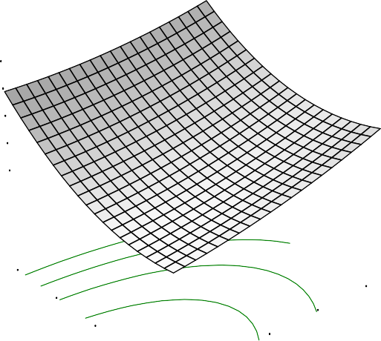Length
X = A: Soaking Time Y = B: Parboiling temp

Actual Factors

6.13473

C: Drying Temp = 50.00
D: Storage Duration6=.0155.0605

5.89657

5.77748

5.6584
Length

120.00

110.00

100.00

B: Parboiling tem9p0.00

2.00

5.00

4.00

3.00

80.00

1.00
A: Soaking Time

Fig. 4.1: Effect of soaking time and parboiling temperature on rice length

DESIGN-EXPERT Plot

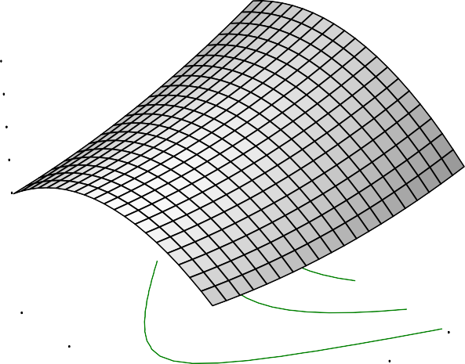Length
X = A: Soaking Time Y = C: Drying Temp

Actual Factors

5.92596

B: Parboiling temp = 100.00 D: Storage Duration5=.8455.0803

5.7657

5.68557

5.60544
Length

70.00

60.00

50.00

3.00

4.00

5.00

C: Drying Temp40.00

30.00

1.00

2.00
A: Soaking Time

Fig.4.2: Effect of drying temperature and soaking time on rice length

DESIGN-EXPERT Plot

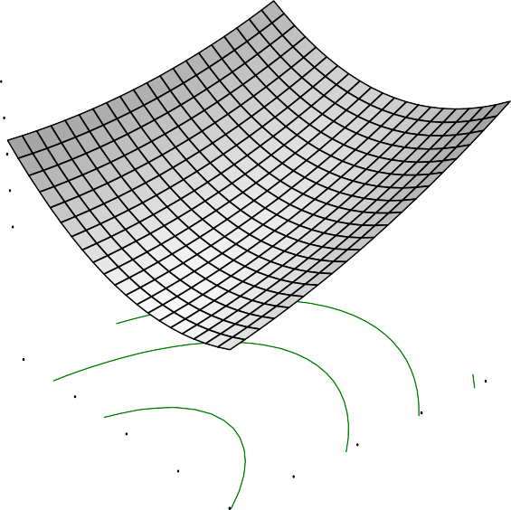Length
X = A: Soaking Time
Y = D: Storage Duration

Actual Factors

5.9977

B: Parboiling temp = 100.00 C: Drying Temp = 550..9020495

5.8522

5.77944

5.70669
Length

9.00

7.00

5.00

3.00

4.00

5.00

D: Storag e Duratio3n.00

1.00

1.00

2.00

A: Soaking Time

Fig.4.3: Effect of soaking time and storage duration on rice length

DESIGN-EXPERT Plot

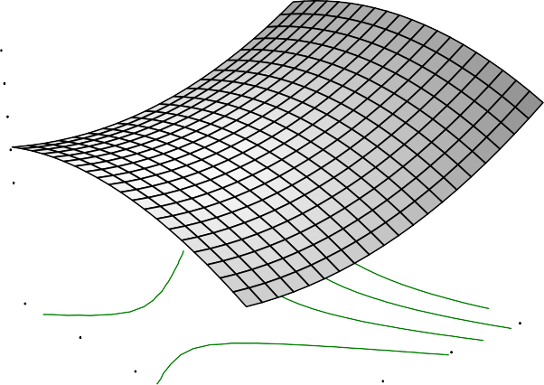Length
X = B: Parboiling temp Y = C: Drying Temp

Actual Factors

6.04187

A: Soaking Time = 3.00
D: Storage Duration5=.9258.0001

5.81415

5.70029

5.58643
Length

70.00

60.00

50.00

C: Dr ying Temp40.00

90.00

120.00

110.00

100.00

30.00

80.00
B: Par boiling temp

.

Fig. 4.4: Effect of parboiling and drying temperature on rice length

DESIGN-EXPERT Plot

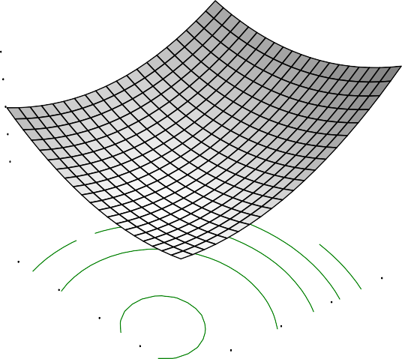Length
X = B: Parboiling temp Y = D: Storage Duration

Actual Factors

6.15148

A: Soaking Time = 3.00
C: Drying Temp = 560..0040482

5.93815

5.83149

5.72482
Length

9.00

7.00

5.00

120.00

110.00

100.00

D: Storag e Duratio3n.00

1.00

80.00

90.00
B: Par boiling temp

Fig. 4.5: Effect of parboiling temperature and storage duration on rice length

DESIGN-EXPERT Plot

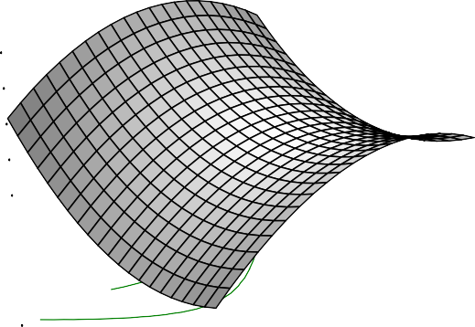Length
X = C: Drying Temp
Y = D: Storage Duration

Actual Factors

5.9117

A: Soaking Time = 3.00
B: Parboiling temp =5.180403.0060

5.77443

5.7058

5.63716
Length

9.00

7.00

5.00

50.00

60.00

70.00

D: Storag e Duratio3n.00

1.00

30.00
40.00
C: Drying Temp

Fig.4.6: Effect of drying temperature and storage on rice length

The response surface plots, showing the interaction effect of soaking time and parboiling temperature, soaking time and drying temperature, soaking time and storage duration, parboiling and drying temperatures, parboiling temperature and storage duration, drying temperature and storage duration on the width of Ofada rice were presented (Figs. 4.7 – 4.12). The effect of soaking time and parboiling temperature were concave inward with mid soaking time favouring the highest increase while the extremes shown least effects (Figs. 4.7, 4.8,4.9, 4.10, 4.11). Ofada rice width increased with drying temperature (Figs. 4.8, 4.10, and 4.12) and decreased with increase in storage duration (Figs. 4.9, 4.11 and 4.12).

According to Danbaba et al., (2012), the ratio of length to width is used for the determination of rice shape. Danbaba et al., (2012) and Otegbayo et al., (2001) recorded ranges of 2.61-3.2mm and 2.53-3.0 mm for rice width respectively. The variation might be attached to the varietal factors, processing conditions, climatic and geographical area of the rice origin. From the result, it was observed that the samples with high elongation were low in width. Rhaghavendra and Juliano (1970) recorded that parboiled rice expanded more in width and breadth than the length but however, the consumer preference to rice acceptability revealed long rice with less width.

DESIGN-EXPERT Plot

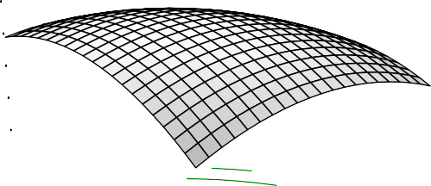Width
X = A: Soaking Time Y = B: Parboiling temp

Actual Factors

2.94636

C: Drying Temp = 50.00
D: Storage Duration2=.8655.0305

2.78434

2.70333

2.62232
Width

120.00

110.00

100.00

B: Parboiling tem9p0.00

2.00

5.00

4.00

3.00

80.00

1.00
A: Soaking Time

Fig.4.7: Effect of soaking time and parboiling temperature on width of rice

DESIGN-EXPERT Plot

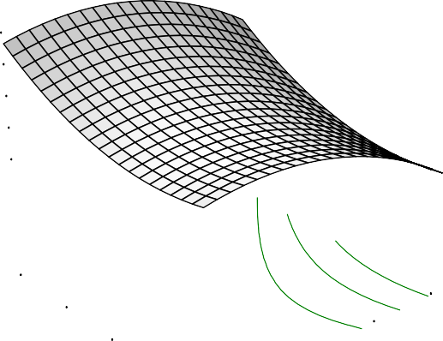Width
0.00
58.0102
2043
581
4274

6506
70.00
5.00
60.00
4.00
50.00
3.00
C: Drying Temp40.00
2.00
A: Soaking Time
X = A: Soaking Time Y = C: Drying Temp

Actual Factors

3.07

B: Parboiling temp = 10 D: Storage Duration2=.99

2.9

2.8

2.7
Width

30.00 1.00

Fig.4.8: Effect of soaking time and drying temperature on width of rice

DESIGN-EXPERT Plot

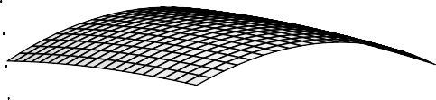Width
X = A: Soaking Time
Y = D: Storage Duration

Actual Factors

3.03305

B: Parboiling temp = 100.00 C: Drying Temp = 520..9050194

2.87083

2.78971

2.7086
Width

9.00

7.00

5.00

3.00

4.00

5.00

D: Storag e Duratio3n.00

1.00

1.00

2.00

A: Soaking Time

Fig.4.9: Effect of soaking time and storage duration on width of rice

DESIGN-EXPERT Plot

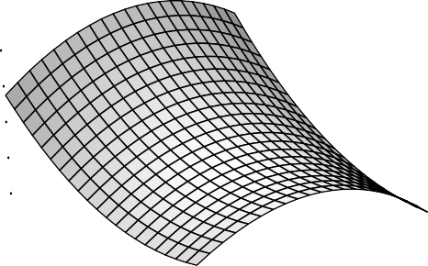Width
626
51.0602
2064

4966

7868
70.00
120.00
60.00
110.00
50.00
100.00
C: Drying Temp40.00
90.00
B: Parboiling temp
X = B: Parboiling temp Y = C: Drying Temp

Actual Factors

3.0

A: Soaking Time = 3.00 D: Storage Duration2=.99

2.9

2.8

2.7
Width

30.00 80.00

Fig.4.10: Effect of parboiling and drying temperature on width of rice

DESIGN-EXPERT Plot

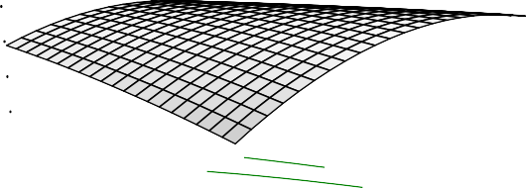Width
X = B: Parboiling temp Y = D: Storage Duration

Actual Factors

3.00666

A: Soaking Time = 3.00
C: Drying Temp = 520..9020009

2.83351

2.74694

2.66037
Width

9.00

7.00

5.00

120.00
110.00
100.00

D: Storag e Duratio3n.00

1.00

80.00
90.00
B: Par boiling temp

Fig. 4.11: Effect of parboiling temperature and storage duration on width of rice

DESIGN-EXPERT Plot

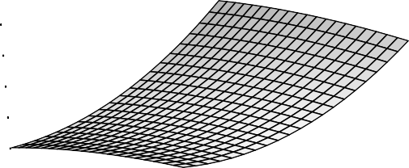Width
X = C: Drying Temp
Y = D: Storage Duration

Actual Factors

3.11041

A: Soaking Time = 3.00
B: Parboiling temp =3.100301.7050

2.95309

2.87444

2.79578
Width

9.00

7.00

5.00

50.00

60.00

70.00

D: Storag e Duratio3n.00

1.00

30.00

40.00
C: Drying Temp

Fig.4.12: Effect of drying temperature and storage duration on width of rice

      - Breadth

The result obtained for the breadth ranged between 2.36 to 1.93 mm. The minimum breadth value was obtained at 9 month of paddy storage, one day soaking duration, 120⁰C parboiling temperature, and 50⁰C drying temperature while maximum value was recorded at1 (one) month paddy storage duration, 1 day soaking, 120⁰C parboiling temperature, and 30⁰C drying temperature. There existed significant differences (P<0.05) in the breadth of processed Ofada rice as a result of processing conditions. The non significance of the lack of fit was an indication that the model was fit. Low standard deviation and PRESS values of 0.050 and 0.58 respectively were also recorded which also supported model fitness. The coefficient of the model is presented in Table 4.3. Positive coefficients of soaking time and parboiling temperature revealed that the effect of these operation units brought increase on breadth of rice.

Breadth is also an important size characteristic of grain but is not involved in the estimation of the shape which is the important consumer index that determine the price and purchase of rice. Response surface graphs on the effect of interactions of soaking time and parboiling temperature, soaking time and drying temperature, soaking time and storage duration, parboiling and drying temperatures, storage duration and drying temperature, and parboiling temperature and storage duration on breadth of Ofada rice were shown (Figs. 4.13-4.18).

From the response surface graphs, the range of minimum to maximum values recorded for the effects of soaking time and parboiling temperature, soaking time and drying temperature, soaking time and storage duration, parboiling temperature and drying temperature, parboiling temperature and storage duration, and drying temperature and storage duration were 1.9124 - 2.12287 mm, 2.05677 - 2.23041 mm,
2.013 - 2.27632 mm, 1.97695 - 2.24219 mm, 1.95524 – 2.27516 mm, and 2.09452 -
2.39189 mm (Figs. 4.13 - 4.18) respectively. The effect of parboiling and storage duration produced the least breadth (Fig. 4.17). Parboiling and soaking showed relative inward concave curves, however, the curves in parboiling were more extended to a

point before a steep downward curve (Figs. 4.13 and 4.16). Drying temperature and storage duration axis were concave outward.

DESIGN-EXPERT Plot

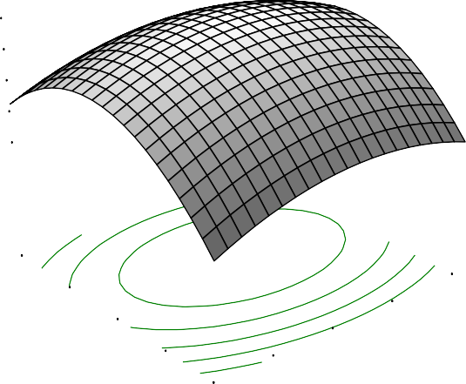Breadth
X = A: Soaking Time Y = B: Parboiling temp

Actual Factors

2.12287

C: Drying Temp = 50.00
D: Storage Duration2=.0750.0205

2.01763

1.96501

1.9124
Breadth

120.00

110.00

100.00

B: Par boiling tem9p0.00

2.00

5.00

4.00

3.00

80.00

1.00
A: Soaking Time

Fig.4.13: Effect of soaking time and parboiling temperature on rice breadth

DESIGN-EXPERT Plot

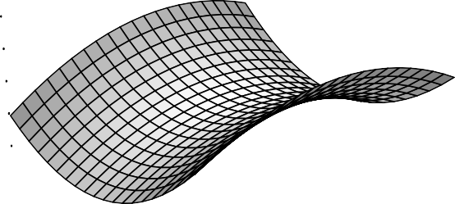Breadth
X = A: Soaking Time Y = C: Drying Temp

Actual Factors

2.23041

B: Parboiling temp = 100.00 D: Storage Duration =25.1.0807

2.14359

2.10018

2.05677
Breadth

70.00

60.00

50.00

C: Drying Temp40.00

2.00

5.00
4.00
3.00

30.00

1.00
A: Soaking Time

Fig.4.14: Effect of soaking time and drying temperature on rice breadth

DESIGN-EXPERT Plot

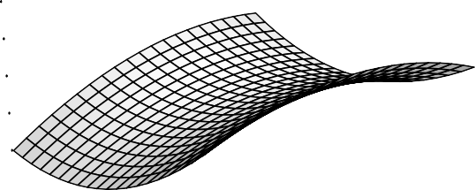Breadth
X = A: Soaking Time
Y = D: Storage Duration

Actual Factors

2.27632

B: Parboiling temp = 100.00 C: Drying Temp = 520..2010049

2.14466

2.07883

2.013
Breadth

9.00

7.00

5.00

3.00

4.00

5.00

D: Storag e Duratio3n.00

1.00

1.00

2.00
A: Soaking Time

Fig. 4.15: Effect of soaking time and storage duration on rice breadth

DESIGN-EXPERT Plot

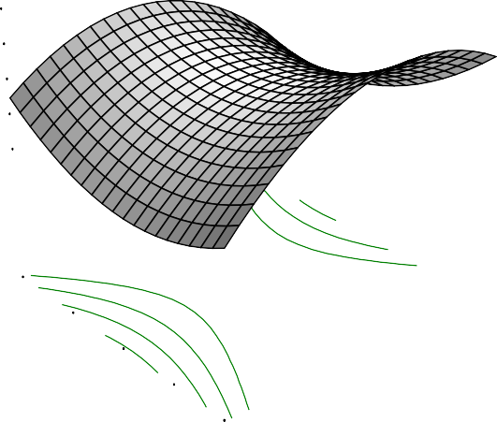Breadth
X = B: Parboiling temp Y = C: Drying Temp

Actual Factors

2.24219

A: Soaking Time = 3.00
D: Storage Duration2=.1755.0808

2.10957

2.04326

1.97695
Breadth

70.00

60.00

50.00

C: Drying Temp40.00

90.00

120.00

110.00

100.00

30.00

80.00
B: Parboiling temp

Fig.4.16: Effect of parboiling and drying temperature on rice breadth

DESIGN-EXPERT Plot

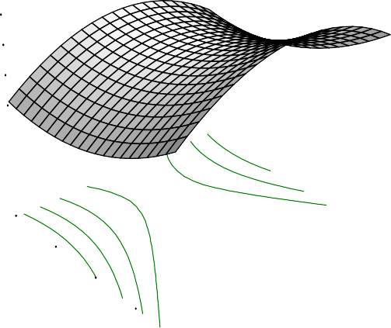Breadth
X = B: Parboiling temp Y = D: Storage Duration

Actual Factors

2.27516

A: Soaking Time = 3.00
C: Drying Temp = 520..1090518

2.1152

2.03522

1.95524
Breadth

9.00

7.00

5.00

120.00
110.00
100.00

D: Storag e Duratio3n.00

1.00

80.00
90.00
B: Parboiling temp

Fig. 4.17: Effect of parboiling temperature and storage duration on rice breadth

DESIGN-EXPERT Plot

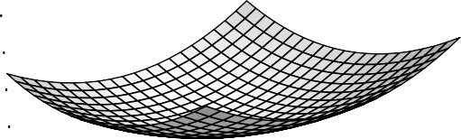Breadth
X = C: Drying Temp
Y = D: Storage Duration

Actual Factors

2.39189

A: Soaking Time = 3.00
B: Parboiling temp =2.130107.5050

2.24321

2.16886

2.09452
Breadth

9.00

7.00

5.00

50.00

60.00

70.00

D: Storag e Duratio3n.00

1.00

30.00

40.00
C: Drying Temp

Fig.4.18: Effect of drying temperature and storage duration on rice breadth

    - Head rice yield (HRY)

The result of percentage HRY ranged from 50.74 to 76.50%. The minimum value 50.74 % was recorded when paddy was stored for 1 month, soaked for 1 day, parboiled at 80⁰C, and dried at 70⁰C while the maximum value 76.45 % was obtained from paddy processed by storage for 1 month duration, soaked for 1 day, parboiled at 120⁰C, and dried at 30⁰C.There were significant differences (P < 0.05) in the result obtained for HRY. The model for the result lack of fit was not significant which was good for the model and the model F-value of 7.67 implied the model was significant. The mean value of HRY was 66.49% while the R², adjusted R², predicted R², and adjusted precision values for the model of HRY were shown (Table 4.2). Standard deviation was 3.59 and the coefficient of the model on HRY as affected by processing parameters and storage is presented (Table 4.3);

The range of HRY (50.74 - 76.50 %) is related to the result obtained by Patindol et al., (2008), 59.6 - 89.4 % for certain cultivars of rice (Bilivar, Cheniere, Dixebelle and Wells). The result of the coefficient of model (Table 4.3) showed the effectiveness of parboiling temperature (P) and storage duration (T) at increasing HRY compared to other unit operations involved. According to Marshall et al., (1993) the effect of parboiling temperature and cultivar were discovered as the reason behind the variation in HRY of rice. Well parboiled rice is harder and gives a higher yield of head rice upon milling andincomplete parboiling causes increased kernel breakage upon milling (Marshall et al., 1993).

During parboiling, profound changes occurred in physical, chemical and functional properties of rice. Starch granules undergo irreversible swelling and fusion as a result of gelatinization (Patindol et al., 2008). Research has shown that rough rice storage history can affect head rice yield and cooking quality of rice (Hamaker et al., 1993; Tamaki et al., 1993; Chrastil, 1990). Changes during storage include increase in grain hardness and these changes occur most rapidly in the first months of storage (Daniels et al., 1998). This might be responsible for the high variation obtained in %

HRY in the paddy stored for 1 month. High coefficient of storage duration (T) supported this.However, parboiling of rough rice at high temperature and the long steaming time mayproduce dark colour and harder product, hence these products fetch lower price in the market (Kimural et al., 1993; Bhattacharya, 1985).

There is relationship between head rice yield and soaking time of brown rice at different steaming time. Bhonsle and Sellappan (2010), also recorded HR recovery ranged from 45 – 74 % in the evaluation of grain quality of traditionally cultivated rice varieties of GOA, it was also reported that the quality rice variety should have HRY value of at least 70 %. HRY value depends on the grain type, chalking, cultivation practices and drying condition (Dipti et al., 2003). The Response surface graphs for the effects of parboiling temperature and soaking time, soaking time and drying temperature, soaking time and storage duration, parboiling and drying temperatures, parboiling temperature and storage duration, drying temperature and storage duration on head rice yield of parboiled Ofada rice were presented (Figs. 4.19 – 4.24).

Illustration from the response surface graphs above revealed effects of soaking time and parboiling temperature, soaking time and drying temperature, soaking time and storage duration, parboiling and drying temperatures, parboiling temperature and storage duration, and storage duration and drying temperature on head rice yield of Ofada rice and the minimum and maximum values highlighted by the graph preferences were 60.1662 - 74.2208 %, 62.3937 - 76.0548 %, 68.75 - 76.3574 %,
51.8463 - 71.8169 %, 56.9201 - 72.6891 %, and 62.1518 - 74.4918 % respectively
(Figs.4.19 – 4.24). However, from the results given above, soaking time and storage duration as shown in Figure 4.21 was more effective in maximising the head rice yield. Steady increase in parboiling temperature increases the HRY of Ofada rice to a point where further increase in parboiling temperature gives a tendency of decline in HRY.

4.1.3 Thousand Grain Weight

The values for the thousand grain weight (TGW) ranged from 240.80 to 292.20 g with average mean value of 262.04 g. However, a negative “Predicted R²” implied

that the overall mean is a best predictor of TGW than the current model. The results of TGW were not significant (p > 0.05) with the treatment. The model coefficient for the effect of processing parameters and storage on TGW of rice is presented in Table 4.3.

TGW is used as an indication of the presence of foreign materials and also to identify breeds since a particular breed of rice has its TGW range. According to Gayin et al., (2009), the acceptable range for the TGW of paddy was 20 to 30 g. Values below 20 g indicate presence of immature, damage or unfilled grains(Adu-Kwarteng et al., 2003). However, unprocessed paddy was referred to in the experiment not parboiled rice. The high value obtained in the experiment might be as a result of processing operations the Ofada rice was subjected such as soaking, that causes absorption and swelling, coupled with parboiling that lead to the gelatinization of starch with irreversible swelling and formation of hydrate with starch.

An important component of yield in rice is TGW, according to Liu et al., (2009), TGW is determined by grain length, grain width and grain thickness. Grain thickness is regarded as the strongest determinant of TGW (Liu et al., 2009). In most cases, the thousand grains could not be of a specific value but range. Several factors could determine the thousand grain weight of rice such as the variety, climatic condition and agricultural practices.

The thousand grain weight of cereals is usually done to determine likely presence of contaminants and maturity of the variety. It usually falls within a range for particular varietal specie of produce. Therefore, the range obtained from the experiment 292.20 – 240.80 g can be used as the basis for the TGW standardisation of the species of Ofada rice undergoing similar processing operations and storage.

DESIGN-EXPERT Plot

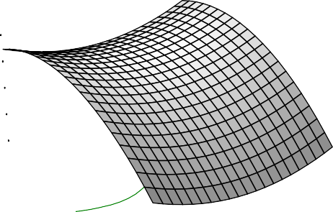HRY
X = A: Soaking Time Y = B: Parboiling temp

Actual Factors

75.2743

C: Drying Temp = 50.00
D: Storage Duration7=1.754.0701

68.2199

64.6927

61.1655
HRY

120.00

110.00

100.00

B: Parboiling tem9p0.00

2.00

5.00

4.00

3.00

80.00

1.00
A: Soaking Time

Fig.4.19: Effect of soaking time and parboiling temperature on HRY

DESIGN-EXPERT Plot

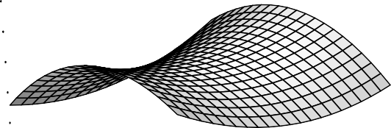HRY
X = A: Soaking Time Y = C: Drying Temp

Actual Factors

76.0548

B: Parboiling temp = 100.00 D: Storage Duration7=2.653.0905

69.2242

65.809

62.3937
HRY

70.00

60.00

50.00

3.00

4.00

5.00

C: Drying Temp40.00

30.00

1.00
2.00
A: Soaking Time

Fig.4.20: Effect of soaking time and drying temperature on HRY

DESIGN-EXPERT Plot

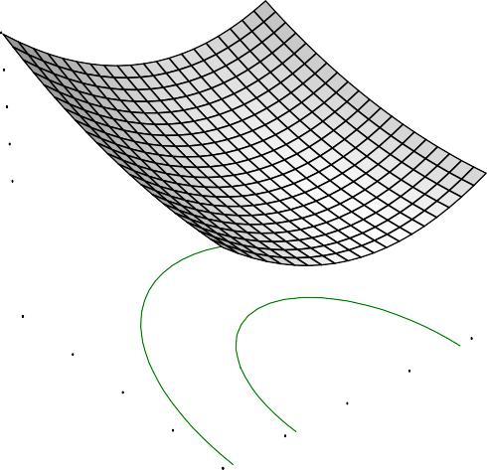HRY
X = A: Soaking Time
Y = D: Storage Duration

Actual Factors

77.7153

B: Parboiling temp = 100.00 C: Drying Temp = 5705.0.60144

73.5134

71.4124

69.3115
HRY

9.00

7.00

5.00

3.00

4.00

5.00

D: Storag e Duratio3n.00

1.00

1.00

2.00

A: Soaking Time

Fig.4.21: Effect of soaking time and storage duration on HRY

DESIGN-EXPERT Plot

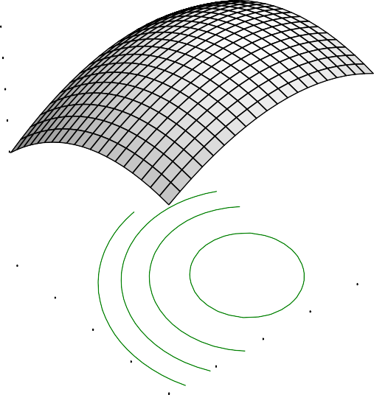HRY
X = B: Parboiling temp Y = C: Drying Temp

Actual Factors

71.8169

A: Soaking Time = 3.00
D: Storage Duration6=6.852.0403

61.8316

56.8389

51.8463
HRY

70.00

60.00

50.00

C: Drying Temp40.00

90.00

120.00

110.00

100.00

30.00

80.00
B: Parboiling temp

Fig.4.22: Effect of parboiling and drying temperature on HRY

DESIGN-EXPERT Plot

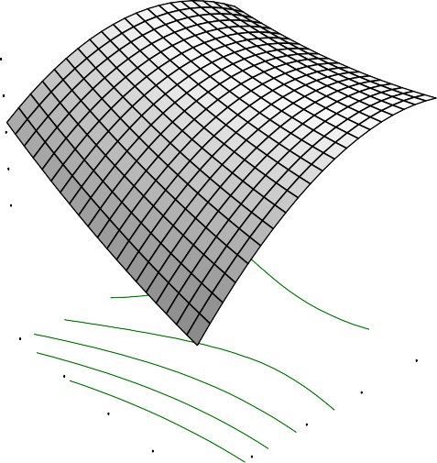HRY
X = B: Parboiling temp Y = D: Storage Duration

Actual Factors

73.6199

A: Soaking Time = 3.00
C: Drying Temp = 5609.0.60764

65.7328

61.7893

57.8457
HRY

9.00

7.00

5.00

120.00
110.00
100.00

D: Storag e Duratio3n.00

1.00

80.00
90.00
B: Parboiling temp

Fig.4.23: Effect of parboiling temperature and storage duration on HRY

DESIGN-EXPERT Plot

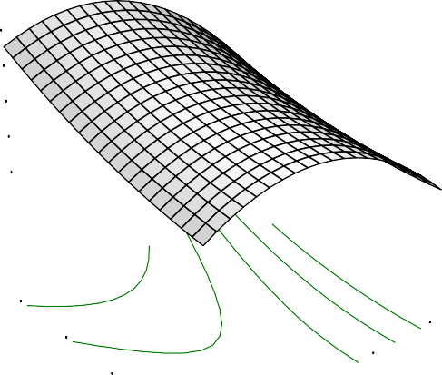HRY
X = C: Drying Temp
Y = D: Storage Duration

Actual Factors

74.4968

A: Soaking Time = 3.00
B: Parboiling temp =711.0401.0050

68.3243

65.238

62.1518
HRY

9.00

7.00

5.00

50.00

60.00

70.00

D: Storag e Duratio3n.00

1.00

30.00
40.00
C: Drying Temp

Fig. 4.24: Effect of drying temperature and storage duration on HR

80

4.1.4 Brokenness

Brokenness is another critical quality characteristic of milled rice. The degree of brokenness ranged from 0.81 to 83.08 %. The minimum value was obtained at 9 month of storage duration, 3 days soaking time, 120 ⁰C parboiling temperature, and 30 ⁰C drying temperature. The maximum value was at 1 (one) month storage duration, 1 day soaking time, 80 ⁰C parboiling temperature, and 70 ⁰C drying temperature. The results obtained for the brokenness was significant (p < 0.05) and the lack of fit test for the model was not significant. The non significant lack of fit test was favourable for the fitness of the model to define brokenness of Ofada rice as affected by processing conditions.

The overall mean value of the percentage brokenness was 27.90; the R² and adjusted R² were presented in Table 4.2. The standard deviation was14.13 and adequate precision of 7.257 measure the signal to noise ratio. The coefficient of R² recorded affirms the fitness of the model in the prediction of percentage brokenness of Ofada rice. The coefficient model that showed the effect of processing parameters on brokenness is presented (Table 4.3).

Broken grains can be classified into two, large and small broken or “brewers rice”. Large broken are milled rice with length less than three quarters but more than one quarter of the average length of the whole kernel while small broken are milled rice with length less than one quarter of the average length of the whole kernel (Saleh and Meullenet, 2012). Response surface graphs showing the interactions of the effect of soaking time and parboiling temperature, soaking time and drying temperature, soaking and storage duration, parboiling temperature and drying temperature, parboiling and storage duration, drying temperature and storage duration of ricebrokenness were presented below (Figs. 4.25-4.30).

The effect of soaking and parboiling have shown that higher parboiling temperature and longer soaking time reduced the percentage of broken grains while reduction in parboiling temperature and decrease in soaking time increased broken

grain (Fig.4.25). This report was also affirmed by the high coefficient of soaking time
- and parboiling temperature (P) (Table 4.3). From the response surface graphs, it was also revealed that these processing operations were associated with percentage brokenness of Ofada either singularly or combinations. The relatively high percentage of broken fractions could be attributed to low moisture content (Gayin et al., 2009), also chalkiness indirectly contributes to rice breakage through easier cracking (Bhattacharya, 1980).

According to Marshall et al., (1993), parboiling of paddy at high temperature increases the degree of rice starch gelatinization. Well parboiled rice is harder and less subject to transverse breakage than raw rice. However, broken grain has found its utilisation in various recipes such as adjunct in wort/beer production and in other uses (Malomo et al., 2012). High drying temperature and relatively increase in soaking time also increased broken grains (Fig.4.26). However, Itoh and Kawamaura (1991) observed that as the degree of gelatinization increases from 2 to 60, the percentage of kernel breakage decreased from 7 to 1% in a linear manner. Broken Kernels reduce milling yield. Broken grains produced during milling are generally the result of immature, chalky, or fissured kernels all of which are weak and typically break during milling due to the substantial forces imparted to kernels in order to

DESIGN-EXPERT Plot

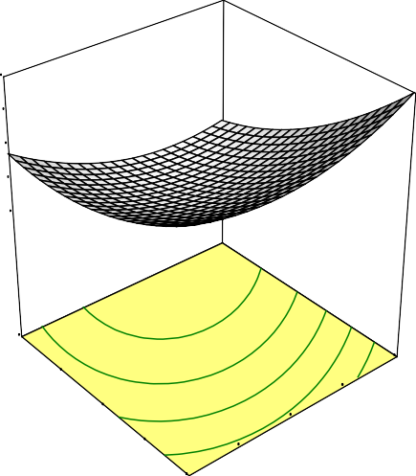
Brokenness
X = A: Soaking Time Y = B: Parboiling temp

Actual Factors

46.7442

C: Drying Temp = 50.00
D: Storage Duration =345.5.0101

22.2777

10.0444
Brokenness

-2.18884

120.00

110.00

100.00

B: Parboiling tem9p0.00

2.00

5.00
4.00
3.00

80.00

1.00
A: Soaking Time

Fig.4.25: Effect of soaking time and parboiling temperature on brokenness

DESIGN-EXPERT Plot

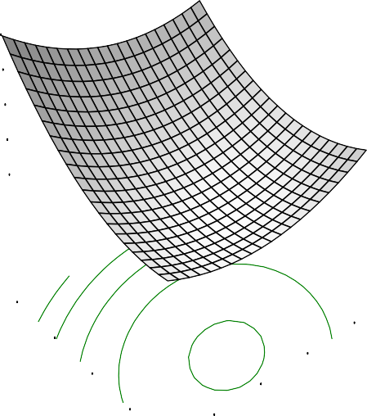Brokenness
0.00
50.0109
2653
384
0288

9233
70.00
5.00
60.00
4.00
50.00
3.00
C: Drying Temp40.00
2.00
A: Soaking Time
X = A: Soaking Time Y = C: Drying Temp

Actual Factors

49.7

B: Parboiling temp = 10 D: Storage Duration3=8.5

27.

16.
Brokenness

4.7

30.00 1.00

Fig. 4.26: Effect of soaking time and drying temperature on brokenness

DESIGN-EXPERT Plot

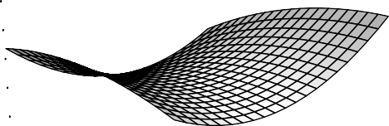Brokenness
X = A: Soaking Time
Y = D: Storage Duration

Actual Factors

23.9075

B: Parboiling temp = 100.00 C: Drying Temp = 5107.0.00979

10.2883

3.4787
Brokenness

-3.33089

9.00

7.00

5.00

3.00

4.00

5.00

D: Storag e Duratio3n.00

1.00

1.00
2.00

A: Soaking Time

Fig.4.27: Effect of soaking time and storage duration on brokenness

DESIGN-EXPERT Plot

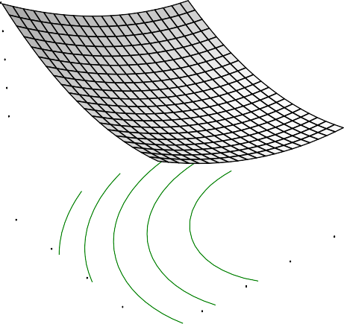Brokenness
271
59.0208
5586

4243

7099
70.00
120.00
60.00
50.00
110.00

100.00
C: Drying Temp40.00
90.00
B: Parboiling temp
X = B: Parboiling temp Y = C: Drying Temp

Actual Factors

57.8

A: Soaking Time = 3.00 D: Storage Duration4=2.6

27.

12.
Brokenness

-2.

30.00 80.00

Fig.4.28: Effect of parboiling and drying temperature on brokenness

DESIGN-EXPERT Plot

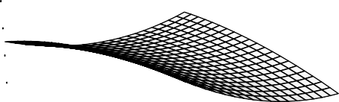Brokenness
X = B: Parboiling temp Y = D: Storage Duration

Actual Factors

43.0681

A: Soaking Time = 3.00
C: Drying Temp = 5301.0.00906

19.113

7.13551
Brokenness

-4.84202

9.00

7.00

5.00

120.00

110.00

100.00

D: Storag e Duratio3n.00

1.00

80.00

90.00
B: Parboiling temp

Fig.4.29: Effect of parboiling temperature and storage duration on brokenness

DESIGN-EXPERT Plot

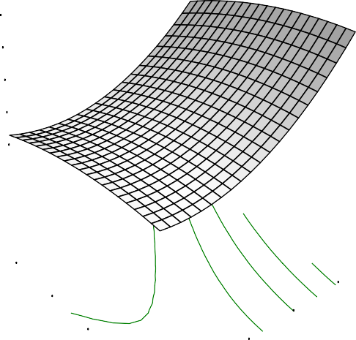Brokenness
X = C: Drying Temp
Y = D: Storage Duration

Actual Factors

40.2519

A: Soaking Time = 3.00
B: Parboiling temp =291.0007.9060

17.9072

6.73487
Brokenness

-4.43746

9.00

7.00

5.00

50.00

60.00

70.00

D: Storag e Duratio3n.00

1.00

30.00

40.00
C: Drying Temp

Fig.4.30: Effect of drying temperature and storage duration on brokenness

remove bran. Severe brokenness are only approximately 60 % of the value of head rice, HRY directly determines the economic value of rice (Siebenmorgen et al., 2010).

The kernel of rice can become cracked in the field, during the dumping process, or during the milling process. Cracks are usually caused when moisture is migrating quickly within the kernel (chopping too fast, or moisture being added back to a dry kernel). Most broken rice is removed during the milling process to less than 40% in U.S in order to give the consumer high quality rice. Broken rice tends to get mushy during cooking and makes poor quality table rice.

4.1.5. Chalkiness

The degree of percentage chalkiness ranged from 0 to 49.64% and the mean percentage chalkiness was 12.34% (Table 4.1). There were significant differences (p < 0.05) in the results obtained for the percentage of chalkiness in relation to the processing conditions. The R², Adjusted R², predicted R² and adequate precision were presented (Table 4.2) while the standard deviation was 11.73. The coefficient of the model is presented in Table 4.3. The coefficient showed the impact of soaking and parboiling in the elimination of the chalkiness in rice kernel.The response surface graphs showing the effects of soaking time and parboiling temperature, soaking time and drying temperature, soaking and storage duration, parboiling temp and drying temp, parboiling and storage duration, drying temperature and storage duration on the percentage of chalkiness were presented below (Figs.4.31 – 4.36).

The deductions from the response surface plots revealed that reduction in soaking time, high parboiling temperature, low drying temperature and increased storage duration favoured low percentage of chalkiness (Figs.4.31–4.36). The rice varieties with minimum amount of chalkiness is considered as good quality grains in comparison with chalky ones which decreases the rice grain quality (Bhonsle and Sellappan, 2010). Chalkiness higher than 1 % is considered not acceptable in parboiled rice (Gayin et al., 2009).

DESIGN-EXPERT Plot

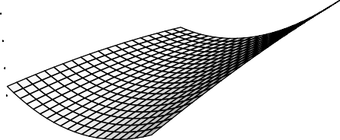Chalkiness
X = A: Soaking Time Y = B: Parboiling temp

Actual Factors

32.5946

C: Drying Temp = 50.00
D: Storage Duration2=3.551.0007

14.4268

5.34284
Chalkiness

-3.74109

120.00

110.00

100.00

B: Parboiling tem9p0.00

2.00

5.00

4.00

3.00

80.00

1.00
A: Soaking Time

Fig.4.31: Effect of soaking time and parboiling temperature on chalkiness

DESIGN-EXPERT Plot

Chalkiness
X = A: Soaking Time Y = C: Drying Temp

Actual Factors

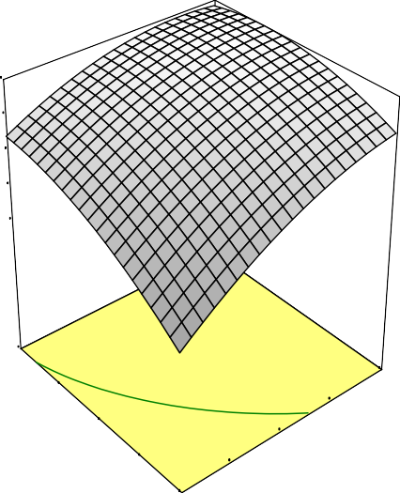7.1
0.00
59.0704
5739
021
1497

8732
70.00
5.00
60.00
4.00
50.00
3.00
C: Drying Temp40.00
2.00
A: Soaking Time

B: Parboiling temp = 10 D: Storage Duration4=.22

1.3

-1.5
Chalkiness

-4.3

30.00 1.00

Fig.4.32: Effect of soaking time and drying temperature on chalkiness

DESIGN-EXPERT Plot

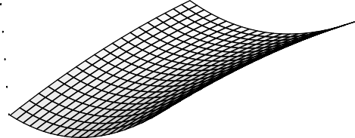Chalkiness
X = A: Soaking Time
Y = D: Storage Duration

Actual Factors

18.395

B: Parboiling temp = 100.00 C: Drying Temp = 5102.0.50165

6.63797

0.759438
Chalkiness

-5.11909

9.00

7.00

5.00

3.00

4.00

5.00

D: Storag e Duratio3n.00

1.00

1.00

2.00

A: Soaking Time

Fig.4.33: Effect of soaking time and storage duration on chalkiness

DESIGN-EXPERT Plot

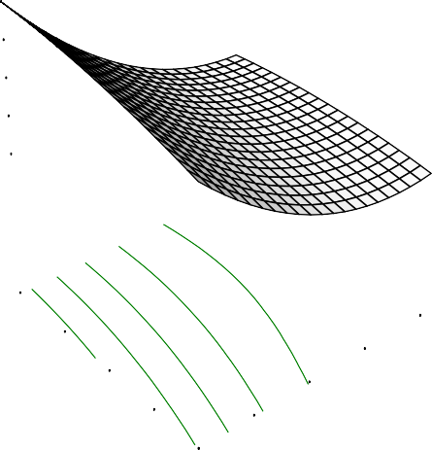Chalkiness
582
52.0905
2007

7203

5668
70.00
120.00
60.00
110.00
50.00
100.00
C: Drying Temp40.00
90.00
B: Parboiling temp
X = B: Parboiling temp Y = C: Drying Temp

Actual Factors

29.0

A: Soaking Time = 3.00 D: Storage Duration2=1.1

13.

5.2
Chalkiness

-2.6

30.00 80.00

Fig.4.34: Effect of parboiling and drying temperature on chalkiness

DESIGN-EXPERT Plot

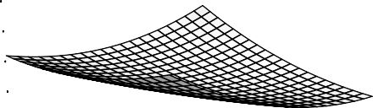Chalkiness
X = B: Parboiling temp Y = D: Storage Duration

Actual Factors

47.1926

A: Soaking Time = 3.00
C: Drying Temp = 5305.0.20133

23.234

11.2547
Chalkiness

-0.724572

9.00

7.00

5.00

120.00

110.00

100.00

D: Storag e Duratio3n.00

1.00

80.00

90.00
B: Parboiling temp

Fig.4.35: Effect of parboiling temperature and storage duration on chalkiness

DESIGN-EXPERT Plot

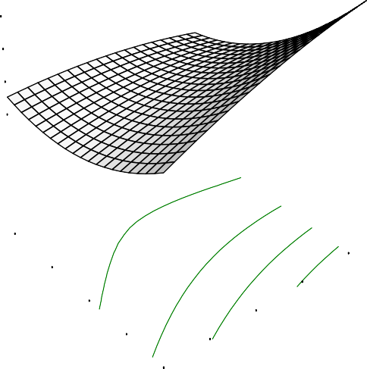Chalkiness
X = C: Drying Temp
Y = D: Storage Duration

Actual Factors

23.1997

A: Soaking Time = 3.00
B: Parboiling temp =161.0909.9060

10.7996

4.59949
Chalkiness

-1.60059

9.00

7.00

5.00

50.00

60.00

70.00

D: Storag e Duratio3n.00

1.00

30.00

40.00
C: Drying Temp

Fig.4.36: Effect of drying temperature and storage duration on chalkiness

Bhonsle and Sellappan (2010) reported 24.1-85% of chalkiness in some varieties of rice in India made up of white centre and white back based on the position and orientation of chalkiness. Chalkiness disappears upon cooking and has no effect on taste or aromahowever; it downgrades the grain quality and reduces milling recovery. The results obtained showed dependence of rice chalkiness which is mainly on parboiling temperature and partially on soaking time. The degree of gelatinization which results in the conversion of starch to gel depends on steaming temperature. Chalky rice occurs when part of the grain is whiter than the rest because this is where the starch has not developed properly and is a point of weakness.
Chalkiness and grain wholeness are the two characteristics that both domestic and international rice markets base their grading on. Two things known to cause chalkiness in the grains are the genetics of the rice variety and higher growing temperatures. Unfortunately, since farmers cannot manage their rice crops to reduce grain chalkiness nor can they do anything to change temperature; they must rely on growing varieties less susceptible to chalkiness. A lot of research is still on to find out why it has been so difficult to eliminate chalkiness from rice improvement programs (IRRI, 2007).The findings from this study have shown that appropriate processing technology could reduce chalkiness in rice grain.
4.1.6. Colour assessment of Ofada rice

Colour is an important attribute in acceptability of food products such as rice. The result of the colour lightness (L*) and colour values were presented (Table 4.1). The value of rice lightness ranged from 65.99 to 78.80. There exist significant differences at p < 0.05 on rice lightness obtained from the experiment. The closeness of the values of rice lightness to the standard (A4 paper of 91.83whiteness) was used to determine the percentage whiteness. The highest lightness was from Ofada rice stored for 5 months, soaked for 3 days, parboiled and dried at 120°C and 50°C respectively while lowest was from rice stored for 1 month, soaked for 5 days, parboiled and dried at 120°C and 70°C temperatures respectively.

The lack of fit test for the model is not significant with the F-value of 3.80. The coefficient of the mathematical quadratic model is presented (Table 4.3). High coefficients of drying (D) and storage (T) showed that the outcome of rice colour after processing is dependent on drying temperature and storage duration. The data in Table
4.3 revealed that increase in soaking time was favourable to the whiteness of Ofada rice while the effect of parboiling temperature was not prominent. The impact of low drying temperature is good for the processing of Ofada rice similar to the result of Adeyemi et al., (1986) which recommended the drying of rice in shade under good aeration. High coefficient of drying (D) model also supported the impact of drying temperature on whiteness of milled rice (Table 4.3). The curve for the storage duration is concave downward with the mid experimental drying temperature most preferred to obtain light colour of rice which is more preferred in term of acceptability.
4.17. Effect of storage and processing conditions on colour value of Ofada rice

The results of colour value as calculated from a* and b* were presented (Table 4.1). There was no significant difference in the value obtained (p > 0.05). The highest colour value was obtained from paddy rice stored for 9 months and processed by soaking for 5 days, 80°C parboiling temperature and 30°C drying temperature while the minimum value was rough rice stored for only 1 month and treated by soaking for 5 days, parboiling at 120°C and drying at 70°C. The lack of fit test for the model was not significant with the F-value of 0.055 which was good for the fitness of the equation to describe the experiment. The R², adjusted R², predicted R², adequate precision were presented (Table 4.2). The quadratic coefficient of the model is presented (Table 4.3). The coefficient revealed that all the processing parameter contributed to the colour of Ofada rice.
As presented in the Table 4.1, colour value increased with increase in drying temperature, storage duration and soaking time while increase in parboiling temperature reduced colour value. This is similar to the investigation by Sareepuang et al., (2008), that due to parboiling treatment, discolouration of grain occurs which decreases the lightness value. The negative effect of parboiling is as a result of

discoloration of rice mainly caused by Maillard type non enzymatic browning and the processing conditions determine the intensity of colour during parboiling.
4.1.8. Optimisation of physical characteristics of Ofada rice

The physical qualities selected for optimisation of Ofada rice include maximum length, maximum width, minimum brokenness, maximum head rice yield, minimum chalkiness, and maximum colour lightness. The best optimum storage and processing conditions obtained revealed storage of paddy for 1 month, soaking in water for 1 day, parboiling at 119.92°C and drying at 30.32°C. Other solutions and their yields were presented (Table 4.4). The prediction would be useful for upgrading the present quality ofOfada rice and sustenance of its physical quality. Hence, this would also allow healthy competition of indigenous rice with imported rice.

Table 4.4: Predicted solutions for optimisation of physical qualities of Ofada rice
No | Soaking | Parboiling | Drying | Storage | Length | Width | Breadth | HRY | Brokenness |  | Chalkiness | Lightness | Desirability
 | time,days | temp. °C | temp.°  C | ,  month | mm | mm | mm | % | % |  | %
1 | 1.00 | 119.92 | 30.32 | 1.00 | 6.005 | 3.016 | 2.349 | 73.22 |  | 3.606 | 0.005 | 77.612 | 0.88
2 | 1.00 | 119.96 | 31.76 | 1.31 | 6.008 | 2.998 | 2.31 | 73.532 |  | 4.495 | 0.001 | 78.043 | 0.872
3 | 1.62 | 120.00 | 30.00 | 1.00 | 6.003 | 3.009 | 2.364 | 70.865 |  | -1.339 | -0.18 | 76.72 | 0.8723
4 | 1.18 | 120.00 | 37.94 | 1.00 | 6.061 | 2.999 | 2.266 | 74.313 |  | 2.463 | 2.942 | 77.238 | 0.872
5 | 1.00 | 117.27 | 30.80 | 1.00 | 5.947 | 3.029 | 2.36 | 73.894 |  | 3.535 | 0.247 | 76.643 | 0.872
6 | 1.00 | 116.84 | 30.00 | 1.19 | 5.924 | 3.027 | 2.36 | 73.674 |  | 4.228 | -0.479 | 76.746 | 0.872
7 | 1.00 | 116.07 | 32.27 | 1.00 | 5.933 | 3.03 | 2.349 | 74.477 |  | 3.56 | 0.974 | 76.238 | 0.872
8 | 1.28 | 120.00 | 36.72 | 2.40 | 6.011 | 2.944 | 2.198 | 73.267 |  | 4.975 | -6.276 | 78.65 | 0.872
9 | 4.51 | 120.00 | 33.17 | 1.00 | 6.114 | 2.781 | 2.254 | 68.846 |  | -2.537 | -6.276 | 73.974 | 0.872

  - Chemical quality of Ofada rice

The results of the effect of processing conditions and storage on the chemical qualities of Ofada rice (OS-6) were presented (Table 4.5).
    - Moisture content of Ofadarice

The result of percentage moisture content ranged from 4.35 to 10.30 % with
7.64 % as the mean value. It was shown that quadratic model best fit the experiment while there existed significant differences (p<0.05) in moisture contents ofOfada as influenced by the processing conditions. The R², adjusted R², predicted R², adequate precision were presented (Table 4.6). A very low value of standard deviation (0.56) confirmed the fitness of the model andcoefficient of the model in term of actual factor is presented (Table 4.7). The response surface graphs on the effects of interactions of two variables (soaking time and parboiling temperature, soaking time and drying temperature, soaking and storage duration, parboiling temperature and drying temperature, parboiling and storage duration, drying temperature and storage duration) were presented (Figs.4.55-4.60).
The highest amount of moisture (10.30 %) was recorded at 1 month of paddy storage, 5 days of soaking, 80⁰C parboiling temperature, and 30⁰C drying temperature while the lowest (4.35%) was at the storage duration of 9 months, 1 day soaking, 120⁰C parboiling and 50 ⁰C drying temperature. Adeyemi et al., (1985) on the study of rice processing options for Nigerian rice industry recorded a moisture range between
10.12 to 13.88%; Ebuchi and Oyewale (2007) between 7.5-11.2%. The variation may majorly be influenced by the variety and the prevailing condition of treatment, processing and environmental factors (Ebuchi and Oyewole, 2007).
The low amount of moisture recorded may be due presence of wax content in brown rice seed coat and on the pericarp which reduces water absorption (Roy et al., 2011). The post harvest stability of the grains depend on their moisture contents at harvest, conditions prevailing in their immediate environment during transportation, pre-processing and storage; and also on their moisture sorption behaviours (Ajisegiri et

94

al., 2007). Water as the most important storage factor plays a significant role in storage stability of agricultural produce depending on the chemical composition and physical structure of the produce and on the form in which it exist in the produce (Ajisegiri and Chukwu, 2004). High coefficient value of soaking revealed its effect on moisture content of rice.

95

Table 4.5: Chemical composition of Ofada rice
Run | Soaking | Parboiling | Drying | Storage | Moisture | Protein | Ether extract | Ash | Carbohydrate | Crude fibre | Fatty acid | Metabolizable Energy | Amylose
 | day | ᵒC | ᵒC | Month | % | % | % | % | % | % | % | kcal/100g | %
1 | 1 | 120 | 70 | 1 | 8.95 | 9.52 | 1.93 | 0.58 | 78.65 | 0.37 | 1.56 | 379.7 | 21.34
2 | 1 | 80 | 70 | 1 | 7.45 | 8.67 | 1.66 | 0.57 | 81.31 | 0.34 | 2.9 | 385.26 | 23.67
3 | 5 | 80 | 30 | 5 | 7.8 | 10.00 | 1.64 | 1.02 | 80.03 | 0.28 | 3.06 | 381.92 | 20.93
4 | 5 | 80 | 30 | 1 | 10.3 | 8.71 | 1.61 | 0.46 | 78.63 | 0.29 | 4.78 | 373.85 | 25.29
5 | 3 | 80 | 30 | 9 | 5.48 | 10.44 | 1.81 | 0.77 | 81.36 | 0.14 | 3.22 | 393.79 | 19.71
6 | 5 | 80 | 50 | 5 | 8.35 | 9.05 | 1.36 | 0.53 | 80.54 | 0.17 | 2.95 | 381 | 21.76
7 | 1 | 120 | 30 | 5 | 7.8 | 9.74 | 1.72 | 1.01 | 79.51 | 0.22 | 1.37 | 382.37 | 20.93
8 | 5 | 80 | 70 | 1 | 8.01 | 8.68 | 1.62 | 0.57 | 80.78 | 0.34 | 2.09 | 382.77 | 23.05
9 | 3 | 120 | 70 | 9 | 4.72 | 9.21 | 1.04 | 0.54 | 84.35 | 0.14 | 2.84 | 384.79 | 23.55
10 | 3 | 120 | 50 | 5 | 8.75 | 9.43 | 1.69 | 0.53 | 79.41 | 0.19 | 1.86 | 380.52 | 18.47
11 | 5 | 120 | 30 | 9 | 5.25 | 9.96 | 0.7 | 0.65 | 83.29 | 0.15 | 1.42 | 390.4 | 25.58
12 | 1 | 100 | 50 | 5 | 8.65 | 9.31 | 1.8 | 0.93 | 79.13 | 0.18 | 1.51 | 374.62 | 19.09
13 | 3 | 120 | 70 | 5 | 8 | 9.19 | 1.91 | 0.63 | 81.04 | 0.23 | 1.49 | 388.23 | 20.5
14 | 1 | 100 | 50 | 9 | 6.93 | 8.86 | 1.18 | 0.78 | 82.06 | 0.19 | 1.78 | 385.1 | 25.51
15 | 5 | 120 | 50 | 9 | 4.35 | 9.31 | 1.98 | 0.78 | 83.4 | 0.18 | 1.79 | 399.07 | 20.38
16 | 1 | 120 | 70 | 1 | 9.1 | 8.42 | 1.24 | 0.58 | 80.29 | 0.37 | 1.23 | 376.55 | 20.98
17 | 3 | 100 | 50 | 5 | 6.65 | 9.83 | 1.42 | 0.74 | 81.13 | 0.23 | 3.04 | 386.94 | 18.12
18 | 5 | 100 | 50 | 5 | 9.86 | 8.92 | 1.68 | 0.54 | 78.66 | 0.34 | 1.82 | 375.46 | 24.86
19 | 1 | 80 | 30 | 1 | 9.7 | 8.78 | 1.71 | 0.47 | 79.05 | 0.29 | 3.2 | 376.7 | 26.54
20 | 1 | 120 | 30 | 1 | 9.3 | 10.14 | 1.27 | 0.47 | 78.58 | 0.24 | 1.43 | 376.26 | 22.39
21 | 5 | 100 | 30 | 9 | 4.83 | 9.31 | 2 | 0.52 | 83.18 | 0.16 | 2.66 | 398.33 | 19.95
22 | 1 | 80 | 70 | 5 | 8.95 | 9.07 | 0.98 | 0.7 | 80.11 | 0.19 | 1.64 | 367.18 | 24.44
23 | 5 | 80 | 70 | 9 | 5.95 | 9.48 | 3.76 | 0.71 | 79.98 | 0.12 | 3.66 | 400.4 | 20.5
24 | 1 | 80 | 30 | 9 | 6.57 | 10.35 | 2.25 | 0.11 | 81.7 | 0.13 | 2.41 | 393.23 | 22.28
25 | 1 | 120 | 30 | 1 | 9.2 | 9.87 | 1.36 | 0.47 | 78.86 | 0.24 | 1.59 | 377.14 | 21.46

96

Table 4.6: ANOVA of regression of chemical properties as a function of storage and processing conditions
Parameters | p-value | R2 | Adjusted R² | Predicted R² | Adequate precision
Moisture,% | <0.0001 | 0.9573 | 0.8976 | 0.4633 | 13.954
Protein content, % | 0.0297 | 0.8253 | 0.5806 | -1.0142 | 5.917
Ether extract,% | 0.0246 | 0.8332 | 0.5998 | -0.6776 | 10.048
Ash content,% | 0.6911 | 0.5149 | -0.1643 | -7.3242 | 3.201
Crude fibre, % | 0.0082 | 0.8717 | 0.692 | -1.4198 | 7.063
Carbohydrate,% | 0.0012 | 0.917 | 0.8009 | 0.0038 | 9.357
Fatty acid,% | 0.0644 | 0.7867 | 0.4881 | -2.2444 | 5.182
Metabolizable energy,kcal/100g | <0.0001 | 0.9681 | 0.9234 | 0.2367 | 17.553
Amylose, % | 0.038 | 0.814 | 0.5535 | -2.2422 | 6.241

Table 4.7: Coefficient of model on effect of storage and processing parameters on chemical quality of Ofada rice
 | Moisture | Protein | Fat | Ash | CHO | Crude fibre | fatty acids | ME | Amylose
 | % | % | % | % | % | % | % | kcal/kg | %
Intercept | -3.02 | 19.94 | 1.32 | 1.03 | 93.27 | -0.1 | 16.71 | 448.37 | 3.16
S | 3.43 | -12.8 | -0.47 | -0.53 | -1.44 | -4.96x10⁻⁴ | -0.63 | -7.81 | 7.6
P | 0.34 | -0.17 | -0.05 | -0.02 | -0.18 | 0.01 | -0.16 | -1.72 | 0.76
D | -0.19 | 0.02 | 0.06 | 0.04 | -0.05 | -7.48x10⁻³ | -0.11 | 0.68 | -0.83
T | 0.43 | 0.5 | 0.5 | 0.11 | -1.23 | -0.02 | -0.58 | 2.17 | -3.24
S2 | -6.37 | 0.09 | 0.1 | 0.05 | 0.12 | -5.58x10⁻³ | 0.02 | 1.13 | -0.99
P2 | -1.53x10⁻³ | 9.41x10⁻⁴ | 2.8x10⁴ | 7.05x10⁻⁵ | 4.87x10⁻⁴ | -8.45x10⁻⁵ | 2.63x10⁻⁴ | 7.93x10⁻³ | -4.01x10⁴
D2 | 1.66x10⁻³ | -2.89x10⁻⁴ | -4.33x10⁻⁴ | -2.49x10⁻⁴ | 5.31x10⁻⁵ | 3.98x10⁻⁵ | -1.09x10⁻⁴ | -6.31x10⁻³ | 8.42x10⁻³
T2 | -0.05 | -0.01 | 5.97x10⁻³ | -0.01 | 0.05 | 4.82x10⁻⁴ | 0.02 | 0.31 | 0.09
SP | -0.08x10⁻³ | 8.69x10⁻⁴ | 4.23x10⁻³ | 2.49x10⁻³ | -1.58x10⁻³ | 3.70x10⁻⁴ | 6.08x10⁻³ | 0.04 | -0.02
SD | -2.43x10⁻³ | 3.99x10⁻⁴ | -9.31x10⁻³ | 6.57x10⁻⁵ | 9.41x10⁻³ | -5.34x10⁻⁵ | 2.85x10⁻³ | -0.09 | 0.01
ST | -0.02 | 0.03 | -0.04 | 5.65x10⁻³ | 0.05 | -1.04x1010⁻³ | -0.01 | -0.19 | 0.01
PD | -8.31x10⁻⁵ | -4.13x10⁻⁵ | 4.26x10⁻⁶ | -1.33x10⁻⁴ | 6.28x10⁻⁴ | 5.27x10⁻⁵ | 9.10x10⁻⁴ | 2.89x10⁻³ | 5.52x10⁻⁴
PT | -5.56x10⁻³ | -3.5x10⁻³ | -4.96x10⁻³ | 3.26x10⁻⁴ | 0.01 | 1.01x10⁻⁴ | 1.66x10⁻³ | -0.02 | 0.02
DT | 5.56x10⁻³ | -7.44x10⁻⁴ | 1.87x10⁻³ | -1.12x10⁻⁵ | -6.91x10⁻³ | -2.53x10⁻⁴ | 5.51x10⁻³ | -0.03 | 9.49x10⁻³

According to Roy et al., (2000), it is believed that milled and brown rice exhibit different rates of moisture absorption with milled rice initially absorbing water at a faster rate than brown rice because the milling treatment removes the outer protective layers of rice caryopsis, the endosperms of milled rice becomes relatively prone to water absorption (Siebenmorgan and Meullenet, 2004). However, it could be observed that the presence of some bran layer that is usually remained on Ofada rice seed coat and on the pericarp could be responsible for the reduction of water absorption, hence the low moisture content.
4.2.2 Protein content of Ofada rice

The result of the percentage protein contents ranged from 8.42 to 10.44% with the average mean of 9.37 % (Table 4.5).There were significant differences (p < 0.05) in protein contents of the milled Ofada rice as affected by storage duration and processing condition. The R², adjusted R², predicted R² and adequate precision were presented in Table 4.6. The non significance lack of fit test shown by ANOVA was good for the model. The coefficient of the model is presented (Table 4.7).Drying temperature (D) and storage duration (T) as processing parameters have positive influence on protein content of rice. The response surface plots for the effect of interaction between two variables of the processing conditions were given (Figs. 4.37 – 4.42).
The highest amount of protein (10.49 %) was recorded in Ofada rice paddy stored for 9 months, soaked for of 5 days, parboiled at 80°C, and dried at 30°C while the lowest (8.92 %) was at 1(one) month of paddy storage, 5 days of soaking, 120°C parboiling temperature, and 70°C drying temperature. The result of some protein contents were higher than protein contents reported by some authors. Megat- Rusydi et al., (2011) reported a range of 4.78 - 6.45 %; Ebuechi and Oyewole (2007) 6.95 - 7.30
%; Oko and Ugwu (2011), 1.53 %. This investigation had showed the significance of Ofada rice in human nutrition compared to other varieties of rice. However, the result of the protein content was related to the range obtained by Otegbayo et al., (2001) on two local rice varieties from Ekiti, Nigeria (6.85-8.75 %). The variation may be as a

result of processing conditions, types of soil where the rice is cultivated, the varietal differences, harvesting and handling (Abbas et al., 2011). This study revealed the effectiveness of processing operations in improving the nutritional quality of rice.
The response surface plots shown that soaking time produced an upward curve with extremes (1 and 5 days) favouring increase in protein (Figs. 4.37, 4.38, and 4.39). The effect of parboiling temperatures and drying were opposite. Parboiling temperature brought about a relative improvement in protein contents (Figs. 4.38, 4.40 and 4.41), drying showed opposite effects (Figs.4.38, 4.40 and 4.42).
Rice polishing operation may lead to loss of 29 % of the protein (Abba et al., 2011). It was also recorded that the differences in protein contents between two varieties of rice of about 2 g per 100 g may not at first right appear to be large, but on accumulation the changes may be very important. The significance of the protein contents can be attributed to the effect of parboiling temperature. High heat treatment such as high parboiling temperature can reduce protein during processing while mild temperature treatment could assist in retaining protein in food under processing although this could be dependent on parboiling time. Patindol et al., (2008) in the experiment on effect of parboiling on rough rice using mild and severe parboiling temperature, the result showed that parboiling at severe temperature reduced protein content of rice compared with the control and this also varied with evaluated cultivars.

DESIGN-EXPERT Plot

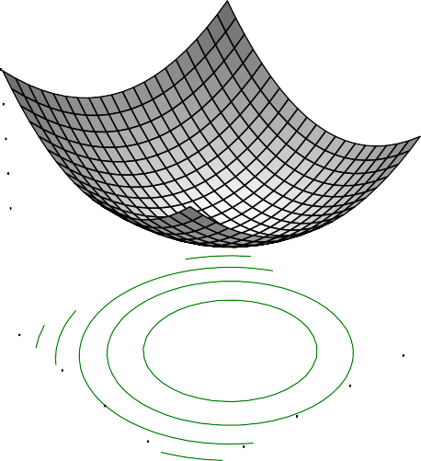Protein
X = A: Soaking Time Y = B: Parboiling temp

Actual Factors

9.79822

C: Drying Temp = 50.00
D: Storage Duration9=.5855.0301

9.3724

9.15948

8.94657
Protein

120.00

110.00

100.00

B: Parboiling tem9p0.00

2.00

5.00

4.00

3.00

80.00

1.00
A: Soaking Time

Fig.4.37: Effect of soaking time and parboiling temperature on protein

DESIGN-EXPERT Plot

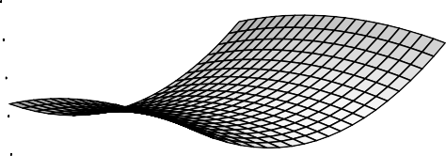Protein
0.00
57.0703

0564
907
6507

7374
70.00
5.00
60.00
4.00
50.00
3.00
C: Drying Temp40.00
2.00
A: Soaking Time
X = A: Soaking Time Y = C: Drying Temp

Actual Factors

9.63

B: Parboiling temp = 10 D: Storage Duration9=.34

9.

8.7

8.4
Protein

30.00 1.00

Fig. 4.38: Effect of soaking time and drying temperature on protein

DESIGN-EXPERT Plot

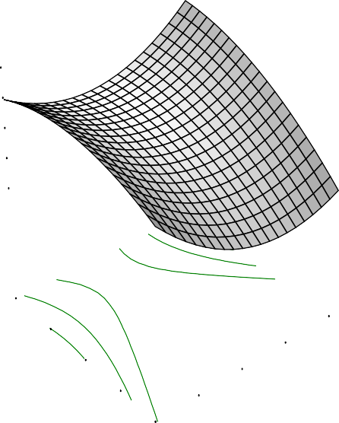Protein
X = A: Soaking Time
Y = D: Storage Duration

Actual Factors

9.55154

B: Parboiling temp = 100.00 C: Drying Temp = 590..2070136

8.99119

8.71101

8.43083
Protein

9.00

7.00

5.00

3.00

4.00

5.00

D: Storag e Duratio3n.00

1.00

1.00
2.00

A: Soaking Time

Fig.4.39: Effect of soaking time and storage duration on protein

DESIGN-EXPERT Plot

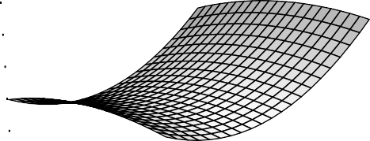Protein
585
54.0807

0739

7293

7195
70.00
60.00
120.00

110.00
50.00
100.00
C: Drying Temp40.00
90.00
B: Parboiling temp
X = B: Parboiling temp Y = C: Drying Temp

Actual Factors

9.67

A: Soaking Time = 3.00 D: Storage Duration9=.37

9.

8.7

8.4
Protein

30.00 80.00

Fig. 4.40: Effect of parboiling and drying temperature on protein

DESIGN-EXPERT Plot

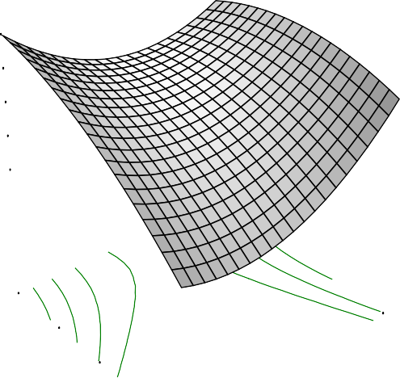Protein
X = B: Parboiling temp Y = D: Storage Duration

Actual Factors

9.62686

A: Soaking Time = 3.00
C: Drying Temp = 590..3010802

9.00918

8.70034

8.39149
Protein

9.00

7.00

5.00

120.00

110.00
100.00

D: Storag e Duratio3n.00

1.00

80.00

90.00
B: Parboiling temp

Fig.4.41: Effect of parboiling temperature and storage duration on protein

DESIGN-EXPERT Plot

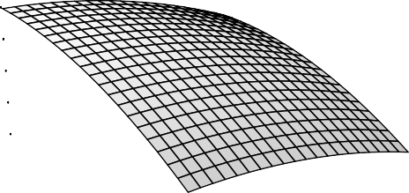Protein
X = C: Drying Temp
Y = D: Storage Duration

Actual Factors

9.36066

A: Soaking Time = 3.00
B: Parboiling temp = 91.0003.5010

8.70954

8.38398

8.05842
Protein

9.00

7.00

5.00

50.00

60.00

70.00

D: Storag e Duratio3n.00

1.00

30.00

40.00
C: Drying Temp

Fig. 4.42: Effect of drying temperature and storage duration on protein

Solubility of protein during soaking can also contribute to the variation of protein contents in Ofada rice by the process of leaching into the water during soaking which may also be relative to the soaking time.According to Zhouet al., (2001), ageing of rice do not give any significant change in protein during storage, although its general solubility may be reduced. The effect of soaking on chemical composition of processed rice has also been established by Sareepuanget al., (2008). The study concluded that soaking of rice in 50⁰C water produced the highest amount of protein. Rice proteins are valuable because they are colourless and having a bland taste. Rice proteins are non allergic and possessing cholesterol reducing properties (Chrastil, 1992). The milled rice protein has less protein while brown rice shows maximum retention of protein (Ellis et al., 1985).
    - Fat content of Ofadarice

The result of the effect of processing condition and storage duration on fat ranged from 0.70 to 3.76 % with mean value at 1.65 % (Table 4.5). There were significant differences at p < 0.05 in the result obtained due to the varied levels of processing conditions and storage duration. One day of soaking, 80⁰C of parboiling, 70⁰C drying temperature and 9 months storage produced the highest value of fats (3.76
%) while the lowest (0.70 %) was also recorded at the same storage duration but the treatment involved 3 days of soaking, 120⁰C parboiling temperature, and 30⁰C drying temperature.
The lack of fit was not significant which was good for the model prediction. The R², Adjusted R², predicted R², and adequate precision were presented (Table 4.6). Low values of standard deviation and PRESS values were 0.36 and 12.97 respectively which favoured the reliability of prediction. Adequate precision of 10.048which is greater than 4 gave an indication that this model can be used to navigate the design. The coefficient of the model showing the effect of processing units and their interactions is presented (Table 4.7).

The response surface graphs showing the effects of interactions of soaking time and parboiling temperature, soaking time and drying temperature, soaking and storage duration, parboiling and drying temperature, parboiling and storage duration, drying temperature and storage duration on fat composition of Ofada were presented (Figs.4.43- 4.44).

DESIGN-EXPERT Plot

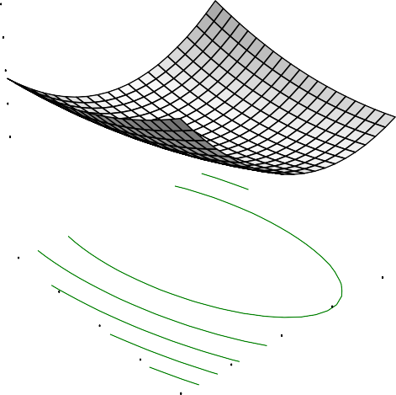Ether Extract
X = A: Soaking Time Y = B: Parboiling temp

Actual Factors

2.27295

C: Drying Temp = 50.00
D: Storage Duration2=.0255.0002

1.77709

1.52916
Ether Extract

1.28122

120.00

110.00

100.00

B: Parboiling tem9p0.00

2.00

5.00
4.00
3.00

80.00

1.00
A: Soaking Time

Fig.4.43: Effect of soaking time and parboiling temperature on fat

DESIGN-EXPERT Plot

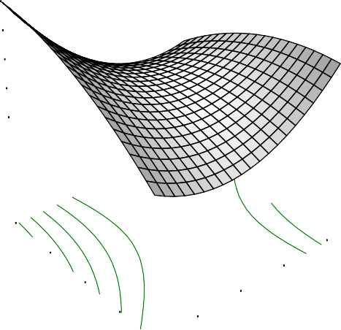Ether Extract
0.00
51.0307
6572
701
8008

4434
70.00
5.00
60.00
4.00
50.00
3.00
C: Drying Temp40.00
2.00
A: Soaking Time
X = A: Soaking Time Y = C: Drying Temp

Actual Factors

2.13

B: Parboiling temp = 10 D: Storage Duration1=.85

1.5

1.2
Ether Extract

0.99

30.00 1.00

Fig. 4.44: Effect of soaking time and drying temperatureon fat

DESIGN-EXPERT Plot

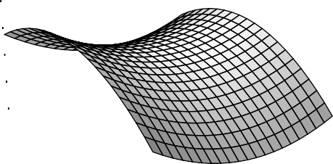Ether Extract
334
59.0908
9662

8326

6991
70.00
120.00
60.00
110.00
50.00
100.00
C: Drying Temp40.00
90.00
B: Parboiling temp
X = B: Parboiling temp Y = C: Drying Temp

Actual Factors

1.52

A: Soaking Time = 3.00 D: Storage Duration1=.40

1.2

1.1
Ether Extract

1.0

30.00 80.00

Fig.4.45: Effect of parboiling and drying temperature on fat

DESIGN-EXPERT Plot

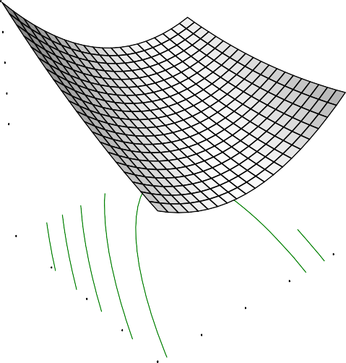Ether Extract
X = A: Soaking Time
Y = D: Storage Duration

Actual Factors

2.47488

B: Parboiling temp = 100.00 C: Drying Temp = 520..1050598

1.83708

1.51817
Ether Extract

1.19927

9.00

7.00

5.00

3.00

4.00

5.00

D: Storag e Duratio3n.00

1.00

1.00

2.00
A: Soaking Time

Fig. 4.46: Effect of soaking time and storage duration on fat

DESIGN-EXPERT Plot

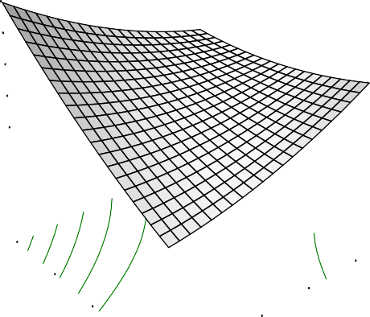Ether Extract
X = B: Parboiling temp Y = D: Storage Duration

Actual Factors

2.21442

A: Soaking Time = 3.00
C: Drying Temp = 510..9010536

1.61629

1.31723
Ether Extract

1.01817

9.00

7.00

5.00

120.00
110.00
100.00

D: Storag e Duratio3n.00

1.00

80.00
90.00
B: Parboiling temp

Fig.4.47: Effect of parboiling temperature and storage duration on fat

DESIGN-EXPERT Plot

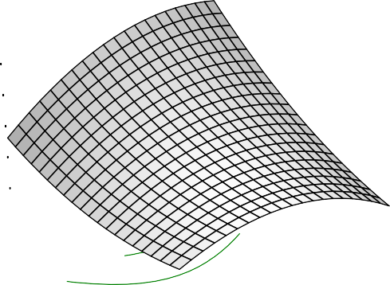Ether Extract
X = C: Drying Temp
Y = D: Storage Duration

Actual Factors

1.65905

A: Soaking Time = 3.00
B: Parboiling temp = 11.0407.6030

1.29354

1.11078
Ether Extract

0.92802

9.00

7.00

5.00

50.00

60.00

70.00

D: Storag e Duratio3n.00

1.00

30.00
40.00
C: Drying Temp

Fig. 4.48: Effect of drying temperature and storage duration on fat

Soaking period of between 3 – 4 days produced the lowest amount of fat as shown by the graphs while 1 and 5 days soaking were responsible for the high fat contents recorded (Figs.4.43,4.44, and 4.45). It was discovered from the graphs that the fat concentrations relatively reduced with increase in parboiling temperature which showed that 80°C parboiling temperature accorded the highest lipid content (Figs.4.43,
4.46 and 4.47). High temperature increases extraction of fat (Fennema, 1996).The drying temperature of 30°C produced lowest amount of fat and the lipid content increased with elongation of storage (Figs. 4.44, 4.47and 4.48).
Zhou et al., (2001), recorded lipid content of 1.65 – 1.75 % for rice stored for 12 months with lipid content decreasing with period of storage. However, this was not in line with the result obtained from this study as the highest percentage of 3.76 was recorded at 9 months of storage. According to Akinoso and Adeyanju (2010), oil recovery and yield is dependent on solvent and the method of extraction. Large deposit of oil was found in Ofada rice bran in the experiment conducted by Akinoso and Adeyanju, (2010), which ranged between 11.3 – 14.50 % as affected by the treatment condition(roasting temperature and roasting duration). This has shown that large deposit of oil in Ofada rice is found in the bran which invariably might have been removed during polishing and processing.
Storage duration has effect on the fat compared to the processing conditions as shown by the high coefficient of storage (T) (Table 4.7). Similar work by Patindol et al., (2008), where rough rice were subjected to parboiling at temperature of 100⁰C and 120⁰C recorded, percentage lipid ranged from 0.30 to 0.84 which cut across the various four cultivars investigated. The low fat content has revealed that rice may not be quickly prone to auto-oxidation and rancidity. Rice lipids are usually stable in the intact spherosomes in the cell. However, when the lipids membrane is destroyed by phospholipase as a result of physical injury or high temperature, lipid hydrolysis is initiated by the action of lipases (Zhouet al., 2001).

    - Ash content ofOfada rice

Ash content is the approximation of mineral composition of a food sample. The result of ash contents ranged from 0.11 to 1.02 % with the mean value at 0.63. The highest amount of ash (1.02 %) was obtained at processing condition; 5 months of storage duration, 1 day soaking, 80⁰C parboiling temperature, and 30⁰C drying temperature while the minimum level of ash was obtained at 5 months storage duration, 5 days of soaking, 80⁰C parboiling
temperature, and 30 ⁰C drying temperature. The values for R², adjusted R², predicted R² and adequate precision were presented (Table 4.6) and the coefficient of model depicting effect of processing parameters and storage on ash is shown (Table 4.7).
Negative predicted R² showed that mean was the best predictor of the effect of processing parameters on ash content of Ofada rice. The extremes soaking time (1 and 5 days) showed maximum increase of ash while the variation in parboiling temperature did not depict notable changes in the ash content (Table 4.7). The result obtained in this experiment was low compared to the ash content obtained by Chukwu and Oseh, (2009). In the study, 1.50 % was recorded for unparboiled paddy and 2.028 to 2.39 % range were recorded for the same variety of rice parboiled at different temperatures of 80⁰C, 100⁰C and 120⁰C (Chukwu and Oseh, 2009). The effect of soaking time and storage duration were more felt compared to drying temperature and parboiling temperature in this study.
    - Crude fibre content of Ofada rice

The minimum and maximum values of Ofada rice as affected by storage duration and processing condition were 0.12 and 0.37 respectively. The lack of fit is significant which showed that mean is the best predictor of the effect of processing conditions on crude fibre of Ofada rice. Minimum value was obtained from paddy stored for 9 months and processed by soaking of paddy for 5 days, parboiling for 80
⁰C, and drying at 70⁰C while maximum crude fibre was from paddy stored for 1 month, soaked for 1 day, parboiled at 120⁰C and dried at 70⁰C. The R², adjusted R^{2,}

predicted R² and adequate precision of the model were presented (Table 4.6). The coefficient of the model is presented (Table 4.7). The response surface graphs for the effects of processing conditions on crude fibre of Ofada rice were presented (Figs. 4.79 – 4.84).
The result presented in Table 4.5 has shown that storage duration, soaking time and parboiling temperature affect crude fibre quality of processed rice. The results obtained for crude fibre in this study were low compare with data recorded by Oko et al.,(2012) (1 %); Ibukun (2008) (1.02-1.76 %) and Sareepuang et al., 2008 (1.79±0.04
%). According to Ebuehi and Oyewole (2007) soaking significantly increases crude fibre content of rice which is importantin order to maintain the digestive system healthy and functional. A steady increase in drying temperature improves crude fibre while the opposite trend was observed for storage duration.
    - Carbohydrate content of Ofada rice

The carbohydrate content of the processed rice ranged from 78.58 to 84 35% with average value at 80.60 %. There were significant differences (p < 0.05) in the results of carbohydrate as a result of variation in processing conditions and storage. The highest value (84.55%) was obtained at 9 month storage duration, 5 days of soaking, 120⁰C parboiling temperature, and 70⁰C drying temperature and while the least amount (78.58%) was reported at 1 (one) month storage duration, 1 (one) day soaking, 120⁰C parboiling temperature,and 30⁰C drying temperature. The values for R², adjusted R^{2,} predicted R² and adequate precision of the model were presented (Table 4.6). The coefficient of the model is presented (Table 4.7).
Extrapolating from the Table 4.7, soaking at minimum number of days showed high percentage of carbohydrate while the extremes parboiling temperature(low and high temperature) also favoured increase in carbohydrate content. However, steady increase in drying temperature and increase in storage duration were also found to be proportional to the increase concentration of carbohydratein Ofada rice.

Effect of parboiling on physico-chemical qualities of two local rice varieties from South-West, Nigeria investigated by Otegbayo et al., (2001), revealed that parboiling as a process increases the carbohydrate content of rice when compared to non parboiled rice. According to Ituen and Ukpakha (2011), soaking of rice at 80⁰C hot water for 3 h, and steam parboiling for 20 min was analyzed as optimum processing condition with total carbohydrate of 81.30 % compared to the traditional method that gives 77.4 %.
Adeniran et al., (2012), recorded a relative low carbohydrate as a result of using specific microbes for soaking/fermenting paddy rice. Therefore, ithas shown that processing conditions and aging could affect the carbohydrate composition of rice.
    - Free fatty acid content of Ofada rice

There were no significant differences (p > 0.05) in the result obtained for fatty acid contents of Ofada rice. The fatty acid ranged from 1.23 to 4.78 % calculated as oleic acid. The mean value was 2.29 % with the highest amount obtained at one month of paddy storage, 5 days soaking period, 80⁰C parboiling, and 30⁰C drying temperature; however lowest fatty acid was recorded at the same storage duration followed by soaking for 5 days, parboiling at 120⁰C, and drying at 70⁰C. The values for R², adjusted R^{2,} predicted R² and adequate precision of the model were presented in Table 4.6. The coefficient of the model showing the effect of processing parameters and storage duration on free fatty acid in Ofada rice is presented (Table 4.7).
The results of free fatty acid described the presence of peroxides which are responsible for auto-oxidation, hence, rancidity of a product. According to Bryant et al., (2011), various form of unsaturated fatty acids have been detected in aromatic and non aromatic rice varieties. These fatty acids act as antifungi and increase with ageing. The result depicted reduction in free fatty acid with increase in soaking time and parboiling temperaturewhile increase in drying temperature also steadily lowered the fatty acid content ofOfada rice. Lipase an enzyme that speeds up lipolitic reaction is

affected by high temperature or rendered inactive at high temperature (Fennema, 1996).
Fatty acids are major components of all lipids classes but must occur as acyl esters of glycerol, which are non polar lipids (Inching, 2007). According to Lee et al., (1965) as reported by Kabirullah and Rahman (2001), that storage time has effect on rice fatty acids which increases with storage time. The various processing operations involved in the processing might have distorted reactions that lead to the production of free fatty acids. Storage of raw brown rice for 6 month at 28.30 ⁰C did not revealed significant change during storage but reduction in fatty acid as a result of parboiling process (Biswas, 1987).
    - Metabolizable Energy of Ofada rice

The metabolizable energy ranged from 367.18 to 400.40 kcal/100g. There were significant differences at (p<0.05) based on the effect of the processing conditions and storage duration. The values for R², adjusted R^{2,} predicted R² and adequate precision for the model on effect of processing parameters and storage on metabolizable energy on of Ofada rice and coefficient of the model were presented in Table 4.6 and 4.7 respectively.
The interaction between the soaking time and storage temperature produced maximum effect on metabolizable energy (372.381 – 398.749 kcal/ 100g) followed by the parboiling and storage duration. Considering the effect of individual factor on metabolizable energy, metabolizable energy relatively reduced with increase in soaking time. There exist a slight increase in metabolizable energy with steady increase in parboiling temperature and the graph showing the effect of drying temperature is hyperbolic with the highest metabolizable energy relatively at centre while elongation of storage duration favoured increase in metabolizable energy. The energy that remains after accounting for the important losses in animal is known as metabolizable energy (FAO, 2002). The average metabolizable energy for rice (381.2 kcal/100g) is closely related to that of maize (389.1 kcal/100 g) (Li et al., 2010).

    - Amylose content of Ofada rice

Amylose content is considered the single most important characteristic for predicting rice cooking and processing behaviour (Juliano, 1985; Lii et al., 1996). The total amylose of the milled rice flour was in the range 18.12 – 26.54 % with average at
22.05 %. There were significant differences (p < 0.05) in the result in relation to the processing conditions and the storage duration. The highest amount of amylose was obtained at one month storage with processing conditions of 5 days soaking period, 80
⁰C parboiling temperature, and 30 ⁰C drying temperature while the lowest was at 5 month storage duration, 3 days soaking period, 120 ⁰C parboiling temperature, and 50
⁰C drying temperature.

The lack of fit test for the model is not significant which is good for the fitness of the model. The values for R², adjusted R², predicted R² and adequate precision for the model were presented (Table 4.6) and coefficient of quadratic model is also presented (Table 4.7). Response surface
graphs showing the effect of soaking time and parboiling temperature, soaking time and drying temperature, soaking and storage duration, parboiling temp and drying temperature, parboiling and storage duration, drying temperature and storage duration on amylose content of Ofada rice were presented (Figs.4.49 – 4.54).

Interactions between the drying temperature and storage duration showed the highest range of amylose content (23.1425 – 28.9323 %) (Fig.4.54) preceded by parboiling and drying temperature (21.0078 – 27.1963 %) (Fig.4.52). Soaking time and parboiling temperature produced the least effect (Fig.4.39). Considering the individual processing operations as described in the graphs, the plot between the soaking time and parboiling temperature was concave with minimum values of amylose produced at the two extremes (1 and 5 soaking time; 80 °C and 120 °C parboiling temperatures) but soaking time gave a sharp concave while parboiling curve was relatively extended.

The high coefficient of soaking (S) and parboiling temperature (P) supported the finding. The opposite were the cases of drying temperature and storage duration

with inverted concave and the mid values producing the highest amount of amylose. The overview of the results revealed a relative decrease in the amylose content during storage which latter showed an increase. This might be in agreement with the statement that amount of amylose soluble in boiling – water decreases during rice storage (Zhouet al., 2001). Therefore, a decrease in the loss of soluble amylose during the course of storage increased the total amylose content of the milled rice.

Zhou et al., (2001), reported the importance of percentage insoluble amylose, calculated from total amylose and soluble amylose at 100 ⁰C, as a determination of rice quality. In some Nigeria local varieties as reported by Otegbayo et al., (2001), parboiling at 120 ⁰C produced 22.39 % amylose content while the result for non parboiled was 28.58 % in non parboiled. The result indicated that parboiling as a processing operation reduced amylose content of rice.

DESIGN-EXPERT Plot

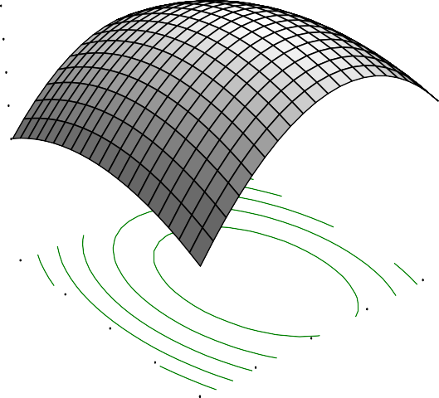Amylose
X = A: Soaking Time Y = B: Parboiling temp

Actual Factors

23.3393

C: Drying Temp = 50.00
D: Storage Duration2=1.752.0302

20.107

18.4909

16.8748
Amylose

120.00

110.00

100.00

B: Parboiling tem9p0.00

2.00

5.00

4.00
3.00

80.00

1.00
A: Soaking Time

Fig.4.49 : Effect of soaking time and parboiling temperature on amylose content

DESIGN-EXPERT Plot

Amylose
X = A: Soaking Time Y = C: Drying Temp

Actual Factors

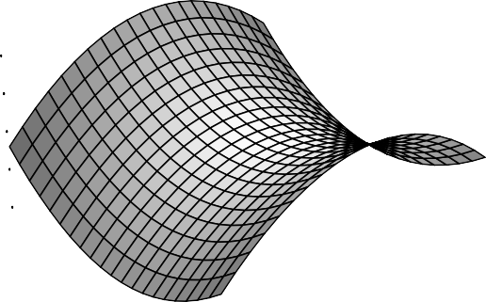27.
0.00
58.0801

8292
147
6703

5115
70.00
5.00
60.00
4.00
50.00
3.00
C: Drying Temp40.00
2.00
A: Soaking Time

B: Parboiling temp = 10 D: Storage Duration2=4.9

22.

20.

18.
Amylose

30.00 1.00

Fig.4.50: Effect of soaking time and drying temperature on amylose content

DESIGN-EXPERT Plot

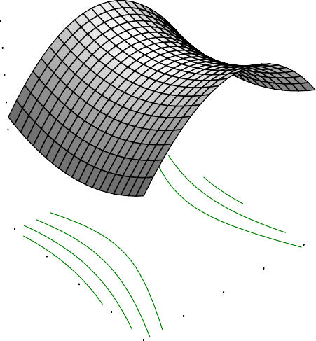Amylose
X = A: Soaking Time
Y = D: Storage Duration

Actual Factors

25.3221

B: Parboiling temp = 100.00 C: Drying Temp = 5203.0.50995

21.877

20.1544

18.4319
Amylose

9.00

7.00

5.00

3.00

4.00

5.00

D: Storag e Duratio3n.00

1.00

1.00

2.00

A: Soaking Time

Fig.4.51: Effect of soaking time and storage duration on amylose content

DESIGN-EXPERT Plot

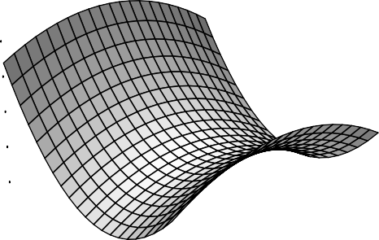Amylose
963
54.0902
.102

5549

0078
70.00
120.00
60.00
110.00
50.00
100.00
C: Drying Temp40.00
90.00
B: Parboiling temp
X = B: Parboiling temp Y = C: Drying Temp

Actual Factors

27.1

A: Soaking Time = 3.00 D: Storage Duration2=5.6

24

22.

21.
Amylose

30.00 80.00

Fig.4.52: Effect of parboiling temperature and drying temperature on amylose content

DESIGN-EXPERT Plot

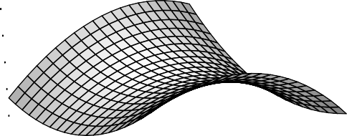Amylose
X = B: Parboiling temp Y = D: Storage Duration

Actual Factors

25.8887

A: Soaking Time = 3.00
C: Drying Temp = 5204.0.60463

23.4039

22.1615

20.9191
Amylose

9.00

7.00

5.00

120.00

110.00

100.00

D: Storag e Duratio3n.00

1.00

80.00

90.00
B: Parboiling temp

Fig.4.53: Effect of parboiling temperature and storage duration on amylose content

DESIGN-EXPERT Plot

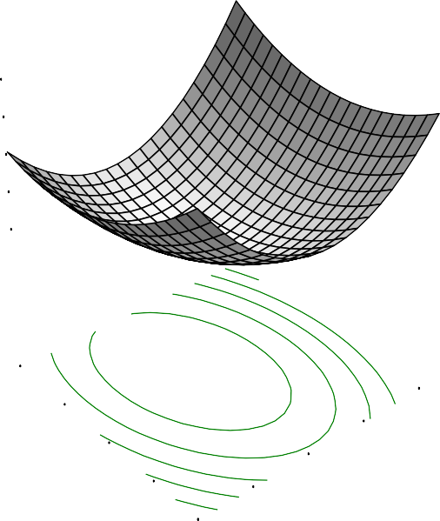Amylose
X = C: Drying Temp
Y = D: Storage Duration

Actual Factors

28.9323

A: Soaking Time = 3.00
B: Parboiling temp =271.0408.4090

26.0374

24.59

23.1425
Amylose

9.00

7.00

5.00

50.00

60.00

70.00

D: Storag e Duratio3n.00

1.00

30.00

40.00
C: Drying Temp

Fig.4.54: Effect of drying temperature and storage duration on amylose content

4.2.9 Optimisation of chemical qualities ofOfada rice

The optimisation of best processing conditions and storage duration for Ofada rice was assessed based on the following parameters; minimum moisture content, maximum protein, minimum fat, maximum carbohydrate, maximum crude fibre, minimum fatty acid, maximum metabolizable energy and maximum amylose content. The result of the optimisation is presented in Table 4.8.

The result from the optimisation process revealed that the best solution was achieved by storage of paddy for 9 months, soaking time of 1 day:8 h, parboiling at 120°C, and drying at 30.00 °C drying to yield 4.97% moisture, 9.59% protein, 0.95 % fat, 83.19% carbohydrate, 0.16% crude fibre, 1.31 % free fatty acid, 392.84kcal/100g metabolizable energy and 24.20 % amylose.

Table 4.8:Predicted solutions for optimisation of chemical qualities of Ofada rice

Number | Soaking | Parboiling | Drying | Storage | Moisture | Protein | Ether | Carbohydrate | CrudeFibre | Fatty Acid | Metabolisable | Amylose | Desirability
 | Time,day | temp.°C | Temp.°C | Duration,month | % | % | Extract,% | % | % | % | Energy,kcal/100g | %
1 | 1.82 | 120.00 | 30.00 | 9.00 | 4.9725 | 9.58603 | 0.94677 | 83.6928 | 0.155862 | 1.30539 | 392.835 | 24.2024 | 0.8066562
2 | 1.68 | 119.98 | 30.00 | 9.00 | 4.84626 | 9.6058 | 0.97705 | 83.759 | 0.154094 | 1.30805 | 393.299 | 23.8616 | 0.80632714
3 | 4.15 | 120.00 | 30.83 | 8.98 | 4.98681 | 9.75604 | 1.04324 | 83.2549 | 0.154061 | 1.4385 | 391.44 | 23.9923 | 0.80398385
4 | 3.34 | 120.00 | 30.00 | 8.66 | 5.81632 | 9.61348 | 0.893895 | 82.8659 | 0.16583 | 1.3135 | 389.097 | 25.2019 | 0.78551424
5 | 4.67 | 120.00 | 32.79 | 9.00 | 4.35017 | 9.90868 | 1.22723 | 83.3952 | 0.143002 | 1.55988 | 392.837 | 22.0498 | 0.7834054
6 | 4.93 | 102.81 | 30.00 | 9.00 | 5.56456 | 9.80145 | 1.48155 | 82.4422 | 0.169972 | 1.94014 | 390.416 | 23.1367 | 0.7277408
7 | 5.00 | 97.02 | 30.37 | 9.00 | 5.74901 | 9.86962 | 1.60451 | 82.1992 | 0.1655 | 2.12426 | 390.519 | 22.7199 | 0.70984563
8 | 3.11 | 80.02 | 30.00 | 9.00 | 6.89019 | 9.9226 | 1.83454 | 81.3144 | 0.180345 | 3.01847 | 392.9 | 23.7788 | 0.6564669
9 | 2.07 | 120.00 | 61.30 | 8.80 | 5.85989 | 8.9626 | 1.58974 | 83.0546 | 0.165049 | 2.34876 | 392.499 | 23.6568 | 0.63139189
10 | 5.00 | 83.18 | 67.33 | 9.00 | 6.64297 | 9.52788 | 1.61462 | 81.4576 | 0.0736284 | 2.34623 | 379.076 | 23.8175 | 0.62970325

120

  - Cooking properties of Ofada rice

The results of cooking properties(cooking time, water uptake ratio, elongation and solid loss) of Ofada rice as affected by processing conditions and storage is presented (Table 4.9).

    - Cooking time

The cooking time of Ofada rice was shown in Table 4.9. The minimum and maximum cooking time values were 15 and 44 min respectively while the average value was 28.28min. There exist significant differences (p < 0.05) in the cooking time as affected by the processing parameters. The maximum cooking time was obtained at 9 months storage duration, 1 (one) day soaking time, 120⁰C parboiling temperature, and 50⁰C drying temperature while the minimum cooking time was at 1 month storage of paddy, 1 (one) day of soaking, 80⁰C parboiling temperature, and 70⁰C drying temperature. The R², Adjusted R², predicted R²and adequate precision of the model were presented in Table 4.10 and coefficient of the model was also presented (Table 4.11).The coefficient ofpredicted R²revealed that the model was good for the prediction of effect of processing parameters and storage on cooking time of Ofada rice.

Response surface graphs showing interactions of the effects of soaking time and parboiling temperature, soaking time and drying temperature, soaking and storage duration, parboiling temperature and drying temperature, parboiling temperature and storage duration, drying temperature and storage duration on cooking time of Ofada rice were presented (Figs.4.55 – 4.60). The cooking time range of parboiled rice obtained in this experiment was high (15 - 44min) compared with 10-25 min reported by Adeyemi et al., (1986). However, Otegbayo et al., (2001), revealed cooking time between 52-56 min which is higher than the result obtained in this study. Research works from different backgrounds have shown that parboiling increased cooking time of rice (Saeed et al., 2011; Otegbayo et al., 2001). The removal of bran layers that are

richer in proteins and lipids probably facilitates water migration into rice kernels during cooking thereby, reducing the cooking time (Saleh and Meullent, 2008).

The present result showed that soaking significantly reduced cooking time in agreement with Sareepuang et al., (2008). Parboiling is another essential factor which affected the cooking time. An increased in parboiling temperature also increased cooking time as shown in the response surface plots (Figs.4.55, 4.58 and 4.59). The result is in agreement with the findings of Saeed et al., (2011), that parboiling increases cooking time in milled rice but indicated that the opposite was the trend with brown rice. The degree of gelatinisation of the starch to form hard gels may be one of the factors responsible for the data obtained. Drying at relatively mild temperature i.e (50 ⁰C) had the lowest cooking time (Figs.4.56, 4.58 and 4.60) while cooking time also increased with storage duration (Figs.4.57, 4.59 and 4.60).

4.3.2. Water uptake ratio

The data obtained for water uptake ratio revealed significant differences at p <
0.05. The water uptake ratio ranged between 2.5 – 4.86 with average ratio at 3.65. The lack of fit test was not significant which is good for the model fitness. The R², adjusted R², predicted R², and adequate precision were presented (Table 4.10). The coefficient of the model was also presented (Table 4.11). Response surface graphs showing interactions between effects of soaking time and parboiling temperature, soaking time and drying temperature, soaking and storage duration, parboiling and drying temperature, parboiling and storage duration, drying temperature and storage duration on water uptake ratio were presented (Figs. 4.61– 4.66).

Considering the effects of interactions and the individual factors as given in response plots, soaking time relatively showed a concave upward curve with extremes (highest and lowest point) producing high water uptake ratio (Figs. 4.61, 4.62 and 4.63). The effect was opposite to the drying temperature that produced concave downward curves with the average variable temperature producing the highest water

122

Table 4.9: Cooking properties of Ofada rice
Run | Soaking | Parboiling | Drying | Storage duration | Cooking time | Water uptake ratio | Solid loss | Elongation
 | day | °C | °C | month | minute |  | % | %
1 | 1 | 120 | 70 | 1 | 28 | 2.66 | 1.69 | 6.2
2 | 1 | 80 | 70 | 1 | 15 | 3.26 | 4.05 | 7.59
3 | 5 | 80 | 30 | 5 | 23 | 4.61 | 4.78 | 9.2
4 | 5 | 80 | 30 | 1 | 20 | 3.69 | 4.7 | 6.32
5 | 3 | 80 | 30 | 9 | 23 | 4.23 | 2.63 | 9.6
6 | 5 | 80 | 50 | 5 | 19 | 4.39 | 5.1 | 11.76
7 | 1 | 120 | 30 | 5 | 38 | 3.46 | 2.99 | 9.23
8 | 5 | 80 | 70 | 1 | 17 | 3.2 | 4.09 | 6.77
9 | 3 | 120 | 70 | 9 | 39 | 3.43 | 3.21 | 9.64
10 | 3 | 120 | 50 | 5 | 37 | 3.49 | 3.6 | 9.8
11 | 5 | 120 | 30 | 9 | 42 | 3.38 | 3.28 | 9.85
12 | 1 | 100 | 50 | 5 | 26 | 3.98 | 4.16 | 10
13 | 3 | 120 | 70 | 5 | 39 | 3.3 | 2.94 | 9.9
14 | 1 | 100 | 50 | 9 | 29 | 4.01 | 4.55 | 9.55
15 | 5 | 120 | 50 | 9 | 44 | 3.86 | 2.82 | 9.3
16 | 1 | 120 | 70 | 1 | 25 | 2.84 | 3.58 | 7.52
17 | 3 | 100 | 50 | 5 | 35 | 3.99 | 3.37 | 8.8
18 | 5 | 100 | 50 | 5 | 32 | 3.76 | 3.99 | 7.71
19 | 1 | 80 | 30 | 1 | 16 | 3.27 | 5.01 | 8.45
20 | 1 | 120 | 30 | 1 | 26 | 2.51 | 1.53 | 8
21 | 5 | 100 | 30 | 9 | 34 | 4.08 | 4.27 | 9.6
22 | 1 | 80 | 70 | 5 | 27 | 4.29 | 3.9 | 12.5
23 | 5 | 80 | 70 | 9 | 25 | 4.86 | 3.51 | 9.9
24 | 1 | 80 | 30 | 9 | 21 | 4.2 | 2.65 | 10.7
25 | 1 | 120 | 30 | 1 | 27 | 2.56 | 1.47 | 8.09

Table 4.10: ANOVA of regression of cooking properties as a function of storage and
processing conditions
Parameters | p-value | R2 | Adjusted R² | Predicted R² | Adequate precision
Cooking time (min) | <0.0001 | 0.9586 | 0.9006 | 0.366 | 13.412
Water uptake ratio | <0.0001 | 0.987 | 0.9687 | 0.9123 | 26.927
Solid loss | 0.0068 | 0.8781 | 0.7075 | -0.0449 | 7.932
Elongation (mm) | 3.67 | 0.8371 | 0.609 | -0.8423 | 7.848

Table 4.11: Coefficient of model on effect of storage and processing on cooking quality of Ofada rice
 | Cooking time | Water uptake ratio | Solid loss | Elongation
 | min |  | % | mm
Intercept | -25.98 | 8.01 | 3.19 | 23.03
S | 1.75 | -0.43 | 0.66 | 1.11
P | 0.68 | -0.1 | 0.11 | -0.42
D | -0.32 | 0.05 | -0.12 | 0.08
T | 2 | 0.47 | -0.44 | 1.35
S2 | 0.28 | 0.04 | -0.19 | -0.02
P2 | -1.57x10⁻³ | 3.97x10⁻⁴ | -1.12x10⁻³ | 2.53x10⁻³
D2 | 5.01x10⁻³ | 5.61x10⁻⁴ | 4.92x10⁻⁴ | 1.88x10⁻⁴
T2 | -0.29 | -0.02 | -0.02 | -0.09
SP | -0.03 | 2.07x10⁻³ | 5.59x10⁻³ | -0.02
SD | -2.62x10⁻³ | 1.25x10⁻³ | 2.34x10⁻³ | 0.01
ST | -0.18 | -0.02 | -0.04 | 2.76x10⁻³
PD | -1.44x10⁻³ | -3.41x10⁻⁵ | 4.34x10⁻⁴ | -1.17x10⁻³
PT | 0.03 | -7.94x10⁻⁴ | 7.22x10⁻³ | -8.68x10⁻⁴
DT | -2.77x10⁻³ | 7.0x10⁻⁴ | 1.23x10⁻³ | -3.92x10⁻⁵

DESIGN-EXPERT Plot

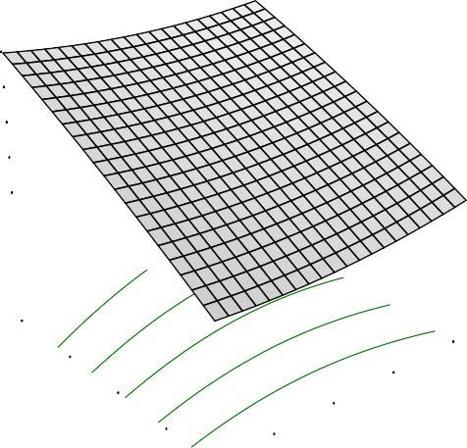Cooking time
X = A: Soaking Time Y = B: Parboiling temp

Actual Factors

38.993

C: Drying Temp = 50.00
D: Storage Duration3=4.651.0009

30.2289

25.8469
Cookingtime

21.4649

120.00

110.00

100.00

B: Parboiling tem9p0.00

2.00

5.00

4.00

3.00

80.00

1.00
A: Soaking Time

Fig.4.55: Effect of soaking time and parboiling temperature on cooking time

DESIGN-EXPERT Plot

Cooking time
0.00
5.5.0801
627
4992

4175

3357
70.00
5.00
60.00
4.00
50.00
3.00
C: Drying Temp40.00
2.00
A: Soaking Time
X = A: Soaking Time Y = C: Drying Temp

Actual Factors

33.6

B: Parboiling temp = 10 D: Storage Duration =32

31.

30.
Cookingtime

29.

30.00 1.00

Fig.4.56: Effect of soaking time and drying temperature on cooking time

126

DESIGN-EXPERT Plot

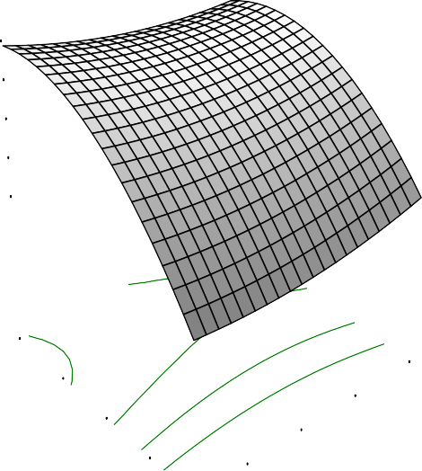Cooking time
X = A: Soaking Time
Y = D: Storage Duration

Actual Factors

33.7617

B: Parboiling temp = 100.00 C: Drying Temp = 5300.0.00964

26.4312

22.766
Cookingtime

19.1008

9.00

7.00

5.00

3.00

4.00

5.00

D: Storag e Duratio3n.00

1.00

1.00

2.00
A: Soaking Time

Fig.4.57: Effect of soaking time and storage duration on cooking time

DESIGN-EXPERT Plot

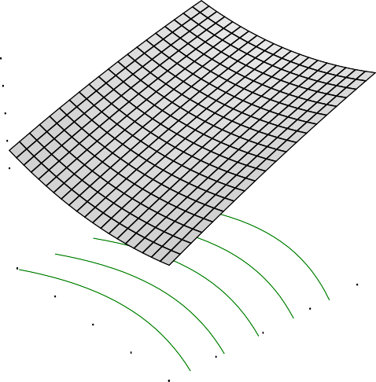Cooking time
692
52.0806
.888

6474

4068
70.00
120.00
60.00
50.00
110.00
100.00
C: Drying Temp40.00
90.00
B: Parboiling temp
X = B: Parboiling temp Y = C: Drying Temp

Actual Factors

38.3

A: Soaking Time = 3.00 D: Storage Duration3=4.1

29

25.
Cookingtime

21.

30.00 80.00

Fig.4.58: Effect of parboiling and drying temperature on cooking time

DESIGN-EXPERT Plot

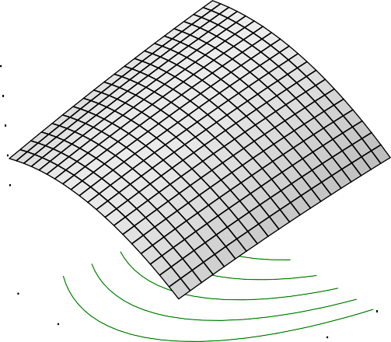Cooking time
X = B: Parboiling temp Y = D: Storage Duration

Actual Factors

39.3949

A: Soaking Time = 3.00
C: Drying Temp = 5302.0.90739

26.5528

20.1318
Cookingtime

13.7107

9.00

7.00

5.00

120.00

110.00

100.00

D: Storag e Duratio3n.00

1.00

80.00

90.00
B: Parboiling temp

Fig.4.59: Effect of parboiling temperature and storage duration on cooking time

DESIGN-EXPERT Plot

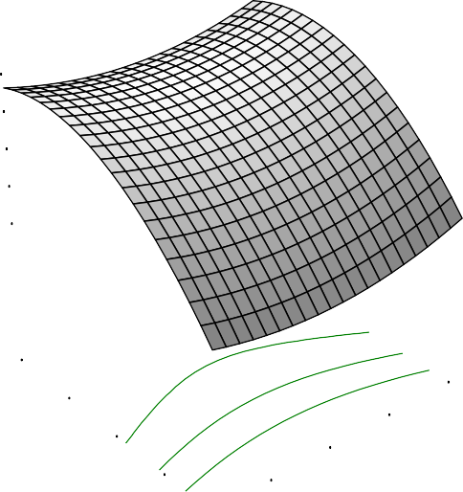Cooking time
X = C: Drying Temp
Y = D: Storage Duration

Actual Factors

33.2255

A: Soaking Time = 3.00
B: Parboiling temp =291.0702.0050

26.2156

22.7107
Cookingtime

19.2057

9.00

7.00

5.00

50.00

60.00

70.00

D: Storag e Duratio3n.00

1.00

30.00
40.00
C: Drying Temp

Fig.4.60: Effect of drying temperature and storage duration on cooking time

uptake ratio (Figs.4.62, 4.64, and 4.66). The parboiling temperature produced downward curve from the least to the highest with the water uptake ratio reducing withincrease in parboiling temperature (Figs.4.61,
4.64 and 4.65), but increase in storage duration is directly proportional to water uptake ratio (Figs. 4.63, 4.65 and 4.66).

The highest water uptake ratio was obtained from paddy stored for 9 months followed by soaking for 1(one) day, parboiling at 80 ⁰C, and drying at 70 ⁰C while the least water uptake ratio was obtained from paddy stored for 1(one) month, soaked for 1(one) day, parboiled at 120 ⁰C and dried at
30 ⁰C. The highest water uptake ratio obtained at the least parboiling temperature (80 ⁰C) was in line with the explanation Biswa, (1987), that parboiled milled rice of low gelatinization temperature varieties absorbed higher water content than intermediate i.e gelatinization temperature varieties at room temperature. This was not in line with the discovery of Melidizadeh and Zomorodian, (2009), which stated that high gelatinization temperature meaning higher water absorption. Although the quality of the starch (amylose: amylopatin ration) and the varietal variation could also contribute to the water uptake ratio.

The result (1.14-3.30) for water uptake ratio obtained in the experiment carried out by Oko et al., (2012) on different varieties of rice in Nigeria was not comparable with the values reported in the present study. The various processing conditions might have initiated the variations. Amylose content was reported by Frei and Becker (2003) to affect the water uptake of rice. Increase in amylose content improves water uptake. Minimum drying temperature gave low water uptake. It is worthy to note that high water ratio affects the palatability of the cooked rice negatively. The interactions of the processing conditions have favoured increase in

water uptake which translate to more gain for rice vendors in term of volume better than result gotten from new breeds of rice (Nerica) which was recorded to range between 2.02 to 2.36 ( Fofana et al., 2011).

DESIGN-EXPERT Plot

Water Uptake ratio X = A: Soaking Time
Y = B: Parboiling temp

Actual Factors

4.71576

C: Drying Temp = 50.00
D: Storage Duration4=.4058.0801

4.10185

3.79489
Water Uptakeratio

3.48794

120.00

110.00

100.00

B: Parboiling tem9p0.00

2.00

5.00
4.00
3.00

80.00

1.00
A: Soaking Time

Fig.4.61: Effect of soaking time and parboiling temperature on water uptake ratio

DESIGN-EXPERT Plot

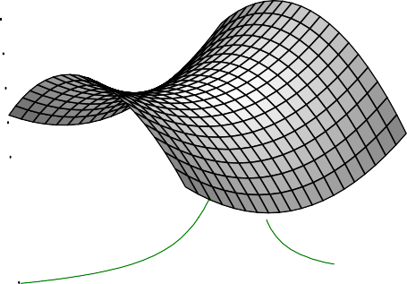Water Uptake ratio X = A: Soaking Time Y = C: Drying Temp
0.00
59.0405
7717
184
5984

5425
70.00
5.00
60.00
4.00
50.00
3.00
C: Drying Temp40.00
2.00
A: Soaking Time

Actual Factors

4.01

B: Parboiling temp = 10 D: Storage Duration =3.8

3.7

3.6
Water Uptakeratio

3.

30.00 1.00

Fig.4.62: Effect of soaking time and drying temperature on water uptake ratio

DESIGN-EXPERT Plot

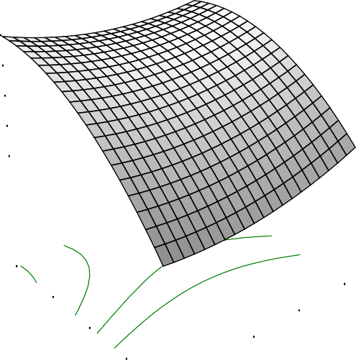Water Uptake ratio X = A: Soaking Time
Y = D: Storage Duration

Actual Factors

4.32317

B: Parboiling temp = 100.00 C: Drying Temp = 530..9060093

3.5987

3.23647
Water Uptakeratio

2.87424

9.00

7.00

5.00

3.00

4.00

5.00

D: Storag e Duratio3n.00

1.00

1.00

2.00
A: Soaking Time

Fig.4.63: Effect of soaking time and storage duration on water uptake ratio

DESIGN-EXPERT Plot

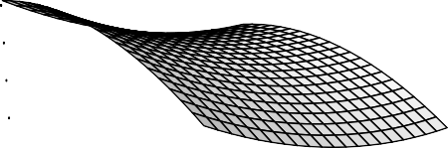Water Uptake ratio
227
58.0405
2462

5208

1698
70.00
60.00
120.00

110.00
50.00
100.00
C: Drying Temp40.00
90.00
B: Parboiling temp
X = B: Parboiling temp Y = C: Drying Temp

Actual Factors

4.43

A: Soaking Time = 3.00 D: Storage Duration4=.12

3.8

3.
Water Uptakeratio

3.2

30.00 80.00

Fig.4.64: Effect of soaking time and storage duration on water uptake ratio

DESIGN-EXPERT Plot

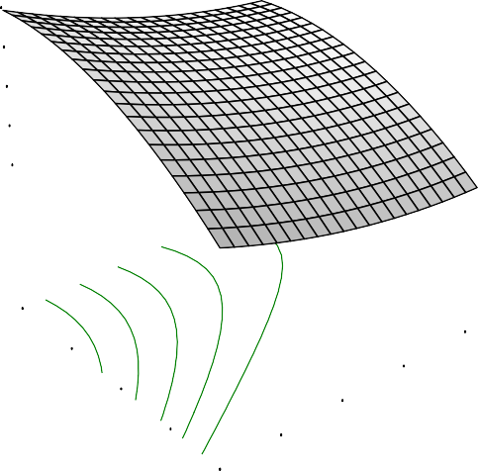Water Uptake ratio
X = B: Parboiling temp Y = D: Storage Duration

Actual Factors

4.66498

A: Soaking Time = 3.00
C: Drying Temp = 540..1060152

3.65807

3.15461
Water Uptakeratio

2.65115

9.00

7.00

5.00

120.00
110.00
100.00

D: Storag e Duratio3n.00

1.00

80.00
90.00
B: Parboiling temp

Fig.4.65: Effect of parboiling temperature and storage duration on water uptake ratio

DESIGN-EXPERT Plot

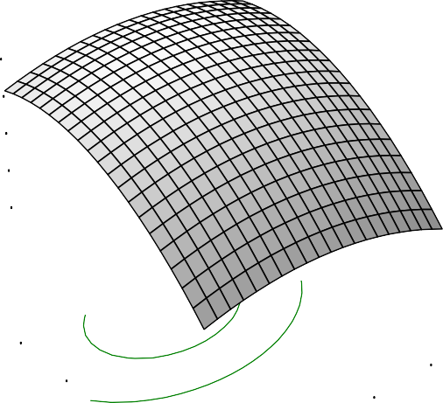Water Uptake ratio X = C: Drying Temp
Y = D: Storage Duration

Actual Factors

3.98833

A: Soaking Time = 3.00
B: Parboiling temp =3.160307.0050

3.28577

2.9345
Water Uptakeratio

2.58322

9.00

7.00

5.00

50.00

60.00

70.00

D: Storag e Duratio3n.00

1.00

30.00

40.00
C: Drying Temp

Fig.4.66: Effect of drying temperature and storage duration on water uptake ratio

    - Solid Loss

The percentage solid loss from Ofada rice ranged from 1.47 to 5.10 %. There were significant differences (p < 0.05) in the percentage solid loss as a result of variations in the processing parameters and storage duration. The “lack of fit F-value” of 1.30 implied the lack of fit is not significant; this value justified the fitness of the model to describe the effect of processing conditions on solid loss of Ofada. The R², adjusted R², predicted R², and adequate precision were presented (Table 4.10). The high value of R² (0.8452) and low standard deviation of 0.65 accorded the fitness of the model. The coefficient of the model is presented (Table 4.11). Effect of soaking time (S) and parboiling temperature (P)were found to have more positive effect at decreasing solid loss of milled rice.

The lowest solid loss (1.47 %) was from paddy stored for one month, soaked for one day, parboiled at 120 ⁰C, and dried at 30 ⁰C while the highest solid loss (5.10
%) was from paddy stored for one month, soaked for 5 days, parboiled at 80 ⁰C, and dried at 30 ⁰C. The trend of the result revealed that solid loss decreased with increase in parboiling temperature. This is supported by the Sareepuang et al., (2008), that parboiling caused stronger structure of rice starch as a result of gelatinization. Solids in cooking water (loss in solids) affect the stability of the cooked rice (Juliano et al., 1982). The variation in values may be as a result of the variation in the rice consistency, due to bursting of the grains during and after cooking, as they were subjected to different processing conditions (Oko et al., 2012).

It was also discovered that most physico-chemical characteristics i.e amylose, amylopectin, gel consistency, and gelatinization temperature were significantly correlated either positively or negatively with cooking qualities traits i.e solid loss,

grain elongation and so on (Oko et al., 2012). The effect of drying temperature is relatively stable while the solid loss shown a slight increase with storage duration.

    - Elongation

The longitudinal increase in rice after cooking was from 6.20 to 12.50 mm. The processing conditions insignificantly affected the elongation of the rice (p ≤ 0.05). The R², adjusted R², predicted R², and adequate precision and coefficient of the model were presented in Table 4.9 and 4.10 respectively. The value of R² and low standard deviation of 0.8371 and 0.96 respectively increased the degree of fitness of the model.

The result revealed that low parboiling temperature and increase in soaking time favoured grain elongation (Table 4.9). Combination of low drying temperature and low soaking time were most preferred for high elongation while increase in storage duration lead to increase in elongation. According to Ashish-Jain et al., (2012), high volume expansion correlates with high amylose content.
    - Optimisation of cooking qualities of Ofada rice

The best solution prescribed for good cooking qualities of Ofada rice was based onminimum cooking time, high water uptake ratio, minimum solid loss and maximum elongation. The predicted storage and processing conditions include storage of paddy for 9 months, soaking for 5 days, parboiling at 80°C, and drying at 55°C months with desirability of 0.82 to yield 20.24min cooking time, 4.54 water uptake ratio, 2.53% solid loss and 11.76mm elongation. Other relevant solutions were presented in Table 4.12.

Table 4.12: Predicted solutions for optimisation of cooking qualities of Ofada rice

Number | Soaking Time | Parboiling temp | Drying Temp | Storage Duration | Cooking time | Water Uptake  ratio | Solid Loss | Elongation | Desirability
1 | 5.00 | 80.00 | 55.05 | 9.00 | 20.2488 | 4.5362 | 2.52724 | 11.76 | 0.815233 | Selected
2 | 5.00 | 80.17 | 64.53 | 9.00 | 21.5322 | 4.46517 | 2.62106 | 12.3362 | 0.809189
3 | 5.00 | 80.00 | 49.61 | 8.85 | 20.2577 | 4.53963 | 2.58354 | 11.4836 | 0.800732
4 | 4.98 | 80.00 | 47.70 | 9.00 | 19.925 | 4.5165 | 2.53714 | 11.3096 | 0.798182
5 | 5.00 | 80.00 | 60.69 | 7.80 | 22.8109 | 4.56455 | 3.03207 | 12.4302 | 0.774529
6 | 4.67 | 80.00 | 69.57 | 9.00 | 22.3019 | 4.38515 | 2.99422 | 12.5006 | 0.76714
7 | 1.02 | 80.00 | 58.40 | 9.00 | 22.6601 | 5.04483 | 3.58478 | 9.83572 | 0.648864
8 | 1.19 | 80.00 | 49.11 | 9.00 | 21.6819 | 5.04136 | 3.7144 | 9.77893 | 0.639147
9 | 4.97 | 92.18 | 70.00 | 9.00 | 27.9762 | 3.96861 | 3.27804 | 10.9013 | 0.59867
10 | 1.01 | 120.00 | 43.56 | 3.52 | 35.0883 | 3.33794 | 2.1198 | 9.56614 | 0.466827

  - Mineral quality of Ofada rice

The result of mineral composition of Ofada rice as affected by storage duration and processing condition (Table 4.13).
    - Zinc composition of Ofada rice

The results obtained for zinc ranged from 13.00 - 42.45 mg/kg with the average value of 25.70 mg/kg (Table 4.13). There were significant differences (p < 0.05) in the concentrations of zinc obtained as a result of processing conditions and storage duration. The non significant lack of fit signified that the model was fit to describe the experiment. R²-squared, Adjusted R², predicted R², and adequate precision and coefficient of the model were presented (Table 4.14 and 4.15). Coefficient of the model revealed the positive effect of processing parameters and storage duration on zinc content of Ofada rice. The positive coefficient of drying (D) and parboiling temperatures (P) showedthe impact of these processing conditions in relation to other conditions. Adequate precision measures the signal noise ratio and a greater than 4 is desirable which justified the value of 6.417 obtained from the experiment.
The highest concentration of zinc (42.45mg/kg) was obtained when paddy was stored for 9 months, stored for 5 days, parboiled at 80⁰C and dried at 30⁰C drying while the lowest (13 mg/kg) was obtained from paddy stored for 5 months followed by 1(one) day of soaking, parboiling at 120⁰C, and drying at 70⁰C.The concentrations of zinc obtained from this experiment were on the high side which might be associated to the variation of processing condition or the variety.
In the result presented (Table 4.13), the parboiling temperature and storage duration have more influence on the zinc concentration of Ofada rice. Increase in storage duration was found to be proportional to the increase in zinc concentration but opposite trend was observed with parboiling temperature. Intermediate drying temperature was found to favour maximum zinc concentration.

According to Abbas et al., (2011), in its investigation on the effect of processing on nutritional value of rice, highlighted that series of condition rice is subjected to from time of harvest to the time it is consumed seriously depletes it nutrient such as protein, fat, carbohydrates, mineral and vitamins. The zinc content for rough, brown and milled rice were given as 2.4, 3.3 and 18.0 mg/kg respectively while Anderson (1976) as reported by Makela et al., (1998) recorded a range of 3.3 - 6.5 mg/kg in wild rice (Zizania aquatica) indigenous to North American. Chukwu and Oseh {2009} in the study onthe effect of various parboiling temperature on the nutritional composition of rice suggested 80°C parboiling temperature as the best for the retention of zinc in rice which was also confirmed in this experiment.
    - Iron composition of Ofada rice

The concentrations of iron from the experiments ranged between 24.00 – 85.00 mg/kg. The highest value of Fe was at 5 months storage duration, 1 day of soaking, 80
°C parboiling, and 30 °C drying temperature while the minimum value was at 1 month storage duration, 5 days soaking time, 120 °C parboiling temperature, and 70 °C drying temperature. There existed significant differences at p < 0.05 for the results of iron obtained at various processing conditions. The values of R², adjusted R², predicted R², and adequate precision were presented (Table 4.14). The“Lark of fit F-value” of
0.24 implied the lack of fit is not significant and this was found to be good for the fitness of the model. The coefficient of the model showing the effect of processing parameter and storage on iron concentration of Ofada rice is presented (Table 4.15).
The results of iron concentrations obtained in this experiment were higher compared to the report from some other authors. Martinez et al., (2010); Abba et al., (2011) showed values ranging from 0.03 to 0.10 mg/kg while 42 mg/kg was recorded in wild rice by Anderson (1976). The values of iron in the Ofada rice are enough to supplement for the deficiency of iron. Iron deficiency (ID) is the most prevalent micronutrient deficiency Worldwide, affecting mainly children under 5 and women of child bearing age living in the poorer communities of the developing world (Martinez et al., 2010).

Iron fortification of foods or iron supplements have traditionally been the main intervention strategies used to combat iron deficiency (ID), however, they are less suitable for the more remote rural communities in the redeveloping world (Allen et al., 2006). The fortification compliance programmes in Nigeria since 1990 has not even yield expected result due to poor compliance. However, the results have shown that Ofada rice is a good diet for iron supplements.

Table 4.13: Mineral composition of Ofada rice
Number | Soaking | Parboiling | Drying | Storage | Zinc | Iron | Magnesium | Copper | Potassium | Calcium
 | Time,day | temp. | Temp. | Duration | mg/kg | mg/kg | mg/kg | mg/kg | mg/kg | mg/kg
1 | 5 | 120 | 70 | 1 | 18.23 | 24 | 341 | 28.42 | 25 | 0.3
2 | 1 | 80 | 70 | 1 | 32.23 | 35 | 301.22 | 58.09 | 14.15 | 0.5
3 | 1 | 80 | 30 | 5 | 37.46 | 85 | 311 | 2.95 | 18.2 | 0.22
4 | 5 | 80 | 30 | 1 | 23.85 | 34 | 279 | 49 | 10.03 | 0.24
5 | 5 | 80 | 30 | 9 | 22.76 | 74.98 | 234.25 | 8.04 | 24.68 | 0.29
6 | 3 | 80 | 50 | 5 | 31.52 | 45.93 | 275.61 | 3.5 | 26.29 | 0.23
7 | 5 | 120 | 30 | 5 | 21.98 | 57.07 | 305.89 | 5.05 | 12.88 | 0.39
8 | 1 | 80 | 70 | 1 | 30 | 29 | 307.52 | 42 | 22 | 0.56
9 | 5 | 120 | 70 | 9 | 17.52 | 72.98 | 387 | 10.19 | 22.54 | 0.3
10 | 3 | 120 | 50 | 5 | 22.98 | 53.74 | 289.66 | 6.8 | 15.02 | 0.33
11 | 3 | 120 | 30 | 9 | 19.41 | 47 | 329.18 | 6.5 | 23.61 | 0.43
12 | 5 | 100 | 50 | 5 | 32.25 | 58.33 | 308.4 | 5.95 | 18.24 | 0.36
13 | 1 | 120 | 70 | 5 | 13 | 58.02 | 247.15 | 4.7 | 15.56 | 0.41
14 | 3 | 100 | 50 | 9 | 28 | 66.09 | 296.02 | 9.3 | 29.05 | 0.32
15 | 1 | 120 | 50 | 9 | 20 | 27.79 | 365.74 | 4.5 | 15.56 | 0.3
16 | 5 | 120 | 70 | 1 | 18.06 | 31 | 344 | 26 | 30 | 0.28
17 | 1 | 100 | 50 | 5 | 28.47 | 76 | 365 | 10.26 | 16.63 | 0.48
18 | 3 | 100 | 50 | 5 | 26.63 | 63 | 299.65 | 21 | 32 | 0.31
19 | 5 | 80 | 30 | 1 | 27 | 30 | 270.06 | 40 | 10.2 | 0.39
20 | 1 | 120 | 30 | 1 | 14 | 45 | 235.66 | 27 | 13.16 | 0.23
21 | 1 | 100 | 30 | 9 | 34.87 | 60.55 | 297.63 | 6.65 | 28.98 | 0.3
22 | 5 | 80 | 70 | 5 | 25.98 | 57.64 | 288.55 | 6.83 | 10.2 | 0.34
23 | 1 | 80 | 70 | 9 | 37.76 | 46.9 | 268.22 | 8.35 | 27.9 | 0.62
24 | 5 | 80 | 30 | 9 | 42.45 | 28 | 366.16 | 4.6 | 20.93 | 0.35
25 | 1 | 120 | 30 | 1 | 16 | 42 | 276 | 33 | 13.03 | 0.32

Table 4.14: ANOVA of regression of mineral properties as a function of processing conditions
Parameters | P-value | R2 | Adjusted R² | Predicted R² | Adequate precision
Zinc, mg/kg | 0.023 | 0.8359 | 0.6061 | 0.1769 | 6.417
Iron, mg/kg | 0.0478 | 0.8028 | 0.5267 | -0.3764 | 5.928
Magnesium, mg/kg | 0.3893 | 0.6284 | 0.1081 | -1.5006 | 4.215
Copper, mg/kg | 0.0002 | 0.9462 | 0.8709 | 0.4784 | 10.446
Potassium, mg/kg | 0.0132 | 0.8565 | 0.6556 | -0.67 | 7.264
Calcium, mg/kg | 0.045 | 0.8057 | 0.5338 | -1.7144 | 6.887

Table 4.15: Coefficient of model on effect of storage and processing parameters on mineral quality of Ofada rice
 | Zn, mg/kg | Fe, mg/kg | Mg, mg/kg | Cu, mg/kg | K, mg/kg | Ca, mg/kg
Intercept | 17.99 | -154.81 | 715.09 | -91.97 | -93.02 | -1.13
S | -12.28 | -17.36 | -130.35 | 6.95 | 5.41 | 7.20x10⁻³
P | 0.3 | 7.49 | -9.68 | 3.47 | 2.51 | 0.03
D | 1 | -5.56 | 10.86 | -0.53 | -0.87 | 6.92x10⁻³
T | 3.08 | 7.05 | -23.66 | -20.78 | 2.81 | 2.26x10⁻³
S2 | 0.69 | -0.61 | 11.62 | -0.85 | -2.11 | -1.47x10⁻⁴
P2 | -3.78x10⁻³ | -0.04 | 0.04 | -0.02 | -0.01 | -1.47x10⁻⁴
D2 | -8.84x10⁻³ | 0.04 | -0.13 | 7.75x10⁻³ | 5.26x10⁻³ | 1.30x10⁻⁴
T2 | -0.03 | -1.22 | 1 | 1.02 | 0.28 | 4.30x10⁻⁴
SP | 0.08 | 0.11 | 0.45 | 5.38x10⁻³ | 0.07 | 4.58x10⁻⁴
SD | 1.51x10⁻³ | 0.1 | 0.35 | -0.07 | 6.7x10⁻³ | 1.40x10⁻³
ST | -0.1 | 0.92 | 0.56 | 0.23 | -0.07 | -9.64x10⁻⁴
PD | -1.22x10⁻³ | 0.01 | 0.01 | -2.44x10⁻⁴ | 4.77x10⁻³ | -1.22x10⁻⁴
PT | -0.01 | 9.29x10⁻³ | 0.33 | 0.05 | -0.04 | 2.30x10⁻⁵
DT | -0.01 | 0.08 | -0.16 | 0.01 | -0.02 | 3.96x10⁻³

4.4.3 Magnesium composition of Ofada rice

Magnesium is one of the major elements in rice and the results of magnesium concentrations in Ofada rice obtained from the experiment as affected by storage duration and processing conditions ranged from 234.25 to 387.0 mg/kg. However, at the different levels of processing conditions no significant difference (p>0.05) were found in concentration of magnesium obtained from the experiment.
The highest amount of Mg was recorded at 9 months of storage duration, 5 days of soaking, 120⁰C parboiling, and 70⁰C drying temperature whilethe least concentration of Mg was derived from paddy stored for 9 months, stored for 5 days, parboiled at 80⁰C, and dried at 30⁰C. The “Lack of Fit F-value” of 0.55 implied the lack of fit was not significant. Non significant lack of Fit is recommended and good for the model. The values of R², Adjusted R², predicted R², and adequate precision and coefficient of the models were presented (Table 4.13 and 4.14).
The magnesium contents in wild rice and polished white rice are 80 -1 61 and 28 mg/100g respectively (Makela et al., 1998). The results were related to some of the Mg concentration obtained in this work. Judging by the recommendation of magnesium intake by Food and Nutrition Board, (1997), the recommended daily intake of magnesium can be met with only consumption of Ofada rice. An adult female only require 310 – 320 mg/day and between 400 – 420 mg/day is recorded for adult males while the requirement for pregnant women and children are lesser. The major functions of magnesium include contraction and relaxation of muscles, production and transportation of energy and production of protein while its deficiency can lead to hyper-excitability, sleepiness, and weakness of the muscle.
    - Copper composition of Ofada rice

The concentration of cupper ranged between 2.95 and 58.09 mg/kg with the mean value of 17.15. The model F-value of 12.56 implied the model was significant and the highest concentration of copper was obtained at the lowest soaking time (1 day), 80 °C parboiling temperature, 70 °C drying temperature and one (1) month

storage duration while the minimum value was also obtained at the same least levels of soaking and parboiling but 30⁰C drying temperature and 5 months of storage.
The values of R², Adjusted R², predicted R², and adequate precision were presented in Table 4.14. The value of 10.446 adequate precision indicates adequate signal for the model with low standard deviation favoured the model. The coefficient of the model is presented (Table4.15). Soaking time (S) and parboiling temperature (P) were found to be the key processing unit operations that majorly influenced copper concentration of Ofada rice. An increase in soaking time causes increase in copper retention until a peak is reached and a steady concentration maintained. However, increase in storage duration steadily reduced the copper in Ofada rice and the same trend was recorded with the drying temperature (Table 4.13).
Copper is an essential nutrient and have normal physiological regulatory activities in organisms (Hogstrand and Haux, 2001). The USA and Canada recently established a recommended dietary allowance (RDA) of 900 μg/day for adults while 340 μg/day for those children not exceeding 3 years, 440 μg/day for ages 4 through 8,
700 μg/day for ages 9 through 13 and 890 μg/day for ages 14 through 18 (IOM, 2001). During pregnancy and lactation, 1000 μg/day and 1300 μg/day are recommended respectively. The concentrations of copper recorded in this experiment is related to the result obtained by Anjum et al., (2007) on mineral composition of different rice varieties, however, a range between 0.58 and 0.92 mg/100g was documented.

    - Potassium composition of Ofada rice

The minimum and maximum concentrations of potassium were 10.03 and
32.00 mg/kg respectively.There exist significant differences (p < 0.05) in the values of potassium as affected by processing parameters and storage duration. The maximum level of potassium concentration was obtained from the paddy stored for 5 months and processed by soaking for 3 days, parboiling at 100 °C, and 50 °C drying temperature while the minimum concentration was retained in paddy stored for one month, soaked for 5 days, parboiled at 80 °C and dried at 30 °C.

The “lack of fit F-value” of 2.23 obtained from the analysis implied the lack of fit is not significant. The values of R², Adjusted R², and adequate precision and coefficient of the model were as presented in Table 4.14 and 4.15. However, the fit summary suggested the quadratic model because of the highest F-value of 4.77 for the sequent model sum of squares and the lowest F-value of 2.23 for lack of fit test.

As shown in Table 4.13 potassium levels in Ofada rice increased with extension of storage duration, the variations in the drying temperatures during the processing of Ofada rice revealed relative stability in the concentrations of potassium. Potassium is a very important mineral to the human body to build proteins, break down and use carbohydrates, build muscle, maintain normal body growth, control the electrical activity of the heart and control the acid-base balance (USDA, 2010).

    - Calcium composition of Ofada rice

The concentrations of calcium ranged between 0.22 to 0.62 mg/kg and 0.35 mg/kg as the mean value. The highest value of calcium was recorded at 1 day soaking, 80 ⁰C parboiling temperature, 70 ⁰C drying temperature and 9 months storage duration while the least value was at 1(one) day soaking, 80 ⁰C parboiling temperature, 30 ⁰C drying temperature and 5 months storage duration. The values of R², Adjusted R², predicted R², and adequate precision were presented in Table 4.14. The closeness of R² and Adjusted R² to 1 and extent of greatness of adequate precision above 4 are indicators of the degree of fitness of the model. The low standard deviation and PRESS values of 0.070 and 0.68 also classified the model for better fitness. The coefficient of the model terms of actual of factors is presented (Table 4.15).
As shown in the Table 4.13, calcium levels increased steadily with soaking time, drying temperature and storage duration. Average parboiling temperatureproduced the highest calcium. Calcium contents recorded in this experiment were lower compared to the result documented by Chukwu and Oseh, (2009) which ranged from 3.287 in unparboiled rice to between 1.612 to 3.68 mg/kg in parboiled rice with rice parboiled at 120⁰C with highest calcium concentration.

According to Sarubin and Thomson (2007), calcium is one of the most important minerals for the human body. Calcium helps form and maintains healthy teeth and bones. Proper levels of calcium over a lifetime can help prevent osteoporosis, building strong bones and teeth, clotting blood, sending and receiving nerve signals, squeezing and relaxing muscles, releasing hormones and other chemicals and keeping a normal heartbeat. Although, a large proportion of potassium is required by adult (4.7g/day), however, the composition in ofada rice is also significant at attaining the daily recommendation.
    - Optimisation of mineral quality of Ofada rice

The result of optimization of the mineral quality ofOfada rice was analyzed based on the recommended daily intake allowance for adults. Therefore, maximum concentrations of potassium, magnesium, calcium; and minimum amount of zinc, copper and iron were selected. The appropriate processing conditions to achieve these were predicted (Table 4.16). Storage of paddy for 9 months followed by soaking time of one day, 8 h: 8 min, parboiling at 115.08⁰C, and drying at 58.41⁰C were best selected for attainment of these required quality as stated.

Table4.16: | Predicted solution for the optimisation of mineral qualities of Ofada rice
Number | Soaking Time | Parboiling temp | Drying Temp | Storage Duration | Zn | Fe | Mg | Cu | K | Ca | Desirability
 | days | °C | °C | months | mg/kg | mg/kg | mg/kg | mg/kg | mg/kg | mg/kg
1 | 1.37 | 115.08 | 58.41 | 9.00 | 21.3637 | 44.718 | 327.858 | 9.57569 | 21.8341 | 0.394462 | 0.625238209 | Selected
2 | 3.84 | 119.43 | 39.19 | 9.00 | 22.326 | 43.6022 | 357.604 | 8.73483 | 22.5575 | 0.341879 | 0.622590512
3 | 1.91 | 116.55 | 56.38 | 9.00 | 20.3653 | 44.5728 | 328.449 | 9.60108 | 23.8516 | 0.355805 | 0.621387612
4 | 1.94 | 116.61 | 57.12 | 9.00 | 20.083 | 45.2824 | 326.4 | 9.87431 | 24.0925 | 0.357589 | 0.621148119
5 | 3.97 | 120.00 | 47.32 | 9.00 | 21.8793 | 43.5603 | 376.16 | 8.01142 | 22.1423 | 0.313648 | 0.61031034
6 | 5.00 | 117.29 | 65.95 | 1.00 | 21.0248 | 25.1177 | 344.292 | 29.5347 | 26.0264 | 0.300029 | 0.5818773
7 | 5.00 | 117.34 | 65.33 | 1.00 | 21.2299 | 24.3749 | 345.872 | 29.4236 | 25.7734 | 0.299638 | 0.581876935
8 | 5.00 | 117.69 | 65.37 | 1.00 | 21.1259 | 24.0001 | 346.417 | 29.0886 | 25.733 | 0.29764 | 0.581835042
9 | 5.00 | 117.07 | 67.54 | 1.00 | 20.4969 | 27.2733 | 339.581 | 29.9543 | 26.7086 | 0.302185 | 0.581630076
10 | 1.12 | 119.47 | 63.89 | 1.00 | 14.2583 | 26.4018 | 283.966 | 34.8507 | 20.4333 | 0.368705 | 0.530164843

  - Pasting properties of Ofada rice

The result of pasting properties of Ofada rice (peak, trough, breakdown, final viscosity, setback, peak time, and pasting temperature) as affected by processing conditions and storage is presented (Table 4.17). The parameters revealed were significant at p < 0.05 except breakdown viscosity.Pasting is a phenomenon during rice cooking following gelatinization of rice starch, which involves swelling, exudation of molecular components from the granules and eventual total disruption of the granules (Danbaba et al., 2012). The minimum and maximum range of peak, trough, breakdown, final viscosity, setback, peak time and pasting temperature were 27.33 - 1951.00 RVA, 24.17 - 1583.50 RVA, 3.17 - 210.50 RVA, 38.42 - 2898.50 RVA, 14.00
- 1315 RVA, 5.54 - 7.00 min and 49.20 - 90.35°C respectively. The values of R², adjusted R², predicted R², and adequate precision were presented (Table 4.18) and the coefficient of the model showing the effect of processing parameter and storage on pasting properties of Ofada rice is presented (Table 4.19).
The average peak viscosity was 801.17RVA. The mean value recorded in this experiment was higher than the results reported by Danbaba et al.,(2012; Gayin et al.,(2009), however, correlated with the result obtained by Patindol et al., (2008). The maximum peak value was obtained in the rice sample stored for 9 months and subjected to 5days soaking period followed by parboiling at 120°C temperature, and drying temperature at 70°C while minimum peak was at 1 month storage of paddy but the same trend of processing conditions.
The variation in the peak viscosity could be attributed to storage duration since the same processing conditions were maintained. According to Katekhong and Charoenrein (2012), storage of rice influences property changes in rice; the swelling of starch granule, pasting properties and thermal properties of rice. Three months of storage is regarded as the minimum period for major changes to occur in the hardness of cooked rice (Katekhong and Charoenrein, 2012). Danielset al.,(1998); Perez and Juliano (1981) reported first six weeks and first month for rapid changes to occur in stored rice respectively. The data recorded in this experiment revealed increase in peak

with storage duration while the reverse was reported by Katekhong and Charoenrein, (2012).
High peak viscosity value is important in the preparation of stiff dough products such as „tuwo shinkafa‟ which is popular among the Hausas in Nigeria. According to Danbaba et al., (2012), peak viscosity is an indicative of water binding capacity and ease with which starch granules are disintegrated, and often this has been seen in correlation with the quality of final product. Starch swelling is mainly due to the activity of the amylopectin, but this can be hindered by amount of protein and amylose present in the rice (Inouchi et al., 2000). The soaking period caused a gradual increase in peak value while peak viscosity diminished with elevation of parboiling temperature (Table 4.17). Increases in drying temperature and storage duration were proportional to the increase in peak viscosity.
The trough values were closed to peak viscosity except in two cases (run 4 and 18 in Table 4.13). The highest trough value of 1583.5RVA was obtained from the rice sample stored for 9 months and at the processing condition of 1day soaking time, 80°C parboiling temperature, and 70°C drying while the minimum trough (24.17 RVA) was obtained from rice sample stored for 1 month, soaked for one day, parboiled at 120°C and dried at 50°C. The trough is the minimum point at which the viscosity reaches its minimum during either heating or cooling process (Danbaba et al., 2012). High trough shows a tendency of rice starch to breakdown during cooking, thus, trough values usually decreased with cooking. Breakdown viscosity describes the ability of swollen starch granules to rupture when held at high temperatures with continuous shearing (Patindol et al., 2008). The breakdown viscosity ranged between 3.17 to
210.5 RVA with average value of 48.01 RVA. However, the values obtained for the breakdown viscosity were not significant (p > 0.05). The maximum breakdown was recorded at processing conditions of 5 days of soaking, 100 °C parboiling temperature, 50 °C drying temperature and 5 months of storage while the minimum was at storage duration of paddy for 1(one) month, 5 days of soaking, 120 °C parboiling temperature, and 70 °C drying temperature.

At high breakdown there is tendency for the rice to stick (Gayin et al., 2009). In a study by Tran et al., (2001), when comparing the physic-chemical properties of different rice cultivars, it was deduced from the sensory report that rice cultivar with the highest breakdown value was rated the most palatable. The least breakdown viscosity makes such rice useful for dishes involving boiled rice for the grain that do not stick together which is a typical delight of many in Nigeria. This type of dish is usually consumed with fried soup or vegetable. The response surface plots describing the interaction of processing conditions on breakdown viscosity of Ofada rice were presented (Figs. 4.181 - 4.186). There exist significant differences (p < 0.05) on the value obtained for final viscosity (Table 4.13). The final viscosity ranged from 38.42 to 2898.50 RVA with a mean value of 1184.22 RVA. Final viscosity is a parameter which gives an idea of the ability of starch to gel after cooking. It is

Table 4.17: Pasting properties of Ofada rice
Run | Soaking Time | Parboiling Temp | Drying Temp | Storage Duration | Peak | Trough | Breakdown | Final viscosity | Set back | Peak time | Pasting temp
 | Day | °C | °C | Month | RVU | RVU | RVU | RVU | RVU | min | ⁰C
1 | 5 | 120 | 70 | 1 | 28.17 | 24.42 | 3.75 | 38.92 | 14.5 | 6.94 | 49.35
2 | 1 | 80 | 70 | 1 | 95.58 | 87.67 | 7.92 | 171.33 | 83.67 | 5.9 | 49.3
3 | 1 | 80 | 30 | 5 | 770 | 762 | 8 | 1243 | 481 | 6.4 | 87.95
4 | 5 | 80 | 30 | 1 | 138.92 | 90 | 48.92 | 163.92 | 73.92 | 5.54 | 49.4
5 | 5 | 80 | 30 | 9 | 1331.5 | 1240 | 91.5 | 2160 | 920 | 5.93 | 81.1
6 | 3 | 80 | 50 | 5 | 1570.5 | 1414 | 156.5 | 2519.5 | 1105.5 | 5.77 | 80.3
7 | 5 | 120 | 30 | 5 | 633.5 | 606 | 27.5 | 897.5 | 291.5 | 5.77 | 87.18
8 | 1 | 80 | 70 | 1 | 102.67 | 94.08 | 8.58 | 177.83 | 83.75 | 6.13 | 49.3
9 | 5 | 120 | 70 | 9 | 1951 | 929 | 46.5 | 1391.5 | 462.5 | 6.97 | 85.55
10 | 3 | 120 | 50 | 5 | 766.5 | 745.5 | 21 | 1178 | 432.5 | 6.93 | 84.38
11 | 3 | 120 | 30 | 9 | 815 | 792 | 23 | 1162 | 370.5 | 7 | 85.51
12 | 5 | 100 | 50 | 5 | 1744.5 | 1534 | 210.5 | 2726.5 | 1192.5 | 5.83 | 79.85
13 | 1 | 120 | 70 | 5 | 620 | 592 | 28 | 915 | 323.5 | 6.9 | 90.18
14 | 3 | 100 | 50 | 9 | 1373.5 | 680 | 43.5 | 2347.5 | 1017.5 | 6.9 | 84.1
15 | 1 | 120 | 50 | 9 | 966.5 | 937.5 | 29 | 1411 | 473.5 | 5.97 | 81.9
16 | 5 | 120 | 70 | 1 | 27.33 | 24.17 | 3.17 | 38.42 | 14.25 | 6.94 | 49.3
17 | 1 | 100 | 50 | 5 | 646 | 623.5 | 22.5 | 915.5 | 292.5 | 6.97 | 90.35
18 | 3 | 100 | 50 | 3 | 693 | 671.4 | 21.6 | 945 | 273.5 | 6.83 | 89.11
19 | 5 | 80 | 30 | 1 | 135.92 | 86.75 | 49.17 | 157.83 | 71.08 | 5.57 | 49.4
20 | 1 | 120 | 30 | 1 | 33.08 | 32.25 | 6.83 | 46.25 | 14 | 6.97 | 49.2
21 | 1 | 100 | 30 | 9 | 1017 | 994 | 23 | 1558 | 564 | 6.37 | 84.7
22 | 5 | 80 | 70 | 5 | 1535 | 1385 | 150 | 2422.5 | 1037 | 6.37 | 80.7
23 | 1 | 80 | 70 | 9 | 1705.5 | 1583.5 | 122 | 2898.5 | 1315 | 6.03 | 81.9
24 | 5 | 80 | 30 | 9 | 1298.5 | 1224 | 44.5 | 2071.5 | 847.5 | 5.97 | 81.45
25 | 1 | 120 | 30 | 1 | 30 | 32.56 | 3.42 | 48.5 | 15.92 | 6.97 | 49.25

Table 4.18: ANOVA of regression of pasting properties as a function of processing conditions
Parameters | p-value | R2 | Adjusted R² | Predicted R² | Adequate precision
Peak, RVA | 0.0003 | 0.9381 | 0.8515 | -0.3633 | 10.337
Trough, RVA | 0.0013 | 0.9152 | 0.7966 | -1.2596 | 8.625
Breakthrough, RVA | 0.1738 | 0.7173 | 0.3216 | -5.4171 | 5.375
Final viscosity, RVA | 0.0013 | 0.9159 | 0.7981 | -0.6288 | 8.766
Setback, RVA | 0.006 | 0.8806 | 0.7134 | -1.2816 | 7.645
Peaktime, min | 0.008 | 0.8724 | 0.6938 | -1.1176 | 6.798
Pasting temperature, °C | <0.0001 | 0.994 | 0.9855 | 0.9018 | 26.825

Table 4.19: Coefficient of model on effect of storage and processing conditions on pasting properties of Ofada rice

 | Peak | Trough | Breakdown | Final viscosity | Setback | Peak time | Peak temp.
 | RVA | RVA | RVA | RVA | RVA | min | 0C
Intercept | 719.93 | 1881.88 | -326.75 | -2537.39 | -115.64 | -1.52 | -8.96
S | -397.38 | -230.58 | 0.67 | -7.46 | 19.79 | 0.72 | 1.69
P | -27.19 | -84.53 | -0.56 | -38.34 | -21.25 | -0.22 | 1.61
D | 61.34 | 91.42 | 14.77 | 173.3 | 83.71 | -0.18 | -1.55
T | 163.73 | 471.52 | 26.2 | 730.3 | 83.71 | -0.18 | -1.55
S2 | 35.19 | 52.66 | 6.8 | 29.99 | 11.43 | -0.16 | -0.5
P2 | 0.13 | 0.5 | 0.62 | 0.35 | 0.18 | -1.04x10⁻³ | -9.16x10⁻³
D2 | -0.56 | -0.6 | -0.09 | -1.16 | -0.55 | 1.34x10⁻³ | 0.01
T2 | -11.94 | -20.81 | -1.5 | -21.08 | -6.79 | -1.21x10⁻³ | -1.26
SP | 0.61 | -6.94 | -0.3 | -1.47 | -0.6 | -1.66x10⁻³ | 0.02
SD | 3.32 | 1.83 | 0.16 | 2.48 | 0.89 | 4.70x10⁻³ | -0.03
ST | 12.38 | -5.13 | -0.84 | -7.13 | -3.94 | 0.02 | 0.04
PD | -0.19 | -0.35 | -0.06 | -0.63 | -0.31 | 3.78x10⁻⁴ | 4.18x10⁻³
PT | 0.33 | -1.27 | -0.11 | -3.42 | -1.96 | -1.31x10⁻³ | 9.05x10⁻³
DT | 2.4 | 0.26 | 0.16 | 1.45 | 0.8 | 4.36x10⁻⁴ | 6.42x10⁻³

also important in determining ability of the sample material to form gel during processing (Niba et al., 2001
Highest final viscosity was recorded from paddy stored for 9 months, and subjected to 1(one) day of soaking, parboiling at 80 °C and drying at 70 °C while the least was at 1 month storage, 120°C parboiling and 70°C drying temperature. Rice with high viscosity has firm paste and increase in paste viscosity when a hot paste is cooled is governed by the tendency of the starch to undergo retrogradation.
The set back viscosity ranged from 14.00 to 1315 RVA with mean value of
470.84 RVA. There exist significant differences (p < 0.05) in the values obtained for the setback viscosity as presented (Table 4.13). The maximum setback was obtained from the rice sample stored for 9 months, soaked for 1 day, parboiled at 80°C and dried 70°C. Observation has shown that the same processing conditions for maximum setback were also recorded for final viscosity. The minimum setback was from 1 month storage of paddy, 1 day soaking, 120°C parboiling temperature and 30°C drying temperature. The retrogradation tendency of rice is determined by setback (Traore, 2005). Low setback is related to soft rice texture.
The minimum and maximum peak times were 5.54 and 7.00 min respectively with an average of 6.39 min and the result were also significant at p < 0.05. The maximum peak time was obtained from rice stored for 9(nine) months, soaked for 3 days, parboiled at 120°C and dried at 30°C while the minimum peak time was from paddy with storage duration of 1 month, 5 days of soaking, 80°C and 30°C parboiling and drying temperatures respectively. The pasting temperature recorded from the experiment were significant at p<0.05 and ranged from 49.20 to 90.35°C. The pasting temperature is the temperature at which viscosity start to rise. It was generally observed from the result that Ofada rice stored for 1 month have low pasting temperature (less than 50°C) compared to those stored for 5 and 9 months which fall within 78 and 90°C. The range of pasting temperature recorded in this experiment is similar with result documented by Eke-Ejiofor et al., (2011).

Usually, pasting temperature is higher than the gelatinization temperature, which means that starch granules are gelatinized before the viscosity begins to rise and detected by the RVA. Low pasting temperature indicates faster swelling. Higher peak temperature suggests the presence of higher proportion of long amylopectin chains and would require higher temperatures to dissociate (Nweta et al., 2008).
4.5.1 Optimisation of pasting properties of Ofada rice

Optimisation of pasting properties of Ofada rice is determined by the utilisation or end use. The two major end use of Ofada rice could be classified as either boiled rice which is the most popular mean of consumption or in the preparation of rice balls; a popular dish common in the Northern part of Nigeria in which boiled rice is mashed and moulded like balls usually eaten with soup such as okro/Cocorus. In the preparation of non sticky boiled rice, the requirement for the pasting optimisation include; low breakdown viscosity, least trough value and high setback viscosity while for marshy porridge; low setback, high breakdown viscosity and high trough value are required.
The best processing condition for boiled Ofada rice as predicted include; storage of paddy for 9 months and processing by soaking for 2 days and 19 h, parboiling at 90.42 °C, and drying at 30 °C (Table 4.20) while for stiff paste/mashy/porridge rice involves storage of paddy for 1 month followed by soaking for 5 days, parboiling at 80 °C and drying at 54.22 °C (Table 4.21).

155

Table 4.20: Predicted solutions of pasting properties for boiled Ofada rice
No | Soaking | Parboiling | Drying | Storage | Trough | Breakdown | Setback | Desirability
 | time,days | temp. °C | Temp° C | ,  month
1 | 2.83 | 90.42 | 30.00 | 9.00 | 762 | 5.358 | 637.115 | 0.649 | Selected
2 | 2.79 | 90.98 | 30.00 | 9.00 | 752.536 | 4.461 | 627.122 | 0.629
3 | 2.91 | 89.35 | 30.00 | 8.96 | 782.291 | 7.516 | 655.152 | 0.628
4 | 2.69 | 92.32 | 30.82 | 9.00 | 756.632 | 6.868 | 629.514 | 0.627
5 | 2.52 | 104.88 | 70.00 | 9.00 | 693.246 | 35.995 | 677.479 | 0.626
6 | 2.66 | 105.21 | 70.00 | 9.00 | 691.091 | 36.162 | 675.672 | 0.626
7 | 2.38 | 104.14 | 70.00 | 9.00 | 704.594 | 37.205 | 689.195 | 0.625
8 | 2.35 | 103.72 | 70.00 | 9.00 | 712.048 | 38.221 | 697.901 | 0.625
9 | 2.55 | 106.95 | 69.49 | 9.00 | 671.799 | 31.732 | 639.308 | 0.623
10 | 3.05 | 104.82 | 70.00 | 9.00 | 718.327 | 41.795 | 703.684 | 0.621

Table 4.21: Predicted solutions of pasting properties of stiff

mash
No | Soaking | Parboiling | Drying | Storage | Breakdown | Setback | Desirability
 | time,days | temp. °C | temp.°  C | ,  month
1 | 5.00 | 80.00 | 54.22 | 1.00 | 128.22 | 529.96 | 0.603 | Selected
2 | 5.00 | 80.00 | 50.30 | 1.00 | 123.12 | 502.276 | 0.601
3 | 5.00 | 80.22 | 50.38 | 1.00 | 122.73 | 500.371 | 0.601
4 | 4.93 | 80.00 | 61.64 | 1.00 | 126.51 | 526.428 | 0.601
5 | 4.92 | 80.00 | 61.89 | 1.00 | 125.95 | 524.397 | 0.6
6 | 5.00 | 86.54 | 70.00 | 2.49 | 125.24 | 611.877 | 0.564
7 | 5.00 | 92.31 | 69.95 | 4.04 | 126.15 | 725.065 | 0.519
8 | 1.00 | 80.00 | 59.38 | 3.27 | 70.74 | 603.468 | 0.422
9 | 1.02 | 80.00 | 59.31 | 3.29 | 70.95 | 606.957 | 0.422
10 | 1.00 | 120.00 | 45.12 | 5.48 | 54.33 | 457.548 | 0.403

157

4.6 Overall optimisation and validation of storage and processing conditions of

Ofada rice

The result of the overall optimisation of quality properties (physical, chemical, cooking, and mineral) of Ofada rice investigated is presented (Table 4.22). The optimisation process was based on maximum length, maximum width, minimum breadth, maximum head rice yield, thousand grain weight in range, minimum broken grain, minimum chalkiness, low moisture content, maximum protein, minimum ether extract, maximum ash content, maximum carbohydrate, minimum fatty acids, maximum metebolizable energy, maximum amylose, minimum cooking time, maximum elongation, minimum solid loss, maximum water absorption ratio, minimum zinc level, minimum iron, minimum copper concentration, maximum levels of magnesium, potassium and calcium.
The best optimisation process for the storage of paddy and processing conditions to achieve these parameters as predicted include storage of rough rice for
8.63 months(8months and 19 days), soaking for 1 (one) day and19h:55min, parboiling at 113.04°C, and drying at 43.23°C to yield length of 5.92mm, breadth 2.06 mm, width
2.75 mm, 278.02 g thousand grain weight, 74.91 % head rice yield, 2.64 % brokenness, 0.08 % chalkiness, 71.05 % lightness, 5.68 % moisture, 9.28 % protein,
1.49 % ether extract, 0.65 % ash, 82.63 % carbohydrate, 0.17 crude fibre, 1.95 % fatty acid, 392.122 kcal/100g metabolizable energy, 22.10 % amylase, 38.68 min cooking time, 3.81 water uptake ratio, 3.73 % solid loss, 9.49mm elongation, 24.66 mg/kg Zn,
48.58 mg/kg Fe, 6.83 mg/kg Cu, 24.02 mg/kg K, and 0.34 mg/kg Ca.

The validation result of best processing condition predicted was presented (Table 4.22). Observation showed that most of the values were close to the predicted value except in few cases especially in mineral levels (Zn, Fe and K), cooking time and brokenness. The result of the validation demonstrated that the model is substantial in predicting the quality indices of Ofada rice which could be applied in arriving at a particular quality of rice in demand as dictated by the consumer‟s market.

Table 4.22: Optimisation and validation of storage and

processing conditions of Ofada rice
Parameters | Predicted | Validated
Length, mm | 5.92 | 6.01
Width, mm | 2.75 | 2.72
Breadth, mm | 2.06 | 2.07
TGW, g | 278.02 | 266.32
HRY, % | 74.91 | 72.48
Brokenness, % | 2.64 | 7.08
Chalkiness, % | -0.08 | 0.21
Lightness, L* | 71.05 | 73.28
Moisture, % | 5.68 | 8.59
Protein, % | 9.28 | 10.01
Alter Ether extract, % | 1.49 | 1.64
Ash, % | 0.65 | 0.73
Carbohydrate, % | 82.63 | 78.84
Crude fibre, % | 0.17 | 0.19
Fatty acids, % | 1.95 | 1.67
Metabolizable energy, kcal/kg | 392.12 | 379.94
Amylose, % | 22.1 | 22.86
Cooking time, min | 38.68 | 32
Water uptake ratio | 3.81 | 4.02
Solid loss, % | 3.73 | 2.28
Elongation, mm | 9.49 | 9.15
Zinc, mg/kg | 24.66 | 33.27
Iron, mg/kg | 48.58 | 77.36
Copper, mg/kg | 6.83 | 8.06
Potassium, mg/kg | 24.02 | 17.61
Calcium, % | 0.34 | 0.36

  - Volatile and non volatile components of optimised Ofada rice

Ofada rice at optimum conditions for storage and processing were subjected to volatile and non volatile components analyses.The components in rough,parboiled and cooked rice grain were presented in Table 4.23. The rough rice contained more of alcohols, aldehydes and unsaturated fatty acids (6-octadecenoic acid, oleic acid, 11- octadecenoic acid, and 9-dodecenoic acid) while parboiled and cooked rice have more of aldehydes and ketones. A major focus has been on 2-acetyl-1-pyrroline (2-AP), the primary volatile compound in aromatic rice. However, this was not detected in rough, parboiled and cooked Ofada rice.
The presence of certain aldehydes, pentanal, indole and benzothiazole might have been responsible for the aroma in cooked and parboiled rice. According to Bryant et al., (2011), benzothiazole is notable for slightly sweet aroma while pentanal is also found responsible for certain fruity flavour in rice while indole is known with sweet, floral and burnt flavour characteristics. Other groups of compounds such as ketones, esters and organic acids present may also have contributed to the aroma of cooked Ofada rice.
Lipid oxidation products and unsaturated fatty acids were identified in rough paddy which is known to have a negative impact on acceptability (Champagne, 2008). Unsaturated fatty acids like oleic acid and decenoic are antifungal. It is known that some fatty acids inhibit β-oxidation in mammals. These unsaturated fatty acids were not found in parboiled and cooked rice. The result revealed that processing parameters could eliminate unsaturated fatty acids in paddy during processing. The unsaturated fatty acids may become more prevalent with the length of storage time or due to poor post-harvest handling (Bryant et al., 2011).
The presence of acetic (organic acid), acetaldehydes (aldehydes) and glycoaldehydes contribute to aromatic nature of foods. The acetic acid and furfural can be generated as a result of hydrolysis of sugar or lignocelluloses materials of the rice bran (Cunha-Pereira et al., 2010). Most of the volatiles identified in cooked Ofada rice were aldehydes (carbonicdihydrazide, 2-butyl-2-octenal, 2,4-pentadiene aldehyde,

pentanal), ketones (2-dodecanone, 4-hydroxy-4methyl-2-pentanone), siloxane derivative ( dimethyl silanediol) and volatile alcohols (1,2 ethane diol,, methyl alcohol). According to Lin et al., (2010), rice contains aldehydes, ketones, esters, hydrocarbons, acids and heterocyclic volatile compounds. Aldol reactions of glycolaldehyde catalyzed by dipeptides can lead to pentose sugars in an enantioselective way, adding to the importance of glycolaldehyde in prebiotic chemistry (Altnoder et al., 2012).
As reported by Bergman et al., (2000) and Champagne (2008), more than 200 volatile compounds have been identified in rice. 2-AP, 2-acetyl-pyrrole,a-pyrrolidone, and pyridine, have been identified as enhancing the consumer acceptability of rice, while other compounds, such as lipid oxidation products, hexanal, acetic acid, and pentanoic acid, can have a negative effect on acceptability. Alcohols, phenols, and amines can give a pleasant aroma like 2-AP. Bryant et al., 2011 identified sixty four volatile compounds in aromatic and non aromatic rice cultivar. It was discovered that volatile compounds were more present in freshly harvested rice, with reduction or very few new compounds being identified only after storage. The major variation in the result could be the difference in the extraction method as solid phase microextraction (SPME) was used by Bryant et al., (2011).
Various methods have been reported in the literature for the synthesis of 2- acetyl-1-pyrroline (2AP). The first synthesis started from the hydrogenation process that reduced 2-acetyl-1-pyrrole into 2-(1-hydroxyethyl) pyrrolidine via rhodium on alumina catalyst and hydrogen. Because nitrogen heterocyclic compounds deactivate hydrogenation catalysts, a large quantity of expensive rhodium was necessary to complete the hydrogenation. A subsequent oxidation step via addition of silver carbonate on celite in benzene also produced the product 2AP (Ming-Chih, 2013). 2- Acetyl-1-pyrroline (2AP) which provides a rice-like and roasty aroma was reported as the primary odorant in various foods. However, due to the highly unstable nature of this compound, it is scarcely used commercially in flavor formulations. A novel and attractive method for stabilizing 2AP was successfully developed by formation of 2AP zinc iodide complex. Stability studies showed that 2AP zinc iodide complex was stable

at ambient temperature (only 6% reduction after 3 months of storage at 25°C). Meanwhile, the ATHP-ZnI₂ complex was similarly stable and showed over 88% retention after 2 months of storage.

Table 4.23:Volatile and non volatile components in Ofada rice
Rough rice | Cooked rice | Parboiled rice
Methyl alcohol | 1,2 ethane diol | Methyl alcohol
Acetaldehyde | Methyl alcohol | Acetaldehyde, hydroxyl
Glycolaldehyde | Acetic acid | Carbonic dihydrazines
6-octadecenoic acid | Carbonicdihydrazide | 2-dodecanone
Oleic acid | 2 benzothiazole | 2 benzothiazole
11-octadecenoic acid | Dimethyl silanediol | 1,2 ethane diol
9-dodecenoic acid | 2-butyl-2-Octenal | dodecane
cyclopropanepentanoic acid | 2,4-pentadiene aldehyde | hexadecane
2-dodecanone | benzene formaldehyde | 2-pentyl - furan
1,2 ethane diol | 4-hydroxy-4-methyl-2-pentanone | Indole
dodecane | 2-dodecanone | undecane
2,6,10-trimethyl-  pentadecane | Pentanal
hexadecane | Naphthalene
 | Indole

  - Chemical and functional qualities of ready-to-eat Ofada rice flakes

The result of chemical and functional qualities of ready-to-eat Ofada rice flakes produced from Ofada rice is presented (Table 4.24).
    - Moisture composition of ready-to-eatOfada rice flakes

The minimum and maximum moisture content of the rice flakes were 3.10 and
6.89 respectively (Table 4.24). The standard deviation was 0.66 while the mean value obtained was 5.22 %. The least percentage moisture content was obtained from flake produced from Ofada paddy stored for 9 months and subjected to processing operations which involved 5 days of soaking, 80 °C parboiling, and 30°C drying temperature while the maximum moisture in the flake was obtained from the paddy stored for 1 month, soaked for 1 day, parboiled at 120 °C, and dried at 30 °C.
There were significant differences in the result of moisture contents obtained at p < 0.05.The R², Adjusted R², predicted R², and adequate precision were presented in Table 4.245and coefficient of the model depicting effect of processing condition and storage duration on Ofada rice in the production of rice flour in manufacturing of flakes is presented (Table 4.26). Positive coefficient of drying temperature showed that drying of paddy has a major influence on moisture content of flake. The movement of water out of the flake during drying and into the flake during food processing(water absorption) has implications on quality (Free, 2007). Flake thickness influences the rate of diffusion of water during drying. However, Machado et al, (1998) argued that range of thickness did not correlate with water absorption.
Oeding (1996) has profound that higher steam temperature and moisture during steaming resulted in increased water absorption, and also suggested that this was related to changes in pasting behaviour. The report justified the result of this experiment with rice parboiled at highest temperature measuring highest percentage of moisture while this decreased with reduction in parboiled temperature. Mid parboiling temperature (100 °C) and soaking time (3 day) are adequate to produce rice flakes of low moisture content that can be stable as required in the standard quality of flakes.

The extreme low and high drying temperature and storage duration are recommended to give rice flakes of least moisture composition. High drying temperature causes thermal damage during dehydration

165

Table 4.24: Chemical and functional composition of Ofada rice flakes
Number | Soaking | Parboiling | Drying | Storage | Moisture | Protein | Ether extract | Ash | Carbohydrate | Phytate | Water absorption | Metabolisable
 | Time,day | temp.°C | Temp.°C | Duration | % | % | % | % | % | % | ratio | energy,kcal/100g
1 | 5 | 120 | 70 | 1 | 5.9 | 8.5 | 0.89 | 2.93 | 81.78 | 0.8 | 2.37 | 368.46
2 | 1 | 80 | 70 | 1 | 5.6 | 8.81 | 1.49 | 2.4 | 81.7 | 1.51 | 3.43 | 374.81
3 | 1 | 80 | 30 | 5 | 6.25 | 9.73 | 0.3 | 1.28 | 82.44 | 1.47 | 4.34 | 382.63
4 | 5 | 80 | 30 | 1 | 5.6 | 8.77 | 0.49 | 1.57 | 83.57 | 0.69 | 2.65 | 373.03
5 | 5 | 80 | 30 | 9 | 5.65 | 12.84 | 0.49 | 1.59 | 79.43 | 1.15 | 4.29 | 383.53
6 | 3 | 80 | 50 | 5 | 5.15 | 10.26 | 0.52 | 0.95 | 83.12 | 1.46 | 4.77 | 389.33
7 | 5 | 120 | 30 | 5 | 5.4 | 9.64 | 0.4 | 0.2 | 84.36 | 0.39 | 4.51 | 391.11
8 | 1 | 80 | 70 | 1 | 5.69 | 8.9 | 0.97 | 2.43 | 82.01 | 1.36 | 3.41 | 371.67
9 | 5 | 120 | 70 | 9 | 5.75 | 12.21 | 0.51 | 1.68 | 79.85 | 0.51 | 4.41 | 383.09
10 | 3 | 120 | 50 | 5 | 5.85 | 10.5 | 0.37 | 1.13 | 82.15 | 0.62 | 4.17 | 384.95
11 | 3 | 120 | 30 | 9 | 3.7 | 13.1 | 0.66 | 1.6 | 80.94 | 0.92 | 4.55 | 392.28
12 | 5 | 100 | 50 | 5 | 5.25 | 10.19 | 0.31 | 1.03 | 83.22 | 0.64 | 4.69 | 387.72
13 | 1 | 120 | 70 | 5 | 5.1 | 9.76 | 0.24 | 1.03 | 83.87 | 1.01 | 4.88 | 388.19
14 | 3 | 100 | 50 | 9 | 3.73 | 13.01 | 0.76 | 1.72 | 80.76 | 1.09 | 4.74 | 392.02
15 | 1 | 120 | 50 | 9 | 5.6 | 12.81 | 0.32 | 1.52 | 79.75 | 1.14 | 4.32 | 383.37
16 | 5 | 120 | 70 | 1 | 5.24 | 8.62 | 0.86 | 2.94 | 82.34 | 0.72 | 2.38 | 370.89
17 | 1 | 100 | 50 | 5 | 5.3 | 9.96 | 0.46 | 1.12 | 83.16 | 1.36 | 4.59 | 387.84
18 | 3 | 100 | 50 | 5 | 4.05 | 6.99 | 0.46 | 2.63 | 86.87 | 0.89 | 2.95 | 378.99
19 | 5 | 80 | 30 | 1 | 5.01 | 8.81 | 0.56 | 1.65 | 83.97 | 0.71 | 2.67 | 375.42
20 | 1 | 120 | 30 | 1 | 6.89 | 9.36 | 0.63 | 1.42 | 85.79 | 1.42 | 3.22 | 385.49
21 | 1 | 100 | 30 | 9 | 3.33 | 12.76 | 0.44 | 1.74 | 81.73 | 1.53 | 4.52 | 392.42
22 | 5 | 80 | 70 | 5 | 6.85 | 9.94 | 0.43 | 1.01 | 81.77 | 1.42 | 4.66 | 381.73
23 | 1 | 80 | 70 | 9 | 3.8 | 12.93 | 0.52 | 2.05 | 80.7 | 1.67 | 4.21 | 389.46
24 | 5 | 80 | 30 | 9 | 3.1 | 12.61 | 0.38 | 1.65 | 82.26 | 1.22 | 3.92 | 393.55
25 | 1 | 120 | 30 | 1 | 6.82 | 9.28 | 0.67 | 1.41 | 81.82 | 1.25 | 3.24 | 369.66

Table 4.25: ANOVA of regression of chemical and functional qualities of Ofada rice flakes
Parameters | p-value | R2 | Adjusted R² | Predicted R² | Adequate precision
Moisture, % | 0.0207 | 0.84 | 0.6161 | -0.187 | 7.088
Protein, % | 0.0019 | 0.9084 | 0.7802 | -0.082 | 7.58
Ether extract, % | 0.0029 | 0.8991 | 0.7579 | 0.3474 | 9.795
Ash, % | 0.0267 | 0.8297 | 0.5914 | -1.6124 | 7.966
Carbohydrate, % | 0.146 | 0.7318 | 0.3562 | -0.9228 | 5.317
Phytate, % | <0.0001 | 0.9662 | 0.919 | 0.6943 | 16.673
Water absorption ratio | 0.0229 | 0.8361 | 0.6066 | -1.5452 | 5.835
Metabolisable energy, kcal/100g | 0.0627 | 0.7882 | 0.4917 | -0.8638 | 5.013

Table 4.26: Coefficient of the quadratic model for the effect of storage and processing parameters on Ofada rice quality in production of ready to eat flakes
 | Moisture (%) | Protein (%) | Ether extract (%) | Ash (%) | CHO (%) | Phytate, % | Water absorbtion | M.E kcal/100g
Intercept | 36.41 | 23.04 | -0.76 | -4.27 | 38.55 | 2.77 | 3.56 | 296.21
S | -2.31 | -0.65 | -0.02 | 0.42 | 2.9 | -0.12 | -0.45 | 3.72
P | -0.66 | -0.37 | 0.03 | 0.16 | 1.01 | -0.03 | -0.03 | 1.44
D | 0.21 | 0.19 | 0.03 | -0.06 | -0.39 | 0.01 | 0.04 | -0.21
T | -0.27 | -0.09 | -0.24 | -0.34 | 0.79 | 0.18 | 0.48 | 5.86
S2 | 0.28 | 0.12 | -0.03 | -0.12 | -0.3 | 6.30X10⁻³ | 0.08 | -0.27
P2 | 3.33x10⁻³ | 2.02x10⁻³ | -1.44x10⁻⁴ | -9.17x10⁻⁴ | -4.89x10⁻³ | 2.17x10⁻⁴ | 2.19x10⁻⁴ | -5.92x10⁻³
D2 | -2.30x10⁻³ | -1.45X10⁻³ | -1.55X10⁻⁵ | 3.42X10⁻⁴ | 3.68X10⁻³ | 2.97X10⁻⁵ | -3.32X10⁻⁶ | 5.65X10⁻³
T2 | -0.03 | 0.07 | 0.02 | 0.06 | -0.11 | 3.38X10⁻³ | -0.05 | -0.32
SP | -2.63X10⁻³ | -1.63X10⁻³ | 1.87X10⁻³ | 2.62X10⁻³ | -3.99X10⁻³ | -2.11X10⁻³ | -1.75X10⁻³ | -1.44X10⁻³
SP | 6.01 | 2.12X10⁻³ | -1.55X10⁻⁴ | 1.19X10⁻³ | -0.01 | 3.40X10⁻³ | 7.94X10⁻⁴ | -0.04
ST | 0.04 | -6.07X10⁻³ | 8.27X10⁻³ | -8.16X10⁻³ | -7.57X10⁻³ | -1.30X10⁻³ | 0.02 | 5.19X10⁻³
PD | -3.18X10⁻⁴ | -5.50X10⁻⁴ | -1.47X10⁻⁴ | 4.73X10⁻⁴ | 2.29X10⁻⁴ | -2.03X10⁻⁴ | -3.98X10⁻⁴ | -3.26X10⁻³
PT | 1.98X10⁻³ | -5.35X10⁻⁴ | 2.42X10⁻⁴ | -1.50X10⁻³ | -3.28X10⁻³ | -1.43X10⁻³ | 1.95X10⁻³ | -0.01
DT | 1.81X10⁻³ | -9.5X10⁻⁴ | -1.06X10⁻³ | -2.08X10⁻³ | 5.53X10⁻³ | -9.09X10⁻⁴ | -3.65X10⁻⁴ | 3.95X10⁻³
S-soaking time; P-parboiling temp.; D-drying temp.; T- storage duration

temperature this is usually responsible for the low water activity and flake instability (Sapers et al., 1974).
    - Protein composition of ready-to-eat Ofada rice flakes

The results of the protein content of rice flakes ranged between 6.99 to 13.10 % (Table 4.24). Some of the values obtained in this study were comparable to protein content in wheat (USDA 2010). There exist significant differences in the result for protein at p < 0.05 and values of R², Adjusted R², predicted R², and adequate precision were presented in Table 4.24. The closeness of R² and Adjusted R² to 1 and extent of greatness of adequate precision above 4 were indicators of the degree of fitness of the model. The coefficient of the model is presented (Table 4.26).
Maximum protein content in rice flake was obtained from paddy stored for 9 months, and subjected to 3 days soaking, 100°C parboiling temperature, and 50°C drying temperature. The response surface plots showing the effect of soaking time and parboiling temperature, soaking time and drying temperature, soaking and storage duration, parboiling temperature and drying temperature, parboiling and storage duration, drying temperature and storage duration on protein content of Ofada rice flakes were presented (Figs. 4.67 - 4.72).
As revealed in response surface graph (Fig.4.67), soaking and parboiling produce skewed curve with mid experimental parboiling temperature and soaking time producing the least protein. Ready to eat Ofada rice flakes produced from paddy stored for longer duration relatively shown improvement in the protein content (Figs.4.69,
4.71 and 4.72) while drying temperature plots were concave downward showing that the mid experimental drying temperature favoured high protein (Figs.4.68, 4.70 and 4.72).
The protein composition recorded in this experiment was higher than the result recorded by most authors (Nazni and Bhuvaneswari, 2011), however, when the nutritional protein composition was compared with the popular „Kelloggs‟ products, it was found that ofada rice flakes protein were higher

    - Fat content of ready-to-eat Ofada rice flakes

Fat content results were significant at p < 0.05 and ranged from 0.24 to 1.49 % with mean value of 0.57 %. Generally, the ether extracts were low (<1.5 %) with the maximum extract recorded from the flake produced from paddy stored for 1 month and treated under 1 day soaking, 80°C parboiling and 70°C drying temperatures respectively while the minimum value was from rice stored for 5 months, and processed by soaking for 1 day, parboiling at 120°C and drying temperature at 70°C. The coefficient of the model is presented (Table 4.26).
The response surface plots showing the effect of soaking time and parboiling temperature, soaking time and drying temperature, soaking and storage duration, parboiling temperature and drying temperature, parboiling temperature and storage duration, drying temperature and storage duration on fat content of Ofada rice flakes were presented (Figs. 4.217 -4.222). The effect of the soaking time on the fat of rice flakes showed tendency of obtaining least fat at the minimumand maximum soaking time as prescribed in the experiment. There was a slow steady increase in fat content with increase in drying temperature.
The result obtained from this experiment is comparable to the general fat content recorded for most commercial rice flakes (Fatsecret, 2013). High fat content can easily cause rancidity of the package foods, however, maximum of 3 % fat has been found in most commercial rice flakes. Gupta et al., (2012), recorded fat content range of 0.76 – 5.91 % in the production of rice flakes mix using dehydrated herbs.
    - Ash contents of ready-to-eat Ofada rice flakes

The ash content is the total mineral composition of rice flakes and it ranged from 0.20 to 2.94 %. The model F-value of 3.48 implied the model was significant. Maximum ash content was from rice flake produced from the paddy stored for 1 month followed by soaking of the rough rice for 5 days, parboiling at 120 °C, and drying at 70 °C while minimum value was obtained from rice stored for 5 months, soaked for 5 months, parboiled at 120 °C and dried at 30 °C. It was observed from the factors that

the effect of storage duration and drying temperature could have been the responsible for the variation.
The lack of fit value was significant which is not good for the fitness of the model for predicting ash quality of rice flakes. However, values of R², Adjusted R², predicted R², and adequate precision were presented and coefficient of the model were presented in Table 4.25 and 4.26 respectively. Soaking time (S) and parboiling temperature (P) in the treatment of paddy rice for flake production have effect on the ash content of the flakes as shown by the coefficient of the model (Table 4.26).

DESIGN-EXPERT Plot

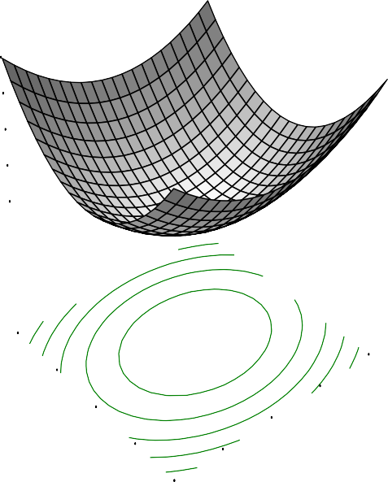Protein
X = A: Soaking Time Y = B: Parboiling temp

Actual Factors

10.4279

C: Drying Temp = 50.00
D: Storage Duration1=0.058.0701

9.74636

9.40561

9.06486
Protein

120.00

110.00

100.00

3.00

4.00

5.00

B: Parboiling tem9p0.00

80.00

1.00

2.00
A: Soaking Time

Fig.4.67: Effect of soaking time and parboiling temperatureon protein of rice flakes

DESIGN-EXPERT Plot

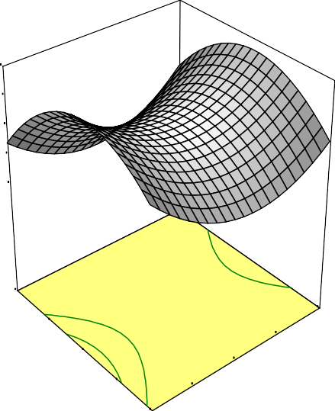Protein
0.00
56.0506
7854
459
6052

3425
70.00
5.00
60.00
4.00
50.00
3.00
C: Drying Temp40.00
2.00
A: Soaking Time
X = A: Soaking Time Y = C: Drying Temp

Actual Factors

9.61

B: Parboiling temp = 10 D: Storage Duration9=.29

8.9

8.6

8.
Protein

30.00 1.00

Fig.4.68: Effect of soaking time and drying temperature on protein of rice flake

DESIGN-EXPERT Plot

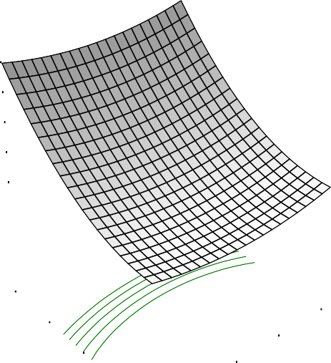Protein
X = A: Soaking Time
Y = D: Storage Duration

Actual Factors

12.8054

B: Parboiling temp = 100.00 C: Drying Temp = 5101.0.60448

10.4843

9.32372

8.16317
Protein

9.00

7.00

5.00

3.00

4.00

5.00

D: Storag e Duratio3n.00

1.00

1.00

2.00
A: Soaking Time

Fig.4.69: Effect of soaking time and storage duration on protein in rice flakes

DESIGN-EXPERT Plot

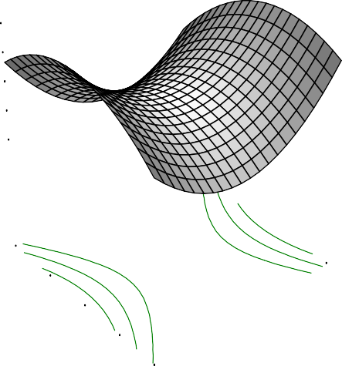Protein
097
53.0108
1666

2014

2361
70.00
120.00
60.00
50.00
110.00

100.00
C: Drying Temp40.00
90.00
B: Parboiling temp
X = B: Parboiling temp Y = C: Drying Temp

Actual Factors

9.9

A: Soaking Time = 3.00 D: Storage Duration9=.51

9.1

8.7

8.3
Protein

30.00 80.00

Fig.4.70: Effect of parboiling and drying temperature on protein in rice flake

DESIGN-EXPERT Plot

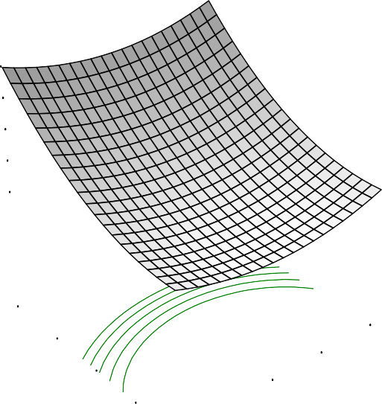Protein
X = B: Parboiling temp Y = D: Storage Duration

Actual Factors

13.1157

A: Soaking Time = 3.00
C: Drying Temp = 5101.0.80775

10.6394

9.40129

8.16317
Protein

9.00

7.00

5.00

120.00

110.00

100.00

D: Storag e Duratio3n.00

1.00

80.00

90.00
B: Parboiling temp

Fig.4.71: Effect of parboiling temperature and storage duration on protein in rice flakes

DESIGN-EXPERT Plot

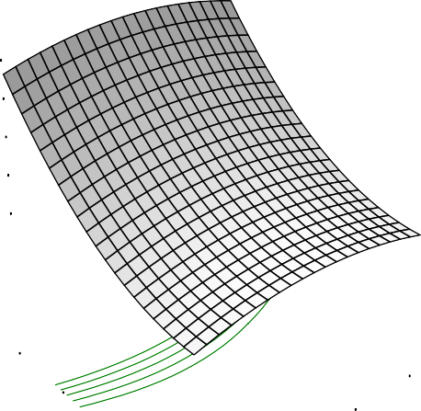Protein
X = C: Drying Temp
Y = D: Storage Duration

Actual Factors

12.2512

A: Soaking Time = 3.00
B: Parboiling temp =111.0006.5060

9.88014

8.69463

7.50913
Protein

9.00

7.00

5.00

50.00

60.00

70.00

D: Storag e Duratio3n.00

1.00

30.00
40.00
C: Drying Temp

Fig.4.72: Effect of drying temperature and storage duration on protein in rice flakes

    - Carbohydrate contents of ready-to-eat Ofada rice flakes

There was no significant difference in the data obtained for carbohydrate and the result ranged from 79.43 – 86.87 % (Table 4.24). The “Lack of Fit test” is not significant with the F-value of 0.66. The values of R², Adjusted R², predicted R², and adequate precision of the model were presented in Table 4.25. Carbohydrates are the macronutrient that human need in the largest amounts. According to the Dietary Reference Intakes published by the USDA, 45% - 65% of calories should come from carbohydrate. It is the body‟s main source of fuel and energy. Carbohydrates are needed for the central nervous system, the kidneys, the brain, the muscles (including the heart) to function properly (Fatsecret, 2013).

It was documented by Fatsecret (2013) that when carbohydrate consumption levels are at or above 75% of total energy there could be significant adverse effects on nutritional status by the exclusion of adequate quantities of protein, fat and other essential nutrients. In arriving at its recommendation of a minimum of 55% of total energy from carbohydrate, the consultation realised that a significant percentage of total energy needs to be provided by protein and fat, but that their contribution to total energy intakes will vary from one country to another on the basis of food consumption patterns and food availability.

    - Water absorption of ready-to-eat Ofada rice flakes

Water absorption is one of the major factors in determining the quality of flakes. The results obtained ranged from 2.37 to 4.88. The result showed that there were significant differences in the water absorption ratio values of the rice flakes (p<0.05). Observation of the data revealed that the rate of water absorption majorly varied with the storage duration of paddy before processing.
However, the highest water absorption ratio was obtained in rice flakes processed from rice subjected to 1 day soaking, 120 °C parboiling temperature, 70 °C drying after storage for 5 months duration. However, values of R², Adjusted R²,

predicted R², and adequate precision were presented (Table 4.25). The coefficient of the model showed a positive influence of drying temperature (D) and storage duration
- on raw material processing (paddy) in manufacturing of flakes (Table 4.26). The effect of soaking time and parboiling temperature, soaking time and drying temperature, soaking and storage duration, parboiling temperature and drying temperature, parboiling and storage duration, drying temperature and storage duration on water absorption of Ofada rice flakes were presented (Fids. 4.73-4.78).
    - Phytate composition of ready-to-eat Ofadaflakes

Rice contains some important anti-nutritional factors, most which are concentrated in the bran. All anti nutritional factors in rice except phytate are proteins and denatured by heat. The phytate levels from the experiment ranged from 0.39 to
1.67 %. Variation in respect of phytate content was found to be significant (p < 0.05). The highest amount of phytate was recorded in the flake produced from rice stored for 9 months, processed by soaking for 1 day, 80 °C parboiling temperature, and 70 °C drying temperature while the least value of phytate was at 5 days soaking, 120 °C parboiling, 30°C drying and 5 months storage duration of paddy. R², Adjusted R², predicted R², and adequate precision values were presented (Table 4.25). The low value of standard deviation (0.01) increased the degree of fitness of the model and the coefficient of the model is presented. However, increase in drying temperature and storage duration improved phytate of rice flakes which showed that reduction in drying temperature and short storage duration may prevent accumulation of phytate content in flakes (Table 4.23).
According to Noreen et al., (2009), soaking and boiling processes caused significant decrease in phytic in rice. This report may be related to the reason why soaking at longest day and highest degree of parboiling temperature resulted to the least value of phytate while the opposite of the processing conditions in terms of soaking and parboiling gave the highest phytate value in the rice flake. Humans have limited ability to absorb and hydrolyse phytate (Pawar and Ingle, 1988). Binding of

minerals with phytic acid decrease bio availability of calcium, iron, phosphorus, zinc and other trace elements to human and other monogastric

DESIGN-EXPERT Plot

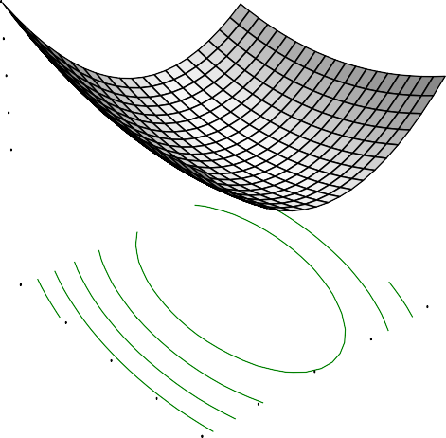Water Absorption
X = A: Soaking Time Y = B: Parboiling temp

Actual Factors

4.6963

C: Drying Temp = 50.00
D: Storage Duration4=.5554.0507

4.41284

4.27111
Water Absorption

4.12938

120.00

110.00

100.00

B: Parboiling tem9p0.00

2.00

5.00
4.00
3.00

80.00

1.00
A: Soaking Time

Fig.4.73: Effect of soaking time and parboiling temperature on water absorption ratio of flakes

DESIGN-EXPERT Plot

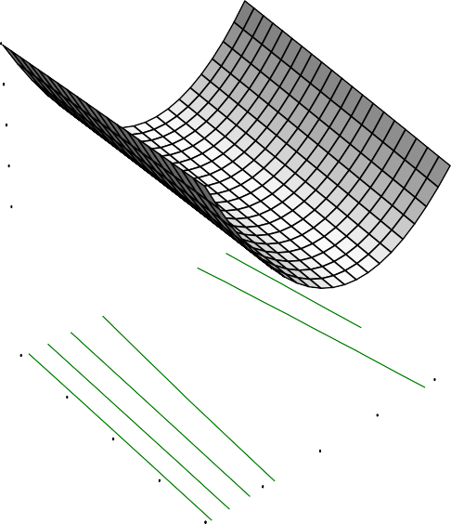Water Absorption
0.00
56.0508

1371
945
0084

8797
70.00
5.00
60.00
4.00
50.00
3.00
C: Drying Temp40.00
2.00
A: Soaking Time
X = A: Soaking Time Y = C: Drying Temp

Actual Factors

4.53

B: Parboiling temp = 10 D: Storage Duration4=.42

4.3

4.2
Water Absorption

4.0

30.00 1.00

Fig.4.74: Effect of soaking time and drying temperature on water absorption ratio of flakes

DESIGN-EXPERT Plot

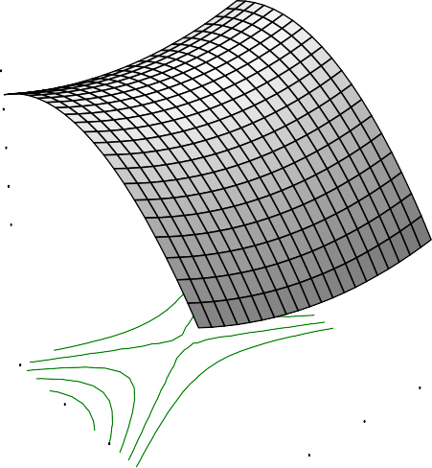Water Absorption
X = A: Soaking Time
Y = D: Storage Duration

Actual Factors

4.66202

B: Parboiling temp = 100.00 C: Drying Temp = 50.040.118

3.57398

3.02997
Water Absorption

2.48595

9.00

7.00

5.00

3.00

4.00

5.00

D: Storag e Duratio3n.00

1.00

1.00
2.00

A: Soaking Time

Fig.4.75: Effect of soaking time and storage duration on water absorption ratio of flakes

DESIGN-EXPERT Plot

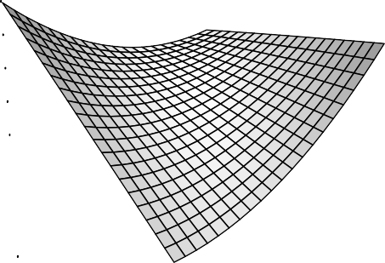Water Absorption
748
50.0605
2382

2699

3016
70.00
120.00
60.00
110.00
50.00
100.00
C: Drying Temp40.00
90.00
B: Parboiling temp
X = B: Parboiling temp Y = C: Drying Temp

Actual Factors

4.41

A: Soaking Time = 3.00 D: Storage Duration4=.32

4.2

4.1
Water Absorption

4.0

30.00 80.00

Fig.4.76: Effect of parboiling and drying temperature on water absorption ratio of flakes

DESIGN-EXPERT Plot

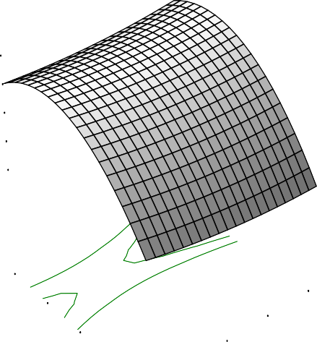Water Absorption
X = B: Parboiling temp Y = D: Storage Duration

Actual Factors

4.4921

A: Soaking Time = 3.00
C: Drying Temp = 530..9080564

3.47918

2.97272
Water Absorption

2.46625

9.00

7.00

5.00

120.00
110.00
100.00

D: Storag e Duratio3n.00

1.00

80.00
90.00
B: Parboiling temp

Fig.4.77: Effect of parboiling temperature and storage duration on water absorption ratio offlakes

DESIGN-EXPERT Plot

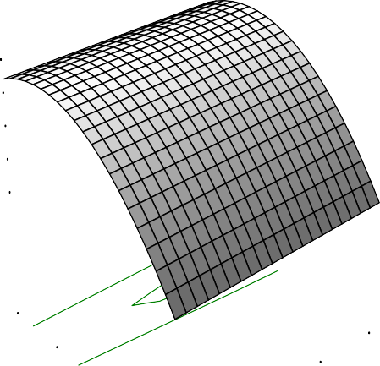Water Absorption
X = C: Drying Temp
Y = D: Storage Duration

Actual Factors

4.3413

A: Soaking Time = 3.00
B: Parboiling temp =3.180703.6050

3.406

2.93835
Water Absorption

2.4707

9.00

7.00

5.00

50.00

60.00

70.00

D: Storag e Duratio3n.00

1.00

30.00
40.00
C: Drying Temp

Fig.4.78: Effect of drying and storage on water absorption ratio of flakes

animals. This may lead to severe nutritional and consequently health problems in the consuming population (Thompson (1987).
4.8.8. Metabolization energy of ready-to-eat Ofada rice flakes

The metabolizable energy in the flakes was between 368.46 and 393.55 kcal/100g. There exist no significant difference (P > 0.05) in the metabolizable energy obtained from the rice flakes as affected by the processing condition and storage duration of paddy before processing. The “Lack of Fit” for the model is non significant with the F-value of 0.71. The R², Adjusted R² and standard deviation were 0.7882, 0.4917 and 5.64 respectively (Table 4.25). The effect of soaking were relatively stable while increase in parboiling temperature brought about increase in metabolisable energy.
  - Optimisation and validation of chemical quality of ready-to-eat Ofada

flakes

The optimisation of the ready to eat Ofada rice flake was based on quality indices and level of desirability expected from high profile ready to eat flakes. These indices include maximum protein for good nutrition, minimum ether extract to prevent rancidity, minimum moisture to increase its shelf life and to prevent microbial activities, maximum ash represents total mineral composition which is also vital in nutrition because of their various functions, carbohydrate was not specified since the product have high carbohydrate value, minimum phytate (anti-nutritional factor usually found in rice), maximum metabolizable energy and maximum water absorption.
There were ten solutions suggested with desirability range of 0.745 to 0.783 with the first predicted solution having the highest desirability (Table.4.27). This involved storage of paddy for 9 months, soaking for 4 days and 17h, parboiling at 106°C and drying at 30°C before milling to flour of desired particle size for the production of ready to eat flakes to yield 3.10% moisture, 12.16 % protein, 0.67 %

ether extract, 1.62 % ash, 393.19 kcal/100g, 0.67 % phytate, and 4.40 water absorption ratio. However, the first three solutions as presented (Table 4.27) have similar desirability with high closeness of processing conditions and the same storage duration of paddy. Observations of the yields were also closely related.
The result of the validation of the best predicted solution showed yields of 4.08
% moisture, 11.93 % protein, 0.86 % ether extract, 1.92 % ash, 81.21 %, 390.604kcal/kg, 4.57 water absorption and 0.32 % phytate. However, the results of the validation are closer to the result predicted by the response surface.

Table 4.27:Optimization of chemical and functional properties of Ofada rice flakes
S/N | Soaking | Parboiling | Drying | Storage | Moisture | Protein | Ether | Ash | Phytate | Water absorption | Metabolisable | Desirebility
 | Time,day | temp. | Temp. | Duration | % | % | Extract,% | % | % | ratio | energy,kcal/100g
1 | 4.70 | 106.16 | 30.00 | 9.00 | 3.1 | 12.164 | 0.67 | 1.621 | 0.665 | 4.4035 | 393.192 | 0.7832 | Selected
2 | 4.75 | 105.32 | 30.00 | 8.99 | 3.099 | 12.148 | 0.663 | 1.619 | 0.67 | 4.40266 | 393.191 | 0.7831
3 | 4.62 | 107.24 | 30.07 | 9.00 | 3.099 | 12.178 | 0.678 | 1.63 | 0.664 | 4.40116 | 393.166 | 0.7829
4 | 4.79 | 103.94 | 30.13 | 9.00 | 3.102 | 12.144 | 0.654 | 1.63 | 0.685 | 4.39364 | 393.112 | 0.7824
5 | 4.90 | 99.66 | 30.01 | 9.00 | 3.099 | 12.123 | 0.623 | 1.651 | 0.743 | 4.36695 | 392.962 | 0.7787
6 | 1.94 | 114.80 | 70.00 | 9.00 | 3.1 | 11.818 | 0.466 | 2.183 | 0.881 | 4.21874 | 388.686 | 0.7774
7 | 2.06 | 114.92 | 70.00 | 9.00 | 3.1 | 11.793 | 0.479 | 2.207 | 0.866 | 4.20355 | 388.584 | 0.7773
8 | 1.92 | 114.76 | 70.00 | 9.00 | 3.099 | 11.816 | 0.463 | 2.178 | 0.883 | 4.22206 | 388.71 | 0.7773
9 | 1.91 | 114.54 | 70.00 | 8.93 | 3.099 | 11.745 | 0.458 | 2.178 | 0.887 | 4.23492 | 388.817 | 0.7773
10 | 3.64 | 113.71 | 30.00 | 8.95 | 3.1 | 12.269 | 0.698 | 2.178 | 0.786 | 4.37523 | 392.861 | 0.7773

  - Sensory evaluation of ready to eat Ofada rice flakes

The first, sixth and tenth predicted solutions were chosen for sensory evaluation based on variation of the levels of processing conditions. The ready to eat Ofada rice flakes manufactured were subjected to sensory analysis (colour, crispiness, taste, aroma, and overall acceptability) based on a nine point hedonic scale, where 1 is dislike extremely and 9 is like extremely. The result of the sensory analysis is presented (Table 4.28).
There exist no significant differences (p > 0.05) in crispiness, taste, and aroma, however, significant difference was shown in colour attribute with flakes produced from tenth predicted solution been rated better than others. For the overall acceptability, the first solution was most accepted.
  - Moisture adsorption of Ofada rice flakes

The moisture sorption characteristic of Ofada rice flakes is presented in Fig.
4.79. Observation from the Figure presented revealed type II isotherm (sigmoidal). Equilibrium moisture content increased at the same relative humidity as temperature decreased. This is an indication that samples absorbed more moisture at lower temperature than when the temperature is high. Several works of other authors reported similar finding (Vega-Gálvez et al.,, 2008; Ajisegiri et al., 2007). According to Taoukis et al., (1988), lose of crispiness and texturally acceptability may be as a result of increase in water activity from 0.35 to 0.5.
The general trend of sorption isotherm as a function of temperature was shown in Fig.4.79. The percentage relative humidity (RH %) was converted to water activity (a_{w}). Over the range of water activity at lower temperature there was an increase in the equilibrium moisture content as also reported by Vega-Galvez et al., (2008). The equilibrium moisture content increased at the same water activity as temperature decreased. This may be due to the fact that food materials absorb more moisture at low temperature than when the temperature is high and water molecules have lower kinetic energy at low temperature which is not enough to overcome the corresponding

sorption energy (Vega-Galvez et al., (2008). Mould growth was observed on all the samples kept at 90 % relative humidity of 25 ºC and 35 ºC and presumes not to have significant effect on the final moisture content of the samples (Alam and Singh, 2011).
The parameter values at 25, 35 and 45 ºC of all the models used (Brunauer, Emmett and Teller (BET), Guggenheim Anderson de- Boer (GAB), Oswin, and Halsey) for the adsorptions were shown in Table 4.28. The high regression coefficient (R²), percentage deviation, % E lower than 12 % and root mean square error (RMSE) close to zero for the isotherms and temperatures as obtained in the experiment have shown that all the models were fit. GAB recorded highest regression coefficient (0.985-0.981), lowest root mean square error value (RMSE) (0.18 and 0.09 at 25 ºC and 35 ºC respectively). However, based on the average values of the statistical parameters, GAB has the best fitness for the three temperatures studied. The GAB and BET models were used to estimate the monolayer moisture content.
The monolayer moisture content is the moisture of a material when its entire surface is covered with a unimolecular moisture layer (Alakali et al., 2009). It is referred to moisture content of maximum stability. As presented in Table 4.29, the monolayer moisture decreased with increase in temperature for samples tested which may be due to reduction in the number of active site for water binding because of the physical and chemical changes in the product induced by temperature (Alakali et al., 2009). These observations imply that the optimum moisture for shelf stability of Ofada flake will be determined in relation to anticipated temperature of storage.

Table 4.28: Sensory evaluation of Ofada rice flakes
Ofada rice flakes | Colour | Taste | Aroma | Crispiness | Overall Acceptability
First solution | 6.7a | 7.1a | 6.9a | 6a | 7.30a
Sixth solution | 6.3a | 7.5a | 7.2a | 6.3a | 6.4ab
Tenth solution | 7.8b | 7.20a | 6.80a | 6.2a | 6.6a
Note: Compared values with the same alphabet are not significantly different while those which differalphabetically showed significant differences at p<0.05.

EMC(db%)

Figure 4.79: Experimental adsorption isotherms of Ofadaflakes at three working temperatures
30

25

20

15

10
25oC
35oC
45oC
5

0
0
0.2
0.4
0.6
0.8
1
water activity

Table 4.29: Equation and statistics value of four different equation
Sorption Isotherm at 25oC |  |  |  |  | Equation coefficients
Model | Equation | R2 | A | B | C | E% | RMSE | Cal. F. value | Prob.F. value
GAB | A*B*C*aw/((1-C*aw)*(1+(B-1)*C*aw)) | 0.982 | 9.467 | 2.104 | 0.769 | 0.073 | 0.18 | 241.69 | 9.28
BET | A*C*aw/((1-aw)*(1+(C-1)*aw)) | 0.745 | 2.995 |  | 3.99E+07 | 1.273 | 3.067 | 31.884 | 6.94
Oswin | A*(aw/(1-aw))**C | 0.963 |  | 9.132 | 0.479 | -0.076 | 0.183 | 235.139 | 4.53
Halsey | (-A/Ln(aw))**B | 0.946 |  | 34.637 | 0.565 | -0.12 | 0.29 | 157.809 | 6.94
Sorption Isotherm at 35oC |  |  |  |  | Equation coefficients
Model | Equation | R2 | A | B | C | E% | RMSE | Cal. F. value | Prob.F. value
GAB | A*B*C*aw/((1-C*aw)*(1+(B-1)*C*aw)) | 0.985 | 7.064 | 2.925 | 0.784 | 0.044 | 0.09 | 303.32 | 9.28
BET | A*C*aw/((1-aw)*(1+(C-1)*aw)) | 0.713 | 2.496 |  | 1.10E+08 | 1.37 | 2.37 | 29.889 | 6.94
Oswin | A*(aw/(1-aw))**C | 0.968 |  | 7.823 | 0.479 | -0.067 | 0.137 | 280.948 | 4.53
Halsey | (-A/Ln(aw))**B | 0.95 |  | 29.634 | 0.547 | -0.11 | 0.223 | 179.504 | 6.94
Sorption Isotherm at 45oC
Model | Equation | R2 | A | B | C | E% | RMSE | Cal. F. value | Prob.F. value
GAB | A*B*C*aw/((1-C*aw)*(1+(B-1)*C*aw)) | 0.981 | 6.251 | 2.4 | 0.777 | 0.061 | 0.1033 | 228.514 | 9.28
BET | A*C*aw/((1-aw)*(1+(C-1)*aw)) | 0.732 | 2.091 |  | 2.26E+07 | 1.307 | 2.207 | 30.809 | 6.94
Oswin | A*(aw/(1-aw))**C | 0.962 |  | 6.435 | 0.473 | -0.075 | 0.127 | 230.796 | 6.94
Halsey | (-A/Ln(aw))**B | 0.944 |  | 19.306 | 0.559 | -0.119 | 0.2 | 337.197 | 6.94
A- Monolayer moisture content; B and C are constants

CHAPTER FIVE

5.0 CONCLUSION AND RECOMMENDATIONS

  - Conclusions

Response surface methodology was used successfully in the optimisation and modelling effect of storage duration and processing parameters on Ofada rice and flakes quality.The results of rice and flakes analysis showed significant differences (p<0.05) as affected by storage duration and processing parameters except in thousand grain weight, colour value, ash content, elongation, magnesium, breakdown viscosity of rice while carbohydrate and metabolisable energy of flakes were not significant. The multiple correlation coefficients (R²) of rice for the models ranged between 0.3562- 0.948 for physical qualities, 0.5149-0.9573 for chemical qualities, 0.609-0.9687 for cooking properties and 0.3562-0.919 for chemical qualities of flakes.
The sensory assessment has revealed that local rice such as Ofada rice could be used for the production of ready-to-eat flakes of good quality.Optimum processing of Ofada paddy for ready-to-eat flakes production include storage of paddy for 9 (nine) months, soaking for 4 (four) days and 17 h, parboiling at 106 °C and drying at 30 °C before milling to flour.
Optimum conditions for storage and processing of Ofada paddy for various end uses include;
    - Best physical quality requires storage of paddy for storage 1 (one) month, soaking of paddy for 1 (one) day, parboiling at 119.92°C, and drying at 30°C.
    - Best chemical quality requires storage of paddy 9 (nine) months, soaking for 1 day and 19h, parboiling at 120°C and drying at 30°C.
    - Best indices for cooking properties could be attained by storage of paddy for 9 (nine) months, soaking of paddy for 5 (five) days, parboiling at 80°C and drying at 55°C.

    - Best mineral requirement involved storage of paddy for 9 (nine) months, soaking for 1 (one) day 9h, parboiling at 115°C and drying at 58°C.
    - Pasting requirement for boiled rice is storage of paddy for 9 months, soaking for 2 (two) days and 19h, parboiling at 90.42⁰C, and drying at 30⁰C.
    - Pasting requirement for mashed rice include storage of paddy for 1 (one month),
soaking 5 (five) days, parboiling at 80°C, and drying at 54°C.
    - Overall optimisation of processing and storage duration for optimum physical, chemical, mineral, and cooking properties of Ofada rice include storage of paddy for 8 (eight) months and 19 (nineteen) days, soaking for 1 day and 19 h: 55 min, parboiling at 113.4⁰C and drying at 43.23⁰C.
Moisture adsorption of Ofada flakes produced J shaped curve which can be classified as type II. The equilibrium moisture content of the flakes increased with decrease in temperature at a constant water activity.
Out of the models tested, Brunauer, Emmett and Teller (BET), Guggenheim Anderson de- Boer (GAB), Oswin, and Halsey for the adsorptions, GAB is rated best for the fitness and with calculated monolayer moisture range between 6.251-
9.467 and 2.091-2.995 for BET which decreased with increase in temperature.

Response surface methodology was applied for the optimisation and modelling of processing parameters (soaking time, parboiling temperature, and drying temperature) and storage duration of paddy rice for quality and production of Ofada ready-to-eat flake. The study revealed appropriate best practices for Ofada rice processing operations for the purpose of upgrading its physical, chemical, functional, and cooking properties for various end uses, production of flakes and determination of its moisture adsorption in storage.

  - Recommendation

The following recommendations were suggested for further studies:

- Optimisation and modelling of quality of other variety of Nigerian local rice as affected by storage duration and processing condition should also be investigated.
- Sensory quality of ready-to-eat rice flake produce from non parboiled
Ofada rice is also a green area of pending research.
- Processing operations for the manufacture of ready-to-eatOfada rice flake should also be studied for the purpose of optimisation.
  - Contribution to knowledge

    - The results of this study made available relevant technical data on optimum storage duration, soaking time, parboiling temperature, and drying temperature forOfadamilled rice processing for present and prospective investors that would have relied on “trial and error” method in processing Ofada rice for various end uses.
    - Information on the optimum processing conditions of Ofada rice into flour for the production of ready-to-eat flake as an alternative mean of utilization was provided.
    - Mathematical modelling of effect of physical, chemical, cooking, and pasting properties of Ofada riceand flakes as affected by storage and processing parameters.
    - Identification of volatile compounds responsible for aromatic quality ofOfada rice.
    - Technical data on moisture adsorption characteristics of ready-to-eat Ofada
flakes and best model for moisture stability prediction were supplied.

REFERENCES

Abbas, A, Murtaza. S, Aslam, F, Khawar. A, Rufique S and Naheed .S. (2011). Effect of processing on nutritional value of rice (oryza sativa). World Journal of Medical Sciences 6 (2). 68-73.
Adair, C.R, Beachell, H.M, Jodon, N.E., Johnston, T.H, Thysell,J.R.,, Green, V.E,, Webb, B.D., Atkins, J.G. (1966). Rice breeding and testing methods in the U.S. In: Rice in the U.S.: varieties and production. USDA Agricultural Research Services Handbook
289. U.S. Dept. of Agriculture. Pp. 19-64.
Adebowale,A.A, Sanni, S.A, Karin,O.R and Ojoade,J.A (2010). Malting characteristics of Ofada rice.Int.Food Research Journal 17:83-88.
OF
Adekoyeni, O.O., Akinoso, R. And Malomo, O. (2012). Some physical properties and yield of Ofada rice. J. Basic Appl. Sci. Res.,2(4)4098-4108.
Adeniran, O., Atanda, O., Edema, M., and Oyewole, O. (2012). Effect of lactic acid bacteria and yeast starter cultures on the soaking time and quality of “Ofada” rice. Food and Nutrition Sciences,3; 207-211.
Adeyemi,I.A. (2009). Some quality factors of raw and processed rice. http://www.nifst.org/layout/set/print/Editorials/FOOD-FORUM/
Adeyemi, I.A., Fagade, S,O and Ayotade, K.A. (1986). Some physicochemical and cooking qualities of Nigeria rice varieties. Nigerian Food Journal, 4(1): 26 - 33.
Adeyemi,I.A,Ojo,A.A, Fagade, S.O and Ayotade,K.A(1985). Rice processing technology-options for Nigerian rice industry. In: Technological Development and Nigerian Industries (B.J. Olufeagba, J.S.O. Adeniyi and M. A. Ibiejugba, Eds.), UNILORIN Press, pp.158.
Adu-Kwarteng, E., Ellis, W.O., Oduro, I. and Manful, J.T. (2003). Rice grain quality: a comparison of local varieties with new varieties under study in Ghana. Food Control 14: 507 – 514. Agriculture and Healthcare, 3(6); 106-112.
Ajisegiri, E.S.A, Chukwu, O and Sopade P.A (2007). Moisture Sorption study of locally parboiled rice A.U.J.T 11(2): 86-90.

Ajisegiri, E.S.A. and Chukwu, O. (2004). Moisture-sorption isotherm of kulikuli and Fura. Landzun J. Engin. Appr. Technol.2:1-3.
Akande, T (2001). An overview of the Nigerian rice economy. Nigeria Institute of Social and Economic Research (NISER), Ibadan, Nigeria.
Akanji, B.O. (1995). Hedonic-Price Analysis of the Demand for Grain Crops in Nigeria: The Case of Rice and Cowpea. A Ph.d Thesis Submitted to the University of Ibadan, Ibadan, Nigeria.
Akinoso, R. and Adeyanju, J. A. (2010). Optimization of edible oil extraction from ofada rice bran using response surface methodology. J. Food and Bioprocess Technology DOI:10.1007/s11947-010-0456
Akionso, R., Aboaba, S.A., and T.M.A. Olayanju (2010). Effects of moisture content and heat treatment on peroxide value and oxidative stability of un-refined sesame oil. African Journal of Food Agriculture, Nutrition and Development,10(10),4269-4268.
OF
Akintunde, B.O. and Tunde-Akintunde, T.Y.(2013). Ffect of drying method and variety on quality of cassava starch extractsVolume 13(5)8353-8354.
Akpokodje, G., F. Lancon and O. Erenstein, 2001. Nigeria's rice economy: Stateof the art. The Nigeria Rice in a Competitive World: Constraints, Opportunities and strategic choices. Final Report Presented to West Africa Rice Development Association (WARDA), Ouake, Cote'Ivoire, pp: 55
Alam, M.S. and Singh, A. (2011). Sorption isotherm characteristics of aonla flakes. J. Food Sci. Technol, 48(3);335-343.
Alakali, J., Irtwange, S.V., and Satimehin, A.(2009). Moisture characteristics of ginger slices.Cienc. Technol. Aliment., 29(1) (http ://dx.doi.org/10.1590/S0101- 20612009000100024)
Allen L, de Benoist B, Dary O, Hurrell R (2006) Guidelines on food fortification with micronutrients; WHO/FAO, editor.
Alp, A., Needet, O, and Ali, G. (2009). Equilibrium moisture content and equations for fitting sorption isotherms of Capsicum annuum. GIDA,34(4): 205-211.

Ambreen, N., Hanif, Q.N, Khatoon, S. (2006).Chemical composition of rice polishing from different sources. Pakistan Vet. J., 2006, 26(4): 190-192.
American Rice Inc. 2004. Nutritional information. [online] Available at. http://www.amrice.com/6-4.cfm (Verified 06 Aug. 2007)
Anderson, R.A. (1976). Wild rice: Nutritional review. J. cereal chemistry 53(6): 949- 955.
Anjum,F.M., Pasha, I., Bugti, A., and Butt, M.S. (2007). Mineral composition of different rice varieties and their milling fractions. Pak.J.Agri. Sci.44(2):332-336.
A.O.A.C. (2000). Official method of analysis 17th edition, Horowitz edition intern, Maryland, USA. Vol. 1; 452-456.
Araullo, A.V., De-Padua, D.B., and Graham, M. (1976). Moisture. Rice: Post Harvest Technology. Intr. Develop. Res. Cen. Ottawa Canada. 113-118.
OF
Ashish J., Sughosh, M. R., Sarika, S., Abhinav ,R., Swapnil ,T., Sanjeeb ,K.M., Nishant, k.S., Ashish, S., Naisarg ,M., Vibhav, B. and Chitra,K. (2012). Effect of cooking on amylose content of rice. Euro. J. Exp. Bio., 2 (2):385-388
Atkins, J.G. (1966). Rice breeding and testing methods in the U.S. U.S. Dept. of Agriculture. Pp. 19-64. 302, India LWT - Food Science and Technology 01/2008; 41(10):2092-2096.
Awan, I.A. (1996). Physical and biochemical char acterization of some of the Pakiatani rice varieties. M.Sc. (Hons.) Thesis. Dept . of Food Tech., Univ. Agric. Fsd.
163.
Ayelogun, T.A. and Adegboyega, T.D. (2000). Effects of steeping on rice characteristics. Proceedings of 1st International Conference, Nigerian Institution of Agricultural Engineers, University of Ibadan, Ibadan.pp8.
Azizah, A, Sulaiman,R.R, Osman, A, Saari, N (2004). Preliminary study of the chemical composition of rice milling fractions stabilized by microwave heating. Journal of Food Composition and Analysis, 20 (7). pp. 627-637.
Bamidele, F.S., Abayomi, O.O. and Esther, O.A. (2010). Economic analysis of rice consumption patterns in Nigeria J. Agr. Sci. Tech. Vol. 12: 1-11

Bandara, D.M., Bandara, B.D.,Wickramanayaka, W.P, Rathnayake, H.M.,Senanayake , D.P., and Palipane, K.B. (2007). Design and development of a small /medium scale rice flaking machinery for manufacture of rice flakes. Annual Transactions of IESL, pp. 168-175.
Bao, J., and Bergman, C.J. (2004). The functionalityof rice starch. In: Starch in food: Structure, function and applications, A.-C. Eliasson (Ed.), Woodhead Publishing Ltd. and CRC Press LLC: Boca Raton, Fl. pp. 258-294.
Bao, J., Sun, M., and Corke, H. (2007). Analysis of genotypic diversity in starch thermal and retrogradation properties in nonwaxy rice. J. Carbohydrate Polymers 67:174–181.
Bello, M.,R. Baeza,M.P. Tolaba (2004). Quality characteristics of milled and cooked rice affected by hydrothermal treatment. J. Food Engineering, 72:124-133.
OF
Bergman, C. J., Delgado, J. T., Bryant, R., Grimm, C., Cadwallader, K. R., & Webb,
B. D. (2000). Rapid gas chromatographic technique for quantifying 2-acetyl-1- pyrroline and hexanal in rice (Oryza sativa, L.).Cereal Chemistry, 77, 454–458.

Beston, G.H and Kirk, D.W (1978). Method of producing dehydrated rice flakes.
United States patent 4107344.
Bhatta Changa, K.R., Sowbhagya., C.M. and Indudhara Swamy, Y.M.(1998). Importance of insoluble amylose as a determinant of rice quality. J. Sci. Food Agric, 29: 359-364.
Bhattacharya, K.R. (2004). Parboiling of rice. In: Rice chemistry and technology, Champagne ET, editor, St. Paul, Minn.:AACC Int. Pp.329-40
Bhattacharya, K.R. (1985). Parboiling of rice: In “Rice Chemistry and Technology”ed. by B.O. Juliano. American Association of Cereal Chemists, Inc., St Paul, Minnesota Pp. 289-348.
Bhattacharya, K.R. (1980). Breakage of rice during milling: a review. Tropical Science 22 (3): 255-276.
Bhattacharya, K.R. and Ali, S.Z. (1990). Improvement in commercial sundrying of parboiled paddy for better milling quality. Rice Journal. 73(9), 12-15.

Bhattacharya,K.R, and Subbarao, P.V (1996). Effects of processing condition on quality of parboil rice, J. Food Science and Technology, 14(5). 476- 479.
Bhonsle S.T and Sellappan, K (2010). Grain quality evaluation of traditionally cultivated rice varieties of GOA, India .J. of recent research Science and Tech. 2010, 2(6):88-97.
Biswas, S.K (1987). Effect of starch properties on parboiling process and some physicochemical properties of parboiled rice. (Thesis (M.S.). University of the Philippines at Los Barios, Pp. 9-11.
Blanshard, J.M.V. and Mitchell, J.K. (1988). Food structure-its creation and evaluation. Butler and Tanner, Great Britain,pp.17.
Bryant, R.J. and McClung, A.M. (2011).Volatile profiles of aromatic and non-aromatic rice cultivars using SPME/GC–MS. Food Chemistry, 124;501-513.
OF
California Rice Commission (2003). Environmental and conservation balance sheet for the California Rice Industry. Sacramento CA, 2003. Available onlinein March 2003 at www.calrice.org/a_balancesheet/index.htm.
Champagne, E. (2008). Rice aroma and flavor: A literature review.Cereal Chemistry, 85, 445–454
Chang,T.T (1976). The origin, evolution, cultivation, dissemination, and diversification of Asian and African rice. Euphytica 25 (1):425-41.
Cherati, F.E, Babatabar, R and Nikzard, F. (2012). Analysis and study of parboiling method, and the following impact on waste reduction and yield increase of Iranian rice in paddy conversion phase. World Academy of Science, Engineering and Technology (63), pp. 772-775.
Chrastil, J. (1992). Correlation between the physicochemical and functional properties of rice. J.Agri.Food Chem., 40:1683-1686.
Chrastil, J. (1990). Chemical and physicochemical changes of rice during storage at different temperatures. J. Cel Sci. 11; 7185.
Chris, O. (2013). Rice: Elasticity demand at play. http.//www.manufacturingtoday.com.ng/2013/12/11/rice.elasticity-of-demand-at- play/

Chukwu, O and Ajisegiri, E.S.A (2005). The effects of moisture sorption cycles on some physical properties and nutritional contents of Agricultural grains. A.U.J.T, 9(2) 121-150.
Chukwu, O. and Oseh, F.J. (2009). Response of nutritional contents of rice (Oryza sativa) to parboiling temperatures , Am.-Eurasian J. Sustain. Agric., 3(3): 381- 387.
Danbaba,N., Anounye,J.C., Gana,A.S., Abo, M.E., Ukwungwu, M.M and Maji, A.T (2012). Physical and pasting properties of Ofada rice (Oryza sativa L.) varieties. Nigerian Food Journal,30(1); 18 – 25.
Danbaba, N., Anounye, J.C, Gana, A.S, Abo, M.E and Ukwungwu, M.N (2011). Grain quality characteristics of Ofada rice (Oryza sativa L.); Cooking and eating quality. Int. Food Res. Journal 18; 629-634.
OF
Daniels, M.J., Marks B.P., Siebenmorgen, T.J., Menew, R.W. and Meullenet, J.F (1998). Effect of long grain rough rice storage history on end – use quality. J. Food Sci., 63 :832-835.
Daramola, B. (2005). Government policies and competitive of Nigerian rice economy. A paper presented at the workshop on Rice Policy and Food security in Sub- Saharan Africa organised by WARDA, Cotonou, Republic in Benin,Nov.7th 2005.
Desikacha (1975). Processing of maize, sorghum and millets for food uses. J.Sci. Ind.
Res. 34:231-237.
Decagon (2011). Fundamentals of moisture sorption isotherms: application note. www.aqualab.com
Diagne, A, I. Bamba, J. Manful, O. Ajayi (2011). Historic opportunities for rice growers in Nigeria. Inter-reseaux Department rural.www.inter-reseaux.org.
Dipti, S.S., Bari, M.N and K.A. Kabir, (2003). Aging of rice in the first six month after harvest. Arkanas Farm Research 42 (1); 8-9.
Ebuchi, A.E, and Oyewole, C.O(2007). Effect of cooking and soaking on physical characteristics, nutrient composition and sensory evaluation of indigenous and

foreign rice varieties in Nigeria. African Journal of Biotechnology; Vol6(8), pp 1016- 1020.
Ellis, J.R., C.P. Villareal and B.O. Juliano. (1985). Protein content, distribution and retention
during milling of brown ri ce. Qual. Plant. Plants Food Hum.. Nutr. In Press.
Eke-Ejiofor.J, Barber, l.I and Kiin-Kabari, D.B (2011). Effect of pre-boiling on the chemical, functional and pasting properties of rice. J. of Agric. and Biol. Sciences, 2(7); 214-219.
Eme and Nathan (2007). Diaspora demand study for Ofada rice. Monograph series Vol. 31 Department for International Development, 40 Mississippi street, Maitama, Abuja, Nigeria.
OF
Enwerem, V.A. and Ohajianya, D.O. (2013). Farm size and technical efficiency of rice farmers in Imo State, Nigeria. Greener Journal of Agric. Sci. 3(2)128-136.
Erhabor, P.O.I and Ojogho, O. (2011). Demand and analysis for rice in Nigeria. J. Food Tech., 9(2): 66-74.
Erenstein, O., F. Lancon, O. Osiname and M. Kebbeh, 2004. Operationalizing the strategic framework for rice sector revitalization in Nigeria. The Nigerian Rice Economy in a Competitive World: Constraints, opportunities and strategic choices, Project Report, pp: 38.
Evans, L.T (1972). Storage capacity as a limitation to grain yield. In: Rice Breeding.
International Rice Research Institute Los Banus, Pp. 499-511.
Fast, R. B. and Caldwell, F.E. (1990). Manufacturing technology of Ready-to-eat cereals. Breakfast cereals and how they are made. Pub. by American
Association of Cereal Chemists (AACC), Inc. St. Paul, Minnesota, USA.
Fatsecret (2013). Rice flakes; nutritional facts. http://www.fatsecret.com/calories- nutrition.
Fennema, O. R. (1996). Food chemistry, Third edition. Mercel Dekker, Inc. New York, pp.191-201.
Fofana, M., Wanvoeke, J., Mandful, J., Futakuchi, K., Van Mele, P., Zossou, E., and Bleoussi, T.M.R. (2011). Effect of improved parboiling methods on the physical

and cooked grain characteristics of rice varieties in Benin. Int. Food Res. Journal, 18:715-721.
Food and Agriculture Organisation (2008). African development indicator. Food and Agriculture Organization, Rome.
Food and Agriculture Organisation (2005). Rice faces the future. Agriculture and Consumer Protection Department, Food and Agriculture Organisation of the United Nations.http://wwwfao.org/ag/magazine/0512Sp2.htm
Food and Agricultural Organisation (2002). Food Energy – Methods of analysis and convertion factors. Report of a technical workshop. Rome,
3-6 December, 2002.
Food and Agricultural Organisation/ World Health Organisation (1998). Physical activity: impact of protein and amino metabolism and implication for nutritional requirements. World Health Organization (WHO) Technical Report, Geneva, Ser. No 522.
OF
Food and Nutrition Board, Institute of Medicine (1997). DRI Dietary Reference Intakes for Calcium,Phosphorus, Magnesium, Vitamin D, and Fluoride. Washington, DC: National Academy Press; 1997.
Free, G. (2007). Role of heat treatment in the processing and quality of oat flakes. Academic dissertation submitted to the Department of Food Technology, University of Helsinki.
Frei, M. and Becker, K. (2003). Studies on the in vitro starch digestibility and glycemic index of six different indigenous rice cultivars from the Philippines, J. Food Chemistry,83, 395-400.
Gadja, W. J., and Biles, W.E.(1978). Engineering modelling and computation.
Houghton
Miffling Company, Boston. pp. 315-320.
Garcia-Estepa, R. M., Guerra-Hernández, E., and García-Villanova, B. (1999). Phytic acid content in milled cereal products and breads. Food Res. Int. 32:217–221.
Gayin, J.,Manful, J.T , P.T. Johnson(2009). Rheological and Sensory properties of rice

varieties from improvement programme in Ghana. International Food Research Journal 16:167-174.
Gomez, K.A. (1979). Effect of Environment on protein and amylose content of rice in: Workshop on chemical aspects of rice grain quality. I RRI. Los Banos, Laguma, Philippines. p. 59-68.
Gupta.E, Sinha.J and Dubey, R.P. (2012). Utilization of dehydrated herbs in the formulation of value added snack ”Rice Flakes Mix”. Journal of Food Process (SI http://dx.doi.org/10.4172/2157-7110.SI-002.
Hamakers, B.R., Siebenmorgan, T. J., and Dilday, R.H. (1993). Aging of rice in the first six months after harvest. Arkanas Farm Research, 42(1):8-9.
Hardcastle, J.E.Y. (1959. The Development of rice production and research in the Federation of Nigeria. Trop. Agric. (Trinidad), 36: 79-95.
OF
Helliwell, S. and C. Blanchard (2001). Ageing to stored rice: changes in chemical and physical attribute. J. of cereal science 33: 1000.
Hizukuri, S., Takeda, Y., M aruta, N. and Juliano, B .O. (1989). Molecular structures of rice starch. Carbohydr. Res. 189: 227–235.
Hogstrand, C. and Haux, C. (2001). Binding and detoxification of heavy metals in lower vertebrates with reference to metallothionein. Comp. Biochem. Physiol., 100: 137.
Hongyi, D., Yidan, O., Chengjun, Z. and Qifa, Z. (2011). Complex evolution of S5, a major reproductive barrier regulator, in the cultivated rice Oryza sativa and its wild relatives DOI: 10.1111/j.1469-8137.2011.03691.x

Ibukun E.O (2008) Effect of prolonged parboiling duration on proximate composition of rice. J Scientific Research and Essay Vol.3 (7), pp. 323-325.
Idris, A., Rasaki, K., Hodefe, O.J. and Hakeem, B.(2013). Consumption pattern of
Ofada rice among civil servants in Abeokuta metropolis of Ogun State,Nigeria.
J. of Biology, Agriculture and Healthcare, 3(6); 106-112.
Igbeka, J.C, Verma, L.R and Vehipillai, L. (1991). Predicting selected quality attributes in parboiled rice. American Society of Agricultural Engineers,

7(4),38-42.
Inching K. (2007). Fatty acds in food and their health implication, 3rd edition CRC press 2001, pp. 303-316. Edited by Ching Kung Chow.
Inouchi,N., Ando,H., Asaoka, M., Okuno, K., and Fuwa, H.(2000). The effect of environmental temperature on distribution of unit chains of rice amylopectin. Starch/Starke 52: 8-12.
International Food Policy Research Institute (2013). Policy options for accelerated growth and competitiveness of the domestic rice economy in Nigeria .
International Food Policy Research Institute (IFPRI) Series number: 35 http://www.ifpri.org/publication/policy-options-accelerated-growth-and- competitiveness-domestic-rice-economy-nigeria
OF
International Institute for Tropical Agriculture (2001). Analytical manual. IITA.
IOM (2001) Dietary reference intakes for vitamin A, vitamin K, arsenic, boron, chromium, copper,iodine, iron, manganese, molybdenum, nickel, silicon, vanadium and zinc. A report of the Panel on Micronutrients, Subcommittees on Upper Reference Levels of Nutrients and of Interpretation and Use of Dietary Reference Intakes, and the Standing Committee on the Scientific Evaluation of Dietary Reference Intakes. Food and Nutrition Board, Institute of Medicine. Washington, DC, National Academy Press.
IRRI (International Rice Research Institute) ( 2008). Knowledge bank on rice quality.Downloadedfrom http://www.knowledgebank.irri.org/riceQuality/riceQuality.doc on 6/6/2008.
IRRI (International Rice Research Institute) (2007). Procedures for measuring quality of milled rice In: Rice quality available from http://www.knowledgebank.irri.org/riceQuality/default.htm#Qly05.htm.
Accessed on June 30, 2010.
IRRI, (2004). World Rice Statistics. International Rice Research Institute, Manila, Philippines.

Islam, M.R., Shimizu, N., and Kimura, T. (2003). Energy requirement in parboiling and its relationship to some important quality indicators. J. Food Engin.63: 433- 439.
Itoh, K, and Kawamaura, S. (1991). Milling characteristics of parboiled rice and properties of the milled rice studies on parboiled rice. J. of Food Sci. Technol. 38: 776-783.
Ituen, E.U.U. and Ukpakha, A.C. (2011). Improved method of parboiling paddy for better quality rice. World Journal of Applied Science and Technology, 3(1); 31- 40.
James, C. and D. McCaskill. (1983). Rice in Amer ican diet. Cereal Foods World.
28(11): 667-669.
OF
Janick, J.(2002). Rice: the natural history of rice [online].Available at. http://www.hort.purdue.edu/newcr op/tropical/lecture_20/rice.html.(Verified 24 Sep. 2006).
Jennings, R.B., Coffman, W.R. and Kauffman, H.E. (1979). Rice improvement. IRRI, Los Banos.
Johnson, S.A. (1995). Rice. Mirneapolis, MN: Learner publications Co., 1995. Juliano,
B. O. 1993. Rice in human nutrition. Food and Agriculture Organization of the United Nations, International Rice Research Institute, 162pp.
Jones, M. P., (1995). The rice plant and its environment. WARDA Training Guide 2.
WARDA, Bouaké, pp. 27-30.
Jouki, M. and Khazaei, N. (2012). Some physical properties of rice seed (Oriza sativa). IIOABJ,3(4); 15-18.
Juliano, B. O. (1993). Rice in human nutrition. Food and Agriculture Organization of the United Nations, International Rice Research Institute, 162pp.
Juliano, B.O. (1985). Criteria and test for rice grain qualities. In „ Rice chemistry and Techonology‟ (B.O. Juliano, ed), Am Assoc. Cereal Chem., St Paul, MN, USA. (1985)
Juliano, B.O. and Duff, B. (1989). Setting priorities for grain quality research. A paper presented on grain post harvest technology, 29-31 Aug., 1989, Surabaya,

Indonesia.
Juliano, B.O., Blakeney, A.B., Butta, I., Castilli, D., Choundhury, N.H.,Iwasaki, I.,Shibuya, N.,Kongseree, N., Lagos, E.T., Murty, V.S., Paule, C.M., Perez, C.M., and Webb, \.D. (1982). International cooperative testing on alkaline digestibility values for milled rice. Starke 34, 21-26.
Juliano, B. O., Perez, C. M., and Blakeney, A. B. (1981). International Cooperative Testing on the amylose content of milled rice. Starch/Stärke 33(5):157–162.
Juliano, B.O., Onate, L.U., and Del, M.A.M. (1965). Relation of starch composition, protein content and gelatinisation temperature to cooking and eating quality of milled rice. Food Technol. 19:1006- 1011.
Kaasova,J., Kadlec,P., Bubnik,Z. and Pour,V.(2001). Microwave treatment of rice.
OF
Czech J.Food Science Vol.19(2);62-66.
Kabirullah, M., and Rahman, M. (2001). Chemicalchangesinfoodgrainsin governmentstorage.Food Management & Research Support Project (FMRSP),
Ministry of Food, People's Republic of Bangladesh. Working Paper No.21FIIRSP Bangladesh International Food Policy Research Institute
Kassali, R., Kareem, R.O., Oluwasola, O. and Ohaegbulam, O.M. (2010). Analysis of demand for rice in Ile Ife, Osun State, Nigeria. Journal of Sustainable Development in Africa. 12(2), 2 63 – 78.
Katekhong, W and Charoenerein, S. (2012). Effect of rice storage on pasting properties, swelling and granular morphology of rice flour. Asian Journal of Food Ag-Ind. 5(4), 315 – 321.
Kaung,J.(1984. Nigerian Rice Industry. International Rice Commission Newsletter,December,1985 Vol.xxxx,No.2.
Khush, G.S., Paule, C.M. and De la Cruz, N. M. (1979). Rice grain quality evaluation and improvement. In proceedings of workshop on chemical aspects of rice grain quality(pp. 21 – 31) Manila, Philippines: IRRI
Kimural. G.T., Bhattacharya, K.R. and Ali, S.Z. (1993). Discoloration characteristics of riceduring parboiling (T): effect of processing conditions on the colour

intensity of parboiled rice. Journal of the society of Agricultural Struntives, Japan 24; 23-30.
Klush, G.S (1983). Improved Rice varieties in retrospect and prospect. Paper presented at the conference on women in rice farming system at IRRI, Los bsnod, 26-30 Sept. 1983.
Kurien, P. P., Murty, P., Desikachan, H.S.R. and Subrahwanyan,V. (1964). Effect of parboiling on the swelling quality of rice. Cereal Chem. 41:16-22.
Lapinski M, Kostyrkoand K, Wlodarski W (1976) Modern methods for control and measurement of humidity and moisture. Translated from polish. Published by the Foreign Scientific, Technical and Economic Information, Warsaw, Poland.
Laurian, J. U. (1986). Consumer demand for rice grain quality and returns to research for quality improvement in South East Asia. American J. of Agricultural Economics 68, (3), pp. 34-641.
OF
Lee, T., Wu, W. T, and Williams, V.R (1965). The effect of storage time on the compositional patterns of rice fatty acid. A paper presented at the 11th Rice Technical working group, Davis, California June 17-18, 1961. Contribution from the Dept of Biochemistry Louisiana State University, Baton Ronge, Louisiana.
Lii, C.Y., Tsai, M, L, and Tseng, K.H. (1996). Effect of amylose content on the rheological property of rice starch. Cereal Chemistry 73; 415-420.
Lii, T Dishao, Malli Karjuna Rao Kali. Yougzhong Xing (2010). Mapping and validation of quantitative trait loci for Spikelets per panicle and 100-grain weight in rice (Oryza Sedivol). Tlio Appl Genet (2010) 120: 933-942.
Liu, K., Cao, X., Bai, Q., Wen, H. and Gu, Z. (2009). Relationships between physical properties of brown rice and degree of milling and loss of selenium. Journal of Food Engineering 94 (1): 69-74.
Liu, T., Shao, D., Koyi, M.R., Xing, Y. (2009). Mapping and validation of quantitative trait loci for spikeletsper panicle and 1,000-grain weight in rice (Oryza sativa L.). Theor Appl Genet;DOI 10.1007/s00122-009-1222-z

Lu, S . and Walker, C.E. (1988). Laboratory Preparation of Ready to Eat Breakfast Flakes from Grain Sorghum Flour. Journal of American Association of Cereal Chemist, 65(4).377-379
Machado, M. F., F. A. R. Oliveira, V. Gekas, and R. P. Singh. (1998). Kinetics of moisture uptake and soluble-solid loss by puffed breakfast cereals immersed in water. Int. J. Food Sci. Technol.33:225–237.
Malik, N. S., Ladhi, E.N and Ichponani,J.S. (1973). Effect of replacing rice polish in starter ration on the performance of chicks. Indian J. Anim. Sci., 43: 230-233.
Malomo, O., Ogunmoyela, A.O.B., Oluwajoba, S.O., Adekoyeni, O.O. (2012). Evaluation of chemical and heavy metal concentrations in maize (Zea mays) from industrial areas of Ogun State, Nigeria. J. of Sustainable Development and Environmental Protection, 2(3);35-42.
OF
Makela, P., Archibold, O.W. and Peltonen-Salnio, P.(1998). Wild rice- a potential new crop for Finland. Agric. And Food Science in Finland, Vol. 7; 583-597.
Mardiah, A., N. Huda and R. Ahmad, (2010). A study on the physicochemical properties,microstructure and sensory characteristics of fish flakes. J. Fish. Aquat. Sci., 5: 469-482.
Marr, K.M. (1995). Relationship between minerals in Australian brown rice. Journal of the Science of Food and Agriculture, 68(3)285-291.
Marshall, W.E., Wadsworth, J.T., Verma, L. R., Ad Velupillail. (1993). Determining the degree of gelatinization in parboiled rice: comparison of a subjective and objective method Cereal Chemistry, 70 (2); 226-230.
Martinez, C.P., Borrero, J., Taboada, R., Viana, J.L., Neves, P., Narvaez, L, Puldon,V, Adames,A., Vargas, A. (2010). Rice cultivations with enhanced iron and zinc content to improve human nutrition. A paper presented at the 28th International Rice Research conference, 8-12 November 2010, Hanoi, Vietnam.
Matz, S.A. (1970). Manufacture of breakfast cereals In: Cereal Technology AVI Publishing company, Westport, Conn.
Mehdi, G.V, Hossein, M., Ali, J.,Shahin R., Mohsen, H., Kamran, K.(2009). Some

engineering properties of paddy rice. International Journal of Agriculture &Biology, Vol.9(5);763-766.
Mehdizadeh, Z. and Zomorodian, A. (2009). A study of the effect of solar drying system on rice quality. J. Agr. Sci.Tech.,11:527-534.
Megat-Rusydi, M.R., Noraliza, C.W., Azrina, A., and Zulkhairi, A. (2011). Nutritional changes in germinated legumes and rice varieties. International Food Research Journal, 18:705-713.
Mithu, D., Rintu, B., Satish, B. (2008). Evaluation of physicochemical properties of enzymetreated brown rice (part B) IIT Kharagpur, Microbial Biotechnology and Downstream Processing Laboratory, Agricultural and Food Engineering Department, Kharagpur721 302, India LWT - Food Science and Technology 01/2008; 41(10):2092-2096. DOI:10.1016/j.lwt.2007.11.018
OF
Montgomery, D.C. (2005). Design and analysis of experiments: Response surface method and designs, John Wiley and Sons Inc., New Jersey, USA.
Muhammad, A.S. (2009). Biochemical and technological characterization of pakistani rice and protein isolates. A dissertation submitted in partial fulfillment of the requirements for the degree of doctor of philosophy in Food Technology National Instutute of Food Science and Technology University of Agriculture, Faisalabad-Pakistan.
Murray, S.S. (2004). Searching for the origins of African rice domestication. Antiquity 78(300) http://antiquity.ac.uk/projgall/murray/
Nalladulai, K., Alagusundaram, K. and Gayathri, P. (2002). Airflow resistance of paddy and its by products. Biosyststems Engineering 831 (4): 67–75.
National Cereal Research Institute (NCRI) and Africa Rice Centre (WARDA) (2007). Definition of Ofada Rice Qualities through Varietal Identification and Testing. PrOpCom publication Monograph Series #26, Abuja, Nigeria.
National Cereal Research Institute (NCRI) (2000) nd. Introducing NCRI. National Cereals Research Institute, Badeggi.

National Research Council (1996). African Rice; Lost Crop of Africa: Vol. 1:Grain.
National Academics Press.
Nazni, P. and Bhuvaneswari, J. (2011). Optimization of mixture flakes and nuts to formulate ready to eat breakfast bar using response surface methodology . International J. of Current Research, 3(3) 29-38.
Ng, N.Q., T.T. Chang, D.A. Vaughan and C. Zuno-Alto Veros,(1991). African rice diversity: conservation and prospects for crop improvement, vol. 2. In: eds. N.Q. Ng, P.
Ngoddy, P.O . and Ihekoronye, A.I., (1985). Integrated Food Science and Technology for the tropics. Macmillian publishers , London,pp115-146.
Niba, L.L., Bokanga,M.M., Jackson, F.L., Schlimmee, D.S. and Li, B.W. (2001). Physicochemical properties and starch granular characteristics of flour from various Manihot esculenta (cassava) genotypes. J. Food Sc. 67(5);112-118.
OF
Nkang, N.M., Abang,S.O. Akpan, O.E and Edet , E.O (2011). Rice production, imports and food security in Nigeria: An application of cointegration and error correction model. Journal of Food, Agriculture and Environment, 4 (1): 86-90..
Noreen, N., Shah, H., Anjum, F., Masood, T., and Faisal, S. (2009). Variation in mineralcomposition and phytic acid content in different rice varieties during home traditional cooking processes. Pak.J. life Soc. Sci,,7(1):11-15.
Normita, M. And Cruz, D. (2002). Rice grain evaluation procedures. Proposal for IRRI to establish a grain quality and nutrition research centre: IRRI discussion paper series No.44 Los Banos, Philippines: International Rice Research Institute.
Nwanze, K.F.,Mohapatra, S., Kermawa, P., Keyas, S.,Bruce-Oliver, S. (2006). Perspective :Rice development in Sub-Saharan Africa. J.of Science of Food and Agriculture; 86:675- 677.
Nweta, D.E., Labuschagne, M.T., Koen, E., Benesi, I.R.M, and Saka, J.D.K. (2008). Some properties of starchies from cocoyam (Colocasia esculenta) and cassava (Manihot esculenta crantz) grown in Malawi, African Journal of Food Science 2: 102 – 111.

Obo, A.U and Ugwu, S.I (2011). The proximate and mineral compositions of five major ricevarieties in Abakaliki, South – Eastern Nigeria. Int.J.of plant physiology and biochemistry vol. 3(2), Pp. 25-27.
Oeding, J. (1996). Einfluß der hydrothermischen Behandlung und des Flockierens auf die funktionellen und die physikalischen Eigenschaften von Haferflocke. Doctoral dissertation, University of Hohenheim, 1996.
Oko, A.O., Ubi, B.E., Efisue, A.A., and Dambaba, N. (2012). Comparative analysis of the chemical nutrient composition of selected local and newly introduced rice varieties grown in Ebonyi State of Nigeria. J. Agricultural Forestry, 2(2):16-23.
Oko A. O. and Ugwu S. I.(2011). The proximate and mineral compositions of five major rice varieties in Abakaliki, South-Eastern Nigeria. International Journal of Plant Physiology and Biochemistry,3(2)pp25-27.
OF
Olaoye, J.O. and Oyewole, S. N. (2012). Optimization of some "poundo" yam productionparameters. Agric Eng Int: CIGR Journal, 14(2): Manuscript No. 2063.
Olayemi, J. K. (1998). Elements of applied econometrics. Elshaddai Global Ventures Ltd., Ibadan, Nigeria. Pp. 144-145.
Osiname, O.A. (2002). Review of current status, policy and prospects of rice production in Nigeria. Paper Presented at Rice Stakeholders Workshop, Nigerian Institute of Social and Economic Research (NISER) Nov. 19-20.
Otegbayo, B.O, Osamuel, F and Fashakin,J.B (2001). Effect of parboiling on chemical qualities f two local rice varieties in Nigeria.. J.Food science;Vol(6) 4:130-132.
Rameezanzadeh, F.M, Rao,,R.M, Prinyawiwatkulw, W, Marshall, W,E, Wirdhauser,M (2000). Effects of microwave heat, packaging, and storage temperature on fatty acids and proximate compositions in rice bran. J. of Agric. and Food Chem.;48(2), 464-467.
Roy, P., Orikasa, T., Okadome, H., Nakamura, N., and Shiina, T (2011). Processing Conditions, rice properties, health and environment. Int J. Environ Res Public
Health 8(6): 1957–1976. doi: 10.3390/ijerph8061957

Parnsakhon, M and Noomhorm, A. (2008). Changing physiochemical properties of parboiled brown rice during heat treatment. Agricultural Engineering Internatood: the CIGR E- Journal
Patindol,J,Newton,J, and Y.J, wang (2008). Functional properties as affected by laboratory scale parboiling of rough rice and brown rice.J. of Food Science,Vol(73)8pp.370-377.
Patrick, D.L., Anna, M.M, Nicola, M.A. and W.D.P (2003). The effect of the waxy locus (Granule Bound Starch Synthase) on pasting curve characteristics in specialty rices (Oryza sativa L.). Euphytical131: 243 – 253.
Pawar, V.D. and Inble, U.M. (1988). Investigation on phytate protein mineral complexes in whey fractionsof moth bean (Phaseolus aconitifolius jacq) flour. J.Food Sci. And Tech.25:190-195.
OF
Perdon.A.A, Siebenmorgen.T.J., Mauromoustakos.A, Griffin. V.K., and Johnson. E.R (2001). Degree of milling effects on rice pasting properties .J. Cereal Chem. 78(2): 205-209.
Perez.C.M and Juliano. B.O (1981). Texture changes and storage of rice. Journal of texture Studies,12; 321-333.
Perez, C.M, and Webb, B.D (1982). International cooperative testing on alkaline digestivality values for milled rice. Starke 34, 21-26.
Porteres, R. (1976). African cereals: Eleusine, fonio, black fonio, teff, Brachiaria, Paspalum, Pennisetum and African rice.
Ramezanzadeh, F.M., R.M. Rao, W. Prinwiwaykul, W.E. Marshell and M. Windhauser,(2000). Effect of microwave heat, packaging and storage temperature on fatty acid and proximate composition in rice bran. J.
Rashid-Noah, A.B. (1995). Survey and development of uplands for rice production.
WARDA Training Guide 3. WARDA, Bouaké, pp. 9-10.
Ray, L. (1999). Rice: Post harvest operations. International Rice Research Institute, Philippines.

Rhaghavendra Rao, S.N. and Juliano,B.O. (1970). Effect of parboiling on some physicochemical properties of rice. Journal of Agriculture and Food Chemistry, 18: 289 - 294.
Roy P. Ijiri T, Okadome, H, Nei D, Onikasa J, Nakamura, N, Shiina,T. (2000). Effect of processing conditions on overall energy consumption and quality of rice. J. Food Eng 89: 343-348.
Roy. P., Orikasa, T., Okadone, H., Nakamura, N. and Shiina, T. (2011). Processing conditions, rice properties, health and environment. Int. J. Environ Res. Public Health, 2011, June, 8(6) 1957-1976.
Saeed, M., Muhammad, N., Khan, H. (2011). Assessment of heavy metal content of brandedPakistani herbal products. Trop. J. Pharm. Res.,10: 499-506.
OF
Sagar, M.A., Ahsraf, M and Akmal, M.A. (1988). Grain quality characteristics of Pakistani commercial rice varieties. Pak. J. Agric. Res., 9: 431-6.
Sailaja, Y.S. (1992). Popping and flaking quality of sorghum cultivars in relation to physicochemical characteristics and in vitro starch and protein digestibility. A PhD. Thesis, Food and Nutrition Department, Andhra Pradesh Agriculture University, Rajendranager.
Saleh, M. and Meullenet, J.F. (2012). Broken rice kernels and the kinetics of rice hydration and texture during cooking. J. Sci. Food Agric, 93(7):1673 – 1679.
Saleh, M., and Meullenet, J.F. (2008). Effect of long grain rice degree of milling, moistureuptake, and solids leach during cooking on rice textural properties. AAES Research Series 560,pp.251-260
Samson, I.O and M.A. Akadiri (2007). Problems and prospects of rice production in Central District of Edo State, Nigeria. J. Hum. Ecology 22(2): 123-128.
Sapers, G.M, Panasiuk. O, Talley, F.B, Shaw. R.L. (1974). Flavour quality and stability of potato flakes: Effects of drying conditions, moisture content and packaging. J. of Food Science and Technol. 39(3) 555-558.
Sareepuang,S,S. SSiriamornpun, L. Wist and N. Meeso (2008). Effect of soaking temperature on physical chemical and cooking properties of parboiled fragrant rice. World Journal of Agricultual Sciences, 4(4);409-415.

Sarubin, F. A, and Thomson C.(2007). The Health Professional's Guide to Popular Dietary Supplements. 3rd ed. Chicago, Il: American Dietetic Association; 2007.
Selbut, R.L. (2003). A review and description of rice production systems in Nigeria.Eco-systems Development Organisation, WIS Partners Building, 5 Lugard road, Jos Plateau, Nigeria.9-13.
Seymour, S.K. (1985). Studies on the relationships between the mechanical, acoustical and sensory properties in low moisture food products. PhD. Thesis, North Carolina State University, Raleigh, North Carolina.
Shin, M.G., Yoon, S.H., Rhee, J.H. and Kwon, T.W. (1986). Correlation between oxidative deterioration of un-saturated lipid and n-hexanal during storage of brown rice. J Food Sci 51(1986) 460–463.
OF
Shitanda,D.,Y.Nishiyamaand,S.Koide.(2002).Compressivestrengthofroughriceconsider ingvariationofcontactarea.Journal of FoodEngineering,53,53-58.
Siebermorgen T.J, Counce, P.A, Wilson, C.E (2010). Factors effecting rice milling quality. Clof A university of Arkaias, Division of Agric. and Natural Seduces) FSA 2164 (http://www.uaex.edu).
Siebenmorgen,T.J. and Menllenet, J.F.(2004). Impart of drying, storage and milling on rice quality and functional properties. In Champague ET, edition. Rice chemistry and Technology, 3rd ed. Americal Association of Cereal Chemist, Eagan, M.N, USA; 2004 Pp. 301-328.
Singhal, O.P. and Thiersten, G.E. (1982). A solar dryer for agricultural produce.
Proceedings National Solar Energy society convention, New Delhi.
Singh, K. S. and B. Panda, (1988). Poultry Nutrition. 1st Ed., Kalyani Publishers, New Delhi, India. pp: 282-293
Sivashanmugan, P. and Arivazhagan, M. (2008). Experimental studies on parboiling of paddy by ohmic heating. Int. J. Food Eng.4(1):102-121.
Soponronnarit, S., Nathakaranakule, A., Jirajindalert, A., and Taechapaorij, C. (2006). Parboiling brown rice using superheated steam fluidization technique. J. Food Eng., 75:423-432.

Sotelo, A., Sousa, V., and Montalvo,I. (1990). Chemical composition of different fractions of 12 Mexican varieties of rice obtained during milling. Cereal Chem. 67209-212.
Sowunmi F. A., Omigie O. C. and Daniel D. T. (2014). Consumers‟ Perception on Ofada Rice in Ibadan North Local Government Area of Oyo State, Nigeria. Journal of Economics and Sustainable Development Vol.5(16),78.
Taira, H. and B.Y. Lee. (1988). Fatty acid composition of non glutinous brown rice of Japonica type and indica. Japonica hybrid type cultivars in Korea. J. Japanese Soc. Food. Sci. Tech. 35(1): 23-27.
Taoukis, P. S., Meskine, A. E. and Labuza, T. P. (1988). Moisture transfer shelf-life Packaged foods. In : Food packaging interactions. Hotchkiss, J. H., Ed.,American Chemical Society.
OF
Tamaki, M.T., Tahiro, M. Ishidawa and Ebata, M (1993). Physico-ecological studies on quality formation of rice kernel: N, effect of storage on eating quantity of rice J pn J. Crop Sci. 62: 540-546.
Thompson, I.U. (1987). Reduction of PA in protein isolates by acylation technique.
J.AM. Oil Chem. Soc., 64:712-717.
Tomlins, K., Manful, J., Gayin, J., Kudjawu, B. and Tamakloe, I. (2007). Study of sensory evaluation, consumer acceptability, affordability and market price of rice. Journal of Science Food Agriculture 87:1564–1575.
Tomlins, K.I., Manful, J. T., Larwer, P. and Hammond, L. (2005). Urban consumer acceptability and sensory evaluation of locally produced and imported parboiled and raw rice in West Africa. Food Quality Preference 16: 79–89.
Tran, U.T., Okadome, H., Murata, m., Homma, S and Ohtsubo, K. (2001). Comparison of Vietnames and Japanese rice cultivars in terms of physicochemical properties. J. Food Sc. Technol. Res. 7:323-330.
Traore, K. (2005). Characterisation of novel rice germplasy from West Africa and genetic maker associations with rice cooking quality. Texas, USA: Texas A and M University, PhD thesis.

Tufail S. (1997). Cooking and Eating Quality of Some Cultivars of Rice. M.Sc (Hons) Thesis, Dept. of Food Tech. Univ. of Agri. Faisalabad.
United States, Department of Agriculture. Center for Nutrition Policy and Promotion. Dietary Guidelines for Americans. (2010). National Academy Press, Washington, DC, 2010.
USA Rice Federation (2002). The natural history of rice, Food and Culture Encyclopedia,1-4.
USAID (2009). Global food security response Nigeria rice study. United States Agency for International Development.
USDA (2010). Rice area, yield, and production. USDA Foreign Agricultural Service.
Available at www.fas.usda.gov. Accessed 11 May 2010
OF
USDA and USA Rice Federation (2007). Exploiting the benefit properties of the rice grain. 6th rice utilization workshop, New Orleans, Louisiana.
Vegas, P. (2008).U.S production and marketing of rice. Available from http://wwwsagevfoods.com/MainPages/Rice101/production.htm.Accessed Feb. 28, 2010.
Vega-Gálvez , A,Palacios, M. and Lemus-Mondaca, R. (2008). Moisture sorption isotherms and isosteric heat determination in chilean papaya. Quim. Nova, 31(
6): 1417-1421.
Villareal, R.M. Resurretion, A.P., Suzuki, L.B and Juliano 13.0 1976. Changes in the physicochemical properties of rice during storage. Staerke 28(3): 78-94.
Vickers, Z.M.(1987). Sensory, acoustical, and force-deformation measurements of potato chip crispiness. Journal of Food Science, 52(1):138-140.
Vickers, Z.M. (1985). The relationship of pitch, loudness and eating to judgements of the crispiness and crunchiness of food sounds. Journal of Texture Studies, 16: 85-95.
Vickers, Z.M. (1983). Evaluation of crispiness. Department of Food Science, University of Minnesota, USA.pp. 24.
Ujah, E.(2011)."Sovereign Wealth Fund: Aganga’s legacy". Retrieved 2011-07-02 from http://en.wikipedia.org/wiki/Olusegun_Olutoyin_Aganga

Udo, R.K.(1970), Geographical regions of Nigeria, London: Heinemann.
WARDA (2003). Srategy for rice sector revitalization in Nigeria. Project report-The Nigeria rice economy in a competitive World: constraints, opportunities and strategic choices. Abidjan: WARDA- The Africa Rice Centre.iii-15pp. pp.1-5.
WARDA, (1999). Rice Interspecific Hybridization Project: Research Highlights 1999, Bouaké.
WARDA, (1998). Focus interspecifics: Africa-Asia Joint Research on Inter-specific Hybridization between African and Asia Rice varieties. Highlights of 1998 Activities, Bouaké.
WARDA (1995). Grain quality laboratory database. Bouake, Mali: West Africa Rice Development Association
OF
Watt, B.M, Yimaki, G.L, Jeffery, L.E, Elias, L. G (1989). Basic sensory methods for foods. Evaluation International for Development Research Centre (IDRC),
Ottawa, Canada, pp150-185
Waug,L., Deng. F, Ren, W.F, Jang, W.Y. (2013). Effects of shading on starch pasting characteristics of indica hybrid rice (Oryza sativa L.).PLOSONE8(7); e68220.doi:10:1371/J.pone.0068220.
William, J.H. and William, G.H. (1966). A review of response surface methodology: A literature survey. J. Technometrics 8(4)571.
Wudiri, B. B. (1990). Research to meet Nigeria‟s rice requirement in the 1990s and beyond. A paper presented at the Federal Ministry of Science and Technology Technical Seminar, Lagos. www.calrice.org/a_balancesheet/index.htm.
Yousaf, M. (1992). Study on some physic-chemical characteristics affecting cooking and eating qualities of some Pakistani rice varieties. MSc. Thesis Department of Food Technology, University of Agriculture Faisalabad, Pakistan. Zhou, Z., Robards, K., Helliwell, S. and Blanchard, S. (2001). Ageing of stored rice: changes in chemical and physical attributes. Journal of Cereal Science 33 (2001)
000-000.DOI:10-1006/;jrs.2001.0418.Available at http://www.idealibrary.com.on

APPENDIX 1 SENSORY EVALUATION OF FLAKES

Name:

Date:

You are provided with three coded samples of ready to eat rice flakes. Kindly evaluate the samples with the number category scale.

Sample codes acceptability | Colour | Aroma | Crispiness | Taste | General
601 | .......... | ............. | ................. | ............ | .......................
659 | .......... | ............. | ................. | ............ | ........................
723  ........................ | .......... | ............. | ................ | ............

Category scale
Like extremely |  | 9
Like very much |  | 8
Like moderately | 7
Like slightly |  | 6
Neither like nor dislike |  | 5
Dislike slightly |  | 4
Dislike moderately |  | 3
Dislike very much |  | 2
Dislike extremely |  | 1

APPENDIX 2

Computer print out for sensory analysis

GET FILE='C:\Users\Lukman\Documents\flake sensory.sav'. ONEWAY Aroma Taste Crispiness Acceptability Colour BY Judges /MISSING ANALYSIS
/POSTHOC=TUKEY DUNCAN LSD WALLER(100) ALPHA(0.05).

Oneway

 | Notes
Output Created |  | 22-Feb-2014 10:41:30
Comments
Input | Data | C:\Users\Lukman\Documents\flak e sensory.sav
 | Active Dataset | DataSet1
 | Filter | <none>
 | Weight | <none>
 | Split File | <none>
 | N of Rows in Working Data File | 30
Missing Value Handling | Definition of Missing | User-defined missing values are treated as missing.
 | Cases Used | Statistics for each analysis are based on cases with no missing data for any variable in the  analysis.

Syntax |  | ONEWAY Aroma Taste
 |  | Crispiness Acceptability Colour
 |  | BY Judges
 |  | /MISSING ANALYSIS
 |  | /POSTHOC=TUKEY DUNCAN
 |  | LSD WALLER(100)
 |  | ALPHA(0.05).
Resources | Processor Time | 0:00:00.234
 | Elapsed Time | 0:00:00.234

ANOVA
 |  | Sum of Squares | df | Mean Square | F | Sig.
Aroma | Between Groups | .867 | 2 | .433 | .416 | .664
 | Within Groups | 28.100 | 27 | 1.041
 | Total | 28.967 | 29
Taste | Between Groups | .867 | 2 | .433 | .557 | .579
 | Within Groups | 21.000 | 27 | .778
 | Total | 21.867 | 29
Crispiness | Between Groups | .467 | 2 | .233 | .212 | .810
 | Within Groups | 29.700 | 27 | 1.100
 | Total | 30.167 | 29
Acceptability | Between Groups | 4.467 | 2 | 2.233 | 2.885 | .073
 | Within Groups | 20.900 | 27 | .774
 | Total | 25.367 | 29
Colour | Between Groups | 12.067 | 2 | 6.033 | 8.227 | .002
 | Within Groups | 19.800 | 27 | .733
 | Total | 31.867 | 29

Post Hoc Tests

 |  |  |  | Multiple C | omparison | s
 |  |  | (J)  Ju dg  es | Mean Difference (I-J) | Std. Error | Sig. | 95% Confidence Interval
Dependent Variable |  | (I)  Judges |  |  |  |  | Lower Bound | Upper Bound
Aro | Tukey HSD | 601 | 65 | .300 | .456 | .790 | -.83 | 1.43
ma |  |  | 9
 |  |  | 72  3 | .400 | .456 | .659 | -.73 | 1.53
 |  | 659 60 |  | -.300 | .456 | .790 | -1.43 | .83
1
72
 |  |  |  | .100 | .456 | .974 | -1.03 | 1.23
 |  |  | 3
 |  | 723 | 60  1 | -.400 | .456 | .659 | -1.53 | .73
 |  |  | 65  9 | -.100 | .456 | .974 | -1.23 | 1.03
 | LSD | 601 | 65  9 | .300 | .456 | .516 | -.64 | 1.24
 |  |  | 72  3 | .400 | .456 | .388 | -.54 | 1.34
 |  | 659 | 60  1 | -.300 | .456 | .516 | -1.24 | .64
 |  |  | 72  3 | .100 | .456 | .828 | -.84 | 1.04
 |  | 723 | 60  1 | -.400 | .456 | .388 | -1.34 | .54
 |  |  | 65  9 | -.100 | .456 | .828 | -1.04 | .84
Tast e | Tukey HSD | 601 | 65  9 | .400 | .394 | .574 | -.58 | 1.38

 |  |  | 72 | .300 | .394 | .730 | -.68 | 1.28
 |  | 3
 |  | 659 | 60  1 | -.400 | .394 | .574 | -1.38 | .58
 |  |  | 72  3 | -.100 | .394 | .965 | -1.08 | .88
 |  | 723 | 60  1 | -.300 | .394 | .730 | -1.28 | .68
 |  |  | 65  9 | .100 | .394 | .965 | -.88 | 1.08
 | LSD | 601 | 65 | .400 | .394 | .319 | -.41 | 1.21
 |  |  | 9
 |  |  | 72  3 | .300 | .394 | .453 | -.51 | 1.11
 |  | 659 | 60  1 | -.400 | .394 | .319 | -1.21 | .41
 |  | 72  3 |  | -.100 | .394 | .802 | -.91 | .71
 |  | 723 | 60  1 | -.300 | .394 | .453 | -1.11 | .51
 |  |  | 65  9 | .100 | .394 | .802 | -.71 | .91
Cris pine ss | Tukey HSD | 601 | 65  9 | .300 | .469 | .800 | -.86 | 1.46
 |  |  | 72  3 | .100 | .469 | .975 | -1.06 | 1.26
 |  | 659 | 60  1 | -.300 | .469 | .800 | -1.46 | .86
 |  |  | 72  3 | -.200 | .469 | .905 | -1.36 | .96
 |  | 723 | 60  1 | -.100 | .469 | .975 | -1.26 | 1.06
 |  |  | 65  9 | .200 | .469 | .905 | -.96 | 1.36

 | LSD | 601 | 65 | .300 | .469 | .528 | -.66 | 1.26
 |  |  | 9
 |  |  | 72  3 | .100 | .469 | .833 | -.86 | 1.06
 |  | 659 | 60  1 | -.300 | .469 | .528 | -1.26 | .66
 |  |  | 72  3 | -.200 | .469 | .673 | -1.16 | .76
 |  | 723 | 60  1 | -.100 | .469 | .833 | -1.06 | .86
 |  |  | 65 | .200 | .469 | .673 | -.76 | 1.16
9
Acce | Tukey HSD | 601 | 65 | -.900 | .393 | .075 | -1.88 | .08
ptabi lity |  |  | 9
 |  |  | 72  3 | -.200 | .393 | .868 | -1.18 | .78
 |  | 659 | 60  1 | .900 | .393 | .075 | -.08 | 1.88
 |  |  | 72  3 | .700 | .393 | .196 | -.28 | 1.68
 |  | 723 | 60  1 | .200 | .393 | .868 | -.78 | 1.18
 |  |  | 65  9 | -.700 | .393 | .196 | -1.68 | .28
 | LSD | 601 | 65  9 | -.900* | .393 | .030 | -1.71 | -.09
 |  |  | 72  3 | -.200 | .393 | .615 | -1.01 | .61
 |  | 659 | 60  1 | .900* | .393 | .030 | .09 | 1.71
 |  |  | 72  3 | .700 | .393 | .086 | -.11 | 1.51
 |  | 723 | 60  1 | .200 | .393 | .615 | -.61 | 1.01

 |  |  | 65 | -.700 | .393 | .086 | -1.51 | .11
9
Colo ur | Tukey HSD | 601 | 65  9 | -.400 | .383 | .556 | -1.35 | .55
 |  | 72  3 |  | -1.500* | .383 | .002 | -2.45 | -.55
 |  | 659 | 60  1 | .400 | .383 | .556 | -.55 | 1.35
 |  |  | 72  3 | -1.100* | .383 | .021 | -2.05 | -.15
 |  | 723 60 |  | 1.500* | .383 | .002 | .55 | 2.45
 |  |  | 1
 |  |  | 65  9 | 1.100* | .383 | .021 | .15 | 2.05
 | LSD | 601 | 65  9 | -.400 | .383 | .306 | -1.19 | .39
 |  | 72  3 |  | -1.500* | .383 | .001 | -2.29 | -.71
 |  | 659 | 60  1 | .400 | .383 | .306 | -.39 | 1.19
 |  |  | 72  3 | -1.100* | .383 | .008 | -1.89 | -.31
 |  | 723 | 60  1 | 1.500* | .383 | .001 | .71 | 2.29
 |  |  | 65  9 | 1.100* | .383 | .008 | .31 | 1.89
*. The mean difference is significant at the 0.05 level.

Homogeneous Subsets

Aroma

Judges |  | N | Subset for alpha = 0.05
 |  |  | 1
Tukey HSDª | 723 | 10 | 6.80
 | 659 | 10 | 6.90
 | 601 | 10 | 7.20
 | Sig. |  | .659
Duncanª | 723 | 10 | 6.80
 | 659 | 10 | 6.90
 | 601 | 10 | 7.20
 | Sig. |  | .416

Means for groups in homogeneous subsets are displayed.
a. Uses Harmonic Mean Sample Size = 10.000.

Taste

Means for groups in homogeneous subsets are displayed.
Judges |  | N | Subset for alpha = 0.05
 |  |  | 1
Tukey HSDª | 659 | 10 | 7.10
 | 723 | 10 | 7.20
 | 601 | 10 | 7.50
 | Sig. |  | .574
Duncanª | 659 | 10 | 7.10
 | 723 | 10 | 7.20
 | 601 | 10 | 7.50
 | Sig. |  | .348

a. Uses Harmonic Mean Sample Size = 10.000.

Means for groups in homogeneous subsets are displayed.
a. Uses Harmonic Mean Sample Size = 10.000.

Crispiness
Judges |  | N | Subset for alpha = 0.05
 |  |  | 1
Tukey HSDª | 659 | 10 | 6.00
 | 723 | 10 | 6.20
 | 601 | 10 | 6.30
 | Sig. |  | .800
Duncanª | 659 | 10 | 6.00
 | 723 | 10 | 6.20
 | 601 | 10 | 6.30
 | Sig. |  | .552

Ac |  | ceptabili | ty
Judges |  | N | Subset for alpha = 0.05
 |  |  | 1 | 2
Tukey HSDª | 601 | 10 | 6.40
 | 723 | 10 | 6.60
 | 659 | 10 | 7.30
 | Sig. |  | .075
Duncanª | 601 | 10 | 6.40
 | 723 | 10 | 6.60 | 6.60
 | 659 | 10 |  | 7.30
 | Sig. |  | .615 | .086

Means for groups in homogeneous subsets are displayed.
a. Uses Harmonic Mean Sample Size = 10.000.

Colour

Means for groups in homogeneous subsets are displayed.
- Uses Harmonic Mean Sample Size = 10.000.
- Type 1/Type 2 Error Seriousness Ratio = 100.
Judges |  | N | Subset for alpha = 0.05
 |  |  | 1 | 2
Tukey HSDª | 601 | 10 | 6.30
 | 659 | 10 | 6.70
 |  |  |  | 7.80
 | 723 | 10 | .556
 | Sig. |  |  | 1.000
Duncanª | 601 | 10 | 6.30
 | 659 | 10 | 6.70
 | 723 | 10 |  | 7.80
 | Sig. |  | .306 | 1.000
Waller-Duncan^{a,,b} | 601 | 10 | 6.30 | 7.80
 | 659 | 10 | 6.70
 | 723 | 10

