# EFFECT OF PRECIPITATION EFFECTIVENESS INDICES ON THE YIELD OF SOME SELECTED CEREAL CROPS IN SOKOTO STATE, NIGERIA.

**BY**

# Stanley Ikechi EMEGHARA M.Sc/SCI/6076/2011-2012

**A THESIS SUBMITTED TO THE SCHOOL OF POSTGRADUATE STUDIES AHMADU BELLO UNIVERSITY ZARIA, IN PARTIAL FULFILLMENT OF THE REQUIREMENTS FOR THE AWARD OF MASTER DEGREE IN GEOGRAPHY,**

# DEPARTMENT OF GEOGRAPHY FACULTY OF SCIENCE

**AHMADU BELLO UNIVERSITY ZARIA, NIGERIA.**

# AUGUST, 2015

# DECLARATION

I declare that the work in this thesis titled “EFFECT OF PRECIPITATION EFFECTIVENESS INDICES ON THE YIELD OF SOME SELECTED GRAIN CROPS IN SOKOTO STATE

NIGERIA”, was carried out by me in the Department of Geography, Ahmadu Bello University, Zaria under the supervision of Dr. B.A. Sawa and Dr. I.A. Ibrahim. The information derived from available literature has been duly acknowledged in the text and a list of references provided. No part of this project was previously presented for another degree or diploma at this or any other institution.

STANLEY IKECHI EMEGHARA Date

# CERTIFICATION

This dissertation titled “EFFECT OF PRECIPITATION EFFECTIVENESS INDICES ON THE YIELD OF SOME SELECTED CEREAL CROPS IN SOKOTO STATE, NIGERIA” by Stanley

Ikechi Emeghara, M.Sc./Sci/6076/2011-2012 meets the regulations governing the award of the degree of M.Sc. Geography of Ahmadu Bello University, Zaria and is approved for its contribution to knowledge and literary presentation.

Chairman Supervisory Committee Sign Date Dr. B.A. Sawa

Member Supervisory Committee Sign Date Dr. I.A. Ibrahim

Head of Department Sign Date Dr. I.J. Musa

Dean, School of Postgraduate Studies Sign Date Prof. A.Z. Hassan

# DEDICATION

This research work is dedicated to the Almighty God, the giver of life, health, strength, grace and wisdom. I also dedicate this work to my family; my mother Mrs. BenardineEmeghara, my father Mr. SabinusEmeghara, my siblings Kelechi, Chinedu and Onyinyechi and to my Grandmother Mrs. CordeliaEmeghara.

# ACKNOWLEDGEMENT

My profound gratitude goes to God Almighty who has shown me mercies, love and kindness and for making it possible for me to complete this research work.

I am eternally grateful to my supervisors: Dr. B.A. Sawa and Dr. I.A. Ibrahim for their fatherly, selfless and benevolent disposition towards the successful completion of this research work. I am equally grateful to the Head of Department Dr. Ibrahim J. Musa, the postgraduate coordinator, Dr. R.O. Yusuf and Dr. Y.Y. Obadaki for their immense support. I equally thank the entire lecturers in geography department for their immeasurable assistance directly or indirectly to the success of this work.

I also thank all my colleagues and friends for their unending moral support, love and advice, during the course of this work.

# ABSTRACT

Agriculture in Nigeria is mainly dependent on rainfall which is variable in nature. Therefore, the need to have a full knowledge of its pattern and trend is pertinent in order to achieve food sufficiency. This study examined the effect of precipitation effectiveness indices: Onset date, cessation date, length of rainy season and occurrence of pentad dry spells (5, 10 and ≤15) days on the yield of millet, sorghum, rice and maize in Sokoto State, between 1993 and 2008. Walter‟s 1967 method was used to derive the selected precipitation effectiveness indices while dry spell parameters, was derived in pentads. Crop yield data in (ton/ha) and the selected precipitation effectiveness indices wereharmonised using log10 method. Trendline and linear trendline equations where fitted to show the direction of change. While simple correlation was used to analyse the relationship between crop yield and the selected precipitation indices. Furthermore, regression analysis was used to determine to what extent the selected precipitation effectiveness indices influence the yield of the selected crops.The findings revealed that the trend of these precipitation effectiveness indices are characterized by marked “noises” and variability. Additionally, onset dates of rainfall are arriving earlier while cessation dates are arriving latter. Consequently the length of rainy season is increasing. Dry spells of 5 days is common while dry spell incidents of 10 days and ≤15 consecutive days is decreasing. Similarly rice and maize yield are increasing, due to early onset date of rains. The regression summary shows that the selected precipitation effectiveness indices account for only 52.1%, 50.4%, 52.1% and 68% of yield variation in maize, millet, rice and sorghum respectively. The study therefore, recommends government support for farmers to increase the cultivation of rice and maize in the study area, and the introduction of more crop varieties that are tolerant to dry spells of 5 consecutive days.

# TABLE OF CONTENTS

Contents

Title page i

Declaration ii

Certification iii

Dedication iv

Acknowledgement v

Abstract vi

Table of Contents vii

List of Tables xi

List of Figures xiiii

CHAPTER ONE: INTRODUCTION 1

* 1. Background to the Study 1
  2. Statement of the Research Problem 4
  3. Aim and Objectives of the Study 7
  4. Scope of the Study 7
  5. Significance of the Study 7

CHAPTER TWO: LITERATURE REVIEW 9

* 1. Introduction 9
  2. The Concept of Precipitation Effectiveness Indices 9
  3. Agro-Climatic Derivations 10
     1. Onset, Cessation and Length of Rainy Season 10
        1. The Walters method 11
        2. The Olaniran (1988) method 11
        3. Rainfall-evapo-transpiration relation model 12
        4. The Inter-Tropical Discontinuity (ITD) Rainfall Model 13
        5. The percentage Cumulative mean model 14
        6. The Adefolalu (1993) Ogive Method 15
        7. Wind Shear Model 15
     2. Pentad Dry Spells 16
     3. Studies of Fundamentals of Crop Climate Relationship 17
     4. Crop-Climate Relationship under Controlled Environment 19
     5. Studies of Agricultural and Climatic Data 20

CHAPTER THREE: THE STUDY AREA AND METHODOLOGY 24

* 1. Introduction 24
  2. The Study Area 24
     1. Location 24
     2. Climate 26

3.2.3. Relief and drainage 26

* + 1. Geology 27
    2. Soil and Vegetation 28
    3. Population and People 28
    4. Ecological Challenges 28
  1. Methodology of Research 29
     1. Preliminary Preparations 29

3.3.2. Reconnaissance Survey 29

* + 1. Types of Data Required 29
    2. Sources of Data 30
    3. Agro Climatical Derivations 30
       1. Onset, Cessation and Length of Rainy Season 30
       2. Pentad Dry Spells 31
  1. Data Analysis 31

CHAPTER FOUR: RESULT AND DISCUSSION 33

* 1. The Derived Precipitation Effectiveness Indices 33
  2. Trends in Precipitation Effectiveness Indices 35
     1. Trends in Onset Dates 35
     2. Trends in Cessation date of rainfall 36
     3. Trend in Dry Spell of 5 Consecutive Days 38
     4. Trend in dry spell of 10 consecutive days 39
     5. Trend in Dry Spell of ≤15 Consecutive Days 40
  3. Yield pattern of Crops at Sokoto 41
     1. Trends in maize yield 41
     2. Pattern of Millet Yield 42
     3. Pattern of Rice Yield 43
     4. Pattern of Sorghum Yield 44
  4. Relationship Between the Derived Precipitation Indices and Maize, Millet, Rice and Sorghum Yield in Sokoto State 45
  5. Regression Analysis for Derived Precipitation Effectiveness Indices and Crop Yield 48

CHAPTER FIVE: SUMMARY, CONCLUSION AND RECOMMENDATIONS 50

* 1. Introduction 50
  2. Summary of the Study 50
  3. Conclusions 52
  4. Recommendations 52

References 54

Appendix I 61

appendix II 62

# LIST OF TABLES

Table 4.1: Computed Precipitation Effectiveness Indices for Sokoto State (1993-2008) 33

Table 4.2: Millet, Maize, Rice and Sorghum Production (ton/ha) with total amount rainfall for Sokoto (1993-2008) 34

Table 4.3 Correlation Between Precipitation Effectiveness Indices and Crop Yield 45

Table 4.4. Regression between precipitation effectiveness indices and crop yield 48

# LIST OF FIGURES

Figure 1: Map of the Study Area 25

Fig 4.1 Trends of Rainfall Onset Dates in Sokoto (1993-2008) 35

Figure 4.2 Trend of Rainfall Cessation Dates in Sokoto (1993-2008) 36

Figure 4.3.3: Trends in Length of Rainy Season (LRS) 37

Figure 4.3: Trends in Length of Rainy Season in Sokoto (1993-2008) 37

Figure 4.4. Trend in Dry Spell of 5 Consecutive Days 38

Figure 4.5: Trend in Dry Spell of 10 Consecutive Days 39

Figure 4.6 Trend in dry spell of ≤15 consecutive days 40

Figure 4.7 Trend in Maize Yield 41

Figure 4.8 Pattern of Millet Yield 42

Figure 4.9 Pattern of Rice Yield 43

Fig 4.10 Trends of sorghum yield in Sokoto 44

# CHAPTER ONE: INTRODUCTION

# BACKGROUND TO THE STUDY

The limit to the productive capacity of land resources are set by climate, as climatic variability constitutes a major constraint to agricultural production especially in developing countries. However, adequate knowledge of climatic parameters minimizes climatic constraint to food production (Farajzedah et.al., 2012).

The world population is projected to continue increasing well into the present century. The primary question is whether and how global food production may be increased to provide for the population expansion. It will be necessary to increase current level of food production more than proportional to the population growth so as to meet human demand in food production. The major source of water available either for agriculture or for human consumption is the rain that falls on the Earth Surface. Subsequently, the primary source for agricultural production for most of the world is rainfall. Hence, a detailed knowledge of the rainfall at a place is an important prerequisite for agricultural planning and management. More so, for rain-fed agriculture, rainfall is the single most important Argo-meteorological variable influencing crop production in the tropics (Ravindran, 2010).

The most important characteristics of rainfall are, Onset Date (OD), Cessation Date (CD), Length of Rainy Season (LRS), Mean Annual Precipitation (MAR), Hydrological Ratio (HR), number of Rainy Days (RD), Rainfall Intensity (RI), Specific Water Consumption (SWC), rainfall in months of the growing season (May, June, July, August and September), Seasonality Index (SI), Index of Replicability, and Pentad Dry Spells. These are referred to as precipitation effectiveness indices. However, in spite of voluminous data on weather, all is not yet known that,

should be known about rainfall. Therefore, to have a comprehensive inventory of knowledge on rainfall, for agricultural purposes in any space, this must include information concerning the aforementioned characteristics, all of which denote the degree of utility of rainfall (Pashiardis, 2011).

According to Moncunill (2006), precipitation effectiveness indices are indispensible in the measurement of the quantity and period of available moisture utilized by plants, which is essential in appropriate crop selection for planning. In Nigeria, agriculture employs about 70% of the population. Apart from the socio-economic problems facing Nigerian farmers, crop production is predominantly anchored on rain-fed agriculture. Subsequently unreliable amount and spread of rainfall, has been implicated as a major factor leading to Nigeria‟s declining crop production and productivity.

Consequent upon this, a declining amount of rainfall portends an adverse effect on crop production. Hence, an in-depth knowledge and understanding of the pattern of precipitation effectiveness indices is pertinent as it governs and determines crop yield. On this premise a detailed knowledge of precipitation effectiveness indices is an important prerequisite to combating food shortage and rising food prices which have precipitated hunger and starvation in our nation in spite of the abundance of vast acreage of arable land (Audu, 2012).

Interestingly, cereals form the major source of food for human consumption globally. Bezadih, Falco and Yesuf (2011), identified that cereal production is the key to feeding the growing human population. They further asserted that 80-100 million additional people must be supplied with cereal each year which will require a 70% increase in production over the next 30 years. Cereal growing areas are also being reduced by the growth of urban centers as less developed

nation enter the industrial age, and finally as these less developed countries gain in affluence, they will demand more meat which will require more cereal for livestock feed. As cereal becomes scarce, and more expensive, the need to increase cereal production becomes more glaring. In recent times Nigeria has faced a rise in food prices, especially cereals. According to Audu (2012), cereals are one of the most important crops grown in the Savanna region of Northern Nigeria, Sokoto State inclusive. Crops like rice, millet, sorghum and maize are the major staple food of most Nigerians, which equally form a major commodity in the interstate trade in the country.

These cereals are important crops cultivated in the Savanna region of Nigeria. They have been in the diet of Nigerians for centuries. They form the staple diet of the people with delicacies like *“fura”, “akamu”, “kwokwo”, “kunu”, “tuwo”, “jellof rice”, “white rice”, “agidi” and “utara”.* Hence, they are major food crops. The ban imposed by the Federal Government of Nigeria on the importation of these cereals, has occasioned a low supply for them. Subsequently, local production has to be increased in order to meet demand for human consumption, livestock feeds, baby cereals and pharmaceuticals. Furthermore, the adequate sunshine and moderate rainfall in Northern Nigeria, favour post harvest preservation conditions for these cereals. (Iken and Amusa, 2004). Since, crop production in Nigeria is highly rain-dependent, definitely, information generated on precipitation effectiveness indices will be of considerable agronomic relevance for efficient planning and management of these grains in Nigeria at large and the study area in particular.

# STATEMENT OF THE RESEARCH PROBLEM

Rainfall in Nigeria is the most variable climatic element both in its spatial and temporal distribution (Yusuf and Mohammed, 2011). Living organisms (both plants and animals including Man) cannot survive without optimal water supply. Although, it has been argued that rain fall and temperature are the most important climatic determinants of crop survival and production especially in Nigeria, however, generally; temperature has remained favorable especially during the growing season, on the other hand, the amount, distribution and reliability of rainfall appear the severest constraints to agriculture in Nigeria (Audu, 2012). Following the high dependence on rain-fed agriculture, climatic variability has led to so many incidents of crop failures with its attendant socioeconomic problem. Consequently, since rain-fed agriculture relies on the “mercy of nature”, the need to have a comprehensive knowledge of its pattern and trends is inevitable.

During the eighteenth century, a prominent British economist Thomas Malthus first put forth the observation that population grows exponentially, while food production only grows arithmetically until it reaches some upper limit dictated by the amount of arable land. In order to avert this grim prediction by Malthus, climate must be efficiently, utilized to maximized food production. Furthermore, precipitation effectiveness indices highlight the nature of drought incidents, to engender adequate planning and preparations by farmers. According to Otun (2010), it gives the first indication of drought over an area, better still, the drought characteristic lumped, hidden or entirely omitted by one index, would be better revealed or earmarked by another index. Equally, it is not so much that amount of rainfall that matters, what matters most is how well spread it is. For instance, a delay in the onset of rains may result in poor seasonal distribution, even when that total amount of rainfall received within the same season is normal. Similarly, a pre-mature cassation may constitute a serious water deficit problem. A worse condition may be

obtained when the onset is delayed and the rains cease pre-maturely resulting in shortened rainy season duration.

Various studies (Olaniran and Babatolu, 1987; Adebayo and Adebayo, 1997; Abdulhamid and Abubakar. 2002; Sawa and Abdulhamid 2011; Sawa and Adebayo, 2011; Danladi, 2012;Audu, 2012) have been carried out on precipitation effectiveness indices and crop production, in some parts of Nigeria. Olaniran and Babatolu (1987), discovered that pre-sowing rainfall is significantly correlated with the yield of Sorghum and Maize. The result of Adebayo and Adebayo (1997),reveals that hydrologic ratio, onset dates, length of rainy season, dry spell, rainfall in May and June have significant relationship with rice yield, accounting for 73.5% of the variation in the yield of upland rice in the area.

Furthermore, the study of Abulhamid and Abubakar (2002) found the area to have a high hydrologic ratio and low seasonally index due to long dry season of at least seven months. Muncunill (2000), identified that precipitation constitute a major limiting factor for grain yields, and are often associated with small rainfall anomalies. Sawa and Ibrahim (2011), developed “forecast models for the yield of millet and sorghum in the semi arid region of Northern Nigeria using dry spell parameters.” Their findings indicate that dry spells during the growing season is critical to millet and sorghum yield, as the occurrence of dry spells at some phonological stages of development of sorghum is beneficial and increase its yield.

Sawa and Adebayo (2011), considered the impact of climate change on precipitation effectiveness indices in Northern Nigeria and noticed the decrease in length of rainy season, as northern Nigeria gets drier, the rainy months get fewer and dry spell incidents are on the increase, posing an imminent threat to crop production in the region. Similarly, Danladi (2012),

looked at precipitation effectiveness indices and millet yield in two local government areas of Kura and Dambatta in Kano State, his findings indicate that precipitation effectiveness indices greatly influence variations in the yield of millet in the study area . In the same vein, Audu (2012),found that a strong relationship exists between precipitation effectiveness indices and crop yield. He further asserts that the frequent dry spells occasioned by late onset, early cessation and fluctuations lead to crop failure. He therefore proffered the early cultivation of crops, especially those which can tolerate long period of absence of rain.

To the best of the researcher‟s knowledge, however, few studies e.g. Sawa and Adebayo (2011), have been carried out on the impact of precipitation effectiveness indices such as Onset, Cessation, Length of rainy season, number of rainy days, Hydrologic Ratio, Seasonally Index, Dry Spell etc on maize, millet, rice and sorghum yield in Sokoto State. This study therefore, seeks to fill this existing gap in relating the yield of these crops to Onset, Cessation, Length of Rainy Season, and occurrence of dry spell of 5, 10 and 15 pentads.

The questions the study seeks to answer are:

* + 1. What are the trends of the selected precipitation effectiveness indices in Sokoto State?
    2. What is the trend of millet, sorghum, rice and maize yield in Sokoto State?
    3. What is the relationship between the yield of these selected crops and the selected precipitation effectiveness indices in the study area?
    4. Which indices has the most effect on the yield of each of the selected crops.

# AIM AND OBJECTIVES OF THE STUDY

The aim of this study is to examine the effect of precipitation effectiveness indices: onset date, cessation date, length of rainy seasons and occurrence of dry spell of 5, 10 and 15 pentads, on millet, sorghum, rice and maize yield in Sokoto State, between 1993 and 2008. The specific objectives to achieve this aim are to:

* + 1. examine trends in the selected precipitation effectiveness indices in Sokoto State between 1993 to 2008
    2. assess the yield pattern of millet, sorghum, rice and maize within the stated period
    3. examine the relationship between the yield of these crops and the selected precipitation effectiveness indices in Sokoto State
    4. identify which indices has the most effect on the yield of the selected crops.

# SCOPE OF THE STUDY

In terms of the spatial extent, this study will be limited to Sokoto State while the content, scope, will include relationship between precipitation effectiveness indices from 1993 to 2008, and yearly yield in tons per hectare of millet, sorghum rice and maize within the same period. This temporal scope is occasioned by lack of crop yield data beyond the stated period from the Sokoto Agricultural Development Project (SADP).

# SIGNIFICANCE OF THE STUDY

Food is very necessary for human survival. More so, grain production is the key to feeding the ever swelling human population (Bezadih, Falco and Yesuf, 2011). Similarly rainfall pattern in the tropics is highly variable, due to its patchy nature. Therefore, to optimally produce this

selected crops namely: maize, millet, rice and sorghum in the study area, there is the need to fully understand the rainfall patterns and trends.

# CHAPTER TWO: LITERATURE REVIEW

# INTRODUCTION

This review of literature focuses on related previous studies on precipitation effectiveness indices and crop yield relationship studies. It is presented in the following order: Concept of precipitation effectiveness indices; methods for calculating onset, cassation, length of rainy season and dry spells; studies of fundamentals of crop-climate relationship; crop-climate relationship under controlled environment; studies of agricultural and climatic data.

# THE CONCEPT OF PRECIPITATION EFFECTIVENESS INDICES

Silva, Dayawansa and Ratnasiril (2007), highlighted the importance of identifying spatio- temporal variability of rainfall over space, which can be used to forecast, model and resolve environmental problems like floods, droughts and landslides. These precipitation effectiveness identified by researchers in recent times include: Onset Date (OD), cessation Date (CD), Length of Rainy Season (LRS), Mean AnnualPrecipitation (MAP), Hydrological Ratio (HR), number of Rainy Days (RD), Rainfall Intensity (RI), Specific Water Consumption (SWC), rainfall in months of the growing season (May, June, July, August, and September), Seasonality Index (SI), Index of Replicability and pentad dry spells, all of which denotes the degree of utility of rainfall by plants for processes like germination, growth, flowering, fruiting, ripening and post-harvest preservation (Pashiardhis, 2011). Similarly, Sawa (2010) suggested that the major research interest in rainfall climatology includes rainfall Onset Dates, Cessation Date, spatio-temporal variability, periodicities, persistence and sequence of dry spells.

In the same vein, Jawoo (2010), asserted that water availability is the most critical factor for sustaining crop productivity in rainfed agriculture. Adequate rainfall ensures soil water

availability to crops which is very vital for crop production. He identified that high amount of rainfall correlates with higher yield, while low amount of rainfall correlates with lower yield. However, this depends on certain factors like crop type, phonological stage and soil characteristics. He noted that different crop growth stages have different sensitivity levels of development to water stress, subsequently if the amount of water available to plant during the critical stage of growth is minimal. This can have an adverse effect on plant growth and vice versa. He opined that to efficiently use water, it is pertinent to understand the period plants need water the most and in what quantity they do, as water available to plants in the right quantity and period facilitates maximum utilization for optimal yield. However, water is not always available to plants at right period and quantity thus to measure the level of utilization of available water by plant for their yield requirements, requires the use of precipitation effectiveness indices.

# AGRO-CLIMATIC DERIVATIONS

# Onset, Cessation and Length of Rainy Season

In recent times, it has not been easy for researchers and scholars to find a common ground in the definition of onset, cessation, length of rainy days and dry spells in tropical regions. This is due to the unreliable and patchy nature of rainfall in the region. Onset is the time in which the accumulated rainfall received over a place is adequate for crop germination and growth (Sawa, 2011). Omotosho (1990) defined onset as the first three or four rainfalls of at least 10mm of rainfall with not more than 7 days between them. Similarly, Omotosho, Balogun and Ogunjobi (2002), further expanded this definition to encompass various groups that have moisture requirement for germination above 10mm and more frequency of rainfall. Subsequently they

defined onset as the beginning of the first two rains totaling 20mm or more, within 7 days, followed by 2-3 weeks each with at least 50% of weekly crop water requirement.

In a nutshell, rainfall onset is considered as the period, during the start of rainy season, when the distribution of rainfall becomes adequate for crop development (Walter, 1967; Ilesanmi, 1972; Olaniran, 1988; Odekunle, Balogun and Ogunkoya 2005), defined rainfall cessation as the period towards the end of the rainy season, when the distribution of rainfall may no longer sustain crop growth. The length of the rainy season is simply the period between the onset and cessation dates (Walter, 1967; Ilesanmi, 1972; Adefolalu, 1993; Sawa and Adebayo, 2011). The length of rainy season determines the type and variety of crops that can be grown in any environment (Mubvuma, 2013). All these indices are indispensible in achieving an efficient and effective planning of rainfall utilization (Pashiardis, 2011). These methods are further elucidated below:

* + - 1. The Walters method

Walter (1976), developed this method which assumes that the soil moisture level required for plants to germinate is 51mm. Therefore, soil moisture index is related to monthly rainfall using 51mm as the benchmark. Subsequently, the number of days in the first months whose rainfall is greater than or equals 51mm, is multiplied by 51mm subtracted by the total rainfall of the previous month all divided by the total rainfall of the first month with rainfall greater than or equals 51mm. In calculating cessation it is worked backwards. Finally the length of rainy season will therefore be the difference in days between onset date and cessation date .

* + - 1. The Olaniran (1988) method

This is a modified version of Walters (1967) method. For this formular, the 51mm benchmark is used in selecting the first month of rainfall. Subsequently where the rainfall of the month

following the first month whose cumulative rainfall is greater than 51mm, has a rainfall less than 51mm, that month is disregarded and the subsequent month with rainfall amount more than 51mm, is taken as the month of the start of the rainy season, while for the retreat or cessation of rain season the formula is worked backwards from December. The difference between these period becomes the length of rainy season (Sawa,2007).

* + - 1. Rainfall-evapo-transpiration relation model

Cocheme and Franquin, (1967) and Benoit(1977), developed this method which does not depend on rainfall, in determining the onset, cessation dates of rainfall and the length of rainy season. It uses the balance between water received from rainfall and water lost to evapo-transpiration to determine these indices. This method involves the use of climatic data to predict potential evapotranspiration which will be related to rainfall (Cocheme and Franquin, 1967).

Firstly climatic parameters like sunshine hours, wind speed, vapor pressure and other meteorological manifestations are measured using relevant instruments. The potential evapotranspiration are predicted using either the Penman (1992) method or the Thornthwaite (1990) method (Benoit, 1977).

Similarly, after the PET has been estimated, the mean monthly rainfall amount for the study area will be plotted for each month in a year. Furthermore, the mean monthly predicted PET values will be superimposed on the plotted mean monthly for each month (Odekunle, 2006). A PET scale of 0.1 to 1.0 will be used to determine the yearly Onset date, cessation date and length of Rainy season. Thus the period between 0.1 and 0.5 is rainless while the period between 0.5 to 0.1is the period of intermittent light shower. The period from 1.0 and above is the period of steady and reliable rain. Subsequently, where the rainfall curve crosses the PET at 1.0 upwards

marks the onset while where it crosses it downwards, marks the cessation date. While the period between the Onset and cessation date on the PET scale marks the length of rainy season (Cocheme and Franquin, 1967; Benoit, 1977; Bello. 1997; Odekunle, 2006).

However, the major limitation of this model in Nigeria is the poor skilled manpower and equipment available in the country. Furthermore it is rare and difficult to obtain an accurate field measurement of potential evapotranspiration. In addition the available empirical formulae adopted to predict PET are many and the choice of formular depends on available climatic data. Generally, no specific guideline is given for selecting a particular method over the others in predicting PET. There are equally issues bordering on methods of determination of formular or use of questionable assumptions (Bello, 1997).

* + - 1. The Inter-Tropical Discontinuity (ITD) Rainfall Model

This method was postulated by Ilesanmi, Kowal and Knabe (1972). Here, the movement of the Inter Tropical Discontinuity (ITD) in West Africa is used to determine the Onset and Cessation dates and the length of rainy season. It is very pertinent to note that the occurrence, amount and variations of rainfall within West Africa Nigeria inclusive, follows the movement of the (ITD) (Ilesanmi, 1972a). Places located north of the (ITD) are dominated by the hungry dry north easterly airstreams (North east trade wind) from the Sahara desert. This gives these areas a vapour pressure less than 15 millibars (mb) causing rainless conditions and clear skies (Bello, 1995). Conversely, places located South of the (ITD), have a vapour pressure above 15mb these causes rainfall due to the presence of the moisture laden south west trades winds or Tropical maritime air mass which emanates from the vast Atlantic Ocean (Ilesanmi, 1972a).

It is important to note that places located south of the ITD at any given season are always under the influence of low pressure condition that brings precipitation. At the end of the last quarter of the year and beginning of the first quarter of the subsequent year around December to January, the coastal areas like Brass, Bonny and Southern Cross River state falls within the zone B with prevalence of rainfall while the rest of Nigeria will fall within the zone A under the dominance of dust-laden-arid harmattan winds which pervades rainless conditions (Bello1995). During the month of February, the ITD will be located around latitude 170N subsequently Zone A and B will be located outside Nigeria towards Northwestern part of West Africa, while the whole of Nigeria will lie in zones C and D, under the influence of the rain bearing maritime airmass from the Atlantic, producing clouds of great vertical extent like cumulus, cumulonimbus and low clouds like nimbostratus (Kowal and Knabe, 1972). Therefore by July all of Nigeria would be under wet season. This sequence is repeated year after year providing an avenue for the determination of Onset and Cessation dates using the seasonal fluctuation of the ITD (Ilesanmi, 1972a, Kowal and Knabe, 1972; Bello, 1995).

* + - 1. The percentage Cumulative mean model

This was adopted by Adefolalu, (1993). The first essential step in this method is to derive the mean annual rainfall that occurs at each 5-day interval of the year. This is followed by computing the percentage of the mean annual rainfall that occurs at each of the 5-day interval throughout the year. The next step involves cumulating the percentages of the 5-day periods. Finally, when the cumulative percentage is plotted against time through the year, the first point of maximum curvature of the graph corresponds to the time of rainfall Onset, while the last point of maximum negative curvature corresponds to rainfall retreat date (Ilesanmi, 1972b).

This method is widely adopted, because as observed by several scholars, it provides mean onset of rains that do not differ significantly from the mean start of the growing season for all locations in the country. Furthermore, it uses rainfall data, which is a readily available direct measurement, rather than some other rainfall associated factors (Odekunle, 2006).

* + - 1. The Adefolalu (1993) Ogive Method

Firstly, the twelve month of the year are divided into pentads, using the pentad calendar. This gives us a total of 73 pentads.

Secondly, pentad rainfall is calculated for each pentad and cumulated. Then, the cumulated rainfall is plotted against pentad to give an Ogive.

Thirdly, to determine the onset and cessation dates, the points on the pentad axis corresponding to the first and the last point of maximum curvature on the Ogive, gives the onset and cessation pentad respectively. This therefore implies that the last date in the onset pentads gives the exact date of the onset of rains. Subsequently, the cessation of rainy season is given by the exact first date on the cessation pentad. Finally, the length of rainy season is derived by subtracting the onset pentad from the cessation pentad and multiplying the answer by five (5) which is the number of days in a pentad (Sawa, 2007).

* + - 1. Wind Shear Model

This model adopted by Omotosho (1990), which uses upper air data to predict the onset and cessation date of rainfall over West Africa (Odekunle, 2006). Weekly wind shear between 400 and 700mb, are computed, 6 weeks before the start of the rainy season to predict the date of onset of rains in the region (Omotosho, 2006).

“Onset begins 5-6 weeks after the vertical wind shear below the Africa Easterly Jeststream,

(surface, 700hpa), and the mid-tropospheric shear wind (700-400hpa), simultaneously satisfy the condition  and 0  as previously put forward by Omotosho. The total precipitation for any year is found to be correlated with the total moisture anomaly from the week of the above-critical wind shear to the week of rainfall onset. This makes it possible to estimate the expected rainfall total at the very onset of the rains” Omotosho, 2006. The major disadvantage of this model is the sparse network of the required upper air data over the entire African region (Odekunle, 2006).

# Pentad Dry Spells

According to Adefolalu (1993) precipitation does not usually occur on a daily basis during the rainy season. Subsequently, there are breaks in between rain spells, when these breaks become prolonged, plants may wilt or die. In 1919 the British meteorological agency delineated periods of non-rainfall during the rainy season. They identified a dry spell based on the length of the consecutive dry days. They identified a dry day as a day with less than 1.0mm of rainfall, while a dry spell is a period of 3 consecutive days with less than 1.0mm of rainfall (Mathugania and Peiris, 2011). Similarly, Adefolalu (1993), considered days with less than 2mm of rainfall as dry days while dry days of equal to or more than three pentads as dry spells.

Mzezewe et al (2010) opined that a dry day is a day having less than 1mm of rainfall while a dry spell is regarded as sequence of dry days bracketed by wet days on both sides. Sawa (2010), suggested the determination of dry spells based on the Nigerian meteorological agency standard of 2010, which used a rainfall amount equal to or greater than 1mm as a benchmark for a wet day while days with rainfall less than 1mm are regarded as dry days. Similarly 5 consecutive dry

days(pentads) are regarded as dry spells. Therefore dry spells are an accumulation of dry weather for an abnormally long time, shorter and not as severe as a drought (Mathugama and Peiris, 2011).

# Studies of Fundamentals of Crop Climate Relationship

The important rainfall features, crucial for agricultural activities in the tropics are the rainfall onset, cessation, length of rainy season and dry spells (Ezenekwe et al, 2003).

Abdulhamid and Abubakar (2002), considered the application of agro-climatology to agricultural planning in Katagum zone, in Bauchi State of Nigeria. They computed the onset, cessation, length of rainy season, using the Adefolalu (1989) Ogive method. They equally computed the dry spell, hydrologic ratio and seasonality index. Their findings indicated that the area is highly prone to dry spells and diminition in soil moisture at critical periods.

Omotosho, Balogun and Ogunjobi (2002), in their study on “predicting monthly and seasonal rainfall onset and cessation of rainy season in West Africa using only surface data”. They used the Omotosho (1990) wind shear model, subsequently the surface data of the monsoon flow which prevails over West Africa, was used to develop empirical prediction schemes for onset dates, retreat dates, length of rainy season and rainfall amount over Kano state of Nigeria. They found the method to be reliable for all round rainfall prediction prior to onset of rains and determination of annual, seasonal and monthly variations of these indices, over spatio-temporal scales.

Similarly, Odekunle, Balogun and Ogunkoya(2005), examined rainfall onset and retreat dates in some selected locations in Nigeria like Kano, Ikeja, Benin, Ilorin, Kaduna and Ibadan. They generated model for predicting these indices using land and sea thermal contract between these

locations and the Atlantic Ocean. The percentages cumulative mean rainfall method by Ilesanmi (1972b), was used to generate rainfall onset and retreat dates. The results indicate that all the areas of the Atlantic Ocean significantly influence the inter-annual variability in the rainfall onset and retreat dates in Nigeria.

Olaniran (1983) suggested that the cumulative percentage mean rainfall method is mathematically elegant and efficient in determination of onset and retreat date, as it is free of assumptions of rainfall thresholds because it relies on pertinent rainfall data rather than related rainfall factors or inferences. In the same vein, Odekunle (2006) assessed the relative efficiency of the use of rainfall amount and rainy days in the determination of onset and cessation dates in Nigeria, in the cities of Ibadan, Ilorin, Kaduna and Kano. Using the percentage cumulative mean method of Ilesanmi (1972b), he identified that the use of number of rainy days is more efficient and realistic in determining onset dates and cessation dates than the use of rainfall amount, as the former is based on rainfall frequency while the latter is based on quantity which could be upset or met by isolated rainfall accompanied by long dry periods before genuine onset and cessation dates thereby, generating misleading onset or retreat days for farmers.

Ndombo (2010), considered the development of rainfall curves for crops planting date in Pangani River Basin in Tanzania. He used the Ilesanmi (1972b) method of percentage cumulative mean model to compute the onset, cessation and length of rainy season. His findings indicate that the onset of rains occurs three weeks earlier than the traditional planting dates, thus farmers in the region usually planted three weeks after onset of rains leading to a reduced length of rainy season for grain cultivation which bears an adverse effect on grain yield in the region.

Ifabiyi and Omoyosoye (2011) studied the impact of rainfall characteristics on maize yield in kwara state, using the Walter (1967) method to determine the Onset, cessation and length of rainy season. Their work identified regular incidents of late onset for both early and late maize, while excessive rainfall in June/July reduces maize yield, as such, the quantity of precipitation is less effective for maize growth.

Similarly, Sawa and Adebayo (2011) investigated the impact of climate change on precipitation effectiveness indices in Northern Nigeria using the Adefolalu (1993) Ogivemethod.Their results shows incidents of late onsets, early cessation of rains with prolonged dry spells which indicates a shorter length of rainy season in the region. This further corroborates the connection between the spatio-temporal variations of precipitation effectiveness indices and crop yield (Pashiardis, 2011). In the same vein, Solomon, Ambrose and Jahknwa(2013) looked at the effects of precipitation effectiveness on the yield of Irish potato in Jos-Plateau, Nigeria using the Walter (1967) method, which revealed that onset date is very critical in the yield of Irish potato as onset date usually arrives early in April which favours high yields as opposed to late onset dates in May which portends lower yield.

# Crop-Climate Relationship under Controlled Environment

Very few studies have been carried out on crop-climate correlation, using the simulation model or controlled environment.

Cadidell and Wibel (1971), investigated the effect of photo period and temperature on the development of sorghum. They identified that flowering or panicle initiation in sorghum is highly influenced by photoperiodism and temperature.

Similarly, Babalola, (1972) considered the effect of different soil moisture on cocoa, kola and coffee. He asserts that an increase in soil moisture level, encourages increment in height, root and leaf area of coffee and cocoa than it does for the kola plant.

In the same vein, Ajadi, Adeniyi and Afolabi (2011), considered the impact of climate on urban agriculture in Ilorin city from 1991 to 2000. They evaluated the correlation between climatic elements like rainfall, evaporation, relative humidity, temperature and sunshine and some crops which include rice, sorghum, maize, cowpea and yam. Their findings showed that the selected climatic parameters have a very minimal effect on urban agriculture in the study area.

# Studies of Agricultural and Climatic Data

The need to understand the influence of climate on crop yield cannot be overemphasized, because the findings will facilitate policy formulations in tackling climate related vulnerability in the world (Moncumill, 2006).

Adebayo and Adebayo (1997) investigated the effect of precipitation effectiveness indices on upland rice yield in Adamawa state, from 1984-1994. Rice yield and precipitation effectiveness indices like hydrological ratio, onset dates, length of rainy season, dry spells, rainfall in June and May, where analyzed, using multiple correlation and regression analysis. The result reveals that hydrological ration, onset dates, length of rainy season, dry spells, and rainfall in May and June have significant relationship with rice yield, accounting for 73.5% of the variation in the yield of upland rice in the area. Furthermore, the afore-mentioned factors were used as predictor in multiple regression model developed to forecast upland rice yield in the state. The result suggests that the model is very effective and reliable for predicting rice yield in the state which showed

that a little below 60% of the land area in the state could be utilized to produce more than average of the national rice yield in Nigeria.

Olaniran and Babatolu (1987) studied the effect of climate on the growth of early maize at Kabba area of Kogi state. He used simple correlation analysis to determine the relationship between maize yield and climatic variables like sunshine hours, air temperature, soil temperature, humidity, evaporation and rainfall amount between1977-1984. The growing season was divided into phenological stages like pre-sowing, vegetative, flowering and grain filling. The result shows that well established onset of the rains before planting results in good maize yield. It further reveals that rainfall distribution and occurrence of moisture stress condition during the vegetative period are critical for the yield formation of maize crop in the area. Similarly, air temperature and maize yield during vegetative growth period are very low while during the grain filling period the correlation between these two variables becomes significant, as higher air temperature encourages higher maize yield in the study area, because cool temperature during the maturity period for maize, prevents grain ripening.

Makinde et al (2010) examined the effect of climate on citrus yield in rainforest savanna transitional zone of Ibadan Nigeria from 1979-2008. Citrus yield and climatic parameters like maximum and minimum temperature, relative humidity and total rainfall were subjected to correlation. Regression analysis was used to test the level of contribution of each of these climatic variables to citrus yield. The study reveals that out of the four climatic variables, increase in maximum temperature was favourable to citrus yield while an increase in minimum temperature correlated to low citrus yield. Furthermore, mean relative humidity and total annual rainfall had statistically non-significant correlation with citrus yield.

Abdulhamid, Ati and Adebayo (2011) examined the effect of climate on the growth and yield of Sorghum at Wailo, in Bauchi State, from 1985 to 2001. They employed correlation and regression analysis to determine the relationship between the yield of sorghum and some selected climatic variables which include; rainfall, relative humidity and seasonality index. Their findings show a positive correlation between the selected climatic elements and sorghum yield. In the same vein, Murtala, Ismaila, Adamu and Inobeme(2011), evaluated the effect of drought on groundnut yields in Kano from 1982 to 2009. Correlation coefficient was used to determine the relationship between drought index and groundnut yield. The result reveals that recurrent drought persists in the study area, resulting in serious loss in agricultural yields, while most of the years with high rainfall generated high yield.

Sawa and Ibrahim (2011) developed statistical models for predicting millet and sorghum yields when dry spells of 5, 7, 10 and equal to or greater than 15 consecutive days occurs during growing season, in the semi-arid region of Northern Nigeria. They used daily rainfall records from 1976-2005 from nine synoptic met stations in the regions and crops yield per hectare records for the same period.

Double log multiple regression and stepwise regression models were used to predict the yield of the selected grain crops. While the dry parameters and crop yield per hectare values were subjected to bivariate correlation analysis. The result shows that occurrence of dry spells at some phenological stage is more beneficial to sorghum than millet as this significantly increases the yield of the latter. The forecast error and linear graph of the observed and predicted yields reveals that these models are efficient in forecasting the yield of these selected grains in the study area.

In the same vain, Umoru (2013), analyzed the long term annual rainfall profile at Funtua, Katsina State. Using daily rainfall data from 1976-2015, her findings suggests a steady decline in long term average annual rainfall, with dire consequences for crop yield in the study area.

Similarly, Ikpe (2014), investigated the adaptation strategies to climate change among grain farmers in Goronyo Local Government Area of Sokoto from 1981 to 2010. Using daily temperature and rainfall records and farmer perception on climate change, he reported that onset dates, cessation dates, length of rainy season, number of rainy days and amount of annual rainfall are inconsistent in the study area and therefore constitute a great impediment to optimal grain production in the study area.

# CHAPTER THREE: THE STUDY AREA AND METHODOLOGY

# INTRODUCTION

This chapter deals with the study area, and methodology employed in the study, the nature and type of data required to answer the research questions, agro-climatological derivation and data analysis.

# THE STUDY AREA

# Location

Sokoto State is located in North Western Nigeria, between Lat 1305and 1308 N and long 05025 to 5014 E (see figure 1). Contiguous to Niger Republic to the North, Kebbi State to the West and Zamfara State to the South East.

# REPUBLIC

**Figure 1: Map of the Study Area**

# Source: Adapted from the administrative map of Sokoto State

# Climate

Sokoto has a tropical continental climate type characterized by wet and dry season. The tropical continental is more pronounced in the dry season particularly in December and January. The dry season is dominated by the North – East trade winds called the Hamattan which prevails between November to February with an annual average temperature of 28.30C, Sokoto is one of the hottest places in the world, however the maximum day time temperature are most of the generally under 400C and the dryness makes the heat bearable. The warmest months are February to April, where daytime temperature can exceed 450C. The highest recorded temperature is 47.20C, which is also the highest recorded temperature in Nigeria. The rainy season is from June to October, during which showers are a daily occurrence(Ayoade,1996).

The showers rarely last long and are a far cry from the regular torrential showers known in many tropical regions. From late October to February, during the cold season, the climate is dominated by the “hungry winds” of the Harmattan blowing the viscous Sahara dust over the land. The season are controlled by the apparent movement of an imaginary line known as the Inter- Tropical Discontinuity (ITD), which is in turn dictated by two dominant air masses of Tropical Continental (cT) and the Tropical Maritime (mT) (Tsoho, 2008).

# 3.2.3. Relief and drainage

The relief of the state is dominated by famous Hausa plains of Northern Nigeria. The Sokotoplains, form a monotonous lowland derived from softer sedimentary rocks, with an average height of 300m. The monotony of the plains is interrupted by isolated flat-topped hills (mesas), together with the Dange and Kalambaina escarpments near Sokoto city, which result from outcrops of resistant limestone. The flood plains of the major rivers are very wide, up to

8km in some places and represent earlier stages of erosion when the climate was wetter. The floodplains are a complex of stream channels, some abandoned, fringed by seasonal swamps and lagoons, and are flanked by sets of river terraces, remnants of former floodplains at a higher level.

Similarly, the study area has a radial drainage system which is dominated by the Rima river and its tributaries. The main tributaries rise in Zamfara and Kaduna area, three of these; the Gagere, Bunseru and maradi, flow in a northerly direction until they unite to form the Rima river just above sabonbirni. The Sokoto, Zamfara and Ka tributaries flow westwards to join the Rima river which ultimately drains into the Niger below Kende in Kebbi State (Swindell et.al., 1982).

# Geology

Sokoto state generally consist of basement complex rocks which is unconformably overlain by sedimentary rocks, laid down in a geosynclinal feature known as the Iullemeden basin which extends from Sokoto State across southern Niger Republic into Mali. The strata here have not been folded and show a very little gentle angle of dip towards the north. The depositional history of these sediments can be conveniently divided into three main episodes. In the first, the continental Gundumi and Illo formations were deposited unconformably over the basement complex during the upper cretaceous period. The Gundumi formation is of lacustrine and fluviatile origin and consists of clayey grits, clays, sandstones and pebble beds, which are generally unfossiliferous with a basal conglomerate which contains silicified wood. The Illo formation consists of pebbly grits, sand stones and clays, which are also unfossiliferoys except for silicified wood, and is characterized by the occurrence of pisolitic and nodular clays in the middle part of the formation (Swindell et.al., 1982).

# Soil and Vegetation

The area is vastly overlain with sandy topsoil and clayey subsoil. Along the river valleys alluvial soil are more common. To the north of the state, especially along the border with Niger republic, the undulating plains are covered by Aeolian deposits of variable depth. They support light sandy soils, however, due to its geographical location, the state suffers from the scourge of desertification and occasional drought (Bello, 2001).

# Population and People

The name Sokoto which is the anglicized or modern version of the local name, “*Sakkawato*” is of Arabic origin representing suk, “market”. It is also known as “Sakkwato, BirninShaihu da Bello”, which means Sokoto, City of Shaihu and Bello. Sokoto State has a projected population of 3.7 million people based on the 2006 National population Census. The state is made up of two ethic groups namely, Hausa and Fulani apart from this ethnic groups, there are the Zabarmawa and Tuareg minorities in the border local government areas. All these groups speak Hausa, as a common language (Tsoho, 2008). Furthermore, over eighty percent (80%) of the inhabitants of Sokoto practice one form of Agriculture or the other. The produce such crops as millet, maize, groundnuts, beans and vegetable.

# Ecological Challenges

Sokoto state is located in a semi arid environment, contiguous to the southern fringe of the Sahara desert (Bello, 2001). This challenging location coupled with manmade activities like over grazing, over exploitation of fuel wood, poor farming practices like over cultivation, bush burning and over application of synthetic fertilizers has thus, accelerated desertification in the area (Iwena, 2012). This is happening at the rate of 20 to 30 kilometers per year (Dingyadi,

2014). Similarly, the area suffers from perennial floods during the short four months period of rainy season from June to October. This is caused by inadequate culverts, failed and blocked culverts, building on flood plains and incessant release of excess water from the Rima River Basin dam in Goronyo (EFO, 2014).

# METHODOLOGY OF RESEARCH

# Preliminary Preparations

The researcher perused through relevant journals, thesis, dissertation, textbooks, magazines and internet materials, relevant to the research problem. A current map of Sokoto State was obtained to prepare for the study.

# 3.3.2. Reconnaissance Survey

A reconnaissance survey was embarked upon by the researcher. This was to acquaint the researcher with the study area.

# Types of Data Required

The data required for this study includes the daily rainfall data from 1993 – 2008, from the Nigerian Meterological Agency (NIMET), Oshodi, Lagos State. This is due to limited available crop yield data from the Sokoto Agricultural Development Project , beyond the stated period. Secondly crop yield records of maize, millet, rice and sorghum in (ton/ha) were used (during the period of 1993-2008).

# Sources of Data

The rainfall data for the stated period were sourced from the Nigerian meteorological agency (NIMET) in Oshodi, Lagos State. While the crop yields data for the same period was sourced from the Sokoto Agricultural Development Project (SADP).

# Agro Climatical Derivations

* + - 1. Onset, Cessation and Length of Rainy Season

Various method‟s abound for the derivation of onset, Cessation, and Length of rainy season example, (Walter 1967; Illesanmi, 1972; Kowal and Knabe, 1972; Stern and Dale; Olaniran, 1984,1988; Sivakumar; 1988 and Adefola, 1993). Following the unreliable and patchy nature of rainfall in Northern Nigeria, Walter‟s (1967) method is most accurate (Sawa and Adebayo, 2011). On this premise, this method was employed by the researcher.

Here, soil moisture index is related to monthly rainfall using 51mm as the benchmark for soil moisture level necessary for plants germination. Therefore onset and cessation dates were derived considering months with rainfall greater than or equal to (≥) 51mm, thus the number of days in the first month in which cumulative monthly rainfall is ≥ 51mm, multiplied by 51 minus the rainfall total of the previous month, all divided by the total rainfall of that first month with cumulative rainfall ≥ 51mm, gives us the onset date. Cessation date is worked backward from December. It is the number of days in the first month from December in which cumulative monthly rainfall ≥ 51mm, multiplied by 51 minus the total rainfall of the previous month from December all divided by the total rainfall of the first month from December with rainfall ≥ 51mm gives us a value that is subtracted from the number of days in the month with cumulative

rainfall ≥ 51mm, this gives the cessation date. Finally, the length of raining season is therefore the total number of rainy days between the onset and cessation date.

Formular: 

Where = number of days in the first month whose rainfall is 51 Y = rainfall total of the previous month

= total rainfall of the first month with rainfall 51mm

* + - 1. Pentad Dry Spells

Using daily rainfall data, Sawa (2010), day with rainfall amount less than 1mm was considered dry while any day with rainfall amount equal to or greater than 1mm was considered a wet day. With this definition, pentads of 5, 10 and greater than or equal to fifteen (≥15) consecutive days were derived for each month and each year.

# DATA ANALYSIS

Firstly, crop yield and the selected precipitation effectiveness indices records were harmonized using the log10 method as proffered by Sawa and Ibrahim (2011). To achieve objectives (i and ii), the values of the selected precipitation effectiveness indices and crop yield data for millet, maize rice and sorghum were subjected to time series analysis. Trend lines and linear trend line equations were fitted to show the direction of change, if any.

Furthermore, to achieve objective (iii) simple correlation was used to examine the relationship between these crops and the selected precipitation effectiveness indices whileregression analysis

was employed to determine which of the precipitation indexes most accounts for the variability of maize, millet, rice and sorghum yield in the study area.

# CHAPTER FOUR: RESULT AND DISCUSSION

* 1. This chapter presents and discusses onset date, cessation date, length of the rainy season, dry spells and their relationship with maize, millet, rice and sorghum yield in Sokoto State. The order of presentation of result is guided by earlier stated objectives.

# THE DERIVED PRECIPITATION EFFECTIVENESS INDICES

The derived Agro-climatic parameters (onset, cessation, length of rainy season and dry spell in pentads) are presented in table 4.1

Table 4.1: Computed Precipitation Effectiveness Indices for Sokoto State (1993-2008)

|  |  |  |  |  |  |  |  |  |
| --- | --- | --- | --- | --- | --- | --- | --- | --- |
| YEARS | ONSET | JULIAN CALENDAR | CESSATION | JULIAN CALENDAR | LRS | DRY SPELL IN PENTADS  (DAYS) | | |
| 5 (days) | 10 (days) | ≤1 5 (days) |
| 1993 | 26th May | 147th day | 15th Sept | 259th day | 112 days | 0 | 2 | 0 |
| 1994 | 30th June | 182nd day | 23rd Sept | 267th day | 116 days | 0 | 1 | 0 |
| 1995 | 4th June | 156th day | 13th Sept | 257th day | 101 days | 0 | 2 | 0 |
| 1996 | 13th June | 165th day | 9th Sept | 253rd day | 88 days | 1 | 0 | 0 |
| 1997 | 11th May | 132nd day | 29th Aug | 242nd day | 110 days | 4 | 1 | 1 |
| 1998 | 23rd May | 144th day | 16th Sept | 260th day | 116 days | 1 | 1 | 0 |
| 1999 | 3rdJuly | 185th day | 15th Sept | 259th day | 74 days | 1 | 0 | 1 |
| 2000 | 10th June | 162nd day | 29th Sept | 273rd day | 111 days | 5 | 0 | 1 |
| 2001 | 14th May | 135th day | 16th Sept | 260th day | 125 days | 0 | 0 | 0 |
| 2002 | 9th June | 161st day | 29th Sept | 273rd day | 112 days | 2 | 0 | 0 |
| 2003 | 14th June | 166th day | 18th Sept | 262nd day | 96 days | 3 | 1 | 0 |
| 2004 | 7th May | 128th day | 30th Aug | 243rd day | 115 days | 2 | 1 | 0 |
| 2005 | 15th May | 136th day | 20th Sept | 264th day | 128 days | 2 | 0 | 0 |
| 2006 | 2nd July | 184th day | 27th Sept | 271st day | 87 days | 1 | 0 | 0 |
| 2007 | 2nd June | 154th day | 15th Sept | 259th day | 105 days | 2 | 1 | 1 |
| 2008 | 3rd June | 155th day | 14th Sept | 258th day | 103 days | 2 | 0 | 0 |

Table 4.1 depicts the occurrence of the selected precipitation effectiveness indices in the study area, which shows that onset of rains is between May 7th and July 3rd while the cessation of rainy season occurs between August 29th and September 29th, giving the area a period of 3 to 4 months of rainfall. Furthermore, there are high incidents of dry spell of 5 consecutive daysfollowed by dry spells of 10 consecutive days, while ≤15 consecutive days have the least frequency of occurrence. This may affect cereal production in the study area. According to Sawa and Ibrahim (2011) frequent dry spells significantly influence the yield of cereal crops.

Table 4.2: Millet, Maize, Rice and Sorghum Production (ton/ha) with total amount rainfall for Sokoto (1993-2008)

|  |  |  |  |  |  |
| --- | --- | --- | --- | --- | --- |
| YEARS | TOTAL RAINFALL  (MM) | MAIZE (tons/ha) | MILLET (tons/ha) | RICE (tons/ha) | SORGHUM  (tons/ha) |
| 1993 | 642.2 | 0.80 | 1.00 | 0.90 | 0.70 |
| 1994 | 762.1 | 0.90 | 1.00 | 0.60 | 0.90 |
| 1995 | 336.8 | 0.90 | 0.80 | 0.50 | 0.70 |
| 1996 | 636.0 | 1.20 | 0.80 | 0.70 | 0.40 |
| 1997 | 645.5 | 1.20 | 0.90 | 0.80 | 0.50 |
| 1998 | 663.0 | 1.20 | 0.90 | 0.70 | 0.50 |
| 1999 | 536.5 | 1.30 | 0.91 | 0.70 | 0.60 |
| 2000 | 732.6 | 1.30 | 0.91 | 0.73 | 0.63 |
| 2001 | 731.6 | 1.00 | 0.91 | 0.84 | 1.30 |
| 2002 | 768.7 | 1.30 | 0.88 | 0.91 | 1.23 |
| 2003 | 790.2 | 1.29 | 0.88 | 0.84 | 0.64 |
| 2004 | 649.5 | 1.25 | 0.92 | 1.30 | 0.58 |
| 2005 | 637.6 | 1.24 | 0.92 | 1.53 | 0.58 |
| 2006 | 745.5 | 1.26 | 1.10 | 2.0 | 0.68 |
| 2007 | 636.4 | 1.30 | 1.40 | 2.50 | 1.10 |
| 2008 | 514.6 | 1.45 | 1.50 | 2.60 | 1.30 |

(S.A.D.P, 2014)

# Trends in Precipitation Effectiveness Indices

# Trends in Onset Dates

Trends in the Onset dates, of the rainy seasons is presented in figure 4.1

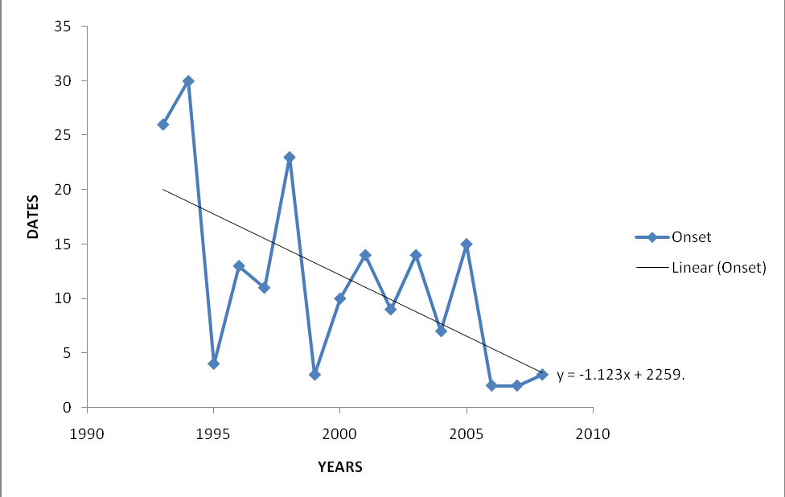

Trends in

Dates

Trend line

# Fig 4.1 Trends of Rainfall Onset Dates in Sokoto (1993-2008). Source: Field Survey, October 2014

From fig 4.1, it is observed that the trend in onset dates of rains is on the decline. The linear trend line equation is negative (y= -1.123 x +2259).The mean onset date is 11th of June. This further indicates that in the study area, the rains progressively starts earlier in recent times, compared to earlier years. This is a welcomed development for farmers as it ensures the availability of pre-sowing soil moisture which is essential for plant growth, germination and

optimal yield. According to Kowal and Andrew (1973) the antecedent moisture status of the soil at planting is more important for good germination or sustained growth of seedling.

# Trends in Cessation date of rainfall

The linear trend and trendline equation for the cessation to date of rainfall is shown in figure 4.2

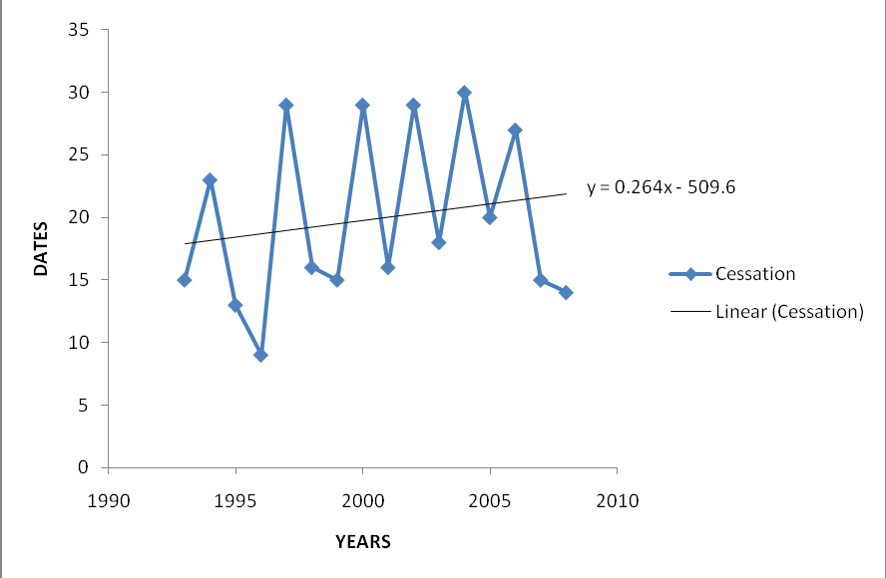

Trends in

Date

Trend line

# Figure 4.2 Trend of Rainfall Cessation Dates in Sokoto (1993-2008) Source: Field Survey, October 2014

It is obvious from fig. 4.2 that cessation dates of rainfall are characterized by marked „noises‟ (variability) from year to year. The mean cessation date is 19th September. This clearly indicates an increasing trend line in cessation date. The trend line equation is positive. This means that rainfall cessation date comes relatively later than usual. There is a slight delay in rainfall cessation date. This is good news for farmers in the study area as the selected grains will have adequate moisture available for later stage development.

# Figure 4.3.3: Trends in Length of Rainy Season (LRS)

Figure 4.3 Depicts the Linear Trend and Trendline Equation for the Length of Rainy Season.

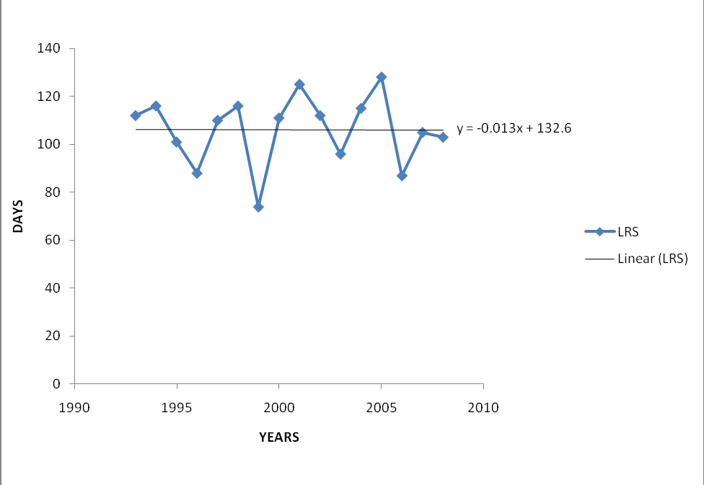

Trends in

Trend line

# Figure 4.3: Trends in Length of Rainy Season in Sokoto (1993-2008) Source: Field Survey, October 2014

Fig 4.3 shows a negative trend line equation of y=-0.013 x +132.6, which indicates a downward trend in LRS. However, this confirms to the marked yearly “noises” on the trend line. For instance, in the year 2000, the LRS was as low as 74 days before shooting up to the peak level of 128 days in 2006 and declined further to 87 days in 2007, before leaping up to 103 days in 2008.

# Trend in Dry Spell of 5 Consecutive Days

The trend in Pentad dry spells in the study area is presented in figure 4.4

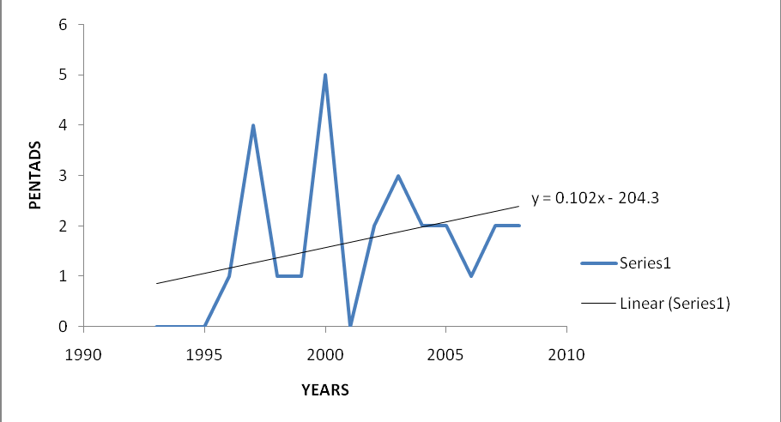

Trends in Pentad dry spell

Trend line

# Figure 4.4. Trend in Dry Spell of 5 Consecutive Days Source: Field Survey October 2014

Dry spell of 5 consecutive days has the highest number of occurrence amongst the other selected dry spell pentads of 10 and ≤15 consecutive days. The year 2000 has the highest incident of 5 days dry spell occurring five times during the growing season while 1993, 1994, 1995 and 2001 recorded no incident of 5 days dry spell. 2002, 2003 and 2004, had 2,3 and 2 incidents of 5 days dry spell respectively. It has an average occurrence of twice every growing season. This development may be of immense benefit to farmers in the area. According to Sawa and Ibrahim (2011), occurrence of 5 day dry spell during the vegetative growth stage, is critical to sorghum yield as it increases its yield.

# Trend in dry spell of 10 consecutive days

Trends in dry spell of 10 consecutive days is presented in figure 4.5

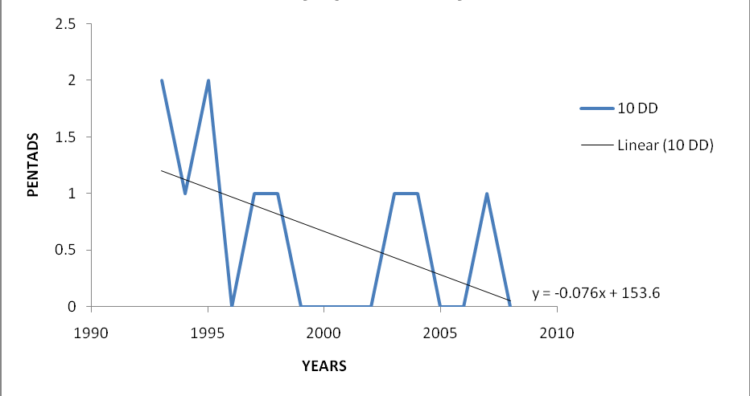

Trends in 10 days dry spell

Trend line

# Figure 4.5: Trend in Dry Spell of 10 Consecutive Days Source: Field Survey, October 2014

The dry spell of 10 consecutive days has the second highest incident or number of occurrence in the period under review in the study area. 1993 and 1995 has the highest incidents of twice each, while 1994, 1997, 199, 2003, 2004 and 2007 have single incidents while the remaining years recorded no incident of 10 days dry spell. This may be good news to farmers because incidents of prolonged dry spell are diminishing in the study area as posited by Ati (2006), that false start of rainy season, characterized by isolated showers and uncertain intensity with rainless periods of varying duration which last upto two weeks or more, dries out soil moisture necessary for plant germination, and leads to repeated and late planting resulting in crop failure or preclude optimal crop yield.

# Trend in Dry Spell of ≤15 Consecutive Days

Figure 4.6 shows the trend of dry spell of ≤15 consecutive days

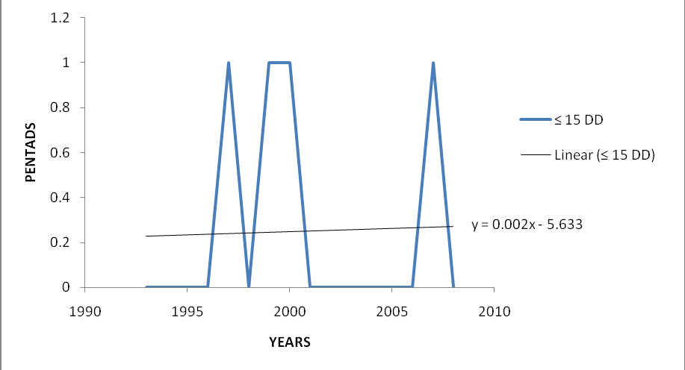

Trends in ≤15 days dry spell

Trend line

# Figure 4.6 Trend in dry spell of ≤15 consecutive days Source: Field Survey October 2014

Figure 4.6 reveals that the dry spell incidents of ≤15 consecutive days was recorded only four times during the period under review, in 1997, 1999, 2000, and 2007. Subsequently there is evident decline in the incidents of long term dryspell in the study area.Subsequently farmersshould anticipate steady rainfall with fewer lengthy dry spell “breaks”. This could be encouraging to farmers in the study area, following the findings of Adebayo and Onu (2012) in Adamawa State, that frequent and prolonged dry spells leads to reduced crop yield.

# Yield pattern of Crops at Sokoto

Trends for the yield of maize, millet sorghum and rice, are presented in figure 4.7 to 4.10

# Trends in maize yield

Figure 4.7 shows the pattern of maize yield in the study area

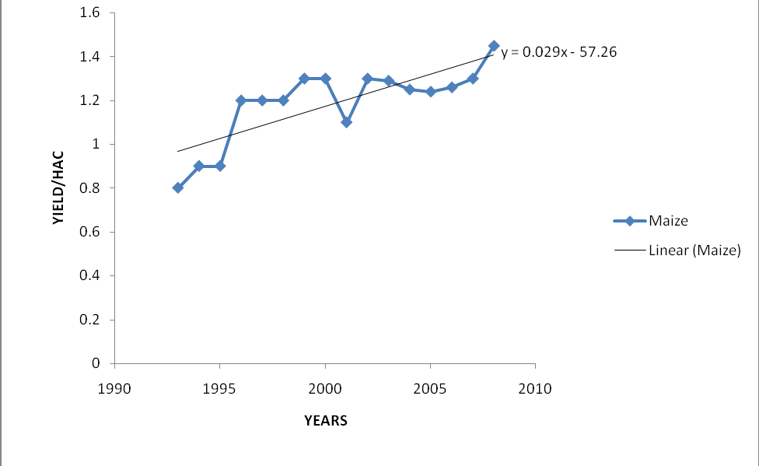

Trends in maize yield

Trend line

2008

**ton/ha**

# Figure 4.7 Trend in Maize Yield Source: Field Survey, October, 2014

Fig.4.7 Reveals that the yield of maize in the study area, is characterized by marked variability, with the highest yield of 1.45 ton/ha occurring in 2008, while the lowest yield of 0.80 ton/ha was recorded in 1993. During the period under review, the average yield of maize was 1.2 ton/ha which was obtained by calculating the mean of annual maize yield during the period under review. Similarly, the trend line equation is negative (0.029 x -57.27). However, during the later years of 2004 to 2008, there was a steady up-leap or increase in maize production. This appears to coincide with the steady decline of onset date see (fig. 4.1).

# Pattern of Millet Yield

The trend of millet yield in the study area is depicted in figure 4.8

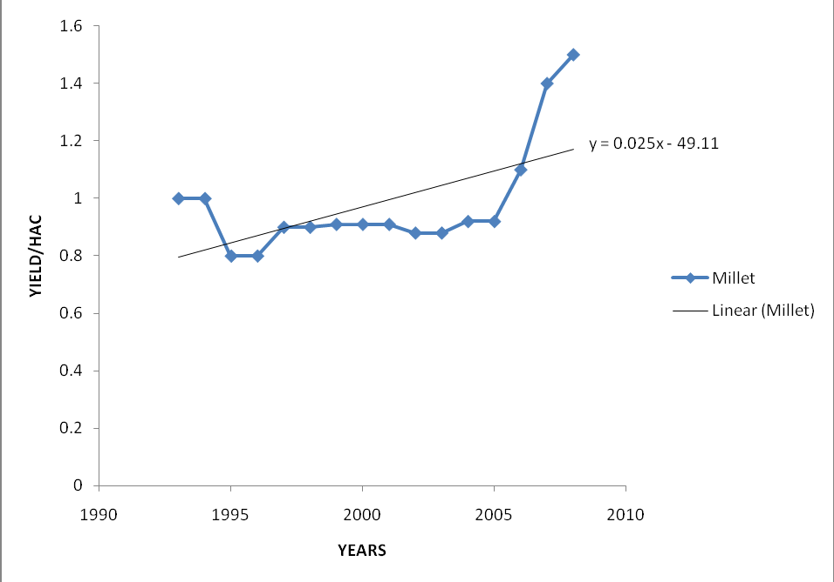

Trends in millet yield

Trend line

2008

**ton/ha**

# Figure 4.8 Pattern of Millet Yield Source: Field Survey, October 2014

Fig 4.8, shows variability in millet yield however, this is not as marked compared to maize yield. The period of highest yield of 1.50 ton/ha was 2008, while the period of lowest yield was between 1995 and 1996. From 1997 to 2005, the yield was almost the same, with little variations, up until 2006whenthere was an increase. Though the trend line equation is negative, (0.025 x - 49.11) which means a yield decline.From 2005 to 2008, there was a steady increase in yield this equally tallies with the period of decline or early arrival of onset date in the study area.

This may not be unconnected with the fact that millet requires considerable amount of moisture to thrive. According to Ikpe (2014), maize needs about 500-600mm of annual rainfall while millet can thrive on less than 300mm of rainfall. The period of highest yield, was 2008, with above 500mm of total annual rainfall while the period of lowest yield was between 1995 and 1996. The total annual rainfall distinction is very pronounced for 1996 which has less than 350mm, corresponding to lowest yield period.

# Pattern of Rice Yield

The yield pattern for rice is depicted in figure 4.9

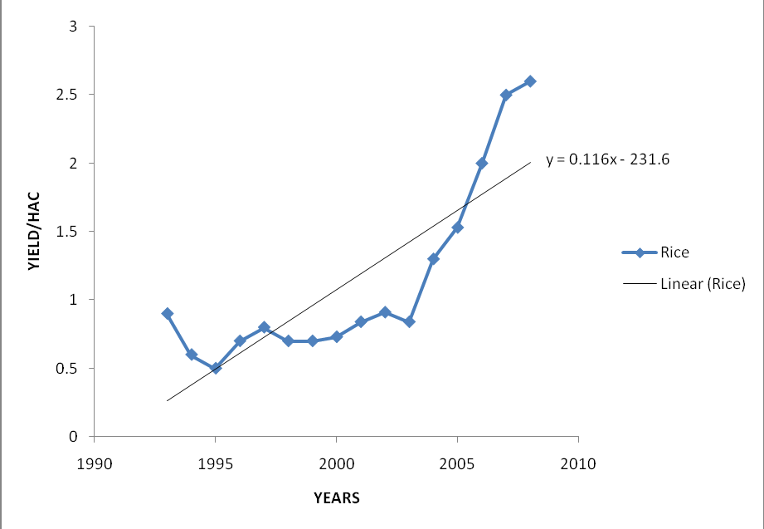

Trends in rice yield

Trend line

2008

**ton/ha**

# Figure 4.9 Pattern of Rice Yield Source: Field Survey, October 2014

Fig. 4.9 indicates that the linear trendline equation is negative. The highest yield was in 2008, while the lowest yield was in 1995. The average rice yield is 1.1 ton/ha. An in-depth look at figure 4.9, reveals that from 2005 to 2008 there was a steady increase in rice yield this observation tallies with those of millet and maize which coincides with the period of early onset of rains in the study area.

As postulated by Ndomba (2010) that early onset of rains contribute to better yield because grains have access to required moisture pertinent for germination.

# Pattern of Sorghum Yield

Figure 4.10 shows the yield pattern for sorghum

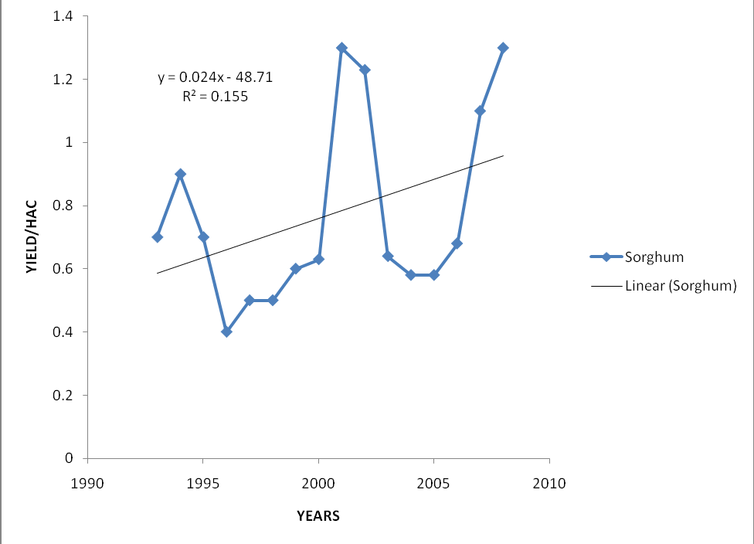

Trends in maize yield

2008

Trend line

**ton/ha**

# Fig 4.10 Trends of sorghum yield in Sokoto Source: Field Survey, October 2014

Fig 4.10 shows marked variability in the yield of sorghum with the highest production in 2008 and 2001, while the lowest production was in 1996. The average yield of sorghum is 0.8 ton/ha. The trend line equation is negative (0.024 x -48.71) this shows an average decline in yield during the period under review, however just like maize, millet and rice, sorghum yield began a steady increase from 2005 to 2008.

# RELATIONSHIP BETWEEN THE DERIVED PRECIPITATION INDICES AND MAIZE, MILLET, RICE AND SORGHUM YIELD IN SOKOTO STATE

Table 4.3 shows the relationship between the selected precipitation effectiveness indices, namely: onset date, cessation date, length of rainy season and dry spells of 5, 10 and ≤15 consecutive days with maize, millet, rice and sorghum yield in the study area.

Table 4.3 Correlation Between Precipitation Effectiveness Indices and Crop Yield

|  |  |  |  |  |
| --- | --- | --- | --- | --- |
| Precipitation effectiveness indices | Selected grain crops | | | |
|  | Maize | Millet | Rice | Sorghum |
| Onset | -0.616* | -0.318 | -0.501* | -0.173 |
| Cessation | 0.198 | -0.141 | -0.030 | -0.049 |
| LRS | -0.249 | -0.043 | -0.039 | 0.263 |
| 5DD | 0.612* | 0.042 | 0.113 | -0.188 |
| 10DD | -0.700 | -0.109 | -0.249 | -0.215 |
| ≤15DD | 0.298 | 0.142 | 0.043 | -0.127 |

*Correlation is significant 0.05 level

Correlation is meant to show the nature of relationship, between the precipitation effectiveness indices, and each of the selected grain crops.

Firstly, a positive correlation means an increase in one phenomenon leads to an increase in the other phenomenon while a negative correlation means an increase in one phenomenon leads to a decrease in the other phenomenon.

Considering maize, it has the negative „r‟ value of -0.616, -0.249 and -0.700 with onset, LRS and dry spell of 10 consecutive days respectively. Therefore, the earlier the date of onset, the higher the yield of maize. For length of rainy season, the longer the LRS, the higher the yield of maize. While for dry spell of 10 consecutive days, the more the incidents of 10days dry spell, the lesser the yield of maize this finding is corroborated by Adebayo and Onu (2012), in Adamawa State, that frequent and prolonged dry spells lead to reduced crop yield.

Similarly, maize is positively correlated with cessation at 0.198, 5 days dry spell at 0.612 and

≤15 dry spell at 0.298. Therefore, the latter the rains cease the more yield maize produced as later cessation date of rainy season means more amount of moisture available for maize yield. Ikpe (2014), corroborated that, maize requires considerable amount of moisture about 500 to 600mm of well distributed rain for optimal yield. Therefore, as cessation date of rains delay over the years it facilitates better moisture availability promoting growth and optimal maturation which invariably means better maize yield in the study area.

Furthermore, maize is equally positively correlated to 5 days dry spell in the study area which means the more the incidents of 5 days dry spell the more the yield of maize in the study area. Secondly, millet is negatively correlated to onset at -0.318, cessation at -0.141, length of rainy season at -0.043 and 10 day dry spell at -0.109.Therefore,the earlier the onset of rainy season, the

lesser the yield of millet.Ikpe (2014), identified that millet thrive best under low and erratic precipitation of 300 mm or less with short growing seasons due to its origin in the Sahel region of Africa. Subsequently when onset comes earlier than usual, this may portend a longer length of growing season and larger annual rainfall than usual which may exceed normal quantity required for optimal yield of millet, thereby reducing millet yield in the study area. Furthermore, as cessation date equally increases further, which means late cessation of rains, invariably the length of rainy season and quantity of available moisture increases which may be detrimental to millet which requires ample and erratic precipitation to thrive optimally, hence the negative correlation between millet and late cessation.

Furthermore, bearing antecedence to its Sahelian origin millet yield correlates positively with dry spells of 5 days and ≤15 consecutive days. There is a high prevalence of 5 days dry spell in the study areas in the study area.Which means as dry spells increases especially that of 5 consecutive days which is more prevalent in the study area, (see table 4.1), millet yield would increase, because dry spells promote arid conditions which favours millet yield, however intermittent showers are still necessary to promote crop yield.

Thirdly, rice correlates to onset at -0.501, cessation at -0.030, LRS at -0.039 and 10 days dry spell at -0.249. This entails that in the study area, the earlier the onset dates of rainfall, the higher the yield of rice. Equally, the later the date of rainfall cessation, the higher the yield of rice. This scenario equally applies to the length of rainy season in the study area. On the other hand, rice is positively correlated to 5 days dry spell at 0.113.

Finally, sorghum is negatively correlated to onset, cessation, 5 day dry spell, 10 days dry spell and ≤15 days dry spell, at -0.173, -0.049, -0.188, -0.215 and -0.127 consecutively. An increase in

onset, cessation and length of rainy season leads to a decline in sorghum yield. For all the dry spell incidents, they correlate negatively with sorghum. This dry spell incidents are detrimental to sorghum yield. While sorghum is positively correlated to length of rainy season. Therefore, a longer length of rainy season is favourable to sorghum yield. This corresponds to the postulation of Olanrewaju (2008), that an increased length of rainy season promotes crop yield because it ensures moisture availability from germination to maturation stages.

# REGRESSION ANALYSIS FOR DERIVED PRECIPITATION EFFECTIVENESS INDICES AND CROP YIELD

Table 4.4.shows how the selected precipitation effectiveness indices influence the variability in annual yield of each of the selected crops.

# Table 4.4. Regression between precipitation effectiveness indices and crop yield

|  |  |  |  |  |  |  |
| --- | --- | --- | --- | --- | --- | --- |
| Dependent  variable | Independent  variable | Regression  coefficient | T-  value | R2 | Significance  of T | Equation |
| Maize yield | Onset Cessation LRS  Dry spell | .000  .006  .003  -.019 | -2.853  .147  .844  -1.630 | .521 | .016  .886  .417  .131 | Ŷ=1.146+0.00x1+0.0006x2+0.003x3-0.019x4 |
| Millet yield | Onset Cessation LRS  Dry spell | .000  .000  .009  -.036 | -2.541  -1.864  2.179  -2.734 | .504 | .027  .089  .52  .019 | Ŷ=-0.700+0.000x1+-.000x2+0.009x3-0.036x4 |
| Rice yield | Onset Cessation LRS  Dry spell | -.001  .000  .030  -.092 | -3.254  -1.373  2.196  -2.077 | .521 | .008  .197  .050  .062 | Ŷ=-0.091+-0.001x1+0.000x2+0.030x3-0.092x4 |
| Sorgum | Onset Cessation LRS  Dry spell | .000  .000  .021  -.063 | -3.353  -2.458  4.241  -3.908 | .680 | .006  .032  .001  .002 | Ŷ=-0.382+0.000x1+0.000x2+0.021x3-0.063x4 |

Correlation is significant at 0.05 level

The regression results for maize shows that onset, cessation, LRS and dry spell account for 52.1 percent of total variation in maize yield while of all the selected precipitation effectiveness indices, cessation date has the highest positive influence on maize yield which means later cessation of rains encourages maize yield with.006 as the regression coefficient.

The regression results for millet yield shows that the combined influence of the selected precipitation effectiveness indices, accounts for 50.4 percent variation in millet yield while the length of rainy season has the highest influence on millet yield with the regression coefficient of

.009 means an increase in the length of rainy season leads to decrease in millet yield.

For rice yield, the regression summary shows that the selected precipitation effectiveness indices, accounts for 52.1 percent variations in rice yield. While, the length of rainy season has the highest effect on rice yield in the study area with a regression coefficient of .030. This means that an increase in the length of rainy season leads to increase in rice yield in the study area.

Finally, the regression summary for sorghum shows the selected precipitation effectiveness indices, accounts for 68% variation in sorghum yield. While the length of rainy season has the highest positive influence on sorghum, which means that an increase in the length of rainy seasons, increases the yield of sorghum in the study area. This result is supported by the finding of Olanrwaju (2008) at Kwara that longer length of rainy season affects crop yield positively.

# CHAPTER FIVE: SUMMARY, CONCLUSION AND RECOMMENDATIONS

# INTRODUCTION

This chapter presents the summary, conclusion and recommendations based on the findings of the research.

# SUMMARY OF THE STUDY

The major source of water available either for agricultural or human consumption is precipitation. This is the reality in northern Nigeria and the study area in particular where the ultimate productivity of crops under natural conditions are determined by the amount, distribution and variability of rainfall.

The study used daily rainfall records (mm) and crop yield data for maize, millet, rice and sorghum in (ton/ha) sourced from the National meteorological agency (NIMET) in Oshodi Lagos and the Sokoto Agricultural Development Project (SADP), from 1993 to 2008. The relationship between crop yield and the derived precipitation effectiveness indices where analyzed using simple correlation and regression techniques.

Furthermore, the Walter‟s 1967 method was used to derive the selected precipitation effectiveness, indices, while dry spell parameter where derived in pentads (5, 10 and ≤15 consecutive days).Similarly, the yield data for the selected crops and the selected precipitation effectiveness indices where harmonized using the log10 method. While simple correlation was used to analyze the relationship between crop yield data and precipitation indices. In the same vein, regression analysis was used to determine to what extent the selected precipitation

effectiveness indices influence the yield variation of the selected crops and which indices have the most influence for each crop.

While, trendline and linear trendlineequations was used to show the pattern of the selected precipitation effectiveness indices and crop yield in the study and within the period under review. The result showed that onset dates, cessation dates, length of rainy season, dry spells of 5, 10 and ≥15 consecutive days are characterized by inter-annual variability for example, onset ranges from 3rd July in 1999 to 7th May in 2004, showing a marked distinction of almost two month between these dates. For cessation dates it fluctuates from August 29th in 1997 to September 29th in 1997. Similarly, for LRS it ranges from 74 days in 1999 to 128 days in 2005. For 5 days dry spell it has 5 incidents in 2000 and none in the years preceding 1996.

For 10 days dry spell, its highest level of occurrence which is twice was in 1993 and 1995 while most of the years had none except 1994, 1997, 1998, 2000 and 2004 which all had single incidents. For 15 consecutive days, most of the years had no incident except 1997, 1999, 2000 and 2007 which all had single incidents. These clear pattern of inconsistency and variability for these elements, in Sokoto will have serious implication on grain production as farmers in the study area would find it difficult to predict the selected precipitation effectiveness indices in the area, thereby adversely affecting crop yield and other crop cultivation processes like land preparation, clearing, planting, weeding harvesting and storage.

Additionally, the study revealed that onset dates of rain is arriving earlier than usual, and cessation date of rains is arriving letter than usual. This development, has translated into a longer length of rainy season in the study area, this mean more available moisture for optimal crop yield. Following the regression summary for each crop, the selected precipitation effectiveness

indices accounts for only 52.1%, 50.4%, 52.1% and 68.0% variations in the yield of maize, millet, rice and sorghum respectively.Similarly considering the simple correlation analysis between the selected cereals and the precipitation effectiveness indices table 4.3 revealed that rice and maize yield are influenced by early onset, subsequently as onset date of rain arrives earlier in recent times, there is significant increase in rice and maize yield as shown in figures 4.7 and 4.9. The result equally showed a high incident of dry spell of 5 consecutive days in the study area, while dry spells of 10 and ≤15 consecutive days are on the decline.

# CONCLUSIONS

Based on the findings of the research, it was concluded that there is early onset of rains and late cessation of rains in the study area. Furthermore, rice and maize yield are increasing due to early onset of rains. Finally, there is increase in dry spell of 5 consecutive days, in the study area.

# RECOMMENDATIONS

Following the findings and conclusion made in the study between 1993 and 2008, the following recommendations are made:

Since the characteristics of rainfall onset and cessation dates, length of rainy season and dry spells of 5, 10 and ≤15 consecutive days are inconsistent and variable in the study area. It is therefore recommended that land preparation and planting of maize, millet, sorghum and rice can be done from 11th of June, which is the established mean onset date of rainy season in the study area.

Following the early onset of rains and late cessation of rains in the study area, which has led to increase in rice and maize yield, government at all levels should encourage the cultivation of these crops by giving farmers incentives and loans to boost the local production of these crops.

Since there is a high incident of dry spells of 5 consecutive says in the study area, farmers should introduce other crops and seed varieties that can tolerate short dry spells in order to boost crop production in the study area.

Finally, more research should be carried out on other areas not considered by the research work, concerning cereal production in the study area.

# REFERENCES

Abdulhamid A.I., Ati F.O. and Adebayo, A.A. (2011).Effect of climate on the growth and yield of sorghum in Wailo, Ganjuwa Local Government Area, Bauchi State. Research Journal of environmental and earth sciences 3(5): 469-472

Abdulhamid, A. I. and Abubakar, G.Z (2002).Application of Agro-Climatology to Agricultural Planning in Katagum Zone, Bauchi State – Nigeria.Azare Journal of Education vol. 6. No. 1 pp. 8-14.

Adebayo, A.A and Adebayo, E.F (1997), Precipitation Effectiveness and Upland Rice Yield in Adamawa State.*(Annals of Borno,* 266 – 276.

Adebayo, O.B., Osunbitan, J.A., Adekalu, K.O., and Okunade, D.A. (2009). Evaluation of FAO- 86 Penman Montaith and Temperature Based Models in Estimating Reference Evaporation. The C.I.G.R. E Journal.No. 1291.Volume 6.

Adebayo, A.A. and Onu, J.I. (2012): Farmers awareness, vulnerability and adaptation to climate change in Adamawa State, Nigeria. British Journal of Arts and Social Sciences, ISSN: 2046-9578, vol. 9, No. 11.

Adefolalu, D.C (1993): Word Meteorological Organization Lecture Serial 1993 (1), 1-4

Ajadi, B.S., Adeniyi, A., Afolabi M.T. (2011). Impact of climate on urban agriculture: Case study of Ilorin City, Nigeria. Global Journal of Human Social Science. Vol. 11: 25-29.

Ati, O.F (2006). Rainfall Characteristic in Drought – prone Sudano-Sahelian Zone of Nigeria.An Unpublished Ph. D Dissertation Department of Georaphy, Ahmadu Bello University Zaria.

Ati, O.F. Stigter, C.J., Iguisi, E.G., and Afolayan, J.O. (2009). Profile of Rainfall Change and Variability in the Northern Nigeria, 1953 – 2002. *Journal of Environmental and Earth Sciences* 1 (2), 580 -63.

Audu, E.B (2012): A Descriptive Analysis of Rainfall for Agricultural Planning in Lokoja Local Government Area of Kogi State, Nigeria; *International Journal of Science and Technology* volume 2 No 12.

Ayoade, J.O., (1996) Geography of Nigeria. Ibadan: Sepctrum Books Ltd.

Babalola, O. (1972). A preliminary investigation into the water relations of cocoa, coffee and Kola Nigeria Agric Journal, 9:78-82.

Baltensperger, D.D., L.A. Nelson, and G.E. Frickel (1995b) Registration of „Earlybird‟ proso millet crop Sci. 35:1204-1205.

Baltensperger, D.D., L.A. Nelson, G.E. Frickel and Anderson(1995a). Registration of

„Huntsman‟ proso millet. Crop Sci. 35:941.

Baweja, P.K. (2011). Rainfall Variability and Probability for Crop Planning in Solan. Himachal Pradesh. *Journal of Farm Science* 1(1), 75-88

Bello, F.A. (2001). Soil variability in Northern Kware, Kware Local Government Area, Sokoto State.Unpublished B.Sc. Project Dept. of Geography, UsmanuDanfodiyo University Sokoto.

Bello, N.J. (1995). On the reliability of methods of predicting the onset and cessation of the rains in a tropical wet-and-dry climate: A case study of Ondo. Journal of the Nigeria meteorological society, 1:41-55.

Bello, N.J. (1997). Evaluation of reference-crop evapotranspiration by empirical method for predicting consumptive water use of a crop in a tropical wet-dry climate. Indian J. Agric Science, 67(6): 269-270.

Benoit, P. (1977) The start of the growing season in Northern Nigeria. Agric. Met., 18: 91-99. Bezadih, Falco and Yesuf (2011): Precipitation Effectiveness Indices and Grain Production in

Rural Pakistan. *Journal of Agrometerology*

Bruken, j., De Wet, J.M.J. and Harlan, J.R (1977) The morphology and domestication of pearl millet. Economic Bot. 31(3): 163-174.

Cadidell, J.H. and Weibell, D.L. (1971).Effect of photoperiod and temperature on the development of sorghum, Agronomy Journal. Vol. 3(2) pp. 61-66.

COCHEME, J. and P. Franquin (1967). An agroclimatology survey of Semiarid area in Africa South of the Sahara. W.M.O Tech note No 86 PP 136. Geneva.

Darladi, Bello (2012). Precipitation Effectiveness Indices and Millet Yield in two Local Government Areas of Kano State, Nigeria. An unpublished M.Sc. Research, Departments of Geography, Ahmadu Bello University, Zaria

David D. Baltensperger (2002) Progress with Proso, pearl and other millet.

De martonne, E. (1926).Measurement of evaporation from land and water surface. U.S.D.A Technical bulletin 817: 1-143

Dingyadi, Y. (2014). Desert encroachment: Poor response on managing disasters retrieved November 12, 2014. From: [www.gamji.com/article300/news3662.htm](http://www.gamji.com/article300/news3662.htm).

EFO (2014).Ecological Fund Office.Accessed from: www.ecological/fund.gov.ng.

Ekpoh, I.J and Epenyong, N. (2011). Extreme Climatic Variability in North –Western Nigeria: An Analysis of Rainfall Trends and patterns. *Journal of Geography and Geology*, Vol. 3, No: 1.

Ekwe, M.C, Joshua J.K., Igwe J.E and Oshinowo A.A. (2014).Mathematical Study of monthly and Annual Rainfall Trends in Nasarawa State, Nigeria.*IOSR Journal of Mathematics* Volume 10, PP 56-62.

Elizabeth S., Claire H.R., Philip A., Nnyaladzi B., Andrew J.D., Jen D., Evan. D.G., David M., Staffan R., Susannah S. and Lindsay C.S., (2011). African farmers perceptions of erratic rainfall SRI Papers, 73:1-46.

Ezenekwe.L.N, Ezemonye M.N and Emeribe C.N. (2013) An Appraisal of the characteristics of Rainfall in Kano.*British Journal of Advance Academic Research.* Vol.2 No.1 pp 20-28.

F.A.O (1992) Applications of Climate data for effective irrigation planning and management.FAO plant production training material Samaru Nigeria. Pq58.

Farajzadeh M., Khoorani A., Bazgir S., and Zizelan P. (2012).The Analysis of the Agroclimatological indices and climatic elements effect on rainfed wheat phonological stages in Kurdistan province.Journal of Spatial planning, volume 15, number 4(72); pages 1 to 17.

French M.A. (1948) Local millets as substitutes for maize in feeding of domestic animals East

*African Agriculture Journal,* 13:213-220.

Gilbert, M.J. and Van Bavel (1954) A simple field installation for measuring maximum evaporation transpiration *American Geophysics Journal* 35: 937-942.

Iken, J.E and Amusa, N.A (2004). Maize Research and Production in Nigeria *African Journal of Biotechnology,* Vol. 3 (60 302 – 307.

Ikpe, Elisha (2014): Adaptation strategies to climate change, among grain farmers in Goronyo Local Government Area of Sokoto State Nigeria, an unpublished M.Sc. thesis Department of Geography, Ahmadu Bello University, Zaria.

Ilesanmi, O.O (1972a) An empirical formulation of the Onset, advance and retreat of rainfall in Nigeria. *Journal of Tropical Geography,* 34: 17-24.

Ilesanmi, O.O (1972b) Aspects of the Precipitation Climatology of the July-August rainfall minimum of Southern Nigeria *Journal of tropical Geography* 35.51-59.

Ilesanmi, O.O (1972): An Empirical Formulation of the Onset, Advance and Retreat of Rainfall in Nigeria: *Journal, Trop. GEOGR.* 34,17-24.

Iwena, O.A. (2012). Essential Geography.Tonad Publisher Limited, Ikeja Lagos.

J.O. Ayoade (1973): Annual Rainfall Trends and Periodiaties in Nigeria, Nigeria Geogr. *Journal*

16,167-176

Jawvo, .K. (2013) Rainfall Variability and crop yield potential. *International food policy Research Institution Journal.*

Kowal, J.M., and Knabe, D.T. (1972): An Agro-Climatic Atlas of Northern States of Nigeria.

Ahmadu Bello University Press, Zaria. PP 111.

Makinde A.A., Afolayan. S.O, Olaniyan A.A., Odeleye O.M.O., and Okafor B.N. (2010) Effect of Climate on Citrus Yield in Rainforest Savanna Transitional Zone of Nigeria.*Journal of Agriculture and Biological Sciences* Vol.2 (1) pp. 010-013.

Maman, N., S.C. Mason, T. Galusha, and M.S. Clegg. (1999) Hybrid and Nitrogen influence on pearl millet production in Nebraska: yield, growth and nitrogen uptake and nitrogen use efficiency. Agron .J. 91: 737-743.

Mathugama, S.C. and Peiris, T.S. G. (2011) Critical Evaluation of Dry Spell Research. International Journal of Basic and Applied Sciences IJBAS-IJENS Vol:11, No. 06, pg. 153- 160.

Mayee, C.D. and Sirasker, R.D. (1982).Relationship between Downy mildew evaluation parameter and pearl millet productivity. Current Sci. 51(20):993.

Mohmudu. A., Moh‟d T., Chamhuri S, and Basir. T (2010).Rainfall Variation and Changing Pattern of Agriculture Cycle.*American Journal of Environment Sciences.*

Molden, D. (2007) Water for food, water for life; A comprehensive Assessment of water management in Agriculture. Earth scan Publishers, U.K

Moncumill, D.F. (2006). Climate Variability and Corn Yields in Semiarid Ceara; Brazil. *Journal of Applied Meteorology and Climatology,* Vol. 46, 226 -280.

Mubvuma, M.T. (2013). Climate change: Matching growing season length with maize crop varietal life cycles in Semi-Arid regions of Zimbabwe. Greener Journal of Agricultural Sciences. Vol. 3(12), pp. 809-816.

Murtala. M., Ismaila .K.B, Adamu A. and Inobeme .J. (2011) An Evaluation of the Effects Drought on Groundnut yields in Kano. The Information Manager Vol.11.44-24.

Mzezewa J. and Gwata E.T. (2012). The Nature of rainfall at a typical Semi-Arid Tropical Ecotope in Southern Africa and options for sustainable crop production, crop production technologigies, Dr. Peeyush Sharma (Ed.), ISBN: 978-953-307-787-1.

Ndomba, P.M. (2010). Development of Rainfall curves for crops planting Dates: *A case study of Pangani River Basin in Tanzania Nile Basin water Science and Engineering Journal,* Vol.3, 13-27.

Nwabufo,K. (2003). Geology and Relief of Sokoto State.Retrieved March 1, 2014.

Odekunle O.T. (2006). Determining Rainy Season Onset and Retreat Over Nigeria from Precipitation amount and number of rainy days. *Journal of Theoretical and Applied Climatology.*Vol(83), 193-201.

Odekunle T.O., Balogun, E.E and Ogunkoya O.O (2005).On the Prediction of Rainfall Onset and Retreat dates in Nigeria.*Journal of theoretical and Applied Climatology* 81, 101-112.

Odekunle, T.O. (2004) Determining Rainfall Onset and Retreat Dates in Nigeria. J. Hum. Ecd 16(4): 239-247.

Odekunle, t.o. (2004).Rainfall and the length of the Growing Season in Nigeria.*International Journal of Climatology,* 24: 467-479.

Oguntoyinbo, J.S and Akintola, F.O. (1983) Rainstorm Characteristics affecting water availability for Agriculture.IAAS Publication Number 140.

Olarenwaju, R.M. (2008) Variation in precipitation features and its implications on crop production in the Guinea Savanna Ecological Zone: A case Study of Kwara State. Journal of the Nigerian Metrological Society. 5(1): 465-468.

Olaniran, O.J. (1981): Research in Agroclimatology in Nigeria. *Journal Agric. Res. 19,15-29.*

Olaniran, O.J. (1983). The onset of the rains and the start of the growing season in Nigeria: Nigerian geographical Journal, 26:81-88.

Olaniran, O.J. (1988). The distribution in space of rain-days of different amounts in the tropics; Nigeria as a case study.Geoforum, 19(4), 507-520.

Olaniran, O.J. and Babatolu.J.S.(1987).The Effect of Climate on the Growth of Early Maize at Kabba, Nigeria.*Geo Journal* 14.1, 71 – 75.

Omotosho J.B, Balogun A.A. and Ogunjobi K. (2002). Predicting monthly and Seasonal rainfall, onset and cessation of the Rainy season in West Africa using only surface data. *International Journal of Climatology* (20) 865-880.

Omotosho, J. Bayo, (1990) Onset of thunderstorm and precipitation over Northern Nigeria,

*International Journal of Climatology* 10, 849-860.

Omotosho, J.B., Balogun, A.A., and Ogunjobi K. (1999).Predicting monthly and seasonal rainfall onset and cessation of the rainy season in West Africa using only surface Data.International Journal of Climatology. 20:865-880.

Otun, J.A (2010). Using Precipitation Effectiveness Variables in indexing Drought in Semi –arid Regions.*African Journal of Agricultural Research,* Vol. 5(14), 1784 – 1793.

Owonubi, J.J. and Yayock, J.Y. (1981).Climatic Limitation to Crop Production in the Savana Region of Nigeria.Institution for Agricultural Research, A.B.U, Zaria.

Pashiardis, S. (2011). Trends of Precipitation in Cyprus, Rainfall Analysis for Agricultural planning.*Journal of Agrometerology*

Penman, H. (1992)Evaporation from open water bare soil, and grass proceeding. Roy. Soc. Vol.

A203 Pq 115-135.

Physical setting (Geology and Relief) (2003).Retrieved March 1, 2014, from <http://www.onlinenigeria.com/links/SokotoStateadv.asp>.

Pisani, A.L. (2013). Importance of Rainfall Oscillation in Agricultural Planning. *South African Journal of Plant and Soil,* 2:1, 31 – 34.

Rahman, M.M. Islam, M.O, Hasanuzzaman, M. (2000).Study of Effective Rainfall for Irrigated Agriculture in South – Eastern part of Bangladesh.*World Journal of Agricultural Sciences* 9 (4). 453 – 457.

Ravindran, C.D. (2010) Use of Rainfall Analysis in the Planning and Management of Rain –fed Cotton Central Institute for Cotton Research Nagpor. Technical Bulletin No: 15.

Sawa, B. and Adebayo, A. (2011).The Impact of Climate on Precipitation Effectiveness Indices in Northern Nigeria. *Journal of Environmental and Earth Sciences*, 481 – 486.

Sawa, B. and Ibrahim, A. (2011). Forecast Models for the Yield of Millet and Sorghum in the Semi Arid Region of Northern Nigeria using Dry Spell parameters.*AsianJournal of Agricultural Science* 3(3)187 – 191.

Sawa, B.A (2007) Computation of Precipitation effectiveness indices.An unpublished work.Department of Geography, Federal University of Technology Yola.

Sawa, B.A (2010) The Occurrence and Persistence of Dry Spells and Its Implications for Crops Yield in the SudanoSahelian Regions of Northern Nigeria. An Unpublished Ph. D Thesis, Dept. of Geography Modibo Adamawa University of Technology, Yola.

Silva D., Dayawansa K. and Ratnasiri D. (2007). A comparison of methods used in estimating missing Rainfall Data. The journal of agricultural sciences, vol. 3.No.2.

Silva.D. Dayawansa K., and Ratnasiri. D (2007) A comparison of Methods used in estimating missing Rainfall Data.*The Journal of Agricultural Sciences,*Vol 3. No2.

Sivakumar, M.V.K. (1992): Empirical Analysis of Dry Spells for Agricultural Application in West Africa. *Journal of Climate,* 5,532-539.

Solomon Z.W, Ambrose A.Z. and Jahknwa C.J. (2013).Effects of Precipitation Effectiveness on the yield of Irish potato (SolanumTuberosum) in Jos Plateau Nigeria.*International Journal of Research in Applied, Natural and Social Sciences* Vol. 1, 27-32.

Stanley, I.E (2010). The Effect of Poverty on Biological Fertility, A Case Study of Sokoto South. Geography DepartmentSokoto South. An Unpublished Bs.c Project, Dept. of Geography, UsmanDandofioUniversity,Sokoto.

Stern,R.D., and Dale, I.C (1982): Statistical Methods for Tropical Drought Analysis Based on Rainfall Data Project AZ 1: A Report on Data Requirement for Estimating the Likelihood of Droughts. WMO Programme on Research in Tropical Meteorology (PRTM),35.

Swindell, K., Abdu P.S., Bode J., Boyd J., Davies G., Main H.A.C., McCarthy M. (1982). Sokoto State in maps: An atlas of physical and human resources. University press Limited. Lagos.

Thornthwaite C.W. (1931) The Climate of North America to a new Classification. Geography Rev. 21(4): 633-55.

Thornthwaite, C.W (1990) The water balance Publication in Climatology. Laboratory of Climatology.Vol. 28 No 1124Pq.

Thornthwaite, C.W. (1948) An approach towards a rational classification of climates. Geog. Rev.

38; 55-94.

Thornthwaite, C.W. and Hotzman, B (1942) Measurement of evaporation from and water surface. U.S.D.A. Technical Bulletin 817:1-143.

Thornthwaite, C.W. and Mather, J.R. (1955) The water balance. Drexet Institute Technical Pblications in Climatology, 8: 1-104.

Transeau, E.N. (1905) Forest Centres of America.America Naturalist 39.875-89.

Tsoho, U.H. (2008). Growth and History of the Establishment of MakaaAsssada in Sokoto History Department, UsmanDanfodiyo University.Sokoto.

Walter, M.W. (197): Length of the Rainy Season in Nigeria. Samaru Research Bulletin, 103 (Ahmadu Bello University, Zaria-Nigeria).

Yusuf, Y.O. and Mohammed, N.A. (2011).An Assessment of Spatial Distribution of Rainfall Amount in Zaria, Kaduna State.The 52nd Annual Conference of Nigerian Geographers, U.D.U.S, Sokoto.

# Appendix I: Julian Date Calendar for Leap Year Only

|  |  |  |  |  |  |  |  |  |  |  |  |  |  |
| --- | --- | --- | --- | --- | --- | --- | --- | --- | --- | --- | --- | --- | --- |
| Day | Jan | Feb | Mar | Apr | May | Jim | Jul | Aug | Sep | Oct | Nov | Dec | Day |
| 1. | 001 | 032 | 061 | 092 | 122 | 153 | 183 | 214 | 245 | 275 | 306 | 336 | 1 |
| 2. | 002 | 033 | 062 | 093 | 123 | 154 | 184 | 215 | 246 | 276 | 307 | 337 | 2 |
| 3. | 003 | 034 | 063 | 094 | 124 | 155 | 185 | 216 | 247 | 277 | 308 | 338 | 3 |
| 4. | 004 | 035 | 064 | 095 | 125 | 156 | 186 | 217 | 248 | 278 | 309 | 339 | 4 |
| 5. | 005 | 036 | 065 | 096 | 126 | 157 | 187 | 218 | 249 | 279 | 310 | 340 | 5 |
| 6. | 006 | 037 | 066 | 097 | 127 | 158 | 188 | 219 | 250 | 280 | 311 | 341 | 6 |
| 7. | 007 | 038 | 067 | 098 | 128 | 159 | 189 | 220 | 251 | 281 | 312 | 342 | 7 |
| 8. | 008 | 039 | 068 | 099 | 129 | 160 | 190 | 221 | 252 | 282 | 313 | 343 | 8 |
| 9. | 009 | 040 | 069 | 100 | 130 | 161 | 191 | 222 | 253 | 283 | 314 | 344 | 9 |
| 10. | 010 | 041 | 070 | 101 | 131 | 162 | 192 | 223 | 254 | 284 | 315 | 345 | 10 |
| 11. | 011 | 042 | 071 | 102 | 132 | 163 | 193 | 224 | 255 | 285 | 316 | 346 | 11 |
| 12. | 012 | 043 | 072 | 103 | 133 | 164 | 194 | 225 | 256 | 286 | 317 | 347 | 12 |
| 13. | 013 | 044 | 073 | 104 | 134 | 165 | 195 | 226 | 257 | 287 | 318 | 348 | 13 |
| 14. | 014 | 045 | 074 | 105 | 135 | 166 | 196 | 227 | 258 | 288 | 319 | 349 | 14 |
| 15. | 015 | 046 | 075 | 106 | 136 | 167 | 197 | 228 | 259 | 289 | 320 | 350 | 15 |
| 16. | 016 | 047 | 076 | 107 | 137 | 168 | 198 | 229 | 260 | 290 | 321 | 351 | 16 |
| 17. | 017 | 048 | 077 | 108 | 138 | 169 | 199 | 230 | 261 | 291 | 322. | 352 | 17 |
| 18. | 018 | 049 | 078 | 109 | 139 | 170 | 200 | 231 | 262 | 292 | 323 | 353 | 18 |
| 19. | 019 | 050 | 079 | 110 | 140 | 171 | 201 | 232 | 263 | 293 | 324 | 354 | 19 |
| 20. | 020 | 051 | 080 | 111 | 141 | 172 | 202 | 233 | 264 | 294 | 325 | 355 | 20 |
| 21. | 021 | 052 | 081 | 112 | 142 | 173 | 203 | 234 | 265 | 295 | 326 | 356 | 21 |
| 22. | 022 | 053 | 082 | 113 | 143 | 174 | 204 | 235 | 266 | 296 | 327 | 357 | 22 |
| 23. | 023 | 054 | 083 | 114 | 144 | 175 | 205 | 236 | 267 | 297 | 328 | 358 | 23 |
| 24. | 024 | 055 | 084 | 115 | 145 | 176 | 206 | 237 | 268 | 298 | 329 | 359 | 24 |
| 25. | 025 | 056 | 085 | 116 | 146 | 177 | 207 | 238 | 269 | 299 | 330 | 360 | 25 |
| 26. | 026 | 057 | 086 | 117 | 147 | 178 | 208 | 239 | 270 | 300 | 331 | 361 | 26 |
| 27. | 027 | 058 | 087 | 118 | 148 | 179 | 209 | 240 | 271 | 301 | 332 | 362 | 27 |
| 28. | 028 | 059 | 088 | 119 | 149 | 180 | 210 | 241 | 272 | 302 | 333 | 363 | 28 |
| 29. | 029 | 060 | 089 | 120 | 150 | 181 | 211 | 242 | 273 | 303 | 334 | 364 | 29 |
| 30. | 030 |  | 090 | 121 | 151 | 182 | 212 | 243 | 274 | 304 | 335 | 365 | 30 |
| 31. | 031 |  | 091 |  | 152 |  | 213 | 244 |  | 305 |  | 366 | 31 |

**USE IN 2004, 2008, 2012, 2016, 2020, 2024, ETC.**

# Appendix II: Pentad Calendar Table

|  |  |  |  |  |  |  |  |
| --- | --- | --- | --- | --- | --- | --- | --- |
| JANUARY | | FED | | MARCH | | APRIL | |
| Pentad  No. | Dates | Pentad  No. | Dates | Pentad  No. | Dates | Pentad  No. | Dates |
| 1 | 1st -5th | 7 | 1st -5th | 13 | 1st -5th | 19 | 1st -5th |
| 2 | 6th -10th | 8 | 6th -10th | 14 | 6th -10th | 20 | 6th -10th |
| 3 | 11th-15th | 9 | 11th-15th | 15 | 11th-15th | 21 | 11th-15th |
| 4 | 16th-20th | 10 | 16th-20th | 16 | 16th-20th | 22 | 16th-20th |
| 5 | 21st-25th | 11 | 21st-25th | 17 | 21st-25th | 23 | 21st-25th |
| 6 | 26th-31st | 12 | 26th-28th/ 29th | 18 | 26th-31st | 24 | 26th-30th |
|  | | | | | | | |
| MAY | | JUNE | | JULY | | AUGUST | |
| Pentad  No. | Dates | Pentad  No. | Dates | Pentad  No. | Dates | Pentad  No. | Dates |
| 25 | 1st -5th | 31 | 1st -5th | 37 | 1st -5th | 43 | 1st -5th |
| 26 | 6th -10th | 32 | 6th -10th | 38 | 6th -10th | 44. | 6th -10th |
| 27 | 11th-15th | 33 | 11th-15th | 39 | 11th-15th | 45 | 11th-15th |
| 28 | 16th-20th | 34 | 16th-20th | 40 | 16th-20th | 46 | 16th-20th |
| 29 | 21st-25th | 35 | 21st-25th | 41 | 21st-25th | 47 | 21st-25th |
| 30 | 26th-31st | 36 | 26th-30th | 42 | 26th-31st | 48 | 26th-31st |
|  | | | | | | | |
| SEPTEMBER | | OCTOBER | | NOVEMBER | | DECEMBER | |
| Pentad  No. | Dales | Pentad  No. | Dates | Pentad  No. | Dates | Pentad  No. | Dales |
| 49 | 1st -5th | 55 | 1st -5th | 61 | 1st -5th | 67 | 1st -5th |
| 50 | 6th -10th | 56 | 6th -10th | 62 | 6th -10th | 68 | 6th -10th |
| 51 | 11th-15th | 57 | 11th-15th | 63 | 11th-15th | 69 | 11th-15th |
| 52 | 16th-20th | 58 | 16th-20th | 64 | 16th-20th | 70 | 16th-20th |
| 53 | 21st-25th | 59 | 21st-25th | 65 | 21st-25th | 71 | 21st-25th |
| 54 | 26th-30th | 60 | 26th-31st | 66 | 26th-30th | 72 | 26th-31st |