**Effect of Obesity-Induced Tumor Necrosis Factor Alpha on Adipocyte Function**

**ABSTRACT**

Obesity-induced inflammation has been linked to the onset of insulin resistance (IR), which is a strong risk factor for the development of T2DM. Recent studies have indicated that tumor necrosis factor alpha (TNFα) plays a causative role in obesity-mediated IR via its overexpression in adipose tissue. Moreover, TNFα has been shown to induce the IR and the alteration of lipid and glucose metabolism in adipose tissue at various levels including normal adipocyte differentiation and mature adipocyte function. However, the mechanisms linking TNFα-induced adipocyte dysfunction in chronic obesity to the IR and T2DM are largely unknown. Herein we report that TNFα inhibited the mRNA expression of PPARγ, which is a key nuclear transcriptional factor for driving preadipocyte differentiation and maintaining normal function of mature adipocyte. TNFα treatment suppressed preadipocyte differentiation by downregulating mRNAs for FAS, perilipin, GLUT4, adiponectin, PGC-1α and C/EBPα and also altered adipocyte function by inhibiting mRNAs for perilipin, GLUT4, CPT-1 and PGC-1α, while increasing the expression of IL-6 and MCP1 mRNAs. In palmitic acid (PA)-induced *in vitro* hypertrophic adipocytes, we found that mRNA expression of inflammatory cytokines (TNFα and IL-6) was significantly elevated, while the expression of mRNAs for PPARγ, perilipin and adiponectin was markedly reduced, suggesting that TNFα may induce dysfunctional adipocyte phenotypes by targeting PPARγ and its target genes. In *in vivo* study, mice fed high fat diet (HFD) for 16 weeks had adipose tissue dysfunction as reflected by significant reduction of protein expression for PPARγ, perilipin, FAS and FABP4, consistent with the results observed in *in vitro* hypertrophic adipocytes. Interestingly, this was reversed by the loss of TNFα in TNFα knockout mice, indicating that TNFα may induce adipocyte dysfunction via the inhibition of PPARγ and its target genes. In the liver, HFD significantly increased hepatic triglyceride (TG) contents, while decreasing *de novo* lipogenesis (SCD1 and FAS), whereas TNFα deficiency decreased TG content and *de novo* lipogenesis compared to HFD-fed wild-type (WT) mice, suggesting that TNFα-induced adipocyte dysfunction is associated with hepatic lipid deposition in chronic obesity. Taken together, the current findings provide new insights into the role of TNFα in obesity-induced inflammation and also suggest the TNFα as a mediator for obesity-induced IR & T2DM.

vi

**TABLE OF CONTENTS**

**Page**

**ACKNOWLEDGEMENT** **iv**

**ABSTRACT** **v**

**LIST OF TABLES** **x**

**LIST OF FIGURES** **xi**

**CHAPTER**

**1. PURPOSE OF STUDY** **1**

1.1. Overview of Hypotheses 1

1.2. Specific Aims & Hypothesis 3

1.3. Significance 4

**2. LITERATURE REVIEW** **5**

2.1. Obesity & diabetes 5

2.1.1. Prevalence & Interrelationship 5

2.1.2. Obesity-induced insulin resistance and T2DM 6

2.2. The physiological role of adipose tissue 10

2.3. Insulin-resistant obesity: Adipose tissue & adipocyte 12

2.3.1. Inflammation and adipose tissue 12

2.3.2. The role of TNFα in obesity 13

2.3.3. Therapeutic approaches against the action of TNFα 14

**3.** ***IN VITRO*** **STUDY: THE EFFECTS OF TNFα IN ADIPOCYTE**

**FUNCTIONS** **18**

3.1. Materials 18

3.2. Experimental design 19

vii

3.3. Methods 20

3.4. Statistical analysis. 21

3.5. Results 22

3.5.1. TNFα inhibited preadipocyte differentiation. 22

3.5.2. TNFα inhibited the expression of major transcriptional factors for

adipocyte differentiation. 23

3.5.3. PPARγ downstream target genes were inhibited in the presence of

TNFα during preadipocyte differentiation. 24

3.5.4. PGC-1α only was inhibited by TNFα during preadipocyte

differentiation. 25

3.5.5. TNFα also inhibited PPARγ gene expression in mature adipocyte. 26

3.5.6. TNFα increased its target proinflammatory genes expressed in mature

adipocytes. 27

3.5.7. Perilipin and GLUT4 were decreased by TNFα in mature adipcoytes. . 28

3.5.8. Lipid oxidation-related genes were inhibited in the presence of TNFα in

mature adipocytes. 29

3.5.9. Palmitic acid induced hypertrophic adipocytes concomitant with

increased expression of proinflammatory cytokines. 30

3.5.10. Hypertrophic adipocytes induced dysfunctional adipocyte phenotypes.

32

**4. *IN VIVO* STUDY: THE ROLE OF TNFα IN HIGH-FAT DIET (HFD)-**

**INDUCED OBESITY** **33**

4.1. Materials 33

4.2. Experimental design 33

4.3. Methods 33

viii

4.4. Statistical analysis 35

4.5. Results 35

4.5.1. High-fat diet (HFD) for 16 weeks induced obesity but decreased adipose

tissue functions via TNFα. 35

4.5.2. TNFα inhibited adipose tissue PPARγ gene expression. 36

4.5.3. Obesity-induced TNFα inhibited adipose tissue functions. 37

4.5.4. Obesity-induced TNFα induced hepatic TG accumulation. 38

4.5.5. Obesity-induced TNFα increased hepatic TG content. 39

**5. SUMMARY** **41**

5.1. *In vitro* study: The effects of TNFα in adipocyte functions 41

5.2. *In vivo* study: The role of TNFα in high-fat diet (HFD)-induced obesity 42

**6. DISCUSSION** **43**

**REFERENCES** **46**

ix

**LIST OF TABLES**

Table Page

1. PCR primer sequences for real-time PCR analysis 18

x

**LIST OF FIGURES**

Figure Page

|  |  |  |  |  |
| --- | --- | --- | --- | --- |
| 1 TNFα induces adipocyte dysfunction via the inhibition of PPARγ .................... | | | 2 | |
| 2. |  | Differentiation process of 3T3-L1 preadipocytes into adipocytes (Ntambi & | |
| Young-Cheul, 2000) ............................................................................................ | | | 11 | |
| 3. | Obesity-induced hypertrophic adipocye and low-grade inflammation (Samad | | |
| & Ruf, 2013) ........................................................................................................ | | | 13 | |
| 4. | The role of isoflavones in PPAR signaling. (Patel & Barnes, 2010) ............... | | 17 | |
| 5. | Experimental design of TNFα treatment during 3T3-L1 preadipocyte | |  | |
| differentiation ....................................................................................................... | | | 19 | |
| 6. | Experimental design of TNFα treatment to mature adipocyte ......................... | | 19 | |
| 7. | Experimental design of the induction of adipocyte hypertrophy ..................... | | 20 | |
| 8. | The effects of TNFα during 3T3-L1 preadipocyte differentiation .................. | | 23 | |
| 9. | TNFα-induced changes in gene expression of PPARγ, C/EBPα, IL-6 and | |  | |
| MCP1 during preadipocyte differentiation .......................................................... | | | 24 | |
| 10. | | TNFα treatment results in the downregulation of PPARγ downstream target | |
| genes during preadipocyte differentiation ........................................................... | | | 25 | |
| 11. | | TNFα does not affect the mRNA expression of CPT-1 but PGC-1α during |  | |
| preadipocyte differentiation ................................................................................. | | | 26 | |
| 12. | | Effect of TNFα on PPARγ expression in mature adipocytes ......................... | 27 | |
| 13. | | TNFα increases the expression of IL-6 and MCP1 in mature adipocyte ....... | 28 | |
| 14. | | TNFα does not affect the expression of FAS and adiponectin but alters |  | |
| perilipin and GLUT4 expression in mature adipocytes ....................................... | | | 29 | |

xi

15. Effects of TNFα on the mRNA expression of CPT1 and PGC-1α in mature

adipocytes 30

16. PA-induced *in vitro* hypertrophic adipocytes mimics adipose tissue low-

grade inflammation in obesity. 31

17. PA-induced changes in mRNA gene expression of PPARγ, perilipin and

adiponectin 32

1. Changes in adipogenic protein expression in adipose tissue from LFD-TNFα+/+ (WT-LF), HFD-fed TNFα+/+ (WT-HF) and HFD-fed TNFα-/- (TNFα

KO-HF) 36

19. The mRNA expression of adipogenic genes such as PPARγ, perilipin, FAS in

TNFα+/+ (WT-HF) and TNFα-/-(TNFα KO-HF) 37

20. The mRNA expression of GLUT4, adiponectin, DGAT1 and ATGL in

TNFα+/+ (WT-HF) and TNFα-/-(TNFα KO-HF) 38

21. Hepatic TG contents from LFD-TNFα+/+ (WT-LF), HFD-fed TNFα+/+

(WT-HF) and HFD-fed TNFα-/- (TNFα KO-HF) 39

1. The mRNA expression of TNFα, FAS and SCD1 in liver tissues from LFD-TNFα+/+ (WT-LF), HFD-fed TNFα+/+ (WT-HF) and HFD-fed TNFα-/- (TNFα

KO-HF) 40

23. The schematic diagram depicting the possible mode of action of TNFα in

adipocytes 41

24. The schematic diagram depicting the underlying mechanisms by which

TNFα induces insulin resistance in obesity. 42

xii

**CHAPTER**

**1. PURPOSE OF STUDY**

**1.1. Overview of Hypotheses**

In chronic obesity, hypertrophic adipocytes present altered glucose & lipid metabolism with increased secretion and expression of proinflammatory cytokines such as TNFα, IL-6 and MCP1. This obesity-mediated low-grade inflammation has been demonstrated to be a causative factor of the onset of insulin resistance (IR) (Samad & Ruf, 2013), which is known to be the primary defect for the development of type 2 diabetes mellitus (T2DM). However, the mechanisms by which inflammation contributes to IR in chronic obesity remain unclear.

Among proinflammatory cytokines, tumor necrosis factor alpha (TNFα) has been proposed as a major candidate gene that links obesity to the onset of IR and T2DM (Borst, 2004). Overexpression of TNFα in adipose tissue and elevated systemic TNFα levels have been observed in obese or diabetic humans and animals (Hotamisligil, Arner, Caro, Atkinson, & Spiegelman, 1995; Hotamisligil, Shargill, & Spiegelman, 1993; Moon, Kim, & Song, 2004; Salles et al., 2012; Uysal, Wiesbrock, Marino, & Hotamisligil, 1997). TNFα neutralization in diabetic *fa/fa* mouse model significantly improved peripheral glucose uptake in response to insulin (Hotamisligil et al., 1993). Likewise, insulin-mediated glucose disposal in TNFα knockout mice fed high fat diet (HFD) for 12 weeks was substantially higher than HFD-fed wild type mice (Uysal et al., 1997). In addition, circulating free fatty acids levels and hepatic triglyceride (TG) contents were decreased in TNFα-deficient mice, whereas adipose tissue weight was increased in the mice (Salles et al., 2012; Uysal et al., 1997), indicating that TNFα alters adipose tissue function in obesity. Furthermore, TNFα has

1

been shown to inhibit preadipocyte differentiation and mature adipocyte functions (PPARγ, adiponectin, GLUT4, IR, IRS-1 and perilipin) (Gao, Zuberi, Quon, Dong, & Ye, 2003; Hotamisligil et al., 1996; Ruan, Hacohen, Golub, Van Parijs, & Lodish, 2002; Yanagisawa et al., 2012), suggesting that TNFα induces insulin resistance and adipocyte dysfunction, by, at least in part, inducing lipogenic capacity.

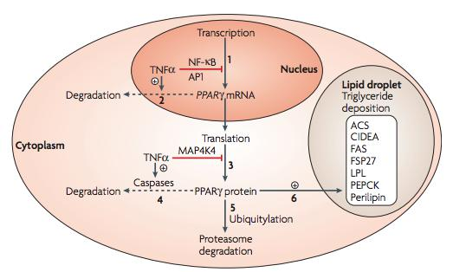

**Figure 1 TNFα induces adipocyte dysfunction via the inhibition of PPARγ**



Even though the underlying mechanisms by which TNFα impairs normal adipocyte functions are not fully understood, TNFα-induced suppression of the expression of PPARγ has been suggested to play a critical role (Guilherme, Virbasius, Puri, & Czech, 2008). However, it is still unclear if the adipocyte dysfunctions are directly mediated by TNFα-induced PPARγ inhibition *in vitro*. In addition, whether TNFα-suppressed PPARγ expression during preadipocyte differentiation and in mature adipocytes is a causative factor of IR *in vivo* has not been investigated.

Therefore, the ***goal*** of this work is to elucidate the role of TNFα in adipocyte *in vitro* and *in vivo* to understand the potential mechanism of TNFα-induced IR andT2DM. Hence, ***the central hypothesis of this study is that TNFα induces IR in chronic obesity by inducing altered lipogenic capacity and adipocyte dysfunction*.**

2

**1.2. Specific Aims & Hypothesis**

***Specific Aim 1*** is to test if TNFα induces adipocyte dysfunction and to establish and

characterize *in vitro* model of hypertrophic adipocytes.

***I hypothesize that TNFα causes adipocyte dysfunction through PPARγ inhibition. Further, I hypothesize that hypertrophic adipocytes present dysfunctional phenotype with a decrease in PPARγ but an increase in TNFα expression Rationale:*** In the literature, TNFα has consistently inhibited preadipocyte differentiation as well as normal adipocyte function. However, it has been unclear if TNFα-induced PPARγ inhibition is involved in adipocyte dysfunction.

***Specific Aim 2*** is to examine the role that TNFα plays in adipose tissue and to determine the metabolic consequences of TNFα-induced adipocyte dysfunction *in vivo*.

Therefore***, I hypothesize that obesity-induced TNFα induces adipose tissue dysfunction via PPARγ inhibition and its downstream target genes involved in normal adipose function in vivo.***

***Rationale:*** In the literature, TNFα has been directly linked to IR and altered lipid metabolism in the whole body. However, it has not been elucidated if TNFα induces adipocyte dysfunction *in vivo* and if TNFα-induced adipocyte dysfunction is involved in systemic IR.

3

**1.3. Significance**

The growing prevalence of obesity and type 2 diabetes mellitus (T2DM) is a major leading public health problem in the U.S. and around the world and the direct association between obesity-induced IR and T2DM has been long recognized. Although the precise mechanisms and molecule(s) responsible for this link are still unclear, altered production of TNFα caused by excess adipose tissue have been known to contribute to the onset of insulin resistance (IR) and development of T2DM. Our findings aid in understanding the role of TNFα in obesity-induced IR & T2DM, which is important to help identify specific targets and molecular mechanisms for effective intervention and treatment.

4

**2. LITERATURE REVIEW**

**2.1. Obesity & diabetes**

**2.1.1. Prevalence & Interrelationship**

Obesity is characterized by an excessive adipose tissue mass and is a leading preventable cause of death in the 21st century. The increase in adipose mass results from both increased adipocyte size (hypertrophy) or increased adipocyte numbers (hyperplasia) through adipogenesis (Salans, Cushman, & Weismann, 1973). In 2013, the adult population with body mass index (BMI) of 25 kg/m2 or greater (overweight) across 183 countries increased up to 36.9% (men) and 38.0% (women) and the number of obese or overweight people are becoming more prevalent in both developed countries (Ng et al., 2014). The prevalence of child and adolescent obesity has increased substantially in developing and developed countries; over 20% in developed countries and about 13 % in developing countries (Ng et al., 2014). In addition, the numbers for overweight and obese individuals are estimated to increase up to 1.35 billion and 573 million worldwide, respectively, by 2030 (Kelly, Yang, Chen, Reynolds, & He, 2008).

Diabetes is characterized by hyperglycemia and insulin resistance and is a worldwide public health problem. There are three types of diabetes such as type 1 diabetes mellitus (insulin-dependent diabetes, T1DM), type 2 diabetes mellitus (non-insulin dependent diabetes, T2DM) and gestational diabetes. Among three types of diabetes, T2DM accounts for approximately 90% of all cases of diabetes. Similar to obesity, the prevalence of T2DM has rapidly increased since 1980 and it is estimated to further increase from 382 million (in 2013) to 592 million by 2035 across 130

5

countries (Guariguata et al., 2014). The global prevalence of T2DM is also becoming higher in both developing and developed countries (Guariguata et al., 2014).

According to the map showing trends in diabetes & obesity from Centers for Disease Control and Prevention (CDC, http://www.cdc.go/diabetes/statistics), the growth rate of obese population (BMI≥ 30 kg/m2) in the U.S. has been almost doubled between 1994 and 2013; 26% or greater obese population in 38 states, 22 to 25.9% obese population in 11 states, and 18 to 21.9% obese population in 2 states. Similarly, the prevalence of T2DM grew rapidly in nearly all the states; more than 9% diabetic population in 25 states, 7.5 to 8.9% diabetic population in 19 states and 6.0 to 7.4% diabetic population in 7 states, and it presents a similar trend to the increase in obesity prevalence across all the states during the time period. Although the relationship between obesity & diabetes is interdependent, the clear mechanisms linking these two conditions remain unclear. It is therefore important to understand the pathogenesis of obesity-mediated T2DM for effective prevention & treatment options.

**2.1.2. Obesity-induced insulin resistance and T2DM**

Although the exact mechanism of obesity-mediated T2DM has been unclear, obesity-induced IR has been believed to be a critical factor that contributes to the development of T2DM. IR is a condition in which insulin-mediated glucose disposal in the body is impaired and is highly associated with the severity of obesity. Garcia-Estevez and the co-workers (Garcı́a-Estévez, Araújo-Vilar, Saavedra-González, Fiestras-Janeiro, & Cabezas-Cerrato, 2004), for example, reported that insulin sensitivity index as measured by oral glucose tolerance test is dramatically decreased as BMI increased and that the amount of insulin secreted was significantly increased

6

from BMI 29.3 to 45 kg/m2, whereas this was consistent between BMI 18 to 29.3 kg/m2. In addition, obesity-induced IR has been positively correlated with waist circumference (WC), plasma free fatty acids (FFAs), triglyceride (TG) and proinflammatory cytokines levels (Aslam, Aggarwal, Sharma, Galav, & Madhu, 2016; Boden & Shulman, 2002; Greco et al., 2002; Xu et al., 2015), all of which are the risk factors for the development of T2DM. Although most patients with T2DM are obese, not all obese individuals develop T2DM later in their lives, suggesting that environmental factors such as diets and sedentary behavior interact with a genetic predisposition during the development of T2DM. Therefore, identifying factors that underlie insulin resistance in obesity will be essential to advance the effective interventions.

In an attempt to elucidate the complexity of the progression of obesity to T2DM, many risk factors have been investigated and identified such as circulating FFAs, adipokines and ectopic fat deposition to the liver and muscle (Kralisch et al., 2007; Petersen et al., 2005; Roden et al., 1996). These factors are inter-independent and positively correlated with the whole-body insulin resistance in the patients with T2DM.

* **Free fatty acids (FFAs):** Elevated plasma FFAs levels have been observed in obese and diabetic states. (Boden, 2011; Savage, Petersen, & Shulman, 2007). The concentration of FFAs in the circulation is determined by the dynamics between the release of FFAs from adipocytes and FFAs clearance from the circulation. In obesity and T2DM, however, chronically elevated FFAs inhibit insulin-mediated antilipolytic action and in turn perturb the turnover rate of FFAs in adipocytes (Bjorntorp, Bergman, & Varnauskas, 1969; Jensen, Haymond,

7

Rizza, Cryer, & Miles, 1989). This also causes insulin resistance through the inhibition of glucose translocation in skeletal muscle and stimulation of glycogenolysis, glycogen breakdown, suggesting failure of FFAs clearance mediate insulin resistance in obesity (Boden, Chen, Capulong, & Mozzoli, 2001; Dresner et al., 1999).

* **Adipokines:** Adipokines refers to cytokines secreted from adipose tissue. Adiponectin is known as adipoQ and a key regulatory protein for systemic insulin sensitivity. The biological roles of adiponectin are to increase FFA oxidation in the liver and muscle tissues through adiponectin receptor 1 & 2 (AdipoR1 & 2) and also to stimulate the clearance rate of FFAs, TG and glucose from the blood (Cnop et al., 2003; Kadowaki & Yamauchi, 2005; Liu et al., 2012; Polyzos, Kountouras, Zavos, & Tsiaousi, 2010). However, the plasma level of adiponectin is lower in obese and diabetic individuals (Hara et al., 2003; Yu et al., 2002). Plasma adiponectin level is inversely correlated with plasma TG, free fatty acids levels and insulin resistance (Cnop et al., 2003; Engeli et al., 2003; Medina-Urrutia et al., 2015). In *in vivo* study with rhesus monkeys, Hotta and the co-workers (Hotta et al., 2001) demonstrated that plasma adiponectin levels were decreased in primates before the onset of diabetes and persisted even after the onset. By comparing the rate of glucose clearance from blood between hyperadiponectinemia and hypoadiponectinemia in obese monkeys, they found that hypoadiponectinemia had significantly lower glucose disposal rate, indicating adiponectin is closely associated with systemic insulin sensitivity.

Inflammatory cytokines such as TNFα and Il-6 are also included in adipokines due to that they are overexpressed from adipose tissue in obese and diabetic

8

humans and animals (Barbarroja et al., 2010; Chang et al., 2015; Kern, Ranganathan, Li, Wood, & Ranganathan, 2001; Kuo, Chang, Tsai, & Lee, 2012). It could be attributed to the fact that macrophages are infiltrated into adipose tissue and activated while increasing the expression of proinflammatory cytokines (Heilbronn & Campbell, 2008). However it has been reported that enlarged and hypertrophic adipocytes overexpress TNFα, MCP1, IL-6, serum amyloid A (SAA), plasminogen activator inhibitor-1 (PAI-1), and hyaluronan (HA) *in vitro* (Han et al., 2007; Jernas et al., 2006; Kim et al., 2015). In addition, the size of adipocyte was highly associated with plasma IL-6, TNFα and insulin resistance in obese individuals (Maffeis et al., 2007).

Taken together, these observations reinforce the function of adipose tissue in metabolic homeostasis through sequestration of fat and normal secretion of adipokines as supported by the demonstration that the loss of adipose tissue function increases the risk factors for T2DM (Moitra et al., 1998; Sovik, Vestergaard, Trygstad, & Pedersen, 1996; Vigano et al., 2011).

9

**2.2. The physiological role of adipose tissue**

Adipose tissue is a specialized connective tissue that serves as a major energy reservoir in the body. Adipose tissue is classified into brown adipose tissue (BAT) and white adipose tissue (WAT) by the physiological characteristics in the body, but WAT is the major tissue that constructs the body’s adipose tissue. Over the past decade, the perspective on adipose tissue (WAT) is changed from a fat store to a complex endocrine organ because it secrets adipokines, such as adiponectin that plays an important role in the whole body energy metabolism and homeostasis.

In adipose tissue, there are many different types of cells such as adipocyte, preadipocytes and non-adipose cells such as lymphocytes, neutrophils, endothelial cells and macrophages but adipose tissue is mainly made up of adipocytes. In our body, adipose tissue is distributed in many different sites throughout the body such as subcutaneous layers, around heart, kidneys and internal organs to provide insulation and mechanical support. However, the most important role of adipose tissue in the body is (1) to esterify and store TGs during a feeding state and (2) to de-esterify and release FFAs into the circulation during a fasting state. Even though the release of FFAs increases during a fasting state, the fasting fatty acid is taken up into the liver, muscle and heart to esterify with coenzyme A and to oxidize it in mitochondria. On the other hand, during feeding, the concentration of FFAs and glucose in the circulation is regulated by insulin, whose actions are to increase the uptake of glucose and FFAs in adipose tissue and to inhibit lipolysis in adipocytes.

Adipose tissue function is There are two ways to store the energy in the body, such as hyperplasia which is the process to increase the number of adipocytes through preadipocyte differentiation and adipocyte hypertrophy which is the process to enlarge adipocyte itself. The process of preadipocyte differentiation has been

10

investigated using reliable *in vitro* cell model which is 3T3-L1 preadipocyte from 3T3

mouse embryo fibroblasts.

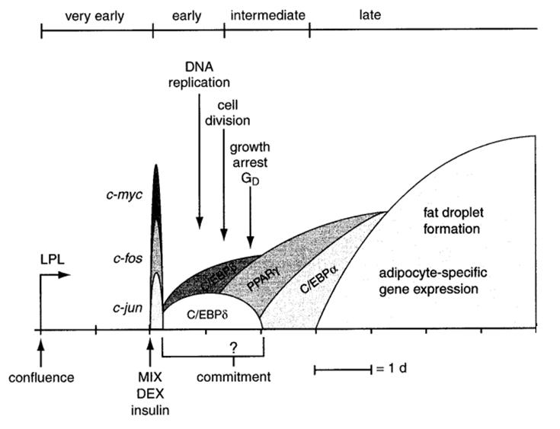

**Figure 2. Differentiation process of 3T3-L1 preadipocytes into adipocytes (Ntambi & Young-Cheul, 2000)**



3T3-L1 preadipocytes are differentiated into adipocyte with morphological changes by adipogenic cocktail including insulin, a glucocorticoid and 3-isobutyl-1-methylxanthine. Once confluent 3T3-L1 preadipocytes are exposed to the adipogenic cocktail, the cells undergo a complex cell signaling event including postconfluent mitosis and growth arrest and differentiate into adipocytes through a series of transcriptional steps as described in Fig.1. Among adipogenic transcription factors, the importance of PPARγ has been notably known for the regulation of cell differentiation and metabolism such as lipogenic genes such as FAS, GLUT4 and adiponectin. In addition, PPARγ plays an important role in the maintenance of mature fat cell functions. Tamori and the co-workers (Tamori, Masugi, Nishino, & Kasuga,

11

2002) created PPARγ mutant 3T3-L1 adipocytes and found that the mutation of PPARγ in adipocytes increased the rate of lipolysis and caused a reduction in the uptake of free fatty acids. Also, it decreased the expression of GLUT4, insulin receptor, and insulin receptor substrate (IRS).

**2.3. Insulin-resistant obesity: Adipose tissue & adipocyte**

Over the past decade, it has been suggested that inflammation plays an important role in the onset of insulin resistant (Samad & Ruf, 2013). Recently, it has been increasingly evident that inflammation-induced adipocyte dysfunction links obesity to insulin resistance (Guilherme et al., 2008). This is also strongly supported by a large body of evidence that PPARγ agonist reverses adipocyte dysfunction in IR (Mayerson et al., 2002; Tiikkainen et al., 2004), further suggesting the role of PPARγ in obesity-induced IR.

**2.3.1. Inflammation and adipose tissue**

Adipose tissue is an insulin-sensitive tissue and the major site where the body stores the energy in a highest density. Adipose tissue function properly controls the whole body lipid and glucose metabolism in response to insulin. However, in obesity, prolonged excessive energy induces abnormally enlarged and hypertrophied adipocytes. The plasma adiponectin, which is associated with systemic insulin sensitivity, is downregulated and adipocyte lipolysis is stimulated (Kennedy, Martinez, Chuang, LaPoint, & McIntosh, 2009; Meyer, Ciaraldi, Henry, Wittgrove, & Phillips, 2013). In addition, macrophages are infiltrated into adipose tissue and become activated. Vicious cycle is created between hypertrophic adipocytes and macrophages by secreting proinflammatory cytokines such as tumor-necrosis factor alpha (TNFα)

12

and interleukin 6 (IL-6) (Suganami & Ogawa, 2010). Therefore, low-grade

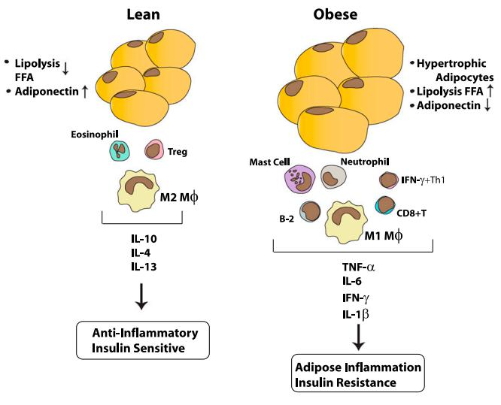

**Figure 3. Obesity-induced hypertrophic adipocye and low-grade inflammation (Samad & Ruf, 2013)**



inflammation is created in obesity and it causes insulin resistance locally and systemically. Among many proinflammatory cytokines, TNFα has been recently suspected of the causative factor that induces insulin resistance in obesity.

**2.3.2. The role of TNFα in obesity**

TNFα is one of the key regulators of inflammatory response and originally thought to be associated with cachexia. However, it has been now recognized as a critical factor involved in insulin resistance in obesity.

In clinical trials, systemic TNFα levels are positively correlated with BMI, WC and body fat mass (%) (Moon et al., 2004). In addition, it showed a positive correlation with plasma insulin, glucose and the size of adipocytes (Bahceci et al., 2007; Nilsson, Jovinge, Niemann, Reneland, & Lithell, 1998). Adipose tissue TNFα

13

expression is also increased in obese groups (Hotamisligil et al., 1995). In addition, it has shown a positive correlation with body fat (%), plasma insulin and glucose levels (Hotamisligil et al., 1995; Kern et al., 1995).

In *in vivo* studies, *fa/fa* mouse model has been shown that genetically develops T2DM and IR with adipose tissue TNFα expression increased (Hotamisligil et al., 1993). However, TNFα neutralization significantly improved glucose disposal in peripheral tissues and high concentration of the TNFα-neutralizing agent further increased glucose uptake into peripheral tissues in the mice (Hotamisligil et al., 1993). In addition, high-fat diet (HFD)-fed TNFα-deficient mice had improved insulin sensitivity, decreased the mRNA expression of proinflammatory cytokines (IL-6, MCP1 and SAA) and circulating free fatty acids (FFAs) levels (Salles et al., 2012; Uysal et al., 1997).

In *in vitro* models, TNFα inhibited 3T3-L1 preadipocyte differentiation (Chae

* Kwak, 2003). In mature adipocytes, TNFα inhibited insulin signaling pathway by decreasing the protein expression of insulin receptor substrate 1 (IRS-1) and increasing serine phosphorylation of insulin receptor (Hotamisligil et al., 1996). In addition, TNFα significantly decreased the expression levels of glucose transporter 1
* 4 (GLUT1 & GLUT4) and adiponectin (Stephens, Lee, & Pilch, 1997). However, the evidence of underlying mechanisms by which TNFα alters adipocyte functions is unclear.

**2.3.3. Therapeutic approaches against the action of TNFα**

Even though the mode of action of TNFα in IR is unclear, there have been many observations that synthetic and natural bioactive compounds attenuate IR in

14

obesity and T2DM. The evidence could give us an insight into the ways to prevent and treat IR and T2DM.

* **Drugs:** Sodium salicylate, an anti-inflammatory drug, has been shown to reduce urinary glucose excretion in T2DM patients (Ebstein, 1876; Williamson, 1901). Aspirin (~ 6 g/d), one of salicylates, also causes a reduction in fasting plasma glucose, TG and fatty acid levels in diabetic patients (Hundal et al., 2002). But at low-dose between 81 to 100 mg per day aspirin did not alter the plasma parameters (Ogawa et al., 2008). In 3T3-L1 adipocytes, aspirin antagonized TNFα-induced impairment of insulin signaling pathway by blocking mediated NF-κB signaling pathway, which is activated by TNFα *in vitro* (Gao et al., 2003). In addition, transfected adipocytes with a non-degradable mutant of IκBα which blocks NF-κB signaling showed upregulation of GLUT4 (Ruan et al., 2002), suggesting that TNFα-mediated NF-κB signaling impairs adipocyte functions.

TZDs are anti-diabetic drugs with insulin-sensitizing effects by targeting PPARγ in diabetic patients. The treatment with TZDs has been shown to reduce plasma TG, FFAs and insulin in obese and diabetic individuals (Mayerson et al., 2002; Yu et al., 2002). It has also shown the antagonizing effects on the action of TNFα. TZDs such as pioglitazone (Pio) increased the downregulation of IRS-1 and insulin receptor protein expression by TNFα in adipocytes *in vitro* (Iwata et al., 2001). However, Pio did not alter TNFα-mediated NF-κB signaling pathway, suggesting that PPARγ is an intermediate gene between NF-κB signaling cascades and insulin signaling pathway. However, aspirin worked at a high concentration that might lead to the adverse effects such as gastrointestinal tract bleeding and also it showed that aspirin resistance occurs commonly in diabetic

15

patients. In addition, TZDs treatment accompanies significant weight gain (Fateh-Moghadam et al., 2005; Fonseca, 2003).

* **Bioactives:** Phytoestrogens (isoflavones) are plant-derived compounds with partial estrogenic effects due presumably to structurally similarity to endogenous estrogen, estradiol. The bioactive compounds are abundant in legumes, red clover and soy-containing foods. Besides the partial estrogenic effects, isoflavones are well known for PPARs activator. In obesity, soy consumption is inversely correlated with the prevalence of obesity across 167 countries (Dante & Maciej, 2012), suggesting that soy consumption lowers adiposity in the body. In *vivo* study with Zucker rat which is used as an genetically-induced obese metabolic syndrome model, Mezei and co-workers (Mezei et al., 2003) demonstrated that high-isoflavone soy protein (HIS) were significantly reduced hepatic cholesterol and TG levels compared to low-isoflavone soy protein (LIS) and control groups in male and female rats. In oral glucose tolerance test in obese Zucker rats, HIS also significantly improved glucose intolerance. In another genetic model (obese SHR/N-cp rats), isoflavones (genistein, daidzein and glycetin) administration for 20 weeks significantly lowered plasma total cholesterol and LDL levels but increased HDL cholesterol levels (Ali, Velasquez, Hansen, Mohamed, & Bhathena, 2004). In addition, genistein or daidzein alone significantly reduced HFD-induced body weight and adiposity in mice (Ae Park et al., 2006), suggesting that isoflavones could be the beneficial factor that reduces the incidence of obesity.

16

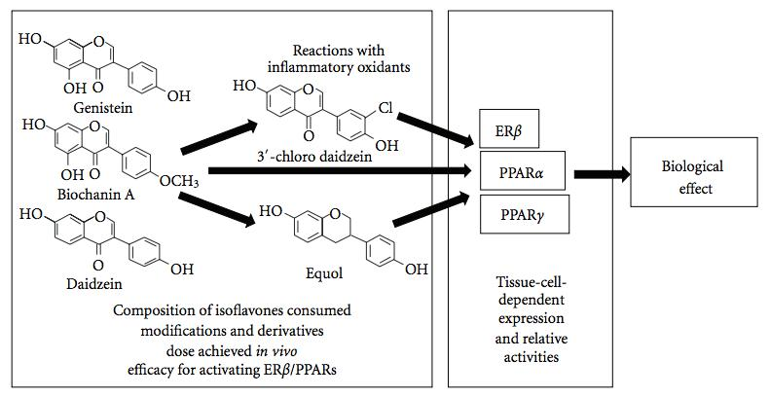

**Figure 4. The role of isoflavones in PPAR signaling. (Patel & Barnes, 2010)**



In diabetes, legume and soy food intake reduced the onset of T2DM in the women living in the Shanghai (Villegas et al., 2008). Also, the association between a higher intake of soy product and a lower risk of T2DM among overweight Japanese women has been observed (Nanri et al., 2010). In *db/db* mice, genistein and daidzein significantly improved plasma HbA1c levels and hepatic glucokinase activity (M. S. Choi, Jung, Yeo, Kim, & Lee, 2008). Genistein lowered hyperglycemia and oxidative stress and also reduced plasma TNFα, IL 1β and IL-6 in streptozotocin (STZ)-induced diabetic mice (Valsecchi et al., 2011). Besides to soy isoflavones, red clover extract rich in formononetin and biochanin A reduced plasma TG, total and LDL-cholesterol levels in STZ-induced diabetic mice (Qiu, Chen, et al., 2012; Qiu, Ye, et al., 2012). Also isoflavones such as formononetin or biochanin A alone also attenuated plasma hyperlipidemia suggesting isoflavones as the bioactives exerting anti-diabetic effects. However, the underlying mechanism of isoflavones-induced anti-obesity or anti-diabetic effects has remained unclear.

17

1. ***IN VITRO STUDY*: THE EFFECTS OF TNFα IN ADIPOCYTE FUNCTION**

**3.1. Materials**

Oil Red O (ORO), palmitate, 3-isobutyl-1-methylxanthine (IBMX), dexsamethasone (DEX) and insulin (INS) were purchased from Sigma Chemical Co. (St Louis, MO, USA). Rhe fast SYBR real-time PCR master mix, TNFα Dulbecco’s modified Eagle’s medium (DMEM), fetal bovine serum (FBS), newborn calf serum (NCS), penicillin-streptomycin (P/S), and trypsin-EDTA were obtained from Life Technologies (Grand Island, NY, USA). The specific primers for quantitative real-time PCR were designed

using PrimerQuest (Integrated DNA Technologies; https://www.idtdna.com/Primerquest/Home/Index and obtained from integrated DNA Technologies (Coralville, Iowa, USA) and the primer sequences used are provided in Table 1.

**Table 1 PCR primer sequences for real-time PCR analysis**

|  |  |  |  |  |  |  |
| --- | --- | --- | --- | --- | --- | --- |
| PPARγ | F1) | TCGGTTTCAGAAGTGCCTTG | β-actin | F | CAGCCTTCCTTCTTGGGTATG |  |
| R2) | GATCTCCGCCAACAGCTTC | R | CGGATGTCAACDTCACACTT |  |
| Perilipin | F | CCTCTGTGTGCAATGCCTAT | C/EBPα | F | GAACGCAACAACATCGC |  |
| R | CTCTGCAGGCCAACTCATT | R | CACCTTCTGTTGCGTCT |  |
|  |  |  |
| FAS | F | CTGTACGGGATCATACTGGTTC | IL-6 | F | TTGCCTTCTTGGGACTGATG |  |
| R | CAGAGCGCTGGTCATGTA | R | AGGTCTGTTGGGAGTGGTAT |  |
|  |  |  |
| GLUT4 | F | GCTTGGCTCCCTTCAGTTT | MCP1 | F | CRCACCTGCTGCTACTCATTC |  |
| R | CCAGCCACGTTGCATTGTA | R | ACTACAGCTTCTTTGGGACAC |  |
|  |  |  |
| AdipoQ3) | F | GAGAGAAGGGAGAGAAAGGAG | TNFα | F | GCCTCCCTCTCATCAGTTCTA |  |
| CAGCTCCTGTCATTCCAACA | CACTTGGTGGTTTGCTACGA |  |
|  | R |  | R |  |
| CPT-1 | F | CTGGATGTTTGCAGAGCAC | DGAT1 | F | CCAGCAAGCTGTGAGCTAT |  |
| R | GCTGTACAACATGGGCTTTC | R | GGACCGAGGAAAGTTGAGTT |  |
|  |  |  |
| PGC-1α | F | CGATCACCATATTCCAGGTCAAG | ATGL | F | TCCAGTTCAACCTTCGCAAT |  |
| R | AAGGGAGAATTGCGGTGTG | R | CCATCTCTGTAGCCCTGTTTG |  |
|  |  |  |
| SCD-1 | F | CACAGATGATGACAGGAGATGG | - |  | - |  |
| R | AAAGGAGGCGTCGAACTTG |  | - |  |
|  |  |  |  |



1. Forward
2. Reverse
3. Adiponectin



18

**3.2. Experimental design**

**3.2.1. TNFα treatment during preadipocyte differentiation**

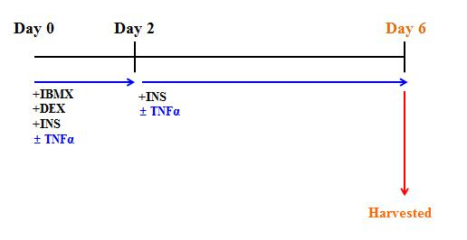

**Figure 5. Experimental design of TNFα treatment**



**during 3T3-L1 preadipocyte differentiation**

3T3-L1 cells (ATCC® CL-173TM) were used below passage 12. 3T3-L1 preadipocytes were propagated and cultured in DMEM medium supplemented with 10% NCS and 1% P/S until confluent, further maintained for additional 2 days and differentiated in DMEM containing 10% FBS and 1% P/S for 6 days. The medium was changed every other day.

**3.2.2. TNFα treatment in mature adipocyte**

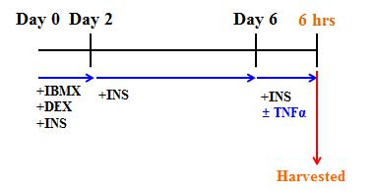

**Figure 6. Experimental design of TNFα treatment to mature adipocyte**



19

Once 3T3-L1 preadipocytes were fully differentiated into adipocytes, the cells were serum-starved in serum-free, high-glucose DMEM with 1% P/S for 24 h. After serum starvation, the cells were exposed to TNFα for 6 h and then harvested.

**3.2.3. Characterization of hypertrophic adipocyte**

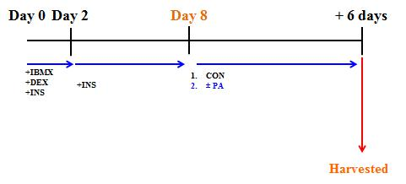

**Figure 7 Experimental design of the induction of adipocyte hypertrophy**



Fully differentiated adipocytes were exposed to palmitic acid (250 µM) to induce hypertrophic adipocytes as reported. The medium was daily changed and the cells were harvested after 6 days.

**3.3. Methods**

* **Oil Red O (ORO) staining.** To determine the degree of differentiation as measured by intracellular lipid content, ORO was performed. Briefly, 3T3-L1 adipocytes were washed with 4% paraformaldehyde once and fixed with 4% paraformaldehyde for 20 min at room temperature. Cells were then washed with 60% isopropanol once and stained with diluted Oil Red O solution for 30 min. After photographing the stained cells, the dye retained in 3T3-L1 cells was eluted

20

with 100% isopropanol and absorbance was measured by a microplate reader (SpectraMax M2, Molecular Devices, Sunnyvale, CA) at 490 nm.

* **Quantitative real-time PCR.** Total RNA was isolated with TRIzol® according to manufacturer’s protocol (Life technologies, Grand Island, NY). 1 µg of total RNA was used to synthesize cDNA using RevertAid First Strand cDNA Synthesis kit (Thermo Scientific, Waltham, MA). The reaction was performed with Fast SYBR® Green Master Mix containing 1 µM of primer pair and 100 ng of cDNA under 40 cycles with each of 95 °C for 1 sec and 58 °C for 20 sec. Relative levels of the target mRNA expression were determined by ViiATM 7 real-time PCR system (Life technologies, Grand Island, NY), normalized to GAPDH or β-actin and calculated with the 2-(ΔΔnd) method.

**3.4. Statistical analysis.**

All statistical analyses were performed in Excel and statistical significances were evaluated with independent t-test.

21

**3.5. Results**

**3.5.1. TNFα inhibited preadipocyte differentiation.**

In order to investigate if TNFα induces adipocyte dysfunction through the inhibition of preadipocyte differerntiation, first the inhibitory effects of TNFα on preadipocyte differentiation was evaluated. Widely used concentration of TNFα, 10 ng/mL (Chae & Kwak, 2003), was selected and preadipocytes were differentiated into adipocytes in presence or absence of TNFα for 6 days. The cells were then stained with ORO. As shown in Fig. 8, the picture of ORO stained-cells indicates that about 50% of preadipocytes were differentiated into adipocytes at day 6 of the differentiation. However, the differentiation of TNFα-treated preadipocytes was noticeably inhibited compared to the picture of control cells. The TNFα-induced relative inhibition was about 60% at day 5 (p <0.001).

22

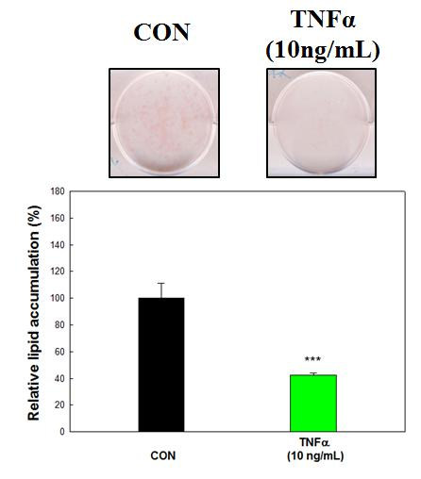

**Figure 8. The effects of TNFα during 3T3-L1 preadipocyte differentiation.** On day 5 of differentiation, intracelluar lipid droplets were stained with ORO solution for 30 min air-dried overnight. After then the picture of the plate with ORO-stained cells was scanned and eluted with 100% isopropanol. The expriment was repeated three times. Each bar represents a mean ± S.E. Significant difference was determined by independet t-test (*p<0.05 vs. control, **p<0.01vs. control, ***p<0.001 vs. control)

**3.5.2. TNFα inhibited the expression of major transcriptional factors** **for**

**adipocyte differentiation.**

In an mRNA level, the inhibitory effects of TNFα on preadipocyte differentiation were confirmed. As shown in Fig. 9, TNFα significantly suppressed the mRNA expression levels of PPARγ and C/EBPα (p <0.001) which are the key nuclear transcriptional factors for preadipocyte differentiation while inducing the mRNA expression levels of IL-6 and MCP1 (p <0.001) which are well known for

23

TNFα target gene, suggesting that TNFα inhibits preadipocyte differentiation through

the inhibition of endogenous elements for the differentiation.

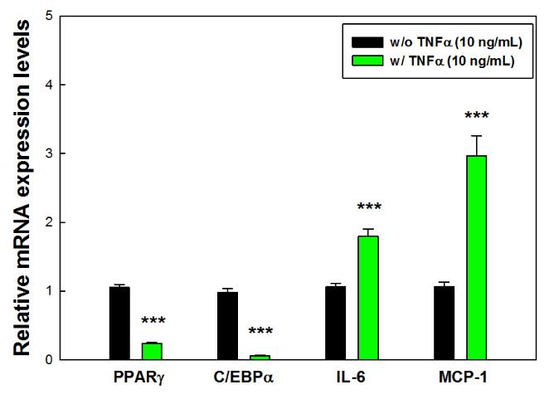

**Figure 9. TNFα-induced changes in gene expression of PPARγ, C/EBPα, IL-6 and MCP1 during preadipocyte differentiation.** At day 5, the cells were harvested with TRizol and used for RT-PCR as described Methods. The expriment was repeated three times and the data resented are relative values expressed in relation to endogenous β-actin (mean±S.E.). Significant difference was determined by independent t-test (*p<0.05 vs. control, **p<0.01vs. control,

***p<0.001 vs. control)

**3.5.3. PPARγ downstream target genes were inhibited in the presence of TNFα**

**during preadipocyte differentiation.**

To assess if the inhibition of preadipocyte differentiation by TNFα is a potential mechanism for TNFα-induced adipocyte dysfunction, the genes related to lipid and glucose metabolism in adipocyte were analyzed. As shown in Fig. 10, TNFα induced a progressive decrease in the mRNA expression levels of FAS and perilipin (p <0.001), which are involved in lipid synthesis and coating. In addition, TNFα suppressed the mRNA expression levels of GLUT4 and adiponectin (p <0.001).

24

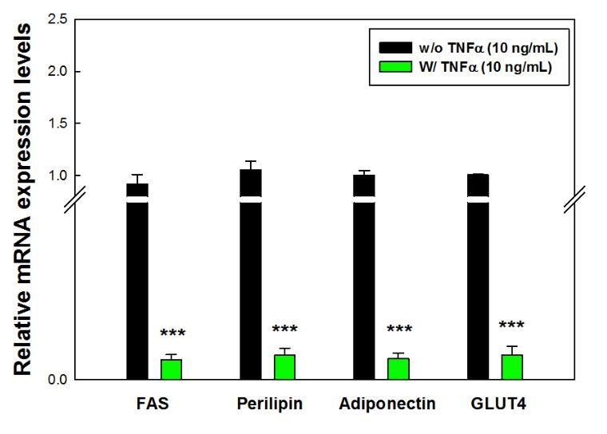

**Figure 10. TNFα treatment results in the downregulation of PPARγ downstream target genes during preadipocyte differentiation.** At day 5, the cells were harvested with TRizol and used for RT-PCR as described Methods. The expriment was repeated three times and the data resented are relative values expressed in relation to endogenous β-actin (mean±S.E.). Significant difference was determined by independent t-test (*p<0.05 vs. control, **p<0.01vs. control,

***p<0.001 vs. control)

**3.5.4. PGC-1α only was inhibited by TNFα during preadipocyte differentiation.**

To ascertain the effects of TNFα-inhibited preadipocyte differentiation on lipid metabolism, lipid oxidation-related genes such as carnitine palmitoyltransferase 1(CPT1) and peroxisome proliferator-activated receptor gamma coactivator 1 alpha (PGC-1α) were analyzed. TNFα significantly inhibited PGC-1α mRNA (p<0.001) but did not affect the mRNA expression of CPT-1 during preadipocyte differentiation. Since CPT-1 expression is not altered during preadipocyte differentiation (Brown et al., 1997), our data clearly indicate that TNFα impairs adipocyte functions through the inhibition of preadipocyte differentiation and.

25

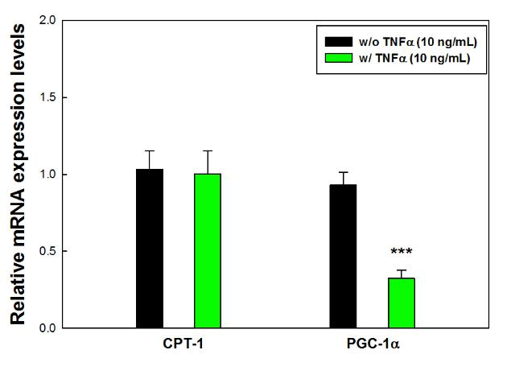

**Figure 11. TNFα does not affect the mRNA expression of CPT-1 but PGC-1α during preadipocyte differentiation.** At day 5, the cells were harvested with TRizol and used for RT-PCR as described Methods. The expriment was repeated three times and the data resented are relative values expressed in relation to endogenous β -actin (mean±S.E.). Significant difference was determined by independent t-test (*p<0.05 vs. control, **p<0.01vs. control, ***p<0.001 vs. control)

**3.5.5. TNFα also inhibited PPARγ gene expression in mature adipocyte.**

Even though adipocyte functions are maintained through preadipocyte differentiation, adipose tissue functions are represented by adipocyte functions. Thus, the effects of TNFα on adipocyte functions were evaluated. To this end, if PPARγ mRNA is altered during TNFα stimulation as the endogenous expression is an essential for adipocyte to function was investigated. The mRNA expression of PPARγ was decreased after 3 h treatment of TNFα and the expression was further decreased up to 50 % after 6 h (p<0.001). However, no further decrease was induced after 9 h treatment of TNFα. Thus, 6 h treatment was selected and used for further study.

26

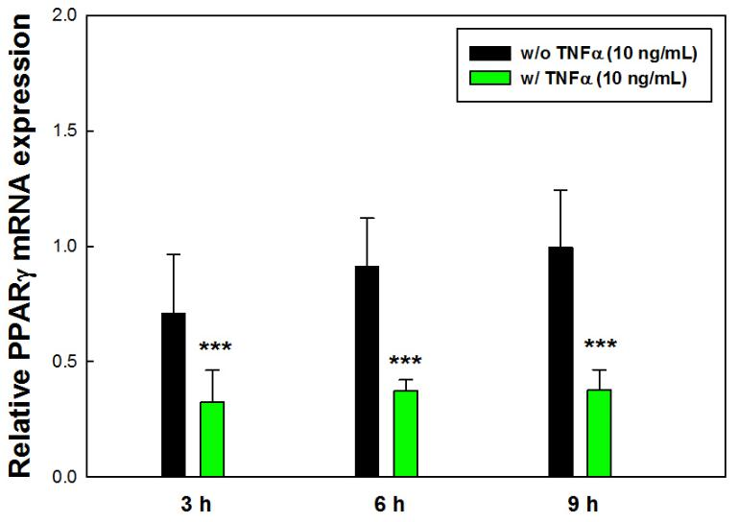

**Figure 12. Effect of TNFα on PPARγ expression in mature adipocytes.** Fully differentiated 3T3-L1 adipocytes were serum-starved for 24 h and then treated with TNFα (10 ng/mL) for the indicated time periods in the presence of insulin (167 nM). Total RNAs were isolated and subject to RT-PCR as described in Methods. The expriment was repeated three times in duplicate and the data resented are relative values expressed in relation to endogenous β -actin (mean±S.E.). Significant difference was determined by independent t-test (*p<0.05 vs. control, **p<0.01vs. control, ***p<0.001 vs. control)

**3.5.6. TNFα increased its target proinflammatory genes expressed in mature**

**adipocytes.**

To ascertain whether TNFα induces the mRNA expression of IL-6 and MCP1 in adipocytes as observed during preadipocyte differentiation, TNFα-treated adipocytes were analyzed. As shown in Fig. 13, the mRNA expression of IL-6 and MCP1 were significantly increased after 6 h in adipocytes. IL-6 mRNA expression was upregulated nearly 13-fold (p<0.001). In addition, the mRNA expression of MCP1 was increased about 5-fold (p<0.001) compared to non-TNFα-treated adipocytes, suggesting TNFα induces the expression of inflammatory cytokines while impairing adipocyte functions.

27

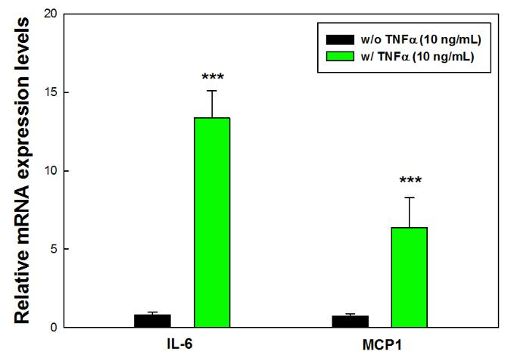

**Figure 13. TNFα increases the expression of IL-6 and MCP1 in mature adipocyte.** Fully differentiated 3T3-L1 adipocytes were serum-starved for 24 h and then treated with TNFα (10 ng/mL) for 6 h in the presence of insulin (167 nM). Total RNAs were isolated and subject to RT-PCR as described in Methods. The expriment was repeated three times in duplicate and the data resented are relative values expressed in relation to endogenous β -actin (mean±S.E.). Significant difference was determined by independent t-test (*p<0.05 vs. control, **p<0.01vs. control, ***p<0.001 vs. control)

**3.5.7. Perilipin and GLUT4 were decreased by TNFα in mature adipcoytes.**

To assess the inhibitory effects of TNFα on adipocyte functions, the genes related to adipocyte functions such as lipid and glucose metabolism were analyzed (Fig. 14). The mRNA expression of perilipin and GLUT4 were significantly inhibited in the presence of TNFα (p<0.001). However, TNFα did not affect the expression of FAS and adiponectin, consistent with the observation that FAS and adiponectin expression are not affected by PPARγ expression (J. H. Choi et al., 2010; Tan et al., 2005). Thus these data indicate that TNFα impairs adipocyte functions via PPAR inhibition.

28

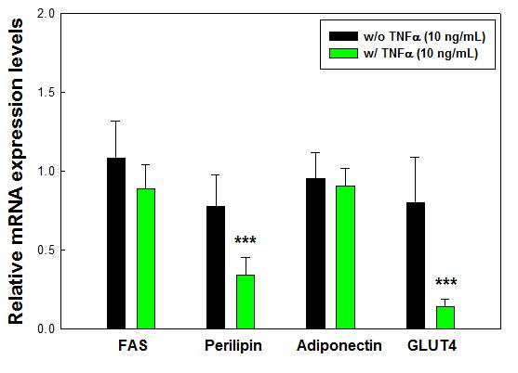

**Figure 14. TNFα does not affect the expression of FAS and adiponectin but alters perilipin and GLUT4 expression in mature adipocytes.** Fully differentiated 3T3-L1 adipocytes were serum-starved for 24 h and then treated with TNFα (10 ng/mL) for 6 h in the presence of insulin (167 nM). Total RNAs were isolated and subject to RT-PCR as described in Methods. The expriment was repeated three times in duplicate and the data resented are relative values expressed in relation to endogenous β -actin (mean±S.E.). Significant difference was determined by independent t-test (*p<0.05 vs. control, **p<0.01vs. control,

***p<0.001 vs. control)

**3.5.8. Lipid oxidation-related genes were inhibited in the presence of TNFα in**

**mature adipocytes.**

To ascertain the inhibitory effects of TNFα on adipocyte function, lipid oxidation-related genes were also analyzed after 6 h treatment of TNFα. Unlike the data from preadipocyte differentiation, TNFα treatment significantly downregulated the mRNA expression of CPT1 and PGC-1α both in mature adipocytes (p<0.001), suggesting the differential modes of action of TNFα that induces adipocyte dysfunction through the inhibition of adipocyte PPARγ and preadipocyte differentiation.

29

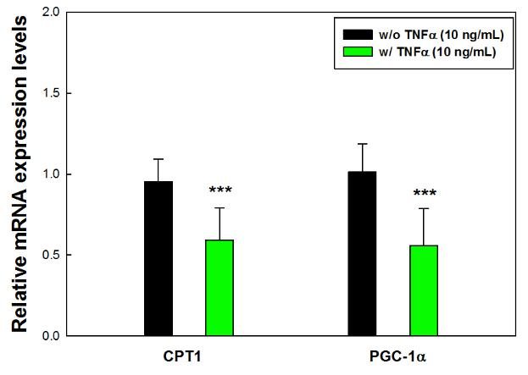

*.*

**Figure 15. Effects of TNFα on the mRNA expression of CPT1 and PGC-1α in mature adipocytes.** Fully differentiated 3T3-L1 adipocytes were serum-starved for 24 h and then treated with TNFα (10 ng/mL) for 6 h in the presence of insulin (167 nM). Total RNAs were isolated and subject to RT-PCR as described in Methods. The expriment was repeated three times in duplicate and the data resented are relative values expressed in relation to endogenous β -actin (mean±S.E.). Significant difference was determined by independent t-test (*p<0.05 vs. control, **p<0.01vs. control, ***p<0.001 vs. control)

**3.5.9. Palmitic acid induced hypertrophic adipocytes concomitant with increased**

**expression of proinflammatory cytokines.**

Since obesity is characterized by hypertrophic adipocytes and chronic inflammation state, *in vitro* TNFα treatment will represent acute inflammatory response of normal adipocytes. Thus, the characteristics of *in vitro* lipid-overloaded adipocytes which represent hypertrophic adipocytes in obesity were investigated to confirm the TNFα-induced characteristic changes in gene expression previously (Fig. 8-15). To this end, adipocytes were exposed to palmitic acid (PA) at 250 µM to induce hypertrophic adipocytes that overexpress proinflammatory cyoktines such as TNFα as described in previous studies (Han et al., 2007; Kim et al., 2015). As shown in Fig. 16, PA-treated adipocytes showed a big lipid droplet and a bigger size of

30

adipocytes compared to nonPA-treated cells. In addition, hypertrophic adipocytes significantly increased the mRNA expression of TNFα (p<0.05) and IL-6 (p<0.001), suggesting that obesity-induced hypertrophic adipocytes are established *in vitro*.

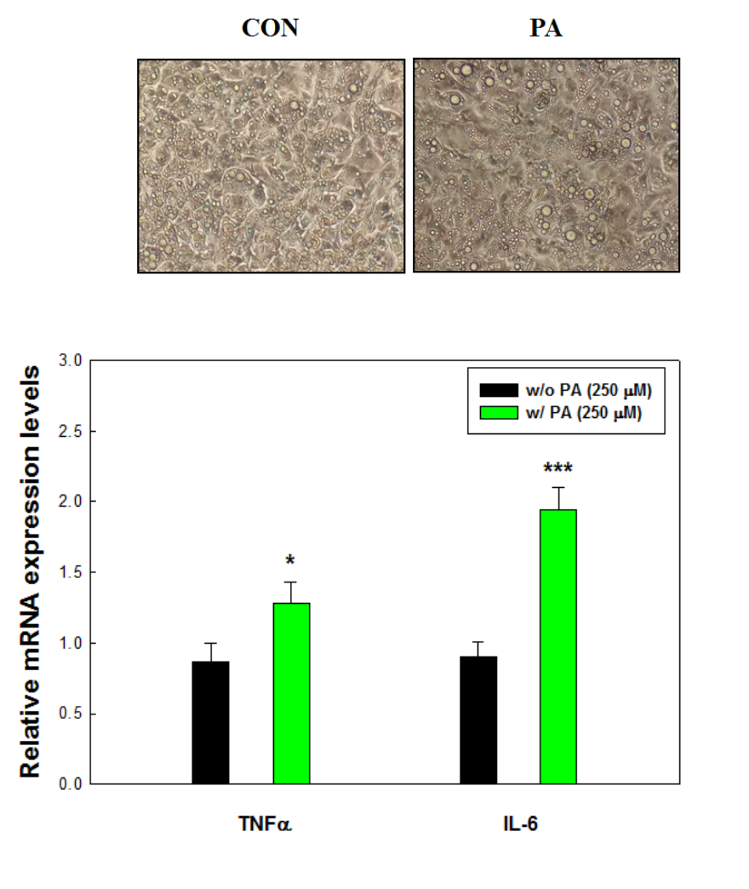

**Figure 16. PA-induced *in vitro* hypertrophic adipocytes mimics adipose tissue low-grade inflammation in obesity.** At day 8 after differentiation, the cells were exposed to PA at 250 µM for additional 6 days to induce hypertrophic adipocytes. Total RNAs were isolated and subject to RT-PCR as described in Methods. The expriment was repeated three times in duplicate and the data resented are relative values expressed in relation to endogenous β -actin (mean±S.E.). Significant difference was determined by independent t-test (*p<0.05 vs. control, **p<0.01vs. control, ***p<0.001 vs. control).

31

**3.5.10. Hypertrophic adipocytes induced dysfunctional adipocyte phenotypes.**

To assess if chronic inflammatory state during the induction of adipocyte hypertrophy indeed induces adipocyte dysfunction as observed in *in vitro* TNFα treatment studies during preadipocyte differentiation and in mature adipocyte, the major genes for adipocyte function were analyzed, such as PPARγ, perilipin and adiponectin. As shown in Fig. 17, hypertrophic adipocytes showed a significant reduction in the levels of PPARγ (p<0.05), perilipin (p<0.01) and adiponectin (p<0.05), indicating that in vitro hypertrophic adipocytes are characterized by overexpression of proinflammatiory cytokines but by dysregulation of adipocyte functions.

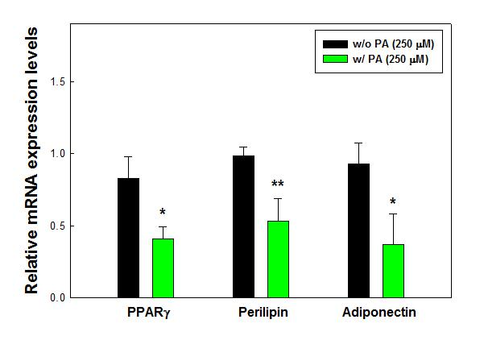

**Figure 17. PA-induced changes in gene expression of PPARγ, perilipin and adiponectin.** At day 8 after differentiation, the cells were exposed to PA at 250 µM for additional 6 days to induce hypertrophic adipocytes. Total RNAs were isolated and subject to RT-PCR as described in Methods. The expriment was repeated three times in duplicate and the data resented are relative values expressed in relation to endogenous β-actin (mean±S.E.). Significant difference was determined by independent t-test (*p<0.05 vs. control, **p<0.01vs. control,

***p<0.001 vs. control).

32

1. ***IN VIVO* STUDY: THE ROLE OF TNFα IN HIGE-FAT DIET (HFD)-INDUCED OBESITY**

**4.1. Materials**

Triglyceride content measurement kit was purchased from Sigma Chemical Co.(St Louis, MO, USA) and the fast SYBR real-time PCR master mix was obtained from ife Technologies (Grand Island, NY, USA). Antibodies against fatty acid binding protein 4 (FABP4), perilipin and fatty acid synthase (FAS) were purchased from Cell signaling technology (Beverly, MA, USA). Antibodies against peroxisome proliferator-activated receptor gamma (PPARγ), and β-actin were purchased from Santa Cruz Biotechnology (Santa Cruz, CA, USA).

**4.2. Experimental design**

All experimental procedures were approved by the Institutional Animal Care and Use Committee of the Jean Mayer USDA human Nutrition Research Center on Aging at Tufts University. C57BL/6 mice were used in this study. At age of 6 weeks, the mice were divided into three groups (6 mice per group): wild-type mice administered with a low-fat diet (10% of total kcal as fat), WT-LF; wild-type mice administered with a high-fat diet (60% of total kcal as fat), WT-HF; TNFα knockout mice administered with a high-fat diet, TNFα KO-HF. Obesity was induced for 16 weeks (from age of 6 to 18 weeks). At the time of sacrifice, adipose tissues were frozen in liquid nitrogen and stored at - 80˚C.

**4.3. Methods**

* **Triglyceride (TG) content measurement.** Liver TG contents were measured by TG content measurement kit from Sigma Chemical Co.(St Louis, MO, USA). Sample TG

33

contents were compared with a TG standard curve which is measured by a microplate reader (SpectraMax M2, Molecular Devices, Sunnyvale, CA) at 570 nm.

* **Quantitative real-time PCR.** Total RNA was isolated with TRIzol® according to manufacturer’s protocol (Life technologies, Grand Island, NY). 1 µg of total RNA was used to synthesize cDNA using RevertAid First Strand cDNA Synthesis kit (Thermo Scientific, Waltham, MA). The reaction was performed with Fast SYBR® Green Master Mix containing 1 µM of primer pair and 100 ng of cDNA under 40 cycles with each of 95 °C for 1 sec and 58 °C for 20 sec. Relative levels of the target mRNA expression were determined by ViiATM 7 real-time PCR system (Life technologies, Grand Island, NY), normalized to GAPDH or β -actin and calculated with the 2-(ΔΔnd) method.
* **Western blotting.** Adipose tissues were lysed using RIPA buffer (Life technologies, Grand Island, NY) with protease and phosphatase inhibitor cocktail (Life technologies, Grand Island, NY) for 30 min in ice, and then centrifuged at 12,000 x g for 20 min at 4 °C. The supernatants were taken into new tubes for protein quantitation assay using DCTM protein assay kit II (Bio-Rad, Hercules, CA). 50 µg of each lysates were separated on 10 % SDS-polyacrylamide gel and transferred to PVDF membranes. The membranes were blocked for 1 h at room temperature, washed 4 times with TBS-T for 5 min and incubated overnight with a primary antibody at 4 °C. The membranes were then washed 3 times with TBS-T and incubated with a secondary antibody at RT. To detect the target proteins, the membranes were incubated with ClarityTM Western ECL Blotting substrate (Bio-Rad, Hercules, CA) for 5 min using an Image Station

34

4000MM instrument (Carestream Health, New Heaven, CT). The band intensity was determined by ImageJ software (U.S. National Institutes of Health).

**4.4. Statistical analysis**

All statistical analyses were performed in Excel and statistical significances were evaluated with independent t-test.

**4.5. Results**

**4.5.1. High-fat diet (HFD) for 16 weeks induced obesity but decreased adipose tissue functions via TNFα.**

In order to examine if HFD administration for 16 weeks, which is relatively prolonged and chronic over-nutrition period, induces adipocyte dysfunction through TNFα production, adipogenic function-related genes such as PPARγ, perilipin and FAS and FABP4 were analyzed in adipose tissue. As shown in Fig. 18, HFD for 16 weeks significantly inhibited the protein expression levels of PPARγ, perilipin, FAS and FABP4 (p<0.001), suggesting obesity-induced adipose tissue dysfunction. However, HFD-induced suppression of perilipin and FABP4, were in part restored and PPARγ was completely recovered in the absence of TNFα, suggesting HFD or TNFα itself is able to induce adipose tissue dysfunction but the inhibitory effects of TNFα is a PPARγ-dependent.

35

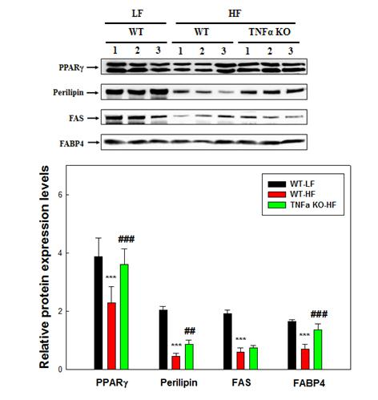

**Figure 18. Changes in adipogenic protein expression in adipose tissue from LFD-TNFα+/+ (WT-LF), HFD-fed TNFα+/+ (WT-HF) and HFD-fed TNFα-/-(TNFα KO-HF).** A representative immunoblot showing PPARγ, perilipin, FAS and FABP4 protein levels in adipose tissues. The western blots are quantified by Image J software and presented as relative expression of control. Six mice were used in each analysis. Significant difference was determined by independent t-test (*p<0.05 vs. WT-LF, **p<0.01vs. WT-LF, ***p<0.001 vs. WT-LF, #p<0.05 vs. WT-HF, ##p<0.01 vs. WT-HF, ###p<0.001 vs. WT-HF)

**4.5.2. TNFα inhibited adipose tissue PPARγ gene expression.**

To confirm TNFα-induced changes in the gene expression, the adipogenic

genes were analyzed by RT-PCR. Consistent with the protein data, mRNA expression

levels of PPARγ and perilipin were significantly upregulated in the absence of TNFα,

whereas the mRNA expression of FAS was not significant at p<0.05 despite an

upward tendency. Also, these data are consistent with TNFα-treated mature adipocyte

which represented a significant decrease in the mRNA expression of perilipin and

PPARγ but not in FAS mRNA expression.

36

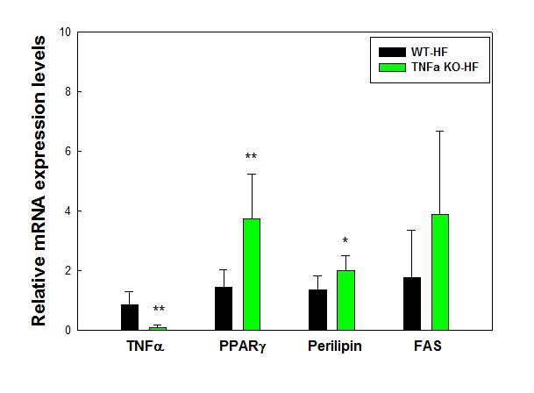

**Figure 19. The mRNA expression of adipogenic genes such as PPARγ, perilipin, FAS in TNFα+/+ (WT-HF) and TNFα-/-(TNFα KO-HF).** The data presented are relative values expressed in relation to endogenous β-actin (mean±S.E.). Six mice were used in each analysis. Significant difference was determined by independent t-test (*p<0.05 vs. WT-HF, **p<0.01vs. WT-HF, ***p<0.001 vs. WT-HF)

**4.5.3. Obesity-induced TNFα inhibited adipose tissue functions.**

To ascertain the role of TNFα in adipose tissue function, glucose metabolism

and triglyceride (TG) dynamics-related genes were analyzed. As shown in Fig. 20, glucose metabolism-related genes, TNFα deficiency significantly upregulated the mRNA expression adiponectin and GLUT4 at least 20-fold (p<0.05). In addition, the marker genes for TG synthesis (DGAT1) and TG breakdown (ATGL) were significantly increased in the absence of TNFα (p<0.001), suggesting that TNFα plays

an important role in adipose tissue dysfunction in obesity.

37

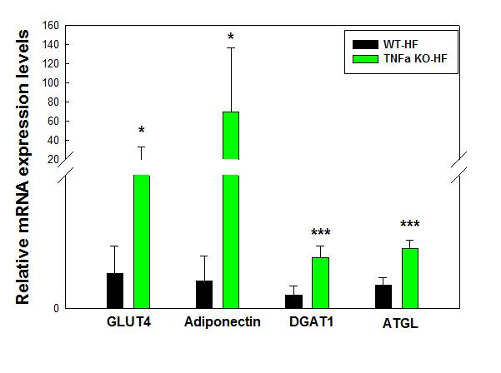

**Figure 20. The mRNA expression of GLUT4, adiponectin, DGAT1 and ATGL in TNFα+/+ (WT-HF) and TNFα-/-(TNFα KO-HF).** The data presented are relative values expressed in relation to endogenous β -actin (mean±S.E.). Six mice were used in each analysis. Significant difference was determined by independent t-test (*p<0.05 vs. WT-HF, **p<0.01vs. WT-HF, ***p<0.001 vs. WT-HF)

**4.5.4. Obesity-induced TNFα induced hepatic TG accumulation.**

Since a loss of TNFα in HFD-induced obese mice decreased circulating FFAs

and hepatic TG contents (Salles et al., 2012), we next investigated if TNFα-induced

adipose tissue dysfunction increases hepatic accumulation. To this end, hepatic TG

contents among the groups were first analyzed. As shown in Fig. 21, HFD

significantly increased hepatic TG contents (p<0.05), whereas the TG contents in

HFD-fed TNFα-/- mice were significantly lowered as statistically similar as to LFD-

fed TNFα+/+, suggesting that TNFα is the causative factor that increases hepatic lipid

deposition in obesity.

38

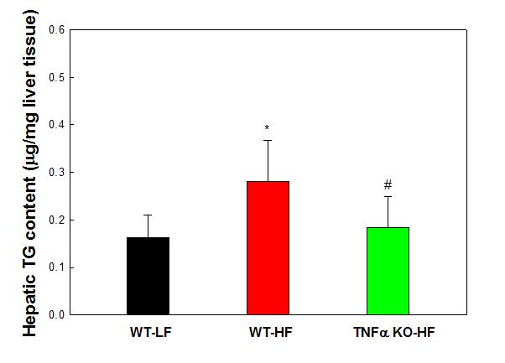

**Figure** **21. Hepatic TG contents from LFD-TNFα+/+ (WT-LF), HFD -fed TNFα+/+ (WT-HF) and HFD-fed TNFα-/- (TNFα KO-HF).** Hepatic TG was extracted and analyzed using TG content measurement kit. Data are expressed as µg/mg of liver tissue and represent the means±S.E. Six mice were used in each analysis. Significant difference was determined by independent t-test (*p<0.05 vs. WT-LF, **p<0.01vs. WT-LF, ***p<0.001 vs. WT-LF, #p<0.05 vs. WT-HF, ##p<0.01 vs. WT-HF, ###p<0.001 vs. WT-HF)

**4.5.5. Obesity-induced TNFα increased hepatic TG content.**

To investigate if TNFα-induced hepatic lipid engorgement is associated with

adipose tissue dysfunction, lipogenic genes such as FAS and SCD1 were analyzed

from the liver. First, TNFα mRNA expression was analyzed and decreased in TNFα-

deficient mice as expected. As shown in Fig. 22, the mRNA expression levels of FAS

and SCD1 were significantly decreased in the liver from HFD-fed TNFα+/+ mice

(p<0.01), suggesting that HFD itself decreases *de novo* lipogenesis genes, FAS and

SCD1 due perhaps to abundant dietary free fatty acids in HFD but increases TG

synthesis through the utilization of circulatory free fatty acids (Duarte et al., 2014).

However, the reduction of de novo lipogenesis-related genes was further decreased in

the absence of TNFα, suggesting obesity-induced TNF production causes adipose

tissue dysfunction that imposes the metabolic burden to the liver.

39

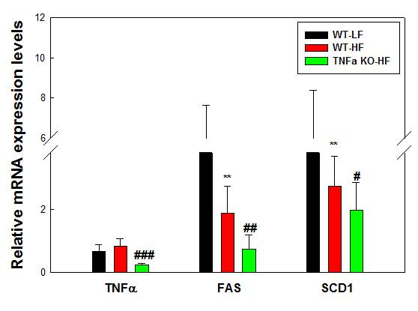

**Figure 22. The mRNA expression of TNFα, FAS and SCD1 in liver tissues from LFD-TNFα+/+ (WT-LF), HFD-fed TNFα+/+ (WT-HF) and HFD-fed TNFα-/- (TNFα KO-HF).** The data presented are relative values expressed in relation to endogenous β -actin (mean±S.E.). Six mice were used in each analysis. Significant difference was determined by independent t-test (*p<0.05 vs. WT-LF, **p<0.01vs. WT-LF, ***p<0.001 vs. WT-LF, #p<0.05 vs. WT-HF, ##p<0.01 vs. WT-HF, ###p<0.001 vs. WT-HF)

40

**5. SUMMARY**

**5.1. *In vitro* study: The effects of TNFα in adipocyte functions**

In summary, we examined the role of TNFα in adipocyte functions. The results demonstrate that TNFα treatment induces dysfunctional adipocytes through the inhibition of adipocyte PPARγ and preadipocyte differentiation. In addition, our data indicate that PA-induced *in vitro* hypertrophic adipocytes are dysfunctional, due perhaps to overexpression of TNFα. This conclusion is supported by the data from TNFα-treated adipocytes that showed a consistent data with hypertrophic adipocytes. Therefore, TNFα-induced changes in gene expression during preadipocyte differentiation and in mature adipocytes provide a molecular understanding for the development of adipocyte dysfunction..

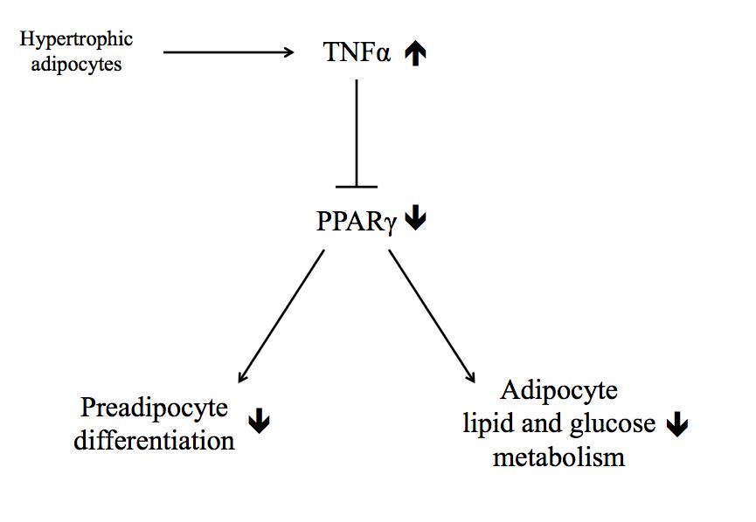

**Figure 23. The schematic diagram depicting the possible mode of action of TNFα in adipocytes.**

41

**5.2. *In vivo* study: The role of TNFα in high-fat diet (HFD)-induced obesity**

In summary, we examined the potential role that TNFα plays in adipocyte metabolism and function *in vivo.* The results indicate the significant contribution of obesity-induced TNFα production to adipocyte dysfunction, hepatic lipid deposition and insulin resistance. Also, this study clearly indicates that diet itself is a negative mediator that suppresses *de novo* lipogenesis in the liver and adipose tissue.

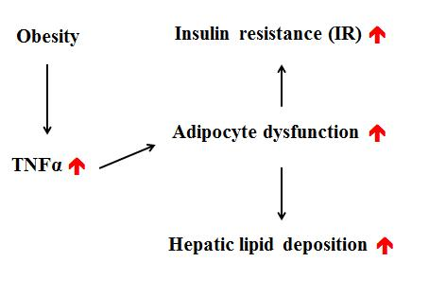

**Figure 24. The schematic diagram depicting the underlying mechanisms by which TNFα induces insulin resistance in obesity.**

42

**6. DISCUSSION**

In obesity, chronic low-grade inflammation has been implicated to induce insulin resistance (IR) that links obesity to type 2 diabetes (T2DM) (Samad & Ruf, 2013). Recent research studies indicate that tumor necrosis factor α (TNFα) is a causative factor of acquired IR and with it come many risk factors of T2DM, such as elevated free fatty acids (FFAs) and hepatic deposition (Bouter, Geary, Langhans, & Asarian, 2010; Salles et al., 2012). However, the molecular mechanisms that underlie the deleterious action of TNFα in obesity have been unclear.

A direct interaction between TNFα and insulin resistance has been implicated, as studies in obese and diabetic rodents indicate that the absence of TNFα improves the resistance to the action of insulin to stimulate peripheral glucose uptake (Hotamisligil et al., 1993; Uysal et al., 1997). This is further supported by the demonstration that TNFα impairs the signaling capacity of the insulin receptor in adipose tissue *in vivo* and adipocytes *in vitro* through the blockage of tyrosine phosphorylation of the insulin receptors (Hotamisligil et al., 1996; Hotamisligil et al., 1993; Stephens et al., 1997). In addition, TNFα increases the mobilization of FFAs into the circulation, hepatic lipid deposition and elevated concentrations of inflammatory cytokines such as MCP1 and IL-6 in HFD-induced obese mice (Salles et al., 2012), suggesting that the association between TNFα and T2DM is a causal relationship. However, how TNFα is interrelated with the risk factors for T2DM should be determined.

The importance of adipose tissue function in the body has been brought up by the observation that dysfunctional adipose tissue elevates circulating concentration of FFAs and causes dramatic lipid engorgement in the liver and insulin resistance (Moitra et al., 1998; Sovik et al., 1996). Adipose tissue function is maintained by

43

adipocytes which constitutes almost adipose tissue. Also, preadipocyte differentiation is required to maintain functional adipocytes. In this context, TNFα has been implicated to compromise adipose tissue function through the downregulation of PPARγ expression which is an essential transcriptional factor for preadipocyte differentiation and mature adipocyte functions such as lipid and glucose metabolism. Indeed, our data indicate that TNFα inhibited preadipocyte differentiation and mature adipocyte functions through PPARγ *in vitro,* consistent with previous studies (Chae & Kwak, 2003; Ruan et al., 2002). In addition, *in vitro* hypertrophic adipocytes had a significant decrease in PPARγ but overexpressed TNFα and IL-6 mRNAs. Consistent with *in vitro* data, TNFα-/- fed HFD had a significant increase in the genes such as PPARγ, perilipin, DGAT1 and ATGL, suggesting that the development of the inflammatory state in obesity is associated with adipocyte dysfunction. However, HFD *per se* is a negative mediator of adipose tissue function as TNFα deficiency in part restored lipogenic genes such as perilipin, FAS and FABP4.

In addition, the normal secretion of adipokines such as adiponectin is the role of adipose tissue as endocrinal organ. Adiponectin is the important cytokine to enhance the whole body insulin sensitivity, but especially hepatic insulin sensitivity (Kawano & Arora, 2009; Pagano et al., 2005). Indeed, the circulating concentration of adiponectin is decreased but hepatic insulin resistance and lipid deposition are increased in obesity and T2DM (Kadowaki et al., 2006). To our knowledge, however, it has not been previously reported which factor or factors alter plasma adiponectin levels in obesity and T2DM. Our *in vitro* data indicate that TNFα treatment significantly inhibited the mRNA expression of adiponectin during preadipocyte differentiation and in mature adipocytes and that hypertrophic adipocytes had a decrease in adiponectin mRNA expression. In addition, adiponectin mRNA

44

expression significantly increased but hepatic deposition decreased in HFD-fed TNFα-/-, suggesting that TNFα-induced adipocyte dysfunction is associated with a decrease in adiponectin expression. However, it has been reported that circulating adiponectin concentration is not increased in TNFα-deficient mice fed HFD for 4 weeks (Bouter et al., 2010). This could be the difference in HFD feeding period that can also differentiate the profound effects of TNFα on adipocyte because the circulating levels of TNFα is increased in proportion to the severity of insulin resistance.

In conclusion, the present study provides the new insight into the casual relationship between inflammation and insulin resistance in obesity. Our data indicate the contribution of obesity-induced TNFα to adipocyte dysfunction that can increase the risk factors such as the elevated circulating FFAs levels, hepatic deposition, insulin resistance and decreased circulating concentration of adiponectin, for T2DM.

45

**REFERENCES**

Ae Park, S., Choi, M. S., Cho, S. Y., Seo, J. S., Jung, U. J., Kim, M. J., . . . Lee, M. K. (2006). Genistein and daidzein modulate hepatic glucose and lipid regulating enzyme activities in C57BL/KsJ-db/db mice. *Life Sci, 79*(12), 1207-1213. doi: 10.1016/j.lfs.2006.03.022

Ali, A. A., Velasquez, M. T., Hansen, C. T., Mohamed, A. I., & Bhathena, S. J. (2004). Effects of soybean isoflavones, probiotics, and their interactions on lipid metabolism and endocrine system in an animal model of obesity and diabetes. *J Nutr Biochem, 15*(10), 583-590. doi: 10.1016/j.jnutbio.2004.04.005

Aslam, M., Aggarwal, S., Sharma, K. K., Galav, V., & Madhu, S. V. (2016). Postprandial Hypertriglyceridemia Predicts Development of Insulin Resistance Glucose Intolerance and Type 2 Diabetes. *PLoS One, 11*(1), e0145730. doi: 10.1371/journal.pone.0145730

Bahceci, M., Gokalp, D., Bahceci, S., Tuzcu, A., Atmaca, S., & Arikan, S. (2007). The correlation between adiposity and adiponectin, tumor necrosis factor alpha, interleukin-6 and high sensitivity C-reactive protein levels. Is adipocyte size associated with inflammation in adults? *J Endocrinol Invest, 30*(3), 210-214.

Barbarroja, N., Lopez-Pedrera, R., Mayas, M. D., Garcia-Fuentes, E., Garrido-Sanchez, L., Macias-Gonzalez, M., . . . Tinahones, F. J. (2010). The obese healthy paradox: is inflammation the answer? *Biochem J, 430*(1), 141-149. doi: 10.1042/BJ20100285

Bjorntorp, P., Bergman, H., & Varnauskas, E. (1969). Plasma free fatty acid turnover rate in obesity. *Acta Med Scand, 185*(4), 351-356.

Boden, G. (2011). Obesity, insulin resistance and free fatty acids. *Curr Opin*

*Endocrinol* *Diabetes* *Obes,* *18*(2), 139-143. doi:

10.1097/MED.0b013e3283444b09

Boden, G., Chen, X., Capulong, E., & Mozzoli, M. (2001). Effects of free fatty acids on gluconeogenesis and autoregulation of glucose production in type 2 diabetes. *Diabetes, 50*(4), 810-816.

Boden, G., & Shulman, G. I. (2002). Free fatty acids in obesity and type 2 diabetes: defining their role in the development of insulin resistance and beta-cell dysfunction. *Eur J Clin Invest, 32 Suppl 3*, 14-23.

Borst, S. E. (2004). The role of TNF-alpha in insulin resistance. *Endocrine, 23*(2-3), 177-182. doi: 10.1385/ENDO:23:2-3:177

Bouter, B., Geary, N., Langhans, W., & Asarian, L. (2010). Diet-genotype interactions in the early development of obesity and insulin resistance in mice with a genetic deficiency in tumor necrosis factor-alpha. *Metabolism, 59*(7), 1065-1073. doi: 10.1016/j.metabol.2009.11.003

Brown, N. F., Hill, J. K., Esser, V., Kirkland, J. L., Corkey, B. E., Foster, D. W., & McGarry, J. D. (1997). Mouse white adipocytes and 3T3-L1 cells display an anomalous pattern of carnitine palmitoyltransferase (CPT) I isoform expression during differentiation. Inter-tissue and inter-species expression of CPT I and CPT II enzymes. *Biochem J, 327 ( Pt 1)*, 225-231.

Chae, G. N., & Kwak, S. J. (2003). NF-kappaB is involved in the TNF-alpha induced inhibition of the differentiation of 3T3-L1 cells by reducing PPARgamma expression. *Exp Mol Med, 35*(5), 431-437. doi: 10.1038/emm.2003.56

46

Chang, C. J., Lin, C. S., Lu, C. C., Martel, J., Ko, Y. F., Ojcius, D. M., . . . Lai, H. C. (2015). Ganoderma lucidum reduces obesity in mice by modulating the composition of the gut microbiota. *Nat Commun, 6*, 7489. doi: 10.1038/ncomms8489

Choi, Jang Hyun, Banks, Alexander S, Estall, Jennifer L, Kajimura, Shingo, Bostrom, Pontus, Laznik, Dina, . . . Bluher, Matthias. (2010). Obesity-linked phosphorylation of PPARγ by cdk5 is a direct target of the anti-diabetic PPARγ ligands. *Nature, 466*(7305), 451.

Choi, M. S., Jung, U. J., Yeo, J., Kim, M. J., & Lee, M. K. (2008). Genistein and daidzein prevent diabetes onset by elevating insulin level and altering hepatic gluconeogenic and lipogenic enzyme activities in non-obese diabetic (NOD) mice. *Diabetes Metab Res Rev, 24*(1), 74-81. doi: 10.1002/dmrr.780

Cnop, M., Havel, P. J., Utzschneider, K. M., Carr, D. B., Sinha, M. K., Boyko, E. J., . . . Kahn, S. E. (2003). Relationship of adiponectin to body fat distribution, insulin sensitivity and plasma lipoproteins: evidence for independent roles of age and sex. *Diabetologia, 46*(4), 459-469. doi: 10.1007/s00125-003-1074-z

Dante, Roccisano, & Maciej, Henneberg. (2012). Soy consumption and obesity. *Food and Nutrition Sciences, 2012*.

Dresner, A., Laurent, D., Marcucci, M., Griffin, M. E., Dufour, S., Cline, G. W., . . .

Shulman, G. I. (1999). Effects of free fatty acids on glucose transport and IRS-1-associated phosphatidylinositol 3-kinase activity. *J Clin Invest, 103*(2), 253-259. doi: 10.1172/JCI5001

Duarte, J. A., Carvalho, F., Pearson, M., Horton, J. D., Browning, J. D., Jones, J. G.,

* Burgess, S. C. (2014). A high-fat diet suppresses de novo lipogenesis and desaturation but not elongation and triglyceride synthesis in mice. *J Lipid Res, 55*(12), 2541-2553. doi: 10.1194/jlr.M052308

Ebstein, Wilhelm. (1876). *Zur Therapie des Diabetes mellitus, insbesondere über die Anwendung des salicylsauren Natron bei demsellben*.

Engeli, S., Feldpausch, M., Gorzelniak, K., Hartwig, F., Heintze, U., Janke, J., . . .

Sharma, A. M. (2003). Association between adiponectin and mediators of inflammation in obese women. *Diabetes, 52*(4), 942-947.

Fateh-Moghadam, S., Plockinger, U., Cabeza, N., Htun, P., Reuter, T., Ersel, S., . . .

Bocksch, W. (2005). Prevalence of aspirin resistance in patients with type 2 diabetes. *Acta Diabetol, 42*(2), 99-103. doi: 10.1007/s00592-005-0186-y

Fonseca, V. (2003). Effect of thiazolidinediones on body weight in patients with diabetes mellitus. *Am J Med, 115 Suppl 8A*, 42S-48S.

Gao, Z., Zuberi, A., Quon, M. J., Dong, Z., & Ye, J. (2003). Aspirin inhibits serine phosphorylation of insulin receptor substrate 1 in tumor necrosis factor-treated cells through targeting multiple serine kinases. *J Biol Chem, 278*(27), 24944-24950. doi: 10.1074/jbc.M300423200

Garcı́a-Estévez, Daniel A, Araújo-Vilar, David, Saavedra-González, Ángeles, Fiestras-Janeiro, Gloria, & Cabezas-Cerrato, José. (2004). Analysis of the relationship between body mass index, insulin resistance, and beta-cell function: a cross-sectional study using the minimal model. *Metabolism, 53*(11), 1462-1466.

Greco, A. V., Mingrone, G., Giancaterini, A., Manco, M., Morroni, M., Cinti, S., . . .

Ferrannini, E. (2002). Insulin resistance in morbid obesity: reversal with intramyocellular fat depletion. *Diabetes, 51*(1), 144-151.

Guariguata, L., Whiting, D. R., Hambleton, I., Beagley, J., Linnenkamp, U., & Shaw, J. E. (2014). Global estimates of diabetes prevalence for 2013 and projections

47

for 2035. *Diabetes* *Res* *Clin* *Pract,* *103*(2), 137-149. doi:

10.1016/j.diabres.2013.11.002

Guilherme, A., Virbasius, J. V., Puri, V., & Czech, M. P. (2008). Adipocyte dysfunctions linking obesity to insulin resistance and type 2 diabetes. *Nat Rev Mol Cell Biol, 9*(5), 367-377. doi: 10.1038/nrm2391

Han, C. Y., Subramanian, S., Chan, C. K., Omer, M., Chiba, T., Wight, T. N., & Chait, A. (2007). Adipocyte-derived serum amyloid A3 and hyaluronan play a role in monocyte recruitment and adhesion. *Diabetes, 56*(9), 2260-2273. doi: 10.2337/db07-0218

Hara, T., Fujiwara, H., Shoji, T., Mimura, T., Nakao, H., & Fujimoto, S. (2003). Decreased plasma adiponectin levels in young obese males. *J Atheroscler Thromb, 10*(4), 234-238.

Heilbronn, L. K., & Campbell, L. V. (2008). Adipose tissue macrophages, low grade inflammation and insulin resistance in human obesity. *Curr Pharm Des, 14*(12), 1225-1230.

Hotamisligil, G. S., Arner, P., Caro, J. F., Atkinson, R. L., & Spiegelman, B. M. (1995). Increased adipose tissue expression of tumor necrosis factor-alpha in human obesity and insulin resistance. *J Clin Invest, 95*(5), 2409-2415. doi: 10.1172/JCI117936

Hotamisligil, G. S., Peraldi, P., Budavari, A., Ellis, R., White, M. F., & Spiegelman, B. M. (1996). IRS-1-mediated inhibition of insulin receptor tyrosine kinase activity in TNF-alpha- and obesity-induced insulin resistance. *Science, 271*(5249), 665-668.

Hotamisligil, G. S., Shargill, N. S., & Spiegelman, B. M. (1993). Adipose expression of tumor necrosis factor-alpha: direct role in obesity-linked insulin resistance. *Science, 259*(5091), 87-91.

Hotta, K., Funahashi, T., Bodkin, N. L., Ortmeyer, H. K., Arita, Y., Hansen, B. C., & Matsuzawa, Y. (2001). Circulating concentrations of the adipocyte protein adiponectin are decreased in parallel with reduced insulin sensitivity during the progression to type 2 diabetes in rhesus monkeys. *Diabetes, 50*(5), 1126-1133.

Hundal, R. S., Petersen, K. F., Mayerson, A. B., Randhawa, P. S., Inzucchi, S., Shoelson, S. E., & Shulman, G. I. (2002). Mechanism by which high-dose aspirin improves glucose metabolism in type 2 diabetes. *J Clin Invest, 109*(10), 1321-1326. doi: 10.1172/JCI14955

Iwata, M., Haruta, T., Usui, I., Takata, Y., Takano, A., Uno, T., . . . Kobayashi, M. (2001). Pioglitazone ameliorates tumor necrosis factor-alpha-induced insulin resistance by a mechanism independent of adipogenic activity of peroxisome proliferator--activated receptor-gamma. *Diabetes, 50*(5), 1083-1092.

Jensen, M. D., Haymond, M. W., Rizza, R. A., Cryer, P. E., & Miles, J. M. (1989). Influence of body fat distribution on free fatty acid metabolism in obesity. *J Clin Invest, 83*(4), 1168-1173. doi: 10.1172/JCI113997

Jernas, M., Palming, J., Sjoholm, K., Jennische, E., Svensson, P. A., Gabrielsson, B. G., . . . Lonn, M. (2006). Separation of human adipocytes by size: hypertrophic fat cells display distinct gene expression. *FASEB J, 20*(9), 1540-1542. doi: 10.1096/fj.05-5678fje

Kadowaki, T., & Yamauchi, T. (2005). Adiponectin and adiponectin receptors. *Endocr Rev, 26*(3), 439-451. doi: 10.1210/er.2005-0005

48

Kadowaki, T., Yamauchi, T., Kubota, N., Hara, K., Ueki, K., & Tobe, K. (2006). Adiponectin and adiponectin receptors in insulin resistance, diabetes, and the metabolic syndrome. *J Clin Invest, 116*(7), 1784-1792. doi: 10.1172/JCI29126 Kawano, J., & Arora, R. (2009). The role of adiponectin in obesity, diabetes, and cardiovascular disease. *J Cardiometab Syndr, 4*(1), 44-49. doi:

10.1111/j.1559-4572.2008.00030.x

Kelly, T., Yang, W., Chen, C. S., Reynolds, K., & He, J. (2008). Global burden of obesity in 2005 and projections to 2030. *Int J Obes (Lond), 32*(9), 1431-1437. doi: 10.1038/ijo.2008.102

Kennedy, A., Martinez, K., Chuang, C. C., LaPoint, K., & McIntosh, M. (2009). Saturated fatty acid-mediated inflammation and insulin resistance in adipose tissue: mechanisms of action and implications. *J Nutr, 139*(1), 1-4. doi: 10.3945/jn.108.098269

Kern, P. A., Ranganathan, S., Li, C., Wood, L., & Ranganathan, G. (2001). Adipose tissue tumor necrosis factor and interleukin-6 expression in human obesity and insulin resistance. *Am J Physiol Endocrinol Metab, 280*(5), E745-751.

Kern, P. A., Saghizadeh, M., Ong, J. M., Bosch, R. J., Deem, R., & Simsolo, R. B. (1995). The expression of tumor necrosis factor in human adipose tissue. Regulation by obesity, weight loss, and relationship to lipoprotein lipase. *J Clin Invest, 95*(5), 2111-2119. doi: 10.1172/JCI117899

Kim, J. I., Huh, J. Y., Sohn, J. H., Choe, S. S., Lee, Y. S., Lim, C. Y., . . . Kim, J. B. (2015). Lipid-overloaded enlarged adipocytes provoke insulin resistance independent of inflammation. *Mol Cell Biol, 35*(10), 1686-1699. doi: 10.1128/MCB.01321-14

Kralisch, S., Sommer, G., Deckert, C. M., Linke, A., Bluher, M., Stumvoll, M., & Fasshauer, M. (2007). Adipokines in diabetes and cardiovascular diseases. *Minerva Endocrinol, 32*(3), 161-171.

Kuo, J. J., Chang, H. H., Tsai, T. H., & Lee, T. Y. (2012). Positive effect of curcumin on inflammation and mitochondrial dysfunction in obese mice with liver steatosis. *Int J Mol Med, 30*(3), 673-679. doi: 10.3892/ijmm.2012.1049

Liu, Q., Yuan, B., Lo, K. A., Patterson, H. C., Sun, Y., & Lodish, H. F. (2012). Adiponectin regulates expression of hepatic genes critical for glucose and lipid metabolism. *Proc Natl Acad Sci U S A, 109*(36), 14568-14573. doi: 10.1073/pnas.1211611109

Maffeis, C., Silvagni, D., Bonadonna, R., Grezzani, A., Banzato, C., & Tato, L. (2007). Fat cell size, insulin sensitivity, and inflammation in obese children. *J Pediatr, 151*(6), 647-652. doi: 10.1016/j.jpeds.2007.04.053

Mayerson, A. B., Hundal, R. S., Dufour, S., Lebon, V., Befroy, D., Cline, G. W., . . .

Petersen, K. F. (2002). The effects of rosiglitazone on insulin sensitivity, lipolysis, and hepatic and skeletal muscle triglyceride content in patients with type 2 diabetes. *Diabetes, 51*(3), 797-802.

Medina-Urrutia, A., Posadas-Romero, C., Posadas-Sanchez, R., Jorge-Galarza, E., Villarreal-Molina, T., Gonzalez-Salazar Mdel, C., . . . Juarez-Rojas, J. G. (2015). Role of adiponectin and free fatty acids on the association between abdominal visceral fat and insulin resistance. *Cardiovasc Diabetol, 14*, 20. doi: 10.1186/s12933-015-0184-5

Meyer, L. K., Ciaraldi, T. P., Henry, R. R., Wittgrove, A. C., & Phillips, S. A. (2013). Adipose tissue depot and cell size dependency of adiponectin synthesis and secretion in human obesity. *Adipocyte, 2*(4), 217-226. doi: 10.4161/adip.24953

49

Mezei, O., Banz, W. J., Steger, R. W., Peluso, M. R., Winters, T. A., & Shay, N. (2003). Soy isoflavones exert antidiabetic and hypolipidemic effects through the PPAR pathways in obese Zucker rats and murine RAW 264.7 cells. *J Nutr, 133*(5), 1238-1243.

Moitra, J., Mason, M. M., Olive, M., Krylov, D., Gavrilova, O., Marcus-Samuels, B., . . . Vinson, C. (1998). Life without white fat: a transgenic mouse. *Genes Dev, 12*(20), 3168-3181.

Moon, Y. S., Kim, D. H., & Song, D. K. (2004). Serum tumor necrosis factor-alpha levels and components of the metabolic syndrome in obese adolescents. *Metabolism, 53*(7), 863-867.

Nanri, A., Mizoue, T., Takahashi, Y., Kirii, K., Inoue, M., Noda, M., & Tsugane, S. (2010). Soy product and isoflavone intakes are associated with a lower risk of type 2 diabetes in overweight Japanese women. *J Nutr, 140*(3), 580-586. doi: 10.3945/jn.109.116020

Ng, M., Fleming, T., Robinson, M., Thomson, B., Graetz, N., Margono, C., . . .

Gakidou, E. (2014). Global, regional, and national prevalence of overweight and obesity in children and adults during 1980-2013: a systematic analysis for the Global Burden of Disease Study 2013. *Lancet, 384*(9945), 766-781. doi: 10.1016/S0140-6736(14)60460-8

Nilsson, J., Jovinge, S., Niemann, A., Reneland, R., & Lithell, H. (1998). Relation between plasma tumor necrosis factor-alpha and insulin sensitivity in elderly men with non-insulin-dependent diabetes mellitus. *Arterioscler Thromb Vasc Biol, 18*(8), 1199-1202.

Ntambi, J. M., & Young-Cheul, K. (2000). Adipocyte differentiation and gene expression. *J Nutr, 130*(12), 3122S-3126S.

Ogawa, H., Nakayama, M., Morimoto, T., Uemura, S., Kanauchi, M., Doi, N., . . .

Japanese Primary Prevention of Atherosclerosis With Aspirin for Diabetes Trial, Investigators. (2008). Low-dose aspirin for primary prevention of atherosclerotic events in patients with type 2 diabetes: a randomized controlled trial. *JAMA, 300*(18), 2134-2141. doi: 10.1001/jama.2008.623

Pagano, C., Soardo, G., Esposito, W., Fallo, F., Basan, L., Donnini, D., . . . Vettor, R.

(2005). Plasma adiponectin is decreased in nonalcoholic fatty liver disease.

*Eur J Endocrinol, 152*(1), 113-118.

Petersen, K. F., Dufour, S., Befroy, D., Lehrke, M., Hendler, R. E., & Shulman, G. I. (2005). Reversal of nonalcoholic hepatic steatosis, hepatic insulin resistance, and hyperglycemia by moderate weight reduction in patients with type 2 diabetes. *Diabetes, 54*(3), 603-608.

Polyzos, S. A., Kountouras, J., Zavos, C., & Tsiaousi, E. (2010). The role of adiponectin in the pathogenesis and treatment of non-alcoholic fatty liver disease. *Diabetes Obes Metab, 12*(5), 365-383. doi: 10.1111/j.1463-1326.2009.01176.x

Qiu, L., Chen, T., Zhong, F., Hong, Y., Chen, L., & Ye, H. (2012). Red clover extract exerts antidiabetic and hypolipidemic effects in db/db mice. *Exp Ther Med, 4*(4), 699-704. doi: 10.3892/etm.2012.658

Qiu, L., Ye, H., Chen, L., Hong, Y., Zhong, F., & Zhang, T. (2012). Red clover extract ameliorates dyslipidemia in streptozotocin-induced diabetic C57BL/6 mice by activating hepatic PPARalpha. *Phytother Res, 26*(6), 860-864. doi: 10.1002/ptr.3641

Roden, M., Price, T. B., Perseghin, G., Petersen, K. F., Rothman, D. L., Cline, G. W.,

* Shulman, G. I. (1996). Mechanism of free fatty acid-induced insulin

50

resistance in humans. *J* *Clin Invest, 97*(12), 2859-2865. doi:

10.1172/JCI118742

Ruan, H., Hacohen, N., Golub, T. R., Van Parijs, L., & Lodish, H. F. (2002). Tumor necrosis factor-alpha suppresses adipocyte-specific genes and activates expression of preadipocyte genes in 3T3-L1 adipocytes: nuclear factor-kappaB activation by TNF-alpha is obligatory. *Diabetes, 51*(5), 1319-1336.

Salans, L. B., Cushman, S. W., & Weismann, R. E. (1973). Studies of human adipose tissue. Adipose cell size and number in nonobese and obese patients. *J Clin Invest, 52*(4), 929-941. doi: 10.1172/JCI107258

Salles, J., Tardif, N., Landrier, J. F., Mothe-Satney, I., Guillet, C., Boue-Vaysse, C., . . . Walrand, S. (2012). TNFalpha gene knockout differentially affects lipid deposition in liver and skeletal muscle of high-fat-diet mice. *J Nutr Biochem, 23*(12), 1685-1693. doi: 10.1016/j.jnutbio.2011.12.001

Samad, F., & Ruf, W. (2013). Inflammation, obesity, and thrombosis. *Blood, 122*(20), 3415-3422. doi: 10.1182/blood-2013-05-427708

Savage, D. B., Petersen, K. F., & Shulman, G. I. (2007). Disordered lipid metabolism and the pathogenesis of insulin resistance. *Physiol Rev, 87*(2), 507-520. doi: 10.1152/physrev.00024.2006

Sovik, O., Vestergaard, H., Trygstad, O., & Pedersen, O. (1996). Studies of insulin resistance in congenital generalized lipodystrophy. *Acta Paediatr Suppl, 413*, 29-37.

Stephens, J. M., Lee, J., & Pilch, P. F. (1997). Tumor necrosis factor-alpha-induced insulin resistance in 3T3-L1 adipocytes is accompanied by a loss of insulin receptor substrate-1 and GLUT4 expression without a loss of insulin receptor-mediated signal transduction. *J Biol Chem, 272*(2), 971-976.

Suganami, T., & Ogawa, Y. (2010). Adipose tissue macrophages: their role in adipose

tissue remodeling. *J Leukoc Biol, 88*(1), 33-39. doi: 10.1189/jlb.0210072

Tamori, Y., Masugi, J., Nishino, N., & Kasuga, M. (2002). Role of peroxisome proliferator-activated receptor-gamma in maintenance of the characteristics of mature 3T3-L1 adipocytes. *Diabetes, 51*(7), 2045-2055.

Tan, G. D., Fielding, B. A., Currie, J. M., Humphreys, S. M., Desage, M., Frayn, K. N., . . . Karpe, F. (2005). The effects of rosiglitazone on fatty acid and triglyceride metabolism in type 2 diabetes. *Diabetologia, 48*(1), 83-95. doi: 10.1007/s00125-004-1619-9

Tiikkainen, M., Hakkinen, A. M., Korsheninnikova, E., Nyman, T., Makimattila, S.,

* Yki-Jarvinen, H. (2004). Effects of rosiglitazone and metformin on liver fat content, hepatic insulin resistance, insulin clearance, and gene expression in adipose tissue in patients with type 2 diabetes. *Diabetes, 53*(8), 2169-2176.

Uysal, K. T., Wiesbrock, S. M., Marino, M. W., & Hotamisligil, G. S. (1997). Protection from obesity-induced insulin resistance in mice lacking TNF-alpha function. *Nature, 389*(6651), 610-614. doi: 10.1038/39335

Valsecchi, A. E., Franchi, S., Panerai, A. E., Rossi, A., Sacerdote, P., & Colleoni, M. (2011). The soy isoflavone genistein reverses oxidative and inflammatory state, neuropathic pain, neurotrophic and vasculature deficits in diabetes mouse model. *Eur J Pharmacol, 650*(2-3), 694-702. doi: 10.1016/j.ejphar.2010.10.060

Vigano, A., Zuccotti, G. V., Cerini, C., Stucchi, S., Puzzovio, M., Giacomet, V., & Mora, S. (2011). Lipodystrophy, insulin resistance, and adiponectin concentration in HIV-infected children and adolescents. *Curr HIV Res, 9*(5), 321-326.

51

Villegas, R., Gao, Y. T., Yang, G., Li, H. L., Elasy, T. A., Zheng, W., & Shu, X. O. (2008). Legume and soy food intake and the incidence of type 2 diabetes in the Shanghai Women's Health Study. *Am J Clin Nutr, 87*(1), 162-167.

Williamson, R. T. (1901). On the Treatment of Glycosuria and Diabetes Mellitus with Sodium Salicylate. *Br Med J, 1*(2100), 760-762.

Xu, Y., Huang, Q., Zhang, W., Wang, Y., Zeng, Q., He, C., . . . Xu, Y. (2015). Decreased expression levels of Nurr1 are associated with chronic inflammation in patients with type 2 diabetes. *Mol Med Rep, 12*(4), 5487-5493. doi: 10.3892/mmr.2015.4105

Yanagisawa, M., Sugiya, M., Iijima, H., Nakagome, I., Hirono, S., & Tsuda, T. (2012). Genistein and daidzein, typical soy isoflavones, inhibit TNF-alpha-mediated downregulation of adiponectin expression via different mechanisms in 3T3-L1 adipocytes. *Mol Nutr Food Res, 56*(12), 1783-1793. doi: 10.1002/mnfr.201200284

Yu, J. G., Javorschi, S., Hevener, A. L., Kruszynska, Y. T., Norman, R. A., Sinha, M.,

* Olefsky, J. M. (2002). The effect of thiazolidinediones on plasma adiponectin levels in normal, obese, and type 2 diabetic subjects. *Diabetes, 51*(10), 2968-2974.

52