### AMERICAN UNIVERSITY OF NIGERIA DEPARTMENT OF NATURAL AND ENVIRONMENTAL SCIENCE

Senior Research Thesis

# EFFECT OF IRRIGATION USING WATER FROM FISH PONDS ON PLANT GROWTH IN NORTHEASTERN NIGERIA

### By Chidiebere Ojukwu

**A00017137**

Submitted in partial fulfillment of the requirements for the degree of Bachelor of Science

2018

**AMERICAN UNIVERSITY OF NIGERIA DEPARTMENT OF NATURAL AND ENVIRONMENTAL SCIENCE**

# EFFECT OF IRRIGATION USING WATER FROM FISH PONDS ON PLANT GROWTH IN NORTHEASTERN NIGERIA

This thesis represents my original work in accordance with the American University of Nigeria regulations. I am solely responsible for its content.

### CHIDIEBERE OJUKWU

**Signature Date**

I further authorize the American University of Nigeria to reproduce this thesis by photocopying or by any other means, in total or in part, at the request of other institutions or individuals for the purpose of scholarly research.

### CHIDIEBERE OJUKWU

**Signature Date**

# EFFECT OF IRRIGATION USING WATER FROM FISH PONDS ON PLANT GROWTH IN NORTHEASTERN NIGERIA

### Chidiebere Ojukwu A00017137

**Approved By**

Research Supervisor: **Jennifer Che**

Professor, Department of Natural and Environmental Sciences

Signature Date

Co-research Supervisor: **Hayatu Raji, Ph.D.**

Associate Professor and Chair, Department of Natural and Environmental Sciences

Signature Date

## DEDICATION

This project is dedicated to my God almighty who has helped throughout my stay in AUN and to my parents for all their supports in all areas.

## ACKNOWLEDGEMENTS

All praises be to the highest God who gave me the strength, ability and zeal to carry out this project successfully without mistakes. Also, a big thank you to my parents my Daddy who has supported me financially and my Mummy who has supported me through prayers, morally and mentally. Also, to my sibling for their support.

My heart goes Mrs. Jennifer Che and Dr. Hayatu Raji for being wonderful supervisor and advisers. Thank you for your time and everything you put into making sure that this project was a success. I am glad to say the two of you are the best. I appreciated the deeds to make this project a good one.

My ultimate gratitude goes to Dr. Lynne Baker for her endless support while I was doing this project. I really appreciate all you have from the information you send to the time we communicate individually. I believe they all helped make this project a successful one.

I will also like to thank the following people Simon Iliyasu, Stanley Bitrus, Miebaka Worika, Olaoluwa Nwobodo and Joy Chifang for being my strength and my backbone during the course of this project thanks for the support and advise and thanks for standing by me from day one.

To my friends and employees Hafsat Adhama, Aisha Mukthar, Hajara, Aisha, Richard and Japhet for all the help when in needed. Thank you guys I really appreciate. Finally, I want to thank AUN for making me who I am today and for producing a platform for me to carry out this research.

# EFFECT OF IRRIGATION USING WATER FROM FISH PONDS ON PLANT GROWTH IN NORTHEASTERN NIGERIA

### Chidiebere Ojukwu

American University of Nigeria, 2018

### Co-Supervisors: Jennifer Che, Hayatu Raji

Instructor, Department of Natural and Environmental Sciences

## ABSTRACT

The irrational consumption of water is one of the greatest problem in the world today. Irrigation of agricultural crops with fish effluent is one way to solve this problem. Rather than disposing of effluents gotten from aquaculture; then providing nutrients from fertilizer and irrigation from another source of water. We could use water containing fish effluent to irrigate agricultural crop. The aim of this study was to determine the effect of irrigating with water from fish ponds on plant growth in test plots in Yola, northeastern Nigeria. A field experiment was carried out in Yola Adamawa state at American University of Nigeria. The experiment involved a farm which was divided into the plots and 50 plant were present on each plot. Each plot were irrigated differently. After the germination of the crops the stem growth of the plants were measured. The data acquired was analyzed using ANOVA which gave a p-value 0.1 indicating that the result was statistically not significant. Although, there was no statistical significance the result was ecologically significant, because at the end of the study plants were taller on the fish water plot than any other plot. This

finding is very import to farmer who find it hard to acquire fertilizer due to cost. It is also important because this type of irrigation is organic, environmentally friendly and a sustainable type of farming.

### TABLE OF CONTENTS

DEDICATION iv

ACKNOWLEDGEMENTS v

ABSTRACT vi

LIST OF TABLES ix

LIST OF FIGURES xi

CHAPTER 1 1

INTRODUCTION 1

Benefits of aquaponics 5

Aquaponics in northeastern Nigeria 8

Advantages of integrating aquaculture with agriculture 9

RESEARCH QUESTION 11

HYPOTHESES 11

AIMS & OBJECTIVES 11

CHAPTER 2 12

MATERIALS AND METHODS 12

Study site 12

Sampling 14

CHAPTER 3 18

RESULTS 18

Table 1. Data collected showing different growth rate in different plot. Plants in each plot grew differently depending on nutrient available. 19

Presence of weed on plots 20

CHAPTER 4 23

DISCUSSION 23

Comparing three plots 25

Presence of weed on plots 26

Challenges 26

CHAPTER 5 28

CONCLUSION 28

REFERENCES 29

**LIST OF TABLES**

**Table 1A.** Data collected showing different growth rate in different plot. Plants in each plots grew differently depending on nutrient available… 19

### LIST OF FIGURES

**Fig. 1**. Aquaponics can be mobile like the image above showing an aquaponics setup on the top of a car. It can also be setup at different floors of a storey building and also a glass house 4

**Fig. 2.** Diagram representing the irrigation of rice from fish reservoir. The channel are connected to reservoirs and the long arrows show the direction of water flow 9

**Fig.3.**Map of Nigeria showing Yola the capital city of Adamawa state 12

**Fig.4.** Yola is the capital city of Adamawa state and located in Yola is the American University Nigeria where the study site is located. The study site is the American University of Nigeria recycling center 13

**Fig.5.** Graph showing the Yola, Nigeria climate. The graph shows the high temperature and level of precipitation observed in this region… 14

**Fig.6.** Ridges dug for the plantation of the crops 16

**Fig.7.** Ecological significant growth of plants found in fish water plot compared to plants found in normal water plot and plants found in fertilizer 20

**Fig.8A.** Weed on plot watered with fish water. No weed observed 21

**Fig.8B.** Weed on plot watered with only normal water. Little amount of weed observed… 21

**Fig.8C.** Weed on plot watered with normal water with fertilizer applied on it. Lots of weeds present in this plot 22

## CHAPTER 1 INTRODUCTION

Desertification is the process of soil degradation in arid and semi-arid areas and caused by human and climatic activities (European Environment Agency, 2013). As a result of this areas like Bucharest, the capital city of Romania have been forced to take up irrigation in order to present constant water supply for their crops. Irrigation is the artificial supply of water to farm crops and livestock. Irrigation for agriculture consumes 70% of the global water supply (Abdul-Rahman et al., 2011). Procedures of applying water to the soil are various, such as drip irrigation, which makes use of tubes or stripes for watering plants (irrigation). With drip irrigation, the water coming out of the tubes or strips is dispensed in little drops, directly into the roots of the plants.

Aside from drip irrigation, scientists and agricultural specialists are working on new techniques to improve crop production by using less water and conserving aquatic organisms. One such technique is using water from fish ponds.

Fish farming is a type of aquaculture, which is the farming of fishes under controlled conditions (Helfrich & Libey, 1991). Approximately 46,000 fish ponds produce 1.1 Gg of fish every year in Africa (Meso et al., 2004). During the harvesting process, the fish ponds are drained, leading to the discharge of fish waste. Before the invention of aquaponics (the combination of aquaculture and hydroponics), the fish wastes are poured on the soil and were allowed to flow into the waterways from the

soil; since the fish waste is nutrient-rich those that remain makes the soil become nutritious.

Aquaculture is a sector of agriculture that is growing rapidly all over the world because of the demand for fish as food and other uses. Aquaculture includes the farming of finfishes, mollusks, crustaceans, amphibians (frogs), aquatic reptiles (except crocodiles), and other aquatic animals, such as sea urchins, sea squirts, and jellyfishes (Boison & Turnipseed, 2015). Aquaculture farmers are restricted to the farming of newly hatched, algae and also aquatic items needed for fashion and cosmetic, like shell buttons and pearls. The United Nations’ Food and Agricultural Organization defines aquaculture as the farming of aquatic organisms including fish, molluscs, crustaceans, and aquatic plants (Boison & Turnipseed, 2015). Historically, the water used for fish farming in aquaculture was disposed of, but this has changed in recent years, as fish pond water has been shown to be potentially beneficial to plant growth. Aquaculture depends on the constant supply of freshwater from rivers and other water sources, but discharging waste water from the fish pond to the freshwater sources degrades water quality of the source and may also affect the fishes reared in the aquaculture system (Trang & Brix, 2014). Fish ponds have begun to serve as reservoir for the irrigation of plants because the effluent of fishes deposited in the water is important for the growth of plants (Fernando & Halwart, 2000). As a result, integrating aquaculture and hydroponics (planting of crops in water and not soil) has become popular globally.

Around the 80s and 90s, the urban style of agriculture has experienced an explosion in terms of creativity and innovation. Living in the city where education, nightlife,

and culture have become the day to day worries of the various individuals. With all the creativity and innovations, scientists came up with ways to access fresh food without importing from other places. Scientists came up with a technique which involves the integration of aquaculture and hydroponics is the best way to do it.

However, the process of integrating aquaculture and hydroponics gives rise to aquaponics.

*Aquaponics*

Aquaponics combines aquaculture and hydroponics. Hydroponics is the process of planting crops in nutrient-rich water rather than in soil. It was developed during the 1980s became more popular in subsequent years (Elia, Popa, & Nicolae, 2014). As a result, others scientist are now researching about, developing, and diversifying the method. The combination of the two methods is known as a close-loop food production system, which results in little or no waste. The close-loop means that the waste obtained from one method becomes the nutrients, or input, for the other method. This is possible because aquaponics takes advantage of the natural nitrification process that is carried out by bacteria (Nicolae et al., 2015). Basically, in aquaponics, the waste obtainedfrom fish water in aquaculture serves as fertilizer for plants that are grown in hydroponics.

*Functions of an aquaponics system*

To carryout aquaponics, the first step is to setup a fish pond, water pumps, sump tanks, settling tanks, and grow beds, all of which are connected through a pipe system. The fish are fed the exact way as they are being fed in the aquaculture system. After digestion occurs in the fish, they release their waste, which includes

ammonia, in the water. Since the aquaponic system is connected by pipes; the fish water flows through the pipes into the grow bed where the absorption of nitrate from the water takes place. After which the water flows back through the pipes into the fish pond. In the process of the flow backing into the pond aeration occurs in order to restore oxygen that has been used by the fish and bacteria.



**Fig. 1.** Aquaponics can be mobile like the image above showing an aquaponics setup on the top of a car. It can also be setup at different floors of a storey building and also a glass house. *Credit: Nawar, 2014.*

*Benefits of aquaponics*

Aquaponics is a system that requires only one input: fish food. Fertilizers are not needed because plants are fertilized by the nitrates obtained from fish waste. This means the method can be carried out on a small scale or commercially (large scale). Aquaponics was setup to improve agricultural systems in urban areas by turning industrial buildings and facilities that have been abandoned into aquaponic farms. It does not need an enormous amount of land or space because it doesn’t require soil. Instead, it uses vertical farming system where plants grow on storey buildings. The planting is done at different floors of a storey building. A combination of aquaponics and vertical farming systems uses abandoned industrial facilities because the facilities have been already constructed. These facilities are of major concern to public safety because the structures are not maintained, which makes them susceptible to increased structural damage and arson, which is concerning from a safety standpoint. Also, these facilities are located in areas where the individuals living there have no or low access to food. In addition, aquaponics offers other benefits, including producing foods that are healthy and environmentally friendly, which can feed a large community.

In regions that are arid or semi-arid, the use of water in the agricultural sector is of great relevance to minimize conflicts over water. Aquaponics is one way to minimize such conflicts. The method improves the quality of the water in fish ponds, and it minimizes the cost of water used (Castro, Borges Azevedo, & Bezerra-Neto, 2006). The only input in aquaponics is fish food; aquaponics does not require chemical based pesticides or fertilizers to aid the growth of crops or plants. The fact that chemical pesticides and fertilizers are not used in aquaponics means that every

crop, plant, or food that is obtained from aquaponics is 100% organic. This also benefits the environment by keeping chemicals out of waterways and soil.

Aquaponics also uses 90% less water compared to traditional agriculture.

Considering the fact that the idea of aquaponics surround the reuse of water, traditional agriculture are done outdoors because there is a limit to the kind to the crop that can be planted due to climate. Climate does not allow for the traditional agricultural system to plant certain crops at particular seasons, because the climate at those seasons does not support the crops. Unlike traditional agriculture, aquaponics controls the climatic conditions to which crops are subjected to because it is an indoor farming system. Thus, aquaponic farmers can extend their planting season to all year-round, for such crops as lettuce, tomatoes, cucumbers, leafy greens, herbs, and spinach. Climatic control also means that the aquaponic farmers do worry about weather-related crop catastrophes, such as drought or erosion.

*Disadvantages of aquaponics*

Although the aquaponic system comes with many benefits; it does not come without flaws. The aquaponics system is very expensive compared to the traditional agricultural system and it may not necessarily replace the traditional agricultural system completely because of the high cost of establishment and maintenance. For an aquaponics farm to become operational and remain operational, millions of dollars need to be invested. The construction of new indoor facility may cost up to

$70-$85 dollars per square foot in urban areas, excluding the costs associated with the equipment needed for production, such as settling tanks and grow beds. The high

cost of constructing an aquaponics farm is applicable to developing and undeveloped countries that do not have old or abandoned industrial facilities.

Aside from cost, plants in aquaponics systems need to be exposed to intense light for long periods of time – for 16 to 18 hours when they are not receiving direct sunlight(Tomlinson, 2015). Thus, a potentially expensive prolonged lighting source of energy is required to the production cycle. Thus, with indoor farming, glass roofing is advised when establishing an aquaponics farm because if the roof is not made of glass, then a more expensive source of light, such as UV light, is required. In addition to the drawbacks of the aquaponic system, it has been argued that aquaponics is not as environmentally friendly as claimed by its supporters (Tomlinson, 2015). There has been question on whether the environmental benefit that comes with the disapproval of using pesticides and fertilizer is greater than the environmental cost of using an enormous amount of energy required for an aquaponics system. However, the aquaponics farmers have found various ways to fight both the operation cost debate and the environmental cost debate. The usage of already existing industrial facilities helps aquaponics farmers reduces the cost of constructing a new farming space. In addition, aquaponics farmers reuse materials that are found in the abandoned facilities or materials that are donated to them.

While reconstructing or restructuring the abandoned facilities aquaponics farmers can make use of renewable energy to reduce or eliminate the environmental damage that may result from the energy source. It has been argued that the benefit of establishing an aquaponics farming system is greater than the flaws. The argument was backed up by Tomlinson, L stating that aquaponics farms are a source of food

all year round for dry land regions by using sites that are otherwise considered useless and dangerous(2015). Nevertheless, there is a still a debate about the viability of aquaponics, especially on a large scale and in developing countries.

*Aquaponics in northeastern Nigeria*

Aquaponics may be the solution to conservation of water, but it is very expensive especially for farmer in rural areas where there are no abandoned industrial facilities. Farmers in developing or underdeveloped regions (like Nigeria) might encounter difficulty establishing an aquaponics system of farming because it is not cost efficient. This study aims to introduce a sub-category of the aquaponics system of farming in Yola, northeastern Nigeria. This study looks to provides farmers of Yola, northeastern Nigeria, with an alternative to aquaponics system that is affordable.

Unlike aquaponics, this alternative system of farming integrates aquaculture and traditional agricultural farming system. In this type of farming system water from fish ponds is used to irrigate the soil on which plants grow. Integrating aquaculture and agriculture generates higher yields and has very low risk especially for farmers of developing countries with low resources(Castro et al., 2006). Farmers in other regions also use this system for example in certain areas like China and Indonesia where fish reservoirs are made and used for the irrigation of most of their crops like rice, lettuce and tomatoes(Fernando & Halwart, 2000). This system of farming is hardly affected by weather and production of quality fish is done all year round.

Integrating fish farming and agriculture holds much promise to obtaining profitable and sustainable farming enterprises(Fernando & Halwart, 2000). In Kenya 46,000 fish ponds are produced annually; the effluents from the fish ponds are high in nutrients and are applied to crops for irrigation water(EFFLUENT & CROP, n.d.).

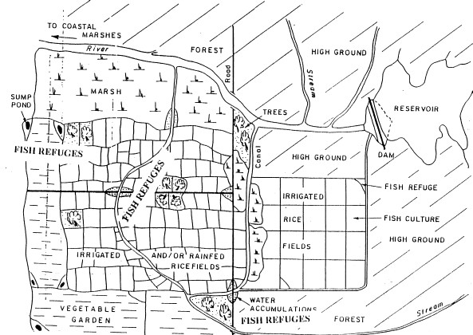A report shows wheat grain yields ranging from 770 to 5,010 kg ha-1 with normal water and 2,140 to 5,790 kg ha-1 with aquaculture effluent (EFFLUENT & CROP, n.d.). Therefore, when water from fish pond is applied to the soil greater crop returns are expected.

**Fig. 2.** Diagram representing the irrigation of rice from fish reservoir. The channel are connected to reservoirs and the long arrows show the direction of water flow. *Credit: Fernando 2000.*

*Advantages of integrating aquaculture with agriculture*

The irrigation of crop using fish water has similar advantages to aquaponics because it is a sub-category of aquaponics. That is to say it increases the water quality of fish ponds, it reduces the discharge of effluent into water ways (stream, lakes, rivers and so on) and it reduces the chemical impact on the environment. In other words, it is a complete organic farming system and it is environmentally friendly. Most of all it is a cheap sustainable form of agriculture that can be applied by both rural and urban farmers. Therefore, I intended to test and determine the effect of irrigation using

water from fish ponds on plant growth in an aquaponics-type study. In this research, I did not test aquaculture and hydroponics, but instead concentrated on combining aquaculture and traditional farming systems. To test the viability of this model for poor, rural farmers in the region, I focused on the effects of fish-pond water on plants growing in typical soil without the use of chemicals or fertilizers. This study ultimately aims to find new solutions to dryland agriculture challenges.

## RESEARCH QUESTION

What is the effect of irrigating with water from fish ponds on plant growth in test plots in Yola, northeastern Nigeria?

## HYPOTHESES

**Null Hypothesis:** Irrigating with water from fish ponds has no effect on plant growth in test plots in Yola, northeastern Nigeria.

**Research Hypothesis:** Irrigating with water from fish ponds will improve plant growth in test plots in Yola, northeastern Nigeria.

## AIMS & OBJECTIVES

### Aims:

* To determine the effect of irrigating with water from fish ponds on plant growth in test plots in Yola, northeastern Nigeria

### Objectives:

* To measure plant growth for plants irrigated with water from fish pond and plant given normal water
* To compare plant growth rates between test and control plots ….
* To share my findings with the AUN Sustainability Office
* To provide cheap sustainable agriculture to rural farmers in Yola northeastern Nigeria.

## CHAPTER 2

## MATERIALS AND METHODS

*Study site*

The experiment performed was a field experiment, carried out at the American University of Nigeria’s (AUN) Sustainability recycling center. The site is located at the Northeastern part of Nigeria, specifically Yola the capital city of Adamawa State.

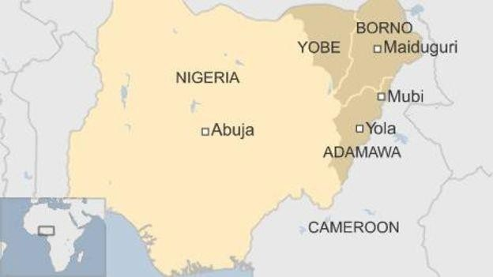

**Fig.3.**Map of Nigeria showing Yola the capital city of Adamawa state.

This region where the research took place is known to have a tropical wet and dry/ savanna climate with a pronounced dry season in the low-sun months, no cold season, and wet season in the high-sun months. Yola has its wettest weather in the month of August with an average of 190.2mm (7.5 in) of rainfall. The driest weather of Yola occurs in January, February and December with an average of 0 mm (0 in) rainfall. On an average, Yola has 883 mm (34.8 in) of rainfall per year and 73.6 mm (2.9 in) per month. The yearly temperature of Yola is very hot at 28.1 degrees

Celsius (82.5 degrees Fahrenheit). The hottest month of the year in Yola is the month of April; 32.5 degrees Celsius (90.5 degrees Fahrenheit).

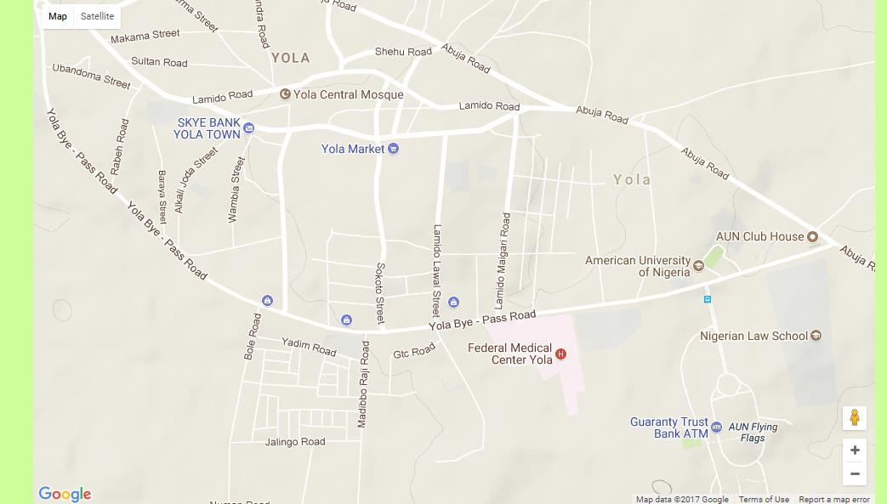

**Fig.4.** Located in Yola is the American University Nigeria where the study site is located. The study site is the American University of Nigeria. *Credit: Google map and* [*http://www.yola.climatemps.com/map.php.*](http://www.yola.climatemps.com/map.php)

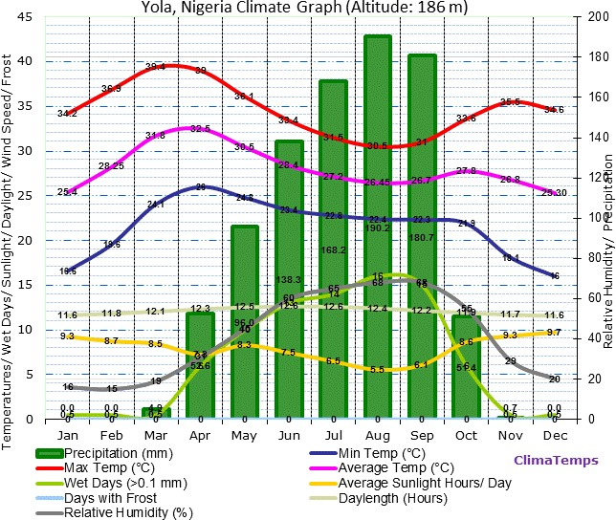

**Fig.5**. Graph showing the Yola, Nigeria climate. The graph shows the high temperature and level of precipitation observed in this region. *Credit: ClimaTemps.com* [*http://www.yola.climatemps.com/*](http://www.yola.climatemps.com/)

*Sampling*

This study involved three plots; each plot contained 50 corn plants. The plants in plot 1 were irrigated using water from a fish pond and there was no fertilizer applied to the soil. The crops in plot 2 were irrigated using normal water and there was no fertilizer applied to the soil. The crops in plot 3 had fertilizer. The area of the each plot and the spacing between each crop were determined. Planting of the crops was done by using hoes. Fertilizer was applied on plot 3 (three) by digging a hole close to the hole dogged for the plant. Fertilizer was then applied to that hole. Irrigation of the plant was done using a watering can. The plants were irrigated once every day from the date of planting until germination. As soon as germination occurred the date of germination of each plots were recorded. When the plant developed stems

these were measured once every week. When the crops germinated fully they were compared with each other.

The research was started on 13th February 2018. The research was carried out by me, a friend and an employee. Germination of the crops planted occurred exactly one week after plantation (7 days) and that same day (20th of February 2018) data. collection started.

On the 13th of February 2018 a plot of land was given to me by the Landscaping department of the American University of Nigeria. On the land given to me I measured a total of 12 x 24m (39 x 78 feet) plot. I divided the total plot size into three, each plot measured 4 x 8m (13 x 26 feet). With the help of a friend and two employees I made ridges which were used to separate the plots. The ridges were 500mm apart (1.6 feet apart), 300mm wide (0.98-1feet wide) and 200mm high (0.65-0.7 feet high) (Fig).

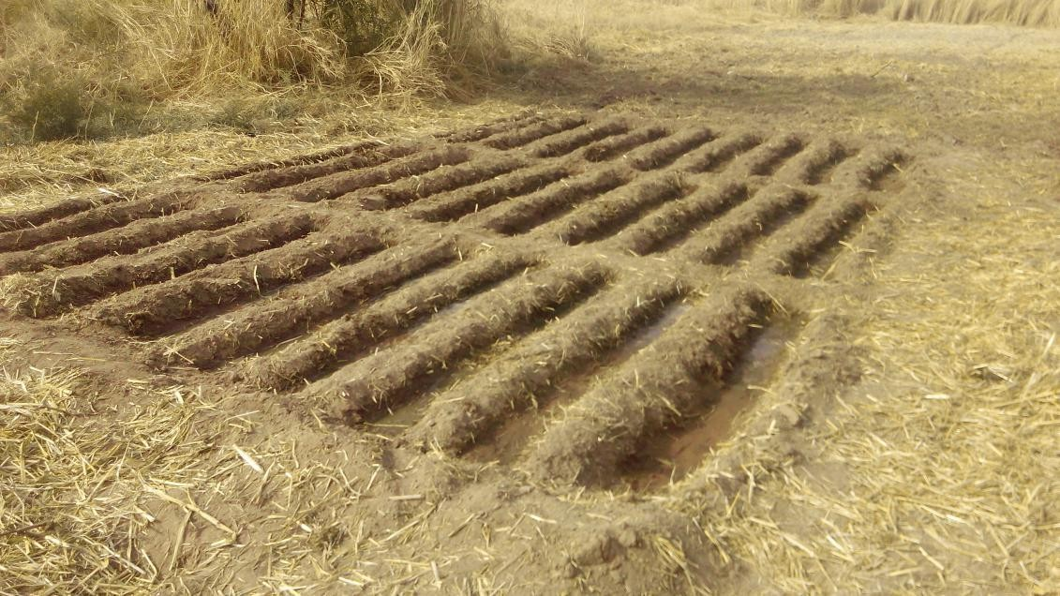

**Fig.6.** Ridges dug for the plantation of the crops.

As soon as the ridges were ready, the ground was dug using a hoe (not too deep) and the seeds were place in each hole. The seeds were planted between the ridges.

After seeds had been placed in the three plots, I then added fertilizer to the plot that needed fertilizer. I dug holes 2feet away from the hole that had the seed it in and a hand full of fertilizer (Urea fertilizer) was applied to all of the 50 crops on that plot. As soon as that was done water was added to the plot to begin melting the fertilizer to add nutrients to the soil.

Watering of the plots done two times a day for the first 2 weeks of plantation by me, it was done once early in the morning and once in the evening. After which I started watering once a day in the evening. Each plot was given three 9 liter watering cans, that is, each plot received 27 liters of water. The normal water was obtained from a water source close to a football field where the farm was located. The fish was taken

from a fish pond at the AUN recycling center. The fish pond contained about 32 catfish species.. To get the water from the fish pond, the water is sucked from the pond by a pump connected to the pond into a tank connected to the pump through a pipe. The water is stored and from a tap connected to the tank the water is gotten. As soon as I observed germination I used a centimeter calibrated meter rule to measure and record the growth of three successful plants on each plot. This was

done for 24 days after which I put the data collected into excel and I used ANOVA a statistical analysis program to analyze my data and I also plotted a bar chat and line graph for the comparison of the growth between each plot. I used ANOVA for my data analysis because it gives the p-value and gives the level of significance of a research from the data acquired.

## CHAPTER 3 RESULTS

The sample size of my research involves a total of 150 plants of which each plot (fertilizer plot, Normal water plot and fish water plot) have 50 plants. Of all the plants the plants on the plot watered with fish water showed significant growth in terms of freshness of plant and growth. Table 1A shows a significant difference between plants on each plot although, in the same table one can observed that there are certain days when average growth in two plots are similar example 25-Feb-2018 both Normal water plot and fertilizer plot had were measured at 9cm. Measurement of plant was done on daily basis. Three well germinating plants were chosen at random from the first day of measurement and measured for data. An average of these plants was taken to form the data. This was done in each plot.

A one-way between-subjects ANOVA was conducted to compare the effect of three different treatments (irrigating with fish water, irrigating with normal water, and irrigating with normal water with fertilizer added) on plant growth. The results show that there was no significant difference among the plots (groups) [F (2, 69) = 2.29, p

= 0.11].

**Table 1.** Data collected showing different growth rate in different plot. Plants in each plot grew differently depending on nutrient available.

|  |  |  |  |
| --- | --- | --- | --- |
| **Plant Growth Measurement** | | | |
| **Date** | Plot 1 (Fish water plot) | Plot 2 (Normal water plot) | Plot 3 (Fertilizer plot) |
|  | Measurement (cm) | Measurement (cm) | Measurement (cm) |
| **20-Feb-18** | 4 | 3 | 3.9 |
| **21-Feb-18** | 5.5 | 4.6 | 4.6 |
| **22-Feb-18** | 7 | 5 | 6.5 |
| **23-Feb-18** | 7.9 | 6 | 7 |
| **24-Feb-18** | 8.5 | 6.9 | 8 |
| **25-Feb-18** | 10 | 9 | 9 |
| **26-Feb-18** | 11.5 | 9.5 | 10 |
| **27-Feb-18** | 12 | 9.9 | 11.9 |
| **28-Feb-18** | 13.5 | 12 | 12.5 |
| **1-Mar-18** | 14.9 | 12.5 | 14 |
| **2-Mar-18** | 16.5 | 12.5 | 14 |
| **3-Mar-18** | 18 | 12.5 | 14.5 |
| **4-Mar-18** | 18.6 | 13 | 16 |
| **5-Mar-18** | 19 | 13.5 | 18.5 |
| **6-Mar-18** | 20 | 17 | 19 |
| **7-Mar-18** | 21.5 | 17 | 20 |
| **8-Mar-18** | 23 | 18 | 20.9 |
| **9-Mar-18** | 25.9 | 18.5 | 21.5 |
| **10-Mar-18** | 27 | 19.9 | 22.5 |
| **11-Mar-18** | 29.9 | 20.5 | 23 |
| **12-Mar-18** | 31.5 | 21.5 | 24.9 |
| **13-Mar-18** | 33 | 22.9 | 25 |
| **14-Mar-18** | 35.9 | 24 | 26 |
| **15-Mar-18** | 37 | 25 | 27 |

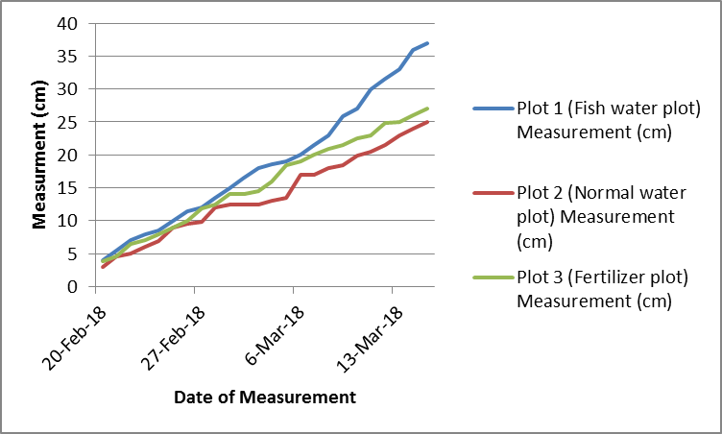

**Fig.7.** Ecological significant growth of plants found in fish water plot compared to plants found in normal water plot and plants found in fertilizer

*Presence of weed on plots*

During the course of the research an observation was made on each plot. This observation was made as to no regards to the adjectives of the research. The observation made was concerning the presence of weed on each plot. It was observed that in each plot, the presence of weed were different. The presence weed on the plot watered with fish was zero, while the plot that fertilizer was applied on had the highest amount of weed presence. The plot watered with normal water had weed on it but not as much weed that was observed on the plot that was fertilized (Fig. 8A), (Fig. 8B) and (Fig. 8C).

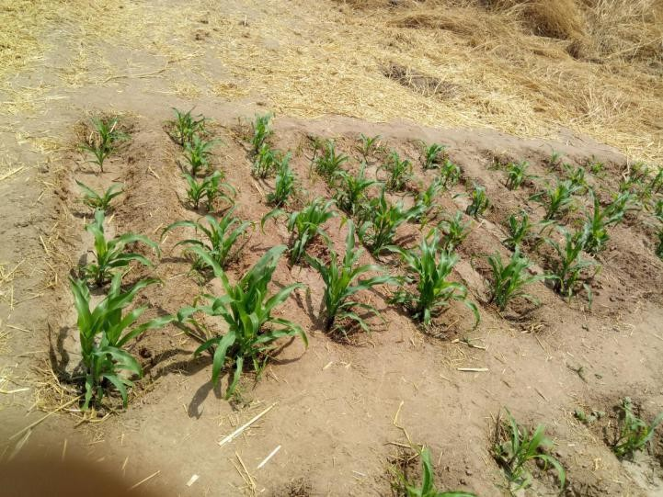

**Fig.8A.** Weed on plot watered with fish water. No weed observed.

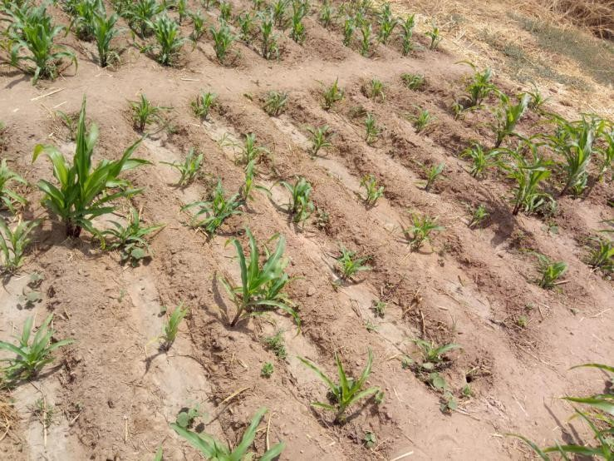

**Fig.8B.** Weed on plot watered with only normal water. Little amount of weed observed.

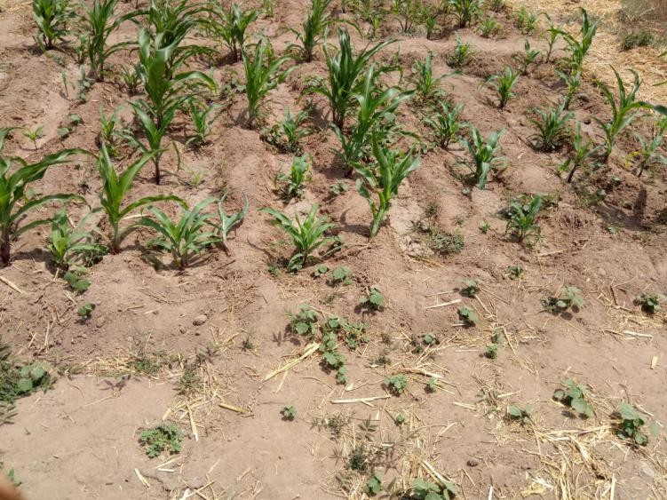

**Fig.8C.** Weed on plot watered with normal water with fertilizer applied on it. Lots of weeds present in this plot.

## CHAPTER 4 DISCUSSION

In this study, I hypothesized that irrigating plants with water from fish ponds would improve plant growth. After comparing growth of three test plots, I found support for this hypothesis. Stems of corn plants irrigated with fish water plot grew taller than plants irrigated with normal water or normal water with fertilizer. Although the differences among the plots were not statistically significant, they may be ecologically significant. In addition, my sample size was small. With a larger sample and longer study period, the results may have provided greater support for the use of fish water for irrigation. My findings ultimately provide insight into ways to potentially boost crop yields for rural, dryland farmers in Nigeria and other drier regions of Africa.

My findings are similar to other studies. According to Abdul-Rahaman et al. (2011) plant irrigated with fish effluent had better growth than those irrigated with well water. It was also observed in the research that stem, leaf, plant length and root diameter were higher when irrigated with fish effluent compared to water from well. Another research showed an increase in tomato yield from 64.5 to 95.8 t ha when the plants were irrigated with aquaculture and low yield produce when irrigated with well water (Castro et al., 2006)

However, not all research found support for fish water. For example, Meso et al. (2004) discovered that water from canals combined with fertilizer had significantly more nutrients than fish effluent. As a result, a combination of canal water and

fertilizer produced more yield during the research, while irrigation produced less. A study showed similar result, in this study three system of farming were compared (aquaponics, hydroponics and soil culture), as they were used to producr three different kinds of crops. Part of the research was the use of fish water for irrigation in the aquaponics system. According to another research tomato yield was in aquaponics system was identical to hydroponics or soil culture. Nevertheless, the yields were of poor quality because of the lack of phosphorus present it in fish effluent which a major nutrient needed for plant growth. However, my research shows a different result because irrigation was done on the soil and phosphorus is a component of the soil; therefore irrigation plants using fishing water yield produce with quality yield(Graber & Junge, 2009). So therefore, the use of fish water for irrigation still stands to be better than an inorganic source of nutrient and irrigation with normal water.

Analyzing the relationship between the high growth of plant on the fish water plot and nutrient, the major constituent of fish effluent is nitrogen. According to Castro et al., the total amount of nitrogen usually present in a fish effluent is about 4 to 10 mg L-1. This show that nitrogen has a major role to play in the high growth of the plants found in the fish water plot. Even if the nitrogen concentration in the fish effluent is low, it also serves as fertilizer to the plants and as a result yielding the growth of the plants. Also, the nitrogen in the fish effluent can be easily and efficiently absorbed by the plants compared to the nutrient gotten from the fertilizer. The nutrient gotten from the fertilizer is initially in a solid form which needs few hours to melt before plants can absorb. On the other hand nitrogen in the fish effluent is absorbed almost immediately it is applied to the soil.

*Comparing three plots*

Plants were taller at the end of the study in fish water plot. There was no statistical significance but it was ecologically significant. Given that the plants on the fish water plot grew taller, it best to say that. The plants irrigated with normal water grew the least because there was no nutrient added to the soil. The plot with fish water grew most compared to fertilizer and normal water plot. The difference (cm) between the growth found in fish water plot and normal water plot was high but there was not much growth difference between the plants on the fish water plot and fertilizer plot. From the result of the study one would agree that irrigating with fish water proves to be better than fertilizer or normal water. The use of this technique proves to be significant ecologically and other wise. The use of fish water for irrigation solve a part of the long lasting problem we are facing in the world today the overuse of water. It give a solution to it because it encourages recycling of water and minimizes the use of water. The result of the present experiment suggest that using fish water for irrigation could reduce fertilizer use and increase economic returns. In such a way that after setting up a fish pond or source of fish water, one does not need large amount for maintenance of this. That is the start up cost may be pretty high but cost of maintenance is pretty low or moderate. This form of agriculture would be the best way to improve crop production in Nigeria especially in hot area like northeastern Nigeria Yola with little or no rainfall. Areas like these could use a technique like this to boost crop productivity which will also help increase their income. Also recycling of water helps them retain whatever little water they get from rainfall for other use. It is also sustainable type of farming which could help prevent degradation of the land used for farming.

*Presence of weed on plots*

During the course of the research, nature was also carrying out it on research. I observed the in the plot irrigated with fish water there were little or no weed, while the normal water plot and fertilizer plot there was abundant of weeds. This may be as a result of the nitrogen nutrient present in the fish effluent. Moreau, Busset, Matejicek, & Munier-Jolain (2014) stated that in response to nitrogen, that oligotrophic species of weed don’t survive while nitrophilic species weed survive. In other word oligotrophic species of weed will be abundant in soil with low nitrogen concentration, while nitrophilic species weed will be abundant in soil with high concentration of nitrogen. There might be several reasons for the presence of weeds on the fertilizer plot and no weeds on the fish water plot. It may because there is little or no nitrogen present in the fertilizer used causing oligotrophic species of weeds to be rampant in the fertilizer plot. Also, given the fact that the fish effluent contains a reasonable amount of nitrogen oligotrophic species of weeds won’t be able to survive in its presence. As for the normal water plot there is not nitrogen present in the water used for irrigation and there may be little or no nitrogen in the soil, so there is a possibility that both species of weeds can survive in the plot.

*Challenges*

One crop (maize) and short study period – may have affected the results. Possibly why non-significant results. Recommend longer study, different crops/plants (tomatoes, rice or vegetables), and agricultural ministry should consider more widespread promotion of using this technique in rural areas and educated them on the important and significance of using this technique.

During the course of the research all of obstacles were encountered. One them was rodent, the rodents around the American University of Nigerian Main Campus constantly attack my seeds. This was resolved by plant a decoy plant close to the main research in other to get them away from the research. Also the presence of weeds in the fertilizer and normal water plot that compete for nutrient with plants found in this plot, to resolve this constant weeding is required. Other challenges time and funds necessary to carry out this research.

The use of fertilizer is common among farmers (commercial and small scale farmers) to produce yield. It is not an efficient in terms of money and sustainability. From this study one can see a better way to add nutrient to soil is through irrigating with fish water. I recommend that farmers adapt this style of irrigation because it is cost efficient (rural farmer can afford it), it is environmentally friendly, use less water and a sustainable type of farming. Also I was unable to carry out some certain test like productivity yield when irrigated with fish water, nutrient (nitrogen) concentration in fish effluent and nutrient content of the soil. I suggest that for future research all this test should be carried out for more accurate result.

## CHAPTER 5 CONCLUSION

The key finding of this study is that fish effluent is the better for irrigation than any other form of nutrient supply or irrigation. It is encourages organic farming, it encourages the use of water in a sustainable way and easy to setup so farmers in rural areas can do it. At the end of this study, plants found on the fish water plot were taller compare to those found in fertilizer plot and normal water plot.

.

## REFERENCES

Abdul-Rahman, S., Saoud, I. P., Owaied, M. K., Holail, H., Farajalla, N., Haidar, M., & Ghanawi, J. (2011). Improving Water Use Efficiency in Semi-Arid Regions through Integrated Aquaculture/Agriculture. *Journal of Applied Aquaculture*, *23*(3), 212–230. https://doi.org/10.1080/10454438.2011.600629

Boison, J. O., & Turnipseed, S. B. (2015). A Review of Aquaculture Practices and Their Impacts on Chemical Food Safety from a Regulatory Perspective. *Journal of AOAC International*, *98*(3), 541–549. https://doi.org/10.5740/jaoacint.15-033

Castro, R. S., Borges Azevedo, C. M. S., & Bezerra-Neto, F. (2006). Increasing cherry tomato yield using fish effluent as irrigation water in Northeast Brazil.

*Scientia Horticulturae*, *110*(1), 44–50. https://doi.org/10.1016/j.scienta.2006.06.006

EFFLUENT, U. O. P., & CROP, I. (n.d.). PD/A CRSP EIGHTEENTH ANNUAL

TECHNICAL REPORT. *Pond Dynamics/Aquaculture Collaborative Research Support Program Eighteenth Annual Technical Report*, 69.

Elia, E., Popa, D. C., & Nicolae, C. G. (2014). Startup Stages of a Low-Tech Aquaponic System. *Scientific Papers: Series D, Animal Science - The International Session of Scientific Communications of the Faculty of Animal Science*, *57*, 263– 269.

European Environment Agency (Ed.). (2013). *Adaptation in Europe: addressing risks and opportunities from climate change in the context of socio-economic developments*. Copenhagen: European Environment Agency [u.a.].

Fernando, C. H., & Halwart, M. (2000). Possibilities for the integration of fish farming into irrigation systems. *Fisheries Management and Ecology*, *7*(1–2), 45–54.

Graber, A., & Junge, R. (2009). Aquaponic Systems: Nutrient recycling from fish wastewater by vegetable production. *Desalination*, *246*(1–3), 147–156. https://doi.org/10.1016/j.desal.2008.03.048

Helfrich, L. A., & Libey, G. (1991). *Fish farming in recirculating aquaculture systems (RAS)*. Virginia State Cooperative Service.

Meso, M. B., Wood, C. W., Veverica, K. L., Woomer, P. L., Kinyali, S. M., & Karanja, N. K. (2004). Effect of Fish Pond Effluents Irrigation on French Beans in Central Kenya. *Communications in Soil Science & Plant Analysis*, *35*(7/8), 1021– 1031. https://doi.org/10.1081/CSS-120030578

Nicolae, C. G., Popa, D. C., Turek Rahoveanu, A., Dumitrache, F., Mocuţa, D., & Elia, E. (2015). Low-Tech Aquaponic System Based on an Ornamental Aquarium. *Scientific Papers: Series D, Animal Science - The International Session of Scientific Communications of the Faculty of Animal Science*, *58*, 385–390.

Tomlinson, L. (2015). Indoor Aquaponics in Abandoned Buildings: A Potential Solution to Food Deserts. *Sustainable Dev. L. & Pol’y*, *16*, 16.

Trang, N. T. D., & Brix, H. (2014). Use of planted biofilters in integrated recirculating aquaculture-hydroponics systems in the Mekong Delta, Vietnam. *Aquaculture Research*, *45*(3), 460–469. https://doi.org/10.1111/j.1365- 2109.2012.03247.x