**EFFECT OF DATE SEED POWDER FILLER ON PROPERTIES OF HIGH-DENSITY POLYETHYLENE**

**By**

**Africanus Chinedu ELOBUIKE, PGD. (ABU) 2013 PGD/CE/ENG/3580/09-10**

**A DISSERTATION SUBMITTED TO THE SCHOOL OF POST GRADUATE STUDIES,**

**AHMADU BELLO UNIVERSITY, ZARIA,**

**IN PARTIAL FULFILLMENT OF THE REQUIREMENTS FOR THE AWARD OF A**

**MASTER OF SCIENCE DEGREE IN CHEMICAL ENGINEERING.**

**DEPARTMENT OF CHEMICAL ENGINEERING, FACULTY OF ENGINEERING,**

**AHMADU BELLO UNIVERSITY, ZARIA, NIGERIA**

**OCTOBER, 2017.**

# DECLARATION

I declare that the work in this Dissertation entitled “EFFECT OF DATE SEED POWDER FILLER ON THE PROPERTIES OF HIGH-DENSITY POLYETHYLENE” has been carried

out by me in the Department of Chemical Engineering. The information derived from the literature has been duly acknowledged in the text and a list of references provided. No part of this dissertation was previously presented for another degree or diploma at this or any other institution.

ELOBUIKE, Africanus Chinedu

**Name of Student Signature Date**

# CERTIFICATION

The dissertation entitle “THE EFFECT OF DATE SEED POWDER ON THE PROPERTIES OF HIGH-DENSITY PLOYETHYLENE” by Africanus Chinedu ELOBUIKE meets the regulations governing the award of Master of Science Degree in Chemical Engineering at the Ahmadu Bello University, and is approved for its contribution to knowledge and literary presentation

Dr. Bello MUKHTAR

Chairman, Supervisory Committee Signature Date

Dr. M.T. ISA

Member, Supervisory Committee Signature Date

|  |  |  |
| --- | --- | --- |
| Prof. B.J. El-Yakubu |  |  |
| H O D Chemical Engineering | Signature | Date |

Prof. S. Z. Abubakar

Dean, School of Postgraduate Studies Signature Date

# ACKNOWLEDGEMENTS

I humbly and gratefully appreciate the Almighty God for His grace and favors in my life and for crowning all my efforts with outstanding success.

I also appreciate members of my supervisory team: Dr. B. Mukhtar and Dr. M.T. Isa for their creative and valuable contributions to this work; all lecturers of our department, especially the former HOD, Professor Mohammed Dabo, and the present HOD Professor B.J. El-Yakubu for their great encouragement; also worthy of mention are the management and staff of Bam Chemical and Paint Industry Nigeria limited, Kaduna and Nsukka, for the financial and moral support given to me.

My gratitude also goes to my late parents, Chief and Mrs Joseph Elobuike, for the investment they made in me. May their souls and those of all the faithful departed through the mercy of God rest in peace. Amen.

Finally, my appreciation goes to my wife, children siblings and friends for their support and prayers since the inception of the academic pursuit. I pray that they will be successful in all their endeavors irrespective of life’s challenges.

# ABSTRACT

High-density polyethylene composites of date seed powder were prepared at filler loadings of 0 to 40wt%. The particle sizes of the date seed powder investigated were 72, 125, 150 and 180µm. Calcium carbonate was used as a reference filler. The high- density polyethylene composites were prepared in a two-roll mill machine and the resulting composites were extruded as sheets. Mechanical, thermal, morphological and physical properties of the composites were determined. Results showed outstanding mechanical performance with the date seed powder. Impact strength, increased from 0.65 to 1.35J/m, flexural strength increased from 28 to 31MPa, hardness property increased from 67 to 74 J/m, tensile strength increased from 10 to 18J/m, and the tensile modulus also increased. These properties increased with increase in filler loading and decreased as the filler particle size were increased. However, the elongation at break of the composites was observed to decrease from 250 to 180 with increase in filler loading and particle size. The elongation at break of calcium carbonate filled high-density polyethylene was almost zero, an indication of the more brittle nature of high-density polyethylene composite of calcium carbonate. The water absorption test showed that the composite with the smallest particle size of 72µm had the lowest water absorption value while the biggest particle size of 180µm had the highest. The thermal gravimetric analysis showed an improvement in thermal stability of the high-density polyethylene/date seed powder composite due to incorporation of the date seed powder filler.

# TABLE OF CONTENTS

DECLARATION ii

CERTIFICATION iii

ACKNOWLEDGEMENTS iv

ABSTRACT v

TABLE OF CONTENTS vi

LIST OF TABLES xi

LIST OF FIGURES xii

LIST OF ABBREVIATIONS xiii

CHAPTER ONE 1

* 1. INTRODUCTION 1
  2. Problem Statement 3
  3. Justification 3
  4. Aim and Objectives 4
  5. Scope of the work 4

CHAPTER TWO 5

* 1. LITERATURE REVIEW 5
  2. Polyethylene 5
     1. High-density polyethylene (HDPE) 6
     2. Low-density polyethylene (LDPE) 9
     3. Linear-low density polyethylene (LLDPE) 10
     4. Medium Density Polyethylene (MDPE) 12
  3. Fillers 12
     1. Effect of filler on properties of polyethylene 13
     2. Classification of fillers 14
  4. Functions of fillers 17
     1. Factors affecting the choice of fillers 18
  5. Composites 19
     1. Classification of composites 20
     2. Particulate reinforced composite 23
     3. Fibrous reinforced composite 23
     4. Hybrid composite 23
     5. Prediction of properties of hybrid system 25
     6. Composite theoretical properties calculations 26
     7. Factors affecting mechanical behaviour of hybrid composite 27
     8. Composites structure 29
  6. Date palm 35
     1. Top ten Date producers (1000 metric tonnes) 37

Table 2.4 shows the world producers of Date (FAO, Statistics Division 2010) 37

* + 1. Date production in Nigeria 38
    2. Fruit food uses 39
    3. Uses of other parts of the Date palm tree 40
    4. Disease and pests 41
    5. Health benefits of Date palm fruits 42
  1. Date Seed 44
     1. Composition of the date seed 45

CHAPTER THREE 47

* 1. MATERIALS AND METHODS 47
  2. Materials 47
  3. Equipment 48
  4. Apparatus 48
  5. Methodology 49
     1. Filler characterisation 49
     2. Preparation of filler and high-density polyethylene 50
     3. Mechanical tests 52
     4. Morphological analysis 53

CHAPTER FOUR 54

4.0 RESULTS AND DISCUSSION 54

CHAPTER FIVE 68

* 1. CONCLUSION AND RECOMMENDATION 68
  2. Conclusion 68
  3. Recommendations 69
  4. Contribution to knowledge 69

REFERENCES 70

APPENDIX A 79

Figure A1: Thermal Gravimetric analysis of CaCO₃ 79

Figure A.2: Differential thermal analysis of CaCO₃ 80

Figure A. 4: Thermal Gravimetric analysis of 180µm composite 81

Figure A.5: Differential thermal analysis of 180µm composite 82

Figure A.6: Thermal Gravimetric Analysis of 72µm composite 83

Figure A.7: Differential thermal analysis of 72µm composite. 84

Figure A.8: Thermal Gravimetric Analysis of Pure HDPE 85

APPENDIX B. 86

Table B.1: water absorption result 72µm particle size 86

Table B.2: water absorption result for 125µm particle size 86

Table B.3: water absorption result for 150µm particle size 87

Table B.4: water absorption result for 180µm particle size 87

Table B.5: water absorption result for calciumcarbonate 88

Table B.7: standard error calculation on flexural analysis of the composite (72µm) 89

Table B.8: standard error calculation on flexural analysis of the composite (125µm) 90

Table B.8: standard error calculation on flexural analysis of the composite (150µm) 90

Table B.9: standard error calculation on flexural analysis of the composite (180µm) 91

Table B.10: standard error calculation on flexural analysis of the composite (CaCO₃) 91

Table B.11: standard error calculation on hardness analysis of the composite (72µm) 92

Table B.12: standard error calculation on hardness analysis of the composite (125µm) 92

Table B.13: standard error calculation on hardness analysis of the composite (150µm) 93

Table B.14: standard error calculation on hardness analysis of the composite (180µm) 93

Table B.15. standard error calculation on hardness analysis of the composite (CaCO₃) 94

Table B.16: standard error calculation on impact analysis of the composite (72µm) 94

Table B.17: standard error calculation on impact analysis of the composite (125µm) 95

Table B.18: standard error calculation on impact analysis of the composite (150µm) 95

Table B.19: standard error calculation on impact analysis of the composite (180µm) 96

Table B.20: standard error calculation on impact analysis of the composite (CaCO₃) 96

# LIST OF TABLES

Table 2.1: Physical properties of HDPE 8

Table 2.2: Physical properties of LDPE 10

Table 2.3: Physical properties of LLDPE 12

Table 2.4: World Date producers in 2013 37

Table 2.5 States in Nigeria that produce Dates 39

Table 3.1: Materials and their sources 47

Table 3.2: Equipment and their sources 48

Table 3.3: Formulation table for CaCO₃/HDPE composite 51

Table 3.4: Sample for HDPE/Date seed composite using 72µm particle Ssze 51

Table 3.5: Sample for HDPE/Date seed composite using 125µm particle size 52

Table 3.6: Sample for HDPE/Date seed composite using 150µm particle size 52

Table 3.7: Sample for HDPE/Date seed composite using 150µm particle size 52

Table 5 XRF Results of Date seed and CaCO₃ 65

# LIST OF FIGURES

Figure 2.1 Classification of filler based on performance 15

Figure 2.2 Classification of composite materials 22

Figure 4.1 Variation of particle size and loading with flexural properties of

HDPE 59

Figure 4.2 Effect of particle size and loading on the impact resistance properties of HDPE 61

Figure 4.3 Effect of particle size and loading on hardness properties of HDPE 63

Figure 4.4: Effect of particle size and loading on the tensile property of HDPE 60

Figure 4.5: Effect of filler loading on the elongation at break of the composite 61

Figure 4.6 Effect of filler loading on the Young’s modulus of the composite 62

Figure 4.7: Water absorption capacity of the composites (HDPE/Date seed and HDPE/CaCO₃).

……………………………………………………………………………………….63

Figure 4.8: Super imposed TGA results of the fillers and pure HDPE 66

# LIST OF ABBREVIATIONS

|  |  |
| --- | --- |
| ASTM | America Standard for Testing and Material |
| CaCO3 | Calcium carbonate |
| DTA | Differential Thermal Analysis |
| FIIRO | Federal Institute of Industrial Research, Oshodi |
| HDPE | High-Density Polyethylene |
| NGRL | National Geo-Science Research Laboratory, Kaduna |
| NILEST | Nigeria Institute for Leather and Science Technology. Samaru, Zaria |
| SEM | Scanning Electron Microscopy |
| TGA | Thermo-Gravimetric Analysis |
| Wt% | Weight Percent |
| XRF | X-ray Florence |

# CHAPTER ONE

## INTRODUCTION

In the plastics industry, it is often necessary to add materials to a basic polymer resin in order to make it processable. Additives are required to modify a resin, to improve properties that are desirable and to eliminate or mitigate properties that are undesirable. In developing additive systems, the plastic industry has learnt much from the earlier experience of the rubber industry and the pace of development, responding to market needs has pushed for research in completely new fields.

Plastic industry is a major user of additives, which include:

* + 1. Fillers and mineral reinforcements (CaCO3, talc, mica)
    2. Fiber reinforcements (armid, carbon, glass, natural fibre)
    3. Colorants (pigments, carbon black, TiO2 colour, paste, dyestuff)
    4. Heat resistant materials (antioxidants and stabilisers)
    5. Ultraviolet resistant materials (UV stabilisers)
    6. Flame retardants (reactive additives)
    7. Curing system for thermosets (accelerators, curing agent and catalyst)
    8. Cross-linking, coupling, compatibiliser (Forming cross links between suitable polymer and other molecules)
    9. Plasticisers (mainly phthalates, but many systems are used)
    10. Process modifiers, processing aids (lubricants and plasticiser, nucleating agents)
    11. Blowing agents (inert gas or gas-forming chemicals injected or mixed into a compound to react during processing.)
    12. Lubricants (lubricants mould release agents, slip and anti-block)
    13. Recycling additives (impact modifiers, stabilisers)

Virgin materials such as high-density polyethylene (HDPE) are not often used without additives. One of the most important additives and second largest in terms of the amount used following the base polymer in plastic compounding is the filler (Bello, 2010). Filler technology is shaping an entirely new and active role for these very traditional materials, especially using coating and other surface treatments to confer other properties, such as pigmentation and processing assistance. Expandable fillers continue to be promising. Calcium carbonate is the most commonly used filler in terms of volume, but relatively low in value.

In plastic industry, calcium carbonate (CaCO₃) has mainly been used in polyvinylchloride (PVC) compounds but engineered grades (produced by adjusting particle size or geometry and

/or modifying the surface) are opening up a large potential market in polyolefin, where the aim is not to extend the bulk of the compound but to offer positive properties such as reducing cycle time and improving physical properties. For example, very fine particles give marked increase in the strength of the films. Stearic acid-coated grades give good mechanical properties and improved processing.

Suitable calcium carbonate can be used in part, as replacement of white pigment and to achieve high gloss (and off-set the reduction in gloss produced by replacement of lead stabilisers with calcium/zinc systems). Other mineral fillers are coming into preeminence as users demand cheaper and more effective compounds. Talc, mica and wollastonite improve stiffness, heat stability, and expansion/shrinkage and certain clays in sub-micrometer particle size (nano- particles) are currently the focus of research to improve mechanical and also barrier properties with very small percentage loadings (Bello, 2010). The new area of development is to incorporate the filler permanently into the polymer matrix by use of coupling reactions. This can increase impact strength and thermal properties of polyamides and polyesters (Bello, 2010). In polypropylene, bonding with kaolin can also improve scratch resistance which is a useful benefit for automobile interior applications. Surface modification of filler materials using

materials such as silica, mica and wollastonite allows these to penetrate markets that were formerly the province of reinforcements such as carbon black and glass fibre.

Recently, there has been growing interest in the use of renewable resources such as sawdust, eggshell, corncobs, groundnut shells, rubber seed shell, rice husk, Cocoa pod husk, cherry bone, coconut shell, as a result of their biodegradability. However, they are among the underutilised renewable resources in our society today, which can be used directly or converted by simple processes to valuable materials in polymer related applications (Osabohien *et al.,* 2012).

Date seed is another renewable resource that can be used as filler. The seed is very hard, which makes it potential filler for enhancing properties of a polymer in form of a composite.

## Problem Statement

Virgin high-density polyethylene (HDPE) is difficult to process because it does not possess all the properties that make processing easy (biodegradability, mechanical, thermal and morphological properties) need to be improved. Calcium carbonate filler which is currently in use though is performing well is not a renewable source and is relatively expensive compared to date seed

On the other hand, to the best of my knowledge there is no established work on the effect of date seed as filler on the morphological, physical, thermal and mechanical properties of high- density polyethylene.

## Justification

When Date seed is compounded with virgin high-density polyethylene (Pure HDPE), there may be Increase in mass, decrease in consumption of expensive HDPE, improvement in its properties, reduction in production cost, and also a degradable finished product. Date seed as a renewable source (bio-filler) will impart biodegradability to high- density polyethylene thereby

reducing land pollution and make more land available for other purposes. Date seed will create employment opportunity locally.

## Aim and Objectives

The aim of this research work is to determine the effect of date seed powder filler on the mechanical, thermal, physical and morphological properties of high-density polyethylene/date seed composites.

The specific objectives are to:

1. determine the composition of Date seed
2. Prepare the composites of HDPE/Date seed
3. determine the effect of particle loading on the composite
4. determine the effect of particle size on the composite

## Scope of the work

The scope of this work is as follows:

1. Collection, sorting, drying and grinding of the date seed
2. Sieving into different particle sizes
3. Characterisation of Date seed filler (x-ray florescence /XRF)
4. Morphological analysis of the blends (scanning electron microscopy)
5. Mechanical analysis on the blends (hardness, impact resistance, tensile strength, flexural/bending test).
6. Thermal- gravimetric analysis (TGA)
7. Physical analysis of the composite to determine its water absorption

# CHAPTER TWO

## LITERATURE REVIEW

* 1. Polyethylene

Polyethylene, also called polyolefin, is produced via polymerisation of ethylene (ethene). It is used more than any other thermoplastic polymer. There is a wide variety of grades and formulations available that have equally wide range of properties.

The chemical formula of polyethylene is C2H4 while the chemical structure is represented as

C = C

H

H H

H

H H



H

H

[ − 𝐶 − 𝐶 − ]

𝑛

Polyethylene polymer (George *et al.,* 2015).

The outstanding characteristics of polyethylene are:

1. Toughness
2. Chemical resistance
3. Abrasion resistance
4. Impact resistance
5. Low coefficient of friction
6. Near zero moisture absorption.

The most commonly used grades of polyethylene (polyolefin) are:

1. Low density
2. High density
3. Medium density
4. Linear low density polyethylene.
   * 1. High-density polyethylene (HDPE)

High-density polyethylene is prepared from ethene by catalyticpolymerisation process. The catalysts used are chromium/silica, Ziegler-Natta or metallocene. The absence of branching results in a more closely packed structure with a higher density, tensile strength and, to some extent, higher chemical resistance. The lack of branching is ensured by an appropriate choice of catalyst. High-density polyethylene meets Food and Drug Agency (FDA) requirement for direct food contact application.

HDPE has several properties. The prominent ones are:

1. Abrasion resistance

The extremely high molecular weight HDPE combined with its very low coefficient of friction provides an excellent abrasion resistance, prevents gouging, scuffing and scrapping.

1. Exceptional impact strength

HDPE is one of the highest impact resistant thermoplastic available and maintains excellent machinability and self- lubricating characteristics. This property is maintained even at extremely low temperatures.

1. Chemical resistance

HDPE has a very good chemical resistance of corrosive as well as stress cracking resistance (with exception of strong oxidising acid at elevated temperatures). Certain hydrocarbon causes only a light surface swelling at a moderate temperature.

1. Water resistance

Moisture and water (including salt water) have no effect on HDPE. It can be used in fresh and salt water immersion application.

1. Fabrication

Table 2.1 shows the physical properties of high-density polyethylene (George *et al.*, 2015). Table 2.1: Physical Properties of HDPE

|  |  |
| --- | --- |
| **Property** | **Value** |
| Tensile strength | 0.2 – 0.40 N/mm2 |
| Notched impact strength | No break |
| Thermal coefficient of expansion | 100 – 200x10-6 |
| Max. Continued Temperature | 650C |
| Melting point | 1260C |
| Density | 0.941 – 0.965g/cm3 |

HDPE has many applications, which include:

1. Food cutting board
2. Corrosion resistance wall coverings
3. Pipe flanges
4. Lavatory partitions
5. Man-hole covers in chemical plants
6. Radiation shielding
7. Self supporting containers
8. Prosthetic devices

However, despite the many applications of HDPE, it has some disadvantages, which include:

1. It may have voids, bubbles or sink
2. Poor dimensional accuracy
3. Low mechanical and thermal properties
   * 1. Low-density polyethylene (LDPE)

Low density polyethylene is produced by free radical polymerization. The high degree of branches with long chains gives molten low density polyethylene unique and desirable flow properties. It has a high degree of short and long chain branching which means that the chain does not pack into crystal structure as well. It has therefore less strong intermolecular forces at the instantaneous dipole, induced dipole attraction is less. This results in a lower tensile strength and increased ductility. It is defined by a density range of 0.910 – 0.940g/cm3 (George *et al.*, 2015).

Low-density polyethylene has several properties. The prominent ones are:

1. high flexibility
2. milk color
3. Translucent with high impact strength.
4. Excellent for mild and strong buffers
5. Good chemical resistance
6. Good water vapor and alcohol barrier properties
7. Poor gas barrier
8. It is sterisable with Ethylene oxide or gammer radiation
9. Good stress crack and impact resistance
10. Low cost
11. Easily processable

It can be fabricated using the following techniques:

1. Hot gas welded, fusion and butt welded, ultra sonic sealed, Die cut. It can be machined with wood or metal working tools.
2. Vacuum forming
3. Thermo-forming

Table 2.2 shows the physical properties of low-density polyethylene (George *et al.,* 2015).

Table 2.2: Physical properties of LDPE

|  |  |
| --- | --- |
| Property | Value |
| Notched impact strength | No break |
| Thermal coefficient of expansion | 100 – 220x10-6 |
| Maximum continued temperature | 650C |
| Melting point | 1100C |
| Glass-transition Temperature | -1250C |
| Density | 0.910 – 0.940g/cm3 |

LDPE has many applications, which include:

1. It is used for chemical resistance tanks and containers
2. Food storage containers
3. Laboratory equipment
4. Disposable thermo-formed products
5. Corrosion resistance work surfaces
6. Vacuum formed end caps and tops
7. Moisture barrier
   * 1. Linear-low density polyethylene (LLDPE)

Linear-low density polyethylene is commonly made by copolymerisation of ethene with short chain alpha olefins (1-butene, 1-hexene, 1- octane). It has a density range of 0.915 – 0.925g/cm3 (George *et a*l., 2015). It is substantially linear polymer with a significant numbers of short branches. Linear low density polyethylene differs from convectional low density polyethylene

because of the absence of long chain branches. It is produced at lower temperatures and pressure by copolymerisation of ethylene and such high alpha olefins as butene, hexene and octene. The copolymerization process produces a linear low density polyethylene that has a narrower molecular weight distribution than convectional low density polyethylene and in combination with the linear structure, significantly different rheological properties.

LLDPE has several properties. The prominent ones are:

1. high tensile strength
2. high impact and puncture resistance
3. very flexible and elongates under stress
4. Used to make thinner films with better environmental stress cracking resistance.
5. chemical resistance
6. electrical properties
7. is not as easy to process as low density polyethylene
8. It has lower gloss and narrower range for heat sealing.

LLDP has many applications, which include:

1. It is used for plastic bags and shields

ii. It is used for plastic wraps, stretch wraps, pouches, toys, covers, lids, pipes, buckets and containers, covering of cables, geo-membranes and many flexible tubing.

Table 2.3: Physical properties of LLDPE (George *et al*., 2015)

|  |  |
| --- | --- |
| **Property** | **Value** |
| Density | 0.915 – 0.925g/cm3 |
| Surface hardness | SD 48 |
| Tensile strength | 30MPa |
| Flexural modulus | 0.35GPa |
| Maximum operating temperature | 500C |
| Melting temperature range | 120 – 1600C |

* + 1. Medium Density Polyethylene (MDPE)

It is defined by a density range of 0.926 – 0.940g/cm3 (George *et al.,* 2015). Medium density polyethylene can be produced using chromium/silica catalyst, Ziegler-Natta catalyst or metallocene catalyst.

## Fillers

Fillers are particles added to materials (plastics, composite materials, concrete etc.) to lower the consumption of more expensive material or to better some properties of the mixture materials with reduction in cost. Fillers can be in the form of solid, liquid or gas. By the appropriate selection of these materials not only the economics but also the other properties such as processing and mechanical behavior can be improved. Although these fillers retain their inherent characteristics, very significant differences are often seen, depending on the molecular weight, compounding technique and the presence of other additives in the formulation. Therefore, once the basic property requirement is established, the optimum filer type and the loading level for cost and performance balance must be determined. The addition of fillers also

requires a balance of formulation for optimum processing properties. Therefore, before making a final decision on a filled compound, it is critical to establish the following:

1. Optimum loading level for property and benefit
2. Optimum formulation for processing and production output
3. Economics of filled formulation (Abdulwahab *et al*., 2014).
   * 1. Effect of filler on properties of polyethylene

Filler has the following effect on the properties of polyethylene:

1. Mechanical properties

Impact strength and flexural modulus are the mechanical properties that can most be improved by careful selection of mineral fillers, and the shape of the particles is important. Fibre-like wollastonite particularly improves the flexural modulus while cube-shaped calcium carbonate can improve both the impact strength and modulus. Talc offers several options because it is capable of many different modifications and surface treatments. The high aspect ratio of glass fibre means that they can provide the greatest improvement in mechanical properties (Abdulwahab *et al*., 2014).

1. Thermal properties

Fillers usually have a thermal conductivity of about twenty times higher than plastic and the specific heat is about 50%. By improving the heat transfer in the melt, the use of filler may therefore give a faster set-up when moulding and so improve the cycle time.

1. Moisture content

Water soluble compounds in filler (such as Na, or K salts) may be affected by outdoor exposures, so damaging the performance of the compound for example an outdoor application

with a calcium carbonate filled compound may have its outer layer converted to calcium sulphide and then to calcium sulphate (gypsum) by the effect of sulphurdioxide in the air. Fortunately, gypsum is virtually in soluble in water and cannot be washed out. However, in products with high percentage of dolomite, the magnesium carbonate eventually combines with sulphurdioxide to form water-soluble magnesium sulphate, which produces efflorescence (Abdulwaab *et al.,* 2014).

1. Reinforcement mechanism of fillers

Reinforcement depends on two features: the number of interactions at the interface between the polymer and filler (which is mainly controlled by the low primary particle sizes in conjunction with the surface activity) and the hydrodynamic effect of particle aggregation and agglomeration (which are linked with shear modulus and hysteresis during dynamic or static deformation). One key is the shape and size of the primary aggregates which are largely dependent on the manufacturing process, but the distribution of the particles is also important which is largely controlled by processing conditions. This is particularly true in the case of elastomeric matrices. Recent thinking is that the differences in the aggregate size distributions are particularly respon

sible for the processing and vulcanization characteristics of the compound (Abdulwaab *et al.,*

2014).

* + 1. Classification of fillers

Fillers have been classified in many different ways, ranging from their shapes to specific characteristics. Basically, fillers can be classified into two categories, based on performance and type.

* + - 1. Classification based on performance

Extenders (Clay Talc)

Functional Fillers

FILLER

Figure 2.1 Classification of filler based on performance (Abdulwaab *et al*., 2014). Extender fillers

The extender fillers primarily occupy space and are mainly used to lower the formulation cost. The extender filler should possess the following properties:

1. Be spherical to permit retention of anisotropic properties
2. Has an appropriate particle size distribution for particle packing
3. Cause no chemical reactivity with the polymer or the additives
4. Has low specific gravity and desirable refractive index and colour
5. Be available and low in cost.

Functional fillers

Functional fillers on the other hand have a definite and required function in the formulation apart from lowering the formulation cost. However, some of the extender fillers when reduced to a finer particle size and or surface treated would perform as functional filler. Fillers that are functional in one polymer may be merely extenders in another polymer. Such factors seriously complicate the task of establishing sharp boundary lines between extenders and functional fillers in terms of their generic composition. Therefore, the extender fillers basically lower the formulation cost and increase the flexural modulus, whereas the functional fillers provide at least one specifically required function in the formulation (Abdulwaab *et al.,* 2014).

* + - 1. Classification based on type

There are three main groups of filler based on its type (nature). They are:

1. Particulate fillers
2. Resinous fillers
3. Fibrous fillers Particulate fillers

Particulate fillers are essentially the most important and most widely used. They are classified into reinforcing and diluents fillers. The reinforcing fillers provide general improvement in tensile strength, tear strength, abrasion resistance, hardness and modulus of the polymer compound. Reinforcing fillers have a particulate size range of 200˚A – 600˚A in diameter (Abdulwaab *et al*., 2014). The most important and most widely used reinforcing filler is carbon black, others are silica aluminum silicate and calcium sulphate.

The diluents fillers on the other hand, cause reduction in strength properties of polymer. Hardness and modulus are however increased. They have a particulate size of ≥ 6000A. The most important example is china clay and whiting. It is good to note that the presence of particulate fillers in a rubber compound reduces dieswell, nipswell, shrinkage and as well gives addition better extrudates.

Resinous/Rubbery fillers

The resinous fillers on the hand are in liquid form and serves as both filler and as well as plasticizers. When particulate fillers are added to plastics, there is considerable increase in viscosity and flow properties become extremely poor. In order to facilitate processing by improving flow, plasticizers are added.

The level of plasticisers to be added is kept low. It is because of this, that resinous fillers are used in rubbers. Examples of resinous fillers are styrene-butadiene (50/50) resin (SBR) and phenolic (phenol/formaldehyde) resin (Abdulwaab *et al*., 2014).

The fibrous fillers

Fibrous fillers have been long used in plastic materials. Fibrous fillers are often embedded in the laminar form. The fibres have higher modulus than the resin in which they are embedded so that when the composite of resin plus the fibre is strained in the plane of the fibrous layer, the bulk of the stress is taken up by the fiber. As a result of this, both the strength and the modulus are enhanced when compared to the unfilled resin. Fibrous fillers are generally fibers of cotton, rayon, wood, asbestos, etc., (Abdulwahab *et al.,* 2014).

## Functions of fillers

Fillers play a vital role in the processing of polymers. There must be adhesion (bond) between the filler and the polymer interface in order for it to perform the following functions (Bawa, 2013).

1. Cost reduction

Fillers such as calcium carbonate (CaCO3) help to extend the volume of the product thereby reducing cost.

1. Antidegradants

Carbon black acts as antidegradant, protecting the product from ultra-violet rays. It absorbs ultra-violet radiation and transforms them into harmless state.

1. Acid processability

Processing problems such as nerve, high viscous materials sticking to the rolls are reduced by the incorporation of fillers such as thermal black.

1. Colorant/Pigment

Most polymers would require additional colorant after using fillers. This is because fillers such as carbon black would give blackcolour to the product, example tyres

1. Flame retardant

Fillers are also used to either detract or improve insulating properties.

1. Tack and brittleness

Fillers are also used to reduce tackiness of highly plasticised compounds. Example is China clay

1. Hardness and modulus

Fillers especially particulate fillers play a very vital role in a vulcanizate by measuring the hardness and modulus.

* + 1. Factors affecting the choice of fillers

Some major factors to a great extent influence the choice of fillers for use in the production of any polymer article either for engineering, domestic or decorative purposes which must be carefully considered (Bawa, 2013).

These factors are:

1. End user Requirement (Serviceability)

The specification of any product plays a major role in the choice of filler. Since filler (reinforcing) are capable for being good solution to strength, example hardness, tensile strength, tear strength, abrasion resistance, etc. The choice of filler is governed by the end user requirement of the product.

1. Processability

In order to avoid undue difficulties, hence the incorporation of filler into the polymer matrix during processing, it is important that filler should be chosen on the basis of processability. For

instance, the hard semi-reinforcing clays and black provides smoothness during extrusion and it reduces mould shrinkage during the processability of rubber products.

1. Cost

This factor can be considered in terms of cost of the fillers and cost of the overall production of the product. It is advantageous to use fillers that do not compromise the desired properties of the end product. However, the problem associated with cost reduction can always be solved by incorporating inert fillers into polymer matrix in order to enhance bulkiness.

1. Chemical nature of filler

Some filler is alkaline and others are acidic in nature. This chemical condition affects the core properties of the compound mix. For instance, aluminum oxide as filler is alkaline in nature and has an accelerating effect on the core characteristics of the polymer. Fillers with low PH values retard curing of compound mix. This phenomenon can be controlled by the addition of certain amount of accelerator (Bawa, 2013).

Colour

Polymer products can be obtained in a variety of colours ranging from transparency to opaque. Thus in choosing particulate filler, it is important for the color of the product to be considered so as to avoid interference of color in the end product.

## Composites

A composite is a material that consists of two or more constituents that are combined at a macroscopic level and not soluble in each other (Al-Mosawi, 2012). One constituent is called the reinforcing phase and the other one in which it is embedded is called the matrix (Patel *et al.,* 2012). The composite material, however, generally possesses characteristic properties such as stiffness, strength, weight, high temperature performance, corrosion resistance, hardness, and

conductivity that is not possible with the individual components by themselves (Dubey*et al.,* 2012). The mechanical properties of composite materials are importance in the fields where high mechanical properties values are required so that they can perform successfully (Rao- Sathish and Rodrigues, 2012).

Composites are formed by combining different materials to form an overall structure that is better than the individual components. Composites are materials made from two or more constituents materials with significantly different physical and chemical properties, that when combined, produce a material with characteristics different from the individual components. The individual components remain separate and distinct within the finished structure.

The new materials may be preferred for many reasons. Common examples include materials which are stronger, lighter or less expensive compared to traditional materials (Waterman, 2007). A composite material can be defined as a combination of a matrix and a reinforcement, which, when combined give properties superior to the properties of the individual component. The earliest man made composite materials were straw and mud combined to form bricks for building construction.

Composites consist of one or more discontinuous phases embedded in a continuous phase. The discontinuous phase is usually harder and stronger than that of the continuous phase and is called reinforcement material or reinforcement whereas the continuous phase is termed as the matrix. The difference between composites and filled system lies in the fact that the continuous phase impacts significant mechanical reinforcement. They only play their roles on loading agent of diluents without enhancement or reinforcement.

* + 1. Classification of composites

Most composite materials developed thus far have been fabricated to improve the mechanical properties of the matrix. It is naturally convenient to study together the composites that have

the same strengthening mechanism, which in turn depends on the geometry of the reinforcement. It is therefore convenient to classify composite materials on the geometry of a representative unit of reinforcement (Bhagwan and Lawrence, 2006).

Figure 2.2presents a commonly accepted composite classification scheme.

Composite material



Fibre Reinforced Composite

Particle-reinforced Composite

Random orientation

Preferred orientation

Single-layer composite (including those having the same orientation and properties in each layer)

Multilayered (angle- ply composites)



Continuous-fibre- reinforced composites



Discontinuous-fibre- reinforced composites

Laminates

Hybrids



Unidirectional

Bidirectional reinforcement (Woven reinforcement)



Random Orientation Preferred Orientation

Figure 2.2 Classification of composite materials (Bhagwan and Lawrence, 2006)

* + 1. Particulate reinforced composite

A composite whose reinforcement may be classified as particle is called a particulate composite (Bhagwan and Lawrence, 2006). A particle by its own definition is nonferrous and generally has no long dimension with the exception of the platelets (Bhagwan and Lawrence, 2006). Particulate fillers are employed to improve high temperature performance, reduce friction, increase wear resistance and to reduce shrinkage (Richardson, 1987). The particles will also share the load with the matrix, but to a lesser extent than a fibre. A particulate reinforcement will therefore improve stiffness but will not generally strengthen.

* + 1. Fibrous reinforced composite

Fibre reinforcement represents physical rather than a chemical means of modifying a material to suit various engineering applications (Warner, 1995). Fibres, because of their small cross- sectional dimensions, do not have direct engineering application. They are therefore embedded in matrix materials to form fibrous composites (Bhagwan and Lawrence, 2006). Fibres incorporated in a polymer matrix increase the stiffness, strength, fatigue life, and other properties (Agarwal and Broutman, 1990; Schwartz, 1992). Fibres are mechanically more effective in achieving a stiff, strong composite than particles.

* + 1. Hybrid composite

The incorporation of several different types of fibres into a single matrix has led to the development of hybrid composites. The behaviour of hybrid composites is a weighed sum of the individual components in which there is a more favourable balance between the inherent advantages and disadvantages. Also, using a hybrid composite that contains two or more types of fibers, the advantages of one type of fibre could complement with what are lacking in the other. As a consequence, a balance in cost and performance could be achieved through proper

material design (Thwe and Liao, 2003). The properties of a hybrid composite mainly depend upon the fibre content, length of individual fibres, orientation, extent of intermingling of fibres, fibres to matrix bonding and management of both the fibres. The strength of the hybrid composite is also dependent on the failure strain of individual fibers. Maximum hybrid results are obtained when the fibers are highly strain compatible (Sreekala *et al.,* 2002).

A positive or negative hybrid effect is defined as a positive or negative deviation of a certain mechanical property from the rule of hybrid mixture. The term hybrid effect has been used to describe the phenomenon of an apparent synergistic improvement in the properties of a composite containing two or more types of fibre. The selection of the component that make up the hybrid composite is determined by the purpose of the hybridisation, requirements imposed on the material or the construction being designed. The problem of selecting the type of compatible fibers and the level of their properties is of prime importance when designing and producing hybrid composites. The successful use of hybrid composites is determined by the chemical, mechanical and physical stability of the fibre/matrix system. Hybrid biocomposites can be designed by the combination of a synthetic fibre and natural fibre (biofibre) in a matrix and a combination of two natural fibre/biofibres in a matrix.

Hybridisation with glass fibre provides a method to improve the mechanical properties of natural fibre composites and its effect in different modes of stress depends on the design and construction of the composites (Ray *et al.,* 2005).The tensile and impact behaviour of oil palm fibre-reinforced epoxy resin was investigated by Bakar*et al.,* 2005. The hybridisation of oil palm fibres with glass fibres increased the tensile strength, Young’s modulus, and elongation at break of the hybrid composites. A negative hybrid effect was observed for the tensile strength and Young’s modulus while a positive hybrid effect was for the elongation at break of the hybrid composites. The impact strength of the hybrid composites increased with the addition of glass fibers.

Hybridisation also has a profound effect on the water absorption property of composites. An attempt to study the moisture uptake characteristics of hybrid systems was performed by Mishra (2003). The composite systems chosen were sisal/glass and pineapple/glass fiber reinforced polyester composites. Composites were prepared by varying the concentration of glass fibre and by subjecting the bio-fibre to different chemical treatments. The authors observed that water uptake of hybrid composites were less than that of un-hybridised composites. Kasama and Suppakarn (2009) studied the effect of glass fibre hybridisation on the properties of sisal fiber polypropylene composites and observed a decrease in water absorption of the sisal- polypropylene composites.

* + 1. Prediction of properties of hybrid system

The properties of the hybrid system consisting of two components can be the rule of mixtures as presented in equations 2.1 to 2.4 (Thwe and Liao (2003), (Sreekala*et al*., 2002).

PH = P1V1 + P2V2 (2.1)

where PH is the property to be investigated, P1 the corresponding property of the first system, P2 the corresponding property of the second system, V1 and V2 are the relative hybrid volume fractions of the first and second system (resin and the fibre).

V1 + V2 = 1 (2.2)

The volume fractions of resins and composites are calculated with the relationship (Srinivasababu *et al.,* 2009).

VR = (MR x Pc) / (Mcx PR) (2.3)

Where PR and Pc = density of resin and composites in kg/m3 Then the fiber volume fraction is determined by the relation

Vf= 1 – VR (2.4)

MC and MR are the mass of composite and resin, respectively.

* + 1. Composite theoretical properties calculations

By the rule of mixtures, the modulus of a composite is defined as the combination of the modulus of the fibre and the modulus of the matrix that are related to the volume fractions of the constituent materials (Maya *et al.,* 2009). If subscripts f and m denote fibre and matrix, then the rule of mixture equation will be given by equation 2.5

Ec=EfVf +EmVm= EfVf +Em(1-Vf) (2.5)

Ec is the modulus of elasticity of the composite material. According to the rule of mixtures, the volume fraction of the fibre and the volume fraction of the matrix must be unity as in equation

2.6 (Yakubu*et al.,* 2012)

Vf + Vm= 1 (2.6)

In an aligned two-fiber composite (hybrid composite), the rule of mixtures can be explained as in equation 2.7 where subscripts a and b indicate each of the fibre species (Maya *et al.,* 2009).

EH = EaVa + EbVb+ Em(1-Va-Vb) (2.7)

Va+ Vb +Vm = 1 (2.8)

Va and Vb are the volume fractions of each of the fibre species

In practice, the contribution of the matrix to the overall strength of the composite is negligible and is ignored (Short and Summerscales, 1982).

The different arrangements of fibres in the matrix are square packing, hexagonal packing and random packing. For a random close packed in the matrix, the value of θm is 0.82, square packing is 0.785 and hexagonal packing is 0.907 (Chawla, 1998).

* + 1. Factors affecting mechanical behaviour of hybrid composite

Srinivas *et al.,* (2012), in their work, listed some of the factors that affect the behaviour of hybrid composites. The factors include;

1. Fibre volume or weight fraction: It is the measure of the volume or weight proportion of fibers in a hybrid composite (Srinivas *et al.,* 2012). Positive and negative effects of varying the volume/weight fraction of the fibers had been observed by many researchers. Pothan *et al.,* (1999) concluded that the impact strength of banana and glass hybrid composite increases when the glass volume fraction is increased up to 11%. A further increase in the glass volume fraction lowers the impact strength slightly. Rajesh *et al.,* (2011) studied the effect of volume fraction on the tensile strength of banana fibre reinforced vinyl ester resin composite and observed an improvement in the tensile properties of banana vinyl ester resin composite. The tensile strength and tensile modulus increased by 38.6% and 65%, respectively, at 35% fibre volume fraction. Prasad (2011) studied the tensile and flexural properties of hybrid composite increased with the increase in glass fiber volume fraction. The Young’s modulus is greater for the hybrid composite with greater jute fibre volume fraction than the one with higher glass fiber volume fraction.
2. Stacking Sequence of the Fibre: Stacking sequence represents the pattern of arrangement of fiber layers in the hybrid composite (Srinivas *et al.,* 2012).

Sabeel and Vijayarangan (2008) investigated the tensile, inter laminar shear and flexural properties of jute and glass fibre reinforced polyester hybrid composite by varying the stacking sequence of the layers. The result indicated the tensile strength of the specimens with glass fibre

at the extreme showed higher values than the other specimen. This, they explained, was as a result of the superior strength and stiffness of the glass fibres compared to the jute fibres.

The flexural strength was higher for the specimen with glass fibres at the extreme ends and the jute layer at the core. This was because the flexural strength is mainly controlled by the stiffness of the extreme plies. Gupta (2009) experimentally evaluated the mechanical properties for flax fibre reinforced composite lamina; Glass fibre reinforced composite lamina, glass-flax-glass hybrid and flax-glass-flax hybrid. A change in properties due to variation in stacking was observed. The glass-flax-glass hybrid has the superior properties (tensile, compressive, flexural, impact and specific tensile strength) compared to the flax-glass-flax hybrid.

1. Treatment of Fibers: In composite materials, good interfacial bonding between the fibre and matrix is essential for optimum performance (Srinvas *et al.,* 2012). Chemical treatment of fibres is one of the ways adopted by researchers to achieve good bond strength between the fibre and matrix.

Raghu *et al.,* (2010) examined the chemical resistance of the treated and untreated sisal, silk fibre reinforced polyester hybrid composite. The treated and untreated hybrid composites were exposed to various acid, solvents, alkali. Exposure of the treated and untreated hybrid composite to carbon tetra chloride showed predominant weight loss due to damage to polyester cross- linking caused by chlorinated hydrocarbon. Venkata *et al.,* (2010) studied the effect of chemicals and alkali treatment on the mechanical behaviour of glass and bamboo fibre reinforced polypropylene hybrid composites. The alkali treated composite showed positive effect on the tensile properties and chemical resistance due to removal of hemicelluloses on the bamboo fibres.

* + 1. Composites structure

The individual materials that make up composites are called constituents. Most composites have two constituent materials: a binder or matrix and reinforcement. The reinforcement is usually much stronger and stiffer than the matrix, and gives the composite its better properties. The matrix holds the reinforcements in an orderly pattern. Because the reinforcements are usually discontinuous, the matrix also helps to transfer load among the reinforcements. The fundamental design concept of composites is that the bulk phases (matrix) accepts the load over a large surface area, and transfer it to the reinforcement material, which can carry a greater load. The significance here lies in that there are numerous matrix materials and as many fibre types, which can be combined in countless ways to produce just the desired properties. Most commonly, composite materials have a bulk phase, which is continuous, called matrix and a dispersed, non-continuous, phase called the reinforcement.

* + - 1. Matrix phase

The matrix phase is the bulk phase and it comprises of materials such as the polymer resins, ceramics and metals. A comparison in general terms, however, can identify some of the more obvious advantages and disadvantages of the different types of material, at a simplistic level.

* + - 1. Plastics

They have good short-term chemical resistance but they lack thermal stability and have only moderate resistance to environmental degradation (especially that caused by the photo-chemical effects of sunlight). They have poor mechanical properties, but are easily fabricated and joined and are of low density. Typically most common polymer-based composite materials, including fiberglass, carbon fiber, and Kevlar include at least two parts, the substrate and the resin. The two most common plastic matrixes are epoxy resins and polyester resins.

Polyester resin tends to have a yellowish tint, and is suitable for most backyard projects. Its weakness is that it is UV sensitive and can tend to degrade over time, and thus generally is also coated to help preserve it. It is often used in the making of surfboards for marine applications. Its hardener is peroxide, often, methyl ethyl ketone peroxide (MEKP). When the peroxide is mixed with the resin, it decomposes to generate free radicals, which initiate the curing reaction. Hardeners in these systems are commonly called catalysts, but since they do not re-appear unchanged at the end of the reaction, they do not fit the strictest chemical definition of a catalyst.

Vinyl ester resin tends to have a purplish to bluish to greenish tint. This resin has lower viscosity than polyester resin, and is more transparent. This resin is often billed as being fuel resistant, but will melt in contact with gasoline.

This resin tends to be more resistant over time to degradation than polyester resin and is more flexible. It uses the same hardeners as polyester resin (at a similar mix ratio) and the cost is approximately the same.

Epoxy resins are almost totally transparent when cured. In the aerospace industry, epoxy is used as a structural matrix material or structural glue.

* + - 1. Ceramics

Ceramics have great thermal stability and are resistant to most forms of attack (abrasion, wear, corrosion). Although intrinsically very rigid and strong because of their chemical bonding, they are all brittle and can be formed and shaped only with difficulty.

* + - 1. Metals

Metals are mostly of medium to high density, which implies that only magnesium, aluminum and beryllium can compete with plastics in this respect. Many have good thermal stability and may be made corrosion resistant by alloying. They have useful mechanical properties and high

toughness, and they are moderately easy to shape and join. It is largely a consequence of their ductility and resistance to cracking that metals, as a class, became (and remain) the preferred engineering materials (Raghu *et al.,* 2010).

* + - 1. Functions of matrix

Matrix plays a vital role in preparation of composite. There must be adhesion (bond) between the reinforcement and matrix interface in order to perform the following functions (Smith *et al.,* 2001).

1. The matrix binds the fibers together, holding them aligned in the important stressed directions. Loads applied to the composite are then transferred into the fibres, the principal load- bearing component, through the matrix, enabling the composite to withstand compression, flexural and shear forces as well as tensile loads. The ability of composites reinforced with short fibres to support loads of any kind is independent on the presence of the matrix as the load- transfer medium, and the efficiency of this load transfer is directly related to the quality of the fiber/matrix bond.
2. The matrix must also isolate the fiber from each other so that they can act as separate entities.

Many reinforcing fibres are brittle solids with highly variable strengths. When such materials are used in the form of fine fibres, not only as fibres stronger than the monolithic form of the same solid, but there is the additional benefit that the fiber aggregate does not fail catastrophically. Moreover, the fibre bundle strength is less variable than that of a monolithic rod of equivalent load-bearing ability. These advantages of the fibre aggregates can only be realized if the matrix separates the fibres from each other so that cracks are unable to pass unimpeded through sequences of fibres in contact, which would result in completely brittle composites.

The matrix should protect the reinforcing filaments from mechanical damage (example abrasion) and from environmental attack. Since many of the resins which are used as matrixes for glass fibrers permit diffusion of water, this function is often not fulfilled in many glass reinforced products (GRP) materials and the environmental damage that results in aggravated by stress. In cement the alkaline nature of the matrix itself is damaging to ordinary glass fibres and alkali-resistant glasses containing zirconium have been developed (Proctor and Yale, 1980) in effort to composites counter this. For composites like metal matrix composites (MMC) or CMCs ceramics matrix (CMCs) operating at elevated temperatures, the matrix would need to protect the fibres from oxidative attack.

1. A ductile matrix will provide a means of slowing down or stopping cracks that might have originated at broken fibers: conversely, a brittle matrix may depend upon the fibres to act as matrix crack stoppers.
2. Through the quality of its ‘grip’ on the fibers (the interfacial bond strength), the matrix can also be an important means of increasing toughness of the composite.
3. By comparison with the common reinforcing filaments most matrix materials are weak and flexible and their strengths and moduli are often neglected in calculating composite properties. But metals are structural materials in their own right and in MMCs their inherent shear stiffness and compression rigidity are important in determining the behavior of the composite in shear and compression (Bryan, 1999).
   * + 1. Reinforcement phase

Reinforcements basically come in three forms: particulate, discontinuous fibres and continuous fibres. A particle has roughly equal dimensions in all directions, though it doesn’t have to be spherical. Gravel and resin powder are examples of particulate reinforcement. Reinforcements become fibres when one dimension becomes long compared to others. Discontinuous reinforcement (chopped fibres, or whiskers) vary in length from a few millimeters to a few

centimeters. Most fibres are only a few microns in diameter, so it does not take much length to make transition from particle to fibre.

With either particles or short fibres, the matrix must transfer the load at very short intervals. Thus, the composite properties cannot come close to the reinforcement properties. With continuous fibres, however there are few if any breaks in the reinforcements. Composite properties are much higher, and continuous fibres are therefore used in most high performance components.

Reinforcement fibres usually employed are the natural and synthetic fibres. A fibre has a length that is much greater than its diameter. The length-to-diameter (l/d) ratio is known as the aspect ratio and can vary greatly. Continuous fibres have long ratios, while discontinuous fibres have short aspect ratios. Continuous-fibre composites normally have a preferred orientation and examples of continuous reinforcements include unidirectional, woven cloth and helical winding while discontinuous fibers generally have a random orientation and examples of discontinuous reinforcements are chopped fibres and random mat (Campbell, 2010). Fibres produce high- strength composites because of their small diameter, they contain far fewer defects (normally surface defects) compared to the material produced in bulk, as a general rule, the smaller the diameter of the fibre, the higher its strength. Smaller-diameter high-strength fibres have greater flexibility and are more amenable to fabrication processes such as weaving (Campbell, 2010).

* + - 1. Natural fibres

Natural (cellulosic) fibres are subdivided based on their origins, coming from plants, animals or minerals. All plants fibre is composed of cellulose while animal fibres consist of proteins (hair, silk, and wool) (Maya and Thomas, 2008). Plant fibres include bast (or stem or soft sclerenchyma) fibres leaf or hard fibres, seed, fruit, wood, cereal straw, and other grass fibres. Over the last few years, a number of researchers have been involved in investigating the

exploitation of natural fibres as load bearing constituents in composite materials. The use of such materials in composites has increased due to their relative cheapness, their ability to recycle and for the fact that they can compete well in terms of strength per weight of material. Natural fibres can be considered as naturally occurring composites consisting mainly of cellulose fibres embedded in lignin matrix (Maya and Thomas, 2008). The cellulose fibres are aligned along the length of the fibre, which render maximum tensile and flexural strengths, in addition to providing rigidity. The reinforcing efficiency of natural fibre is related to the nature of cellulose and its crystallinity. The main components of natural fibrer are cellulose (a- cellulose), hemicelluloses, lignin, pectin’s, and waxes (Kestur *et al.,* 2009).

Cellulose is a natural polymer consisting of D-anhydro-glucose (C6H11O5) repeating units joined by 1, 4-b-D-glycosidic linkages at C1 and C4 position (Nevell *et al.,* 1985). The degree of polymerisation (DP) is around 10,000. Each repeating unit contains three hydroxyl groups. These hydroxyl groups and their affinity to hydrogen bond play a major role in directing the crystalline packing and also govern the physical properties of cellulose.

Solid cellulose forms a microcrystalline structure with regions of high order that is crystalline regions and regions of low order that is amorphous regions. Cellulose is also formed of slender rod like crystalline microfibers. The crystal nature (monoclinic sphenodic) of naturally occurring cellulose is known as cellulose 1. Cellulose is resistant to strong alkali (17.5w %) but is easily hydrolyzed by acid to water-soluble sugars. Cellulose is relatively resistant to oxidizing agents.

* + - 1. Advantages of composite

Composite generally have advantages and hence its wide use and application. Some benefits and advantages of composites are:

1. Non- corrosive
2. Non conductiveness
3. Flexible
4. Low maintenance cost
5. Longer lifespan
6. Design flexibility

These advantages have led to its wide applications in different areas. Some of these applications of composites are:

* 1. Production of armor and bullet proof materials due to its light weight (Lubib, 1982).
  2. Production of soles of shoe.
  3. They are used for bone fracture repairs such as total knee replacement, dental application, soft tissue application etc. (Ramakrishna, 2001).

## Date palm

Date palm (*Phoenix dactylifera*) is a flowering plant species in the palm family *Arecaceae*, cultivated for its edible sweet fruit as well as other benefits derived from other parts of the tree and the fruit’s seed (Date seed). Although its place of origin is unknown because of long cultivation, it probably originated from lands around, Iraq. The species is widely cultivated and is naturalized in many tropical and subtropical regions worldwide (Alvarez-Mon, 2006). Date palm (*Phoenix dactylifera*) grows 21-23m in height, growing singly or forming a clump with several stems from a single root system. The leaves are 4 – 6 meters long, with spines on the petiole, and pinnate, with about 150 leaflets, the leaflets are 30cm long and 2cm wide. The full span of the crown ranges from 6 – 10m. The species name dactylifera “date-bearing” comes from Ancient Greek.

Date fruit has been a staple food of the Middle East and the Indus Valley for thousands of years. They are believed to have originated around Iraq, and have been cultivated since ancient times from Mesopotamia to prehistoric Egypt, possibly as early as 4000BCE. The ancient Egyptians used the fruits to make date wine and ate them at harvest. There is archaeological evidence of date cultivation in Eastern Arabia in 6000BCE (Alvarez-Mon, 2006).In later times, traders spread dates around South West Asia, Northern Africa and Spain. Dates were introduced into Mexico and California by the Spaniards in 1765, around Mission San Ignacio.

A date palm cultivar, known as Judean date palm is renowned for its long-lived orthodox seed, which successfully sprout after accidental storage for 2000 years. This particular seed is presently reputed to be the oldest viable seed but the upper survival time limit of properly stored seeds remains unknown. Fossil records show that the date seed has existed for at least 50 million years.

Dates are naturally wind-pollinated but in both traditional oasis horticulture and in the modern commercial orchards they are entirely pollinated manually. Natural pollination occurs with about an equal number of male and female plants. However, with assistance, one male can pollinate up to 100 females. Since the males are of value as pollinators, this allows the growers to use their resources for many fruit producing female plants. Some growers do not even maintain any male plants as male flowers become available at local markets at pollination time. Manual pollination is done by skilled labourers on ladders. In some areas such as Iraq, the pollinator climbs the tree using a special climbing tool that wraps around the tree trunk and the climber’s back to keep him attached to the trunk while climbing. Less often, the pollen may be blown onto the female flowers by a wind machine.

Dates ripen in four stages which are known throughout the world as: 1.Unripe, 2. full-size, crunchy. 3. Ripe, soft. 4. Ripe, sun-dried .Dates are an important traditional crop in Iraq, Arabia,

and North Africa west morocco. Dates are also mentioned more than 50 times in the Bible and 20 times in Qur’an. In Islamic culture, dates and yogurt or milk are traditionally the first foods for Iftar after the sun has set during Ramadan. Dates are also cultivated in America in southern California, Arizona and Southern Florida in the United States and in Sonora and Baja California in Mexico.

Date palms can take 4 to 8 years after planting before they will bear fruit, and produce viable yields for commercial harvest between 7 to 10 years (AbdulQadir *et al.,* 2011). Mature date palms can produce 68 to 176 kilograms of dates per harvest season, although they do not all ripen at the same time, so several harvests are required. In order to get fruit of marketable quality, the bunches of dates must be thinned and bagged or covered before ripening so that the remaining fruits grow larger and are protected from weather and pests such as birds.

* + 1. Top ten Date producers (1000 metric tonnes).

Table 2.4 shows the world producers of Date (FAO, Statistics Division 2010) Table 2.4: World Date producers in 2013

|  |  |
| --- | --- |
| Country | Quantity (1000 metric  tonnes) |
| Iran | 1766 |
| Saudi Arabia | 1655 |
| Egypt | 1470 |
| Algeria | 789 |
| Iraq | 650 |
| Pakistan | 600 |
| Oman | 270 |
| United Arab Emirate | 250 |
| Tunisia | 190 |
| Libya | 170 |

* + 1. Date production in Nigeria

The Date palm is believed to have been introduced into Nigeria in the early seventeenth century through the trans Sahara trade route from North Africa and Muslim pilgrimage to Holy cities of Mecca and Medina (Omamor *et al., 2000*). Although Date palm has economic, social and religious values in the Sudan-Sahel Savanna region of Nigeria, its cultivation has remained restricted to compounds, homestead and few orchards in the northern parts of the country.

Date palm is grown in Northern Nigeria States like Kaduna, Katsina, Kano, Sokoto, Kebbi, Jigawa, Yobe, Borno, Gombe, Bauchi and Adamawa. Others states like Plateau, Taraba, Nassarawa and useful. Despite the abundant land resource, the Niger could be classified as marginal areas for Date palm cultivation in the country. Dates palm production in Nigeria has two fruiting seasons (dry and wet seasons fruits), but only the dry season fruit is economical in our country. Nigeria is still increasingly dependent on dates import to meet local demand. The statistics of annual Date productions in the country from studied states deduce so far is over 21,000MT from the available data as shown in the table 2.5 (AbdulQadir *et al.,* 2011). This figure is insignificant compared to local demand in the country. As a result, the nation resorts to Dates importation to meet local demand. This shows that market prospects of Dates in Nigeria are very bright.

Table 2.5 States in Nigeria that produce Dates (2013)

|  |  |  |
| --- | --- | --- |
| **S/N** | **States** | **Annual production in Metric Tonnes (MT)** |
| 1 | Bauchi | 6000 |
| 2 | Kano | 6000 |
| 3 | Jigawa | 5000 |
| 4 | Yobe | 2000 |
| 5 | Gombe | 1500 |
| 6 | Bornu | 1000 |
| 7 | Adamawa | 200 |

* + 1. Fruit food uses

Dry or soft dates are eaten out-of-hand or may be pitted and stuffed with fillings such as almonds, walnuts, pecans, candied orange and lemon peel, tahhini, marzipan or cream cheese. Pitted dates are also referred to as ‘stoned dates’. Partially dried pitted dates may be glazed with glucose syrup for use as a snack food. Dates can also be chopped and used in a range of sweet and savory dishes, from tagines in Morocco to puddings and other desert items. Date fruit bread, a type of cake is very popular in United States especially during holidays. Dates are also processed into cubes, paste called ‘ajwa’, spread, date syrup or ‘honey’ called dibs or rub in Libya, powder (date sugar) Vinegar or alcohol. Vinegar made from dates is a traditional product of the Middle East. Recent innovations include chocolate-covered dates and products such as sparkling date juice, used in some Islamic countries as a non-alcoholic version of champagne, for special occasions and religious times such as Ramadan. When Muslims break-fast in the evening meal of Ramadan, it is traditional to eat a date first.

Dates can also be dehydrated, ground and mixed with grain to form a nutritious stock feed. Dried dates are fed to camels, horses and dogs in the Sahara. In northern Nigeria, dates and

peppers added to the native beer are believed to make it less intoxicating. In Israel date syrup is used while cooking chicken and also for sweet and desserts.

Dates provide a wide range of essential nutrients and are a very good source of dietary potassium. The sugar content of ripe dates is about 80%; the remainder consists of protein, fiber, and trace elements including boron, cobalt, copper, fluorine, magnesium, manganese, selenium, and zinc. The glycermic index for three different varieties of dates are 35.5(Khalas), 49.7(barhi) and 30.5 (Boma’an) (Dada *et al.,* 2012). The caffeic acid glycoside 3-O-caffeoylshikimic acid (also known as dactylifric acid) and its isomers are enzymic browning substrates found in dates.

In Pakistan, viscous, thick syrup made from the ripe fruits is used as coating for leather bags and pipes to prevent leaking.

* + 1. Uses of other parts of the Date palm tree

Where craft traditions still thrive, such as in Oman, the palm tree is the most versatile of all indigenous plants, and virtually every part of the tree is utilized to make functional items ranging from rope and baskets to beehives, fishing boats, and traditional dwellings. Stripped fruit clusters are used as brooms. Sweet saps tapped from date palm in West Bengal, India are used for date wine.

In large parts of Northern India, the local species of wild date palm, phoenix sylvestris is tapped for palm wine, while in Pakistan and other countries in the region, it is now mostly tapped for jiggery and palm syrup production. Wild date palms are also tapped in large parts of Africa for palm wine. The process of palm wine tapping involves the cutting of the unopened flower stalk and then fastening a bottle gourd, clay or plastic vessel on to it. The palm sap then collects in the vessel and is harvested in the early morning hours. If a few drops of lime juice are added to the palm sap, fermentation can be stopped and the sap can then be boiled to form palm syrup, palm sugar, jaggery and numerous other edible products derived from the syrup.

In India and Pakistan, North Africa, Ghana, and Cote d’voire, dates are tapped for sweet sap, which is converted into palm sugar (known as jiggery or gur), molasses or alcoholic beverages. In North Africa, the sap obtained from tapping palm is known as lagbi easily becomes an alcoholic drink. Special skill is required when tapping the palm tree so that it does not die.

Date leaves are used for Palm Sunday in the Christian religion. In North Africa, they are commonly used for making huts. Mature leaves are also made into mats, screens, baskets and fans. Processed leaves can be used for insulating board. Dried leaf petioles are a source of cellulose pulp, used for walking sticks, brooms, fishing boats and fuel. Leaf sheaths are prized for their scent, and fiber from them is also used for rope, coarse cloth, and large hats. The leaves are also used as a lulav in the Jewish holiday of Sukkot.

Young date leaves are cooked and eaten as a vegetable, as is the terminal bud or heart, though its removal kills the palm. The finely ground seeds are mixed with flour to make bread in times of scarcity. The flowers of the date palm are also edible. Traditionally, the female flowers are the most available for sale and weighs 300 – 400g. The flower buds are used in salad or ground with dried fish to make a condiment for bread.

Date palm wood is used for posts and rafters for huts; it is lighter than coconut and not very durable. It is also used for construction such as bridges and aqueducts, and parts of dhows. Leftover wood is burnt for fuel.

* + 1. Disease and pests

Date palms are susceptible to disease called Bayoud disease, which is caused by the fungus Fusariumoxysporum. This disease, which kills many of the popular older cultivars like Deglet Algeria. However, new cultivars resistant to the disease are being developed. A major palm pest, red palm beetle (Rhynchophorus ferrugineus) currently poses a significant threat to date

production in parts of the Middle East as well as to iconic landscape specimens throughout the Mediterranean world.

In the 1920s, eleven healthy Madjool palms were transferred from Morocco to the United States, where they were tended by members of Chemehuevi tribe in a remote region of Nevada. Nine of these survived and in 1935, cultivars were transferred to the US Date Garden in Indio, California. Eventually this stock was reintroduced to Africa and led to the US Production of dates in Yuma, Arizona and the Bard Valley in California.

* + 1. Health benefits of Date palm fruits

Dates used in the production of many consumable products have a lot of health benefits. The prominent ones are:

1. Wonderfully delicious, dates are one of the most popular fruits packed with an impressive list of essential nutrients, vitamins and minerals that are required for growth development and overall well-being.
2. Fresh dates compose of soft easily digestible flesh and simple sugars like fructose and dextrose. 100g of mejdool dates hold 277 calories. When eaten, they replenish energy and revitalise the body instantly. For the qualities, they are being served to break the fast during Ramadan month since ancient times.
3. The fruit is rich in dietary fiber, which prevents LDL cholesterol absorption in the gut.

Additionally, the fiber works as a bulk laxative. It thus helps to protect the colon mucous membrane from cancer-causing chemicals binding to it in the colon.

1. They contain health benefiting flavonoid poly phenolic antioxidants known as tannins.

Tannis are known to possess anti-infective, anti-inflammatory, and anti-hemorrhagic (prevent easy bleeding tendencies) properties.

1. They are moderate source of vitamin A (149 IU per 100g), which is known to have antioxidant properties and essential for vision. Additionally, it is also required maintaining healthy mucus membranes and skin. Consumptions of natural fruits rich in vitamin A are known to protect from lung and oral cavity cancers.
2. They compose antioxidant flavonoids such as β-carotene, lutein and zea-xanthin. These antioxidants found to have the ability to protect cells and other structures in the body from harmful effects of oxygen-free radicals. Thus, eating dates found to offer some protection from colon, prostate, breast, endometrial, lung, and pancreatic cancers.
3. Zea-xanthun is an important dietary carotenoid that selectively absorbed into retinal macula lutea, where it thought to provide antioxidant and protective light-filtering functions. It thus offers protection against age-related degeneration, especially in elderly populations.
4. Dates are an excellent source of iron, carry 0.9mg/100g of fruits (about 11% of RDI).

Iron, being a component of hemoglobin inside red blood cells, determines the oxygen-carrying capacity of the blood.

1. Further, they are excellent sources of potassium. 100g contains 696mg or 16% of daily- recommended levels of this electrolyte. Potassium is an important component of cell and body fluids that help regulate heart rate and blood pressure. They, thus offer protection against stroke and coronary heart disease.
2. Date fruits are also rich in minerals like calcium, manganese, copper and magnesium.

Calcium is an important mineral that is an essential constituent of bone and teeth and required by the body for muscle contraction, blood clotting, and nerve impulse condition. Manganese is used by the body as a co-factor for the antioxidant enzyme, superoxide dismutase. Copper is required for the production of red blood cells. Magnesium is essential for bone growth.

1. The fruit has moderate levels of B-complex group of vitamins as well as vitamin K. It contains very good amounts of pyridoxine (vitamin B-6), niacin, pantothenic acid, and

riboflavin. These vitamins are acting as cofactors help body metabolize carbohydrates, protein and fats. Vitamin K is essential for many coagulant factors in the blood as well as in the bone metabolism (Dada *et al.,* 2012).

## Date Seed

Date seed are obtained from date palm fruits. Date fruits (*Phoenix dactylifera L*) have become an important fruit in some countries as a source of nutrition and economics (Nancib *et al.,* 1997; Bendiab *et al*., 1998; Al-Qaraw *et al.,* 2003).

Date fruits consist 73 – 79% Carbohydrates, 14 – 18%, total dietary fibers, 2.5% ash, 2.1 – 3.0% protein (Eueuch *et al.,* 2008) and 2.0 – 3.2% fat (Al-Farsi *et al.,* 2007) depending on variety of the date fruit. The food and Agricultural Organisation of the United Nations (FAO, 2010) reported that during 2010, the total world production of dates has exceeded seven million tons, meaning that approximately more than one million tons of date seeds were produced during that year .Date seeds have been used traditionally as animal feeds or grinded into smaller sizes and being roasted to turn it into caffeine free coffee substitute, which have been commercialized by the Arabs in two types, whether plain or mixed with coffee (Rahman *et al.,* 2007; Al-Farsi and Lee, 2011).

Date seed is collected from date fruit Industry, after removing the date fruit. Various studies that have been conducted on date seed found that it can be an excellent source of dietary fiber. In addition, the other components such as protein and minerals also present in considerable amount in the seed. Based on the fatty acid composition of date seed oil, it is suggested the use of this oil for nutritional purpose, as edible cooking oil and also for the production of margarine due to the high stability and resistance of date seed oil to thermal treatment which indicate the good shelf life and storability of this oil even for a long period of time. Moreover different degree of unsaturation of date seed oil compared to other vegetable oil make it a potential oil

that can be developed for different uses, than the already existing commercial vegetable oil. As there is scarce information on date seed oil, perhaps more research should be conducted, not only to identify its characteristics and its various difference, that would occur either inter or intra species but also for development of edible and non-edible products.

* + 1. Composition of the date seed

Seed play an important part for certain plants in production new plant generation. Normally a seed is composed of proteins, carbohydrate and lipids, which is either in wax fats, or oil form. Among these three components, the oil content is the most important for seed germination as the oil can supply twice the energy needed for the germination process compared to protein and carbohydrates (Baud and Lepiniec, 2010).About 11-18% of the date fruit weight comes from the seed (Besbes *et al.,* 2004; Nehdi *et al.,* 2010; Amira *et al.,* 2011).

The fat content in the date seed obtained from several studies were ranged from 5.7 – 12.7% (Besbes *et al.,* 2004; besbes, 2005 Rahman *et al*., 2007, Habib and Ibrahim, 2009; Nehdi*et al.,* 2010). They stated that difference may occur due to different date and the use of fertiliser which could affect nutrient content of the date. Other than oil, protein, carbohydrates, moisture and ash, the date seed is also composed of several important minerals, namely potassium, magnesium, calcium, phosphorus, sodium and iron. Various studies regarding date seed have been carried out in order to determine the functional properties of the date seed in food and non- food usage, such as thermal properties (Rahman *et al.,* 1998; Aldhadheri *et al.,* 2004). Macro and micro nutrient composition (Al-Farsi and Lee, 2008), as bread ingredient (Almana and Mahmoud, 1994) as well as protein solubility (Hamada *et al.,* 2002). These studies show that date seed can be good source dietary fiber, phenolic component and natural antioxidant which can be further developed into new products or already existing products. The use of date seed in fiber based foods and dietary supplements are suggested due to the excellent content of dietary fiber in the seed (Al- Farsi and Lee, 2008).

The total mineral content found in date seed was comparable with the mineral content in barley, it shows that the date seed can be used as a good source of minerals and can also be used as good source of minerals and can also be used to substitute the usage of Barley in food products for the same purpose (Ali- Mohammed and Khamis, 2004).The total dietary fiber found in date seed was 58% with 53% of it being insoluble dietary fiber namely as hemicelluloses, cellulose and lignin (Aldhaheri *et al.,* 2004; Al Farsi and Lee, 2008). Albumin, globulin, prolamin and glutelin are among the soluble protein that was detected in date seed with 5 – 6% of total protein content (Hamada *et al.,* 2002). The total phenolic content found in date seed was 48.64mg/100g. The phenolic acids detected in date seed were garlic acid, protocatachuic acid and p-Coumaric acid, Ferulic acid, m- Coumaric acid, Ferulic acid, m-Coumaric acid and o-Coumaric acid (Al- Farsi and Lee, 2008).

The poly phenols present in date seed exert anti-oxidant activities in vitro and in vivo. These poly phenolic compounds have been shown to inhabit or attenuate the initiation, progression and spread of cancer in vitro in animals and in vivo (Al- Farsi and Lee, 2008).

# CHAPTER THREE

## MATERIALS AND METHODS

The materials and equipment used for the purpose of this research are listed in the next sections

## Materials

Table 3.1 gives a list of the materials used and their sources

Table 3.1: Materials and Their Sources

|  |  |  |
| --- | --- | --- |
| S/No | MATERIAL | SOURCE |
| HDPE |  | Eleme Petrochemical Company, Port Harcourt, Nigeria |
| Date seed | | Kwori market, Kano, Nigeria |

## Equipment

The equipment used in the course of this research work are listed in Table 3.2

TABLE 3.2: Equipment and their sources

|  |  |  |  |
| --- | --- | --- | --- |
| S/No | EQUIPMENT | MANUFACTURER/MODEL | SOURCE |
|  | Two roll mill | Rubber and Plastics Machinery Company, New Jersey, U.S.A  (Model 5189) | NILEST, Samaru – Zaria. |
|  | Hydraulic Hot press | Carver Inc., Wabash, U.S.A  (Model 3851-0) | NILEST, Samaru – Zaria. |
|  | Mechanical Testing machine | Saumya Machines Pvt Ltd (Model  38241-0) | Oshodi, Lagos |
|  | Mechanical grinder | Locally fabricated | Samaru Market, Zaria |
|  | XRF spectrometer | Shimadzu, Model 6000 | NGRL, Barnawa, Kaduna |
| 6 | TGA | KYN 209 | FUT, Minna |

## Apparatus

The apparatus that were used in this work are weighing balance, stop watch, scissors, saw blade, Moulds, crucible**,** beaker**,** oven, desiccators, sieve( with mesh size 72µm, 125μm, 150μm and 180µm).

Tests carried out**.**

1. Moisture content of the composites
2. XRF of the fillers
3. SEM
4. Tensile strength
5. Hardness
6. Impact strength
7. Flexural test
8. Thermal gravimetric analysis

## Methodology

* + 1. Filler characterisation

The filler, which is date seed powder, was characterised using the methods described in sections 3.4.1.1.

* + - 1. Composition/XRF

The Date seed and Calcium carbonate composition was analyzed with the aid of XRF spectrometer at National Geosciences Research Laboratory (NGRL), Kaduna. The result is attached as Table 1 in the Appendix.

* + - 1. Water absorption/moisture content

The water absorption analysis was done using ASTM D5229 method. A part of the composite material was cut to a dimension and weighed before immersing inside distilled water in a container. After 24 hours, the composite material was removed and weighed and the difference in weight was recorded. This procedure was repeated three times for each particle loading across the respective particle sizes.

Moisture Content (MC) % = ((Final weight – Initial weight/Initial weight)) x 100 Where

*w0*= Final weight

*w1* = Initial weight

* + 1. Preparation of filler and high-density polyethylene

The sample preparation was done according to the following processes.

* Processing of filler
* Compounding/mixing
  + - 1. Processing of Date seed powder

A 10kg of date seed was bought from Kwori market in Kano, Kano State. It was well separated from debris and dried for 14 days under the sun; it was also dried in an oven at 110ᵒC for complete moisture removal. It was ground to powder form, ball milled, and then sieved into particle sizes of 72μm, 125μm, 150µm and 180µm using an American Society for Testing and Materials (ASTM) sieve.

* + - 1. Mixing of HDPE with Date seed powder

The thermoplastic composite of high density polyethylene and date seed powder of varying particle sizes of 75µm, 125µm, 150µm and 180µm and filler loading of 0 – 40wt% to the HDPE

were prepared by switching on the two roll mill machine and allowed to heat up to a processing temperature of 170˚C, this is the melting temperature of high-density polyethylene, the nip of the rolls were tightened before the granules of HDPE were fed in between the nip of the rollers. After total melting of the pellets, the filler (date seed powder) was poured inside and was cross- mixed, the nip of the rollers was then adjusted and the composite was then sheeted out.

The second set of composites (HDPE and calcium carbonate) was prepared as stated above.

Table 3.3: Formulation Table for CaCO₃/HDPE Composite

|  |  |  |  |  |  |  |
| --- | --- | --- | --- | --- | --- | --- |
| Formulations (wt%) grams | | | | | | |
| S/No | Ingredient | Pure | A | B | C | D |
| 1 | HDPE | 100 | 90 | 80 | 70 | 60 |
| 2 | CaCO3 | - | 10 | 20 | 30 | 40 |

Table 3.4: Sample for HDPE/Date seed composite using72µm particle size

|  |  |  |  |  |  |
| --- | --- | --- | --- | --- | --- |
| Formulations (wt%) grams | | | | | |
| S/No | Ingredient | A72 | B72 | C72 | D72 |
| 1 | HDPE | 90 | 80 | 70 | 60 |
| 2 | Date seed  powder | 10 | 20 | 30 | 40 |

Table 3.5: Sample for HDPE/Date seed composite using 125µm particle size

|  |  |  |  |  |  |
| --- | --- | --- | --- | --- | --- |
| Formulations (wt%) grams | | | | | |
| S/No | Ingredient | A125 | B125 | C125 | D125 |
| 1 | HDPE | 90 | 80 | 70 | 60 |
| 2 | Date seed  powder | 10 | 20 | 30 | 40 |

Table 3.6: Sample for HDPE/Date seed composite using 150µm particle size

|  |  |  |  |  |  |
| --- | --- | --- | --- | --- | --- |
| Formulations (wt%) grams | | | | | |
| S/No | Ingredient | A150 | B150 | C150 | D150 |
| 1 | HDPE | 90 | 80 | 70 | 60 |
| 2 | Date seed  powder | 10 | 20 | 30 | 40 |

Table 3.7: Sample for HDPE/Date seed composite using 180µm particle size

|  |  |  |  |  |  |
| --- | --- | --- | --- | --- | --- |
| Formulations (wt%) grams | | | | | |
| S/No | Ingredient | A180 | B180 | C180 | D180 |
| 1 | HDPE | 90 | 80 | 70 | 60 |
| 2 | Date seed  powder | 10 | 20 | 30 | 40 |

* + 1. Mechanical tests

The samples were cut from the composite according to ASTM dimensions and shapes.

The following mechanical test; impact, flexural, hardness, tensile were all carried out at Federal Institute of Industrial Research Oshodi in Lagos State.

* + 1. Morphological analysis
       1. Scanning Electron Microscopy (SEM)

Scanning electron microscopy results obtained was not reliable, as the structures are not visible.

* + - 1. X-Ray Florescence (XRF) spectroscopy

A prepared test sample of the date seed powder was placed on the powder sample holder, then the sample was illuminated with x-rays of a fixed wave-length and the intensity of the reflected radiation recorded using a goniometer. The data was then analyzed for the reflection angle to calculate the inter-atomic spacing (D values in Angstrom units -10-8cm).

The intensity (I) was measured to discriminate (using I ratios), the various D spacing and the results were then identified with possible matches. This was also repeated for calcium carbonate.

This test was carried out at NGRL, Barnawa, Kaduna. Their results are attached in the Appendix.

* + - 1. Thermal gravimetric analysis (TGA) and differential thermal analysis (DTA)

Prepared samples of the composites (HDPE/ Date seed powder filler and HDPE/calcium carbonate) were sent to Mechanical Engineering Department Laboratory of Federal University of Technology, Minna, Niger State, where the analysis was carried out. Both results are in the appendix.

# CHAPTER FOUR

## 4.0 RESULTS AND DISCUSSION

Flexural strength (MPa)

HDPE

72um 125um 150um 180um

CaCO3

Filler loading (Wt) %)

Figure 4.1: Variation of particle size and loading with Flexural Properties of HDPE.

Figure 4.1 presents the effect of particle size and loading on the flexural properties of high density polyethylene. At zero loading the flexural strength of High density Polyethylene was found to be 28.65N/mx102. As loading increased from 10wt% to 40wt% in 72µm particle size, the flexural strength increased up to 20wt% after which it started decreasing. This was because the matrix is no longer wetting the filler properly.

Loading of 150µm particle size, the flexural strength increased from 10wt% to 20wt%, after which it started decreasing. Loading of 180µm particle size, the flexural strength increased from 10wt% to 20wt%, after which it started decreasing. The error bars of 10wt% and 20wt% overlapped showing no significant difference in their increasing value. In calcium carbonate loading, the flexural strength increased up to 20wt% loading after which it started decreasing.

The error bars of 10wt% loading and that of 20wt% loading overlapped as well as that of 30wt% loading and 40wt% loading. At 10wt% loading, the flexural strength increased and the error bars of the respective particle sizes and CaCO₃ overlapped showing no significant difference. At 20wt% loading, the flexural strength also increased, but the error bars of respective particle sizes did not overlap. At 30wt% loading, the flexural strength of the composite decreased and their error bars overlapped, showing no significant difference in their decreased value except in CaCO₃. The same is also observed in the 40wt% loading. In all the loadings, it was seen that the particle size of 72µm has the highest flexural strength far above that of calcium carbonate. The brittle nature of calcium carbonate will affect its flexural strength. This result could be attributed to the fact that the smallest particle size will have better adhesion, homogeneity, and better interphase bonding. The decrease in flexural strength witnessed after 20wt% loading shows that the ability of the matrix to wet the filler has reduced, hence less bonding, more stiff and poor bending.

This result agrees with the work of Onuegbu *et al* (2011) who reported that flexural strength of polypropylene filled with snail shell powder increased with increase in filler loading but decreases as the filler particle size increases.

HDPE

72um 125um 150um 180um

CaCO3

Filler loading (Wt %)

Impact Strength (J/m)

Figure 4.2: Effect of particle size and loading on impact properties of HDPE

Figure 4.2 presents the effect of particle size and loading on the impact resistance property of high density polyethylene.

As loading started from 10wt% to 40wt% in 72µm particle size, the impact strength of the HDPE increased as loading progresses, error bars of 20wt%, 30wt% and 40wt% overlapped showing that there is no significant difference in their increasing valve.

As loading started from 10wt% to 40wt% in 125µm particle size the impact strength of the HDPE increased. The error bars of 30wt% and 40wt% overlapped showing no significant difference in their increasing value. As loading started from 10wt% to 40wt% in 150µm particle size, the impact strength increased, but the error bars in 20wt%, 30wt% and 40wt% overlapped, showing no significant difference in their increasing value.

As loading progresses from 10wt% to 40wt% in 180µm particle size, the impact strength increased. The error bars of 30wt% and 40wt% overlapped, showing no significant difference in their increasing value. In calcium carbonate, the impact strength increased as loading

progresses, the error bars in 20wt%, 30wt% and 40wt% overlapped, showing no significant difference in their increasing value. In all the loadings, which are from 10wt% to 40wt%, it was discovered that 72µm particle size has the highest impact strength resistance far better than calcium carbonate. It was also observed that after 20wt% loading the increase is not significant as shown in the error bars. The addition of date seed powder increased the stiffness of the filled HDPE. This suggests that the date seed powder added to HDPE acts like a solid additive, which stiffened the flexibility of the polymer and improves its ability to absorb and dissipate energy, thereby enabling the composite to possess high impact energy to fracture. Calcium carbonate is more brittle in nature.

This experimental result is in agreement with the work of Guo *et al* (2005) who investigated poly-propylene/CaCO₃ system and found that the impact strength of the composite increased with increase in filler loading but decreased with increase in particle size. It is also in line with the work of Bigg (1987), who studied the mechanical properties of saw dust/low-density polyethylene composite and reported that there is increase in impact strength of a polymer composite with increase in filler loading but decrease as particle size increases.

HDPE

72um 125um 150um 180um

CaCO3

Filler loading (Wt %)

Hardness (J/m)

Figure 4.3: Effect of particle size and loading on hardness property of HDPE

Figure 4.3 presents the effect of particle size and loading on the hardness property of HDPE.

As loading is increased from 10wt% to 40wt% in 72µm particle size, the hardness of the HDPE increased as loading progresses, error bars of 20wt%, 30wt% overlapped showing that there is no significant difference in their values. As loading started from 10wt% to 40wt% in 125µm particle size, the error bars did not overlap, even though as loading increases, hardness increased.

As loading started from 10wt% to 40wt% in the 150µm particle size, error bars of 10wt% loading and that of 20wt% loading overlapped, showing no significant difference in the increasing value of the HDPE hardness.

As loading progresses from 10wt% to 40wt% in the 180µm particle size, all the error bars overlapped showing no significant difference in the increasing value of HDPE hardness. As loading progresses from 10wt% to 40wt% in the calcium carbonate, the hardness of the HDPE increased up to 20wt% loading, after which it started decreasing. The error bars of 10wt% and

20wt% overlapped in the increasing value while that of 30wt% and 40wt% overlapped but in the decreasing value. At 10wt% loading, it is only the error bars of 180µm particle size and that of calcium carbonate that overlapped. The same result was shown in 20wt% loading. At 30wt% and 40wt% loading, none of the error bars overlapped.

In all the loadings, from 10wt% to 40wt%, it was discovered that 72µm has the highest hardness value better than calcium carbonate. The brittle nature of calcium carbonate led to poor Hardness value witnessed. The addition of Date seed filler into the plastic stiffened the elasticity and improved the matrix surface resistance to the indentation. 72µm particle size has better homogeneity, filler/matrix adhesion and better dispersion. This result agrees with the result of the work done by Nwanonenyi *et al.,* (2013) who used a Periwinkle shell powder on linear low density polyethylene, and reported that the addition of periwinkle shell powder stiffened the elasticity of LLDPE and improved the hardness properties.

HDPE

72µm 125µm 150µm 180µm

CaCO₃

Figure 4.4: Effect of particle size and loading on the tensile property of HDPE

Figure 4.4 presents the effect of particle size and loading on the tensile property of HDPE

As loading started from 10wt% to 40w%, the tensile strength increased across all the particle sizes including CaCO₃. The error bars of 10wt % and 20wt% overlapped. They did not overlap with that of 30wt% and 40wt%, but 30w % and 40wt% overlapped. Since 30wt% and 40wt% overlapped showing no significant difference, it might not be necessary to load beyond 30wt%.

Amongst all the particle sizes investigated including the calcium carbonate, it was observed that 72µm particle size gave the highest tensile strength. This result could be attributed to better dispersion of smaller sized filler in the high-density polyethylene matrix, good filler-matrix interaction. This result is in agreement with the findings of Onuegbu and Igwe (2012) that studied snail shell powder/polypropylene system and reported increases in tensile strength of

polypropylene composites with increase in snail shell powder contents. Also Genevieve, *et al.,* (2011) who studied the effect of periwinkle shell powder on the mechanical properties of low density polyethylene reported the same result.

Elongation at break (%)

HDPE

72µm 125µm 150µm 180µm

CaCO₃

Filler loading (wt %)

Figure 4.5: Effect of filler loading on the elongation at break of the composite

Figure 4.5 presents elongation at break on filler content. It was observed that as loading started from 10wt% to 40wt%, elongation at break for date seed powder-high density polyethylene composites decreased with increase in filler content at any given filler particle size considered. There is increase in the deformation of a rigid interfacial interaction between the fillers and matrix. It was also observed that calcium carbonate-high density polyethylene composite showed almost zero elongation at break compared to that of date seed-high density polyethylene composites. This result was due to the fact that de-wetting between the fillers and high- density

polyethylene occurred and this caused the matrix not to be ductile. This result also indicated that calcium carbonate is more brittle in nature and hence has lowest elongation at break value.

Young Modulus (N/m^2)

This result is in agreement with other researchers like Genevive *et al*., (2011); Nwanonenyi *et al.,* (2013); Fuad *et al.,* (1995); Ameh *et a*l., (2015). These researches concluded in their respective work that elongation decreases with increase in filler loading.

HDPE

72µm 125µm 150µm 180µm

CaCO₃

Filler Loading (Wt%)

Figure 4.6 Effect of filler loading on the Young modulus of the composite

Figure4.6 presents a plot of Young’s modulus on filler content. It was observed that the modulus of the composites increased with increases in the filler content and filler particle size. This observation highlights the fact that incorporation of fillers into polymer matrix improves the stiffness of the composites.

The date seed powder exhibited higher Young’s modulus on the composites than calcium carbonate the reference filler. This result is in agreement with Onuegbu *et al.,* (2011) who

worked on snail shell powder-polypropylene composite and talc-polypropylene composite as reference and reported increase in Young’s modulus across the particle sizes and the loadings investigated.

72µm

125µm 150µm 180µm

CaCO₃

Composites with different particle sizes

Volume of water

Figure 4.7: Water absorption capacity of the composites (HDPE/Date seed and HDPE/CaCO₃).

Figure 4.7 presents the water absorption result of composites, date seed particle sizes and calcium carbonate. From figure 4.7, it can be seen that 180µm particle size composite has the highest value of water absorbed. This is due to the fact that bigger particle sizes will have more porosity and hence ability to absorb and retain more water.

The smallest particle size 72µm has the least water absorption value which is very negligible and lower than that of calcium carbonate.

The presence of water in biofillers is one of its greatest drawbacks in biocomposites, as it is a medium that brings hydrophilic and hydrophobic materials together. Factors that affect water absorption are (a) type of plastic (b) length of exposure (c) temperature (d) additives used.

This result which stated that larger filler particle size will have more water absorbed is in agreement with the work of other researchers like Yykora *et al*., (2015); Ameh *et al.,* (2015) and Genevieve *et al.,* (2011).

Table 4.1 XRF Results of Date seed and CaCO₃

|  |  |  |  |
| --- | --- | --- | --- |
| S/No. | Oxide present | Date seed% | CaC0₃% |
| 1 | CaO | 15.2 | 50.21 |
| 2 | MgO | 6.74 | 9.30 |
| 3 | TiO₂ | 1.4 | 0.03 |
| 4 | V₂O5 | - | 0.008 |
| 5 | Fe₂O₃ | 3.6 | 0.61 |
| 6 | CuO | 2.2 | 0.031 |
| 7 | SrO | - | 0.073 |
| 8 | BaO | 2.1 | 0.10 |
| 9 | Na₂O | 8.28 | 0.04 |
| 10 | CO₂ | - | 40.01 |
| 11 | SiO₂ | 20.5 | - |
| 12 | Al₂O₃ | 3.84 | - |
| 13 | Fe₂O | 5.59 | - |
| 14 | ZnO | 0.6 | - |
| 15 | K₂O | 26.6 | - |
| 16 | AS₂O₃ | 0.02 | - |
| 17 | MnO | 1.6 | - |
| 18 | P₂O5 | 1.73 | - |

Table 4.1 presents the XRF results of both fillers. It shows the percentage of oxides present in both fillers. The main strength enhancing oxides in calcium carbonate is alcium oxide (50%) and magnesium oxide (9%). Other ones are negligible in quantity. In Date seed, the strength-

enhancing oxides are CaO (15%), SiO2 (20.5), K2O (27%), Na2O (8%), MgO (6.7 %). Date seed contains a lot of flame suppressants like Fe2O3, Na2O3, SiO2, and Al2O3.

Percentage Weight Loss

The XRF result shows that Date seed has more strength enhancing oxides than calcium carbonate, hence, harder, better particulate filler and will give better reinforcement in composites.

**HDPE**

**CaCO3 72**

**180**

## Temperature (0C)

Figure 4.8: Super imposed TGA results of the fillers and pure HDPE

At about 170˚C the pure high density polyethylene underwent glass transition and melted after which degradation commenced from 380˚C up to 480˚C with a zero weight percent remaining. There were carbon deposits after complete degradation, at about 600˚C; the carbon weight is 40%. Calcium carbonate composite was stable up to 280˚C, after which degradation started till 800˚C with zero weight percent remaining.

180µm particle size composite was stable up to 180˚C after which degradation commenced up to 800˚C with 20 weight percent remaining.

72µm particle size composite was stable up to about 200˚C, after which degradation commenced up to 800˚C. At 800˚C, the loss in weight is remains 10 percent.

It was seen from the above result that the addition of fillers into high density polyethylene made it more thermal stable.

The composite will withstand more heat than the unfilled High-density polyethylene.

# CHAPTER FIVE

## CONCLUSION AND RECOMMENDATION

* 1. Conclusion

From this research, it has been seen that propagation of thermoplastic composite using high - density polyethylene and date seed powder is possible. The following conclusions The are drawn from the findings of the investigation:

**i.** Tensile strength, tensile modulus, flexural strength, hardness and impact strength increased with increase in filler content, however these properties decreased as the filler particle size increased.The elongagtion at break of the prepared composite decrease as the filler content and the particle size increased. It was also observed that lower particle size have lower percent absorption.

1. Loading up to 20wt % gave the best results since there is no significant diffrence in value thereafter.The flame supressant/retardant property of high-density polyethylene is greatly enanced with incorporation of date seed powder filler. The present of more strength enhancing oxides such as calcium oxide, silicon oxide and potassium in date seed than in calcium carbonate increase the strength of the thermoplastic composite.
2. The incorporation of date seed powder filler delayed degredation of high-density polyethene and the calcium carbonate gave a better thermal resistance to the high density polyethylene.
3. Date seed powder filler can serve as a good alternative to conventional mineral fillers like calcium carbonate, asbestos silica, mica, among others in plastics composite due to the growing global environmental concern and the high depletion of petroleum and mineral

resources, as well as new environmental regulation demanding the search for the composite materials that are compatable with the environment.

## Recommendations

Sequel to the limitations encountered in this research, the following recommendations are made:

1. Other biofillers should be studied and results compared to date seed filler
2. This study should be carried out using nano-particles of date seed filler
3. Biodegradability study of the samples should also be carried out.

## Contribution to knowledge

At the end of this work, the following contributions were made to knowledge:

1. Use of date seed powder, a biofiller as a good alternative to conventional calcium carbonate (which is not a renewable source) in preparing a thermoplastic composite is possible.
2. An improvement in degradability of high-density polyethylene products is achieved.
3. Better thermal stability of high-density polyethylene was achieved.

# REFERENCES

Abdulwahab, K. U. and Addo, T.K (2014). “Preparation and characterization of polymer rice husk composite”. *Journal Reinforce Plastics and Composite*, 39, (15): 1643-1694.

Agarwal, A., Brontman, K. and Y. A. Binkhder, (2010) “Preparation and characterization of polymer/date pits composites,” *Journal of Reinforced Plastics and Composites*, 29 (11): 1743–1749,

Aldhadheni, J., Devuono, M. and Pearce, J. M. (2013) ["Distributed recycling of waste polymer](http://www.academia.edu/2643418/Distributed_Recycling_of_Waste_Polymer_into_RepRap_Feedstock) [into Rep Rap feedstock".](http://www.academia.edu/2643418/Distributed_Recycling_of_Waste_Polymer_into_RepRap_Feedstock) *Rapid Prototyping Journal* 19 (32): 118.

Al-Farsi, M. and Lee, J. (2011) “Effect of Coupling Agent on the Properties of Polymer/Date Pits Composites”, *Journal of Composites*. 8 (7): 664–674.

Ali-Mohammed, M. and Khamil, A. (2004) “Effect of filler on flexural properties of nanocomposites (polypropylene and αAl₂O₃)” *Journal of Composites*, 64 (1): 8-15

Almana, H. and Mahmoud, A. (1994) “Preparation and properties of recycle HDPE/Natural fiber composites” *Composite A*, 41 (7): 205-214

Al-Mosawi, S. M. and Tabil, L. G. (2012) “Thermal and mechanical properties of blends and composites from HDPE and date pits particles,” *Journal of Composite Materials,* 42 (1): 77–89,

Al-Qaraw, A. and Chanda, M. (2003) “Mechanical properties of wood-fiber reinforced polypropylene composites” *Journal of Composites A*, 38 (2): 227–233,

Alsewailem, G. and Binkhder, Y. A. (2010) “Preparation and characterization of polymer/date pits composites,” *Journal of Reinforced Plastics and Composites*, 29 (11):1743–1749,

Alvarez-Mon, P. and Pearce, J. M. (2006).["Life cycle analysis of distributed recycling of post-](https://www.academia.edu/6188555/Life_cycle_analysis_of_distributed_recycling_of_post-consumer_high_density_polyethylene_for_3-D_printing_filament) [consumer high density polyethylene".](https://www.academia.edu/6188555/Life_cycle_analysis_of_distributed_recycling_of_post-consumer_high_density_polyethylene_for_3-D_printing_filament) *Journal of Cleaner Production* 70: 90.

Alvarez-Mon, P. and Pearce, J. M. (2013). [Distributed Recycling of Post-Consumer Plastic](http://www.academia.edu/2921972/Distributed_Recycling_of_Post-Consumer_Plastic_Waste_in_Rural_Areas) [Waste in Rural Areas.](http://www.academia.edu/2921972/Distributed_Recycling_of_Post-Consumer_Plastic_Waste_in_Rural_Areas) Material Research Society Proceedings 4(2), 72-75.

Ameh, A.O. (2015) “The effect of particle size and concentration on the mechanical properties of polyester/date palm seed particulate composite” *Leonardo Electronic Journal of Practices and Technology*, 65-78

Amira, H. and Y. Xu, (2011) “Preparation and properties of recycled HDPE/natural fiber composites,” *Composites A*, 38 (7): 1664–1674,

Baechler, C. Devuono, M. and Pearce, J. M. (2013) ["Distributed recycling of waste polymer](http://www.academia.edu/2643418/Distributed_Recycling_of_Waste_Polymer_into_RepRap_Feedstock) [into Rep Rap feedstock".](http://www.academia.edu/2643418/Distributed_Recycling_of_Waste_Polymer_into_RepRap_Feedstock) *Rapid Prototyping Journal* 19 (2): 118.

Bakar, M. and A. G. Mekkawi, (2005) “Photochemical and biological investigation on date seeds (Phoenix dactylifera L.)” Produced in Saudi Arabia, *Arab Gulf Journal of Science and Research*, 4 (2): 495–507,

Band, S., Lepiniec, E and Gabil, T. (2012) “Thermal and mechanical properties of blends and composites from LDPE and date pits particles,” *Journal of Composite Materials,* 40 (1): 80–89,

Bawa, A. O. (2008) *Effect of Particle size, particle/matrix interface adhension and particle loading on mechanical properties of saw dust/Linear low density polyethylene composite.* Material Science and Engineering Symposium, 28 (2008): 684-898

Bawa, A.O. (2013) “Effect of particle size and weight fraction of Alumina reinforcement on wear behavior of Aluminum metal matrix composites” *International Journal of Innovative Research in Science, Engineering and Technology* 3 (4): 7-12

Bello, H., Yoshiyuki, X. and Iemoto J. (2013) *Thermal and Mechanical Properties of Polypropylene/Boron Nitride Composites*. [Energy Procedia,](http://www.sciencedirect.com/science/journal/18766102) 10th Eco-Energy and Materials Science and Engineering Symposium.

Benchiab, Y. A. and T.-S. Hwang, (2007) “Effect of compatibilizing agents on rice-husk flour reinforced polypropylene composites,” *Journal of Composite Structures*, 77 (1): 45–55,

Besbes, R. (2004). “Chemistry of polymer biodegradation and implications on parental delivery”. *International Journal of Pharmaceutical*. 277: 133.

Bhagwan, A. and Lawrence, K. (2013). “Effect of saw dust filler on mechanical properties of Low-density polyethylene”. *Journal of Composite structures.* 6 (15): 68.

Big, I. and E. Tomas-Pejo, (2009). “Pretreatment technologies for an efficient bioethanol production process based on enzymatic hydrolysis”: *Journal of Biological resource Technology Article in press*.

Biosulfurol (2010). [http://www.biosulfurol-energy.com](http://www.biosulfurol-energy.com/)

Bryyan, Y. And Siuli, M. (2010). “Response Surface Methodology-WlREs Computational Statistics”. Vol.2, Toyota central R&D Labs, Inc. John Wiley & Sons, New York. : 17.

BW, HuxhamHabib and Ibrahim, M. (1998). “Fine structure in cellulose microfibrils: NMR evidence from onion and quince”. *The Plant Journal*. 16:183-190.

Campbell, B. and Annadurai, G. (2010). “Optimized RSM for adsorption of dyestuff from aqueous solution”. ASTM Standards, Standard Terminology Relating To Plastics. New York, NY. ASTM, 08 (01): 883- 896.

Chawla, O. and Komarek, O.J. (1993). “Aerobic biodegradation of cellulose acetate”. *Journal of Applied Polymer Science*. 47(10): 1709 - 1719.

Dada, A. and Goncalves, A.R. (2012) “Study on sugarcane baggasse pretreatment with sulfuric acid as a step of obtaining cellulose”. *Biochemical Engineering Journal* 46(2): 126-131.

Eueuch, S. and L.C. Duarte, (2008). *Hemicellulose biorefineries*: *A review on biomass pre- treatments. Journal of Scientific and Industrial Research* 67(11): 849-864.

Eueuch, S. and Young, R.A. (2008). “Acetylation of Mechanical Pulp with subsequent Isolation of Cellulose acetate by differential solubility”. University Press Ltd of Wisconsin, Department of forestry. pp 672

FAO, 2010

Fares D. Alsewailem, G. Yazeed, A. and Binkhder, R. (2014) “Effect of Coupling Agent on the Properties of Polymer/Date Pits Composites”, *Journal of Composites*.

Fatemeh, I.K. (2012) “Effect of filler on flexural properties of nanocomposites (polypropylene and αAl₂O₃” *Journal of Composites*, 64 (1): 8-15

Fuad, H. and RustgiRenu (1995). “Biodegradable Polymers”. *Journal of Program Polymerisation. Science. 23: 1273-1335.*

Genevieve, P. and M.T. Holtzapple (2000). *Fundamental factors affecting biomass enzymatic reactivity. Applied Biochemistry and Biotechnology* - Part A. *Journal of Enzyme Engineering and Biotechnology 84-86: 5-37.*

George, C.K. (2015) “Preparation and properties of recycle HDPE/Natural fiber composites”

*Journal of Composite A*, 41 (7): 205-214

George, N. and Silvestre, F. (2002). “Aerobic Biodegradation of polymers in Solid-State Conditions: A Review of Environmental and Physicochemical Parameter Settings in Laboratory Simulation”. *Journal of Polymer and Environmental Science*. 8, 4. (2003).

Ghazanfari, S. Emami, S. Panigrahi, and L. G. Tabil, (2008) “Thermal and mechanical properties of blends and composites from HDPE and date pits particles,” *Journal of Composite Materials*, 42 (1): 77–89,

Guo, X. and Yiqi, Y. (2013). “Acetylation of rice straw for thermoplastic applications”. *Journal of carbohydrates polymers*. 96: 218 - 226

Gupta, R and Lee, Y. Y. (2009). “Mechanism of cellulose reaction on pure cellulosic substrates”. *Journal of Biotechnology and Bioengineering*, 102 (6): 1570 - 1581

Ham-A, L. Apperley, DC, Evans Gupta N., P. S. Nizam, and Anthwal, A. (2009). “Pre- treatment of agro-industrial residues”. In: P.S. Nizam, A. Pandev, (Eds). *Biotechnology for agro-industrial residues utilization. pp 13-33. Netherlands: Springer; 13-33.*

Hamada, I. and Cindy C. M. (2015). “Microbiological Investigation on Some Biodegradable Plastics used as Packaging Materials”. *Asian Journal of Applied Sciences*

Harrison, I.K., Huttenhuis, P.J.G. and Heesink, A.B.M. (2009). Biomass Waste Streams to Produce Cellulose Acetate”. Proceeding of Twenty BV Hendriks. 9(12):72-74

Holtzapple, M. T., Jun, J. H., Ashok, G., Patibandla, S. L., and Dale, B. E. (1091). “The ammonia freeze explosion (AFEX) process”: A practical lignocellulose pretreatment. *Applied Journal of Biochemistry. Biotechnology*. 28/29, 59-74.

Holtzapple, M.T., Ripley, E.P., Nikolaou, M., (1994). “Saccharification, fermentation, and protein recovery from low-temperature AFEX-treated coastal Bermuda grass”. *Journal of Bioethanol Bioengineering.* 44, 1122-1131.

Hu, C., Reddy, N., Yan, K. and Yang, Y. (201 l). “Acetylation of chicken leathers for thermoplastic- applications”. *Journal of Agricultural and Food Chemistry*. 59 (19): 517- 523

huzek S., Nawak B., and Pajak J.,(2004). “The Susceptibility of Polyethylene modified with Bionelleti Biodegradation of Filamentous Fungi”. Polish *Journal of Environmental Studies*. 13:59-68

Ikada, E. (1999). “Electron microscope observation of biodegradation of polymers”. *Journal of Environment on Polymer Degradation*; 7:197-201.

Jayawardhana, K. Mayaand, G.P. and V. Walsum (2008). “Modeling of carbonic acid pretreatment process using ASPEN-Plus”. *Journal of Applied biochemistry and biotechnology* 113-116: 1087-1102.

Jinghua, Yuan, Dong Dum, Y. Nancy M.C. and Ray J.N. (2009). “Characterization of cellulose acetate films: formulation effects on the thermo-mechanical properties and permeability of free films and coatings films”. *Publication of Pharmaceutical Technology*, 3(3): 88- 100

Karmarkar, S. S. Chauhan, J. M. Modak, and M. Chanda, (2007) “Mechanical properties of wood-fiber reinforced polypropylene composites: effect of a novel compatibilizer with isocyanate functional group,” *Journal of Composites A*, 38, (2): 227–233.

Kestur, R and M.R. Ladisch, (1980). Alcohol from Cellulose. Chemtech. 10: 315-319.

Kreiger, M. A.; Mulder, M. L.; Glover, A. G.; Pearce, J. M. (2014).["Life cycle analysis of](https://www.academia.edu/6188555/Life_cycle_analysis_of_distributed_recycling_of_post-consumer_high_density_polyethylene_for_3-D_printing_filament) [distributed recycling of post-consumer high-density polyethylene for 3-D printing](https://www.academia.edu/6188555/Life_cycle_analysis_of_distributed_recycling_of_post-consumer_high_density_polyethylene_for_3-D_printing_filament) [filament".](https://www.academia.edu/6188555/Life_cycle_analysis_of_distributed_recycling_of_post-consumer_high_density_polyethylene_for_3-D_printing_filament) *Journal of Cleaner Production* 70: 90.

Kreiger, M. Anzalone, G. C.; Mulder, M. L.; Glover, A.; Pearce, J. M. (2013).["Distributed](http://www.academia.edu/2921972/Distributed_Recycling_of_Post-Consumer_Plastic_Waste_in_Rural_Areas) [Recycling of Post-Consumer Plastic Waste in Rural Areas".](http://www.academia.edu/2921972/Distributed_Recycling_of_Post-Consumer_Plastic_Waste_in_Rural_Areas) *Material Research Society Proceedings* pp. 14-23

Lei, Q. Wu, F. Yao, and Y. Xu, (2007) “Preparation and properties of recycled HDPE/natural fiber composites,” *Journal of Composites A*, 38 (7): 1664–1674,

Lubin, K. and Sundholm, F. (1996). “Evaluation of physical properties of plasticized ethyl cellulose films cast from ethanol solution, Part 1”. *International journals of Pharmaceutics*, 133: 161-170.

Maya, V. and Thomas, S. (2008): “Biodegradability of Selected Range of Polymers and Polymer Blends and Standard Methods for Assessment of Biodegradation”. *Journal of Polymer and Environmental Science* 13: 231.

Mishra, J.O. and Harayama, S. (2003): “Biodegradation of High- Molecular-Weight Polycyclic Aromatic Hydrocarbons by Bacteria”. *Journal of Bacteriology*. 8 (2): 2000.

Mossa, M. S. Hifnawy, and A. G. Mekkawi, (1986) “Photochemical and biological investigation on date seeds (Phoenix dactylifera L.) Produced in Saudi Arabia,” *Arab Gulf Journal of Science and Research*, 4 (2): 495–507,

Nehdi, P. and Y.Y. Lee (2005). “Pretreatment of corn stover by soaking in aqueousammonia. Applied Biochemistry and Biotechnology” - Part A. *Journal of Enzyme Engineering and Biotechnology* 124 (1-3): 1119-1131.

Nevell and Kim S.W. (2008). “Statistical optimization of enzymatic saccharification and ethanol fermentation using food waste”. *Journal of Process Biochemistry*. 43: 1308- 1312.

Nogi, M., Abe, K., Handa, K., Nakatsubo, F. and Yano, H., (2007). “Surface modification of bacterial cellulose nanofibers for property enhancement of optically transparent composites”. *Journal of Biomacro-molecules*. 8:1973-1978.

Nwanonenyi, S.O. (2013) “The effect of particle sizes, loading and compatibility on the properties of LLDPE filled with periwinkle shell powder”. *Journal of Composites,* 68 (2): 12-24,

Onuegbu G.C (2011). ”The effect of filler loading and particle size on Mechanical and end user properties of snail shell powder filled Polypropylene”. *Journal of Composites* 60 (1): 18-34,

Onuegbu, I. and Briassoulis, D. (2007): “Biodegradation of Agricultural Plastic Films”: A Critical Review. *Journal of Polymer and Environmental Science*. 15, 125.

Patel B.S, Emami, S. and Gabil, (2012) “Thermal and mechanical properties of blends and composites from LDPE and date pits particles,” *Journal of Composite Materials*, 40 (1): 80–89

Potham, L. and J. J. Meister, (1992). “Fungal Biodegradation of Lignopolystyrene graft Copolymers”. *Journal of Applied Environment Microbiology*, 58 (10): 3225.

Prasad, A. and Montgomery, D.C. (2005). Design and analysis of experiments. John Wiley and sons press Ltd. New York, America. pp. 301 - 307

Procter, F and Tale, G. (1980). Application of Central Composite Design based Response Surface Methodology in parameter optimization and on cellulose production using agricultural waste. In R World Academy of Science, Engineering and Technology pp 37.

Raghun, J. and Narayan, R. (2001). “Drivers for biodegradable/compostable plastics and role of composting in waste management and sustainable agriculture”. *Orbit Journal 1 (1): 1-9*

Rahman, S. and Akhiruddin, M. (2013): “Production of Cellulose Acetate from Oil Palm Empty Fruit Bunches Cellulose”. *Journal of Chemical and Process Engineering Research* 2(5): 174 – 78.

Rahman, S. Kasapis, N. S. Z. Al-Kharusi, I. M. Al-Marhubi, and A. J. Khan, (2007) “Composition Characterisation and Thermal Transition of Date Pits Powders,” *Journal of Food Engineering*, 80 (1): 1–10,

Rajesh, J. and Nakasaki K. (2000). “Comparison of the Weight Loss Degradabilily of various Biodegradable Plastics under Laboratory Composting Conditions”, *Journal of Material Recycles Waste Management*. 2:118-12

Ramakrishna, P. and Peter S. (2009). Methods for Pretreatment of Lignocellulosic Biomass for Efficient Hydrolysis and Biofuel Production. *Industrial Engineering Chemical Research* Article published by America Chemical Society.

Rao, S. S. and Rodrigues, T. (2012) “Mechanical properties of wood-fiber reinforced linear low density composites: effect of a novel compatibilizer with isocyanate functional group”, *Journal of Composites A*, 38 (2): 117–123

Rao-Sathish, K. and Rodrigues A (2005). *Natural Fibres, Biopolymers and Biocomposites,* edited by A.K. Mohanty, M. Misra, L. T. Drzal,S.E. Selke, B.R. Harte and G. Hinrichsen (CRC Press, Boca Raton), 569.

Rasama, F. and Suppakarn, A. (2012). “Optimization Studies on Gastroretentive Floating System Using Response Surface Methodology”. APS Pharmaceutical Science Technology 2012 Mar; 13(1): 85-93. Short and summer scales, (1992): *Biology of plants (6th edition*). W.H. Freeman and com-pany/Worth Publishers.

Shao, B .C. (2008) “Effect of Particle size, particle/matrix interface adhension and particle loading on mechanical properties of saw dust/Linear low density polyethylene composite” *Material science and Engineering Symposium*, 28 (208): 684-898.

Smekala, Y. and Saha B.C. (2003). Hemicellulose bioconversion*. Journal of Industrial Microbiology and Biotechnology* 3 (1): 279-291.

Srinivas, H. and C.A. Cardona (2008). “Trends in biotechnological production of fuel ethanol from different feeds tocks", *biological resource Technology* 99: 5270-5295. Technology 90 (1): 39-47.

Thomas J.H. Ersel, O. Wesley, W.T. and Kent, D.R. (2002)”. Tensile properties of extruded corn protein low-density polyethylene films”. *Cereal Chemical Journal*. 72 (2): 261- 264.

Thwe, B. and Liao, K. (2006). “Process for obtaining cellulose acetate from agricultural by- products”. *Journal of Chemical Technology and Biotechnology*.

Tuomela, O. M., Vikman, M., Hatakka, A., and Itavaara, M. (2000). “Biodegradation of lignin in a compost environment”: A review *Journal of Bioresearch Technology*. 72: 169.

Udo, B. and Pagga, R. (1997). “Biodegradation and compostibility of polymeric materials in the context of European packaging regulation”. *Journal of polymer degradation and stability*, 59: 371 - 376.

Venkata, D. and Shah A.A. (2007). “Role of Microorganisms in Biodegradation of Plastics, Department of Microbiology”. Quaid-iAzam University. Islamabad.

Wang, E. Wang, S. Zhang, Z. and Y. Ren, (2009) “Effects of cross-linking on mechanical and physical properties of agricultural residues/recycled thermoplastics composites,” *Journal of Industrial Crops and Products*, 29 (1): 133–138,

Warner, P. and Chanzy, H. (1995). “Ultrasturctural aspects of the acetylation of cellulose”.

*Journal of Cellulose*, 2: 111-127.

Xiao, C.M. Lu, D.R. and Xu, S.J. (2009). “Starch-based completely biodegradable polymer materials”. College of material science and engineering of Huaquiao University, Quanzhou, P.R. China. Express Polymer Letters 3 (6): 366-375

Xinyue, L., Jianfeng, S., Xiaopeng, C. and Jie, W. (2014). “Optimization of process parameters for litopenaeusvannamei seafood sauce using response surface methodology”. *Advanced Journal of Food Science and Technology*. 259; 262-263.

Yakubu, M. and Faujan, B.H. (2013). “The application of response surface methodology for lead ion removal from aqueous solution using intercalated tartrate-Mg Al-Layered double hydroxide”. *International Journal of Chemical Engineering*. 23 24.

Yang, H.-J.Kim, H.-J.Park, B.-J.Lee, and T.-S. Hwang, (2007) “Effect of compatibilizing agents on rice-husk flour reinforced polypropylene composites,” *Journal of Composite Structures*. 77 (1): 45–55,

Yykora, I. and He, Z.M. (2010). “Fractionating lignocellulose by formic acid: Characterization of major components”, *Journal of Biomass and Bioenergy* 34 (4): 525-532.

Zeeman G. and A.T.W.M..(2008). “Pretreatments to enhance the digestibility of lignocellulose biomass”. *Journal of Biological resource Technology* 100 (1): 10-18.

# APPENDIX A

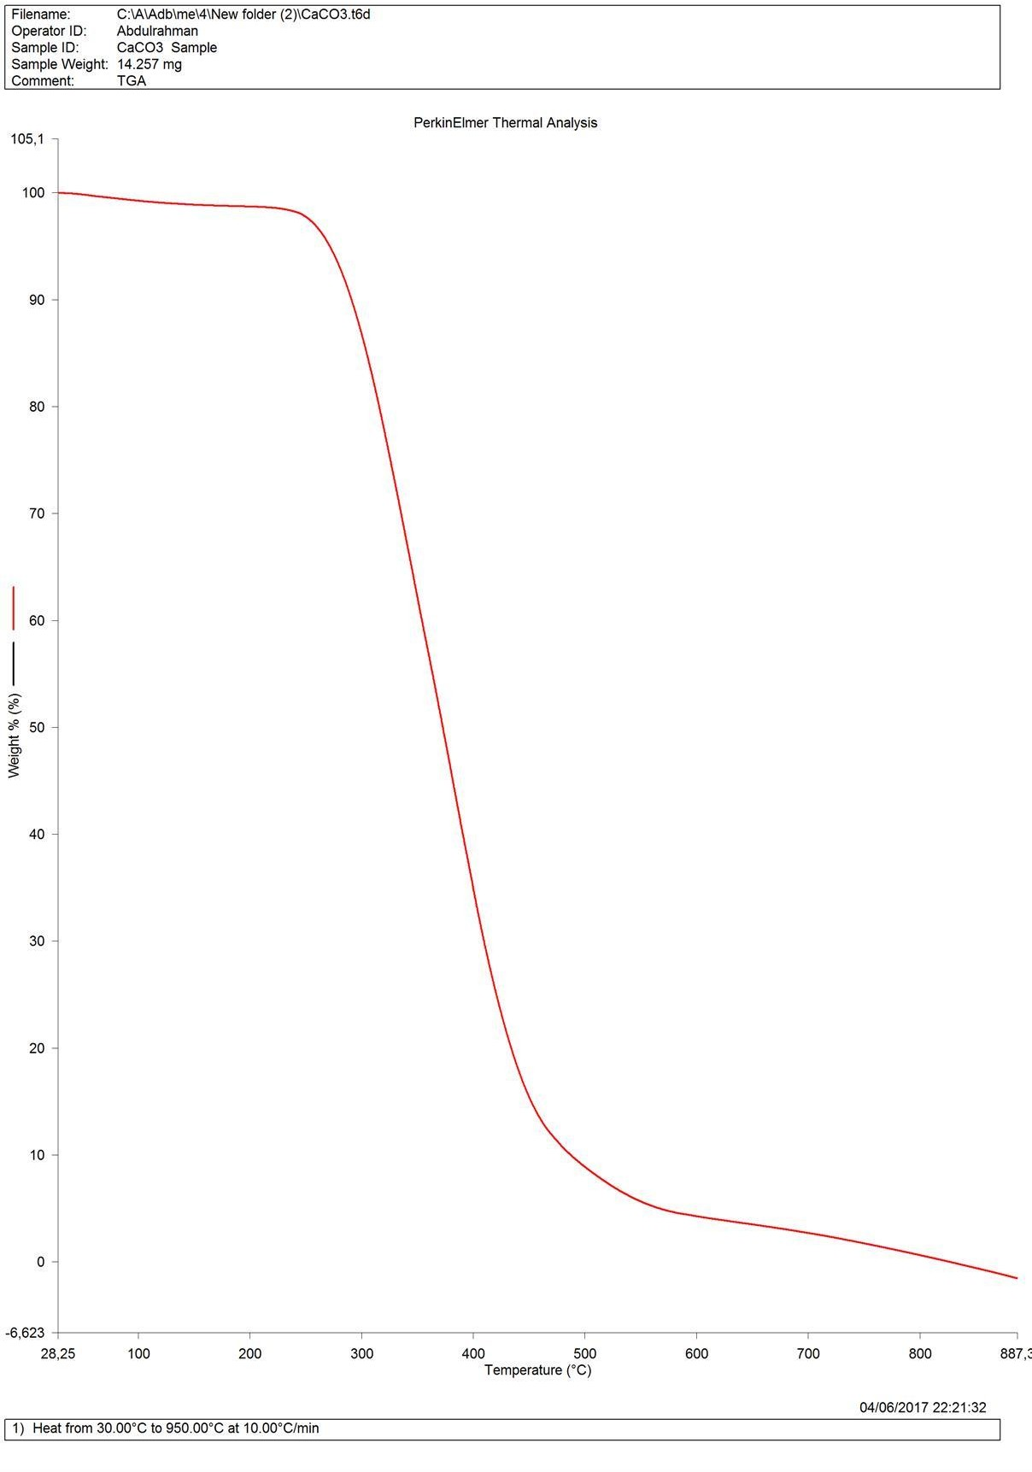

Figure A1: Thermal Gravimetric analysis of CaCO₃.

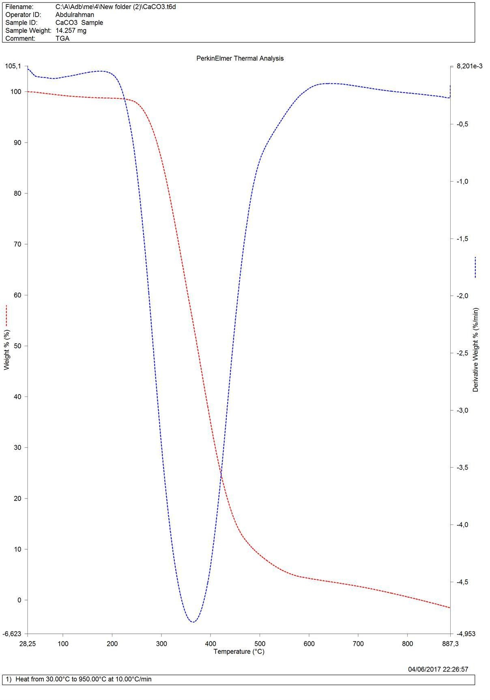

Figure A.2: Differential thermal analysis of CaCO₃.

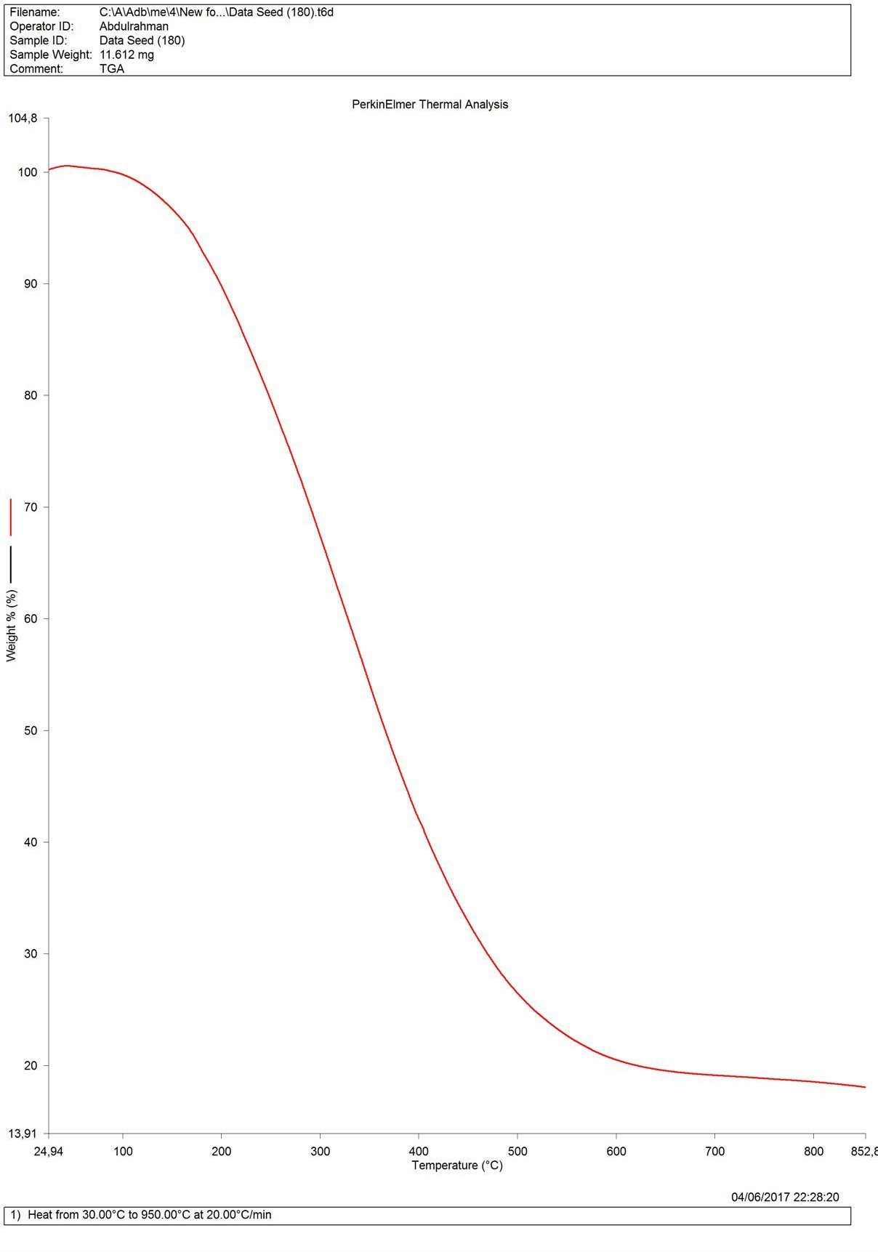

Figure A. 4: Thermal Gravimetric analysis of 180µm composite

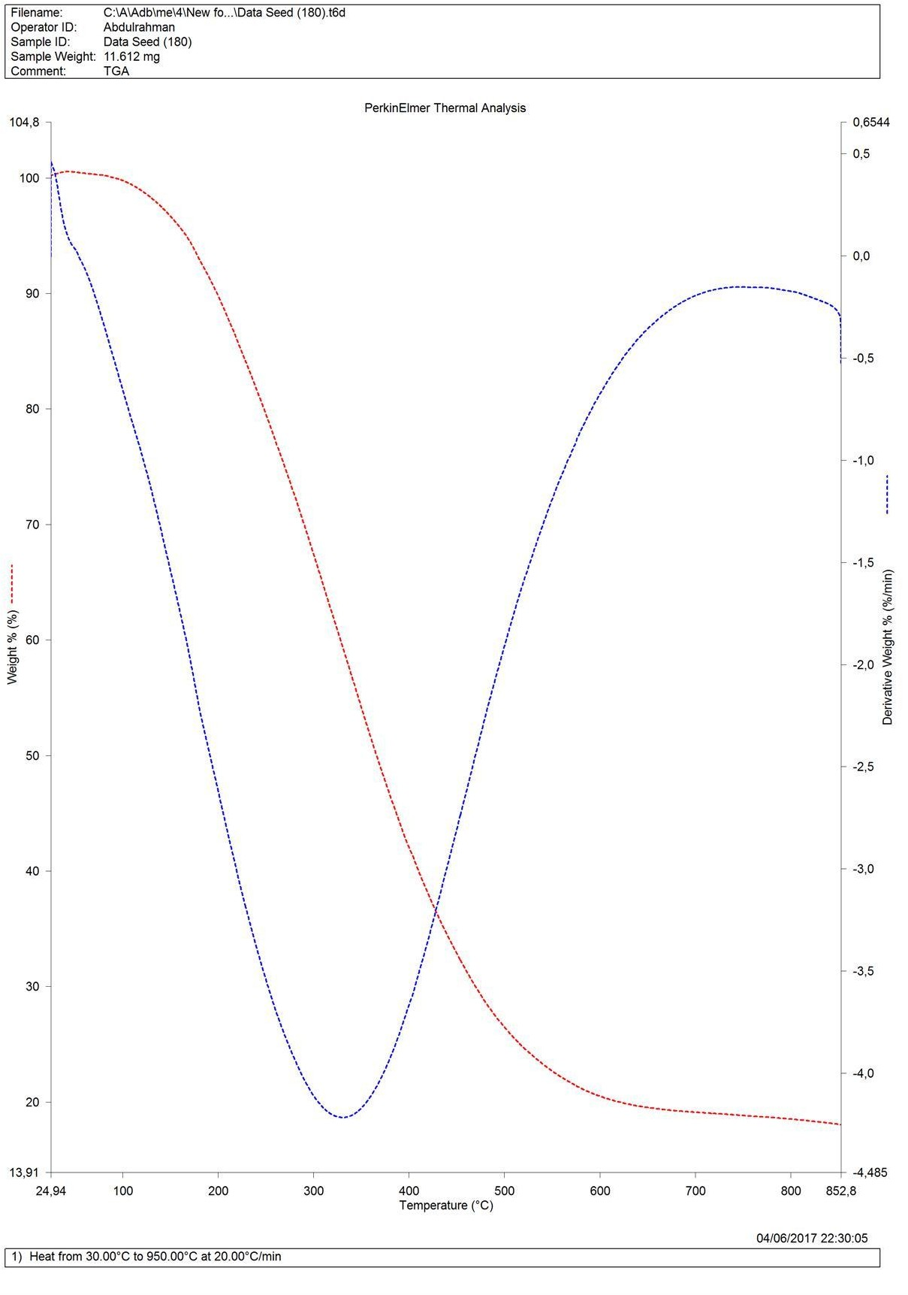

Figure A.5: Differential thermal analysis of 180µm composite

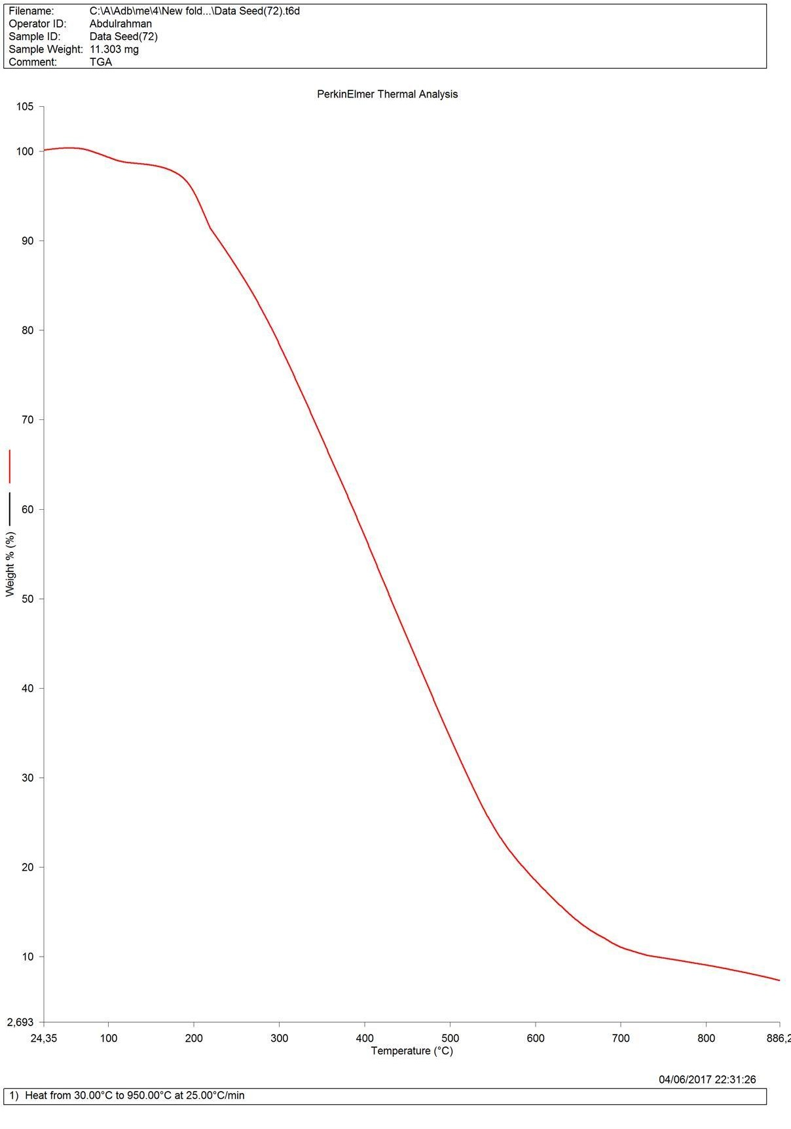

Figure A.6: Thermal Gravimetric Analysis of 72µm composite

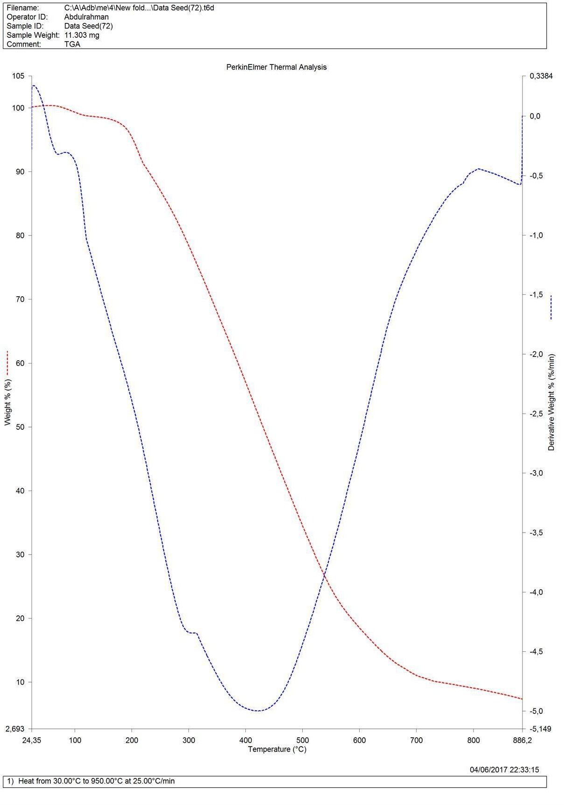

Figure A.7: Differential thermal analysis of 72µm composite.

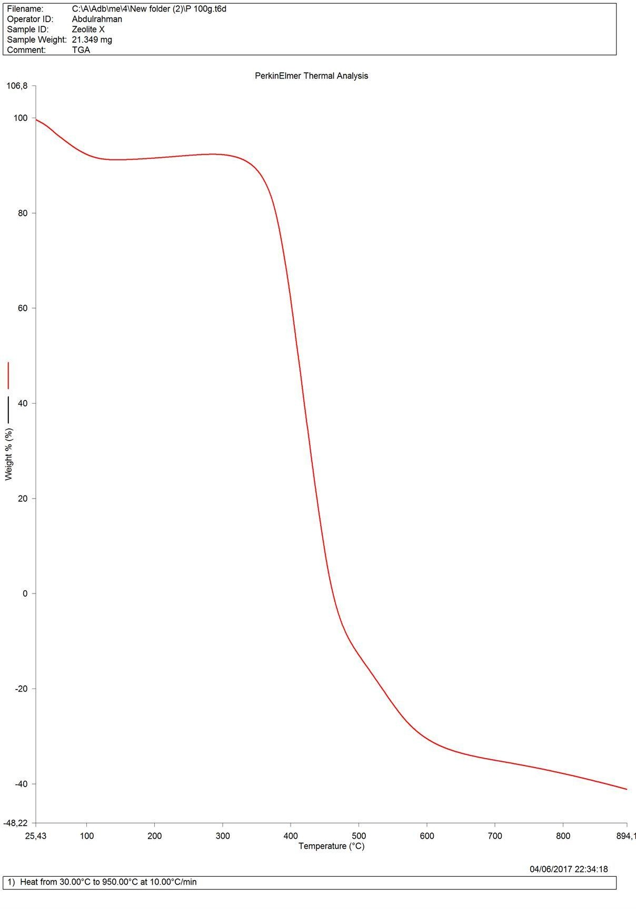

Figure A.8: Thermal Gravimetric Analysis of Pure HDPE

APPENDIX B.

Table B.1: water absorption result 72µm particle size

Particle size

Loading

1st

1st

2nd

2nd

3rd

3rd

Total

Total

Absorption

|  |  |  |  |  |  |  |  |  |  |  |
| --- | --- | --- | --- | --- | --- | --- | --- | --- | --- | --- |
| (µm) In | | | Out | In | Out | In | Out | In(g) | Out | % |
|  | (ppw) | (g) | (g) | (g) | (g) | (g) | (g) |  | (g) |  |
| 72 | 10 | 0.8 | 0.8 | 0.8 | 0.8 | 0.5 | 0.5 | 2.1 | 2.1 | 0 |
|  | 20 | 0.9 | 0.9 | 1.1 | 1.2 | 1.1 | 1.1 | 3.1 | 3.2 | 3.2 |
|  | 30 | 0.9 | 0.9 | 1.1 | 1.1 | 1.0 | 1.0 | 3.0 | 3.0 | 0 |
|  | 40 | 0.8 | 0.8 | 0.9 | 0.9 | 1.1 | 1.1 | 2.8 | 2.8 | 0 |
| AVERAGE |  |  |  |  |  |  |  |  |  | ***0.8*** |

Table B.2: water absorption result for 125µm particle size

Particle size

Loading

1st

1st

2nd

2nd

3rd

3rd

Total

Total

Absorption

|  |  |  |  |  |  |  |  |  |
| --- | --- | --- | --- | --- | --- | --- | --- | --- |
| (µm) In  (ppw)  (g) | Out  (g) | In  (g) | Out  (g) | In  (g) | Out  (g) | In (g) | Out  (g) | % |
| 125 10 0.9 | 0.9 | 1.1 | 1.1 | 1.1 | 1.1 | 3.1 | 3.1 | 0 |
| 20 1.1 | 1.2 | 1.2 | 1.2 | 1.1 | 1.2 | 3.4 | 3.5 | 2.9 |
| 30 0.9 | 0.9 | 1.3 | 1.3 | 0.8 | 0.8 | 3.0 | 3.0 | 0 |
| 40 1.1 | 1.1 | 1.2 | 1.2 | 1.2 | 1.3 | 3.5 | 3.6 | 2.8 |
| AVERAGE |  |  |  |  |  |  |  | ***1.43*** |

Table B.3: water absorption result for 150µm particle size

Particle size

Loading

1st

1st

2nd

2nd

3rd

3rd

Total

Total

Absorption

|  |  |  |  |  |  |  |  |  |  |  |
| --- | --- | --- | --- | --- | --- | --- | --- | --- | --- | --- |
| (µm) | (ppw) | In  (g) | Out  (g) | In  (g) | Out  (g) | In  (g) | Out  (g) | In (g) | Out  (g) | % |
| 150 | 10 | 1.2 | 1.2 | 0.6 | 0.6 | 1.1 | 1.1 | 2.9 | 2.9 | 0 |
|  | 20 | 1.1 | 1.2 | 1.0 | 1.0 | 1.2 | 1.2 | 3.3 | 3.4 | 3.03 |
|  | 30 | 0.8 | 0.8 | 0.8 | 1.0 | 1.1 | 1.2 | 2.7 | 3.0 | 11.1 |
|  | 40 | 1.0 | 1.0 | 1.0 | 1.0 | 1.1 | 1.3 | 3.1 | 3.3 | 6.45 |
| AVERAGE |  |  |  |  |  |  |  |  |  | ***5.15*** |

Table B.4: water absorption result for 180µm particle size

Particle size

Loading

1st

1st

2nd

2nd

3rd

3rd

Total

Total

Absorption

|  |  |  |  |  |  |  |  |  |  |  |
| --- | --- | --- | --- | --- | --- | --- | --- | --- | --- | --- |
| (µm) | (ppw) | In  (g) | Out  (g) | In  (g) | Out  (g) | In  (g) | Out  (g) | In (g) | Out  (g) | % |
| 180 | 10 | 0.9 | 0.9 | 1.1 | 1.1 | 1.0 | 1.1 | 3.0 | 3.1 | 3.3 |
|  | 20 | 0.9 | 1.2 | 1.1 | 1.2 | 1.0 | 1.1 | 3.0 | 3.5 | 16.7 |
|  | 30 | 1.0 | 1.0 | 1.1 | 1.2 | 0.9 | 0.9 | 3.0 | 3.1 | 3.3 |
|  | 40 | 1.0 | 1.2 | 1.1 | 1.3 | 1.0 | 1.0 | 3.1 | 3.5 | 12.9 |
| AVERAGE |  |  |  |  |  |  |  |  |  | ***9.05*** |

Table B.5: water absorption result for calciumcarbonate

MATERIAL Loading

1st In

1st

2nd

2nd

3rd In

3rd

Total

Total

Absorption

|  |  |  |  |  |  |  |  |  |  |  |
| --- | --- | --- | --- | --- | --- | --- | --- | --- | --- | --- |
|  | (ppw) | (g) | Out  (g) | In (g) | Out  (g) | (g) | Out  (g) | In (g) | Out  (g) | % |
| CaCO₃ | 10 | 0.9 | 0.9 | 0.9 | 0.9 | 1.0 | 1.0 | 2.8 | 2.8 | 0 |
|  | 20 | 1.1 | 1.1 | 1.1 | 1.1 | 0.9 | 1.0 | 3.1 | 3.2 | 3.2 |
|  | 30 | 1.1 | 1.1 | 1.2 | 1.2 | 1.0 | 1.1 | 3.3 | 3.4 | 3.0 |
|  | 40 | 1.0 | 1.1 | 1.1 | 1.1 | 1.1 | 1.1 | 3.2 | 3.3 | 3.1 |
| AVERAGE |  |  |  |  |  |  |  |  |  | ***2.3*** |

Percentage increase in weight during immersion = ((wet weight – conditioned weight)/conditioned weight) x 100.

Table B.6: summary of water absorption test result

|  |  |  |
| --- | --- | --- |
| S/NO. | PARTICLE SIZE | AVERAGE % WATER ABSORPTION |
| 1 | 72µm | 0.8 |
| 2 | 125µm | 1.43 |
| 3 | 150µm | 5.15 |
| 4 | 180µm | 9.05 |
| 5 | CaCO₃ | 2.3 |

Table B.7: standard error calculation on flexural analysis of the composite (72µm)

|  |  |  |  |  |  |  |  |  |  |  |
| --- | --- | --- | --- | --- | --- | --- | --- | --- | --- | --- |
| Loading | 1st Run x1 | 2nd Run (x2) | 3rd Run (x3) | Average Ẍ | (X1- Ẍ)^2 | (X2- Ẍ)^2 | (X3- Ẍ)^2 | ∑(x- Ẍ)^2 | SD | SE |
| 0 | 28.65 | 28.65 | 28.65 | 28.65 | 0 | 0 | 0 | 0 | 0 | 0 |
| 10 | 30.25 | 29.76 | 28.97 | 29.66 | 0.348 | 0.010 | 0.4761 | 0.8341 | 0.5273 | 0.3044 |
| 20 | 31.00 | 31,05 | 30.89 | 30.98 | 0.0004 | 0.0049 | 0.0081 | 0.0134 | 0.0668 | 0.0386 |
| 30 | 30.00 | 29.87 | 29.21 | 29.69 | 0.0961 | 0.0324 | 0.2304 | 0.3589 | 0.3459 | 0.1997 |
| 40 | 29.00 | 28.34 | 27.83 | 28.39 | 0.3721 | 0.0025 | 0.3136 | 0.6882 | 0.4790 | 0.2765 |

Table B.8: standard error calculation on flexural analysis of the composite (125µm)

|  |  |  |  |  |  |  |  |  |  |  |
| --- | --- | --- | --- | --- | --- | --- | --- | --- | --- | --- |
| Loading | 1st Run x1 | 2nd Run (x2) | 3rd Run (x3) | Average Ẍ | (X1- Ẍ)^2 | (X2- Ẍ)^2 | (X3- Ẍ)^2 | ∑(x- Ẍ)^2 | SD | SE |
| 0 | 28.65 | 28.65 | 28.65 | 28.65 | 0 | 0 | 0 | 0 | 0 | 0 |
| 10 | 29.75 | 29.03 | 29.05 | 29.28 | 0.2209 | 0.0625 | 0.0529 | 0.3363 | 0.3348 | 0.1933 |
| 20 | 20.00 | 31.22 | 29.98 | 30.40 | 0.1600 | 0.1724 | 0.1764 | 0.5088 | 0.4118 | 0.2378 |
| 30 | 29.50 | 28.87 | 28.79 | 29.05 | 0.2025 | 0.0324 | 0.0676 | 0.3025 | 0.3175 | 0.1833 |
| 40 | 29.35 | 29.78 | 28.03 | 29.05 | 0.0900 | 0.5329 | 1.0404 | 1.6633 | 0.7446 | 0.5658 |

Table B.8: standard error calculation on flexural analysis of the composite (150µm)

|  |  |  |  |  |  |  |  |  |  |  |
| --- | --- | --- | --- | --- | --- | --- | --- | --- | --- | --- |
| Loading | 1stRun x1 | 2ndRun (x2) | 3rdRun (x3) | Average Ẍ | (X1- Ẍ)^2 | (X2- Ẍ)^2 | (X3- Ẍ)^2 | ∑(x- Ẍ)^2 | SD | SE |
| 0 | 28.65 | 28.65 | 28.65 | 28.65 | 0 | 0 | 0 | 0 | 0 | 0 |
| 10 | 29.50 | 29.03 | 29.04 | 29.19 | 0.0961 | 0.0256 | 0.0225 | 0.1442 | 0.2192 | 0.1266 |
| 20 | 29.85 | 30.02 | 29.97 | 29.95 | 0.0100 | 0.0049 | 0.0004 | 0.0153 | 0.0714 | 0.0412 |
| 30 | 29.40 | 29.03 | 28.95 | 29.13 | 0.0729 | 0.0100 | 0.0324 | 0.1153 | 0.1960 | 0.1132 |
| 40 | 29.22 | 28.98 | 29.01 | 29.07 | 0.0225 | 0.0081 | 0.0036 | 0.0342 | 0.1068 | 0.0616 |

Table B.9: standard error calculation on flexural analysis of the composite (180µm)

|  |  |  |  |  |  |  |  |  |  |  |
| --- | --- | --- | --- | --- | --- | --- | --- | --- | --- | --- |
| Loading | 1st Run x1 | 2nd Run (x2) | 3rd Run (x3) | Average Ẍ | (X1- Ẍ)^2 | (X2- Ẍ)^2 | (X3- Ẍ)^2 | ∑(x- Ẍ)^2 | SD | SE |
| 0 | 28.65 | 28.65 | 28.65 | 28.65 | 0 | 0 | 0 | 0 | 0 | 0 |
| 10 | 29.05 | 29.42 | 29.32 | 29.26 | 0.0441 | 0.0256 | 0.0036 | 0.0733 | 0.1563 | 0.0903 |
| 20 | 29.68 | 29.85 | 29.01 | 29.51 | 0.0289 | 0.1156 | 0.2500 | 0.3945 | 0.3626 | 0.2094 |
| 30 | 29.35 | 28.97 | 28.97 | 29.10 | 0.0625 | 0.0169 | 0.0169 | 0.0963 | 0.1792 | 0.1034 |
| 40 | 29.15 | 28.04 | 28.58 | 28.59 | 0.3136 | 0.0361 | 0.0001 | 0.3498 | 0.3415 | 0.1971 |

Table B.10: standard error calculation on flexural analysis of the composite (CaCO₃)

|  |  |  |  |  |  |  |  |  |  |  |
| --- | --- | --- | --- | --- | --- | --- | --- | --- | --- | --- |
| Loading | 1st  Run x1 | 2nd  Run (x2) | 3rd  Run (x3) | Average Ẍ | (X1- Ẍ)^2 | (X2- Ẍ)^2 | (X3- Ẍ)^2 | ∑(x- Ẍ)^2 | SD | SE |
| 0 | 28.65 | 28.65 | 28.65 | 28.65 | 0 | 0 | 0 | 0 | 0 | 0 |
| 10 | 29.5 | 28.98 | 28.86 | 29.11 | 0.1521 | 0.0169 | 0.0625 | 0.2315 | 0.2778 | 0.1604 |
| 20 | 29.00 | 29.35 | 29.24 | 29.20 | 0.040 | 0.0400 | 0.0016 | 0.0816 | 0.1649 | 0.0301 |
| 30 | 28.8 | 29.07 | 28.27 | 28.71 | 0.0081 | 0.1296 | 0.1936 | 0.3313 | 0.3323 | 0.1919 |
| 40 | 28.70 | 29.03 | 28.04 | 28.59 | 0.0121 | 0.1936 | 0.3025 | 0.5082 | 0.4116 | 0.2376 |

Table B.11: standard error calculation on hardness analysis of the composite (72µm)

|  |  |  |  |  |  |  |  |  |  |  |
| --- | --- | --- | --- | --- | --- | --- | --- | --- | --- | --- |
| Loading | 1st  Run x1 | 2nd  Run (x2) | 3rd  Run (x3) | Average Ẍ | (X1- Ẍ)^2 | (X2- Ẍ)^2 | (X3- Ẍ)^2 | ∑(x- Ẍ)^2 | SD | SE |
| 0 | 67.00 | 67.00 | 67.00 | 67.00 | 0 | 0 | 0 | 0 | 0 | 0 |
| 10 | 73.00 | 72.87 | 72.00 | 72.62 | 0.1444 | 0.0625 | 0.3844 | 0.5913 | 0.4440 | 0.2563 |
| 20 | 74.00 | 74.14 | 74.00 | 74.05 | 0.0025 | 0.0081 | 0.0025 | 0.0131 | 0.0660 | 0.0382 |
| 30 | 74.50 | 74.86 | 73.34 | 74.23 | 0.0729 | 0.3969 | 0.7921 | 1.2619 | 0.6486 | 0.3745 |
| 40 | 75.80 | 75.21 | 75.00 | 75.34 | 0.2116 | 0.0169 | 0.1156 | 0.3441 | 0.3387 | 0.1955 |

Table B.12: standard error calculation on hardness analysis of the composite (125µm)

|  |  |  |  |  |  |  |  |  |  |  |
| --- | --- | --- | --- | --- | --- | --- | --- | --- | --- | --- |
| Loading | 1st  Run x1 | 2nd  Run (x2) | 3rd  Run (x3) | Average Ẍ | (X1- Ẍ)^2 | (X2- Ẍ)^2 | (X3- Ẍ)^2 | ∑(x- Ẍ)^2 | SD | SE |
| 0 | 67.00 | 67.00 | 67.00 | 67.00 | 0 | 0 | 0 | 0 | 0 | 0 |
| 10 | 70.00 | 71.00 | 71.00 | 70.67 | 0.4489 | 0.1089 | 0.1089 | 0.6667 | 0.4714 | 0.2722 |
| 20 | 72.60 | 72.96 | 72.87 | 72.81 | 0.0441 | 0.0225 | 0.0036 | 0.0702 | 0.1530 | 0.0883 |
| 30 | 73.00 | 73.68 | 73.48 | 73.39 | 0.1521 | 0.0841 | 0.0081 | 0.2443 | 0.2854 | 0.1648 |
| 40 | 74.20 | 74.87 | 74.00 | 74.36 | 0.0256 | 0.2601 | 0.1296 | 0.4153 | 0.3721 | 0.2148 |

Table B.13: standard error calculation on hardness analysis of the composite (150µm)

|  |  |  |  |  |  |  |  |  |  |  |
| --- | --- | --- | --- | --- | --- | --- | --- | --- | --- | --- |
| Loading | 1st Run x1 | 2nd Run (x2) | 3rd Run (x3) | Average Ẍ | (X1- Ẍ)^2 | (X2- Ẍ)^2 | (X3- Ẍ)^2 | ∑(x- Ẍ)^2 | SD | SE |
| 0 | 67.00 | 67.00 | 67.00 | 67.00 | 0 | 0 | 0 | 0 | 0 | 0 |
| 10 | 68.70 | 67.96 | 68.00 | 68.22 | 0.2304 | 0.0676 | 0.0484 | 0.3464 | 0.3398 | 0.1962 |
| 20 | 70.10 | 70.03 | 69.30 | 69.81 | 0.0841 | 0.0484 | 0.2601 | 0.3926 | 0.3618 | 0.2089 |
| 30 | 70.60 | 71.11 | 70.01 | 70.57 | 0.0009 | 0.2916 | 0.3136 | 0.6061 | 0.4495 | 0.2595 |
| 40 | 71.80 | 72.04 | 72.00 | 71.95 | 0.0225 | 0.0081 | 0.0025 | 0.0331 | 0.1050 | 0.0606 |

Table B.14: standard error calculation on hardness analysis of the composite (180µm)

|  |  |  |  |  |  |  |  |  |  |  |
| --- | --- | --- | --- | --- | --- | --- | --- | --- | --- | --- |
| Loading | 1st  Run x1 | 2nd  Run (x2) | 3rd  Run (x3) | Average Ẍ | (X1- Ẍ)^2 | (X2- Ẍ)^2 | (X3- Ẍ)^2 | ∑(x- Ẍ)^2 | SD | SE |
| 0 | 67.00 | 67.00 | 67.00 | 67.00 | 0 | 0 | 0 | 0 | 0 | 0 |
| 10 | 67.50 | 68.92 | 67.00 | 69.81 | 0.0961 | 1.2321 | 0.6561 | 1.9843 | 0.8133 | 0.4696 |
| 20 | 68.20 | 69.01 | 68.00 | 68.40 | 0.0400 | 0.3721 | 0.1600 | 0.5721 | 0.4367 | 0.2521 |
| 30 | 68.50 | 69.32 | 68.34 | 68.72 | 0.0484 | 0.3600 | 0.1444 | 0.5528 | 0.4293 | 0.2478 |
| 40 | 69.00 | 70.07 | 69.13 | 69.40 | 0.1600 | 0.4489 | 0.0729 | 0.6818 | 0.4767 | 0.2752 |

Table B.15. standard error calculation on hardness analysis of the composite (CaCO₃)

|  |  |  |  |  |  |  |  |  |  |  |
| --- | --- | --- | --- | --- | --- | --- | --- | --- | --- | --- |
| Loading | 1st  Run x1 | 2nd  Run (x2) | 3rd  Run (x3) | Average Ẍ | (X1- Ẍ)^2 | (X2- Ẍ)^2 | (X3- Ẍ)^2 | ∑(x- Ẍ)^2 | SD | SE |
| 0 | 67.00 | 67.00 | 67.00 | 67.00 | 0 | 0 | 0 | 0 | 0 | 0 |
| 10 | 67.15 | 68.76 | 67.00 | 67.64 | 0.2401 | 1.2544 | 0.4096 | 1.9041 | 0.7967 | 0.4600 |
| 20 | 67.30 | 69.05 | 67.00 | 67.98 | 0.4624 | 1.7449 | 0.1444 | 2.3517 | 0.8854 | 0.5111 |
| 30 | 67.80 | 67.35 | 67.00 | 67.98 | 0.1764 | 0.0009 | 0.1444 | 0.3217 | 0.3275 | 0.1891 |
| 40 | 68.00 | 66.86 | 66.67 | 67.51 | 0.2401 | 0.1225 | 0.7056 | 1.0682 | 0.5967 | 0.3445 |

Table B.16: standard error calculation on impact analysis of the composite (72µm)

|  |  |  |  |  |  |  |  |  |  |  |
| --- | --- | --- | --- | --- | --- | --- | --- | --- | --- | --- |
| Loading | 1st Run x1 | 2nd Run  (x2) | 3rd Run (x3) | Average Ẍ | (X1- Ẍ)^2 | (X2- Ẍ)^2 | (X3- Ẍ)^2 | ∑(x- Ẍ)^2 | SD | SE |
| 0 | 0.654 | 0.654 | 0.654 | 0.654 | 0 | 0 | 0 | 0 | 0 | 0 |
| 10 | 1.350 | 1.326 | 1.342 | 1.339 | 0.0001 | 0.0002 | 0.00001 | 0.0003 | 0.0100 | 0.0058 |
| 20 | 1.400 | 1.387 | 1.423 | 1.403 | 0.0000 | 0.0003 | 0.0004 | 0.0007 | 0.0086 | 0.0050 |
| 30 | 1.405 | 1.416 | 1.431 | 1.417 | 0.0014 | 0.0000 | 0.0002 | 0.0016 | 0.0234 | 0.0135 |
| 40 | 1.410 | 1.424 | 1.435 | 1.423 | 0.0002 | 0.0000 | 0.0001 | 0.0003 | 0.0102 | 0.0059 |

Table B.17: standard error calculation on impact analysis of the composite (125µm)

|  |  |  |  |  |  |  |  |  |  |  |
| --- | --- | --- | --- | --- | --- | --- | --- | --- | --- | --- |
| Loading | 1st Run x1 | 2nd Run (x2) | 3rd Run (x3) | Average Ẍ | (X1- Ẍ)^2 | (X2- Ẍ)^2 | (X3- Ẍ)^2 | ∑(x- Ẍ)^2 | SD | SE |
| 0 | 0.654 | 0.654 | 0.654 | 0.654 | 0 | 0 | 0 | 0 | 0 | 0 |
| 10 | 1.280 | 1.273 | 1.261 | 1.271 | 0.0001 | 0.0000 | 0.0001 | 0.00019 | 0.0079 | 0.0045 |
| 20 | 1.350 | 1.354 | 1.322 | 1.342 | 0.0000 | 0.0001 | 0.0004 | 0.0006 | 0.0142 | 0.0082 |
| 30 | 1.360 | 1.371 | 1.351 | 1.360 | 0.0001 | 0.0000 | 0.0002 | 0.0002 | 0.0082 | 0.0047 |
| 40 | 1.380 | 1.393 | 1.365 | 1.380 | 0.0000 | 0.0002 | 0.0002 | 0.0004 | 0.0115 | 0.0066 |

Table B.18: standard error calculation on impact analysis of the composite (150µm)

|  |  |  |  |  |  |  |  |  |  |  |
| --- | --- | --- | --- | --- | --- | --- | --- | --- | --- | --- |
| Loading |  | 2nd Run  (x2) | 3rd Run (x3) | Average Ẍ | (X1- Ẍ)^2 | (X2-Ẍ)^2 | (X3-Ẍ)^2 | ∑(x- Ẍ)^2 | SD | SE |
| 0 | 0.654 | 0.654 | 0.654 | 0.654 | 0 | 0 | 0 | 0 | 0 | 0 |
| 10 | 0.990 | 0.971 | 0.974 | 0.978 | 0.0001 | 0.0000 | 0.0000 | 0.0002 | 0.0084 | 0.0048 |
| 20 | 1.227 | 1.243 | 1.218 | 1.229 | 0.0000 | 0.0002 | 0.0001 | 0.0003 | 0.0103 | 0.0060 |
| 30 | 1.235 | 1.257 | 1.231 | 1.241 | 0.0000 | 0.0003 | 0.0001 | 0.0004 | 0.0114 | 0.0066 |
| 40 | 1.239 | 1.276 | 1.228 | 1.248 | 0.0001 | 0.0008 | 0.0004 | 0.0013 | 0.0205 | 0.0119 |

Table B.19: standard error calculation on impact analysis of the composite (180µm)

|  |  |  |  |  |  |  |  |  |  |  |
| --- | --- | --- | --- | --- | --- | --- | --- | --- | --- | --- |
| Loading |  | 2nd Run  (x2) | 3rd Run (x3) | Average Ẍ | (X1- Ẍ)^2 | (X2-Ẍ)^2 | (X3-Ẍ)^2 | ∑(x- Ẍ)^2 | SD | SE |
| 0 | 0.654 | 0.654 | 0.654 | 0.654 | 0 | 0 | 0 | 0 | 0 | 0 |
| 10 | 0.856 | 0.842 | 0.842 | 0.847 | 0.0001 | 0.0000 | 0.0000 | 0.0001 | 0.0066 | 0.0038 |
| 20 | 0.980 | 0.923 | 0.946 | 0.950 | 0.0009 | 0.0007 | 0.0000 | 0.0017 | 0.0234 | 0.0135 |
| 30 | 0.992 | 0.971 | 0.967 | 0.977 | 0.0002 | 0.0000 | 0.0001 | 0.0004 | 0.0110 | 0.0063 |
| 40 | 0.998 | 0.986 | 0.974 | 0.986 | 0.0001 | 0.0000 | 0.0001 | 0.0003 | 0.0098 | 0.0057 |

Table B.20: standard error calculation on impact analysis of the composite (CaCO₃)

|  |  |  |  |  |  |  |  |  |  |  |
| --- | --- | --- | --- | --- | --- | --- | --- | --- | --- | --- |
| Loading | 1st Run (x1) | 2nd  Run (x2) | 3rd Run (x3) | Average Ẍ | (X1- Ẍ)^2 | (X2-Ẍ)^2 | (X3-Ẍ)^2 | ∑(x- Ẍ)^2 | SD | SE |
| 0 | 0.654 | 0.654 | 0.654 | 0.654 | 0 | 0 | 0 | 0 | 0 | 0 |
| 10 | 1.400 | 1.389 | 1.389 | 1.396 | 0.0000 | 0.0001 | 0.0001 | 0.0001 | 0.0062 | 0.0036 |
| 20 | 1.535 | 1.523 | 1.531 | 1.530 | 0.0000 | 0.000 1 | 0.0000 | 0.0001 | 0.0050 | 0.0029 |
| 30 | 1.600 | 1.597 | 1.594 | 1.597 | 0.0000 | 0.0000 | 0.0000 | 0.0000 | 0.0024 | 0.0014 |
| 40 | 1.618 | 1.609 | 1.612 | 1.613 | 0.0000 | 0.0000 | 0.0000 | 0.0000 | 0.0037 | 0.0022 |