# EFFECT OF CHRONOMODULATED ARTESUNATE ON RENAL AND HAEMATOLOGICAL TOXICITY IN CISPLATIN-TREATED

**WISTAR RATS**

# By

**Abdulrasheed USMAN, B.Sc Human Physiology (A.B.U) 2009 MSc/Pharm-Sci/44773/12-13**

# A DISSERTATION SUBMITTED TO THE SCHOOL OF POSTGRADUATE STUDIES, AHMADU BELLO UNIVERSITY ZARIA,

**IN PARTIAL FULFILMENT OF THE REQUIREMENTS FOR THE AWARD OF A MASTER DEGREE IN PHARMACOLOGY**

# DEPARTMENT OF PHARMACOLOGY AND THERAPEUTICS, FACULTY OF PHARMACEUTICAL SCIENCES

**AHMADU BELLO UNIVERSITY, ZARIA NIGERIA**

# NOVEMBER, 2017

# DECLARATION

I declare that the work in this dissertation titled **“**EFFECT OF CHRONOMODULATED ARTESUNATE ON RENAL AND HAEMATOLOGICAL TOXICITY IN CISPLATIN-

TREATED WISTAR RATS‖ has been carried out by me in the Department of Pharmacology and Therapeutics, under the joint supervision of Prof. T.O. Olurishe and Dr. Y. Musa. The information derived from the literature has been duly acknowledged in the text and a list of references provided. No part of this dissertation has been previously presented for another Degree or Diploma at this or another University.

# USMAN, ABDULRASHEED

Name of student Signature Date

# CERTIFICATION

This dissertation entitled ―EFFECT OF CHRONOMODULATED ARTESUNATE ON RENAL AND HAEMATOLOGICAL TOXICITY IN CISPLATIN-TREATED WISTAR

RATS‖ by Abdulrasheed USMAN meets the regulations governing the award of the degree of Master of Science (Pharmacology) of the Ahmadu Bello University, and is approved for its contribution to knowledge and literary presentation.

Prof. T.O. Olurishe

Chairman, Supervisory Signature Date

Committee

Dr. Y. Musa

Member, Supervisory Signature Date

Committee

Dr. M.G. Magaji

Head of Department Signature Date

Prof. S.Z. Abubakar

Dean, School of Signature Date

Postgraduate Studies

# ACKNOWLEDGEMENT

All praises are due to Allah, the Beneficent and the Merciful for making this dissertation a reality. My sincere appreciation goes to my supervisory team; Prof. T.O. Olurishe and Dr. Y. Musa for their support, encouragement, sacrifices, mentorship and constructive criticisms during the course of this research work.

My profound gratitude goes to Prof. T.O. Olurishe for his brilliant editorial skills and conventional swift correction of my documents; you are indeed a remarkable and uncommon researcher in today‘s Nigerian university.

Finally, I am greatly indebted to my parents, siblings and friends including Michael Ikechukwu ORAEBOSI (Mazi). I am also indebted to Mr and Mrs Lawal Saeed and the entire team of Ranbaxy Kano for their love, support, prayers, encouragement and perseverance during the course of this pursuit.

# DEDICATION

This work is dedicated to my family, colleagues and friends

# ABSTRACT

Cisplatin is a non-cell-cycle dependent chemotherapeutic agent used in the treatment of several common solid tumours. However, an array of serious toxicities in various organs and systems limit its therapeutic use. Artesunate, a semisynthetic derivative of artemisinin is the recommended treatment by the WHO for severe and complicated malaria in low-transmission areas and in the second and third trimesters of pregnancy. In contrast, animal experiments show considerable toxicity upon administration of artemisinins. When malaria and cancer co- exist, treatment of patients could be challenging due to the burden of disease and possible drug-drug interaction. The present study investigates the effect of 7-day chronomodulated artesunate administration on renal and haematological toxicity in cisplatin-treated rats. Four groups (n=7/group) of rats received intraperitoneal (i.p.) injection of 3 mg/kg daily dosing of cisplatin at four equispaced circadian times (00:00, 06:00, 12:00 and 18:00 h), for four days to determine the time of least renal and hematological toxicity. Another, two groups of rats (n=7/group) pre-treated with cisplatin (3 mg/kg i.p.) at 06:00 h received artesunate (60 mg/kg i.p.) at 12:00 h and 18:00 h. Parameters of the kidney function, histology of the kidneys and haematological variables were measured on day-8. Post-treatment results showed that administration of cisplatin at 06:00 h and 18:00 h appeared to produce least renal and haematological toxicity. However, kidney function as determined by urea and creatinine levels were not significantly (p>0.05) different between cisplatin-artesunate treated groups and saline control rats.. The group pre-treated with cisplatin and then artesunate at 12:00 h had higher (p<0.05) mean magnesium levels when compared to the saline control and the group pre-treated with cisplatin and then artesunate at 18:00 h. This is indicative of a less protective effect of time of artesunate administration, which is consistent with the impaired kidney histologic architecture observed. The red blood cell (RBC) and haemoglobin (HGB)

counts were unaffected in cisplatin-artesunate treatment groups irrespective of the time of artesunate administration. However, cisplatin-treated rats that received artesunate at 12:00 h had slightly higher RBC and HGB values indicative of enhanced erythropoiesis. A reduction (p<0.05) in mean serum levels of white blood cell (WBC), platelets (PLT) and lymphocytes (LYM) was observed in both groups of rats pretreated with cisplatin and then artesunate at 12:00 h or 18:00 h. Conversely, neutrophils and monocytes (granulocytes) in these groups had higher (p<0.05) mean values indicative of time dependent immune reconstitution. The ameliorative effect of late activity span cisplatin-treatment on renal and haematological toxicity in wistar rats does not appear to be negated by 7-day chronomodulated daily administration of artesunate. However, this study illustrated the potential therapeutic value of time dependent administration of artesunate in contributing to the ameliorative effect of late activity span cisplatin dosing.

# TABLE OF CONTENTS

TITLE PAGE i

DECLARATION i

CERTIFICATION ii

ACKNOWLEDGEMENT iii

DEDICATION iv

ABSTRACT v

TABLE OF CONTENTS vii

LIST OF TABLES xi

LIST OF FIGURES xii

LIST OF PLATES xiii

ABBREVIATIONS AND SYMBOLS xiv

CHAPTER ONE 1

* 1. INTRODUCTION 1
  2. BACKGROUND 1
  3. STATEMENT OF RESEARCH PROBLEM 2
  4. JUSTIFICATION 4
  5. AIM AND OBJECTIVES 5
     1. Aim 5
     2. Specific Objectives 5
  6. HYPOTHESIS 5

CHAPTER TWO 6

* 1. LITERATURE REVIEW 6
  2. BIOLOGICAL RHYTHM 6
     1. Environmental cycles and Biological Rhythm 6
     2. Classification of Biological Rhythms 7
     3. Circadian timing system (CTS) and its Biological Clocks 9
     4. Circadian Rhythm in Occurrence and Severity of Disease 11
     5. Chronopharmacology 12
  3. CANCER CHEMOTHERAPY 15
     1. Introduction 15
     2. Pathogenesis of cancer 15
     3. Treatment options in cancer 16
     4. Cisplatin Chemotherapy 17
     5. Antimalarial therapy 25
     6. Antitumor action of artemisinin 27
  4. COMBINATORIAL THERAPY 29
     1. Introduction 29
     2. Cisplatin/Artesunate Combination Therapy and its possible Interaction 30

CHAPTER THREE 32

* 1. MATERIALS AND METHODS 32
  2. Animals and Housing 32
  3. Drugs and Chemicals 32
  4. Equipment and Apparatuses 33
  5. Experimental Design and Procedures 33
     1. Drug Preparation and Administration 33
  6. Assessment of Nephropathy 39
     1. Biochemical Analysis 39
  7. Statistical Analysis and Presentation of Result 41

CHAPTER FOUR 42

* 1. RESULTS 42
  2. Effect of Different Doses of Cisplatin on Survival and some Renal Biomarkers in Wistar Rats 42
  3. Effect of Time of Daily Cisplatin Administration on Toxicological Biomarkers in Wistar Rats 45
     1. Time-dependent Effect of Daily Cisplatin Administration on some Serum Renal Biomarkers in Wistar rats 45
     2. Time Dependent Effect of Daily Cisplatin Administration on some Haematological Parameters 49
  4. Time-dependent Effect of Daily Cisplatin Administration on Kidney Histology of Wistar Rats 51
  5. Effect of Chronomodulated Artesunate Administration on some Toxicological Markers in Cisplatin-treated Wistar Rats 57
     1. Effect of Chronomodulated Artesunate Administration on Serum Renal Biomarkers in Cisplatin-treated Wistar Rats 57
     2. Effect of Chronomodulated Artesunate Administration on some Haematological Parameters in Cisplatin-treated Wistar Rats 61
  6. Effect of Chronomodulated Artesunate on the Kidney Histology in Cisplatin-treated Groups that received Artesunate at Either 12:00 h or 18:00 h in Wistar Rats 63

CHAPTER FIVE 66

5.0 DISCUSSION 66

CHAPTER SIX 73

* 1. SUMMARY, CONCLUSION AND RECOMMENDATIONS 73
  2. Summary 73
  3. Conclusion 73
  4. Recommendation 74
  5. Suggestions for Further Studies 74

REFERENCES 75

# LIST OF TABLES

Table 2.1: Spectrum of biological rhythms 8

Table 3.1: Dosage determination using intraperitoneal route of administration at 10:00 h in Wistar rats… 34

Table 3.2: Cisplatin chronotoxicity study in Wistar rats 35

Table 3.3: Study on effect chronomodulated artesunate administration on toxicity of 06:00 h cisplatin treated Wistar rats 38

Table 4.1: Effect of different doses of cisplatin on some renal biomarkers in Wistar rats 44

Table 4.2: Effect of time of administration of cisplatin on some haematological parameters following four days treatment in Wistar rats 50

Table 4.3: Effect of chronomodulated artesunate administration on some haematological parameters in cisplatin-treated Wistar rats 62

# LIST OF FIGURES

Figure 2.1: The mammalian circadian timing system 10

Figure 4.1: Effect of Different Doses of Cisplatin on Survival 43

Figure 4.2: Effect of Time of Daily Cisplatin Administration on mean (±SEM) Serum Creatinine Concentration in Wistar Rats 46

Figure 4.3: Effect of daily cisplatin administration on serum urea Concentration in Wistar Rats 47

Figure 4.4: Effect of Time of Daily Cisplatin Administration on Mean (±SEM) Serum Concentration of Magnesium in Wistar Rats 48

Figure 4.5: Effect of Chronomodulated Artesunate Administration on Mean Serum Creatinine Concentration in Cisplatin-treated Wistar Rats 58

Figure 4.6: Effect of Chronomodulated Artesunate Administration on Mean Serum Urea Concentration in Cisplatin-treated Wistar Rats 59

Figure 4.7: Effect of Chronomodulated Artesunate Administration on Mean Serum Magnesium Concentration in Cisplatin-treated Wistar Rats 60

# LIST OF PLATES

Plate I: Photomicrograph of a kidney section of control Wistar rat 52

Plate II: Photomicrograph of kidney section of a Wistar rat treated with cisplatin at 00:00 h 53

Plate III: Photomicrograph of a kidney section of a Wistar rat treated with cisplatin at 06:00 h 54

Plate IV: Photomicrograph of a kidney section of a Wistar rat treated with cisplatin at 12:00 h 55

Plate V: Photomicrograph of a kidney section of a Wistar rat treated with cisplatin at 18:00 h 56

Plate VI: Photomicrograph of a kidney section of cisplatin-treated Wistar rats that received artesunate at 12:00 h 64

Plate VII: Photomicrograph of a kidney section of cisplatin-treated rats that received artesunate at 18:00 h 65

# ABBREVIATIONS AND SYMBOLS

%: Percentage

AKI: Acute kidney injury

ART: Artesunate

bmai1: brain-muscle arnt-like protein 1 Ca2+: Calcium ion

CDDP: cis-diamminedichloroplatinum CDK: Cyclin dependent kinase

CIPN: Chemotherapy-induced peripheral neuropathy CNS: Central nervous system

CTS: Circadian timing system

CYP: Cytochrome

DDI: Drug-drug interaction

DHA: Dihydroartemisinin

DNA: Deoxyribonucleic acid

e.g. Example

EDTA: Ethylenediamine tetraacetic acid EEG: Electroencephalogram

FeII: Ferrous ion

GRA: Granulocyte

HALO: Hours after light on set HCT: Haematocrit

HGB: Haemoglobin

IC50: Fifty percent inhibitory concentration LYM: Lymphocyte

NCI: National cancer institute

NIH: National institute of health

PACAP: Pituitary-adenylate-cyclase activating peptide PUMA: p53 up-regulated modulator of apoptosis RBC: Red blood cell

ROS: Reactive oxygen specie

SCN: Superchiasmatic nucleus

SERCA: Sarco-endoplasmic reticulum Ca2+-ATPase TALH: Thick loop of Henle

WBC: White blood cell

WHO: World Health Organization h: Hour

NOAEL: non-observable-adverse-effect level

# CHAPTER ONE

# INTRODUCTION

# BACKGROUND

Cisplatin with the chemical name*, cis*-diamminedichloroplatinum (CDDP), a platinum based chemotherapeutic compound is one of the most active drugs against a large spectrum of common solid tumours (Asna *et al.*, 2004) including testicular germ cell cancers, with 90% reported cure rate (Raghavan, 2003). However, in addition to being efficacious is a dose related array of serious toxicities including, gastro-intestinal, neurotoxicity, renal toxicity and myelosuppression (Burton *et al*., 2007; Windebank and Grisold, 2008; Gutiérrez-Gutiérrez *et al.*, 2010). It‘s renal and blood toxicities are however some of the major side-effects that have limited its use in clinical practice (Gulec *et al*., 2013). The pathophysiologic mechanisms of these toxicities include oxidative damage, inflammation and apoptotic cell death (Gill and Windebank, 1998; Englander, 2013). Therefore, effective strategies to reduce the severity of damage following chemotherapy are intensively being investigated. However, changing the timing of administration along the 24-hour time scale has profoundly modified the extent of dose-limiting toxicities of anticancer agents both in rodents and in humans (Levi, 2001; Levi *et al.*, 2010). Circadian administration of several cancer chemotherapy regimens to improve their safety as well as their antitumour activity in patients has been validated (Hrushesky *et al.*,, 1982; Levi *et al.*, 2010). Cisplatin as well as its analogs have been studied in the context of their circadian pharmacodynamics (chronopharmacodynamics), tolerability (chronotolerability) and toxicity (chronotoxicity) (Levi *et al.*, 2010). The results of the above studied showed that with proper timing of their administration, cisplatin as well as other drugs with narrow efficacy-toxicity dosage ratio index could have their toxicities significantly reduced on healthy tissues, and maximize their attack on tumour cells.

Artesunate, a semisynthetic derivative of artemisinin, is an endoperoxide compound extracted from the Chinese herb *qinghaosu* (*Artemisia annua* L., annual wormwood or sweet wormwood), (Wood and Hrushesky, 1996), It is widely used as an antimalarial and has replaced chloroquine and quinine for the treatment of *Plasmodium falciparum* (*P. falciparum*) parasite which causes malaria in endemic regions. This strain of malaria parasite is responsible for nearly all the mortalities in some 1 million people each year (WHO, 2012). Furthermore, antitumor activity of artemisinin has also been documented in animal models (Zhang *et al.*, 2008) and individual clinical cases (Breman *et al.*, 2004: Singh and Lai, 2004; Berger *et al.*, 2005). In addition, artesunate used in cancer therapy has demonstrated good tolerability and lack of significant side effects (Lai and Singh, 1995).

It has been reported that reactive oxygen species (ROS) as well as inflammatory response play an important role in cisplatin triggered kidney toxicity (Masuda *et al.*, 1994) and subsequently renal failure (Jaggi and Singh, 2012; Kamisli *et al.*, 2015) resulting in oxidant- antioxidant imbalance (Jin-Gang and Lindup, 1993; Khynriam and Prasad, 2002). The antimalarial and anticancer effects of artesunate are largely attributed to the release of highly alkylating carbon-centered radicals and generation of ROS (Du *et al*., 2010; Mercer *et al.*, 2011). However, this drug is distributed into other organs making such organs possible target of toxicity. When malaria and cancer co-exist, treatment of co-morbid patients could be challenging due to the burden of disease and possible drug interaction of the pharmacological agents involved in their management.

# STATEMENT OF RESEARCH PROBLEM

Common toxicities of cisplatin are blood related toxicities which typically manifests predominantly as transient leukopenia and thrombocytopenia (Han and Smith, 2013), and an

irreversible renal damage (Hrushesky *et al*., 1982; Yao *et al*., 2007). This has resulted not only to increasing the burden of disease, but also limiting dosage, thus, leading to suboptimal pharmacotherapy (Windebank and Grisold, 2008; Podratz *et al.*, 2011), resulting to inevitable discontinuation of therapy (Podratz *et al.*, 2011). Cisplatin in the kidneys has been demonstrated to accumulate in proximal tubular cells, its primary site of nephrotoxicity, which in turn results in secondary tubular degeneration (Cavaletti *et al.*, 1992; Mc Donald *et al.*, 2005). Conversely, Ho *et al.* (2013) and Akman *et al*. (2014) have shown involvement of renal haemodynamics and vascular injury in the pathogenesis of cisplatin-induced acute kidney injury (AKI). Thus, it is arguable that its underlying pathomechanisms are still poorly understood and treatment options are limited (Huehnchen *et al.,* 2013), suggesting further research.

Artemisinin and its derivatives produce toxic effects on erythropoiesis as measured by the number of counts of reticulocytes in both animal experiments and human studies. (Genovese *et al*., 2000; Gordi and Lepist, 2004; Nontprasert *et al*., 2008). Again, artesunate undergoes bioactivation in the liver to artenimol, the active antimalarial agent, which results in the generation of reactive oxygen species (ROS) or free radicals (Li *et al*., 2005). This toxic specie could explain the alteration seen in enzyme activity and tissues of the kidneys (Rajput, 2013). More so, results obtained have shown artesunate to clearly alter the functional capacities of the kidneys (Campos *et al.*, 2001; cheng *et al.*, 2011; Rajput, 2013).

Adding to the complexity of managing co-morbid patients are drug-drug interactions (DDIs) between agents used for the management of malaria and cancer (Extermann *et al.*, 1998). Thus, the co-administration of cisplatin and artesunate especially in malaria endemic regions

such as sub-Saharan Africa is rational, hence the need to study their toxicological interaction and try to proffer solution to their tolerability as it relate to time of their administration.

# JUSTIFICATION

Animal studies and human trials have been carried out on toxicological aspects of a number of chemotherapeutic drugs. However, majority do not consider the rhythmicity of the biological system (chronopharmacokinectics) and the synchrony with chemotherapeutic agents (chronopharmacodynamics). The results of such single time-of-day studies are representative of only one circadian phase. Thus, the tradition of drug administration at evenly spaced time intervals throughout the day, in an attempt to maintain constant drug levels within a time period of 24 hr, may be changing as on-going researches are aimed at coordinated administration with day-night patterns and biological rhythms.

Malaria is the world's most prevalent of human parasitic infections and is endemic in sub- Saharan Africa. Co morbid conditions are however, common with neoplastic diseases and could have implications in their treatment and care, including the timing and choice of drugs. Cisplatin, a common antineoplatic drug, with narrow therapeutic index poses a greater potential for causing harmful side effects in high-risk individuals. Thus, understanding its toxicological interaction with antimalarial drug such as artesunate is essential for its safe and effective use. Furthermore, chronomodulation of these two pharmacological agents along a 24 hours‘ time scale could reduce the possible cumulative drug-induced toxicity and improve their tolerability when co-administered.

# AIM AND OBJECTIVES

# Aim

To investigate the effect of time of artesunate administration on the ameliorative benefits of chronomodulated cisplatin administration on some toxicological effects of cisplatin in wistar rats.

# Specific Objectives

* + - 1. To investigate the ameliorative effect of time of cisplatin administration on renal and haematological toxicity in Wistar rats
      2. To investigate the effect of time of artesunate administration on the ameliorative effect of chronomodulated cisplatin on renal toxicity
      3. To investigate the influence of time of artesunate administration on the ameliorative effect of chronomodulated cisplatin on haematological toxicities.

# HYPOTHESIS

Chronomodultated artesunate does not negate the ameliorative effect of timed cisplatin administration on renal and haematological toxicity in Wistar rats.

# CHAPTER TWO

# LITERATURE REVIEW

# BIOLOGICAL RHYTHM

# Environmental cycles and Biological Rhythm

Evolutionarily, the environment has imposed recurrent cycles on the basic biology of living organisms. Their adaptability to the influence of these cyclic patterns has thus become a *sine qua non* of life, making it apparent for all organisms to incorporate and retain in their genetic make-up for survival (Halberg, 1990; Wolverton, 2003). However, these environmental cycles; light and dark, the yearly changes in day length; the rhythms of the tides synchronize but do not drive these intrinsic biological rhythms (Ekstrom and Ingelman-Sundberg, 1989).

All organisms studied from a single cell to the more complex humans, have evolved complex biological timing mechanisms with which biochemical processes occur in their optimal temporal niche (Czeisler *et al.*, 1999). Biological rhythm that has been characterized includes but not limited to; heart beat which reveals patient‘s health state (Roenneberg and Merrow, 2002) and the electroencephalogram (EEG) which depicts graphically the brain oscillation (Guengerich *et al*., 1991). Also, the heart pulses rhythmically at about 70 beats per minute (Germaine *et al*., 2005; Singh *et al.*, 2008) resulting in body temperature and blood pressure to both rise and fall within a 24-hour period (Germaine *et al*., 2005). More so, hormone levels fluctuate monthly and seasonally (Lee *et al.,* 1988). In addition, the cells on the skin have been shown to undergo division, which peaks at night and drops markedly by the day (Bjarnason *et al.,* 2001). Although these rhythms are endogenous i.e. in-built and self- sustained, they are reset or entrained to external environment cues called zeitgebers (meaning *time giver*); the most important of which is light/dark cycle (Ekstrom and Ingelman- Sundberg, 1989). These biological interacting time frames gave birth to the field of science

known as ―Chronobiology‖. The term first described by University of Minnesota Medical School Professor, Franz Halberg in the 1960s to mean, cyclical view of time within a 24 hours period (Wolverton, 2003). Chronobiology weaves together different strands of inquiry from biology to psychology and genetics to define and quantify biological effects seen in living organisms, it also forms the basis to which scientific and biochemical questions should be asked (Halberg *et al.*, 1990). Thus, chronobiology could be defined as the field of biology that examines biological temporal rhythms, such as daily, [tidal,](http://en.wikipedia.org/wiki/Tidal) weekly, seasonal and annual rhythms and the adaptations of different living organisms (Roenneberg and Merrow, 2002).

# Classification of Biological Rhythms

Human and many other primates are active during the day periods (*diurnal*), while most mammals including rodents are active during the dark periods (*nocturnal*); and relatively inactive during the day (Pittendrigh and Daan, 1976; Banjanin and Mrosovsky, 2000). This alteration has given rise to various classifications such as physical classification as shown below (Table 2.1), which is based on the length of the periods of oscillation; also included are, the functional classification that is based on functional concept that recognizes four varieties of biological rhythms i.e. *alpha, beta, gamma* and *delta* (Cugini, 1993; Redman, 1997; Gothaskar, 2004). However, in variety and heterogenicity, biological rhythms are almost endless, while the length of time has become their unifying factor (Cugini, 1993).

Circadian rhythm is by far the most studied as almost all physiologic processes including, hormonal level, blood temperature and drug sensitivity changes that follow a course of about a day (Chhabra *et al.*, 2012). A circadian (from the Greek word [*circa*,](http://en.wikipedia.org/wiki/Circa) meaning "around" or

―approximately‖ and *Diem* or *dies*, meaning ―day‖) rhythm is any biological process that displays an endogenous, entrainable oscillation of about 24 hours (Hastings *et al*., 2003).

These oscillations have been widely observed in plants, animals, fungi and cyanobacteria, thus making the study of circadian rhythm in the context of biological processes to be known as chronobiology (Czeisler *et al.*, 1999).

# Table 2.1: Spectrum of biological rhythms

|  |  |
| --- | --- |
| Major rhythmic components | Period (τ) |
| 1. Ultradian 2. Circadian    1. Dian 3.Infradian a.Circaseptan    2. Circadiseptan    3. Circavigintan    4. Circatrigintan    5. Circannual | < 20 h  24±4 h  24±0.2 h  >28 h  7±3 d  14±3 d  21±3 d  30±5 d  1y±2 m |

h= hours; d= days; m= month; y= year, (Gothaskar, 2004)

# Circadian timing system (CTS) and its Biological Clocks

Organisms for the most part of life have had to adapt to environmental cycles such as the light and dark with which they restrict many of their biological activities to specific times of day and night which has led to the evolution of an endogenous, self-sustained biological clock central to their adaptation. These biological clocks are groupings of interacting molecules found in cells throughout the body. Human biological clocks are coordinated by the suprachiasmatic nucleus (SCN), a paired nucleus located at the base of the hypothalamus and just above the optic nerve (Levi, 2001). Light provided by the day is the major factor that resets the activity of the SCN. When light reaches the retina, impulses are generated and conducted via the retino-hypothalamic tract using glutamate and pituitary-adenylate-cyclase- activating peptide (PACAP) as neuromediators and other brain areas via neuropeptide Y fibers (Hastings *et al.*, 2003); that in turn regulate endogenous oscillators present in peripheral tissues such as the heart (Storch *et al.*, 2002), the liver (Panda *et al.*, 2002, Delaunay *et al.*, 2000), and the kidney (Kita *et al.*, 2002), as well as in embryos (Delaunay *et al.*, 2000) and isolated cells (Balsalobre *et al*., 1998; Yamazak *et al.,* 2000). Several clock genes that contribute to the entrainment and maintenance of rhythm have been identified; they include *clock* gene, a gene encoding brain-muscle arnt-like protein 1 (*bmal1*), three period genes (*per1, per2,* and *per3*), and two cryptochrome genes (*cry1* and *cry2*) (King *et al.*, 2000).

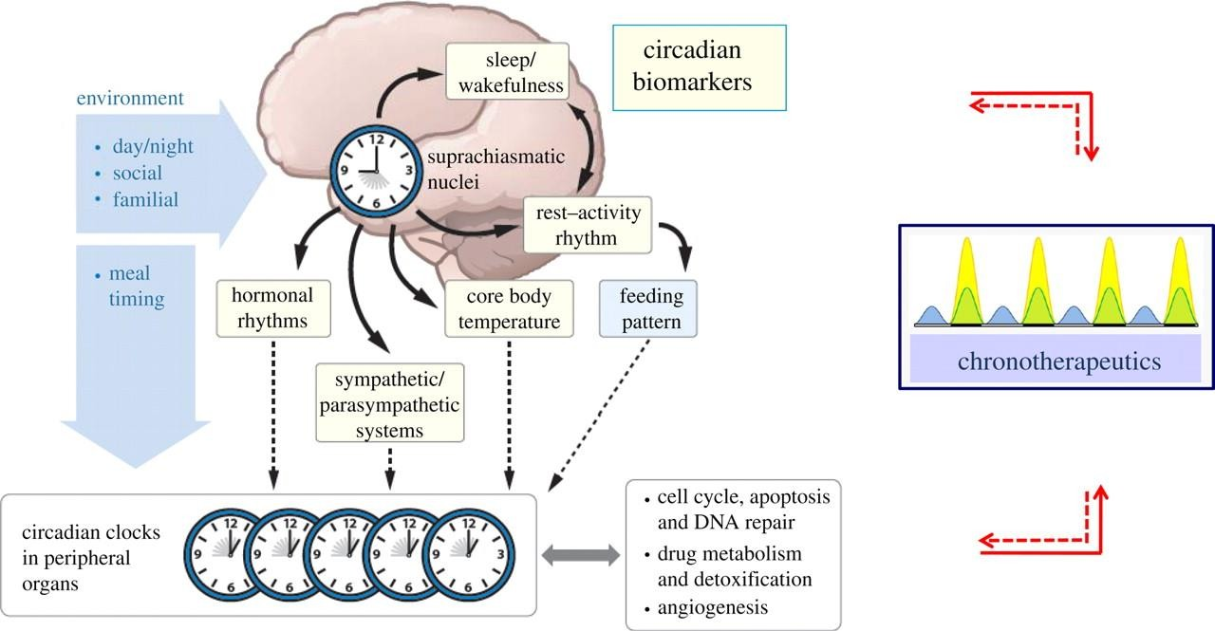

# Figure 2.1: The mammalian circadian timing system (CTS)

The CTS is composed of (a) a hypothalamic pacemaker, the suprachiasmatic nuclei SCN, (b) an array of SCN-generated circadian physiology outputs, and (c) molecular clocks in the cell (Reick *et al.*, 2001)

These genes are involved in transcriptional and posttranscriptional activation and inhibition of the interlock regulatory loops that result in the generation of 24 h variations in cellular physiologic processes (Dunlap, 1999; Shearman *et al*., 2000; Reick *et al.,* 2001: Gherghel *et al.*, 2004). Studies have not only shown biological clocks to be genetically determined but also transplanted from one animal to another, thereby inducing the rhythmicity of the donor into the recipient (Bargiello *et al.*, 1984).

The CTS essentially comprises of three components as shown above (Figure 2.1); an input pathway (photoreceptors and projections of retinal ganglion cells), circadian pacemakers that generate the circadian signal and an output pathway that couples the pacemaker to effector

systems manifesting into circadian physiology and behavior (Innominato *et al.*, 2014). However, circadian disruption leads to loss of rhythms in key clock peripheral genes and is associated with poor outcomes, including sleep/wake pattern disorders (Monk *et al.*, 2003). A monograph by the International Agency for Research on Cancer concludes that; shift work that involves circadian disruption is probably carcinogenic to humans, with an estimated risk level 2A, that is, close to full evidence (Munoz *et al.*, 2002). Thus, the prevention of circadian disruption, and/or the restoration of functional clocks, could constitute new objectives for therapeutics.

# Circadian Rhythm in Occurrence and Severity of Disease

In humans, current societal habits, including high snacking frequency, a reduction in the time spent sleeping and increased exposure to bright light during the night, act on the brain to induce a loss of feeling for internal and external rhythms (Sack *et al.*, 2000). Consequently, the brain becomes metabolically flattened and arrhythmic, intensifying symptoms of many medical conditions and the occurrence of life-threatening medical emergencies (Devdhawala- Mehul, 2010). Example of this is seen in cancer chemotherapy, where normal human bone marrow‘s deoxoribonucleic acid (DNA) synthesis (associated with the S-phase of the cell cycle) peaks around noon, while that of malignant lymphoma cells peaks near midnight (Antoch and Kondratov, 2013). Thus, introducing chemotherapy at midnight means more cell kill could be achieved with same dose of the S phase specific cytotoxic therapy with relatively little bone marrow damage (Antoch and Kondratov, 2013). In addition, cisplatin is better tolerated when administered at 16:00 and 20:00 h (early to near peak activity) when compared to other time points (Li *et al.*, 2005). The chronopharmacokinetics of the drug seems to contribute to the decreased renal toxicity during the evening administration (Li *et al.*, 1997; To *et al*., 2000).

# Chronopharmacology

Chronopharmacology is the study of the manner and extent to which the kinetics and dynamics of medications are directly affected by endogenous biological rhythms (Dallmann *et al.*, 2014). It is a branch of science that deals with the pharmacologic aspects of chronobiology and may be subdivided into chronotherapy, chronopharmacokinetics and chronotoxicity (Dallmann *et al.*, 2014). The paradigm in clinical pharmacology that pharmacokinetic parameters are considered not to be influenced by time of the day (homeostatic approach) may no longer be valid, as convincing evidence has established nearly all functions of the body including those that influence pharmacokinetic parameters display significant daily variations (Hrushesky *et al.*, 1982; Levi *et al.*, 1982; Lemmer, 1996).

Numerous studies in animal and man have provided convincing evidence that the pharmacokinetics (To *et al*., 2000) and/or drug effects-side effects can be modified by the timing of drug administration within 24 hours of the day (Devdhawala-Mehul, 2010). These findings have contributed to incorporation of time of the day in drug treatment of disease (Reinberg and Smolensky, 1983).

# Definitions

*Chronopharmacokinetics;* Involves the study of temporal variation in the pharmacokinetics of drugs. Hence it studies how the absorption, distribution, metabolism and excretion of drugs are affected by time of day (Lemmer and Bruguerolle, 1994). It investigates the variation in drug plasma levels as it relates to time of the day and the mechanisms responsible for these time dependent variations. These changes could be due to rhythmic variation in mechanisms involved in pharmacokinetics within the biological system and include variation in gastric emptying time, gastric and mucosal motility, hepatic and renal blood flow, and also diurnal variation in protein binding (Paysse *et al*., 1997).

*Chronotoxicology;* refers to circadian variation in the manifestation and severity of adverse effects and, thus intolerance to medications (Reinberg and Smolensky, 1983). Chronotoxicity is more common in drugs with relatively low therapeutic index with high risk of adverse effects (Francis and Ueli, 2007).

*Chronotherapy;* refers to a treatment method in which *in vivo* drug availability is timed to match rhythms of disease in order to optimize therapeutic outcomes and minimize side effects. It takes the advantage of the knowledge that various disease conditions, pharmacologic sensitivity, and pharmacokinetics of many drugs follow circadian variation (Traynor *et al*., 1992). Although, To *et al.* (2000) have demonstrated drug pharmacokinetic rhythmicity as a function of time of administration, cellular rhythms in drug susceptibility resulting from rhythmic control by inner clocks appear as more superior determinants of anticancer drug chronopharmacology; as they can modulate the generation or the catabolism of intracellular cytotoxic substances; thus, their interactions with the molecular targets leads

to cell dysfunction and/or the repair of cytotoxic damage (Boughattas *et al*., 1989; Zhang *et al.*, 1993).

# Relationship between Chronotoxicity and Chronoefficacy

A number of investigations geared towards exploring the relationship between the circadian rhythm in the tolerability (chronotoxicity) and efficacy (chronoefficacy) of chemotoxic drugs, as a prerequisite for the development of chronotherapy schedules has been documented in both experimental (Cemazar *et al.*, 2002; Li *et al.*, 2005) and clinical trials (Ezzat *et al*., 1997; Garufi, *et al.*, 2006; Falcone *et al*., 2007). The extent of toxicity of more than forty (40) anticancer drugs including cytostatics, cytokines, and targeted biological agents in both mice and rats have been largely modified by circadian timing. A potentially lethal dose of any of these agents results in 2-fold to more than 10-fold changes in the incidence of toxic deaths and/or maximum body weight loss as a function of circadian timing of drug administration (Levi *et al.*, 2010; Innominato *et al.*, 2014). The difference seen occurs irrespective of delivery route; oral, intravenous, intraperitoneal, or intra-arterial; or the number of daily or weekly administrations (Boughattas *et al*., 1990; Kobayashi *et al*., 2000; Li *et al.*, 2005; Levi and Schibler, 2007). In addition, circadian rhythms in the tolerability of anticancer drugs persist in rodents kept in constant darkness or in constant light, which demonstrates their endogeneity (Klein *et al.*, 1999). The circadian pattern of chronoefficacy usually coincides with that of chronotolerance. This is true for cytostatics, interferons, antiangiogenic agents, and cell cycle inhibitors, as well as for combination chemotherapy, such as irinotecan- oxaliplatin, gemcitabine-cisplatin, and docetaxel-doxorubicin; three widely used clinical regimens (Sothern *et al.*, 1989; Granda *et al*, 2001; Granda *et al*, 2002). Thus, experimental chronotherapeutics, strongly supports circadian timing as a relevant method for improving anticancer treatments. Studies have also shown that combination chemotherapy of drugs does

not seem to affect their optimal administration times which remain the same when they are administered as single agents (Asna *et al.*, 2005).

# CANCER CHEMOTHERAPY

# Introduction

Cancer ultimately arises from alterations in an individual cell. A normal human cell in culture can divide between 40 and 60 times before it stops dividing (Hayflick and Moorhead, 1961). This is called the Hayflick limit (Hayflick and Moorhead, 1961). Occasionally, cells become immortal and continue to multiply giving rise to abnormal cells that can form a mass of cells termed tumour; however, tumours may be benign or malignant. Although, Medeiros *et al.* (2009) have shown benign tumours do not have the ability to metastasis and do not pose significant health risk, the malignant tumour cells invade adjacent tissues and organs and often pose deleterious risk (Nguyen *et al.*, 2009). Cancer cells can also circulate through the body via the blood or lymphatic systems and could lodge in distant organs, giving rise to secondary malignant tumours. This process called metastasis if left untreated is often fatal (Medeiros *et al.*, 2009; Nguyen *et al.*, 2009).

# Pathogenesis of cancer

Cancer is a multistage process requiring initiation and promotion to exogenous carcinogenic chemicals (Rak and Yu, 2004; Motoyama and Naka, 2004). The initiation stage is mutagenic in nature and generally results from DNA damage produced by metabolically activated genotoxic carcinogen. Although, this stage is an irreversible phenomenon, its tumor promotion is epigenetic in nature and is often reversible (Rak and Yu, 2004). Furthermore, the promoters induce changes in epidermal homeostasis, which provide a tissue environment conducive for the clonal expansion of initiated cells (Radiæ *et al.*, 2004). The consequence of

initiation and promotion is the formation of a single clone of initiated cells (Franks, 2001). However, initiated cells remain latent until acted upon by promoting agents, many of which may not grow at all, or grow very slowly (Franks, 2001; Rak and Yu, 2004). These pathways of initiation and promotion may interfere with the process of differentiation that normally takes place when cells move from the dividing stem cell population into functioning and usually non-dividing cells (Yuspa *et al.*, 1997). Although, these growth-promoting stimuli are acting on the cells, they may still be sensitive to the normal growth inhibiting factors in the body so that the final outcome will depend on the balance between the factors and the extent of the changes in the initiated cells (Yuspa *et al.*, 1997; Franks *et al.*, 2001). This explains why preneoplastic, or even apparently fully transformed tumours, can be found but do not appear to be growing, and sometimes even regress (Radiæ *et al.*, 2004). The whole sequence of events in the process of tumour formation is almost certainly a consequence of gene changes, although the host may influence gene expression (Nguyen *et al.*, 2009).

# Treatment options in cancer

Curative therapies have been identified over the years for a number of previously fatal malignancies. These therapies range from a traditional multimodal approach involving, chemotherapy, irradiation and surgery to genetic therapies, vaccines and manipulation of the immune system (Chabner *et al.*, 2011). Overall, when these therapies are put together, a good control of the disease, with improvement in the quality of life is most desirable.

Chemotherapy, one of such treatment options, is employed as part of a multimodal approach to the initial treatment of many other tumours, including locally advanced stages of head and neck, lung, and oesophageal cancers, soft tissue sarcomas, and paediatric solid tumours (Joensuu, 2008). At the same time, chemotherapy drugs have found expanded utility in

noncancerous diseases. Chabner *et al.,* (2011) reviewed that some drugs used for cytotoxic antitumor therapy have become important components of immunosuppressive regimens for rheumatoid arthritis (methotrexate and cyclophosphamide), organ transplantation (methotrexate and azathioprine), sickle cell anaemia (5-azacytadine and hydroxyurea), anti- infective chemotherapy (trimetrexate and leucovorin) and psoriasis (methotrexate).

In designing specific regimens for clinical use, a number of factors must be taken into account. Drugs are most effective in combination, and may be synergistic because of their biochemical interactions. It is more effective to combine drugs that neither share common mechanisms of resistance (non-cross-resistant) nor overlap in their major toxicities, minimal overlapping toxicity (Mayer and Janoff, 2007). Studies on a number of cytotoxic drugs conclude that they should be used as close as possible to their maximum individual doses and should be given as frequently as possible to discourage tumour regrowth and to maximize dose intensity, a key parameter in the success of chemotherapy (Citron *et al.*, 2003).

Although, the management of a number of cancers including metastatic breast cancer have had success, cure in its real meaning (disappearance of any evidence of tumour for several years and a high actuarial probability of a normal life span) is still therapeutically challenging. Curative options remain elusive, and newer innovative approaches are only experimental (Chabner *et al.*, 2011).

# Cisplatin Chemotherapy

*Cis*-diamminedichloro-platinum (II) (cisplatin) was first identified as a potential antiproliferative agent in 1965 by Rosenberg and co-workers on experimental tumour systems and has proven to be of great clinical value (Rosenberg *et al.*, 1969). Since its

discovery, many platinum-containing compounds have been synthesized and tested. Carboplatin and oxaliplatin have found therapeutic use in the treatment of ovarian and colonic cancers (Samimi *et al.*, 2004). As a group, these agents have broad antineoplastic activity, and have become the foundation for treatment of testicular cancer, ovarian cancer, and cancers of the head and neck, bladder, oesophagus, lung, and colon (Samimi *et al.*, 2004). Although cisplatin and other platinum complexes do not form carbonium ion intermediates like other alkylating agents, they covalently bind to nucleophilic sites on DNA and share many pharmacological attributes, justifying their inclusion as alkylating agents (Kartalou, 2001).

Cisplatin, in combination with bleomycin, etoposide, ifosfamide, or vinblastine cures 90% of patients with testicular cancer (Giacchetti *et al.*, 2000). Also, when used with paclitaxel, cisplatin induces complete response in the majority of patients with carcinoma of the ovary (De Gramont *et al.*, 2000; Rothenberg *et al.*, 2003; Goldberg *et al.*, 2004). Furthermore, cisplatin produces complete response in cancers of the bladder, head and neck, cervix, endometrium and neoplasms of childhood (Pritchard *et al.*, 2000). Interestingly, this drug also sensitizes cells to radiation therapy and enhances control of locally advanced lung, esophageal, head and neck tumours when given with irradiation (Rothenberg *et al.*, 2003; Goldberg *et al.*, 2004).

* + - 1. *Clinical Toxicity of Cisplatin Cisplatin-induced Kidney damage:*

Cisplatin nephrotoxicity primarily causes tubulo-interstitial lesions. In animal models, cisplatin damages the proximal tubules, specifically the S3 segment of the outer medullary stripe. Mitochondrial swelling and nuclear pallor occur in the distal nephron. The glomerulus

has no obvious morphologic changes (Cornelison *et al.*, 1993; Meyer and Madias*.*, 1994; Vickers *et al.*, 2004). Although, studies have described the pathological results associated with cisplatin-induced nephrotoxicity in humans, the site of injury involved is either the distal tubule and collecting ducts or the proximal and distal tubules (Cornelison *et al.*, 1993; Meyer and Madias, 1994). The sites affected probably depend on differences in dose and timing of biopsy specimens. Biopsies obtained 3 to 60 days after dosing reveal segmental degeneration, necrosis, and desquamation of the epithelial cells in the *pars convoluta and pars recta* of the proximal tubules and distal tubules (Tanaka *et al.*, 1986). Also, in patients with acute renal failure, the predominant lesion is acute necrosis with no interstitial nephritis and is located mostly in the proximal convoluted tubules. However, the severity of necrosis is dose, concentration and time dependent (Meyer and Madias, 1994; Vickers *et al.*, 2004). Conversely, patients with chronic nephrotoxicity have focal acute tubular necrosis characterized by cystic dilated tubules lined by a flattened epithelium showing atypical nuclei and atypical mitotic figures with hyaline casts (Cornelison *et al.*, 1993). Thus, Long-term cisplatin treatment and injury may cause cyst formation and interstitial fibrosis (Cornelison *et al.*, 1993).

*Cisplatin-Induced Neurotoxicity:*

Neurologic complications of chemotherapy have been shown to increase in cancer patients due to aggressive antineoplastic therapy using neurotoxic agents (Grisold *et al.*, 2012). These complications may result from the direct toxic effects of the drug on the nervous system or indirectly from metabolic derangements or cerebrovascular disorders induced by the drugs (Windebank and Grisold, 2008; Mohty *et al.*, 2013). Thus, Cisplatin neurotoxicity is well established and constitutes a major limiting factor in the treatment of various malignancies (Roelofs *et al.*, 1984; Thompson *et al.*, 1984; Miltenburg and Boogerd, 2014).

Peripheral neurotoxicity develops in approximately 50% of patients receiving cisplatin (van der Hoop *et al.*, 1990), but the onset of toxicity is delayed until a cumulative dose higher than 300 mg/m2 has been given (Cersosimo, 1989, Gregg *et al.*, 1992). Signs and symptoms of peripheral neurotoxicity involve the upper and lower extremities and include loss of vibration sense, loss of position sense, tingling paraesthesia, weakness, tremor, and loss of taste (Von Hof *et al.*, 1979; Roelofs *et al.*, 1984; Thompson *et al.*, 1984). Seizures and leukoencephalopathy have also been described (Cattaneo *et al.*, 1988; von Schlippe *et al.*, 2001). Although, neurological dysfunction may gradually improve after cisplatin discontinuation, it may persist for a period of time, or become permanent (Von Hof *et al.*, 1979; van der Hoop *et al.*, 1990). In addition, cisplatin has also shown ototoxic effect, with tinnitus and hearing loss haven been observed in up to 31% of patients treated with initial intravenous cisplatin dose of 50 mg/m2 (Hartmann and Lipp, 2003; Laurell *et al.*, 1996). Glover *et al.*, (1989) and Hallmark *et al.,* (1992) reported transient hearing loss and mild audiometric abnormalities in 30% of patients receiving 150 mg/m2 of cisplatin. The mechanism of cisplatin-induced damage to the outer hairy cells of the cochlea probably includes the formation of reactive oxygen radicals and depletion of glutathione (Peters *et al.*, 2000). Other risk factors include simultaneous use of other potentially ototoxic agents (e.g., aminoglycosides), previous cranial irradiation, preexisting renal dysfunction, or inner ear damage (Chapman, 1982; Moroso and Blair, 1983; Hallmark *et al.*, 1992; Laurel *et al.*, 1996).

With a 3-fold increase in the number of cancer survivors noted since the 1970s, there are now over 28 million cancer survivors worldwide (Bray *et al.*, 2013). However, there is a heightened awareness of long-term toxicities and the impact on the quality of life following treatment in cancer survivors (Han *et al.*, 2013). Accordingly, there has been a gradual shift

in focus towards post chemotherapy recovery and survivorship, with an increase in awareness of the importance of the individual patient experience, patient-reported outcomes, and the long-term effects of treatment. Chemotherapy-induced peripheral neuropathy (CIPN) is of particular importance, and can lead to permanent symptoms and disability in up to 40% of cancer survivors. The CIPN can be a significant disability following the treatment of many types of cancers, including breast, colorectal, testicular, and haematological malignancies, and has impact on quality of life (Chabner *et al.*, 2011).

Clinical signs of central nervous system involvement have also been reported (Philip *et al.*, 1991; Highley *et al.*, 1992; LoMonaco *et al*, 1992), including focal encephalopathy, epileptic seizures and cortical blindness. Ocular toxicity, including optic nerve degeneration and retinal infarcts, is a common complication of intracarotid cisplatin administration (Maiese *et al.*, 1992). However, physicians in practice have often reported neurotoxicity of central origin to occur in tumour-bearing patients given cisplatin for therapy under certain conditions (Minami *et al.*, 1994). Minami *et al.,* (1996a and 1996b) have demonstrated platinum to pass through the blood-brain barrier and accumulate in the cerebral cortex when cisplatin was administered to mice after exposure to short-term hypoxia and in murine model of lipopolysaccharide (LPS) induced microvascular injury, respectively.

*Others toxicities of cisplatin*

Mild-to-moderate myelosuppression, with transient leukopenia and thrombocytopenia have also been reported due to cisplatin toxicity. However, anaemia may become prominent after multiple cycles of treatment (Samimi *et al.*, 2004). Furthermore, electrolyte disturbances, including hypomagnesemia, hypocalcaemia, hypokalaemia, and hypophosphatemia, are common side effects of cisplatin toxicity (Mohty *et al.*, 2013). Cisplatin induced toxicities

can cause anaphylactic-like reactions, characterized by facial oedema, bronchoconstriction, tachycardia and hypotension, which may occur within minutes after administration (Mohty *et al.*, 2013). Hyperuricaemia, haemolytic anaemia, and cardiac abnormalities are rare side effects (Samimi *et al.*, 2004).

* + - 1. *Treatment option in cisplatin nephro- , neuro- and haematological toxicities* Following an understanding of the pathogenesis of cisplatin-induced toxicity, a number of adjunctive therapies have been developed to prevent and lessen the need for reduction in dose or withdrawal, and also to reduce patient morbidity and mortality. These adjunctive therapies include but not limited to; recombinant human erythropoietin (rHuEpo) and mesenchymal stem cell (MSC) transplantation both involved in tubular regeneration and amelioration of its toxicity as demonstrated by Vaziri *et al*. (1994) and Iwasaki *et al.* (2005), respectively. Also included are agents with proven antioxidant properties such as sodium thiosulfate and metabolites of amifostine (WR-2721) which have been known to inactivate host toxic platinum species and protect against cisplatin toxicity (Pfeifle *et al.*, 1985; Glover *et al.*, 1989). Others are; hydroxyl radical scavengers such as dimethyl sulfoxide (DMSO), mannitol, and benzoic acid which significantly reduced cisplatin-induced cytotoxicity. Furthermore, dimethylthiourea (DMTU) and N-acetylcysteine (NAC) suppressed hydroxyl radical accumulation, p53 (53-kilodalton protein) activation, and cisplatin nephrotoxicity both *in vitro* and *in vivo* (Jiang *et al.*, 2007). Vitamin C and vitamin E were also found to be renoprotective in cisplatin-treated mice (Ajith *et al.,* 2009). Edaravone, a free radical scavenger, has been reported in the literature to have cytoprotective properties in murine proximal tubular cells (Satoh *et al.,* 2003).

Although, adjunctive treatment options have been prescribed as above, Ozkok and Edelstein (2014) have shown the most important supportive measure to be hydration which should be started before and maintained 3 days after; replacement of electrolyte losses and avoidance of other potentially nephrotoxic drugs. Despite considerable effort being invested towards alleviating cisplatin toxicity, effective prophylactic treatment against cisplatin-induced toxicity and treatment is still merely symptomatic.

*Chronomodulation of cisplatin nephrotoxicity, neurotoxicity and haematotoxicities:*

The circadian timing system (CTS) is composed of molecular clocks, which drive 24 h changes in xenobiotic metabolism and detoxification, cell cycle events, DNA repair, apoptosis and angiogenesis (Panda *et al.*, 2002). Due to synchronous ticking of the molecular clocks in the host tissues, they evade damage by anticancer agents (Delaunay *et al.*, 2000). However, host clocks are disrupted whenever anticancer drugs are administered at the time of the day that produces highest toxicity (Li *et al.,* 1998). Circadian timing of drug administration seeks to take advantage of the inherently poor circadian entrainment of tumours and capitalize on the persistent circadian entrainment of healthy tissues (Levi *et al.*, 2010).

Circadian timing of administration has been shown to ameliorate cisplatin toxicity and coincide perfectly with its therapeutic efficacy (Innominato *et al.*, 2014). Circadian rhythms have been demonstrated in all renal function variables measured (Hrushesky *et al.*, 1982). The ability of the kidney to concentrate and excrete hydrogen ions and trace metals and to clear the blood of urea, creatinine, and inulin are highly circadian stage dependent (levi *et al.*, 1997). Circadian rhythms have also been well documented for renal cytokinetics (Margolis, 1997). In addition, urinary activity of a key proximal tubular enzyme, α-N-

acetylglucosaminidase, has been shown to be highly rhythmic, and holds true for many other renal tubular enzymes (Lindahl and Surowiak 1970; Margolis, 1997). This rhythmicity is responsible for the phase variation seen in cisplatin toxicity in both man and animal.

# MALARIA

* + 1. **Introduction**

Malaria is a parasitic disease endemic in parts of the world where moisture and warmth permit the disease vector, mosquitoes of the genus Anopheles, to exist and multiply. The emergence of multi drug-resistant strains of malarial parasites and insecticide-resistant strains has contributed to the extensive spread of this infectious disease (Shapiro and Goldberg, 2011). Malaria ranks as a leading cause of mortality in the world today and the most important epidemiological disease (WHO, 2012). In addition, about 3.3 billion people, one- half of the world‘s population, live in at-risk regions for malaria infection with an estimated 207 million episodes of malaria cases, and approximately 627,000 deaths annually (Anstey *et al.*, 2009). Of the five typically recognized genera of *Plasmodium* causing malaria in humans, *Plasmodium falciparum* (*P. falciparum*) is responsible for about 95% cases of malaria worldwide with a mortality rate of 1–3%, while *Plasmodium vivax* (*P*. *vivax*) is responsible for most morbidity (WHO, 2012). More so, the *P*. *vivax* specie represents a reservoir of latent infection that hampers current control and future elimination efforts (Miller, 2002).

Malaria has been shown to be contracted through blood and could infect transfused individuals (Miller, 2002; Shapiro and Goldberg, 2011), making it true for hypodermic needles previously contaminated by blood containing malarial parasites to be a source of malarial infection. Thus, malaria has become a challenging public health problem all over the world, and is known as one of the major infectious diseases that afflicts human kind and also

a hazardous parasitic disease throughout the world. In addition, the rapid expansion of multidrug-resistant strains of the parasite has weakened therapeutic efficacy of antimalarial agents (Miller, 2002). Therefore, there exists an urgent need for more potent antimalarial drugs.

# Antimalarial therapy

* + - 1. *Artemisinins*

Artemisinin (*qinghaosu*), a sesquiterpene trioxane lactone, was isolated in 1971 from Artemisia annua (sweet or annual wormwood plant) as the active component responsible for antimalarial activity. Artemisinin and its derivatives represent one of the latest and new class of antimalarials containing an endoperoxide moiety. Several semi-synthetic artemisinin derivatives with better pharmacokinetic parameters have been produced chemically by modifying the parent compound at the C-10 position to create the following compounds: dihydroartemisinin, sodium artesunate, artemether, arteether, and artelinic acid (O'Neill and Posner, 2004; Woodrow *et al.*, 2005). These compounds are more potent than artemisinin, but have short plasma half-lives. The replacement of oxygen at the C-10 position of dihydroartemisinin (DHA) with carbon produces compounds not only with greater hydrolytic stability but also with longer half-life and lower toxicity (O'Neill and Posner, 2004). All artemisinins are readily metabolized to the biologically active metabolite DHA. Artemisinin and artemisinin derivatives kill all stages of plasmodium falciparum species that infect humans, possibly by interacting with heme to activate the carbon - centered free radicals that alkylate protein and damage important organelles and membranes of the parasite (Olliaro et al., 2001). A recent alternative hypothesis implicates PFATPase6 codes for sarco/endoplasmic reticulum Ca2+-ATPase (SERCA), a (calcium transporter), an orthologue of the mammalian SERCA; as the major chemotherapeutic target of artemisinin derivatives

(Bray et al., 2003; Eckstein-Ludwig et al., 2003). Recent studies suggest artemisinin may inhibit SERCAATPase, and thus and alter intracellular calcium stores (Eckstein-Ludwig *et al.*, 2003). The major drawback of artemisinin derivatives is their short half-life (3–5hrs); for which reason artemisinins are used in combination with other longer acting antimalarial agents.

* + - 1. *Mechanism of action*

In the malaria parasite, the endoperoxide moiety of artemisinin has been shown to be pharmacologically important and responsible for the antimalarial activity (Jefford *et al.*, 1989; Posner *et al.*, 1992). The endoperoxide bond is thought to be activated by reduced heme (FPFeII) or ferrous iron (FeII) (Meshnick *et al.*, 1991), leading to cytotoxic carbon- centred radicals which are highly potent alkylating agents (Olliaro *et al.*, 2001). Radicals may target essential parasite macromolecules causing the parasite‘s death. However, the precise mechanism of action and primary target of artemisinin remain under study. In Plasmodium, it has been postulated that artemisinin may target organelles such as the mitochondrion, sarco/endoplasmic reticulum, and the digestive food vacuole (O‘Neill *et al*., 2010). Some postulated molecular targets include heme alkylation, protein alkylation, SERCA inhibition, membrane damage, and loss of mitochondrial potential (O‘Neill *et al.,* 2010). Despite the continuous debate on artemisinin activation and specific targets, supporting evidence points that heme or ferrous iron is required for potent activity (Klonis *et al.*, 2011).

* + - 1. *Artesunate Toxicity*

*Neuro-, Nephro- and Haemato- toxicity:*

Artesunate undergoes bioactivation in the liver to artenimol, the active antimalarial agent, which results in the generation of reactive oxygen species (ROS) or free radicals (Li *et al*.,

2005). These radicals could damage enzymes and tissues in the kidney and other organs. Artemisinin and its derivatives produce an unusual pattern of selective damage to brain stem centres, predominantly involved in auditory processing and vestibular reflexes (Nontprasert *et al*., 2002). However, little data exists on its effect on peripheral neuropathy; results obtained have shown artesunate to clearly alter the functional capacities of the kidney (Rajput, 2013).

# Antitumor action of artemisinin

Artemisinin and its analogues are naturally occurring antimalarials, which have shown potent anti-cancer activity. As in malaria, the artemisinin molecular targets in cancer cells are debatable. Although artemisinin-induced alterations in some tumour cells are consistent, it is not clear if this toxicity resides in defined molecular targets. Drug concentrations required to exhibit anti-cancer effects are often higher than those inducing toxicity in malaria parasites. Artemisinin, DHA, artesunate, and artemether exhibit 48 hours fifty percent inhibitory concentration (IC50) of up to 15nM in malaria parasites (Ferreira *et al.*, 2007; Crespo *et al.*, 2008), whereas their anticancer activity is cell-line dependent and IC50 fluctuate between 0.5 and ≥200μM (Efferth *et al.*, 2003). The exquisite sensitivity of malaria parasites to artemisinin points to the presence of specific parasitic targets. However, in cancer cells, the artemisinin activity seems to be rather mediated by more general mechanisms through generation of ROS. However, it has also been suggested that ROS-mediated damage may be triggered by an initiating event in the vicinity of artemisinin activation (Mercer *et al.*, 2011). Considerable research has been focused on the most active compounds, namely, DHA and artesunate. One study that tested 55 cell lines from the Developmental Therapeutics Program of the National Cancer Institute (NCI) showed that artesunate displays inhibitory activity against leukemia, colon, melanoma, breast, ovarian, prostate, central nervous system (CNS),

and renal cancer cells (Efferth *et al.*, 2003). Dihydroartemisinin also have remarkable antineoplastic activity against pancreatic, leukemic, osteosarcoma, and lung cancer cells (Lu *et al.*, 2009).

Artemisinin has been found to act either directly by inducing DNA damage (genotoxicity) or indirectly by interfering with a range of signaling pathways involved in several hallmarks of malignancy. In pancreatic cells (Panc-1), artesunate caused DNA fragmentation and membrane damage. Interestingly, low doses of artesunate were associated with oncosis-like cell death, whereas higher concentrations induce apoptosis (Du *et al.*, 2010). The extent and type of damage seems to depend on the phenotype and the origin of cell line, and it may also vary in a time and dose-dependent manner. Notably, higher sensitivity to artesunate was observed in rapidly growing cell lines when compared with slow growing cancer cells (Efferth *et al.*, 2003).

Artemisinin and its semisynthetic derivatives are able to effectively induce cell growth arrest in cancer lines either by disrupting the cell cycle kinetics (inhibition of cyclin dependent kinase) or by interfering with proliferation-interacting pathways. Dihydroartemisinin and artesunate are very potent growth inhibitors with multiple studies pointing to DHA as the most potent anticancer artemisinin-like compound in the order of; DHA > artesunate > arteeter >artemether (Woerdenbag *et al.*, 1993; Efferth *et al.*, 2003).

Artemisinin-induced growth arrest has been reported at all cell cycle phases; however, arrest at G0/G1 to S transition seems to be more commonly affected (Efferth *et al.*, 2003). Disruption of the cell cycle at G2/M was observed after DHA treatment in osteosacorma, pancreas and leukemia (Yao *et al.*, 2008), and ovarian cancer cells (Jiao *et al.*, 2007). The

underlying mechanisms of artemisinin-induced growth arrest include alterations in the expression and activity of regulatory enzymes of the cell cycle, such as CDK2, -4 and -6 and D type cyclins (G1-to-S-phase transition) or CDK1, and A-type cyclin (G2/M) (Johnson and Walker, 1999; Malumbres and Barbacid, 2001; Firestone and Sundar, 2009). The anti- proliferative action of artemisinin induce downregulation of CDK transcription, inhibition of CDK promoters or increase the p21, p27 and CDK inhibitor (Firestone and Sundar, 2009). Inhibition of proliferation may also be attributed to downregulation of interacting proteins targeting multiple pathways (Firestone and Sundar, 2009).

# COMBINATORIAL THERAPY

# Introduction

There has been considerable improvement in cancer treatment. However, there are still numerous challenges. One such challenge is in the area of tumours that are characterized by relative resistance to chemotherapy and poor prognosis. Studies have shown combination therapies (two to three anticancer drugs with different mechanisms of action) to effectively overcome previously resistant tumours. These combination therapies have been used successfully in clinical practice. Example, includes cisplatin in combination with other antineoplastic drugs such as bleomycin, etoposide, ifosfamide, or vinblastine in both *in vitro* cancer cell lines (Rodríguez-Enríquez *et al*., 2009) and in clinical settings (Dieras *et al.*, 2006). Also, platinum drugs have showed enhanced anti-tumor effects when administered in combination with other anticancer agents, such as 5-fluorouracil, gemcitabine, topoisomerase I inhibitors, and taxanes (Raymond *et al.*, 2002; Dieras *et al.*, 2006).

Target of combination therapy includes, but not limited to important macromolecules and signalling pathways implicated in the pathogenesis of cancers. One such target is the tumour

suppressor protein (p53), although often not functional or/and mutated in some cancer cells (Ganjavi *et al.*, 2006); upregulation of this protein by p53 up-regulated modulator of apoptosis (PUMA), a potent proapoptotic molecule, would significantly increase both apoptosis and the chemosensitivity of cancer cells when combined with antitumor such as cisplatin (Ganjavi *et al.*, 2006; Zhang *et al.*, 2008). Furthermore, Günes *et al.,* (2009) reported that the combination of CDDP (which triggers influx of calcium) and arsenic trioxide (which depletes intracellular calcium stores) resulted in a synergistic increase in calcium-signal induced apoptosis in cancer cells.

# Cisplatin/Artesunate Combination Therapy and its possible Interaction

In humans, artemisinin derivatives are rapidly biotransformed into their bioactive metabolite DHA, which is later eliminated by glucuronidation (Grace *et al.*, 1998). Its metabolism is mediated primarily by the liver cytochrome P450 enzyme CYP2B6 (Ilett *et al.*, 2002), Depending on the derivatives, the extent of conversion varies; artesunate is converted to DHA within minutes, while conversion of artemether and arteether is slower. Artemisinin has been found to act either directly by inducing DNA damage (genotoxicity); or indirectly by interfering with a range of signalling pathways involved in several hallmarks of malignancy (Grace *et al.*, 1998). Du *et al.* (2010) demonstrated that artesunate caused DNA fragmentation and membrane damage. Others proposed mechanism are, heme alkylation, SERCA inhibition, membrane damage, and loss of mitochondrial potential (O‘Neill *et al*., 2010); which is true for both its antitumor and its antimalarial activity. In addition, Ji *et al*. (2011) reported that DHA and artesunate in a panel of osteosarcoma cells showed overexpression of proapoptotic factors and increase in the proapoptotic/antiapoptotic (Bax and Bcl2) ratio; which induces the release of cytochrome c followed by sequential activation of caspases, finally culminating into cell death (Elmore, 2007); an important process in the

effective treatment of tumours. Consistent with these effects, cisplatin has also been shown to have similar pharmacological activity (Kruidering *et al*., 1997; Arany *et al*., 2008). In addition, platinum complexes to which cisplatin belong to has recently been reported to have antimalarial activity (de Souza *et al*., 2011; Navarro *et al.*, 2014). Hence, its possible inclusion as an antimalarial therapy when used in the appropriate concentration range; importantly, due to the high incidence of malaria and drug-resistant strains of its parasite.

Conversely, systemic studies have shown cisplatin to slightly inhibit the extent of activities of three known CYP enzyme forms. The effect exhibited decrease CYP2C9 enzyme by 25%, CYP2B6 by 85% and CYP1A2 by 10% (Masek *et al*., 2009); and by itself biotransformed to an aquated specie, a positively charged highly reactive electrophile to form cisplatin-DNA crosslinks (Du *et al.*, 2010). Therefore, cisplatin interaction with CYP2B6, the enzyme responsible for metabolizing artemisinins, could theoretically lead to higher plasma concentrations and longer residence time, hence compromising the therapeutic efficacy of artesunate.

# CHAPTER THREE

# MATERIALS AND METHODS

# Animals and Housing

All experiments and procedures were carried out in accordance with Ahmadu Bello University and other international guidelines relating to principle on Laboratory Animal Welfare Act of CPCSEA (committee for the purpose of control and supervision on experimentation on animals) 1986 and NIH animal care guidelines.

Male albino Wistar rats (70) with an average weight of 166±11 g were purchased and housed in the animal house facility of the Faculty of Pharmaceutical Sciences, Ahmadu Bello University, Zaria (11° 10′ N′, 07° 38′ E); under natural light/dark environmental cycles. The rats were fed on commercial rodent chow pelleted diet (Topfeed, Nigeria) and given tap water *ad libitum*. Also, animals were acclimatized for three (3) weeks prior to commencement of study as recommended by Reinberg and Smolensky, (1983) for environmental (such as ambient temperature, relative humidity and light) entrainment of rats.

# Drugs and Chemicals

The drugs used for the study were as follows: Cisplatin (CISTEEN®, Miracalus Pharma pvt. Ltd, India), artesunate (ARTESUNAT®, Neros Pharmaceuticals, Nigeria), 10% dextrose in water (Juhel Nig Ltd, Enugu), chloroform (Sigma chemical, Germany), 10% formalin, 4% formaldehyde solution, ethanol, polyethylene glycol (Sigma chemical, Germany) and Picric acid (Sigma chemical, Germany).

# Equipment and Apparatuses

The following equipment were used: flame photometer, microtome, Bayer auto analyzer and surgical sets (dissecting kits), pestle and mortar, syringes (1 ml, 2 ml, 5 ml and 10 ml), animal cages, plain and heparinized bottles, cotton wool, weighing balance (AE240 dual range, Mettler Instrument Corporation, USA).

# Experimental Design and Procedures

The experiment went through three phase of design and procedures; dosage determination (Phase I) and chronotoxicity studies (Phase II and III). The rats were randomly assigned to different but comparable groups (n=7) and were maintained in stainless steel wire-mesh cages under natural environmental conditions for chronobiological study.

# Drug Preparation and Administration

Cisplatin (50mg/50ml) was used for the study. Artesunate powder (60 mg) was dissolved in 1ml sodium bicarbonate (NaHCo3) and then 5 ml NaCl to give a final stock concentration of 10 mg/ml. The two drugs were administered intraperitoneally (i.p.) at the predetermined time points.

* + - 1. *Phase I*

A total of 21 rats randomly assigned to three groups (n=7) received cisplatin i.p administration at a single time point (10:00 am) during the diurnal rest span of rats to avoid the influence of circadian effects.

# Phase I

**Table 3.1: Dosage Determination using Intraperitoneal Route of Administration at 10:00 h**

|  |  |  |  |  |  |
| --- | --- | --- | --- | --- | --- |
| Date of study | Groups | Treatment | Dosage | Cumulative dosage | End point |
| 22/04/2016-  28/05/2016 | Control | Saline | 1 ml/kg | - |  |
|  | Group 1 | Cisplatin | 3 mg/kg† | 3 mg/kg |  |
|  | Group 2 | Cisplatin | 3 mg/kg†††† | 12 mg/kg | Survival urea/creatinine/Mg |
|  | Group 3 | Cisplatin | 8 mg/kg‡ | 24 mg/kg |  |

Mg= magnesium; †=single dose; ††††=4 days; ‡=alternate day for 6 days; n=7 rats per group

*3.2.1.2 Phase II*

After an appropriate dose of 3 mg/kg daily for four (4) days was selected, the time of administration that produces least toxicity (chronotoxicological study) was determine after administration (i.p.) of cisplatin at one of the four equispaced circadian stages (00:00 h, 6:00 h, 12:00 h, 18:00 h; n=7 per group).

# Phase II

**Table 3.2: Cisplatin Chronotoxicity Study in Wistar rats**

|  |  |  |  |  |
| --- | --- | --- | --- | --- |
| Date of study | Groups | Treatment | Time (h) | End point |
| 2/05/2016-  9/05/2016 | Control | Saline | 06:00 |  |
|  | Group 1 | cisplatin | 06:00 | urea/creatinine/Mg histopathology; kidney  haematology |
|  | Group 2 | cisplatin | 12:00 |
|  | Group 3 | cisplatin | 06:00 |  |
|  | Group 4 | cisplatin | 00:00 |  |

Mg=magnesium; n= 7 rats per group

3.3.1.3 *Phase III*

Artesunate (60 mg/kg, i.p.) was administered daily for seven days to two groups of rats (n=7) at one of the 2 circadian stages (12:00 and 18:00 h), while these rats were pre-treated with cisplatin (i.p.) at the time that produces least toxicity

At the end of experimental protocol on day 8, for each of the experimental phases (Phase I, II, III), animals were euthanized by exsanguination under chloroform anaesthesia. The kidneys were excised and prepared for histopathological examination as described below. A portion of blood sample collected from the jugular veins of each of the euthanized rats was dispensed into EDTA anticoagulant vacutainers for haematological analyses using a Sysmsex Automated Haematology Analyzer (KX-2IN, Sysmsex Corporation, Kobe-Japan) following manufacturer‘s instruction. The remaining portion of the blood samples were dispensed into plain vacutainers for serum urea, creatinine and electrolytes (magnesium) using appropriate Randox® diagnostic kits

# Phase III

**Table 3.3: Study on Effect Chronomodulated Artesunate Administration on Toxicity of 06:00 h Cisplatin Treated Wistar Rats**

|  |  |  |  |  |  |  |
| --- | --- | --- | --- | --- | --- | --- |
| Date of study | Groups | Treatment (mg/kg) | Time (h) | Treatment (100mg/kg) | Time (h) | End point |
| 11/10/2016-  18/10/2016 | Control | Saline  1 ml/kg | 06:00 | - | - |  |
|  |  |  |  | urea/creatinine/Mg* histopathology; kidney  haematology |
|  | Group 1 | Cisplatin  3 mg/kg†††† | 06:00 | ART††††††† | 12:00 |
|  | Group 2 | Cisplatin  3 mg/kg†††† | 06:00 | ART††††††† | 18:00 |  |

Mg=magnesium; Grp=group; ART=artesunate; †††††††= 7 days; ††††= 4 days; n= 7 rats per group

# Assessment of Nephropathy

# Biochemical Analysis

* + - 1. *Blood urea nitrogen (BUN)*

The reported procedure of Ajith *et al.*, (2009) was adopted in this assay. In brief, working reagent for the determination of BUN was prepared by reconstituting one vial of reagent 2 (R2) in 10 ml of deionized water. To determine blood urea nitrogen, three test tubes were prepared and labelled accordingly (blank, test and sample). 1000 µl of the working reagent was added to all the test tubes, 10 µl of standard (Urea B 40 mg/dl) was added to the test tube labelled as standard, while 10 µl of the serum was added to the test tube labelled as sample. The content of all the test tubes were mixed and incubated at 37ºC for five minutes. Afterwards, 1000 µl of colour reagent was added to all the test tubes and properly mixed. The mixture was then incubated at 37ºC for five minutes. Finally, 1000 µl of deionized water was added to all the test tubes and was properly mixed. The absorbance of the sample and the standard against the reagent blank was measured using a spectrophotometer. The concentration of urea was calculated as shown below.

Urea conc (mmol/L) = Abso𝑟bance of sample × 40

Absorbance of standard

* + - 1. *Serum creatinine*

The reported procedure of Ajith *et al.*, (2009) was adopted in this assay. In brief, three test tubes labelled; blank, standard and sample were prepared. Serum (100 µl) and standard creatinine (2 mg/dl) were added to the test tubes labelled sample and standard, respectively. Working reagent (alkaline picrate reagent, 1000 µl) was added to all the test tubes and the content of all the test tubes were mixed properly. At 30 seconds and at 1 minute after mixing,

the initial and final absorbance for the sample and standard were read against the reagent blank using a spectrophotometer. The serum creatinine concentration was calculated as

shown below:

creatinine conc (µm/L) = Absorbance of sample × 2

Absorbance of standard

* + - 1. *Serum magnesium*

The reported procedure of Ajith *et al.*, (2009) was adopted in this assay. In brief, three test tubes labelled; blank, standard and sample were prepared. The working reagent (1000 µl) was added to all the test tubes. Standard magnesium (2 mg/dl, 10 µl) and 10 µl of serum were added to the test tubes labelled standard and sample, respectively. The content of each test tube was mixed properly and incubated for 5 minutes at a temperature of 37ºC. The absorbance of the sample and the standard were measured against the reagent blank using a spectrophotometer. The serum magnesium concentration was calculated using the formula:

Magnesium conc (mg/dl) = Absorbance of sample × 2

Absorbance of standard

* + - 1. *Histological study of the kidney*

Isolated kidneys for all the groups were fixed in 10% formalin, until processed. Kidney tissues (three centimetres thickness) were sliced and kept in an automatic tissue processor and then fixed in 10% buffered formalin-saline solution for 6 hours. They were then dehydrated for 2 hours in ascending grades of alcohol- 70%, 90% and 100% v/v. The dehydrated tissues were cleaned with toluene for 2 hours after which the tissues were embedded in paraffin wax and left to cool. The blocks were trimmed and sectioned on the microtome at 5 microns. The ribbons of sections were floated in a warm water bath. Suitable sections were selected, attached to slide and dried on a hot plate and stained with haematoxylin and eosin (H & E)

stain. Sections were dewaxed in xylene, rehydrated in descending grades of alcohol 100%, 90% and 70% v/v; then stained in haematoxylin for 5 minutes, differentiated in 1% acid alcohol, glued in Scott‘s tap water and stained with eosin for 3 minutes. Sections were rinsed and dehydrated in ascending grades of alcohol 70%, 90% and 100%, then finally dewaxed in xylene and mounted in a box. The slides were then examined microscopically for pathological lesions (Arthur and John, 1978). For histopathological evaluations of tissues (kidneys), board-certified pathologists performed the assessment (morphological changes) with neither knowledge of the treatment, nor control group (blinded).

# Statistical Analysis and Presentation of Result

Results are expressed as mean ± standard error of mean for parametric or normalized data using the log transform method and were presented as tables and bar charts. Box plots with their individual wiskers (percentile quartiles) were used to represent data for non-parametric data. Histological findings were presented as photomicrographs. One-way analysis of variance (ANOVA), followed by Tukey-Kramer *post hoc* test was used in the analysis of single point data that were normally distributed. In addition to normality, Welch Robust test of means was used when Levene‘s test of homoscedasticity failed to accept the null hypothesis of equal variance. Kruskal-Wallis, followed by Dunn‘s pair wise multiple comparison of ranks and Bonferoni correction test were used to analyse variables that were not normally distributed. Results were considered significant at *p*≤0.05.

# CHAPTER FOUR

# RESULTS

# Effect of Different Doses of Cisplatin on Survival and some Renal Biomarkers in Wistar Rats

Survival as a function of dose and repeated exposure to cisplatin in the group of rats that received 3 mg/kg single dose was significantly (p<0.05) longer when compared to the groups that received 3 mg/kg and 8 mg/kg daily dose for four and three days respectively (Figure 4.1).

Statistically significantly higher (p<0.05) mean serum creatinine and urea levels were observed in the group that received cisplatin 3 mg/kg daily for four days in comparison with controls. Also, in this group mean serum magnesium levels were statistically significantly lower (p<0.05) when compared to control (Table 4.1). However, these biomarkers (serum creatinine, urea and magnesium) were not available for the group of rats that received 8 mg/kg daily administration for three days due to 100 % mortality by day 6 (Figure 4.1).

3 mg/kg

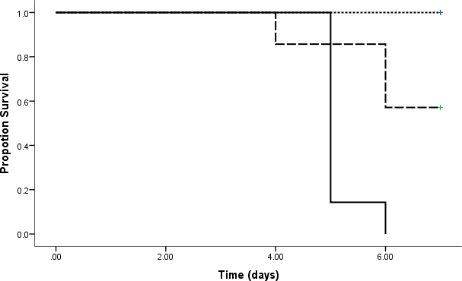

*

** 3 mg/kg††††

*

8 mg/kg†††

# Figure 4.1: Effect of Different Doses of Cisplatin on Survival

Kaplan Meier survival curves followed by log rank pairwise comparison were used to analyse survival of rats per group. N= 7 rats per group pre-treatment, †††=daily dosing for three days,

††††=daily dosing for four days, *= p<0.05; comparison between 8 and 3 mg/kg, **=p<0.001; comparison between 3 mg/kg single dose and 3 mg/kg daily dose

# Table 4.1: Effect of Different Doses of Cisplatin on some Renal Biomarkers in Wistar Rats

|  |  |  |  |  |  |
| --- | --- | --- | --- | --- | --- |
| **Treatment** | **Dose** | **n** | **Creatinine∞** | **Urea**  **(mmol/L)** | **Magnesium**  **(mmol/L)** |
| **Saline** | 1 ml/kg | 7 | 1.98±0.02 | 26.95±2.36 | 2.50±0.14 |
| **Cisplatin** | 3 mg/kg† | 7 | 2.07±0.02 | 38.10±2.34 | 1.98±0.03 |
| **Cisplatin** | 3 mg/kg†††† | 4 | 2.23±0.09* | 67.50±3.75* | 0.92±0.11* |

Data is presented as mean ± SEM and analysed using one-way ANOVA followed by Tukey- Kramer *post hoc* test, n= animals per group, *=p<0.05 vs. control, †=single dosing , ††††=daily dosing for four days,∞= normalized data using log transform

# Effect of Time of Daily Cisplatin Administration on Toxicological Biomarkers in Wistar Rats

# Time-dependent Effect of Daily Cisplatin Administration on some Serum Renal Biomarkers in Wistar rats

Daily administration of cisplatin (3 mg/kg for four days) resulted in higher mean levels of serum renal biomarkers (creatinine and urea), irrespective of time of administration (00:00 h, 06:00 h, 12:00 h and 18:00 h) when compared to controls (Figure 4.2 and 4.3 respectively). However, animals that received cisplatin at 18:00 h and 12:00 h had significant higher mean levels of creatinine and urea, respectively when compared to controls (p≤0.05).

Administration of cisplatin also resulted in lower mean serum magnesium levels irrespective of treatment time when compared to controls. Animals that received cisplatin at 00:00 h, 06:00 h and 18:00 h, had serum magnesium concentrations that were significantly (p≤0.05) lower than controls (Figure 4.4).

350

300

00:00 h

06:00 h



12:00 h

a

18:00 h

control

250

**Mean Serum Creatinine (µmol/L)**

200

150

100

50

0

00:00 h 06:00 h 12:00 h 18:00 h control

Cisplatin

3 mg/kg

# Treatment groups

**Figure 4.2: Effect of Time of Daily Cisplatin Administration on mean (±SEM) Serum Creatinine Concentration in Wistar Rats**

Data is presented as mean ± SEM and analysed using Welch robust test of means followed by Tukey-Kramer *post hoc*, The horizontal black bar at the bottom denote the duration of the natural light-dark cycle. a =p≤0.05 vs. control

80

a

70

60

50

**Serum Urea (mmol/L)**

40

30

20

10

0

00:00 h 06:00 h 12:00 h 18:00 h control

Cisplatin 3 mg/kg

# Treatment group

**Figure 4.3: Effect of Time of Daily Cisplatin Administration on Serum Concentration of Urea in Wistar Rats**

Box plot presentation of data for each time point and control (middle point: median; box value: percentiles 25–75%; whisker value: minimum–maximum). Data was analysed using Kruskal Wallis followed by Dunn‘s pair wise multiple comparison and Bonferoni correction. The horizontal black bar denote the duration of the natural light-dark cycle.

a = p≤0.05 vs. control

2.5



00:00 h

06:00 h

12:00 h

18:00 h

control

2.0 a a a

1.5

**Mean Serum Magnesium (mmol/L)**

1.0

0.5

0.0

00:00 h 06:00 h 12:00 h 18:00 h control

Cisplatin 3 mg/kg

# Treatment groups

**Figure 4.4: Effect of Time of Daily Cisplatin Administration on Mean (±SEM) Serum Concentration of Magnesium in Wistar Rats**

Data is presented as mean ± SEM and analysed using one-way ANOVA followed by Tukey-

Kramer *post hoc* test. The horizontal black bar at the bottom denote the duration of the

a

natural light-dark cycle. =p≤0.05 vs. control

# Time Dependent Effect of Daily Cisplatin Administration on some Haematological Parameters

Administration of cisplatin at the various time points caused lower red blood cell counts (RBC), haemoglobin (HGB) concentration and haematocrit (HCT) when compared to control. However, only animals that received cisplatin at time 06:00 h had significantly (p<0.05) lower values of RBC, HGB and HCT when compared to control.

# Table 4.2: Effect of Time of Administration of Cisplatin on some Haematological Parameters Following Four Days Treatment in Wistar Rats

|  |  |  |  |  |  |  |  |  |  |
| --- | --- | --- | --- | --- | --- | --- | --- | --- | --- |
| **Group/ Treatment** | **Dose (mg/kg)** | **n** | **RBC (1012/L)** | **HCT (%)** | **PLT (109/µL)** | **WBC (109/L)** | **HGB**  **(g/dl)** | **LYM (103/µL)** | **GRA (%)** |
| **00:00** | 3 mg/kg | 4 | 6.54±1.71 | 35.03±10.49 | 265.14±76.52 | 9.13±5.62 | 12.39±3.11 | 45.56±15.46 | 34.67±13.22 |
| **06:00** | 3 mg/kg | 5 | 6.11±0.48**\*** | 31.98±1.24**\*\*\*** | 358.50±34.75 | 7.90±4.50 | 11.58±0.70**\*\*** | 52.98±7.49 | 31.85±7.02 |
| **12:00** | 3 mg/kg | 4 | 6.16±1.43 | 33.64±7.67 | 454.40±96.77 | 8.28±4.50 | 11.72±2.50 | 57.58±11.81 | 25.18±9.93 |
| **18:00** | 3 mg/kg | 6 | 6.80±0.76 | 36.00±4.03 | 330.00±29.37 | 12.38±3.62 | 13.18±1.34 | 48.10±16.35 | 37.03±13.64 |
| **Control (Saline)** | 1 ml/kg | 7 | 7.35±0.16 | 40.28±0.64 | 467.50±31.48 | 9.75±1.21 | 14.03±0.33 | 63.10±7.09 | 25.60±5.16 |

Data are mean ± SEM. Red Blood Cells (RBC), Haematocrit (HCT) and Haemoglobin (HGB) analysed using Welch robust test of mean followed by Games-Howell *post hoc,* while Platelet (PLT), White Blood Cells (WBC), Lymphocytes (LYM) and Granulocytes (GRA) were analysed using one-Way ANOVA, n= animals per group *= p<0.05, **= p<0.01, ***= p<0.001 compared to controls

# Time-dependent Effect of Daily Cisplatin Administration on Kidney Histology of Wistar Rats

Light microscopic examination of kidney sections of Wistar rats after repeated daily treatment with cisplatin at different time point showed both normal capillary tufts of the glomerulus and subcapsular space in all treatment groups. Also, deposition of homogenous material (urinary casts) and dilatations in the lumens (renal tubules) characterised most time points (Plate II-V) as compared to controls. However, animals treated at 06:00 h had less urinary casts (plate III). Also, rats that receive cisplatin at 18:00 h showed urinary cast deposited in the lumen close to the glomerulus (proximal tubule, Plate V)

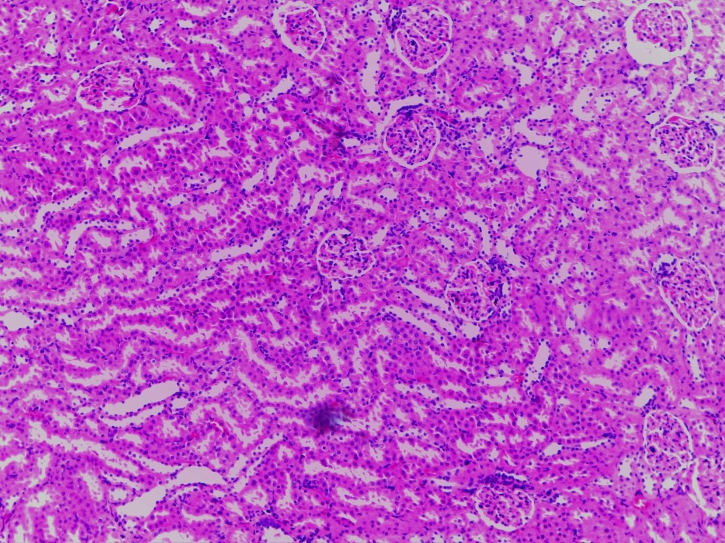

**Plate I**: Photomicrograph of a kidney section of control Wistar rat showing both normal renal tubules (blue arrow head) and glomerular architecture (black arrow head), (×100; H & E)

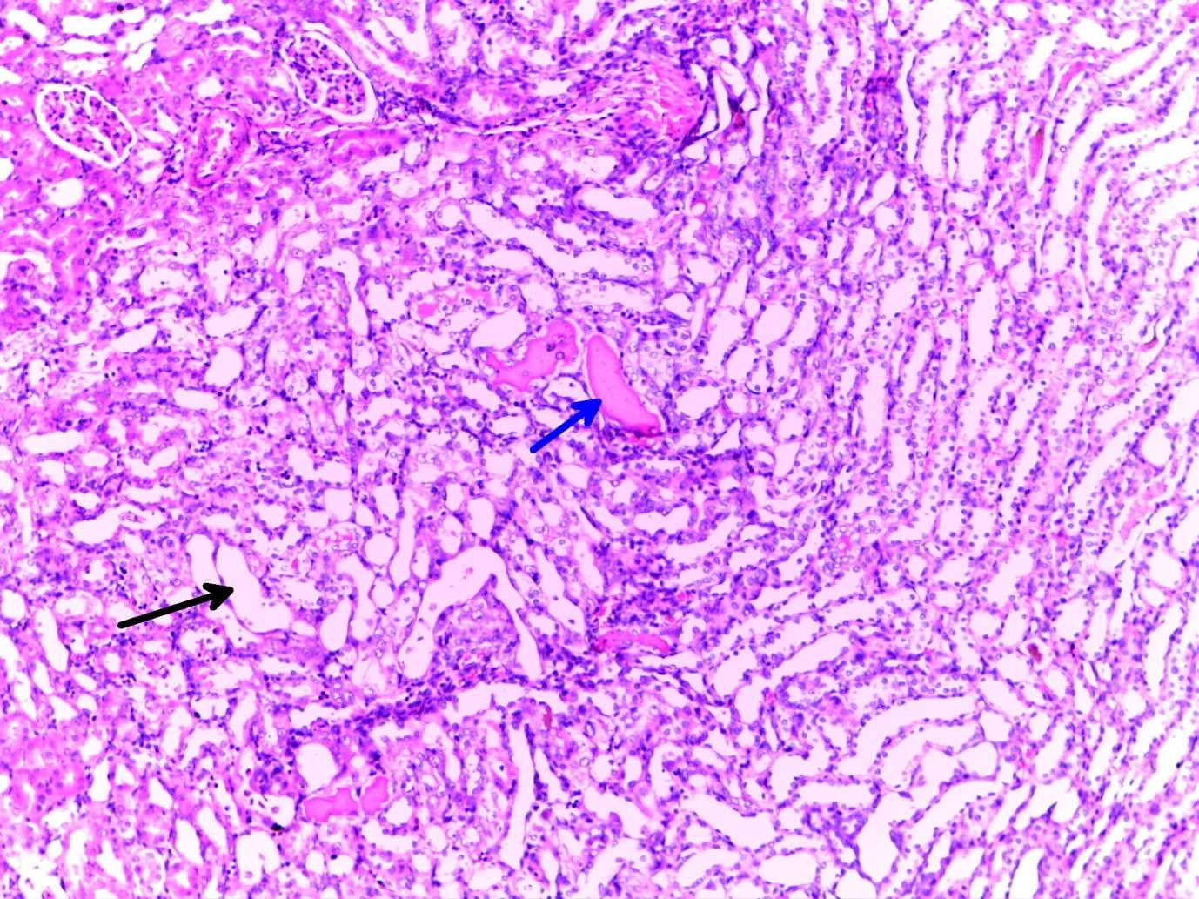

**Plate II:** Photomicrograph of kidney section of a Wistar rat treated with cisplatin at 00:00 showing dilation of renal tubules, while deposition of homogenous material (urinary casts) in the renal tubules is indicated with blue arrow. Normal glomerulus are also shown (black broken squares), (x100; H & E stain)

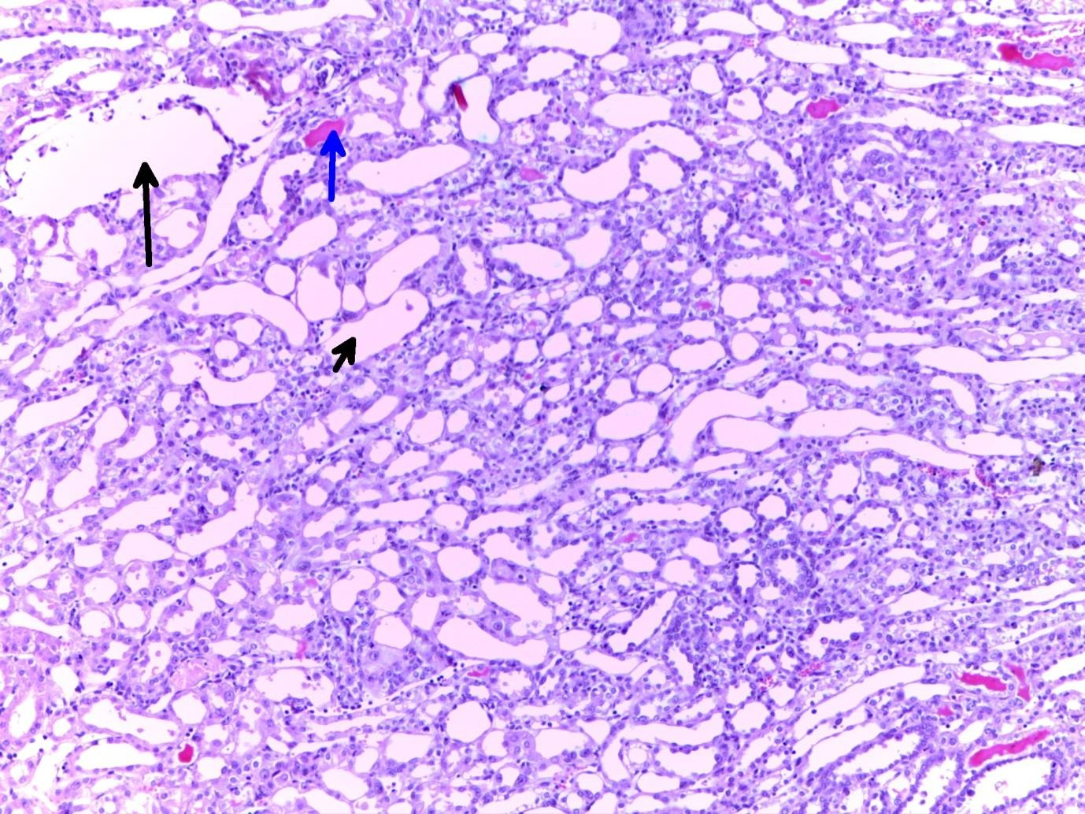

**Plate III**: Photomicrograph of a kidney section of a Wistar rat treated with cisplatin at 06:00 h showing dilation of renal tubules (black arrow) and deposition of homogenous material (urinary casts) in the renal tubules (blue arrow), (x100; H & E stain)

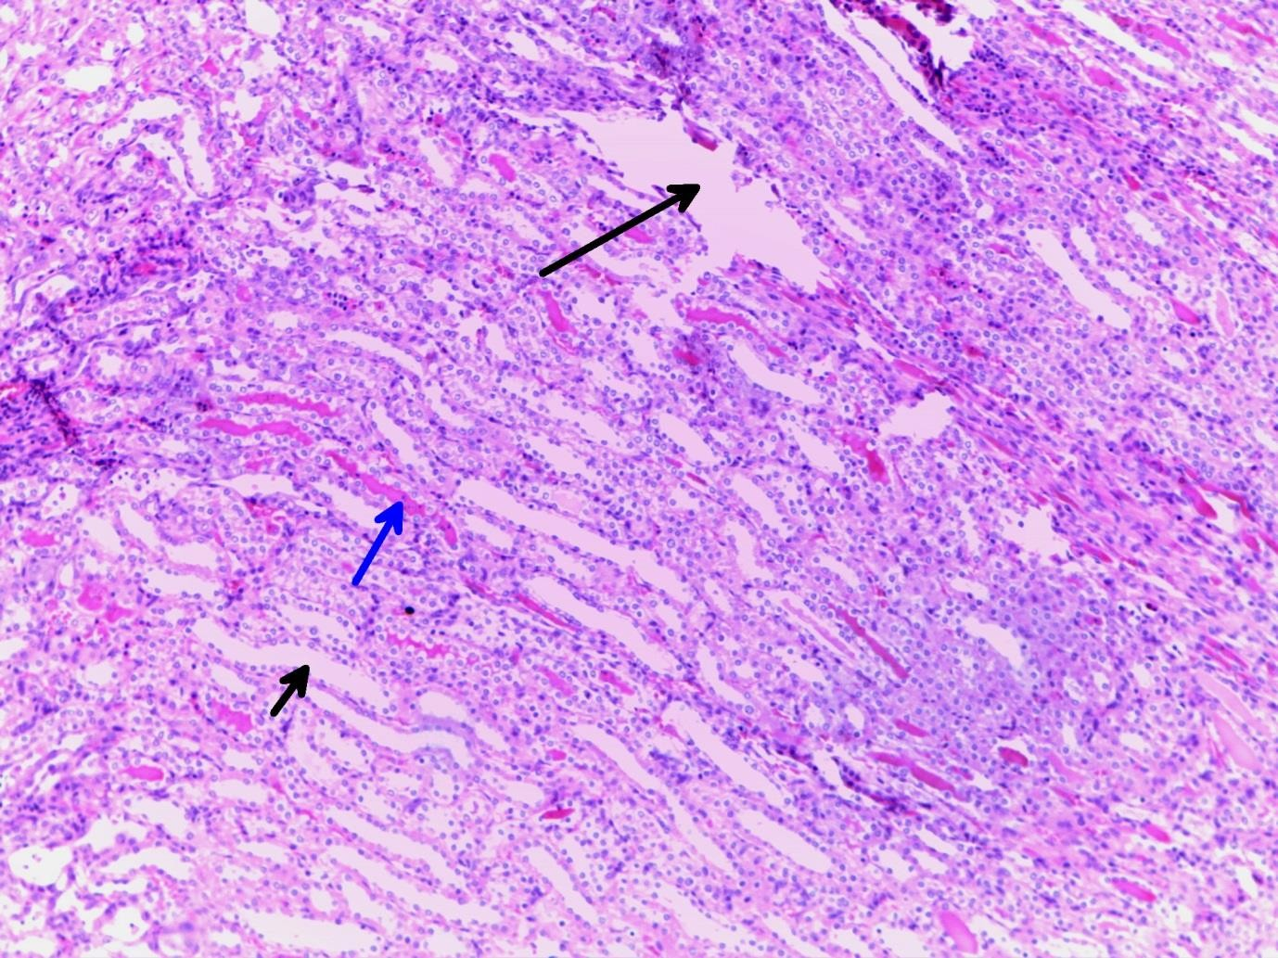

**Plate IV**: Photomicrograph of a kidney section of a Wistar rat treated with cisplatin at 12:00 h showing dilation of renal tubules (black arrow) and deposition of homogenous material (urinary casts) in the renal tubules (blue arrow), (x100; H & E stain)

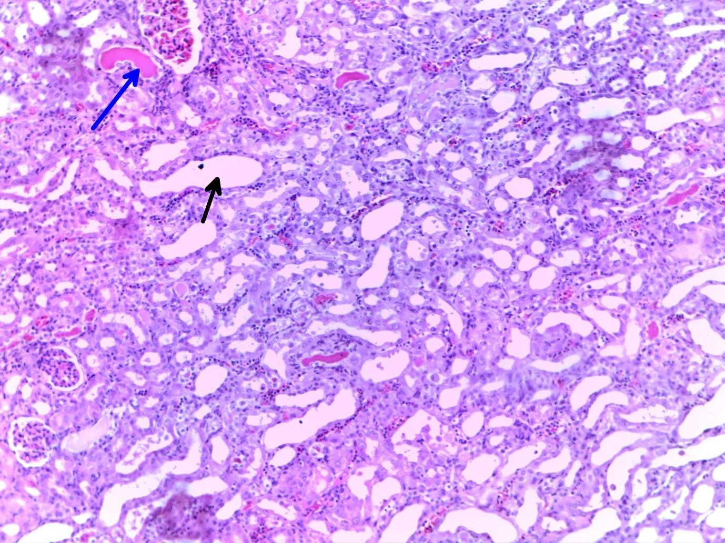

**Plate V:** Photomicrograph of a kidney section of a Wistar rat treated with cisplatin at 18:00 h showing dilation of renal tubules and deposition of homogenous material (urinary casts) in the renal tubules (blue arrow), normal glomerulus (black broken square), (x100; H & E stain)

# Effect of Chronomodulated Artesunate Administration on some Toxicological Markers in Cisplatin-treated Wistar Rats

* + 1. **Effect of Chronomodulated Artesunate Administration on Serum Renal Markers in Cisplatin-treated Wistar Rats**

There were no significant differences in mean levels of creatinine and urea in cisplatin- treated groups that received artesunate at 12:00 h or 18:00 h when compared to control (Figure 4.5 and 4.6). However, a statistically significantly higher (p<0.05) mean serum magnesium level was observered in cisplatin-treated groups that received artesunate at 12:00 h and 18:00 h, respectively compared to control and the cisplatin-treated group that received artesunate in addition at 18:00 h (Figure 4.7).

60



50

40

**Mean Serum Creatinine (µmol/L)**

30

20

10

0

Control (1 ml/kg) ART (60 mg/kg) 12 00 h ART (60 mg/kg) 18 00 h

Cisplatin (3 mg/kg)

06:00 h

# Treatment groups

**Figure 4.5: Effect of Chronomodulated Artesunate Administration on Mean Serum Creatinine Concentration in Cisplatin-treated Wistar Rats**.

Data is presented as mean ± SEM and analysed using one-way ANOVA. Cisplatin 06:00+ART 18:00 h: group that was co-administrated cisplatin at 06:00 h with artesunate (ART) at 12:00 h; Cisplatin 06:00+ART 18:00 h: group that was co-administrated cisplatin at 06:00 h with artesunate (ART) at 18:00 h; no statistical difference observed

5.0



4.0

3.0

**Mean Serum Urea (mmol/L)**

2.0

1.0

0.0

Control (1 ml/kg) ART (60 mg/kg) 12 00 h ART (60 mg/kg) 18 00 h

Cisplatin



(3 mg/kg)

# Treatment groups

06:00 h

# Figure 4.6: Effect of Chronomodulated Artesunate Administration on Mean Serum Urea Concentration in Cisplatin-treated adult Wistar Rats

Data is presented as mean ± SEM and analysed using one-way ANOVA. Cisplatin 06:00+ART 18:00 h: group that was co-administrated cisplatin at 06:00 h with artesunate (ART) at 12:00 h; Cisplatin 06:00+ART 18:00 h: group that was co-administrated cisplatin at 06:00 h with artesunate (ART) at 18:00 h

1.2



a,b

1.0

0.8

**Mean Serum Magnesium (mmol/L)**

0.6

0.4

0.2

0.0

Control (1 ml/kg) ART (60 mg/kg) 12 00 h ART (60 mg/kg) 18 00 h

 Cisplatin (3 mg/kg)

06:00 h

# Treatment groups

**Figure 4.7: Effect of Chronomodulated Artesunate Administration on Mean Serum Magnesium Concentration in Cisplatin-treated Wistar Rats**

Data is presented as mean ± SEM and analysed using one-way ANOVA followed by Tukey- Kramer *post hoc*. Cisplatin 06:00 h +ART 18:00 h: co-administration of cisplatin at 06:00 h and artesunate (ART) at 18:00 h; Cisplatin 06:00 h +ART 18:00 h: group that was co- administrated cisplatin at 06:00 h with artesunate (ART) at 18:00 h. a =p<0.05 compared to control, b=p<0.05 compared to group that received Cisplatin 06:00 h + ART 18:00 h.

# Effect of Chronomodulated Artesunate Administration on some Haematological Parameters in Cisplatin-treated Wistar Rats

Red blood cell (RBC) and Monocyte (MON) count and haemoglobin (HGB) concentration were not significantly different between cisplatin-treated groups that received artesunate at 12:00 h or 18:00 h and the control group; although the mean values of these haematological parameters were higher in the cisplatin-treated group that received artesunate at 12:00 h when compared to control (Table 4.3). Platelet (PLT) and leucocyte (L) counts were significantly lower (p<0.05) in cisplatin-treated groups that received artesunate at 12:00 h compared to the control group (Table 4.3).

The WBC count was significantly lower (p<0.01) in cisplatin-treated groups that received artesunate at 12:00 h and 18:00 h when compared to the control group. Conversely, neutrophil count (NEUT) was significantly higher (p<0.05) in the same cisplatin-artesunate combination schedules when compared to control (Table 4.3).

# Table 4.3: Effect of Chronomodulated Artesunate Administration on some Haematological Parameters in Cisplatin-treated Wistar Rats

|  |  |  |  |  |  |  |  |  |
| --- | --- | --- | --- | --- | --- | --- | --- | --- |
| **Group** | **RBC**  **(1012/L)** | **n** | **PLT**  **(109/µL)** | **WBC**  **(109/L)** | **HGB**  **(g/dl)** | **LYM**  **103/µL** | **NEUT.**  **(%)** | **MON.n** |
| **CIS 06:00+ ART12:00 h** | 8.06±0.36 | 5 | 263.60±43.58* | 1.5±0.28** | 15.18±0.98 | 77±3.51* | 13.40±2.11** | 1.10±2.20 |
| **CIS06:00+ART18:00h** | 7.62±0.24 | 6 | 376.17±84.96 | 1.25±0.39** | 14.80±0.46 | 81±4.02 | 10.83±1.83* | 0.94±2.38 |
| **Control** | 7.11±0.19 | 7 | 492.86±32.76 | 13.7±1.99 | 13.80±0.27 | 87±0.74 | 5.14±0.51 | 0.88±0.42 |

Data are mean ± SEM. Red Blood Cell (RBC), Haemoglobin (HGB), neutrophils (NEUT.), Platelet (PLT) and Monocytes (MON) were analysed using one-way ANOVA followed by Tukey-Kramer *post hoc,* while White Blood Cell (WBC) and Lymphocyte (LYM) were analysed using Kruskal Wallis and Dunn‘s pair wise comparison of mean ranks followed by Bonferoni correction test. CIS 06:00 h + ART 18:00 h: co- administration of cisplatin (CIS) at 06:00 h and artesunate (ART) at 18:00 h; CIS 06:00 h + ART 18:00 h: group that was co-administrated cisplatin (CIS) at 06:00 h with artesunate (ART) at 18:00 h *= p<0.05 and **= p<0.01 compared to controls; n= animals per group, n=normalized mean value using log transform

# Effect of Chronomodulated Artesunate on the Kidney Histology in Cisplatin-treated Groups that received Artesunate at Either 12:00 h or 18:00 h in Wistar Rats

Cisplatin-treated groups that received artesunate at 12:00 h and 18:00 h showed dilatation of renal tubules. However, flaking of cells into tubular lumen and reduction in the homogeneous cast (plate VII) characterise the cisplatin-treated group that received artesunate at 18:00 h.

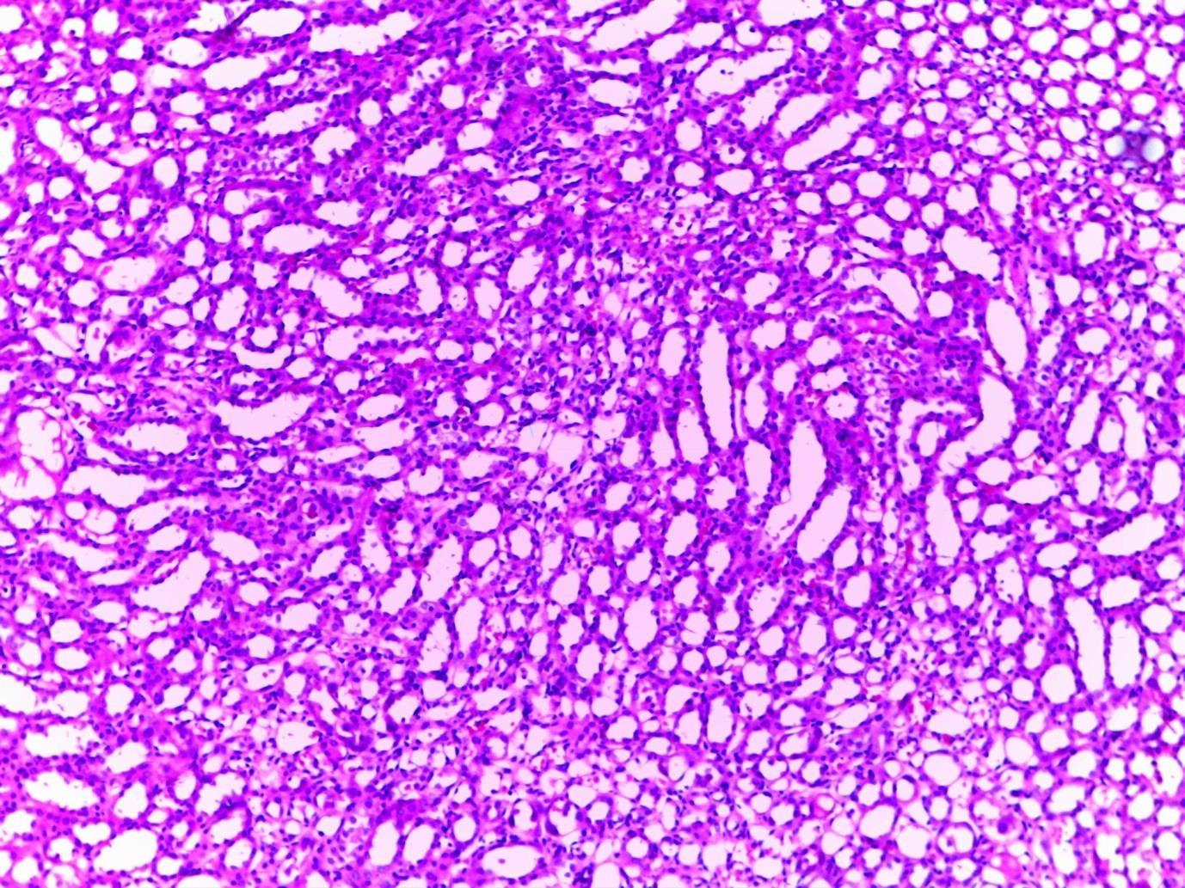

**Plate VI:** Photomicrograph of a kidney section of cisplatin-treated Wistar rats that received artesunate in addition at 12:00 h showing dilation of renal tubules (red arrow), (x100; H & E)

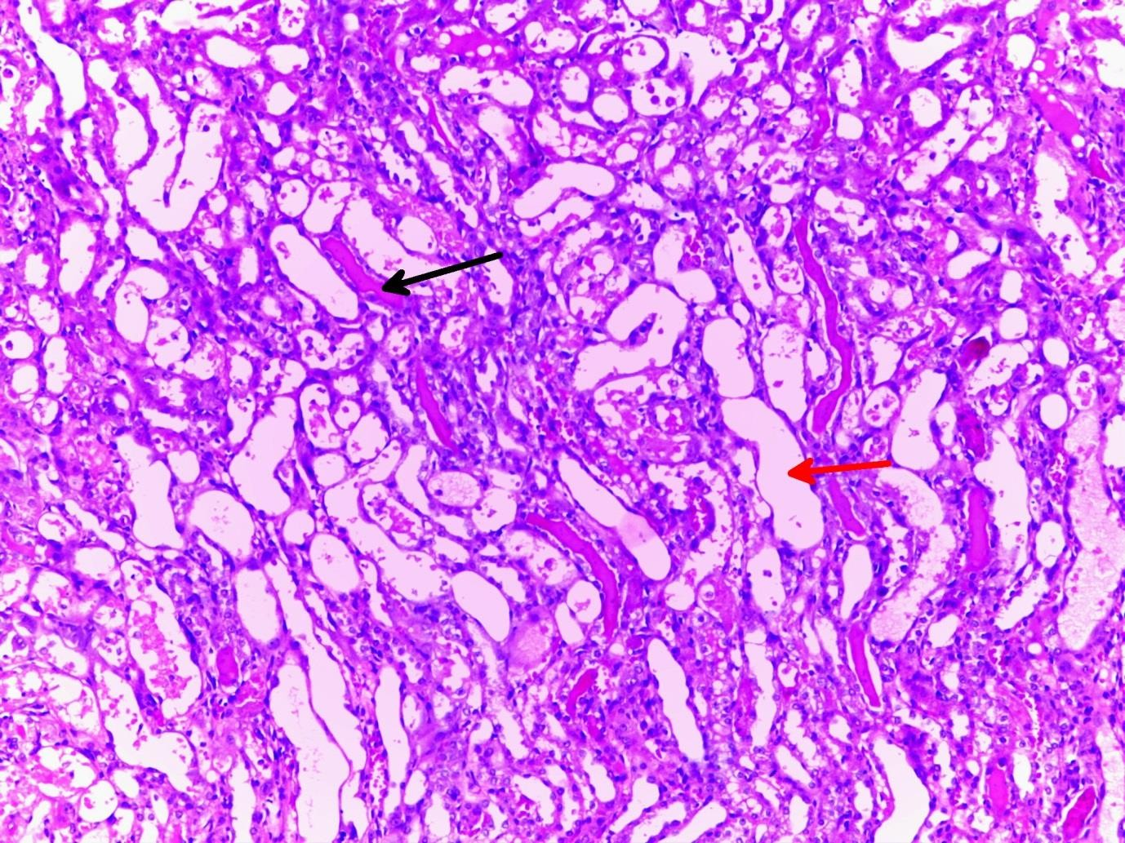

**Plate VII**: Photomicrograph of a kidney section of cisplatin-treated Wistar rat that received artesunate at 18:00 h showing dilation of renal tubles and deposition of homogenous materials (urinary casts) in the renal tubules (black arrow), flaking of cells into tubular lumen (white arrow head), reduction of homogeneous cast (black stars). (x100; H & E stain)

# CHAPTER FIVE

# 5.0 DISCUSSION

Circadian rhythmicity is manifested by the occurrence of peaks and troughs of biological/physiological processes, which do not occur at random but rather are regulated along an approximate 24-hr time scale. Importantly, this temporal rhythm can augment therapeutic efficacy, increase overall survival rate and reduce toxicity of cytotoxic drugs when used singly or in combination therapy.

Several doses and courses of cisplatin have been administered both in clinical and preclinical studies. However, renal injury and quality-of-life (QoL) is a principal WHO toxicity criterion in the choice of dose reduction and/or delay in cancer chemotherapy. In this study, the relatively lower lethal dose of cisplatin (3 mg/kg daily for 4 days) as against lethal 8 mg/kg every other day for 6 days (24 mg/kg cumulative dose) was used to investigate the circadian dependency of cisplatin induced renal and haematological toxicity (phase II and III). This was due to renal toxicity as defined by the significantly higher mean levels of creatinine and urea, both of which are indicators of extensive kidney damage (approximately half nephronal damage). Also, the choice of dosage in this study was dependent on survival, as the group that received 3 mg/kg cisplatin daily for 4 days had 60% survival as against 0% survival in the group that received cisplatin 8 mg/kg every other day for 6 days. Although, 3 mg/kg single dose was also used in the exploratory dose range findings study (phase I), it was anticipated to be below the threshold for renal toxicity and to correspond to a non-observable- adverse-effect level (NOAEL).

After confirming the working dose of cisplatin for the subsequent phase of the current study, it was found that the time of peak renal toxicity in cisplatin treatment as measured by

creatinine and urea was observed in rats that received cisplatin at 18:00 h and 12:00 h, respectively, which is indicative of a six (6) hour phase shift and corroborates early studies by To *et al*. (2000), Kobayashi *et al.* (2000) and Asna *et al.* (2005) in terms of phase shifts but not the time of administration. Also, for haematological parameters, least toxicity was seen at early and middle activity span (18:00 h and 12:00 h), when compared to early and late activity span (06:00 h and 18:00 h) for renal toxicity indicated by urea levels. These results are indicative of a temporal variability in relationship between the two physiological indices studied. This further demonstrates the fact that peripheral tissue clocks can manifest a remarkable independence from the master clocks, particularly in animals kept under natural environmental conditions (Al-Haidary *et al.*, 2016). In these conditions, entrainable peripheral oscillators are not only driven by light but also entrained by other environmental cues such as ambient temperature and atmospheric pressure (Refinetti, 2010; Ayo *et al*., 2017) which could cause pronounced segregation of phase consequence exotoxic administration. Least toxicity for the haematological parameters in the present study is in consonance with studies by Asna *et al.* (2005); however, results reported for time of administration that produces the least renal toxicity of these researchers are in disagreement with the present study. These differences observed could be due to the strict thermoregulatory environment of the animals used and control photoperiod which has been shown to differ from studies under natural condition (Scheibler and Wollnik, 2009; Al-Haidary *et al.*, 2016).

The significant and possible ameliorative effect of timed administration of cisplatin and artesunate is a consequence of the circadian organization, which resulted in variations to their combined toxicities. A possible explanation is; systemic studies have shown cisplatin to inhibit the extent of activities of the cytochrome enzyme; Cytochrome P-450 enzyme 2B6 (CYP2B6) by up to 85%. This enzyme is responsible for the inactivation of

dihydroartemisinin (DHA), a potent metabolite of artesunate. CYP2B6 inhibition as a result of cisplatin interaction could lead to a higher plasma concentration and longer residence time of DHA. Hence, cisplatin-artesunate concurrent administration could cause increase concentration of highly toxic specie that could damage vital organs and subsequently death. Therefore, the modulatory schedule-dependent effect of cisplatin with artesunate (administration of cisplatin at 06:00 h; and then artesunate at 12:00 h or 18:00 h on renal and haematological toxicities as against their concurrent administration may be due to biological oscillation of this enzyme in determining the availability of the drug and its metabolites.

Furthermore, results obtained from this study suggest time dependent anti-inflammatory and electrolyte homeostatic effect of artesunate tends to contribute to the ameliorative effect of chronomodulated cisplatin administration on renal toxicity. Inflammatory markers such as, white blood cell (WBC), platelet (PLT) and lymphocyte (LYM) were significantly suppressed in the present study. This is indicative of a probable anti-inflammatory effect of artesunate in cisplatin induced renal injury in the two time schedules. Earlier studies have suggested that inflammation provoked by injury to renal epithelial cells are strongly linked to the pathogenesis of cisplatin induced kidney injury and dysfunction (Ozkok and Edelstein, 2014). This is achieved via the activation of pro-inflammatory signaling pathways (Cornelison *et al*., 1993; Miltenburg and Boogerd, 2014); as confirmed in the circadian timing of cisplatin administration of the present study; which indicates an increase in circulating WBC and granulocytes counts. However, Ho *et al*. (2012) and Ng *et al.* (2014) reported artesunate to markedly suppress ovalbumin-induced increases in total WBC and lymphocyte counts, and protect against cigarette smoke-induced lung injury via inhibition of inflammatory and apoptotic pathways respectively. In this study, administration of artesunate at the two time schedules (at 12:00 h and 18:00 h) in cisplatin treated rats suppressed WBC,

PLT and LYM with subsequent significant increase in granulocytes, which is indicative of a probable immune reconstitution as shown by Chen *et al.* (2002), while working on renal protecting agent.

Studies have shown cisplatin concentrations in tubular epithelial cells to be five times greater than in blood and even non-toxic blood levels may reach toxic levels in the kidneys. Inhibition of erythropoiesis as measured by the levels of RBC, HCT and HGB was slightly affected and dependent on the time of administration in cisplatin only treated rats (phase II study). However, rats that received artesunate in the two time schedules in addition to cisplatin (phase III) had higher levels of these haematological parameters when compared to controls. This is indicative of a likely enhancement of erythropoiesis or protection against the toxic effect of cisplatin. This is in disagreement with studies that showed artesunate to clearly inhibit erythropoiesis (Noker and Simpson-Herren, 1998); although, the latter study did not factor in time of administration. One possible explanation for these effects is that; artesunate is rapidly converted to dihydroartemisinin (DHA) also known as artemisone, a potent metabolite responsible for its antimalarial and toxic effect (Woerdenbag *et al.*, 1993; Efferth *et al.*, 2003). Studies have shown diseased cells to concentrate DHA (Gu *et al.*, 1984) and artesunate (Meshnick *et al.*, 1991; Kamchonwongpaisam *et al.*, 1994; Li *et al*., 2007) at 100- 300 folds higher when compared to non-diseased erythrocytes; hence reducing the flow of their free forms in blood. Although, this effect is reversible, it could be responsible for modifying the extent of cispaltin-artesunate combined toxicity on erythropoiesis in a time dependent manner as seen in the present study.

dos Santos *et al*. (2012) attributed the nephrotoxicity of cisplatin to its adverse impact on the renal transport system. Administration of cisplatin resulted in hypomagnesaemia, a condition

which is secondary to renal electrolyte wasting and subsequently tetany. This effect was dependent on the time of cisplatin administration. However, administration of artesunate at the two time schedules in rats that received cisplatin in late activity span ameliorated cisplatin induced reduction in magnesium levels. Although, the mechanism of modulating cisplatin toxicity as it relates to the time of the day was not investigated in the present study, a number of studies have shown the kidney‘s ability to concentrate cisplatin in a time dependent manner to be directly linked to its chrono-nephrotoxicity using single dosing (Levi *et al.*, 1982; Boughattas *et al*., 1990). To *et al.*, (2000) demonstrated the non-involvement of cisplatin accumulation in the kidneys in its mechanism of time dependent chrono- nephrotoxicity in mice. This study is arguable as the authors only used two time points (0400 and 1600 hrs).

In addition, Campos *et al*. (2001) reported artesunate to cause diuresis and natriuresis in patients without renal failure, which reverted to normal after completion of treatment. The report was also corroborated in an experimental model that demonstrated the inhibitory effect of artesunate on chloride transport across the cortical thick ascending loop of henle (TALH) and nitric oxide which acts to suppress and/or disrupt tubuloglomerular feedback (Seguro and Campos, 2002). This action leads to the retention of electrolytes such as magnesium accompanied by natriuresis that was reversed after discontinuation of artesunate treatment (Huang and Kuo, 2007). Although, there are few studies that demonstrate time dependent diuresis or natriuretic effect of artesunate, Olurishe and Fatika, (2016) suggested the link between timed artesunate diuretic properties to its ameliorative effects on gentamicin-induced nephrotoxicity. In the current study, the higher level of magnesium in cisplatin-treated rats that received artesunate at 12:00 h may be indicative of shorter diuretic effect of artesunate, This is in consonance with the impaired kidney histologic architecture of the rat in this group

as compared with cisplatin-treated rats that received artesunate at 18:00 h that had a near normal kidney histology. In addition, nitric oxide synthesis has been shown to be stimulated by artesunate at TALH segment of the nephron (Campos *et al.*, 2001) and also parallel its antimalarial activity (Taylor-Robinson and Looker, 1998). Also, Ashrafi *et al*. (2012) demonstrated a relationship between magnesium (Mg) and nitric oxide (NO); such that Mg deficiency can result in a rise in plasma NO in rats. Taking together with these reports, this increase Mg concentration in the group of rats that received artesunate at 12:00 h + cisplatin at 06:00 h may suggest the possibility of less ameliorative effect of artesunate on cisplatin induced toxicity.

Histologic evaluation of the kidneys of representative members of rats that received cisplatin at the predetermined four time points of the present study were characterized by changes in renal morphology and degeneration; although the severity of damage was dependent on the time the animals received the drug. A study involving light microscopic examination of kidney sections of rats after a repeated dosing of cisplatin in a time dependent manner is in agreement with this study (Boughattas *et al*., 1990). However, administration of artesunate at 18:00 h in cisplatin treated rats apparently ameliorated nephrotoxicity which was evidenced by absence of homogenous casts deposition and similar histological architecture when compared to control. Conversely, Cisplatin treated rats that received artesunate at 12:00 h were characterised by reduced homogenous cast that did not completely fill the tubular interstitium as compared to cisplatin only rats in phase II, and also seen are the flaking of cells into the tubular lumen. These features are indicative of tubular regeneration, which is similar to studies by Osman *et al.* (2015) who reported in addition to these features dilation of renal tubules after concomitant administration of cisplatin and resveratrol.

Therefore, delivery of cisplatin at 06:00 h and artesunate at 12:00 h or 18:00 h improved tolerability as measured by the mean serum creatinine and urea when compared to chronomodulated cisplatin alone. Similar circadian pattern of administration have shown the chronopharmacology of two or more anticancer drugs across different rodent species and tumor models to modifying toxicity and improve efficacy (Granda and Levi, 2002; Levi *et al.*, 2010). Although the current study did not explore the relevance of this best treatment schedule in host or tumour bearing models, studies have shown coincidence between the time of best efficacy and that of best tolerability. Li *et al.* (2005) reported schedule-dependent effect of cisplatin-gemcitabine in non-tumor bearing rats when gemcitabine was administered at 11 HALO (awakening) and cisplatin at 15 HALO (near mid-activity span). These researchers further found this time schedule to be most active against rats bearing glasgow osteosarcoma.

# CHAPTER SIX

# SUMMARY, CONCLUSION AND RECOMMENDATIONS

# Summary

The present study was carried out to investigate the effects of chronomodulated artesunate on renal and haematological toxicity in cisplatin-treated wistar rats. Results obtained from this study suggest circadian variation in the time of administration of cisplatin in haematological and renal toxicities including histopathological changes in the kidney. These effects were observed more in groups of rats that received cisplatin in the light phase (inactive phase) when compared to the dark phase. However, administration of artesunate at 12:00 and 18:00 h in addition to cisplatin did not cause increase in the creatinine and urea levels when compared to controls. Conversely, this timing of artesunate administration in the groups that were treated with cisplatin caused significant decrease in WBC count and increase in the counts of neutrophils when compared to controls, while the RBC and HGB were not affected.

# Conclusion

The ameliorative effect of late activity (06:00 h) cisplatin (3 mg/kg x 4 days)-treatment on renal and haematological toxicity in Wistar rats does not appear to be negatively affected by 7-day chronomodulated daily administration of artesunate (60 mg/kg). However, artesunate administration contributed to the ameliorative effect of 06:00 h cisplatin treatment in rats irrespective of the time of artesunate administration. Furthermore, administration of artesunate at 18:00 h + cisplatin at 06:00 h appeared to result in least renal toxicity, and more pronounced amelioration of toxicity when compared to rats that receive artesunate at 12:00 h + cisplatin at 06:00 h. This implies that timed administration of cisplatin-artesunate approach may provide merits in co-

morbid conditions involving cancer and malaria where artesunate, an antimalarial may be used alongside cisplatin as an anti-tumour agent.

# Recommendation

Optimal combination schedule identified in this study, where cisplatin is administered at 06:00 h (late activity span) and artesunate at 18:00 h (early activity span) is physiologically analogous to the end of the activity and awakening, respectively in diurnal human subjects. Hence, time dependent schedule administration of cisplatin- artesunate should be incorporated as part of a treatment strategy when cancer and malaria co-exist in order to optimize delivery of the two agents and reduce side effects.

# Suggestions for Further Studies

1. Further studies should be conducted based on the findings suggested in this study, which are; the circadian expression and the circadian stage involvement of electrolytes homeostasis in contributing to the chrononephrotoxicity of cisplatin.
2. Also, chronopharmacodynamic anti-inflammatory response and immune reconstitutive effect of artesunate in cisplatin induced toxicity should be conducted to further elucidate its involvement in augmenting the effect of time on amelioration of renal toxicity.
3. Furthermore, circadian variation in cellular susceptibility of artesunate and its metabolite accumulation in diseased red cells should be carried out.
4. A schedule dependent effects of cisplatin and artesunate on time-dependent enhancement in erythropoiesis should also be carried out.
5. The present study and the proposed future study should be conducted in human subjects in order to actualize the bench to bedside principle.

# REFERENCES

Ajith, T.A., Abhishek, G., Roshny, D. and Sudheesh, N.P. (2009). Co-supplementation of single and multi doses of vitamins C and E ameliorates cisplatin-induced acute renal failure in mice. *Experimental and Toxicologic Pathology*, 61(6): 565-571.

Akman, T., Akman, L., Erbas, O., Terek, M.C., Taskiran, D., and Ozsaran, A. (2014). The preventive effect of oxytocin to cisplatin induced neurotoxicity: an experimental rat model. *BioMed Research International*, 2015(167235): 1-5.

Al-Haidary, A.A., Abdoun, K.A., Samara, E.M., Okab, A.B., Sani, M. and Refinetti, R. (2016). Daily rhythms of physiological parameters in the dromedary camel under natural and laboratory conditions. *Research in Veterinary Science*, 107: 273-277.

Anstey, N.M., Russell, B., Yeo, T.W., Price, R.N. (2009). The pathophysiology of vivax malaria. *Trends in Parasitology*, 25: 220-227.

Antoch, M.P. and Kondratov R.V. (2013). Pharmacological modulators of the circadian clock as potential therapeutic drugs: focus on genotoxic/anticancer therapy. *Hand book of Experimental Pharmacology*, 21(7): 289-309

Arany, I., Kaushal, G.P., Portilla, D., Megyesi, J., Price, P.M. amd Safirstein, R.L. (2008). Cellular mechanisms of nephrotoxicity. In: *Clinical Nephrotoxins*; Broe, M.E.D., Porter, G.A., Bennett, W.M., Deray, G., (Ed.); Springer: New York, NY, USA, PP. 155-170.

Arthur, S.J. and John, B. (1978). *A colour Atlas of Histopathological Staining Techniques*. Wolf Medical Publisher Limited, London, PP. 14-20.

Asna, N. Lewya, H., Ashkenazia, I.E., Deutschc, V., Peretzd, H., Inbarb, M. and Rona,

I.G. (2005). Time Dependent Protection of Amifostine from Renal and Hematopoietic Cisplatin Induced Toxicity. *Life Sciences,* 76: 1825-1834.

Ayo, J.O., Makeri, H.K., Minka, N.S. and Aluwong T. (2017). Circadian rhythms of biomarkers of oxidative stress and their characteristics in broiler chickens reared under natural light/dark cycle. *Biological Rhythm Research*, 35 (1): 56- 66

Balsalobre, A., Damiola, F. and Schibler, U. (1998). A serum shock induces circadian gene expression in mammalian tissue culture cells. *Cell*, 93: 929-937.

Banjanin, S. and Mrosovsky, N. (2000). Preferences of mice, *Mus musculus*, for different types of running wheel. *Laboratory Animals*, 34: 313-318.

Bargiello, T.A., Jackson, F.R. and Young, M.W. (1984). Restoration of circadian behavioural rhythms by gene transfer in drosophila. *Nature*, 312: 752.

Berger, T.G., Dieckmann, D. and Efferth, T. (2005). Artesunate in the treatment of metastatic uveal melanoma–first experiences. *Oncology Reports*, 14(6): 1599- 1603.

Bjarnason, G.A., Jordan, R.C.K., Wood, P.A., Li, Q., Lincoln, D.W., Sothern, R.B., Hrushesky, W.J.M. and Ben-Davidi, Y. (2001). Circadian Expression of Clock Genes in Human Oral Mucosa and Skin. *American Journal of Pathology*, 158(5): 1793-1801.

Boughattas, N., Levi, F., Fournier, C., Lemaigre, G., Roulon, A., Hecquet, B., Mathe,

G. and Reinberg, A. (1989). Circadian Rhythm in Toxicities and Tissue Uptake of 1,2-Diamminocyclohexane(trans-1) oxalatoplatinum (II) in Mice. *Cancer Resource,* 49: 3362-3368.

Boughattas, N.A., Levi, F., Fournier, C., Hecquet, B., Lemaigre, G. (1990). Stable circadian mechanism of toxicity of two platinum analogs (cisplatin and carboplatin) despite repeated dosages in mice. *Journal of Pharmacology and Experimental Therapeutics*, 255: 672-79.

Bray, P.G., Ward, S.A. and Krishna, S. (2003). Artemisinins target the SERCA of Plasmodium falciparum. *Nature,* 424(6951): 957-961.

Breman, J.G., Alilio, M.S. and Mills, A. (2004). Conquering the intolerable burden of malaria: what‘s new, what‘s needed: a summary. *American Journal of Tropical Medicine and Hygiene*, 71: 1-15.

Burton, A.W., Fanciullo, G.J., Beasley, R.D. and Fisch, M.J. (2007). Chronic Pain in the Cancer Survivor: A New Frontier. *Pain Medicine,* 8: 189-198.

Campos, S.B., Rouch, L.H.K. and Seguro, A.C. (2001). Effects of sodium artesunate, a new antimalarial drug, on renal function. *Kidney International*, 59: 1044-1051.

Cattaneo, M.T., Filipazzi, Piazza, E., Damiani, E. and Mancarella, G. (1988). Transient blindness and seizure associated with cisplatin therapy, *Journal of Cancer Research and Clinical Oncology*, 114(5): 528-530.

Cavaletti, G., Tredici, G., Marmiroli, P., Petruccioli, M.G., Barajon, I. and Fabbrica, D. (1992). Morphometric study of the sensory neuron and peripheral nerve changes induced by chronic cisplatin (DDP) administration in rats. *Acta Neuropathologica,* 84: 364-371.

Cemazar, M., Auersperg, M., Scancar, J., Kirbis, I.S., Pogacnik, A. and Sersa, G. (2002). Schedule-dependent interaction between vinblastine and cisplatin in ehrlich ascites Tumours in Mice. *Journal of Pharmacology and Experimental Therapeutics*, 302 (1): 337-343.

Cersosimo, R.J. (1989): Cisplatin neurotoxicity. *Cancer Treatment Reviews*, 16: 195- 211.

Chabner, B.A., Amrein, P.C., Druker, B.J., Michaelson, M.D., Mitsiades, C.S., Goss, P.E., Ryan, D.P., Ramachandra, S., Richardson, P.G., Supko, J.G. and Wilson,

W.H. (2011). Antineoplastic Agents. In: Goodman and Gilman's (Eds), *The Pharmacological Basis of Therapeutics,* McGraw-Hill Companies, PP. 1315- 1316.

Chapman, P. (1982). Rapid onset hearing loss after cisplatinum therapy: case reports and literature review. *Journal of Laryngology and Otology*, 96(2): 159-162.

Cheng, C, Ho, W.E., Goh, F.Y. Guan, S.P., Kong, L.R. (2011). Anti-Malarial Drug Artesunate Attenuates Experimental Allergic Asthma via Inhibition of the Phosphoinositide 3-Kinase/Akt Pathway. *PLoS ONE*, 6(6): 20932-21209.

Chhabra, V.S., Tilloo S.K, Walde S.R. and Ittadwar A.M. (2012). The essentials of chronopharmacotherapeutics. *International Journal of Pharmacy and Pharmaceutical Sciences*, 4(3): 1-8.

Citron, M.L., Berry, D.A., Cirrincione, C., Hudis, C., Winer, E.P. and Gradishar, W.J. (2003). Randomized trial of dose-dense versus conventionally scheduled and sequential versus concurrent combination chemotherapy as postoperative adjuvant treatment of node-positive primary breast cancer: first report of Intergroup Trial C9741/Cancer and Leukemia Group B Trial 9741. *Journal of Clinical Oncology*, 21(8): 1431-1439.

Cornelison, T.L. and Reed, E. (1993). Nephrotoxicity and hydration management for cisplatin, carboplatin, and ormaplatin. *Gynecologic Oncology*, 50: 147-158.

Crespo, M.D.P., Avery, T.D. and Hanssen, E. (2008). Artemisinin and a series of novel endoperoxide antimalarials exert early effects on digestive vacuole morphology. *Antimicrobial Agents and Chemotherapy*, 52(1): 98-109.

Cugini P. (1993). Chronobiology: principles and methods. *Annali dell’Istituto Superiore di Sanità*, 29(4): 483-500.

Czeisler, C.A., Duffy, J.F., Shanahan, T.L., Brown, E.N., Mitchel, J.F., Rimmer, D.W., Ronda, J.M., Silva, E.J., Allan, J.S. and Emens, J.S. (1999). Stability, precision and near-24-hour period of the human circadian pacemaker. *Science* 284: 2177-2181.

Dallmann, R., Brown, S.A. and Gachon, F. (2014). Chronopharmacology: New Insights and Therapeutic Implications. *Annual Review of Pharmacology and Toxicology*, 54: 1-25.

De Gramont, A., Figer, A. and Seymour, M. (2000). Leucovorin and fluorouracil with or without oxaliplatin as first-line treatment in advanced colorectal cancer. *Journal of Clinical Oncol*ogy, 18: 2938-2947.

Delaunay, F., Thisse, C., Marchand, O., Laudet, V. and Thisse, B. (2000). An inherited functional circadian clock in zebrafish embryos. *Science*, 289: 297-300.

de Souza, N.B., Carmo, A.M.L., Lagatta, D.C., Alves, M.M., Fontes, A.P.S, Coimbra, E.S., da Silva, A.D. and Abramo, C. (2011). 4-aminoquinoline analogues and its platinum (II) complexes as antimalarial agents. *Biomedicine and Pharmacotherapy*, 65: 313-316

Devdhawala, M.G. and Seth, A.K. (2010). Current status of Chronotherapeutic Drug Delivery System: An Overview. *Journal of Chemical and Pharmaceutical research*, 2(3): 312-328.

Dieras, V., Girre, V., Guilhaume, M.N., Laurence, V., Mignot, L. (2006). Oxaliplatin and ovarian cancer. *Bulletin du Cancer,* 93(1): 35-39.

Du, J.H., Zhang, H.D., Ma, Z.J. and Ji, K.M. (2010). Artesunate induces oncosis-like cell death in vitro and has antitumor activity against pancreatic cancer xenografts in vivo. *Cancer Chemotherapy and Pharmacology*, 65(5): 895-902.

Dunlap, J.C. (1999). Molecular bases for circadian clocks. *Cell*, 96: 271-290.

Eckstein-Ludwig, U., Webb, R.J., Van Goethem, I.D., East, J.M., Lee, A.G., Kimura,

M. and O'Neill, P.M. (2003). Artemisinins target the SERCA of *Plasmodium falciparum*. *Nature*, 424(6951): 957-961.

Efferth, T., Saverbrey, A. and Olbrich, A. (2003). Molecular modes of action of artesunate in tumour cell lines. *Molecular Pharmacology*, 64(2): 382-394.

Ekstrom, G. and Ingelman-Sundberg, M. (1989). Rat liver microsomal NADPH- supported oxidase activity and lipid peroxidation dependent on ethanol- inducible cytochrome P-450 (P-450IIE1). *Biochemical Pharmacology*, 38: 1313-1319.

Elmore, S. (2007). Apoptosis: a review of programmed cell death. *Toxicologic Pathology*, 35(4): 495-516.

Englander, E.W. (2013). DNA damage response in peripheral nervous system: coping with cancer therapy-induced DNA lesions. *DNA Repair*, 12(8): 685-690.

[Extermann](http://jco.ascopubs.org/search?author1=M%2BExtermann&sortspec=date&submit=Submit), M., [Overcash](http://jco.ascopubs.org/search?author1=J%2BOvercash&sortspec=date&submit=Submit), J., [Lyman,](http://jco.ascopubs.org/search?author1=G%2BH%2BLyman&sortspec=date&submit=Submit) G.H., [Parr](http://jco.ascopubs.org/search?author1=J%2BParr&sortspec=date&submit=Submit), J., and [Balducci](http://jco.ascopubs.org/search?author1=L%2BBalducci&sortspec=date&submit=Submit), L. (1998). Comorbidity and functional status are independent in older cancer patients. *American Society of Clinical Oncology*, 16(4): 1582-1587.

[Ezzat, A](http://www.ncbi.nlm.nih.gov/pubmed/?term=Ezzat%20A%5BAuthor%5D&cauthor=true&cauthor_uid=9296219)., [Raja, M.A](http://www.ncbi.nlm.nih.gov/pubmed/?term=Raja%20MA%5BAuthor%5D&cauthor=true&cauthor_uid=9296219)., [Berry, J](http://www.ncbi.nlm.nih.gov/pubmed/?term=Berry%20J%5BAuthor%5D&cauthor=true&cauthor_uid=9296219)., [Bazarbashi, S](http://www.ncbi.nlm.nih.gov/pubmed/?term=Bazarbashi%20S%5BAuthor%5D&cauthor=true&cauthor_uid=9296219)., [Zwaan, F](http://www.ncbi.nlm.nih.gov/pubmed/?term=Zwaan%20F%5BAuthor%5D&cauthor=true&cauthor_uid=9296219)., [Rahal, M.](http://www.ncbi.nlm.nih.gov/pubmed/?term=Rahal%20M%5BAuthor%5D&cauthor=true&cauthor_uid=9296219) and [el-Warith, A](http://www.ncbi.nlm.nih.gov/pubmed/?term=el-Warith%20A%5BAuthor%5D&cauthor=true&cauthor_uid=9296219). (1997). A phase II trial of circadian-timed paclitaxel and cisplatin therapy in metastatic breast cancer. *Annals of Oncology,* 8(7): 663-667.

Falcone, A., Ricci, S., Brunetti, I., Pfanner, E. and Allegrini, G. (2007). Phase III trial of infusional fluorouracil, leucovorin, oxaliplatin, and irinotécan (FOLFOXIRI) compared with infusional fluorouracil, leucovorin, and irinotécan (FOLFIRI) as first-line treatment for metastatic colorectal cancer: the Gruppo Oncologico Nord Ovest. *Journal of the American Society of Clinical Oncology,* 1(25): 1670-1676.

Ferreira, I.D., Lopes, D., Martinelli, A., Ferreira, C., Dorosario, V.E. and Cravo, P. (2007). In vitro assessment of artesunate, artemether and amodiaquine susceptibility and molecular analysis of putative resistance-associated mutations of Plasmodium falciparum from Sao Tomé and Prıncipe. *Tropical Medicine and International Health*, 12(3): 353-362.

Firestone, G.L. and Sundar, S.N. (2009). Anticancer activities of artemisinin and its bioactive derivatives. *Expert Reviews in Molecular Medicine*, 11: 1-15.

Francis, L. and Ueli, S. (2007). Circadian Rhythms: Mechanisms and Therapeutic Implications. *Annual Review of Pharmacology and Toxicology*, 47: 593-628.

Franks, L.M. (2001). The spread of tumours. In: Franks, L.M. and Teich, N.M. (Ed.) *Introduction to the Cellular and Molecular Biology of Cancer*. Oxford University Press, London, PP. 1-17.

Ganjavi, H., Gee, M., Narendran, A., Parkinson, N., Krishnamoorthy, M., Freedman,

M.H. and Malkin, D. (2006). Adenovirus-mediated p53 gene therapy in osteosarcoma cell lines: sensitization to cisplatin and doxorubicin. *Cancer Gene Therapy*, 13: 415-419.

Garufi, C., Vanni, B., Aschelter, A.M., Zappala, A.R. and Bria, E., (2006). Randomised phase II study of standard versus chronomodulated CPT11 plus chronomodulated 5-fluorouracil and folinic acid in advanced colorectal cancer patients. *European Journal of Cancer*, 42: 608-616.

Genovese, R.F., Newman, D.B. and Brewer, T.G. (2000). Behavioral and neural toxicity of the artemisinin antimalarial, arteether, but not artesunate and artelinate in rats. *Pharmacology Biochemistry and Behavior*, 67: 37-44.

Germaine, C., Delcourt, A., Toussaint, G., Otsukla, K., Watanabe, Y. and Siegelova, J. (2005). Opportunity of detecting pre-hypertension: worldwide data on blood pressure overswinging. *Biomedicine and Pharmacotherapy,* 59: 152-156.

Gherghel, D., Hosking, S.L., Orgul, S. (2004). Autonomic nervous system, circadian rhythms, and primary open-angle glaucoma. *Survey of Ophthalmology*, 49: 491-508.

Giacchetti, S., Pepoint, B., Le Bail, N., Faggiuolo, R. and Focan, C. (2000). Phase III multicenter randomized trial of oxaliplatin added to chrono- modulated fluorouracil-leucovorin as first-line treatment of metastatic colorectal cancer. *Journal Clinical Oncology*, 18: 136-147.

Gill, J.S. and Windebank, A.J. (1998). Cisplatin-induced apoptosis in rat dorsal root ganglion neurons is associated with attempted entry into the cell cycle. *Journal of Clinical Investigation*, 101: 2842-2850.

Glover, D., Grabelsky, S., Fox, K., Weiler, C., Cannon, L. and Glick, J. (1989). Clinical trials of WR-2721 and cis-platinum. *International Journal of Radiation Oncology Biology Physics*, 16(5): 1201-1204.

[Goldberg, R.M](https://www.ncbi.nlm.nih.gov/pubmed/?term=Goldberg%20RM%5BAuthor%5D&cauthor=true&cauthor_uid=14665611)., [Sargent, J](https://www.ncbi.nlm.nih.gov/pubmed/?term=Sargent%20DJ%5BAuthor%5D&cauthor=true&cauthor_uid=14665611)., [Morton, R.F](https://www.ncbi.nlm.nih.gov/pubmed/?term=Morton%20RF%5BAuthor%5D&cauthor=true&cauthor_uid=14665611)., [Fuchs, C.S](https://www.ncbi.nlm.nih.gov/pubmed/?term=Fuchs%20CS%5BAuthor%5D&cauthor=true&cauthor_uid=14665611)., [Ramanathan, R.K](https://www.ncbi.nlm.nih.gov/pubmed/?term=Ramanathan%20RK%5BAuthor%5D&cauthor=true&cauthor_uid=14665611)., [Williamson,](https://www.ncbi.nlm.nih.gov/pubmed/?term=Williamson%20SK%5BAuthor%5D&cauthor=true&cauthor_uid=14665611) [S.K](https://www.ncbi.nlm.nih.gov/pubmed/?term=Williamson%20SK%5BAuthor%5D&cauthor=true&cauthor_uid=14665611)., [Findlay, B.P](https://www.ncbi.nlm.nih.gov/pubmed/?term=Findlay%20BP%5BAuthor%5D&cauthor=true&cauthor_uid=14665611)., [Pitot, H.C](https://www.ncbi.nlm.nih.gov/pubmed/?term=Pitot%20HC%5BAuthor%5D&cauthor=true&cauthor_uid=14665611). and [Alberts, S.R](https://www.ncbi.nlm.nih.gov/pubmed/?term=Alberts%20SR%5BAuthor%5D&cauthor=true&cauthor_uid=14665611). (2004). A randomized controlled trial of fluorouracil plus leucovorin, irinotecan, and oxaliplatin combinations in patients with previously untreated metastatic colorectal cancer. *Journal of Clinical Oncol*ogy, 22: 23-29.

Gordi, T. and Lepist, E. (2004). Artemisinin derivatives: toxic for laboratory animals, safe for humans. *Toxicology Letters*, 147: 99-107.

Gothaskar, A.V., Joshi, A.M. and Joshi N.H. (2004). Pulsatile drug delivery system. *A review of drug Development and Techniques*, 4 (5): 207-211.

Grace, J.M., Aguilar, A.J., Trotman, K.M., Peggins, J.O. and Brewer, T.G. (1998). Metabolism of β-arteether to dihydroqinghaosu by human liver microsomes and recombinant cytochrome P450. *Drug Metabolism and Disposition*, 26: 313-317.

Granda, T.G., D‘Attino, R.M., Filipski, E., Vrignaud, P. and Garufi, C. (2002). Circadian optimisation of irinotecan and oxaliplatin efficacy in mice with Glasgow osteosarcoma. *British journal of cancer*, 86: 999-1005.

Granda, T.G., Filipski, E., D‘Attino, R.M., Vrignaud, P. and Anjo, A. (2001). Experimental chronotherapy of mouse mammary adenocarcinoma MA13/C with docetaxel and doxorubicin as single agents and in combination. *Cancer Resource*, 61: 199-210.

Gregg, R.W., Molepo, J.M. and Monpetit, V.J.A. (1992). Cisplatin neurotoxicity: the relationship between dosage, time, and platinum concentration in neurologic tissues, and morphologic evidence of toxicity. *Journal of Clinical Oncology*, 10(5): 795-803.

Grisold, W. Cavaletti, G. and Windebank, A.J. (2012). Peripheral neuropathies from chemotherapeutics and targeted agents: Diagnosis, treatment, and prevention. *Neuro-Oncology*, 14 (4): 45-54.

Gu, H.M., Warhurst, D.C. and Peters, W. (1984). Uptake of [3H] dihydroartemisinine by erythrocytes infected with Plasmodium falciparum in vitro. *Transactions of the Royal Society of Tropical Medicine and Hygiene*. 78: 265-270.

Guengerich, F.P., Kim, D.H. and Iwasaki, M. (1991). Role of human cytochrome P-450 IIE1 in the oxidation of many low molecular weight cancer suspects. *Chemical Research in Toxicology*, 4: 168-179.

Gulec, M., Oral, E., Dursun, O.B., Yucel, A., Hacimuftuoglu, A., Akcay, F. and Suleymanm H. (2013). Mirtazapine Protects against cisplatin-induced oxidative stress and DNA damage in the rat brain. *Psychiatry and Clinical Neurosciences*, 67: 50-58.

Günes, D.A., Florea, A.M., Splettstoesser, F. and Büsselberg, D. (2009). Co-application of arsenic trioxide (As2O3) and cisplatin (CDDP) on human SY-5Y neuroblastoma cells has differential effects on the intracellular calcium concentration ([Ca2+]i) and cytotoxicity. *Neurotoxicology*, 30: 194-202.

Gutiérrez-Gutiérrez, G., Sereno, M., Miralles, A., Casado-Sáenz, E. and Gutiérrez- Rivas, E. (2010). Chemotherapy-induced peripheral neuropathy: clinical features, diagnosis, prevention and treatment strategies. *Clinical Translation of Oncology*, 12: 81-91.

Halberg F, Cornelissen G, Bakken E. (1990). Care giving merged with chronobiologic outcome assessment, research and education in health maintenance organizations. *Progress in Clinical Biological Research*, 341: 491-549.

Hallmark, R. J., Snyder, J. M., Jusenius, K. and Tamimi, H.K. (1992). Factors influencing ototoxicity in ovarian cancer patients treated with cis-platinum based chemotherapy. *European Journal of Gynaecological Oncology*, 13(1): 35-44.

Han,Y. and Smith,M.T. (2013). Pathobiologyofcancerchemotherapy-inducedperipheral neuropathy (CIPN). *Frontiers in Pharmacology,* 4: 156-161.

Hanigan, M.H., Lykissa, E.D., Townsend, D.M., Ou, C., Barrios, R. and Lieberman,

M.W. (2001). Gamma-glutamyl transpeptidase-deficient mice are resistant to the nephrotoxicity of cisplatin. [American Journal of Pathology](http://ajp.amjpathol.org/), 159: 1889- 1894.

Hartmann, J.T. and Lipp, H.P. (2003). Toxicity of platinum compounds. *Expert Opinion on Pharmacotherapy*, 4(6): 889-901.

Hastings, M.H., Reddy, A.B. and Maywood, E.S. (2003). A clock work web: circadian timing in brain and periphery, in health and disease. *Nature Reviews Neuroscience*, 4: 649-661.

Hayflick, L. and Moorhead, P.S. (1961). The serial cultivation of human diploid cell strains. *Experimental Cell Research*, 25: 585-621.

Highley, M., Meller, S.T. and Pinkerton, C.R. (1992). Seizures and cortical dysfunction following high-dose cisplatin administration in children. *Medical and Pediatric Oncology*, 20(2): 143-148.

Ho, W.E., Cheng, C., Peh, H.Y., Xu, F., Tannenbaum, S.R. (2012). Anti-malarial Drug artesunate ameliorates oxidative lung damage in experimental allergic asthma. *Free Radical Biology and Medicine,* 53: 498-507.

Ho, Y., Cheng, J. and Chiou, L. (2013). Hypofunction of Glutamatergic Neurotransmission in the Periaqueductal Gray Contributes to Nerve-Injury- Induced Neuropathic Pain. *Journal of Neuroscience*, 33(18): 7825-7836.

Hrushesky, W.J.M, Levi, F.A., Halberg, F. and Kenned, B.J. (1982). Circadian Stage Dependence of *cis*-Diamminedichloroplatinum Lethal Toxicity in Rats. *Cancer Resource*, 42: 945-949.

Huehnchen, P., Boehmerle, W. and Endres, M. (2013). Assessment of Paclitaxel Induced Sensory Polyneuropathy with ‗‗Catwalk‘‘ Automated Gait Analysis in Mice. *Public Library of Science*, 8(10): 76772-76784.

Ilett, K.F., Ethell, B.T., Maggs, J.L. (2002). Glucuronidation of dihydroartemisinin in vivo and by human liver microsomes and expressed UDP- glucuronosyltransferases. *Drug Metabolism and Disposition,* 30: 1005-1012.

Innominato, P.F., Roche, V.P., Palesh, O.G., Ulusakarya, A., Spiegel, D. and Levi, F.A. (2014). The circadian timing system in clinical oncology. *Annals of Medicine*, 46: 191-207.

Iwasaki, M., Adachi, Y. and Minamino, K. (2005). Mobilization of bone marrow cells by G-CSF rescues mice from cisplatin-induced renal failure and M-CSF enhances the effects of G-CSF. *Journal of the American Society of Nephrology*, 16(3): 658-666.

Jaggi, A.S. and Singh, N. (2012). Mechanisms in cancer-chemotherapeutic drugs- induced peripheral neuropathy. *Toxicology*, 291(1–3): 1-9.

Jefford, C.W., Velarde, J. and Bernardinelli, G. (1989). Synthesis of tricyclic arteannuin-like compounds. *Tetrahedron Letters*, 30(34): 4485-4488.

Ji, Y., Zhang, Y.C., Pei, L.B., Shi, L.L., Yan, J.L. and Ma, X.H. (2011). Anti-tumor effects of dihydroartemisinin on human osteosarcoma. *Molecular and Cellular Biochemistry*, 351(1-2): 99-108.

Jiang, M., Wei, Q. and Pabla, N. (2007), Effects of hydroxyl radical scavenging on cisplatin-induced p53 activation, tubular cell apoptosis and nephrotoxicity. *Biochemical Pharmacology*, 73(9): 1499-1510.

Jiao, Y., Ge, C.M., Meng, Q.H., Cao, J.P., Tong, J. and Fan, S.J. (2007).

Dihydroartemisinin is an inhibitor of ovarian cancer cell growth. *Acta Pharmacologica Sinica*, 28(7): 1045-1056.

Jin-Gang, Z. and Lindup, W.E. (1993). Role of mitochondria in cisplatin-induced oxidative damage exhibited by rat renal cortical slices. *Biochemical Pharmacology*, 45 (11): 2215-2222.

Joensuu, H. (2008). Systemic chemotherapy for cancer: from weapon to treatment.

*Lancet Oncology,* 9: 304-314.

Johnson, D.G. and Walker, C.L. (1999). Cyclins and cell cycle check-points. *Annual Review of Pharmacology and Toxicology*, 39: 295-312.

Kamchonwongpaisam, S.C., Chandra-ngam, G., Avery, M.A. and Yuthavong, Y. (1994). Resistance to artemisinin of malaria parasites (Plasmodium falciparum) infecting α-thalassemic erythrocytes in vitro. Competition in drug accumulation with uninfected erythrocytes. *The Journal of Clinical Investigation*, 93: 467-473.

Kamisli, S., Ciftci, O, Kaya, K., Cetin, A., Kamisli, O. and Ozcan, C. (2015) Hesperidin protects brain and sciatic nerve tissues against cisplatin-induced oxidative, histological and electro- myographical side effects in rats. *Toxicology and Industrial Health*, 31(9): 841-51.

Kartalou, M. and Essigmann, J.M. (2001). Mechanisms of resistance to cisplatin.

*Mutation Research*, 478: 23-43.

Khynriam, D. and Prasad, S.B. (2002) Changes in glutathione-related enzymes in tumor-bearing mice after cisplatin treatment. *Cell Biology and Toxicology*, 18(6): 349-58.

King, D.P. and Takahashi, J.S. (2000). Molecular Genetics of Circadian Rhythms in Mammals. *Annual Review of Neuroscience,* 23: 713-742.

Kita, Y., Shiozawa, M., Jin, W., Majewski, R.R., Besharse, J.C., Greene, A.S., and Jacob, H.J. (2002). Implications of circadian gene expression in kidney, liver and the effects of fasting on pharmacogenomic studies. *Pharmacogenetics*, 12: 55-65.

Klein, F., Danober, L., Roulon, A., Lemaigre, G., Mechkouri, M. and Levi, F. (1999). Circadian rhythm in murine tolerance for the anticancer agent mitomycin-C (MIT-C). [Annual Review of Chronopharmacology](https://books.google.com.ng/books?id=ewglBQAAQBAJ&pg=PA324&lpg=PA324&dq=Annu.%2BRev.%2BChronopharmacol.&source=bl&ots=nhxxVpuR1c&sig=Ldmp40nfUIOA3a0BiPd2BpnyRLU&hl=en&sa=X&ved=0ahUKEwiFjuyqqKDQAhWmCcAKHTpYCRwQ6AEIOjAF), 5: 367-70.

Klonis, N., Crespo-Ortiz, M.P. and Bottova, I. (2011). Artemisinin activity against *Plasmodium falciparum* requires haemoglobin uptake and digestion. *Proceedings of the National Academy of Sciences of the United States of America*, 108(28): 11405-11410.

Kobayashi, M., To, H., Yuzawa, M., Hakamata, Y., Higuchi, S., Tokue, A., Fujimura,

A. and Kobayashi, E. (2000). Comparison of cisplatin-induced nephrotoxicity between dosing time and dosing-schedule in rats. *Journal of Pharmacy and Pharmacology,* 52: 1233-1237.

Kruidering, M., Van de Water, B., de Heer, E., Mulder, G.J. and Nagelkerke, J.F. (1997). Cisplatin induced nephrotoxicity in porcine proximal tubular cells: Mitochondrial dysfunction by inhibition of complexes I to IV of the respiratory chain. [Journal of Pharmacology and Experimental Therapeutics](http://jpet.aspetjournals.org/), 280: 638-649.

Lai, H. and Singh, N.P. (1995). Selective Cancer Cell Cytotoxicity from Exposure to Dihydroartemisinin and Holotransferrin. *Cancer Letters*, 91(1): 41-46.

Laurell, G., Beskow, C., Frankendal, B. and Borg, E. (1996). Cisplatin administration to gynecologic cancer patients: long-term effects on hearing. *Cancer*, 78(8): 1798-1804.

Lee, S.W., Tsou, A.P. and Chan, H. (1988). Glucocorticoids selectively inhibit the transcription of the interleukin 1-beta gene and decrease the stability of interleukin 1-beta mRNA*.* [*Proceedings of the National Academy of Sciences*,](https://www.google.com.ng/url?sa=t&rct=j&q&esrc=s&source=web&cd=1&ved=0ahUKEwid29mOqaDQAhVHGsAKHZjRCAkQFggbMAA&url=http%3A%2F%2Fwww.pnas.org%2F&usg=AFQjCNF8L8b8kaHKmCj0CPzwGkSLYL9tsA&sig2=dajlNm3Smn1vi15evzWCKg) 85: 1204-1208.

Lemmer, B. (1996). The clinical relevance of chronopharmacology in therapeutics.

*Pharmacological Research*, 33(2): 107-115.

Lemmer, B. and Bruguerolle, B. (1994). Chronopharmacokinetics-are they clinically relevant. *Clinical Pharmacokinetics*, 26: 419-427.

Levi, F. (2001). Circadian chronotherapy for human cancers. *Lancet Oncology*. 2: 307- 315.

Levi, F. and Schibler, U. (2007). Circadian rhythms: mechanisms and therapeutic implications. *Annual Review of Pharmacology and Toxicology*, 47: 593-628.

Levi, F., Hrushesky, W.J., Borch, R.F., Pleasants, M.E., Kennedy, B.J. and Halberg, F. (1982). Cisplatin urinary pharmacokinetics and nephrotoxicity: a common circadian mechanism. *Cancer Treatment Reports*, 66: 1933-38.

Levi, F., Okyar, A., Dulong, S., Innominato, P. F. and Clairambault, J. (2010). Circadian Timing in Cancer Treatments. *Annual Review of Pharmacology and Toxicology*, 50: 377-421.

Levi, F., Zidani, R. and Misset, J.L. (1997). Randomised multicentre trial of chronotherapy with oxaliplatin, fluorouracil, and folinic acid in metastatic colorectal cancer. *Lancet,* 350: 681-686.

Li, Q., Xie, L.H., Johnson, T.O., Si, Y., Haeberle, A.S. and Weina, P.J. (2007). Toxicity evaluation of artesunate and artelinate in Plasmodium berghei infected and uninfected rats. *Royal Society of Tropical Medicine and Hygiene*, 101: 104- 112.

Li, W., Mo, W., Shen, D., Sun, L., Wang, J., Lu, S., Gitschier, J.M. and Zhou, B. (2005). Yeast Model Uncovers Dual Roles of Mitochondria in the Action of Artemisinin. *Public Library of Science,* 3: 329-334.

Li, X.M., Metzger, G., Filipski, E., Boughattas, N., Lemaigre, G., Hecquet, B., Filipski,

J. and Levi, F. (1997). Pharmacological modulation of reduced gluthatione circadian rhythms with buthionine sulfoximine: relationship with cisplatin toxicity in mice. *Toxicology and Applied Pharmacology*, 143: 281-290.

Li, X.M., Metzger, G., Filipski, E., Lemaigre, G. and Levi, F. (1998). Modulation of nonprotein sulphydryl compounds rhythm with buthionine sulphoximine: relationship with oxaliplatin toxicity in mice. *Archives of Toxicology*, 72: 574- 79.

Lindahl, P.E., and Surowiak, J. (1970). The circadian fluctuation of the amount of free phosphate and of the activity of acid phosphatases in the kidneys of mice and the effect of UV radiation upon this rhythm. *Acta Physiologica Scandinavica*, 80: 254-268.

LoMonaco, M., Milone, M., Batocchi, A.P., Padua, L., Restuccia, D. and Tonali, P. (1992). Cisplatin neuropathy: clinical course and neurophysiological findings. *Journal of Neurology*, 239(4): 199-204.

Lu, Y.Y., Chen, T.S., Qu, J.L., Pan, W.L., Sun, L. and Wei, X.B. (2009).

Dihydroartemisinin (DHA) induces caspase-3-dependent apoptosis in human lung adenocarcinoma ASTC-a-1 cells. *Journal of Biomedical Science*, 16(1): 1- 15.

Maiese, K., Walker, R.W., Gargan, R. and Victor, J.D. (1992). Intra-arterial cisplatin- associated optic and otic toxicity. [Archives of *N*eurology*,*](https://www.ncbi.nlm.nih.gov/nlmcatalog/0372436)49(1), 83-86.

Malumbres, M. and Barbacid, M. (2001). To cycle or not to cycle: a critical decision in cancer. *Nature Reviews Cancer*, 1(3): 222-231.

Margolis, R. (1997). The effect of continuous illumination (LL) and continuous darkness (DD) on the daily rhythms of membrane-bound and microsomal enzymes in the adrenal gland and kidney of the rat. *American Journal of Anatomy*, 149: 469-476.

Masek, V., Anzenbacherova, E., Machova, M., Brabecc, V. and Anzenbacher, P. (2009). Interaction of antitumor platinum complexes with human liver microsomal cytochromes P450. *Anti-Cancer Drugs*, 20: 305-311.

Meshnick, S.R., Thomas, A., Ranz, A., Xu, C.M. and Pan, H.Z. (1991). Artemisinin (qinghaosu): the role of intracellular hemin in its mechanism of antimalarial action. *Molecular and Biochemical Parasitology*, 49: 181-189.

Masuda, S., Okano, M., Yamagishi, K., Nagao, M., Ueda, M. and Sasaki, R. (1994). A novel site of erythropoietin production: oxygen-dependent production in cultured rat astrocytes. *Journal of Biological Chemistry*. 269: 19488-19493.

Mayer, L.D. and Janoff, A.S. (2007). Optimizing combination chemotherapy by controlling drug ratios. *Molecular Interventions*, 7, 216-223.

McDonald, E.S., Randon, K.R., Knight, A. and Windebank, A.J. (2005). Cisplatin preferentially binds to DNA in dorsal root ganglion neurons in vitro and in vivo: a potential mechanism for neurotoxicity. *Neurobiology of Disease*, 18: 305-313.

Medeiros, L.R., Rosa, D.D., Bozzetti, M.C., Fachel, J.M., Furness, S., Garry, R., Rosa,

M.I. and Stein, A.T. (2009). Laparoscopy versus laparotomy for benign ovarian tumour. *Cochrane Database of Systematic Reviews*, 2: 1-86.

Mercer, A.E., Copple, I.M., Maggs, J.L., O‘Neill, P.M. and Park, B.K. (2011). The role of heme and the mitochondrion in the chemical and molecular mechanisms of mammalian cell death induced by the artemisinin antimalarials. *Journal of Biological Chemistry*, 283(2): 987-996.

Meyer, K.B. and Madias, N.E. (1994). Cisplatin nephrotoxicity. *Mineral and electrolyte metabolism*, 20: 201-213.

Miller, L.H., Baruch, D.I., Marsh, K. and Doumbo, O.K. (2002). The pathogenic basis of malaria. *Nature,* 415: 673-679.

Miltenburg, N.C. and Boogerd, W. (2014). Chemotherapy-induced neuropathy: A comprehensive survey. *Cancer Treatment Reviews*, 40: 872-882.

Minami, T., Okazaki, J., Kawabata, A., Kawaki, H. and Okazaki, Y. (1996a). Lipopolysaccharide-induced platinum accumulation in the cerebral cortex after cisplatin administration in mice: Involvement of free radicals. *Environmental Toxicology and Pharmacology*, 2: 321-326.

Minami, T., Hashii, K., Tateyama, I., Kadota, E., Tohno, Y., Tohno, S., Utsumi, M., Yamada, M.-O., Ichii, M., Namikawa, K. and Okazaki, Y. (1994). Accumulation of platinum in the intervertebral discs and vertebrae of the ovarian tumour-bearing patients treated with cisplatin. *Biological Trace Element Research*, 42: 253-257.

Minami, T., Ichii M. and Okazaki, Y. (1996b), Detection of platinum in the brain of mice treated with cisplatin and subjected to short-term hypoxia, *Journal of Pharmacy and Pharmacology*, 48: 505-509.

Mohty, M., Brissot, E., Savani, B. N. and Gaugler, B. (2013). Effects of bortezomib on the immune system: a focus on immune regulation. *Biology of Blood and Marrow Transplantation*, 19: 1416-1420.

Monk, T.H., Reynolds, C.F., Buysse D.J., DeGrazia, J.M. and Kupfer, D.J. (2003). The relationship between lifestyle regularity and subjective sleep quality. *Chronobiology International*, 20: 97-107

Moroso, M.J. and Blair, R.L. (1983). A review of cis-platinum ototoxicity. *Journal of Otolaryngology*, 12(6): 365-369.

Motoyama, N. and Naka, K. (2004). DNA damage tumor suppressor genes and genomic instability. *Current Opinion in Genetics and Development,* 14: 11-16.

Munoz, E., Brewer, M. and Baler, R. (2002).Circadian transcription: thinking outside the E-box. [Journal of Biological Chemistry](http://www.jbc.org/), 277: 36009-36017.

Navarro, M., Castro, W., Madamet, M., Amalvict, R., Benoit, N. and Pradines, B. (2014). Metal-chloroquine derivatives as possible anti-malarial drugs: evaluation of anti-malarial activity and mode of action. *Malaria Journal*, 13: 471-478.

Ng, D.S.W., Liao, W., Tan, W.S.D., Chan, T.K., Loh, X.Y. and Wong, W.S.F. (2014).

Anti-malarial Drug artesunate protects against cigarette smoke-induced lung injury in mice. *Phytomedicine,* 21: 1638-1644.

Nguyen, D.X., Bos, P.D. and Massague, J. (2009). Metastasis: from dissemination to organ-specific colonization. *Nature Review of Cancer*, 9: 274-284.

Nontprasert, A., Nosten-Bertrand, M., Pukrittayakamee, S., Vanijanonta, S., Angus, B.J. and White, N.J. (1998). Assessment of the Neurotoxicity of Parenteral Artemisinin derivatives in Mice. *The American Society of Tropical Medicine and Hygiene*, 59(4): 519-522.

Nontprasert, A., Pukrittayakamee, S., Dondorp, A.M., Clemens, R., Looareesuwan, S. and White, N.J. (2002). Neuropathologic toxicity of artemisinin derivatives in a mouse model. *American Journal of Tropical Medicine and Hygiene*. 67:423- 429.

O‘Neill, P.M. Barton, V.E. and Ward, S.A. (2010). The molecular mechanism of action of artemisinin - The debate continues. *Molecules*, 15(3): 1705-1721.

Olliaro, P.L., Haynes, R.K., Meunier, B. and Yuthavong, Y. (2001). Possible modes of action of the artemisinin-type compounds. *Trends in Parasitology*, 17(3): 122- 126.

Olurishe, T.O. and Fatika, J.I. (2016). Artesunate Affects Diurnal Variation of Gentamicin nephrotoxicity in Wistar rats. *Journal of Pharmaceutical Sciences*, 6 (2): 48-53.

O'Neill, P.M. and Posner, G.H. (2004). A medicinal chemistry perspective on artemisinin and related endoperoxides. *Journal of Medicinal Chemistry*, 47(12): 2945-2964.

Ozkok, A. and Edelstein, C.L. (2014). Pathophysiology of Cisplatin-Induced Acute Kidney Injury. *BioMed Research International*, 201: 1-18

Panda, S., Antoch, M.P., Miller, B.H., Su, A.I., Schook, A.B., Straume, M., Schultz, P.G., Kay, S. A., Takahashi, J. S. and Hogenesch, J.B. (2002). Coordinated transcription of key pathways in the mouse by the circadian clock. *Cell*, 109: 307-320.

Paysse, H., Fagiolino, P., Vazquez, M., Beyssac, E., Cardot, J.M. and Aiache, J.M. (1997). Chronopharmacokinetics of Carbamazepin and 10, 11 Epoxide.

*Journal de Pharmacia Clinique,* 16: 60-64.

Peters, U., Preisler-Adams, S. and Hebeisen, S. (2000). Glutathione S-transferase genetic polymorphisms and individual sensitivity to the ototoxic effect of cisplatin, *Anti-Cancer Drugs*, 11(8): 639-643.

Pfeifle, C.E., Howell S.B. and Felthouse R.D. (1985). High dose Cisplatin with sodium thiosulfate protection. *Journal of Clinical Oncology*, 3(2): 237-244.

Philip, P.A., Carmichael, J. and Harris, A.L. (1991): Convulsions and transient cortical blindness after cisplatin. *British Medical Journal,* 302(6773): 416-422.

Pittendrigh, C.S. and Daan, S. (1976). A functional analysis of circadian pacemakers in nocturnal rodents. I. The stability and lability of circadian frequency. *Journal of Comparative Physiology,* 106: 223-252.

Podratz, J.L., Knight, A.M., Ta, L.E., Staff, N.P., Gass, J.M., Genelin, K., Schlattau, A., Lathroum, L. and Windebank, A.J. (2011). Cisplatin induced mitochondrial DNA damage in dorsal root ganglion neurons. *Neurobiology of Disease*, 41: 661-668.

Posner, G.H., Chang, H., Gerena, L. and Milhous, W.K. (1992). Extraordinarily potent antimalarial compounds: new, structurally simple, easily synthesized, tricyclic 1, 2, 4-trioxanes. *Journal of Medicinal Chemistry*, 35(13): 2459-2467.

Pritchard, J., Brown, J., Shafford, E., Perilongo, G., Brock, P., Dicks-Mireaux, C., Keeling, J., Phillips, A., Vos, A. and Plaschkes, J. (2000). Cisplatin, doxorubicin, and delayed surgery for childhood hepatoblastoma: A successful approach—results of the first prospective study of the Internal Society of Pediatric Oncology. *Journal of Clinical Oncol*ogy, 18: 3819-3828.

Radiæ, S., Stanojeviæ, Z., and Ðinðiæ, B. (2004). The pathogenesis of neoplasia.

*Archive of Oncology*, 12(1): 35-37

Raghavan, D. (2003). Chemotherapy and Cystectomy for Invasive Transitional Cell Carcinoma of Bladder. *Urologic Oncology*, 21: 468-474.

Rajput, D.K., Moid, N., Patel, P.B., George, L.B., Desai, K.R. and Highland, H.N. (2013). Assessment of Artesunate Toxicity on Renal Tissue of Male Albino Mice. *The Bioscan,* 8(3): 1095-1102.

Rak, J. and Yu, J.L. (2004). Oncogenes and tumor angiogenesis. The question of vascular 'supply' and vascular 'demand'. *Seminars in Cancer Biology*, 14: 93- 104.

Raymond, E., Faivre, S., Chaney, S., Woynarowski, J. and Cvitkovic, E. (2002). Cellular and molecular pharmacology of oxaliplatin. *Molecular Cancer Therapeutics*, 1: 227-235.

Redman, J. (1997). Circadian entrainment and phase shifting in mammals with melatonin. *Journal of Biological Rhythms*, 12: 581-587.

Refinetti, R. (2010). Entrainment of Circadian Rhythm by Ambient Temperature Cycles in Mice. *Journal of Biological Rhythms*, 25(4): 506-509.

Reick, M., Garcia, J.A., Dudley, C. and McKnight, S.L. (2001). NPAS2: an analog of clock operative in the mammalian forebrain. *Science*, 293: 506-509.

Reinberg, A. (1976). New aspects of human chronopharmacology. *Archives of Toxicology*, 36 (3-4): 327-339.

Reinberg, A. and Smolensky, M.H., (1983). Investigative methodology for chronobiology. In: Reinberg, A., Smolensky, M.H. (Ed.), *Biological Rhythms and Medicine*; *cellular, physiological, pathophysiological and therapeutic aspects*. Springer-Verlag, New York, PP. 24-46.

Rodríguez-Enríquez, S.; Marín-Hernández, A.; Gallardo-Pérez, J.C.; Carreño-Fuentes, L.; Moreno-Sánchez, R. (2009). Targeting of cancer energy metabolism. *Molecular Nutrition and Food Research*, 53: 29-48

Roelofs, R.I., Hrushesky, W., Rogin, J. and Rosenberg, L. (1984) Peripheral sensory neuropathy and cisplatin chemotherapy. *Neurology*, 34(7): 934-938.

Roenneberg, T. and Merrow, M. (2002). Light reception: Discovering the clock-eye in mammals. *Current Biology*, 12: 163-165.

Rosenberg, B., VanCamp, L., Trosko, J.E. and Mansour, V.H. (1969). Platinum compounds: a new class of potent antitumour agents. *Nature*, 222: 385-386.

[Rothenberg, M.L](https://www.ncbi.nlm.nih.gov/pubmed/?term=Rothenberg%20ML%5BAuthor%5D&cauthor=true&cauthor_uid=12775730)., [Oza, A.M](https://www.ncbi.nlm.nih.gov/pubmed/?term=Oza%20AM%5BAuthor%5D&cauthor=true&cauthor_uid=12775730)., [Bigelow, R.H](https://www.ncbi.nlm.nih.gov/pubmed/?term=Bigelow%20RH%5BAuthor%5D&cauthor=true&cauthor_uid=12775730)., [Berlin, J.D](https://www.ncbi.nlm.nih.gov/pubmed/?term=Berlin%20JD%5BAuthor%5D&cauthor=true&cauthor_uid=12775730)., [Marshall, J.L](https://www.ncbi.nlm.nih.gov/pubmed/?term=Marshall%20JL%5BAuthor%5D&cauthor=true&cauthor_uid=12775730)., [Ramanathan,](https://www.ncbi.nlm.nih.gov/pubmed/?term=Ramanathan%20RK%5BAuthor%5D&cauthor=true&cauthor_uid=12775730) [R.K](https://www.ncbi.nlm.nih.gov/pubmed/?term=Ramanathan%20RK%5BAuthor%5D&cauthor=true&cauthor_uid=12775730)., [Hart, L.L](https://www.ncbi.nlm.nih.gov/pubmed/?term=Hart%20LL%5BAuthor%5D&cauthor=true&cauthor_uid=12775730)., [Gupta, S](https://www.ncbi.nlm.nih.gov/pubmed/?term=Gupta%20S%5BAuthor%5D&cauthor=true&cauthor_uid=12775730)., [Garay, C.A](https://www.ncbi.nlm.nih.gov/pubmed/?term=Garay%20CA%5BAuthor%5D&cauthor=true&cauthor_uid=12775730)., [Burger, B.G](https://www.ncbi.nlm.nih.gov/pubmed/?term=Burger%20BG%5BAuthor%5D&cauthor=true&cauthor_uid=12775730)., [Le Bail, N](https://www.ncbi.nlm.nih.gov/pubmed/?term=Le%20Bail%20N%5BAuthor%5D&cauthor=true&cauthor_uid=12775730)., and [Haller,](https://www.ncbi.nlm.nih.gov/pubmed/?term=Haller%20DG%5BAuthor%5D&cauthor=true&cauthor_uid=12775730)

[D.G](https://www.ncbi.nlm.nih.gov/pubmed/?term=Haller%20DG%5BAuthor%5D&cauthor=true&cauthor_uid=12775730). (2003). Superiority of oxaliplatin and fluorouracil–leucovorin compared with either therapy alone in patients with progressive colorectal cancer after irinotecan and fluorouracil–leucovorin: interim results of a Phase III trial. *Journal of Clinical Oncology*, 21: 2059-2069.

Sack, R.L., Brandes, R.W., Kendall A.R. and Lewy, A.J. (2000). Entrainment of free- running circadian rhythms by melatonin in blind people. *New England Journal of Medicine,* 343: 1070-1077

Samimi, G., Safaei, R., Katano, K., Holzer, A.K., Rochdi, M., Tomioka, M., Goodman,

M. and Howell, S.B. (2004). Increased expression of the copper efflux transporter ATP7A mediates resistance to cisplatin, carboplatin, and oxaliplatin in ovarian cancer cells. *Clinical Cancer Research,* 10: 4661-4669.

Satoh, M., Kashihara, N. and Fujimoto, S. (2003). A novel free radical scavenger, edarabone, protects against cisplatin-induced acute renal damage invitro and invivo. *Journal of Pharmacology and Experimental Therapeutics*, 305(3): 1183-1190.

Scheibler, E. and Wollnik, F. (2009). Interspecific contact affects phase response and activity in desert hamsters. *Physiology and Behavior*, 98: 288-295

Shapiro, T.A. and Goldberg, D.E. (2011). Chemotherapy of protozoal infections: malaria. In: Goodman and Gilman's (Ed.), *The Pharmacological Basis of Therapeutics,* McGraw-Hill Companies, New York, P. 1315.

Seguro A.C. and Campos S., B. (2002). Diuretic effect of sodium artesunate in patients with malaria. *American Journal of Tropical Medicine and Hygiene*, 67(5): 473- 489.

Shearman, L.P., Sriram, S. and Weaver, D.R. (2000). Interacting molecular loops in the mammalian circadian clock. *Science*, 288: 1013-1019.

Singh, N.P. and Lai, H.C. (2004). Artemisinin induces apoptosis in human cancer cells.

*Anticancer Research*, 24(4): 2277-2280.

Singh, R., Verma, N.S., Singh, R.K., Singh, S., Singh, R.B., Rajesh, K. (2008). Continued 7-day/24-hour monitoring required in (MESOR)-Hypertension and other VVDs (Vascular Variability Disorders). *World Heart Journal*, 1: 311-23.

Sothern, R.B., Levi, F., Haus, E., Halberg, F. and Hrusheski, W.J. (1989). Control of a murine plasmacytoma with doxorubicine–cisplatin: dependence on circadian stage of treatment. *Journal of the National Cancer Institute,* 81: 135-145.

Storch, K.F., Lipan, O., Leykin, I., Viswanathan, N., Davis, F.C., Wong, W.H. and Weitz, C.J. (2002). Extensive and divergent circadian gene expression in liver and heart. *Nature*, 417: 78-83.

Tanaka, H., Ishikawa, E. and Teshima, S. (1986). Histopathological study of human cisplatin nephropathy. *Toxicology Pathology*, 14: 247-57.

Thompson, S.W., Davis, L.E., Kornfeld, M., Hilgers, R.D. and Standefer, J.C. (1984). Cisplatin neuropathy. Clinical, electrophysiologic, morphologic, and toxicologic studies. *Cancer*, 54(7): 1269-1275.

To, H., Kikuchi, A., Turuoka, S., Sugimoto, K., Fujimura, A., Higuchi, S., Kayama F., Hara, K., Matsuno, K. and Kobayashi, E. (2000). Time-dependent nephrotoxicity associated with daily administration of cisplatin in mice. *Journal of Pharmacy and Pharmacology*, 52: 1499-1504.

Traynor, K., Newton, D.W., Hrushesky, J.M. and Reiter, R.J. (1992). A pharmacist‘s primer on chronotherapeutics . *American Pharmacy*, 32(2): 261-269.

van der Hoop, R.G., van der Burg, M.E., ten Bokkel, H., van Houwelingen, C., Neijt,

J.P. (1990): Incidence of neuropathy in 395 patients with ovarian cancer treated with or without cisplatin. *Cancer*, 66: 1697-1702.

Vaziri, N.D. Zhou, X.J. and.Liao, S.Y. (1994). Erythropoietin enhances recovery from cisplatin-induced acute renal failure. *American Journal of Physiology*, 266(3): 360-366

Vickers, A.E., Rose, K. and Fisher, R. (2004). Kidney slices of human and rat to characterize cisplatin-induced injury on cellular pathways and morphology. *Pathology and Toxicology,* 32: 577-590.

Von Hoff, D.D., Schilsky, R. and Reichert, C.M. (1979). Toxic effects of cis- dichlorodiammineplatinum(II) in man. *Cancer Treatment Reports*, 63(9): 1527-1531.

Von Schlippe, M., Fowler, C.J. and Harland, S.J. (2001). Cisplatin neurotoxicity in the treatment of metastatic germ cell tumour: time course and prognosis. *British Journal of Cancer*, 85(6), 823-826.

WHO (2012). World Malaria Report. Geneva: World Health Organisation. December 13, 2014. Retrieved from <http://www.who.int/malaria/publication/world> malariareport/2012/wmr2012.

Windebank, A.J. and Grisold, W. (2008). Chemotherapy-induced neuropathy. *Journal of Peripheral Nerve System*, 13: 27-46.

Woerdenbag, H.J., Moskal, T.A. and Pras, N. (1993). Cytotoxicity of artemisinin- related endoperoxides to Ehrlich ascites tumor cells. *Journal of Natural Products*, 56(6): 849-856.

Wolverton, M. (2003). *Living by the clock: the science of chronobiology*. Penn medicine Magazine. Pennsylvania, pp. 17-23.

Wood, P.A. and Hrushesky, W.J.M. (1996). Circadian Timing of Cancer Chemotherapy. In: Perry, M. C. (Ed.), *The Chemotherapy Source Book*. Lippincott Williams and Wilkins, Philadelphia, United States of America, PP. 177-202.

Woodrow, C.J., Haynes, R.K. and Krishna, S. (2005). Artemisinins. *Postgraduate Medical Journal*, 81(952): 71-78.

Yamazaki, S., Numano, R., Abe, M., Hida, A., Takahashi, R., Ueda, M., Block, G. D., Sakaki, Y., Menaker, M. and Tei, H. (2000). Resetting central and peripheral circadian oscillators in transgenic rats. *Science*, 288: 682-685.

Yao, L., Xie, H., Jin, Q.Y., Hu, W.L. and Chen, L.J. (2008). Analysing anti-cancer action mechanisms of dihydroartemisinin using gene chip. *China Journal of Chinese Materia Medica*, 33(13): 1583-1586.

Yao, X., Panichpisal, K., Kurtzman, N. and Nugent, K. (2007). Cisplatin Nephrotoxicity: A Review. *American Journal of Medical Sciences,* 334(2): 115-124.

Yuspa, S.H. and Shields, P.G. (1997). Etiology of cancer: chemical factors. In: DeVita, V.T., Hellman, S. and Rosenberg, S.A. (Ed.) *Cancer Principles of Oncology*, Philadelphia: Lippincott-Raven, PP. 185-202.

Zhang, R., Lu, Z., Liu, T., Soong, S.J. and Diasio, R.B. (1993). Relationship between Circadian-Dependent Toxicity of 5-Fluorodeoxyuridine and Circadian Rhythms of Pyrimidine Enzymes: Possible Relevance to Fluoropyrimidine Chemotherapy. *Cancer Resource*, 53: 2816-2822.

Zhang, Z.Y., Yu, S.Q. and Miao, L.Y. (2008). Artesunate combined with vinorelbine plus cisplatin in treatment of advanced non-small cell lung cancer: a randomized controlled trial. *Journal of Chinese Integrative Medicine*, 6(2): 134-138.