# EFFECT OF CAFFEINE ON PHARMACOKINETICS OF PARACETAMOL IN HEALTHY HUMAN VOLUNTEERS: A CASE STUDY OF PANADOL EXTRA®

**BY**

# HARIRAH ABDULLAHI

**DEPARTMENT OF PHARMACOLOGY AND THERAPEUTICS FACULTY OF PHARMACEUTICAL SCIENCES**

# AHMADU BELLO UNIVERSITY, ZARIA NIGERIA

**OCTOBER, 2015**

# EFFECT OF CAFFEINE ON PHARMACOKINETICS OF PARACETAMOL IN HEALTHY HUMAN VOLUNTEERS: A CASE STUDY OF PANADOL EXTRA®

**BY**

# Harirah ABDULLAHI B.Pharm (ABU) 2008 MSc/Pharm-Sci/04088/09-10

**A DISSERTATION SUBMITTED TO THE SCHOOL OF POSTGRADUATE STUDIES AHMADU BELLO UNIVERSITY**

# IN PARTIAL FULFILLMENT OF THE REQUIREMENTS FOR THE AWARD OF MASTER OF SCIENCE IN PHARMACOLOGY

**DEPARTMENT OF PHARMACOLOGY AND THERAPEUTICS FACULTY OF PHARMACEUTICAL SCIENCES**

# AHMADU BELLO UNIVERSITY, ZARIA NIGERIA

**OCTOBER, 2015**

# DECLARATION

I declare that the work in this dissertation entitled: „Effect of caffeine on pharmacokinetics of paracetamol in healthy human volunteers: A case study of Panadol Extra®‟ have been carried out by me in the Department of Pharmacology and Therapeutics. The information derived from the literature has been duly acknowledged in the text and a list of references provided. No part of this thesis was previously presented for another degree or diploma at this or any other Institution.

Harirah ABDULLAHI

Signature Date

# CERTIFICATION

This dissertation entitled EFFECT OF CAFFEINE ON PHARMACOKINETICS OF PARACETAMOL IN HEALTHY HUMAN VOLUNTEERS: A CASE STUDY OF

PANADOL EXTRA**®** by Harirah ABDULLAHI meets the regulations governing the award of the degree of Master of Science in Pharmacology of the Ahmadu Bello University, and is approved for its contribution to knowledge and literary presentation.

# Prof. I. Abdu-Aguye

Chairman, Supervisory Committee

# Dr. (Mrs) B.B. Maiha

Member, Supervisory Committee

# Dr. N. M Danjuma

Head of Department

# Prof. K. Bala

Dean, School of Postgraduate Studies

Date

Date

Date

Date

# ACKNOWLEDGEMENT

In the name of Allah, the Most Gracious, the Most Merciful. All praise goes to Almighty ALLAH for sparing my life; I remain His able, noble and humble servant.

I am particularly most grateful to the chairman of my supervisory committee, Prof I. Abdu-Aguye and Associate Professor (Mrs) B. B. Maiha for their individual and collective roles played to make this work a success. I appreciate the patience, kindness, encouragement and personal sacrifices rendered to me during this work. May Allah guide and protect you always.

I also wish to extend my sincere gratitude to Dr. Aminu Musa, Dr. Musa Gombe, Dr. Mahdi, Dr. Malami, Dr. Magaji and Dr. O. Olurishe for their individual contributions and efforts. My appreciation also goes to Mal Salisu and Mal Umar of the Pharmaceutical Chemistry Department for helping me in the analysis of this project.

I wish to extend my appreciation to my dear and loving Husband for granting me approval for this study and supporting me in morally, physically and financially. My sisters, you are the Best!!!

My parents for their love, understanding and support, May Allah grant you Aljannatus- Firdaus.

Dr Makarfi, Halima Ango, Hadiza Mohammed, Tawakaltu Bakare, Madina and Onikola, thank you all.

Sincere gratitude also goes to my volunteers who participated in the study.

# ABSTRACT

Acetaminophen or paracetamol is an analgesic and anti-pyretic agent widely used for treatment of headaches, minor pains and in combination with other medications like cold remedies and opoid analgesics. Individuals with headaches and minor pains tend to use paracetamol with caffeine combinations than paracetamol alone in their treatment due to faster relief. However, the pharmacokinetic rationale for use is still unclear. The aim of this study was to determine the effect of caffeine on pharmacokinetics of paracetamol in Panadol Extra® tablets using healthy human volunteers. Three different batches of Panadol® and Panadol Extra® tablets sourced from retail outlets within Zaria were analysed qualitatively using *in vitro* analysis which include weight uniformity test, friability test, chemical assay, dissolution test, disintegration test and also for the pharmacokinetic studies.

Standard paracetamol powder was used for pilot study and to validate the modification of Glynn and Kendal method using spiked aqueous samples with known concentrations of paracetamol and a calibration curve was plotted.

Twelve (12) healthy volunteers of both sexes within the age of 20-29 years took part in the study. It was a single blind, cross over study with wash out period of two weeks. Each volunteer was administered 1g tablets of both test samples containing paracetamol orally with 200ml of water after fasting overnight and saliva was sampled at different time intervals up to six (6) hours. The samples were analyzed for presence of paracetamol using the Glynn and Kendal method modified by Shihana by taking their absorbances with a UV spectrophotometer at 430nm. The results were compared using the independent student‟s t- test between the samples. P value less than 0.05 was considered significant.

All the six batches of samples studied passed *in vitro* tests for paracetamol except for a sample of Panadol Extra® tablets that failed the friability test.

The pharmacokinetic parameters compared showed variable values. However consistently higher saliva paracetamol concentrations ranging from 22.20 to 25.20 µg/ml were seen with all samples of Panadol Extra® tablets which was statistically significant (p ≤ 0.05) compared to Panadol® tablets which ranged from 20.60 – 22.50 µg/ml. All the other values calculated did not show statistical significant difference when compared. This study has therefore shown that Panadol Extra® tablets and Panadol® tablets are chemically equivalent for the paracetamol component and possess varying values of pharmacokinetic parameters. This was indicated by the significantly higher saliva paracetamol levels for Panadol Extra® tablets as compared to Panadol® tablets and may be concluded that caffeine in Panadol Extra® tablets is responsible.

# TABLE OF CONTENTS

DECLARATION iii

CERTIFICATION iv

ACKNOWLEDGEMENT v

ABSTRACT vi

TABLE OF CONTENTS vii

LIST OF TABLES x

LIST OF FIGURES xi

LIST OF APPENDICES xii

ABBREVIATIONS xiii

CHAPTER ONE 1

* 1. INTRODUCTION 1
  2. Background of Study 1
  3. Statement of Research Problem 2
  4. Justification of Study 3
  5. Aim and Objectives 4
     1. Aim 4
     2. Objectives 4
  6. Research Hypothesis 4

CHAPTER TWO 5

* 1. LITERATURE REVIEW 5
  2. History and Chemistry of Paracetamol 5
     1. Structure and reactivity of paracetamol 6
     2. Synthesis of paracetamol 7
  3. Overview of Pharmacokinetics 9
  4. .1 Pharmacokinetics of paracetamol 12
     1. Pharmacodynamics of paracetamol 15
  5. Panadol Extra® Tablets 15
     1. Pharmacokinetics of caffeine in panadol extra® tablets 16
     2. Pharmacodynamics of Caffeine 17
     3. Interaction 17
     4. Pregnancy and Lactation 17
     5. Side effects of paracetamol/ caffeine combination 18
     6. Toxicity and overdose of panadol extra® tablets 18
  6. Assay Methods of Paracetamol 19
     1. *In Vitro* bioavailability test of paracetamol 20
     2. *In Vivo* bioavailability testing of paracetamol 25
  7. MATERIALS AND METHOD 31
  8. Materials 31
     1. Study site 31
     2. Human volunteers 31
     3. Drugs 32

3.1.5 Equipments and apparatus 33

* 1. Methods 33
     1. In Vitro experiment 33
     2. In Vivo experiments 35
  2. Statistical Analysis 37

CHAPTER FOUR 38

* 1. RESULTS 38
  2. Uniformity of weight test of Paracetamol tablets 38
  3. Friability Test 40
  4. Disintegration Test 42
  5. Dissolution Test (USP XIX) 44
  6. Chemical Assay Result of Panadol® and Panadol Extra® tablets 46
  7. Calibration Curve of Standard Paracetamol Powder 48
  8. Validation Studies 50
  9. In vivo studies 52

CHAPTER FIVE 58

5.0 DISCUSSION 58

* 1. SUMMARY AND CONCLUSION 63
  2. Summary 63
  3. Conclusion 63
  4. Recommendation 63

REFERENCES 64

Mehta S. (2012)Medicinal Chemistry,Notes, Pharmacology August, 25 2012.

[http://pharmax](http://pharmax/)

change.info/press/2012/08 70

# LIST OF TABLES

Table 4.1: Weight Uniformity test for samples of Panadol® and Panadol Extra® tablets

39

Table 4.2: Friability test result for samples of Panadol® tablets and Panadol Extra® tablets 41

Table 4.3: Disintegration test for samples of Panadol® and Panadol Extra® tablets 43

Table 4.4: Dissolution rate for sample Panadol® and Panadol Extra® tablets in 0.1M

|  |  |  |
| --- | --- | --- |
| HCl using USP rotating basket method measured at 257nm |  | 45 |
| Table 4.5: Chemical Assay for samples of Panadol® and Panadol Extra® tablets | - | 47 |
| Table 4.6: Mean Saliva Paracetamol Concentration in Panadol® tablets and Panadol Extra® tablets |  | 54 |

Table 4.7: Mean Pharmacokinetic Parameters for Samples of Paracetamol in

Panadol® tablets and Panadol Extra® tablets 56

# LIST OF FIGURES

|  |  |  |
| --- | --- | --- |
| Figure 2.1 | Structure of Paracetamol - - - | 6 |
| Figure 2.2 | Synthesis of Paracetamol by nitration - - - | 8 |
| Figure 2.3 | Synthesis of paracetamol by Acylation - - - | 8 |
| Figure 2.4 | Chemical pathway of metabolism of paracetamol - - | 14 |
| Figure 2.5 | Structure of caffeine - - | 16 |
| Figure 4.1 | Calibration curve of standard paracetamol powder - - | 48 |
| Figure 4.2 | Validation studies of Standard Paracetamol Powder using UV |  |
|  | Spectrophotometer at 430nm - - | 51 |
| Figure 4.3 | Mean saliva concentration of paracetamol in Panadol® tablets and Panadol Extra® tablets - - | 53 |

Figure 4.4 Semi- log saliva paracetamol concentratio time graph of Panadol® tablets and Panadol Extra® tablets 54

# LIST OF APPENDICES

Appendix 1 Mean saliva paracetamol concentration in healthy subjects after oral administration of 1g tablets. 74

Appendix 2 Mean saliva paracetamol concentration in healthy subjects after oral administration of 1g tablets after washout 75

Appendix 3 Mean Pharmacokinetic Parameters for samples of Paracetamol in

saliva of volunteers after administration of 1g Samples 76

Appendix 4 Mean Pharmacokinetic Parameters for samples of Paracetamol in

|  |  |  |
| --- | --- | --- |
|  | saliva of volunteers after administration of 1g Samples | 77 |
| Appendix 5 | Semi – log concentration time curve of Panadol tablet (A1) | 78 |
| Appendix 6 | Semi – log concentration time curve of Panadol tablet (A2) | 79 |
| Appendix 7 | Semi – log concentration time curve of Panadol tablet (A3) | 80 |
| Appendix 8 | Semi – log concentration time curve of Panadol Extra® tablet (B1) | 81 |
| Appendix 9 | Semi – log concentration time curve of Panadol Extra®tablet (B2) | 82 |
| Appendix 10 | Semi – log concentration time curve of Panadol Extra®tablet (B3) | 83 |

# ABBREVIATIONS

**Abbreviation Meaning**

B.P British Pharmacopoiea

U.S.P United States Pharmacopoiea

IP Indian Pharmacopoiea

ºC Degree Centigrade (Celsius) kg Kilogram

g Gram

µg Microgram

mg Milligram

ml Millilitre

min Minutes

hr Hour

HCl Hydrochloric acid

NaOH Sodium hydroxide

NaNO3 Sodium Nitrite

pH Negative logarithm of hydrogen ion concentration

U.V Ultraviolet

nm Nanometer

cm centimeter

L Litre

% Percentage

r.p.m. Revolutions per minute

NAFDAC National Agency for Food and Drug Administration and Control

SIGN Scottish Intercollegiate Guidelines Network

MHRA Medicines and Health Products Regulatory Agency

i.e that is

e.g example

|  |  |
| --- | --- |
| ANOVA | Analysis of variance |
| SEM | Standard error of mean |
| COX | Cyclooxygenase |
| NSAID | Non steroidal anti inflammatory drug |
| GSH | Glutathion |
| GI | Gastrointestinal |
| CNS | Central Nervous System |
| tmax | Time to reach maximum concentration |
| Cmax | Peak concentration |
| Vd | Volume of distribution |
| AUC | Area under the concentration time curve |

# CHAPTER ONE

# INTRODUCTION

# Background of Study

Paracetamol, or Acetaminophen, chemically named N-acetyl-p-aminophenol, is a widely used over the counter analgesic and antipyretic. Paracetamol exhibits weak anti- inflammatory activity and is not used for the treatment of inflammatory pain. It is a weak cyclooxygenase (COX) inhibitor thus not generally classified as a Non-Steroidal Anti- inflammatory drug (NSAID) (Ottani *et al*., 2006). It is commonly used for the relief of [headaches](http://en.wikipedia.org/wiki/Headache) and other minor aches and pains; and is a major ingredient in numerous [cold](http://en.wikipedia.org/wiki/Common_cold) and [flu](http://en.wikipedia.org/wiki/Influenza) remedies. It is also used in combination with [opioid analgesics](http://en.wikipedia.org/wiki/Opioid_analgesic) in the management of more severe pain such as post-surgical pain and for providing [palliative care](http://en.wikipedia.org/wiki/Palliative_care) in advanced and end terminal cancer patients (SIGN, 2008). It is better tolerated than aspirin in patients with high risk of excessive [gastric acid](http://en.wikipedia.org/wiki/Gastric_acid) secretion or patients with prolonged bleeding time. It is available without a prescription; in recent years it has increasingly become a common household drug (Maddison *et al.,* 2002).

The onset of analgesia is approximately 11 minutes after its [oral administration](http://en.wikipedia.org/wiki/Oral_administration) with a [half-life](http://en.wikipedia.org/wiki/Biological_half-life) of 1– 4 hours. The daily adult dose recommended for use is 1g (1000 mg) single dose and up to 4g (4,000 mg) per day (Karthikeyan *et al*., 2005).

Paracetamol is mostly available in [tablet](http://en.wikipedia.org/wiki/Tablet_%28pharmacy%29) form, other formulations include [capsule,](http://en.wikipedia.org/wiki/Capsule_%28pharmacy%29) liquid suspension, [suppository,](http://en.wikipedia.org/wiki/Suppository) [intravenous,](http://en.wikipedia.org/wiki/Intravenous) and [intramuscular](http://en.wikipedia.org/wiki/Intramuscular) form. In recommended doses, paracetamol is generally safe for children and infants, as well as for adults, although rare cases of acute liver injury have been linked to amounts lower than 2500 mg per day (Charles *et al*., 2009).

Paracetamol may reduce post traumatic inflammatory response and may be preferable to acetylsalicylic acid in bilateral oral surgery. It is also the analgesic of choice in patients whom salicylates or NSAIDS are contraindicated such as asthmatics and those with history of peptic ulcer (Laurence *et al*, 2009). Paracetamol does not produce any abnormality indicative of an adverse reaction in therapeutic doses. The effective serum concentration of paracetamol attained for analgesia and antipyresis is 10- 20 microgram per ml after single dose of less than 2g taken orally (Gardiner, 2011).

# Statement of Research Problem

Pain is a global problem, it is estimated that 1 in 5 people suffer from pain; another 1 in 10 adults are diagnosed with chronic pain each year (Goldberg and McGee, 2011). It affects all populations irrespective of age, sex, income, ethnicity, or geography. Those who experience pain can have acute, chronic, or intermittent pain, or a combination of the three. The four largest causes of pain are injuries and operations, cancer, osteo- and rheumatoid arthritis and spinal problems, making the etiology of pain a complex, transdisciplinary affair. Pain has a multiple, serious sequelae including but not limited to depression, inability to work, disrupted social relationships and suicidal thoughts. Of those living with chronic pain, the median time of exposure is 7 years (Goldberg and McGee, 2011).

Mild to moderate pain such as headaches and minor pains can be managed with drugs such as analgesics and antipyretics which are mostly acquired without any prescription. This has led to their wide use within all age groups. The increase in consumption of these drugs results in the presence of many products by various companies to meet the demand. Analgesics are either used alone or in combination with other drugs for faster relieve of pain. They are also used in cold and flu remedies and other drug formulations.

In the treatment of acute migraine, the combination of paracetamol and caffeine is superior to placebo, with 39% of people experiencing pain relief at 1 hour compared to 20% in the control group (Derry and Murray, 2013). The efficacy of paracetamol when used in combination with weak opioids (such as codiene) improved for approximately 50% of people but increased in the number experiencing side effects (Laurence *et al*., 2009) while the combination of paracetamol and strong opioids like morphine also improved analgesic effect (Murnion, 2010).The combination of paracetamol with caffeine is superior to paracetamol alone for the treatment of common pain conditions including dental pain, postpartum pain, and headaches (Derry and Murray, 2013).

However, the preference of the use of these combinations by the community is very overwhelming despite the risks of spontaneous abortion, restlessness and sleeplessness associated with these drugs (MHRA UKPAR, 2010). Reports of adverse drugs reactions have also been documented by the National Agency for Food and Drug Administration and Control (NAFDAC) Pharmacovigilance Centre (2014) for the consumption of a single dose combination of Paracetamol 500mg and Caffeine 65mg tablets. They presented with symptoms of anxiety, restlessness, insomnia and threatened abortion.

# Justification of Study

Paracetamol is used extensively alone or in combination with caffeine for the treatment of headaches and minor pain or pain associated with other diseases in Nigeria (Charles *et al*., 2005). The increase in its misuse within the community by all age group is alarming.

Excessive and long term use of paracetamol and its combinations results in the potential damage of the liver, nervousness, restlessness and deferral of fatigue (Khashab *et al*.,

2007). Big manufacturing companies who have made name for their products and have been unable to take effective action against widespread of drug imitation because of their inability to trace the sources (Akunyili, 2005), this have led to huge economic loss.

# Aim and Objectives

* + 1. Aim

The aim of this study was to determine the effect of caffeine on pharmacokinetics of paracetamol in Panadol Extra® tablets using healthy human volunteers.

* + 1. Objectives

The objectives of the study were to:

* + - 1. Determine the quality of the samples parameters according to British Pharmacopoiea (2009) Standard.
      2. Determine the effect of caffeine on pharmacokinetics of paracetamol in Panadol Extra® tablets using healthy human volunteers.

# Research Hypothesis

Paracetamol component in Panadol® and Panadol Extra® tablets are chemically equivalent and caffeine does not affect the pharmacokinetics of paracetamol in Panadol Extra®

# CHAPTER TWO

# LITERATURE REVIEW

# History and Chemistry of Paracetamol

Antipyretic agents were used in ancient and medieval times as compounds contained in white willow bark from the family of chemicals known as Salicins, which led to the development of aspirin and compounds contained in cinchona bark. A lot of efforts to refine and isolate salicin and salicylic acid took place throughout the 19th century, and this was accomplished by Bayer chemist Felix Hoffmann (French chemist Charles Frédéric Gerhardt 40 years earlier worked on it, but abandoned the work when he thought it was impractical) until the cinchona tree became scarce in the 1880s, and alternatives were sought (Lester *et al*., 1947). Two alternative antipyretic agents were later developed in the 1880s known as acetanilide in 1886 and phenacetin in 1887 (Lester *et al*., 1947).

Brodie and Axelrod in 1949 linked the use of acetanilide with methemoglobinemia, showed that the analgesic effect of acetanilide was due to its active metabolite paracetamol and so they advocated the use of paracetamol, since it did not have the toxic effects of acetanilide (Brodie and Axelrod, 1949).

Paracetamol was first synthesized in 1873 by Harmon Northrop Morse through the reduction of p-nitrophenol with tin in glacial acetic acid. It was not used medically for two decades until in 1893 when it was discovered in the urine of individuals who had taken Phenacetin, and was concentrated into a white, crystalline compound with a bitter taste (Morse, 1878). In 1899, Paracetamol was found to be a metabolite of acetanilide but the discovery was not built on and ignored (Lester *et al,*. 1947).

Paracetamol was first sold in the United States in 1955 under the brand name Tylenol®

while in 1956; 500 mg tablets of paracetamol were sold in the United Kingdom under the trade name Panadol®, produced by Frederick Stearns & Co, a subsidiary of Sterling Drug Inc.

Panadol® was originally available only by prescription, for the relief of pain and fever. It was advertised as being "gentle to the stomach," since all other analgesic agents at the time contained aspirin that was a stomach irritant. The children's formulation named Panadol Elixir® was later released in June 1958 (Milton *et al*., 1992).

In 1963, paracetamol was added to the British Pharmacopoeia, and has since gained popularity as an analgesic agent with few side-effects and with little interaction with other pharmaceutical agents (Milton *et al*., 1992).

# Structure and reactivity of paracetamol

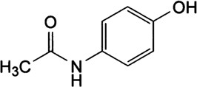

Figure 2.1 Structure of Paracetamol

The chemical name of Paracetamol is N-(4-hydroxyphenyl)acetamide or N-(4- hydroxyphenyl)ethanamide, with a structural formula of C8H9NO2 and a molar mass of

151.169 g/mol. It has a melting point of 169° C and density of 1.26 g/cm³.

Paracetamol is soluble in water sparingly, freely soluble in alcohol and slightly soluble in dichloromethane.

The structure of Paracetamol has a [benzene](http://en.wikipedia.org/wiki/Benzene) ring core, [substituted](http://en.wikipedia.org/wiki/Substituent) by one [hydroxyl](http://en.wikipedia.org/wiki/Hydroxyl) group and the [nitrogen](http://en.wikipedia.org/wiki/Nitrogen) atom of an [amide](http://en.wikipedia.org/wiki/Amide) group in the *para* (1,4) [pattern](http://en.wikipedia.org/wiki/Arene_substitution_patterns) (Bales *et al*., 1985). The amide group is [acetamide](http://en.wikipedia.org/wiki/Acetamide) and the antipyretic activity of the compound resides in the aminobenzene structure. It is an extensively [conjugated system](http://en.wikipedia.org/wiki/Conjugated_system), as the [lone pair](http://en.wikipedia.org/wiki/Lone_pair) on the hydroxyl oxygen, the benzene pi cloud, the nitrogen lone pair, the [p](http://en.wikipedia.org/wiki/Atomic_orbital) [orbital](http://en.wikipedia.org/wiki/Atomic_orbital) on the [carbonyl](http://en.wikipedia.org/wiki/Carbonyl) carbon, and the lone pair on the carbonyl oxygen are all conjugated.

The presence of the two activating groups also makes the benzene ring highly reactive towards [electrophilic](http://en.wikipedia.org/wiki/Electrophile) aromatic substitution. As the substituents are *ortho, para*-directing and *para* with respect to each other, all positions on the ring are more or less equally activated. The conjugation also greatly reduces the [basicity](http://en.wikipedia.org/wiki/Base_%28chemistry%29) of the oxygens and the nitrogen, while making the hydroxyl acidic through delocalisation of charge developed on the [phenoxide](http://en.wikipedia.org/wiki/Phenol) [anion](http://en.wikipedia.org/wiki/Ion) (Bales *et al*., 1985).

* + 1. Synthesis of paracetamol

In the laboratory, paracetamol can easily be prepared by [nitrating](http://en.wikipedia.org/wiki/Nitration) phenol with [sodium](http://en.wikipedia.org/wiki/Sodium_nitrate) [nitrate](http://en.wikipedia.org/wiki/Sodium_nitrate) separating the desired *para-* nitrophenol from the *ortho*- byproduct, and reducing the [nitro group](http://en.wikipedia.org/wiki/Nitro_group) with [sodium borohydride.](http://en.wikipedia.org/wiki/Sodium_borohydride) The [*4*-aminophenol](http://en.wikipedia.org/wiki/4-aminophenol) produced is then acetylated with [acetic anhydride](http://en.wikipedia.org/wiki/Acetic_anhydride) according to Köfalvi (2008). In this reaction, [phenol](http://en.wikipedia.org/wiki/Phenol) is a strong activating agent, thus the reaction requires only mild conditions. The industrial process is analogous, but hydrogenation is used instead of the sodium borohydride reduction (Ottani, *et al*., 2006).

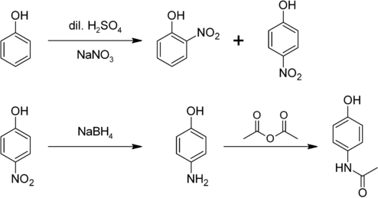

Figure 2.2 Synthesis of Paracetamol by nitration

Hoechst-Celanese used a simpler process that involves direct acylation of phenol with acetic anhydride catalyzed by Hydrogen Flouride (HF), with conversion of the ketone to a [ketoxime](http://en.wikipedia.org/wiki/Ketoxime) with [hydroxylamine,](http://en.wikipedia.org/wiki/Hydroxylamine) followed by the acid-catalyzed [Beckmann](http://en.wikipedia.org/wiki/Beckmann_rearrangement) [rearrangement](http://en.wikipedia.org/wiki/Beckmann_rearrangement) resulting to the amide (Harvison *et al*., 1986; Hogestatt *et al.,* 2005).

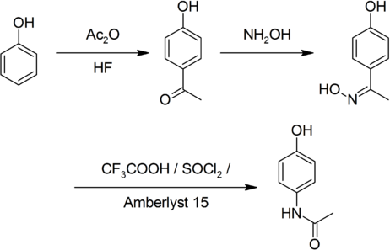

Figure 2.3 Synthesis of paracetamol by Acylation

# 2.2 Overview of Pharmacokinetics

Pharmacokinetics involves the processes associated with the absorption, distribution, metabolism and elimination of a drug from the body or systemic circulation i.e quantitating drug and/or its metabolites level in body fluids, tissues and excreta at any point in time from the moment of administration until elimination from the body is complete (Kaplan and Jack, 1980). The primary standard of pharmacokinetic study is based on the data obtained after intravenous administration which goes directly into the blood stream. The parameters obtained are not affected by all the rate limiting and metabolic factors associated with drug absorption from other routes.

Pharmacokinetics describes a biological event in mathematical terms, by developing mathematical models to represent the body as a system of compartments, even though these compartments often have no apparent physiologic or anatomic reality. The one- compartment model simply depicts the body as a single homogenous unit. This model is particularly useful for the pharmacokinetic analysis of blood, plasma or serum concentration, salivary and urinary excretion data for drugs which rapidly distribute between plasma and other body fluids and tissues upon entry into systemic circulation.

Assuming the human body behaves like a one-compartment model does not necessary mean that the drug concentrations in all body tissues at any given time are the same. However, a one-compartment model does assume that any changes that occur in the plasma quantitatively reflect changes occurring in tissue drug levels. Another criterion for using a one-compartment model is that drug elimination occurs from the body in a first order fashion meaning that the rate of elimination of drug from the body is proportional to the amount of drug in the body at any time. The proportionality constant

relating the rate and amount is the first order elimination rate constant which has unit of reciprocal of time (min-1, hr-1 (Gibaldi and Perrier, 1975b).

The half-life is one of the most useful pharmacokinetic parameters obtained following the administration of a drug. The half-life of a drug is simply the time required for the amount of drug in the blood stream to reduce by fifty percent (Wagner, 1980; Gibaldi and Perrier, 1975b). This parameter is calculated by dividing 0.693 by the calculated slope of each exponential Phase of multiphasic blood/saliva level curve.

Another important parameter in use frequently is Area under the Curve of blood/saliva level against time. The method of calculating this parameter has been discussed by several authors (Wegner, 1967; Gibalbdi and Perrier, 1975c). Many authors have used area analysis to develop a pharmacokinetic pathway and to obtain the rate constants associated with the proposed pharmacokinetic model.

The total clearance of the drug is the sum of individual clearances of the drug by various organs and tissues. The volume of distribution (Vd) of a drug is inversely proportional to blood level that is, the larger the volume of distribution the more extensively the drug will be distributed from the blood into the tissues organs, and binding sites in the body. The volume of distribution can be calculated by various ways depending on the pharmacokinetic profile of the drug (Gibaldi and Perrier, 1975b)

Clinical implications of drug bioavailability changes that result either from a pathological condition, drug interaction, product substitution or any other factor, can be appropriately divided into three major groups: those that have definitely caused changes in clinical response, those which have not been shown to cause clinical changes but are highly likely to, and those that could bring about clinical changes in extreme situations.

* + - 1. Bioavailability changes that have caused altered clinical response: the instances where marked clinical changes have been associated with impaired drug bioavailability are due either to product substitution or formulation changes. Theses have been described for phenytoin (Eadie *et al.,* 1968), indomethacin (katz *et al*., 1968), tolbutamide (Carter, 1963), digoxin (Lindenbaum *et al*., 1961) and dicoumarol (Lozinski, 1960).
      2. Bioavailability changes which are likely to have clinical effects: if a drug meets any of the criteria mentioned (i), it is likely that a change in drug bioavailability will have a great clinical effect. They include cardiac glycosides, anticoagulants, antihypertensive agents, anticonvulsants and inorganic ions such as lithium (Santos, 1986). However in many cases, the level of these compounds in the body greatly exceeds the minimum required for activity and small changes in bioavailability are unlikely to be of clinical significance.
      3. Bioavailability changes that may have clinical effect: a clinical change will occur for all drugs provided the change in bioavailability is sufficiently large. A drug like aspirin which has a wide therapeutic index will produce no effect if it is not absorbed from a particular formulation (Morrison and Campbell, 1960). This bioavailability change is significant. The clinical effect may be altered by changes in either the rate or extent of drug absorption. Changes in absorption rate are more important for drugs with short biological and pharmacological duration, but effects tend to be attenuated with repeated dosing.
  1. .1 Pharmacokinetics of paracetamol
     + 1. *Absorbtion of paracetamol*

It is rapidly and almost completely absorbed from the gastro-intestinal tract after oral administration. It is distributed relatively uniformly throughout most body fluids and exhibits variable protein binding. Its concentration in the plasma reaches peak in about thirty minutes to one hour and the therapeutic half-life is approximately three hours (Flower *et al*., 1985). It is absorbed from the stomach and intestine (Jaffe *et al*., 1971). Excretion is almost exclusively renal, in the form of conjugated metabolites (Mitchell *et al.,* 1974).

It has been generally recognised that administration of a drug before or after a meal may alter the absorption. Meals have been reported to retard the absorption (Jaffe *et al*., 1971). A certain specific dietary component can significantly alter the absorption pattern of an orally administered paracetamol. A high fat diet or protein content before drug administration did not delay the absorption of paracetamol significantly; but a high carbohydrate meal with large amount of pectin reduced the absorption by 60-76% in the first one and half hrs compared with fasting state (Jaffe *et al*., 1971).

Chiou (1975) reported that food could significantly reduce the absorption rate and peak blood levels of paracetamol in humans but it had no significant effect on total bioavailability.

* + - 1. *Distribution and elimination of paracetamol*

It is relatively uniformly distributed throughout most body fluids (Flower *et al*., 1985). Elimination of paracetamol is largely found as glucoronide and sulphate conjugates while less than 50% is excreted in the urine (Mitchell *et al*., 1974). Paracetamol in urine

comes primary as acetaminophen glucoronide and is the largest fraction in humans; however, children have less capacity for glucoronidation than adults (Miller and Fischer, 1974).

* + - 1. *Metabolism of paracetamol*

Paracetamol is [metabolised](http://en.wikipedia.org/wiki/Drug_metabolism) primarily in the [liver,](http://en.wikipedia.org/wiki/Liver) into non-toxic products via three [metabolic pathways](http://en.wikipedia.org/wiki/Metabolic_pathway) as follows:

* + - * 1. [Glucuronidation](http://en.wikipedia.org/wiki/Glucuronidation): this accounts for about 40% to two-thirds of the metabolism of paracetamol.
        2. Sulfate conjugation: this may account for about 20–40% of the metabolism of paracetamol (Hendrickson *et al.,* 2006)
        3. N-hydroxylation and rearrangement, then GSH conjugation: this accounts for less than 15% of paracetamol metabolism. The hepatic [cytochrome P450](http://en.wikipedia.org/wiki/Cytochrome_P450) enzyme system metabolizes paracetamol, forming a minor but significant alkylating metabolite known as [NAPQI](http://en.wikipedia.org/wiki/NAPQI) (N-acetyl-p-benzo-quinone imine) or N-acetylimidoquinone (Hendrickson *et al.,* 2006). This by-product irreversibly conjugates with the [sulfhydryl groups](http://en.wikipedia.org/wiki/Thiol) of [glutathione](http://en.wikipedia.org/wiki/Glutathione) (Borne, 1995).

The pathways yield final products that are inactive, non-toxic, thus eventually excreted by the kidneys. The third pathway however, gives a toxic intermediate product NAPQI thus is primarily responsible for the [toxic effects](http://en.wikipedia.org/wiki/Paracetamol#Toxicity) of paracetamol and constitutes an example of [toxication](http://en.wikipedia.org/wiki/Toxication).

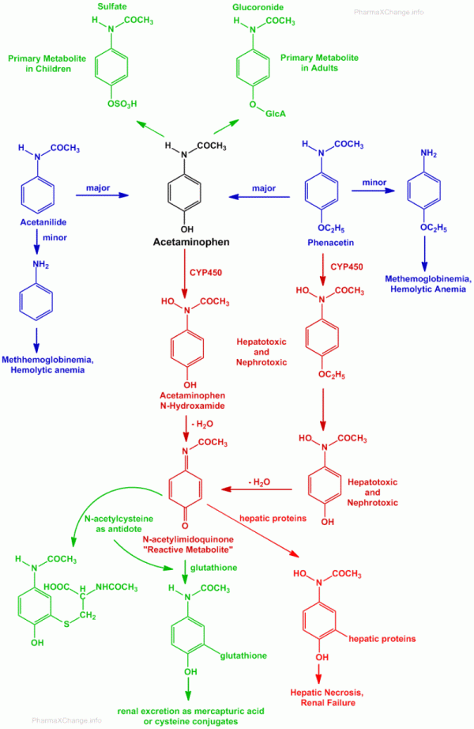

Figure 2.4 Chemical pathway of metabolism and excretion of paracetamol.

2.2.2 Pharmacodynamics of paracetamol

The antipyretic activity of paracetamol is thought to be mediated by central prostaglandin synthetase inhibition. This may also play a role in the analgesic effect though the precise mechanism remains unclear. Paracetamol does not have an anti- inflammatory effect and unlike NSAIDs, does not inhibit peripheral prostaglandin synthetase (Ottani *et al*., 2006). This lack of peripheral prostaglandin inhibition confers important pharmacological properties such as the maintenance of the protective prostaglandins within the gastrointestinal tract. Therefore, it is suitable for patients with a history of liver disease or on concomitant medication where peripheral prostaglandin inhibition would not be desired (such as those with a history of GI bleeding or the elderly) (Garcia *et al*., 2000).

# Panadol Extra® Tablets

Panadol Extra® (Paracetamol/ Caffeine, 500 mg / 30 mg) Tablets

This was first introduced into the drug market as this combination over two decades ago. The tablets contain two active ingredients, paracetamol and caffeine, this combination has been widely available for many years. Caffeine is a methylxanthine, it is used in combinations with paracetamol and acts to help the effectiveness of paracetamol with its actual mechanism of action unknown (MHRA UKPAR, 2010).

This combination is a mild to moderate analgesic and antipyretic. The tablets are recommended for the treatment of most painful and febrile conditions such as, headache, including migraine, backache, toothache, pain of osteoarthritis, and dysmenorrhoea, and for relieving the fever, aches and pains of colds and flu, and sore throat.

The maximum recommended dose of the combination product is two tablets every 4-6 hours, up to a maximum of 8 tablets in 24hours.

* + 1. Structure and reactivity of caffeine

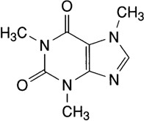

Figure 2.5 Structure of caffeine

The chemical name of caffeine is 1, 3, 7-trimethyl-1, 3-dihydro-1H-purine-2,5-dione, or 1, 3, 7-trimethylxanthine. It has a molecular formula of C8H10N4O2, and molecular weight of 194.2. It is a white or almost white, crystalline powder. It is sparingly soluble in water, freely soluble in boiling water, and slightly soluble in ethanol.

* + 1. Pharmacokinetics of caffeine in panadol extra® tablets

It is rapidly absorbed from the gastrointestinal tract and is widely distributed throughout the body. It is almost completely metabolized in the liver by oxidation and demethylation to various xanthine derivatives and is excreted in the urine. The mean plasma half-life is about 4.9 hours.

* + 1. Pharmacodynamics of Caffeine

Caffeine is a methylxanthine with a mild stimulant effect. The specific mechanism by which it acts as an analgesic adjuvant remains unclear but may be mediated via adenosine antagonism (adenosine; one of the kinins released in association with pain), inhibition of COX-2 synthesis or by affecting the emotional response to pain (Hinz, *et al*., 2008). The efficacy of the combination is superior compared to the single actives and placebo; it confirms that caffeine acts as an analgesic adjuvant which enhances the efficacy of paracetamol (MHRA UKPAR, 2010).

* + 1. Interaction
       1. Interactions with other medicinal products: The rate of absorption of paracetamol may be increased by metoclopramide or domperidone and absorption reduced by colestyramine. Anticoagulants like warfarin and other coumarins may enhance their effect by increasing risk of bleeding with regular use but occasional doses do not have significant effect (MHRA UKPAR 2010).
    2. Pregnancy and Lactation

Paracetamol/caffeine combination is not recommended for use during pregnancy as a result of its possible increased risk of spontaneous abortion associated with the consumption of caffeine. Caffeine in breast milk may potentially have a stimulating effect in breast fed infants but significant toxicity has not been observed (MHRA UKPAR, 2010).

* + 1. Side effects of paracetamol/ caffeine combination

When the recommended paracetamol/caffeine dosing regimen is combined with caffeine in diet, the resulting higher dose of caffeine may increase the potential for caffeine- related adverse effects such as insomnia, restlessness, anxiety, irritability, headaches, gastrointestinal disturbances and palpitations (Larson *et al*., 2005).

* + 1. Toxicity and overdose of panadol extra® tablets

Symptoms of paracetamol over dosage seen in the first 24 hours are pallor, nausea, vomiting, anorexia and abdominal pain. Liver damage may become apparent 12 to 48 hours after ingestion (Larson *et al*., 2005). Abnormalities of glucose metabolism and metabolic acidosis may occur. In severe poisoning, hepatic failure may progress to encephalopathy, haemorrhage, hypoglycaemia, cerebral oedema, and death. Acute renal failure with acute tubular necrosis, strongly suggested by loin pain, haematuria and proteinuria, may develop even in the absence of severe liver damage. Cardiac arrhythmias and pancreatitis have been reported (MHRA UKPAR, 2010).

* + - 1. *Management of paracetamol overdose*

Immediate treatment is essential in the management of paracetamol overdose. Despite a lack of significant early symptoms, patients should be referred to hospital urgently for immediate medical attention. Symptoms may be limited to nausea or vomiting and may not reflect the severity of overdose or the risk of organ damage. Treatment is aimed at removing the paracetamol from the body and replacing [glutathione](http://en.wikipedia.org/wiki/Glutathione) (Ryder and Beckingham, 2001).

Treatment with activated charcoal should be considered if the overdose has been taken within 1hour. Plasma paracetamol concentration should be measured at 4 hours or later after ingestion (earlier concentrations are unreliable). Treatment with N-acetylcysteine may be used up to 24 hours after ingestion of paracetamol; however, the maximum protective effect is obtained up to 8 hours post-ingestion. The effectiveness of the antidote declines sharply after this time. If required the patient should be given intravenous N-acetylcysteine, in line with the established dosage schedule. If vomiting is not a problem, oral methionine may be a suitable alternative for remote areas, outside hospital (MHRA UKPAR 2010).

* + - 1. *Management of caffeine overdose*

Symptoms of caffeine overdose include epigastric pain, vomiting, diuresis, tachycardia or cardiac arrhythmia, or CNS stimulation (insomnia, restlessness, excitement, agitation, jitteriness, tremors and convulsions). It must be noted that for clinically significant symptoms of caffeine overdose to occur with this product, the amount ingested would be associated with serious paracetamol-related liver toxicity.

Patients should receive general supportive care (e.g hydration and maintenance of vital signs). The administration of activated charcoal may be beneficial when performed within one hour of the overdose, but can be considered for up to four hours after the overdose. The CNS effects of overdose may be treated with intravenous sedatives.

# Assay Methods of Paracetamol

There are several methods for the quantitative determination of paracetamol in pharmaceutical preparations most of which are colorimetric and spectrophometric

assays. The type and design of assay procedure employed vary according to the concentration and medium of analysis. The earliest colorimetric assay of paracetamol in plasma was proposed by Brodie and Axelrod (1949). Paracetamol is hydrolysed by acid to form p –aminophenol then it is diazotized and coupled to alpha-naphthol; the azo dye is measured by a spectrophotometer, however this method is non- specific and time consuming (Wallace *et al*,. 1973). Other assay procedures utilize the reaction of p- aminophenol with sodium nitrate (NaNO3-HCl) to form the coloured 2-nitro-p- aminophenol (Glynn and Kendal, 1975; Chambers and Jones, 1976) and with Vanillin to a stable imine with an absorbance maximum at 395nm (Plankogiannis and Saad, 1978). These procedures resulted in good selectivity for paracetamol and found no interference from the sulphate and glucoronide conjugate of paracetamol.

* + 1. *In Vitro* bioavailability test of paracetamol

The pharmacokinetics of a drug product is very important in the formulation of solid dosages to ensure that a given dose of active ingredient is released at its site of action in amounts adequate to produce the desired effect after administration. Examples include disintegration tests, hardness test and dissolution test.

* + - 1. *Dissolution test*

The dissolution rate test provides a step for evaluation of physiological availability since the solid dosages have to be dissolved before absorption but it does not measure the safety or the effectiveness of the solid dosage form.

The physical characteristics and composition of a drug can have effect on the rate of disintegration, deaggregation and dissolution of the drug which in turn affect rate of

absorption and resultant blood levels of the drug. Drugs administered as solid dosage forms are often slowly absorbed because of their dissolution properties which are a rate limiting step for absorption. Thus anything that affects dissolution can affect the overall bioavailability of the drug.

Dissolution rate test is used as a means of quality assurance of a good pharmaceutical dosage form. It is used to confirm that a product is uniform from batch to batch and within the same batch during in- process quality control. The characteristics of the pure drug or the effect of excipients, the method of processing and manufacturing variables can be assessed using dissolution rate test. Others are optimization of therapeutic effectiveness during product development and stability assessment, assessment of

„bioequivalence‟, that is production of the same biological availability from discrete batches of products from one or different manufacturers and prediction of *in-vivo* availability, i.e. bioavailability.

The dissolution rate depends on the surface area of the solid, and in turn depends on the particle size. It also depends on the energy and energy states within the crystals of the drug. Noyes and Whitney in 1897 put into an equation the factors that affect dissolution rate as follows:

ds/dt =ks (cs-ct)

s is the surface area of the particles,

k is a constant specific to a substance and incorporates energy and entropy factors, cs is the concentration at saturation, and

ct is the concentration at time t.

K varies from drug to drug where some drugs have slow dissolution rate, some drugs may exist in more than one crystal form.

The rate of dissolution of an active drug ingredient can be altered by improper choice of ingredients and other formulation factors. This could be due to the effect of compaction during tableting, hydrophobicity by tablet lubricants and adsorption of air particles.

A solid drug when administered has to be dispersed into a solution. This solution surrounds the surface of the solid and moving where the particle moves. The rate at which the drug goes into solution can be explained by Fick‟s law of diffusion. The drug moves from area of higher concentration to area of lower concentration.

Rate of diffusion =DA/L (C1-C2)

According to Fick‟s law the rate of solution is directly proportional to the area of solid (Acm2), and inversely proportional to the L length of the path through which the dissolved solute must diffuse.

D is a constant called diffusion coefficient in cm2/sec. C1 is the saturation concentration;

C2 is the dissolution medium (lower concentration than C1). Factors that affect Dissolution Rate

The rate of dissolution of a solid dosage form can be affected by its particle size, solubility, chemical form, surface area and disintegration rate. The dissolution rate apparatus should be standardized in such a way as to simulate in vivo dissolution processes. The British Pharmacopoeia requires the stimer shaft eccentricity to be an imperceptible wobble; the sampling position should be half way between the basket and

the wall and half way up the basket while the speed of the drive motor should be kept constant. The use of deaerated dissolution medium is specified (B.P 2009). Aerated medium contains air bubbles which can form on the surface of the basket mesh thereby altering the flow of the medium from the basket. Samples should be filtered to remove solid particles which will give false spectrophotometric readings. The temperature of the dissolution medium is important and it is the only *in vivo* parameter that can be reproduced with ease in the laboratory since the dissolution strongly depends on the temperature of the medium.

* + - 1. *Disintegration rate tests*

This test is performed as per the pharmacopoeia standards. Disintegration is a measure of the quality of the oral dosage form like tablets and capsules. Each of the pharmacopoeia like the USP, BP, IP etc have their own set of standards and specification. The British Pharmacopoeia was the first, in 1945, to adopt an official disintegration test. It was in the year 1970 that the first dissolution apparatus, the rotating basket was designed and adopted in the USA (Wagner, 1971).

The disintegration test prescribed in the individual monograph of a product is to be followed. If the monograph does not specify any specific test, the general test for the specific dosage form may be employed. Some of the types of dosage forms and their disintegration tests are:

Uncoated tablets: Tested using distilled water as medium at 37±2 ºC at 29-32 cycles per minute; test is completed after 15 minutes. It is acceptable when there is no palpable core at the end of the cycle (for at least 5 tablets or capsules) and if the mass does not stick to the immersion disc.

Coated tablets: The same test procedure is adapted as in uncoated tablets but the time of operation is 30 minutes.

Enteric coated/ Gastric resistant tablets: The test is carried out first in distilled water at room temperature for 5 min as per USP and without distilled water for BP and IP, then it is tested in 0.1 M HCL for up to 2 hours as per BP or Stimulated gastric fluid 1 hour as per USP followed by Phosphate buffer, pH 6.8 (1 hour for BP) or Stimulated intestinal fluid without enzymes (1 hour as in USP).

Chewable tablets: this is exempted from disintegration test (BP and IP), 4 hours (USP). These are a few examples for illustration. The disintegration tests for capsules, both hard and soft gelatin capsules are also performed in a similar manner. The USP also provides disintegration tests for suppositories, pessaries etc.

Advantages of Disintegration test: Disintegration test is a simple test which helps in the preformulation stage to the formulator, It helps in the optimisation of manufacturing variables, such as compressional force and dwell time, this test is also a simple in- process control tool to ensure uniformity from batch to batch and among different tablets and it is also an important test in the quality control of tablets and hard gelatine capsules.

* + - 1. *Friability tests*

The ability of a solid dosage form to withstand mechanical abrasions and handling is determined by this test. It is expressed as percentage of friability. These abrasions could lead to capping, aberration or breakage of the tablets. Thus it is important to monitor the resistance of these tablets to decide their suitability for further distribution and handling (Jacob, 2011).

* + - 1. *Content and weight uniformity test*

These tests are performed on any solid dosage forms to ensure an individual receives in the dose an amount of that drug close to the label claim (Zaid *et al*., 2013 ; Vranic and Uzunovic, 2007). The B.P standards have provided limits for permissible variation in the amount of active ingredient of individual dose units. Its advantage is to assess the quality of a batch and helps to ensure that the strength of a product remains within the specified limits.

* + 1. *In Vivo* bioavailability testing of paracetamol

Bioavailability has been defined as the rate and extent to which an active ingredient or therapeutic moiety is absorbed from a drug product into systemic circulation which is normally estimated by its concentration in body fluids, or pharmacological effect (Skelly, 1976). Based on this definition the absorption of a drug administered through the intravenous route is rapid and complete. However most drugs are administered orally due to convenience and stability and the bioavailablity becomes incomplete due to individual differences thus not precise (Blanchard and Sawchuk, 1979).

Bioequivalence or bioavailability studies are usually based on the measurement of the active drug moiety and or its metabolites in biological fluids as a function of time. *In vivo* testing in humans usually dictates that the biological fluid sampled is limited to blood, urine and saliva.

Drug is administered to volunteers who are usually in fasted state (approximately 12 hours), will not be permitted food after administration of drug till last sample is collected and have not taken the drug for at least two (2) weeks. Blood or saliva samples

are collected at a frequency sufficient to permit the estimation of peak concentration in the sampled body fluid and the total area under the concentration time curve. In many cases where oral dosage forms are compared, the sampling times after drug administration will be identical and concentration time curves may be obtained after administration.

The bioavailability parameters include: peak plasma concentration (Cmax), time to reach the peak plasma concentration (tmax) and area under the Concentration time curve (AUC). The Cmax and tmax are used to measure the rate of bioavailability of the drug while the AUC defines the extent of drug absorption. Therefore bioequivalent studies is used to determine if the tested drug is equivalent to the reference form or demonstrate that there is no statistically significant difference between two products at a particular sampling time or interval.

The „absolute‟ bioavailability of a drug is usually a comparism of the area under the plasma concentration – time curve (AUC) from oral and intravenous administration of the drug. For practical purposes intravenous administration is not often possible, as such the „relative‟ bioavailability is determined by comparing the AUC‟s of the test drug and a secondary reference standard such as an orally administered solution which has been accepted as a standard (Gilbaldi and Perrier, 1975c; Blanchard and Sawchuk, 1979).

In some circumstances it is quite difficult to determine the availability of a drug following the administration of a single dose. The plasma levels of certain drugs may be very low such that an assay method sensitive enough to measure these levels may not be available. Other drugs which have longer half- lives require that their plasma samples be obtained for a longer periods of time. It is thus sometimes desirable to determine the

availability based on steady state plasma drug levels following multiple dosing (Gilbaldi and Perrirer, 1975b).

For the determination of the (AUC) plasma concentration time curve, the most commonly employed methods for calculation are the “cut and weigh” method, employment of plane meter and application of trapezoidal rule (Gibaldi and Perrier, 1975c).

*2.3.2.1 Factors affecting drug bioavailability*

The most common route of administration of drugs is orally due to its convenience. The compressed tablet is widely used and mostly involved in drug bioavailability and bioequivalent problems. This is due to the reduction in surface area of the drug in the compressed form and the wide variety of drug forms, tabletting methodologies, excipients and coating used for the formulation.

Absorption may be affected not only by the different dosage forms but also by similar dosage forms from different manufacturers and different batches of a dosage form from a single manufacturer. The most common conventional oral dosage forms in their order of decreasing order of relative dissolution and absorption rates are: solutions, suspensions, capsules, tablets, coated tablets and sustained- release preparations.

Factors which can produce significant differences in bioavailability include formulation and manufacturing variables such as particle sizes, chemical form and the solubility of the drug; the type and quantity of excipients used, compaction pressure (Blanchard and Sawuck, 1979). The various formulation and dosage form related factors which have been extensively discussed by Poole (1979), and many writers in this field include: particle size, crystal form, salt, complex, pH and solubility. Other factors are excipients and adjuvants as well as manufacturing methods (Poole, 1979). According to Poole, he

proved that bioavailability of some drugs has been improved by particle size reduction, and how the particle size reduction in recent years has been achieved. This is by the preparation of microcrystalline molecular dispersions of poorly soluble drugs in solid matrices of water soluble carriers.

The crystal form in which a drug is presented for administration is an important factor influencing the bioavailability of drugs. The crystal form of a drug may change because the substance exhibits polymorphism. This has been reported to be relatively common being exhibited by at least one-third of all organic compounds. Apart from the polymorphic forms which these substances exist, they can also occur in non-crystalline or amorphous form. The energy required to remove a molecule of drug from the crystal which it is located is greater than that required to escape from an amorphous powder. Therefore the amorphous form of the compound is always more soluble than the corresponding crystal form and may exhibit corresponding different therapeutic properties (Poole, 1979). Example of a drug with this property is chloramphenicol.

Complex formation is a process which occurs when drugs interact reversibly with substances present in the body, with other drugs or with pharmacologically inactive components of the dosage form. Such a drug may differ in its physicochemical properties from the pure drug. For example its ability to pass through biological membranes will be hindered thus become pharmacologically inactive since dissolution prior to absorption fails to occur (Poole, 1979). The effect of complexation of a drug on absorption depends on the magnitude of the stability of the complex.

The components in a dosage form other than the active ingredient may influence absorption and subsequently bioavailability. These excipients may either facilitate or inhibit the absorption process. The importance of excipients in the determination of

final drug effect was demonstrated by the outbreak of phenytoin toxicity in Australia. The toxicity occurred when patients were previously maintained with „Dilantin‟ capsules in which calcium sulphate had been used as inert excipient were given capsules containing some quantity of active compound but with the calcium sulphate substituted for lactose as inert excipient. It is assumed that the inorganic ion had complexed with phenytoin reducing absorption.

Interaction between drugs and dosage forms may influence the bioavailability of a drug. Such interactions may be directly as in the chelation of tetracycline by polyvalent metal ions or indirectly as with the increased rate of acetaminophen (paracetamol) absorption due to the stimulating effect of metoclopromide on the stomach emptying rate. However propantheline reduced the rate of acetaminophen absorption by delaying the stomach emptying rate (Welling, 1980).

Influence of food and specific dietary components on drug absorption was extensively reviewed (Welling, 1977). It reflects the complex and unpredictable nature of drug-food interactions and the difficulty of establishing patterns to be used as guidelines for optimum drug therapy. The presence of food has been shown to decrease, delay, increase and often not to affect drug absorption. Observed effects have been influenced by the type of drug and dosage form, the nature and size of meal, fluid intake, the conditions of the subject and the time sequence between eating and drug administration.

Although the studies of drug bioavailability are routinely carried out in human volunteers, drugs are administered in practice to patients who may be suffering from various ailments. Diseases concerning the gastrointestinal tract, cardiovascular system and liver may alter the circulating drug or metabolite level after oral dosing. Surgical removal of parts of the gastrointestinal tract reduces the absorption of most compounds,

suggesting that patients that have undergone such procedures may need to be monitored carefully when taking drugs while absorption efficiency is critical.

# CHAPTER THREE

# MATERIALS AND METHOD

# Materials

* + 1. Study site

The Faculty is located opposite the University sick bay and adjacent to Faculty of Veterinary Medicine. It is one out of 12 faculties in the university. The Faculty comprises of five (5) Departments and five (5) tiers of classes with a population of 854 undergraduate students.

* + 1. Human volunteers

Twelve (12) healthy adult volunteers between the ages of 20-29 years, seven (7) females and five (5) males participated in the study. They were undergraduate students of the Faculty of Pharmaceutical Sciences of Ahmadu Bello University, Zaria.

* + - 1. *Recruitment of human volunteers*

Prior to the study, the 400L and 500L undergraduate classes were briefed on the study, about 20 students showed interest in the exercise but after complete orientation on the design and protocol, they were subjected to the inclusion and exclusion criteria, we were able to get 12 volunteers that satisfied the inclusion criteria.

* + - 1. *Inclusion criteria*

Students who were able to satisfy the following criteria were enrolled:

* + - * 1. Non smokers or non alcoholics
        2. Not taken Paracetamol or any drug with paracetamol for the preceeding two weeks
        3. Had no apparent liver disease
        4. Agreed to fast over night before the exercise begins; and throughout the period of sample collection
      1. *Exclusion criteria*

Students were excluded from the study if they:

* + - * 1. Smoke or drink alcohol
        2. Had taken paracetamol or any drug containing paracetamol in the preceeding two weeks
        3. Could not fast overnight
    1. Drugs

Panadol® tablets (GlaxoSmithkline Ltd); Batch No. 093U, 084U, 067U. Panadol Extra® tablets (GlaxoSmithKline Ltd); Batch No. 196U, 134U, 004U.

* + 1. Chemicals

 15% Trichloroacetic Acid (C2HCl3O2, MW 163.39) (BDH Chemicals Ltd, Poole England)

 15% Sulfamic Acid (NH2SO3H, MW 97.09) (BDH Chemicals Ltd, Poole England)

 15% Sodium Hydroxide (NaOH, MW 40.0) Analar grade 6N Hydrochloric Acid (HCl, MW 36.46) Analar grade

 15% Sodium Nitrite (NaNO2, MW 69.0),

 Paracetamol Powder B.P; MD: 07/12; ED: 06/17; Batch Number: 1307102 Distilled water

* + 1. Equipments and apparatus

Test tubes, Centrifuge tubes, Pipettes (1ml, 5 mls), volumetric flasks (10 ml, 50 mls, 100 mls, and 250 mls), measuring cylinder 10ml, Measuring Scoop, Spatula, Sample bottles, Wash bottles, Testtube holders, Weighing Balance (Gallenkamp), Water bath (Mc Donald Scientific International), UV Spectrophotometer (Hellious Zeta Thermo Scientific England), Centrifuge Gallenkamp (England), Flask Shaker Gallenkamp (England), Isotemp Oven Fisher Scientific (England), Freezer Haier Thermacool HF- 299, Friabilator Erweka (England)

# 3.2 Methods

* + 1. *In Vitro* experiment
       1. *Chemical assay of paracetamol*

Twenty (20) tablets were weighed from each batch sampled and the average weight determined. The tablets were powdered and a quantity of the powder equivalent to 0.15 g of paracetamol was weighed and dissolved into 50 ml of 0.1M NaOH solution in 200ml flat bottom flask and diluted with 100 ml of water. This was shaken for 15 minutes, and then sufficient water was added to produce 200 ml. The solution was filtered and 10ml of the filtrate was diluted to 100 ml with water. 10 ml was pipetted

from the resulting solution and added to 10 ml of 0.1M NaOH, which was diluted to 100 ml with water and the absorbance of the resulting solution measured at 257nm using a UV spectrophotometer. The percentage content of paracetamol was calculated taking 715 as the value of A (1%, 1cm) at the maximum of 257 nm B.P, 2009) using the formula below:

Percent content of Paracetamol = *Absorbance x Dilution factor*

*[Weight of drug in g x A]*

Where

A (1%, 1cm) is the absorbance of a 1cm layer of a 1% w/v solution of the absorbing solute. It is also called the specific absorbance

* + - 1. *Dissolution rate test*

The USP basket method was used for the dissolution tests. The dissolution medium is a litre of 0.1M HCl, introduced into the vessel immersed in a water bath maintained at 37oC. For each test, one tablet was placed in the basket and allowed to rotate at a speed of 100 rev/min and a sample of 5ml dissolution medium was withdrawn at 1, 5, 10, 20, 40 and 60 minutes. These samples were withdrawn from half way between the basket wall and the wall of the vessel to ensure that the normal pattern of flow of dissolution medium was not disturbed. An equivalent volume of 5ml of the dissolution medium was replaced after each withdrawal. These samples of the dissolved drug was filtered and its absorbance taken at 257nm.

* + - 1. *Disintegration tests*

One tablet each was placed in all the tubes of the basket and a disc was added to each tube. The assembly was then suspended in a beaker containing distilled water and maintained at 37ºC using a thermometer and the machine allowed running till the tablets disintegrated. The average time taken to disintegrate was recorded for each tablet.

* + - 1. *Friability tests*

Twenty (20) tablets of each sample were weighed before transferring into a friability tester which was allowed to run at 25 revolutions per minute for 4 minutes. The tablets are then reweighed and recorded.

* + - 1. *Weight uniformity test*

Twenty (20) tablets of each formulation were weighed individually and the average weight and percentage mean deviation determined.

* + 1. *In Vivo* experiments
       1. *Calibration curve*

Paracetamol powder was used to prepare 1000 mg /L stock solution by dissolving1000mg powder in 1000ml of warm distilled water. The stock solution was used to prepare eight series of (25 mg/l – 500 mg/l) working standards, 25, 50, 100, 150,

200, 250, 300, 350, 450 mg/l. The blank saliva was added to a flask of distilled water,then 0.5ml blank saliva was added to each flask to simulate *in vivo* concentrations. All samples were treated as mentioned in the colorimetric assay method. The absorbance was measured at 430nm against reagent blank of water. Graph of absorbance versus concentration were plotted.

* + - 1. *The validation experiments*

The paracetamol assay validation studies in aqueous solution were carried out using the modified method to measure standard paracetamol concentrations 25, 50, 100, 150, 200, 250, 300 and 400 mg/l using a UV spectrophotometer. It was evaluated by assay of paracetamol standards, the absorbance were measured at 430nm against reagent blank of water. Graphs of absorbance versus concentration were plotted; the stability of the final coloured solutions was also assessed up to 10 min.

* + - 1. *Protocol*

Twelve (12) apparently healthy adult volunteers took part in the study. The protocol was explained to them and an informed consent was obtained.

The study was single blind, cross over study with a wash out period of two weeks between administrations. On the day of each test, a 2ml blank saliva sample was collected after stimulation with a rubber band at time 0 minute. Subsequently, stimulated salivary samples were collected into plain plastic containers at time 5, 10, 20, 30, 60, 120, 180, 240, 360 minutes after ingestion of 1g tablets of the study drug with water. All volunteers remained with no food or drink while samples were collected. Samples were stored in a refridgerator at -10ºC until analysed.

***3****.2.2.2 Analysis of saliva samples*

The paracetamol assay method used in this study is based on the Glynn and Kendal (1975) colorimetric method with a few modifications by Shihana (2010) which came about in order to decrease the production of nitrous gas.

In the modified method, 0.5 ml of saliva was pipetted into a 15 ml centrifuge tube containing 1.0 ml of 15% trichloroacetic acid. After mixing, it was centrifuged for three minutes and the clear supernatant decanted into a 10 ml test tube containing 0.5 ml 6*N* hydrochloric acid. Nitrous acid was generated by adding 0.4 ml of sodium nitrite to the resulting solution. The contents were allowed to stand for two minutes, and then 1.0 ml of 15% sulphamic acid was added carefully to neutralize excess nitrous acid. Finally,

* 1. ml of 15% sodium hydroxide was added and the absorbance of each sample was measured at 430 nm, against a reagent blank of water.

# 3.3 Statistical Analysis

The results of the various studies were recorded as means ± SEM. The data were statistically analysed using Independent student‟s paired t test (IBM SPSS statistics 20) for all data except dissolution studies where analysis of variance (ANOVA) was used. Differences between sampled drugs of P ≤ 0.05 were considered to be statistically significant.

# CHAPTER FOUR

# RESULTS

# Uniformity of weight test of Paracetamol tablets

The result of uniformity of weight test is shown in table 4.1. It shows that in the weight uniformity test the deviation from the mean was 1.5% for sample A1, 2.4% for A2, 1.1% for A3 and 1.7%, 1.4% and 1.7% for samples B1, B2 and B3 respectively.

# Table 4.1: Weight Uniformity Test for Samples of Panadol® and Panadol Extra® Tablets

|  |  |  |
| --- | --- | --- |
| **Samples of Paracetamol** | **Mean weight (g)± SEM** | **% Mean deviation** |
| **A1** | 0.65 ±0.03 | 1.5* |
| **A2** | 0.62 ±0.03 | 2.4* |
| **A3** | 0.65 ±0.02 | 1.1* |
| **B1** | 0.65 ± 0.01 | 1.7* |
| **B2** | 0.65 ±0.02 | 1.4* |
| **B3** | 0.67 ±0.01 | 1.7* |

**Key**: A1, A2 and A3 are samples of Panadol® tablets

B1, B2 and B3 are samples of Panadol Extra® tablets

* passed (B.P 2009 stated that not more than two of the individual weights for tablet of average weight 250mg or more deviates from average weight by more than 5% and none deviates by more than twice that percentage).

# Friability Test

The percentage friability of Samples A1, A2 and A3 were found to be 0.17%, 0.42% and 0.43% respectively, while those of samples B1 and B2 had 0.74% and 0.33% respectively. However, Sample B3 had 5.83% which was greater than 1% and so had failed the test (Table 4.2)

# Table 4.2: Friability Test for Samples of Panadol® tablets and Panadol Extra® Tablets

|  |  |
| --- | --- |
| **Samples of Paracetamol** | **% Friability** |
| **A1** | 0.17* |
| **A2** | 0.42* |
| **A3** | 0.43* |
| **B1** | 0.74* |
| **B2** | 0.33* |
| **B3** | 5.83** |

**Key**: A1, A2 and A3 are samples of Panadol® tablets

B1, B2 and B3 are samples of Panadol Extra® tablets

*passed, **failed

(B.P 2009 states that the percentage friability of a tablet should not be greater than 1%)

# Disintegration Test

Samples A1, A2 and A3 disintegrated in a mean time of 1.7 min, 1.2 min and 1.3 min respectively while samples B1, B2 and B3 disintegrated in a mean time of 1.3 min, 1.0 min and 0.5 min respectively. The B.P 2009 specification states that all tablets should disintegrate before 15 minutes (Table 4.3).

# Table 4.3: Disintegration Test for Samples of Panadol® and Panadol Extra® tablets

|  |  |
| --- | --- |
| **Sample of Paracetamol** | **Average disintegration time (min)** |
| **A1** | 1.7* |
| **A2** | 1.2* |
| **A3** | 1.3* |
| **B1** | 1.3* |
| **B2** | 1.0* |
| **B3** | 0.5* |

**Key**: A1, A2 and A3 are samples of Panadol® tablets

B1, B2 and B3 are samples of Panadol Extra® tablet

*passed

(B.P 2009 states that all tablets should disintegrate before 15 minutes)

# Dissolution Test (USP XIX)

The mean concentration of the samples in 0.1M HCl after 1hr for the tablets is as shown in the table 4.4. Samples A1, A2and A3 had 97.8%, 98.8% and 98.0% dissolution of active ingredient respectively while Samples B1, B2 and B3 had 99.4%, 99.2% and 99.6% respectively. The time for half of the drug to go into dissolution state was less than 5 minutes. It was observed that the entire samples dissolution rate increased rapidly in the first 10 minutes then remaining constant afterwards.

# Table 4.4: Dissolution Rate Studies of Samples of Panadol® and Panadol Extra® tablets in 0.1M HCl using USP rotating basket method measured at 257nm

**dissolved**

**Sample**

|  |  |  |  |  |  |  |  |
| --- | --- | --- | --- | --- | --- | --- | --- |
|  | **1** | **5** | **10** | **20** | **40** | **60** | **after 45 mins** |
| **A1** | 220±5.04 | 448±7.36 | 468±3.38 | 478±4.06 | 484±1.16 | 489±2.19 | 97.8 |
| **A2** | 208±5.04 | 450±7.36 | 466±3.38 | 470±4.06 | 482±1.16 | 494±2.19 | 98.8 |
| **A3** | 225±5.04 | 427±7.36 | 457±3.38 | 464±4.06 | 480±1.16 | 490±2.19 | 98.0 |
| **B1** | 300±5.77** | 459±1.73 | 488±3.84 | 478±2.08 | 480±2.91 | 497±2.60 | 99.4 |
| **B2** | 280±5.77** | 465±1.73 | 476±3.84 | 485±2.08 | 490±2.91 | 496±2.60 | 99.2 |
| **B3** | 290±5.77** | 462±1.73 | 477±3.84 | 480±2.08 | 486±2.91 | 498±2.60 | 99.6 |

# Concentration (mg/L) / Time (min) %

Data was analysed using one way ANOVA and **p<0.01is significant

**Key**: A1, A2 and A3 are samples of Panadol® tablets

B1, B2 and B3 are samples of Panadol Extra® tablets

(B.P 2009 states that for a tablet to pass dissolution test, the amount of active ingredient released after 45 min should not be less than 70%)

# Chemical Assay Result of Panadol® and Panadol Extra® tablets

The assay of paracetamol content in each tablet revealed that, Samples A1, A2 and A3 had percentage active content of 101.37%, 102.16% and 99.95% respectively; while Samples B1, B2 and B3 had 97.07%, 100.78% and 101.17% respectively. All the samples analysed passed the test as the percentage content were within the B.P (2009) limits of 95% - 105%.

# Table 4.5: Chemical Assay of Samples of Panadol® and Panadol Extra® Tablets

|  |  |  |
| --- | --- | --- |
| **Sample** | **Content of paracetamol per tablet (mg)** | **Percentage content (%)** |
| **A1** | 506.80 | 101.37* |
| **A2** | 510.80 | 102.16* |
| **A3** | 499.77 | 99.95* |
| **B1** | 485.33 | 97.07* |
| **B2** | 503.89 | 100.78* |
| **B3** | 506.38 | 101.19* |
| **Standard** | 502.77 | 100.55* |

**Key**: A1, A2 and A3 are samples of Panadol® tablets

B1, B2 and B3 are samples of Panadol Extra® tablet

*passed (B.P 2009 states that the percentage content of active ingredient should be within limits of 95-105%)

# Calibration Curve of Standard Paracetamol Powder

The calibration curve of paracetamol in saliva was plotted using the absorbance from the UV spectrophotometer and is as shown in figure 4.1 with correlation coefficient of (r2 = 0.9926.); the figure shows the calibration plot for the standard paracetamol solution and correlation coefficient for the calibration curve.

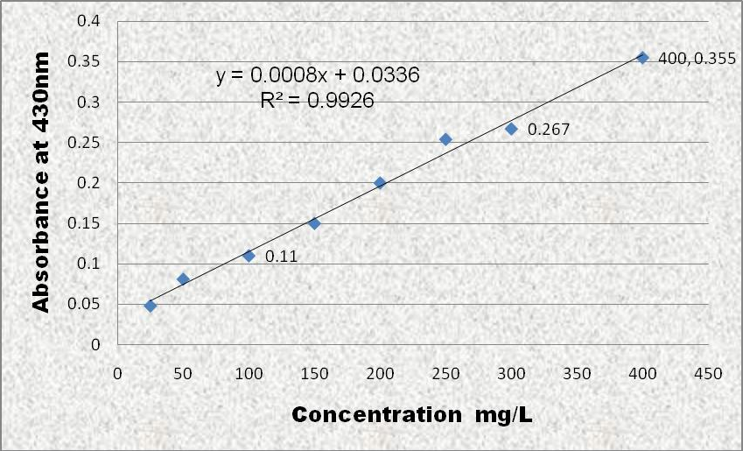

Figure 4.1: Calibration Curve of Standard Paracetamol Powder using UV Spectrophotometer at 430nm

# Validation Studies

The paracetamol assay validation studies in aqueous solution performed well up to a concentration of 400mg/L. The correlation coefficient variant and accuracy for the standards were 0.14%

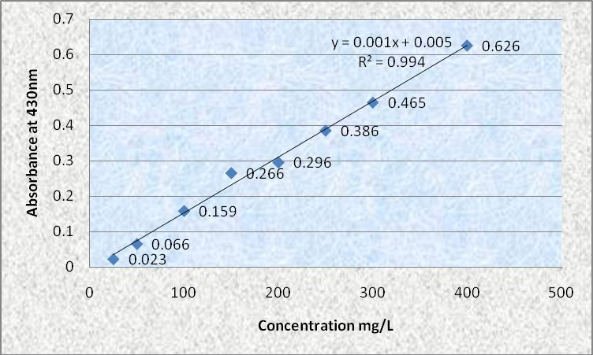

Figure 4.2: Validation studies of Standard Paracetamol Powder using UV Spectrophotometer at 430nm

* 1. ***In vivo* studies**

The colorimetric assay of paracetamol validation studies in aqueous solution were found to perform well up to a concentration of 400 mg/L (r2=0.9926). The administration of 1g samples with 200ml water to volunteers gave mean saliva concentrations indicated in appendix1 and 2. The mean peak saliva concentrations Cmax ranges from 20.60 - 25.20 µg/ml while the mean time taken (Tmax) to reach peak concentration was 0.33hr for all volunteers (table 4.6).

Mean saliva semi - log concentration time curves are shown in figures 4.3. The pharmacokinetic parameters obtained from the plots of the mean saliva concentration for all samples are shown in table 4.6. The average lag time calculated during exposure was three and half (3.5) minutes for Panadol Extra® tablets and four (4) minutes for Panadol® tablets. The pharmacokinetic parameters compared showed variable values. However consistently higher saliva paracetamol concentrations with mean 23.90 ± 0.40 µg/ml indicated with Panadol Extra® tablets which was statistically significant (p<0.05) compared to Panadol® tablets with mean of 21.60 ± 0.34 µg/ml.

Ke calculated ranged from 0.62 – 0.98 (µg/ml/hr) for all samples with mean of 0.95 ±

0.1 (µg/ml/hr) for Panadol® tablets and 0.71 ± 0.3 (µg/ml/hr) for Panadol Extra® tablets.

Ka calculated ranged from 6.89 – 15.47 (µg/ml/hr) for all samples with mean of 9.75 ±

0.68 for Panadol tablets and 10.61 ± 1.30 (µg/ml/hr).

Elimination half-life of Panadol Extra® tablets calculated was within the range of (0.89 - 1.18hr-1) with mean of 1.02 ± 0.04 hr-1 while Panadol® tablets ranged within (1.32- 1.41hr-1) with mean of 1.36 ± 0.02 hr-1.

The calculated volume of distribution ranged from 14010.77 – 27652.94 (mls) for all samples with mean of 20808.08 ± 1586.30 (mls) as indicated in table 4.6 for Panadol®

tablets and 16967.20 ± 1084.94 (mls) for Panadol Extra® tablets. The clearance calculated ranged from 10680.41 – 25213.95 (ml/hr) for all samples with mean of 19596.25 ± 1338.13 (ml/hr) for Panadol® tablets compared to mean value of 11989.12 ±

688.13 (ml/hr) indicated for Panadol Extra® tablets was statistically significant at p≤ 0.05.

The area under the concentration time curve AUC0-6hr calculated indicated a mean of 5497.00 ± 362.02 (µg/ml/hr) for Panadol® tablets and 5958.87 ± 243.30 (µg/ml/hr) indicated for Panadol Extra® tablets. All the other values calculated did not show significant difference when compared.

# Table 4.6: Mean Saliva Paracetamol Concentration in Panadol® tablets and Panadol Extra® tablets

|  |  |  |
| --- | --- | --- |
| **Time (Min)** | **Panadol® tablets** | **Panadol Extra® tablets** |
| **5** | 7.63 ± 0.75 | 8.43 ± 0.72 |
| **10** | 11.32 ± 0.45 | 12.45 ± 0.25 |
| **15** | 15.22 ± 0.24 | 16.58 ± 0.33 |
| **20** | 21.6 ± 0.34 | 23.90 ± 0.40 |
| **30** | 17.88 ± 0.26 | 19.03 ± 0.18 |
| **60** | 15.38 ± 0.25 | 16.35 ± 0.09 |
| **90** | 13.73 ± 0.17 | 14.28 ± 0.23 |
| **120** | 11.72 ± 0.28 | 12.22 ± 0.21 |
| **180** | 5.07 ± 0.04 | 6.02 ± 0.32 |
| **360** | 2.32 ± 0.07 | 2.97 ± 0.10 |

Values are expressed as mean ± SEM.

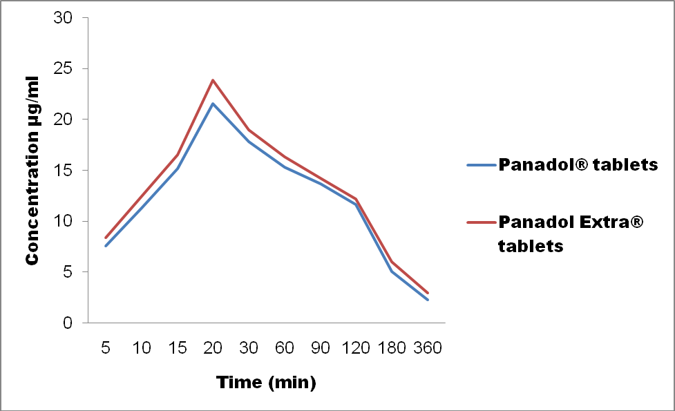

Figure 4.3: Mean saliva concentration of paracetamol in Panadol® tablets and Panadol Extra® tablets

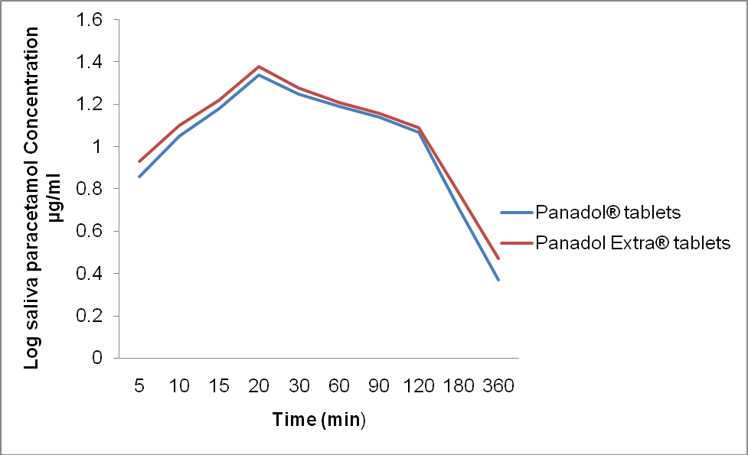

Figure 4.4 Semi- log saliva paracetamol concentration time graph of Panadol® tablets and Panadol Extra® tablets

# Table 4.7: Mean Pharmacokinetic Parameters for Samples of Paracetamol in Panadol® tablets and Panadol Extra® tablets

|  |  |  |
| --- | --- | --- |
| **Pharmacokinetic Parameters** | **Panadol® tablets** | **Panadol Extra® tablets** |
| **Lag time (min)** | 4.0±0.45 | 3.5±0.22 |
| **Cmax (µg/ml)** | 21.60±0.34 | 23.90±0.40* |
| **Tmax (hr)** | 0.33±0.00 | 0.33±0.00 |
| **Ke (µg/ml/hr)** | 0.95±0.10 | 0.71±0.30 |
| **Ka (µg/ml/hr)** | 9.75±0.68 | 10.61±0.13 |
| **t*1/2α* (hr)** | 14.06±0.98 | 15.30±1.89 |
| **t*1/2β* (hr)** | 1.36±0.02 | 1.02±0.04 |
| **Vd(ml)** | 20808.08±1586.30 | 16967.20±1084.94 |
| **Cl (ml/Hr)** | 19596.25±1338.13 | 11989.12±688.13* |
| **AUC0-6hr (µg/ml)** | 5497.00±362.02 | 5958.87±243.30 |
| **AUC0-*∞* (µg/ml)** | 5498.50±362.02 | 5961.02±243.30 |

Data was analysed using independent student paired t- test and * p<0.05, significant difference. Values are expressed as mean ± SEM.

# CHAPTER FIVE

# 5.0 DISCUSSION

The in vitro weight uniformity test ensures that the formulation is of similar thickness (mass). The samples used for this study all passed the weight uniformity test. B.P (2009) stated that not more than two of the individual weights (for tablet of average weight of 250mg or more) deviates from the average weight by more than 5% and none deviates by more than twice that percentage. The significance of this test is to ascertain its quality and was cofirmed.

Tablet formulations are consistently subjected to mechanical stress from the point of production, through handling and transportation till it is consumed. The samples analysed passed the friability test except for sample B3 (Panadol Extra® tablets). This could be due to insufficient binder in the mixture and/or insufficient compression strength, as all samples of B3 were very soft. It correlated with values of disintegration test where it disintegrated in the least mean time of 30 seconds that is less than one minute. The aim of the test is to ensure that tablets will withstand the mechanical stress during handling; transportation and they will not break or lose significant weight to abrasions. The loss of any part of the tablet results in loss of active ingredient in the formulation.

The disintegration test is very crucial in a solid tablet formulation. The B.P 2009 specification states that all tablets should disintegrate before 15 minutes. All tablets sampled passed the disintegration test as they disintegrated before 15mins. The time of disintegration is a measure of the quality of a tablet, this is because, if the disintegration time is too long; it means that the tablet was highly compressed or excess amount of binder in the formulation and may not release the active ingredient at the right time

which may often affect the drug‟s bioavailability or it may imply several other reasons. Similarly if the disintegration time is not uniform in a set of samples being analysed, it indicates batch inconsistency and lack of batch uniformity.

The dissolution rate of a drug is used to identify a crucial effect in the bioavailability of the active ingredient (Jacob, 2011). The absorption of solid oral formulations depends on the release of the therapeutic moiety at a given time. The B.P 2009 specification states that for a tablet to pass dissolution test, the amount of active ingredient released after 45 min should not be less than 70%. The time for half of the sampled drugs to go into dissolution state was less than 5 minutes and over 80% was in dissolution after 45 minutes. The sample tablets passed the dissolution test thus they are bioequivalent for the paracetamol component.

From the dissolution studies results, samples of Panadol Extra® tablets (B1, B2 and B3) were observed to release over 50% of the active ingredient in the first minute compared to samples of Panadol® tablets (A1, A2 and A3) as seen in table 4.4. This correlates with the mean saliva concentrations that revealed higher mean peak saliva paracetamol levels in samples of Panadol Extra® and was statistically significant at P ≤ 0.05 compared to samples of Panadol® tablets.

The variation in dissolution rate of samples of paracetamol can be explained by many formulation factors. They include: amount and type of diluents (Marlowe and Shangraw, 2006), binder and disintegrant (Suren 2010). Method of incorporation of the ingredients, the compressional force and speed of compression are also factors leading to variations in the dissolution rates of tablets (Khan and Rhodes, 1992).

The samples analysed passed the chemical assay test as the percentage content all were within the limits of the B.P (95% - 105%). The presence and percentage content of

active ingredient in the samples used were determined quantitatively. This has shown that the samples actually contain the label claim of the active ingredient and they are chemically equivalent. The label claim of 500mg paracetamol in the samples confirmed will be expected to produce similar bioavailability following administration but this is not often achieved due to difference in subject physiological factors. The *in vitro* analysis carried out showed that the samples selected are of good quality and have been manufactured based on good manufacturing practices.

The semi – log mean saliva concentration time graphs plotted fitted into first order kinetics. This means the amount of drug in the body at any time is proportional to the elimination of the drug from the body at that time. The proportionality constant relating the rate and the amount in the body is the first order elimination rate constant (Gibaldi and Perrier, 1975). The pharmacokinetics of paracetamol have been investigated extensively (Thomas, 1993) and others, they have all shown varying inter individual differences in the plasma and saliva levels on the pharmacokinetics of paracetamol. All pharmacokinetic parameters derived compared well with already established values.

There were differences as well as similarities in the calculated individual pharmacokinetic parameter as in table 4.7. The tmax for all samples were 0.33hr. The lag time indicated faster onset of action for Panadol Extra® tablets than for Panadol® tablets.

The peak saliva paracetamol levels ranging from 22.20 – 25.20 (µg/ml) were recorded for all samples of Panadol Extra® tablets which was statistically significant at P ≤ 0.05 when compared with saliva paracetamol levels of samples of Panadol® tablets ranging from 20.60 – 22.50 (µg/ml) thus confirming greater bioavailability. In the calculated elimination half-life of Panadol Extra® tablets it was seen to be lower than the value of

Panadol® tablets. It was shorter than the time seen in the latter thus shows as it‟s absorbed faster into the systemic circulation, it is also eliminated faster. Other parameters slightly different within subjects are in agreement with the findings of Levy *et al*., 1965 and Albert *et al*., 1974 though not statistically significant. The differences observed in the individual parameters are due to individual variability (females may be in their Luteal or ovulatory phase of their menstrual cycle) or varying degree of the hepatic first-pass effect.

Caffeine is claimed to enhance the efficacy of paracetamol was confirmed with the high Cmax observed with the combination leading to greater bioavailability. However, peak plasma levels and extent of absorption are similar for paracetamol with caffeine and paracetamol alone (GSK, 2009). The extent to which caffeine improves the analgesic effect of paracetamol is uncertain and may not be clinically meaningful. Published trials have assessed the effect of combining caffeine with paracetamol compared with paracetamol alone (Ward *et al*., 1991)

Trials were generally of poor quality and had conflicting results: some showed a small benefit, most did not. For example, a trial of 320 young women found that a single dose of paracetamol with caffeine provided more relief in pain for primary dysmenorrhoea 2 hours after administration than paracetamol but it is unclear whether this is clinically meaningful (Ali Z *et al*., 2007).

Another example is the study of characterization of analgesia. The analgesic activities of paracetamol (100, 178, 316 and 562 mg kg−1), caffeine (10, 18, 32 and 56 mg kg−1) and combinations of these doses were tested on a pain-induced functional impairment model in the rat. Paracetamol alone induced a dose-dependent analgesic effect while caffeine alone did not exhibit any activity at the assayed doses. It is concluded that

caffeine is able to potentiate the analgesic effect of paracetamol by a pharmacodynamic mechanism, but this only occurs at certain dose combinations (Vinicio, *et al*., 2011).

The individual variations found from the calculated pharmacokinetic parameters could be from many factors such as drug absorption, pharmaceutical formulation and subject characteristics. The latter can result in great differences in the efficacy of a drug product. The rate of gastric emptying is one of the characteristics that influence drug absorption; this may affect even the bioavailability (Rawlings, 1979). It is an important rate limiting step in the absorption of paracetamol.

# CHAPTER SIX

# SUMMARY AND CONCLUSION

# Summary

The samples of Panadol® and Panadol Extra® tablets used in this study have passed the official tests for identification and percentage content of active ingredient, weight uniformity/variation, disintegration and dissolution based on the B.P 2009 specifications. However, Panadol Extra® tablets sample (B3) failed friability test, though other test samples passed this test. These tests have shown that both sampled products are chemically equivalent in their paracetamol component and have been manufactured based on good manufacturing practice. However the pharmacokinetic parameters calculated indicated varying values and only the peak saliva concentration levels was statistically significant at p ≤ 0.05.

# Conclusion

The study revealed that the drugs used were chemically equivalent and significantly higher saliva paracetamol levels recorded for Panadol Extra® tablets as compared to Panadol® tablets and may be concluded that caffeine in panadol Extra® is responsible.

# Recommendation

Further studies should be carried out to compare pharmacokinetics of the combination of caffeine with paracetamol at varying doses since not all the pharmacokinetic parameters showed significant differences to affect the bioavailability and pharmacological activity.

# REFERENCES

Akunyili D. (2005) “*Counterfeit and Substandard drugs, Nigeria’s Experience: Implication, Challenges, Actions, and Recommendations*”. A speech delivered at a meeting for key interest groups on health organised by the World Bank in Washington DC, 10-11 March 2005.

Albert, K. S., Sadman, J. A, and Wagner J. G. (1974). *Pharmacokinetics of orally administered acetaminophen in man.* J. Pharmacokinetics and Biopharmaceutics. 2(5): 381 – 393.

Ali Z, Burnett I, Eccles R, North M, Jawad M, Jawad S, Clarke G, Milsom I (2007). *Efficacy of a paracetamol and caffeine combination in the treatment of the key symptoms of primary dysmenorrhoea*. Curr Med Res Opin 2007;23:841–51

Andersson D A, Gentry C, Alenmyr L, Killander D, Lewis SE, Andersson A, Bucher B, Galzi J-L, Sterner O, Bevan S, Högestätt ED, Zygmunt PM (2011). "TRPA1 mediates spinal antinociception induced by acetaminophen and the

cannabinoid (9)-tetrahydrocannabiorcol".

Anton J M de Craen, Giuseppe Di Giulio, Angela J E M Lampe-Schoenmaeckers, Alphons G H Kessels, Jos Kleijnen (1996). "Analgesic efficacy and safety of paracetamol-codeine combinations versus paracetamol alone: a systematic review".

Aronoff D M, Oates JA, Boutaud O (2006). "New insights into the mechanism of action of acetaminophen: Its clinical pharmacologic characteristics reflect its inhibition of the two prostaglandin H2 synthases". *Clin. Pharmacol. Ther.* **79** (1): 9–19.

Bales J R, Nicholas J K, Sadler P J (1985). *Two dimensional proton nuclear magnetic resonance “Maps” of acetaminophen metabolites in human urine”.* Clinical chemistry 31 (5): 757-762. PMID 3987005

Barr, R. G. (2008). "*Does paracetamol cause asthma in children? Time to remove the guesswork*". *The Lancet* **372** (9643): 1011–1012.

Bakare Taibat Mojitade (1987) “*Bioavailability and pharmacokinetic studies of brands of Paracetamol dosage forms*” (Master‟s thesis, Ahmadu Bello University, Zaria).

Beasley, Richard; Clayton, Tadd; Crane, Julian; von Mutius, Erika; Lai, Christopher; Montefort, Stephen; Stewart, Alistair (2008). "*Association between paracetamol use in infancy and childhood, and risk of asthma, rhino conjunctivitis, and eczema in children aged 6–7 years: analysis from Phase Three of the ISAAC programme*". [*The Lancet*](http://en.wikipedia.org/wiki/The_Lancet) **372** (9643): 1039–1048.

Blanchard, J. and Sawchuk, R. J. (1979). Drug Bioavailability: *An overview. Principles and perspectives in drug bioavailabilty* by Blanchard, j., Sawchuk, R. J and Brodie B. B., Boehm S. Karger, A. G. 4001. Basel, Switzerland pp 1 – 16.

Borne, R F. (2007) "*Nonsteroidal Anti-inflammatory Drugs*" In: Foye‟s Principles of Medicinal Chemistry, (6th Ed.) William D.A; Lemke T. L.; Published by Lippincott Williams & Wilkins,Philadelphia. p. 751- 793.

Bradley, N (1996). ["BMJ should use "paracetamol" instead of "acetaminophen" in](http://www.ncbi.nlm.nih.gov/pmc/articles/PMC2351967/) [its index"](http://www.ncbi.nlm.nih.gov/pmc/articles/PMC2351967/). *BMJ* **313** (7058): 689.["Acetaminophen".](http://www.drugs.com/monograph/acetaminophen.html) *The American Society of Health-System Pharmacists*. Retrieved 3 April 2011.

British Pharmacopoiea (2009) “*Chemical assay of paracetamol*”. 9th Ed. Pp 1546 - 1547

Brodie BB, Axelrod J (1949). "*The fate of acetophenetidin (phenacetin) in man and methods for the estimation of acetophenitidin and its metabolites in biological material". J Pharmacol Exp Ther* **94** (1): 58–67.

Chambers, R. E. and Jones, K. (1976*). Comparism of a gas chromatographic and colorimetric method for the determination of plasma Paracetamol* J. Clin. Biochem., 13: 433 – 434

Chiou, W. L. (1975). Estimation of hepatic first – pass effect of acetaminophen in humans after oral administration. J. Pharm. Sci. 64 (10): 1734 – 1735.

Clark E, Plint AC, Correll R, Gaboury I, Passi B (2007). "*A randomized, controlled trial of acetaminophen, ibuprofen, and codeine for acute pain relief in children with musculoskeletal trauma"*. *Pediatrics* **119** (3): 460–7.

Daniel S Goldberg and Summer J McGee **(**2011**) *“****Pain as a global public health priority”* BMC Public Health 2001, 11: 770 doi: 10.1186/1471-2458-11:770

Derry S, Moore RA (2013). "Paracetamol (acetaminophen) with or without an antiemetic for acute migraine headaches in adults".

Dukes, M N G; Jeffrey K Aronson (2000). *Meyler's Side Effects of Drugs, Vol XIV*. Elsevier. [ISBN](http://en.wikipedia.org/wiki/International_Standard_Book_Number) 9780444500939.

Eadie, M. J., Sutherland, J. M and Tyer, J. H (1968) Med. J. Aust., 2: 515

Ebrahimi, Sedigheh; Soheil Ashkani Esfahani, Hamid Reza Ghaffarian, Mahsima Khoshneviszade (2010). ["Comparison of efficacy and safety of acetaminophen](http://journals.tums.ac.ir/abs/17188) [and ibuprofen administration as single dose to reduce fever in children.".](http://journals.tums.ac.ir/abs/17188)

*Iranian Journal of Pediatrics* **20** (4): 500–501.

Emdex: The Complete Drug Formulary (2010/2011) 52-54.

Flower, R. J., Moncada, S. and Vane, J. R (1985*). Analgesic – Antipyretics and Anti – inflammatory agents; Drugs employed in the treatment of gout* in The Pharmacological basis of Therapeutics 7th Edition. Ed. Gilman, A.G., Goodman, L. S., Rall, T. W and Murad, F. pp 674- 715.

García Rodríguez LA, Hernández-Díaz S (2000). [*"The risk of upper gastrointestinal*](http://www.ncbi.nlm.nih.gov/pmc/articles/PMC128885/)[*complications associated with nonsteroidal anti- inflammatory drugs,*](http://www.ncbi.nlm.nih.gov/pmc/articles/PMC128885/)[*glucocorticoids, acetaminophen, and combinations of these agents*"](http://www.ncbi.nlm.nih.gov/pmc/articles/PMC128885/). *Arthritis Research and Therapy* **3** (2): 98–101.doi:10.1186/ar146

Gardiner Harris (January 13, 2011). ["F. D. A. Plans New Limits on Prescription](http://www.nytimes.com/2011/01/14/health/policy/14fda.html) [Painkillers".](http://www.nytimes.com/2011/01/14/health/policy/14fda.html) [*The New York Times*](http://en.wikipedia.org/wiki/The_New_York_Times). Retrieved January 13, 2011.

Glaxo Smith Kline Consumer Healthcare. Panadol Extra product information 9 October 2009.

Gibaldi, M and Perrier, D. (1975b). *One – compartment model. Pharmacokinetics*, Vol 1 Ed. Swarbrick, J. pp 1 – 43.

Gibaldi, M and Perrier, D. (1975c). Trapezoidal Rule. (Appendix 4) Pharmacokinetics, Vol 1. Ed. Swarbrick, J. pp 293 – 296.

Glynn, J. P and Kendal, S. E (1975) Paracetamol measurement. The Lancet., 1 : 1147- 1148.

*Guideline 106: Control of pain in adults with cancer*. Scotland: National Health Service (NHS).

Harvison P J, Egan R W, Gale P H, Nelson SD (1986). "Acetaminophen as a cosubstrate and inhibitor of prostaglandin H synthase". *Adv. Exp. Med. Biol.* **197**: 739–47.

Hendrickson, Robert G.; Kenneth E. Bizovi (2006). "[Acetaminophen](http://books.google.com/books?id=cvJuLqBxGUcC&pg=PA525)", in Nelson,

Lewis H.; Flomenbaum, Neal; Goldfrank, Lewis R. *et al. Goldfrank's toxicologic emergencies*, p. 525, New York: McGraw-Hill. Retrieved on

January 18, 2009

Hinz, B.; Cheremina, O.; Brune, K. (2008). "Acetaminophen (paracetamol) is a selective cyclooxygenase-2 inhibitor in man." *The FASEB journal: official publication of the Federation of American Societies for Experimental*

*Biology* **22** (2): 383–390.

Högestätt ED, Jönsson BA, Ermund A (2005). "Conversion of acetaminophen to the bioactive N-acylphenolamine AM404 via fatty acid amide hydrolase- dependent arachidonic acid conjugation in the nervous system". *J. Biol. Chem.* **280** (36): 31405–12.

Jacob Don (2011). “*Tablet Friability, Hardness and Dissolution”* Slideshare.net

Jaffe, J. M., Collaizzi, J. L., Barry, H. (1971). Effects of dietary components on G. I absorption of acetaminophen tablets in man. J. Pharm. Sci. 60(11) : 1646 – 1650

Kaplan, S. A and Jack, M. L (1980). *Pharmacokinetics as a tool in drug development*. Progress in drug metabolism Ed. Bidges, J. W and Chasseaud, L.F. A Wiley- interscience Publication. J Wiley and sons Ltd., pp 1 -51.

Karthikeyan, M.; Glen, R. C.; Bender, A. (2005). "*General Melting Point Prediction Based on a Diverse Compound Data Set and Artificial Neural Networks*". *Journal of Chemical Information and Modeling* **45** (3): 581–590.

Katz, A. M., Pearson, C. M. and Kennedy, J. M. (1968). Clin. Pharmacol Ther., 6 : 25

Khashab M, Tector AJ, Kwo PY (2007). "Epidemiology of acute liver failure". *Curr Gastroenterol Rep* **9** (1): 66–73.

Köfalvi A (2008). "9. Alternative interacting sites and novel receptors for cannabinoid ligands". *Cannabinoids and the Brain*. Springer-Verlag. pp. 131– 160.

Larson A. M, Polson J, Fontana R. J, Davern T. J, Lalani E, Hynan L S (2005). "*Acetaminophen-induced acute liver failure: results of a United States multicenter, prospective study*". *Hepatology* 2005, **42** (6): 1364–72.

Laurence Toms, Sheena Derry, R Andrew Moore, Henry J McQuay (2009). "Single dose oral paracetamol (acetaminophen) with codeine for postoperative pain in adults". Cochrane Database of systematic reviews 2009, Issue I. Art no: CD 00157. Doi:10.1002/14651858.CD 001547. Pub 2

Lawrence, J.; Moore, E.; Port, L.; Danchin, M.; Connell, T. (2009). "Paracetamol as a risk factor for allergic disorders". *The Lancet* **373** (9658): 119–119.

Lee WM (2004). "Acetaminophen and the U. S. Acute Liver Failure Study Group: lowering the risks of hepatic failure". *Hepatology* **40** (1): 6–9.

Lester D, Greenberg L. A, Carroll R. P (1947). ["The metabolic fate of acetanilid and](http://jpet.aspetjournals.org/cgi/reprint/90/1/68) [other aniline derivatives: II. Major metabolites of acetanilid appearing in the](http://jpet.aspetjournals.org/cgi/reprint/90/1/68) [blood".](http://jpet.aspetjournals.org/cgi/reprint/90/1/68) *J. Pharmacol. Exp. Ther.* **90** (1): 68–75.

Levy, G., Leonards, J. R and Procknol, J. A. (1965). Development of in vitro dissolution test which correlate quantitatively with dissolution rate - limited drug bsorption in man. J. Pharm sci. 54 (12): 1719 -1722.

Linderbaum, J., Mellow, M. H., Blackstone, M. O., and Butler, V. P., (1971). New Engl. J. Med., 285: 1344

Lozinski, E, (1960). J. Canad. Med. Assoc., 83: 177

Maddison, Jill E.; Stephen W. Page, David Church (2002). *Small Animal Clinical Pharmacology*. Elsevier Health Sciences. pp. 260.

MHRA-UKPAR (2010) Medicines and Healthcare products Regulatory Agency. - Paracetamol Extra/Plus tablets PL16028/0141-2. London: MHRA, 2009. (MHRA-UKPAR (2010)) – Paracetamol and Caffeine 500mg/65mg Tablets.

[Medicines and Healthcare products Regulatory Agency](http://en.wikipedia.org/wiki/Medicines_and_Healthcare_products_Regulatory_Agency); [Commission on Human](http://en.wikipedia.org/wiki/Commission_on_Human_Medicines) [Medicines](http://en.wikipedia.org/wiki/Commission_on_Human_Medicines) (2008). ["Paracetamol use in infancy: no strong evidence for asthma](http://www.mhra.gov.uk/Publications/Safetyguidance/DrugSafetyUpdate/CON030923) [link".](http://www.mhra.gov.uk/Publications/Safetyguidance/DrugSafetyUpdate/CON030923) *Drug Safety Update* **2** (4): 9. Retrieved May 1, 2009.

[Mehta](http://pharmaxchange.info/press/author/sweety/) S. (2012)[Medicinal Chemistry,](http://pharmaxchange.info/press/category/notes/medchem/)[Notes,](http://pharmaxchange.info/press/category/notes/) [Pharmacology](http://pharmaxchange.info/press/category/notes/pharmacology/) August, 25 2012. <http://pharmaxchange.info/press/2012/08>

Miller, R. P and Fischer, L. J. (1974). Urinary excretion of aceaminophen by the rat. J. Pharm. Sci. 63 (6): 969 – 970

Milton Silverman, Mia Lydecker, Philip Randolph Lee (1992). *Bad Medicine: The Prescription Drug Industry in the Third World*. Stanford University Press.

pp. 88–90.

Mitchell, J. R., Thorgeirsson, S. S., Potter, W. Z., Jolloiw, D. J. and Keiser, H. (1974). *Acetaminophen induced hepatic injury: Protective role of glutathione in man and rational for therapy* Clin. Pharmacol. Ther. 16 : 676 – 684.

Moller, P.; Sindet-Pedersen, S.; Petersen, C.; Juhl, G.; Dillenschneider, A.; Skoglund, L. (2005). "Onset of acetaminophen analgesia: comparison of oral and intravenous routes after third molar surgery". *British journal of anaesthesia* **94** (5): 642–648.

Morse H N (1878). "Ueber eine neue Darstellungsmethode der Acetylamidophenole" (in German).

Murnion Bridin (2010). ["Combination analgesics in adults".](http://www.australianprescriber.com/magazine/33/4/113/5) *Australian Prescriber* (33): 113–5. Retrieved 12 August 2010.

Noyes, A.A and Whitney, W.R (1897). “*the rate of solution of solid substances in their own solutions”*. Z. Physic. Chem., 23 : 689.

Ohki S, Ogino N, Yamamoto S, Hayaishi O (1979). "Prostaglandin hydroperoxidase, an integral part of prostaglandin endoperoxide synthetase from bovine vesicular gland microsomes". *J. Biol. Chem.* **254** (3): 829–36.

Ottani A, Leone S, Sandrini M, Ferrari A, Bertolini A (2006). "The analgesic activity of paracetamol is prevented by the blockade of cannabinoid CB1 receptors". *Eur. J. Pharmacol.* **531** (1–3): 280–1.

Plankogiannis, F. M and Saad, A. M. (1978*). Quantitative determination of acetaminophen in plasma.* J. pharm sci., 67 (4): 581.

Poole, J.W. (1979) “*Effects of formulation and dosage form on drug bioavailability. In: Principles and Perspectives in Drug Bioavailability*”. Ed, Blanchard, J., SAwchuk, R. J. and Brodie, B S. Karger A. G. 4001 Basle Switzerland pp 59

-89.

Rawlings, M. D (1979) “*Pharmacokinetics of paracetamol after itravenous and oral administration” Eur. J. Clin. Pharmacol*. 11: 283- 286

Roberts, L.J. II. & Marrow, J.D. (2001) "*Analgesic-antipyretic and Antiinflammatory Agents and Drugs Employed in the Treatment of Gou*t" in, "Goodman & Gilman's The Pharmacological Basis of Therapeutics (10th Ed.)" by Hardman,

J.G. & Limbird, L.E. Published by McGraw Hill, 2001, pp.687–731 ISBN

0071354697

Roland B. Walter, Filippo Milano, Theodore M. Brasky and Emily White (2011). "Long-Term Use of Acetaminophen, Aspirin, and Other Nonsteroidal Anti- Inflammatory Drugs and Risk of Hematologic Malignancies: Results From the Prospective Vitamins and Lifestyle (VITAL) Study". *Journal of Clinical Oncology*.

Ryder SD, Beckingham IJ (2001). ["ABC of diseases of liver, pancreas, and biliary](http://www.ncbi.nlm.nih.gov/pmc/articles/PMC1119531/) [system. Other causes of parenchymal liver disease".](http://www.ncbi.nlm.nih.gov/pmc/articles/PMC1119531/) *BMJ* **322** (7281): 290–92.

Scottish Intercollegiate Guidelines Network (SIGN) (2008).

Shihana Fathima, Dhammika Menike, Dissanayeke, and Andrew Hamilton (2010) “ A modified low cost colourimetric method for paracetamol (Acetaminophen) measurement in plasma” Clinical toxicology (Philadelphia, Pa.)

Silva Santos (1986) “*Effect of cisapride and metoclopramide on digoxin bioavailability”* European journal of drug metabolism and pharmacokinetics (impact factor) 13110/1986), 11 (4): 249-50 doi: 10.1007/ B03189108

Skelly, J. P. (1976). J. Clin. Pharmacol., 16 : 539.

Suren, G (1970). *Disintegration studies on amylobarbitione tablets*. Acta Pharm.

Suecica

Thomas, S. H. L (1993). “*Paracetamol poisoning*” *J. Pharmacol. Ther*. 60: 91 - 120

Vinicio Granados-Soto, Francisco J. López-Muñoz, Gilberto Castañeda- Hernández, Luis A. Salazar, Julian E. Villarreal And Francisco J. Flores- Murrieta, (2011). Characterization Of The Analgesic Effects Of Paracetamol and Caffeine Combinations In The Pain-Induced Functional

Impairment Model In The Rat.

Vranic Edina, Alija Uzunovic (2008) Study of the applicability of content Uniformity and Dissolution variation test on Ropinirole Hydrochloride tablets.

Wade, D. N (1976). “*the therapeutic performance of drug products”.* In: Drug treatment, Ed. Avery, S., Avis Press, Sydney pp 143 – 160.

Wagner, J. G. (1967). *Method of estimating relative absorption of a drug in a series of clinical studies in which blood levels are measured after single and/or multiple doses.* J. Pharm. Sci., 56: 652

Wagner J.G 1971: *Biopharmaceutics and relevant Pharmacokinetics*, Drug Intelligence Publications, Hamilton, IL, 1971, p.64

Wagner, J.G. (1980). *Bioavailability trials: A modern perspective*. Pharmacy International, pp 184.

Wallace, J. E, Biggs, J. D., Hamilton, E. H, Foster, L. L. and Blum, K (1973). U. V spectrophotometric method for determination of phenacetin in biological specimens. J. Pharm. Sci., 62 (4): 599 – 601.

Ward N, Whitney C, Avery D, et al (1991). *The analgesic effects of caffeine in headache.* Pain 1991; 44:151–5

Welling, P.G (1980). “*Drug Bioavailability and its clinical significance*”. In: Progress in drug metabolism, Vol. 4 ed. Bridges, J. W. and Chasseaud, L. F. A wiley – interscience Publication. Pp 131 – 163.

# APPENDIX 1

**Table 1: Mean saliva paracetamol concentration in healthy subjects after oral administration of 1g tablets**.

|  |  |  |  |  |  |  |
| --- | --- | --- | --- | --- | --- | --- |
| **Subjects** | **I** | **II** | **III** | **IV** | **V** | **VI** |
| **Samples**  **Time (min)** | **A1** | **B1** | **A2** | **B2** | **A3** | **B3** |
| 5 | 6.35 | 7.20 | 5.25 | 6.45 | 6.40 | 6.90 |
| 10 | 10.20 | 11.60 | 10.00 | 12.10 | 10.90 | 12.10 |
| 15 | 14.80 | 17.40 | 14.40 | 15.50 | 15.60 | 15.70 |
| 20 | 20.80 | 24.10 | 20.60 | 23.90 | 21.20 | 22.20 |
| 30 | 18.20 | 18.60 | 17.50 | 18.40 | 17.20 | 19.30 |
| 60 | 15.60 | 16.30 | 16.20 | 16.40 | 15.70 | 16.70 |
| 90 | 14.20 | 13.80 | 14.30 | 14.10 | 13.40 | 13.50 |
| 120 | 12.80 | 12.90 | 12.10 | 12.60 | 11.70 | 11.60 |
| 360 | 5.20 | 7.10 | 5.10 | 6.20 | 5.10 | 6.20 |
| 720 | 2.10 | 2.60 | 2.20 | 3.10 | 2.50 | 3.10 |

**Key**: A1, A2 and A3 are samples of Panadol® tablets

B1, B2 and B3 are samples of Panadol Extra® tablets

# APPENDIX 2

**Table 2: Mean saliva paracetamol concentration in healthy subjects after oral administration of 1g tablets (after wash out).**

|  |  |  |  |  |  |  |
| --- | --- | --- | --- | --- | --- | --- |
| **Subjects** | **I** | **II** | **III** | **IV** | **V** | **VI** |
| **Samples**  **Time (min)** | **B1** | **A1** | **B2** | **B1** | **B3** | **A3** |
| 5 | 9.90 | 9.40 | 10.30 | 9.20 | 9.80 | 9.20 |
| 10 | 12.90 | 12.10 | 13.10 | 12.60 | 12.90 | 12.10 |
| 15 | 16.80 | 15.30 | 17.40 | 16.10 | 16.70 | 15.10 |
| 20 | 23.80 | 22.50 | 24.20 | 22.20 | 25.20 | 22.30 |
| 30 | 19.20 | 18.60 | 19.60 | 18.50 | 18.10 | 17.30 |
| 60 | 16.40 | 14.40 | 16.10 | 15.40 | 16.20 | 15.00 |
| 90 | 14.90 | 13.60 | 14.60 | 13.50 | 14.40 | 13.40 |
| 120 | 12.50 | 11.70 | 11.90 | 11.10 | 11.80 | 10.90 |
| 360 | 5.20 | 5.10 | 5.10 | 5.00 | 5.60 | 4.90 |
| 720 | 2.50 | 2.40 | 3.20 | 2.20 | 3.00 | 2.50 |

**Key**: A1, A2 and A3 are samples of Panadol® tablets

B1, B2 and B3 are samples of Panadol Extra® tablets

# APPENDIX 3

**Table 3: Mean Pharmacokinetic Parameters for samples of Paracetamol in saliva of volunteers after administration of 1g Samples.**

|  |  |  |  |  |  |  |
| --- | --- | --- | --- | --- | --- | --- |
| **Subjects** | **I II III IV V VI** | | | | | |
| **Samples**  **Pharmacokinetic Parameters** | **AI** | **BI** | **A2** | **B2** | **A3** | **B3** |
| Lag time (min) | 5.00±0.45 | 4.00±0.22 | 5.00±0.45 | 4.00±0.22 | 5.00±0.45 | 4.00±0.22 |
| Cmax (µg/ml) | 20.80±0.18 | 24.10±0.60 | 20.60±0.18 | 23.90±0.60 | 21.20±0.18 | 22.20±0.60 |
| Tmax (hr) | 0.33±0.00 | 0.33±0.00 | 0.33±0.00 | 0.33±0.00 | 0.33±0.00 | 0.33±0.00 |
| Ke (µg/ml/hr) | 0.98±0.01 | 0.62±0.04 | 0.97±0.01 | 0.76±0.04 | 0.95±0.01 | 0.68±0.04 |
| Ka (µg/ml/hr) | 10.80±0.78 | 13.18±2.36 | 11.21±0.78 | 7.54±2.36 | 8.71±0.78 | 15.47±2.36 |
| t1/2α (hr) | 15.59±1.12 | 19.02±3.40 | 16.17±1.12 | 10.88±3.40 | 12.57±1.12 | 22.32±3.40 |
| t1/2β (hr) | 1.41±0.01 | 0.89±0.06 | 1.40±0.01 | 1.10±0.06 | 1.36±0.01 | 0.98±0.06 |
| Vd(ml) | 17422.00 | 18654.11 | 21834.41 | 14010.77 | 17776.23 | 20866.04 |
| Cl (ml/Hr) | 17003.87 | 11466.70 | 21092.04 | 10680.41 | 16791.42 | 14128.40 |
| AUC0-6hr (µg/ml) | 5308.75 | 5976.25 | 5127.25 | 7124.00 | 7276.00 | 5616.00 |
| AUC0-∞ (µg/ml) | 5310.15 | 5978.79 | 5128.70 | 7126.02 | 7277.51 | 5618.17 |

Data was analysed using independent student paired t- test and * p<0.05, significant difference. Values are expressed as mean ± SEM.

**Key**: A1, A2 and A3 are samples of Panadol® tablets

B1, B2 and B3 are samples of Panadol Extra® tablets

# APPENDIX 4

**Table 4: Mean Pharmacokinetic Parameters for samples of Paracetamol in saliva of volunteers after administration of 1g Samples (after washout)**

|  |  |  |  |  |  |  |
| --- | --- | --- | --- | --- | --- | --- |
| **Subjects** | **I II III IV V VI** | | | | | |
| **Samples**  **Pharmacokinetic Parameters** | **BI** | **AI** | **B2** | **A2** | **B3** | **A3** |
| **Lag time (min)** | 3.00 | 3.00 | 3.00 | 3.00 | 3.00 | 3.00 |
| **Cmax (µg/ml)** | 23.80±0.42 | 22.50±0.88 | 24.20±0.42 | 22.20±0.88 | 25.20±0.42 | 22.30±0.88 |
| **Tmax (hr)** | 0.33±0.00 | 0.33±0.00 | 0.33±0.00 | 0.33±0.00 | 0.33±0.00 | 0.33±0.00 |
| **Ke (µg/ml/hr)** | 0.73±0.05 | 0.95±0.01 | 0.66±0.05 | 0.92±0.01 | 0.82±0.05 | 0.91±0.01 |
| **Ka (µg/ml/hr)** | 7.40±0.93 | 6.89±1.22 | 9.59±0.93 | 10.93±1.22 | 10.49±0.93 | 9.95±1.22 |
| **t*1/2α* (hr)** | 10.62±1.34 | 9.94±1.76 | 13.83±1.34 | 15.77±1.76 | 15.13±1.34 | 14.36±1.76 |
| **t*1/2β* (hr)** | 1.06±0.06 | 1.36±0.01 | 0.96±0.06 | 1.33±0.01 | 1.18±0.06 | 1.32±0.01 |
| **Vd(ml)** | 14056.39 | 18367.97 | 17025.50 | 21794.98 | 17190.42 | 27652.94 |
| **Cl (ml/Hr)** | 10311.16 | 17348.55 | 11279.41 | 20127.67 | 14068.64 | 25213.95 |
| **AUC0-6hr (µg/ml)** | 5727.00 | 5343.75 | 5831.00 | 4987.50 | 5479.00 | 4938.75 |
| **AUC0-*∞* (µg/ml)** | 5729.07 | 5345.23 | 5833.23 | 4989.08 | 5480.83 | 4940.33 |

Data was analysed using independent student paired t- test and * p<0.05, significant difference. Values are expressed as mean ± SEM.

**Key**: A1, A2 and A3 are samples of Panadol® tablets

B1, B2 and B3 are samples of Panadol Extra® tablets

# APPENDIX 5

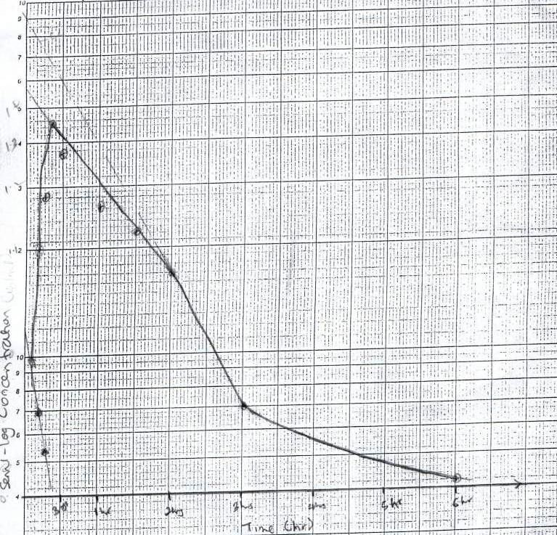

Semi – log saliva concentration time curve of Panadol® tablets

# APPENDIX 6

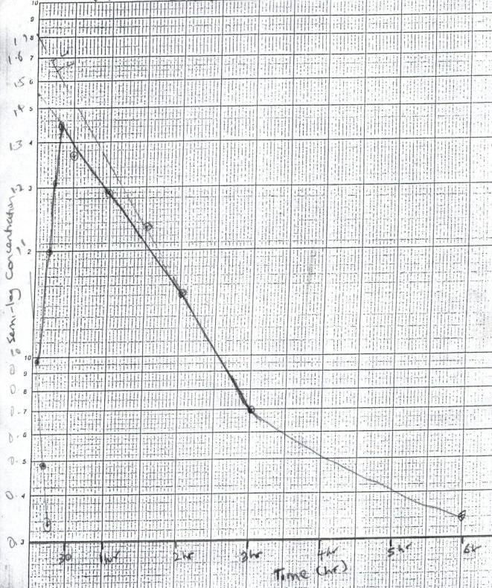Semi – log saliva concentration time curve of Panadol® tablets (A2)

# APPENDIX 7

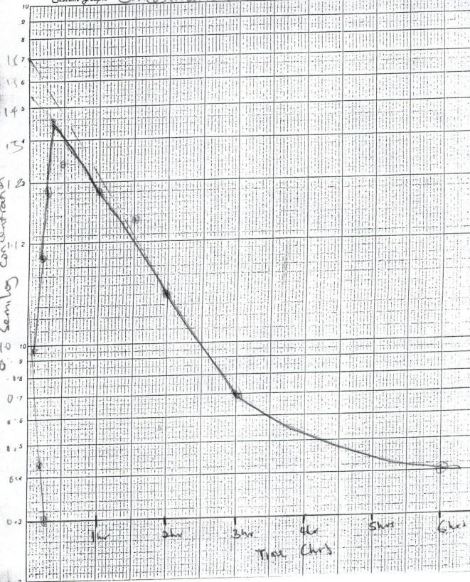Semi – log saliva concentration time curve of Panadol® tablets (A3)

# APPENDIX 8

Semi - log saliva concentration time curve of Panadol Extra® tablets (B1)

# APPENDIX 9

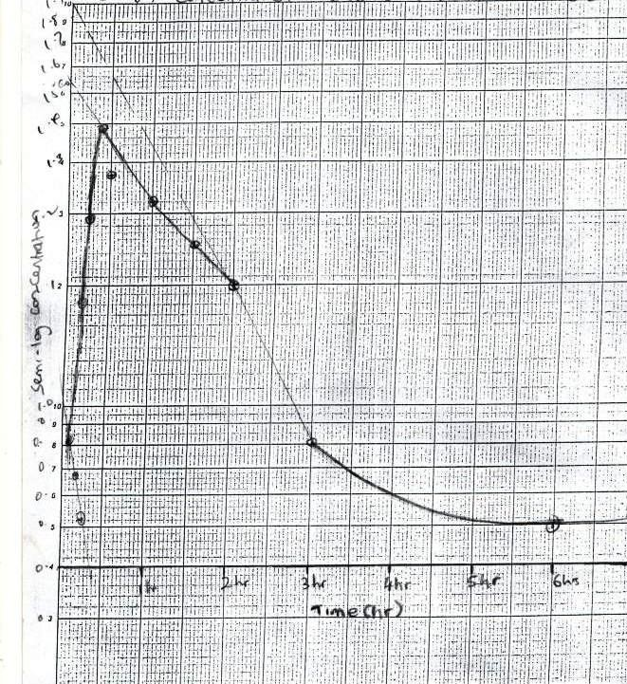Semi – log saliva concentration time curve of Panadol Extra® tablets (B2)

# APPENDIX 10

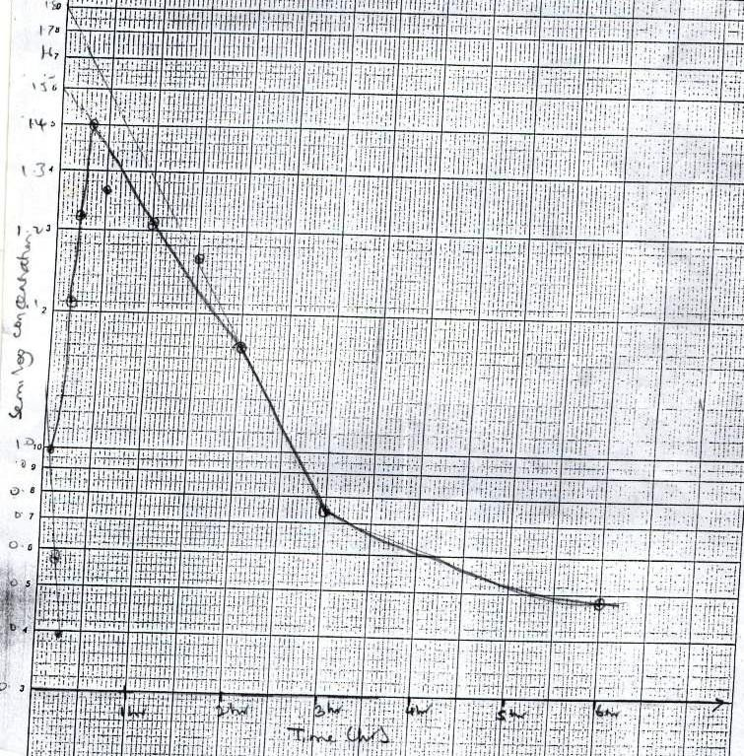

Semi – log saliva Paracetamol concentration time curve of Panadol Extra® tablets (B3)