# EFFECT OF ANTHROPOGENIC PRACTICES ON AGRICULTURAL ACTIVITIES IN PARTS OF BWARI AREA COUNCIL ABUJA, NIGERIA.

**By**

**BAKO, Rahila MTech/SPS/2017/7122**

**THESES SUBMITTED TO THE POSTGRADUATE**

**SCHOOL FEDERAL UNIVERSITY OF TECHNOLOGY, MINNA, NIGERIA IN PARTIAL FULFILMENT OF THE REQUIREMENTS FOR THE AWARD OF THE DEGREE OF MASTER OF TECHNOLOGY IN ENVIRONMENTAL MANAGEMENT**

**JULY, 2021**

# ABSTRACT

This study was carried out to evaluate effects of anthropogenic practices on agricultural activities in parts of Bwari area council (Igu, Mpape, Bwari and Bazango Kubwa). In order to obtain the pertinent information needed for the study a structured questionnaire was administered to the farmers as well as households of the study area. The Landsat Images of 1988, 2008 and 2018 of the study area was analysed to show that there are anthropogenic practices going on in the study area among these are deforestation, overgrazing, urbanisation mining among others. The analysis of delineation of the land cover change in,Igu, Mpape, Bwari and Bazango Kubwa of the study area unveils that, there is drastic reduction in area of vegetation over the years. Agricultural land in Kubwa 16.9614 Km2 (43.39%), 14.2263Km2 (36.41%). 12.4209(Km2) (31.78%), in

Bwari form 24.5988Km2 (45.96%), 18.9612Km2 (35.45%), 6.327 (Km2) (11.83%) also

in Igu 75.3138Km2 (58.79%), 57.4758Km2 (44.91%), 47.1006(Km2) (36.77%) and finally in Mpape 31.2831km2 (57.96%), 24.9831km2 (46.3%) , 18.1692Km2 (33.66%) .

The degraded land cover has been proven that there is direct impact on the agricultural practices in the study area. It was discovered that land cover change has greatly contributed to the loss of soil nutrient, exposure of soil to erosion, impede plant growth, soil salinity. Low yield of agriculture becomes a threat for the farmers in the area as a result of anthropogenic practices; cultivated land to grazing, cultivated land to urban, cultivated land to infrastructural constructions as well as eroded cultivated land by running water. Numerous strategies are being put in place in order to mitigate and adapt effect of delineation of the land cover change on agricultural activities such as training programmes should be set in place to guide people on proper anthropogenic practice, Increasing the area and standard management of protected areas. The researcher here by recommend that anthropogenic practices within the vicinity of the agricultural land should be regulated, Policy should be put to control and restrict the various anthropogenic practices such as mining, deforestation, to prevent its hazardous effective on lives and properties of the people, and Enlightening programs should be organized on proper anthropogenic practices as well as risk involved in wrong practices.

# TABLE OF CONTENTS

## CONTENTS Page

Cover Page Title page

Declaration ii

Certification iii

Dedication iv

Acknowledgement v

Abstract vi

Table of Contents vii

List of Tables xi

List of Figures xii

List of Plates xiv

Abbreviation xv

**CHAPTER ONE**

* 1. **INTRODUCTION** 1
  2. Background of the Study 1
  3. Statement of the Problem 5
  4. Aim and Objective of the Study 6
  5. Justification of the Study 6
  6. Scope of the Study 7
  7. Study Area 8
     1. Geographical description 8
     2. Geology and landform 10

|  |  |  |
| --- | --- | --- |
| 1.6.3 | Soils. | 10 |
| 1.6.4 | Climate | 10 |
| 1.6.5 | Vegetation | 11 |
| 1.6.6 | Population | 11 |
| 1.6.7 | Settlement | 12 |

# CHAPTER TWO

* 1. LITERATURE REVIEW 13
  2. Conceptual Framework 13
     1. Anthropogenic practices on agricultural land in Nigeria 15
     2. Human impacts on land degradation 16
     3. Devastating effects of land degradation 17
        1. On-site effect 18
        2. Off-site effect 19
        3. Sequential aerial photographs 19
        4. Photogrammetry and ground control points 20
        5. Environmental impacts of land degradation – A global perspective 21
        6. Impact of anthropogenic practices on urban infrastructure 22

in human settlement

* 1. Theoretical Framework 24
  2. Review of Related Literature 26

CHAPTER THREE

* 1. MATERIALS AND METHODS 33
  2. Research Design 33
  3. Types and Sources of Data 33
  4. Techniques of Data Collection 33
     1. Reconnaissance survey 33
     2. Questionnaires and interviews 34
     3. Measurements and phonographs 34
  5. Sample and Sampling Techniques 34
  6. Sample Procedure 35
  7. Geospatial Techniques 35
  8. Method of Data Analysis 35
     1. Objective I: Identifying the various source of anthropogenic practices 35

in the study area

* + 1. Objective II: Analyse landuse and landcover change of 36

the study area from (1988-2018)

* + 1. Objective III: Impact of the of degraded land-cover on agricultural 37

Activities in the study area

* + 1. Objective IV: Various management practices put in place 38

in the study area

CHAPTER FOUR

* 1. RESULTS AND DISCUSSION 40
  2. Introduction 40
  3. Socio Economic Characteristics of the Respondents 40
     1. Sex of the respondents 40
     2. Age of the respondents 41
     3. Marital status 41
     4. Major occupation 42
     5. Farming experience 43
     6. Source of anthropogenic practices 43
     7. People involved in anthropogenic practices 44
     8. Major anthropogenic practice in the study area 45
  4. Landcover Change Based on the Anthropogenic Practices 45
     1. Analysis of landuse/landcover classification for Bazango Kubwa 46
     2. Analysis of landuse/landcover classification for Bwari 51
     3. Analysis of landuse/landcover classification for Igu 55
     4. Analysis of land use/landcover classification for Mpape 59
     5. Analysis of anthropogenic activities based on land-use 64
        1. Deforestation 64
        2. Overgrazing 64
        3. Urbanization 66
        4. Over exploration 67

4.3.5.6 Poor human activities 68

* 1. Impacts of Degraded Land-Cover on Agricultural Activities 70

in the Study Area

* + 1. Impact of degraded land cover on agricultural land 71
    2. Status of land-cover change on agricultural activities 73
    3. Major effect of degraded land-cover 74
  1. Mitigation and Adaptation Measures put in Place in the Study Area 75
  2. Summary of Findings 76

CHAPTER FIVE

* 1. CONCLUSION AND RECOMMENDATION 79
  2. Conclusion 79
  3. Recommendations 79

References 81

APPENDICES 85

|  |  |  |
| --- | --- | --- |
|  | **LIST OF TABLES** |  |
| **Tables**  3.1 | The Sample Size and Number of Questionnaire Administered | **Pages**  34 |
| 3.2 | Details of Satellite Data Used | 36 |
| 3.3 | The Intended Classes and their Definitions | 37 |
| 3.4 | Summary of Materials and Methods | 39 |
| 4.1 | Source of Anthropogenic Practices | 44 |
| 4.2 | The Intended Classes and their Definitions | 46 |
| 4.3 | Land use Changes between 1998, 2008 and 2018 | 70 |
| 4.4 | Difference in Land Use Changes (Area) between 1998, 2008 and 2018 | 72 |
| 4.5 | Status Level of Impact of Land-Cover Change on Agricultural Practices | 74 |
| 4.6 | Mitigation and Adaptation Measures | 75 |

# LIST OF FIGURES

**Figures Pages**

|  |  |  |
| --- | --- | --- |
| 1.1.1 | Selected Communities within the Study Area | 9 |
|  | (Bwari Area Council, Abuja, Nigeria). |  |
| 2.1 | The DPSIR Framework (Driving Force-Pressure-State-Impact-Response | 25 |
| 4.1 | Sex of Respondents | 41 |
| 4.2: | Age of the Respondents | 41 |
| 4.3: | Marital Status of the Respondents | 42 |
| 4.4: | Major Occupation of the Respondents | 42 |
| 4.5 | Farming Experience of the Respondents | 44 |
| 4.6 | People Involve in Anthropogenic Activities | 45 |
| 4.7: | Major Anthropogenic Activities in the Study Area | 45 |
| 4.8 | Bazango Kubwa 1988 LULC Distribution Map Generated from | 47 |
|  | LandSat 4 TM |  |
| 4.9 | Bazango Kubwa 2008 LULC Distribution Map | 49 |
| 4.10 | Generated from LandSat 7 ETM+  Bazango Kubwa 2018 LULC Distribution Map | 50 |
|  | Generated from LandSat 8 OLI |  |
| 4.11 | Bazango Kubwa LULC Comparison Chart | 51 |
| 4.12 | Bwari 1988 LULC Distribution Map Generated from LandSat 4 TM | 52 |
| 4.13 | Bwari 2008 LULC Distribution Map Generated from LandSat 7 ETM+ | 53 |
| 4.14 | Bwari 2018 LULC Distribution Map Generated from LandSat 8 OLI | 54 |
| 4.15 | Bwari LULC Comparism Chart | 55 |
| 4.16 | 1988 Igu LULC Distribution Map Generated from LandSat 4 TM | 56 |

* 1. Igu 2008 LULC Distribution Map Generated from LandSat 7 ETM+ 57
  2. Igu 2018 LULC Distribution Map Generated from LandSat 8 OLI 58
  3. Igu LULC Comparison Chart 59
  4. 1988 Mpape LULC Distribution Map Generated from LandSat 4 TM 59
  5. 2008 Mpape LULC Distribution Map Generated from LandSat 7 ETM+ 61
  6. 2018 Mpape LULC Distribution Map Generated from LandSat 8 OLI 62
  7. Mpape LULC Comparison Chart 63
  8. Landuse Changes in Kilometres from 1998 – 2018 71
  9. Differences in Landuse Changes (Area) between 1988, 2008 and 2018 73
  10. Major Effect of Degraded Landcover 74

|  |  |  |
| --- | --- | --- |
|  | **LIST OF PLATES** |  |
| **Plates**  I. | Nature of Anthropogenic Practices in the Study Area | **Pages**  44 |
| II. | Deforestation for Housing Development in Igu Community | 64 |
| III. | Activities of Herdsmen Causing Overgrazing in Igu Community | 65 |
| IV. | Resultant Effect of Overgrazing on the Environment | 65 |
| V. | Quarry Activities in Mpape Area | 67 |
| VI. | Over Exploration of the Environment Causing Land Degradation | 68 |
| VII. | Over Exploration Causing Environment damage to Farm Land | 68 |
| VIII. | Nature of Human Activities Relating to Waste Disposal in | 69 |
|  | the Study Area |  |
| IX. | Poor Human Activities as a Result of Building on Flood Plain Area | 69 |

# CHAPTER ONE

# INTRODUCTION

## Background to the Study

Human impact on the environment or anthropogenic impact on the environment includes changes to [biophysical environments](https://en.wikipedia.org/wiki/Environment_(biophysical)) (Sahney*,* 2010) and [ecosystems](https://en.wikipedia.org/wiki/Ecosystem), [biodiversity,](https://en.wikipedia.org/wiki/Biodiversity) and [natural resources](https://en.wikipedia.org/wiki/Natural_resources) (Hawksworth*,* 2008) caused directly or indirectly by humans, including [global warming](https://en.wikipedia.org/wiki/Global_warming) (Cook*,* 2016), [environmental degradation](https://en.wikipedia.org/wiki/Environmental_degradation) (Sahney*,* 2010)*.* Modifying the environment to fit the needs of society is causing severe effects, which become worse as the problem of [human overpopulation](https://en.wikipedia.org/wiki/Human_overpopulation) continues (Stockton*,* 2015). Some human activities that cause damage (either directly or indirectly) to the environment on a global scale include [human reproduction](https://en.wikipedia.org/wiki/Human_reproduction), [overconsumption](https://en.wikipedia.org/wiki/Overconsumption), [overexploitation](https://en.wikipedia.org/wiki/Overexploitation), [pollution](https://en.wikipedia.org/wiki/Pollution), and [deforestation](https://en.wikipedia.org/wiki/Deforestation), to name but a few. Some of the problems, including [global warming](https://en.wikipedia.org/wiki/Global_warming) and [biodiversity loss](https://en.wikipedia.org/wiki/Biodiversity_loss) pose an [existential risk](https://en.wikipedia.org/wiki/Existential_risk) to the human race (Perkins*,* 2017) and [overpopulation](https://en.wikipedia.org/wiki/Human_overpopulation) causes those problems.

In most parts of the world, land degradation occurs due to human activities and natural factors. According to Ademiluyi *et al.* (2008), Africa has among the fastest rates of deforestation in the world associated with competing land uses which are mainly agriculture and human settlements. The rising demand for fuel wood and charcoal is also a major cause of deforestation and land degradation in this region where biomass is the main source of energy for domestic uses (Matano *et al*., 2015). The high population growth rates and migration in response to shortage of land resources are important factors contributing to the degradation of agricultural land (Diagana, 2003). Maitima *et al.* (2004) explained that soil erosion is a common phenomenon in the intensively grazed areas of sub-Saharan Africa due to lack of pasture management practices. Here,

expansion of livestock farming practices, the increase in their numbers and in some places integration with rain fed agriculture in low potential areas leads to soil erosion. Land degradation by depletion of soil nutrients is widespread in areas of subsistence farming especially as a result of removal of crop residue from farmlands either by burning or for domestic energy.

This type of activities intensifies the acidity levels in the soils and may trigger soil erosion, and also reduces crop yields (FAO, 2001). Management and utilization of natural resources is often considered as the most critical environmental problem in Nigeria. However, pollution from industrial and domestic sources and related public health problems is also becoming a real menace. Water and air pollution and domestic and industrial wastes are some of the critical diseconomies that have resulted from the process of industrial expansion and social transformation in the country (Kamau, 2010). Anthropogenic practices impact directly and indirectly on people’s livelihoods, their vulnerability and food security (McDonagh *et al.,* 2006). Bationo *et al*. (2006) stated that land degradation is the most serious threat to food production, food security, and natural resource conservation in Africa. They explained that the African population is trapped in a vicious cycle between land degradation and poverty, and the lack of resources and knowledge to generate adequate income and opportunities to overcome the challenges of land degradation.

Due to anthropogenic practices, Net Primary Productivity (NPP) index decreased in South Africa with a 41 per cent reduction in croplands (Bai and Dent 2007) About 17 million people, 38 % of the South African population, depend on these degrading areas. They reported that about 6 million hectares of primary forest is lost annually due to agriculture, logging, and other human activities responsible for land use and land cover

changes (FAO, 2006; Lambin *et al.,* 2003). In Nigeria over the period 1981-2017, NPP increased in woodland and grassland, but hardly at all in cropland and in 40 % of cropland it decreased. This was in the context of a doubling of human population over the same period and an increased demand for food resources (Bai and Dent, 2006).

In Sub-Saharan Africa, most economic developments are agriculturally based with two thirds of African countries depending on agriculture for their livelihoods. Diagana (2003) explains that in this region, most farmers are small holders with 0.5 to 2 ha of land and who earn less than US $1 a day. Many of the farmers face 3-5 months of hunger, have large families and are malnourished. The fate of the agricultural sector, therefore, directly affects economic growth, poverty eradication programs and the social welfare of livelihood Wanjala and Kinyanjui 0039 in Africa. In Nigeria specifically, agricultural productivity and food security are currently under serious threat due to the decline in soil fertility (Kabubo-Mariara, 2010).

Landuse changes in Nigeria have transformed land cover to farmlands, grazing lands, human settlements, and urban centres at the expense of the natural vegetation (Abdullahi *et al.,* 2010). These changes are associated with deforestation, biodiversity loss, and land degradation (Maitima *et al.,* 2009). For example, in the early 2000s, approximately 30% of Nigeria’s land was affected by very severe to severe land degradation and an estimated 12 million people, equivalent to a third of the Nigeria’s population, depended directly on that land which was being degraded (Bai and Dent, 2008).

While making an attempt to address degradation issues, the iterative nature of causative agents are given less consideration. For instance, it has become a general tendency to treat increasing population pressure and unsustainable agricultural practices as primary

cause of land degradation (Vezina *et al*., 2006), whereas the effects of other socio- economic and environmental factors are under-estimated. This is being echoed particularly by two researchers; firstly, by Boardman (2006) who stated that to understand land degradation due to water erosion, “the greatest need is for a full recognition of socio-economic drivers,” and secondly, by Jones (1996) who stated, “as the interest of land degradation grows in the field of developmental studies, meanings are implicitly negotiated and Western Scientists begin to revise their worldviews on land degradation.” True to saying that land degradation issues are partly socially constructed, both locally and at broader scales (Lestrelin & Giordano, 2007), developmental activities in any form(s) may contribute to causing land degradation (Vezina *et al*., 2006).

Considering all things, the key question which often springs to mind is: should we make a holistic approach to address land degradation issues? Mazzucato and Niemeijer (2000) states: “the need to focus studies on land degradation in understanding how agricultural systems respond to various changes in the social, economic and environmental context in which agriculture takes place, rather than focus solely on the population pressure as an indicator of the use or the non-use of soil and water conservation technologies.” This is particularly important because efforts towards intervening in ongoing land degradation of any kind may likely change if insights into the socio-economic web of the communities are unravelled. Anthropogenic problems creep in when the society undergoes some kind of transition (Easterling & Apps, 2005), particularly in respect to social and economic terms.

## Statement of the Research Problem

Improving agricultural activities in Bwari area council of Abuja in achieving food sustainability need serious action. However, widespread anthropogenic practices, exemplified by soil erosion and declining soil fertility, which in turn leads to falling production, remains a big challenge in the region. Over the last three decades, soil erosion and land degradation have become major environmental concerns and present a formidable threat to food security and sustainability of agricultural production (Kabubo- Mariara *et al.,* 2010). In Bwari area council deforestation is still rampant particularly in villages and among farmers where land for cultivation is priority. Population pressure, improper Government policies and disruption of indigenous traditional landuse management practices, have contributed to accelerated degradation of forest land and loss of biodiversity (Wafuke, 2012). These human activities have resulted in intensive landuse, modification, and alteration of the status of the land use and land cover change over time.

Anthropogenic practices constitute a serious problem in many parts of the world. The causes, processes, prediction and control have aroused the interest of many researchers (Ireland *et al.,* 2016). Natural events such as erosion can be hazardous to man. The disasters that natural hazards can cause are largely the result of actions by man that increase vulnerability, or lack of action to anticipate and mitigate the potential damage of these events. Anthropogenic practices have been mentioned as one major constraint to improved agricultural activities and household welfare in Nigeria (Adewuyi, 2012). In fact, recent household budget survey studies show that the major cause of low incomes in Nigeria rural areas has been stagnating agricultural production (Deininger and Okidi, 2001). As a result, poverty in Nigeria is still pervasive and highest among those households whose main source of living is crop agriculture. For instance, poverty

among households headed by crop farmers increased from 39 to 50 percent between 1999 and 2002 while poverty dropped from 47 to 38 percent for those households the main occupation of which is non-crop agriculture (livestock and fishing) for the same period of time (Appleton and Sewanyana, 2013). Farming is a major economic activity of the people of Bwari and its being practiced all year round both at subsistence and commercial scale. Increase in population in the area has led to high demand of land for agriculture production and hence intensive cultivation which leads to so much pressure on the land due to over cultivation. This might have resulted in decline in soil fertility. Few studies (Wafuke, 2012; Ireland *et al.,* 2016; Adewuyi, 2012 and Deininger and Okidi, 2001) available in the area of interest, none of this study dealt with anthropogenic practices on agricultural activities specifically in the study area. Therefore, this study will consider it has a gap to fill.

## Aim and Objectives of the Study

The aim of this research is to examine the effect of anthropogenic practices on agricultural activities in parts of Bwari Area Council, Abuja, Nigeria.

The specific objectives are to:

1. Identify sources of anthropogenic practices in the study area.
2. Analyse the land use and landcover change of the study area from (1988-2018).
3. Analyse the impacts of degraded landcover on agricultural activities in the study area.
4. Assess the mitigation and adaptation measures put in place on the effect of anthropogenic practices on agricultural activities.

## Justification for the Study

Man depends on the environment, he makes changes to the environment and yet, he faces the worst effect and consequences of the environment. Land degradation has

become an increasing problem in some part of Bwari and there is the need to reduce the rate and to conserve and enhance landuse in the area. In the absence of comprehensive data on this problem of human activities effect on agricultural land in the area, the expected outcome of this research is to be a framework which will assist government, non-governmental organizations on how to address the problem of erosion in the area.

The rate at which anthropogenic practices are damaging the land in Bwari had not received the desired attention. The rate at which human activities rapidly unchecked that, many people does not know its effects and consequences. This study will examine various forms of anthropogenic practices in parts of Bwari Area council. Furthermore, the fact that a number of people had put forward various solution regarding the effect of human activities that makes it necessary to examine those opinions in addition to the problem. It’s also imperative to conduct this study not only for its academic but also to bring out useful fact so as to get solutions to the problem of human activities effect on agricultural activities. This research will go a long way to unravel the nature of anthropogenic practices effects on agricultural activities in the study area which will address the problem of human activities so as to improve the economic activities of the people.

## Scope of the Study

The study was carried out in Bwari Area Council of FCT Abuja, it covers four communities (Bazango Kubwa, Mpape, Bwari town and Igu). This focused on various anthropogenic practices such as farming, urbanization, overgrazing, and deforestation menace on landuses in the area, it assesses the land use of the area, agricultural practices of the people of the area and investigate the mitigative measures towards the effect of anthropogenic practices on land uses. The research makes use of both theoretical and

investigative method for collection of data such as landcover changes between 1988 and 2018.

## Study Area

## Geographical description

Bwari area council of the Federal Capital Territory (FCT) lies between 9°08'25" North and 7°22'25" East. Abuja has an area of 8,000km2 and it lies wholly within the geo- political region referred to as the middle belt, and it forms part of the Guinea Savannah ecological zone (Chup, 2004). Abuja is bounded to the west and north by Niger State. It also shares boundary with Kaduna State in the North East, Nasarawa State in the West, and Kogi State in the South. A straight line drawn across Abuja from north to south covers a distance of about 87km, and from east to west is about 90km (Chup, 2004).

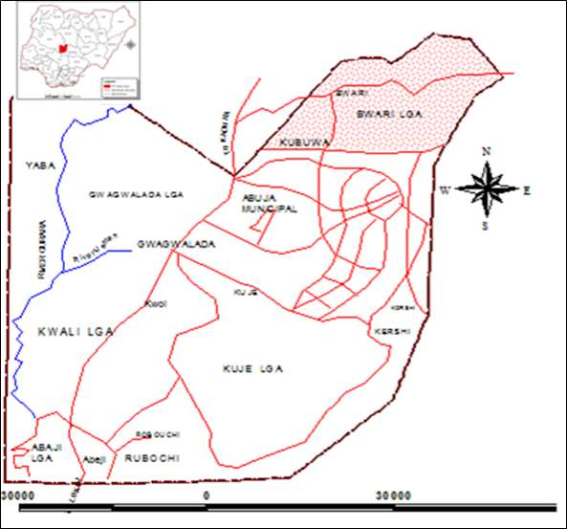

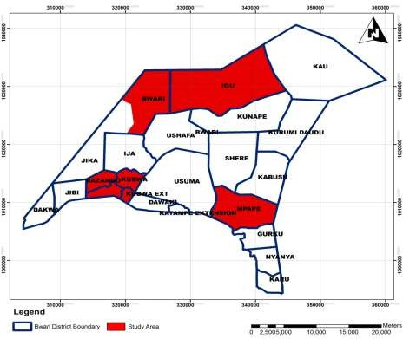

## Figure 1.1 Selected Communities within the Study Area (Bwari Area Council, Abuja, Nigeria).

**Source:** Federal Capital Development Authority (FCDA) Abuja, (2019).

## Geology and landforms

The basement complex rocks and the sedimentary rocks, cover a total land area of about 48% and 52% respectively (Abumere, 1993), Bwari has base of complex rocks are occupied majorly by hills and terrain with rocks of schists, gneiss and older granites. The highest areas in FCT are located in these areas, with peak reaching 940 metres above sea level, towards the North Eastern part. The undulating plains under the sedimentary rocks are deposits of erosional surfaces of the quarternary period (Adeleye, 1989). These plains are however dotted with isolated hills and inselbergs (Chup, 2004).

## Soils

The soils of the FCT derive basically from two sources; the crystalline rocks of the basement complex rocks, which cover the northern two-thirds of the territory, and the Nupe sandstones, which covers the southern one-third of the territory. The soils are often described along the identified physiographic regions (Alhassan, 2000). The major soil types include the gleysols, fluvisols, luvisols, combisols, regosols and lithosols. Generally, the alluvial complexes contain gleysols and fluvisols, with the exception of the alluvial pediment complex of the Zuba hills, which contain combisols and regosols. The interfluves are dominated by luvisols and combisols. The summit and upper slopes of most interfluves are dominated by combisols and lithosols, while the wooded hills of plains (especially Gwagwa, Iku and Kau) are dominated by the regosols (Chup, 2004).

## Climate

This section presents a brief description of the precipitation, temperature and humidity characteristics of the territory. In terms of precipitation, mean annual amount varies from about 1400mm in the southern part of Abuja to about 1765mm in the north-east. The rainfall in the Abuja occurs during the rainy season (April to October) when the

tropical Maritime air mass prevails over most parts of the country. There is extreme concentration of rainfall in the three months of July, August and September when more than 60% of the rainfall is received. The duration of the rainy season also varies from six months in the northern parts, to eight months in the southern parts of Abuja.

Highest temperatures in Abuja occur during the dry season months which are generally cloudless. Maximum temperatures in March and vary from 39°C in the south west to about 34°C in the north east. This period also records the highest diurnal temperature range of about 17°C. The rainy season months usually record lower diurnal temperature ranges of about 7°C. Maximum temperatures during this period vary from about 34°C in the south west to about 31°C in the north east. Average temperatures of about 24°C and 28°C are recorded in the rainy and dry seasons respectively in the north east and 27°C and 30°C, in the south west. Humidity varies in the dry season from as low as 20% in the afternoon, in areas of high elevation (North and North East), to about 30% in areas of lower elevation (South West). (Chup, 2004).

## Vegetation

Abuja vegetation reveals a gradual transition from the rain forest in the south, to the Sudan Savannah in the north. The existence of numerous river valleys and hill ranges have added to the variety of vegetation in the territory. Adakayi (2000), has separately discussed the variety of vegetation in the FCT. A common observation is the fact that the vegetation consists of both forests and savannah types. The forests consist predominantly of woody plants, while the savannah consist of a combination of woody plants and mesophytic grasses which may grow to a height of 0.8m. (Chup, 2004).

## Population

The population of Abuja has been on the increase especially within the last two decades. At the 2006 census, Bwari Area Council has an area of 914 km² and a population of 227,216 as at 2006. The population of Abuja as at 1987 consisted mainly of eight ethnic groups which included Gbagyi 61.7%, Bassa 17.4%, Koro 6.1%, Gade 4.8%, Hausa

3.0%, Gwandara 2.7%, Ebira 1.3%, Tiv 0.8%. In addition, other ethnic groups constituted 2.2% of the population (Mundi, 2000). The indigenous population is presently mostly restricted to the rural areas, while the urban centers are heterogeneous. To illustrate this, the entire rural population of 1977, with no settlement having a population of up to 5,000 is believed to have had at least 27 settlements with populations of more than 5,000 by 1999 (Mundi, 2000).

## Settlements

The capital city has more than 850 settlements out of which more than 80% are rural (Dawam, 2000), apart from the Federal Capital City (FCC), Gwagwalada, Kwali, Kuje, Bwari, Yaba, Robochi, Karshi, Zuba, Kubwa, Gwagwa, Karimu, Idu, Lugbe, Nyanya and Karu, all other settlements are villages and hamlets which are of the isolated nucleated pattern (Dawam, 2000). As at 1977, all the settlements lacked basic infrastructure and the inhabitants were engaged in farming and other extractive activities. The urban areas today are provided with basic amenities and infrastructure, and have populations whose major occupation is in the secondary and tertiary sectors of the economy (Dawam, 2000).

# CHAPTER TWO

# LITERATURE REVIEW

## Conceptual Framework

The term anthropogenic designates an effect or object resulting from [human activity](https://en.wikipedia.org/wiki/Human_behavior). The term was first used in the technical sense by Russian geologist [Alexey Pavlov,](https://en.wikipedia.org/wiki/Alexey_Pavlov) and it was first used in English by British ecologist [Arthur Tansley](https://en.wikipedia.org/wiki/Arthur_Tansley) in reference to human influences on [climax](https://en.wikipedia.org/wiki/Climax_community) plant communities (Bampton, 1999) The atmospheric scientist [Paul Crutzen](https://en.wikipedia.org/wiki/Paul_Crutzen) introduced the term "[Anthropocene](https://en.wikipedia.org/wiki/Anthropocene)" in the mid-1970s (Crutzen, 2000). The term is sometimes used in the context of [pollution](https://en.wikipedia.org/wiki/Pollution) emissions that are produced from human activity but also applies broadly to all major human impacts on the environment (Scott*,* 2014).

Anthropogenic practices like modifying natural landscapes for economic purposes or changing [management practices](https://www.sciencedirect.com/topics/earth-and-planetary-sciences/management-practice) on human-dominated lands have transformed a large proportion of Earth’s surface. Human actions have almost completely transformed, eroded, and fragmented pre-existing natural landscapes, leaving only a limited number of natural areas, in an often heavily anthropogenic matrix. Nowadays, this phenomenon has reached critical thresholds, since residual areas of natural landscapes are increasingly rare and dispersed in many parts of the world. Human actions, mostly associated with agricultural expansion and [intensification](https://www.sciencedirect.com/topics/earth-and-planetary-sciences/amplification), conversion of [perennial](https://www.sciencedirect.com/topics/agricultural-and-biological-sciences/perennials) habitats to cultivation fields, farming practices such as fire and [crop rotation](https://www.sciencedirect.com/topics/earth-and-planetary-sciences/crop-rotation), [urban](https://www.sciencedirect.com/topics/earth-and-planetary-sciences/urban-sprawl) [sprawl,](https://www.sciencedirect.com/topics/earth-and-planetary-sciences/urban-sprawl) [industrial development](https://www.sciencedirect.com/topics/earth-and-planetary-sciences/industrial-development), road infrastructure, or any other substitution or conversion of an original natural landscape with an anthropogenic type, lead to anthropogenic landscapes.

Anthropogenic practices are accelerating rates of environmental perturbation including changes in temperature and precipitation; frequencies and intensities of fire and storms; the structure of habitats; levels of noise; and the presence and density of disease, predators, competitors, and prey (Bouwer, 2011; Hendry, *et al.*, 2018).

In the context of anthropogenic processes, there are numerous studies carried out. However, the majority of these studies are in empirical form, while comparatively few have looked into the social and economic attributes contributing to land degradation (Mazzucato & Niemeijer, 2000). The formulation of a methodology to address land degradation problem has been perceived as one of the greatest challenges and it will remain to be so if the strategies remain unaltered for now and in future (Mazzucato & Niemeijer, 2000).

It would be really unjust to make coarse assumptions to say that lack of proper research on the subject curtails various stakeholders to address land degradation issues as desired. Unlike in other places, there are not many formal studies accomplished within the domain of land degradation caused by water erosion. On a secondary note, one would find some general assessments on land degradation executed by the National Soil Services Centre, NSSC (Rinzin, 2008). Apart from this, Turkelboom and Wangchuck (2001) have done a holistic study to assess the land degradation in the Eastern part of Bhutan which covers the current study sites, Norbu *et al.,* (2003) have made an overview assessment of land degradation in Bhutan, etc. The more promising thing is, these days there are more studies conducted with a particular focus in this area. This is encouraging, because according to Alewell *et al*. (2008), the “mountain systems all over the world are unique in their ecology, economy and cultural diversity.” Others say that ecological conditions in the mountain areas vary spatially, even within short distances

(Paudel & Thapa, 2004). This required that one considers a particular land degradation problem in its specific local context.

Agriculturally, deforestation and conversion of forest to arable land has drastic effect on soil properties. The principal effect of deforestation on chemical and nutritional properties of soil is related to a decrease in organic content. This leads to disruption of nutrient cycling mechanism as a result of the removal of deep-rooted trees, which has serious effect on organic and nutrient content as such affects agricultural productivity. For instance, studies conducted from 1971 to 2005 revealed that there was a temperature increase in Nigeria by 1.10C, compared to the global increase in mean temperature of 0.740C. It was also found that in the same period the amount of rainfall in the country decreased by 81mm as against global average decrease of 52.8mm. It was noticed that these climatic changes had sharp effects on the agriculture (Udofia *et al*., 2011).

## Anthropogenic practices on agricultural land in Nigeria

It must be borne in mind that any environment could suffer gully erosion if the factors that cause gully erosion are prevalent in such an environment. This is the case whether or not the environment is an arid, semi-arid, humid or cold environment. In Nigeria, serious cases of gully erosion have been reported in the very densely populated areas of the northern and southern parts where over cultivation and overgrazing have exposed and impoverished the soil. The worst affected areas are the eastern scarp lands of Nigeria, the Jos plateau, Kastina State and parts of Sokoto State. Large areas of farmland at Agula-Nanka Nsude, Ukeche, Awka, Nsukka and Udi in Anambra and Enugu States have experienced mass destruction by gully erosion. Similarly, gully erosion has adversely affected some urban areas. Examples are Auchi and Benin City in

Edo state, Aba in Abia State. Gullies can also be found along the major highways in different parts of the country and along the headstreams of many rivers. In the southern parts of Nigeria, gully erosion is mainly due to the action of running water, while in the extreme northern parts, it is due to combine actions of rainfall and running water. Gully erosion is thus an environmental problem that exists in all parts of Nigeria (Bali *et al.,* 2009).

It is a problem which is growing stronger and stronger in farmland areas that are subjected to deforestation, overgrazing, bush fires and poor agricultural management. It is equally prevalent in areas affected by large scale construction, mining and urbanization (Abegunde *et al.*, 2001). Water plays an important role in gully erosion by carrying away materials that have been weathered. When an area receives more water (in the form of rain, melting of snow, or ice) than the ground can absorb the excess water flows to the lowest level carrying loose materials with it, which the runoff removes a thin layer of top soil without leaving visible traces on the eroded surface. This erosion may be balanced by the formation of new soil. Often, however, especially in arid areas having little vegetation, the runoff leaves a pattern of gullies formed by rivulets. Water can even erode solid rock, especially along streambeds where the stones that are carried with the current scour and abrade. Every year, rivers deposit about

3.5million tons of eroded materials into the oceans (Skoola, 2012).

## Human impacts on land degradation

Without human activities, loss of soil through gully erosion would in most areas probably be balanced by formation of new soil. On virgin land, a mantle of vegetation protects the soil. When rain falls on the surface of grass or on the leaves of trees, some of the moisture evaporates before it can reach the ground. Trees and grass serve as

windbreaks and network of roots helps to hold the soil in place against the action of rainfall.

Agriculture and lumbering, as well as housing, industrial development and highway construction, however, partially or wholly destroy the protective canopy of vegetation. Gully erosion is less severe with crops such as wheat, which cover the ground evenly, than with crops such as corn and tobacco, grown in rows. Overgrazing, which in time can change grassland to desert, and careless cultivation have had disastrous effects in certain geographical regions (Odunayo, 2006).

## Devastating effects of land degradation

Gully initiation is the result off localized erosion by surface run off associated with rainfall events of intensity. Gully erosion is frequently focused, where the forest cover has been removed for an agricultural purpose and also at the sites of uneven compaction of surface soils by foot (human and livestock) and wheeled traffic, in off road locations. It also takes place, where soils and sediments abut against artificial materials, notably at poorly designed road culverts and road site gutters. Gullies also occur, where springs issue from permeable sands, at contacts with less permeable deposits beneath. In general, the propagation of gullies is by sapping, caving and sliding at the gully head and sliding along the sides, accompanied by the down-slope transportation of gully floor debris by storms run off (Lal, 2000).

Gully erosion has had and will continue to have destructive impacts in Nigeria in absence of immediate corrective and preventive measures. The government and the world cannot afford to remain silent in the face of ecological calamites that may wipe out millions of people. However, in spite of the threat posed by the gully erosion, some of the inhabitants who have no other places to go to have stayed behind waiting for the

worst to happen. (Famous G., 2012) There are farms that are losing large quantities of top soil and subsoil each year due to fully erosion. Surface runoff, causing gully formation or the enlarging the existing gullies, is usually the result of improper outlet designed for local surface and subsurface drainage systems. The soil instability of fully banks, usually associated with seepage of ground water, leads to sloughing and slumping (caving-in) of bank slopes. Such failures usually occur during spring months when the soil water conditions are most conductive to the problem.

Gully formations can be difficult to control if remedial measures are not designed and properly constructed. Control measures have considered the cause of the increase flow water across the landscape. This where the multitude of conservation measures come into play. Operations with farm machinery adjacent to gullies can be quite hazardous when cropping or attempting to reclaim lost land. (Shelton, 2012).

## On – site effects

The implications gully erosion extends beyond the removal of valuable top soil. Crop emergence, growth and yield are directly affected through the loss natural nutrients and applied fertilizers with the soil. Seeds and plants can be disturbed or completely removed from the eroded sites. Organic matter from the soil, residues and any applied manure, is relatively light weight and can be readily transported off the field, particularly during spring thaw conditions. Pesticides may also be carried off the site with the eroded soil.

Soil quality, structure, stability and texture can be affected by the loss of soil. The breakdown of aggregates and the removal of smaller particles or entire layers of soil or organic matter can weaken the structure and even change the texture. Textural changes

can in turn affect the water holding capacity of the soil, making it more susceptible to extreme condition such as drought.

## Off-site effects

Off-site impacts of gully erosion are not always as apparent as on-site effects eroded soil, deposited down slope can inhibit or delay the emergence of seeds, bury small seedling and necessitate replanting in the affected areas. Sediment can be deposited on down slope properties and can contribute to road damage (Shelton, 2012).

## Sequential aerial photographs

In New Zealand, gullies are common due to a combination of bedrock susceptible to erosion, mountainous topography, extreme rainfall events, and drastic land use changes. Most gully systems in this region are termed fluvio-mass movement, due to the major role that mass movement plays in sediment production and gully enlargement (Parkner *et al.,* 2006). Here, sequential aerial photographs were interpreted to measure and analyse temporal changes for a long-time span with higher temporal resolution. The area of gullies and complexes affected by gully incision and mass movement erosion was measured for each time slice after digitizing in ArcGIS. Gully erosion is considered a threshold phenomenon because it occurs only when a threshold in terms of rainfall, topography, and land use is surpassed. The air photographs were interpreted to determine landuse and landcover (Parkner *et al.,* 2006). Rainfall data was collected from stations close to the study area at their highest temporal resolution, while a history of major storms records was also used. Studies with lower time resolution showed the same pattern of overall gully complex development with expansion and stabilization. The topographic threshold line developed for gully initiation allows for the prediction of which catchments will develop gullies and gully complexes (Parkner *et al.,* 2006).

However, this could not be used in other areas where mass movement does not play as significant a role as it does in New Zealand. Sequential aerial photographs would be useful within the United States to study the migration of gully heads, but could not be used to estimate total erosion because it puts less emphasis on erosion occurring along the channel side slope.

* + - 1. **Photogrammetry and ground control points**

Another method uses images taken from a blimp or kite allow for the gully systems to be surface modelled and monitored, while gully growth and soil loss are measured using geographic information systems (GIS) and digital photogrammetric analysis. At all gully sites, ground control points (GCPs) were installed to help provide more accurate modelling and monitoring (Marzolff and Poesen 2009).

These are located at points that are clearly identifiable places in the image because it has to be possible to derive location and elevation of the point from the map. Automatic digital elevation model (DEM) generation in digital photogrammetry systems uses image matching and DEM interpolation. A hybrid method of automatic and interactive feature extraction was used to eliminate false matches and reduce problems such as shadowing (Marzolff and Poesen 2009). Assessment of errors associated with DEM accuracy was done by examination of the bundle block adjustment results and by visual inspection of the concordance of the surfaces with the 3D dataset of GCPs. The change of gully area and volume were determined by differencing the raster files with a simple subtraction operation in the GIS and separating areas of loss and gain. Total gully volume was then calculated by using the ArcGIS cut/fill operation. Small format aerial photogrammetry can be considered an important tool for the monitoring of gully erosion sites (Marzolff and Poesen 2009). Gully extent, volume, and change can be derived with

accuracy and detail that corresponds to the magnitudes and geomorphic characteristics of gully erosion processes. However, problems such as the sidewall erosion being omitted can distort the morphology and volumetric measurements, which cannot be solved without a combination of aerial and terrestrial imagery.

## Environmental impact of land degradation – A global perspective

According to Marsh and Gross (1989), the principal impact of soil erosion is reduction in the quality of the world’s soils. Because erosion is concentrated on the surface, topsoil, that is the most fertile part of the soil in most severely affected by erosion. The most worrisome consequence of topsoil is reduced agricultural productivity. Marsh (1989) further describes that, it is estimated that for each inch of soil eroded from wheat fields in the United States, wheat yields are reduced by 6 percent. To make up for such fertility loss, farmers in large production farms apply commercial fertilizers. This adds significantly to the coat of food production. Where gully erosion occurs, there are multiple environmental impacts. In addition to the soil loss, workable land units are reduced in area and are often fragmented into smaller parcels making the land insufficient for use. It also breaks up the biographical environment. Most of the sediments eroded from farm fields are stored in the landscape, sediment accumulation (sedimentation) to another prominent impact of soil erosion. It is the deposition of excess sediment in wooded areas. Swale, wetlands, ponds, lakes and reservoirs has become a serious problem. When a surge of in organic sediment is deposited in a wetland among other things, biochemical processes and nutrient availability in the underlying soil will be altered and many aquatic organisms will be buried. In addition, impact of sedimentation is clogged stream channels and turbid water. Fine particles, mainly clay and fine organic materials are carried in suspension in streams and lakes,

moulding the water muddy or turbid. Impedes biological activity (sunlight is reduced, among other things) and damages drinking water supplies.

Stewart (1998) further reviewed the water quality impact due to nutrient and pesticide transport in river systems leading to eutrophication and pollution of water; damages to the municipal water treatment system due to increased salinity for the lower basin and damages to agriculture when eroded soil and runoff from one field enters another. The deposits reduce the channels flow capacity, which may increase the magnitude and frequency of flooding. In addition, sediment checked channels, increase flooding and damage to the built system of drains, irrigation channels, bridges and reservoirs in and around urban and agricultural regions. Environmental degradation has become an issue of centrality, since it affects every region in sub-Sahara Africa and thus, impedes development and the region’s progress to prosperity (Wall, 2012)

## Impact of anthropogenic practices on urban infrastructure in human settlement.

Rising population pressures and economic development have increased the need for better infrastructures. As reviewed by Adebayo, (1995), deforestation, urbanization, construction of structures and utilities, agricultural practice and industrialization are some of man’s activities that expose the soil for ready attack by erosion. This construction of structures has made the soil loosed and pond drained to protect initiated infrastructures like drainage, roads and houses in the environment thereby, encroaching desert into forested areas.

In the East Africa Highlands, Moeyersons (1991), monitored and analysed progressive gully formation after road building in Rwanda. Where he stated that, preference for road buildings in Ethiopia is given to pediment in order to avoid flat, poorly drained, and

steep areas. He added that, surface runoff on the pediment is concentrated by the roads and induces gulling on the lower part of the pediment. Most civil engineering structures such as roads, dams, ports, harbours, buildings, etc. are exposed to one form of erosion or the other, since the ground conditions create unique problem for civil engineering structure situated on them. Many of this structure in Nigeria have been swept off by erosion. Roads have been cut off by landslides in places like Efori-Alaaye, Nana, and in other riverine areas of the country. The geo-technical nature of the soil on which the structure is located plays a vital role.

Jegede (1995), after series of intensive laboratory investigation, revealed that erosion as the cause of highway pavement failure in Illoda locality along Ado-Ekiti with Ifaki- Ekiti stretch of F209 highway South Western Nigeria. He concluded that soil erosion by water is the main exogenesis process responsible for the destruction of the highway alignment in the area.

Similarly, Adedeji and Salami (2008) revealed in their study, the menace, erosion and flood have caused severe damages to about 4 number of block building in Opomalu/Amildge and Gaa-akanbi area respectively. Collapsed and dilapidated wall in these buildings were associated to the intensity of rainfall. The maximum monthly rainfall in the month of September i.e. 373.2mm. It is obvious that erosion and flooding will occur as a result of high moisture content in the soil.

In addition, soil erosion plays an important role in the development of drainage system. According to Deju et al (not. dated), areas of heavy rainfall and poor drainage are most favourable for slumping than area of average on low rainfall and well-integrated drainage patterns. This implies that inadequate drainage pattern leads to flooding which

is an environmental hazard that impinge unfavourably upon human activity and thus damage other infrastructures.

## Theoretical Framework

Ecosystems or landscapes are in a continuous state of spatial‐temporal change caused by natural as well as man‐made drivers. The change has potential to create a mosaic pattern of patches of different sizes and shapes, with varying impacts on the ecosystem functioning (Rapport *et al.* 1985). At interfaces of change, ecosystems are likely to experience stresses, and this can reflect in some form of degradation. Like in medical practice, these stresses make the ecosystems unhealthy, unstable and unsustainable. This similarity in response of the ecosystem with human health resulting in a signal of an unhealthy environment/system was described by Rapport et al. (1985) as the Ecosystem Distress Syndrome (EDS). The authors observed that distressed systems have disrupted functions e.g., reduced productivity and biodiversity, lower decomposition and nutrient cycling, reduced aesthetic value. By identifying ‘hotspot’ areas within the ecosystem experiencing stresses and by identifying causes of these stresses, recommendations for restoration and conservation can be made. To do this requires the adoption of a framework that integrates all factors, i.e., biophysical, social and economic factors driving natural resource use.

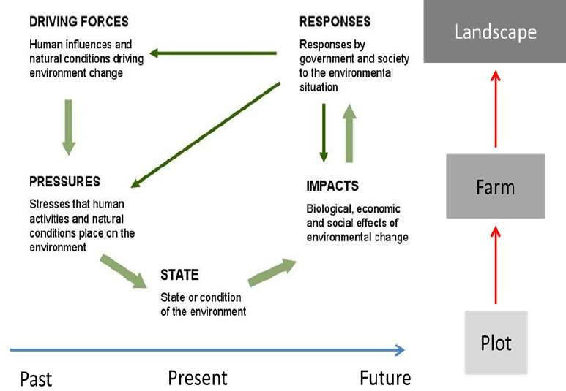

## Figure 2.1 The DPSIR framework (Driving Force – Pressure – State – Impact –

Response)

**Source:** LADA 2009

The DPSIR framework (Driving Force – Pressure – State – Impact – Response) was proposed by the European Environmental Agency (EEA) as an integrated approach to environmental management (EEA 2000; FAO 2011). A summary of the DPSIR framework is presented in Figure 2.1. This framework was adopted in the Land degradation Assessment in Dry land Areas (LADA) projects it has proved versatile for land degradation assessment (LADA 2009).

The DPSIR framework is useful in describing the origins and consequences of environmental problems. The framework provides an overview of the relation between the environment and humans (Karageorgis *et al*. 2005). According to this framework, social and economic developments and natural conditions (driving forces) exert pressure on the environment and, as a consequence, the state of the environment changes. This leads to impacts on human health, ecosystems and materials, which may

elicit a societal or government response that feeds back on all the other elements. Results from the DPSIR framework can be applied, and the assessments on land degradation extrapolated using GIS and remote sensing techniques from local to national and even global levels. Combining the EDS and the DPSIR frameworks can help deliver an integrated or interdisciplinary assessment of land degradation not only in the proposed study site but the region as a whole.

## Review of Related Literature

Hao *et al.* (2018) studied climate change and anthropogenic impacts on wetland and agriculture in the Songnen and Sanjiang plain, northeast China. Influences of the increasing pressure of climate change and anthropogenic activities on wetlands ecosystems and agriculture are significant around the world. This study assessed the spatiotemporal landuse landcover changes (LULCC), especially for conversion from marshland to other LULC types (e.g., croplands) over the Songnen and Sanjiang Plain (SNP and SJP), northeast China, during the past 35 years (1980–2015). The relative role of human activities and climatic changes in terms of their impacts on wetlands and agriculture dynamics were quantitatively distinguished and evaluated in different periods based on a seven-stage LULC dataset. The results indicated that human activities, such as population expansion and socioeconomic development, and institutional policies related to wetlands and agriculture were the main driving forces for LULCC of the SJP and SNP during the past decades, while increasing contributions of climatic changes were also found. Furthermore, as few studies have identified which geographic regions are most at risk, how the future climate changes will spatially and temporally impact wetlands and agriculture, i.e., the suitability of wetlands and agriculture distributions under different future climate change scenarios, were predicted and analysed using a habitat distribution model (Maxent) at the pixel-scale. The present

findings can provide valuable references for policy makers on regional sustainability for food security, water resource rational management, agricultural planning and wetland protection as well as restoration of the region.

Izuogu (2015) examined environmental hazard effects as a critical issue relating to agricultural production of rural households in Imo State, Nigeria. The study used multi- staged purposive and random sampling techniques. The finding determined the farming activities of the respondents, ascertained the respondent’s knowledge of the effects of environmental hazard on agricultural production among respondents and analysed the relationship between environmental hazard and agricultural production of respondents. Primary data collected from 116 respondents were used for the study. Data analysis was carried out with the use of descriptive statistics and multiple regression analysis. Results from the study show that majority (76.54%) of the respondents were engaged in cassava production as their major cash crop. The finding shows that flood, oil pollution, erosion and wind storm were significant and negatively related to the agricultural production. Oil explorations that go on in the rural areas should be adequately monitored to reduce its negative effect on the rural environment. It was therefore recommended that more efforts should be made to mitigate the effects of environmental hazard on agricultural production of rural dwellers. This could be achieved by providing agricultural insurance schemes for farmers, paying compensation to farmers over losses arising from environmental hazards.

Chioma and Felix (2017) examined the impact of environmental degradation on agricultural production and poverty in rural Nigeria. The dual problems of environmental degradation and poverty have over the years being a topic of great influence in International discussion because of the challenges they pose to sustainable

development in world countries today. To combat the effects of these two problems, international community, world organizations, and scholars have tried to establish links between the two problems. One of the links between the two concepts is found to exist in rural areas where poverty due to poor access to societal resources and other forms of inequality compel rural people to over exploit immediate environmental resources which are readily available for subsistence or mini commercial agriculture. In most rural areas, agriculture is the main source of livelihood and environmental resources form the basic source. Some scholars are of the view that this dependence on the environment easily depletes resources when people are faced with poverty and high population density. When these resources become depleted the people are once again pushed into more poverty. In Nigeria, few attentions have been given to the impact of unsustainable agriculture on the environment; and many ways poverty, which is rampant in these rural areas, encourage rural agriculturalists to abandon traditional resource management methods for immediate benefits. This study highlights the impact of unsustainable agricultural practices on the environment and emphasizes the importance of addressing the challenges of rural poverty in achieving effective sustainable development and management of environmental resources depended on for agriculture in the rural areas in Nigeria.

Apata (2015) assessed the effects of global climate change on Nigerian agriculture: an empirical analysis. This study presents an empirical analysis of the effects of global warming on Nigerian agriculture and estimation of the determinants of adaptation to climate change. The results show determinants scenarios, either an optimistic baseline annual increase of agricultural output of 1.85% or a more pessimistic appraisal of 0.75% was used and indicated that hunger-related deaths could increase if grain productions do

not keep pace with population growth in an unfavourable climatic environment. However, Climate change adaptations have significant impact on farm productivity.

Mbah *et al.,* (2016) analyse climate change effects among rice farmers in Benue State, Nigeria. The study was carried out in Benue state, Nigeria to analyse climate change effects among rice farmers. Questionnaire/interview schedule was used to collect data from a sample of 90 respondents in the study area. The study shows that land degradation due to soil erosion are among others increase in pests and diseases infestation in rice farms. Human activities such as deforestation, overgrazing of farmland by livestock, use of inorganic manure, etc. should be discouraged in order to cushion the effects of climate change as well as increasing productivity among rice farmers.

Omokhua and Koyejo (2014) examined the impact of human activities on ecosystem in River State, Nigeria. This study was to assess the percent sample population size of people involved in selected human economic activities and the impact on ecosystem in Rivers State. The data for this study was obtained from a sample size of 1000 respondents who were purposively selected from the study area. Purposive sample was used to ensure that the questionnaires which were the materials for collection of data, were directed at 8 human economic activities in Rivers State. The 8 human economic activities were: farming, fishing, logging, charcoal/fuel wood collection, construction/urban development, industrialization/manufacturing, transportation and soil excavation. The state was divided into 10 strata and assessment was carried out using 100 questionnaires per stratum. Descriptive statistics involving frequencies and percentages were used to analyse the data. Result showed that 40.8% of the sample population was involved in transport business. 19.9% and 11.9% were involved in industrialization/manufacturing and construction/urbanization respectively. Other

economic activities were farming 2.6%, fishing 1.5%, logging 2.3%, fuel wood collection 6% and soil excavation 5.6% respectively.

Adindu (2014) assessed the consequences of population growth on agricultural production in Obingwa Local Government Area of Abia State Nigeria. Today, millions of people in the world are without food especially in the developing world which has been of great concern as stipulated in the United Nations millennium development goal 1, sub-targets A, B and C to fight hunger, poverty and starvation across the world and ensure environmental sustainability (UNCSD, Aug, 2011).

This study investigated the consequences of population growth on agricultural production in Obingwa local government area in Nigeria. This is a survey type of research and the instrument used for this study was a questionnaire developed by me for the purpose of this study. The result of this study shows that there is a significant effect of population growth and food production based on land pattern systems in the locality as a result of pattern of land ownership, communal land ownership, individual land tenure system and land fragmentation; rural-urban migration caused by shortage of land available for farmers for food production, higher paying jobs and better educational opportunities, capital intensive methods of production lack of proper land use decrees etc. To put an end to this menace, it entails a holistic approach not only involving the affected people but also people of great concern around the world. This study has therefore suggested that land polices and its implementations should be amended in the country or create new laws that could integrate both traditional (i.e., communal and individual) land ownership and legal right of land ownership in the country.

Ansari and Matondkar (2014) studied anthropogenic activities including pollution and contamination of coastal marine environment, India. The term anthropogenic designates an effect or object resulting from human activity. The increasing economic development and a rapidly growing population that has taken the country from 300 million people in 1947 to more than one billion people today is putting a strain on the environment, infrastructure and the country’s natural resources. Today Industrial pollution, soil erosion, deforestation, rapid industrialization, urbanization and land degradation are all worsening problem due to environmental contamination Massive changes are reported due to various anthropogenic practices such as changes in temperature regime and radioactive background, discharges of toxic effluents and inflow of nutrients, irretrievable water consumption and damage of aquatic organisms, landing of commercial species, destruction of shoreline and construction of drilling rig. Simultaneous impact of several factors can cause synergistic effects when the consequences can exceed the mere sum of the effects caused by each factor separately. The concept of environmental contamination and its effect is extremely important for analyzing the changes in regional ecology due to anthropogenic practices.

Ibrahim, *et al.,* (2015) studied econometric analysis of causes and impact of deforestation on agriculture in Nigeria. This study analyzed the econometrics causes and impact of deforestation on agriculture in Nigeria. The specific objectives were to estimate the magnitude of direct, indirect causes of deforestation and determine the relationship between demographic variables and deforestation. Time series data on all the variables in the study spanning from 1975 to 2013 were used. Block recursive and ordinary least square regressions were the analytical techniques used for the study.

The results of the study revealed that fuel wood consumption (FWC), forest product for export (FPE), round wood consumption (RWC) and area of food crop production (AFP)

were found to be the direct causes of deforestation. Fuel wood consumption was found to be the major causes of deforestation with elasticity of 3.1, followed by round wood consumption and area of food crop production with elasticity of 2.4 and 0.08, respectively. Among the indirect causes, Gross Domestic Product and population were found to be significant factors affecting fuel wood consumption at 5% and 1% levels respectively, while Gross Domestic Product and price of forest product were significant at 5% level in equation of FPE with elasticity 1.6 and 1.1 respectively. Population and forest total area were found to be positive and significant at 1% and 5% levels as indirect causes of round wood consumption.

The coefficient of forest total area had inverse relationship with round wood consumption. The elasticity of population and forest total area were 0.31 and 0.14, respectively. Poverty, human population and livestock population were found to be positively related to forest decline at 1% level, while education was negatively related to deforestation at 1% level. Fuel wood consumption, round wood consumption, exported forest product and area of food crop production were found to be the direct causes of deforestation, while Gross Domestic Product, population growth rate and international price of forest product exported were found to be the indirect causes. Based on the findings of the study it was recommended that policies should gear up towards finding alternative sources of energy than concentrating on fuel wood, while unnecessary clearing of forests should be legislated against to minimize the direct and indirect causes of deforestation.

# CHAPTER THREE

# MATERIALS AND METHODS

## Research Design

This research is empirical in nature and intends to investigate the effect of anthropogenic practices on agricultural activities in parts of Bwari area council of FCT. It was designed to collect information from all parameters that is needed to solve the research problems stated in chapter one.

The research makes use of both theoretical and investigative method for collection of data such as landcover changes between 1988 and 2018. Also, data was collected from residents of these neighbourhoods on land use practices and various mitigating measures use against the effect of anthropogenic practices.

## Types and Sources of Data

The types of data used comprise both primary and secondary. The primary data was collected from the study area through the field work. It involves the personal observation, structured questionnaire and the used of GPS, while secondary data include satellite imagery (Landsat) for three (3) decade (1988-2018) other data was obtained through library and internet search.

## Techniques of Data Collection

The methods used in data collection include:

* + 1. **Reconnaissance survey**: This served as an initiative for the preparation of questionnaire, interview, measurements and photographs. This was carried out with the

aim that efficient data could be gathered which was essential to the achievement of the objectives of this research.

* + 1. **Questionnaires and interviews**: Both questionnaires and interviews were used in getting information from the people in the area selected. Questionnaires was structurally designed
    2. **Measurements and photographs**: Measurement tape was used for taking measurement of width and depth of the degraded areas. Also, photographs were taken at some sites to further amplify the magnitude of anthropogenic impacts on landuse.

## Sample and Sampling Techniques

A total number of 3,459 household were identified in the study area. From the total of 3,459 households in the study area, 10% which is approximately 346 was sampled. Therefore, the calculated sample size is 346. Based on household population 10% of the calculated sample size was given to each of the selected neighbourhoods under study based on their household population as shown in table 3.1.

## Table 3.1: The Sample size and Number of Questionnaire Administered

|  |  |  |  |
| --- | --- | --- | --- |
| **Peri-Urban Area** | **Estimated Population in 2018** | **No. of Households** | **Sample Size (10%)** |
| Kubwa | 11367 | 1,421 | 142 |
| Igu | 3843 | 549 | 55 |
| Mpape | 6906 | 863 | 86 |
| Bwari | 4387 | 626 | 63 |
| Total | 26,506 | 3,459 | 346 |

**Source:** National Demography Survey, (2018)

## Sample Procedure

Cresswell (2012), opined that complete inventory is usually a difficult task particularly with large number of populations. This is exactly the issue with the study area. Therefore, systematic random sampling was employed. Systematic random sampling is a method of choosing a random sample from among a large population. The process of systematic random sampling involves first selecting a fixed starting point in the large population and then obtain subsequent observations by using constant interval between samples taken. It uses the same statistical principles as simple random sampling, in which p values and confidence interval are calculated the same way. The sample interval was calculated by dividing the number of households in the population by the number of households needed to be sample.

## Geospatial Techniques

The mapping depends on the use of computer-assisted interpretation of satellite imagery. Field survey was conducted, GPS coordinates was captured in the field to enable the GIS techniques to develop the geospatial map of degradation in the area. Change in Landuse over time was detected by comparing the different and level of degradation in the area. Agricultural land was delineated in order to determine the level of degraded agricultural land.

## Method of Data Analysis

* + 1. **Objective I: Identifying various sources of anthropogenic practices in the study area.**

To achieve objective I, structured questionnaires, direct interview and field work was employed. Structured questionnaires were administered to the residents of the study area and its environs with a section of questions asking on the source of anthropogenic

practices in the area and its environs. The information and results generated from questionnaire was subjected to statistical treatment using descriptive statistics and presented in figures to demonstrate the effectiveness of the responses with analysing comments.

Extensive personal observation was embarked upon so as to rightly and accurately identify the various anthropogenic practices in the area and its environs. Personal observation was used to validate the results from questionnaire administration in achieving objective I.

## Objective II: Analyse landuse and landcover change of the study area from (1988-2018)

This objective was achieved through the use of multi – date satellite images of Landsat, they include Landsat Thematic Mapper, Enhanced Thematic Mapper and Operational Land Imager with a resolution of 30m of 1988, 2008, and 2018 respectively was used for landuse/landcover classification. These datasets were imported to Idrisi Terrset. Digital image analysis was carried out. The major image processing steps include image layer stacking, resampling, and image enhancement of the datasets which are of utmost importance for LULC analysis. The types of landuse landcover features identify in this study includes; (built up area, agricultural land, vegetation, water bodies). Summary of satellite images used are indicated on table 3.1

## Table 3.2 Details of Satellite Data Used

**Year of**

## Scale/resolution

|  |  |  |  |  |  |
| --- | --- | --- | --- | --- | --- |
| **S/N** | **Sensor** | **Path / Row** | **Source** | **Acquisition** | **(m)** |
| **1** | TM | 189/054 | earth explorer | 1988 | 30 |
| **2** | ETM+ | 189/054 | earth explorer | 2008 | 30 |
| **3** | OLI | 189/054 | earth explorer | 2018 | 30 |

**Source**: Author’s Analysis, 2019

The study area was extracted from the scene, and a supervised maximum likelihood classification method was carried out based on level 1 classification of Anderson *et al.* (1976) three basic operations namely image reconstruction to extract area of interest from the general satellite scene, image enhancement to improve visual interpretation by increasing apparent contrast among various features in the image and image classification to classify the various landuse and cover types as indicated on table 3.2

## Table 3.3 The intended classes and their definitions

Land Use Definitions

Built-up Areas All built up structures including residential and commercial, roads, shanties, make shift buildings, freight containers and all other

structures, containing Aluminium, Zinc or Asbestos.

Farmland All human cultivated areas, including mechanized and subsistence

farming practices.

Woodland All forms of vegetation including those growing on land, in between

urban, structures and on water.

Water Body All water bodies including the rivers, streams, lakes, reservoirs and

tributaries/channels.

Exposed Surface All sandy surfaces and rocky deposits, bare/ undeveloped surfaces

which appear to be lightly vegetated.

***Source:*** Adopted and Modified from Onojeghuo & Onojeghuo (2013)

## Objective III: Impact of degraded landcover on agricultural activities in the study area.

To achieve this objective, structured questionnaires and field work was employed. Structured questionnaires were administered to the residents of the study area with a section of questions asking on the impacts of anthropogenic practices on agricultural activities. The information and results generated from questionnaire was subjected to statistical treatment using descriptive statistics and presented in figures to demonstrate the effectiveness of the responses with analysing comments. Personal observation was made to assess rightly the impacts of anthropogenic practices on agricultural land in the study area.

**3.7.4 Objective IV: Various management practices put in place in the study area** To achieve objective IV, structured questionnaires, direct interview and field work was employed. Structured questionnaires were administered to the residents of the study areas with a section of questions asking on land degradation management practices such as the responses, mitigation and preventive measures are put in place and applied in the study area. The information and results generated from questionnaire was subjected to statistical treatment using descriptive statistics and presented in figures to demonstrate the effectiveness of the responses with analysing comments.

Extensive personal observations (field work) were embarked upon so as to rightly and accurately identify and assess the management practices in the study areas. Field work was also used to confirm the results from questionnaire administration in achieving objective IV.

## Table 3.4 Summary of materials and methods

|  |  |  |  |  |
| --- | --- | --- | --- | --- |
| **S/N** | **Objectives** | **Source of Data** | **Data Type** | **method of analysis** |
| I | Identify the various sources of anthropogenic practices in the study area | Field Survey | Structural Questionnaire | Descriptive analysis which will involve frequency and percentage will be used. |
| Ii | Analyse land use and land cover change of the study area from (1988-2018) | Earth explorer | Landsat Imagery of 1988 to 2018 | Digital image processing and analysis |
| Iii | assess the impacts of  degraded land cover on agricultural activities | Field Survey | Structural Questionnaire | Descriptive analysis which involves frequency |

; and

and percentage will be used.

Iv Assess the various management practices put in

place in the study area.

Field Survey

Structural Questionnaire

Descriptive analysis which will involve frequency and percentage will be used.

**Source:** Author’s, 2019

# CHAPTER FOUR

# RESULTS AND DISCUSSION

## Introduction

This chapter addresses the issue of the effect of anthropogenic practices on agricultural activities in parts of Bwari Area Council, Abuja. This section comprises of four sections. The first section identifies sources of anthropogenic practices in the study area. The second section delineate the degraded landcover change based on the anthropogenic practices identified in the study area. The third section analyse the impacts of degraded landcover on agricultural activities in the study area while the fourth section assess the mitigation and adaptation measures put in place in the study area.

## Socio Economic Characteristics of the Respondents

## Sex of the respondents

Socio economic characteristics of the respondents were analysed base on sex of the respondents, age of the respondents, marital status, household size, major occupation of the respondents, types of materials used for building, sources of drinking water and energy sources. Analysis from Figure 4.1 shows that majority of the respondent with 56% were female while 44% of the respondents were male.

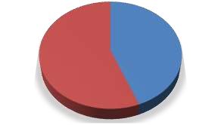

**44%**

**56%**

Male

Female

**Figure 4.1: Sex of the Despondence Source:** Authors Field Survey, 2019

## Age of the respondents

Figure 4.2 shows the various age of group of the respondents, it was discovered that 17% of the respondents were less than 20 years of age, 36% of the respondents were above 40 years while majority of the respondents with 47% were between the age group of 20-40 years. The analysis signifies that majority of the respondents were above 20 years, which means they are old enough to respond to the questionnaires.

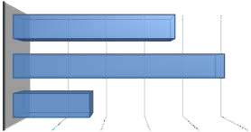

ABOVE 40 YEARS

20-40 YEARS

BELOW 20YEARS

0

10

20

30

40

50

**Percentage**

**Age Group**

**Figure 4.2: Age of the Respondents Source:** Authors Field Survey, 2019

## Marital status

Analysis in Figure 4.3 shows the marital status of the respondents, it reveals that 8% of the respondents were divorced, 9% of the respondents were widowed, and 27% of the

respondents were single while majority of the respondents with 56% were married. The shows that majority of the respondents were married.

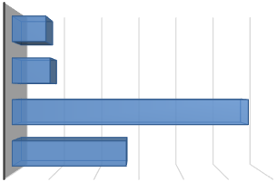

DIVORCED

WIDOWED

MARRIED

SINGLE

0

10

20

30

**Percentage**

40

50

60

**Marital Status**

**Figure 4.3: Marital Status of the Respondents Source:** Authors Field Survey, 2019

## Major Occupation

It was discovered from Figure 4.5 that 15% of the respondents were artisan, 17% were public servant, 19% of the respondents were into trading while majority of the respondents with 49% were into farming as a major occupation. The analysis signifies that farmers are the major respondents to the questionnaires.

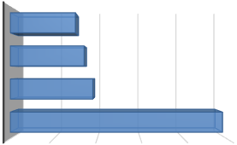

ARTISANS

PUBLIC SERVICE

TRADING

FARMING

0

10

20

30

40

50

**Major Occupation**

**Percentage**

**Figure 4.4: Major Occupation of the Respondents Source:** Authors Field Survey, 2019

## Farming experience

Figure 4.5 shows farming experience of the respondents, it shows that about 30% of the respondent has about 15 years farming experience, 22% of the respondents has about 31-40 years farming experience, 10% of the respondents have between 41-50 years farming experience while majority of the respondents with 38% has between 16-20 farming experience.

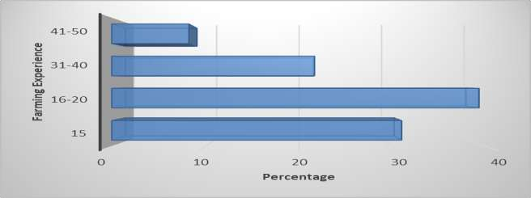

**Figure 4.5 Farming experience of the respondents Source:** Authors Field Survey, 2019

## Sources of anthropogenic practices

Source of anthropogenic practices was examined in the study area using 5 linket scale of analysis, it was discovered that deforestation has the highest means score of 10.53 and was ranked the most common source of anthropogenic practices in the study area, followed by overgrazing with 13.10 and was ranked 2nd most source of anthropogenic practices in the area, poor human activities was ranked 3rd with a means score of 10.21 has a source of human anthropogenic practices while over population was ranked 5th with a means score of 4.52. (Plate I show anthropogenic practices in the study area)

|  |  |  |  |  |  |
| --- | --- | --- | --- | --- | --- |
| **Table 4. Source of anthropogenic practices** | | | | | |
| **Variables** | **5** | **4** | **3** | **2** | **1 Mean Ranking Remarks STD** |
| Deforestation | 7 |  |  |  | 1st Strongly |
|  | | 13 | 21 | 35 | 21 10.53 agree |
| Overgrazing 3 | | 7 | 29 | 31 | 27 2nd Strongly  13.30 agree |
| Urbanization 7 | | 15 | 27 | 30 | 18 4th Undecided  9.29 |
| Over 9  exploration | | 16 | 21 | 32 | 19 5th Agree  8.38 |
| Over 19  population | | 19 | 19 | 22 | 18 6th Disagree  4.52 |
| Poor human 7  activities | | 11 | 32 | 24 | 23 3rd Agree  10.21 |

### NB: 5 = strongly agree; 4 = Agree; 3 = Undecided; 2 = Disagree; 1= strongly disagree

**Source:** Authors Field Survey, 2019

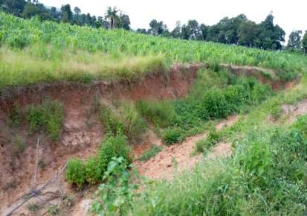

Plate I: Nature of Anthropogenic practices in the study Area

## People involved in anthropogenic practices

Figure 4.6 shows the nature of people involved in anthropogenic practices in the study area, it reveals that 11% of the respondents were residents of the study area, 10% of the respondents were business men, 17 % of the respondents were herdsmen, 27% of the respondents were miners while majority of the respondents were farmers.

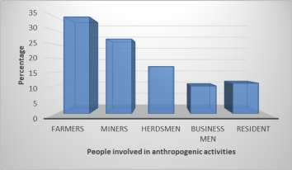

## Figure 4.6 People involve in anthropogenic practices

* + 1. **Major anthropogenic practices in the study area**

Major anthropogenic practices in the study area were reveal in Figure 4.7, it shows that 17% of the respondent agree that constant grazing is the major cause of anthropogenic practices in the area, 22% of the respondent said it is mining activities, 27% of the respondents said it was burning of forest while majority of the respondents said it was regular cutting down of tree.

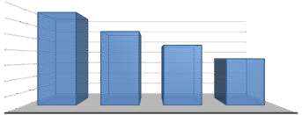

35

30

25

20

15

10

5

0

34

27

22

17

REGULAR

CUTTING DOWN OF TREES

BURNING OF

FOREST

MINING OF CONSTANT

MINERIAL GRAZING RESOUIRCES

**Anthropogenic practices**

**Percentage**

## Figure 4.7: Major anthropogenic practices in the study area

## Landcover Change based on the Anthropogenic Practices.

Based on statistics (mean; variance/covariance), (Bayesian) Probability Function is calculated from the inputs for classes established from training sites. Each pixel is then judged as to the class to which it most probably belongs (Eastman, 2006). The classes used and their definitions are shown in table 4.2

## Table 4.2 The intended classes and their definitions Land Use Definitions

Built-up Areas All built up structures including residential and commercial, roads,

shanties, make shift buildings, freight containers and all other structures, containing Aluminium, zinc or asbestos.

Farmland All human cultivated areas, including mechanized and subsistence farming practices.

Woodland All forms of vegetation including those growing on land, in between urban, structures and on water.

Water Body All water bodies including the rivers, streams, lakes, reservoirs and tributaries/channels.

Exposed Surface All sandy surfaces and rocky deposits, bare/ undeveloped surfaces which appear to be lightly vegetated.

**Source:** Adopted and Modified from Onojeghuo & Onojeghuo (2013)

## Analysis of landuse/landcover classification for Bazango Kubwa

Figure 4.8 shows the landuse landcover change map of the study area for 1988, it reveals that agricultural land was the dominant land cover features covering about 16.9614 square kilometres (43.39%) of the area. This can be found almost on every section of the map but more at the centre and towards the north east and west of the study area, this might be as a result of low anthropogenic practices at that time. This is followed by vegetation landcover which covers area of 15.4827 square kilometres (39.62%) of the total land mass of the area. Most of the vegetation landcover were found majorly in the northern, southern and south western section of the study area. This implies low developmental activities in the area resulting to large vegetation cover.

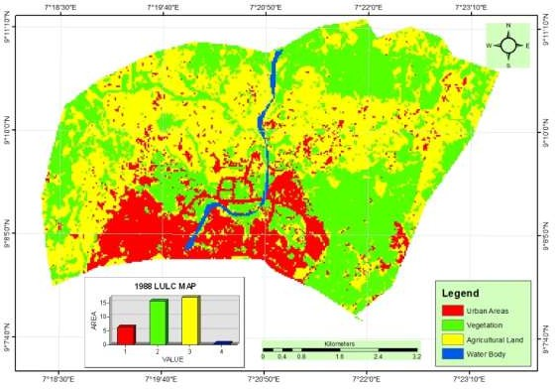

## Figure 4.8 Bazango Kubwa 1988 LULC distribution map generated from LandSat 4 TM

**Source**: Author’s Analysis, 2019.

Also, urban areas accounted for 6.2361 square kilometres (18.63%) were typically found majorly at the southern section of the study area, some patches of built-up area can also be found across the different area of the map. This implies that built up or urbanization was because the federal capital has not been moved finally from Lagos to Abuja. In addition, water body covers a total land area of 0.4023 square kilometre (1.03%) and these rivers start flowing from the northern section of the map to southern section of the study area. The total land area of the study area is 39.0825 square kilometres. The 1988 landuse and landcover map were used as the base year map to examine the changes that have taken place over time and space.

Figure 4.9 shows the landuse and landcover (LULC) of the study area for 2008 which indicates that built up or urban areas has increased within the twenty –years (20) time

period from 6.2361 square kilometre (18.63%) in 1988 and now accounted for about 12.9834 (Km2) (33.26%) this increase can be attributed to influx of people to the area as well as increase in population due to the migration of people from other state to the area. This implies urban areas continues to exert pressure on the area which increase anthropogenic practices resulting to effect on the environment. Vegetation on the other hand decreased from 15.4827 square kilometre (39.62%) in 1988 to 11.4633 (Km2) (29.34%) in 2008 which indicates that expansion in built up, deforestation and other developmental activities has reduced vegetation cover. In addition, agricultural land also decreases from 16.9614 square kilometre (43.39%) in 1988 to 14.2263 (Km2) (36.41%). This decrease can be attributed to increase demand for land for development. Also, water body remains relatively stable 0.3906 (Km2) (0.99%) in 2008. In all, Kubwa is one of the study area which has witness changes in landuse and landcover mainly from urbanization.

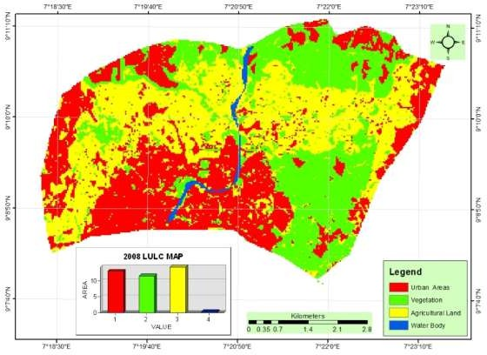

## Figure 4.9 Bazango Kubwa 2008 LULC distribution map generated from LandSat 7 ETM+

**Source:** Author’s Analysis, 2019.

Figure 4.10 show the analysis of 2018 satellite image of the study areas reveals that there was continuous expansion of built-up area on the study area. The expansion encroached on other landuse category mostly towards eastern, western and southern section of the area. Figure 4.7 reveals that in 2018 built up was the major landcover type in the areas covering a total of 19.3941 (Km2) (49.61%) of the total area which is made up both residential, commercial, and other landuse areas. There was an increase of built- up areas by 13.158 (Km2) (33.65%) in the thirty years’ period. This increase can be attributed to the closeness of Kubwa to the federal capital territory

Similarly, vegetation cover also continues to decreases from 11.4633 (Km2) (29.34%) in 2008 to 6.7986 (Km2) (17.39%) in 2018 which may be attribute to the continuous influx of people in the area leading to increased deforestation activities as well as pressure on

other available vegetation resources. Agricultural land on the other hand decreased further to 12.4209 (Km2) (31.78%) in 2018, which can be attribute to the conversion of farmland, vegetation as well as other landuses to other developmental activities to meet the increase demand of accommodation in the area as well as other people coming to the area, while Water body increased to 0.4761 (Km2) (1.22%) in 2018. This implies that the people in the area continues to source for water to meet their daily needs.

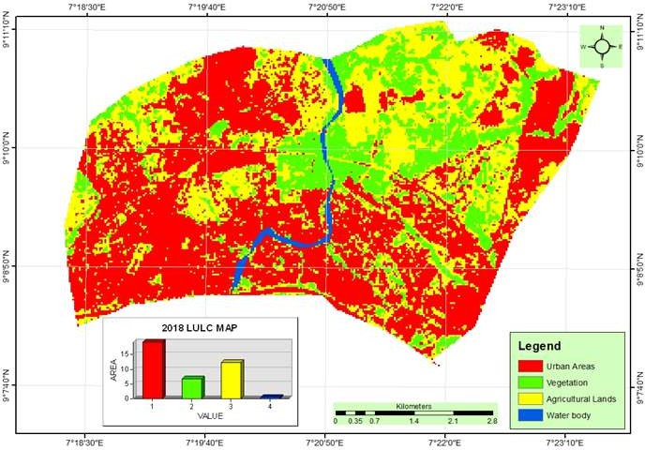

## Figure 4.10 Bazango Kubwa 2018 LULC distribution map generated from LandSat 8 OLI

**Source**: Author’s Analysis, 2019.

Similarly, Figure 4.11 shows the comparism chart of the various landuse and landcover areal statistic generated from the classified images, it shows that built up areas majorly was on the increase while vegetation and agricultural land was on the decrease.

|  |  |  |  |  |
| --- | --- | --- | --- | --- |
| 0 | Built up Areas | Vegetation | Agricultural Land | Water Body |
| 1988 | 6.2361 | 15.4827 | 16.9614 | 0.4023 |
| 2008 | 12.9834 | 11.4633 | 14.2263 | 0.3906 |
| 2018 | 19.3941 | 6.7986 | 12.4209 | 0.4761 |

## Figure 4.11: Bazango Kubwa LULC Comparism Chart

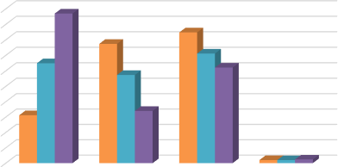

20

18

16

14

12

10

8

6

4

2

## Analysis of landuse/landcover classification for Bwari

Landuse and landcover Analysis of 1988 imagery of Bwari (Figure 4.12) reveals that agricultural land areas were the most dominant land cover features covering about 24.5988 (Km2) (45.96%) of the area. This can be found at different section of the map of the study area most especially at the western section of the area. This is attributed to the fact that Bwari area are known for farming activities which is one the core anthropogenic practices in the area. This is followed by vegetation areas which covers an area of 21.2994 (Km2) (39.79%) of the total land mass of the area. Most of the vegetation areas were located majorly in the south west, northern and eastern sections of the study area.

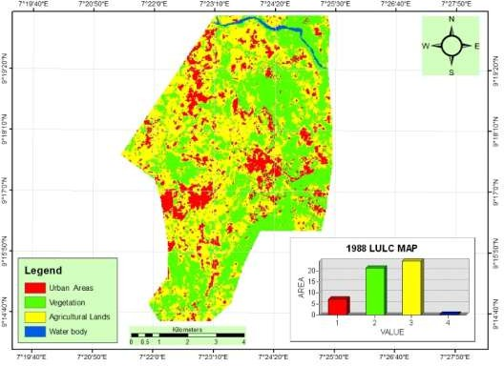

**Figure 4.12 Bwari 1988 LULC distribution map generated from LandSat 4 TM Source:** Author’s Analysis, 2019.

Also, built up area accounted for 7.2396 (Km2) (13.53%). This is found majorly in the northern and southern western part of the map and in small patches at other section of the area, this landuse indicates that in 1988 they were few settlements in the study at that time across the study area. This was because the area at that time is still rural area. Furthermore, water body covers a total land area of 0.3852 (Km2) (0.72%) and these rivers start flowing from the north western to north eastern section of the study area. The total land area of the study area is 53.523 (Km2).

Figure 4.13 shows the LULC of the study area for 2008 which indicates that built up areas has increased within the twenty –years (20) time period from 7.2396 (Km2) (13.53%) in 1988 and now accounted for about 15.588 (Km2) (29.14%) in 2008. This increase can be attributed to influx of people to the area converting other landcover type to urban areas. On the other hand, vegetation area and farm land has decreased from

21.2994 (Km2) (39.79%) in 1988 to 18.5544 (Km2) (34.69%) in 2008 and agricultural

land from 24.5988 (Km2) (45.96%) of in 1988 to 18.9612 (Km2) (35.45%) in 2008

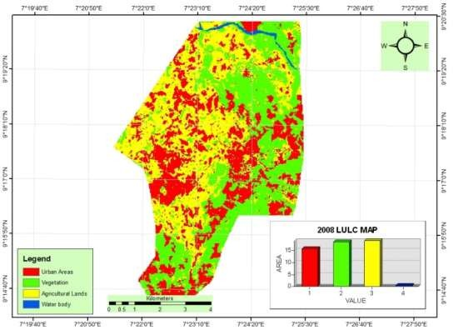respectively. This indicates that expansion in built up and other developmental activities has reduced both vegetation and agricultural landcover in the area. Water body remains relatively stable at 0.3852 (Km2) (0.72%).

## Figure 4.13 Bwari 2008 LULC Distribution Map Generated from LandSat 7 ETM+

**Source:** Author’s Analysis, 2019.

The analysis of 2018 satellite image of the study areas reveals that there was continuous increase of built-up area on the study area. Figure 4.14 reveals that in 2018 Settlement areas covers a total of 31.2552 (Km2) (58.46%) of the total area which is made up both residential, commercial, and other landuse category of the study areas. There was an increase of built-up areas by 24.0156 (Km2) (44.93%) within the thirty years’ period. This is found majorly at the southern, western, eastern and northern section of the study area.

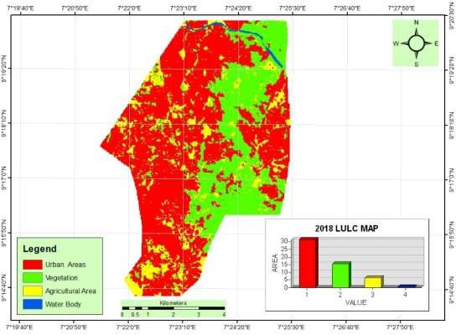

**Figure 4.14 Bwari 2018 LULC Distribution Map gener#ated from LandSat 8 OLI Source:** Author’s Analysis, 2019.

Similarly, vegetation landcover also decreases from 18.5544 (Km2) (34.69%) in 2008 to 15.5826 (Km2) (29.14%) in 2018 which may be attributed to the influx of people leading to increased deforestation activities as well as pressure on other available vegetal cover resources. agricultural land on the other hand decreased further to 6.327 (Km2) (11.83%) in 2018 from 18.9612 (Km2) (35.45%) in 2008. The major reason for the decreased may be attributed to the fact that there is continuous influx of people to the area from neighbouring satellite communities across the area. The implication of this increase in urban areas is that agricultural produce will become expensive as lands that was used for farming in the area has now be converted to urban areas. This will also lead to increase in land surface temperature of the area. While water body decrease to 0.3024 (Km2) (0.57%) in 2018.

In addition, figure 4.15 shows the areal statistic generated showing the changes that have occurred in terms of land area covered by each land use category over the years.

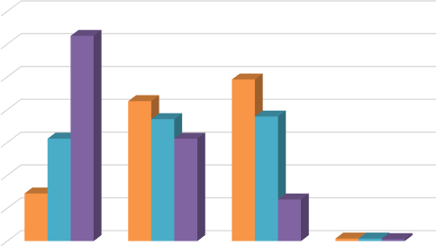

35

30

25

20

15

10

5

|  |  |  |  |  |
| --- | --- | --- | --- | --- |
| 0 | Built up Areas | Vegetation | Agricultural Land | Water Body |
| 1988 | 7.2396 | 21.2994 | 24.5988 | 0.3852 |
| 2008 | 15.588 | 18.5544 | 18.9612 | 0.3852 |
| 2018 | 31.2552 | 15.5826 | 6.327 | 0.3024 |

## Figure 4.15: Bwari LULC Comparism Chart

## Analysis of landuse/landcover classification for Igu

Figure 4.16 shows the landuse landcover (LULC) change map of the study area in 1988, it reveals that agricultural land areas was the most dominant land cover features on the study area. It covers about 75.3138 (Km2) (58.79%) in 1988. This can be found on every section of the map but more at the centre, southern and north eastern section of the study area. This is followed by vegetation areas which covers an area of 37.9845 (Km2) (29.65%) of the total land mass of the area. Most of the vegetation lands were located majorly at the north eastern and northern fringes as well as in some section of the main map of the study area. Similarly, built up areas on the other hand covers an area of 12.9348 (Km2) (10.1%) found at the centre as well as at the fringes while water body covers 1.8702 (Km2), (1.46%). The total land area of the area is 128.1033 (Km2)

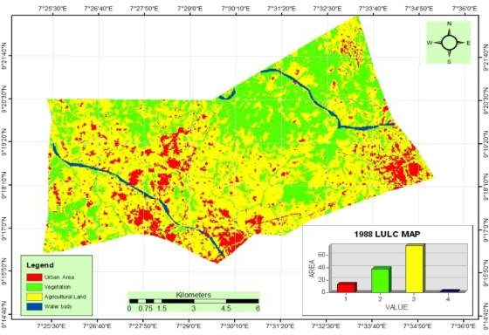

**Figure 4.16: 1988 Igu LULC distribution map generated from LandSat 4 TM Source:** Author’s Analysis, 2019

Figure 4.17 shows the LULC of the study area in 2008 which indicates that agricultural land areas was still the dominant landcover feature occupying an area of 57.4758 (Km2), (44.91%). However, there was a decreased in agricultural land 17.838 (Km2) (13.88%) within the time period. This decrease can be attributed to conversion of agricultural land to other landuse type. This area is known for grazing activities. This is one of the anthropogenic activities in the study area which has resulted to land degradation in the area thereby changing the landuse and landcover of the area.

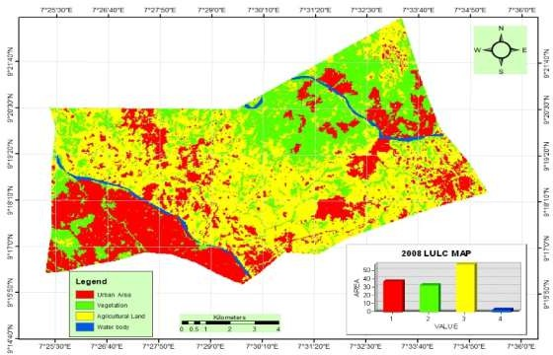

**Figure 4.17 Igu 2008 LULC distribution map generated from LandSat 7 ETM+ Source:** Author’s Analysis, 2019.

On the other hand, vegetation decreased from 37.9845 (Km2) (29.65%) in 1988 to 32.1462 (Km2), (25.12%) the decrease in vegetation area can be attributed to influx of people to the area who engage in various activities such as local fuel wood sourcing and illegal lumbering in the area. This is more towards the north eastern section of the map and in patches and fringes of the study area especially at the centre. Also, built up areas continues to increase to 36.4833 (Km2), (28.51%) in 2008 from 12.9348 (Km2), (10.1%) in 1988. This is more at the southern section of the map as well as in the eastern part of the map while water body is 1.8702 (Km2), (1.46%) in 2008.

The analysis of 2018 satellite image of the study areas reveals that there was continuous expansion of other landuse and landcover category such built up areas on the study area (Figure 4.18). The expansion encroached on agricultural landuse and landcover type mostly towards eastern, northern, western and southern section of the area. The built-up areas as reveal on Figure 4.15 shows that built up areas increased to

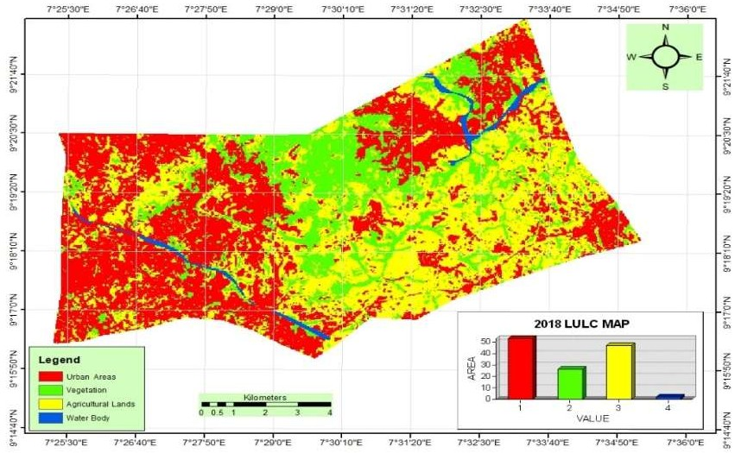53.2179 (Km2) (41.54%) in 2018. The figure further reveals that in 2018 agricultural areas covers a total of 47.1006 (Km2), (36.77%) of the total area from 57.4758 (Km2) (44.91%) in 2008. There was a further decrease of 10.3752 (Km2) (8.14%) within the ten years period.

**Figure 4.18 Igu 2018 LULC Distribution Map Generated from LandSat 8 OLI Source:** Author’s Analysis, 2019.

Similarly, other landuse and landcover types such as vegetation and water body continue to decreases to 26.0208 (Km2) (20.31%) and 1.7712 (Km2), (1.38%) respectively. This can be attributed to the vegetation resources exploitation leading to increased deforestation activities as well as pressure on other available vegetation resources such as fire wood, lumbering, farming and hunting. This will in turn change the climate of the area by increasing the temperature of the area considering the important role played by vegetation in an area. Also, if the rate of grazing is not check, this might result to clashes between farmers and herders in the area.

Similarly, Figure 4.19 shows the areal cover by each of the landuse and landcover category across the years under study from 1988 to 2018, the chart reveals that built up area was the only landuse category that was on a steady increase while other were on the decline. This can be attributed to the continued influx of people to the area as one of the major satellite town in Abuja.

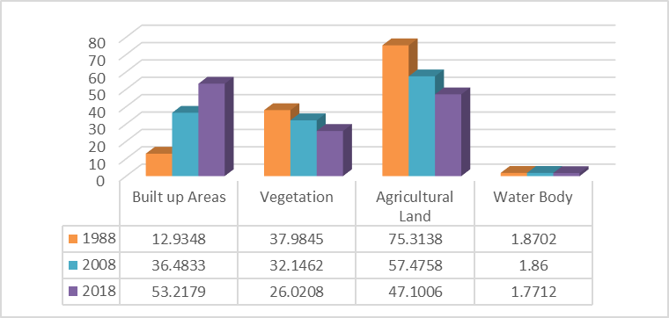

## Figure 4.19: Igu LULC Comparism Chart

## Analysis of landuse/landcover classification for Mpape

Fig 4.20 shows evidences of agricultural land dominating the land surface which occupy about 31.2831(km2) (57.96%) in the study area which is distributed all over the area. Another features which occupy a major landcover is the vegetation land accounting for 17.8128 (km2), (33%) of the total land area. Most of the vegetation lands were located majorly in the southern, south eastern and in fringes part of the study area. This is then followed by built up area which accounted for 4.6629 square kilometres (8.64%) were typically found across the north western, north eastern, and south western section of the study area. All of this analysis indicates that settlement present in the study area as at

1988 are very few. Finally, water body covers a total land area of 0.2142 (km2) (0.4%). This is found in the north western section of the map; the total land area of the study area is 53.973 square kilometres. The reason for the dominance of farm land can be attributed to the fact that the area was rural area.

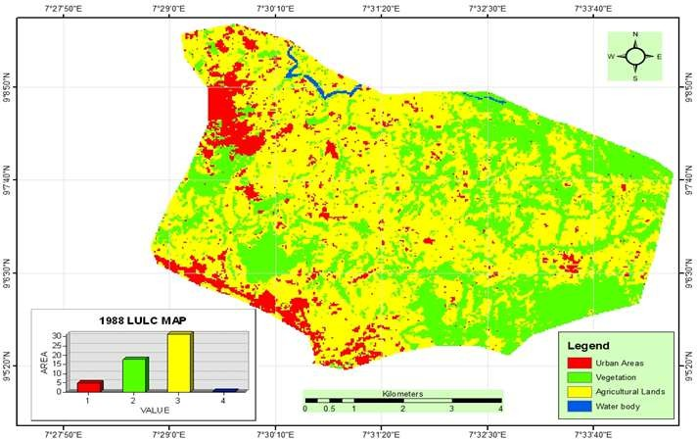

**Figure 4.20: 1988 Mpape LULC distribution map generated from LandSat 4 TM Source:** Author’s Analysis, 2019

Figure 4.21 shows that, as at 2008 the LULC of the study area has witness drastic changes across the study. The map indicates that Urban areas continuous to increase within the twenty –years (20) time period from 4.6629 square kilometres (8.64%) in 1988 and now accounted for about 14.6232 (Km2) (27.1%). vegetation on the other hand decreased from 17.8128 (km2), (33%) to 14.1579 (Km2) (26.24%) which indicates that deforestation and expansion in built up and other developmental activities has reduced vegetation cover which has resulted to land degradation.

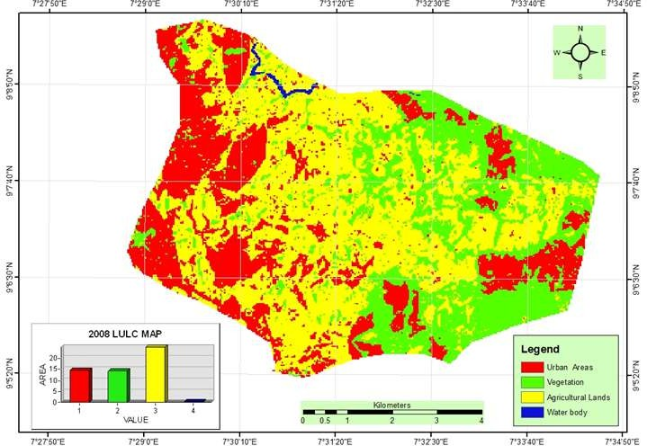

## Figure 4.21: 2008 Mpape LULC distribution map generated from LandSat 7 ETM+

**Source:** Author’s Analysis, 2019

In addition, agricultural land has also continued to decrease further as settlement increase, to most section of the study area mostly western and southern part of the area. Figure 4.21 reveals that agricultural land reduce was to 24.9831 (km2) (46.3%) in 2008 from 31.2831(km2) (57.96%) in 1988. Settlement increase in 2008 is an indication of increased in population over time and space in the study area. Finally, water body decreased from 0.2142 (km2) (0.4%) in 1988 to 0.1899 (Km2) (0.35%) in 2008.

The 2018 satellite image analysis of the study areas reveals that there is continual enlargement of built-up area in the study area. The enlargement encroached on the various LULC category mostly towards eastern, western, southern north western section and other landcover types. Figure 4.22 shows that in 2018 Settlement areas covers a total of 22.2264 (Km2) (41.19%) of the total area which is made up of both residential,

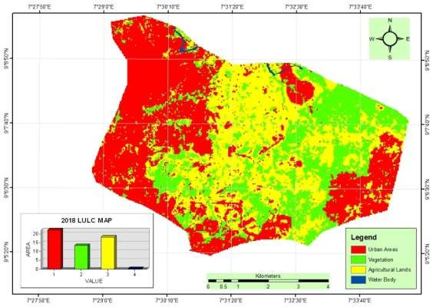commercial, and other landuse areas. There was an increase of built-up areas by 7.6032 (Km2) (14.09%) within the ten years period.

## Figure 4.22: 2018 Mpape LULC Distribution Map Generated from LandSat 8 OLI

**Source:** Author’s Analysis, 2019

Similarly, vegetation land also decreases slightly from 14.1579 (Km2) (26.24%) in 2008 to 13.4136 (Km2) (24.86%) in 2018 which may be attribute to the influx of people leading to increasing population pressure on the available vegetation resources resulting from deforestation thereby degrading the environment of the area.

|  |  |  |  |  |
| --- | --- | --- | --- | --- |
| 0 | Built up Areas | Vegetation | Agricultural Land | Water Body |
| 1988 | 4.6629 | 17.8128 | 31.2831 | 0.2142 |
| 2008 | 14.6232 | 14.1579 | 24.9831 | 0.1899 |
| 2018 | 22.2264 | 13.4136 | 18.1692 | 0.1575 |

## Figure 4.23: Mpape LULC comparism chart.

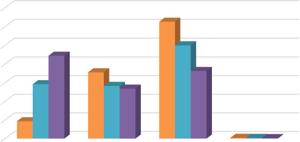

35

30

25

20

15

10

5

Agricultural land on the other hand has decreased further to 18.1692 (Km2) (33.66%), in 2018 from 24.9831 (km2) (46.3%) in 2008, which is attribute to conversion of the area to other landuses as well as increased land for construction purpose. Water body remains relatively stable within the study period from 0.1899 (Km2) (0.35%) in 2008 to 0.1575 (Km2) (0.29%) in 2018. The decrease may be due to encroachment by other land use type most especially settlement as a result of sand filling which is a means of land reclamation as well as drying up of the rivers in the study area. Furthermore, Figure

4.20 shows the changes that have occurred among the various landuse and landcover classes over space and time across the study area. the chart reveals that vegetation cover, agricultural land and water body are on the decrease while built up areas is on the increase as revealed on figure 4.20 due to contineous anthropogenic practices in the area for one socio – economic activities or the other.

## Analysis of anthropogenic practices based on landuse

## Deforestation

Deforestation is the permanent removal of trees to make room for something besides forest. This can include clearing the land for agriculture or grazing, or using the timber for fuel, construction or manufacturing. Deforestation activities seems to be higher in Map area, natural vegetation that includes forest has being reduce from 31.283 hectares in 1988 to 18.1692 hectares in 2018. It was also observed that at Igu community deforestation is prominent, it increase from 24.598 in 1988 to 6.327 and in Kubwa natural forestation reduce from 16.961 in 1988 to 12.4209 in 2018. Deforestation in the study areas occurred for several reasons: trees were cut down to be used for building or sold as fuel, while cleared land were used as [pasture](https://en.wikipedia.org/wiki/Pasture) for [livestock](https://en.wikipedia.org/wiki/Livestock) and [plantation](https://en.wikipedia.org/wiki/Plantation). The removal of trees without sufficient [reforestation](https://en.wikipedia.org/wiki/Reforestation) has resulted in degradation, [habitat](https://en.wikipedia.org/wiki/Habitat_destruction) [damage,](https://en.wikipedia.org/wiki/Habitat_destruction) [biodiversity loss](https://en.wikipedia.org/wiki/Biodiversity_loss), and [aridity.](https://en.wikipedia.org/wiki/Arid)

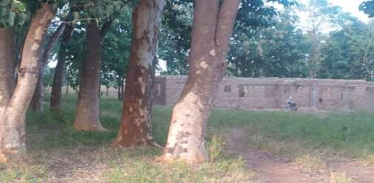

Plate II: Deforestation for housing development in Igu community

## Overgrazing

Overgrazing occurs when plants are exposed to intensive [grazing](https://en.wikipedia.org/wiki/Grazing) for extended periods of time, or without sufficient recovery periods. It can be caused by either [livestock](https://en.wikipedia.org/wiki/Livestock) in poorly managed [agricultural](https://en.wikipedia.org/wiki/Agriculture) applications, [game reserves,](https://en.wikipedia.org/wiki/Game_reserve) or [nature reserves](https://en.wikipedia.org/wiki/Nature_reserve). It can also

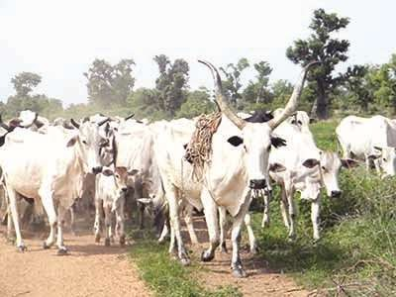be caused by immobile, travel restricted populations of [native](https://en.wikipedia.org/wiki/Indigenous_(ecology)) or [non-native](https://en.wikipedia.org/wiki/Introduced_species) [wild](https://en.wikipedia.org/wiki/Wildlife) [animals](https://en.wikipedia.org/wiki/Wildlife). However, element of overgrazing as a result of cattle movement was discovered in part of Igu and Mpape area (Plate iii and iv) farmers in these areas were complaining bitterly about the activities of herdsmen grazing their animals in that areas thereby causing soil erosion as a result of exposure of top soil.

Plate III: Activities of herdsmen causing overgrazing in Igu community

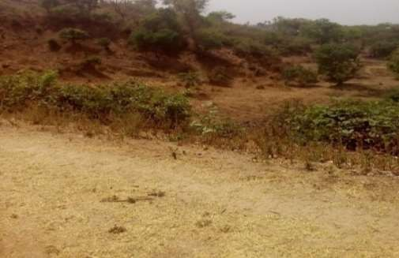

Plate IV: Resultant Effect of Overgrazing on the Environment

The activities of the herdsmen in the area reduces the usefulness, [productivity](https://en.wikipedia.org/wiki/Primary_productivity), and [biodiversity](https://en.wikipedia.org/wiki/Biodiversity) of the land and is one cause of [desertification](https://en.wikipedia.org/wiki/Desertification) and [erosion](https://en.wikipedia.org/wiki/Erosion). Overgrazing is also seen as a cause of the spread of [invasive species](https://en.wikipedia.org/wiki/Invasive_species) of [non-native plants](https://en.wikipedia.org/wiki/Invasive_plant) and of [weeds](https://en.wikipedia.org/wiki/Weed).

## Urbanization

As localities become more fruitful and prosperous due to development growth, the discovery of minerals, resource exploitation, or agricultural activities, cities start emerging as the rural areas transform to urban areas. The increase in productivity leads to economic growth and higher value-added employment opportunities.

Urbanization is observed in all the study area with higher percentage in Kubwa, followed by Mpape and Bwari. Most of the workers in FCT prefer to stay in this communities due to cost of accommodation in the city centre. Thereby brings about the need to develop better infrastructure, better education institutions, better health facilities, better transportation networks, establishment of banking institutions, better governance, and better housing. As this takes place, rural communities start to adopt the urban culture and ultimately become urban centres that continue to grow as more people move to such locations in search of a better life.

Urbanization in this area yields several positive effects if it happens within the appropriate limits. Some of the positive implications of urbanization therefore include creation of employment opportunities, technological and infrastructural advancements, improved transportation and communication, quality educational and medical facilities, and improved standards of living. However, extensive urbanization mostly results in adverse effects. The growth of slums and squatters in urban areas is even further exacerbated by fast-paced industrialization, lack of developed land for housing, large

influx of rural immigrants to the cities in search of better life, and the elevated prices of land beyond the reach of the urban poor.

## Over exploration

Exploration is the act of searching for the purpose of discovery of [information](https://en.wikipedia.org/wiki/Information) or resources. Exploration occurs in all [non-sessile](https://en.wikipedia.org/wiki/Sessility_(motility)) animal species, including humans. Over exploration of natural resources in the study area are quite severe. The first of these is the depletion of resources, this is observed in Mpape area (Plat iv). The Earth can only produce a limited amount of water and food, which is falling short of the current needs. Most of the environmental damage being seen in the last fifty odd years is because of the growing number of people on the planet.

Over exploration in the study area has started producing some serious [effects on our](https://www.conserve-energy-future.com/15-current-environmental-problems.php) [environment.](https://www.conserve-energy-future.com/15-current-environmental-problems.php) Rise in the number of vehicles and industries have badly affected the quality of air. Rise in amount of CO2 emissions leads to [global warming](https://www.conserve-energy-future.com/is-global-warming-real.php) and [changing](https://www.conserve-energy-future.com/causes-and-effects-of-climate-change.php) [climate patterns.](https://www.conserve-energy-future.com/causes-and-effects-of-climate-change.php)

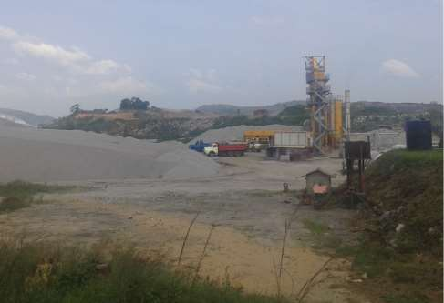

Plate V: Quarry activities in Mpape area

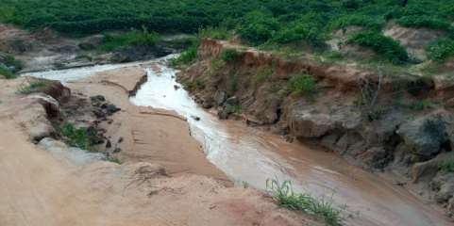

Plate VI: Over Exploration of the Environment Causing Land Degradation

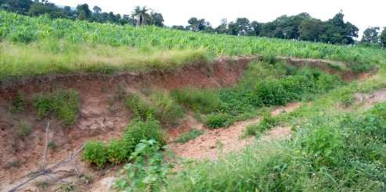

Plate VII: Over Exploration Causing Environmental damaged to Farm Land

## 4.3.5.6 Poor human Activities

Environmental impacts are changes in the natural or built environment, resulting directly from an activity that can have adverse effects on the air, land, water, fish, and wildlife or the inhabitants of the ecosystem. Pollution, contamination, or destruction that occurs as a consequence of an action that can have short-term or long-term ramifications is considered an environmental impact. Most adverse environmental impacts also have a direct link to public health and quality of life issues. Several successful reductions in pollution levels have been attributed to strict regulations, including levels of [carbon monoxide](https://www.sciencedirect.com/topics/social-sciences/carbon-monoxide) and more recent reduction in fine particulate matter. All the selected study area has serious poor human activities taken place in the

area, such as poor waste disposal management, building on flood plain areas and farming in flood plain areas. Plate VIII and IX

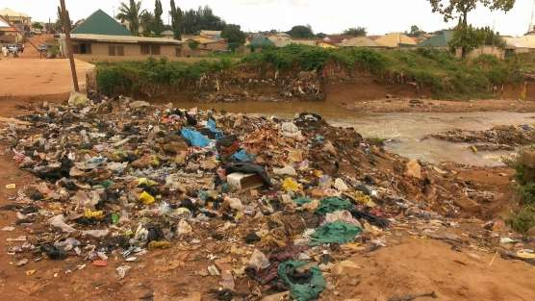

Plate VIII: Nature of Human Activities Relating to Waste Disposal in the Study Area

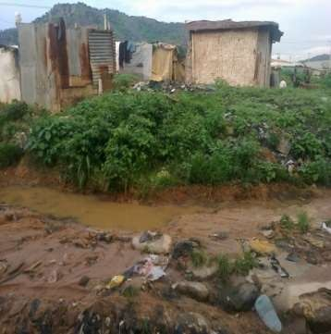

Plate IX: Poor Human Activities as a Result of Building on Flood Plain Area Mass transit, as a result of the operations and maintenance of infrastructure, facilities, and vehicles, has numerous potential

environmental impacts to manage, including air pollution and greenhouse gas from energy use, noise, and vibrations, [water discharges](https://www.sciencedirect.com/topics/social-sciences/water-discharge), waste removal of passenger trash, harmful materials such as lead-based paint, mercury, PCBs, asbestos, contaminated soil, and groundwater. Both train and bus operations have significant environmental issues to manage on an on-going continuous basis. Besides regulatory compliance, it befits an agency to reduce environmental impacts in order to pollute less, protect natural resources, and reduce liability and save costly impacts to budgets.

## Impacts of Degraded LandCover on Agricultural Activities in the Study Area

## Impact of degraded land cover on agricultural land

In the thirty years interval between 1988 and 2018, both positive and negative changes in landuse and landcover categories were experienced. Figure 4.14 and Table 4.3 reveals that built up areas and farmland increased at the rates indicated therein. The significant rate of change is in built up land which increased at the rate of 72%. This increase is due to the rapid urbanization witnessed especially from 2008-2018.

## Table 4.3 Landuse Changes between 1988, 2008 and 2018

|  |  |  |  |
| --- | --- | --- | --- |
| Land use | 1988 (km2) | 2008 (km2) | 2018 (km2) |
| Built – up Area | 64.79 | 72.92 | 127.08 |
| Farmland | 70.87 | 85.84 | 235.52 |
| Woodland | 459.96 | 428.70 | 249.67 |
| Water Body | 49.27 | 61.68 | 47.85 |
| Exposed Surface | 59.79 | 55.53 | 44.54 |

**Source:** Author field survey 2019

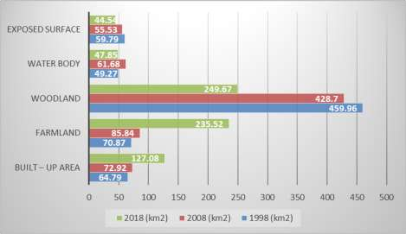

**Figure 4.24 Landuse changes in Kilometres from 1998 – 2018 Source:** Authors Analysis, 2019

The study revealed a tremendous increase residential, commercial, institutional, public and semi-public; industrial and road network were classified under built-up area. The built-up area increased from 64.79 kilometres square (km2) between 1998 to 331.12 km2in 2008, farmlands for agricultural activities increased from 70.87 hectares in 1995 to 195.54 km2in 2018.

Woodland declined from 459.96 km2in 1998 to 95.32 hectares in 2018, water body decreased by 1.94 km2, i.e., from 49.27 km2 to 47.33 km2, exposed surface in the study area also decreased from 59.79 km2 to 34.87 km2. Therefore, the decline of these land use changes was basically due to human activities and the development of the city.

## Table 4.4 Difference in Landuse Changes (Area) between 1988, 2008 and 2018

|  |  |  |
| --- | --- | --- |
| **Land Use** | 1988 - 2008 | 2008 - 2018 |
| Built – up Area | 8.13 | 54.16 |
| Farmland | 14.97 | 149.68 |
| Woodland | -31.26 | -179.03 |
| Water Body | 12.41 | -13.83 |
| Exposed Surface | -4.26 | -10.99 |

**Source:** Author field survey 2019

200

150

100

50

0

Built – up Area Farmland

Woodland Water Body

Exposed

Surface

Barren Land

-50

-100

-150

-200

## Figure 4.25 Differences in landuse changes (Area) between 1998, 2008 and 2018

**Source:** Author field survey 2019

As urbanization gradually envelopes major town in the area, it patterns of growth as indicative from figures 4.11 and 4.12 depicts that woodland, water bodies and exposed surfaces are the worst hit due to the human activities (urbanization and agriculture) in the area. If this pattern remains unchecked it would lead to the total annihilation of woodland areas in the study area.

## Status of landcover change on agricultural activities

Status to the level of impact of landuse on agricultural activities was examined, Table

4.4 shows that loss of soil macro and micro-organism has the highest mean score of

14.31 and was ranked 1st as the most impact of land use on agricultural activities, followed by impending plant growth with 14.15 ranked second and loss of soil structure was ranked 3rd with a mean score of 13.43.

## Table 4.5 Status Level of Impact of Landcover Change on Agricultural Practices

|  |  |  |  |  |
| --- | --- | --- | --- | --- |
| Variables 5 | 4 | 3 | 2 | 1 **Mean Ranking Remarks**  **STD** |
| Loss of soil nutrient 4 | 14 | 33 | 30 | 22 11.87 5th Disagree |
| Exposure of top soil to 2  erosion | 11 | 31 | 31 | 28 th Agree  13.32 4 |
| Impeding plant growth 4 | 9 | 33 | 36 | 21 2nd Strongly  14.15 agree |
| Loss of soil macro and 3 micro-organism | 7 | 31 | 31 | 31 1st Strongly  14.31 agree |
| Soil salinity 8 | 16 | 29 | 32 | 18 7th Strongly  9.84 disagree |
| Loss of soil structure 6 | 9 | 21 | 38 | 29 13.43 3rd Agree |
| Others 5 | 22 | 35 | 22 | 19 6th Strongly  10.69 agree |

### NB: 5 = strongly agree; 4 = Agree; 3 = Undecided; 2 = Disagree; 1= strongly disagree

**Source:** Authors Field Survey, 2019

## Major effect of degraded land cover

Figure 4.16 shows that the major effect of degraded landcover is decline in crop yield with 43% respondents, followed by loss of source of income with 31% of the respondents, followed by 22% of the respondent with render people jobless while only 4% of the respondents attribute it to other factors not listed.

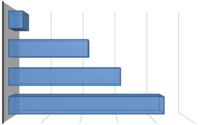

**Major Effect**

50

40

30

20

10

0

43

DECLINE IN CROP YEILLD

31

LOSS OF SOURCE OF INCOME

22

RENDER PEOPLE JOBLESS

4

OTHERS

**Percentage**

## Figure 4.26 Major Effect of Degraded Landcover

## Mitigation and Adaptation Measures put in Place in the Study Area.

Various mitigation measures were adopted by the respondents to mitigate against the effect of anthropogenic activities on land use in the area, it shows that training programme, increase the area standard management, increase the area of farming encouraging individual, involvement of the local people, intensifying cooperation and encourage the development are some of the measures used by the respondents in the study area.

## Table 4.6 Mitigation and Adaptation Measures

|  |  |  |  |  |  |  |
| --- | --- | --- | --- | --- | --- | --- |
| **Items** | **5** | **4** | **3** | **2** | **1** | **Mean STD** |
| Training programmes | 2 | 9 | 21 | 47 | 32 | 17.99 |
| Increasing the area. | 2 | 7 | 30 | 39 | 33 | 16.57 |
| Increase the area of farming | 4 | 15 | 33 | 38 | 21 | 13.70 |
| Encouraging individual | 2 | 11 | 31 | 36 | 31 | 14.82 |
| Involvement of the local | 4 | 7 | 33 | 38 | 29 | |
| people |  |  |  |  |  | 15.61 |
| Intensifying cooperation | 3 | 8 | 31 | 41 | 28 | 16.08 |
| Encouraging the development | 2 | 9 | 21 | 47 | 32 | 17.99 |
| Inventorying degraded lands, | 2 | 7 | 30 | 39 | 33 | 16.57 |
| Development of a National | 4 | 15 | 33 | 38 | 21 | 13.70 |

(NB: Details tested variables were attached in Appendix 1)

**Source:** Authors Analysis 2019

## Summary of Findings

Socio economic characteristic of the respondents were analysis base on sex of the respondents, age of the respondents, marital status, house hold size, major occupation of the respondents, types of materials used for building, sources of drinking water and energy sources. The findings show that 56% of the respondents were female while 44% of the respondents were male. This shows that females were the majority of the respondents to this research questionnaires and this is because at the time of visit to the community’s female were found to be more available than male. It also shows that 17% of the respondent were less than 20 years of age, 36% of the respondents were above 40 years while majority of the respondents with 47% were between the age group of 20-40 years. The analysis signifies that majority of the respondents were above 20 years, which mean they are old enough to respond to the questionnaires it also revealed that majority of the respondents were married. It was also discovered that about 30% of the respondent has about 15 years farming experience, 22% of the respondents has about 31-40 years farming experience, 10% of the respondents have between 41-50 years farming experience while majority of the respondents with 38% has between 16-20 farming experience.

Source of anthropogenic practices was examined in the study area using 5 linket scale of analysis, it was discovered that deforestation has the highest means score of 10.53 and was ranked the most common source of anthropogenic practice in the study area, followed by overgrazing with 13.10 and was ranked 2nd most source of anthropogenic practice in the area, poor human activities was ranked 3rd with a means score of 10.21 as a source of human anthropogenic practices while over population was ranked 5th with a means score of 4.52. It also shows the nature of people involved in anthropogenic practices in the study area, it reveals that 11% of the respondents were residents of the

study area, 10% of the respondents were business men, 17 % of the respondents were herdsmen, and 27% of the respondents were miners while majority of the respondents were farmers.

Major anthropogenic practices in the study area reveal that 17% of the respondents agree that constant grazing is the major cause of anthropogenic practices in the area, 22% of the respondent said it is mining activities, 27% of the respondents said it was burning of forest while majority of the respondents said it was regular cutting down of tree. It also revealed that in 1988, the northern, eastern and western sectors of the study area was covered by mostly woodland vegetation sparsely intermixed with farmlands. And in 2018, LULC images shows that the area built up areas have grown from 10.35% in 2008 to 18.03%, a leap of over 54.166 kilometres square being developed in ten years.

Impact of degraded landcover on agricultural land, the findings reveal that built up areas and farmland increased at the rates indicated therein. The significant rate of change is in built up land which increased at the rate of 72%. This increase is due to the rapid urbanization witnessed especially from 2008-2018. It also revealed a tremendous increase in residential, commercial, industrial, institutional, public and semi-public; industrial and road network were classified under built-up area. The built-up area increased from 64.79 kilometres square (km2) between 1988 to 331.12 km2in 2008, farmlands for agricultural practices increased from 70.87 hectares in 1995 to 195.54 km2in 2018.

Status to the level of impact of landuse on agricultural activities was examined, the findings shows that loss of soil macro and micro-organism has the highest mean score of 14.31 and was ranked 1st as the most impact of landuse on agricultural activity, followed by impending plant growth with 14.15 ranked second and loss of soil structure was ranked 3rd with a mean score of 13.43. The least ranked was loss of soil nutrient with 11.87 and ranked 5th which signifies disagree with the statement. The findings shows that the major effect of degraded landcover is decline in crop yield with 43% respondents, followed by loss of source of income with 31% of the respondents, followed by 22% of the respondent with render people jobless while only 4% of the respondents attribute it to other factors not listed.

The findings show various mitigation measures were adopt by the respondents to mitigate against the effect of anthropogenic practices on land use in the area, it shows that training programme, increase the area standard management, increase the area of farming encouraging individual, involvement of the local people, intensifying cooperation and encourage the development of some of the measures used by the respondents in the study area.

# CHAPTER FIVE

* 1. **CONCLUSION AND RECOMMENDATIONS**

## Conclusion

Despite the fact that the study area is becoming more and more urban, the indigenous landuse type of farm holdings and villages is still in existence. The availability of land in the area which supports agricultural production makes farming the major land use type and occupation of the residents. However, agriculture doesn’t translate to higher income earning, among the different categories of respondents studied in the area, as their overall income still remains low. The different categories of landuse activities in the study area being mapped in this study shows huge and, in some cases, serious degradation. This study would therefore draw the conclusion that as already established, there is little natural vegetation remaining in the area, which should be conserved acutely despite its rapid urbanization. Hence proper planning on future expansion of the area should be based on sustainable practices, if the best and optimum use of land is to be achieved.

## Recommendations

To fight with the problems of anthropogenic practices on agricultural activities in the study area, it is suggested that the use of remote sensing and GIS in conjunction with geospatial data is of vital importance. There is need for the use of an urban information database that can be generated using remote sensing data and GIS techniques. Top priority should be given to the issues related to the planned development of the area to foster damaged to agricultural land.

The study also recommends the following:

1. Agricultural activities should be carried out in a sustainable manner.
2. The anthropogenic practices within agricultural land should be regulated.
3. Other landuses that are non-agricultural should be sustainably utilized and areas with natural vegetation should also be reserved with strict laws enacted to maintain them.
4. Enlightening on proper anthropogenic practices as well as risk involved in wrong practices should be encourage by different stakeholders.

# REFERENCES

Abegunde, M.A., Adegoke, K.A., Onwumere, M.A., Dahiru, A. & Okunade, S. (2001).

*Senior Secondary geography 3* Longman Nigeria plc. 42 – 44.

Abumere, S.I. (1993); Statistical methods in Urban and Regional Planning in Agbola, T. Readings in Urban and Regional Planning. 103-127.

Abdullahi, A.M., Ariyo, J.A., Oladipo, E.O., & Owonubi, J.J. (2010). Reclamation of desertified farmlands and consequences for its farmers in semiarid northern Nigeria: a case study of Yambawa rehabilitation scheme. *Arid Land Research and Management*, 17(1), 85-101. <http://dx.doi.org/10.1080/15324980301590> (Accessed 5

May, 2015)

Ansari, J. & Matondkar, D. (2014). Management of the Urban Environment Using Remote Sensing and Geographic Information Systems. *Journal of Human Ecology*, 20(4): 269-277

Adakayi P.E. (2000). *Climate*. In: Dawam, P.D. (ed) Geography of Abuja, Federal Capital Territory. Abuja: Famous/Asanlu Publishers

Adebayo, S. (1994). Effects of Land Degradation on Maize-Based Farm Resource Productivity in Oyo State, Nigeria. *Direct Research Journal of Agriculture and Food Science,* 2(1), 8-12.

Adedeji, S. & Salami, O. (2008). Change detection and hydrological implication in the Lower Ogun flood plain, SW Nigeria, IAHS Symposium on Remote Sensing for Environmental Monitoring and Change Detection. Perugia: ITALIE, 316: 91-99.

Adeleye, A.O. (1989). *Introduction* to Tropical Crops. Ibadan: Published by Raflink Computer Eleyele.

Ademiluyi, I.A., Okude, A.S. & Akanni, C.O., (2008), An appraisal of land use and land cover mapping in Nigeria. *African Journal of Agricultural Research*, 3(9): 581- 586.

Adewuyi, T.O. (2012). Recent Consequences of Land Degradation on Farmland in the Peri-Urban Area of Kaduna Metropolis, Nigeria. *Journal of Sustainable Development in Africa*, 14(3), 1520-5509.

Alhassan, M.M., (2000). Estimation of Land cover change in the Federal Capital Territory (FCT) Using Satellite Remote sensing. Proceedings of the 12th Annual National Conference of Environment and Behaviour Association of Nigeria held at the University of Agriculture Abeokuta Nigeria. 24-26.

Alewell, C., Meusburger, K., Brodbeck, M., & Bänninger, D. (2008). Methods to describe and predict soil erosion in mountain regions. *Landscape and Urban Planning*, 88, 46-53

Amsalu, A., & de Graaff, J. (2006). Farmer’s views of soil erosion problems and their

conservation knowledge at Beressa watershed, central highlands of Ethiopia.

*Agriculture and Human Values,* 23, 99 – 108

Apata, E. (2015). Trends in land use and agricultural intensification in Kakamega, Western. Rheinischen‐Friedrich‐Wilhelms‐Universität, Bonn, Germany

Appleton, K. & Sewanyana, S. (2013). Poverty Estimates from the Uganda National Household survey II, 2012/13. EPRC memo.

Bai, Z. & Dent, D. (2008). *Land Degradation and Improvement in Argentina: Identification by Remote Sensing.* Wageningen, Netherlands: International Soil Reference Information Center-World Soil Information

Bationo, A., Kihara, J., Waswa, B., Ouattara, B., Vanlauwe, B. (2006). Technologies for sustainable management of sandy Sahelian soils. In: Management of Tropical Sandy soils for sustainable agriculture. A holistic approach for sustainable development of problema soils in the tropics. FAO Regional Office for Asia and the Pacific. Bangkok. 414-429.

Bampton, M. (1999). ["*Anthropogenic Transformation*"](https://books.google.com/books?id=Y0iX2z48qkUC&pg=PA22) *in Encyclopaedia of Environmental Science*, D. E. Alexander and R. W. Fair bridge (eds.), Kluwer Academic Publishers, Dordrecht, The Netherlands, [ISBN](https://en.wikipedia.org/wiki/International_Standard_Book_Number) 0412740508.

Bali, Z., Bhattacharya, A.R., & Singh, T.N. (2009). Active tectonics in the outer Himalaya: dating a landslide event in the Kumaun sector. *E-Journal Earth Science India,* 2 (IV), 276–288

Boardman, J. (2006). Soil Erosion Science: Reflections on the limitations of current approaches. *Soil Erosion Research in Europe*, 68 (2-3), 73-86

Cook, J. (2016). "Consensus on consensus: a synthesis of consensus estimates on human-caused global warming". [*Environmental Research Letters*](https://en.wikipedia.org/wiki/Environmental_Research_Letters)*.* 11 (4): 048002. [Doi](https://en.wikipedia.org/wiki/Digital_object_identifier): [10.1088/1748-9326/11/4/048002](https://doi.org/10.1088%2F1748-9326%2F11%2F4%2F048002). Warming is shared.

Creswell, J.W. (2012). Educational Research: Planning. Conducting, and Evaluating Quantitative and Qualitative Research. (4TH edition). SAGE in Publications.

Chioma, M. & Felix, B. (2017). Farmers’ indicators for soil erosion mapping and crop yield estimation in central highlands of Kenya. Wageningen University: the Netherlands

Chup, A. (2004). Effect of Economic Liberalisation in Chicken Meat Production in Nigeria: *European journal of Social Sciences*. **7**(4):173 – 180.

Crutzen, P. (2000). "The 'Anthropocene'" *International Geosphere-Biosphere Programme Newsletter*. 41: 17–18

Dawan, M. (2000) Climatic perspectives on Sahelian desiccation: 1973–1998. Global Environmental Change—*Human and Policy Dimensions* 11:19–30

Deininger, K. & J. Okidi (2001). “Rural households: Incomes, productivity and non-

farm enterprises. In *Uganda’s Recovery: The Role of Farms, Firms, and Government*. Washington, D.C., the World Bank.

Diagana, B. (2003). Creating incentives for the adoption of sustainable agricultural practices in developing countries: the role of soil carbon sequestration. *American Journal of Agricultural Economics* 85:1178-1184. [http://dx.Doi.org/10 .1111/j.0 092-](http://dx.doi.org/10%20.1111/j.0%20092-5) [5](http://dx.doi.org/10%20.1111/j.0%20092-5)853.2003.00526.x

EEA (2000). Are we moving in the right direction? Indicators on transport and environmental integration in the EU. European Environment Agency (EEA), Copenhagen, Denmark

Easterling, W., & Apps, M. (2005). Assessing the consequence of climate change for food and forest resources, a view from the IPCC. *Climate Change*, 70, 165-189

FAO (2011). Land Degradation Assessment in Drylands (LADA): manual for local level assessment of land degradation and sustainable land management, Part 1: Planning and methodological approach, analysis and reporting. Food and Agriculture Organization of the United Nations (FAO), Rome

Famous, G. (2012). Erosion Crisis and its Effects on Housing in Akure. *Urban Environment Sustainability, Urban Design Research Team, Akure. Fadamiroet al (ed)*, 161-168.

FAO (2001). Household Food Security and Forestry an Analysis of Socio-economic Issues. Community Forestry Note 1. FAO, Rome. 140-148.

FAO (2006). Soil Fertility Management in Support of Food security in Sub-Saharan Africa. Retrieved on March 21, 2016 from: <ftp://ftp.fao.org/agl/agll/docs/foodsec.pdf>.

Hawksworth, D.L. & Bull, A.T. (2008). *Biodiversity and Conservation in Europe.*

Springer. 3390. [ISBN](https://en.wikipedia.org/wiki/International_Standard_Book_Number) 978-1402068645.

Ireland, L., Amthys, E., Pius, O. & Golly, M. *(*2009). Water erosion in the southern French Alps: climatic and human mechanisms. *Catena*, 50, 53-85

lbrahim, H.B. (2015). Towards a People-Centred Approach in Theology for Socio-Economic Rural Community Development in Nasarawa State, Nigeria. Unpublished Master Thesis Department of Practical Theology, University of Stellenbosch, South Africa. Pp 1-48.

Izuogu, J.G. (2015). An investigation of vegetation status and process in relation to human disturbance in Kakamega Forest, western Kenya. University of Wales, UK, London

Ireland, X., Chuanglin F., George L.C.S., Hongmian, G., and Biao, Q. (2016). Tempo- Spatial Patterns of Land Use Changes and Urban Development in Globalizing China: A Study of Beijing. Sensors, 7:2881-2906

Hau, G.S.K. & Denga, S.M. (2018). FO An overview of the soil erosion and

sedimentation problems in Kenya. In: Hadley RF, Mizuyama T. (eds) Sediment problems: strategies for monitoring, prediction and control, Yokohama, Japan, 1993. IAHS Publ. (217) 216‐221

Jegede, C. (1995.), Physical Environment, Decision- making and Land-Use Development in Metropolitan Lagos. *Geo Journal*, 12: 433-442

Jean, van der (2002). "Evaluation of the environmental impact of agriculture at the farm level: a comparison and analysis of 12 indicator-based methods". *Agriculture, Ecosystems and Environment.* 93(1–3): 131–145. [Doi](https://en.wikipedia.org/wiki/Digital_object_identifier): [10.1016/S0167-8809 (01)00 3](https://doi.org/10.1016%2FS0167-8809%2801%2900354-1)

[54-1](https://doi.org/10.1016%2FS0167-8809%2801%2900354-1).

Jones, S. (1996) Discourses on land degradation in the Uluguru Mountains, Tanzania: evolution and influences. *Journal of Rural Studies*, 12 (2), 187-199

Karageorgis, A.P., Skourtos, M.S., Kapsimalis, V., Kontogianni, A.D., Skoulikidis N.T., Pagou K., Nikolaidis, N.P., Drakopoulou, P., Zanou, B., Karamanos, H., Levkov, Z. & Anagnostou, C., (2005). An integrated approach to watershed management within the DPSIR framework: Axios River catchment and Thermaikos Gulf. *Regional Environmental Change* 5:138–160. Doi: 10.1007/s10113‐004‐0078‐7

Kabubo-Mariara, J., Linderhof, M., Kruseman, G., Atieno, F. & Mwabu, M. (2010). “Land Conservation and Tenure Security in Kenya: Boserup’s Hypothesis Revisited.” *Ecological Economics* 64: 25–35.

Kamau, F. (2010). Factors affecting acceptance and continued use of soil conservation practices in developing societies: a diffusion perspective. *Agriculture, Ecosystems and Environment* 36:127–140

Kimaru, G. & Jama K.K. (2010). *Soil Fertility and Land Productivity. A Guide for extension Workers in the Eastern Africa Region*. Regional Land Management Unit (RELMA), Nairobi. 132pp.

LADA (2009). Field manual for local level land degradation assessment in dry lands.

LADA Part 1: Methodological Approach, Planning and Analysis.

Lal, R., (2000). Soil erosion in the tropics: Principles and management, Mcgrew Hill Inc. New York 236.

Lambin, E.F., Geist, H. & Lepers, E. (2003). Dynamics of land use and cover change in tropical regions. *Annual Review. Environmental. Resource*. 28: 205–241.

Lestrelin, G. & Giordano, M. (2007). Upland development policy, livelihood change and land degradation: Interaction from a Loatian Village. *Land Degradation and Development,* 18, 55-76

Mariara, O.S., Wokocha, C.C & Ayolagha, G. (2010). GIS Assessment of Land Use and Land Cover Changes in OBIOIAKPOR L.G.A., Rivers State, Nigeria*. Research Journal of Environmental and Earth Sciences* 3(4): 307-313, 2011 ISSN: 2041-

0492

Mba, Z., Hongming, J., Malpezzi, S. and Guo, W.K. (2016): Measuring Human Activities: Alternative Measures of Urban Form in US Metropolitan Area. The Centre for Urban land Economics Research, University of Wisconsin, Madison.

Marsh, O. & Gross, A. (1989). “Social Capital and Rural Intensification: Local Organisations and Islands of Sustainability in the Rural Andes. *Geographical Journal*: 163: 189-197.

Marzolff, P. & Poesen, K.G. (2009). “Poverty, Institutions and the Environment- Resource Base.” World Bank Environment Paper Number 9; World Bank- Washington.

Mazzucato, V. & Niemeijer, D. (2000). Rethinking soil and water conservation in a changing society; a case study in eastern Burkina Faso*. Tropical Resource Management Papers*. Wageningen University, Wageningen.

Matano, F.S., Mugendi, D.N., Mwanje, J.I., Ramisch, J.J., Mbugua, P.K. and Chiang,

J.N. (2015). “Integrating scientific and farmers’ evaluation of soil quality indicators in Central Kenya”, *Geoderma*, 139: 134–143.

Maitima, J.M., Mugatha, S.M., Reid, R.S., Gachimbi, L.N., Majule, A., Lyaruu, H., Pomery, D., Mathai, S. and Mugisha, S. (2009). “The linkages between land use change, land degradation and biodiversity across East Africa”. *African Journal of Environmental Science and Technology*, 3(10): 310–325.

McDonagh, J.F., Hillyer, A., E.M. & Verlinden, A. (2006). Land-use and legumes in northern Namibiathe value of a local classification system. *Agriculture*, *Ecosystems & Environment*, 117, 251-265.

March, Y. (1989). Evaluation of land performance in Senegal using multi‐temporal NDVI and rainfall series. *Journal of Arid Environments* 59:463‐480

Moeyersons, E.B. (1991). “The Economic Linkage between Rural Poverty and Land Degradation: Some Evidence from Africa”. *Agriculture, Ecosystems and Environment*: 82:355-370.

Mushala, H.M. (1997). Soil Erosion and Indigenous Land Management: Some Socio- Economic Considerations. *Soil technology,* 11, 301-310

Mundi, B. (2000). Agroforestry in the dry lands of eastern Africa: a call to action.

ICRAF Working Paper – No. 1. World Agroforestry Centre, Nairobi, Kenya

Norbu, C., Baillie, I., Dema, K., Dema, Y., Tamang, H.B., Turkelboom, F. (2003).

Types of Land degradation in Bhutan, *Journal of Bhutan Studies*, 8, 88-114

Odunayo, O. (2006). Introduction to Environmental Issues Causes, Effects and Solutions. Ikofa Commercial Press Ltd. 20, Mutairu Street, Off Pedro Road Shomolo: 59.

Omokhua, K. & Koyejo, S. (2014). "Galloping Poverty in Nigeria: An Appraisal of the Government's Interventionist Policies." *Journal of Sustainable Development in*

*Africa* 12(6); 23-29.

Paudel, G.S., & Thapa, G.P. (2004). Impact of social, institutional and ecological factors on land management practices in mountain watersheds of Nepal. *Applied Geography*, 24, 35-55

Parkner, O., Byiringiro, F. and Reardon, T. (1996).” Farm Productivity in Rwanda: Effects of Farm Size, Erosion and Soil Conservation Investments” *Agricultural Economics*: 15:127-136.

Perkins, S. (July 11, 2017). ["The best way to reduce your carbon footprint is one the](http://www.sciencemag.org/news/2017/07/best-way-reduce-your-carbon-footprint-one-government-isn-t-telling-you-about) [government isn't telling you about"](http://www.sciencemag.org/news/2017/07/best-way-reduce-your-carbon-footprint-one-government-isn-t-telling-you-about). [Science](https://en.wikipedia.org/wiki/Science_(journal)). Retrieved November 29, 2017.

Pearson, C.J., & Ison, R.L. (1997). Overview: perspective on grassland systems.

*Agronomy of grassland systems*, 17

Rapport D.J, Regier, H.A., Hutchinson, T.C. (1985) Ecosystem behaviour under stress.

*The American Naturalist,* 125:617‐640

Rinzin, C. (2008). Status, options and challenges in soil and water conservation in Bhutan: An implication for sustainable land management. *MSc Thesis*, Asian Institute of Technology (AIT), Thailand

Turkelboom, F., & Wangchuk, T. (2011) Steep land farmers and their land resources: a holistic degradation assessment of eastern Bhutan. Renewable Natural Resources Research Centre (RNR RC), Wengkhar, *Technical Documents No.42/FS/2009*.Minsitry of Agriculture. Royal Government of Bhutan

Sahney, S., Benton, M.J. Ferry, P.A. (2010). ["Links between global taxonomic](https://www.ncbi.nlm.nih.gov/pmc/articles/PMC2936204) [diversity, ecological diversity and the expansion of vertebrates on land"](https://www.ncbi.nlm.nih.gov/pmc/articles/PMC2936204). Biology Letters. 6 (4): 544–547. [Doi](https://en.wikipedia.org/wiki/Digital_object_identifier):[10.1098/rsbl.2009.1024](https://doi.org/10.1098%2Frsbl.2009.1024). [PMC](https://en.wikipedia.org/wiki/PubMed_Central) [2936204](https://www.ncbi.nlm.nih.gov/pmc/articles/PMC2936204). [PMID](https://en.wikipedia.org/wiki/PubMed_Identifier) [2010685](https://www.ncbi.nlm.nih.gov/pubmed/20106856)

[6](https://www.ncbi.nlm.nih.gov/pubmed/20106856)

Scott, M. (2014*).* [*"Glossary"*](http://earthobservatory.nasa.gov/Library/glossary.php3?mode=all)*.* [*NASA Earth Observatory.*](https://en.wikipedia.org/wiki/NASA_Earth_Observatory) *Retrieved 2008-11-03.* Shelton,

I. J., (2012). Gully erosion control Retrieved from [www.omafra.gov.on.ca/..](http://www.omafra.gov.on.ca/) /88- 059htm August 2019

Stockton, Nick (22 April, 2015). ["The Biggest Threat to the Earth? We Have Too Many](https://www.wired.com/2015/04/biggest-threat-earth-many-kids/) [Kids".](https://www.wired.com/2015/04/biggest-threat-earth-many-kids/) [Wired.com](https://en.wikipedia.org/wiki/Wired.com). Retrieved 24 November, 2017.

Skoola, T. (2012). Multivariate approach to grouping soils in small fields 1: extraction of factors causing soil variation by PCA. *Soil Science Plant Nutrition* 35 (3):469‐477

Stewart, D. (1998). Physical and chemical methods of soil analysis. Report No. M17.

Kenya Soil Survey, Nairobi, Kenya

Valentin, C., Agus, C., Alamban, F., Boosaner, R., Bricquet, A., Chaplot, J.P., de Guzman, V., de Rouw, T., Janeau, A., Orange, J.L., Phachomphonh, D., Phai, K.,

Podwojewski, D.D., Ribolzi, Silvera, O., Subagyono, L.N., Thiébaux, K., Toan, J.P., & Vadari, T. (2008). Runoff and sediment losses from 27 upland catchments in Southeast Asia: Impact of rapid land use changes and conservation practices. *Agriculture, Ecosystems and Environment*, 128, 225–238

Vezina, K., Bonn, F., & Van, C.P. (2006). Agriculture land-use patterns and soil erosion vulnerability of watershed units in Vietnam’s northern highlands. *Landscape Ecol*ogy, 21, 1311-1325

Wall, P.J, (2012). Increasing food Production in Sub‐Saharan Africa: Environmental problems and inadequate technological solutions. *American Journal of Agricultural Economics* 66 (5):671‐676

Wafuke, C. (2012). Farmers’ perception of socio-economic constraints and coping strategies in crop production in Mopipi, Botswana, Master’s thesis, Norwegian University of Life Sciences. Retrieved on October 15, 2013 from [http://www.bio.ui](http://www.bio.ui/) o.no/cees/doc/GEFIVP/gefivp3.pdf.

# APPENDIX A DEPARTMENT OF GEOGRAPHY

**FEDERAL UNIVERSITY OF TECHNOLOGY**

**Topic: EFFECT OF ANTHROPOGENIC PRACTICES ON AGRICULTURAL ACTIVITIES IN PARTS OF BWARI AREA COUNCIL ABUJA, NIGERIA**

# QUESTIONNAIRE

This questionnaire is designed to facilitate an ongoing data collection exercise on effect of anthropogenic practices on agricultural activities in parts of Bwari Area Council Abuja, Nigeria. Information given will be treated with utmost confidence and used strictly for academic purpose.

Thank You

## BAKO, Rahila MTECH/SPS/2017/7122

**SECTION A**: **Demographic Information of the Respondent**

Please complete the information below by ticking [√] appropriately

1. Sex: (a) Male [ ] (b) Female [ ]
2. Age:(a) *Below 20yrs*. [ ] (b)20-40 yrs. [ ] (c)Above 40yrs. [ ]
3. Marital Status: (a). Single [ ] (b) Married [ ] (c) Widowed [ ] (d) Divorced [

]

1. Educational level: (a). No formal education [ ] (b). Primary school [ ] (c). Secondary School (d) Tertiary completed [ ]
2. What is your major occupation? (a). Farming [ ] (b). Trading [ ] (c). Civil/Public Service [ ]

(d). Artisans [ ] (f). Others please specify

1. What is your farming experience year? (a) 15 (b) 16-20 (c) 21-30 (d) 31-40 (e) 41- 50 (f) Other specify identify sources of anthropogenic practices in the study area.

# SECTION B

**INSTRUCTION:**

Below are some questions to evaluate the effect of anthropogenic practices on agricultural activities in Bwari Area Council Abuja, Nigeria. Please tick (√) the appropriate column to indicate the extent to which you are sure.

**SA = Strongly Agreed A = Agreed**

**U = Undecided**

**SDA = Strongly Disagreed DA = Disagreed**

**Question One:** what are the sources anthropogenic practices in the study area

|  |  |  |  |  |  |  |
| --- | --- | --- | --- | --- | --- | --- |
| S/N | Statement | SA | A | U | DA | SDA |
| 1 | Deforestation |  |  |  |  |  |
| 2 | Overgrazing |  |  |  |  |  |
| 3 | Urbanization |  |  |  |  |  |
| 4 | Over exploitation |  |  |  |  |  |
| 5 | Over Population |  |  |  |  |  |
| 6 | Poor activities |  |  |  |  |  |

1. The major people that are involve in the anthropogenic practices in the study area?

(a) Farmer (b) Miners (c) Herdsmen (c) Business men (d) resident

1. The presence of commercial and industrial activities contributed to the anthropogenic practices in your area.

(a) Strongly Agreed (b) Agreed (c) Disagreed (c) Strongly Disagreed

1. Major Anthropogenic practices in your area are?

(a) Regular Cutting down of trees (b) Burning of Forest (c) Mining of Mineral Resources (d) constant grazing.

**Question Two:** what are the impact of degraded land cover change on agricultural activities in the study area?

|  |  |  |  |  |  |  |
| --- | --- | --- | --- | --- | --- | --- |
| S/N | Statement | SA | A | U | DA | SDA |
| 1 | Loss of soil nutrient |  |  |  |  |  |
| 2 | Exposure of top soil to |  |  |  |  |  |
|  | erosion |  |  |  |  |  |
| 3 | Impeding plant growth |  |  |  |  |  |
| 4 | Loss of soil macro and |  |  |  |  |  |
|  | micro-organisms |  |  |  |  |  |
| 5 | Soil salinity |  |  |  |  |  |
| 6 | Loss of Soil structure |  |  |  |  |  |
| 7 | Others |  |  |  |  |  |

* 1. The constant degradation in land cover as reduce yearly agricultural produce in your area?

(a) Strongly Agreed (b) Agreed (c) Disagreed (c) Strongly Disagreed

* 1. Degraded Land cover as leads to loss of farm animals such as cow, goat and so on?

(a) Strongly Agreed (b) Agreed (c) Disagreed (c) Strongly Disagreed

* 1. Major effects of degraded land cover in your area?
     1. Decline in crop yield
     2. Loss of Source of Income
     3. Render people Jobless
     4. Others.
  2. The decline in crop yield as a result of anthropogenic practices is:-
     1. Cultivated land to grazing
     2. Cultivated land to urban
     3. Cultivated land to infrastructural constructions
     4. Eroded Cultivated land by running water.

**Question Three:** Assess the mitigation and adaptation measures put in place in the study area

S/No. Items SA A U DA SDA

1. Training programmes should be set in place to guide people on proper anthropogenic practice
2. Increasing the area and standard management of

protected areas.

1. Increase the area of farming and also the use improve seedling farming with manure in their farming activities
2. Encouraging individual and community participation in viable afforestation and reforestation programmes

Involvement of the local people in the designing,

implementation and management of natural resource

1. conservation programmes for combating desertification

and ameliorating the effects of drought Intensifying cooperation with relevant inter and non-

governmental organizations in combating intense

1. anthropogenic activities and mitigating the effects of

degradation

1. Encouraging the development and adoption of efficient

farming practices

Inventorying degraded lands, and implementing

1. preventive measures for lands that are not yet degraded

or which are slightly degraded Development of a National Action Program to Combat

1. anthropogenic activities and mitigate the effects of

Degradation

1. The following strategies will mitigate anthropogenic practices in your area:
2. Sustainable land use management policy
3. Land registry and certificate
4. Land Redistribution.
5. Proper Monitoring

Thank you for Responding to this Questionnaire