

بسم ميحرلا نمحرلا هللا University Nile
Department of Computer Information system

Design of Tourism Website in Sudan
(As case study at Ministry of Tourism, Antiquities & Wildlife)

Research submitted as partial fulfillment for degree of bachelors (honors) in computer information systems

Submitted by:

Tasneem Idris
Mohammed Mahmoud Supervisor: Hala abdulaziz Eissa Sayed

February: 2021

ِعْلما{˝
ْدنِي
َر ِّب زِ
ق.ُلْ
} َو

Dedication

We dedicate this project to everyone who stood next to us until we reach this stage, including family and friends.
And thanks to the professors who have illuminated the path of knowledge and knowledge who led us despite the difficulties.
And special thanks to the father who supported our path of success and to the mother who raised and fulfilled.

Abstract
This research is based on creating a website that helps the tourist to know tourism areas in Sudan and facilitate access to them and the possibility to benefit from the services provided by the website, when entering it, such as booking airline tickets and providing him with an express reservation service according to the economy class he wants, as well as booking hotels near the Tourist area, according to what is needed from the rooms, the number of people, the type of hotel service, and the confirmation of the reservation date of entry
To the hotel has to book the date of departure from it and also on the site finds a car rental service according to the type of car, number of people and the number of days that he wants to rent. We also provided him with a service to change the currency in an easy and safe way and finally the main service of the site is the service of tourists within the tourist areas where he chooses the area he wants to visit where we offer The tourist has a guide to introduce the tourist areas, such as Mount Barkal, which is considered a symbol of tourism in Sudan and other tourist areas, to provide experts and specialists on Sudanese antiquities and tourism, to review many cultures of the tourist area, and to review Sudanese customs and traditions.

المستخلص

عهٗ انًُبطك انسٛبحٛخ فٙ انسٕداٌ
فٙ انتعزف
انسبئح
إنكتزَٔٙ ٚسبعذ
يٕلع
إَشبء
إنٗ
انجحث
ْذا
ٚستُذ

ٔتسٓٛم انٕصٕل إنٛٓب ٔإيكبَٛخ االستفبدح يٍ انخذيبد انتٙ ٚمذيٓب انًٕلع عُذ انذخٕل إنّٛ يثم حجش تذاكز

انفُبدق
حجش
ٔكذنك
ٚزٚذْب
انتٙ
االلتصبدٚخ
انذرجخ
حست
انسزٚع
انحجش
خذيخ
ثزلى.
ٔتشٔٚذِ
انطٛزاٌ

انمزٚجخ يٍ انًُطمخ انسٛبحٛخ حست يب ْٕ يطهٕة يٍ انغزف ٔعذد االشخبص َٕٔع انخذيخ انفُذلٛخ ٔتأكٛذ
انحجش تبرٚخ انذخٕل

َٕع
حست
انسٛبراد
تأجٛز
خذيخ
ٚجذ
ضب فٙ انًٕلع
ٔأٚ
يُّ
انًغبدرح
تبرٚخ
حجش
عهّٛ
ٚجت
انفُذق
إنٗ

سٓهخ
ثطزٚمخ
انعًهخ
تغٛٛز
خذيخ
لذيُب نّ
كًب
استئجبرْب.
ٚزٚذ
انتٙ
األٚبو
ٔعذد
األشخبص
ٔعذد
انسٛبرح

ٔآيُخ ٔأخٛ ًزا انخذيخ انزئٛسٛخ نهًٕلع ْٙ خذيخ انسبئح داخم انًُبطك انسٛبحٛخ حٛث ٚختبر انًُطمخ انتٙ ٚزٚذ
سٚبرتٓب حٛث َمذو انسبئح نذّٚ دنٛم نهتعزٚف ثبنًُبطك انسٛبحٛخ يثم ججم انجزكم انذ٘ ٚعتجز ريشا سٛبحٛب فٙ

انسٕداَٛخ ،
ٔانسٛبحخ
اٜثبر
ٔانًتخصصٍٛ فٙ
انخجزاء
نتٕفٛز
األخزٖ ،
انسٛبحٛخ
ٔانًُبطك
انسٕداٌ

ٔانتمبنٛذٚستُذ ْذا انجحث
ٔاالستعزاض انسٕداَٙ انعبداد
الستعزاض انعذٚذ يٍ ثمبفبد انًُطمخ انسٛبحٛخ ،

إنٗ إَشبء يٕلع إنكتزَٔٙ ٚسبعذ انسبئح فٙ انتعزف عهٗ انًُبطك انسٛبحٛخ فٙ انسٕداٌ ٔتسٓٛم انٕصٕل
إنٛٓب ٔإيكبَٛخ االستفبدح يٍ انخذيبد انتٙ ٚمذيٓب انًٕلع عُذ انذخٕل إنّٛ يثم حجش تذاكز انطٛزاٌ ٔتشٔٚذِ ثزلى. خذيخ انحجش انسزٚع حست انذرجخ االلتصبدٚخ انتٙ ٚزٚذْب ٔكذنك حجش انفُبدق انمزٚجخ يٍ انًُطمخ انسٛبحٛخ حست يب ْٕ يطهٕة يٍ انغزف ٔعذد االشخبص َٕٔع انخذيخ انفُذلٛخ ٔتأكٛذ انحجش تبرٚخ انذخٕل

إنٗ انفُذق ٚجت عهّٛ حجش تبرٚخ انًغبدرح يُّ ٔأٚضب فٙ انًٕلع ٚجذ خذيخ تأجٛز انسٛبراد حست َٕع
انسٛبرح ٔعذد األشخبص ٔعذد األٚبو انتٙ ٚزٚذ استئجبرْب. كًب لذيُب نّ خذيخ تغٛٛز انعًهخ ثطزٚمخ سٓهخ
ٔآيُخ ٔأخٛ ًزا انخذيخ انزئٛسٛخ نهًٕلع ْٙ خذيخ انسبئح داخم انًُبطك انسٛبحٛخ حٛث ٚختبر انًُطمخ انتٙ ٚزٚذ
سٚبرتٓب حٛث َمذو انسبئح نذّٚ دنٛم نهتعزٚف ثبنًُبطك انسٛبحٛخ يثم ججم انجزكم انذ٘ ٚعتجز ريشا سٛبحٛب فٙ
انسٕداٌ ٔانًُبطك انسٛبحٛخ األخزٖ ، نتٕفٛز انخجزاء ٔانًتخصصٍٛ فٙ اٜثبر ٔانسٛبحخ انسٕداَٛخ ،
الستعزاض انعذٚذ يٍ ثمبفبد انًُطمخ انسٛبحٛخ.

Index
Contents

Chapter one: Introduction 1
  - Introduction 2
  - Background of the Sstudy 3
  - Problem statement 3
  - Research Questions 4
  - Objectives of the Study 4
  - Scope of Research 4
  - Limitation of Study 4
  - Significance of the Study 5
  - Thesis Structure 5
Chapter two: Literature review 6
  - Tourism electronic application 7
  - Related works 7
    - I.T.C Sudan.com 7
    - Real Sudan.com 8
    - DGL Travel.com 8
    - Saaih.com 9
    - Tripadvisor.com 9
    - Priceline.com 9
    - Rome2rio.com 10
    - Airbnb.com 10
Chapter Three Methodology 12
  - Overview 13
  - Research methodology 13
3.3. Requirements Management 13
  - Functional Requirements 14
    - Nonfunctional requirements 14
    - Current system description 14
  - description of the proposed system 15
  - Feasibility Study 15
    - Economic Feasibility 16
    - Technical Feasibility 16
    - Operational Feasibility 17
  - Design phases 17
    - Use case diagram 18
    - Sequence diagram 19
      - Admin login 19
      - Select what service you want 19
      - Booking a flight 20
      - Hotel booking 20
      - Car rent 21
      - Exchange of currency 21
      - Activity diagram 22
      - Class diagram 23
Chapter four: Implementation 24
  - Screens the main pages 25
    - Home screen 25
      - The first section 25
      - The second section search 25
      - The third section 26
      - Fourth Section 26
      - Section Five. 27
      - Section Six 27
    - Flight ticket 27
      - The first section search 28
      - The second section search 28
      - The third section 29
    - Coin 29
      - The first section search 29
      - The second section 30
      - The third section 30
    - Hotel 31
      - The first section 31
      - The second section 31
4.1.4.2 The thrid section 32
4.1.4.4 Fourth Section 32
    - Taxi 33
      - The first section 33
      - The second section 33
      - The third section 34
      - Fourth Section 34
  - Screens the sub-main pages 35
    - Port Sudan 35
      - The first section 35
      - The second section 36
      - The third section 36
    - Al Salam Hotel 37
      - The first section 37
      - The second section 37
      - The third section 38
    - Toyota double chaps 2017 38
      - The first section 38
      - The second section 39
      - The third section 39
  - Screens Admin 40
    - Login screen 40
    - Tourist Areas screen 40
    - Port Sudan screen 41
    - Other services screen 41
    - Flight Tickets screen 42
    - Coin screen 42
    - Hotel screen 43
    - Acropole Hotel screen 43
4.3. 9Taxi screen 44
    - Tucson 19/2018 screen 44
    - Subscribe screen 45
Chapter five: Conclusion and recommendations 46
  - Conclusion 47
  - Recommendation 47
  - References 48
  - Appendix 49
    - Related works 49
    - Tables in Database 53

Lists of Figures

Figure1 I.T.C website 49
Figure 2 realsudan 49
Figure 3 DGLtravel 50
Figure 4 saaih 50
Figure 5 tripadvisor. 51
Figure 6 priceline. 51
Figure 7 rome2rio 52
Figure 8 airbnb 52
Figure 9 the current system 18
Figure 10 admin login 19
Figure 11 select what service you want 19
Figure 12 book a flight ticket 20
Figure 13 book a hotel 20
Figure 14 car rent 21
Figure 15 Exchange of currency 21
Figure 16 activity diagram 22
Figure 17 class diagram 23
Figure 18 home menu pages 25
Figure 19 search home page 26
Figure 20 tourist areas 26
Figure 21 offers of tourist area. 27
Figure 22 the home page footer. 27
Figure 23 search Flight Tickets page. 28
Figure 24 form Flight Tickets page. 28
Figure 25 footer Flight Tickets page 29
Figure 26 search coin page 29
Figure 27 form exchange coin page 30

Figure 28 footer of coin page 30
Figure 29 check available hotel page 31
Figure 30 explanation of the services hotel page 31
Figure 31 hotel tourism services and offers hotel page 32
Figure 32 footer of hotel 32
Figure 33 taxi webpage 33
Figure 34 explanations of car services 33
Figure 35 select of car 34
Figure 36 is footer for taxi 34
Figure 37 Display all the information about the tourist area 35
Figure 38 Form the tourist fills in the data required to reserve the hotel 36
Figure 39 footer taxi 36
Figure 40 Details of hotels Al Salam Hotel 37
Figure 41 form Al Salam Hotel 37
Figure42 footer Al Salam Hotel 38
Figure 43 the car reservation type 38
Figure 44 the car reservation form 39
Figure 45 car reservations 39
Figure 46 admin login 40
Figure 47 tourism area admin 40
Figure 48 portsudan view admin 41
Figure 49 View other services 41
Figure 50 Show tourists who have booking 42
Figure 51 Display the currencies 42

Figure 52 select the hotel that was booked by choosing the hotel name 43
Figure 53 View inquiries about hotels available in the area 43
Figure 54 select the car retaing 44
Figure 55 View inquiries 44
Figure 56 Displaying the names and e-mails of tourists who want to follow 45
Figure 57 table name alsbloukh 53
Figure 58 table name currency 53
Figure 59 table name dindernational 53
Figure 60 table name flighttickets 54
Figure 61 table name hotel 54
Figure 62 table name jebelbarkal 54
Figure 63 table name marrahmountains 54
Figure 64 table name nubianpyramids 55
Figure 65 table name portsudan 55
Figure 66 table name subs 55
Figure 67 table name taxi 55
Figure 68 table name travell 56
Figure 69 table name users_info 56

List of tables
Table 1 different between studies 11
Table 2 Economic feasibility 16
Table 3 Technical feasibility hardware requirement 16
Table 4 Technical feasibility software requirement 17

Chapter one

Introduction

Introduction.

Chapter one

Introduction

The chapter is talking about the tourism services in Sudan ,There is no doubt that the scientific developments achieved by human in the twentieth century has an effective impact on the way of life in all contemporary societies, technology has contributed to this modern development by speeding data processing and storage, called and used in all calculations, statistical and analytical requirements to cope with life which also led to the speed completion of the tasks and the speed of business and achieving goals., so this sense of information technology has become a real weapon in all its forms to address the many challenges that we face as individuals and as
a nation, and thus the national economy , Where he became a national goal of technological development and the real need for the growth of society and the development of the capacities of its members and good use of resources and protection. At the time it was developing these techniques had to be used in the nation benefit from the speed of completion of the work and save time and exploited at all useful.
There are many tourism and travel sites in the internet that offer those who want to travel information about the tourist areas, and the cost of: trips, hotels restaurants, and recreational place that tourists can visit, and some also provide information about universities, cities, and cost of living for those wishing to move to a new place come to mention the most prominent of these sites (Numbeo.com, Tripadvisor.com, booking.com, Expedia.com, Airbnb.com, Go today.com, Trover.com, Honestay.com, Wego.com, Pricline.com).
Hence, the traditional booking methods for tourist trips in Sudan are no longer the first choice for users, as electronic methods have become more preferred for them because of the flexibility and wide options they provide at a lower cost as well as providing integrated reservation services (Airport taxi, Transportation between cities, car with driver, renting cars our tourism programs, airline tickets, book hotels and apartments, train tickets ,book for the most beautiful cruises, limousine

for business, translation for tourists and businessmen, health therapy and recreation). Discounts, offers and price comparison gave these the methods are a clear increase in the number of internet users and Smartphone's. In this research we have implemented (website for tourism services in Sudan) to help the user to get to know the tourist areas in Sudan and their services, if the tourist does not know the country sites that he came to once you provide this application can Easily Chooses the service he wants and this helps him to save time.
Services that are provided by the tourism website are:
- Fights tickets booking.
- Hotel booking.
- Taxi rent.
- Currency exchange.
- Organize daily tourism programs.

Background of the Study
The e-tourism is the services provided by information and communication technology for the purpose of accomplishing and promoting tourism and hotel services through various open and closed networks, based on the principles and foundations of electronic commerce, and in fact go beyond their concept to beyond that, they are used for mobile electronic devices such as mobile phones and electronic notices even including mobile tourism / Mobile phones and others, and thus, information and communication technology is used by all partners of the tourism sector, including institutions, bodies and individuals, and this technology may be used in the construction and establishment of tourism entities that require operation also Dara of technological knowledge among the pioneers, such as smart hotels based in the construction, operation and management of modern technologies

Problem statement
This study aims to solve some of the problems that tourists faces when wanting to visit Sudan
These problems are:
- There are some situations in which you may face reasons related to it in the procedures or requests to reach the area that connects them together.

- Some areas of tourism in Sudan are unknown to non-Sudanese visitors due to the lack of publicity for tourist areas in the country
- Weak government interest in tourism and scarcity of government funding.
- The weak role the private sector plays in investing in tourism

Research Questions
- What is role of tourism systems or applications in the sustainability of tourism in Sudan?
- What is role of tourism systems or applications in learning tourist about Sudan?
- How can research solve the problems of the tourist in booking flights tickets?
- How does this research solve the problem of the tourist in booking of hotels?
- How can the research help tourist in the process of renting a car?
- How can the research help tourist in the process of currency change?

Objectives of the Study
- Develop a website that can help tourists to know tourism developments in Sudan.
- To develop a website that can help tourists to know tourist places in Sudan.
- To facilitate the process of booking a flight for the tourist.
- To facilitate the process of booking a hotel for the tourist.
- To facilitate the process of renting a car for tourist.

Scope of Research
This website developed to be used by travelers who are vesting Sudan for the purpose of tourism only.
The study serves tourist and the entire Sudan community, at Ministry of Tourism, Antiquities & Wildlife and the whole society.
The study has been carried out in Nile University Computer Studies & Information Technology College during the period of 10th February of 2020 to February 2021.
  - Limitation of Study
The acute lack of information and the difficulty of collecting it due to the vast area of the country, lack of expertise and lack of resources

Significance of the Study
In this section, we will talk about the importance of this project for the parts included in it (students, college, travel agency, foreign tourists, and Sudanese, and for Sudan as a country).
To the faculty: here we mean the academic institute.
It will increase the number of scientific research that the university has.
To the students: here we mean us the graduates.
The project will help us obtaining a bachelor's degree
To tourists: The project will help the foreign tourist to get acquainted with the Sudanese culture and tourism in Sudan, such as the Nubian culture and the Dinka culture.
To Sudan: It helps in the development and spread of Sudanese culture and tourism around the world and the influx of tourists from all countries of the world.
  - Thesis Structure Chapter one: introduction Chapter two: litreure review Chapter Three: methodology Chapter four: Implementation
Chapter five: Conclusion and Recommendation and Refrances

Chapter two
Literature review

Chapter two

Literature review
This chapter discusses literature review for some tourism website ideas.
Online tourism is about the tourist service and information that tourist gets, but from their countries they can book the services, we will talk about multiple options for people.
Take the idea from the discussion table to the real world, so in this chapter also we will get to know the literary reviews of many online tourist services that have been since the 1960s until now.

Tourism electronic application
In the past few years, the technology industry is continuously evolving. The technology has brought major revolution in the traveling and tourism industry too. We have witnessed that the travel and tourism industry has gone through a complete overhaul. Apps makes it effortless for everyone to book an unforgettable holiday with a few simple steps with the help of mobile apps as these mobile apps become a one-stop solution for its users. Travel agencies and physical bookings are now almost outdated because there are many mobile applications available in the internet market from where you can easily plan your trips. Currently, around 80% of travellers use mobile apps to plan their holiday trips. With the advancement in technology, we can easily book our vacations sitting back at our homes. Due to this transformation, many travel companies are looking to get their mobile app developed to engage more potential customers. There are many mobile app development companies available in the market which can assist you in developing and launching your application as per your requirements.

Related works
There are many existing applications for tourism .almost every application is focusing on tourism approach and in their applications they provide flight booking, hotel, car rent and exchange currency and services for tourist.

I.T.C Sudan.com:
Is the leading tour operator based in Khartoum .Offer great itineraries and own the exclusive accommodations of the Nubian Rest House in Karima and Meroe Camp and guarantee the best services in the unknown Susan.Specialized in cultural, archaeological, adventure, business and luxury tours. Have own cars with professional drivers, excellent desert cooks and cultural multilingual – English, Italian, French, Spanish and German –guides. [Figure 1][1]

Cons:
      - No local contact number for Sudan.
      - No Arabic language on the site.
      - Difficult to use.
      - Inconsistent color.
      - No direct flight booking from the site

Real Sudan.com:
Real Sudan for tailor made tour programs provides advice and customer service to ensure get the most out of holiday in Sudan. Offer Tailor-Made Tour programs tailored to your needs and interests. Guide you to the "must-see" locations and beyond the usual tourist destinations, into a world that only the local people know. It committed to the UN Sustainable Development Goals 2030. It has embedded those goals into its core state. [Figure 2][2]

Cons:
      - No Arabic and any language other just English on the site.
      - Inconsistent color.

DGL Travel.com:
First trip was in October 2013, in an attempt to discover our country, Sudan, the land of history, geography and culture with a small group of adventurers and traveling enthusiasts, and we were surprised that this country has a history and civilization that dates back to ancient times and a dazzling ethnic and cultural diversity that most of the people don`t know, even us Sudanese, and that was the beginning to Sudan – the amazing Sudan. These years were enough to make us believe that travel and beauty lovers all around the world need to visit Sudan to see the otherworldly and bedazzling historical and cultural diversity in the country – they need to live the experience of the real and fantastic Sudan [Figure 3] [3]

Cons:
      - No Arabic and any language other just English on the site.
      - Inconsistent color.
      - Difficult to use.

Saaih.com:
This website about tourism all over the world, he talks about news of countries and continents and brings together important tourist areas in one place.[Figure 4] [4]

Cons:
      - Unmatched.
      - Full of ads
      - No English and any language other just Arabic on the site.
      - Not easily to access.
      - Full of news.

Tripadvisor.com:
TripAdvisor is the world's largest travel platform *, and it helps 463 million passengers every month make all their flights the best trips. Travelers around the world use TripAdvisor and its app to browse more than 859 million reviews and opinions on 8.6 million accommodations, restaurants, experience, airline and cruise. Whether it is planning or making use of it during their travels, travelers turn to TripAdvisor to compare low prices for hotels, flights and cruises, book popular destinations and attractions, as well as book tables at great restaurants. TripAdvisor is the perfect travel companion, available in 49 markets and 28 languages.
It owns subsidiaries and subsidiaries of TripAdvisor, (listed on the NASDAQ under the symbol: TRIP). It operates a group of websites and businesses.[Figure 5 ]
[5]

Priceline.com:
Priceline was founded in 1997 on the back of a brilliant original idea. Airlines regularly flew only two-thirds full, with millions of seats empty. A million hotel rooms might go unused every night. We thought what if we harnessed the Internet to drive demand, filling those planes and hotels? And what if customers could make an offer – name their own price - rather than pay the full fare?
The airlines were skeptical. One seasoned executive straightforwardly told our founder Jay Walker that they’d be better off if Jay was “hit by a bus.” Jay conceded that a bus might get him, but the Internet wasn’t going away. The airlines needed it, even if they were wary of it One reason for airline skepticism was their desire to not disrupt pricing. In fact, that’s what “Priceline” means. The “price line” is a

point airlines didn’t want to sell below; if they sold seats at full price in one place. [Figure 6] [6]

Rome2rio.com:
Rome2rio makes travel planning easy. We are door-to-door travel information and booking engine, helping you get to and from any location in the world.
Enter any address, landmark, or city as your destination and we will instantly display all your travel and booking options, along with information about accommodation and things to do, in one convenient spot.
Whether you’re after flight, train, bus, ferry, rideshare or rental car info, we’ve got estimated prices, journey durations and booking details from over 5000 companies in more than 160 countries – making us one of the top online travel resources used globally.[Figure 7 ] [7]
    - Airbnb.com:
Airbnb is one of the world’s largest marketplaces for unique, authentic places to stay and things to do, offering over 7 million accommodations and 50,000 handcrafted activities, all powered by local hosts. An economic empowerment engine, Airbnb has helped millions of hospitality entrepreneurs monetize their spaces and their passions while keeping the financial benefits of tourism in their own communities. With more than three quarters of a billion guest arrivals to date, and accessible in 62 languages across 220+ countries and regions, Airbnb promotes people-to-people connection, community and trust around the world.[Figure 8][8]

Table 1 different between studies

Former researches | Tools | Fragment
1- I.T.C Sudan.com | Html,php,javascript | website that allows user to discover more about Sudan culture  made by an international company
2- Real Sudan.com | Html,php,javascript,bootstrap | Real Sudan for tailor made tour programs provides advice and customer service to ensure get the  most out of holiday in Sudan
3- DGL Travel.com | Html,php,javascript,bootstrap | Website that was developed to add services that are not available on  TripAdvisor
4- Saaih.com | Html,php,javascript,bootstrap | This website about tourism all over the world, he talks about news of countries and continents and brings together  important tourist areas in one place.
5- Tripadvisor.com | Html,php,javascript,bootstrap | The world's largest travel platform, helps hundreds of millions of travelers each month make every  trip their best.
6- Priceline.com | Html,php,javascript,bootstrap | Is an online travel agency for finding discount rates for  travel-related purchases such as airline tickets and hotel stays  It was founded at 1997
7- rome2rio.com | Html,php,javascript,bootstrap | Rome2rio is an online multimodal transport search engine helping  travelers

Chapter Three Methodology

Chapter Three

Methodology

Overview

This chapter explains the methodologies that were used to complete this research.
This chapter also explains tools and techniques that will be used to develop this website.
Also explains the current system and the proposed system. Which is a: website

Research methodology
The methodology is: steps that must be followed in the process of developing this website. The methodology used in developing this research and data were collected By following up the work progress from the moment the tourist enters Sudan until he leaves. Registration and individual follow-up and the Problems facing tourist The data was analyzed using Enterprise Architecture (UML)
The tools that were used are:
Html, Css, JavaScript, Xampp, Bootstrap, Php

3.3. Requirements Management:
This website provides tourist with guidance about Sudan most popular areas for tourist, also provides tourist with a very specific services.
This involves explicit documentation of the user’s requirement and keeping track of changes with respect to the requirement. It also analyses the system and the impact those changes will make on the system before taking them into consideration.

Functional Requirement
    - The website enables user to access different services like (hotel booking, flight booking, etc.)
    - The admin of the website is the only one who can add or remove users, services, tasks.
    - The customer can view the information of tourism attraction places in Sudan.
    - Customers will get detailed information about the trip.
    - The customer can book a tourism trip.
    - The customer can determine wither is he alone or going in group.
    - The system will calculate the cost of the customer choices and save his transaction to the database.
    - The customers can review another friends and people reviews.
    - The customers can subscribe to the site by e-mail to receive all new updates.

Nonfunctional requirements
      - Compatibility: the website should be able to run in different types of devices and platforms like (laptops, smartphones)
      - Usability: the website should provide systematic and simple interfaces.
      - Maintainability: The website must be easy to maintain if there are changes to functionalities in the future.
      - Security

Current system description
In the current system:
Generally: people who want to come to Sudan for tourism must have an idea about tourism areas in Sudan.
For example: Sudan most visited places by tourists, hotel rating and prices, where to get transportation from, and the exchange of currency.

The standard procedure is tourist will have to go all the way to ministry of tourism to get manual about tourism in Sudan, and then the tourist will also have to look for the suitable hotel by himself.

3.5 description of the proposed system
We have built an electronic website that helps tourists do basic things.
In this website you’ll find the following:
The new system purposes to make all of the tourist procedures to be done electronically, that means that tourist will be able to book the flights tickets and book a hotel room and rent a car and exchange money all through the website.
By using the website user or tourist will be able to know more about Sudan, via the screens or pages he can use.
Every page is divided into three sections to make it easier for user to access the website features.

The main services are provided in the website are:
Booking a flight tickets, Booking a hotel rooms, Renting cars, Exchange money

Feasibility Study
The feasibility study is the most important thing in the preliminary study, as the feasibility study aims to rationalize the investment decision that the economic project must be based on the foundations of economic and technical viability. In other words, this study is concerned with the feasibility of establishing the proposed project before its practical implementation on the ground. Failure to carry out feasibility studies before establishing new projects or making replacement, renewal or expansion decisions in existing projects, whether out of ignorance or intentionally is a fatal mistake that leads to waste of resources, misuse of them and the loss of many times the money that could have been spent on feasibility studies. There are three stages in the feasibility process:

Economic Feasibility
It is the second part of resource determination. The basic resources to consider are: your time and that of the systems analysis team; the cost of doing a full systems study (including time of employees you will be working with); cost of the business employee time, estimated cost of hardware, and estimated cost of software and/or software development. The concerned business must be able to see the value of investments it is pondering before committing to an entire system study.
Economic feasibility: all HW/SW
Table 2 Economic feasibility

Item | Specification | Qty | Unit  coast
Pc | - | 1 | 35000
Network | Server | 777 | 45000

Technical Feasibility
A large part of determining resources has to do with assessing technical feasibility. The analysis must find out whether current technical resources can be upgraded or added to in a manner that fulfills the request under consideration. However, sometimes; add-ones to exiting systems are costly and not worthwhile simply because they meet needs inefficiently.
Table 3 Technical feasibility hardware requirement

Item | Specification | Qty
Pc | - | 1
Mobile | Smartphone | 1

Table 4 Technical feasibility software requirement

.
Item | Version
Xampp | 1.3.2
Bootstrap | 4
Notepad++ | 5.1.2

Operational Feasibility
Suppose that the technical and economic resources are both adequate, the system analysis must still consider the operational feasibility of the requested project. Operational feasibility is dependent on human resource available for the project and involved projecting whether the system will operate and be used once it is installed. If users are virtually wed to the present system, see no problems with it, and generally are not involved in requesting a new system, resistance to implementing the new system will be strong. Chances for it ever becoming operational for it are low. A summary of the proposed alternative information system, this should include a short, clear and precise statement of the objectives of the proposed system.

Design phases
The Design Phase seeks to develop detailed specifications that emphasize the physical solution to the user's information technology needs. The system requirements and logical description of the entities, relationships, and attributes of the data that were documented during the Requirements Analysis Phase are further refined and allocated into system and database design specifications that are organized in a way suitable for implementation within the constraints of a physical environment.

- Planning: The planning phase is the fundamental process of understanding why an information system should be built and determining how the project team will go about building it.
- Analysis: The analysis phase answers the questions of who will use the system, what the system will do, and where and when it will be used.
- Requirement: statement of what the system must do or what characteristics it needs to have.
- Design: The design phase decides how the system will operate, in terms of the hardware, software, and network infrastructure; the user interface, forms and reports; and the specific programs, databases, and files that will be needed.
- Implementation: we start building the system in this phase.
- Verification: check if the built system functions as we planned.

Use case diagram
Describes what dose the system consist of.
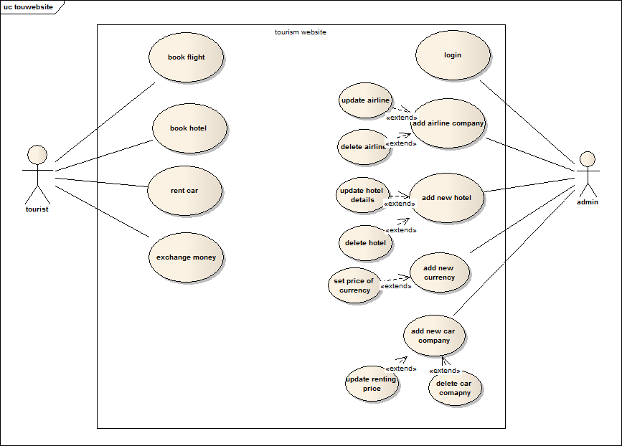
Figure 9 propsed systems.

Sequence diagram
Describes use cases scenarios

Admin login
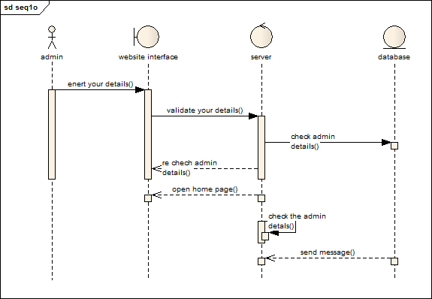
Figure 10 admin login

Select what service you want
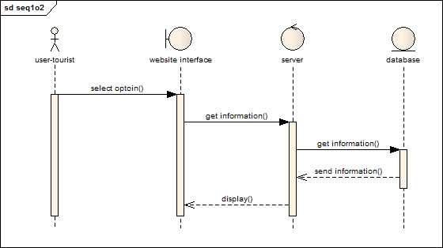
Figure 11 select what service you want.

Booking a flight

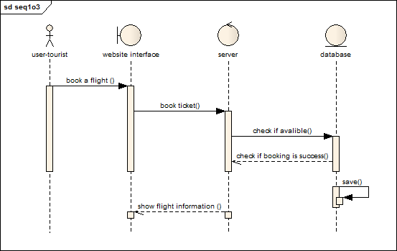
Figure 12 book a flight ticket.

Hotel booking
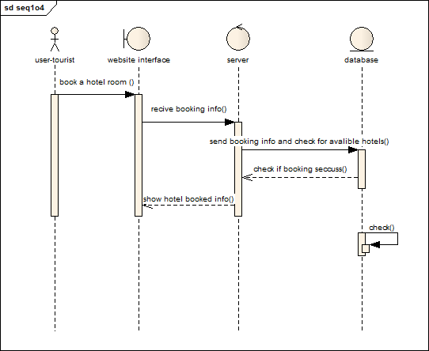
Figure 13 book a hotel.

Car rent
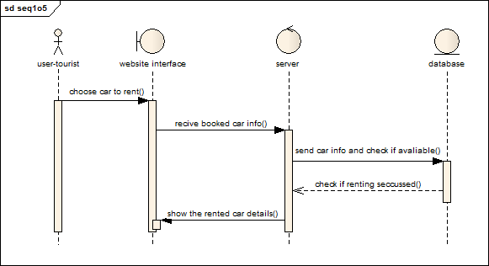
Figure 14 car rent

Exchange of currency
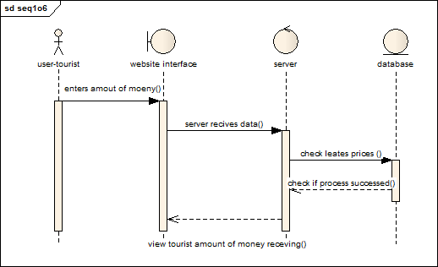
Figure 15 Exchange of currency

Activity diagram
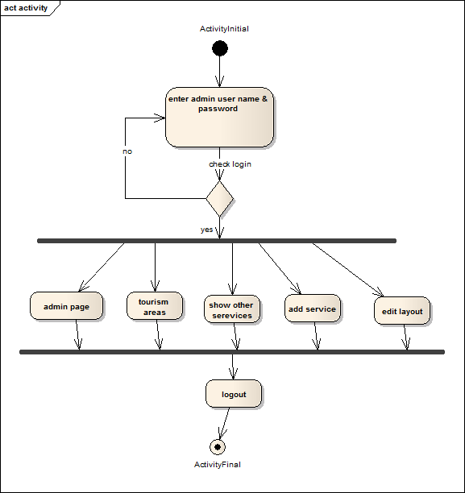
Figure 16 activity diagram

.7.2.8 Class diagram
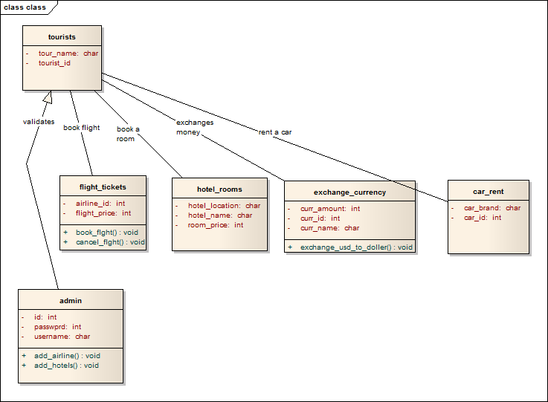
Figure 17 class diagram

Chapter four
Implementation

Chapter four

Implementation

Screens the main pages:
This chapter display the system functionalities and interfaces, also The inter face of the system uses to insert the data into the system to process it, the system provide friendly interface can uses by all the user even users with poor skills with technology.

Home screen
The main page is divided into six sections:

The first section, the main menu, is to choose the type of any services:
Reservations of an airline tickets change of currency hotel reservation car rental.
      - The second section search:
Displaying the names and e-mails of tourists who want to follow all new developments
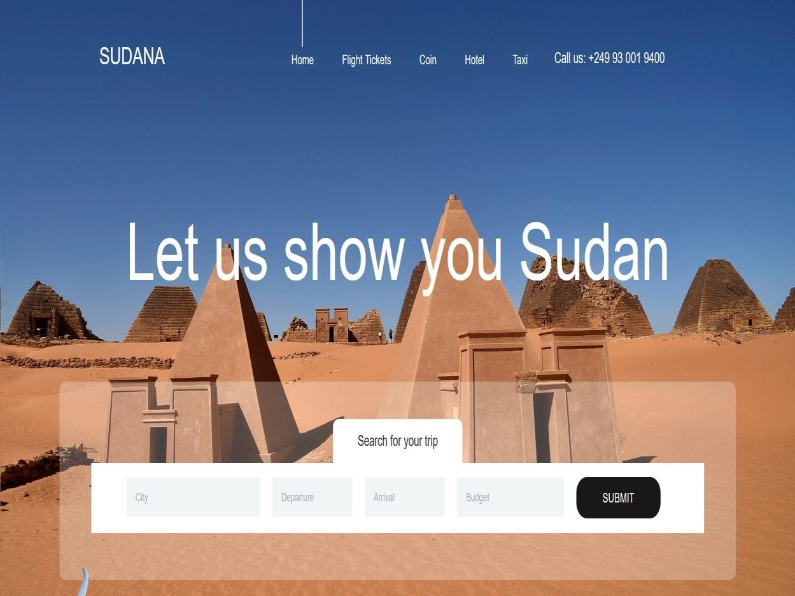
Figure 18 home menu page

The third section:
a detailed explanation of the services we provide to the tourists.
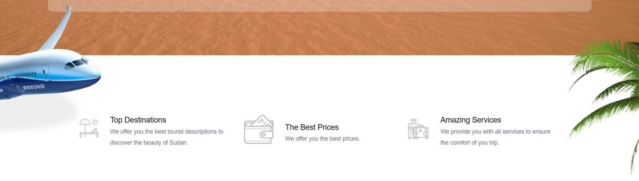

Figure 19 search home page

Fourth Section:
Our site offers tourist areas, which are six tourist areas.
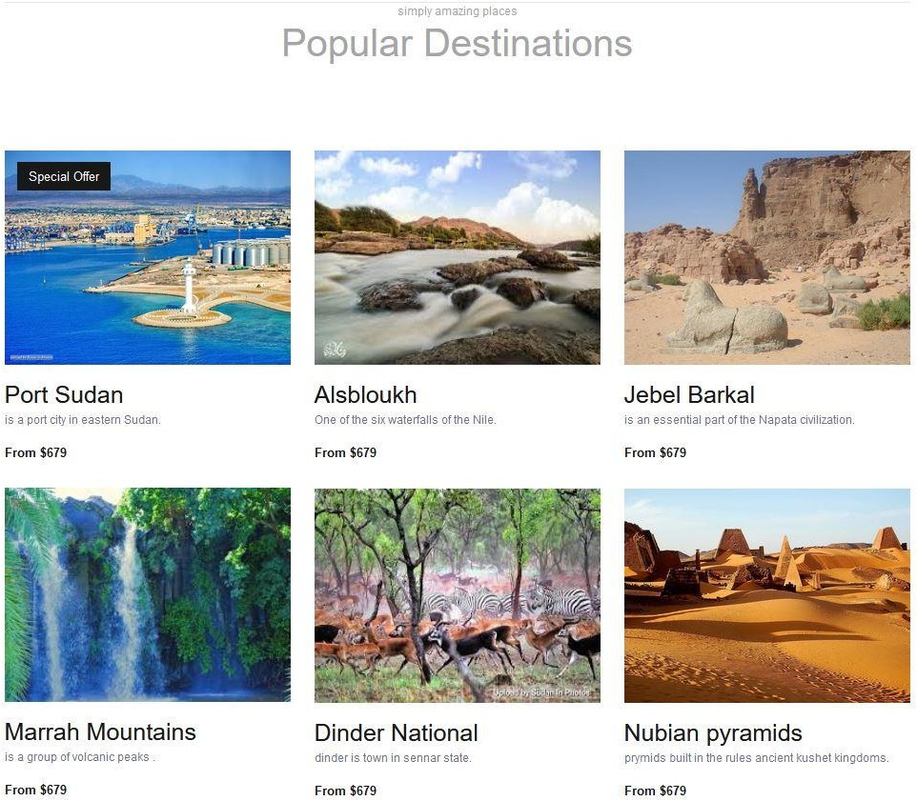

Figure 20 tourist areas

Section Five:
Offers and dates of the nearest flights and the existence of offers of discounts.
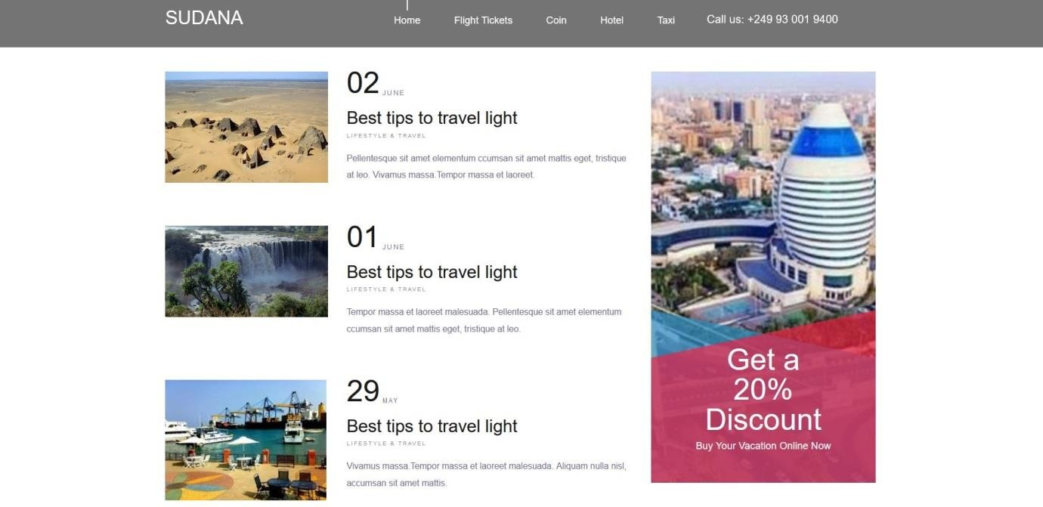
Figure 21 offers of tourist area

Section Six:
Page footer, copyright and form to follow, allow the tourist to write his name and e-mail to send him all the new offers.
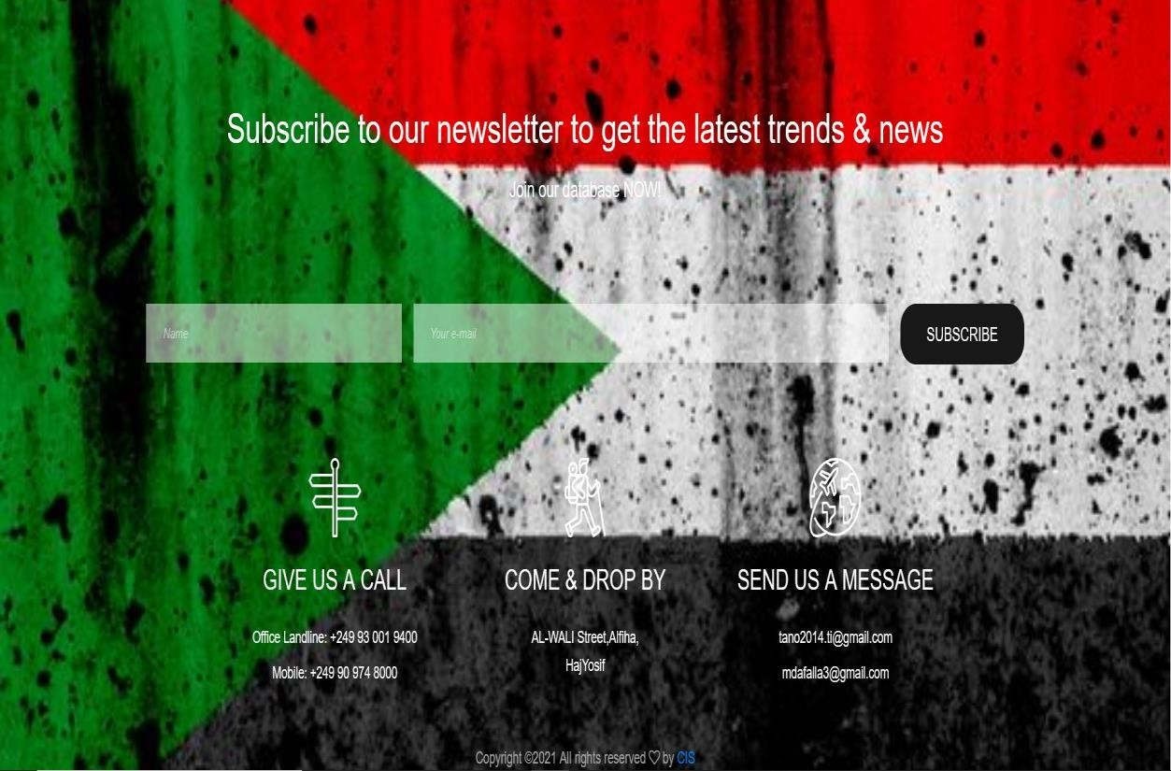

Flight ticket:
Figure 22 footer home page

The page is one of five services divided into three sections:

The first section search:
the tourist can search for trips in the near future.
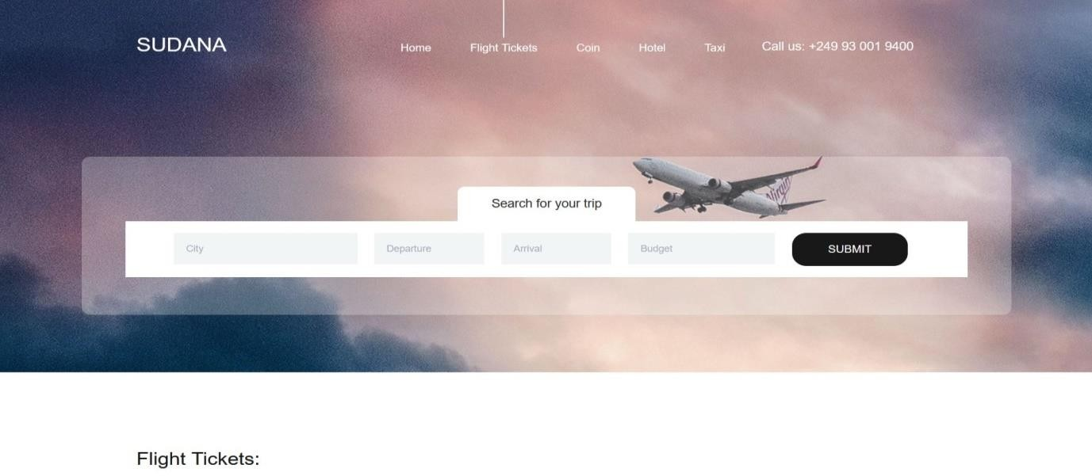
Figure 23 search Flight Tickets page

The second section search:

The website addresses booking airline tickets. The tourist will fill in his full name, phone number, address, from which country he wants to travel, to which country, type of flight, date of reservation, if he wants to send any comment.
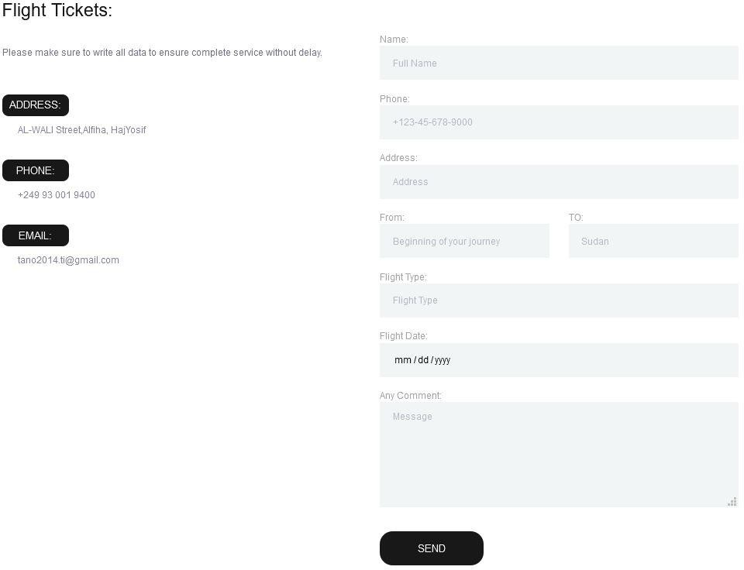

Figure 24 form Flight Tickets page

The third section:
Page footer, copyright and form to follow, allows the tourist to write his name and e-mail to send him all the new offers.
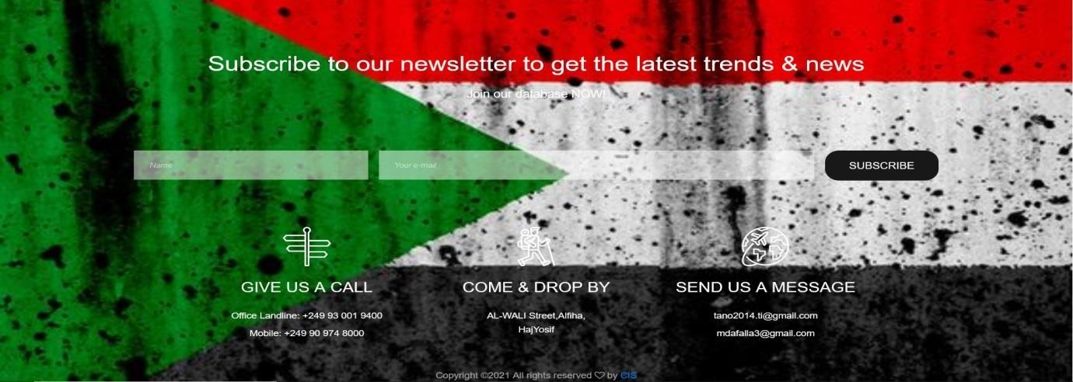

Coin:
Figure 25 footer Flight Tickets page

The page is one of five services divided into three sections:

The first section search:
The tourist is looking for currencies, their dependency for any country
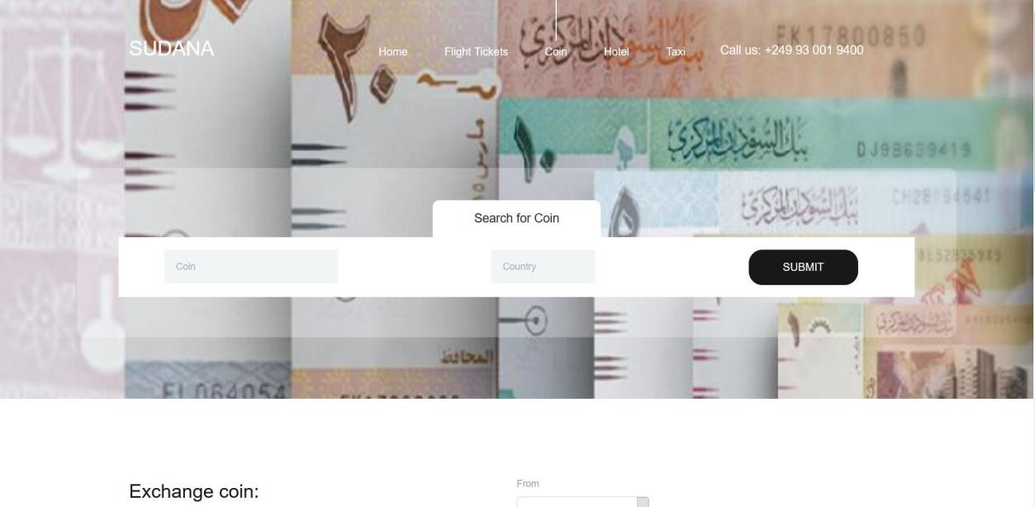
Figure 26 search coin page

The second section:

The form of converting currencies from the currency to the Sudanese currency, the currencies are constantly updated by the admin

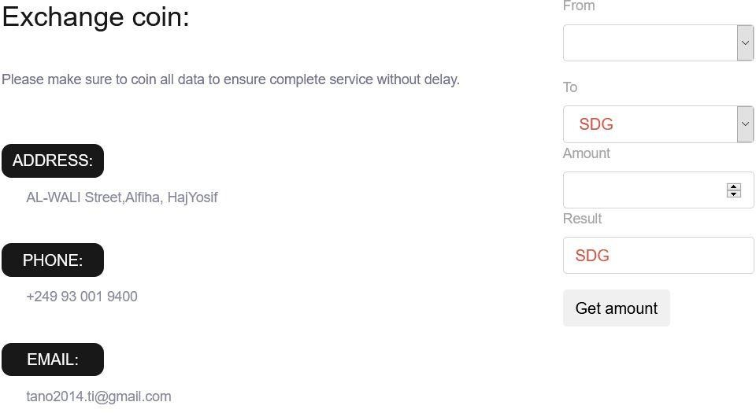

Figure 27 form exchange coin page

The third section:
Page footer, copyright and form to follow, allows the tourist to write his name and e-mail to send him all the new offers.
Figure 28 footer of coin page

    - Hotel:
The page is one of five services divided into four sections:

The first section:

Form for hotels available in the region enter the details: area, booking date and end date of booking, the number of adults, number of children, and the number of rooms
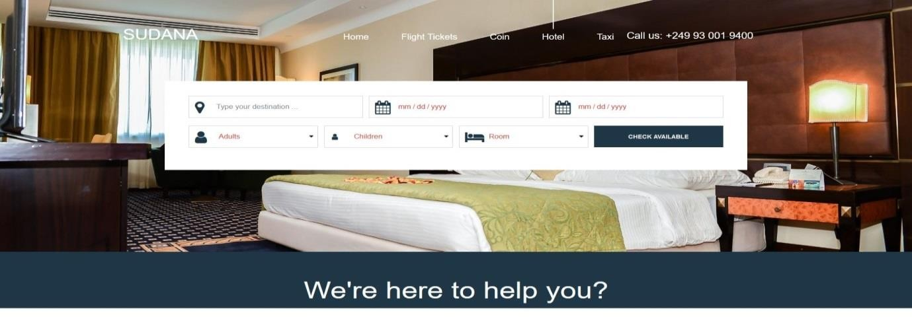

Figure 29 check available hotel page

The second section:
a detailed explanation of the services we provide to the tourists.
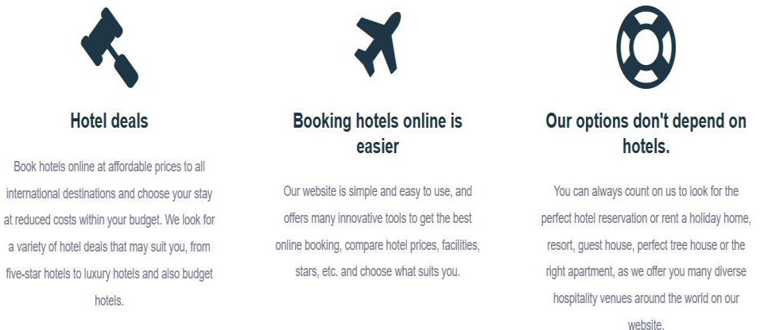

Figure 30 explanation of the services hotel page

The third section:

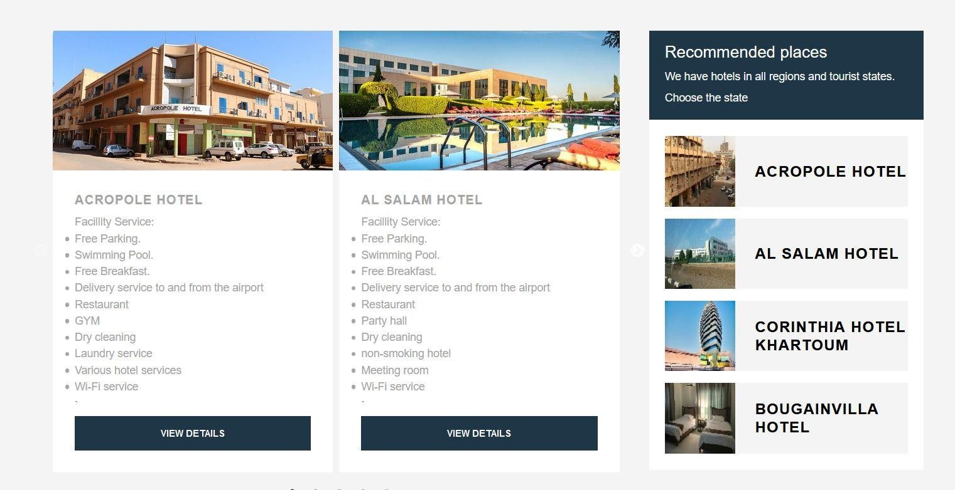
Offer hotels tourism services.
Figure 31 hotel tourism services and offers hotel page

Fourth Section:
Page footer, copyright and form to follow, allows the tourist to write his name and e-mail to send him all the new offers.

Figure 32 footer of hotel

    - Taxi:
The page is one of five services divided into four sections:

The first section:
The form of inquiring about a car is available by filling in the following data and sending it to us: the region, the date of the rental, the date of return, the type of
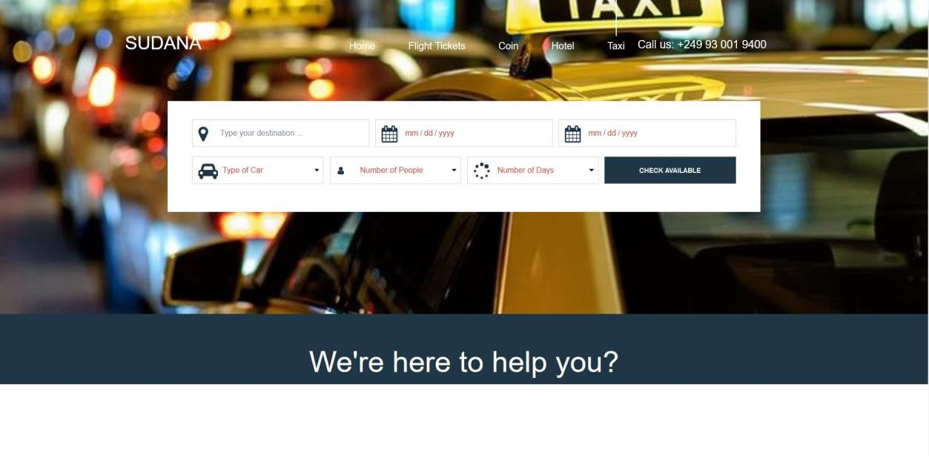
the car, the number of people, and the number of days
Figure 33 taxi webpage

The second section:
Detailed explanation of the services we provide to the tourists.
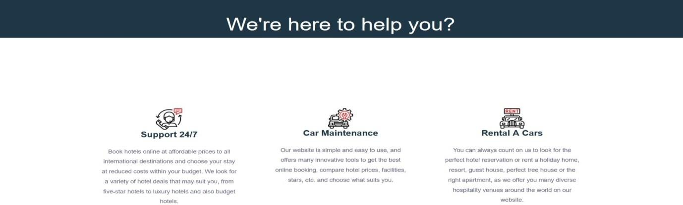

Figure 34 examples of car services

The third section:
Offer cars retaing services.
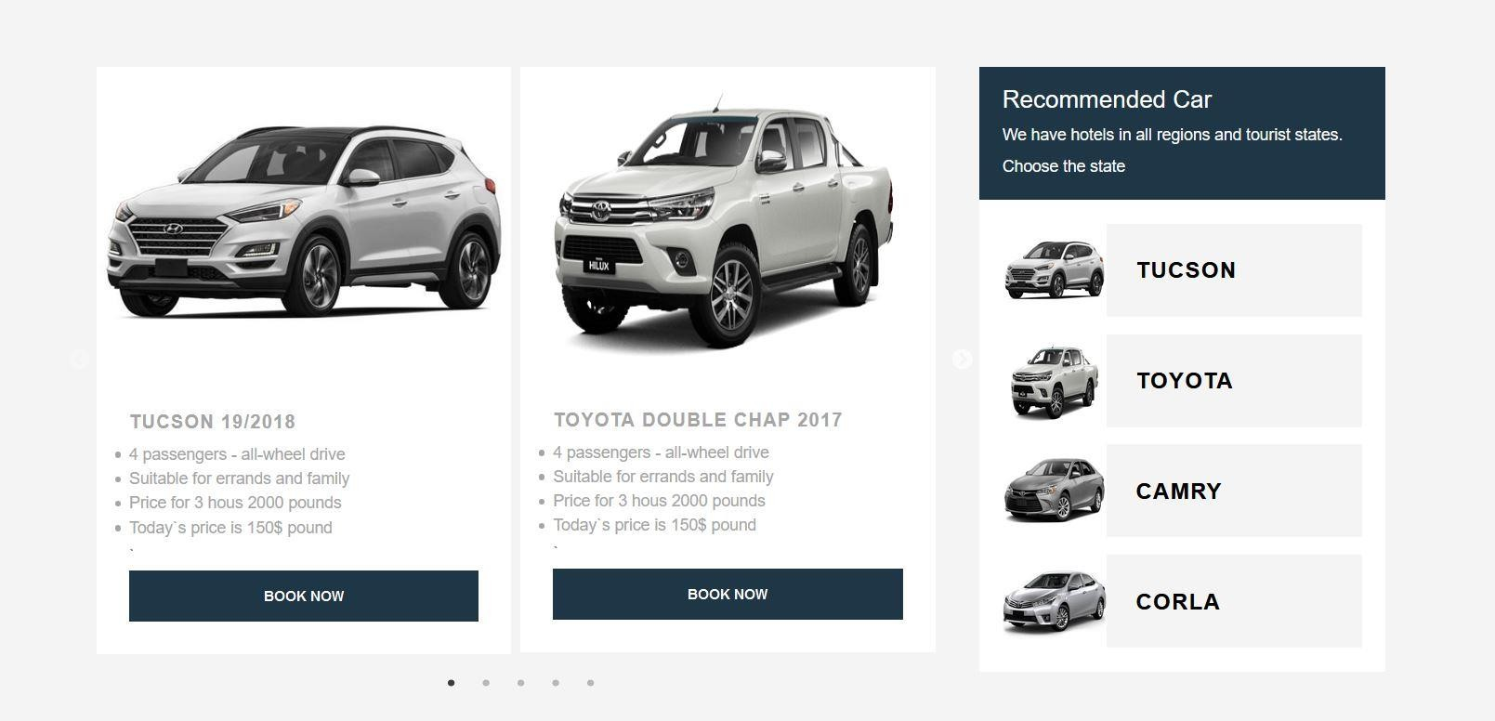
Figure 35 select of car

Fourth Section:
Page footer, copyright and form to follow, allows the tourist to write his name and e-mail to send him all the new offers.

Figure 36 footer of taxi page

  - Screens are sub-main pages:

Port Sudan:
This page when we choose one of the tourist areas from the taxi page divided into three sections:

The first section:
Display all the information about the tourist area and its details and display animated pictures related to the area
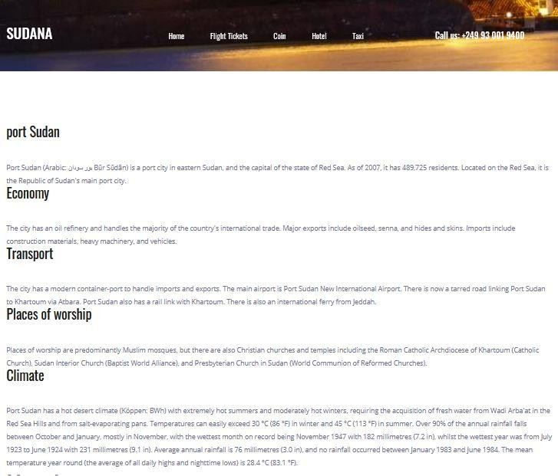
Figure 37 Display all the information about the tourist area

The second section:
Form the tourist fills in the data required to reserve the hotel, the data that he must send are: full name, country, phone number, email, number of people, if he wants to send any comment

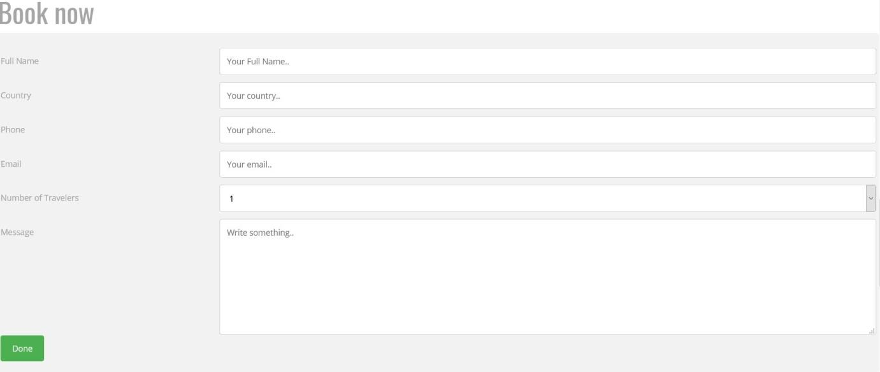
Figure 38 Form the tourist fills in the data required to reserve the hotel

The third section:
Page footer, copyright and form to follow, allows the tourist to write his name and e-mail to send all the new offers.
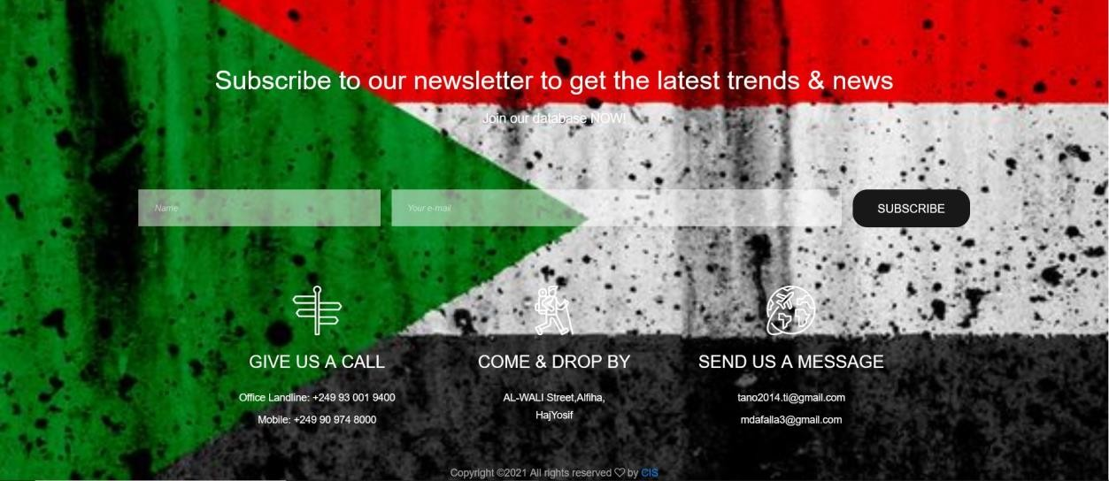
Figure 39 footer taxi

Al Salam Hotel:
This page when we choose one of the hotel areas from the hotel page divided into three sections:

The first section:
Details of hotels and services provided by the tourist
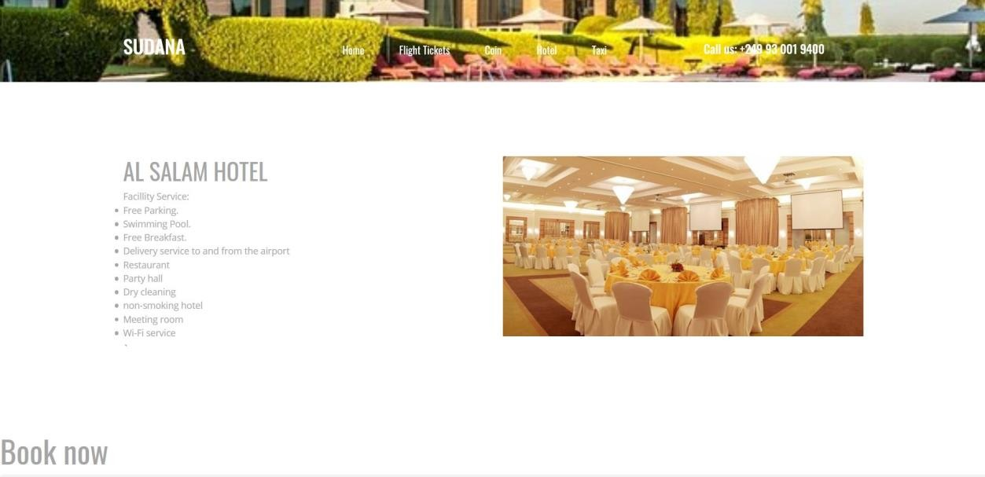
Figure 40 Details of hotels Al Salam Hotel

The second section:
Form the tourist fills in the data required to reserve the hotel the data that he must Send are: full name, country, phone number, email, number of people, if he figure
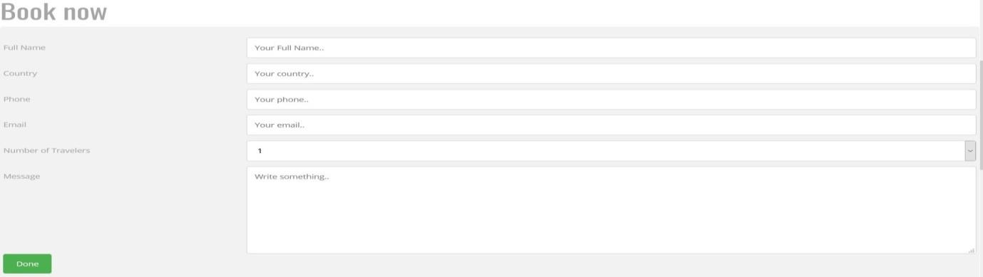
Figure 41 form Al Salam Hotel

The third section:
Page footer, copyright and form to follow, allows the tourist to write his name and e-mail to send him all the new offers.
Figure42 footer Al Salam Hotel

Toyota double chap 2017:
This page when we choose one of the cars rating from the main page divided into three sections:

The first section:
Details of the car and pictures
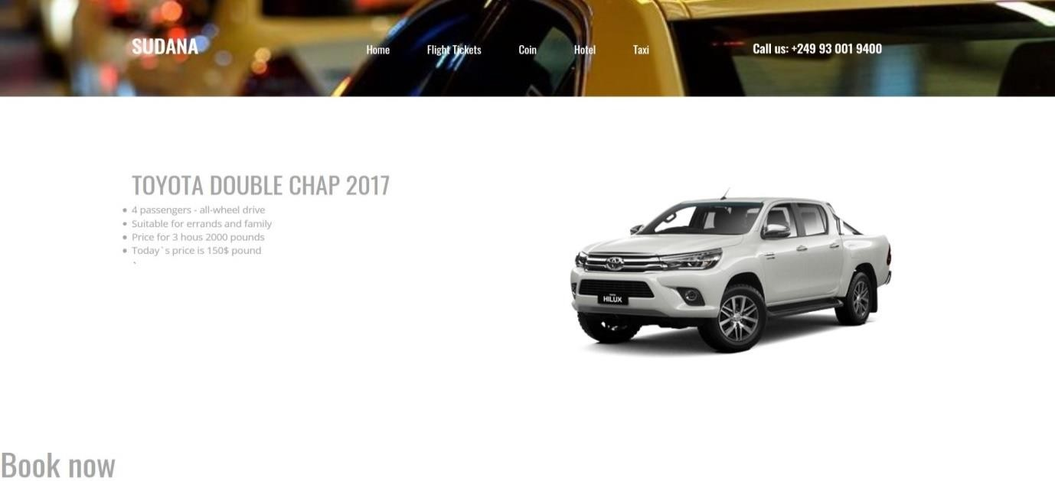

Figure 43 the car reservation type

The second section:
The car reservation form and the existing form filled out with the following deta: full name, location, rental date, retrieval date, number of people, and if he wants to send any comment
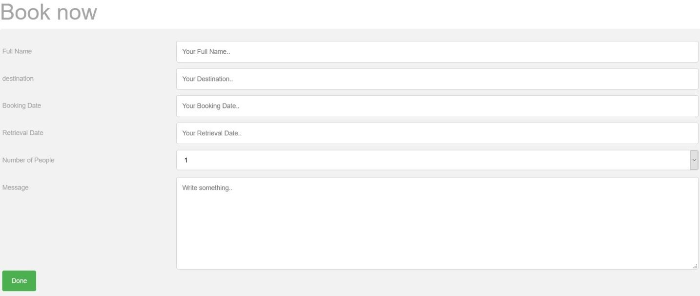
Figure 44 the car reservation form

The third section:
Page footer, copyright and form to follow, allows the tourist to write his name and e-mail to send him all the new offers.
Figure 45 car reservation

  - Admin Screens:
The admin page is the page where the admin receives the tourist requests from within the website

Login screen

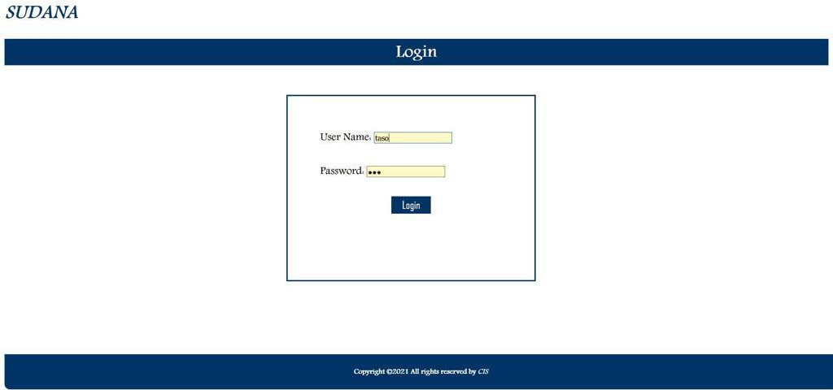
Figure 46 admin login

Tourist Areas screen
And it contains the names of a the tourist areas available to me on the site
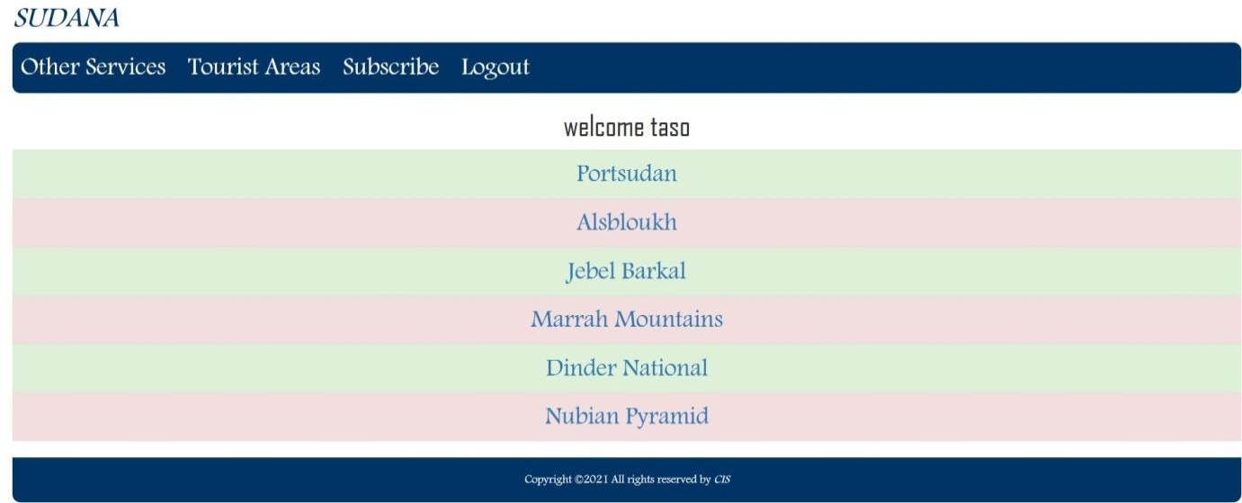
Figure 47 tourism area admin

Port Sudan screen
It contains the details of the tourists that he entered to book a trip to the region
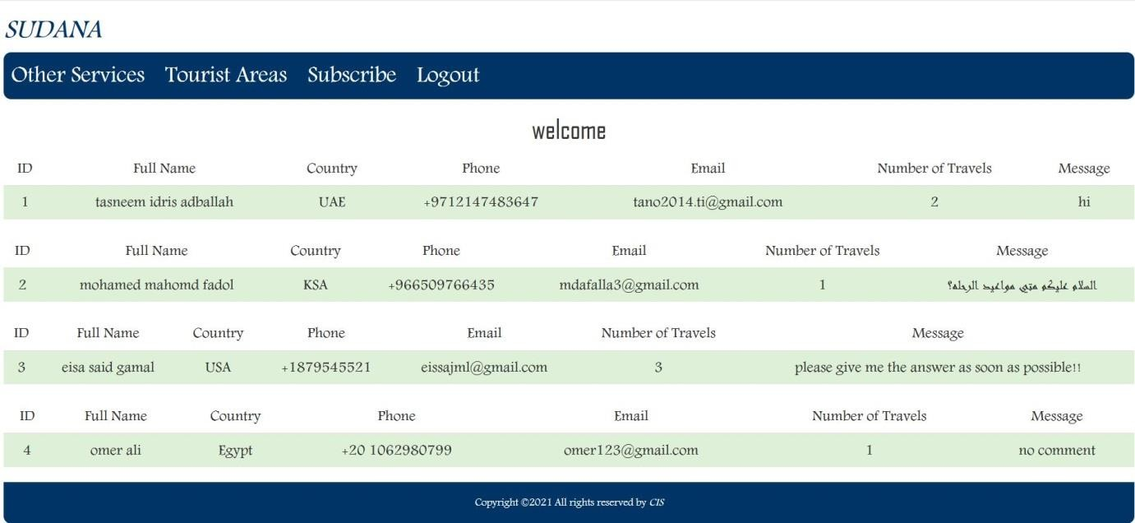
Figure 48 portsudan view admin

Other services screen
View other services provided by the site

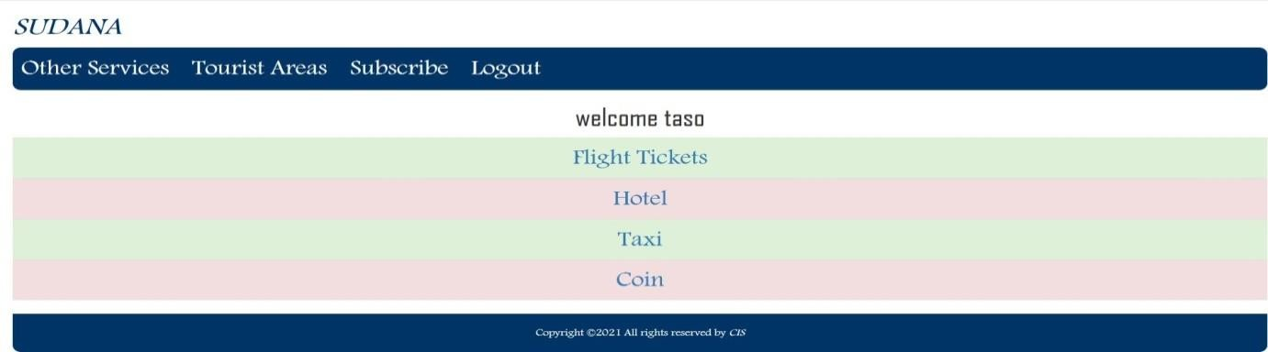
Figure 49 View other services

Flight Tickets screen
Show tourists who have booked flights from the site
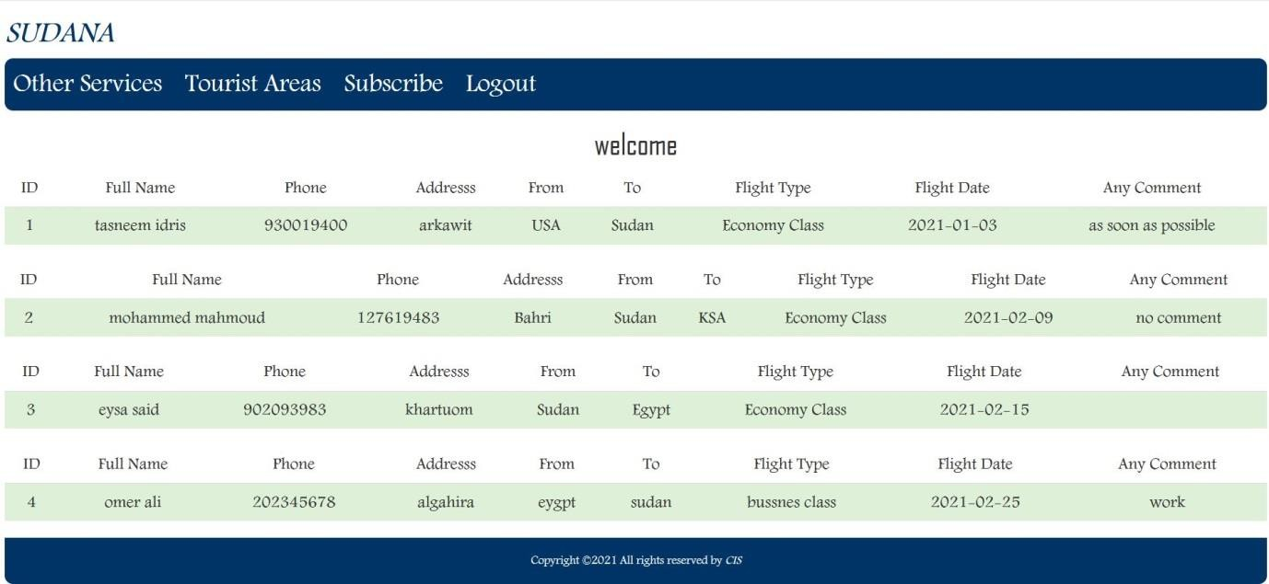
Figure 50 Show tourists who have booked flights from the site

Coin screen
Display the currencies available to me on the site
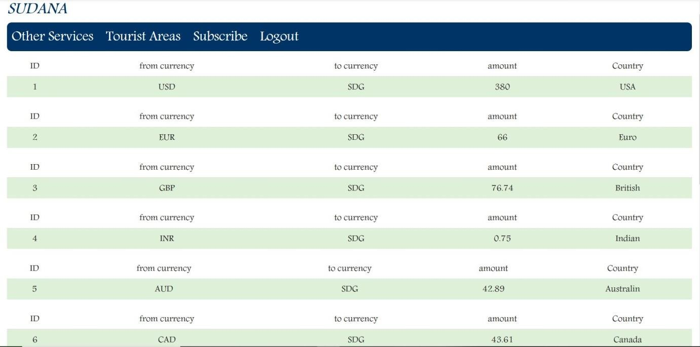
Figure 51 Display the currencies available to me on the site

Hotel screen
Select the hotel that was booked by choosing the hotel name
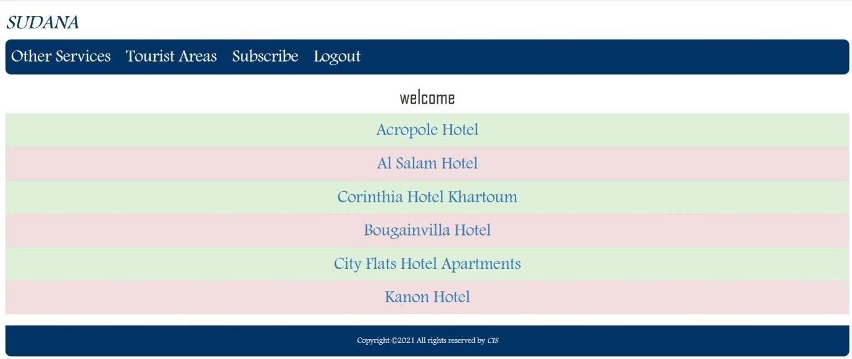
Figure 52 select the hotel that was booked by choosing the hotel name

Acropole Hotel screen
View inquiries about hotels available in the area
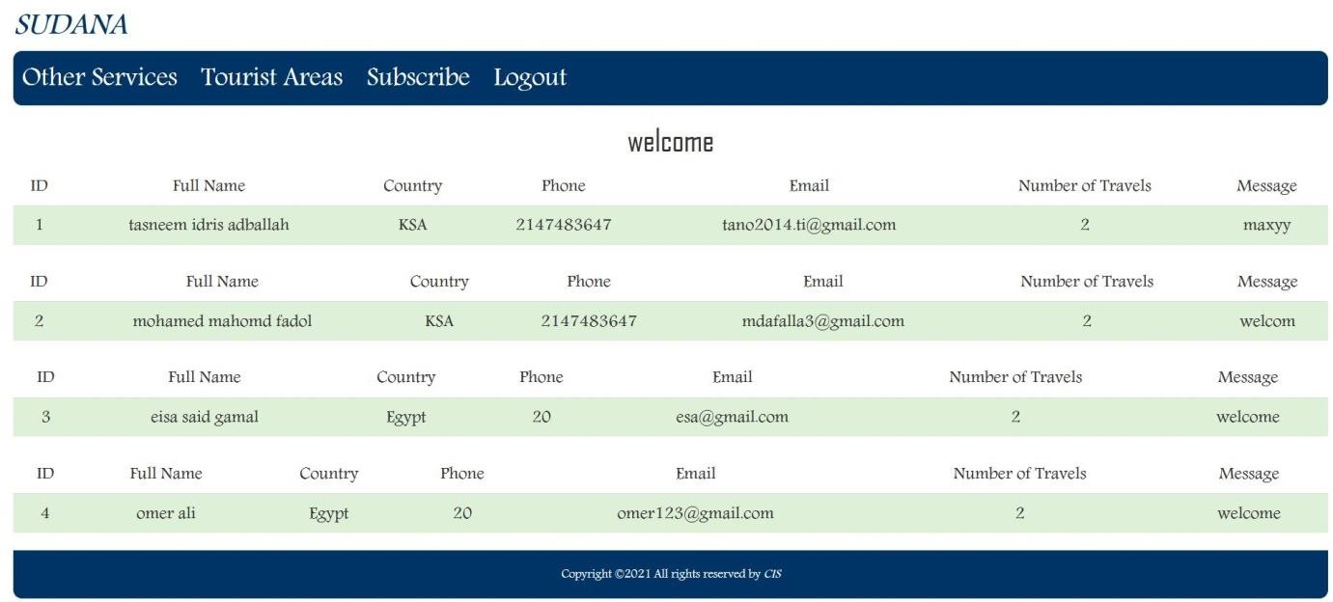
Figure 53 View inquiries about hotels available in the area

4.3. 9Taxi screen

Select the car that was booked by choosing the hotel name
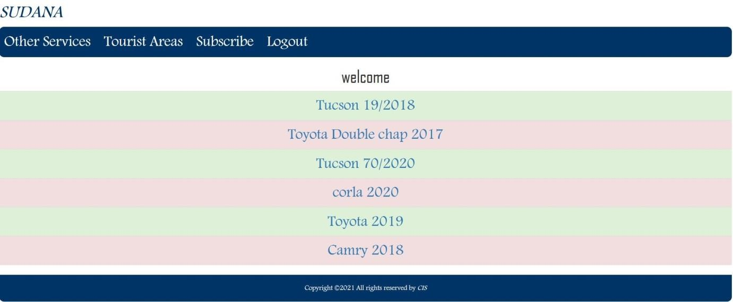
Figure 54 select the car that was booked by choosing the hotel name

Tucson 19/2018 screen
View inquiries about care retain available in the area
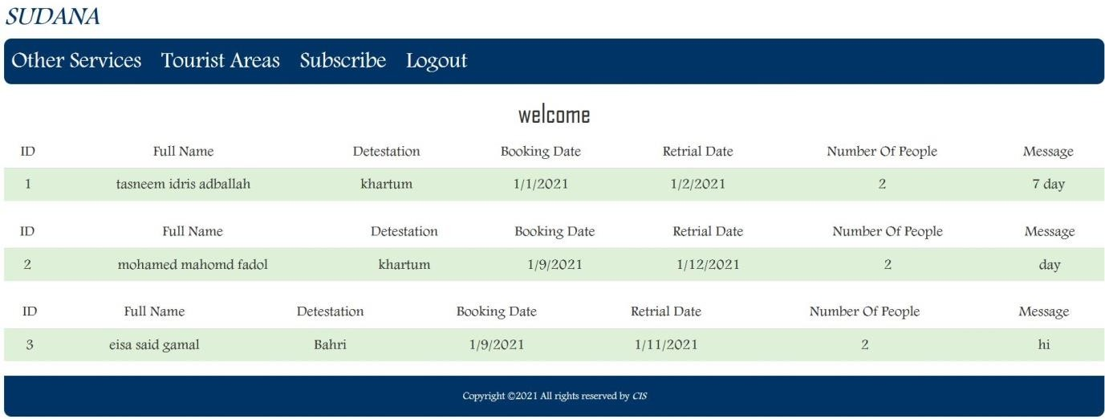
Figure 55 View inquiries about care retain available in the area

Subscribe screen
Displaying the names and e-mails of tourists who want to follow all new developments

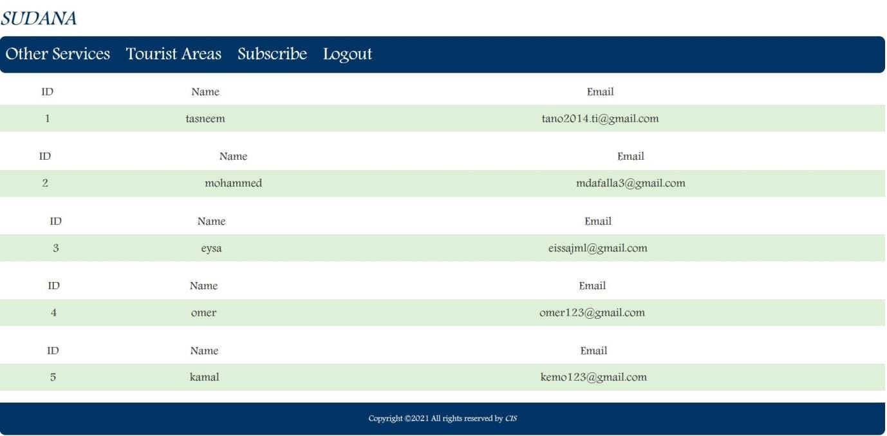
Figure 56 Displaying the names and e-mails of tourists who want to follow all new developments

Chapter five
Conclusion and recommendations

Conclusion

Chapter five

Conclusion and recommendations

We have built an electronic website that helps tourists do basic things. In this website you’ll find the following:
The new system purposes to make all of the tourist procedures to be done electronically.

Recommendation
This search can be developed later to enable the user:
    - To register using national data such as passport and credit cards.
    - This website can also be turned into an application that works on mobile phones.
    - The admin page can be developed so that he can perform the operations of removing services, adding them, modifying them, or modifying and adding a tourist area and adjusting currency rates continuously.
    - We wish that this website will be used by the government.

References
- Italian Tourism Co.Sudan. 2020. ITC Italian Tourism. [online] Available at:
<https://www.italtoursudan.com/test-pagina/ > [Accessed 17 April 2020].
- Real Sudan. 2020. About Us - Real Sudan. [online] Available at:
<https://www.realsudan.com/about-us/> [Accessed 17 April 2020].
- DGL Travel. 2020. About Us - DGL Travel. [online] Available at:
<https://www.dgltravel.tours/about-us/> [Accessed 17 April 2020].
- Saaih 2020.saaih. [online] Available at: <https://www.saaih.com /> [Accessed 17 April 2020].
- MediaRoom. 2020. Mediaroom – About Us [online] Available at: <https://www. tripadvisors.mediaroom.com/al-about-us> [Accessed 19 April 2020].
- Ltd ., 2020. Rome2rio: Discover How To Get Anywhere [online] Rome2rio Available at:
<https://www. Rome2rio.com > [Accessed 19 April 2020].
- Aribnb. 2020. Holiday Lets Homes, Experiences & Places – Aribnb [online] Available at: <https://www. aribnb.com > [Accessed 19 April 2020].
priceline. 2020. [online] Available at: <https://www. priceline.com/ > [Accessed 19 April2020].

Appendix

Related works
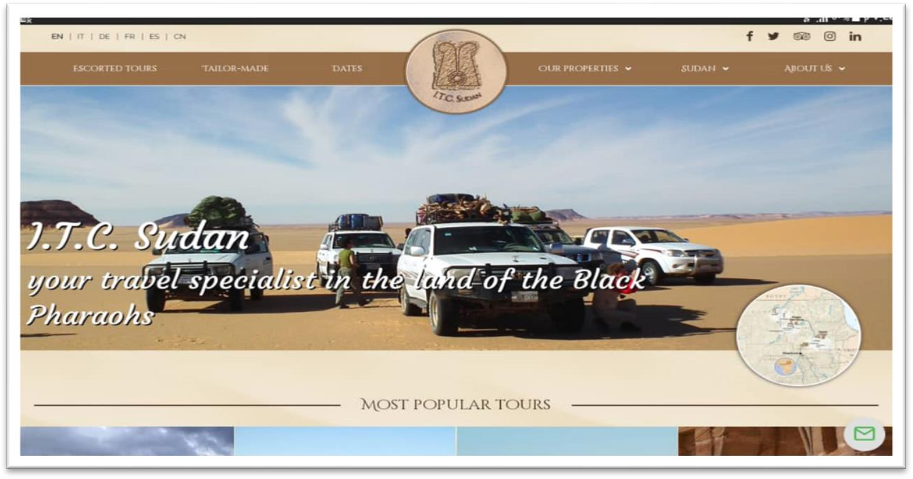

Figure1 I.T.C website
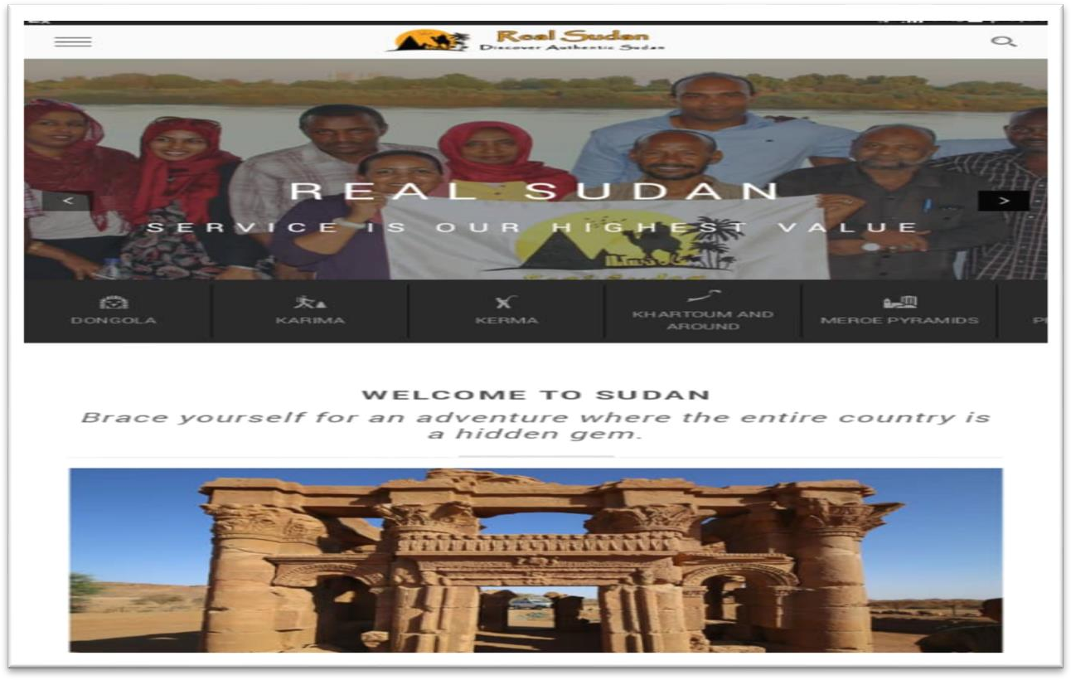

Figure 2 realsudan.com

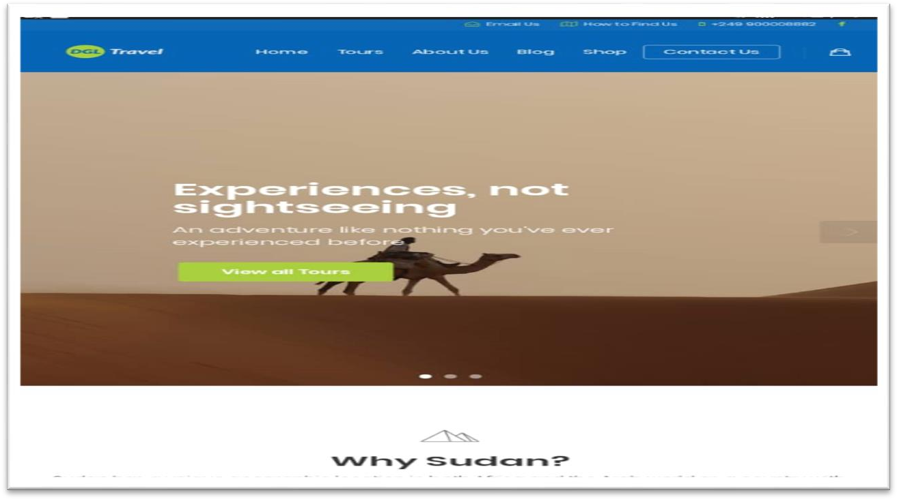

Figure 3 DGLtravel.com
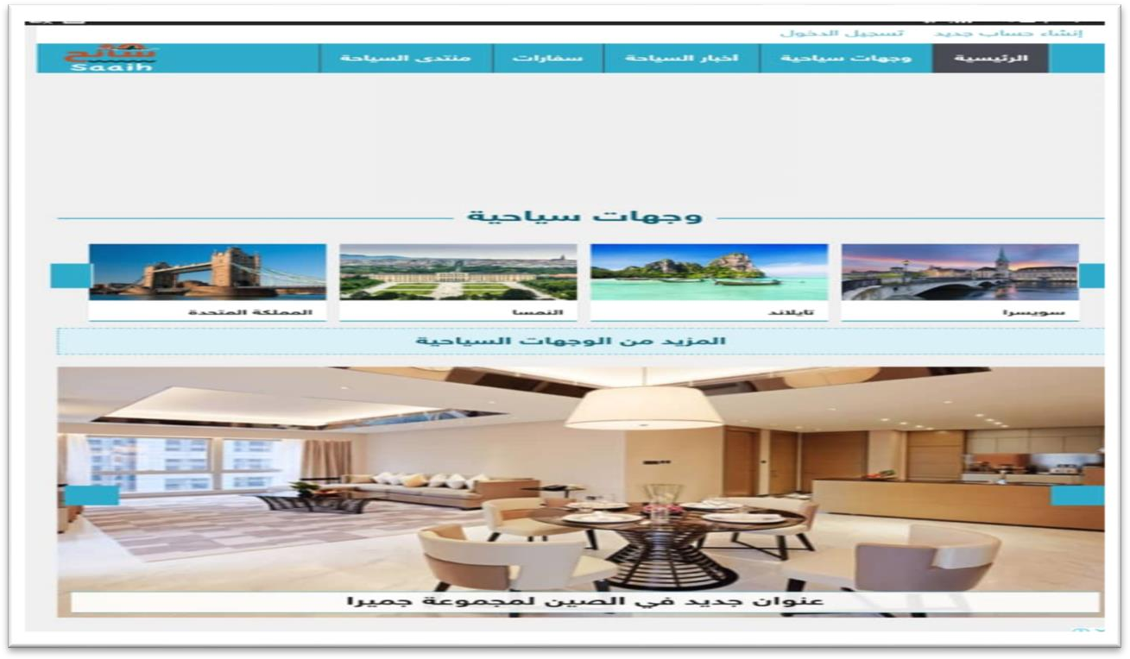

Figure 4 saaih.com

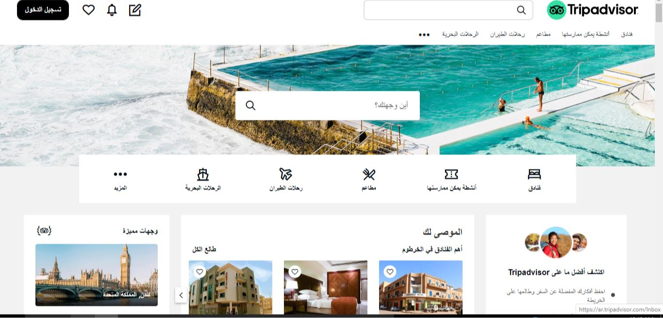

Figure 5 tripadvisor.com
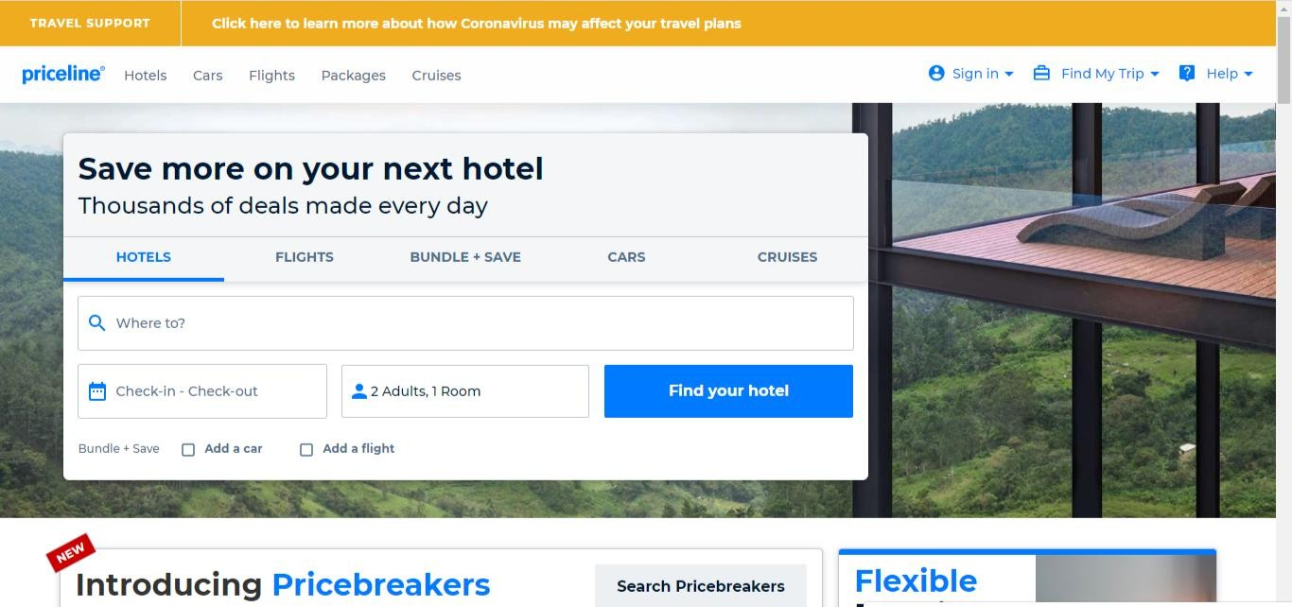
Figure 6 priceline.com

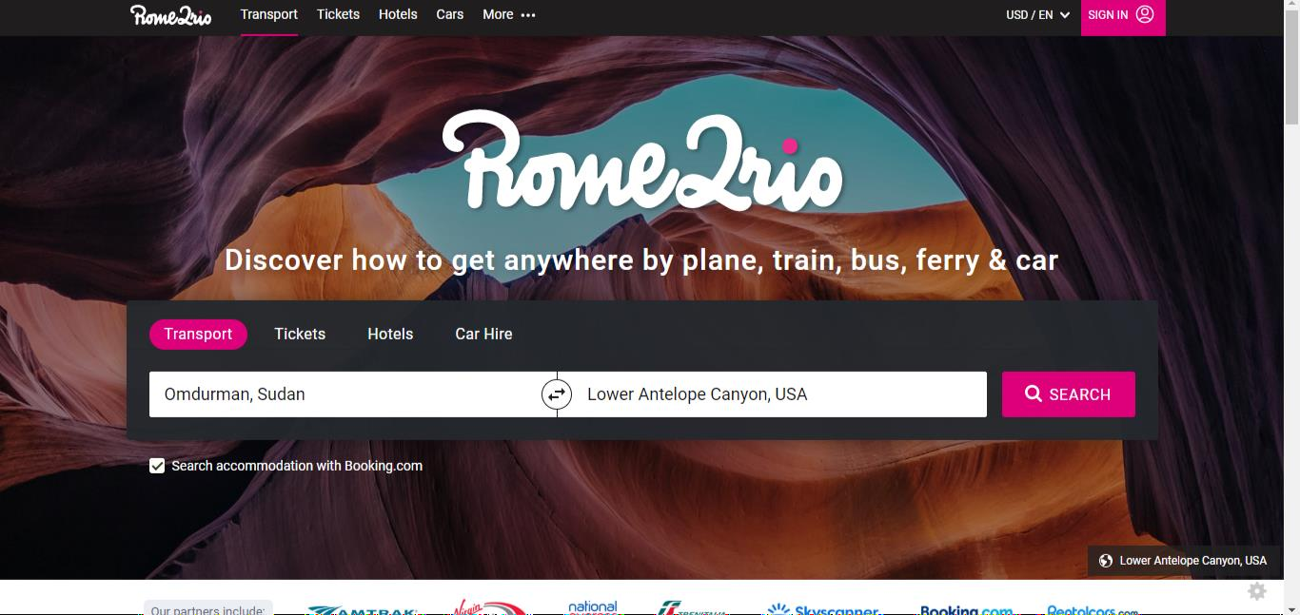

Figure 7 rome2rio.com
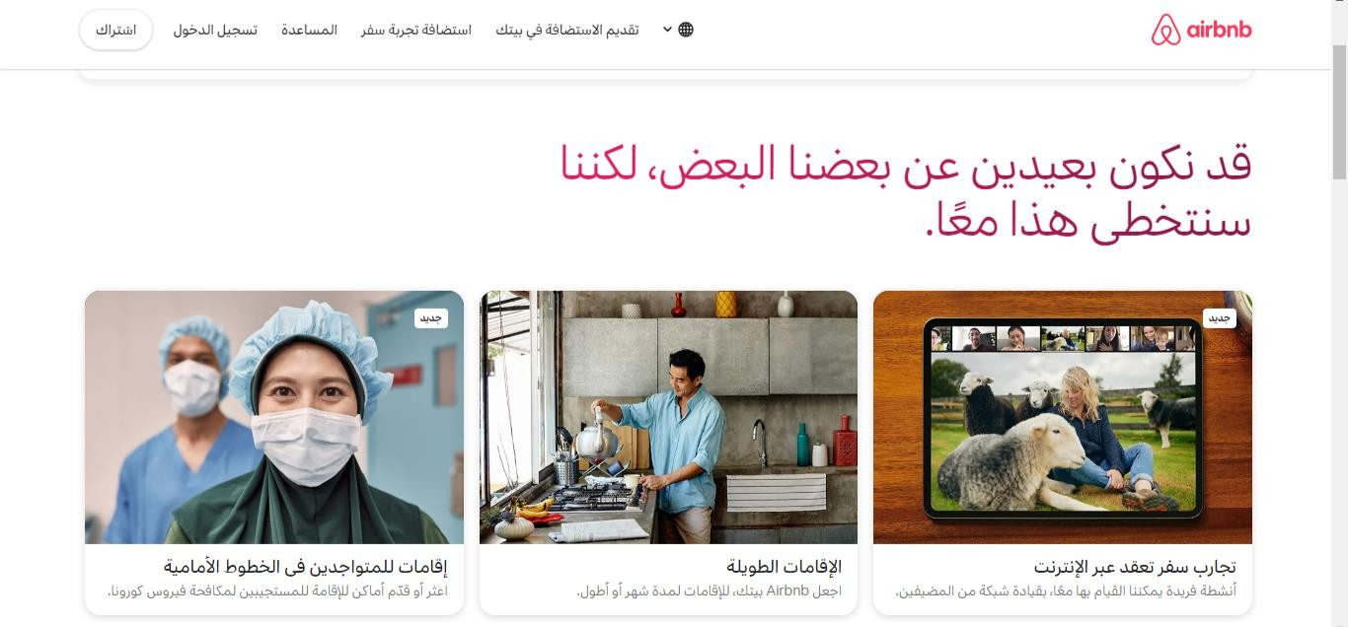

Figure 8 airbnb.com

Tables in Database
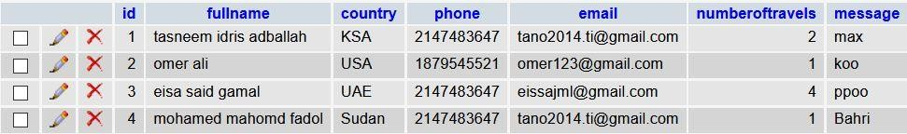
Figure 57 table name alsbloukh
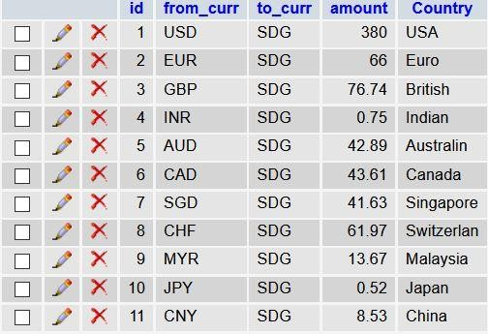
Figure 58 table name currency
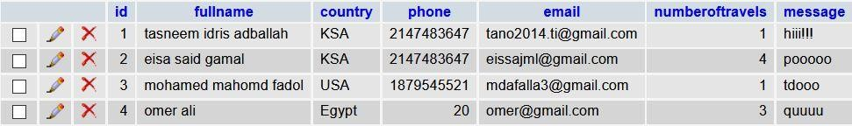
Figure 59 table name dindernational

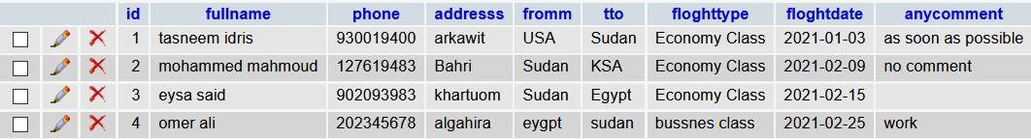

Figure 60 table name flighttickets
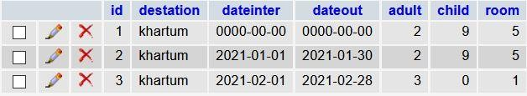
Figure 61 table name hotel
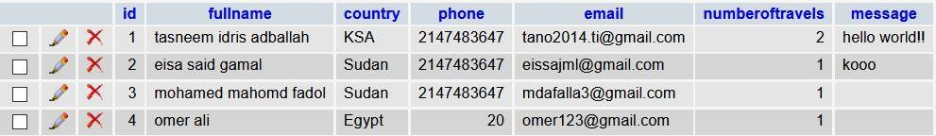
Figure 62 table name jebelbarkal
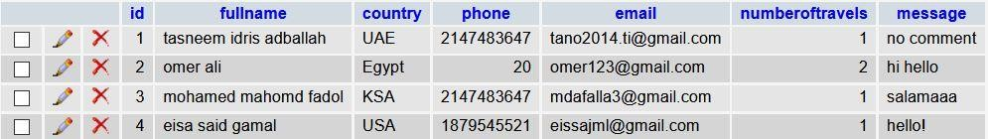
Figure 63 table name marrahmountains

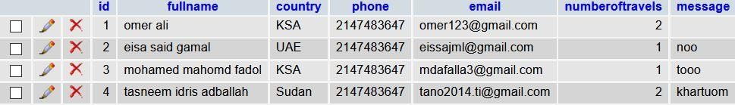

Figure 64 table name nubianpyramids

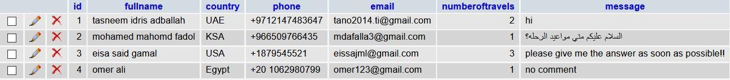
Figure 65 table name portsudan
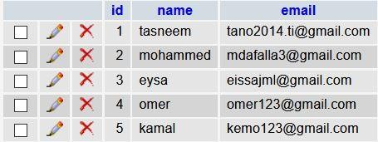
Figure 66 table name subs
Figure 67 table name taxi

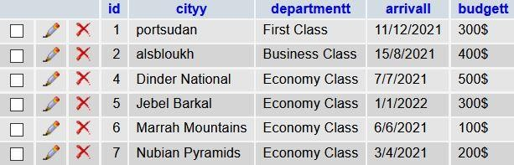

Figure 68 table name travell
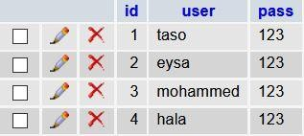
Figure 69 table name users_info

