Design and Implementation of a fitness Application Thesis Submitted in Partial Fulfillment of the Requirement for the Degree of

B.Sc.

In Computer Science

By

Mchiaga-Tsavsar Shater To

The Department of Computer Science Baze University, Abuja

June 2022

# DECLARATION

This is to certify that this Thesis entitled Fitness Application, which is submitted by [Mchiaga-Tsavsar Shater] in partial fulfillment of the requirement for the award of degree for B.Sc. in Computer Science to the Department of Computer Science, Baze University Abuja, Nigeria, comprises of only my original work and due acknowledgment has been made in the text to all other materials used.

Date: 9th June 2022 Name of Student: Mchiaga-Tsavsar Shater

**APPROVED BY** …………………

# HOD

Dept. of Computer Science

# CERTIFICATION

This is to certify that this Thesis entitled Fitness Application which is submitted by Mchiaga-Tsavsar Shater in partial fulfillment of the requirement for the award of degree for B.Sc. in Information Technology to the Department of Computer Science, Baze University Abuja, Nigeria is a record of the candidate’s own work carried out by the candidate under my/our supervision. The matter embodied in this thesis is original and has not been submitted for the award of any other degree.

Date: Supervisor:

# APPROVAL

This is to certify that the research work, and the subsequent preparation by Mchiaga-Tsavsar Shater with BU/19C/IT/3826 has been approved by the Department of Computer Science, Faculty of Computing and Applied Science, Baze University, Abuja, Nigeria.

By

Mr. Gilbert George Date

1st Supervisor

Dr. C. V Uppin Date

Head of Department

Prof Peter Date

Dean, Faculty of Computing and Applied Science

Prof. A. B. Garko Date

External Examiner

# DEDICATION

I dedicate this project to almighty God and my parents for encouraging me to do well and strive for better always. I would also like to dedicate this project to my supervisors Mr. Gilbert George for aiding me in my time while I worked on the application.

# ABSTRACT

We have found ourselves in a situation where people all around the world who want to either lose or gain weight or just remain fit, find it hard to do these things for one reason or the other which can range from availability to lack of proper coaching or whatever it may be. This Project provides a possible solution to some of these issues, allowing the users to be freer and more enthusiastic about working out. Using Javascript i have made an app that offers access everything you will need along their weight loss or weight gain journey, research has been carried out in order to present a solution that works .

# TABLE OF CONTENTS

ABSTRACT VI

LIST OF

TABLES IX

LIST OF

FIGURES X

LIST OF

ABBREVIATIONS… XI

CHAPTER 1: INTRODUCTION 1

* 1. Overview
  2. Background and Motivation
  3. Statement of the Problem
  4. Aim and Objectives
  5. Significance of the Project
  6. Project Risks Assessment
  7. Scope/Project Organization

# CHAPTER 2: LITERATURE REVIEW 5

* 1. Introduction
  2. Historical Overview
  3. Related Work
  4. Summary

# CHAPTER 3: REQUIREMENTS, ANALYSIS, AND DESIGN 7

* 1. Overview
  2. Proposed Model
  3. Methodology
     1. Method 1 (e.g Interview)
     2. Method 2 (e.g Observation)
  4. Tools and Techniques
  5. Ethical Consideration
  6. Requirement Analysis
  7. Requirements Specifications
     1. *Functional Requirement Specifications*
     2. *Non-Functional Requirement Specifications*
  8. System Design
     1. *Application Architecture*
     2. *Use Case*
     3. *Activity Diagrams*
     4. *User Interface Design*
  9. *Summary*

# CHAPTER 4: IMPLEMENTATION AND TESTING 12

* 1. Overview
  2. Main Features
  3. Implementation Problems
  4. Overcoming Implementation Problems
  5. Testing
     1. *Tests Plans (for Unit Testing, Integration Testing, and System Testing)*
     2. *Test Suite (for Unit Testing, Integration Testing, and System Testing)*
     3. *Test Traceability Matrix (for Unit Testing, Integration Testing, and System Testing)*
     4. *Test Report Summary (for Unit Testing, Integration Testing, and System Testing)*
     5. *Error Reports and Corrections*
  6. Use Guide
  7. Summary

# CHAPTER 5: DISCUSSION, CONCLUSION, AND RECOMMENDATIONS 15

* 1. Overview
  2. Objective Assessment
  3. Limitations and Challenges
  4. Future Enhancements
  5. Recommendations
  6. Summary

# REFERENCES APPENDICES

**LIST OF TABLES**

Table 1 Functional Requirement Specifications Table 2 Non-Functional Requirement Specifications

# LIST OF FIGURES

FIGURE 1 USE CASE DIAGRAM FIGURE 2 ACTIVITY DIAGRAM

# LIST OF ABBREVIATIONS

CPU Central Processing Unit

ERD Entity Relationship Diagram

IT Information Technology

# CHAPTER 1: INTRODUCTION

## Overview

Recent technological advances have created enormous opportunities for developing applications that support training from home - particularly for older adults, who often are socially more isolated, are physically less active, and have fewer chances to train in a gym.

Fitness apps can help people manage their nutritional intake, assist their participation in fitness and physical activities, and promote a healthy lifestyle. Therefore, these apps are gradually occupying the commercial mobile app market (Beldad and Hegner, 2018).Everyone’s top priorities have always included health and fitness. However, staying fit and on-trend is difficult due to the difficulty of finding fitness coaches who you would enjoy working with or finding fitness plans that work for you. The high rate of obesity is one of the most worrying factors for health globally, particularly in developed countries, but also in emerging countries, with a drastic growth among children (Anderson et al., 2019). Fortunately, since the dawn of the digital era, the fitness industry has undergone a full digital transformation makeover as well. Since then, health and fitness app development have marked a variety of approaches, from cultivating healthy diets to weight loss exercises with only one tap on their smart phones to connecting users with trainers and coaches to aid their journey. “Mobile Health (mHealth) has become an essential field for disease management, assessment of healthy behaviors, and for interventions on healthy behaviors” (Mas et al., 2016, p. 32). This is what i hope to achieve with this project.

## Background and Motivation

Nowadays, fitness apps are rapidly developing in the commercial application market and are attracting the attention of academia (Beldad and Hegner, 2018). Numerous studies have implemented empirical protocols to verify the results of using fitness apps for improving

the level of physical activity and/or diet in users (Schoeppe et al., 2017).

A key question presented to me was, ‘Do fitness applications help?’. A study conducted by Flinders University in 2021 showed that social components of physical activity apps are beneficial in promoting engagement in physical activities due to their capacity to facilitate social support and positive influence and motivation.

Flinders University, (2021, August). fitness apps keeps us moving during lockdown.

An article on gearbrain.com showed that, When fitness apps include personal touches such as individualized goals and contact with a 'real live trainer', users tend to exercise more consistently.

"More than ever before, mobile apps provide an opportunity to provide real-time feedback and support to the public and specialized health populations," says mary Jung, an assistant professor in UBC Okanagan's School of Health and Exercise Sciences.

*Jung, Mary. (2016, October 3). Fitness apps more effective when personalized*

## Statement of the Problem

Most of the users have to use multiple apps to track their fitness activity, do workout, exercises & meal planning. People loose interest after a while as they find it very cumbersome to use different apps and keep track of it.

## Aim and Objectives

Aim and objectives of the system:

* + - The aim of the project is to design and implement a fitness application

The objectives are to;

* + - Aid with weight gain and weight loss along with general fitness
    - Suggest meal plans and excersise routines for the users
    - Calculate BMI and allow users to journal their progress
    - Provide access to coaches and mentors based on specific goals

## Significance of the Project

The health and fitness community will profit from the successful development and implementation of this application. The research undertaken on this problem domain will help to bridge the gap between people and fitness in general.

## Project Risks Assessment RISKS

|  |  |
| --- | --- |
| Inability to carry out research due to loss of hardware/software resources | Be aware of and observe school IT security procedures  Secure Android mobile phone when not in use. |
| Loss of work due to equipment failure /loss | Daily Backup of data to multiple sources of storage such as flash drives, hard drives, google drive, etc. Fr multiplicity |
| Software availability (Unavailability of API’s) | Alternative API’s will be checked for. Software requirements will be identified in good time for possible contentious software. |

* 1. **Scope/Project Organization**

The Scope of the project is concerned with the development of the health and fitness sector with the aid of fitness tools such as this app to provide the necessities and basics for people to go through their fitness journeys.

# CHAPTER 2: LITERATURE REVIEW

## Introduction

The following chapter is based on the literature review of the various techniques and technologies used in this thesis. Thereafter, section 2.2. is based on the Historical Overview of the fitness app. Section 2.3 gives descriptions of some of the respective literature and nomenclature available with regards to the application of Python/android studio in solving the research question. Finally, section 2.4 provides a comprehensive summary of the entire chapter.

## Historical Overview

***History of Capacitor***

A cross-platform native runtime called Capacitor makes it simple to create contemporary web applications that work flawlessly on iOS, Android, and the Web. Capacitor, which develops Web Native applications, is the next step in the evolution of hybrid apps. It offers a contemporary native container solution for teams who want to build web-first without giving up full access to native SDKs when they need it.

A uniform, web-focused collection of APIs called Capacitor makes it feasible for an app to adhere to web standards as closely as possible while also accessing robust native device features on platforms that support them. With a straightforward Plugin API for Swift on iOS, Java on Android, and JavaScript for the web, adding native functionality is simple.

**Alpine** is a rugged, minimal tool for composing behavior directly in your markup. Think of it like jQuery for the modern web.

## Related Work

There have been many works that are similar to mine and are used in some institutions, but I will add personal touches to make mine unique and stand out although the

concept of providing questions and showing steps may be similar, I tend to add a more dynamic user interface acquiring ideas from other inspirations and modifying my own.

Some of the related works may include:

[**Sworkit**](https://sworkit.com/)

**Price:** free to download; $9.99 a month or $59.99 a year for premium subscription [iOS](https://itunes.apple.com/us/app/sworkit-daily-circuit-training/id527219710?mt=8&ign-mpt=uo%3D4) and [Android](https://play.google.com/store/apps/details?id=sworkitapp.sworkit.com)

**Pros:** You can design your own workouts and skip tasks that aren’t to your liking. The video demonstrations are easy to follow, and you can listen to your own music.

**Cons:** A few reviewers complain that the break between activities is a little bit too short. Sworkit will offer the exercises for your sweat session when you specify the type of exercise you want to do (strength, cardio, yoga, or stretching) and the time allotted (anything from 5 minutes to an hour). By selecting the number of reps and the body parts you wish to concentrate on, the app's premium version gives you even more personalization options.

[**Strava Running and Cycling**](https://www.strava.com/)

**Price:** free for basic use; $5 a month or $59.99 a year for premium version (Strava Summit) [iOS](https://itunes.apple.com/app/strava-cycling/id426826309?mt=8) and [Android](https://play.google.com/store/apps/details?id=com.strava)

**Pros:** It’s a great way to track your running without a GPS watch. It can also help you find new running routes and lets you connect with friends.

**Cons:** Strava’s sharing features can be a little intimidating. Some folks feel insecure about

posting their shorter or slower runs.

If you’re a serious runner or cyclist, you need one place to keep track of your most recent runs and rides. No other app comes close to the capabilities of Strava. The app can track distance, speed, elevation, calories burned, heart rate, power, and cadence. Then it synthesizes all this data into easy-to-understand graphics.

## Summary

With the popularity of the health and wellness trend in recent years, smartphone fitness applications have become more and more popular. Thus, this study explored factors affecting the behavioral intention to use and the actual usage behavior of smartphone fitness apps from technical, health, and social perspectives by integrating the Social Cognitive Theory (SCT) and Unified Theory of Acceptance and Use of Technology (UTAUT). Specifically, fitness applications or “apps” on smartphones are programs that use data collected from a smartphone's inbuilt tools, such as the Global Positioning System, accelerometer, microphone, speaker, and camera, to measure health and fitness parameters. The apps then analyze these data and summarize them, as well as devise individualized plans based on users' goals.

# CHAPTER 3: REQUIREMENTS, ANALYSIS, AND DESIGN

## Overview

Chapter 3 is comprised of the requirement, analysis and design of the fitness app. In chapter 3 Requirements, analysis and the design, the methodology or methodologies used will be discussed, the consequential choice of method used will be highlighted. The requirement system specifications, functional and non-functional requirement, application architecture, schematics and user interface will be discussed in this chapter.

## Proposed Model

The proposed model for the application was “Rapid Application Development” (RAD), in the beginning of the project, the waterfall model was used.

## Methodology

The approach will outline the fitness app's development and testing process, as well as how the features will be launched and delivered. Waterfall and Agile methodologies

are the approaches that have been selected. The recommended approaches will have their own definition and justification for its selection. (Waterfall Methodology - A Complete Guide | Adobe Workfront, 2022)

The **WATERFALL** model divides project activities into linear sequential stages, each of which is dependent on the previous phase's deliverables and corresponds to a task specialization. The stages the waterfall model follow is:

REQUIREMENTS: The Waterfall method is predicated on the notion that all project needs can be gathered and comprehended beforehand. Every effort is made by the project manager to thoroughly understand the requirements of the project sponsor. Written requirements are typically provided in a single document and used to describe each stage of the project, including costs, assumptions, risks, dependencies, success indicators, and completion dates.

DESIGN: To solve the problems mentioned in the product requirements technically, software developers employ scenarios, layouts, and data models. The purpose and scope of the project, as well as the general traffic flow of each component and the integration points, are first specified in a higher-level or logical design. Then, with the aid of specific hardware and software technologies, it is transformed into a physical design.

IMPLEMENTATION: Technical execution starts when the design is finished. This could be the quickest stage in the Waterfall process because the difficult research and design have already been finished. Programmers create applications during this phase, which also includes some testing and implementation based on the goals and requirements of the project. It can be necessary to go back to the design phase if significant adjustments are needed during this stage.

VERIFICATION & TESTING: Before a product is made available to customers, testing is necessary to ensure that it is error-free and that all specifications have been satisfied, resulting in a great user experience. The testing team will make use of the product manager's design documents, personas, and user case scenarios to create their test cases.

DEPLOYMENT & MAINTENANCE: After the software has been made available to the public or to end users, the maintenance phase begins. A team will be established to manage updates and the distribution of new versions of the program as issues are found and user requests for modifications are received.

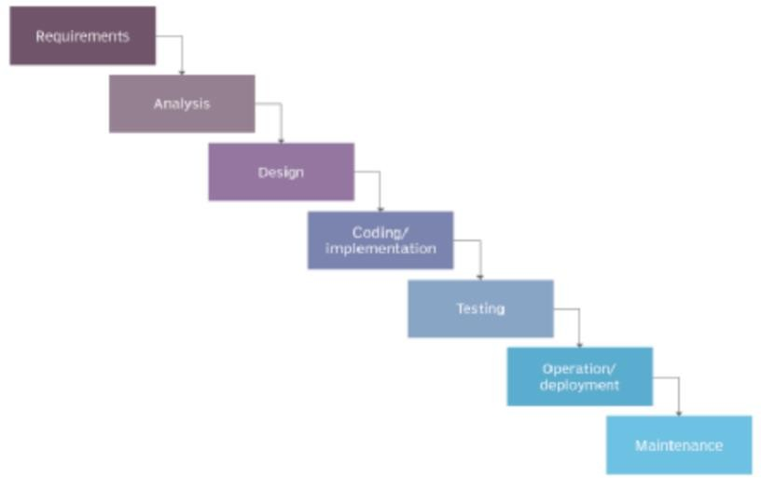

Figure 1. Water Fall Model Diagram

*Source:htt*[*ps://w*](http://www.techtarget.com/searchsoftwarequality/definition/waterfall-model)*ww*[*.techtarg*](http://www.techtarget.com/searchsoftwarequality/definition/waterfall-model)*e*[*t.com/searchsof*](http://www.techtarget.com/searchsoftwarequality/definition/waterfall-model)*tw*[*arequality/definition/waterfall-model*](http://www.techtarget.com/searchsoftwarequality/definition/waterfall-model)

The **AGILE** model in software development includes adaptive planning, evolutionary development, early delivery, continuous improvement, and flexible responses to changes in requirements, capacity, and understanding of the problems to be solved through the collaborative effort of self-organizing and cross-functional teams with their customers or end users. (Agile software development - Wikipedia, 2021).

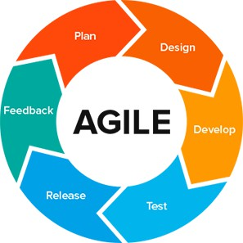

Figure 2. Agile Method Diagram

*Source:https://texassoftware.com/agile-vs-waterfall-model/*

## Interview

In the search for the target audience i visited multiple gyms and spoke to multiple gym users. The main goal was to figure out what they look for with gym apps or what they want that no gym app provides. After talking with them i realized the main thing evereyone was referencing was flexibility, A lot of gym apps offer static workout plans, that is why i created a system that lets you build using existing workouts while also allowing you the freedom to create your own. I also spoke to people to understand why they do not go to gyms, a response i got was “i dont know any gyms”, so using mapbox’s map API i added gym profiles with their locations on the app, although it is just a small pool of gyms, with future updates ill be adding more.

## Observation

From what i observed from gym apps, they were all too static so people with different body types often find it hard picking what to do, that’s why my app has a built in bmi calculator that recommends meal plans, routines, and exercises catered to your specific need.

## Tools and Techniques

On the verge of going on, the project made use of various tools such as:.

* Capacitor: an open source project that runs modern Web Apps natively on iOS, Android, Electron, and Web (using Progressive Web App technology) while providing a powerful and easy-to-use interface for accessing native SDKs and native APIs on each platform
* MapBox: Mapbox is an American provider of custom online maps for websites and applications such as Foursquare, Lonely Planet, the Financial Times, The Weather Channel, Instacart Inc. and Snapchat.

## Ethical Consideration

The ethical consideration relied on the health information which were implemented in bmi calculator allowing us to provide health tips.

## Requirement Analysis

In the Requirement Analysis the factors required were covered in an interview provided by the target audience, this information helped with said requirements.

## Requirements Specifications

This section distinguishes between functional and non-functional criteria

## Functional Requirement Specifications

The user can read articles related to health The user can find out their bmi

The users can find info and location of gyms The user can make specific workout routines The user can contact fitness specialists

|  |  |  |
| --- | --- | --- |
| **Req.No** | **Description** | **Type** |
| 1 | The user can read articles related to health | Availability |
| 2 | The user can find out their bmi | Availability |
| 3 | The user scan find info and location of gyms | Availability |
| 4 | The user can contact fitness specialists | Availability |
| 5 | The user can make specific workout routines | Availability |

## Table 1 Functional Requirement Specifications

* + 1. **Non-Functional Requirement Specifications** There must be an internet connection to use the map All other functionalities are available offline

## Table 2 Non-Functional Requirement Specifications

|  |  |  |
| --- | --- | --- |
| **Req. No.** | **Description** | **Type** |
| 1 | There must be an internet connection to use the map | Availability |
| 2 | All other functionality are available offline | Utilization |

* 1. **System Design**

REGISTRATION: This is the back-end operation that provides authentication for users when they are new to the app, registering them to the user database and allowing for future notifications and assessment.

LOGIN: This works hand in hand with the registration and it is meant for returning users allowing them to be recognized.

BMI CALCULATOR: This is a calculator that takes in height and weight and returns the users BMI

WORKOUTS: this allows users to create workouts or select from existing workouts

## Application Architecture

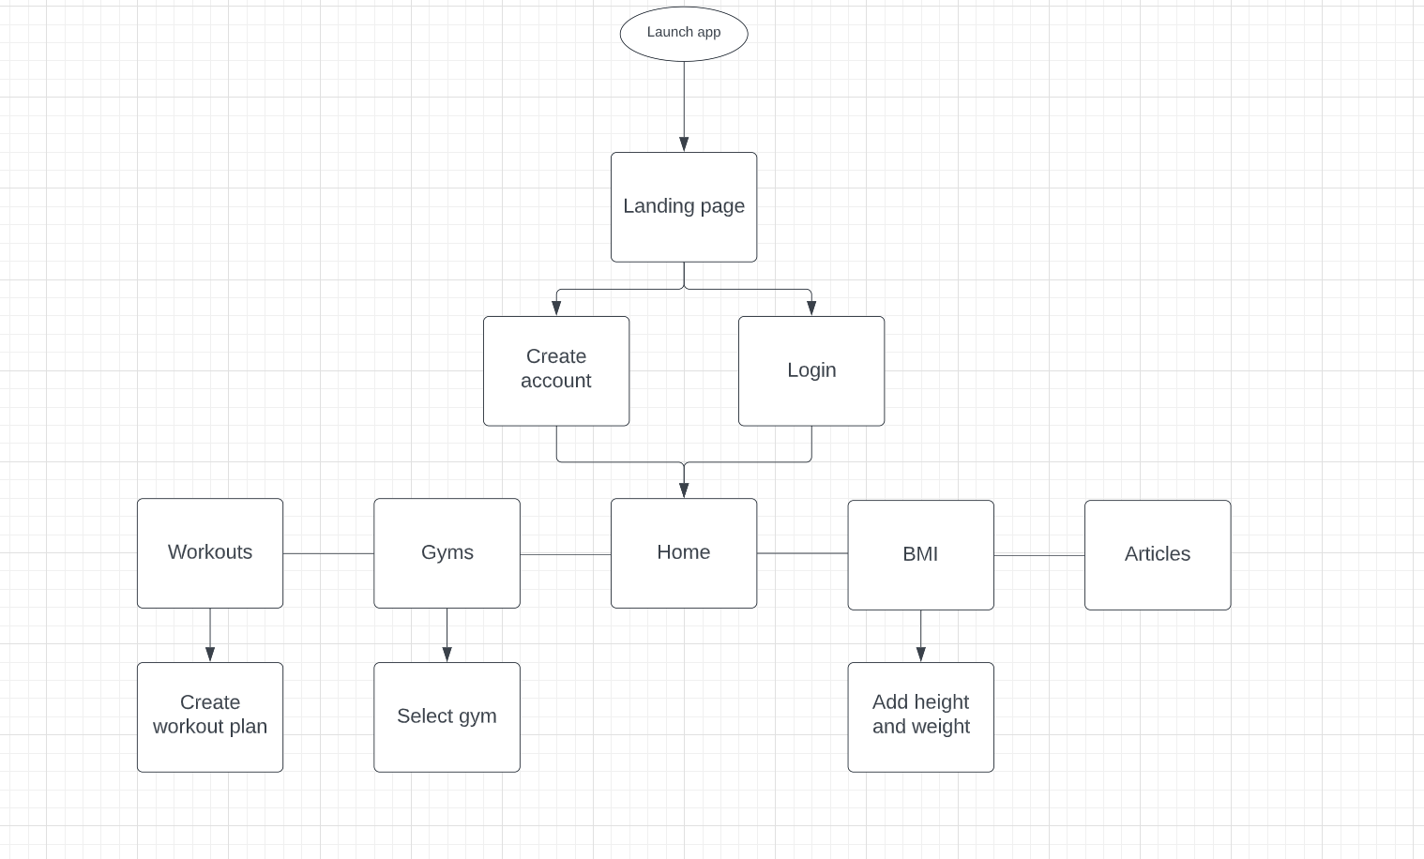

Figure 3. Application Architecture

## Use Case

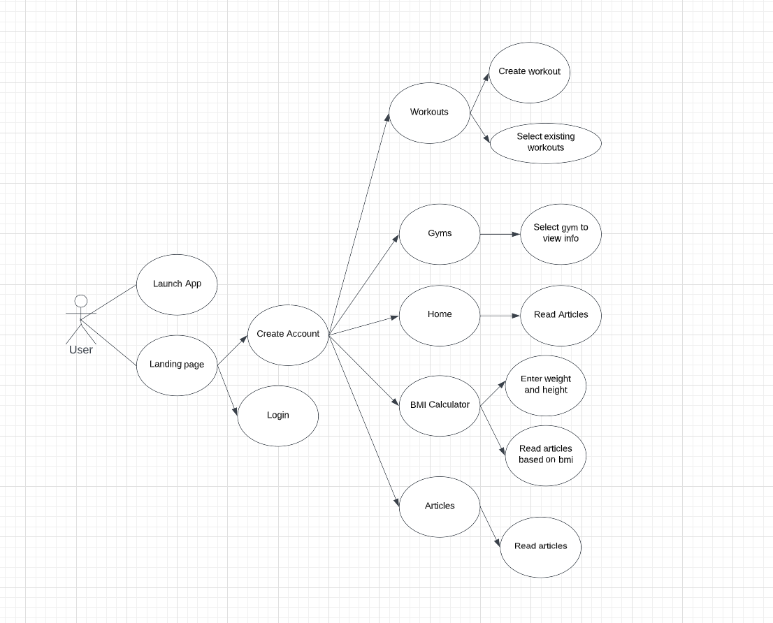

Figure 4. Use case diagram

## Activity Diagrams

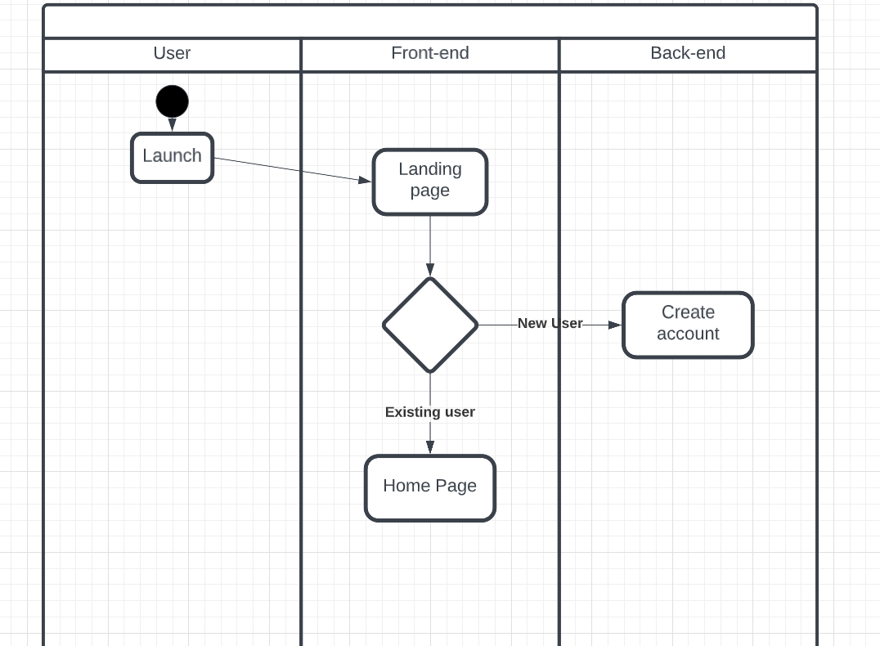

Figure 3. Activity diagram

## 3.8.8 User Interface Design

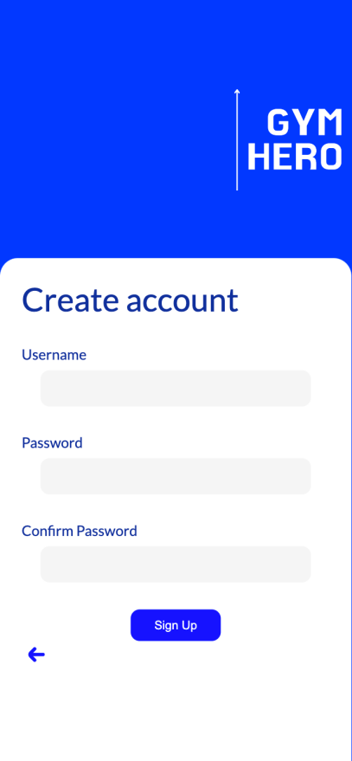

***Figure 1 Landing Page Figure 2 Create Account***

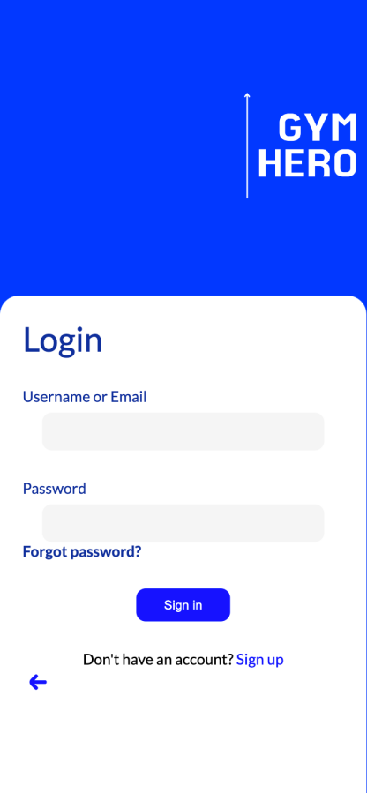

***Figure 3 Log in Page***

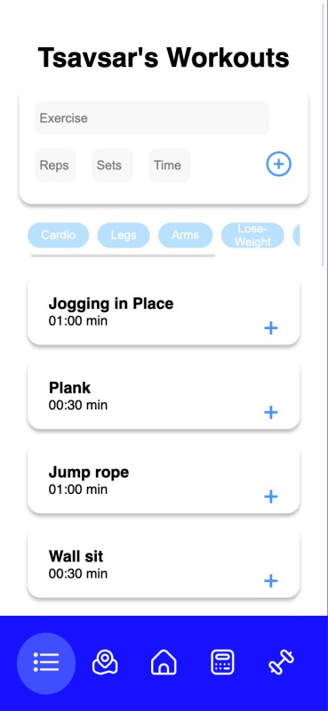

***Figure 4 Workouts page***

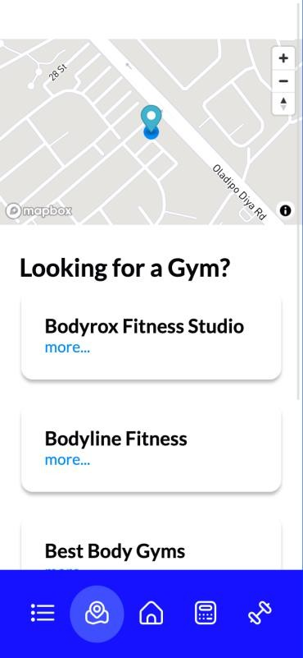

***Figure 5 Gyms***

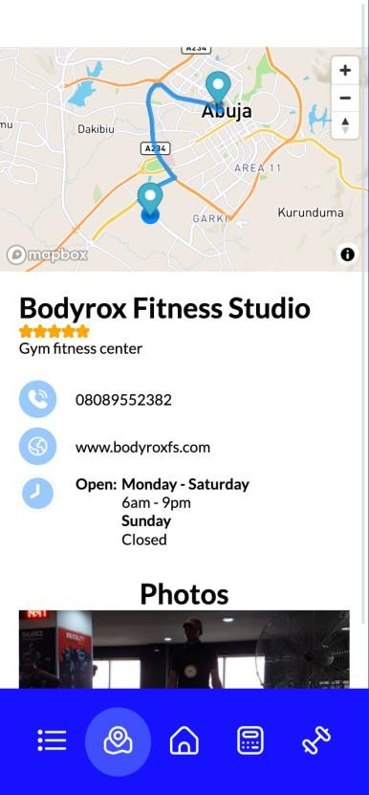

***Figure 6 Gym Profiles***

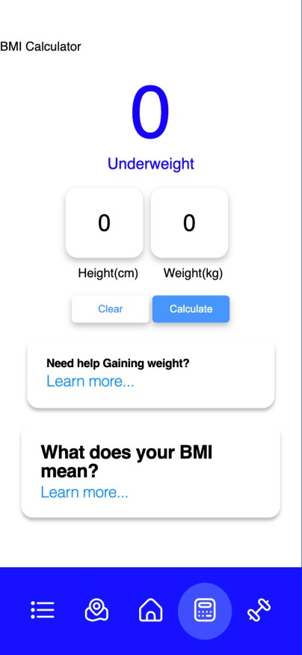

***Figure 7 BMI calculator***

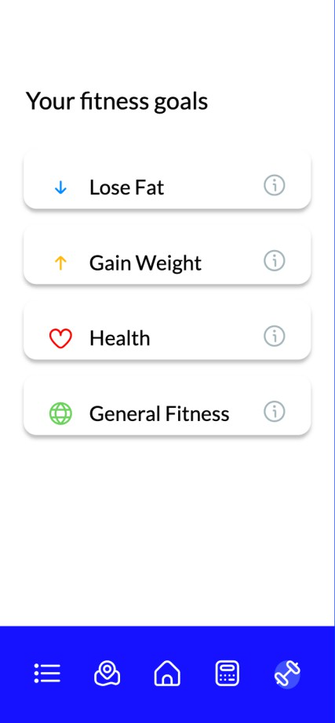

***Figure 8 Articles***

## Summary

In the development there was ease of use which were top considerations, and the use of capacitorjs, as well as the decision to develop using RAD, guaranteed that the requirements were met while staying on schedule. This chapter explained why RAD was chosen for this project, as well as some UML diagrams of the system that demonstrated how a user can interact with it and the requirements that must be met for this project to be regarded successful.

# CHAPTER 4: IMPLEMENTATION AND TESTING

## Overview

In this chapter we will be looking at the practical development of the app and look at the other factors involved in the making, from its front end to its back end and also all the challenges that came along the way as well as the solutions to the problems as follows.

## Main Features

**The main features include:**

**Gym locations system:** This allows you to search through the pool of gyms provides by the app to pick out the one most convenience and closest to you, pictures and opening schedules are provides as well as contact info for all locations, as well as a map for directions



***Figure Gyms Page***

**BMI CALCULATOR:** The BMI calculator which was written using Alpine.js takes the users height and weight to calculate their BMI, it also provides info based on your BMI, grouping it into categories underweight, normal, overweight and obese. I have also provides articles concerning BMI and the significance.

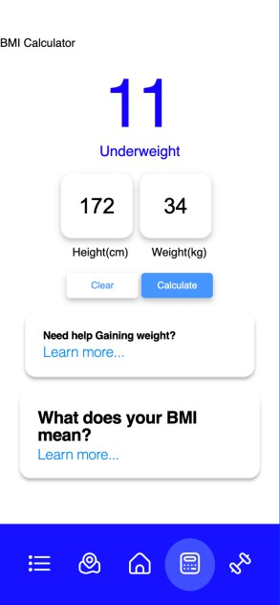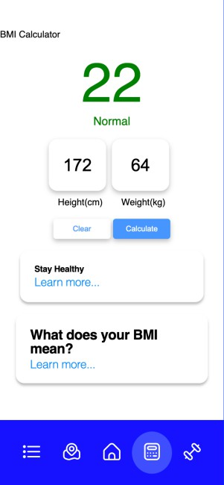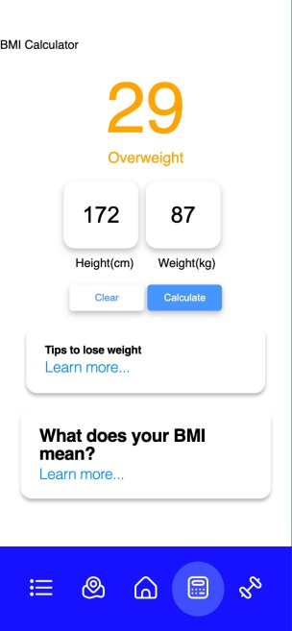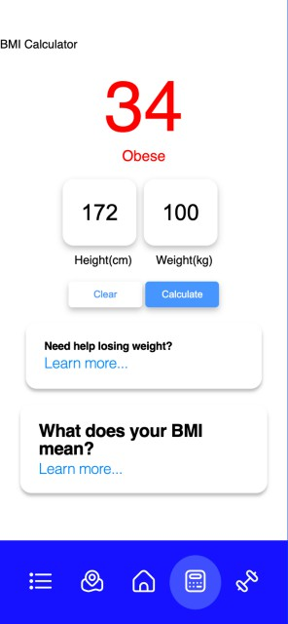

***Figure BMI calculator***

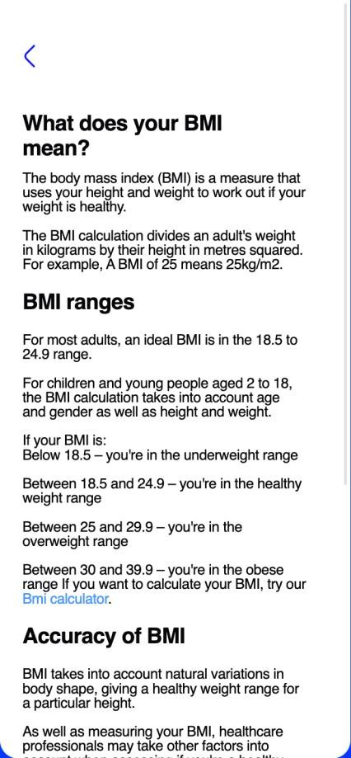

***Figure About BMI***

**WORKOUT:** Here users can create their own workouts and add to a queue or select from existing workouts. Its fully customizable putting you in charge of your own work.

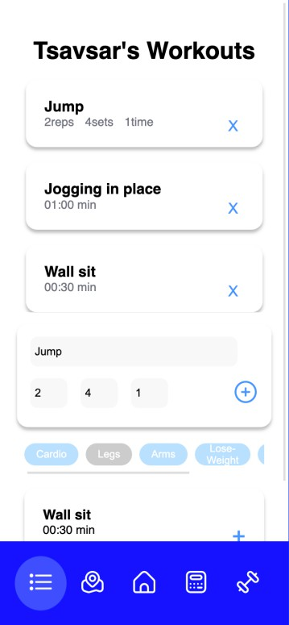

***Figure Workout creator***

## Implementation Problems

An issue i faced during the development process was compiling the code using capacitor, things like the mapbox api were having a hard time functioning as swift code.

Another issue was using my phone as an emulator, since i wanted to test on ios, i had a hard time doing that becasue of Apple’s strict rules when it comes to app development.

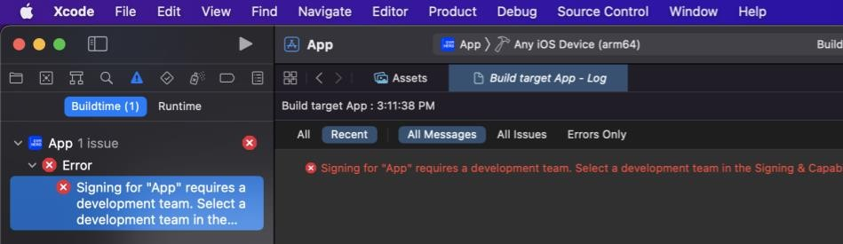

***Figure Xcode error***

Deployment of the app onto the ios App store was also an issue, this one i couldnt avoid

sadly since it cost $100 to have an app on the app store.

## Overcoming Implementation Problems

I used Vite as bundler. This solved the issues i had with capacitor and the Mapbox API I was able to solve this issue by creating an apple development team.

## Testing

Testing was carried out to ensure that efficiency and reliability of the application were put to the test, within the testing period it was tested manually and with this it allowed for one to see it from the perspective of the user. Other forms of testing such as unit testing allowed for the application to be examined and tested for its individual functions from its front-end to its back-end.

## Tests Plans

If the map works properly

Ensure the math behind the BMI calculator works If the DOM manipulation works as should

Make sure the user date is stored and can retrieved or altered if need be

* + - 1. **Tests Identifier**
    1. **Test Suite (for Unit Testing, Integration Testing, and System Testing)**

|  |  |  |
| --- | --- | --- |
| **Req. No.** | **Description** | **Type** |

|  |  |  |
| --- | --- | --- |
| R-101 | When launched, the application shall stay running unless there is an intentional shutdown of the application or the platform. | Performance |

* + 1. **Test Traceability Matrix (for Unit Testing, Integration Testing, and System Testing)**

|  |  |  |  |
| --- | --- | --- | --- |
| **Description** | **Priority** | **Test Case** | **Test Resul t** |
| The app shall have a working BMI calculator that classes users based on BMI and health needs | high | 1 | Pass |
| The map should acurately direct users to gyms | high | 2 | pass |
| The app shall provide options of operations to choose from | high | 3 | pass |
| The app must work without internet connection | low | 4 | pass |
| Does user data come back when requested for from the storage | high | 5 | pass |
| Does the map accurately determine the users location on the gps | medium | 6 | pass |

* + 1. **Test Report Summary (for Unit Testing, Integration Testing, and System Testing)**

These will be focused on the next section of this chapter.

## Error Reports and Corrections

|  |  |  |
| --- | --- | --- |
| **S/N** | **Error** | **Corrections** |
| 1 | Register and Login not storing user info | Applied the newly updated capacitor storage feature in capacitorjs |
| 2 | BMI calculator not producing the right articles | Using alpine i added individual condition statements as they were easier to manipulate than the loops |
| 3 | Icons from font awesome not working | Downloaded an SVG pack and used them instead |

* 1. **Use Guide**

The user had to have a suitable internet connection to use the application to its full capability.

## Summary

This chapter has covered the primary features, testing, and implementation processes of the Application's development life cycle. The following chapter will offer a succinct summary of the project as a whole, with recommendations to follow.

# CHAPTER 5: DISCUSSION, CONCLUSION, AND RECOMMENDATIONS

## Overview

This is the final chapter which includes an overall evaluation of the project, as well as information on the difficulties and limits encountered throughout the project's development life cycle, as well as suggestions for how the project could be better in the future. Finally, based on the project's findings, ideas for the project's direction will be considered.

## Objective Assessment

Majority of the project’s objectives were completed, such as making gyms more accessible and making working more flexible. More is yet to be included to improve the app’s capabilities and allowing for a smoother and more interactive performance.

## Limitations and Challenges

As for the Limitations of the app:

Availability on the apple app store: duer to apple’s strict policies and guidelines, i was not able to put the application on the apple app store.

These are some of the major Challenges faced:

I believe due to the short time of the project duration i could not achieve everything i would have liked to do and i recommend this as future enhancements

Working with a new frame work in Alpinejs and using the MapBox API, Mapbox is a tool that i have not worked extensively with, also learning alpinejs which took a great deal of

time but ultimate contributed to the project’s completion

## Future Enhancements

I believe due to the short time of the project duration i could not achieve everything i would have liked to do and i recommend this as future enhancements

* + - Calories tracker: This will give users a better insight into what they are doing, with a calorie tracker you can easily plan out meals.
    - Weight loss/gain chart: this again will give the user a better insight on what they have been doing and it can serve as much needed motivation.

## Recommendations

* + - We recommended that the data storage be changed to firebase as it world give the application a more portable feel, this way users reatin their information and data regardless of where they are.

## Summary

This chapter brings the project documentation to an end. It covered the project's objectives, scope, risk assessments, requirements, analysis, and design, as well as the methodology used throughout the development life cycle and how it was implemented and tested in the field. Finally, adjustments that could be implemented in the near future, as well as recommendations, were evaluated. Finally, suggestions for adjustments that could be implemented in the near future were examined.

# REFERENCES

*Fitness courses & qualifications*. Origym. (2019). Retrieved August 11, 2022, from Higgins, J. P. (2016). Smartphone applications for patients' health and fitness. The

American journal of medicine, 129(1), 11-19.

Khaghani-Far, I., Nikitina, S., Baez, M., Taran, E. A., & Casati, F. (2016). Fitness applications for home-based training. IEEE Pervasive Computing, 15(4), 56-65.

Davis, N. (2022, March 7). *Best fitness and exercise apps*. Healthline. Retrieved September 21, 2022

Hall, A., Williams, V., & Lester , J. (Eds.). (2022, July 25). *Best fitness apps of 2022*.

Forbes. Retrieved September 21, 2022, from

Barna, W. B. M., & Barna, M. (2017, July 11). *Do fitness apps actually do anything?*

Highsnobiety. Retrieved September 21, 2022, from

Wathan, A., & Schoger, S. (2019). *Refactoring Ui*. Adam Wathan & Steve Schoger.

*Project Management Methodologies | Adobe Workfront*. (n.d.). Retrieved September 21, 2022

Workfront.com. 2021. *Waterfall Methodology - A Complete Guide | Adobe Workfront*. En.wikipedia.org. 2021. *Agile software development - Wikipedia*.

Vinnikova, A., Lu, L., Wei, J., Fang, G., & Yan, J. (2020). The use of smartphone fitness applications: The role of self-efficacy and self-regulation. International Journal of Environmental Research and Public Health, 17(20), 7639.

Lynch, M., & Poole, C. (2018, November 19). *Cross-platform native runtime for web apps*.

Capacitor. Retrieved September 21, 2022.

# APPENDICES

**Appendix A - Project Document**

# IN-DEPTH PROJECT DOCUMENTATION

**Full Candidate Name**: Mchiaga-Tsavsar Shater

**Student ID**: BU/19C/IT/3836

**Title**: Implementation of a fitness app

**Course of Study**: B.Sc. Computer Science

**Appendix B – Questionnaire**

Male/Female

How often do you [exercise](https://www.bartleby.com/topics/exercise) in a week? Have you ever used an app for exercising? What type of app did you use to exercise?

What have you used the fitness app for? (Select all that apply) Do you currently use any mobile fitness apps?

What are the factors that prevent you from working out? What are your favorites activities for a workout?

Would you like to have options of seeing gym options before going?

**Appendix C – Source Codes**

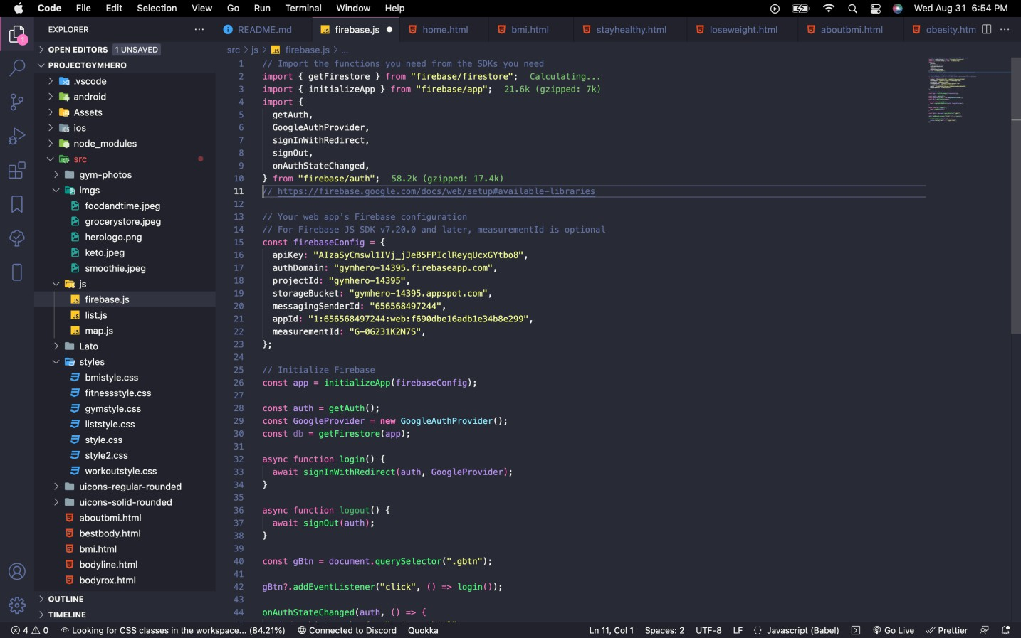

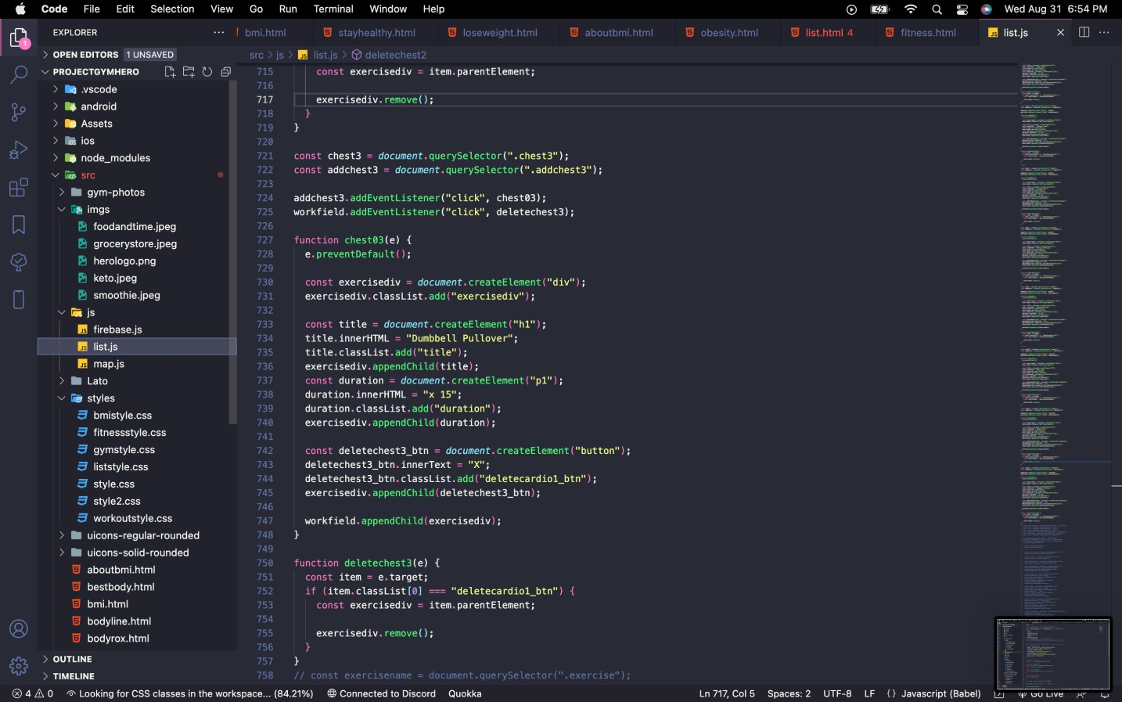

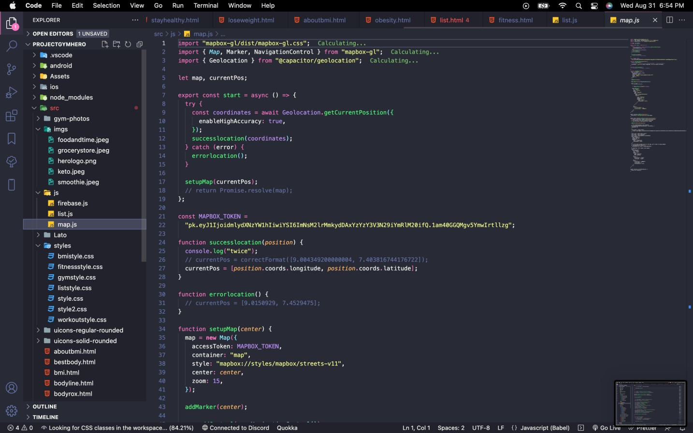

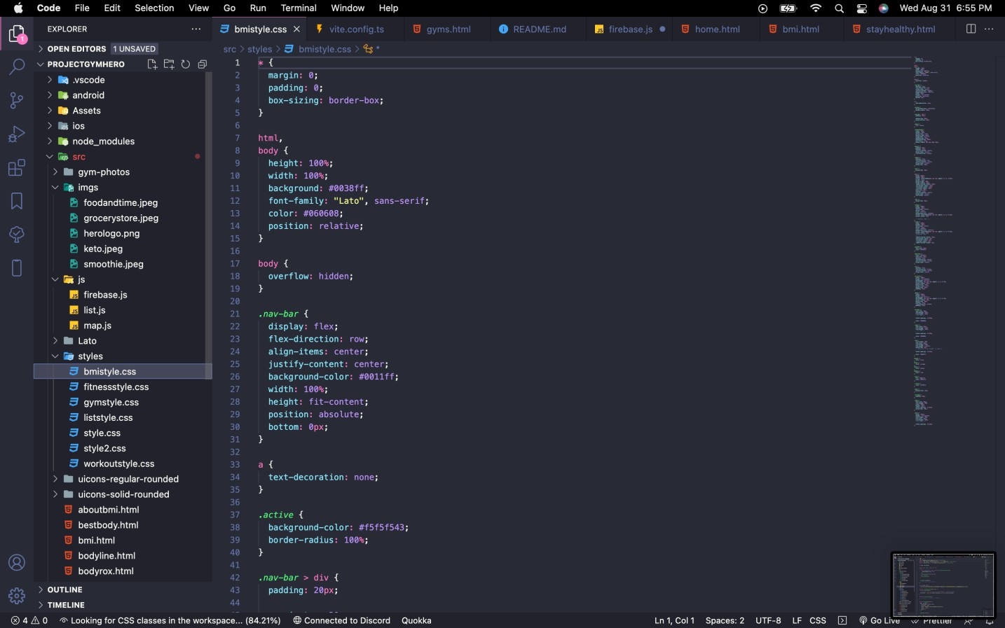

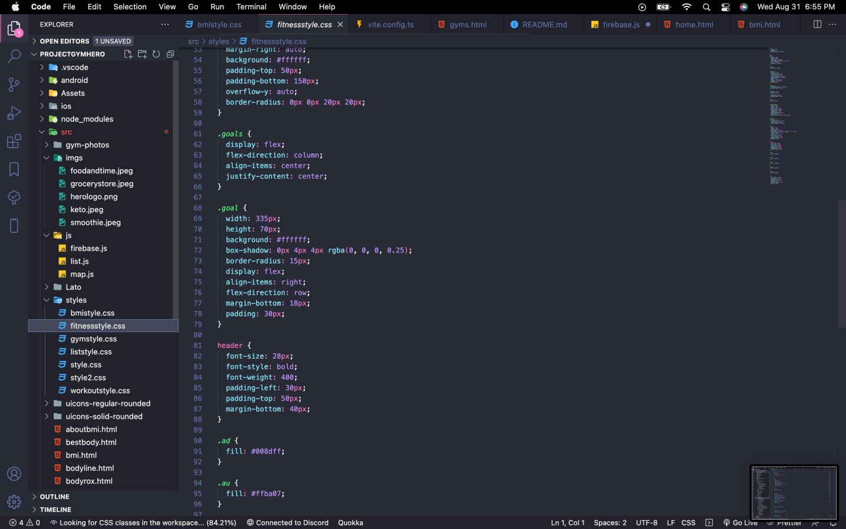

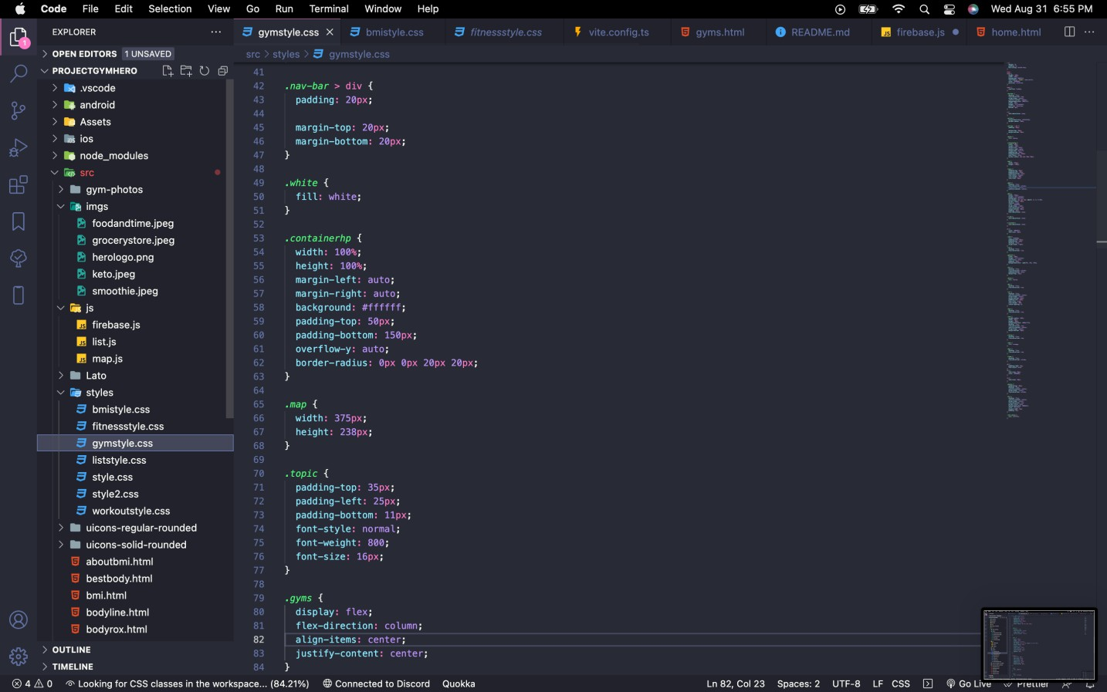

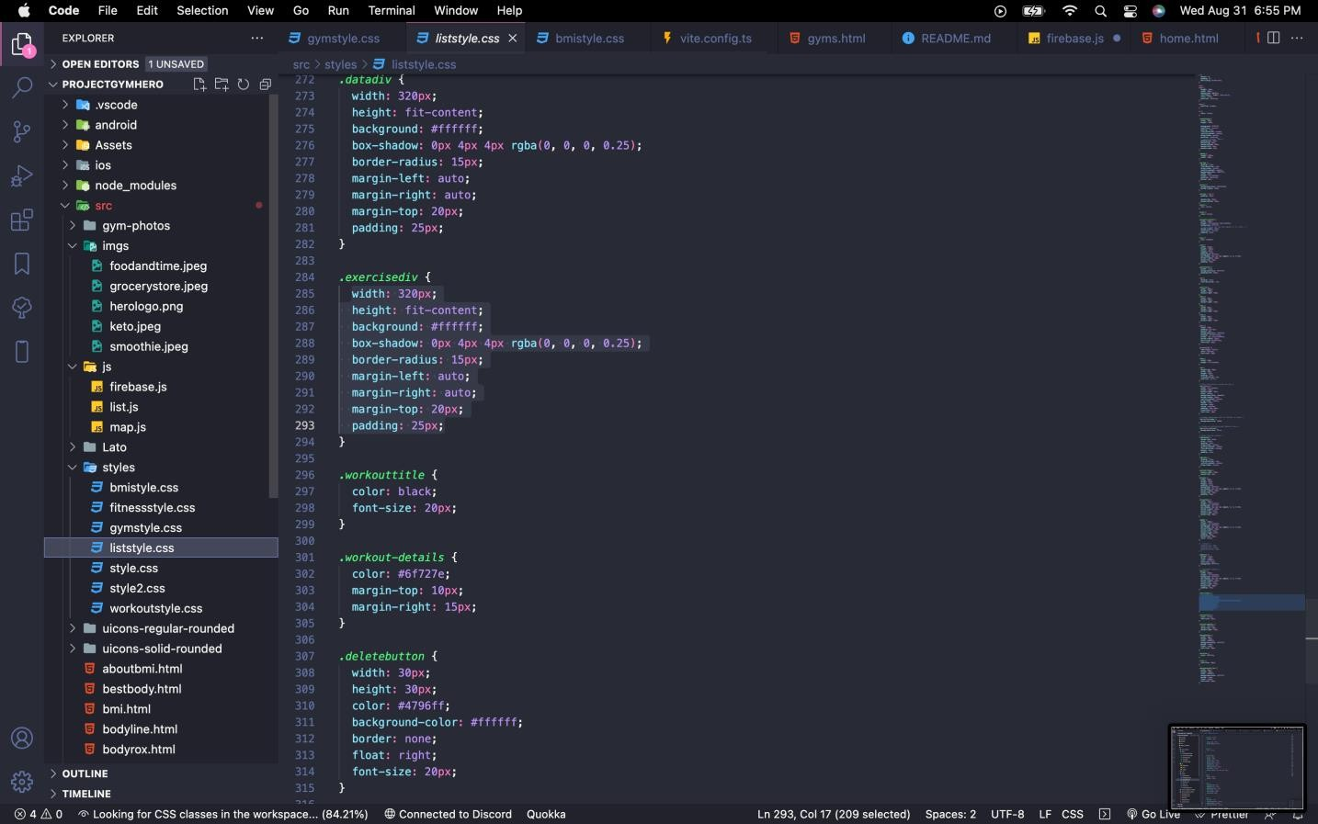

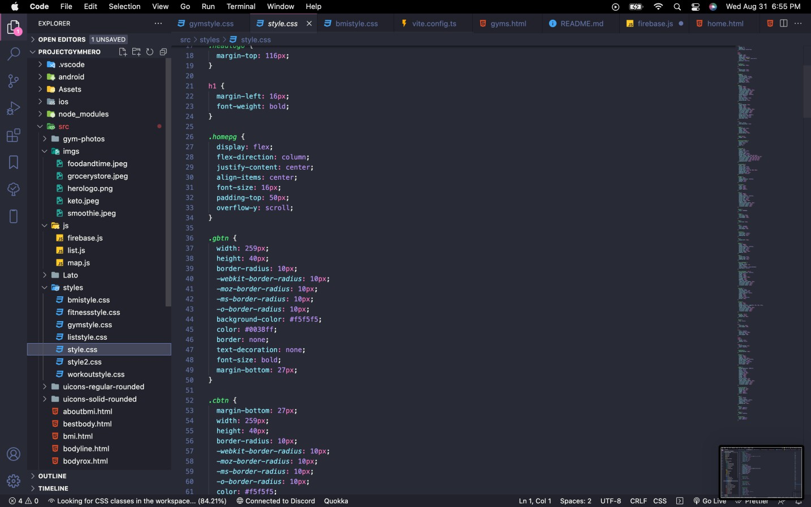

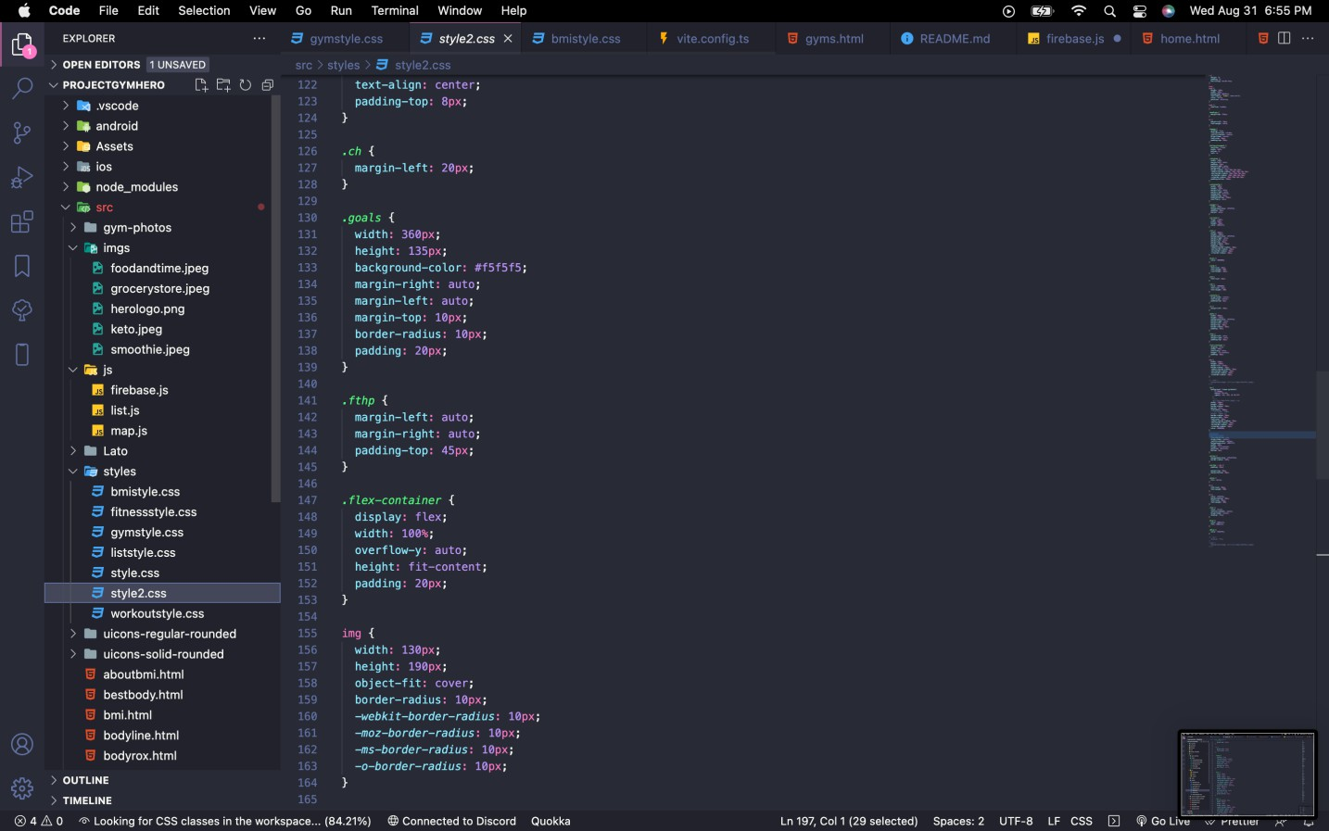

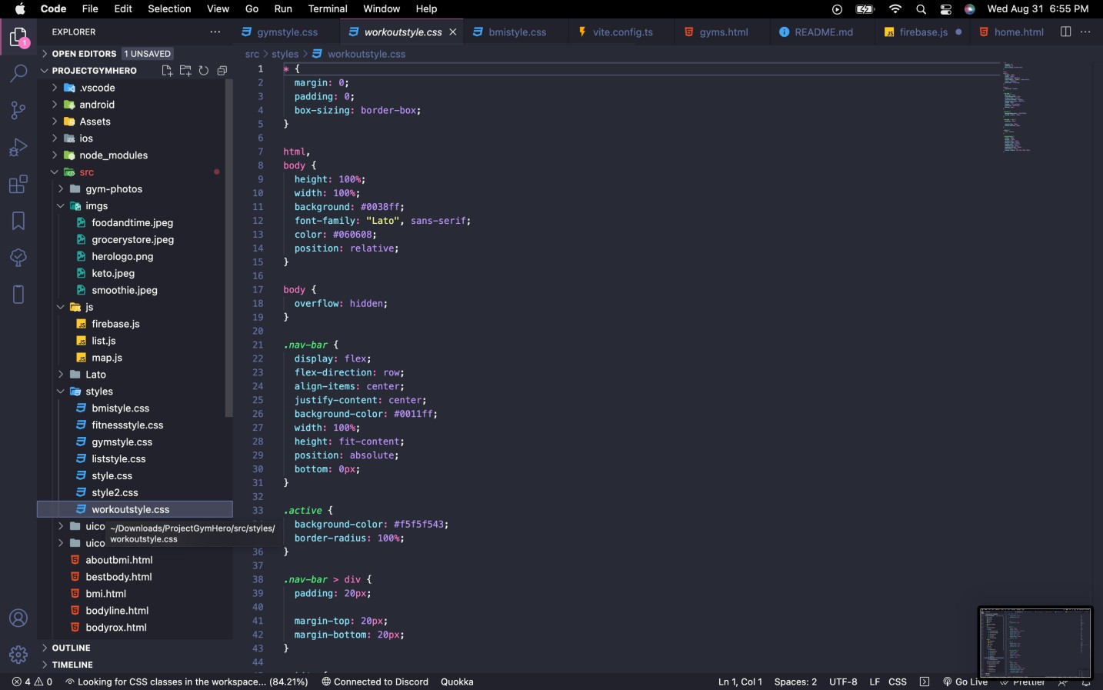

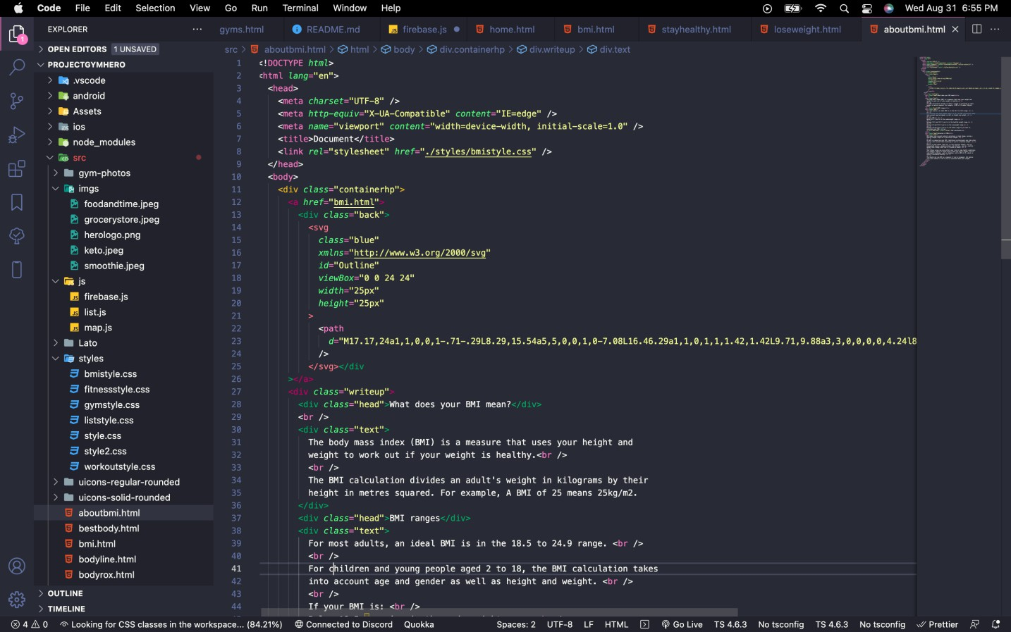

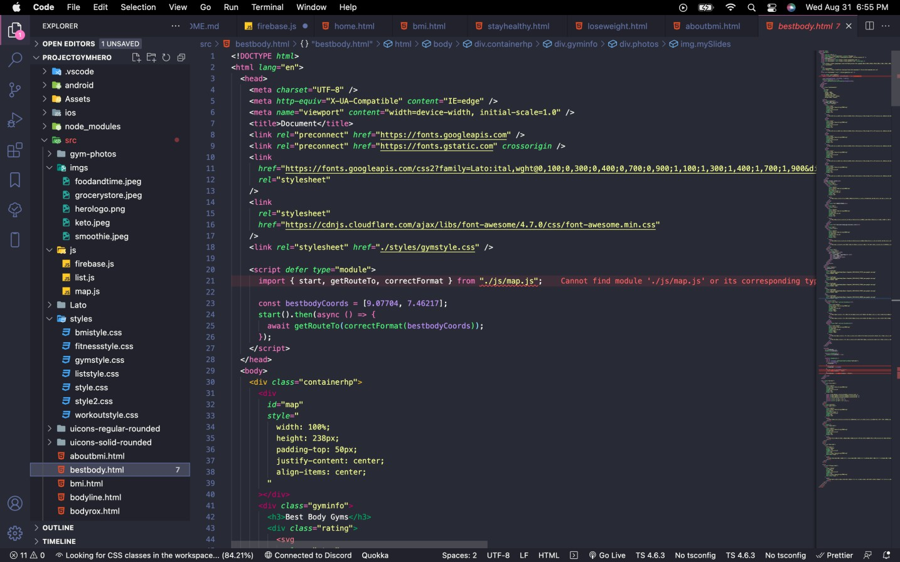

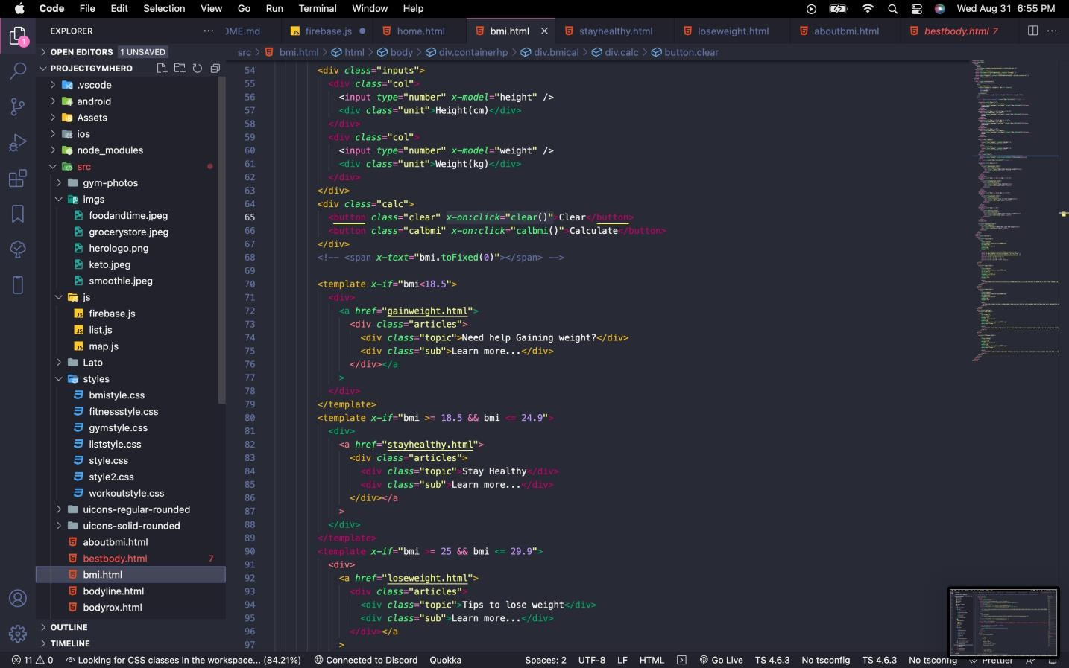

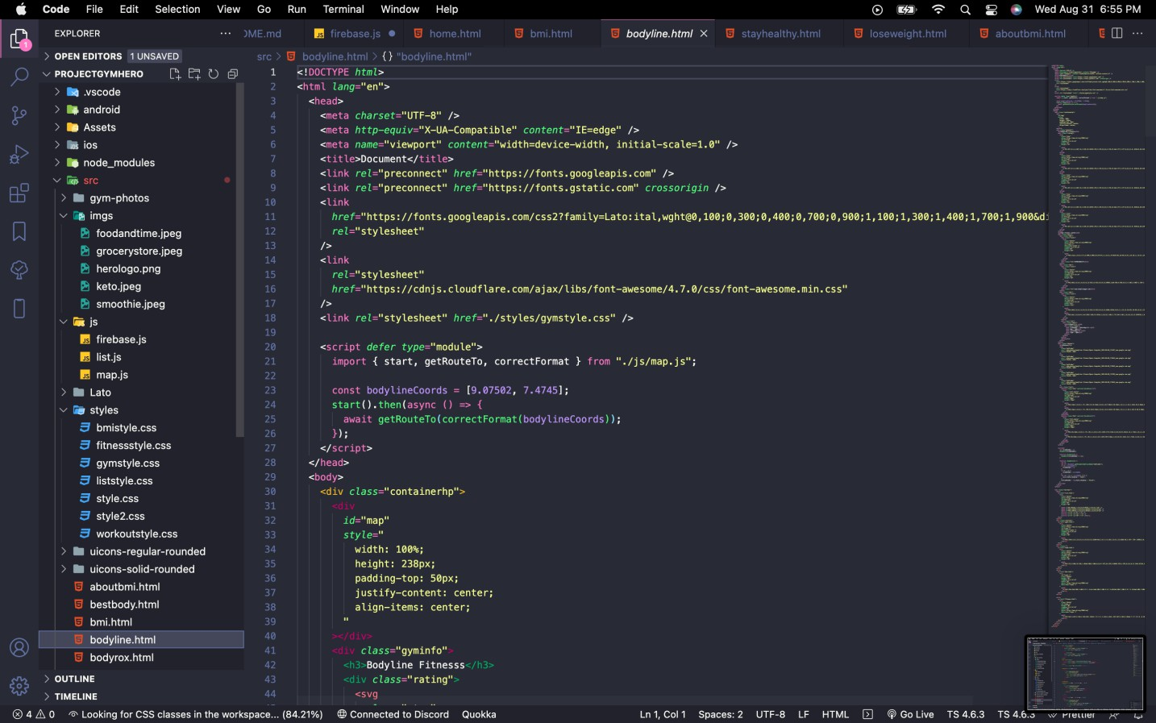

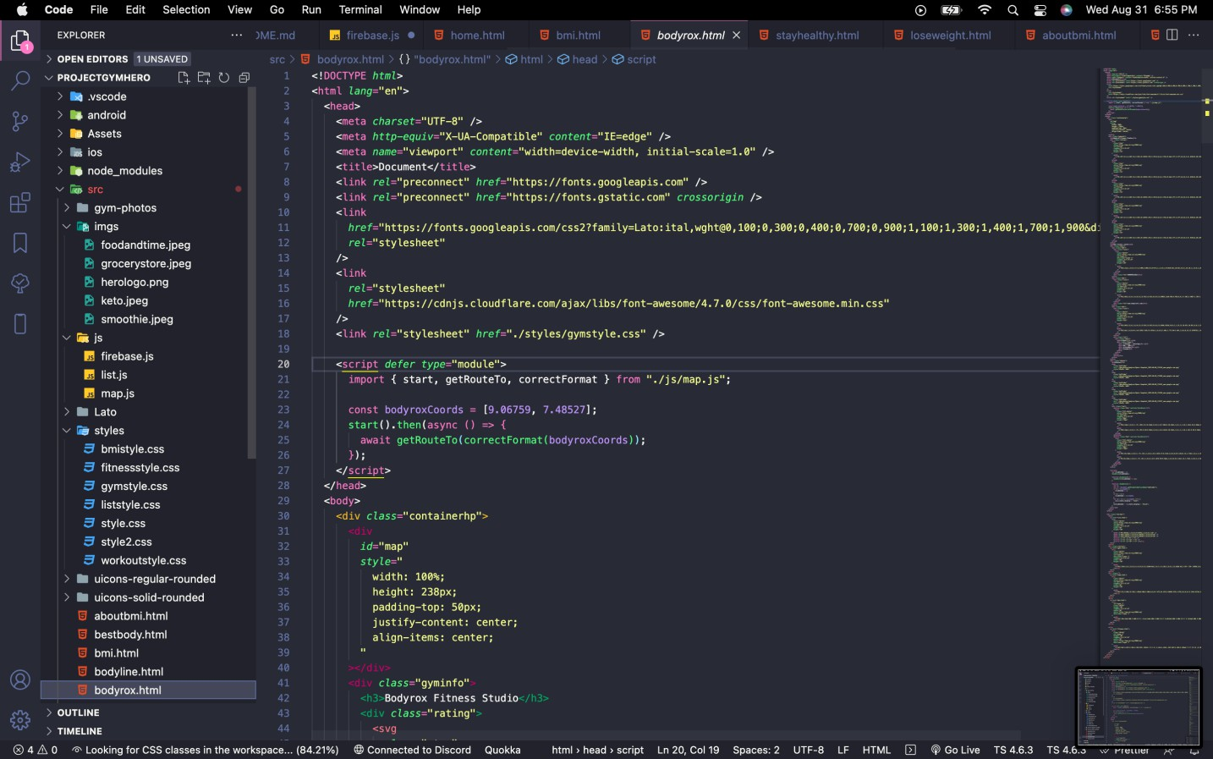

**Appendix C – Plagiarism**

