**Bachelor’s Degree Report (BSc)**

**Design and Implementation of SITC Faculty Portal**

**Rahma MUHAMMAD (A00017367)**

**&**

**Sadiya IMAM (A00017366)**

**Supervisor: Mathias Fonkam**

**School of IT & Computing American University of Nigeria**

**May 2018**

**Design and Implementation of SITC Faculty Portal**

**Rahma MUHAMMAD (A00017367)**

**&**

**Sadiya IMAM (A00017366)**

***BSc Report***

***Project Submitted in***

***Partial fulfillment of the requirements for the Degree of Bachelor in Software Engineering***

**Supervisor: Mathias Fonkam**

**School of IT & Computing American University of Nigeria**

**May 2018**

# DECLARATION

This project work is declared to be carried out by Rahma and Sadiya. It has not been submitted for the degree previously. We solemnly declare that the report is solely written in our very own words. All parts quoted from other materials were clearly and correctly identified and acknowledged. Both project work and report documentation were conducted under the guidance of Dr. Abubakar Sadiq Hussaini and the supervision of Dr. Mathias Fonkam.

Student's Name:

Rahma Muhammad Signature....................................

Student's Name:

Sadiya Imam Signature.....................................

Supervisor's Name:

Mathias Fonkam Signature.....................................

Program Chair's Name:

Dr. Rao Vajjhala Signature....................................

Dean's Name:

Dr. Mathias Fonkam Signature.....................................

SDP Coordinator’s Name:

Dr. Abubakar S. Hussaini Signature.....................................

# ABSTRACT

American University of Nigeria (AUN) has many web application used every day both by students and faculty. For students, faculty and other staff to know about a course or department; they have to visit the AUN website and they can only have little information about them. This problem is faced by students, faculty and visitors that want know about the school of information, technology and computing in the American University of Nigeria. SITC is the second largest school in AUN and it should have its own website platform where people can know more about the courses offered in the school, Catalogs, dean, different majors offered in the school and chairs of these majors. The STIC Faculty Portal will give a clear image of the school of STIC and will help the faculty share documents and information among themselves. This application would have a logo of AUN and a description of the courses offered. A user would be required to simply log in in order to have access to the portal. It will have portlets which are pluggable user interface software components that are managed and displayed in a web portal, example are calendar, newsfeed and others. It would be compatible to any device supporting a web browser (like most of our phones and tablets). Given there is internet connection on campus and the compatible devices are mostly portable, this portal will be accessed.

This application if deployed would provide an easier, faster to know about the STIC for students, alumni, faculty and even visitors. And it will provide solutions to all of the above mentioned challenges faced by the member of SITC.

# ACKNOWLEDGEMENT

We would like to express our sincere gratitude to Dr. Mathias Fonkam our Supervisor, for his professional guidance, support and patience throughout this project work. We acknowledge with a deep sense of gratitude, the encouragement and inspiration received from Dr. ASH and the rest of the SITC faculty members and colleagues. We would also like thank our parents and relatives for their encouragement and support throughout our study.

|  |  |
| --- | --- |
| **Table of Contents** |  |
| DECLARATION | i |
| ABSTRACT | ii |
| ACKNOWLEDGEMENT | iii |
| Table of Contents | iv |
| List of Figures | v |
| List of Tables | vi |
| CHAPTER ONE | 1 |
| 1.0 INTRODUCTION | 1 |
| 1.1 BACKGROUND | 1 |
| 1.2 PROBLEM STATEMENT | 2 |
| 1.3 PROJECT AIMS | 2 |
| 1.4 PROJECT OBJECTIVE | 3 |
| 1.5 OUTLINE OF THE REPORT | 3 |
| CHAPTER TWO | 4 |
| 2 REQUIREMENTS | 4 |
| 2.1 FUNCTIONAL REQUIREMENTS | 4 |
| 2.2 NON-FUNCTIONAL REQUIREMENT | 5 |
| 2.3 USECASE DIAGRAM | 5 |
| 2.4 USE CASE DESCRIPTION | 6 |
| 2.5 HARDWARE REQUIREMENT | 10 |
| CHAPTER THREE | 11 |
| 3 DESIGN | 11 |
| 3.1 METHODOLOGY | 11 |
| 3.2 INTERFACE DESIGN | 12 |
| 3.3 TECHNOLOGIES USED | 14 |
| 3.3.1 HARDWARE | 14 |
| 3.3.2 SOFTWARE | 15 |
| 3.3.3 LANGUAGES | 15 |
| CHAPTER FOUR | 16 |
| 4 CONCLUSION | 16 |
| 4.1 RECOMMENDATION | 16 |
| 4.2 CONCLUSION | 16 |
| 4.3 FUTURE WORK | 17 |
| REFERENCES | 18 |

# List of Figures

Figure 1: Use case diagram 6

Figure 2: Agile process 11

Figure 3: Homepage 12

Figure 4: Groups 13

Figure 5: Users 13

Figure 6: Events 14

**List of Tables**

*Table 1: Use Cases* 6

*Table 2: Use case 1: Login* 7

*Table 3: Use case 2: Create Group* 7

*Table 4: Use case 3:* Create Content 7

*Table 5: Use case 4:* Publish Content 7

*Table 6: Use case 5:* Manage Files 8

*Table 7: Use case 6: Assign roles* 8

*Table 8: Use case 7:* View content 8

*Table 9: Use case 8: Review content* 9

*Table 10: Use case 9: Manage portlets* 9

*Table 11: Use case 10: Share Contents* 9

# CHAPTER ONE

* 1. **INTRODUCTION**

## BACKGROUND

American University of Nigeria is a digital community in which almost everything runs online. There are so many web platforms used every hour of every day by both faculties and students. The current way of accessing these platforms is to some extent time consuming and redundant. One has to manually visit the webpage from his/her browser, input login details where required before accessing any of these pages. This hierarchical long process makes the whole process boring and in some cases confusing especially to first time users (fresh students/faculties). For users that happen to set different passwords for different platforms, it is very likely to forget or mix-up one for another. Another problem is that, each of these web platforms has to be opened separately in a new browser tab. It has to be completely managed separately.

However, not that one cannot access any of the platforms on his mobile phone, No, surely everyone can. But this application would be introducing a completely different way of doing it. It would provide a very nice looking and mobile friendly interface with straightforward commands, hints and pop-up messages. This application if deployed, would provide an easier, faster and more efficient way of utilizing the chosen American University of Nigeria web platforms by proving solutions to all of the afore mentioned challenges faced by users.

## PROBLEM STATEMENT

The development of this project would make it easier for both faculties and students to access the school of information, technology and computing’s new, Catalogs, courses, details about all faculty and more. It would ease the challenges faced by first semester students of SITC view the above mentioned things. What prompted us to take this project is nothing other the difficulties the faculty of STIC are facing. Below is just a few of the problems this project will solve.

* + - The existing system AUN site has limited resources, there things happening in the school and many people are not aware of it.
    - Limited Information about the School and faculty, the available information on the AUN site is not efficient.
    - The way the content is created is not dynamic; the contents available on the AUN site are not dynamic and not up-to-date.
    - No platform to share contents among faculty. Faculty share contents only via email.

Therefore, there is a need for platform.

* + - The existing system AUN site has limited resources.

## PROJECT AIMS

This project of a proposed Faculty Portal application has the following aims:

* + - To develop faculty portal for School of IT and Computing that supports additional real time public facing contents about the school.
    - Dynamic content provision.

## PROJECT OBJECTIVE

The proposed objectives of this Faculty Portal are as follows:

* + - To develop faculty portal for School of IT and computing that supports additional real time public facing contents about the school.
    - To build a platform that enables through the web publishing of contents. It will empower faculty to create, review, and manage contents.
    - To make room for faculty in SITC to communicate with one another.
    - To make it easier for first semester students of SITC to know more about their school.
    - Faculty can share documents with amongst themselves.

## OUTLINE OF THE REPORT

Chapter 1 vividly introduces the project. It entails the problem statement, aims and objectives of the project; all clearly stated as well.

Chapter 2 clearly describes what the system is supposed to do (Requirements). This serves as a way of attesting if the project actually accomplished the set goals.

Chapter 3 shows and describes how the system was developed and shows the interaction between the system and the user.

Chapter 4 states the project's conclusion, recommendation, further work and references.

# CHAPTER TWO

1. **REQUIREMENTS**

Requirements are constraints that depict the behavior of an application or software system under development. This chapter will specifically address what the system should do and have as well as set constraints on the design to meet a specific level of quality. It will consist of the functional, non-functional, hardware and business requirements of this project.

## FUNCTIONAL REQUIREMENTS

The functional requirements define the functionalities of the application. It describes what the application should do. The requirements are categorized below base on the functions of the involved platforms. They are as follows:

**Functional Requirements**

* The system shall user add to the public facing content of the portal based on privilege.
* It will allow faculty to manage resources and share documents among one another.
* The application shall allow user to input their login details where required.
* The application shall allow user to login to their respective accounts.
* The application shall allow user to upload/download files.
* The application shall allow user to logout from their accounts.
* The application should provide simple and understandable error messages to the user in case of any error.
* The application should allow user to successfully exit.

## NON-FUNCTIONAL REQUIREMENT

**Look and Feel** – The targeted users of the application are members of the school of School of Information Technology & Computing, as such, its color combinations and appearance would match AUN’s logo (Red, Green and Blue). It shall be made captivative and friendly to attract users and be pleasing for academic activities.

**Performance** – Users would be able to access their various accounts based on privilege and shall be able to perform all the designated activities rendered by the system.

**Usability** – The application would be made very much easy and instinctive to use with simple direction tips wherever the need arise.

**Operational** – The system would be used by the faculties of School of Information & Technology & Computing.

**Maintainability and portability** – The application would be compatible to all available devices as well as browser.

**Security** – All users’ activities on the system shall be kept confidential and highly secured.

**Legal** - The application will follow to all applicable laws regulating holding data on people and the presentation of the system.

## USECASE DIAGRAM

Below is the use case diagram that shows the entities’ relationships and how any user can initiate a functionality.

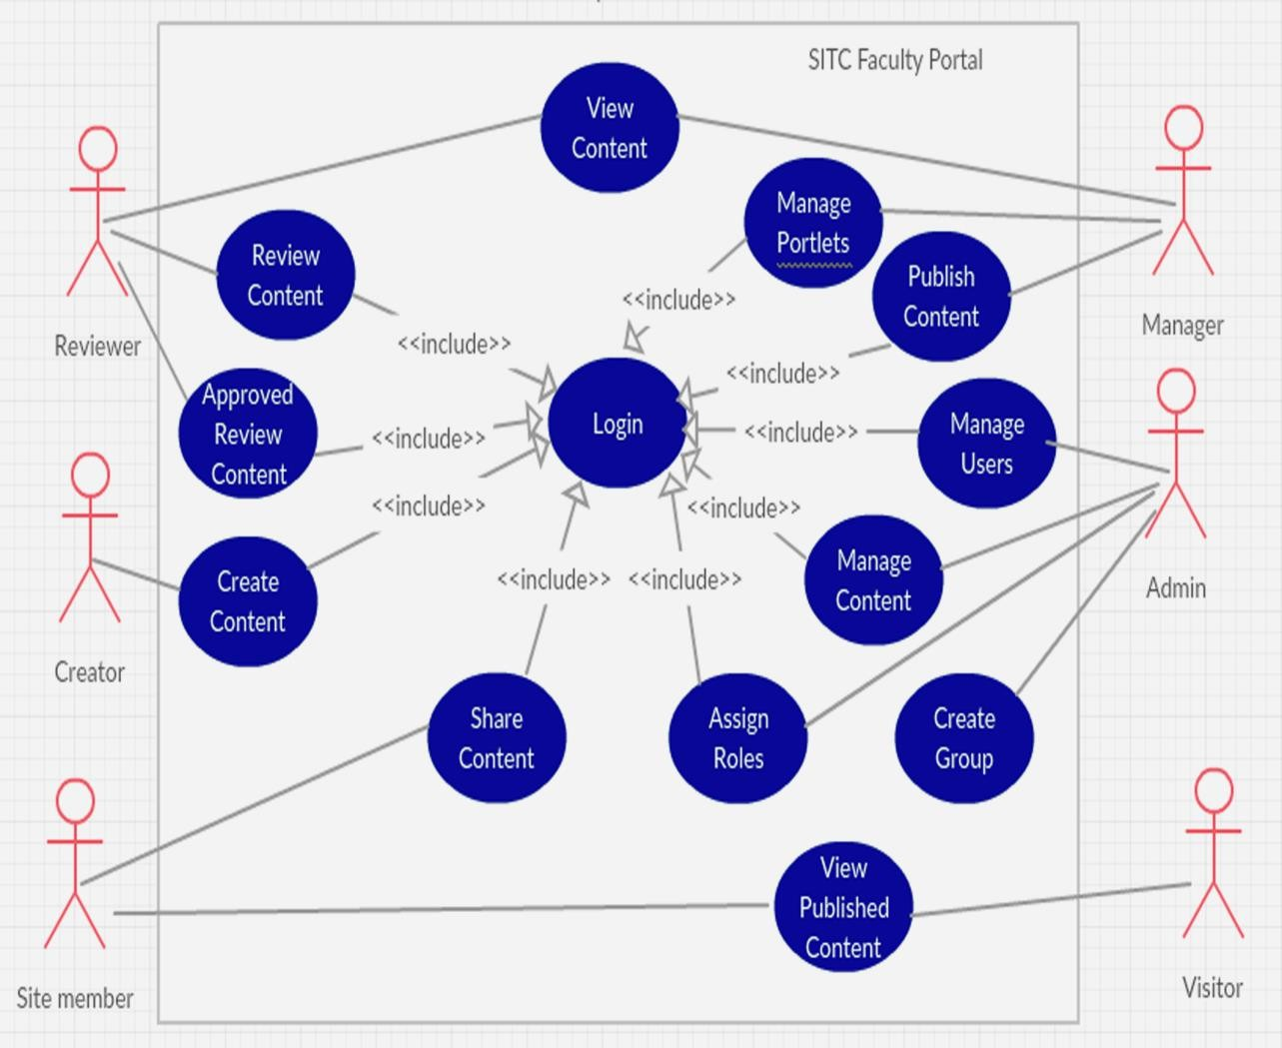

**Figure 1: Use case diagram**

## USE CASE DESCRIPTION

***Table 1: Use Cases***

|  |  |
| --- | --- |
| 1. | Login |
| 2. | Create Group |
| 3. | Create Content |
| 4. | Publish Content |
| 5. | Manage Content |
| 6. | Assign roles |
| 7. | View Content |
| 8. | Review Content |
| 9. | Manage Portlets |
| 10. | Share Content |

***Table 2: Use case 1: Login***

|  |  |
| --- | --- |
| Use Case | Login |
| Goals | To gain access into user’s account. |
| Assumptions | User has valid and active account registered on the platform. |
| Steps | * Application prompt user to input his credentials * User provides login details * User is successfully logged into his/her account. |
| Preconditions | Input login details. |
| Post-conditions | Gives user access to on the system. |

***Table 3: Use case 2: Create Group***

|  |  |
| --- | --- |
| Use Case | Create group |
| Goals | To create group that has title and group members’ information. |
| Assumptions | User has opened the system and accessed the group icon. |
| Steps | * Click on create group * Assign title to the group |
| Preconditions | User accesses the group icon to create group. |
| Post-conditions | Desired group is created ready to use. |

***Table 4: Use case 3:* Create Content**

|  |  |
| --- | --- |
| Goals | To gain access into user’s account. |
| Assumptions | User has valid and active account registered on the platform. |
| Steps | * Application prompt user to input his credentials * User provides login details * User is successfully logged into his/her account. |
| Preconditions | Select and open platform. |
| Post-conditions | Gives user access to his/her account on the selected platform. |

***Table 5: Use case 4:* Publish Content**

|  |  |
| --- | --- |
| Use Case | Publish content |
| Goals | To publish a written /uploaded content |

|  |  |
| --- | --- |
| Assumptions | Content has been approved |
| Steps | * User logs into his/her account. * Select content. * Save and publish. |
| Preconditions | Create content. |
| Post-conditions | The content get published |

***Table 6: Use case 5:* Manage Files**

|  |  |
| --- | --- |
| Use Case | Manage Files |
| Goals | To be able to access, review, upload and download files. |
| Steps | * Login into user’s account. * Access files from the menu. * Select the file to be managed. |
| Preconditions | Access file in the platform. |
| Post-conditions | View, download or upload files. |

***Table 7: Use case 6: Assign roles***

|  |  |
| --- | --- |
| Use Case | Assign roles |
| Goals | Assign roles to users |
| Assumptions | Existing users |
| Steps | * Login into user account. * Go-to site-setup. * Select users &groups. * Assign roles. |
| Preconditions | Log into account. |
| Post-  conditions | Roles have been assigned. |

***Table 8: Use case 7:* View content**

|  |  |
| --- | --- |
| Use Case | View contents |
| Goals | View content. |

|  |  |
| --- | --- |
| Steps | * Login into user’s account * Select a targeted folder. * View the content. |
| Preconditions | Log into portal. |
| Post-conditions | Display the content ready for use. |

|  |  |
| --- | --- |
| Use Case | Review content |
| Goals | To be able to review content needed to be published. |
| Steps | * Open the portal. * Access the content based on privilege. * Review the content. |
| Preconditions | Request to review the content. |
| Post-conditions | Content has been reviewed. |

***Table 9: Use case 8: Review content***

***Table 10: Use case 9: Manage portlets***

|  |  |
| --- | --- |
| Use Case | Manage Portlets |
| Goals | To be able to manage portlets. |
| Steps | * Open the portal. * Access the menu from the side menu bar. * Select “Manage portlets”. |
| Preconditions | Request to manage portlets. |
| Post-conditions | Been able to manage portlets. |

***Table 11: Use case 10: Share Contents***

|  |  |
| --- | --- |
| Use Case | Share contents. |
| Goals | To be able to share contents. |

|  |  |
| --- | --- |
| Assumptions | User has filed to share. |
| Steps | * Access the menu from the side menu bar. * Select “share contents”. * Select whom to share with. |
| Preconditions | Request to share contents. |
| Post-conditions | Content has been shared. |

## HARDWARE REQUIREMENT

To be eligible to use the portal, a user simply needs the following:

* An android mobile phone/tablet.
* Internet connection

# CHAPTER THREE

1. **DESIGN**

## METHODOLOGY

The methodology followed in developing this application is the Agile Methodology. This is a method in which the application is broken down into increments called Sprint. The first sprint is developed and tested to meet expectations before the development of the second sprint is started. This process is followed until the last sprint. The complete application at the end must has passed all the testing procedures and recorded no defect or bug. It is a very good method for developing small projects that requirement customer involvement.

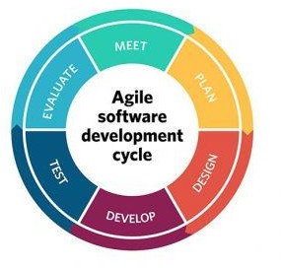

**Figure 2: Agile process**

## INTERFACE DESIGN

The application is exclusively built for use by the school of SITC and shall be used by its members. We tried as much as possible to make the application’s interface portray AUN’s theme to the uppermost degree. As such, all the color combinations we used for the interfaces are the same colors on the school’s logo (red, blue and green). The portal’s welcoming page carries a logo we designed containing all the colors. A welcoming message and upcoming events follow the logo.

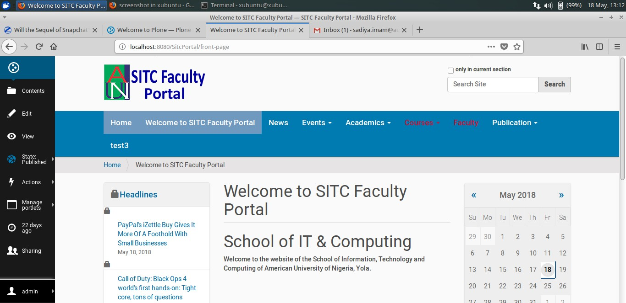

**Figure 3: Homepage**

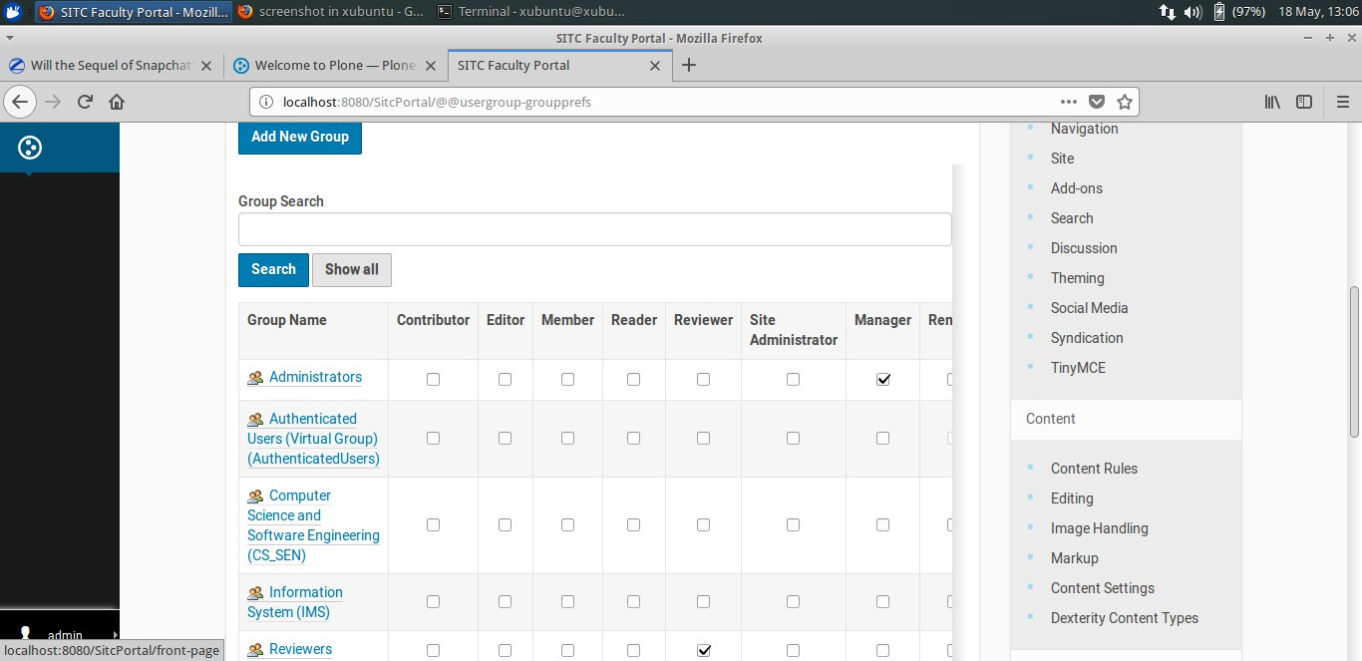

**Figure 4: Groups**

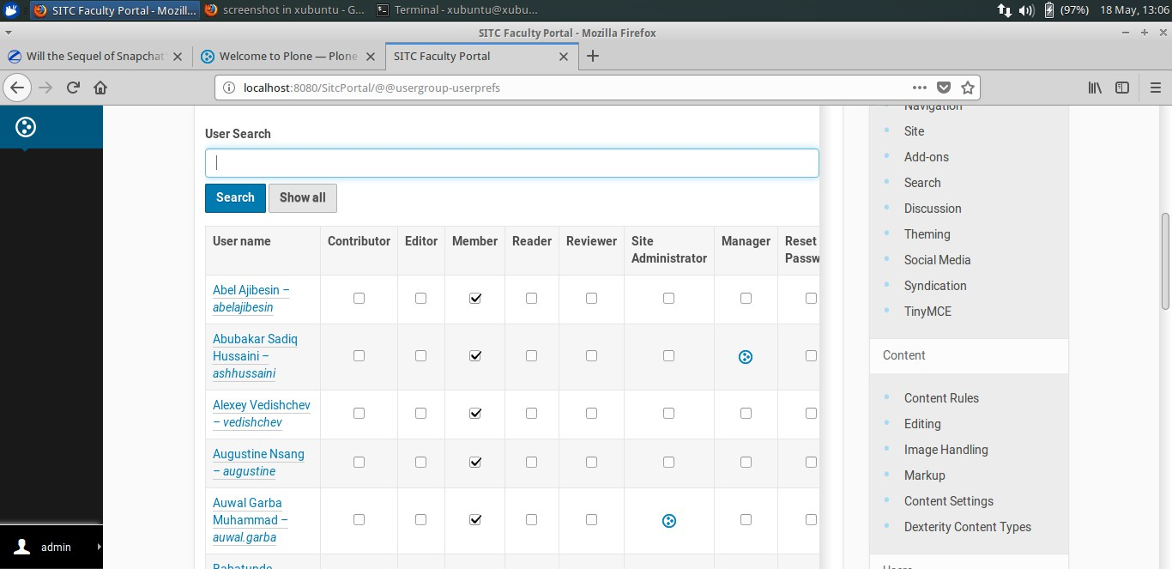

**Figure 5: Users**

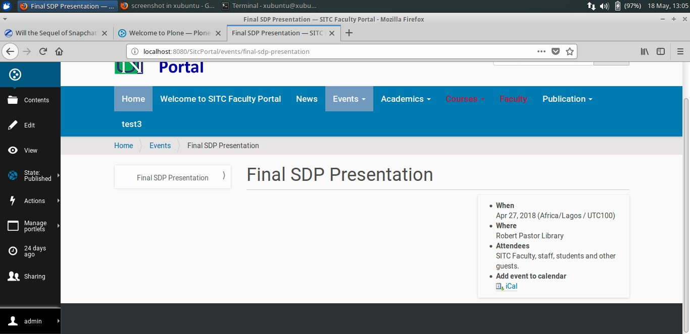

**Figure 6: Events**

## TECHNOLOGIES USED

### HARDWARE

Computer

Hard drive (backup)

### SOFTWARE

**Plone:** is a free and open source content management system built on top of the Zope application server. It is positioned as an "Enterprise CMS" and is normally used for intranets and as part of the web presence of large organizations

**Zope Application Server:** Zope is an open-source web application servers written in Python, and their associated online community.

### LANGUAGES

**HTML/XML:** They were used for structuring the application’s interfaces.

**CSS:** Cascading Style Sheet was used to define looks, design and beautify the structured interfaces of the application.

**JAVASCRIPT:** is a high-level, interpreted programming language. It is a language which is also characterized as making contents dynamic.

**PYTHON:** is an interpreted high-level programming language for general-purpose programming.

# CHAPTER FOUR

1. **CONCLUSION**

## RECOMMENDATION

This project is very simple and cheap to implement. Moreover, it will solve problems that many faculties are facing. We therefore recommend that the school authority to see to the implementation of this project.

### CONCLUSION

This is a content management system will add to the public facing content of AUN. It will allow faculty to manage resources and share documents among one another. It would be used for the School of Information Technology and Computing. There will be potlets; software components that are managed and displayed in a web portal, e.g. calendar, newsfeed and others. It is solely developed to serve the AUN community members. One of the most important objectives of taking the project is to develop and android application for the school. AUN community is the targeted scope. The included web platforms are used on daily basis by almost every member of the community. The project addresses certain inefficiencies of the current process of accessing the web platforms, especially on mobile phones or tablets. This includes redundancy, unfriendly interfaces and time consumption. SITC Faculty Portal is a Web site specifically for use by SITC members that aggregates an array of contents. This portal empowers Faculty by enabling them to create, share, view, edit, review and publish dynamic contents

according to their assigned roles in the system. It also provides variety of services including search engines, news, portlets and groups. This portal will not only help the faculty but will add to the public facing contents of SITC. Visitors can also public contents are published. This project solves a real life problem in AUN community. It is very cheap and easy to implement.

### FUTURE WORK

In order to make this application more efficient and useful, we are suggesting some more features that future works may consider adding. They are as follows:

* Provide information about SITC Alumni and also empower them to share their documents, publications and success stories.
* Create a room for graduate studies.

# REFERENCES

1. [http://www.creately.com](http://www.creately.com/)
2. [http://www.plone.org](http://www.plone.org/)
3. Latteier. Amos; Pelletier. Michel; McDonough. Chris; Sabaini. Peter; The Zope Book 2.6 Edition. 2010.
4. Martin. Aspeli, Professional Phone Development. Birminham-Mumbai. 2011
5. J. Cameron. Cooper, Building Websites with Plone. Packt Publishing Ltd. 2004
6. Bauer. Philip, Gerken. Patrick, Mastering Plone Documentation.

October 03, 2015

1. <http://www.sixfeetup.com/plone-cms>