**Design and Implementation of IoT based PV Integrated Power Monitoring System**

**Abstract.** The awareness of usage of power and effective utilization of power is based on intelligent decision, which can help the user as well as supplier. In this paper the design and implementation of IOT based PV integrated system is presented. A hardware prototype is developed with PV module connected to boost converter, Arduino Uno controller, ESP 8266 Wi-Fi module, and Thing speak to monitor a real-time power. The Arduino Uno serves as the central controller, gathering data from smart power meters and PV modules for solar energy generation. The collected data is wirelessly delivered to the ThingSpeak, which provides cloud-based storage, data analysis, and visualization. With these users may remotely monitor usage of power, track solar energy generation, and get notifications for energy utilization.

**1. Introduction**

The fast growth of Internet of Things (IoT) has opened the way for cutting-edge solutions in a variety of fields, including power monitoring and management. With increased concerns about energy efficiency, cost savings, and sustainability, intelligent systems that can monitor and optimize power use in real-time are in high demand. IoT with cloud-based monitoring has been marked as a versatile tool for visualization and compatibility with other devices and transmit to cloud by making an idea for low-cost solutions. In answer to this demand, this paper provides an IoT-based smart power monitoring system. The goal of this paper is to provide an intelligent and user-friendly power monitoring system that enables people to make educated decisions about their energy consumption. The system provides power usage patterns, recognizing possible energy waste, and offering personalized optimization recommendations. Furthermore, the incorporation of renewable energy sources via the PV module adds to the use of clean and sustainable energy.

1. **Literature survey**

The integration of IoT-based technologies has significantly transformed energy management and control paradigms. These advancements encompass various aspects, including IoT-driven smart energy meters that facilitate the cloud-based analysis of consumption patterns [1]. The SMACS system employs IoT elements to monitor power usage and leverage cloud platforms for comprehensive data analysis [2]. These initiatives collectively bolster energy management both at the grid level and in everyday living scenarios, addressing critical challenges while enabling real-time measurements for accurate load analysis [3]. Expanding on this, the impact of IoT extends to seamless remote management and monitoring processes [4]. Moreover, the integration of IoT applications within the Smart Grid



Content from this work may be used under the terms of the Creative Commons Attribution 3.0 licence. Any further distribution of this work must maintain attribution to the author(s) and the title of the work, journal citation and DOI.

|  |  |
| --- | --- |
| Published under licence by IOP Publishing Ltd | 1 |

|  |  |  |
| --- | --- | --- |
| ICISPES-2023 |  | IOP Publishing |
| IOP Conf. Series: Materials Science and Engineering | 1295 (2023) 012012 | doi:10.1088/1757-899X/1295/1/012012 |

framework offers multifaceted benefits. Demand-side energy management, exemplified by systems like ISEMS, leverages sensor-based data collection and cloud-powered analysis to harness renewable energy and optimize usage of power [5]. Furthermore, IoT's transformative influence extends to areas like solar energy enhancement, where IoT technologies enable real-time tracking of factors like dust accumulation on solar panels, ultimately optimizing power production [6]. Venturing into novel territories, the field witnesses groundbreaking advancements. For instance, the adoption of a unified model predictive control approach in integrated PV and battery storage systems promises higher reliability and compliance with standards [7]. Simultaneously, the digital implementation of control loops for bidirectional converters, enriched with features like maximum power point tracking (MPPT) and high-bandwidth current regulation, introduces improved performance and enhanced energy flow management

1. These innovative strides significantly contribute to the efficiency of renewable energy systems. However, amidst these promising advancements, challenges remain, particularly in dealing with higher voltage levels in PV and battery systems [9]. Despite the potential gains, the complexities of system design, installation intricacies, and safety concerns associated with elevated voltage levels necessitate careful consideration. This confluence of innovative solutions and persistent challenges drives the continuous evolution of energy management and control within the broader context of IoT-driven advancements.
2. **Methodology**

The proposed system is designed and implemented with the help of block diagram shown in figure 1. The PV panel output is converted to AC using H bridge inverter and is fed to a load. The switching signals for using boost converter and inverter are provided through Arduino Uno controller to driver IC. The maximum power point tracker is implemented with perturb and observe algorithm and is realized through boost converter. At PV side and load side voltage and current sensors are connected. The real time data is fetched to cloud via ThingSpeak APP and the flow chart is shown in figure 2.

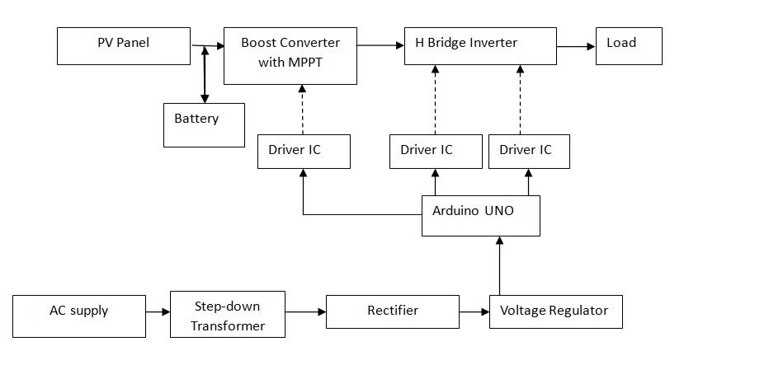

**Figure 1**. Block diagram of proposed PV based power monitoring system.

2

|  |  |  |
| --- | --- | --- |
| ICISPES-2023 |  | IOP Publishing |
| IOP Conf. Series: Materials Science and Engineering | 1295 (2023) 012012 | doi:10.1088/1757-899X/1295/1/012012 |

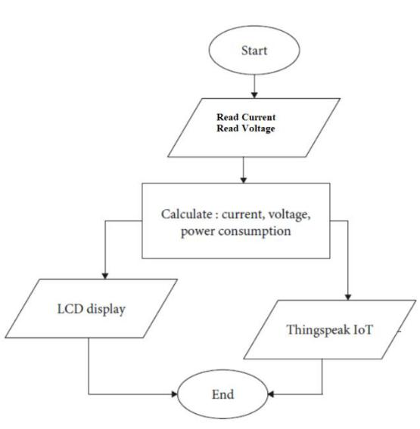

**Figure 2**. Flow chart of PV based power monitoring system.

1. **Design**

The PV power system is simulated using MATLAB/Simulink platform. The Simulink diagram is shown in figure 3. The designed values are mentioned in table 1.

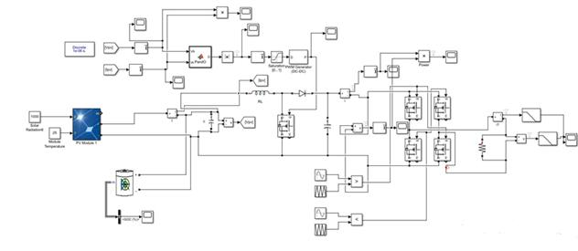

**Figure 3.** Simulink block diagram of PV power system.

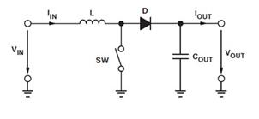

**Figure 4.** Boost converters.

**Table 1.** Design Specifications of

Boost converter.

|  |  |  |
| --- | --- | --- |
| S. No. | Component | Specification |
|  |  |  |
| 1. | PV Module | 12Vp |
|  | 3 |  |

|  |  |  |  |  |  |  |
| --- | --- | --- | --- | --- | --- | --- |
| ICISPES-2023 | |  |  |  | IOP Publishing | |
| IOP Conf. Series: Materials Science and Engineering | | 1295 | (2023) 012012 | doi:10.1088/1757-899X/1295/1/012012 | |
| 2. | | Fs | 5kHz |  |  | |
| 3. | | Vin | 12V |  |  | |
| 4. | | Vo | 24V |  |  | |
| 5. | | L1 | 3.6mH |  |  | |
| 6. | | C0 | 0.345μF |  |  | |
|  |  |  |  |  |  | |

Design of a boost converter specifications are shown in table 1. And the value of inductor and capacitor is calculated using equation (1) and (2) and the ripple current is considered as 20% [10].

*C*

*L*

|  |  |  |  |  |  |  |  |  |  |  |  |
| --- | --- | --- | --- | --- | --- | --- | --- | --- | --- | --- | --- |
|  | = | | *I* | 0 | *d* | |  |  | |  | |
|  |  |  |  |  |  | |  | |
|  |  |  |  |  |  |  |  | |  | |
| 0 |  | *V* | | | *f* | | |  | |  | |
|  |  | *s* | |  | |
|  |  |  |  | 0 |  |  |  |  | |
|  | = | *V* | (*V* | | |  | − | |  | |
|  | *in* |  |  | 0 | |  |  | |  | |
|  |  |  |  |  |  | |  | |
|  |  | *I f* | | | | *s* |  | |  | |
|  |  |  |  |  |  |  |  | |  | |



*Vin* )

*V*0

(1)

(2)

where, I0 is output current, d is duty cycle, fs is switching frequency, ΔI is ripple current, V0 is output voltage, Vin is input voltage.

The simulation is carried out for standard test conditions like 250ºC and 1000W/m2 radiation and the inverter output voltage, current and its THD is shown if figures 5 and 6 respectively. It is observed that the THD of inverter is around 7% for the tested result

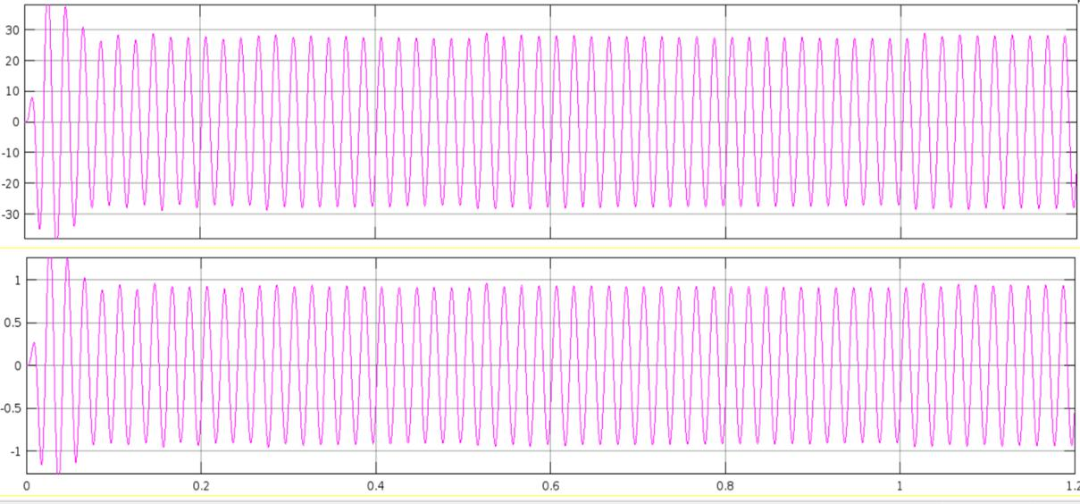

**Figure 5.** Inverter output voltage and current.

4

|  |  |  |
| --- | --- | --- |
| ICISPES-2023 |  | IOP Publishing |
| IOP Conf. Series: Materials Science and Engineering | 1295 (2023) 012012 | doi:10.1088/1757-899X/1295/1/012012 |

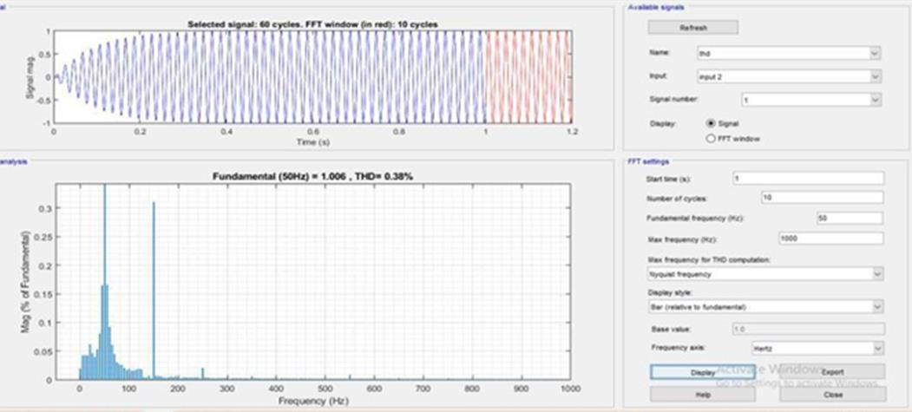

**Figure 6.** THD of inverter output current.

Figure 6 shows how the efficiency of the proposed and traditional systems varies throughout a range of output powers. Both methods were found to be relatively effective. As a result of the proposed system's additional boost converter losses, its overall efficiency is slightly lower than that of the standard system. The maximum efficiency is close to 50% of the nominal output power.

1. **Hardware model**

In this section the hardware & Software implementation aspects of the IoT-based Smart Power Monitoring System are explained. The hardware components, including Arduino Uno, voltage sensors, current sensors, and the PV module, play a crucial role in collecting data on power consumption and solar energy generation. The proposed system hardware is mostly broken down into three sections: the power circuit, driver circuit, and micro controller. With the aid of a micro controller adapter, the voltage-regulated supply for the micro controller is provided straight from the AC supply. The step-down transformer supplies the rectifier with power for the Driver circuit. The rectifier, output is connected to 12V regulator and then to the Driver ICs. With the aid of this 12V regulator, we can supply each driver IC with the 12V supply that it needs. Around the Driver circuit. It has a buffer IC. Between the driver IC and the microcontroller, this buffer IC functions as an intermediary circuit. The micro controller component with the Driver circuit is isolated by the buffer IC. It is employed to deliver constant pulses. Using this buffer IC, ripples or disturbances can be prevented if they occur. It needs a 5V supply for this buffer IC, which can be derived from the Arduino Uno microcontroller. It receives pulses from the Arduino Uno microcontroller, and these pulses are applied to the buffer IC and then to the driver ICs. The power circuit section now consists of an inductor, a boost converter, an H Bridge inverter, and other components. It is using a 12 V lead acid battery in case PV is not sufficient and battery is available, to supply the inductor with power for the inverter. The H bridge inverter receives this boosted output. Now that the inverter has converted the DC power to AC power, the load will be powered by this AC power. Three voltage sensors and two current sensors are used in the system. Figure 7 shows the image prototype of smart IOT integrated PV power monitoring system. Table 2 shows the hardware component details.

5

|  |  |  |
| --- | --- | --- |
| ICISPES-2023 |  | IOP Publishing |
| IOP Conf. Series: Materials Science and Engineering | 1295 (2023) 012012 | doi:10.1088/1757-899X/1295/1/012012 |

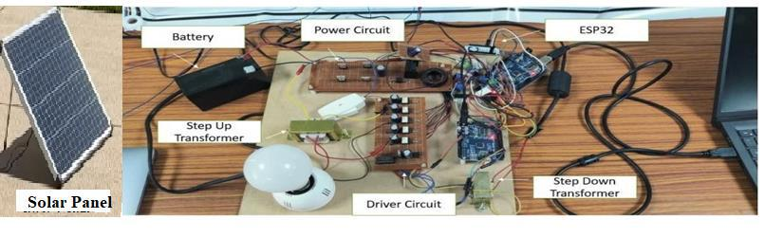

**Figure 7.** Hardware prototype.

**Table 2.** List of components used.

|  |  |  |  |  |
| --- | --- | --- | --- | --- |
|  | S. No. | Components | Specifications | |
|  |  |  |  | |
|  | 1. | PV Panel | 100 Wp, 22 Vmp, | |
|  |  |  | 4.52 Imp | |
|  | 2. | Rectifier (DB107) | 1A | |
|  | 3. | Capacitor | 1000uF,25volts | |
|  | 4. | Regulator12 V | 12V | |
|  | 5. | IRF250N (4 no) | 200V,30A | |
|  | 6. | TLP250H (Optocoupler IC) | 12V,1.5A | |
|  | 7. | IN4007 Diode | 700V,1A | |
|  | 8. | Transformer | 230/12 V | |
|  | 9. | CD4050BufferIC | 3-18V,0.32mA | |
|  | 10. | LED lamp | 230V,9W | |
|  | 11. | Bridge Rectifier–BR1010 | 50V,10A | |
|  | 12. | Voltage sensor (3 no) | Robodo | |
|  | 13. | Current sensor (2no) | ACS712 | |
|  | 14. | Resistors | 100ohms, | |
|  | 15. | Inductor | 0.8mH | |
|  | 16. | Arduino Uno Microcontroller | |
|  | 17. | ESP 32 Wi-Fi module | |
|  |  |  |  | |

For real-time power monitoring, current and voltage sensors, as well as an ESP32 WiFi module for wireless communication and data transfer is used. The data analysis, visualization is achieved with the help of ThingSpeak [11]. The sensors measure the voltage and current of the batteries, the voltage and current of the loads, and the voltage of the PV panel. Figure 8 shows the sample code screen short of the system.

6

|  |  |  |
| --- | --- | --- |
| ICISPES-2023 |  | IOP Publishing |
| IOP Conf. Series: Materials Science and Engineering | 1295 (2023) 012012 | doi:10.1088/1757-899X/1295/1/012012 |



**Figure 8.** Sample code written to upload the data to cloud.

1. **Results and discussion**

The proposed system power monitoring at different stages is achieved using Thingspeak App and with the algorithm used to decide the effective utilization of PV or battery based on the decision. The prototype is tested for a sample lamp load. The results are graphically shown in Thingspeak App and the real time data and battery voltage is captured and is organized using a data wrapper. It displays charging and discharging patterns, battery voltage levels. Load voltage and current tables assess power delivery and stability, detecting load usage peaks or dips the solar voltage table reflects solar energy generation, analyzing this data help in system understanding, aiding, power management and decision-making. The sample data is shown in figure 9.

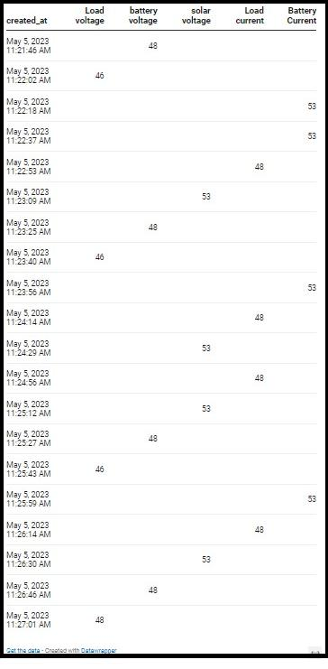

**Figure 9.** The screen shot of the real time data captured from the prototype.

7

|  |  |  |
| --- | --- | --- |
| ICISPES-2023 |  | IOP Publishing |
| IOP Conf. Series: Materials Science and Engineering | 1295 (2023) 012012 | doi:10.1088/1757-899X/1295/1/012012 |

Figure 10 shows the solar output voltage during different period of the day. It is observed that during the 13:55 to 2:00 PM the highest voltage is obtained and also after 2:05 PM 2:10 one more peak voltage is obtained. During that time the output is directly by the PV module.

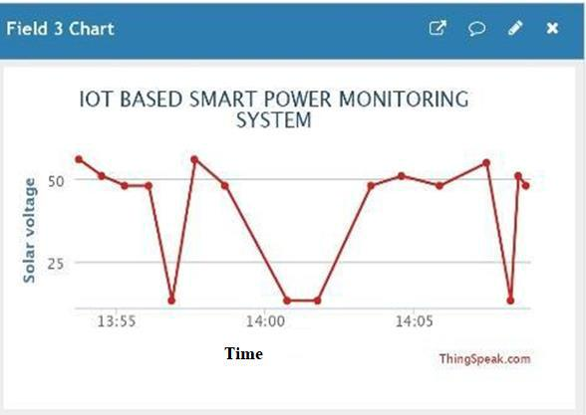

**Figure 10.** Dashboard display of real time PV voltage.

Figure 11 shows real time battery voltages. The graphical representation of these measurements helps to analyse and interpret the data effectively.

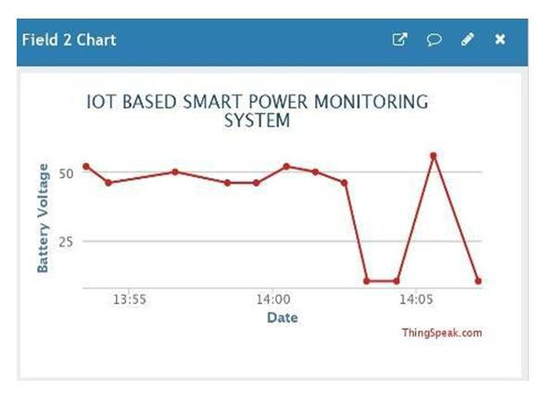

**Figure 11.** Dashboard display of real time battery voltage.

Figure 12 shows the battery current with respect to time a, the variation of battery current is observed between 13:55 PM to 2:05 PM. Depending on load the battery current is also varying.

8

|  |  |  |
| --- | --- | --- |
| ICISPES-2023 |  | IOP Publishing |
| IOP Conf. Series: Materials Science and Engineering | 1295 (2023) 012012 | doi:10.1088/1757-899X/1295/1/012012 |

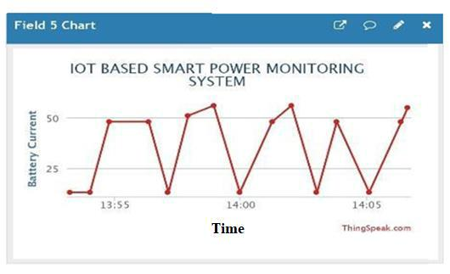

**Figure 12.** Dashboard display of real time battery current.

Figure 13 shows the variation of load voltage with respect to time. Solar or PV output voltage, battery voltage, battery current is all simultaneously obtained on the dashboard at the same time. It is clearly observed that when PV is there battery will not be discharged. Users can easily identify patterns, anomalies, and correlations within the voltage and current values, facilitating in-depth analysis and decision-making.

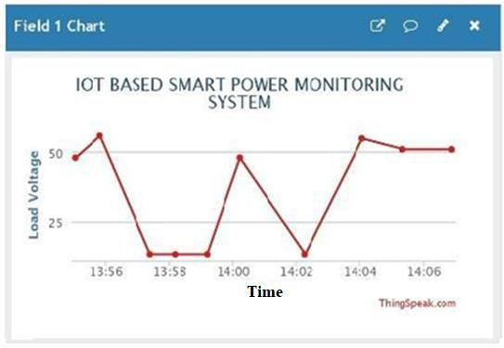

**Figure 13.** Dashboard display of real time load voltage.

1. **Conclusion and future scope**

In this paper an IoT-based PV integrated power monitoring system is designed, and hardware prototype is developed. It is a scale down model to understand the effective utilization of PV power and it’s mentoring effectively with the help of IOT and ThingspeakApp. The integration of IoT technologies, such as the ESP8266 Wi-Fi module and cloud-based storage and analytics provided by ThingSpeak, enables seamless communication, remote monitoring, and control. Users can access the power monitoring system from anywhere and at any time, gaining valuable insights into their energy usage through intuitive data visualization and analysis. The paper objectives on power monitoring of data

9

|  |  |  |
| --- | --- | --- |
| ICISPES-2023 |  | IOP Publishing |
| IOP Conf. Series: Materials Science and Engineering | 1295 (2023) 012012 | doi:10.1088/1757-899X/1295/1/012012 |

visualization, energy efficiency analysis, and integration with IoT technologies, energy conservation, and cost savings are all successfully achieved. The future scope includes advanced data analysis using machine learning for energy efficiency and expanded compatibility with devices through integration with smart home automation.

**8. References**

1. Jafari M, Kavousi-Fard A, Chen T and Karimi M 2023 *IEEE Access* **11** 17471
2. Tuyen N D, Quan N S, Linh V B, Van Tuyen V and Fujita G 2022 *IEEE Access* **10** 35846
3. Bhau G V, Deshmukh R G, kumar T R, Chowdhury S, Sesharao Y and Abilmazhinov Y 2023 *Mater Today Proc* **80** 3697
4. Xu S, Cao B, Chang L and Zhou J 2021 *IEEE J Emerg Sel Top Power Electron* **9** 5851
5. Zafar S, Miraj G, Baloch R, Murtaza D and Arshad K 2018 *Engineering, Technology & Applied Science Research* **8** 4
6. Wan Z, Song Y and Cao Z 2019 *Proceedings of 2019 IEEE 3rd Information Technology, Networking, Electronic and Automation Control Conference, ITNEC* p 18738137
7. Gopal M, Chandra Prakash T, Venkata Ramakrishna N and Yadav B P 2020 *IOP Conference Series: Materials Science and Engineering* **981** 032037
8. Pawar P, TarunKumar M and Vittal K. P 2020 *Measurement (Lond)* **152** 107187
9. Rupesh M and Anbu Selvan N 2021 *Journal of Physics: Conference Series* **1964** 052001
10. Khan F, Siddiqui M A B, Rehman A U, Khan J, Asad M T S A and Asad A 2020 *2020 International Conference on Engineering and Emerging Technologies, ICEET 2020* p 19493952
11. Hasan M K, Ahmed M M, Pandey B, Gohel H, Islam S and Khalid I F 2021 *Wireless Communications and Mobile Computing* **2021** 6544649

10