Design and Implementation of A Movie Reservation System

Thesis Submitted in Partial Fulfilment of the Requirement for the Degree of

B.Sc.
In
Computer Science [Student Major]
By
Nabilah Lawal Adamu To
The Department of Computer Science Baze University, Abuja

OCTOBER, 2020

DECLARATION

This is to certify that this Thesis entitled Design and Implementation of a Movie Reservation System, which is submitted by Nabilah Lawal Adamu in partial fulfilment of the requirement for the award of degree for B.Sc. in Information Technology to the Department of Computer Science, Baze University Abuja, Nigeria, comprises of only my original work and due acknowledgement has been made in the text to all other materials used.

Date: [15th October 2022] Name of Student: Nabilah Lawal Adamu

APPROVED BY …………………
HOD
Dept. of Computer Science

CERTIFICATION

This is to certify that this Thesis entitled Design and Implementation of a Movie Reservation System,, which is submitted by Nabilah Lawal Adamu in partial fulfilment of the requirement for the award of degree for B.Sc. in Information Technology to the Department of Computer Science, Baze University Abuja, Nigeria is a record of the candidate’s own work carried out by the candidate under my/our supervision. The matter embodied in this thesis is original and has not been submitted for the award of any other degree.

Date: 15th October, 2022 Supervisor: Ms. Khadija Saad Ibrahim

APPROVAL
This is to certify that the research work, Design and Implementation of a Movie Reservation System and the subsequent preparation by Nabilah Lawal Adamu with BU/19c/IT/3900 has been approved by the Department of Computer Science, Faculty of Computing and Applied Science, Baze University, Abuja, Nigeria.
By

Ms Khadija Saad Ibrahim Date
1st Supervisor

[Full name] Date
2nd Supervisor

Dr. C. V Uppin Date
Head of Department

Prof Peter Ogedebbe Date
Dean, Faculty of Computing and Applied Science

Prof. CHOJI Davou Nyap Date
External Examiner

DEDICATION

Alhamdulilah, I would like to thank almighty Allah for granting me the knowledge and wisdom to accomplish this project, indeed it was huge success. I would also like to express gratitude to my parents, Dr. Lawal Adamu and Hajiya Aisha Lawal Adamu for their immense contribution towards the successful completion of this project, may Allah bless them and grant them Jannah. My special appreciation to Baze University for impacting a good knowledge on me, I will forever be thankful. My special appreciation to my project supervisor Ms. Khadija Ibrahim Saad for all the educational support throughout the completion of this project. I would also like to appreciate my siblings Ammar, Fadilah, Naziha, Fariha, Nawla for helping me out when in need of assistance. To my nephews Ammar and Jamal, thank you for always disturbing while studying. I would like to thank my friends Khadija Kamba, Maryam Abubakar Ojone, Maryam Sirajo, Hadiza Al Hassan, Khadija Aminu, Atiku Bugaje, Ruqayya Rabilu, Hamida Magaji, Najah Al- Amin, Khadija Ibrahim, Abdallah Auwal, Fatima Tahir, Asmau Jallah, Hauwa Muhammad Yusuf, Ahmad Mukhtar and many others for supporting me during my time at the university. Thank you all for prayers.

ABSTRACT

Nowadays, people wants to achieve what they want effortlessly. This application will provide an easy way for its users to reserve seat and book a movie ticket at their convenient time.
The Movie Reservation System is online application whereby anyone who has an internet connection can gain access.
A user will be required to login to the system by entering the appropriate details and following the procedures that will be provided on the system and needs a credit card to complete the booking process.
Tickets will be sent to the customers email containing a barcode which will tackle corrupt customers from sneaking into the cinema hall. Tickets can also be collected at the counter.
Watching movies in a cinema hall is a medium of entertainment that is appreciated by most people after having a hectic schedule. But all this excitement disappears after standing in long queues to reserve a ticket.
This application provides the solution to the problem because it provides the opportunity for users to be able to reserve seat and book a movie ticket at their convenient time provided they have an internet connection.
It also give users the opportunity to cancel their reservation due to unforeseen circumstances

TABLE OF CONTENTS
ABSTRACT VI
LIST OF TABLES IX
LIST OF FIGURES X
LIST OF ABBREVIATIONS XI
CHAPTER 1: INTRODUCTION 1
1.1 | 1
1.2 | 1
1.3 | 3
1.4 | 3
1.5 | 3
1.6 | 3
1.7 | Error! Bookmark not defined.
CHAPTER 2: LITERATURE REVIEW 5
2.1 4
2.2 4
2.3 RELATED WORK 6
2.4 7
CHAPTER 3: REQUIREMENTS, ANALYSIS, AND DESIGN 7
3.1 8
3.2 8
3.3 8
3.3.1 10
3.3.2 10
3.4 10
3.5 11
3.6 11
3.7 11
3.7.1 | 11
3.7.2 | 12
3.8 | 13
3.8.1 | 14
3.8.2 | 14
3.8.3 | 16
3.8.4 | 17
3.8.5 | 18
3.8.6 | 20
3.8.7 | 21
3.8.8 | 22
3.9 29
CHAPTER 4: IMPLEMENTATION AND TESTING 12
4.1 30
4.2 30
4.3 34

4.4 34
4.5 34
4.5.1 35
4.5.2 35
4.5.3 36
4.5.4 37
4.5.5 37
4.6 37
4.7 38
CHAPTER 5: DISCUSSION, CONCLUSION, AND RECOMMENDATIONS 15
5.1 39
5.2 39
5.3 39
5.4 40
5.5 40
5.6 41
REFERENCES 16
APPENDICES 17

LIST OF TABLES
TABLE 1 FUNCTIONAL REQUIREMENT SPECIFICATIONS 11TABLE 2 NON-FUNCTIONAL REQUIREMENT SPECIFICATIONS 12

LIST OF FIGURES

FIGURE 3.1 | APPLICATION ARCHITECTURE | Error! Bookmark not defined.FIGURE 3.2
 | USE CASE DIAGRAM | 11
FIGURE 3.3 | ACTIVITY DIAGRAM
FIGURE 3.4 | DATA FLOW DIAGRAM
FIGURE 3.5 | CONTROL FLOW DIAGRAM
FIGURE 63.6 | ENTITY RELATIONSHIP DIAGRAM
21

LIST OF ABBREVIATIONS

HTML: HyperText Markup Language CSS: Cascading Style Sheet
SSS: Secure Server Software OTP: One-time password SMS: Short Message Service OS: Operating System

  - Overview

CHAPTER 1: INTRODUCTION

A movie reservation system is an online movie reservation system whereby customers/users can book for a seat anywhere and anytime, getting to know information about the movies, such as the brief description of the movie so a user can easily get more details about the movies that are uploaded then make a choice, knowing when the movies will be released, duration of a movie and knowing the age limitation of a movie before reserving for it.
It is a web-based system whereby customers can make can make a seat reservation online and being able to cancel the seat at a suitable time.
An online movie ticket reservation system is basically a system that provides customers a way of reserving a seats in movie hall anywhere, anytime and in a specified seating position if still available.(Agbaegbu et al., 2019)
The main aim of this system is to provide a convenient way for customers to buy and reserve movie tickets online by inputting the appropriate data that the system will have.

Background and Motivation
During the recent years, many individuals who wish to reserve a seat at a cinema, will have to reserve or book a movie manually, and due to traffic or busy schedules some end up missing a movie because they have no idea about the time of the movie.
A movie reservation system will help to ease the stress because it will let you know the time of a movie and help in reserving a seat of your choice before it is taken.
Also, nowadays people are very dependent on the internet so users of a cinema would prefer to follow the process of reserving a movie or seat online than doing it manually.
When I was making this research I discovered the movie reservation tickets in Abuja does not have some features like adding a barcode to a printout which will help to stop people from printing a fake movie tickets. The implementation of this system will help to stop this problem

Statement of the Problem

The major problem that bring about this research project faced by silverbird cinemas include:
    - Corrupt clients who have a way of sneaking into the cinema hall with fake number printout.
    - The inability of computer illiterate customers to reserve a seat.
    - The fluctuation of network service which delays giving feedback to customers.
    - Corrupt staff who have a way of blackmailing customers into reserving ticket at a higher price.

Aim and Objectives

The main aim of this research is to design and implement a movie reservation system. This system will achieve the following:
- To enable easy printout of seat numbers.
- To establish e-secure payment option for customers.
- To make sure customers are able to book seat at their convenient.
- To make sure customers are able to search movies available.
- To create a database of movies with their description.

Significance of the Project

This research project will have a good impact on the society.
This movie reservation system is a safe option because it will use a Secure Server Software (SSS) which hides your private information.
Also, it will save cost because the cinema do not need to printout ticket to give to customers which will be thrown away after the movie.
It will save time because customers do not need to arrive early to queue for ticket in case the ticket is sold out.
The application will establish a secure e-payment option with different modes of payment to avoid disappointment from one mode of payment.

Project Risks Assessment

Inability to carry out research due to loss of hardware/software resources | Be aware of and observe school IT security procedures  Secure Android mobile phone when not in use.
Loss of work due to equipment failure /loss | Daily Backup of data to multiple sources of storage  such as flash drives, hard drives, google drive, etc. for multiplicity
Software availability (Unavailability of API’s) | Alternative API’s will be checked for. Software  requirements will be identified in good time for possible contentious software.

  - Scope/Project Organization

The scope of the project is concerned with helping customers with the ease to reserve seats and book a ticket at their own convenience.

CHAPTER 2: LITERATURE REVIEW

Introduction
The following chapter is based on the literature review of the various techniques and technologies used in this thesis.
Thereafter, section 2.2 is based on the Historical review of the application of booking systems. Section 2.3 gives descriptions of some of the respective literature with regards to the application of Typescript, Firebase, HTML and CSS in solving the research question.
Finally .section 2.4 provides a comprehensive summary of the entire chapter.

Historical Overview
A reservation system is a software or application that allows customers to make reservations or book an appointment via a company’s website or application instead of over the phone or in person.(Rui, 2021)
In making an application that adds to the entertainment industry, just like this software many other software comes with different ideas, different aims and objectives.

The application of booking systems was developed in 1950s when American Airlines required a system that would allow real-time access to flight details in all of its offices and the integration and automation of its booking and ticketing processes. (Pro, 2020)
As a result, Semi-Automatic Business Research Environment (Sabre) the first booking automation system was developed which became fully operational in 1964.(Sabre, 2017)
The first sabre system was installed on two IBM computers, located in a specifically designed computer centre in Briarcliff Manor,NY .(Sabre, 2017)
Sabre could process over 7,000 bookings per hour with nearly zero rate which is connected with thousands of terminals allowing American Airlines operators to check the inventory and book in seconds and also storing passenger information in its memory.
Sabre worked over telephone lines in real-time to handle to handle seat inventory and passenger records from terminals in more than 50 cities.(Norman, 2021)

In 1994, the electronic tickets and the first online booking system was developed introducing new technology capabilities.
An electronic ticket is a digital version of a paper ticket, stored in the airlines reservation system to reduce the cost of ticketing process. Customers could be able to pass the check-in by providing the necessary documents.
Mobile technologies became more advanced with the emergence of smartphones an 3G internet connection. Furthermore, mobile websites and applications became capable of connecting with APIs to source and update data.
. In 1985, American created easySabre to give consumers online access over the Internet and through services like CompuServe(IBM, 2022)
For that reason, online booking systems became much more secure, providing fast processing. A common mobile applications now allows customers to plan a trip, book flights, hotel rooms and rent cars in just few taps.
As a result, in 2009 the Redifon computers designed, installed, maintained and supported many online movie booking systems, using videotex technology. The system provides voice response and handprint processing before the existence of the internet and World Wide Web, the IBM PC, and Microsoft OS and were installed mainly in the UK by large corporations.(ENEH CHIDERA VALERIE-PROJECT, n.d.)
Thus, Reid(1983) observed that computers were replacing traditional paper and pencil systems, allowing several telephones to simultaneous access the same seating plan, thus minimizing the queue and improving customer services, compared to a manual system.(ENEH CHIDERA VALERIE-PROJECT, n.d.)
The technologies used in this work are:
- Hypertext Markup Language (HTML): HTML is the standard markup for creating webpages. It describes how the content of webpages is displayed. HTML allows web developers to design how they want browser to display the web page elements. It describes the structure of a web page semantically and originally included cues for the appearance of the document. (Sarkar & Noel, 2020)
- Cascading Style Sheet (CSS): CSS is a language that we use to style an HTML document. It is used to describe how HTML elements should be displayed.
- Typescript: Typescript was designed and developed by Anders Hejlsberg at Microsoft in the year 2012. It is an extended JavaScript with additional features. (Answersjet, 2021)
Some features of typescript are:

  - Opensource: it is an opensource programming language which means that everyone can download and use it from their official website.
  - JavaScript Libraries: It supports many libraries and elements of javascript programming language
  - Error checking feature: It supports the feature of error checking during compilation.

- Angular: Angular is a platform that makes building application easy with the web. It is a JavaScript-based open-source front-end web application framework developed by a Google employee by the name of Miško Hevery. (NgDevelop, 2022)
- Firebase: Envolve was the company that created Firebase in 2011. The founders of that are James Templon and Andrew Lee (Introduction to Google Firebase, 2019). Firebase was originally developed for real-time chat apps before it got adopted by several game developers as a tool to store game-states for real-time multiplayer games. Eventually, James and Andrew decided to split Firebase into two parts: a chat module and a game framework module.
Some firebase services include:
    - Authentication: Firebase authentication enables developers to build a secure authentication systems. This feature supports Facebook, Gmail, Twitter and more. It also have an additional option for OTP authentication, which uses SMS for authentication.
    - Real-Time Database: Google Firebase's real-time database is the company's first service. It enables data to be stored and synced between users in real time.
    - Cloud Messaging: Firebase has a tool which enables companies to constantly receive and deliver messages on iOS, Android and the web.
    - Performance: Firebase gives developers insight on the performance characteristics of their apps which enables them to figure out how to improve the performance of their apps.

Related Work

Most cinemas in Nigeria have a web application not a mobile application.

The difference between a web application and a mobile application is a web application is more of a website whereby it is accessed via an internet browser and can be accessed by all devices as long as there is browser on the device while a mobile application is built for a particular operating system. A mobile application live and run on a device because they are downloaded on the device. For example you can’t install a mobile application built for IOS on an android operating system. Although the concept of a web application and a mobile application may be similar but mobile application is safe and secure than a web application. It also have a greater functionality because they have access to system resources.(Sagara, 2019)
Although, during my research on works that were related to mine, I found a couple of work that had the same idea. To acquire more knowledge, the work I saw were being put to test by trying to reserve a movie. I learned a lot from their errors and used that to improve my own application.
Some of the related works include:
- Genesis deluxe cinema: It is a free App available on android and IOS for genesis cinema porthacourt.
- Filmhouse+ : It is an application available on IOS for reserving seats at different parts of the country.

Summary
The literature reviewed in this chapter shows that this application has been created using various technologies and a secure payment options for easy of ticket and seat reservation payment as well as for appealing and impressive user experience.
Chapter 3 presents the requirement analysis and the methodology adopted in solving the problem that arises when it comes to a reservation whilst also dealing with important diagrams such as Use Case, Activity, Sequence diagrams which helps in describing different aspects of the project.

CHAPTER 3: REQUIREMENTS, ANALYSIS, AND DESIGN

Overview
Chapter 3 is comprised of the requirement analysis and design of the movie reservation system. In chapter 3 requirements, analysis and the design, the methodology or methodologies used will be discussed, the consequential choice of method used will be highlighted. The requirement system specifications, functional and non-functional requirement, application architecture, schematics and user interface will be discussed in this chapter.

Proposed Model

The proposed model for the application was “Rapid Application Development” (RAD).In the beginning of the project, the waterfall model was used.

Methodology
The methodology will outline the techniques that will be followed to show how the application will be launched and delivered.
Waterfall and Agile methodologies are the approaches that have been selected.
The Waterfall methodology is a sequential process of software development whereby the developers goes to the next stage after the previous stage is fully accomplished. The phases of the waterfall model are:
    - REQUIREMENTS: This first phase involves understanding what you need to design and its function. It ensures that the requirements of a software are being listed so as to ensure the smooth working of the remaining phases.(Mccormick, 2012)
    - ANALYSIS: In this stage, all the hardware and software needed to complete the project is analyzed to ensure smooth functioning of the software.(Mccormick, 2012)
    - DESIGN: In this phase, the algorithm or flowchart of the project or the software code to be written in the next phase, is developed now. This stage relies on the previous two stages for its proper implementation. Having a proper design at the stage ensures that the next stage is being executed. If during the design phase, it is observed that there are some more requirements for designing the code, the analysis phase is revisited and the design phase is carried out according to the new set of resources(Mccormick, 2012)

    - IMPLEMENTATION: Based on the algorithm or flowchart designed, the actual coding of the software is carried out. This is the stage whereby developers code applications based on project requirements and specifications, with some testing and implementation taking place as well. A proper execution of the previous stages ensures a smooth and easier implementation of this stage.(Mccormick, 2012)
    - TESTING: After completing the coding of the application, the testing of the written code now comes into scene whereby checking for any faults in the designed software and if the software has been designed as per the listed requirements. A proper execution of this stage ensures that the client interested in the created software, will be satisfied with the finished product. If there are any errors, the software development process must step back to the previous phase whereby changes are implemented and then the succeeding stages of coding and testing are again carried out.(Mccormick, 2012)
    - DEPLOYMENT AND MAINTENANCE: This is the last phase of the software development in the waterfall model whereby the software has been released to customers, the maintenance phase begins. As flaws are found and change requests come in from users, a team will be assigned to take care of updates and release new versions of the software.(Adobe Workfront, 2022)

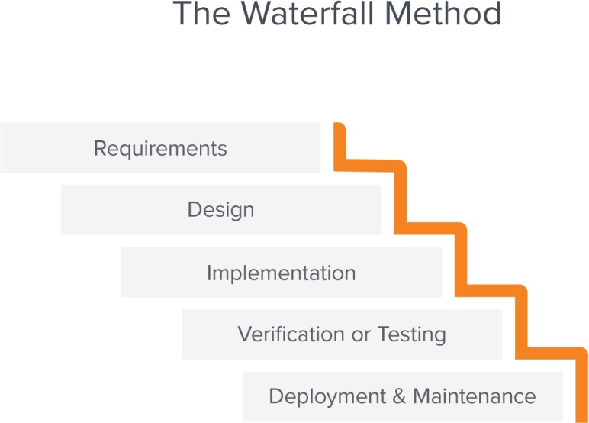

The AGILE methodology is based on iterative and incremental model of software development. This software model includes adaptive planning, evolutionary development, early delivery, continuous improvement, and flexible responses to changes in requirements, capacity, and

understanding of the problems to be solved through the collaborative effort of self-organizing and cross-functional teams with their customers or end users.(En.wikipedia.org., 2021)
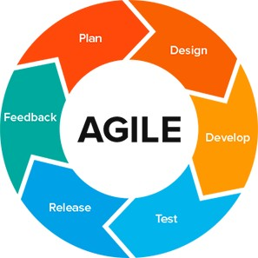

Method 1 (e.g Interview)
The researcher carried out an interview with the manager of Silverbird cinemas, Abuja to ask his opinion regarding what is suitable for Silverbird that is different from what they already have.
The response was the current requirement of the app being developed is perfect because what they have is a web application not a mobile application.

Method 2 (e.g Observation)
The developer presented the front end to the client and it was observed that they like the modern design on it and the navigation through the pages.

Tools and Techniques
Tools are the necessary requirement that are used during the design to enable us achieve the system design. The various tools used for this project are:
    - Firebase: Firebase provide developers with a variety of tools and services to help them develop quality apps, grow their user base. It is built on Google's infrastructure.

    - Ionic: Ionic is an open source mobile toolkit for building high quality, cross-platform native and web app experiences.

Ethical Consideration
The ethical consideration is based on ensuring that payment method is secured.
Also, all personal information collected from the users will be kept confidential to ensure privacy policy.

Requirement Analysis
The requirement analysis is determined by the use of the interview method and observation method above to meet the customer’s expectations.
The requirement analysis helps to get information acquired to achieve the customer’s need regarding the new or modified application.

Requirements Specifications
The requirement specification determine how the application should be developed. It describes the functional and non-functional requirement of the application.

    - Functional Requirement Specifications

      - A customer shall be able to sign up.
      - A customer shall be able to book a movie.
      - A customer shall be provided with a secure billing method by the use of a third party for payment
      - A customer will be sent an email to confirm the transaction after successful payment.
      - A customer shall be able to view movies.
      - A customer shall be able to view movie details.
      - The admin shall be able to add a movie.
      - The admin shall be able to update a movie.
      - The admin shall be able to delete a movie.

Table 1 Functional Requirement Specifications

Req.  No. | Description | Type
R-101 | The server shall Windows 7 or later version. | Configuration
R-102 | A customer shall be able to sign up. | Functional
R-103 | A customer shall be able to book a movie. | Functional
R-104 | A customer shall be provided with a secure billing  method by the use of a third party for payment. | Functional
R-105 | A customer will be sent an email to confirm the  transaction after successful payment. | Functional
R-106 | A customer shall be able to view movies. | Functional
R-107 | A customer shall be able to view movie details. | Functional
R-108 | The admin shall be able to add a movie. | Functional
R-109 | The admin shall be able to update a movie. | Functional
R-110 | The admin shall be able to delete a movie. | Functional

    - Non-Functional Requirement Specifications

- The application shall be available all the time.
- The application shall be easy to use.
- The application is HTML and scripting based so the end-user part shall be fully portable.
- The application shall be maintained efficiently.

Table 2 Non-Functional Requirement Specifications

Req.  No. | Description | Type
R-101 | When launched, the application shall stay running unless there is an intentional shutdown of the  application or the platform. | Performance

R-102 | The application shall easy to use. | Accessibility
R-103 | The application shall be available all the time. | Availability
R-104 | The application is HTML and scripting based so the  end user shall be fully portable | Portability
R-105 | The application shall be maintained efficiently | Efficiency

System Design
The system design describes the major components of the system such as:

    - ADMIN: The admin is the main administrator who is in charge of adding movies, deleting movies and updating movies. The admin page has a separate page where the admin can login using the username and password that it was registered. The admin is responsible for managing the movie timings.
    - SIGNUP: The signup page is the backend feature of the application which is responsible to add new users into the database.
    - LOGIN: The login page is mainly for existing users. If the username and password exist in the database the user is provided an authentication to have access to the application.
    - HOME: The home page consist of list of movies available on different sections, their description, their duration and genre. Also, the homepage have some trailers for a movie.
    - SEARCH TAB: The search tab consist of all the movies available on the system whereby users can search for their preference
    - SETTINGS TAB: The settings tab consists of the log out button and the about page.
    - PAYMENT: The payment page is the page that confirms your bookings. A user will have to fill a form which contains their name, phone number, seat(s) selected, number of ticket(s), date and time they want to book a movie to proceed to make the payment which confirms the transaction. The payment is done by the use of paystack, a user is required to select its mode of payment then proceed with the transaction. After a successful transaction, a receipt will be sent to the users email.

Application Architecture

An application architecture is a structural diagram that defines how application interact with other entities such as middleware, database and other applications to meet several requirements to ensure scalability and reliability.
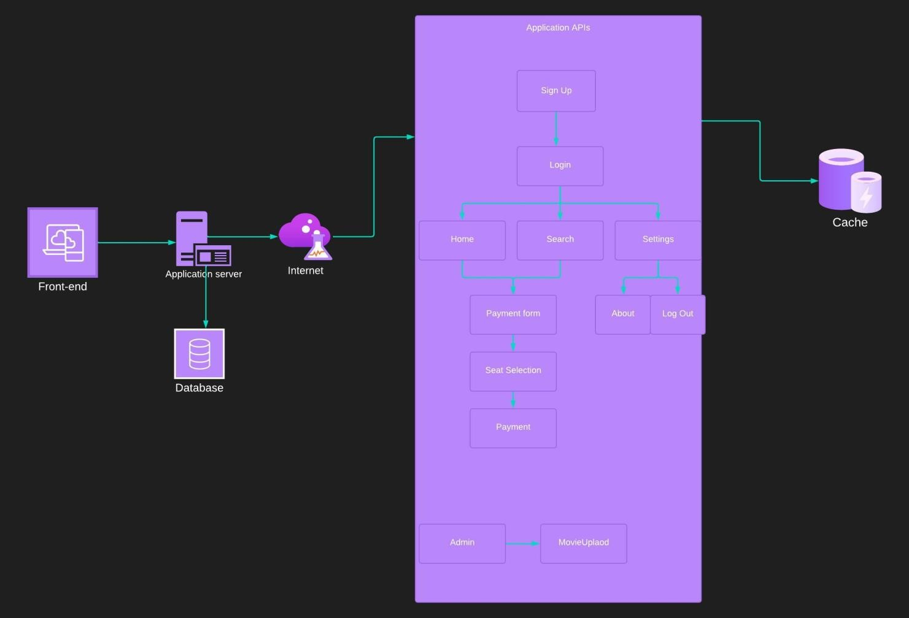
Figure 3.1 Application Architecture

Use Case

A Use Case diagram depicts the interaction between the users and the system. It shows the functions of the system from the user’s point of view and the various actions the user as the actor carries out.

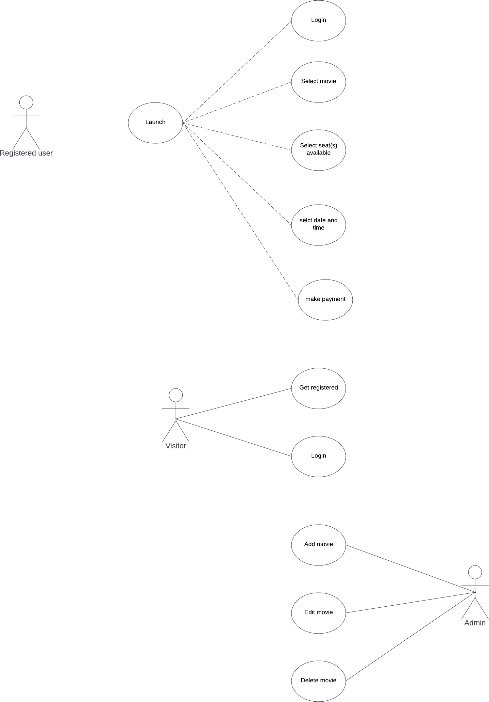

Figure 3.2 Use Case diagram

Actors: Registered user, visitor, Admin
The corresponding use cases for these actors are:
      - Registered User: Select movie, Select seat, Select Date and Time, Make Payment.

      - Visitor : Get Registered, Login
      - Admin: Login, Add movie, Edit movie, Delete movie.

Data Design

Table 3.1: Data Dictionary for the User Table

Attribute Name | Type | Range | Required | PK or FK
idUser | INTEGER | - | Y | PK
idLogin | INTEGER | - | Y | FK
idPayment | INTEGER | - | Y | FK
Name | VARCHAR | 45 | Y | -
Email | VARCHAR | 45 | Y | -
Password | VARCHAR | 45 | Y | -

Table 3.2: Data Dictionary for the Payment Table

Attribute Name | Type | Range | Required | PK or FK
idPayment | INTEGER | - | Y | PK
Name | VARCHAR | 45 | Y | -
Email | VARCHAR | 45 | Y | -
Phone_number | VARCHAR | 45 | Y | -
Date | DATE | - | Y | -
Time | TIME | - | Y | -
Amount | INT | - | Y | -

Table 3.3: Data Dictionary for the Admin Table

Attribute Name | Type | Range | Required | PK or FK
idAdmin | INTEGER | - | Y | PK

Table 3.4: Data Dictionary for the Movies Table

Attribute Name | Type | Range | Required | PK or FK
idMovieUplaod | INTEGER | - | Y | PK
Movie_name | VARCHAR | 45 | Y | -

Movie-cover | VARBINARY | 45 | Y | -
Movie_description | VARCHAR | 45 | Y | -
Movie_genre | VARCHAR | 45 | Y | -
Movie_duration | VARCHAR | 45 | Y | -
Movie_type | VARCHAR | 45 | Y | -

The tables above contains the data dictionaries for our various tables contained in the database that would be implemented. These data dictionaries describes the various attribute names and their data types, the range of these attributes, the level of requirement and the primary or foreign key classifications.

Activity Diagrams

An activity diagram is a model that shows the process of a task or action from a use case. It represents the flow of one activity to the other activity.

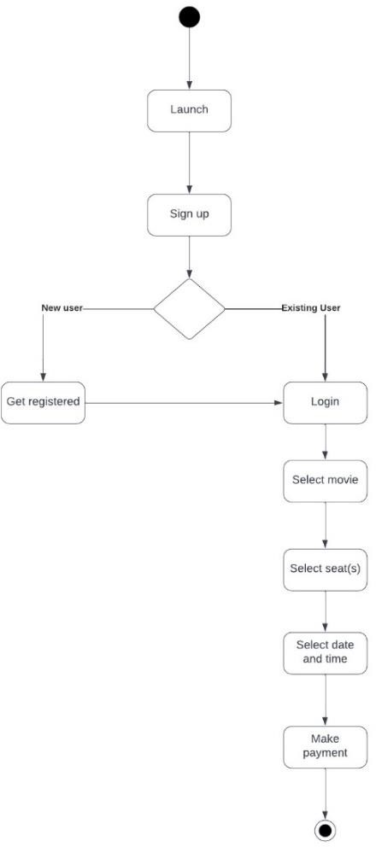

Figure 3.3 Activity Diagram

Dataflow Diagram
The Dataflow diagram maps out the flow of information through a process or a system.

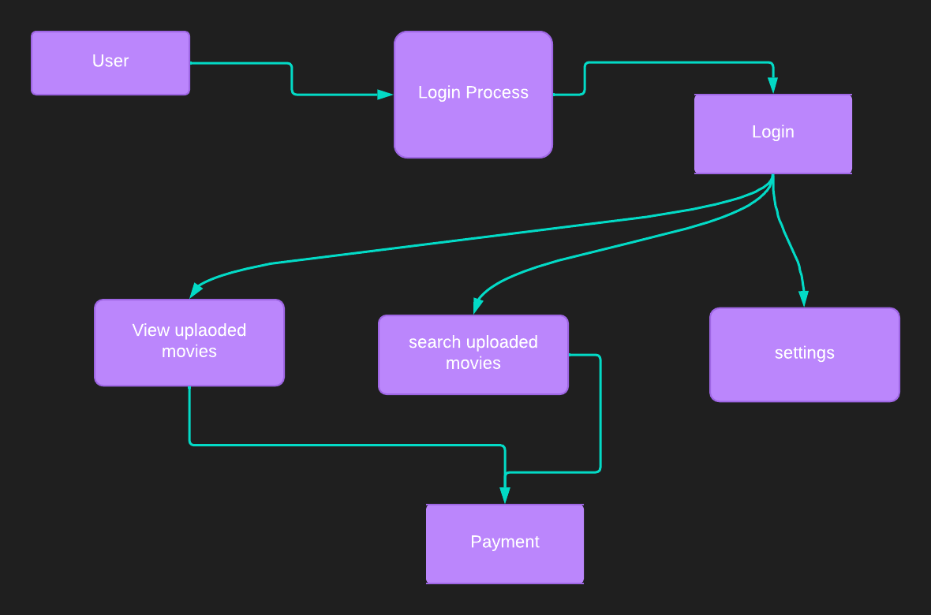

Figure 3.4 Data flow Diagram

Control Flow Diagram
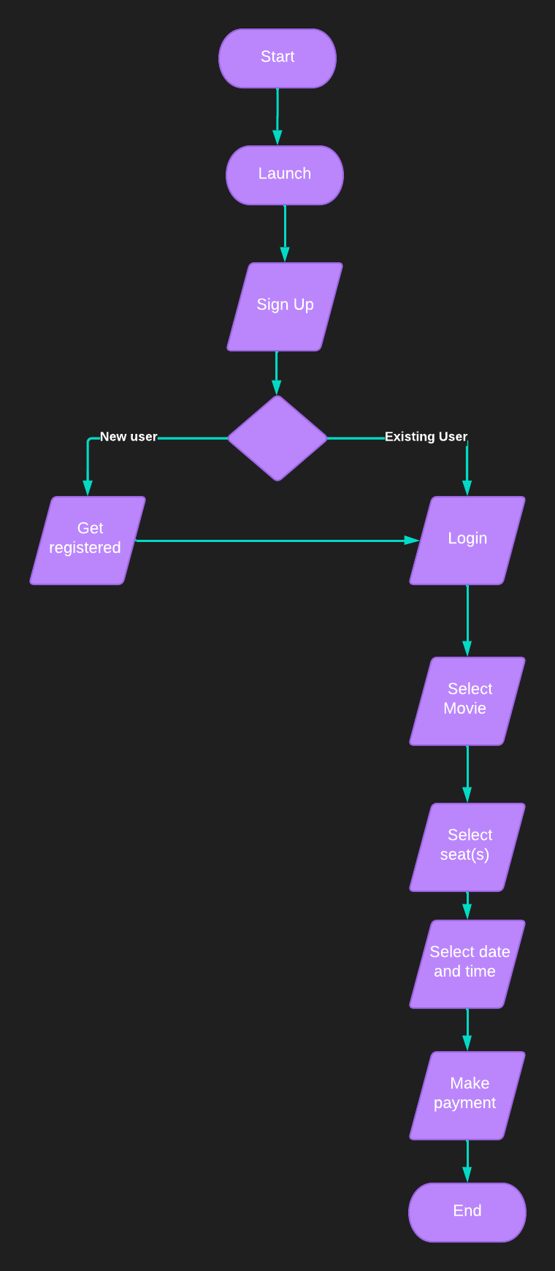
Figure 3.5 Control Flow Diagram

Entity-Relationship Diagram (ERD)

Entity-relationship diagrams show the entities and attributes of tables in a database. Linked ERDs show the relationship between tables or tables. Entities can only have a many-to-one or one-to-many relationship

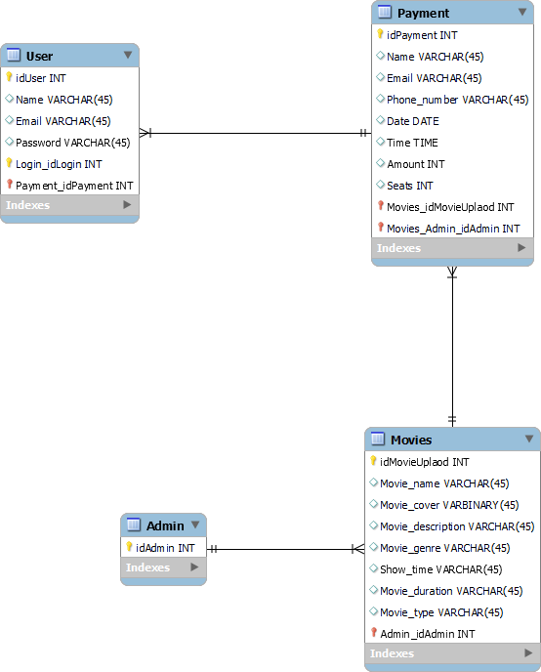

Figure 3.6 Entity Relationship Diagram

User Interface Design

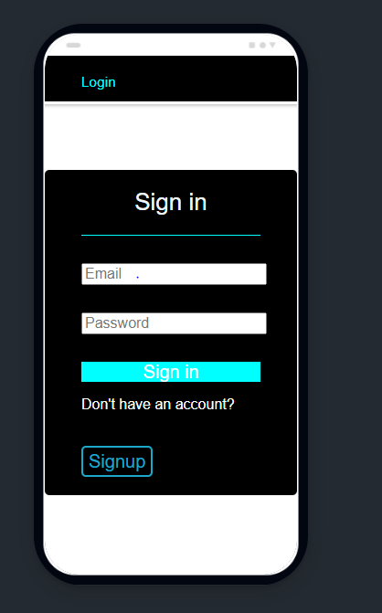

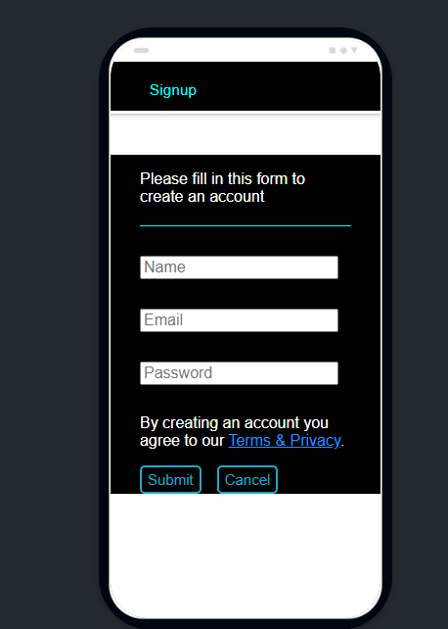

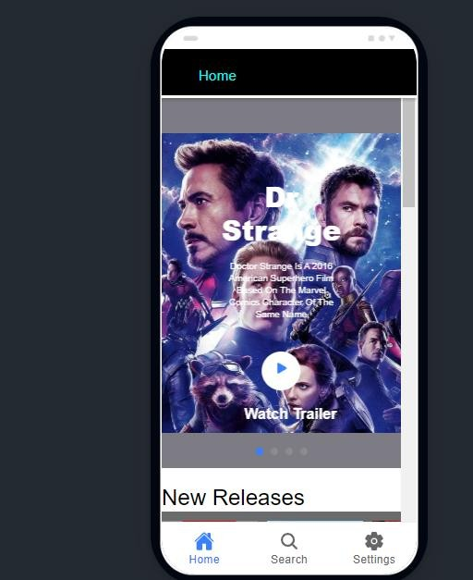

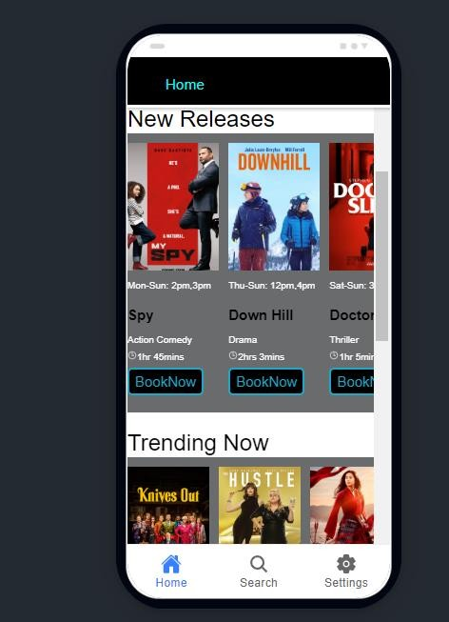

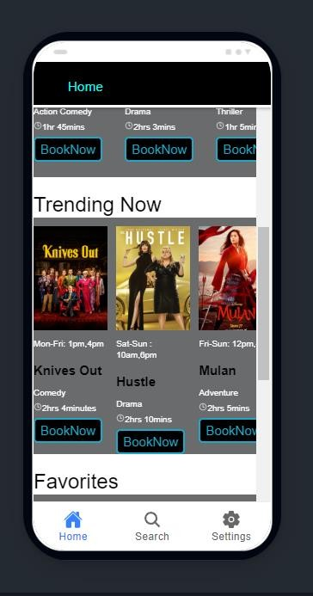

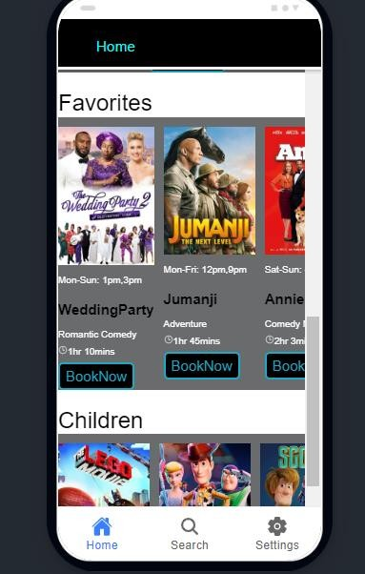

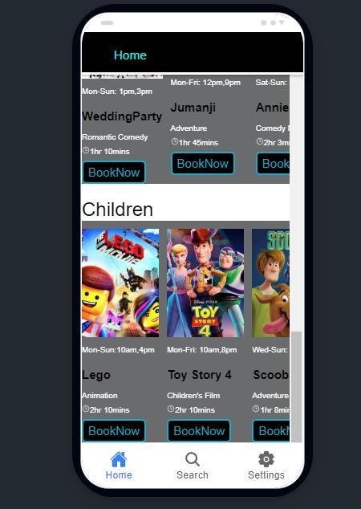

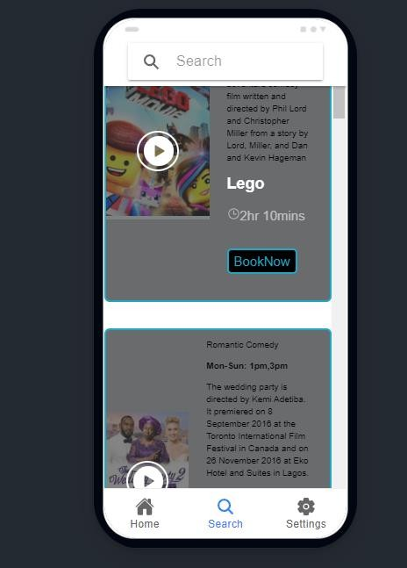

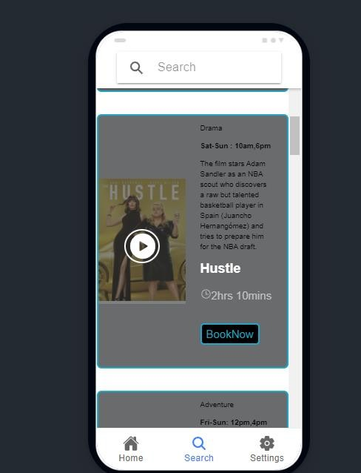

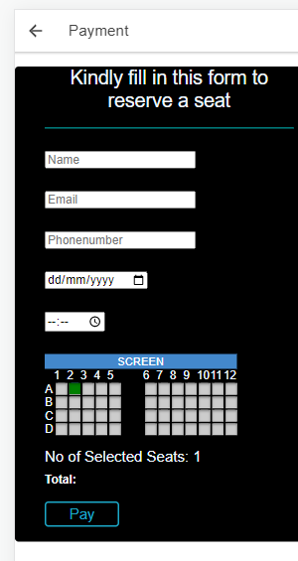

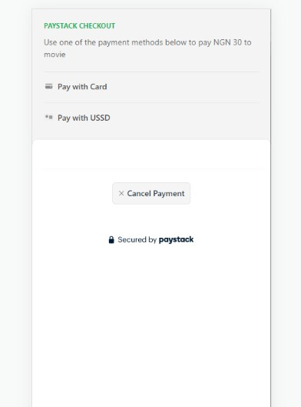

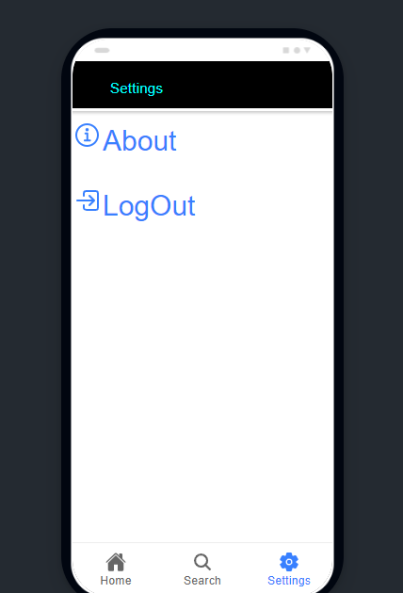

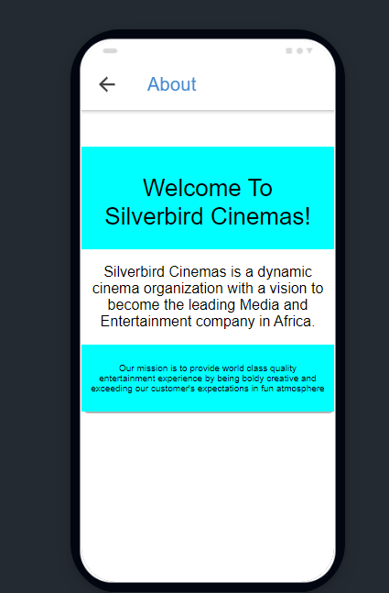

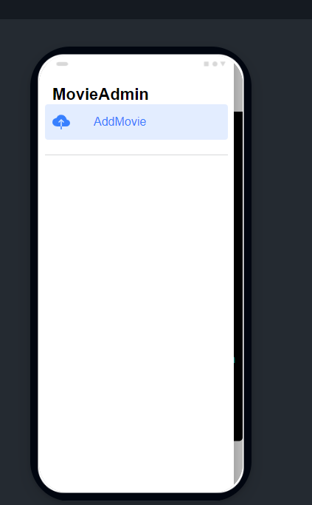

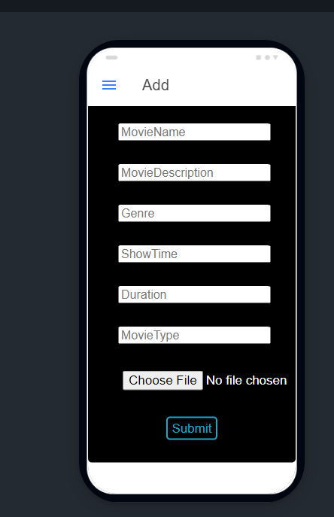

  - Summary
In the developing this system the decision to use the methodology and the proposed model granted the ease of use which were top considerations, and the use of angular guaranteed that the requirements were met while staying on schedule.
This chapter explained why RAD was chosen for this project, as well as some UML diagrams of the system that demonstrated how a user can interact with it and the requirements that must be met for this project to be considered successful.

CHAPTER 4: IMPLEMENTATION AND TESTING

Overview

This chapter discusses the practical development of the system and other related factors that assisted in developing the system including the front-end, back-end, database and the challenges encountered and solutions to the challenges encountered

Main Features
The main features of this project are:

    - AUTHENTICATION: The authentication feature is one of the backend feature of the application that makes use of the database to store user’s information. A new user is required to fill in the form in the signup page so the database can store the user’s
information for login purposes.

After filling out the necessary information, a user is required to click the submit button to send the information to the database.

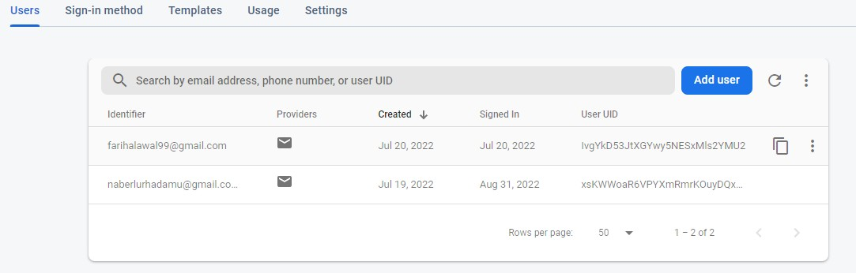
The figure above demonstrates how a user will be stored to my database. Each user has a unique user ID for validation purposes.

The login page consists of the email and password input that the user registered with. An existing user will be able to login with the correct information whereas if an incorrect information that does not exist in the database is inputted the system will notify the user that the email or password entered is invalid

    - PAYMENT PAGE: The payment page requires a user to fill in their name, email, phone number, date and they want to book a movie, number of seats they want to select
before they proceed to make the payment.
On clicking the pay button, a user is directed to the transaction page with the use of a third party application called pay stack integrated to the application. A user is required to select the mode of payment suitable to make the payment.

    - ADMIN PAGE: The admin page is where the movie is being uploaded to the database and front end. The page is separated from the user interface because a user is not required to see the admin page but all linked to the same database.
The administrator is required to fill the necessary information to upload a movie. On

clicking the submit button the movie goes directly to the database and the front-end side.
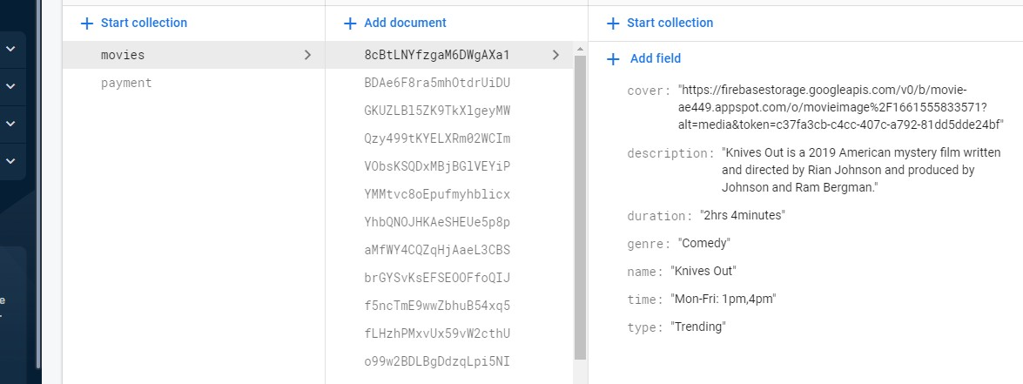

The picture above demonstrates how the details of a movie gets stored to the database.

Implementation Problems

Along the line of developing of this project, few problems were encountered. However, problem solving is a way to enhance one’s capabilities. Some of the problems encountered were:
    - Firebase Rules: Using firebase was quite easy but understanding the rules of firebase made my progress slow because of the error encountered regarding firebase rules.
    - Angular version: The angular version used for the project requires additional packages and additional keyword.
    - New programming language: The use of Angular as my backend language was challenging which made my progress slow but apprehended quickly which made progress to be gained as well as acquire knowledge.

Overcoming Implementation Problems
Overcoming the problems encountered was successful with the aid of more research.

    - Firebase Rules: Firebase has a rule that says all projects in test mode stops allowing request after the first thirty (30) days. Changing the timestamp of the project after thirty
(30) days was the solution to the error.
    - Angular version: Researching the suitable packages and keyword for the angular version being used helped in solving the error.
    - New programming language: A tutorial called tour of heroes on angular documentation made understanding the concept easy.

Testing
Testing was carried out to ensure the application passed its requirements. The application was tested from the perspective of a user to ensure that the efficiency and reliability of the application were put to test. Other forms of testing such as unit testing ensured that the functions of the application from the front-end to the back-end were examined and tested.

Tests Plans (for Unit Testing, Integration Testing, and System Testing)

S/N | Test Summary | Case ID
1 | Buttons must navigate to specified locations | T-01
2 | Sign up form must accept new users | T-02
3 | Sign up form must indicate error when no information is inputted | T-03
4 | Sign up form must indicate error when invalid information is inputted | T-04
5 | Login form must accept existing users | T-05
6 | Login form must indicate when no information is inputted | T-06
7 | Login form must indicate when invalid information is inputted | T-07
8 | Search Tab must provide the name of a movie that is searched for. | T-08
9 | Payment form must store data to the database. | T-09
10 | Seat selection must allow users select multiple seats | T-10
9 | Pay button must allow users to pay | T-11
11 | Users must be able to cancel payment | T-12
12 | Users must be able to log out | T-13
13 | An admin must be able to upload movies | T-14
15 | Uploaded movies must be viewed at the front end | T-15

Figure 4.1 Test Plan Tree

Test Suite (for Unit Testing, Integration Testing, and System Testing)

Table 4.2 Test Suite Performed

Req.  No. | Description | Type

R-101 | When launched, the application shall stay running unless there is an intentional shutdown of the  application or the platform. | Performance
R-102 | The application must have a fast reaction time when  buttons are tapped | Performance

Test Traceability Matrix (for Unit Testing, Integration Testing, and System Testing)

Requirement | Description | Test  Case | Status | Expected
R-101 | Login with invalid email and password. | 1 | Pass | Invalid email or  password.
R-102 | Login with valid email and password. | 2 | pass | Login successful.
R-103 | The app shall provide available movies  with their description. | 3 | pass | Movies available and  descriptions.
R-104 | The search tab must provide only the name of a movie being typed. | 4 | pass | Only the name of the  movie that was typed appeared
R-105 | The app shall allow users to select  multiple seats. | 5 | pass | Multiple seats  selected
R-106 | The app shall be able to accept  payment. | 6 | pass | Payment successful
R-107 | Payment form must store data to the  database | 7 | pass | Data stored to  firebase
R-108 | The app shall be able to cancel  payment on clicking the cancel button. | 8 | pass | Payment canceled
R-109 | A user shall be able to log out the  application. | 9 | pass | Back to the login  page

R-110 | An admin must be able to upload  movies. | 10 | pass | Movies uploaded to  firebase
R-111 | Uploaded movies must be viewed at the front end | 11 | pass | Movies viewed at home page and  search page

    - Test Report Summary (for Unit Testing, Integration Testing, and System Testing)

These will be discussed on the next section of this chapter.

Error Reports and Corrections

All errors encountered during the implementation and testing were fixed accordingly.

Report Number | Error Report | Correction
Report401 | Firebase was not accepting data to my database | The solution was to change my rules timestamp because the  timestamp of the project expired

Use Guide

Step1: Ensure your mobile device has an internet connection before launching the app.
Step2:
- For new users, fill in the sign up form with the appropriate information.
- For existing users, fill in the login form with the correct information to login.

Step3: Homepage
- Tap on the watch trailer button to watch a trailer.

- Scroll to left to view all available movies on the different sections.
- Scroll up or down to view all the movies on the home page.
- Long press a movie to view movie’s description.

Step4: Search Tab
- Tap on the search icon to go to search tab.
- Type in a movie name to check if a movie is available.

Step5: Settings
- Tap in the settings icon to go to settings tab.
- Tap on the about to view information about the application.
- Tap on the log out to sign out of the application.

Step6: Payment page
- Tap the book now button for payment.
- Fill in the payment information and select number of seats to proceed with payment.
- Tap the pay button to make payment.
- Select the payment mode suitable for your transaction.
- Check your email for receipt

Step7: Admin page
- The admin page is separated from the user’s page.
- The admin is required to go to the admin page for movie upload.
- The admin should fill in the upload form with necessary information to upload a movie.
- The admin should tap on the submit button to successfully upload a movie.

Summary

Testing is a major aspect of software development. Multiple test were being carried out during the implementation of the application, the errors that was encountered during the test were resolved accordingly. The following chapter provides the project evaluation, summary with recommendations as guidelines to follow.

CHAPTER 5: DISCUSSION, CONCLUSION, AND RECOMMENDATIONS

Overview
This chapter discusses the overall evaluation of the project, the difficulties and limitation encountered during the project development. Also, any new features that will be added to make the application better in the future.

Objective Assessment
Most of the project objectives were accomplished, such as allowing users to reserve seats at their convenience and allowing the administrator to upload a movie successfully. As our technology improves, the application will also be updated to suite the technological advancement allowing for an interactive performance.

.

Limitations and Challenges
Developing this application made me gained a lot including some areas I was not familiar with. Although, the challenges and limitation faced were:
    - New programming language: In search of a suitable platform for building applications, angular was the suitable platform that was suggested but came with a programming language called typescript.
    - New database: Getting along with a new database for backend services was quite challenging but kicked off quickly.
    - Time management: Focusing on developing an application and school work was challenging but I hard to learn time management to be able to complete my application.

In order to gain access to some of the features of the application,
    - A user must require a specific OS version namely Android.
    - A user requires an internet connection for signup and login functionalities.
    - A user requires an internet connection to be able to view movies.
    - A user requires an internet connection to watch trailers.
    - A user requires an internet connection to pay for the reservation.
    - An admin requires an internet connection to upload movies.
    - An admin requires an internet connection to update movies.
    - An admin requires an internet connection to delete movies.

Future Enhancements
With the time frame given, some of the functionalities for better performance and interaction were not completed but there is room for improvement. Those functionalities include:
    - User profile: The user profile will enable users to make changes to their information.
    - Review: The review section would allow users to give feedback and rate a movie
    - Multi language support: The application will use language module to translate or edit the system to support multiple languages. A default language will be set whereby it will enable users to select their preferred language from a drop-down menu.
    - Timer on screen: To prevent multiple users from reserving a seat at the same time, a timer on the screen will be implemented whereby if users do not complete the seat selection before the timer elapse, the seats will be marked available

Recommendations
Specific measures or guidelines that may be taken to use the application includes:
    - The use of an anti-virus on the mobile device to keep personal information saved on the application safe.
    - Always updating the android OS due to vulnerabilities that may occur.
    - A user needs to avoid allowing access to information that the application does not require.
    - Always updating the application when a new update is available.

Summary
This chapter concludes the project documentation. The documentation covered all aspect of the application including the project's objectives, challenges, risk assessments, scope, requirements, analysis, and design, as well as the methodology used throughout the implementation of the project. Also the project was tested to examine the reliability and efficiency of the project.
Finally, the suggestions for better functionalities in the near future were examined.

REFERENCES

    - Adobe Workfront. (2022). Waterfall Methodology. https://www.workfront.com/project-management/methodologies/waterfall
    - Agbaegbu, J., Chibuikem Victor, C., Oluwafemi, A. J., & Epse TUMA, N. (2019). Design and Implementation of a Movie Reservation System. International Journal of Computer Techniques, 6(4), 1–6. http://www.ijctjournal.org
    - Answersjet. (2021). TypeScript Programming Language: history, features and applications. https://www.answersjet.com/2021/06/typescript-programming- language-history-features-applications-why-should-learn-typescript.html
    - ENEH CHIDERA VALERIE-PROJECT. (n.d.). http://eprints.gouni.edu.ng/id/eprint/609
    - En.wikipedia.org. (2021). Agile software development. https://en.wikipedia.org/wiki/Agile_software_development
    - IBM. (2022). The First Online Reservation System. https://www.ibm.com/ibm/history/ibm100/us/en/icons/sabre/transform/
    - Mccormick, M. (2012). Waterfall vs. Agile Methodology.
    - NgDevelop. (2022). Angular History. https://www.ngdevelop.tech/angular/history/
    - Norman, J. M. (2021). HistoryofInformation.com. https://www.historyofinformation.com/detail.php?entryid=1035
    - Pro, T. (2020). History of flight bookings. https://www.travelopro.com/history-of- flight-booking-crss-gds-distribution-travel-agencies-and-online-reservations#
    - Rui, T. (2021). What is an online reservation system and why do you need it. What Is an Online Reservation System and Why Do You Need It. https://ombori.com/blog/online- reservation-system
    - Sabre. (2017). The Sabre Story. 1–12. https://www.sabre.com/files/Sabre-History.pdf
    - Sagara, T. (2019). Mobile Apps vs Web Apps: Which is the Better Option? https://sagaratechnology.medium.com/mobile-apps-vs-web-apps-which-is-the-better- option-868106c88730
    - Sarkar, P., & Noel, M. S. (2020). a Project on Online Ticket Booking System.
International Research Journal of Engineering and Technology, June. www.irjet.net

APPENDICES

Appendix A - Project Document

IN-DEPTH PROJECT DOCUMENTATION
Full Candidate Name: Nabilah Lawal Adamu
Student ID: BU/19C/IT/3900
Title: A Movie Reservation System
Course of Study: B.Sc. Computer Science.

Background and Motivation
During the recent years, many individuals who wish to reserve a seat at a cinema, will have to reserve or book a movie manually, and due to traffic or busy schedules some end up missing a movie because they have no idea about the time of the movie.
A movie reservation system will help to ease the stress because it will let you know the time of a movie and help in reserving a seat of your choice before it is taken.
Also, nowadays people are very dependent on the internet so users of a cinema would prefer to follow the process of reserving a movie or seat online than doing it manually.
When I was making this research I discovered the movie reservation tickets in Abuja does not have some features like adding a barcode to a printout which will help to stop people from printing a fake movie tickets. The implementation of this system will help to stop this problem.

Statement of the Problem

The major problem that give rise to this research project faced by silverbird cinemas
      - Corrupt customers who have a way of sneaking into the cinema hall with fake seats number printout.
      - The inability of computer illiterate customers to reserve a seat.
      - The fluctuation of network service which delays giving feedback to customers.
      - Corrupt staff who have a way of blackmailing customers into reserving ticket at a higher price.

Appendix B - Questionnaire

A question and answer session took place between the silverbird manager and the developer. The questions that were asked include:

- What type of application would you want for the cinemas? Answer: An application that is easy to use
- What are the requirements would you want to be implemented in the application? Answer:
  - A customer should be able to sign up.
  - A customer should be able to book a movie.
  - A customer should be provided with a secure billing method.
  - A customer should be sent an email to confirm the transaction after successful payment.
  - A customer should be able to view movies.
  - A customer should be able to view movie details.
  - The admin should be able to add a movie.
  - The admin should be able to update a movie.
  - The admin should be able to delete a movie.

- How would you want the design of the front-end?

Answer: The front end should be unique.
- Have you ever considered using a mobile application for movie reservation? Answer: Yes we plan on developing a mobile application.
- Have you ever thought of using a student’s work for the cinema? Answer: Yes, as long as the student can defend the work.
- What difference would you want to see between your web application and the mobile application?
Answer: We actually want you to use your knowledge and develop what is suitable.
- How does a customer finds out what is screening and when at the cinema?
Answer: The date and time of every movie should help a customer to know what is screening
- How often do customers pay ticket online?
Answer: Everything nowadays is mostly done online, customers prefer paying for a movie ticker online.
- What type of movies should be uploaded more?
Answer: The manager decides the movie to be uploaded by generating a movie schedule
- How do online booking system promote a movie on the internet?
Answer: We are in an era whereby our we are connected to the internet 24/7, users mostly see a movie online before checking if it’s available
- With the existence of applications like Netflix, do people still watch a movie at the cinema?
Answer: Our mission at silverbird cinemas is to provide world class quality entertainment experience by being boldly creative and exceeding our customer's expectations in fun atmosphere, Customers still trust us for their entertainment.
- Do you think the customers will use the application?
Answer: We have a web application that customers use, the application will be more appreciated by customers.

Appendix C – Plagiarism
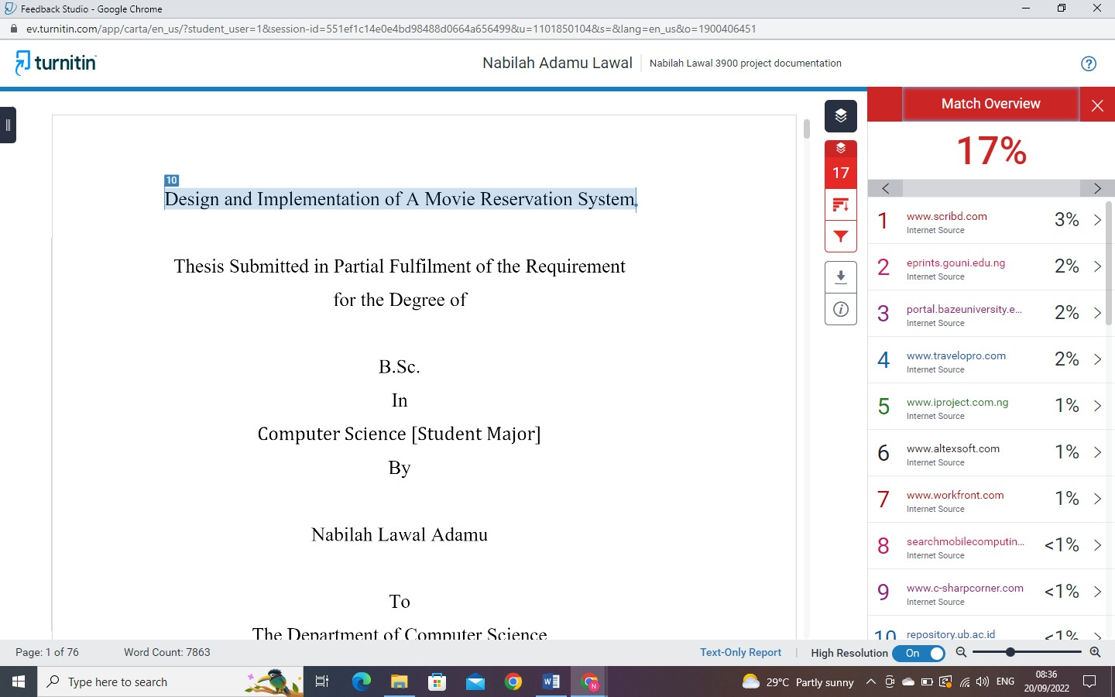

Appendix D – Source Codes

LOGIN PAGE
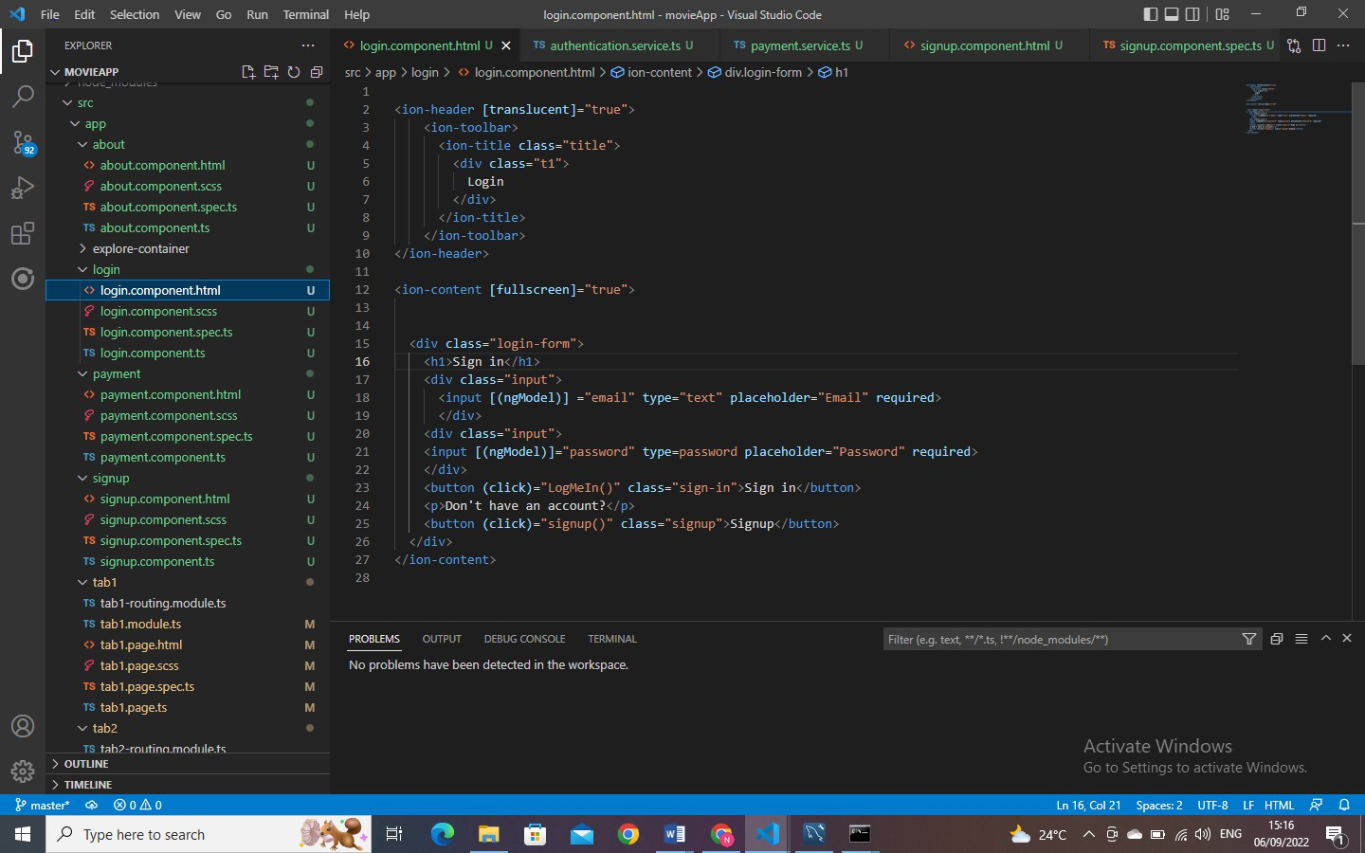

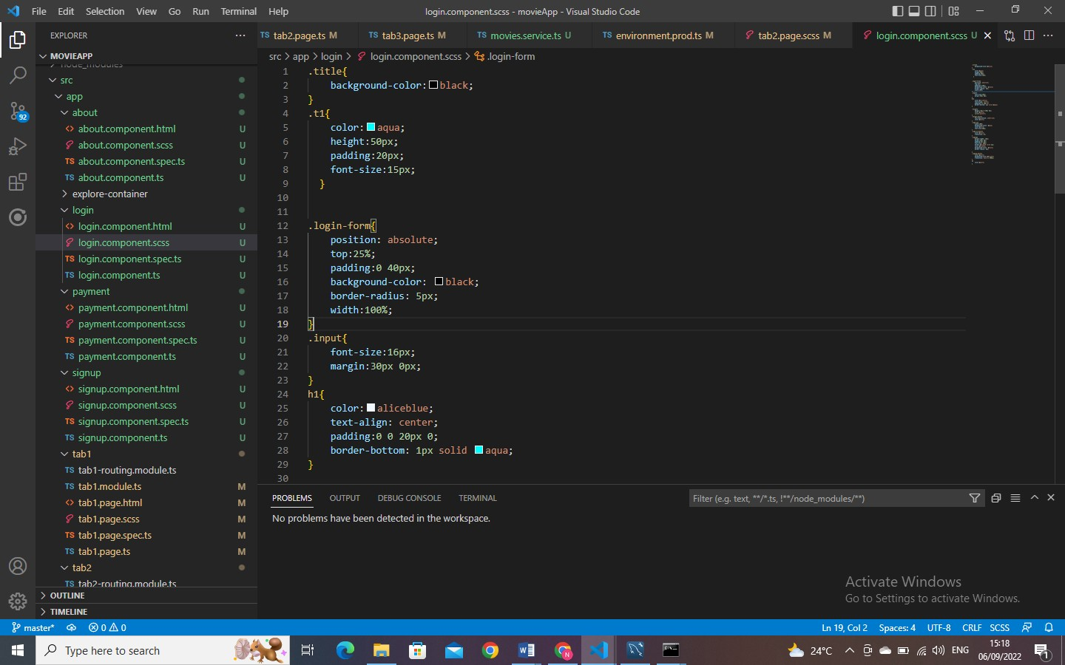

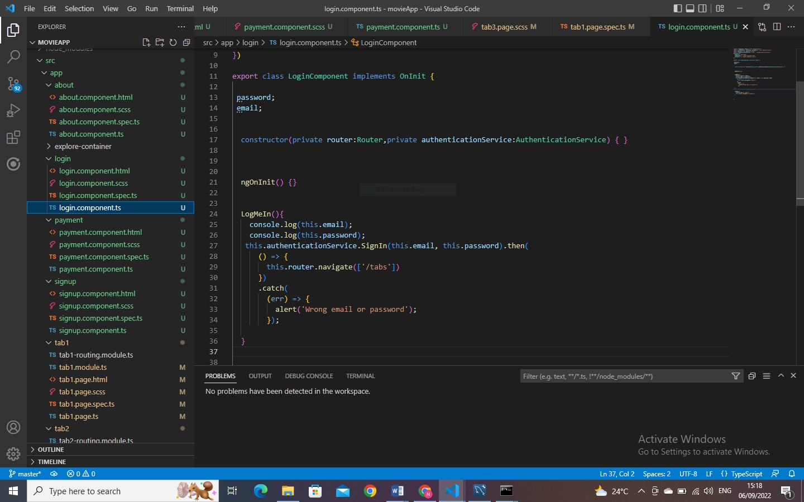

SIGNUP PAGE
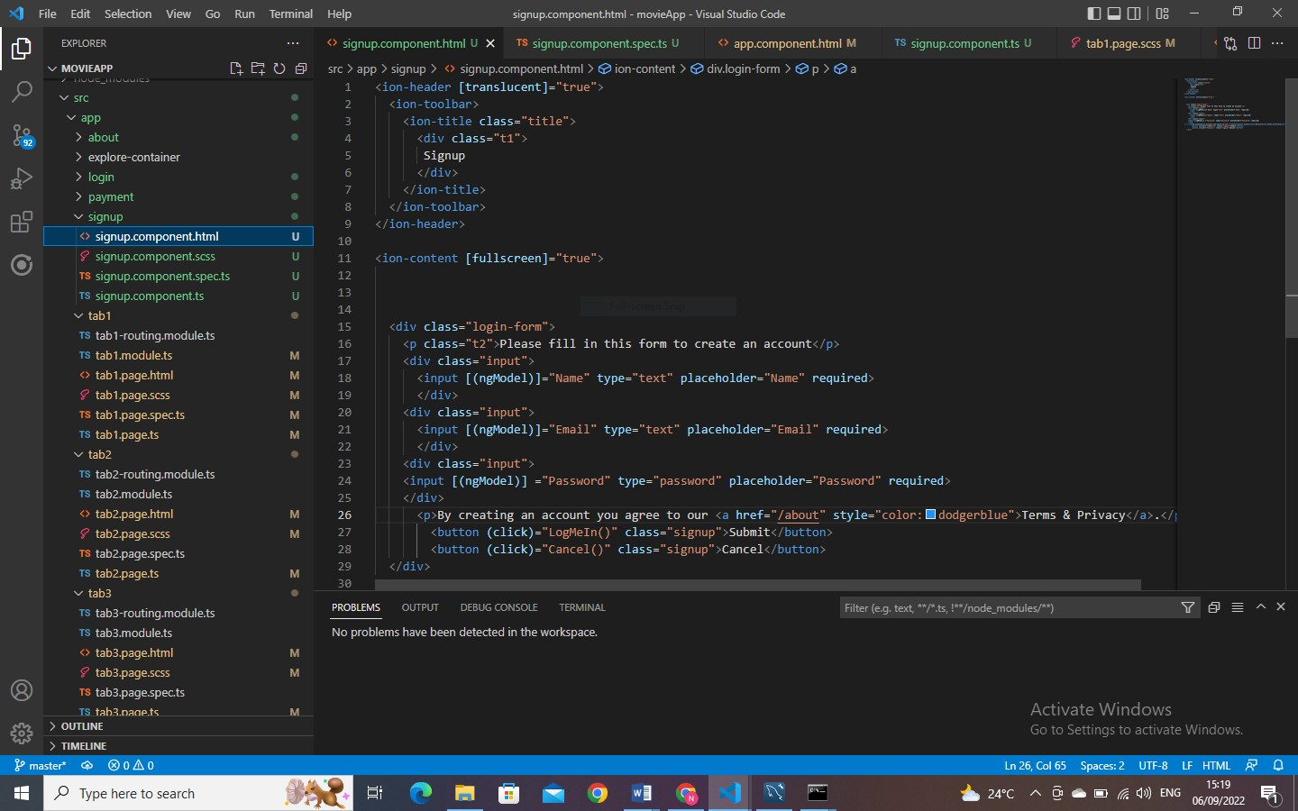

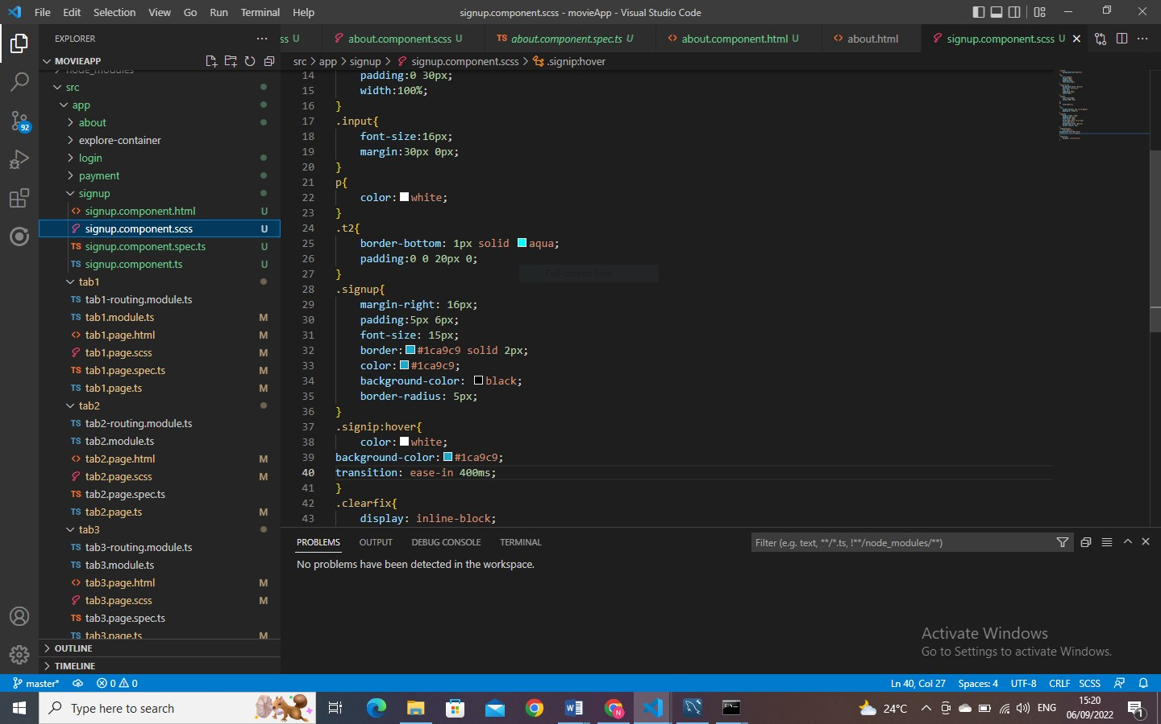
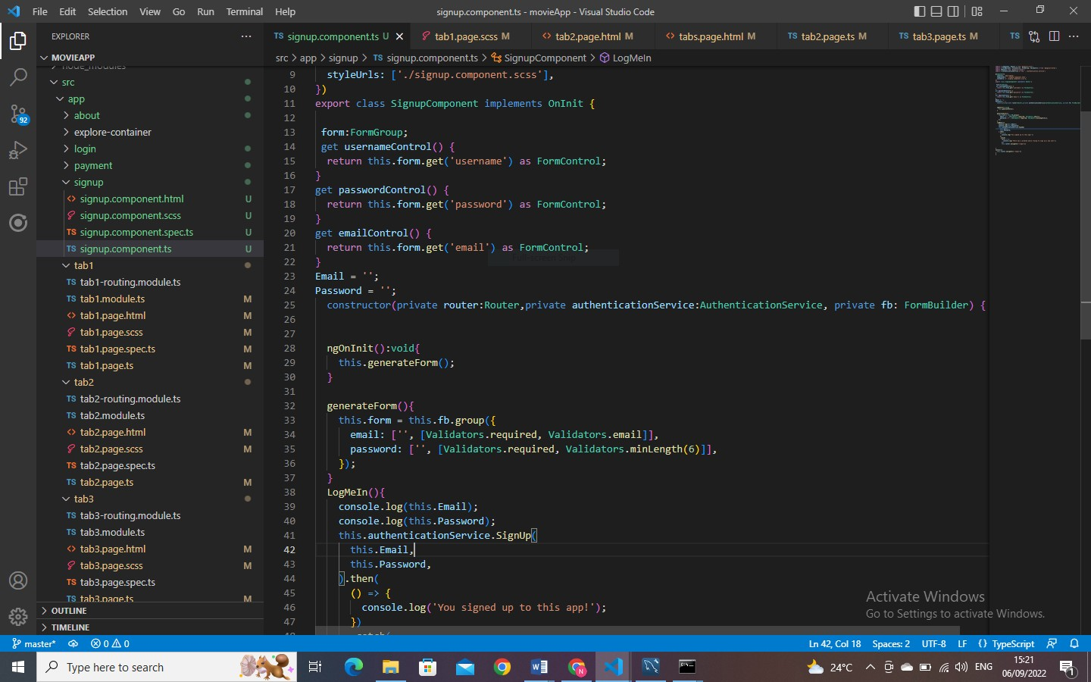

HOME TAB
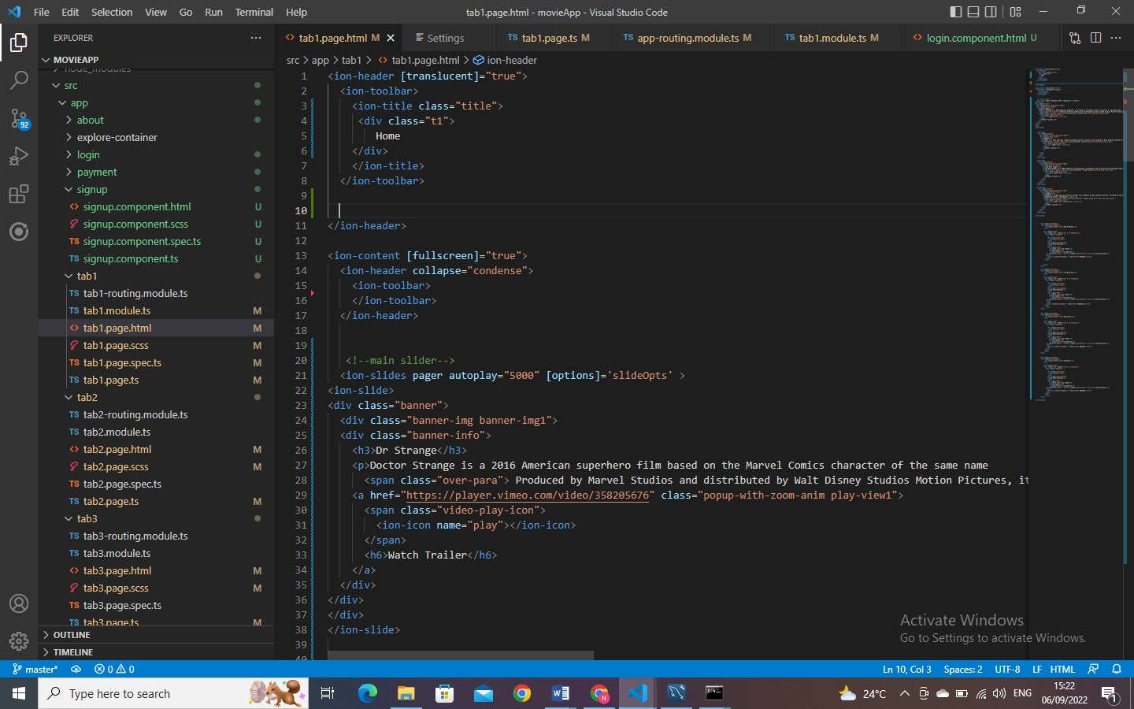

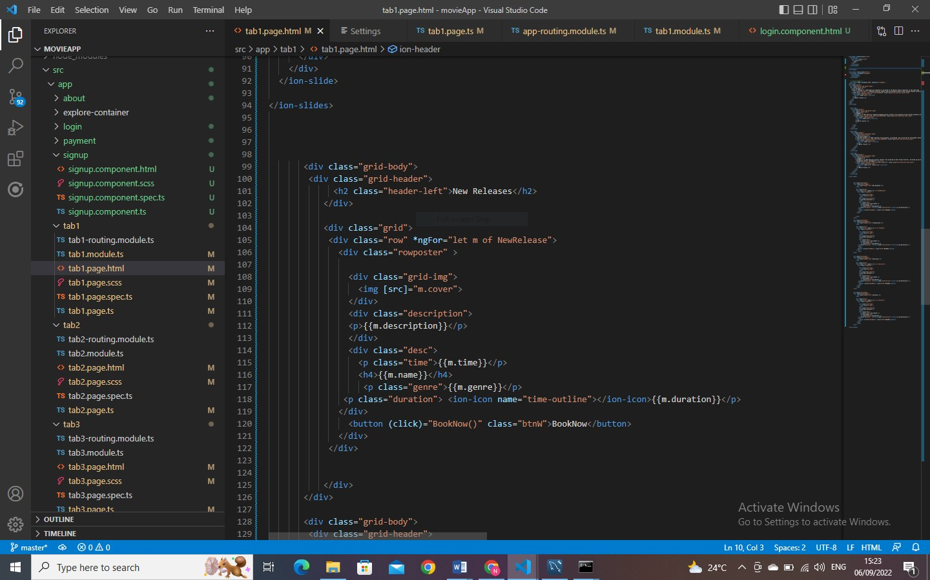

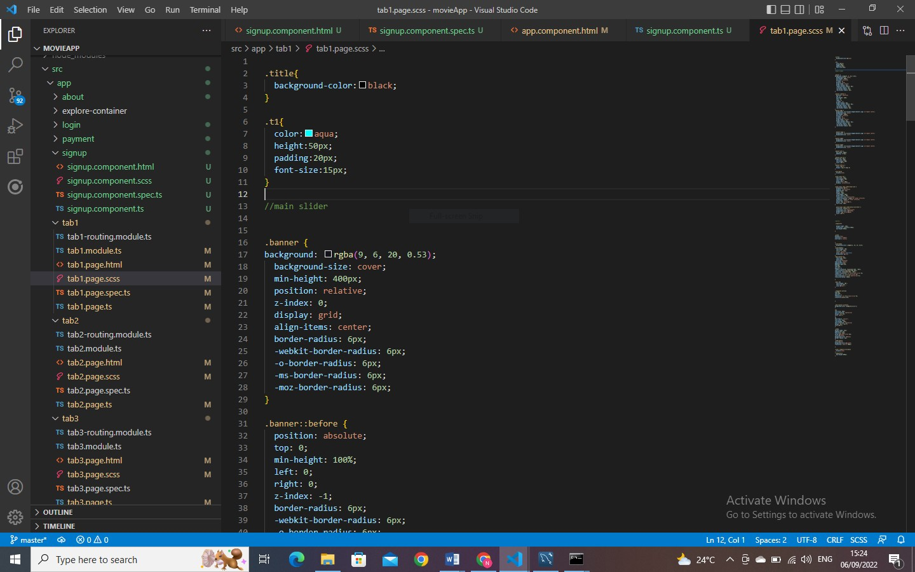
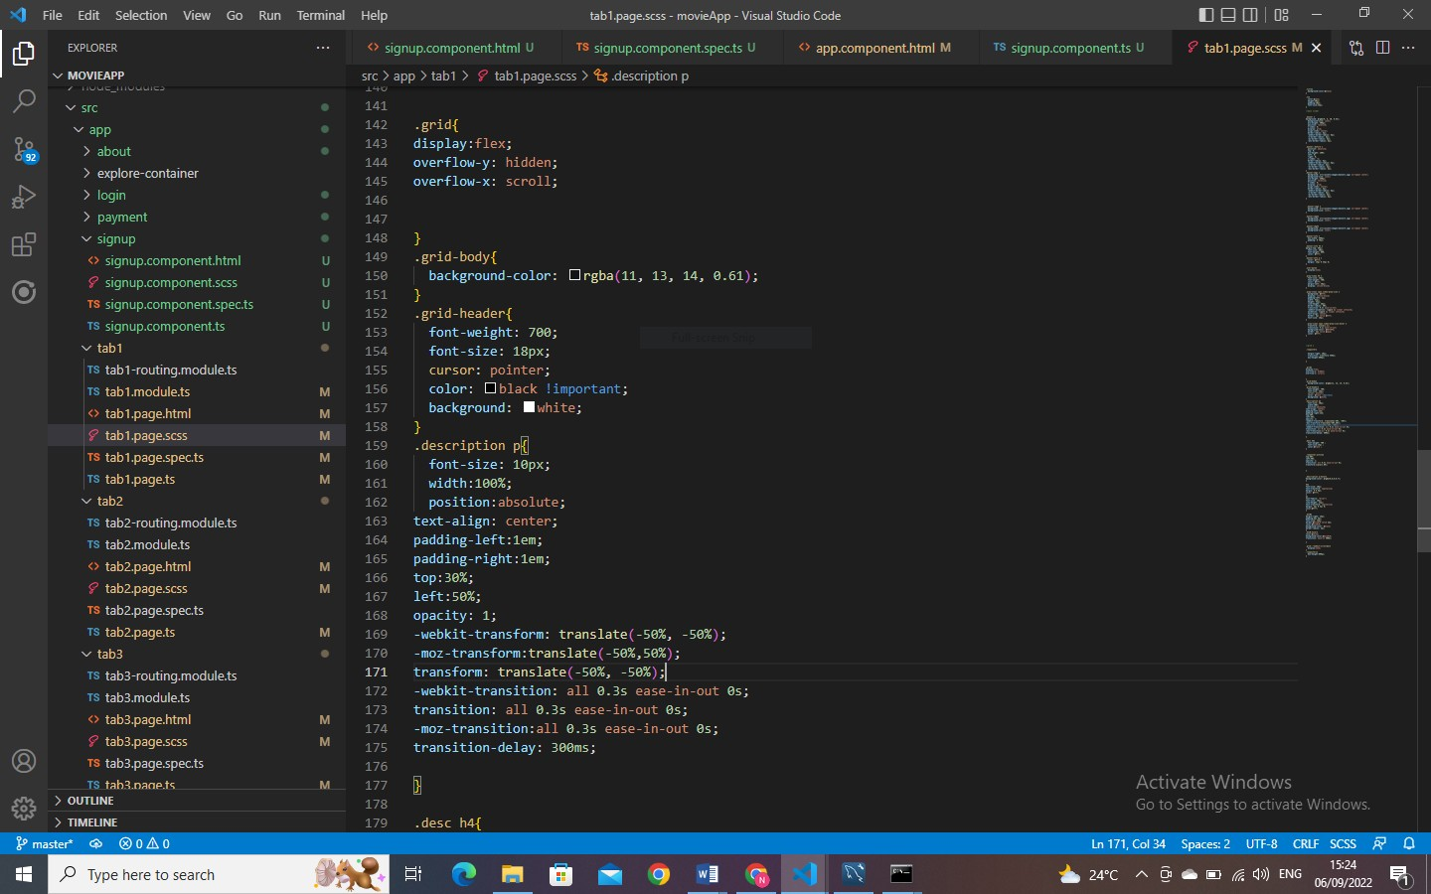

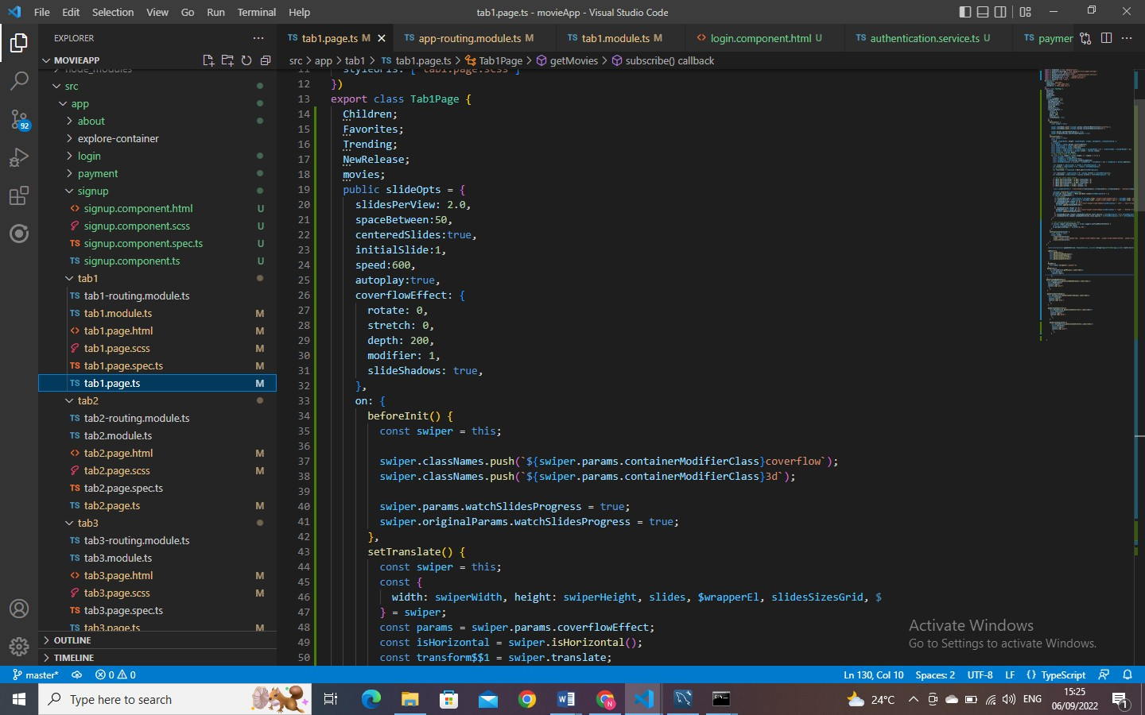
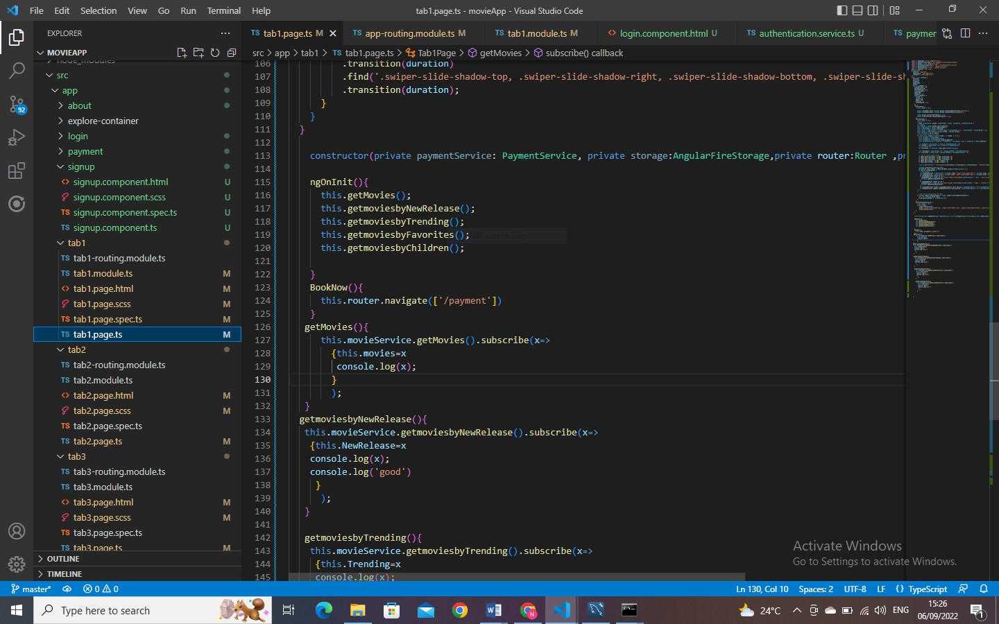

SEARCH TAB
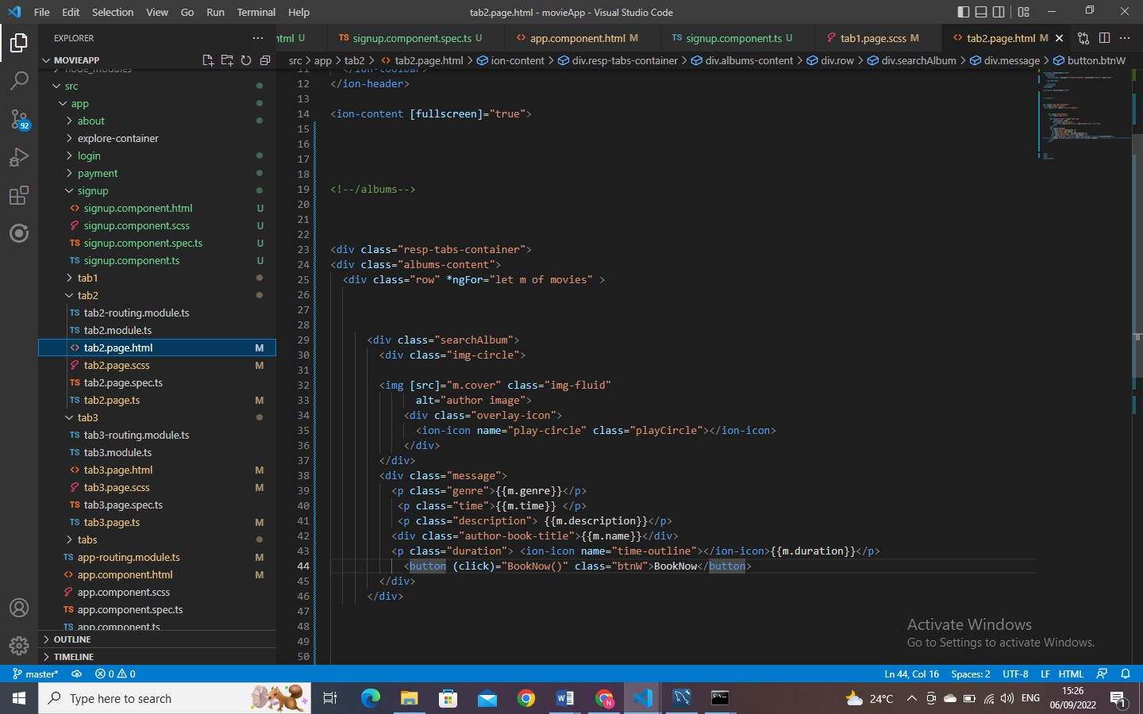
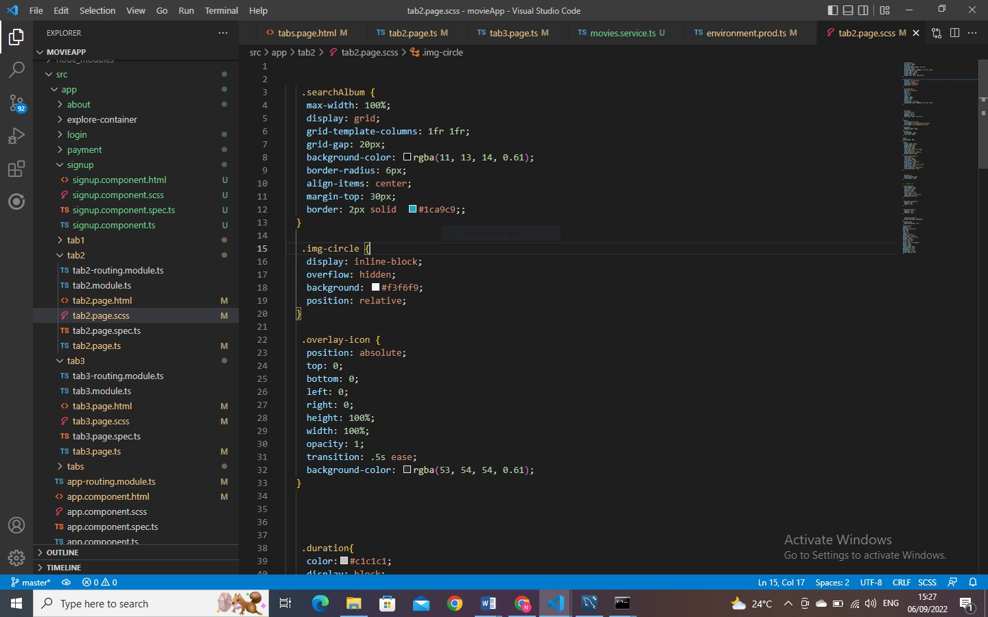

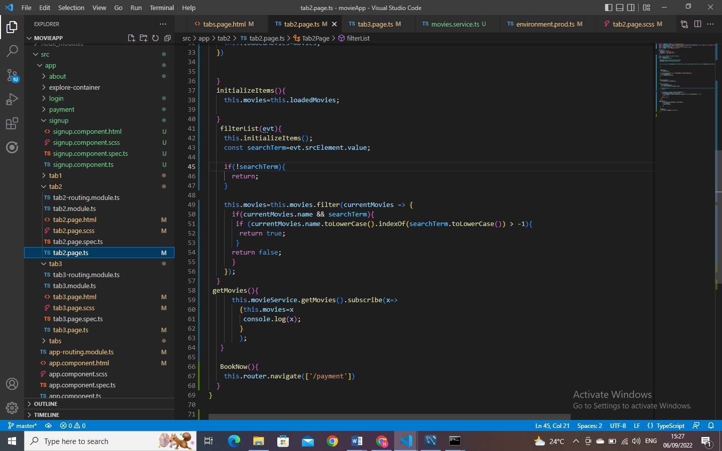

SETTINGS TAB
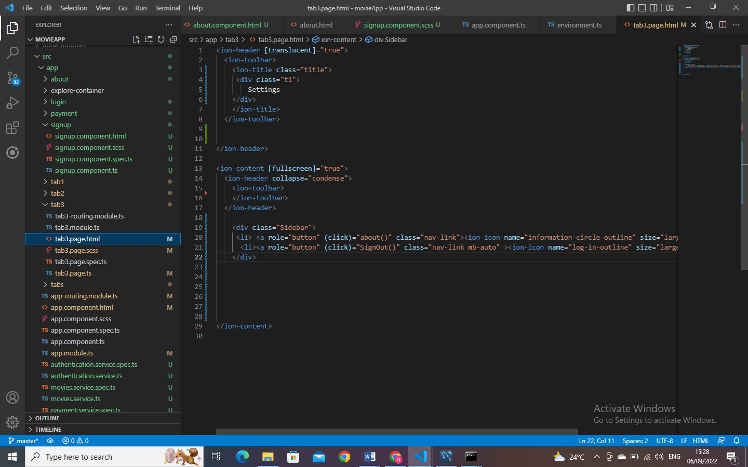

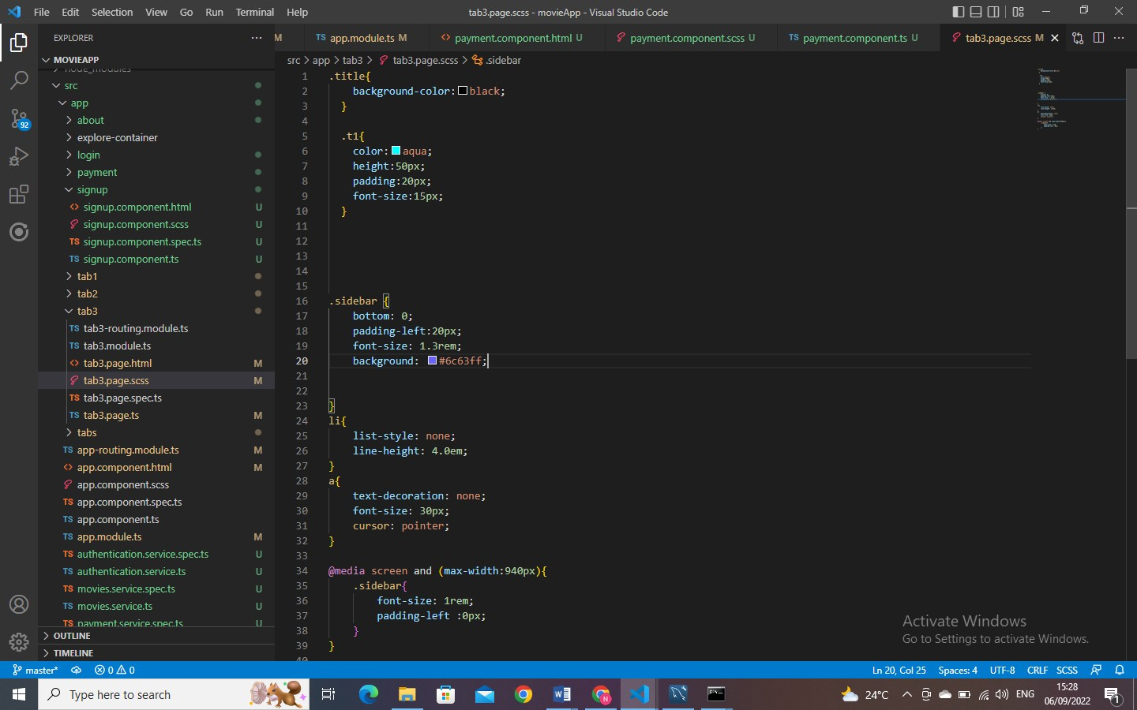
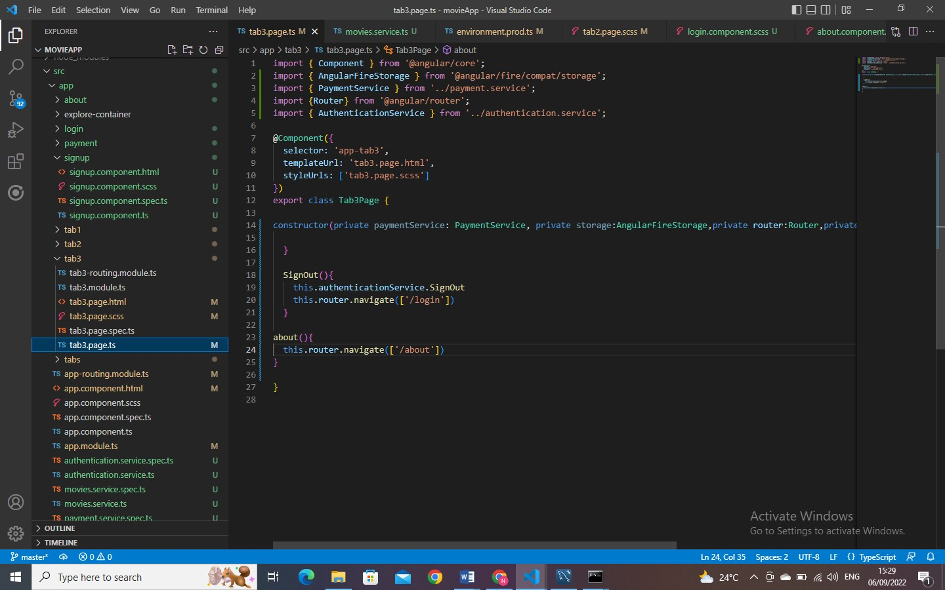

ABOUT PAGE
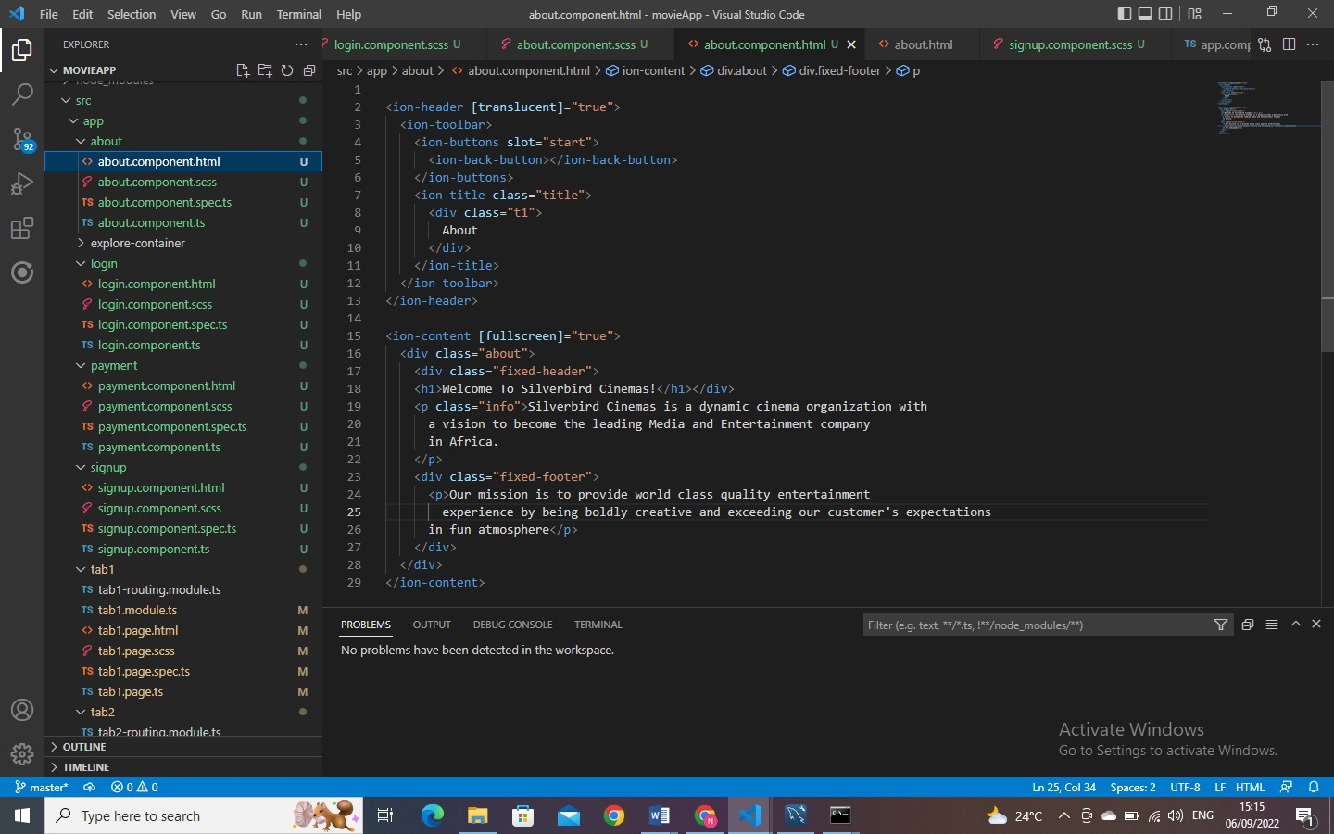
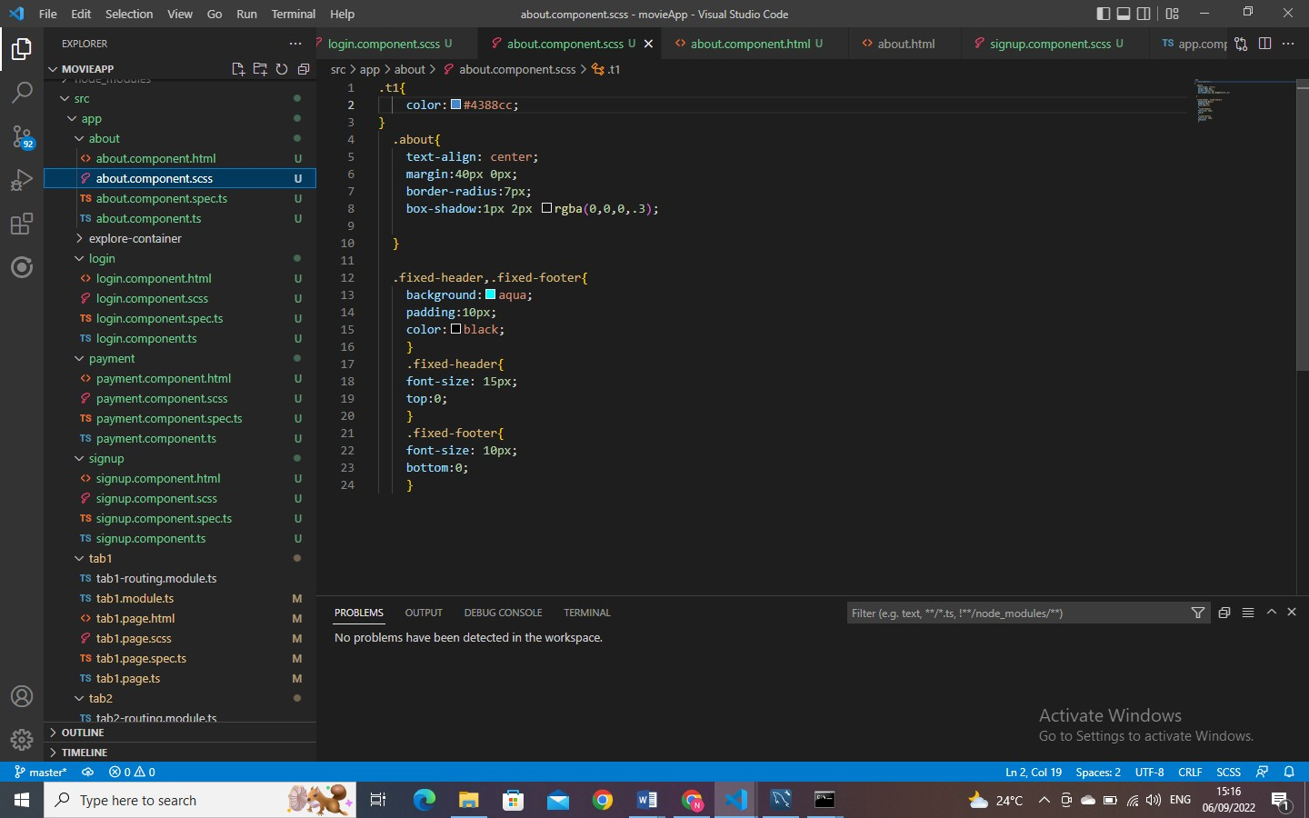

PAYMENT PAGE
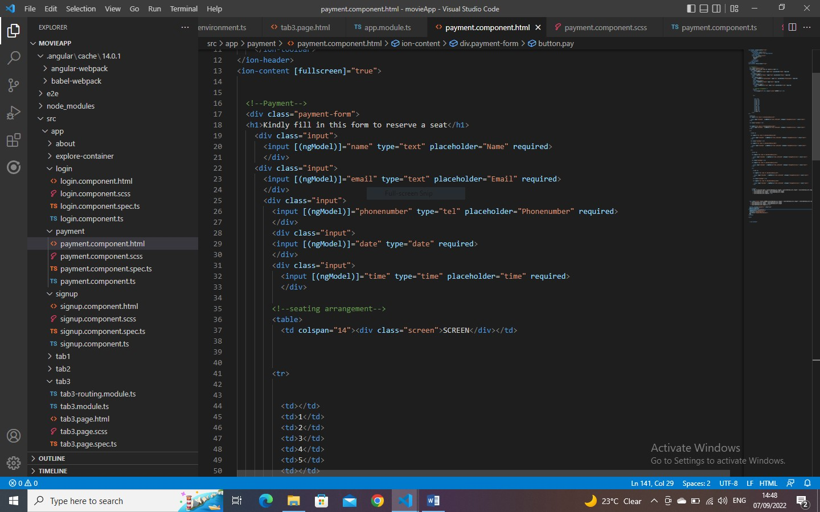
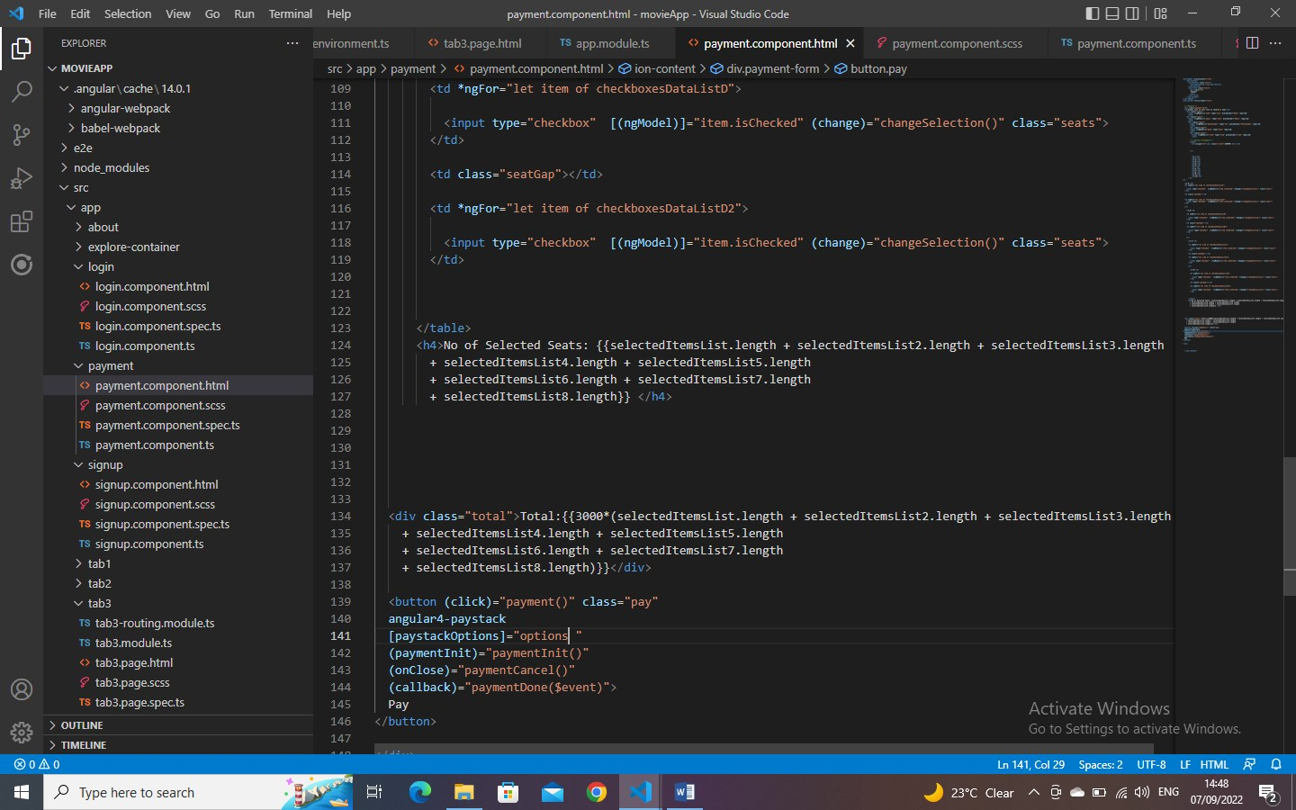

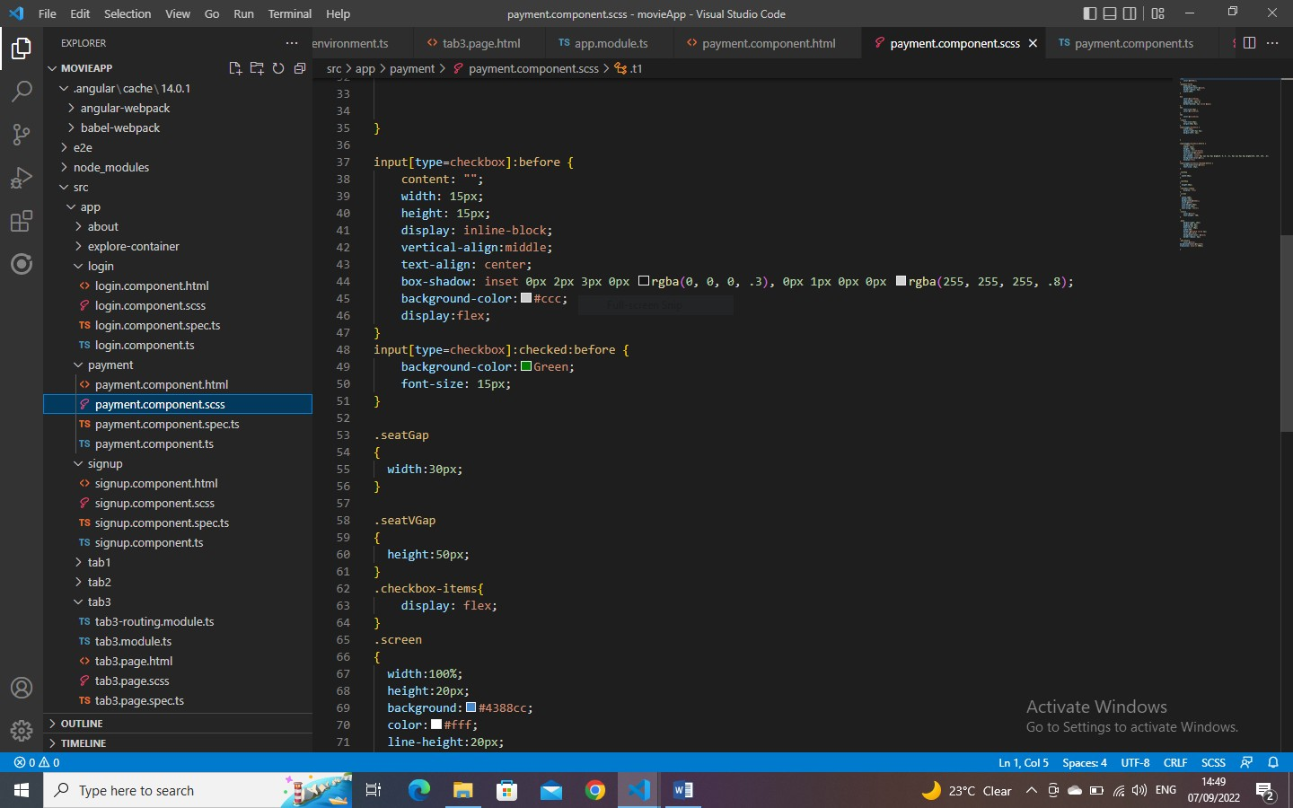

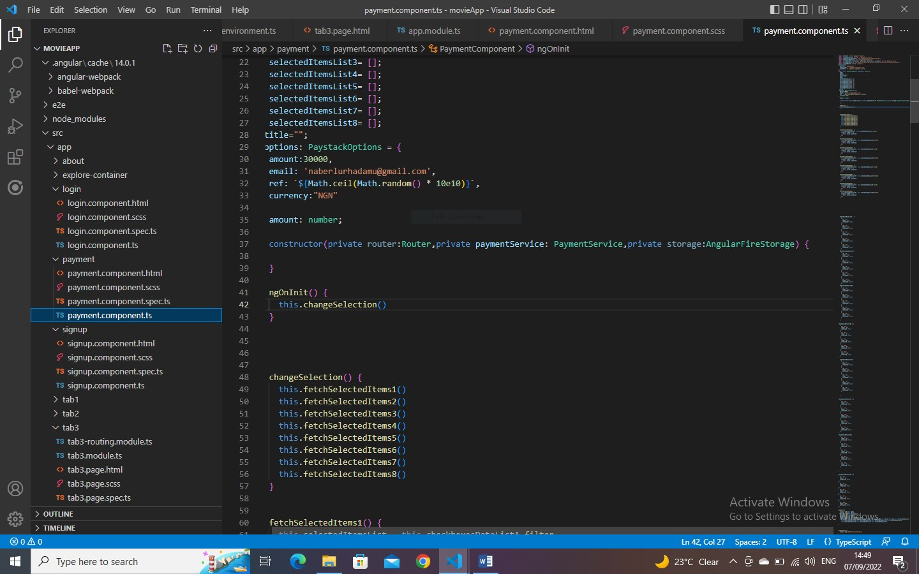

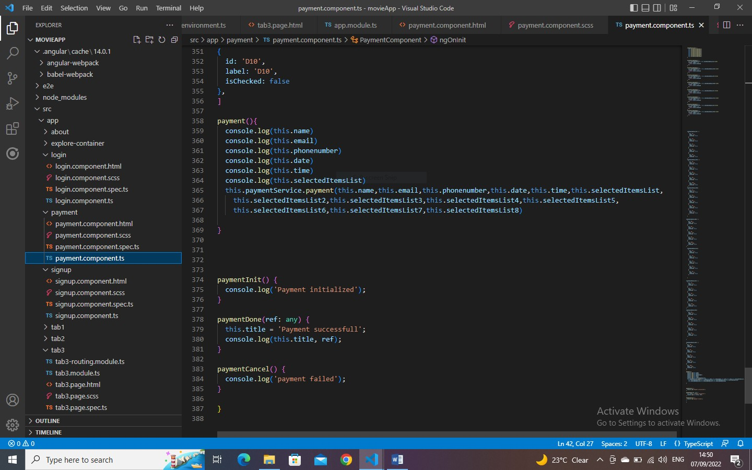

MOVIE SERVICE
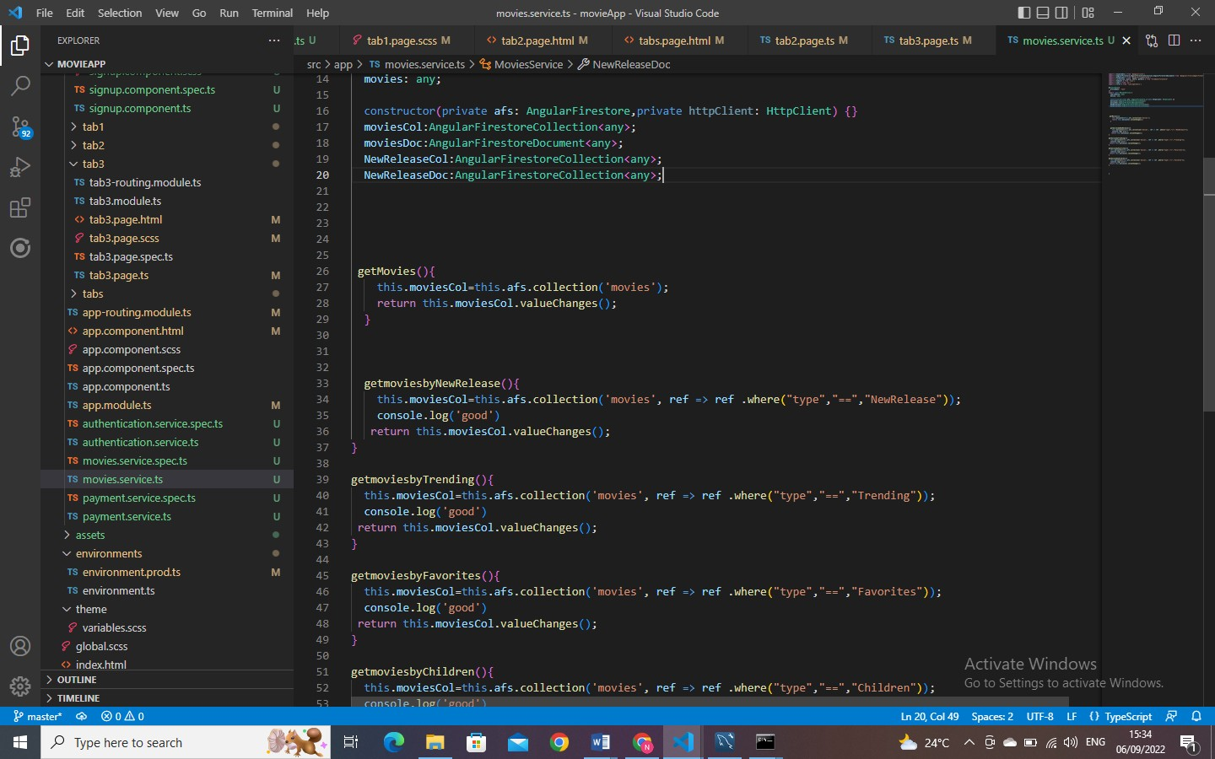

AUTHENTICATION SERVICE
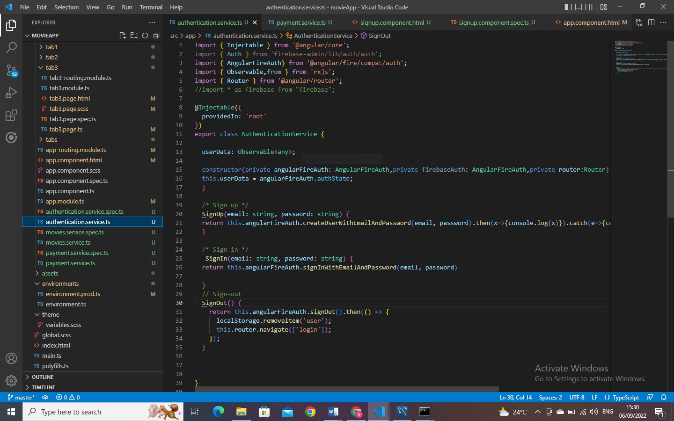

ADMIN PAGE
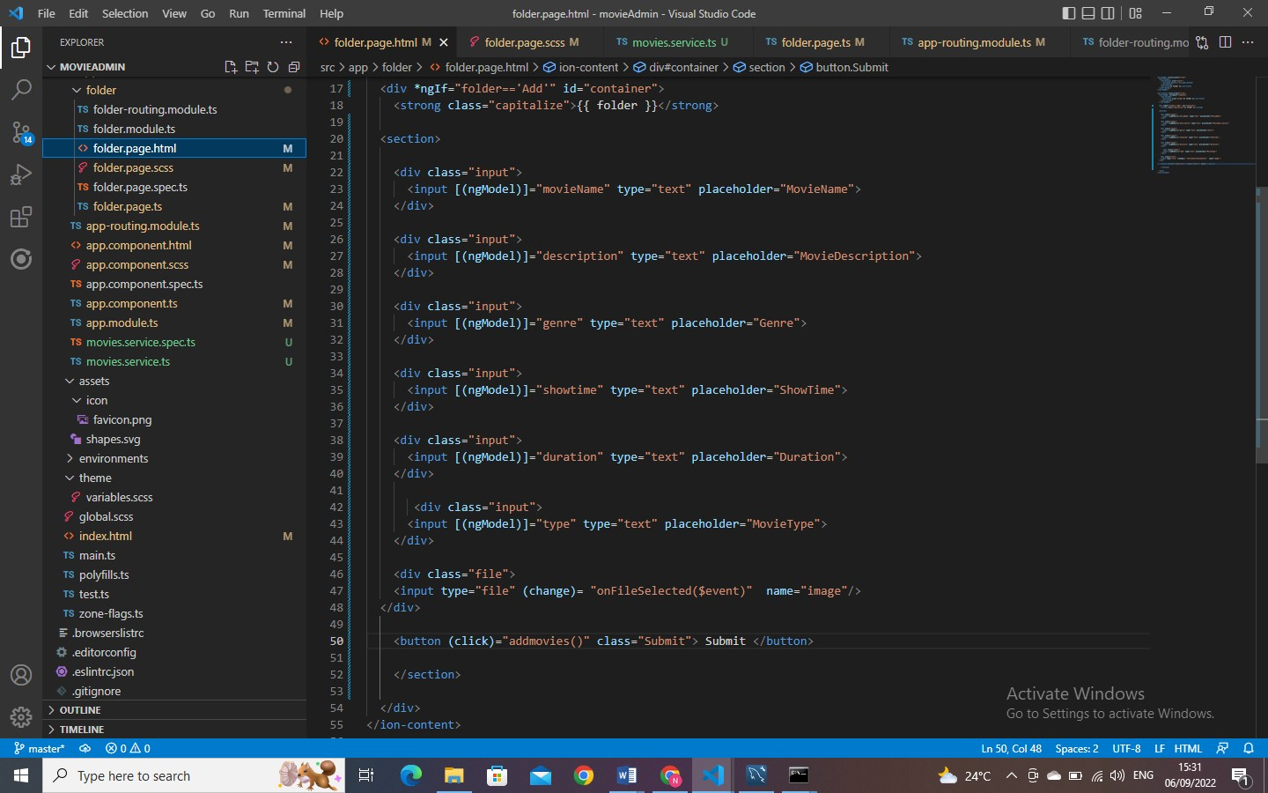
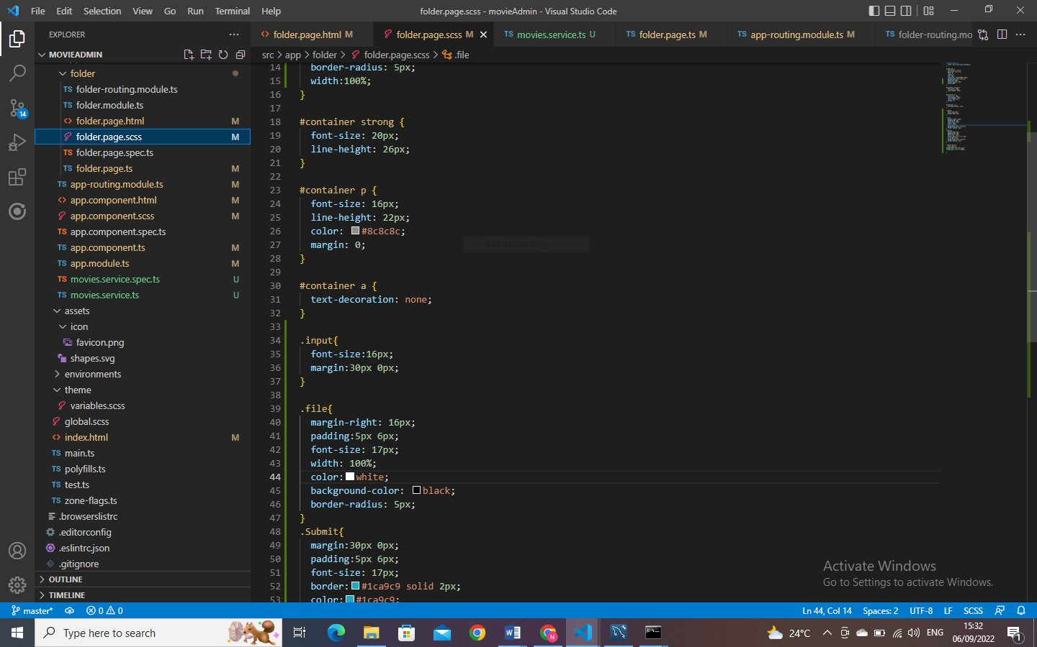

PAYMENT SERVICE
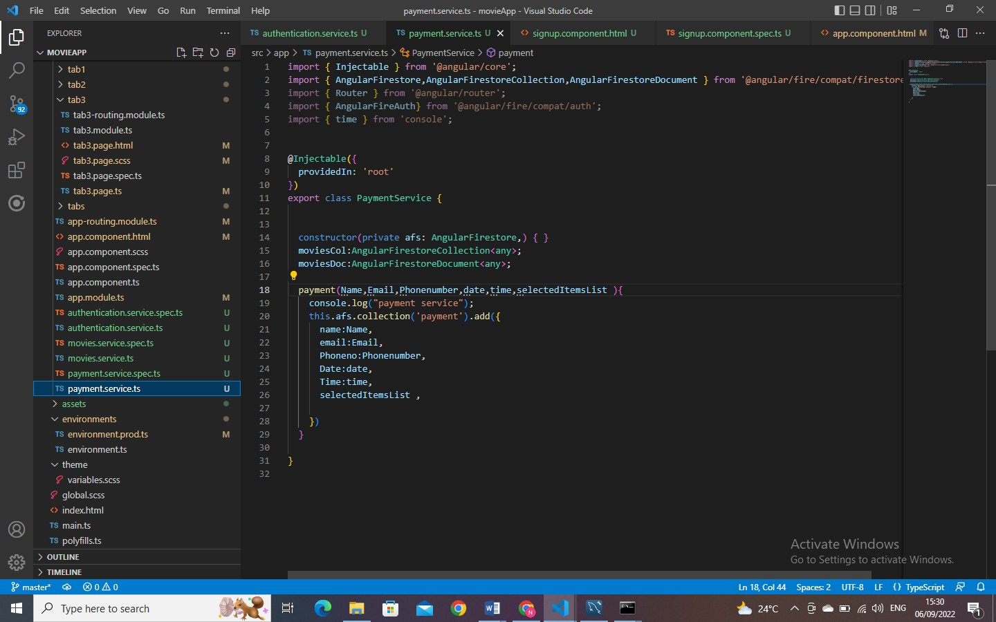

MOVIES SERVICE ADMIN PAGE
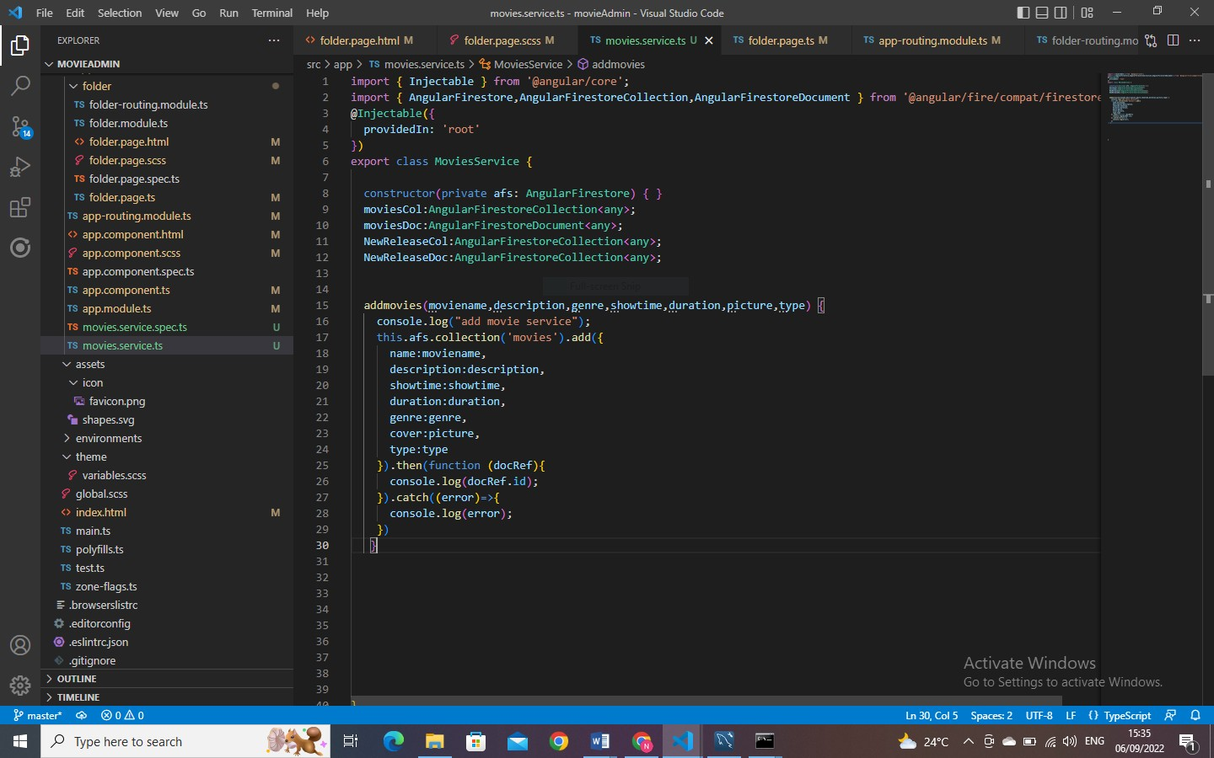

REFER TO THE FOLDERS ATTACHED FOR COMPLETE SOURCE CODE.

Appendix D – Test Cases
Refer to chapter 4 of this documentation

Appendix E – Use Guide/Manual

Refer to Chapter 3 of this documentation.

