DRIVERS' VISUAL FOCUS AREAS ON COMPLEX ROAD NETWORKS IN STRATEGIC CIRCUMSTANCES: AN EXPERIMENTAL ANALYSIS

by Abhishek Shah

Submitted in Partial Fulfillment of the Requirements for the Degree of
Master of Science in the
Computing and Information Systems Program

Youngstown State University December 2022

DRIVERS' VISUAL FOCUS AREAS ON COMPLEX ROAD NETWORKS IN STRATEGIC CIRCUMSTANCES: AN EXPERIMENTAL ANALYSIS
Abhishek Shah

I hereby release this thesis or dissertation to the public. I understand that this thesis will be made available from the OhioLINK ETD Center and the Maag Library Circulation Desk for public access. I also authorize the University or other individuals to make copies of this thesis as needed for scholarly research.

Signature:

Abhishek Shah, Student Date

Approvals:

Dr. John R. Sullins, Advisor Date

Dr. Alina Lazar, Committee Member Date

Dr. Yong Zhang, Committee Member Date

Dr. Salvatore A. Sanders, Dean of Graduate Studies Date

ABSTRACT

The safety of passengers is an important aspect of developing a car with superlative automaticity. Human error accounts for 94% of serious crashes, according to the National Highway Traffic Safety Administration (NHTSA). Autonomous vehicles or self-driving cars may respond more quickly than human drivers, theoretically (Shwartz, 2021). The purpose of this study was to analyze those human errors or potential factors that affected the decision-making ability of a human driver that led to errors. A simulation was built to represent a real-life driving experience to accomplish this goal. Participant-drivers drive in a simulated city with busy traffic, 3-way to 5-way intersections, and complex routes. Pedestrians, flashing and non-flashing road signs and distractions are also prevalent in the city. Data from an eye tracker device was collected in the form of fixation maps and heat maps to determine the driver's visual focus areas. Previous studies have shown that drivers tend to focus mainly on the road straight ahead (Mauk, 2020). Hence, few changes have been made in this study to collect more precise data. The results have shown that the drivers are more attentive in busy/occupying scenarios. Along with that, the study indicated that 70% of the drivers followed the actions of vehicles that were in front of them. This study also explored the dissimilarity of driving patterns of the same driver on a non-familiarized road versus a familiarized road. From the dissimilarities, it was established that the drivers were at ease while driving in the simulation for the second time in comparison to the first time. However, the drivers' visual span seemed to be reduced despite their compliance with traffic laws.

ACKNOWLEGEMENT

I would first like to acknowledge the participant-drivers who took out time from their busy schedule to participate in this experiment. Their patience and support were overwhelming. The data we collected is the backbone of this research and I am grateful to all the participant-drivers.

My profound thanks go out to Dr. John R. Sullins, my advisor, for his constant support of my master's studies and research as well as for his patience, inspiration, enthusiasm, and knowledge. Throughout the research and thesis-writing process, his guidance was beneficial to me. There is no one else I could have asked for as a mentor and advisor.

Along with my advisor, I would also like to thank Dr. Yong Zhang and Dr. Alina Lazar from my thesis committee for their support, challenging questions, and enlightening remarks.

Lastly, I would also like to thank the entire computer science information systems department for what I have learned as a student and the grad school at YSU for the opportunity they have given me.

TABLE OF CONTENTS

LIST OF FIGURES vii
LIST OF TABLES ix
CHAPTER 1 INTRODUCTION 1
  - Motivation 2
  - Research Questions 4
  - Contributions 5
  - Organization 6
CHAPTER 2 BACKGROUND AND RELATED WORK 7
  - Previous Works 7
  - Eye Tracking Technology 9
    - Observation 9
    - Instrumentation 9
    - Application 10
  - Autonomous Vehicle 10
    - Levels of Automation 13
CHAPTER 3 EXPERIMENTAL SETUP 14
  - Hardware 14
    - Eye Tracking Device 14
      - Heat Maps 15
      - Fixation Map 15
    - Simulation Hardware 16
  - Simulation Software 17
CHAPTER 4 EXPERIMENT METHODOLOGY 20
  - Participant Recruitment 20
  - Experimenting on the Simulation 20
  - Trial Recording 21
  - Scenario 22
CHAPTER 5 RESULT 42
  - Performance 44
  - Active and Passive Distractions 45
    - Billboards 45
    - Rock 46
    - Road Signs 46
  - Traffic Lights 47
  - Active Pedestrians 48
  - Intersections 48
  - Familiarization vs non-Familiarization 49
  - Discussion 49
CHAPTER 6 CONCLUSIONS AND FUTURE WORK 50
  - Conclusions 51
  - Future Work 52
APPENDIX A: STUDY MATERIAL 53
REFERENCES 56

LIST OF FIGURES

Figure 1. Levels of Automation chart 13

Figure 2. Examples of heat map 15

Figure 3. An example of fixation map 15

Figure 4. Simulator 16

Figure 5. Simulation Map 21

Figure 6. Scenario 1 23

Figure 7. Scenario 2 23

Figure 8. Scenario 3 24

Figure 9. Scenario 4 24

Figure 10. Scenario 5 25

Figure 11. Scenario 6 25

Figure 12. Scenario 7 26

Figure 13. Scenario 8 26

Figure 14. Scenario 9 27

Figure 15. Scenario 10 27

Figure 16. Scenario 11 28

Figure 17. Scenario 12 29

Figure 18. Scenario 13 29

Figure 19. Scenario 14 30

Figure 20. Scenario 15 | ................................................................................................... | 30
Figure 21. Scenario 16 | ................................................................................................... | 31
Figure 22. Scenario 17 | ................................................................................................... | 31
Figure 23. Scenario 18 | ................................................................................................... | 32
Figure 24. Scenario 19 | .................................................................................................. | 32
Figure 25. Scenario 20 | ................................................................................................... | 33
Figure 26. Scenario 21 | ................................................................................................... | 33
Figure 27. Scenario 22 | ................................................................................................... | 34
Figure 28. Scenario 23 | ................................................................................................... | 34
Figure 29. Scenario 24 | ................................................................................................... | 35
Figure 30. Scenario 25 | ................................................................................................... | 35
Figure 31. Scenario 26 | ................................................................................................... | 36
Figure 32. Scenario 27 | ................................................................................................... | 36
Figure 33. Scenario 28 | ................................................................................................... | 37
Figure 34. Scenario 29 | ................................................................................................... | 37
Figure 35. Scenario 30 | ................................................................................................... | 38
Figure 36. Scenario 31 | ................................................................................................... | 38
Figure 37. Scenario 32 | ................................................................................................... | 39
Figure 38. Scenario 33 | ................................................................................................... | 40
Figure 39. Scenario 34 | ................................................................................................... | 40
Figure 40. Scenario 35 | ................................................................................................... | 41
Figure 41. Scenario 36 | ................................................................................................... | 41

LIST OF TABLES
Table 1. Table of Strategic points 42
Table 2. Table of Performance 44

CHAPTER 1 INTRODUCTION
Autonomous cars are the future for commuting. There are over 250 autonomous vehicle companies that are taking serious steps to make self-driven cars reliable. Global Autonomous Cars Market size is expected to grow from $23 billion to $64 billion by 2026. The reason for this expected growth in the market for self-driven cars is that automation can help reduce the number of crashes on our roads by 93%, disabled people can commute on their own, and less traffic congestion.
Centers for Disease Control and Prevention has categorized distraction in three types, i.e., visual distractions: taking your eyes off the road, manual distractions: taking your hands off the wheel, and cognitive distractions: taking your mind off driving. These three distractions have been inter-related with each other. This paper will mainly focus on the errors that are caused by visual distractions (CDC, Distracted Driving). Some of the major causes of visual distractions outside the cars are pedestrians, flashing/non-flashing lights, billboards/advertising, pets, crash scenes, road constructions, and places or things of interest alongside the road.
These distractions account for 7% of distracted driving fatalities and can result in potential consequences such as failing to avoid oncoming traffic, not maintaining the correct lane position, unable to make judgments quickly, reduced awareness of the issue. inability to carry out emergency maneuvers, and not being able to read and follow traffic signs and signals (EndDD, 2021).
This study aims to provide data that can be utilized to make better informed decisions on drivers' on-the-road focus so that it may be used in further research or can

significantly be used in autonomous vehicles. The simulation built to gather the data imitates a driving environment in a city like structure with intersections and turns that requires the participant-drivers to be attentive. Throughout the simulation, the participant- drivers drive through several strategic points which are rigged with distractions, road signs, traffic lights, pedestrians, jaywalkers, and a few unprecedented scenarios such as a huge rock in the middle of the road or an accident. While the participant-drivers drive through the simulation, the eye tracking device will collect the data in the form of heatmaps, and fixation maps. To develop a more accurate model, the data may further be examined to determine what sort of events people often notice.

Motivation

Image processing for recognizing environmental situations is the most time- consuming part of the processing for autonomous navigation. It requires a huge amount of sensory data to be processed in real-time. A study conducted in 2001 examined two methods (Kwashima 2001). First, the reduction of the image processing load of the Fast Fourier Transform (FFT) picture compression technique in the manner of human eye sensitivity. Second, simplified driving rules extracted from human driving behavior correspond to the minimum energy-efficient control. One of the key strategies for improving results when working with a large number of data is trimming unnecessary data. In addition to ignoring parts of sensor data, focusing on sensor data from certain areas can also be a method of trimming sensor data. The system can react more quickly and efficiently by removing data that is not relevant to specific regions. This is possible by identifying certain regions that are more significant in particular circumstances. Since

eye-tracking devices and simulators were not commonly used for experiments in 2001, this aspect became the motivation for the study.
Prior work done by Jacob Mauk (2020), concluded that the drivers spend vast majority of time focusing directly on the road in front of them when compared to the time they spent on observing the potential distractions. Hence, a better approach to understand this data is to state that, assuming other systems are in place, a self-driving car should concentrate on everything along with what is directly in front of it. Mauk suggested some adjustments and addition of more distractions with a larger sample size of participant- drivers could reveal a better data quality.
Mauk’s findings compels to analyze the possible reason for participant-drivers focusing more on the road straight ahead of them and focusing less on the distractions. Therefore, in this paper, along with analyzing the visual areas of focus, it will also explore what makes the drivers spend most of the time focusing on the road directly in front of them and ignoring the surroundings. This paper analyzes much complex scenarios such as turning in a 5-way intersection with adjacent lanes, unprecedented situations, passing vehicles, flashing/non flashing road signs, maintaining speed, and attentiveness to rear/side mirrors.

Research Questions (RQ)

There are three questions that this study hopes to discover.

RQ1: Does driving behind another car brings any changes in the visual focus areas of the driver?
RQ 2: Are there any dissimilarities in the attentiveness of drivers while driving on a non- familiar road versus familiar road?
RQ 3: In terms of the assessments a self-driving car makes while on the road, are a human driver's behaviors the best one to emulate?
The first question pursues the details for what grabs the driver’s attention while driving. It is important to acknowledge the factors that divert the attention of the drivers. Their gaze pattern determines the safety. It also helps to determine the installations the road signs, traffic lights, or billboards on the road to make it noticeable timely. The second question seeks for the changes that might occur in an individual’s driving pattern based on the familiarization of the road. The third question looks for a conclusion to decide if it is the best idea to train the models based on human’s driving skill.

Contributions

The objectives of this study are:

    - To gather data of visual focus areas of the drivers while driving and analyze the information which will help analysts to train the model more accurately.
    - To improve the decision making of the model so they perform more educatively, confidently and are aware of their surrounding while on road.
    - To suggest possible implication of this data in public safety, automotive engineering, and artificial intelligence to fuse it with devices and algorithms in future.

Organization

In this study the second chapter begins with acknowledging the narratives of research and development of autonomous vehicles over the years. It also provides an overview on observations, instrumentation, and application of the eye tracking technology along with the autonomous vehicles. The paper then transitions into the third chapter which discusses the methodologies used in the research, including the set up that was used to test the participant-drivers. The fourth chapter goes through each process of how the experiment was conducted along with demonstrating each scenario that was strategized and designed to test the drivers. The fifth and sixth chapters share the outcome of the data collected from the eye tracking device after analyzing them and drawing conclusions from the outcome.

CHAPTER 2 BACKGROUND AND RELATED WORK
Looking back into history, the idea of the first autonomous vehicle was developed in 1925, which was more like a remote-controlled car (U, 2016). Almost a century after, we are not too far from achieving fully functional and reliable autonomous cars, theoretically. However, this field still has a long way to go and a lot of work to put in to see vehicles that are fully automated and do not require a human to intervene in any scenario. In this chapter, previous work done by the researchers in this field to validate the approach of this research is provided along with an overview of eye tracking technology and autonomous vehicle.

Previous Works

In a study, researchers investigated if self-driving cars should mimic human driving behaviors. They developed a survey with 46 questions that asked 352 participants about their personal driving behaviors such as speed, lane changing, distance from a car in front, acceleration, and deceleration, passing vehicles (Craig & Nojoumian). The identical questions on their expectations of a self-driving car carrying out these activities were also posed in the survey. They discovered that the majority of people like autonomous vehicles that drive more subtly than humans do. According to research, human-centered approach in autonomy is perceived as more trustworthy by users. Therefore, enabling computers to have the perception of humans could set the development of self-driven cars at a higher pace.
Perception is based on how humans interpret their five basic senses, i.e., sight, sound, touch, taste, and smell. Among all the senses, vision is considered as the most

important. To convey the sense of vision to the computers, human perception of object detection is required. Therefore, study uses eye tracking technology since eye gaze is a better predictor of study participants' genuine thoughts than, answering a series of questions, researchers may get accurate data for use in their studies. The precise location a user is gazing at a screen can be tracked by modern eye tracking devices after calibration. A study in study discovered how eye tracking can be used in fields such as advertising and agreed with the sentiment that a user’s vision will closely and accurately correlate to their thinking process (Cooke, 2005). The technology can lead an eye- operated communication and control system that allows people with disabilities to communicate and interact with the world. Users are writing books, attending school, and communicating with their loved ones, all through the power of their eyes (Norloff, 2022). The main idea is to consider not only the intention behind each glance but to also account for what is relevant in the surrounding scene. This is regardless of whether the driver has looked there or not.
The topic for previous work published in 2020 by Jacob Mauk was Eye Tracker Analysis of Driver Visual Focus Areas at Simulated Intersections. Mauk aimed to discover where does a driver tend to focus most of their attention towards while driving and are human driver’s habit an ideal model for a self-driving car to follow, regarding the observations they make while driving. Mauk concluded that the drivers spend vast majority of time focusing directly on the road in front of them when compared to the time they spent on observing the potential distractions. Mauk stated, no work is established or executed perfectly, and there are always ways to improve the quality. He suggested some

future works that included addition of diverse scenarios, such as turning at an intersection, tests with a much larger sample size of participants.

Eye Tracking Technology

This study uses eye tracking technology to evaluate the attentiveness of drivers, therefore it is essential to understand the development and application of eye tracking technology. There are several ways to measure eye movement. The most often used variation extracts the eye position from video pictures. All industries use eye tracking technology nowadays, yet the field of technology invention dates back hundreds of years.

Observation

Like every other innovation, eye tracking biometric technology began with interest and observation. Most eye tracking studies are attributed to Louis Emile Javal, a French ophthalmologist who conducted study around 1879 (EyeSee, 2017). He was one of the earliest professionals to have done the research. He found that people's eyes did not naturally move over the page as they were reading. Instead, they made quick movements—now referred to as saccades— followed by brief pauses—now referred to as fixations.

Instrumentation

In late 1800s, a lens that had a tiny pupil aperture and a lengthy pointer to track the reader's eye movements was used to study the visual movements of a subject (Gazepoint, 2022). However, by 1900s, Guy Thomas Buswell created the first non-intrusive eye-trackers in Chicago utilizing light beams that were reflected off the subject's eyes and subsequently recorded on film in 1900s.

Modern eye trackers still employ a similar methodology. Although it still uses light reflection, digital records have replaced film in this system.

Application

By 1980’s, computers became a means of monitoring users' responses to material like animated graphics and online adverts since they were strong enough to handle visual-tracking data in real-time. That was when eye trackers became even more precise and unobtrusive. This led the eye tracking technology to globalize and most of the automobile industries have brought this technology in use.

Autonomous Vehicle

Autonomous vehicles use sensors, actuators, sophisticated algorithms, machine learning systems, and potent CPUs to run the software. Radar sensors, video cameras, lidar sensors, ultrasonic sensors, all work co-independently to keep track of the whereabouts of adjacent vehicles, to detect traffic lights, road signs, other cars, and pedestrians, to use the reflection of light pulses from the environment around the vehicle to calculate distances, find road boundaries, and recognize lane markers, respectively. They can also notice obstacles and other cars through the wheels when parking. Then, the sophisticated software analyzes all these sensory data, draws a path, and issues commands to the actuators in the vehicle that manage acceleration, braking, and steering. The software aids in adhering to traffic regulations and avoiding obstructions with hard- coded rules, obstacle avoidance algorithms, predictive modeling, and object detection (Synopsys).

To imitate the human brain and its cognitive networks, a self-driven car also needs to compute all the sensory inputs into the machine learning algorithms to forecast outcomes based on a massive amount of data, enabling it to plan and act. Therefore, as a car takes more trips, data is gathered to update its cognition of the surroundings and map. A single self-driving car is predicted to be able to gather up to 1GB of data each second which makes the number of sensors and transmitting information instantly and continuously expensive. According to an article, an autonomous vehicle must be fitted with a platform that produces at least 75 Tera-Operations-Per-Second (TOPS) of computations for every watt of power used to effectively minimize human error (Krishnamurthi, 2020).
Suppose driver-1 is distracted and does not notice the red light and makes an illegal left turn with a speed of 30 mph, whereas driver-2 notices the light is green and drives straight ahead at 5 mph. By the time driver-1 notices and react to the situation, a collision may occur with driver 2. Humans take longer to react than expected (1.5 seconds). In other words, if they are not totally attentive, they frequently detect important visual signals too late, which can result in a disastrous chain of events. However, the 1.5 second response time is eliminated when the person is only operating as a passenger, giving the autonomous vehicle plenty of time to safely brake at the stoplight and avoid the crash. Even if the driver gets distracted when a self-driving car is in motion, the accident will still be avoided.
The major challenges with the autonomous vehicle are creating and maintaining maps, social interactions while driving, and tackling bad weather. However, these challenges can be tackled by capturing massive amounts of data and applying it to the deep learning algorithms. For one test vehicle, up to 4 terabytes of data are produced

every hour by real-time data about the surrounding environment, including weather, road conditions, other cars, pedestrians, and street signs, together with information about the vehicle and the intelligence required to make quick driving decisions (DXC). The data is analyzed in real time to tackle the challenges and later it is analyzed by the manufacturers to identify the novel driving condition and inform the artificial intelligence (AI).
To gather the data, an experiment was required. An experiment which can replicate vast number of scenarios and gather the reactions of drivers to the scenarios. However, it is not possible to fully train (perform the experiment) an autonomous vehicle in a physical environment, therefore simulators are used in almost all the trainings of autonomous driving algorithms. To train an autonomous vehicle in a physical environment with the sensors and eye tracking devices can be dangerous. Such devices would require to be placed on the dashboard of a car and can possibly be a distraction for the drivers. Also, building a physical prototype could be expensive and time-consuming which would vastly slow down the process of the research. In this research, the simulator that was used was equipped with three monitors, accelerating and breaking pedals and a gear shifter. The purpose of these monitor was to provide a wide-angle view of the environment.
The simulator was also mounted with an eye tracker device which uses infrared light to follow the movement of the participant-drivers’ pupils while collecting data on where they gaze on the screen is. The device collects data on several points, including movements, duration, and fixations. Movements indicates how a participant-drivers’ gaze moves around on the screen and tells what draws their interest. Duration indicates the amount of time a person spends staring at on object on the screen, which might be a sign

of interest or difficulty understanding. Fixation indicates points where a participant- drivers’ attention lingered or halted, which might assist in tracking their general eye movement and concentration.

Levels of Automation

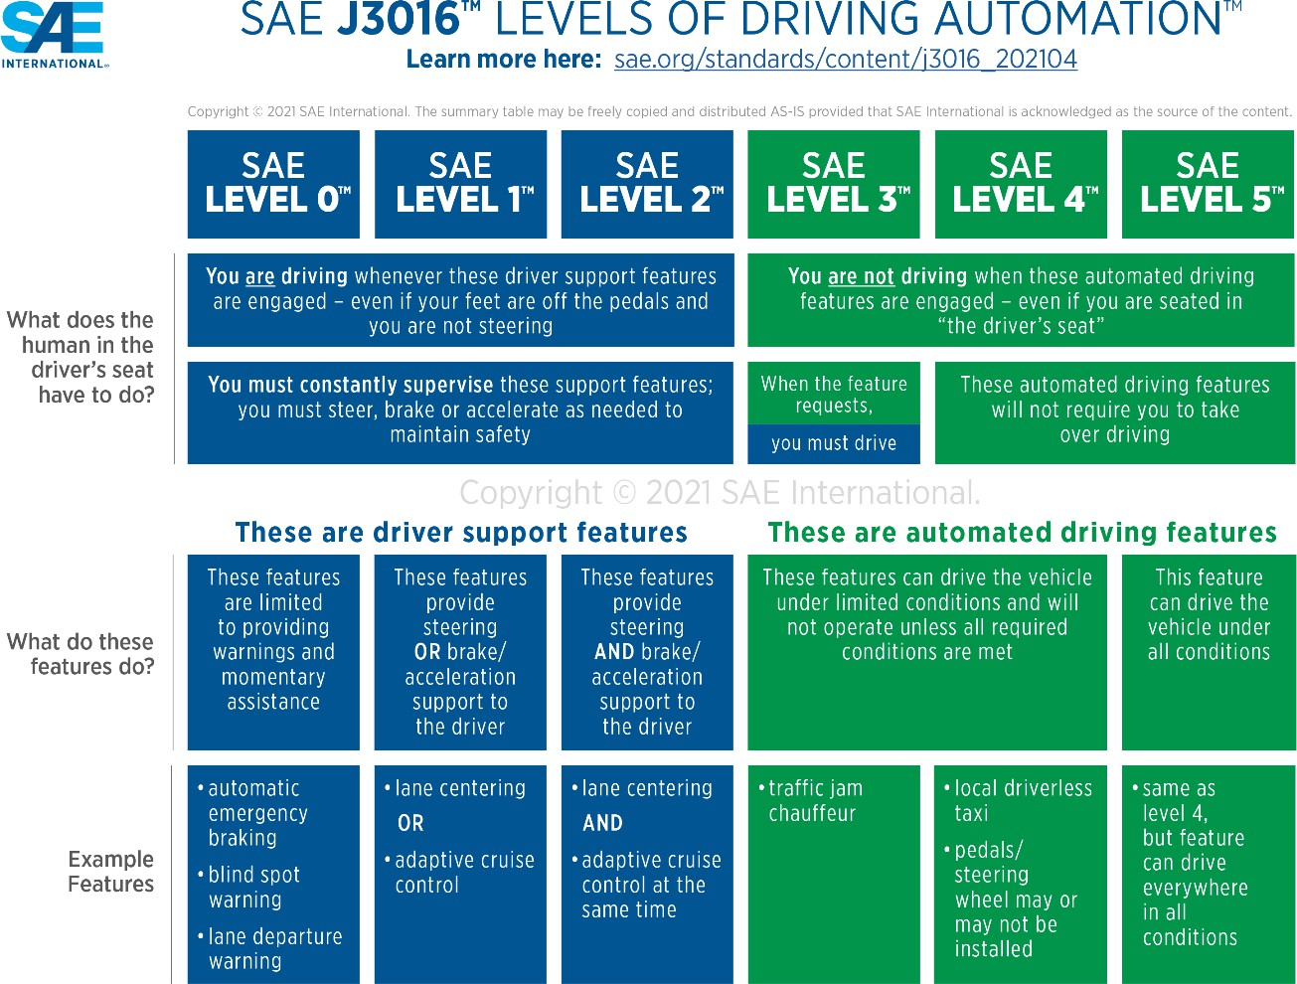
The society of automotive engineers (SAE) identifies the automation of a car in 6 levels which is also adopted by the U.S. department of transportation. From level 0, being fully manual to level 5 being fully autonomous (SAE, 2021).

Figure 1. Chart representing levels of automation (SAE, 2021)

Even while the future of autonomous cars is promising and exciting, anything more advanced than level 2 would not be in widespread production in the US for a few more years.

CHAPTER 3 EXPERIMENTAL SETUP
In this chapter, the setup that was used to conduct the experiment is explained. The chapter is divided into two parts, i.e., hardware and software. The hardware section talks about the devices and equipment that were used for driving and tracking participant- drivers eye movements. The software section discusses about the platform that was used to build the simulation.

Hardware

This section is categorized in two sections, i.e., eye tracking device and simulation hardware.

Eye Tracking Device

This experiment required an eye tracking device that could record real- time data, while user ran synchronously with the eye tracking software and simulation software. Therefore, an eye tracker developed by Gazepoint GP2 was brought in use.
The Gazepoint software offers a variety of mapping outputs for data analysis, including heatmaps and gaze fixation path that shows precise point-by- point tracking. The software captures the screen, draws patterns over it, and provides for an interactive visualization. It also allows custom changes such as switching between maps, size, transparency, gaze duration, outlier filter, and change the heat map scale.

Heat Maps

The heat map displays the relative intensity of values captured by your eye tracker within each square of a grid that divides a picture, giving each value a color representation. Given a "hot" color are the numbers with the highest value in relation to the other current numbers and given a "cold" color are the numbers with the lowest value.
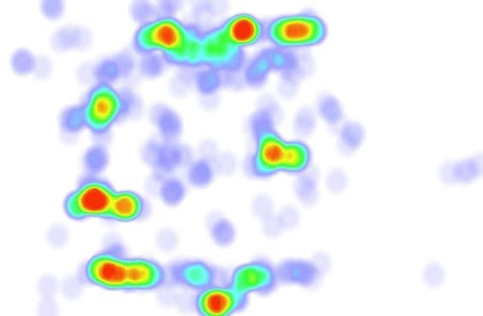
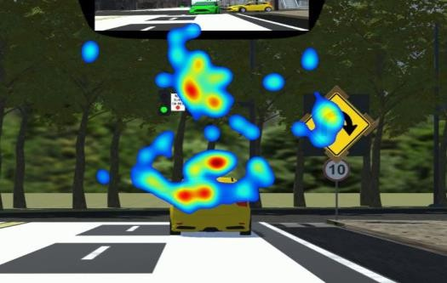
Figure 2. Example of heat map patterns

Fixation Map
Eyes cease sweeping the scene during a fixation and fixate on the foveal region of our field of vision. This enables the visual system to process in-depth information about the object being viewed. Even while our eyes appear to be fixed during a fixation, there are constant, little eye movements. However, since these do not divert our attention from the object of our attention, they are seen as being part of the same fixation.
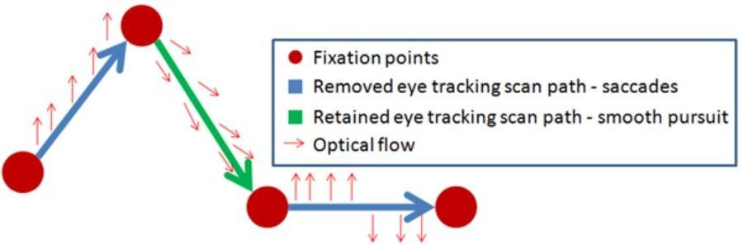
Figure 3. An example of fixation map

Simulation Hardware


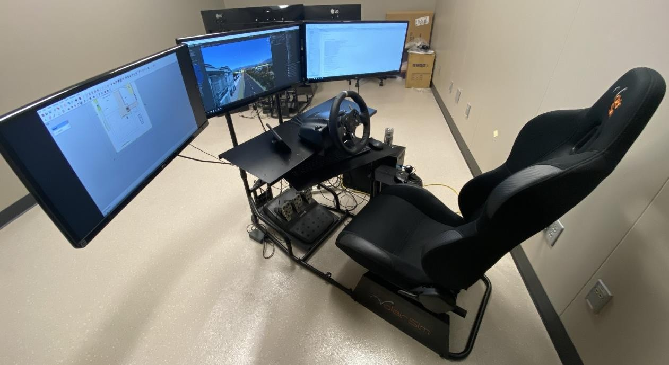
This simulation was run using specialized gear, including a Logitech G920 driving kit on a desktop provided by Youngstown State University (YSU). The Logitech G920 driving kit was mounted on a Volair Sim Chassis which features factory pre-drilled mounting locations for all the Logitech accessories. This chassis includes a seat, a foot pedal mechanism for acceleration and deceleration, and a steering wheel that closely resembles real driving.

Figure 4. Simulator

The chassis has triple monitor mounts that allow mounting triple monitors

angled at 60-degrees from the center display. The purpose of this chassis was to provide maximum driving immersion and realism.

Simulation Software

The simulation was built on Unity3D game engine which allows users to develop 2D and 3D games and experiences, and the engine provides drag-and-drop capabilities in addition to a primary scripting application programming interface (API) in C# utilizing Mono for both the Unity editor and games itself. The reason for choosing Unity was because it is supported by multiple platforms and has a rich asset store. One of the other reasons to choose Unity was the previous simulation was built on Unity as well therefore, it was easier to transition the assets to the new simulation software.
The planning and initiation of building the new simulation was started in the beginning of year 2021. As Mauk suggested in his previous study, the newer simulation demanded to be upscaled. Besides gathering the visual data, one of the major objectives for building the new simulation was to focus more on the customization of the scenarios, environments, traffics, and distractions. With the ability of customization, future student researchers will spend less time on building the simulation and more time on planning and designing the strategic scenarios. This will allow them to collect visual data from a diverse range of scenarios and move this study on much higher pace.
Instead of building a scenario from scratch, the future student researchers can drag and drop the nodes, and choose the number of lanes required, choose the type of community for each block such as residential, downtown, or industrial. They can customize a lane to be one lane or a four-lane or replace an intersection with a stop sign instead of a traffic light.
The scene incorporates a package from Unity, which allows the construction of streets, sidewalks, prefab buildings, and street assets. It can merge the city to our terrains

since it is integrated with Unity terrain. It allows to construct editable detailed multi-lane parametric roads, intersections, and sidewalks with this editable city designer, which operates directly within Unity's scene view. Additionally, it manages lot division within city blocks, building placement on lots, the arrangement of streetlights, and the placement of clutter. It lets us drag and drop required prefabs into the appropriate folders once automatic custom theme folders are generated. To further customize procedural power lines, guard rails, barriers, and sidewalks, procedural spline spawners can be curated to roads.
The package can also create traffic routes and expose this data by an API with the help of basic traffic systems. Another package from Unity allows to incorporate AI based cars and waypoint system, together with editing tools that enable the construction of waypoint-based routes that can be connected to create road networks in the scenes. The main logic was handled by a single AI Traffic Controller, to which AI Traffic Cars register. This controller uses the C# Job System and Burst Compiler to distribute processing across all available CPU cores, reducing usage on the main thread and enabling users to use more of one’s process costing system for other content.
A Unity package that has been integrated into the program starts in full screen mode on all windows. The program uses tools like occlusion culling and checkpoint- based level loading to keep the frame rate at sixty frames per second. As Mauk mentioned in his paper, 60 frames per second was selected because it supports tasks where users would be tracking objects and because users do better at interactive tasks on a higher framerate.

The simulation software includes a drivable car that the user can use to maneuver through the simulation. The car uses the same AI traffic controller script which prevents it from other cars to crash into it along with Mauk’s car controller script. The simulation was curated with triggers set into cube shaped colliders which does not render in the run time. The pedestrian was set to active state when the car comes in contact with the colliders that are located in multiple strategic points throughout the course.

CHAPTER 4 METHODOLOGY
Before the participant-drivers could drive on the simulator, there were a few measures to be taken. This chapter discusses an in-detailed step-by-step process of the experiment. It includes the simulation steps, participant recruitment, trial recordings, and the scenarios throughout the simulation.

Participant Recruitment

There were 20 participant-drivers recruited via email. The email briefly described the research and the experiment. They were made aware of what to expect through an informed consent form attached to the email. The requirement to qualify for participation was to have a driving license. This would ensure that the participants are aware of the general rules and regulations of traffic laws. On a Google form, participants were asked to RSVP, after which a date and time were set for them to visit the lab and drive the simulator.

Experimenting on the Simulation

The recruited participant-drivers were asked to sign an informed consent form and be briefed about the simulation before each trial. Before each trial was recorded, the participant-drivers were put on the road for a test run. The purpose of the test run was to make them comfortable with the steering, braking, and acceleration of the car in the simulation. The test run gave them roughly 60 seconds to drive anywhere in the simulated city.
The participant-drivers were supposed to follow the route and obey any applicable standard traffic regulations once they were on the course.

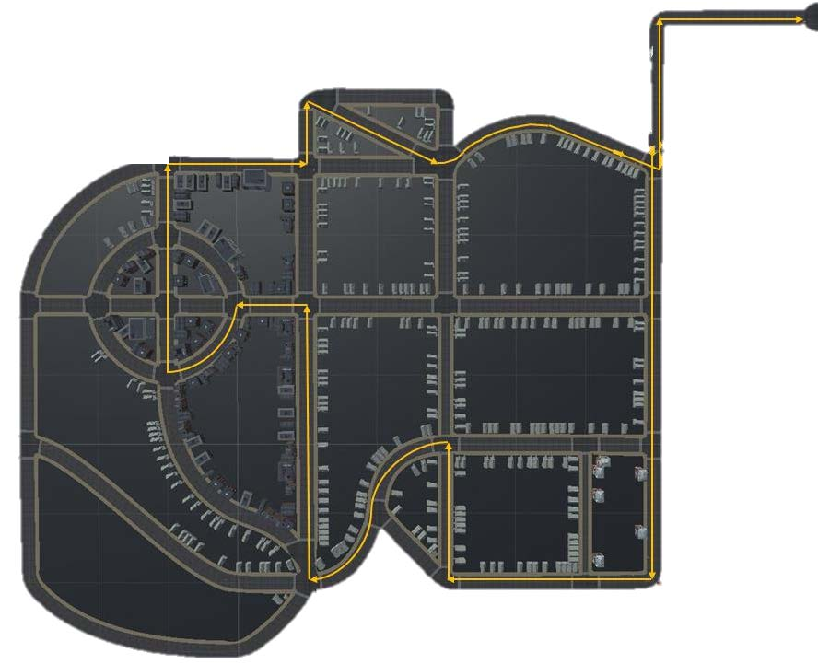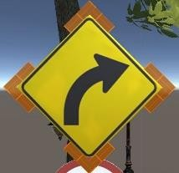
Downtown Area
Residential Area
Figure 5. Simulation map
A small city was built featuring residential and downtown areas. A navigation map was strategized to direct the participant-drivers through eighteen intersections rigged with several distractions. A total of fourteen flashing signboards guided the participants as they drove the course. Throughout the course of the trial, the participant-drivers were instructed to follow the yellow flashing signs, as shown in the figure above in the top left corner. The figure above indicates the downtown area in the green box and the residential area in the blue box. The yellow arrow on the map indicates the course that was selected for participant-drivers to drive in the simulation.

Trial Recording
Before the trial could begin, the participants were told that they would be driving a car. Their eye movements would be recorded using the Gazepoint GP2 device

throughout the course. Every time the eye tracking device was used, the driver's eye movements must be calibrated before each trial.
Gazepoint GP2 use two software:

    - Gazepoint Control: This was used to calibrate and set the device at an appropriate distance from the participant-driver before conducting the experiment. With the help of the OpenGaze API, it has user-controlled calibration points. With a minimum of 4 calibration points needed, this allows complete control over the calibration points utilized.
    - Gazepoint Analysis: Once the device was calibrated appropriately, this software was used to record the screen throughout the experiment. It was used to visualize and store data for analysis in several formats, such as images, videos, and CSV files. The software incorporates the input from the eye-tracking device into the screen.

Scenario

This section explains each scenario that was strategized, designed, and built to assess the reaction of the participant-drivers. The course that was selected on the map was curated with eighteen intersections. Among them, nine of them were three-way intersections, seven of them were four-way intersections, and two of them were five-way intersections. Throughout the course, the active distractions are circled in red, and the passive distraction is circled in green. Previously, the drivers focused on the empty road straight ahead, so this time there will be cars driving in front of the participant-drivers to determine their actions.

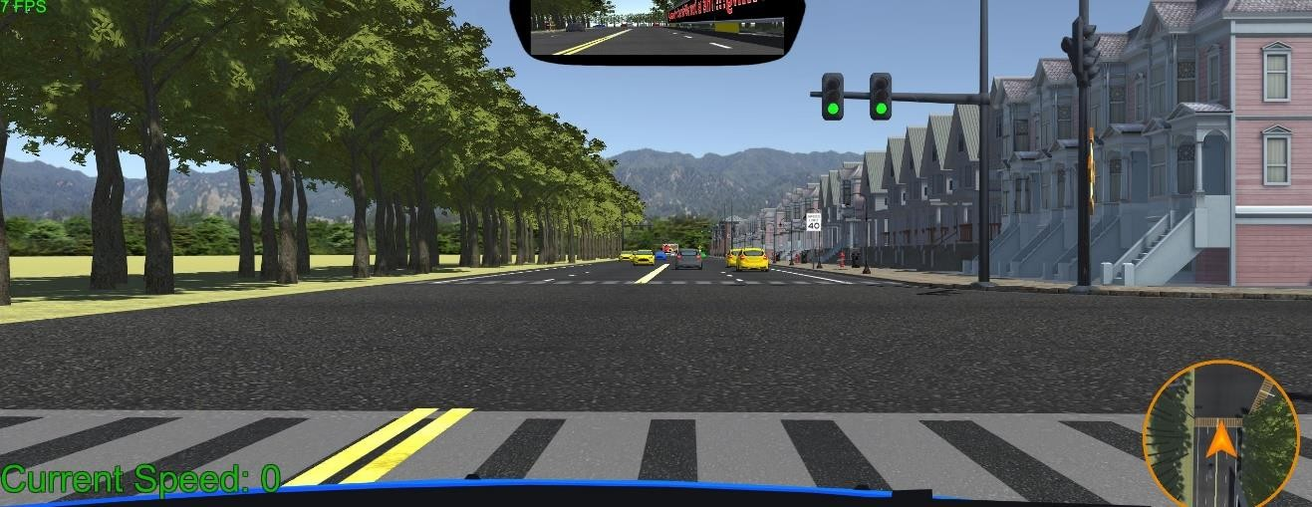
Figure 7. Scenario 1
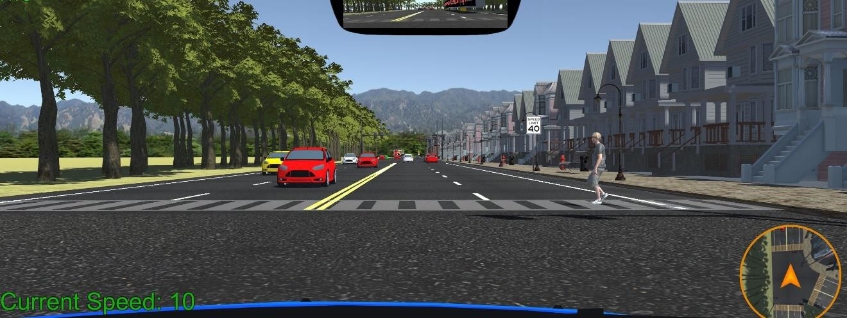
Scenario 1, the starting point of the course begins at the first intersection (three- way intersection). At this intersection, the signal was green and there are cars moving in both directions. A collider was placed at the end of this intersection, which, when triggered, forces the driver to face the second scenario.
Figure 6. Scenario 2
In scenario 2, the participant-driver makes contact with the collider which triggers the pedestrian. A pedestrian appears to walk across the street, in front of the participant-driver’s car. The red car in the green circle was yielding for its turn and the cars in the red circle are moving. The participant-driver was in the middle of the first intersection and must decide his next action. There was a speed limit sign in the green circle to the right side of the driver. Based on the previous study by Mauk, it was

determined that drivers tend to pay more attention to the road straight ahead of them. Therefore, the second scenario would determine if the driver was attentive enough to act to the pedestrian crossing from the right side, the yielding car on the left side, the moving traffic straight ahead, and the speed limit sign on the right side.
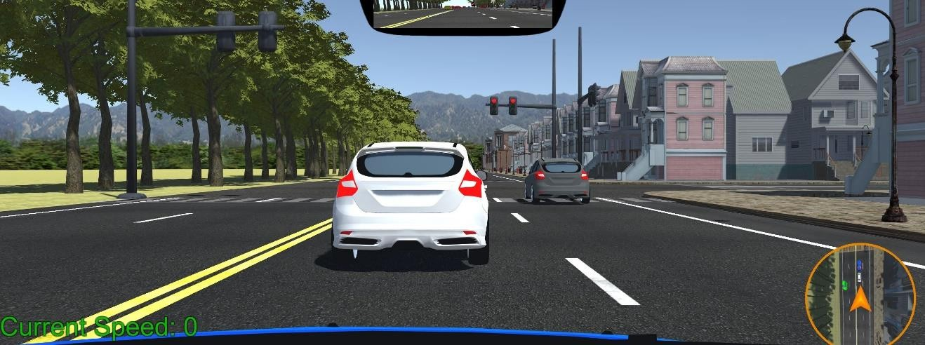
Figure 8. Scenario 3
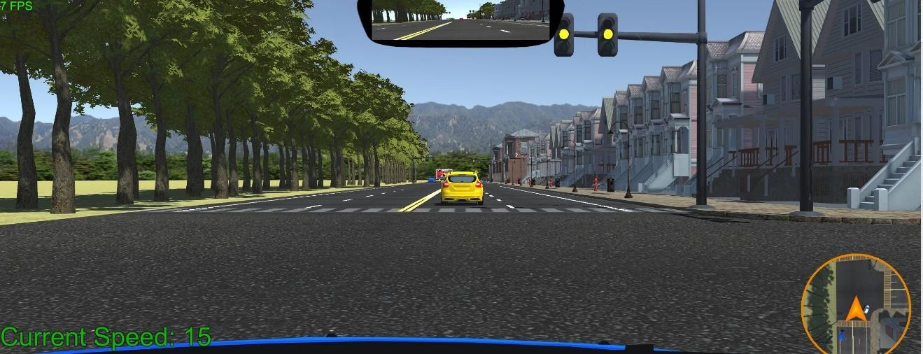
Scenario 3 is the second intersection (three-way intersection) of the course. Previous studies have shown that drivers focus mostly on the empty road straight ahead of them (Mauk, 2020). Therefore, throughout this course cars are driving in front of the participant-drivers. As the roads are not empty, it was expected that participants will be less at ease and more aware of their surroundings. At this intersection, there are cars waiting for the signal to turn green in front of the participant-driver and a car was passing in the right lane for a right turn at the intersection.
Figure 9. Scenario 4

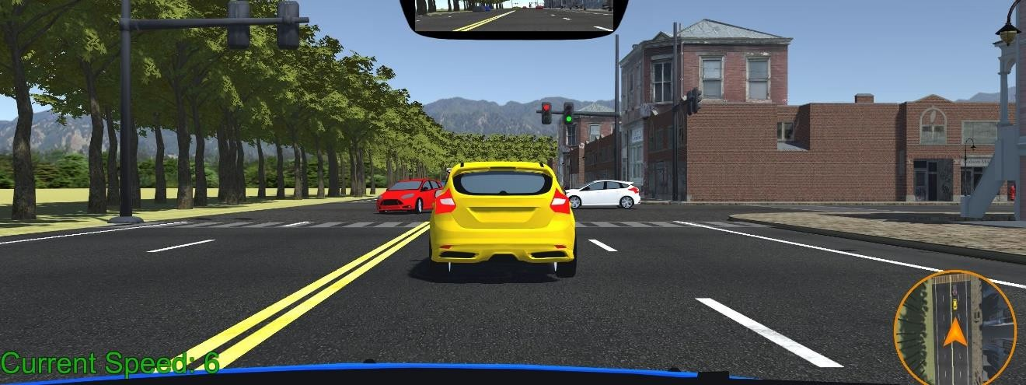
In scenario 4, at the second intersection, the signal turns green, and the cars in front of the participant-driver move ahead. By the time the participant driver enters the intersection, the traffic lights change to yellow. The reaction of participant-drivers to this scenario will determine if they follow the car in front of them and drive away or notice the yellow light and stop.
Figure 10. Scenario 5
In scenario 5, at the third intersection (three-way intersection), there are cars ahead of the participant-driver waiting for the light to turn green. Also, there are cars circled in red turning in both directions. Participants-drivers who follow cars in front instead of traffic lights might be at risk.
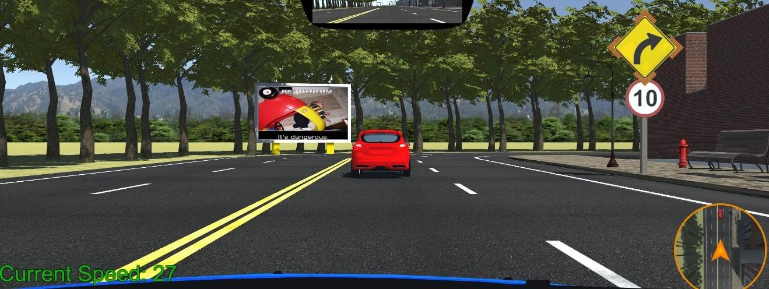
Figure 11. Scenario 6

Scenario 6, a car was moving ahead in the same lane. As mentioned above, participant-drivers were asked to follow yellow signs with flashing lights throughout the course. This yellow sign on the right alerts the participant-driver about the upcoming right turn along with a suggested speed limit sign. As the participant-driver proceeds, they come into contact with another collider and face the next scenario.
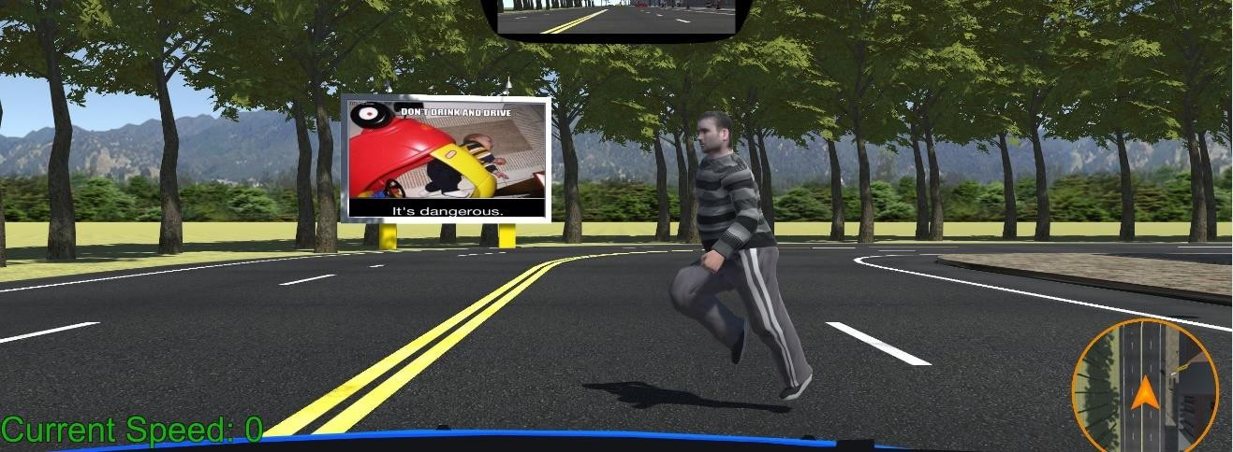
Figure 12. Scenario 7
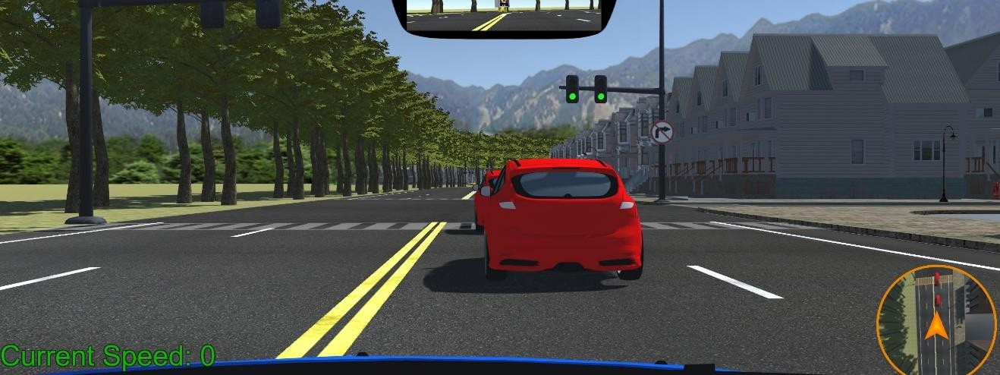
In scenario 7, a series of mistakes can lead the participant-driver to hit the jaywalker that appears to be running across the road. A collider was placed before the sixth scenario, which activates this jaywalker. If the participant-driver does not follow the speed limit and gets distracted by the billboard straight ahead, they might hit the jaywalker.

Figure 13. Scenario 8

Scenario 8 is the fourth intersection (three-way intersection). At this intersection, there are cars ahead of the participant-driver and a “no right turn” road sign. There are no potential threats at this intersection triggered by the driver.
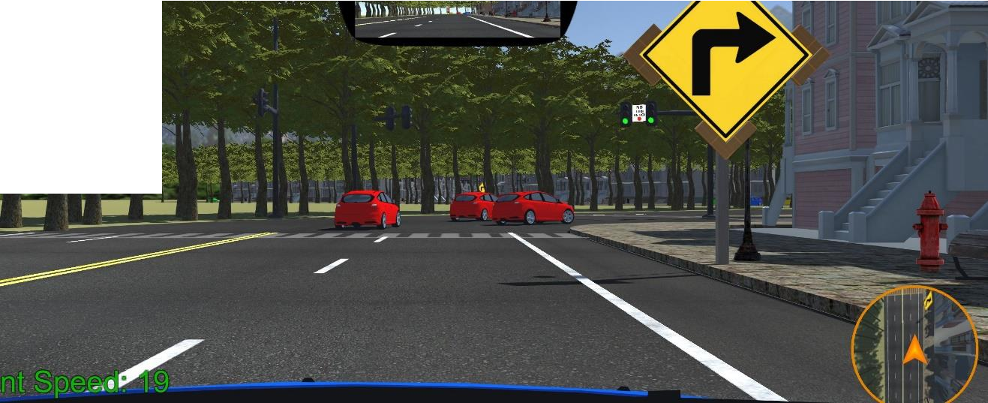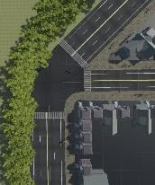
Figure 14. Scenario 9
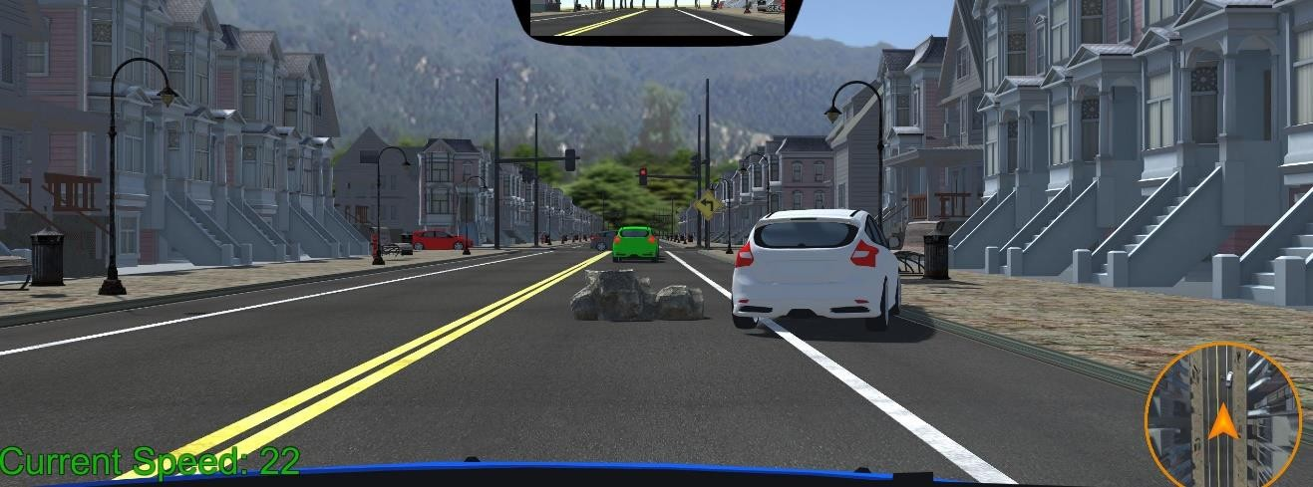
Scenario 9, at the fifth intersection (three-way intersection), there are cars going in two directions in front of the participant-drivers. The “right turn” yellow sign guides the drivers to take a sharp right at this “no turn on red” intersection. As soon as the driver proceeds the intersection, the light turns red. At this intersection, the road straight ahead takes a curve, therefore the cars appear to look like they are taking a right even though they are going straight. If the drivers, do not pay attention they might follow the cars ahead of them and miss the sharp right turn they are supposed to take.
Figure 15: Scenario 10

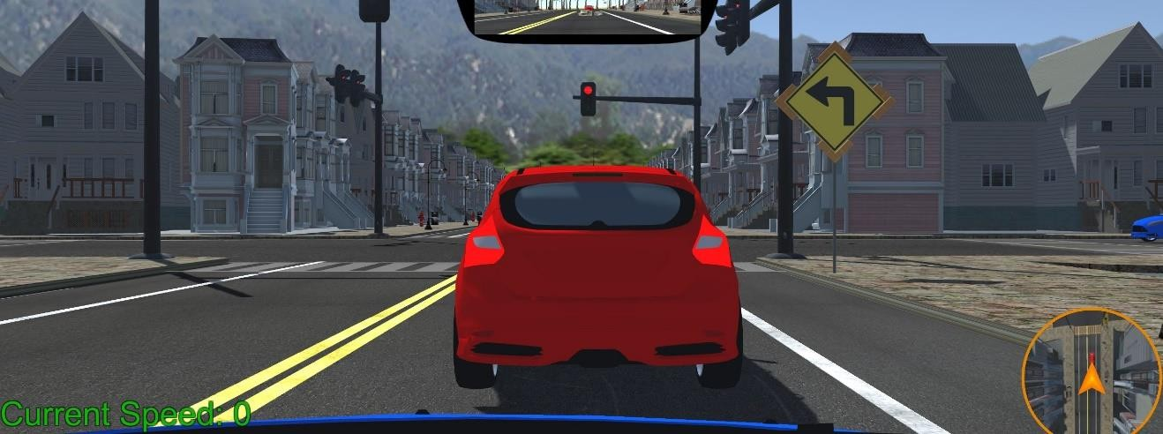
In scenario 10, there was a rock lying in the middle of the right lane. From a distance, the visibility of the rock was blocked by the car in front of the participant- driver. The car in front dodges the rock from the right by driving over the footpath to get around the rock. In this scenario, it was possible that the participant-driver will not see the rock in time if they follow the car in front too closely. Nonetheless, if they maintain an appropriate distance and notice the rock early enough, they have two options to avoid hitting it. They could either follow the car in front of them and drive over the footpath or they could look for oncoming vehicles in the left lane and proceed cautiously.
Figure 16. Scenario 11
In scenario 11, this is the sixth intersection (four-way intersection) and the left- turn yellow sign directs the participant-driver to turn left at this intersection. There was a car blocking the view of the road across the intersection from in front of the participant- driver, so the driver was unaware if there was a vehicle waiting for the green light on the other side of the intersection.

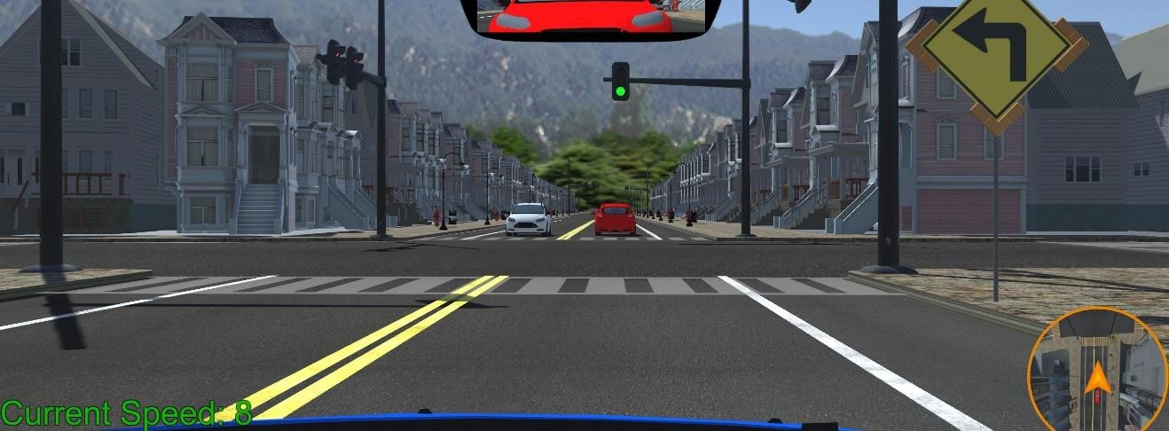
Figure 18. Scenario 12

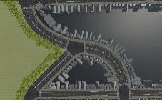
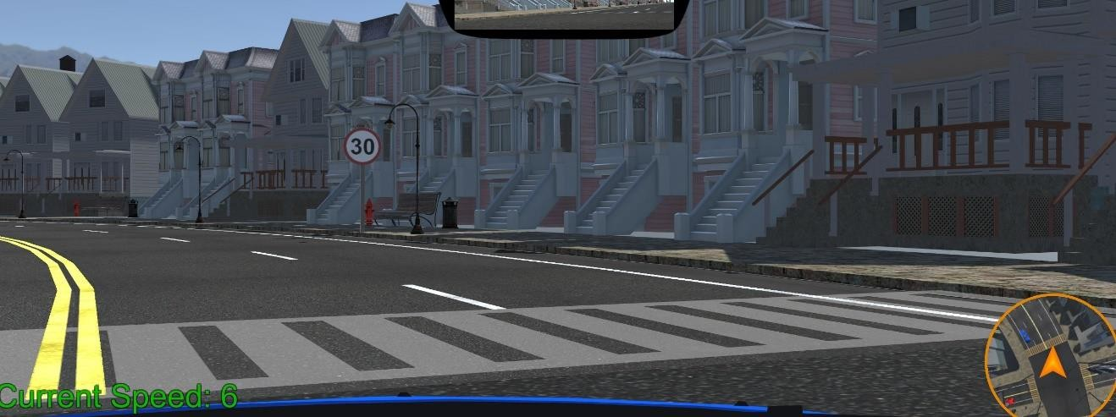
Scenario 12, being a four-way intersection, the sixth traffic light makes the participant-driver wait longer than the previous traffic lights. When it turns green, there was a car waiting on the other side. The car just stays there and does not move. It was up to the participant-driver if they want to yield to the other car to cross the intersection or move ahead without yielding to the other car.
Figure 17. Scenario 13

Scenario 13, as soon as the participant exits the sixth intersection, there was a speed limit sign on the road. Given that the last few scenarios would have slightly occupied the decision-making skill of the participants, this speed limit sign would be a useful tool to determine if the driver was still attentive enough to notice the sign after exiting the intersection and entering a turn.

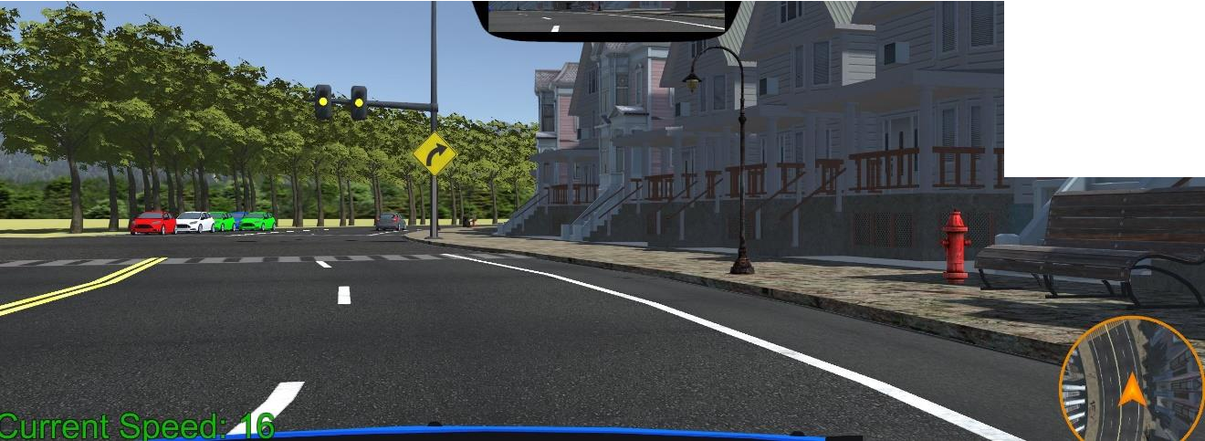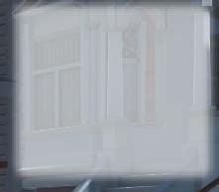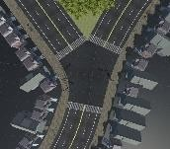
Figure 20. Scenario 14
Scenario 14, as soon as the participant-driver enters the seventh intersection (three-way non-symmetrical intersection), the traffic light transitions from yellow to red. This time, the yellow turn signal does not have a flashing light on it. There are cars on the opposite side waiting for the light to turn green and cars in the distance was driving away.

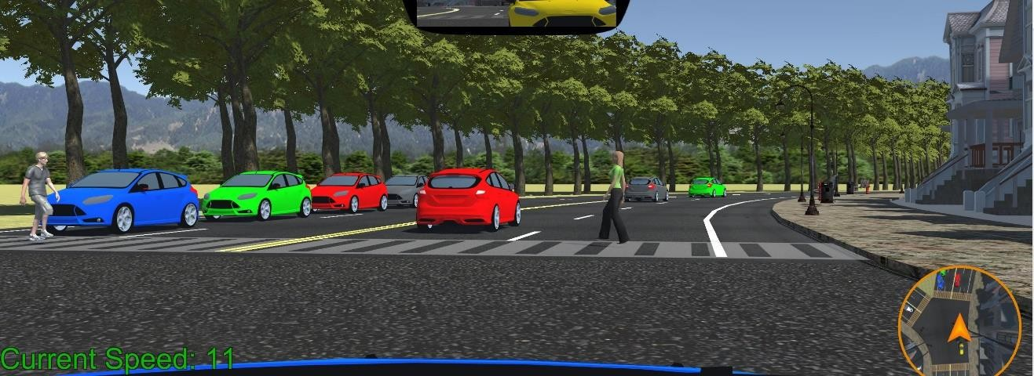
Figure 19. Scenario 15
In scenario 15, the light turns green, and the participants move ahead. Two pedestrians on both sides of the road are triggered by a collider placed at the previous crosswalk. There was a car behind the participant-driver yielding and a car ahead of the participant-driver driving away despite pedestrians crossing the road. This scenario will help us analyze the decision-making skills of the participant-drivers.

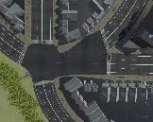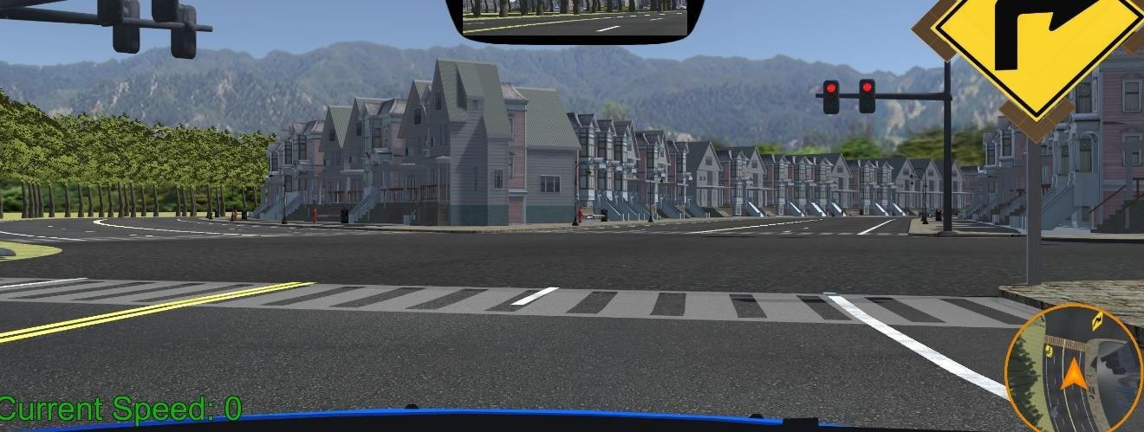
Figure 21. Scenario 16
Scenario 16: At the eighth intersection (five-way intersection), the yellow sign indicates the participant-driver to take a right. In accordance with traffic regulations, participants-drivers can turn right at the red light. They must, however, be attentive enough to stop for oncoming vehicles at such an intersection. As soon as the participant- driver moves closer to the traffic light at this intersection, cars from other lanes appear to pass through the intersection.
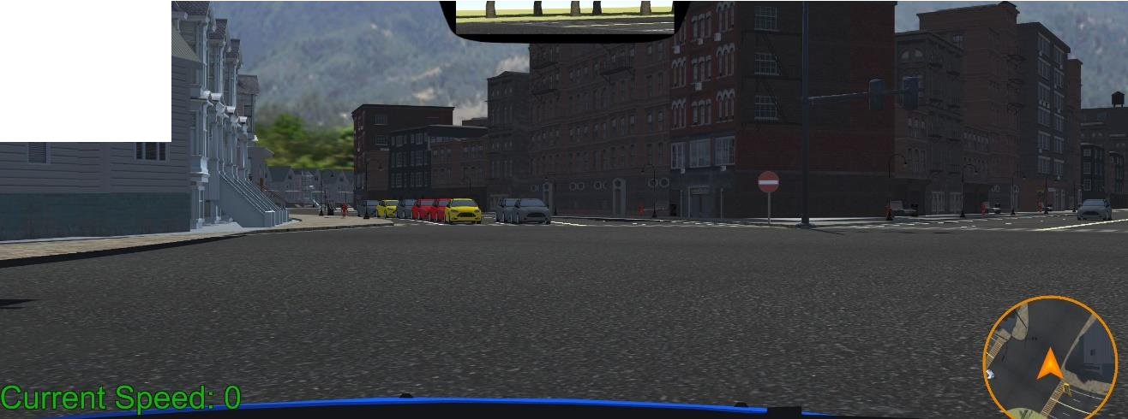

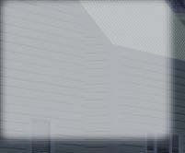
Figure 22. Scenario 17
In scenario 17, there are five corners that aren't symmetrical, and two adjoining lanes can cause confusion as to which lane the driver should take. However, if the participant driver was attentive enough, they will notice that one of the adjoining lanes

has a “do not enter” sign. There are cars in the green circle waiting for the light to turn green and a car in the red circle moving towards the intersection which could distract the participant-driver from noticing the “do not enter” sign.
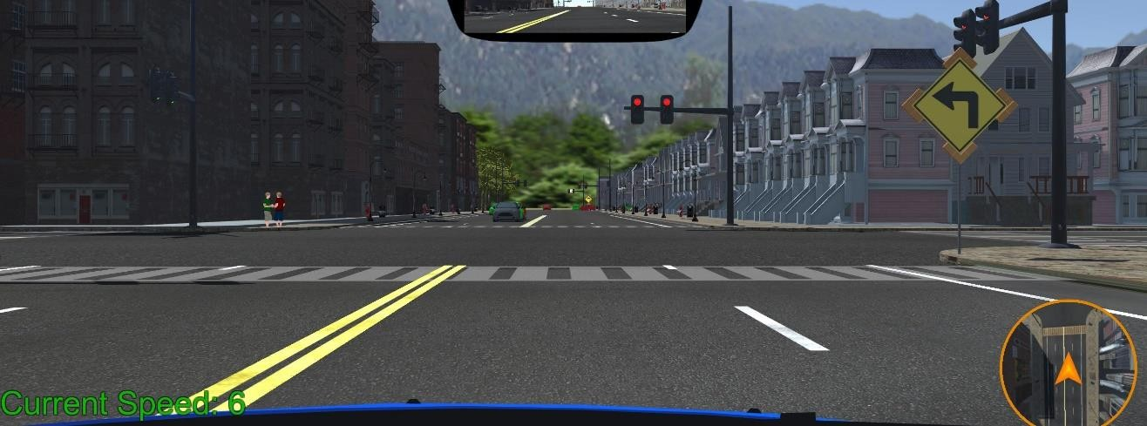
Figure 23. Scenario 18
In scenario 18, at the ninth intersection (four-way intersection), the yellow flashing sign instructs the driver to turn left. The traffic light was red and there are oncoming vehicles on the other side of the road. On the left side of the intersection, two pedestrians can be seen idling on the street.
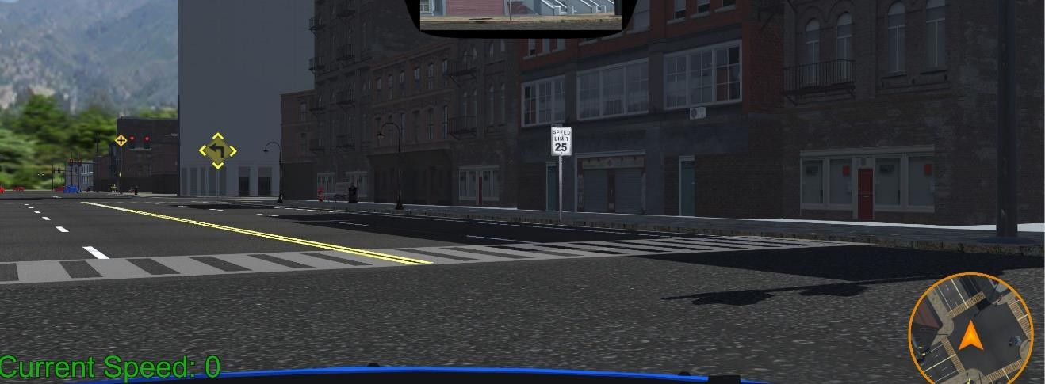
Figure 24. Scenario 19
In scenario 19, the participant-driver takes a left at the ninth intersection. The scenario was curated with a speed limit sign and a yellow flashing sign that instructs the

participant-driver to turn left at the next intersection. As the participant-driver was driving into the downtown area, the speed limit decreases, and the traffic lights tend to change quickly.
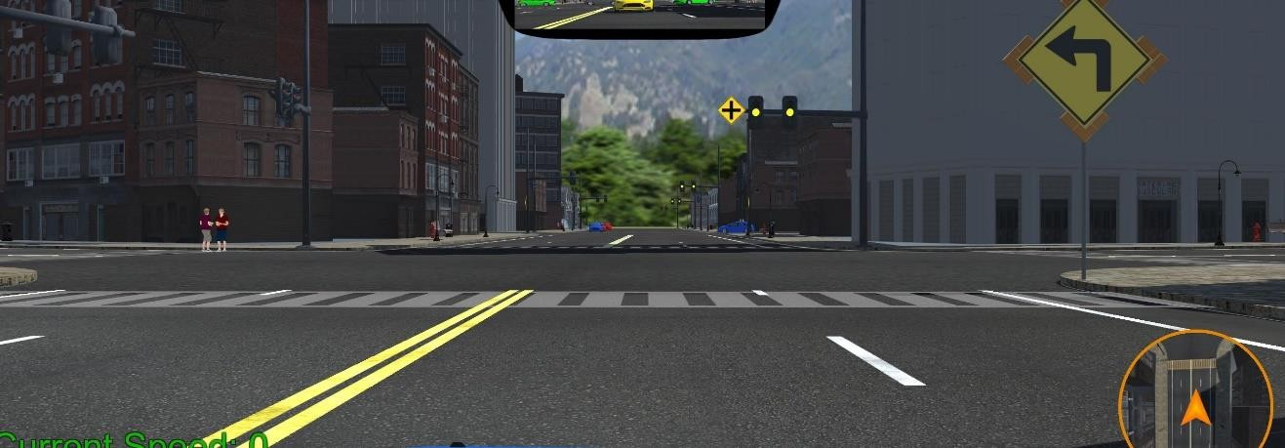
Figure 25. Scenario 20
Scenario 20, as soon as the participant-driver enters the tenth intersection (four- way intersection) the light turns yellow. The four-way intersection sign was posted throughout the downtown area.
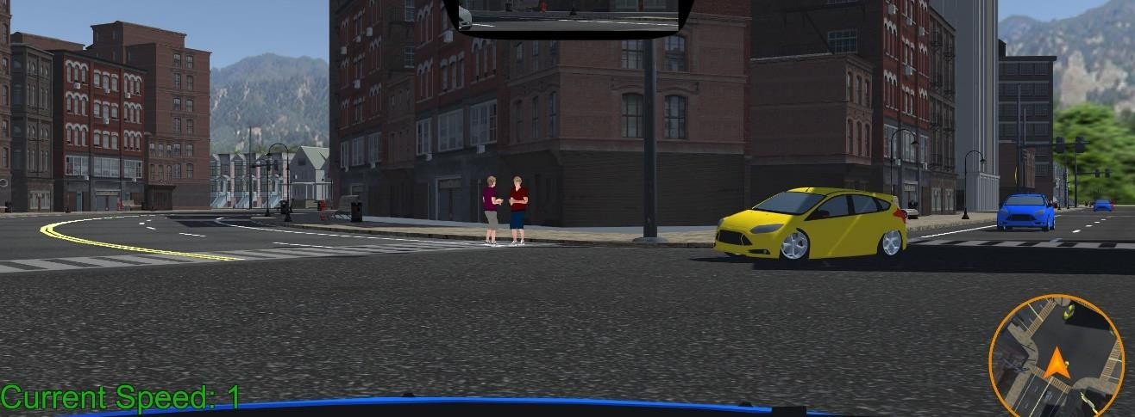
Figure 26. Scenario 21
Scenario 21, as soon as the light turns green at the tenth intersection, the participant driver moves ahead and there are cars on the opposite side that are driving in the same direction as the participant-driver. Two pedestrians are idling in the parking lane

of the road the participant-driver was about to enter. It was imperative for drivers to be cautious to avoid hitting each other.
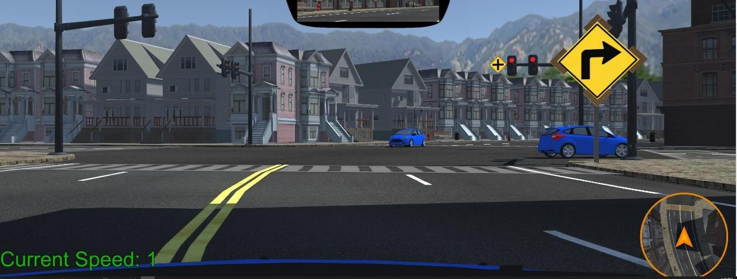
Figure 27. Scenario 22
Scenario 22 is the eleventh intersection (four-way intersection) and the flashing yellow sign at this intersection indicates the participant-driver to turn right. As the participant-driver approaches this intersection, the light was red. Even though it was legal to make a right turn after a complete stop, there are vehicles passing by. Therefore, the participant-driver must be cautious while taking a right turn as they are supposed to yield to the passing vehicle.
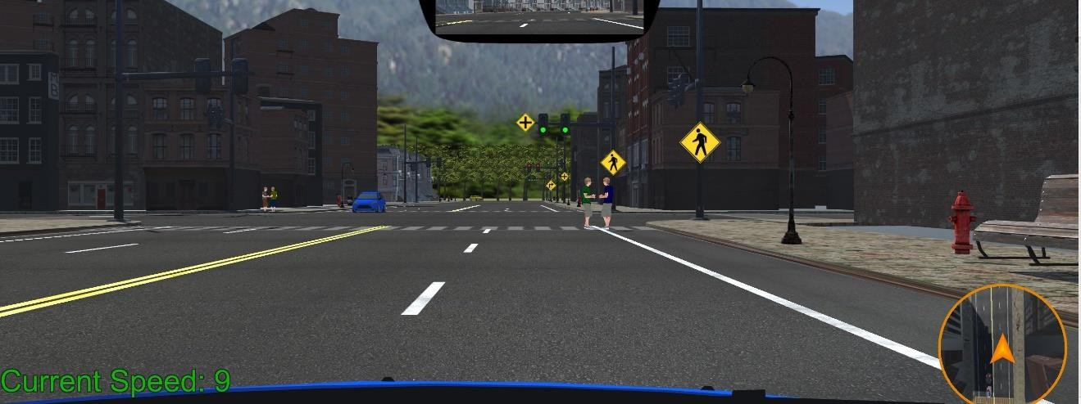
Figure 28. Scenario 23

Scenario 23, at this scenario there are signs that indicate that there are pedestrians all around this intersection. As soon as the participant-driver reaches the intersection the light turns red. There are two pedestrians idling on the road. In this scenario, it would be appropriate for the participant-driver to change lanes to the left in order to avoid any threats.
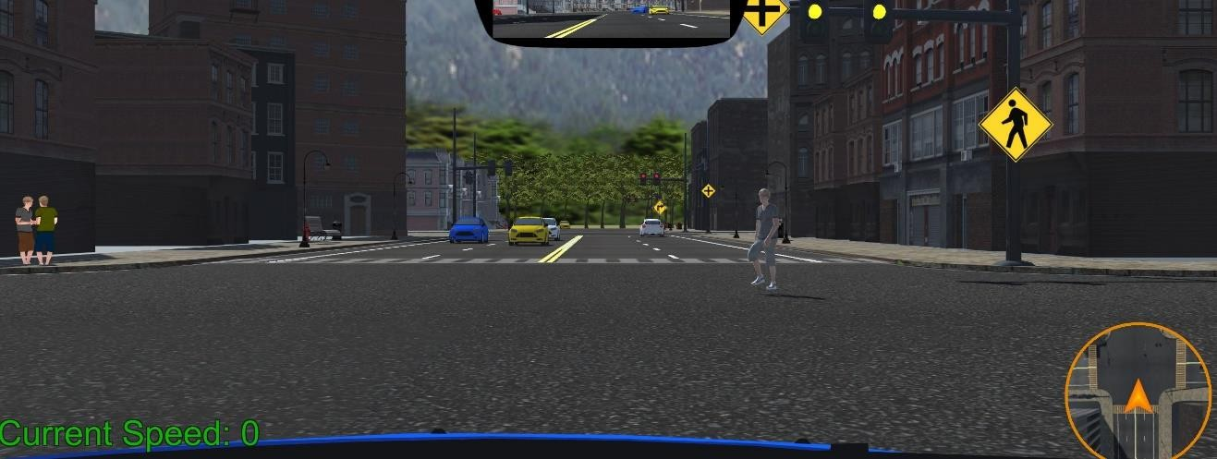
Figure 29. Scenario 24
Scenario 24, as soon as the participant-driver drives into the twelfth intersection, a jaywalker appears to cross the road diagonally. On the left side of the intersection, there are two pedestrians idling. Meanwhile the traffic light transitions from yellow to red. In the distance, cars are driving toward the intersection.
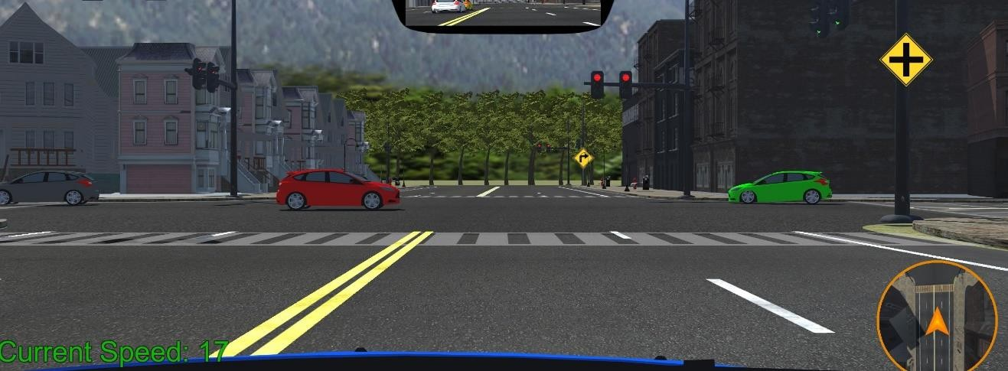
Figure 30. Scenario 25

In scenario 25, at the thirteenth intersection (four-way intersection), the light was red and there are cars passing by in front of the participant-driver. After crossing this intersection, the participant-drivers have to change to the right lane and hence have to be cautious of other passing cars.
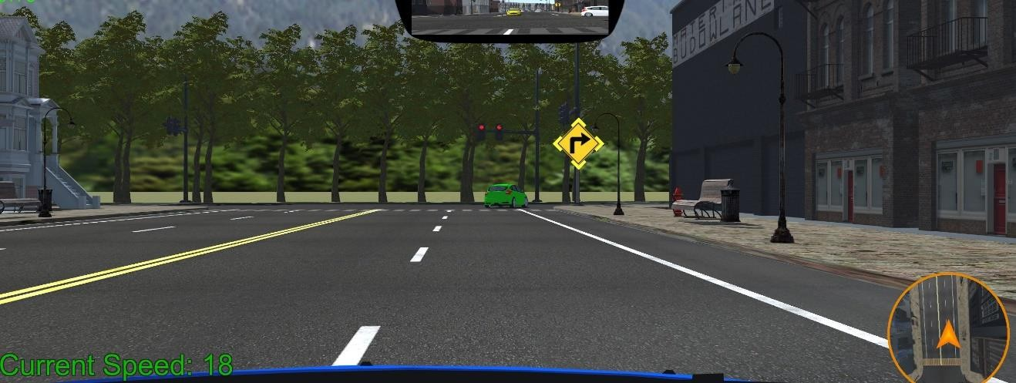
Figure 31. Scenario 26
In scenario 26, at the fourteenth intersection (three-way intersection) the yellow flashing sign indicates the participant-driver to take a right at the traffic light. The light was red, and the car in front of the participant-driver was turning right as a right turn at this intersection was legal.
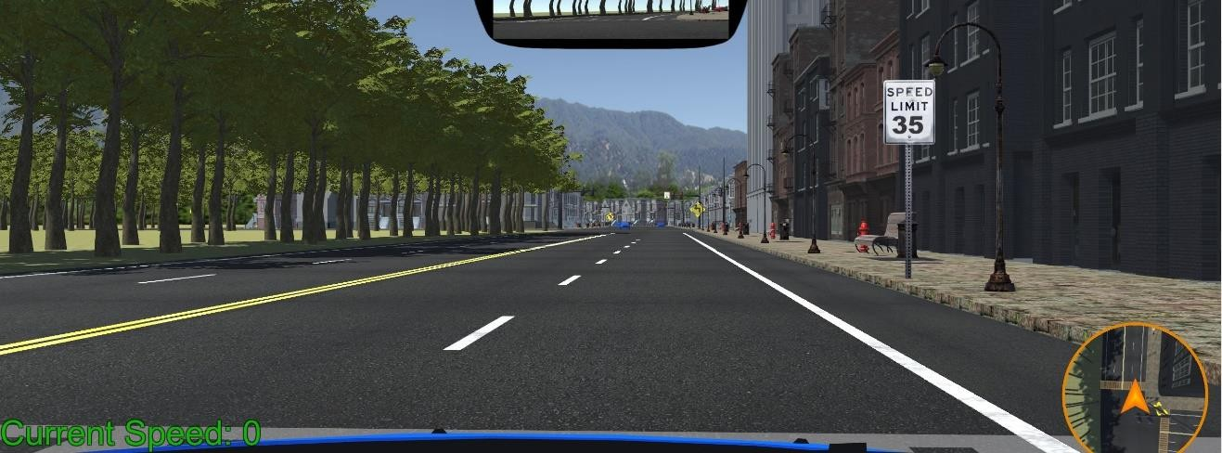
Figure 32. Scenario 27

Scenario 27, after taking a right at the fourteenth intersection, there was a speed limit sign. At this point in the course, the participant-driver transitions from downtown to a residential area. The speed limit was raised from 25 mph to 35 mph. A participant- driver's response to the speed limit sign will be determined by this.
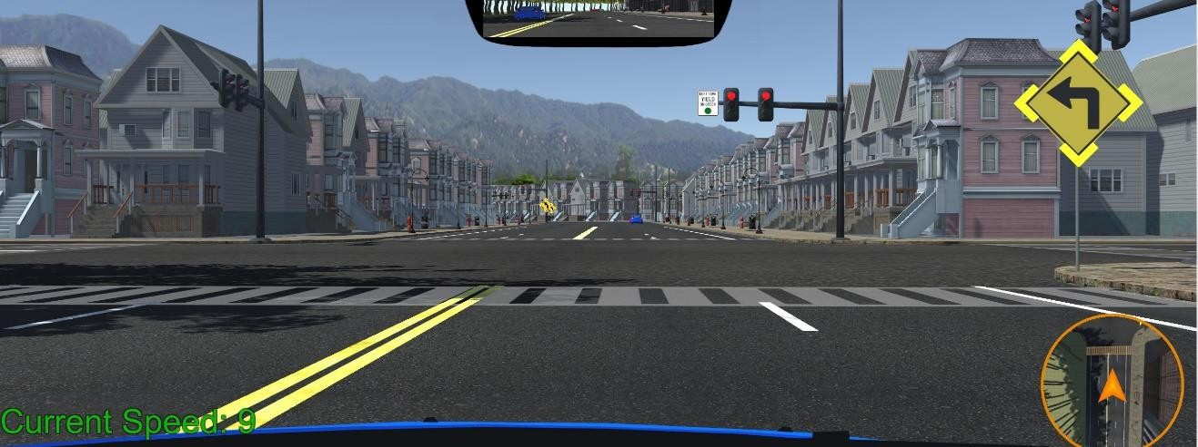
Figure 33. Scenario 28
In scenario 28, the participant-driver was at the fifteenth intersection (four-way intersection). The yellow flashing sign at this intersection indicates the participant-driver to turn left. There was a sign that says, “left turn yield on green.”
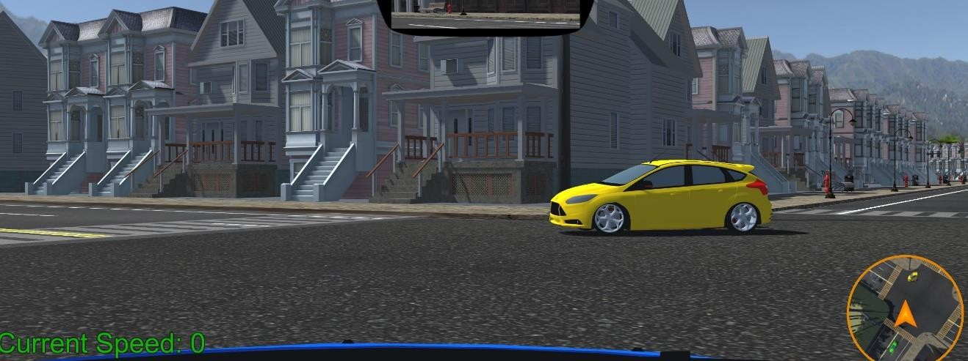
Figure 34. Scenario 29
In scenario 29, the light turns green at the fifteenth intersection, and as soon as the driver turns left a car appears to turn in the same direction the participant-driver was driving.

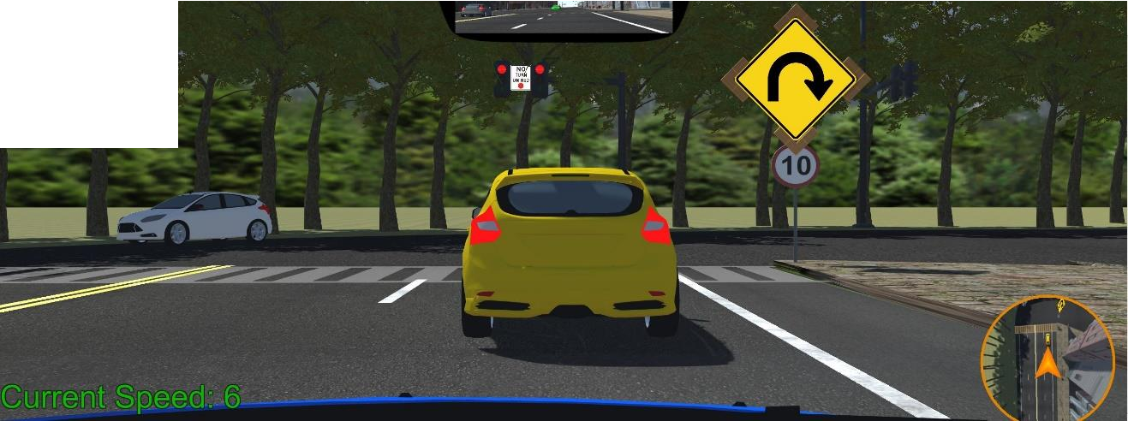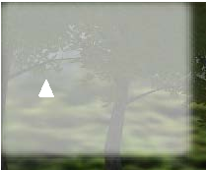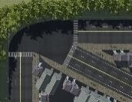

Figure 35. Scenario 30
Scenario 30 is the sixteenth intersection of the course (three-way intersection). This intersection has two adjacent right turns at 90 degrees and 120 degrees. The yellow flashing sign indicates the participant-driver to turn right at 120 degrees. There was a speed limit sign at this intersection. The traffic light at this intersection does not allow right turns on red. There was a car in front of the participant-driver waiting for the light to turn green. And a car was driving towards the previous intersection on the other side.
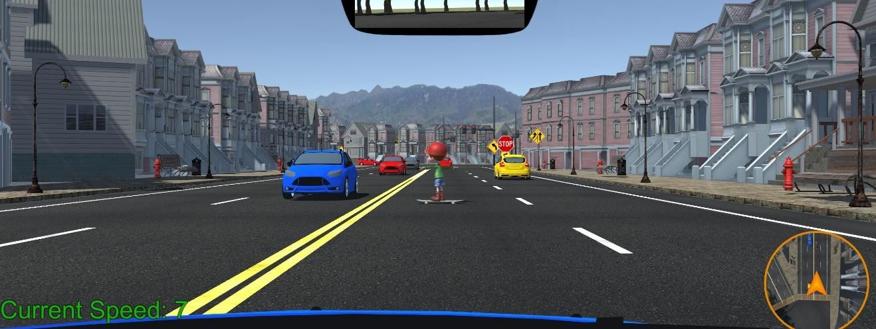
Figure 36. Scenario 31
Scenario 31: In this scenario, a kid appears in front of the participant-driver skating. There are oncoming cars in the left lane and the participant-driver must decide

either to yield or change the lane. There was a road sign on the right that warns the

participant-driver about the adjoining lanes ahead.
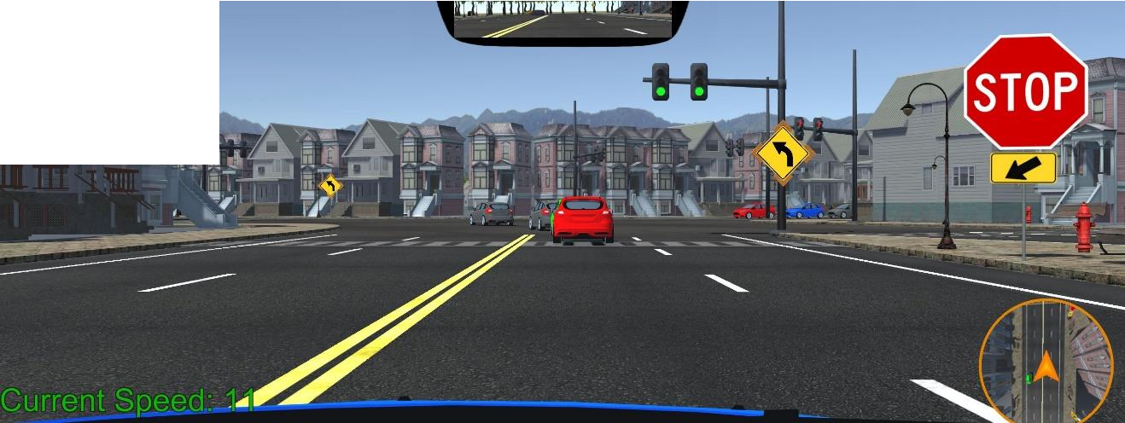

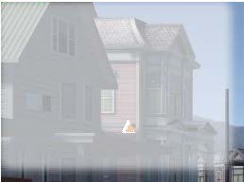
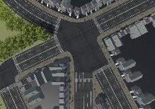
Figure 37. Scenario 32
In scenario 32, at the seventeenth intersection (five-way intersection), the flashing yellow sign indicates to turn left. There was a stop sign and a traffic light at this intersection. As the participant-driver approaches the intersection, the light turns red. At the stop sign, which precedes the traffic light, the participant-driver was supposed to stop. However, if the participant-driver misses the stop sign, and stops at the crosswalk, the traffic light will be blocked by the rear-view mirror. And at this point, the participant- driver would have no idea when the light turns green. This will be a helpful scenario, as it will help us analyze the decision-making skills of the participant-driver if they miss the stop sign.

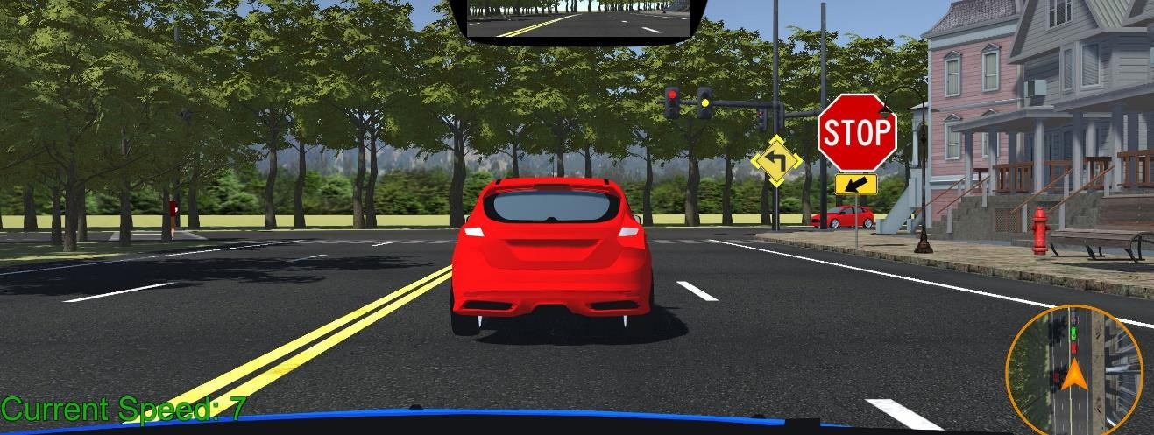

Figure 38. Scenario 33
Scenario 33, similar to the previous scenario, if the participant-driver does not stop at the stop sign, the traffic light at the eighteenth intersection will not be visible. At this intersection, there was a pedestrian idling on the left side of the intersection. There are cars in front of the participant-driver waiting for the light to turn green. The yellow
flashing signs indicate the participant-driver to turn left at this traffic light.
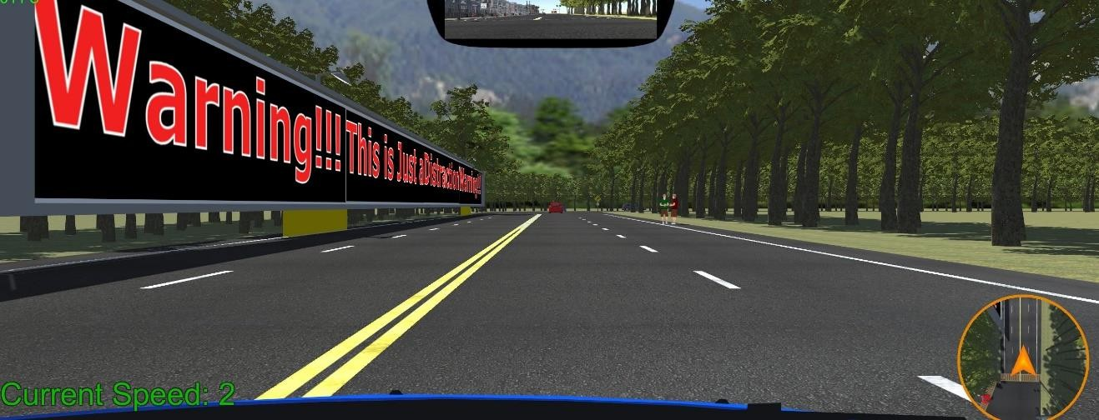

Figure 39. Scenario 34
Scenario 34. In this scenario, there was a long billboard that displays “Warning!!! This was just for distraction. Warning!!!”. On the left side, there are two pedestrians idling on the right side of the road. The participant-driver can see a car driving away in

the distance. Focusing on the billboards can be a threat in this scenario as there are

pedestrians.
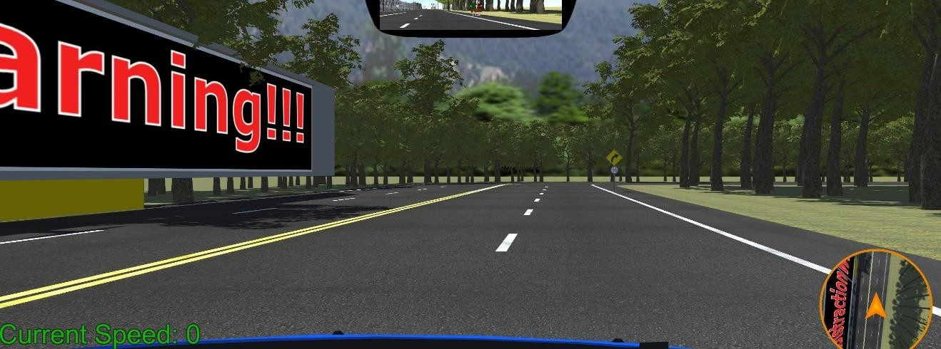
Figure 40. Scenario 35
In scenario 35, at the end of the billboard, there was a non-flashing yellow sign that warns the participant-driver that the road turns to the right with a speed limit sign. If the participant-driver was too distracted by the billboard, they might miss the sign and may not comply with the speed limit.
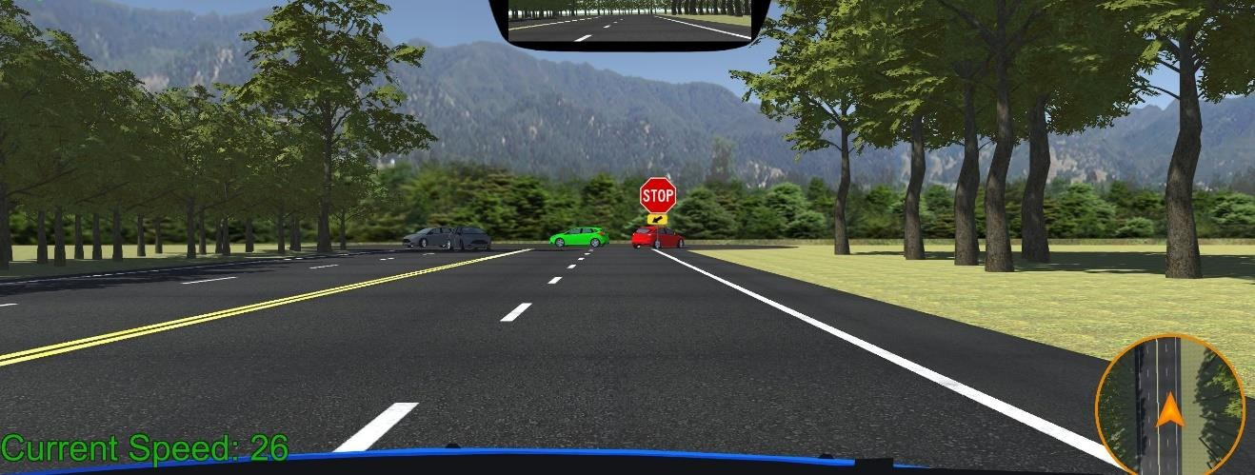
Figure 41. Scenario 36
In scenario 36, there are cars making a U-turn after stopping at the stop sign in front of the participant-driver. Once the participant driver reaches the stop sign, the course ends.

CHAPTER 5 RESULT
The table below summarizes the number of active distractions, passive distractions, road signs, and pedestrians in each scenario along with the traffic light column indicating “1” as present and “0” if there were no traffic light in that scenario.
Table 1. Table of Strategic points

Scenarios | Active Distraction | Passive Distraction | Traffic Light | Road Sign | Active Pedestrian | Total
1 | 1 0 |  | 1 | 1 | 0 | 3
2 | 2 | 1 | 0 | 1 1 |  | 5
3 | 1 1  1 0 |  | 1  1  1 | 0 0  0 0  0 0 |  | 3
4 |  |  |  |  |  | 2
5 | 2 | 1 |  |  |  | 4
6 | 1 1  1 1 |  | 0 1 0  0 0 1 |  |  | 3
7 |  |  |  |  |  | 3
8 | 1 | 0 | 1 | 1 0 |  | 3
9 | 2 | 0 1  2 1  1 1  1 1 |  | 2 | 0  0  0  0  0  0 | 5
10 | 1 |  |  | 1  1  1  1  1 |  | 5
11 | 0  1 |  |  |  |  | 3
12 |  |  |  |  |  | 4
13 | 0 0 0 |  |  |  |  | 1
14 | 1 1  1 1 |  | 1 |  |  | 4
15 |  |  | 0 0 |  | 2 | 4
16 | 0 0 |  | 1 | 1  1  1 | 0  0  0  0  0 | 2
17 | 1 | 2 | 0 |  |  | 4
18 | 1 1 |  | 1 |  |  | 4
19 | 0 0 0 |  |  | 2  2 |  | 2
20 | 2  2 | 1  1 | 1 |  |  | 6
21 |  |  | 0 0 0 |  |  | 3
22 | 2 | 0 1 2  2 1 3 |  |  | 0  0 | 5
23 | 1 |  |  |  |  | 7
24 | 3 1 1 |  |  | 2 | 1 | 8
25 | 3 0 1  1 0 1 |  |  | 2 | 0  0  0 | 6
26 |  |  |  | 1 |  | 3
27 | 0 0 0 |  |  | 1 |  | 1
28 | 0 0 |  | 1 | 2 0 |  | 3
29 | 1 0 0 0 0  1 1 1 2 0  2 0 0 1 1 |  |  |  |  | 1
30 |  |  |  |  |  | 5
31 |  |  |  |  |  | 4
32 | 1 1 |  | 1 3 |  | 0 | 6
33 | 1 | 2 | 1 | 2 0 |  | 6
34 | 1 2  0 1 |  | 0 0 0  0 1 0 |  |  | 3
35 |  |  |  |  |  | 2
36 | 2 | 0 0 1 0 |  |  |  | 3
Total | 41 | 26 | 22 | 41 | 6 | 136

In the table above, the active distraction column groups the vehicles that are going in each direction separately and counts them as one in each scenario. Passive distractions include stationary vehicles, idling pedestrians, rocks, and billboards. The passive distraction column groups non-moving vehicles in each area and counts them as one in each scenario. The passive distraction column also groups non-moving pedestrians idling in each area and counts them as one in each scenario. In total, there were 36 scenarios imposing 136 strategic points throughout the course. There were 41 active distractions, 26 passive distractions, 22 traffic lights, 41 road signs, and 6 active pedestrians.
Some of the scenarios were designed in a way that would generate a chain of reactions, such as scenarios 6 and 7. Participants-drivers were expected to divert their attention from the road straight ahead of them when the road ahead was not empty. However, this led us to our new findings. The participant-drivers when completely focused on the car in front of them while waiting at an intersection, drove along when the car in front started moving without visually confirming if the traffic lights were green. In busy scenarios, it was expected that the participant-driver’s visual span would be wider. Turns out, once driver notices a distraction in a distance, they tend to spend the majority of their focus on that distraction until they pass it. This made them less attentive to the distractions that suddenly appeared in such scenarios. It was also expected that the participant-drivers would be more cautious while turn on an intersection, however, it was found that their visual span reduced to the road in front of them.

Performance

The table below indicates the attentiveness of each participant-drivers to active distractions, passive distractions, traffic lights, road signs, and active pedestrians conclusive of all scenarios throughout their trial. The table was organized into five categories representing drivers' attentiveness in percentile order, as well as the average rate of their performance.
Table 2. Table of Performances

  Drivers | Active Distraction | Passive Distraction | Traffic Light | Road Signs | Active Pedestrian | Average
1 | 56% | 41% | 91% | 72% | 67% | 65%
2 | 35% | 23% | 87% | 59% | 17% | 44%
3 | 41% | 27% | 96% | 65% | 50% | 56%
4 | 59% | 40% | 91% | 73% | 50% | 63%
5 | 51% | 37% | 91% | 67% | 67% | 63%
6 | 29% | 26% | 87% | 53% | 17% | 42%
7 | 52% | 33% | 91% | 70% | 50% | 59%
8 | 66% | 47% | 96% | 93% | 67% | 74%
9 | 36% | 21% | 91% | 56% | 84% | 58%
10 | 54% | 43% | 96% | 72% | 50% | 63%
11 | 49% | 39% | 87% | 69% | 84% | 66%
12 | 27% | 19% | 87% | 44% | 17% | 39%
13 | 67% | 44% | 91% | 87% | 67% | 71%
14 | 59% | 46% | 96% | 81% | 50% | 66%
15 | 50% | 43% | 91% | 74% | 67% | 65%
16 | 50% | 44% | 87% | 70% | 50% | 60%
17 | 63% | 51% | 91% | 84% | 67% | 71%
18 | 31% | 27% | 87% | 66% | 17% | 46%
19 | 46% | 26% | 87% | 60% | 50% | 54%
20 | 51% | 38% | 91% | 71% | 50% | 60%
Average | 49% | 36% | 91% | 69% | 52% | 59%

The attentiveness of the driver is the measurement unit of the performance of each participant-driver which was calculated as:

Attentiveness =
Noticed Events
Total Events
× 100%

In the equation above, total number of events in each category where each driver gazed, fixated, or reacted to accounts for “noticed events” whereas total number of events in each category that exists accounts for “total events”. For example, there were 41 active distractions, and participant-driver - 1, gazed, fixated, or reacted to 23 of them.
Therefore, ²³ × 100% = 56% approximately.
41

Green color in the table represents the highest percentile, white represents the median, and red represents the lowest percentile in their respective columns. The average column represents the average performance of each driver conclusive of all five categories and the average row on the table represents the average performance conclusive of all drivers in each category.

Active and Passive Distractions

The participant-drivers were found to be less attentive to vehicles driving in the left lanes. The drivers seemed to focus more on active distractions, such as moving cars, compared to passive distractions such as non-moving vehicles, and idling pedestrians. Comparing the results, it was found that drivers are less likely to notice an idling pedestrian. This was especially the case when the driver was taking a turn or when there are other vehicles around. When the participant-driver was about to make a turn, it was observed that their main focus was on the edge of the road they were about to enter. The drivers did not even notice the speed limit signs when they were taking a turn.

Billboards
Both billboards were noticed by all the participant-drivers. In scenarios 6 and 7, many drivers were distracted by the billboard, which resulted in ignoring the speed limit sign. As the participant-driver was not complying with the speed

limit sign at the turn, they ended up hitting the running pedestrian. Similarly, the participant-drivers were distracted by the billboard in scenarios 34 and 35, leading them to ignore the idling pedestrian on the road.

Rock

There was a rock in scenario 10 which was counted as a passive distraction. The participant-driver had two options to dodge the rock. They could either stop, look for any on-coming vehicles and go around the rock from the left lane or they could go around the rock from the right side by driving over the footpath partially. It was found that when the participant-driver got too close to the car in front of them, the rock seemed to appear suddenly to the participant- driver, and hence they chose to follow the car in front which was programmed to drive over the footpath. However, when the participant-driver was driving under the speed limit, the car in front of them had already dodged the rock before the participant-driver could have noticed. In this case, the participant-driver chose to stop, look around, and then drive around the rock from the left lane.

Road Signs

Among 41 road signs, flashing signs seemed to work most effectively as the participant-drivers noticed them from a distance and changed lanes accordingly. There were "no-turn-on-red" signs at the fifth and sixteenth intersections and, aside from those two intersections, turning right on red after making a complete stop was legal. However, after passing the fifth intersection, 50% of the participant-drivers waited for the traffic lights to turn green before they made a right turn.

Traffic Lights

In the previous study, the roads in front of the drivers were mostly empty and it was concluded that drivers focused mostly on the road straight in front of them (Mauk, 2020). Therefore, in this study, cars were driving in front of the participant-drivers. The goal of having cars driving in front of the participant-driver was to see if there were any differences in the visual focus areas of drivers when the visual of the road straight ahead was blocked by another car. It was found that out of 20 participant-drivers we tested, 20% of drivers did not notice four traffic lights, 35% of drivers did not notice seven traffic lights, and 45% of drivers did not notice nine traffic lights. Especially where the traffic lights took longer to turn green, the participant-driver visual focus was mostly on the car in front of them. The participant-driver followed the car in front of them without even looking at the traffic light to confirm if it had really changed to green. Suppose the car in front chooses to jump a red light and the participant-drivers behind it follow the car assuming the light must have turned green because the car in front has started driving. It can be a potential threat to all the cars that pass that intersection.
Throughout the course, three traffic light turns yellow by the time the participant- driver reaches the intersection. It was found that all participants gazed at the traffic signals well before reaching the intersection. When they are about to enter the intersection, their focus was either on the road straight ahead or on the vehicle in front of them. At two intersections, the traffic light was placed too close to the crosswalk along with a stop sign with an arrow to indicate drivers to stop before the crosswalk, so if the participant-driver stops on the crosswalk, they would not be able to see the traffic light. Only 10% of participant-drivers obeyed the stop sign at those two intersections.

Active Pedestrians

There were 3 jaywalkers and 3 pedestrians on the entire course. As the table above indicates, only 7 of the participant-drivers were able to notice the active pedestrians early enough to yield and let them pass. Rest of the drivers either dodged and drove away following the vehicle in front of them or were too fast to even realize that they had hit a pedestrian.

Intersections

Only 50% of drivers appeared to yield to vehicles on the green. Participants- drivers seemed to struggle at intersections in scenarios 9, 14, 16, 30, and 32. The intersections in scenarios 9, 14, and 30 were asymmetrical intersections, and the intersections in scenarios 16, and 32 were five-way intersections. In scenario 9, the road straight ahead angles to 60 degrees from the intersection and the yellow sign with a flashing light prompted the participant-driver to take a sharp right turn at 90 degrees. At 60 degrees, the road also appeared to curve right at a distance. As a result, 30% of the participants missed the right turn at 90 degrees because they followed the cars in front of them. In scenario 14, the yellow sign at this intersection directed the participant-drivers to turn right. However, at this intersection, the yellow sign that directed the drivers did not have a flashing light on it this time. The participant-drivers were too late to notice the yellow sign and ended up in the wrong lane. In scenario 30, 20% of the drivers couldn't decide whether they had to turn right at 90 degrees or 120 degrees. In scenario 16, 50% of the drivers did not notice the “do not enter” sign and in scenario 32, the participant- drivers did not notice the “adjoining lanes ahead” sign as well as the “stop here” sign and

stopped beneath the traffic light. Because they couldn't see the traffic light anymore, they waited for a few seconds and assumed the lights should be green by now.

Familiarization vs non-Familiarization

Studies have claimed that drivers are more likely to be involved in accidents while driving on a familiar road. As mentioned earlier in this paper, participants were asked to drive the simulator for the second time. Other than the traffic around the participant-driver, all the scenarios were identical to those of the first trial.
We found that drivers were more at ease and comfortable while driving the second time. Most participants-drivers did not obey the speed limit signs in the first trial. However, in the second trial, the drivers were found to be speeding and making a smoother stop than before. The claims from previous studies seemed to be accurate as the attentiveness, and visual span of the participant-drivers was drastically reduced in comparison to their first trial. Their fixation on strategic points was too brief for a driver to react in case of an unprecedented situation. It was also found that the participant did not follow the car in front and made unsafe moves as much as they did in their first trial.

Discussion

To answer the third question from chapter 1.2, human drivers’ behaviors may not be the most appropriate ones to emulate for an autonomous vehicle, but they are essential. If only autonomous vehicles were allowed on the road, it would be a whole different scenario. All autonomous vehicles could interact with each other, and we would not even require traffic lights to coordinate traffic flow. However, it could still be a threat to pedestrians. One of the biggest challenges for autonomous vehicles is social interactions. Consider the gentle waves drivers give pedestrians as they cross the road. The human

brain is subjective and depicts the existence of a being in conjunction with others, whose identity reflects a dynamically engaged reality. Therefore, as of now, we are trying to build a vehicle that can safely drive on the road along with human-driven vehicles which would require enormous data on human behaviors to emulate an autonomous vehicle.

CHAPTER 6 CONCLUSIONS AND FUTURE WORK
In this work, we designed and developed a simulation to gather, in the form of heat maps and fixation maps, the visual focus areas of human drivers. This was done to examine their driving and gaze patterns. After analysis, we discovered several significant findings from which we have drawn conclusions and suggested some ideas for future work.

Conclusion

The results have shown that the drivers are more attentive in busy/occupying scenarios. It seems that they lack focus when they have to wait longer for the traffic lights or when there are no active distractions in the scene. Spending the vast majority of time focused on the empty road straight in front of the driver could be considered safer than spending their majority of time focusing on the car in front. It was seen that when there was a car in front of the participant-driver, the participant-driver’s partial view was blocked, and the driver was not as attentive to their environment. The participant-driver now spends the vast majority of their time gazing at the car in front especially when the traffic light takes longer to turn green. This could be a threat when the car in front decides to jump the light or make any unsafe move while the driver behind follows it without giving it a second thought. Participant-drivers lack both visual acuity and awareness when taking turns as their visual span shrinks. Human drivers become careless and inattentive while driving a familiar road. Whereas, assuming the self-driven car can trim the unnecessary data, and has the capability of higher computation speed, it would not let

down its guard and be attentive even if it had driven through the same area several times before.

Future Work

We have made an effort to make the map customizable along the way to make it convenient for future researchers who will contribute to our work. It is anticipated that future authors will have more time to strategize the map rather than build it from scratch. Added more strategic scenarios will help gather a diverse range of data. If recorded, the visual focus areas on the side two screens can produce valuable information. Human gestures made by pedestrians in the scenes can be an effective way of resolving social interaction problems. Also, introducing drivers to ethical dilemmas, such as driving in a scenario where driver is surrounded by traffic from all sides and bunch of boxes loaded in the truck in front of the participant-driver falls off the truck. The participant-driver does not have much time to react and has just four options. Hit the break and crash into the boxes in front, swerve right and crash into the motorcycle on the right lane, or swerve left and crash into a car on the left lane. Knowing how a human driver would react to such situations would be useful to train the models for autonomous vehicles.

APPENDIX A: STUDY MATERIALS

INFORMED CONSENT
Project: Drivers' Visual Focus Areas on Complex Road Networks in Strategic Circumstances: An Experimental Analysis
Department of Computer Science Information Systems Youngstown State University
Dear Participants,

The purpose of this experiment is to determine the attentiveness of a driver while driving through distractions on a complex road network. It uses a driving simulator that attempts to create a real- life driving experience for the participant. The objective of this study is to improve the decisiveness of an autonomous vehicle in such scenarios.

The participants will be seated on a driving simulator. The simulator is a set-up of three monitors with Logitech Driving Force Steering Wheels & Pedals. The simulator is also equipped with the Gazepoint eye tracking device, which allows the analytical monitoring of eye movements, eye positions, and points of gaze. Eye tracking can track a participant's visual attention in terms of time, place, and objects. With the help of the simulator, we will be able to track the visual attention of the participants while driving in the simulation.

This experiment will take about 30 minutes and there are no risks to the participants from the use of the eye trackers or the driving simulator.

All information will be handled in a strictly confidential manner, so that no one will be able to identify you when the results are recorded/reported.

Your participation in this study is voluntary. You may withdraw from sharing your information with the researchers at any time. Withdrawing from this study will have no negative consequences. If you wish to withdraw at any time during the study, simply call Dr. Sullins (330-941-1806) or email him (jrsullins@ysu.edu).

If you have questions about this research project, please contact Dr. Sullins, Associate Professor of Computer Science & Information Systems at Youngstown State University, at 330-941-1806. If you have questions about your rights as a participant in a research project, you may contact the Office of Research at YSU (330-941-2377) or YSUIRB@ysu.edu

I understand the study described above and have been given a copy of the description as outlined above. I agree to participate with my assent when possible.

Signature of the Participant Date

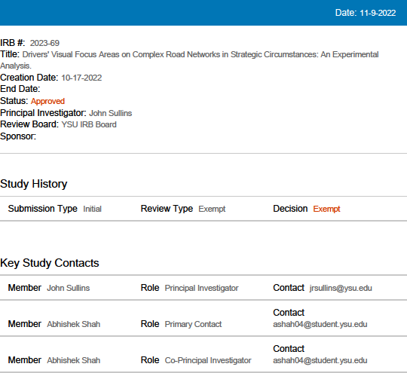

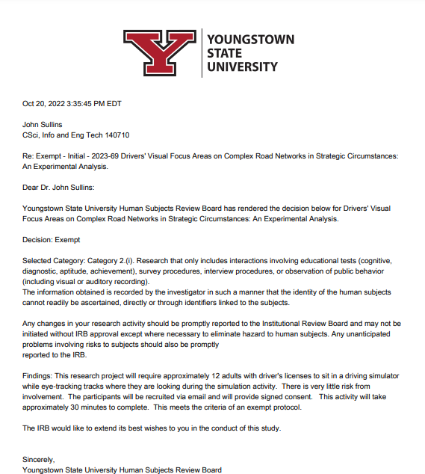

REFERENCES

Addressing the Autonomous Vehicle Data Problem. DXC Technology. (n.d.). Retrieved November 17, 2022, from https://dxc.com/us/en/insights/customer- stories/addressing-the-autonomous-vehicle-data- problem#:~:text=That%20data%20is%20analyzed%20for,underlies%20the%20veh icle's%20autonomous%20operations.

Applications & history of eye tracking technology. Gazepoint. (2022, May 6). Retrieved November 9, 2022, from https://www.gazept.com/eye-tracking/

Automated vehicles for safety. National Highway Traffic Safety Administration. (n.d.).

Retrieved November 9, 2022, from https://www.nhtsa.gov/technology- innovation/automated-vehicles-safety

Award-winning flight simulation chassis. Volair Sim. (n.d.). Retrieved November 9, 2022, from https://volairsim.com/

Centers for Disease Control and Prevention. (2022, April 26). Distracted driving. Centers for Disease Control and Prevention. Retrieved November 9, 2022, from https://www.cdc.gov/transportationsafety/distracted_driving/index.html

Craig, J., &amp; Nojoumian, M. (n.d.). Should self-driving cars mimic human driving behaviors? Retrieved November 28, 2022, from https://faculty.eng.fau.edu/nojoumian/Files/Publication/SDCMimicBeh.pdf

Eye tracking connects eye movement, attention and cognition. Tobii. (n.d.). Retrieved November 9, 2022, from https://www.tobii.com/solutions/scientific- research/psychology-and-neuroscience

EyeSee. (2017, December 27). Eye tracking through history. Medium. Retrieved November 18, 2022, from https://medium.com/@eyesee/eye-tracking-through- history-b2e5c7029443

The importance of driving simulators in car development. Barco. (n.d.). Retrieved November 17, 2022, from https://www.barco.com/en/news/2022-07-13-driving- simulators-in-car-development

Just how dangerous are external distractions while driving? Fishwick & Associates | FindLaw IM Template. (2022, January 6). Retrieved November 9, 2022, from https://www.fishwickandassociates.com/blog/2021/07/just-how-dangerous-are- external-distractions-while-driving/

Karthikeyan, S., Ngo, T., Eckstein, M., & Manjunath, B. S. (n.d.). Eye tracking assisted extraction of attentionally important objects from videos. Retrieved November 17, 2022, from https://openaccess.thecvf.com/content_cvpr_2015/papers/Vadivel_Eye_Tracking_ Assisted_2015_CVPR_paper.pdf

Kawashima, A., Kobayashi, K., & Watanabe, K. (2001). Implementation of human-like driving for Autonomous Vehicle. JSTOR. Retrieved from https://www.jstor.org/stable/44718358

Krishnamurthi, S. (2020, September 24). How autonomous vehicles mitigate distracted driving. Medium. Retrieved November 9, 2022, from https://medium.com/@recogni/how-autonomous-vehicles-mitigate-distracted- driving-bdc2fad66b8d

Liu, Z., Yuan, W., & Ma, Y. (2021, April 2). Drivers' attention strategies before eyes-off- road in different traffic scenarios: Adaptation and anticipation. International journal of environmental research and public health. Retrieved November 9, 2022, from https://www.ncbi.nlm.nih.gov/pmc/articles/PMC8038146/

Mauk, J. (2020, December 12). Eye Tracker Analysis of Driver Visual Focus Areas at Simulated Intersections. OhioLink. Retrieved January 9, 2021, from https://etd.ohiolink.edu/apexprod/rws_etd/send_file/send?accession=ysu160759011 9438536&disposition=inline

Milenkovic, D. (2022, August 13). 24 self-driving car statistics & facts. Carsurance.

Retrieved November 9, 2022, from https://carsurance.net/insights/self-driving-car- statistics/

National Highway Traffic Safety Administration. (n.d.). Distractions: In and out of the vehicle - NHTSA. National Highway Traffic Safety Administration. Retrieved November 9, 2022, from https://www.nhtsa.gov/sites/nhtsa.gov/files/documents/driverdistractions.pdf

Norloff, P., &amp; *, N. (2022, January 18). 3 real-life examples of eye tracking technology. Eyegaze. Retrieved November 25, 2022, from https://eyegaze.com/3- real-life-examples-of-eye-tracking-technology/

Pfeifer, M. & S. (2020, November 16). Do more accidents really happen closer to home?

Pfeifer Morgan Stesiak. Retrieved November 17, 2022, from https://www.pilawyers.com/blog/more-accidents-happen-close-to-home/

Plumer, B. (2016, April 21). 5 big challenges that self-driving cars still have to overcome. Vox. Retrieved November 17, 2022, from
https://www.vox.com/2016/4/21/11447838/self-driving-cars-challenges-obstacles

RECKLESS GAMES STUDIO. (n.d.). CiDy 2.0. RECKLESS GAMES STUDIO.

Retrieved November 9, 2022, from https://www.recklessgamesstudio.com/

U, J. (2016, July). The road to driverless cars: 1925 - 2025. Engineering.com. Retrieved November 18, 2022, from https://www.engineering.com/story/the-road-to- driverless-cars-1925---2025

SAE levels of Driving Automation™ refined for clarity and international audience. SAE International. (n.d.). Retrieved November 17, 2022, from https://www.sae.org/blog/sae-j3016-update

Schwarting, W., Pierson, A., Alonso-Mora, J., & Rus, D. (n.d.). Social behavior for autonomous vehicles | PNAS. PNAS. Retrieved November 17, 2022, from https://www.pnas.org/doi/10.1073/pnas.1820676116

Selimis, V. (n.d.). Eye-tracking technology in vehicles: Application and Design. EyeTracking Technology in Vehicles: Application and Design. Retrieved November 9, 2022, from https://openaccess.city.ac.uk/id/eprint/14802/1/Selimis%2C%20Vasileios%20%28 Redacted%29.pdf

Shwartz, S. (2021, November 17). Are self-driving cars really safer than human drivers? The Gradient. Retrieved November 9, 2022, from https://thegradient.pub/are-self- driving-cars-really-safer-than-human-drivers/

Stapel, J., El Hassnaoui, M., & Happee, R. (n.d.). Measuring Driver Perception: Combining Eye-Tracking and Automated Road Scene Perception. Retrieved November 9, 2022, from https://journals.sagepub.com/doi/full/10.1177/0018720820959958

Tobii Customer Portal. Tobii Connect. (n.d.). Retrieved November 17, 2022, from https://connect.tobii.com/s/article/types-of-eye-movements?language=en_US

Turn The Game On. (n.d.). Simple traffic system. Simple Traffic System. Retrieved November 9, 2022, from https://simpletrafficsystem.turnthegameon.com/

What is an autonomous car? – how self-driving cars work. Synopsys. (n.d.). Retrieved November 9, 2022, from https://www.synopsys.com/automotive/what-is- autonomous- car.html#:~:text=Ultrasonic%20sensors%20in%20the%20wheels,acceleration%2C
%20braking%2C%20and%20steering.

Woding, D. S. (n.d.). Fixation maps: Quantifying eye-movement traces - Carnegie Mellon University. Retrieved November 17, 2022, from https://cnbc.cmu.edu/~tai/readings/active_vision/wooding_fixation_map.pdf

