**DOMESTIC VIOLENCE ON CHILDREN AND ITS EFFECT ON ACADEMIC PERFORMANCE: A CASE STUDY OF EDO STATE**

# ABSTRACT

The main aim of the study is to find out the effects of domestic violence on performance of students in public secondary schools. The case study was conducted in Benin city of Edo State.

Chapter one entails the background of the study which has grounded out the negative effects of domestic violence generally in our society as a summary of literature review. The statement of the problem clearly states the research gap that is how domestic violence is negatively affecting performance, well defined purpose of the study research questions, delimitation and limitations of the study. Chapter two entails important findings briefly described from previous research studies. Chapter three presents the methodology used by the researcher which entails; research design, location of the study, target population, sampling techniques, research instruments, reliability and validity of the instruments.

The sample design used by the researcher is both qualitative and quantitative because the tools used are both numeric and non numeric where a sample of fifty secondary school students were drawn from the target public secondary school population in Benin city and six teachers from the teacher population from the two sample schools. The researcher used observation schedules, questionnaires and focus group discussion in gathering data.

# TABLE OF CONTENTS

**ABSTRACT** v

**CHAPTER ONE** 1

**INTRODUCTION** 1

1.0 Introduction 1

1.1 Background of the study 1

1.2 Statement of the Problem 3

1.3 Purpose of the Study 3

1.4 Objectives of the Study 3

1.5 Significance of the Study 4

1.6 Delimitation of the Study 4

1.7 The limitations of the Study 5

1.8 Organization of the Study 6

**CHAPTER TWO** 8

**LITERATURE REVIEW** 8

2.0 Introduction 8

2.1 Domestic Violence 8

2.2 Effects of Domestic Violence 10

2.3 Domestic Violence and School Drop Outs/ Truancy 12

2.4 Domestic Violence and Poor Academic Performance 13

2.5 Domestic Violence and Violent Behavior in Schools 14

2.6 Domestic Violence and Concentration 14

2.7 Recommendation 15

2.7.1 Helping Children and Adolescents Exposed to Domestic Violence 15

2.8 Conclusion 16

**CHAPTER THREE** 19

**RESEARCH METHODOLOGY** 19

3.0 Introduction 19

3.1 The Research Design 19

3.2 Targeted Population 19

3.3 Sampling Procedure 20

3.4 Data Collection Instruments 20

3.4.1 Validity of Research Instrument 21

3.4.2 Reliability of Research Instrument 21

3.5 Data Collection Procedure 21

3.6 Methods of Data Analysis 22

3.6.1 Coding of Data 22

3.6.2 Tabulation of Data 22

3.6.3 Interpretation of Data 22

3.6.4 Editing of Data 23

**CHAPTER FOUR** 24

**DATA ANALYSIS, PRESENTATION AND INTERPRATATION** 24

4.0 Introduction 24

4.1 Quantitative Analysis 24

4.1.1 Age of Respondents 24

4.1.2 Truancy and domestic violence 25

4.1.3 Domestic Violence and School Drop Out 26

4.1.4 Domestic Violence and Poor Concentration 26

4.1.5 Domestic Violence and Violent Behavior 27

4.1.6 Substance Abuse/ Alcoholism and Domestic Violence 29

4.1.7 Physical Abuse/Abuse on Property and Domestic Violence 29

4.1.8: Sexual/ Psychological Abuse and Domestic Violence 30

4.2 Qualitative Analysis 32

4.2.1 Truancy 32

4.2.2 School Drop-outs 32

4.2.3 Violence 32

4.2.4 Poor Concentration 33

4.2.5 Alcohol/ Substance Abuse 33

**CHAPTER FIVE** 34

**CONCLUSION SUMMARY OF FINDINGS AND RECOMMENDATIONS** 34

5.0 Introduction 34

5.1 Summary of Findings 34

5.2 Conclusions of the Study 34

5.3 Recommendations 35

5.4 Suggestions for Further Research 36

**REFERENCES** 37

**APPENDICES** 40

APPENDIX 1: QUESTIONNAIRE FOR STUDENT 40

APPENDIX II: TEACHERS QUESTIONNAIRE 43

APPENDIX III: RESEARCH WORK PLAN 46

**CHAPTER ONE**

**INTRODUCTION**

**1.1Background of the study**

Ganley (1989) states that domestic violence includes: physical violence, sexual violence, emotional abuse and abuse of property and pets. According to him, exposure to these forms of violence has considerable potential to be perceived as a threat to the lives of victims and can make them feel vulnerable, helpless and, in extreme cases, horrified. Dutton (1992) defines physical violence as any behavior that involves the intentional use of force against the body of another person and that may cause physical injury, injury and / or pain. This includes pushing, hitting, slapping, suffocating, using an object to hit, twisting a part of the body, forcing the ingestion of an unwanted substance and using a weapon. Dutton (1994) defines sexual abuse as any unwanted sexual intimacy imposed on an individual by another.

This may include oral stimulation or anal or vaginal penetration, forced nudity, forced exposure to material or explicit sexual activity. Compliance can be achieved by actual physical force or threat or other forms of coercion. Psychological abuse 2 may include derogatory statements or the threat of loss of life by another person. It can also involve isolation, economic threats and emotional abuse.

Straus and Gelles (1990), domestic violence is widespread and affects all social and economic groups. A national survey of more than 6,000 American families found that between 53% and 70% of violent men also abuse their children. Domestic violence is one of the least reported crimes in the United States, and the Department of Justice estimated in 1998 that there were between 960000 and four million domestic incidents each year.

In 1994, statistics from the justice office estimated that around 92% of domestic violence cases involved women. Wopadovi (women against domestic violence) 2014, domestic violence threatens many Nigerian families and, unfortunately, increases in our society. Many people, including the vast majority of women, have been injured, disabled and killed as a result of domestic violence. After recent events in which domestic violence has become commonplace and every day the death of spouses and lovers of domestic violence is reported, it has become a high priority to make domestic violence a threat that must be addressed. Face as soon as possible. All the seriousness that you deserve. Wopadovi also points out that domestic violence does not recognize the standards of class or social education. Domestic violence according to Wikipedia (2004) is a problem as in many parts of Africa. In Nigeria, there is a deep cultural belief that it is socially acceptable to beat a woman to discipline her spouse.

**1.2 Problem statement**

Although domestic violence has been recognized today as one of the most entrenched and widespread forms of violence in Nigeria, its influence on schoolchildren has not yet received the same level of attention (Tony, 2002). Child victims or witnesses of domestic violence may develop physical, psychological and behavioral problems as a result of physical, verbal, psychological and other forms of violence. This can affect their participation in school because they can go to school when they are too afraid to learn and many of them may fall behind in class or in life because of exposure to domestic violence (Wathen, 2003). The short- and long-term emotional and physical sequelae of domestic violence can affect school attendance, student achievement, and behavioral patterns of students in school and participation in the classroom. It is not known how the types and extent of domestic violence affect student achievement and school participation.

**1.3 Purpose of the study**

The purpose of this study is to examine the domestic violence on children and its effect on academic performance, using the Edo State as a case study. Specifically the study:

1. Establish the extent of various forms of domestic violence among households of different socio economic characteristics in Edo state.

2. Determine the influence of domestic violence on pupil’s school attendance in primary schools in Edo state.

3. Determine the influence of domestic violence on academic performance of pupils in primary schools in Edo state.

**Significance of the study**

Policy makers, school administrators and teachers in the education sector can use the findings of this study to formulate strategies for implementing PFH that promote the participation of children from vulnerable families in violence. Local government and social workers, as well as non-governmental organizations (NGOs), can use these findings to identify these abused families and children, develop strategies to combat domestic violence, and encourage socially inclusive intervention mechanisms. in poor neighborhoods The study can also benefit the legal or legislative framework by providing the necessary information to incorporate the laws of protection against domestic violence and school participation, the basic rights of education and regulations. The findings can also contribute to the national debate on domestic violence and its control, as well as ideas for future research on the causes, impacts and relationships of domestic violence with other elements of social and economic well-being. the society.

**Study hypothesis**

The study hypotheses are:

Ho1 There is no significant difference in the extent of various forms of domestic violence among households of different socio-economic characteristics in Edo state.

Ho2 Domestic violence does not significantly influence pupils’ school attendance in primary schools in Edo state.

Ho3 Domestic violence does not significantly influence pupils’ academic performance in primary schools in Edo state.

**Scope and Limitations of the Study**

The study scope is limited to investigating the impact of domestic violence on children and its effect on academic performance of primary school pupils in Edo state. Limitation faced by the research was limited time and financial constraint

**Definition of Basic terminologies**

Academic performance – It was the mean score in examinations of a pupil in the past one year in examinations given within the municipality.

Attendance – This referred to the number of times a pupil was present during learning activities in school in one term.

Child abuse – This consists of anything, which individuals, institutions or processes do or fail to do which directly or indirectly harms children or damages their prospects of safe and healthy development into adulthood.

Child labour – This is any form of economic exploitation in which the child is involved or performance of any work that is likely to be hazardous or interfere with the child’s physical, mental, spiritual, moral or social development

**Organisation of study**

The study is grouped into five chapters. This chapter being the first gives an introduction to the study. Chapter two gives a review of the related literature. Chapter three presents the research methodology; chapter four presents the data analysis as well as interpretation and discussion of the results. Chapter five gives a summary of findings and recommendations.

**CHAPTER TWO**

# LITERATURE REVIEW

# 2.0 Introduction

This chapter entails the effects of domestic violence on students in general over time. It shows what various authors have noted or realized from the definition and background of domestic violence to its relations to school drop outs, violence, truancy and concentration which all contribute to poor academic performance of high school students.

# 2.1 Domestic Violence

In the past two decades there has been growing recognition of the prevalence of domestic violence in the society. Moreover, it has become apparent that some individuals are at a greater risk for victimization than others.

Domestic violence has adverse effect on individuals, families and society in general.

Ganley (1989) states that Domestic violence includes: physical abuse, sexual abuse, psychological abuse and abuse to property and pets. According to him, exposure to these forms of violence has considerable potential to be perceived as life threatening by those victimized and can leave them with a sense of vulnerability, helplessness and in extreme cases horror.

Dutton (1992) defines Physical abuse as any behavior that involves the intentional use of force against the body of another person that risks physical injury, harm and or pain. It includes pushing, hitting, slapping, choking, using an object to hit, twisting of a body part, forcing the ingestion of an unwanted substance and use of a weapon.

Dutton (1994) defines sexual abuse as any unwanted sexual intimacy forced on ne individual by another. It may include oral anal or vaginal stimulation or penetration, forced nudity, forced exposure to sexual explicit material or activity. Compliance may be obtained through actual or threatened physical force or through some other form of coercion. Psychological abuse may include derogatory statements or threat of being killed by another individual. It may also involve isolation, economic threats and emotional abuse.

Straus and Gelles (1990) domestic violence is widespread and occurs among all social economic groups. in a national survey of over 6000 American families it was estimated that between 53% and 70% of male batterers also frequently abuse their children. Other research by CWP, (1995) suggests that women who have been hit by their husbands are twice as likely as other women to abuse a child. Over three million children at a risk of exposure to parental violence each year observes Carlson (1984).

Mackay (1994) notes that children from homes where domestic violence occurs are physically or sexually abused and/or seriously neglected at a rate 15 times the national average Regier and Cowdry (1995) estimated that 1 in 5 female children and 1 in 10 male children may experience sexual molestation. According to statistics from (2012) governors’ commission, roughly 50% of homicides and 92% of murders- suicides in New Hampshire are domestic violence related.

Domestic violence is a pattern that usually builds in intensity without intervention according to Representative Shannon Chandley, an Amherst democrat.

Children regardless of race or social class are victimized at a higher rate than adults according to the U.S. department of justice. Some children in that country also witness violence on a daily basis which can have long term psychological consequences.

Gabby Gifford (2014) is urging congregational actions on domestic violence and calls for legislation including steps like denying people facing restraining orders on domestic violence the right to possess guns.

Margaret Thomas (1992) a health master’s student in Auckland University observes that workers who are harassed stalked and subjected to violence by abusive partners bring that trauma to work with them costing industry hundreds of millions of dollars in lost productivity. Over half of the more than 1600 public service association union members surveyed reported some experience with family violence. Of 26% more than half needed to take time off work and 38% said violence made it difficult for them to get into work.

David Finkelher (2004) director of crimes against children research center at the University of New Hampshire notes that more violence occurs during economic down turns.

# 2.2 Effects of Domestic Violence

According to community overcoming relationship abuse CORA (2014) children and teen are often hidden victims of domestic violence/abuse. When exposed to a parent who is abusive, children and teens often witness domestic violence/abuse, get hurt accidentally or become direct victims of abuse. The effects of exposure to domestic violence abuse can be as damaging to children and teens as the damage that an abusive person inflicts on his/her partner.

The good news is that children and teens are resilient.

They are strong and able to heal if they are listened to, nurtured and allowed to feel safe. Three to 10 million children witness domestic violence/abuse. The extent of the risk and trauma of witnessing domestic violence/abuse depends on the age of the child and the severity length and frequency of the abuse. Children as young as 1 and 2 years and teens exposed to an abusive parent often feel afraid, helpless, guilty, angry, frustrated, isolated and confused.

As the incidents of interpersonal violence grows in our society so does the need for investigation of the cognitive, emotional and behavioral consequences produced from exposure to domestic violence especially in children and teens. Traumatic stress is produced by exposure to events that are so extreme or severe and threatening that they demand extra ordinary coping efforts. Such events are often unpredictable and uncontrollable. They overwhelm a person’s sense of safety and security.

A traumatic event can seriously interrupt the school routine and the processes of teaching and learning. There are usually high levels of emotional upset, potential for disruptive behavior, or loss of student attendance unless efforts are made to reach out to students and staff with additional information and services. Students traumatized by exposure to violence have been shown to have lower grade point averages, more negative remarks in their cumulative records, and more reported absences from school than other students. They may have increased difficulties concentrating and learning at school and may engage in unusually reckless or aggressive behavior

# 2.3 Domestic Violence and School Drop Outs/ Truancy

According to Rosenberg, M.S. and Rossman, B.B. (1990), it is estimated that more than 3.3 million children are exposed to physical and verbal spousal abuse each year. Exposure means hearing or seeing the actual abuse or dealing with the aftermath of the abuse.

McKay M. (1994) notes, when describing the effects of domestic violence on children it is important to note that domestic violence and child abuse are often present in the same family which leads to psychological trauma in children. In homes where domestic violence occurs, children are physically affected and neglected at a rate 15 times higher than national average. Several studies have shown that 60% to 70% of families in which a woman is battered, children are also battered.

According to Graham Berman (1994), more than half of the school aged children in domestic violence shelters show clinical levels of anxiety or post-traumatic stress disorder without treatment, these children are significance of risks for delinquency, school dropouts and difficulties in their own relationships. Children may become withdrawn, non-verbal and exhibit regression behavior such as clinging and whining, eating and sleeping difficulties, concentration problems. Unlike young children, the pre-adolescence child typically have greater ability to externalize negative emotions (i.e. to verbalize) in addition to symptoms commonly seen with childhood anxiety; victims within this age group may show a loss of interest in school, low self esteem/ concept, avoidance of peer relations and opposition defiant behavior in school setting

# 2.4 Domestic Violence and Poor Academic Performance

According to Talera centre (1988) the effects of witnessing violence at home vary tremendously from one child to another. The attributes that give a child the greatest chance of surfing unscathed are average or above average intellectual development with good attention and

interpersonal skills.

According to www.treatment-centre.net, children exposed to domestic violence not only have more disciplinary problems at school also they perform considerably worse in math and reading than other students. They also have negative effects on their classroom peers, resulting to decreased test scores and increased disciplinary problems according to a new study by economists Scott carrel of university of California-devised mark Hoekstra of the University of Pittsburgh (1998).

Exposure to violence has been associated with problems in children’s cognitive process and poor academic functioning. Researchers have linked exposure to chronic abuse and violence with lower scores, poorer language skills, decrement in visual-motor integrations skills and problems with attention memory. Cognitive problems associated exposure to violence and abuse comprise one of the most direct trends to the development task of school adaptation and academic achievements.

Deficits in attention regulation, language skills and memory undermine the child’s ability to accomplish the central requirements of academic achievements and school adaptation, namely to encode, organize, recall and express understanding of new information

# 2.5 Domestic Violence and Violent Behavior in Schools

Calvert, G (1993) states that, Children often imitate behaviors they witness. Generationally transfer of violent behaviors and emotional dependency on another is common, thus children learn that violence is an acceptable behavior and an integral part of an intimate relationship. Children may become abusive adults or domineering and controlling in relationships and may perceive violence as normal part of intimate relationship. Children raised in an abusive environment do not understand this is a problem between adults. They learn that family violence is acceptable and it is okay to be loved and hurt at the same time.

They believe in what they see and they expose the same to their peers as a sign of defense mechanism. According to the standard Monday February 13 2012, a woman splashed her husband with boiled water as the children watched. Mjuchiri reported to the journalist that he arrived home from work and went to bed ‘’I fell asleep and was woken up by some exculpating pain all over the body’’ he also said that when he woke up he discovered that the bed was soaked with hot water while one of his three children were in the bedroom which also serves as the kitchen,

# 2.6 Domestic Violence and Concentration

The effects of witnessing or experiencing violence at home vary from one child to another. According to Florida P.A (2001), children may experience a wide range of emotions some of which may be new and therefore doubly distressing. Students are thus insecure and afraid of the future. Children may experience a sense of insecurity and make them fear the future. Fear of being beaten up and abandoned, imaginable trauma are common traits that are perceived by a victim. Witnessing a parent being abused affects the children fearing they may be next.

Royal (1990) insists that Rejected children perceive themselves as the centre of the universe and therefore everything that happens must have something to do with them. They feel dejected and unloved by the parents who fight them or leave them. At fault children may feel a sense of guilt and shame because they believe they caused divorce of their parents or violence between them by something they said or did. He further says that Children emotionally develop on parents, caregiver bonding and nurturing. When a divorce or violence occurs a child experiences a grief reaction towards the loss. Waller Stern and Kelly (1975) noted that the children aged 4-5 years react with irritability, crying, bedtime anxiety and regression fearful behavior. They express sadness felt and wish to bring the parents together.

# 2.7 Recommendation

### 2.7.1 Helping Children and Adolescents Exposed to Domestic Violence

According to Blanchard, A., Molloy, F. and Brown, L. (1992), For some children and adolescents, questions about home life may be difficult to answer, especially if the individual has been "warned" or threatened by a family member to refrain from "talking to strangers" about events that have taken place in the family. Referrals to the appropriate school personnel could be the first step in assisting the child or teen in need of support. When there is suggestion of domestic violence with a student, consider involving the school psychologist, social worker, guidance counselor and/or a school administrator (when indicated). Although the circumstances surrounding each case may vary, suspicion of child abuse is required to be reported to the local child protection agency by teachers and other school personnel. In some cases, a contact with the local police department may also be necessary. When in doubt, consult with school team members. If the child expresses a desire to talk, provide them with an opportunity to express their thoughts and feelings. In addition to talking, they may be also encouraged to write in a journal, draw, or paint; these are all viable means for facilitating expression in younger children. Adolescents are typically more abstract in their thinking and generally have better developed verbal abilities than younger children. It could be helpful for adults who work with teenagers to encourage them to talk about their concerns without insisting on this expression. Listening in a warm, non-judgmental, and genuine manner is often comforting for victims and may be an important first step in their seeking further support. When appropriate, individual and/or group counseling should be considered at school if the individual is amenable. Referrals for counseling (e.g., family counseling) outside of the school should be made to the family as well. Providing a list of names and phone numbers to contact in case of a serious crisis can be helpful.

# 2.8 Conclusion

The US departments of justice (2014) observes that despite all the national headlines about school shootings and other violence, life has actually gotten a lot after for American children according to a new study. Instances in which children were the victims of crimes such as assault or violence such as bullying have declined significantly according to the study which appears in the most recent edition of the JAMA Pediatrics. Researchers compared rates of 50 different types of violence and crimes over time. Of those categories, 27 saw significant declines between 2003 and 2011.

Governor Maggie Hassan (2014) will soon sign legislation to designate the crime of domestic violence named Joshua’s law in honor of a boy killed by his father at a Manchester YMCA last year (2003) after the bill received unanimous support in the senate, passed on 1st may 2014. She continues that although they will never be able to relieve the pain caused by the tragic murder of Joshua Savyon, that the bill in his memory will help countless families and communities. The bill according to her does not create new crimes but instead organizes existing crimes that occur between family members or intimate partners under the new domestic violence category. Under current law for example, someone who beats up his/her spouse would likely be charged with simple assault and the same applies to someone who beats up strangers in a bar. Supporters of the bill aid that labeling these crimes as domestic violence will better help law enforcement officers, court and victims advocates identify and react to domestic violence.

Hoell (2014), voted against the bill because he thought the language pertaining to intimate partners is too vague and could apply to someone who commits a crime against someone they have gone on one date with.

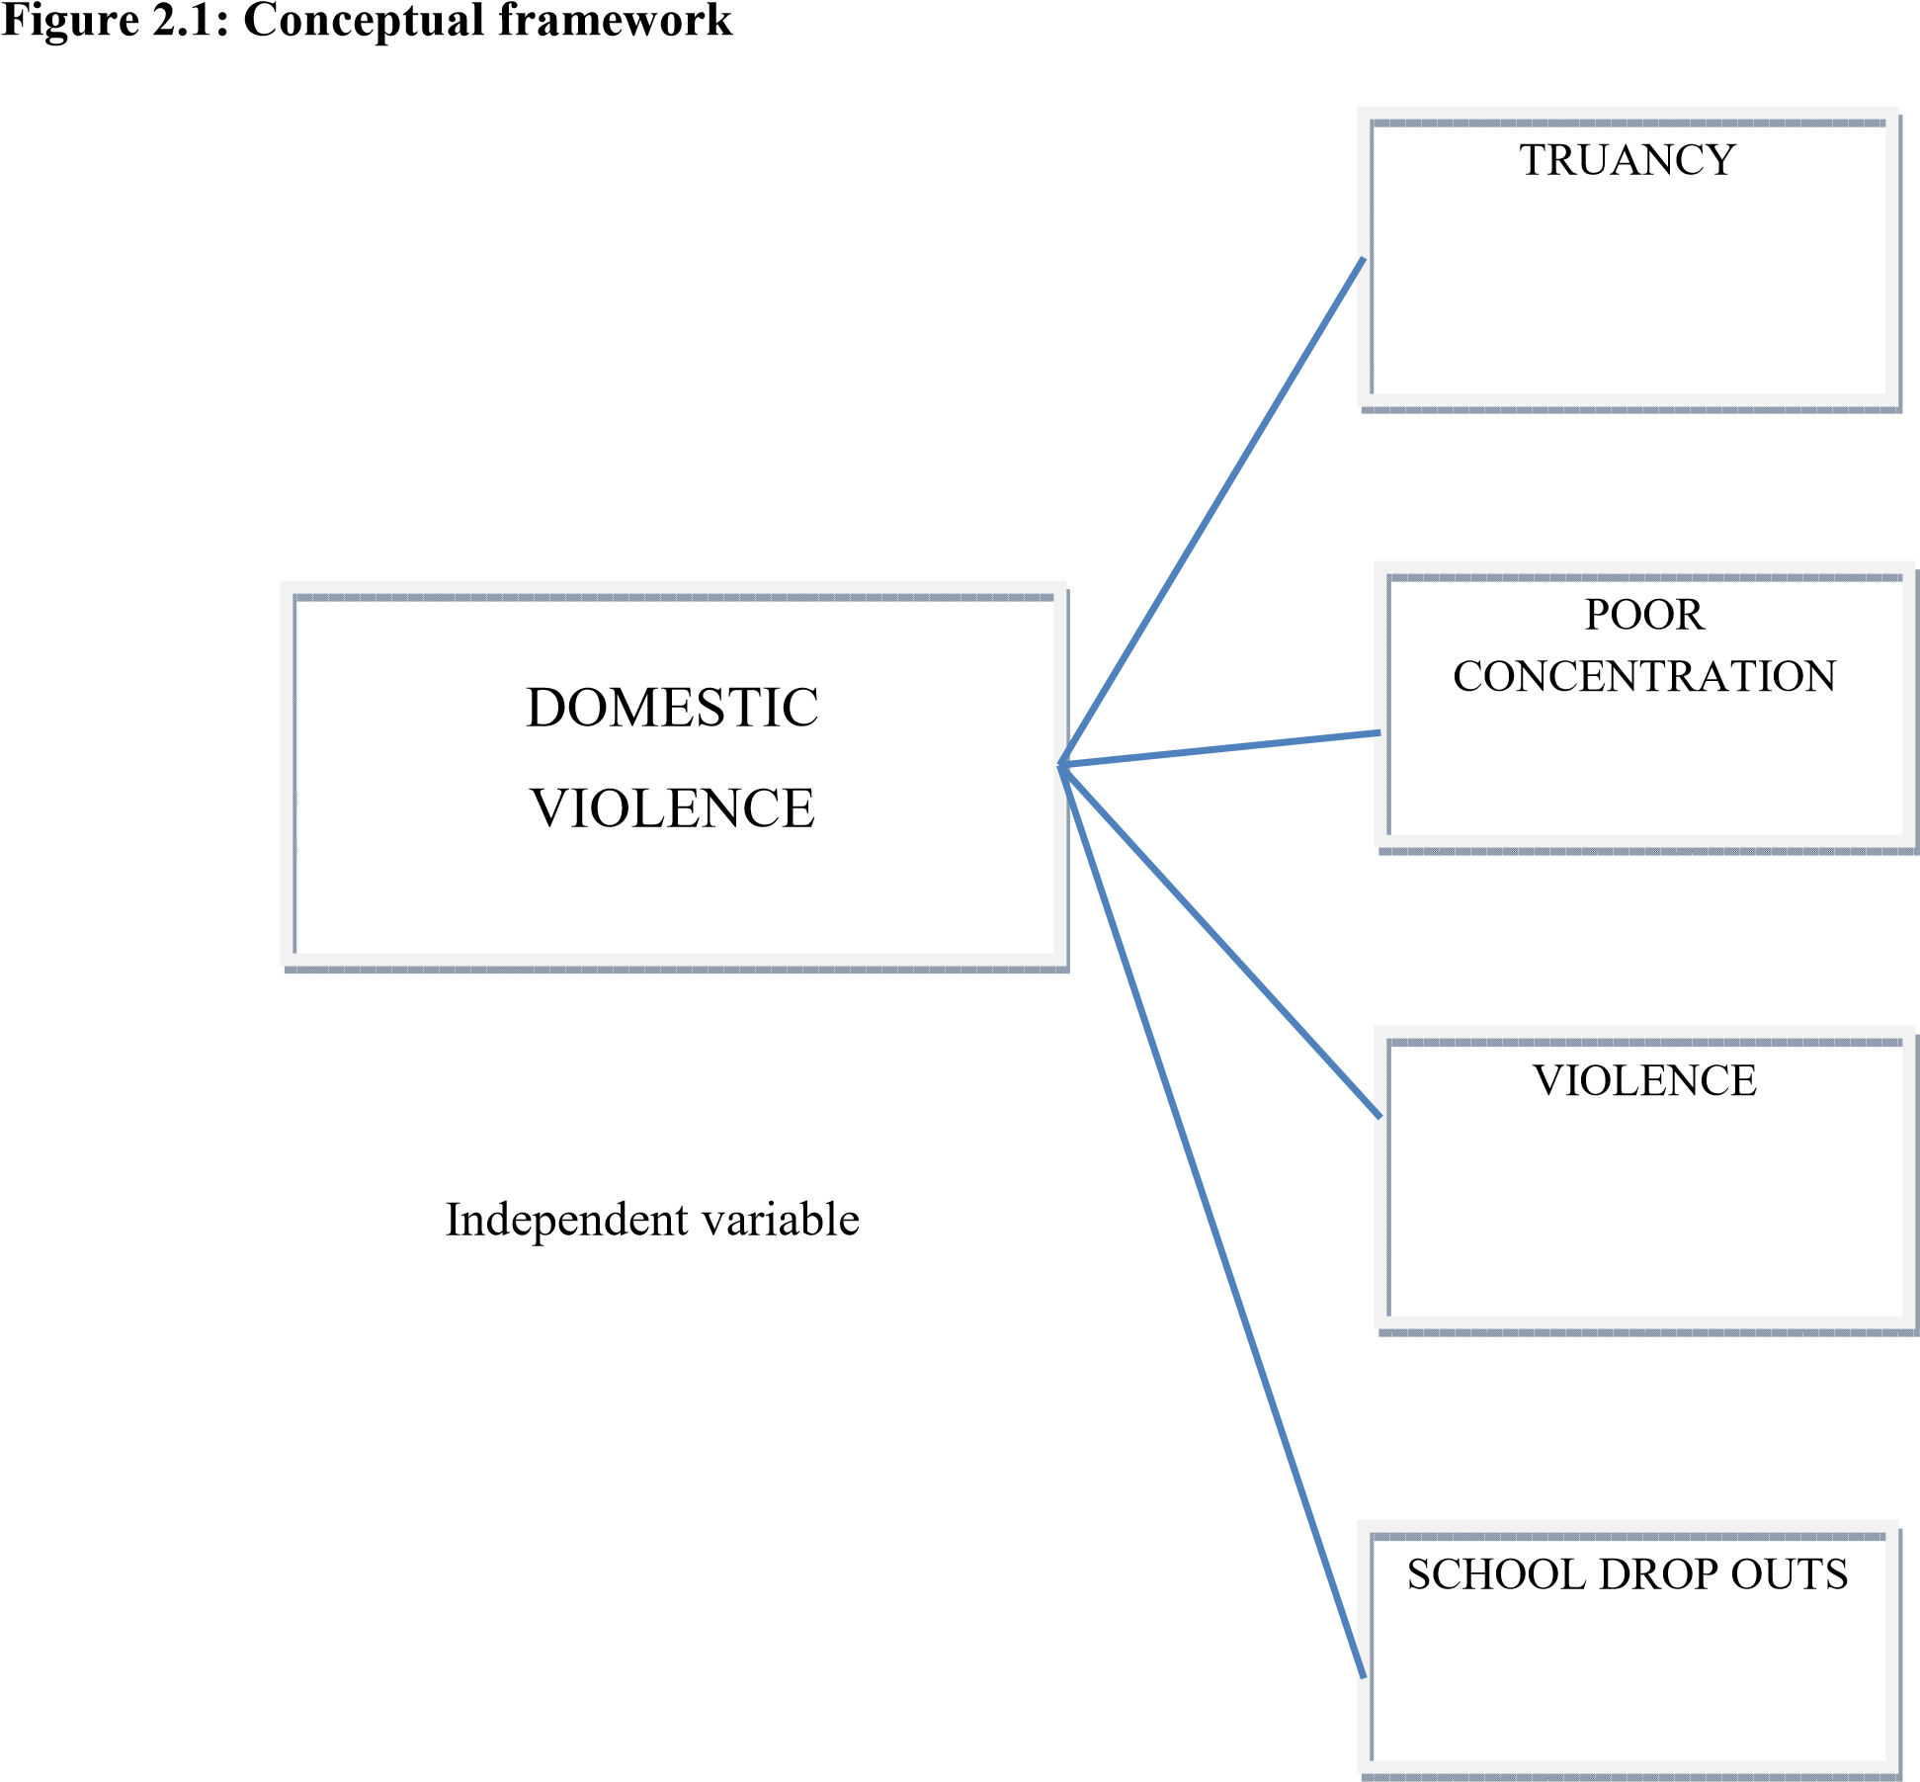

Dependent variables

The figure above explains clearly relationships between independent variable which is domestic violence and dependent variable which includes; truancy, poor concentration violence and school drop outs it explains how domestic violence has led to violence, school drop outs, truancy and poor concentration hence resulting to poor performance among students.

# CHAPTER THREE

# RESEARCH METHODOLOGY

# 3.0 Introduction

This chapte**r** gives the methodology that the researcher used in the study. The research design, methods of data collection and methods of data analysis.

# 3.1 The Research Design

The researcher used both qualitative and quantitative research design. Qualitative because it’s not numeric and the researchers’ intention was concerned with experiences of individuals and also the researcher wanted to collect detailed information. The researcher therefore used the following instruments; interview and focus group discussion.

The researcher also used quantitative because it utilizes numerical data. This is because just like the researcher sought details by using qualitative design, she also sought to clearly define the subject matter. The researcher therefore used questionnaires to collect data from the targeted population.

# 3.2 Targeted Population

The researcher target population was the students and teachers of Edo public secondary schools in Benin city. The researcher targeted students studying in Edo public secondary schools because according to speculation, they are affected direct and indirectly by domestic violence and they are reason the study was conducted.

The researcher also targeted teachers because they are able to assess the students’ behavior socially, academically, emotionally and psychologically. Also because of the long stay with the students they are in a position to give detailed and clear information. The researcher then used a sample of 6o respondents.

# 3.3 Sampling Procedure

The researcher first used stratified random sampling where she divided her population that is schools in Benin city into strata that is day public secondary schools and boarding public secondary schools. The researcher then used random sampling from the list of day public secondary schools to narrow down on the sample size. This was done where from the list of day schools provided, the researcher wrote down the names of all schools on a piece of paper, folded them, put them in a container, mixed them then picked the folded papers. The names selected formed the sample of the study.

From the schools selected the researcher used stratified sampling where the researcher targeted a given form/class. Then from the class the researcher used systematic sampling to determine who will take place in the study. This is whereby the researcher selected every second student in a class sampled.

# 3.4 Data Collection Instruments

The researcher used questionnaires as the main tool to collect information. This instrument was especially beneficial because it guaranteed privacy of the respondents and they are cheap in terms of time saved as they took lesser time as compared to interviewing. The researcher was also provided with an opportunity to explain the purpose and meaning of the study and meaning of questions if they might not be clear to the respondents. The researcher was also looking forward to more details because questionnaires are private.

### 3.4.1 Validity of Research Instrument

For a test to be reliable, it should measure what is supposed to measure. The researcher used content validity to test the reliability of the instruments

The researcher used content validity to test the reliability of the instrument. This was through ensuring that all items in the instruments were related to the study and they cover all the important areas of the study by relating them to research questions. The supervisor also went through the data collection instruments and made necessary corrections of its validity.

### 3.4.2 Reliability of Research Instrument

Instruments should give the same results when administered again on the sample.

The researcher used the test-retest method to know the reliability of the items where if the results of the first and of the second administration should be similar, then the instrument is reliable. This was done by the researcher giving two random people to fill in the item. Twice and different intervals their ability to fill in all items twice and comparison of findings done made the instrument reliable.

# 3.5 Data Collection Procedure

The researcher first went personally to the sampled areas and sought permission first to the school authorities before coming back on the appointed date to collect data; she never encountered any problems as permission was granted. Questionnaires were distributed personally by the researcher and took her time for the respondents to fill as the questions were straight forward and summarized. This saved the researcher time as she would not need to return again to pick the questionnaire.

# 3.6 Methods of Data Analysis

In order to sort, edit, code, enter, process and clean data the researcher used frequency method and sort percentages.

### 3.6.1 Coding of Data

The data collected was categorized Kerlinger (1973) in relation to research problem “closed “Type pre-coded and ‘’open’ type recoded. Open type was read to get the feel of the data according to young (1992). Quantification was done, assigning numerical numbers to various categories to facilitate statistical representation of data.

### 3.6.2 Tabulation of Data

Computing the results and seeing the patterns emerging in data categories aided in weighing and comparing higher numerical scales from the others

### 3.6.3 Interpretation of Data

This involves deducing the data collected and interpreting the data strictly within the frame of the research problem.

### 3.6.4 Editing of Data

The answered questionnaires are edited for accuracy, completeness and uniformity. Those with major errors are discarded. The remaining are given serial numbers.

# CHAPTER FOUR

# DATA ANALYSIS, PRESENTATION AND INTERPRATATION

# 4.0 Introduction

This chapter presents the findings from the study as feedback from the respondents. As described in the previous chapter, tables and graphs has been used in this chapter to present the outcomes from the study. Questionnaires were used to a large extent as an instrument of data collection that consisted of four main variables namely poor concentration, truancy, violence and school dropouts. Data was presented in tables and pie charts where necessary. The researcher analyzed the chapter based on information gathered quantitatively and qualitatively. The questionnaires were distributed to a sample of 60 respondents; 10 teachers and 50 students.

# 4.1 Quantitative Analysis

### 4.1.1 Age of Respondents

This was obtained from the respondents of the sample target population regarding their general characteristics. The analysis was got from the structured questions and is presented in tables and pie charts.

**Table 4.1 Ages of Respondents**

|  |  |  |
| --- | --- | --- |
| **Ages in years** | **Respondents** | **Percentages (%)** |
| Below 20  21-30  31-40  41-50  Above 50 | 36  4  6  8  6 | 60  6.7  10  13.3  10 |
| **Total** | 60 | 100 |

The table above shows the ages of the respondents. The study found out that young teens below the age 20 were the most respondents who formed a 60% and are the most affected by the variables of the research. This was followed by ages 41-50 who formed 13.3% and above 50 who formed 10% respectively. The purpose was to establish the age diversity of the respondents.

### 4.1.2 Truancy and domestic violence

Respondents were asked to indicate the rate at which domestic violence contributed to truancy among students. The responses were analyzed in the table below

**Table 4.2 Truancy and Domestic Violence**

|  |  |  |
| --- | --- | --- |
| **Weights** | **Numbers** | **Percentage (%)** |
| Very high  High  Moderate  Low | 42  10  7 1 | 70  16.7  11.7  1.7 |
| **Total** | 60 | 100 |

From the table above, it clearly indicates that domestic violence is a major cause of truancy with 70% confirming this as very high, 16.6% as high, and 11.7% as moderate and 1.7% as low. The purpose was to establish the relationship between domestic violence and poor exam results in the area

### 4.1.3 Domestic Violence and School Drop Out

Respondents were asked to indicate whether domestic violence contributed towards school dropout. The responses are analyzed in table 4.1.3 below

**Table 4.3: Domestic Violence and School Dropout.**

|  |  |  |
| --- | --- | --- |
| **Weights** | **Numbers** | **Percentage (%)** |
| Very high  High  Moderate  Low | 39  12  5 4 | 65 20  8.3  6.7 |
| **Total** | 60 | 100 |

The table above indicates high prevalence of school dropout rates as 65% of the respondents confirmed this as very high, 20% high, 8.3% moderate and finally 6.7% as low. Domestic violence hence plays a big role in school dropout rates in the area. This also confirms high numbers of semi illiterate population in the area due to the high number of school dropout rates.

### 4.1.4 Domestic Violence and Poor Concentration

Responses of respondents towards poor concentration as an effect of domestic violence are analyzed in the table below.

**Table 4.4: Domestic Violence and Poor Concentration**

|  |  |  |
| --- | --- | --- |
| **Weights** | **Numbers** | **Percentage** |
| Very high  High  Moderate  Low | 15 30  10  5 | 25 50  16.7  8.3 |
| **Total** | 60 | 100 |

From the findings as shown in the table above, 25% of the respondents rated domestic violence as an effect to poor concentration as very high, 50% as high, 16.7% as moderate and finally 8.3% as low.

### 4.1.5 Domestic Violence and Violent Behavior

Responses of respondents towards violent behavior as an effect of domestic violence are analyzed in the table below.

**Table 4.5: Domestic Violence and Violent Behavior**

|  |  |  |
| --- | --- | --- |
| **Weights** | **Numbers** | **Percentage (%)** |
| Very high  High  Moderate  Low | 34  14  6 5 | 58 23  10  9 |
| **TOTAL** | 60 | 100 |

The table above shows that 58% of the respondents rated violent behaviour as an effect of domestic violence as very high, 23% as high, 10% as moderate and 9% as low in the society as a whole. The purpose was to establish the relation between domestic violence and criminal activities like violent robberies, assaults, and to some extend drug abuse and murder.

**Figure 4.1: A Graph Showing the Level of Effects of Domestic Violence in Benin city**

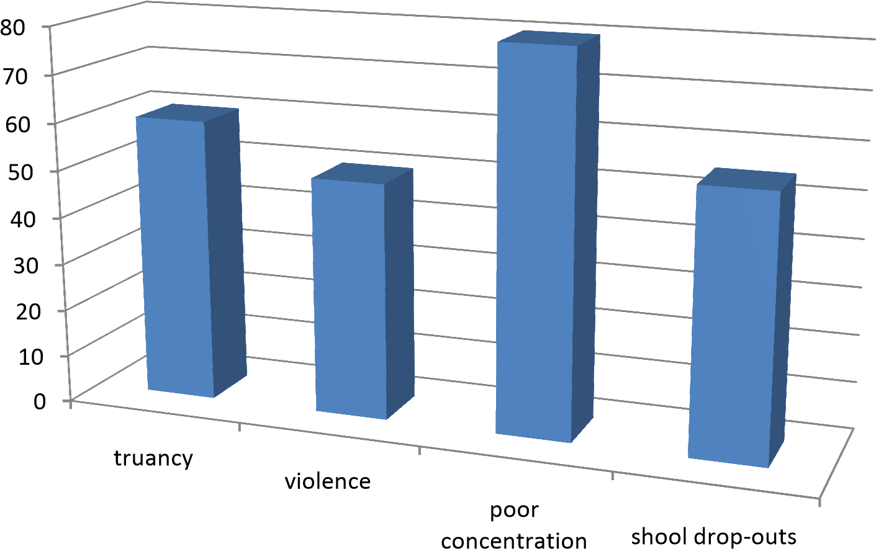

The graph above analyses the general dependant variables as compared to domestic violence in public secondary schools in Benin city. Poor concentration had the highest percentage of 78% as the largest effect of domestic violence in public secondary schools in Edo area. Followed by truancy with 57%, school dropout effect came third with 52% and finally violent behavior with 48%.

### 4.1.6 Substance Abuse/ Alcoholism and Domestic Violence

The table below analyses alcohol and substance abuse as a cause of domestic violence.

**Table 4.6: Substance Abuse/Alcoholism and Domestic Violence**

|  |  |  |
| --- | --- | --- |
| **Weights** | **Numbers** | **Percentage (%)** |
| Very high  High  Moderate  Low | 40  9 6 5 | 66.7  15 10  8.3 |
| **TOTAL** | **60** | **100** |

From the findings in the table above the researcher found out that alcohol and substance contributed greatly to domestic violence with 66.7% (40) of the respondents terming it as very high, 15% (9) as high, 10% (6) as moderate and finally 8.3% (5) rating it as low. This clearly indicates alcohol and substance abuse as a major cause of domestic violence in the area

### 4.1.7 Physical Abuse/Abuse on Property and Domestic Violence

The table below illustrates the relation between physical abuse/ property destruction and domestic violence.

**Table 4.7: Physical Abuse/Abuse on Property and Domestic Violence**

|  |  |  |
| --- | --- | --- |
| **Weights** | **Numbers** | **Percentage (%)** |
| Very high  High  Moderate  Low | 38  12  6 4 | 63.3  20 10  6.7 |
| **TOTAL** | **60** | **100** |

From the above findings 63.3% rated physical abuse/abuse on property destruction as very high, 20% as high, 10% as moderate, and 6.7% as low. Domestic violence hence plays a big role in property destruction and physical abuse in the area.

## 4.1.8: Sexual/ Psychological Abuse and Domestic Violence

The table below illustrates the extent of sexual/psychological abuse as a result of domestic violence

**Table 4.8: Sexual /Psychological Abuse and Domestic Violence**

|  |  |  |
| --- | --- | --- |
| **Weights** | **Numbers** | **Percentage (%)** |
| Very high  High  Moderate  Low | 34  14  6 5 | 58 23  10  9 |
| **TOTAL** | **60** | **100** |

From the findings in table 4.1.9 concerning sexual/psychological abuse and domestic violence illustrated, 58% of the respondents rated as very high, 23% as high, 10% as moderate and 9% as low, hence confirming that domestic violence plays a major role in psychological and sexual abuse.

**Figure 4.2: Frequency of Domestic Violence in Benin city.**

The graph below illustrates the frequency in percentage of domestic violence in the area.

0

10

20

30

40

50

60

daily

weekly

occasionally

rarely

Frequency of domestic violence

Frequency of domestic violence

From the graph above, frequency of domestic violence on daily basis was 5% of the 60 respondents, 15% on weekly basis, 50% occasionally and finally 30% rated rarely on domestic violence. These findings confirmed that domestic violence significantly high on occasional basis in the area and low on daily basis

# 4.2 Qualitative Analysis

The researcher also used interviews and focus group discussion to gather data intensively so as to compare with the data collected by use of a questionnaire.

### 4.2.1 Truancy

It was observed that there was a lot of abseentism in most of the cases as most teachers and students interviewed confirmed. Many parents who are alcoholics have become violent turning their anger to their children. This has led to a fallback between parents and their children leading them to feel rejected and in some cases the students run away from their homes in search of solace.

### 4.2.2 School Drop-outs

The researcher also gathered that due to truancy as a result of domestic violence, the school dropout rate was prevalent. This has led to students not completing their education and hence lacking a chance to get tertiary education. This in turn has led to many young people in the area being jobless.

### 4.2.3 Violence

Most interviewees admitted that the insecurity in the area had being partly caused by the domestic violence effect in families. Students or rather teens get to have the violent character that they have experienced in their respective homes. This has led to criminal acts like assaults, violent robberies and even murders which are rampant in the area.

### 4.2.4 Poor Concentration

In the discussions, students admitted that in cases of domestic violence, concentration is poor in class and is still is when out of school. In one case, the researcher also learned of a girl who was being beaten by his father almost daily from Kiambaa area was hit by an oncoming vehicle as she crossed the road. This has also led to poor exam results in the area.

### 4.2.5 Alcohol/ Substance Abuse

In the interviews and group discussions the majority number of interviewees and the students admitted that in most cases the inflictor was under the influence of drugs and alcohol was the overall abused substance.

# CHAPTER FIVE

# CONCLUSION SUMMARY OF FINDINGS AND RECOMMENDATIONS

# 5.0 Introduction

The chapter presents summary of findings of the study conclusions made from the findings.

# 5.1 Summary of Findings

The research findings led to the following conclusions. There was a major problem in the area school dropout rate, violence, poor concentration, truancy were just a drop in the ocean as the researcher gathered a lot of effects of domestic violence in Edo area. She found out that domestic violence is rampant. It has led to a trickledown effect to the society. Social vices in the area have been directly or indirectly caused by domestic violence at the grassroots(their homes) most teachers who are also parents confirmed the drug abuse, suicides, muggings and illegal trades are more of a result to high rates of school dropout rates and violence in the area.

The researcher also observed drug abuse and alcoholism has led to domestic violence in the area where parents become violent and create chaos at homes. The abuse has led to family breakups and disunity in the social setting. Some of the teachers are heavily charged with the duty of caring for the affected victims who are socially, psychologically, physically and morally affected. Domestic violence is real and is an issue that needs to be addressed with urgency.

# 5.2 Conclusions of the Study

The study came up with the following conclusions

* Domestic violence was found to be a major cause of truancy as many students did not go to school consistently and this affected their academic performance.
* Due to truancy as a result of domestic violence dropout rate was high resulting to students not completing their education leading to lack of tertiary education and joblessness.
* Domestic violence had contributed to high rate of insecurity in the region since teens tend to develop violence traits experienced during upbringing.
* Domestic violence caused poor concentration among students.
* In most cases, the inflictor of the violence was under the influence of alcohol and drug abuse hence increasing the rate of violence.

# 5.3 Recommendations

* From the research findings, domestic violence is rampant in contemporary society. There is therefore need for educating people about family responsibility, as way of eradicating domestic violence among families.
* There should be guidance and counseling therapy sessions in both school and community level. This will educate sensitize and rehabilitate each and every individual in the society. This would also help students to cope with the trauma associated with the violence
* The helping professionals should take responsibility of reporting the suspected abuse to the child protection agency or police; this would reduce the rate of violence since law will be applied effectively to apprehend offenders typically counselors and school personnel should be required to report and be granted immunity from liability because they are presumed to be acting in good faith.
* The government has also enacted laws but its efforts of implementing them bear no fruits, therefore legislation of strict laws should be formulated to protect the children
* . Communities, churches, schools and the government should take the responsibility of minimizing domestic violence and provide security for the young ones in particular and the community as a whole.
* Finally offices should be erected in communities where one is able to report to in case of such incidences, they should be in strategic positions and easy to access in order to stem out the vice.
* The nation should move through stages of public awareness and face the phenomenon head on. Practitioners should be aware of the widespread domestic violence cases reported and unreported. And take action when necessary. Counselors should keep abreast of the indicators of maltreatment in order to help victims of domestic violence.
* In conclusion, the above suggestions are inadequate and the researcher strongly recommends a consultative meeting involving all stake holders e.g. parent, educational officers, family based organizations, sponsors, teachers, pupils and the community at large to deliberate on effective counseling in our institutions in order to reduce if not stop domestic violence in our society
* The recommendations suggested in this chapter are based on major findings and conclusion drawn from the study.

# 5.4 Suggestions for Further Research

Further research should be done on the effects of alcohol and substance abuse on academic performance of students in secondary schools.

# REFERENCES

Alexander, R. (1988) The Crimes (*Family Violence*) Act (1987) Law Institute Journal. March pp

166-169.

American Psychiatric Association (1994) *Diagnostic and statistical manual of mental disorders*

(4th). Washington, DC: Author Ammerman, R.T. and Herson, M. (eds) (1990), *Treatment of Family Violence*, John Wiley and Sons, New York.

Blanchard, A., Molloy, F. and Brown, L. (1992) 'I Just Couldn't Stop Them': *Western Australian Children Living with Domestic Violence:* A Study of Children's Experiences and Service Provision, Curtin University School of Social Work, Western Australia.

Bowker, L.H., Arbittel, M. and McFerron, J.R (1988), *'On the relationship between wife beating and child abuse' in:* Feminist Perspectives on Wife Abuse, M. Bograd, Sage, and

California.

Calvert, G (1993) *Preventing Child Abuse and Neglect: the National Strategy*, National Child

Protection Council and Canberra.

Carlson, B.E. (1984), 'Children's *observations of inter-parental violence' in:* Battered Women and Their Families, ed. A.R. Roberts, Springer, New York.

Christopoulos, C., Cohn, D., Shaw, D., Joyce, S., Sullivan-Hanson, J. Kraft, S. and Emery, R. (1987), 'Children *of abused women: adjustments at time of shelter residence'*, Journal of the Marriage and the Family, vol. 49, pp. 611-19.

Church, J. (1984), *Violence against Wives: Its Causes and Effects*, John Church (Publisher),

Christchurch, New Zealand.

Cummings, E.M. (1987) '*Coping with background anger in early childhood'*, Child

Development, vol.58, pp.976-84.

Cummings, E.M., Iannotti, R.J. and Zahn-Waxler, C. (1985) '*Influence* *of conflict between adults on the emotions and aggression of young children',* Developmental Psychology, vol.21, pp.495-507.

Cummings, E.M., Zahn-Waxler, C. and Radke-Yarrow, M. (1981) 'Young children's responses to expressions of anger and affection by others in the family', Child Development, vol.52, pp.1274-82.

Davis, L. and Carlson, B. (1987) *'Observation of spouse abuse: what happens to the children?',*

Journal of Interpersonal Violence vol.2, no.3, pp.278- 91.

DeLange, C. 1986, *'The family place children's therapeutic program*', Children's Today, pp.12-

15.

Dobash, R.E. and Dobash, R (1979) *Violence against Wives: A Case Against the Patriarchy*,

Free Press, New York.

Domestic Violence Resource Centre (1992), *Preventing Abuse in Relationships*, Brisbane.

Duncan (1984), *'The nature and antecedents of violent events',* British Journal of Criminology, vol.24, no.3, pp.269-88.

Dutton, M.A. (1992). *Women's response to battering: Assessment and intervention.* NewYork: Springer.

Dutton, M.A. (1994). *Post-traumatic therapy with domestic violence survivors*. In M.B. Williams & J.F. Sommer (Eds.), *Handbook of post-traumatic therapy* (pp. 146-161). Westport, CT:

Greenwood Press.

Easteal, P.W. (1994), *'Violence against women in the home',* Family Matters, No. 37, April, pp.

86-93.

Forsstrom-Cohen, B. and Rosenbaum, A. (1985), *'The effects of parental marital violence on young adults: an exploratory investigation',* Journal of Marriage and the Family, May, pp.467-72.

Ganley, A. (1989). *Integrating feminist and social learning analyses of aggression: Creating multiple models for intervention with men who battered.* In P. Caesar & L. Hamberger (Eds.) Treating men who batter (pp. 196-235). New York: Springer.

Garmezy, N. (1983), '*Stressors of childhood', in:* Stress, Coping and Development in Children, eds N. Garmezy and M. Rutter, McGraw-Hill, New York.

Graham-Bermann, S (1994). *Preventing domestic violence.* Universityof Michigan research information index. UM-Research-WEB@umich.edu.

Hart, S.N. and Brassard, M.R. (1987), *'A major threat to children's mental health: psychological maltreatment'*, American Psychologist, vol.42, pp.160-5.

Hess, R.D. and Camara, K.A. (1979), *'Post-divorce: family relationships as mediating factors in the consequences of divorce for children'*, Journal of Social Issues, vol.35, pp.79-96.

Hetherington, E.M. and Anderson, E.R. (1988), *'The effects of divorce and remarriage on early adolescents and their families', in:* Early Adolescent Transitions, Lexington, MA, pp. 46-

57.

**QUESTIONNAIRE**

Please tick in the appropriate spaces, the options that best fits your opinion.

**Gender**

Male { }

Female { }

**Ages in years**

Below 20 { } 21-30 { }

31-40 { } 41-50 { }

Above 50 { }

**SECTION B**

Pupils exposed to domestic violence can perform badly in their academics?

Yes { } No { } Uncertain { }

School attendance of pupils exposed to domestic violence can drop?

Yes { } No { } uncertain { }

To what extent would you describe the influence of domestic violence on the truancy of pupils

Very high { } High { } Moderate { } Low { }

To what extent would you associate domestic violence as a cause for school drop-out?

Very high { } High { } Moderate { } Low { }

To what extent would you attribute domestic violence as a reason for poor concentration?

Very high { } High { } Moderate { } Low { }

Pupils exposed to domestic violence can acquire a violent behaviour. To what extent do you think this statement is true?

Very high { } High { } Moderate { } Low { }

The persistent intake of alcohol could lead to negative outcome like domestic violence, to what extent do you think intake of alcohol leads to domestic violence?

Very high { } High { } Moderate { } Low { }

Some acts of domestic violence could lead to physical or property destruction. To what extent do you agree with this statement?

Very high { } High { } Moderate { } Low { }

To what extent do you think that sexual or psychological abuse can result from domestic violence?

Very high { } High { } Moderate { } Low { }