CHAPTER ONE

INTRODUCTION

The subject of airport passenger terminal building must involve a discussion of transportation.

Transportation has remained one of the most vital factors that influence the development of a nation. The credibility of this statement has been proven over the centuries, that if one decides to take a critical look at earlier civilizations, from the time of early Egyptian civilization to the current civilized world, one will discover that many of the great feats achieved during these civilizations would have been impossible without one form of transportation or the other.

By way of definition; transportation (or transport) is the movement of people, animals and goods from one location to another. Modes of transport include air, rail, road, water, cable, pipeline and space. The field can be divided into infrastructure, vehicles and operations. Transportation is important since it enables trade between people, which in turn establishes civilizations.

Transport infrastructure consists of the fixed installations necessary for transport, including roads, railways, airways, waterways, canals and pipelines and terminals such as airports, railway stations, bus stations, warehouses, trucking terminals, refuelling depots (including fuelling docks and fuel stations) and seaports. Terminals may be used both for interchange of passengers and cargo and for maintenance.

Vehicles travelling on these networks may include automobiles, bicycles, buses, trains, trucks, people, helicopters and aircraft. Operations deal with the way the vehicles are operated, and the procedures set for this purpose including financing, legalities and policies. In the transport industry, operations and ownership of infrastructure can be either public or private, depending on the country and mode.

Transportation can be broadly classified under three broad groups thus:

 Land transportation;
Water transportation; and Air transportation.

Land transportation is the most common and dates back to the beginning of civilization. Land transportation can take various forms, which are dependent on the sophistication, stage of civilization and development, and on the technical stratum of the society in question. It can be by the use of animals (camels, mules, horses, dogs, etc.) or by use of machines such as wheelbarrows, carts, cars etc.

Similarly, water transportation dates back a long time as humanity can recall. Water transportation, as land transportation, has also been developed in complexity, technical superiority, and usage.

Air transportation has its origin in the 20th century. The superiority of air transport over the rest can be attributed the reason behind its progressive growth and preference as the safest modern mode of transportation.

1.1.0 BACKGROUND TO THE PROJECT

The airpot terminal is a building at an airport where passengers transfer between ground transportation and the facilities that allow them to board and disembark from the aircraft. Within the terminal, passengers purchase tickets, transfer their luggage, and go through security. The buildings that provide access to the airplanes (via gates) are typically called concoures. However, the terms terminals and concourses are used interchangably, depending on the configuration of the airport.
Smaller airports have one terminal while larger airports have several terminals and/or concourses. At small airports, the single terminal building typically serves all of the functions of a terminal and a concourse. Some larger airports have one terminal that is connected to multiple concourses via walkways, sky-bridges, or underground tunnels (such as Denver International Airport). Some larger airports have more than one terminal, each with one or more concourses (such as New York‟s John F. Kennedy Airport). Still other larger airports have multiple terminals each of which incorporate the functions of a concourse (such as Dallas/Fort Worth International Airport).

According to Frommers, most airport terminals are built in a plain style, with the concrete boxes of the 1960s and ‟70s generally gave way to glass boxes in the ‟90s and ‟00s, with the best terminals making a vague stab at incorporating ideas of light and air. However, some, such as Baghdad International Airport, are monumental in stature, while others are considered architectural masterpieces, such as Terminal 1 at Charles de Gaulle Airport near Paris or Terminal 5 at New York‟s John F. Kennedy Airport. A few are designed to reflect the culture of a particular area, some examples being the terminal at Albuquerque International Sunport in New Mexico, which is designed in the Pueblo Revival Style popularized by architect John Gaw Meem, as well as the one at Bahiasde Huatulco International Airport in Huatulco, Oaxaca, Mexico, which features some palapas that are interconnected to form the airport terminal building.

Due to the rapid rise in popularity of passenger flight, many early terminals were built in the 1930s–1940s and reflected the popular art deco style architecture of the time. One such surviving example from 1940 is the Houston Municipal Airport Terminal. Early airport terminals opened directly onto the tarmac: passengers would walk or take a bus to their aircraft. This design is still common among smaller airports, and even many larger airports have "bus gates" to accommodate aircraft beyond the main terminal building.

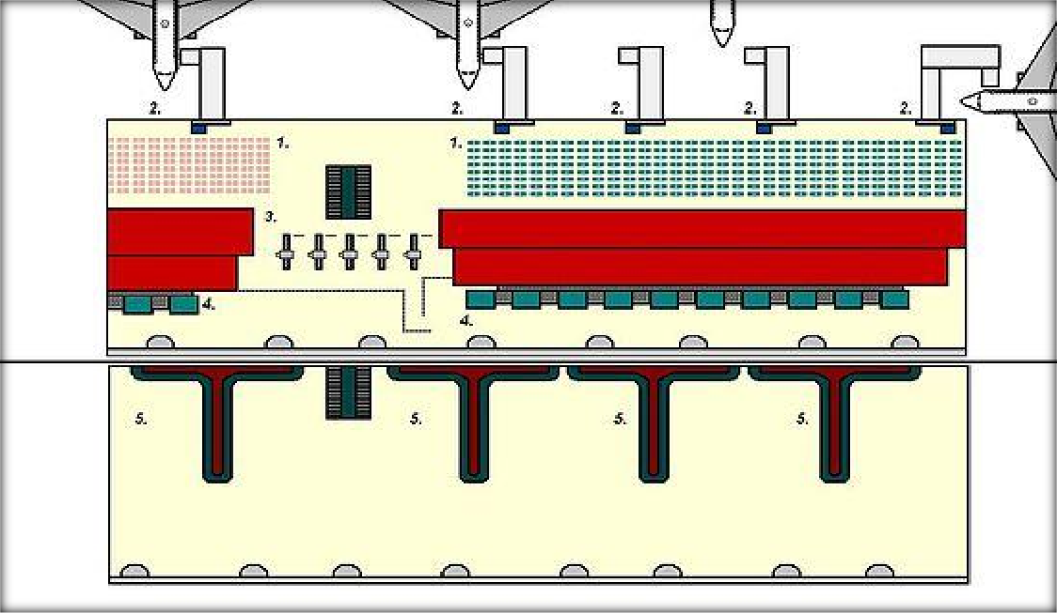

Figure 1.1 Typical design of a terminal, showing the Departures (upper half of page) and Arrivals levels. 1. Departures Lounge. 2. Gates and jet bridges. 3. Security Clearance Gates. 4 Baggage Check-in. 5. Baggage Carousels

1.2.0 STATEMENT OF ARCHITECTURAL PROBLEM

A functional airport passenger terminal is meant to ease the stress encountered by airpassengers during the process of air travel. Therefore the architectural problem of the project is how best to provide an aesthetically pleasant, efficient, economical, bigger and more modern domestic airport passenger terminal, with good flexibility and expansion capabilities, to replace the outdated and small existing airprot terminal at Makurdi for Federal Airports Authority of Nigeria (FAAN).

1.3.0 AIMS

The primary aims/goals of the design are as follows:

to provide/design a suitable passenger terminal building in the Makurdi Airport which would potray a good image of Benue State
to provde a passenger terminal building as well as other auxilliary facilities with the necessary tools requisite for air transportation activities as well as upgrade the economic facet of Makurdi city.
to ensure these facilities will streamline the productivity in the airport without interruption or interference from each other or any source; and
to provide a design that will adequately contain all the kinds of functions and activities associated with air travel to be carried out in the airport which will be expanded for this purpose.

1.4.0 OBJECTIVES

The principal objective of this project is to provide Makurdi Airport with a ultra-modern, befitting and function passenger airport terminal building which has been badly absent since the construction of that airport and also to upgrade the landscape around it and prescribe other salient facilities which have been omitted.
In appreciation of the particular demands of the project, I opt;

To situate the structure in an ideal location that easily catches eye sight from around the environment and can be easily accessible to staff, air travellers, as well as visitors;
To ensure good road network that create easy flow of vehicular and human traffic;

To consider the environmental consequences as far as they are not a detriment to the proposed development.

To minimise costs by putting construction techniques, and employing materials within the level of technology that is commensurate with our national aspiration.
To ensure flexibility and adaptability for future changes in use of facilities or space; To ensure efficient security within and around the facility premises;
To ensure the terminal building, the parking lots and other auxilliary facilities are strategically placed for easy accessibilty from one to the others;

1.5.0 RESEARCH METHODOLGY

The required information for proper planning and design of a domestic passenger terminal that will raise the quality and standard of the Makurdi Airport will be obtained through primary data; direct interviews with personnel or representatives of existing airports in Nigeria which basically are FAAN officials, porters on the airport grounds and locals residing around the airport vicinity, case studies, library research, and internet surfing. The emerging ideas and opinions or results are manually organized. On site physical survey will reveal the statistical data inherent of the site venue and will be gainfully utilized.


Figure 1.2 Project research requires various techniques of data collection(Photo: A. Kazda)

1.6.0 PROJECT MOTIVATION

The Federal Government of Nigeria has, in recent times, moved a motion for the rebranding of the Aviation Industry to upgrade the facilities within airports owned by the Federal Government as well as check the activities of private parastatals within the Aviation Industry. Previously, the airports in the Federation have been either dilapidated or grounded that no aviation activities take place in such airports. It is to this end that the Federal Government has moved to build or renovate existing terminal facilities in the airports within the federation listed below:

Enugu Airport (re-christened Akanu Ibiam International Airport), Enugu, Enugu State; Gen. Yakubu Gowon Airport, Jos, Plateau State;
Nnamdi 999Azikiwe International Airport, Abuja, Federal Capital Territory; Sam Mbakwe Airport, Owerri, Imo State;
Makurdi Airport, Makurdi, Benue State

1.7.0 SCOPE AND LIMITATION OF THE PROJECT

This scope of this thesis is restricted to the passenger terminal building within the airport and NOT the entire airport as a whole. This is to say that the work involves the only the landside of the airport (and not the airside) which includes the terminal building and auxiliary (supporting) facilities within the landside premises. These are briefly listed below:

Exterior elements:
Terminal building;
Well-defined road network; Parking lots;
Signs;
Fire station; Motel;

Terminal building:
Entrance hall;
Departure lounge; Arrivals lounge;
Customs and Immigration; Baggage reclaim hall;
Outbound baggage hall; Shops and snack bars; Conveniences;
Supporting office spaces.

1.8.0 PROJECT JUSTIFICATION

The passenger terminal building is chosen and located in the Makurdi Airport premises, which is a domestic airport in Makurdi, Benue State, for the following reasons:
The existing terminal building on the site is small and outdated; Aviation prospects in the state of project location is terribly poor; The existing facility has no provision for future expansion.

1.9.0 RELEVANCE OF PROJECT

This rearch will help to contribute and extend the frontiers of knowledge in the academic development of aviation architecture. It also exposes all aspects of professional details and necessary techniques of scientific investigation in this field.
In other words, this guide provides the basic criteria to organize, evaluate, plan, programme and design airport terminal facilities. The information presented is intended to make researchers aware of important design considerations and to aid them in project development.

1.10.0 DEFINITION OF TERMS
(1.) The Terminal Building:The structure located on the landside of the airport which is the interface between the airfield and the rest of the airport. It include those facilities that are required for passenger handling, cargo handling, maintenance, and airport administration.
(2.) Amenities:That part of a terminal building housing convenience, service, and diversion facilities for the passengers, tenants, and public.

(3.) Apron:The apron comprises the area and facilities used for aircraft gate parking and aircraft support and servicing operations. It includes the following subcomponents:
Aircraft Gate Parking Positions: Used for the parking aircraft to enplane and deplane passengers. The passenger boarding device is part of the gate position.
Aircraft Service Areas: On or adjacent to an aircraft parking position. They are used by airline personnel/equipment for servicing aircraft and the staging of baggage, freight, and mail for loading and unloading of aircraft.
Taxi Lanes: Reserved to provide taxing aircraft with access to and from parking positions.
Service/Fire Lanes: Identified rights-of-way on the apron designated for aircraft ground service vehicles and fire equipment.

(4.) Average Peak Hour:The peak hour of the average peak day. The peak hour is the one hour period of any peak day during which the highest percentage of the day‟s traffic is experienced. The average peak day is the average of the top 37 days (10 percent) of a year in terms of traffic volume.
(5.) Baggage Diverted:A mechanical device for transferring baggage from a moving conveyor belt to a baggage claim counter in such manner that the baggage is evenly distributed along the baggage counter.

(6.) Boarding Control Point: The point at which a passenger‟s credentials are inspected to assure that they are authorized to board a particular flight. Normally, this point is located in the vicinity of the gate from which the flight will depart.

(7.) Boarding Passenger:Any originating or connecting passenger authorized to board a flight.

(8.) Connecting Passenger:A passenger who arrives on one flight only for the purpose of transferring to another flight to reach her destination. These passengers are broken down into two categories: intraline and interline passengers.
(9.) Connector:The connector consists of the structure(s) and/or facilities normally located between the aircraft gate and the main terminal building, at low activity airports, i.e., less than approximately 200,000 annual enplaned passengers, this component is often combined with the terminal building component. It normally contains the following elements:
Concourse: A passageway for circulation between aircraft gate parking positions and the main terminal building.
Departing Lounge: An area for assembling and holding passengers prior to a flight departure. In some instances, it may be a mobile lounge also used to transport passengers to a parked aircraft.
Security Inspection Station: A control point for passenger and baggage inspection and controlling public access to parked aircraft.
Airline Operation Areas: Areas set aside for airline personnel, equipment, and servicing activities related to aircraft arrivals and departures.
Passenger Amenities: Areas normally provided in both the connector as well as the terminal components, particularly at the busier airports with relatively long connectors. These amenities include rest rooms, snack bars, beverage lounges, and other concessions and passenger services.
Building Maintenance and Utilities: Areas often included in the connector to provide terminal building maintenance and utilities.

(10.)Customs: This is an area under federal jurisdiction through which passengers arriving from foreign countries are require by law to pass, in order to make a declaration related to baggage which is accompanying them upon entry to the a country. This area is used for receipt of a declaration and/or examination of baggage. If duty is required, the customs agent will receive same in the customs area. Special attention must be paid to the design of this area because of changing techniques of operation.
(11.) Departing Room:An assembly area, including the boarding control point, located at a gate position(s) for passengers pending availability of aircraft for boarding.
(12.) Deplaning:Any passenger, cargo, baggage, visitor, etc., which is related to the unloading from an arriving flight.

(13.) Domestic Passengers: All passengers travelling in the territorial limits of a country or its terriories are considered as domestic. Foreign nationals within the confines and territory require no special checking and operate as domestics.
(14.) Enplaning: Any passenger, cargo, baggage, visitor, etc., which is related to the boarding of a departing flight.

(15.) Gate: A location to which aircraft are brought for the purpose of discharging and loading passengers and their baggage.

(16.) Gate Concourse:An extension from the main terminal building primarily intended to provide protected access for passengers and the gates. In addition to the passenger between the main terminal building corridor, the concourse may include airline functional areas and minimum consumer services.
(17.) Ground Transportation:The independently operated transportation vehicles scheduled for passenger‟s use between airports and the areas served thereby is called ground transportation.

(18.) Immigration: This area is devoted to the examination of passports of the nationals of the country where the airport is located and aliens seeking to enter that territory. Consideration for design and function of this area must be correlated federal authorities.
(19.) Interline Connecting(ion): A term used to describe passengers and baggage which arrive on the flight of one airline and depart on the flight of another.
(20.) Intown Terminal:A facility located apart from the airport, usually in the downtown area of the city, at which passengers may be processed, baggage checked to passengers‟ destinations, and from which ground transportation is provided.
(21.) Intraline Connecting(ion): A term used to describe passengers and baggage which arrive on one flight and depart on another flight of the same airline.
(22.) In-Transit Passenger: If an internationally bound aircraft stops at an airport for refuelling or discharge of passengers and a remaning number of passengers are to be detained in the aircraft of another destination, the convenience of providing a totally segregated lounge facility may be warranted for the continuing passengers. This facility is reffered to as an in-transit area. Security of the area is important.
(23.) Long-Haul: A term used to defined flights of or traffic which travel over a relatively long distance as opposed to those which travel over a shorter distance. Normally, long-haul passengers arrive at the originating airport earlier than short-haul passengers, carry more baggage than short-haul passengers, and are accompanied to or are met at the airport by more persons than short-haul passengers.
(24.)Originating Passenger: A passenger who is starting a trip.

(25.) Public Health Service: The function of the Public Health Service is to determine whether an arriving passenger will present a health hazard to the general population. Design requires correlation with federal authorities. This may require inoculation, special examination, and possibly quarantine.

(26.) Ready Room:An area adjacent to the normal work areas in which personnel whose duties are performed out-of-doors may assemble, be protected, and form which they may receive their work assignments. These rooms should be concealed from public view.
(27.)Self-Claim Baggage: A method under which passengers have direct access to terminating baggage in a controlledarea. As passengers leave the area, an attendat retrieves baggage claim checks and matches them to strap checks to assure that passengers have selected only baggage to which they are entitled.
(28.) Short-Haul: A term used to define flights or traffics which travel over relatively short distance as opposed to those which travel over a long distance. Normally, passengers arrive at the airport of origin late, carry less luggage than long-haul passengers, and are accompanied to or met at the airport by fewer persons.
(29.) Standby Passenger: A passenger not holding confirmed space but who is on hand at departure time for space that might become available.
(30.) Terminating Passenger: A passenger who has arrived at their destination.

(31.) Through Passenger: A passenger who arrives and departs on the same flight.

(32.) Transfer Baggage Room: The area to which checked baggage of connecting passengers is delivered for sorting by flight prior to its being dispatched to the aircraft for loading. This may be combined with outbound baggage room at the same locations.
(33.) Unit Terminal: One of several functionally completed terminal areas (which may be in the same or several buildings) each of which houses the activities of one or more airlines.

CHAPTER TWO

LITERATURE REVIEW AND THEORITICAL FRAMEWORK

2.1.0 AIR AGE (DEVELOPMENT OF AIRCRAFTS)

The first aeroplanes were light, with a tail wheel, and the engine power was usually low. A mowed meadow with good water drainage was sufficient as an aerodrome for those aeroplanes. The difficulty in controlling the flight path of these aeroplanes required the surrounding airspace to be free of obstacles over a relatively wide area. Since the first aeroplanes were very sensitive to cross wind, the principal requirement was to allow taking off and landing always to be into wind. In the majority of cases, the aerodrome used to be square or circular without the runway being marked out. The wind direction indicator that was so necessary in those days still has to be installed at every aerodrome today, though its use now at big international airports is less obvious. Other visual aids that date from that period are the landing direction indicator and the boundary markers.

The latter aid determined unambiguously where the field was, and where the aerodrome was, this flight information for the pilot not always being evident in the terrain.
Immediately after World War I in 1919-1920, the first air carriers opened regular air services between Paris and London, Amsterdam and London, Prague and Paris, among others. However, in that period no noticeable changes occurred in the airport equipment, or in the basic operating concept, other than some simple building for the processing of passengers and hangars for working on the aeroplanes.

Even in the 1930s, the new technology of the Douglas DC-2 and DC-3, which were first put into airline service in 1934 and 1936 respectively, was not sufficiently different to require large changes in the physical characteristics of aerodromes, so the development of airports up to that period may be characterised as gradual. The first passengers on scheduled airlines were mostly business people or the rich and famous, but this was a small scale activity, most of the flying being done by the military. The main change in the airfield‟s physical characteristics was the runway length. The multi-engine aircraft required the length to increase to approximately 1000m.The increasing number of aircrafts and the training of the military pilots required more support facilities at airfields, such as hangars, workshops and barracks.

War does not benefit mankind but, for aviation, it has always meant a rapid step change in development. After World War II, there were unusually favourable conditions for the development of civil aviation and air transport. On one hand there were damaged ground communications, while on the other hand, there were plenty of surplus former military aircraft. There was also the requirement to support the supply chains from the USA to Latin America, to Japan and to Europe under the Marshall Plan. All of that activity allowed civil air transport to recover quickly and then to continue to a higher level than before World War II. The requirements for aerodromes changed dramatically in that same short period of time.

The new aircraft required paved runways, partly because they were heavier and partly because regularity of service became more important. However, they were still relatively sensitive to the crosswind, despite having nose-wheel steering. Therefore the big international airports adopted a complicated system of between three and six runways in different directions in order to provide sufficient operational usability from the entire runway system. The large number of runways often reduced the amount of land available for further development of the airport. One of the runways, most often the runway in the direction of the prevailing winds, was gradually equipped with airport visual aids, thus being regarded as the main runway. At the same time terminal facilities were constructed which, besides the services required for the processing of passengers and their baggage, provided also the first non–aeronautical services, such as restaurants, toilets, and duty-free shops.

The next substantial change that significantly influenced the development of airports was the introduction of aircraft with jet propulsion.Jet aircraft required further extension of the runway, together with increases in its width and upgrading its strength. The operation of jet aeroplanes had an effect also upon other equipment and technical facilities of the airport. One of them was the fuel supply system. Not only did the fuel type change from gasoline to kerosene, but also the volume per aircraft increased considerably, requiring reconstruction of the fuel farms and the introduction of new refueling technologies.

The following important factors influenced the entire development of airports from 1975 to 1992:
- The threat of terrorism and a fear of unlawful acts.
- The privatisation of airports.
- The progressive deregulation of air transport.
- The increasing environmental impact around airports.
The threat of terrorism, and in particular the bomb attack against the B 747 Pan-Am Flight 103 on23rd December 1988 near Lockerbie in Scotland, subsequently required expensive changes of airport terminal buildings with a consistent separation of the arriving and departing passengers and installation of technical equipment for detecting explosives.

HISTORY OF CIVIL AVIATION IN NIGERIA
Civil aviation in Nigeria is a spin-off of the British Colonial rule. But above all else, it is a product of a mere accident of history dating back to 1925 in the unlikeliest of places –the ancient city of Kano. Sometime in July of that year the Northern city was gripped by a tense stand-off between the residents and the colonial government officials.

The British government at the time was maintaining an active Royal Air Force (RAF) base in Khartoum, Sudan. On sensing the trouble in Kano, London swiftly signalled the Squaddron, instructing him to fly to the Northern Nigerian city and report on the situation. Flying a Bristol fighter, the pilot made a breath-taken but safe landing on the horse race course in Kano, thus going down in history as the first recorded aviation activity in Nigeria.

The earliest known commercial aviation activity in Nigeria is credited to one gentleman “Bud” Carpenter, who owned the earliest type of the lightcraft, de Havilland Moth. Records show that he frequently undertook high-risks flights between Kano and Lagos using the rail tracks as his guide and piling up extra distance in the process.
In the early 1930s, an enterprising pilot carried a few fare-paying passengers in a seaplane between Lagos and Warri. With the continuation of the annual RPLF flights, aviation activities in Nigeria became quite considerable, creating the need for aerodromes.
Consequently, a representative of the Air Ministry in London visited Nigeria to inspect what could then be appropriately described as “landing grounds”. Sites were selected at Maiduguri, Oshogbo, Lagos, Minna, Kano and Kaduna.
In 1935, the operations of the RAF were replaced by those of the Imperial Airways that flew regular airmail and passengers from London to Nigeria, although it was not until 1936 that commercial aviation actually came to Nigeria. The Imperial Airways, the forerunner of the British Overseas Airways Cooperation (BOAC), operated large four-engined aeroplanes, known as the Hannibal class or the Handley, on the Nile route from Cairo to Kisimu, Uganda.
The Air Age in Nigeria dates back to the late forties, with recordings of landing of aeroplanes in what is today known as Nigeria. This compared to the record that the National Carrier, the Nigeria Airways, carried 233,130 International passengers and 1,352,210 Domestic passengers in 1979, shows growth of air transportation and the economic viability of air transportation in Nigeria.

ECONOMIC SIGNIFICANCE OF AIR TRANSPORTATION IN NIGERIA

The growth of the Nigerian Economy is closely associated with the development of efficient transportation. The budgetary allocation for transportation sector has correlated fairly with the level of economic activity as measured by the gross national product (GNP). Over the years, aviation (air transportation) has witnessed a phenomenal growth, thereby increasing its quota of common carrier travel (rail, bus, and aircraft). However, it witnessed some setbacks in 1987-89 due to the economic significance of the introduction of the structural adjustment programme by the military government of General Ibrahim Badamusi Babangida.

The influence of aviation on economic development on the local scene can be discussed under the following sub-topics:

(i.) Communication (ii.)Economic growth (iii.) Defence capability (iv.) Tourism
(v.)Meteorology

(i.) COMMUNICATION

The effect of proper communication network on the development of a country is most significant and important. Air transportation as a mode of communication- brings about economic, social, cultural and political interaction of different people through the speedy and safe ferrying of people from one part of the country to another. Air transportation also brings about greater efficiency in the nation‟s postal services and courier services. It makes it possible for one to live in another area and have business links in other parts of the country.

(ii.) ECONOMIC GROWTH

As a mode of transportation, aviation has done a lot for commerce: the art of buying and selling, in Nigeria. By providing fast and efficient services, it becomes a lot easier for the businessman to meet up with impromptu demands and to respond fast to a market in whatever part of the world. Therefore, it becomes practicable for a bulky spare part that is required urgently to be transported down by aviation.

Aviation by linking up Nigeria to the rest of the world has opened a far larger market for Nigerian products and exports. Before the advent of aviation in Africa, trade between the continent and the rest of the world has been by water transportation. This mode of transportation, which is relatively much slower than air transportation, brings about delay in responding to market demands, the time which could have been used in more productive aspects.

(iii.) DEFENCE CAPABILITY

It is an acknowledged fact that the economic might of a country is directly dependent on its military might or capabilities. At present, in Nigeria, there is an effective network of airports sited across the nation. Each airport serves as a defence fort.

(iv.) TOURISM

The dominance of oil as a major foreign exchange earner of the country and the need for a divergent network of foreign exchange earners coupled with the vast potentials of tourism, as a foreign exchange earner, has made the development of tourism a national economic priority. For a country with vast tourist potentials, proper management and development of these tourist potentials brings the income generated up appreciably to a point that makes it one of the chief foreign exchange earners of the country.

The preference of aviation to tourism in Nigeria can be attributed to the long distances separating our principal tourist attractions. For example, the distance between Yankari Games Reserve and Obudu Cattle Ranch. The Nigerian Tourist Board recognises the importance of aviation as a fundamental element for the development of the tourist industry. This is not unconnected with the fact that any measure of encouragement will lose a good deal of effectiveness if the supplementary structures are lacking or inadequate.

(v.) METEOROLOGY

The aviation industry provides meteorological information to concerned institutions such as ministry of agriculture. This is due to availability of adequate facilities for metrological observations at such airports.

There are four zonal centres in Nigeria: Kaduna, Enugu, Kano, and Ibadan. These centres serve to collect data from the various observation stations. The data collected, is processed and disseminated as extension services to interested parties. The importance of weather forecast can be best understood if one realizes that agriculture, in terms of planting season and harvesting season, is greatly dependent on the season (i.e. rainy season, harmattan, etc.), which in turn is dependent on the weather. In other words, each crop has a weather or season in which it thrives best.

ROLE OF THE FEDERAL GOVERNMENT IN AVIATION AND AIR TRANSPORTATION IN NIGERIA

Aviation, in Nigeria, since its inception to the late „70‟s was totally a Federal Government affair, with the national carrier, the Nigerian airways, having a monopoly of the domestic routes. At Independence, the Federal Government enacted laws and acts (to govern the aviation industry) in line with such acts as obtained in other parts of the world (e.g. United States of America). Examples of these acts are: Federal Aviation Act; Federal Airport Act; Airport and Airways Development Act; Federal Airways Safety Act; etc.

The federal government plays a vital role in terms of the following:

    - Airport siting;
    - Airport and air transportation; and
    - Aviation management.

AIRPORT SITING

The Federal government is responsible for the selection of a site for an airport based on the recommendation of a technical committee made up of representatives of the Federal Airports Authority of Nigeria (FAAN), respective State government, Federal government and other interested financiers.

The choice of site and probability of its approval by the government is dependent on several factors:

Economic viability;
National defence policy; Site micro-climate;
Site topography;
National development policy; Political reasons;
Site airway;
Financial feasibility;
Environmental studies; and Local land use planning.

In approving airport sites, the government gives preference to those airports which are important to the maintenance of safe and efficient operation of air transportation along the major trade routes of the country; and to those rendering special service to the national defence. The detailed plans for the location and development of any airport in Nigeria, with respect to which there is federal contribution of any kind, should be subject to the approval of the Federal Airports Authority of Nigeria, which is charged with the establishment of civil airways, landing areas, and necessary air-navigation facilities.

AIRPORT AND AIR TRANSPORTATION FINANCING

In Nigeria, the Federal government plays a major role in airport financing. Until recent times, the government has been the sole major financier of air transportation in Nigeria. The government provides this through its agency the Nigerian Airways Ltd.

The Nigerian Airways was set up as a corporate body with limited autonomy under the Federal Ministry of Aviation. It is solely financed by the Federal government. As the national carrier, the Nigerian Airways is charged with the conveyance of passengers along the international and domestic routes; it is a profit-making body which competes with other airlines on the international routes. It had monopoly until the late seventies, when approval was given to some indigenously-owned airlines to operate non-scheduled flights along the domestic routes. The list of airlines which have an Air Operator Certificate issued by the Civil Aviation Authority of Nigeria are:

Table 2.1 A list of airlines which have an Air Operator Certificate in Nigeria

AIRLINE | ICAO | IATA | CALLSIGN | HUB/AIRPORT
AERO CONTRACTORS | NIG | AJ | AEROLINE | MMA
ALLIED AIR | AJK |  | BAMB | MMA
ARIK AIR | ARA | W3 | ARIK AIR | MMA, ABUJA

ASSOCIATED AVIATION | SCD |  | ASSOCIATED | MMA, ILORIN, MAKURDI
CHANCHANGI AIRLINES | NCH | 3U | CHANCHANGI | MMA
DANA AIR | DAN | 9J | DANACO | MMA
DORNIER AVIATION NIGERIA | DAV |  | DANA AIR | KADUNA
FIRST NATION AIRWAYS | FRN |  | FIRST
IRS AIRLINES | LVB |  | SILVERBIRD | ABUJA
KABO AIR | QNK | N2 | KABO | KANO
MAX AIR | NGL |  |  | MMA
MED-VIEW AIRLINE | MEV |  | MED-VIEW | MMA
OVERLAND AIRWAYS | OLA | OJ | OVERLAND | ABUJA
PAN AFRICAN AIRLINES |  | RF |  | MMA
TAT NIGERIA |  |  |  | MMA
WINGS AVIATION | TWD |  | TRADEWINGS | MMA

(Source: Civil Aviation Authority of Nigeria, 2013)

NOTE:

MMA: Murtala Mohammed International Airport, Ikeja, Lagos State; KANO: Mallam Aminu Kano International Airport, Kano, Kano State; ABUJA: Nnamdi Azikiwe International Airport, Abuja, FCT;
ILORIN: Ilorin Airport, Ilorin, Kwara State;
KADUNA: Kaduna Airport, Kaduna, Kaduna State; ICAO: International Civil Aviation Organization;

IATA: International Air Transport Association.

These airlines are privately financed by wealthy Nigerians and Nigerian-owned companies. These ushered in the era of private financing of air transportation in Nigeria.

Consequently, one can observe that air transportation financing in Nigeria is provided by private concerns and predominantly by the Federal government through its agency; the Nigerian Airways Ltd.

AVIATION MANAGEMENT

The need for a safe and efficient operation of air transportation and a well co-ordinated airway in the country, in accordance with international standards and air routes, the government set up several agencies and enacted aviation acts. Some of these are:

(i.) The Federal Airports Authority of Nigeria (FAAN); (ii.) The Federal Ministry of Aviation;
(iii.) The Nigerian Airways; and
(iv.) The Nigerian Civil Aviation Training Centre.

Each organization was programmed to serve a specific function, each geared towards creating an overall efficient aviation industry.

(i.) The Federal Airports Authority of Nigeria:

In 1979, the Military government of the late Ltd. Gen. Murtala Muhammad promulgated the Nigerian Airports Authority Decree – Decree No. 45, b brought about the inauguration of the Nigerian Airports Authority which is presently known as the Federal Airports Authority of Nigeria (FAAN). Prior to this time; the activities of the aviation industry was managed by the Federal Ministry of Aviation and the Nigerian Airway. In setting up the FAAN, its functions were clearly spelt out and these include:

the development and maintenance, at airports, of all operations and operational facilities of aircraft excluding navigation aids, telecommunication facilities and air traffic control;
the development and provision of facilities and definite circulation pattern for surface transport within the airport;
the provision and management at the airport (either directly or indirectly through agents) of all commercial and economic activities as are relevant to air transport (e.g. car hire services); and
Generally, the creation of conditions favourable for the development of air transport and ancillary services, towards the creation of the most economic and efficient aviation industry.

The performance of these functions has involved the FAAN in the take-over of the management of aerodromes, hangers and airport ware-houses, and cargo handling services. The former function was previously undertaken by the Federal Aviation Ministry while the latter was undertaken by the Nigerian Airways.

From its onset, the FAAN, for reasons most inherent in governmental corporations, was operating the airport at loss. It therefore, became inherent for government to sub vent their spending each budgetary year. In 1989, the government cut down on its subventions to its parastatals, making it compulsory for every corporation to seek a way of balancing its yearly expenditure. The Federal Airports Authority of Nigeria set up a commission to look into its operations. The terms of reference of the commission included, amongst other objectives, to seek a way of cutting the operational cost of the FAAN; improve the efficiency of services provided at the airport; seek ways of generating revenues internally through its commercial venture; seek ways of improving the public image of the airports and the Nigerian Airways; etc. The commission in its recommendation called for:

reduction in staff strength in some departments;
merging of some departments to eliminate need for duplication of facilities and personnel; decentralization of management;
improvement of security at the airports;
use of computerised ticketing system to minimize the amount lost to ticket forgers;
acquisition of new larger jet aircrafts and the disposal of old smaller aircrafts with high maintenance cost; and
providing the maintenance hangers with modern sophisticated equipment, so that preliminary maintenance check-ups can be done locally.

The approval of these recommendations led to the setting-up of the Nigerian Airport Commercial Venture (NACV), as an autonomous body with its own manage managerial staff and general manager. Its general manager is answerable to the managing director of the Federal Airports Authority of Nigeria. The NACV was charged with the management of all the commercial ventures at the airport such as restaurants, shops, car

hire service, car rental service, etc. This separation of function between FAAN and NACV has improved the efficiency of the airport authority tremendously.

(ii.) The Federal Ministry of Aviation:

The Federal Ministry of Aviation, in accordance with the law that set it up, is charged with the overall responsibility for the development and maintenance of air transportation. It also reserves the right to issue air licences to private airlines and for the development of air fields by indigenes for private use.

The ministry is headed by a politically appointed ministry, with a crop of civil-servant directors-general and career civil servants. For ease of management and efficiency, the ministry is divided into three divisions:

Policy and Management Division; Civil Aviation Department; and
Meteorological Department.

In accordance with the performance of its function, the ministry co-ordinates, supervises and regulates the activities of the Federal Airports Authority of Nigeria (including the NACV), the Nigerian Airways and Nigerian Civil Aviation Training Centre.

It is important to note that what is known as the Federal Ministry of Aviation, today, used to be a division under the ministry of works; until its importance and need for closer attention by the government were realized, thereby causing the government to carve it out as an autonomous ministry.

The Policy and Management Division is primarily concerned with the formation of policy statements, the evaluation of existing policies with the view of identifying and correcting its weak points and the modification of policies to go in line with current aviation requirements. It also provides sound managerial services to its many units.

The Civil Aviation Department is responsible for laws regulating safety in aviation. Through this department, instrument and landing procedures have been installed in some of our airports. Also, other essential navigational aids are being provided at the airports to improve the efficiency of flight operations by easing delays and congestion both at the terminal and the maintenance of these equipment and facilities.

(iii.) The Nigerian Airways:

The Nigerian Airways is a corporate body solely owned by the government and financed by the through budgetary allocation and loans from banks. The Nigerian Airways is under the Federal Ministry of Aviation and caters for 60 - 75% of passengers and freight in the domestic routes.

Statistical data show that in1979, the Nigerian Airways catered for 233,130 international passengers and 1,352,210 domestic passengers. These, represent an increase of 9.2% and 9.9% above figures, respectively.

Nigerian Airways have the logistic problem of inadequate number of aircrafts to cater for its teeming passengers, resulting in delays and cancellation of flight bookings. However, the situation is a lot better today with the arrival of the airbuses ordered by the airways. Although there are still hinderances due to continuous seizure of its planes by its creditors, damage to its A310 which crashed, and technical problems with the planes.

(iv.) The Nigerian Civil Aviation Training Centre:

The Nigerian Civil Aviation Training Centre (NCATC) is a joint venture between the Federal Government of Nigeria, the United Nations Development Programme (UNDP) and the International Civil Aviation Organisation (ICAO). The school was established in 1964 as a result of the promulgation of the Nigerian Civil Aviation Training Centre Act. Today, the school has performed wonders as can be observed in the airports, where the personnel are indigenes – most of which were trained at the NCATC. The NCATC is affiliated with such training schools in United Kingdom.

Basically, the NCATC comprises four schools namely:

(a.) The Flying School: This school caters for the training of pilots. It is affiliated with world-renowned pilot schools such as the TWA training school in USA. The school is manned by a corps of indigenous and expatriate instructors.
(b.) The Aircraft Maintenance School: the competence of the technical staff in the maintenance hangers at airports across the country can be attributed to the high standard of training at this school. They provide the basic training required of maintenance personnel. For further training, these graduates are sent to maintenance schools abroad.
(c.) The Air Traffic Services and Communication School: They train air traffic controllers, aeronautic tele-printer operators, and communication personnel.
(d.) Aeronautic Electronics and Tele-Communications Schools: They train the manpower needed for the installation and maintenance of the navigational aids equipment.

In setting up the NCATC, the government was striving towards ensuring that there is continuous supply of trained and qualified personnel for the civil aviation industry. As a big brother, the centre also enrols students of other African and Asian countries. These personnel are

trained to carry out field duties in conformity with international standards and practices of the International Civil Aviation Organisation (ICAO).

AIRPORT FINANCING

Airports are owned and financed by the Federal government, private interests and public Agencies. In the early years of aviation, airport ownership was vested almost entirely in government hands. Most of the airport owned by private interest are mere airfields, which in most cases are unpaved.

The dominance of Federal government can be attributed to the fact that the era which saw the construction of most its international and domestic airports was during the oil boom of the „70‟s. After the inauguration convention of the African Civil Aviation Commission (AFCAC); Nigerian government accepted this desire to co-operate at the world level in the framework of ICAO, at regional level by participating at the activities of AFCAC, and at home by adopting an articulated air route circulation network to will connect the principal economic – and – financial feasible areas. This action reveal a major concern for both nation – wide and continent – wide organisation of an adequate system to meet the safety requirements of air navigation and the requirement for efficiency and cost effectiveness of air transport operations.

Therefore, the Federal Government towards achieving its objectives approved the construction of 16 airports in the Airways Development Plan. These airports were sited at the places listed in table 2.2 below:

Table 2.2 Places where airport were first sited in Nigeria

Lagos | PORTHARCOURT
KANO | SOKOTO
KADUNA | MAIDUGURI
ILORIN | ENUGU
JOS | CALABAR
BENIN | ZARIA
YOLA | WARRI
GUSAU

In general, airports in Nigeria are financed in a number of ways:

(i.) Federal government grant; (ii.) State government grant;
(iii.) Private investments and grants; (iv.) Tax levy; and
(v.) Government bonds.

(i.) FEDERAL GOVERNMENT GRANT

The construction of all federal government owned airports are wholly financed by the Federal governments. Towards the realisation of its air transport objectives, the government initiated plans for the construction of airports at approved site all over the nation. The task was not so difficult considering the fact that the nation was undergoing an economic boom previously unknown. The government was responsible for the construction and provision of all the facilities and amenities such as terminal buildings, access roads, taxi ways, aircraft and maintenance hangers, telecommunication facilities, electricity and water supply, support vehicles and service vehicles, waste disposal facilities, etc.

For state-owned airports, a trend which took root in the 1980‟s, the Federal Government gave grant to aid the State Government. The value of this grant depend on the strategic importance of the proposed airport to the national air route network and, in most cases, is for the provision of air traffic control and maintenance equipment to ensure that the proposed airport will meet up with the ICAC standards and practices.

(ii.) STATE GOVERNMENT GRANT

State-owned airports are financed mainly through State Government grants, and donations from the public and the Federal Government. In today‟s Nigeria, the State Government is expected to contribute towards the construction of any airport sited in the state; this can be attributed to the poor state of the national economy, which has compelled the Federal Government to state that it will only provide grant based on proof of availability of finance for part of the construction to be undertaken by the state government.

State Government grant is allocated at the annual budgetary allocation and is derived from the total annual revenue of the government. The magnitude of the State Government grant varies depending on whether federal aid is involved and whether this federal aid is channelled through a state aeronautical agency.

(iii.) PRIVATE INVESTMENTS AND DONATION

Private Investment in airport-construction financing can be in various forms. Some facilities at the airport, such as hangers, shopping centres, parking lots, hotels can be financed through private debt. The tenant is allowed to construct the facility on airport property leased to him by the government. This arrangement relieves the government of all capital investments in the facility except for utilities and access roads or taxiways, however, this leads to the commitment of ground to the tenant for 25 – 30 years.

Also, the government has been tapping the philanthropic nature of the Nigeria, in financing most development-projects. This is achieved, through the launching of funds in the concerned areas.

(iv.) TAX LEVY

It is not uncommon to see some state government imposing special taxes for peculiar development projects, as a reliable means of raising capital to finance the project.

In other cases, the capital is deducted from the tax normally imposed on the citizens by the governments. Capital can also be raised by Federal Government from the special taxes placed on aviation fuel and travelling air passenger, as is the case at all airports in Nigeria. The fund generated in the latter case is primarily used for airport maintenance.

(v.) GOVERNMENT BOND

This is very common in the United States of America. There are primarily two types of bond used in financing airport construction:

General Obligation Bond; Revenue Bond.

General obligation bonds involve the obligation of the entire resources of a State or Local government revenue from the airport to meet the obligations of the bond. This brings about a much more favourable interest-rate to the government than could be obtained by any other form of financing. However, the amount of general obligation bonds which could be issued for airport construction is limited considering other vast ever- increasing demands of the society for facilities that have less revenue potential than the airports such as schools, streets, sewage disposal and other social services.

TECHNICAL INFORMATION

    - THE AIRPORT

The airport plays a vital role in the social and economic life and in the quality of human experience. The is the point of access, interaction, and relationship between local, regional global community. The airport is the point of interface and transition between the various modes of surface and air transportation and is of critical importance to the total transportation network.
The planning and design of an airport is a study in the complex, multidimensional spatial and temporal movement and flow of aircraft, surface vehicles, travellers and their baggage, service and operational personel, and cargo. However, the airport is also a study in the aesthetics and symbolism of urban and architectural form. The airport is an expression of the nature and character of the people and community it serves and the greater environmental context of which it is an integral part.
An airport is like a total city devoted to dynamic movement. It comprises many varied structures that facilitate passenger and cargo movement, maintenance, and aircraft control, and other structures that provide for auxiliary support functions, the very nature of an airport‟s complexity makes it necessary to isolate its segments for design purposes. It is therefore the intent of this article to isolate primarily the passenger functions and to discuss how they tend to operate at an airport and what their general relationships to a community are.

AIRPORT OPERATIONS

First, all movements and functions of the passengers, cargo and the airline employees to and from an airport are regulated by a printed schedule. That is, the action that each discipline will follow is begun on the basis of this schedule, and the passenger‟s actions are based on the printed time table of the airline chosen for flight.

The passenger time actions are accelerated because of the wide use of electronics, computers and telephones. Passengers can arrive with information to “go directly to your gate, no ticket is required.”
The cargo movements to or from the community are based upon the normal working hour of the community. This working schedule is generally in conflict with the flying schedule of the airline. Therefore it requires special correlation by the airline.
Considerable storage or holding area is required to offset the window of shipment.

The employees‟ working hours are predicated upon the functions of each discipline as it relates to the schedule. Therefore, all major elements of the movement to and from the airport tend to take place upon a preestablished, programmed basis. However, the technology of the aviation industry changes so rapidly that a secondary but most important consideration arises. The technology can, overnight change the preestablished schedules, thereby changing all relationships and movement to and from the airport. This occurs in three ways:
- The aircraft manufacturer has demonstrated its ability to produce new aircraft with greater speeds, capable of carrying a gross load comparable to that of existing aircraft. Therefore, with the faster aircraft, time zones that that had one relationship now have another. This then affects the predetermined schedule and all related disci[plines.
- The ability to change and increase the payload of the aircraft for both passengers and cargo creates a new condition. This requires a revision of function and all disciplines in order to accept greater numbers of the passengers an dincreased cargo movement within a short period of time. It creates voids during other periods of the day.
- This condition results from both increased payload and increased speed. This will totally change the predetermined schedule.

Therefore, the constant factor in the development and design programme is the on-time record of aircraft as related to the printed schedule. The actual arrival and departure times are subject to weather conditions, mechanical difficulties, and other special considerations that will arise from time to time.
An airport functions as a transfer point between air vehicles and ground vehicles. There are numerous types of air vehicles designed for various functions.
The ground vehicles at an airport can take many forms. They are motor vehicles utilized for supplemnetary transfer with the airport proper. The transfer point (passenger terminal) is generally a building structure or structures, and it is to its activities that I will primarily address myself. However, the understanding of the operation of this type building is incomplete without knowledge of a series of systems that must be correlated to its activity.

AIRPORT PLANNING

      - SITE SELECTION

In choosing a suitable site for a domestic airport or in considering expansion possibilities for an existing airport, the architect must establish a limitless set of general and specific design criteria, in each case he will sought to determine both the location and size of the projected airport. The general criteria gives him an estimate value in relation to the determination of preliminary size and probable location, and is hence most appropriate at the schematic design stages; on the other hand, the introduction of the specific criteria gives a more accurate and definite solution to the problem of location and size. Some of these specific criteria are listed below:

(i.) Infrastructural developments of the region; (ii.) Atmospheric conditions;
(iii.) Vehicular access; (iv.) Expansivity;
(v.) Physical hinderances/obstructions;
(vi.) Presence of airfields in the general area; (vii.) Project economy and management; (viii.) Availability of utilities; and
(ix.) Proximity to aeronautical demands.

(i.) INFRASTRUCTURAL DEVELOPMENT OF THE REGION

Airport design considerations lay a lot of emphasis on the infrastructural development of the immediate region. This is not unrelated to the problem of noise and pollution of the adjacent settlements. Note that it is very common all over the world to find inhabitants of an airport sub- region protesting against noise pollution of their environment by the jet aircraft. The influence of these protests on the airport authority has been so great that the areas where such a situation exists (such as in airports sited within the urban area) various regulations are being promulgated to check the menace and pacify the protesters. Two of such methods are sound abation during aircraft take-off and the orientation of take-off runway in a manner to minimize the effect of the jet engine exhaust pn the community.
Also, only sites that offer the closest compartibility with airport activities should be considered at the schematic design stages in airport planning. Proximity to residential settlements, recreational areas, institutions of learning, commercial areas and business districts, etc must be avoided whenever possible. It is desirable to create a buffer zone between high noise activity areas (eg. runway, etc) and the airport boundaries

or the nearby settlements. Even in a region which is sparsely developed, the airport designer should comply with the local zoning ordinance controlling the use of the airport land and adjacent properties to avoid future conflict.

(ii.) ATMOSPHERIC CONDITIONS

This is directly related to the overall traffic capacity of an airport. When the micro-climate of an airport site is such with great presence of fog, haze and smoke, it only follows, that the amount of aircrafts operating at the airport will be greatly reduced. This condition can only be bettered where the airport in question is provided with landing aids. Not just landing aids, but those that will function satisfactorily and efficiently.
This fact can be better observed in some parts of the Northern Nigeria where some airports are inaccessible by air due to bad weather during harmattan season. Moreover, in airports bordering large industrial layouts, there is always the problem of high industrial air pollution as a result of post-production smoke exhausts. This can also contribute to the overall air pollution level.

(iii.) VEHICULAR ACCESS

The proportion of the ground time to the air time of an air passenger has been a major concern to the airport designer. One can observe that for short-haul travels, an air passenger spends 75% of total travel-time on the ground. Therefore, it becomes imperative that the designer should strive towards reducing the transit tiem from the passengers‟ point of origin to the airport. This is not particularly easy considering the fact that in Nigeria, most of the airports (both domestic and international) are sited out of the town eg. Makurdi Airport, Makurdi; Murtala Mohammed International Airport, Ikeja; Nnamdi Azikiwe International Airport, Abuja FCT; etc. and the fact that out-of-town passengers‟ origins and destinations are widely scattered throughout a metropolitan area and its surrounding environs.

(iv.) EXPANSIVITY

Designs of dynamic concepts are demanding; demanding in the sense that they require land for flexibility and expansion. Consequently, an airport design require that the architect should acquire in advance or be able to acquire sufficient land in the future for expansion puposes and processes.
Note that as bigger aircrafts are introduced and airport capacity increases, airport facilities such as runways have to be lengthened, terminal facilities have to be expanded either vertically or horizontally and additional support facilities provided. It is of most importance that land is sufficient to provide such facilities – changes should be available.

(v.) PHYSICAL HINDERANCES/ OBSTRUCTIONS

A proper knowledge of aircraft manouevrenecessitates that the provision and protection of efficient approach to an airport will necessitate height restrictions in the airport turning zones and in line with the runways. Therefore, site for airport development should be so selected that approaches necessary for the future development of the site are free of obstruction or can be cleared if obstructions exist.
An object is an obstruction to air navigation if it protrudes above the imaginary surfaces specified in Federal Airports Regulation (FAR) Part 77(ref. 7) and Part IV of ICAO Annex 14 (ref. 13). Hence, it becomes imperative that at the schematic design stage, the architect should take steps to negate the possibility of future erection of obstructions to aircraft using the airport. The most effective step to be taken is to initiate zoning for height restriction around the airport site.

(vi.) PRESENCE OF AIRFIELDS IN THE GENERAL AREA

For optimum time-cost efficiency, it is very important that airports should be properly spaced from one another. This is to save time which otherwise would have been wasted in preventing aircraft which are manoeuvring for a landing at one airport from interfering with the movements of aircraft at other airports. Note that the minimum practicable distance between two airports depend on:

type of traffic; volume of traffic; and
whether it is a precision instrument runway.

The importance of the third factor is linked to the fact that air manoeuvring is more complicated in periods of low visibility. Hence it becomes necessary for the airways control tower, by utilising an Instrument Landing System (ILS) or Precision Approach Radar (PAR), to segregate aircrafts using the airways and maintain control until each in turn is cleared for an instrument approach to the airport.

(vii.) PROJECT ECONOMY AND MANAGEMENT

This is a factor which is applicable to every construction project that is undertaken. When a situation exist that there are alternative sites available and suitable for construction, it only follows that a table of cost-effectiveness is drawn, with the site which offers the most marginal advantage at minimum cost chosen.
Moreover, proper construction management will be required at all stages of consturction to bring the project within budget. The importance of project management is better appreciated in the initial stages of site selection and development. For example, a site with a rolling terrain or topographical undulations is far more expensive to develop than a flat one – it requires a lot of grading and soil stabilization.

(viii.) AVAILABILITY OF UTILITIES

This factor plays an important role in the overall project cost, in the sense that if a site in which these utiulities are not already available, they will have to be provided at an additional cost to the developer.
An airport requires large quantities of pipe-borne water, aviation and vehicle fuel, natural gas, oil, electric power, telephone facilities etc. These, are normally transfered to the airport ground by either special trucks, rail, sea or pipeline. In choosing a site, the provision of these utilities must be given consideration. A large sum of money, which otherwise would have been used in order aspects of construction, will be spent if such utilities such as gas pipeline, water mains etc are non-existent in the region, encompassing the chosen airport site. Moreover, the presence/existence of sewers is an added advantage. However, in Nigeria where a centralised sewer system is non-existent resulting in the use of personal disposal units, the airport site should be provided with a disposal plant to take care of the enormous amount of sewage commonly associated with such projects. The airprot should also be provided with such generating plants to make up for shortfall in commercial sourcing, a service normally provided by the Power Holding Company of Nigeria (PHCN).

(ix.) PROXIMITY TO AERONAUTICAL DEMAND

As mentioned earlier, airports in Nigeria are normally located out of town centres. One can easily appreciate the logic behind such choice of site. However, it is important that the location be such that will result in the shortest practical ground access time possible.
The short-haul passenger, which makes up a greater percentage of air travellers is more interested in his overall door-to-door time than just the portion in the air. For example, it does not make sense – economically – for an air traveller (between Enugu and Owerri) to spend one hour and thirty minites to get to the Enugu Aiport before checking-in and flying to the Owerri Airport in another fourty-five minutes, bringing the overall door-to-door time to two hours thirty minutes; when it will take him only two hours to travel by road at a coat of one quarter the cost of flying.

Therefore, one can reasonably state that the location of an airport at a considerable distance from the centre of the population not only negates the increased speed provided by short range tubor jet transports but results in loss of patronage as well.

THE AIRPORT SYSTEM
An airport system is comprised of two major components. These are: (i.) the airside; and
(ii.) the landside.

The airside refer to those facilities which are involved when the passenger is abroad the plane. It includes elements such as apron gate, taxiways, holding pads, runways, etc. and serves as the interface between the terminal building and the terminal airspace. It is the job of the engineer to design and supervise the construction of the airside of the airport.
The landside includes the terminal building, vehicular circulation system, etc. This is the aspect of the airport that basically concerns the architect.
An airport encompasses a wide variety of activities which often have different and conflicting requirements. Nevertheless, these activities are interdependent to such an extent that shortfalling in a single activity will greatly limit the capacity of the whole complex.

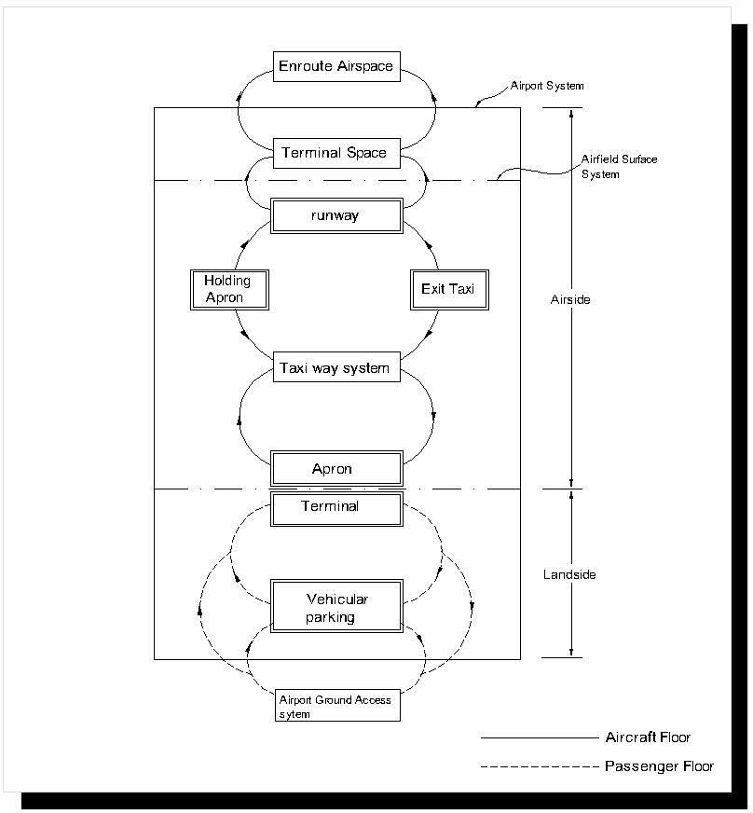

Figure 2.1 diagram of typical airport system showing aircraft and passenger flow

AIRPORT MASTER PLAN

Airport planning is a dynamic process based upon a multitude of procedures and criteria for evaluating

The rapid development of air transport in the 1980s caused the capacities of many big European airports to be fully taken up in a very short time. The increasing volumes of passengers and freight will continue making demands for the expansion of airport facilities. Although the majority of European airports have still an excess of capacity, as concluded at the meeting of the ECAC ministers of transport in 1992, each state is obliged to ensure development of ground infrastructure, to detect and eliminate bottlenecks that are limiting the capacity of the airport system. In that way it should be possible to ensure that the increased requirements for capacity of airports in the future will be met. The solutions to these capacity issues can only be approached successfully on a system basis. It is necessary to assess the capacity of each part of the airport system individually: runway, taxiway system and configuration of apron, service roads, parking lots, cargo terminal and ground access to the airport. The result of such a system study is a proposal for staging the development of airport facilities, elaborated in a Master Plan of the airport.
An airport Master Plan represents a guide as to how the airport development should be provided to meet the foreseen demand while maximising and preserving the ultimate capacity of the site. In the majority of cases it is not possible to recommend one specific dogmatic solution. It is always necessary to search for alternative solutions. The result is a compromise which, however, must never be allowed to lower safety standards.
Planning of an airport‟s development is usually complicated by considerable differences between types of equipment and the level of the technology of the installations that are required for ramp, passenger and freight handling, and operations on the taxiways and runways.
The Master Plan of an airport may be characterised as: „a plan for the airport construction that considers the possibilities of maximum development of the airport in the given locality. The Master Plan of an airport may be elaborated for an existing airport as well as for an entirely new one, regardless of the size of the airport’. It is necessary to include not only the space of the airport itself and its facilities, but also other land and communities in its vicinity that are affected by the airport equipment and activities.

It must be highlighted that a Master Plan is only a guide for: (i.) development of facilities
(ii.) development and use of land in the airport vicinity
(iii.) determination of impacts of the airport development on the environment (iv.) determination of requirements for ground access.
It is necessary to actually construct each of the planned facilities only when an increasing volume of traffic justifies it. Therefore the Master Plan of an airport should include the plan of the phasing of the stages of building.

As it has been already emphasized, the Master Plan of an airport is only a guideline, and not a programme of construction. Therefore it does not solve details of design. In a financial plan, which is included in Master Plan, it is only possible to make approximate analyses of alternatives for development, though costs of construction over the short term do need to be estimated with some accuracy if decisions are to be made on the economic feasibility. The Master Plan determines the strategy of development but not a detailed plan of how to ensure financing of each of the construction stages.
The basic objective of the elaboration of a Master Plan should be that the interested parties must approve it and the public should accept it.

AIRPORT CONFIGURATION

      - RUNWAYS

The term runwayrefers to the structural part of an airport which is directly involved with the taking off and landing of aircrafts operating in the airport. The number of runways is directly proportional to the volume of traffic; while the orientation of a runway is dependent on the the

prevailing wind direction and, sometimes, on the size of area available for airport development. In planning of runways and taxiways, care should be taken to:
provide adequate separation in the air traffic pattern;
cause the least delays and interferance in aircrafts landinng taxing and takeoff.
Provide the shortest taxi distance possible from temminal area top end of runway(s). Provide adequate taxiways.
Runway configuration vary a lot from one airport to another. However, there are several basic configuration and what one consider as different might just be varing combinations of these basics. The basic configurations are:
(i.) Single runway; (ii.) Parallel runway;
(iii.) Intersecting runway; and (iv.) Open-Vee runway.

GEOMETRIC DESIGN OF RUNWAYS

The principal elements of a runway are:

The structural pavementwhich supports the aircraft load.
The shoulders – these are adjacent to the structural pavement and are designed to resist erosion due to jet blast. They should also be designed to support maintenance equipment and patrol.
The ruway safety area – this should be capable of providing support for aircraft in case they veer off the structural pavement.
The blast padwhich is an area designed to prevent erosion of surface adjacent to the ends of runways which are subjected to sustained or repeated jet blast. This area can be paved or planted with turf.
The extended safety area – this serves to reduce accidents from undershoots and overruns.

Each runway should be surrounded by a runway strip. The runway strip is intended to ensure the safety of an aeroplane and its occupants in the event of an aeroplane:
undershooting, overrunning or veering-off the runway during landing or take-off deviating from the runway centreline during a missed approach.

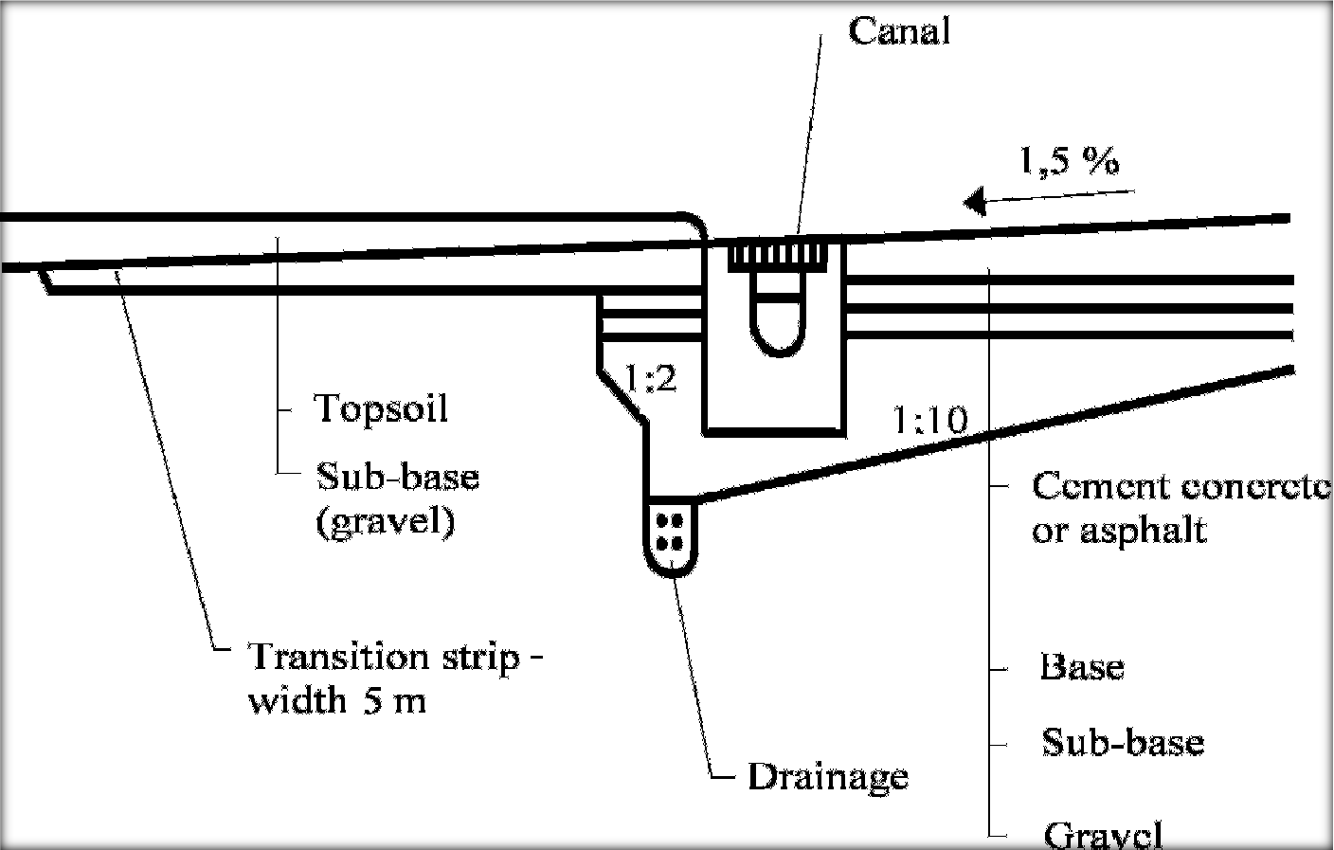
Figure 2.2 Transition strip – gravel and topsoil
(Source: J. Čihař, Letiště a jejichzařízení I., Alfa Bratislava 1973)

TAXIWAY SYSTEM DESIGN
Considering that the load bearing strength of a taxiway should be equal to or greater than the load bearing strength of a runway, the construction of taxiways represents an important item in the total investment costs. Therefore it is necessary to optimise the taxiway system layout to provide efficient taxiing without undue expense.
The taxiways should permit safe, fluent and expeditious movement of aircraft. They should provide the shortest and most expeditious connection of the runway with the apron and other areas in the airport. This minimises time and also the fuel consumption of the aeroplanes, which has a positive effect upon the environment. The safety of aeroplanes is enhanced if the taxiways are designed to allow one-way operation, and if crossing other taxiways, and particularly runways, is minimised. The FAA has issued guidance for the provision of end-around taxiways in order to minimise the need to cross runways. These taxiways are to be provided with a screen to hide aircraft on the taxiway from pilots lined up for take-off so that they concentrate only on observing aircraft which may be actually on the runway (Airports International, April 2006).

HIGH-SPEED EXIT TAXIWAYS

To improve the capacity further, it is necessary to construct one or more rapid exit (high-speed exit) taxiways, usually from the preferred direction of the main runway, whose parameters and location need to correspond to the type of operation on the given runway.

The purpose of the standardisation is to allow the pilot to anticipate the conditions at a less familiar aerodrome in order to avoid prolonging the time of occupation of the runway occupancy time by failing to make the best use of the turn-off.

It is also more likely that they will be used effectively if distance markers are set up 300, 200 and 100 metres before the throat. The parameters of a high-speed exit taxiway, particularly the radius of the turn-off curve, should permit turning off the runway at a speed of; up to 93 km.h-1 if the runway code number is 3 or 4; and 65 km.h-1 if the runway code number is 1 or 2, even if the surface of the runway is wet. The correct location of the beginning of the high-speed exit taxiway from the landing threshold of the runway is important in obtaining optimum use of the facility. It depends on:
speed of the aeroplane crossing the threshold of the runway deceleration of the aeroplane after its touch-down
initial speed of turn-off.

Table 2.3 Categories of airplanes according to their speed overhead the threshold

Category | Airplane speed overhead the threshold
A | less than 169 km/h (91 KT) IAS
B | 169 km/h (91 KT) or more but less than 224 km/h (121 KT) IAS
C | 224 km/h (121 KT) or more but less than 261 km/h (141 KT) IAS
D | 261 km/h (141 KT) or more but less than 307 km/h (166 KT) IAS
E | 307 km/h (166 KT) or more but less than 391 km/h (211 KT) IAS

(Source: ICAO Doc 8168/I, Part III, Chapter 1)

In line with Doc 8168/I, Part III, Chapter 1, the aeroplanes have been divided into five categories based on 1.3 times the stall speed in the landing configuration at maximum certificated landing mass overhead the threshold of the runway, as shown in Table 6-1.
For the purpose of high-speed exit taxiway design, the aeroplanes are assumed to cross the threshold at a speed that is equal to 1.3 VS, where VS is the stalling speed of the aeroplane in the landing configuration with an average gross landing mass (85 per cent of the maximum landing mass). Table 2.4 gives examples of ranking of the aeroplanes into groups on the basis of their threshold speed.

Table 2.4 Examples of ranking of the aeroplanes into categories on the basis of their threshold speed

A | B | C | D | E
Convair 240 | Convair 600 | B-737 | B-747 | Concorde
Saab 340 | DC-6 | B-707 | DC-10
DC-3 | Fokker F 27 | B-727 | L-1011
DHC-7 | ATR – 72 | 42 A-380/1 | A-380/1

1/ Depends on the aircraft mass

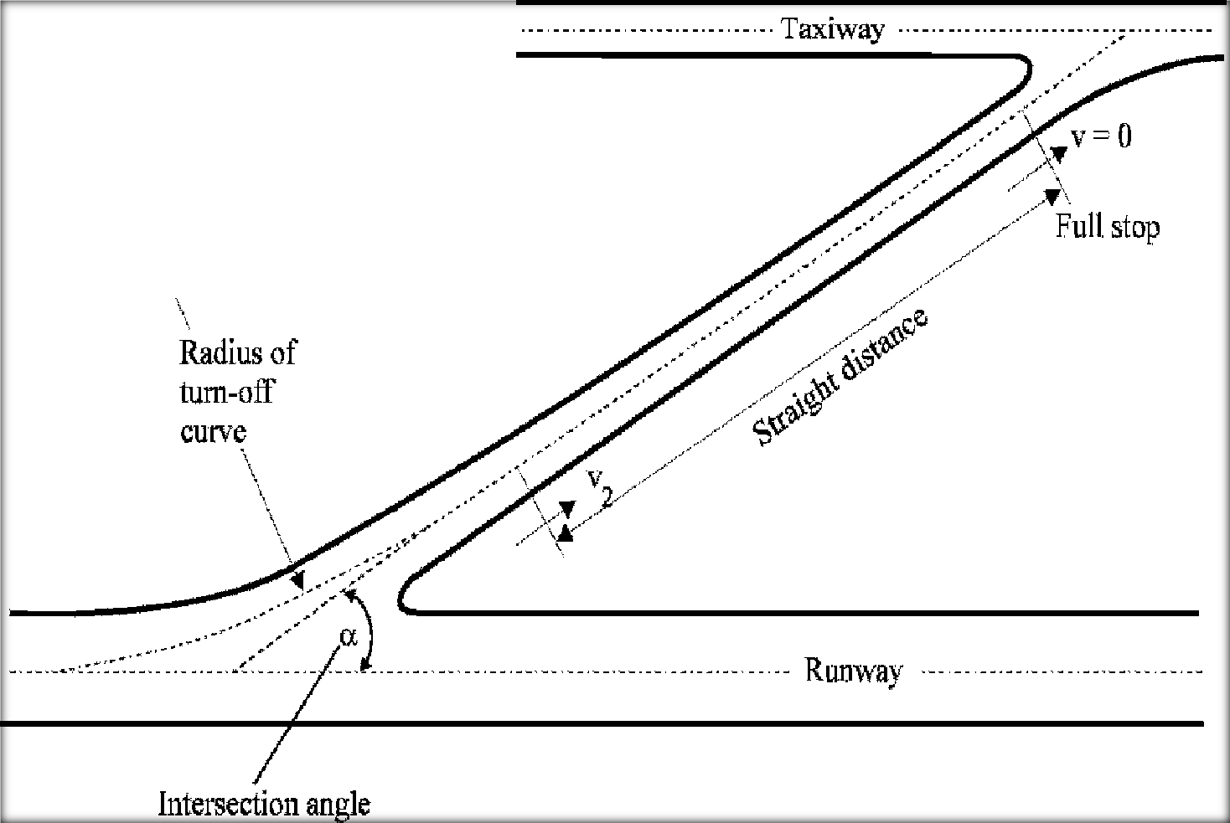

Figure 2.3 Characteristics of high-speed exit taxiway

TAXIWAY SEPARATIONS
The minimum safe separation distance between the centre line of a taxiway and the centre line of a runway is defined as a standard in Annex 14. The actual distance depends on the code number of the runway and the category of its approach aids, and it is such that the wingtip of a taxiing aircraft will not encroach into the runway strip. With the introduction of a Code F in Annex 14, the distance might have to be as much as 190 m. Similarly, the minimum safety separation distances are specified between parallel taxiways; these should be 97.5 m to allow unimpeded use by aircraft of up to 80 m wingspan.

Table 2.5 Taxiway minimum separation distances

Code letter | Instrument runways code number |  |  |  | Line to TWT centre line [m] | Stand taxilane centre line to object [m] | Taxilane centre line to object [m]
 | 1 | 2 | 3 | 4
A | 82.5 | 82.5 | – | – | 23.75 | 16.25 | 12
B | 87 | 87 | - | – | 33.5 | 21.5 | 16.5
C | – | – | 168 | – | 44 | 26 | 24.5
D | – | – | 176 | 176 | 66.5 | 40.5 | 36
E | – | – |  | 182.5 | 80 | 47.5 | 42.5
F | – | – | – | 190 | 97.5 | 57.5 | 50.5

Note: Data for non-instrument RWYs are not shown.
(Source: ICAO Annex 14, Aerodromes, Volume I, Aerodrome Design and Operation 4th edition)

APRONS
      - APRON REQUIREMENTS
Aprons are designed for parking aeroplanes and turning them around between flights. They should permit the on and off loading of passengers, baggage and cargo, and the technical servicing of aeroplanes including refuelling.

The requirements for the construction of aprons are similar to those of the other reinforced surfaces. The aprons are the most heavily loaded of all the movement area pavements. The aeroplane has its maximum mass on the apron just prior to departure. The surface is subject to concentrated point loads from the wheels of standing or slowly moving aeroplanes. In addition, it is dynamically stressed by vibrations after starting up the engines. Therefore, when calculating the apron pavement thickness, a safety factor of 1.1 is used.

The apron is a bridging point between the runway system and the terminal building. The location of the apron and its aircraft stands should allow convenient access. The following are some of the basic requirements that should be objectives when designing the apron:
location of the apron to minimise the length and complexity of taxiing between the runway and the stands
the apron should permit mutually independent movements of the aeroplanes on to and off stands with minimum delay
on the apron it must be possible to locate a sufficient number of stands to cope with the maximum number of aircraft expected during the peak hour
the apron should be adequate to allow quick loading and unloading of passengers and cargo
the apron should be designed so that there is sufficient space for the turn-round activities to be performed independently of activities on an adjacent stand.

the apron area should be adequate to provide sufficient space for parking and manoeuvring of the handling equipment , and also for the technical personnel
there should be a safe and effective system of airside roads for technical equipment to access the stands, preferably avoiding the need for aircraft to cross them to access the taxiway system.
they should be clearly marked with the width of each lane able to accommodate the widest piece of ground equipment
the negative impacts on the workers‟ environment, particularly safety, noise and exhaust gases should be minimised, the emphasis being the health and safety of the staff and passengers accessing aircraft across the apron.
the possibility of further extension of the runway system, aprons and buildings should be considered.

Each of these requirements has an effect upon the final design of the apron.

APRON SIZING
The above objectives can only be achieved if the apron size and the positioning of the stands are adequate to permit expeditious handling of the aerodrome operation during predicted peak hour traffic levels.
The appropriate apron size depends on the types of aircraft which are intended to use the apron, but the shape and apron layout also depends upon a number of other geometric considerations. In addition to the aircraft stands, the over-all apron area also includes space needed for apron taxiways and taxi-lanes, safety clearances, space for blast fences, service roads and areas designated for ground equipment and vehicle placement.

The size and shape of land available also influence the stand types and apron layout concept.

Each aircraft type needs sufficient stands in the correct position, and possibly a specific manner of stand operation, either nose-in or inclined for self-manoeuvring. There may also be specific requirements for technical servicing (e.g. refuelling), for technical equipment, and for guidance to the parking position when nose-in operation is used. The accuracy of the aircraft guidance on theapron may have an effect upon the size of the apron.

The total apron area depends also on the type of the operation prevailing on the aerodrome and the occupancy time of stands. For some airline operators, the aerodrome may serve as a base; for others, as a departure/arrival aerodrome or only as a transit stop. The based aircraft normally have a greater occupancy time between arrival and departure, so much so that it may be better to consider towing them off to remote stands.

In order that all the factors that influence the apron size may be considered, particularly with large aerodromes, it is advisable to simulate the operations on the apron. Similarly, the operational control of the apron, e.g. stand allocation, is computerised at large airports.

APRON LOCATION
Theoretically, the most efficient location for the apron is at a distance of 1/3 length of the runway from the main runway threshold, based on a normal split of use of the two runway thresholds.
When determining the apron location and orientation, the following objectives should be taken into account: minimum length of taxiing of the aeroplanes
the shortest distance possible from the walkway in front of the terminal building to and fromthe aeroplane minimum impact of the engine exhaust on the terminal building
possible expansion of the apron as well as the terminal building.

In the majority of cases, the apron is constructed directly in front of the terminal building, allowing the stands to be served by air-bridges if they are deemed to be necessary. If bridges are not provided, some other safe way of getting the passengers to and from the aircraft will be needed using well-policed walkways or buses. Preferably, the airside service road runs under the air-bridges; otherwise it has to run between the back of the stands and the taxiways.

In some other cases, the whole apron, or a section of it, is constructed at a considerable distance from the terminal building. Then it is necessary to provide some form of transport of passengers between the terminal building and aeroplanes. This increases the operating costs. There are many reasons why an apron might be located remotely.
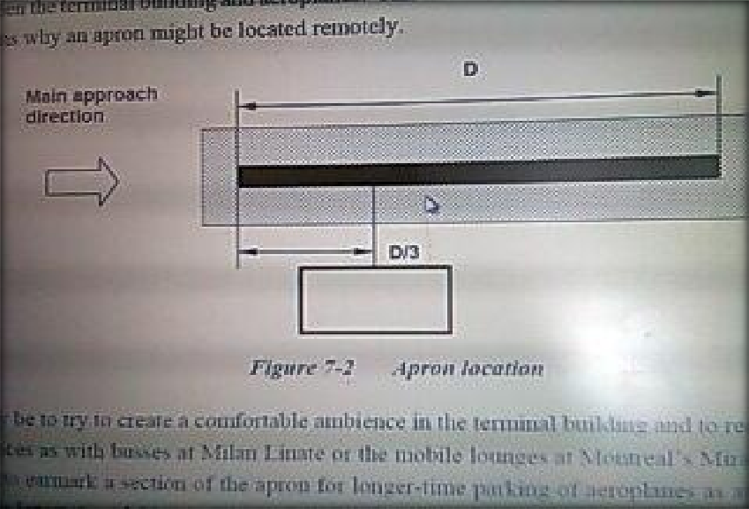
Figure 2.4 Apron location

AIRCRAFT STAND TYPES (PARKING CONFIGURATION)
Aircraft can be positioned at various angles to the terminal building and can manoeuvre either under their power or with aid of towing equipment. The latter results in the economy of gates. In adopting a particular parking type, the criteria should be on economy of space and the protection of passengers from the adverse elements of noise, jet blast, and weather. It is also advisable to consult with the operating airline since most of them have preferred parking positions. Some of the successfully operated parking positions. Some of the successfully operated stand types are:
(i.) The nose-in stand;
(ii.) The angled nose-in stand;
(iii.) The angled nose-out stand; and (iv.) The parallel stand.

(i.) THE NOSE-IN STAND
As the name implies, the aircraft is parked perpendicular to the terminal building with the nose as close to the building as possible.The aircraft can manoeuvre into the gate under its own power or be towed into position. However, it cannot leave the gate under its own power, so it has to be towed a sufficient distanced to allow it to proceed under its own power.

Advantages:
 It requires the smallest gate for a given aircraft. It causes low noise levels, as there is turning.
No jet blast towards the terminal building.
Nose proximity to the terminal facilities loading and unloading passengers.

Disadvantage:
It requires towing equipment.
Rear aircraft doors are too far to be used effectively in loading and unloading operations. Towing-out consumes time and hence causes delay.

(ii.) THE ANGLED NOSE-IN STAND
This parking type requires that the aircraft be parked at an angle to the terminal building with the nose of the aircraft closest to the terminal building.

Advantages:
Aircraft can manoeuvre in and out of gate on its own power.
Rear aircraft doors are close enough for loading and unloading operations.

Disadvantages:
Requires a larger gate area.
Produces higher noise level in terminal area.

(iii.) THE ANGLED NOSE-OUT STAND
This is similar to the angled nose-in parking type except that, in this case, the aircraft is parked with its nose pointing away from the terminal building.

Advantages:
Same as in angled nose-in stand.

Disadvantages:
Requires a larger gate area than the angled noes-in type. Terminal building is exposed to jet blast.
Produces high noise level in terminal area.

(iv.) THE PARALLEL STAND
This type of aircraft stand requires that the aircraft be parked parallel to the major axis of the terminal building. It is the easiest to achieve from the aircraft manoeuvring standpoint.

Advantages:
Easy to achieve in manoeuvrability.
Noise level and jet blast are minimised.
Both forward and after doors can be used in loading and unloading operations effectively.

Disadvantages:
Require a larger gate position.
Aircraft long wingspan brings about the need for long bridges in loading and unloading operations.

APRON CONCEPTS
This refers to the manner in which the apron is arranged around the terminal building. It has a direct effect on apron size. It depends on the manner in which the gates are grouped around the terminal and on the circulation and taxiing patterns adopted between the terminal and the runways.
Aircraft are grouped around terminal buildings in the following ways:
(i.) Transporter concept; (ii.)Linear concept;
(iii.) Pier concept; (iv.) Satellite concept. (v.) Unit concept.

(i.) TRANSPORTER CONCEPT
Here the gates are positioned freely on the apron near the terminal building but not directly adjacent to it. It is most applicable in airports where the traffic volume is low and passengers walk between the terminal and the aircraft. This concept might require the conveyance of passengers, and is used in conjunction with the mobile conveyance processing concept. This concept is outdated and gives no room for future expansion.

(ii.)LINEAR CONCEPT
The linear terminal is one of the most basic passenger terminal concepts. The linear terminal may be a single level or multi-level building. The linear plan may accommodate a single airline or may be a consolidated terminal for multiple airlines. In the linear terminal concept, passenger processing is primarily centralized. This concept requires that the airplanes be hooked up to the apron by means of a concourse and bridge through which passengers board the plane and are protected from the elements. This is suitable for domestic airports as it handles a smaller traffic well. It also allows for future expansion if required.
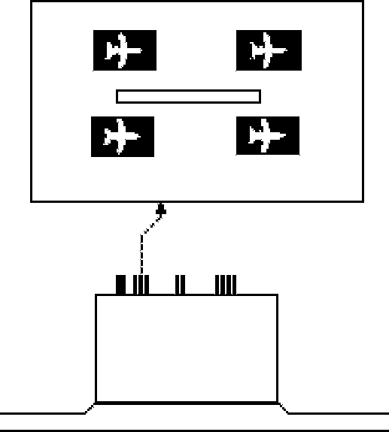
Figure 2.5 Transporter concept
(Source: ICAO Doc 9157 Part 2)

(iii.) PIER CONCEPT
This system operates in conjunction with the pier finger processing concept. The gates are positioned around the pier finger. It has the advantage of allowing for expansion of number of gate positions without addition to the size of the processing system. It also allows for use of passenger loading facilities such as nose bridges.

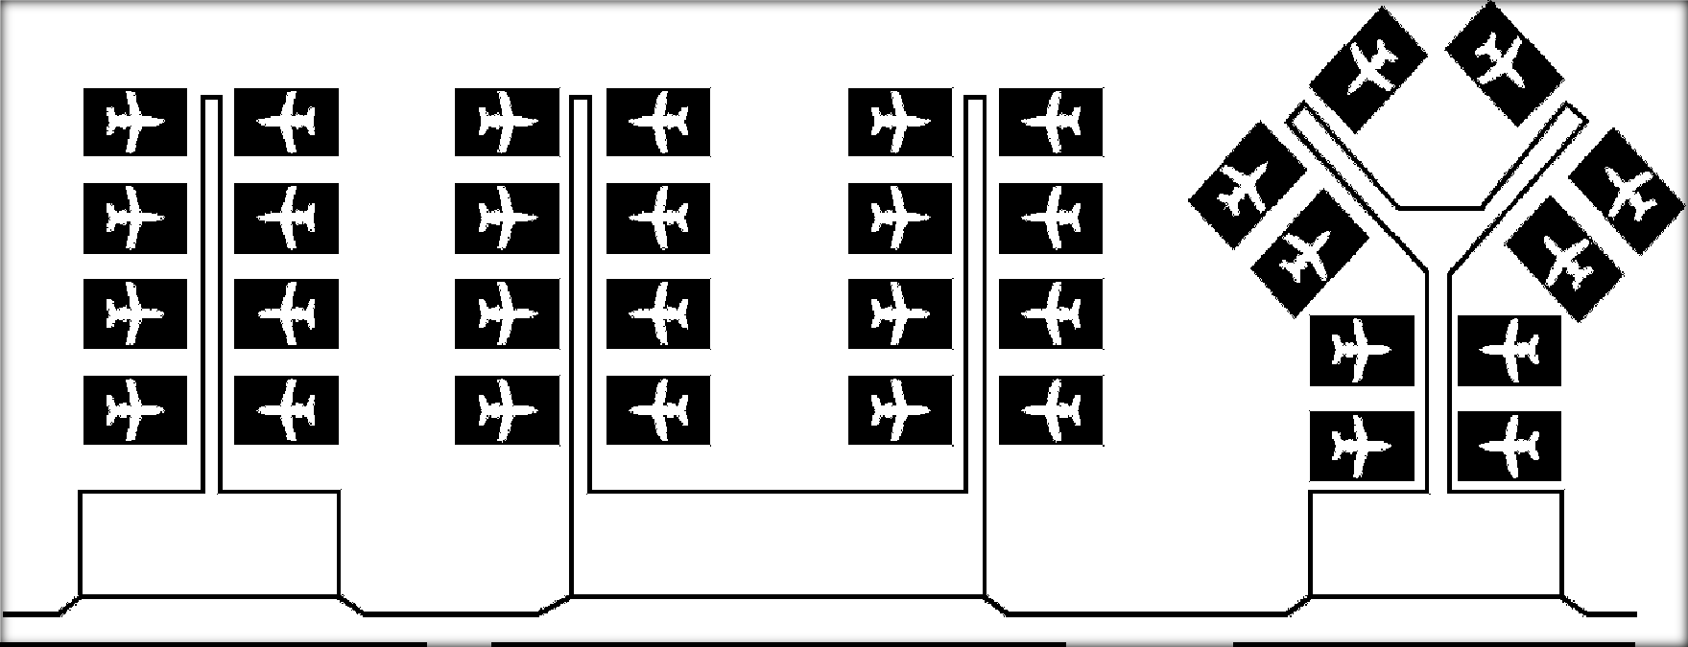

Figure 2.6 Pier concept
(Source: ICAO Doc 9157 Part 2)

(iv.) SATELLITE CONCEPT
In this concept, each of the remote passenger loading satellites is connected with the terminal building by underground tunnels or by overhead corridors. The satellites may be any shape from linear as at Atlanta Hartsfield to circular as with Charles de Gaulle Terminal One(CDG T1). Typically, the number of stands at circular satellites varies between 4 to 8 aeroplanes but the linear ones may well have 20 stands per side. The larger ones are usually sited in mid-field, their length being limited by the separation between the runways. Satellites, as opposed to unit terminals, imply that the processing takes place centrally, but in some cases there is a degree of decentralised processing, particularly with security screening. Given a suitable gate assignment system, this concept is good for hubbing, except for international/domestic transfers that require clearing through the central terminal.
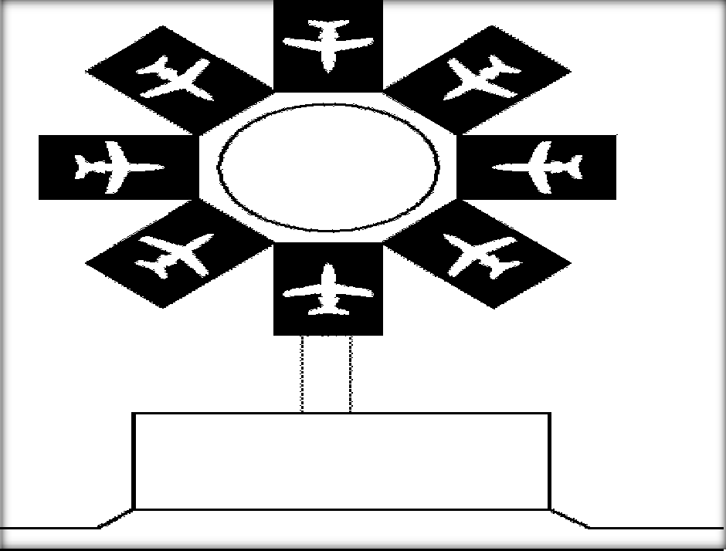
Figure2.7 Satellite concept (Source: ICAO Doc 9157 Part 2)

(v.) UNIT TERMINAL

In the unit terminal concept, a single airline or a number of airlines are accommodated in individual, stand alone terminal buidings. The individual terminal buildings are linked together by a terminal area access roadway. The unit terminal concept provides a high degree of individual identity and operational autonomy to the airlines. Transferring between airlines and between unit terminal buildings may be very difficult for passengers at unit terminal airports. London Heathrow, John F. Kennedy Airport in New York, and Chicago O‟Hare International Airport are examples of the unit terminal concept implemented on a large scale. The Dallas Fort Worth International airport is a famous example of the unit terminal concept in which the design tried to provide for more efficient interline transfers.

THE PASSENGER TERMINAL BUILDING
This is the term of reference of my thesis work and, hence, has to be given great attention. The terminal building is a connecting link between the air-side the land-side. It is a connection between „the sky and the earth‟. First and foremost, it must provide basic aeronautical services; that is activities directly connected to provision of the passenger check-in process. The building must provide a fast and the shortest possible transition of the passengers from the surface transport through the outbound processes to the aircraft on departure and in the opposite direction on arrival.

The arriving and departing passengers must be physically separated, not only for fast and fluent movement of the passenger flows but also in order to ensure security. The flows of passengers can be separated by fixed or moveable obstacles on a single level (horizontally) or on several levels (vertically).

On the landside, the passenger terminal must be designed to interface with the various modes of transportation providing access to the airport. Personal and commercial vehicle traffic must be analyzed and the access roadways and terminal curbfront must be designed to accommodate the volume of average peak hour vehicle traffic. If train service is provided to the airport, the train stations and passenger passenger platforms must

be carefully integrated with the the design of the terminal complex to provide smooth and efficient passenger flow to an d from the terminal building. The terminal building must accommdate the projected average peak hour departing and arriving passenger volume. (Average peak hour passenger traffic is defined by the Federal Aviation Administration as the volume of passengers projected for the peak hour of the average day of the peak month).
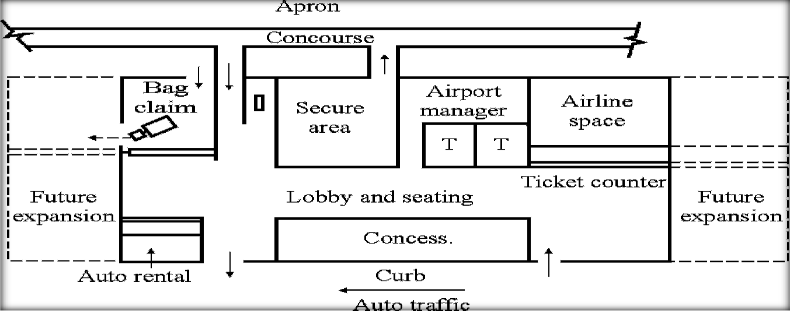On the airside, the terminal must be designed to accommodate the airline flight schedules. The terminal apron and airside interface must be designed to accommodate the anticipated number and type of average peak hour aircraft and all necessary ground service vehicles and equipment.
Figure 2.8 Example of a functional terminal layout

(Source: FAA Advisory Circular, Planning and Design of Airport Terminal Facilities at Nonhub Locations)

FUNCTIONAL DESIGN OF THE AIRPORT PASSENGER TERMINAL

The passenger terminal is one of the most important elements of the airport due to its essential role in providing services to air travelers. The passenger terminal must be designed to perform a number of functions:
- Facilitate the transition of passengers between surface and air modes of transportation.

- Provide a controlled and orderly environment for the processing and flow of passengers.

- Create a secure and comfortable environment for passengers to gathern and to wait, if necessary, pror to boarding the aircraft.

- Accommodate and facilitate all of the necessary and often complex work processes associated with the operation and maintenance of the terminal facility.

USERS OF THE TERMINAL BUILDING

The airport terminal must be planned and designed to meet the needs of the terminal facility. The primary user groups include the passengers, airlines, airport operator, and concessionaires. The principal purpose of the passengers terminal is to provide transportation services to air travelers. Therefore, it is of the greatest importance to accommodate passenger needs.
The airlines are the primary providers of services to passengers and are of the most important operators of the passenger terminal. Therefore, it is especially important that the passenger terminal be designed in accordance to with requirements of the airlines and to facilitate the process of providing passenger services.

The airport operator performs many functions that are essential to the operation and maintenance of the airport terminal. Therefore, it is imperative that the airport terminal be designed for efficient and economical operations and maintenance. The passenger terminal must accommodate the airport operator‟s requirements for administrative and support space and must provide an efficient, safe, and healthy work environment for the airport operations and maintenance personel.

AIRPORT TERMINAL LAYOUT
For small airports, a single level concept is the most suitable (Figure 2.9a). In this concept the departing and arriving passengers and their baggage are separated horizontally, usually on the same level as the apron. The arriving passengers on domestic flights often do not even pass through the terminal building and the baggage is directly handed to them from the baggage cart under a shelter or even near the aircraft. In this single level concept passenger loading bridges are not used, though the concept of a telescopic cover to protect passengers from the weather was introduced at Oakland, California by 1930 and installed at the original beehive terminal at Gatwick in 1936 [12-B ]. If terminal buildings at larger airports were designed on a single level, the terminal would require a large area of land. It then becomes more convenient to separate the passengers vertically. The simplest type of vertical separation is a concept of one and a half levels in several variants according to local conditions (Figure 2.9b). Normally the departure and arrival landside concourses are on the same level side-by-side. The division of flows of departing and arriving passengers and baggage can be done at any point after the check-in process or alternatively immediately after the entrance into the terminal building. Both levels meet again on the apron if the passengers are to walk or be bussed to the aircraft.

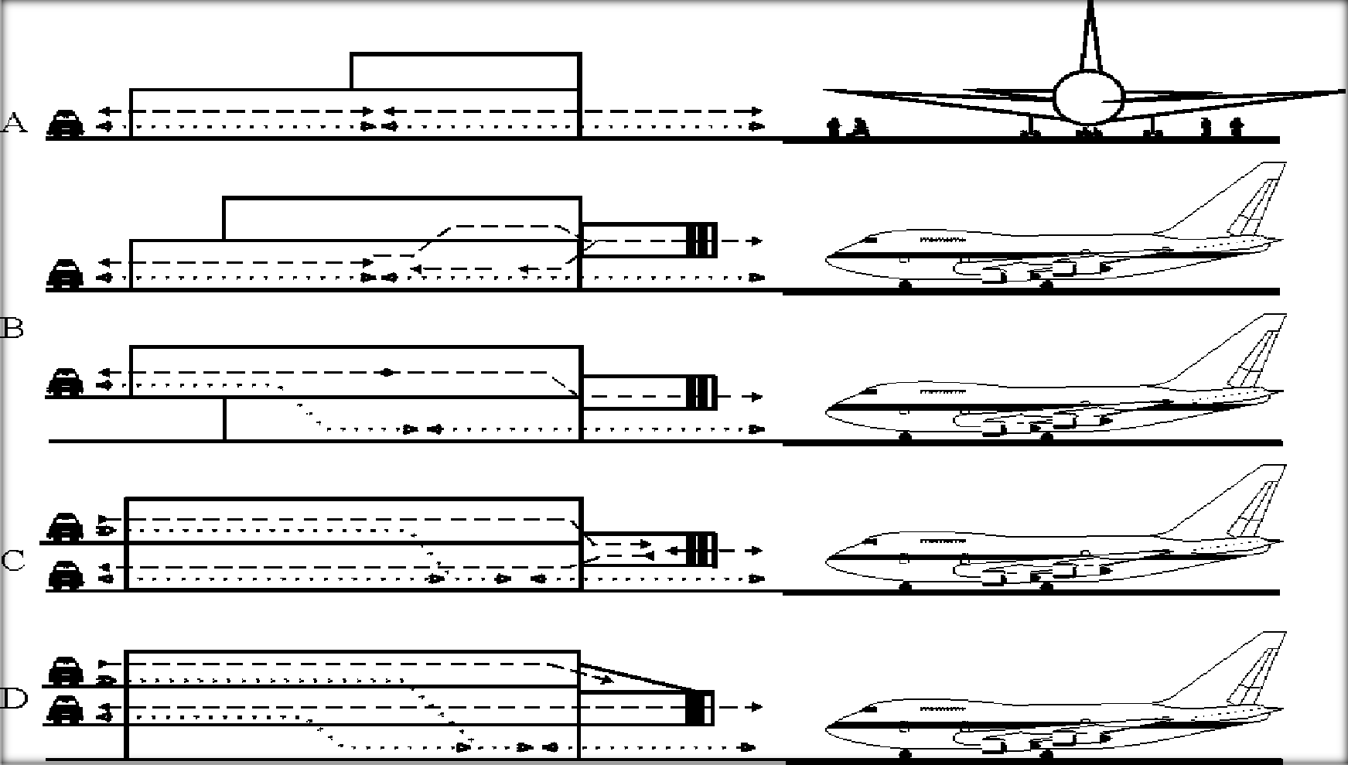
Figure 2.9 Airport terminal layout
      - single level concept (b) one and half level concept
(c) double level concept (d) three level concept

The double level concept provides separation of the passenger flows even on the landside by vertical stacking of the road access system, though with the capability to move between the levels inside the building (Figure 12.3c). The double level concept is usually used for terminals with traffic volumes of above 5 million passengers a year.
The flow of passengers through the departing process must be direct, logical, limiting the changes on the vertical levels and as short as possible. Maximum walking distances for the passengers are recommended by the International Air Transport Association (IATA) as shown in Figure 12- 4 and described below:
from the departure kerbside in front of the terminal building to the check-in counter 20 m from the farthest car park to the check-in counter 300 m
from the check-in counter to the farthest - gate 330 m from the gate to the plane 50 m
The walking distances are similarly specified also in the case of passenger transfer between aircraft. If the distances are longer than specified, it is necessary to provide some kind of mechanical assistance for the passenger. ICAO suggests that the time from disembarking the aircraft to exiting the terminal should not exceed 45 minutes for international passengers.

Table 2.6 Activities and space needs in a terminal building

MOVEMENT | ACTIVITIES | SPACE NEEDS
DEPARTURE PASSENGERS | CHECK-IN COMMERCIAL AREAS  CUSTOMS CLEARANCE | DEPARTURE CONCOURSE
 | SECURITY  SHOPPING EATING | DEPARTURE CONCOURSE
 | GATE CHECK-IN
ARRIVAL PASSENGERS | IMMIGRATION SECURITY | ARRIVALS AREA
 | BAGGAGE CLAIM | BAGGAGE HALL
 | CUSTOMS CLEARANCE | CUSTOMS HALL
 | MEETING  REFRESHMENT | ARRIVALS HALL
TRANAFER PASSENGERS | SECURITY  CUSTOMS CLEARANCE IMMIGRATION REFRESHMENT | TRANSFER LOUNGE/ DEPARTURE LOUNGE

(Source: The Architect‟s Handbook; edited by Quentin Pickard RIBA )

2..5.12. TERMINAL BUILDING SPACE REQUIREMENTS

The determination of space requirements at passenger terminals is directly proportional to the level of serviced desired. Some guidelines for the determinations of space requirements can be defined. These guidelines give estimates which are subject to changes depending on the requirements of specific design. The following steps should be followed:
(i.) Identify passenger type;
(ii.) Identify passenger type facility demand; and (iii.) Determine general space requirement.

(i.) IDENTIFY PASSENGER VOLUME AND TYPES

Forecast done in airport planning studies provide estimate passenger volumes. Two measures of volumes are used:

(a.) Annual passenger volume; which is used for preliminary sizing of terminal building and can be based on 5, 10 or 20 years.
(b.) Typical peak-hours passenger volume; which serves as an hourly, design volume passenger teerminal design. It is a design index andis usually in the range of 0.03 to 0.05 % of the annual passenger volume.
The identification of passenger type is important in the sense that different types of passenger place varying demands on different airport facilities. Passenger types are identified according to the following characteristics:

international or domestic; arriving, departing or transfer; with or without checked baggage; mode of access to airport; and scheduled or chartered.

(ii.) IDENTIFY PASSENGER TYPE FACILITY DEMAND

This is done by matching the pssenger types with the various facilities in the terminal building. Table enables one to calculate the total load on each facility by indicating the volume of each type of passenger in the rows corresponding to the facilities. This is done by taking the row sums of the volumes entered.

(iii.) DETERMINE GENERAL SPACE REQUIREMENTS

This is done by multiplying the demand for various types of facilities obtained in the previous step with the approximate requirements per unit volume shown in Table . The use of figures in Table will provide a reasonable level of service and a tolerable occupancy level of the various facilities.

2..5.13 PASSENGER-HANDLING SYSTEM

This is the major connection between airport access and the aircraft. Its purpose is to: (i.) Interface with the passenger‟s mode of access;

(ii.) Process the passenger for starting or ending an airstrip; (iii.) Convey the passenger to and from the aircraft.
The passenger handling system is composed of three components. These components are:

ACCESS INTERFACE

In this component, the passenger transfers from the access mode of travel to the passenger-processing component. Circulation, parking and curbside loading and unloading of passengers are the activities that occur in this component. This area includes:
(a.) Arrival and departure curbs for passengers accessing by automobile;
(b.)Convenient connection to the various automobile parking facilities on the airport, eg. walkways, shuttle bus, etc.; (c.) Facilities for passengers using collective airport access mode

PASSENGER PROCESSING

The passenger is processed in preparation for starting or ending a trip. Ticketing, baggage check-in, baggage claim and control are the activities that take place in this component. They include:
(i.) Counter for airline ticketing and baggage check-in;
(ii.)Counter for control, such as customs, security, health and immigration; (iii.) Facilities for baggage claim support facilities;
(iv.) Passenger circulation and movement spaces;

(v.)Waiting rooms;
(vi.) Ammenities – washrooms, public telephone, storage lockers, nurseries, first-aid rooms, post office, and hotel reservation desks; (vii.)Information displays;
(viii.) Restaurants, snack bars and counters, bars, etc.; and
(ix.) Facilities for visitors, including observation desks and special lobbies

FLIGHT INTERFACE

The perssanger transfers from the processing component to the aircraft in this component. Activities in this component include passenger assembly, conveyance, and aircraft loading and unloading.
From the above, one can see that varying activities in each component will demand a definite set of facilities for the proper functioning of the passenger handling concept. These facilities are indicated for each component as follows:
(a.) Space for gate lounges;
(b.)Conveyance facilities – buses, mobile lounges, etc.; (c.) Loading facilities – jetways, nose bridges, etc.;
(d.)Conveyance facilities for transfer passengers;

PASSENGER FLOW PLANNING

Passenger flow planning is governed by two rules:

(i.)Separation must be completely secure between the airside activities, (Airport staff operate a pass system; the combination of airside/landside catering preparation facilities requires approval).
(ii.) Departure and arrival flow systems must be separate within the terminal. The exception is in international passengers section where the communal use of piers and aircraft access systems, departures and arrival concourse do not require physical separation.
The decision on how many levels require for adequate separation of arriving and departing passengers is based on the volume of passengers. Some distribution concepts are discussed below:

ONE-LEVEL SYSTEM

With this system, all processing of passengers and baggage occur at the level of the apron. Separation between arriving and departing passenger flows is achieved horizontally. Ammenities and administrative facilities may be placed on a second level. This system system is very economical and is suitable with low passenger volumes not exceeding 1 or 2 million annually.

TWO-LEVEL SYSTEM

There are two basic types of this system:

(i.)The two levels are used in separating the passenger-processing area and baggage-handling areas. Therefore, processing activities including baggage claim occur on the upper level, while airline operations and baggage-handling level occurs at the lower apron level. The higher passenger-handling level allows for convenient interface with the aircraft.
(ii.) The two levels are used in separating the arriving and departing passenger flows. Departing-passenger processing activities occur at the upper level; while arriving passenger processing and baggage claim occur at the apron level. Vehicular access occur at both levels, one for arrivals and the upper one for departures.

TERMINAL BUILDING SPACES (i.) THE LANDSIDE KERB
This is used by cars, taxis, courtesy busses and public busses for drop off and pick up. The various vehicles are often segregated to separate kerbs, with the consequent need for most people to cross lanes of traffic. They are also segregated between arrivals and departures, either spatially in single level terminals or vertically in two level buildings. A typical total kerb length is 1 m per 10 TPHP, but this depends very much on the mix of traffic and the discipline at the kerb.

It is often the case that vehicles stay longer than permitted, and strong policing is required. There is also a problem with security when vehicles are left empty while meeting or waving. Some airports have now banned the use of close-in kerbs, and force people to use a park and ride system.

(ii.) THE TICKETING LOBBY
This requires 4 m of queuing space, a counter and space behind the counter for staff and facilities; perhaps some 2,500 m2 for 50 EQA. The lobby is usually on the back all of the check-in concourse.

(iii.) THE CHECK-IN CONCOURSE
This needs, in addition to the counters, some basic facilities like flight counter information, telephones, toilets, and a small café for people who wish to linger with those who are seeing them off, but the general aim is to move passengers through the security screen quickly after check-in so as to avoid delays and crowding. It is becoming increasingly common to provide selfservice kiosks, whether dedicated to an airline or Common User Self Service (CUSS) kiosks (www.iata.org/CUSS), together with fast bag drop facilities for the kiosk users with bags.

(iv.) CHECK-IN COUNTERS
This may be provided at train stations, car parks, downtown or at gate lounges, but it is most common to situate them immediately after the entry to the terminal. They may be arranged linearly facing the passengers when they enter the concourse (Heathrow Terminal 4, Manchester), end-on to the flow (London Stansted, Hong Kong) or in islands (Heathrow Terminal 1, Dublin). The linear facing type may allow passengers to move on through the line of desks after processing, or require them to move across the queues to the departure gates. This latter arrangement can lead to confusion unless there is a lot of room behind the queues, but it is by far the most common layout.

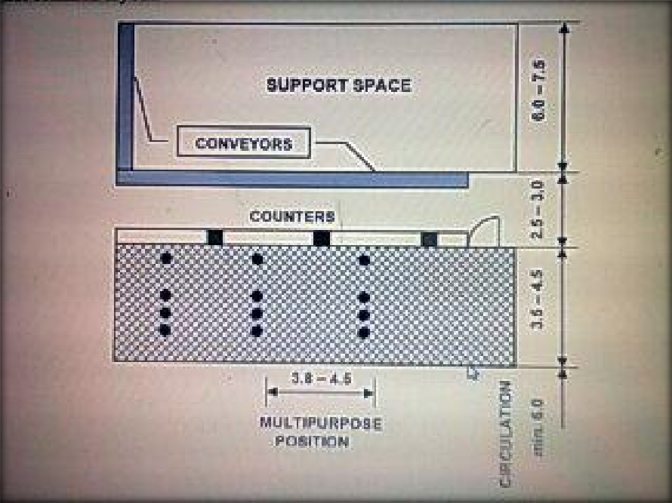
Figure 2.10 Linear counter (all dimensions in meters)
(Source: FAA AC 150/5360 –13 Planning and design guidelines for airport terminal facilities)

The conveyors run along behind the counter staff, and are fed by a short feeder belt running back from each pair of counters. The flow-through types take more space and cost more to build and maintain. The island types have the counters arranged in a U shape around belts running in the direction of the passenger flow. They offer some element of flowthrough and make efficient use of the conveyor belts because they can be fed from both sides.

IATA has a preference for the island layout, with between 10 and 20 counters per side and with 20 to 30 m separation between islands. The average processing time is 2 minutes, depending onnumber of bags, size of group and procedures required by the authorities. The FAA suggests that, for 50 EQA, 86 m of counter frontage is needed for a hubbing terminal and 148 m for an O-D terminal. Each pair of counters takes approximately 3.5 m, so a total of 84 counters is needed.
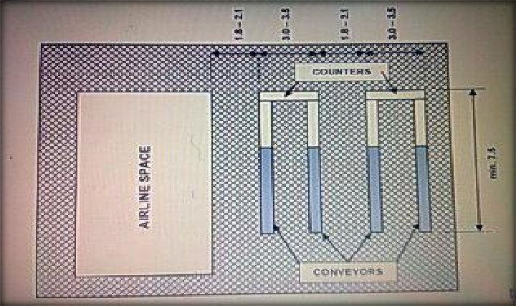
Figure 2.11 Flow-Through counter (all dimensions in meters)
(Source: FAA AC 150/5360 –13 Planning and design guidelines for airport terminal facilities)

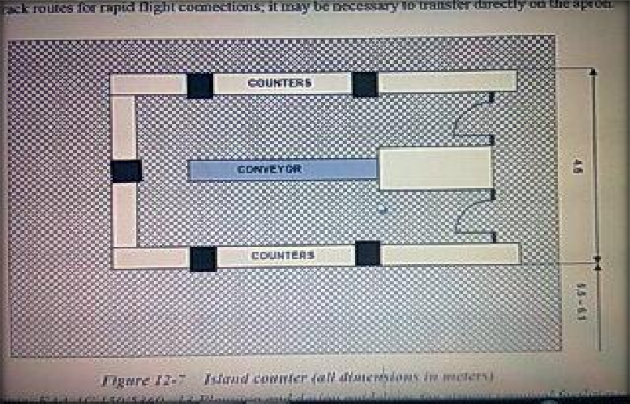
Figure 2.12 Island counter (all dimensions in meters)
(Source: FAA AC 150/5360 –13 Planning and design guidelines for airport terminal facilities)

(v.) THE OUT-GOING BAGGAGE HANDLING SYSTEM
This is usually installed under the floor of the departure level at large airports. It consists of:

belts, or trains with tilting trays or destination-coded vehicles
sorting devices that read the codes on the bags and either push the bags off the belts or tilt the trays to assign the bags to the flight make- up area
a screening system
a feed for transfer bags.

The system needs to be able to handle a large number of bags; between 0.8 and 2.2 bags per passenger, or between 1600 and 2200 bags per hour for 4 EQA and between 16000 and 26000 per hour for 50 EQA. IATA suggests that it should take no longer than 9 minutes for a bag to get from check-in to the furthest make-up area. Transfers from domestic to international should take less than 25 minutes, from international to international no more than 35 minutes. This may require fast track routes for rapid flight connections; it may be necessary to transfer directly on the apron.

The conveyor belts normally operate at between 0.4 and 0.8 m/sec, giving 26 to 50 bags per minute, but can achieve 1.5 m/sec if acceleration and deceleration belts are employed. Slopes should not exceed 22 degrees. Chutes may be used for down-slopes, but there is a greater tendency to damage the bags. If there are many flights to be served, it is necessary to install belts that recirculate past the fixed make-up stations for each flight, where the carts for each flight are usually positioned parallel to the belt for ease of loading. Those belts with inclined beds can carry a double layer of bags. Semi-automated sorting can be installed, where a pneumatic arm pushes the bag onto the appropriate slide, actuated by a signal from the operator who reads the baggage tag. The system can sort about 30 bags per minute.

(vi.) OUTBOUND PASSPORT CONTROL
This can achieve an average processing time of 20 seconds. As an example, if there are 7 desks and if the maximum desirable queuing time is 5 minutes, the queue could be 105 people long. The spacing in the queue is 0.8 – 0.9 m, 1 m2 per passenger giving LOS level C.
Space needs to be available in the check-in hall for this size of queue to develop. Clearly, if people present themselves at greater than the flow rate of 21 per minute for a sufficiently long time, e. g. if, say, 350 people leave the check-in counters in a 10 minute period, the queue could exceed the maximum desirable length. It should not be necessary to wait more than 5 minutes. It is often difficult to persuade government offices that more desks should be opened in such a case, so it is necessary to try to manage check-in so as to deliver a smoother flow, or provide more

queuing space and accept a lower level of service. The process should be speeded up with the introduction of Advanced Passenger Processing (APP), using biometrics and machine-readable passports.
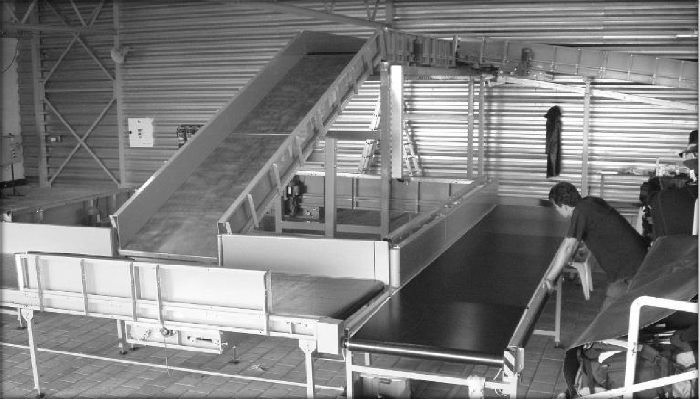

Figure 2.13 For small airports simple manual sorting system is sufficient – Brno Airport
(Photo: A. Kazda)

(vii.) SECURITY SCREENING OF PASSENGERS
This requires a walk-through detection device, an X-ray machine for accompanied baggage and space for manual searches and recovery of the X-rayed items. The FAA suggests that each security station requires an area of 10 m² to 15 m², and that it can handle 500 to 600 passengers per hour (pax/hr). However, the flow rate at Heathrow, until more severe requirements were put in place in late 2006, was 270 pax/hr per facility. The rate fell to 210, but improved management of the process should bring the productivity back to 270 pax/hr or 13.3 seconds per person. It is difficult to see how the FAA productivity estimates can be achieved with today‟s security regime, so the security queues should follow roughly the same calculations as for passport control. Meanwhile, the queues have sometimes been backing up to landside.

(viii.) CORRIDORS/LOBBIES
These have an effective width some 1 m less than the actual width, because of a reluctance to use the space in the „boundary layer‟ near the walls. The effective width is also reduced by facilities such as telephones, and displays which encourage people to congregate in front of them.
If the average walking speed is 74 m/min, a corridor with an effective width of 6 m will allow a flow of 300 to 600 people per minute, depending on how wide the people are and how closely they follow one another.

(ix.) THE DEPARTURE LOUNGE
This should have, as a minimum, space for the essential activities of waiting for flights to be called and then queuing to board the flight, and the facilities required for processing the passengers. There should also be telephones, toilets and some minimum catering for those whose flights are delayed after they have passed through security. At today‟s load factors of around 75%, this requires approximately 1 m² per seat of the aircraft being boarded. Seats should be provided for some 50% of the expected number of passengers unless it is likely that they will be held for a long time, this being dependent to some extent on the boarding policy of individual airlines. The space required per seat is 1.5 m² to 2.0 m², and for circulating is 1.5 m² to 1.8 m² /pax for LOS level C.

(x.) GATE ROOMS

where they are required or preferred, should have seating for 80% of the aircraft capacity at 1.7 m² per seat, and standing room for the remaining possible 20% at 1.2 m² /pax. Then LOS level C is achieved with a 65% load factor; a 95% load factor results in LOS level E. There must also be room for the airline counter and for a queue to form for checking the boarding pass and bag reconciliation prior to boarding. There is a conflict between the airline‟s desire to process passengers early into the gate rooms, and the passengers‟ aversion to being kept corralled for what may be an indefinite period with few if any facilities. Toilets should be provided if there is security control on entry. If there is a change of level from the gate room to the airbridge, escalators should not be used because the queue from the bridge could back up o to the escalator. The IATA sizing methods suggest that, when gate rooms are built along the sides of piers for a Code F aircraft like the A380, the total pier width needs to be at least 26 m².

(xi.) EXECUTIVE (V.I.P) LOUNGES
They are an important part of an airline‟s service to its Commercially Important Passengers (CIP). Business people need to be able to continue to conduct their business in suitable surrounding while they wait for their flights. Airlines sometimes share lounges when their business and first class market is small. At least four times the normal space should be used for sizing, to allow for the expected levels of comfort. The lounges should be near to the access to the gates.

(xii.) INBOUND GOVERNMENT CONTROLS
These cover immigration and naturalisation services; customs; public health; and lifestock and plant health. Some countries install pre-clearance facilities at the point of flight origin, in which case provision needs to be made for those facilities at the origin airport rather than on entry. The

areas downstream of inspection for passengers and for their baggage should be sterile. At the entry airport, strict segregation is required of international passengers from domestic passengers and the public by means of a physical barrier and with strict controls on entry and exit. There should be no public phones. The areas should be well lit and without glare.
Baggage from international flights should also be segregated. Transit passengers should have their own secure waiting room. The total space required for the support of all these activities is approximately 750 m² per 1000 peak hour international passengers. The processing time is longer than on departure, and may average 30 seconds, depending on the origin of the passengers. In completely smooth flow, the 1000 passengers per hour could be served comfortably by 9 desks.

An acceptable time for waiting in the inbound passport queue is 7 minutes. Customs require inspection tables, interview rooms, payment facilities, kennels, a bonded warehouse and space for administration and accommodation for staff.
A separate reception lounge is required at gateway airports, where visiting dignitaries may be entertained while the formal processes are completed on their behalf.

(xiii.) THE BAGGAGE CLAIM
This hall needs to be close to the airside road system for ease of transferring bags from the carts to the reclaim belt, and also close to the landside access points so as to avoid long walking distances with baggage. Airside it contains tugs/dollys/containers pending flight make-up, tug charging (if electric), staff restroom, early bag store. Landside it normally contains one or more bag reclaim units (carousels), though a simple roller bed fed from airside by gravity may be used.

It is important to provide currency exchange and toilets in this area, as passengers wish to use the time while waiting for bags to make themselves comfortable after the flight and before being met. The reclaim units may be either flat bed or sloping bed devices, the latter being

able to carry a double row of bags. They may circulate round from airside to landside on the same level, or a conveyor may provide a remote feed to an island carousel on a different level to the airside dock The length of claim frontage depends on the number of aircraft arriving in a peak 20 minute period.
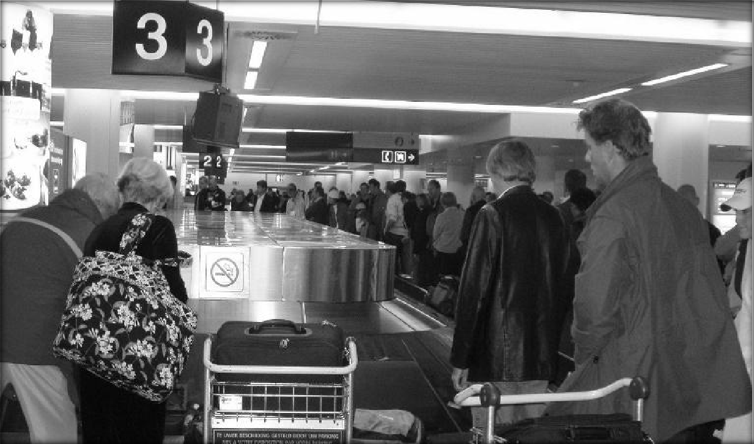
Figure 2.14 A waiting time for bags of 12 minutes is deemed to be acceptable
(Photo: A. Kazda)

There should be approximately 12 m between the claim units. The airside input area should be approximately 3 m² per metre of claim frontage for a U-shaped flat bed, rising to 6 m² per metre for a remote sloping bed carousel. A waiting time for bags of 12 minutes is deemed to be acceptable.

(xiv.) THE ARRIVALS LOUNGE
This should allow unimpeded exit from customs. The essential facilities are: meeting point, currency conversion, hotel and tourism booking, hire car, ticketing for onward transport and car parks (remote and isolated payment stations are to be avoided), café, flight information, phones. The sizing depends on the same factors as the check-in hall, but the only long queues are likely to be formed by meeters wanting to be close to the entry point.

(xv.) AIRLINE OFFICES
These are required for cabin service and personnel, aircraft line maintenance, managerial offices, flight operations, flight crew and cabin staff, secure and volatile storage. These activities might take 25 m² per EQA movement.

Table 2.7 Terminal building: space standards per passenger

SPACE PROVISION | SIZE (PER PASSENGER)
CHECK-IN AREA | 1.4m²
DEPARTURE LOUNGE | 1.8m²
BARS/ SHOPPING AREAS | 2.1m²
ARRIVALS LOUNGE | 1.5m²
BAGGAGE CLAIM | 1.6m²
CUSTOMS/ IMMIGRATION | 2.0m²
CIRCULATION AREAS | 2.0m²

(Source: The Architec‟s Handbook, edited Quentin Pickard RIBA)

(xvi.) GATE LOUNGE CONCEPT

The concept and function of the gate lounge are basically standard through the airline industry. The basic functional requirements are a ticket counter with all its communication equipment, a secure or semi-secure seating area with sufficient seating capacity to handle the passengers, flight identification, last-minute baggage drop, and circulation pattern which seperates the deplaning passenger from the enplaning passenger. However, each airline‟s requirements will vary in accordance with its operation procedures and level of activity.

The following are average sizes for gates lounges as require by each type of aircraft.

Table 2.8 Aircraft type and gate lounge size

AIRCRAFT | GATE LOUNGE SIZE
DC-9, BAC 111 | 60m²
B737 | 100m²
B707, B727, DC-8 | 140m²
B757 | 190m²
DC-10, B767 | 250m²
B747 | 360m²
B777, A3XXX SERIES | 460m²

(Source:The Architect‟s Handbook, edited by Quentin Pickard RIBA)

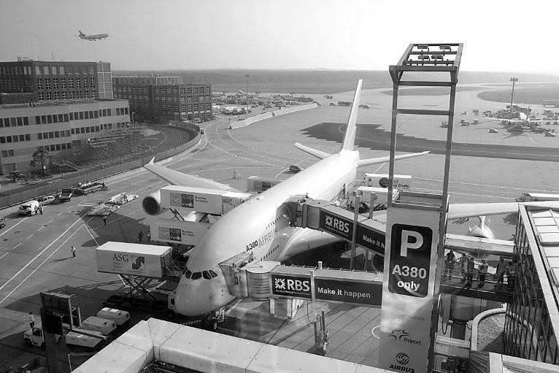

Figure 2.15 Airbus 380 connected to the gate lounge by means of the bridge (connector)
(Courtesy: Airbus Industry)

BAGGAGE HANDLING SYSTEMS

The average number of baggage pieces handled by the airlines ranges from 1.6 to 1.9 per passenger. This will vary depending upon the airport and airline for the type of route structure that exists. For example, the longer the flight the greater the probability that passengers will take several pieces of luggage–although very long international stage lengths show a reduction. Therefore, an airline that has a route structure built basically of long flight lenghts will handle a much greater number of bags than an airline with route structure based upon short stage lengths.
In providing space for baggage handling system, the architect must have a complete understanding of each airline operation and the relationship of all the airlines combined. This understanding should encompass the percentage of baggage per passenger for originating, terminating, and transfer (both interline and intraline). It also should be related to the time schedule and the peak conditions.
A check-in system can be serviced by a simple conveyor or a gravity chute. For large terminal facilities where there can be many check-in points and more than one baggage makeup space, a system can comprise fully automated cars or pallets that move bags to many destinations. This type of sophisticated system is costly and, in order to justify its use, it should be considered as a total system of all baggage movement, from aircraft to passenger and from passenger to aircraft.
Baggage claim devices can involve many different shapes, forms, and methods of mechanical or manual handling of baggage. The basic general technique is to produce a great display of linear feet of frontage so that passengers can readily identify their bags and claim same.
The design of an automated system to transfer the baggage modules to the building system is technically feasible. This would eliminate the towing operation and provide a faster method of producing the baggage at the claim area. It would also mean that the baggage could be claimed in many different locations. However, this will depend upon the airline‟s required time frame, passenger convenience, and financial capabilities.

Baggage rooms must be handled with special caution to make sure that sufficient quantities of fresh air are provided if diesel-power tractors are used. Sprinkler protection must be provided and careful fire cutoff must be made between the terminal proper and baggage areas. Doors leading from the baggage room to the outside should be automated and must use rapid-acting equipment.

AIRPORT SERVICES

    - CARGO HANDLING

The perculiar commercial outlook of Makurdi suggest a decent volume of cargo at the airport. Therefore, a cargo terminal that is – functionality
– separate from the passenger terminal should be provided. The cargo terminal should be provided. The cargo terminal should be provided with an apron-gate area and linked to the principal runway by taxiways. However, due to the advent of large jet aircraft, there has been an increase in the occurrence of mixed passenger and cargo operations.
This is due to the fact that large jet aircrafts have a high cargo carrying capacity in excess to that required to carry passengers and baggage. Therefore, in planning the apron-gate area of a passenger terminal, it is important to take cargo-handling considerations into account.
Efficient cargo loading at passenger terminal aprons have the following requirements: (i.)provision of a cargo loading area at apron gate;
(ii.) provision of roadways for cargo transporters; (iii.)provision of efficient loading equipment; (iv.)flexibility (in cases of technological advancements).

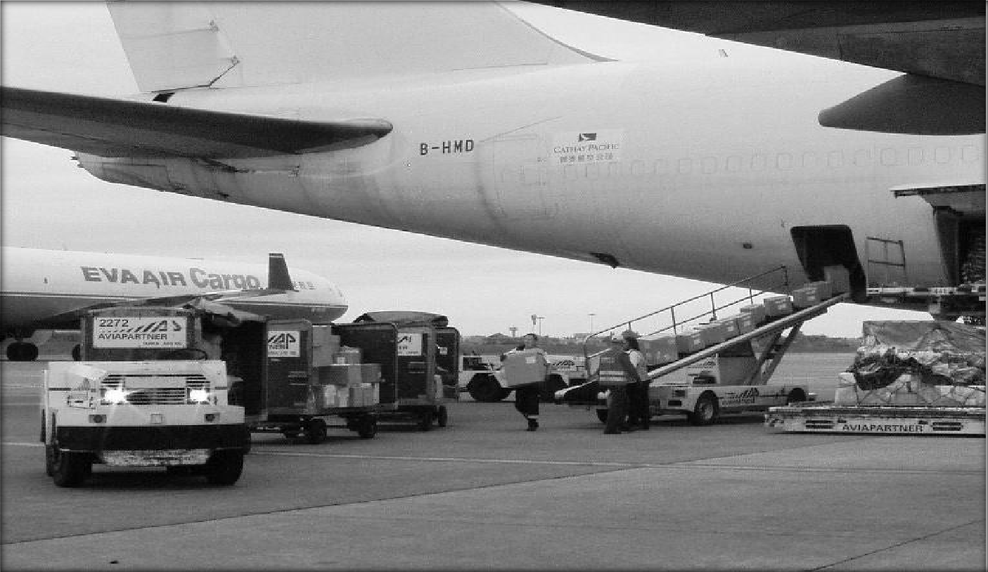

Figure 2.16 Bulk loading cargo into a belly hold (Photo: A. Kazda).

PARKING FACILITIES

Parking facilities have become a dominant factor in airport planning; this is due to the great increase ion its demand over the years. In each case, the prime objective in location of parking facilities is to minimise walking distances of the air passenger, design of parking facilities is also influenced by the volume and characteristics of users because each class of users have different requirements.
Parking facilities should be provided for the following group of users:

Airline passengers;
Visitors accompanying passengers; Spectators;
Airport employees;
People employed at the airport;
Car rentals and car hire service; and
People having business with airport tenants.
Public parking facilities are provided for air passengers, visitors and spectators. These group can be divided into: Short term parkers; and
Long term parkers.

The short term parkers represent about 80% of this group. Hence, airports designate the most convenient spaces for short term parkers. The forecast of passengers and vehicle occupancy can be used to determine the size of the entrance and exit to the parking facility and the number of

spaces required. Methods used for projecting parking requirements range from rules of thumb based on nationwide averages, to trend analysis, to mathematical models and simulation. The choice of method depends on the accuracy and sensitivity desired.
Airpoprt employees are provided with separate parking area. This should be as close as practicable to the facilities in which they work.

Car-rental and car-hire service are located as close as possible to the terminal building to minimise the walking distance of the air passengers. In locating the car-hire service parking lot, the design should aim at protecting the passenger and baggage from the elements of weather.
The recommended basic parking stall is 2.5m wide amd 5m long. The choice of pattern for parking is dictated by the shape of the area available.

AIR TRAFFIC CONTROL

Airport planning requires the provison for facilities, to be located at airports, which support the air traffic control system. Air traffic control is the assingment of specific routes and altitudes and maintenance of minmum separation between aircraft.
Air traffic control consist of:

      - Air traffic control facilities;
      - Air traffic separation rules; and
      - Navigation aids.

AIR TRAFFIC CONTROL FACILITIES

These facilities provide for the safe separation and orderly flow of aircarft within the range of the system. Proper air traffic management demands the division of jurisdiction under control into three parts:

(i.) enroute; (ii.)terminal; and (iii.) airport.

(i.)Enroute (Air Route Traffic Control Centres- ARTCC):

ARTCC have the responsibility of controlling the flight pattern of enroute aircrafts along the airways, jet routes, and in other parts of the air space. Each centre has control over a defined geographical area; and aircraft‟s flight plan is transferred from one center to another in the direction of flight.

Each ARTCC area is divided into sectors. The average number of aircraftsbthat a sector can handle effectively depende on the number of controllers assigned to the sector, the complexity of trffic, and the degree of automation provided. Availability of radar facilities increase the monitoring capacity of each sector – 20 aircrafts can be controlled by the three controllers.

Each sector is provided with “flight progress strips”. This contains information on the identification of the aircraft, destination, flight plan route, estimated speed and flight altitude. These informations are continously updated as the need arises.

(ii.) Terminal (Approach Control Facility – TRACON ):

With the availability of radar, the approach control facility is referred to as TRACON – terminal radar approach control. TRACON has the responsibility of controlling the air traffic (both arrivals and departures) in the terminal area. It performs the function of metering and sequencing aircraft to provide uniform and overly flow to the airports.

The TRACON area is divided into sectors to evenly distribute the work load amongst the controllers. If the flow of aircrafts is greater than the airport‟straffic capacity, the aircrafts are delayed either by reducing their speed enroute or by „stacking‟. Stacking refers to a situation, in which, aircrafts navigate around a fix in a racetrack pattern and are separated vertically by 1000ft. intervals; the number of aircraft ranging from 2 to 10.

(iii.) Airport (Airport Traffic Control Tower):

The control tower facility supervises directs and monitors the traffic in the airport and in the immediate airspace up to about 5 miles from the airport. It is responsible for the issuance of clearance to all departing aircraft; providing pilots with information on wind, temperature, barometric pressure and operating conditions at the airport; and the control of all aircraft on the ground, except in the manoeuvering area immediately to the aircraft gates.
Clear height of the control tower is related to distance from runway and anlges of vision over local obstruction. The dimension and facilities required there-in is normally located adjacentthe terminal building however, the expression pattern and direction should be considered in locating airport traffic control tower.

AIR TRAFFIC SEPARATION RULES

Minimum separation between aircrafts depend on aircraft type, aircraft speed, availability of radar facilities, severity of wake vortices, etc. Air traffic separation rules are divided into rules governing:
(i.) Vertical separation; (ii.) Horizontal separation; (iii.) Lateral separation; and
(iv.) Runway lateral separation.

(i.) Vertical Separation:

The minmum VS of aircraft relative to their altitued is shown in the table below:

Table 2.9Vertical separation of aircraft relative to their aircraft

AIRCAFTS‟ ALTITUDE | MINIMUM VERTICAL SEPARATION (ft.)
UP TO AND INCLUDING 29,000 ft. | 1000
ABOVE 29,000 ft | 2000

For vertical separation between east-bound and west-bound flights:

Up to 29,000ft. (altitude); odd altitudes are used for east-bound aircrafts and even altitudes used for west-bound aircrafts. Above 29,000ft., odd altitudes are used for both east- and west-bound aircrafts in an alternate pattern. For example;
o west-bound flight altitudes – 31,000; 35,000; 39,000; 43000; etc.
o east-bound flight altitudes – 33,000; 37,000; 41,000; 45,000; etc.

(ii.) Horizontal Separation:

The minimum HS is a function of the aircraft size, aircarft speed and the availability of radar for air traffic control. Aircraft control. Aircraft size is relative to wake turbulence. Large aircrafts have great wake vortices, making it harzadous to light aircraft trailing them. The minimum HS between two aircrafts are shown in the table below:

Table 2.10

SITUATION(S) | MINIMUM H.S. (IN NAUTICAL MILES)
TWO AIRCRAFTS OVER LAND  (WAKE TURBULENCE IS NOT A FACTOR) | 5
HEAVY AIRCRAFT PRECEEDING A LIGHT ONE  (WAKE TURBULENCE IS A FACTOR) | 5
TWO HEAVY AIRCRAFT  (WAKE TURBULENCE IS A FACTOR) | 4
LIGHT AIRCRAFT PRECEEDING A HEAVY ONE  (WAKE TURBULENCE IS A FACTOR) | 3
TWO AIRCRAFTS OVER OCEAN  (WAKE TURBULENCE IS A FACTOR) | 20

Conditions for the above occurences include th following: When radar is available;
When direction of travel is the same; and When altitude of both aircrafts is same.

(iii.) Lateral separation:

This is illustrated in the table below:

Table 2.11 Illustration of lateral separation

AIRCRAFT ALTITUDE (ft) | MINIMUM LATERAL SEPARATION (nmi)
BELOW 18,000 | 8
ABOVE 18000 | 20
ACROSS OCEANS | 100-200

(IV.) Runway Lateral Separation:

Minimum RLS depends on two conditions:

Whether VFR or IFR rules prevail; Whether wake vortices are a factor.
If wake vortices are a factor, two parallel runways spaced closer than 2,500 ft. are considered as one runway. The aircrafts should be fed to the two runways essentially in a single line, with a light aircraft trailing a heavy one with at least 5 nmi. The table below shows minmum RLS:

Table 2.12 Illustration of runway lateral separation

 | MINIMUM RLS
SITUATION(S)
VFR PREVAILS | 700 ft.
IFR PREVAILS | 3500 ft. (UNIFORM RUNWAYS)
IFR PREVAILS | 3500 ± 100 ft. FOR EVERY 500 ft. STAGGER OF PARALLEL  RUNWAYS
SIMULTANEOUS USE OF BOTH RUNWAYS FOR EITHER ARRIVAL  OR DEPARTURES | 4300 ft INDEPENDENT OF WHETHER THE RUNWAYS ARE  UNIFORM OR STAGGERED

Conditions involved:

Wake velocity is not a factor;
Simultaneous use of runways; one of arrival, the other of departure.

NAVIGATIONAL AIDS
Navigational aids can be broadly classified into two groups: (i.) External aids;
(ii.) Internal aids.

External aids refer to those navigational; aids that are located on the ground; while internal aids refer to those that are located in the cockpit. A graphical representation of the classification of navigational aids is shown below:


Over land
External aid
Over water
Internal aid
Over land
Over water
Enroute terminal
Navigational aids
Enroute terminal
Enroute terminal
Enroute terminal
Enroute terminal
Enroute terminal

Figure 2.17 A chart showing kinds of navigationnal aids in aviation

CHAPTER THREE

CASE STUDIES

The aim of this chapter is to study existing passenger terminal building located in airports to understand how they function and the relationship between spaces within each facility of study. This would, enventually aid in making a critical appraisal of the buildings to identify their merits and demerits and avoid including design processes that would lead to such demerits in the proposed design. It will serve as a good basis for proffering effective design solutions.

CASE STUDY ONE: AKANU IBIAM INTERNATIONAL AIRPORT (ENUGU AIRPORT), ENUGU

    - BRIEF HISTORY

AkanuI biam International Airport (IATA: ENU, ICAO: DNEN), formerly known as Enugu Airport, is an airport serving Enugu, the capital city of Enugu State of Nigeria. The airport is named after the late Akanu Ibiam (1906-1995), a Medical Doctor and Statesman who hailed from Afikpo in Ebonyi State. The airport is sited off the Enugu-Emene road. It was completed in 1975 to serve as a domestic airport.

The airport was closed on February 10, 2010, by the Federal Airports Authority of Nigeria (FAAN) for the first phase of major renovation and expansion works. The airport was re-opened on 16 December 2010, but the second and third phase of the construction works is still ongoing. The airport is being prepared for its new status as international airport.

FACILITIES

The airport resides at an elevation of 1,466 feet (447 m) above mean sea level. It has one runway designated 08/26 with an asphalt surface measuring 2,402 by 45 metres (7,881 ft × 148 ft). The runway has been extended and widened for local and international flights at 3,000 by 60 metres (9,843 ft × 197 ft)

Table 3.1 Airlines operating in Akanu Ibiam International Airport and destinations

Airlines | Destinations
Aero Contractors | Lagos
Arik Air | Abuja, Lagos

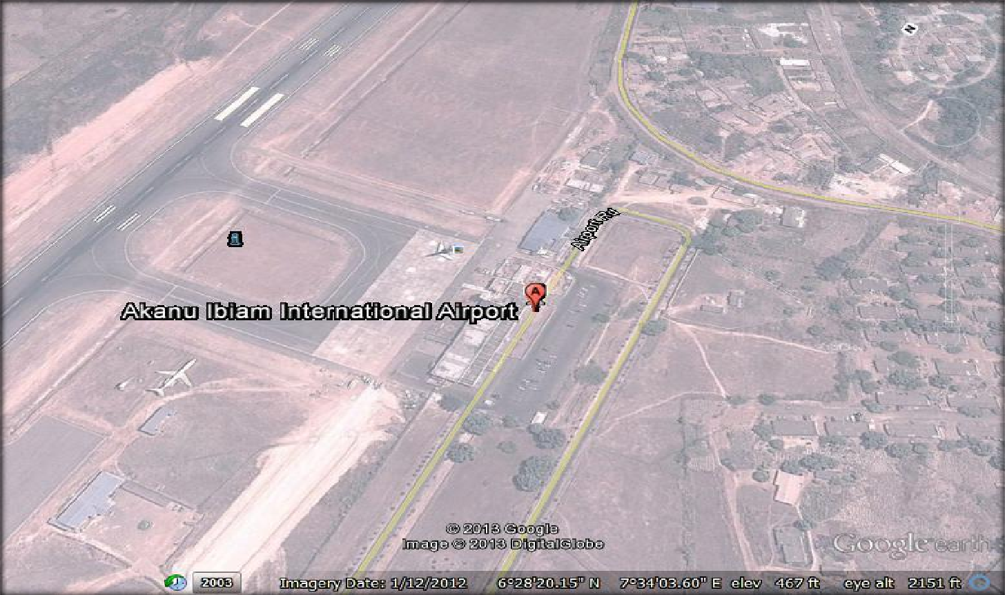

Figure 3.1 site layout of Akanu Ibiam International Airport

DESIGN ANALYSIS

The terminal consists of a simple rectangular block of two floors placed adjacent to the single runway at two-third the runway length. The fire department is housed in a separate building and sited on the right side of the terminal building. The terminal is configured to the transporter type.

The airport utilizes a centralized concept of passenger processing methods with the apron-gates situated directly adjacent the terminal building. There is great flexibility in aircraft parking layout, with preference of a type dependent on the pilot.

GENERAL TERMINAL LAYOUT

The three basic facilities for passenger processing are on the ground floor level of the terminal building: ticketing; check-in; departure lounge and arrival lounge and baggage reclaim.

The ticketing and check-in are linked with the departure lounge. The departure lounge enjoys the visual field of the apron. It is provided with a restaurant, gift shop and public utilities.

The arrival lounge is separated horizontally from the departure lounge through the ingenous use of outbound baggage and reclaim baggage halls. There is a clear separation between these facilities resulting in no collision of arriving and departing passengers. Visual continuity but physical separation between the baggage reclaim hall and the arrival lounge is achieved through the use of glass walls. The administrative offices are located behind on the first floor of the building.

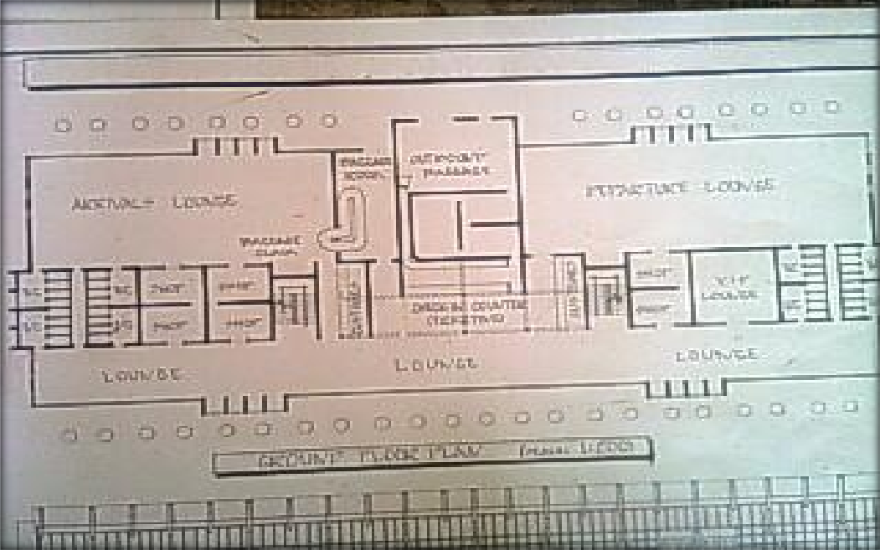

Firgure 3.2 Ground floor plan

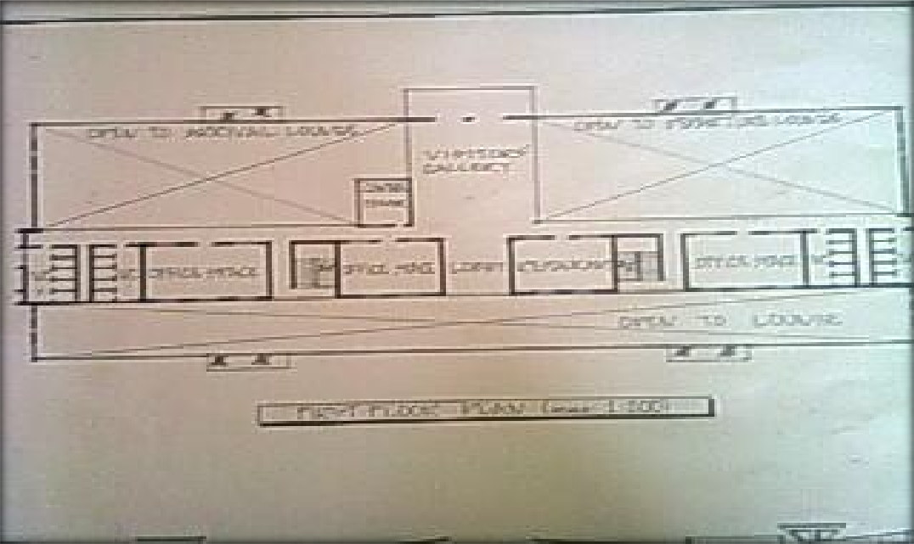

Figure 3.3 First floor plan

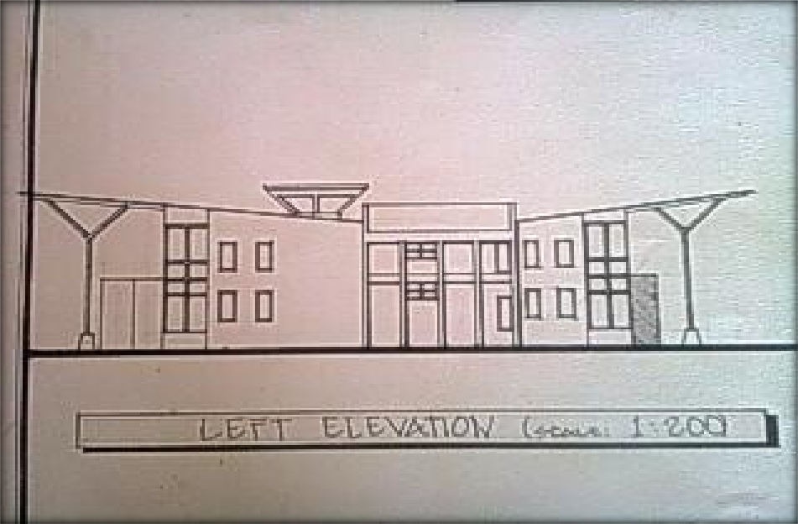

Figure 3.4 Left side elevation

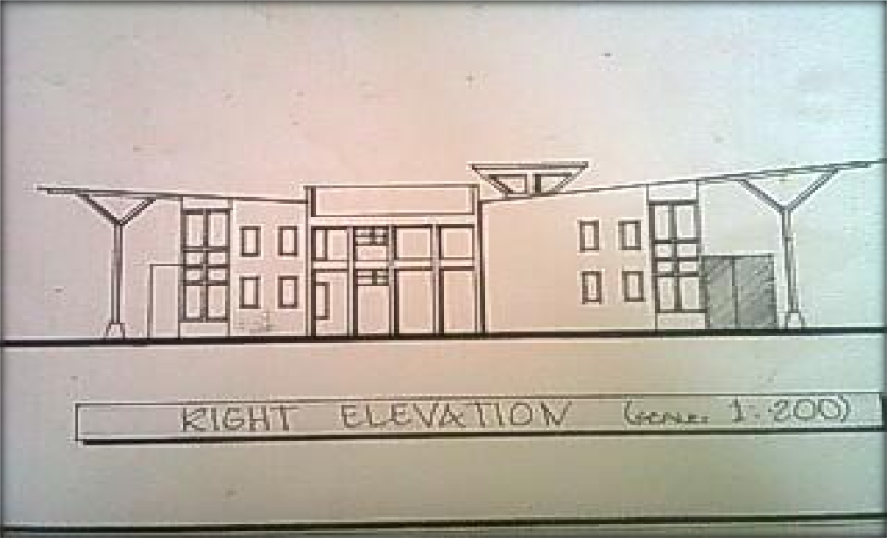

Figure 3.5 Right side elevation

CONSTRUCTION

The walls are constructed of sandcrete block. The front and rear façades are glazed from the ground floor to the top floor. Doors and windows are generally steel materials. Roof which is aluminum roofing sheets over steel trusses propped either side (front and rear of building) by a system of steel columns casted by means of gauzette plates into huge truncated conical concrete form slope inward onto the administrative block between the waiting area and the lounges below. Pipes of 100mm diameter are casted into the walls to harvest rainwater from the roof and transfer it into underground drainage systems.

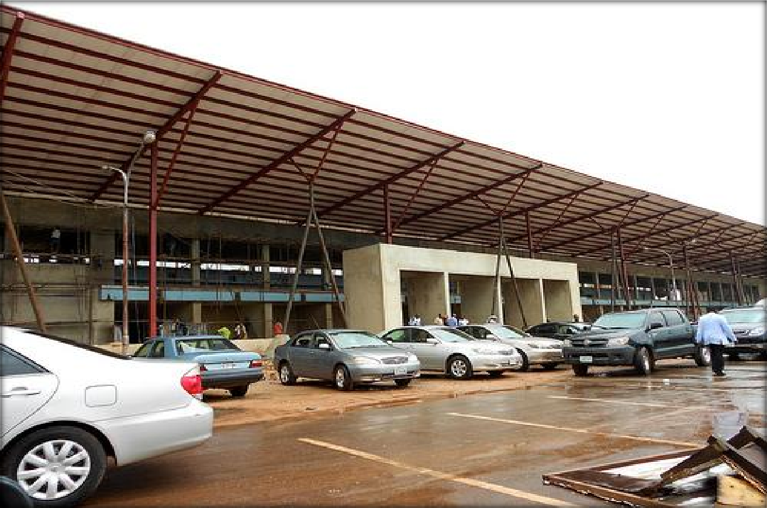

Figure 3.6 Construction work in progress

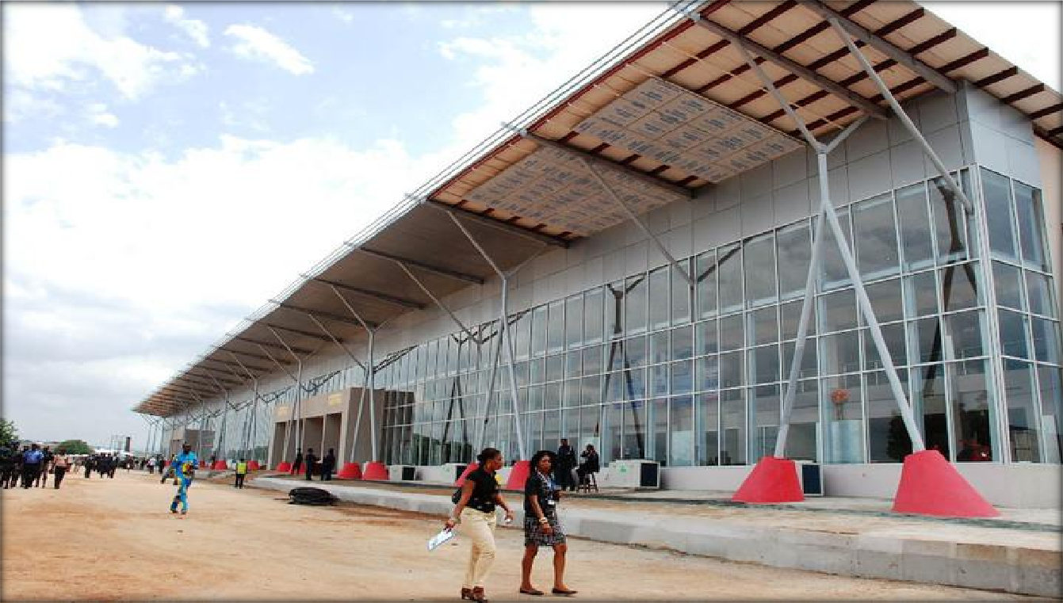

Figure 3.7 finishing of terminal building

PERFORMANCE IN USE (GENERAL APPRAISAL)

      - MERITS


The distinct horizontal separation of departing and arriving passengers prevent collisions in the pedestrian circulation network, within the terminal.
Access road network into the terminal building site is well defined and encourages flow of traffic without collision. There is adequate provision of waiting areas within the terminal building.
The visitors‟ gallery situated on the top floor directly on the outbound baggage hall is well placed to overlook the arrival and departure lounges as well as the airside of the airport.

DEMERITS


Parking lot system is simple but will be inadequate at peak periods of the airport given its international status. The parking lots are also too closely situated to the terminal building leaving little clearance for hubbing.

RECOMMENDATION

The terminal hub should be increased to reduce congestion. This would involed the shifting away of the parking lot to make room for the correction.

CASE STUDY TWO: MAKURDI AIRPORT, MAKURDI

    - BRIEF HISTORY

Makurdi Airport (IATA: MDI, ICAO: DNMK) is an airport serving Makurdi, the capital city of the Benue State of Nigeria. Airport type is public/ military. Makurdi Airport is a domestic airport owned and operated by Federal Airports Authority of Nigeria (FAAN). The airport control tower is operated by the Nigerian air force which is situated on the air-side of the airport. The air force base is adjacent the airstrip.

FACILITIES

The airport resides at an elevation of 371 feet (113 m) above mean sea level. It has one runway designated 05/23 with a concrete surface measuring 2,996 by 50 metres (9,829 ft × 164 ft).

Table 3.2 Airline operating in Makurdi Airport and destination

AIRLINE | DESTINATION
ASSOCIATED AVIATION | ABUJA

    - DESIGN ANALYSIS

The building is a simple rectangular bungalow placed adjacent the runway on the land-side of the airport. The building houses the entire departments which are a set of very simple functioning system.

BUILDING LAYOUT

The building opens directly into a common lounge which has a security desk at the far right hand side. On the left hand side is the ticketing office with a common supporting office beside it. Entering through the ticketing office, one gets to the FAAN secretary‟s office and then to the director‟s office which has a toilet unit within it. A principal lobby from the common lounge opens to the VIP lounge on the left and the chief security‟s office by the left. Immediately entering the lobby, another lobby branches to the right leading to a general store where fire extinguishers and other equipments are stored.

CONSTRUCTION

The walls are made of sandcrete blocks with openings for windows and doors. The VIP lounge is separated from the common lounge by wooden boards. The parking lot is a simple one with few spaces for automobiles. Roof is long span aluminum roofing sheets.

PERFORMANCE IN USE (GENERAL APPRAISAL)

      - MERITS

Large space for parking lot; Provision of fire hydrant

DEMERITS

No security for the VIP lounge;
No facility for processing of passenger baggage;
No flow-through access to through airport grounds to combat congestion; No protection of passengers from the elements.

RECOMMENDATIONS

A solid wall should be build to separate the VIP lounge from the common lounge for security purpose; A road network should be constructed through the site so as to enhance free-flow of traffic.

CASE STUDY THREE: REDMOND MUNICIPAL AIRPORT – ROBERTS FIELD

    - BRIEF HISTORY

Roberts Field (IATA: RDM, ICAO: KRDM) (Redmond Municipal Airport) is a public airport in Redmond, Oregon. With two runways, the airport is the main commercial airport in Central Oregon, with flights on regional airlines to several hubs in the western US. It is home of the Lancair factory and a base for aerial firefighting, and hosts private air tanker companies as well as the United States Forest Service Redmond Air Center, which supports regional operations; it provides training and housing for smokejumper teams, along with fuel, water and retardant for air tanker units, at its ramps along the north side of the field.

Built in the 1920s, passenger service arrived at the airport in 1940. During World War II the airfield was used by the United States Army Air Forces as a bomber base. After the war the federal government sold the airport back to the city for $1.

FACILITIES

A passenger terminal was built in 1950 and replaced in 1981 by a 6,000-square-foot (560 m²) terminal. In 1992-93 the terminal was expanded to 23,000 square feet (2,100 m²).

By late 2009, Roberts Field had completed another large terminal expansion, designed by HNTB.

In October 2009 most sections of the expanded passenger terminal opened for public use; the improvements include more numerous check-in counters and bathrooms, along with a two story, windowed departure lounge. Travelers also may now use covered walkways between aircraft and terminal.

A year following the expansion's completion, a bar and restaurant was opened in the secure area after a contentious permitting process; efforts to add pizza and coffee outlets to the non-secure area are now underway. While there was a restaurant in the check-in hall until 2009, this is the first time in Roberts Field's history that food and drink are available in the departure gate area. If initial OLCC approval is continued, it will also become the second location in Oregon allowed to serve alcohol beginning at 5 am, following Portland's airport.

The airport upgraded its mass-casualty vehicle in 2011 due to larger commercial jets using Roberts Field; while the old unit could handle 37 patients, the new truck is prepared for an incident involving over 100.

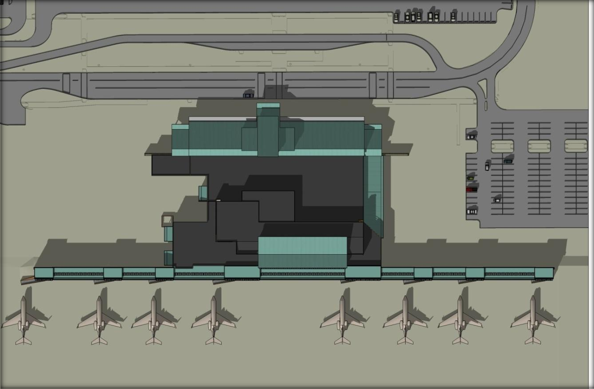

Figure Site plan

Table 3.3 Airlines operating within the airport and their destinations

Airlines | Destinations
Alaska Airlines operated by Horizon  Air | Portland (OR),  Seattle/Tacoma
American Eagle operated by SkyWest Airlines | Los Angeles
Delta Connection operated by SkyWest Airlines | Salt Lake City
United Express operated by SkyWest Airlines | Denver, Portland (OR), San  Francisco

    - DESIGN ANALYSIS

Redmond's 132,000 square feet terminal showcases Central Oregon design elements that can be enjoyed while experiencing one of the region's award winning microbrews and freshly prepared meal at Coyote Ranch Pub or while making those last minute travel arrangements online with the terminal's free wi-fi service.

Along with increased parking, the facility has increased its area by about 600%, allowing more room for security and traveler services, as well as concessions and gate operations. While the new bi-level structure is capable of supporting jet bridges, the low frequency of full-size jets operating from the terminal, and no indication of tenant airline desire, means that these bridges are not currently included, though walking distance to and from planes has been reduced.

TERMINAL LAYOUT

There are three entrances on the ground floor: the main entrance into the entrance hall which leads to the check-in and ticketing, the one from the arrivals lounge where arriving passengers leave after sorting out their baggage, and a third for officials. In the entrance hall, there is a restaurant, a waiting area and a play area for children. On the first floor is the Executive or VIP lounge and two other spaces. Security is mounted at the entrance into the entrance hall.

PERFORMANCE IN USE (GENERAL APPRAISAL)

      - MERITS

The access road through the site is well defined and discourages congestion; The departure lounge is well separated from the arrival hall;
Baggage handling is effective; Good arrangement of parking lots

DEMERITS

Restaurant is only at the entrance hall; No drug store.

RECOMMENDATIONS

Provision should be made in the departure lounge for a small snack bar/ coffee shop

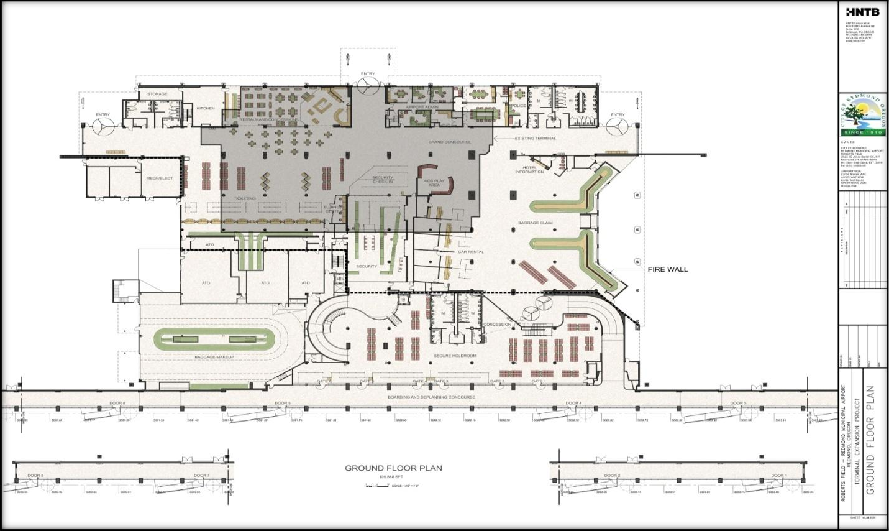

Figure 3.8 Ground floor plan with existing shaded

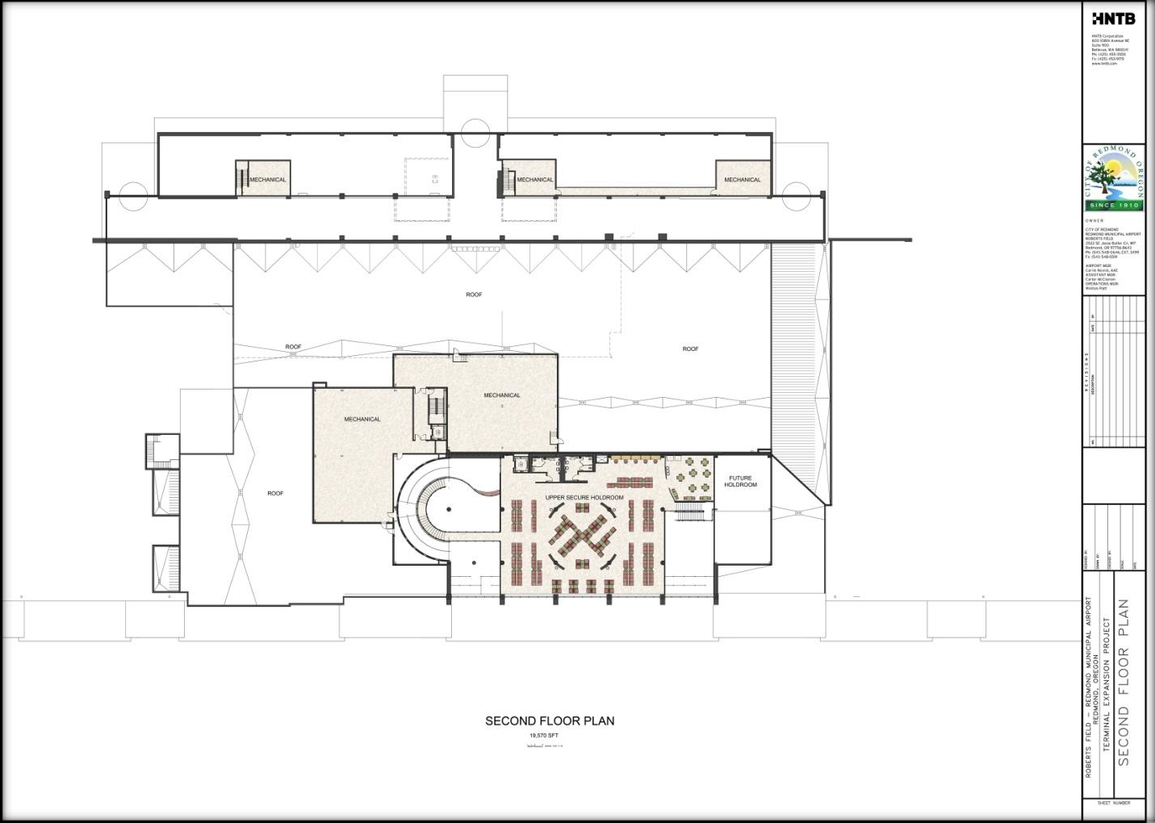

Figure 3.9 First floor plan

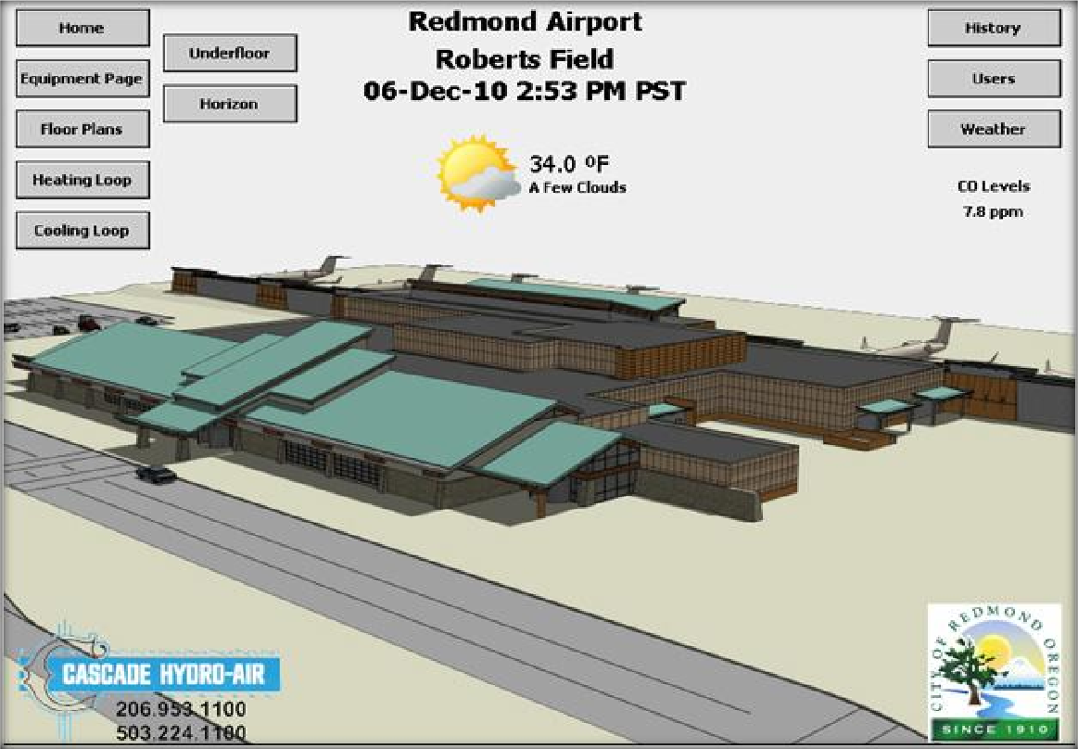

Figure 3.10 Aerial view of Redmond airport terminal building

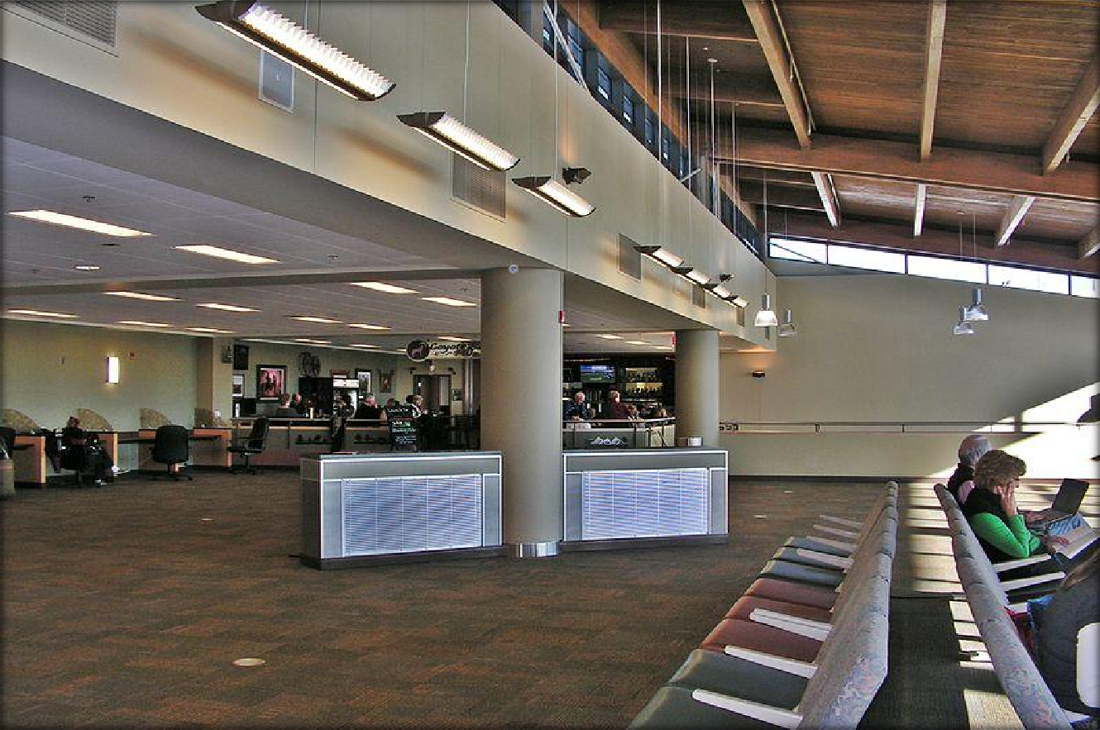

Figure 3.11 Redmond, Oregon passenger terminal, upper deck restaurant area

CHAPTER FOUR

THE PROJECT: PLANNING AND DESIGN ANALYSIS

    - MAKURDI: BRIEF HISTORY

Makurdi, the state capital of Benue State, was established in the early twenties and gained prominence in 1927 when it became the headquarters of the then Benue Province. Being a river port, it attracted the establishment of trading depots by companies such as UAC and John Holt Limited. Its commercial status was further enhanced when the Railway Bridge was completed and opened in 1932. In 1976, the town became the capital of Benue State and today, doubles as the headquarters of Makurdi Local Government Area.

The town is divided by the River Benue into the north and south banks, which are connected by two bridges: the railway bridge, which was built in 1932, and the new dual carriage bridge commissioned in 1978.

The southern part of the town is made up of several wards, including Central Ward, Old GRA, Ankpa Ward, Wadata Ward, High Level, Wurukum (Low Level), New GRA etc. Important establishments and offices located here include the Government House, The State Secretariat, The Federal Secretariat, Commercial Banks, Police Headquarters, Nigeria Prisons Service, Aper Aku Township Stadium, Nigeria Air force Base,Makurdi, the Makurdi Modern Market, the Federal Medical Centre, Nigeria Railway Station, Benue Printing and Publishing Company Limited, Radio Benue, Nigeria Television authority (NTA), Central Post Office, Benue Hotels, Benue State University.

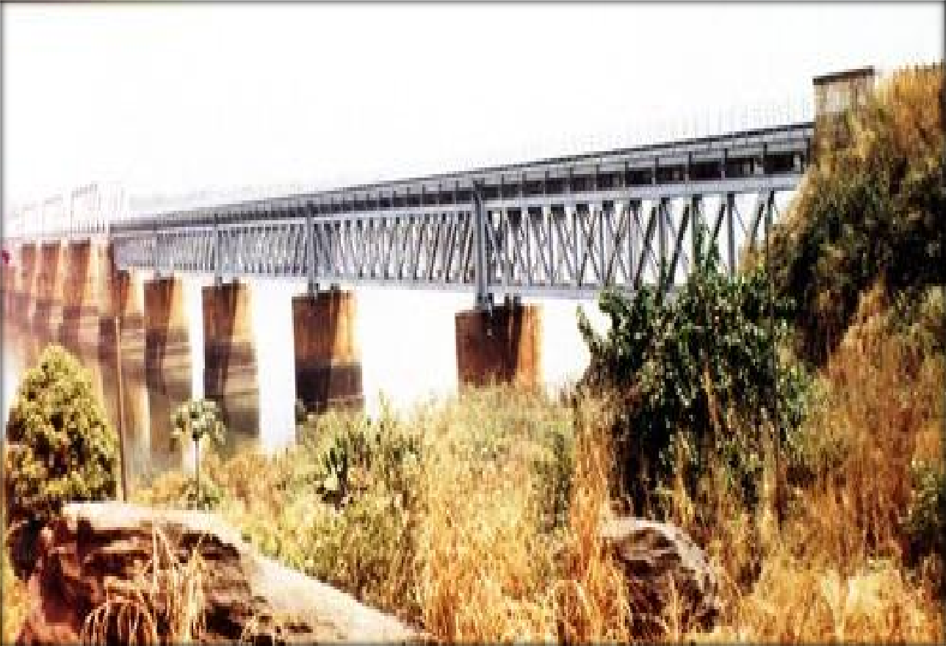

Figure 4.1 Old Makurdi bridge (commissioned in 1932)

The North bank area of the town houses among other establishments, the Federal University of Agriculture, the Nigerian Army School of Military Engineering, the headquarters of the 72 Airborne Battalion and the State Headquarters of the Department of Customs and Excise.

Owing to its location in the valley of River Benue, Makurdi experiences warm temperatures most of the year. The period from November to January, when the harmattan weather is experienced is, however, relatively cool.

Makurdi can be reached by air, rail, road and water. The major northern route is the Makurdi – Lafia – Jos road. The southern routes are Makurdi – Oturkpo – Enugu and Makurdi – Yandev – Adikpo – Calabar roads. Traffic from the west comes through Makurdi – Ankpa – Okene roads and from the east through Makurdi – Yandev – Katsina Ala – Wukari roads. These Makurdi Rail Bridge provides the only rail link between the northern and eastern parts of Nigeria.

Makurdi is the home of the Makurdi Airport which holds the base for the Nigerian Air Force's MiG 21 and SEPECAT Jaguar aircraft squadrons. Nigeria Airways and other private airlines provide air links, through the airport, between Makurdi and the rest of the country. The beautiful beaches of River Benue can be exploited to provide good sites for relaxation. The river itself provides tourist opportunities for boating angling and swimming. The Makurdi Moratorium that houses a variety of animals including some rare species also serves as another feature of tourist attraction.

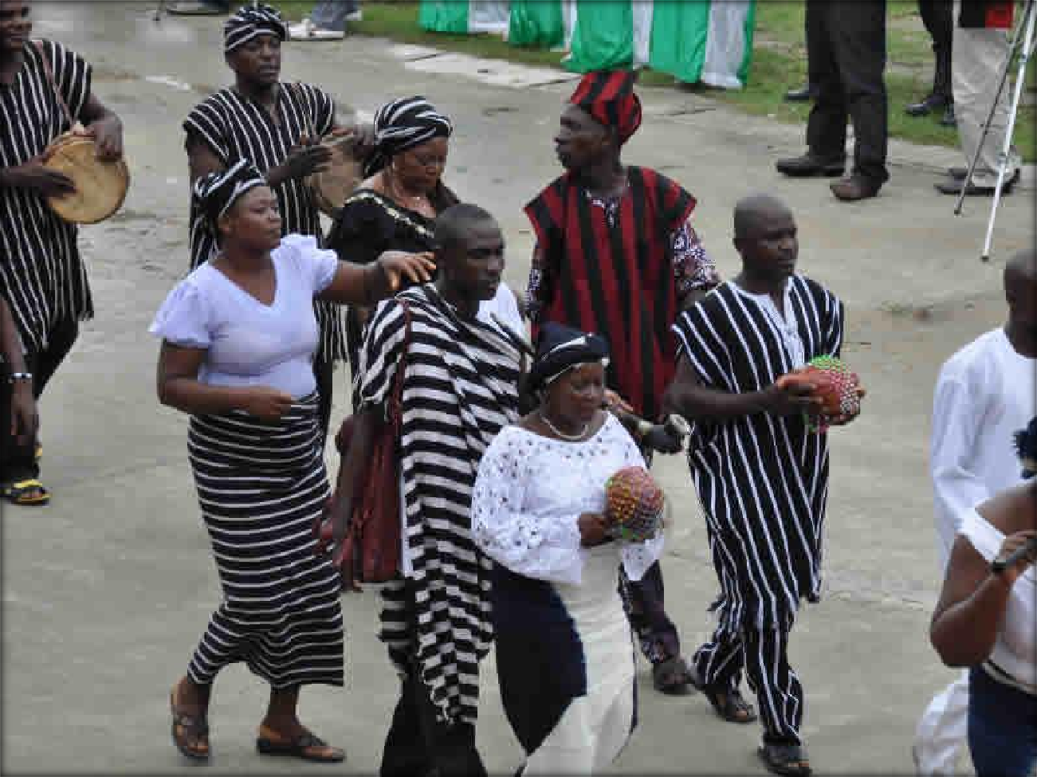

Figure 4.2 The Benue people show-casing their colours

DEMOGRAPHY

The major ethnic groups are the Tiv, Idoma and Igede. As of 2007, Makurdi had an estimated population of 500,797. Makurdi is home to Benue State University and the Federal University of Agriculture.
The Benue State is predominantly an agricultural catchment area specializing in cash crops, subsistence crops, and a variety of potentials. Benue State has huge potentials in human, capital, and material resource and a veritable source of raw materials for processing plants and manufacturing industries.

Benue State, which is the home of Makurdi has a population and size of, approximately 5 million by 2009 estimate/projection on a 2.8% growth rate. Benue State has 23 Local Government Areas.

MAKURDI TOPOGRAPHY

Benue State lies in undulating plains with occasional elevations of 150-300 meters above sea level.

Culture: Rich and diverse cultural heritage ably promoted by the State Cultural Arts Troupe who have won national and international awards.

Soils here are sandy loam, sheaves basement complex and alluvial plains coupled with location in the traditional zone between the North and South ecologies. Favourable rainfall accounts for its capacity to support a variety of crops. The state's immense agricultural potential has earned it the official recognition as the “Food Basket of the Nation”.
Climatic region is tropical hinterland with two distinct seasons with the rainy season recording 750-1500 mpa. Temperatures are between 23-35° C.

Basic infrastructure includes improved electricity, portable water telephone, postal services, and road network.

MAKURDI AIRPORT LOCATION

MakurdiAirport(IATA code: MDI, ICAO code: DNMK) – being the proposed site of the project (passenger airport terminal) – is located on the outskirts on the outskirts of Makurdi. The airport, serves which serves Makurdi the capital city of the Benue State of Nigeria, is situated along Gboko-Makurdi Road.

The airport resides at an elevation of 371 feet (113 m) above mean sea level. It has one runway designated 05/23 with a concrete surface measuring 2,996m by 50m (9,829 ft × 164 ft).

The geographical coordinates of this airport 7 degrees, 42 minutes, 14 seconds, north (7.703883) and 8 degrees, 36 minutes, 50 seconds, east (8.613939). Makurdi Airport, near Makurdi is in the local time zone; GMT + 01:00hrs.

The airport is a public/military airport type owned/operated by the Federal Airports Authority of Nigeria, (FAAN) – a service organization statutorily charged by the Federal Government of Nigeria to manage airports in Nigeria and provide service to both passenger and cargo airlines. Generally, to create conditions for the development in the most economic and efficient manner of air transport and the services connected to it. The agency has its head office located on the grounds of MurtalaMohammed International Airport in Ikeja, Lagos State.

Main users of the airport are the Nigerian Air Force (which operate the runway and have the control tower within its domain which is adjacent the airport premises) and the general public within or visiting Makrudi.

The nearest airports to Makurdi Airport are listed below:

Nnamdi
Azikiwe International Airport, Abuja, FCT: 207.88 kilometres/129.17 miles; Jos Airport, Jos, Plateau State: 217.23 kilometres/134.98 miles.

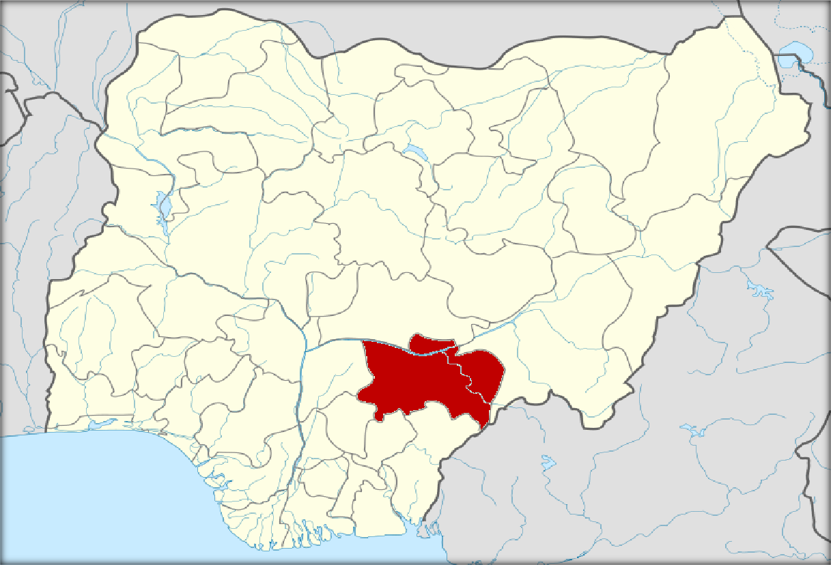

Figure 4.3 The location of Benue State on the Nigeria map

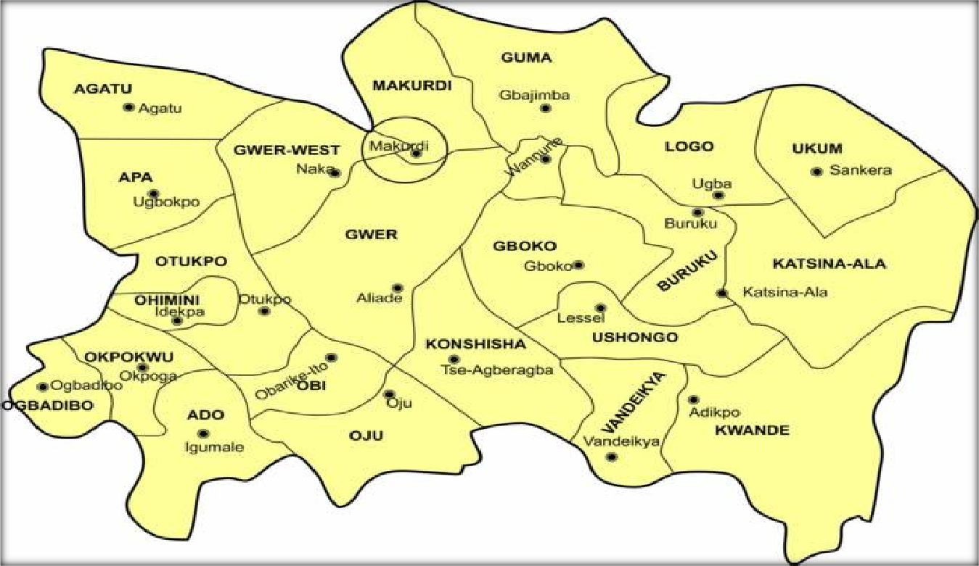

Figure 4.4 Map of Benue State showing the location of Makurdi

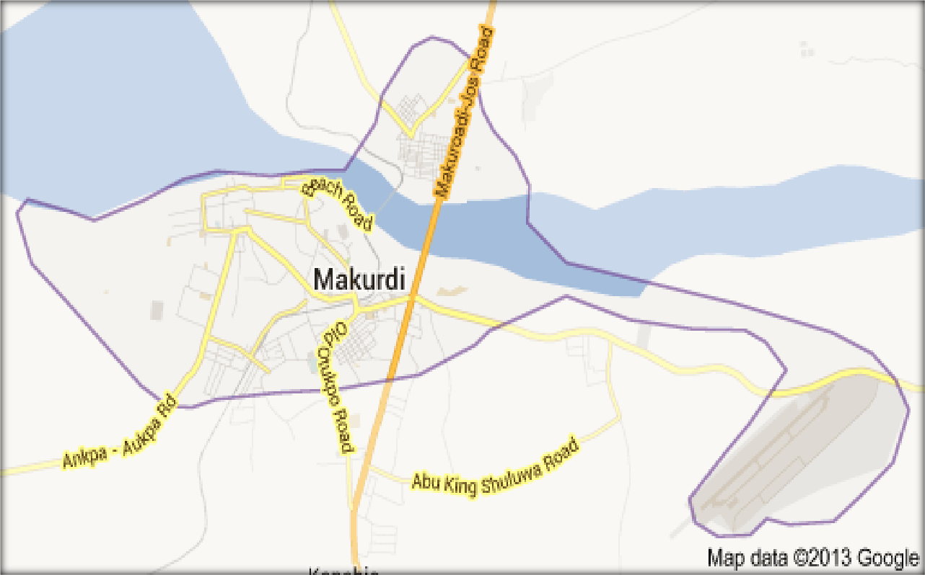

Figure 4.5 Map of Makurdi showing the airport site just at the outskirts

(Source: wikipedia, google.com)

THE SITE GEOGRAPHY

    - CLIMATOLOGICAL STUDY OF MAKURDI

It is highly difficult, if not impossible, to forecast what the weather will be like at a certain time in a very precise place. And yet all travellers would like to know in advance the climate conditions in advance the climate conditions in order to organise their future trip. Ample knowledge about temperature or rainfall can help the traveller with a good idea of a suitable time-table.
The preliminary stages of design of an airport requires a comprehensive study of the micro-climate of the region, with the view of knowing the effect of the micro-climate on the construction, project cost and operation of the airport. Climatic factors to be considered include:
(A.) Temperature; (B.) Rainfall;
(C.) Humidity;

In each case, the prime objective will be the evolution of a design which will afford the users‟ maximum convenience and safety from the weather factors.

(A.) TEMPERATURE

The average temperature of a region has far-reaching effects on the design of an airport. Temperatures in Makurdi city are generally very high during the day, particularly in March and April. Along the River Benue valleys, these high temperatures plus high humidity produce inclement/debiliating weather conditions. Makurdi records average maximum and minimum temperatures of 35°C and 21°C in the dry season and 37°C and 16°C in the wet season respectively.

(B.) RAINFALL

Benue State has a tropical sub-humid climate, with two distinct seasons namely wet season and dry season. The wet season which lasts for seven months starts from April to October bringing about rainfall. There is, however, usually one or more heavy out of season rains in January, February and March from East-West squalls. The annual rainfall total ranges from 1,200m to 1,500m.

(C.) HUMIDITY

Average daily relative humidity in Makurdi may rise to around 85% making the city stuffy and uncomfortable.
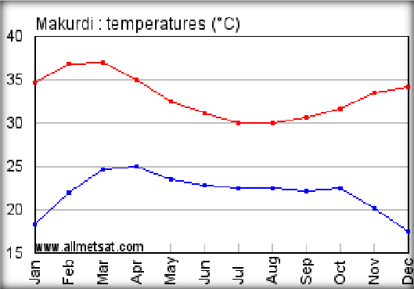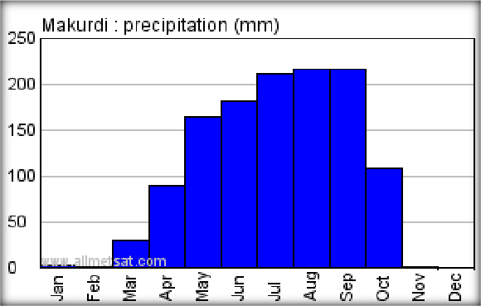

Figure 4.6 Temperature graph (in degree celcius) Figure 4.7 Rainfall (precipitation) graph (in millimetres)

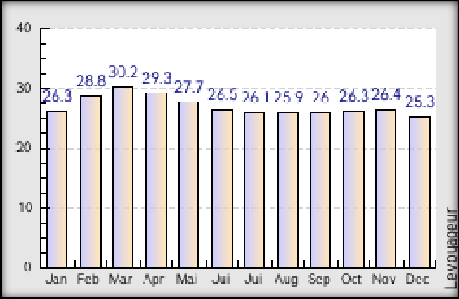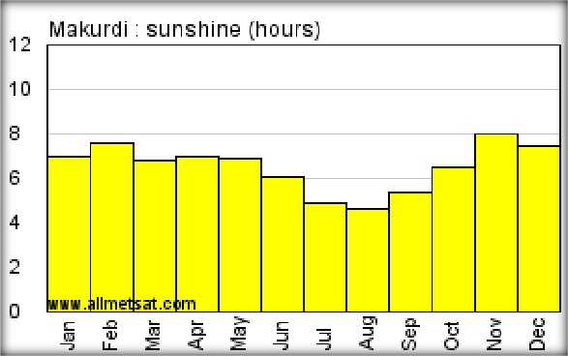

Figure 4.8 Humidity graph (in percentage) Figure 4.9 Sunshine graph (in hours)

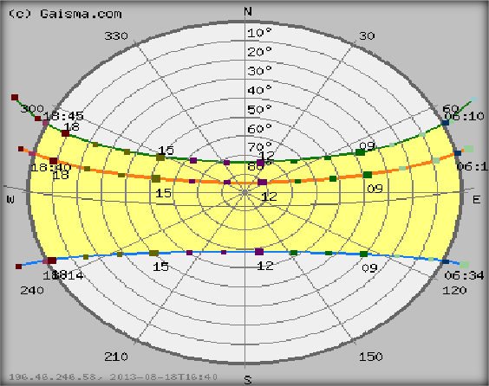

Figure 4.10 Wind rose analysis

TOPOGRAPHY (RELIEF AND DRAINAGE)

The land is generally low-lying (averaging 100m to 250m) and gently undulating with occasional inselbergs, knolls, ruwares laterite capped mesas and buttes. Site gradients average less than 4°. Such areas are made up to interfluves, broad open valleys and flood plains. River Benue is the dominant geographical feature about 15Km from the site just across the Gboko-Makurdi road. It is one of the few large rivers in Nigeria not plagued with water falls and rapids. Surface drainage of site is generally good.

Though Benue State has high drainage density many of the streams are seasonal. Also, the permanent water table in many parts of the state is very low, as a consequence of the thick over-lying permeable meta-sediments and the great depth to which weathering has reached. Hence, there is an acute water shortage in the dry season in LGAs such as Guma, Okpokwu, Ogbadibo, Gwer West and Oju.
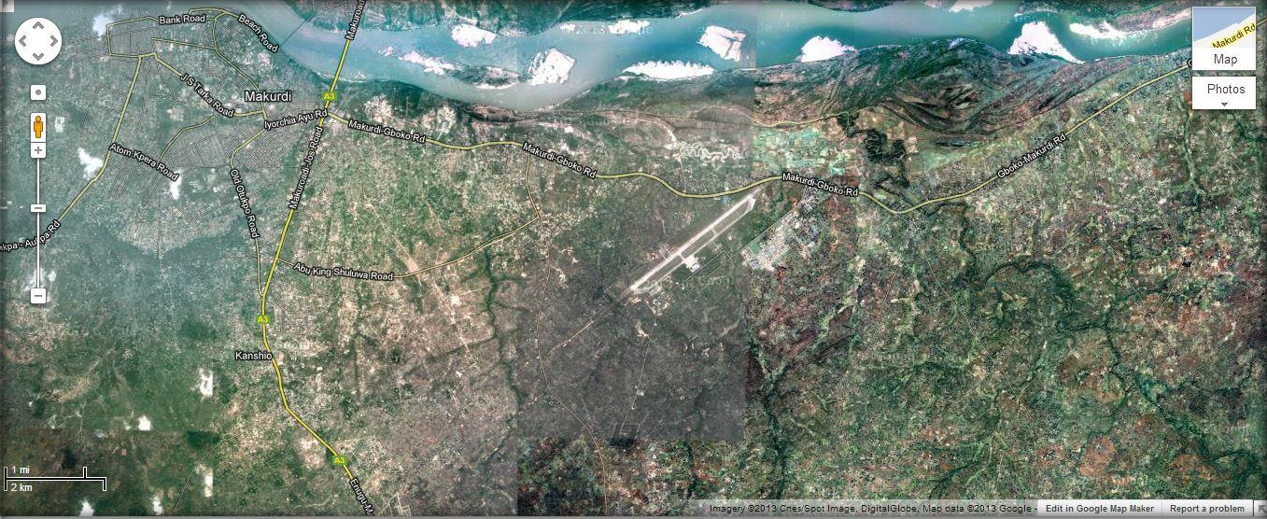

Figure 4.11 Proposed site showing the inherent topography and gradient of site; note the River Benue up north of site

SOILS AND SOIL EROSION

The soils in Benue State are mainly oxisols and ultisols (tropical ferruginous) which vary over space with respect to texture, drainage, gravel content, etc. A typical profile is highly weathered with sandy surface layer overlying clay mottled subsoil. In the southern part of the state, around Vandeikya, Oju, Obi, Oturkpo, Ogbadibo LGAs, well developed lateritic profiles with pallid zones exist. Deep seated lateritic crusts occur over extensive areas on the plains.

The agronomic significance of this subsoil crust is that it often produces a perched water table which is an important source of capillary water, which keeps the surface moist long after the end of the rainy season. Entisols and inceptisols also occur associated with young soils on hill slopes and recent alluvium on flood plains. Around Gbajimba in Guma LGA, Eutrophic Brown Earths occur associated with the volcanic parent materials.

Sheet erosion is the dominant form of water erosion in the State. Deep gullies occur in Ogbadibo LGA and represent a northern extension of the eastern Nigerian, meta-sedimentary deep gully system. Other gulled areas in the state include Makurdi North Bank area, TseMker and Gbem in Vandeikya LGA, Gbajimba town, stream bank erosion in Gboko town, incised streams on sloppy ground coterminous to AnwaseKyogenAbande ranges in Kwande LGA.

VEGETATION

Benue State lies in the southern Guinea Savannah. Persistent clearance of the vegetation has led to the development of re-growth vegetation at various levels of serene development, but more importantly, parklands with grasses ideal for animal grazing during their early growth. These succulent grasses can be cut with machinery, dried and baled for dry season livestock feeding.

The grasses however grow very tall, coarse and tough on maturity. The scattered trees are mainly those of economic value and include locust bean, shear butter, mango, silk cotton, African iron, Isoberlinia, cashew, oil palm, DanielliaOliveri, Melina, et cetera. These trees produce valuable fruits, wood and fibre which can be utilized for small-scale cottage industries.

In the southern part of the State, particularly in Oju, Ado, Obi, Ogbadibo and Okpokwu LGAs, the vegetation is mainly oil palm bush. The oil palm is utilized for its palm oil, palm kernel, palm wine, broom sticks and several other products. Dense forests are few and far apart, except in a few LGAs such as Vandeikya, Kwande and Okpokwu.

Generally, forest vegetation may be grouped into: village forest; gallery forests; and forest reserves. In these forests, typical rain forest trees such as mahogany, Obeche, Iroko, Afara, etc. occur and are used for timber. Other economic trees in these forests include African .pear, ogbono, bamboo, raffia palm, oil palm, orange and coconut.

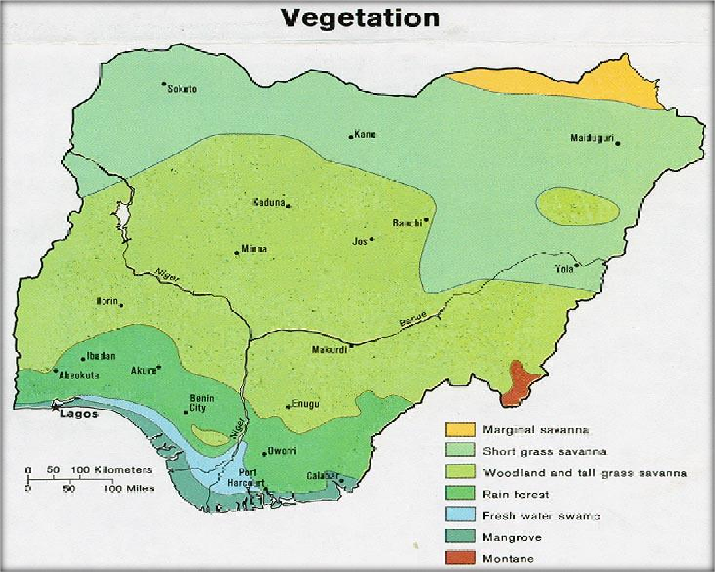

Figure 4.12 Map of Nigeria showing vegetation (Makurdi is located in the woodland and tall grass savanna)

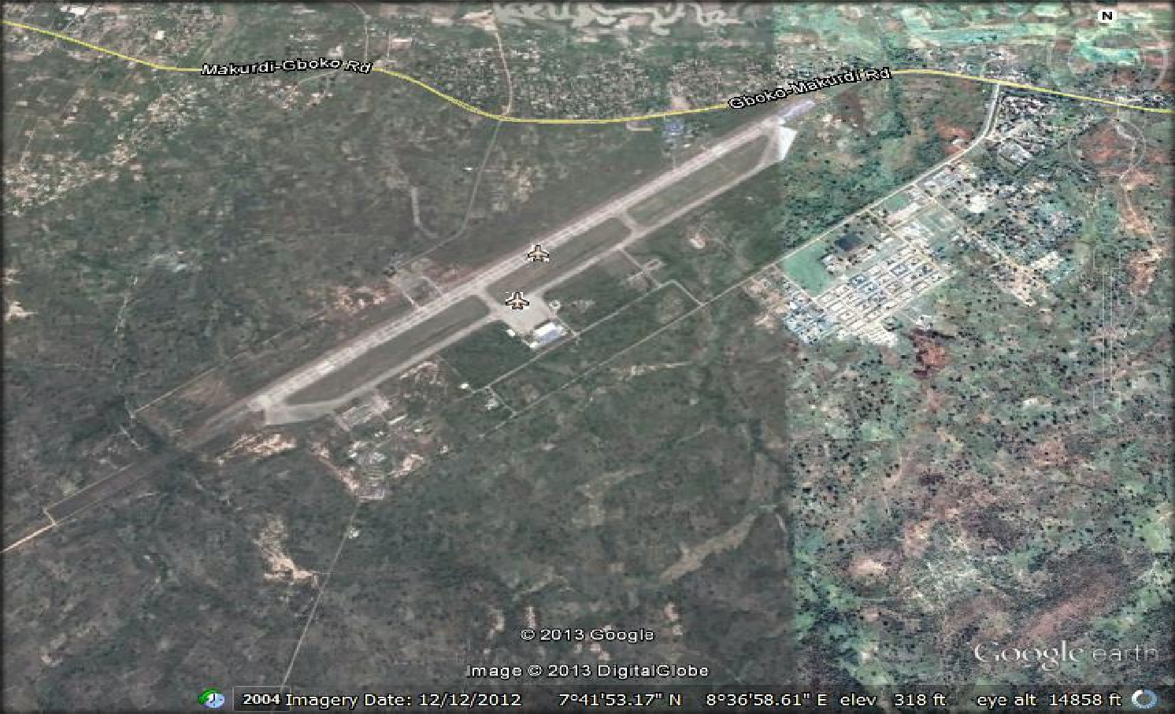

Figure 4.13 Aerial view of airport site showing the proposed building location and the runway

(Source: DigitalGlobe, google earth.com)

4.3.0 PLANNING CONSIDERATIONS

This stage is ushered in by the completion of selection of site. It involves the production of schematic sketches with reference to the overall relationship between the elements on the site.
Each sketch will aim towards achieving a balanced and efficient airport that is safe for aircraft manoevre and functional to the needs of the airpassengers and users. To achieve this, the designer should take into consideration several factors, amongst which we have:
(i.) Access and circulation; (ii.) Gradient/slope;
(iii.) Solar radiation; (iv.) Wind direction; (v.) Orientation; (vi.) Noise; and (vii.) Vegetation.

(i.) ACCESS AND CIRCULATION

For effective cordination and corelation of functions, circulation has to be carefully and cautiously planned. Circulation can therefore be divided into the following :
- External circulation; and
- Internal circulation.

EXTERNAL CIRCULATION
This encompasses the requirements and limitations of aircraft, vehicular and pedestriantraffic on site and entailscareful and cautious planning to achieve free flow of traffic through the provision of:
(a.) Aircraft traffic and parking; (b.)Vehicular traffic parking; and (c.) Pedestrian traffic;

(a.) Aircraft Traffic and Parking:

The design of runways and taxiways should allow for an uninterrupted view, of at least one-third of the whole length from any point, 10ft above the surface, to allow for efficient and easy manoeuvre of aircraft. Also, there should be adequate runway and taxiway lighting, signing and marking.
The apron should be sufficiently large and flexible to allow for expansion. Each aircraft gate should be carely marked out for efficient aircraft parking and servicing.

(b.) Vehicular Traffic and Parking:

There should be provision for adequate network of roads to allow for easy access to and circulation within the airport grounds. At the landside, interchange (kerb-side), there should be seperation of grades to facilitate a vertical separation of arriving and departing passengers and freight.
Car-parking facilities are to be at the landside of the airport for:

airline passengers;
visitors accompanying passengers; spectators (tourists);
airport employees; and
car rentals and airport taxi-cabs.

In each case, the volume and characteristics of the user plays a vital role in the planning process. Parking facilities for the first three groups should be provided close to the terminal building to rreduce the walking distance; for the fourth group, parking facilities should be provided as close as possible to the facilities in which they work. For the last group, parking lots should be provided adjacent to the terminal building, thereby reducing to the least practicable, the walking distance of the air passenger. However, this car-park need not be for the entire car-rental fleet but only for cars which have previously been reserved by arriving passengers.
On the airside, the apron should be marked to show routes to be support and service trucks. This is to bring an order into the vehicular circulation on the apron and to minimize the chances of accidents due to collision between taxing aircrafts and support vehicles to have an indicator light affixed to its roof-top. Parking lots for the support vehicles are provided adjacent to the terminal building to allow for easy and efficient mobilsation in case of emergencies.
Makurdi and its suburbs have an appreciable number of cars per person ratio. Hence, the airport should be provided with a large car park. Moreover, the socio-cultural pattern of the people in this northern part of Benue State is family oriented, thus a person travelling is normally accompanied by a large entourage to the airport, in most cases this entourage remains at the airport until the aircraft – carrying their brother is airborne. This is a perculiar characteristic of the Tivs, the Idomas and Igede which should be taken into cognisance in the design of parking lots for an airport, because provisions have to be made to accommodate the cars of this large percentage of car park users.

Four types of parking arrangement exists namely:

Parallel: 0˚ parking;
Inclined parking: 30˚ parking, 45˚ parking, and 60˚ parking; Perpendicular parking: 90˚ parking; and
Circular parking: 0˚ parking, 45˚ parking, 90˚ parking.

These parking spaces exist in direction to link roads.

(c.) Pedestrian Traffic:

In every case, there should be a distinct separation between the pedstrian traffic and other traffics. This can be achieved through the use of physical barricade or separate grades. The pedestrian should be protected from the hazards of rainfall, temperature, infra-red radiation and vehicles.
Walkways should be provided to link major areas, in each case, the walkways should represent the most practicable minimum walking distance between the two areas. It should be properly drained, and aesthetically sound to attract useage. At points of intersection with roads, the road should be marked with zebra crossing or pedestrian bridge should be constructed.

INTERNAL CIRCULATION
Legibility and passenger-orientation are important because airports are normally devoid of obvious points of external reference and many travellers are in a hurry. Once inside the terminal the problem of identifying routes to check-in, ticket purchase or arrivals lounge can be as great as in the external airport environment. Architectural land-marking is an important adjunct to effective signage. Light, structural form and volumetric orchestration are factors to employ. If the primary architectural language is not strong, the terminal will not survive either retailing pressure or management changes to the use and distribution of space. After the example of terminals at Stansted or Denver, the aesthetic qualities of architectural structure have tended to be the primary elements in establishing airport character. The design of columns and beams, often interplayed with the clever manipulation of roof lighting, provides a memorable experience to aid navigation through complex terminals. It is a philosophy which accepts various degrees of change of structure, enclosure, building services, interior space and finish. With each on a different time- scale, one can be altered without sacrificing the quality of the remainder.
For convinience and comfort which are factors considered necessary in the design of public spaces it is proper to reduce or eliminate the possibility ofcongestion in various parts and sections of the building making it possible for users to move around freely. Congestion should be avoided at the foyer areas to which main entrances lead. Areas that require less traffic include bars auditriums, movement within the dressing rooms as well as proscenium movement from backstage to main stag, exhibition spaces restaurants.
Corridors of minimum width of 1.5m should be provided to reduce congestion. Corridors terminating in dead ends should be avoided unless otherwise required. Services such as stairs lifts escalators should be located off main routes easily visible to avoid loss of direction.

(ii.) GRADIENT/SLOPE

The airport site terrain is relatively flat. Gradient is less than 4°. This is good for the airport design as it requires a flat surface and this implies maximising the cost of construction on site.

(iii.) SOLAR RADIATION:

These refer to the effect of the suns‟s light or heat on the building and the environment. Sun travels to earth through the space in discrete packets of photons. On the side of the earth facing the sun, a square kilometer of the outer edge of the atmosphere receives 1400 mega watts of solar energy every minute. Only half however reaches any part of the earth‟s surface. The amount of light that reaches any particular part of the ground to have effect on a building depends on the time of day, year, the amount of cloud cover of the place and latitude of the point. Solar intensity varies with the time of day,peaking at noon and declining at sunset.
Radiation level has direct effect on passenger comfort, through direct contact; and on the functioning of enclosed spaces. Enclosed spaces should be protected by the introduction of radiation/thermal insulating glass windows; and where practicable,shading devices should be incorporated or provided. The use of large sunshielding windows, window overhangs, as well as cantilevered eaves and fins strategically placed in the building helps to reduce the effect of the sun‟s radiation on the building in such a way that it does not disturb natural ventiation, air flow and ciculation through and around the buildings.
A sun-path study should be carried out to determine the most efficient means of protecting the walkways from the sun, which varies between 8:00am – 5:00pm daily. Trees to be used in providing shades should be of a specie of known maximum growth and spread, so as not to pose an obstacle problem to manoeuvring aircrafts.

(iv.) ORIENTATION

This refers to the positioning of the building with respect to the prevailing wind direction, weather conditions, solar radiation, climatic characteristics and the cardinal points of the earth. Proper orientation protects the building from adverse weather effects. The area with regards to the sun and its effect plays a significant role in the siting of the terminal building. The terminal building must be duely positioned to protect its users from the harshness of the sun‟s rays at peak periods. Covered sheltering can help shield the building users from the harmful effect of the sun by means of canopies or roofing.
The prevailing winds in Makurdi are the South-West and North-East trade winds. The centre will be positioned to angle incedent to the prevailing air movement on the site.

(v.) NOISE:

The airport environment is usually heavily polluted by fumes and noise. As a result most terminals are sealed air-conditioned buildings. Increasingly, however, they are partially open to the elements, with some recent designs using mixed mode ventilation and natural air-current smoke extraction (in the event of a fire).To make the interior as comfortable as possible two problems have to be overcome:
solar gain and glare; and noise abatement.
Both are largely solved by a combination of interior and exterior measures. External screens and grilles help shade the terminal from direct sunlight and more substantial structures at the building face deflect the noise from aircraft. The design of glazing also helps tackle these dual problems. Fritted or solar control glazing helps diffuse both high and low angled sunlight, whilst double or treble glazing reduces external noise to tolerable levels.

Sunlight can add sparkle to the terminal interior and aid the passengers' sense of location or direction. A balance has to be struck between the environmentally neutral interior and dramatic sun-filled spaces. Likewise some contact with external noise can give a sense of being at an airport and a degree of noise is tolerable in busy places. Where noise is unacceptable is in the tranquil areas, such as the transit departure or gate lounges and in office areas.
The location of the terminal building should be sited away from sources of serious noise and like disturbancesas far as possible. This is ensured through the use of acoustics on walls and ceilings to exclude the exterior disturbances.

(vi.) WIND DIRECTION AND VELOCITY

These have far-reaching effect on the functioning of an airport runway. Sites with high crosswind are not suitable for aircraft landing or take-off operations. In airport design, a study of the wind pattern in relationship to runway alignment ensures a proper usability factor. The daily wind speed in the month of May on site has been around 4km/h, that is equivalent to about 3mph or 2 knots. In recent years, the maximum sustained wind speed has reached 56km/h (around 35mph or 30 knots).
The site occurs approximately in the Inter-tropical Continental Zone (ITCZ); ie.where the North-East and South-West trade winds meet. The probable runway usage at runway 28 and 10 are equal representing 95% usability factor

Table 4.1 Wind distribution statistics by direction and speed in per mile meterolgical station

WIND  SPEED/ DIRECTION | N | NE | E | SE | S | SW | W | NW | CALM | ∑
CALM | -- | -- | -- | -- | -- | -- | -- | -- | 123 | 123
1-2 | 40 | 82 | 52 | 31 | 25 | 23 | 28 | 65 | -- | 344
3-5 | 45 | 45 | 34 | 37 | 26 | 16 | 19 | 111 | -- | 333
6-10 | 39 | 3 | 5 | 16 | 16 | 4 | 9 | 90 | -- | 181
11-15 | 4 | 0 | -- | 1 | 1 | 0 | 1 | 15 | -- | 21
16-20 | -- | -- | -- | -- | -- | -- | -- | 1 | -- | 1
› 20 | -- | -- | -- | -- | -- | -- | -- | -- | -- | --
∑ | 128 | 130 | 91 | 83 | 68 | 43 | 52 | 282 | 123 | 1000

DESIGN CONSIDERATIONS: TECHNICAL DATA

    - SPACES AND THEIR RELATIONSHIP

The design of the terminal building, of Makurdi Airport, as an interface between the landside and the airside, is geared towards the evolution of a functional and efficient passenger-processing and baggage – handling system. Functional spaces to be provided are:

(i.) ENTRANCE HALL

The entrance hall should be large and directly adjacent to the kerbside. It should create in the mind of the user, a free-feeling, by adopting the style of free flow space. Moreover, it should be in a scale larger than thhe human scale to convey the felling of grandeu to the user, but this should not be so obvious as to express a monumental rhythm.
As a part of a dynamic structure, it should possess a sucking and free expression. This can be achieved through the use of large glass partitions and brick walls. There should be a visual continuity of space within the arrival lounge and other adjacent fuctional spaces. However, in situations where security is a prime consideration, such as in the relationships between the arrival and the departure lounges, the much needed separation can be achieved through the combine use of separate levels and glass partitioning.
The entrance hall is a transit space and is flanked by shops, telephone services, waiting lounges, information desk, caash dispensers(Automtic Teller Machines), etc. The entrance hall should be fully airconditioned but provisions for natural ventilation will be made in case of prevalent power outage in these areas. Due to its huge traffic as a transit zone, the choice of material will be influenced by the durability and resilence nature of the flooring materials, aesthetics and economy of initial and maintenance costs.

(ii.) DEPARTURE LOUNGE

The departure lounge is to be located at the same level as the entrance hall. It should be connected to the entrance hall via the customs and immigration hall. It should be provided with a chain of stores and restaurants, and should have a visual link with the apron and runway. To make up for aircraft delays, provision should be made for recreational facilities.
The departure lounge, which is a transit plane between earth and the heavens, should create a floating feeling in its occupants. The scale of its design and interior decoration should be in the human scale. Choice of flooring and design of interior spaces and utilities should be in line with its optimum level of passenger usage.

(iii.) ARRIVAL LOUNGE

This will be quite similar to the departure lounge in choice of scale, interior decoration, provision of utilities and architectural expression. It would be linked to the entrance hall via customs and immigration check-points, and should be close to the baggage reclaim area and exit from the terminal building.

(iv.) CUSTOMS

This will be located between the entrance hall and the arrival/ departure lounge. Its interior layout should allow for uninterrupted security survillence, while not compromising the comfort of the passenger. Ists architecture should express deterance and security without jeopardising the free-flow concept of the whole airport; it should be a transparent prison, a glass cage.

It should be linked directly to the security department by a separate corridor or stairwell. Its internal disposition should include spaces for personal body search, detention and offices.

(v.) BAGGAGE RECLAIM HALL

This shall be located in proximity to egress points. Its architectural scale is human, with sufficient space for passenger circulation. The baggage reclaim hall should be connected to the arrival lounge, and non-arrival and other airport users should be barred from accessing this space to eliminate pilfering of baggages by airport touts. It should be connected directly to the sorting room. Provisions should be made to ensure a safe and efficient sorting and distribution of baggage in syncronisation with the movement of passengers from the aircraft to the baggage claims.

(vi.) VISITORS GALLERY

This will be provided for visitors viewing pleasure at the Makurdi Airport terminal building, in consonance with the socio-cultural behavioural pattern of the indegenes of Benue State. This will enable those accompanying airline passengers to the airport to observe the efficient processing of the air-passenger, boarding of aircraft and takeoff of the aircraft. This will be in line with the African concept and exceptions of warmness and brotherhood.

The veiwing gallery would be connected directly to the entrance hall and have ONLY visual connection with the departure hall, arrival hall and the airport‟s airside. It may be at the same level with the mezzanine restaurants and bar.

Table 4.2 Terminal spartial requirements (space allocation)

FUNCTION (SPACE) | NUMBER REQUIRED | UNIT SPACE/PERSON (m²) | EXPECTED NUMBER OF USERS | TOTAL SPACE (m²)
CHECK-IN | 1 | 1.4 | 50 | 70
ENTRANCE HALL | 1 | 2.0 | 600 | 1200
TICKETING COUNTER | 1 | 2.0 | 50 | 100
CUSTOMS | 2 | 2.0 | 50 | 200
CIRCULATION AREA | 5 | 2.0 | 50 | 500
OUTBOUND BAGGAGE | 1 | 1.4 | 10 | 14
ARRIVAL LOUNGE | 1 | 1.5 | 300 | 450
DEPATURE LOUNGE | 1 | 1.8 | 600 | 2160
VIP LOUNGE | 1 | 1.8 | 100 | 180
CONVENIENCES | 32 | 2.7 | 30 | 2592

OFFICE SPACES | 4 | 3.5 | 100 | 1400
DRUG STORE | 1 | 2.0 | 50 | 100
BAR/RESTAURANT | 3 | 1.8 | 100 | 540
BAGGAGE CLAIM | 1 | 1.6 | 600 | 960
BAGGAGE ROOM | 1 | 2.0 | 15 | 30

    - CONSTRUCTION MATERIALS

Certain factors are considered before a choice is made on the type of material to be used in any part of a building. These factors are:

(1.) Function: This has to do with the purpose, structure and aesthetics of the material. The airport terminal is a stand out point in any state it is situated. It serves as a gate into that state and, hence, should create a positive impression on the air passenger; it should exhibit grandeur.
(2.) Durabilty: Any material chosen should be able to stand the stand all test of time and quality brought about by external and internal factors.
(3.) Tecnology and Maintenance: The functionality and durability of a material is often maimed by lack of installation technology and means of maintenance in case of damage. Despite how good a material may be once the technological knowledge is not available, it is still not convenient practically. High cost of maintenance should be avoided. Easy maintenance in terms of cleaning, changing and repairs should be considered. Some materials are either too expensive to maintain, or to replace.

Also some manufactured materials, especially those imported from other countries may pose issues in meeting the need of the local architecture
due to difference in climate.

The following nformation should be obtained from manufacturers on materials to be used:

Density: given in Kg/m², from which the mass of the material can be used;
Coefficient of thermal expansion: knowing that Nigeria belongs to the tropical region, materials normally expand or contract with changes in temperature;
Thermal conductivity: this is expressed in w/m²⁰C. Moisture content of material normally affect this value;
Sound absorption: this affects the revaberation time of sound in a building;

Modulus of elasticity (Kn/mm³) and tensile and compressive strength(Mn/m²): these values give indication on structural performance in terms of strength, tensile and compressive stress,

Consturction materials proposed for use include the following:

(1.) Sandcrete hollow blocks (225mm thick) for internal walls
(2.) A framework of semi-circular space truss systems to form the basic structural system of the building. The trusses are anchored to the flooring of building and exposed to enhance its aesthetics.
(3.)Glass curtain walls (10mm thick) to encase the terminal building to “bring the surrounding airport environmentinto interior of the terminal building”and also to encase office spaces for transparency and linkage with airpassengers. Glass used is of acoustic material to shut out external noise sources such as automobiles, jet blasts etc
(4.)Paquet floor finishing for halls, lounges, visitors gallery, etc
(5.)Floor tiles and terrazzo for offices
(6.)Aluminum roofing sheets (5mm thick) prefabricated to suit design of structure.
(7.)Two semi-circular forged systems of trusses, forming the roof structure and embedded into the mass concrete floor which is in turn finished by parquet floors.

AESTHETICS

Columns, glass glazing, galvnised steel balustrades, etc are used to enhance the aesthetic look of the structure. The entrance lobby/ foryer is designed in a way to give the structure a look of grandeu.

BUILDING SERVICES (A.) PLUMBING
- Sufficient toilets (including disabled) in several locations, all fitted with airlocks.

- Minimum dimensions per cubicle 1.5m by 85m, with doors to swing in.

- Cubicle partitions minimum 2100mm high.

- Two continuous toilet roll dispensers per cubicle.

- Paper towels and dryers (not just one or the other).

- Full length mirrors available in all toilets.

(B.) VENTILATION AND AIRCONDITIONNG SYSTEMS:

- Windows that open, where possible, in smaller meeting rooms or public areas.

- Air conditioning which is quiet, effective, quickly adjustable, provides uniform comfort conditions throughout facility.

- Separate ventilations system in areas where smoking is permitted.

(C.) POWER

- Multiple power points, easily accessible, built into floors, walls and ceilings in all areas

- Sufficient power including 15 amp GPOs and at least 300 amps per phase for concert sin larger venues.

- Floor well access for power in halls, lounges, offices, etc.

- Complete backup system for emergencies to maintain all services (standby generator with uninterruptable power supply, gas back up or similar).
- Power points clearly labeled with circuit breaker number and phase around all spaces within terminal on multiple circuits to spread loads.

- Surge protectors for computers as well as for the whole facility.

- Earth leakage detector and cut out, particularly where users patronize most.

(D.) FIRE SAFETY

Fire safety largely depends on precautions taken, adequacy of escape or exit routes. Length of evacuation time and extent of panic generated. However solution adopted to ensure safety may include:
Ensuring that the fire does not spread by trying to make sure it is cconfined to its portion; Preventing fire by installing permanent fire fighting appliances at strategic locations prone;
Easy means of escape – exit routes should have ample space of t least 1.8m wide and for each door space of the hall or room should lead straight to open escape routes easily identifiable;
Unusual fire alarms and sound should be avoided so as not to create panic within the facility.

(E.) SECURITY

The airport in general and terminal in particular is one of the most intensively managed areas from a security point of view. Architecture of the terminal building is, therefore, a question of creating space and helping to control it. The management of security underpins the plan and section of a typical airport terminal.
There are barriers to movement, physical and psychological controls, security camerals (CCTVs – Close Circuit Televsion) and spot checks of passengers and airline staff.
A security system is necessary to protect against theft and, increasingly, to thwart acts of terrorism. ICAO (10) passed responsibility to the freight agents to X-ray screen, search, and hold for 12 hours or depressurise all cargo that is not from a „known‟ shipper. New regulationshave

been brought in, requiring screening of all cargo inbound as well as outbound. Cargobound for the USA has to be put through a portal on the ramp to detect explosives.
A minimum requirement of a cargo terminal security system will have: control of access to staff and visitors
a CCTV system
perimeter fencing and lighting, and a road to physically inspect it a barrier control system
background checks on all employees explosive detection system.

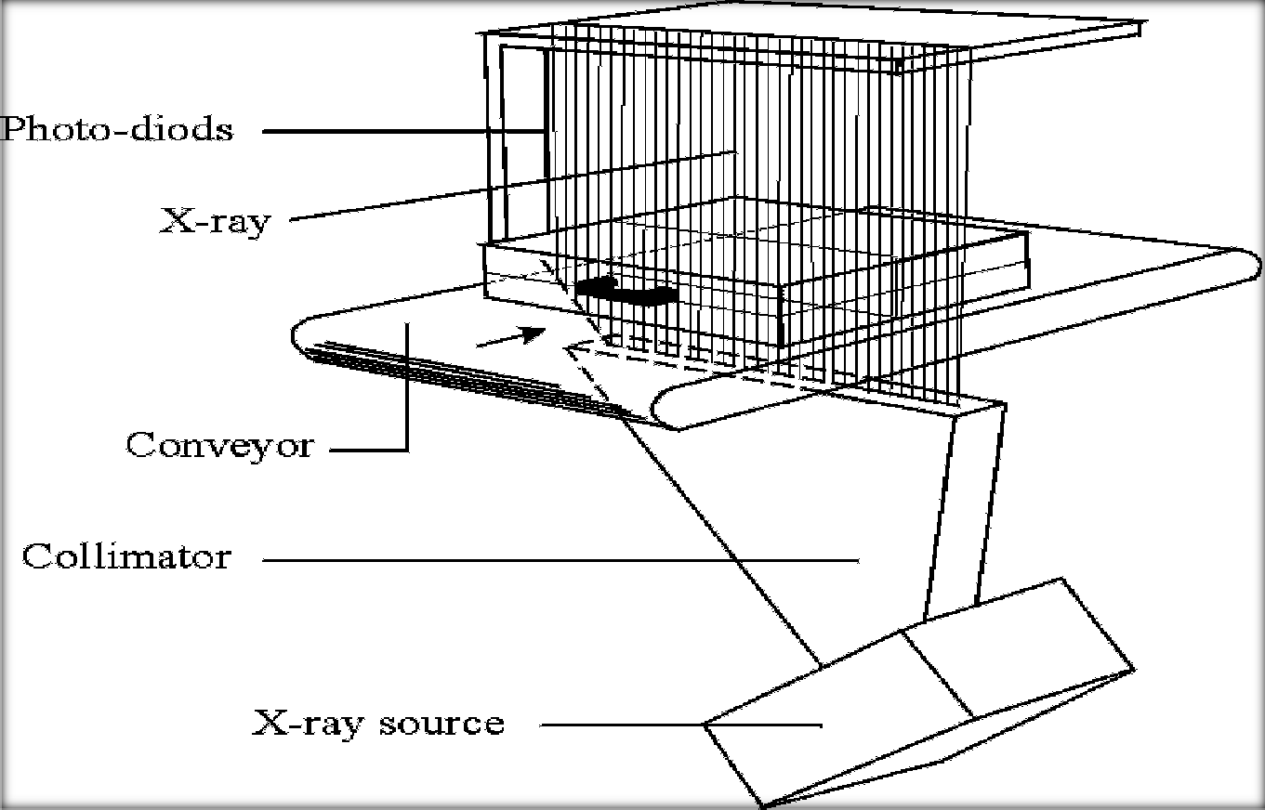

Figure 4.14 Principle of modern x-ray unit

(F.) THERMAL COMFORT

Thermal comfort is affected by heat conduction, convection, radiation and evaporation heat loss. Thermal comfort is maintained when the heat generated is allowed to dissipate, thus maintaining thermal equiibrum with the surrounding. The temperature of air, and the mean relative humidity of the environment play important roles in the determining the level of termal comfort in the environment. Therefore it is very important to ensure adequate ventilation through the building and the environment. The centre will make use of HVAC (Heating Ventilation AirConditioning) unit to control the thermal environment. Natural ventilation will be employed also to reduce the need for mechanical cooling or aeration. Both natural and artificial methods of ventilation will be applied where use is necessary so as to control the air temperature and consequently curb thermal stress which is an enemy to concentration and fosters absent mindness and distraction.

4.4.5.0 FUNCTIONAL SPACE REQUIREMENTS

(A.) FACILITIES NEEDED FOR PASSENGER HANDLING (1.)ACCESS INTERFACE:
Arrival and departure curbs; and
Convenient connection between car parking lot and terminal.

(2.) PROCESSING:

Airline tickect and baggage check-in counters; Security, customs and immigration counters; Facilities for baggage claim;
Waiting lounges;
Departure and arrival lounges; Stores, shops, restaurants and bars; Information counters;
Observation galleries; and Public utility amenites.

(3.) FLIGHT INTERFACE:

Gate lounge;
Loading facilities;
Passenger conveyance facilities.

(B.) FACILITIES NEEDED FOR AIRLINE OPERATIONS:

Office spaces;
Baggage – handling facilities; Telecommunication facilities; Dispatch offices.

(C.) FACILITY NEEDED FOR AIRPORT MANAGEMENT:

Office spaces for administrative department; Office spaces for security personnel;
Office spaces for customs and immigration personnel;
Spaces for housing maintenace equipment ans personnel; Spaces for support- and emergency – vehicles and personnel.

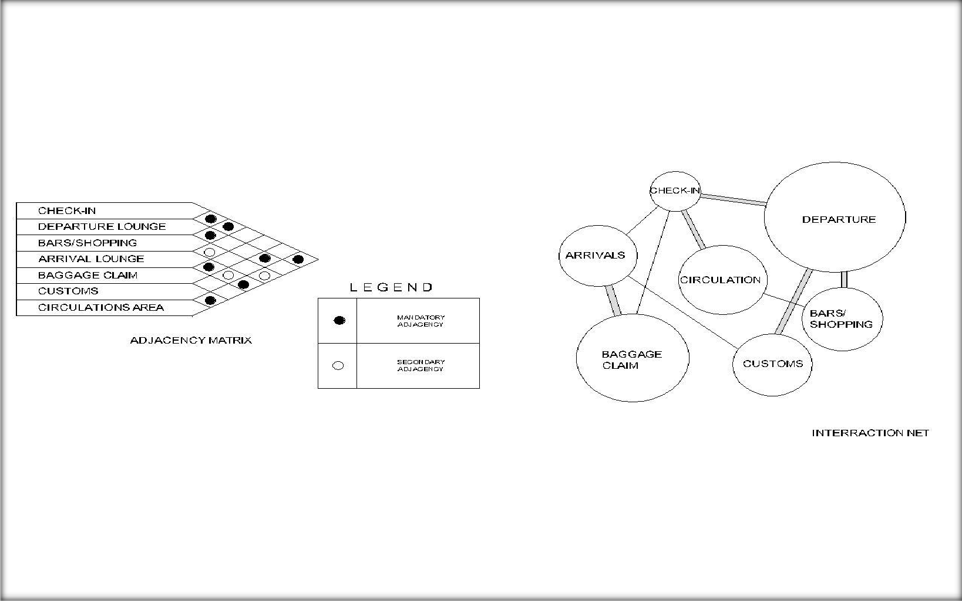

Figure 4.15 The adjacency matrix and interraction net chartsof the relationship of the principal spaces in the terminal building

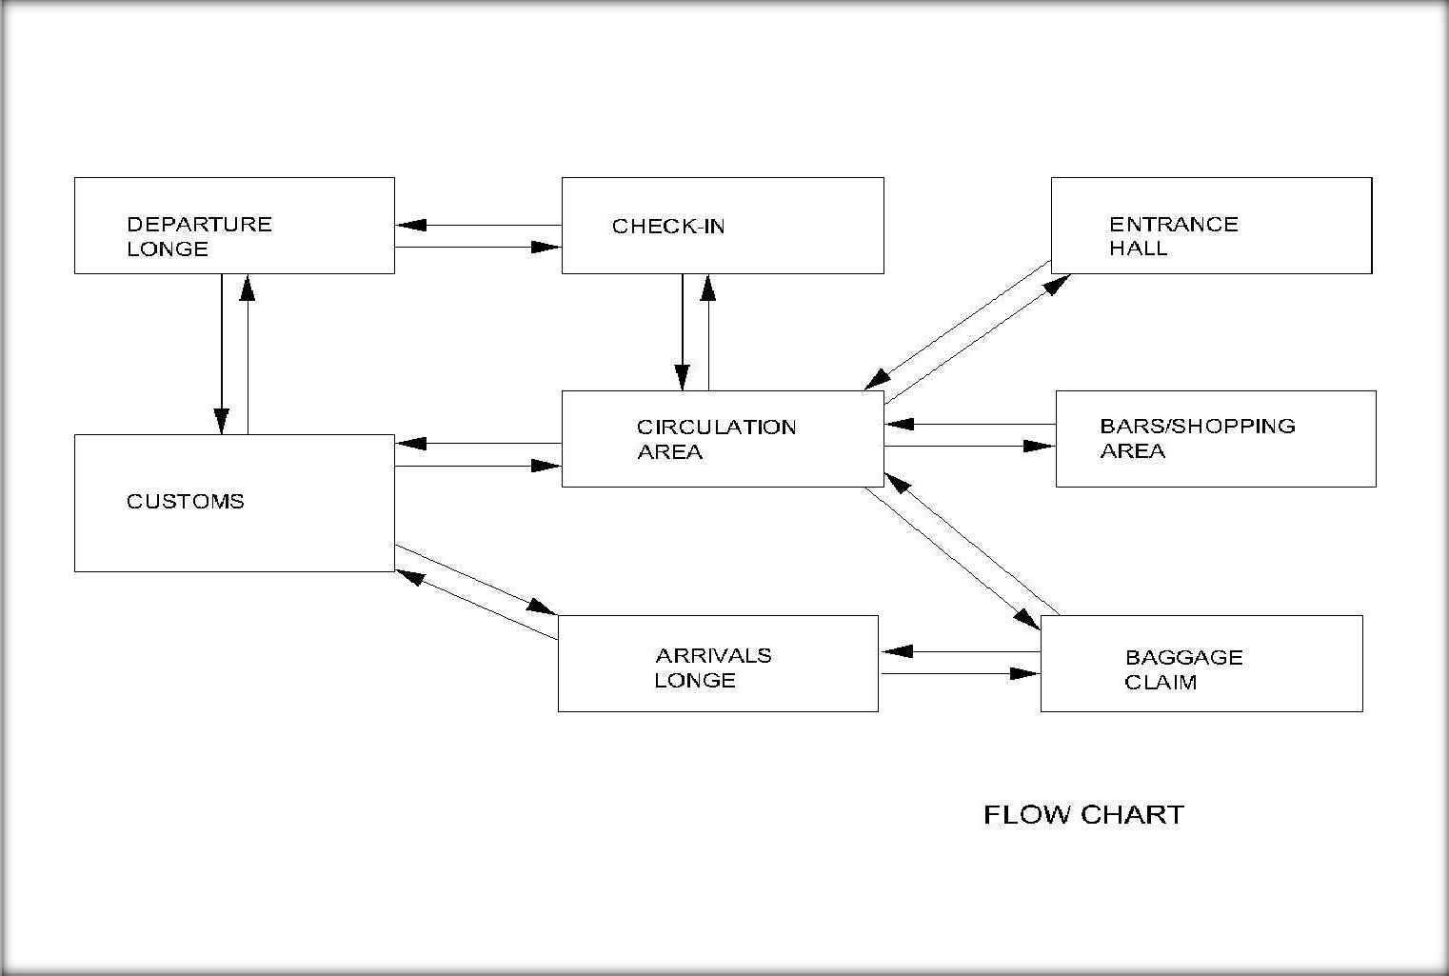

Figure 4.16 flow chart of principal spaces of proposed terminal building

CHAPTER FIVE

DESIGN SYNTHESIS

5.1.0 PLANNING AND DESIGN PHILOSOPHY

The need for designing a passenger terminal for the Makurdi Airport is to provide the facilities and environment requiste to replace the existing terminal which is small scale and outdated and without provision for future expansion. The programme aims at developing a creative approach to understanding and providing solutions to design problems with the motivation to seek new solutions to the issues and challenges facing a developing country with a rich cultural heritage such as Nigeria and also upgrade the status of Makurdi which is the capital city of Benue State.
The primary objective of the project is to upgrade the aviation sector of the entire federation- Makurdi Airport being just are phase of that project. The end product is expected to be a good and mature initiative to the social and cultural environment competent to grapple with the demands and needs of a complex modern society.
The philosophy stresses the importance of physical as well as socio–cultural factors which are a crux of the way of life of the Benue nation. The facility has been designed to stimulate fruitful personal interaction so as to fulfill the above purpose through the effective use of circulation spaces allowed between facilities. Emphasis will be on security and effective flow of users in the building, rather than on showcasing finished work.

5.2.0 DESIGN CONCEPT AND FORM

Each place has a spirit and character which must be related to and cultivated in a positive manner. Our emphasis is on sensitivity to context, and whether it be a remote wooded glen or an urban site, planning is a careful process of fitting buildings in a natural way to their setting. As buildings engage the landscape, there is often much concern for outdoor spaces and their environmental qualities. Sun, vegetation, wind, etc. are considered, as well as access, parking, zoning regulations, environmental regulations and building character. The architectural expression of the terminal building utilizes elements from the architectural language of postmodernism to create an expression that is very much part of the inherent geography of simple topographical and demographical geo-informatics, and its exclusion from the hustle and bustle of the town, also responds to the particular condition of its site and program as the structure‟s location is just 25km from Makurdi metropolis town.

According to architect Frank Lloyd Wright, “…every building should reflect its use…” the airport terminal is affiliated with flight and hence should be dynamic in form to achieve this form. Structure primarily shows the wings of an eagle in flight. This is achieved by fusing two semi- circles to overlap at the base; a system of steel truss is then used to derive the „wings‟ of the eagle over which aluminum roofing sheets and covered to complete the roof. The eagle is a significant bird to the people of Benue State as it symbolizes strength, courage, farsightedness and immortality. The eagle is considered to be the king of the air. The site of the terminal is well beautifully landscaped to ensure a green environment. The essence of this form in concept is to portray the whole idea of architectural symbolism, unity, rhythm and harmony characterized by juxtapositioning of characteristic elements of the building and the site. The terminal building reflects a design that is rich in character, functional, and environmentally sustainable, enriches its setting, relate to the spirit of the place, and takes the fullest advantage of the site's qualities.

5.3.0 CONCLUSION

The Makurdi domestic airport terminal building reflects a design that is rich in character, functional, environmentally sustainable, enriches its setting, relates to the spirit of the place, and takes the fullest advantage of the site's qualities.

A very high priority is energy conservation with a tendency towards simple and economical means such as orientation, passive systems, insulation, solar heating, day lighting, shading, and natural ventilation. Building materials are considered for their environmental impacts and are often durable, natural, and designed to age gracefully.

To create the best pre-air travel experience, the terminal building is provided withmany types of accommodation contained within its envelope and has necessarily to provide for high levels of control. Conceptually, there are public (e.g. departure lounge) and private (e.g. offices) areas, as well as secure and unsecure areas. In addition, there are the barriers to movement needed for ticket and non-ticket holding people, as well as immigration controls. The airport in general and terminal in particular is one of the most intensively managed areas from a security point of view. There are barriers to movement, physical and psychological controls, security cameras and spot checks of passengers and airline staff. The architectural mission here was, therefore, a question of both creating space and helping to control it.

CHAPTER SIX

DESIGN PROPOSAL OF AIRPORT TERMINAL BUILDING

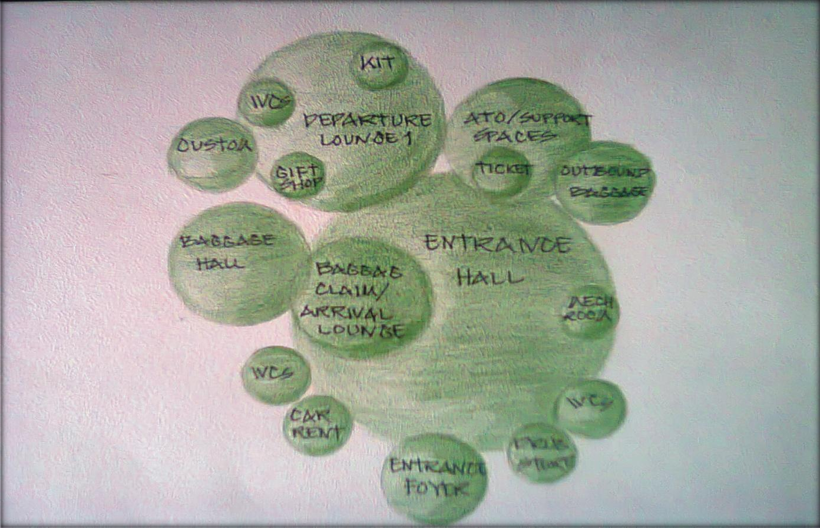

Figure 6.1 Ground floor bubble diagram

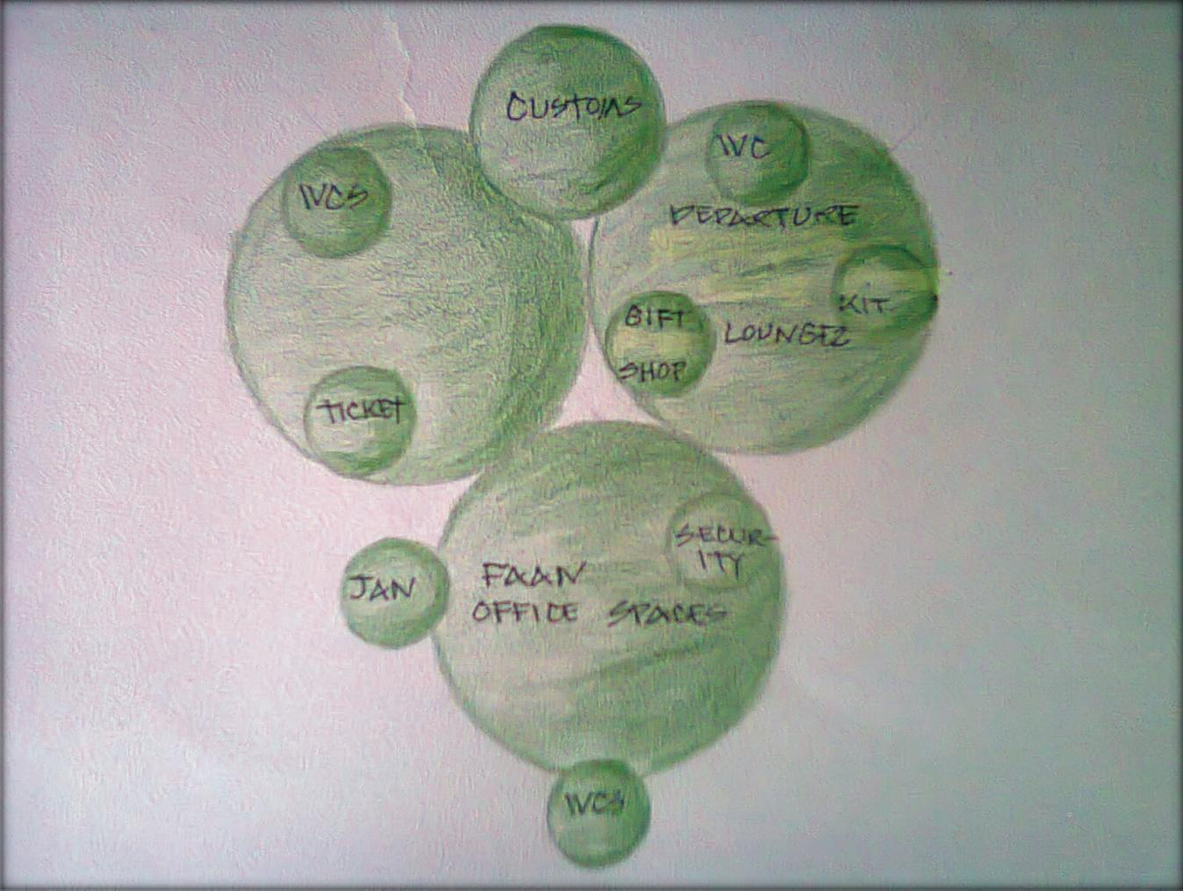

Figure 6.2 First floor bubble diagram

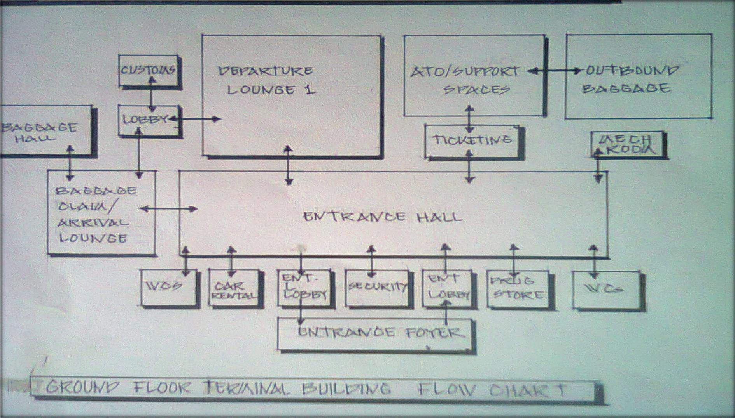

Figure 6.3 Ground floor flow chart

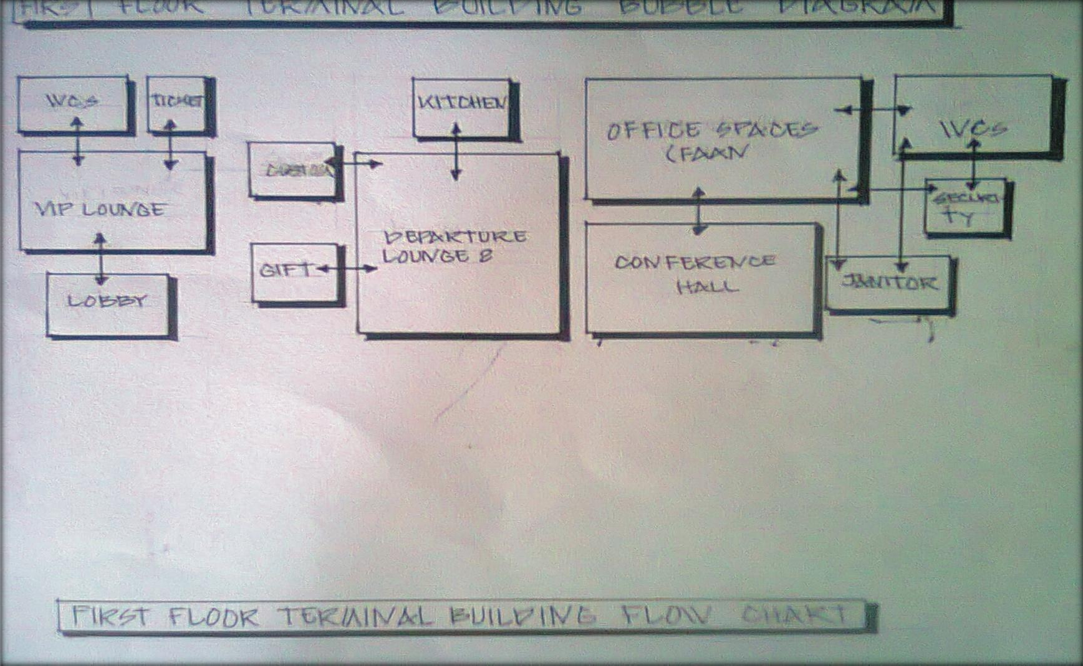

Figure 6.4 First floor flow chart

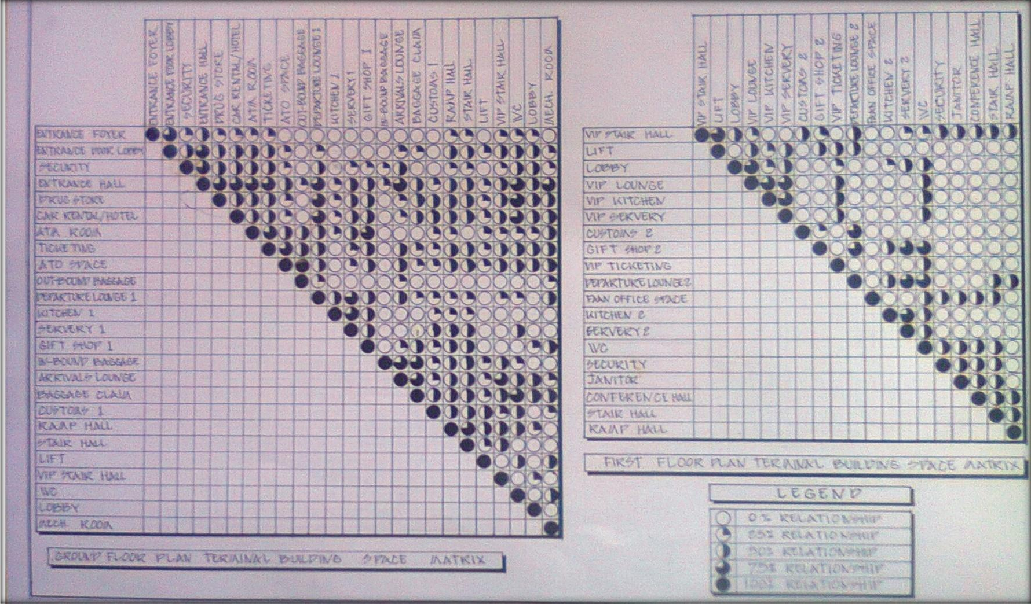

Figure 6.5 Ground and first floor space matrices

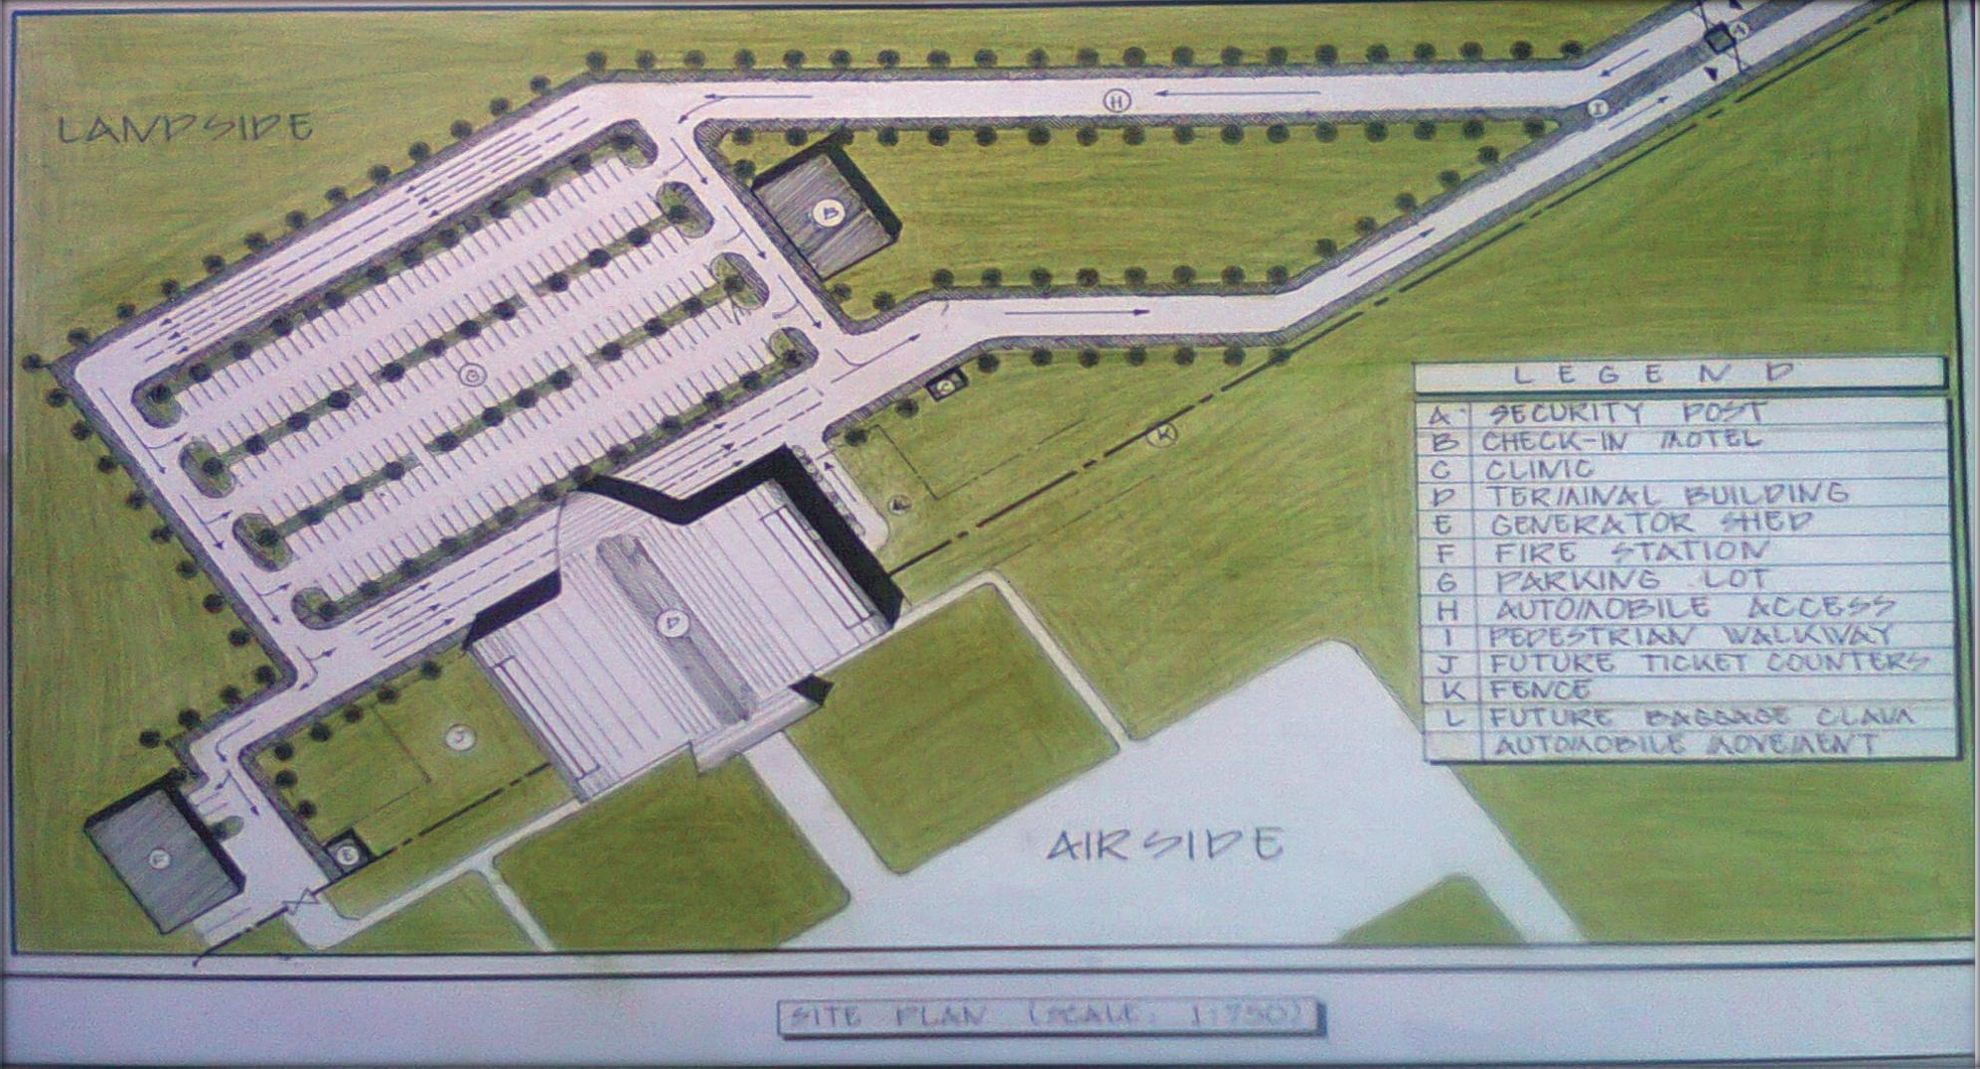

Figure 6.6 Site plan

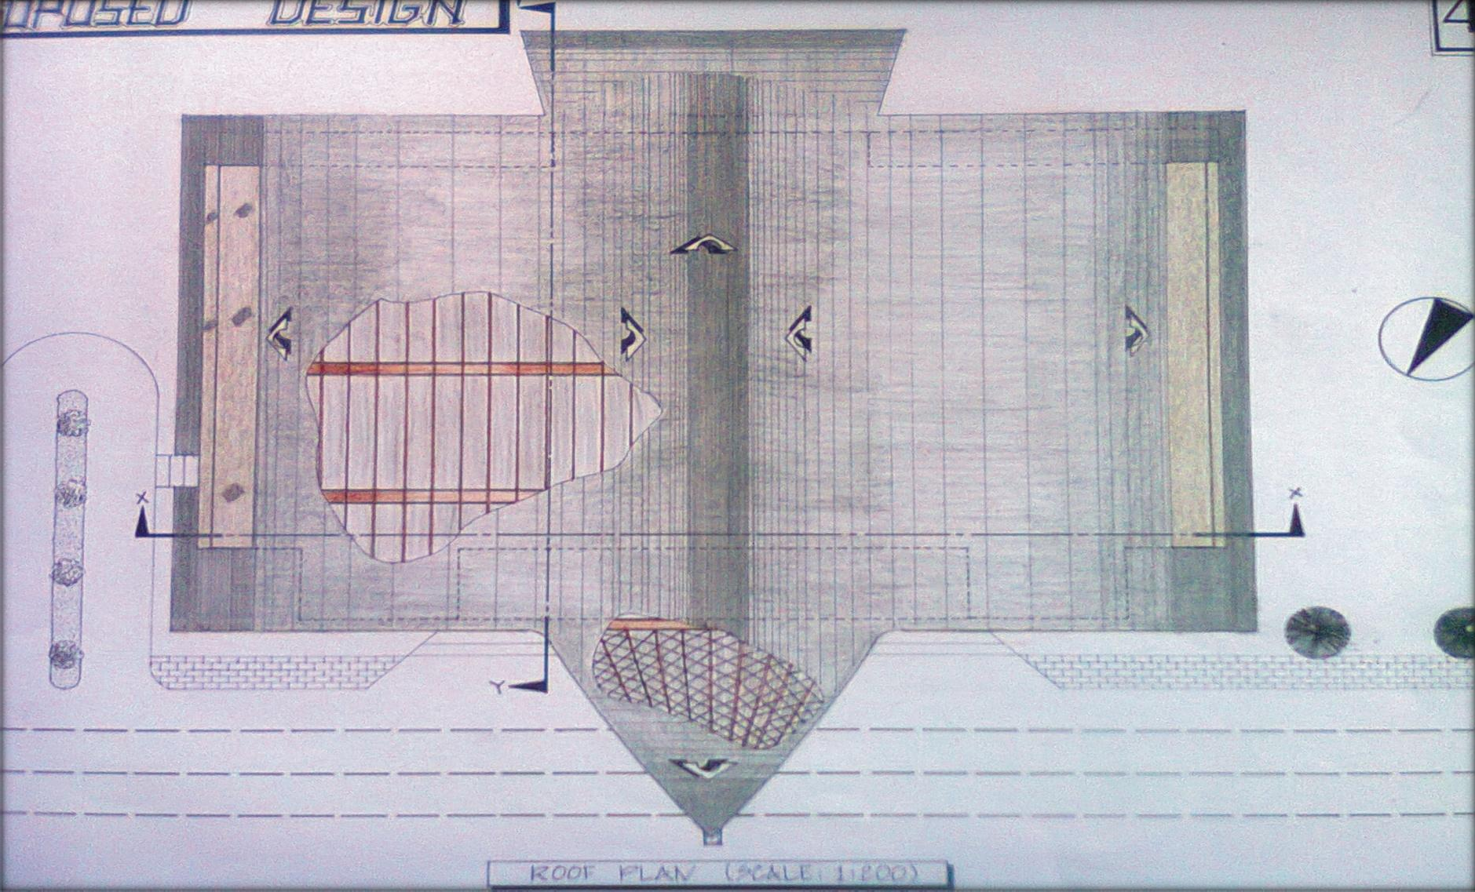

Figure 6.7 Roof plan

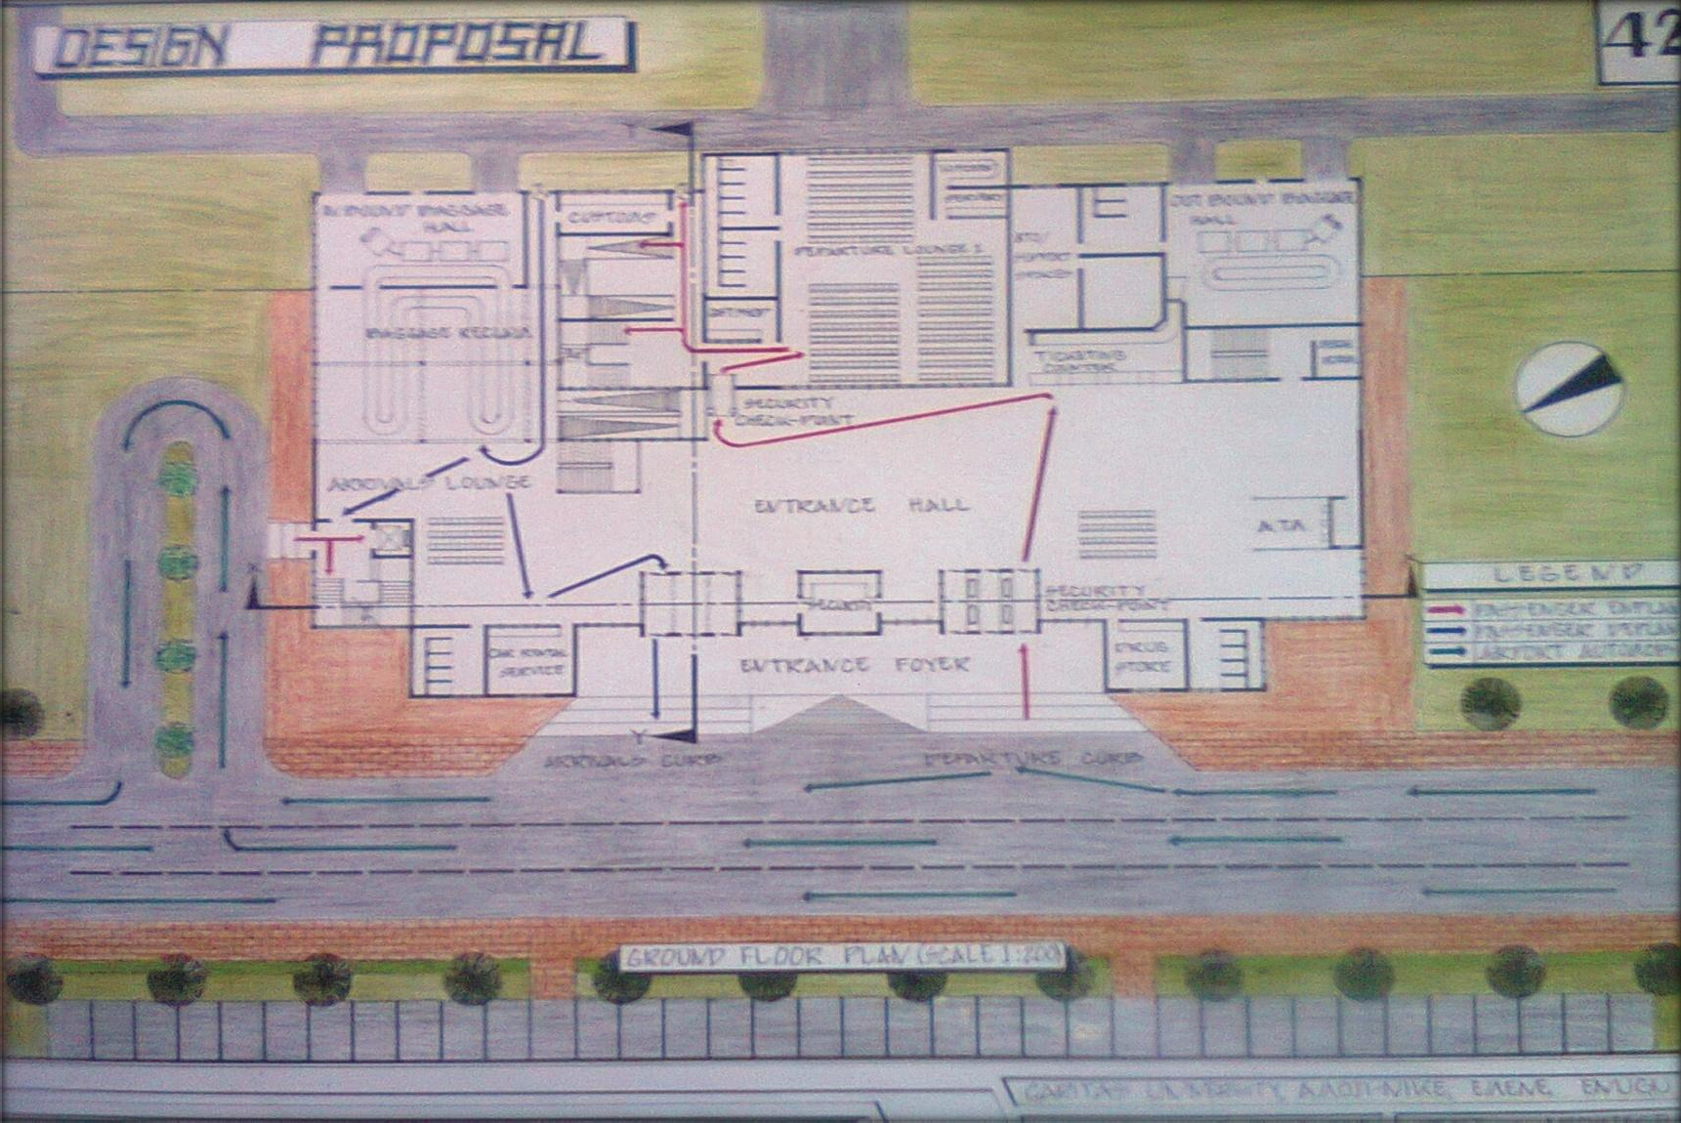

Figure 6.7 Ground floor plan

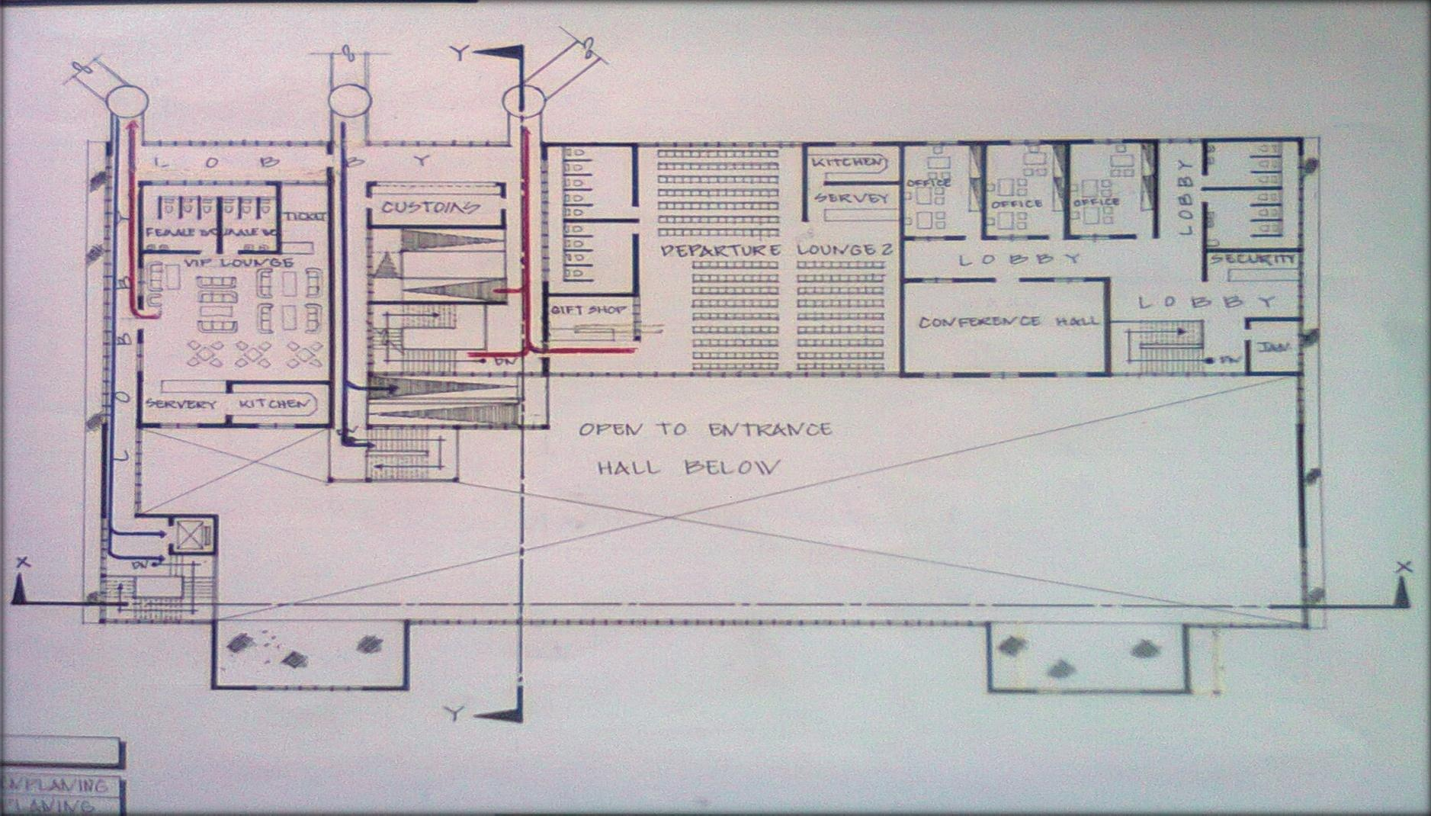

Figure 6.8 First floor plan

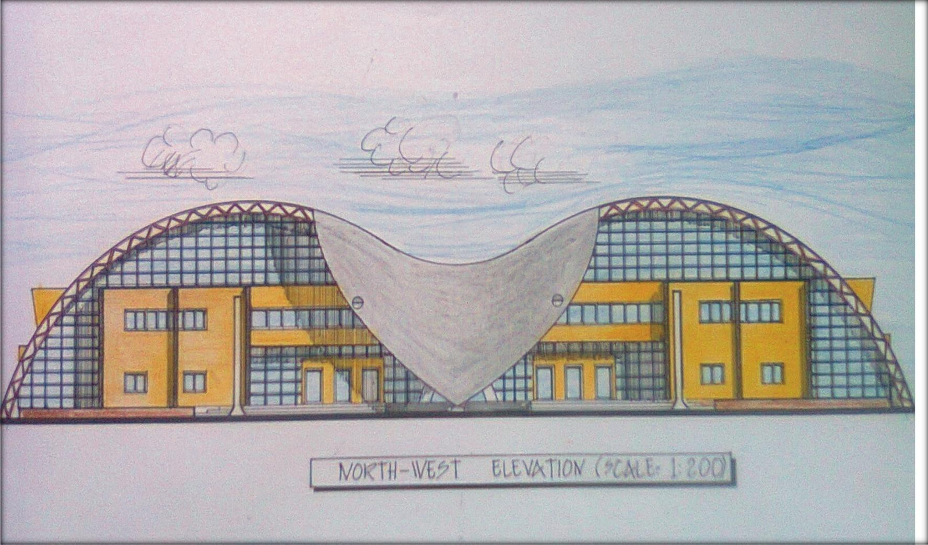

Figure 6.9 North-West elevation

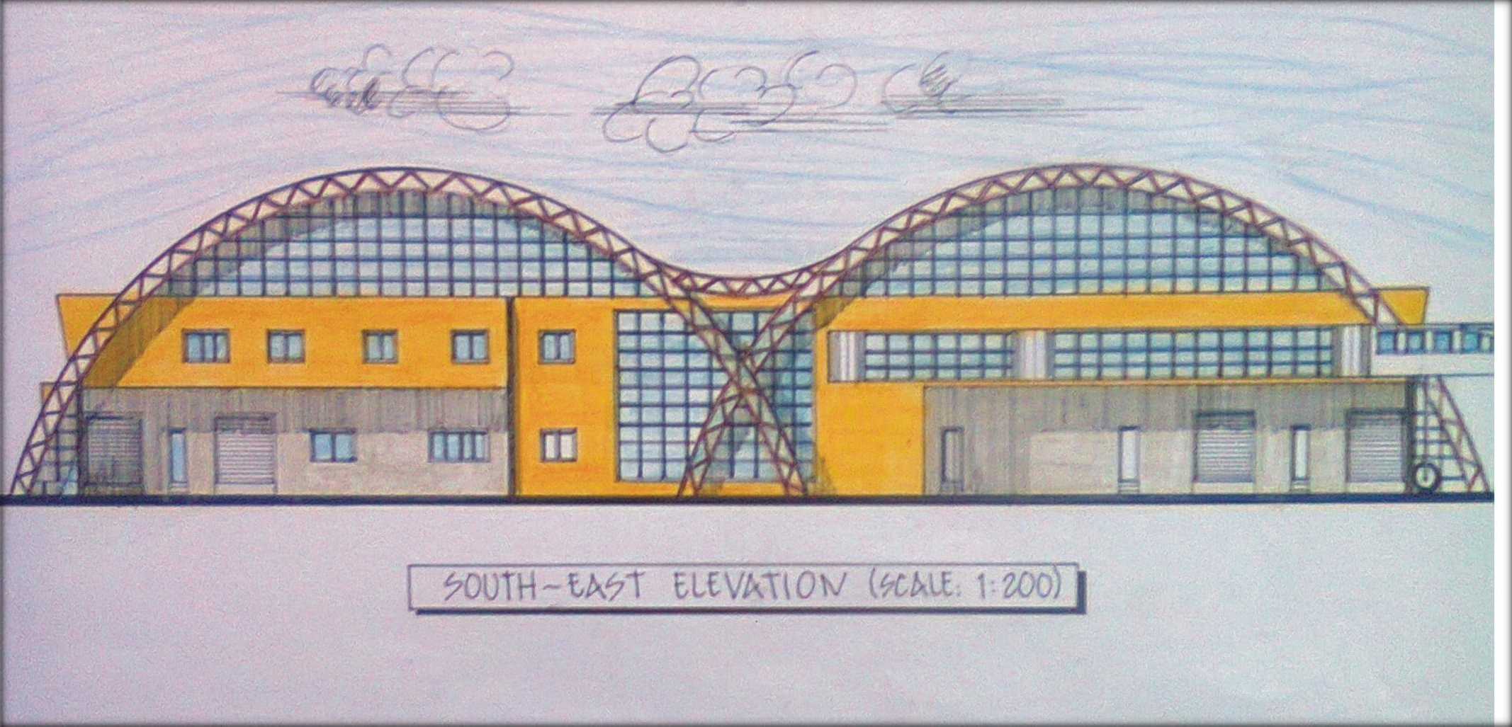Figure 6.10 South-East elevation

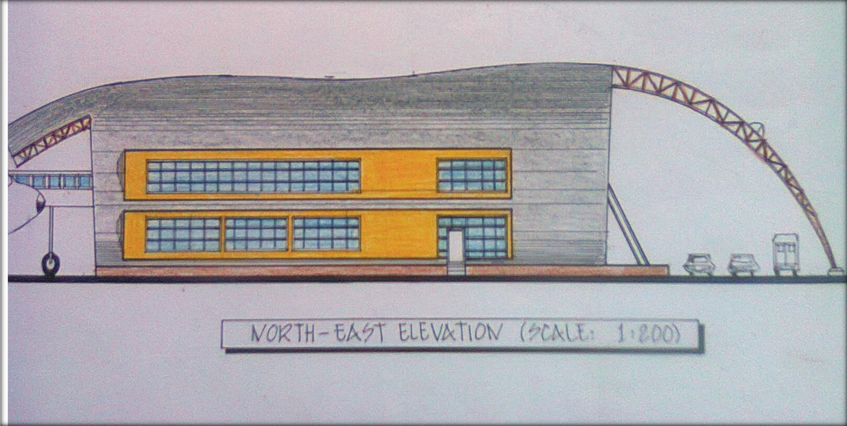

Figure 6.11 North-East elevation

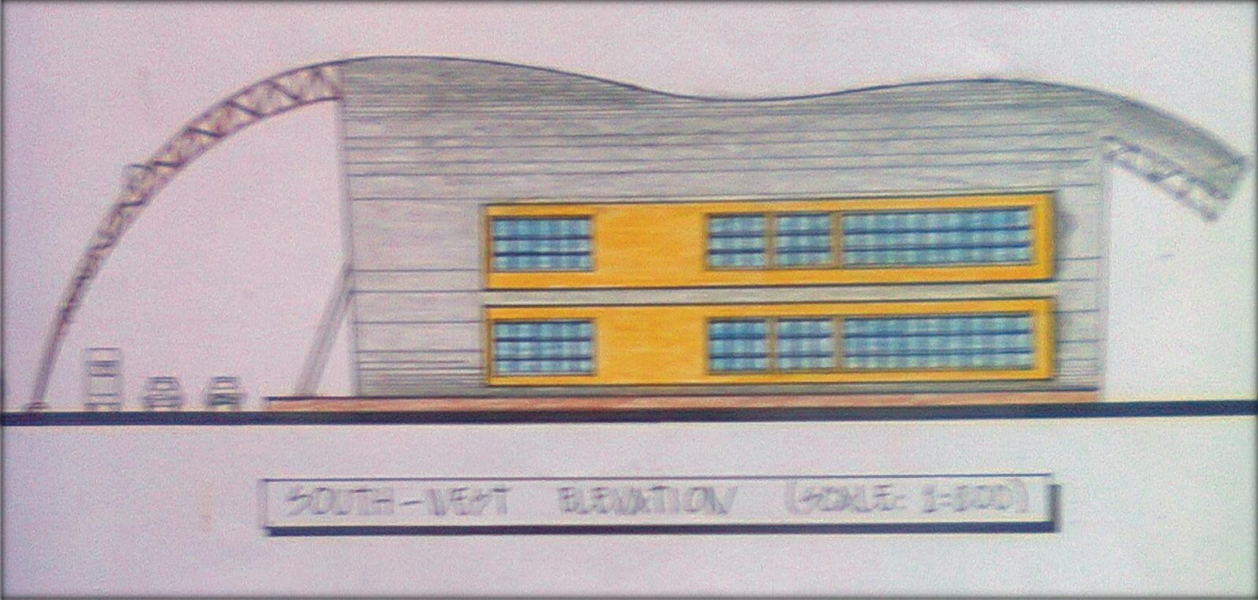

Figure 6.12 South-West elevation

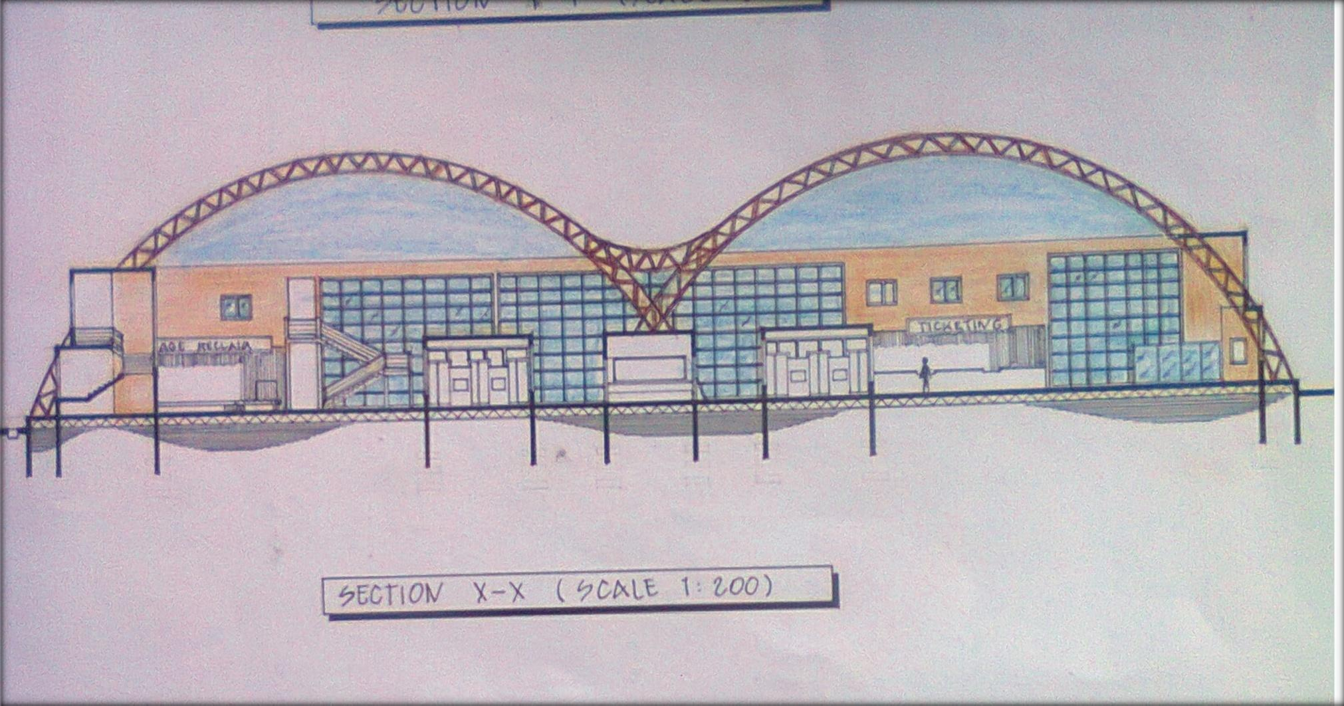

Figure 6.13 Section X-X

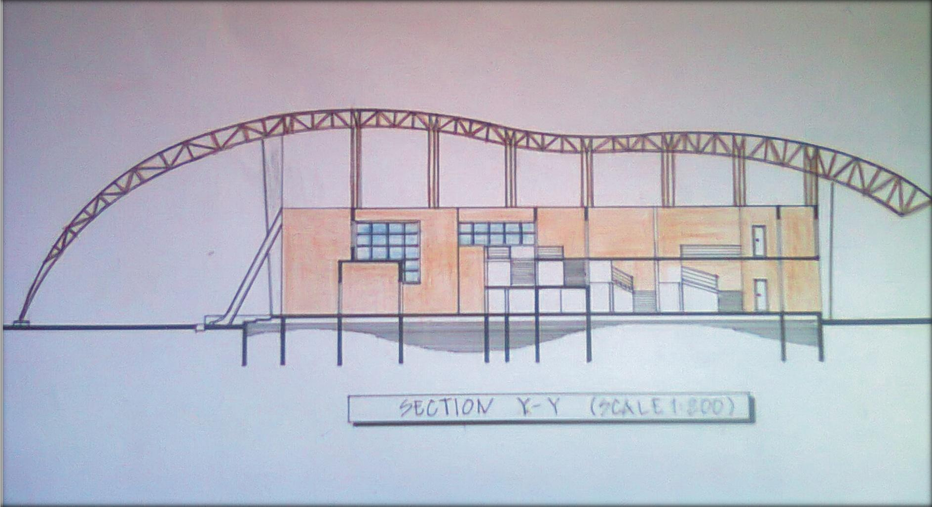

Figure 6.14 Section Y-Y

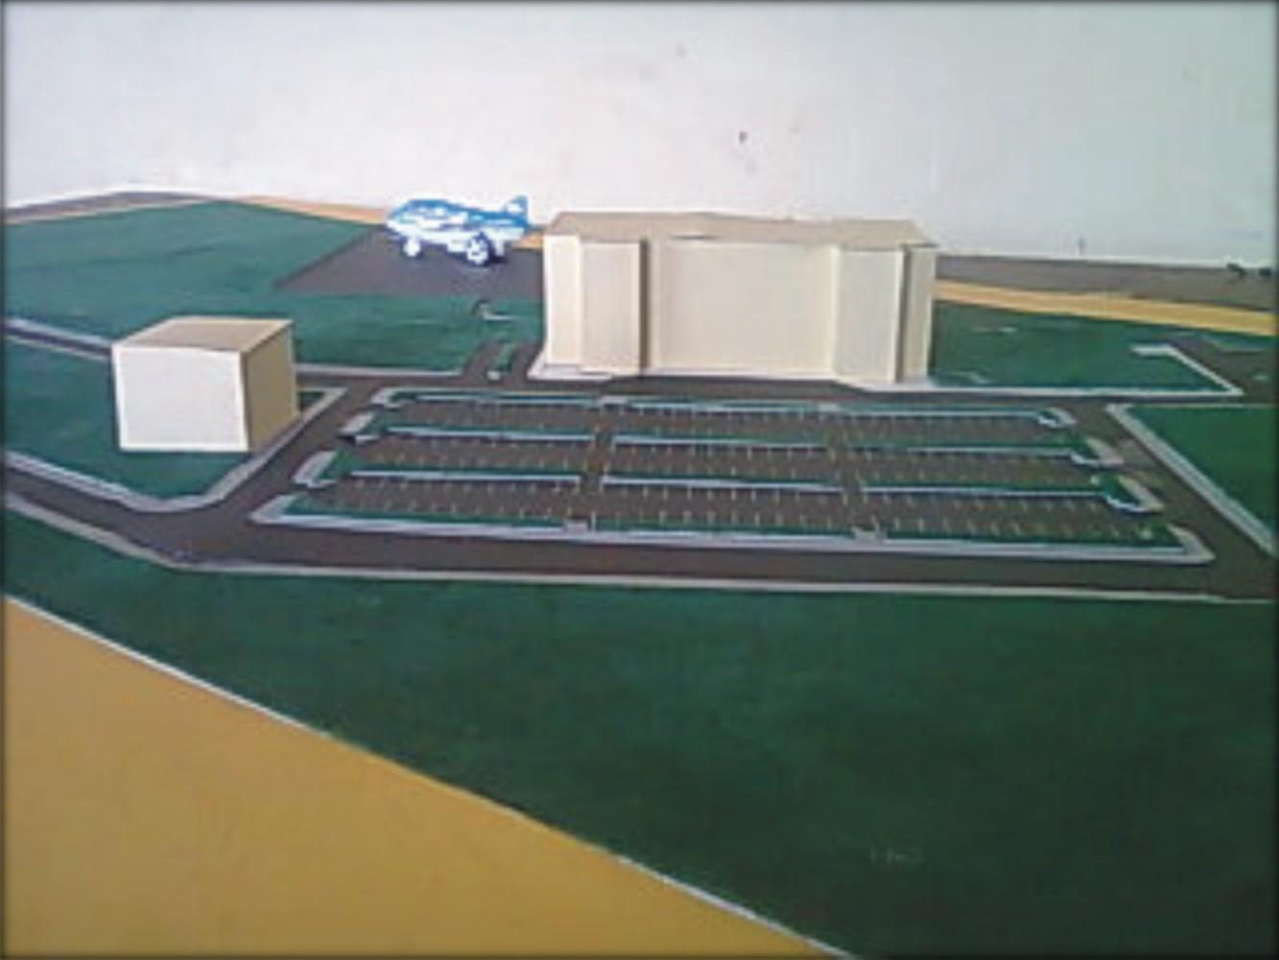

Figure 6.15 Model of proposed airport terminal

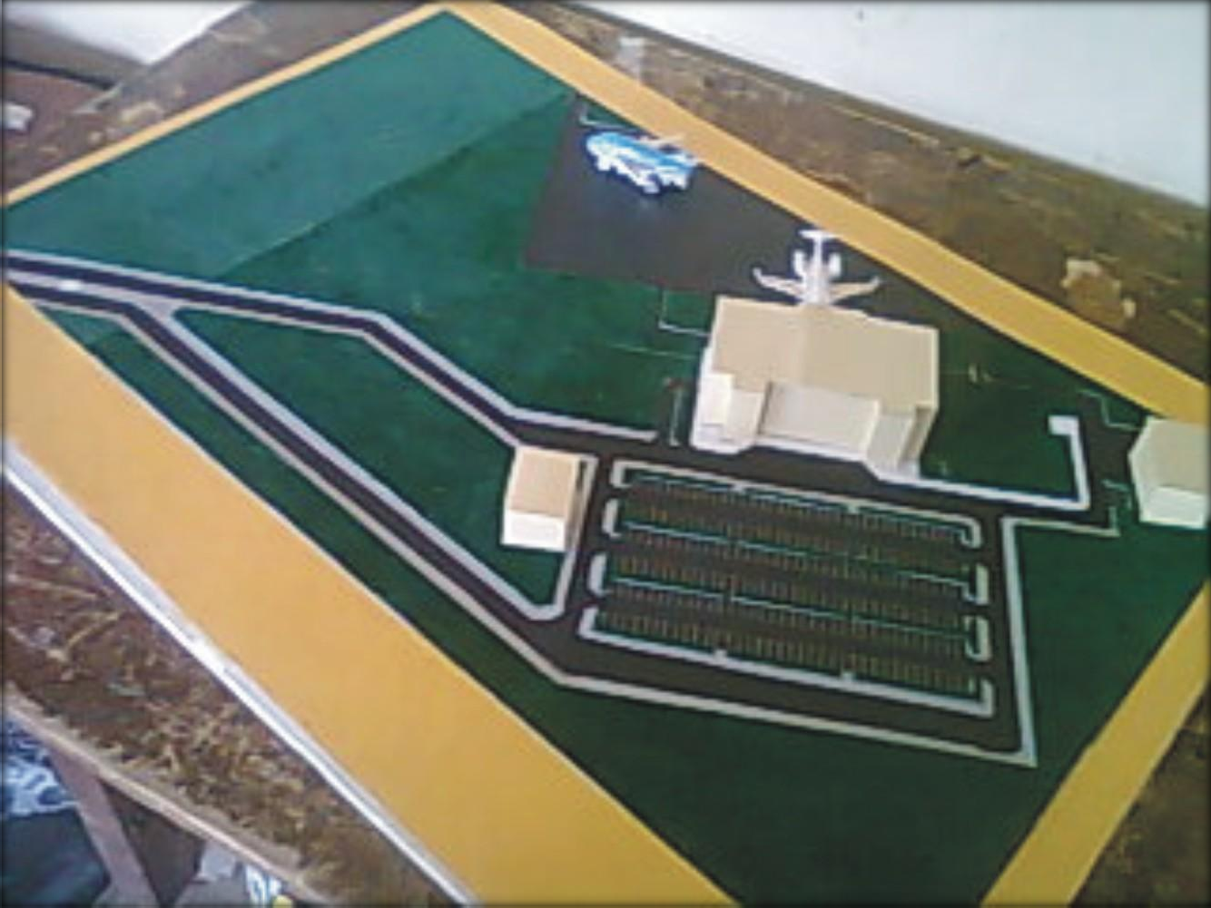

Figure 6.16 Model of proposed airport terminal and site (aerial view)

BIBLIOGRAPHY

(1.) Chudley R & Greeno R, (2006) Building construction handbook Oxford: Butterworth-Heinemann. (2.) De Chiara J & Crosbie J. M, (2001) Time saver standards for building types Singapore: McGraw-Hill. (3.) Neufert E & Neufert P, (2009) Architect‟s data Singapore: Wiley-Blackwell.
(4.) Kazada A & Caves R. E, (2007) Airport design and operations Oxford: Elsevier.
(5.) Littlefield D. (ed), (2008) Metric handbook planning and design data Oxford: Elsevier. (6.) Riba Q. P, (2002) Architect‟s handbook Oxford: Blackwell.
(7.) Apology: wikipedia@google.com

