DIURETIC AND TOXICITY STUDIES OF METHANOL STEM BARK EXTRACT OF

*SPONDIAS MOMBIN* LINN (ANACARDIACEAE) IN RATS

BY

Muhammad Mujtaba ABDULRASHEED MSc/Pharm Sci./2283/2011-12

A DISERTATION SUBMITTED TO THE SCHOOL OF POSTGRADUATE STUDIES, AHMADU BELLO UNIVERSITY IN PARTIAL FULFILLMENT FOR AWARD OF MASTERS OF SCIENCE DEGREE IN PHARMACOLOGY

DEPARTMENT OF PHARMACOLOGY AND THERAPEUTICS, FACULTY OF PHARMACEUTICAL SCIENCES,

AHMADU BELLO UNIVERSITY, ZARIA NIGERIA

OCTOBER, 2015

# DEDICATION

This work is dedicated to God Almighty ―Allah (Subhanahuwata’ala)‖.

# DECLARATION

I declare that the work in the dissertation entitled ―DIURETIC AND TOXICITY STUDIES OF METHANOL STEM BARK EXTRACT OF *SPONDIAS MOMBIN LINN*

(ANACARDIACEAE) IN RATS‖ has been performed by me in the Department of Pharmacology and Therapeutics under the supervision of Professor I Abdu-Aguye and Dr.

A.U. Zezi. The information derived from the literature has been duly acknowledged in the text and a list of references provided.

No part of this thesis has been previously presented for another degree at this or any other university.

Muhammad Mujtaba ABDULRASHEED

Name of student Signature Date

# CERTIFICATION

This disseertation entitled ―DIURETIC AND TOXICITY STUDIES OF METHANOL STEM BARK EXTRACT OF *SPONDIAS MOMBIN* LINN (ANACARDIACEAE) IN

RATS‖ by ABDULRASHEED Muhammad Mujtaba meets the regulations governing the award of the degree of Masters of Science of Ahmadu Bello University, and is approved for its contribution to knowledge and literary presentation.

# Prof. I Abdu-Aguye

MBBS, MSc (Pharm), FMCP.

**Chairman Supervisory Committee** Department of Pharmacology and Therapeutics Ahmadu Bello University Zaria

Date

Date

# Dr. A.U. Zezi

B.Pharm.,( ABU), MSc. (ABU), PhD (ABU), MPSN.

**Member Supervisory Committee** Department of Pharmacology and Therapeutics Ahmadu Bello University Zaria

# Dr. N.M. Danjuma

M.Pharm. (UKR), PhD., (ABU), MPSN.

**Head of Department** Pharmacology and Therapeutics Ahmadu Bello University, Zaria

Date

Prof. KabirBala

# Dean, School of postgraduate studies,

Ahmadu Bello University, Zaria.

Date

# ACKNOWLEDGMENT

Unquantifiable gratitude first goes to Almighty Allah for giving me the intent, determination and the wisdom to carry out this work and programme.

Acknowledgement is due to my supervisors, Prof I Abdu-Aguye and Dr AU Zezi, who despite their variety of schedule took the patience to supervise every bit of this work to make it a success.

Notable thanks go to Dr NM Danjuma, the Head, Department of Pharmacology and Therapeutics Ahmadu Bello University, Zaria, for all the encouragement and support throughout my MSc programme. The entire academic, technical and secretarial staff of Department of Pharmacology and Therapeutics also never rested until they made sure I pulled through. Most notable are Mal Abubakar Balarabe, Miss Fatima Hassan Isma’il, and Mal Ya’u Dari. Thank you all.

So many other staff of this University got involved in the making of this piece at one time or the other. They include: Dr Yusuf Rasheed and Mr Jonathan Aluwong of Department of Chemical Pathology, Ahmadu Bello University Teaching Hospital (ABUTH) Zaria, Dr Suleiman DaudaEneyamire of Department of Histopathology, ABUTH, Zaria, AlhYunusa of Department of Veterinary Pathology, and Mal Mustafa Abba- Department of Pharmacognosy and Drug Development.

Always at the background are my family members whom would always second the direction of struggle.

Overall, may Allah reward you all abundantly.Ameen!

# ABSTRACT

*Spondias mombin* belongs to the family *Anacardiacae*. All parts of the tree are reported to be medicinally useful. The fruit juice is drunk as a diuretic and febrifuge. The main aim of the study is to determine the diuretic activity and toxicity of methanol stem bark extract of *Spondias mombin*.

The plant was collected, authenticated, and studied in Department of Pharmacology and Therapeutics, Ahmadu Bello University, Zaria. Adult albino rats of Wistar strain of either sex were used for the experiments. Phytochemical screening of the methanolic extract of stem bark of *Spondias mombin* was carried out according to the methods described by Trease and Evans. The oral median lethal dose (LD50) of the extract was determined in rats according to Lorke’s method. The sub-chronic study was carried out in accordance with WHO and OECD 407 guidelines. Twenty four adult rats (Wistar strain) were randomly divided into four groups of six rats each. The rats in group I were administered with normal saline orally and served as the control. Groups II – IV were administered 250mg/kg, 500mg/kg, and 750mg/kg of the extract daily for twenty eight days.At the end of the study, the animals were euthanized and relative organ weight ratio (ROW) was determined.Histological examination of heart, liver and kidneys were also performed. Complete blood count, liver and kidney function tests were also determined. For diuretic screening, test animals were placed into metabolic cages with total withdrawal of food and water for 12 hours. They were then randomly divided into five groups of five animals each. Each animal was rehydrated with 25 ml/kg of normal saline just before the experiment. Group-I animals were provided only with 25ml/kg of Normal saline to serve as control. Group-II animals were provided with frusemide at a dose of 5 mg/kg body weight. Group-

III, IV and V animals were given 250mg/kg, 500mg/kg and 750mg/kg of the extract respectively. These preparations were all given by the oral route. After administration of test samples, the urinary excretion was recorded at 3rd, 6th and 24th hour, from the graduated urine chamber of metabolic cage. Urine was also analyzed for electrolytes.

The phytochemical screening of methanolic stem bark extract of *S. mombin* revealed the presence of flavonoids, alkaloids, tannins, saponins, cardiac glycosides, phenols, and carbohydrates,but anthraquinones were absent. The median oral lethal dose was found to be greater than 5000mg/kg. Sub-chronic toxicity studies revealed there was no significant statistical difference in the animal body weights at all weeks compared to week zero and in relation to different doses of extract compared to the control.A significant statistical reduction of bicarbonate was noted at the dose of 500mg/kg compared with control (p< 0.05).There was no statistically significant difference observed in the liver function test, haematological indices, and relative organ weight (ROW) ratio of the groups administered with the extract compared with control.Vascular congestion was noted in the heart at 500mg/kg and the kidneys at 250mg/kg. Vacuolar changes seen at 750mg/kg dose are most likely due to fatty liver.No significant statistical differences were observed in urine output between the test groups given the extract and the control groups during the first 6 hours and after 24 hours. There was significant excretion of potassium at 500mg/kg dose compared with the negative control. No other significant statistical differences were observed between the other test groups given the extract and the control groups.

In conclusion methanolic extract of the stem bark of *S.mombin* has shown structural toxicity on the some organs, but has not been shown to have diuretic property.

TABLE OF CONTENTS

TITLE PAGE **Error! Bookmark not defined.**

DEDICATION ii

DECLARATION iii

CERTIFICATION iv

ACKNOWLEDGMENT v

ABSTRACT vi

TABLE OF CONTENTS viii

LIST OF TABLES xi

LIST OF PLATES xii

LIST OF APPENDICES xiv

LIST OF ABBREVIATIONS xv

CHAPTER ONE 1

* 1. INTRODUCTION 1
  2. Statement of Research Problems 5
  3. Justification 5
  4. Research Hypothesis 7
  5. Aim 7
  6. Specific Objectives 7

CHAPTER TWO 8

* 1. LITERATURE REVIEW 8
  2. Diuretics 8
     1. Introduction 8
     2. Clinical uses and side effects 13
     3. Time course of diuresis 16
     4. Preclinical studies on plants that have been shown to have diuretic properties 17
  3. Phytochemical Screening 18
  4. Toxicology 18
     1. Importance of dose-response relationship in toxicology 19
     2. Routes of exposure to toxic substances 20
     3. Some target organs in toxicology 21
     4. Preclinical toxicology studies 25
  5. Traditional Medicine 27
     1. Safety of traditional medicine 28
  6. The plant; Spondias mombin 30
     1. Ethnomedical uses 31
     2. Non medical uses 31

CHAPTER THREE 33

* 1. MATERIALS AND METHODS 33
  2. Plant Collection and Authentication 33
  3. Preparation of the Extract 33
  4. Experimental Animals 33
  5. Materials 34
  6. Phytochemical Screening of the methanol extract of Spondias mombin 34
     1. Test for cardiac glycosides 34
     2. Test for tannins 35
     3. Test for saponins 35
     4. Test for flavonoids 35

3.5.6 Test for anthraquinones 36

* 1. Acute toxicity studies: 37
  2. Sub chronic toxicity study 38
     1. Calculation of relative organ weight ratio (ROW) 38
     2. Biochemical studies 38
     3. Haematological studies 39
     4. Histopathological Study 39
  3. Screening of Diuretic Activity 39
  4. Data analysis 40

CHAPTER FOUR 41

* 1. RESULTS 41
  2. Phytochemical Screening 41
  3. Toxicity studies 43
     1. Acute toxicity studies (LD50 determination) 43
     2. Sub chronic toxicity studies 44
     3. : Diuretic Screening 68

CHAPTER FIVE 78

5.0 DISCUSSION 78

CHAPTER SIX 85

* 1. SUMMARY, CONCLUSION AND RECOMMENDATIONS 85
  2. Summary 85
  3. Conclusion 85
  4. Recommendations 86

REFERENCES 87

# LIST OF TABLES

Table2.1: Commonly encountered nephrotoxic agents and exposures 23

Table 4.1: The phytochemical screening of methanolic stem bark extract of *S. mombin* 42

Table 4.2: Effect of methanol stem bark of *S. mombin* on average body weight 45

Table 4.3: Effect of methanol stem bark of *S. mombin* on renal toxicity 47

Table 4.4: Effect of methanol stem bark of *S. mombin* on Liver function 49

Table 4.5: Effect of methanol stem bark of *S. mombin* on Hematological indices 51

Table 4.6: Effect of methanol stem bark of *S. mombin* on Relative Organ Weight (ROW) 53

Table 4.7: Design of the diuretic screening of stem bark *S. mombin* 69

Table 4.8: Urinary output of rats at different time intervals after oral administration of methanol extract of *S. mombin* 71

Table 4.9: Diuretic action at different time intervals after oral administration of methanol extract of *S. mombin* 73

Table 4.10:Dose response study of diuretic effects of *S. mombin* extract through electrolyte excretion in urine in rats 75

Table 4.11: Dose response study of Diuretic index and Lipschitz values of *S. mombin* 77

# LIST OF PLATES

Plate I *Spondias mombin* in its natural habitat (own picture) 30

Plate II Photomicrograph of rat heart of control group showing normalintercalated muscles (arrow). (mag. x400) 56

Plate III Photomicrograph of rat heart administered with methanol extract of *S. mombin*of at dose of 250mg/kg showingno pathological changes when compared with control. (mag. x400). 57

Plate IV Photomicrograph of rat heart administered with methanol extract of *S. mombin* of at dose of 500 mg/kgshowing congested vessels when compared with control (mag. x400) 58

Plate V Photomicrograph of rat heart administered with methanol extract of *S. mombin* of at dose of 750 mg/kg showing normal intercalated cells when compared with control. No pathological changes observed (mag. x400) 59

Plate VI Photomicrograph of rat liver of control group showing normal parenchymal with no distortion, cetral vein and portahepatis. (mag x100) 60

Plate VII Photomicrograph of rat liver administered with methanol extract of *S. mombin* of at dose of 250 mg/kg showing normal liver when compared with control (mag x100) 61

Plate VIII Photomicrograph of rat liver administered with methanol extract of *S. mombin* of at dose of 500 mg/kg showing normal liver when compared with control (mag x100) 62

Plate IX Photomicrograph of rat liver administered with methanol extract of *S. mombin* of at dose of 750 mg/kg showing many vacuolar degenerative changes when compared with control (mag x100) 63

Plate X Photomicrograph of rat kidney of control group showingmany normal glomeruli and tubules when compared with control (mag x100)… 64

Plate XI Photomicrograph of rat kidney administered with methanol extract of *S. mombin* of at dose of 250 mg/kg showing many congested vessels when compared with control (mag x100) 65

Plate XII Photomicrograph of rat mg/kidney administered with methanol extract of *S. mombin* of at dose of 500 mg/kg showing many normal glomeruli and tubules when compared with control (mag x100)… 66

Plate XIII Photomicrograph of rat kidney administered with methanol extract of *S. mombin* of at dose of 750 mg/kg showing vacuolar change when compared with control (mag x100) 67

# LIST OF APPENDICES

Appendix A Extraction of sample 94

# LIST OF ABBREVIATIONS

ADH antidiuretic hormone ALP alkaline phosphatase ALT alanine aminotransferase

AST aspartate aminotransferase BDH British Drug House

DNA deoxynucleic acid

EDTA Ethylene Diamine Tetra-acetic Acid GGT γ- glutamyltranspeptidase

JNC Joint National Committee on detection, evaluation and management of hypertension LD50 median lethal dose

LFTs Liver function tests Ltd Limited

OECD Organization for Economic Co-operation and Development RBC red blood cells

ROW Relative organ weight ratio WHO World Health Organisation

# CHAPTER ONE

# INTRODUCTION

Plants have fed the world and cured its ills since time immemorial. Ecology has shown us the intense dependence of man on plants for his basic needs of food, shelter, clothing and even medicine. The use of plants for curing and healing is as old as man himself. Therefore, a vast knowledge of [medicinal plant](http://www.scialert.net/asci/result.php?searchin=Keywords&cat&ascicat=ALL&Submit=Search&keyword=medicinal%2Bplant)s have accumulated,but most of the knowledge only exists as verbal tradition and only a fraction has gotten scientific validation till date(Osai, 1998). A plant becomes a medicinal plant only when its biological activity has been ethnobotanically reported or scientifically established (Elujoba, 1997).

Since 1978 the World Health Organisation (WHO) commenced the evolution of scientific confirmation of medicinal effect of herbs. World Health Organization has estimated that over 75% of the world’s population relies on plant-derived medicines, usually obtained from traditional healers, for basic health-care needs (Patel *et al*., 2009). It is estimated that about 25% of all modern medicines are directly or indirectly derived from plants (Craig *et al.*, 1997).

Diuretics are a class of drugs that increases the rate of urine formation. They are used in many clinical conditions including edematous disorders and hypertension. Historically, the classification of diuretics has been made using multiple of ideas like: place of action (loop diuretics), efficiency (high ceiling diuretics), chemical structure (thiazide diuretics), similarity of action to other diuretics (diuretics similar to thiazides), the effects upon the potassium excretion (potassium-sparing diuretic), and others (Florez, 2003; Rang *et al.,* 2008).

The diuretic effectiveness of medicinal plants needs to be experimentally proved, because diuresis could be influenced by the form of administration (infusion or decoction) which implies the consumption of a great amount of liquids that can provoke an increase in the amount of urine excreted without a true evidence of a diuretic action. This is illustrated by the following equations ([Abeywickrama](http://www.phcog.com/searchresult.asp?search&author=K%2E%2BR%2E%2BW%2E%2BAbeywickrama&journal=Y&but_search=Search&entries=10&pg=1&s=0)*et al.,* 2010):

* + 1. Urine excretion = mean urine volume of test x100 total fluid administered
    2. Diuretic action:= urinary excretion in test x100

urinary excretion in standard

* + 1. Diuretic activity= diuretic action of test x100

diuretic action of standard

* + 1. Diuretic index= urine volume of test group x100

urine volume of control group

=diuretic action of test x100 diuretic action of control

* + 1. Saluretic index= urinary excretion of electrolyte of test group urinary excretion of electrolyte of control group
    2. Natriuretic index (Aldosterone index)= urinary excretion of Na+

urinary excretion of K+

* + 1. Ion quotient (carbonic anhydrase inhibition index)= urinary excretion of Cl

sum of urinary excretion of Na+ and K+

* + 1. Thiazide diuretic index= urinary excretion of Na+

urinary excretion of Cl-

* + 1. Lipschitz value = mean urine volume of test

mean urine volume of standard

= urine excretion of test urine excretion of standard

Even though all diuretics are used to increase renal excretion of sodium and water, they differ considerably in chemical derivation, efficacy, sites and mechanism of action (Florez, 2003; Rang *et al.,* 2008). The choice of a diuretic clinically depends on the objective of therapy and the pathophysiology of the patient’s disease. Patients with renal insufficiency require loop diuretics because they do not respond to other agents to a clinically relevant degree. Patients with cirrhosis are reported to have sodium retention secondary to hyperaldosteronism and diuretic treatment in such patients is initiated with an inhibitor of aldosterone, spironolactone. Effective use of diuretics requires knowledge of the pharmacology of each diuretic agent coupled with an understanding of the pathophysiology of the patient’s disease.

Several preclinical studies have been reported in Nigeria to assay the diuretic action of the following plants: *Agave sisalana* (Omodamiro *et al.,* 2014), leaf extracts of *Irvingia gabonensis* (Nosiri *et al.,* 2009), [stem-bark extracts of *Steganotaenia araliacea* hochst](http://www.researchgate.net/publication/8110254_Diuretic_activity_of_the_stem-bark_extracts_of_Steganotaenia_araliacea_hochst_Apiaceae) [*[Apiaceae]*](http://www.researchgate.net/publication/8110254_Diuretic_activity_of_the_stem-bark_extracts_of_Steganotaenia_araliacea_hochst_Apiaceae) (Agunu *et al*., 2005).

Toxicology is the science that deals with the study of the adverse effects caused by chemicals or physical agents in living organism under specific conditions of exposure (Doull *et al*., 2008). It is a science that attempts to qualitatively identify all the hazards, such as organ toxicities associated with a substance, as well as to qualitatively determine the exposure conditions under which those hazards are induced. It also experimentally

determines the occurrence, nature, incidence, mechanism, and risk factors for the adverse effects of a toxic substance (James *et al*., 2000).

Toxicity studies are conducted to provide greater understanding of the potential intrinsic hazard of the test item and to estimate the safety margins (Robinson *et al*., 2013). These safety margins are used to determine an initial safe starting dose for clinical trials, a safe dose for continued use in humans through longer clinical trials, and ultimately to achieve successful review of registration dossiers to support marketing approval.

*Spondias mombin Linn* or *Spondias purpurea* var. lutea, is a tree [specie](http://en.wikipedia.org/wiki/Species)s of the [flowering](http://en.wikipedia.org/wiki/Flowering_plant) [plant](http://en.wikipedia.org/wiki/Flowering_plant) in the family [Anacardiaceae.](http://en.wikipedia.org/wiki/Anacardiaceae) It is native to the tropical [Americans,](http://en.wikipedia.org/wiki/Americas) including the [West](http://en.wikipedia.org/wiki/West_Indies) [Indies.](http://en.wikipedia.org/wiki/West_Indies) The tree has been [naturalized](http://en.wikipedia.org/wiki/Naturalisation_%28biology%29) in parts of [Africa,](http://en.wikipedia.org/wiki/Africa) [India,](http://en.wikipedia.org/wiki/India) [Sri Lanka](http://en.wikipedia.org/wiki/Sri_Lanka) and [Indonesia.](http://en.wikipedia.org/wiki/Indonesia) It is rarely cultivated. Traditionally, it has been used for a lot of local clinical indications. The fruit-juice is used as a [febrifuge](http://en.wikipedia.org/wiki/Febrifuge) and diuretic. The roots are well-known febrifuge. The bark is used as a purgative and in local applications for leprosy and for severe cough, causing relief through vomiting. The dry pulverized bark is applied as a dressing to the circumcision wound.. A decoction of the mashed leaves is used by the [Ibos](http://en.wikipedia.org/wiki/Igbo_people) ([Nigeria](http://en.wikipedia.org/wiki/Nigeria)) for washing a swollen face. A leaf infusion is a common cough remedy and it is used as a laxative for fever with constipation and decoction is used for [gonorrhea.](http://en.wikipedia.org/wiki/Gonorrhea) All these leaf preparations are used for [leprosy.](http://en.wikipedia.org/wiki/Leprosy) Crushed, with lemon they are effective for worms in children. A decoction of pounded leaves is used as an eye lotion and the juice pressed from young, warm leaves is given to children for stomach troubles. The young leaves are used as an infusion taken internally or as a warm astringent lotion by women in confinement in [Sierra Leone](http://en.wikipedia.org/wiki/Sierra_Leone) (Aiyeloja*et al*., 2006; Ayoka *et al*., 2008).

# Statement of Research Problems

Diuretics are indicated in different clinical conditions such as hypertension, oedematous states like congestive heart failure, nephrotic syndrome, renal failure, acute pulmonary oedema, cerebral oedema, and dyselectrolytaemia like acute hypercalcaemia, hypokalaemia. Other uses are glaucoma, urine alkalanization, etc. These conditions are some of the commonest reasons for physician consultation in various health care delivery systems in Nigeria, United States and other parts of world. The combined prevalence of hypertension in Nigeria by metanalysis, for instance, is said to be 22% (Obinna and Cletus, 2011). Unfortunately significant percentages of Nigerians do not have access to specialized health facility or cannot even afford to sustain the bill for abovementioned chronic illnesses. Like every part of the world, for so many reasons, most of the people depend on traditional herbs for their medications (Patel *et al.,* 2009).

Unfortunately, the use of commonly available orthodox drugs is sometimes associated with some side effects (Vincent and Furnham, 1996). Most of the medicinal plants that have been identified have not been subjected to studies to ascertain their side effects. Toxicological studies of medicinal plants will add more value to the therapeutics.

# Justification

Nigerians require different alternative therapies because of their different beliefs, limited health facilities, and large number of people with low socio-economic status. World Health Organization statistics project that nearly 75% of population worldwide still depend upon herbals (Patel *et al.,* 2009). This percentage may be higher in Nigeria. So far literature search shows few studies done on medicinal plants with diuretic properties in Nigeria.

A number of diuretics like mannitol, thiazides, frusemide, and spironolactone are used in practice. However, most diuretic drugs have been associated with numerous adverse effects such as electrolyte imbalance, metabolic alterations, development of new-onset diabetes, activation of the renin-angiotensin and neuroendocrine systems, and impairment of sexual function. According to Joint National Committee on Prevention, Detection, Evaluation, and Treatment of High Blood Pressure, JNC VIII, the choice of antihypertensive agent(s) in blacks must include diuretic to achieve good goal (Paul *et al.,* 2014). Hence there is a need for novel diuretics such as plant-based substances, which are considered to be relatively safe and possessing lower potential for adverse effects.’

The fruits of S*pondias mombin* have been demonstrated to have diuretic property (Ayoka *et al.,* 2008), but no literature has shown such properties on the stem bark. Fruits of *Spondas mombin* are seasonal, unlike the stem bark which can always be sourced as long as the plant exists. Additionally, fruits are perishable unlike stem bark which can be more easily preserved.

There is a continuous need to carry out research into these useful medicinal plants which are used as potent diuretics with fewer side effects, cost effectiveness and are accessibility. This research will also provide additional information for further studies in the area of pharmacology, phytochemistry, pathology, and toxicology. Toxicological studies on the renal, hepatic and hematological systems will provide information on the effects of this plant on these tissues and organs.

# Research Hypothesis

Methanol stem bark extract of *Spondias mombin* has diuretic activity associated with minimal renal, liver and haematological adverse effects.

# Aim:

To determine the diuretic activity and toxicity of methanol stem bark extract of *Spondias mombin*.

# Specific Objectives:

The specific objective is to determine the following parameters of methanol stem bark extract of *Spondias mombin*:

* + 1. To determine the phytochemical components
    2. To ascertain the median lethal dose
    3. To conduct a sub-chronic toxicity study for 28 days
    4. To determine the diuretic property of the extract

# CHAPTER TWO

# LITERATURE REVIEW

# Diuretics

# Introduction

Technically, the term "diuresis" signifies an increase in urine volume, while "natriuresis" denotes an increase in renal sodium excretion. Because natriuretic drugs almost always also increase water excretion, they are usually called diuretics (Katzung, 2005). Diuretics act by diminishing sodium reabsorption at different sites in the nephron, thereby increasing urinary sodium and water losses.

The classes of diuretics available in the market act by various ways. Some of them work by inhibiting sodium, potassium, chloride co-transport pumps (e.g. loop diuretics) or sodium chloride pumps (e.g. thiazide diuretics), etc. Some of them also inhibit specific proteins like enzymes (e.g. carbonic anhydrase inhibitors) or hormones (e.g. aldosterone antagonists). Some act as direct osmotic agents (e.g. osmotic diuretics**).** The diuretics are generally divided into four major classes, which are distinguished by the site at which they impair sodium reabsorption (Hropot *et al*., 1985; Rose, 1991,):

 Loop diuretics act in the thick ascending limb of the loop of Henle

 Thiazide-type diuretics in the distal tubule and connecting segment (and perhaps the early cortical collecting tubule)

 Potassium-sparing diuretics in the aldosterone-sensitive principal cells in the cortical collecting tubule

 Acetazolamide and mannitol act at least in part in the proximal tubule

Diuretics act by altering the general mechanism by which sodium is reabsorbed. Each of the sodium-transporting cells contains Na-K-ATPase pumps in the basolateral membrane (Katz, 1986). These pumps perform two major functions: they return reabsorbed sodium to the systemic circulation, and they maintain the cell sodium concentration at relatively low levels. The latter effect is particularly important, since it allows filtered sodium to enter the cells down a favorable concentration gradient via a carrier-mediated transport (Katz, 1986).

This process must be mediated by a trans-membrane carrier or a sodium channel, since charged particles cannot freely cross the lipid bilayer of the cell membrane. Each of the major nephron segments has one or more unique sodium entry mechanisms and the ability to specifically inhibit this step explains the nephron segment at which the different classes of diuretics act (Katz, 1986).

The site of action within the nephron is a major determinant of diuretic potency. Most of the filtered sodium is reabsorbed in the proximal tubule (about 60 to 65 percent) and the loop of Henle (20 percent). As a result, it might be expected that a proximally acting diuretic, such as the carbonic anhydrase inhibitor, acetazolamide, could induce relatively large losses of sodium and water. However, this does not occur since almost all of the excess fluid delivered out of the proximal tubule can be reabsorbed more distally, particularly in the loop of Henle and to a lesser degree the distal tubule. Transport in these segments is primarily flow-dependent, varying directly with the delivery of chloride (Wright, 1982; Greger and Velázquez, 1987).

A similar process of distal compensation occurs with the administration of loop diuretics, as some of the extra sodium chloride leaving the loop of Henle is reabsorbed in the distal tubule. With chronic loop diuretic therapy, animal studies have demonstrated both distal tubular hypertrophy and a rise in Na-K-ATPase activity in distal tubular cells (Scherzer*et al*., 1987; Ellison *et al*., 1989). A similar increase in distal tubular sodium reabsorption appears to occur in humans as demonstrated by an enhanced diuresis following administration of a thiazide diuretic after chronic therapy with a loop diuretic compared to placebo (Loon *et al.,* 1989). However, the reabsorptive capacity of the distal and collecting tubules is relatively limited, and in most circumstances, the natriuretic response to a loop diuretic is not seriously impaired (Hropot *et al*., 1985).

*Loop diuretics* — When administered at maximum dosage, the loop diuretics, furosemide, bumetanide, torsemide, and ethacrynic acid, can lead to the excretion of up to 20 to 25 percent of filtered sodium (Rose, 1991; Stanton and Kaissling, 1988). They act in the medullary and cortical aspects of the thick ascending limb, including the macula densa cells in the early distal tubule. At each of these sites, sodium entry is primarily mediated by a Na- K-2Cl carrier in the luminal membrane that is activated when all four sites are occupied. The loop diuretics appear to compete for the chloride site on this carrier, thereby diminishing net reabsorption (Amsler and Kinne, 1986; O’grady*et al*., 1987). Inhibition of an isoform of this cotransporter in the inner ear is thought to be responsible for the ototoxicity that is rarely seen with high dose intravenous loop diuretic therapy.

Loop diuretics also have important effects on renal calcium handling. The reabsorption of calcium in the loop of Henle is primarily passive, being driven by the electrochemical gradient created by NaCl transport and occurring through the para cellular pathway

(Bronner, 1989; Fredman, 1988). As a result, inhibiting the reabsorption of NaCl leads to a parallel reduction in that of calcium, thereby increasing calcium excretion. Another potential concern is that the calciuric response can lead to kidney stones and/or nephrocalcinosis.

*Thiazide diuretics* — The thiazide diuretics primarily inhibit sodium transport in the distal tubule (Hropot *et al.,* 1985; Rose,1991), the connecting segment at the end of the distal tubule (Shimizu *et al*., 1988), and possibly the cortical collecting tubule (Terada and Knepper, 1990; Rouch*et al*., 1991; Leviel*et al*., 2010). These segments reabsorb a smaller proportion of the filtered load than the loop of Henle; as a result, the thiazide-type diuretics have a smaller natriuretic effect than loop diuretics and, when given in maximum dosage, inhibit the reabsorption of at most 3 to 5 percent of filtered sodium (Hropot *et al.,* 1985; Rose,1991). Furthermore, the net diuresis may be partially limited by increased reabsorption in the cortical collecting tubule (Stanton and Kaissling,1988). These responses make the thiazides less useful in the treatment of edematous states (unless given in combination with a loop diuretic for resistant edema), but are not a problem in uncomplicated hypertension where marked fluid loss is neither necessary nor desirable.

Thiazide-sensitive sodium entry in the distal nephron is mediated by neutral Na-Cl cotransport (Shimizu *et al*., 1988; Rose 1991). Both a Na-Cl cotransporter and, to a lesser degree, parallel Na-H and Cl-HCO3 exchangers are responsible for NaCl reabsorption at these sites

The thiazides inhibit NaCl reabsorption in these segments by competing for the chloride site on the transporters (Trans *et al.,* 1990, Hoover *et al*., 2003). The distal tubule is the major

site of active calcium reabsorption in the nephron, an effect that is independent of sodium transport. Although the thiazides inhibit the reabsorption of sodium in this segment, they also increase the reabsorption of calcium (Costanzo, 1985).

*Potassium-sparing diuretics* — The four potassium-sparing diuretics, amiloride, triamterene, spironolactone, and eplerenone, act in the principal cells in the cortical collecting tubule (and possibly in the papillary or inner medullary collecting duct) (Rose, 1991). Sodium entry in these segments occurs through aldosterone-sensitive sodium channels. The reabsorption of cationic sodium without an anion creates a lumen-negative electrical gradient that then favors the secretion of potassium (through selective potassium channels) and hydrogen ions. Thus, inhibition of sodium reabsorption at this site can lead to hyperkalemia and metabolic acidosis due to the concurrent reductions in potassium and hydrogen ion excretion (Hropot *et al.,* 1985; Rose,1991). The potassium-sparing diuretics decrease the number of open sodium channels in the principal cells by two different mechanisms (Horisberge and Giebisch, 1987; Kleymanand Cragoe,1988):

 Amiloride and triamterene are cations that directly decrease sodium channel activity but do not affect the mineralocorticoid receptor. Another cation, the antibiotic trimethoprim, also can act as a potassium-sparing diuretic when given in high doses (eg, to treat Pneumocystis carinii pneumonia in patients with AIDS

 Spironolactone and eplerenone competitively inhibit the mineralocorticoid receptor. Eplerenone is a more specific receptor inhibitor that is associated with fewer endocrine side effects than spironolactone. In patients treated with diuretics,

mineralocorticoid receptor inhibitors also may act in the distal tubule, diminishing the number of Na-Cl cotransporters (Abdallah*et al.,* 2001).

*Carbonic anhydrase inhibitors* — Acetazolamide inhibits the activity of carbonic anhydrase, which plays an important role in proximal bicarbonate, sodium, and chloride reabsorption. As a result, this agent produces both NaCl and NaHCO3 loss (Leaf *et al.*, 1954; Preisig*et al.,* 1987). The net diuresis, however, is relatively modest for two reasons:

 Most of the excess fluid delivered out of the proximal tubule is reclaimed in the more distal segments, particularly the loop of Henle.

 The diuretic action is progressively attenuated by the metabolic acidosis that results from the loss of bicarbonate in the urine.

*Osmotic diuretics* — Mannitol is a nonreabsorbable sugar alcohol that acts as an osmotic diuretic, inhibiting sodium and water reabsorption in the proximal tubule and more importantly the loop of Henle (Mathisen*et al*., 1981). As with loop diuretics, mannitol produces a relative water diuresis in which water is lost in excess of sodium and potassium.

*Vasopressin receptor antagonists* — The diuretics described in the preceding sections increase sodium and water excretion. In contrast, the vasopressin receptor antagonists (also called aquaretics) inhibit the action of antidiuretic hormone (vasopressin), resulting in a selective water diuresis. (Greenberg, 2006)

# Clinical uses and side effects

Spironolactone or eplerenone is specifically indicated in patients with primary aldosteronism or heart failure because blocking the mineralocorticoid receptor may reduce

the adverse effects of excess aldosterone on the heart. These drugs are also preferred in patients with cirrhosis.

The potassium-sparing diuretics have relatively weak natriuretic activity, leading to the maximum excretion of only 1 to 2 percent of filtered sodium (Rose, 1991). Thus, they are primarily used in combination with a loop or thiazide diuretic, primarily to diminish the degree of potassium loss (Hropot *et al*., 1985; Rose, 1991).

Amiloride is also effective in the treatment of polyuria and polydipsia due to lithium- induced nephrogenic diabetes insipidus. The resistance to ADH in this disorder appears to result from lithium accumulation in the collecting tubule cells by movement through the sodium channels in the luminal membrane. Blocking these channels with amiloride partially reverses and may even prevent the concentrating defect, presumably by diminishing lithium entry into the tubular cells (Battle *et al*., 1985).

Amiloride is better tolerated than triamterene. It can be given once a day and is associated with few side effects other than hyperkalemia. Triamterene, in comparison, is a potential nephrotoxin, possibly leading to crystalluria and cast formation (in up to one-half of patients), and rarely to triamterene stones (Fairley *et al*., 1986, Carr *et al*., 1990) or to acute renal failure due to either intratubular crystal deposition or the concurrent use of a nonsteroidalantiinflammatory drug.

Eplerenone is better tolerated than spironolactone since it has greater specificity for the mineralocorticoid receptor, resulting in a lower incidence of endocrine side effects (eg, gynecomastia, menstrual abnormalities, impotence, and decreased libido) that are mediated

by nonselective binding to estrogen and progesterone receptors. However, eplerenone may be substantially more expensive.

The main indication for the use of acetazolamide as a diuretic is in edematous patients with metabolic alkalosis in whom loss of the excess bicarbonate in the urine will tend to restore acid-base balance (Preisig*et al*., 1987). This effect may be particularly important in patients with hypercapnic chronic lung disease in whom conventional diuretic therapy can produce metabolic alkalosis; the compensatory hypoventilation induced by the rise in arterial pH can exacerbate the hypoxemia and retard weaning from mechanical ventilation.

Mannitol is not generally used in edematous states, since initial retention of the hypertonic mannitol can induce further volume expansion which, in heart failure, might precipitate pulmonary edema. Mannitol can also produce a clinically important increase in the plasma osmolality by two different mechanisms:

 The preferential water diuresis induced by the repeated administration of mannitol can, if the losses are not replaced, lead to a water deficit and hypernatremia (Gipstein and Boyle, 1965).

 Hypertonic mannitol may be retained in patients with renal failure, directly increasing the plasma osmolality. In this setting, water movement out of the cells down an osmotic gradient will lower the plasma sodium concentration by dilution (Aviram*et al*., 1967). This is an important condition to recognize, since treatment must be aimed at the hyperosmolality, not the hyponatremia.

Vasopressin receptor antagonist drugs are used for the treatment of hyponatremia, since water loss will raise the serum sodium concentration, not for the treatment of edema.

# Time course of diuresis

The efficacy of a diuretic is related to a number of factors, including its site of action, its duration of action, and dietary salt intake. As an example, a short-acting loop diuretic, such as furosemide, produces a significant natriuresis during the six hour period that the diuretic is acting (Wilcox *et al.*, 1983 and 1987). Sodium excretion then falls to very low levels during the remaining 18 hours of the day, because the associated volume depletion leads to the activation of sodium-retaining mechanisms.

The net result in patients on a high sodium intake is that there is no net sodium loss. In this setting, one or more of the following changes must be present to induce a negative sodium balance:

 The patient can be placed on a low sodium diet, thereby minimizing the degree of sodium retention once the diuretic has worn off (Wilcox *et al*., 1983). This is the preferred method, since it can also limit concurrent potassium losses (Ram *et al.,* 1981).

 The diuretic can be given two or more times per day.

 The dose of the diuretic can be increased, although the larger initial diuresis may induce symptomatic hypovolemia.

Several factors contribute to the compensatory anti-natriuesis following the institution of diuretic therapy. The initial fluid loss leads to activation of the renin-angiotensin- aldosterone and sympathetic nervous systems; angiotensin II, aldosterone, and norepinephrine can all promote tubular sodium reabsorption (Osborn *et al*., 1983; Liu and Cogan, 1987; and Stanton 1987). However, in a study of normal volunteers who were

treated with furosemide, blocking both of these pathways with prazosin (an alpha-1- adrenergic blocker) and an angiotensin converting enzyme inhibitor did not prevent the secondary renal sodium retention (Wilcox *et al*., 1987). In this setting in which both vasoconstrictor hormones were inhibited, there was a mean 13 mmHg fall in the systemic blood pressure. Hypotension, in the absence of neurohumoral activation, directly promotes sodium retention (Guyton, 1991).

* + 1. **Preclinical studies on plants that have been shown to have diuretic properties** Omodamiro *et al*.(2014) evaluated the diuretic activity of ethanol extract and its fractions of *Agave sisalana.* It has the following phytochemical components: alkaloid, anthraquinone, glycoside, flavonoids (predominanltly), saponins, steroids, tannins, phenols, and anthocyanin. The study revealed that ethanol extract of *A. sisalana* significantly dose dependently increased the urine volume as well as urinary electrolyte concentration.

Nosiri *et al*. (2009) evaluated the diuretic effect of Leaf Extracts of *Irvingia gabonensis*. They found that the extract enhanced the urinary excretion of Na+, K+ and Cl- and urine volume.

Agunu *et al*.(2005) evaluated the diuretic activity of the stem-bark extracts of *Steganotaenia araliacea.*The ethanol extract excreted more than two fold the volume of urine as compared to control. Among the extracts, ethanol gave higher urine output followed by methanol and the least, water. Similarly, ethanol showed more K+ lost as compared to other extracts. The excretion of Na+, K+ and Cl− ions were higher than in the saline group.

# Phytochemical Screening

Phytochemicals are chemical compounds that occur naturally in plants. Some are responsible for color and other [organoleptic](https://en.wikipedia.org/wiki/Organoleptic) properties, such as the deep purple of blueberries and the smell of garlic. Phytochemicals may have biological significance, for example [carotenoids](https://en.wikipedia.org/wiki/Carotenoids) or [flavonoids](https://en.wikipedia.org/wiki/Flavonoids), but are not established as essential nutrients.

Joseph *et al*. (2009) did phytochemical screening of stem bark methanol extract of *Spondias mombin*. It revealed the presence of tannins, flavonoids, cardenolides, and anthraquinones while alkaloids were found absent.

Ayoka *et al*.(2008) during studies on the anxiolytic effect of aqueous, ethanol and methanol leaf extract of S*pondias mombin* found that LD50 after oral administration was > 5000mg/kg. The preliminary phytochemical studies conducted revealed that the extracts contained tannins, anthraquinones, flavonoids, cardiac glycosides and saponnins. Phlobatannins and alkaloids were absent from the extracts. The aqueous extract did not contain phenol, while ethanol and methanol extracts contained phenol

Njokuand Akumefula(2007) demonstrated the phytochemical constituents of aqueous leaf extract of *Spondias mombin*. They found the presence of tannins, saponins, flavonoids, alkaloids and phenols

# Toxicology

Toxicology is an applied science that incorporates biology, chemistry, physiology, pathology, physics, statistics, and sometimes immunology or ecology to help solve problems in forensic medicine, clinical treatments, pharmacy and pharmacology, public health, industrial hygiene, veterinary science, agriculture, as well as giving basic insight into

how an organism functions (Casarez, 2001). It can also be defined as a branch of science that deals with poisons. A poison is defined as any substance that causes a harmful effect when administered , which can be designed or accidental to a living organism (Doull *et al*., 2008).

Toxicology, like medicine, is both a science and an art. The science is defined as the observational and data gathering phase, whereas the art consists of utilization of data to predict outcomes of exposure in human and animal populations. (Doull *et al*., 2008). Toxicity can be acute or chronic depending on the duration of exposure. Acute toxicity is an adverse effect that is manifested within a relatively short period of time, ranging from almost immediately to within several days following exposure, while chronic toxicity is a permanent or lasting adverse effect that is manifested after exposure to toxicant over a long period of time, ranging from months to years (Casarez, 2001).

# Importance of dose-response relationship in toxicology

A substance can cause adverse event only if it has come in contact with the organism, which is referred to as exposure. This exposure can be via air, water, food, or medications. Dose in the context of toxicology can be defined as the amount of hazardous substance administered to an organism at specific times or intervals while Response is any change in an organism’s normal state, and degree of response depends on the amount of toxicant at the target site (James *et al*., 2000).

The relationship between the dose of toxicant and the response produced follows a predictable pattern. As the dose of a toxicant increases, the response also increases, which may be either in terms of the proportion of the population responding or in terms of the

severity of the graded responses. For most toxicants, at very low amounts, there will be no detectable effect of the toxicant, while in midrange of doses; the amount of the damage will increase as the doses increase. Larger amounts of toxicants will cause more severe biological response until a maximum level of damage is reached. Further toxic effects may also appear along with increased doses, depicting both dose response and dose effect relationships (Casarez, 2001).

Appropriate dose selection is essential to establishing toxicity. The primary parameter used in dose selection is the tolerability of the test items in animals. Tolerability can be determined by observations such as clinical signs, reduction in body weight or a decrease in food consumption. Important parameters such as systemic exposure and histopathology may be used to support dose selection. Depending on the nature of the test items, other specific parameters may be used, these may include: changes in haematological parameters for certain anticancer drugs or blood pressure or electrocardiogram effects for compounds targeting the cardiovascular system. (Robinson *et al*., 2009)

# Routes of exposure to toxic substances

Results obtained from toxicity studies can be different for the same dose, depending on the route of exposure to the toxicant. Hazardous substances can be inhaled, ingested, absorbed through skin or injected (Everhard*et al*., 1976). The pathway by which a substance enters the body determines the amount, rate and extent of absorption, and organs that are initially exposed to the largest concentration of the substance. Water and lipid solubility characteristics of a toxicant affects its absorption across the lungs after inhalation, the skin after dermal application, or the gastrointestinal tract after oral ingestion, and the effect

differs for each organ. The rate and site of absorption may also determine the rate of metabolism and excretion of the toxicant (James *et al.,* 2000).

# Some target organs in toxicology

1. *Kidney*

The paired kidneys are located retroperitoneally in the dorsal abdominal cavity. Each kidney consists of an outer cortex, an inner medulla and a hollow pelvis, which empties into the ureter. (Rang and Dale, 2007)

Kidney is not just an organ of excretion but a major effector organ of homeostasis of blood volume and electrolytes and acid base. It constitutes 1 percent of the body’s weight yet receives 20-25 percent of the cardiac output. The kidney’s main functions are urine formation, regulation of acid-base balance, excretion of waste products of protein metabolism, protein conservation and hormonal function. (Casarette*et al.,* 1996). The kidneys play fundamental role in the removal of waste products, such as urea, uric acid and creatinine. It also has some endocrine functions such as production of erythropoietin, rennin, and angiotensin and also contributes to general metabolism (e.g. gluconeogenesis).

The key role played by the renal tubule in the reabsorption processes of a number of endogenous and exogenous substances further increases the exposure of the kidney to high concentrations of potentially toxic agents, both in the tubular lumen and cells. As a result, drugs may be toxic to all of the four structures of the kidney: glomerulus, tubule, interstitium, and blood vessels. (Karie *et al*., 2010). Most drugs found to cause nephrotoxicity exert toxic effects by one or more common pathogenic mechanisms. These include altered intra-glomerular hemodynamics, tubular cell toxicity, inflammation, crystal

nephropathy, rhabdomyolysis, and thrombotic microangiopathy. . (Karie *et al*., 2010). Examples of toxic herbs: *Caulis aristolochiae* (Amy, 2002), *Aristolochiafangchi* (Amy, 2002) All contain Aristolochicacid and are Chinese herbs. Table 2.1 is a list onsomenephrotoxic drugs (Karie *et al*., 2010).

# Table 2.1: Commonly encountered nephrotoxic agents and exposures

|  |  |  |  |
| --- | --- | --- | --- |
| **Antimicrobial** | ***Herbal remedies*** | ***Radiocontrast*** | ***Heavy metals*** |
| Aminoglycosides | Aristolochic acid | High osmolar | Lead |
| Antiviral agents | *Ephedra* sp*.* | Low osmolar | Mercury |
| Amphotericin B | *Glycyrrhiza*sp. | Isoosmolar | Cadmium |
| Colistin | *Datura*sp. | Gadolinium (in high dose) | Uranium |
| Sulfadiazine | *Taxuscelebica* | Oral NaP solution (colonoscopy prep) | Copper |
| Ciprofloxacin | *Uno degatta* |  | Bismuth |
|  | *Cape aloes* |  |  |

1. *Liver*

The liver is the largest organ in the body, accounting for 5 percent of the body mass. It is the principal organ of biotransformation of drugs and other xenobiotics, and type of injury depends on the type of toxicant and duration of exposure (James *et al*., 2000). The enzyme systems involved in the biotransformation are localized primarily in the liver and active metabolites can cause liver damage. It is involved with almost all the biochemical pathways to growth, fight against disease, nutrient supply, energy provision and reproduction (Ward and Daly, 1999).

The liver is continuously and variedly exposed to environmental toxins, abused drug habits, alcohol and prescribed over-the-counter drugs which can eventually lead to various liver ailment like hepatitis, cirrhosis and alcoholic liver disease (Sharma *et al*., 1991; Subranonium and Pushpangadan, 1999).

Many drugs can cause liver damage, manifested clinically as hepatitis or (in less severe cases) as laboratory abnormalities (e.g. increased plasma alanine transaminase activity).Liver transaminases are important in the diagnosis of liver toxicity caused by drugs or harmful chemicals. [Nelson and Cox, 2005]. Paracetamol, isoniazid, iproniazid and halothane cause hepatotoxicity by mechanism of cell damage. (Rang and Dale, 2007). Reported cases of liver toxicity related to herb consumption: *Larreadivaricata* (Amy 2002), *Chelidoniummajus* (Amy 2002), *Symphytumofficinale, Symphytumasperum* (Amy 2002)

1. *Blood*

This system can be damaged by agents that affect blood cell production such as bone marrow, blood components such as red blood cells, and white blood cells, or even the

oxygen-carrying capacity of red blood cells (Ellenhorn, 1997). When bone marrow is injured or suppressed, specific types or all marrow cells are affected. The specific cell(s) line involved determines the clinical manifestation. For example if erythroids are involved anaemia manifest.

1. *Heart*

Cardiotoxicity is the occurrence of heart electrophysiology dysfunction or muscle damage. The heart becomes weaker and is not as efficient in pumping and therefore circulating blood. Cardiotoxicity may be caused by chemotherapy by both herbal and orthodox medications. Examples of cardiotoxic herbs: *Aconitum carmichaeli, Aconitum kusnezoffii* (Amy, 2002), *Digitalis lanata* (Amy, 2002), *Lycopodiumserratum* (Amy, 2002)

# Preclinical toxicology studies

Olaitan *et al*.(2012) in a study to evaluate the toxicological effects of *Spondias mombin* in adult male Wistar rats found that the acute toxicity test carried out did not show any toxicity by ethanol and aqueous leaf extracts on rats. In the sub-chronic study, there was a significant (p<0.05) reduction in the body weights of treated rats compared to that of control. Rats in all the groups that received the extracts lost weight during the 4 weeks of administration, but, the weight loss was most significant during the 4th week of treatment. The extracts of *S. mombin* did not cause any significant (p>0.05) change in the haematological indices of the treated animals. Significant (p<0.01) reduction was also recorded in ALP levels in groups 500mg/kg of both ethanolic and acqueous leaf extract groups compared to control. However ALP was significantly elevated (p<0.05) group treated with 250mg/kg of ethanolic extract. The study also demonstrated biochemical and

histological evidence of kidney toxicity but no evidence of liver toxicity in all the treated groups.

Olaitan *et al*.(2013) also discovered hematinic potential of ethanol leaf extract of *Spondias mombin* in a 42 day studies. The following haematological parameters: RBC, haemoglobin and haematocrit were statistically dose-dependently increased in the experimental groups (P<0.05. Similarly, levels of ALT and AST were non-significantly increased (P>0.05). However, significance (P<0.001) was recorded in the value of ALP. There was also absence of histological changes in the liver.

Nusrat(2010) also studied hepatoprotective and toxicological assessment of aqueous leaf extract of S*pondias mombin.* The LD50 of the aqueous leaf extract was found to exceed 5000 mg/kg body weight. Sub-acute toxicity studies on the extract also showed no significant physical, physiological and behavioural effects. Haematological and biochemical studies also revealed no effect on rats administered with doses from 300 mg/kg to 1500 mg/kg body weight of extract. This effect was clearly confirmed by histopathological studies, as they showed no pathological difference in the target organs, livers and kidneys of treated rats when compared to those of the control rat group.

Emeka and Funmilayo(2011) conducted a study to experiment hypoglycaemic, biochemical, and histological changes by ethanolic seed extract Spondias mombin seeds in Alloxan- induced diabetic rats. *Spondias mombin* extract was given for ten days. They found no significant changes in liver transaminases. Histologically also liver damage was only noted in the group co-administered with *Spondias mombin* along with Parinaripolyandra in

Alloxan-diabetes induced rats not when *Spondias mombin* was used alone in both alloxan- diabetes induced and non-diabetes induced.

Gbogbo *et al*.(2014) conducted a sub-acute study administering 250mg/kg, 500mg/kg and 1000mg/kg of aqueous stem bark extract of *Spondias mombin* on rats. Urea remained lower in animals in 250mg/kg group than in controls throughout the study period. The animals in group given 500mg/kg had a first week low of urea, before showing a greater increase significantly (p < 0.05) than controls at week four. In 1000mg/kg group, their urea was high the first week and less than that in control the weeks 2 to 4. Apart from the fourth week, creatinine levels of rats treated remained in all lower than those of the control rat. The rats in control and 250mg/kg groups had ALT close throughout the study. Those of higher dose groups had an increase with a significant difference from the second week compared to controls. In contrast, the total aqueous extract had no effect on AST in all subjects.

Gbolade *et al*. (2011) conducted a sub-chronic toxicity study on stem bark ethanol extract of *Spondias mombin* on alloxan-induced diabetic rats. They found that the extract improve the weight of animals significantly better than that of chlorpropamide and control (p< 0.05). Liver enzymes were found to be normal in the alloxan-induced rats treated with the extract compared with control. Renal function tested by urea level showed significant reduction in the level in the extract group compared with control. Hematological parameter were not significantly affected by the extract.

# Traditional Medicine

Traditional medicine is defined by the World Health Organisation as the sum total of knowledge, skills, and practices based on theories, beliefs, and experiences indigenous to

different cultures, whether explicable or not, used in the maintenance of health as well as in the prevention, diagnosis, improvement of treatment of physical and mental illnesses (WHO, 1999).

Traditional healing can be defined as practices designed to promote mental, physical and spiritual well-being that are based on beliefs which date back to the time before the spread of western scientific bio-medicine. It includes a wide range of activities, from physical cures using herbal medicine and other remedies, to the promotion of psychological and spiritual well-being using ceremony, counseling and the accumulated wisdom of elders. Large proportion of the population relies on traditional practitioners and their armamentarium of medicinal plants in order to meet health care needs in many developing countries (Martin, 2003).

The primary source of remedies in Traditional Medicine is botanical, although animal and mineral materials have been used. Of the several thousands of remedies available worldwide, about 500 are in common use. Herbal medicine is used after processing and may be soaked in water or vinegar, or even wine (Li, 2000). Plants and their secondary metabolites have along history of use in modern medicine and in certain systems of traditional medicine, and are the sources of important drugs such as atropine, codeine, digoxin, morphine, quinine and vincristine (WHO, 2002 and 2005).

# Safety of traditional medicine

As the use of herbal medicinal products continues to grow worldwide, there is increasing concern by the public on safety, quality, availability, preservation and further development of this type of health care (Corbin, 1998). Many herbal therapies have promising potential,

and are increasingly used, but few have been tested and monitored. As a result of this, knowledge of their potential side effects is limited, which makes the identification of the safest and most effective therapies difficult (Obomsawin, 2008).

Plants commonly used in traditional medicine are assumed to be safe. This safety is based on their long time use in the treatment of diseases according to knowledge accumulated over centuries. Scientific research has shown that many plants used as food or traditional medicine are potentially toxic, mutagenic or carcinogenic (Fennell *et al*., 2004). Many herbs or plants in use have been screened for toxicity and considered as safe, including*Artemisia annua* (Harril, 2005) and Cinchona bark (Obomsawin, 2008) for treatment of malaria.

According to WHO, traditional and complementary or alternative medicine has demonstrated efficacy in areas such as mental health, disease prevention, treatment of non- communicable diseases and improvement of the quality of life for persons living with chronic diseases as well as for the ageing population. Although further research, clinical trials, and evaluations are needed, traditional and complementary or alternative medicine has shown great potential to meet a broad spectrum of health care needs (WHO, 2001).

WHO experts in 1992 stated that few herbal medicines have withstood scientific testing, but others are used simply for traditional reasons to protect, restore, or improve health. Their documents cover topics such as developing protocols for clinical trials using herbal medicine research, guidelines for quality specifications of plant materials and preparations, and guidelines for pharmacodynamics, general pharmacological studies and toxicity investigations of herbal medicines. (WHO, 1993).

* 1. **The plant; *Spondias mombin***

*Spondias mombin* belongs to the family *Anacardiacae*.The genus *Spondias* consists of two species, *S. purpurea* L. and *S. mombin L*. (Chris, 2006)

*S. mombin* grows in the rain forest and in the coastal area. The trunk and bark are gray, and sometimes have distinctive bur, blunt, gray spines (often more like warts than spines) It has its habitat in the West Indies, Southern Mexico, Peru, Brazil, and many tropical African countries like Equatorial Guinea, Cote D’evoir, Nigeria and Sierra-Leone.

Common names, according to Ayoka *et al.*(2008) are hog plum (English), *Tsadar masar*

(Hausa), *chabbuh* (Fulani) *Iyeye/Akika*(Yoruba*), Uvuru/Ijikara* (Igbo), *nsukakara* (Efik)

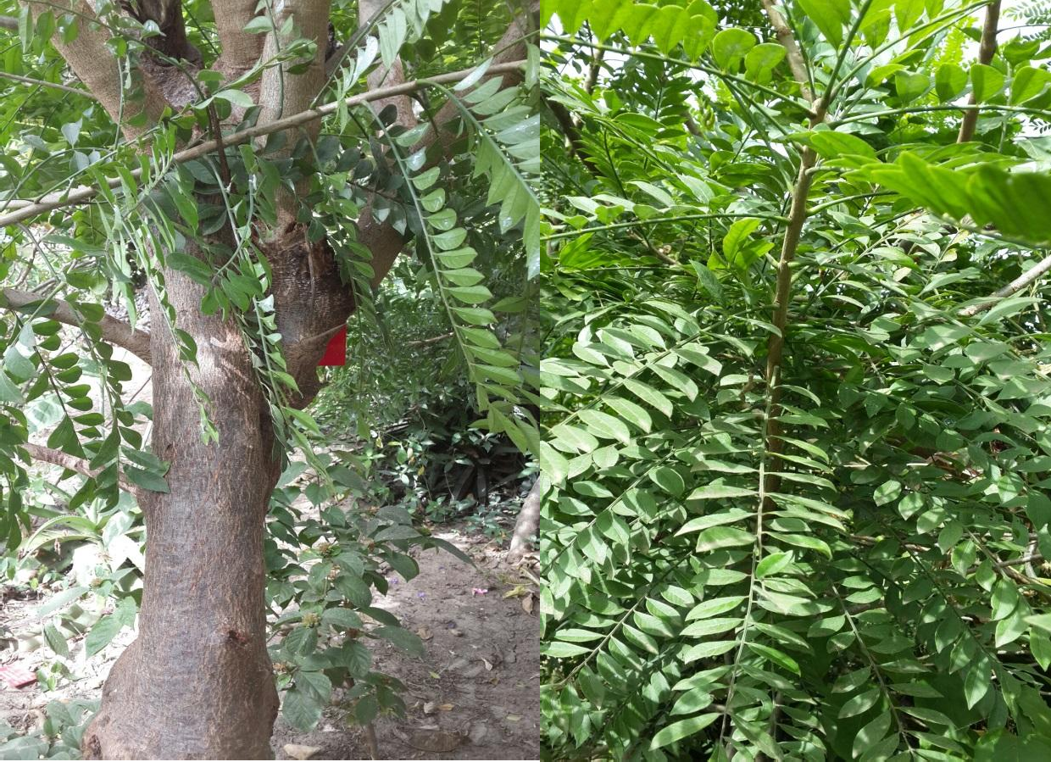

**PlateI: *Spondias mombin* in its natural habitat (own picture)**

Synonyms: *Spondias purpurea, Spondias tuberosa, Spondias dulcis*

Authority: Linn Kingdom: Plantae Phylum: Angiosperms Order: Sapindales Family: Anacardiaceae Genus: *Spondias*

Species: *Spondias mombin*

# Ethnomedical uses

All parts of the tree are medicinally useful (Daniel, 1990). The fruit juice is drunk as a diuretic and febrifuge. The decoction of the astringent bark serves as an emetic, a remedy for diarrhea, dysentery, haemorrhoids and a treatment for gonorrhoea and leukorrhea. The powdered bark is applied on wounds. A tea made from the flowers and leaves is taken to relieve stomach ache, biliousness, urethritis, cystitis, and eye and throat inflammations. In Belize, a decoction of the young leaves is a remedy for diarrhea and dysentery. The juice of crushed leaves and the powder of dried leaves are used as poultices on wounds and inflammations and as abortifacients. The gum is employed as an expectorant and to expel tapeworms.

# Non medical uses

It has a lot of non-medical uses. It is commonly used for living fences, in farm lands and shelter by artisans. The fruits are edible and sometimes called monkey-plum. The extracted juice is used to prepare ice cream, cool beverages and jelly in Costa Rica and Brazil. It is

used in Panama, Peru and Mexico in fairly large quantities as jams. In Amazon, the fruit is used mainly to produce wine sold as ―*Vinho de Taperiba*‖. In Guatemala, the fruit is made into a cider-like drink. Mexicans pickle the green fruits into vinegar and eat them like olives with salt and chili, as they do with unripe purple *mombin*. Young leaves are cooked as greens. The fruits are widely valued as feed for cattle and pigs. The tree exudes a gum that is used as glue. Used in carpentry, for match sticks, match boxes, physician’s spatulas, stick for sweet meats, pencils, pen-holders, packing cases, interior sheathing of houses and boats and as a substitute for cork. In tropical Africa, saplings serve as poles for huts, branches for garden poles and for axes and hoe handles. In Costa Rica and Puerto Rico, the wood is employed only as fuel. Ashes from the burnt wood are utilized in indigo-dyeing in Africa. The bark is used in dyeing. It is so thick that it is popular for carving amulets, statuettes, cigarette holders and various ornamental objects. Portable water can be derived from the roots in emergency.

# CHAPTER THREE

# MATERIALS AND METHODS

# Plant Collection and Authentication

The sampleof the plant, *Spondias mombin* was collected by Mallam Rabi’u Dalhat (a plant collector) in in Zaria in July 2014. A branch of the tree was taken for identified and authentication in the Herbarium of the Department of Biological Sciences, Ahmadu Bello University, Zaria, by Namadi Sanusi(a taxonomist). The voucher specimen number was given as 2384 for future reference.

# Preparation of the Extract

The stem bark was cleaned to remove adhering dirts, air-dried in the shade under ambient temperature for one week. It was crushed into coarse powder using a pestle and mortar.

Extraction was carried out by cold maceration of 500 g of the coarse powder with 2.5L of 70% v/v methanol for 72 h, with occasional shaking using the mechanical shaker (no. 3017GBh, Germany). The resultant mixture was filtered using a plug of cotton wool.

The filtrate was concentrated and dried using water bath maintained at temperature of 50 – 600C. The extract was then weighed to a constant value and kept in a desiccator until needed for use.

# Experimental Animals

Adult albino rats of Wistar strain (130-170g) of either sex were obtained from the animal house of Department of Pharmacology and Therapeutics, Ahmadu Bello University Zaria. The animals were housed in standard metal cages under standard conditions of temperature (25 ± 2ºC) and humidity, and provided with food and water *ad libitum.*

# Materials

The following materials were used:

Apparatus: pestle and mortar, mechanical shaker (no. 3017GBh, Germany), Whatman filter paper (No.1), desiccator, test tubes, metabolic Cages (Tecniplast, USA).

Chemicals: absolute methanol (BDH Poole, England), chloroform (Sigma Chemical Co. U.S.A), sodium hydroxide ( BDH Poole, England), ferric chloride (BDH Ltd Poole, England), dragendroff reagent (BDH Ltd Poole, England), ammonia (BDH Ltd Poole, England). All the chemicals wereof analytical grade.

Drugs: distilled water, normal saline, frusemide (Sanofi Aventis, Ireland), 10% buffered neutral formalin

* 1. **Phytochemical Screening of the methanol extract of*Spondias mombin*** Phytochemical screening of the methanolic bark extract of *Spondias mombin* was carried out according to the methods described by Evans (2002) looking out for flavonoids, alkaloids, tannins, saponins, cardiac glycosides, phenols, anthraquinones, and carbohydrates

# Test for cardiac glycosides

 *Keller-kiliani test*

A portion of the extract was dissolved in 1ml of glacial acetic acid containing one drop of ferric chloride solution. This was then transferred into a dry test tube and 1ml of concentrated sulphuric acid was added down the side of the test tube to form a lower layer at the bottom. Appearance of a purple-brown ring at the interphase indicates the presence of desoxy sugars and a pale green colour indicated the presence of cardiac glycosides (Evans, 2002).

# Test for tannins

 *Ferric chloride Test*

To a portion of the extract, 3-5 drops of ferric chloride solution were added. A greenish- black precipitate indicated presence of condensed tannins while hydrolysable tannins give a blue or brownish-blue precipitate (Evans 2002).

# Test for saponins

 *Frothing test*

Two ml of the extract was dissolved in 10 ml of distilled water and shaken in a test tube for 30s and then allowed to stand for 30 minutes. The occurrence of honey comb froth of at least 1cm in height persisting for a minimum of 15 minutes indicated the presence of saponins (Evans, 2002*)*.

# Test for flavonoids

 *Shinoda reduction test*

A solution of 0.5g of the extract was dissolved in 5ml of methanol was warmed on steam bath. Magnesium chips and 5 drops of concentrated hydrochloric acid were added. A red or orange colour indicated the presence of flavonoids (Evans, 2002)

# Test for alkaloids

 *Dragendoff’s test*

To a portion of the extract(dissolved in dilute HCl) few drops of Dragendoff reagent was added. Anorange red precipitate indicated the presence of alkaloids (Evans, 2002)

# Test for anthraquinones

 *Bontrager’s test*

To a portion of the extract in a dry test tube, 5ml of chloroform was added and was shaken for atleast 5 minutes. This was filtered and the filterate shaken with equal volume of 10% ammonia solution.Bright pink colour in the aqueous (upper) layer indicated the presence of free anthraquinones (Evans, 2002).

*Modified Bontrager’s test*

Small portion of the extract in a test tube was boiled with 5ml of 10% hydrochloric acid for 2-3mins. This hydrolysed the glycosides to yield aglycones, which are soluble in hot water. This was then filtered and the filterate was cooled and extracted with 5ml of benzene. The benzene layer was pipetted off and shaken gently in a test tube with half of its volume of 10% ammonium hydroxide (Evans, 2002).

# Acute toxicity studies:

The median lethal dose (LD50) of the extract was determined in rats orally according to Lorke’s method (1983). This method has two phases: Phase 1 and 2 respectively:

# Phase 1

This phase was carried out using nine animals (Wistar albino rats). The nine Wistar albino rats were randomly divided into three groups of three animals each. Each group of animals was administered with different doses (10, 100 and 1000 mg/kg) of the extract. The animals were placed under observation for first 4 hours to watch for symptoms and signs of toxicity and subsequently after 24 hours to monitor any abnormal behavior as well as mortality.

# Phase 2

This phase involved the use of four animals, which were distributed into four groups of one animal each. The animals were administered with geometrically increasing doses of the extract at 1200mg/kg, 1600 mg/kg, 2900mg/kg, and 5000mg/kg based on the outcome of Phase 1 and then observed for the first 4 hours and thereafter for abnormal behavior as well as mortality. The LD50 was calculated based on the formula below:

Description: http://www.toxicologyinternational.com/articles/2013/20/3/images/STOX_2013_20_3_224_121674_il3.jpg

D0 = Highest dose that gave no mortality

D 100 = Lowest dose that produced mortality

# Sub chronic toxicity study

The study was carried out in accordance with WHO (1992) and OECD 407 (1995) guidelines.Twenty four set of adult rats (Wistar strain) were randomly divided into four groups of each containing six rats. Group I were administered with normal saline at a dose of 10 ml/kg body weight orally (*p.o*) and served as the negative control. Groups II – IV were administered 250mg/kg, 500mg/kg, and 750mg/kg of the stem bark of *S. mombin*(dissolved in distilled water) daily for twenty eight days. Rats in all the groups were weighed daily during the period of treatment till the end of the study. Doses of the extract administered were adjusted accordingly.

At the end of the study, the animals were euthanized, the serum was collected for kidney function, liver function tests, and full blood count. Organs such as kidneys, heart and liver from at least two of the euthanized rats in each group were examined grossly and weighed to determine organ weight ratio and sent for histological examination.

# Calculation of relative organ weight ratio (ROW)

The heart, liver and kidneys of rats were removed and weighed using weighing balance (Mettler P162 Switzerland), and the relative organ weight ratio (ROW) was determined using the formula:

ROW = Absolute organ weight (g) Body weight of rats on sacrificed day (g)

# Biochemical studies

Blood samples were collected into plain bottles, allowed to clot and centrifuged at 3500rpm for 10 minutes. The sera were separated, stored at 4⁰C, and used for evaluation of

biochemical parameters which include kidney function test (Serum urea, electrolyte and creatinine) and liver function tests (liver enzymes and bilirubin) using commercial kits from Reckon Diagnostic Ltd India.

# Haematological studies

Blood samples were collected into EDTA bottle for estimation of full blood count involving heamoglobin, hematocrit, total and differential white blood cells using automated machine (Audicom).

# Histopathological Study

The organs excised from rats were immediately washed with normal saline. Samples were fixed in 10% buffered neutral formalin for 48 hours and then with bovine solution for 6 hour. Paraffin sections were taken at 5 mm thickness processed in alcohol-xylene series and were stained with alum hematoxylin and eosin. The sections were examined microscopically for histopathological changes by a Histopathologist at Histopathology Department, Ahmadu Bello University Teaching Hospital, Shika Zaria. Histological examination was done with the aid of the Olympus binocular light research microscope. The permanent photomicrographs of each slide were recorded with a Kodak digital camera for subsequent histological analysis.

# Screening of Diuretic Activity

The method described by Lipschitz *et al*. (1943) with some modifications was employed for the assessment of diuretic activity.

Twelve hours before the experiment, test animals were placed into metabolic cages with total withdrawal of food and water. They were weighed and randomly divided into five groups containing five animals in each group.

Each animal was rehydrated with 5ml/kg of normal saline just before administration of extracts and drugs. Group-I were provided only with 5ml/kg of normal saline to serve as control. Group-II were provided with standard diuretic drug- frusemide at a dose of 5 mg/kg body weight. Group-III, IV and V were given 250mg/kg, 500mg/kg and 750mg/kg of the extract respectively. These preparations were all given by oral route. After administration of test samples, the urine excretion was recorded at 3rd, 6th and 24th hour, from the graduated urine chamber of metabolic cage. Urine were also analyzed for Na+ and K+ concentration by flame photometric method while Cl- concentration was determined by the Argentometric titration method.

# Data analysis

Statistical Package for the Social Sciences, SPSS software tool was used for analysis. Data were analysed using one way ANOVA followed by post hoc Dunnet test. Weight of rats was however analysed using repeated measures ANOVA followed by Bonferroni post hoc test. Statistical significance was when p ≤ 0.05. Values are presented as mean ± SEM.

# CHAPTER FOUR

# RESULTS

# Phytochemical Screening

The phytochemical screening of methanolic stem bark extract of *Spondias mombin* revealed the presence of flavonoids, alkaloids, tannins, saponins, and cardiac glycosides. Anthraquinones were absentas summarized in Table 4.1.

# Table 4.1: The phytochemical screening of methanolic stem bark extract of *S. mombin*

|  |  |
| --- | --- |
| **Phytochemical constituents** | **Result** |
| Flavonoids | present |
| Alkaloids | present |
| Tannins | present |
| Saponins | present |
| Cardiac glycosides | present |
| Anthraquinones | absent |

# Toxicity studies

# Acute toxicity studies (LD50 determination)

The rats that received the methanol extract of *Spondias mombin* orally did not show any sign of toxicity after 48 hours. The median oral lethal dose was found to be greater than 5000mg/kg.

# Sub chronic toxicity studies

1. ***Effect of methanol stem bark extract of S. mombin on average body weight (g)***

The effect of sub-chronic oral administration of the methanol extract of *S. mombin* for 28 days on animal body weight is shown in table 4.2. There was no significant statistical difference in the animal body weights at all weeks compared to week zero and in relation to different doses of extract compared to the control.

# Table 4.2: Effect of methanol stem bark extract of *S. mombin* on average body weight

|  |  |  |  |  |  |
| --- | --- | --- | --- | --- | --- |
| **Treatment** | **Week 0** | **Week 1** | **Week 2** | **Week 3** | **Week 4** |
| **Control** | 141.00±19.76 | 154.25±22.50 | 161.00±17.47 | 150.75±19.64 | 153.25±19.32 |
| **250mg/kg of *SM*** | 147.50±19.76 | 152.75±22.50 | 161.75±17.47 | 159.00±19.64 | 166.25±19.32 |
| **500mg/kg of *SM*** | 183.33±22.81 | 189.00±25.98 | 202.33±20.17 | 198.00±22.68 | 206.33±22.31 |
| **750mg/kg of *SM*** | 171.00±19.76 | 185.50±22.50 | 182.00±17.47 | 180.75±19.64 | 187.00±19.32 |

Data were analyzed using repeated measures ANOVA followed by Bonferroni post hoc test.

No statistical significant differences were observed. Values are mean ± SEM, n = 6, *SM*= *Spondias mombin.*

# Effect of methanol stem bark extract of S. mombin on renal toxicity

The effect of sub-chronic oral administration of the methanol stem bark extract of *S. mombin* on renal function test such as urea sodium (Na+), potassium (K+), chloride (Cl-), bicarbonate (HCO3-), and creatinine for 28 days is shown in table 4.3. A significant statistical reduction of bicarbonate was noted on 500mg/kg group in relation to control, p< 0.05.

# Table 4.3: Effect of methanol stem bark extract of *S. mombin* on renal toxicity

|  |  |  |  |  |  |  |
| --- | --- | --- | --- | --- | --- | --- |
| **Treatmnt** | **Urea (mmol/L)** | **Na+ mmol/L** | **K+**  **mmol/L** | **Cl- mmol/L** | **HCO3-**  **mmol/L** | **Creatinine mmol/L** |
| **Control** | 5.90±0.42 | 149.25±4.72 | 13.25±0.63 | 80.75±1.11 | 28.50±065 | 184.25±9.28 |
| **250mg/kg of *SM*** | 5.33±0.38 | 131.00±9.74 | 13.25±0.63 | 79.25±6.10 | 27.25±0.75 | 189.25±20.75 |
| **500mg/kg of *SM*** | 5.20±0.31 | 143.33±18.48 | 15.00±0.00 | 80.33±1.33 | 25.33±0.88* | 223.33±34.67 |
| **750mg/kg of *SM*** | 5.00±0.96 | 133.25±5.12 | 13.38±2.78 | 84.50±3.75 | 26.75±0.48 | 178.5±12.65 |

Data were analysed using one way ANOVA followed by Dunnett’spost hoc test. * represent

statistical significance p<0.05. Values are mean ± SEM, n = 6, *SM*= *Spondias mombin.*

1. *Effect of methanol stem bark extract of S. mombin on Liver function*

The effect of sub-chronic oral administration (for 28 days) of the methanol stem bark extract of *S. mombin* on Liver function indices such as aspartate and alanine transaminases, alkaline phosphatase, and bilirubin is shown in table 4.4. There was no statistically significant difference observed in the liver function of the groups administered with the extract in relation to the control.

# Table 4.4: Effect of methanol stem bark extract of *S. mombin* on Liver function

|  |  |  |  |  |  |
| --- | --- | --- | --- | --- | --- |
| **Treatment** | **AST (IU/L)** | **ALT (IU/L)** | **ALP (IU/L)** | **Total bilirubin (µmol/L)** | **Conjugated bilirubin (µmol/L)** |
| **Control** | 4.00±0.00 | 3.25±0.63 | 186.25±61.68 | 7.75±1.18 | 5.25±0.95 |
| **250mg/kg of S*M*** | 4.00±0.00 | 2.75±0.25 | 183.75±84.70 | 6.25±0.75 | 3.50±0.96 |
| **500mg/kg of *S1M*** | 6.00±1.00 | 2.33±0.33 | 274.33±185.97 | 6.33±0.67 | 3.67±0.88 |
| **750mg/kg of *SM*** | 5.50±1.50 | 2.25±0.25 | 289.00±82.84 | 6.50±2.89 | 4.25±0.25 |

Data were analysed using one way ANOVA followed by Dunnett’s post hoc test. No

statistical significant differences were observed. Values are mean ± SEM, n = 6, *SM*= *Spondias mombin.*

1. *Effect of methanol stem bark extract of S. mombin on Hematological indices*

The effect of sub-chronic oral administration of the methanol stem bark extract of *S. mombin* on hematological indices such as haemoglobin, hematocrit, and white blood cells, for 28 days are shown in table 4.5. There was no statistical significant difference observed in the hematological indices of the groups administered with the extract in relation to the control.

# Table 4.5: Effect of methanol stem bark extract of *S. mombin* on Hematological indices

|  |  |  |  |  |  |  |  |
| --- | --- | --- | --- | --- | --- | --- | --- |
| **Treatment** | **Haemoglobin (g/dl)** | **Hematocrit (%)** | **Total wbc (x10⁹/L)** | **Neutrophil (%)** | **Lymphocyte (%)** | **Monocyte (%)** | **Eosinophil (%)** |
| **Control** | 12.48±0.83 | 37.50±2.53 | 7.45±3.58 | 17.00±3.34 | 75.75±5.96 | 2.00±1.63 | 0.25±0.25 |
| **250mg/kg of *SM*** | 11.7±0.42 | 35.25±1.25 | 8.65±1.94 | 22.25±3.33 | 78.25±3.47 | 2.75±1.25 | 0.50±0.50 |
| **500mg/kg**  **of *SM*** | 10.30±1.91 | 31.00±5.69 | 7.30±1.51 | 19.67±6.01 | 73.00±9.07 | 4.67±2.33 | 1.67±0.88 |
| **750mg/kg**  **of *SM*** | 8.20±1.45 | 24.75±4.36 | 4.40±1.29 | 25.00±1.47 | 72.50±0.87 | 0.00±0.00 | 1.25±1.25 |

Data were analysed using one way ANOVA followed by Dunnett’spost hoc test. No statistical significant differences were observed. Values are mean ± SEM, n = 6, *SM*= *Spondias mombin*

1. *Effect of methanol stem bark extract of S. mombin on relative organ weight (ROW)* The effect of methanol stem bark of *S. mombin* on relative organ weight (ROW) is shown on table 4.6. There was no statistical significant difference observed in the ROW of the groups administered with the extract in relation to the control.

# Table 4.6: Effect of methanol stem bark extract of *S. mombin* on Relative Organ Weight (ROW)

|  |  |  |  |
| --- | --- | --- | --- |
| **Treatment** | **Heart (%)** | **Liver (%)** | **Kidney (%)** |
| **Control** | 0.41 ± 0.05 | 4.23 ± 0.22 | 0.72 ± 0.06 |
| **250mg/kg of *SM*** | 0.48 ± 0.06 | 4.14 ± 0.22 | 0.71 ± 0.06 |
| **500mg/kg of *SM*** | 0.42 ± 0.02 | 3.51 ± 0.11 | 1.10 ± 0.60 |
| **750mg/kg of *SM*** | 0.42 ± 0.05 | 4.61 ± 0.26 | 0.75 ± 0.00 |

Data were analysed using one way ANOVA followed by Dunnett’s post hoc test. No

statistical significant differences were observed. Values are mean ± SEM, n = 6, *SM*= *Spondias mombin*

1. *Effects of methanol stem bark extract of S. mombin on histology of the heart, liver, and kidney.*

The effects of methanol stem bark extract of *S. mombin* on histo-architecture of the heart, liver, and kidney are shown in plate 2-13. Plate II shows photomicrograph of rat heart of control group showing normal intercalated muscles. Plate III shows photomicrograph of rat heart administered with methanol stem bark extract of *S. mombin* at dose of 250 mg/kg showing no pathological changes when compared with control. Plate IV shows photomicrograph of rat heart administered with methanol stem bark extract of *S. mombin*at dose of 500 mg/kg showing congested vessels when compared with control. Plate V shows photomicrograph of rat heart administered with methanol stem bark extract of *S. mombin*at dose of 750 mg/kg showing normal intercalated cells when compared with control. No pathological changes observed. Plate VI shows photomicrograph of rat liver of control group showing normal parenchyma. Plate VII shows photomicrograph of rat liver administered with methanol stem bark extract of *S. mombin* at dose of 250 mg/kg showing normal liver parenchyma when compared with control. Plate VIII shows photomicrograph of rat liver administered with methanol stem bark extract of *S. mombin*at dose of 500 mg/kg showing normal liver when compared with control. Plate IX shows photomicrograph of rat liver administered with methanol stem bark extract of *S. mombin*at dose of 750 mg/kg showing many vacuolar degenerative changes when compared with control. Plate X shows photomicrograph of rat kidney of control group showing many normal glomeruli and tubules. Plate XI shows photomicrograph of rat kidney administered with methanol stem bark extract of *S. mombin* at dose of 250 mg/kg showing many congested vessels when compared with control. Plate XII shows photomicrograph of rat kidney at administered with methanol stem bark extract of *S. mombin*at dose of 500 mg/kg, showing many normal

glomeruli and tubules when compared with control. Plate XIII showsphotomicrograph of rat kidney administered with methanol stem bark extract of *S. mombin*at dose of 750 mg/kg showing vacuolar changes when compared with control.

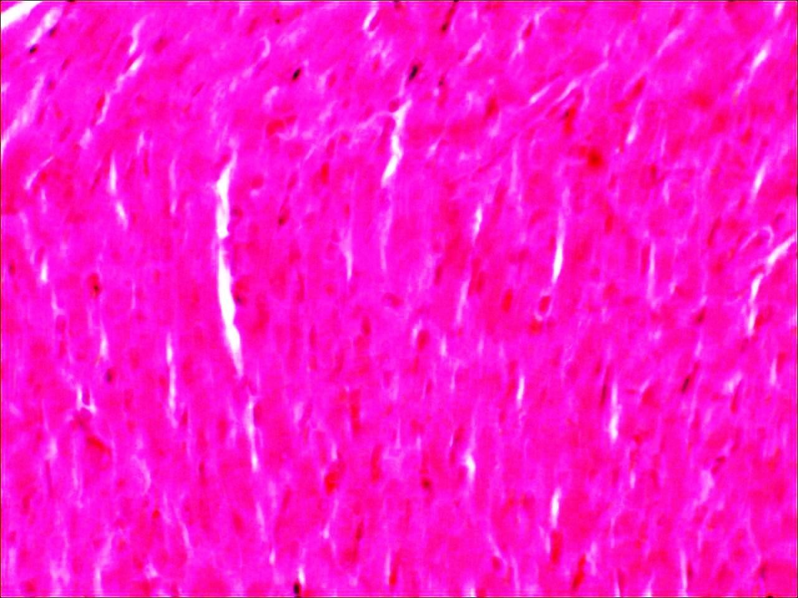

**PlateII**: Photomicrograph of rat heart of control group showing normal intercalated muscles (arrow). (mag. x400)

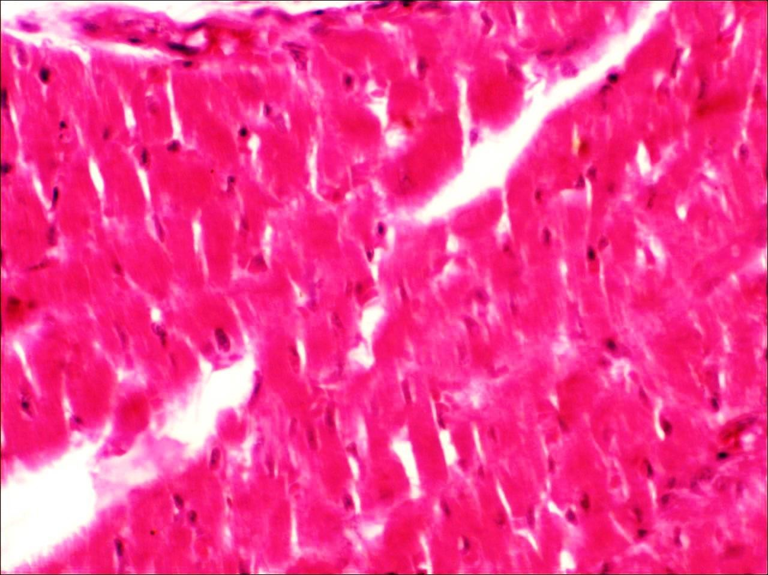

**Plate III**: Photomicrograph of rat heart administered with methanol stem bark extract of *S. mombin*at dose of 250mg/kg showing no pathological changes when compared with control (arrow) (mag. x400).

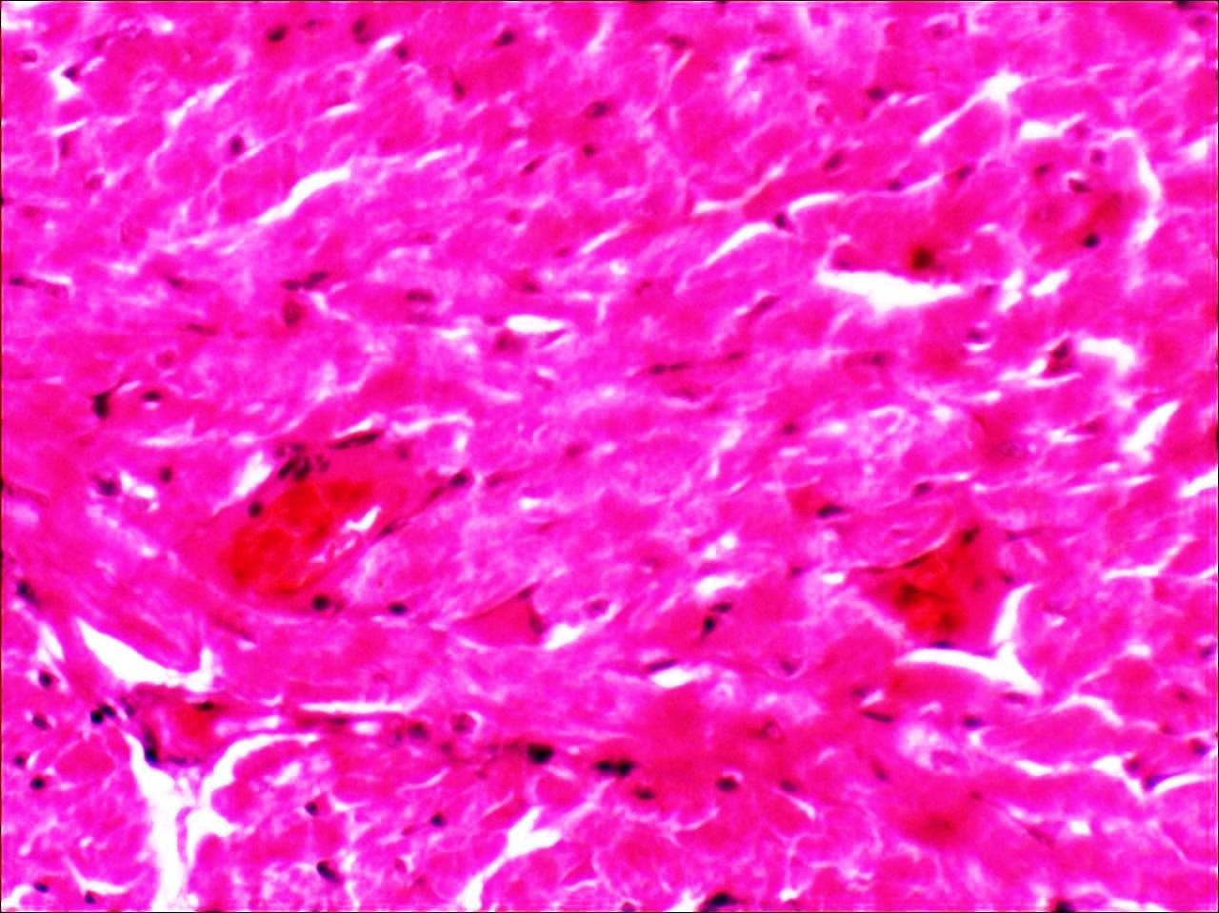

**Plate IV**: Photomicrograph of rat heart administered with methanol stem bark extract of *S. mombin*at dose of 500 mg/kg showing congested vessels when compared with control (blue arrows) (mag. x400)

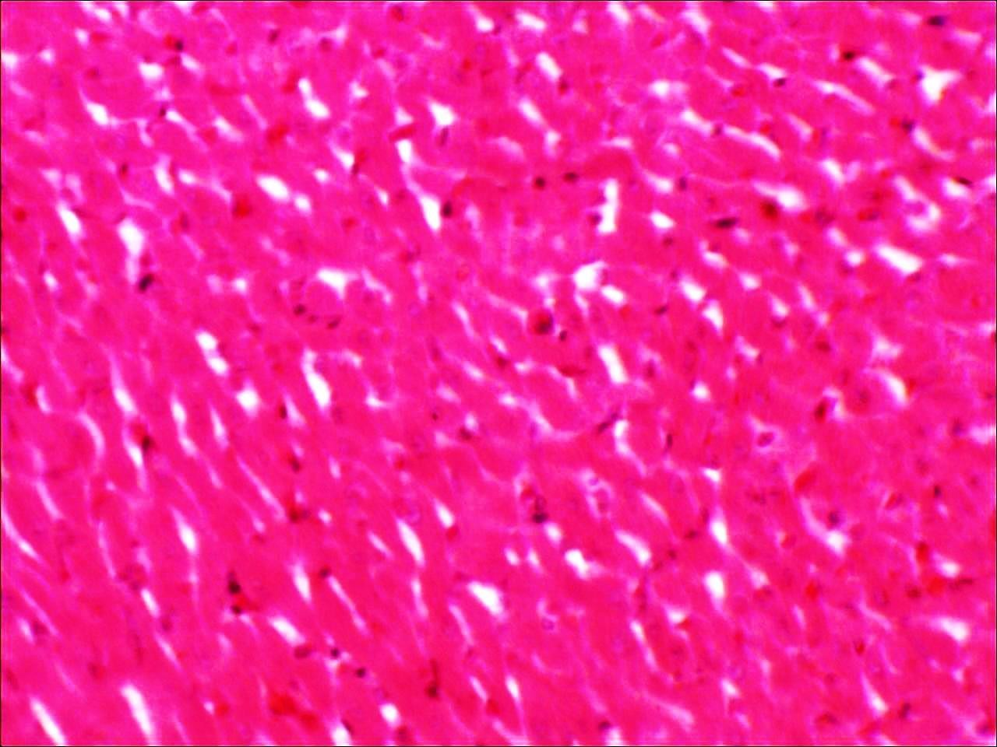

**Plate V**: Photomicrograph of rat heart administered with methanol stem bark extract of *S. mombin* at dose of 750 mg/kg showing control normal intercalated cellsas compared with control. No pathological changes observed (mag. x400)

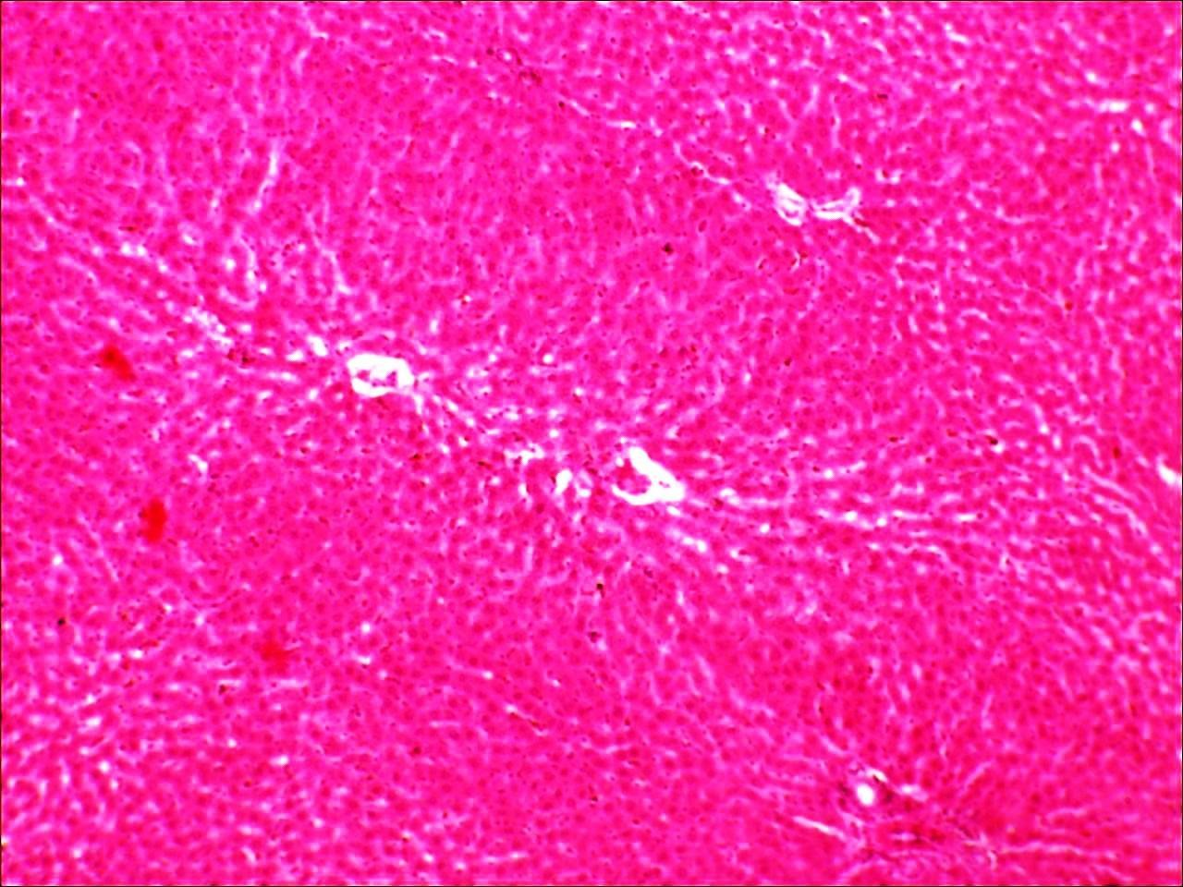

**Plate VI**: Photomicrograph of rat liver of control group showing normal parenchyma with no distortion. Cetral vein (blue arrow) and portahepatis (green arrow). (mag x100).

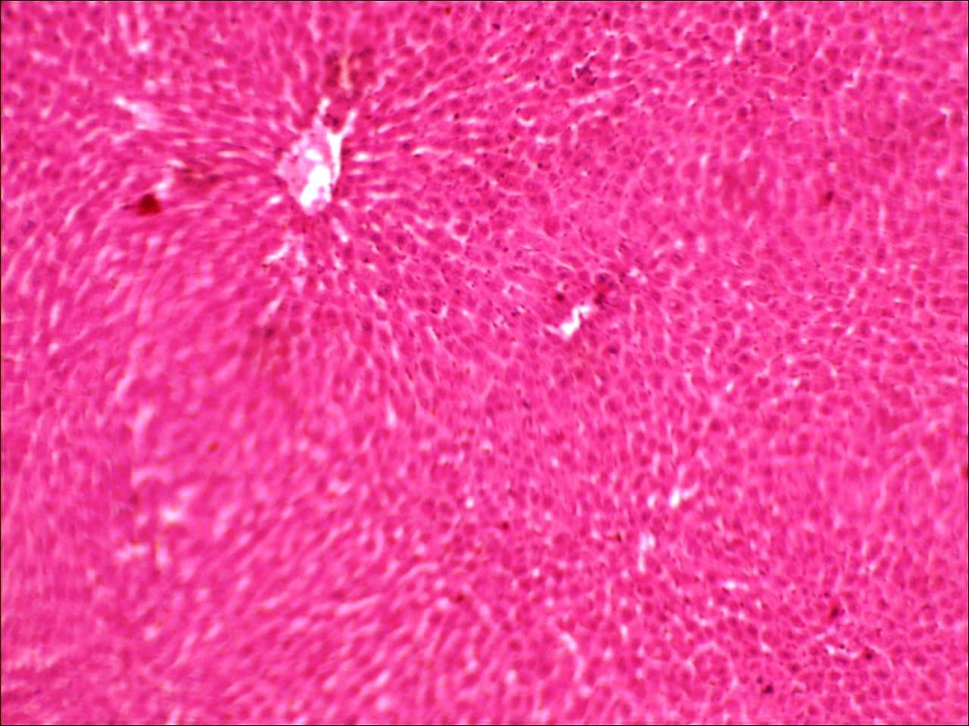

**Plate VII:**Photomicrograph of rat liver administered with methanol stem bark extract of *S. mombin* at dose of 250 mg/kg showing normal liver (mag x100)

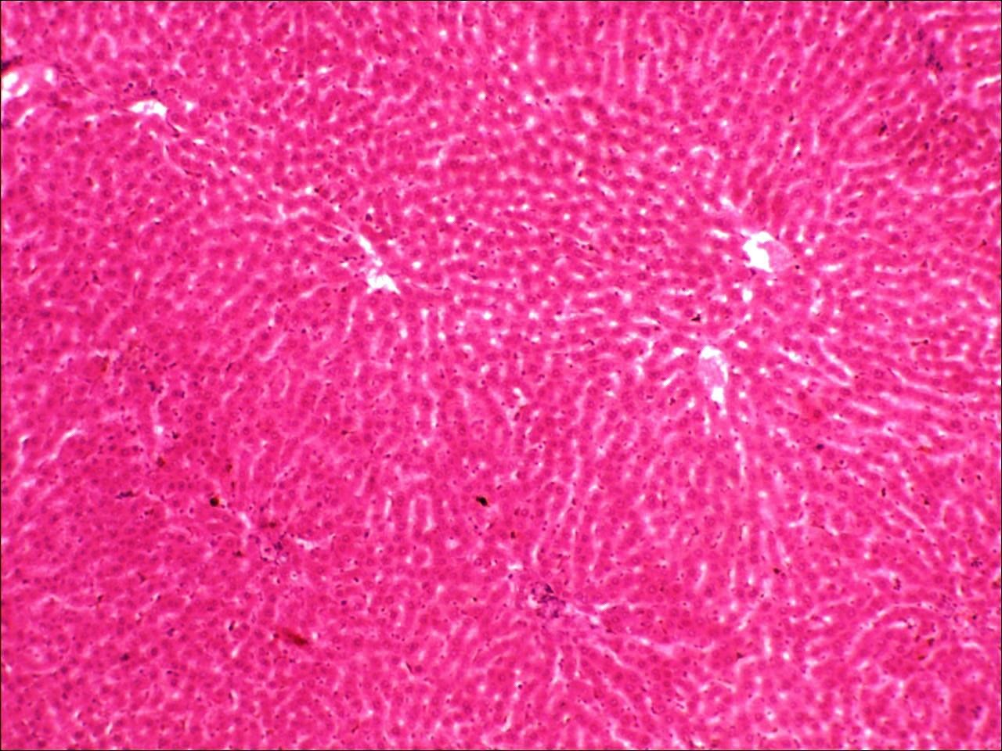

**Plate VIII:**Photomicrograph of rat liver administered with methanol stem bark extract of *S. mombin* at dose of 500 mg/kg showing normal liver (mag x100)

**Plate IX**: Photomicrograph of rat liver administered with methanol stem bark extract of *S. mombin* at dose of 750 mg/kg showing many vacuolar degenerative changes (arrow) (mag x100)

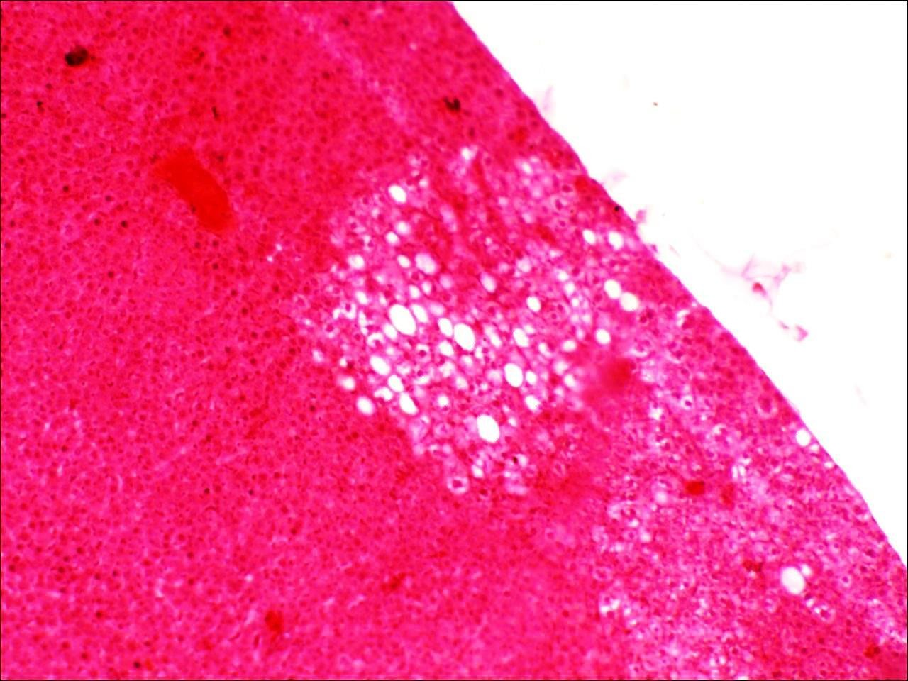

**Plate X**: Photomicrograph of rat kidney of control group showing many normal glomeruli (blue arrow) and tubules (green arrow) (mag x100).

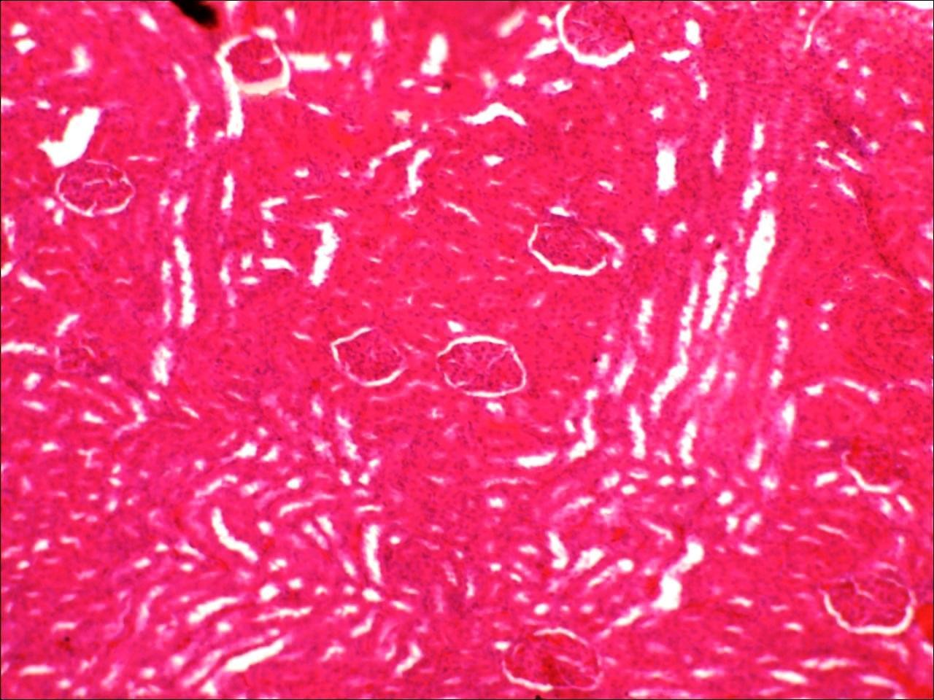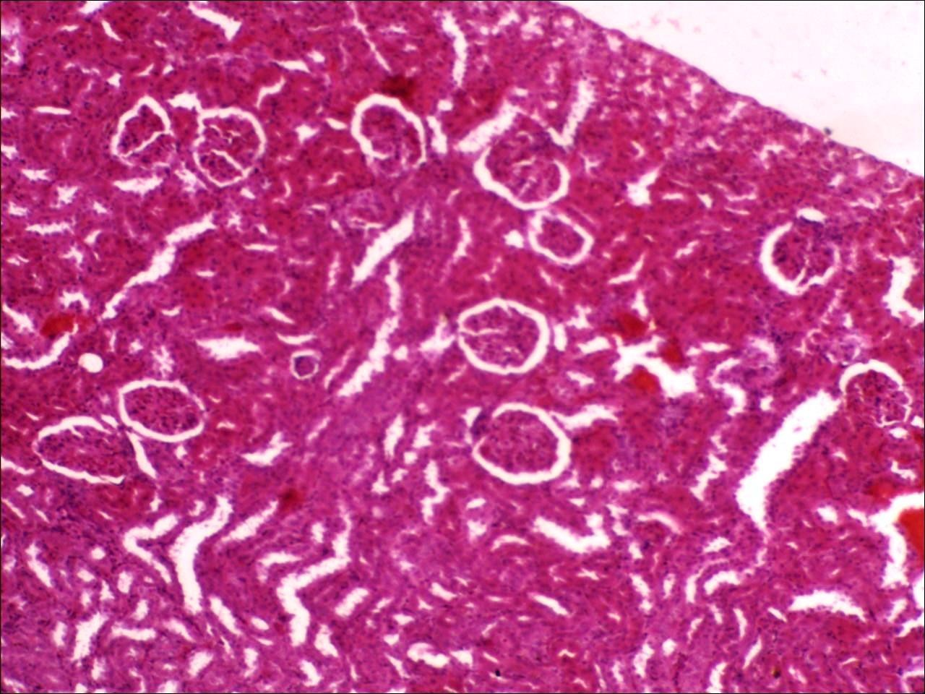

**Plate XI**: Photomicrograph of rat kidney administered with methanol stem bark extract of *S. mombin* at dose of 250 mg/kg showing many congested vessels (blue arrows) (mag x100).

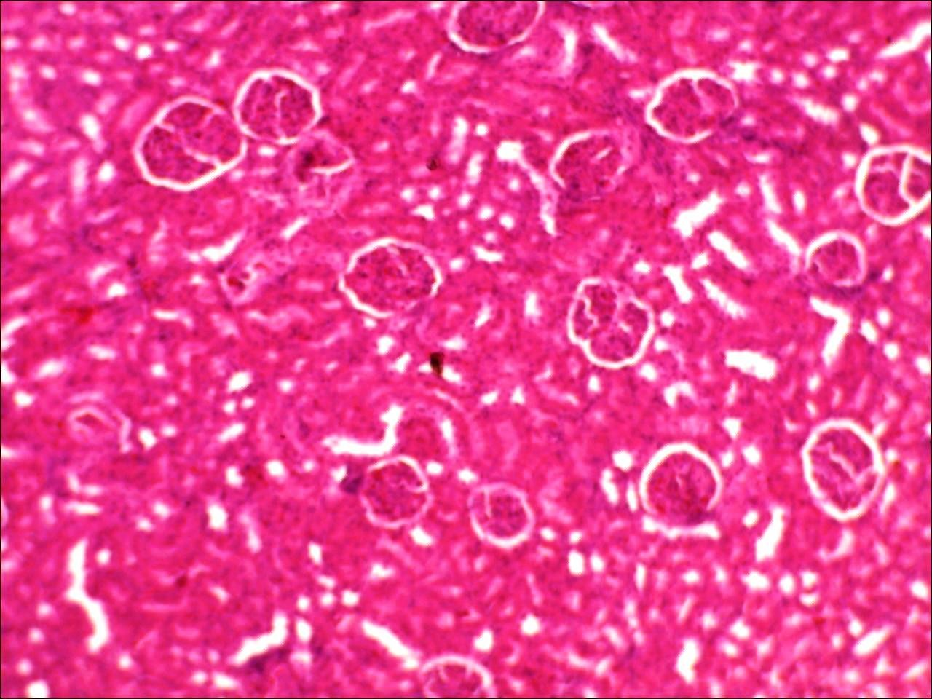

**Plate XII**: Photomicrograph of rat kidney administered with methanol stem bark extract of

*S. mombin* at dose of 500 mg/kg, showing many normal glomeruli and tubules (mag x100).

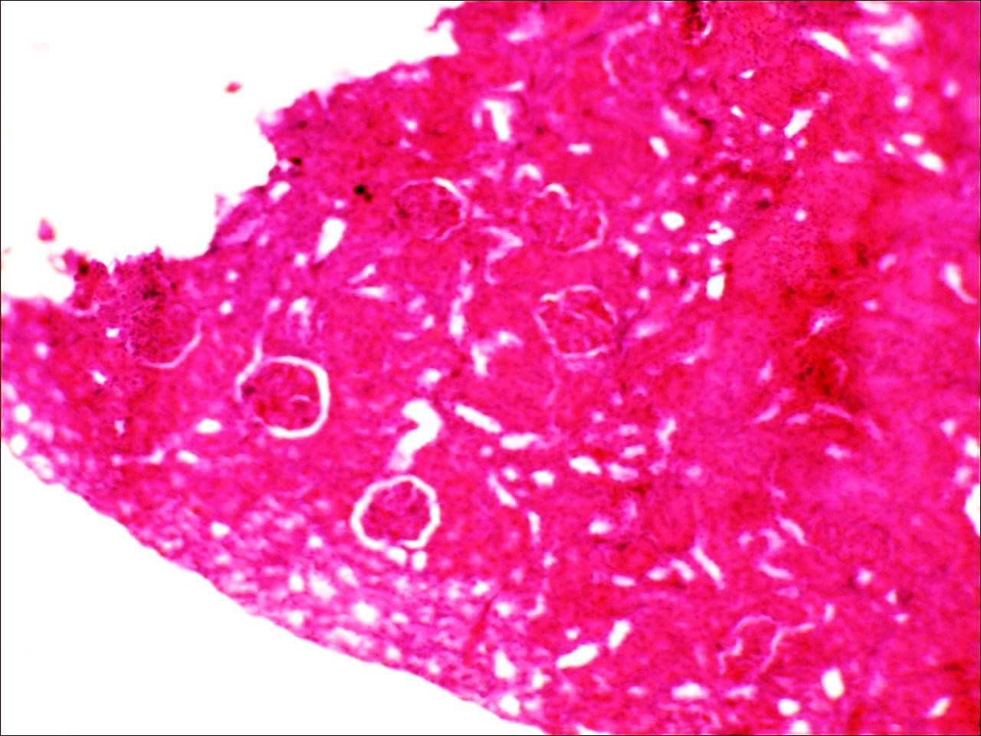

**Plate XIII:** Photomicrograph of rat kidney administered with methanol stem bark extract of

*S. mombin* at dose of 750 mg/kg showing vacuolar changes. (mag x100).

# : Diuretic Screening

1. *Design of the diuretic screening of stem bark S. mombin*

The design of the diuretic screening of stem bark *S. mombin* is shown in table 4.7. Wistar albino rats between the weights of 130g to 170g were used. All drugs given to the different groups were via oral route. Groups I and II are the negative and positive control groups respectively while III IV and V are the test groups.

# Table 4.7: Design of the diuretic screening of stem bark *S. mombin*

|  |  |  |  |  |
| --- | --- | --- | --- | --- |
| **Animal group** | **No. of animals** | **Mean body weight (gm)** | **Dose** | **Route of**  **administration** |
| **Group I (Normal**  **saline)** | 5 | 151.2±10.7 | 5ml/kg | Oral |
| **Group II**  **(Frusemide)** | 5 | 162.0±8.8 | 5mg/kg | Oral |
| **GroupI11 (*SM*)** | 5 | 151.6±15.5 | 250mg/kg | Oral |
| **Group IV (*SM*)** | 5 | 137.0±15.0 | 500mg/kg | Oral |
| **Group V (*SM*)** | 5 | 132.6±6.4 | 750mg/kg | Oral |

Data were analysed using one way ANOVA followed by Dunnett’spost hoc test. No

statistical significant differences were observed. Values are ± SEM, n = 5, *SM*= *Spondias mombin*

1. *Urinary output of rats at different time intervals after oral administration of methanol extract of S. mombim*

The urinary output of rats at different time intervals after oral administration of methanol extract of *Spondias mombin* is shown in table 4.8. No significant statistical differences were observed between the test groups given the extract and the control groups during the first 6 hours and after 24 hours.

# Table 4.8: Urinary output of rats at different time intervals after oral administration of methanol extract of *S. mombin*

|  |  |  |  |  |  |  |  |
| --- | --- | --- | --- | --- | --- | --- | --- |
| **Urine Groups volume (ml)** | | | | | **Urinary excretion (V0/V1) x 100** | | |
|  | | **3h** | **6h** | **24h** | **3h** | **6h** | **24h** |
| **Group (Control)** | **I** | 0.92±0.33 | 1.16±0.34 | 2.20±0.30 | 122.60±42.78 | 158.40±47.59 | 290.40±37.78 |
| **Group (Frusemide)** | **II** | 1.70±0.67 | 1.94±0.70 | 2.72±0.75 | 218.00±96.42 | 249.00±102.68 | 345.40±110.76 |
| **Group (250mg/kg SM)** | **III**  **of** | 0.96±0.40 | 1.08±0.37 | 1.68±0.43 | 120.80±39.09 | 136.60±35.29 | 219.60±41.91 |
| **Group (500mg/kg SM)** | **IV**  **of** | 0.30±0.17 | 0.76±0.19 | 1.32±0.49 | 48.60±27.37 | 111.60±25.43 | 178.00±44.56 |
| **Group (750mg/kg SM)** | **V**  **of** | 0.56±0.24 | 0.56±0.24 | 1.02±0.23 | 82.20±32.50 | 82.20±32.50 | 151.40±28.06 |

Data were analysed using one way ANOVA followed by Dunnett’spost hoc test. No statistical significant differences were observed. Values are ± SEM, n = 5, *SM*= *Spondias mombin*, Vo= Total Urinary output; V1 = Total Fluid input (5 ml/kg)

1. *Diuretic action at different time intervals after oral administration of methanol extract of S. mombin*

The diuretic action of rats at different time intervals after oral administration of methanol extract of *Spondias mombin* is shown in table 4.9. No significant statistical differences were observed between the test groups given the extract and the control groups during the first 6 hours and after 24 hours.

# Table 4.9: Diuretic action at different time intervals after oral administration of methanol extract of *S. mombin*

|  |  |  |  |
| --- | --- | --- | --- |
| **Groups** | **Diuretic action UEt / UEc** | |  |
|  | **3h** | **6h** | **24h** |
| **Group I (Control)** | 1.00 | 1.00 | 1.00 |
| **Group II (Frusemide)** | 1.78 | 1.57 | 1.19 |
| **Group III (250mg/kg of SM)** | 0.99 | 0.86 | 0.76 |
| **Group IV (500mg/kg of SM)** | 0.40 | 0.71 | 0.61 |
| **Group V (750mg/kg of SM)** | 0.67 | 0.52 | 0.52 |

Data were calculated using the formula,Diuretic action =UEt / UEc , UEt= mean urine

excretion of test, UEc= mean urine excretion of control. *SM*= *Spondias mombin.*

1. *Dose response study of diuretic effects of methanol extract of S. mombin through electrolyte excretion in urine in rats*

The dose response study of diuretic effects of *Spondias mombin* extract through electrolyte excretion in urine in rats is shown in table 4.10. There was significant excretion of potassium in the 500mg/kg group in relation to the negative control. No other significant statistical differences were observed between the other test groups given the extract and the control groups

# Table 4.10:Dose response study of diuretic effects of *Spondias mombin* extract through electrolyte excretion in urine in rats

|  |  |  |  |  |  |  |  |
| --- | --- | --- | --- | --- | --- | --- | --- |
| **Treatment** | **Dose** | **No. of animals** | **Total urine volume (ml)** | **Electrolyte excretion in (mmol/L)** | | | **Na+ / K+ ratio** |
|  |  |  | **Na+** | **K+** | **Cl-** |  |
| **Group I (Control)** | 5ml/kg | 5 | 2.20±0.30 | 333.80±71.98 | 252.00±57.22 | 283.20±91.63 | 1.49±0.25 |
| **Group II (Frusemide)** | 5mg/kg | 5 | 2.72±0.75 | 251.80±71.47 | 233.60±55.87 | 244.00±108.97 | 1.10±0.28 |
| **Group III (*SM*)** | 250mg/kg | 5 | 1.68±0.43 | 329.80±111.12 | 400.20±44.24 | 351.00±80.79 | 0.88±0.29 |
| **Group IV (*SM*)** | 500mg/kg | 5 | 1.32±0.49 | 384.80±73.32 | *499.60±50.06 | 374.60±47.09 | 0.77±0.12 |
| **Group V (*SM*)** | 750mg/kg | 5 | 1.02±0.23 | 325.00±73.50 | 445.80±72.74 | 354.60±88.35 | 0.82±0.23 |

Data were analysed using one way ANOVA followed by Dunnett post hoc test. Potassium excretion was statistically significant at dose of 500mg/kg. (p<0.5) No other statistical significant differences were observed. Values are ± SEM, n = 5, *SM*= *Spondias mombin*

1. *Dose response study of Diuretic index and Lipschitz values of S. mombin*

The diuretic index and Lipschitz value of varying doses of stem bark of *Spondias mombin* is shown in table 4.11. Only Frusemide which is the standard was shown to have a diuretic index of > 1.0. Lipschitz values of the extract were all <0.75.

# Table 4.11: Dose response study of Diuretic index and Lipschitz values of *S. mombin*

|  |  |  |  |
| --- | --- | --- | --- |
| **Goups** | **Mean urine in 24h (ml)** | **Diuretic index** | **Lipschitz value** |
| **Normal saline (5ml/kg)** | 2.20±0.30 | -- | -- |
| **Frusemide (5mg/kg)** | 2.72±0.75 | 1.24 | -- |
| **250mg/kg of *SM*.** | 1.68±0.43 | 0.76 | 0.62 |
| **500mg/kg of *SM*** | 1.32±0.49 | 0.60 | 0.49 |
| **750mg/kg of *SM*** | 1.02±0.23 | 0.46 | 0.38 |

Data were calculated using the following formula: Diuretic Index=Mean urine volume of

test/ Mean urine volume of control, Lipschitz value = Mean urine volume of test/ Mean urine volume of standard. n = 5, *SM*= *Spondias mombin*

# CHAPTER FIVE

# 5.0 DISCUSSION

The phytochemical screening of methanolic stem bark extract of *Spondias mombin* revealed the presence of flavonoids, alkaloids, tannins, saponins, cardiac glycosides, phenols, and carbohydrates. Anthraquinones were absent. These findings are consistent with the findings of Ayoka *et al.* (2008), who evaluated the methanol and ethanol extracts of the leaf of same plant.Joseph *et al*. (2009), who did phytochemical screening of methanol extract of stem bark of *Spondias mombin,* however, found the presence of anthraquinones which was absent in a similar preparation in our plant. Environmental factors might account for these differences; as Joseph *et al*. (2009) collected their plant materials from Ibadan in August 2007 while my plant material was gotten in Zariain July 2014. Both were similarly extracted via cold extraction.

Acute toxicity is usually defined as the adverse change(s) occurring immediately or a short time following a single or short period of exposure to a substance or substances or as adverse effects occurring within a short time of administration of a single dose of a substance or multiple doses given within 24 hours (Walum, 1998). Studies of acute systemic toxicity attempt to determine the dose-dependent adverse effect that may occur and various appropriate data may be collected when determining the comprehensive acute toxicity profile of a substance. This may include the incidence of lethality.

The median lethal dose of oral methanol stem bark extract of *S. mombin* in rats was found to be above 5000mg/kg. Lorke’s classified substances as: Very toxic- toxicity at 10mg/kg; Toxic- toxicity at 100mg/kg; Less toxic-toxicity at 1000 mg/kg; Only slightly toxic- toxicity

at >1000mg/kg. The Organisation for Economic Cooperation and Development (OECD) recommend chemical labeling and classification of acute systemic toxicity based on oral median lethal dose values as: very toxic, < 5 mg/kg body weight; toxic, > 5 < 50 mg/kg; harmful, >50<500 mg/kg; and no label, > 500 < 2000 mg/kg (Walum, 1998). Based on this classification methanol stem bark extract can be termed to be realatively safe. Similar results were obtained in aqueous stem bark extract (Gbogbo *et al.,* 2014), and aqueous leaf extracts (Nusrat, 2010; Olaitan *et al*., 2012).

The effect of sub-chronic oral administration of the methanol extract of *S. mombin* for 28 days on animal body weight showed no significant difference in the animal body weights at all weeks compared to week zero and in relation to different doses of extract compared to the control. This showed that the extract did not necessarily affect their appetite and there was no significant effect on catabolism. Measurement of food intake would have specifically assessed the apetite. This is contrary to the finding of Olaitan *et al.* (2012) on aqueous leaf extract of same plant. He found significant reduction of weight in all treated groups in relation to control. On the other hand Gbolade *et al*. (2011) found increase in weight by ethanol stem bark extract of the plant.

The finding from sub-chronic oral administration of the methanol stem bark extract of *S. mombin* on renal function indicesfor 28 days revealed significant reduction of bicarbonate at dose of 500mg/kg in relation to control (p< 0.05). This can be described as chronic metabolic acidosis. Calculating the anion gap from the mean values of the groups, it was found to be 37.67mmol/L as compared to that of control which is 40.00mmol/L. Anion gap is calculated as: [Na+] - ([Cl-] + [HCO3-]) (Jurgen *et al*., 2010). This means that it is a relatively ―normal or non anion gap metabolic acidosis‖. It means it is unlikely due to the

accumulated compounds of S. mombin or due to renal toxicity as all are causes of high anion gap metabolic acidosis. Another source of concern is why it did not occur in a much higher dose of 750mg/kg. Since the anion gap is unlikely to result from accumulation of the extract then it is not surprising it did not relate to the dose of the extract. Overall there is no biochemical evidence to suggest significant renal toxicity from the result. This is consistent with the findings of Gbolade *et al*. (2011) that used ethanol stem bark extract at maximum dose of 400mg/kg. Opposite findings were gotten by Gbogbo *et al.* (2014), who used aqueous stem bark of the extract, and Olaitan *et al*. (2012) that used ethanol and aqueous leaf extracts. The renal toxicity seen by Gbogbo *et al*. (2014), manifested from 500mg/kg group in the last half of 28 days to the 1000mg/kg group that was documented in the first week. Olaitan *et al*. (2012) however found renal toxicity from 250mg/kg.

Liver function tests are commonly used in clinical practice to screen for liver disease, monitor the progression of any known disease, and the effects of potentially hepatotoxic drugs. The most common LFTs include the serum aminotransferases, alkaline phosphatase, bilirubin, albumin, and prothrombin time. Aminotransferases, such as alanine aminotransferase (ALT) and aspartate aminotransferase (AST), measure the concentration of intracellular hepatic enzymes that have leaked into circulation and serve as a marker of hepatocyte injury. Alkaline phosphatase (ALP), γ- glutamyltranspeptidase (GGT), and bilirubin act as markers of biliary function and cholestasis. Albumin and prothrombin reflect liver synthetic function (Salmela*et al.,* 1984).

Serum levels of ALT, AST, ALP and bilirubin were not significantly altered by extracts of

*S. mombin*. This suggests that the extract at 4 weeks is not hepatotoxic. Similar non toxicity was found by Nusrat (2010), Emeka *et al*. (2011), and Olaitan *et al*. (2013). In fact

Nusrat(2010) and Gbolade *et al*. (2011) showed evidence of hepatoprotection against damage by other substances. However hepatic damage was demonstrated by Gbogbo *et al* (2014).

The effect of sub-chronic oral administration of the methanol stem bark extract of *S. mombin* on both liver function and hematological indices for 28 days showed no statistically significant difference in the groups administered with the extract in relation to the control.

These are consistent with findings of Nusrat (2010), Gbolade *et al*. (2011) and Olaitan *et al.* (2012). However Olaitan *et al.* (2013) discovered hematinic potential of ethanol leaf extract of *Spondias mombin* in a 42 day study: RBC, haemoglobin and haematocrit were found to be statistically and dose-dependently increased in the experimental groups. From these available findings supported by literature, it shows that the extract demonstrated no harm and may even be hematologically beneficial.

Organ weight can be the most sensitive indicator of an effect of an experimental compound, as significant differences in organ weight between treated and untreated (control) animals may occur in the absence of any morphological changes. The comparison of the organ weights of treated animals with untreated animals is often complicated by differences in body weights between groups. Therefore, other parameters that are commonly used for analysis of organ weight are the ratio of the organ weight to body weight (to account for differences in body weight)(Bailey *et al*., 2004).

Evaluation of organ weight changes in the presence of body weight differences has resulted in the use of additional tools such as organ-to-body weight and organ-to-brain weight ratios to assess treatment effects in toxicology studies.The ratio of the organ weight to the brain

weight (which represents a surrogate measure for lean body mass, which is not usually affected by xenobiotics) is a very good alternative. These ratios are generally described as relative organ weights.

The effect of methanolic extract of stem bark of *S. mombin* on Relative Organ Weight (ROW) showed no statistical significant difference observed in the ROW of the groups administered with the extract in relation to the control. Earlier discussion has revealed that there was no significant difference in the weight of treated animals and the untreated. Hence relative organ weight is applicable here. Therefore *S. mombin* has not shown gross organ toxicity.

Vascular congestion is a sign of inflammation noticed in heart at dose of 500mg/kg and the kidneys at dose of 250mg/kg. Vacuolar changes seen in the liver and kidney at dose of 750mg/kg are most likely due to fatty changes. This is consistent with findings by Olaitan *et al.* (2012) noticed even from 500mg/kg but not demonstrated by Emeka *et al.* (2011) and Olaitan *et al*. (2013). These findings suggest that at the highest dose there is evidence of liver and renal toxicity. The pockets of vascular congestion may mean that there is already initiation of toxic changes in both the heart and kidneys which would have become prominent on a longer exposure.

The urinary output of rats at different time intervals after oral administration of methanol extract of *Spondias mombin* showed no statistical difference observed between the test groups given the extract and the control groups during the first 6 hours and after 24 hours. There is biological significance in urine volume of positive control in relation to the

negative control during the first 6 hours and at 24th hour, but it was not statistically significant.

The diuretic action showed no statistical difference between the test groups given the extract and the control groups during the first 6 hours and after 24 hours. Diuretic action is defined as urine excretion of test divided by urine excretion of control. Urine excretion is also defined as urine volume divided by total fluid admistered during the experiment. The fluid volume administered is even uniform across all groups. Since urine volume did not show statistical significance, it is not surprising that the diuretic action is not significant in both the extract-treated and the positive control.

The dose response study of diuretic effects of *Spondias mombin* extract through electrolyte excretion in urine in rats showed there was significant excretion of potassium in the 500mg/kg group in relation to the negative control. No other statistical difference were observed between the other test groups given the extract and the control groups

Diuretics act by diminishing sodium reabsorption at different sites in the nephron, thereby increasing urinary sodium and water losses. The extract and the positive control did not show any statistical significance in both urine volume and urine sodium excretion.Diuretic Index is equal to mean urine volume of test divided by mean urine volume of control (Abeywickrama*et al*., 2010). It is only the positive control (Frusemide) that has a significant diuretic index of 1.24. At dose of 250mg/kg the extract of *S. mombin* also demonstrated little diuretic index which is of course in relation to the negative control. When compared with positive control (standard), as indicated by Lipschitz value, none of the doses statistically demonstrated diuretic activity. Lipschitz value is defined by mean urine volume

of test divided by mean urine volume of standard (Lipschitz et al., 1943). The Wistar strains of rats in Zaria used may also be genetically not susceptible to diuretic action of the extract.

There was significant excretion of potassium at the dose of 500mg/kg relation to the negative control. Most of mechanism of action of diuretic action is accompanied by potassium losses with some exception of potassium sparing diuretics. The extract *S mombin* has overall not shown significant natriuesis and diuresis hence significance kalliuresis seen in this test group is not via diuretic activity. Even the Natriuretic index which is equal to urinary excretion of Na+ divided by urinary excretion of K+ (Abeywickrama*et al*., 2010), has shown evidence of preferential urinary potassium losses in excess to that of sodium.

# CHAPTER SIX

# SUMMARY, CONCLUSION AND RECOMMENDATIONS

# Summary

The methanol stem bark extract *Spondias mombin* was found to contain the following bioactive constituents: flavonoids, alkaloids, tannins, saponins, cardiac glycosides, phenols, and carbohydrates. The median lethal dose of oral methanol stem bark extract of *S. mombin* in rats was found to be above 5000mg/kg. The extract has not shown significant effect on body weight and the relative organ weight ratio. It has not shown biochemical evidence of renal toxicity, even though non anion gap metabolic acidosis occurred in the group administered with 500mg/kg of the extract. No significant effect was noted in the liver function test and the hematological profile. Histology post 28 day administration of methanol stem bark extract of *Spondias mombin* showed vascular congestion in heart at dose 500mg/kg and the kidneys of the 250mg/kg group. Vacuolar changes were noted at the dose 750mg/kg in the liver and the kidney, likely due to fatty changes.

No statistical difference was observed in urinary output of rats at different time intervals after oral administration of methanol extract of *Spondias mombin.* There was significant kalliuresis at dose of 500mg/kg relation to the negative control, however no significant natriuresis was observed.

# Conclusion

In conclusion, methanol stem bark extract of *Spondias mombin* has not shown toxic effect on the functional integrity of tissues and organs studied, however it has shown some structural toxicity on the organs especially liver at high dose. The extract has not been

shown to have diuretic property in healthy rats. The methanol stem bark extract of *Spondias mombin* has been analysed to be relatively safe for short term use. There is potential multi-organ toxicity if adopted for chronic use.

# Recommendations

* + 1. The methanol extract of *Spondias mombin* should only be adopted for scientifically proven ethnomedical use(s) in view of risk of toxicity.
    2. It should be used only for ailments that require short term therapy.
    3. Caution should be exercised when used in patients with liver, renal and heart diseases.
    4. More research is needed on toxicity of the individual fractions of the plant

# REFERENCES

Abdallah, J. G., Schrier, R. W., Edelstein, C. (2001). Loop diuretic infusion increases thiazide-sensitive Na(+)/Cl(-)-cotransporter abundance: role of aldosterone. *Journal of American Society of Nephrology*; 12: pp. 1335.

[Abeywickrama,](http://www.phcog.com/searchresult.asp?search&author=K%2E%2BR%2E%2BW%2E%2BAbeywickrama&journal=Y&but_search=Search&entries=10&pg=1&s=0)K. R. W., [Ratnasooriya,](http://www.phcog.com/searchresult.asp?search&author=WD%2BRatnasooriya&journal=Y&but_search=Search&entries=10&pg=1&s=0) W. D., [Amarakoon](http://www.phcog.com/searchresult.asp?search&author=A%2E%2BM%2E%2BT%2E%2BAmarakoon&journal=Y&but_search=Search&entries=10&pg=1&s=0), A. M. T. (2010). Oral diuretic activity of hot water infusion of Sri Lankan black tea (*Camellia sinensis* L.) in rats *Pharmacognosy magazine*; 6(24): pp. 271-277.

[Agunu,](http://www.researchgate.net/researcher/11449491_A_Agunu) A., [Abdurahman](http://www.researchgate.net/researcher/6718189_E_M_Abdurahman), E.M., [Andrew,](http://www.researchgate.net/researcher/29714181_G_O_Andrew) G.O., [Muhammed](http://www.researchgate.net/researcher/33231665_Z_Muhammed), Z.,(2005): [Diuretic activity of](http://www.researchgate.net/publication/8110254_Diuretic_activity_of_the_stem-bark_extracts_of_Steganotaenia_araliacea_hochst_Apiaceae) [the stem-bark extracts of Steganotaenia araliacea hochst [Apiaceae].](http://www.researchgate.net/publication/8110254_Diuretic_activity_of_the_stem-bark_extracts_of_Steganotaenia_araliacea_hochst_Apiaceae)*Journal of Ethnopharmacology*; 96(3): pp. 471-475.

Aiyeloja, A. A. and Bello O.A. (2006). "Ethnobotanical potentials of common herbs in Nigeria: A case study of Enugu state" .*Academic Journals*; 1 (1): pp.16–22.

Amy, C. B. (2002)Potentially life-threatening herbs: Reported cases in MEDLINE of liver toxicity, renal toxicity, cardiotoxicity, cancer, and death. Poster Presentation #489.29 Experimental Biology New Orleans, April 20-24.

Aviram, A., Pfau, A., Czaczkes, J. W., Ullmann, T. D. (1967). Hyperosmolality with hyponatremia, caused by inappropriate administration of mannitol.*American Journal of Medicine;* 42: pp. 648.

Ayoka, A.O., Akomolafe, R.O., Akinsomisoye, O.S., Ukponmwan, O. E., (2008).Medicinal and Economic Value of Spondias mombin.*African Journal of Biomedical Research,* 11(2).pp. 129-136.

Bailey, S. A., Zidell, R. H., Perry, R. W. (2004).Relationships Between OrganWeight and Body/BrainWeight in the Rat: What Is the Best Analytical Endpoint? *Toxicologic Pathology*. 32(4): pp. 448–466

Batlle, D. C., von Riotte, A. B., Gaviria, M., Grupp M. (1985).Amelioration of polyuria by amiloride in patients receiving long-term lithium therapy.*NewEngland Journal of Medicine*; 312: pp. 408.

Bronner, F. (1989). Renal calcium transport: mechanisms and regulation-an overview.

*American Journal of Physiology*; 257: pp. 707.

Carr, M. C., Prien, E. L.Jr, Babayan, R. K. (1990). Triamterene nephrolithiasis: renewed attention is warranted. *Journal of Urology*; 144: pp.1339.

Casarez, E. (2001). Basic Principles of Toxicology.BIOC.pp.597.

Cassarette, I., Klaassen, C. D., Amdur, M. O., andDoulls, J. (1996). Principles of toxicology In: Cassarett and Doul’s Pharmacology, The Basic Science of Poison Edited by Curtis, D. Klaassen, 5th edition 1996 copyright McGraw – Hill (USA) Health Professional Division New York. pp.13 – 33

Cassarette, I.,Klaassen, C. D., Amdur, M. O., and Doulls, J. (1996). Toxic responses of kidney In: Cassarett and Doul’s Pharmacology, The Basic Science of Poison Edited by Curtis, D. Klaassen, 5th edition 1996 copyright McGraw – Hill (USA) Health Professional Division New York. pp. 403 – 414.

Chris, S. D. (2006).On the origin of the tree Spondias mombin in Africa.*Journal of Historical Geography* .32: pp.249-266

Corbin, W. L. (1998). Herbs as medicine.*Archives of Internal Medicine*; 158(20): pp.2199. Costanzo, L. S. (1985). Localization of diuretic action in microperfused rat distal tubules:

Ca and Na transport. *American Journal of Physiology*; 248: pp. 527.

Craig, G.M., Newman, D.J &Snader, K.M (1997).Natural products in drug discovery and development. J Nat Prod, **60**: pp52-60. PMID:9014353.

Daniel, K. A. (1990). Useful plants of Ghana, Intermediate Tech. Pub. *The Royal Botanic Garden*. Kiev. pp. 3010 – 3014

Doull, J., Klaassen, D. C., Amdur, M. D. (2008). Casarett and Doull’s Toxicology.The Basic Science of Poisons. 7th ed. *McGraw-Hill companies Inc*. New York pp. 11- 44.

Elujoba, A. A. (1997): The role of pharmacognosy in phytotherapy the challenges of our time. *Nigerian Journal of Natural Products and Medicine* 2 (3) pp.4 – 36.

Ellenhorn, M. J. (1997). Ellenhorn’s Medical Toxicology: Diagnosis and Treatment of Human Poisoning. 2nd Edi. Williams and Wilkins, Baltimore

Ellison, D. H., Velázquez, H., Wright, F. S. (1989). Adaptation of the distal convoluted tubule of the rat.Structural and functional effects of dietary salt intake and chronic diuretic infusion.*Journal of Clinical Investment*; 83: pp. 113.

Emeka, .J.I. and Funmilayo, D.O. (2011).Hypoglycaemic effect, biochemical and histological changes Spondias mombin Linn.andParinaripolyandraBenth. seedsethanolic extract in Alloxan-induced diabetic rats. *Journal of Pharmacology and Toxicology* 6(2): pp. 101-112.

Evans, WC. (2002). Trease and Evans Pharmacognosy. 15th Ed. W.R. *Saunders, London*. pp. 233-336.

Everhard, A., Simonis, A. M., and Offermeir, J. (1976).Introduction to General Toxicology.

Academic Press, New York.

Fairley, K. F., Woo, K. T., Birch, D. F. (1986). Triamterene-induced crystalluria and cylinduria: clinical and experimental studies. *Clin Nephrol*; 26: pp. 169.

Fennell, C. W., Lindsey, McGaw, L. J., Sparg S. G., Stafford G. I., Elgorashi E. E., Grace

O. M., and van Staden J. (2004). Assessing African medical plants for efficacy and safety: Pharmacology screening and toxicology. *Journal of Ethnopharmacology*; 94: pp. 205-217.

Florez, J. 2003. Farmacología Humana 4ta Edición. Editoriales: MASSON, S.A.Barcelona España.

Friedman, P. A. (1988). Basal and hormone-activated calcium absorption in mouse renal thick ascending limbs.*Am J Physiol*; 254: pp. 62.

Gbogbo, M., Kone, M., Bleyere, N. M., Yao, K. E., Yapo, A. P. (2014).Effect of total aqueous stem bark extract of spondias mombin l. on some biochemical and anthropometric parameters in wistar albino rats.*International Journal of Biosciences* 4(7): pp. 1-8.

Gbolade, A. A., Akinlolu, A.A and Odewabi, A.O. (2011). Anti-hyperglycaemic and hypolipidemic activities of stem bark ethanol extract of *spondias mombin* l. (anacardiaceae). *Nig. Journ. Pharm. Sci*. 10(1): pp. 39 – 49

Gipstein, R. M., Boyle, J. D. (1965). Hypernatremia complicating prolonged mannitol diuresis.*N England Journal Medicine*; 272: pp. 1116.

Greger, R., Velázquez, H. (1987). The cortical thick ascending limb and early distal convoluted tubule in the urinary concentrating mechanism.*Kidney International*; pp31: pp. 590.

Greenberg, A., Verbalis, J. G. Vasopressin receptor antagonists. *Kidney International* 2006; 69: pp. 2124.

Guyton, A. C. (1991). Blood pressure control--special role of the kidneys and body fluids.

Science; 252: pp. 1813.

Harril, R. (2005). Researchers blend folk treatment, high tech for promising anti-cancer compound. *Anticancer Research*; 76(11): pp. 1267-1279.

Hoover, R. S., Poch, E., Monroy, A. (2003). N-Glycosylation at two sites critically alters thiazide binding and activity of the rat thiazide-sensitive Na(+):Cl(-) cotransporter. *Journal American Society Nephrology;* 14: pp. 271.

Horisberger J. D., Giebisch G. (1987). Potassium-sparing diuretics.*Renal Physiology*; 10: pp. 98.

Hoover, R. S., Poch, E., Monroy, A., (2003). N-Glycosylation at two sites critically alters thiazide binding and activity of the rat thiazide-sensitive Na(+):Cl(-) cotransporter. *Journal American Society Nephrol*; 14: pp. 271.

Hropot, M., Fowler, N., Karlmark, B., Giebisch, G. (1985). Tubular action of diuretics: distal effects on electrolyte transport and acidification. *Kidney International;* 28: pp. 47.

James, R. C., Roberts, S. M., Williams, P. L. (2000). Principle of toxicology: Environmental and Industrial applications. 2nd Ed. *John Wiley and sons Incorporation*. New York. pp. 3-32.

Joseph, A. O. O., Jones, O. M., Mark, T. H. (2009). AntiMtb activity of triterpenoid-rich fractions from Spondias mombin L. *African Journal of Biotechnology*; 8(9): pp. 1807-1809.

Jürgen, F., Richard, J. J., John, F. (2010).Comprehensive Clinical Nephrology. 4th ed. US;

*Elsevier Incorporation*.:. pp. 193-526

Karie, S., Launay-Vacher, V., Deray, G., Isnard-Bagnis, C. (2010). Drugs renal toxicity.Nephrol Ther. Feb;6(1):pp58-74. doi: 10.1016.

Katz, A. I. (1986). Distribution and function of classes of ATPases along the nephron.*Kidney International;*pp.29:21.

Katzung, B. G. 2005. Basic and Clinical Pharmacology.9th Ed. *Lange Medical Book*.pp.

242-269.

Kleyman, T. R., Cragoe, E. J. Jr. (1988). The mechanism of action of amiloride.*Seminar Nephrology*; 8: pp. 242.

Leaf, A., Schwartz, W. B., Relman, A. S. (1954). Oral Administration Of A Potent Carbonic Anhydrase Inhibitor (Diamox). I. Changes In Electrolyte And Acid-Base Balance. *New England Journal of Medicine*; pp. 250:759.

Leviel, F., Hübner, C. A., Houillier, P., (2010). The Na+-dependent chloride-bicarbonate exchanger SLC4A8 mediates an electroneutral Na+ reabsorption process in the renal cortical collecting ducts of mice. *Journal of Clinical Investment*; pp. 120:1627.

Li, L. (2000). Opportunity and challenge of traditional Chinese medicine in the face of the entrance to WTO (World Trade Organisation).Chinese Information. Traditional Chinese Medicine; 7: pp. 7-8 (in Chinese).

Lipschitz, W.L., Hadidian, Z., Krespscar, A., (1943): Bioassay of Diuretics. [*Journal of*](https://www.google.com/url?sa=t&rct=j&q&esrc=s&source=web&cd=1&cad=rja&uact=8&ved=0CB8QFjAAahUKEwjXjNHz9PPIAhXJuxQKHf3UAcQ&url=http%3A%2F%2Fjpet.aspetjournals.org%2F&usg=AFQjCNE4m52VZK0mBX86GaB_-VNAQxdQFQ&bvm=bv.106379543%2Cd.d24)[*Pharmacology and Experimental Therapeutics*](https://www.google.com/url?sa=t&rct=j&q&esrc=s&source=web&cd=1&cad=rja&uact=8&ved=0CB8QFjAAahUKEwjXjNHz9PPIAhXJuxQKHf3UAcQ&url=http%3A%2F%2Fjpet.aspetjournals.org%2F&usg=AFQjCNE4m52VZK0mBX86GaB_-VNAQxdQFQ&bvm=bv.106379543%2Cd.d24)*.*79: pp. 97–110.

Liu, F. Y., Cogan, M. G. (1987). Angiotensin II: a potent regulator of acidification in the rat early proximal convoluted tubule. *Journal of Clinical Investigation*; 80: pp.272.

Loon, N. R., Wilcox, C. S., Unwin, R. J. (1989). Mechanism of impaired natriuretic response to furosemide during prolonged therapy.*Kidney International*; 36: pp.682.

Lorke, D. (1983). A new approach to practical acute toxicity testing.*Archives Toxicology*; 54: pp.275-287.

Martin, D. (2003). Traditional medicine in contemporary contexts : protecting and respecting indigenous knowledge and medicine. *National Aboriginal Health Organization*.

Mathisen, O., Raeder, M., Kiil, F. (1981).Mechanism of osmotic diuresis.*Kidney International*; 19: pp.431.

Nelson, D.L., and Cox M.M. (2005). Lehninger; Principle of Biochemistry.4th Edi. W.H.

*Freeeman and Company, New York*.

Njoku, P. C., Akumefula, M. I. (2007). Phytochemical and nutrient evaluation of *Spondias mombin.Pakistan Journal of Nutrition;* 6(6): pp.613-615.

Nosiri, I., Abdu-Aguye, I., Hussaini, M., Abdurahaman, E. (2009): Leaf Extracts Of Irvingia Gabonensis Increase Urine Output And Electrolytes In Rats. The *Internet Journal of Alternative Medicine*; 2009 8 (2).

Nusrat, A. H. (2010).Hepatoprotective and toxicological assessment of *Spondias mombin l. (Anacardiaceae)* in rodents.*M. Phil (Pharmacology).Kwame Nkrumah University of Science & Technology, Kumasi, Ghana.*

Obomsawin, R. (2008). The efficacy and safety of traditional medicines.National Aboriginal Health Organization.Ottawa, Ornatario, Canada.pp. 5-11.

Obinna, I.E., Cletus, N.A. (2011): A meta-analysis of prevalence rate of hypertension in Nigerian populations.*Journal of Public Health and Epidemiology*; 3(13): pp.604- 607.

OECD.(1995). Repeated Dose 28- day Oral Toxicity Study in Rodents. OECD guideline for testing of chemicals 407: pp. 1-8.

O'Grady, S. M., Palfrey, H. C., Field, M. (1987). Characteristics and functions of Na-K-Cl cotransport in epithelial tissues. *American Journal of Physiology*; 253: pp. 177.

Olaitan, R.A., Theresa, B. E., Mokutima, A.E., Oluwatosin, O. O., Daniel, E. I. (2012). Evaluation of Toxicological Effects of *Spondias Mombin* in Adult Male Wistar Rats.*Journal of Natural Sciences Research* 2(7): ISSN 2224-3186.

Olaitan, R. A., Theresa, B. E., Paul, B. U., Out, E. M., Patrick, E. E. (2013). Haematinic Potential of Spondias Mombin Leaf Extract in Wistar Rats.*Advanced Biomedical Research*; 4(2): pp.53- 56.

Omodamiro, O.D., Unekwe, P.C., Nweke, I.N., Jimoh, M.A. (2014): Evaluation of diuretic activity of ethanol extract and its fractions of Agave sisalana. *Peak Journal of Pharmacy and Pharmaceutical Sciences*; 2 (1): pp.1-6.

Osai, V. (1998)**:** The transition challenges of herbal drug. *Nigerian Journal of Natural Products andMedicine.*2, pp.16 – 18.

Osborn, J. L., Holdaas, H., Thames, M. D., DiBona, G. F. (1983). Renal adrenoceptor mediation of antinatriuretic and renin secretion responses to low frequency renal nerve stimulation in the dog.*Circulation Research*; 53: pp.298.

Patel, U., Kulkarni, M., Undale, V., Bhosale, A., (2009): Evaluation of diuretic activity of aqueous and methanol extracts of Lepidium sativum Garden Cress (Cruciferae) in rats. [*Tropical Journal of Pharmaceutical Research*](https://www.google.com/url?sa=t&rct=j&q&esrc=s&source=web&cd=1&sqi=2&ved=0CB8QFjAAahUKEwimwdWg-PPIAhWLaxQKHWtnAG8&url=http%3A%2F%2Fwww.tjpr.org%2F&usg=AFQjCNHsSDShe9UC_XLK0JLREbpODgyJEA&bvm=bv.106379543%2Cd.d24&cad=rja); 8(3): pp.215-19.

Paul, A.J., Suzanne O., Barry, L.C., William, C.C., Cheryl, D.H., Joel, H., et al., (2014): *Evidence-Based Guideline for the Management of High Blood Pressure in AdultsReport From the Panel Members Appointed to the Eighth Joint National Committee (JNC 8),* 311(5): pp.507-520.

Preisig, P. A., Toto R. D., Alpern R. J., (1987). Carbonic anhydrase inhibitors.*Renal Physiology*; 10: pp. 136.

Ram, C. V., Garrett, B. N., Kaplan, N. M., (1981). Moderate sodium restriction and various diuretics in the treatment of hypertension.*Archives of Internal Medicine*; 141: pp.1015.

Rang, H. P. and Dale, M. M. (2007). Harmful effects of drugs In: Rang and Dales Pharmacology sixth edition Churchill Livingstone USA Edited by Rang H. P and Dale, M. M. pp. 752 – 764.

Robinson, S., Chapman, K., Hudson, S., Sparrow, S., Spencer-Briggs, D.,Danks A., Bruce,

C. (2009). Guidance on dose level selection for regulatory general toxicology studies for pharmaceuticals. *Elsevier Inc;* 65(3): pp.334-343.

Rose, B. D. (1991). Diuretics.*Kidney International*; pp.39:336.

Rouch, A. J., Chen, L., Troutman, S. L., Schafer, J. A. (1991). Na+ transport in isolated rat CCD: effects of bradykinin, ANP, clonidine, and hydrochlorothiazide. *American Journal of Physiology*; 260: pp.86.

Salmela, P. I., Sotaniemi, E. A., Niemi, M., and Maentausta, O. (1984). Liver function tests in diabetic patients. *Diabetes care* 7: pp.248 – 254.

Scherzer, P. Wald, H.Popovtzer, M. M. (1987). Enhanced glomerular filtration and Na+- K+-ATPase with furosemide administration.*American Journal of Physiology*; 252: pp.910.

Sharma, A. A., Chakraborti, K.K and Handa, S. S. (1991). ―Anti-hepatotoxic activity of some Indian herbal formulations as compared to silymarin.‖*Fitoterapia*62: pp.229 – 235.

Shimizu, T. Yoshitomi, K. Nakamura, M. Imai, M. (1988). Site and mechanism of action of trichlormethiazide in rabbit distal nephron segments perfused in vitro. *Journal of Clinical Investigation.* 82: pp.721.

Stanton B. A., Kaissling, B. (1988). Adaptation of distal tubule and collecting duct to increased Na delivery. II. Na+ and K+ transport. *American Journal of Physiology*; 255: pp. 1269.

Stanton, B. A. (1987). Regulation of Na+ and K+ transport by mineralocorticoids.*Seminars in Nephrology*; 7: pp.82.

Subramonium, A. and Pushpangadan, P. (1999). ―Development of Phytomedicines for liver diseases‖.*Indian Journal of Pharmacology* 31: pp. 166 – 175.

Terada, Y., Knepper, M. A. (1990). Thiazide-sensitive NaCl absorption in rat cortical collecting duct.*American Journal of Physiology*; 259: pp.519.

Trans, J. M., Farrell, M. A., Fanestil D. D. (1990). Effect of ions on binding of the thiazide- type diuretic metolazone to kidney membrane.*American Journal of Physiology*; 258: pp.908.

Vincent, C. I., Furnham,A., (1996): Why do patients turn to complementary medicine? An empirical study.*British Journal of Clinical Psychology*; 35 ( Pt 1): pp.37-48.

Walum, E. (1998). Acute oral toxicity.*Environmental Health Perspectives*106(Suppl 2): pp.497-503.

Ward, F.M.and Daly, M. J.(1999). ―Hepatic Disease. In: Clinical Pharmacy and Therapeutics (Walker R. and C. Edwards Eds.)‖.*Churchill Livingstone*, NY, USA.pp. 195 – 212.

WHO (1992).Research guidelines for evaluating the safety and efficacy of Herbal Medicines.World Health Organization Regional Office for the Western Pacific Manila1993.pp. 38.

WHO (1993).Research Guidelines for Evaluating the safety and efficacy of Herbal Medicines. Manila. pp. 1-94.

WHO (1999).WHO monographs on selected medicinal plants Geneva; vol1 pp. 1.

WHO (2001). Legal status of traditional medicine and complementary alternative medicine: A worldwide Review; Geneva, Switzerland. pp. 4.

WHO (2002 and 2005). Traditional Medicine Summit, Geneva.

Wilcox, C. S., Guzman N. J., Mitch W. E. (1987).. Na+, K+, and BP homeostasis in man during furosemide: effects of prazosin and captopril. *Kidney International*; 31: pp. 135.

Wilcox, C. S., Mitch, W. E., Kelly, R. A., (1983)..Response of the kidney to furosemide. I. Effects of salt intake and renal compensation. *Journal of Laboratory and Clinical Medicine*; 102: pp.450.

Wright, F. S. (1982). Flow-dependent transport processes: filtration, absorption, secretion.

*American Journalof Physiology*; 243: pp.1.

# APPENDIX A

**Extraction of sample**

Weight of evaporating dish = 575.4g

Weight of dried extract + evaporating dish =736 Weight of extract = 160.6

Percentage yield = weight of dried extract x 100

Weight of powdered plant

= 160.6 x100

1000

=16.1%

The percentage yield of the methanol stem bark extract of S. mombin was found to be 16.1%