TABLE OF CONTENTS

TITLE PAGE I DECLARATION II CERTIFICATION III DEDICATION IV ACKNOWLEDGEMENT V TABLE OF CONTENT VI-XI ABSTRACT XII INTRODUCTION 1-3

CHAPTER ONE

  - Background to the Study 4
  - Statement Of Architectural Problems 5
  - Motivation 6
  - Aims 7
  - Objectives 8

  - Scope Of Project -8
    - The Site 9

    - The Main Building 10-13

    - The Clinic 14

    - The Staff Accommodation 14

  - Project Justification 14

  - Definition Of Terms 15 -18

  - Research Methodology 18

CHAPTER TWO

  - LITERATURE REVIEW

  - History of Disaster 19

  - The Origins of Disaster Management 20- 21

  - History of Disaster Management in Nigeria 22 -23

  - Disaster 24

    - Types of Disaster 25- 35

    - Implications of Disasters on Our Region and Environment 36- 38

  - Disaster Management Cycle 39- 42

  - Technical Information 42- 44

CHAPTER THREE

  - CASE STUDY 45

  - CASE STUDY ONE 46 Enugu State Fire Service Station 46
    - Location 46

    - Client 46

    - Architect 46

    - Brief History 46

    - Functions 46

    - Mode Of Operation 47

    - Challenges 47

    - Programme Element 47

    - Planning Concept 48-49

    - Environmental Control 50

    - Services Needed 50

    - General Appraisal 51

    - Construction Materials 51

    - Merits 52

    - Demerits 52

    - Drawings 51- 55

    - 0rganisational Chart 56

  - CASE STUDY TWO

National Emergency Management Agency (NEMA)

    - Location 57

    - Programme Element 57-59

    - Merits 60

    - Demerits 60

    - Challenges 60

    - Possible Solutions 60

    - Organisational Chart 61

    - Drawings 62-64

  - CASE STUDY THREE

Disaster Management Centre For Ehlanzeni District Municipality, South Africa.

    - Location 65

    - Objectives 65
    - Program Element 66
    - Merits 67
    - Demerits 67
    - Drawings 68-71

CHAPTER FOUR

  - PLANNING AND DESIGN REQUIREMENT

  - The Site 72

    - Geographical Location 72

    - Site Selection Criteria 72

4.1.2 Location Maps 73-78

  - Climate Of Port Harcourt, River State 79-80

  - Planning Considerations

    - Access and Circulation 81

    - Gradient And Slope 81

    - Solar Radiation 82

    - Wind Direction 82

    - Noise 83

    - Orientation 84

    - Vegetation 85 87

  - Design Considerations 88

    - Technical Data 89- 92

    - Spaces and Their Relationships 94-104

    - Materials for Construction 105

    - Aesthetics 105

    - Services 106-110

    - Lighting 111- 113

    - Ventilation 114

    - Thermal Comfort 115

    - Fire Safety 116-120

  - Space Requirements 121-130

CHAPTER FIVE

  - DESIGN SYNTHESIS

  - Planning And Design Philosophy 131

  - Design Concept 132

  - Concept Derivation 133

  - Form of the Building 134 CONCLUSION 135 BIBLIOGRAPHY 136-137

INTRODUCTION
"Disaster management" can be defined as the range of activities designed to maintain control over disaster and emergency situations and to provide a framework for helping at-risk persons to avoid or recover from the impact of the disaster. Disaster management deals with situations that occur prior to, during, and after the disaster. Globally, there has been lots of disaster on land, air and sea, though these disasters may be natural or man-made, it has however led to the destruction of lives and properties worth billions of Naira.
In Nigeria, there have been instance of earth tremors in Ogun state in 1994, several cases of flood has occurred in Nigeria, in July 2012, 363 people killed, over 2,100,000 displaced, Areas affected include, Adamawa, Taraba, Plateau, and Benue state. On 2nd July 2012, many Nigerian coastal and inland cities experienced heavy rains, and residents of Lagos state were "gasping for breath" due to the flooding. In addition, there was a gridlock on major roads, causing people to cancel or postpone appointments they may have had. Thousands of stranded commuters had to pay increased fares for the few bus drivers who were willing to risk travelling on the roads, and construction of work by the Nigerian government on the inner Oke-Afa Road took a "heavy toll." In mid-July 2012, flooding in the Ibadan metropolis caused some residents at Challenge, Oke-Ayo, and Eleyele to flee from their residences and save their lives. The flooding also prevented some Christians from attending churches in the morning, while a few bridges caved in. The Nigerian government said that certain structures on waterways had to be demolished as a result of the flooding, while Commissioner for Information and Orientation, Bosun Oladele, announced that there weren't any casualties from the flooding. Although, most of the disasters that Nigerians face are generally preventable, such as aircraft crash, boat mishap, floods, landslides, fire out breaks, oil spillage etc, can actually be prevented.

Disaster is an event, natural or man-made, sudden or progressive, which impacts with such severity that the affected community or individual has to respond by taking exceptional measures.
Disaster Management is the systematic observation and analysis of disasters to improve measures relating to prevention, mitigation, preparedness, emergency response and recovery. It is also the range of activities designed to maintain control over disaster and emergency situations and to provide a framework for helping at-risk persons to avoid or recover from the impact of the disaster and deals with situations that occur prior to, during, and after the disaster.
The term "Disaster Management" encompasses the complete realm of disaster-related activities. Traditionally people tend to think of disaster management only in terms of the post-disaster actions taken by relief and reconstruction officials; yet disaster management covers a much broader scope, and many modern disaster managers may find themselves far more involved in pre-disaster activities than in post-disaster response. This is because many persons who work in the development field, or who plan routine economic, urban, regional or agricultural development projects, have disaster management responsibilities. Disaster management also encompasses the field of emergency assistance and long-term maintenance for refugees and displaced persons. The refugee field of disaster management is highly specialized and requires not only many development skills but also a broader awareness of political, legal, and humanitarian issues.
The project is to design a Disaster Management Centre which will serve as a centre for the operational squad and aid for investigation, assistance and relief of people affected with disasters. The aim of this project is to provide disaster management knowledge and

skills to enhance the understanding of good (and bad) disaster preparedness and response and their reasons for them. This project introduces the main principles of Disaster Management, with a focus on disaster response in the developing world.

CHAPTER ONE
  - BACKGROUND TO THE STUDY

THE NEED FOR A DISASTER MANAGEMENT CENTRE
Disaster means a progressive or sudden, widespread or localised, natural or human caused occurrence which causes or threatens to cause; Death, injury or disease, Damage to property, infrastructure or the environment, Disruption of the life of a community; and is of the magnitude that exceeds the ability of those affected by the disaster to cope with its effect using only their own resources. A disaster management centre is needed to:
- To implement an integrated and coordinate disaster management policy that focuses on preventing or reducing the risk disasters, mitigating the severity of disasters, emergency preparedness, rapid and effective response to disasters and post disaster recovery.
- To prepare the document that will identify risks, assess risks, risk response development and risk response control.

- The purpose of centre is to outline policy and procedures for both proactive disaster prevention and the re-active disaster response and mitigation phases.
The disaster management centre functions are as follows:
- Must specialise in issues concerning disasters within Rivers State.

- Act as a repository and conduit for information concerning disasters.

- Must perform it functions and exercise powers as stipulated section 44 of the Disaster Management Act, 57 of 2002.

- Must liaise and co-ordinate its activities with those of National, State Management centres.

STATEMENT OF ARCHITECTURAL PROBLEMS

Architecture is an abstraction from nature and intuition with possibilities of aesthetic accompaniments for overall ambient satisfaction (Fashuyi, 2004). Nevertheless, this ideological perception must graft with sensitive issues bordering on culture, economy before Architecture can become acceptable in its right values. However, Architectural Education in Nigeria as presently structured is not responsive to her socio- economic environment. In fact, it is more suited to problems of urban environment of prosperous economies having nothing in common with the cultural and economic features of the country (Adesina, 1987). Architectural Education in Nigeria was inherited from the Beaux-Art concept of Western educational philosophy through the colonial mentors. This tendency is to provide aesthetically satisfying buildings, irrespective of function.
The design of the Disaster Management Centre will take into cognisance proper functional relationship between each section of the building to another; the site is located at an area that can be easily accessible from various parts of the state, helicopters are also available to ease rescue in parts of the states that cannot be easily assessable by land, the structure is responsive to the socio-economic environment in the state, the structure is aesthetically satisfying, the structure conforms to the building codes and zoning.
Therefore architectural problems of the Disaster Management Centre Are as follows:

- The integration of architectural purpose, site, suitable spaces, technical systems and materials.

- Inadequate ventilation and natural lightening

- Primary and secondary circulation in and around the site.

MOTIVATION

Disaster Management is an enormous task. Disasters are not confined to any particular location; neither do they disappear as quickly as they appear. Therefore, it is imperative that there is proper management to optimize efficiency of planning and response. Due to limited resources, collaborative efforts at the governmental, private and community levels are necessary. This level of collaboration requires a coordinated and organized effort to mitigate against, prepare for, respond to, and recover from emergencies and their effects in the shortest possible time.
The motivation of this project steams from:

- The absolute necessity for such a project: Over the years, lives have been lost in natural and man-made disaster primarily due to absence of a disaster management centre or slow response of rescue team.
- The wealth of knowledge, which the project adds to existing information on architectural building types.

- The sense of comfort and security inspired by the project, being from the riverine area in the Niger Delta region where the terrain is difficult and inter-city transport is mostly done by boat, the potential for boat mishaps is rather high.
- To reduce subsequent insurance claims and compensation on government and insurance companies.

- The passion to create an avenue that will aid for relief to all disaster victims.

- To create awareness for the need of disaster management.

AIMS

- To provide a facility that will improve response to disasters for an initial period after which other sources would assist.

- To reduce confusion on the part of all personnel concern in disasters.

- To enhance the role of rapid deployment of its personnel in response to emergency

- Preventing or reducing the risk of disasters and mitigating the severity or consequences of disasters

- A rapid and effective response to disasters and post- disaster recovery and rehabilitation.

- To ensure the survival of the maximum possible number of victims, keeping them in the best possible health in the circumstances.

- To re-establish self-sufficiency and essential services as quickly as possible for all population groups, with special attention to those whose needs are greatest: the most vulnerable and underprivileged.
- To repair or replace damaged infrastructure and regenerate viable economic activities. To do this in a manner that contributes to long-term development goals and reduces vulnerability to any future recurrence of potentially damaging hazards.
- In cases involving population displacements (due to any type of disaster) the aim is to find durable solutions as quickly as possible, while ensuring protection and assistance as necessary in the meantime.

OBJECTIVES

- To create a building for imparting training in disaster prevention, mitigation, preparedness, relief and rehabilitation and also to undertake research studies, documentation and development of database.
- Organize state and regional level conferences/workshops in disaster management and related subjects.

- To develop and encourage NGO's network in the state to manage disasters in the state.

- to reduce or avoid the human, physical, and economic losses suffered by individuals, by the society, and by the country at large

- To reduce personal suffering and to speed recovery.

SCOPE OF PROJECT:
This project provides, to a satisfactory level, all the facilities that are needed in the disaster management centre for optimum performance to manage disaster. There are provisions for effective control, relief and rescue of disasters by mitigating, preparedness, response and recovery.
The scope of the project is limited to the following;
- The design of the Administrative building

- The clinic

- A staff residential building

- Hanger for helicopter

THE SITE:

This project involves the design of a Centre that aids for Disaster Management, thus, due to the amphibiotic nature of its function, the facility would require a site that enhances the marine and land base operation, and hence, it is located within the southern section of Port Harcourt. It can also be accessible through various pedestrian routes emanating from the neighbouring residential zones. This will be dutifully respected in the cause of designing.
The site is in close proximity to the State secretariat, the Nigerian marine base, Trans Amadi Industrial Layout, Orobum Vimmage (now called Obunabali). Ogbunabali bound the site on the East, the far North by Trans Amadi Industrial Layout, to the West by the Amadi flat and old GRA Residential Quarters and the South by Marine Base.
The exterior element in the site include

- Parking lots

- Sign post

- Main building

- Clinic

- Heliport

- Staff Accommodation

- Power plant.

    - THE MAIN BUILDING: The sections in the Disaster Management Centre include:

- Administrative unit

- Control unit

- Training unit

- Maintenance unit

- The Aviation operation

- The Marine operation

- The land operation

- Finance unit

- Relief and rehabilitation unit

- Ware house

- Conference hall

- Search and rescues unit.

The Administrative unit:

This is the first point of call as one gets into the building, this department is responsible for all staff matters, appointments, records of service, welfare of officers, employment etc. This section is responsible for personnel functions and employee services, Personnel functions cover tracking staff and disaster deployments, obtaining local hires, arranging billeting, and processing payroll while Employee services include providing for personnel health and safety, overseeing access to medical services, and ensuring security of personnel, facilities, and assets.

Control Unit:

This is one of the most important units in the centre, it takes care of all emergency calls and make sure they are transmitted as clearly and as fast as possible to the squad responsible for that particular disaster. The unit will have communication gadgets such as pager systems, walking talkie, phones, radars, satellites, reception systems global positioning system (G.P.S), to guide the development of a comprehensive information and communication system and establish integrated communication links with all disaster risk management role players.
This unit has two major tasks: the collection, processing, analysis, and dissemination of information about disaster operations to support planning and decision making in the field and at the headquarters’ levels; and the coordination of short- and long-term planning in the field.

The Training unit:

This unit will be responsible for the training of the rescue squads and will feature necessary fitness facilities. It is also a unit that aids to promote a culture of risk avoidance among people by capacitating role players through integrated education, training and public awareness programmes informed by scientific research.
The department of training develops the curriculum and coordinate the human resources development of the agency in addition to catering for the training needs of the staff on modern skills which qualify them to be good disaster managers as obtain in other part of the world.

The Maintenance Unit:

This unit takes care of all repairs and daily/weekly check of all the vehicles used for search and rescue operations. The automobile workshop, electrical workshop, vulcanizing workshop, tailor workshop, spare parts store etc. are all part of the maintenance department.

The Aviation Operations:

This section takes care of disasters not easily assessable by land; it involves the use of helicopters necessary for rapid response to disasters that occurred in difficult or far terrain.

The Marine Operations:

This unit takes care of offshore disasters such as boat mishap.

The Land Operations:

This unit will take care of out-breaks and other land accidents where necessary. It will involve provision of parking lots for ambulances; fire fighting vehicles, motor bikes, personnel carries etc.

The Finance Unit:

This section plans, organizes, and directs logistics operations that include control and accountability for supplies and equipment; resource ordering; delivery of supplies, equipment, resource tracking, facility location, setup, space management, building services, general facility operations, Transport coordination and fleet management services, and salary of staff.

The Relief and Rehabilitation Unit:

This unit provides leadership to build, sustain, and improve the coordination and delivery of support and relief to citizens and State, local, tribal and territorial governments to save lives, reduce suffering, protect property and recover from all hazards. These units also receive the materials for relief and properly distribute it to affected people.

THE CLINIC:

Time is a crucial element in Disaster Management. In recognition of this, the agency will have a clinic that will aid in first aid treatment of victims, and also, there will be ambulances that will convey seriously injured people to bigger hospitals and also convey the dead to the mortuary.

THE STAFF ACCOMMODATION:

Accommodation will be provided for resident staff of the organization and also for resident doctors that will handle the clinic and all medical affairs.

PROJECT JUSTIFICATION

The project is located within the southern section of Port Harcourt. The site is in close proximity to the State secretariat, the Nigerian marine base, Trans Amadi Industrial Layout; Orobum Vimmage (now called Obunabali). Ogbunabali bound the site on the East, the far North by Trans Amadi Industrial Layout, to the West by the Amadi flat and old GRA Residential Quarters and the South by Marine Base.
This site was chosen for the following reasons:

- It can be assessable through the Eastern bypass road and various pedestrian routes emanating from the neighbouring residential zones

- No existing facility defined for this purpose within the area.

- The area is very busy and prone to disasters like accidents.

- The site can be assessable from land and water.

DEFINITION OF TERMS

- Disaster: this is an event, natural or man-made, sudden or progressive, which impacts with such severity that the affected community or individual has to respond by taking exceptional measures.
- Disaster management: is the systematic observation and analysis of disasters to improve measures relating to prevention, mitigation, preparedness, emergency response and recovery.
- Disaster management centre: this will serve as a centre for the operational squad and aid for investigation, assistance and relief of people affected with disasters.
- Risk: is the relative degree of probability that a hazardous event will occur. An active fault zone, for example, would be an area of high risk.
- Mitigation: is action taken to reduce both human suffering and property loss resulting from extreme natural phenomena. Measures include land use planning, improved disaster-resistant building techniques, and better agricultural practices.
- Preparedness: encompasses those actions taken to limit the impact of natural phenomena by structuring response and establishing a mechanism for effecting a quick and orderly reaction. Preparedness activities could include pre-positioning supplies and equipment; developing emergency action plans, manuals, and procedures; developing warning, evacuation, and sheltering plans; strengthening or otherwise protecting critical facilities; etc

- Disaster Prevention: this is action taken to eliminate or avoid harmful natural phenomena and their effects. Examples of prevention include cloud seeding to control meteorological patterns, pest control to prevent locust swarms, erection of dams or levees to prevent flooding, etc.
- Intervention: this refers to an action taken in order to change the course of events. In disaster management the term's use is similar to the medical sense, i.e., disaster response initiated from outside the affected community is a form of intervention and, as such, must be handled with care because it does come from without. It therefore always runs the risk of being more disruptive than productive.
- Pre-disaster planning: this is the process of preparing, in advance, to meet a future disaster. Pre-disaster planning consists of disaster prevention, mitigation, and preparedness.
- Vulnerability: this is a condition wherein human settlements, buildings, agriculture, or human health are exposed to a disaster by virtue of their construction or proximity to hazardous terrain.
- Maintenance: refers to the services that are provided to refugees during the period after the emergency but before a permanent solution to their plight is developed. Maintenance operations may include tracing and family reunification, general care and food distribution, a variety of social services such as education and cultural activities, and efforts to help the people to become as self-sufficient as possible under the circumstances.
- Evaluation occurs as a refugee operation ends or as a new phase begins. Evaluation should be carried out by every manager and key members of the staff. The results and lessons learned should become the basis for further emergency preparedness activities.

- Durable (Permanent) Solution is the term used to describe collectively the three long-term solutions that resolve a refugee situation- voluntary repatriation, assimilation, and resettlement to a third country. In this phase, any number of activities can take place including transportation of the refugees, legal assistance, and provision of financial and material aid to the refugees to help them start their new lives. If the solution is repatriation or assimilation, the Patterns of assistance often resemble reconstruction and development assistance given to the victims of natural disasters.

- Essential goods and services: this means those products, items, expertise or manufacturers, which are considered of importance or are indispensable when responding to a disaster.
- Hazard: means threats to life, well-being, material goods or the environment.

- Head of centre means the person appointed in terms of either section 45 of the Act.

- Local disaster means a disaster classified as a local disaster in terms of section 23.

- Primary role means that function for which a specific identified role player is best equipped and qualified to perform.

- Recovery means decisions and actions taken after a disaster with a view to restoring or improving the pre-disaster living conditions of the stricken community, while encouraging and facilitating necessary adjustments to reduce disaster risk.
- Relief means the provision of assistance or intervention during or immediately after a disaster in order bring relief to people and communities affected by a disaster.
- Risk reduction means measures taken to reduce long-term risks associated with human activity or natural events.

- Role player means an individual or group in society that can contribute meaningfully to the implementation of disaster management.

- Secondary role means an additional function that is performed by an identified role player in support of a primary role player.

- Emergency: “Is a situation generated by the real or imminent occurrence of an event that requires immediate attention” (key words).

Paying immediate attention to an event or situation as described above is important as the event/situation can generate negative consequences and escalate into an emergency. The purpose of planning is to minimize those consequences.
- Assistance: to help support affected persons with relief materials and make sure it is properly distributed amongst the people.

RESEARCH METHODOLOGY

The research process for this project was tedious as it was interesting. The research methods used in this project is a descriptive research that employs survey or observational research method. Typically, the following methods where used for the research:
- The use of the library

- Site visits

- Books and foreign data review

- Case studies

- Interview and questionnaires

- Consultation with my supervisor.

CHAPTER TWO LITERATURE REVIEW

2.1 HISTORY OF DISASTER

The word disaster is derived from Middle French “désastre” and that from Old Italian “disastro”, which in turn comes from the Greek pejorative prefix δυσ-, (dus-) "bad" + ἀστήρ (aster), "star". The root of the word disaster ("bad star" in Greek) comes from an astrological theme in which the ancients used to refer to the destruction or deconstruction of a star as a disaster.
Researchers have been studying disasters for more than a century, and for more than forty years of disaster research. The studies reflect a common opinion when they argue that all disasters can be seen as being human-made, their reasoning being that human actions before the strike of the hazard can prevent it developing into a disaster. All disasters are hence the result of human failure to introduce appropriate disaster management measures. Hazards are routinely divided into natural or human-made, although complex disasters, where there is no single root cause, are more common in developing countries. A specific disaster may spawn a secondary disaster that increases the impact. A classic example is an earthquake that causes a tsunami, resulting in coastal flooding.
All communities are subject to disasters, a disaster is a situation in which the community is incapable of coping. It is a natural or human- caused event which causes intense negative impacts on people, goods, services and/or the environment, exceeding the affected community’s capability to respond; therefore the community seeks the assistance of government and international agencies.

THE ORIGINS OF DISASTER MANAGEMENT

Early society viewed disasters as preordained, however, by the 20th century, the idea of providing disaster preparedness and relief was gradually forming within Governments. Natural disasters have always occurred; Earthquakes, floods, wildfires, tornadoes and hurricanes happened before human activity and likely will happen long afterward. But what really makes a disaster is how humans react to the occurrence of a natural hazard, and Disaster Management has under-gone so many changes. Long before there was an America, Red Cross or FEMA, people were learning to deal with disasters.
Emergency management (or disaster management) is the discipline of dealing with and avoiding both natural and manmade disasters. It involves preparedness, response and recovery in order to lessen the impact of disasters. It may also involve preparedness training by private citizens, as by FEMA in the United States. All aspects of emergency management deal with the processes used to protect populations or organizations from the consequences of disasters, wars and acts of terrorism. Emergency management doesn't necessarily avert or eliminate the threats themselves, although the study and prediction of the threats is an important part of the field. The basic levels of emergency management are the various kinds of search and rescue activity.
Natural disaster research became interdisciplinary after the publication of White’s Natural Hazards Research in 1973, and White and Haas’ book, Assessment of Research on Natural Hazards in 1975. The integration and cooperation of crisis management in the US became more comprehensive after the establishment of the Federal Emergency Management Agency (FEMA) in 1979. During the development of the

theoretical analytical framework, this study first examined the work of Nudell and Antokol (1988) and Alexander (2000:7-22). Nudell and Antokol define five major crises types. They include:
- Natural hazards such as windstorms, earthquakes, floods, etc.

- accidents such as transportation accidents

- technological accidents such as chemical or nuclear disasters

- induces catastrophes such as kidnapping and crime

- War related emergencies involving civilians.

Following every disaster is a search and rescue effort, however, the search and rescue effort are usually too slow, sometimes it’s because the scene of the disaster is not easily accessible or the deliberate nature of the officials involved and these results to increase in death and cause more pain and anguish to the affected people. Although having cohesive emergency management practices remains vital to saving lives during a disaster, newer methods of handling disasters attempt to reduce or even eliminate some of the risks long before the earth quakes or rivers flood. Disaster risk reduction attempts to look back at the root causes of risks and vulnerabilities in a society, state, town or even a single household. Factors can be broad or specific, depending on the scope of risk and vulnerability assessments.

HISTORY OF DISASTER MANAGEMENT IN NIGERIA

`Disasters are old as mankind and man has always accepted disaster as part of life. However, every disaster comes with its pains involving loss of life and property. Regrettably, not until recently, this fact was continually ignored, the fact that the degree of life and property loss can be reduced if man, before and after disaster takes reasonable and pre conceived measures to address the situation. Major disasters in Nigeria that have taken great role on lives and properties include natural disasters such as flooding, wind storm, drought, erosion and landslide and manmade disaster such as: fire, boat mishap, plane crash, road accident, oil pipeline spillage.
Back in the early time In Nigeria, the only governmental body responsible for disaster is the fire service stations which were created as a result of consequent economic and human losses dema
nded a more efficient fire fighting technique and equipment. Unlike the initial one which was the use of sand buckets and fresh leaves to fight fire.
The first fire service station in Nigeria was part of the Police Department established by an act of Federal parliament. In 1961, a separate body was created from the police under the ministry of Home Affair. All the four regions in Nigeria had their own establishment. The Eastern region started a fire station in Port Harcourt in 1962 and began operation in 1963. The fire station had an administrative unit, operational unit, fire preventing unit, training unit, control unit, maintenance unit and stores. The National Environmental Management Agency (NEMA) was established via Act 12 as amended by Act 50 of 1999, to manage disasters in Nigeria. It has been tackling disaster related issues through the establishment of concrete structures.

It is widely agreed that disaster is a serious disruption of the functionary of a society causing widespread human, material or environmental losses, which exceed the ability of the affected society to cope, using only its own resources as well as any event or circumstances. Most disasters happen without prior knowledge or warning, which cause or threaten injury, disruption of the community, damage to property and lead to death. Unfortunately, on several occasions, the environment, so affected in large scale, cannot be handled by the emergency services and local authorities. Disasters in Nigeria have often been attended and managed through fire- brigade-approach and as such, to tackle such emergencies require comprehensive, holistic strategies at local and national levels. It is obvious that certain previous disasters witnessed in the country have shown lack of proactive policies and programmes to prevent reoccurrence. A national disaster management policy is therefore, needed to define roles of relevant agencies, stakeholders, funding, partnership among other undertakings.
Disaster management requires not only emergency reliefs but political and legal commitment, public understanding, scientific knowledge, careful development planning, responsible enforcement of policies which should be responsive and proactive for the effective management of any untoward event. It could be recalled that in the recent past, especially before the establishment of the disaster agency, some ecological problems such as drought, flood, landslide, erosion have been managed in an uncoordinated manner which made many victims homeless and helpless. Experience has shown that disasters had been managed without making use of adequate data and knowledge related to management and impacts. For instance, information on the vulnerable people (in terms of nutrition) during drought periods has been lacking and this has created difficulties when trying to identify and target those who need relief, especially the rural poor. Too much is expected from government; especially from NEMA which has little resources at its disposal. It is gratifying to note the introduction of volunteers groups like members of the National Youth Service Corps (NYSC) and local people at the grassroots in managing disaster in Nigeria. The concept of this innovative volunteerism will go a long way in helping the affected people.

DISASTER

A disaster is a situation in which the community is incapable of coping. It is a natural or human-caused event which causes intense negative impacts on people, goods, causing significant physical damage or destruction, loss of life, or drastic change to the environment, exceeding the affected community’s capability to respond; therefore the community seeks the assistance of government and international agencies. A disaster can be extensively defined as any tragic event stemming from sudden occurrences such as earthquakes, floods, catastrophic accidents, fires, or explosions. It is a phenomenon that can cause damage to life and property and destroy the economic, social and cultural life of people.
The tragedy Nigerians faces in terms of disaster are: plane crash, fire outbreak, landslide, erosion, drought, flood, road accident, boat mishap. These could be avoided if only warning and preparedness arrangement have been adopted. In the disaster management centre, there are provisions for effective control, relief and rescue of disasters by mitigating, preparedness, response and recovery etc. explanation is given to keywords in order to assist the reader though these words are in everyday usage but may be different as used in this context, such words are:
- Mitigation: Measures to minimize the results from a disaster, includes, building codes and zoning; vulnerability analyses; public education.
- Preparedness: Planning how to respond, examples: preparedness plans; like emergency exercises/training; warning systems.

- Assistance: to help support affected persons with relief materials and make sure it is properly distributed amongst the people.

- Response: Initial actions taken as the event takes place. It involves efforts to minimize the hazards created by a disaster. Examples: evacuation; search and rescue; emergency relief.
- Recovery: Returning the community to normal. Ideally, the affected area should be put in a condition equal to or better than it was before the disaster took place. Examples: temporary housing; grants; medical care.

TYPES OF DISASTER

- Natural Disaster
- Non-Natural Disasters (Man-Made)

NATURAL DISASTER:

These types of disaster naturally occur in proximity to, and pose a threat to people, structures or economic assets. They are caused by biological, geological, seismic, hydrologic, or meteorological conditions or processes in the natural environment. A natural disaster is a consequence when a natural hazard affects humans and/or the built environment. Human vulnerability and lack of appropriate emergency management, leads to financial, environmental, or human impact. The resulting loss depends on the capacity of the population to support or resist the disaster: their resilience. This understanding is concentrated in the formulation: "disasters occur when hazards meet vulnerability". A natural hazard will hence never result in a natural disaster in areas without vulnerability.

Various phenomena like earthquakes, landslides, volcanic eruptions, floods and cyclones are all natural hazards that kill thousands of people and destroy billions of dollars of habitat and property each year. However, the rapid growth of the world's population and its increased concentration often in hazardous environments has escalated both the frequency and severity of natural disasters. With the tropical climate and unstable land forms, coupled with deforestation, unplanned growth proliferation, non-engineered constructions which make the disaster-prone areas more vulnerable, tardy communication, poor or no budgetary allocation for disaster prevention, developing countries suffer more or less chronically by natural disasters. (e.g. of natural disasters in Nigeria include: floods, landslides, drought, and volcanic eruptions).

Flood:

This phenomenon occurs when water covers previously dry areas, i.e., when large amounts of water flow from a source such as a river or a broken pipe onto a previously dry area, or when water overflows banks or barriers. Floods can be environmentally important to local ecosystems. Having a better understanding of what causes flooding can help people to be better prepared and to perhaps minimize or prevent flood damage. The primary causes of flooding are ocean surge, tropical rains and blocked drainages in urban areas. Flooding is endemic in the coastal zone, in the flood plains of many of our rivers and in many urban areas. Nigeria’s coastal belt is low lying and is subject to flooding as a result of heavy rainfalls and ocean surge. An estimated 25 million people or 28% of Nigeria’s population live in the coastal zone and are at risk from flooding. The areas that receive severe flooding impact include the coastal areas of Lagos, Ondo, Delta, Bayelsa, Rivers, Akwa Ibom and Cross River States. Many of the country’s larger rivers have flood plains, which are subject to flooding during the rainy season. These

include the Rivers Niger, Benue, Cross River, Katsina and Imo. Nigerian towns are generally characterized by poor drainage and are therefore subject to flooding. Particularly affected are such towns as Lagos, Ibadan, Aba, Calabar, and Port Harcourt.
In Nigeria, at least 20 per cent of the population is at risk from one form of flooding or another. This includes the whole spectrum from the rich urban residents of Victoria Island, Lagos to poor farmers and fishermen in Benue and Niger trough and the coastal regions of Nigeria. Averages of about 100 people are killed and millions of dollars of property is damaged by heavy rainstorm and flooding each year. Images from weather satellites are used routinely for weather predictions. Data from remote sensing can be relayed to provide early warning of impending flood conditions. Geographic Information Systems (GIS) and remote sensing are useful for risk analysis and calculation of the various areas that are more at risk of flooding. That allows for better targeting of the people in the areas perceived being most in danger. A flooding contingency plan can be made based on regional and weather forecasts, geographic information systems, ground stations and satellite imaging. During flooding, timely and detailed situation reports are required by authorities to locate and identify the affected areas and to implement corresponding damage mitigations. During this period of response or relief, it is essential that information be accurate and timely in order to address emergency situations like search, rescue and relief. Information collected on the mitigation, preparedness, response and recovery phases can be integrated into master flood prevention projects.

Drought:
Drought is one of the most important natural disasters in Nigeria. It is often aggravated by human actions. Since drought affects very large areas for months, even years, it has a serious impact on regional food production, often reducing life expectancy for entire populations and economic performance of large regions. During the drought of 1972-1973, about 300,000 animals representing 13 per cent of the livestock population of north-eastern Nigeria were estimated to have died. Agricultural yields dropped to between 12 per cent and 40 per cent of the annual averages. In the drought of year 1987, crop yields ranged between 56per cent and 75 per cent of the 1986 totals. The consequences of environmental breakdown as a result of a prolonged drought led to massive economic losses, destruction of ecological resources food shortages and starvation for millions of people. Information that will be needed for drought disaster includes those to be used for prediction, monitoring, early warning, impact assessment and recovery. Such information which can be provided by space technology includes:
- Climate variability
- Persistent anomalous circulation patterns in the ocean and atmosphere

- Initial soil moisture

- Knowledge of stored water available for domestic stock and irrigation uses

- Land use types
- Demographic and infrastructure around the impacted area
- Intensity and aerial extent
- Water management
- Crop management

Landslides:
The term landslide refers to the downward movement of masses of rock and soil. Landslides are caused by one or a combination of the following factors: change in slope gradient, increasing the load the land must bear, shocks and vibrations, change in water content, ground water movement, frost action, weathering of rocks, removal or, or changing the type of vegetation covering slopes. Landslide hazard areas occur where the land has certain characteristics which contribute to the risk of the downhill movement of material. These characteristics include:
      - A slope greater than 15 %.
      - Landslide activity or movement occurred during the last 10,000 years.

      - Stream or wave activity which has caused erosion, undercut a bank or cut into a bank to cause the surrounding land to be unstable.

      - The presence or potential for snow avalanches.

      - The presence of an alluvial fan which indicates vulnerability to the flow of debris or sediments.

Vi. The presence of impermeable soils, such as silt or clay, which are mixed with granular soils such as sand and gravel.

Landslides can also be triggered by other natural hazards such as rains, floods, earthquakes, as well as human-made causes, such as grading, terrain cutting and filling, excessive development, etc. Because the factors affecting landslides can be geophysical or human-made, they can occur in developed areas, undeveloped areas, or any area where the terrain has been altered for roads, houses, utilities, buildings, etc.

HUMAN-MADE DISASTERS

These are disasters or emergency situations of which the principal, direct causes are identifiable human actions, deliberate or otherwise. Apart from “technological disasters” this mainly involves situations in which civilian populations suffer casualties, losses of property, basic services and means of livelihood as a result of war, civil strife or other conflicts, or policy implementation. In many cases, people are forced to leave their homes, giving rise to congregations of refugees or externally and/or internally displaced persons as a result of civil strife, an airplane crash, a major fire, oil spill, epidemic, terrorism, bush fire etc.

Bush fire:

Bush fire threat tends to be seasonal. Speed of onset may vary. It can be rapid under conditions of high temperatures and high wind, when major fire fronts advance very quickly. Also, fragments of fire from a front may be carried forward by the wind, starting new fires further ahead. Effects of bush fire can be very destructive, especially in loss of building, timber and livestock. Recovery from effects on the environment may take several years. Wildfires occur almost everywhere in Nigeria where combustible materials are available, particularly in the dry season. Nigeria suffers enormous losses through uncontrolled wildfires. A comprehensive study in seven states in Nigeria indicates that of the 12, 274 hectares of plantation established, 1,122 hectares was affected by fire while 1,7885.3 hectares or 14.55% was completely destroyed in 1992/93 alone. This loss amounted to over 20million Naira (over $2 million) and the trend seems to be on the increase. The effect of this to agriculture and human settlement is unimaginable. Satellite remote sensing makes it possible to identify the fires that are hottest. This allows the fire fighters to analyse the conditions of the area and prioritise fire-fighting efforts.

Oil spill:

Oil spill disaster is caused either by tanker break up at sea, illegal discharged and tanker clean up. Oil spill especially in Nigeria could also result from sabotage. Oil is both physically and chemically hazardous with disastrous consequences in marine environments that are exposed to both chronic and acute pollution. The two major applications of space technology to oil pollution are:
- Law enforcement surveillance of coastal and inlands waterways for violations of pollution regulation

- Monitoring of accidental spills to aid clean-up operations.

The three aspects of oil-spills monitoring are:

- Detection of oil spills

- Estimation of thickness and volume of spills

- Identification of the type of crude oil or refined oil in a spill.

Space derived information will be needed to detect locate and track oil spillages so that vital information can be relayed to relief workers, clean-up agencies and the local population.

Boat Mishap:

This is another disaster common in the riverine area of Niger Delta which have been greatly neglected, numerous boat mishap have occurred not because the victims couldn’t swim, but because of slow or no response to rescue the victims, the victims usually engage in a survival struggle without help.
In Nigeria, on the 5th of June 2013, the National Emergency Management Agency (NEMA) confirmed the recovery of 20 b0dies from the boat mishap at Mgbu-Oduahi community in river state, on the 31st of March 2013, in Kogi state, 55 passengers on a boat cap sided near Lokoja, in February 2000, misfortune knocked on the doors of many traders in Bonny when a cargo boat locally known as “cannon boat” sank in the bonny river with goods estimated at N1.3billion

Plane Crash:

An aviation incident is defined as an occurrence, other than an accident, associated with the operation of an aircraft that affects or could affect the safety of operations. An accident in which the damage to the aircraft is such that it must be written off, or in which the plane is destroyed is a hull loss accident.
In Nigeria, Dana Air Flight 992 was a McDonnell Douglas MD-83 aircraft making a scheduled commercial passenger flight from Abuja to Lagos, On Sunday, 3 June 2012, the aircraft crashed into a furniture works and printing press building in the Iju-Ishaga neighbourhood of Lagos. The crash, believed to have been caused by dual engine failure and subsequent forced landing, resulted in the deaths

of all 153 people on board, as well as approximately ten deaths and an unknown number of injuries to people on the ground, May 4, 2002 – Nigerian EAS Airlines’ BAC 1-11-500 with 105 people on board crashed and burst into flames in a poor, densely populated suburb of Kano. 76 on board killed, including 72 on the ground bringing it to a total 148 dead, October 22, 2005 – A Nigerian Bellview Airlines Boeing 737 airliner with 117 people on board crashes and disintegrates in flames shortly after take-off from Lagos, all on board killed, December 10, 2005
– A Nigerian Sosoliso Airlines DC-9 crashes in Port Harcourt, killing all 103 on board. Most on board were school children going home for Christmas, September. 17, 2006 – A Nigerian 18-seater Dornier 228 Air Force transport plane, carrying 15 senior army officers and three crew members crashed leaving only three survivors that sustained serious injuries.
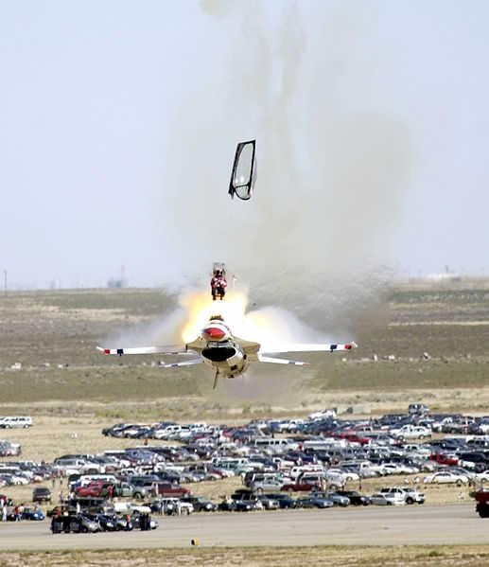
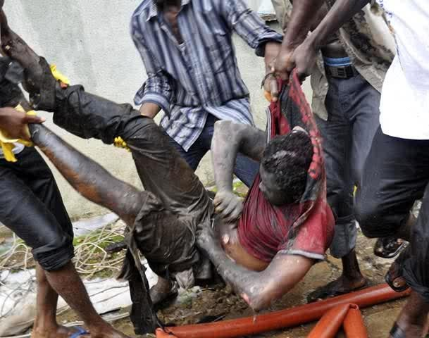

A scene of plane crash victim being rescued from a plane crash
Source: Google image source: Google images

Road Accidents:

This is a traffic collision (motor vehicles collision, motor vehicle accident, car accident or car crash) is when a road vehicle collides with another causing loss of live, injury and damage. In Nigeria, most road accidents are caused as a result of bad and poor road maintenance, over speeding, lack of traffic signs, carelessness of drivers, lack of knowledge and awareness of the use of road signs etc.
In Nigeria, a truck crash occurred on the 28 August 2000 at the central bus station in the city of Abuja. A gravel truck transporting building supplies to a construction site suffered total brake failure on a hill above the bus station. The truck then free-wheeled in reverse down the hill, entering the bus station at a very high speed, crushing three old buses under its considerable weight. The crash caused gallons of petrol to spill from the damaged buses which were in the process of being refuelled, flooding the wreckage and parts of the crowded bus station. A flame, from an unknown source, caught the spilt fuel, and the bus station was almost instantly consumed by an immense fireball, which killed or seriously injured hundreds of people in the station or in the crushed buses, one of which was still underneath the truck. At least 70 were killed in the blast and well over 100 badly injured. The full death toll cannot be known, as there is little available census information for the area, some bodies were destroyed outright in the blaze, and others may have been removed by relatives before the recovery operation began. Others died later in hospital from their terrible injuries.

Building Collapse:

These happens when a building fall down or inward suddenly: cave in. Usually, structural collapse does not happen suddenly. There are signs given – which when ignored – could lead to structural collapse. Structural collapse could happen – because: old building have not been given proper care and preventive maintenance has been ignored for a long while alterations are made to the civil structure, without considering the load bearing capacity, If you are working/residing in a building, which does not seem to be well-maintained, you might be at risk of getting caught in, when the building collapses. It’s much better to get the building repaired appropriately, before it’s too late.
If you are making renovations to your building – causing structural changes, its best to do these under the guidance of appropriately qualified Structural Engineers, Civil Engineers or Architects. This will significantly reduce the chances of the collapse. Since this kind of disaster mostly preventable (and, has a certain degree of predictability), can should be avoided.
However, in case, one is still stuck in a situation of collapsing structure, the primary aim should be to save oneself from instantaneous damage. Usually, help would start arriving in a few hours (maximum). If you have survived the immediate impact, most probably, you might get rescued soon, and, might get medical attention.

Implications of Disasters on Our Region and Environment:

- Infrastructure damage

- Telecommunication loss

- Flooding

- Landslides

- Power disruption

- Water problems

- Agricultural damage

- Loss/damage to housing

- Damage to inland and coastal environments

People at risk from disasters, whether natural or human in origin can take actions that save lives, reduce losses, speed response and reduce human suffering when they receive accurate warnings on time. Space derived information can provide accurate and warning techniques as better sensors are deployed to measure key variables, employ better dynamic models and expand the understanding of the causes of disasters. Any effort at managing disaster must apply prevention strategies to reduce the impacts of natural and man-made disasters. We cannot decide how many storms will strike, or how fiercely the winds will blow, or the waters will rage. But we can decide - we must decide together - the impact they will have on our lives and on the ecosystem. This requires a collective approach by all stakeholders.

With the development of industrial and scientific technology, the relationships between the human environment and the natural environment have become more sensitive and each may be more vulnerable. In fact, according to the United Disaster Relief Organisation (UNDRO), and experienced organisation in disaster management, the present disaster situation has merged human activities and human phenomena. Therefore, UNDRO currently uses the term “complex disaster” to describe situations (Aptekar, 1994: 22). The definition of a disaster according to the International Strategy of Disaster Reduction (ISDR), or more specifically a “purely” natural calamity, include storms, drought, volcanic eruptions etc., and these may not result in disaster. For example, torrential rain in the middle of the ocean will not necessarily cause any damage. However, if the same torrential rain falls on a community, it could easily cause injury (ISDR, visited in 4/10/2007). Varley ( 1994: 1-2) suggests that if someone wants to understand disasters better, he/she must pay close attention to the social course, that is, the degree of human vulnerability. The figure below displays what Cannon (1994) treats as a natural disaster through vulnerability analysis.

Regional Distribution
Production Resources;
e.g. land, water, mineral,
Opportunities
Risks
Environment provides:

Hazards: e.g. Floods, drought,
Unequal Access to opportunities and Unequal Exposure to Risk

Social System and Inherent Power Relations

Class---- Gender Ethnicity

This figure shows the relationship between the environment, social economic and political system
Political and Economic System at the National and International Level

DISASTER MANAGEMENT CYCLE

To improve disaster management, Public Administration Review (PAR) issued a special volume entitled “Emergency Management”: A Challenge for Public Administration in 1985. It has been shown that more attention is paid to crisis management in contemporary public administration. Being a public problem, natural disasters have become one critical policy issues in modern government, Schneider (1992, 1995) points out that there are two systems that are important in disaster management: “bureaucratic norms” and “emergent norms”. The former promotes the mobilization of public organizations while providing disaster relief, and organizes and implements performance. The latter are contingent through the collective action of people influenced by the disaster. Successful disaster relief depends on the gap between these two norms
Bureaucratic systems typically play an important role in crisis management in government around the world. The following are a few examples: japan passed the Disaster Preparedness and Relief (Gesetz uber die Erweiyerung des Katastrophenschutez) in 1968. The establishment of FEMA by the government in 1979 also reflects how many disaster management concerns the government has. In terms of structural perspective of organisational theory, in order to have an effective response within the golden first 24hours of any crisis (Jan, Chung- Yuang, 2004a), the ideal type of bureaucracy and centralized authority is one which contributes to efficiency. Thus the role of government acting in crisis management will be similar in both Western and developing countries, (Rosenthal and Kouzmin, 1997: 287).

A crisis at the prodromal stage is not easy-to-do but also effective. Further, it can generate preventive results, which explains why “prevention is better than a cure”. Once we enter the acute stage, which is what people perceive as the “crisis stage”, the key to coping at this particular stage is to work as hard as one can to get a crisis under control, and to prevent the crisis from exploding rapidly.
After the explosion of crisis there are many complications – this is what we call the “aftermath stage”. This is also the stage of recovery and alleviating pain. At this particular time, the government should analyse the key points of the issue. Some crises do not occur suddenly but have incubated for a long time. (Jan, Chaung-yuang, 1999:17-18).
With the coming of globalization, modern disaster management becomes more flexible and complicated. Rosenthal and Kouzmin (1997: 287) think the role and authority of government in disaster management is no longer unchallenged today. In other words, cotemporary disaster management will rely on diverse relationships and participants, such as intergovernmental relations, non-governmental organisations and civil organisation (Benson, Twiggand Myers, 2001; Mushkatel and Weschler, 1985; Rubin and Barbee, 1983). After reviewing the research on disaster management, Birkland (2006) concluded that the critical factor in successful disaster management is not merely having enough resources, but resource coordination. In short, how the resources are utilized by different actors and organisation is the major factor in successful disaster management.
With the onset of globalization, more international disasters have appeared. The concept of global governance has again challenged international cooperation in disaster management. Given the formation of global public policy network (Reinicke, 1999) and the high

interdependence of the global political economy, more emphasis should be placed on the essentials of global crisis management and international cooperation.

The Function and Policy Making Approach to Disaster Management

By means to the functional approach to understand disaster management, Integrated Emergency Management System (IEMS) are design to address multiple objectives and assume that all kinds of crises share common crisis characteristics. Thus FEMA defines IEMS as a ‘’single flexible system capable of adjusting too many kinds of hazards’’. IEMS divides crisis management into the following four stages of policy making and execution.

- Mitigation policy: The policy at this stage includes planning to take preventive measures which alleviate the damage of the crisis.

Mitigation policy in crisis management can be categorized into two types 1. Structured (e.g. flood preventive plans, improving) anti-riot equipment and techniques etc.) 2. Unstructured (e.g. drafting construction laws/codes to strengthen anti- seismic measures agreeing on disaster-insurance regulations and land allocation regulation and establishing tax incentives and dis- incentives)
- Preparedness policy: Such policy improves operational ability when faced with crisis and includes

- Designing crisis operation plans,

- Establishing a crisis communication network

- Establishing an emergency operation center

- Setting up a crisis alarm system

- Designing emergency operation team training and practices and

- Resource management.

- Responses policy: The policy stresses what action to take when a crisis will inevitably be converted into a disaster. This includes a medical care system, operation of an emergency center, rescue and evacuation, shelter for disaster victim and preventive measures to avert second round disasters.
- Recovery policy: Short term recovery policy includes rebuilding the basis of a rescue system for example restoring water and electricity. In terms of long term recovery policy rebuilding public transportation, controlling radiative pollution and controlling disease and improving sanitation are all important.

TECHNICAL INFORMATION

  - Lighting

  - Drainage

  - Fire protection

  - Plumbing

  - Acoustics

    - Lighting: the purpose of lighting is to achieve a high standard of visual efficiency so that eyestrain, slow inaccurate work by the staff, is prevented. Good lighting depends upon the amount of light at various places of work i.e., workshops, control room, maintenance bay etc. the quality of light require for different types of work may demand different level of illumination, this is so because the smaller the detail of works, the greater the amount of light necessary to see clearly. Lighting irrespective of the intensity is of two types: natural lighting and artificial lightening.

    - Drainage: this is the natural or artificial removal of surface and sub-surface water from an area. Gully traps receive discharge from wastewater fixtures; the entire topography is also characterized by the image of waterways, creeks and swamps. Drainage systems in port- Harcourt are primarily North to South orientation and can either be fresh water system or salt water system.

    - Fire Fighting: these are techniques and equipment used to extinguish fires and limit the damage caused by them. Fire fighting consists of removing one or more of the three elements essential to combustion—fuel, heat, and oxygen—or of interrupting the combustion chain reaction. The risk of fire existing in this project particularly in areas where inflammable petroleum products and ignition are kept, fire occurs when ignition develops within combustible materials in air. The following should be installed in the building to fight fire:
- Fire alarms
- Fire sprinklers
- Fire extinguishers
- Standpipe systems

    - Plumbing: there are several issues with sanitary plumbing and drainages that must be considered during building design.

Accommodating water supply pipes in a building structure generally present few problems, but this is not the case with drainage pipe as they are generally larger and need to be installed with maximum gradient.
    - Acoustics: this is a term used for the science of sound in general. It is more commonly used for the special branch of that science, architectural acoustics, which deals with the construction of enclosed as to enhance the hearing of speech or music. Acoustical design must take into cognisance the physiological peculiarities of the ear. In the design stage, suitable acoustic materials should be introduced.

CHAPTER THREE CASE STUDY
It is generally believed that the case-study method was first introduced into social science by Frederic Le Play in 1829 as a handmaiden to statistics in his studies of family budgets. (Les Ouvriers Europeans (2nd edition, 1879).This is a process or record of research in which detailed consideration is given to the development of a particular matter over a period of time.
Case study is defined as a research strategy, an empirical inquiry that investigates a phenomenon within its real-life context. Case study research can mean single and multiple case studies, can include quantitative evidence, relies on multiple sources of evidence, and benefits from the prior development of theoretical propositions. Case studies should not be confused with qualitative research and they can be based on any mix of quantitative and qualitative evidence. Single-subject research provides the statistical framework for making inferences from quantitative case-study data. This is also supported and well-formulated in (Lamnek, 2005): "The case study is a research approach, situated between concrete data taking techniques and methodological paradigms."

PURPOSE OF A CASE STUDY
- The purpose of a case study is to provide a more thorough analysis of a situation or "case" which will reveal interesting information to the reader. Case studies often accompany reports, to give ‘flesh’ to written reports.
- Know why you are conducting this interview. To what end will you ask questions?
- To aid for a good design.
Case studies where carried out in different organisations which include; Enugu State Government Fire Service Station, National Emergency Management Agency (NEMA) Enugu Branch, Disaster Management Centre For Ehlanzeni District Municipality, South Africa.

CASE STUDY ONE

ENUGU STATE FIRE SERVICE STATION

    - LOCATION:

Enugu State Fire Service Station is located along Ogui Road opposite NIPOST. It is bounded in the west by Ogui road, in the east by a track road, in the north by an undeveloped land (empty land) and in the south by Nigeria Union of Teacher’s building (NUT).
    - CLIENT: Anambra State Ministry of Internal Affairs, Fire Service Department

    - ARCHITECT /CONTRACTOR: Building and Housing Division, Anambra State Ministry of Works and Housing Anambra State.

BRIEF HISTORY:

Enugu state fire service was built in 1960’s by the colonial masters. It was the first fire service station built by the colonial master which serves the old eastern region. The Enugu State Fire Service Station is an Emergency responder; it is military in nature which means it has different ranks. The highest rank is the Chief Fire Officer.

FUNCTIONS:

- Fight fire and rescue victims of fire, drowning, falling in a pit etc

- preach fire prevention

- Render other humanitarian services.

MODE OF OPERATION

The officers run shift, each shift has a watch officer as the head. When information is gotten via phone call or running call, the watch officer then rings a bell once and everyone gets ready, then when he rings the bell three more times, all the fire men then enter the fire engines and water truck and move to the location of the fire.

CHALLENGES
- It is capital intensive to fund the equipment

- Few staff

- Some people in the public turn to interfere in the duties of the fire men

- Hydrants alone the road sides have been damaged by hoodlums, road construction etc

- People don’t give way to the sirens

- People don’t believe in fire, so, they need enlightenment

PROGRAMME ELEMENT

- Parking: There is no parking space for visitors and staff. It is just an open space which is use as parking lots.

- Road: The access road to the Enugu state fire station is tarred.
- Landscape: There is no attempt on soft landscape of the premises. The whole open space is paved which causes radiation and reflection during hot weather.

PLANNING CONCEPT

- The Corridor: The corridor has a narrow space of about 900mm.

- The windows facing the appliance bay were run from up to the down from 900mm upward to enable them to have clear view of the activities going on the area of appliance bay.
- The sliding pole: this is a pole that enable quick move of the fire men from the crew room. it is positioned at the front of the crew room for the fire fighter men to get easy access to the appliance bay when emergency arise.
- Hydrants: this is an upright water pipe; it has a nozzle to which a fire hose can be attached. It aids for supply of water in the fire station.

- Appliance Bay: the appliance bay is positioned in such a way that the offices face it and it has a maintenance pit for the maintenance of the underneath of the fire engine. It covers a space of 8meter by 16meter which accommodates four (4) fire engines.
- The Toilets are positioned at the extreme of the office which space covers area of 2m by 1.8m. It has a common lobby which has a wash basin.
- Living Lounge: The fire fighter men have a common living lounge equipped with an indoor game which keeps the fighter men alert.

The living lounge has a door which has direct access to the sliding pole.

- Zonal Commander Office: The zonal commander office is close to the watch room, it has a space of 3.0m by 3.0m. It is equipped with chairs, table and desk.

- Watch Room : The watch room which is equally called the control room is equipped with mobilization board which is use to keep record of fire fighter men whose turn reaches to be in duty therefore is use to know who and who is on duty, also watch room is equipped with radio message receivers, telephone to receive any emergency and watch room equally have watch (wall clock) which the fire fighter men on duty have to take note on the time he/she receive the emergency call and fire alarm which are trigger to send signal to the fire fighter men in their lounge if there is any emergency.

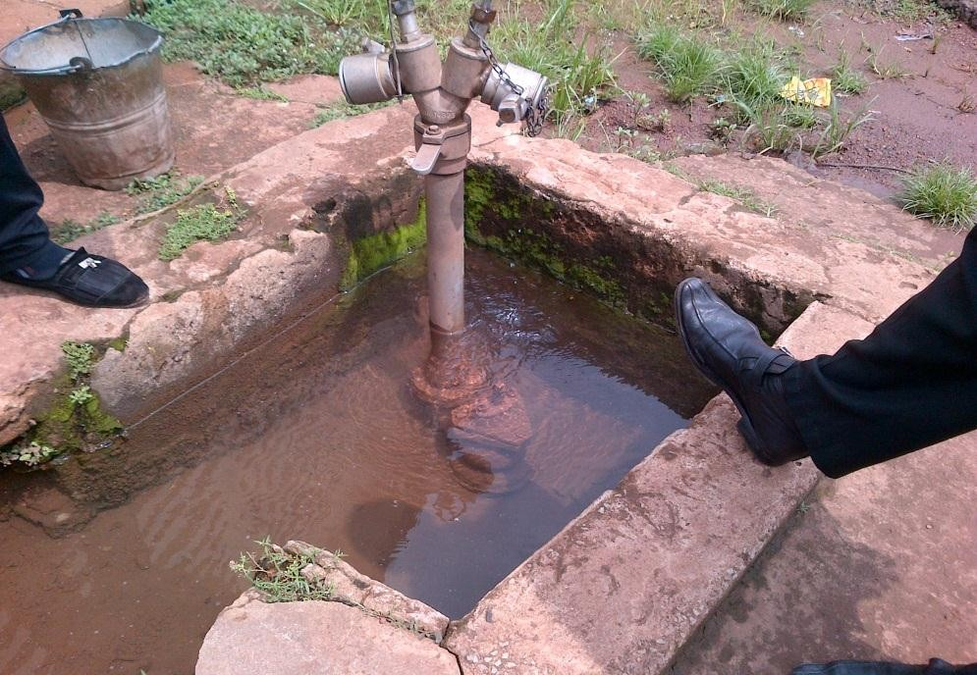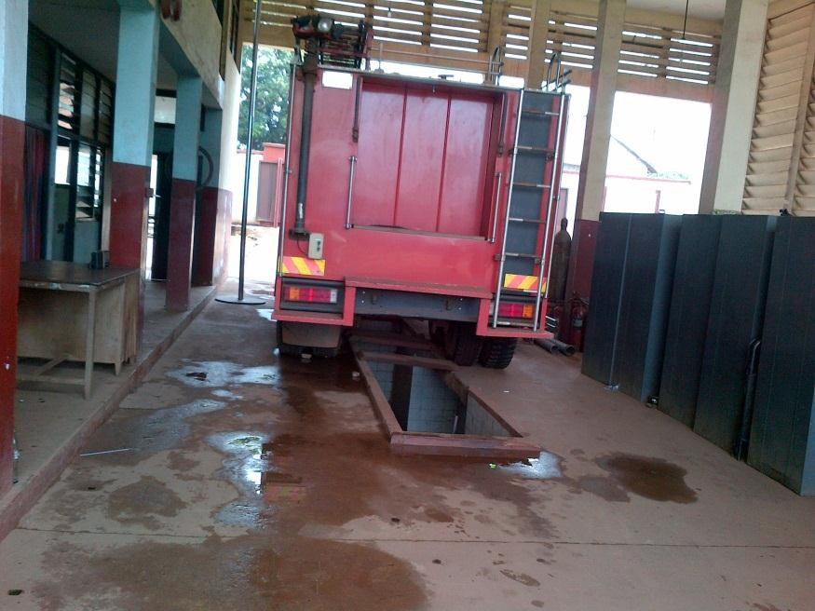

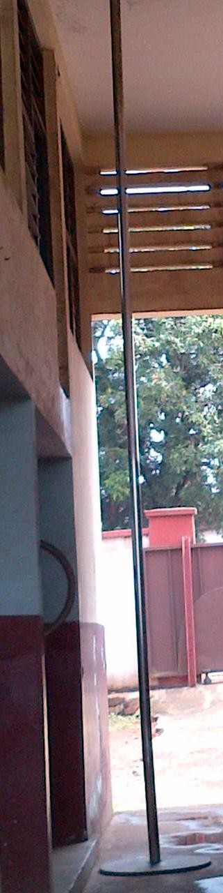
Sliding pole
Hydrant appliance bay
Source: case study research 61

ENVIRONMENTAL CONTROL:

Orientation of the Building: the Enugu state fire service station is positioned in such a way that the entrance of the building faces the tarred road (Ogui road) which serves as easy access to the main road. The building is positioned in such a way that it is not protected from the solar radiation.
Road: the Enugu state fire service station has a good access road which equally serves as a collector road to the Enugu-Abakaliki road.

SERVICES NEEDED:

- Water: in Enugu state fire service station water is supply directly from Enugu State water Board Corporation to the water hydrant of the fire service station. Although due to occasional failure of steady water supply by the water board corporation therefore the fire service station make use of underground water storage tank and overhead tanks.
- Electricity: The Enugu State Fire Service Station make use of electricity provided by the Power Holding Company of Nigeria (PHCN) and a standby generator due to unreliable nature of PHCN.
- Waste Disposal: Solid wastes are piped through septic tank to soak away pit on the premises. While refuse tin are been placed at strategic part of the premises.

GENERAL APPRAISALS Floor plan:
- Enugu State Fire Service Station floor plan is rectangular in shape.

- The plan has two floors.

- Floor plan has no courtyard.

The content of each floor is enumerated below.

Ground floor: contains the office of the zonal commander, the dressing room, watch room, conveniences (WC) and the appliance bay.

First Floor: contains the living room (lounge) for the fire fighter men.

CONSTRUCTION MATERIALS:

The materials used for construction were as follows:

- Wall: sand Crete hollow block

- reinforced concrete column

- Glass louvers window.

MERITS
- The building station has adequate cross ventilation

- The use of slide pole for emergency movement from the crew room

- The station is properly and strategically located

- The station has good access to the major road

- The station has maintenance pit at the appliance bay

- There is presence of hose drying tower

- There is presence of water hydrant

- Cross ventilation in the offices

DEMERIT
- The corridor space is not wide

- Lack of parking lots

- The station is not position to protect it from solar radiation

- No soft landscape

- No visitors toilets

- Poor plumbing facilities

- The site is too small, therefore, circulation is difficult.

ENUGU FIRE SERVICE STATION

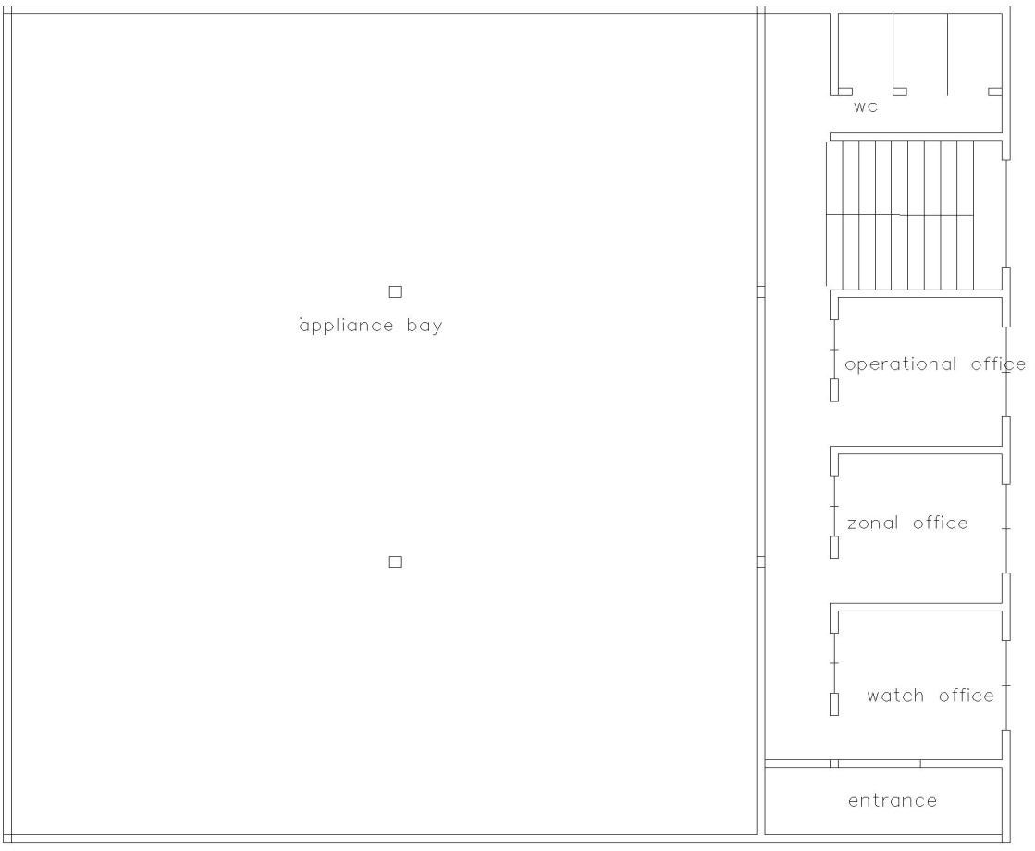
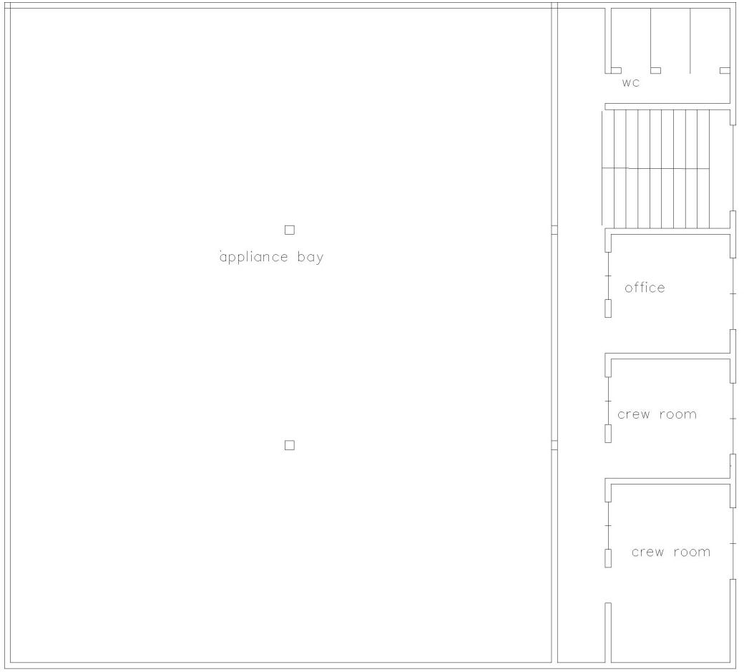

Ground floor plan first floor plan

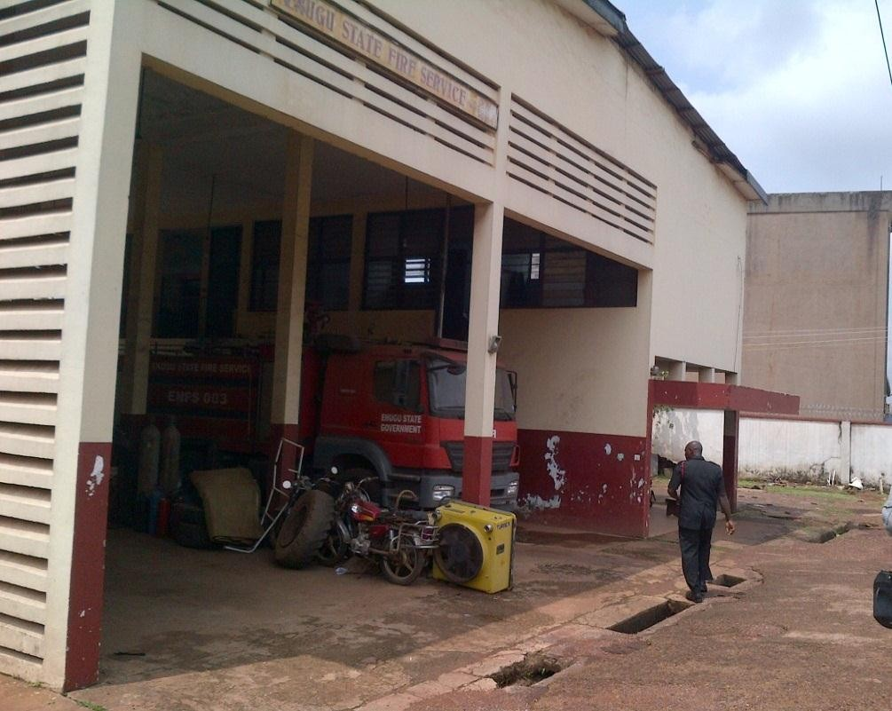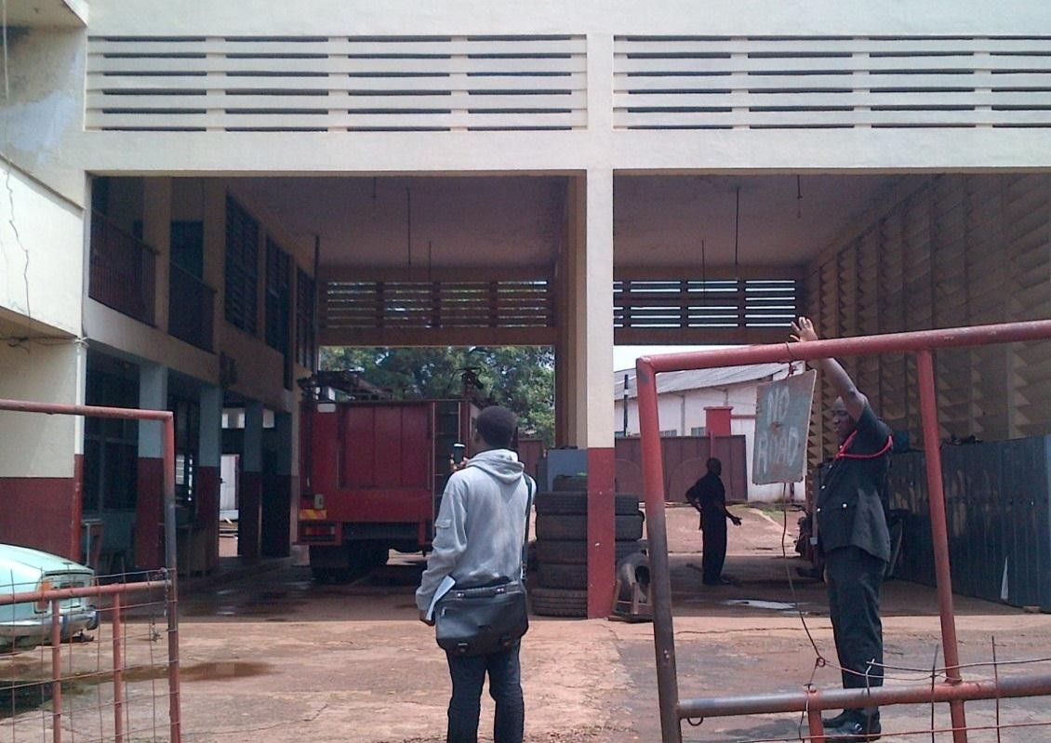

FRONT ELEVATION BACK ELEVATION
Source: case study research

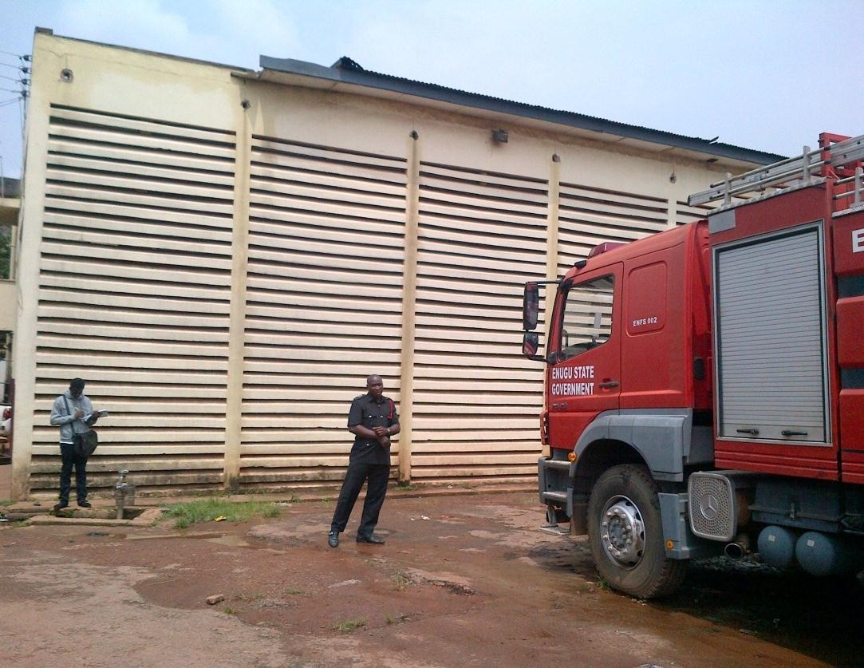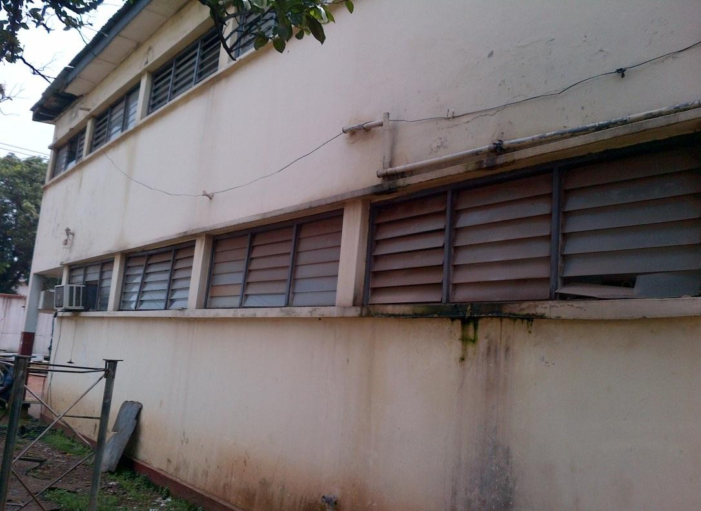

LEFT SIDE VIEW RIGHT SIDE VIEW
Source: case study research

ORGANIZATIONAL CHART

Chief fire officer

Deputy Chief Officer
Division A
Division B
Division C
Division D
Division E
Divisional officer

Assistant Divisional officer
Station officer

Leading fire men
Fire men

  - CASE STUDY TWO

NATIONAL EMERGENCY MANAGEMENT AGENCY (NEMA)

The National Emergency Management Agency (NEMA) was established via Act 12 as amended by Act 50 of 1999, to manage disasters in Nigeria. It has been tackling disaster related issues through the establishment of concrete structures. Its mission is to coordinate resource towards efficient and effective disaster prevention, preparation, mitigation and response in Nigeria with the vision to build a culture of preparedness, prevention, response and community resilience to disaster in Nigeria.
It acts in the following areas:
- Disaster Risk Reduction

- Search and rescue

- Policy and strategy

- Geographic Information System

- Advocacy, education

- Administration

- Finance and logistics

- Relief and rehabilitation

- PLANNING, research and forecasting

LOCATION:

Address: Plot 439 (No. 8), Adetokunbo Ademola Crescent, Maitama, Abuja. Postal Code: 9001
City: Abuja Country: Nigeria
    - PROGRAMME ELEMENT

Site Plan:

The site plan contains the following facilities

    - The main building

    - The warehouse

    - The clinic

    - The parking lots/maintenance bay

    - proper landscaping

Building plan:
The building has four floors

- The ground floor contains the administrative section for enquiries, employment details, press unit and legal unit of the organisation

- The first floor contains offices for various staff in the establishment, the finance and account department.

- The second floor contains offices for the department of planning, research and forecasting, and the research and rescue team.

- The third floor contains the training unit, offices for the relief and rehabilitation officers.

  - WAREHOUSE: this is a separate building from the main building, this is the section where all the relief materials like, drugs, buckets, foodstuff, cooking utensils, matrasses etc. are kept for distribution.
  - THE CLINIC: the clinic is located behind the main building, the clinic has well trained medical personnel to look after the health of the staff and some affected victims. The clinic contains an emergency unit, out-patient department, male ward, female ward, children ward, and offices for medical personnel, toilets and bathrooms etc.
  - THE PARKING LOTS/ MAINTENANCE BAY: this is a section meant for parking of the fire engines, water tankers, ambulances and other search and rescue vehicles. The section also has a maintenance unit which has an appliance bay for the repairs of spoilt vehicles. Also, there are offices for the mechanical and electrical engineers who maintain these vehicles.

MERITS
      - The building is well planned and organised

      - Good and proper landscaping

      - Free flow of traffic within and around the building

      - Good and proper ventilation

      - Good maintenance of the facilities.

DEMERITS
      - Difficulty in leaving the base for an emergency due to surrounding constraints

      - No emergency exit around the building

      - The site is not large enough

CHALLENGES
      - People do not respect the sirens when going for rescue.

      - Due to limited resources, it takes time for the accident scene to be located especially if its plane crash inside the bush

      - Due to bad roads, accessibility to the accident scene especially in remote villages is usually very difficult.

POSSIBLE SOLUTIONS
      - The public should be educated on the need to give way for the rescue team when going on an emergency rescue and obey the siren.

      - Nigerian roads should be repaired to ease movement to the scene of the accidents.

      - More resources and man power should be employed.

NATIONAL EMERGENCY MANAGEMENT AGENCY (NEMA) ORGANOGRAM
Chairman of Council
Governing Council
Director General

Department of planning, research & forecasting
Legal unit
Audit unit
Press unit
Accounts
Supplies
relief &rehabilitation
Department
Department of finance & account
Department of admin & supplies
Department of training

Admin
Finance

Pension

North west zonal office
Training
Abuja operatio- nal office | North central zonal office | North east zonal office

South south zonal office
South east zonal office
South west zonal office

Disaster risk reduction
NIMCC
Care unit
Simulation

Relief
Communication

Department of search & rescue
of
Monitoring and evaluation
GIS
Library

Rehab.
Search & rescue
Evaluation

NATIONAL EMERGENCY MANAGEMENT AGENCY (NEMA) HEADQUARTERS ABUJA

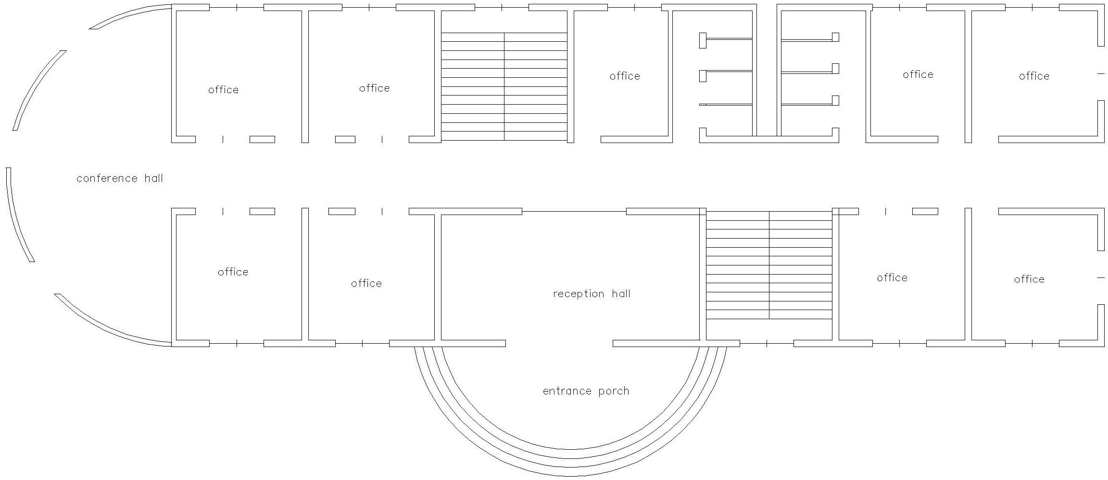

Ground floor plan

NATIONAL EMERGENCY MANAGEMENT AGENCY (NEMA) HEADQUARTERS ABUJA

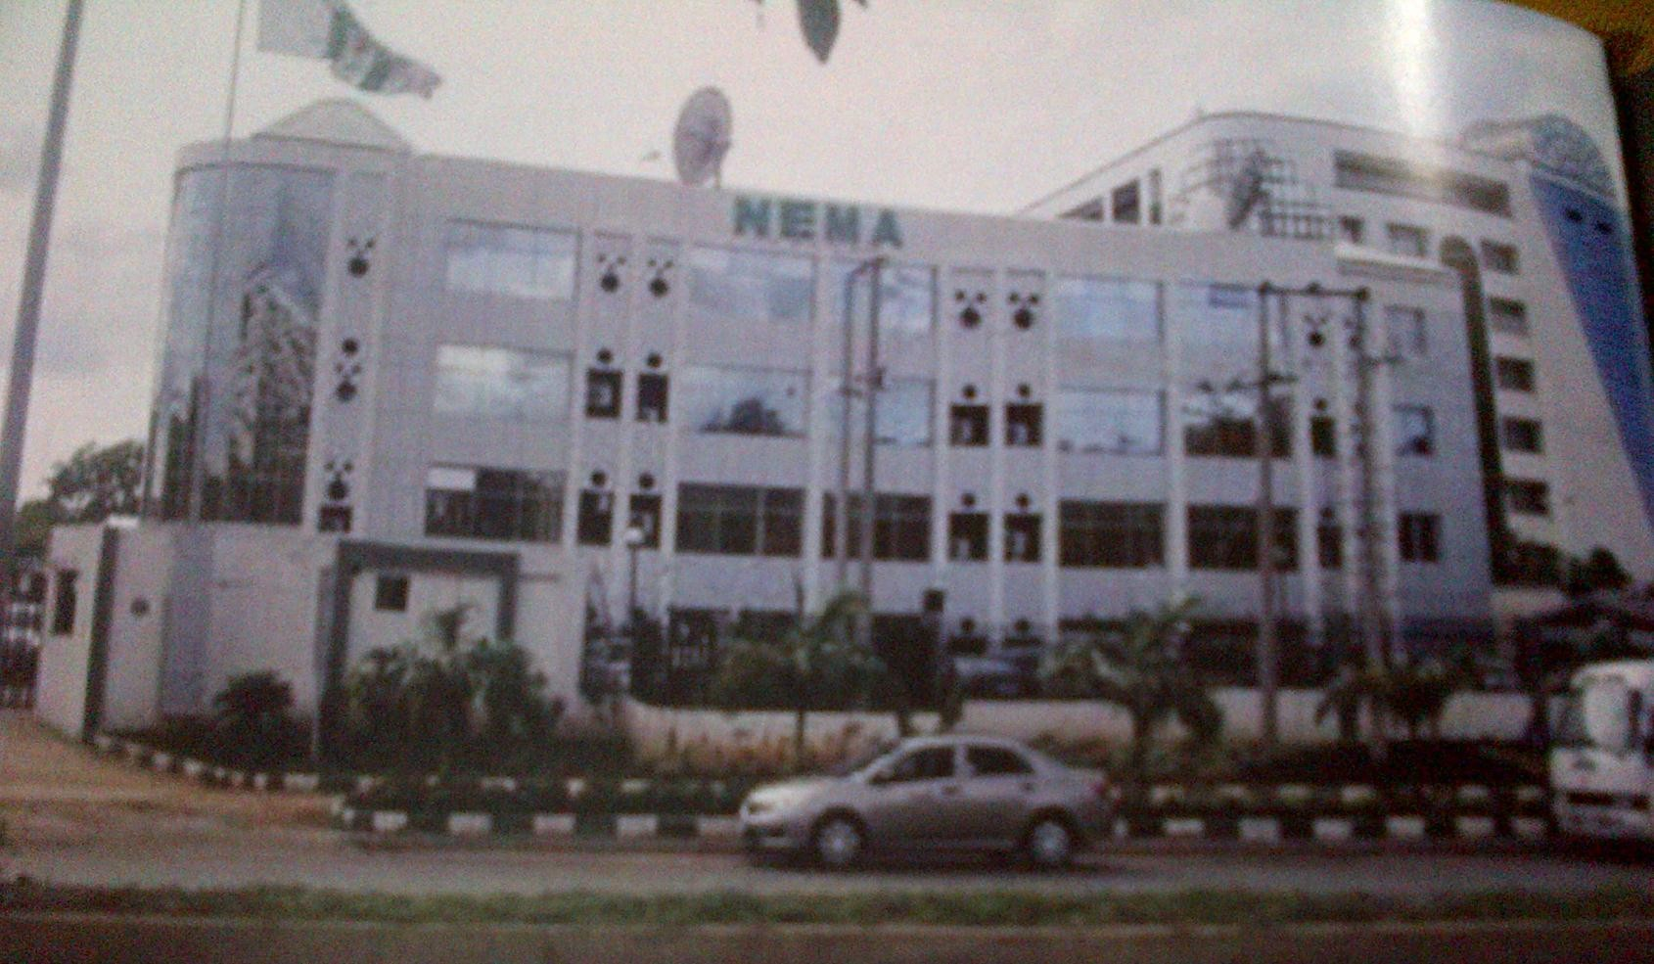
Source: case study research.

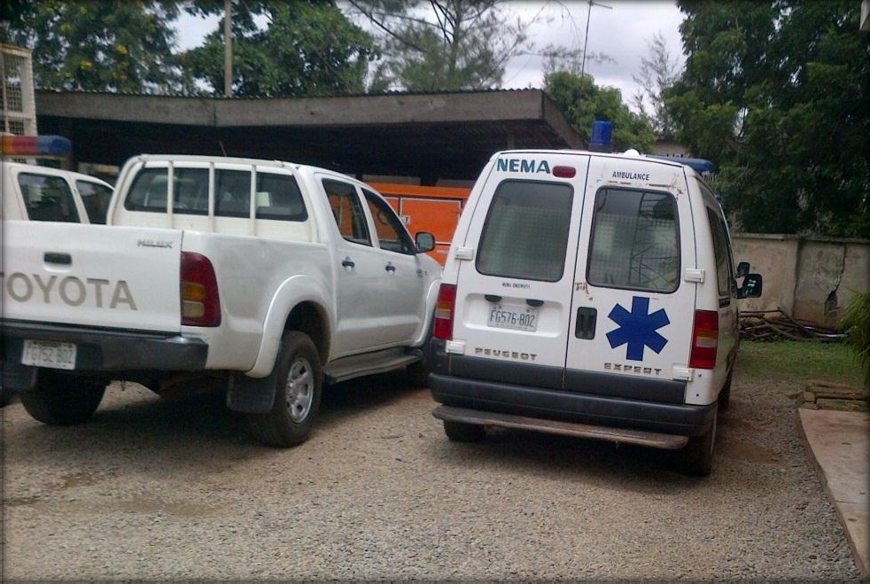
Helicopter used for search and rescue.

Source: case study research.
ambulance used for rescue operations

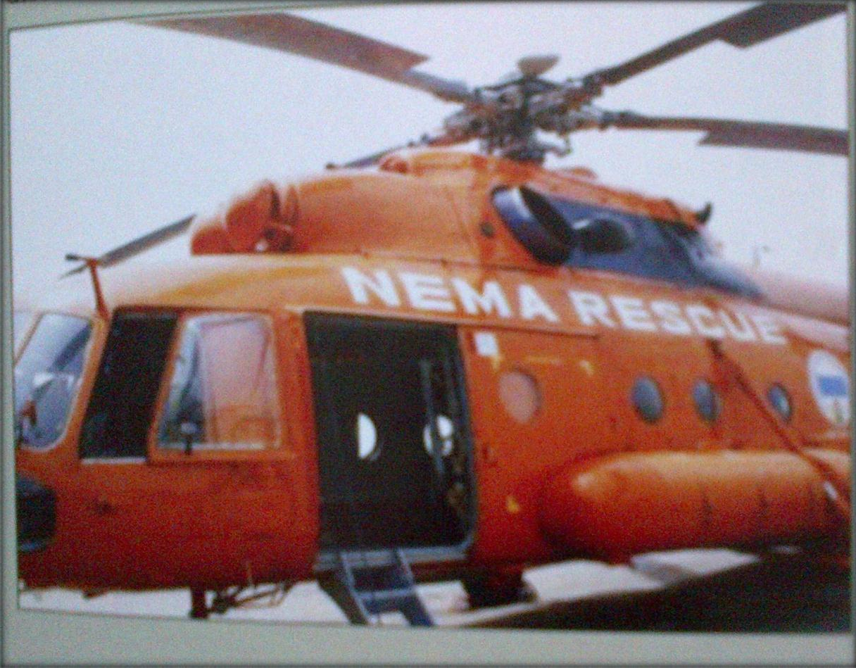
76

CASE STUDY THREE

DISASTER MANAGEMENT CENTRE FOR EHLANZENI DISTRICT MUNICIPALITY, SOUTH AFRICA
Ehlanzeni District Municipality is primary responsible for Disaster Management within its area of jurisdiction in South Africa. In order to fulfil its primary mandate, Ehlanzeni District Municipality needs to adhere to the National Disaster Management framework, Provincial Disaster Management framework and the Disaster Management Act.
The successes and challenges of the Disaster Management Unit can be measured based on four key performance areas and the enablers. These includes; Institutional capacity arrangement, Risk assessment, Risk reduction, and Response and recovery.

LOCATION:
Ehlanzeni District Municipality (EDM) is one of the three district municipalities located in the north eastern part of Mpumalanga Province in South Africa. It is bordered by Mozambique and Swaziland in the east, Gert Sibande District in the south, Mopani and Sekhukhune Districts of Limpopo in the north and Nkangala District Municipality in the west.

OBJECTIVES
Disaster Management involves the continuous and integrated multi-sectorial, multi-disciplinary process of planning and implementation of measures aimed at:
- Preventing or reducing the risks of disaster
- Mitigating the severity or consequences of disasters
- Responding to emergencies
- Rapid and effective response to disaster incidents and Post-disaster recovery and rehabilitations

PROGRAM ELEMENT
The site has the following facilities

- The main building

- The clinic

- The ware house

- The multipurpose hall

  - The main building contains the following:

- Tactical room

- Media centre

- Radio room

- Joint operation centre

- Canteen

- Kitchen

- offices

MERITS

- Good landscaping

- Free flow of traffic

- Sufficient parking lots

- Good communication systems

- Presence of basement floor for parking fire engines

DEMERITS

- No emergency exit from the site

- General office is too large

- Both fire engines and other smaller vehicles come in through one entrance.

Source: Google images

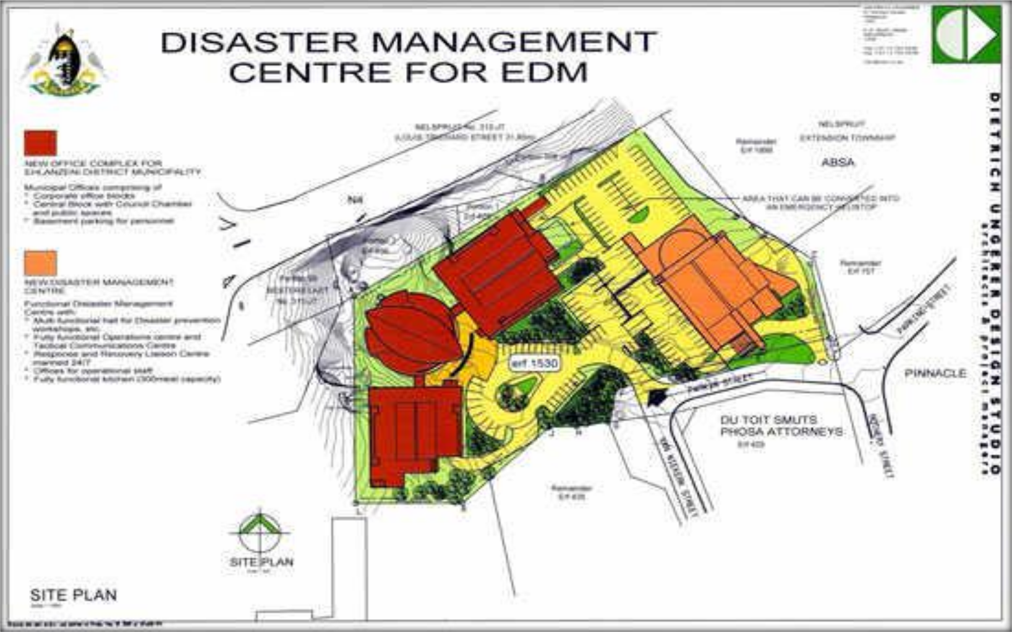

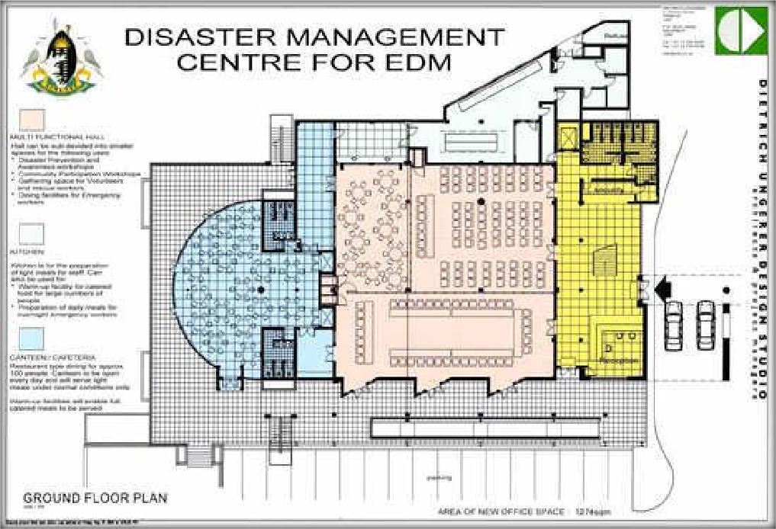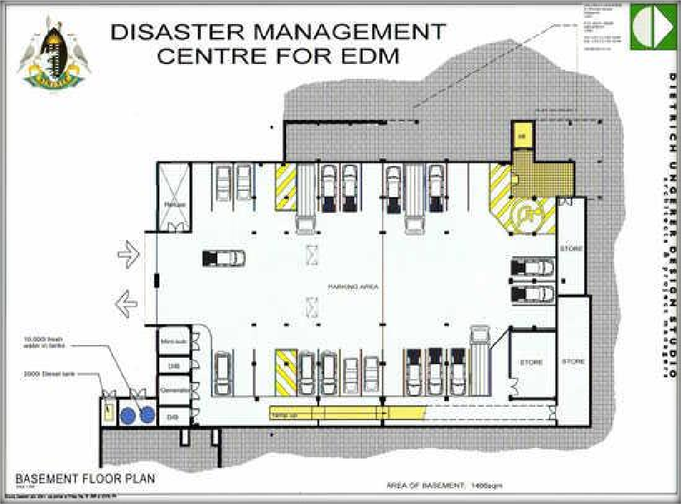

BASEMENT FLOOR PLAN

GROUND FLOOR PLAN
81

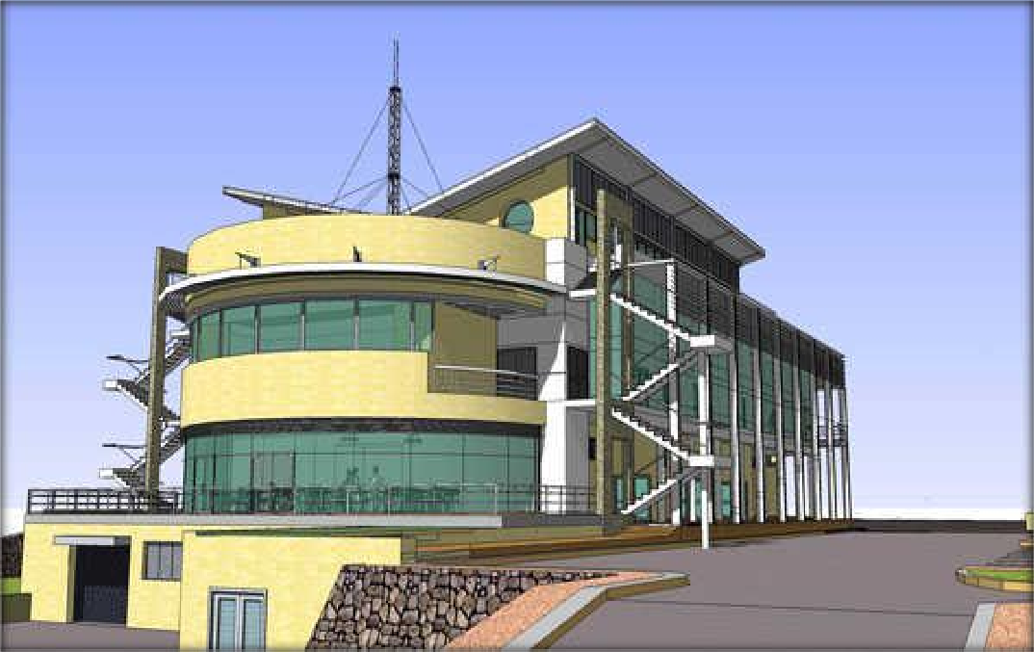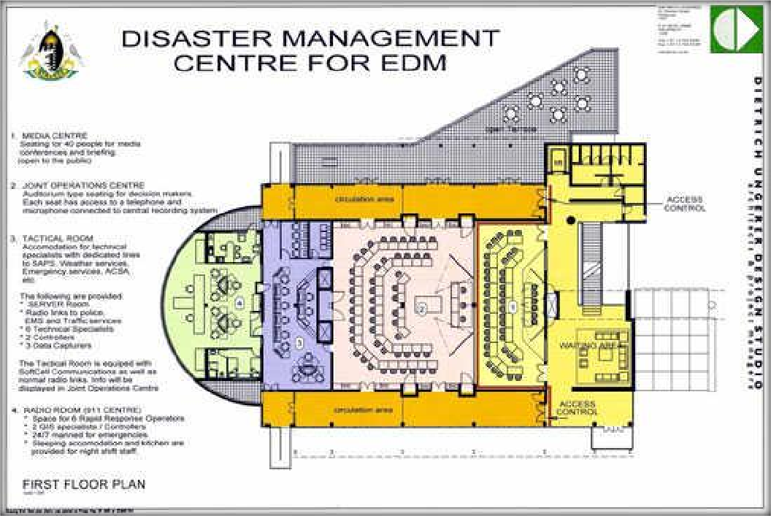
82
FIRST FLOOR PLAN

FRONT ELEVATION

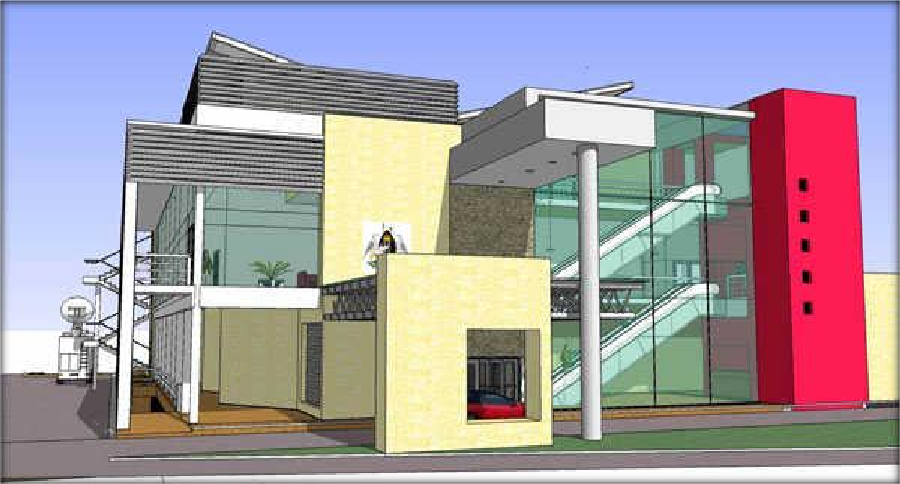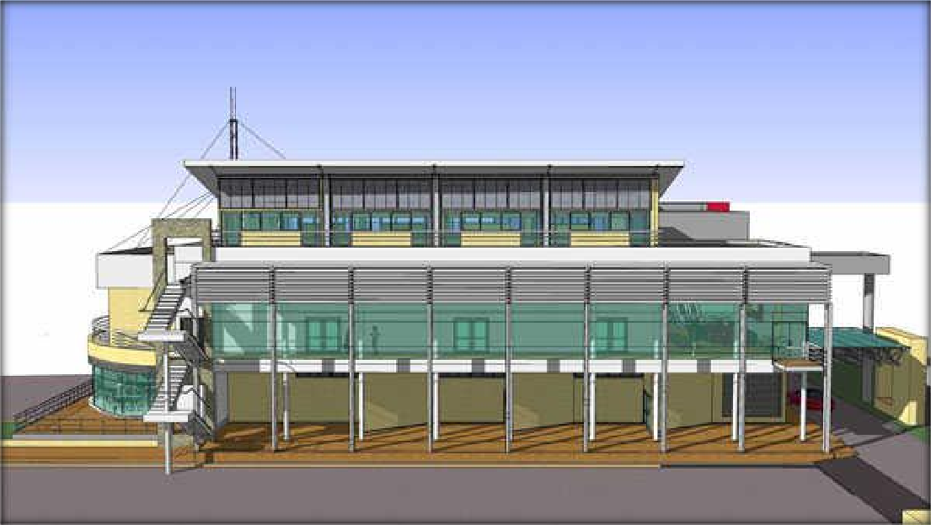

BACK ELEVATION

RIGHT SIDE ELEVATION

Source: Google images 83

CHAPTER FOUR

PLANNING AND DESIGN REQUIREMENT

THE SITE:
    - Geographical Location:
The site is located in Port Harcourt, the capital of River State, a state located at the southern part of Nigeria. It lies on latitude 4°N and longitude 7°E of the equator. It covers approximately 700 square hectares of land and according to the 2006 Nigerian census Port Harcourt has a population of 1,382,592. It has an area of 360 km² (140 square mile) it is the fifth largest urban area in Nigeria.

Site Selection Criteria

The conditions for selecting the site are based on certain factors. These factors include;

- The site is located where bulk of business and commercial activities take place.

- The site is situated in accident prone area.

- The site is accessible by pedestrians, vehicles and all forms of movement.

- The site is accessible by water and land.

- Its topography encourages good natural drainage of water

- It provides a good atmosphere and natural setting

- It is appropriately zoned and sizeable for its intended use.

MAP OF AFRICA SHOWING NIGERIA

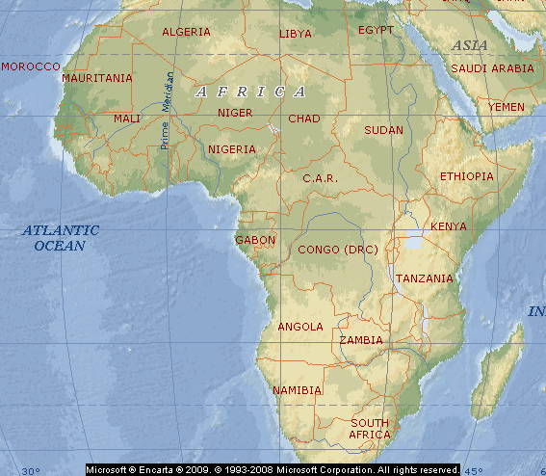

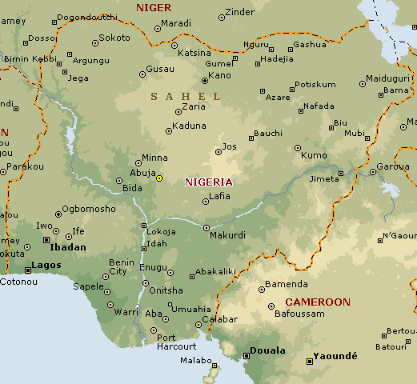
MAP OF NIGERIA SHOWING RIVERS STATE

MAP OF RIVER STATE SHOWING PORT HARCOURT

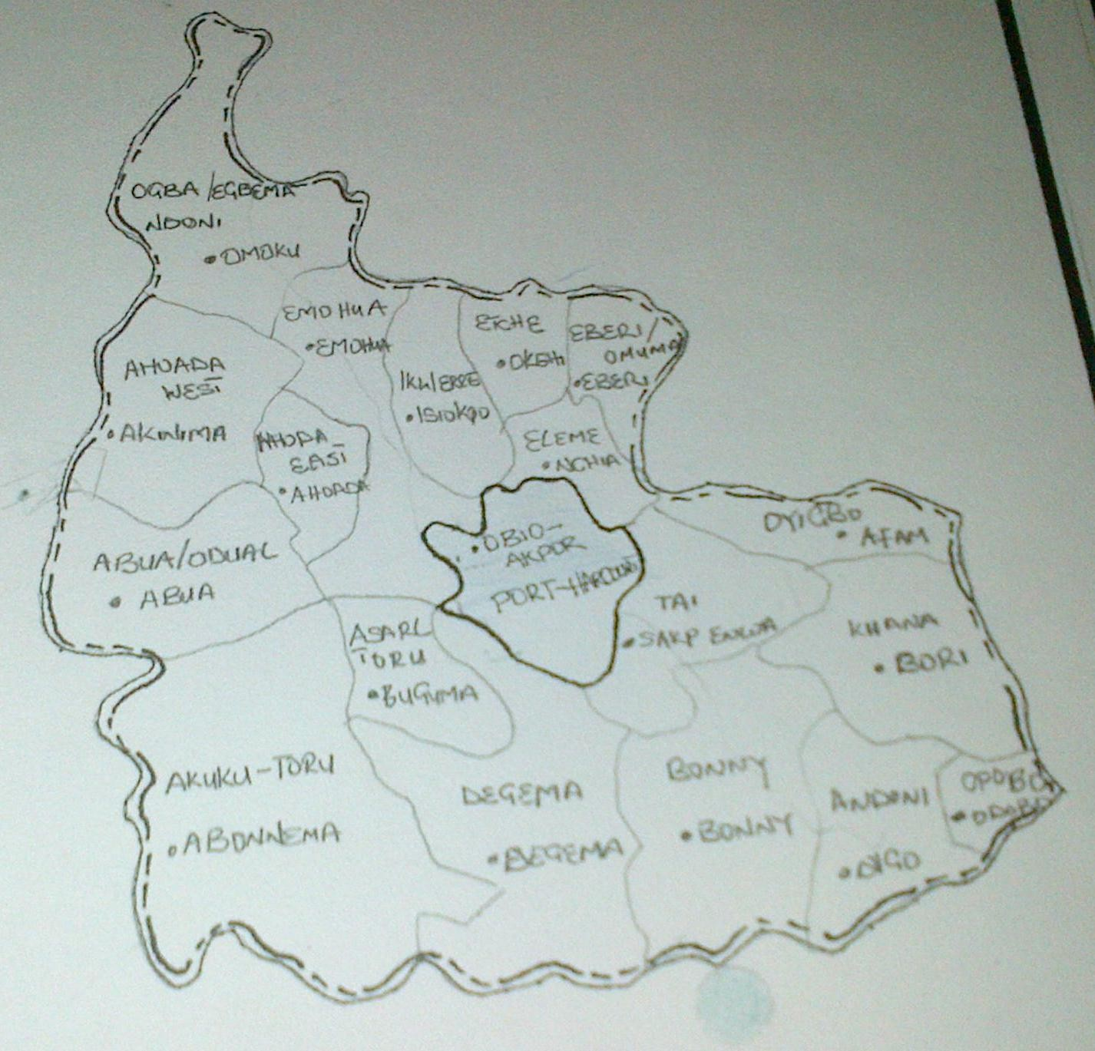

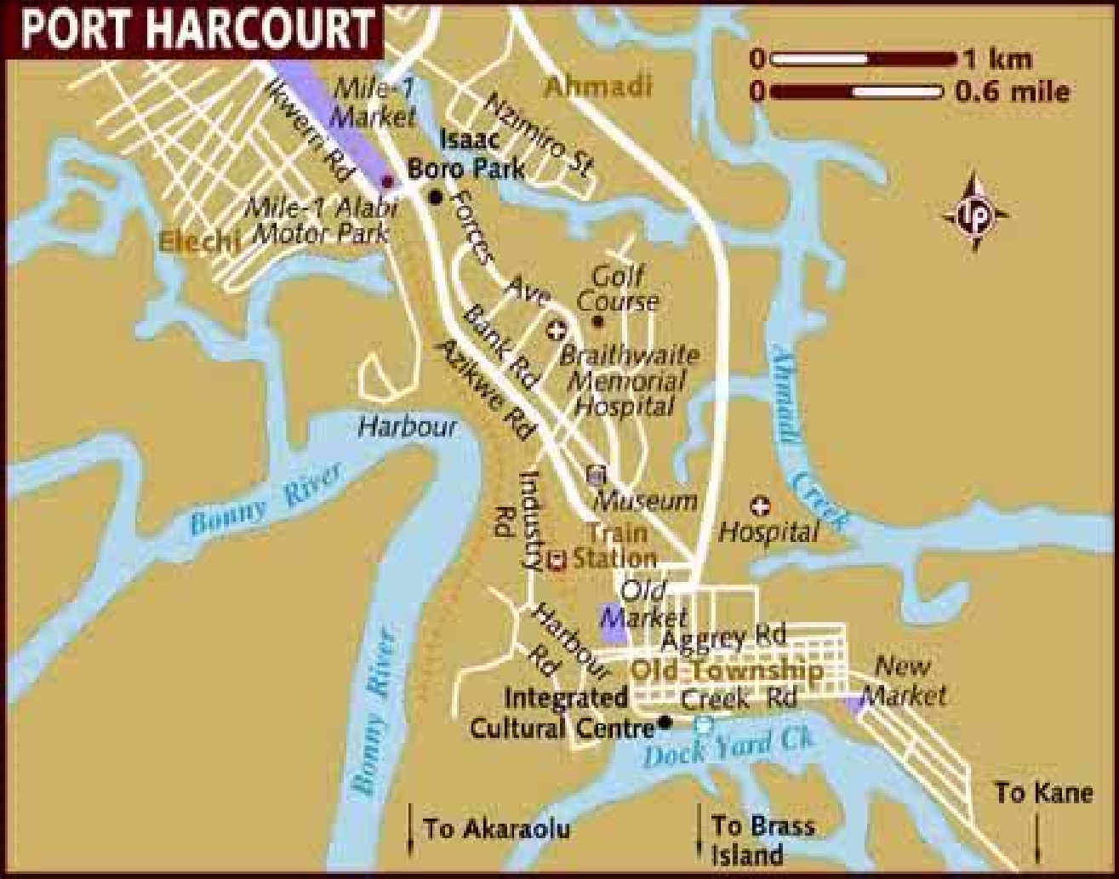MAP OF PORT HARCOURT SHOWING MAJOR ROADS

CLIMATE OF PORT HARCOURT, RIVER STATE

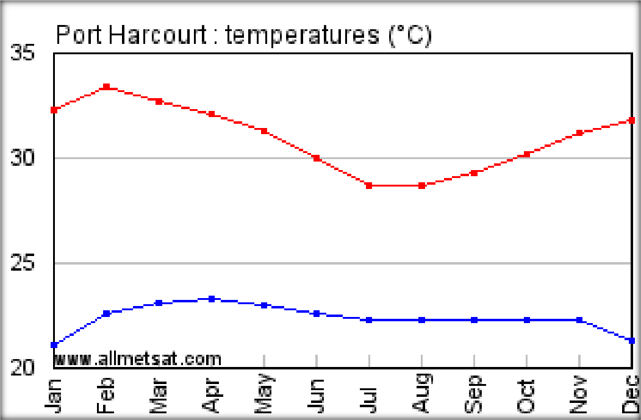Port Harcourt experiences a tropical monsoon climate with lengthy and heavy rainy seasons and very short dry seasons. Only the months of December and January truly qualifies as dry season months in the city. The harmattan, which climatically influences many cities in West Africa, is less pronounced in Port Harcourt. Port Harcourt's heaviest precipitation occurs during September with an average of 370 mm of rain. December on average is the driest month of the year; with an average rainfall of 20 mm. Temperatures throughout the year in the city is relatively constant, showing little variation throughout the course of the year. Average temperatures are typically between 25°C-28°C in the city.

PORT-HARCOURT RAINFALL

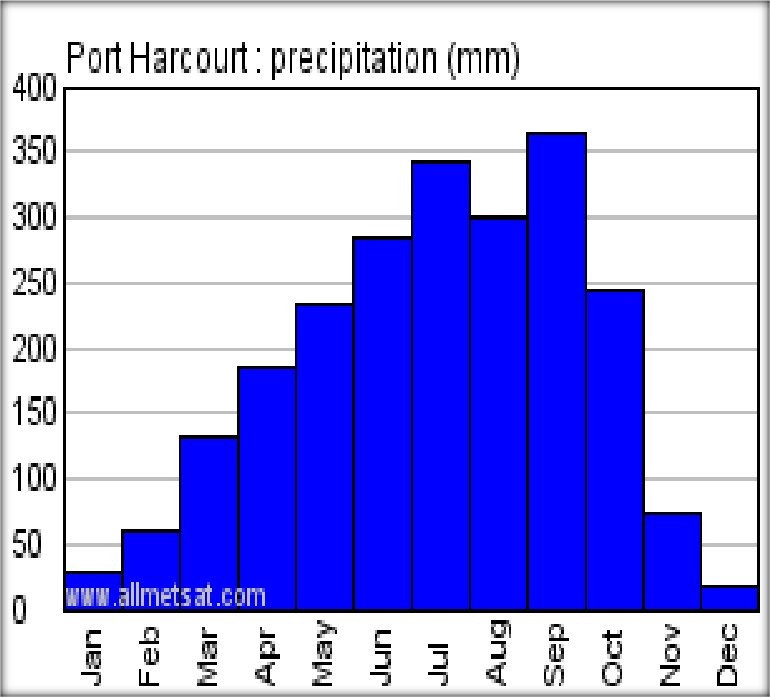450

400

350

300

250

200

150

100

50

0
J F M

A M J J

A S O N D

PLANNING CONSIDERATIONS
    - Access and Circulation:

The site is accessible by Eastern bypass through Trans –Amadi Industrial layout; it is located within the southern section of Port Harcourt. It can also be accessible through various pedestrian routes emanating from the neighbouring residential zones. This will be dutifully respected in the cause of designing.
The site is in close proximity to the State secretariat, the Nigerian marine base, Trans Amadi Industrial Layout, Orobum Vimmage (now called Obunabali). Ogbunabali bound the site on the East, the far North by Trans Amadi Industrial Layout, to the West by the Amadi flat and old GRA Residential Quarters and the South by Marine Base.

4.4.2 Gradient and Slope:

The site gently slopes from the West to the East, and has a natural drainage system which empties into the Amadi Creek. The natural land scape consists of scattered palm trees with rich foliage and a fine layer of short grass. In the background however is a rain forest that consists of thick vegetation as a characteristic of rain forest region. There are presently no particular features existing on the site. The soil is wet and marshy, but well drained with a low to moderate audibility and runoff potential. The soil will present a little constraint to development due to its marshy nature, but proper care will be taken in designing the foundation for the complex.

Solar Radiation:

The solar radiation and ventilation will principally influence the orientation of the building on the site as the site is not restricted in nature. The shorter sides of the building will face the E/W direction, and when this is not practicable, sun-shading devices shall be dutifully employed.

Wind Direction:

Prevailing winds are the North East trade winds and the South West monsoon winds. The North East trade winds are prevalent during the drier months between November and February, because of the long distance the wind travel from (North to South), they come with little or no force. These winds are usually not very dusty. The Southwest winds on the other hand are prevalent in the rest of the months of the year and come with a swing force due to the cities’ proximity to the Atlantic Ocean. The strongest winds are recorded between the months of May to October.

- Dry season: the tropical continental air mass (Hamattan wind) picks up little or no moisture from the Sahara desert and therefore is dry.

- Wet season: the tropical maritime air mass influences the whole country during this season because it comes from the Atlantic ocean to the south and drops its moisture progressively northward. Rainfall diminishes from south to north. 9th mile corner, Enugu shows the influence of south – west tropical maritime air masses throughout the year and Hamattan fails to break through as a strong feature.

Noise:

Noise can be defined as an unwanted sound; it is an ever increasing problem. Sound in the form of noise is capable of causing distraction, which both internal and external generate a problem. The agents of noise on and around the site include;
- Generator houses

- Heliport parking lots/mechanical spaces

- Existing industries

Such destructive noise can be controlled by employing one or more of these methods;

- Insulation of the exterior and internal walls to keep out and absorb external noise

- Within the room, the use of carpets, suitable wall finishes and sound absorbent ceiling materials will prevent the aggravation of noise in the space by way of sound reflections but cannot be expected to eliminate significant noise space.
- Zone quite spaces away from noisy spaces.

- Location of function that create noise together.

- Outside the building, use vegetative cover such as tress, creepers etc

Orientation:

This refers to the positioning of the building with respect to the prevailing wind direction, weather conditions, solar radiation, climatic characteristics and the cardinal points of the earth. Proper orientation protects the building from adverse weather effects. The area with regards to the sun and its effect plays a significant role in the siting of the Diasater Management Centre. The Diasater Management Centre must be duely positioned to protect participants from the harshness of the sun’s rays at peak periods. For ventilation purpose, the main direction is the SW/NE orientation; this will be encouraged as much as possible.
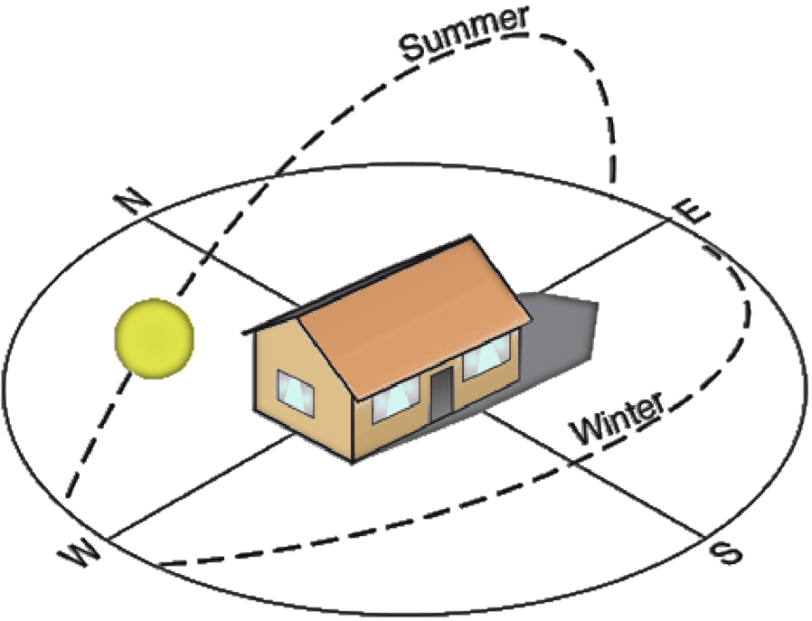Building Orientation

Vegetation:

The broad belts of plant group are forests and savannah.

Forest:

- Salt water swamp

- Fresh water swamp

- High forest

Savannah:

- Guinea savannah

- Sudan savannah

- Sahel savannah

DESIGN CONSIDERATIONS

Certain factors must be taken into consideration when producing a design for a Disaster Management building. These factors influence all aspect of the design and must therefore be carefully looked into if a befitting design must be provided. These factors include:

- Technical data

- Spaces and their relationships

- Materials of Construction

- Aesthetics

- Services

- Lighting

- Ventilation

- Thermal comfort

- fire safety

- drainage

TECHNICAL DATA:
The main structural system will be reinforced concrete columns and beams (frame structure). Precast where necessary suitable to support the walls and all the slabs.

Floors:
This is the lower surface of a room, on which one may walk. All floors shall be concrete slabs. The floor finishes will vary from one part of the complex to the other depending on the function of each space. The requirement for the qualities of any finish is:
- it must be durable

- it must be easy to clean and maintain

- it must be of good acoustic quality

- it must have good appearance to fit the purpose of the space The possible floor finishes to be used are;
- carpet (inherent acoustic requirement is high)

- wood

- terrazzo

- Marble tiles.

Walls:

This is a continuous vertical brick or stone structure that encloses or divides an area of land or space in a building. The walls will be built with bricks or sandcrete blocks. However, there will be a cavity inside the wall for acoustic materials.
Wall finishes are like the floor finishes, they will vary from one space of the building to another depending on the function of the space and the degree of exposure of the atmosphere. The criteria for determining the suitability of the wall finishes depends on;
- Fire resistance

- Appearance

- Durability

- Resistance to atmospheric conditions The possible finishes to be used include;
- Ordinary sand cement plaster

- Staggered stud

- Curtain

Roof:
This is the structure forming the upper covering of a building. The construction of the roof will vary with the span, the following will be considered;
- Solar radiation

- Drainage

- Resistance to fire

- Cost

Space decks for very long span will be used. Steel trusses will be used for shorter span and in any case, the covering will be of cement roofing sheets.

Ceiling:

This is the upper interior surface of a room or other similar compartment, an upper limit, typically one set on prices, wages, or expenditure.
Suspension of lightweight ceiling will be adopted where sound insulation can be a critical factor, such ceiling will be fixed to the structural ceiling by long resistant hanger. It may also be used for hidden ventilation duct and other services. The lightweight ceiling is generally in pre-plastered, channelled reinforced wood wool slabs. The conference hall will use movable ceiling while other spaces will use the ordinary plaster or ½ fireboard.

Doors:

This is a movable, usually solid, barrier for opening and closing an entranceway, cupboard, cabinet, or the like, commonly turning on hinges or sliding in grooves.
The criteria for selecting and providing the doors are;

- Operation

- Safety and security

- Durability

- Sound insulation properties

- Appearance

Design of the door:

The door to the spaces that require sound insulation will be double and will have separate frames which are held together with interposing layers of insulation or will have locks. Flush or caved doors will be used where sound insulation does not apply. Glass doors will also be used for same purposes.

Windows:

This is an opening constructed in a wall or roof that functions to admit light or air to an enclosure and is often framed and spanned with glass mounted to permit opening and closing.
The criteria for selecting and providing windows are;

- Sound insulation (where necessary)

- Durability

- Lighting capability

- Ventilation capability

Design for windows:

If windows must be provided in spaces that require sound insulation, they will be double glazed while other spaces will have glass windows: levered or sliding windows.
The double glazes where used will be made with 10mm (3/8 inches) and 6.5mm (14inches) thick pane of glass, minimum spacing beyween the pane of glass will be 200mm.

SPACES AND THEIR RELATIONSHIPS:

The spaces in the Disaster Management Centre are organized with respect to zoning them into related functions. They are zoned according to public area, semi – public and private area. This is for effective use of spaces. The relationship between one space and another like the maintenance offices should be close to the maintenance/repairs section, for easy communication. The spaces in the Disaster Management Centre include;
Exterior elements on the site

- The main building

- The clinic

- The staff accommodation

- The power house

- Parking lots

- Landscaping and sign post

- hanger

- THE MAIN BUILDING: The sections in the Disaster Management Centre include:

- Administrative unit

- Control unit

- Training unit

- Maintenance unit

- The Aviation operation

- The Marine operation

- The land operation

- Finance unit

- Relief and rehabilitation unit

- Ware house

- Conference hall

- Search and rescues unit.

The Administrative unit:

This is the first point of call as one gets into the building, this department is responsible for all staff matters, appointments, records of service, welfare of officers, employment etc. This section is responsible for personnel functions and employee services, Personnel functions cover tracking staff and disaster deployments, obtaining local hires, arranging billeting, and processing payroll while Employee services include providing for personnel health and safety, overseeing access to medical services, and ensuring security of personnel, facilities, and assets.
Spaces in the administrative unit are as follows

- Director’s office

- Deputy director’s office

- General office

- Lands officer

- Marine officer

- Aviation officer

- Record office

- Secretary’s office

- Welfare office

Control Unit:

This is one of the most important units in the centre, it takes care of all emergency calls and make sure they are transmitted as clearly and as fast as possible to the squad responsible for that particular disaster. The unit will have communication gadgets such as pager systems, walking talkie, phones, radars, satellites, reception systems global positioning system (G.P.S), to guide the development of a comprehensive information and communication system and establish integrated communication links with all disaster risk management role players.
This unit has two major tasks: the collection, processing, analysis, and dissemination of information about disaster operations to support planning and decision making in the field and at the headquarters’ levels; and the coordination of short- and long-term planning in the field.
Spaces in the control unit are:

- Control officer

- Record room

- On-air studio

- Transmission room

- General office

The Training unit:

This unit will be responsible for the training of the rescue squads and will feature necessary fitness facilities. It is also a unit that aids to promote a culture of risk avoidance among people by capacitating role players through integrated education, training and public awareness programmes informed by scientific research.
The department of training develops the curriculum and coordinate the human resources development of the agency in addition to catering for the training needs of the staff on modern skills which qualify them to be good disaster managers as obtain in other part of the world.
Spaces in the training unit include:

- Lecture halls

- Toilets

- Tutor’s offices

- Secretary’s office

The Restaurant:

This section provides food for all the workers in the disaster management centre especially for the watch officers in the crew room

The Maintenance Unit:

This unit takes care of all repairs and daily/weekly check of all the vehicles used for search and rescue operations. The automobile workshop, electrical workshop, vulcanizing workshop, tailor workshop, spare parts store etc. are all part of the maintenance department.
Spaces in the maintenance unit include;

- Engineers offices

- Toilets

- Crew room

- General office

- Appliance bay/workshop

- Bathrooms

∗

Zonal Unit:

This unit handle all issues of disaster within the zones in port-Harcourt, each zone has a representative in the disaster management centre.
Spaces in the zonal unit include:

    - Zonal offices

The Aviation Operations:

This section takes care of disasters not easily assessable by land; it involves the use of helicopters necessary for rapid response to disasters that occurred in difficult or far terrain.
Spaces in the Aviation unit include;

- Aviation officer

- Toilets

- Pilot’s office

∗

The Marine Operations:

This unit takes care of offshore disasters such as boat mishap.

Spaces in the marine unit include;

- Marine officer

- Toilets

- General office

- Secretary’s office

The Land Operations:

This unit will take care of out-breaks and other land accidents where necessary. It will involve provision of parking lots for ambulances; fire fighting vehicles, motor bikes, personnel carries etc.
Spaces in the land operation unit include;

- Geologist office

- Toilets

- General office

The Finance Unit:
This section plans, organizes, and directs logistics operations that include control and accountability for supplies and equipment; resource ordering; delivery of supplies, equipment, resource tracking, facility location, setup, space management, building services, general facility operations, Transport coordination and fleet management services, and salary of staff.
Spaces in the finance unit include;

- Chief accountant’s office

- General office

- Secretary office

- Account officer’s office

The Relief and Rehabilitation Unit:

This unit provides leadership to build, sustain, and improve the coordination and delivery of support and relief to citizens and State, local, tribal and territorial governments to save lives, reduce suffering, protect property and recover from all hazards. These units also receive the materials for relief and properly distribute it to affected people.

Library section:

This unit is in charge of all the books in the disaster management centre Spaces in the library unit include:
- Chief Liberian office

- Toilets

- Library hall

- Liberian office

Search and rescue unit

This unit takes care of all search and rescue operations, it contains offices for the search and rescue team

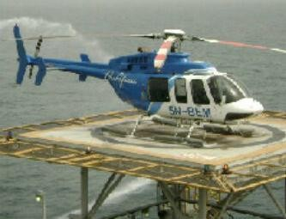

THE CLINIC:
Time is a crucial element in Disaster Management. In recognition of this, the agency will have a clinic that will aid in first aid treatment of victims, and also, there will be ambulances that will convey seriously injured people to bigger hospitals and also convey the dead to the mortuary.

THE STAFF ACCOMMODATION:

Accommodation will be provided for resident staff of the organization and also for resident doctors that will handle the clinic and all medical affairs.

HANGER:

This is a parking space for a helicopter used for emergency rescue; it is easily assessable by the personnel when called for an emergency.

Hanger

Source: Google images

MATERIALS OF CONSTRUCTION

Certain factors are considered before a choice is made on the types of materials to be used, these factors include the following: function, durability, technology and maintenance.

  - Function: this has to do with purpose, structure and aesthetics of the material. It should be welcoming and attractive.

  - Durability: any material chosen should be able to stand the test of time and resist weather element.

  - Technology and Maintenance: the functionality and durability of a material is often maimed by lack of installation technology and means of maintaining it.

The materials used for the building are as follows; Sandcrete block, concrete, steel, glass, timber, Long span aluminum roofing sheet etc, all these are used to achieve a strong, good aesthetics and stable Disaster Management building.

AESTHETICS:

The centre also build reputation based on aesthetics and appeal. To this effect, materials also used for construction will be employed to special skillful use to create that erogenic tasteful finish to the façade in such a way that beckons audience and admiration. This will be done to;

  - To create a design that will consider the comfort and protection of the users.

  - To create a design where simple forms are used to functional architectural piece

SERVICES:

Building services are the facilities and installations provided in building to ensure safety, security, and comfort of the occupants or users. Services oversee the internal environment and environmental impact of a building. It essentially brings buildings and structures to life. Building services engineers are responsible for the design, installation, operation and monitoring of the mechanical, electrical and public health systems required for the safe, comfortable and environmentally friendly operation of modern buildings.

These services include; energy supply, communication lines, security and safety, escalators and lifts/stairs, heating and air conditioning (HVAC), water supply, drainage, plumbing, and ventilation.

Energy Supply (electricity):

Electricity supply in Port Harcourt, on the average is stable; it is the sole responsibility of the Power Holding Company of Nigeria (PHCN) to provide good electricity to the state. Apart from the main power station located in the old township section of the city, there is however a new transformer and switching installation on the Northern side of the Trans Amadi Industrial Area of the city to make sure power supply is constant. Besides, they will be a standby generator to generate electricity in case of power failure.

Communication Lines:

The disaster management centre will have adequate communication systems, the use of intercom within the building will be encourage and also, the media centre will enable to get and transfer information to the general public.

Air Conditioning:

Air conditioning refers to the cooling and dehumidification of indoor air for thermal comfort. In a broader sense, the term can refer to any form of cooling, heating, ventilation or disinfection that modifies the condition of air. An air conditioner (often referred to as AC or air con.) is an appliance, system, or mechanism designed to stabilize the air temperature and humidity within an area (used for cooling as well as heating depending on the air properties at a given time), typically using a refrigeration cycle but sometimes using evaporation, most commonly for comfort cooling in buildings

Security and Safety:

Security is the degree of protection against danger, loss, and criminals. Individuals or actions that encroach upon the condition of protection are responsible for a "breach of security." A condition that results from the establishment and maintenance of protective measures that ensures a state of inviolability from hostile acts or influences. The Disaster Management Centre will have a team of security men to tackle the problems of security in the building.

Safety is the state of being "safe" (from French sauf), the condition of being protected against physical, social, spiritual, financial, political, emotional, occupational, psychological, educational or other types or consequences of failure, damage, error, accidents, harm or any other event which could be considered non-desirable. This can take the form of being protected from the event or from exposure to something that causes health or economic losses. It can include protection of people or of possessions. The center will use alarms and other safety gadget to tackle the issue of safety.

Water Supply:

The Port Harcourt metropolis is linked with the riverine areas of the state via three major watersides; Abonnema Wharf, Okirika Waterside, and the Marine Base. Water supply to the disaster centre is gotten from the Marine Base and also from the creek close to the centre.

Drainage:

In Port Harcourt where rain is heavy, proper provision will be made to properly drain runoff water. this will be done by;

  - Sloping roof and proper direction of rain water pipes.

  - Proper landscaping around the site in other to avoid erosion.

  - Use of drainage gutters.

Plumbing:

This is the system of pipes, fittings, valves, drains, tanks, and other apparatus required for the water supply, heating and sanitation in the building. The centre will provide present plumbing systems.

LIGHTING:

Lighting is the deliberate use of light to achieve a practical or aesthetic effect. The object of good lighting is to achieve a high standard of visual efficiency so that eyestrain, slow inaccurate work by the staff, officers etc are prevented. Good lightening depends upon the amount of light at various places of work that is; workshops, control rooms, offices etc. the quantity of light required for different kind of work may require different levels of illumination. This is so because, the smaller the detail of work, the greater the amount of light necessary to see clearly. While the quantity of light is been considered, we also require light for clear vision and for avoiding accident. Lighting irrespective of the intensity is of two types:

Natural Daylight:

This is diffused from the sun; the factor affecting daylight design under the valuation on the amount and source of daylight caused by positioning and intensity of the sunlight.
Sources of Daylight

  - Direct solar radiation

  - Diffuse radiation

  - Reflected light from bright surfaces

Artificial Lighting:

This is any lighting that is not sunlight, it is usually man-made. Artificial lighting involves the use of lighting fixtures like fluorescent bulbs, candles, tungsten incandescent, low pressure sodium vapour, light emitting diode etc.

Function of light in building

This comprise of four main aspects:

  - Amenity

  - Visual task

  - Safety

  - Aesthetic effect

  - For comfort

  - For creating quality interior appearance

•

VENTILATION:

Ventilation is the process of “changing” or replacing air in any space to provide high indoor air quality. Ventilation is used to remove unpleasant smells and excessive moisture, introduce outside air, to keep interior building air circulating, and to prevent stagnation of the interior air. It is also the process by which stale air within a building is constantly replaced by fresh air from outside. A minimum of 20 – 30% of air changes per hour is required for human comfort in the tropics. Ventilation comes in two aspects namely:

Natural Ventilation:

This is the ventilation of the building with outside air without the use of fans or other mechanical system. It is influenced by the building orientation, presences of vegetation, presences of water bodies and size of fenestration and openings. Natural ventilation efficiency can depend to a large extent on the fenestration level of the exterior wall, thus affecting the quality of air as regards temperature of the room or space. Natural ventilation may also be useful in the conference halls and lecture rooms, but is plagued by being a medium to sources of disturbance such as noise, hence the use of artificial ventilation to complement the efforts of ensuring a more cozy and productive environment within the spaces as it gives the advantage of not inviting the exterior sources of disturbance and allowing for measures to exclude interior disturbance sources too.

Artificial Ventilation:

This is all about the use of mechanical means to provide ventilation like the use of Air conditioner, fans etc.

THERMAL COMFORT:

This is the condition of mind that expresses satisfaction with the thermal environment and is assessed by subjective evaluation. Thermal comfort is affected by heat conduction, convection, radiation, and evaporative heat loss. Thermal comfort is maintained when the heat generated by human metabolism is allowed to dissipate, thus maintaining thermal equilibrium with the surroundings. Thermal comfort is affected by heat conduction, convection, radiation and evaporation heat loss.
Thermal comfort is maintained when the heat generated is allowed to dissipate, thus maintaining thermal equiibrum with the surrounding. The temperature of air, and the mean relative humidity of the environment play important roles in the determining the level of thermal comfort in the environment. Therefore it is very important to ensure adequate ventilation through the building and the environment. The centre will make use of HVAC (Heating Ventilation AirConditioning) unit to control the thermal environment. Natural ventilation will be employed also to reduce the need for mechanical cooling or aeration. Both natural and artificial methods of ventilation will be applied where use is necessary so as to control the air temperature and consequently curb thermal stress which is an enemy to concentration and fosters absent mindness and distraction.

FIRE SAFETY:

Fire is the rapid oxidation of a material in the exothermic chemical process of combustion, releasing heat, light and various reaction products. Fire safety refers to the precautions that are taken to prevent or reduce the likelihood of fire that may result in death, injury, or property damage, alert those in the structure to the presence of an uncontrolled fire in the event one occurs, better enable those threatened by a fire to survive in and evacuate from affected areas, or to reduce the damage caused by fire. Fire safety measures include those that are planned during construction of a building or implemented in structures that are already standing, and those that are taught to occupants of the building. The risk of fire existing in this project particularly in areas where inflammable petroleum and ignition sources. Fire exist when ignition develops within combustible materials in air. An adequate fire protection plan is therefore essential and these must work on the assumption on that unwanted fires may still occur despite efforts to prevent them. Various measures must be taken to minimise these through fire incidents. The severity of a fire depends largely on the amount of oxygen available, the supply of fuel and a temperature high enough to cause ignition of the material. If one of the conditions is missing, the fire is impossible. Fires are divided into three classes;
- Class A fire: Fires that involve flammable liquids or liquefiable solids such as petrol/gasoline, oil, paint, some waxes & plastics, but not

cooking fats or oils

- Class B fires: Fires that involve flammable gases, such as natural gas, hydrogen, propane, butane

- Class C fire: Fires that involve combustible metals, such as sodium, magnesium, and potassium

- Class D fire: Fires that involve any of the materials found in Class A and B fires, but with the introduction of an electrical appliances, wiring, or other electrically energized objects in the vicinity of the fire, with a resultant electrical shock risk if a conductive agent is used to control the fire
- Class E fire: (Class E) now no longer in the European standards Class C Fires involving cooking fats and oils. The high temperature of the oils when on fire far exceeds that of other flammable liquids making normal extinguishing agents ineffective.
- Class F and Class K: Fires are sometimes categorized as "one alarm", "two alarm", "three alarm" (or higher) fires. There is no standard definition for what this means quantifiably, though it always refers to the level response by the local authorities. In some cities, the numeric rating refers to the number of fire stations that have been summoned to the fire. In others, the number counts the number of "dispatches" for additional personnel and equipment.
In designing against fire, three aspects of fire incidents must be considered namely;
- The time before the fire occurs

- Period when fire actually occurs

- Period following fire

The measures for fire protection include:
- Passive fire protection

- Active fire protection

- education

  - Passive fire protection:

This involves use of integral, fire-resistance rated wall and floor assemblies that are used to form fire compartments intended to limit the spread of fire, or occupancy separations, or firewalls, to keep fires, high temperatures and flue gases within the fire compartment of origin, thus enabling fire fighting and evacuation.

  - Active fire protection:

manual and automatic detection and suppression of fires, as in using and installing a Fire Sprinkler system or finding the fire (Fire alarm) and/or extinguishing it.

  - Education:

ensuring that building owners and operators have copies and a working understanding of the applicable building and fire codes, having a purpose-designed fire safety plan and ensuring that building occupants, operators and emergency personnel know the building, its means of Active fire protection and Passive fire protection, its weak spots and strengths to ensure the highest possible level of safety.

SPACE REQUIREMENTS

The space requirements in the Disaster Management include:

  - Administrative unit

  - Control unit

  - Training and fitness unit

  - Maintenance unit

  - The Aviation operation

  - The Marine operation

  - The land operation

  - Finance unit

  - Relief and rehabilitation unit

  - Clinic section

  - The staff accommodation

  - The hanger

The Administrative Unit:

This is the first point of call when you get into the building, this department is responsible for all staff matters, appointments, records of service, welfare of officers, employment etc. This section is responsible for personnel functions and employee services, Personnel functions cover tracking staff and disaster deployments, obtaining local hires, arranging billeting, and processing payroll while Employee services include providing for personnel health and safety, overseeing access to medical services, and ensuring security of personnel, facilities, and assets.

Design consideration

- Offices should be provided for various management staff, secretarial staff, and typist

- This is the link space between the public and the facility, therefore, it should be properly organized

- This should have spaces designed to take care of all records and statistics of the facilities

- An information section should also be present in this unit

- Offices should be provided for the heads of all disaster officers.

Control Unit:
This is one of the most important units in the centre, it takes care of all emergency calls and make sure they are transmitted as clearly and as fast as possible to the squad responsible for that particular disaster. The unit will have communication gadgets such as pager systems, walking talking phones, radials, satellites, reception systems global positioning system (G.P.S), to guide the development of a comprehensive information and communication system and establish integrated communication links with all disaster risk management role players.
This unit has two major tasks: the collection, processing, analysis, and dissemination of information about disaster operations to support planning and decision making in the field and at the headquarters’ levels; and the coordination of short- and long-term planning in the field.

Design consideration

  - It should be isolated from all hazards that might interfere with prompt transmission of alarms

  - Ample emergency power should be provided so that communication equipment will continue to function

  - It should be completely sound controlled for optimum hearing ability

  - It should be completely air conditioned

  - It should have maximum control of streets and quarters conditions

The control unit is the operating room where all alarms, security and functions are controlled, therefore, it should have; Telephone switchboards, Radio control console, and Voice amplification control

The Training Unit:

This unit will be responsible for the training of the rescue squads and will feature necessary fitness facilities. It is also a unit that aids to promote a culture of risk avoidance among people by capacitating role players through integrated education, training and public awareness programmes informed by scientific research.
The department of training develops the curriculum and coordinate the human resources development of the agency in addition to catering for the training needs of the staff on modern skills which qualify them to be good disaster managers as obtain in other part of the world.

Design consideration

  - Offices for the trainees

  - Lecture rooms for students

  - Laboratories

  - Stores

•

The Maintenance Unit:

This unit takes care of all repairs and daily/weekly check of all the vehicles used for search and rescue. The automobile workshop, electrical workshop, vulcanizing workshop, tailor workshop, spare parts store etc. are all part of the maintenance department.
Design consideration

  - Workshops are provided for simple repairs

  - Workshops are provided for electrical machines

  - Spaces are provided for storekeeper and stores

  - Offices for mechanics and electricians

The Aviation Operations:
This section takes care of disasters not easily assessable by land; it involves the use of helicopters necessary for rapid response to disasters that occurred in difficult or far terrain. The Disaster Management Centre will have a hanger meant for the maintenance and repairs of the helicopter.
Design consideration

- Offices for worker

- Hangers for helicopter

The Marine Operations:

This unit takes care of offshore disasters such as boat mishap. Design consideration
  - Offices for workers

  - Workshops for repairs

  - stores

The Land Operations:

This unit will take care of out-breaks and other land accidents where necessary. It will involve provision of parking lots for ambulances; fire fighting vehicles, motor bikes, personnel carries etc.
Design consideration

  - offices for workers

  - parking lots

  - Easy access outside the base in case of emergencies.

The Finance Unit:

This section plans, organizes, and directs logistics operations that include control and accountability for supplies and equipment; resource ordering; delivery of supplies, equipment, resource tracking, facility location, setup, space management, building services, general facility operations, Transport coordination and fleet management services, and salary of staff.
Design consideration

  - offices for staff

  - store for equipment

  - Coordinating of all financial affairs.

The Relief and Rehabilitation Unit:

This unit provides leadership to build, sustain, and improve the coordination and delivery of support and relief to citizens and State, local, tribal and territorial governments to save lives, reduce suffering, protect property and recover from all hazards. These units also receive the materials for relief and properly distribute it to affected people.

Clinic Section:

Time is a crucial element in Disaster Management. In recognition of this, the agency will have a clinic that will aid in first aid treatment of victims, and also, there will be ambulances that will convey seriously injured people to bigger hospitals and also convey the dead to the mortuary.
Design consideration

  - Offices for doctors

  - Record room

  - Card room

  - Male ward

  - Female ward

  - Children’s ward

  - Toilets

  - Mini theatre

  - First aid room

Accommodation Unit:

Accommodation will be provided for resident

Design consideration

  - Rooms for resident staff

Parking Lots:

There will be different parking lots, this includes:

  - Emergency parking bay for emergency vehicles

  - Visitors parking lots

  - Staff parking lots

  - Hangers for helicopters

CHAPTER FIVE DESIGN SYNTHESIS

PLANNING AND DESIGN PHILOSOPHY

Philosophy of design is the study of assumptions, foundations, and implications of design. The field is defined by an interest in a set of problems, or an interest in central or foundational concerns in design. Exceptional design must be approached from the client’s perspective. The needs, wants, desires, purpose of the building and vision of our clients and/or occupants who will ultimately use the space must be thoughtfully considered and reflected in the end result. So we centre everything we do on these values and our philosophy of designing responsible, environmentally conscious, and aesthetically pleasing solutions that leave a positive impact.
The essence of designing a Disaster Management Centre is to provide the facilities and environment requiste to foster knowledge and learning about the importance of the management and control of disaster and disaster related issues. The Centre aims at developing a creative approach to understanding and providing solutions to design problems with the motivation to seek new solutions to the issues and challenges facing a developing country (Nigeria) with disasters and also preach the philosophy of prevention and mitigating all formsof disasters in the modern world.
My design philosophy steams from Architecture of ideas, sustainable innovations and substantive intensions, an architecture that accommodates for humankind and the habitability of buildings to encourage consistent quality and design expression within the state while allowing for individuality of architectural expression by its Owners.

DESIGN CONCEPT

A design concept is an idea for a design. Concept design (or outline design) requires that the architect grapples with the real issues of form and bulk, scale and mass and the generic appearance of a building within its surrounding urban context, resolving and encapsulating the principles of the scheme. Concept design implies an idea, or range of ideas, a development approach, a guiding concept and design intent. It resolves the issue of ‘what’ and ‘how much’ and begins to set the stage for understanding ‘how’. Concept design explores the resolution of the brief, implied or set out in the feasibility and assessment stage. The conceptual approach places the quantum of development intelligently on the site.
The buildings of the Centre reflect a design that is rich in character, aesthetics, functional, environmentally sustainable, relate to the spirit of the place, and take the fullest advantage of the site's qualities. The concept of the Disaster Management Centre design steams from the purpose of the building, the behaviour of the environment, the compatibility of the building to its environment, the occupants/users of the building; into considerations the metaphor, juxtaposition etc., this will help in the derivation of the design concept.
The design concept of the Disaster Management Centre is gotten from an aerial view of an aeroplane. Turn out time is the key element in any Search and Rescue Centre, the most important factor is in grouping functional spaces in primary adjacency pattern so that movements to exit from the Centre take the least possible time. The concept of this design is that which will facilitate safe and swift movement of men, materials and equipment at short notice.

CONCEPT DERIVATION

The concept was derived from the aerial view of an aeroplane, and then the wings are cut out to reduce its length, the back is then recessed to be used as the entrance into the building. Then, the form below is the achieved.

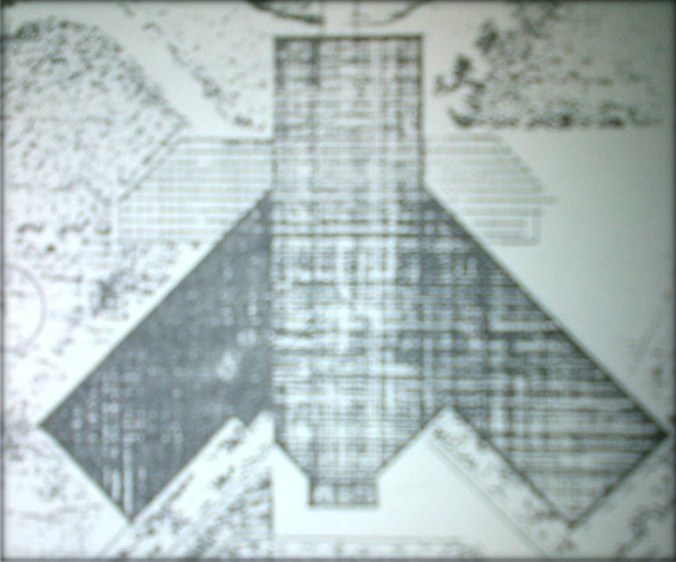The concept of the building was used to achieve an architectural space that is comfortable and meet the need for proper communication within the building and the site. The design for effective communication within the building and site formed the heart of the design process.

FORM OF THE BUILDING

The best designs are based on purpose and function; this may determine the form of the building. When a design solves a functional problem as simply and elegantly as possible, the resulting form will be honest and timeless. The form achieved for the design of the Disaster Management Centre steams from an aerial view of an aeroplane. I used this form to portray the purpose and use of a building whereby the form of this building will speak the purpose, of which it is meant for, and also:

    - To create a design that will consider the comfort and protection of the users.

    - To create a design where simple forms are used to achieve a functional architectural piece

    - To avoid conflict in the flow of traffic both within and around the structure.

    - To provide a design that provides undisrupted flow of activities.

    - To provide a straight – forward design that provides individual needs without difficulty.

    - To create a design that provides activities that gradually flows from the main activities within to the outdoor activities within the environment.

CONCLUSION

Architecture is achieved when all intentions are satisfied in one integrated whole. The design which fails to meet essential practical requirements will fails as a building and as architecture.
The Disaster Management Centre building reflects a design that is rich in character, aesthetics functionality, environmentally sustainable, relate to the spirit of the place, and take the fullest advantage of the site's qualities.
A very high priority is energy conservation with a tendency towards simple and economical means such as orientation, passive systems, insulation, solar heating, day lighting, shading, and natural ventilation. Building materials are considered for their environmental impacts and are often durable, natural, and designed to age gracefully.

Bibliography

Apr-Jun 2012 Journal Of Sustainable Development And Environmental Protection Vol.2 No.2

Auf Der Heide, E. (1989). Disaster Response: Principles of Preparation And Coordination. Mosby: ISBN 0801603854.

Disaster Management Act 57 Of 2002

Disaster Preparedness Guidelines, OFDA Disaster Preparedness Seminar Handbook, 1976. Disaster Preparedness Guidelines, OFDA Disaster Preparedness Seminar, St. Lucia, 1979. Ehlanzeni District Municipality IDP Review 2013/14
Emergency Disaster Relief By JICA. Official Web-Page Of The JICA. Emin, N. (2011). Emergency Response Management. Japan:
Fire And Disaster. Actual Condition And Prospects Of Fire And Disaster Management Administration. Fire And Disaster Management Agency.

Fire Service Law. Published By International Fire Service Information Center. 2005.

Imaah, N. O. (June, 2008). Science Environmental Management.

National Environment Management Authority March, 2010 Kenya

Quentin, P. (2002). The Architect’s Handbook. Oxford: Blackwell Publishing.

Rattan, P. (2013). Role Of Library And Information Centres In Disaster Management. Pine Town: Africon (Pty) Ltd

Schramm, D. & Hansen, R. (1993). Aim & Scope Of Disaster Management ,Study Guide And Course Text. Wisconsin-Madison: Jason Press. Stock, R (2003). Microsoft Encarta Encyclopaedia.

The Beacon, October 2012, Nebraska Emergency Management Agency

The Focus Of The Disaster Risk Management Plan Must Be As Required By The Disaster Management Act, 2002 (Act No. 57 Of 2002),
Urmanov, R C (1982). Climatic–Environmental Model of Space for Architectural Design, In Basics Of Architectural Design. Russia: Tomsk Gosuniversitet

