Poznań University of Life Sciences

Faculty of Economics

Field of studies: Agri-food Economics and Trade Album No. 146328

# Kuluta Haruna Bernard-Zoyaar

**DEVELOPMENT OF TECHNICAL INFRASTRUCTURE AND THE STATE OF AGRICULTURE AND RURAL AREAS IN NIGERIA**

# POLISH VERSION

**MSc thesis**

**Department**: Department of Economics and Economic Policy in Agriculture **Seminar**: Scientific title or academic degree, name and surname of seminar leader **Supervisor**: Dr. Aldona Standar

Accepted

# ..................................................................

(date and signature of supervisor) (10 p)

Poznań, 2021

# TABLE OF CONTENT

Abstract Introduction

Aim And Scope Of Research Materials And Method

# CHAPTER ONE

**THE ESSENCE OF TECHNICAL INFRASTRUCTURE AND ITS ROLE IN STIMULATING DEVELOPMENT**

* 1. Technical Infrastructure: Definition, Classification and Functions
  2. Sources and barriers to financing technical infrastructure development
  3. The influence of technical infrastructure on the development of agriculture and rural areas-theoretical discussion

# CHAPTER TWO

**SOCIOECONOMIC CHARACTERISTICS OF NIGERIA**

* 1. Background Information
  2. Economy and Finance
  3. Population and Social condition

# CHAPTER THREE

**THE STATE AND DEVELOPMENT OF TECHNICAL INFRASTRUCTURE IN NIGERIA**

* 1. The Country's Strategy on Technical Infrastructure
  2. State and Development of Technical Infrastructure
  3. Financing Sources of Technical Infrastructure
  4. Case Study of Selected Technical Infrastructure Project
     1. Mambilla Hydropower Project

# CHAPTER FOUR

**DIAGNOSIS OF THE STATE OF AGRICULTURE AND RURAL AREAS**

* 1. Overview Of Nigeria Agricultural Sector
  2. Road Infrastructure
  3. Water Supply Infrastructure
  4. Sewage Treatment Infrastructure
  5. Gas Infrastructure
  6. Electricity Infrastructure
  7. Internet Infrastructure

# Conclusion

**ABSTRACT**

This study was undertaken to assess the development of technical infrastructure in Nigeria with a particular interest in the Nigeria agricultural sector. A qualitative research method was employed and data was obtained from credible sources. Applying library/doctrinal strategy, the state of Nigeria’s agriculture and rural areas were diagnosed. The findings of this study showed that Nigeria have made little progress over a ten year period (2011-2020) with regards to its agricultural production. The findings of this study also revealed that rural roads in Nigeria are in a deplorable state, making it difficult for farmers in transporting their goods from the market to the farm. Road network in Nigeria is a major impediment to agricultural productivity and rural development. Other technical infrastructures that are either absent or non- functional in the country includes, water supply, sewerage management, gas, electricity, and internet. The diagnosis of this study further shows that Nigeria’s agricultural sector suffers corruption and leadership malfunction. This study highly recommends the implementation of agricultural policies aimed at the acquisition, accessibility, and utilization of technical infrastructure that will boost agricultural production and rural development.

# INTRODUCTION

The distribution of proven and proved yield-enhancing agricultural technology aimed at achieving national development is significantly influenced by both physical and institutional infrastructure. Development as a concept has been thoroughly researched as a wide and inclusive term used to explain economic growth and social progress. However there has been a shift of focus from industrial and economic development as defining forces to societal transformation. Gran (1983) defined development as a social and practical process aimed at the liberation of human potential by allowing people to gain the most socially feasible and practical control over all available resources required to meet basic human needs and ensure security. The poor, in particular, are free to participate effectively and meaningfully in social, political, and economic exchanges for economic advancement and people empowerment in this framework. In other words, development entails the release of human potential in order for people have full control over resources in order to meet their basic human needs.

Therefore, development is for and by the people. Burkey (1993) defined development from the perspective of individual to general; as a process through which an individual gains self-respect and becomes more self-assured, self-reliant, cooperative, and tolerant of others by being aware of his or her flaws as well as his or her capacity for positive change. This is accomplished by collaborating with others, learning new skills, and actively participating in their communities' economic, social, and political development. Development, according to Todaro and Smith (2006), is a process aimed at achieving equitable social and economic change of society through institutionalized social institutions and people's positive attitudes in order to achieve expedited and higher growth and poverty elimination. Todaro and Smith agreed with Korten (1990) that development is a process of achieving equitable societal change through structural capacities.On the one hand, it is also about the sustainability of the resources.

Burkey (1993) emphasized the importance of a good and popular mindset for collective collaboration and tolerance in development.Pearson (1992), development involves "an improvement in the use of available resources, either qualitatively, quantitatively, or both.It also asserts that development does not refer to a single point of view on social, political or economic progress. Instead, it's a catch-all word for a variety of approaches of moving from existing to desirable socioeconomic and

environmental states. It is pertinent to note that a rise in real national income/national output is referred to as economic growth. While economic development entails a rise in living standards and quality of life, such as literacy, life expectancy, and health care. The importance of public finance in achieving economic development cannot be overstated. It is clear that public finance have impacted the majority of developing economies, as seen by rising budget deficits. The public sector typically has an impact on the national economy through revenue allocation (taxation) and allocation of expenditure (social services), as well as possible interventions such as price controls and licensing (Linn 1975).

Reforming public finances entail making political judgements, which most governments in both developed and developing economies would prefer to avoid (Linn 1975). Public finance is critical for achieving a high rate of economic growth that can be sustained. The government use fiscal measures to boost aggregate demand and aggregate supply. Taxes, public debt, and public spending are examples of instruments. In order to combat inflation and deflation, the government employs public finance.During inflation, indirect taxes and overheads are reduced, but direct taxes and capital expenditures increase. More so, to keep the economy stable, the government employs budgetary instruments. During times of prosperity, the government raises taxes and the internal public debt. The money will be used to pay off international debt and fund new inventions. Internal expenses have been decreased.The government uses revenues and expenditures to bridge the gap between urban and rural areas, as well as between the agricultural and industrial sectors.

The government budgets for infrastructural development in rural areas as well as direct economic benefits to rural residents. The government receives taxes and spends them on infrastructure projects.It must also maintain peace, justice and security. It must also bring about socioeconomic change. It employs revenues and expenditures as fiscal instruments for all of these activities (Oyeniran, and Onikosi- Alliyu, 2016). The transformation of enterprises and immense contribution to global sustainable development across countries of the world is highly associated to technical infrastructure. The Sustainable Development Goals (SDGs) acknowledge infrastructure's supremacy as a panacea for a country's development and improving people's lives (United Nations 2016). The SDGs went into effect on January 1, 2016, as a worldwide call to action to eradicate poverty in all forms, safeguard the environment, and promote peace and prosperity for all people by 2030. The 17

Sustainable Development Goals (SDGs) were based on the achievements of the Millennium Development Goals raging from 2015-2030 which is aimed at no poverty, zero hunger, good health and well-being, encourage lifelong learning opportunities for all and high-quality education, gender equality and women's empowerment, clean water and sanitation, access to affordable and clean energy, economic growth and decent work, industry, innovation, and infrastructure, reduced inequality within and among nations, sustainable cities and communities, responsible production and consumption patterns, climate act (Casier, 2015; United Nations 2016).

Technical infrastructure has remained a critical component in any country's growth. It has been highly advocated in several articles as a catalyst in the growth and improvement of a nation, particularly in enhancing access to social, human, natural and financial resources for the nation (Aschauer, 1989; Buhr, 2008; Jochimsen, 1966; Torrisi, 2009; Egert et.al., 2009). This is because adequate infrastructure contributes to a country's prosperity through boosting economic growth, diversifying output, sustaining population expansion, reducing poverty, and improving environmental conditions (Buhr, 2008). The absence of technical infrastructure, according to Oke (2013), is one of the most major limiting factors to economic growth and the attainment of the MDGs in numerous developing nations. It was claimed that infrastructure investment was responsible for more than half of Africa's improved growth performance and company expansion between 1990 and 2005 (Oke, 2013).

Technical infrastructure is essential for sustaining growth and reducing poverty, and infrastructure planning can contribute to a country's socio-economic development. According Oyeniran, and Onikosi-Alliyu, (2016) World Bank assessment reveals that the quality of technical infrastructure has an impact on urbanization, which is directly proportionate to gross domestic product. Also, physical infrastructure, such as roads, power, and telecommunications, contribute to a country's economic growth and development (Oyeniran, and Onikosi-Alliyu, 2016). Regarding agriculture, adequate technical infrastructure increases farm production and decreases farming expenses; its rapid expansion promotes both agricultural and economic growth. Infrastructure is widely recognised as playing a critical role in generating higher multiplier effects in the economy as a result of agricultural expansion. A 1% increase in infrastructure stock should be correlated with a 1% increase in GDP in all countries (Oke, 2013). More so, historically, governance in Nigeria has been overridden by ethnic, religious, and regional interests and conflicts

(Ikeh 2011), thereby, weakening institutions, institutionalizing corruption and slowing down socio-economic development, and much more, the demise of the spirit of national stewardship and patriotism (Sarafa, 2009). Regrettably, the state, the instrument of governance within which socio-economic development is pursued, has remained continuously embroiled in these conflicts (Sarafa, 2009). Whether in the implementation of public policies, budget allocation and strategic political missions, who gets what, how and when,depends on ethnic and regional cleavages with development patterns and trends absolutely characterized by these dichotomies (Oludele, 2008). In the leadership recruitment process, excellence, competence, and character have repeatedly been sacrificed on the altar of ethnic and religious considerations, hence the rise of poor leadership at virtually all levels of government. These issues, and others, represent Nigeria’s barriers to driving sustained technical infrastructure and rural development

.

# AIM AND SCOPE OF RESEARCH

The primary aim of this study is to assess the development of technical infrastructure and the state of agriculture and rural areas in Nigeria. Specifically, this study examines some agricultural indicators such as road viability and accessibility, water supply, gas, electricity and internet. The period of examination ranged from 2011 to 2020.

# MATERIALS AND METHOD

This study adopted a desktop research method. The desk-based research consisted of a document and database review of accessible information, statistics, and other data from private, federal, provincial, regional, and municipal sources. A statistical search was undertaken in order to discover, retrieve, and synthesise available material relating to the research problem. The majority of statistical information originated from government sources. These major sources include the Nigeria Bureau of Statistics (NBS), the Central Bank of Nigeria (CBN), others includes the Food and Agriculture Organization (FAO), the United Nations Children's Fund (UNICEF), the World Bank, and published works. These sources include demographic, economic, and rural data about the communities included in this analysis.

# CHAPTER ONE

**THE ESSENCE OF TECHNICAL INFRASTRUCTURE AND ITS ROLE IN STIMULATING DEVELOPMENT**

# Technical Infrastructure: Definition, Classification and Functions

There is no universally recognised definition for infrastructure, nevertheless, in this section, definitional viewpoints of many scholars and authors are sampled. Oke (2003) refers to Infrastructure as physical and organisational structures and facilities that are vital to a country's security, as well as its residents' health, safety, and economic prosperity. The World Bank (1994) described technical infrastructure in the 1994 World Development Report as long-lasting constructed structures, equipment, and facilities, as well as the services they supply, that are used in economic production and by families.

Estache and Fay (2007), defined infrastructure as networks with network externalities and other economic characteristics. These traits lead to market flaws and government intervention. Torrisi (2009) provides a comprehensive overview of infrastructure definitions, defining infrastructure as a capital good (provided in large units) in the sense that it is created through investment expenditure and is characterized by long duration, technical indivisibility, and a high capital-output ratio; he then assumes infrastructure is also a public good in the proper economic sense, meeting the criteria of not being excusable and having a high capital-output ratio.

The bulk of the time, infrastructure is classified into two categories: social infrastructure and economic infrastructure. Social infrastructure (school, waste disposal plants, sporting facilities, health, recreation, and housing), increases the quality of life (human capital) and has a range of economic ramifications. The development of human capital will assure economic innovation, creativity, and productivity growth (Egert et al., 2009). (Egert et al., 2009). on the other side, The five sectors of economic infrastructure are electricity, banking, irrigation, transportation, and communications.

Fung, Garcia-Herrero, Lizaka, and Siu (2005) divided technical infrastructure into two types: hard and soft infrastructure. Hard infrastructure includes roads, sewers,

highways, bridges, electricity, railroads, and other physical infrastructure, whereas soft infrastructure includes human capital and facilities that foster infrastructure, such as universities.

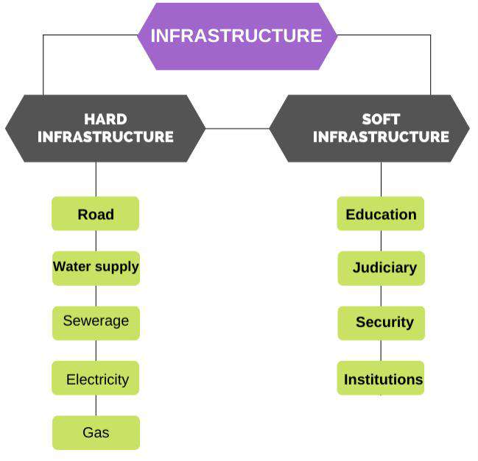

**Figure 1:** *Classification of Infrastructure in Nigeria*

**Source: Ayamba, & Abang (2021)**

Jochimsen (1996) defined infrastructure as the totality of material, institutional, and personal facilities and data available to economic actors that contribute to the equalisation of payment for equivalent inputs under conditions of appropriate resource allocation, i.e. total integration and maximum level of economic activity. The most crucial infrastructure characteristics are listed below:

# Road System

Transportation is an important human activity with a significant spatial component. Second, it is a major determinant of the geographical variation of a vast array of other social and economic activities (Aldagheiri,2009). The proper building of a road network not only reduces the cost of transportation in terms of both money and time, but it also facilitates the integration of varied regions within a nation and a better knowledge of adjacent nations on a global scale.

Roads contribute to the development of a country by providing direct benefits through their role in the development of activities such as agriculture, industry, commerce, and mining, as well as indirect benefits through the increase in property value and the change in people's way of life and thinking (Aldagheiri,2009).

# Water Supply System

A water supply system consists of a raw water source, a treatment or production facility, and a distribution system. Water is one of man's most essential physical environments, and it directly influences his health and cleanliness (Devlin, 2016). There is no doubt that water pollution causes several health issues. The World Health Organization considers "management of water sources to ensure that they are pure and sanitary" one of the fundamental goals of environmental sanitation due to the importance of water to humans. In the twenty-first century, potable water is one of the greatest threats to public health in developing nations.

The "International Decade for Action: Water for Life" began in 2005, with a renewed emphasis on achieving the Millennium Development Goal (MDG) of reducing the percentage of the world's population without access to safe drinking water and sanitation by 2015. Water is a suitable vehicle for bacteria that cause disease. If disease-causing microorganisms are not removed from water, it could become the source of several diseases and epidemics. Diseases such as typhoid, cholera, and dysentery are induced directly by contaminated water. Water is another excellent solvent. Excessive concentrations of minerals or toxic dissolved substances in water can cause a variety of problems for the populace. Therefore, public water should be free of disease-causing microorganisms, toxic compounds, and excessive amounts of minerals and organic waste (Singh, Saxena, Bharti, & Jaspal, 2018).

# Network For Sewerage And Wastewater Treatment

Sewage is waste that is transported by water and leaves a community as a solution or suspension. It is also known as waste water flows or the city's used water supply. Sewage management is concerned with the several means by which sewage can be treated for the benefit of mankind. The operations include sewage collection, treatment, screening, and disposal in a manner that poses no environmental or health risks to humans (Singh, Saxena, Bharti, & Jaspal, 2018).

There are primary, secondary, and tertiary treatment options. During the earliest phase of treatment, sewage flows through enormous tanks known as "primary clarifiers" or "primary sedimentation tanks." In the tanks, sludge can collect, and floating substances such as grease and oils can rise to the surface and be skimmed off. The major goal of the primary treatment is to create a liquid that can be biologically treated and sludge that can be treated or processed separately. The objective of secondary treatment is to dramatically reduce the biological component of sewage,

including that of human waste, food waste, soaps, and detergents. The goal of tertiary treatment is to provide a last level of treatment before wastewater is discharged into the receiving environment (sea, river, lake, ground, etc.).

# Waste dumps

In numerous urban and industrial regions of Asia's expanding economies, waste management and disposal pose an alarming challenge. Waste production has increased alongside the progress of industrialization, urbanisation, and population development. It has become one of the most pressing urban environmental issues (Devlin, 2016). Every step of the waste handling, treatment, and disposal process is linked to health concerns, either directly (via recovery and recycling activities or other occupations in the waste management industry by exposure to hazardous substances in the waste or emissions from incinerators and landfill sites, vermin, odours, and noise) or indirectly (via other occupations in the waste management industry by exposure to hazardous substances in the waste or emissions from incinerators and landfill sites, vermin, odours, and noise) (e.g. via ingestion of contaminated water, soil and food).

# Gas Distribution Network

Natural gas contributes significantly to the energy mix. Natural gas transmission and distribution networks transfer the majority of the economy's energy, which is utilised in virtually every significant sector, including buildings, industrial operations, power generation, and transportation. Natural gas is utilised in homes and businesses for a variety of purposes, including space and water heating, cooking, and garment drying. In the majority of regions, natural gas is the most frequent household heating fuel, and it plays a crucial role in space heating. 47 percent of American families use natural gas as their major source of heat, compared to 36 percent who use electricity (Singh, Saxena, Bharti, & Jaspal, 2018).

The chemical industry (where natural gas is used as a feedstock to make methanol and ammonia) and the manufacturing sector (where natural gas helps satisfy high-temperature process heat requirements) are the two largest industrial consumers of natural gas (where natural gas is used as a feedstock to produce methanol and ammonia). In 2019, natural gas-fired turbines produced over 37 percent of total energy generation in the United States, more than any other source. In locations such as California, where intermittent renewable power is becoming more widespread, gas- fired generation's consistent, solid electricity is particularly important (Devlin, 2016).

Compressed natural gas and liquefied natural gas (CNG and LNG) are currently utilised in heavy-duty trucks, freight trains, and marine vessels, but they account for a small portion of total natural gas consumption and demand for transportation fuel. Depending on the vehicle type, duty cycle, and engine calibration, natural gas can extend the life cycle of a vehicle. As a transportation fuel, biofuels produce fewer greenhouse gas emissions than traditional fuels.

# Electricity System

The primary objective of an electricity distribution system, after receiving bulk electrical energy from a transmission or subtransmission substation, is to meet the energy demands of customers. The two primary types of distribution substations are primary substations and customer substations. The customer substation communicates with the low voltage (LV) network, while the large substation is a load centre. A customer substation is often a distribution room provided by the customer. In the distribution room, the transformer and a number of HV switchgear panels can be accommodated to allow LV connection to the customer's incoming switchboard (Devlin, 2016).

Depending on the region, the distribution network could consist of overhead wires or underground cables. In urban areas, cables are frequently utilised, whereas in rural areas, overhead lines are utilised. To meet the required supply reliability, numerous network configurations are possible. Protection, control, and monitoring equipment is added to guarantee the distribution network's proper operation. To meet the required demand, the distribution network must be meticulously built based on various expected loading numbers and supply security/reliability. There are three forms of planning available: long-term planning, network planning, and construction planning. Long-term planning requires identifying the optimal network designs and associated expenditures while taking into consideration future technological advances. So that power demands may be met on time, development must be consistent with anticipated load growth. Once the required circuits and substations have been established and adopted, the real design and engineering work is referred to as construction planning or design (Singh, Saxena, Bharti, & Jaspal, 2018).

Voltage and current are the two most essential electrical parameters. Voltage and current are separate variables, yet they are interconnected in electrical circuits. Both are required for the circuit to function properly. Voltage is the force that causes current to flow in a circuit. It is measured in volts (V or E). Current refers to the

movement of electrical charges or the flow of electrons across an electronic circuit. Amperes or amps are the current measurement units (A or I).

# Characteristics of Infrastructure

1. Infrastructure has a servant-like aspect in that it supports the economic processes of production and consumption.
2. Due to budgetary and technological constraints, it is necessary to produce devices in their totality; they cannot be built in pieces.
3. High capital intensity - the construction of infrastructure facilities necessitates significant expenditures that, due to their lumpiness, pay off gradually.
4. Infrastructure costs fluctuate as a result of the indivisibility of infrastructure devices, often known as the leaping technique of cost generation.
5. Durability - Infrastructure facilities have a service life that is particularly long.
6. The services offered by infrastructure facilities can be utilised on-site, whereas infrastructure facilities are stationary.
7. Infrastructure facilities are not interchangeable, yet they complement one another.

# Infrastructure Functions

1. Transfer - creates conditions for the movement of products, energy, and people within a certain region or territory.
2. The service meets the service criteria of both the production and consumption sectors.
3. Integration changes regional systems' social, economic, and informational linkages.
4. Locational - the level of infrastructure development in a particular location reflects the popularity of the area (availability of transportation network, energy, water resources, etc.).
5. Acceleration - the degree of infrastructure development is a precondition for the economic development of certain locations; the reserve of infrastructure potential is a critical component in the economic development of a particular region.

# Sources and barriers to financing technical infrastructure development

Researchers have only recently wondered why infrastructure investment has stalled despite the availability of long-term finance. Since the benefits of infrastructure are so evident, policymakers were extremely concerned about determining why so few infrastructure projects are successfully finished. Given the amount of cash on the world's financial markets and the extraordinarily low long-term interest rates, the fundamental barrier to increased infrastructure investment cannot be a dearth of available capital (Zeller, Diagne and Mataya. 1998). The challenge, according to Zeller et al., is matching the supply of funds with investable initiatives. This is contingent on the availability of substantial long-term government financing. Pension funds, insurance companies, and other long-term institutional investors have substantial and expanding long-term liabilities. Therefore, they need long-term assets. However, very few of their financial resources are allocated to infrastructure. Moreover, the enormous funding potential of international financial markets is completely underused.

In a 2012 research, McKinsey projected that the global proportion of overall infrastructure funding in GDP will increase from approximately 3.8% to 5.6% by 2020. (McKinsey Global Institute, 2012) Sadly, the Covid occurred, and this estimation remained speculative. The required rise would be significantly greater in emerging markets. G20 analysis indicates that emerging nations will need to invest an additional $1 trillion annually through 2021 in order to meet the needs of urbanisation and improved global integration and connectivity (G20 2013). Developed countries will likely need to invest a comparable amount to finance low-carbon emission energy projects through 2050, in addition to potentially comparable investments in transport and social infrastructure. Privatization of existing infrastructure assets may provide more government funding for new infrastructure, but this is unlikely to be sufficient.

According to Pinstrup-Andersen and Shimokawa (2006), other capital- intensive machinery may be the only viable option for many infrastructure projects, such as roads, sewers, highways, bridges, power, and railroads, and may consume enormous percentages of the public's financial capacity. Consequently, the key drivers of increased infrastructure demand, such as the massive infrastructure gap in emerging nations or the switch to renewable energy sources in developed economies, would entail an increase in private sector investment.

According to Engel, Fischer, and Galetovic (2010), the apparent mismatch between infrastructure investment demand and infrastructure finance availability, as well as the lack of a pipeline of appropriately structured projects, is a significant hurdle to funding technical infrastructure development. Infrastructure investments necessitate complex legal and financial procedures, which require a great deal of expertise. Developing the necessary skills is costly, and investors will only be willing to pay these fixed costs if the pipeline of infrastructure investment opportunities is robust and reliable. Otherwise, the costs of investing in infrastructure as opposed to other, less complex asset categories could quickly exceed the possible returns.

Building a pipeline of feasible projects requires a consistent and dependable legal framework for infrastructure initiatives. In certain nations, these structures are absent. Political risk is a significant concern for private investment (OECD 2014). The arbitrary exercise of political authority can take many forms, such as price reductions for private infrastructure operators, the introduction of new regulations, or the unilateral renegotiation of previous contracts by new administrations. Even when robust legal frameworks are in place, governments may fall short of best practises. To remedy this, positive actions are necessary. Certain nations, such as the United Kingdom, have established central government agencies as the focal point for the development of major infrastructure projects. Importantly, this facilitates the progressive acquisition of information. In nations where infrastructure projects are executed by provincial administrations, such as Australia, an effective dissemination of best practises and experience may be achieved. Such processes and institutions are time-consuming to develop, but they can aid governments in achieving significant efficiency gains and completing a significantly larger number of projects.

Complexity of infrastructure projects is a further hindrance. This is because it usually includes a large number of individuals. Infrastructure typically consists of natural monopolies, such as roads or water supplies, and governments like to retain ultimate authority to prevent monopoly power abuse (Inderst and Stewart 2014). This demands sophisticated legal structures to ensure fair dividend distribution, risk- sharing, and alignment of all participants' interests. Nevertheless, any measures used to reduce monopolistic power must ensure that governments honour previously agreed-upon agreements. According to Preqin (2011), several infrastructure projects generate revenue only after several years, and the beginning phase of an infrastructure project is laden with risk. Due to the singularity of infrastructure projects in terms of

the services they provide, infrastructure investment is also less liquid. These three characteristics — the cash flow time profile, substantial early risks, and illiquidity — make implementation financially difficult and expensive.

There are two significant sources of infrastructure financing in Nigeria: oil revenues and non-oil revenues.

NNPC's earnings from direct sales and gas sales (crude oil sales). Other factors include domestic market profits, Gas flared, subject to a fine Pipeline permits and other costs, Excise taxes and VAT on domestic crude oil, In 2020, the petroleum profit tax (PPT) and royalties from the oil and gas sector brought in N304 billion.

According to figures from the Central Bank of Nigeria, the country's overall revenues from the oil and gas sector in February 2020 were $4.06 billion, above experts' projections of $3.86 billion but marking a 66 percent fall from 2019 ($11.8 billion).

Non-oil revenue: Implicit taxes These are indirect taxes applied to consumer goods. Indirect taxes include customs and excise taxes, sales taxes, and spending taxes. Some indirect tax sources include:

Excise duties - they are levies imposed on locally manufactured items. Certain products, including alcoholic beverages, petroleum products, and cigarettes, are subject to excise taxes. The duties are routinely enforced ad volarem and are inherently discriminatory. Occasionally, excise taxes are used to protect budding industries from foreign competition.

Customs duties are one of the oldest techniques of generating revenue. It is the tax imposed on goods crossing a country's borders. Customs duties fall into two distinct groups. These are the export and import tariffs.

This is another strategy employed by the government of Nigeria to generate income from within the country. The sales tax is a reliable source of revenue for goods with inelastic demand, as it applies to a vast array of products and is frequently collected on the most basic necessities of life. In addition, this type of tax is an effective means of controlling the country's inflation. The majority of Nigeria's infrastructure is funded by direct budget spending, borrowing, and market-based financing. In Nigeria, urban infrastructure is largely financed through direct budget spending from the three levels of government (central, state, and local) (Ayamba, & Abang, 2021).

# The influence of technical infrastructure on the development of agriculture and rural areas-theoretical discussion

Agriculture has a tremendous impact on poverty alleviation and economic development. Agriculture encompasses food production, forestry, poultry, beekeeping, fish farming, and swine husbandry. In contrast, the agriculture industry faces a lot of challenges. As the global population is projected to increase from 7.6 billion in 2018 to over 9.6 billion in 2050 (UN DESA, 2019), there will be a substantial increase in food demand (UN DESA, 2017). Simultaneously, natural resources such as fresh water and arable land are becoming scarcer, resulting in a growing demand for technical infrastructure.

According to Venkatachalam (2003), the amount of infrastructure in the agricultural sector is one of the key factors that may explain regional disparities in agricultural growth. Irrigation, transportation, electric generating, agricultural markets, and other investments in infrastructure have garnered the most attention. These variables contribute not only to agricultural growth at the macro level, but also to the enormous disparity between rural and urban agricultural growth. In general, the research suggests that public investment in infrastructure, especially in the repair of rural roads, improves the local community and agricultural product sales.

Khandker, Bahkt, and Koowal (2006) offered an example of how building rural roads increases agricultural revenues and aggregate crop indices in underdeveloped regions of Bangladesh. Antle (1983) predicts that agriculture-related infrastructures will reduce farmers' expenses and promote agricultural expansion. The result is an increase in food availability and agricultural worker pay in Vietnam (Mu and van de Walle, 2007). Access to new and improved roads in rural areas increases opportunities for non-agricultural activities in Peru (Escobal and Ponce, 2002) and for non-agricultural occupations among Georgian women (Lokshin and Yemtsov, 2005).

By aggregating the individual cost of access (TCi) to the specified eight key infrastructure elements in the research region, Egbetokun (2009) applied the infrastructural index to the obtained village level data in Oyo State, Nigeria. Infrastructure provision has been found to encourage rural residents to increase their economic productivity and output. In addition, the study indicated that rural infrastructure is essential for the growth of agriculture in the study region. A lack of access to infrastructure such as health centres, educational institutions, communication devices, and water sources causes low agricultural output.

According to Pinstrup – Andersen and Slimokama (2006), in one of the technical background documents for the World Food Summit held more than a decade ago, "Roads, electricity supplies, telecommunications, and other infrastructure services are limited in all rural areas, despite their importance in stimulating agricultural investment and growth." According to a 1996 report by the Food and Agriculture Organization of the United Nations, "improved communication is a vital prerequisite." Several studies of infrastructure in developing nations, including Antle 1984; Binswanger, Khandker, and Rosenzweig 1993; Fan, Hazell, and Thorat 2000; and Fan and Zhang (2004), support this conclusion. These studies found that infrastructure investment is crucial for expanding farmers' access to input and product markets and bolstering the rural non-agricultural sector. It also facilitates the participation of underserved rural populations in national and international marketplaces.

Fan and Chan-Kang (2005) shown that infrastructure quality is a significant factor of agricultural development and poverty alleviation in China. Integration of markets across location and time necessitates a solid infrastructure and efficient market institutions. Where spatial market integration is inadequate, favourable local growing conditions, improved production practises, or the adoption of modern technologies that increase marketable surpluses may result in significant price declines, whereas other regions may experience deficits and rapid price increases. For example, according to Pinstrup-Andersen (2002), corn prices in Ethiopia tripled between 1997-1998 and 1999-2000, followed by an 80 percent decline between 1999- 2000 and 2000-2001. The price of maize in Malawi doubled between April 2001 and April 2002. Infrastructure and market conditions have a significant impact on the response of small farmers' supply chain. Chhibber (1988) discovered that a one percent increase in output prices would result in a supply response of 0.3% to 0.5% in regions with low infrastructure and 0.7% to 0.9% in regions with adequate infrastructure.

Limi and Smith (2007) stated in their study that the supply of public infrastructure is anticipated to increase the expansion of agriculture as a whole. However, the impact on infrastructure may differ depending on the commodity. The estimation results suggested that, depending on the commodity, various infrastructures could support agricultural productivity. According to them, roads and irrigation infrastructure might improve the productivity of the coffee and cocoa

sectors, for instance. Moreover, telecommunications infrastructures are essential for branding these products. In contrast, rural dairy production requires more water.

Theoretically, development economics is concerned with the formation and re- formation of institutions — what sociologists and others refer to as organisations and technological infrastructures (Apthorpe, 1994). According to Midgley (2003), the purpose of development initiatives is to improve the living conditions and meet the needs of vulnerable and oppressed groups, especially those in rural areas whose primary source of income is agricultural goods. As a result, the study of development remains an eclectic and pragmatic collection of behaviours led by good intentions, rather than well-defined theoretical notions.

The theory of economic development may also be utilised to study developments. Schumpeter's contribution to development economics is the concept that economies undergo growth cycles. He asserts that when knowledge advances, technological and organisational progress ensues. If new technology advances create opportunities for new firms, they can contribute to economic growth. Schumpeter believes that development, apart from being an economic event, is primarily a disruption of the static economic equilibrium. According to Schumpeter, the third characteristic of development is that it occurs in waves or successive discrete partial developments. While advancement improves the value of goods, it also reduces their value (Schumpeter, 2002). This is supported by Sein and Harindranath (2004), who argue that this socioeconomic model provides a set of basic building pieces for studying the impact of changes or interventions, such as IT installations, on development. It contributes to existing models by providing an integrated, global perspective on ICT implementations. The implications of this process model include the ability to inform research and practise about the effects of technology on social and economic growth, and not just in the agriculture sector.

Without efficient provision and maintenance of these technical infrastructures, the development of the agricultural sector in rural areas may be unable to significantly contribute to overall economic growth, and a significant portion of the population will be relegated to poverty, hunger, and human misery. Nigeria, the most populous nation in West Africa, is the subject of this research in terms of infrastructure and agriculture. In the following chapter, a review of Nigeria's socio-economic characteristics, its finances, and an economic overview will be presented in an effort to clarify the purpose of this study.

# CHAPTER TWO SOCIOECONOMIC CHARACTERISTICS OF NIGERIA

* 1. **Background Information**

According to Amartya (1999), Nigeria historically became a British protectorate in 1901. However, British rule ended in 1960 when Nigeria achieved independence as a result of the independence movement. Subsequently, in 1963, Nigeria became the first republic; three years later, a coup d'état ushered in military dictatorship (Archibong, 2002). In addition, Adamsn (1969), referenced by Archibong (2002), asserted that Nigeria underwent a three-year Civil War in 1967, which was orchestrated by the Republic of Biafra separatist movement. However, Nigeria recovered its republic status following the 1979 adoption of a new constitution (Ikeh, 2011). Sadly, the military seized power in 1983 and reigned for a decade. According to Agbola (2000), the country wanted to form a new republic in 1993, but the death of General Sani Abacha in 1998 prevented this. Regardless, the occasional military rule ceased the year after the establishment of the fourth republic.

According to Oyovbaire, Nigeria is located in West Africa and encompasses a total area of 910770 square kilometres (2008). The country shares a border with Chad in the north-east, Cameroon in the east, the Gulf of Guinea in the south, Benin in the west, and Niger in the north-west, as noted by Oommen (1997). In the 15th century, Augustinian and Capuchin monks brought Christianity to Nigeria, while Augustinian and Capuchin monks brought Islam to Nigeria through the Bornu Empire in the 11th century. Since then, there have been confrontations between the two major religions, which have recently attracted public attention.

According to Gandonu (2007), Nigeria is the most populated country in Africa and the seventh largest country in the world, with an estimated population of over 150 million people. In his study, David (1999) found that Nigeria contains more than 250 ethnic groupings and over 500 languages, with English being the official language. According to David (1999), the most numerous and politically prominent tribes are the Hausa-Fulani, Yoruba, Igbo (Ibo), Ijaw, Kanuri, Ibibio, and Tiv. There are 36 states in the country, with Abuja serving as the federal capital territory (FCT).

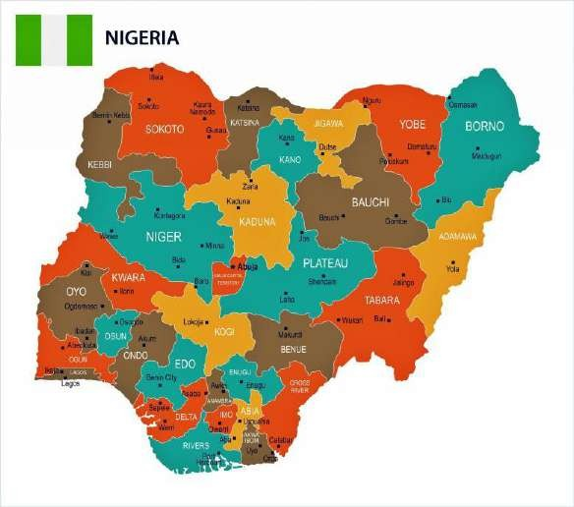

Figure 2: Map of Nigeria showing its 36 states

**Source:** Orangesmile

# Economy and Finance

According to Wosowei (2013), Nigeria is endowed with an abundance of natural resources, including solid minerals (crude oil, gold, tin, iron ore, niobium, lead, zinc, lime stone, salt, etc.) and agricultural goods (palm oil, cocoa, groundnuts, beans, melon, corn, rice, etc.). As of 2017, Nigeria was the eleventh largest oil exporting nation in the world (IMF, 2018). A research conducted by Adelman (2000) revealed that agriculture was the primary driver of Nigeria's economy prior to the discovery of oil in significant quantities. Nigeria, according to Kilian (2004), changed from being an agriculturally based nation to a crude oil dependent nation as a result of the discovery of oil. According to Obiechina (2010), Nigeria was a victim of a monolithic economy during the 1970s oil boom, enjoying the crude crash without effectively developing a viable policy that would set the nation's economy on a solid foundation for sustained growth.

Consequently, oil contributes for over 90 percent of the nation's total export revenue, leaving only 10 percent for other commodities like as agricultural goods and solid minerals (Ogbonna, 2012). Thus, Nigeria greatly dependent on oil earnings. Consequently, due to the fluctuation of oil prices and a subsequent sharp decline in the world oil price in recent years, the country's excessive reliance on oil as a major source of revenue has negatively impacted the country and led to excessive borrowing from external sources to finance the budgets (Babosa, 2012). In 2021, Nigeria's Gross

Domestic Product (GDP) was 480 billion US dollars, accounting for 18 percent of Africa's economy and establishing it as the continent's leading economy. This is followed by South Africa with 415 billion US dollars and Egypt with 396 billion US dollars (ICIR, 2021). The following tables compare the economy of Nigeria to that of other African nations.

**Table 1.** A comparative view of Nigeria’s economy and other African countries

|  |  |  |  |
| --- | --- | --- | --- |
| **S/N** | **Country/Economy** | **2021 GDP (Billions $)** | **% share of Africa’s economy** |
| 1. | Nigeria | 480 | 18 |
| 2. | South Africa | 415 | 16 |
| 3. | Egypt | 396 | 15 |
| 4. | Algeria | 164 | 6 |
| 5. | Morocco | 126 | 5 |
| 6. | Kenya | 109 | 4 |
| 7. | Ethiopia | 93 | 4 |
| 8. | Ghana | 75 | 3 |
| 9. | Angola | 70 | 3 |
| 10. | Tanzania | 69 | 3 |

**Source: International centre for investigative reporting (ICIR, 2021)**

# Table 2. Comparison of GDP Per Growth Rate (2011-2020)

|  |  |  |  |  |  |
| --- | --- | --- | --- | --- | --- |
| **Year** | **Nigeria** | **Egypt** | **South Africa** | **Kenya** | **Ghana** |
| 2011 | 2.525 | -0.363 | 3.659 | 5.965 | 0.667 |
| 2012 | 1.472 | -0.012 | 4.085 | 0.586 | 0.766 |
| 2013 | 3.853 | -0.105 | 4.647 | 0.290 | 1.209 |
| 2014 | 3.513 | 0.616 | 5.542 | 1.640 | 2.235 |
| 2015 | -0.029 | 2.093 | 6.029 | 1.572 | 1.812 |
| 2016 | -4.168 | 2.132 | 6.346 | 1.018 | 1.491 |
| 2017 | -1.788 | 2.025 | 5.313 | -0.670 | 1.442 |
| 2018 | -0.679 | 3.194 | 5.177 | 2.416 | 1.036 |
| 2019 | -0.379 | 3.492 | 2.818 | 2.734 | 1.099 |
| 2020 | -4.260 | 1.599 | -7.273 | -0.360 | -10.202 |

**Source: Nigeria Bureau of Statistics (NBS, 2022)**

However, Onwloduokit (1999) asserted that borrowing for budget deficits is not a new trend in the country. On this note, Owui (2011) observed that Nigeria was faced with escalating budget deficits year in and year out, generating an ever increasing disparity between public expenditure and the money earned. Hence, deficit financing remained high at N 117.2 billion, N 47.4 billion, and N 810.0 billion in 2014, 2015, and 2016, respectively, and remained on the climb down to 2022, as a N

4.28 trillion 2021 budget deficit was reported (CBN, 2021).

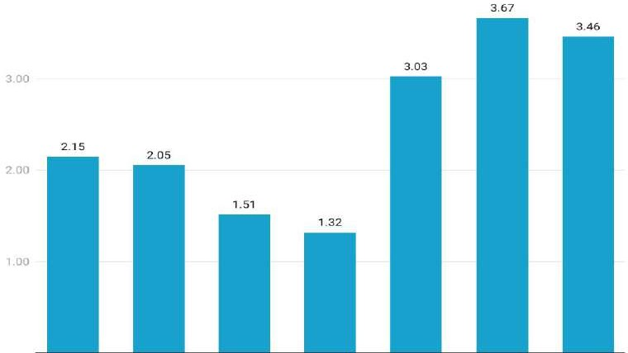

Figure 3: budget deficit from 2014-2020. Source CBN, 2021 report

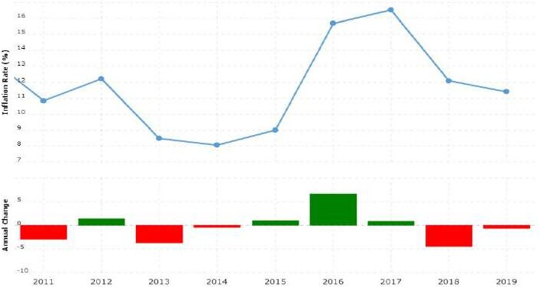

**Figure 4: Inflation rate in Nigeria**

**Table 3: Inflation rate in Nigeria- 2011 to 2020**

|  |  |  |
| --- | --- | --- |
| **Year** | **Inflation Rate (%)** | **Annual Change** |
| 2020 | 13.72% | 1.17% |
| 2019 | 11.40% | -0.70% |
| 2018 | 12.09% | -4.43% |
| 2017 | 16.52% | 0.85% |
| 2016 | 15.68% | 6.67% |
| 2015 | 9.01% | 0.95% |
| 2014 | 8.06% | -0.41% |
| 2013 | 8.48% | -3.74% |
| 2012 | 12.22% | 1.38% |
| 2011 | 10.84% | -2.88% |

The anticipated pay range in Nigeria is between N37,000 (67 USD) and N5,000,000 ($9,000) each month. This wage includes housing and transportation. The average monthly salary is N300,000, which is obtained by approximately 30% of the working population; 20% of this group earns more than N300,000, 25% make less than N150,000, and an estimated 25% earn more than N576,000. The total number of older individuals, defined as those aged 60 and older, went from 8,741,292 in 2013 to 9,622,056 in 2016. This represents a 1.8 percent increase in the male ageing population between 2013 and 2014, compared to a 1.4 percent growth in the female ageing population.

# 2.3 Population and Social condition

According to the National Population Commission, Nigeria had a population of over 193 million in 2016, a population growth rate of 3.2% annually, and over 41% of its population was under the age of 15. Amin (2013) noted that more than fifty percent of the population resides in metropolitan regions. According to Abdulrahman (2013), the population of the country consists of seventy-two million males and sixty- eight million females. Nigeria's population accounts for around 14% of Africa's overall population. Due to their consequences for ethnic balance, electoral competitiveness, and the distribution of government funds, the exact size and growth

rate of the United States' population have long been a sensitive topic (Oladeji, 2011). Nevertheless, it was anticipated that the population would reach 206,139,587 in 2020. (World Bank, 2021). The Total Fertility Rate, or the average number of children a woman has over the course of her lifetime, declined from 6.5% in 1990 to 5.8% in 2016. (NDHS, 2013).

According to the UN's World Population Prospects, the country's population could reach 410 million by 2050. (2017). The World Health Organization (WHO) has encouraged the country to emphasise expanding access to and utilisation of family planning to achieve broad-based and equitable economic growth. Additionally, due to the large number of young individuals entering the labour force, skill development and job creation are necessary (NBS, 2017).

High levels of risk are associated with the ages of 16 to 30, particularly among men. It is referred to as the "youth bulge." To reverse the effects of youth bulges, the country's policy design prioritises specific methods, such as providing more jobs, expanding family planning services, and reducing infant mortality rates overall. The young population imposes supply restrictions on school systems and labour markets; it also indicates that a growing part of the total population is of working age and is, therefore, independent of the economic activities of others. As a result, the decreasing dependency ratio may result in a demographic dividend, which is an increase in overall economic growth. The ability of a specific economy to reap this dividend, on the other hand, is dependant on its ability to orient the growing working-age population toward productive economic activity and to produce the jobs necessary to support the expanding labour force.

It was estimated that there were 447,411 international migrants in 1990, 751,126 in 2000, and 972,126 in 2005. Throughout history, net migration has been

negative, with rates of -0.2, -0.2, and -0.3 per 1,000 people in 1995, 2000, and 2005, respectively. According to these statistics, more Nigerians are leaving the country as emigrants than as immigrants. This trend has been confirmed in recent years, and it is anticipated that it will continue. In reality, the net migration rate in 2010 was -0.4 per 1,000 people, and it is projected to fall to -0.7 by 2022. This ratio equates to 90,000 more emigrants than immigrants, roughly tripling the number of emigrants since 2005. (UNPD, 2016). Additionally, Nigeria as a nation comprises approximately 250 ethnic groups with distinct cultural values (Anwana, 1989).

According to a study by Ibia (2005), Nigeria is not a homogeneous society; hence, the people do not share a local language. According to Jarb (1999), referenced by Ibia (2005), Nigeria is inhabited by the Hausa-Fulani, who are predominately Muslims in the North, although Hausa is a second language because the various communities also speak their native tongues. To the west and east of Nigeria, where the Yoruba and Ibo languages are widely spoken, the similar arrangement applies (Okafor, 2007). Diversity of cultures should be a source of strength because it brings a wide range of skills, abilities, knowledge, and human capacity, but this is not the case in Nigeria.

In a broader sense, many African states, Nigeria included, face challenging economic situations due to limited road infrastructure, inefficient ports, catastrophic power outages, and, worst of all, pervasive government corruption (Onyeiwu, 2010). Thus, Nigeria is beset with socioeconomic issues that have led to poverty and violence in the nation. According to Sanni (2009), the country's growth is still hindered by consumerist cultures, weak institutions, and unstable political systems. According to Ude (2013), the socioeconomic condition of Nigeria has had a negative impact on the economic activities of the population. Tosun (2011) identified the socioeconomic factors in Nigeria as a dearth of quality education, cultural and religious discrimination, overpopulation, unemployment, poverty, a high infant mortality rate, food insecurity, corruption, insurgency, insecurity, human rights violations, and a weak political system.

Similarly, Aderayior (2003), quoted by Tosun (2011), highlighted the rising crime rate in Nigeria and its repercussions for the country's national and individual development. Moreover, he argued that the primary causes of crime in Nigeria are a lack of quality education, a dearth of economic prospects, and tribalism. The prevalence of digital and non-digital crime in Nigeria has deteriorated the country's social state. As a result, worldwide communities label Nigeria as a nation with a high rate of dynamic crimes.

In a study of the elements influencing socioeconomic growth in Nigeria, Moreso, Ikah (2006) discovered that a lack of quality education in Nigeria has led to the societal challenges. According to the research, a lack of quality education in society has led to, among other things, extreme poverty, poor health, social and interpersonal violence, and child labour. In a similar vein, Oju (2016) said that Nigerian insecurity has increased and sparked public worry. Boku-Haraam, thugs, and

hoodlums, among others, have led to the invasion of towns and the kidnapping of influential individuals, common men, and students in the society. In addition, communal farms, government and private properties have been damaged in Nigeria as a result of insecurity. In accordance with this, Nuash (2014) recognised and stressed how both the governing entities and the governed have severely impacted Nigeria's social status. The societal problems in Nigeria extend beyond the alarming rates of violent crime, unemployment, and poor administration (Nuash, 2014). Moreover, he disclosed that prostitution, armed robbery, malpractice of all types, drug misuse, tribalism, adolescent pregnancy, cultism, ritual slaughter, and fraudulent activities are the most prevalent societal issues in Nigeria today. Due to the presence of these problems in society, the majority of the population struggles to survive.

|  |  |  |  |  |  |  |  |  |  |  |  |  |
| --- | --- | --- | --- | --- | --- | --- | --- | --- | --- | --- | --- | --- |
| **Year** | **Population** | **Yearly % Change** | **Yearly Change** | **Migrants (net)** | **Median Age** | **Fertility Rate** | **Density (P/Km²)** | **Urban Pop %** | **Urban Population** | **Country's Share of World Pop** | **World Population** | **Nigeria Global Rank** |
| 2020 | **206,139,589** | 2.58 % | 5,175,990 | -60,000 | 18.1 | 5.42 | 226 | 52.0 % | 107,112,526 | 2.64 % | 7,794,798,739 | 7 |
| 2019 | **200,963,599** | 2.60 % | 5,088,916 | -60,000 | 17.9 | 5.67 | 221 | 51.2 % | 102,805,995 | 2.61 % | 7,713,468,100 | 7 |
| 2018 | **195,874,683** | 2.62 % | 5,001,439 | -60,000 | 17.9 | 5.67 | 215 | 50.3 % | 98,610,801 | 2.57 % | 7,631,091,040 | 7 |
| 2017 | **190,873,244** | 2.64 % | 4,913,003 | -60,000 | 17.9 | 5.67 | 210 | 49.5 % | 94,525,016 | 2.53 % | 7,547,858,925 | 7 |
| 2016 | **185,960,241** | 2.66 % | 4,822,793 | -60,000 | 17.9 | 5.67 | 204 | 48.7 % | 90,546,177 | 2.49 % | 7,464,022,049 | 7 |
| 2015 | **181,137,448** | 2.71 % | 4,526,850 | -60,000 | 17.9 | 5.74 | 199 | 47.8 % | 86,673,094 | 2.45 % | 7,379,797,139 | 7 |
| 2010 | **158,503,197** | 2.68 % | 3,927,636 | -60,000 | 17.9 | 5.91 | 174 | 43.5 % | 68,949,828 | 2.28 % | 6,956,823,603 | 7 |
| 2005 | **138,865,016** | 2.58 % | 3,316,233 | -34,000 | 18.0 | 6.05 | 152 | 39.1 % | 54,288,918 | 2.12 % | 6,541,907,027 | 9 |
| 2000 | **122,283,850** | 2.53 % | 2,867,103 | -19,005 | 17.9 | 6.17 | 134 | 34.9 % | 42,627,440 | 1.99 % | 6,143,493,823 | 10 |
| 1995 | **107,948,335** | 2.54 % | 2,547,177 | -19,154 | 17.7 | 6.37 | 119 | 32.2 % | 34,785,545 | 1.88 % | 5,744,212,979 | 10 |

# Table 4: Nigeria population statistics

29

# CHAPTER THREE

**THE STATE AND DEVELOPMENT OF TECHNICAL INFRASTRUCTURE IN NIGERIA**

# The Country's Strategy on Technical Infrastructure

According to Dalakoglou (2017) and Koh (2018), the need of proper infrastructure in achieving competitive, sustainable, and resilient cities has been strongly underlined. Investments in infrastructure are required for economic growth, job creation, and the provision of important services to a nation's citizens. According to statistics, every dollar spent on capital projects (utilities, energy, transport, waste management, flood defence, and telecommunications) generates a 5 to 25 percent return on investment (World Economic Forum, 2020). However, Nigeria's lack of infrastructure is not a new phenomenon. In the majority of localities, water supply, sewage, waste management, roads and drainage, electricity supply, and other services are either inadequate or nonexistent (Dimitris, 2021). Additionally, it appears that the existing facilities are not receiving the necessary upkeep (Familoni, 2013). However, the problem has been linked to the country's inadequate funding, adoption of inappropriate norms and legislation, inefficient and unsustainable maintenance, fragmented administration and uncoordinated infrastructure development and management activities (Oluba, 2008). The problem was compounded by the rapid and persistent urbanisation of the country during the past few decades.

The efforts and strategies of all levels of government in Nigeria (federal, state, and local) to promote the availability of adequate infrastructure led to the development and establishment of a number of measures, including the Infrastructural Development Fund (IDF), the Urban Development Bank of Nigeria (UDBN), the fragmentation of cities into municipalities that later morphed into local governments, and the formulation and implementation of development plans (Familoni, 2013). Even if the initiatives resulted in minor infrastructure development in important cities, studies indicate inadequacy, rapid deterioration, vandalism, and the inability to replicate the current infrastructure in the rest of Nigerian cities (Foster and Pushak, 2011; Fidelis, Obasanmi, and Ighata, 2014; and Orji, 2017). Nigeria's federal government, led by President Umar Musa Yar'dua (late) and Vice-President (later president) Goodluck Jonathan, launched a comprehensive policy document titled

"Vision 20:2020" in conjunction with state and local governments in recognition of the importance of infrastructure to the country's rapid and sustainable socio-economic development (Umofia. 2017).

The vision emphasised good infrastructure supply in both urban and rural areas of the country and outlined many programmes aimed at constructing major infrastructure with the ultimate goal of placing Nigeria among the top twenty economies in the world by 2020. (FGN, 2009). Unfortunately, President Goodluck Jonathan's term expired in 2015, and the proposal was never carried through. Despite abandoning the vision paper, the administration of President Muhammadu Buhari has been unable to formulate a plan for infrastructure development in Nigeria. As a result, the current administration's infrastructure development projects have been haphazard, disconnected, and highly expensive, with little to show for the vast sums spent on numerous facilities (Ighata, 2014). The purpose of this chapter is to evaluate the condition of infrastructural development in Nigeria by analysing the existence and functionality of a number of fundamental infrastructure projects. In the following chapter, particular technical infrastructure pertinent to agricultural expansion and rural development was reviewed.

# State and Development of Technical Infrastructure

In recent years, Nigeria has made tremendous headway in updating most of its infrastructure. Comparatively to a number of Sub-Saharan African nations, Nigeria's energy supply, road, rail, and information and communications technology (ICT) networks cover considerable portions of the country. In contrast to some other West African nations, Nigeria has established infrastructure pillars with national reach. Despite this progress, the African Development Bank Group (ADBG, 2018) highlighted that the country's weak physical infrastructure remains one of the primary obstacles to sustained and broad-based robust economic growth.

# Road Network

When the country acquired independence in 1960, the national road network was projected to be roughly 6,500 kilometres long; by 2010, the national road network was estimated to be 197,000 kilometres long, with approximately 18 percent of it paved. The federal primary road network made up 9% of the total, while state- managed secondary roads made up nearly a quarter of the network. The remaining 67 percent consists of tertiary and village access roads, practically all of which are under local government control (FMWH, Nigeria 2013).

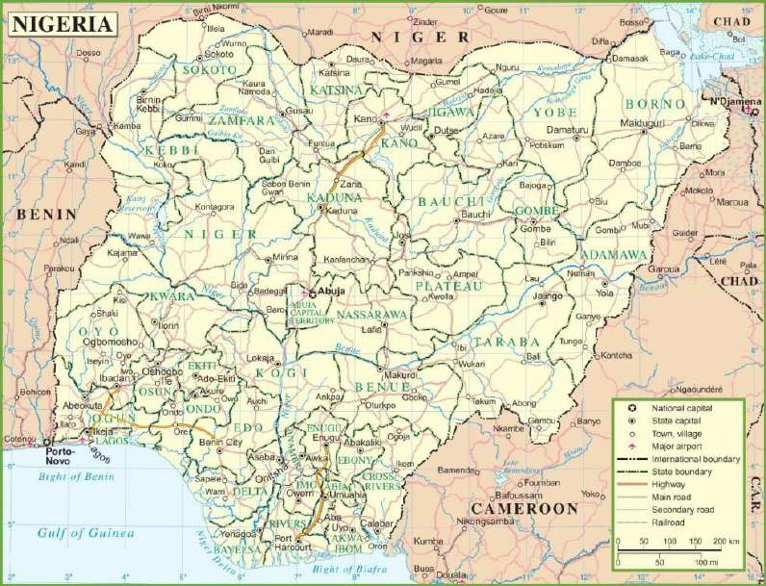

At least 90% of the country's internal and cross-border freight is transported by road. According to LAMATA, there are 222 vehicles per kilometre in Lagos, which is more than the national average of 11 cars per kilometre of the road, which is rapidly growing. The country's metropolitan regions account for around 30,000 kilometres of the overall network (ADBG, 2020).The principal towns, state capitals, and mainly the sea ports and interior ports are the key traffic sources. About 30 kilometres of the overall network are in the country's metropolitan centres.

# 3.2.1a The road network performance

Nigeria's road density of 0.21 kilometres per square kilometre of land area is greater than the average of 0.06 kilometres per square kilometre for West and Central Africa. The road density of Nigeria is equivalent to South Africa, Mexico, Brazil, Indonesia, and Pakistan (ADBG, 2020). Due to a lack of maintenance, the quality and quantity of road services are insufficient, resulting in the deterioration of road networks. With a poor road safety record and inadequate enforcement of traffic and

safety laws, major portions of the road network are in poor condition, putting the process at risk for capacity constraints (ADBG, 2020).

There is a great deal of banditry and criminal activity on the roads. 40 percent of the federal principal road network is in poor condition or worse, demanding rehabilitation; 30 percent is in medium condition, necessitating periodic maintenance; and around 27 percent is in acceptable condition. Approximately 160,080 km of secondary and tertiary roads were maintained by state and municipal governments at the time, with 85 percent in poor or worse condition and only 6 percent in good shape (ADBG, 2020).

# b Current Issues of Nigeria Road Transport Network

As a result of the poor condition of the road network, national connectivity is impeded. The primary factor contributing to the deterioration of the nation's road infrastructure has been a lack of maintenance culture. Lack of regulation of axle weights on roads and bridges has contributed to the deterioration of infrastructure quality (ADBG, 2020). In addition, the increasing number of heavy-duty vehicles carrying large and cumbersome loads has contributed to the deteriorating condition of the roads.

Federal Roads Maintenance Agency (FERMA), which is responsible for maintaining the federal highway system, reported that the need for significantly larger public budgetary allocations for road network maintenance will be one of the most significant concerns in the coming decade. This funding is anticipated to come from the federal budget (ADBG, 2020). According to current estimates of costs per kilometre for appropriate levels of routine and periodic maintenance, if the entire federal road network were in good condition and required only routine and periodic maintenance, the annual budget requirements for routine maintenance would be approximately $1.7 billion and the annual budget requirement for periodic maintenance would be approximately $1.2 billion (ADBG, 2020). The federal government now accounts for slightly more than 10 percent of these expenditures. The study undertaken for this paper indicates that if the whole network of state and local government roads were in good condition, annual regular and periodic maintenance costs would be roughly $200 million and $550 million, respectively (ADBG, 2020).

In contrast, the rural road network falls well short of what is required to support the rural economy, which is a serious cause for concern. Due to insufficient

transportation facilities and services, many rural communities with substantial agricultural potential, vast natural resources, and a variety of rural businesses lack rapid access to markets. More than half of Nigeria's non-oil GDP is derived from agriculture, with small-scale family farming accounting for the majority of output. Access to inexpensive agricultural inputs and product markets is crucial for increasing farm production and productivity (ADBG, 2020).

# Water Supply Network

The combined capacity of Nigeria's existing dams is around 51 billion cubic metres, according to ADBG (2018). In 2008, the nation's total renewable water resources per capita were equivalent to 1,893 m3. 47 percent of active water storage capacity is accounted for by single-purpose hydroelectric dams, while 41 percent is accounted for by multipurpose dams. The remaining 12 percent of operating capacity consists of irrigation and water supply dams with a single function.

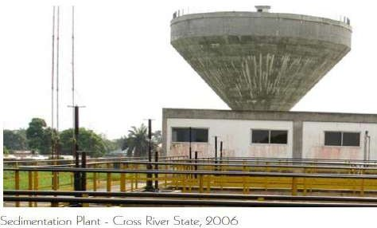

Figure 3.1:

In 2010, just about 4 percent of the population had access to piped water, compared to 16 percent for all of Sub-Saharan Africa and 60 percent for middle- income African states on average. In urban areas, access to superior water is far greater than in rural areas. In 2010, 74% of the urban population had access to improved water, compared to only 43% of the rural population, which relies heavily on surface water and a much larger proportion of unprotected wells and springs (ADBG, 2018). The water delivery network has been ineffective at providing the public with better water. The poor performance regarding utility water availability is very alarming. ADBG, (2018) stated that Nigeria failed to meet its Millennium Development Goal (MDG) of providing improved water to 75% of the population by

2015. Given that 93 million people (or 27 percent of the population) had access to improved water in 2010, achieving the MDG target would need an additional 87 million people to have access to improved water between 2011 and 2015, which is highly improbable.

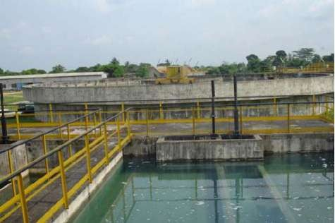

**Figure 3.2: Conventional Water Treatment - Surface Water Cross River State, Nigeria**

The majority of Nigeria's state water boards have minimal yearly revenues due to low water service tariffs and substantial quantities of uncollected cash. Revenue collection might be as low as 10% of the total amount due in rare circumstances. Furthermore, many boards have significantly inflated running expenses, owing in part to over-staffing, and rely on unpredictably allocated state funds (ADBG, 2018).Furthermore, one of the most pressing issues in the water supply industry is the lack of access to proper sanitation. The range of issues related to the design and implementation include:

1. the lack of mechanisms for public interventions that support the policy, leaving households with the sole responsibility for acquiring the facilities required for improved access to sanitation;
2. wide-spread rural poverty which makes it difficult for individual rural homes to implement this policy;
3. insufficient capacity at all levels of government related to the design and implementation of programs that can meet the ambitious targets for improved access; and
4. lack of mechanisms that support the entry of private entrepreneurs into services related to provision of improved sanitation.

# Sewerage Network and Wastewater Treatment

In developing nations such as Nigeria, the management of sewage and wastewater has been a serious obstacle. Sewage is the liquid waste from domestic toilets, bathtubs, showers, kitchens, and sinks that is disposed of through sewers. Also included are liquid industrial and commercial wastes (Wise, 2009). In Nigeria, wastewater or sewage is typically disposed of in rural pit latrines and in urban septic tanks, soak ways, and cesspools. These systems are troublesome, however, since soils get saturated with pollutants and effluents with extraordinarily high suspended and dissolved solids, resulting in environmental degradation and, in some cases, groundwater contamination (Ogedengbe, 2011).

Sunday (2012) found that septic tanks are the most prevalent sewage disposal technique in Nigeria. In addition to the abundance of pit latrines, there are few sewer pipes. While sewer lines are prevalent in the south-west and north-central geopolitical zones (particularly in Abuja), ancient tactics such as dirt pits and defecating in the wild are still prevalent in the south-west, south-south, and north-central geopolitical zones. In addition, Mara (2015) discovered that due to a lack of available technology, virtually little urban sewage is treated. According to Sperling (2016), the increase in the occurrence of water-borne diseases and the rapid degradation of the environment are a result of the usage of wastewater containing toxic wastes and the lack of enough funding for treatment. Historically, Nigeria has suffered from poor sanitation and an unsanitary atmosphere due to a lack of properly functioning sewage infrastructure. According to Ajibade (2013), about four of the available sewage facilities in south- western Nigeria were not operating. Additionally, he disclosed that sewage technologies are more prevalent in the south than in other regions. In the north, only Kaduna has a functional system, while Kano has not. Similarly, the FCT has the only working system in the middle belt, while Benue has a system that is not operational. Even though the South has a disproportionate number of sewage treatment plants, several southern states lack functional sewerage networks, and others have none at all. Among them are Bayelsa, Ondo, Anambra, Ebonyi, Abia, Imo, Cross River, and Akwa Ibom.

Moreover, among the two fundamental methods of sewage treatment, biological treatment is more sustainable in Nigeria than mechanical treatment (biological and mechanical). According to Sperling (2016), biological treatment is a more natural waste water treatment procedure than other waste treatment methods.

Microorganisms consume the waste's complex ingredients and break them down into simpler ones, enabling further treatment of the water. This procedure seeks to reduce the level of biological oxygen demand (BOD). Due to the hardworking organisms, biological waste treatment saves money because the process does not require a great deal of energy to finish. In contrast, mechanical systems utilise physical, biological, and chemical processes to achieve therapeutic goals. Mechanical treatment systems treat wastewater by mimicking natural processes in an artificial setting with a series of tanks, pumps, blowers, filters, and other mechanical components. Diverse instruments regulate the flow of wastewater throughout the system. As noted previously, water closets and septic tanks account for the majority of sewage disposal methods in the United States, followed by pit latrines. Despite the fact that some states have designed sewer lines for efficient sewage treatment, the concept has not been implemented due to a shortage of water supply and expensive initial project costs. For example, the design proposed by Oyo state few years ago has not been implemented.

# Waste dumps

Waste production is an inevitable consequence of human activities. These wastes include food waste, plastics, paper, polythene, metals, batteries, and textiles, in addition to rare and emerging wastes such as cell phones, computers, and other electronic equipment (Dauda, and Osita, 2003). The majority of solid waste in emerging and consuming nations consists of domestic garbage, followed by commercial waste from markets and other businesses. The daily rate of solid waste production in Nigeria is estimated to be 0.49 kg per person. Rates of solid trash generation in Nigerian cities vary substantially based on the features of each metropolis (Ajibade, 2015). Ado-Ekiti and Ogbomosho had the highest (0.71 kg/capita/day) and lowest (0.13 kg/capita/day) solid waste generation rates per capita, respectively (both in southern Nigeria). Lagos (0.63 kg/capita/day), Port Harcourt (0.60 kg/capita/day), and Abuja (0.57 kg/capita/day) are three other significant cities with quite high per capita rates of garbage production (Ajibade, 2015). According to Afon (2007), between July and December, more garbage is produced (59.4 percent for outlying districts and 51 percent for the city core), with the peak occurring in December. Domestic garbage, on the other hand, comprises 49 to 78.9 percent of Nigeria's total solid waste production (Ukoje, 2011; Fakere et al., 2012). The rate of municipal solid waste production in Nigeria is influenced by socioeconomic status,

lifestyle and habits, gross domestic product, environmental sanitation awareness, and population density.

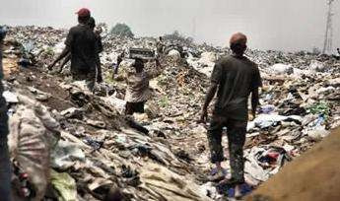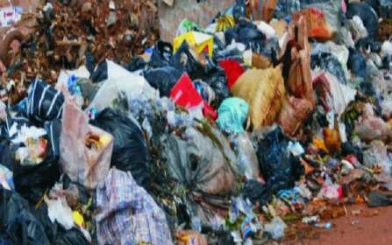

**Figure 3.3: Poor waste disposal situation in Nigeria Source: Google image**

**Table 5: Major dumpsites in Nigeria**

|  |  |  |
| --- | --- | --- |
| **DUMPSITE** | **SIZE** | **ANNUAL WASTE TONNE** |
| Olusosun | 43 hectares | 2.1 million |
| Solous 2 | 32 hectares | 820,000 |
| Epe | 80 hectares | 12,000 |
| Awotan (Apete) | 14 hectares | 36,000 |
| Lapite | 20 hectares | 9,000 |
| Eneka | 5 hectares | 45,600 |

Approximately 30-60 percent of solid trash created in Nigeria is not collected, according to a research (Ogwueleka, 2009). Low accessibility owing to poor road networks, waste management authorities' technical, economic, and management deficiencies, inadequate facilities, reluctance to pay collection bills, and lack of route optimization are all contributing problems. With the exception of Abuja, where the waste management authority serves approximately 56% of the population (DFID, 2004), over 80% of inhabitants in other cities dispose of their waste by illegal open dumping, open air burning, burying, and other unorthodox means. Most municipal waste management authorities have been overburdened by the huge amount of waste generated, inadequate and frequent breakdowns of collection trucks, a shortage of labour, inadequate data gathering and administration, low pay, and illiteracy (Awosusi, 2010). According to Ogwueleka (2009), waste management companies have financial difficulties paying their hefty salary bills, and workers threaten to go on strike over unpaid wages every year.

As a result of the inadequacy of waste management authorities to handle the volume of waste produced, many Nigerian cities have allowed open rubbish dumps. The collection vans visit each of these landfills sequentially. Therefore, waste management firms perform services at the cell level rather than the residential level. Certain of these approved landfills are excruciatingly distant from some residences, leading in the formation of an open dump close to the residences. Some resourceful individuals have seized the opportunity afforded by this grave situation in order to make a living.

In addition to scavengers and intermediaries, private firms are involved in rubbish collection. These corporations can be hired by large organisations, governments, and wealthy people to collect rubbish for a fee. These businesses charge significantly higher collection fees than municipal garbage management authorities, but they are far more efficient.

# Gas Network

The Nigerian network includes 3,071 kilometres of natural (dry) gas pipelines,

124 kilometres of condensates (wet gas) pipelines, and 156 kilometres of LPG pipelines as of 2007. Individual upstream gas producers control the existing gas transportation pipelines, gas processing facilities, and other related infrastructure, and are dedicated to their respective companies (ADBG, 2020). NGC owns and manages 1,100 kilometres of gas pipelines with a daily capacity of 2.5 billion cubic feet. The AlakiriObigbo-IkotAbasi Pipeline (Eastern network) and the Escravos-Lagos Pipeline System (ELPS) (Western network) provide the nation's commercial nerve centre and key power station at Egbin, near Lagos, with fuel. Additionally, NLNG and NNPC/SPDC/Total run a specialised pipeline infrastructure (ADBG, 2020).

The Gas Master Plan Infrastructure Blueprint included a network of gas hubs, which are secondary gas gathering facilities that connect the designated nodes of upstream gas producers to a network of gas processing facilities, where gas is processed to national standards and evacuated through transmission pipelines. After the Gas Infrastructure Blueprint is fully completed, the majority of pipes are anticipated to be interconnected (ADBG, 2020). The gas producers owned and operated the pipelines for gas transportation from the well heads to the selected nodes, while the hub operator owned and operated the pipelines for gas transportation from the specified nodes to the transmission pipelines.

The vandalism of pipelines has created a huge risk to the gas infrastructure. The Transmission Corporation of Nigeria (TCN) recently disclosed that gas shortages caused by vandalism of two major gas pipelines supplying gas to eight power plants in the country resulted in quick power outages of about 1,598 megawatts in some regions of the country (ADBG, 2020). Because Nigeria's oilfields lack the infrastructure required to produce and market natural gas, a large portion of it is flared. In 1980, 90 percent of the gas produced was flared, compared to 77 percent in 1990. The government has pursued a programme to reduce gas flaring through the use of incentives and severe penalties for gas emitted for several years. In consequence, flared gas accounted for less than half of total gas output by the year 2000. (ADBG, 2020). There is still a significant mismatch between strong investments in export- oriented gas projects, such as LNG, GTL, and the West African Gas Pipelines (WAGP), and inadequate infrastructure investments to develop natural gas for electricity generation and gas as a feedstock for the local industrial economy.

# Electricity Network

Among the facilities owned by the federal government are three hydropower plants with an installed capacity of 1,900 MW, one oil-fired plant with a capacity of 60 MW, one coal-fired plant with a capacity of 30 MW (which is no longer in operation), and seven gas-fired thermal plants with an installed capacity of 4,988 MW (ADBG, 2020).

The total installed capacity of the eleven active on-grid private generation plants in 2012 was 2,314 MW, compared to 9,384 MW at the end of 2011. As a result, total installed capacity decreased from 5,880 MW in 2009 to 5,550 MW in 2010 and 5,400 MW in 2011, much below the anticipated demand range of 10,000–12,000 MW. Therefore, load shedding is frequent and unpredictable to the extent that those who can afford generators rely on them for the majority of their power supply (ADBG, 2020). However, in 2011, the country's installed capacity was 64 megawatts per million people, when the middle-income group in Africa had 800 megawatts per million people. Self-generating facilities may be able to match or perhaps surpass the capacity of public and licenced commercial generation facilities, with estimates ranging between 4,000 and 8,000 megawatts (MW).

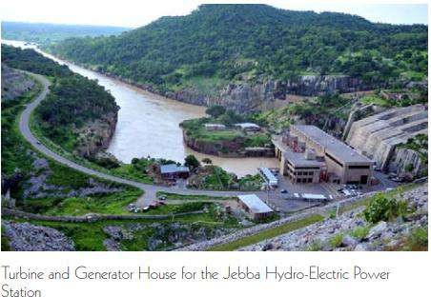

Figure 3.4

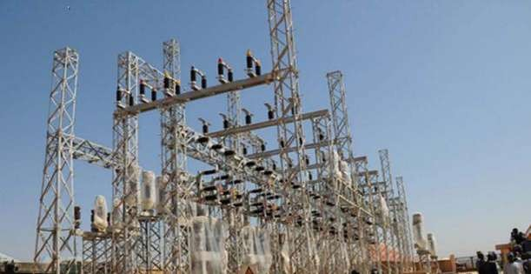Source: Nigeria Electricity hub

Figure 3.5: Transmission And Distribution

Source: Nigeria Electricity hub

According to recent statistics as shown in ADBG, (2020) summary report, the accessible capacity was 96 percent of the total installed capacity. The average technical transmission losses were estimated to be 8.5 percent. However, much of the transmission equipment is obsolete, with several facilities dating back 30 to 40 years. To put it another way, the power sector has long been plagued by operational inefficiencies and under pricing. Distribution losses have been as high as 30% throughout the years, compared to best practice levels of 10%. Tariffs covered around 28% of the cost of power generation.

# State and Issues In Electricity Sector

There is no doubt that sufficient domestic resources exist to meet the nation's energy demands. These assets include oil and gas, coal, significant hydropower capacity, and many sorts of renewable assets (ADBG, 2020). As with other sectors of national development, the chronically inadequate indigenous technical capacity, poor

governance in the sector, and lack of long-term planning have impeded the exploitation and application of natural resources.

Renewable energy is a minor contributor to the energy mix. I policy and regulatory concerns; (ii) investment and financial issues; (iii) technology obstacles; (iv) public awareness issues; (v) absence of technical standards and quality control; and (vi) intermittent availability of various energy sources and poor resource evaluations.

The poor electricity supply in Nigeria is primarily due to a lack of investment in the industry by successive administrations over the past 25 years.

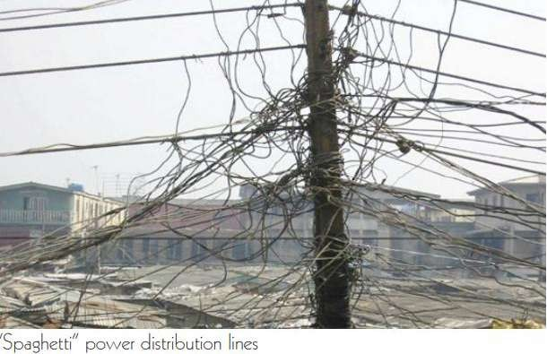

Figure 3.6

The Nigeria Vision 20:2020 report sets out clearly the main challenges facing the power sector:

1. An inadequate power generation capacity.
2. Insufficient supply of fuel for thermal power stations.
3. Issues related to the choice of technologies for power generation.
4. A congested transmission and distribution network, comprising antiquated and inefficient equipment, a lack of sophisticated modern control systems for power supply management, and rampant equipment theft.
5. Weaknesses in the institutional and regulatory structure, as well as a lack of precise projections of future electricity demand.
6. Inadequate framework and operating environment for private investment in the power sector.
7. Inadequate electric power price regulations, along with inadequate billing and revenue collection capabilities, render the sector inherently unsustainable financially.
8. Capacity constraints with respect to the skills of the power sector workforce.

# Financing Sources of Technical Infrastructure

Infrastructure development necessitates a significant financial investment. The conditions and availability of such necessary funds determine the trend in infrastructure provision. When sufficient money are available, building and upkeep of all types of infrastructure are greatly accelerated. According to Delanney (2012), Nigeria would need approximately $10 billion per year over the next decade to close the infrastructure gap. Infrastructure construction and maintenance in Nigeria is primarily funded by the Federal Government and its agencies, state and local governments, commercial and merchant banks, specialised financial institutions, international organisations, and donor agencies working within and outside Nigeria (Delanney, 2012).

**The U.S. Government:** The majority of the government's annual capital budget allocations fund national infrastructure. For example, the 2016 government budget aims for N1.8 trillion in overall capital expenditures (Olugbamila, 2017). However, such funding is rarely cemented since it is easily eroded when government priorities shift in response to competing demands. Inadequate infrastructure funding and neglectful maintenance have resulted in infrastructure abuse, failure, and, in some cases, total collapse amid the current economic recession.

In 1977, the government of post-independence Nigeria made its first concerted effort to reconstruct infrastructure in the seven newly formed states of Benue, Gongola, Imo, Niger, Bauchi, and Ondo. The effort was known as the Nigerian States Urban Development Programme (NSUDP). The Infrastructure Development Fund (IDF) was created to provide long-term financing for state and local government urban investment programmes and to channel funds from the Nigerian Capital Market to state and local government areas for priority projects, thereby decreasing the need for Federal Government subventions (Fidelis et al, 2016).

Typically, projects in the IDF are expected to be funded as follows: Global Bank - One hundred percent offshore costs

State Government - Seventy-five percent on-site costs Private Sector Financing - 15% on-site expenses

Financial Institutions - 10% of costs are incurred on-shore.

Other government interventions in infrastructure finance in the past included the Petroleum (Special) Trust Fund (PTF), the Directorate of Foods, Roads, and Rural

Infrastructure (DFFRI), and the Oil Minerals Producing Areas Development Commission (OMPADEC) (Fidelis et al, 2016).

Nationally, the PTF plays a larger role in the areas of road reconstruction, drug distribution, health institution renovation, higher education institution rehabilitation, and police barracks renovation.

Other federal agencies that provide essential services to the nation, such as NEPA (formerly PHCN and currently Electricity Transmission Company of Nigeria) and NIPOST, generate revenue that is utilised to expand and maintain their infrastructure in order to continue providing valuable services (Fidelis et al, 2016).

**States and local authorities:** There are two primary sources of financing for urban infrastructure development for state and municipal governments in Nigeria: external and internal sources. External sources include federal government statutory allocations and grants, as well as external loans, according to Otegbulu (2013). Internal sources include taxes, profits and sales from commercial operations, earnings from industrial endeavours, land allocations and other land charges, contractor registration fees, and tender fees, among others. Approximately 33 percent of state and local government funding is generated organically, while 67 percent comes directly from federal government statutory allocations, according to investigations.

States, local governments, and certain federal agencies get loans from commercial and merchant banks for the building and upkeep of infrastructure facilities like markets, stadiums, and other commercial and industrial projects (Oteh, 2013). However, the rate of load repayment default is relatively high.

In the past, development finance organisations existed in undeveloped nations to address market failures and supplement government resources and market funding. The dual responsibilities of these organisations include financing development initiatives and serving as financial facilitators for countries' broader industrialization and economic development goals (Oteh, 2013).

In addition to their current objectives, DFIs seek to assist the expansion of currently existing inadequate infrastructure and serve as catalysts for faster industrialisation, economic growth, and human resource development while addressing infrastructure issues. Existing Development Finance Institutions in Nigeria share these goals: I Bank of Industry (BOI); ii) Federal Mortgage Bank of Nigeria (FMBN); iii) Nigerian Export–Import Bank (NEXIM); iv) Bank of Agriculture (BOA); v) Infrastructure

Bank (formerly Urban Development Bank of Nigeria Plc; and vi) National Economic Re-construction Fund (NERFUND)

According to Oyedele (2012), the CBN and the Ministry of Finance (which works on behalf of the Federal Government) own the majority of DFIs, whose primary mandate is to offer financial services to sectors and projects that stimulate economic growth and real sector activity.

**International Organizations And Donating Organizations**: In Nigeria, the provision of urban infrastructure is supported by the World Bank, the African Development Bank (ADB), and other international organisations including the United Nations Development Programme (UNDP), the United Nations Industrial Development Organization (UNIDO), UNICEF, USAID, and AFRICARE (Sanusi, 2012). The World Bank undertook a national water rehabilitation scheme, urban renewal schemes in various states of the federation (e.g., Okpoko-Onitsha urban renewal scheme), provision of infrastructure such as electricity, water, and tarred roads in numerous housing estates across the country, including the Udoka Housing Estate in Awka, Anambra State, and sponsored numerous urban developments through the Infrastructure Development Fund (IDF). According to Sanusi (2012), the World Bank and other foreign institutions are delaying additional funding because the majority of loans are never repaid by the federal and state governments, who are obliged to rely on debt rescheduling strategies. Donor fatigue impacts the vast majority of donor organisations.

# Case Study of Selected Technical Infrastructure Project

* + 1. **Mambilla Hydropower Project**

Nigeria has invested billions of dollars to address its chronic infrastructure deficit, with megaprojects around the country receiving additional funding at varying stages of construction (Michael 2017). As a result of the current administration's infrastructure push, train, road, airport, and energy projects in Nigeria are either highly developed, just approved, or just beginning construction. Not only is the government focusing on new infrastructure, but also on the rehabilitation of existing assets and the completion of long-stalled projects that failed to gain traction under previous administrations, such as the infamous 3,050 MW Mambilla hydropower project, which has been stalled for more than 40 years despite significant budgetary allocations (Michael 2017).

The facility, located on the Donga River in eastern Taraba State, has been repeatedly delayed since its commencement in the early 1980s, most recently due to a landslide that blocked access routes to the project site. However, the project is anticipated to be completed by 2024. (NS Energy 2018).

The overall cost of the project (Mambilla hydropower) was estimated to be

$5.8 billion. According to Teresia, the Exim Bank of China has been identified as a potential source of funding for 85 percent of the project (US $4.93 billion) (2019). Although the federal government has agreed to contribute 15 percent (US $870 million) of the construction costs, it is expected that the development of this power plant will generate 50,000 temporary and permanent jobs. The generated electricity will be sold to Nigeria's Transmission Company, which will transport it to two locations for incorporation into the nation's power grid.

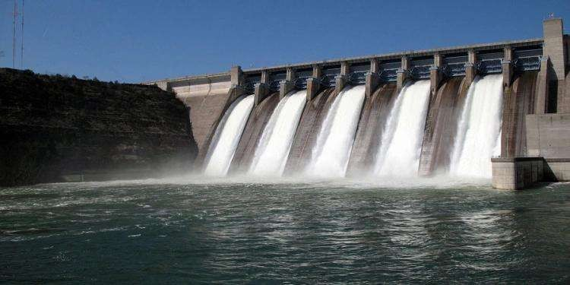

Figure 3.7: The mambila hydropower

# The Implication Of Mambilla Hydropower Project On Agriculture Sector

Current agricultural techniques lead to increasing production, and the consequences of these innovations need the use of sufficient energy in agriculture. Ayodeji (2018) identifies important trends in irrigation, the use of pressured systems for distributing irrigation water, no-till agriculture, etc. However, the energy and power supply situation in Nigeria has been unfavourable to homes, small enterprises, and agriculture for decades. This has had a significant effect on the development and utilisation of contemporary technical infrastructures in Nigeria's commercial agribusinesses. The Mambilla hydroelectric project would nevertheless increase Nigeria's electrical energy supply. According to Michael (2017), the construction of

Mambilla hydropower will enhance electricity delivery, hence encouraging the usage of powered crop dryers and irrigation equipment.

It will also allow poultry and barns to make more efficient use of lighting, heating, and air conditioning. Teresia (2019) asserts that the completion of the Mambilla hydropower project will cut the cost of operating certain energy-intensive agricultural equipment and machinery. Dairies for milking systems, cooling milk, and providing hot water for sanitation, irrigation equipment for drying grain or fruit, ginning cotton, curing tobacco, heating for frost protection in groves and orchards, heating/cooling of cattle barns, pig or poultry brooders, greenhouses, and other animal waste treatment machines.

# CHAPTER FOUR

**DIAGNOSIS OF THE STATE OF AGRICULTURE AND RURAL AREAS**

# 4.1 OVERVIEW OF NIGERIA AGRICULTURAL SECTOR

Agriculture is practised in all 36 states organised into six geographical zones, making it Nigeria's largest single economic sector in terms of contribution to the country's real GDP growth. In nominal terms, the sector expanded by 10.6% year on year in the second quarter of 2018. (Adeleye, Daramola, Onabote, et al. 2021).

In January 2022, Nigeria's total population was 214.1 million. Females account for 49.3 percent of Nigeria's population, while males account for 50.7 percent.

53.4 percent of Nigeria's population resided in rural areas at the start of 2022, while

46.6 percent lived in urban areas. Nigeria's population is 18.2 years old on average (Knoema, 2022).

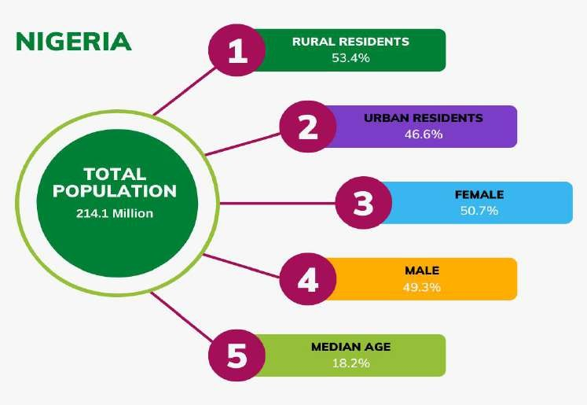

Figure 4.1: A chart showing population details of Nigeria

Maize, cassava, guinea corn, yam beans, millet, and rice are the main crops grown on Nigeria's 70.8 million hectares of agricultural land. Rice production in Nigeria increased from 3.7 million metric tonnes in 2017 to 4.0 million metric tonnes in 2019 (FAO, 2020). Despite this, only 57% of the 6.7 million metric tonnes of rice

consumed in Nigeria each year is produced domestically, resulting in a 3 million metric tonnes shortage that is either imported or smuggled in illegally. In order to boost domestic production, the government banned rice imports in 2019 (FAO, 2020).

Nigeria was the world's greatest producer of cassava in 2017, with 59 million tonnes produced (approximately 20 percent of global production) (FAO, 2019). The economic opportunities are vast, with substantial revenue yields from domestic value addition and derived income, as well as government revenues (FAO, 2019). Manufacturing is expected to rise as a result of improved cultivars and production practises.

Animal production has been underutilised for a long time. Small ruminants such as goats (76 million), sheep (43.4 million), and cattle (43.4 million) are the most common livestock raised by Nigerian farm families (18.4 million) (NBS, 2020). The northern region of the country's nature makes it well-known for livestock farming. In addition to small and large ruminants, there are 180 million chickens in the world (FMARD, 2017). Despite various initiatives by development partners to boost output and protect against diseases such as transboundary animal diseases, local demand dominates production here as well.

With around 3.2 million metric tonnes of fish consumed yearly, Nigeria is Africa's largest fish consumer and one of the world's major fish consumers (FAO, 2019). Fisheries and aquaculture are two of the country's fastest-growing subsectors. Total fish output each year is close to 1 million metric tonnes (FAO, 2019), with an 853-kilometer coastline and about 14 million hectares of inland waters (313,231 metric tonnes from aquaculture and 759,828 metric tonnes from fisheries). In Nigeria, fishing is a vital source of income for the impoverished and an important supply of protein for households (FAO, 2019). The aquaculture sub-sector is seen as a very viable option for satisfying the country's need for fish production and nutrition self- sufficiency.

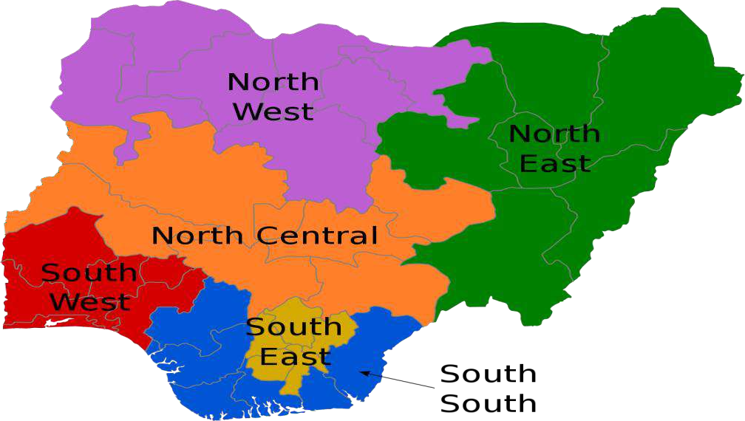

Figure 4.2: The geopolitical zones of Nigeria Source: UNICEF, 2020

It is impossible to overstate the importance of forestry to agriculture and prosperity in general. According to the FAO's 2018 report, Nigeria's forest ecosystems are threatened by rapid population expansion and economic activities, with yearly deforestation rates ranging from 0.72 to 2.38 percent. This tendency is fueled by agricultural expansion, a high reliance on firewood and charcoal for electricity, unsustainable timber extraction, urbanisation, grazing, bushfires, and infrastructure development (FAO, 2019).

With a projected population of 400 million by 2050, increased agricultural production through the adoption of new technology and innovations would be required to provide food security and nutrition (NBS, 2020). Support for the federal and state governments' efforts from all partners is critical to accomplishing this aim (NBS, 2020).

Despite the sector's importance to the economy, Nigeria's agricultural sector continues to suffer numerous issues that have had a negative impact on its productivity. Poor road networks impedes Nigeria’s agricultural market access; water supply; sewage management; insufficient gas supply; epileptic electricity; and excessive internet costs are among them. The insufficiency and low quality of this technical infrastructures continue to stifle the growth of Africa's most populous country, resulting in greater food imports as the population grows. For example, between 2016 and 2019, Nigeria's total agricultural imports were N3.35 trillion, four times larger than the N803 billion in agricultural exports during the same period (NBS, 2020).



Figure 4.3: Rainforest zone of Nigeria

Source: Food and Agriculture Organization, 2020

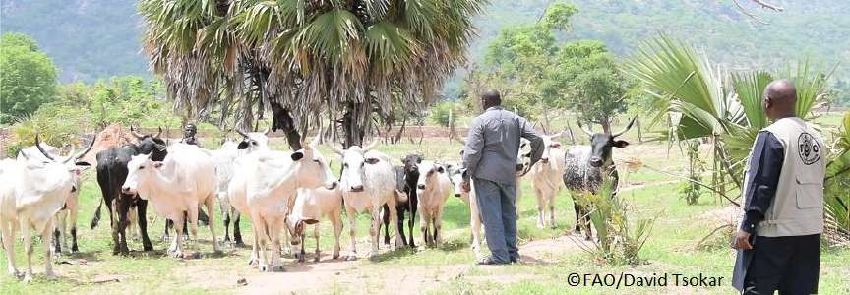

Figure 4.4: Cattle rearers in Adamawa state, Nigeria Source: Food and Agriculture Organization, 2020

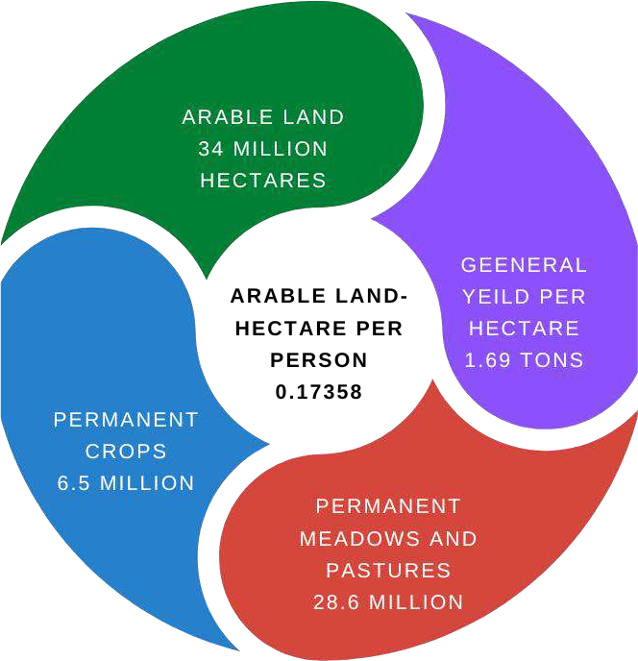

Figure 4.5: Overview of Agricultural land activities in Nigeria

# Table 4.1: percentage of agricultural employment

|  |  |
| --- | --- |
| Year | % of agricultural employment |
| 2011 | 40.58 |
| 2012 | 39.47 |
| 2013 | 38.27 |
| 2014 | 37.51 |
| 2015 | 36.94 |
| 2016 | 36.55 |
| 2017 | 36.05 |
| 2018 | 35.53 |
| 2019 | 34.97 |
| 2020 | 34.66 |

* 1. **ROAD INFRASTRUCTURE**

Nigeria's rural transportation infrastructure, which connects rural settlements to urban regions, has been regarded as a critical component for the country's economic development. The majority of rural roads are in poor condition, imposing large expenses on the national economy, particularly on agricultural operations, as a result of higher vehicle operating costs and travel times (Ezugwu, Onyelowe, Ezugwu, Onyekweredike, Odumade, et al., 2021).

Nigeria has a road network of around 195,000 kilometres, with about 60,000 kilometres of asphalt roads. This network is made up of roadways owned by the federal, state, and local governments. The Federal trunk highways are the system's main arteries, with a total length of 32,100 km (16%), the majority of which is paved. State highways cover 30,900 kilometres (16%), whereas the local government road network covers around 132,000 kilometres (68 percent ). The three tiers of government in Nigeria have separate responsibility for the planning, construction, financing, and maintenance of their own road networks, as stipulated in the Nigerian Constitution.

In comparison to other West African countries such as Ghana (67,291 km) and European countries such as Poland, Nigeria has a considerable road network (423,997km). Ghana has a total of 12,785 kilometres of trunk roads, 42,394 kilometres of feeder roads, and 12,112 kilometres of urban roads (FAO, 2020). In comparison to Nigeria, which has roughly 60,000 kilometres of paved roads, Poland has 292,134 kilometres of paved highways connecting its rural and urban areas (Statistics Poland, 2020b). According to statistics (NBS, 2020), the world's average road quality was 4.07 in 2019. Nigeria's highest road quality rating for 2019 was 2.5 points, which is low when compared to Ghana's 3.00 points and Poland's 4.3 points (Statistics Poland, 2020b). This explains why Nigeria's roads are in such bad shape and have become a barrier to productive agricultural operations (Ajiboye, and Afolayan, 2019).

Despite the fact that roads are one of the most convenient and inexpensive modes of transportation in the world (FAO, 2019). Roads are important for the socio- economic growth of every community, because a well-developed network of roads is a fundamental aspect of technical infrastructure in any given society, including Nigeria, which has a staggering infrastructure deficit.

Nigeria would experience more than 60% post-harvest losses of farm commodities in 2020, particularly perishable goods (FAO, 2021). In February 2021, the Federal Government allocated N34 billion to the construction of 377 rural roads in order to reduce post-harvest losses (FAO, 2021).

Indeed, the country's 195, 000-kilometer network of roads has deteriorated to the point that it poses a serious threat to road users, particularly vehicles, even as terrible roads are now one of the country's leading causes of death (FAO, 2021). Traps serve as highways in over 266 settlements across the six geopolitical zones. In the absence of storage facilities, Nigerian farmers face significant post-harvest losses. Due to delays in transporting mangos from the farms to the market, more than half of the mangos harvested in 2020 will be squandered (FAO, 2021).

Poor roads may be seen at Ugwuonyeama– Ninth Mile; Ninth Mile–Enugu– Onitsha Expressway; Oji–Achi–Mmaku Road in Enugu State; Enugu–Port Harcourt Expressway; Okigwe–Owerri Road and Ninth Mile–Makurdi Highway in Nigeria's South East area.

Several other highways in the zone are near inaccessible, with the exception of the current repair of the Enugu–Port Harcourt Highway, which has facilitated mobility for the time being. Enugu's Ugwuonyeama–Ninth Mile Road has turned into a death trap. The Federal Government restored the dual carriageway that leads to Onitsha in Anambra State almost seven years ago. Many motorists have abandoned the road due to the extent of deterioration caused by gully erosion and heavy-duty trucks. On the Ninth Mile–Enugu–Onitsha Highway, the scenario is similar (Ajiboye, and Afolayan, 2019).

**Table 4.2: Comparative table of roadway between Nigeria Poland, and Ghana as at 2019**

|  |  |  |  |
| --- | --- | --- | --- |
| **Country** | **Total roadways** | **Per 1 mio inhabitants** | **Per km2** |
| Nigeria | 195,000 km | 945.96 km | 211.09 m |
| Poland | **423,997km** | 11,082.07 km | 1,343.23 m |
| Ghana | **67,291km** | 3,524.45 km | 459.11 m |

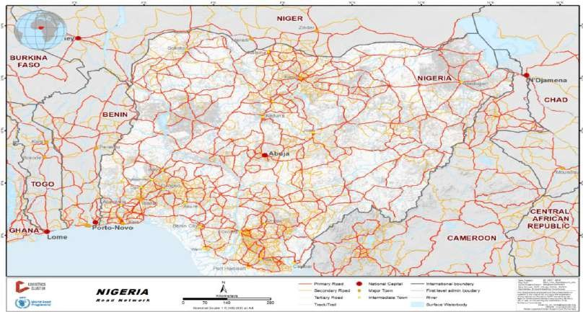

Figure 4.6:Nigeria road network

Source: Food and Agriculture Organization, 2020

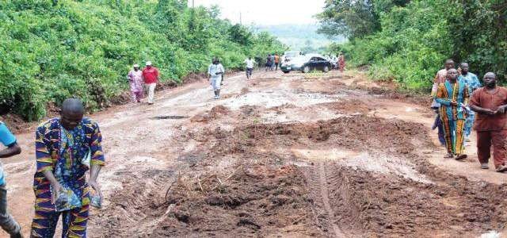

Figure 4.7:Nigeria road network

Source: Food and Agriculture Organization, 2020

# WATER SUPPLY INFRASTRUCTURE

With over 86 percent of Nigerians without access to a safely managed drinking water source, sustainable and equitable access to safe drinking water remains a technical infrastructural barrier. Poor drinking water quality and inequity in access exacerbate the situation (UNICEF, 2021).

Despite the fact that over 70% of Nigerians have access to basic water services, more than half of these sources are contaminated. And, despite the fact that 73% of the country's population has access to a water source, the average Nigerian only has access to nine litres of water each day (UNICEF, 2021). According to WorldBank (2021) reports, 60 million Nigerians did not have access to basic drinking water

services in 2019, 80 million did not have access to improved sanitation facilities, and 167 million did not have access to a basic handwashing facility. In rural regions, 39% of families lack access to at least basic water supply services, just half have access to improved sanitation, and over a third (29%) practise open defecation, a percentage that has barely changed since 1990 (WorldBank, 2021).

Water covers 13 000 square kilometres in Nigeria. (The CIA, 2013). Nigeria has an annual surface water supply of 267 billion cubic metres and a ground water supply of 52 billion cubic metres (Ince et al. 2010). Nigeria has a lot of surface water compared to other nations, but it has a lot of dependency compared to Poland, and it has a low renewable per capita and renewable water resources compared to Poland and Ghana.

**Table 4.3 Comparative table of water statistics of Nigeria, Poland and Ghana**

|  |  |  |  |
| --- | --- | --- | --- |
| **Country** | **NGN** | **POL** | **GHA** |
| Surface | 214 bcm | 2.1 bcm | 29 bcm |
| Underground | 87 bcm | 12.5 bcm | 26.3 bcm |
| Dependency | 22.8% | 11% | 46.1% |
| Renewable Per  capital | 1,461 cb | 1,584 cb | 1,888 cb |
| Int. Renewable wate resources | 1,128 cm | 1,413 cm | 1,018 cm |

Source: worldbank, 2022

To supply their home needs, almost 47 million Nigerians still rely solely on surface water sources. According to the World Bank, an individual need an average of 20 to 50 litres of safe water per day for metabolism and cleanliness. Nigeria's national water requirements are 23 litres per day in rural areas and 60 litres per day in urban areas (Ishaku et al. 2011). About 100 million Nigerians rely on groundwater for their water supply. Since 1990, Nigeria's water supply in metropolitan areas has decreased (Olajuyigbe 2010).

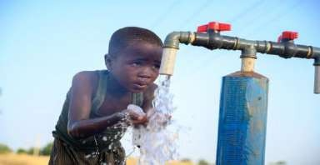

Figure 4.8: Child accessing drinking water in Kogi state, Nigeria Source: UNICEF, 2020

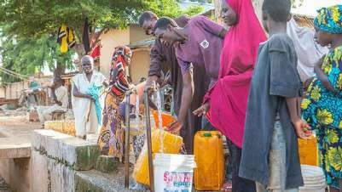

Figure 4.9: Residents of Kebbi state accessing drinking water Source: Worldbank, 2021

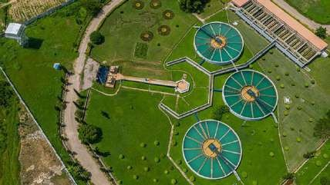

Figure 4.10: Aerial view of completed Dadin-Kowa treatment plant in Gombe State. Source: Worldbank, 2021

# SEWAGE TREATMENT INFRASTRUCTURE

When sewage is very concentrated (e.g. sewage from residential and industrial buildings) or mixed with industrial wastes, it is usually treated using a mixture of physical and biological processes, with the addition of a chemical procedure (Ashagidigbi, Abiodun and Samson, 2018). Bacteria, protozoa, and algae work on sewage under optimum conditions in the biological process. Wastewater or sewage generated in a developing country like Nigeria with old cities and villages is frequently discharged into pit latrines in rural regions, while it is released into septic tanks, soakaways, and cesspools in towns and cities (Ajiboye, 2014). These systems

are troublesome because soils get saturated with pollutants and effluents with extremely high suspended and dissolved solids, resulting in degradation of the environment and, in certain circumstances, groundwater pollution. Environmental contamination caused by human activities has been a significant challenge and difficulty for environmental engineers all over the world (Aloba, 2016).

# Table 4.4: Various Sewage Plants in Nigeria and their status.

|  |  |  |  |  |  |  |
| --- | --- | --- | --- | --- | --- | --- |
| **STATE** | **LOCATIONS OF SEWER LINES** | **KIND OF TREATMENT** | **LEVEL OF TREATMENT** | **LONGITUDE** | **LATITTUDE** | **STATUS** |
| F.C.T,  Abuja | Wupa central Plant | Mechanical | Complete | 7.380470 | 9.021910 | Functioning |
| Markurdi | Markurdi central | Mechanical | Complete | 8.496710 | 7.724560 | Not Functioning |
| Kaduna | Nigerian Brewery,  Kaduna | Mechanical | Complete | 7.426657 | 10.508529 | Functioning |
| Kano | Kano central | Mechanical | Complete | 8.558002 | 11.984488 | Not Functioning |
| Enugu | Abakpanike Estate | Biological | Partial | 7.523686 | 6.518289 | Functioning |
| Edo | Nigerian Brewery,  Benin | Mechanical | Complete | 5.622182 | 6.334431 | Functioning |
| Delta | NNPC, Warri Shell Petroleum Main Office and Staff Quarters Warri | Mechanical Mechanical | Complete Complete | 5.740021  5.740724 | 5.515570  5.539423 | Functioning Functioning |
| Rivers | Ifruga Estate, Rivers Etope Estate , Rivers Chevron Office, Rivers Shell Petroleum office,  Rivers | Mechanical Biological  Mechanical Mechanical | Partial Partial Complete Complete | 7.009141  7.003762  7.005839  7.005724 | 4.779042  4.785990  4.786335  4.784149 | Not Functioning Functioning Functioning Functioning |
| Lagos | Abesan Oke Afa Alausa  Olusosun Nigerian Brewery,  Lagos University of Lagos | Biological Biological Mechanical Biological Mechanical Biological | Partial Partial Partial Partial Complete Partial | 3.292370  3.300730  3.352090  3.356550  3.364784  3.388970 | 6.591050  6.527210  6.623650  6.633710  6.480348  6.516493 | Functioning Functioning Functioning Functioning Functioning Functioning |

|  |  |  |  |  |  |  |
| --- | --- | --- | --- | --- | --- | --- |
| Ekiti | ABUAD | Mechanical and Biological | Partial | 5.223361 | 7.612281 | Functioning |
| Oyo | UCH  University of Ibadan  I.I.T.A Ibadan Nigerian Brewery, Ibadan | Mechanical Biological Mechanical Mechanical | Partial Partial Complete Complete | 3.903897  3.901553  3.896732  3.969622 | 7.405737  7.433328  7.495748  7.397722 | Not Functioning Functioning Functioning Functioning |
| Osun | OAU, Ile-Ife Nigerian Brewery, Ilesha | Biological Mechanical | Partial Complete | 4.528612  4.785830 | 7.516464  7.624270 | Functioning Functioning |
| Ogun | Agbara Industrial Estate | Mechanical | Complete | 3.086104 | 6.505113 | Functioning |

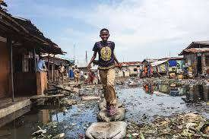

Figure 4.11: Sewage pollution in south-east Nigeria Source: UNICEF, 2020

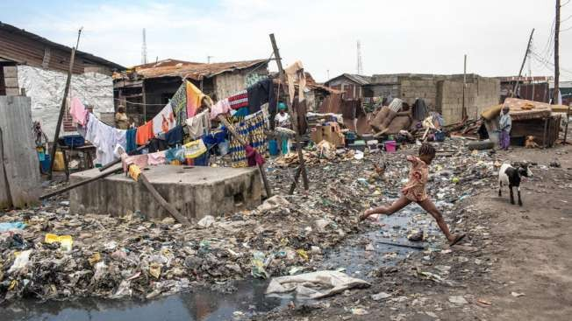

Figure 4.12: Sewage pollution in south-west, Nigeria Source: UNICEF, 2020

Although sewage lines are largely used in the southwest and north central geopolitical zones (notably Abuja), ancient methods like as earth pits and defecating in the bush are still prevalent, especially in the southwest, south-south, and north central geopolitical zones (Ajiboye, and Afolayan, 2019).

# Table 4.5: Comparative table of sewage network between Nigeria, Poland and Ghana

|  |  |  |  |
| --- | --- | --- | --- |
| **Country** | **NGN** | **POL** | **GHA** |
| Sewage Network | 23,700km | 102,900km | 63,000km |
| House Connection | 1,1660 | 103,000 | 4,184 |

It's worth noting that the facility, which was built to process sewage from the Federal Capital City's phases one, two, and three, is now operating at just approximately 25% of its installed capacity, owing to a lack of power and low sewage intake (Ajiboye, and Afolayan, 2019).

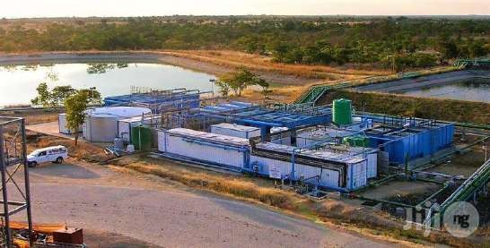

Figure 4.13: Sewage plant, Abuja, Nigeria Source: worldbank.org

The dismal results in rural sanitation are just more proof of Nigeria's bad policy failure in rural development. The formulation and execution of an integrated rural development policy with a strong focus on the development of the rural economy is a major goal. People can save money and invest in other industries to enhance their living standards, including sanitation, if the economy improves. Other serious interventions include promoting health and hygiene education, particularly among children, as well as using inspectors to monitor rural sanitation practises and ensure compliance with basic standards; providing soft loans to families to improve their sanitation; and fostering partnerships between local institutions, government, non- governmental organisations, and donor agencies to identify and assess community sanitation needs and preferences.

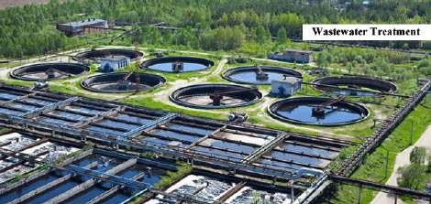

Figure 4.14: Sewage plant, Gombe, Nigeria Source: worldbank.org

# GAS INFRASTRUCTURE

Nigeria is a major gas producer in Africa and on the global market, and it does not always require gas imports (Osabohien, Adeleye, & De Alwis, 2020). However, due to numerous bureaucratic hurdles and corruption by Nigerian politicians and marketers, this commodity is too expensive for citizens to purchase (Osabohien, Adeleye, & De Alwis, 2020). Nigeria flared an estimated 7.4 billion cubic feet of gas in 2018, making it the world's eighth highest gas flarer. In Nigeria, gas flares also endanger human health, taint water supplies, and disrupt crop production.

# Table 4.6 Comparative table showing Gas infrastructure in Nigeria, Poland and Ghana

|  |  |  |  |
| --- | --- | --- | --- |
| **Countries** | **NGN (MMCF)** | **POL(MMCF)** | **GHA(MMCF)** |
| Gas reserve | 180,490,000 | 3,015,000 | 800,000 |
| Gas Production | 3,009,650 | 217,117 | 45,203 |
| Gas Consumption | 664,628 | 642,804 | 44,990 |
| Yearly deficit/Surplus | +2,345,022 | -425,687 | +214,000 |
| Gas import | 0 | 428,053 | 19,736 |
| Gas Export | 929,844 | 1,978 | 0 |

Flared gases interact with water vapour in the air to form acid rain, which has detrimental effects on the soil, flora, fish, and humans. The impact of gas flaring on soil is clear, especially when the length of the flaring is examined. One of the most essential chemical bases of soil fertility is exchangeable cations; shortages of these mineral components are responsible for the poor quality of tropical soil (FAO, 2020).

The cation exchange capacity (CEC) of soils exposed to gas flaring, on the other hand, is extremely low, reducing soil fertility and nutrients. Soils under gas flaring have relatively low mean values of organic matter (1.83 percent) and total nitrogen (0.08 percent). The increase in acidity caused by (FAO, 2020) gas flaring is one of the most significant effects on the chemistry of the soil. Because solubility and hence the uptake of nutrients from soil are reduced, gas flaring causes an increase in soil acidity, rendering soils unproductive agriculturally (FAO, 2020). Due to the country's significant subsistence farming practises, farm practises that encourage carbon sequestration by either increasing carbon storage or minimising carbon loss do not exist.

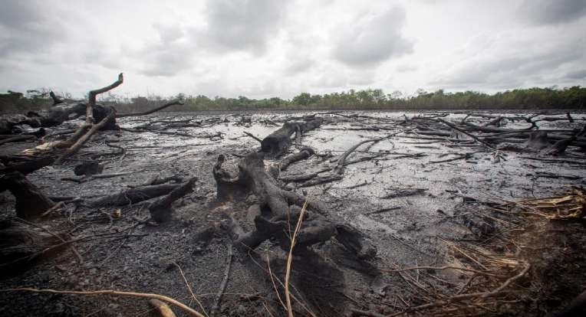

Figure 4.15: Oil leakage from illegal refineries in Delta State, Nigeria, has left large swaths of land barren. Source: carbonbrief, 2022

# ELECTRICITY INFRASTRUCTURE

More than half of Nigeria's population lives in rural areas, and more than 60% of them rely on fuel wood for their energy (NBS, 2020). Due to a shortage of power, about 65 percent of rural people's livelihoods and overall national development are severely hampered (Ashagidigbi, Abiodun and Samson, 2018). Basic services such as drinking water, health care, telecommunications, and education, as well as agro- industrial operations, all require electricity (Ashagidigbi, Abiodun and Samson, 2018). These amenities have a significant positive impact on poverty alleviation and neighbourhood quality of life.

Similarly, contemporary cooking fuels like LPG (liquefied petroleum gas) and kerosene are costly and difficult for the poor to afford. Solar PV (photovoltaic) and other renewable energy technologies (RE) are not widely used. The initial installation costs are significant, and awareness appears to be limited. It's worth noting that the country lacks a grid-connected RE electricity system. All of the current uses (especially solar PV) are primarily stand-alone systems that work infrequently or not at all. As a result, assessing the social impact of renewable energy technology in Nigeria is difficult (Ajiboye, and Afolayan, 2019). As a result, the majority of people still rely on firewood, which has resulted in a 3.6 percent annual loss of forest area, or 350,000 hectares (Ajiboye, and Afolayan, 2019).

Extreme heat is a particular threat to Nigeria's many millions who do not have access to power or air conditioning. Only 92 persons out of 1,000 in metropolitan

areas have access to air conditioning. In rural areas, only 14 people out of 1,000 are affected (Onwutuebe, 2019).

# Table 4.7: Electricity statistics between Nigeria, Poland and Ghana

|  |  |  |  |  |  |  |
| --- | --- | --- | --- | --- | --- | --- |
| **Country** | **Nigeria** | | **Poland** | | **Ghana** | |
| Total | Per capita | Total | Per capita | Total | Per capita |
| Production | 29.35 bn  kWh | 142.38  kWh | 156.90 bn  kWh | 4,139.94  kWh | 12.52 bn  kWh | 402.92  kWh |
| Consumption | 24.72 bn  kWh | 119.92  kWh | 149.40 bn  kWh | 3,942.05  kWh | 9.36 bn  kWh | 301.32  kWh |
| Access to electricity | Total | Rural | Total | Rural | Total | Rural |
| 55.4% | 24.6% | 100.0% | 100.0% | 85.9% | 74.0% |

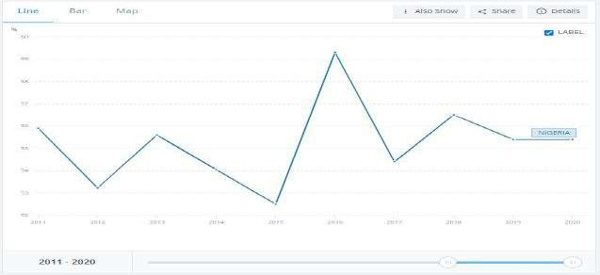

**Figure 4.16: Percentage of population with access to electricity in Nigeria Source: Worldbank, 2022**

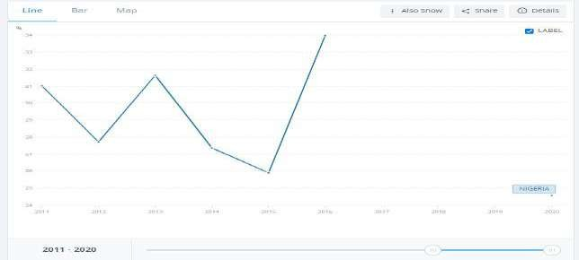

Figure 4.17: Rural access to electricity in Nigeria Source: Worldbank, 2022

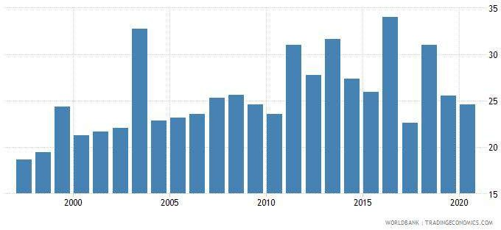

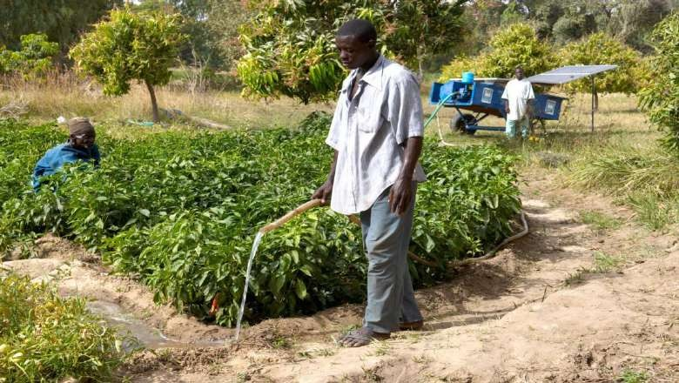

Figure 4.19: In the community of Wawan Rafi, Jigawa State, Northern Nigeria, a small-scale solar energy plant is being implemented.

Source: carbonbrief

# INTERNET INFRASTRUCTURE

Farmers can use the internet to find out about agricultural news, production figures, and regional prices for various inputs and crops. Fertilizer is a hot topic in each of these fields, and there are numerous web pages dedicated to fertiliser information (Aloba, 2016). Aside from agricultural information, the internet also gives information on crop pricing and agricultural news. Farmers in Nigeria are limited in their use of the internet due to a lack of awareness, access, and skills, particularly in the case of subsistence farming, which is prevalent in the country. The median mobile internet connection speed via cellular networks in Nigerian metropolitan areas is

17.38 Mbps, while the median fixed internet connection speed via PC is 10.06 Mbps (NBS, 2020).

# Table 4.8: Internet users statistics in Nigeria, Poland and Ghana

|  |  |  |
| --- | --- | --- |
| Country | Total internet users  (Million) | Percentage of total  population |
| Nigeria | 109.2 | 51.0 |
| Poland | 32.86 | 87.0 |
| Ghana | 17 | 53.0 |

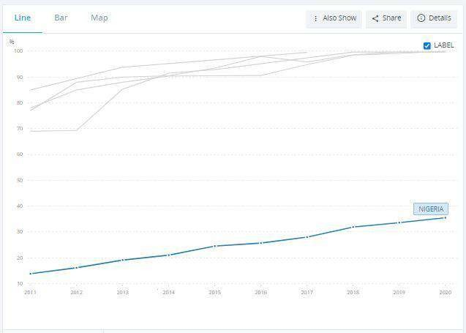

* 1. **CONCLUSION**

Agriculture is Nigeria’s single largest sector with large arable land, continuous increased livestock activity but with high import dependency. Despite agricultural threat such as deforestation, and population, Nigeria boost of a large agricultural potential space. In this study, I have carefully analyzed the place of technical infrastructure in increasing agricultural productivity. Having chronologically examined the presence of major technical infrastructure in the Nigeria agricultural sector. Obtaining data from various credible sources including Nigeria bureau of statistics (NBS), Worldbank, Food and agriculture organization (FAO), Central Bank of Nigeria (CBN), and other published literature; this study have been able to assess the position of Nigeria in the acquisition, accessibility, and utilization of technical infrastructure.

Relying on the recent evidences provided by these credible sources and authorities, the findings of this study reveals that Nigeria is highly deficient in the acquisition, accessibility and utilization of agricultural basic infrastructures. Evidence from literature shows that Nigeria most likely, may have the worst of roads in West Africa. This fact is indicated by the result of the quality of Nigeria road in comparison to other west Africa countries like Ghana and Benin Republic. The effect of this situation is the low access to market as rural farmers continue to face acute difficulty in the transportation of agricultural produce from the farm to the market. Furthermore, rural farmers continue to suffer losses on their products as some agricultural produce gets damaged on their way to the market. Rural farmers in Nigeria suffer high cost of labour as there are little or machinery to facilitate their activities.

Another major challenge discovered in this study is poor sewage management. Nigeria has poor sewage management system and while its sewage network is high, it has a very low household connection as sewage in rural Nigeria are publicly disposed on ground surfaces with little or no proper sewage management. This situation results to soil pollution as toxic substances and untreated sewage continue to impede the soil quality, making it unhealthy for crop production. Gas flaring in some parts of rural Nigeria is next to poor sewage management that has made the soil in the rural southern Nigeria region harmful for crop production. Other factors include inaccessibility of water supply, electricity and internet. However, the solution to these rural agricultural impediments are not far-fetched. Nwala and Mohammed (2019) postulated in their study that agricultural solutions in Nigeria are not laws to be learn

but actions to be applied. Nigeria has a policy implementation issue. This is despite the numerous initiatives, government sponsored activities, grants from non- governmental organization (both national and international) and expert assistance the country have received overtime. Nigeria’s agricultural solution lies in the implementation of many of the formulated agricultural policies. Corruption and bureaucratic bottlenecks has been the bane of policy implementation in Africa’s most populous nation.

It is the recommendation of this study that to achieve increased agricultural productivity in Nigeria and rural development, national agricultural reform policies from the ministry of Agriculture (MOA), Worldbank, International Monetary fund (IMF), African Development Bank (AFDB), Bank of industry (BOI), Food and agricultural organization (FAO) be carefully considered and implemented as no new policy put forward in this study will revive the poor state of agricultural technical infrastructure in Nigeria without the cooperation of Nigeria leaders from the federal government to the local government authorities through the fight against corruption, agricultural funds embezzlement, high rural insecurity and weak judiciary. It is the position of this study that if these aspect of agricultural leadership are addressed, functional technical infrastructures will emerge, import dependency will be reduced, increased agricultural productivity will be attained and rural development will be achieved.

# REFERENCE

Abdulrahman, S. (2013). Population growth and food security in Nigeria (2010- 2012) Adeleye, A. (2013) Rural infrastructural development in Nigeria. African Development Bank

Group(2018) Summary Report.

Adeleye, B.N., Daramola, P., Onabote, A. et al. (2021). Agro-productivity amidst environmental degradation and energy usage in Nigeria. Sci Rep 11, 18940. https://doi.org/10.1038/s41598-021-98250-y

Adelman, A., 2000. Determinants of growth and development of the Nigerian economy. Adesogan, Sunday. (2013). Sewage Technology in Nigeria: A Pragmatic Approach.

Environmental Engineering Research. 2013. 10.7237/sjeer/266.

AFDB (2010). Infrastructure - African Development Bank. Retrieved on 22 August 2011 from <http://www.afdb.org/en/topics-> sectors/sectors/infrastructure.

Africa Development Bank Report ( 2020). An infrastrucure action plan for Nigeria. Agbola (2000). Control of Large Scale Civil Conflicts in Democratic Nigeria

Agenor, U. (2016) Public infrastructure and growth: New channels and policy implications Ajibade, F. O. (2013). Design of a Central Wastewater Disposal System for an Urban Area

Using FUTA Campus as Case Study.

Ajibade, L. (2015), “Storage and treatment system of solid waste as strategy for sustainable development in Ilorin Metropolis, Nigeria”,

Ajiboye, A. and Afolayan, O. (2019). The impact of transportation on agricultural production in a developing country: A case of kola nut production in Nigeria. International Journal of Agricultural Economics and Rural Development, 2 (2), 49-57.

Ajiboye, A. (2014). Rural accessibility and transportation problems. A case study of ljebu North Local Government Area Ogun State. Unpublished PGD Thesis, Department of Geography and Regional Planning, Ogun State University, Ago- Iwoye.

Akangbe, J. A., Oloruntoba, O. O., Achem, B., & Komolafe, S. E. (2013). An appraisal of transportation facilities effects on agricultural development in Moro Local Government Area, Kwara State, Nigeria. Ethiopian Journal of Environmental Studies and Management, 6 (2), 191 – 200.

Aldagheiri, M. (2009).The role of the transport road network in the economic development of Saudi Arabia. Department of Geography, Qassim University, Saudi Arabia

Almond and Powell (1988), Nation building and socio-cultural inherent

Aloba, O. (2016). Rural transportation. In I. Falola and S. A. Olarewaju (Eds.), Transport Systems in Nigeria Syracuse University Maxwell School of Citizenship and Public Affairs. Series XLII: 125-138. Ashagidigbi, W., Abiodun. O. E., and Samson, O. A., (2018). The effects of rural infrastructure development on crop farmer productivity in Osun State. World Rural Observation, 3(1), 48-58

Amartya(1999),Governance for Sustainable Human Development

Amin, A. (2013). The impact of population growth on economic development in Nigeria Anonymous, (2008) Sewage Technology http://

[www.en.wikpedia.org/wiki/sewage_collection_and_disposal](http://www.en.wikpedia.org/wiki/sewage_collection_and_disposal)

Antle, J. M. (1983). Infrastructure and Aggregate Agricultural Productivity: International Evidence Economic Development and Cultural Change.

Anwana, V. I. (1989). Psychology: Aspects of human development. Enugu.

Apthorpe, R. (1994) “Development Theory Now.” European Journal of Development Research, 6, 2, 182-188

Archibong, B. (2002). ‘Historical origins of persistent inequality in Nigeria.

at the Feed the Future Second Conference organized by the International Food Policy Research

Awosusi, A. (2010), “Assessment of environmental problems and methods of waste management in Ado-Ekiti, Nigeria

Ayamba, I. & Abang, P. (2021). Agricultural Development Programmes in Nigeria's Fourth Republic: Changing the Narrative of Food Insecurity in Nigeria. 6. 64-74. 10.36758/jggsda/v6n3.2021/7.

Ayodeji Adegboyega (2018). "What we're doing to improve Nigeria's electricity supply – Minister". Nigeria.

Babosa, N. (2012). Fiscal deficits, economic growth and government debt. Bengal. [www.kpmg.com.](http://www.kpmg.com/)

Bisallah, Hashim. (2014). Effect Of Ict On Agricultural Sector In Nigeria.

Casier L, (2015). Why Infrastructure is Key to the Success of the SDGs. [Online]. Available: https://[www.iisd.org/blog/why-infrastructure-key-success-sdgs.](http://www.iisd.org/blog/why-infrastructure-key-success-sdgs) [Accessed: 31-Dec- 2018].

Central bank of Nigeria (2006) Repositioning Developments Financing Activities of the Central Bank of Nigeria .vein publishers Ltd, Abuja

Central Bank of Nigeria. (2013a). Understanding Monetary Policy Series No.2.” [Online].

Retrieved from <https://www.cbn.gov.ng/documents>

Central Bank of Nigeria. (2019). Understanding Monetary Policy Series No.3, Central Bank of Nigeria Monetary Policy Framework. [Online]. Retrieved from <https://www.cbn.gov.ng/documents>

Central Bank of Nigeria. (2020). Economic Report Fourth Quarter 2020 [Online]. Retrieved from https://[www.cbn.gov.ng/Documents/](http://www.cbn.gov.ng/Documents/)

Central Bank of Nigeria. (2021). Annual Statistical Bulletin2021. [Online]. Retrieved from https://[www.cbn.gov.ng/documents/](http://www.cbn.gov.ng/documents/)

Chhibber, A. (1988). Raising Agricultural Output: Price and Non Price Factors. Finance and Development. Vol. 25. No. 2. pp 44 – 47.

Chidozie, Udemezue & A., Kanu. (2019). Challenges of Nigerian Agricultural Sector in the Twenty First Century: The Case of Nomadic Insurgence and Terrorist Sects. Universal Journal of Agricultural Research. 7. 117-124. 10.13189/ujar.2019.070204.

Dauda, M. and Osita, O. (2003), “Solid waste management and re-use in Maiduguri, Nigeria” David Laitin(1999), social and cultural diversities in Nigeria.

Delanney, Elaine (2012): “Frontier Infrastructure: The Way Forward of Nigeria.

Department of Economic and Social Affairs, Envision2030: 17 goals to transform the world for persons with disabilities United Nations Enable.[Online]. Available:

Devlin, J., Li, K., Higgins, P., & Foley, A. (2016). The importance of gas infrastructure in power systems with high wind power penetrations. Applied Energy, 167, 294–304.

DFID (2004), “Estimates of waste generation volumes and income potential in Abuja”, DFID CNTR: 00 0512A, SPLG Consultant’s Report No. 805, DFID, London.

Dredging Today. (2012) River Niger dredging improves inland water transportation in Nigeria. [www.dredgingtoday.com](http://www.dredgingtoday.com/)

Edeme, Richardson Kojo; Nkalu, Nelson C.; Idenyi, Janefrancis C; Arazu, Winnie O. (2020). Infrastructural Development, Sustainable Agricultural Output and Employment in ECOWAS Countries. Sustainable Futures, 2(), 100010–.

doi:10.1016/j.sftr.2020.100010

Egbetokun, O. A. (2009). Provision of Rural Infrastructure Oyo State, Nigeria. Agricultura – Ştiinţă şi practică nr. 1-2 (69-70]/2009

Engel, E, R Fischer and A Galetovic (2010): “The economics of infrastructure finance: Public-Private Partnership versus public provision.” EIB papers, vol 15, no 1, pp 41–69.

Escobal, J. and C. Ponce. (2000). The Benefits of Rural Roads: Enhancing Income Opportunities for the Rural Poor Group of Analysis for Development (GRADE) Working Paper No. 40, November.

Estache, A. (2014) Infrastructure finance in developing countries

Ezugwu, Charles & Onyelowe, Kennedy & Ezugwu, Chisom & Onyekweredike, Kelechi & Odumade, Adegboyega & Omunakwe, Okechukwu & Hussaini, Mahmud & Oloyede, Amodu & Innocent, Wokocha. (2021). Community Water Demand and

Sustainable Water Supply Planning in Nigeria: A Review. Jurnal Kejuruteraan. 33. 517-530. 10.17576/jkukm-2021-33(3)-13.

Ezugwu, Onyelowe, Ezugwu, Onyekweredike, Odumade, Adegboyega et al. (2021)

Fakere, A., Fadair, G. and Oriye, O. (2012), “Domestic waste management and urban residential environment: focus on Akure, Nigeria”,

Familoni, K.(2013) The role of economic and social infrastructure in economic development. FAO (2019). Global Trends in GDP, Agriculture Value Added, and Food-Processing

Value Added (1970-2017). FAO, Italy, Rome, retrieved at: [www.fao.org/economic/ess/ess-economic/gdpagriculture/en/,](http://www.fao.org/economic/ess/ess-economic/gdpagriculture/en/) 20th August 2020.7.

FAO (2020). Food security indicators. FAO, Italy, Rome, retrieved at: [www.fao.org/economic/ess/ess-fs/ess-fadata/en/#.X4QIs1UzZhE,](http://www.fao.org/economic/ess/ess-fs/ess-fadata/en/#.X4QIs1UzZhE) 17th September 2020.

Fay, M; Toman, M; Benitez, D; (2013). Infrastructure and sustainable development.

Federal Airport Authority of Nigeria (FAAN) (2013). Air ports in Nigeria. [www.faannigeria.org](http://www.faannigeria.org/)

Federal Government of Nigeria (2009). Concept paper for development. [www.v2020.ng.org.](http://www.v2020.ng.org/)

Fidelis 0., Nedozi, J., Obasanmi, J., Ighata, A. (2014). Infrastructural development and economic growth in Nigeria.

Fidelis I., Emoh, U., Ajator, U.,and Ugonabo M. (2016). Urban infrastructure financing and management in Nigeria

FMW (2013). Compendium report on road infrastructure & related development in

FMWH, Nigeria (2013). Infrastructure development fund (IDF) project implementation in Nigeria.

Fofana, I. (2011). Stimulating the Impact of Climate Change and Adaptation Strategies on Farm Productivity and Income: A Bioeconomic Analysis. Discussion Paper IFPRI Washington, DC, 01095.

Foster, V. and Pushak, N. (2011) Nigeria's infrastructure: A continental perspective. Africa Infrastructure Country Diagnostic.

Fung KC, Garcia-Herrero A, Lizaka H and Siu A, (2005). Hard or soft? Institutional reforms and infrastructure spending as deter

Gandonu, A. (2007) “Nigeria’s 250 Ethnic Groups: Realities and Assumptions” Ibia, E. I. (2005). Sociological foundation of Nigerian education.

Iheke, C. (2013). Nigerian economic development and inland waterways: Dredging Rivers Niger and Benue.

Ikah(2006), The factors affecting socioeconomic development in Nigeria. Ikeh(2011), Nigeria: History, Geography, Government and Culture.

Inderst, G, and F Stewart (2014): “Institutional Investment in Infrastructure in Developing Countries”, World Bank Policy Research Working Paper, No 6780, February.

Institute in conjunction with USAID and Michigan State University, USA. 14-16, August 2018

International Monetary Fund (IMF). 2018. Regional Economic Outlook.

Javeed, Insha & Narayan, Sumati & Malik, Ajaz A. & Kumar, Anil & Rahman, Rihana & Nisar, Shemoo & Akhter, Afroza & Indrabi, Sayed & Sultan, Amreena. (2021). Role of Information and Communication Technology in Agriculture.

Joe, B. (2013) Nigeria hands state power assets to private buyers.

Josephine Okojie (2015). Poor road network hinders market access to farm produce. https://businessday.ng/agriculture/article/poor-road-network-hinders-market-access- to-farm-produce/

Khandker, S. R., Z. Bahkt and G. B. Koowal. (2006). The Poverty Impact of Rural Roads: Evidence from Bangladesh. World Bank Policy Research Working Paper No 3875, April.

Kilian, 2004. Economic growth: Determinants, issues and lessons.

Kiprono, P., & Matsumoto, T. (2014). Roads and farming: The effect of infrastructure improvement

Koh, Jae-myong (2018) Green infrastructure financing: Institutional investors, ppps and bankable projects.

KPMG. (2017). Importance of urban and social infrastructure in economic growth of

Limi, A. and J. W. Smith. (2007). What is missing between Agricultural Growth in Infrastructure Development? Cases of Dairy in Africa. World Bank Policy Research Working Paper No. 4411. November.

Lokonon, B. (2018). Land Tenure and Communities Vulnerability to Climate Shocks: Insights from the Niger Basin of Benin. In A. Shimeles, A. Verdier-Chouchane, &

A. Boly (Eds.), Building a Resilient and Sustainable Agriculture in Sub-Saharan Africa.

Lokshin, M. and R. Yemtsov. (2005). Has Rural Infrastructure Rehabilitation in Georgia Helped the Poor? The World Bank Economic Review No. 19 Vol. 2, pp 311- 333

Mara, D, (2015): Water, Wastes and Health in Hot Climate.

Michael Harris (2017), Construction begins on Nigeria’s 3,050-MW Mambilla hydropower plant. https://[www.renewableenergyworld.com/baseload/construction-begins-on-](http://www.renewableenergyworld.com/baseload/construction-begins-on-) nigeria-s-3-050-mw-mambilla-hydropower-plant/#gref

Midgley, J. (2003) “Social development: the intellectual heritage”Journal of International Development, 15, 7, 831-844. 24.

Minges, M., Gray, V. and E. Magpantay. (2003) “World Telecommunication Development Report 2003: Access Indicators for the Information Society”. International Telecommunications Union. Geneva.

Mostafa, A and Ezatollah, K (2007) Sustainable Agriculture: Towards a Conflict Management Based Agricultural Extension. Journal of Applied Science

National Bureau of Statistics (NBS) (2019). Transportation. [www.nbs.org](http://www.nbs.org/)

Nigeria - An investor's manual; Abuja: Pison Real Estate and Infrastructure Professional Practice & Services.

Nigeria Bureau of statistics (2015). AGRICULTURAL STATISTICS. <https://www.nigerianstat.gov.ng/pdfuploads/GDP_Report_Q2_2015.pdf>

Nigeria Bureau of statistics (2018). AGRICULTURAL STATISTICS. <https://www.nigerianstat.gov.ng/pdfuploads/GDP_Report_Q2_2018.pdf>

Nigeria Bureau of statistics (2020). AGRICULTURAL STATISTICS. <https://www.nigerianstat.gov.ng/pdfuploads/GDP_Report_Q2_2020.pdf>

NRC (2013). The pride of the Nation. NRC Newslette

NS Energy (2018). "Mambilla Hydropower Project". United Kingdom: NS Energy. Nuash (2014), An analysis of social condition of Nigeria and its effect on the populace

Nwozor, Agaptus & Shola, John & Ake, Modupe. (2019). National Insecurity and the Challenges of Food Security in Nigeria. Academic Journal of Interdisciplinary Studies. 8. 10.36941/ajis-2019-0032.

Obiechina, M.E. (2010) Analysis of Revenue Generation as a Tool for Socio-Economic and Infrastructural Development in Nigeria.

Odeleye,A.(2012). The challenges of infrastructure development in democratic governance in Nigeria

Ogbonna G.N, and Appah E (2012), Impact of Petroleum Revenue and the Economy of Nigeria.

Ogedengbe, M.(2011) Waste Management Systems Potential impacts.

Ogwueleka, T. (2009). “Municipal solid waste characteristics and management in Nigeria” Oju(2016), Impact of insecurity on Nigeria economic development

Okafor(2007), Cultural diversities and socioeconomic constrains in Nigeria.

Oke AE, (2013). Indices of infrastructural development in a developing economy: Focus on Nigeria: in Sustainable Infrastructural Development in a Developing Economy.

Oke, F (2017) Africa‟s Lack of Infrastructure and its Effect on the Agricultural Sector <http://www.blog.kpmgafrica.com/africas-lack-of-infrastructure-and-its-effect-onthe-> agricultural-sector/

Ola M. (2017), Appraisal Of Vision 20:2020 Infrastructure Development Strategies In Nigeria

Oladeji, P. A. O. S. I. (2011). Population Dynamics and Economic Growth in Sub-Saharan Africa

Olisa, M.S.O. and Obiukwu, J.I. (1992), Rural Development in Nigeria: Dynamics and Strategies, Awka, Mekslink Publishers (Nig).

Olorunfemi S.O (2018). Factors Impeding Food Security in Akutupa-Kiri, Nigeria. Paper presented

Olorunfemi, O. D., Ogunlade, I., Fakayode, S. B., & Adekunle, O. A. (2014). Ensuring improved livelihood opportunities for resource-poor Maize farmers through the dissemination of striga control methods in Kwara State, Nigeria. Albanian Journal of Science, 13(2), 80 – 88.

Oluba, M. (2008) Who should provide public infrastructure in Nigeria? Economic Reflections. Oludele (2008) Corruption and Economic Growth in Nigeria

Olugbamila, O.(2017). Public private participation for infrastructure in developing countries. Omotoso, Abeeb Babatunde; Daud, Saidat Adebola; Okojie, Luke; Omotayo, Abiodun

Olusola (2020). Rural infrastructure and production efficiency of food crop farmers: Implication for rural development in Nigeria. African Journal of Science, Technology, Innovation and Development, (), 1–7. doi:10.1080/20421338.2020.1821441

Onwloduokit, E.A. (1999). Fiscal deficit and inflation dynamics in Nigeria

Onwutuebe, C. J. (2019). Patriarchy and Women Vulnerability to Adverse Climate Change in Nigeria. SAGE Open. <https://doi.org/10.1177/2158244019825914>

Onyeiwu(2010), Economic and national underdevelopment in Africa.

Oommen, T.K. (1997) “Introduction: Conceptualizing the Linkage between Citizenship and National Identity.

Orakwue, C.O Umeghalu, I.C.E and Ngini, J.O (2015).Effects of Road Transport on Agricultural Productivity: A Case Study of Ayamelum Local Government Area of Anambra State, Nigeria. International Journal of Applied Science Engineering 3(1):1-4

Orji. K., Worika, I., and Umofia. N. (2017). The impact of infrastructural development on Nigeria's industrial sector.

Osabohien, R., Adeleye, N. & De Alwis, T. (2020). Agro-financing and food production in Nigeria. Heliyon 6, 1–8. [https://doi.org/10.1016/j.heliyon.2020.e04001.](https://doi.org/10.1016/j.heliyon.2020.e04001)

Osaghae, E.E. (1998) “Managing Multiple Minority Problems in a Divided Society. Otegbulu, A.(2013). Governance and management of urban infrastructure services in Lagos

Nigeria.

Oteh, A. (2013). Capital market as a long term option for financing infrastructure development.

Owui, H.O. (2011). Effect of budget deficit financing on the development of the Nigerian economy: 1980-2008

OXFORD ENGLISH DICTIONARY. 1971. The Oxford English dictionary. Oxford: Oxford University Press.

Oyedele, O. (2012). The challenges of infrastructure development in democratic governance. Oyeniran WI, and Onikosi-alliyu S, (2016). Information and Telecommunication

Infrastructure and Economic Growth : An Experience From Nigeria, Serbian J. Manag., 11, 275–289.

Oyovbaire, S.E. (2008) “Structural Change and the Problems of National Cohesion Paul. (1986) Islam and Urban Labor in Northern Nigeria

Pinstrup – Andersen, P. (2002). Food and Agricultural Policy for Globalizing World: Preparing for the Future. American Journal of Agricultural Economics. Vol. 25, No. 2. pp 1201 – 1214.

Pinstrup -Andersen,, and Shimokawa S. (2006). Rural Infrastructure and Agricultural Development. Paper Prepared for Presentation at the Annual Bank Conference on Development Economics, Tokyo, Japan. May 29th – 30th .

Preqin (2011): “LP Views on Infrastructure Fund Management Fees”, Preqin Research Centre, September.

Pye (1966), Federalism and Ethnic Conflict in Nigeria.

Sanni(2009), Factors affecting national and human capital development in Nigeria.

Sanusi, S.(2012). The role of development finance institutions in infrastructure development: What Nigeria can learn from Bndes and the Indian Infrastructure Finance Company. Sarafa(2009), “Political Corruption in Nigeria: Theoretical Perspectives and Some

Explanations.

Schumpeter, J. A. (2002) “The economy as a whole: Seventh chapter of The Theory of Economic Development” Industry and Innovation, 9, 1/2, 93-145.

Sein, M.K. and G. Harindranath, (2004) "Conceptualizing the ICT Artifact: Towards Understanding the Role of ICT in National Development." The Information Society. vol 20.

Singh, J & Saxena, & Bharti, Vandana & Singh, Jaspal. (2018). The Importance of Waste Management to Environmental Sanitation: A Review. 202-207. 10.15515/abr.0976- 4585.9.2.202207.

Sperling (2016). Estimation of Domestic Wastewater Characteristics in a Developing Country based on Socioeconomic Variables.

Statistics Poland (2019). Statistical Yearbook of the Republic of Poland 2019. Statistics Poland, Warsaw, Poland, retrieved at: https://stat.gov.pl/, 24th June 2020.

Statistics Poland (2020b). Land use. Portal of Statistics Poland, Warsaw, Poland, retrieved at: https://bdl.stat.gov.pl/BDL/dane/podgrup/temat, 13th August 2020

Sudhir Wanmali and Yassir Islam (1997). Rural Infrastructure and Agricultural Development in Southern Africa: A Centre-Periphery Perspective. The Geographical Journal, 163(3), 259–269. doi:10.2307/3059722

Sunday, &Kure (2012). Determination of organic pollutants in hospital wastes water and food samples within Ahmadu Bello University Teaching Hospital (Abuth), Shika, Zaria, Nigeria.

Temel, T. and A. Maru. (2007). Georgia ICT Infrastructure and Use in Agriculture Agricultural Policy, Research and Education Organizations http//srn.com/abstract=986496

Teresia Njoroge (2019). "Nigeria seeks US $5bn loan for construction of Mambilla Hydropower Project". Nairobi: Construction Review Online. Retrieved 20 February 2020.

Tosun(2011), Socioeconomic problems of Nigeria.

Ude (2013), Constrains of National growth and development: Nigeria perspective.

Ukoje, J. (2011), “Analysis of the determinants of participation of stakeholders in solid waste management in Zaria, Nigeria.

United Nations ICT Task Force (2004) “Mainstreaming Information & Communication Technologies for the Achievement of the Millennium Development Goals” Report Prepared by the UN ICT Task Force in Support of the Science, Technology & Innovation Task Force of the UN Millennium Project, Berlin, 18-20 November.

Wise, A.(2009): Water, Sanitary and Waste Services for Building. Dalakoglou, Dimitris (2017) The road: An ethnography of immobility, space and cross-border infrastructures.

World Bank, (2021), datacatalog.world-bank.org

World Bank. (1994). World Development Report 1994: Infrastructure for Development: Word Development Indicators Washington D.C. The World Bank.

World Economic Forum (2020) Global risks report 2019. Available at: ‘vww.weforuntorA accessed, 2021.

Wosowei, E. (2013). Fiscal deficits and macroeconomic aggregates in Nigeria.

Zeller, M., A. Diagne and C. Mataya. (1998). Market Access by Small Holder Farmers in Malawi. Implication for Technological Adoption, Agricultural Productivity and Crop Income. Agricultural Economics. Special Issue.