
DEVELOPMENT OF SOCIAL STUDIES BASED WEBQUESTS FOR PRE-SERVICE TEACHERS IN COLLEGES OF EDUCATION IN SOUTHWESTERN, NIGERIA

MORAKINYO, DANIEL ADEDIRAN 90534

DEVELOPMENT OF SOCIAL STUDIES BASED WEBQUESTS FOR PRE-SERVICE TEACHERS IN COLLEGES OF EDUCATION IN SOUTHWESTERN, NIGERIA

BY

MORAKINYO, DANIEL ADEDIRAN 90534
B.Ed, M.Ed (Ibadan)

A Thesis in the Department of Teacher Education, Submitted to the Faculty of Education in Partial Fulfillment of the Requirement for the Degree of
DOCTOR OF PHILOSOPHY

of the UNIVERSITY OF IBADAN

January, 2013.

ABSTRACT
Social studies is largely taught in schools using lecture method, which does not promote higher-order thinking skills. One of the ways by which students could be involved in meaningful learning and develop these skills is to integrate WebQuests into the teaching and learning process. Studies have been carried out on the effectiveness of WebQuests as teaching-learning tool. However, many teachers do not possess the necessary skills to develop and use WebQuests in Nigerian classrooms. This could be attributed to the fact that teachers were not trained to use such technology. This study, therefore, developed WebQuests in social studies to train the pre-service teachers for the use of the tool in the teaching of social studies. It also examined the moderating effect of gender, attitude and prior knowledge of computer on pre-service teachers’ WebQuests knowledge and skills as well as attitude to WebQuests.

The study was executed in two phases. The first phase involved the designing of a WebQuest using Dodge WebQuest design model. The second phase employed case study research design. The study lasted 14 weeks. Participants comprised 152 second year pre-service teachers randomly selected from two colleges of education in the Southwest. The two colleges of education were purposively selected based on availability of functioning computer laboratories. Four instruments were used: Pre- service Teachers’ Computer and WebQuests Literacy Test (r = 0.82), Pre-service Teachers’ Attitude Towards Computer and WebQuests Questionnaire (r = 0.91), WebQuests Assessment Rubric (r = 0.88) and WebQuests Training Package. Seven research questions were answered and five hypotheses tested at 0.05 level of significance. Data were analysed using percentages, t-test and Analysis of Variance (ANOVA).

The WebQuests were designed and developed through the following processes: selection of topic, writing of introduction, specifying the task, explaining the process, identifying resources, providing evaluation and writing of conclusion. The WebQuests development scores of pre-service teachers in Overall Aesthetic (66.8%); Introduction (79.8%); Task (56.6%); Process (59.1%); Resources (71.5%) and Evaluation (67.8%) at the post training level shows that they learn how to develop WebQuests. There was no significant difference among the pre-service teachers with low, average and high prior knowledge of computer in their post WebQuests development scores. There was no significant difference between male and female pre-service teachers in their post WebQuests development score. There was
significant difference (t=12.78; df=302; p<0.05) between pre attitude (𝑋̅ = 64.73) and
post attitude (𝑋̅ = 72.61) of pre-service teachers to WebQuests and computer. This implies that post attitude scores of participants were higher after the training. There
was significant difference (t= -3.04; df= 150; p<0. 05) between the WebQuests of pre- service teachers in learning groups mean score (𝑋̅ = 33.73) and those that worked individually (𝑋̅ = 29.48).
Pre-service social studies teachers in Colleges of Education were able to develop WebQuests after exposure to training. It is therefore recommended that training in WebQuests design and development should be given to pre-service teachers and that a curriculum be developed for this purpose.

Key words: WebQuests, Attitude towards the use of computer, Pre-service social studies teachers

Word count: 488

CERTIFICATION

I certify that this work was carried out by Morakinyo Daniel Adediran in the Department of Teacher Education, University of Ibadan

………………………………………… Supervisor

Ayotola Aremu
B.Sc (Electrical/Electronic)(Ife), PGDE, M.Ed., Ph.D (Ibadan) Senior Lecturer, Department of Teacher Education
University of Ibadan, Ibadan, Nigeria

DEDICATION
This work is dedicated to the glory of God, the author and finisher of our faith.

ACKNOWLEDGEMENTS
The Almighty God, the alpha and omega deserves my gratitude for sparing my life to complete this course successfully.
My sincere gratitude also goes to my supervisor, Dr. Ayotola Aremu. Words are not enough to thank. She willingly and genuinely accepted to supervise my work in spite of her tight schedule. She gave me unparallel support and tough challenge that led to the presentation of this work. She would not just compromise standard. She is not only my supervisor but a sister, an aunty and a mother. I learnt a lot of things from her. I wish to thank her immensely for her support and words of encouragement. I also want to thank her husband Ven. K. Aremu and her lovely children Demilade, Damilola and Tijesupemi.
My profound appreciation also goes to Dr. Gloria Adedoja, my teacher and my sister. She stood by my vision right from the conception of the work to its completion. Her words of encouragement and advice have been tremendous to my success. May God shower his blessings on her. I also want appreciate Dr. Kola Babarinde, he is more than a teacher to me, he is my mentor. I cannot but also appreciate Dr Temisan Ige, for her motherly love, suppoer and encouragements.
My gratitude also goes the Dean of Education - Prof. C.O.O. Kolawole, he read my work and contributed to the successful completion of this work. He also supported me in some other ways. I also appreciate the effort of the Sub-Dean Postgraduate – Dr O.A. Adegbesan most especially during the consideration of my abstract. I also express my profound gratitude to the head of Teacher Education Department – Prof. F.A. Adesoji, and the postgraduate coordinator for the department – Dr. M.K. Akinsola.
My thanks go to all the lecturers in the Department of Teacher Education. They have all contributed to this work one way or the other. I also want to thank them for their encouragement, advice, love and warmth during the course of my study. I cannot but thank Prof. E.A. Oluleye (Dean of Technology) and Dr. A.O.Raji, my internal/external examiner for their love and the interest they showed in me and my work.
I also wish to express my profound gratitude to all my friends and Edutech family – Abayomi Olajide, Sikiru Abass, Abidemi Oguntunde, Toyin Bamigboye, Tumbi Akinyemi, Ajala Abidoye, Tolu Famaye, Bro. Israel Olasunkanmi, Folajimi Fakoya, Oluwadarasimi Abimbade, Ronke Ajayi and many others too numerous to mention for their support, prayers and love during the course of this programme. I am highly indebted to a number of eminent scholars and others whose work were consulted in the course of writing this work.

I am grateful to my parents, Chief and Mrs Adeyemi Daniel for their support and parental advice during the course of this work. I also want to thank my siblings, Ronke Adegbite and family, Bunmi Babanumi and family, Peju Davies and family, Banke Ayo and family, Wumi Daniel and Adeola Daniel for their love and support. May God bless you all.
Finally, I want to thank my wife, Olufunke Daniel and my daughter, Adetilewa Daniel. Thank you for always being there for me.

TABLE OF CONTENTS
Page
Title Page i

Abstract iii
Certification v
Dedication vi
Acknowledgements vii
Table of Contents ix
List of Figures xii
List of Tables xiii
CHAPTER ONE: INTRODUCTION
  - Background to the Study 1
  - Statement of the Problem 12
  - Research Questions 13
  - Research Hypotheses 13
  - Scope of the Study 14
  - Significance of the Study 14
  - Definition of Terms 15
CHAPTER TWO: REVIEW OF RELATED LITERATURE
  - Social Learning Theory 16
  - Cognitive Flexibility Theory 16
  - ADDIE Model 17
    - Integrating Technology into Teaching and Learning 17
    - Steps For Designing Classroom-Level Technology Integration Action Plans 23
  - Integrating Technology into Teaching and Learning of Social Studies 23
  - Categories of Instructional Softwares 26
  - Choosing Appropriate Softwares 36
  - Stages of Instructional Product Development 42
  - WebQuests and Higher-Level Thinking 43
  - WebQuests and Multiple Intelligences 44
  - Critical Attributes of WebQuests 46
  - Some Empirical Research On WebQuest 48
  - Attitude to Computer Use 50
  - Some Example of WebQuests 52
  - Some WebQuests’ Websites 53
  - Appraisal of Literature Reviewed 53
CHAPTER THREE: METHODOLOGY
  - Research Design 55
  - Population of the Study 58
  - Sample Selection 58
  - Variables of the Study 59
  - Research Instruments 59
  - Procedure 61
  - Data Analysis 65
CHAPTER FOUR: RESULTS
  - Presentation of Results 66
  - Answers to Research Questions 67
    - Research Question One 67
    - Research Question Two 67
    - Research Question Three (i) 68
    - Research Question Three (ii) 68
    - Research Question Four 68
    - Research Question Five 69
    - Research Question Six 69
    - Research Question Seven 70
  - Testing of the Null Hypotheses 70
    - Hypothesis One 70
    - Hypothesis Two 72
    - Hypothesis Three 73
    - Hypothesis Four 74
    - Hypothesis Five 74
CHAPTER FIVE: DISCUSSION OF FINDINGS, RECOMMENDATIONS AND CONCLUSION
  - Discussion of Results 77
    - Acquisition of WebQuests Development Skills 77
    - Previous Knowledge of Use of Computer and WebQuests Development 77
    - Attitude and WebQuests Development 78
    - Gender and WebQuests Development 78
    - Co-operative Learning and Individual-based Learning and WebQuests
Development 78
  - Implications of Results for Technology Integration in Teacher Training 79
  - Recommendations 80
  - Limitation of the Study 83
  - Suggestions for Further Studies 83
  - Conclusion 83
REFERENCES 85
APPENDICES 101

LIST OF FIGURES

Fig. Page
  - WebQuests Design Model 56
  - Stages Involved in Conducting Case Study 57
5.1 The Training Model Used by the Researcher 82

LIST OF TABLES

Table |  | Page
3.1 | Schedule of Activities for Phase One |  | 64
3.2 | Schedule of Activities for Phase Two |  | 64
4.1 | Distribution of Participants According to Gender and School |  | 66
  - Distribution of Participants According to Class and Their Level of Computer Literacy
66
  - Pre score and Post score of The Pre-service Teachers’ in WebQuests design Skills
67
  - WebQuests Development Score and The Pre-service Teachers Previous Knowledge of Use Of Computer. As Revealed by Analysis of Variance (ANOVA). 68
  - Summary of Linear Regression Showing Influence of Attitude on Post WebQuests Development Score 69
  - Summary of t-test Analysis Showing Difference Between Male and Female Pre- service Teachers 70
  - Pre and Post WebQuests Development Score of Pre-service Teachers 70
  - Summary of t-test Analysis Showing The Difference Between Male and Female in Each of The WebQuests Component 71
  - Summary of t-test Analysis Showing The Difference Between Pre-service Teachers With High Basic Skills of Computer And Those With Low Basic Skills of Computer.
72
  - Summary of t-test Analysis Showing Difference Between Pre and Post Attitude of Pre-service Teachers To Computer And WebQuests 74
  - Summary of t-test Showing The Difference The Attitude of Male and Female Pre- service Teachers to Computer and WebQuests After The Training 74
  - Summary of t-test Showing Difference Between The WebQuests of Pre-service Teachers in Cooperative Learning Groups and Those Who Are Not in Cooperative Learning Groups 75

Background to The Study

CHAPTER ONE INTRODUCTION


Social Studies as a school subject of prime importance emerged in order to modify the dysfunctionality of inherited educational system and experiences. Social Studies as a school subject is an inevitable approach at making education equip learners with the relevant knowledge of their fast changing community and nation. The introduction of Social Studies was meant to involve pupils in more meaningful and purposeful learning activities based upon investigation, examination and observation of their own immediate neighbourhood, embodying the social, physical, economic, cultural, religious, scientific and technological environments (Akinlaye, Mansaray & Ajiboye, 1996).
Social Studies is the integrated study of the social sciences and humanities to promote civic competence. Within the school programme, social studies provides coordinated, systemic study drawing upon such discipline as anthropology, archaeology, economics, geography, history, law, philosophy, political science, psychology, religion and sociology, as well as appropriate content from the humanities and the natural sciences (NCSS, 1994).
The importance of Social Studies in the school curriculum is better comprehended when its aims and objectives are aligned with the National Educational aims and objectives. The emergent philosophy of education for Nigeria as established in the revised National Policy of Education (FRN, 2004) was:
The integration of the individual into a sound effective citizen and equal educational opportunities for all citizens of the nation at the primary, secondary and tertiary levels, both inside and outside the formal school system (section 1: 2).
In consonance with the philosophy of education in Nigeria, FRN (2004) further enumerated the following as the national objectives:
    - The inculcation of national consciousness and national unity;
    - The inculcation of the right type of values and attitudes for the survival of individual and the Nigerian society;
    - The training of mind in the understanding of the world around; and
    - The acquisition of appropriate skills, abilities and competence both mental and physical as equipment for the individual to live and contribute to the development of his society.

Based on the above national aims and objectives of education, the Social Studies sub-committee of the Joint Consultative Committee (JCC) on Secondary Education (1982) proposed the following as the general objectives of Social Studies teaching in schools:
      - To create awareness and understanding of our evolving social and physical environment as a whole in its natural, man-made and cultural resources together with the rational use and conservation of these resources.
      - To develop a capacity to learn and acquire certain basic skills, including not only those of listening, speaking, reading and writing and of calculations but also those skills of hand and head together with those of observation, analysis and inferences which are essential to the forming of a sound social, economic and political judgment.
      - To ensure the acquisition of that relevant body of knowledge and information which is essential pre-requisite to personal development as well as to a positive personal contribution to the betterment of mankind.
      - To develop a sympathetic appreciation of the diversity and interdependence of all members of the local community and the wider national and international community.
      - To develop in students positive attitudes of togetherness, comradeship and cooperation toward a healthy nation, inculcation of appropriate values of honesty, hard work, fairness and justice at work and play as one‘s contribution to the development of the nation.
Setting these objectives side by side with those of the national educational objectives according to Omosehin (2002), it is obvious that Social Studies is an attempt to achieve in more precise terms the goals of education. Okobiah (1984), had earlier remarked that Social Studies, by understanding human relationships aimed at producing citizens with skills, competences, moral values and reasoned judgment required to effectively live, interact and interrelate and contribute positively to the economic, social, political and cultural development of the Nigerian Society in particular and the world in general.
As lofty as the aims and objectives of Social Studies teaching are, most of the time it is taught in our schools using lecture method instead of the inquiry based method (Roblyer, 2006; Adeyemi & Ajibade, 2011; Ediyang & Ubi, 2012; Olajide, 2012). This could be because of the sheer amount of materials to review in Social Studies (Roblyer, 2006). In using lecture method instead of inquiry based method, higher-order thinking

skills of students are not developed through Social Studies. Also the purpose of introducing social studies which was meant to involve pupils in more meaningful and purposeful learning activities based upon investigation and observation of their environment are defeated.
One of the ways by which higher order thinking skill of students can be developed as well as to involve pupils in more meaningful and purposeful learning activities is to integrate technology into the teaching and learning process (Sherman & Sherman, 2004). The integration of technology, most especially Information and Communication Technology (ICT), into teaching and learning provides opportunities to access abundant information using multiple information resources and viewing information from multiple perspectives, thus fostering the authenticity of teaching and learning (Smeets, 2004). ICT also makes complex processes easier to understand through simulations that, again, contributes to fruitful teaching and learning environments. Thus, ICT functions as a facilitator of active learning and higher order thinking (Alexander, 1999; Jonassen, 1999). The use of ICT foster co-operative learning and reflection about the content (Susman,1998). Furthermore, ICT may serve as a tool for curriculum differentiation, providing opportunities for adapting the learning content and tasks to the needs and capabilities of each individual pupil and by providing tailored feedback (Mooij, 1999; Smeets & Mooij, 2001).
Technology use in education has become popular following major advancement in computer hardware and software development which has led to computer integration in the classroom. The use of technology in education has been a major way of improving teaching and learning (Fajola, 2000). In the opinion of Johassen (2000), technology has always been zealously promoted as a modern solution to the problems of education – lack of productivity, inefficiency and lack of focus. Evidence indicates that when used effectively, technology applications can support higher order thinking by engaging students in authentic complex task within collaborative contexts (Means, Blando, Olson, Middleton, Morocco, Remz & Zorfass, 1993) cited by Gahala (2006). In other words, new technology can be an appropriate vehicle for promoting meaningful learning. It allows students to work on authentic, meaningful and challenging problems, similar to the tasks performed by professionals in various disciplines, to interact with data in ways that allow student-directed learning; to build knowledge collaboratively and to interact with professionals in the field.
Technologically, a number of computer-based innovations have been developed to enhance instructions, most especially, Computer Based Instructions (CBI). There are

two main types viz: Computer Assisted Instructions (CAI) and Computer Managed Instructions (CMI). In CAI Computers deliver instructions directly to students by allowing them to interact with the instructions which are programmed into the system while in CMI, the computer helps teacher to administer and guide the instructional process (Abimbade, 1997). According to Akudolu (2004), there are eight instructional modes of CAI, namely: games, drills and practice, simulations, information handling, modeling, problem analysis, dialogue and tutorials. These CAI modes can be found off- line and on-line, but those on-line i.e. those on the internet are more accessible to a wider audience.
The advent of the Internet which Botto (1999) defines as global network of computer network was described by Santoro (1994) as the most important technological development since the commencement of computer revolution. While no one can predict precisely the effect of the Internet on the future, for now it has become the principal system for distributing information worldwide (Negroponte, 1992). For the educators, the Internet represents a medium for locating and retrieving data and reference materials, researching information, displaying projects, delivering in-service programmes, posting news, participating in continuing education and talking with colleagues (Ekoko & Ekoko, 2004).
The importance of Internet in the school setting cannot be over-emphasized, because it‘s use not only provides access to and up-to-date instructional content, it changes the approach of learning from the traditional teacher-centred instructions to the student-centred learning environment, thereby motivating active learning on the part of the students (Yusuf, 2002). The Internet also saves time as instructors can post learning materials on-line so that students can have access to them, thus this saves time that can be used for many other things (Ali & Franklin, 2001). The Internet has also been regarded as a powerful tool that helps to expedite research work in educational researches, with so many research works, articles, literatures and publications that can be viewed across the continents. It is a good avenue for the dissemination and delivery of results (Harper, 1987; Milheim & Harvey, 1998). The effectiveness of the Internet in the classroom according to Luan, Fung, Nawawi and Hong (2005), is profound when used either as a teaching tool or as a delivery medium.
According to Ekoko and Ekoko (2004), the Internet‘s main applications and services include the following:
- Electronic Mail (E-mail): This involves sending and receiving information to and from users via the internet.

- Usenet: It involves discussing one‘s favourite topic with people all over the world using thousands of bulletin board and discussion groups operating over the Internet.
- File Transfer Protocol (FTP): Transfer (download remote on-line text files, programs, software and graphics).
- Telnet: Logging onto another computer connected to the Internet.
- Hypertext Transfer Protocol (HTTP): HTTP functions as a request-response protocol in the client-server computing model. In HTTP, a web browser , for example, acts as a client, while an application running on a computer hosting a web site functions as a server. The client submits an HTTP request message to the server. The server, which stores content, or provides resources, such as HTTP files, or performs other functions on behalf of the client, returns a response message to the client. A response contains completion status information about the request and may contain any content requested by the client in its message body.
- World Wide Web (www): From the world wide web one can locate and read information that are displayed on colourful graphical pages stored in computers physically located throughout the globe.
The World Wide Web provides the graphical user interface that allows users to find information from the Internet. Information on the web is organized into vibrant, colourful, magazine-style pages (documents) containing texts, data files and graphics. More advanced pages offer sound, animation, video, interactive capabilities, 3-D effects and links to other pages (Davis, 1995). With over 80,000 www.sites and over 2 million daily users, the web is the fastest growing part of the Internet.
The World Wide Web has been used for educational purposes most especially for Web-Based Lessons or Web-Based Instructions (WBI). Matthew and Doherty-Poirer (2000) suggested that Web-Based Instructions (WBI), create an environment where teachers will have more time working with individual students and small groups because instructions are delivered via the web. Teachers are spared the burden of repeating their teaching task with the use of WBI, while communication between teachers and students is more targeted and directed (Boer, 2001). Under these circumstances, the student- centred learning environment is greatly enhanced. Lessons also become more interactive and students become more independent (Le & Le, 1999). Le and Le (1999) stressed that teachers and students are no longer bound by the traditional mode of learning instead their interactions with one another is immediate, prompt, widely shared and resource

supportive. This is true with the incorporation of synchronous and asynchronous communication. Synchronous communication takes place when two or more people are communicating in real time. Sitting in a classroom, talking on the telephone, chatting via instant messaging and video conferencing are example of synchronous communication. Asynchronous communication on the other hand takes place outside of real time. For example, a learner sends a teacher an e-mail message, the teacher reads and later respond to the message. There is a time lag between the time the learner sent the message and the teacher replied.
There are various modes of delivering Web-Based lessons and some of them are CyberGuide, Filamentality and WebQuests. A CyberGuide is a supplementary, standard- based, web-delivered unit of instruction centered on core works of literature. CyberGuide provides a quick supplementary set of activities for students (and teacher candidates) as they explore specific pieces of literature. Each CyberGuide contains a student and teacher edition, identified target standards, a description of task and a process by which it may be completed, teacher-selected websites and an assessment rubric. The Filamentality on the other hand, derives its names from the way the teacher can combine the ‗filament‘ of the web with a learners ‗mentality‘. The filamentality sites provide templates and resources that allow educators to create their own Internet-based activity or search for one that has been created by others and adapt it.
A WebQuest according to March (2003) is a scaffolded learning structure that uses links to the essential resources on the World Wide Web and an authentic task to motivate students‘ investigation of a central open ended question, development of individual expertise and participation in a final group process that attempt to transform newly acquired information into a more sophisticated understanding. The WebQuests do this in a way that inspire students to see richer thematic relationships, facilitate contribution to a real world of learning and reflect on their own metacognitive processes. A WebQuest is an inquiry-oriented activity in which some or all of the information that learners interact with to complete a given task comes from resources on the Internet (ISTE, 2004). The purpose of WebQuests according to Grabe and Grabe (2007) is not just to use the web resources to locate specific information to answer specific factual questions. Rather, the goal is a learning activity that promotes genuine information problem solving.
In the opinion of Yodder (1999), the increasing use of the World Wide Web for educational purposes around the world comes with a lot of challenges. Some of them include issues of effective use i.e. how can one use World Wide Web to effectively teach

and motivate learners? Some others deal with fears and anxieties of concerned parents and administrators such as-how can one curb irresponsible use of the World Wide Web in the classroom? How can a teacher hold student‘s attention when they run across intriguing, but not necessarily safe Internet Sites? And a lots of other questions.
One possible effective way to address these concerns according to Yoder (1999) is to use WebQuests this is because WebQuest is directly relevant to the curriculum, interesting and motivating to both teachers and students, WebQuests add spice to lesson and direct a more responsible use of the Internet. A well-written quest demands that students go beyond fact-finding: It asks them to analyze a variety of resources and use their creativity and critical-thinking skills to derive solutions to a problem. The problem is often ‗‘real-world‘‘-that is, one that needs genuine and reasonable solution. Students use current resources from authors who are often quite accessible. Fortunately, the students usually become so busy with the task at hand that they have no time for indiscriminate Web surfing. WebQuests can be designed as a short and long term activity. The instructional goal of a short term WebQuest according to Dodge (1997) is knowledge acquisition and integration. At the end of a short term WebQuest, a learner will have grappled with a significant amount of new information and made sense of it. A short term WebQuests is designed to be completed in one to three class periods. The instructional goal of a longer term WebQuests on the other hand is to extend and refine knowledge. After completing a longer term WebQuests, a learner would have analyzed a body of knowledge deeply, transformed it in some way and demonstrated an understanding of the material by creating something that others can respond to on-line or off-line. A longer term WebQuest will typically take between one week and a month in a classroom setting.
Since it was first developed in 1995 by Bernie Dodge with Tom March, the WebQuests model has been incorporated into hundreds of education courses and staff development programs around the world (Dodge, 1997). WebQuests are designed to use learner‘s time well, to focus on using information rather than looking for it and to support learner‘s thinking at the levels of analysis, synthesis and evaluation (Dodge, 1997, 2001, 2002). WebQuests are appealing because they provide structure and guidance both for students and teachers. WebQuests have become a popular form of guided inquiry using Web resources and are excellent instructional tools for promoting critical thinking skills, scaffolding, and cooperative learning (Zheng, Stucky, McAlack, Menchanna, & Stoddart, 2005).

WebQuests are student-centred, in other words, WebQuests promote student- centred learning environment and WebQuests model has been effectively applied to all levels of education, from elementary to post graduate study (ISTE, 2002). According to Sen and Neufeld (2006), there are certain things to be considered carefully during the stages of design, preparation and implementation of the WebQuest tasks and these are:
- Before embarking on the design and preparation phase, it is crucial that teachers have an in-depth understanding of the rationale for using WebQuests.
- Next, teachers may adapt an existing WebQuest task that has potential to meet the course objectives. Sometimes it is necessary to start from scratch. In this design phase, it is equally important to consider not only how the task supports the syllabus, but also when to introduce the task to the students. The task should be flexible in order to cater for the differences among learners‘ understanding of the given task and their ability to reflect on it. So, there should be ample potential for learners to come up with creative and diverse solutions and results to the given task through active construction of meaning within the learner‘s own context.
- Subsequent to this, the primary resources need to be found on the Internet that will be made available for students to refer to in the appropriate stages of the given task. This is necessary in order to maximize the time and effort towards the contribution to students‘ critical thinking skills and avoid unnecessary and time- consuming searches. Such guidance will provide them with a ‗map‘ to be followed in order to successfully achieve the aim of the WebQuest. Another important consideration is to provide information sources that require students to construct or interpret a meaning or ‗intellectual value‘ and not simply ask them to process information as ‗given‘ without any reflection on its validity or reliability.
- A fundamental feature in designing a WebQuest is to give enough time for students to analyze, critically evaluate and assess the collected information in order to incorporate all relevant views and perspectives into their own unique solution to the task. It should be designed in such a way to motivate learners to learn how to effectively use the Web as a source for learning beyond the assigned project.
- During its implementation, the teachers should act as facilitators and try to shift the responsibility of learning within the context of the WebQuest to the students. It is also important to maintain cooperation among students through the use of collaborative group work. Students should not work in isolation as it is important that they share their ideas with other students in their group. The skill and ability

to work effectively in a team is increasingly seen as essential in today‘s workplace. As many students are not accustomed to tasks that not only require creative thinking but also team work, it is important to provide some scaffolding, such as a schedule for students to plan their study in terms of where to work, when to work, and with whom. WebQuests are based on the intensive use of technology, so it may be necessary to help students arrange where and how they will make use of these resources, such as in a scheduled lab hour, in class or at periods when students are not in class.
To achieve efficiency and clarity of purpose, WebQuests, according to Dodge (1997), should contain at least the following parts:
- An introduction that sets the stage and provides some background information.
- A task that is doable and interesting.
- A set of information sources needed to complete the task. Many (though not necessarily all) of the resources are embedded in the WebQuests document itself as anchors pointing to information on the World Wide Web. Information sources might include web documents, experts available via e-mail or real time conferencing, searchable database on the net and books and other documents physically available in the learner‘s setting. Because pointers to resources are included, the learner is not left to wander through web space completely adrift.
- A description of the process the learner should go through in accomplishing the task. The process should be broken out into clearly described steps.
- Some guidance on how to organize the information acquired. This can take the form of guiding questions or directions to complete organizational framework such as timeliness, concept maps, or cause-and-effect diagrams as described by Marzano (1988, 1992) and Clarke (1990).
With the advantages of WebQuests, and other Web Based Instruction (WBI) tools, it would be beneficial to integrate them into teaching and learning at all levels of education. However to do this, it is necessary that teachers are trained (whether in service or pre-service) so as to acquire the skills of designing and integrating such WBI tools in the school system. Periodic training workshop should be organized for the in-service teachers while training in designing WBI tools should be incorporated into the curriculum of the pre-service teachers.
Computer Based Instruction is not a new phenomenon in the Nigerian schools. Many educators/teachers are familiar with Computer Assisted Instruction (CAI) however, not many have a knowledge of computer-based tools such as Web-Quests. An analysis of

the teacher education programme curriculum in Nigeria shows that WBI tools like WebQuests are not part of instruction and are not taught. WebQuests which is an inquiry based and constructivist approach to learning has not been really explored. This may be as a result of limited knowledge on the possibilities of using the Internet in learning or to the fact that most teachers are inexperienced when it comes to computer integration in classroom instruction. This is why this research is set out to train pre-service teachers on the use of WebQuests.
It is quite unfortunate that many teachers are not aware of the availability of computer tools that could provide access to information and strategies they could pursue to overcome barriers to learning (Ewereonye, 2004). They often do not possess the necessary skills to use new technology. Therefore, computer literacy is very much needed for teachers as well as learners. The computers have created a revolution in the content of education and in the nature of learning process. They have the capability of multiplying the human intellect beyond part conceptions and have tremendous implications for education. They have a great impact upon our educational system. The teachers should be in terms with the physical reality of the computers, and learn how to take actual advantage of the machines‘ educational potential. For this, computer knowledge is essential for teachers (Rajasekar & Vaiyapuri, 2010).
Favourable attitude towards computer plays a very important role in making one really interested in it. Unless the teachers possess a favourable attitude towards computer, they may not be interested in it, which in turn will affect their knowledge of computer and also they will find teaching with help of computer difficult, which in turn will affect students learning. A large part of this problem is the result of not having the knowledge to use the machine, and not having any knowledge or expertise with computer-based and computer managed instruction (Okinaka, 1992). This is the more reason they (teachers) need continuous training and retraining more so that technology is dynamic. The training and retraining of teachers on the use of new technology will improve their attitude towards the new technology and this improved attitude will be imparted on the learners.
Kadijevick (2002) has identified four issues as critical to proper and effective use of computer technologies in the classroom. Top among them is computer attitude, followed by software selection, a proper utilization direction, and web-based professional development for teachers. Similarly, in his meta-analysis of the factors that are instrumental in promoting the use of computer aided learning by teachers, Griffin (1998) found that teacher attitude toward computer is an important factor. According to Yuen and Ma (2006), teachers attitude towards computer is central to any successful use of

computer in education. An early review of studies of children‘s attitude to computers concluded that low levels of computers literacy among children would not increase greatly until teachers become more receptive to the technology (Lawton & Gerschner, 1982). However, using an attitude scale focused on confidence with computers, Smith and James (1996) found a strong negative relationship between the attitude of children and their teachers‘ attitude while Al-Khaldi and Al-Jabri (2009) were of the opinion that attitudes of students towards computer are significant determinants of behaviour that may influence computer utilization. This is why attitude to computer is a moderator variable in this study.
Pepper (1999) was of the opinion that teachers who are interested in using the computer are more likely those who already have computer experience, whereas those who have no knowledge of the machine are more hesitant. Savenye (1993) investigated the prior computer experience of pre-service teachers and attempted to discover whether their attitude and feeling of anxiety are lessened by participating in a computer course. The findings suggested that participating in a semester long systematically designed computer literacy course can produce more positive attitude towards computers, reduce computer-related anxiety and provide pre-service teachers with many perspectives on their upcoming role as technology using teachers. This is why in this research, prior computer experience was an issue that was investigated. Thus it was incorporated as a moderator variable in the study.
Apart from attitude to computer and prior computer knowledge, gender is another issue that was addressed in this research. As important as ICTs are to everyday human activities, it is generally believed that there exists a gender gap in the access and use of ICTs (Kelkar, 2004; Aremu, 2008). As has been well documented by Hutchinson and Weaver (2004), women‘s domestic and employment roles have changed from home makers to income earners over the decades. According to Kroker and Weinstein (1994), inequalities in access and use of ICT are about to become a central social problem in the Information Age. It is estimated that computer literacy will soon be a key factor of social mobility as the ICT competent will be able to convert their intellectual capital to economic and cultural capital. Lacking computer knowledge will in turn, increase the risk of social and political exclusion as increasingly more economic and democratic activities go on-line. Three social groups in particular, have been identified as being at risk from exclusion in the information society: women, ethnic and racial groups, and older people (INSINC, 1997).

It has been explained by many researchers that the difference between the use of technology by women and men is largely a sociological phenomenon determined by customary male control of means of acquiring and using the technology; but it may be the way in which technology works and information is designed – usually by men for men- establish differences in the way men and women use ICT. According to Huyer (1997), information revolution has bypassed women, there has been little research done on women‘s information needs and access to information in the developing countries. However, Kalmus (2004) portends that in most age groups, there are no significant gender differences in general awareness and in using the Internet for obtaining professional, political and economic information, or for economic and civic participation. Also, Aremu and Morakinyo (2009) reported that there is no significant gender difference in the use of ICT for research by post-graduate students in a typical Nigerian university. This however needs to be verified because it can affect the outcome of this study and also because it is necessary to identify and locate the areas of differences in bridging the digital divide and providing interventions that would encourage the participation of both gender in the use of technology.
The variables discussed hitherto, (gender, attitude to computer and prior knowledge of computer use) are important in this study because they are factors that can determine if teachers would acquire ICT skills or use computer tools for teaching and learning purposes. Once teachers are familiar and comfortable with the use of the new technology, they can develop a myriad of technology-supported engaged learning projects that will enable students to retrieve information from on-line resources, connect with experts and to solve real-world problems. Technology such as WebQuests can be applied to every school subject most especially subjects with wide wealth of information such as Social Studies. Most of the time, Social Studies is taught using lecture method instead of inquiry based method because Social Studies content is wide and teachers are not trained to use the new technologies.
From the foregoing therefore, it is important and beneficial that technology use, most especially Web-based instructional strategy, is infused and integrated in the curriculum of Social Studies pre-service teachers in the Nigerian tertiary institutions.

Statement of the Problem
Today‘s classroom teachers must be prepared to provide technology-supported learning opportunities for their students. Being prepared to use technology and knowing how that technology can support student learning must become an integral skill in every

teacher‘s professional repertoire. It is imperative that technology is integrated into the teaching and learning of Social Studies so that the purpose of introducing Social Studies into schools, and the objectives of social studies teaching can be realized. For technology to be integrated and use constructively in the teaching and learning of Social Studies, teachers must be properly trained to use technology.
Quite a lot of teachers in Nigeria are not familiar with the use of new technologies and those that are familiar with the new technologies do not possess the right tools for using them. Therefore, this study intends to train the pre-service teachers to design and develop WebQuests on Social Studies which will be evaluated to find out if they have acquired the skills. Specifically in this study, the researcher shall train the subjects to design and develop WebQuest on Social Studies and the WebQuests that have been designed and developed would be assessed to ascertain acquisition of skills.

Research Questions
The following research questions were answered in this study:
    - To what extent will pre-service teachers acquire the skills to develop WebQuests after the training?
    - To what extent will the WebQuests that have been developed meet the WebQuests development standard?
- Which of WebQuests components do the pre-service teachers find (i) most difficult and (ii) easiest?
- Do the pre-service teachers‘ previous knowledge of computer influence their WebQuest development?
- Do the attitude of pre-service teachers towards computer and WebQuests influence their WebQuests development?
- Will there be gender difference in the pre-service teachers‘ WebQuests development?
- Will there be difference in the pre-service teachers‘ pre and post training gained knowledge about WebQuests development?

Hypotheses
The following null hypotheses were tested at 0.05 level of significance:
Ho1: There is no significant difference between male and female pre-service teachers in their development of these WebQuests components:
- Overall aesthetics

- Introduction
- Task
- Process
- Resources and
- Evaluation.
Ho2: There is no significant difference between the pre-service teachers with basic computer knowledge and those without basic computer knowledge in their development of these WebQuests components:
- Overall aesthetics
- Introduction
- Task
- Process
- Resources and
- Evaluation.
Ho3: There is no significant difference between the pre-service teachers‘ pre and post training attitude to computer and WebQuests.
Ho4: There is no significant difference between the attitude of male and female pre- service teachers to computer and WebQuests after the training.
Ho5: There is no significant difference between the WebQuests of the pre-service teachers in cooperative learning groups and those who are not in cooperative learning groups

Scope of the study
In this study, pre-service Social Studies teachers were trained to design and develop WebQuests which was evaluated using WebQuests assessment tools. This study was delimited to the Nigerian College of Education students who are undergoing training for the Nigeria Certificate in Education (NCE) in the South Western part of Nigeria.

Significance of the study
The study would help to develop the ICT skills of pre-service teachers so that they will be able to provide technology-supported learning opportunities for their students and also to be able to cope in this ever changing world of ICTs. Thus from this study, conditions and limitations to the acquisition of ICT skills by pre-service teachers would be revealed. This would help in designing instruction for ICT integration. The study would also reveal if gender and previous knowledge of computer and attitude are

factors in development and acquisition of ICT skills. This will go a long way in helping Teacher Education curriculum planners in providing appropriate interventions for ICT skills development of teachers.
Furthermore, the study would provide a tested guide that would assist the ICT skills of pre-service teachers to be developed so that they would have the confidence to use ICT tools and be able to develop themselves as teachers that use technology. In this country, a lot has been said about using ICT in schools but not much has been done in training the teachers to identify and design ICT tools that can be used in the classroom as part of the teaching strategies. Thus, this research would be significant in that it would provide such a tool and how the tool can be designed and adapted to the Nigerian curriculum content.

Operational Definition of terms
New technologies: These are computers-based resources and other electronic gadgets. Pre-Service Teachers: They are the 200 level students selected from the Colleges of Education that constitute the sample.
WebQuest: An activity designed and developed by teacher for students which is of guided inquiry in nature that require problem solving and reflection through locating web resources that provide information rather than pre-processed conclusion. The goal is a learning activity that promote genuine information problem solving.

CHAPTER TWO
REVIEW OF RELATED LITERATURE

Theoretical Framework
This study was based on the following theories:
    - Social Learning Theory (Bandura)
    - Cognitive flexibility theory
    - ADDIE Model.
  - Social Learning Theory (Bandura): Bandura‘s Social Learning Theory posits that people learn from one another, via observation, imitation, and modeling. The theory has often been called a bridge between behaviorist and cognitive learning theories because it encompasses attention, memory, and motivation. People learn through observing others‘ behavior, attitudes, and outcomes of those behaviors. ―Most human behavior is learned observationally through modeling: from observing others, one forms an idea of how new behaviors are performed, and on later occasions this coded information serves as a guide for action.‖ (Bandura, 1986, 1997). Social learning theory explains human behavior in terms of continuous reciprocal interaction between cognitive, behavioral, and environmental influences (Bandura, 1986, 1997). This theory is relevant to this research in the sense that the pre-service teachers came together and learn from one another during the training.
  - Cognitive Flexibility Theory: Cognitive Flexibility(CF) theory was initially formulated to address factors contributing to failures to learn complex knowledge at advanced instructional levels(Feltovich, Spiro & Coulson, 1989; Spiro, Vispael, Schmitz, Samarapungavan & Boerger,1987). It proposes that complex knowledge may be better learnt for flexible application in new contexts by employing case-based learning environments that include features such as:(a) use of multiple knowledge representations (b)link abstract concepts in cases to depict knowledge-in-use,(c) demonstrate the conceptual interconnectedness or web-like nature of complex knowledge,(d) emphasize knowledge assembly rather than reproductive memory,(e) introduce both conceptual complexity and domain complexity early and (f) promote active student learning. These features have been used prescriptively to specify design elements for complex multidimensional, and nonlinear environments such as hypertext and hypermedia(Spiro et al,1992; Spiro & Jehng,1990).
This theory is relevant to this study in the sense that the development of WebQuests is a complex activity and in this study, pre-service teachers were able to learn this complex activity because they were actively involved in the training.

ADDIE Model
The ADDIE model is a systematic instructional design model consisting of five phases: (1) Analysis, (2) Design, (3) Development, (4) Implementation, and (5) Evaluation. Each step has an outcome that feeds into the next step in the sequence.
The five phases of ADDIE are as follows:
Analysis: During analysis, the designer identifies the learning problem, the goals and objectives, the audience‘s needs, existing knowledge, and any other relevant characteristics. In the Analysis phase, he designer/developer also considers the learning environment, any constraints, the delivery options, and the timeline for the project.
Design: A systematic process of specifying learning objectives. Detailed storyboards and prototypes are often made, and the look and feel, graphic design, user-interface and content is determined here.
Development: The actual creation (production) of the content and learning materials based on the Design phase.
Implementation: During implementation, the plan is put into action and a procedure for training the learner and teacher is developed. Materials are delivered or distributed to the student group. After delivery, the effectiveness of the training materials is evaluated.
Evaluation: This phase consists of (1) formative and (2) summative evaluation. Formative evaluation is present in each stage of the ADDIE process. Summative evaluation consists of tests designed for criterion-related referenced items and providing opportunities for feedback from the users.
This model is relevant to this study because the first thing the researcher did was to identify a problem. The problem was that pre-teachers were not equipped with technological skills to develop WebQuests as instructional tool for effective teaching- learning of social studies. After this, the researcher designed a course of action to train the pre-service teacher. This was in form of developing training guide for the pre-service teachers. The training guide was used to train the pre-service teachers to design and develop WebQuests. The WebQuests developed by pre-service teachers were evaluated by the researcher

Integrating Technology into Teaching and Learning
There is no clear standard definition of technology integration in schools (Bebell, Russell, & O‘Dwyer, 2004). For some scholars, technology integration was understood and examined in terms of types of teachers‘ computer use in the classrooms: low-level (e.g., students doing Internet searches) or high-level use (e.g., students doing multimedia

presentations, collecting and interpreting data for projects) (Cuban, Kirkpatrick, & Peck, 2001). For other scholars, technology integration was understood and examined in terms of how teachers used technology to carry out familiar activities more reliably and productively, and how such use may be re-shaping these activities (Hennessy, Ruthven, & Brindley, 2005). Still, others consider technology integration in terms of teachers using technology to develop students‘ thinking skills (Lim, Wong, Khine, Chai & Divaharan, 2003).
The push to provide technology in schools has been successful in recent years. according to Goldman, Cole & Syer (1999), most schools in the USA have computer laboratory and many have computers in every classroom. More than 90% of all schools are connected to the Internet, and more than 33% of teachers have access to Internet in their classrooms. Yet teachers readily admit that they are not making as much use of technology as they could. According to an Education Week survey, nearly 30% of the teachers said their students use computer only one hour per week; nearly 40% said their students do not use computers in the classroom at all (Trotter,1999). Integrating technology into the classroom has become an imperative for teachers at all grade levels. State standards require it and research supports its positive impact on student learning. Nearly all schools today have computer labs or a computer in the classroom and many also have Internet connection (Melville, 2012).
When effectively utilised, technology has a positive impact on student learning. It can increase student motivation for learning; improve communication of learning goals; facilitate higher-order thinking skills; build valuable skills that students will use in college and in the workplace and expands students' understanding from novice to mastery. Although technology is more prevalent in the schools, several factors affect whether and how it is used. Those factors include placement of computers for equitable access, technical support, effective goal for technology use, new roles for teachers, time for ongoing professional development, appropriate coaching of teachers at different skill levels, teacher incentives for use, availability of educational softwares and sustain funding for technology.
Also, Hew and Bush (2006) identify six barriers against the integration of technology: (a) resources, (b) knowledge and skills, (c) institution, (d) attitudes and beliefs, (e) assessment, and (f) subject culture.
Resources: The lack of resources may include one or more of the following: (a) technology, (b) access to available technology, (c) time, and (d) technical support. Lack of technology includes insufficient computers, peripherals, and software (Karagiorgi,

2005; O‘Mahony, 2003; Pelgrum, 2001). Without adequate hardware and software, there is little opportunity for teachers to integrate technology into the curriculum. Even in cases where technology is abundant, there is no guarantee that teachers have easy access to those resources. Access to technology is more than merely the availability of technology in a school; it involves providing the proper amount and right types of technology in locations where teachers and students can use them (Fabry & Higgs, 1997). For example, Selwyn (1999) found that the best resources tended to be dominated by technology classes (e.g., computer studies); thus resulting in a ‗‗pecking order‘‘ of subjects where use of computer laboratories is concerned, putting teachers of non- technological subjects (e.g., art, humanities) at a disadvantage. Zhao, Pugh, Sheldon, and Byers (2002) similarly found that although schools have computers housed in laboratories, teachers might not have easy access to them if they needed to compete with other teachers for laboratory time. Lack of time is another resource-type barrier (Butzin, 2001; Cuban et al., 2001; Karagiorgi, 2005; O‘Mahony, 2003). Teachers needed hours to preview web sites, to locate the photos they required for the multimedia project they assigned to students, or to scan those photos into the computers. Teachers who were willing to work longer hours paid a personal price in ‗‗burn out‘‘ and an eventual exit from the school. The lack of technical support is yet another resource-type barrier (Lai, Trewen, & Pratt, 2002; Rogers, 2000). Teachers need adequate technical support to assist them in using different technologies. Employing a limited number of technical support personnel in a school severely hinders teachers‘ technology use. More often than not, these technical support personnel were often overwhelmed by teacher requests, and could not respond swiftly or adequately (Cuban et al., 2001).
Knowledge and Skills: The lack of specific technology knowledge and skills, technology-supported-pedagogical knowledge and skills, and technology-related- classroom management knowledge and skills has been identified as a major barrier to technology integration. Lack of specific technology knowledge and skills is one of the common reasons given by teachers for not using technology (Snoeyink & Ertmer, 2001/2; Williams, Coles, Wilson, Richardson, & Tuson, 2000). For example, in a study of Scottish schools, Williams et al. (2000), found that lack of skills in the use of databases and spreadsheets was seen as an inhibiting factor by more than 10% of elementary school teachers. Snoeyink and Ertmer (2001/2), in their study of one middle- class school in the United States, also found that limited computer knowledge or skills contributed to the lack of technology integration by teachers. The teachers in their study did not attempt any technology-related activities with their students until they had

developed basic skills such as logging onto the network, opening and closing files and applications, and basic word processing. In addition to the lack of technology knowledge and skills, some teachers are unfamiliar with the pedagogy of using technology. According to Hughes (2005), teachers need to have a technology-supported-pedagogy knowledge and skills base, which they can draw upon when planning to integrate technology into their teaching. Technology-supported-pedagogy may be classified into three categories in which technology functions as: (a) replacement, (b) amplification, or
(c) transformation (Hughes, 2005). Technology as replacement involves technology serving as a different means to the same instructional goal. For example, a teacher could type a poem on a PowerPoint slide and project it on the wall. This activity replaces the writing of the poem on a poster and taping it on the wall with the unchanged instructional goal for students to read the poem. Technology as amplification involves the use of technology to accomplish tasks more efficiently and effectively without altering the task (Pea, 1985). For example, a teacher may ask students to edit peers‘ stories typed in a word processor. As opposed to hand-written stories, the author‘s ability to easily revise the story based on peers‘ comments is amplified because the student does not have to rewrite the story each time to accommodate the peers‘ feedback. Finally, use of technology as transformation has the potential to provide innovative educational opportunities (Hughes, 2005) by reorganizing students‘ cognitive processes and problemsolving activities (Pea, 1985). For example, students can use computer databases and graphing software as tools for exploratory data analysis, data organization, and for framing and testing hypotheses related to the data.
Institution: Institutional barriers may include: (a) leadership, (b) school time-tabling structure, and (c) school planning. Research has shown that school leadership can hinder the integration of technology by teachers. Fox and Henri (2005) found that the majority of teachers felt that their principals did not understand technology and its relevance to the government‘s proposed shift to more learner-centered activities. Consequently, the impact of technology on the teachers‘ practices in the classroom was restricted. An inflexible timetable can also act as a barrier. In a survey of more than 4,000 teachers in over 1,100 schools in the United States, Becker (2000) found that most secondary students have a continuous block of less than one hour‘s duration to do work in any one class. Such a time limit constrains the variety of learning modalities their teachers can design. Consequently, fewer teachers plan computer activities on a regular basis. The lack of school planning with regard to technology use is another barrier. Lawson and Comber (1999) found that in one United Kingdom school that made minimal use of

technology, the administrators had decided to enter a technology integration project as a way of getting free Internet access for a year. There had been no planning regarding what to do with the technology once it was installed, and the administrators left the information technology department to its own devices during the project. Consequently, the use of technology did not extend beyond that department.
Attitudes and beliefs: Teacher attitudes and beliefs towards technology can be another major barrier to technology integration (Hermans, Tondeur, Valcke, & Van Braak, 2006). According to Simpson, Koballa, Oliver, and Crawley (1994), attitudes can be defined as specific feelings that indicate whether a person likes or dislikes something. In the context of technology integration, teacher attitudes toward technology may be conceptualized as teachers liking or disliking the use of technology. Beliefs can be defined as premises or suppositions about something that are felt to be true (Calderhead, 1996; Richardson, 1996). Specifically, teachers‘ beliefs may include their educational beliefs about teaching and learning (i.e., pedagogical beliefs), and their beliefs about technology (Ertmer, 2005; Windschitl & Sahl, 2002). Researchers have found that beliefs determine a person‘s attitude (Bodur, Brinberg, & Coupey, 2000). Ertmer (2005) argued that the decision of whether and how to use technology for instruction ultimately depends on the teachers themselves and the beliefs they hold about technology. For example, in an investigation of one elementary school in the United States, Ertmer, Addison, Lane, Ross, and Woods (1999) found that teachers‘ beliefs about technology in the curriculum shaped their goals for technology use. Teachers who viewed technology as merely ‗‗a way to keep kids busy,‘‘ did not see the relevance of technology to the designated curriculum. Computer time was commonly granted after regular classroom work was done and as a reward for the completion of assigned tasks. To these teachers, other skills and content knowledge were more important. Similarly, other researchers have found teacher beliefs about technology to be a major barrier to technology integration. For example, a study in Australia that investigated the perceptions of students and teachers towards the use of portable computers at a secondary school revealed that the majority of teachers believed that computers would not lead to better understanding or faster learning (Newhouse, 2001). Similarly, teachers who participated in a program focusing on information and communication technologies in schools, failed to see the value of such technology for their students. Although they had seen the power of the computer in other areas, they were unconvinced that it could help in education (Karagiorgi, 2005).
Assessment: Assessment can be defined as the activity of measuring student learning (Reeves, 2000). It can be formative or summative in nature, although traditionally, it is

typically summative in the form of school and national highstakes testing. High-stakes testing can be defined as assessment with serious attached consequences such as promotion or graduation for students (CEO Forum on Education and Technology, 2001) or rewards versus sanctions for schools. The pressures of such testing can be a major barrier to technology integration. For example, Fox and Henri (2005) explored the use of technology in elementary and secondary school classrooms and found that pressures related to high-stakes testing gave teachers little time to attempt new instructional methods involving technology. This view was corroborated by Butzin (2004) who noted that the pressure to meet higher standards and score high on standardized tests, along with the need to cover vast scope of material within a limited amount of time, creates a daunting challenge for any teacher. Consequently, teachers feel they can cover more material when they are in front of the class talking with every student doing the same thing at the same time, rather than using technology because of the additional technology planning time required to identify and select appropriate software to match lesson objectives (Butzin, 2004). In addition, high-stakes testing can result in the shift of using technology from teaching and learning to using it to facilitate assessment (Bichelmeyer, 2005). The ‗‗No Child Left Behind‘‘ act has placed great emphasis on testing and has accordingly drawn more attention to comparative test scores (Brantley-Dias, Calandra, Harmon, & Shoffner, 2006). Such emphasis on testing, argued Schneiderman (2004), undercuts the potential promise of technology as a teaching and learning tool. As a result, the focus of technology use in education has not been on the use of computers for teaching and learning, but rather on the financial benefits of computer-based testing and the warehousing of assessment results (Bichelmeyer & Molenda, 2006; Education Week, 2003).
Finally, Hennessy et al. (2005) found that there was a perceived tension between using technology and the need to conform to the external requirements of traditional examinations. Requirements to use technology to enhance learning without recognition through assessment were deemed problematic. For example, there was concern that the use of graphic calculators was disadvantageous to students because such calculators are prohibited in national examinations. Such concerns led to decreased enthusiasm among teachers for using technology.
Subject culture: Subject culture refers to the ‗‗general set of institutionalized practices and expectations which have grown up around a particular school subject, and shapes the definition of that subject as a distinct area of study‘‘ (Goodson & Mangan, 1995). Subject cultures have long-standing histories, reinforced by generations of school

practice (Goodson & Mangan, 1995), and are typically shaped by the subject content, subject pedagogy, and subject assessment (Selwyn, 1999). Teachers are reluctant to adopt a technology that seems incompatible with the norms of a subject culture (Hennessy, Ruthven, & Brindley, 2005). For example, Selwyn (1999) found an art teacher who justified her avoidance of using computers by saying that when painting, one would be more in tune with it if one did it physically with one‘s own hand; the art teacher believed that using a mouse makes one‘s mind and hand disjointed. Another art teacher argued that from an aesthetic point of view, accessing art galleries through a computer can never equal experiencing an actual painting in person.

Steps For Designing Classroom-Level Technology Integration Action Plans
Several conditions must be met before attempting to develop and implement a classroom technology implementation plan (Cradler,1998; Zhao at al.,2002). And these are:
      - Teachers must have access to information resources related to the use of technology. These resources would include publications, conferences, and regional professional development opportunities.
      - Teachers need an awareness of the wide variety of technology applications they may consider for classroom use and professional development and training on how to use the technology.
      - Teachers should become familiar with standards guidelines for the instructional use of technology, such as ISTE‘s National Educational Technology Standards for Teachers (NETS) and the related publication of sample lessons and units, self assessment, and other resources (ISTE, 2002)

Integrating Technology into Teaching and Learning of Social Studies
Technology tools make possible a variety of strategies to enhance learning for the varied topics and concepts that comprise Social Studies (Roblyer, 2006).Nine strategies will be reviewed, and these strategies support more traditional, directed approaches to teaching social studies topics. Most of these strategies, however, make possible what many social studies educators feel is a more meaningful, dynamic way of learning key concepts in social studies (Whitworth & Berson, 2003). These nine strategies are:
    - Simulated Problem-Solving Environment: Many social studies topics present issues, concepts, or procedures that are at first complex and confusing to students. Simulations or electronic environment that allow students to interact with simulated events or locations, can help make these concepts at once clearer and more meaningful. It is for

this reason that simulation has been a popular resource in social studies since early days of microcomputers in schools. Some simulations allow students to take an active part in historical situations that they would not otherwise even be able to observe due to historical or physical distance. Most such products are designed to immerse students in problem-solving scenarios where they must make decisions and apply information they have learnt. By placing students in the role of decision makers in these simulations, students not only see the relevance of social studies in their daily lives, they also develop better problem-solving skills.
    - Graphic Representations: Students often have problems visualizing abstract concepts such as timelines and maps. Teachers can use various technologies to represent theses concepts graphically, which can let even novices understand and apply them. Products such as graphing softwares and spreadsheets put data into a concrete form for easier analysis and representation of concepts and allow geographic concepts to be depicted visually.
    - Digital Storytelling: This is the process of using images and audio to tell the stories of lives, events or eras. With this technique, students use personal narrative to explore community-based history, politics, economics, and geography. This projects offer students the opportunity to make their own lives a part of their scholarly research. The use digital images in the social studies can accomplish many purposes (Berson, 2004; Berson & Berson, 2003):
      - Assist students in comparing the past and the present.
      - Sensitize students to diverse perspectives and biases.
      - Provide visual cues that reinforce geographic concepts.
      - Represent abstract and concrete social studies concepts (e.g., democracy, liberty, needs and wants).
      - Foster skills in analysis and critical thinking.
      - Facilitate greater connection to the community
      - Personalize association with the study of geography, history, economics, government, and other related disciplines.
One type of digital storytelling requires students to create their own images with camcorders or digital cameras. By sending students into their world with digital camera in hand, teachers provide opportunities for them to bring their lives into the classroom, creating a rich, authentic authoring space. Writing and arranging pictures as artifacts within a digital space allows students to explore events from multiple perspectives. As an extension or adaptation, students might create digital movies about an event, place, or

individual using the camera to capture scenes and artifacts that would be woven together to tell a particular story. Students can also collect audio available on websites and by interviewing people in their communities. These can be in the form of oral histories or music that helps tell the history of a period or place.
    - Virtual Trips: These are visits that students make to Internet sites to see places they could not easily go in real life or that can help them get more out of the visit they are able to take. Virtual trips do not have the interactive qualities of the simulated environments, but they have some of the same instructional benefits. Visiting these foreign locations gives students a richer, more comprehensive perspective on the world around them and makes the world a living part of their classroom. For students who may travel little, the wealth of images and information from virtual trips help them understand the variety of cultures, sights, and events outside their own communities. To best explain methods of using virtual trips in the classroom, Beal and Mason, (1999) described four different objectives of virtual field trips and these are:
      - To help students synthesize what they learnt on a class field trip.
      - To prepare students for an upcoming class field trip.
      - To provide students with information about areas they are unable to visit as a class.
      - To provide students with information about areas their teachers visited.
    - Digital Information Critiques: History is replete with examples of using manipulated images to control people‘s impressions and opinions. Part of developing skills as citizens in a digital age is to learn how to critically evaluate digital information. Students have to learn how to analyze images and tell facts from fiction. Social studies activities provide a context for simultaneously exploring the social impact of images while developing media literary skills (Van Hover, Swan, & Berson, 2004)
    - Electronic Research: As students study areas such as politics, economics, and current events, information is likely to change quickly and frequently. Internet sources give student and teachers up-to-date information they could not obtain easily from any other sources. Also, access to information summaries and examples of data pictures on the Internet help students learn to analyze information in both graphic and text forms. Since we are relying more and more on Internet sources for reliable, up-to-date information, students must learn where they can look for various types of data and facts they need to complete research in schools and, later, at work.
    - GIS and GPS Lessons: Since Geographic Information Systems (GISs)house a wealth of information about the surface of the earth and provides tools for viewing, manipulating,

and analyzing the information, the result is a highly graphic way of looking at numerical information, such as population information overlaid on an area map. GIS is a very powerful tool that can allow exploration of relationship between people and their environment. This technology is becoming a very popular way to help students visualize data distributed over geographical areas.
Another tool that helps students to look at geography from many different perspectives is a Global Positioning System (GPS). Larry (2004) describes a popular GPS activity in the classroom called geocaching. She calls a ―high-tech, worldwide treasure hunt…where a person hides a cache for others to find‖. Students look at a database of caches at the geocachig website, decide on cache to hunt for, and use GPS to help them locate it.
    - Practice of Factual Information: A more traditional but still useful integration strategy is having students use drill-and-practice, instructional game softwares, or pay-to-view Internet sites to help them learn and remember important facts such as states and capitals and dates of important events.
    - Student Tele-collaborations: Email and Internet-based projects offer a way for students in distance locations to work together to share perspectives and gain insights that would not be possible if they worked by themselves. Such projects are often called telecollaborations. As students collaborate to study a topic or create a product, these projects promote communication, encourage reflection, and provide a wealth of information to support students‘ research.

Categories of Instructional Softwares
Grabe and Grabe (2007), categorized instructional softwares into the following: drill-and-practice, tutorials, simulations and games.
    - Drill and Practice: Drill and practice software is developed to meet the need of the third stage of instruction: extended practice. Student‘s initial exposure to academic facts or skills is seldom sufficient for an adequate level of mastery. Extended study is required before the fact and skills can be considered learned. The exact proficiency that students should develop varies with the type of content. For factual information the expectation is that students will be able to retrieve the information from memory quickly, smoothly and with few errors. Students are also expected to perform many tasks that require mastery of a routine. Technically, drill and practice are nor identical. Drill activities concern factual memorization and practice concerns the development of skill fluency (Price, 1991).

Benefits of Drill and Practice
Research has shown that drill-and-practice software activities can allow effective rehearsal students need to newly learn information into long term memory (Merill and Salisbury, 1984, Salisbury 1990, Roblyer 2006). Many teachers feel that such practice gives students more rapid recall and use of basic skills as prerequisite to advanced concepts. They like students to have what Gagne (1982) and Blooms (1986) call automaticity, automatic recall of these lower order skills to help them master higher order ones faster and more easily. The usefulness of drill-and-practice programs in providing this kind of practice has been well documented, but the programs seem especially popular among teachers of students with learning disabilities (Hasselbring, 1988, Okolo, 1992, Higgins and Boone, 1993).
Although curriculum increasingly emphasizes problem solving and higher order skills, teachers still give students on-paper practice (e.g., worksheet or exercises) for many skills to help them learn and remember correct procedures. Drill software provides the following acknowledged benefits as compared to paper exercises (Kahn, 1998-1999): Immediate feedback – When students practice skills on paper, they frequently do not know until much later whether or not they did their work correctly. As they complete work incorrectly, students may actually be memorizing the wrong skills. Drill-and- practice software informs them immediately whether their responses are accurate, so they can make corrections. This helps both ―debugging‖ (identifying errors in their procedures) and retention (placing the skills in long-term memory for ready access later) Motivation – Many students refuse to do the practice they need on paper, either because they have failed so much that the whole idea is abhorrent, they have poor handwriting skills, or they simply dislike writing. In these cases, computer-based practice may motivate students to the practice they need. Computers don‘t get impatient or give disgusted looks when student gives a wrong answer.
Saving teacher time – Since teachers do not have to present or grade drill and practice, students can practice on their own while the teacher addresses other student needs.

Limitation and Problems Related to Drill and Practice
Although drill-and-practice can be extremely useful to both students and teachers, it is also the most maligned of the software activities, sometimes informally referred to among its critics as ―drill and kill‖. This criticisms according to Roblyer (2006) comes from the following two sources:
Perceived misuses – Some authors have criticized teachers for presenting drills for overly long periods or for teaching functions that drills are ill suited accomplish. For example,

teachers may give students drills-and-practice software as a way of introducing new concepts rather than just for practicing and reinforcing familiar ones.
Criticism by constructivists – Since it is identified so closely with traditional instructional methods, drill-and-practice software has become an icon for what many people consider an outmoded approach to teaching. Critics claim that introducing isolated skills and directing students to practice them contradicts the trend toward restructured curriculum in which students learn and use skills in an integrated way within the context of their own projects that specifically require the skills.
Despite these criticisms, it is likely that some form of drill-and-practice software probably will be useful in many classrooms for some time to come. Rather than ignoring drill-and-practice software or criticizing it as outmoded, teachers should seek to identify needs that drills can meet and use the software in ways that take advantages of its capabilities.

    - Tutorials: High quality tutorials should present information and guide learning-the first two stages of the instructional model (Alessi & Trollip, 2001).We usually think of tutoring as a form of instruction involving a teacher and one or two students. The individual nature of the interaction between tutor and students is assumed to offer certain advantages. In comparison to group-based instruction, tutorials can more precisely tailor the rate of progress and content of presentations to the needs of individual student, immediate adaptations in instruction can be made, and students can interact with the tutor. The individual nature of the tutorial approach is frequently proposed as an advantage of computer-based tutorials.
Benefits of Tutorials: Since a tutorial includes drill-and-practice activities, helpful features include the same one as for drills (immediate feedback to learner3333s and time savings) plus additional benefit of offering a self-contained, self-paced unit of instruction (Roblyer ,2006). Many successful uses of tutorials have been documented over the years and these include: Cann and Seale (1999), Arnett (2000) and Steinberg and Oberem (2000).
Limitations and Problems Related to Tutorials: According to Roblyer (2006), tutorials can fulfill many much-needed instructional functions but, like drill-and-practice, they also attract their shared criticism, including:
Criticism by constructivists – Constructivists criticize tutorials because they deliver directed instruction, rather than letting students generate their knowledge, through hands- on projects and inquiry activities. Thus they feel tutorial are trivial uses of computers.

Lack of good products – Software publishers describe packages as tutorials than any other kind of microcomputer software. This is partly due to the difficulty and expense of designing and developing them. A well-designed tutorial sequence emerges from extensive research into how to teach the topic well. Designers must know what learning task the topic requires, the best sequence for students to follow, how best to explain and demonstrate essential concepts, common errors that students are likely to make, and how to provide instruction and feedback to correct those errors. Therefore programming and graphics can become fairly involved.
Reflect only one instructional approach – These problems become still more difficult because teachers frequently disagree about what they should teach for a given topic, how to teach it most effectively, and in what order to present learning task. A teacher may choose not to purchase a tutorial with a sound instructional sequence because it does not cover the topic the he or she presents it. Not surprisingly, software companies tend to avoid programs that difficult to develop and market.

    - Simulations: A simulation is a computerized model of a real imagined system that is designed to teach how the system works. Simulations provide controlled learning environment that replicate key element of real-world environments. A simulation‘s focus on a limited number of key elements provide a simplified version of the real world that allows the students to learn a topic or skills very efficiently. A simulation is designed so that the action a student takes within the simulated environment produce results similar to those that would occur in the actual environment. The student acts, and the simulated environment reacts (Grabe & Grabe, 2007). Alessi and Trollip (2007) identified two main types of simulations: those that teach about something and those that teach how to do something. They further divide the ―about‖ simulations into physical and iterative types and they divide the ―how to‖ simulations into procedural and situational types. Simulations That Teach About Something
Physical simulations - These allow users to manipulate things or processes represented on the screen. For example, students see selection of chemicals with instructions on how to combine them to see the result, or they may see how various electrical circuit operates. Iterative simulations – These simulations speed up or slow down processes that usually happen either so slowly or so quickly that students could not ordinarily see the event unfold. Fro example, software may show the effect of changes demographic variables on population growth or effect of environmental factors on ecosystems. Alessi and Trollip (2001) refer to this type as ―iterative‖ because the students can run it over and over again

with different values, observing the result each time. Biological simulations such as those on genetics are popular since they help students experiment with natural processes. Genetic simulations help students pair animal with given characteristics and see the resulting offspring.

Simulations That Teach How to Do Something
Procedural simulations – These activities teach the appropriate sequences of steps to perform certain procedures. They include diagnostic programs, in which students try to identify the sources of medical or mechanical problems, and flight simulators, in which students simulate piloting an airplane or other airplane.
Situational simulations – These programs give student hypothetical problem situations and ask them to react. Some simulations allow for various successful strategies such as letting the students play the stock market or operate businesses. Others have more desirable options such as choices when encountering a potentially volatile classroom situation.

Benefits of Simulations
The field of science seems to include more simulations than any other areas (Andaloro, 1991; Richards, 1992; Ronen, 1992; Smith, 1992; Mintz, 1993; Simmons & Lunetta, 1993), but the use of simulations is also popular in social science topics (Clinton, 1991; Allen, 1993; Estes, 1994; Adams, 1998). However, more simulations are currently being developed and feature online delivery or supplements to combine the control, safety, and interactive features of computer simulations with the visual impact of pictures of real-life devices and processes. Depending on the topic, simulations can provide one or more of the following benefits (Alessi & Trollip, 1991):
Compress time – This feature is important whenever students study the growth or development of living thing (e.g., pairing of animals to observe the characteristics of their offspring) or other processes that take a long time (e.g., movement of a glacier). A simulation can make something happen in seconds that normally takes days, months, or longer, so that students can cover more variations of the activity in a shorter time.
Slow down processes – Conversely, a simulation can also model processes normally invisible to the human eye because they happen so quickly. For example, physical education students can study the slowed-down movement of muscles and limbs as a simulated athlete throws a ball or swings a golf club.
Get students involved – Simulation can capture students‘ attention by placing them in charge of things and asking, ‖What would you do?‖ The results of their choices can be

immediate and graphic. It also allows users to interact with the program instead of just seeing its output.
Make experimentation safe – Whenever learning involves physical danger, simulations are the strategy of choice. This is true anytime students are learning to drive vehicles, handle volatile substances, or react to potentially dangerous situations. They can experiment with strategies in simulated environments that might result in personal injury to themselves or others in real life.
Make the impossible possible – Very often, teachers simply cannot give students access to the resources or situations that simulations can. Simulations can show students what it would be like to walk on the moon or to react to emergencies in a nuclear power plant. They can see cells mutating or hold countrywide elections. They can even design new societies or planets and see the result of their choices.
Save money and other resources – many school systems are finding dissections of animals on a computer screen much less expensive than on real frogs or cats and just as instructional. (It is also easier on the animals) Depending on the subject, a simulated experiment may just as effective as a learning experience, but at a fraction of the cost.
Allow repetition with variations – Unlike real life, simulations let students repeat events as many times as they wish and with unlimited variations. They can pair any number of cats or make endless airplane landings in a variety of conditions to compare the results of each set of choices.
Allow observation of complex processes – Real life events often are so complex that they are confusing, especially to those seeing them for the first time. When many things happen at once, students find it difficult to focus on the operation of individual components.

Limitations and Problems Related to Simulations
Most educators according to Roblyer (2006) acknowledge the instructional usefulness of simulations; however, there are some concerns, which include the following:
Accuracy of models – When students see simplified versions of these systems in a controlled situation, they may get inaccurate or imprecise perspectives on the systems‘ complexity. For example, students may feel they know all about how to react to driving situations because they have experienced simulated versions of them. Many educators feel especially strongly that situational simulations must be followed at some point with real experiences. Many teachers of very young children feel that learners at early stages of their cognitive development should experience things first with their five senses rather than on computer screens.

Misuse of simulations – Sometimes, simulations are used to teach concepts that could just as easily be demonstrated on paper, with manipulatives, or with rael objects. For example, students usually are delighted with the simulation of the food chain called
―Odell Lakes‖, a program that lets students see which animals prey on another in a hypothetical lake. However, some educators wonder whether such a computer simulation is necessary or even desirable to teach this concept. Hasselbring and Goin (1993) point out that students can often master the activities of a simulations without actually developing effective problem-solving skills; on the contrary, such applications can actually encourage counterproductive behaviours. For example, some simulations initially provide little information with which to solve problems, and students are reduced to ―trial-and-error guessing rather than systematic analysis of available information. Therefore, teachers must carefully structure integration strategies so that students will not use simulations in inappropriate ways.

    - Educational Games: Instructional activities are categorized as games when the activities emphasize competition and entertainment. If the activity has a winner or a loser or focuses the students on competing against established records or standards, the activity has game-like qualities. Games also employ fantasy, action, uncertainty and similar features to make the activity interesting or the players. Even though teachers often use them in the same way as drill-and-practice or simulation software, games are usually listed as a separate software activity because their instructional connotation to students is slightly different (Roblyer, 2006; Grabe & Grabe, 2007). When students know they will be playing games, they expect a fun and entertaining activity because of the challenge of the competition and the potential for winning (Randel, Morris, Wetzel, & Whitehill, 1992). Naturally, classroom instruction should not consist entirely of these kinds of activities, no matter how instructional or motivational they are. Teachers intersperse games with other activities to hold students‘ attention or as a reward for accomplishing other activities.
Researchers, educators, and software developers have grown increasingly interested in digital games and how games might be used in education. This interest according to Grabe & Grabe (2007), arises from a variety of perspectives. Some researchers recognize that video games have achieved a high level of commercial success and represent a preferred method of recreation for many young people. Understanding why games are so voluntarily engaging for extended period of time, how they motivate participants to create on-line community of practice, how they appear able to scaffold the

development of complex motor skills, rules and factual knowledge may suggest insights for those interested in improving classroom learning (Gee, 2003).

Benefits of Instructional Games
A classroom without elements of games and fun would be a dry, barren landscape for students to traverse. In their review of the effectiveness of games for educational purposes, Randel et al. (1992) found that games are more interesting than traditional instruction is both the basis for using them as well as a consistent finding. They also observed that retention over time favours the use of simulations/games. Successful use of games have been reported in many content areas (Trotter, 1991; Flowers, 1993; Aremu, 1998; Muckerheide, Mogill, & Mogill, 1999). The appeal of games seem to centre around students‘ desire to compete and play. Games provides teachers with opportunities for taking advantage of this innate desire to get students to focus on a curriculum topic.

Limitations and Problems Related to Instructional Games
Some teachers believe that any time they can sneak in learning under the guise of a game, it is altogether a good thing (McGinley, 1991). However, games are also frequently criticized form several standpoints:
Learning versus having fun – some schools forbids any use of games because they believe games convince students that they are escaping from learning, thus drawing attention away from the intrinsic value and motivation of learning. Critics also feel that winning the game becomes the student‘s primary focus and that the instructional purpose is lost in the pursuit of this goal. Observers disagree about whether getting lost in the game is a benefit or a problem.
Confusion of game rules and real life rules – Some teachers have observed that students can become confused about which part of the activity is the game and which part is the skill; they may then have difficulty transferring their skills to later nongame situations. Studies seem to indicate that instructional games can be useful in fostering higher order skills, but that their usefulness hinges on how teachers employ them (Rieber, Smith & Noah, 1998; Henderson, Klemes & Eshet, 2000).
Inefficient learning – Although students obviously find many computer games exciting and stimulating, it is sometimes difficult pinpoint their educational value. Teachers must try to balance the motivation that instructional games bring to learning against the classroom time they take away from nongame strategies.

Problem-Solving Software
Although simulations and instructional games are often used to help teach problem- solving skills, problem-solving software is especially designed for this purpose. Problem- solving software may focus on fostering component skills in or approaches to general problem-solving ability, or it may provide opportunities to solving various types of content area problems. However, everyone has difficulty defining the activity of problem-solving. Funkhouser and Dennis (1992) quoted an earlier author as saying that
―Problem solving means behavior that researchers who say they are studying problem solving, study‖ Sherman (1988) was somewhat more specific, claiming that all problem solving involves three components: recognition of a goal (an opportunity for solving a problem), a process (a sequence of physical activities or operations), and a mental activity (cognitive operations to pursue a solution)
Problem solving covers a wide variety of desired component behaviours. The literature mentioned such varied subskills for problem solving as metacognition, observing, recalling information, sequencing, analyzing, finding and organizing information, inferring, predicting outcomes, making analogies, and formulating ideas. Although there are many opinions about the proper role of instructional software in fostering these abilities, there seem to be two main approaches according to Roblyer (2006):
Content area skills – some problem-solving software focuses on teaching content area skills, primarily in mathematics and science. For example geoboard by Aremu (1998) encourages students to learn strategies for solving triangles problems by playing that game. Others developed by the University of Texas, USA, are what might be called problem-solving environments. These complex multifaceted packages offer a variety of tools that that allow students to create solutions to science related problems presented by a scenario. Still others present opportunities to practice solving specific kinds of math or science problems.
Content-free skills – some educators feel that general problem-solving ability can be taught directly by specific instruction and practice in its component strategies and subskills (e.g., recalling facts, breaking a problem into a sequence of steps‘ or predicting outcomes). Others suggest placing students in problem-solving environments and, letting them develop their own heuristics for attacking and solving problems.
Roblyer (2006) argued that although the purposes of the two views overlap somewhat, the first is directed more toward supplying prerequisite skills for specific king of problem solving, while the second view aims more towards motivating students to attack problems and to recognize solving problems as an integral part of everyday life.

Benefits of Problem-Solving Software
Problem-solving software can help students in the following ways:
Improved interest and motivation – students are more likely to practice solving problems in activities they find interesting and motivating. Some educators also feel that students will become more active, spontaneous problem solvers if they experience success in their initial problem-solving efforts.
Prevents inert knowledge – Content-area problem-solving environments can make knowledge and skills more meaningful to students, because they illustrate how and where information applies to actual problems. Students learn knowledge and both its application at the same time. Also, students gain opportunities to discover concepts themselves, which they frequently find more motivating than being told or, as constructivist might say, programmed with, the information (McCoy, 1990).

Limitation and Problems Related to Problem-Solving Software
Problem-solving software packages are among the most popular of all software functions; however, the following issues are still of concern to educators:
Names versus skills – Software packages use many terms to describe problem-solving, and their exact meaning are not always clear. Terms that appear in software catalogues as synonyms for problem-solving include thinking skills, critical thinking, higher level thinking, higher order cognitive outcomes, reasoning, use of logic and decision making. In light of this diversity of language, teachers must identify the skills that a software package addresses by looking at its activities. For example, a software package may claim to teach inference skills. One would have to see how it defines inference by examining the tasks it presents, which may range from determining the next number in a sequence to using visual clues to predict a pattern.
Software claims versus effectiveness – it would be difficult to find a software catalogue that did not claim that its products foster problem solving, yet few publishers of software packages that purport to teach specific problem-solving skills have data to support their claims. When students play a game that require skills related to problem solving, they do not necessarily learn these skills. They may enjoy the game thoroughly and even be successful at it without learning any of the intended skills. Teachers may have to use problem-solving software themselves to confirm that it is achieving the result they want. Possible negative effect of directed instruction – some researchers believe that direct attempt to teach problem-solving strategies can actually be counterproductive for some students. Mayes (1992) reports on studies that found ―teaching sequenced planning to

solve problems to high ability learners could interfere with their own effective processing‖. In a review of research on problem-solving in science, Blosser (1988) also found indications that problem-solving instruction may not have the desired result if the instructional strategy does not suit certain kinds of students. For, example, students with high math anxiety and low visual preference or proportional reasoning ability will profit from instruction in problem solving only if it employs visual approaches.
Transfer – Although some educators feel that general problem-solving skills such as inference and pattern recognition will transfer to content-area skills, scant evidence supports this view. In the 1970s and 1980s, for example, many schools taught programming in mathematics classes under the hypothesis that the planning and sequencing skills required for programming would transfer to problem solving skills in math. Research reports never supported this hypothesis. In general, research tends to show that skill in one kind of problem solving will transfer primarily to similar kinds of problems that use the same solution strategies.

2.6.7 Exploratory Environment: Exploratory environment provide manageable and responsible computer-based worlds for students to explore and manipulate (Hsu, Chapelle & Thompson, 1993; Joyce, 1988). These computer-based activities have also been described as intentional learning environments (Scardamalia, Bereiter, McLean, Swallow and Woodruff, 1989) interactive environments (Kozma, 1991). In a way, exploratory environment attempt to place the learner in a ‗‘real world‘‘ situation and require the learner to engage in tasks authentic to that situation.
An exploratory environment offers elements for students to work with and a setting in which the manipulation of these elements allow students to explore a cohesive body of information or a rule system (Hsu et al., 1993}.

Choosing Appropriate Softwares
One barrier to technology integration is the difficulty many teachers face in finding and using appropriate softwares for instruction (Glenn, 1997).Teachers at novice or apprenticeship stages of technology integration may need guidance in locating multimedia softwares and Internet sites to support the schools‘ learning goals, either because they are unfamiliar with these media or because they feel overwhelmed by the profusion of softwares on the Internet. Lack of time and experience to make good

decisions about what particular product or sites have the potential of fostering learning goals can make technology integration a frightening prospect (Grahala, 2006).
In choosing appropriate software for teaching and learning, Keneth and Eric (1995) outline a seven step process for responsible software selection and these are:
Step 1. Analyze needs: The responsible teacher (or materials selection committee) should first determine whether or not the computer is the appropriate medium to use to satisfy particular instructional goals and objectives. There is always the possibility that a careful needs analysis will result in a decision to use some other teaching-learning strategy.
- Needs & Goals. A need is the difference between "where we are now" and "where we would like to be" . "Where we would like to be" is another way of defining a goal.
- Objectives. An objective describes "where we would like to be" in more specific terms (e.g. 90% of all ninth grade students will exceed the minimum level of competence on the state competency test administered in the second semester of ninth grade). Objectives must include conditions under which the desired behavior will be demonstrated and the criteria for measuring that behavior.
Educational objectives help us respond to needs by breaking them down into attainable steps, making it easier to get from "where we are now" to "where we would like to be." Enabling objectives identify specifically what behavior we would like the student to demonstrate. For each enabling objective, the teacher (or materials selection committee) should brainstorm alternative learning methods for achieving that objective-- direct student teacher interaction, self-instruction workbook, videotape, computer assisted instruction, etc.
After considering the benefits and constraints of each learning method, the teacher (or materials selection committee) should be able to make an informed decision about which medium or combination of media will satisfy the identified needs, goals, and objectives.
Step 2. Specify requirements: If a careful needs analysis determines that computer assisted instruction is one of the methods that will be used to meet identified instructional objectives, the teacher (or materials selection committee) should then specify the requirements for the computer software. Factors to consider in specifying requirements for software include: compatibility with available hardware; cost (Will the school need multiple copies of the software? Will a site license be necessary?); user friendliness; level of interaction desired; adequacy of documentation; access to technical support via toll-free number; and of course, direct correlation with the instructional objectives and

curriculum requirements identified in the needs analysis. Ellsworth and Hedley (1993) suggest that educators should apply the following criteria within the context of their objectives and the students' needs: content; instructional presentation; demands placed on the learner; technical features; and documentation and management features.
Step 3. Identify promising software: If requirements are specified in detail, the teacher (or materials selection committee) will have a good head start when it comes to identifying promising software. There are many ways to identify promising software, and the responsible selector should use as many of them as possible. Catalogs still remain an important source for descriptions of software. Most district level educational communications/media centers are on catalog mailing lists from virtually all software producers and wholesalers. Software is advertised, described, and often reviewed in magazines and journals found in school, university, and public libraries. The Educational Products Information Exchange (EPIE) produces The Educational Software Selector (TESS), a database containing descriptions and reviews of thousands of currently published educational software programs.
Teachers who have access to the Internet can find out about software from other teachers by joining a listserv. Posting a question such as, "I am a primary six science teacher and I am looking for interactive software for a PC environment that will teach my students how to..." is likely to bring dozens of responses. Many listservs are archived on the AskERIC Virtual Library gopher (gopher ericir.syr.edu) or WWW site (http://ericir.syr.edu). Directions for joining a listserv may be found in the archives, or e- mail AskERIC@ericir.syr.edu for more information on listservs.
The above are but a few sources for identifying promising software. The more precisely the requirements are specified in Step 2, the easier it will be to screen out those products that are least likely to meet the user's specifications and the easier it will be to focus on more promising products.
Step 4. Read relevant reviews: After a list of promising software has been identified (using the suggestions outlined in Step 3), the teacher (or materials selection committee) may be able to narrow or expand the list by reading relevant software reviews. It is very important to realize, however, that reading reviews should not take the place of previewing, described in Step 5. Software reviews may be found in educational journals, some of which may be identified by searching the ERIC database using appropriate descriptors (e.g. software, selection, evaluation, elementary, secondary). For example, Heyboer and Mayo (1993) describe 12 computer software programs available for elementary and secondary math and science classes. Evaluation services such as EPIE,

subscribed to by many school and public libraries, provide a database of selected software evaluations and reviews. A visit to the library is an important part of responsible software selection. Keep Step 1 (Analyze Needs) and Step 2 (Specify Requirements) in mind as you read the reviews. It is also important to note the audience upon which the review is based. A software program may have received a poor review because it was tested with a different audience than the one you have in mind. Reviews are important screening tools when used as part of the entire selection process.
Step 5. Preview software: The most effective way to judge whether software is appropriate or not is to observe students as they interact with the program. Are the educational objectives achieved when the student uses the program? The responsible teacher should not purchase software without previewing it with his or her own students. Preview as many programs as you can find that appear to meet your selection criteria. Some software vendors will allow free preview of an entire program. Some vendors will provide a free demonstration disk containing a subset of a larger program. Some vendors will not allow preview without a purchase order, but will allow the teacher to return the program within a specified time limit with no financial obligation. In some situations, a teacher may be able to borrow a program from another teacher for preview purposes. As a general rule, if there is no way to preview software with your own students--avoid that software.
Step 6. Make recommendations: After potential software has been previewed, it is time to make recommendations for purchase. The responsible software selector should be able to:
- select the most desirable software after a systematic evaluation of all alternatives in terms of educational objectives and constraints;
- establish a quantitative method for rating each alternative against the selection criteria established in Step 2;
- evaluate the relative importance of each selection criterion, (i.e. previewing should probably be rated relatively high in importance); and
- create a written record outlining the reasons why a piece of software is recommended or not recommended for purchase.
For software that is recommended for purchase, teachers should include suggestions for optimal use that might have become apparent during the preview period. The written record, including the quantitative rating scale and the selection criteria, should be kept on file for future reference.

Step 7. Get post-use feedback: After software is purchased and used with students, it is important for the teacher to determine the conformance or discrepancy between all of the enabling objectives specified in Step 1 and the student performance actually obtained using the chosen computer software. The teacher should keep records on the relative extent to which each objective is met or not met. Objectives not met may be addressed by some other software program or by another teaching/learning method. Post-use feedback can be a significant help to a school's systematic process of software selection, purchase and use. The accumulation of user feedback, including anecdotal experience on the part of both teachers and students, will naturally serve to improve future needs analyses (Step 1) and all succeeding steps in a constantly improving software selection process.

Criteria for Selecting Good Drill-and-Practice Software
In addition to meeting general criteria for good instructional software, well-designed drill-and-practice programs should also meet specific criteria:
Control over the presentation rate – Unless the question are part of a timed review, student should have as much time as they wish to answer and examine the feedback before proceeding to later questions. A student usually signals readiness to go the next question by simply pressing a key.
Answer judging – If programs allow student to enter a short answer rather than simply choosing one, a good drill program must be able to discriminate between correct and incorrect answers.
Appropriate feedback for correct and in correct answers – If students‘ responses are timed, or if their session time is limited, they may find it more motivating simply to move quickly to the next question. When drills do give feedback, they must avoid two common errors. First, feedback must be simple and display quickly. Students rapidly tire of elaborate displays, and the feedback ceases to motivate them. Second, some programs inadvertently motivate students to get wrong answers by giving more exciting and interesting feedback for wrong answers than for correct ones.

Criteria for Selecting Good Tutorial Software
Being a good teacher is a difficult assignment for any human, let alone a computer. However, software must accomplish this task to fulfill tutorial functions. In addition to meeting general criteria for good instructional software, well-designed tutorial programs should also meet the following criteria:
Extensive interactivity – Good tutorials, like good teachers, should require students to give frequent and thoughtful responses to questions and problems and supply appropriate

practice and feedback to guide students‘ learning. The most frequent criticsm of tutorials is that they are ―page turners,‖ that is, they ask students to do very little rather than read. Thorough user control – User control refers to several aspect of the program. First, students should always be able to control the rate at which text appears on the on the screen. The program should not go on to the next information or activity screen until the user presses a key or give other indication of having completed the necessary reading. Next, the program should offer the students the flexibility to review explanations, examples, or sequences of instruction or move ahead to other instruction. The program should also provide frequent opportunities for students to exit the program, if they like.
Appropriate pedagogy – The program‘s structure should provide a suggested or required sequence of instruction that builds on concepts and covers the content adequately. It should provide sufficient explanation and examples in both original and remedial sequences. In sum, it should compare favourably to an expert teacher‘s presentation sequence for the topic.
Adequate answer-judging and feedback capabilities – Whenever possible, programs should allow students to answer in natural language and should accept all correct answers and possible variations of correct answers. They should also give appropriate corrective feedback when needed, applying this feedback after only one or two tries rather than frustrating students by making them keep trying indefinitely to answer something they may not know.
Appropriate graphics – Although some authors insist that graphics form part of tutorial instruction (Baek & Layne, 1988), others warn that graphics should be used sparingly and not interfere with the purpose of the instruction (Eiser, 1988).
Adequate recordkeeping – Depending on the purpose of the tutorial, teachers may need to keep track of student progress. If program does keep records on student work, teacher should be able to get progress summaries quickly and easily.

Criteria for Selecting Good Simulation Software
Simulations vary in type and purpose, so a uniform type and purpose, so a uniform set of criteria is not possible. For some simulations, a realistic and accurate representation of a system is essential (Reigeluth & Schawrtz, 1989), but for others, it is important only to know what the screen elements represent. Since the screen often represent no set of sequence of steps, simulations need good accompanying documentation more than most software. A set of clear directions helps the teacher learn how to use the program and show the student how to use it rapidly and easily.

Criteria for Selecting Good Instructional Games
Since instructional games often amount to drills and simulations overlaid with game rules, these three types of software often share the same criteria (e.g., better reinforcement for correct answers than for incorrect ones). Teachers should use the following criteria to choose instructional games:
Appealing format and activities – When Malone (1980) examined the evidence on what makes things fun to learn, he found that the most popular games included element of adventure and uncertainty and levels of complexity matched to learners‘ abilities.
Instructional values – Teachers should examine instructional games carefully for their value as both educational and motivational tools.
Physical dexterity is reasonable – Teachers should also ensure that students will be motivated rather than frustrated by the activities. For example, a game that requires shooting at an alien spaceship by pressing certain keys quickly before answering an item may prove difficult for some students.
Minimum violence/aggression – Games that call for violence or combat require careful screening, not only to avoid modeling this behavior, but also because girls often perceive the attraction of these activities differently than boys, and because such games sometimes depict female as target of violence.

Criteria for Selecting Good Problem-Solving Software
Qualities to look for in good problem-solving software depend on the purpose of the software. In general, problem format should be interesting and challenging, and software should have a clear link to developing a specific problem-solving ability. Software documentation should state clearly which specific problem-solving skills students will learn and how the software fosters them.

Stages of Instructional Product Development
The followings according to Popham and Baker (1971) are the stages of instructional product development:
Formulation Stage: This is the first stage in the development of instructional product. Precisely, the formulation stage is that period when one or more persons decide what an instructional product, already conceived to some extent, ought to accomplish, and whether such a product is really worth developing.
Instructional Specification Stage: This is the period when instructional objective of the product are delineated.

Prototype Item Tryout Stage: During this period, prototype item (or test item) which measures the terminal, en-route and entry behaviours specified during the previous stage are administered to learners in the potential target population.
Product Development Stage: It is during this period that instructional materials are actually prepared. These materials (the instructional product) will, hopefully, enable the target learner achieve the desired behaviors.
Product Tryout Stage: As implied by its title, this stage is that period in the developmental process when the instructional materials are used extensively with groups of learners
Product Revision Stage: Central to the notion of the systematic development of instructional materials is the tenet that, once prepared, instructional materials can then be improved on an empirical basis. This stage, sometimes referred to as a ‗‘self-correcting mechanism‘‘, occurs when the results of the field trials are used improve the instructional product.
Operation Analysis Stage: This is the phase of the developmental process in which the staff appraises the adequacy of the procedures which are employed in preparing the product. Rules which guided the developmental process are scrutinized, and rule modifications are often suggested. Alternate ways of approaching problems would be considered. The result of this stage are usually added to an evolving set of guidelines concerning the product development cycle.

WebQuests and Higher-Level Thinking
Marzano (1992), developed the concept of thinking skill levels and how they can be applied in the classroom. WebQuests can be used at any of the thinking skills levels, which are arranged in the following hierarchy according to Moser (2002).
Knowledge: The knowledge category involves students retelling new content. Questions at this level are factual and specific. A WebQuest at this level will ask the students to visit a web site and report what they have learned on the message board.
Organizing: The next highest level is organizing, which asks students to compare, classify, and order new information so that it can be understood. Students might complete a WebQuest where they explore two similar topics and compare them. Or compare what they have learned on the Internet with what they have learned in the classroom.

Applying: This is the level where student apply previous learning to a new situation. This is ideally suited for WebQuests, where students can apply the content acquired on- line to a real life problem identified by the teacher or in the society.
Analyzing: Analyzing gives students an opportunity to identify component and cause and effect or hierarchical relationships. They examine parts and relationships, compare and contrast, and may take a certain perspective. A WebQuest at this level might ask students to find information on a web site that will give evidence for a social phenomenon.
Generating: The next level is generating, which includes predicting, elaborating and producing new information, meanings or ideas. At this thinking level a WebQuest might ask students to make a new invention or design or solve a current or past problem.
Integrating: The integrating level asks students to incorporate new information to a prior knowledge. This is different from applying in that at this level students can condense information and discard what is unimportant or trivial. They change their existing knowledge structure to incorporate the new information they have learned. A WebQuest at this high level might ask students to find a new web site and give their understanding of a topic.
Evaluating: At the highest level, evaluating, students judge a value or a logic or confirm or disproof a belief. They can assess the quality of something and whether or not it is reasonable. A WebQuest at this level might ask students to identify the most significant element and explain the criteria they used to come to their conclusion.
Several findings about the cognitive level of teacher‘s questions are useful to consider when writing a WebQuest questions. Lower cognitive questions are found more effective with younger learners. For secondary and adult students, increasing the higher level question used in instruction to above 20% produces superior learning gains.
Studies have also found that frequent use of higher cognitive questions lead to increased length of students‘ responses, more relevant question and contribution by students, and increased student-to-student interactions. Including higher –level question which require students to mentally manipulate new information as well as information previously learned to create an answer in a WebQuest can have a positive effect on students‘ learning (Moser, 2001).

WebQuests and Multiple Intelligences
Students‘ learning styles and strengths strongly influence their performance. Not every student in the same class learns best in the same way. Teachers are faced with the

challenge of presenting the same material in a variety of ways to meet the needs of all students. One way to meet the varying needs of students is to offer alternative methods of instruction including WebQuest (Moser, 2001).
Howard Gardener describes seven intelligences that have been determined based on cognitive research: Verbal-Linguistic, Logical-Mathematical, Bodily-Kinesthetic, Visual-Spatial, Musical, Interpersonal and Intrapersonal. The key to effective education is to harness and take advantage of these natural strengths when teaching new skills. WebQuest can engage students with strength in several of these areas.
People with Verbal-Linguistic intelligence think in words, primarily spoken but also written. They have a great capacity to use words effectively. These people master new information most effectively by listening, reading and verbalizing (Dickinson, 2007). WebQuests that lead students to web sites that include audio as well as text can help address the needs of these students.
Students who have strong Visual-Spatial intelligence learn best by recognizing patterns and perceiving the visual world accurately and are able to transform, modify and recreate things they see. They need to have visual input to learn new materials. They may have difficulty in conversing in class where the material is not explicitly written down. These learners can benefit from interacting with others in a style similar to that of spoken language but presented in a visual form on a message board before or after the oral presentation in class. The set of icons that are available with most message board programs are also a valuable device for visual-spatial learners. This is applicable in WebQuests where navigation bars are in form of icons and there are also graphics in most WebQuests which these students can relate with.
People with Bodily-Kinesthetic intelligence are talented at using the fine and gross motor movement to work with objects. They often need to ‗‘act out‘‘ what they are learning. Keyboarding and mousing are dependent on eye-hand coordination. This physical activity of typing and manipulating the mouse and other pointing device makes the Bodily-Kinesthetically intelligent students are active participants in the learning process.
Interpersonal intelligent learners learn best when they can understand the relationship between people and how to use the information. Students with this intelligence like to socialize and learn best by interacting with or cooperating with or teaching other people. They will benefit from WebQuests because when posted to the message board, their writing is not a private thing, or something to be shared only with

teacher, but rather a means to communicate and share their ideas with their classmates or the world.
Students whose strength lies in intrapersonal intelligence have a strength in identifying and using their own emotions. They learn best by linking their responses to new information and monitoring their reaction to plan a future course of study. These students need their own quiet space and learn more easily with independent study and self-paced instruction. Completing a WebQuest independently on their own time can be an effective way for them to practice and master new structure.
The use of variety of learning activities including WebQuests can help the teacher to meet the varied needs and styles of their students.

Critical Attributes of WebQuests
WebQuests of either short or long term duration are deliberately designed to make the best use of a learner‘s time. There is questionable educational benefit in having the learners surfing the net without a clear task in mind, and most schools must ration student connect time severely, To achieve that efficiency and clarity of purpose, WebQuests according to Dodge (1995) should contain at least the following parts:
- An introduction that sets the stage and provide some background information.
- A task that is doable and interesting.
- A set of information sources needed to complete the task. Many (though not necessarily all) of the resources are embedded in the WebQuest document itself as anchors pointing to information on the World Wide Web. Information sources might include web documents, experts available via e-mail or real-time conferencing, searchable databases on the net, and books and other documents physically available in the learner‘s setting. Because pointers to resources are included, the learner is not left wander through web space complete adrift.
- A description of the process the learners should go through in accomplishing the task. The process should be broken out into clearly described steps.
- Some guidance on how to organize the information acquired. This can take the form of guiding questions, o directions to complete organizational frameworks such as timeliness, concept maps or cause-and-effect diagrams (Marzano, 1992).
- A conclusion that brings closure to the quest, reminds the learners about what they have learned, and perhaps encourage them to extend the experience into other domains.

Some other non-critical attributes of a WebQuest according to Dodge (2002) include the following:
- WebQuests are most likely to be group activities, although one could imagine solo quests that might be applicable in distance education or library settings.
- WebQuests might be enhanced by wrapping motivational elements around the basic structure by giving the learners a role to play.
- WebQuests can be designed within a single discipline or they can be interdisciplinary. Given that designing effective interdisciplinary instruction is more of a challenge than designing for a single content area, WebQuest creators should probably start with the latter until they are comfortable with the format.
Longer term WebQuests can be thought about in at least two ways: what thinking process is required to create them, and what form they take once created. Thinking skills that a longer term WebQuests activity might require include the following (Marzano, 1992):
- Comparing: Identifying and articulating similarities and differences between things.
- Classifying: Grouping things into definable categories on the basis of their attributes.
- Inducing: Inferring unknown generalizations or principles from observations or analysis.
- Deducing: Inferring unstated consequences and conditions from given principles and generalizations.
- Analyzing errors: Identifying and articulating errors in one‘s own or other‘s thinking.
- Constructing support: Constructing a system of support or proof for an assertion.
- Abstraction: Identifying and articulating the underlying theme or general pattern of information.
- Analyzing perspectives: Identifying and articulating personal perspectives about issues.
WebQuest Design Steps: Learning to design WebQuest is a process that should go from the simple and familiar to the more complex and new. That means starting within a single discipline and a short term WebQuest and then moving up to longer and more interdisciplinary activities. The following are the recommended steps by Dodge (1997, 2001, 2002):

- The first stage for a teacher in learning to be a WebQuest designer is to become familiar with the resources available on-line in their own content area.
- The next step is to organize one‘s knowledge of what‘s out there.
- Following that, teachers should identify topics that fit in with their curriculum and for which there are appropriate materials on-line.
- A template will be available to guide the teacher through the process of creating a short-term, single discipline WebQuest.

Some Empirical Research On WebQuests
A first relevant study on the learning impact of WebQuests according to Sergers, Droop & Verhoeven (2010),was performed by Milson (2001). In a qualitative case study, 23 6th graders did a WebQuest on Ancient Egypt. It was noted that, even though the WebQuest provided the relevant Internet links, children were still inclined to search for answers themselves via Internet search engines, thinking this would be the easier way to find an answer to a question, since in some engines; one can type in an entire question. Milson was optimistic (though with reservations) at the end of the study, because teachers can guide the children to show behavior that is asked for in a WebQuest. This is clarified by stating that the teacher in this study made sure the children indeed read all questions and web pages and engaged them in higher level thinking.
King (2003) performed the first study on WebQuests with a more experimental design. An experimental group (n=30) and a control group (n=30) of students in teacher education were divided in groups of 5 to 6 persons. Their assignment was to construct a WebQuest for children in grade 6. The experimental group had an extra day to visit the group the WebQuest was designed for and instruct them on the use of the WebQuest. Before and after the assignment, the expectations of the students about the effectiveness of computer-based instruction were measured with a questionnaire. It turned out that the expectations of the experimental group remained the same, whereas the control group had higher expectations in the end. Working with the children thus diminished the expectations. However, students in the experimental group did design a better WebQuest according to the researchers. Knowing the focus group thus leads to the design of better material. Stinson (2003) emphasized the same thing in her article on experiences of making WebQuests by students in teacher education.
MacGregor and Lou (2004) added something to the traditional WebQuest. They compared two groups of fifth graders (n=26 in each class) who did a WebQuest on endangered species. One of the groups received additional support in the form of a concept map that needed

to be filled with information they found on the Internet. This group showed the highest learning gains; giving this extra form of structure proved to be successful.
Another qualitative study was conducted by Wagman (2005), who gave a very thorough description on the implementation of a WebQuest in a high school in a Latin course. Forty-six pupils, about 15 years of age, took part in this project. They were motivated and showed learning gains in the course of the project. Unfortunately, no control group was enrolled. Wagman observed that children with weak reading skills had difficulties in going through the amounts of text. In interviews, the pupils indicated that they would prefer a combination of learning by own experiences and by teacher guidance.
Perkin and McKnight (2005) in their study to determine the attitude of teachers to WebQuests as a method of teaching made use of 882 participants in a state instructional technology conference who were primarily K-12 teachers, but also included higher education faculty, district-level administrators, and technology vendors . The respondents commented that WebQuests are an effective way to have their students involved with technology. Web resources are far more numerous than those available through other media. WebQuests allow both teachers and students to learn by a method that is more effective, engaging, and meaningful. One teacher even commented that he/she had students create the WebQuests.
In his study,‖ using WebQuests to support learning with technology in higher education‖ Hassanien (2006) made use of 68 students in the WebQuest evaluation. Most of the students (96 percent) found the webquest activity stimulating (66 percent strongly agreed, 29 percent agreed) for their academic progress. It is worth mentioning that none of the students answered ‗not important‘ at the other end of the scale. Moreover, most students agreed (62 percent strongly agreed and 35 percent agreed) that the activity sessions were relevant and useful. Along the same lines, all students agreed that the WebQuest tasks related well to the intended learning outcomes for the module. Similarly, the majority (88 percent) agreed that suitable learning materials were made available for the activity. Although 74 percent of the students agreed that the activity was well organized, interestingly 21 percent were uncertain regarding that point. This might have been attributed to their unfamiliarity with such types of internet activities. Similarly, the majority of the students agreed (82 percent) that they had sufficient opportunity to get help and advice on their academic progress while 18 percent were uncertain or disagreed with the same statement.
This might be attributed to the lack of time, as mentioned before, and/or their poor knowledge of technology.
Gaskill, McNulty, and Brooks (2006), compared the use of WebQuests to conventional instruction in two intervention studies. In the first study, WebQuest and conventional

instruction conditions in the study of science were compared in a high school history setting and the conventional instruction condition was found to produce higher learning gains than the WebQuest condition. In the second study, university students in a WebQuest condition were found to gain just as much knowledge as university students in a conventional instruction condition. Differences between the conventional instruction conditions in the two studies may, however, explain the discrepant results. In the conventional intervention in the first study, for example, a movie was shown, a very experienced teacher told stories and there were group discussions. In the WebQuest condition, the children worked individually at their computer and there were no interactions
In a multiple case study, Kanuka, Rourke, and Laflamme (2007) examined five different communication methods, which included the use of WebQuests. The participants were university students, and it was found that in both the WebQuest and debate methods of communication, the students posted more messages, reflecting the highest level of cognitive involvement. Unfortunately, the learning gains demonstrated by the students were not assessed.
Allan and Street (2007) studied the use of a WebQuest in 87 university students by using a questionnaire. Sixty percent of them believed the WebQuest indeed promoted higher order thinking, while 40% felt their learning was at a lower-order level. The authors drew attention to the work of Young and Wilson (2002) who proposed to add two stages to the WebQuest, based on the theory of anchored instruction (Bransford, Sherwood, Hasselbring, Kinzer, and Williams, 1990). In anchored instruction, a common knowledge base is introduced and discussed in class,
e.g. a movie that helps getting children intrinsically motivated. Then, the learner is invited to help solve a ‗real world‘ problem. Several studies proved the effectiveness of this principle, e.g. Kinzer, Gabella, and Rieth (1994), and Glaser, Rieth, Kinzer, Prestidge, and Peters (1999). An informal review by Ruzic and O‘Connell (2003) found in general positive effects of anchored instruction, especially for children with learning problems.
In 2008, Halat carried out a study on the effects of designing WebQuests on the motivation of pre-service elementary school teachers. There were a total of 202 pre-service elementary school teachers, 125 in a treatment group and 77 in a control group. The study documented that designing WebQuests had positive influence on the pre-service elementary school teachers‘ motivation towards the mathematics course.
In 2009, Segers and Verhoeven compared learning gains of 229 6th graders after doing a WebQuest on Ancient Rome in either a condition in which the Internet sources were provided or a condition in which they had to ‗Google‘ to find answers to the questions in the WebQuest or their own questions. It turned out that girls had similar learning gains in both conditions, but that boys only showed significant learning gains in the WebQuest with Internet sources condition.

Attitude to Computer Use
Gordon Allport defined the concept of attitude in general as follows: "An attitude is a mental and neural state of readiness, organized through experience, exerting a directive or dynamic influence upon the individual's response to all objects and situations with which it is related" (Allport 1935). In other words, attitude is determined by experience and impacts upon the individual‘s behaviour. Fishbein and Ajzen (1975) defined attitude as ―a learned predisposition to respond in a consistently favorable or unfavorable manner with respect to a given object‖. They are relatively less stable than personality traits and can be changed both across time and across situations in virtue of individual‘s interaction with the environment([Robinson, Simpson, Huefner, and Hunt, 1991). Since attitudes are learnt, they are mouldable i.e. they change with experience of the stimulus objects and with social rules or institutions (Binder and Niederle, 2007).
According to Whitrow (1999) and Adebowale, Adediwura, and Bada (2009), computer- related attitudes influence students‘ desire to use computers, their desire to enroll in computer- related subjects and courses, and their choice of career path. Students‘ computer-related attitudes are also directly related to their prior experiences and use of computers (Levine & Donitsa- Schmidt, 1997). Positive attitudes enhance the learning process (Shneiderman 1980), specifically the motivation to learn and the ability to retain information in a given situation (Jawahar & Elango 2001). A negative attitude may lead to computer resistance (Sheiderman 1980), a phenomenon that can be found among experienced as well as inexperienced users (Negron 1995). A person‘s attitude towards computers and related technology could determine his/her performance with the technology and the satisfaction he/she draws from the experience.
The success of any initiatives to implement technology in an educational program depends strongly upon the support and attitudes of teachers involved. It has been suggested that if teachers believed or perceived proposed computer programs as fulfilling neither their own or their students‘ needs, they are not likely to attempt to introduce technology into their teaching and learning. Among the factors that affect the successful use of computers in the classroom are teachers‘ attitudes towards computers (Huang & Liaw, 2005). Attitude, in turn, constitutes various dimensions. Some examples of these are perceived usefulness, computer confidence (Rovai & Childress, 2002), training (Tsitouridou & Vryzas, 2003), gender (Sadik, 2006), knowledge about computers (Yuen, Law & Chan, 1999), anxiety, confidence, and liking (Yildirim, 2000).
In many developed countries, nearly all schools are equipped with the infrastructure to conduct ICT mediated teaching and learning. Positive teacher attitudes towards computing are

critical if computers are to be effectively integrated into the school curriculum. A major reason for studying teachers‘ attitude towards computer use is that it is a major predictor for future computer use in the classroom (Myers & Halpin, 2002). Khine (2001) studied 184 pre-service teachers and found a significant relationship between computer attitude and its use in the institution. This finding was corroborated by Yuen and Ma (2001) who, using the Chinese Computer Attitude Scale for Teachers (CAST), found that 216 secondary teachers in Hong Kong had reported the instructional use of computers and their results revealed that affective attitudes, general usefulness, behavioural control, and pedagogical use to be significant in determining the use of ICT. Kumar and Kumar (2003) reported that most teachers
believe that the amount of computer experience has a positive effect on attitude towards computers. Jackson, Ervin, Gardner and Schmitt (2001) indicated that female users, compared with males, are more inclined to hold negative reactions to computers and such differences may have resulted in the different ways of using computers.
In achieving excellence in schools according to Toe (2008), it is important to ensure that teachers are able to integrate technology into the curriculum. As such, the groundwork must be laid at the trainee or pre-service teacher‘s level. To do otherwise is to produce future teachers with underdeveloped skills in the use of technology. In the course of their training, pre-service teachers should be provided with the tools and experiences that will be useful for the regular activities in their future job: classroom instruction, research, and problem solving. Using technology enables pre-service teachers to arrange their environment and adjust their instructional strategies (Zhang & Espinosa, 1997). On the part of teacher educators, there is a need to understand the dimensions that influence pre-service teachers‘ attitudes towards computers as a means for effective development of teacher training curriculum that will prepare teachers to face the challenges in the information age (Fisher, 2000).

Some Examples of WebQuests
The following are some examples of WebQuests:
- Planet WebQuest: A group of third-grade astronauts are on a mission to another planet. As part of WebQuest, they join a crew to visit the planet and gather information about it, including the origin of its name, its distance from the sun, its diameter, its period of revolution and rotation, its moons, atmosphere, composition, temperature, and other interesting facts.
After filling out their data sheets, they contact Mission Control on Earth by cyber postcard and communicate their information. Using the crew checklist,

they make sure they have completed their mission. They evaluate themselves using the self-evaluation sheet.
- Silver and Black Career Attack: In this WebQuest which explores careers in professional sports, Catlin (female) would like to play football for the Oakland Raiders (male football team). Students explore the Internet to figure out how Catlin could play for the Raiders. This WebQuest contain excellent material on what it is involved in pursuing a career.
- Under the Umbrella of the Rain Forest: This is a WebQuest about the environment, this site asks students to travel through the rain forest and keep a journal in which they consider perils to the environment.
- The Role of American Women in World War II: This WebQuest explores the contribution of women in the war effort. Students discover what is it that men and women of today owe to the effort of American women who served their country, at home, at work and in the armed forces during this war. The WebQuest requires students to interview someone from the their family or community that can provide first-hand account of life during the war years. Students search the Internet and write a history.
- I Believe We Can Fly: In this WebQuest, the team considers important concepts of force and motion. They research information about the Bernoulli Principle, the Wright Brothers, the Peregrine Factors, the X-15 and many other things in the quest for the ultimate flying machine. There are four roles: historians, ornithologist, aeronautical engineer, and speed racer.

Some WebQuests’ Websites
The following are some of the websites where WebQuests can be accessed:
- http://www.spa3.k12.sc.us/webquests.html
- http://en.wikipedia.org/wiki/WebQuest
- http://webquest.sdsu.edu/about_webquests.html
- http://www.thirteen.org/edonline/concept2class/webquests/index.html
- http://webquest.sdsu.edu/designsteps/index.hlml.

Appraisal of Literature Reviewed
The literature reviewed showed that the use of technologies are very effective for teaching and learning and can increase students‘ achievement in learning. Innovative pre- service technology integration efforts are especially critical if we expect enlightened

practices to ultimately emerge in classrooms .Pre-service teacher education has been both criticized for failing to transform traditional practices and lauded as the key to changing those traditions. To develop the skills needed to integrate technology into everyday pedagogy, pre-service teachers need exposure to examples of curricular and classroom use of technology that enhance teaching and learning beyond what the traditional methods allow. Pre-service teachers need to use technology in non-trivial ways, providing higher level learning opportunities that address authentic pedagogical problems.
During the past decade, WebQuests have been widely used by teachers to integrate technology, especially computers and Internet, into learning and teaching. Under the guidance of teacher educators, pre-service teachers have recently applied the WebQuest model to develop technology integration skills akin to those used in everyday schools. However, in Nigeria, though there is National Policy on Computer Education which is the policy statement for the implementation of computer education in Nigeria. Also computers are gradually finding their ways into the Nigerian classrooms. Yet, computers are not being used the way they should be used in the classrooms. How do we use technology in Nigerian classrooms? There is very little literature on the integration and use of computer in the Nigerian classrooms. This could be attributed to the fact that few studies have been carried out in the area of training of teachers to integrate technology in their classrooms. This study therefore intends to fill this gap.


Research Design

CHAPTER THREE METHODOLOGY

This study is in two phases. In the first phase, the researcher designed and developed a WebQuests on Agriculture. Agriculture was chosen because it is a prominent topic in secondary school social studies curriculum. The researcher did this because there are no known WebQuests in Nigeria and the researcher had to come up with one that is relevant to the Nigerian secondary school social studies curriculum. This first phase of the Study was guided by WebQuests design model. The model was developed by Dodge (1995) and was adopted by the researcher.
STAGES
OVERVIEW
INTRODUCTION

QUEST(IONS) AND THE TASK

Phase One
WEBQUEST DESIGN MODEL

 ACTIVITIES
THE DESIGN
      - Describe the lesson
      - Specify content area
      - Specify objectives
      - List resources needed

- Write introduction that will give students some background about the topic
- Include general information like pictures and audio file

- What are the guiding questions that students need to keep in mind in order to accomplish their tasks?
- What is the tasks that the student(s) must undertake?
- Why is the job necessary
- What are the circumstances surrounding that task?
- Assign various roles to students

- 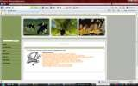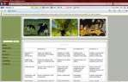Explain that students who have similar roles may work together.
PROCESS
RESOURCES
EVALUATION

CONCLUSION
- Students may continue to pursue their role individually until the conflict generated by the original guiding question forces them to resolve the issue with the entire group.
- Group work should result in a consensus document
  - Identify other resources students may use to complete their task.
  - Power Point software to develop an informative slide show
  - Any URL link provided in this section
  - Classroom encyclopedias
  - Provide students with clear understanding of the grading
criteria which will be used to evaluate their efforts

  - Explain to students how the conclusion will offer the opportunity to engage in further analysis. For example.
  - Ask students how their roles could have been interpreted in a different light?

Fig 3.1: WebQuests Design Model. Source: Dodge (1995)

    - Phase Two
The second phase of the study which is the quantitative part employed case study research design. Case study is not intended as a study of the entire organization, rather is intended to focus on a particular issue, feature or unit of analysis. Case study is useful in order to understand and examine the processes of training activities in organizations (Anderson, 1993). The use of case study to probe an area of interest in depth is particularly appropriate as described by Patton (1987). Case studies become particularly useful where one needs to understand some particular problem or situation in great-depth. The stages involved in conducting case study research as postulated by Noor (2008) is shown in fig 3.2.

Preliminary Stage Field work and Analysis Conclusion Stage Stage
W
ri ti n g C
a
s e
Select Case

Conduct Case Study

Design research questions
Modify theory
Draw conclusion
Cross case analysis
Formulate
Analysis
Writing Cases

Fig. 3.2: Stages involved in conducting case study. Source: Noor (2008)
Data

Formulate theory: From the literatures and general observation, the researcher discovered that teachers are not using technologies the way it should be used in the classrooms. This is as a result of the fact that teachers are not trained to use technologies. Therefore, there is need to train teachers to use technologies.
Select case: The researcher used few of the pre-service teachers studying Social Studies in two colleges of education in Southwestern Nigeria.
Design research questions: Seven research questions and five hypotheses were formulated to guide this research

Conduct case study: In this phase, the researcher trained the pre-service teachers to develop WebQuests. This training was however in two parts. In the first part, which is the training on design and development of WebQuests, the researcher trained the pre-service teachers to develop WebQuests. Here, the WebQuests that has already been designed and developed by the researcher served as a guide that was followed. In other words, the researcher used the WebQuests he had already designed and developed to train the pre-service teachers.

In the second part of the training, the pre-service teachers in one of the colleges of education worked as individuals and in the other college of education, the pre-service teachers worked in cooperative learning groups. Four pre-service teachers worked together in the cooperative learning group. They were put into groups based on their gender and previous knowledge of computer use. In this second part of the training, the pre-service teachers designed and develop their WebQuests, choosing any topic in Social Studies curriculum of the secondary school, without the interference of the researcher. The WebQuests designed and developed by the pre-service teachers were assessed by the researcher and another trained research assistant.
Data analysis: Data generated from the training was analyzed using simple percentages, t- test and ANOVA
Writing cases: From the results of the data analyzed, the researcher presented his discussions and implications of the result for technology integration in teacher education programme.
Draw Conclusion: Based on the results of the study, the researcher made conclusions and certain recommendations were also made.

Population of the study
The target population of this study was all the part II social studies students in the Colleges of Education in the Southwestern part of Nigeria.

Sample Selection
There are 11 government-owned colleges of education in the Southwestern part of Nigeria. All the colleges of education are offering Social Studies (Social Studies, Economics, Political Science and Geography) but only six out of the 11 Colleges of Education have functioning computer laboratories.
Two colleges of education were purposively selected from the colleges and used for this study, based on the availability of functioning computer laboratory.

Participants comprised 152 second year social studies pre-service teachers randomly selected from these two Colleges of Education.

Variables of the study
Independent Variables: Training in WebQuests design and development. Moderator Variables: Gender at two levels (male and female), Previous knowledge in computer at three levels (high, average and low) and Attitude to computer at two levels (positive and negative).
Dependent Variables: WebQuests knowledge, WebQuests design and development skills and Attitude to WebQuests.

Research Instruments
The following research instruments were used in the study.
- Pre-service Teachers‘ Computer and WebQuests Literacy Test (PTCWLT)
- Pre-service Teachers‘ Attitude Towards Computer and WebQuests Questionnaire (PTATCWQ)
- WebQuest Assessment Rubric
- WebQuests Training Package

Pre-service Teachers’ Computer and WebQuests Literacy Test: This is a
50 question multiple choice test designed to test the pre-service teachers knowledge in computer and WebQuests. The questions were developed by Mitchell (2007) – Online With Computers and adopted for this study. The questions covered the following topics in computer study: Generations and types of computers; Features and uses of computers; Applications of computers; Hardware devices and softwares; Windows; Paint; Memory devices; Networks and Multimedia; Exploration in computers; Formatting documents in word; Introduction to WebQuests.

Validation of PTCWLT
PTCWLT was validated through experts‘ review of the items. The draft was given to experts in Test and Measurement, Educational Evaluation, Computer Education and Research Methods. Their comments, criticisms and suggestions were used to re-wok the items, expunge some and add some others. The final draft was then administered to 30 pre-service teachers who were not part of the target group. This was used to determine the reliability of

the instrument using Kuder-Richardson 21 formula (KR- 21). The reliability index of 0.82 was obtained.
- Pre-service Teachers’ Attitude Towards Computer and WebQuests Questionnaire: The computer aspect of this questionnaire was designed by Ohio State University to examine people‘s attitude towards the introduction of information technology into Syrian education. This was adapted by the researcher for this study while the WebQuest aspect of the questionnaire was developed by the researcher. The questionnaire is in three sections, the first section deals with the demographic information of the respondents, the second section has 20 items (statements) designed to elicit respondents attitude towards computer and WebQuests while the third section with 20 items was designed to know the computer competence level of the respondents. Validation of PTATCWQ
PTATCWQ was validated through experts‘ review of the items. The draft was given to experts in Test and Measurement, Educational Evaluation, Computer Education and Research Methods. Their comments, criticisms and suggestions were used to re-wok the items, expunge some and add some others. The final draft was then administered to 30 pre-service teachers who were not part of the target group. This was used to determine the reliability of the instrument using Cronbach Alpha. The reliability coefficient of the instrument was 0.91.
iii WebQuest Assessment Rubric (WAR): This rubric for WebQuests assessment was developed by Bernie Dodge (1995) and was adopted in this study. The rubric has a maximum of 50 points and it is divided into six parts. The first part is General Aesthetic which carries 10 points, the second part is Introduction which carries 4 points, the third part is Task which carries 10 points, the fourth part is Process which carries 12 points, the fifth part is Resources which carries 8 points while the sixth and the last part is Evaluation which carries 6 points.

Validation of WAR
WebQuests Assessment Rubric was developed by Dodge (1995) and was adopted by the researcher. The reliability coefficient of the Instrument was determined using Inter rater technique. The instrument was used to assess the WebQuests developed by 30 pre-service teachers who were not part of the

target group. The pre-service teachers were then rated by two raters and the correlation between the two was determined. The reliability coefficient of 0.88 was obtained.
iv. WebQuests Training Package (WTP): This is the training package that was developed by the researcher himself. This package served as the training guide for the training exercise. This package consists of the step-by-step approach to designing WebQuests. In the package, all the components of WebQuests were discussed and how Microsoft Frontpage (software for the development of WebQuests) is launched. Also the step-by step account of how it was used to develop WebQuests.

Validation of WTP
WTP was validated through experts‘ review of the package. The draft was given to experts in Test and Measurement, Educational Technology, Computer Education and Research Methods. Their comments, criticisms and suggestions were used to re-work the items, expunge some and add some others.

Procedure Phase 1
The researcher first designed a WebQuests on Agriculture in the Social Studies content. The researcher with the participants designed WebQuests using the Agriculture WebQuests designed by the researcher as a guide. The package was used for the training, and the following steps were followed:

Select an appropriate topic in social studies for the WebQuests
- Overview:
  - Describe what the lesson is about
  - Specify content area
  - Specify objectives
  - List any special resources that a teacher would need in the classroom or in the media centre for students to complete the activity

Introduction
  - Write an introduction that will give students some background about the topic. The introduction must be interesting.

  - If the WebQuests is about a place include some general information, a picture, and/or audio files.
  - If it is about a person, describe something about the person that gives general background to the students.

Quest(ions) and the Task
Specify the guiding questions that students need to keep in mind in order to accomplish their task.
Why is the job necessary?
What are the circumstances surrounding the task or the question that may cause conflict? Is there more than one way of looking at this. Can you see conflicting roles for people – such as environmentalist and industrialist?
Briefly outline for students what they are expected to learn.
Assign various roles to students. A good WebQuests generates some tension or conflict that must be resolved so one should try to develop two to four roles.

Process
Explain that students who have similar roles may work together to compare ideas based on the factual information they have collected, or that students may continue to pursue their role individually until the conflict generated by the original guiding question(s) forces them to resolve the issue with the entire group.
Once students have understood their roles and investigated the background materials necessary to make informed decisions, then it is time for them to come together as a group and to discuss the issues. Group work should result in a consensus document or presentation.
Give students directions on this group work. Be sure that they understand that their roles may place them in conflict with another person‘s role.
Provide options for how students may present their information to the group. Here are some ideas:
  - Flowcharts
  - Multimedia Presentations
  - Web Page

  - Summary Tables
  - Concept Maps
- Venn Diagrams

Resources
Identify for the students which other resources they may use to complete their tasks. Other resources may include:
  - PowerPoint software to develop an informative slideshow
  - Any URL links provided in this section
  - Classroom Encyclopedias
  - Colour Printers
  - Periodicals from the media centres

Evaluation
Provide students with a clear understanding of the grading criteria which will be used to evaluate their efforts.
Provide links to online rubrics which will allow students to know upfront what grading criteria will be used. Following are some examples that could be used for a variety of projects.
Include a phrase such as ―please click here to review the criteria on which your individual grade will be based.
Or
―You will also receive a collaborative grade. Please click here to review the criteria which will determine your collaborative grade‘.
Explain how grades will be counted or averaged.

Conclusion
Explain to students how the conclusion will offer the opportunity to engage in further analysis. For example:
  - Ask students how their roles could have been interpreted in a different light?
  - Ask students if they had interpreted their roles differently, how might the outcome have changed.
  - Ask students if they were flexible enough to compromise with the group and attain resolution or did they yield to group pressures?

  - Ask students what new questions did the issues generate? Why would these new question be important in answering the original questions?
After the design stage, then comes the development stage. Here the researcher trained the pre-service teachers how to develop WebQuests bearing in mind the features of a good WebQuests. Some of these features are:
- Visual appeal.

- Negotiation and flow.
- Motivational effectiveness of introduction.
- Cognitive level of the task.
- Richness of process e.t.c.

Phase 2
In this phase, the pre-service teachers designed and developed their WebQuests using the WebQuests design guide in which the steps in WebQuests design and development were followed. After this design and development stage, the researcher with a trained research assistant now evaluated the designed and developed WebQuests. The researcher used the WebQuests Design Guide and WebQuests Evaluating Rubric to assess the designed and developed WebQuests.

Table 3.1 SCHEDULE OF ACTIVITY FOR PHASE ONE

Week | Activity
Week One | Administration  Questionnaire | of | Computer | Literacy | Test | and | Attitude
Week Two | Introduction to WebQuest
Week Three | WebQuest Design Training:  *Selection of topic  *Writing of overview  *Writing of introduction  *Task specification
Week Four | WebQuest Design Training:  *Explaining the process  *Identifying resources  *Providing evaluation  *Writing of conclusion
Week Five | WebQuest Development Training:  *Getting started with the software (Microsoft frontpage) used for

 | development
Week Six | WebQuest Development Training:  *Creating a web page from a template  *Creating themes  *Creating tables and cells  *Font properties
Week Seven | WebQuest Development Training:  *Formatting tables and cells  *Inserting pictures  *Creating links  *Alignments
Week Eight | WebQuests Evaluation

SCHEDULE OF ACTIVITY FOR PART TWO

Week One | Pre-service Teachers WebQuests Design
Week Two | Pre-service Teachers WebQuests Development
Week Three | Pre-service Teachers WebQuests Development
Week Four | Pre-service Teachers WebQuests Development
Week Five | Administration of Attitude to WebQuests Questionnaire
Week Six | Evaluation of WebQuests by the Researcher

Data Analysis
Data collected were analyzed using simple percentages, t-test and ANOVA.

CHAPTER FOUR RESULTS

Presentation of Results
Results of this study are presented based on the research questions and hypotheses.

Table 4.1: Distribution of Participants According to Gender and School

School | Gender |  |  |  | Total
 | Male |  | Female
Emmanuel Alayande  College of Education, Oyo | 32 | (21.1%) | 72 | (47.4%) | 104 | (68.4%)
Federal College of  Education, Abeokuta | 31 | (20.4%) | 17 | (11.2%) | 48 | (31.6%)
Total | 63 | (41.5%) | 89 | (58.6%) | 152 | (100.0%)
Table 4.1 shows that the total number of participants is152. 41.5% of the participants are male while 58.6% of the participants are female. 68.4% of the participants are from Emmanuel Alayande College of Education, Oyo while 31.6% of the participants are from Federal College of Education, Abeokuta.

Table 4.2: Distribution of Participants According to Class and Their Level of Computer Literacy
Level of Computer  Literacy | Class |  |  |  | Total
 | Individual |  | Group
Low | 10 | (6.6%) | 20 | (13.2%) | 30 | (19.7%)
Average | 31 | (20.4%) | 68 | (44.7%) | 99 | (65.1%)
High | 7 | (4.6%) | 16 | (10.5%) | 23 | (15.1%)
Total | 48 | (31.6%) | 104 (68.4%) |  | 152 (100.0%)

Table 4.2 shows that 31.6% of the participants worked individually while 68.4% worked in groups. 19.7% of the participants had low level of computer knowledge, 65.1% had average knowledge of computer while 15.1% of the participants had high knowledge of computer.

Answers To The Research Questions

Research Question One
To what extent will the pre-service teachers acquire the skills to develop WebQuests after the training?

Table 4.3: Pre score and Post score of The Pre-service Teachers’ in WebQuests design Skills
Skills | Mark  Obtainable | Pre Mean  Score | Std.  Deviation | Post Mean  Score | Std.  Deviation
Overall  Aesthetic | 10 | 0.0 | 0.0 | 6.68 (66.8%) | 1.65
Introduction | 4 | 0.0 | 0.0 | 3.19 (79.8%) | 0.93
Task | 10 | 0.0 | 0.0 | 5.65 (56.6%) | 1.83
Process | 12 | 0.0 | 0.0 | 7.09 (59.1%) | 2.17
Resources | 8 | 0.0 | 0.0 | 5.72 (71.5%) | 1.80
Evaluation | 6 | 0.0 | 0.0 | 4.07 (67.8%) | 1.22
NOTE: The percentages of mean score over mark obtainable in Parenthesis
Table 4.3 reveals that the pre-service teachers had no skills of designing WebQuests before the treatment, (X= 0.0). But after the treatment, the pre-service teachers mean scores for the skill are 6.68, 3.19, 5.56, 7.09, 5.72 and 4.07 for overall aesthetics, introduction, task, process, resources and evaluation skills respectively. The total marks obtainable for the skills of overall aesthetic, introduction, task, process, resources and evaluation are 10, 4, 10, 12, 8
and 6 respectively.
These show that the pre-service teachers gained high knowledge of introduction skills, resources skill, evaluation skills and overall aesthetic skills while their knowledge of task and process skills is on the average.

Research Question Two
To what extent will the WebQuests that have been developed meet the webQuests development standard?
Based on the result in Table 4.3, it could be seen that the pre-service teachers WebQuests meet the WebQuests development standard to a great extent. This can be

deduced from the scores of the pre-service teachers after the training. The least score in the measured skills is 56.6%.

Research Question Three (i)
Which of WebQuests components do the pre-service teachers find most difficult?
Based on the results in Table 4.3, task is the most difficult for the pre-service teachers (56.5% score rate); followed by the skill of process (59.1%).

Research Question Three (ii)
Which of the WebQuests components do the pre-service teachers find easiest?
Based on the result in Table 4.3, the skill of writing introduction is the easiest for the pre-service teachers (79.8% score rate); followed by resource skills (71.5% score rate).

Research Question Four
Did the pre-service teachers‘ previous knowledge of computer influence their WebQuest development?

Table 4.4: WebQuests Development Score and The Pre-service Teachers Previous Knowledge of Use Of Computer. As Revealed by Analysis of Variance (ANOVA).
Previous Knowledge  Level | N | Mean | Std. Dev | Source | Sum of Squares | df | Mean Square | F | Sig | Ran k
Low | 30 | 32.033 | 5.5862 |  |  |  |  |  |  | Not
 |  | 3 | 1 | Btw | 306.616 | 2 | 153.30 | 2.30 | .104 | Sig
Average | 99 |  |  | Group |  |  | 8 | 2
 |  | 31.717 | 8.5583 | Within | 9921.48 | 14
High | 23 | 2 | 7 | Group | 2 | 9 | 66.587
 |  | 35.739 | 9.1414
 |  | 1 | 0
Total | 15 | 32.388 | 8.23 |  | 10228.0 | 15
 | 2 | 2 |  |  | 99 | 1

Table 4.4 reveals that there is no significant difference among the pre-service teachers with low, average, and high previous level of computer in their post WebQuests development

score (F (2, 149= 2.302; P> 0.05). This implies that the previous knowledge of the pre- service teachers in computer literacy has no significant influence on their WebQuests development skills after the training.

Research Question Five
Do the attitude of pre-service teachers towards computer and WebQuests influence their WebQuests development?

Table 4.5: Summary of Linear Regression Showing Influence of Attitude on Post WebQuests Development Score
Model | Unstandardized  coefficient |  | Standardized coefficient | T | Sig (P) | Rank
 | Β | Std.  Error
 |  |  | Beta
Constant | 38.75 | 7.31 |  | 5.299 | .000
 |  |  |  |  |  | No Sig
Pre
attitude | -.098 | .112 | -.071 | -.874 | .384

Table 4.5 reveals that there is no significant relative influence of pre attitude score of the pre-service teachers on their WebQuests development score after the training (β= -0.017; t= 0.874; P.0.05)

Research Question Six
Will there be gender difference in the pre-service teachers‘ WebQuests development?

Table 4.6: Summary of t-test Analysis Showing Difference Between Male and Female Pre-service Teachers
Variable | N | Mean | Std. Dev | T | Df | Sig (P) | Remark
POST WEBQUEST
SCORE
Male | 63 | 32.41 | 9.29 |  |  |  | Not  Sig
 |  |  |  | .031 | 150 | .975
Female | 89 | 32.37 | 7.45

Table 4.6 reveals that there is no significant difference between male and female pre- service teachers in their post WebQuests development score (t= 0.031; df= 150; P> 0.05). Therefore, there is no significant gender difference in the WebQuests score after the training.

Research Question Seven
Will there be difference in the pre-service teachers‘ pre and post training gained knowledge of WebQuests development?

Table 4.7: Pre and Post WebQuests Development Score of Pre-service Teachers

Score | N | Mean | Std. Deviation
Pre Score | 152 | 0.00 | 0.00
Post Score | 152 | 32.39 | 8.23

Table 4.7 reveals that at the pre test level, the WebQuests development mean score of the pre-service teachers is (0.00) while after the training, their WebQuests development mean score is (32.39) which can be rated to (64.8%). Therefore, there is a difference between the pre and post WebQuests development score of the pre-service teachers.

Testing of The Null Hypothess
    - Ho1: There is no significant difference between male and female pre-service teachers in their WebQuest component of:

      - Overall aesthetics
      - Introduction
      - Task
      - Process
      - Resources and
      - Evaluation

Table 4.8: Summary of t-test Analysis Showing The Difference Between Male and Female in Each of The WebQuests Component
Variable | N | Mean | Std.  Dev | t | Df | Sig (P) | Rank
OVERALL
AESTHETIC
Male | 63 | 6.60 | 1.83 |  |  |  | Not  Sig
 |  |  |  | -.468 | 150 | .641
Female | 89 | 6.73 | 1.51
INTRODUCTION
Male | 63 | 3.13 | 1.07 | -.714 | 150 | .477 | Not Sig
Female | 89 | 3.24 | .81
TASK
Male | 63 | 5.81 | 2.03 | .933 | 150 | .353 | Not Sig
Female | 89 | 5.53 | 1.68
PROCESS
Male | 63 | 7.06 | 2.38 | -.105 | 150 | .916 | Not Sig
Female | 89 | 7.10 | 2.01
RESOURCES
Male | 63 | 5.68 | 1.90 | -.236 | 150 | .814 | Not Sig
Female | 89 | 5.75 | 1.74
EVALUATION |  |  |  |  |  |  | Not Sig
Male | 63 | 4.13 | 1.29
Female | 89 | 4.02 | 1.18 | .581 | 150 | .605

Table 4.8 shows that there is no significant difference between male and female pre- service teachers in:
- Overall aesthetics (t= 0.468; df= 150; P>0.05), hence Ho1(i) is not rejected.
- Introduction (t= -0.714; df= 150; P. 0.05), hence Ho1(ii) is not rejected.
- Task (t= 0.933; df= 150; P. 0.05), hence H01(iii) is not rejected.
- Process (t= -0.105; df= 150; P. 0.05), hence Ho1(iv) is not rejected.
- Resources (t= -0.236; df 150; P. 0.05), hence Ho1(v) is not rejected and
- Evaluation (t= 0.518; df= 150; P. 0.05), hence Ho(vi)i is not rejected.
    - Ho2: There is no significant between the pre-service teachers with basic computer knowledge and those without basic computer knowledge in the WebQuests component of:
      - Overall aesthetics
      - Introduction
      - Task
      - Process
      - Resources and
      - Evaluation

Table 4.9: Summary of t-test Analysis Showing The Difference Between Pre-service Teachers With High Basic Skills of Computer And Those With Low Basic Skills of Computer.
 |  | N | Mean | Std. Dev | t | Df | Sig(2-  tailed | Rmk
Overall Aesthetics | Low  High | 30  23 | 6.6000  6.8261 | 1.00344  1.87452 | -.564 | 51 | .575 | Not Sig
 | Low | 30 | 3.00667 | .58329
Introduction |  |  |  |  | -3.552 | 51 | .001 | Sig
 | High | 23 | 3.9130 | 1.12464
Task | Low | 30 | 5.8000 | 1.58441 | -1.587 | 51 | .119 | Not  Sig
 | High | 23 | 6.5652 | 1.92652
 | Low | 30 | 6.8333 | 1.72374
Process |  |  |  |  | -2.018 | 51 | .049 | Sig
 | High | 23 | 7.9130 | 2.17241
Resources | Low | 30 | 5.5667 | 1.63335 | -1.391 | 51 | .170 | Not  Sig
 | High | 23 | 6.2174 | 1.75697
Evaluation | Low | 30 | 4.1667 | .91287 | -.478 | 51 | .635 | Not  Sig
 | High | 23 | 4.3043 | 1.18455

Table 4.9 shows that:
- There is no significant difference between the pre-service teacher with high knowledge of computer and those with low knowledge of computer in their WebQuests component of overall aesthetics (t= -.564; df= 51; P> 0.05), hence Ho2(i) is not rejected.
- There is significant difference between the pre-service teachers with high knowledge of computer and those with low level of computer knowledge in their WebQuests component of introduction (t= -3.552; df= 51; P< 0.05), hence Ho2(ii) is rejected
- There is no significant difference between the pre-service teachers with high knowledge of computer and those with low knowledge of computer in their WebQuest component task (t= -1.587; df= 51;P> 0.05), hence Ho2(iii) is not rejected.
- There is significant difference between the pre-service teachers with high knowledge of computer and those with low knowledge of computer in their WebQuest component of process (t=-2.018; df=51; P< 0.05), hence Ho2(iv) is rejected.
- There is no significant difference between the pre-service teachers with high knowledge of computer and those with low knowledge of computer in their WebQuest component of resources (t= -1.391; df= 51; P> 0.05), hence Ho2(v) is no rejected.
- There is no significant difference between the pre-service teachers with high knowledge of computer and those with low knowledge of computer in their WebQuest component of evaluation (t= -.478; df= 51; P> 0.05), hence Ho2(vi) is no rejected.

Ho3: There is no significant difference between the pre-service teachers’ pre and post attitude to computer and WebQuests

Table 4.10: Summary of t-test Analysis Showing Difference Between Pre and Post Attitude of Pre-service Teachers TO Computer And WebQuests
Variable | N | Mean | Std. Dev | t | Df | Sig (P) | Rmk
PRE AND POST ATTITUDE SCORE
Pre Attitude | 152 | 64.92 | 5.98 |  |  |  | Sig
 |  |  |  | -12.78 | 302 | .000
Post Attitude | 152 | 72-61 | 4.39
Table 4.10 reveals that there is a significant difference between pre and post attitude to Computer and WebQuests of the pre-service teachers (t=12.78; df= 302; P< 0.05). Therefore, Ho3 is rejected. The mean scores show that the post attitude mean score (72.61) is higher than that of the pre attitude mean score (64.92).

    - Ho4: There is no significant difference between the attitude of male and female pre- service teachers to computer and WebQuests after the training.

Table 4.11: Summary of t-test Showing the Difference the Attitude of Male and Female Pre-service Teachers to Computer and WebQuests After the Training
Gender |  | N | Mean | Std. Dev | t | df | Sig(P) | Rmk
Post Attitude | Male | 63 | 71.7778 | 4.90044 | -1.974 | 150 | .050 | Not  Sig
 |  | 83 | 73.910 | 3.91349
Female
Table 4.11 shows that there is no significant difference between the attitude of male and female pre-service teachers to computer and WebQuests after the training (t= -1.974; df= 150; P> 0.05). Therefore, Ho4 is not rejected.
Ho5: There is no significant difference between the WebQuests of the pre-service teachers in cooperative learning groups and those who are not in cooperative learning groups

Table 4.12: Summary of t-test Showing Difference Between The WebQuests of Pre- service Teachers in Cooperative Learning Groups and Those Who Are Not in Cooperative Learning Groups
Class | N | Mean | Std. Dev | t | df | Sig(P) | Rmk
Individual  WebQuest  Cooperative  Group | 48 | 29.4792 | 11.12213
 |  |  |  | -3.04 | 150 | .003 | Sig
 | 104 | 33.7308 | 6.09031
Table 4.12 reveals that there is significant difference between the WebQuests of the pre=service teachers in cooperative learning groups and those who are not in cooperative learning group (t= -3.04; df= 150; P< 0.05). Therefore, Ho5 is rejected. The mean score reveals that those in cooperative group have higher mean score (33.73) than those who did their work individually (29.48).

Summary of findings
- The pre-service teachers were able to acquire the skills of WebQuests development after the training.
- The WebQuests that were developed by the pre-service teachers meet the WebQuests development standards.
- The pre-service teachers found the task and process component of the WebQuests development the most difficult.
- The pre-service teacher found the introduction and resources component of the WebQuests development the easiest
- The pre-service teachers previous knowledge in computer did not influence their WebQuests development
- The attitude of the pre-service teachers towards computer and webQuests did not influence their WebQuests development.
- There is no gender difference in the pre-service teachers‘ WebQuests.
- There is difference in the pre-service teachers‘ pre and post training gained knowledge on WebQuests development.
- There is no significant difference between male and female pre-service teachers in overall aesthetics, introduction, task, process, resources and evaluation component of their WebQuests.

- There is no significant difference between the pre-service teacher with high knowledge of computer and those with low knowledge of computer in their overall aesthetics, task, resources and evaluation component of their WebQuests. There is significant difference between the pre-service teacher with high knowledge of computer and those with low knowledge of computer in their skills of introduction and process‘
- There is a significant difference between pre and post attitude to Computer and WebQuests of the pre-service teachers.
- There is no significant difference between the attitude of male and female pre-service teachers to computer and WebQuests after the training.
- There is significant difference between the WebQuests of the pre-service teachers in cooperative learning groups and those who are not in cooperative learning group.

CHAPTER FIVE
DISCUSSION OF FINDINGS, RECOMMENDATIONS AND CONCLUSION

Discussion of Results

Acquisition of WebQuests Development Skills
The data analysis has revealed that the training in WebQuests development has produced outstanding results. This is because the pre-service teachers exposed to the training were able to acquire the skills of webQuests development after the training exercise. The WebQuests developed by the pre-service teachers met the standard of WebQuests development to a great extent. The result was outstanding mainly because of the training approach used by the researcher. The training was interactive in nature. The researcher and the pre-service teachers actively participated in the training exercise as a result of this, the pre-service teachers were able to produce a good result.
Out of the six WebQuests components assessed, the pre-service teachers found task and process the most difficult. This could be as attributed to the level of thinking that they have to be engaged in to be able to come up with scenarios under the task as well as to be able to come up with the idea of how the students are going to go about doing their tasks under the process. The pre-service teachers found the introduction and resources component the easiest. This could be attributed to the fact that the pre- service teachers were allowed to choose the topics they want themselves and they were able to write good introductions on such chosen topics. As for the resources, most of them are familiar with the browsing of the Internet, as such they were able to come up with resources that are relevant to the chosen topics.

Previous Knowledge of Use of Computer and WebQuests Development
The result of data analysis has revealed that previous knowledge of computer has no influence on WebQuests development skills of the pre-service teachers. This means that no matter the level of computer knowledge possessed by the pre-service teachers, with right training they will acquire WebQuests development skills. This was achievable because the researcher developed a very easy and straight forward training guide for the development of the WebQuests. This shows that if training guide is simple and easy to use, even the pre-service teacher with a limited knowledge of computer will be able to benefit immensely from such training. The result negates the position of Schneider & Pressley (1997), Alexander & Judy (1988) and Dochy, Segers, & Buehl (1999) who stated that prior knowledge can determine new learning.

The result however supports Clement (1982), Guzzetti, Snyder, Glass, & Gamas (1993), Fisher, Wandersee, & Moody (2000) and Hoz, Bowman, & Kozminsky (2001) who are of the opinion that previous knowledge might not be necessary to learn something new

Attitude and WebQuests Development
The result of data analysis has revealed that attitudes of pre-service teachers to computer and WebQuests has no influence on the WebQuests development. This could be attributed to pre-service teachers enthusiasm towards the development of WebQuests as well as the novelty of WebQuests itself. When people come across new things and ideas, they tend to be fascinated by them. They also become more endeared to the new thing if they know that such can be of great help to them. Therefore, the pre-service teachers‘ attitude to computer did not matter in as much as they see WebQuests as a tool that can help them become better teachers. This negates the findings of Yuen, Law and Chen (1999) who identified teachers‘ positive attitudes toward computers as an important factor in fostering computer integration and the enhancement of quality learning and teaching using computers and Kluever (1994) who posited that teachers‘ attitudes towards computers affect their instructional use of computers and likelihood of profiting from training.

Gender and WebQuests Development
The result of the data analysis has revealed that there is no significant gender difference in the pre-service teachers‘ WebQuests. This means that gender has no influence in the WebQuests development skills of the pre-service teachers. This negates the findings of Kroker and Weinstein (1994), Hutchinson and Weaver (2004) and Kelkar (2004) who found out that there exists a gender gap an inequalities in the use of ICT. But it corroborates the findings of Sax, Astin, Korn, and Mahoney (2001), Raban, Soffer, Mihnev, and Ganey (2002) and Livingstone, Bober and Helsper (2005) who stated that the gap between male and female in ICT use no longer exists and that the differences have become more subtle.

Co-operative Learning and Individual-based Learning and WebQuests Development
The result of the data analysis has revealed that there is significant difference in the WebQuests development skills of pre-service teachers that worked in groups and those that worked individually. Those in groups performed better than those that worked individually. This is in line with the findings of Schafert, Bischof, Buerger,

Gruber, Hilzensaur and Schaffert (2006) who argued that cooperative learning leads to positive interdependence of group members, individual accountability, face-to-face interaction, and use of collaborative skills and Johnson and Johnson (1986) who posited that cooperative teams achieve higher levels of thought and retain information longer than students who do their work individually.

Implications of Results for Technology Integration in Teacher Training
- Group-based learning seems to be a better way of learning computer-based programmes. This is also a good means of technology integration most especially in Nigerian schools where resources are very scarce. In other words, in most Nigerian schools the available computers cannot go round the students if they are to work individually on computers. In the realization of this, a group of students can work on a computer thereby stretching the resources among many users as well as facilitating the learning of computer programmes.
- Gender stereotype should be discouraged when giving training on ICT. Equal opportunities should be given to both gender. For example, females should not be given only typing assignment while more tasking assignments such as programming and web designs are given to males. Also evaluation of both gender should not be different. This would make the females to have a sense of belonging and more participation in the field of ICT.
- Computer-based programmes can be introduced to the pre-service teachers by various institutions responsible for the training of teachers even when these pre- service teachers have little or no knowledge about computer prior their entering into the programme. Hence, administrators should not entertain fears that if pre- service teachers have little or no knowledge about computer they would not be able to master computer-based programmes when such are introduced to them.
- WebQuests which has been described as an inquiry-based activities has been found to be a worthwhile tool for teaching and learning. As such, WebQuests should be integrated into the curriculum of teacher training institutions, both as a method of teaching as well as for teaching the pr-service teachers themselves.

Recommendations
Based on the findings of this research the following recommendations were
made:
- Training on design and development of computer-based tools should be given for pre-service teachers and a curriculum should be consequently developed for this purpose. This would enable the pre-service teachers to be equipped with the necessary skills they would need to design and develop the computer- based tools more so that the world is gravitating towards the use of ICT. ICT is changing the way we live and its impact is being felt in all areas of human endeavours including education.
- Training workshops should be organized for the in-service teachers so that they too can be equipped with the skills needed to function well in today‘s classroom. It is also a well known fact that computer-based instructional applications are considered an effective alternative to traditional teaching methods (Lakin, 2003). Hence, teachers must be properly trained, encouraged and supported in the appropriate development and use of WebQuest. These training workshops must be intensive and should be organized periodically so that teachers can keep abreast of new developments in the integration of technology into teaching and learning process.
- It is also recommended that whenever this type of training is being organized, participants should be put in groups. This is because teams achieve higher levels of thought and retain information longer than those who do their work individually.
- Education administrators should be given orientation on the benefits of WebQuests. This is because to use WebQuests successfully in the classroom it is important that administrators are convinced of their benefits. They should then provide the necessary physical support by establishing computer laboratories with Internet access to launch the activity at schools. Monitoring teams should also be put in place to ensure that the computer laboratories are properly put into use so that the purpose for which they were established would be achieved.
- Females should be encouraged to participate and enroll in technology-based programmes. This is because earlier studies have shown that women are

lagging behind as far as ICT‘s access and use are concerned. But this study showed otherwise, this means that the digital divide that exists between males and females is being closed and this should be encouraged. As such females should be encouraged to take ICT related courses as well as participate in ICT related training. These types of courses or training should be given to females free of charge or at an highly subsidized rates.
- Equipment and facilities for acquisition of computer skills should be provided to schools at all levels. This would enable the students to be equipped with at least basic computer knowledge and skills upon which other computer skills can be built.
- Attitude to computer is one of the factors militating against the use of computers. Studies have shown that positive attitude computer can facilitate the ease of use of computers. Although in this study, attitude of the pre-service teachers have no influence on their WebQuests development. Hence, it is necessary that positive attitude to computer should be developed. This can be done by teaching computer literacy to students in a friendly manner, it must be taught from simple to complex, from general to specifics and from concrete to abstract, This can also be done by making the students to appreciate the fact that computer use is inevitable at this age and time and that computer knowledge would prepare them for the work force.
- It is also recommended that the training model developed and used by the researcher should be adopted as ICT training model for the integration of ICT into Nigerian schools. This is as illustrated in fig 5.1.

Conceptualization
Design and development by the
Trainer
 |  |  | Training using the
 |  |  | trainer’s model |  |  | Design and
 |  |  |  |  | development by trainee

Fig 5.1: The Training Model used by the researcher
Evaluation

Conceptualization: Here the trainer chooses a topic that he wants to design and develop WebQuest on. This topic must be one that the trainees are familiar with.
Design and Development by the trainer: The trainer designs his WebQuests following this process – writing of introduction, specifying the task, explaining the process, identifying resources, providing evaluation and writing of conclusion. The WebQuests designed is now developed by the trainer using web authoring tool e.g Microsoft Frontpage, Dreamweaver, Joomla. The designed and developed WebQuest is now a model for the training.
Training using the trainer’s model: The trainer uses the already designed and developed WebQuest (model) to train the trainees. Here the trainer shows the trainees step-by-process of designing and developing a WebQuest using the already developed one as an example.

Design and development by trainees: After the trainees have been exposed to the training by the trainer, they are then given the opportunity to design and developed their own WebQuests on any topic of their choice.
Evaluation: Here the WebQuests developed by the trainers is subjected to evaluation using an evaluating rubric. This would enable the trainer to determine if the WebQuests developed is a good one or not.

Limitation of the Study

Limitations of this study include the fact that only two colleges of education were used for this study and only the pre-service teachers offering social studies as a teaching subject in those colleges of education were used for this study. This fact would make the generalization for other levels of teacher training very difficult.

Suggestions for Further Studies

A study of this nature should be carried out among the universities‘ pre- service teachers and it should involve pre-service teachers offering other teaching subjects apart from social studies. Also a study of this nature should be carried out among the in-service teachers and these teachers should be drawn from different subject areas. Further studies should be carried out on the integration of computer- based technologies most especially WebQuests in teaching and learning.

Conclusion
This study has shown that pre-service teachers‘ previous knowledge as well as gender do not affect their proficiency in acquiring ICT skills. Hence, through proper training, teachers whether pre-service or in-service can acquire the necessary skills that will help them to design and develop technological tools that can facilitate effective teaching and learning. One of the computer technology tools that teachers can use to facilitate teaching and learning and learning is WebQuests. WebQuests can easily be developed by teachers once they acquire the skills to develop them through

training. Once this skill has been acquired they can develop WebQuests on any topic they want to teach. With this, teaching and learning would not be a difficult task.

REFERENCES
Abimbade, A. 1997. Principles and practices of educational technology. Ibadan: International Publishers.
Adams, C. 1998. Teaching and learning with SimCity 2000. Journal of Geography, 97(2), 47-55.
Adebowale, O.F, Adediwura, A.A., Bada, T. A. 2009. Correlates of computer attitude among secondary school students in Lagos State, Nigeria. International Journal of Computing and ICT Research, Vol. 3, No. 2, pp. 20 - 30. http://www.ijcir.org/volume3-number2/article3.pdf.
Adeyemi, B.A. & Ajibade, Y.A. 2011.The comparative effects of simulation games and
brainstorming instructional strategies on junior secondary school students‘ achievement in social studies in Nigeria. African Research Review: An International Multi-Disciplinary Journal, Ethiopia Vol. 5 (3), Serial No. 20, 64-80
Akinlaye,F.A., Mansaray, A & Ajiboye, J.O 1996. Fundamentals of social studies teaching.
Ikeja: Pumark Nigeria Limited.
Akudolu, R.L. 2004. Computer Assisted Teaching And Learning. Enugu: John Jacob‘s Classic Publishers Ltd.
Allan, J., and M. Street. 2007. ―The quest for deeper learning: an investigation into the impact of a knowledge-pooling WebQuest in primary initial teacher training‖. British Journal of Educational Technology 38: 1102-1112.
Allen, D.1993. Exploring The Earth Through Software. Teaching With Technology.
Teaching PreK-8, 24(2), 22-26.
Alessi, S., & Trollip, S. 2001. Multi-media for Learning: Methods and Development (3rd Edition). Boston: Allyn & Bacon.
Alessi, S., & Trollip, S. 2001. Multimedia for Learning: Methods and Development.
Needham Heights, MA: Allyn & Bacon.
Alexander, J.O. 1999. Collaborative design, constructivist learning, information technology immersion, and electronic communities: a case study. Interpersonal Computing and Technology: An Electronic Journal for the 21st Century 7 (1-2)
Ali, A. & Franklin, T. 2001. Internet use in the classroom: Potential and pitfalls for student learning and teacher-student relationship. Educational Technology. 14 (4) 57-59.
Al-Jabri, I.M. & Al-Khaldi, M.A.2009. Effects of user characteristics on computer attitudes among undergraduate business students. Journal of Organization and End User Computing (JOEUC) .Volume 9, Issue 2.

Allport, G.W. 1995. Attitudes. In C.M. Murchison (Ed.), Handbook of social psychology, 796-834. Clark University Press, Worcester, Mass.
Anderson, G., 1993. Fundamentals of Educational Research. Falmer Press, London, pp: 152- 160.
Andaloro, G. 1991. Modeling in physics teaching: the role of computer simulation.

International Journal of Science Education, 13(3), 243-354.
Aremu, A 2008. A cry for help! Endagerede species in the science and technology classrooms. Paper presented at the joint Staff-Student Seminar, Department of Teacher Education, University of Ibadan, Nigeria. 9th April, 2008.
Aremu, A & Morakinyo, D.A. 2009. Gender issues in the use of information communication technology (ict) for research by post-graduate students in a typical nigerian university. Journal of Sociology and Education in Africa. 8 (1) 77-92.
Arnett, P. 2000. Mastering reading and writing with technology. Media & Methods. 37(1), 12-14.
Baek, Y., & Layne, B. 1988. Color, graphics, and animation in a computer-assisted learning tutorial lesson. Journal of Computer-Based Instruction. 15(4), 31-35.
Bandura, A. 1997. Self-efficacy: the exercise of control. New York: W.H. Freeman. Bandura, A. 1986. Social foundations of thought and action. Englewood Cliffs, NJ:
Bebell, D., Russell, M., & O‘Dwyer, L. 2004. Measuring teachers‘ technology uses: Why multiple-measures are more revealing. Journal of Research on Technology in Education, 37(1),45–63.
Beal, C. & Mason, C. 1999. Virtual fieldtripping: no permission notes needed. creating a middle school classroom wiyhouit walls. Meridian Middle School Technologies Journal. Retrieved November 1, 2004, from: http://www.ncsu.edu/ meridian/jan99/vfieldtrip/
Bebell, D., Russell, M., & O‘Dwyer, L. 2004. Measuring teachers‘ technology uses: Why multiplemeasures are more revealing. Journal of Research on Technology in Education, 37(1), 45–63.
Becker, H. J. 2000. Findings from the teaching, learning, and computing survey: is larry cuban right? education policy analysis archives, 8(51). Retrieved on July 11, 2005 from http://epaa.asu.edu/epaa/v8n51/.
Berson, M.J. 2004. Digital images: capturing america‘s past with the technology of today.
Social Education. 68 (3), 214-219.

Berson,I.R., & Berson, M.J. 2003. Digital literacy for cyber safety, digital awareness and media literacy. Social Education. 67 (3), 164-168.
Berson, M.J., & Balyta, P. 2004. Technological thinking and practice in the social studies: transcending the tumultuous adolescence of reforms. Journal of Computing and Teacher Education.20(4), 141-152.
Bichelmeyer, B. 2005. Status of instructional technology in elementary-secondary and higher education in the United States. Asia-Pacific Cyber education Journal, 1(2), 49–63.
Bichelmeyer, B., & Molenda, M. 2006. Issues and trends in instructional technology: Gradual growth atop tectonic shifts. In M. Orey, V. J. McClendon, & R. M. Branch (Eds.), Educational Media and Technology Yearbook, 31, 3–32.
Binder, M. and Niederle, U. 2007 Institutions as determinants of preference change– A one way relation? Papers on Economic Evolution Number 0607 retrieved on 25th March 2009 from ftp://papers.econ.mpg.de/evo/discussionpapers/2006-07.pdf
Bloom, B. 1986. Automaticity. Educational Leadership. 43(5), 70-77
Blosser, P. 1988. Teaching problem-solving secondary school science. (ERIC Document Reproduction No. ED309049)
Bodur, H. O., Brinberg, D., & Coupey, E. (2000). Belief, affect, and attitude: Alternative models of the determinants of attitude. Journal of Consumer Psychology, 9(1), 17–28.
Boer, W. 2001. Flexibility, efficiency and enrichment in www-based learning environments. world conference on educational multimedia, hypermedia and telecommunications. 2001 (1). 374-379, Retrieved Nov., 14, 2004 from http//aace.org/4338.
Botto, F. 1999. Dictionary of multimedia and internet applications: A guide for developers and users. New York: Wiley
Bransford, J., R. Sherwood, T. Hasselbring, C. Kinzer, and S. Williams. 1990. ―Anchored

instruction: why we need it and how technology can help‖. D. Nix and R. Spiro, eds.
Cognition, Education and Multimedia: Exploring Ideas in High Technology. Hillsdale, NJ: Lawrence Erlbaum.
Brantley-Dias, L., Calandra, B., Harmon, S. W., Shoffner, M. B. 2006. An analysis of collaboration between colleges of education and arts & sciences in PT3. Tech Trends, 50(3), 32–37.
Brown, J.S., Collins, A., & Duguid, P. 1989. Situated cognition and culture of learning.
Educational Researcher, 18 (1), 32-42.

Butzin, S. M. 2001. Using instructional technology in transformed learning environments: An evaluation of Project CHILD. Journal of Research on Computing in Education, 33(4), 367–373.
Butzin, S. M. 2004. Project CHILD: A proven model for the integration of computer and curriculum in the elementary classroom. Retrieved on May 23, 2006 from http://www.acecjournal.org/archives_archives.php.
Cann, A. & Seale, J. 1999. Using computer tutorials to encourage reflection. Journal of Biological Education. 33(3), 130-132.
Calderhead, J. 1996. Teachers: Beliefs and knowledge. In D. Berliner, R. Calfee (Eds.),
Handbook of educational psychology (pp. 709–725). New York: Macmillan.
CEO Forum on Education and Technology 2001. The CEO Forum school technology and readiness report: Key building blocks for student achievement in the 21st century. Retrieved May 10, 2006 from http://www.ceoforum.org/downloads/report4.pdf.
Child, D. 2004. Psychology and the Teacher. London: Continuum.
Clancey, W.J. 1993. Situated Action: A Neuropsychological Interpretation Response to Vera and Simon. Cognitive Science, 17, 87-116. Edelman,G. 1992. Bright Air, Brilliant Fire: On the Mater of the Mind. New York: Basic Books.
Clarke, J.H. 1990. Patterns of thinking: integrating learning skills in content teaching.
Needham Heights MA: Allyn and Bacon.Cognitive Science, 17, 49-59.
Clement, J. J. 1982. Students‘ preconceptions in introductory mechanics. American Journal of Physics, 50, 66–71.
Clinton, J. 1991. Decisions, decisions. The Florida Technology in Education Quarterly, 3(2), 93-96.
Cuban, L., Kirkpatrick, H., & Peck, C. 2001. High access and low use of technologies in high school classrooms: Explaining an apparent paradox. American Educational Research Journal, 38(4), 813–834.
Cradler, J.D. 1988. Inventory of conditions for effective technology use.(On–line) Available: www.cons.org/resources/012601.htm.
Davis, P. 1995. Welcome to the world wide web. Internet Librarian, 51-55.
Dickinson, D. 2007. Learning through many kinds of intelligence. (On-line) RetrievedMay2,2007fromhttp//www.newhorizonsorg/strategies/mi/Dickinson_mi.htl.
Dochy, F., Segers, M., & Buehl, M. M. 1999. The relation between assessment practices and outcomes of studies: The case of research on prior knowledge. Review of Educational Research, 69, 145–186.

Dodge, B.J. 1997. Some thoughts about WebQuests. San Diego State University.RetrievedMay,15,2007fromhttp//webquest.sdsu.edu/about_webquests.html Dodge, B. J. 2002. The Webquest design process. Retrieved September 15, 2002, from San Diego State University, Educational Technology Department Web site, [accessed
April 02, 2004]. available from: http://Webquest.sdsu.edu/designsteps/index.html Dodge, B.J. 2001. FOCUS: Five rules for writing a great Webquest. Learning & Leading

with Technology, [accessed April 02, 2004]. available from: http://www.Webquest. futuro.usp.br/artigos/textos_outros-bernie1.html
Edinyang, S.D.& Ubi, I. E.2012. relative effectiveness of inquiry and expository methods of
teaching social studies on academic performance of secondary students in akwa ibom state, Nigeria. British Journal of Arts and Social Sciences Vol.8 No.I (2012) 95-102.
Education Week 2005. Technology counts 2005, 24(35).
Eiser, L. 1988 What makes a good tutorial? Classroom Computer Learning, 8(4), 44-47. Ertmer, P. A., Addison, P., Lane, M., Ross, E., & Woods, D. 1999. Examining teachers‘
beliefs about the role of technology in the elementary classroom. Journal of Research on Computing in Education, 32(1), 54–71.
Ertmer, P. A. 2005. Teacher pedagogical beliefs: The final frontier in our quest for technology integration? Educational Technology Research and Development, 53(4), 25–39.
Este, C. 1994. The real-world connection. simulation and gaming, 25(4), 456-463
Ekoko, R.O. and Ekoko, P.O. 2004. The use of world wide web (www) in creating virtual materials and resources index for health education students. Nigeria Journal of Computer Literacy. Vol.1, 122-133.
Ellsworth, N. J. & Hedley, C. N. 1993. What's new in software? Selecting software for student use. "Reading and Writing Quarterly: Overcoming Learning Difficulties," 9(2), 207-211. (EJ 465 250).
Fabry, D. L., & Higgs, J. R. 1997. Barriers to the effective use of technology in education: Current status. Journal of Educational Computing Research, 17(4), 385–395.
Fajola, O.D. 2000.Effect of Three Modes of Computer on Student Learning Outcomes in Biology. Unpublished Ph.D Thesis, University of Ibadan, Ibadan.
Federal Republic of Nigeria. 2004. National Policy on Education. Lagos: Federal Ministry of Information.
Feltovich, O.J.,Spiro, R.J. & Coulson, R.L. 1989. The nature of conceptual understanding in biomedicine: the deep structure of complex ideas and the development of

misconceptions. In D. Evans and V. Patel (Eds.), The Cognitive Science in Medicine
(pp. 132-175) Cambridge, MA: MIT Press (Bradford Books).
Fishbein, L., & Ajzen, I. 1975. Belief, Attitude, Intention and Behavior: An introduction to theory and research. Reading, MA; Addison-Wesley.
Fisher, K. M., Wandersee, J. H., & Moody, D. E. 2000. Mapping biology knowledge.
Dordrecht, The Netherlands: Kluwer.
Fisher, M. (2000). Computer skills of initial teacher education students. Journal of Information Technology for Teacher Education, 9(1), 109-123. http://www.informaworld.com/smpp/431329001-80367837/ftinterface~content=a 739084579~fulltext=713240930
Flowers, R. 1993. New teaching tool for new teaching practices. Instructor, 102(5), 42-45.
Fox, R., & Henri, J.2005. Understanding teacher mindsets: IT and change in Hong Kong schools. Educational Technology & Society, 8(2), 161–169.
Funkhouser, C., & Dennis, J. 1992. The effect of problem-solving software on problem- solving ability. Journal of Research on Computer in Education, 24(3), 338-347.
Gagne, R. 1982. Development in Learning Psychology: Implications for Instructional Design.
Educational Technology. 22(6), 11-15.
Gahala, J. 2006. Promoting technology use in schools. Critical Issue. North Central Regional Educational Laboratory.
Gaskill, M., A. McNulty, and D.W. Brooks. 2006. ―Learning from WebQuests”. Journal of Science Education and Technology 15: 133-136.
Gee, J.P. 2003. What video games have to teach us about learning and literacy. Executive Process in Reading. Ed. McMillan. Glynn Hillsdale, NJ: Erlbaum. 177-199.
Glaser, C.W., H.J. Rieth, C. Kinzer, L. Prestidge, and J. Peters. 1999. ―Impact of multimedia anchored instruction on classroom interactions‖. Journal of Special Education Technology 14: 27-42.
Goodson, I. F., & Mangan, J. M. 1995. Subject cultures and the introduction of classroom computers. British Educational Research Journal, 21(5), 613–629.
Grabe, M., & Grabe, C. 2007. Integrating technology for meaningful learning (5th Edition).
New York: Houghton Mifflin Co.
Griffin, J. 1998. CAL innovation as viewed by purchasers of computer software in secondary schools. Journal of Computer Assisted Learning, 4(1), 34 – 43.
Greeno, J.G. & Moore, J.L. 1993. Situativity and symbols: response to Vera and Simon.

Guzzetti, G. J., Snyder, T. E., Glass, G. V., & Gamas, W. S. 1993. Promoting conceptual change in science: A comparative meta-analysis of instructional interventions from reading education and science education. Reading Research Quarterly, 28, 117–155.
Halat, E. 2008. The effects of designing WebQuests on the motivation of pre-service elementary school teachers. International Journal of Mathematical Education in Science and Technology, Vol. 39, No. 6, 15 September 2008, 793–802.
Harper, D.O. 1987. The creation and development of educational computer technology. Educational Technology: It’s Creation, Development and Cross-Culture Transfer. Eds. R.M. Thomas and V.N. Kobayashi. New York: Pergamon Press, 35-63.
Hassanien, A. 2006. Using Webquest to support learning with technology in Higher Education. Journal of Hospitality, Leisure, Sport and Tourism Education 5(1),41-49. 43.
Hasselbring, T. 1988. Developing Math Automaticity in Learning Handicapped Children.
Focus on Exceptional Children. 20(6), 1-7.
Hasselbring, T., & Goin, L. 1993. Integrating technology and media. Strategies for teaching learners with special needs. Eds. E. Polloway and J. Patton, (5th ed.). New York: Merill.
Henderson, L., Klemes, J., & Eshet, Y. 2000. Just playing a game? educational simulation software and cognitive outcomes. Journal of Educational Computing Research, 22(1), 105-129.
Hennessy, S. Ruthven, K., & Brindley, S. 2005. Teacher perspectives on integrating ICT into subject teaching: Commitment, constraints, caution, and change. Journal of Curriculum Studies, 37(2), 155–192.
Hermans, R., Tondeur, J., Valcke, M. M., & van Braak, J. 2006. Educational beliefs as predictors of ICT use in the classroom. Paper presented at the convention of the American Educational Research Association, San Francisco, CA.
Heyboer, K. & Mayo, C. 1993. Software to swear by. "Teacher Magazine," 4(4), 22-23. (EJ 461 943).
Hew, K.F. & Brush, T.A. 2006. Integrating technology into K-12 teaching and learning: current knowledge gaps and recommendations for future research. Published online: 5 December 2006_ Association for Educational Communications and Technology 2006.

Hoz, R., Bowman, D., & Kozminsky, E. 2001. The differential effects of prior knowledge on learning: A study of two consecutive courses in earth sciences. Instructional Science, 29, 187–211.
Higgins, K., & Boone, R. 1993. Technology as a tutor, tools, and agent for reading.
Journal of Special Education Technology. 12(1), 28-37.
Huang, H. M. & Liaw, S. S. 2005. Exploring user‘s attitudes and intentions toward the web as a survey tool. Computers in Human Behavior, 21(5), 729-743.
Hughes, J. 2005. The role of teacher knowledge and learning experiences in forming technology-integrated pedagogy. Journal of Technology and Teacher Education, 13(2), 277–302.
Hutchinson, M. and Weaver, C.K. 2004. Barriers to women studying IT courses. Bulletin of Applied Computing and Information Technology, 2(3). Retrieved February 13, 2013 from http://citrenz.ac.nz/bacit/0203/2004Hutchinson_BarriersToWomen.htm
Huyer, S. 1997. Supporting women‘s use of information technologies for sustainable development. a paper submitted to the gender and sustainable development unit. IDRC.
Hsu, J., Chapelle, C., & Thompson, A. 1993 Exploratory learning environments: What are they and do students explore? Journal of Educational Computing Research, 9 (1), 1- 15.
INSINC. 1997.The net result: social inclusion in an information society. London: IBM.
ISTE. 2002. National educational technology standards for teachers: preparing teachers to use technology. Eugene, O.R: Author. Available: http//cnets.iste.org.
Jacobson, M.J., Maouri C.,Mishra, P., & Kolar, C. 1996. Learning with hypertext learning environment: theory, design and research. Journal of Educational Multimedia and Hypermedia, 5 (3/4), 239-281.
Jackson, L. A., Ervin, K. S., Gardner, P. D. & Schmitt, N. 2001. Gender and the internet: women communicating and men searching. Sex Roles, 44(5), 363-379.
Jan-Gahala, M.A. 2006. Critical issue: promoting technology use in the classroom. Available:
www.ncrel.org/sdrs/areas/issues/methods/technology/te200.htm.
Jawahar, I.M. and Elango, B. 2001. The effect of attitudes, goal setting and self-efficacy on end user performance. Journal of End User Computing, 13(2), 40-45.
Johassen, D., Peck, K., & Wilson, B. 1999. Learning with technology: a constructivist perspective. Upper Sadle River, NJ: Merrill.

Jonassen, D.H. 1999. Computers as mind tools for schools: Engaging in critical thinking (2nd ed) Englewood Cliffs, NJ: Prentice Hall.
Jonassen, D.H. 2000. Computers as mind tools for schools: engaging in critical thinking (2nd edition). Colombus, Ohio: Merrill/Prentice-Hall.
Joyce, J. 1988. Siren shapes: exploratory and constructivist hypertexts. Academic Computing, 3 (4), 10-14, 37-42.
Jwayyed, S., Park, T.K., Blanda, M., Wilber,S.T., Gerson, L.W., Meerbaum, S.O. & Beeson,
M.S. 2002. Assessment of emergency medicine residents' computer knowledge and computer skills: time for an upgrade? Acad Emerg Med.9(2):138-45.
Kadijevick, D. J. 2002. Four critical issues of applying educational technology standards to Professional development of mathematics teachers. Proceedings of the 2nd International Conference on the Teaching of Mathematics at the Undergraduate Level, University of Crete.
Kahn, J. 1998-1999. The same but different: the computer as an alternate medium. Learning and Leading With Technology, 26(4), 15-18.
Kalmus, V. 2004. Will the girls catch up ?: Trends in gender-based digital inequality in Estonia, 'Internet Research 5.0: Ubiquity?', International and Interdisciplinary Conference of the Association of Internet Researchers at the University of Sussex, England, 19th-22nd September 2004.
Kanuka, H., L. Rourke, and E. Laflamme. 2007. ―The influence of instructional methods on the quality of online discussion”. British Journal of Educational Technology 38: 260- 271.
Karagiorgi, Y. 2005. Throwing light into the black box of implementation: ICT in Cyprus elementary schools. Educational Media International, 42(1), 19–32.
Kelkar, G. 2004. Women in the digital era: gender and culture. A Paper presented at the International Conference on Women in the Digital Era: Opportunities and Challenges. Organised by Annamalai University and Software Technology Parks of India, at Chidambaram, India, 10th-12th December, 2004.
Khine, M. S. 2001. Attitudes toward computers among teacher education students in Brunei Darussalam. International Journal of Instructional Media, 28(2), 147-153.
King, K.P. 2003. ―The WebQuest as a means of enhancing computer efficacy‖. http://eric.ed. gov/ ERICDocs/data/ericdocs2sql/content_storage_01/0000019b/80/1a/e1/7e.pdf]

Kinzer, C., M. Gabella, and H.J. Rieth. 1994. ―An argument for using multimedia and anchored instruction to facilitate mildly disabled students‘ learning of literacy and social studies‖. Technology and Disability 3: 117-128.
Kluever, R. 1994.The computer attitude scale: assessing changes in teachers‘ attitude towards computers. Journal of Educational Computing |Research, 11(3), 251-256.
Komoski, P.K. and Plotnik, C. 1995. "Seven Steps to Responsible Software Selection". ERIC Clearinghouse on Information and Technology Syracuse NY.
Kozma, R. 1991. Learning With Media: Review of Educational Research.
Kroker, A. & Weinstein, M. 1994. Datatrash: the theory of virtual class. New York: St.
Martin‘s Press.
Kumar, P. & Kumar, A. 2003. Effect of a web-based project on pre-service and in-service teachers‘ attitude toward computers and their technology skills. Journal of Computing in Teacher Education, 19(3), 87-91.
Lai, K. W., Trewern, A., & Pratt, K. 2002. Computer coordinators as change agents: Some New Zealand observations. Journal of Technology and Teacher Education, 10(4), 539–551.
Lakin,J.L.2003. Exclusion and non-conscious behavioural mimicry: The role of belongingness threat. Unpublished Doctoral dissertation. The Ohio State University
Lary, L. 2004. Hide and seek: GPS and geocaching in the classroom. Learning and Leading with Technology, 31 (6), 14-18.
Lawson, T., & Comber, C. 1999. Superhighways technology: Personnel factors leading to successful integration of information and communications technology in schools and colleges. Journal of Information Technology for Teacher Education, 8(1), 41–53.
Lawton, J. & Gerschner, V.T. 1982. A review of the literature on attitudes toward computers and computerized instruction. Journal of Research and Development in Education. 16 (1), 50-55.
Le, T. & Le, Q. 1999. A web-based study of students attitudes towards the web. world conference on educational multimedia, hypermedia and telecommunications. 199 (1) 747-752. Retrieved Nov., 16, 2004 from http//aace.org/4338.
Levine, T. & Donitsa-Schmidt, S. 1997 Commitment to learning: effects of computer experience, Confidence and Attitudes. Journal of Educational Computing Research, 16(1), 83-105.

Lim, C. P., Teo, Y. H., Wong, P., Khine, M. S., Chai, C. S., & Divaharan, S.2003. Creating a conducive learning environment for the effective integration of ICT: Classroom management issues. Journal of Interactive Learning Research, 14(4), 405–423.
Livingstone, S; Bober E and Helsper M. 2005. Inequalities and the digital divide in children and young people‘s internet use findings from the uk children go online project, available at www.children-go-online.net
Luan, S.W., Fung, N.S., Nawawi, M., & Hong, T.S. 2005. Experienced and inexperienced internet users among pre-service teachers: their attitudes towards the internet. Educational Technology and Society. 8 (1) 90-103.
MacGregor, S.K., and Y. Lou. 2004. ―WebQuesting: influence of task structure and web site design on learning‖. Journal of Research on Technology in Education 37: 161-175.
March, T. 2000. WebQuests 101. Multimedia Schools, 7 (5), 55-56, 58.
Mathew, N. & Dohery-Poirer, M. 2001. Using the world wide web to enhance classroom instruction. Retrieved November 15, 2004 from http//www.firstmonday.org/ issues/issue5_3/Mathew/
Mayes, R. 1992. The effects of using software tools on mathematics problem solving in secondary schools. School Science and Mathematics, 92(5), 243-248.
McCoy, L. 1990. Does the supposer improve problem solving in Geometry? (ERIC Document Reproduction No. ED320775).
McGinley, R. 1991. Start them off with games! The Computing Teacher, 19(3), 49. Milheim,W.D. & Harvey, D.M. 1998. Design and development of a world wide web site.
Educational Technology. 21 (2), 82-87.
Mintz, R. 1993. Computerized simulation as an enquiry tool. School Science and Mathematics. 93(2), 76-80.
Milson, A.J. 2001. ―Engaging students in historical inquiry using Internet resources‖. The Annual Meeting of the National Council for the Social Studies, Washington, DC.
Mooij, T. 1999. Guidelines to pedagogical use of ICT in education. Paper presented at the 8th Conference of the ‗European Association for Research on Learning and Instruction‘ (EARLI). Goteborg, Sweden, August, 1999.
Morzano, R.J. 1992. A Different Kind of Classroom: Teaching Dimensions of Learning.
Alexandria VA: Association for Supervision and Curriculum Development.
Morzano, R.J., Brandt, R.S., Hughes, C.S., Jones, B.F., Presseisen, B.Z., Rankin, S.C., & Sular,C. 1988. Dimensions of Thinking: A Framework for Curriculum and Instruction. Alexandria VA: Assocition for Supervision and Curriculum Development.

Muckerheide, P., Mogill, A., & Mogill, H. 1999. In search of a fair game. Mathematics and Computer Education, 33(2), 142-150.
Myers, J. M. & Halpin, R. 2002. Teachers‘ attitudes and use of multimedia technology in the classroom: Constructivist-based professional development training for school districts. Journal of Computing in Teacher Education, 18(4), 133-140.
Moser, A. 2001. Using mini webquest to upgrade your language teaching (On-line).
Available: http//members.aol.com/adrmoser/est.html.
National Council for the Social Studies. 1994. Expectation of excellence: curriculum standard for social studies. Silver Spring, MD: Author.
Negroponte, N. 1992 ‗‘Being Digital‘‘ New York: Alfred A. Knopf.
Noor, K.B.M. 2008. A strategic research methodology. American Journal of Applied Sciences 5(11), 1602-1604
Norman, D. 1993. Cognition in the head and in the world: an introduction to special issue on situated action. Cognitive Science, 17 (1), 1-6.
Okinaka, R. 1992. The factors that affects teachers attitude towards computer use. ERIC Educational Document (ED346039).
Okobiah, O.S. 1984. A Guide to the National Curriculum in Social Studies for the Nigerian Junior Secondary Schools. Nsukka: SOSSAN and Institute of Education.
Okolo, C. 1992. The effect of computer-assisted instruction format and initial attitude on arithmetic fact proficiency and continuing motivation of children with learning disabilities. Exceptionality: A Research Journal, 3(4), 195-211.
Omosehin, F. 2002. A handbook on foundations of social studies. Revised Edition. Lagos: Raytel Communications Ltd.
O‘Mahony, C. 2003. Getting the information and communications technology formula right: access + ability=confident use. Technology, Pedagogy and Education, 12(2).
Patton, M. 1987. How to use qualitative methods in evaluation. Sage Publications, Carlifornia.
Pea, R. D. 1985. Beyond amplification: Using the computer to reorganize mental functioning.
Educational Psychologist, 20(4), 167–182.
Pelgrum, W. J. 2001. Obstacles to the integration of ICT in education: Results from a worldwide educational assessment. Computers and Education, 37, 163–178.
Pepper, K. 1999. A Comparison of Attitude Toward Computer Use of Pre-service and In- service Teachers. A Paper Presented at the Annual Meeting of the Mid-South Educational Research Association. Point Clear, Alabama. Nov., 1999.

Perkins, R and McKnight, M.L.2005. 'Teachers' attitudes toward webquests as a method of teaching', Computers in the Schools, 22: 1, 123 — 133.
Popham, W.J. 1971. Preparing instructional products: Four developmental principles. In Baker, R.L. & Schutz, R.E. (Eds.), Instructional Product Development, 169-208.

Raban Y., Soffer , T., Mihnev, P., & Ganev, K. 2002. e -living D7.1 ICT Uptake and Use A Cross Sectional Analysis". E-Living Project Deliverable Available http://www. eurescom.de/e-living [2 May 2006].
Rajasekar S & Vaiyapuri, R.S 2010. Higher Secondary Teachers‘ Computer Knowledge and Their Attitude Toward Computer.
Randel, J., Morris, B., Wetzel, C., & Whitehill, B. 1992. The effectiveness of games for educational purposes: a review of recent research. Simulation and Gaming. 23(3), 261-276.
Reigeluth, C., & Schwartz, E. 1989. An instructional theory for the design of computer-based simulation. Journal of Computer-Based Instruction, 16(1), 1-10.
Richards, J. 1993. Computer simulations in the science classroom. Journal of Sciences Education and Technology, 1(1), 67-80.
Robinson, P.B., Simpson, D.V., Huefner, J.C. & Hunt, H.K. 1991, ―An attitude approach to the prediction of entrepreneurship‖, in: Entrepreneurship. Theory & Practice, Summer, pp. 13-31.
Roblyer, M.D. 2006. Integrating Educational Technology into Teaching (4th Edition). Upper Saddle River: Merrill & Prentice-Hall.
Rogers, P. L. 2000. Barriers to adopting emerging technologies in education. Journal of Educational Computing Research, 22(4), 455–472.
Ronen, M. 1992. Integrating computer simulations into high school physics teaching. Journal of Computer in Mathematics and Science Teaching, 11(3-4), 319=329.
Rovai, A. P. & Childress, M. D. 2002. Explaining and predicting resistance to computer anxiety reduction among teacher education students. Journal of Research on Technology in Education, 35(2), 226-235.
Ruzic, R., and K. O‘Connell. 2003. Anchored Instruction. CAST National Centre on Accessing the General Curriculum. [http://4.17.143.133/ncac/index.cfm?i=1663].
Sadik, A. 2006. Factors influencing teachers‘ attitudes toward personal use and school use of computers: New evidence from a developing nation. Evaluation Review, 30(1), 86- 113.

Sandholtz, J. H., Ringstaff, C., & Dwyer, D. 1997. Teaching with technology: Creating student-centered classrooms. New York: Teachers College.
Santoro, G.M. 1994 ‗‘The Internet: An Overview‘‘ Comm. Educ.‘ 43, 73-86.
Savenye, W.C. 1993. Measuring teacher attitude toward interactive computer technologies. Paper presented at the annual conference of the Association for Educational Communications and Technology, New Orleans, LA.

Sax, L J., Alexander W.A, William S. K, & Mahoney, K.N. 2000. The American freshman: national norms for fall 2000: UCLA, 2001.
Scardamalia, B., Beireiter, C., McLean, R., Swallow, J & Woodruff, E. 1998. Computer- supported intentional learning environments. Journal of Educational Computing Research, 5 (1), 51-68.
Schaffert, S., Bischof, D., Buerger, T., Gruber, A., Hilzensauer, W. & Schaffert, S. 2006. Learning withsemantic wikis. Proceedings of the First Workshop on Semantic Wikis – From Wiki To Semantics(SemWiki2006), Budva, Montenegro: June 11-14, 109-123. Retrieved November 2006 from http: //www. wastl.net /download/paper
/Schaffert06_ SemWikiLearning.pdf
Schneider, W., & Pressley, M. 1997. Memory development between 2 and 20 (2nd ed.). New York: Springer-Verlag.
Schneiderman, M. 2004. What does SBR mean for education technology? THE Journal, 31(11), 30–36.
Sen, A. & Neufeld, S. 2006. In pursuit of alternatives in ELT methodology: WebQuests. The Turkish Online Journal of Educational Technology. 5 (1).
Segers, E, Mienke D, & Verhoeven,L. 2010. Integrating a WebQuest in the primary school curriculum using anchored instruction. CORELL: Computer Resources for Language Learning 3, 65-74.
Sherman, S.J. & Sherman, R.S. 2004. Science and science teaching: methods for integrating technology in elementary and middle schools. Boston: Houghton Mifflin Co.
Shneiderman, B. 1980. Software Psychology. Winthrop, Cambridge, Massachusetts.
Selwyn, N. 1999. Differences in educational computer use: The influences of subject cultures. The Curriculum Journal, 10(1), 29–48.
Sherman, T. 1987-1988. A brief review of development in problem solving. Computers in The School, 4(3-4), 171-178.
Simmons, P., & Lunetta, V. 1993. Problem-Solving Behaviour During A Genetic Computer Simulation. Journal of Research in Science Teaching, 30(2), 153-173.

Simpson, R. D., Koballa, T. R. Jr., & Oliver, J. S., & Crawley, F. E. 1994. Research on the affective dimensions of science learning. Handbook of research on science teaching and learning. Ed., D. White, 211–235. New York: Macmillan.
Smith, K. 1992. Earthquake! The Florida Technology in Education Quarterly, 4(2), 68-70. Smeets, E. 2005. Does ICT contribute to powerful learning environments in primary schools?
Computers & Education 44, 343-355.
Smeets, E., & Mooij, T. 2001. Pupil‘s centred learning, ICT, and teacher behaviour: observation in educational practice. British Journal of Educational Technology, 32 (4), 403-418.
Snoeyink, R., & Ertmer, P. A. (2001–02). Thrust into technology: How veteran teachers respond. Journal of Educational Technology Systems, 30(1), 85–111.
Spiro, R.J., & Jeng, J.C. 1990. Cognitive flexibility and hypertext: Theory and technology for nonlinear and multidimensional trasversal of complex subject matter. In D. Nix and R. Spiro (Eds.) Cognition, Education and Multimedia (pp. 163-205) Hillsdale NJ: Erlbaum.
Spiro, R.J., Vispoel, W.P., Schmitz, J.G., Samarapungavan, A., & Boerger, A.E. 1987. Knowledge Acquisition for Application: Cognitive Flexibility and Transfer in Complex Content Domains. In B.K. Britton & S.M.
Stinson, A.D. 2003. ―Encouraging the use of technology in the classroom: the WebQuest connection‖. Reading Online 6 (7). [www.readingonline.org/articles/stinson].
Suchman, L. 1987. Plans and situated actions: the problems of human-machine communication. Cambridge: Cambridge University Press.
Susman, E.B. 1998. Co-operative learning: a review of factors that increase the effectiveness of computer-based instruction. Journal of Educational Computing Research.18 (4), 303-322.
Steinburg, R. & Oberem, G. 2000. Research-based Instructional Software in Modern Physics.
Journal of Computers in Mathematics and Science Teaching. 19(2), 115-136.
Stone, D. N., V. Arunachalam, and J. S. Chandler, (1996). An empirical investigation of knowledge, skill, self-efficacy, and computer anxiety in accounting education, Issues in Accounting Education, 11, 345-376.
Teo, T. 2008. Pre-service teachers‘ attitudes towards computer use: A Singapore survey.
Australasian Journal of Educational Technology, 2008, 24(4).
Trotter, A. 1991. In The School Game, Your Option Abound. Executive Educator, 13(6), 23. Tsitouridou, M. & Vryzas, K. 2003. Early childhood teachers‘ attitudes towards

computer and information technology: The case of Greece. Information Technology in Childhood Education Annual, 1, 187-207.
Van Hover, S., Swann, K.O., & Berson, M.J. 2004. Digital images in social studies curriculum. Learning and Leading with Technology, 31 (8), 22-25.
Wagman, J.C. 2005. The effects of an inquiry-internet research project on motivation, self- efficacy, and academic autonomy in heterogenously grouped high school latin students. [http://www.eric.ed.gov/ERICDocs/data/ericdocs2sql/content_storage_01/ 0000019b/80/1b/bf/16.pdf].
Williams, D., Coles, L., Wilson, K., Richardson, A., & Tuson, J. 2000. Teachers and ICT: Current use and future needs. British Journal of Educational Technology, 31(4), 307– 320.
Windschitl, M., & Sahl, K. 2002. Tracing teachers‘ use of technology in a laptop computer school: The interplay of teacher beliefs, social dynamics, and institutional culture. American Educational Research Journal, 39(1), 165–205.
Whittich, W.A., & Schuller, C.F. 1978. Instructional technology: its nature and use (6th Edition). New York: Harper and Row Publishers.
Whitrow, T.J. 1999. Integrating Computers Across the Curriculum: Students' Computer- related Attitude Changes. Unpublished B Ed Honours Thesis, School of Education, Flinders University, Adelaide.
Whitworth, S.A. & Berson, M.J. 2003. Computer technology in the social studies: An example of the effectiveness literature (1996-2001). Contemporary Issues in Technology and Teacher Education (Online Serial), 2(4). Available from http//www.citejournal.org/vol2/iss4/socialstudies/article1.cfm
Yildirim, S. 2000. Effects of an educational computing course on pre-service and in-service teachers: A discussion and analysis of attitudes and use. Journal of Research on Computing in Education, 32(4), 479-495.
Yoder, M.B. 1999. The Student WebQuest: A productive and thought provoking use of the internet. Learning and Leading With Technology v 26, no 7, 6-9, ‘99.
Young, D.L., and B.G. Wilson. 2002. ―WebQuests for reflection and conceptual change: variations on a popular model for guided inquiry‖. Ed-Media Conference, Denver.
Yuen, H.K Law, N. and Chan, H.1999. Improving IT training for serving teachers through evaluation, In G. Cumming et al., (Eds) Advanced Research In Computers And Communications In Education, Amsterdam: IOS Press, volume 2, pp. 441-448.

Yuen, A. H. K. and Ma, W. C. 2001. Teachers‘ computer attitudes: Factors influencing the instructional use of computers. Proceedings of the International Conference on Computer in Education, November, Korea, Tp.
Yuen, H. K. & Ma, W. K. 2002. Gender differences in teacher computer acceptance. Journal of Technology and Teacher Education, 10(3), 365-382.
Yusuf, M.O. 1997. An Investigation into Teachers‘ Competence in Implementing Computer Education in Nigeria Secondary Schools. Journal of Science Teaching and Learning.
Zhao, Y., Pugh, K., Sheldon, S., & Byers, J. 2002. Conditions for Classroom Technology Innovations: Executive Summary. Teachers College Record, 104 (3), 482-515.
Zhang, Y. & Espinoza, S. 1997. Affiliations of computer self-efficacy and attitudes with need for learning computer skills. Journal of Educational Computing Research, 17, 371- 383.
Zheng, R., Stucky, B., McAlack, M., Menchanna, M., & Stoddart, S. 2005. WebQuest learning as perceived by higher-education learners. Tech Trends, 49(4), 41-50. 5Retrieved August 25, 2006 from Academic Search Premiere Database.

APPENDIX I UNIVERSITY OF IBADAN
COMPUTER AND WEBQUEST LITERACY TEST

Section A
Please supply the following information:
1. Name of school…………………………………………………………………………

2. Department:………………………………………………………………….…………
3. Level:……………………………………………………………………………………
4. Location of school:……………………………………………………………………..
5. Sex: Male Female
6. Age: 15-19yrs 20-24yrs 25-29yrs 30-34yrs 35yrs+

Section B
Instruction: Answer all the questions Time allowed: 1hr
1 For electronic components, first generation computers used……………………….
A. | Magnetic drum | B. | Transistor | C. | Vacuum tubes
D. | None of the above
In medium scale integration system, it was possible to integrate up to …………
A. | 10 Components | B. | 50 Components |  | C. | 100 Components
D. | 500 Components
For large scale mathematical problems and weather forecasting, we use………..
A. | Supercomputer | B. | Mainframe computers C. |  |  | Minicomputer
D. | Desk top PC

2

3

- Once given a command, computer performs a job without any human help. This is a benefit called…….
  - Automation B. Limitation C. Memory
D. Forecasting
- CPU is made up of …………
  - Z ALU & Control unit B. Memory & Control Unit
C. Memory & ALU D. Storage & ALU
- The function of an input device is to…….. A. Delete the data
B. Print the data C. Enter the data D. Collect the data
- A keyboard generally consists of……… A. 120 Keys B. 104 Keys
C. 70 Keys D. 114 Keys

- The function of a modem is…… A. To record data B. To transfer data
C. To see pictures D. To connect to the Internet
- To stretch the window towards down side, the mouse pointer is placed at…..
  - Lower edge of the window B. Right edge of the window
C. Centre of the window D. Top edge of the window
- In windows all the drives can be operated by the …. A. folder icon
B. My computer icon C. Monitor D. Scroll bar
- In the toolbox, click rubber icon for erasing a ……. A. Small area
- Large area C. Freeform D. Rectangular.
- Selected area can be moved by using cut and…… A. Copy B. Edit
- Paste D. Move
- Using the cut command, the selected area is …………..and goes to the computer memory.
  - Pasted B. Moved C. Erased D. Copied
- For changing the size of the picture in Attribute box, the measurement will be in………
  - Units B. Width / Height C. Colours D. Size on disk.
- To insert a saved file into the current one, on the edit menu click……….
  - Copy to B. Paste from C. Paste D. Cut to
- One can insert text in a picture only in……...
  - Normal view B. Zoom in view C. Zoom out view D. Layout view.
- The full meaning of RAM is……. A. Read Access Memory
B. Read Around Me C. Revolve Around Me D. Random Access Memory
- The capacity of 3 1/2‘‘ floppy is……. A. 1.44 MB B. 1.3MB C. 1.33 MB
D. 2.88 MB
- Hard disk drive is a type of …….. A. Read Only Memory B. Primary Memory
- External Storage D. Temporary Storage
- For communicating between different interconnected computer sites at different places we use…… A. LAN B. WAN C. Conference
- None of the above
- To co-operate in solving a problem, the ability of different users of different computer system is called………
  - Polar ability B. Interoperability C. Common ability D. Network ability
- To run multimedia animation which are large in size, one must possess

  - CD-ROM Drive B. Large amount of RAM C. Sound card & speakers
D. All of the above
- While booting, the file which is not necessary to exist is……… A. command.com
B. config.sys C. IO.SYS D. None of the above.
- IO.SYS is the interface between the heart of the operating system and……
  - Printing capability of computer B. Input/Output capability of computer
C. Command to be given D. File and disk managing.
- The program which contains the code for utility function of DOS is….
  - Complier B. Utility processor C. MS DOS.SYS D. IODOS.SYS
- Machine language is made up of…… A. Arrangement of 1s and 0s
- Mnemonics C. Instruction close to human language D. Compliers
- To expand a branch or to see the contents, one needs to click on the……
  - Minus sign B. Plus sign C. Left button D. Mouse.
- To select a series of continuous objects, click the object at one end and for the other end use……….. A. Single click B. Shift + Click
- Ctrl + Click D. Ctrl + C
- For copying the file, select the file and then choose………. A. Copy from edit menu B. Copy from tool bar C. Right click and choose copy from context menu D. AII of the above.
- To delete any files and folders, press delete from keyboard or A. Ctrl + delete
B. Shift + delete C. Shift + erase D. Choose file > Delete.
- To draw solid circle with border, one will have to……. A. Foreground colour
B. Foreground and Background colour C. Background colour
D. None of the above
- To draw a rectangle with foreground colour, choose by clicking……...
  - Left mouse button B. Right mouse button C. On the toolbox
D. None of the above.
- When we draw an ellipse with right mouse button, the foreground and background colours would be……. A. Same B. Reversed C. Disappear D. Change.
- CIip Art is a collections of……… A. Styles B. Fonts C. Music D. Pictures.
- Word Art is a set of predefined effects to apply to………
  - Text B. Object C. Pictures D. None of the above.

- The process of using computer to develop models of real-life situation is called……………
  - Simulation B. Activation C. Graphics
D. Computer Aided Design
- One of the disadvantages of computer in education is
  - Make students dull B. Leads to bad management
- Reduces the personal relationship that exists between the students and the teacher
- Makes learners to be dependable
- One of the main advantages of CAI include A. Enhances users brain
B. Make users to read very fast C. Improve users legibility
D. Allow users to progress at his/her own pace
- The size and elegance of characters is determined by its….. A. Colour
- Technology C. Shadow D. Font.
- In font dialog box, engrave, emboss and shadow come under the….
  - Font Colour B. Underline style C. Font size D. Special effect.
- In spelling dialog box, for changing all the miss pelt words word in a document to selected correction, use the option….. A. Change B. Add grammar
- Change all D. Check grammar.
- If spelling checker does not understand a word, it puts ……... A. A green line under the word B. A bullet next to the word C. A red line under the word
- A question mark next to the word.
- One page option for print preview is located on…..
A. | Print Preview toolbar B. |  |  | Formatting toolbar |  | C. | Scroll bar
D. | All of the above.
To exit Print Preview and return to the previous view of the document before print
preview, chose…… |  | A. | Close preview button |  | B. | Close button on menu bar
C. Close bar |  | D. | Preview close.

44

- To open the print dialog box, press……. A. File, then Print Preview
B. Print + Ctrl C. Ctrl + P D. Alt + ctrl X print.
- WebQuests were invented by…………….. A. Michael Ashley & Tommy Hicks
B. Adam Wright & Steven Carson C. Bernie Dodge & Tom March.
- WebQuests is……………activity in which some or all of the information that learners interact with comes from the resources on the Internet.

  - an inquiry-oriented B. a lecture based C. a simulation D. a gaming.
- Educators wishing to create their own WebQuests must begin by ………….

A. | Creating a hyperlink | B. | Building a Web page | C. | Creating a folder
D. | Bookmarking a page
- Quality WebQuests begin with…………..A. Task B. Resources C. Introduction
D. Process.
- ………………is an example of a Web page authoring software A. Adobe fireworks
B. Microsoft Frontpage C. Swish D. Microsoft excel.

Dear Respondents,

APPENDIX II DEPARTMENT OF TEACHER EDUCATION
UNIVERSITY OF IBADAN

The purpose of this questionnaire is to examine your attitude toward computer. The questionnaire consists of three sections. Your cooperation in sincerely filling out this questionnaire will be appreciated. Your responses will be treated as confidential.
Thank you.

SECTION A
Please supply the following information:
1. Name of school……………………………………………………………………….
2. Department:…………………………………………………………………………..
3. Level:………………………………………………………………………………….
4. Location of school:……………………………………………………………………
5. Sex: Male Female
6. Age: 15-19yrs 20-24yrs 25-29yrs 30-34yrs 35yrs+

SECTION B
Please indicate your reaction to each of the following statements by ticking (-)

S/N | STATEMENT | Strongly Agree | Agree | Disagree | Strongly Disagree
1 | Computers do not scare me at all.
2 | Computers make me feel uncomfortable
3 | I am glad there are more computers these days.
4 | Computers will not save time and effort.
5 | As a students, I need to use computers in all  subject matter.
6 | Learning about computers is a waste of time.
7 | Computers can enhance my learning as a  student.
8 | If I had money, I would not buy a computer
9 | I would like to learn more about computers.
10 | I have no intention to use computers in the near  future.
11 | People who are skilled in computers have

 | privileges not available to others.
12 | The increased proliferation of computers will  not make our lives easier.
13 | Knowing about computers earns one the respect  of others.
14 | Computers should not be a priority in  education.
15 | WebQuests develops higher order level  thinking in learners
16 | I will never integrate webQuests into my  teaching when I become a teacher
17 | All pre-service teachers should learn how to  develop WebQuests
18 | WebQuests do not add spice to lesson
19 | WebQuests direct a more responsible use of the  internet
20 | I cannot not learn how to create webQuests

SECTION C
Please indicate your current computer competence level (i.e., both your knowledge and skills in using computers) regarding each of the following statements.
S/N | STATEMENT | Not at all | To a very little extent | To a little extent | To a great extent
1 | Install new software on computer.
2 | Use a printer.
3 | Use a computer keyboard.
4 | Operate a word processing program (e.g. word).
5 | Operate a presentation program (e.g. Power Point)
6 | Operate a spreadsheet program (e.g. Excel).
7 | Operate a database program (e.g. Access).
8 | Use the World Wide Web to access different types of  information.
9 | Use the Internet for communication (e.g. e-mail,  chartroom).
10 | Solve simple problem in operating computers
11 | Operate a graphic program (e.g. Photoshop).
12 | Use computers for grade keeping.
13 | Select and evaluate educational software.
14 | Create and organize computer files and folders.
15 | Remove computer viruses.
16 | Create a web page
17 | Create an hyperlink
18 | Bookmark a webpage
19 | Create a webquests
20 | Create a link to a bookmark
21 | Save a webpage
22 | Create a theme
23 | Remove a theme
24 | Convert text to a table
25 | Insert graphic to a webpage

APPENDIX III WEBQUEST EVALUATING RUBRIC
 | Beginning | Developing | Accomplished | Score
Overall Aesthetics (This refers to the WebQuest page itself, not the external resources linked to it.)
 | 0 Points | 2 Points | 4 Points
Appeal Overall Visual | There are few or no graphic elements. No variation in the layout or typography. OR Color is garish and/or typographic variations are over used and legibility suffers. Background interferes with the readability | Graphic elements sometimes, but not always, contribute to the understanding of the concepts, ideas and relationships.  There is some variation in type size, color, and  layout. | Appropriate and thematic graphic elements are used to make visual connection that contribute to the understanding of concepts, ideas and relationships. Differences in type size and/or color are used well and consistently.
 | 0 points | 2 points | 4 points
Navigation and Flow | Getting through the lesson is confusing and unconventional. Pages can‘t be found easily and/or the way  back isn‘t clear. | There are few places where the learner can get lost and not know where to  go next. | Navigation is seamless. It is always clear to learner what all the pieces are and how to get to them.
 | 0 points | 1 point | 2 points
Mechanical Aspects | There are more than five broken links, misplaced or missing images, badly sized tables, misspellings and/or grammatical errors. | There are some broken links, misplaced or missing images, badly sized tables, misspellings and/or grammatical  errors. | No mechanical problems noted.
Motivational Effectiveness of Introduction | 0 points  The introduction is purely factual, with no appeal to relevance or social | 1 point  The introduction relates somewhat to the learners interests | 2 points  The introduction draws the reader into the lesson by relating to the learner‘s interests or

 | importance OR The scenario posed is transparently bogus and doesn‘t respect the media literacy of today‘s  learners. | and/or describes a compelling question or problem. | goals and/or engagingly describing a compelling question or problems.
Cognitive Effectiveness of the Introduction | 0 points  The introduction doesn‘t prepare the reader for what is to come, or build on what the learner already knows. | 1 point  The introduction makes some reference to learner‘s prior knowledge and previews to some extent what the lesson  is about. | 2points  The introduction builds on learner‘s prior knowledge and effectively prepares the learner by foreshadowing what the lesson is about.
Connection of Tasks to Standards | 0 points  The task is not related to standards. | 2 points  The task is referenced to standard but is not clearly connected to what students must know and be able to do to achieve proficiency of  those standards. | 4 points  The task is referenced to standards and is clearly connected to what students must know and be able to do to achieve proficiency of those standards
Cognitive Level of the Task | 0 points  Task requires simple comprehending or retelling of information found on web pages and answering factual questions. | 3 points  Task is doable but is limited in its significance to students‘ lives. The task requires analysis of information and/or putting together information from several sources. | 6 points  Task is doable and engaging, and elicits thinking that goes beyond rote comprehension. The task requires synthesis of multiple sources of information, and/or taking position, and/or going beyond the data given and making a generalization or creative  product.

Clarity of Process | 0 points  Process is not clearly stated. Students would not know exactly what they were supposed to do just from reading this. | 2 points  Some directions are given, there is missing information.  Students might be confused. | 4 points  Every step is clearly stated. Most students would know exactly where they are at each step of the process and know what to do next.
Scaffolding of Process | 0 points  The process lacks strategies and organizational tools needed for students to gain the knowledge needed to complete the task.  Activities are of little significance to one another and/or to the accomplishment of the task. | 3 points  Strategies and organizational tools embedded in the process are insufficient to ensure that all students will gain the knowledge needed to complete the task.  Some of the activities do not relate specifically to the accomplishment  of the task. | 6 points  The process provides students coming in at different entry levels with strategies and organizational tools to access and gain the knowledge needed to complete the task.  Activities are clearly related and designed to take the students from basic knowledge to higher level thinking.
Richness of Process | 0 points  Few steps, no separate roles assigned. | 1 point  Some separate tasks or roles assigned. More complex activities  required. | 2 point  Different roles are assigned to help students understand different perspectives and/or share responsibility in  accomplishing the task.
Relevance & Quantity of | 0 points  Resources provided are not sufficient for students to accomplish the task.  OR | 2 points  There is some connection between the resources and the information | 4 points  There is a clear and meaningful connection between all the resources and the information needed for students to

Resources | There are too many resources for learners to look at in a reasonable time. | needed for students to accomplish the task. Some resources don‘t add anything  new. | accomplish the task.  Every resource carries its weight.
Quality of Resources | 0 points  Links are mundane.  They lead to information that could be found in the classroom encyclopedia. | 2 points  Some links carry information not ordinarily found in a classroom. | 4 points  Links make excellent use of the Web‘s timeliness and colorfulness.  Varied resources provide enough meaningful information for students  to think deeply.
Clarity of Evaluation Criteria | 0 points  Criteria for success are not described. | 3 points  Criteria for success are at least partially described. | 6 points  Criteria for success are clearly stated in the form of a rubric. Criteria include qualitative as well as quantitative descriptors.  The evaluation instrument clearly measures what students must know and be able to do to accomplish the  task.
 |  |  |  | 50

APPENDIX IV

WEBQUESTS DEVELOPMENT TRAINING PACKAGE
  - INTRODUCTION TO WEBQUESTS
  - Advantages of WebQuests

WEBQUESTS DESIGN TUTORIAL
  - Selecting an appropriate topic for the WebQuests
  - Overview
  - Introduction
  - Quest(ions) and the Task
  - Process
  - Resources
  - Evaluation
  - Conclusion (WebQuest Design)

TUTORIAL ON USING FRONTPAGE TO DESIGN WEBQUEST

  - Getting Started
    - Definitions
    - FrontPage Screen Layout
    - Views

Creating a Web Using the Web Wizard
    - Creating a Web Page from a Template
    - Report View
    - Opening a Webpage
    - Saving a Web

Page Properties
    - General
    - Background
    - Margins

Themes
    - Applying a Theme to your Webquest
    - Removing a Theme from your Webquest

Font
    - Font Selection
    - Font Style

    - Font sizes
    - Converting Text to Tables

Creating Links
    - Creating Hyperlinks
    - Creating E-mail Links
    - Bookmarks
    - Inserting Hotspot

Tables
    - Table Properties
    - Cell Properties
    - Inserting Rows and Columns
    - Spanning Cells

Miscellaneous
    - Keyboard shortcuts
    - Web Design Tips
    - Background Images
    - Fonts
    - Long Pages
    - Sound
    - Hyperlinks
    - Page Size
    - Preview

WEBQUESTS DEVELOPMENT TRAINING PACKAGE
Introduction to WebQuests
WebQuests according to Dodge (1997) is an activity of guided inquiry in which some or all of the information that learners need to complete a given task come from the Internet. WebQuests were created by Bernie Dodge together with Tom March in1995, during the early stages of widespread Internet access. With the increase in Internet access in university labs, Dodge began to experiment with effective ways to integrate the technology into classroom instruction (March, 2000). As Dodge developed activities for pre-service teachers, ‗‘he launched the WebQuests, as one of the most popular approach for integrating the Web in classroom learning‘‘ (March, 2000).
WebQuests can be designed as a short and long term activity. The instructional goal of a short term WebQuests is knowledge acquisition and integration. At the end of a short term WebQuests, a learner will have grappled with a significant amount of information and made sense of it. A short term WebQuests is designed to be completed in one to three class periods. The instructional goal of a long term WebQuests on the other hand is to extend and refine knowledge. After completing a long term WebQuests, a learner would have analyzed o body of knowledge deeply, transformed it in some ways and demonstrated an understanding of the material by creating something that others can respond to on-line and off-line. A long term WebQuests will typically take between one week and a month in a classroom setting.

Advantages of WebQuests
WebQuests is directly relevant to curriculum and interesting and motivating to both teachers and learners, WebQuests add spice to lesson and direct a more responsible use of the Internet. WebQuests demand students go beyond fact-finding; it asks them to analyze a variety of resources and use their creativity and critical thinking skills to derive solutions to a problem.
WebQuests are designed to use learners time well, to focus on using information rather than looking for it and to support learners‘ thinking at the level of analyzing, synthesis and evaluation. WebQuests are appealing because they provide structure and guidance both for learners and teachers. WebQuests are learner centred, in other words, WebQuests promote learner-centred learning environment and WebQuests model has been effectively applied to all levels of education, from elementary to post graduate study.

WebQuests Design
Educators wishing to design a WebQuests must follow these steps:

Select an appropriate topic for the WebQuests
Activity: The researcher would ask the participants to mention or write down different topics in social-studies curriculum.
Make a list of various types of resources needed to teach the listed topics.

Overview:
  - Describe what the lesson is about
  - Specify content area
  - Specify objectives
  - List any special resources that a teacher would need in the classroom or in the media centre for students to complete the activity
Activity: The researcher and participants would specify objectives of the lesson. They would also make a list of various types of resources needed to teach the listed topics. Assignment: The participants should bring different types of pictures they would need to teach the listed topics.

Introduction
  - Write an introduction that will give students some background about the topic. The introduction must be interesting.
  - If the WebQuests is about a place include some general information, a picture, and/or audio files.
  - If it is about a person, describe something about the person that gives general background to the students.
Activity: The participants would write introduction that will give students some background about the topic.
The researcher would ask the participants to bring out the pictures they were asked to bring.

Quest(ions) and the Task
Specify the guiding questions that students need to keep in mind in order to accomplish their task.
Why is the job necessary?

What are the circumstances surrounding the task or the question that may cause conflict? Is there more than one way of looking at this? Can you see conflicting roles for people – such as environmentalist and industrialist?
Briefly outline for students what they are expected to learn.
Assign various roles to students. A good WebQuest generates some tension or conflict that must be resolved, so, one should try to develop two to four roles.

Process
Explain that students who have similar roles may work together to compare ideas based on the factual information they have collected, or that students may continue to pursue their role individually until the conflict generated by the original guiding question(s) forces them to resolve the issue with the entire group.
Once students have understood their roles and investigated the background materials necessary to make informed decisions, then it is time for them to come together as a group and to discuss the issues. Group work should result in a consensus document or presentation.
Give students directions on this group work. Be sure that they understand that their roles may place them in conflict with another person‘s role.
Provide options for how students may present their information to the group.
Here are some ideas:
  - Flowcharts
  - Multimedia Presentations
  - Web Page
  - Summary Tables
  - Concept Maps
  - Venn Diagrams

Resources
Identify for the students which other resources they may use to complete their tasks. Other resources may include:
  - PowerPoint software to develop an informative slideshow
  - Any URL links provided in this section
  - Classroom Encyclopedias
  - Colour Printers
  - Periodicals from the media centres

Evaluation
Provide students with a clear understanding of the grading criteria which will be used to evaluate their efforts.
Provide links to online rubrics which will allow students to know upfront what grading criteria will be used. Following are some examples that could be used for a variety of projects.
Include a phrase such as ―please click here to review the criteria on which your individual grade will be based.
Or
―You will also receive a collaborative grade. Please click here to review the criteria which will determine your collaborative grade‘.
Explain how grades will be counted or averaged.

Conclusion
Explain to students how the conclusion will offer the opportunity to engage in further analysis. For example:
  - Ask students how their roles could have been interpreted in a different light?
  - Ask students if they had interpreted their roles differently, how might the outcome have changed.
  - Ask students if they were flexible enough to compromise with the group and attain resolution or did they yield to group pressures?
  - Ask students what new questions did the issues generate? Why would these new question be important in answering the original questions?

GETTING STARTED USING MICROSOFT FRONT PAGE

Definitions
These words are used often in this training, so learn them now!
- Hyperlink - Text or graphic hotspots that load other webpages when clicked on.
- Pixel - The unit of measurement on the web. One pixel is approximately the size of a period (.) in 12-point Arial font.
- 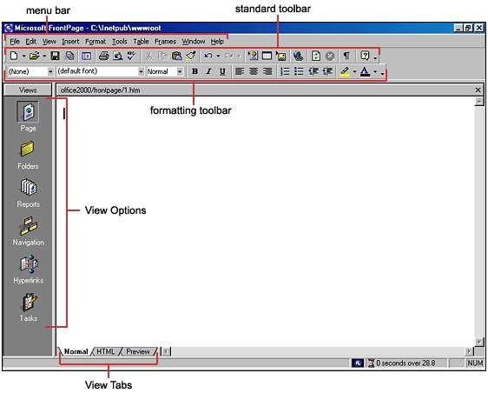Shortcut menu - As with all PC programs, access popup shortcut menus by right- clicking on objects with the mouse.
- URL (Universal Resource Locator) - The address of a web site. This is what is after the "http://" on the location bar on your browser.
- Web - In FrontPage, your web site is referred to as a web.

FrontPage Screen Layout
Below is a diagram of the default page layout in FrontPage. You can change the view by selecting a different View Option.

Views
- Page view gives you a WYSIWYG editing environment for creating and editing web pages.
- Folders view lists all of the files and folders in your web for easy management.

- Reports view identifies problems with pages and links in the web including slow- loading pages, broken links, and other errors.
- Navigation view lists the navigation order of the site and allows you to change the order that a user would view the pages.
- Hyperlinks view allows you to organize the links in the web pages.
- Tasks view provides a grid for inputting tasks you need to complete in your web.

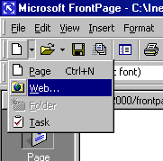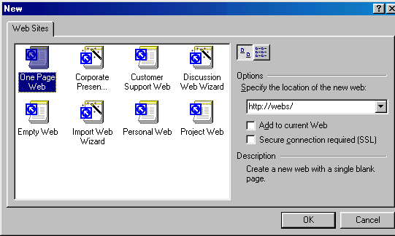Creating a Web Using the Web Wizard
- Open FrontPage and select File|New|Web... from the menu bar or click the small down arrow next to the New button on the standard toolbar and select Web....

- Select the type of web you want to create. It is usually best to create a simple One Page Web which you can add additional blank pages to as you need them. Enter a location for the web in the box provided beginning with "http://". This is the location where you can preview the web on your computer. It will need to be copied to the server to be viewed to the world on the WWW.

- Click OK and wait for FrontPage to finish creating the web.
- Now, explore your web. Click Folders view to see the initial page (default.htm) that was created and two folders. The "images" folder is where you will place all your graphics and photos. While it is not imperative that the images be placed in a separate folder, it keeps the web organized.
- Click on Reports view to see a list of reports for the site. As you construct your web, this page will be much more useful. From here, you can identify and correct broken hyperlinks and fix large pages that take a long time to load.
- View the navigation layout of the web by clicking Navigation view. Right now, there is only one page - the home page - listed. As more pages are added, this page becomes helpful to see how all your pages are linked together.
- Hyperlinks view allows you to manage the links on your pages.
- Optional - in Tasks view, list the tasks that need to be accomplished to create the web. Select Edit|Task|Add Tasks to add a task. Or click the down arrow beside the New button on the standard toolbar.
- Make pages and save them, marking them as completed in the task view.
- Click Folders view to locate the open the next page to work on.
- When you are ready to publish your web on the FGCU server, copy the folder to the server.

Creating a Web Page from a Template
FrontPage provides many individual page templates that can be added to any web. Follow these steps to add a template to a web page.
- 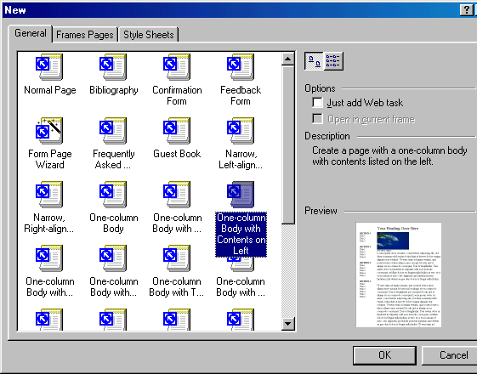Select File|New|Page... and choose a template.

- Select a template and click OK.
- Replace the place-holding body text with your own text and photos with images you would like on your web page.

Report View
When your web is completed, click Reports view to verify that links are correct and use the
Reporting toolbar to switch between reports.

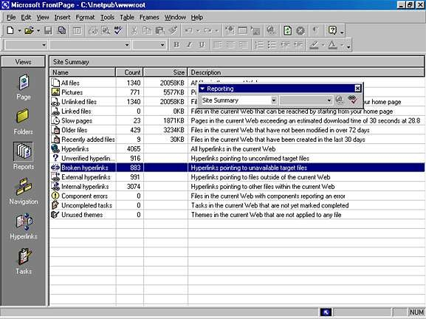Open A Web
To open a web you have already created, select File|Open Web... from the menu bar.
Select the web folder from the list and click Open. Saving A Web
Save all the pages within the web created by FrontPage. These pages, however, are not visible to anyone on the Internet. You must copy the entire web folder to a network drive.

3.0 Page Properties
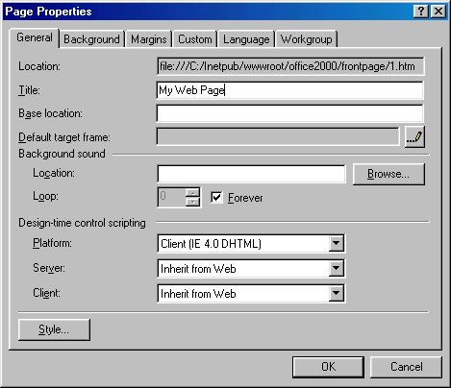Change various page properties by selecting File|Properties from the menu bar. The Page roperties window will allow you to change many general properties, the page background, argins, and more.

  - General - Under the General tab, one property that needs to be changed is the Title. This is the text that will appear across the top of the screen above the browser's menu bar when the page is viewed on the web. Background sounds are not recommended and design-time control scripting options do not need to be changed.

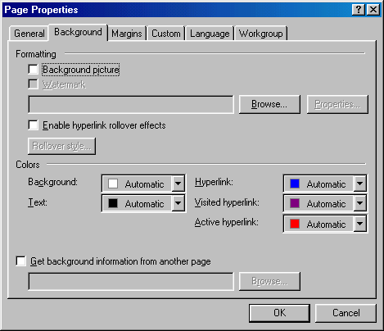Background -
Check the Background picture box and select an image by clicking the Browse...
button to add a repeating graphic to the background of the page.

Enable hyperlink rollover effects adds a Cascading Style Sheet to the page that causes the appearance of text links to change when the mouse is placed over them. These effects are not visible in Netscape version 4 and lower.

Set the Background color and a default Text color if it is not black.

Hyperlink colors can be changed as well. The color set for Hyperlink will be the color of the text of a link that has not been viewed yet by the web site user. Visited hyperlink is the color the link will turn after the page has been visited. Active hyperlink is the color of the link as it is being pressed. This color is usually barely seen as the user quickly clicks the link. The default colors that web users are used to are blue for normal and purple for visited. Refrain from swapping these colors so users will not be confused!
    - Margins - Set the top and left margin width by pixels if necessary. It is not necessary to alter any of the properties on the remaining tabs.

Themes
Themes can quickly add color, graphics, and a common layout to your web pages.
    - 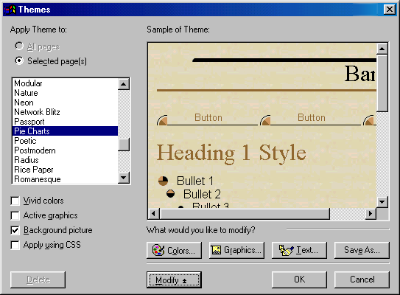Open a web page and select Format|Theme from the menu bar or right-click on the page and select Theme... from the shortcut menu.

    - Under Apply Theme to, select All pages to add the theme to all pages in your web or
Selected page(s) to only apply the theme to activated pages.
    - Scroll through the theme selections and highlight the theme names to preview the theme in the Sample of Theme window. Click the check boxes to change the theme as well.
      - Vivid Colors enhances the colors of the theme.
      - Active Graphics will convert navigation buttons to Java applets that change when the mouse hovers over them.
      - Background picture including a repeating background image to the page. Uncheck the box for a plain color background.
      - Apply Using CSS will add the properties to a style sheet.
    - Click OK when you have chosen the theme

Removing a Theme
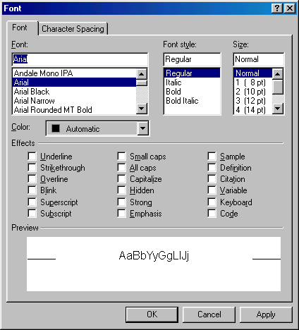To remove a theme from a page after it has been applied, select Format|Theme from the menu bar and select the first "(no theme)" option from the themes list. Click OK.

Font Properties
Many properties of fonts can be changed from the Font dialog box. Highlight the text that will be formatted and select Format|Font from the menu bar.

    - Font - Select a simple, common font for the web page. Keep in mind that the list that appears in FrontPage is the list of fonts loaded onto your computer while many of the visitors of your web site will not have the same fonts. Choose a font such as Arial, Geneva, Verdana, Helvetica, or another sans-serif font that is easy to read and most

people have loaded on their computers.
    - Font Style - Select bold, italics, or a combination of both.
    - 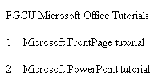Size - Font sizes on web pages are designated by different values than the point sizes you may be used to working with in Word and other word processing programs. Font sizes are listed in parentheses next to the HTML point sizes. A point size of 2 or 3 is usually best for paragraph text. Below are examples of the font sizes using Arial font. font size 1
font size 2
font size 3
font size 4
font size 5
    - Effects - Many of these effects are unnecessary and some are not viewable on all browsers. It is not recommended that you underline any text as this will confuse your user since links are usually underlined. Use bold and italics to emphasize text instead of underlining. Blink is an old HTML specification and since it is quite annoying, many browsers no longer support it. Strong and Emphasis produce similar results to bold and italics.
    - Press OK when finished.

Headings
Explain these. They generally don't work properly in Netscape, but do work when assigned values in themes.

Converting Text to Tables
The text below was typed into FrontPage by pressing the TAB key after each number and ENTER to begin each new line.

The text can be put into a table by selecting Table|Convert|Text to Table from the menu bar. This dialog window will appear. Make a selection and click OK.

    - 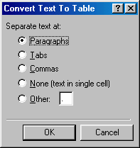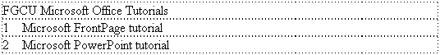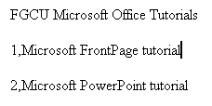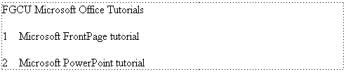Paragraphs - A new table row will begin at each new paragraph. Each line is placed in a single cell on a new row.

    - Tabs - A new column will begin at each tab stop.

    - Commas - A new column will begin at each comma. The text below produces the same table format as the TAB setup.

    - None - All the highlight text will be placed into a single table cell.

    - Other - Select another delimiter for creating a table.

Creating Links
Hyperlinks are text or graphics that can be clicked to bring the user to another web file such as a web page or graphic. They are the essence of the World Wide Web as they link pages within sites and web sites to other web sites. To create a hyperlink in FrontPage, follow these steps:
    - Highlight the text or graphic that will be the hyperlink and select Insert|Hyperlink
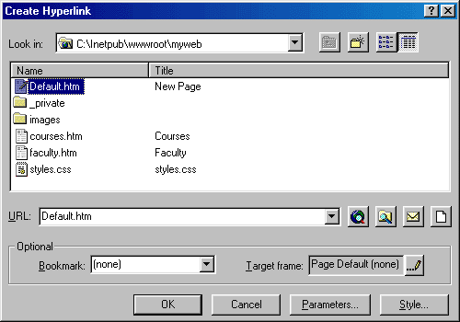from the menu bar or pressing CTRL+K.

    - If the link will lead to a page within your site, highlight the page on the list and click OK. If it is an external link that will lead to another web site, enter the URL in the URL box. External URLs MUST begin with "http://" or they will not work. For example, to link to the FGCU home page, type "http://www.fgcu.edu/" instead of "www.fgcu.edu/".

E-mail Links
Create an e-mail address link by highlighting the text (which should be written as the e- mail address) and pressing CTRL+K. Click the e-mail button with the envelope icon (circled in red below) and enter the e-mail address in the box provided. Click OK on both windows to finish.

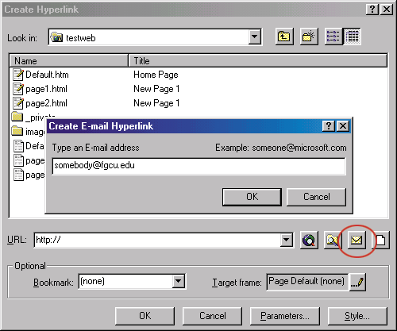Bookmarks
Text and graphics can be set as bookmarks (called "anchors" everywhere except FrontPage) that can be linked to within a page. For example, if a page lists a course syllabus, the titles for each week can be set as bookmarks and a row of links can be added to the top of the page that will each skip down to those bookmarked sections. This method of using bookmarks allows visitors to your site to quickly access information by not having to scroll down the page to view the information they want.
Add a bookmark to a page by following these steps highlighting the text or graphic that will be the bookmark and select Insert|Bookmark... from the menu bar. Enter the bookmark name in the space provided and click OK.

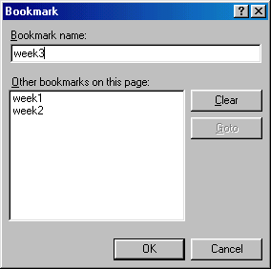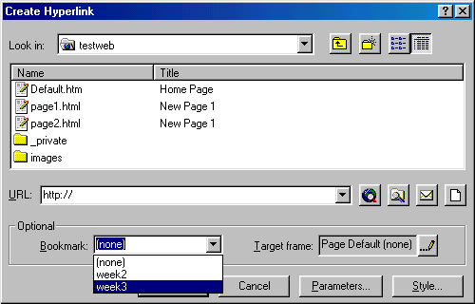Create a link to a bookmark by highlighting the text that will be the link and pressing CTRL+K. Select the bookmark from the drop-down menu in the Optional category and click OK. Link to a bookmark on a separate page by first selecting the file name from the listing and then choosing from the bookmarks in the drop-down menu.

Hotspots
By making a graphic a link in the ways that have already been discussed, each graphic can only link to one location. However, you may have a single graphic that has several sections that each need to link to different pages. Hotspots allow you do to this by creating an image map over the graphic. The main header on the FGCU homepage will be used as an example:

The FGCU logo, "Search", "Directory", and "Index" images all link to different pages on this single graphic. Hotspots can be created by following these steps:

    - Insert the graphic onto the webpage.
    - Using the hotspot tools on the Drawing toolbar, use the necessary shapes to draw the hotspots on the graphic.

The rectangle tool will be used first to draw the hotspot around "search".
    - 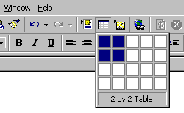The hyperlink window will appear when the mouse button is released. Enter the URL, e-mail address, or bookmark the hotspot will link to.
    - Repeat steps 2-3 until all the hotspots have been added. Use the handles on the hotspots to resize them.
    - If the remainder of the graphic (any part not covered by a hotspot such as the green to blue gradient in the center of this graphic) should be another link, right-click on any area of the graphic that is not a hotspot, select Picture Properties and enter the Default hyperlink location.

Tables
Table Uses
On web pages, tables can serve many functions:
      - Page layout
      - Displaying information in formatted tabular form
      - Adding background color and borders to blocks of text Creating a Table
A quick way to create a small table is using the table button on the standard toolbar. Click the button and drag the mouse over the grid, highlighting the cells that should appear on the table. When the table size has been selected, click the mouse button again.

A table outline with 2 rows and 2 columns will appear on the page:

Table Properties
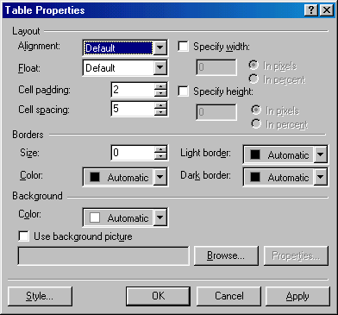Select Table|Properties|Table from the menu border to modify the table's properties.

      - Alignment refers to the table's position on the page, not the alignment of the text within the table. Choose "Center" to center the table on the page, or select left, right, or justify. Default is usually left alignment.
      - Cell padding is the number of pixels between the text and the cell walls.
      - Cell spacing is the number of pixels between the table cells.
      - Specify width sets the width of the table by a distinct number of pixels or by a percentage of the screen width.
      - Specify height is usually not necessary to set since the height depends on the number of rows in the table.

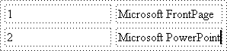
The following table was produced by the settings shown in the window above.

      - Border size indicates the depth of the table border. The dotted lines on the table above are shown only as a visual reference of the table structure, but since this


table's border is set to 0 pixels, no borders will show on a web page:

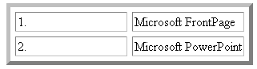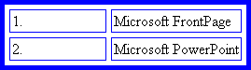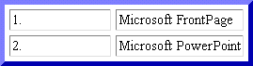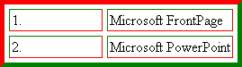Below is the same table with a border set to 5 pixels:

      - Border color will change the color of the borders on the table. The MSIE and Netscape browsers read this property differently. MSIE changes all the border to the solid color, while Netscape keeps the three-dimensional quality of the table and only changes the outer border of the table. Since FrontPage is a Microsoft product, you will always see the MSIE version when constructing a web page in FrontPage.

Microsoft Internet Explorer 5.0 Netscape Navigator 4.7

      - Light border and dark border change the highlight and shadow colors of the table. Be aware that these attributes are not read by Netscape. Light and dark borders of red and green were added to the table, but notice that the Netscape table is still blue:

Microsoft Internet Explorer 5.0 Netscape Navigator 4.7

      - Background color adds a background to the table cells. MSIE will add the color to the background of the cells and the space between the cells while Netscape only adds the color to the background of the cells:

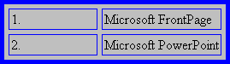
Microsoft Internet Explorer 5.0 Netscape Navigator 4.7
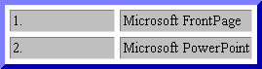

      - Use background picture will add a background image to the table and again, there are differences between browsers. MSIE will repeat the image over the entire background of the table while Netscape repeats the image in each cell:

Netscape Navigator 4.7

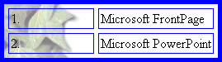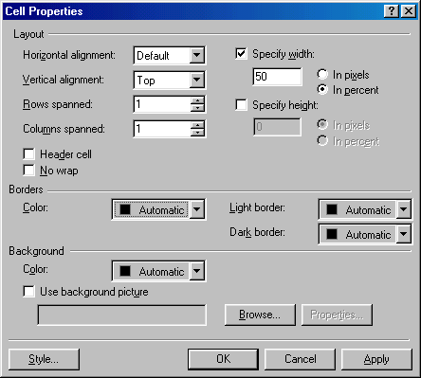Microsoft Internet Explorer 5.0

Cell Properties
Select Tables|Properties|Cell from the menu bar or Cell Properties from the shortcut menu to change the properties of the table cells. Begin by highlighting the cells whose properties will be changed.

      - Horizontal alignment is defaulted to the left side of the table cell. Change this attribute to center or right-justify the text within the table cell.

      - 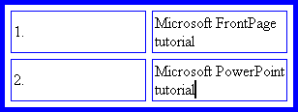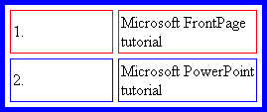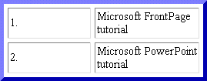Vertical alignment is defaulted at middle as shown in the example below. Since the text in the right-hand column cover more than one line and the left-hand cells do not, that text is centered vertically in the cell. Select "top" or "bottom" to override this default setting.

      - Setting rows spanned and columns spanned is better achieved by a method explained below.
      - Specify width and specify height will set the width and height of the cells. Percentages refer to the portion of the table, not a percentage of the entire screen.
      - Select Header cell to automatically bold and center the content of the cell.
      - Border color is a setting that is not read by Netscape. This changes the color of the cell border only when viewed with MSIE. Note the red borders on the cells in the top row of the MSIE example:

Microsoft Internet Explorer 5.0 Netscape Navigator 4.7

Light and dark border settings will additionally be read by MSIE but not by Netscape.
      - Background color changes the cell's background color. In Netscape, this is the same effect of setting the entire table's background color since the color is not added between the cells.

Microsoft Internet Explorer 5.0 Netscape Navigator 4.7

      - 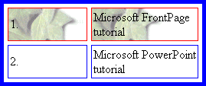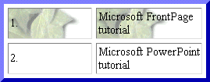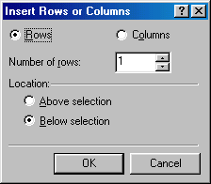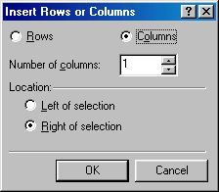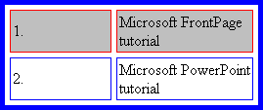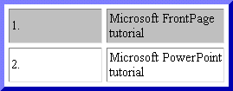Background image adds a graphic to the background of each cell. In Netscape, this is the same effect as setting the background graphic for the entire table since it begins a new repeating pattern for each cell.

Microsoft Internet Explorer 5.0 Netscape Navigator 4.7

Inserting Rows and Columns
Quickly add rows or columns to a table by placing the cursor in the cell the new row or column will be adjacent to, right-click the mouse to access the popup shortcut menu, and select Insert Row or Insert Column. Another method is to use the Insert Rows or Columns dialog box:
- Place the cursor in a cell where the new row or column will be adjacent to.
- Select Table|Insert|Rows or Columns from the menu bar.

- To insert a row, select Rows and enter the Number of Rows. Then select the
Location of the new row by selecting Above selection or Below selection from

where you placed the cursor in step 1.
- Click Columns to insert a new column and the choices will change. Enter the
Number of columns and the Location left or right of the selected point.
- Click OK. Spanning Cells
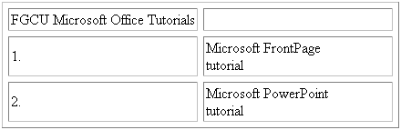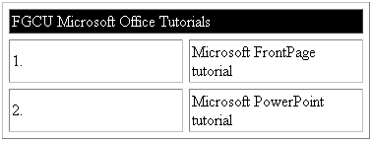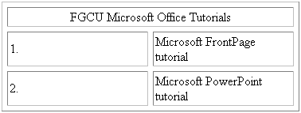There is often the need to create a cell than spans rows or columns, such as the a title at the top of a table. This example will begin with the same table already used on this page.
- Insert a new row to the top of the table.
- Type the text of the row that will be spanned across the columns by typing into the first cell and highlight the cells as shown below:

- Select Table|Merge Cells from the menu bar or right-click with the mouse and select Merge Cells from the popup shortcut menu..

- Center the text in the cell by from the Cell Properties window and deselect the cell.

- To split the cell again, select the cell and choose Table|Split Cell from the menu bar.

Miscellaneous
Horizontal Lines
Horizontal lines can divide sections of text for easy reading.
    - Place the cursor on the page where the horizontal line should be added.
    - Select Insert|Horizontal Line from the menu bar.
    - Double click on the line to change its properties.
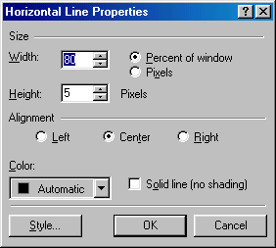
    - Set the Width of the line either as a percentage of the window or an absolute size in pixels.
    - Change the thickness of the line by setting the Height in pixels.
    - Set the Alignment of the line to the left, center, or right size of the page.
    - The lines are automatically shaded to give the illusion of depth. Check the Solid line box to make the line all one color and set a Color for the line if necessary (not supported by Netscape).

Shaded horizontal line:

Solid horizontal line (red when viewed with MSIE):

    - Click OK when finished.
Symbols
Add unique symbols such as the copyright (©) and accented letters (é) from the Symbol
dialog box. Select Insert|Symbol... from the menu bar. Click the symbol on the list you

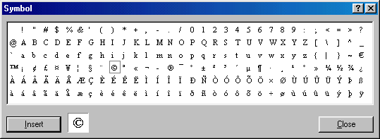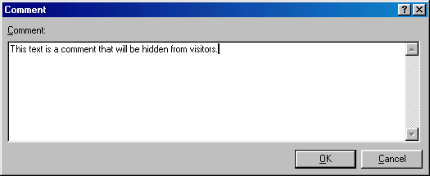want to add and it will appear in the preview window. Click the Insert button to add the symbol to the page. Keep adding symbols and click Close when finished.

Comments
Text can be hidden from visitors to your web page and still be visible to you when the page is edited in FrontPage. These comments can be added by following these steps:
- Place the cursor on the page at the location where the comment will be added.
- Select Insert | Comment from the menu bar.

- Type the text in the Comment box and click OK.
- Notice that the commented text begins with "Comment: " and is another color to differentiate it from regular text. Open the page in a browser to see that the commented text is not visible on the page.

Web Design Tips
- Background Images: Use background images with caution. Light watermarks usually work fine, but dark, busy graphics can impair the readability of the page. Solid, muted colors are usually best to use.
- Fonts: Stick with common fonts such as Arial and Times New Roman. Although

there are many fonts to choose from, if the user does not have a font you choose on their computer, a default font will be used.
- Long Pages: Divide the information into different pages. A long and endless scrolling page is difficult to read.
- 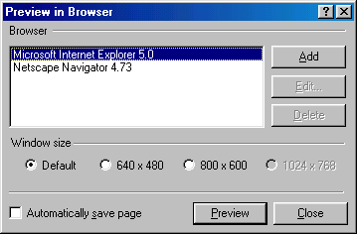Sound: Refrain from using sound, particularly embedded sound files, if possible. If a sound file must be included, make it a link on the page so the visitor to your page can turn it on and off. Many people surf the web with their computer speakers turned off so embedding a sound file that automatically downloads will unnecessarily increase the download time of the page.
- Hyperlinks: Always use descriptive words for link text instead of the simple "Click Here!" For example:
Incorrect - This site includes tutorials for using programs in the Microsoft Office suite.

Correct - To learn more about using the programs of the Microsoft Office suite.
- Page Size: While most Internet users use a screen resolution of 800X600 or higher, there are still users with monitors set to 640X480. Design your web pages so all material is viewable on this small resolution. Therefore, do not create graphics or tables wider than 620 pixels.
Testing
Since different browsers (mainly Microsoft Internet Explorer and Netscape Navigator) read webpage differently, preview your pages in both browsers to make sure the page looks the way you want it. FrontPage provides an easy way to accomplish this.
- Select File|Preview in Browser from the menu bar.

- The list of browsers installed on your computer will be listed. Highlight the browser name and click Preview for each browser.

APPENDIX V
WEBQUESTS ON AGRICULTURE (DEVELOPED BY THE RESEARCHER)

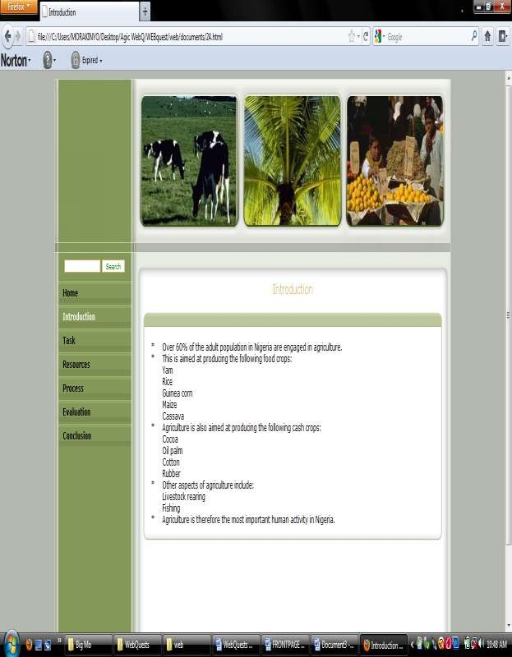

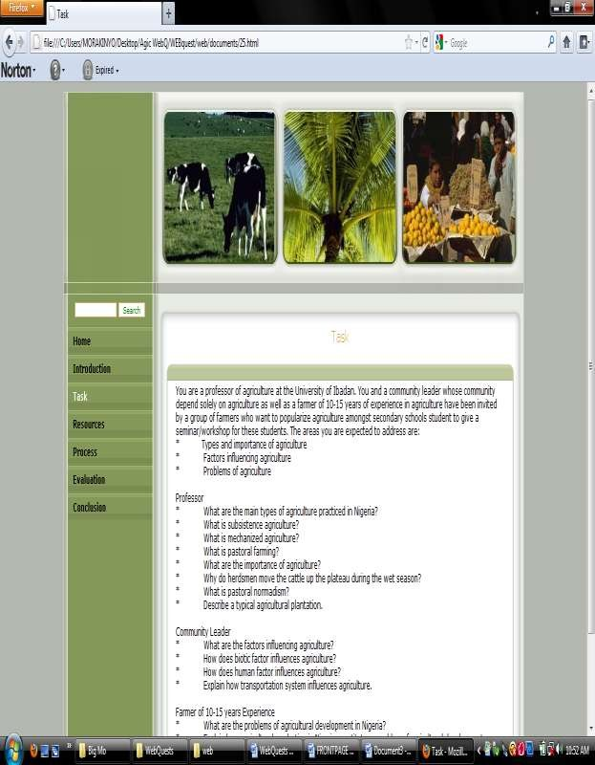

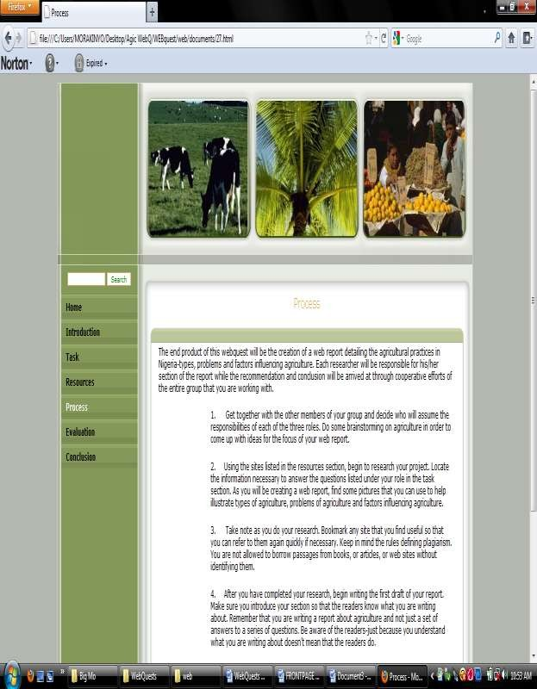

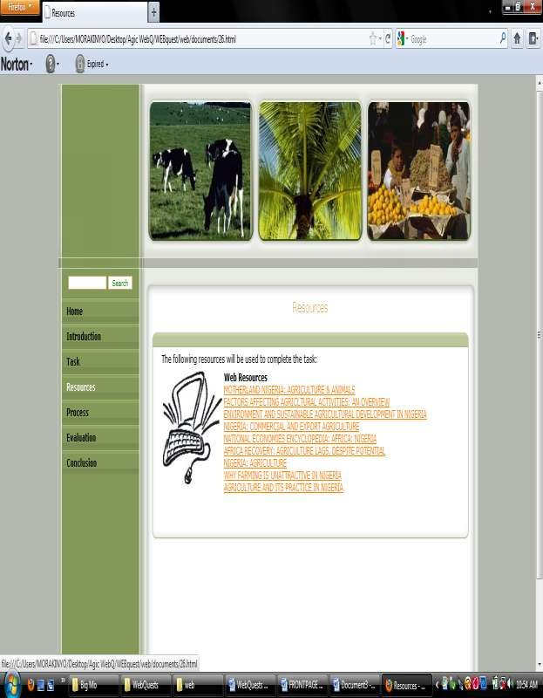

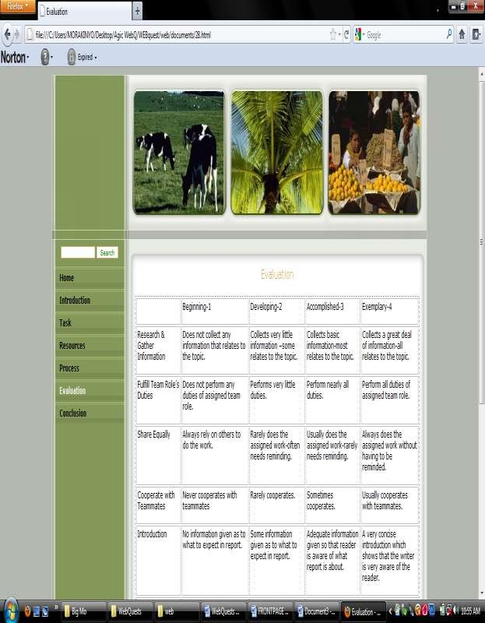

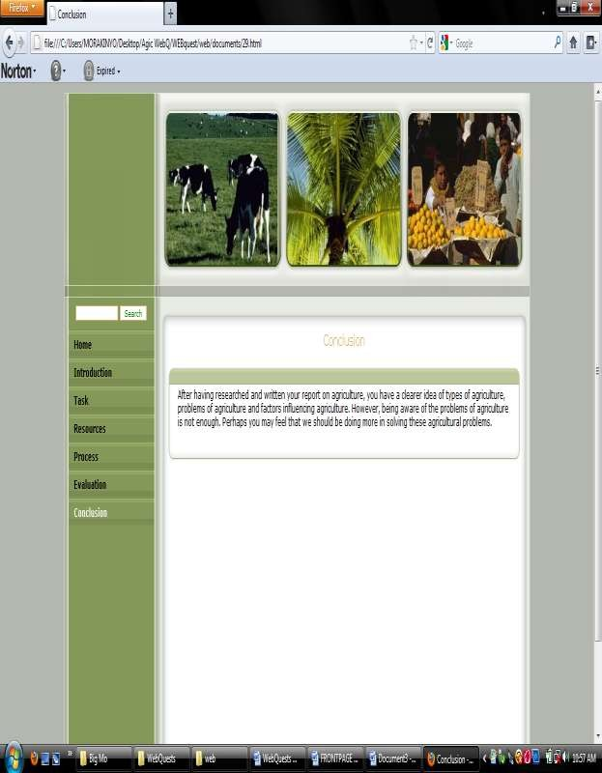

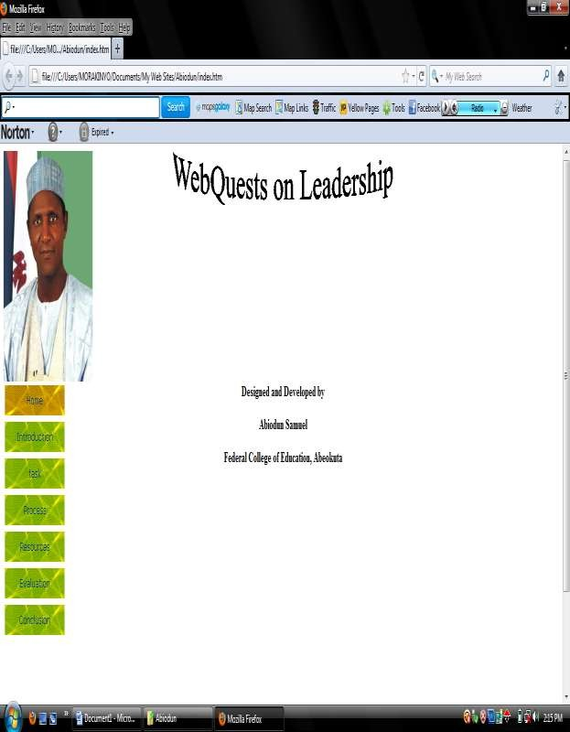APPENDIX VI
WEBQUEST ON LEADERSHIP (DEVELOPED BY PARTICIPANTS)

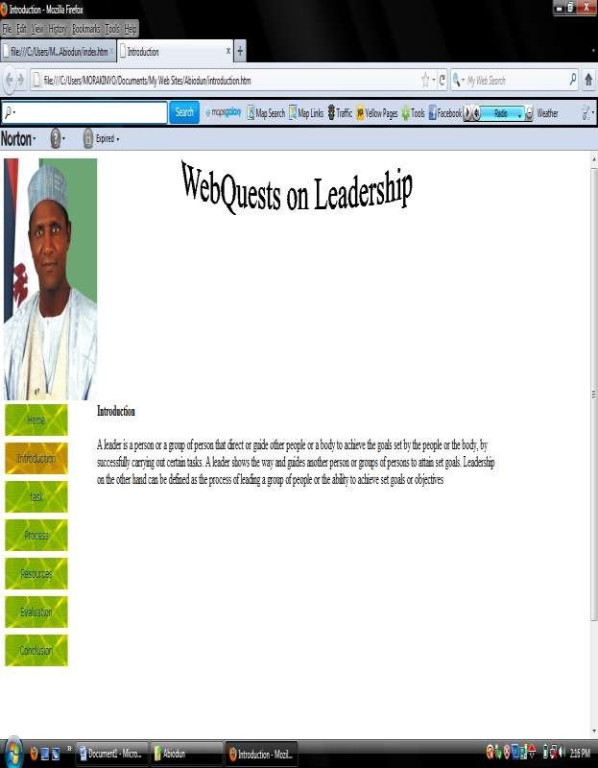

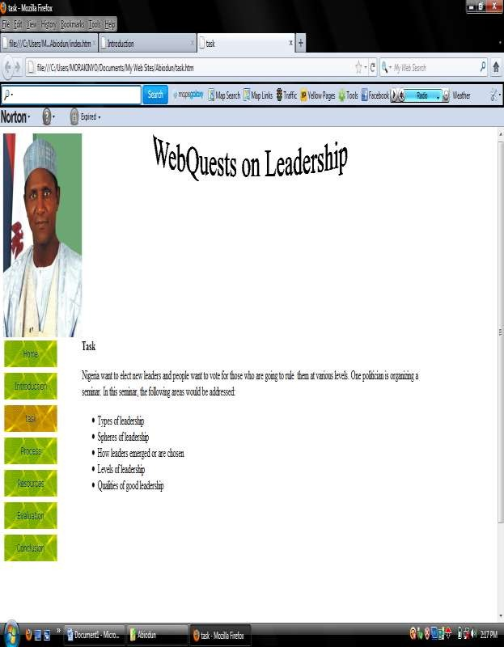

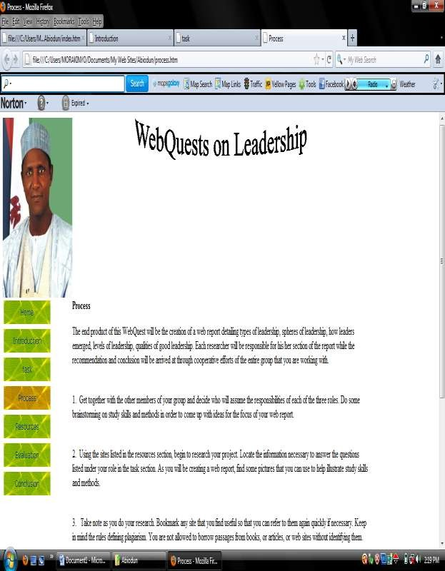

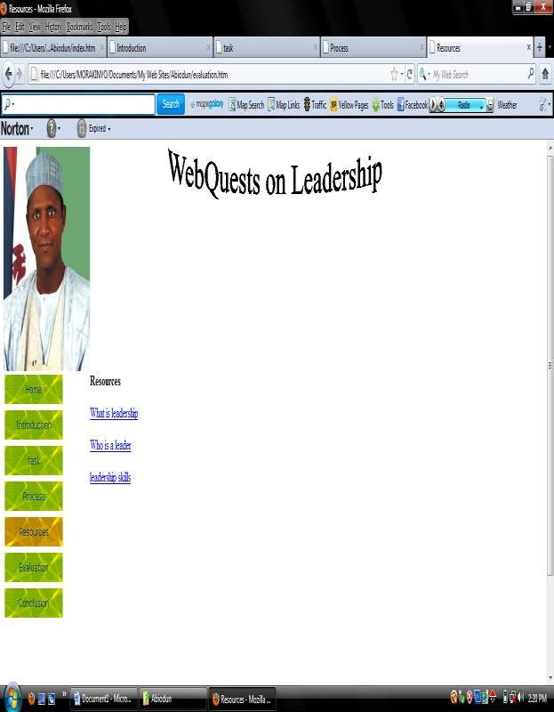

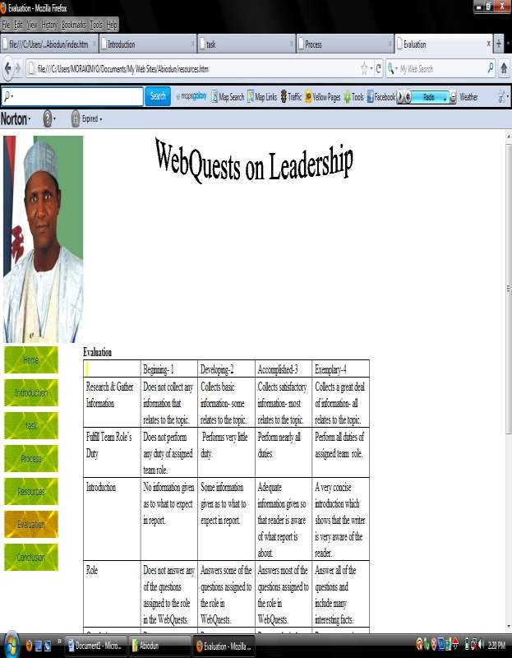

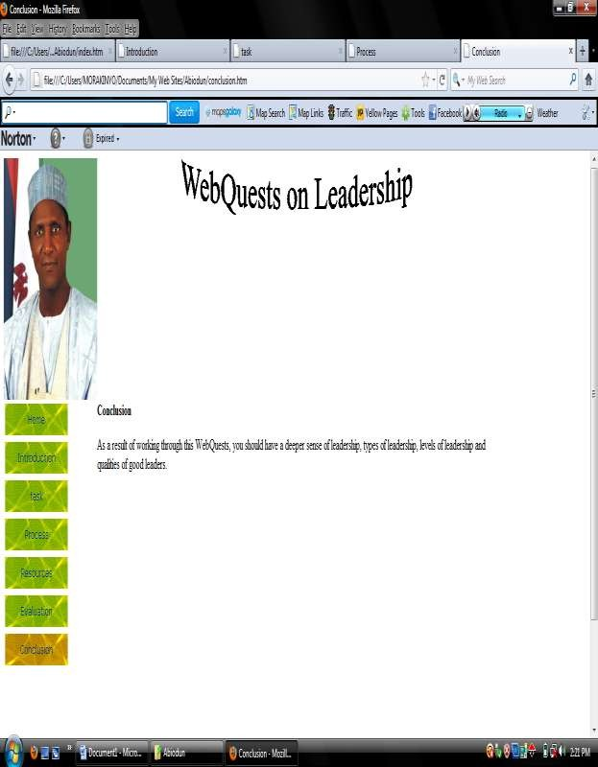

APPENDIX VII
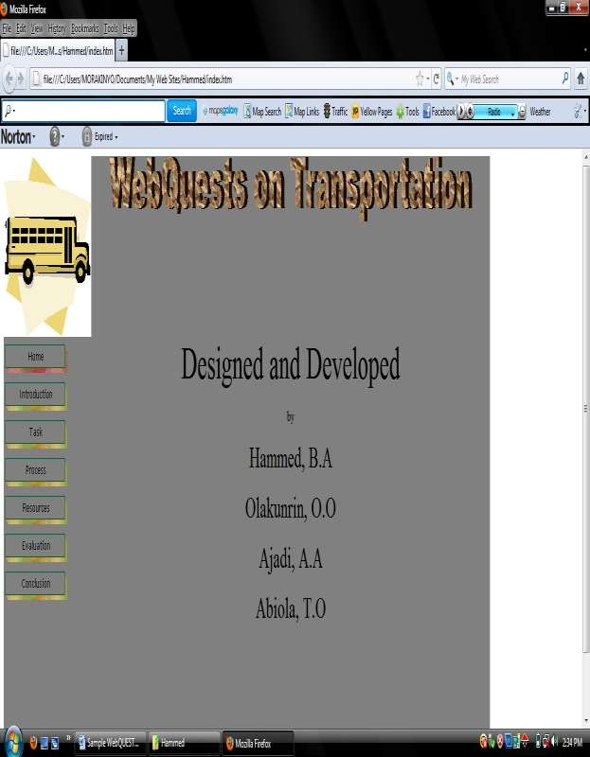WEBQUEST ON TRANSPORTATION (DEVELOPED BY PARTICIPANTS)

