## DEVELOPMENT OF INSTRUCTIONAL MANUAL FOR TEACHING CRAFTS IN NATIONAL CERTFICATE IN EDUCATION HOME ECONOMICS PROGRAMME IN NORTH – WEST, NIGERIA

**BY**

## SHEHU RUKAYYA ALIYU

**DEPARTMENT OF HOME ECONOMICS FACULTY OF EDUCATION**

## AHMADU BELLO UNIVERSITY, ZARIA, NIGERIA

**DECEMBER, 2017**

## DEVELOPMENT OF INSTRUCTIONAL MANUAL FOR TEACHING CRAFTS IN NATIONAL CERTFICATE IN EDUCATION HOME ECONOMICS PROGRAMME IN NORTH – WEST, NIGERIA

**BY**

## RUKAYYA ALIYU SHEHU

**M.ED HOME ECONOMICS EDUCATION (P13EDVE8026)**

## A THESIS SUBMITTED TO THE SCHOOL OF POSTGRADUATE STUDIES, AHMADU BELLO UNIVERSITY, ZARIA

**IN PARTIAL FULFILLMENT OF THE REQUIREMENTS FOR THE AWARD OF MASTER OF EDUCATION (M.ED) DEGREE IN HOME ECONOMICS EDUCATION**

## DEPARTMENT OF VOCATIONAL AND TECHNICAL EDUCATION FACULTY OF EDUCATION

**AHMADU BELLO UNIVERSITY ZARIA**

## DECEMBER, 2017

## DECLARATION

I declare that the work in this thesis entitled: Development of Instructional Manual for Teaching Crafts in N.C.E Home Economics Programme In North – West Nigeria, has been carried out by me in the department of Home Economics. The information derived from the literature has been duly acknowledged in the text and a list of references provided. No part of this thesis was previously presented for another degree or diploma at this or any other institution.

|  |  |  |
| --- | --- | --- |
| Rukayya Shehu Aliyu |  |  |
| Name of student | Signature | Date |

## CERTIFICATION

This thesis entitledDEVELOPMENT OF INSTRUCTIONAL MANUAL FOR TEACHING CRAFTS IN N.C.E HOME ECONOMICS PROGRAMME IN NORTH

– WEST NIGERIA, by RUKAYYA ALIYU SHEHU meets the regulations governing the award of the degree of Masters in Home Economics Education of the Ahmadu Bello University, and is approved for its contribution to knowledge and literary presentation.

Prof. A.Z. Mohammed Date

Chairperson, Supervisory Committee

Dr. M.A. Abubakar Date

Member Supervisory Committee

Prof.E. E.Adamu, Date

Head of Department

Prof. Sadiq Z. Abubakar Date

Dean of Postgraduate Studies

## DEDICATION

This research work is dedicated to my beloved parents who gave me the strength and opportunity to complete this programme successfully.

## Acknowledgements

The researcher give praise to Almighty God for his blessing, guidance, sustenance and the opportunity he grant me to complete this research work.

She sincerely appreciates her able supervisors Prof A.Z. Mohammed and Dr. M.A.Abubakar who devoted their time making constructive criticism, suggestions and offered encouragement throughout the period of this work. She is most grateful for their motherly advice, concern and particularly accommodating spirit at odd times.

Special thanks and love to MrsKantiok who availed herselfthroughout the research work. She appreciates theacademic advices and moral support of Prof E.E.Adamu (head of department), Prof P.E. Onuigbo, Dr. M.F.Ahuwan, Prof T.O. OJO, Prof E. Ike, Prof S.I.Ajayi and other supporting staff in the department of Home Economics, for their concern and advices towards her work. She also appreciates Dr.Sani, Dr. Oni, and Dr.Adamu department of Vocational and Technical Education for their contribution and encouragement throughout the study period. She alsoacknowledge the contribution of Dr. A.B Bawa, Department of Education for his contribution and encouragement. Her profound gratitude also to the statistician MrOkon, for his unquantifiable assistance and guidance. MallamYa‟u Department of Industrial Design for his assistance throughout developing the instruction manual for the study Sincerely appreciation to her beloved parents, Alh S.M Aliyu and BilkisuAbdullahi for their love, moral and financial support. She also expresses her profound gratitude to her beloved husband AliyuMuhammed, brothers DrNuradeenAliyu ,Arc Shamsudeen and Najamudeen and also her sisters Umma, Rukayya and Fauziyya for their support and prayers towards the success of this programme.

## ABSTRACT

The study was carried out on development of instructional manual for teaching crafts in N.C.E Home Economics Programme in North-West Nigeria. The study was conducted to findout the extent to whichcrafts areas are been taught to students and to improvise an instructional manual to help with areas of crafts making that is of difficulty to the students. Four objectives were stated with four correspondent research questions and null hypotheses. All N.C.E three students and lectures in the Colleges of Education was used for the study with a population of 256 in the eight colleges of education offering Home Economics in North West Nigeria. Research and Development (R and D) design was used for the study. Three major instruments were used for the study namely: Structured questionnaire designed by the researcher, Development of an instructional manual for teaching crafts, and a rating scale for assessing the developed manual.Data collected were statistically analyzed using frequencies and percentages to answer research question one and two while mean and standard deviation was used in answering research questions three and four,Independent sample t-test was used to answer null hypotheses one to three while Pearson Product Moment Correlation Coefficient was used in answering research hypotheses four. The findings revealed that all the 11 textile design crafts outlined in the curriculum were all taught to the students, however, findings also revealed that 7 items out of 11 require improvement therefore should be included in the contents of the developed instructional manual for teaching crafts. The findings also revealed that most of the human and non-human resources needed for effective implementation of craftswas proven to be lacking.It was recommended that teachers should throw away their past poor or outdated practices by constructing and reconstructing their practices continually until it results in the kind of best teaching that will enable all their student meet today‟s high expectation of skills.

## TABLE OF CONTENT

TITLE PAGE I

DECLARATION II

CERTIFICATION III

DEDICATION IV

AKNOWLEDGEMENT V

ABSTRACT VI

LIST OF TABLESX

LIST OF PLATES XIII

OPERATIONAL DEFINITIONS OF TERMS XVII

CHAPTER ONE: INTRODUCTION

* 1. Background to the Study 1
  2. Statement of the Problem 3
  3. Objectives of the Study 5
  4. Research Questions 5
  5. Research Hypotheses 6
  6. Significance of the study 6
  7. Delimitation of the study 7

CHAPTER TWO: REVIEW OF RELATED LITERATURE

* 1. Theoretical Framework 9
     1. Theory of Crafts 9
     2. Theory of Design 12
     3. Theories of Curriculum 13
  2. Conceptual Framework 17
     1. Concept of Development of an Instruction Manual 17
     2. Concept of Craft 28
     3. Concept of Teaching 41
  3. History of Crafts 47

2..3.1 Importance of Crafts 52

* + 1. Methods of Teaching 54
    2. Strategies For Improving The Teaching of Crafts 57
  1. Review of Related Empirical Studies 72
  2. Summary 77
  3. CHAPTER THREE : RESEARCH DESIGN AND METHODOLOGY
  4. Research Design 79
  5. Population For the Study 81
  6. Sample and Sampling Procedure 82
  7. Instrument for Data Collection 83
     1. Validity of the Instrument 83
     2. Pilot Study 84
     3. Reliability of the Instrument 84
  8. Procedure for Data Collection 84
  9. Procedure for Data Analysis 85
  10. CHAPTER FOUR : PRESENTATION AND ANALYSIS OF DATA
  11. Analysis of Demographic Variables 87
  12. Answers to Research Question 90
  13. Test of the Null Hypotheses 100
  14. Summary of Major Findings 105
  15. Discussion of Findings 106
  16. CHAPTER FIVE: SUMMARY, CONCLUSION AND RECOMMENDATIONS
  17. Summary 110
  18. Contribution to Knowledge 112
  19. Conclusion 113
  20. Recommendations 114

REFERENCES 115

APPENNDICES :

APPENDIX A: Introduction Letter 121

APPENDIX B:Questionnaire 122

APPENDIX C : Rating Scale 125

APPENDIX D : Instructional Manual 127

## LIST OF TABLES

Tables Pages

3.1: Population for the Study 82

* 1. : Analysis of the Respondents by Age 87
  2. Analysis of the Respondents by Gender 88
  3. Analysis of the Respondents by Marital Status 88
  4. Analysis of the Respondents by Colleges 89
  5. Textile Design Crafts Taught in N.C.E Home Economics Programme in North-West Nigeria 91
  6. Areas of Textile Design Crafts that Require Improvement in N.C.E Home Economics Programme in North-West Nigeria 93
  7. Resources Needed for Effective Implememntation of Textile Design Crafts that Require Improvement in N.C.E Home Economics Programme in North-West Nigeria 96
  8. Extent the Developed Instructional will Improve Textile Design Crafts Taught in N.C.E Home Economics Programme in North West Nigeria 99
  9. t- Test Statistics of Difference in Opinion of Teachers and Students on Textile Design Crafts Taught in N.C.E Home Economics Programme 100
  10. T- Test Statistics Of Difference In Opinion Of Teachers And Students On Areas Of Textile Design Crafts Requiring Improvement In N.C.E Home Economics Programme in North-West Nigeria 101
  11. T- Test Statistics of Difference in Opinion of Teachers and Students on Resources Needed for Effective Implementation of Textile Design Crafts in N.C.E Home Economics Programme 103
  12. PPMC Statistics on Relationship Between the Development of Instructional Manual for Teaching Textile Design Crafts in N.C.E Home Economics Programme 104

LIST OF PLATES

Plates pages

* 1. Plant Materials 135
  2. Chopped Plant Material 135

|  |  |  |
| --- | --- | --- |
| 1.3 | Water and Plant Material | 135 |
| 1.4 | Plant Material Being Boiled | 136 |
| 1.5 | Strain Plant Material | 136 |
| 1.6 | Fabric in Color Fixative | 137 |
| 1.7 | Fabric in Dye Mixture | 137 |
| 2.1 | Tie/Dye Design | 138 |
| 2.2 | Tie/Dye Design | 138 |
| 2.3 | Tie/Dye Design | 138 |
| 2.1.1 | Resist Stitches in place | 139 |
| 2.1.2 | Drawing Together the Fabric in Place | 139 |
| 2.1.3 | Tritik on Color Background | 139 |
| 2.2.1 | Marbling Process | 140 |
| 2.2.2 | Marbling on Tray | 140 |
| 2.2.3 | Marbling Effect | 140 |
| 2.3.1 | Fold Resist | 140 |
| 2.3.2 | Folding and Pressing resist | 140 |
| 2.3.3 | Process of Folding | 141 |
| 2.3.4 | Pleating Technique (folding and tying) | 141 |
| 2.4.1 | Tie/Dye (Plangi) | 141 |
| 2.4.2 | Tie/Dye (plangi) on Colored Background | 141 |
| 2.5.1 | Circle Method | 142 |
| 2.6.1 | Tying with Pebbles | 142 |
| 4.1.1 | Stamping Blocks | 149 |
| 4.1.2 | Stamping Blocks on Fabric | 149 |
| 4.2.1 | Freehand Design using Brush | 149 |
| 4.2.2 | Freehand Design using Tjanting tool | 149 |
| 4.2.3 | Freehand Design using Foam | 150 |
| 4.3.1 | Designed Foam | 150 |
| 5.1.1 | Brushes for Applying Wax | 152 |
| 5.1.2 | Tjanting tools | 152 |
| 5.1.3 | Elactric Tjanting tool | 153 |
| 5.2.2 | Drawing out the Design | 154 |
| 5.2.3 | Melted Wax | 154 |
| 5.2.4a | Painting Wax Using Foam Tool | 155 |
| 5.2.4b | Painting Wax Using Tjanting Tool | 155 |
| 5.2.4c | Painting Wax Using Stamping Block | 155 |
| 5.2.5a | Folding Fabric | 155 |
| 5.2.5b | Folded Fabric in Dye | 155 |
| 5.2.5c | Crumpled Fabric in Dye | 155 |
| 5.2.6a | After Dyeing | 156 |

|  |  |  |  |
| --- | --- | --- | --- |
| 5.2.6b | After Drying |  | 156 |
| 5.2.7a | After dewaxing Fabric |  | 156 |
| 5.2.7b | After Drying |  | 156 |
| 6.1.1 | Geometric Prints |  | 158 |
| 6.1.2 | Geometric Prints |  | 158 |
| 6.2.1 | Botanical Prints |  | 159 |
| 6.2.2 | Botanical Prints |  | 159 |
| 6.3.1 | Dot Prints |  | 159 |
| 6.3.2 | Dots Prints |  | 159 |
| 6.4.1 | Floral prints |  | 160 |
| 6.4.2 | Floral Prints |  | 160 |
| 6.5.1 | Script Prints |  | 160 |
| 6.5.2 | Script Prints |  | 160 |
| 6.6.1 | Pucci Prints |  | 161 |
| 6.6.2 | Pucci Prints |  | 162 |
| 7.1a | Printing Block |  | 162 |
| 7.1b | Applying Paint on Squeegee |  | 163 |
| 7.1c | Painting the Printing Block |  | 163 |
| 7.1d | Measuring and Stamping Fabric |  | 163 |
| 7.1e | Measuring and Stamping Fabric |  | 163 |
| 7.1f | Finished Product |  | 163 |
| 7.1.2 | Block Printing Design |  | 163 |
| 7.1.3 | Block Printing Design |  | 163 |
| 7.2.1a | Drawn Design |  | 164 |
| 7.2.1b | Cut out Design |  | 164 |
| 7.2.2a | Inserting Cardboard |  | 165 |
| 7.2.2b | Applying Paint or Dye to Stencil |  | 165 |
| 7.2.2c | Finished Product |  | 165 |
| 7.3.1 | Frame |  | 167 |
| 7.3.2 | Mesh Attach to Frame |  | 168 |
| 7.3.3 | Applying Emulsion |  | 168 |
| 7.3.4 | Attaching Stencil |  | 169 |
| 7.3.5 | Exposing to Light |  | 170 |
| 7.3.6 | Finished Designed Screen |  | 170 |
| 7.3.7 | Laying Fabric |  | 170 |
| 7.3.8 | First Screen Application |  | 171 |
| 7.3.9 | Second Screen Application |  | 171 |
| 7.3.10 | Third Screen Application |  | 171 |
| 7.4.1 | Application of Dye |  | 173 |
| 7.4.2 | Spreading Dye |  | 173 |
| 7.4.3 | Finished Product | 173 |  |

## OPERATIONAL DEFINITIONS OF TERMS

1. Crafts in these research study is defined as all the skill areas in clothing and textiles
2. Instructional materials - are educational resources used to improve student‟s knowledge, abilities and skills to monitor their assimilation of information and to contribute to their overall development and upbringing.
3. Meta cognition - is a higher order thinking that enables understanding, analysis and control of one‟s cognitive process especially when engaged in learning.
4. Skilled work is all the work that requires one or more skills the mastery of which requires training and practice

CHAPTER ONE INTRODUCTION

* 1. Background to the Study

The importance of exposing students to Home Economics crafts for individual and societal development has been widely acknowledged. The knowledge and skills which include crafts gained within Home Economics make considerable contribution to young people‟s social and economic development as well as prepare them to the world of work in a wide range of areas related to the field. It provides the learners with the opportunity to develop knowledge and skills in both theoretical and practical aspects of livelihood (Her Majesty‟s Inspectorate of Education, (HMIE, 2009). Therefore Home Economics is a broad field that emphasizes training for skilled jobs.

In order to accommodate the various multidisciplinary areas and skills in Home Economics and position the programme to prepare Nigerian students for global participation, the Nigerian Educational Research and Development Council (NERDC, 2013) reviewed and reoriented its curriculum to have a broad scope that virtually covers all aspects of human daily living. Among the aims of the curriculum was to provide the student with broad based education that equips them with transferrable knowledge of craft skills as well as life skills to cope with the increasingly technological, socio economic and multicultural society. Contemporary societal issues have been integrated into more practical classes, which will make for more instructional materials including instructional technologies and manuals for teaching. These are all very vital in teaching of various craft areas in Home Economics.

Craft also known as handcraft or handicraft is the process of making decorative or functional objects, generally by hand. Hand and power tools are used in making craft items. It is an occupation in which manual skill is needed, creating articles using hands and skills. Crafts in its real sense brings out creativity out of person. It is an intellectual and physical activity where the maker explores infinite possibilities of materials and processes to produce unique objects. The beginning of crafts are handwork, needle work or the basic clothing and crafts skills. It then moves to a more complex item such as textile design that includes weave, resist technique, macramé, printing, tie/dye and so forth. (Leedham & Linnea, 2008). However recent research studies have shown that teaching and learning of Home Economics including the craft areas have not been effective in Nigerian schools. Kevin (2009) saw teaching as the systematic presentation of facts, ideas, skills, and techniques to students. Sharp (2003) defined teaching as the specialized application of knowledge, skills and attributes that is designed to provide unique service to meet the educational needs of individuals and of society. The choice of learning activities whereby the goals of education are realized in the school is the responsibility of the teaching profession.

Schneider, Schober, Toah and Woll (2009) saw vocational Home Economics teachers as craft persons with further training imparting practical skills. In Home Economics specialized teachers with intensive crafts knowledge are expected to teach Home Economics crafts. Knowledge of crafts refer to the professional knowledge used by teachers in their day to day classroom teaching. It is mainly an action oriented knowledge that is generally made explicit by teachers, which they may indeed find difficult to articulate or which they may be unaware of using (Ruthven & Goodchild, 2008). Teachers are expected to exhibit behaviors, approaches, classroom practices and skills that meet the criteria of being well defined, implementable, and linked to gains in

student outcomes. Teachers may need to have clear understanding of why when and how each of these practices can be effective and what exactly it means to demonstrate them in a way that is optimal to student‟s wellbeing (Muijis, Kyriakides, Vander Werf, Creemers, Timperley & Earl 2014). Instruction is the purposeful direction of the teaching learning process and there is no doubt that instructions for student‟s exploration and other quality input will help facilitate the teacher‟s task (Joyce, Weil & Calhoun 2003).

The Nigerian Colleges of Education were established under a philosophy derived from the National Policy of Education (N.P.E)which is a product of the National Council on Education, the highest policy body in Nigeria. The general philosophy which guides them according to the National Council of Colleges of Education (NCCE) guidelines includes;

* + 1. The training of various categories of teachers through part-time programs leading to the award of Nigerian Certificate in Education (N.C.E).
    2. The production of disciplined, efficient and highly motivated teachers for the primary and junior secondary school levels of education.
    3. The organization and hosting of seminars, workshops and conferences aimed at updating the professional and administrative competences of teachers.
    4. Conducting research into all aspects of teachers.
    5. Foster unity and understanding among students and staff from various parts of the nation and beyond

The need to analyze the content of various craft areas in Home Economics, the methods used in teaching those crafts, availability of resources needed and seeking ways to improve the program by developing an instruction manual for National Certificate in Education (N.C.E) teachers becomes necessary. The manual will be designed to take

N.C.E teachers through a series of activities that will provide a practical guide to teachers

which would facilitate them to develop more activities and prepare students for the challenges they face about new trends in crafts making. The teacher instructional manual will give teachers the courage to effect visible change in the teacher‟s role and prevent their becoming in active in the presence of new approaches. This also will facilitate in developing creative way of teaching by teachers that will develop young people‟s own creative thinking and behavior which will support the development of student‟s crafts skills.

* 1. Statement of the Problem

A country like Nigeria that is faced with serious economic and social problems which include unemployment, increase in hunger, child trafficking, child labor and others, needs a functional education that will provide people with sources of livelihood. Home Economics Programme in Colleges of Education should be designed to bring both self and National Development.

The National Commission of Colleges of Education (NCCE), (2009) contended that students of Colleges of Education should be equipped with skills which include crafts to enable them be self-reliant on graduation. Ogwo and Oranu (2006) however found that inadequate instructional materials and unwillingness of teachers to improvise different methods of teaching and learning is a great impediment Home Economics instruction is facing.Most Home Economics graduates therefore do not acquire those skills that will enable them be self-reliant. This may be attributed to the inability of the

N.C.E teachers to creatively teach innovative craft skills, so as to empower students to fit in to the dynamic world of work. Creative teaching is the form of teaching that is intended to develop young people‟s creative thinking (Jeffrey & Craft, 2003).Observation by the researcher has shown that the teachers tend to give out all the topics in craft areas

as assignment to students, which leaves the students unmotivated to do the assignments and learn those skills in crafts.

Such researcher‟s personal observation, has shown that most of the crafts areas given out to students as assignments are not done by the students. Most of the students tend to look for experts that produce the product commercially to do the assignments for them; this denies the students the ability to acquire relevant experience, and skills required for effective output. One major problem that teachers are facing with craft instruction is the lack of updated skills due to shortages of teaching and learning resources needed for meaningful education to take place.

This study is therefore aimed at developing an instructional manual for teaching crafts in N.C.E Home Economics Programme in North - West geopolitical zone. This will serve as instructional material for teachers, enhance teacher‟s crafts knowledge and support the development of skills in craft which will stimulate student‟s interest in different crafts areas.

* 1. Objectives of the Study

The main objective of the study was to develop an instructional manual for teaching identified textile design crafts in N.C.E Home Economics programme.

The specific objectives were to:

1. identify the types of textile design crafts taught in N.C.E Home Economics programme in North- West Nigeria;
2. identify the areas of textile design crafts that require improvement in N.C.E Home Economics programme in North-West Nigeria;
3. identify resources needed for effective implementation of textile design crafts that require improvement in N.C.E Home Economics programme in North-West Nigeria; and
4. develop instructional manual for teaching the identified textile design crafts in

N.C.E Home Economics programme in North- West Nigeria.

* 1. Research Questions

The following research questions guides the study:

1. What are the textile design crafts taught in N.C.E Home Economics programme in North-West Nigeria?
2. What the areas of textile design crafts that require improvement in N.C.E Home Economics programme in North-West Nigeria.
3. What are the resources needed for effective implementation of textile design crafts that requires improvement in N.C.E Home Economics programme in North- West Nigeria.
4. To what extent will the developed instructional manual for teaching the identified textile design crafts improve N.C.E Home Economics programme in North- West Nigeria.
   1. Research Hypotheses

The following hypotheses are formulated for the study:

1. There is no significant difference in the responses of teachers and students on textile design crafts taught in N.C.E Home Economics programme in Northwest Nigeria
2. There is no significant difference in the responses of teachers and students on the areas of textile design crafts that require improvement in N.C.E Home Economics programme that in North-West Nigeria.
3. There is no significant difference in the mean responses of teachers and students on resources needed for effective implementation of textile design crafts in N.C.E Home Economics programme in Northwest Nigeria.
4. There is no significant relationship between the opinion of teachers on the developed instructional manual and improvement of textile design crafts in N.C.E Home Economics Programme in Northwest Nigeria.
   1. Significance of the study

The findings of this study is of great benefit to teachers and students of N.C.E Home Economics programme, Government, Curriculum developers and the whole society. This study would enlighten teachers with knowledge on teaching and learning materials for crafts in N.C.E Home Economics programme. It would also update teacher‟s knowledge about new trends in Home Economics crafts areas which would improve their content. The findings of the study would enlighten Home Economics teachers on the strengths and weakness of crafts making, this would improve their methodology in the teaching of crafts. The study would also be of benefit to students as it would facilitate their ability to get the necessary knowledge of crafts and be updated about the trends in crafts making.

Government would also benefit as the study would help in achieving the objectives of vocational and technical education by producing graduates with knowledge and skills that will enable them get a vocation and be self dependent upon completion of

their studies which would reduce unemployment and poverty in Nigeria. The study would be of benefitto the whole society as it would reduce the rate of unemployment and poverty in the society. The study would be of help to curriculum developers, as it would provide them with up-to date information about issues, problems and trends in N.C.E Home Economics Programmes in North-West Nigeria. It is also hoped that the result would stimulate further research on the different crafts and skills acquisition in Home Economics programmes.

* 1. Delimitation of the study

The study was delimited to teachers and students of N.C.E Home Economics programmes. It was also delimited to Colleges of Education in the North-West Nigeria. The states are Kaduna, Kano, Katsina, Zamfara, and Sokoto N.C.E Home Economics programmes.

The study was delimited to nine Colleges of Education (C.O.E) offering Home Economics in these five states of North- West Nigeria. The study was delimited to textile design which is a clothing and textile crafts area (dye and dyestuff), the study was also delimited to only N.C.E III students and lecturers of N.C.E Home Economics programme. The reason for choosing N.C.E III students and lecturers was because they are in a better position to provide data or feedback to the researcher that was used in answering the research questions and testing of the null hypothesis.

CHAPTER TWO

REVIEW OF RELATED LITERATURE

Relevant and related literature are reviewed under the following subheadings.

* 1. Theoretical Framework
     1. Theory of Crafts
     2. Theory of Design
     3. Theory of Curriculum
  2. Conceptual Framework
     1. Concept of Development of instruction manual
     2. Concept of Design
     3. Concept of Crafts
     4. Concept of Teaching
  3. History of Crafts
     1. Importance of crafts
     2. Methods of Teaching Crafts

2.3.4 Strategies for improving the teaching of crafts

* 1. Review of related empirical Studies
  2. Summary of Review of Literature
  3. Theoretical Framework

Currently, as over the past few decades, we teach and learn in a constructivist learning paradigm. The founders and proponents of constructivism are John Dewey, Jean Piaget, Jerome Brunner, Lev Vgyosky and others. Basically constructivism is a theory of

instruction based on observation to judge how people learn. Constructivism is a paradigm that hypothesizes learning as an active, contextualized, or constructive process. Constructivism is a reaction to teaching approaches such as behaviorism and programmed instruction. The learner acts as an information constructor. Learners construct knowledge based on their personal experiences and hypotheses of the environment. Constructivists argued that learner is not a blank slate (*tabula rasa*) but brings past experiences and cultural factors to construct new knowledge in given situation. Therefore each learner has a different interpretation and constructions of knowledge process based on mental representations (Learning Theories Knowledgebase, 2008).

It has been said that “nothing is as practical as a good theory.” All teachers operate according to theories about teaching and learning. Good teaching requires teachers to construct and reconstruct their theories continually and to determine through systematic and careful inquiry whether their theories result in the kind of best teaching practices that will enable all their students to meet today‟s high expectations for learning and achievement. Some theories will be more helpful than others in particular contexts. However, several principles also emerge from these theories.An unfortunate gap between academics and practitioners,however, has led to a perception of theory as belonging to an“ivory tower” and not relevant to practice. Yet the old adage that“there is nothing more practical than a good theory” still ringstrue today.Tom (2005) opined that changes in our educational practice lead in turn, to changes in our approaches to teaching and learning. These changes also impact our teaching and learning paradigms.Constructivism has important implications for teaching and learning. Firstly, the teacher is viewed not as a

transmitter ofknowledge but as a guide who facilitates learning. Secondly, as learning is based on prior knowledge, teachers should provide learning experiences that expose inconsistencies between students‟ current understandings and their new experiences. Thirdly, teachers should engage students in their learning in an active way, using relevant problems and group interaction. Fourthly, if new knowledge is to be actively acquired, sufficient time must be provided for in-depth examination of new experiences. (Cantillon

, Hutchinson and Wood, 2003).

Vygotsky (1979) suggested that the teacher‟s job is to assess the student‟s understanding to locate the point in the “zone of proximal development” (ZPD) where the learner needs the assistance. Once that has been done, the teacher provides that assistance; for example, by modeling or demonstrating, by asking questions or coaching, by creating a group task in which peer assistance can occur, or by providing readings or hands-on materials that support the next stage of learning. Thus, the teacher must have a sense of what kinds of tasks different students are able to tackle and must constantly adjust the kind and amount of assistance provided as students develop.

These framework relate to the current research in the sense that both research studies agreed that students are seen as information holders that have prior knowledge on how to go about different kind of tasks including some crafts areas that was not introduced to them therefore it is vital that a teacher finds out the level of information a student posses in a particular context and help these students widen their idea, the teacher should facilitate the knowledge the student already have on different crafts areas and be able to close the gap in student‟s past experience. The framework also emphasize that teachers are required to construct and reconstruct their theories continually and determine

whether their theories result in the kind of best teaching practices that will enable all their students meet today‟s high expectations for learning and achievement, which is the main focus of this research work to investigate the methods used by teachers in teaching crafts and improvise ways to improve their practices.

* + 1. Theory of Crafts

The distinction between a science and a craft is systematic thought organized in theory. Craft involves doing and some craft involves experimentation. Theory allows us to frame and organize our observations. Theory permits us to question what we see and do. It helps us to develop generalizable answers that can be put to use by human beings in other times and places. Crafts are an integral aspect of Home Economics. It helps students to develop creative activities and manipulative skills that will enable them function effectively in the society. Despite the importance of these crafts, research studies by Fleck, (1974) have clearly shown that teaching of these crafts have not been effective in Nigerian schools at all levels of our education system, therefore leaving students with limited knowledge about what crafts entails.

In a Theory of Craft Risatti, (2013) examines issues by comparing handmade ceramics, glass, metalwork, weaving, and furniture to painting, sculpture, photography, and machine-made design from Bauhaus to the Memphis Group. He describes craft as uniquely blending function with a deeper expression of human values that transcend culture, time, and space. Craft must articulate a role for itself in contemporary society, says Risatti; otherwise it will be absorbed by fine art or design, and its singular approach to understanding the world will be lost.

Craft, as an object has perhaps been analyzed most extensively by Risatti (2007), where it is compared to both art and design in turn, and analyzed according to function and aesthetics. Risatti (2007), also discusses the craft‟s unique qualities as functionality combined with an ability to express human values that transcend temporal, spatial and social boundaries‟. Despite this deep discussion, in the Postscript, Risatti (2007), falls back to a comparison of what he now calls fine craft with fine art. However, when compared to art, craft is often perceived as inferior in status, either subject to its economic value (Greenhalgh, 2002), or subject to assertions of lack of intellectual activity assuming craft as an activity of making that is devoid of conceptual aims (Dormer, 1997). Thus it is often simply regarded as supplemental. Equally, when compared to design, craft has to compete in terms of the use of technology, mass- production and related economic value, and possibly functionality. One might ask then what the unique strength of craft is? As mentioned above, Risatti (2007) has summarised it as „functionality combined with an ability to express human values‟.

These theory is in line with this research study, in the sense that various researches have concluded that crafts are not given the attention and importance it deserves in both our society and schools, that is why it is not taught well at all levels of our education system. Unless something is done to remedy the situation as lamented by the researcher, then the achievement of the laudable objectives of crafts cannot be achieved, and this largely depends on the human and material resources made available and the implementation strategies employed, which are all proven to be lacking.

* + 1. Theory of Design

The central issue in design is to devise courses of action aimed at changing existing situations into preferred ones on a predictable basis, this means understanding things base on how they are and how they work. Design involves solving problems, creating something new, or transforming less desirable situations to preferred situations. To do this, designers must know how things work and why. Understanding how things work and why require analysis and explanation, this is the purpose of theory. (Simon, 1998)

This research work is written base on Thomson and Paredi‟s Rational Design theory which explicitly includes uncertainty considerations and enables quantitative trade-offs between the utility of artefact and of the process by which the artifact design is created. Rational Design Theory (RDT) establishes a theoretical foundation for Artifacts, Properties, Concept Selection and Concept Evaluation. (Thompson and Paredis 2010). Based on Rational Design Theory and on Hazelrigg's decision-based design framework, Thompson and Paredis (2009), argued that two types of properties are prevalent in design: one is used to describe constraints (specification), whereas the other is used to communicate the designer's belief regarding the value of the property (a prediction based on a given specification). Simply considering the objectives for an artifact is not sufficient when designing the artifact. The design process used to design the artifact also needs to be considered.

Thompson and Paredis (2009), added that Under Rational Design Theory, the assumptions which neglect the cost of the design and decision making process in the more classic Decision-Based Design approach are relaxed. The scope in Rational Design

Theory is broadened to encompass not just the final artifact and its net utility, but also the resources consumed in making decisions and analyzing options before selecting the final design. A decision maker is often forced to choose an artifact under some amount of uncertainty. Early in the design stages, this uncertainty may be very high; however, in many cases this uncertainty might be reduced by performing additional analyses or simulations on the designs under consideration. To do this efficiently, it is necessary to quantify the amount of uncertainty before and after an analysis is performed and to consider the cost of the analysis. To do this, the Value of Information metric is presented (Lawrence, 1999). To that end, this study is written from a Rational Design perspective.

* + 1. Theories of Curriculum

The present study is built on the theory of „‟Science of Curriculum Product‟‟ as stated by Franklin Bobbitt (1918: 1928) and Ralph Tyler (1949). The profounders of the theory opines that, the purpose of education is to bring about the significant changes in the student‟s pattern of behavior. The theory recognizes that statements of objectives in schools are reflected in the curriculum. Tyler (1949) stresses that the success or failure of any programme and the individual learners is judged on the basis of curricula. This theory viewed curriculum as the means that prepares learners for the definite and adequate activities. The advocates of this theory are of the view that abilities, attitudes, habits, appreciation, skills and forms of knowledge that is needed in their career are provided by the curriculum content. This theory was acknowledged by some Nigeria curriculum experts such as Tyack (2007), Andi (2007) and Derek (2009) who all observed that curriculum is essentially a roadmap that develops in learner‟s cognitive, affective, psychomotor and psycho – productivity domain. In this theory the curricular

framework is centered on the grounds of education and work based learning, aimed at boosting the pre-graduation employability of students by increasing their practical knowledge and ability to learn skills.

The theory established that curriculum is built upon the philosophy of economic rationalism that guides the learners into lifetime learning. Under this theory, curricular is the major provider of practical knowledge, skills and technical know-how to learners. The advocates of the theory maintained that, learners get their hands-on experience in the workplace and get accustomed to continuing learning at work. They take the initiative to build the habit of learning for improvement (Gyang 2003). This way of thinking about curriculum theory and practice was heavily influenced by Nigerian‟s curriculum planners in 6.3.3.4 system of education. This educational system was introduced to replace the former system which was believed to be irrelevant to national needs, aspirations and goals. This is in line with Omorogbe and Eseosa (2010), who observed that the theory of Bobbitt and Tyler influences formation of 6.3.3.4 curricular and the authors added that curriculum was to provide the learners with only appropriate skills and the development of mental, competences, physical and social abilities to equip them with life and contribute to the development of the society.

In summary, this theory was based on two components: (1) the core requisite job skills that are to be integrated throughout the instructional course sequence of a given program; and (2) the technical skill standards that reflect the occupational-cluster performance requirements unique to a given course. The theory emphasizes on core requisite job skills that are basic requirements for any career. However the theory got mixed in the late 1920s and 1930s responses of the acceptance. One of the criticisms

made was that there is no social vision or program to guide the process of curriculum construction.

This theory emphasize that curriculum guides the learners into lifelong learning and it is the major provider of practical knowledge, skills, and technical know-how to learners therefore it is vital to ensure the curriculum used in teaching those N.C.E Home Economics students is well developed and fully implemented to meet the needs of learners which is pre graduation employability by adding their practical knowledge and ability to learn skills, since it has been stressed that the success or failure of any program or individual learners is judged on the basis of a curricula therefore these research study intends to extensively look at the issues pertaining what the curriculum of N.C.E Home Economics programme entails. Since if a programme is regarded as a failure then the curriculum content used for the programme will also be regarded as inadequate

* 1. Conceptual Framework

The concepts dealt with in this work are development of instructional manual,

* + 1. Concept of Development of an Instruction Manual

An instruction manual is an instructional book or booklet that is supplied with almost all technologically advanced products. [(http://www.unicode.or](http://www.unicode.org/chart/pdf/U1F300.pdf))g[/chart/pdf/U1F300.pdf).](http://www.unicode.org/chart/pdf/U1F300.pdf)) Backinger and Kingsley (1993), present some concepts essential to the process of developing good instruction. The development of the instruction should be part of the overall plan for the design of manuals. Some tasks will follow one another while other activities may be done at the same time. The process that you use will depend on your organization and the type of manual you are writing about. However, that process should address each of these concepts.

The concepts that will be covered includes:

1. User Research
2. Task Analysis
3. Instruction Content and Organization
4. Writing Procedures
5. Writing Warnings
6. Format Design
7. Testing and Revision,
8. Distribution.

Backinger and Kingsley (1993) added that this processes are meant to help develop and write an instruction manual that can easily be read and understood. There is no one right way to write an instruction manual. These recommendations are flexible. The format and content of manuals depend on the type of instructions and the people who use it. Your goal should be to provide the **l**east competent studentwith the information necessary to use your manual in the most safe and effective manner possible. No recommendations can guarantee that the students or teachers will make no errors. But, with instructions that are easy to read and understand, the users are more comfortable with the manual and are likely to make fewer errors. Good instructions promote the safe and effective use of manuals by any user.

## User Research

Before writing your instruction manual, determine who the users of your manual will be. Tailor your manual to typical user characteristics, if possible. The primary users of your manual may be: Teachers and students. Students may or may not need training and help on how to go about a manual, but the best situation is for students to be trained on how to go it. A manual may be the only instructions which students receive. For others, the manual will be a reference when a professional is not easily available.

Students differ in education, literacy, primary language and life experience from professionals.

## Task Analysis

Study the environment in which the manual is likely to be used. The environment often affects what is been taught to the students. Consider students characteristics and the environment in the design and the content of your instruction manual. The designer of the manual should not have sole responsibility for writing the instructions. When you knowa procedure well, it is often hard to put yourself in the place of the new users and to imagine problems that they might have. Set up a team that includes the designer, a skilled writer and a graphic designer. Ideally, at least one member of your team should have some background in writing instructions. Members may be from your own organization or consultants. In addition, consult educationist and lay users for ideas. Pretesting may be helpful in gathering important information from these groups. Pretesting is discussed in the section, "Testing." Start with a task analysis. To do a task analysis, identify and organize materials in the steps necessary for performing the entire process required to use the manual. Walk through the steps using the actual equipment. The information that you gather from this process will be developed into your instructions. The information for each step might include materials and equipment to be used, actions, results of actions, possible errors with results, and corrections. At the beginning of the manual, advise your user to read the entire instruction manual before trial. Let the user know that it is unsafe to start using the manual before reading the whole manual. This advice can be presented in various ways to catch the reader's attention. For example, you could have a separate page with this message on it before the Table of Contents or a highlighted sentence at the top of the Table of Contents page.

## Instruction Content and Organization

Include the following content areas in the following order. If youchoose to change the order of the content areas, test your planned order with users to make sure that it meets their needs.

## User assistance information

Design a page or a clearly marked section at the beginning of the manual that tells users how to get help for problems with any area of the manual. This section should be very easy for the user to find.

## Table of Contents

Provide a complete list of content areas with page numbers. Use the same headings you use in the text. Although glossaries are occasionally included in manuals, they are not recommended because their use requires cross referencing by the reader. If you decide to use a glossary, place it after the Table of Contents to alert readers that it is there to help them. Whether or not a glossary is used, definitions should appear in the end.

## General Warnings and Cautions

General warnings and cautions are those that provide critical information needed before the device is used. Place these warnings and cautions at the beginning of the manual where the user will see them right away. General warnings and cautions can be listed in separate sections with the headings **"Warnings and Precautions.**

## Maintenance

Clearly describe the maintenance actions that are the responsibility of the user. If the user is not responsible for maintenance, briefly outline proper maintenance actions, who is responsible, and how often the action should be done. The user will then know what to expect and can act if proper maintenance is not provided. If your device has some

maintenance procedures to be done by the user and some done by others, you may wish to write this section in two parts. Twosections will help make clear to users what they should and should not be doing during maintenance.

## Storage

Clearly describe proper preparation for storage and storage conditions. State the results of improper storage conditions.

## Writing Procedures

Once the task analysis is complete, refine the instructions using appropriate language and graphics. As you refine the instructions, consider what you found in your user population research into account limitations of typical users that you found. The user needs to know what to do, how to do it, and when to do it. Don't bury this important information in a lot of text. In general, your instructions should: provide logically ordered steps for the task and make the user aware of the importance of doing the steps in order, state the purpose and the expected outcome of each task. Tell the user what steps are essential and which ones are optional. Be writing at a sixth to seventh grade reading level to reach most of the population. It should be clear the first time it is read. Many people will not reread something they do not understand.

## Writing Warnings and Cautions

General warnings and cautions are those that provide critical information needed before the manual is used. Place these warnings and cautions at the beginning of the manual where the user will see them right away. General warnings and cautions can be listed in separate sections with the headings "Warning and Precautions. A warning is a statement that alerts the user to the possibility of injury, death, or other serious adverse reactions associated with the use or misuse of the equipment or materials. A caution is a

statement that alerts the user to the possibility of a problem associated with its use or misuse of equipments or materials. The caution statement includes the precaution that should be taken to avoid the hazard. There may be conditions under which a device or materials should not be used (contraindications). These situations generally exist when the risks associated with the use of the equipment or materials are greater than the benefits. Note: Over warning has the effect of not warning at all. Thereader stops paying attention to excess warnings.

## Format Design

Organize your instructions using any of a number of formats such as text, a flowchart, or a list. Your choice of format will depend on the complexity of the instructions and what you learned about your users. For any format you choose:

* Use headings that describe the information that follows.
* Make sure that short headings tell the reader enough about what is in that section.
* Highlight headings so that they are easily distinguished from the text.
* Include only one topic in each heading.
* Begin each section under a heading with a topic sentence to let the reader know what to expect.
* Number steps that must be completed in order.

## Procedures

The following sections are not procedural steps. They are recommendations, and are not listed in any particular order. Write procedures in short, identifiable steps. Put the steps in the order that they should be performed. Before each set of steps, tell the reader how many steps are in the procedure. This helps the reader avoid missing, steps. Number

each step in Arabic numbers such as 1, 2, 3. Do not use Roman numerals such as I, 11, 111; letters such as A, B, C; or words such as one, two, three. Limit each step to no more than three logically connected actions. If actions are not related, they should be in separate steps.

* Make the instructions for each action clear and definite to prevent misunderstandings. This approach is especially critical for steps that require more than one action.
* Discuss common user errors at the point in procedures where they are likely to occur. Provide information to prevent and correct user errors.
* Each step should be contained on one page. If the entire step will not fit on a single page, break the step into smaller sub steps, each fitting on a page or less. Put more than one step on a page only if each step and accompanying graphics is complete on that page.
* Avoid referring the user to another place in the manual for other information (cross referencing). It is confusing to the reader and interrupts the flow of the procedures. If cross referencing is absolutely necessary, make sure the reader knows when to return to the original place.

## Sentence Construction

**-** Use as few words as possible to present an idea

* Place phrases that describe or explain at the end of the sentence. Phrases at the beginning or in the middle of a sentence may be confusing.
* Write the way you talk. Avoid formal language.
* Express ideas of similar content in similar form.
* Users should be able to read the instructions aloud. Do not use parentheses for information that should be read. Parentheses cause the reader to hesitate as part of the sentence making it is hard to read. Use parentheses only for extra information such as technical terms.
* Don't promote the product in the manual. Ads or promotions in the text will interfere with the user's ability to follow instructions.
* Usebullets, lists, or more than one sentence instead of a long sentence that requires a lot of punctuations.
* Avoid abbreviations or acronyms. If you feel that abbreviations or acronyms are necessary, define them the first time you use them. Use them consistently.
* Use lay language rather than uncommon jargon or technical terms. If technical terms are necessary, use lay language first with the technical word in parentheses.
* Terms should be defined the first time that they occur in thetext. Keep definitions simple and concise.

## Readability

Readability is the grade level of reading ability needed to read a piece of writing. Experts recommend not exceeding the sixth to seventh grade reading level to reach most of the population. To do this, limit each sentence to 25 words or fewer. Try to use words ofthree syllables or fewer. Test your manual for readability to assure that as many lay users can readyour instructions. Several methods are available for testing written materials. Use the method that fits your needs. Readability testing will alert you to the need to simplify your manual if the reading level is too high. Be aware, however, that readability testing addresses only the reading level and will not guarantee that the material can be understood. The suggestions in this work are offered to help you develop instructions that can be both easily read and understood.

## Designing

The design should encourage the user to keep and use the manual. If the manual is appealing, users are more likely to consider it valuable and less likely to lose or discard it.

The cover should be eye catching and easy to identify. Consider using a bright or distinctive color for the cover. The cover should be visually pleasing to the user. Don't put too much on it. Think about the environmental and user conditions under which the manual may be used. Design the manual with those conditions in mind. For example: if there is likely to be poor lighting, then use large print; if any liquid or grease will be used when using the manual, then use waterproof pages; if the user needs both hands when using the manual, then pages should lay open flat; if the manual may be subject to vibrations from the environment, then use large print for easier reading; if the likely user has limited hand motion, then use heavy stock paper to make page turning easier; and if the user may have decreased vision, then use large print. Consider the effects of use and storage on the manual.

## Paper

Lamination can preserve the instruction manual if it is used frequently or in a wet environment. If one page, such as a checklist, is used frequently, consider creating a separate laminated page. When possible, manuals should be a standard size, Standard size materials cost less to produce, may be easier to get, avoid waste, and use resources more efficiently than non standard sizes. If the page size is too big, the manual will be cumbersome or difficult to store. If the page size is too small, it may restrict print size and graphics and may be difficult to handle. Use paper that is thick enough so print and graphics do not show through. Show-through reduces the clarity of the printed words. Layout Separate sections of the manual to make them easy to find. One method is to divide sections with different colored paper, colored paper edges or labeled tabs. Consider using heavy paper for these Pages. There are different approaches to numbering pages in the manual. You can number the pages consecutively through the manual. You

can also number by chapter and page, for example, 2-3 means Chapter 2, page 3. Numbering by chapter and page, rather than by pages only, makes updates easy. Highlighting Use highlighting techniques to emphasize important words, thoughts, or phrases. For example, highlight headings, warnings, and or notes. Highlighting includes: Bolding CAPITAL LETTERS - good for headings, individual words or phrases, not for general print Color - can be used for important words, such as warnings and cautions Use different types of highlighting for different purposes. For example, you may italicize notes and bold warnings. Don't overdo highlighting. Too much highlighting decreases the impact of your message. Whatever method you choose, BE CONSISTENT.

## Graphics

Graphics include line drawings, illustrations, symbols, icons, photographs, tables, and graphs. Use of clear, simple, precise graphics helps any user understand instructions. Graphics are useful when referring to controls or parts of the device. Graphics are especially important if the user does not read well, see well or does not read the language used in your manual.

## Testing and Revision

Your task is not complete when the manual is written. It is essential that you test what you have written to make sure that any usercan understand and effectively follow instructions. While you mainly test your manual on potential users, the first step in testing the manual is to verify that the information is correct. The author must go back over the manual and check it for accuracy. Then the instructions should be given to another person who is familiar with the manual and its operation to validate the information. Validation can be done in different ways: read the manual through for completeness and accuracy, go through the manual using the device as you follow the steps, or go through the manual

while using a simulator to duplicate various operating conditions. Choose the approach that best fits your needs. The last two will provide a more realistic setting to check the accuracy of your instructions. The next essential step is the testing of the manual. We have already discussed readability as an important test for your manual. There are number of additional tests that you should consider. Testing should be done:

1. During planning of the manual, and
2. Once the manual is completed.

You should test your manual on typical potential users. This type of testing is called pretesting. Pretesting is the systematic gathering of user reactions to the information in your manual before it is produced in final form. You can measure the user's acceptance and comprehension of such things as effectiveness of warnings and cautions, length of material, impact of the cover, clarity of the information, difficulty in reading, and order of activities. Even when your manual is technically correct, these important user factors may be overlooked. Pretesting the manual can uncover problems with user friendliness. Revision or improvement may be made while changes are still possible and affordable. While pretesting does not guarantee effectiveness, it decreases the risk of producing a manual that could be misunderstood or misinterpreted. The following are some methods for pretesting. Choose the type that is most useful during planning of the manual or when the manual is in final draft. Pretesting is often conducted by professionals skilled in the various methods.

## Focus Group Interview

A small group of potential users, usually 6 to 8 people, discusses the best way to present your instructions. The discussion is guided by a skilled moderator toward potential problem areas and possible solutions. The group could develop various formats

for drafting the instructions, or work toward a final form from a draft that you have created.

## In-Depth Interview

A potential user provides ideas and impressions of possible ways that the instructions could be most effectively written. This person might also review and comment on your draft.

## Questionnaire

Potential users respond to a draft of your instructions by answering written questions.

## Operator Performance Study

Potential users are asked to develop something while following a draft of the manual. Observers, as well as the users, look for problems with the instructions and differences between the instructions and operation of the equipment and tools. Once you have decided on the best test(s) for your users and your manual, make sure that those doing the testing are skilled in the process. Once the testing is complete, use the information that you have gained to revise your manual.

## Distribution

Once you have developed a manual that is easy to read, understand and follow, make sure that it gets to the people who need it more. Enlist education professionals to stress the importance of your manual to the users. The professionals and suppliers are the ones who place manual into the hands of lay users. Work with them to make sure that the

manuals and any updates get to the user. Your user needs up-to-date information. Be sure to revise the manual. (Backinger and Kingsley, 1993).

* + 1. Concept of Craft

Jean, (2002) denote that the meaning of the word "craft" changes as societies changes, and people tailor the word to their specific needs and desires. Craft Council (2007), saw contemporary craft as about making things. It is an intellectual and physical activity where the maker explores the infinite possibilities of materials and processes to produce unique objects. The beginning of crafts are handwork, needle work or the basic clothing and crafts skills. It then moves to a more complex item such as quilting, tapestry work, tie dye, beads making and patchwork and so forth. Crafts as a subject is now a very wide field of knowledge that is been taught across all levels of education system. According Nkwakwo (2007), students should be taught crafts to give them opportunities for developing manipulative skills that will enable them function effectively in the society within the limit of his or her capacity. He further explained teaching of crafts in schools is very important because the knowledge of craft will help students to develop their creative ability and good taste of selection.

Leedham and linnea (2008) described crafts as the making of decorative or functional objects generally by hand. It is also an occupation in which manual skill is needed, creating articles using hands and skill. Crafts in its real sense brings out creativity out of person. It involves a lot, originate, invent, reflect, analyze, and synthesize. A craft object must, before all else, be made substantially by hand. Obviously, most people have come to accept the use of machinery, but the essence remains. Leedham and linnea (2008) added that Objects that are made without substantial handwork, or that are made

in very large numbers with mechanically repetitive hand labor, are not commonly regarded as craft. Tupperware, tennis rackets, typewriters, or folding chairs: these things are not being thought as craft. Jean, (2002) opined that craft also depends on the respective mediums, techniques, formats, and histories that are traditionally associated with its disciplines. "Ceramics" implies the use of clay, the techniques of working clay, traditional forms of clay objects like the vessel, and the long pan-cultural history of clay objects. Each craft medium has its own list of traditional associations. Of course, part of the twentieth century craft enterprise has been to adapt new techniques (like electroforming), new formats (like computer stands), or even new materials (like plastics), but the traditional associations still constitute a center for craft. It would be said that it's not a matter of either and or, but a matter of degree. There are degrees of craftness. The more an object manifests traditional craft medium, techniques, formats, and history, the more craft-like the object is. Obviously, many of the most interesting objects in the craft world today are hybrids: they take characteristics of both craft and art. Craft must retain a sense of the object, craft must be substantially handmade, craft might engage its own traditions, but craft cannot fully partake of the openness of contemporary art. (Jean, 2002).

A handicraft, sometimes more precisely expressed as artisanal handicraft or handmade, is any of a wide variety of types of work where useful and decorative objects are made by hand or by using simple tools. It is a traditional main sector of craft, and applies to a wide range of creative and design activities that are related to making things with one's hands and skill, including work with textiles, moldable and rigid materials, paper, plant fibers, etc. Usually the term is applied to traditional techniques of creating

items (whether for personal use or as products) that are both practical and aesthetic. Many handicrafters use natural, even entirely indigenous, materials while others may prefer modern, non-traditional materials, and even up cycle industrial materials. Handicrafts are often integrated into educational systems, both informally and formally. Most crafts require the development of skill and the application of patience, but can be learned by virtually anyone. (Jean, 2002)

The focus of this research work is on textile crafts therefore the crafts areas in the textile design will be discussed under the following subheadings:

## Batik

Batik (Javanese pronunciation: [ˈ bateʔ ]; Indonesian: [ˈ batɪ k]) is a technique of wax-resist dyeing applied to whole cloth, or cloth made using this technique. Batik is made either by drawing dots and lines of the resist with a spouted tool called a canting or

by printing the resist with a copper stamp called a cap. The applied wax resists dyes and therefore allows the artisan to color selectively by soaking the cloth in one color, removing the wax with boiling water, and repeating if multiple colors are desired. A tradition of making batik is found in various countries, including Nigeria, Singapore, India, Malaysia, Philippines and Sri Lanka; the batik of Indonesia, however, is the most well-known. Indonesian batik made in the island of Java has a long history of acculturation, with diverse patterns influenced by a variety of cultures, and is the most developed in terms of pattern, technique, and the quality of workmanship. (Sumarsono, Hartono, Ishwara, Helen; Yahya, L.R. Supriyapto... Xenia, 2013).

## Types

As each region has its own traditional pattern, batiks are commonly distinguished by the region they originated in, such as batik Solo, batik Pekalongan, and batik Madura.

Batiks from Java can be distinguished by their general pattern and colors into batik pedalaman (inland batik) or batik pesisir (coastal batik). Batiks which do not fall neatly into one of these two categories are only referred to by their region these are

## Javanese Batik or Inland Batik.

A typical inland batik has deep earthy colors with various indigenous patterns (contemporary kain panjang with sidha pattern from Solo). Inland batik or batik kraton (Javanese court batik) is the oldest form of batik tradition known in Java. Inland batik has earthy color. Such as black, indigo, brown, and sogan (brown-yellow color made from the tree Peltophorum pterocarpum), sometimes against a white background, with symbolic patterns that are mostly free from outside influence. Certain patterns are reserved for royalty, while other are worn on specific occasions. At a Javanese wedding for example, the bride wears specific patterns at each stage of the ceremony. Pradito, Didit; Jusuf, Herman; Atik, Saftyaningsih Ken (2010) Noted inland batiks are produced in Solo and Jogjakarta, cities traditionally regarded as the center of Javanese culture. Batik Solo typically has sogan background and is preserved by the Susuhunan and Mangkunegaran Court. Batik Jogja typically has white background and is preserved by the Yogyakarta Sultanate and Pakualaman Court. (UNESCO, 2009).

## Coastal Batik

Nunuk (2011) explained that In contrast, a typical coastal batik has vibrant colors with patterns drawn from numerous cultures (kain panjang with lotus motifs from Semarang, 1880). Coastal batik is produced in several areas of northern Java and Madura. In contrast to inland batik, coastal batiks have vibrant colors and patterns inspired by a wide range of cultures as a consequence of maritime trading. Recurring motifs include

European flower bouquets, Chinese phoenix, and Persian peacocks. Noted coastal batiks are produced in Pekalongan, Cirebon, Lasem, Tuban, and Madura. Pekalongan has the most active batik industry. (Sumarsono, Hartono; Ishwara, Helen; Yahya, L.R. Supriyapto; Moeis, Xenia, 2013).

## Sundanese Batik

Sundanese or Priangan Batik is the term for batik from the Priangan region of West Java and Banten. Although Priangan batiks can use a wide range of colors, a preference for indigo is seen in some of its variants. Natural indigo dye made from Indigofera is among the oldest known dyes in Java, and its local name tarum has lent its name to the Citarum river and the Tarumanagara kingdom, which suggests that ancient West Java was once a major producer of natural indigo. Noted Priangan batik is produced in Ciamis, Garut, and Tasikmalaya. Other traditions include Batik Kuningan influenced by batik Cirebon, batik Banten that developed quite independently, and an older tradition of batik Baduy. (Uke Kurniawan, Memopulerkan, 2009). Batik Banten employs bright pastel colors and represents a revival of a lost art from the Sultanate of Banten, rediscovered through archaeological work during 2002–2004. Twelve motifs from locations such as Surosowan and several other places have been identified. Batik Baduy only employs indigo color in shades ranged from bluish black to deep blue. It is traditionally worn as iket, a type of Sundanese headress similar to Balinese udeng, by Outer Baduy people of Lebak Regency, Banten. (Antara News.com, 2012)

## Sumatran Batik

The Minangkabau people also produce batik called batiak tanah liek (clay batik), which use clay as dye for the fabric. The fabric is immersed in clay for more than 1 day

and later designed with motifs of animal and flora. The Batik from Bengkulu, a city on west coast of Sumatra, is called Batik Besurek, which literary means "batik with letters" as they draw inspiration from Arabic calligraphy. <http://batikasliindonesia.blogdetik.com/>

## African Batik

In Africa, where batik was originally imported by Dutch merchants from Indonesia (then the Netherlands East Indies), paste made from starch or mud is used as a resist instead of wax. The most developed resist-dyeing skills are to be found in Nigeria where the Yoruba make adire cloths. Two methods of resist are used adire eleso which involves tied and stitched and adire eleko that uses starch paste. The paste is most often made from cassava starch, rice, and other ingredients boiled together to produce a smooth thick paste. The Yoruba of West Africa use cassava paste as a resist while the Soninke and Wolof people in Senegal uses rice paste. The Bamana people of Mali use mud as a resist.

## Tie / Dye

Ebert and Erin, (2013) saw Tie-dye as a modern term invented in the mid-1960s in the United States for a set of ancient resist-dyeing techniques, and for the products of these processes. The process of tie-dye typically consists of folding, twisting, pleating, or crumpling fabric or a garment and binding with string or rubber bands, followed by application of dye(s). The manipulations of the fabric prior to application of dye are called resists, as they partially or completely prevent the applied dye from coloring the fabric. More sophisticated tie-dyes involve additional steps, including an initial application of dye prior to the resist, multiple sequential dye and resist steps, and the use of other types of resists (stitching, stencils) and discharge. Unlike regular resist-dyeing

techniques, tie-dye is characterized by the use of bright, saturated primary colors and bold patterns. These patterns, including the spiral, mandala, and peace sign, and the use of multiple bold colors, have become cliched since the peak popularity of tie-dye in the 1960s and 1970s. The vast majority of currently produced tie-dyes use these designs, and many are mass-produced for wholesale distribution. However, a new interest in more 'sophisticated' tie-dye is emerging in the fashion industry, characterized by simple motifs, monochromatic color schemes, and a focus on fashionable garments and fabrics other than cotton.

A variety of dyes can be used in tie-dyeing, including household, fiber reactive, acid, and vat dyes. Most early (1960s) tie-dyes were made with retail household dyes, particularly those made by Rit. In order to be effective on different fibers, these dyes are composed of several different dyes, and thus are less effective, and more likely to bleed and fade, than pure dyes designed for specific fibers. This is the basis for the famous 'pink socks' phenomenon that occurs when fabrics dyed with mixed dyes are washed with other garments. Most tie-dyes are now dyed with Procion MX fiber reactive dyes, a class of dyes effective on cellulose fibers such as cotton, hemp, rayon, and linen. This class of dyes reacts with fibers at basic (high) pH, forming a wash-fast, permanent bond. Soda ash (sodium carbonate) is the most common agent used to raise the pH and initiate the reaction, and is either added directly to the dye, or in a solution of water in which garments are soaked before dying. Procion dyes are relatively safe and simple to use, and are the same dyes used commercially to color cellulosic fabrics. (Burch and Paula, 2013)

Burch and Paula, (2013) added that Protein-based fibers such as silk, wool, and feathers, as well as the synthetic polyamide fiber, nylon, can be dyed with acid dyes. As

may be expected from the name, acid dyes are effective at acidic (low) pH, where they form ionic bonds with the fiber. Acid dyes are also relatively safe (some are used as food dyes) and simple to use. Vat dyes, including indigo, are a third class of dyes that are effective on cellulosic fibers and silk. Vat dyes are insoluble in water in their unreduced form, and the vat dye must be chemically reduced before they can be used to color fabric. This is accomplished by heating the dye in a strongly basic solution of sodium hydroxide (lye) or sodium carbonate (caustic potash) containing a reducing agent such as sodium hydrosulfite or thiourea dioxide. The fabric is immersed in the dye bath, and after removal the vat dye oxidizes to its insoluble form, binding with high wash-fastness to the fiber. However, vat dyes, and especially indigo, must be treated after dyeing by 'soaping' to prevent the dye from rubbing (crocking) off. Vat dyes can be used to simultaneously dye the fabric and to remove underlying fiber-reactive dye (i.e., can dye a black cotton fabric yellow) because of the bleaching action of the reducing bath. The extra complexity and safety issues (particularly when using strong bases such as lye) restrict use of vat dyes in tie-dye to experts

## Designs and patterns

Pollock and Courtney (2013) opined that tie-dye can be used to create a wide variety of designs on fabric, from standard patterns such as the spiral, peace sign, diamond, and the marble effect to beautiful works of art. Using techniques such as stencils (a la screen printing using dyes or discharge pastes), clamped-on shaped blocks, and tritik (stitching and gathering), tie-dye can produce almost any design desired. Tie- dying, particularly after the introduction of affordable Rit dyes, became popular as a

cheap and accessible way to customise inexpensive T-shirts, singlet, dresses, jeans, army surplus clothing, and other garments into psychedelic creations.

## Textile printing

*Chisholm and Hugh (1911) saw* Textile printing as the process of applying [colour](https://en.wikipedia.org/wiki/Colour)

to [fabric](https://en.wikipedia.org/wiki/Textile) in definite [patterns](https://en.wikipedia.org/wiki/Pattern) or designs. In properly [printed](https://en.wikipedia.org/wiki/Printing) fabrics the colour is bonded with the [fibre,](https://en.wikipedia.org/wiki/Fiber) so as to resist [washing](https://en.wikipedia.org/wiki/Washing) and [friction](https://en.wikipedia.org/wiki/Friction)s. Textile printing is related to [dyeing](https://en.wikipedia.org/wiki/Dyeing)

but in dyeing, the whole fabric is uniformly covered with one colour, whereas in printing one or more colours are applied to it in certain parts only, and in sharply defined patterns. In printing, [wooden](https://en.wikipedia.org/wiki/Wood) blocks, [stencils](https://en.wikipedia.org/wiki/Stencil), [engraved](https://en.wikipedia.org/wiki/Engraving) plates, rollers, or [silk screens](https://en.wikipedia.org/wiki/Silkscreen) can be used to place colours on the fabric. Colourants used in printing contain [dyes](https://en.wikipedia.org/wiki/Dyes) thickened to prevent the colour from spreading by [capillary attraction](https://en.wikipedia.org/wiki/Capillary_attraction) beyond the limits of the pattern or design.

## Methods

Traditional textile printing techniques may be broadly categorised into four styles by

*Chisholm and Hugh (1911)*:

 Direct printing, in which colorants containing dyes, thickeners, and the mordants or substances necessary for fixing the colour on the cloth are printed in the desired pattern.

 The printing of a mordant in the desired pattern prior to dyeing cloth; the color adheres only where the mordant was printed.

 [Resist dyeing, in which a wax or other substance is printed onto fabric which is](https://en.wikipedia.org/wiki/Resist_dyeing) [subsequently dyed. The waxed areas do not accept the dye, leaving uncoloured](https://en.wikipedia.org/wiki/Resist_dyeing) [patterns against a coloured ground.](https://en.wikipedia.org/wiki/Resist_dyeing)

 [Discharge printing, in which a bleaching agent is printed onto previously dyed](https://en.wikipedia.org/w/index.php?title=Discharge_printing&action=edit&redlink=1) [fabrics to remove some or the entire colour.](https://en.wikipedia.org/w/index.php?title=Discharge_printing&action=edit&redlink=1)

Resist and discharge techniques were particularly fashionable in the 19th century,

as were combination techniques in which [indigo](https://en.wikipedia.org/wiki/Indigo_dye) resist was used to create blue backgrounds prior to block-printing of other colours. Modern industrial printing mainly uses direct printing techniques. *Chisholm and Hugh (1911) added that* printing process does involve several stages in order to prepare the fabric and printing paste, and to fix the impression permanently on the fabric:

 pre-treatment of fabric,  preparation of colors,

 preparation of printing paste,

 impression of paste on fabric using printing methods,  drying of fabric,

 fixing the printing with steam or hot air (for pigments),  after process treatments.

## Preparation of cloth for printing

Cloth is prepared by washing and bleaching. For a coloured ground it is then dyed. The cloth has always to be brushed, to free it from loose nap, flocks and dust that it picks up whilst stored. Frequently, too, it has to be sheared by being passed over rapidly revolving knives arranged spirally round an axle, which rapidly and effectually cuts off all filaments and knots, leaving the cloth perfectly smooth and clean and in a condition fit to receive impressions of the most delicate engraving. Some fabrics require very careful stretching and straightening on a stenter before they are wound around hollow wooden or iron centers into rolls of convenient size for mounting on the printing machines.

## Preparation of colours

The art of making colours for textile printing demands both chemical knowledge and extensive technical experience, for their ingredients must not only be in proper proportion to each other, but also specially chosen and compounded for the particular style of work in hand. A colour must comply to conditions such as shade, quality and fastness; where more colours are associated in the same design each must be capable of withstanding the various operations necessary for the development and fixation of the others. All printing pastes whether containing colouring matter or not are known technically as colours.

Colours vary considerably in composition. Most of them contain all the elements necessary for direct production and fixation. Some, however, contain the colouring matter alone and require various after-treatments; and others again are simply thickened mordants. A mordant is a metallic salt or other substance that combines with the dye to form an insoluble colour, either directly by steaming, or indirectly by [dyeing](https://en.wikipedia.org/wiki/Dye). All printing colours require thickening to enable them to be transferred from colour-box to cloth without running or spreading beyond the limits of the pattern.

## Methods of printing

There are seven distinct methods presently used to impress coloured patterns on

cloth:

 [Hand block printing](https://en.wikipedia.org/wiki/Textile_printing#Hand_block_printing)  [Perrotine printing](https://en.wikipedia.org/wiki/Perrotine_printing)

 [Engraved copperplate printing](https://en.wikipedia.org/wiki/Textile_printing#Engraved_copperplate_printing)

 [Roller, cylinder, or machine printing](https://en.wikipedia.org/wiki/Textile_printing#Roller_printing.2C_cylinder_printing.2C_or_machine_printing)  [Stencil printing](https://en.wikipedia.org/wiki/Textile_printing#Stencil_printing)

 [Screen printing](https://en.wikipedia.org/wiki/Textile_printing#Screen-printing)

 [Digital textile printing](https://en.wikipedia.org/wiki/Textile_printing#Digital_textile_printing)

## Hand block printing

This process is the earliest, simplest and slowest of all printing methods. A design is drawn on, or transferred to, prepared wooden blocks. A separate block is required for each distinct colour in the design. A blockcutter carves out the wood around the heavier masses first, leaving the finer and more delicate work until the last so as to avoid any risk of injuring it when the coarser parts are cut. When finished, the block has the appearance of a flat relief carving, with the design standing out.

## Perrotine printing

This process was patented by Bell in 1785, fifteen years after his use of an engraved plate to print textiles. Bell's patent was for a machine to print six colours at once, but, probably owing to its incomplete development, it was not immediately successful. One colour could be printed with satisfactorily; the difficulty was to keep the six rollers in register with each other. This defect was overcome by Adam Parkinson of Manchester in 1785. That year, Bells machine with Parkinson's improvement was successfully employed by Messrs [Livesey, Hargreaves and Company](https://en.wikipedia.org/wiki/Livesey%2C_Hargreaves_and_Company) of [Bamber Bridge,](https://en.wikipedia.org/wiki/Bamber_Bridge) [Preston](https://en.wikipedia.org/wiki/Preston%2C_Lancashire), for the printing of calico in from two to six colours at a single operation.

Roller printing was highly productive, 10,000 to 12,000 yards being commonly printed in one day of ten hours by a single-colour machine. It is capable of reproducing every style of design, ranging from the fine delicate lines of copperplate engraving to the small repeats and limited colours of the perrotine to the broadest effects of block printing with repeats from 1 in to 80 inches. It is precise, so each portion of an elaborate multicolour pattern can be fitted into its proper place without faulty joints at the points of repetition.

## Stencil printing

The art of stenciling on textile fabrics has been practised from time immemorial by the Japanese, and found increasing employment in Europe for certain classes of decorative work on woven goods during the late 19th century. A pattern is cut from a sheet of stout paper or thin metal with a sharp-pointed knife, the uncut portions representing the part that will be left uncoloured. The sheet is laid on the fabric and colour is brushed through its interstices. The peculiarity of stenciled patterns is that they have to be held together by ties. For instance, a complete circle cannot be cut without its centre dropping out, so its outline has to be interrupted at convenient points by ties or uncut portions. This limitation influences the design.

## Screen-printing

[Screen printing](https://en.wikipedia.org/wiki/Screen_printing) is by far the most common technology today. Two types exist: rotary screen printing and flat (bed) screen printing. A blade (squeegee) squeezes the printing paste through openings in the screen onto the fabric.

## Digital textile printing

[Digital textile printing](https://en.wikipedia.org/wiki/Digital_textile_printing) is often referred to as direct-to-garment printing, DTG printing, or digital garment printing. It is a process of printing on textiles and garments using specialized or modified inkjet technology. Inkjet printing on fabric is also possible with an inkjet printer by using fabric sheets with a removable paper backing. Today, major inkjet technology manufacturers can offer specialized products designed for direct printing on textiles, not only for sampling but also for bulk production.

* + 1. Concept of Teaching

Aliyu (2001) define teaching as the imparting of knowledge and skills for effective classroom skills acquisition. Onwuka in Nzeribe and Sawa (2002) defined teaching as an attempt to help one acquire or change attitude, knowledge, idea, skill or appreciation. Yet lenier in the same book viewed teaching as, manipulating the variables of instructions to produce intended changes in learner‟s behavior. Teaching is said to be what the teacher does to bring about change in behavior and skill acquisition of the learners. There are different ways in which teaching can be carried out depending on what an individual wants to achieve or wants to impact on the learners at a given point in time. As stated in word net Princeton.Edu/peri/weboon (2008) teaching is the activity of educating or instructing, an activity that impacts knowledge or skill which results into learning. Nzeribe and Sawa (2002) highlighted that teaching is an activity, a unique profession and a humane act in which one‟s creativities and imaginations are put into use. The use of this knowledge to promote the welfare of his or her students brings about progress and also promotes the individual learner.

The nature of teaching in its broadest sense is a process that facilitates learning. Teaching is the specialized application of knowledge, skills and attributes designed to provide unique service to meet the educational needs of the individual and of society. Teaching is crucial to transmitting and implanting social values, such as democracy equality, tolerance, cultural understanding, and respect for each person‟s fundamental freedoms. The choice of learning activities whereby the goals of education are realized in the school is the responsibility of the teaching profession. In addition to providing students with learning opportunities to meet curriculum outcomes, teaching emphasizes

the development of values and guides students in their social relationships. A teacher is a highly valued personality in a society and teaching is considered to be the most sacred and distinctive profession. Teachers employ practices that develop positive self-concept in students. Although the work of teachers typically takes place in a classroom setting, the direct interaction between teacher and student is the single most important element in teaching.(Sharpe, R. 2004).

Furthermore, Lenier in Nzeribe and Sawa (2002) viewed teaching as manipulating the variables of instruction to produce intended changes in learner‟s behavior. It is also what the teacher does in the teaching learning situation to bring about change in behavior. Teaching in other words is a cluster of activities that one engages in during some specific time which is an act of a particular kind. Graeme, (2000) outline three views of teaching effectiveness:

1. The „style‟ view - A common view of teaching effectiveness which focuses on how teachers teach.
2. The „outcomes‟ approach - A common view of teaching effectiveness which focuses on student results.
3. The „inquiry‟ approach - An alternative view of teaching effectiveness that incorporates style and outcomes within an inquiry based framework.

## The Style View

Teaching effectiveness is determined by what the teacher does. The following statements illustrate this view of teaching effectiveness:

1. Effective teachers display warmth.
2. Effective teachers are enthusiastic.
3. Effective teachers provide an overview at the start of teaching something new.
4. Effective teachers minimize the amount of time they are teaching the whole class from the front (direct instruction).
5. Effective teachers facilitate the joint construction of knowledge through teacher- student and student-student conversations.
6. Effective teachers use teaching techniques and approaches that research has shown to be effective.

Based on these, research have clearly shown some teachers to be ineffective in impacting knowledge to their students, some of the observable flaws teachers commit in this view during teaching and learning includes;

**Flaw 1:** The approach looks in the wrong place. It focuses on what the teacher demonstrates

(Against a predetermined list of qualities deemed to be “effective”) rather than what is happening for the students. As Berliner (1987) explains, the fundamental flaw of t his approach is that a teacher can be judged to be good if they model the desired practices *irrespective of whether thestudents learn*.

**Flaw 2:** It assumes that the research generalizations are unequivocal. The ongoing and sharply polarised debate around teacher use of rewards is one of the many examples in teaching of disputed findings which challenge the assumption that there are clear research generalizations available about the impact of particular styles.

The complex context of teaching are such that it is simplistic to claim that there is one right way to teach (for example, cooperative learning, or facilitation, or direct instruction) or that there are a list of qualities that can define a right way of teaching. Research generalisations, are not necessarily valid for all students in all contexts. That is why it was claimed above that lists of style-based teaching criteria only *appear* to be inclusive. They are often inclusive of a general idealised view of teaching, not for the particular daily circumstances of teaching. The key question as Ackerman (2003)

explains is not the approach the teacher is using but the value of that approach in the particular context within which they are teaching: there is nothing intrinsically „bad‟ about (direct instruction) or „good‟ about co-operative learning. The overriding question must always be: In the time available, which pedagogical pathway is likely to lead students to the biggest pot of educational gold? (Ackerman, 2003).

## The ‘outcomes’ approach

“Teaching effectiveness is determined by student results.” The following statements illustrate this view of teaching effectiveness:

1. Teaching effectiveness is determined by what students achieve.
2. The comparative effectiveness of teachers is best determined by comparing the achievements of the students they teach.
3. The comparative effectiveness of teachers is best determined by comparing the added value they contribute to the achievements of the students they teach.

The first two statements have popular appeal (especially outside the teaching profession) and a simple logic. “Effective teachers cause students to learn. Thus high student achievement can be attributed to effective teaching; low achievement to ineffective teaching.” The league tables of school pass rates in national examinations reflect such logic – the implication being that the best have the highest pass rates and by extension have the best teachers. A further extension of this logic is to suggest that teachers should be rewarded, through the mechanism of performance pay, for the successes of their students. While there is no disputing the need to relate the assessment of teaching effectiveness to student learning and achievement this simple logic has three main flaws, explained in the following text.

**Flaw 1**: Prior knowledge is a powerful determinant of current achievement. This makes it unfair to compare summative achievements of students and to attribute any difference to superior or inferior teaching.

**Flaw 2**: By linking achievement to teaching actions, the „outcomes‟ approach diminishes the role of the student as a source of success for their own achievement. A teacher‟s ability to progress a student between time-points 1 and 2 is influenced by factors internal to the student. Factors include a student‟s personal organisation, interest, motivation, personal attributions of success or failure, and beliefs about and motivations for particular subjects and tasks. While it is certainly true that a teacher can mitigate these influences, these factors cannot be simply dismissed as irrelevant to student progress and by extension to the assessment of teaching effectiveness.

**Flaw 3:** The measurement of student learning between time-points 1 and 2, if it is to be genuinely attributed to a teacher‟s teaching, is extremely complex. The complexity arises because learning is not just influenced by teaching, and by factors internal to the student, but also by such factors as family background, ethnicity and social class. A genuine measure of a teacher‟s contribution to learning would need to take account of these significant influences.

There are three related complications:

* The complexities of measurement may bias the assessment of teaching effectiveness
* Towards more easily measured, objective, short-term outcomes. Even if more sophisticated measures were used there is no guarantee that the student‟s learning could be attributed to the teacher. The student may as well have received extra tutoring or support from external sources.
* Even if learning could be attributed it would lead into something of a “black box”. We would know that Teacher A had contributed substantially to the learning and achievement of the students but we would not know what, of the many things that Teacher A did, made the difference. (Graeme, 2000)

## The ‘Inquiry’ Approach

“Teaching effectiveness is determined by the quality of inquiry into the relationship between teacher actions and student learning.” This alternative view conceptualizes teaching effectiveness in a way that addresses the problems raised in the discussion of style and outcomes. Put simply, this approach argues that: The inquiry model depicts two phases of inquiry:

**Inquiry 1.** This inquiry focuses on the impact of teaching actions on student outcomes. Central to this inquiry is the collection and analysis of high quality evidence based on the key question: “What is happening for students in my classroom?” and sub-questions that explore the relationship between teaching actions and student learning.

**Inquiry 2**. This inquiry focuses on identifying possibilities for improvement sourced in the experiences of other teachers (craft knowledge) and from research. Inquiry 2 adopts a different approach to such evidence than the style-based approach described earlier. Craft and research knowledge are not regarded as absolutes to be applied in all circumstances. They are regarded as the source of working hypotheses for enhancing the relationship between teacher actions and student learning. As such, they too need to be evaluated in the particular context within which the teacher is teaching. The cycle of inquiry established by the processes of Inquiry 1 and Inquiry 2 enhances the opportunity to learn for the teacher (in the sense that they are learning about the impact of their own practice)

and for the students (in the sense that changed teacher practices are aimed at increasing student engagement and success. (Graeme, 2000).

* 1. History of Crafts

Crafts are as old as human history. Originally they are for fulfilling utilitarian purposes, they are now a means of producing objects of intrinsic aesthetic appeal. Among the earliest basic crafts are basketry, weaving, and pottery. Nearly every craft now practiced can be traced back many hundreds or even thousands of years. Before the industrial revolution, most goods were made by hand and crafts techniques were handed down from generation to generation. Agriculture was the main occupation and craftspeople worked alone or in small communities. At the same time, the apprenticeship system played a key role in society. The system of apprenticeship began in the late Middle Ages and was often managed by the craft guilds or town government. A master craftsman was allowed to employ young people in order to provide them with formal training in a particular craft; the young people received a Stipend while undergoing training and the amount increased as the program advanced over time. Most apprentices were male but some programs such as embroidery and silk weaving involved females. Apprentices ranged from 14 to 21 in age and upon successful completion of the apprenticeship became master craftspeople. During the thirteenth and fourteenth centuries, the crafts guilds reached their peak of power and influence and were mainly responsible for the standards of craftsmanship skills and organization of labor. (Evans, 1980)

Craftwork formed the basis of town and city economies throughout Europe until the Industrial Revolution in the 19th century. As the industrial revolution made its mark in the European countries, a particular historical constellation contributed to the somewhat lesser speed and depth of changes in the German-speaking countries. Starting in the nineteenth century, however, the build-up of industrial capacity got seriously underway and inevitably the reigning order, in which artisans had held a central place, began to break up. As the secret knowledge that the guilds had preserved and passed on was no longer fundamental to making things, they began to lose ground. Since then craftsmen and their organizations have faced serious challenges and threats of extinction but have fought to maintain a fixed place in the economy and society. Their efforts have been more or less successful. At the end of the nineteenth century even the core element of the system the transfer of skills from master to apprentice was seriously endangered (Doran 1984). The decisive blow came in 1869 when, upon the unification of Germany, the freedom to enter any kind of business was introduced into the law. A principle of free trade guided the political elite of the new country and in the subsequent years artisans and small enterprises seemed, indeed, to face extinction by industry. It was then that Handwork began to reflect critically on its status and build the ethos and arguments to which it still holds true. At the same time the organizational framework began to form, slowly giving Handwork its modern shape as an organized entity (Muthesius 1998). At this point the chambers (Kammer) and professional associations (Innungen) were established and tied together in a national network. The critical issue from a political perspective, however, became the drying up of skills. By 1890 Germany was short of skill, giving opportunity to the newly arranged organizations of craftsmen In 1897, in the

name of Kaiser Wilhelm II and the parliament (Reichstag), the organizations of Handwork were acknowledged by the German state. (John 1987) Re-introduced, Handwork existed uneasily in conjunction with industry; relations were at times fraught while striking a new balance. The pressure gave rise to a strong anti-modernist movement amongst craftsmen (Campell 1978).

A partial result of these tensions was an eventual alignment with the national socialists following their ascendancy to power. After initial victories in gaining a stronger legal status for Handwork in the 1930s, Handwork organizations found themselves powerless and incorporated in the German state during WWII. To this challenging historical baggage the crafts organizations responded by rearticulating objectives and methods at the end of the war. They found themselves in an intriguing position, whereas the means for industry production had been to a severe extent eliminated during the war, crafts production was still possible. The first post-war products were crafts (Kockel, 2011). Out of this reality was born the tradition of Handwork galary, exhibition spaces created to showcase new products by craftsmen. (They now offer exhibition opportunities in handwork (the applied arts)). As the organizations of skilled crafts continued their campaign for official status within Germany the presence of the occupying forces somewhat influenced the arguments and legislation. Whereas the French and British were soon allowed to re-establish National bodies, in Germany‟s American-occupied zone, authorities were reluctant to approve the protective system. This had considerable influence on subsequent developments. Laws reinstating the powers of Handwork organizations openly collided with the free trade principles guiding the policies of the US and craft leaders had to be “especially careful to frame the argument and outlook in

modern, anti-protectionist, anti-exclusionary terms” (McKitrick 1998). In reaction to the effects of industrialization, the Arts and Crafts movement began in England in the late 19th century, led by the designer and social reformer William Morris. (Leedham and Linnea D, 2008). The strong interest in crafts throughout the Western world today grew in large part from this movement. In its original form, the Arts & Crafts Movement was a reaction against the dominant culture of its time: against mass-production and shoddy goods, against factory labor, against ugliness, and against capitalism. In the twentieth century, most observers have conceded that the factory system is unavoidable, and that a more legitimate complaint is against the exploitation of workers rather than the existence of the system in the first place. (jean 2002).

In many parts of the world crafts are still produced as they have been for centuries. Early on, „father-to-son‟ and „master-to-apprentice‟ succession modes were the main teaching methods in the Chinese crafts sphere. For the past 100 years or so the education of crafts has been moving towards colleges or universities. The development of crafts education has been roughly divided into three stages since 1949:

1. 1949-1980. The form of related crafts educational system began to take shape and gradually developed. It aimed to train and cultivate professional craftsmen with excellent talent, creativity, ability, and quality.
2. 1980-2000 was the reform and adjustment stage of the crafts education system. In face of a rapidly developing economy, „crafts‟ seemed to lag behind the requirements of modern society. The education system of crafts inevitably experienced some negative effects. Even though crafts major subjects were springing up all over China, they were inclined to design and high-technology

within the industrial production milieu. Moreover, fewer and fewer people wanted learn traditional skills and knowledge of crafts due to unemployment.

1. 2000-present has been an innovation and renovation stage for the crafts education system. Government policies and measures for the educational sphere stimulated the initiative of many related colleges or universities and the enthusiasm of students and teachers. (Yan, 1893).

In the southern Appalachian highlands of the United States, basketry and woven goods are made today by much the same methods used by the original settlers of the region; the federal government has made grants to support such traditional work. Throughout the world, museums of ethnography rely on exhibits of indigenous crafts and artisanry to document the development of various cultures; art museums with archaeological collections frequently supplement their displays of formal art objects by showing examples of related folk crafts. In addition, special museums of folk art and of crafts have been established to preserve and display examples of traditional crafts. Contemporary craft workers can learn much from studying earlier techniques and designs, as well as the work of their peers. Many other sources are available to those interested in learning crafts. Books and magazines on history, techniques, and innovations can be found in great number for every craft. Courses are offered by high schools and colleges, art schools, craft groups, and other organizations. Membership in a craft association is another source of instruction and inspiration. Such associations often sponsor lectures and demonstrations, and they offer the opportunity to share ideas with other members through publications, meetings, and crafts fairs (Leedham and Linnea, 2008).

* + 1. Importance of crafts

Hunt, Ball and Pollard (2010) outline the importance of crafts to include:

* Craft like music can play a vital role in education, extending far beyond the most obvious benefits. It fosters creative thinking and innovative learning. Research shows that developing haptic skills, be it with a guitar or a potter‟s wheel, aids cognitive development.
* Craft skills also provide children with a firmer grasp of the 3-D world, 3D world is a magazine and website published by future plc whose main focus is animation, visual effects, videogame design, illustration and architectural visualization allowing young people to experience how the world works in practice, to gain an understanding of materials and processes and to make informed judgments about abstract concepts. This in turn develops problem-solving skills which feed into all manner of professions including engineers, surgeons and software designers.
* Craft, like music and numerous other art forms can help to create links between school, home and work and between generations and communities.

The National Society for Education in Art and Design (NSEAD) (2014) added that the importance of crafts are numerous out of which includes:

* It supports personal, social, moral, spiritual, cultural and creative development.
* It provides children, young people and lifelong learners with regular opportunities to think imaginatively and creatively and develop confidence in other subjects and life skills.
* It is concerned with making critical judgements based on a sound knowledge of a variety of contexts; judgments about cultural values, cultural history, aesthetics, quality, craftsmanship and fitness for purpose.
* In life „knowing how‟ is just as important as „knowing that craft introduces participants to a range of intellectual and practical skills.
* It enables learners to use and understand the properties of a wide range of tools, machines, materials and systems.
* Art, craft and design enables participants to engage with and explore visual, tactile and other sensory experiences and how to recognize and communicate ideas and meanings. These opportunities enable them to work with traditional and new media, so that they develop confidence, competence, imagination and creativity. Through these opportunities they learn to appreciate and value images and artefacts across times and cultures, and to understand the contexts in which they were made.
* Experiences in craft enable students learn how to reflect critically on their own and others‟ work. They learn to think and act as artists, makers and designers, working creatively and intelligently. They develop an appreciation of and engagement in art, craft and design as critical consumers and audiences and an understanding of its role in the creative and cultural industries that shape and enrich their lives.
* Art, craft and design provides an opportunity for and engagement in leisure pursuits that can yield lifelong benefits in health, wellbeing and life satisfaction.
* It enriches children and young people‟s experience of school and college life.

Most children and young people find it enjoyable and motivating, helping to develop positive attitudes to school and life beyond formal education.

* Stem Professionals acknowledge the importance of arts and crafts for critical skill development. (LaMore, Bernstein, Lawton, Schweitzer, Bernstein, Roraback & Fernandez, 2012).
* The full range of thinking tools are best learned through arts and crafts experiences, whether these experiences, are integrated into science instruction or not (Root Bernstein & Root-Bernstein, 2004).
  + 1. Methods of Teaching Crafts

Students have different ways of absorbing information and demonstrating their knowledge. Teachers often use techniques which cater for multiple of learning styles to help students retain information and strengthen their understanding. A variety of strategies and methods are used to ensure that all students have equal opportunities to learn. According to Maduewesi and Ezeani (1999) there are many methods of teaching. The skillful teacher uses as many methods as possible because of the fact that there is no single method which will be regarded as best for every teaching situation. The success in using these methods depends on the teacher‟s intelligent analysis of the educational purposes, the ability, nature of student in the class and the subject matter that will be treated. Teaching methods should be designed to give students the opportunity to observe, engage in, and invent or discover expert strategies in context. Such an approach will enable students to see how these strategies fit together with their factual and conceptual knowledge, and how they cue off and make use of a variety of resources in

the social and physical environment. Below are six teaching methods and it can be categorized into three groups:

1. Modelling
2. Coaching
3. Scaffolding

The first three are the core of cognitive apprenticeship, designed to help students acquire an integrated set of cognitive and meta cognitive skills through processes of observation and of guided and supported practice.

1. Articulation
2. Reflection

The next twoare methods designed to help students both to focus their observations of expert problem solving and to gain conscious access to (and control of) their own problem-solving strategies.

1. Exploration

The final methodis aimed at encouraging learner autonomy not only in carrying out expert problem solving processes, but also in defining or formulating the problems to be solved.

1. **Modelling:** involves an expert carrying out a task so that students can observe and build a conceptual model of the processes that are required to accomplish the task. In cognitive domains, this requires the externalization of usually internal (cognitive) processes and activities--specifically, the heuristics and control processes by which experts make use of basic conceptual and procedural knowledge. (Collins & Smith, 1982)
2. **Coaching:** consists of observing students while they carry out a task and offering hints, scaffolding, feedback, modeling, reminders, and new tasks aimed at

bringing their performance closer to expert performance. Coaching may serve to direct students' attention to a previously unnoticed aspect of the task or simply to remind the student of some aspect of the task that is known but has been temporarily overlooked.

1. **Scaffolding:** refers to the supports the teacher provides to help the student carry out a task. These supports can either take the forms of suggestions or help. When scaffolding is provided by a teacher, it involves the teacher in carrying out parts of the overall task that the student cannot yet manage. As such, it involves a kind of cooperative problem-solving effort by teacher and student in which the express intention is for the student to assume as much of the task on his own as possible, as soon as possible. A requisite of such scaffolding is accurate diagnosis of the student's current skill level or difficulty and the availability of an intermediate step at the appropriate level of difficulty in carrying out the target activity. Fading consists of the gradual removal of supports until students are on their own. The three models described employed scaffolding in a variety of ways.
2. **Articulation:** involves any method of getting students to articulate their knowledge, reasoning, or problem-solving processes in a domain. There are several different methods of articulation. First, inquiry teaching (Collins & Stevens, 1982, 1983) is a strategy of questioning students to lead them to articulate and refine "proto-theories" about the four kinds of knowledge enumerated above. For example, an inquiry teacher in reading might systematically question students about why one summary of the text is a good one while another is poor; in order to get the students to formulate an explicit model

of what makes a good summary. Second, teachers might encourage students to articulate their thoughts as they carry out their problem solving. Third, having students assume the critic or monitor role in cooperative activities, as do all three models we discussed, leads students to formulate and articulate their knowledge of problem-solving and control processes.

1. **Reflection:** involves enabling students to compare their own problem-solving processes with that of an expert, other students, and ultimately an internal cognitive model of expertise. Reflection is enhanced by the use of techniques for reproducing or "replaying" the performances of both expert and novice for comparison. This can be done through a variety of methods.
2. **Exploration:** as a method of teaching involves setting general goals for students, but encouraging them to focus on particular sub goals of interest to them or even to revise the general goals as they come upon something more interesting to pursue. For example, in reading the teacher might send the students to the library to find out what president died in office as a result of a trip to Alaska, or to investigate theories about why the stock market crashed in 1929. In writing, students might be encouraged to write an essay defending the most outrageous thesis they can devise, or to keep a diary of their best ideas or their most traumatic experiences.
   * 1. Strategies for improving the teaching of crafts

Learner- centered learning is considered by most educationists to be an effective approach to teaching especially for young learners because it involves an inquiry-based teaching. Inquiry based teaching is believed to be effective because it is problem centred

as it is concerned with the process by which knowledge is acquired and applied. (Lampert,2006). This method is identified by Lampert, (2006) who believes that learning in art and crafts, Teachers could arrange for students to visit artists and craft-workers locally or at centres to study and learn their processes and work with them in their studios. The artists or craftspeople could be invited to school to work with both teachers and students within a scheme known as artists/craftspeople in residence. Inquiry method has no simple answers. “Students become more like researchers as they investigate ideas, trying to answer questions. Teachers become more like co-inquirers, advisors, research assistants” Teachers begin by consulting students in a mind-mapping session about which key idea to study and this will make them more responsible for what they study. After mind-mapping a topic, teacher and students together can determine what the key idea and essential questions to their project will be. Among other things, this ensures that students understand why the ideas are very important and that they engage their interests in it. “Continuing discussions about what to study are needed because the social and cultural conditions that affect our lives are constantly changing” (Burns, 1995 and Jacobs 1989).

Learning and skill improvement service (LSIS), (2011b) states that: There are many models and theories to explain how learners learn. In practical terms there is evidence that there are significant differences in the way that learners approach their learning and that they can all benefit from experiencing different approaches. An inclusive learning environment is one where the teacher uses a range of strategies to enable all learners succeed and fulfill their potential. Learning and skills improvement service (LSIS), (2011) added that, there are three broad categories of skills and strategies that improves the teaching and learning process in vocational education. These are:

## Planning and Preparation

* 1. Strategies for differentiation

## Managing Delivery of Teaching and Learning in Vocational Education

* 1. Strategies of presentation and demonstration
  2. Strategies involving technology
  3. Strategies for group and individual learning
  4. Strategies for reinforcing learning
  5. Strategies to develop learning skills.
  6. Using multiple strategies

## Assessment in Vocational Education

* 1. Strategies for assessing learning.

## Planning and Preparation

Duckett and Tartarkowski (2005) suggest that planning effective teaching and learning sessions should include the following processes: specifying the aims and objectives or outcomes for the session, how to review the previous session and explaining the links to the current and next sessions, identifying appropriate content, activities and strategies by which the learners will learn, identifying strategies by which learning will be assessed, selecting the resources, materials and media to support learning and considering how to summarize at the end of the session. Differentiation is central in effective planning, ensuring that all learners can learn effectively and are sufficiently challenged. It is identified by LSIS (2011a), as one of ten approaches to effective teaching and learning. The teacher needs to plan and know very well where those learners are in order to contextualize the learning, make it relevant and interesting for them, know

what they‟re interested in, what their aspirations are, and develop aspirations in them. Where do they want to work in the future? What are their strengths, how do they prefer to learn? All of that background information is important in order to plan learning.

## 1. Strategies for Differentiation

Duckett and Tartarkowski (2005) opined that there is no single definition of differentiation, but all definitions are underpinned by a view of learners as individuals. Some approaches to differentiation suggest that differentiation needs to be considered at the planning stage of a session. While the learning objectives and standards should remain the same, time and support given to learners by the teacher should be varied according to individual learner need. There is also the aspect of differences in the way learners prefer to learn – visual, audio or kinesthetic – to be taken into account when using differentiation in the learning process. Understanding the different learning needs of individual learners, their strengths and weaknesses and how they learn best is of paramount importance to enable effective differentiation. Examples of differentiation include:

* advising and keeping learners on track by providing individual support, giving the weaker learners individual instruction and taking the stronger learners a bit further so they are not bored
* providing the right amount of „stretch‟ for individual learners while also managing the group
* e-learning activity allows for wide differentiation, with for example, board games as an alternative approach for learners who haven‟t understood
* using group and paired work, with careful selection of those who work together to enable different pace of learning as well as styles, „I wouldn‟t generally pair a weak learner with a strong one but there are occasions when this can work with the stronger learner being a mentor and also learning more themselves through explaining to others‟
* selection of different resources to reflect the group and individuals within the group, taking account of the learner experiences

-

## Managing Delivery of Teaching and Learning

This section includes examples of strategies used in the delivery of teaching and learning. They include:

* + - 1. Strategies for giving information – presentation and demonstration
      2. Strategies involving technology
      3. Strategies for group and individual learning – pairs, group, whole class and individual
      4. Strategies for reinforcing learning – practice/repetition and questioning
      5. Using multiple strategies.

## Strategies for giving information, Presentation and demonstration

Presentation encompasses giving information in a number of ways including:

* teacher explanation often at the start of a session - „this is what we are going to do, these are the objectives for the session‟
* giving information/instruction and checking that learners understand by, for instance, use of questioning
* clearly presenting information at the start of a session and then linking to other teaching strategies – presentation followed by immediate activity
* guest speaker input – from the relevant vocational sector
* providing information through different sensory modes: visual, audio, kinesthetic
* providing information through a variety of mediums – video, board, paper, work- book, actual demonstration, verbal explanation, questions and answers and practical activity
* short PowerPoint or other computer-based presentations for information, recapping on a previous session, setting exercises or structuring a session. Some teachers use PowerPoint presentations as a convenient way of structuring their sessions and as an aide memoire to ensure that they cover everything.

## Strategies involving technology

Educational technology is the study and practice of facilitating learning and improving performance by creating, using and managing appropriate technological processes and resources. Use of technology in the delivery of teaching and learning for any vocational area is increasing all the time. It is also one of the ten approaches described by LSIS, (2011a) as effective in promoting effective learning. Examples drawn from the visits include:

* Computer in each learning room for various uses
* Use of web pages for storing and accessing learner work
* multi-media learning
* Module – Modular Object-Oriented Dynamic Learning Environment, providing and organized interface for e-learning, or learning over the internet
* e-learning through applied packages and on-line learning
* m-learning – learning on the move including use of mobile phones
* internet research

Learning organizations are changing at different rates. Some have utilised state of the art technology which has been useful in the engagement of learners and some are lagging behind. Funding is one issue here as well as culture change. (LSIS, 2011a)

## Strategies for group and individual learning

Teachers use their skills in deciding how to manage the learning process. This section includes activity-based learning using the strategies of group work, pairs/peer work, whole group and individual work. Many of the strategies described could be used within teaching models that focus on group and cooperative learning and belong to the

„social‟ group of teaching models. Group work and cooperative learning can shift the responsibility for learning from teacher to learner.

## Pairs

Working in pairs is a valuable way of promoting good learning experiences operating along with a set of other ways of learning. Pairings can be learner chosen, friend orientated, random or chosen by the teacher related to abilities both similar and diverse. Sometimes pairing a more able learner with a less able learner can benefit both, as can pairing learners with complementary skills. Pairing can also be used to enable the development of other aspects of learning such as attention to appropriate detail in planning. Peer explanation reinforces understanding of learning both for the recipient and the person explaining. It can really help some learners as a supplement to the teacher‟s

information. Peer help can also be as a role model in showing that something can be done

– it provides motivation for others.

## Small group work

Splitting the whole group into smaller clusters can happen in many ways and is prevalent in vocational education. Apart from the curriculum learning aspects of group work there is also the valuable social interaction and motivation associated with working together. Group activities include:

* Production of a presentation with each person playing a part
* Putting together a piece of work such as a questionnaire or building something as a group
* Discussion to formulate ideas, decisions or content for pieces of work
* Groups competing against each other via quizzes, for instance, to promote learning during assessment
* Carousel activity where learners move from table to table
* Individuals coming together to complete a piece of work as a group
* Group work on a project followed by individuals then taking their version forward
* At the end of a session, reinforced learning via questions and answers. Role play in small groups can be a useful learning tool to reinforce learning as explained in the example below. (Role play can also be used in a larger group with some observing and some playing the parts.)

## Whole group

Whole group activity can take many forms and includes:

* Discussion on a particular topic facilitated by the teacher, perhaps following a presentation or demonstration
* Debate carried out in formal debate mode or more informally
* Games (such as the domino illustration below)
* Whole group activity following individual, paired or small group activity to bring a topic/activity together, this might be individual research for instance followed by whole group debate
* Activity where groups move around a space, for instance, moving to different corners of the room to answer questions or vote on a particular topic.

Carrying out a whole group activity can have advantages and disadvantages, as illustrated in the following example. Since all learners are working at more or less the same pace it is easier to keep track of them and easier to control the group but then some of the group may be relying on others and it is harder to ensure that all have understood. Peer observation can be used in a group activity where small groups are demonstrating and the rest are looking on. Not only does the peer observation activity increase the observer‟s learning it also serves to keep each person in the group actively participating as described in following session where a demonstration is being given for a cabin crew group. Another aspect of group work is being able to draw on learners‟ experiences to enrich the group learning process. In this example there is debate prompted by employee experience. Because some of these learners are working learners they are able to use their own „employer where they work‟ knowledge and may say, „Well we would do it this way‟ and somebody else would add, „well, no, actually, we would do it this way‟.

## Individual work

An individual carrying out learning on their own is often a part of many other ways of learning. In group learning, part of it will be a learner writing, carrying out research or reading themselves. There might be individual work that is then swapped with another for paired work (LSIS, 2006).

## Strategies For Reinforcing Learning Opportunities to practice/repetition

Practice and repetition help to ensure that the learning undertaken is remembered. Opportunities for this can be provided in different ways and Include the examples below taken from the observations and interviews:

* Repetition of practice with regard to usage every time learners use computers
* Practice combined with questioning to memorise information about,
* Facilitating discussion to ensure that everyone understands what they are doing and how they can go back to an example to assist them if they get stuck
* Learners writing about what they have achieved to show that they understand what they have learnt and the importance of being thorough when, for example, writing a plan and being able to follow instructions
* The teacher checking on each learner as they progress and each time there is a repetition task the learner should need less intervention
* Referencing back to objectives to reinforce learning
* Recaping sessions, at the end of lessons to see what knowledge has been retained
* Weekly recaping to make sure of correct understanding, for example, through Moodle with creation of crossword questions, automatic marking and assessment grid to show individual progress. (Redfield and Rousseau, 1981)

## Questioning

Redfield and Rousseau, (1981) opined that effective questioning can be used to reinforce learning and includes a combination of low level and high-order questions for deeper learning and can be used to keep learners at work and to check their understanding. Questioning examples drawn from fieldwork visits include:

* Use at the beginning of session and throughout to ascertain prior knowledge and links to advance organizers
* Use to check understanding and identify who is not on task
* Use to encourage evaluation by learners of their work and learning using appropriate questions
* Questioning in a variety of circumstances, mainly open and not just superficial but going beyond the initial response to probe deeper
* Use to check understanding by returning to a learner who may not have fully understood previously

For questioning, it is helpful to involve all learners, not just the keen ones who want to answer the questions all the time. Sometimes no-one wants to have a go at the answer. One teacher solved these issues, by using learners to nominate someone to answer the next question, Questioning can be used in an elimination strategy so that learners move towards the right answer.

## Strategies to develop learning skills

Assisting learners to become more effective learners, to „learn how to learn‟, enables them to learn knowledge and skills more efficiently and is a valuable skill in itself for life. Active control over the thinking processes involved in learning is referred to as metacognition. Activities such as planning how to approach a given learning task, monitoring comprehension, and evaluating progress toward the completion of a task are metacognitive in nature. Because metacognition plays a critical role in successful learning it is important for both learners and teachers. Metacognition is often referred to as „thinking about thinking‟ and can be used to help learners „learn how to learn‟. In some interviews teachers explicitly described their intention to develop higher order thinking skills.

If the culture of the organisation in which learning takes place systematically cultivates habits and attitudes that help learners to be confident of their own learning ability and to be creative, then learners are likely to learn faster, concentrate more, be resourceful, imaginative, collaborative and find learning more enjoyable. Activities that encourage effective learning and higher order thinking include:

* Questioning that encourages the development of imagination
* Evaluation activities
* Research in preparation for an assignment, particularly with peers
* Tasks in which learners need to reason and apply learning in a way that requires higher-order thinking
* Considering new information and making sense of it
* Investigative and experimental tasks
* Role playing sessions – looking at it from another person‟s point of view
* Simulations to give experience of work situations
* Step by step approaches – building one step at a time cumulatively.

In order for learners to become more effective and develop higher-order thinking they need to be exposed to activities such as research and analysis as in the following example. They are given end user needs and they have to work on their own; carry out research, analyze systems, compare systems and they have to justify where they are suggesting improvements to the systems and explain what components could improve the system. So they are the type of skills they will be using and gaining without really realizing they are doing it. They will be just asked to carry out the task but underpinning that, they are using those higher-order skills when they are researching, they are analysing computer systems and looking at different computer specifications. They are suggesting upgrades, they are justifying the upgrades for it, they are not just listing them, they are justifying why that is a justifiable upgrade for that particular system. Just thinking and pushing them that little bit further rather than just providing the bare evidence, can we make it really, really sound, they then understand the process behind it. (Learning Support Network (LSN), 2006).

## Using multiple strategies

LSN (2006) added that in practice teachers define their learning objectives and utilise multiplicity of teaching and learning strategies in their sessions. This enables the objectives to be achieved, the best learning process to take place for each learner and to appeal to different sorts of learners. Delivery was also found to be tailored to the particular group. One teacher puts their view on the use of different strategies to help the learning process. Trying to get the best activity, best fit and best match for the students is

important. What works for one group of students may not necessarily work for another group and that‟s key, so it‟s not being repetitive, it‟s being adaptive. It‟s knowing that your learners are exposed to a wide range of teaching methods rather than just doing the same thing week in, week out. I think if we do that, we just stagnate and the methods are not particularly stimulating. It‟s our duty to get them into the class and to do things a little bit more exciting, expose them to new technologies where we can, let them have experience of it. Another organisation was making efforts to increase the effectiveness of their teaching and learning and encourages the use of a variety of teaching and learning strategies.

## Assessing learning

Assessment can be either „for‟ or „of‟ learning and we found both types of assessment evident in the observations. Assessment „of‟ learning can take a number of forms and may depend on the curriculum design and/or delivery methods. It includes self-assessment, peer assessment and teacher assessment using questioning, paper based or computer generated tests, demonstration and using games. Assessment methods are not always under the control of the teacher as they might be specified by the awarding organisation. Assessment „for‟ learning is recognised as an effective way of assessing that also has a contribution to learning and is „about assessing progress and analysing and feeding back the outcomes of that assessment positively and constructively to agree actions to help the learner improve and adapt teaching methods to meet the learner‟s identified needs.‟ (QIA 2008).

Ten principles of assessment for learning have been identified by DFES, (2002):

1. Part of effective planning.
2. Focusing on how learners learn.
3. Central to classroom practice.
4. A key professional skill.
5. Sensitive and constructive,
6. Fostering motivation.
7. Promoting understanding of goals and criteria.
8. Helping learners know how to improve,
9. Developing the capacity for self-assessment (and peer assessment), and
10. Recognizing all educational achievement.

It is about the teacher and the learner working together to assess progress and contribute to effective learning. In practice, teachers tend to use a variety of methods of assessment including:

* Using assessment as a learning tool – assessment for learning
* Self-assessment and teacher evaluation/feedback with assignments written on Module avoiding too much paperwork and automatically generating an achievement grid for learner /teacher assessment of progress and hence feedback
* Self-assessment of understanding through the traffic lights method
* Use of checklists to self-assess
* Use of peer feedback to provide assessment
* Use of workbooks
* Mock tests
* Making assessment and learning fun by the use of quizzes, crosswords and game
* Allowing learners to choose their assessment format.

The following example shows effective use of assessment to reinforce learning, track progress and to do assessment for learning. Different modes of testing keep the learners interested as well as the use of incentives. Many of the teachers do some form of

„recap‟ at the beginning of a session and some employ a „test‟ for this.

* 1. Empirical Studies

The researcher reviewed journal, articles, thesis and research related topics and came up with the following.

Philip (2014) conducted a research on Comparative study on the effect of Electronic–Tutor- Guide and Demonstration method of teaching on skills acquisition in clothing in colleges of education Plateau State. In order to achieve this, three specific objectives were raised among which include comparing the level of skills acquired by students taught temporary stitches (even, uneven and tailor‟s tacking) using electronic- tutor-guide and demonstration teaching method. Three research question and three null hypotheses were formulated. Experimental and Descriptive design was used for the study. The population of the study consisted of 299 students from the two colleges of education in plateau state out of which 120 students were sampled using purposive sampling. The scores of the students from the two groups were analyzed using means and standard deviation. Independent sample t- test was used to test all null hypotheses. The findings include among others that electronic-tutor-guide performed better than the demonstration group in the level of skill acquired in decorative, temporary and permanent stitches. It was concluded that the electronic-tutor-guide method is a more effective method of teaching clothing skills.

This study relates to the current research in the sense that both the studies investigates on the right teaching methods to be used when teaching clothing and textile which is also an area of crafts vital for skill development. Thus the methodology employed by the previous study will be used in conducting the present study.

Arubayi and Obunadike (2011) conducted a study titled Problems of Teaching and Learning Clothing and Textiles in senior secondary school in Anambra state. The aim of this study was to examine the problems of teaching and learning of Clothing and Textile as perceived by senior secondary schools in Anambra State, Nigeria. The study was guided by four research questions. A Samples of 941 Clothing and Textile student were randomly selected for the study. Data was collected through questionnaire and analyzed using mean scores and standard deviation. The findings revealed that in the students‟ perception, the problems of teaching and learning of Clothing and Textiles include negative attitudes and lack of confidence among the curriculum and instructional impediments ranging from inadequate topics and tests, inappropriate methods in the curriculum, to lack of pedagogical skills among teachers; and lack of funds and failure of teachers to improvise and utilize instructional materials.

The study is in line and agreement with the current study in the sense that both studies are trying to find out the impediments of teaching clothing and textiles in schools. The study failed to mention the research design used in the study, although the instrument used for data collection and analysis in the previous study will be used in conducting the present study. The study also failed to mention the number of secondary schools used in the study and their total population, but the sample size appeared to be adequate.

Adedokun, Ike, Ajayi, Babalola (2010) conducted a research study on Relationship between the National Certificate in Education Student Skills Development and the teacher‟s preferred Teaching Method in Clothing and Textile. One research hypothesis was formulated for the study. A total number of 30 lecturers from Home Economics department of the three colleges in Adamawa and Taraba states were used for this study. Survey research design was used for the study and a self-designed questionnaire was used as the instrument for data collection. The Data collected were statistically analyzed using ANOVA statistics. Result revealed that there was a significant relationship between the teacher‟s preferred teaching method and the level of student‟s skill development which was negatively reflected in their academic performance, these shows that teacher‟s preferred teaching methods is actually not the best in teaching and learning of clothing and textiles.

This study relates to the current research in the sense that both the studies investigates on the right teaching methods to be used when teaching clothing and textile which is also an area of crafts vital for skill development. The research design as well as the instrument for data collection employed in the previous study will be adopted in the present study. The population of the study and the sampling technique was not stated. The result cannot be generalized for the whole country because proper research procedure was not followed. It can only be used for those Colleges of Education used in the study.

Adedokuni, (2010) conducted a research on: Influence of Demonstration Teaching Method on skill acquisition of National Certificate in Education students in clothing and textiles in Adamawa and Taraba state. Three objectives, three research questions and three null hypotheses were formulated for the study. Descriptive and

inferential research design was adopted. The population for the study was drawn from three colleges of Education in both Adamawa and Taraba states, Nigeria. There were forty eight (48) Pre National Certificate of Education student and all of them were selected for the research work, since they were few. The instruments used for the data collection were questionnaires and the pre test and post tests instruments for the student‟s level of skill acquisition. The data collected were statistically tested using two-tailed t- test and the one way analysis of variance (ANOVA). The two Null hypotheses were statistically tested at a significant level of 0.05. It was concluded based on the findings that proper and availability of equipment, the right teaching method and teacher‟s involvement in the teaching had positive effect on the skill acquisition of Pre National Certificate in Education students in clothing and textile.

The research work did not indicate whether the null hypotheses is accepted or rejected This study is similar to the current research in the sense that both the studies are looking at the right teaching method, equipment and resources needed for effective skills acquisition in N.C.E programme. The instrument for data collection used in previous will be adopted for the present study.

Nwanko (2007) conducted a research titled: Encouraging teaching and learning of crafts for schools and family empowerment in Onitsha, Anambra state. The target population consist of 85 Home Economics teachers from (3) local governments areas in Onitsha zone. The entire population was used for the study. The instrument for data collection was structured questionnaire. The data collected were statistically analyzed using mean. The study revealed that teachers agreed that the possible ways to solve the

problems of teaching and learning crafts in schools is to make availability of materials and facilities to which are the essential ingredients for the preparation of crafts.

The study failed to mention the research design used in the study. The schools used in the study were not well defined and the target population is too little for the research study. The result cannot be generalized because proper research procedure was not followed. The study relates to the current research in the sense that both are looking at the effectiveness and ways to enhance teaching of crafts in Home Economics programmes. The research instrument used in the present study will be adopted for the present one.

Okeke (2005) carried out a research on improving student‟s skills acquisition through effective clothing and textile education in institutions in Anambra state. The purpose of the study was to find out measures of improving student‟s skills acquisitions through effective clothing and textile education. It aimed at finding out problems of teaching and learning in tertiary institutions in Anambra state. It also aimed at finding out the measures of improving clothing and textile education in tertiary institutions. The population for the study was all the students and lecturers in Home Economics in three tertiary institutions offering Home Economics in Anambra State, totaled up to 220. A total sample of 21 lecturers and 90 students were finally used. No null hypotheses were formulated for the study and structured questionnaire containing 28 items was the instrument used to collect data for this research work.

The data collected from the study were subjected to frequencies and mean statistics. The research work observed that the lecturers in clothing and textile did not show much evidence of skill possession, they failed to use a sample of pattern drafting

items in teaching and learning of clothing and textile. They also did not make the course interesting to students. Findings also revealed that since clothing and textile is a practical oriented course, facilities and equipment and also teacher‟s involvement in the practical class is very important.

The study is in line and agreement to the researcher‟s work because the two emphasizes on effectiveness of teaching clothing and textile which is also a form of crafts been studied by the researcher in the current study, and also the issue of using facilities and resources that will enhance the understanding and teaching of these crafts in Home Economics Programmes. The research instrument and analysis employed in previous study will be adopted in the present research. The study failed to mention the research design used, as well as the sampling technique. It also failed to use null hypotheses throughout the study. The tertiary institutions used in the study were not well defined.

* 1. Summary

Literatures reviewed in this chapter revealed crafts as a very wide field of knowledge that is taught across all levels of education system. Crafts are an integral aspect of Home Economics. It helps students develop creative activities and manipulative skills that will enable them function effectively in the society. Despite its importance, teaching of these crafts has not been effective in Nigerian schools at all levels of our education system, therefore leaving students with limited knowledge about what crafts entails. Teaching of crafts in schools is very important because the knowledge of craft will help students develop their creative ability and good taste of selection. Experiences in these craft skills enable students learn how to reflect critically on their own and others‟ work. They learn to think and act as artists, makers and designers, working creatively and

intelligently. To help achieve the laudable objective of crafts an instruction manual is vital to provide the **l**east competent studentswith the information necessary to become more like researchers as they investigate ideas, more knowledge and skills about crafts while Teachers become more like co-inquirers, advisors, research assistants” that will ensure the full implementation of crafts curriculum.

There are many methods of teaching students. The skillful teacher uses as many methods as possible because of the fact that there is no single method which will be regarded as best for every teaching situation. The success in using these methods depends on the teacher‟s intelligent analysis of educational purposes, the ability, nature of student in the class and the subject matter that will be treated. A variety of strategies are used to ensure that all students have equal opportunities to learn. Learner- centered learning is considered by most educationists to be an effective approach to teaching especially for young learners because it involves an inquiry-based teaching. Inquiry based teaching is believed to be effective because it is problem centered as it is concerned with the process by which knowledge is acquired and applied.

The research studies cited did not give detail information on which crafts areas in the curriculum are taught well and those that students find difficulties and ways of handling these difficulties which the present research study intends to cover. In addition it appears none of the reviewed empirical studies developed an instructional manual on crafts that will guide teachers and students about new trends in crafts making Thus, the present study intends to fill these gaps.

CHAPTER THREE

RESEARCH DESIGN AND METHODOLOGY

This chapter is presented under the following subheadings:

* 1. Research Design
  2. Population for the Study
  3. Sample Size and Sampling Procedure
  4. Instrument for Data Collection
     1. Validity of research Instrument
     2. Pilot Study
     3. Reliability of the Instrument
  5. Procedure for Data Collection
  6. Procedure for Data Analysis
  7. Research Design

For this study research and development design was used. Gall, Gall and Borg (2007) saw research and development as a research based approach to developing new programme and materials to improve education. The purpose of research and development is to develop new or improved interventions or strategies to achieve well specified learning goals or objectives, including making refinement on the basis of small scale testing.

Gall, Gall and Borg (2007) advocated ten (10) steps of R and D research design as follows: identify instructional goal or goals, Conducting instructional analysis, Analyzing learning contexts, Writing performance objectives, Develop assessment instruments,

Develop instructional strategy, Develop and select instructional materials, Design and conduct formative evaluation of instruction, Revising instruction, Design and conduct formative evaluation.

Gall et.al (2007) noted that the entire ten steps may not be used in a study, but could be modified to suit the conditions of a particular study, for the purpose of this study, the ten steps of R and D model of Gall et.al (2007), were modified to a three phased cycle which includes:

1. Preliminary Cycle which has 2 steps: determination of crafts taught and Identification of areas in crafts making that require improvement;
2. Product Development has 3 steps: Development of an instruction manual for teaching crafts. Identification of resources needed for effective implementation of the crafts that requires improvement. Observing the procedure for making the crafts and results obtained.
3. Validation and Revision of instructional manual developed

## Frame Work for Developing Instructional Manual for Teaching Crafts in N.C.E Home Economic Programme

**Step 5:** Observing the procedure for making the crafts and result obtained

for

manual

instruction

teaching crafts

**Step 4:** development of

**Step 2:** identification of areas in crafts making that requires improvement

**Step 3:** identification of resources needed for effective implementation of the crafts that requires

determination of

crafts taught

**1:**

**Step**

**Stage 3:** Validation and revision of instructional manual developed

**Stage 2:** product development

preliminary study

**1:**

**Stage**

**(Adapted : Gall, Gall and Borg, 2007)**

* 1. Population for the Study

The population comprised of N.C.E 3 students and lecturers of 9 (nine) Colleges of Education in North- West Nigeria. The total population of the students was 186 while

the population of lecturers was 103, making a total population of 289 for 2015/ 2016 session.

# Table 3.1: Population for the Study

|  |  |  |  |
| --- | --- | --- | --- |
| **S/No** | **Institutions** | **Lecturers** | **Students** |
| 1. | Federal College of Education Zaria | 20 | 25 |
| 2. | Shehu Shagari College of Education Sokoto | 10 | 35 |
| 3. | Federal College of Education Kano | 13 | 15 |
| 4. | Sa‟adatu Rimi College of Education Kano | 12 | 14 |
| 5. | Federal College of Education (Technical) Bichi | 10 | 15 |
| 6. | Federal College of Education Katsina | 10 | 13 |
| 7. | Isa Kaita College of Education Dutsenma | 09 | 13 |
| 8. | Federal Technical College of Education Gusau | 09 | 12 |
|  | **Total** | **93** | **142** |

**Source**: Field report 2016

* 1. Sample and Sampling Procedure

A sample size of 235 was used for the study which comprised of all N.C.E 3 students and lecturers in Home Economics Programme in North–West Nigeria. Since the population is considered manageable the whole population was used, this is in view of the believe that the research report will command respect if the entire population is considered for the study especially where the population is small. The researcher randomly selected 10 textile design specialist from department of Industrial design Ahmadu Bello University Zaria and Sa‟adatu Rimi College of education Kano for the third phase of the study to validate the manual.

* 1. Instrument for Data Collection

Three major instruments were used for the study namely:

* + 1. Structured questionnaire designed by the researcher.

The questionnaire had 33 items which were divided into 4 parts. Section A required personal information about the respondents which contained 3 items. Section B focused on crafts taught in N.C.E Home Economics programme in North-West Nigeria, which contained 11 items relating to research question 1, Section C was focused on areas of crafts making that require improvement in N.C.E Home Economics programme in North-West Nigeria. This relates to research questions 2 and it contains 11 items. Section D, focused on resources available for effective implementation of crafts at N.C.E Home Economics programme in North-West Nigeria, which contain 11 items, covering research question 3,

* + 1. Development of an instruction manual for teaching crafts:

The manual was developed from information gotten from phase one of the study

above.

3 Structured rating scale designed by the researcher for assessing the developed manual:

This instrument was used to determine the validity of the developed manual. The rating scale had 8 items, with a four (4) point rating scale of Very Good (VG) , Good (G), Fair (F),Poor (P) with values 4, 3, 2 and1

* + 1. Validity of the Instrument

The drafted questionnaire was vetted by two specialists in Home Economics Education, Department of Vocational and Technical Education, and two other specialists

from the Department of Measurement and Evaluation all in ABU, Zaria, The necessary corrections made on the vetted questionnaire items were reflected on the final copy.

* + 1. Pilot Study

Pilot study was conducted at the Federal College of Education, Okene, Kogi State. Forty (40) copies of the questionnaire were administered to the respondents by the researcher and research assistants. Eleven (11) copies were administered to the lectures and 29 copies to N.C.E 3 students. This was properly filled and returned to the researcher.

* + 1. Reliability of the Instrument

The data collected from pilot study was statistically analyzed for the purpose of generating the reliability co-efficient of the instrument. The Cronbach Alpha method was used to analyze the instrument. The result of the instrument revealed a reliability coefficient of 0.87. This showed that the instrument was very reliable for the information it gathered. According to Spiegel and Stevens (1999) an instrument is considered reliable if it lies between 0 and 1, and that the closer the calculated reliability coefficient is to zero, the less reliable the instrument and the closer the calculated reliability coefficient is to 1 the more reliable the instrument

* 1. Procedure for Data Collection The study was carried out in three phases:

**Phase 1**: This involved collection of data for research question one to three using structured questionnaire. The researcher got an introductory letter from the department and the letter was presented to the Heads of Departments in each college. The researcher travelled to 5 states in North-West Nigeria and administer the questionnaires personally

with the help of one research assistants in each state. The researcher trained the research assistants in each state on how to go about the administration of the instrument and what to do for example explaining the content of the questionnaire to the respondents before the day of the administration. The researcher and the research assistants in each state administered and retrieved the filled questionnaire which took about three weeks to administer in all the states

**Phase 2:** This involved the development of an instructional manual for teaching crafts. The data collected in phase one above was analyzed and the result was used to develop an instructional manual for teaching crafts in N.C.E Home Economics programme. This was done by the researcher.

**Phase 3:** Validation of the Developed Manual using Structured Rating Scale. The researcher got an introduction letter from the department of Home Economics and was presented to 10 textile design specialist. The developed manual was administered to 5 textile design specialist in the department of Industrial Design Ahmadu Bello University Zaria and another 5 textile design specialist in Sa‟adatu Rimi College of Education Kano,the developed manual along with a rating scale was given to the textile design specialist to evaluate or rate the extent to which the developed instructional manual would help in improving the teaching of crafts. This took about 2 weeks to administer and retrieve the rating scale from the specialist.

* 1. Procedure for Data Analysis

Frequencies and percentages was used to analyze the demographic variables and research questions one and two while mean and standard deviation was used in answering

research question three of the study. Independent sample t-test was used to answer null hypotheses one to three. The hypotheses was tested at 0.05 level of significance.

As for research question 1 and 2 a percentage of 50 and above was regarded as acceptable while a percentage below 50 was rejected. While for research questions 3, a standard mean of 2.5 and above was regarded as acceptable while a standard mean of 2.5 and below was rejected. As for the hypotheses if the calculated t-test value is less than the table value, the hypotheses was accepted and if the calculated t-test value is greater than the table value, then the hypotheses is rejected.

## Phase 3: Evaluation of the developed manual using rating scale

As for research question four, based on a four (4) point rating scale, a mean of

2.50 was the minimum acceptable mean score for appropriateness of the manual for teaching crafts, while the hypothesis was tested using Pearson Product Moment Correlation Coefficient (PPMC), at 0.05 level of significance.in N.C.E Home Economics programme.

## CHAPTER FOUR

DATA PRESENTATION AND ANALYSIS

The chapter is presented under the following sub-headings:

* 1. Analysis of Demographic Variables
  2. Answers to Research Questions
  3. Test of Null Hypotheses
  4. Summary of Major Findings
  5. Discussion of Major Findings
  6. Analysis of Demographic Variables

Age, gender, marital status and responses of respondents by colleges of education were discussed in these study. Their analyses are presented in Tables 4.10 to 4.13.

# Table 4.10 Analysis of Respondents by Age

|  |  |  |  |
| --- | --- | --- | --- |
| **Category** | **Age (Years)** | **Frequency** | **Percent** |
| Students | 15 – 25 | 59 | 25 |
|  | 26 – 35 | 48 | 20 |
|  | 36 – 45 | 33 | 14 |
| Lecturers | 15 – 25 | 0 | 0 |
|  | 26 – 35 | 20 | 9 |
|  | 36 – 45 | 37 | 16 |
|  | 46 – 55 | 38 | 16 |
| **Total** |  | **235** | **100** |

**Source**: Field Survey, 2016

Table 4.10 showed that 25% (59) of the students were within the ages of 15 – 25 years. 20%(48) of the students were within the ages of 26 – 35 years. 14%(33) of the students were within the ages of 36 – 45 years. There were no lecturers 0% within the age range of 15 – 25 years. 9(20) of the lecturers were within the age range of 26 – 35 years. 16% (37) of the lecturers were within the age range of 36 – 45 years. 16% (38) of the lecturers were within the age range of 46 – 55 years. It was concluded that those within the ages of 15 – 25 participated more in this research work.

**Table 4.11 Analysis of Respondents by Gender**

|  |  |  |  |
| --- | --- | --- | --- |
| **Group** | **Gender** | **Frequency** | **Percent** |
| Students | Male  Female | 128  12 | 54  5 |
| Lecturers | Male  Female | 9  86 | 4  37 |
| **Total** |  | **235** | **100** |

**Source**: Field Survey, 2016

Table 4.11 showed that 54% (128) of the students respondents were female while 9% (12) of the students were male. 37% (86) of the lecturers were females while4% (9) of the lecturers were male. It was concluded that females participated most in this research work.

## Table 4.12 Analysis of Respondents by Marital Status

|  |  |  |  |
| --- | --- | --- | --- |
| **Group** | **Marital Status** | **Frequency** | **Percent** |
| Students | Single  Married | 66  74 | 28  32 |
| Lecturers | Single  Married | 19  76 | 8  32 |
| **Total** |  | **235** | **100** |

**Source**: Field Survey, 2016

From Table 4.12, 32% (74) of the students were married while 28% (66) of the students were singles. 32% (76) of the lecturers were married while 8% (19) of the

lecturers were singles. Thus it was concluded that married couples responded more to this research.

## Table 4.13 Analysis of Respondents by Colleges

|  |  |  |  |
| --- | --- | --- | --- |
| **S/No** | **Institutions** | **Lecturers** | **Students** |
| 1. | Federal College of Education Zaria | 20 | 25 |
| 2. | Sa‟adatu Rimi College of Education Kano | 10 | 35 |
| 3. | Shehu Shagari College of Education Sokoto | 13 | 15 |
| 4. | Federal Technical College of Education Gusau | 12 | 14 |
| 5. | Federal College of Education Kano | 10 | 15 |
| 6. | Isa Kaita College of Education Dutsenma | 10 | 13 |
| 7. | Federal College of Education (Technical) Bichi | 09 | 13 |
| 8. | Federal College of Education Katsina | 09 | 12 |
|  | **Total** | **93** | **142** |

**Source**: Field Survey, 2015

From Table 4.13, responses of 20 lecturers were gotten from Federal College of Education Zaria. 10 lecturers were from Sa‟adatu Rimi College of Education Kano. 13 lecturers were from Shehu Shagari College of Education Sokoto. 12 lecturers were from Federal Technical College of Education Gusau. 10 of the lecturers were from Federal College of Education Kano. 10 lecturers were from Isa Kaita College of Education Dutsenma. 09 lecturers were from Federal College of Education (Technical) Bichi. 09 lecturers were from Federal College of Education Katsina. The responses obtained from students includes 35 students from Sa‟adatu Rimi College of Education Kano. 25 students were from Federal College of Education Zaria. 15students were from Shehu Shagari College of Education Sokoto. 15 students were students of Federal College of Education Kano. 14 students were from Federal Technical College of Education Gusau. 13 students were from Isa Kaita College of Education Dutsenma. 13 students were that Federal College of Education (Technical) Bichi. 12 students were from Federal College of Education Katsina. These gives a total of 93 lecturers and 142 students as the respondents from the eight (8) Colleges of Education in North -West Nigeria.

## Answers to Research Questions

Answers to the research questions are presented in 4.20 to 4.23.

* 1. Research Question One: What are the textile design crafts taught in N.C.E Home Economics programme in North-West Nigeria?

Details of textile design crafts taught in NCE Home Economics programme in Northwest Nigeria was provided in Table 4.20.

# Table 4.20: Distribution of respondents by Textile design crafts taught in N.C.E Home Economics programme in North-West Nigeria?

|  |  |  |  |  |  |  |
| --- | --- | --- | --- | --- | --- | --- |
| **S/NO** | **Textile Design Crafts Taught in N.C.E Home**  **Economics Programme** | **Yes**  **(F)** | **%** | **No**  **(F)** | **%** | **Remark** |
| 1. | Creation of design for fabric tie /dye | 235 | 100 | 0 | 0 | Accepted |

|  |  |  |  |  |  |  |
| --- | --- | --- | --- | --- | --- | --- |
| 2. | Creation of design for fabric printing | 134 | 57 | 101 | 43 | Accepted |
| 3. | Creation of design for batik fabric | 231 | 98 | 4 | 2 | Accepted |
| 4. | Processes of using fibre dyeing, | 215 | 91 | 20 | 9 | Accepted |
| 5. | Processes of using yarn dyeing | 206 | 88 | 29 | 12 | Accepted |
| 6. | Processes of using stock dyeing | 218 | 93 | 17 | 7 | Accepted |
| 7. | Making use of commercial dyes | 235 | 100 | 0 | 0 | Accepted |
| 8. | Making use of natural dyes | 230 | 98 | 5 | 1 | Accepted |
| 9. | Production of batik fabrics | 235 | 100 | 0 | 0 | Accepted |
| 10. | Production of tie/ dye fabrics | 235 | 100 | 0 | 0 | Accepted |
| 11. | Production of printed fabrics | 135 | 57 | 100 | 43 | Accepted |

**Source:** Field Survey, 2016

Table 4.20, above shows that 100% (235) of the respondents indicated that creation of design for fabric tie /dye was taught in N.C.E Home Economics programme. 100% (235) of the respondents also indicated that production of tie/dye fabrics was taught to the students. 100% (235) of the respondents indicated that production of batik fabrics was taught in N.C.E Home Economics programme. 100% (235) of the respondents also indicated that making use of commercial dyes was taught to the students. 98% (231) of the respondents indicate that creation of design for batik fabric was taught. 98% (230) also indicated that making use of natural dyes was taught. 93%

(230) of the respondents indicated that processes of using stock dyeing was taught in

N.C.E Home Economics programme. 91% (215) of the respondents indicated that processes of using fibre dyeing was taught. 88% (206) also indicated that processes of using yarn dyeing was taught to the students. 57% (135) of the respondents indicated that production of printed fabrics was taught.57% (134) also indicated that creation of design for fabric printing was taught in N.C.E Home Economics programme.

Data presented in table 4.20 above shows that all the items (1- 11) in textile design crafts were taught to the students. This is shown by the percentage of all the respondents which were all up to and some were even above the acceptable percentage of 50.

* 1. Research Question Two: What are the areas of textile design crafts that require improvement in N.C.E Home Economics programme in North-West Nigeria? Details of areas of textile design crafts that require improvement in NCE Home

Economics programme in Northwest Nigeria (research question two) was provided in Table 4.21.

## Table 4.21: Distribution of respondents by Areas of Textile Design Crafts that Require Improvement in NCE Home Economics Programme in Northwest Nigeria

|  |  |  |  |  |  |  |
| --- | --- | --- | --- | --- | --- | --- |
| **SN** | **Areas of Textile Design Craft that Requires**  **Improvement in Home Economics Programme** | **Yes**  **(F)** | **%** | **No**  **(F)** | **%** | **Remark** |
| 12. | Creation of design for fabric tie /dye | 222 | 94 | 13 | 6 | Accepted |
| 13. | Creation of design for fabric printing | 216 | 92 | 19 | 8 | Accepted |
| 14. | Creation of design for batik fabric | 219 | 93 | 16 | 7 | Accepted |
| 15. | Processes of using fibre dyeing, | 107 | 46 | 128 | 54 | Disagreed |
| 16. | Processes of using yarn dyeing | 116 | 49 | 119 | 51 | Disagreed |
| 17. | Processes of using stock dyeing | 110 | 47 | 125 | 53 | Disagreed |
| 18. | Making use of commercial dyes | 101 | 43 | 134 | 57 | Disagreed |
| 19. | Making use of natural dyes | 189 | 80 | 46 | 20 | Accepted |
| 20. | Production of batik fabrics | 220 | 94 | 15 | 6 | Accepted |
| 21. | Production of tie/ dye fabrics | 219 | 93 | 16 | 7 | Accepted |
| 22. | Production of printed fabrics | 225 | 96 | 10 | 4 | Accepted |

**Source:** Field Survey, 2016

Table 4.21 above shows that 96% (225) of the respondents indicated that production of printed fabrics as an area of difficulty that require improvement in N.C.E Home Economics programme.94% (222) of the respondents indicated creation of design for fabric tie /dye as an area of difficulty that require improvement. 94% (220) of the respondents indicated production of batik fabrics as an area of difficulty that require improvement. 93% (219) of the respondents also indicated production of printed fabrics as an area of difficulty that require improvement. 93% (219) of the respondents indicated creation of design for batik fabric as an area of difficulty that require improvement. 92%

(216) of the respondents also indicated creation of design for fabric printing as an area of difficulty that require improvement. 80% (189) also indicated making use of natural dyes as an area of difficulty that require improvement.49% (116) also indicated processes of using yarn dyeing as an area that require improvement. 47% (110) of the respondents indicated processes of using stock dyeing as an area that require improvement. 45% (107) of the respondents indicated processes of using fibre dyeing as an area that require improvement. 43% (107) of the respondents indicated making use of commercial dyes is an area of difficulty that require improvement.

Base on the data on table 4.21 items 12, 13, 14, 18, 20, 21, and 22 which were production of printed fabrics, creation of design for fabric tie/dye, production of batik fabrics, creation of design for batik fabric, production of tie/dye, creation of design for fabric printing and making use of natural dyes should form the contents of the manual for teaching of crafts in N.C.E Home Economics. This is shown by the percentage of respondents which were all up to the acceptable percentage of 50. The item no 22 has the highest percentage of 96% which is on production of printed fabrics. The table showed that questionnaire item no 16, 15, 17 and 19 which are, Processes of using yarn dyeing, Processes of using stock dyeing, Processes of using fibre dyeing, Making use of commercial dyes had a percentage that is below the minimum acceptable percentage which is 50 therefore will not be included in the manual, this is because they are considered as area that do not require improvement. Item no 43 had the lowest percentage of 43% which is on making use of commercial dyes.

* 1. Research Question Three: What are the resources needed for effective implementation of textile design crafts that requires improvement in N.C.E Home Economics programme in North-West Nigeria?

Details of resources needed for effective implementation of textile design crafts that require improvement in NCE Home Economics programme in Northwest, Nigeria was provided in Table 4.22.

# Table 4.22: Resources Needed for Effective Implementation of Textile Design Crafts that Requirement Improvement in N.C.E Home Economics programme in North-West Nigeria

|  |  |  |  |  |  |  |  |
| --- | --- | --- | --- | --- | --- | --- | --- |
| **S/N** | **Resources Needed for Effective Implementation of Textile Design Crafts that Require Improvement** | **SA** | **A** | **D** | **SD** | **Mean** | **Remark** |
| 23. | Large clothing and textiles laboratory for all levels | 360 | 255 | 100 | 10 | 3.09 | Accepted |
| 24. | Clothing and textile is well equipped with tools e.g. |  |  |  |  |  |  |
| A | rulers, | 100 | 120 | 188 | 76 |  | Rejected |
|  |  |  |  |  |  | 2.06 |  |
| B | variety of scissors, | 0 | 0 | 330 | 70 |  | Rejected |
|  |  |  |  |  |  | 1.70 |  |
| C | tracing wheel, | 16 | 21 | 180 | 134 |  | Rejected |
|  |  |  |  |  |  | 1.49 |  |
| D | cutting tables, | 480 | 345 | 0 | 0 |  | Accepted |
|  |  |  |  |  |  | 3.51 |  |
| E | dry and steam irons, | 356 | 216 | 130 | 9 |  | Accepted |
|  |  |  |  |  |  | 3.01 |  |
| 25. | Other general equipment available in the laboratory may include: |  |  |  |  |  |  |
| F | paper, | 0 | 0 | 270 | 100 | 1.57 | Rejected |
| G | open drums or basin for dyes, | 260 | 177 | 100 | 61 | 2.54 | Accepted |
| H | dyes, | 0 | 0 | 360 | 55 | 1.77 | Rejected |
| I | microscopes, | 0 | 0 | 300 | 85 | 1.64 | Rejected |
| J | chemicals and reagents | 0 | 0 | 160 | 155 | 1.34 | Rejected |
| 26. | There are enough personnel to help with the implementation of the craft areas | 280 | 240 | 90 | 40 | 2.77 | Accepted |
| 27. | Teachers and students find it difficult to handle craft areas because of inadequate resource material i.e. reference books | 392 | 258 | 64 | 19 | 3.12 | Accepted |
| 28. | Teachers are entitled to large number of student that can be difficult to handle by one teacher | 56 | 39 | 204 | 106 | 1.72 | Rejected |
| 29. | Poor funding from the school is one of the problems affecting implementation of crafts areas. | 388 | 252 | 64 | 22 | 3.09 | Accepted |
| 30. | Teachers do not have the required skills to handle the teaching of crafts in clothing and textiles. | 160 | 255 | 120 | 50 | 2.49 | Accepted |
| 31. | Lack of simplified books on craft | 388 | 267 | 40 | 29 | 3.08 | Accepted |
| 32. | Students lack interest in crafts because it does not reflect their needs and interest | 360 | 240 | 80 | 25 | 3.00 | Accepted |
| 33. | Insufficient supervision of students practical | 340 | 270 | 72 | 24 | 3.00 | Accepted |

**Source**: Field Survey, 2016

Table 4.22, above shows that Questionnaire item 27, revealed that 258 respondents agreed while 64 respondents disagreed that Teachers and students find it difficult to handle craft areas because of inadequate resource material i.e reference books, this had a mean of 3.12. Questionnaire item 23, revealed that 255 respondents agreed while 100 respondents disagreed that large clothing and textiles laboratory for all levels, (N.C.E I, N.C.E II AND N.C.E III ) is available for teaching of textile design crafts in

N.C.E Home Economics programme, this had a mean of 3.09. Questionnaire item 29 revealed that 252 respondents agreed while 64 respondents disagreed that poor funding from the school is one of the problems affecting implementation of crafts areas. The responses to this questionnaire item recorded a mean of 3.09. Questionnaire item 31 responses revealed that 267 respondents agreed while 40 respondents disagreed that Lack of simplified books on crafts affects effective implementation of teaching crafts. The responses to this questionnaire item recorded a mean of 3.08. Questionnaire item 32 revealed that 240 respondents agreed that students lack interest in crafts because it does not reflect their needs and interest while 80 respondents disagreed that students lack interest in crafts because it does not reflect their needs and interest, this had a mean of

3.00. Questionnaire item 33 revealed that 270 respondents agreed while 72 respondents disagreed that insufficient supervision of students practical this had a mean of 3.00. Questionnaire item 26 responses revealed that 240 respondents agreed that there are enough personnel to help with the implementation of the craft areas while 90 respondents disagreed, the responses to this questionnaire item recorded a mean of 2.77. Questionnaire item 30 responses revealed that 255 respondents agreed while 120 respondents disagreed that teachers do not have the required skills to handle the teaching

of crafts in clothing and textiles, this had a mean of 2.49. Questionnaire item 28 responses revealed that 39 respondents agreed while 204 respondents disagreed that teachers are entitled to large number of student that can be difficult to handle by one teacher, this had a mean of 1.72

Questionnaire item 24 responses revealed that 345 respondents agreed and 0 respondents disagreed that clothing and textile is well equipped with cutting tables, this had a mean of 3.51. 216 respondents agreed while 130 disagreed that clothing and textile is well equipped with irons, this had a mean of 3.01. 120 respondents agreed while 188 respondents disagreed that clothing and textile is well equipped with rulers, this had a mean of 2.06. 0 respondents agreed while 330 disagreed that clothing and textile is well equipped with variety of scissors this had a mean of 1.70. 21 respondents agreed while 180 respondents disagreed that clothing and textile is well equipped with tracing wheel, this had a mean of 1.49.

Questionnaire item 25 responses revealed that 75 respondents agreed and 202 respondents disagreed that other general equipment available in the laboratory includes open drums or basin for dyes. 0 respondents agreed and 360 disagreed that other general equipment available in the laboratory includes dyes, this had a mean of 1.77. 0 respondents agreed and 300 disagreed that other general equipment available in the laboratory includes microscopes, this had a mean of 1.64. 0 respondents agreed and 160 disagreed that other general equipment available in the laboratory includes chemicals and reagents, this had a mean of 1.34.

From the data interpreted in table 4.22 above, the questionnaire item with the highest mean is item 23 with a mean score of 3.5, detail of responses shows that 345

respondents agreed and on the contrary none of the respondents disagreed with the availability of large clothing and textiles laboratory for all levels, (N.C.E I, N.C.E II AND N.C.E III ). Questionnaire item 25 which has the lowest mean score of 1.3, detail of responses showed that 6 respondents agreed and 120 respondents disagreed with the availability of chemical and reagents that will help with the effective implementation of crafts in N.C.E Home Economics Programme.

* 1. Research Question Four: To what extent will the developed instructional manual for teaching the identified textile design crafts improve N.C.E. Home Economics programme in North- West Nigeria?

Details on extent of how the developed instructional manual for teaching identified textile design crafts will improve NCE Home Economics programme in Northwest Nigeria was provided in Table 4.23.

# Table 4.23: Extent to which the Developed Instructional Manual will Improve Textile Design Crafts in N.C.E. Home Economics Programme in North-West, Nigeria

|  |  |  |  |  |  |  |  |
| --- | --- | --- | --- | --- | --- | --- | --- |
| **SN** | **The Extent to which the Developed**  **Instructional Manual will Improve N.C.E Home Economics programme** | **VG** | **G** | **F** | **P** | **Mean** | **Remark** |
| 1. | Creation of design for tie /dye | 28 | 9 | - | - | 3.7 | High |
| 2. | Creation of design for printing | 16 | 18 | - | - | 3.4 | High |
| 3. | Creation of design for batik | 32 | 6 | - | - | 3.8 | High |
| 4. | Making use of natural dyes | 20 | 15 | - | - | 3.5 | High |
| 5. | Production of batik fabrics | 16 | 18 | - | - | 3.4 | High |
| 6. | Production of tie/ dye fabrics | 20 | 15 | - | - | 3.8 | High |
| 7. | Production of printed fabrics | 24 | 12 | - | - | 3.6 | High |
| 8. | Developed manual will improve textile design | 16 | 18 | - | - | 3.4 | High |

**Source**: Field Survey, 2016

From Table 4.23, the developed instructional manual can improve the of textile design crafts in N.C.E. Home Economics programmes in northwest, Nigeria. Specific areas of improvement were on production of tie/dye fabrics (3.8), creation of design for batik (3.8) and creation of design for tie/dye, (3.8) respectively. Other areas of improvement were production of printed fabrics (3.6), making use of natural dyes (3.5), creation of design for printing (3.4) and production of batik fabrics (3.4), respectively. Thus the high mean score obtained from the respondents which were all highly above the acceptable mean of 2.5 indicated that the instructional manual can be of significant benefit to both teachers and students.

4.3 Test of the Null Hypotheses

The four null hypotheses formulated for the study were tested using regression analysis at 0.05 level of significant in 4.30 to 4.33.

* 1. **Hypothesis One:** There is no significant difference in the opinions of teachers and students on textile design crafts taught in N.C.E Home Economics programme in Northwest Nigeria**.**

The data used to test null hypothesis one was presented in Table 4.30.

# Table 4.30: t-Test Statistics of Difference in Responses of Teachers and Students on Textile Design Crafts Taught in NCE Home Economics Programme

|  |  |  |  |  |  |  |  |  |
| --- | --- | --- | --- | --- | --- | --- | --- | --- |
|  |  |  |  |  |  |  |  |  |
| **Textile Design**  **Crafts** | **N** | **Mean (** X  **)** | **SE** | **SD** | **Df** | **TCal** | **TCrit** | **P-**  **Value** |
| Lecturers  Students | 908  1147 | 82.00  128.82 | 7.76  4.58 | 25.78  15.19 | 2053 | 1.651 | 1.960 | 0.522 |

**Source**: Field Survey, 2016

Table 4.30 showed the results of t-test analysis used for testing the difference in the responses of teachers and students on textile design crafts taught in NCE Home Economics programme in Northwest, Nigeria. The Table showed 908 responses of teachers against 1147 responses of students on eleven (11) textile design crafts taught. The lecturers‟ responses had mean of 82.00 with standard error (SE) and standard deviation (SD) of 7.76 and 25.78 respectively while the students‟ responses had a mean of 128.82, with standard error (SE) and standard deviation (SD) of 4.58 and 15.19 respectively. With a degree of freedom of 2053, the calculated value (Tcal=1.651) was less than the critical value (Tcrit=1.960). This showed that there was no significant difference (*P*=0.522) in the responses of lecturers and students on textile design crafts taught in NCE Home Economics programme in Northwest, Nigeria. Therefore the hypothesis which stated that there was no significant difference in the responses of teachers and students on textile design crafts taught in N.C.E Home Economics programme in Northwest Nigeria was retained**.**

* 1. **Hypothesis Two:** There is no significant difference in the responses of teachers and students on the areas of textile design crafts that require improvement in

N.C.E Home Economics programme that in North-West Nigeria**.**

The data used to test null hypothesis two is presented in Table 4.31.

# Table 4.31: t-Test Statistics of Difference in responses of Teachers and Students on Areas of Textile Design Crafts Requiring Improvement in NCE Home Economics Programme

|  |  |  |  |  |  |  |  |  |
| --- | --- | --- | --- | --- | --- | --- | --- | --- |
| **Areas of Textile Design Crafts** | **N** | **Mean (** X  **)** | **SE** | **SD** | **Df** | **tCal** | **tCrit** | **P-**  **Value** |
| Lecturers  Students | 755  1189 | 68.64  108.09 | 7.05  9.60 | 23.37  31.92 | 1942 | 3.307 | 1.960 | 0.004 |

**Source**: Field Survey, 2016

Table 4.31 showed the results of t-test analysis used for testing the difference in the responses of teachers and students on areas of textile design crafts requiring improvement in NCE Home Economics programme in Northwest, Nigeria. The table showed 755 responses of teachers against 1189 responses of students on eleven (11) areas of textile design crafts requiring improvement. The lecturers‟ responses had mean of

68.64 with standard error (SE) and standard deviation (SD) of 7.05 and 23.37 respectively while the students‟ responses had a mean of 108.09, with standard error (SE) and standard deviation (SD) of 9.60 and 31.92 respectively. With a degree of freedom of 1942, the calculated value (Tcal=3.307) was higher than the critical value (Tcrit=1.960). This showed that there was significant difference (*P*=0.004) in the responses of lecturers and students on textile design crafts requiring improvement in NCE Home Economics programme in Northwest, Nigeria. Therefore the hypothesis which stated that there was no significant difference in the responses of teachers and students on the areas of textile design crafts that require improvement in N.C.E Home Economics programme in North- West Nigeria was rejected**.**

* 1. **Hypothesis Three:** There is no significant difference in the mean responses of teachers and students on resources needed for effective implementation of textile design crafts in N.C.E Home Economics programme in Northwest Nigeria**.**

The data used to test null hypothesis three was presented in Table 4.32.

# Table 4.32: t-Test Statistics of Difference in responses of Teachers and Students on Resources Needed for Effective Implementation of Textile Design Crafts in NCE Home Economics Programme

|  |  |  |  |  |  |  |  |  |  |
| --- | --- | --- | --- | --- | --- | --- | --- | --- | --- |
|  |  |  |  |  |  |  |  |  |  |
| **Implementation** | **N** | **Mean (**  **)** | X | **SE** | **SD** | **Df** | **TCal** | **TCrit** | **P-Value** |
| Lecturers  Students | 1763  2703 | 92.79  142.26 |  | 0.21  0.29 | 0.92  1.24 | 4464 | 139.782 | 1.960 | 0.000 |

**Source**: Field Survey, 2016

Table 4.32 showed the results of t-test analysis used for testing the difference in the responses of teachers and students on resources needed for effective implementation of textile design crafts in NCE Home Economics programme in Northwest, Nigeria. The Table showed 1763 responses of teachers against 2703 responses of students on twenty one (21) resources needed for effective implementation of textile design crafts. The lecturers‟ responses had mean of 92.79 with standard error (SE) and standard deviation (SD) of 0.21 and 0.92 respectively while the students‟ responses had a mean of 142.26, with standard error (SE) and standard deviation (SD) of 0.29 and 1.24 respectively. With a degree of freedom of 4464, the calculated value (Tcal=139.782) was higher than the critical value (Tcrit=1.960). This showed that there was significant difference (*P*=0.000) in the responses of lecturers and students on resources needed for effective implementation of textile design crafts in NCE Home Economics programme in Northwest, Nigeria. Therefore the hypothesis which stated that there was no significant

difference in the mean responses of teachers and students on resources needed for effective implementation of textile design crafts in N.C.E Home Economics programme in Northwest Nigeria was rejected**.**

* 1. **Hypothesis Four:** There is no significant relationship between the opinion of teachers on the developed instructional manual and improvement of textile design crafts in N.C.E Home Economics Programme in Northwest Nigeria.

The data used to test null hypothesis four was presented in Table 4.33.

## Table 4.33: PPMC Statistics on relationship between the opinion of teachers on the developed instructional manual and improvement of textile design crafts in N.C.E Home Economics Programme in Northwest Nigeria.

|  |  |  |  |  |  |  |  |  |
| --- | --- | --- | --- | --- | --- | --- | --- | --- |
|  |  |  |  |  |  |  |  |  |
| **Group** | **N** | **Mean (** X **)** | **SE** | **SD** | **Df** | **TCal** | **TCrit** | **P-Value** |
| Opinion on Manual  Improving Manual | 10  10 | 3.7  3.4 | 0.15  0.16 | 0.48  0.52 | 18 | 2.101 | 1.342 | 0.000 |

**Source**: Field Survey, 2016

Table 4.33 showed the results of PPMC used for testing the relationship between the opinion of teachers on the developed instructional manual and improvement of textile design crafts in N.C.E Home Economics Programme in Northwest Nigeria. Opinion on Developed manual had a mean of 3.7 with standard error (SE) and standard deviation (SD) of 0.15 and 0.48 respectively while improving manual had a mean of 3.4 with standard error (SE) and standard deviation (SD) of 0.16 and 0.52 respectively. With a degree of freedom of 18, the calculated value (rcal=2.101) was higher than the critical value (rcrit=1.342). This showed that there was a significant relationship (*P*=0.000) between the opinion of teachers on the developed instructional manual and improvement of textile design crafts in N.C.E Home Economics Programme in Northwest Nigeria.

Therefore the hypothesis which stated that there was no significant relationship between the opinion of teachers on the developed instructional manual and improvement of textile design crafts in N.C.E Home Economics Programme in Northwest Nigeria, was rejected.

* 1. Summary of Major Findings

The result of the analyses revealed the following major findings:

1. The study revealed that all the 11 textile design crafts outlined in the curriculum were taught to the students. These includes creation of design for fabric tie/die, making use of commercial dyes. while the null hypothesis was retained, these implies that there was no significant difference in the responses of teachers and students on textile design crafts taught in N.C.E Home Economics programme**.**
2. The study revealed that Seven (7) out of (11) textile design crafts should be included in the instructional manual: production of printed fabrics, creation of design for fabric tie/dye, these are the areas in textile design that require improvement in North- West Nigeria. Thenull hypothesis was rejected, these implies that there was significant difference in the responses of teachers and students on the areas of textile design crafts that require improvement in N.C.E Home Economics programme in North- West Nigeria was rejected**.**
3. The resources needed for effective implementation of textile design crafts in NCE Home Economics programme include microscope, dyes, chemicals and reagents, simplified books on craft, interest on the part of the students. The null hypothesis was rejected, these implies that there was significant difference in the mean responses of

teachers and students on resources needed for effective implementation of textile design crafts in N.C.E Home Economics programme**.**

1. Based on teachers opinion all the content of the instructional manual developed will highly help in improving the teaching of textile design crafts. The null hypothesis was rejected which means that there was a significant relationship between the opinion of teachers on the developed instructional manual and improvement of textile design crafts in N.C.E Home Economics Programme.
   1. Discussion of Findings

The study revealed that there was no significant difference in the opinion of lecturers and students on textile design crafts taught in NCE Home Economics programme in northwest, Nigeria. The percentage scores of all the respondents were above the acceptable percentage of 50 in all cases. This is an indication that the textile design crafts outlined in the curriculum were all taught to the students. As National Commission of Colleges of Education (NCCE), (2009), contended that students of Colleges of Education should be equipped with skills which include crafts to enable them be self-reliant on graduation. This is also in agreement with Schneider, Schober, Toah and Woll (2009) who saw vocational Home Economics teachers as craft persons with further training imparting practical skills to students.

The study also revealed that there was significant difference in the opinion of lecturers and students on textile design crafts requiring improvement in NCE Home Economics programme in northwest, Nigeria. The findings revealed that 7 items out of 11 should be included in the contents of the instructional manual for teaching crafts in

N.C.E Home Economics programme and these contents are Creation of design for fabric tie /dye, Creation of design for fabric printing, Creation of design for batik fabric, Making use of natural dyes, Production of batik fabrics, Production of tie/ dye fabrics and Production of printed fabrics. The findings revealed that item 22 on production of printed fabrics had the highest acceptable percentage 96% on the crafts that will be included in the instruction manual. This shows the extent to which an instructional will guide teachers and students in the teaching and learning of textile design crafts, which is in line with the study of Arubayi and Obunadike (2011) who concluded Home Economics instructional impediments ranging from inadequate topics and tests, inappropriate methods in the curriculum, to lack of pedagogical skills among teachers, lack of funds and failure of teachers to improvise and utilize instructional materials.

The study again revealed that there was significant difference in the opinion of lecturers and students on resources needed for effective implementation of textile design crafts in NCE Home Economics programme in northwest, Nigeria. The findings of the study revealed that most of the human and non-human resources needed for effective implementation of crafts is proven to be lacking. These resources includes rulers, variety of scissors, tracing wheel, paper, pins, dyes, microscope and the unavailability of these resources may hinder the effective implementation of teaching of crafts in colleges. This is agreement with the study of Nwanko (2007), The study revealed that teachers agreed that the possible ways to solve the problems of teaching and learning crafts in schools is to make availability of materials and facilities to which are the essential ingredients for the preparation of crafts. It also relate to the work of Adedokuni, (2010) which concluded based on research findings that proper and availability of equipment, the right teaching method and

teacher‟s involvement in the teaching had positive effect on the skill acquisition of students in clothing and textile.

Questionnaire item 31, indicates that teachers and students finds it difficult to handle crafts areas because of inadequate resource materials i.e reference books. This is in line with the study of Ogwo and Oranu (2006) who found that inadequate instructional materials and unwillingness of teachers to improvise different methods of teaching and learning is a great impediment Home Economics instruction is facing. Item 33 which is poor funding from the school is regarded as one of the problems affecting implementation of crafts areas. The study of Arubayi and Obunadike (2011) revealed that in the students‟ perception, the problems of teaching and learning of Clothing and Textiles include negative attitudes and lack of confidence among the curriculum and instructional impediments ranging from inadequate topics and tests, inappropriate methods in the curriculum, to lack of pedagogical skills among teachers; and lack of funds and failure of teachers to improvise and utilize instructional materials.

It was also outlined by the respondents that teachers do not have the required skills to handle the teaching of crafts in clothing and textile, and also there is insuffucuent supervision of student‟s practical. This is all in agreement with the study of Okeke (2005) which theresearch work observed that the lecturers in clothing and textile did not show much evidence of skill possession, in teaching and learning of clothing and textile. They also did not make the course interesting to students. Findings also revealed that since clothing and textile is a practical oriented course, facilities and equipment and also teacher‟s involvement in the practical class is very important. Another problem seen in this research work is that students lack interest in crafts because it does not reflect their

needs and interest rather According Nkwakwo (2007), students should be taught crafts to give them opportunities for developing manipulative skills that will enable them function effectively in the society within the limit of his or her capacity. However the resources that are available includes large clothing and textile laboratory, cutting tables, iron, open drums and basins.it was also seen that teachers are not entitled to large no of students that can be difficult to handle by one teacher and there are enough personnel to help with the implementation of crafts. This is evident in the mean score which were all above the acceptable mean score of 2.50.

This study also found a significant relationship between development of instructional manual and improvement of teaching textile design crafts in NCE Home Economics in northwest, Nigeria. This agrees with the findings of Ogwo and Oranu (2006) who stated that inadequate instructional materials and unwillingness of teachers to improvise different methods of teaching and learning is a great impediment Home Economics instruction is facing.

CHAPTER FIVE

SUMMARY, CONCLUSION AND RECOMMENDATION

This chapter presented the summary, conclusion and recommendations of the study. The chapter was discussed under the following sub headings.

* 1. Summary
  2. Contribution to knowledge
  3. Conclusion
  4. Recommendation
  5. suggestion for further studies
  6. Summary

The main objective of the study was to develop an instructional manual for teaching identified textile design crafts in N.C.E Home Economics programme. The specific objectives were to identify the types of textile design crafts that are taught in

N.C.E Home Economics programme, identify the areas of textile design crafts that require improvement in N.C.E Home Economics programme, Identify resources needed for effective implementation of textile design crafts that requires improvement in N.C.E Home Economics programme, develop instructional manual for teaching the identified textile design crafts in N.C.E Home Economics programme The study answered four research questions and tested four null hypotheses. The study was delimited to Colleges of Education in the North-West Geopolitical zone which comprise of nine Colleges of Education (C.O.E) offering Home Economics.

Literature review revealed that crafts is a very wide field of knowledge that is taught across all level of our educational system and it is seen as an integral aspect of Home Economics. Teaching of crafts in school is very important because the knowledge of crafts will help students develop their creative ability and good taste of selection. Despite its importance the teaching and learning of crafts have not been effective in Nigerian schools at all level of our education system therefore leaving students with limited knowledge about what crafts entails. To help achieve the laudable objective of crafts an instructional manual is vital to provide the least competent students with the information necessary to become more like co- inquiries, advisors, research assistants that will ensure the full implementation of crafts curriculum . A variety of strategies are used to ensure that all students have equal opportunity to learn. Learner centered learning is considered by most educationist to be an effective approach to teaching especially for young learners.

Research and development research design was used in carrying out the study. The whole population of lecturers and N.C.E 3 students was used in the study, this is beacause the population is considered manageable. Three (3) sets of instruments was used in data collection. The first instrument was structured questionnaire designed by the researcher, the second instrument is development of instructional manual while the third instrument is a rating scale to assess the developed manual. The data was analyzed using Frequencies and percentages to analyze the demographic variables and research questions one and four while mean and standard deviation will be used in answering research question two and three of the study. Independent sample t-test will be used to answer all

the null hypotheses one to three, while Pearson Products Moment Correlation Coefficient (PPMC) was used to answer all the null hypotheses four all at 0.05 level of significance.

The findings revealed that all the 11 textile design crafts outlined in the curriculum were all taught to the students, but findings also revealed that 7 items out of 11 which are Creation of design for fabric tie /dye, Creation of design for fabric printing, Creation of design for fabric batik, Making use of natural dyes, Production of batik fabrics, Production of tie/ dye fabrics and Production of printed fabrics, require improvement therefore should be included in the contents of the developed instructional manual for teaching crafts in N.C.E Home Economics programme and It was also revealed that most of the human and non-human resources needed for effective implementation of crafts in colleges of education in north – west Nigeria was proven to be lacking. The developed instructional manual for teaching the identified textile design crafts will help improve teaching of crafts in N.C.E Home Economics programme.

* 1. Contribution to knowledge

This section outlined the contribution of this study to existing knowledge.The study established that :

1. Crafts areas outlined in the curriculum were taught to the students in N.C.E Home Economics programme in North-West Nigeria, theses includes making use of commercial dyes, processes of using fibre dying. Processes of using yarn dyeing among others
2. Out of the crafts areas outlined in the curriculum some crafts areas are of difficulty to the students and lecturers, therefore require improvement in N.C.E Home Economics programme in North-West Nigeria, these areas includes

creation of design for fabric printing, creation of design for batik fabrics, making use of natural dyes among others.

1. Theresources needed for effective implementation of the crafts areas are proven to be lacking in N.C.E Home Economics programme in North-West Nigeria.
2. The study developed an instructional manual for teaching crafts in N.C.E Home Economics programme in North-West Nigeria.
   1. Conclusion

The problem of teaching and learning of textile design crafts include lack of funds, unavailability of equipment and material, inadequate instructional materials and unwillingness of teachers to improvise different methods of teaching and learning, The instructional manual developed benefits both teachers and students because it serve as a practical guide to teachers and prepares students for the challenges they face about new trends in crafts making.

* 1. Recommendations

The following recommendations were made base on the findings of the study.

1. The school authority through the heads of Home Economics department should conduct vigorous inspection and supervision to make sure that all the crafts areas outlined in the curriculum are well and adequately treated to the students.
2. Home Economics teachers association of Nigeria at both state and national level should enlighten Home Economist on writing journals, publication, thesis / dissertation etc, these will help in improving all the crafts areas that are of difficulty and providing more instructional books or materials.
3. Teachers should throw away their past poor or outdated practices by constructing and reconstructing their practices continually until it results in the kind of best teaching that will enable all their student meet today‟s high expectation of skills and achievements.
4. Schools should provide enough infrastructural facilities and equipment needed in the laboratory to help meet the aims and objectives of Home Economics Programme, as stated by the National Council of Collages of Education N.C.C.E because lack of this equipments hinders implementation of all the crafts areas.
5. Non-governmental Organizations (NGOs) should support the teaching of Home Economics by assisting the government through donation of funds materials and equipment. To enable the department of Home Economics procure the needed instructional materials and equipment .
6. Government should organize seminars, workshops, and conferences for teachers of Home Economics to make them conversant with the new trends in the discipline in terms of skill development, use of updated instructional materials and modern equipment.
   1. Suggestion for further studies

The researcher suggested that further research should be conducted in the following areas.

1. Influence of teaching methods on skill acquisition of students in clothing and textile.
2. The influence of teacher‟s involvement in student‟s practical classes in clothing and textile
3. Relationship between National Certificate in Education student‟s skill development and availability of instructional materials in clothing and textile.

REFERENCES

Aburime, M.O & Uhomoibhi, J.O. (2010). Impact of Technology and Culture on Home Economics and Nutrition Science Education in Developing Countries. *Multicultural Education and Technology Journal*,4(1):4-16.

Ackerman, D. (2003). Taproots for a New Century: Tapping the Best of Traditional and Progressive Education. *PhiDelta Kappan*, 84(3):344–349.

Aliyu, A. (2001). *Educational Research*. Onitsha: Africa FEB Publishers Ltd. Anawalt, P.R. (2007). *The Worldwide History of Dress.* Boston: Thames & Hudson.

Backinger, C.L. & Kingsley, P.A. (1993). *Write It Right: Recommendations for Developing User Instructions for Medical Devices Used in Home Health Care*. Maryland: HHS Publication.

Bernd R, (2012). Retrieved from <http://www.youtube.com/watch>? V=TQ8ydnGOxcQ Bobbit, F. (1918). *The Curriculum*. Boston: Houghton Mufflin.

Bobbit, F. (1928). *How to Make a Curriculum*. Boston: Houghton Mufflin.

Bruc e, M. (1999). *Contemporary Craft: A Brief Overview*. Toronto: Harbourfront Center.

Cantillon, P., Hutchinson, L. and Wood, D. (2003). *ABC of Learning and Teaching in Medicine*. London: BMJ publishing group ltd.

Cole, (2010) Retrieved from [http://www.youtube.com/watch?](http://www.youtube.com/watch) U= UZNOiLLAaww Comiskey, M (2013). Retrieved from<http://www.youtube.com/watch?v=3jOpMerc2dM>

Desicrafts (2014). Handblock Printing Using Wooden Blocks. Retrieved from<http://www.youtube.com/watch?v=5n9NOPWcWFU>

Dick, E. (1980). *The History of Technical Education: A Short Introduction 2nd ed*.

Magazine Ltd, Cambridge.

Ding, Y. (1893). *The Current Situation and Issues of Industry Skill Development in China.* China, Fudan University press.

Dormer, P. (1997): *The Culture of Crafts: Status and Future Dreams.* New York: Fireside, Manchester University Press.

Duckett, I. & Tatarkowski, M. (2005). *Practical Strategies for Learning and Teaching on Vocational Programmes. Vocational Learning Support Programme.* London: Learning and Skills Development Agency.

Ebert, E. (2013). *Sense of Fashion: Tie-Dye Gets Modern.* Savanna Now: Morris Publishing,

Eeshaan Fashions (2014). Retrieved from<http://www.youtube.com/watch?v=3-CuP4qsicg>

Fleck, H. (1974)*. Towards Better Teaching of Home Economics*. London: Macmillan Publishers.

Gall, M.D. & Gall, J.P. and Borg, W.R. (2007). Educational Research, An Introduction.

New York: Pearson International Edition

Global M. (2014). Retrieved from<http://www.youtube.com/watch?V=g-0tlhG4Wcw>

Graeme Aitken (2000). The inquiring teacher: Clarifying the concept of teaching effectiveness Retrieved from <http://www.tki.org.nz/r/governance/ftpp/module2/index_e.php>

Greenhalgh, P. (2002). Introduction: Craft in a Changing World. In P. Greenhalgh (ed.) The Persistence of Craft. *A and C Black,* (1)17:6.

Her Majesty‟s Inspectorate of Education (2009). *Home Economics a Portrait of Common Practice in Schools.* Scottland: Corp Creator.

Hernderson R (2014). Retrieved from <http://www.youtube.com/watch?v=gXmgG2TGxu8>

Horn, A.S. (2000). *Oxford Advanced Learners Dictionary of Current English.* New York: Oxford university press.

Howard, R. (2013). *A Theory of Crafts, Functions and Aesthetic Expression.* United Kingdom: UNC Press.

Hunt, W., Ball, L. & Pollard, E. (2010). *Crafting Futures: A Study of the Early Careers of Craft’s Graduates from UK Higher Education Institutions.* London: Crafts Council.

Huxley, S. (1999). *Sewing Secrets from the Fashion Industry: Proven Methods to Help You in the Second Year of Life.* Retrieved 16 November 2013. Interweave Press.

Jacquardproducts, (2011) [http://www.youtube.com/watch?](http://www.youtube.com/watch) V=myNvoAvKL4c <http://m.wikihow.com/make-natural-dyes>

Jeffrey, B. & Craft, A. (2003). Creative Teaching and Teaching for Creativity: Distinction and Relationship. London: Milton Keyres.

Joyce, B., Weil, M. & Calhoun, E. (2003). *Models of Teaching (7TH ed.).* Boston: Allyn and Bacon.

Koplos, A. (1993). *What is this Thing called Crafts?* Texas: San Marcos Publishers.

LaMore, R., Root-Bernstein, R.S., Lawton. J., Schweitzer, J., Root-Bernstein, M., Roraback, E., Peruski, A., Van Dyke, M., Fernandez, L. (2012). *Arts and Crafts Critical to Economic Innovation Economic Development Quarterly.* Boston: Houghton Mufflin.

Lawrence, D.B. (1999). *The Economic Value of Information*. New York: Springer.

*Learning Support Network* (LSN), (2006). *Learning Styles for Vocational Teaching and Learning; LSIS Excellence Gateway*. Retrieved <http://www.excellencegateway.org.uk/VLSP-1311>

Learning Theories Knowledgebase. (2008). Constructivism at Learning-Theories.com. Retrieved February 21st, 2012 from http://www.learning- theories.com/constructivism.html

Leedham, L.D. (2009). *Crafts*. Microsoft® Encarta [DVD]. Redmond, WA.

Lopez, A. (2009). *Focus Artists: Teri Greeves. Southwest Art.* Retrieved 13 March 2009 [http://www.excellencegateway.org.](http://www.excellencegateway.org/) uk/page.aspx?o=131200 (accessed 17.06.11)

LSIS Excellence Gateway (2011a). Effective Teaching and Learning: Introducing Ten Pedagogy Approaches, Teaching and Learning Programme. Retrived (11-06- 2017) from

<http://tlp.excellencegateway.org.uk/tlp/pedagogy/assets/>documents/tttl_cards.pdf

LSIS Excellence Gateway (2011b). *Teaching and Learning: How Learners Learn, Vocational Learning Support Programme*. Retrieved (11-06-2016) from [http://www.excellencegateway.org.](http://www.excellencegateway.org/) uk/page.aspx?o=131200 .

Macarthy, M. (2008). *Teaching Methods*, retrieved: Wikipedia the free Encyclopedia.

Malmqvist, R. (1996). *A Comparative Analysis of the Theory of Inventive Problem- Solving and Systematic Approach of Pahl and Beitz," in ASME Design Engineering Technical Conferences and Computer and Engineering Conference*,

C.A : Irvine.

Mark C, (2011). Publishers textiles handscreen printing “ Botanica”. Leichhardt, Sydney.

Retrieved from<http://www.youtube.com/watch?v=XT-RCDcZIpE>

Meyrich, E. (2006). *Sew Fast Sew Easy: All You Need to Know When You Start to Sew.*

St. Mifflin: Microsoft Corporation.

Michaels, (2014). Retrieved from <http://www.youtube.com/watch?v=eucQNEMCY5A>

Muijis, D., Kyriakides, L., Vander, W.G., Creemers, B., Timperley, H. & Earl, L. (2004). State of the Art Teacher Effectiveness and Professional Learning, School Effectiveness and School Improvement. *International Journal of Research, Policy and Practice,* 25(2):231 – 256.

National Commission for Colleges of Education (2009). *Nigerian Colleges of Education at a Glance.* Lagos: NERDC Press.

Nigerian Educational Research & Development Council (2013). *The Revised Curriculum at a Glance.* Lagos: NERDC Press.

Ogwo, B.A. & Oranu, R.N. (2006). *Methodology in Formal and Non-formal Technical and Vocational Education.* Enugu: Ijejas Publishers Company.

Okorie, J.U. (2001). *Vocational Industrial Education*. Bauchi: League Publishers. Porter, R. & John, B. (1994). *Consumption and the World of Goods.* London: Routledge. QIA (2008). *Guidance for Assessment and Learning*. United Kingdom: Oxford Press. Risatti, H. (2007). *A Theory of Craft*. Chapel Hill, Cover Sleeve.

Root-Bernstein, R.S. & Root-Bernstein, M. (2004). *Sparks of Genius, the Thirteen Thinking Tools of the World’s Most Creative People.* Boston: Houghton Mifflin.

Schneider, V.H., Schober, K., Toah, B., Woll, C. (2009). *The German Vocational Education and Training (VET) system 7TH edition.* BIBB CEDEFOB.

Sharp, R. (2003). *How do Professionals Learn and Develop? Implication for Staff and Education Developers.* In Baume, D and Kahn, P. (eds) Enhancing Staff and Educational Development. London: Rutledge.

Sheoran S & Mathur K, (2014). Printed Textiles, students handbook and practical manual, Dee Kay printers. New Delhi India.

Simon, H. (1998). *The Sciences of the Artificial, 3rd edition.* Cambridge: MIT Press.

Suh, N.P. (1990). *The Principles of Design (Vol. 990).* New York: Oxford University Press.

The National Society for Education in Art and Design-NSEAD (2014). *A Manifesto for Art, Craft and Design Education.* United Kingdom (UK): Sainsbury Centre.

Thompson, S.C. (2011). Rational Design Theory: *A Decision-Based Foundation for Studying Design Methods.* Phd. Thesis, Georgia Institute of Technology, Georgia: USA.

Thompson, S.C. & Paredis, C.J. (2010). *An Introduction to Rational Design Theory. In ASME 2010 International Design Engineering Technical Conferences and Computers and Information in Engineering Conference.* San Diego: CA, USA.

Thompson, S.C. & Paredis, C.J.J. (2009). *A Process-Centric Problem Formulation for Based Design," presented at the International Design Engineering Technical C Decision-Conferences & Computers and Information in Engineering Conference,* San Diego: CA, USA.

Tom, H. (2005). Beyond Constructivism: Exploring Future Learning Paradigms. Thames: New Zealand: Aries Publishing Company.

Tyler, R.W. (1949). Basic Principle of Curriculum and Instruction. Chicago: University of Chicago Press.

Vygotsky, L. S. (1978). *Mind in Society: The Development of Higher Psychological Processes.* Cambridge MA: Harvard University Press.

APPENDIX A: Introduction Letter



APPENDIX C: Questionnaire

Department of Vocational and Technical Education,

Faculty of Education,

Ahmadu Bello University Zaria.

Dear Respondents,

## REQUEST TO COMPLETE QUESTIONNAIRE

I am a postgraduate student of the above mentioned university conducting research on Development of Instructional Manual for the Teaching of Crafts in N.C.E. Home Economics Programme in North–West Geopolitical Zone. Kindly assist by providing answers to the following questions and statements. All information provided will be strictly and confidentially kept. I solicit for your maximum co-operation and contributions to make this study a success.

Thank you for your anticipated co-operation.

Yours sincerely, Rukkayya Shehu Aliyu

## QUESTIONNAIRE

**Instruction**: Questionnaire to be completed by N.C.E 3 Home Economics students and lecturers. You are to please answer all the questions in each section.

## SECTION A: DEMOGRAPHIC DATA.

Please fill or tick ☑ in the corresponding box appropriate to your responses.

## Age

a. 15 – 25 ( )

b. 25 – 35 ( )

c. 35 – 45 ( )

d. 45 – 55 ( )

## College of Education

* + 1. Federal College of Education Zaria Kaduna State ( )
    2. Federal College of Education (Technical) Gusau Zamfara State ( )
    3. Sa‟adatu Rimi College of Education Kumbotso Kano State ( )
    4. Federal College of Education (Technical) Bichi, Kano State ( )
    5. Federal College of Education Kano ( )
    6. Shehu Shagari College of Education Sokoto ( )
    7. Federal College of Education Katsina State ( )
    8. Isa Kaita College of Education Dutsenma Katsina State ( )

## Gender

* + 1. Male ( )
    2. Female ( )

## Status

* + 1. Student ( )
    2. Lecturer ( )

## SECTION B: Identify the textile design crafts that are taught in N.C.E Home Economics programme in North-West Nigeria

|  |  |  |
| --- | --- | --- |
| **S/NO** | **What are the textile design crafts taught in N.C.E Home Economics programme in North-West Nigeria? These crafts are:** | **Tick (where appropriate)** |
| 1. | Creation of design for tie /dye |  |
| 2. | Creation of design for printing |  |
| 3. | Creation of design for batik |  |
| 4. | Processes of using fibre dyeing, |  |
| 5. | Processes of using yarn dyeing |  |
| 6. | Processes of using stock dyeing |  |
| 7. | Making use of commercial dyes |  |
| 8. | Making use of natural dyes |  |
| 9. | Production of batik fabrics |  |
| 10. | Production of tie/ dye fabrics |  |
| 11. | Production of printed fabrics |  |

**Section E: identify the areas of textile design craft that requires improvement, in**

## N.C.E Home Economics program, tick those areas of difficulty in the table below.

|  |  |  |
| --- | --- | --- |
| **S/No** | **What areas of textile design craft that require improvement in**  **N.C.E Home Economics programmes** | **Tick (where appropriate)** |
| 12. | Creation of design for fabric tie /dye |  |
| 13. | Creation of design for fabric printing |  |
| 14. | Creation of design for fabric batik |  |
| 15. | Processes of using fibre dyeing, |  |
| 16. | Processes of using yarn dyeing |  |
| 17. | Processes of using stock dyeing |  |
| 18. | Making use of natural dyes |  |
| 19. | Making use of commercial |  |
| 20. | Production of batik fabrics |  |
| 21. | Production of tie/ dye fabrics |  |
| 22. | Production of printed fabrics |  |

|  |  |  |  |  |  |
| --- | --- | --- | --- | --- | --- |
| **S/NO** | **What are the resources needed for effective implementation of**  **textile design crafts that require improvement in N.C.E Home Economics programme in North-West Nigeria?** | **S. A** | **A** | **D** | **S.D** |
| 23. | large clothing and textiles laboratory for all levels, (N.C.E I, N.C.E II AND N.C.E III ) |  |  |  |  |
| 24. | Clothing and textile is well equipped with tools e.g. |  |  |  |  |
| a. | Rulers, |  |  |  |  |
| c. | variety of scissors, |  |  |  |  |
| d. | tracing wheel, |  |  |  |  |
| e. | cutting tables, |  |  |  |  |
| f. | dry and steam irons, |  |  |  |  |
| 25. | Other general equipment available in the laboratory may include: |  |  |  |  |
| a. | paper, |  |  |  |  |
| f. | Open drums or basin for dyes, |  |  |  |  |
| g. | dyes, |  |  |  |  |
| h. | microscopes, |  |  |  |  |
| i. | chemicals and reagents |  |  |  |  |
| 26. | There are enough personnel to help with the implementation of the craft areas |  |  |  |  |
| 27. | Teachers and students find it difficult to handle craft areas because of inadequate resource material i.e reference books |  |  |  |  |
| 28. | Teachers are entitled to large number of student that can be difficult to handle by one teacher |  |  |  |  |
| 29. | Poor funding from the school is one of the problems affecting implementation of crafts areas. |  |  |  |  |
| 30. | Teachers do not have the required skills to handle the teaching of crafts in clothing and textiles. |  |  |  |  |
| 31. | Lack of simplified books on craft |  |  |  |  |
| 32. | Students lack interest in crafts because it does not reflect their needs and interest |  |  |  |  |
| 33. | Insufficient supervision of students practical |  |  |  |  |

**Appendix D: Rating Scale**

Department of Vocational and Technical Education,

Faculty of Education,

Ahmadu Bello University Zaria.

Dear Respondents,

## REQUEST TO COMPLETE A RATING SCALE

I am a postgraduate student of the above mentioned university conducting research on Development of Instructional Manual for the Teaching of Crafts in N.C.E. Home Economics Programme in North–West Geopolitical Zone. Kindly assist by providing answers to the following questions and statements. All information provided will be strictly and confidentially kept. I solicit for your maximum co-operation and contributions to make this study a success.

Thank you for your anticipated co-operation.

Yours sincerely, Rukkayya Shehu Aliyu

## RATING SCALE

**INSTRUCTION**: A rating scale to be completed by textile design specialist. You are to please read the instructional manual attached to these rating scale before assessing the content of the rating scale. All the questions should please be answered.

## SECTION A: Rate the extent to which the developed instructional manual will help in improving textile design skill acquisition in N.C.E Home Economics Programme.

**Key**

Very Good (VG) =4 Good (G)=3 Fair (F)=2 Poor (P)=1

|  |  |  |  |  |  |
| --- | --- | --- | --- | --- | --- |
| **S/NO** | To what extent will the developed instructional manual for teaching the identified textile design crafts improve N.C.E Home Economics programme in  North- West Nigeria. | **V.G** | **G** | **F** | **P** |
| 1. | Rate creation of design for tie /dye |  |  |  |  |
| 2. | Rate creation of design for printing |  |  |  |  |
| 3. | Rate creation of design for batik |  |  |  |  |
| 4. | Rate making use of natural dyes |  |  |  |  |
| 5. | Rate production of batik fabrics |  |  |  |  |
| 6. | Rate production of tie/ dye fabrics |  |  |  |  |
| 7. | Rate production of printed fabrics |  |  |  |  |

## APPENDIX B TABLE OF CONTENT

## INTRODUCTION 129

## Unit I: Making Use of Natural Dyes 124

1.1 Application of Natural Dyes on Textiles 133

## Unit II: Creation of Design on Fabric Tie and Dye 138

* 1. Stitching or Tritik 138
  2. Marble tie-dye pattern 139
  3. Folding methods 140
  4. Spiral patterns 141
  5. Random circles 141
  6. Tying in Objects 142

## Unit III: Production of Tie / Dye Fabrics 145

**Unit IV: Creation of Design for Batik 148**

* 1. STAMPING METHOD 149
  2. FREEHAND BATIK 150

4.4 FOAM BATIK 150

## Unit V: Production of Batik Fabrics 151

* 1. Materials for Production of Batik 151
  2. Wax Resist Procedure 153

## Unit VI: Creation of Design For Fabric Printing 157

* 1. Geometric Prints 158
  2. Botanical Prints 158
  3. Dot Prints 159
  4. Floral Prints 159
  5. Script Prints 160
  6. Pucci Prints 160

## Unit VII: Production Of Printed Fabrics 161

* 1. Block printing 161
  2. Stencil printing 163
  3. Screen printing 166
  4. Screen stencil printing 172

## INTRODUCTION

A manual in this context refers to a guide or written down guidelines, evaluated to give enough and accurate information to enable someone make a decision about something. It is an instruction or information on how to accomplish a specific task. The aim of the manual is to serve as a reference material or guide that will walk clothing students through a broad range of techniques including those students with little or no previous experience about textile design, the manual will be written down in an easy to understand language that will be easily understood by the learners in an educational setting. i.e in producing different fabric or textile designs.

Designing textile requires correct use of art material, supplies and reference material. Fundamental methods should be adopted for successful development of designs on fabrics. Each fibre has its natural colour, and these natural colours may not be very

attractive when the fibre is made into fabric. For this reason, fabrics are coloured with dyes, designed to make them attractive as well as create variety in those available. Dyeing is the process of adding colour to textiles products like fibers, yarns, and fabrics. In order to decorate textile surfaces various dying techniques are adopted by mankind. There are many categories of dying textile which are distinguished by their origin, cultural references and colour usage. Primitive dyeing techniques included sticking plants to fabric or rubbing crushed pigments into cloth. The methods became more sophisticated with time and techniques using natural dyes from crushed fruits, berries and other plants, which were boiled into the fabric and gave light and water fastness (resistance), were developed.

Today, dyeing is a complex, specialized science. Nearly all dyestuffs are now produced from synthetic compounds. This means that costs have been greatly reduced and certain application and wear characteristics have been greatly enhanced. But many practitioners of the craft of natural dying (i.e. using naturally occurring sources of dye) maintain that natural dyes have a far superior aesthetic quality which is much more pleasing to the eye. On the other hand, many commercial practitioners feel that natural dyes are non-viable on grounds of both quality and economics. In the West, natural dyeing is now practiced only as a handcraft, synthetic dyes being used in all commercial applications.

## CONCEPT OF TEXTILE DESIGN

**Design**; can be define as relating and virtually arranging components or elements to create effects. Space, Line, Shape, Form, Colour, Value and Texture, all these are the design elements with which artists and designers work to create a design. Dye is a

coloured substance that has an affinity to the substrate to which it is being applied. Dyeing is the process of adding colour to textile products like fibres, yarns, and fabrics which is normally done in a special solution containing dyes and particular chemical materials.. Colour is an element of design. If one has the basic understanding of the functions of colour, it will help in its effectiveness. Colour has always been important in textiles, colour has its own characteristics which are hue, value and intensity.

Hues: are basic or pure colours, Hues can be formed by combining each of the primary hues with one of the other two.

Value: This refers to the lightness or darkness of a colour. If white is added to a colour, the result is a tint that is higher in value than the original hue. When black is added, the value is lowered and that is referred to as a shade.

Intensity: This is the brightness of a colour. Pure colours are brighter and more intense than colours mixed with the neutrals, black, white or grey.

An understanding of basic concept of colour and knowing how to apply the right hue, values and intensity as well as harmonies in our dressing enhances skin colouring and appearance of a person. For this reason, colour in our clothing should sometimes be selected to enhance the skin and figure and not just because they are in fashion. Warm colours are advancing they tend to make a person appear larger or plumber; and because cool colours recede, they tend to make a person smaller or thinner.

## Usage Of Colours In Resist Method Of Dyeing

When using colours in resist method of dyeing. One has to be sure of the colours to be chosen. In dyeing, the colour scheme is worked from light to dark, for example if the first colour is yellow and then blue should be dyed over the yellow the fabric would

come out green. Another way to obtain proper color match is to refer to the colour wheel, to determine the colours that harmonise, which are complementary colours that lie directly opposite each other, but are not mixed. One can be intrigued with how colours mix during the over dying process, as one progress. Mixing of dyes is essential in some cases because the colour range in dyes, are limited. Colour produce illusions, colour may vary depending on their composition, they have qualities of lightness and darkness. To appreciate the design of objects in our daily environment one needs to know a basic pigment colour theory. Because the designer most frequent contact with colour pigment and colour materials. Blue being a primary colour is strong and distinctive, red which is warm and aggressive, blue is cool and retiring. Yellow represents purity and brightness and it is the most luminous tint of the spectrum. Red is designated a primary colour on both the light and pigment theory of colour. Red, orange and yellow have being classified as warm aggressive, shown and brilliant.

A good designers must take into consideration the knowledge of combination of colours, so that the finishes could yield good design result. Students should gather related reference material for idea and inspiration to start any design. On designing any fabric or textile product, students can sketch on paper before finalizing the design inorder to ensure the idea is achieved. color selection plays an important role in improving any design

## Unit I: Making Use Of Natural Dyes

Natural dyes are colorants derived from plants, invertebrates, or minerals. Majority of natural dyes are vegetable dyes which are gotten from plant sources, roots, berries, bark, leaves, and wood and other organic sources such as fungi and lichens. Insects are the main source of natural dyes of animal origin and most of these provided

red colors. The process of dyeing textiles with natural dyes differs from the synthetic dye application process. Some natural dyes can be applied directly to textiles, in most of the cases the dye is not substantive to the fiber on which it is being dyed therefore an additional step of mordanting is involved, making it a two-step process. Many natural dyes require the use of mordants to bind the dye to the textile fibers; other binders are tannin from oak galls, salt, natural alum, vinegar, and ammonia from stale urine. Many mordants, and some dyes on their own produce strong odours and large-scale dyeworks were often isolated in their own districts. But for many centuries these four substances were used as mordants. Salt helps to "fix" or increase "fastness" of colors, vinegar improves reds and purples, the ammonia in stale urine assists in the fermentation of indigo dyes and natural alum (aluminum sulfate) is the most common metallic salt mordant, but tin (stannous chloride), copper (cupric sulfate), iron (ferrous sulfate, called copperas) and chrome (potassium dichromate) are also used. Iron mordants "sadden" colors, while tin and chrome mordants brighten colors. Additional chemicals or alterants may be applied after dying to further alter or reinforce the colors.

## Application of Natural Dyes on Textiles

Natural dyes are mostly employed for dyeing of natural fiber textiles to enhance their eco-friendly characteristics. They are usually applied to textiles by dyeing. Apart from indigo, other natural dyes are usually not used for printing directly. For producing printed fabrics, the printing is usually done with mordant and the whole material is dyed whereby only the area printed with mordants picks up the color.

Suitable dyes or dye-bearing resources are selected based on the color requirement. Information about some dye sources has been provided earlier. In general,

tannin-containing barks are used to produce brown and grey colors. Flowers and leaves containing flavonoids are used to produce yellow color shades. Anthraquinone dyes from both animal and plant resources can be used for red color. Indigo is normally used to produce blue color shades. Secondary colors such as orange can be obtained by proper selection of dye and mordant or mixing two compatible for examplr red and yellow dyes. However to get a green color or wherever blue color is needed to make a secondary color, material is first dyed with indigo and then over dyed with the other dye. When gathering plant material for dyeing: Blossoms should be in full bloom, berries ripe and nuts mature. Here is a primer on how to get started with natural color experiments.

## Table 1.1 : A List of Plant Material Available for Dyes

|  |  |  |
| --- | --- | --- |
| S/No | Plant | Dye Color |
| 1. | Butternut Tree ( Juglans cinerea ) – (bark, seed husks) | light yelllow-orange |
| 2. | Carrot ( Daucus carota ) – (roots) | Orange |
| 3. | Pomegranate (skins) – with alum | orange to khaki  green. |
| 4. | Turmeric (Curcuma longa) | orange or red |
| 5. | Dandelion (roots) | Brown |
| 6. | Walnut (hulls) | deep brown |
| 7. | Walnut (husks) | deep brown to black |
| 8. | Indigo (leaves) | Blue |
| 9. | Grass | (yellow green) |
| 10. | Plantain Roots | Green |
| 11. | Onion (skins) set with Alum. | Yellow |
| 12. | Paprika | pale yellow – light  orange |
| 13. | Peach (leaves) | Yellow |
| 14. | Sunflowers – (flowers) | Yellow |
| 15. | Sorrel (roots) | dark green |

**Steps On How To Extract Natural Dyes**

* + 1. Collect your plant materials when they are at their peak of color. Flowers should be fresh, Berries should be very ripe, not withered



Plate 1.1 plant materials (m.wikihow.com)

* + 1. Chop all plant materials into small pieces (inch or smaller) and place them into a large pot

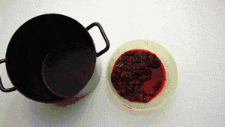

Plate 1.2 Chopped plant material (m.wikihow.com)

* + 1. Measure the amount of plant material and place twice as much water as plant material into the pot with the plant material.



Plate 1.3 water and plant material

(m.wikihow.com)

* + 1. Bring the mixture to a boil and then simmer it, stirring occasionally, for at least an hour.



Plate 1.4 Plant material being boiled (m.wikihow.com)

* + 1. Strain out the plant material and set the dye bath aside.



Plate 1.5 Strain plant material (m.wikihow.com)

* + 1. You will have to soak the fabric in a color fixative before the dye process. This will make the color set in the fabric. Place your fabric into a color fixative bath such as salt water (1 part salt to 16 parts water) or a vinegar bath (1 part vinegar to 4 parts water).
       - Allow the fabric to absorb the color fixative mix and simmer it for an hour.
    2. Remove the fabric from the fixative and wring it out thoroughly.



Plate 1.6 Fabric in color fixative (m.wikihow.com)

* + 1. Place the wet fabric into the dye mixture and simmer it until the desired color is achieved. The dry product (dyed material) will be lighter than the wet product, so go for a slightly darker color when wet. For a stronger shade, allow material to soak in the dye overnight.

Plate 1.7 Fabric

in dye mixture

* + 1. Remove the fabric from the dye bath with rubber gloves. (You want to dye the cloth, not your hands.)
    2. Wring the fabric thoroughly and hang it up to dry.

NOTE : Silk, cotton and wool work best for natural dyes.

* + - * It is also important to note, some plant dyes may be toxic.
      * Wear rubber gloves to handle the fabric that has been dyed because dye can easily stain hands.
      * Launder naturally dyed fabrics in cold water and separate from other laundry to avoid any stain on other clothes.

## Unit II: Creation of Design on Fabric Tie And Dye

Meilach,( 1973) and Banjoko (2000) and Anyakoha and Eluwa (2008) saw tie and dye as a technique of decorating fabrics by the use of resist which includes crumpling, pleating, folding the fabric into various patterns and tying with string, hence, the protected sections do not absorb the dye, an un-dyed pattern against a dyed background is the result. Exciting patterns can be achieved in tie dye process or variations when objects like wood, marbles, stones, rings, tin covers and so on, that can create a shape when tied on the fabric are used. Pattern interest depends on the shape of the object, how it is tied and arranged.

## SAMPLES OF PATTERNS IN TIE/ DYE



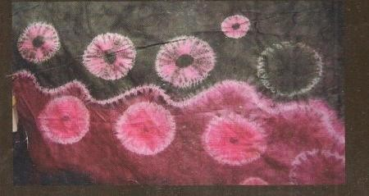

Plate 2.1 Tie/dye design Plate 2.2 Tie/dye design Plate 2.3 Tie/dye design

* 1. **Stitching or Tritik :** It is the method done by running stitches or oversewing stitches. Motifs are first drawn on the fabric all over the areas intended with shapes or real drawing of figures and then the motifs are stitched along the lines of the motifs. With this method one can draw any shape from diamond, square, curve, line and so on and then outlined by stitching with string or thread. The main rule when tritik or stitching is always to knot the thread at each end and leave extra length for grabbing it and pulling it from both ends.

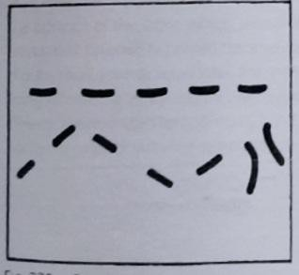 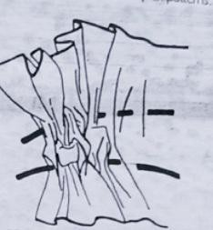

Plate 2.1.1 resist stitches in place Plate2.1.2drawingtogether the fabric in place Sourced from Banjoko (2000)



Plate 2.1.3 Tritik on colored ground Sourced from Banjoko (2000)

* 1. **Marble tie-dye pattern-** It is a method in which the fabric is crumbled with hand and tied tightly with string in several directions round the resulting bundle until it is very crumpled then plunged inside the dye bath for one colour, for more than one colour for example two colours, the marbling process require that the fabric is damped first then in a flat tray, the fabric is squished or crumpled together into a flat form before the prepared dye solution of the first dye is poured directly onto the fabric and then the second dye is also poured to the section of the fabric that needs the dye to achieve the design.

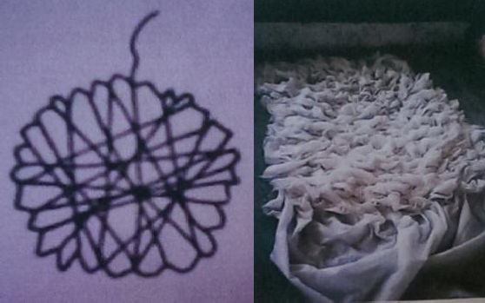

Plate 2.2.1 Marbling process Plate 2.2.1 Marbling on tray Plate 2.2.2 Marbling effect Source : Nkeonye (2009) Sourced from Ngwen, (2013)

* 1. **Folding methods:** This is the common modern tie-dye pattern, The fabric is folded into pleats and tied firmly or pressed together, some parts are protected from the

dye. Which makes it unable to penetrate into the interior of the pressed material. The folding can be done diagonally or horizontally and then tied firmly with the twine or bind with plank and then tied very well before dyeing. The function of the plank or clamper is to hold the fabric tightly against loosing during the dyeing process. Another method is holding a point in the centre of the fabric with one hand and holds the fabric down with the other hand. The fabric is then bound or tied at interval closer to each other up to the edge of the fabric and then the fabric is dyed. Thus in this case parts of the fabric itself acts as resist. A folded fabric can be better held together by pressing.

 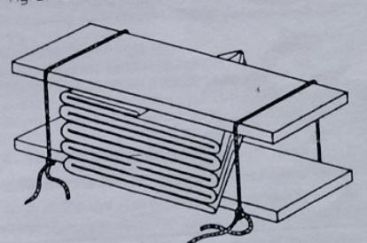

Plate 2.3.1 fold resist Plate 2.3.2 folding and pressing resist Source : Stanfield et al. (1971)

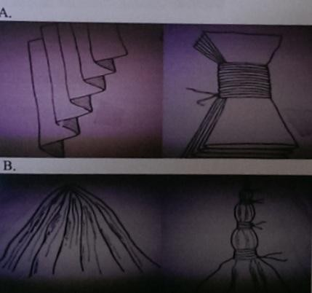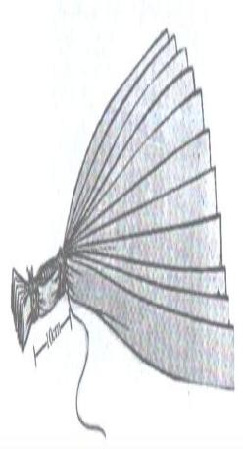

Plate 2.3.3a & b process of folding Plate 2.3.4 Pleating technique (folding & tying)

Source : Stanfield et al. (1971) Sourced from Banjoko (2000)

* 1. **Spiral patterns:** which are created by gathering a small section, usually with a cloth pin or kitchen fork in the middle of the fabric and slowly rotating the piece creating pleats.

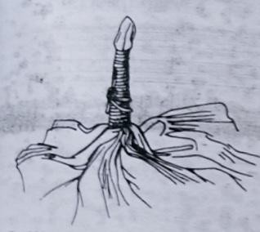 

Plate 2.4.1 Tie /dye (plangi) Plate 2.4.2 Tie dye (plangi) effect

Sourced from Banjoko (2000)

* 1. **Random circles**: The effect is made by tying knots with strings in different places on the fabric depending on the kind of design The more fabric that is tied the larger the pattern.

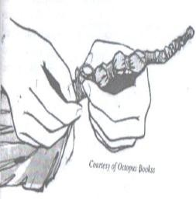

Plate 2.5.1 Circle method, Sourced from Banjoko (2000)

* 1. **Tying in Objects:** Exciting patterns can be achieved in tie dye process or variations when objects like wood, marbles, stones, rings, tin covers and so on, that can create a shape when tied on the fabric are used. Meilach,( 1973) and Banjoko (2000) and Anyakoha and Eluwa (2008), all reported that pattern interest depends on the shape of the object, how it is tied and arranged.

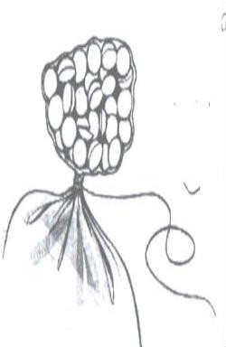

Plate 2.6.1 tying with pebbles Source : Banjoko (2000)

Folding ideas: There are hundreds of ways to fold and dye fabrics to achieve exciting results with dyes. It is a good idea to practice on paper the folding techniques, because it is stiffer than fabric and less expensive. Unusual, exciting patterns can be created by applying pressure to areas of folded cloth. Pressure applied using C- clamps with objects between them and dipped in dye can come out with very fine design, other exciting tie dye designs includes

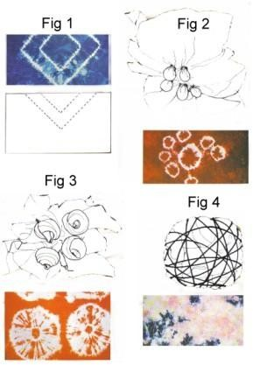

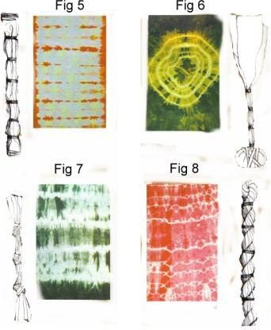

## SAMPLES OF TIE/ DYE DESIGN

**Unit III: Production Of Tie / Dye Fabrics**

The materials required for making designs using tie/dye.

1. 100% clean cotton fabric, silk or wool
2. Strings, ropes and raffia: These are used to resist parts that the dye is not to touch.
3. Plastic bowls: They should be large enough to accommodate the fabric in ample solution to cover.
4. Heat source (cooker, stove and so on).
5. Rubber gloves: for protection from chemicals and dyes.
6. Sticks: to stir dye baths
7. Dyes of assorted colours
8. Chemicals

## Tie and Dye process

The procedure of tie and dye, according to scholars like Meilach (1973), Banjoko (2000) and Anyakoha (2008) can be done with slight variations; different types of designs can be tied, folded and stitched to get different beautiful design and patterns. In the process of making tie and dye it is important to select natural fabrics as synthetic materials do not readily accept dye. Making cotton a very excellent choice silk and wool can also be tied and dyed. The procedure of tie and dye is as follows.

1. Wash the Fabric

Fabrics used for tie and dye are constructed from the natural fibers like cotton,

linen,

silk and wool, which must be washed to remove sizing. The fabric should also be washed vigorously with soap and hot water, after washing the fabric ironing should also take place.

1. Plan the design to be produced

By planning the design one needs to decide what kind of design is to be on the fabric, for a circular pattern pull the fabric up towards the centre like a closed umbrella and bind downwards at intervals. Other methods include marbling, folding, clamping wrapping in objects and stitching, as discussed in unit two. In planning it may be wise to first experiment with a scrap of cloth.

1. Prepare the dye, wear gloves and follow the instructions. Dyes used for tie and dye can be hot water dyes as well as cold water dyes.
2. Dip the rinsed fabric in the dye solution; leave the material in the dye for only a few minutes or as one desire, but not unnecessarily longer, so that the dye will not penetrate the tied places.
3. Remove the fabric from the dye and rinse in cold water.
4. If another colour is to be used, re-tie at other spots and dip into the next dye solution.

Always start with the lightest colours and end with the darkest e.g. Yellow should come before green or blue.

1. Allow to drip dry or squeeze out excess water untie the fabric and then press cloth, with hot iron when cloth is still damp which will help fix the colours.

## Unit IV: Creation of Design for Batik

The Longman Encyclopedia supports this statement by saying “batik is a method of decorating fabric used for centuries in Indonesia, with melted wax, a design is applied to the cloth (cotton) which is then dipped in cool vegetables dye. Wax resist is another popular dye resist technique in which the design is applied to the material with a substance that will resist the action of the dye. (Banjoko, 2000). Hollen (1979) saw wax (batik) resist as the process in which hot wax is poured on a fabric in the form of a design. “the resist is obtained by applying wax to part of the fabric to be waxed, it may be painted, drawn or printed on the cloth”. The application of wax will be determined by the desired designs drawn on the fabric and the type of fabric used, including the technical know-how of the practitioners on the combination of colour. In modern batiks “the trend is to decorate the fabric any way the artist envisions; to apply design by any method,

traditional or innovative, even depart from standard procedures”. Artist and amateurs use traditional tools along with modern tools. Modern batik is often used in combination with other surface design methods. Batiks can be found in clothing, draperies, sculptures, lamps, wall hangings, and in many other end uses. Achievement of batik patterns can be done in many ways which includes:

## STAMPING METHOD

You need a flat table made out of wood/plank. In stamping method wooden block with a raised pattern on the surface is dipped into the wax and then pressed down on to fabric to achieve design on the fabric. In stamping method the pattern is generated by repeating the process of block application on the fabric. The stamp is dipped on hot wax and bee wax together in an enamel pot ratio is part candle wax to 1 part bee‟s wax are recommended. The melt wax should be to reasonable temperature (i.e. not too hot or too cold). It is instantly place on the fabric continuously either horizontally or vertically or zigzag, a set-pattern is formed. Different pattern or modes could be used on the same fabric alternatively depending on the fabric and taste of the designer. The stamping helps to Transfer the design and wax directly to the fabric.

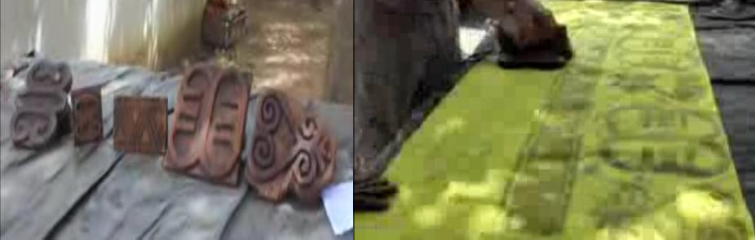

Plate 4.1.1 Stamping blocks Plate 4.1.2 Stamping block on fabric Sourced from Comiskey, (2013)

## FREEHAND BATIK

The freehand design requires the ability to draw and design i.e. creativity of pattern directly on a fabric. This depends on how expert the individual or designers are and the type of design involve, using natural abstract, different shapes in designing of fabric. After designing then wax is applied on the area that will bring out the design drawn. Different types and kind of fabric can be designed with freehand as far as the fabric will be absorbent of colour i.e. dye e.g. cotton, viscose, polyester etc.

 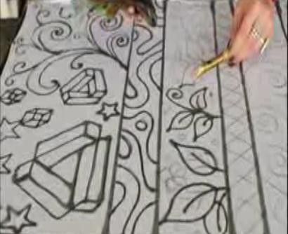

Plate 4.2.1 freehand design using brush Plate 4.2.2 freehand design using tjanting Sourced from EeshaanFashions (2014) Sourced from Hernderson (2014)



Plate 4.2.3 freehand design using foam Sourced from Bernd (2012)

## FOAM BATIK

This require the ability to make a design with foam that has already made with a particular pattern, will now be put inside the candle wax that has already been on fire, then it would be used on the fabric in a repeated pattern. Note: the candle must not be too hot or too cold.

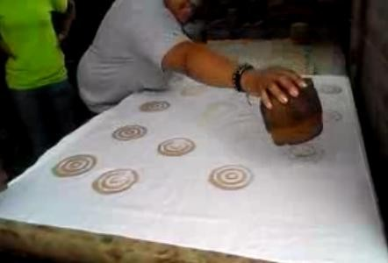

Plate 4.3.1 Designed foam Sourced from GlobalMamas, (2014)

## STEPS TO FOLLOW

1. Spread the fabric on the feature and pin down
2. Draw out your pattern on the cloth with pencil or wax shaped foam
3. Melt the wax and bee wax together in an enamel pot ratio is part candle wax to 1 part bee‟s wax are recommended. The melt wax should be to reasonable temperature (i.e. not too hot too cold).
4. With aid of brush or foam the design is done with wax.
5. Dyeing and washing carefully in a spacious container to avoid cracking and for easier turning and maneuvering during dyeing process i.e. round rubber bowl.
6. De-waxing of fabric (i.e. removing of wax from fabric so the design will show then dry and iron is now ready for use)

## Unit V: Production of Batik Fabrics

**5.1 Materials for Production of Batik**

Product design and development require the use of certain materials that are peculiar to its production. The materials required for it production will be discussed. Banjoko (2000), Anyakoha (2008) and Stanfield (1971).

1. White cloth, preferably vegetable fibre - not synthetic. Natural fibres include - cotton, linen, silk and wool. Cotton and linen come from plants, silk from the cocoon of the silkworm, and wool from sheep.
2. Wooden Frame - Adjustable wooden frames especially made for batik are convenient.

They are adjustable to any size

1. Pins to hold the fabric to frames.

As for item 4 the design used will determine the tool needed in the process.

4.1 Brushes for applying wax, which are preferably material bristle; of assorted sizes and inexpensive.

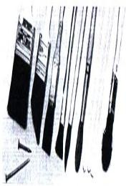

Plate 5.1.1

Sourced from Meilach (1973)

4.2. Small pieces of foam or foam made with a particular pattern can also be used to apply wax on to the designed fabric.

4.3 Wooden block (optional) this can be used to apply the wax if stamping method is used.

4.4. The Tjanting tool (optional) is used for drawing with hot wax. This is a special tool used by professional batik designers. The tool produces interesting linear effects.

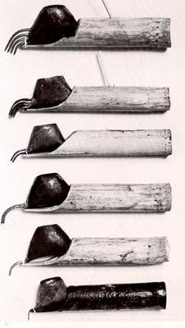

Plate 5.1.2 Tjanting tools Sourced from Meilach (1973)

A modern improvement on the batik process is the development of electric tjantings which allow the flow of the wax to be adjusted.

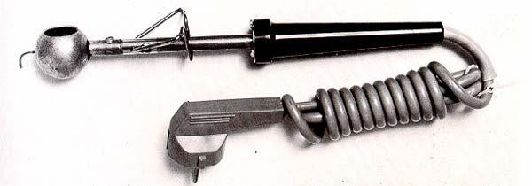

## Plate 5.1.3: Electric tjanting

1. Kerosene cooker
2. Aluminum pan to hold melted wax 7 Rubber gloves
3. Lots of old newspaper to remove wax after it has been dyed.
4. Plastic bucket/bowls to mix and hold dyes
5. Dyes of various colours
6. Chemicals for dyeing
7. Mixing cans /spoons

## 5.2 Wax Resist Procedure

1. Wash the material to remove any sizing (cotton materials are the best for wax resist), and starch will be removed when washed because it retards dye penetration.
2. Designing the fabric: The fabric for wax resist should be spread flat, and lightly draw the design with pencil, pen or charcoal. One can place a paper beneath the fabric and trace. Another way of designing is by just drawing directly with the wax or stamping on the fabric. Anyakoha (2008).

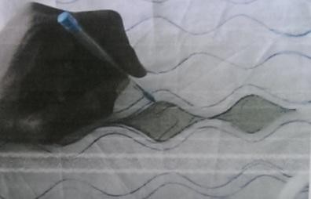

Plate 5.2.2: drawing out the design (Source : Abdulhaiyu, 2012)

1. Prepare the molten wax (wax need not be boiling because it can catch fire) use only enough heat to render the wax liquid.

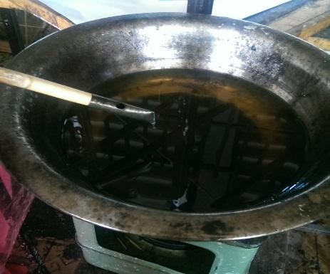

Plate 5.2.3 melted wax (Source the researcher, 2016)

1. Paint the melted wax on the fabric with soft inexpensive, natural, brustle paintbrushes of different widths, artist‟s brushes or paste brushes. Make sure the wax penetrates through the cloth. Tjanting tool or foam of suitable size can be used in

applying the wax on the designed fabric. Another method is by using the stamping block.

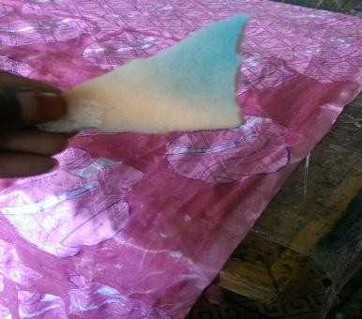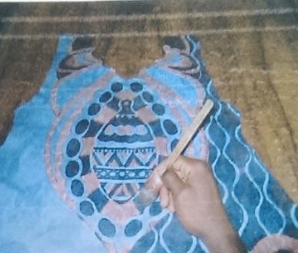

Plate 5.2.4a painting wax using foam Plate 5.2.4b painting wax using tjanting tool (Source the researcher 2016) (Source : Abdulhaiyu, 2012)

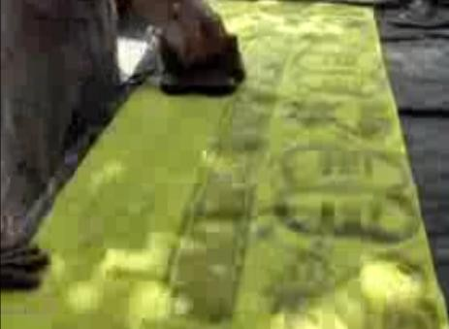

Plate 5.2.4c Painting wax using stamping block (Source Comiskey, 2013)

1. Crumple or fold and submerge the material in the bowl of dye (dye bath) for batiking the dye water must be cold so that the wax does not wash off. There are special cold water wax dyes that are best for use in wax resist. The longer the cloth stays in the dye bath, the stronger the colour. Colour tint is also controlled by the amount of dye used in relation to the size of the material. (Meilach, 1973)



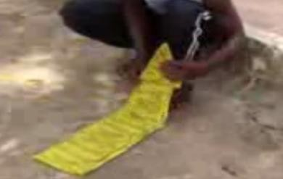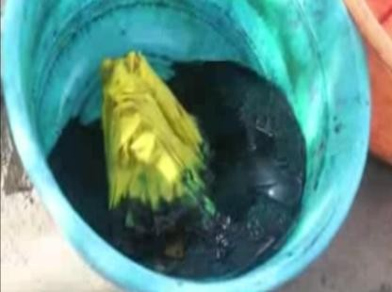

Plate 5.2.5a folding fabric Plate 5.2.5b folded fabric in dye Plate 5.2.5c crumpled fabric (Sourced from Comiskey, 2013) (Source : Abdulhaiyu, 2012)

1. Remove the fabric from the dye and rinse in cold water, spread the fabric out on a wax paper or plastic to dry. If the design has more than one colour, wax is then painted over the just dyed to retain the colour and then put into another solution of dye.

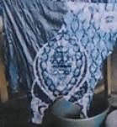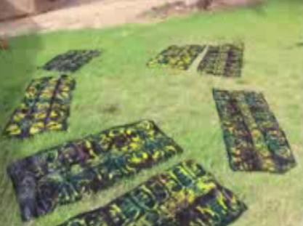

Plate 5.2.6a after dyeing Plate 5.2.6b after drying

(Source : Abdulhaiyu, 2012) (Source : Comiskey, 2013)

1. Remove by ironing for wax removal, change the papers often, or you can de wax by ;

* putting water on top of the fire with de-waxing bowl or pot (the bowl or pot should be spacious).
* Allow the water to boil about and then put your hand glove for easy work.
* Get your already designed fabric with wax and hold it at one end and start to dip it into the boiled water at least three times or more, you dip and raise the fabric up continuously till the wax is almost off fabric.

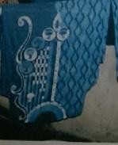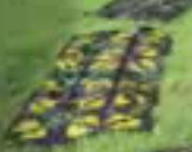

Plate 5.2.7a after de waxing fabric Plate 5.2.7b after dewaxing

(Source : Abdulhaiyu, 2012) Source : Comiskey, M (2013)

* Get cold water ready by the side and dip the already de-waxed fabric into the cold water rinse and starch if necessary and then sun dry, do not squeeze fabric but shake.
* When the fabric is dry remove immediately and iron, then beat, now is ready for

use.

* Collect and squeeze out water from the cold water do not pour the hot water away allow to cool down and all the wax settle on the surface of the bowl or pot used for de-waxing and just remove the wax because it could re-used again.

After removal of wax, the cloth is then given final ironing, folded and ready as a batik material.

## CAUTIONS ON BATIK

1. Dye fabric that is colour absorbent and dye from the lightest colour.
2. In dyeing batik fabric ensure that the dye baths is cold before immersing your batik yardage to avoid melting of design away in dye solution.

## Unit VI: Creation of Design For Fabric Printing

The term „textile printing‟ indicates the patterning of cloth by means of printing, dyeing or painting. In printing the concentration of dye is higher, and the dye medium is thick and viscous to limit dye migration on the fabric, permitting formation of a design or pattern. Printed fabrics are categorized in four different classes or styles: the „resist‟ style, the „dyed‟ style, the „discharge‟ style and the „direct‟ style. The resist style and dyed style are the oldest form of decorating textiles. All four styles can be used in conjunction with a great variety of tools and devices to decorate the textile surface. This chapter therefore will familiarize you with a variety of designs to serve as a general guide, however students should combine these types to develop innovative designs. A design for printed

textiles often begins with a drawing or a pencil sketch. The design often gets its inspiration from a theme. There are many categories of printed textiles. These categories are based on the certain look each print creates on historic and cultural references and on themes originating from fashion trends. (Sheoran and Mathur, 2014)

## Geometric Prints

A geometric prints comprises of design made with circle, squares, triangles, spirals and stars.

it can be used in all kinds of clothing for men, women and children like bags, ties, scarves, and shoes. These prints are also used in home products like table covers, cushion covers, bed sheet

 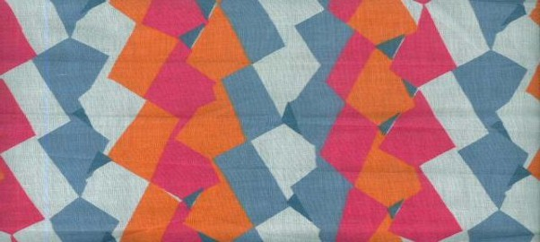

Plate 6.1.1 Geometric Prints Plate 6.1.2 Geometric Prints

(Sourced from Sheoran and Mathur, 2014)

## Botanical Prints

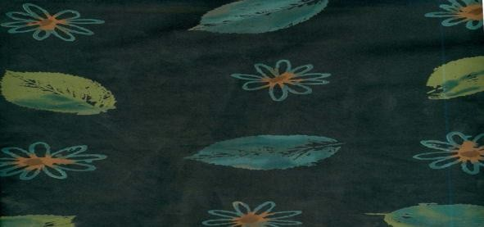Botanical prints are very realistic, well-drawn designs using botanical motifs. Drawing technique is very important in this type of design. Plants with fruits or vegetable, cereals, or grains, flowers with

flower buds, leaves, branches and stem are also depicted. These prints are used in homes- bed linens, cushion covers, table covers and

wallpapers. Botanical prints are very popular in clothing for women.

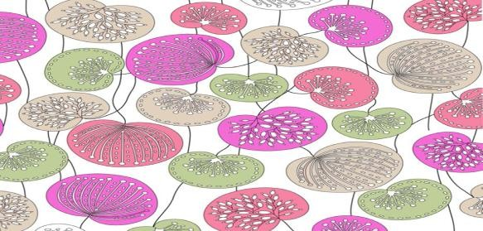

and Mathur (2014)

## Dot Prints

prints

Plate 6.2.1 Botanical print

Plate 6.2.2 Botanical

Sourced from Sheoran

Dots have always been in trend. Dots can be of various sizes. Just a point or a big circle both are referred to as a dot. These can be simply printed onto the fabric with a different background colour, or different coloured dots on a solid background or many dots can make different designs and patterns. Dots are very versatile and can be printed on almost everything.

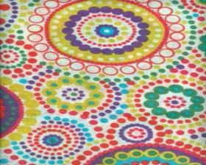

Plate 6.3.1 Dot print Plate 6.3.2 Dot prin (Sourced from Sheoran and Mathur, 2014)

## Floral Prints

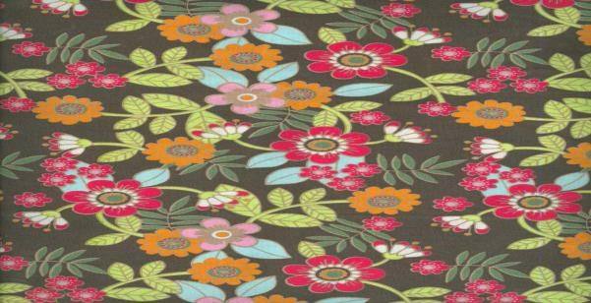Floral prints are patterned in rich colors with delicate flowers and leaves. It includes gathering of a flower garden and also

grasses and grain. It excludes agricultural products like fruits vegetables and nuts, pinecones and trees. Floral prints are very popular for women‟s clothing or accessories. These are also

used in home furnishings. 

Plate 6.4.1 floral prints Plate 6.4.2 floral prints Sourced from Sheoran and Mathur, 2014)

## Script Prints

Such prints have some kind of text, numbers or writings in different languages. The script can be in different layouts i.e. stripes, all over, etc. The letters can be in cursive, italics, block, bold, graffiti style, written with ink pen, rotary tip, felt tip, feath etc. They can be of different colours, textures, can have shadow effects, old text look etc.

 

Plate 6.5.1 script prints Plate 6.5.2 script prints Sourced from Sheoran and Mathur (2014)

## Pucci Prints

Pucci Prints are named after Emilio Pucci, who was an Italian fashion designer and politician. He designed prints which are characteristic of geometric in a kaleidoscope of colours. Emilio Pucci is known as the 'Prince of Prints'. The designs are psychedelic and abstract in multi colours. Along with geometric shapes there are swirls, circles and organic shapes in the print designs. These prints are seen on women's blouses, casual chiffon dresses, bags, scarves, hats, shoes and jackets for men.

 

Plate 6.6.1 Pucci prints Plate 6.6.2 Pucci prints (Sourced from Sheoran and Mathur, 2014)

## Unit VII: Production Of Printed Fabrics

There are different methods and techniques to develop innovative, interesting and unique prints. Different techniques render different results in terms of look, feel, mood and texture. Technique accommodate to the changing fashion trends and create new looks.

## METHODS OF PRINTING

* 1. **Block printing**

Block printing is the oldest form of printing where in a wooden block with a raised pattern on the surface is dipped into the printing colorant and then pressed down on to fabric to achieve design on the fabric. In Block printing, the pattern is generated by repeating the process of block application on the fabric. For a design of four colours, four

separate blocks are developed. This printing is time consuming and allows the flexibility to change the pattern placement.

## Materials for block Printing

* Colour palette / Mixing bowl
* Colour/ dye, water, base binder and color fixer
* Designed stamping block
* Fabric or printing material
* Hand gloves
* Table

## Steps:

1. Mix colour, water, base binder and colour fixer, the colour should be thick to avoid penetration to other areas.
2. A squeegee can be used to apply the paint on the foam, then you dip the block in paint, always try on paper and see the pattern it gives before transferring onto a your fabric.
3. Spread the fabric, two layers of fabric is necessary as thickness of the layers gives nice texture to the print.
4. Scale should be used to measure, the measurement should start from the border, you can leave out the width and the height as desired
5. Stamp the color over the fabric, Stamp using pressure of hand to ensure even distribution. i.e different blocks should be used when using different colors even though the same design, different stamping blocks can also be used on the same fabric to create different designs.

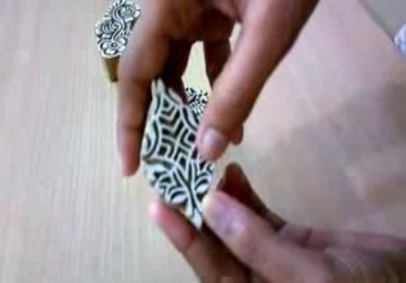 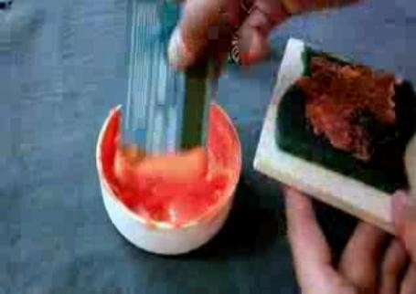

Plate 7.1a printing block Plate 7.1b applying paint on squeegee

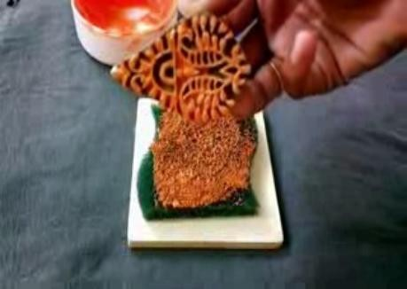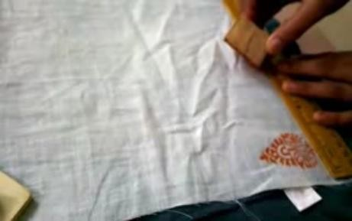

Plate 7.1.1c painting the printing block Plate 7.1.1d measuring and stamping fabric

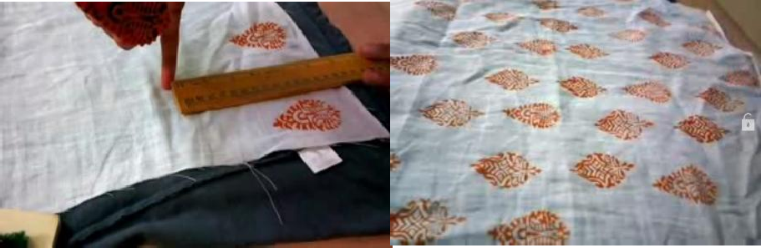

Plate 7.1.1e measuring and stamping fabric Plate 7.1.1f finished product

(Sourced from Desicrafts, 2014)

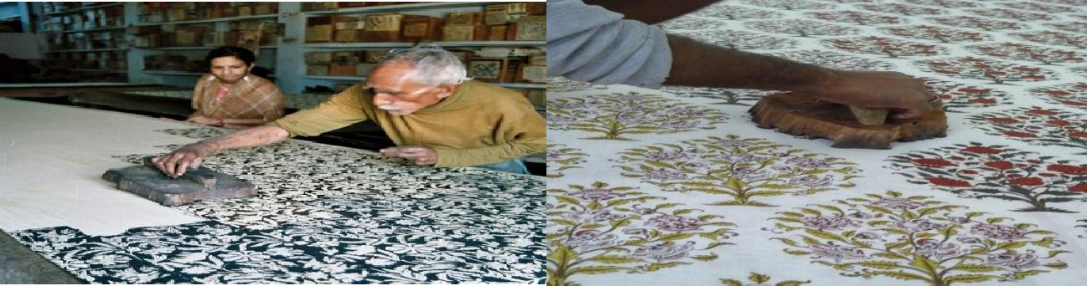

Plate 7.1.2 Block printing design Plate 7.1.3 Block Printing design

## Stencil printing

Stencil printing is one of the oldest printing for achieving the required design onto the fabric. In this method first stencil is prepared by cutting out a design from a flat

paper, metal or plastic sheets. The colour is applied to the fabric by brushing or spraying the interstices of a pattern out of the flat sheet of metal, paper, plastic sheets.

## Materials

1. Paintbrush of different sizes
2. Water container.
3. Colour palette/ Mixing bowl
4. Tape
5. cardboard
6. table
7. Stencil sheet;

## Steps :

* 1. Stencil should be made by drawing out a design on a paper and then transfer the design on a transfer sheet that will not allow penetration of dye to other areas, then you cut out the design using a sharp cutting knife. As in figure 7.2.1a and b

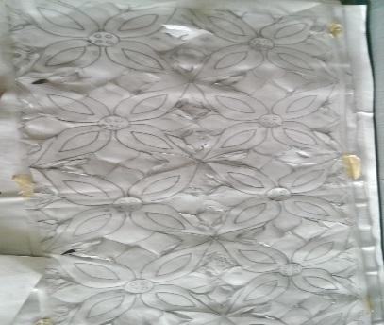 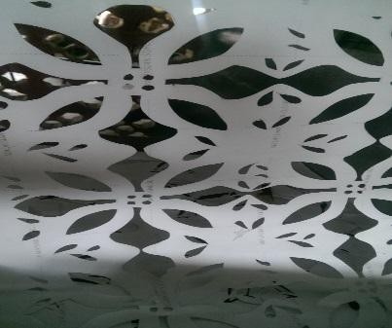

Plate 7.2.1a drawn design Plate 7.2.1b cut out design

(Source researcher 2016)

* 1. Choose a washable natural fibre or natural blend fabrics
  2. Wash and dry your item before stencilling
  3. Place a carboard between the fabric layers in case of a finished fabric or spread on a flat surface in case of one layered fabric, and tape stencil to the fabric

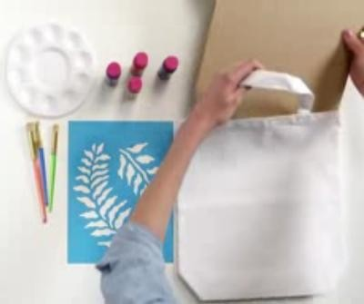

Plate 7.2.2a inserting cardboard (Source Michaels, 2014)

* 1. Choose your fabric paint and load a stencil brush with paint.

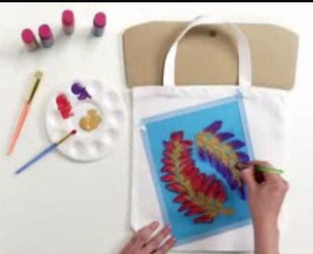

Plate 7.2.2b applying paint or dye to stencil (Source Michaels, 2014)

* 1. Work from centre out to the edges, fill in completely before removing the stencil.

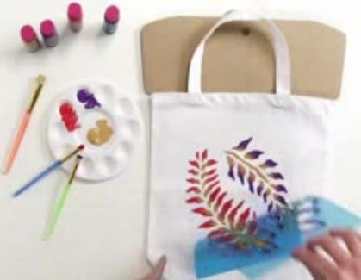

Plate 7.2.2c finished product (Source Michaels, 2014)

* 1. Allow fabric to air dry while you wash the stencil to be used again. Iron the fabric but a material should be put between the design and the ironing board.

## Screen printing

This style of printing is popular because of wider scope for achieving desired results. There are two techniques of screen printing.

1. Light sensitive chemical screen printing : In this technique the printing paste passes through a fine fabric or mesh stretched on a wooden or metal frame, the design is created in reverse on the screen by blocking areas of the screen with a light sensitive chemical. The screen is then placed over the fabric and the printing paste is forced through the open areas of the screen using a synthetic rubber or steel blade. It is done either with flat or cylindrical screens made of silk threads, nylon metal or polyester.
2. Screen stencil printing : In this technique the printing paste passes through a fine fabric or mesh stretched on a wooden or metal frame, the design is created on a stencil which will then be attached to the screen by gluing or taping to it. The screen is then placed over the fabric and the printing paste is forced through the open areas of the screen using a synthetic rubber or steel blade.

## LIGHT SENSITIVE CHEMICAL SCREEN PRINTING

**Materials for Preparation Of Light Sensitive Chemical On Screen**

* 1. Stencil film or paper
  2. Screen printing frame
  3. Mesh
  4. Masking Tape
  5. Squeegee
  6. Emulsion

## Preparation Of Light Sensitive Chemical On Screen

* The whole process starts with a wooden or metal frame of desirable size, it is mostly determined by the size of your printing material.

Plate 7.3.1 frame (Sourced from Cole, 2010)

* Then suitable mesh should be selected there are basically 3 kind of mesh 100, 200 and 300 mesh count. 100 mesh count is the lowest and it contains a lot of space on the mesh, it is mostly used for very thick ink or paint. The 200 mesh count is the most commonly used it is used for printing most colors, while the 300 mesh count is used when printing a picture of four color or anything with great detail, then a higher mesh count should be used to bring out the design.
* Fully stretch your mesh on frame by pulling your mesh and clamping it down on the frame until it is stiff and tight, staplers or pins can be used to clamp it down when using a wooden frame. If metal frame is used then a glue can be used to hold it together.

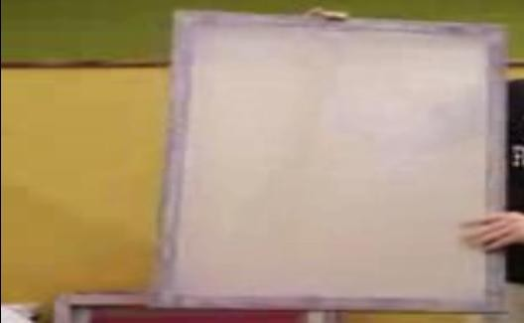

Plate 7.3.2 mesh attach to frame (Sourced from Cole, 2010)

* Pour emulsion on the coder or squeegee and then apply on the screen by flipping the emulsion upward with pressure of hand, the application should be done on both side of the screen. The emulsion is a light sensitive chemical that gives the ability to capture image on the screen by reacting with light therefore the application should only be done in a dark room.

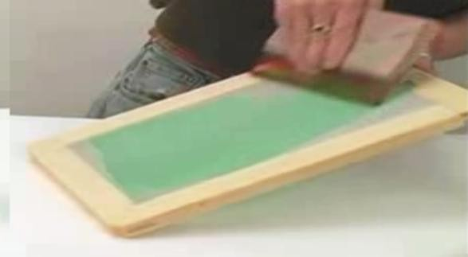

Plate 7.3.3 applying emulsion (Source jacquardproducts, 2011)

Note: ensure that the edges of the coder is smooth to allow even penetration

* Allow in a dark room to dry.
* After drying, fix your stencil film or design were you want it on the screen. Use a tape to hold it on the screen.

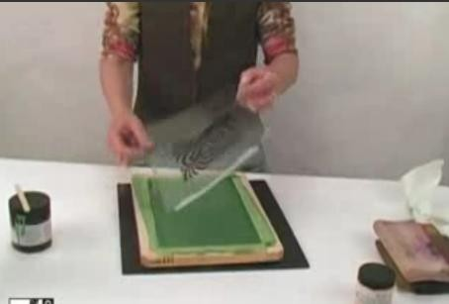

Plate 7.3.4 attaching stencil (Source : jacquardproducts, 2011)

* Put on a black material on the surface of the screen to prevent it from reflecting back.
* Cover the image to your body to avoid partial exposure to the light until you are fully ready to make the exposure
* 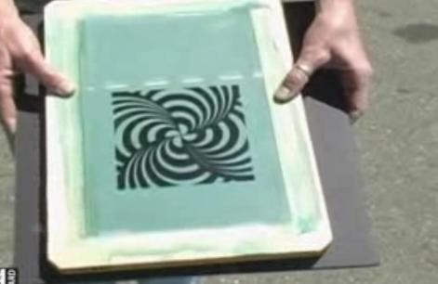Put the stencil side up to the light ensure that the sun is bright when exposing it for one – two minutes depending on the brightness of the day.

Plate 7.3.5 exposing to light (Source jacquardproducts, 2011)

Wash out the emulsion on the screen and you will achieve your design.

Note: there is a tendency that the emulsion did not cover the edges of the screen, therefore before using the screen for printing ensure to cover up the four side of the screen with a Tape to avoid penetration of ink on the edges of the screen

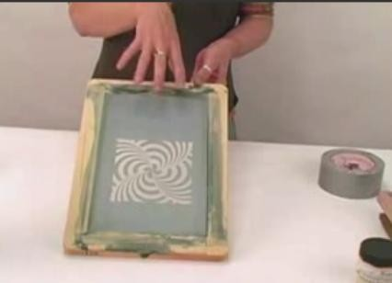

Plate 7.3.6 finished designed screen (Source from jacquardproducts, 2011)

## Production Of Printed Fabric Using Light Sensitive Chemical Screen

* Iron the fabric you are printing
* Place a carboard between the fabric layers in case of a finished fabric or spread fabric on a flat surface in case of one layered fabric.
* For extra precaution tape the fabric to your table to prevent it from shifting

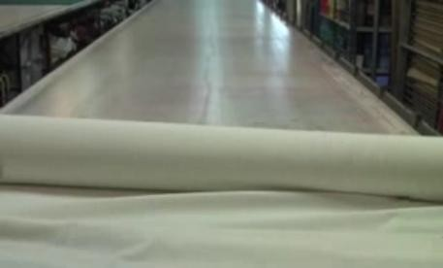

Plate 7.3.7 laying fabric (Sourced from Mark, 2011)

* Place screen on fabric, add a generous amount of ink or paint on the screen, ink it down with pressure of hands using a squeegee. Go over the design area several times to ensure penetration, you can not redo once removed.
* When using more than a single color or design as many screen as desired will be used to achieve the result.

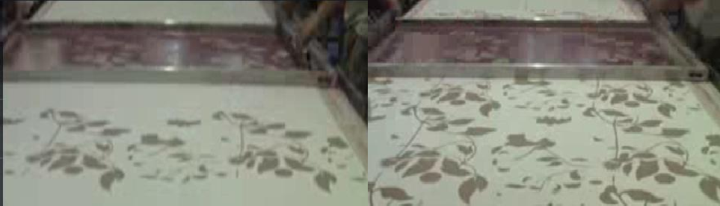

Plate 7.3.8 first screen application Plate 7.3.9 second screen application

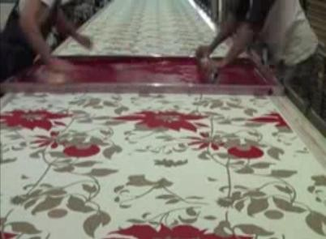

Plate 7.3.10 third screen application (Sourced from Mark, 2011).

* Remove the screen and allow fabric to dry

Note ; the screen can be removed immediately and washed so it could be used again.

## SCREEN STENCIL PRINTING Materials for screen stencil method of printing:

* + 1. Stencil film or paper
    2. Screen printing frame
    3. Mesh
    4. Masking Tape
    5. Ruler
    6. Knife; its best when sharp
    7. Printing Ink or paint
    8. Squeegee
    9. Plastic spatula and a colour palette

## Preparation Of Screen Stencil Printing

* The frame and mesh should tightly attached together to make up the screen, method of attachment has been discussed earlier in light sensitive chemical screen printing.
* Tape the edges of squeegee and screen with a masking tape to avoid penetration, beacause there is a gap from inside the four sides of the screen. The squeegee is taped to avoid permanent stains on the edges.
* Draw out your design, transfer the design onto a transfer/ plastic sheet that will not allow penetration of dye or color and care must be taking when cutting out the design.

i.e method of producing stencil have been discussed in stencil printing.

* Tape or glue the stencil to the screen, the mesh side should be up and make sure the open areas of the mesh is all covered up with a tape or the stencil should be made big enough to cover up the whole mesh area to avoid penetration, then the areas of design will be the only place that is open to bring out the design.
* Iron the fabric you are printing
* Place a carboard between the fabric layers in case of a finished fabric or spread fabric on a flat surface in case of one layered fabric.
* For extra precaution tape the fabric to your table to prevent it from shifting
* Add generous amount of ink or paint on the screen ink it down with pressure of hands using a squeegee. Go over the design area several times to ensure penetration, you cannot redo once removed.
* Remove the screen and allow fabric to dry.
* When using more than a single color or design different screen with stencil will be used to achieve that result.

Note ; the stencil can be removed immediately and washed so it could be used again.

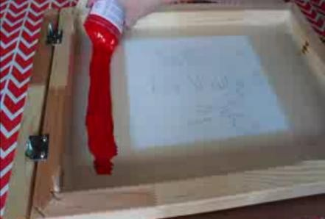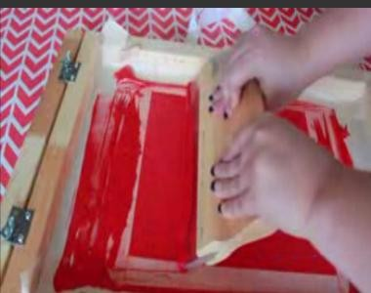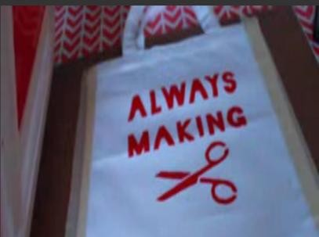

Plate 7.4.1 application of dye Plate 7.4.2 spreading dye Plate7.4.3finished product

(Sourced from Hilary, 2015)