# DEVELOPMENT OF INFANT HAND TUFTED THERMAL INSULATION WEARS IN KANO MUNICIPAL, NIGERIA

BY

**HADIZA LAWAN M.Ed/EDUC/6479/2011-2012 P16EDVE8061**

**DEPARTMENT OF HOME ECONOMICS FACULTY OF EDUCATION**

**AHMADU BELLO UNIVERSITY, ZARIA, NIGERIA**

**MAY, 2019**

i

**DEVELOPMENT OF INFANT HAND TUFTED THERMAL INSULATION WEARS IN KANO MUNICIPAL, NIGERIA.**

**BY**

**Hadiza LAWAN**

**B.Ed. (Home Economics) A.B.U, Zaria 2005 M.Ed/EDUC/6479/2011/2012 P16EDVE8061**

# A DISSERTATION SUBMITTED TO THE SCHOOL OF POST GRADUATE STUDIES, AHMADU BELLO UNIVERSITY, ZARIA,

**IN PARTIAL FULFILMENT OF THE REQUIREMENTS FOR THE AWARD OF MASTER DEGREE (M Ed)**

**HOME ECONOMICS EDUCATION**

**MAY, 2019**

**DECLARATION**

I Hadiza LAWAN a postgraduate (Masters) student of the Department of Home Economics Education Ahmadu Bello University Zaria with registration number M.Ed/EDUC/6479/2011-2012/P16EDVE8061 declared that this dissertation titled Development of Infant Hand Tufted Thermal Insulation Wears in Kano Municipal, Nigeria, have been carried out by me. The information derived from the literature has been duly acknowledged in the text and a list of references provided. No part of this dissertation was previously presented for another degree or diploma at this or any other Institution.

**Hadiza LAWAN Date**

# CERTIFICATION

This dissertation titled, DEVELOPMENT OF INFANT HAND TUFTED THERMAL INSULATION WEARS IN KANO MUNICIPAL, NIGERIA by Hadiza LAWAN meeting

the regulations governing the award of the Degree of Master of Home economics Ahmadu Bello University ZARIA is approved for its contribution to knowledge and literary presentation.

Dr. M. F. Ahuwan Date

Chairman, Supervisory Committee

Prof. A. Z. Mohammed Date

Member, Supervisory Committee

Dr. M. A. Abubakar Date

Head, Home Economics.

Prof. S. Z. Abubakar Date

Dean, School of Postgraduate Studies

# DEDICATION

This work is dedicated to the Almighty ALLAH, THE FIRST AND THE LAST, praise be to Allah who spared my life for the completion of this programme.

# ACKNOWLEDGEMENT

All praise be to Almighty Allah the beneficent the merciful, may His divine favour be upon all of us forever, amen. The researcher wishes to express profound gratitude to her supervisors Ass. Prof. (Mrs.) M. F. Ahuwan and Prof. (Mrs.) A. Z. Mohammed, and her external examiner Prof C. A. Igbo, internal examiners Prof (Mrs.) S. L. Ajayi, and Prof. S. Maiwada who immensely contributed by reading and correcting errors in the manuscripts despite their tight schedules, their constructive criticism and suggestions greatly improved the quality of this research work, and the special encouragement they demonstrated in the course of this study, they are pillars to the success of this work. The researcher sincere appreciation goes to all the lecturers in the Department of Home Economics Education, starting from H.O.D. Dr. (Mrs.) M. A. Abubakar who also served as post graduate coordinator (P. G. Coordinator), Prof (Mrs.) E. E Adamu, Prof. E. Ike, Prof (Mrs.) T O. Ojo and all the lecturers in the Department of Education for their meticulous efforts that led to the completion of her M.Ed.

The researchers’ sincere gratitude goes to her employer, Federal College of Education, (Technical) Bichi and Education Trust Fund (TET- fund) intervention who sponsor her to undertake this course of study. Her special thanks go to the former provost, Alhaji Ibrahim Jibrin and the present provost Prof. Bashir Fagge, the Duputy provost Mr J. Attah, Dean School of Secondary Education (Vocational) Alhaji Abdulmumin Sule and the entire management and council members for their approval. The researcher is indebted to Dr Mrs T, Nafiu former H.O.D. Home Economics Department and present Director Quality Assurance

F.C.E. (T) Bichi for the steady support and prayers. The researcher is also grateful to Dr U.

Y. Peni, H.O.D, Integrated Science Department, Dr Ali Ali and Mr. and Mrs. Momoh for the assistance given as statisticians, and also Mr. Hammed Salami who edited the write up. The researcher’s gratitude also goes to all the lecturers in the Department of Home Economics

F.C.E. (T) Bichi Mrs. I. Salaudeen, Hajiya Fatima Yusuf, Mrs. Z. Ahmed, Mrs H. Oriaje, Alhaji K Hussain, Mrs J.C Waba, Mrs Abdulazeez and all the non academic staff of Home Economics Department, F.C.E. (T). Bichi for the motherly and friendly advices, prayers and encouragement.

The researcher is also grateful to her mother, elder and younger siblings especially Umma and Sabuwa for their prayers and support during the course of this study. Finally, her sincere gratitude goes to her dear husband, M. Salihu Ibrahim for his prayers, encouragement, financial support and also bearing her absence for all these years. The researcher’s special gratitude goes to her son, Abubakar Salihu who guided and assisted her during internet search and snapping of the photographs, and Aisha Salihu who took good care of her younger children and Khadija Fadimatu and Maryama for their patience and prayers during the program. May Almighty reward them, Ameen. The researcher wishes to express her gratitude to everybody who contributed directly or indirectly to the completion of the study.

|  |  |  |
| --- | --- | --- |
|  | **TABLE OF CONTENTS** |  |
| Cover Page |  | i |
| Title Page |  | iii |
| Declaration |  | iv |
| Certification |  | v |
| Dedication |  | vi |
| Acknowledgement |  | vii |
| Table of Contents |  | viii |
| List of Tables |  | xi |
| List of Plates |  | xii |
| List of Illustrations |  | xiv |

List of Appendixes xv

Operational Definition of Terms xvi

Abstract xvii

CHAPTER ONE: INTRODUCTION

* 1. Background to the Study 1
  2. Statement of the Problem 4
  3. Objectives of the Study 6
  4. Research Questions 6
  5. Research Hypotheses 7
  6. Significance of the Study 7
  7. Basic Assumptions of the Study 8
  8. Delimitation of the Study 9

CHAPTER TWO: LITERATURE REVIEW

* 1. Theoretical Framework 10
  2. Concept of Clothing 12
  3. Concept of Hand Tufting 16
  4. Infant’s Clothing Needs 24
  5. Thermal Insulation 30
  6. Policies Supporting Infant Thermal Care 34
  7. Review of Empirical Studies 35

2.7 Summary of Reviewed Literature 40

CHAPTER THREE: MATERIAL AND METHOD

* 1. Research Design 42
  2. Population of the Study 42
  3. Sample Size of the Study 43
  4. Instrument for Data Collection 44
     1. Validation of Research Instrument 58
     2. Pilot Study 58
     3. Reliability of the Research Instrument 58
  5. Procedure for Data Collection 59
  6. Procedure for Data Analyses 60

CHAPTER FOUR: DATA PRESENTATION AND ANALYSES

* 1. Analysis of Bio-data 62
  2. Answers to Research Questions 64
  3. Test of Hypotheses 73
  4. .Summary of Major Findings 76
  5. Discussion of Major Findings 77

CHAPTER FIVE: SUMMARY, CONCLUSION & RECOMMENDATIONS

* 1. Summary 80
  2. Conclusion 82
  3. Contribution to Knowledge 82
  4. Recommendations 82
  5. Suggestion for Further Studies 83

References 84

Appendices 89

|  |  |  |
| --- | --- | --- |
|  | **LIST OF TABLES** |  |
| 1 | Population of the Study | 43 |
| 2 | Sample Size | 44 |
| 3 | Measurements Chart for Infant | 47 |
| 4. | Analysis of Bio-data of Respondents | 62 |
| 5. | Materials for Production of Specimen A | 65 |
| 6. | Materials for Production of Specimen B | 65 |
| 7. | Materials for Production of Specimen C | 66 |
| 8 | Mean Rating on Comfortability of the Developed Infant Hand Tufted |  |
|  | Thermal Insulation Wears in Kano Municipal | 69 |
| 9 | Mean Rating on Textural Preferences of the Developed Infant |  |
|  | Hand Tufted Thermal Insulation Wears in Kano Municipal | 70 |
| 10 | Mean Rating on Decorative Preferences of the Developed Infant |  |
|  | Hand Tufted Thermal Insulation Wears in Kano Municipal | 71 |
| 11 | Mean Rating on Acceptability of the Developed Infant Hand |  |
|  | Tufted Thermal Insulation Wears in Kano Municipal | 72 |
| 12 | Analysis of Variance for Comfortability | 73 |
| 13 | Analysis of Variance for Texture | 74 |
| 14 | Analysis of Variance for Decoration | 75 |
| 15 | Analysis of Variance for Acceptability | 75 |

**LIST OF PLATES**

* + 1. Sewing tools 13
    2. Tracing wheel 13
    3. Sewing notions 15
    4. Sample of Tufting Decoration on baby shawl 17
    5. Sample of Tufting Decoration on table cloth 17
    6. Variation of Hand Tufting Needles 18
    7. Assorted Hand Tufting Yarns 18
    8. Sample of yarns in the study area 18
    9. Hand Tufting Backing Materials 19
    10. Standing Frame 20
    11. Hand Tufting circular hand Frame 20
    12. Plastic Bowl Improvised Tufting Frame 20
    13. Improvised Framed Fabric 20
    14. Samples Tufting Designs 21
    15. Hand Tufting Technique 21
    16. Variation of Tufting Looks 22
    17. Tufting Styles 23
    18. Yarn Ply 24
    19. Samples of yarn in the study area 45
    20. Research Materials 45
    21. Samples of hand tufted fabric for test 46
    22. Standard Drafted infant’s Patterns 49
    23. Modified infant’s Patterns 49
    24. Modified pattern for overall 52
    25. Self Designed Patterns for Caps, socks and mitten 52
    26. Pattern pieces for Appliqué Work 52
    27. Traced pattern on material, ready for application of hand tufting 53

|  |  |  |
| --- | --- | --- |
| 28. Outlook of Specimen A |  | 54 |
| 29. Outlook of Specimen B |  | 55 |
| 30. Outlook of Specimen C |  | 56 |
| 31. Samples of Infants Dressed in Hand tufted Wears during | Field Work | 60 |

**LIST OF ILLUSTRATIONS**

1. Pattern Drafting Procedures 48
2. Procedure for Pattern Modification 50
3. Self-Designed Patterns for Caps, Socks and Mitten 51
4. Self Designed Patterns for Appliqués Work in Specimen C 52
5. Modified Patterns for Overall Specimen C 59

# LIST OF APPENDICES

* 1. Letter of Introduction 89
  2. Check List for Yarn Selection 90
  3. Result for Yarn Selection 91
  4. Research Instrument 92
  5. Frequency Table for Bio-data Variables 95
  6. SPSS Results for Analysis of Variance 96

# OPERATIONAL DEFINITION OF TERMS

Backing fabric: Textile material that served as a supporting fabric for hand tufted garments.

Hand tufting: Fluffy loops applied on the surface of the developed using

centred needle.

Infant: Human baby from birth to one year.

Pattern modification: Personalized sewing patterns for the research work.

Pattern alteration: Addition of length and width on the patterns for the developed the infant wears.

Ribbing: Vertical hand tufting applied on the edges of the developed Hand tufted wears to avoid rolling.

Secondary backing: Fabric folded to the back of ribbed edges on the developed products.

# ABSTRACT

Hand tufting is the decorative techniques applied on the surface of textiles fabric, in the past, women in Kano Municipal embellished various house hold articles with hand tufting and depended on it for income generation. The extinction of the hand tufting craft resulted to many idle skilled personnel. This research work titled ―Development of Infant Hand Tufted Thermal Insulation Wears in Kano Municipal‖ is a product developmental research that developed three sets of hand tufted infant thermal insulation garments. The products were developed in three degrees of hand tufting densities: all over infant hand tufted thermal insulation set, striped infant hand tufted thermal insulation set and appliqué worked overall infant hand tufted thermal insulation set. The objectives of the research were to determine the mean rating of mothers on comfortability, textural preferences, aesthetic preferences and acceptability of the products by mothers in Kano Municipal. The research was conducted in phases, phase 1 involved selection and testing of yarn, phase two is the developmental phase and phase three contained collection of data. 1-9 points’ hedonic scale served as an instrument for data collection on mothers views administered to 30 sampled women that attended infant immunization in three primary health care units in Kano Municipal. The data was analyzed by mean and standard deviation while hypotheses were analysed by analysis of variance (ANOVA). The findings revealed that white coloured all over hand tufted set had the high mean rating of mothers on comfortability and considered as the most comfortable to infant from birth-1year. Striped ash and cream coloured set had high mean rating of mothers and had most preferred texture. Golden coloured appliqué overall set was the most aesthetic set and the most acceptable to mother’s rating in Kano Municipal. Four null hypotheses were tested by Analysis of Variance (ANOVA) at Alpha value of 0.05 level of significance showed that The P values of the entire four tested hypotheses were more than 0.05points, thus; the results were as follows: comfortability P = 0.49, texture P = 0.22, decoration P = .08

and acceptability P = .23. Based on these results, all the hypotheses were retained and concluded that there was no significant difference in the comfortability, textural preferences aesthetic preferences and acceptability of the developed infant hand tufted thermal insulation wears. All the developed garments were cherished and accepted by mothers in Kano municipal meeting the high level of comfortability, textural preferences aesthetic preferences and acceptability as the mean rating of all the variables tested were above 5.00 points. This showed that all the products will be equally acceptable and sold if produced for market consumption in Kano Municipal and elsewhere. The research recommended that hand tufting should be incorporated in the curriculum of vocational and entrepreneur courses in all levels of education.

# CHAPTER ONE INTRODUCTION

## Background to the Study

Clothing is a material significant to human beings alone; clothes cover up nakedness and forms the basic essential stuffs for adequate body temperature and maintenance of human survival as it barricades body from ambient environmental temperature and hazards. Other functions of clothes are safety, identification, modesty and adornment. This is supported by De-Decker (2011) who noted that the human body does not possess coats protective layer like other mammals. Heat transfer out of the body should be limited during cold season by application of thermal insulation to clothing, to warm the layer of air between skin and clothing and prevent body heat from escaping into the environment. Ajirin (2014) added that the safety of human body is achieved when clothes generate three (3) types of comforts thus: thermo-physiological comfort concerned with heat transfer, sensory comfort for body sensation and aesthetic comfort for psychological impressions. All the comforts types will be achieved through fabric surface, weave interlace, thread quality and size as well as fabric constructions processes like hand tufting

Hand tufting is a weaving techniques applied on the surface of fabric by manipulating a special hollow centered needle to repeatedly punch yarn into a fabric creating raised cluster of loops that resemble towel, grasses or hair that stand up bristly on the surface of the fabric. Hand tufted fabric is characterized by stiffness and reinforcement on the fabric as well as increasing the insulation properties of the fabrics. According to Howe (2012) hand tufting is basically for adornment of various household articles like bedspread, curtain and so on, as in Kano municipal is used to decorate baby shawl, throw pillow, chair back rest and so on. Abbas (2013) stated that hand tufting generally cost less in terms of capital production and skill acquisition neither is it time consuming. Floorbiz.com (2008) on the

other hand hinted that hand tufting is an ancient technique for making bedspread and other insulation materials.

Insulation materials are used to protect human body especially infant during cold season due to the capacity to maintain temperature equilibrium from two different environments. Infancy is an early stage of human lives, for the purpose of this study infancy will be limited to birth to one year, their survival largely depend on mother’s health care practices through proper feeding and use of comfortably insulated clothes like knitted and crocheted fabrics. The essentiality of infant insulation demand is spotted as soon as a baby is born. Crying among babies is a medium to express the perceived environmental changes that bears through the skin which directly serves as a means of calling for assistance, as soon as the skin is clothed, the crying often stops. This explains the position of Babycenter.com (2013) that said infants in cold weather are susceptible to ill health due to the body weakness, delicacy, intolerance to rapid climatic changes and incapacity of generating heat hence their propensity to shivering. Infants do not have the ability to regulate body temperature due to immature bones surrounded by thinner skin layer. Karp (2015) revealed that proper insulating fabric shields infants’ internal organs from freezing while improper dressing leads to dangerously chilled and lethargic infants as the heat loss speeds up and increased oxygen demand that calls for urgent medical attention. In view of this, Kratzer (2010) observed that infant wears should be comfortable to wear, warm, provide insulation, absorb perspiration and easy to launder.

Kano Municipal is one of the forty four local government areas of Kano State located at the central part of the state. In the past, hand tufting was one of the hand crafts in vogue in Kano municipal, various house hold articles like throw pillow, chair back rest and so on were embellished by hand tufting at the same time hand tufters depended on it for income generation. It was observed that many tufters were full time house wives with little

or no formal education; they were victims of early marriage and seclusion (Purdah). These enforced women in Kano Municipal to be largely dependents on domesticated female products and services for income generation and hand tufting craft inclusive. Recently hand tufters are not into hand tufting production as such the extinction of hand tufting craft resulted to many idled skilled personnel. In line with this The *Vanguard newspapers of 7thJune2012* reported that fifty four percent (54%) of Nigerian youths were unemployed and females stood up to fifty-nine point nine percent (59.9%) of the total population. Gumbari (2009) reported that the national development plan emphasized small scale enterprises for self-employment, added that it is difficult for citizens to continue to depend on government due to unfavourable economic situation in the country, thus, youths are called to arise and explore their skills and knowledge for self-reliance.

Kano experiences three fluctuating seasons: cool season with low temperature and dusty haze, hot season when temperature rises up above 30oC and wet season, the seasons associated with transition period that many mothers pay less attention to their infant clothing as the weather does not appear harmful but this practice are quite unfavorable to infants. In view of this Nigerian Demographic Health Survey (2013) revealed that Kano state had high mortality rate of under five (5) year children and suggested that all hands must be on deck to check the menace as most of the deaths were caused by preventable and treatable diseases like pneumonia and other diseases (Akpotor 2016).

Traditionally, the indigenous cloth of Kano people is Saki fabric which was personalized by both males and females where infants were wrapped as blankets. With technological advancements, other forms of fabric constructions as knitting and crocheting were introduced and contemporarily the fabrics for infant thermal insulation. Interaction with mothers in Kano Municipal revealed that knitted and crocheted infant thermal insulation wears were associated with various problems such as dropped stitches, slacked

and distorted shapes which consequently affect the garment appearance, functionality and shell life, thus there is a need to use hand tufting techniques to develop insulated garment for infants as a viable alternative.

Based on the features of hand tufted products, accessibility and affordability of the tools and material, less capital intensive and characteristics of hand tufting to density, fluffy and insulation incorporated with high infant insulation demand and weather fluctuation in Kano Municipal, this research work focused on development of infant hand tufted thermal insulation wears in Kano municipal with the view that if done, many infants’ dressing problems particularly during cold season would be reduced, more so, the hand tufting craft would be functionally promoted among hand tufters family in Kano Municipal.

## Statement of the Problem

The researcher was inspired to carry out this research since 2004 after scrutinizing a fuzzily decorated baby shawl that was then in vogue. The shawl contained densely fluffy and loopy surface, which was so attractive to the researcher. The researcher observed that the craft was easy to make by utilizing simple affordable tools and materials. After some years, the researcher observed that hand tufting craft became extinct because hand tufted articles were not been seen in the market any more. The researcher visited the eminent hand tufters and met them idle and they lamented that people were no more patronizing hand tufted products, therefore desperately seeking for solution.

The researcher’s interaction with mothers revealed that contemporary infant thermal insulation wears in Kano municipal manufactured using knitting and crocheting techniques were associated with some hassles: they easily get slack and distortion of shape after few washing. Many of them get dropped stitches when stuck, while some had poorly constructed necklines, arm hole and crotches as such, mothers complained that infants feel uncomfortable whenever they were in such poorly constructed garments. Looking at the above report and

fluctuating weather in Kano Municipal associated with the problems encountered with contemporary insulation wears, there is a need for alternative infants’ thermal insulation material that will solve the above problems.

It was also observed that when hand tufting was in vogue many hand tufters depended on it for income generation because hand tufters were full time house wives with little or no formal education, they were victims of early marriage and seclusion (Purdah). These enforced hand tufters to largely depend on domesticated female products and services for income generation and hand tufting craft inclusive. Recently hand tufters are not into hand tufting production as such the extinction of hand tufting craft resulted to many idled skilled personnel. In line with this The *Vanguard newspapers of 7thJune2012* reported that fifty four percent (54%) of Nigerian youths were unemployed and females stood up to fifty-nine point nine percent (59.9%) of the total population. Gumbari (2009) reported that the national development plan emphasized small scale enterprises for self-employment adding that it is difficult for citizens to continue to depend on government due to unfavourable economic situation in the country, thus, youths are called to arise and explore their skills and knowledge for self-reliance.

The researcher also observed that hand tufting craft goes beyond fabric decorative techniques as it additionally stiffens and reinforces the fabric texture as well as increases the fabric insulation property, but hand tufters truncated the craft to only luxurious functions of fabric decorations instead of other functional bases. These reasons prompted the researcher’s interest to conduct developmental research on hand tufting since it produces densely insulated and fluffy layer similar to qualities required for infant thermal insulation wears. The researcher opined that developing hand tufted clothes will relentlessly revive the extinct hand tufting craft, encourage hand tufters productivity, and solve infant cold dressing problems as

well as producing additional fabric construction technique for cold wears. Hopefully, these would decrease youth unemployment in Kano state and in turn promote economic growth.

## Objectives of the Study

The main objective of this study is the development of infant hand tufted thermal insulation wears Kano municipal. The specific objectives include to:-

* + 1. Develop infant hand tufted thermal insulation wears in Kano municipal
    2. Determine the mean rating of mothers on comfortability of the developed infant hand tufted thermal insulation wears in Kano Municipal.
    3. Determine the mean rating of mothers on textural preference of the developed infant hand tufted thermal insulation wears in Kano Municipal.
    4. Determine the mean rating of mothers on aesthetic preference of the developed infant hand tufted thermal insulation wears in Kano Municipal.
    5. Determine the mean rating of mothers on acceptability of the developed infant hand tufted thermal insulation wears in Kano Municipal.

## Research Questions

The following research questions were answered:

* + 1. How infant hand tufted thermal insulation wears were developed in Kano municipal?
    2. What is the mean rating of mothers on comfortability of the developed infant hand tufted thermal insulation wears in Kano Municipal?
    3. What is the mean rating of mothers on textural preference of the developed infants hand tufted thermal insulation wears in Kano Municipal?
    4. What is the mean rating of mothers on aesthetic preference of the developed infants hand tufted thermal insulation wears in Kano Municipal?
    5. What is the mean rating on acceptability of the developed infant hand tufted thermal insulation wears in Kano Municipal?

## Research Hypotheses

The following null hypotheses were tested in this work.

Ho1. There is no significant difference on the mean rating of mothers on comfortability of the developed infants hand tufted thermal insulation wears in Kano Municipal.

Ho2. There is no significant difference on the mean rating of mothers on textural preference of the developed infants hand tufted thermal insulation wears in Kano Municipal.

Ho3. There is no significant difference on mean rating of mothers on the aesthetic preference of the developed infants hand tufted thermal insulation wears in Kano Municipal.

Ho4. There is no significant difference on mean rating of mothers on acceptability of the developed infants hand tufted thermal insulation wears in Kano municipal.

## Significance of the Study

It is hoped that the outcome of this research work will be of great benefit to local hand tufters, infants, mothers, child care personnel, students, tutors, researchers, curriculum planners and the nation at large. The research will benefit skilled hand tufters who before this developmental project were idle. This work will most likely revive hand tufting craft leading to income generation for hand tufters due of its low capital requirement. The study would curb unemployment among the citizenry and encourage self-reliance and formation of cottage industries where youth will be employed to serve in the industry.

The study will also be beneficial to infants who are the direct consumers of thermal insulation wears due to their higher insulation need: infants’ health is the pride of the nation

since they are the future nation builders, therefore dressing infants with the developed hand tufted thermal insulation wears will solve cold dressing problems among infants

Nursing mothers and care givers in child care centers and infant care units for example, day care centers, play group, pre-school and nursery schools etc. will be indirect beneficiaries of this research work as the research produced new techniques of cold wears for infant use for healthy infants and thermal comfort.

The study will also provide useful contribution to curriculum planning as a craft to be incorporated in the curriculum of vocational subjects like home economics, art and crafts and entrepreneurship education in primary, secondary, vocational centers and even tertiary institutions. Furthermore, the study will encourage cooperative and team work among women during production. The research will also encourage researches, product development and experimentation on knowledge on yarns, backing sheets, designs and other techniques of tufting constructions.

Information about this research will meet the beneficiaries through the following:-

To sponsor radio and television programs, magazines pages, extension services, vocational training and lectures, production and creation of website and development of instructional manual.

## Basic Assumption of the Study

The following assumptions were made:

That the contemporary infant cold wears were associated to so many problems that disturbed mothers. That the developed infant hand tufted thermal insulation wears would be comfortable infant garments which will pose no hazards on infants based on their clothing needs. That the developed infant hand-tufted thermal insulated wears would give effective textural and aesthetic features that will satisfy mothers’ taste in Kano municipal. It is the

assumption of this study that the developed infant hand tufted thermal insulation wears will be acceptable to mothers in Kano municipal, the rest of Kano state and Nigeria as a whole.

## Delimitations of the Study

This research work is delimited to the development of hand tufted thermal insulation wears for infants from birth to one year narrowed to responses of mothers in Kano municipal only. The research is also delimited to the use of plastic bowl that served as improvised frames and used 100% acrylic two ply yarn. The research is also delimited to three selected primary health care units in Kano municipal they were: Gandu Primary Health Care Unit (PHCU), Unguwar Gini Primary Health Care unit (PHCU) and Mayanka primary health care unit (PHCU). These delimitations were made to enable the researcher collect data from all areas of Kano Municipal.

# CHAPTER TWO

**REVIEW OF RELATED LITERATURE**

This chapter presents views from some authors whose works were found to be relevant to this study on ―Development of infant hand tufted thermal insulation wears in Kano municipal, Nigeria.‖ The chapter is organized under the following sub-headings:

* 1. Theoretical Framework
  2. Concept of Clothing
  3. Concept of Hand Tufting
  4. Infants’ Clothing Needs
  5. Thermal Insulation
  6. Review of Empirical Studies
  7. Summary of the Reviewed Literature

## Theoretical Framework

* + 1. **Protection Theory.**

Protection theory believed that wearing of dress is for body protection from extreme climatic condition or injuries during accident. The theory was propounded by Langner (1959) that the primary reason for the first use of clothing was for protection. Human Lack natural protective coat such as most animals have, temperature hazard enforced human beings to cover up their bodies with some natural substances like leaves and resulted to clothing. Langner also noted that clothing protection is used in various ways like protection against harsh weather condition e.g. hot or cold weather. This theory is related to the present study because the developed infant hand tufted garment in this study served as protective garments against cold weather.

In a statement supported by Naajida (2013) believed that clothes serve for protection purposes, this makes it restricted to only man which is not naturally equipped with natural

protective coat in the form of fur and fleeces like other mammals. Clothing provides physical and psychological protection. Physical protection safeguards the body against cold weather when items like sweaters and coats are used. Psychological protection offers guard against psychological nuisances and societal rejection in case of improper dressing.

## Cold Protection theory

Rovelo (2015) viewed that the principle of cloth was dependent on protection against cold and aggravates wind and rain. Rovelo added that cold protection wears should be layered for various functions. First inner layer is directly against the skin should be made up of breathable materials to protect the skin against accumulation of secreted oils as perspiration, and to enable the garment to trapped, absorbed and wicked out perspiration thus, protecting the skin from developing pimples. The second is the insulating layer to entrap heat produced by the body as the body responds to excess of heat through perspiration. The third is the outer layer that keeps inner layers protected refrains the escape of warm air, conserves warmth and it does not necessarily have to have any insulation. Clothing loses much of its insulating capability when it absorbs moisture due to evaporative cooling effects which can bring on hypothermia in children; wearing layer that wicks and insulates the skin surface and greatly reduces the risks of chilling in children.

This theory is relevant to the present research because it discussed on clothing protection. It emphasized that cold wears should be in three layers, first layer for wicking body oils and perspirations, second layer for insulation and the third layer for protecting the first two layers and this research work developed hand tufted infant thermal insulation wears in two layers. First layer is made up of cotton fabric that possess high absorption capacity up to forty(40%) percent of its weight and serves as a basement to the second layer which provides insulation to the garment because it is made up of acrylic yarn which imitates properties of wool fiber and one of the durable fiber for thermal insulation.

* + 1. Adornment Theory: Lapitsky (1961) propounded that the original purpose of clothing relates to adornment or decoration and urge for an artistic experience. To adorn means to

―make attractive‖ or to ―lend beauty‖. This theory believes that all people have an urge to express themselves creatively. Aesthetic values in clothing are extremely significant among consumer preference. This means that a nice appearance in garment is often rated higher than other factors like price and durability in making clothing decisions. This theory related to the present study in the sense that the amount of adornment on a garment promote acceptance and as such increase the quantity of production. That is the reason behind decorations applied on the infant hand tufted thermal insulation.

## Concept of Clothing

Clothing is a material used to cover up nakedness which is restricted to human being alone; Clothing originated at Stone Age period where tree barks, hide, skin, leaves and grasses were adopted into body covering by human beings mainly for protection against ambient conditions, now clothing became integral part of human endeavors based on purposes and geographical locations. Callahan (2016) disclosed that historically, infant clothing lacked sex distinction because of swaddling-immobilizing costume where newborn were wrapped over the belief that babies' limbs needed to be straightened and supported or they would grow bent and the result would be misshapen. By six months or once a child began crawling, long fitted dress and full skirts substituted swaddling. Short clothes-ankle- length skirts called petticoats took over when the child began walking, long slip dresses for crawling infants and toddlers, ankle-length versions of the slip dresses, replaced stiffened bodices and petticoats.

The Nineteenth Century marked the beginning of newborn layettes consisted of ubiquitous clothes and numerous undershirts, caps, napkins (diapers), petticoats, nightgowns, and socks made by mothers or commissioned from seam stresses, dresses ornately trimmed

with embroidery and laced as special occasion attire. Currently, fabrics for children wears were treated with fire-retardants, ecologically-friendly fabrics and chemically safe dyes, soft or brushed materials, comfort, safety, and appearance of the child comprising primary focus. The design approaches to these vary with the age of the child, ease of care, inexpensiveness, eye-catching, durability, tastes in colors. Fabrics, designers, accessories and all aspects of clothing are carefully observed by fashion. Colors used for children's clothing also have gender symbolism, today most universally represented by blue for boys and pink for girls.

## Sewing Tools

Clothes are made from various construction techniques. Nowadays sheet of fabric may be unusual to wrap in as clothes but have to undergo certain construction processes called sewing. The following tools utilized to make sewing easier:

[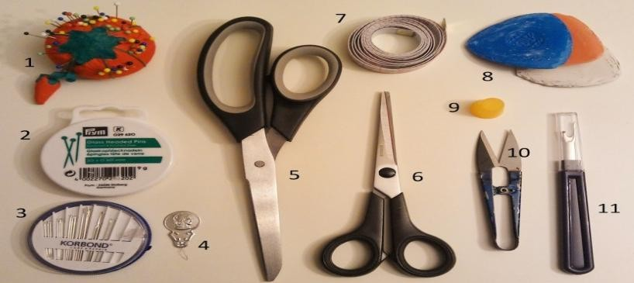](http://2.bp.blogspot.com/-TcxnAUVGHjo/UssZsZeYQpI/AAAAAAAABzU/NVUSf-OmKig/s1600/Basic%2BSewing%2BKit.jpg) 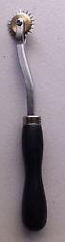

Plate 1 sewing tools source: https//blogspot.com/ Plate 2 tracing wheel Source: javascript

Scissors: A sharp two sided metal with two handles for clipping, slashing, trimming and other cutting operations, it is useful for undoing seams, cutting threads and for fine or delicate detail.

Shears: A sharp two sided metal with two handles for cutting fabrics, bent handle make cutting faster and easier while the fabric remains flat on the table.

Pins: Sharp points small stainless tool for holding fabric

Tracing wheel: is used with carbon paper for transfer marking to the materials

Tape measure: Nylon or plastic coated non stretch tape numbered from either side is used for measurement. .

Sewing Machine: A complete machine that contains several parts serving various functions for stitching pieces of fabrics, they are in three types: hand sewing machine, treadle with pedal and electric sewing machine with an attached electric motor.

Hand needle: These vary in sizes according to their purpose fine Needles, such as inches and 10 inches are for fine work, number 8 for general work and number 6 or 7 used for very thick or stiff material. There are crewels needles of various sizes which have a long eye that are used for embroidery.

Sewing thread: Sewing thread may be cotton, silk, polyester and nylon, used for pieces of fabrics.

Pencil: Pencils are used in drawing of necessary line and marks as a guide for cutting. Eraser: Used to erase the unwanted lines and marks while drafting.

Brown paper: This is a brown or white coloured paper used to construct temporary sewing patterns and for making necessary alteration before it is laid out on the actual fabric.

French curves: This is either plastic or wooden and it is used to trace out curve edges of the fabric in different parts of the body such as hips, necks, sleeve, armholes and crotch (Monday 2014)

* + 1. **Notions:** these are small items attached to the cloth. Heather (2016) defines notion as variety of small articles used for sewing, they are sewn on or attached to a finished garment, they include items like buttons, snaps, thread, and ribbon, or locally homemade notions. Notions can be grouped into functional and embellishments. Embellishment notions are a great way to customize any project because of the amazing variety available in the marketplace, for example, when adding closures to a garment or bag notions like buttons and

zippers are used, when looking for the perfect trim for new quilt, a colorful binding can be the perfect notion to add just the right touch. The most common type of notions include:-



Plate 3 Sewing Notions. Source: <https://thesewingloftblog.com/introductions-please/>

Zipper: The conventional zipper has a stop at the bottom the other type is the specialty zippers for separating decoration.

Snap: They are used to close a garment in the front, front neck, side and at back neck. They include buckles and hook and loop tapes, they serve both decorative and functional purposes.

Hooks and eyes: These are packaged with two types of eyes – curved and straight. Curved eye is used on edges that just meet such as the edge of a collar or neckline, straight eye is used on lapped edges such as waistband.

Buttons: Buttons are available in a wide variety of sizes, shapes and designs, they serve both decorative and functional purposes when used to close openings it for

functional, when use to add beauty to garment is decorative. Buttons are of two types, they are sewing through buttons and shank buttons.

Trims: These are some form of decoration added to a garment, such as braids, lace or rickrack. Trims add a touch of colour or create a new mood for a garment. For example when lace is used, it can add romantic feeling to garment, while rickrack gives a casual look.

Velcro (Hook and loop tape): This consists of two nylon strips, one with tiny hooks and one with looped piles. The hooks and piles intermesh when pressed together. It is available in strips or pre-cut into round or square shapes. Hook and loop tape used on overlapping edges. It is excellent for sport wears, children’s clothes, home finishing and craft items.

Threads: Thread is a very thin spanned of fibers into string made from different fibers and come in different sizes or thicknesses and colours. A good quality thread is strong and smooth, has even thickness and resists tangling. Thread is used to join the different part of garment together.

## Concept of Hand-Tufting

According to Howe (2012) tufting is a type of craft made by punching strands of yarn into stretched sheet of material on a frame to create cluster of pile loops on the surface of a material, the process is repeated until the area to be tufted is filled up. Tufting is carried out with the help of specially hand operated needle or small hand-held device called tufting gun, or on a large machine that utilizes multiple needles to tuft the entire sections in rapid sequence. Tufting decorates cloth and other household articles like bedspread, bath mat, or window curtain, wall frames, mat, rugs etc. (Yarn-crafter 2009). According to Neyman, (2011) tufting serves as embellishment on hand-sewn skin garments such as baby carriers and mittens, ―the finished product results in soft nubby bundles of hair usually arranged into shapes which creates a vivid textural juxtaposition unique and really cool.‖ Below are samples of tufting decorations

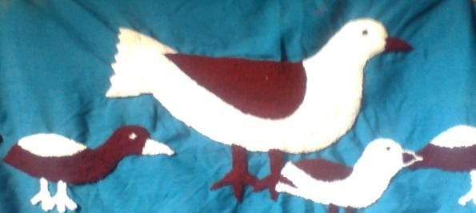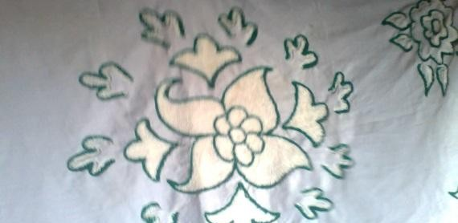

Plate 4: Self Designed Hand Tufted Baby Shawl Plate 5: Self Designed Hand Tufted Table Cloth Source: sample of old hand tufted product Source: sample of old hand tufted product Photograph by Abubakar (2015) Photograph by Abubakar (2015)

## Origin of Hand Tufting Craft

Patton (2013) stated that hand tufting began by a young girl of twelve years

―Catherine Evans‖ who was inspired by an old bedspread in a relative’s family heirloom. The first hand tufted bedspread was produced in 1895 by making some stitches, clipped and boiled it several times to shrink the cloth and lock-in the tufts producing fluffy chenille effect. The bedspread was sold in Whitfield community, later she moved to Dalton Georgia where the popularity of bedspread grew, orders began and she asked for neighbours assistance. Market expansion encouraged faster and efficient tufting production. In 1917 tufting construction company was established, by 1920s to 1930s carpet construction mechanization took up the craft and encouraged experimentation with the aim of initiating mass-production. Around 1949 tufting machine was invented and the introduction of huge multi needles tufting machine eclipsed bedspread and other small goods to carpet production.

## Tools for Hand Tufting Craft

Howe (2012) listed hand tufting tools to include hand tufting needle or hand tufting gun, assorted yarns, frame, primary and secondary backing sheets, designing materials, latex and trimmings.

Hand tufting needle: - This is a handled needle hollowed at the center. The yarn is threaded through the hole operated by punching yarn through the backing material as rapidly as one could find the next hole to be filled.

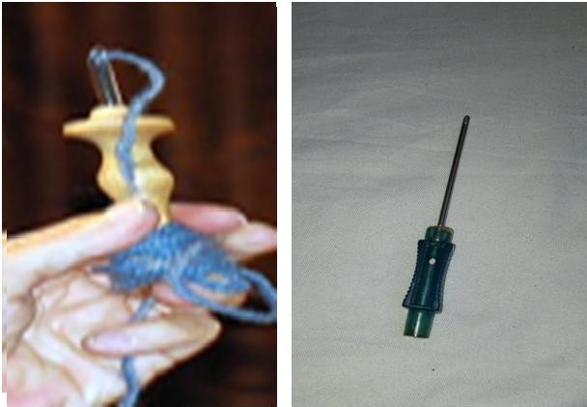

Plate 6: Variations of Hand Tufting Needles

Source: <https://rjohnhowe.wordpress.com/2012> : Photograph by Abubakar (2015)

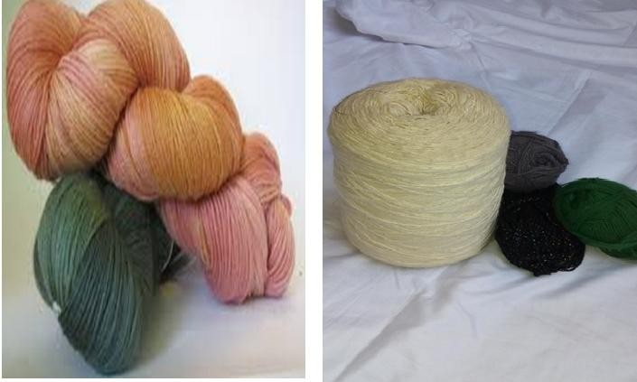Hand tufting yarn: Millstek (2015) suggested that tufting is adapted to various yarns, wool, nylon, cotton, polyester, acrylic and synthetic blends in various ply. Goswami (2009) suggested natural fibers like jute, wool, silk, cotton and synthetic like nylon, rayon, acrylic, and polypropylene are used as hand tufting yarns. The following are samples of tufting yarns:

Plate 7: variation of Hand Tufting Yarns Plate 8: available yarn in the study area. Source Source <https://rjohnhowe.wordpress.com/2012> research tool Photograph by Abubakar (2015)

Primary backing material:-This is a material that tufting is applied on. Strong, elastic, rot resistance and durable material is needed for tufting needle to pierce and retract the back and

hold the yarn when it is withdrawn leaving the loop trapped. Various woven interlacing were used depending on the purpose of the product (Millstek 2015). Howe (2012) stated that plain weave fabric is commonly used for tufting backing while Tamasy (2010) highlighted that natural fabrics deteriorates and produce disagreeable odour especially for tufted carpet and rug, synthetic backing eliminates deterioration, odour and shrinkage. Therefore consideration should be given to the functional needs of a particular article.

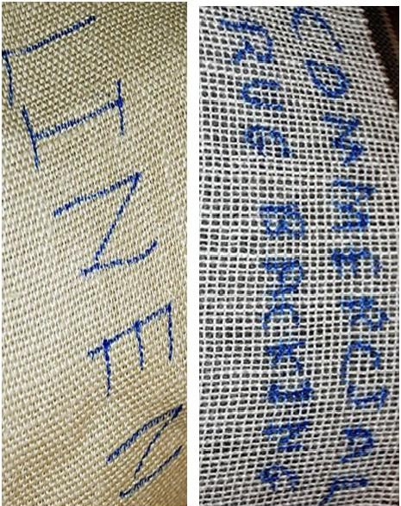

Plate 9: Samples of Plain Woven Materials for Hand tufting Source <https://rjohnhowe.wordpress.com/2012> Secondary backing material: - This is applied to the back of finished tufted article to bond primary backing with latex. Secondary backing material may be the same material as primary backing but its function is optional (Millstek 2015).

Designing material: - Goswami (2009) discussed that materials like pencil, tracing paper, carbon paper and colours etc. are used to translate designs onto primary backing by printing or painting to create artwork or to sketch with colour composition into various motifs.

Frame:-This is where the backing cloth placed on frame with weighted pedestal attached to the nail boards holding for back and forth movement of tufting needle during operation, it is designed vertically, square or rectangular shape, work shop frame is built up for larger activities. (Millstek, 2015).

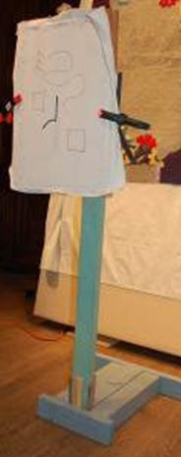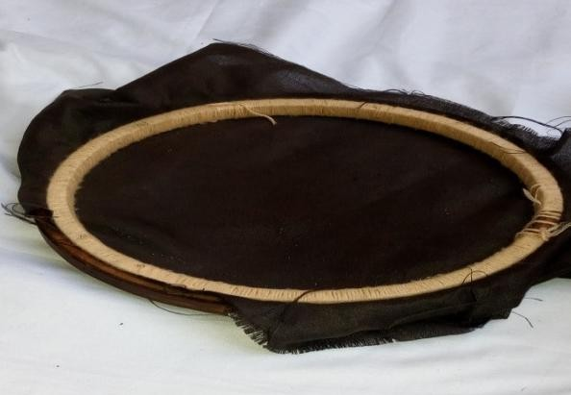

Plate 10: Standing Frame for Tufting Plate 11: Circular of Frame for Hand Tufting. Source Source : <https://rjohnhowe.wordpress.com/2012> Source: Research Tool, Photograph by Abubakar (2015

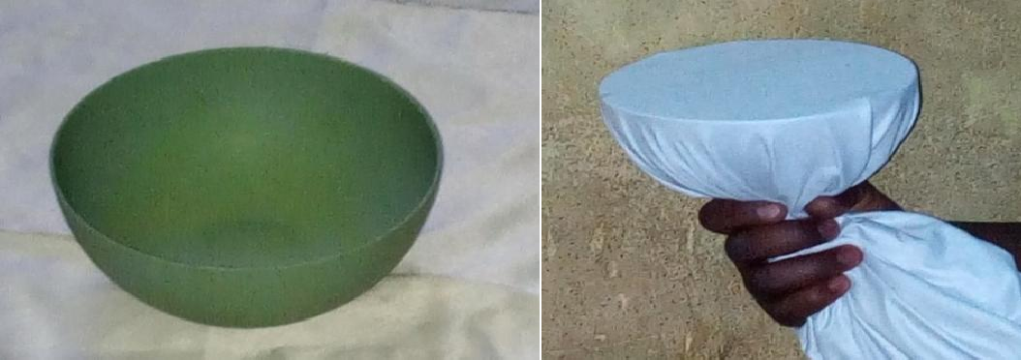

Plate 12: Improvised Frame, Source: Research tool Plate 13: Framed Fabric using Improvised Frame Photograph by Abubakar (2015). Source: Research Tool. Photograph by Abu (2015)

Edging: The finished tufted edge may look indistinguishable. Whipped edge, pre-fabricated tape, stitches, blanket stitches, over edging, fringes, chain stitches and so on add strengthen the tufted edges and prevent unraveling. (Millstek, 2015)

## Hand Tufting Techniques

Millstek.com (2015) explained that hand tufting techniques starts with stretching primary backing material against a frame and drafts the desired design onto the primary backing.

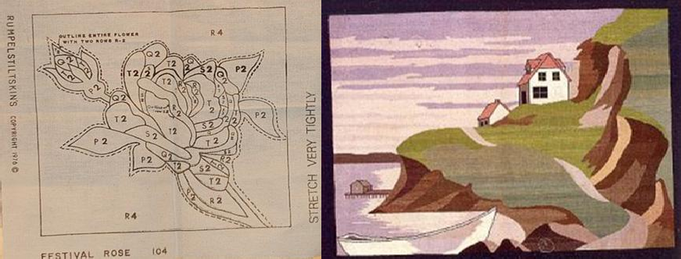

Plate 14: Samples of Tufting Designs Source: <https://rjohnhowe.wordpress.com/2012/>

Then thread the yarn through the needle and proceed by punching strands of yarn into the designed area from the back of primary backing using tufting needle or tufting gun, these accounts for more inserted yarns until the whole area is filled up.

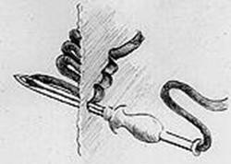

Plate 15: Hand Tufting Technique Source: [https://rjohnhowe.wordpress.com](https://rjohnhowe.wordpress.com/) 2012

Pile density is determined by the closeness of the loops which have major influence on the surface appearance, texture, retention and wear life of the pile structure.

If tufted article is designed for floor coverings, the tufted back may be coated with synthetic adhesive to lock up the fibers and additional fabric may be used as secondary backing to cover up the glue aesthetically. Hilton (2015) added that the fabric should be fully stretched to obtain the correct tension. Howe (2012) added that interval between loops depend on the fabric yarn width and structure of the article, low pile height provides higher

density and better performance; finally, fringe may be added to secure the edge by either stitching or gluing.

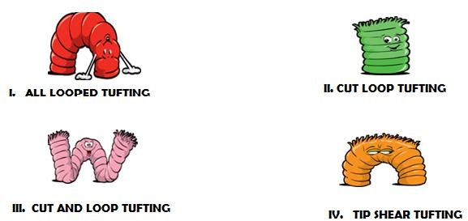According to Cary (2012) to create various looks and performance several tufting styles include all loops, cut pile, cut and loop and tip shear constructions. In all loops construction the tufts are left uncut or adjusted to different levels where some tufted shorts and some made taller to create very nice designs or by colors combinations. All loop tufting out-performs other tufting constructions. Cut pile involves clipping the top of individual bundle of loop, cut pile may be arrange in different directions as splotchy, watermarking etc. Cut and loop involves some tufts are cut and leaving some are uncut. Tip shear styles involve slightly shearing the tip of the loops to achieve better performance than in cut pile but not as good as all loop construction.

Plate 16: Variation of Tufting Looks <http://furniture.about.com/od/accessoriesguide/f/ru41009gs.htm>

In addition to the above tufting styles, Long (2014) explained Saxony tufting construction is having a pile greater than 15mm height and decidedly luxurious look and feel. Sculptured pile a multi-level textured construction and loop pile also called shadow style. Embossed designed with engraved appearance usually achieved by shearing longer denser pile while in cord design the loops are lined giving a ribbed effect. Plush design loop is cut at the same height longer than a velvet pile but shorter than a Saxony pile and twist pile has a spiral disposition of different twisted yarn. Velvet plush are made similar to twist pile but with much softer, smoother, luxurious feel and generally denser compared to velvet plush..

Frieze is similar to shaggy but in different uniformity to fibers arrangement to give slightly informal looks. The following illustrates the tufting styles.

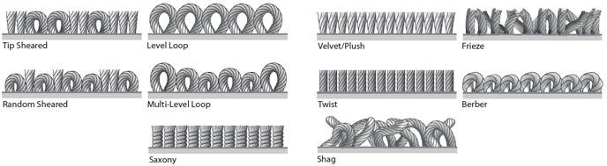

Plate 17 Variation of Tufting looks. Source [info@jlcarpetcleaning.co.uk](mailto:info@jlcarpetcleaning.co.uk)

Newheycarpet.com (2014) disclosed that tufting looks and performance are determined by color-tec and graphics tufting, both employ the same basic principles and construction properties but do have a genuine point of difference. Graphics tufting provides a low cost alternative, the design is limited to stripes and small geometric patterns while color- Tec is advanced high speed patterned tufting technology utilizing computer, yarn placement, technology and the ability to specify complex designs with mixture of different yarn to create stunning textured effects. It offers a cost effective and durable solution to host of commercial environments.

## Yarn Formation

Yarn is a strand of fiber twisted together and spun into longer filaments used for textiles production by weaving, crocheting, knitting, embroidery and net making. Fiber is a raw material for making yarn obtained from natural and synthetic sources. Natural fibers like cotton and linen are obtained from plants and animals respectively, wool from animal hair such as sheep, angora goats and rabbits and silk a protein fiber extruded in long continuous strands by the silkworm cocoons. Natural fibers pass through scotching to remove impurities then carding to separate fibers and pulling them into parallel form to blend them by joining laps of different fibers. If a smoother finer yarn is required, the fibers are subjected to a

further paralleling method in comb like device that arranges fibers parallel with short fibers falling out of the strand, mass of fibers referred to as sliver. Several slivers are combined by rollers rotating at rates of speed elongate the sliver into a single more uniform strand. Acrylic, nylon, polyester, polyolefin, rayon, spandex, and triacetate are synthetic fibers made by forcing a thick solution of polymerized chemicals through spinneret nozzles and harden in a chemical bath.

Texturing during spinning with high degree twist produces strong yarn, low twist produces softer and lustrous yarn and tight twist produces crepe yarn. Yarn marks differences in the degree of twist, textural characteristics, complexity and relative fines for strength and stability. Twisting is used to stabilizes the fine parallel filament, twist specified by direction and level. Left hand or anti-clock wise twist is called S-twist and right handed or clock wise is Z-twist, neither directions offers advantage over another, the amount of twist used in yarn formation is donated by the number of turns per inch Yarn crafter (2009). Yarns are classified according to the number of parts. A single yarn is just one yarn, a ply yarn consists of two or more single yarns twisted together, and a cord yarn is made of two or more ply yarns twisted together.

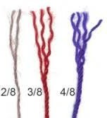

Plate 18: Yarn Plies Source: [www.yarncrafters.com](http://www.yarncrafters.com/)

## Infant’s Clothing Needs

**2.4.1. Infant**

World Health Organization (2015) defined infants as a newborn baby or neonate, is a child under 28 days of age. During these days of life, the child is at highest risk of dying,

thus, it is crucial that appropriate care should be provided to improve the child’s chances of survival and lay the foundations for a healthy life. According to Aggawal (2014) infant is typically applied to young human between the ages of 1month to 12 months. However, it varied between birth and 2 years, added that the first infant year is characterized by rapid physical growth as normal baby doubles its birth weight in six months and triples in a year. Even though there is great expansion of the head and chest bones, the bones are relatively soft and fragile.

Getchildcarenow.com (2011) writes that infants emotionally display individual temperaments, they are active, cuddly and curious; develop attachments to parents and caregivers. Infants use all five senses to learn about the world: seeing, hearing, tasting, touching, smelling and communicate with sounds, bodies and actions. Infant’s unique personalities depend on adult care, properly comfortable garments result to active and cheerful infant whereas poorly fitted garment disturbs infants’ movements. According to EBay Inc. (2015) infant’s physical development diversified through activity levels and pass through five stages which include birth stage, supported sitter stage, sitter stage, crawler stage, and toddler stage. 0-3 months called neonatal or birth stage accustomed to frequent sleep with weak muscle control. 4-7 months start by supported sitter then move to sitter stage that can sit up unsupported and have strength for more physical activities. 9-12 months is crawler stage that always awake and unstoppable during the day with only one or two naps while 1-2 years called toddler stage can stand and walk around independently, their bones are soft flexible in cartilage with soft muscles, they set actions in whole body motion, waves arms and kick legs. Infants have more skin surface in relation to body weight therefore, warm up and cool off faster and communicate for discomfort by crying, therefore, infant wears should give allowance for free movement.

## Infant’s Clothing

EBay Inc. (2015) suggested that infants physical activities and sleeping habit determine their clothing needs, 0-3 months birth or neonate stage needs one-piece garment and sleepwear flexible and easy to put on and take off, swaddling is recommended to prevent turning over at night, 3-5 months as supported sitter stage needs flexible unrestrictive clothing for unrestricted movements.4-7 months called sitter stage need unrestrictive clothing for development, movement, and muscle control for more physical activities At 9-12 months called crawler’s stage unstoppable activities need breathable clothing, durable enough to withstand frequent laundry and to match with physical activities not to inhibit movements during exploration.1-2 years is toddler stage that needs large variety of free and comfortable clothing for all the activities.

EBay Inc. (2015) also added that natural cotton is breathable, inexpensive, soft and popular baby clothing for optimal comfort, it is easy care simple, but may shrink at the first wash. Fleece is popular winter fabric that gives exceptional warmth neither itchy nor irritate infants’ delicate skin, resists wetness and easy to launder. Thick insulated fabrics like fleece and cashmere are good for colder months, the fastenings should provide safety, loose buttons can be choking hazards, zippers may pinch the skin, toddler sizes feature elastic waistbands for comfort are required, Velcro or snap enclosures should slip over the body and open bottoms to provide easy access to diaper and avoid problems.

According to McClintock (2015) at the sight of so small, delicate, adorable and hard to resist infant clothes, the goal is potentially comfort which means more peaceful house. Other factors as softness, safety with no irritating tags or seams and being mindful of sizes and style should be the last thing to consider, also mentioned shoes, socks, hats mittens, gloves, shoes, scarves and booties as outer and everyday wears. Bella (2013) explained that infant garments should have well-fitted necklines neither too tight nor too loose to be worn,

moreover, clothes with fixed and adjustable elastic can strangle the body. Purpose of cloth and gender of the baby should be kept in mind while buying unisex attires; summer time necessitates lighter clothes whilst winter season calls for warm insulated clothes.

## Clothing Comfort

Getchildcarenow.com (2011) discussed that clothing comfort encompasses ease in porosity, absorbency, allowance for growth and activities, proper size to eliminate chances of irritation to the body for proper blood circulation. The fabric should be strong to withstand wear and tear, it should be soft and pliable textured to avoid stiffness and abrasion and that garments should also be light weight as heavy fabrics hinder the physical movements. Stoppard (2008) suggested that lacy material should be avoided as infant tiny fingers catch in lacy holes, white fabrics go dirty quickly, frequent washing drabs, hard seams and fiddly fasteners are chunky, give special attention to cuffs, ankle, neck fastenings, popper crotch, knee protection during crawling, elasticized, soft and strong trousers, flexible necklines for easy slip over the baby head, avoid drawstrings around face or neck nor overdress, should be soft, absorbent, easy to launder and inflammable fabric.

## Clothing Texture

Cantu (2013) defines clothing textures as the structure of interwoven fabrics or threads that make up a textile fabric. EBay Inc. (2015) A garment's texture relies on the visual and tactile surface qualities identified by softness, stretchy and strength, coolness, non- itchy nature, warmth, smoothness, and thickness. According to Sachdeviyer (2014) texture greatly affects the look and feel of a garment; its lucidity in a way influences the appearance of the person wearing the garment. It is basically connected to the weave of the fabric, sometimes affected by stitched details as pin tucks and embellishments as well. Texture is in the thickness and appearance of fabric described by loopy, fuzzy, furry, shiny, bulky, soft, dull, rough, crisps, smooth and sheer, texture increases or decreases body size, draws added

attention to a design, creates illusion, while choosing texture do give in to two tests tactile and visual, some textures can only be felt, but commonly textures can be distinguished visually.

## Clothing Decoration

Macmillan.com (2016) noted that clothes decoration applied to various sewing techniques include bead work, binding or ribbon for edges decoration and avoid raveling, bobble with small wool ball for decorating hats, braid a narrow fabric rope, corsage decoration of flowers, flounce piece of cloth, frill decoration with narrow fabric, marabou the feathers of a marabou for hats decorating, monogram initials sewn onto clothing, piping a thin tube of cloth, pompom a ball made of wool, rosette, ruffle a fold that decorates a piece of clothing, scallop a row of curves decorating along the edge, sequin a small shiny flat piece of plastic or metal, tassel a group of strings tied together, trimmings and other things. Other decorations include appliqué work, patch work, crochet, embroidery stitches, knitting, and needlework, quilting sewing tapestry, tatting and lace work.

## Infant Clothing Colour

Colour is one of the most noticeable vital roles in the overall aesthetics of a space that impacts an individual’s mood, emotional wellbeing, productivity, learning and behaviour. According to Resene.co (2016) strong bright colours affect babies by shocking the inner vibrations which make them unsettled and restless. Bright intense colours as red, yellow and orange stop infants from sleeping and cause crying. Bold patterns and strong contrasting colours are likely to be over-stimulating. Soft tones of yellows or creams, peaches or pinks, apricots and minty greens radiate warmth and peace are emotionally soothing and comforting. Some of the excellent colours for young children are pinks, peaches, pale almond beiges and lavenders as these equate to love comfort and security. Popular color options for infants wears include green, yellow, white, and gray. Gender-neutral colours often contain

lighter hues colors are often neon so that parents can easily spot their children in crowded areas.

## Modification of Infant Clothing

Joyce (2012) defined clothing modification as any change, alteration or adjustment applied to a garment to save money, time for creativity and to make garment look modern. Other reasons are for growing fittings or to alter perfectly good garment once worn by one person to fit another. Garment modification comes in form of pattern alteration or clothing alteration. Pattern alteration is meant for changes needed on a pattern which consists of activities like lengthening and shortening, width increment and so on, while clothing alterations involve activities after garment have been put to use example darning, patching, parts and accessories replacement, transformation into another or breaking down the garment into pieces that could be used in a new sewing project.

Utah Education (2015) noted that infants clothing modification should include measurements taken at each sewing time due to infant’s natural vigorous growth. The pattern should have diaper allowance. Pattern size should be selected by body measurement and not by age in comparison of child size to the width or length of the pattern. Infant garments are purposely altered to create ease. Two types of infants’ ease are wearing ease with extra fullness for comfortable movement without straining. The garment seam or fabric depending on pattern, garment styles and fabric. Knitted fabrics require less wearing ease than woven fabric as it possesses high level of elasticity while designed ease alteration is additional fullness on a garment in addition to the wearing ease. Alteration for infants’ size patterns should be selected according to chest measurement on bodice of coats and jumpsuit while alteration for pant, overall and skirt should be according the waistline measurements.

## Thermal Insulation

Kurtus (2014) defines thermal insulation as the method that inhibits transfer of heat energy from one area to another to keep enclosed area warm or to keep the inside of a container cold. It is used in any location with materials of drastically different temperature; insulating barrier is applied to minimize heat transfer in an object. For example during cold weather human skin is protected by wearing clothes that keep the cold out of the body. The important element of clothing insulation is stopping the wind from penetrating and replacing the layer of warm air close to the body by the use of fibers. Thermal wears are made of fabrics like wool and fur or other artificial fiber which traps the heat and protects the body from cold. (Baby center 2013)

## Importance of Thermal Insulation to Human Being

According to De-Decker (2011) environmental temperature is lower than that of human body which is heat itself to the core temperature of 37°C (98.6°F), body temperature constantly emits small percentage of heat through breathing while the largest heat loss via the skin. Lack of natural insulation and scarcity body hair in human is one of the reasons for wearing clothing as the body is poorly adapted to cold and windy climates, thermal insulated clothing warms air between skin and clothing to prevent heat transfer. Optimum clothing insulation provides thermal comfort to the wearer, thermal insulating properties of textile fabrics depend on their thermal conductivity, density and thickness of material.

According to Babycenter.com (2013) every season possesses certain specifications infants should stay warm, dry and comfortable in cold season, there is a need for higher temperatures to sustain infant thermal comfort. Head, neck, hands and feet are the first cold victims because they lose more heat than other parts of the body. Infants express uncomfortable feelings by crying. They are intolerant to climatic changes and therefore susceptible to ill health in winter. Also hinted further that infants’ normal body temperature

is 36.5-37 ºC (97.5-99 ºF) about the same as adult, but yet do not to have the ability to regulate the body temperature because the body composes large surface area in relation to low body weight and therefore loses heat more easily. This makes it mandatory to provide them with extra thermal care either through clothing and coverings, adjusting room temperature, keeping body contact to parent, proper dressing to shield and insulate them from freezing in cold weather, woolen garments as sweaters, hats, bonnets, socks and booties wraps pleasantly safeguard body from cold, protect and insulate infants from head to toes.

Richards (2015) stated that inadequate infants dressing expend large amounts of energy to stay warm in cold environment. A core body temperature of one degree below normal requires babies to use ten (10) percent more oxygen. They cannot build up energy reserves, they spend too much energy to stay warm and may take longer time to get better and their heat control centre in the brain is still immature. Cold lowers blood sugar as all body functions depend on adequate blood sugar. Loss of heat during infancy increases body’s demands for oxygen. A newborn’s head is large in comparison to the rest of the body approximately 25%.Infants lose more heat from the head, which is why it is very important to cover infant’s head especially in a cool environment making sure that face is not obstructed.

According to De-Decker (2011), insulating materials are combinations of materials characterized by retarding the flow of heat energy by performing one or more of the following functions: conserve energy by reducing heat loss or gain, control surface temperatures for personal protection and comfort, facilitate temperature control, increase operating efficiency of heating and reduce emissions of pollutants to the atmosphere. Insulating materials are poor conductors of heat and electricity, the denser the material the closer its atoms are held together. Both natural and synthetic materials have advantages and drawbacks, both are sustainable choice even though synthetic clothes are made from fossil

fuels they have higher insulation value, last much longer, soft on the skin and very cheap. The main drawbacks of synthetics are their high fire susceptibility and tendency to attract dirt. According to Willey (2011) the best clothing insulation is made up of hair and feathers natural or synthetic, motionless air has lower thermal conductivity while hair and feather entrap it.

Morris (2015) listed polyester blends, knit pile, acrylic fibre, mod-acrylic fibre, wool knitted or pile fabrics blend with other fibres nylon, cotton blend with viscose rayon and feather as sources are high insulation materials. Also added that different fabrics have specific characteristics, for example, acrylic substitutes wool and mimic cotton properties. It is light in weight, soft and warm with good qualities resiliency and quick-drying. Micro- fibres include fine acrylic, nylon, polyester and rayon. The fibres are soft, strong and exhibit better drape. They are more comfortable to wear, durable and move moisture away from the skin – this is called "wicking. Silk is lustrous, strong, and absorbent with excellent draping properties, however, it can be damaged by either heat or water as it is one of the most comfortable forms of fabric to wear. Wool is a comfortable and versatile fabric, warm in the winter and cool in the summer. It resists wrinkling returning to its natural shape when relaxed and it stretches when dry up to about half of its length when wet.

## Signs of Chilling Among Infants

Karp (2015) stressed that parents and caregivers must monitor to touch and feel infant’s chest, tummy and back to ensure it is not too hot or too cold. Over chilling and overheating are risk factors that can impact health and well-being of infants. Deep sleep makes baby more vulnerable to cold and heat, abdominal temperature represents core temperature and it is reliable in the diagnosis of hypothermia. A warm foot indicates thermal comfort while cold feet and warm trunk indicates hypothermia (cold stress). Early signs of infant chilling include colder feet; the whole body becomes cold, less active, suckling poorly

and a weak cry. In a severely hypothermic baby, the face and extremities may develop bright red colour, hardening of the skin associated with reddening and edema. A continuously chilling baby becomes lethargic with shallow and irregular breathing. Prolonged hypothermia is linked to impaired growth and increased risk of death.

## Guide to Infants’ Thermal Insulation

According to C (2015), babies do not emanate with instruction manuals nor temperature gauges, but the reliable guidelines to keep them comfortably dressed in all- weather condition involve wearing layers of regular clothing or cardigans, basic coat, hat with fleece ear flaps, mittens headband ear-warmers, boots, flannel-lined jeans, socks, long sleeves and thick sweaters etc. Parent should be cautioned of overheating because it leads to sickness. Layers of breathable fabric compensate infants’ thinner skin that becomes hotter or colder faster than adults. Ensure no part of the infant’s skin is exposed except face since they always throw covers off at night. Use fuzzy sleeper to keep the body warm comfortably.

Antonio (2015) maintained that the key to cold weather dressing is layering which means wearing multiple layers of garments. Several lighter layers keep warm than very thick one because air trapped between each layer which is warmed by the body with a self- generated heat shield that insulates from the cold. Layering breaks into three sections: The Base Layer is the inner layer that lies against the skin to deal with moisture removal referred to as ―wicking‖. If clothing does not move moisture out and away from skin, it can lead to rapid heat loss, sweating and development of heat rashes. The Insulating Layer is to trap in heat. A natural fiber like wool is an excellent insulating property and absorbs 30% of its weight without feeling wet; for example, wool sweater paired with cotton dress or shirt makes for a functional insulating layer. The protective layer is the outer layer shell that keeps all the inner layers protected. Ahuwan (2010) stated that cold season wears should be layers of light weight clothing to trap air for added insulation, darker colours absorbs more heat;

natural fibers should be next to the skin to absorb moisture; head should be covered with hat, veil or head-tie to prevent heat loss. Thus, infant cold wears should keep warm and full to cover sensitive parts.

## Policies Supporting Infant Thermal Care

Modern societies including local and international laid more emphasis on infant thermal care. The global introduction of maternity leave in the public service supports this fact. For example, Blackmans bay children service (2013) enforced infant clothing policy which aimed to ensure that children are dressed appropriately and comfortably for indoor and outdoor throughout the year, for effective clothing comfort and safety. In cold season parents were encouraged to provide coats, warm jumpers, hats and appropriate footwear due to infants’ higher thermal requirement.

UNICEF (2013) stated that the first month of life is the most vulnerable period for infants’ thermal care. Infants need to be kept in warm environment to **a**void hypothermia (rectal temperature below 36.5°C or 96.8° F) as it increases rate of infant mortality. The risk of losing heat is greatest in wet cloth. It is necessary to dry up and wrap baby in a clean cloth. Heads should be covered for postponed bathing, skin-to-skin contact and delayed bathing. WHO (2013) emphasized that thermal protection should be taken to ensure that a baby does not become either too cold (hypothermia) or too hot (hyperthermia). Hypothermia occurs when the body temperature drops below normal 36.5-37.5°C (97.7-99.5°F), mild hypothermia or cold stress is 32-36°C (89.6-96.8°F), less than 32°C (89.6°F) is severe hypothermia. Hypothermia increases the risk of illness and death. To maintain normal body temperature, hypothermia can be prevented through warming by wrapping the baby, keep in a warm room or under a radiant heater with appropriate dressing or kangaroo-mother care (skin-to-skin contact with the mother) etc. Infants’ body temperature should be monitored frequently.

In Nigeria, the situation remains the same as different measures were taken to secure infants thermal need. Traditional child care in Kano Municipal lays more emphasis on infancy stage. This is testified through cultural practices where nursing mother and the new born are kept in a room for at least forty days receiving thermal care by frequent placement of glowed charcoal, hot showers in the morning and evening so that nursing mother stays close to the baby to supply thermal care for developmental needs of the baby. Nigerian government endorses the importance of infant care starting from enlightenment during antenatal clinics to provision of adequate labour rooms in the hospitals.

The Federal Republic of Nigeria Civil Service Rule (2010) stated in chapter 10 (218 &219) that a pregnant female staff is entitled to 12 weeks maternity leave with full pay. The essence of this special concession is to ensure that the baby and the mother stay at home due to infant immaturity so as to deliver proper infant thermal care and feeding. The mother is also allowed to carry baby to place of work after the stipulated maternity leave and shall be granted an hour off duty every day for a period of six months from the date she resumes duty. All of these are in place to support infant thermal care.

## Review of Empirical Studies

This section presents some previous researches within and outside Nigeria that are relevant to this study titled ―Development of infant hand tufted thermal insulation wears in Kano Municipal, Nigeria.‖

Ying (2005) conducted an experimental research on physical mechanisms and characterization of smart infant’s thermal clothing. The aim was to develop smart thermal functional textiles and clothing that can reduce heat loss problems of infants and provide a personal thermal comfort environment under changing temperature conditions. Micro- encapsulated phase change materials (PCM) were incorporated into textiles. It absorbs heat energy when phase change materials change from solid to liquid and release heat when they

change from liquid to solid. Using experimental investigations and numerical simulations, the thermoregulatory effects and mechanisms of heat and moisture transfer behavior of single-layer PCM textiles and multi-layer PCM textiles assemblies were investigated and the thermal physiological responses of clothed infants were studied. Finally, based on the theoretical analysis and experimental investigation, smart thermal clothing – an infant's wrapper was designed and developed.

This research work share relationship with this study because both are developmental researches that dealt with innovation to design and develop thermal cloth for preventing heat loss among infants. Both studies used the product of the research on infants and infants’ reactions were observed. Contrarily the researcher incorporated micro-encapsulated phase change materials to design smart thermal clothing which may be expensive and only available in the study area. Infants are speechless therefore parents’ views on the infants feelings are very vital and have been neglected in the research. The present research differs because it employed the use of simple tools and materials and involves parent views.

The study titled ―*Improving the practices adopted by mother in the management of their children’s clothing in Enugu state*‖ was carried out by Oluah (2006). It is a survey research with five objectives to determine the guidelines adopted by mothers in planning for their children's clothing, factors considered by mothers in purchase of infant wears, methods employed for care and maintenance of children's clothing, problems encountered in caring and maintaining children's clothing and ways of improving the practices. Five research questions and two hypotheses were formulated; the study adopted a descriptive survey research design. The area of study was Enugu State. The population was made up of mothers within the age limit of 20 - 45 years and random sampling technique was used to select the two hundred (200) respondents for the study. The collected data were analyzed using frequency counts, mean and t-test statistics.

Findings from the study include: seven (7) guidelines for planning of children's clothing, eleven (11) factors to be considered when buying children's clothing, twenty-one

(21) methods of caring and maintenance of children's clothing, mothers encountered sixteen

(16) problems during care and maintenance of children's clothing and seventeen (17) improvement measures that could be adopted in the care and maintenance of children's clothes by mothers in the state. Four recommendations included that government should encourage local manufacturers of textiles and clothing since there is ban on importation of products so that they will be affordable to parents and other users. This research work is related to the present research work because it was designed to determine children's clothing by mothers and the factors to be considered in purchase of clothes for their children from mothers’ point of view. Contrary to the present research work, it did not make any local production. Infants’ thermal needs were ignored while the present research designed infant thermal wears using local hand craft aimed to determine comfort, texture and decorations for infant wears based on the observed infant reactions by mothers and caregivers.

Cascio (2006) conducted an experimental research on development of next generation carpet backings for facile recyclability. The goal of the research is to develop next generation generic construction of broadloom carpet that will compete with the physical performance on the floor and cost basis while avoiding major recycling disadvantages because current carpet construction leads to abundant amount of solid waste entering landfills. To combat these recycling problems, new carpet constructions were designed and developed to be easily recycled. The construction consists of backing material made from nonwoven glass mats and the traditional woven polypropylene (PP) primary backing. The developed carpet constructions still utilize traditional nylon face yarn; substituted nylon resins for the conventional calcium carbonate latex to consolidate the final structures lock in the nylon yarn tufts and incorporate the secondary backing. The flammability and mechanical properties of

the alternative broadloom constructions were measured. The constructions based on the traditional primary PP backing gave good performances, while the glass based primary backing carpets performed flammability below the PP backing carpets. This study relates to the research study at hand because it was designed to modify tufting craft by utilizing some substances to develop new product for primary backing material for carpet recyclability. Contrarily, this research utilizes yarn using fabric as primary backing to develop infant hand tufted thermal insulation wears using simple hand tufted needle.

A descriptive research was carried out by Kolade (2010) *Health implication, choice and management of infant clothing among nursing mothers in some selected health schools in Ilorin, Kwara state*. The research contains two objectives and hypotheses. The objectives were to identify dermatitis problems affecting infant as a result of choice and management of infant clothing among nursing mothers and to determine various strategies that could be employed to improve choice of infant clothing. Open ended and structured questionnaires were administered to a sample of 100 nursing mothers using 4-point likert scale and analyzed by frequency count and mean score ratio from 2.5 level of acceptance. The findings revealed the use of unsuitable synthetic fiber, poor quality diaper, prolonged use of diaper without changing, exposure to feces and urine for long caused skin infection or rashes and irritation to infants, hence the hypotheses were accepted. The recommendation suggested that there is need for enlightenment for mothers during pre-natal clinic on how perfectly to choose and manage of infant clothing for effective health implication. This study relates to the research study at hand since it is concerned with infant’s clothing, choice and management of infant clothing and nursing mothers views on choice but the research did not consider infant’s clothing comfort and thermal needs.

Olowoyeye (2011) studied ―Comparative preference and assessment study of locally designed constructed and foreign constructed children’s China wears in Kaduna State. Four

objectives were drawn to compare and assess the more preferred between locally made and foreign made children’s wears, to use suitable notions on design and construction of locally made compared with foreign made children’s wears, to assess the qualities preferred and sought for in children’s wears, to examine the level of comparative preference between the locally-made to foreign made children’s wears. Four research questions were raised and four hypotheses were also formulated and tested. Simple random sampling was used to select 20 respondents who served as judges in assessing the locally designed children’s wears and the China made. Experimental and questionnaire were two methods of data collection. The data were analyzed using descriptive statistics of mean, median, frequency table and percentage. The result of the analysis showed that the respondents preferred the locally constructed children wears using local fabrics. The four hypotheses tested were rejected. Based on the findings, the recommendations were made which include that there should be finance by government to encourage local textile companies for mass production of suitable for children’s wears. Opinions of women and experts must be regularly sampled on locally made fabrics for improvement and that relevant agencies should stop the importation of foreign made wears as this weakens local production.

This research shares similar features with the present work because both are developmental researches aimed at producing local infant wears and considered mothers’ preferences. Contrary to the present research however, the researcher uses some people as judges for selection of infants wears, the judges may not have full understanding on infant feelings and clothing needs since the infants were not involve for observation also infant thermal needs was not given any consideration.

Aggarwal (2014) conducted a research titled ―designed development and acceptance of Khadi as infant wears.‖ Four (4) objectives stated were to study the existing infant wear brands and purchase behavior of mothers to develop different surface enrichment techniques,

to design and develop a range of clothing for infants (0-3months) and to test the acceptability of developed range in Khadi over other most extensively used fabrics for infant wears. Four research questions and hypotheses were formulated. 43 shopkeepers and 30 expectant mothers were sampled from whom the data was collected. The methods adopted in the study were experimental and survey of methods. Questionnaires, lab reports, design sheets and evaluation sheets used for data collection. The statistical analysis involved deriving mean, mode, standard error, skewness and kurtosis values. The comparison of the Infant wear developed in Khadi (after use) over infant wear in other fabrics was checked by using t-test; the acceptance of infant wear in Khadi and the Infant wear in other fabrics using t-test, the p- value for variables involved fabric comfort, surface development, fit, stitching, hence null hypothesis HO was rejected and alternative hypothesis HA was accepted, stating that there was a significant difference in acceptability of Infant wear in Khadi over Infant wears in other fabrics. This study relates to the research study at hand because both designed local infant wears using locally produced fabric and deliberated on the parents view on the acceptance of local fabric as infant clothing and nursing mother’s views on choice, but the research does not consider infants feelings so as to observe their reactions toward the comfort of the cloth, also infant’s thermal needs have been neglected.

## Summary of Related Empirical Studies

Based on the various reviewed related literatures, very little has been done on the subject of hand tufting. The literature reviewed the theory of clothing protection, concept of hand tufting tools and techniques, concept and characteristics of infants, infants clothing needs, importance of thermal insulation and policies supporting infants’ thermal care traditionally, nationally and globally. Finally, six (6) empirical studies reviewed include designed development and acceptance of Khadi as infant wears, comparative preference assessment study of locally designed constructed and foreign children’s china wear in

Kaduna state and so on. The present study aimed at determining whether mothers in Kano municipal would accept the developed hand tufted garments as infants thermal insulation wears.

Looking at the above reviewed related literature, this research work aimed to fill in the following gaps: this research work differs from other reviewed researches because it designed and developed infant thermal insulation garments using hand tufting craft while all the researches documented on tufting craft were constructed for other house hold articles especially carpets and rugs. The research work is designed to use an extinct hand craft in the study area for production of infant garments in order to revive the craft for the benefits of idle and desperate local tufters. Based on the empirical studies reviewed, there is lack of research on hand tufting for garment production like this research.

Considering the study area, this research work utilizes simple, local, affordable and accessible tools and materials for local production and consumption that can to formation of cottage industries while other researches on hand tufting utilized sophisticated machinery which may be unaffordable to many hand crafters in the study area. Unlike other researches this research work laid more emphasis on mothers and child care taker’s opinions since infants are speechless, this was achieved through practical use of the developed products and observation on infants reactions during dressing and undressing the product, while none of the documented researches addresses these issues like the present research.

Information about the research will be disseminated to the beneficiaries though organizing vocational training center to women where knowledge and skills on hand tufting for garment production will be taught. Programmes in mass media and the commencement of web site will also be sponsored to disperse the information on the research work. Instructional manual will also be developed.

# CHAPTER THREE MATERIALS AND METHOD

This chapter presents the materials and methodology adopted for the research titled

―Development of infant hand tufted thermal insulation wears in Kano municipal, Nigeria.‖ The chapter was presented under the following sub-headings:

* 1. Research Design
  2. Population of the Study
  3. Sample and Sampling Procedure
  4. Instrument for Data Collection
     1. Validation of the Research Instrument
     2. Pilot Study
     3. Reliability of the Research Instrument
  5. Procedures for Data Collection
  6. Procedures for Data Analysis.

## Research Design

This research work is a product development design. Qualtrics.com (2018) stated that product development research helps uncover unmet product needs, identifies product features, development opportunities and identifies awareness and preferences around a particular product.

## Population of the Study

The population of this study covered all women of child bearing age who nurtured infants from birth to one year in Kano Municipal. The researcher met the respondents in primary health care units during clinical session of infant immunization. According to the Health Department Kano Municipal Local Government Area (2017), there were six public primary health care units in Kano Municipal attending infants’ immunization one day every

week. Therefore, the population of mothers that attended infant immunization from 12 to 16 June 2017 in the six primary health care units in Kano Municipal was presented on Table 1 thus:

## Table 1: Population of the Study

|  |  |
| --- | --- |
| **Name of Primary Health Care Units** | **Imm days/ wk. population** |
| Gandu Model Primary Health Care Unit Tukuntawa Model Primary Health Care Unit Unguwar Gini Primary Health Care Unit Sharada Primary Health Care Unit  Yan Awaki Primary Health Care Unit  Mayanka Primary Health Care Unit | 1 day 73  1 day 90  1 day 84  1 day 74  1 day 65  1 days 75 |
| Total No of Health Care Units | 6 days Total 461 |

Source: Health Department Kano Municipal LGA (2017) and immunization and Record units of the respective PHCU

## Sample and Sampling Techniques

Three (3) primary health care units (PHCUs) were selected for the purpose of this research using cluster sampling (based on the location) as the researcher aimed to cover all the areas of Kano Municipal. 10 respondents were randomly sampled from each of the clinic totaling thirty respondents (30) equivalent to 2.17%. This is due to the fact that developmental research carries many activities in field work. According to Charitaki (2015) the minimum sample size for experimental research according to Central Limit Theorem is 30. In addition Aggarwal (2014) in the research titled ―designed development and acceptance of Khadi as infant wears sampled 30 expectant mothers as respondents for data collection. Similarly, Olowoyeye (2011) in the research titled ―Comparative preference and assessment study of locally designed constructed and foreign constructed children’s China wears in Kaduna randomly sampled 20 judges that assessed the locally designed children’s wears.

The breakdown of the sample size is given in Table 2 below:-

## Table 2: Sample Size

|  |  |
| --- | --- |
| **Name of Primary Health Care Unit** | **Sampled Respondents** |
| Gandu Model Primary Health Care Unit (Municipal South) Unguwar Gini Primary Health Care Unit (Municipal Central)  Mayanka Primary Health Care Unit (Municipal North) | 10  10  10 |
| **Total** | **30** |

Source: field work 2017

## Instrument for Data Collection

The following instruments were used for data collection

* + 1. Questionnaire for identifying the task, design, criteria, design features, preferred tuft design, materials and techniques of making hand tufted thermal insulation wears (TDDEMTQ).
    2. Body measurement chart of infant from birth to 1 year.
    3. Drafted patterns from body measurement chart.
    4. Modified infant’s Patterns from Utah Education (2015).
    5. Designs for different hand tufted wears.
    6. Rating scale for testing the variables used for the study in terms of comfort, fit, movement, aesthetic and general utility,

## Questionnaire for identifying the task, design, criteria, design features, preferred tuft design, materials and techniques of making hand tufted thermal insulation wears (TDDEMTQ)

The researcher selected three (3) yarns based on availability in the market and thickness as the tufting needle possesses thin eye that cannot accommodate thicker yarns. The selected yarns were: gun logo two ply yarns, two ply and three ply Yeye yarns.

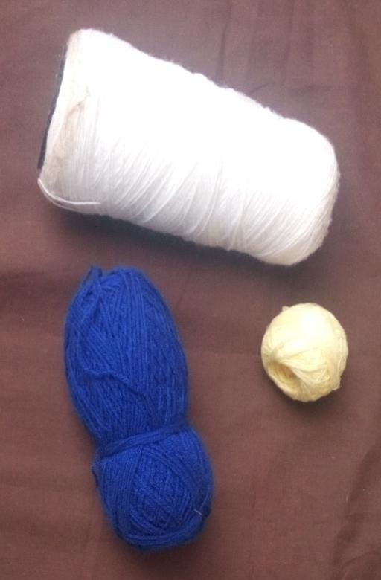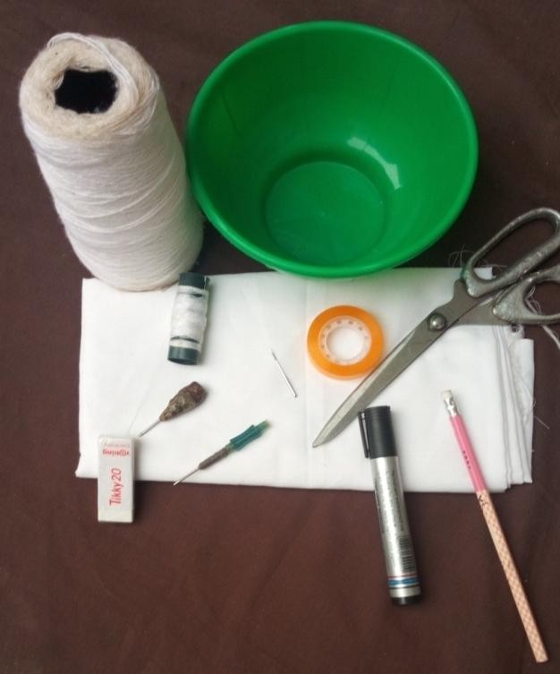

3ply acrylic yarn

3 ply gun logo yarn

2 ply acrylic yarn

plain woven fabric improvised plastic bowl

2 ply tufting yarn

hand tufting needles

scissors and other materials

Plate19: sample of yarns in the study area source: Plate 20: materials used for the research. Source: Research tools Photograph by Abubakar (2015) research tools Photograph by Abubakar (2015)

The yarns were tested by burning methods to identify the origin of fiber. Gun logo yarn was set ablaze; it flamed yellow and smelled of burning paper and left behind gray ash. The researcher confirmed that the gun logo yarn was a cotton fiber because Haynes (2015) stated that cotton material burns fast, the fire singe the fabric, flames yellow glow and after the lighter is removed, the fabric continues to burn quickly with an afterglow, smell is neutral like burning paper, the ash residue is light gray in color. The two Yeye yarns behaved the same; they burned readily and rapidly till extinguished themselves and left behind hard ash with harsh smell which were confirmed as acrylic yarns (Haynes 2015).

Five inches square of hand tufted fabrics were produced from each of the three tested yarns, 10 Home Economists were randomly selected base on their knowledge of clothing and textiles, infant thermal needs and the seasons in Kano Municipal. The experts were asked to select the most appropriate sample for the producing of infant thermal insulation wears. Fabric thickness, loops, softness of the inner side and flexibility of the sample were used as the criterion for selection using 4 points Likerts scale` (appendix ii). Consequently, specimen B (medium and 2 ply yarn) had high mean scores upon all the variables tested (appendix iii) and was used to develop all the products for the research.

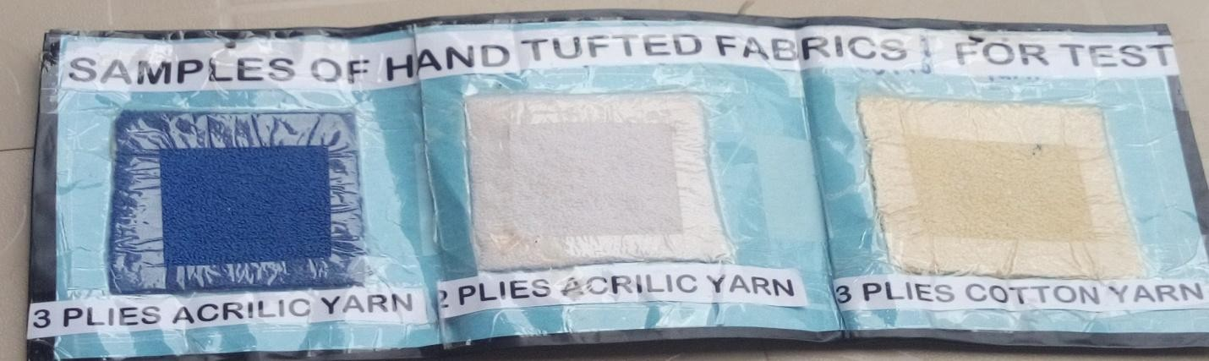

Plate 21: Samples of Hand Tufted Fabrics for Test, Source: Research Products Photograph by Abubakar (2015)

## Body Measurement Chart of Infant from Birth to 1 year

The below is the standard infant body measurement chart from cloud factory used to developed standard infant sewing pattern for the research

Table 3: Measurements Chart for Infant Pattern Birth-year)

|  |  |  |
| --- | --- | --- |
| Section | Position | Birth 3mth 6mth 1yr |
| A | Chest contour | 18 19 20 22 |
| B | Waist contour | 18 19 20 22 |
| C | Hip contour | 19.5 20.5 21.5 23.5 |
| D | Back width | 7.5 8 8.25 8.5 |
| E | Neck width | 1.75 1.75 1.75 1.75 |
| F | Arm hole depth | 3 3.25 3.25 4 |
| G | Waist length | 6 6.5 7 7.5 |
| H | Hip length | 8 8.5 9 9.5 |
| I | Dress length | 13.5 14.5 15.5 17 |
| J | Upper arm | 7 7.5 7.75 8 |
| K | Wrist | 5 5.5 5.5 5.75 |
| L M N  O | Sleeve length Trousers length Crotch length  Ankle contour | 5.5 6.5 6.5 7.5  9 11 11 12.5  4.5 4.75 4.75 5  6 7 7 7.5 |

Source: Cloud Factory YouTube (2016) [https://www.youtube.com](https://www.youtube.com/)

## Drafted Patterns from Infant’s Body Measurement Chart

E

F

A

I

G

B

BODICE BACK

C

E

D

B

H

C



I



J

2)  ~~K~~

L

SLEEVE (CUT

M

trousers back (CUT 2)

N

Trousers front (CUT 2)

O **Illustration 1 Procedures for Drafting Standard Baby Pattern**

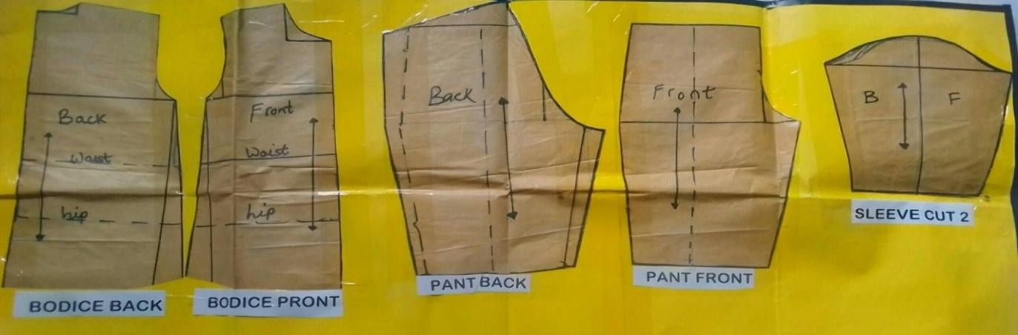

Plate 22: The Standard Drafted Patterns for Developed Infant’s Hand Tufted Garments Photograph by Abubakar (2016)

1. Modification of Infant’s Patterns

The pattern pieces were modified using Utah Education (2015) children's clothing pattern sizes and alteration guidelines, because, the backing sheet was a woven fabric that possessed low level of resiliency. The alterations were as follows:

* 1. Add one inch on width for ease on each of the pattern pieces because woven fabric lack resiliency.
  2. Add one inch to bodice center front on both sides for button stands.
  3. Add 2 inches to the edges on each pattern pieces for ribbing

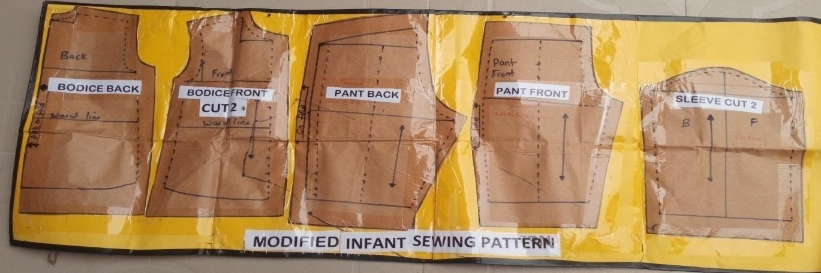

Plate 23: Modified Infant’s Patterns for Developed Hand Tufted Garments Photograph by Abubakar (2015)

**Left Front**

|  |  |  |  |  |  |  |
| --- | --- | --- | --- | --- | --- | --- |
| **Back** | | | | | | |
|  |  |  | **RA** |  |  |  |
|  | | | | | | |

|  |  |  |  |  |
| --- | --- | --- | --- | --- |
| **Right Front** | | | | |
|  |  | **RA** |  |  |

**2 2**

**RA**

**2 2**

# RA

**Ribbing Areas 2**

**2**

**Trouser left Trousers right**

**2**

**RA**

# 2 RA

## 2 2

**.**

**Sleeve Cut 2**

**2**

**2**

Illustration 2 Modified Infant Sewing Patterns ready for lay out on material

**1**

**1.5**

**1.5**

**1.5**

## Cap (set A)

Cap (set C)

**6**

**1.5**

**1.5**

|  |  |  |  |  |
| --- | --- | --- | --- | --- |
| **1.5**  **3 3** | | | | |
|  |  |  |  |  |
|  | | | | |

**8**

**2 2**

## Sock 3

## 15 10

## 4 7

mitten cut 2

2 2

4

5 cap (set B) 7

16

4 2 3 6 3  ~~2~~

.

Illustration 3 Self Designed Patterns for Accessories (Caps, Socks and Mitten)

14

3.

Collar

12

2

4

4

Sole

1. Knee cap

6

bath

3

4.5

Elbow cap 2.5

Illustration 4 Self Designed Patterns for Appliqués Work (Specimen C)

**5**

**2**

**4**

**Overall front**

**1**

**11**

**Overall back**

6

**25**

Illustration 5 Modified Pattern for Ovarall (Set C)

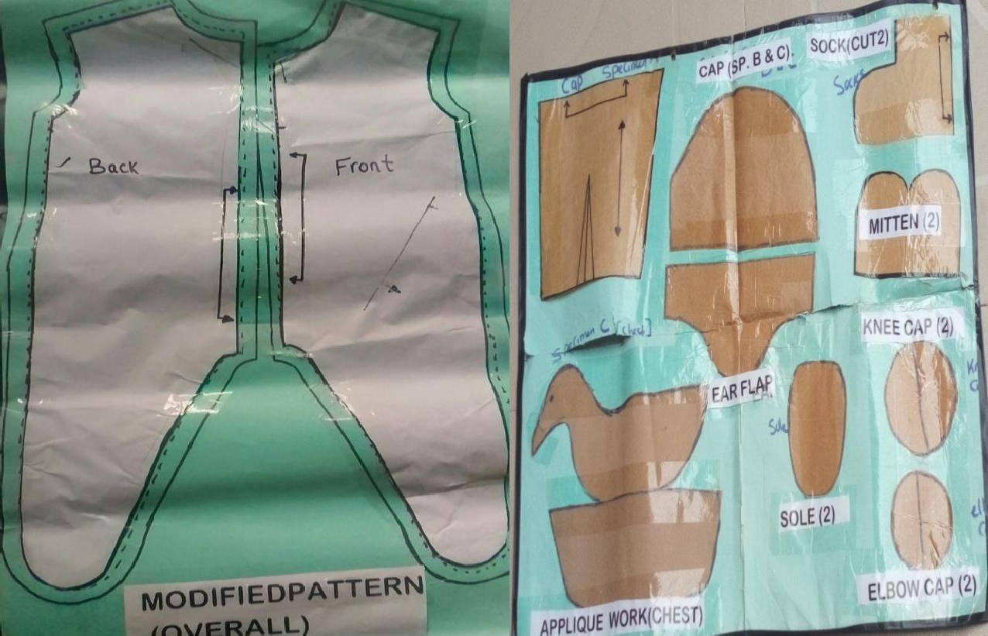

Plate 24: Modified Pattern for Overall. Source: . Plate: 5 Self Designed Patterns for Accessories. Research Product Photograph by Abubakar (2015). Research Product. Photograph by Abu (2016)

Back.

Front left and right

Sleeves

Trousers.

Plate; 26 Sample of Traced Patterns on Fabric for Hand Tufting. Source: Research Product Photograph by Aisha (2019)

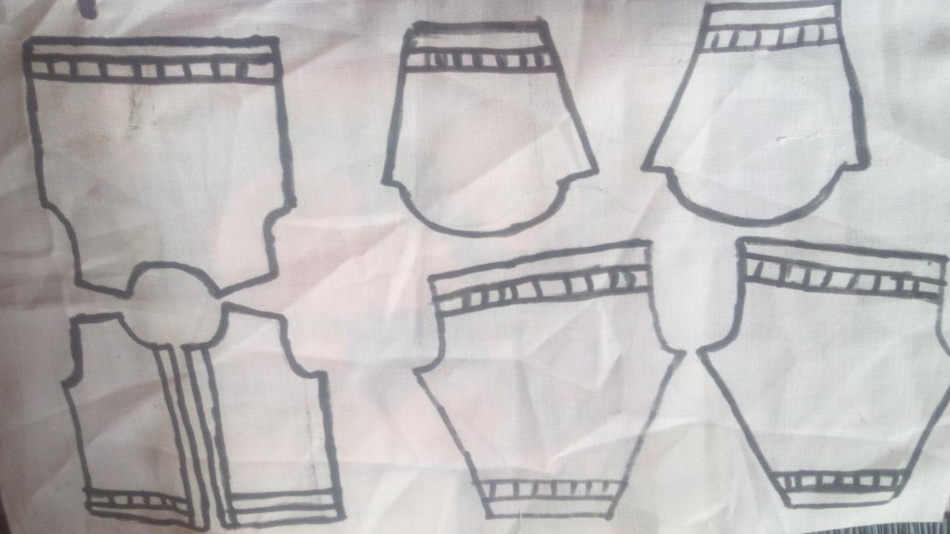

## Designs for Different Hand Tufted Wears

This research work designed and produced three hand tufted thermal insulation wears as follows:-

1. Specimen A white coloured all over infant hand tufted thermal insulation set designed to be adaptable to high cold weather
2. Specimen B ash and cream coloured striped infant hand tufted thermal insulation set to be adaptable to medium cold weather
3. Specimen C golden coloured overall infant hand tufted thermal insulation set to be adapted to normal weather, infants used to be affected by cold breeze especially during early hours of the day

## The outlooks of the developed products were presented in the subsequent three pages below:-

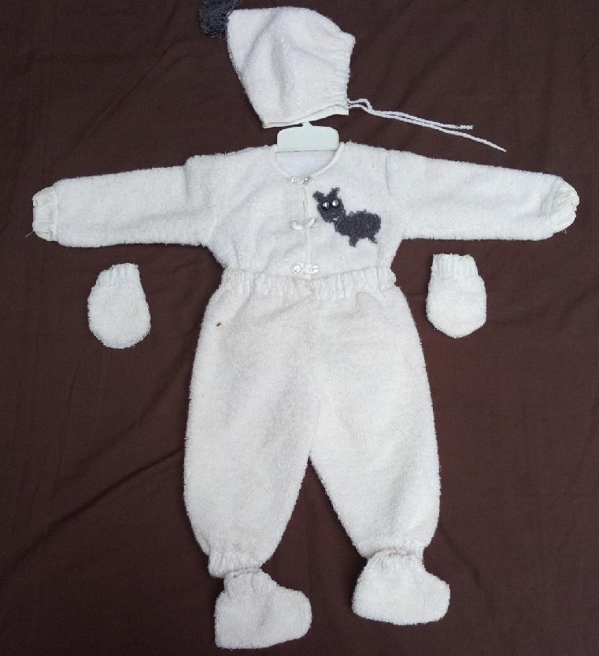

Plate27: Outlook of Specimen A white Coloured Allover Infant Hand Tufted Thermal Insulation Set Photograph by Aisha (2019)

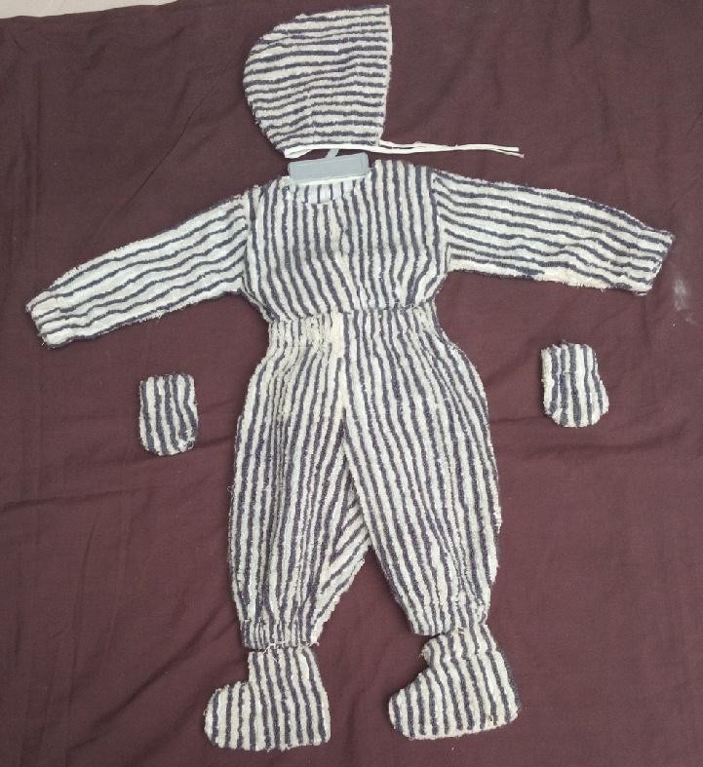

Plate 28: Outlook of Specimen B Ash and Cream Coloured Striped Infant Hand Hufted Thermal Insulation Set Photograph by Aisha (2019)

Hand Tufted Appliqué Work

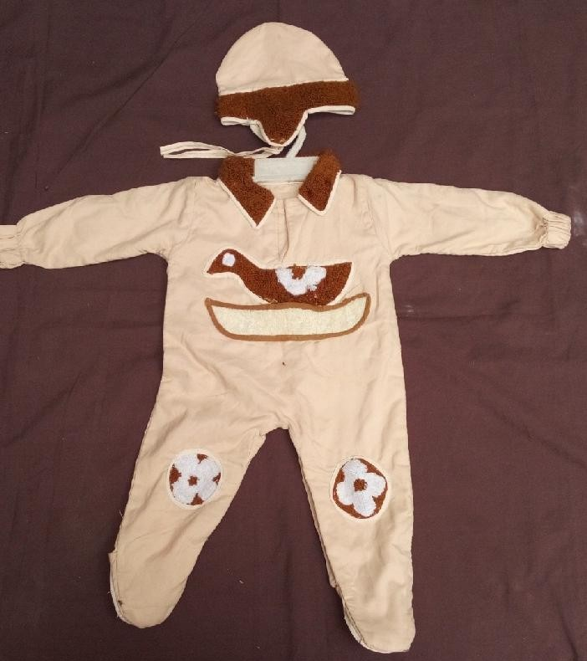

Plate 29: Outlook of Specimen C Golden Coloured Overall Infant Hand Tufted Thermal Insulation Set Photograph by Aisha (2019)

## Rating Scale (hedonic scale) for Testing the Acceptability of the Research Elements in Terms of Comfort, Movement, Fit Aesthetic and General Utility

Self-designed scale tagged Respondents’ Opinions on the Developed Infants Hand Tufted Insulation Wears (RODIHTIW) was used. The designed instrument was guided by hedonic rating scale that involved 1- 9 points for testing acceptability using parametric statistics.

The scale include Like Extremely (LE) 9 points, Like Very Much (LVM) 8 points, Like Moderately (LM) 7 points, Like Slightly (LS) 6 points, Neither Like nor Dislike (NLND) 5 points, Dislike Slightly (DS) 4 points, Dislike Moderately (DM) 3 points, Dislike Very Much (DVM) 2 points and Dislike Extremely (DE) 1 point respectively. According to Wood (2014) Hedonic scale is a sensory scale for measuring the acceptability of personal care products, household products and cosmetics and longer rating scales tended to be more discriminating than shorter scales. The scale for this research work was divided into five sections A – E. **Section A** consisted of four variables on respondents’ bio-data: age of respondents, educational qualification, respondent’s knowledge on clothing and textiles and age of infant at hand

**Section B** contained three (3) variables, they are easy to wear in and take out, safety of seam, opening and fastening and allowance for growth to determine the respondents’ views on comfortability of the developed Infant hand tufted thermal insulation wears in Kano municipal.

**Section C** had three (3) variables; they include soft for infant skin, thickness for thermal insulation and density of the loops to determine the respondents’ views on textural features of the developed infant hand tufted thermal insulation wears in Kano municipal.

**Section D** had three (3) variables of lines and designs, notions used and colours used to determine the aesthetic features of the developed infant hand tufted thermal insulation wears in Kano municipal.

**Section E** featured three (3) variables of covering the important areas, attractiveness/novelty and fluffiness of loops to determine the acceptability of the developed infant hand tufted thermal insulation wears by mothers in Kano municipal.

## Validation of Research Instrument

The contents of the research instrument was subjected to face validity, the research instrument were given to researcher’s supervisors and experts in the area of clothing and textiles and statisticians from Federal College of Education (Technical) Bichi and Kano State College of Education Kumbotso (Saadatu Rimi) for vetting, the advice and corrections were incorporated into the final instrument

## Pilot Study

Pilot study for this research was conducted at Maikalwa Primary Health Care unit under Kumbotso Local Government Area of Kano state study in order to identify the reliability of the instrument. The area was not part the research area but had similar characteristics with the study area. 10 research instruments were distributed for the pilot study.

## Reliability of the Research Instrument

The collected data through pilot study was statistically analyzed for reliability coefficient. The Spearman reliability coefficient was used. According to Stevens and Spegel (2013) an instrument is considered reliable if the reliability coefficient lies between 0 and 1. The closer it is to 1 the more reliable the instrument. The reliability coefficient obtained for pilot study was 0.652 hence confirmed the reliability of the instruments for this study.

## Procedure for Data Collection

The data collection for this research was carried out in phases as follows:-

The first phase contains developmental process. The production procedures were as follows:- Yarn type and thickness was selected by the use of questionnaire administered to 10 home economics using 5 points Likert scale**.** Body measurement chart of infant from birth to 1 year were obtained from cloud factory YOU-TUBE. Infants sewing pattern was drafted from body measurement chart the drafted pattern was modified to suit the need of the research by using guidelines from Utah education (2015). The patterns pieces were laid out and traced on the fabric and hand tufting was applied on the traced pattern. The pattern pieces were cut out with seam allowance and assembled appropriately. Fastenings and other decorations were applied as finishing touches. The products were developed in three variations as follows:-

* + 1. Allover infant hand tufted thermal insulation wears
    2. Striped infant hand tufted thermal insulation wears and
    3. Overall appliqué infant hand tufted thermal insulation wears

The second phase is respondents observation phase where the developed hand tufted thermal insulation wears were given to the respondents who touched, scrutinized, observed and clothed the infants. The mothers observed infant’s reactions in terms of comfortability which was assessed through, safety; allowance for growth and infant’s movement during dressing and undressing. Other elements observed by the respondents were texture, decoration and acceptability of the products in Kano municipal.

The third phase contains administration of research instrument, the researcher with the help of three trained research assistants administered the research instrument to the respondents who rated the products based on comfortability, textural preferences, aesthetic preferences and acceptability based on general utility. One day was utilized for the data collection in each of the selected clinic such that the researcher spent 3 days for the data collection exercise.

## Procedure for Data Analyses

Data was analyzed using descriptive and inferential statistics. Percentages were used to analyze the respondents’ bio- data. Means and standard deviations were used to answer all the research questions, while all the four hypotheses were analyzed by Analysis of Variance (ANOVA) at 0.05 level of significance.

## Decision Rule:

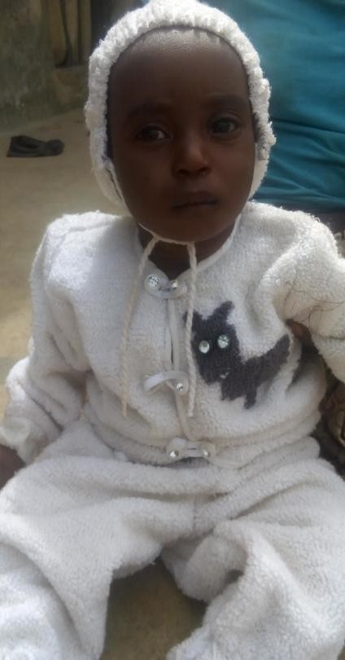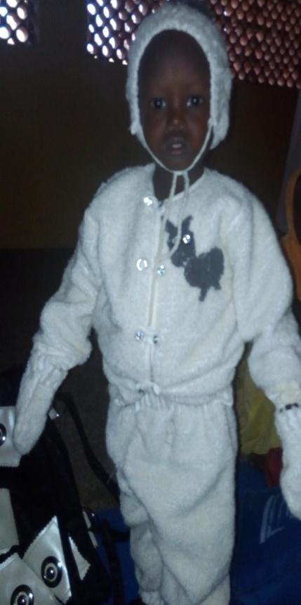The criterion for decision rule for 1-9 Hedonic scale for answering research questions was minimum score of 5.00 points. Any score equals to and above the benchmark was considered as liked. On the other hand, any score below the criterion was considered as dislike. In the case of the hypotheses which were tested at 0.05 level of significance, where the calculated value was equal to or less than the critical P value, the hypothesis was rejected. On the other hand, where the calculated value was more than the P value, the hypothesis was retained.

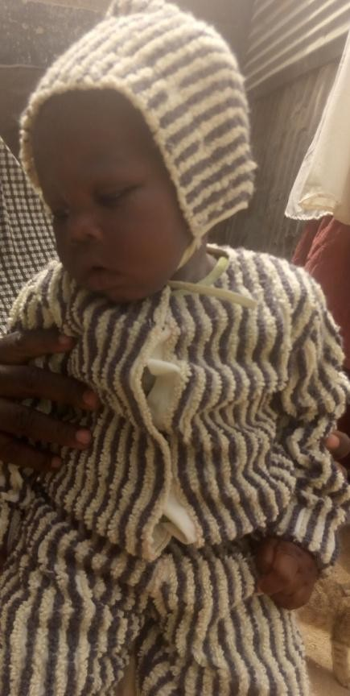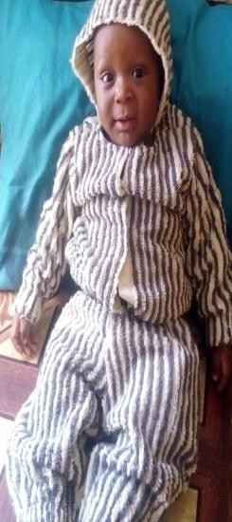

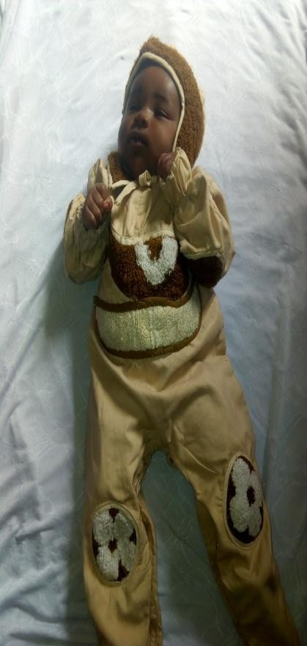

Plates 30-36 Samples of Infants Dressed in Hand Tufted Thermal Insulation Wears. Source: Field Work (2017).

Photograph by Abubakar (2017)

# CHAPTER FOUR PRESENTATION AND ANALYSIS OF DATA

This chapter contains presentation and analysis of data and discussion of the findings on the research titled ―Development of Infant Hand Tufted Thermal Insulation Wears in Kano Municipal. The chapter is organized under the following sub-headings:

* 1. Analysis of Bio-Data
  2. Answers to the Research Questions
  3. Testing of Hypotheses
  4. Summary of the Major findings
  5. Discussion of Major Findings

## Analysis of Respondents’ Bio-data

Data related to the bio-data variables of the respondents were collapsed into one Table and analyzed and presented in Table 4.1 as shown:

Table 4: Analysis of Demographic Variables of Respondents

|  |  |  |  |  |
| --- | --- | --- | --- | --- |
| S/No | Variable | Variable Items | Frequency | Percentage |
| 1.  2.  3.  4. | Age Range of Respondents  Educational Qualification of Respondents  Age of Child at Hand  Attendance of  Clothing & Textile Course | 15 – 20 years  21 – 25 years  26 – 30 years  31 – 35 years  36 yrs.& above Total  Non Formal Primary Secondary Advance Level Graduate  Total  0 – 3 months  4 – 6 months  7 – 9 months  10 months – 1 year Total  Yes  No Total | 1  8  8  6  7  30  1  5  9  14  1  30  9  6  7  8  30  16  14  30 | 3.3  26.7  26.7  20  23.3  100  3.3  16.7  30  46.7  3.3  100  30  20  23.3  26.7  100  53.3  46.7  100 |

Table 4 is an all-in-one table disclosing the bio-data variables of the 30 respondents used for this study. The captured variables shown under serial numbers 1 – 4 include the age range of the respondents, educational qualifications of the respondents, age of child at hand and attendance of clothing and textile course by the respondents. Serial number one showed the age range of the respondents of which ages 21 – 25 years and 26 – 30 years shared 26.7% respectively. Ages 36 years and above followed with 23.3% and then 31 – 35 years were 20%, only one respondent was aged between 15 – 20 years with 3.3%. This indicated that majority of infants mothers in the study in Kano Municipal were between ages 21 – 36 years and that infant care takers cut across various age ranges and have the tendency to use the developed infant hand tufted thermal insulation garment for their infant. Serial number two in Table 4.1 contains educational qualification of the respondents which showed that 46.7% of the respondents had advanced level qualifications, 30% had secondary school education and 16.7% had primary school certificates while 3.3% of the respondents had non-formal and graduate qualification respectively, this showed that majority of the respondents were literate and had the possibility of perfectly rating the developed infant wears.

Serial number three in the Table 4.1 gives the analysis of the respondents’ children’s ages with 30% of the children aged between 0 – 3 months; 26.7% of the children aged between 10 months – 1 year followed by 23.3% of the children aged between 7 – 9 months and only 20% of the children aged 4 – 6 months old. The Table indicated the tendency of using developed infant hand tufted thermal insulation wear across various levels of infancy. Serial number 4 In Table presents the respondents’ attendance of Clothing and Textile course for which 53.3% were positive and 46.7% were negative in their responses. It can thus be held that majority of the respondents used for the study were knowledgeable in clothing and textile.

## Answers to Research Questions

This section contains answers to the research questions based on the objectives and research questions guiding the study which include the following:-

## Research Objective one: To develop infant hand tufted thermal insulation wears in Kano Municipal

**Research Question One: How infant hand tufted thermal insulation wears were developed in Kano Municipal?**

Infant hand tufted thermal insulation wears were developed from an extinct hand tufting craft using hollowed centered needle. The preparation to the production involved selection of yarn type and thickness by the use of questionnaire administered to 10 home economics using 5 points Likert scale**.** Body measurement chart of infant from birth to 1 year were obtained from cloud factory YOU-TUBE. Infants sewing pattern was drafted from body measurement chart the drafted pattern was modified to suit the need of the research by using guidelines from Utah education (2015).

The products were developed in three variations as follows:-

* + 1. Allover hand tufted thermal insulation wears as specimen A
    2. Striped hand tufted thermal insulation wears as specimen B
    3. Overall appliqué hand tufted thermal insulation wears as specimen C

## Materials for the production of infant Hand Tufted Thermal Insulation Wears

The following materials were used for the production of infants hand tufted thermal insulation wears

Table 5: Materials used for production of (specimen A) white coloured all over hand tufted wears

|  |  |  |
| --- | --- | --- |
| **Material** | **Quantity in yard** | **Cost (N)** |
| Fabric | 1½ | 450 |
| Acrylic yarn | ½ of large 2 ply acrylic pack | 1000 |
| Elastic thread | 2 yards | 100 |
| Bias strip | 4 yards | 120 |
| Buttons | 5 | 20 |
| Labor  Total |  | 1000  #2690 |
| **Selling price** |  | **N2700** |

Table 6: Materials for production of Specimen B (striped hand tufted thermal insulation set)

|  |  |  |
| --- | --- | --- |
| **Material** | **Quantity in yard** | **Cost (N)** |
| Fabric | 1 ½ | 450 |
| Acrylic yarn | ¼ of 2 ply acrylic large pack | 500 |
| Elastic thread | 2 yards | 100 |
| Bias strip | 2 yards | 60 |
| Velcro fastener | 6 inches | 100 |
| Labor  Total |  | 800  **# 2010** |
| Selling price |  | # 2100 |

Table 7: Materials for production of Specimen C (overall appliqué hand tufted set)

|  |  |  |
| --- | --- | --- |
| **Material** | **Quantity in yard** | **Cost (N)** |
| Fabric | 1 ½ | 450 |
| Acrylic yarn | Small loom | 200 |
| Elastic thread | ½ yards | 50 |
| Bias strip | 2 yards | 60 |
| Press-tud fastener | 10 | 100 |
| Labor Total |  | 300  #1,160 |
| Selling price |  | **N1,200** |

## Procedures for the production of infant hand tufted thermal insulation wears

The following techniques were used for production of Specimen A: (white coloured all over hand tufted thermal insulation wears)

1. Lay out and trace each of the pattern pieces on the backing material
2. Mark 5/8 of an inch for seam allowance
3. Mark two inches on the edges of each of the pattern piece for ribbing
4. Apply hand tufting all over the pattern pieces excluding the ribbing area.
5. Apply double vertical lines of hand tufting on the ribbing area.
6. Cut out pattern pieces
7. Fold the remaining 2 inches to the back leaving spaces for ribbing
8. Stitch the marked line for easy access to ribbing
9. Insert one inch elastic tape into the ribbing area
10. Assemble pattern pieces in positions and stitch along the seam lines.
11. Secure the raw edges by machine stitch
12. Mark the area for button
13. Stitch bias strip (rouleou-loop) turn it out and cut 5 pieces of two inches each, fold into two with join at the middle and use as decorative fastening
14. Mark and apply buttons on the button stand

## The following techniques were used for production of Specimen B (striped hand tufted thermal insulation wears)

1. Lay and trace each of the pattern pieces on the backing material.
2. Mark 2 inches from edges on each of the pattern pieces for ribbing
3. Mark 5/8 of an inch for seam allowance.
4. Apply double stripes of vertical hand tufting alternating cream and ash colour respectively on the each pattern pieces including the ribbing area.
5. Cut out pattern pieces
6. Fold the remaining 2 inches to the back leaving spaces for ribbing.
7. Stitch the marked line for easy access to ribbing.
8. Insert one inch elastic tape into the ribbing area.
9. Assemble the pattern piece to the positions and stitch along the seam lines.
10. Secure the raw edges by bias binding
11. Stitch 3 pieces of 2 inches velcro fastener on button stand

## The following techniques were used for production of Specimen C (Golden coloured overall with hand tufted appliqué work on the strategic areas)

1. Cut the patterns of front, back and trousers on fold respectively.
2. Join right front dress to right front trouser and left front dress to left front trouser from hip line
3. Join right back dress to right back trouser and left back dress to left back trouser from hip lines
4. Draw curve lines along each of the trousers end for feet
5. Join center front and center back respectively
6. Cut two pieces of front and back patterns respectively
7. Cut out the patches using the guideline on illustration 4
8. Bind the edges of all the pieces with bias binding
9. Cut separate material 2 inches width by 7 inches length
10. Fold it into two and stitch continuous wrapped opening on the center front
11. Stitch the two front pieces together
12. Stitch the two back pieces together
13. Apply the patches into the knee point, elbow point and feet point respectively.

**Research Objective two: - To determine the mean rating of mothers on comfortability of the developed infant hand tufted thermal insulation wears in Kano**

**Municipal.**

**Research Question two: What is the mean rating of mothers on comfortability of the developed infant hand tufted thermal insulation wears in Kano Municipal?**

Table 8: Mean Rating on Comfortability of the Developed Infant’ Hand-Tufted Thermal Insulation Wears in Kano Municipal

Variable Le Lvm Lm Ls N Ds Dm Dvm De T X Sd Am Dc

|  |  |  |  |  |  |  |  |  |  |  |  |  |  |
| --- | --- | --- | --- | --- | --- | --- | --- | --- | --- | --- | --- | --- | --- |
| **Specimen A**  Easy to Ware | 6 | 3 | 3 | 0 | 0 | 0 | 0 | 0 | 0 | 12 | 8.25 | .87 8.19 | LVM |
| Safety | 5 | 5 | 0 | 2 | 0 | 0 | 0 | 0 | 0 | 12 | 8.08 | 1.08 |  |
| Allowance | 5 | 5 | 2 | 0 | 0 | 0 | 0 | 0 | 0 | 12 | 8.25 | .75 |  |
| **Specimen B**  Easy to wear | 3 | 7 | 1 | 1 | 1 | 0 | 0 | 0 | 0 | 13 | 7.77 | 1.17 |  |
| Safety | 3 | 7 | 0 | 3 | 0 | 0 | 0 | 0 | 0 | 13 | 7.77 | 1.09 8.00 | LVM |
| Allowance | 5 | 5 | 1 | 0 | 0 | 0 | 0 | 2 | 0 | 13 | 7.85 | 1.41 |  |
| **Specimen C**  Easy to wear | 2 | 3 | 0 | 0 | 0 | 0 | 0 | 0 | 0 | 5 | 8.40 | .55 |  |
| Safety | 2 | 2 | 1 | 0 | 0 | 0 | 0 | 0 | 0 | 5 | 8.20 | .82 |  |
| Allowance | 2 | 0 | 1 | 2 | 0 | 0 | 0 | 0 | 0 | 5 | 7.40 | 1.52 7.79 | VM |

N=30KEY: LE : Like Extremely, LVM: Like Very Much LM: Like Moderately, LS: Like Slightly, NLND: Neither Like Nor Dislike, DS: Dislike Slightly, DM: Dislike Moderately, DVM: Dislike Very Much, DE: Dislike Extremely, TO: Total X: Mean SD: Standard Deviation AVM; Average Mean DC: Decision

Table 8 above gave the mean rating of mothers for each variable and for the three specimens namely: specimen A (white) specimen B (striped) and specimen C (overall). The average mean rating scores were 8.19, 7.79 and 8.00 respectively; the overall mean rating revealed that specimen A was more comfortable than others with highest mean rating of 8.19. This implied that the respondents liked the comfortability features of all the three developed infant hand tufted thermal insulation wears for infants in kano municipal since the mean scores of the three specimens were above 5.00. Comfortability of the research product composed of easy to wear in and out, safety of seams, openings and fastenings and allowance for growth.

**Research Objective three: - To determine the mean rating of mothers on**

**textural preference of the developed infant hand tufted thermal insulation wears in Kano Municipal.**

**Research Question three: What is the mean rating of mothers on textural preference of the developed infants hand tufted thermal insulation wears in Kano Municipal?**

**Table 9**: Respondents Mean Rating on Textural Preferences of the Developed Infant Hand- Tufted Thermal Insulation Wears in Kano Municipal

++++++++++++++++++++++++++++++++++++++++++++++++++++++++++++++++++++++++++++++++++++++++++

Variable Le Lvm Lm Ls N Ds Dm Dvm De T X Sd Am Dc

|  |  |  |  |  |  |  |  |  |  |  |  |  |  |
| --- | --- | --- | --- | --- | --- | --- | --- | --- | --- | --- | --- | --- | --- |
| **Specimen A**  Softness | 3 | 4 | 4 | 1 | 1 | 1 | 0 | 0 | 0 | 14 | | 7.29 | 1.49 7.69 LM |
| Thickness | 6 | 3 | 3 | 2 | 0 | 0 | 0 | 0 | 0 | 14 | | 7.93 | 1.14 |
| L .density. | 5 | 2 | 7 | 0 | 0 | 0 | 0 | 0 | 0 | 14 | | 7.86 |  |
| **Specimen B**  Softness | 4 | 4 | 1 | 0 | 0 | 0 | 0 | 0 | 0 | 9 | | 8.33 | .71 |
| Thickness | 6 | 0 | 3 | 0 | 0 | 0 | 0 | 0 | 0 | 9 | | 8.33 | 1.00 8.41LVM |
| L density | 6 | 2 | 1 | 0 | 0 | 0 | 0 | 0 | 0 |  | 9 | 8.56 .73 | |
| **Specimen C**  Softness | 4 | 0 | 2 | 0 | 1 | 0 | 0 | 0 |  | 0 | 7 | 7.86 1.5 | |
| Thickness | 4 | 0 | 1 | 0 | 1 | 1 | 0 | 0 |  | 0 | 7 | 7.43 2.15 | |

L. density 3 2 2 0 0 0 0 0 0 7 8.14 .90 7.81LM

N=30 KEY: LE : Like Extremely, LVM: Like Very Much LM: Like Moderately, LS: Like Slightly, NLND: Neither Like Nor Dislike, DS: Dislike Slightly, DM: Dislike Moderately, DVM: Dislike Very Much, DE: Dislike Extremely, TO: Total X: Mean SD: Standard Deviation AVM; Average Mean DC: Decision

Table 9 carried the mean rating for each variable for the three specimens namely: specimen A (white) specimen B (striped) and specimen C (overall). The average mean rating for the three specimens was 7.69, 8.41 and 7.81 respectively. It indicated that specimen B (striped)

possesses the most preferred textural features with 8.41 mean score. It further indicated that all the specimens rated above 5.00. Texture was measured in terms of softness on infant skin, thickness for thermal insulation and density of the loops

## Research Objective four: - To determine the mean rating of mothers on aesthetic preference of the developed infant hand tufted thermal insulation wears in Kano Municipal.

**Research Question four: What is the mean rating of mothers on aesthetic preference of the developed infants hand tufted thermal insulation wears in Kano Municipal?**

Table 10: respondents mean rating on the aesthetic Preferences of the Developed Infant Hand Tufted Thermal Insulation Wears in Kano Municipal

|  |  |  |  |  |  |  |  |  |  |  |  |  |  |
| --- | --- | --- | --- | --- | --- | --- | --- | --- | --- | --- | --- | --- | --- |
| VARIABLE LE | | LVM | LM | LS | N | DS | | DM | DVM DE T | | | X | SD AM DC |
| **Specimen A**  Shape 2 | | 3 | 2 | 1 | 1 | 0 |  | 0 | 0 | 0 | 9 | 7.44 | 1.33 7.81 LM |
| Notions | 6 | 0 | 2 | 1 | 0 | 0 |  | 0 | 0 | 0 | 9 | 8.22 | 1.20 |
| Colors | 2 | 5 | 0 | 2 | 0 | 0 |  | 0 | 0 | 0 | 9 | 7.78 | 1.09 |
| **Specimen B**  Shape | 4 | 1 | 1 | 0 | 0 | 0 |  | 0 | 0 | 0 | 6 | 8.50 | .84 |
| Notions | 1 | 3 | 2 | 0 | 0 | 0 |  | 0 | 0 | 0 | 6 | 7.83 | .75 8.16 LVM |
| Colours | 2 | 3 | 1 | 0 | 0 | 0 |  | 0 | 0 | 0 | 6 | 8.17 | .75 |
| **Specimen C**  Shape | 8 | 5 | 2 | 0 | 0 |  | 0 | 0 | 0 | 0 | 15 | 8.40 | .74 |
| Notions | 7 | 4 | 4 | 0 | 0 |  | 0 | 0 | 0 | 0 | 15 | 8.20 | .86 |
| Colours | 9 | 5 | 0 | 1 | 0 |  | 0 | 0 | 0 | 0 | 15 | 8.47 | .83 8.35 LVM |

N=30 KEY: LE: Like Extremely, LVM: Like Very Much LM: Like Moderately, LS: Like Slightly, NLND: Neither Like Nor Dislike, DS: Dislike Slightly, DM: Dislike Moderately, DVM: Dislike Very Much, DE: Dislike Extremely, TO: Total X: Mean SD: Standard Deviation AVM; Average Mean DC: Decision

Table 10 provided the mean rating for each variable of the three specimens, specimen A (white) specimen B (striped) and specimen C (overall). The average mean scores were 7.81,

8.16 and 8.35 respectively. This indicated that specimen C (overall) had the most preferred decoration because of its highest mean score of 8.35. it also revealed that respondents liked the decorations on all the three developed infant hand tufted thermal insulation wears in Kano municipal due to the mean scores above 5.00.The decoration involved shape/design the notions and colours used,

## Research Objective five: - determine the mean rating of mothers on acceptability of the developed hand tufted infant thermal insulation wears in Kano Municipal.

**Research Question five: What is the mean rating on acceptability of the developed infant hand tufted thermal insulation wears in Kano Municipal?**

Table 11: Respondents mean rating on the acceptability of Developed Infant wears

|  |  |  |  |  |  |  |  |  |  |  |  |  |  |
| --- | --- | --- | --- | --- | --- | --- | --- | --- | --- | --- | --- | --- | --- |
| VARIABLE | Le | Lvm | Lm | Ls | N | Ds | Dm | Dvm | De | T | X | Sd Am Dc | |
| Specimen A |  |  |  |  |  |  |  |  |  |  |  |  | |
| B/Covering | 5 | 4 | 1 | 2 | 0 | 0 | 0 | 0 | 0 | 12 | 7.83 | 1.47 7.80 **LM** | |
| Attraction | 7 | 2 | 3 | 0 | 0 | 0 | 0 | 0 | 0 | 12 | 8.42 | | .79 |
| Loopy surf | 3 | 2 | 5 | 1 | 1 | 0 | 0 | 0 | 0 | 12 | 7.17 | | 1.75 |
| Specimen B |  |  |  |  |  |  |  |  |  |  |  | |  |
| B/Covering | 3 | 1 | 4 | 0 | 0 | 0 | 0 | 0 | 0 | 8 | 7.88 | | .99 |
| Attraction | 6 | 0 | 2 | 0 | 0 | 0 | 0 | 0 | 0 | 8 | 8.50 | | .93 8.00 LVM |
| Loopy surf | 4 | 1 | 1 | 2 | 0 | 0 | 0 | 0 | 0 | 8 | 7.63 | | 1.77 |
| Specimen C |  |  |  |  |  |  |  |  |  |  |  | |  |
| B/Covering | 7 | 2 | 1 | 0 | 0 | 0 | 0 | 0 | 0 | 10 | 8.60 | | .70 |
| Attraction | 6 | 2 | 2 | 0 | 0 | 0 | 0 | 0 | 0 | 10 | 8.40 | | .84 |
| Loopy surf | 5 | 4 | 1 | 0 | 0 | 0 | 0 | 0 | 0 | 10 | 8.40 | | .70 8.4 LVM |

N=30 KEY: LE : Like Extremely, LVM: Like Very Much LM: Like Moderately, LS: Like Slightly, NLND: Neither Like Nor Dislike, DS: Dislike Slightly, DM: Dislike Moderately, DVM: Dislike Very Much, DE: Dislike Extremely, TO: Total X: Mean SD: Standard Deviation AVM; Average Mean DC: Decision

Table 11 revealed the mean scores for each variable and for each of the specimens namely: specimen A (white) specimen B (striped) and specimen C (overall). The average mean scores were 7.80, 8.00 and 8.47 respectively thus showed the acceptability of the developed infant hand tufted thermal insulation wears among mothers in Kano Municipal. The Table showed that specimen C (overall) was more acceptable to the respondents due to the highest mean score of 8.47, nevertheless, all the three infant hand tufted thermal insulation wears were acceptable to the respondents in Kano Municipal because all the mean scores were over

5.00 points, this means that all the specimens had reasonable degree of covering the important areas, attractiveness/ novelty as well as the loopy and fluffiness of the surface.

## Test of Null Hypotheses

This section presents the test of the four null hypotheses guiding the study One Way Analysis of Variance (ANOVA) at 0.05 level of significance.

## Ho1 There is no significant difference on the mean rating of mothers on comfortability of the developed infants hand tufted thermal insulation wears in Kano Municipal.

Table 12: One-Way Analysis of variance on Comfortability of the Developed Infants’ Hand Tufted Thermal Insulation Wears

|  |  |  |  |  |  |
| --- | --- | --- | --- | --- | --- |
| **Source** | **df** | **SS** | **MS** | **F** | **P** |
| **Comfortability** |  |  |  |  |  |
| Between Groups | 2 | 1.01 | .50 | .73 | .49 |
| Within Groups | 27 | 18.69 | .69 |  |  |
| Total | 29 | 19.70 |  |  |  |

From the Table 12 above, the result showed that where f (2. 27) = 0.73, P=0.49, therefore P>

0.05 since 0.05 level of significant was used, The result is statistically in significant and

indicated that there was no significant difference in the comfortability of the developed infants’ hand tufted thermal insulation wears. The Null Hypothesis is therefore retained.

## Ho2. There is no significant difference on the mean rating of mothers on textural preference of the developed infants hand tufted thermal insulation wears in Kano Municipal.

Table 13: One-Way Analysis of Variance on Textural Preference of the Developed Infants’ Hand Tufted Thermal Insulation Wears

|  |  |  |  |  |  |
| --- | --- | --- | --- | --- | --- |
| **Source** | **Df** | **SS** | **MS** | **F** | **P** |
| **Texture** |  |  |  |  |  |
| Between Groups | 2 | 2.65 | 1.32 | 1.63 | .22 |
| Within Groups | 27 | 21.97 | .81 |  |  |
| Total | 29 | 24.62 |  |  |  |

The result on Table 13 showed that where F (2, 27) = 1.63, P = 0.22. Since alpha of 0.05 or level of significant was used, this result showed that P>0.05 and indicated that there was no significant difference in the textural preference of the developed Infants’ hand tufted thermal insulation. The Null Hypothesis is therefore retained.

## Ho3. There is no significant difference on mean rating of mothers on the aesthetic preference of the developed infants hand tufted thermal insulation wears in Kano Municipal.

Table 14: One-Way Analysis of Variance on Aesthetic Preference of the Developed Infants’ Hand Tufted Thermal Insulation Wears.

|  |  |  |  |  |  |
| --- | --- | --- | --- | --- | --- |
| **Source** | **Df** | **SS** | **MS** | **F** | **P** |
| **Decoration** |  |  |  |  |  |
| Between Groups | 2 | 3.44 | 1.72 | 2.77 | .08 |
| Within Groups | 27 | 16.75 | .62 |  |  |
| Total | 29 | 20.19 |  |  |  |

The result showed that where F (2, 27) = 2.77, P = .08. Since 0.05 level of significant was used the result showed that there was no significant difference in the decorative preference of the developed Infants’ hand tufted thermal insulation wears. The Null Hypothesis is therefore retained.

## Ho4. There is no significant difference on mean rating of mothers on acceptability of the developed infants hand tufted thermal insulation wears in Kano municipal.

Table 15: One-Way Analysis of Variance on Acceptability of the Developed Infants’ Hand Tufted Thermal Insulation Wears

|  |  |  |  |  |  |
| --- | --- | --- | --- | --- | --- |
| **Variable and Source** | **Df** | **SS** | **MS** | **F** | **P** |
| **Acceptability** |  |  |  |  |  |
| Between Groups | 2 | 2.46 | 1.23 | 1.56 | .23 |
| Within Groups | 27 | 21.26 | .79 |  |  |
| Total | 29 | 23.72 |  |  |  |

From Table 15 above where F (2, 27) = 1.56, P = .23, The result showed that P> 0.05 level of significant, this concluded that there was no significant difference in the acceptability of the developed Infants’ hand tufted thermal insulation Wears. The Null Hypothesis is therefore retained.

## Summary of Major Findings

The followings were the summary of major findings for this study:

1. The findings for this study showed that the mean rating of mothers on the comfortability of all entire three specimens were satisfactory as all the specimens scored more than 5 points in comfortability, but Specimens A (white coloured all over hand tufted set) was the most comfortable as it scored the highest mean points of 8.19 in comfortability.
2. The findings for this study showed that the mean rating of mothers on the textural preference of all the three specimens were satisfactory as all the specimens scored more than 5 points in textural preferences, but Specimens B (striped ash and cream coloured hand tufted set) had the most preferred texture as it obtained the highest mean points of 8.37 points in textural preference.
3. The findings for this study showed that the mean rating of mothers on the aesthetic features of the entire three specimens were satisfactory as all the specimens scored more than 5 points in aesthetic preference, but Specimens C (overall golden coloured appliqué hand tufted set) had the most preferred aesthetic features as it obtained the highest mean points of 8.47 points in aesthetic preference.
4. The mean rating of mothers on the entire three specimens were acceptable to mothers in Kano municipal as all the specimens scored more than 5 points in acceptabllity, but Specimens C (overall golden coloured appliqué hand tufted set) was the most acceptable to the mothers as it obtained the highest mean points of 8.47 points in acceptability.
5. The four null hypotheses tested using Analysis of Variance (ANOVA) showed that there was a no significant difference in the mean rating of mothers on the comfortability, textural preferences aesthetic preferences and acceptability of the

developed infant hand tufted thermal insulation wears because the entire P values were more than 0.05 points level of significant, the results were as follows: comfortability P

= 0.49, texture P = 0.22, aesthetic P = 0.08 and acceptability P =0.23. therefore all the hypotheses were retained

## Discussion of Major Findings

This research study developed three infant hand tufted thermal insulation wears as alternative to infant cold wears in Kano municipal, they were as follows

* + 1. Allover hand tufted thermal insulation wears
    2. Striped hand tufted thermal insulation wears and
    3. Overall appliqué hand tufted thermal insulation wears

The materials used for development of infant hand tufted thermal insulation wears were plain woven fabric, 100% acrylic 2 ply yarn, elastic thread, Bias strip, buttons, press-tud fastener and velcro fastener respectively. The techniques of producing three hand tufted thermal insulation wears were made by selection of available yarn in the study area, testing the origin of fiber used for manufacturing the yarns by burning method, choosing the suitable tufted fabric for infant thermal insulation wears in Kano municipal by 10 home economics using likert scale based on loop density, flexibility and softness, then infant sewing pattern were developed from cloud factory YOU-TUBE and later modified by addition of one inch for ease and two inches for ribbing to refrain the passage of cold air into the infant body

Based on the weather in Kano municipal the three hand tufted thermal insulation wears were developed to suit the need of fluctuating cold weather in Kano Municipal. High cold season to match with all over tufted set, moderate weather with striped tufted set and overall appliqué hand tufted set for normal weather respectively. The data was collected by face to

face interview and question and answer techniques with sampled of 30 mothers who attended infant immunization in three sampled primary health care units in Kano municipal.

Specimen A (white) had the highest means mean rating of mothers on the comfortability with 8.19 points. Comfortability enticed through easy to wear safety of seams, fastenings and openings and allowance for growth. This established that respondents in Kano Municipal adjudged that specimen A (white all over hand tufted infant thermal insulation wears) was more comfortable for infants from birth to 1 year. This agrees with the work of McClintock (2015) which established that the potential goal for infant clothes is for comfort, softness, safety with no irritating tags or seams. Also, getchildcarenow.com (2011) stated that the comfortability of baby wears encompasses through allowance for growth and activities to eliminate chances of irritation to the body. Seams and fiddly fasteners are chunky and should be avoided, fastenings should provide safety, and zipper may pinch infant skin, therefore simple fastenings, open buttons and snap enclosures should slip over the body to provide easy access to diaper.

It was also found that the specimen B (striped) had the high score on the mean rating of mothers on the textural preference with 8.41 mean points therefore considered having the most preferred texture. Texture in the research was assessed by softness on infant skin without skin irritation, thickness for infant thermal insulation and density of the loops. This is in tandem with the findings of Cantu (2013) who founded that clothing textures relies on the visual and tactile qualities of the surface identified by softness, stretchiness and strength, coolness, non-itchy nature, warmth, smoothness, and thickness basically connected to the weave of the fabric and sometimes affected by stitched details and embellishments.

The study also showed that specimen C obtained the highest mean rating of mothers on the preferred aesthetic preference due to the highest mean score of 8.35 points. Stoppard (2008) maintained that infant garments should have knee and elbow protection for easy

crawling, attached to elasticized, soft and strong trousers. Flexible necklines for easy slip should be used contrary to lacy materials with holes as infant tiny finger catches in lacy holes. Drawstrings around face or neckline, overdressing, over decoration, cuffs ankle and neck fastenings should be avoided.

Finally, specimen C (overall) had 8.47 means scores on mean rating of mothers on the acceptability of the developed infant thermal insulation wears in Kano Municipal. The acceptability was designed through covering the important areas, attractiveness/ novelty as well as loopy and fluffiness of the surface.

It was also found out that all the specimens obtained high mean scores above 5.00 points; this showed that all the specimens had high degree of comfortability, texture, decoration and acceptability. This also implies that in the event of mass production of the developed hand tufted infant thermal insulation wears; all the brands would be produced and sold equally in Kano Municipal and elsewhere.

The results of the hypotheses tested did not contradict the answers obtained for the research questions. The result showed that all the entire P values obtained by the result using analyses of variance (ANOVA) at 0.05 level of significant were higher than the critical values as follows: comfortability P = 0.49, texture P = 0.22, aesthetic P = .08 and acceptability P = .23. The result showed that there was no significant difference on the mean ratings of mothers on the comfortability, texture, aesthetic and acceptability of all the three developed hand tufted infant thermal insulation wears in Kano municipal, based on these results, all the hypotheses were retained.

# CHAPTER FIVE

**SUMMARY, CONCLUSION AND RECOMMENDATIONS**

This chapter provides the summary, conclusion, contribution to knowledge and recommendations made based on the findings of the study.

## Summary

This study examined the Development of Infant Hand Tufted Thermal Insulation Wears in Kano Municipal. The objectives of this research were to develop infant hand tufted thermal insulation wears by identifying materials and the procedures. To determine the mean rating of mothers on comfortability, textural preferences, aesthetic preferences and acceptability of the developed infant hand tufted thermal insulation wears. Five research questions and four null hypotheses were formulated to guide the study.

The materials for developing hand tufted garments were simple, local, affordable and accessible tools; they are hand tufting needle, acrylic two ply yarn, plain fabric, plastic improvised yarn, elastic tape and fastenings. The procedures for developing infant hand tufted thermal insulation wears were made from infant measurement chart, drafting pattern from the measurement, pattern modification, layout and trace pattern on fabric, application of hand tufting on the pattern, cutout pattern and assembling, then addition of fastening and decoration.

Three variation of infant hand tufted thermal insulation wears were developed from extinct hand tufting craft in Kano municipal they are: All over hand tufted infant thermal insulation wears, striped hand tufted infant thermal insulation wears and overall appliqué hand tufted infant thermal insulation wears. The researcher engaged in data collection exercise through face to face interaction and question and answer approach during the clinical session of infant immunization. Mother’s views were collected through observation on infants’ reactions after they were clothed with the products. 30 respondents in three primary health care units in

Kano municipal were sampled using cluster sampling. The garments were given to the respondents who touched, felt and clothed the infants and observed the infant’s reactions during dressing after then questionnaires were administered to the respondents.

Percentages were used to analyze the respondents’ personal data, means and standard deviations were used to answer the research questions while Analysis of Variance (ANOVA) was used to test all the four hypotheses of the study at 0.05 level of significance. Score of

5.00 above were considered as like any score below the mean was considered as dislike.

The result of the showed that the mean rating of mothers on the comfortability of the entire three specimens was satisfactory to infant from birth to one years as all the specimens scored more than 5 points in comfortability, but Specimens A (white coloured all over hand tufted set) was the most comfortable as it scored the highest mean points of 8.19 in comfortability.

The mean rating of mothers on texture of all the three specimen were satisfactory to infant from birth to one years as all the specimens scored more than 5 points in textural preference, but Specimens B (striped ash and cream coloured hand tufted set) had the most preferred texture as it obtained the highest mean rating points of 8.37 points in textural preference.

The mean rating of mothers on aesthetic features of the entire three specimens were satisfactory to infant from birth to one year as all the specimens scored more than 5 points in aesthetic preference, but Specimens C (overall golden coloured appliqué hand tufted set) had the most preferred aesthetic features as it obtained the highest mean points of 8.47 points in aesthetic preference.

The entire three specimens were acceptable by the mean rating of mothers in Kano municipal as all the specimens scored more than 5 points in acceptabllity, but Specimens C (overall golden coloured appliqué hand tufted set) was the most acceptable to the mothers as it

obtained the highest mean points of 8.47 points in acceptability. All the hypotheses were retained as the entire P values were more than 0.05 points level of significant,

## Conclusion

This research work developed infant hand tufted thermal insulation wears in Kano Municipal. Three developed hand tufted garments from extinct hand craft served as a means of promoting the hand tufting craft from merely decoration to infant thermal insulation and resolving idleness and cold dressing problems among hand tufters and mothers in Kano municipal respectively. The products assessment based on comfortability, texture, aesthetic features and acceptability through mothers’ ratings in Kano municipal indicated that the hand tufted garments had a significant positive acceptance for infants’ thermal insulation wears and a considerable level of comfortability, textural preferences, decorative preferences and acceptability among mothers in Kano municipal. These showed that all the products have the tendency of been acceptable in the event of real production.

## Contribution to Knowledge

The following are the contribution of this research work to the body of knowledge:

* + 1. The study established that hand tufting is a technique of garment production not merely garment decoration which is novel (new) as hand tufted garments have not been produced before.
    2. The study established the development of standard infant sewing patterns that could be used for mass production of infant’s garments in Kano Municipal and Nigeria in general.

## Recommendations

Based on the findings of this study, the researcher recommended that:

* + 1. Hand tufting craft should be incorporated to the curriculum of vocational subjects like Home Economics, art and crafts and entrepreneurship education in all level of

education and women centers to serve as a means of solving idleness and encouraging self reliance among hand tufters and youth in general

* + 1. Mother and child care personnel should use the products of this research as infants hand tufted infant thermal insulation wears order to minimize infant cold dressing problems in Kano municipal
    2. Hand tufters should make use of the procedures provided in the study for proper production of standard infant hand tufted thermal insulation wears.
    3. The elements of comfortability, texture, decoration and acceptability used for the research should be maintained as guidelines for production infant hand tufted garment.

## Suggestion for Further Studies

The researcher is of the opinion that further studies could be embarked on:

* + 1. Development of instructional manual on hand tufting garment production.
    2. Effects of thermal insulation on the developed hand tufted thermal insulation wears.
    3. Effects of various weaving techniques on hand tufted thermal insulation garments.
    4. A replica the same research topic could be conducted in another season and another place with different climatic condition to obtain different results.

# REFERENCES

Abbas, A. (2013) what is the difference between hand-knotted and hand-tufted rugs?

Retrieved from <http://furniture.about.com/od/accessoriesguide/f/ru41009gs.htm> on 26/11/16

Aggawal, P. (2014) Design development and acceptance of Khadi as infant wears Retrieved from shodhganga.inflibnet.ac.in/…/01_title.pdf. 0n 28/9/15

Ahuwan, M. F. (2010) ethical dimensions of clothing and physical comfort, *Journal of Home Economics* vol.5 No 5 august 2010 ISSN 2006-3628.

Aljin, L. M. (2014) a brief description of clothing comfort. Textile learner retrieved from blogspot.com/2014/.../clothing-comfort-brief-description-of. Html on 20/10/2016

Antonio (2011) A man’s guide to cold weather dressing. retrieved from [www.artofmanliness.com](http://www.artofmanliness.com/) on 20/10/2016

Bella, S. (2013) Outstanding factors to consider when buying baby clothes. Retrieved from <https://www.liveabout.com/> on 20/10/2016

Babycenter.com (2013) Tips for dressing your newborn Retrieved from.

. [http://www.babycenter.com](http://www.babycenter.com/) 0n 28/9/15

Blackmans bay children service (2012) Clothing policy. Retrieved from [http://www.bbchildcare.org/wp-content/uploads/2012/07/Clothing-Policy.pdf on](http://www.bbchildcare.org/wp-content/uploads/2012/07/Clothing-Policy.pdf%20on) 20/10/16

Callahan, R.C. (2016) History of children's clothing. Retrieved from

<http://fashion-history.lovetoknow.com/fashion-history-eras/history-childrens-clothing> on 26/11/16

Cary, G. (2012) Types of Tufted Carpet Construction. Retrieved from <https://carythecarpetguy.wordpress.com/> Retrieved on 2/11/14

Charitaki, G. (2015) what is an ideal sample size in an experimental design in educational research? Retrieved from https:/[/www.r](http://www.researchgate.net/post/)e[searchgate.net/post/](http://www.researchgate.net/post/) how_might_i_calculate_the_sample_size_for_anexperimental design on 2/3/2018

Cantu, S. (2017) What Are Clothing Textures? Retrieved from https://[www.livestrong.com/article/1005654-clothing-textures/](http://www.livestrong.com/article/1005654-clothing-textures/) Retrieved on 2/11/18

Cloud factory (2015) Basic Patterns for babies. Retrieved from <https://www.youtube.com/> Retrieved on 20/10/2016

Corbett, A.S. (2015) Cold-Weather Dressing for Kids. Retrieved from <http://alphamom.com/parenting/baby/cold-weather-dressing-for-kids/> on 20/10/2016.

Cronbach (2013) Cronbach’s Alpha in spss statistics procedures. Retrieved from [https://statistics.leard.com](https://statistics.leard.com/) Retrieved from Retrieved on 11/2/16

De- Decker, K. (2011) Insulation: first the body, then the home. Retrieved from [http://www.lowtechmagazine.com](http://www.lowtechmagazine.com/) on 2/11/14

EBay Inc. (2015) your guide to buying clothes for newborn. Retrieved from [http://www.ebay.com](http://www.ebay.com/) on 12/10/16

Federal Republic of Nigeria (2008) Public service rule Printed and Published by The Federal

. Government Printer, Abuja, Nigeria FGP *85/820091700* (OL 51)

Floorbiz, inc. (2008) History of carpet tufting. Retrieved from [www.floorbiz.com/carpet/carpet-decorating/about-carpet.htm](http://www.floorbiz.com/carpet/carpet-decorating/about-carpet.htm) 26/11/16

getchildcarenow.com (2015) Basic characteristics of an Infant. Retrieved from htt[p/www](http://www.getchildcarenow.com/content/pdf/).g[etchildcarenow.com/content/pdf/](http://www.getchildcarenow.com/content/pdf/) on 26/11/16

Goswami, k. k. (2009) Development in hand made craft design and manufacture. .

Retrieved from amazon.com books.google.com.ng/books p199 on 26/11/16

Gumbari, J. (2013) Skills acquisition: Economic or political mantra? Retrieved from [http://www.mynewswatchtimesng.com/ on 2/11/14](http://www.mynewswatchtimesng.com/%20%20Retrieved%20on%202/11/14)

Haynes, C. (2015) [How to Do a Burn Test for Fiber Content - Craftsy](https://www.google.com/url?sa=t&rct=j&q&esrc=s&source=web&cd=18&ved=0ahUKEwiVwqvF5uXSAhXCQBQKHUdwC4gQFghyMBE&url=https%3A%2F%2Fwww.craftsy.com%2Fblog%2F2015%2F02%2Fburn-test-for-fiber-content%2F&usg=AFQjCNH0NN6Xybh2qPdevqNajPso446XuA) Retrieved from <https://www.craftsy.com/blog/2015/02/burn-test-for-fiber-content/> 1/1/16

Hilton, M. (2015) the carpet buyers handbook Construction Basics Retrieved from [http://www.autexrj.org/No3-2006/0167.pdf 148](http://www.autexrj.org/No3-2006/0167.pdf%20148) 19/10/15

Howe, R. J. (2012) Rug Hooking and Tufting: Materials and Tools, 1840 to Present. Retrieved from https://rjohnhowe.wordpress.com/2012/08/24/fine-rugs-from- northwest-persia/ on 17/11/14

John, A.C. (2006) Development of next generation carpet backings for facile recyclability Retrieved from <https://www.researchgate.net/scientificcontributions/23388133> On 26/11/16

Joyce, P. G. (2012) Tailoring Alterations of What, When and By Whom? The Sewing Retrieved from [www.Partner.com](http://www.Partner.com/) on 26/3/15

Karp, H. (2015) Temperature Awareness. Retrieved from <http://www.swaddledesigns.com/learn/temperature-> awareness.html 0n 17/11/17

Kolar, A. (2015) How to Know if you’re Overheating a Newborn. Retrieved from. <http://www.livestrong.com/article/1001051> on 17/11/17

Kolade, M. (2010) Health implication, choice and management of infant clothing among nursing mothers in some selected health schools in Ilorin, kwara state. Unpublished thesis

Kurtus, R. (2014) thermal insulation. Retrieved from

www.school-for- champions.com/...//thermal on 01/03/2015

Kwon, J. and Choi, J. (2013) Clothing insulation and temperature, layer and mass of clothing under comfortable environmental conditions. *Journal of Physiological Anthropology* Retrieved from [http://www.jphysiolanthropol.com](http://www.jphysiolanthropol.com/) on 2/11/14

Lagner, L. (1959) the importance of wearing clothes London, Constable Publishers.

Retrieved from [www.abebooks.com>importanc](http://www.abebooks.com/)e-wearing. on 17/11/17

Lloyd, S. (2014) 5 Basic Functions of Clothing protection Retrieved from [https://prezi.com/juashoqkwwa8 on 01/03/2015](https://prezi.com/juashoqkwwa8%20on%2001/03/2015)

Long, J. (2014) Carpet styles Retrieved from [info@jlcarpetcleaning.co.uk](mailto:info@jlcarpetcleaning.co.uk) on 1/7/16

Macmillan.com (2016) Top Decoration Techniques Decoded Retrieved from <https://asicentral.com/.../> on 20/2/17

McClintock, S. (2015) 5 Things to Consider When Buying Newborn Baby Clothes Retrieved from babyclothes.about.com › on 17/11/17

Millstek.com (2015) Millstek Hand Tufted equipment, tools and materials. [www.millstek.com/](http://www.millstek.com/) retrieved on 1/7/16

Monday. (2014) What Things Do You Need To Start Sewing? <http://www.shapelyseams.co.uk/2014/01/> 23/10/16

Morris, G. J. (2008) the thermal properties of textile materials Retrieved from [http://www.tandfonline.com/doi/abs/10.1080/194470253 08662608?journalCodejtit](http://www.tandfonline.com/doi/abs/10.1080/19447025308662608?journalCodejtit)

20#.VvxqoEurB_k on 1/7/16

Naajidah, H. (2013) Theory of protective clothing Retrieved from [https://www.studyBlue.com/](https://www.studyblue.com/)... on 17/11/17

Newheycarpets.com (2014) Types of Construction Retrieved from [www.newheycarpets.co.uk/types+of+construction-9](http://www.newheycarpets.co.uk/types%2Bof%2Bconstruction-9) on1/20/17

Neyman, J. (2011) Dyed delights — Native tufting craft turns hide hair into fancy colorful affair Retrieved from <https://redoubtreporter.wordpress.com/.../> on1/7/16

Oluah, E. (2007) Improving the Practices Adopted by Mother in the Management of their Children’s Clothing in Enugu State. A thesis submitted to Faculty Education Department Vocational Teacher Education, Unpublished Thesis University of Nigeria Nsukka.

Omowumi, K.M. (2010) Health implication, choice and management of infant clothing among nursing mothers in some selected health schools in Ilorin, Kwara State *Journal of Home economics teachers association of Nigeria.*

Olowoyeye. B. (2011) Comparative preference assessment study of locally designed

constructed and foreign children’s china wear in Kaduna State. Unpublished thesis

A.B.U. Zaria.

Patton, L. R. (2013) B.J. Bandy and Bartow Textiles: Creating an Industry. Retrieved from [www.kennesaw.edu/research/crhc/articles/bandy.html](http://www.kennesaw.edu/research/crhc/articles/bandy.html) on 18/2/2015

Qualtrics.com (2018) Product Development Research & Surveys retrieved from https://[www.qualtrics.com/market-research/product-development/](http://www.qualtrics.com/market-research/product-development/) on 14/09/18

Resene.co (2016) Colours for children and the elderly retrieved from . [www.resene.co.nz/homeown/use_colr/colours-for-living.htm](http://www.resene.co.nz/homeown/use_colr/colours-for-living.htm) on14/12/17

Revelo, F. (2015) Clothing theory retrieved from [www.frankrevelo.com/.../gear](http://www.frankrevelo.com/.../gear) clothing...

8/12/2015

Richards, R. (2017) Why Babies Must Be Kept Warm, retrieved from https://[www.livestrong.com/.../531290-why-babies-must-be-kept-warm/](http://www.livestrong.com/.../531290-why-babies-must-be-kept-warm/) on14/08/17

Sachdeviyer, J. (2014) Texture and its Importance in Fashion retrieved from https://jyotisachdeviyer.wordpress.com/.../18/2/2015

Stoppard, M. (2008) complete baby child care. retrieved from [www.dorlingkinderly.com](http://www.dorlingkinderly.com/) 18/2/2015

Tamasy, J.R. (2010) Tufting Legacies: Cobble Brothers to Card-Monroe: The story of man who revolutionized the carpet industry. Card-Monroe Corps USA retrieved from <https://www.amazon.com/Tufting-Legacies-Brothers-Card-Monroe> Revolutionized/dp/145025893X 18/2/2015

The Society of Sensory Professionals (2017) the 9-point hedonic scale Retrieved [http://www.sensorysociety.org/knowledge/sspwiki/pages/the%2](http://www.sensorysociety.org/knowledge/sspwiki/pages/the%252) on 12/04/17

Utah Education (2015) Children's Clothing: Pattern Sizes and Alterations. [www.uen.org/.../clothing.../children/alterations](http://www.uen.org/.../clothing.../children/alterations).... Utah Education Network on

8/12/15

Valentine, H. (2016) Notion/sewing terms Retrieved from <https://thesewingloftblog.com/introductions-please/>on 2/3/17

Vanguard newspapers (2012) 54% of Nigerian youths were unemployed in 2012.

Retrieved from <https://www.vanguardngr.com/2013/12/54-nigerian-youths-unemployed-> 2012/on 17/11/14

Welker, B. (2010) Different Factors to Consider When Buying Baby Clothes. Retrieved from [http://EzineArticles.com/?expert=Brenna_Welker](http://ezinearticles.com/?expert=Brenna_Welker) 2/3/17

World Health Organization (2015) Infant, New born Retrieved from [www.who.int/topics/infant_newborn/en/](http://www.who.int/topics/infant_newborn/en/) on 8/2/2016

World Health Organization (2013) | Thermal Protection of the Newborn: a practical guide.

Retrieved from [www.healthynewbornnetwork.org/.../](http://www.healthynewbornnetwork.org/.../) on 8/2/2016

Yarn crafter (2009) Rug making supplies Retrieved from [www.yarncrafters.com/](http://www.yarncrafters.com/)rug making supplies on. 17/11/14

Yeager, J. I. & Teter-justice, L. K, (2001) Textiles for residential and commercial interior Fairchild publication New York.

Ying, B. (2005) Physical mechanisms and characterization of smart thermal clothing Retrieved from ira.lib.polyu.edu.hk/handle/10397/3942 on 17/11/14

# APPENDIX I LETTER OF INTRODUCTION



**APPENDIX 11**

Ahmadu Bello University Zaria

Faculty of Education. Dept. of Home Economics.

## Questionnaire for identifying the task, design, criteria, design features, preferred tuft design, materials and techniques of making hand tufted thermal insulation wears (TDDEMTQ)

This check list is designed to determine the suitability of the three fabrics for producing infant thermal insulation wears, please, tick the appropriate options ideally suited to the individual specimen

Keys VMI=very much ideal, I=ideal, N I-= not ideal, VMNI= very much not ideal

|  |  |  |  |  |  |  |  |  |  |  |  |  |
| --- | --- | --- | --- | --- | --- | --- | --- | --- | --- | --- | --- | --- |
|  | Specimen A | | | | Specimen B | | | | Specimen C | | | |
|  | V  MI | I | N  I | VM  NI | V  MI | I | N I | VM  NI | V  MI | I | N I | VM  NI |
| Density of the loops |  |  |  |  |  |  |  |  |  |  |  |  |
| Fabric thickness |  |  |  |  |  |  |  |  |  |  |  |  |
| Softness of inner side |  |  |  |  |  |  |  |  |  |  |  |  |
| flexibility |  |  |  |  |  |  |  |  |  |  |  |  |
| total |  |  |  |  |  |  |  |  |  |  |  |  |

Thanks for your cooperation Yours faithfully

Hadiza Lawan

08039643877

## APPENDIX (iii)

Scores of the check list for yarn selection appendix (ii)

|  |  |  |  |  |  |  |
| --- | --- | --- | --- | --- | --- | --- |
| Specimen A | VMI | I | N.I | V.M.N I | Mean scores | Remarks |
| Density of loops | 3 | 2 | 2 | 3 | 6.25 | Ideal |
| Fabric thickness | 2 | 2 | 3 | 3 | 6 | 1deal |
| Softness of inner side | 3 | 2 | 3 | 4 | 6.5 | 1deal |
| flexibility | 3 | 2 | 3 | 2 | 6.5 | Ideal |
|  | | | | | | |
| Specimen B | VMI | I | N.I | V.M.N I |  |  |
| Density of loops | 5 | 3 | 2 | ---- | 7.75 | VMI |
| Fabric thickness | 6 | 2 | 1 | 1 | 8.25 | VMI |
| Softness of inner side | 5 | 2 | 1 | 1 | 7.25 | IDEAL |
| flexibility | 7 | 2 | 1 | ----- | 8.00 | VMI |
|  | | | | | | |
| Specimen C | VMI | I | NI | VMNI |  |  |
| Density of the loops | 3 | 1 | 2 | 4 | 5.75 | NI |
| Fabric thickness | 2 | 2 | 2 | 4 | 5.5 | NI |
| Softness of the inner  side | 1 | 3 | 2 | 3 | 5.5 | NI |
| flexibility | 2 | 3 | 2 | 3 | 6 | IDEAL |

Keys: VMNI 0-.5= very much not ideal, N I 5.1- 6.0 = not ideal, I. 6.1-7.5= ideal, VMI7.6-10 = Very Much Ideal.

# APPENDIX IV RESEARCH INSTRUMENT

**RESPONDENTS’ OPINIONS ON THE DEVELOPED INFANTS HAND TUFTED INSULATION WEARS (RODIHTIW)**

Ahmadu Bello University, Zaria. Faculty of Education

Home Economics, Zaria – Kaduna State.

Dear Respondent,

# REQUEST TO FILL QUESTIONNAIRE

I am a Post-Graduate student of the above named Institution carrying out a research work titled: **Development of Infant Hand Tufted Thermal Insulation Wears in Kano Municipal.** Kindly observe the specimens and complete the questionnaire by rating individual specimen appropriately according to your view. The questions are based on individual opinion and personal experience therefore your response will enormously help this research. Please be frank and accurate as much as possible to enable the researcher obtain the valid information.

Thanks for your cooperation.

Yours faithfully, **Hadiza Lawan** 08039643877.

# SECTION A (BIODATA)

1. Age Range of Respondent

(a)15 – 20 yrs[ ] (b)21 – 25 yrs [ ] (c) 26 – 30 yrs [ ] (d)31 – 35 yrs [ ] (e) above 36 yrs [ ]

1. Educational Qualification of Respondents
   1. Non Formal [ ] (b) Primary Education [ ] (c) SSCE [ ]

(d) Graduate Degree [ ] (e) Postgraduate degree [ ]

1. Age of Child at Hand (a) 0 – 3 months [ ] (b) 4 – 6 months [ ]

(c) 7 – 9 months [ ] (d) 10 months – 1 year [ ]

1. Did you attend any clothing & textiles course?
   1. Yes [ ] (b) No [ ]

# SECTION B

Respondents’ Opinions on set Research Questions

# KEY:

1. LE = Like Extremely [9 points] 2. LVM = Like Very Much [8 points]

3. LM = Like Moderately [7 points] 4. LS = Like Slightly [6 points]

5. NLND = Neither Like nor Dislike [5 points] 6. DS = Dislike Slightly [4 points]

7. DM = Dislike Moderately [3 points] 8. DVM = Dislike Very Much [2points]

9. DE = Dislike Extremely [1 point]

**Which among the specimens do you preferred as the most comfortable to the infant? Please rate in terms of the following**

|  |  |  |  |  |  |  |  |  |  |  |  |  |  |  |  |  |  |  |  |  |  |  |  |  |  |  |  |
| --- | --- | --- | --- | --- | --- | --- | --- | --- | --- | --- | --- | --- | --- | --- | --- | --- | --- | --- | --- | --- | --- | --- | --- | --- | --- | --- | --- |
|  | SPECIMEN A | | | | | | | | | SPECIMEN B | | | | | | | | | SPECIMEN C | | | | | | | | |
|  | L E | V M | L M | L S | N L N D | D S | D M | D V | D E | L E | L V M | L M | L S | N L N D | D S | D M | D V M | D E | L E | L V M | L M | L S | N L N D | D S | D M | D V M | D E |
| Easy to  wear in and out |  |  |  |  |  |  |  |  |  |  |  |  |  |  |  |  |  |  |  |  |  |  |  |  |  |  |  |
| Safety of fastenin g &  opening s |  |  |  |  |  |  |  |  |  |  |  |  |  |  |  |  |  |  |  |  |  |  |  |  |  |  |  |
| Allowan ce for growth |  |  |  |  |  |  |  |  |  |  |  |  |  |  |  |  |  |  |  |  |  |  |  |  |  |  |  |

**Which among the specimens do you like having the most preferred texture? Please ratein terms of the following**

|  |  |  |  |  |  |  |  |  |  |  |  |  |  |  |  |  |  |  |  |  |  |  |  |  |  |  |  |  |
| --- | --- | --- | --- | --- | --- | --- | --- | --- | --- | --- | --- | --- | --- | --- | --- | --- | --- | --- | --- | --- | --- | --- | --- | --- | --- | --- | --- | --- |
|  | SPECIMEN A | | | | | | | | | SPECIMEN B | | | | | | | | | | SPECIMEN C | | | | | | | | |
|  | L E | L V M | L M | L S | N L  N D | D S | D M | D V M | D E | L E | L V M | L M | L S | N L  N D | D S | D M | D V  M | D E | L E | | L V  M | L M | L S | N L  N D | D S | D M | D V M | D E |
| Soft on skin withou t irritati  on |  |  |  |  |  |  |  |  |  |  |  |  |  |  |  |  |  |  |  | |  |  |  |  |  |  |  |  |
| Thickn ess for therma l insulati  on |  |  |  |  |  |  |  |  |  |  |  |  |  |  |  |  |  |  |  | |  |  |  |  |  |  |  |  |
| Densit y of  the loops |  |  |  |  |  |  |  |  |  |  |  |  |  |  |  |  |  |  |  | |  |  |  |  |  |  |  |  |

**Which among the specimens do you like having the most preferred decoration? Please rate in terms of the following**

|  |  |  |  |  |  |  |  |  |  |  |  |  |  |  |  |  |  |  |  |  |  |  |  |  |  |  |  |
| --- | --- | --- | --- | --- | --- | --- | --- | --- | --- | --- | --- | --- | --- | --- | --- | --- | --- | --- | --- | --- | --- | --- | --- | --- | --- | --- | --- |
|  | SPECIMEN A | | | | | | | | | SPECIMEN B | | | | | | | | | SPECIMEN C | | | | | | | | |
|  | L E | L V M | L M | L S | N L  N D | D S | D M | D V M | D E | L E | L V M | L M | L S | N L  N D | D S | D M | D V  M | D E | L E | L V  M | L M | L S | N L  N D | D S | D M | D V M | D E |
| Shape/ Design |  |  |  |  |  |  |  |  |  |  |  |  |  |  |  |  |  |  |  |  |  |  |  |  |  |  |  |
| Notion s used |  |  |  |  |  |  |  |  |  |  |  |  |  |  |  |  |  |  |  |  |  |  |  |  |  |  |  |
| Colour s used |  |  |  |  |  |  |  |  |  |  |  |  |  |  |  |  |  |  |  |  |  |  |  |  |  |  |  |

**Which among the specimens do you preferred as the most acceptable to you? Please rate in terms of the following**

|  |  |  |  |  |  |  |  |  |  |  |  |  |  |  |  |  |  |  |  |  |  |  |  |  |  |  |  |
| --- | --- | --- | --- | --- | --- | --- | --- | --- | --- | --- | --- | --- | --- | --- | --- | --- | --- | --- | --- | --- | --- | --- | --- | --- | --- | --- | --- |
|  | SPECIMEN A | | | | | | | | | SPECIMEN B | | | | | | | | | | | SPECIMEN C | | | | | | |
|  | L E | L V M | L M | L S | N L D | D S | D M | D V M | D E | L E | L V M | L M | L S | N L D | D S | D M | D V M | D E | L E | L V M | L M | L S | N L D | D S | D M | D V M | D E |
| Covered importa nt ares |  |  |  |  |  |  |  |  |  |  |  |  |  |  |  |  |  |  |  |  |  |  |  |  |  |  |  |
| Attracio n and novelty |  |  |  |  |  |  |  |  |  |  |  |  |  |  |  |  |  |  |  |  |  |  |  |  |  |  |  |
| Loopy surface |  |  |  |  |  |  |  |  |  |  |  |  |  |  |  |  |  |  |  |  |  |  |  |  |  |  |  |

**APPENDIX V**

**FREQUENCY TABLE FOR RESPONDENTS BIO-DATA VARIABLES**

|  |  |  |
| --- | --- | --- |
| Age Range | Frequency | Percent |
| 15 - 20 years | 1 | 3.3 |
| 21 - 25 years | 8 | 26.7 |
| 26 - 30 years | 8 | 26.7 |
| 31 - 35 years | 6 | 20.0 |
| 36 years & above | 7 | 23.3 |
| Total | 30 | 100.0 |

|  |  |  |
| --- | --- | --- |
| Educational Level | Frequency | Percent |
| Non Formal | 1 | 3.3 |
| Primary | 5 | 16.7 |
| Secondary | 9 | 30.0 |
| Advance level | 14 | 46.7 |
| Graduate | 1 | 3.3 |
| Total | 30 | 100.0 |

|  |  |  |
| --- | --- | --- |
| Age of Child at Hand | Frequency | Percent |
| 0 - 3 months | 9 | 30.0 |
| 4 - 6 months | 6 | 20.0 |
| 7- 9 months | 7 | 23.3 |
| 10 months - 1 year | 8 | 26.7 |
| Total | 30 | 100.0 |
| Attendance of Clothing & Textiles Course | Frequency | Percent |
| Yes | 16 | 53.3 |
| No | 14 | 46.7 |
| Total | 30 | 100.0 |

**APPENDIX VI**

## One way: COMFORTABILITY Descriptive

|  |  |  |  |  |  |  |
| --- | --- | --- | --- | --- | --- | --- |
|  | N | Mean | Std. Deviation | Std. Error | 95% Confidence Interval for Mean | |
| Lower Bound | Upper Bound |
| Specimen A | 12 | 8.1950 | .64365 | .18580 | 7.7860 | 8.6040 |
| Specimen B | 13 | 7.7938 | 1.01401 | .28124 | 7.1811 | 8.4066 |
| Specimen C | 5 | 8.0000 | .67000 | .29963 | 7.1681 | 8.8319 |
| Total | 30 | 7.9887 | .82413 | .15046 | 7.6809 | 8.2964 |

**Test of Homogeneity of Variances**

Comfortability

|  |  |  |  |
| --- | --- | --- | --- |
| Levene Statistic | df1 | df2 | Sig. |
| .999 | 2 | 27 | .381 |

# ANOVA

Comfortability

|  |  |  |  |  |  |
| --- | --- | --- | --- | --- | --- |
|  | Sum of  Squares | df | Mean Square | F | Sig. |
| Between Groups | 1.005 | 2 | .502 | .726 | .493 |
| Within Groups | 18.691 | 27 | .692 |
| Total | 19.696 | 29 |  |

## Oneway: TEXTURAL PREFERENCE

|  |  |  |  |  |  |  |
| --- | --- | --- | --- | --- | --- | --- |
|  | N | Mean | Std. Deviation | Std. Error | 95% Confidence Interval for Mean | |
| Lower Bound | Upper Bound |
| Specimen A | 14 | 7.7386 | .74173 | .19824 | 7.3103 | 8.1668 |
| Specimen B | 9 | 8.4078 | .61927 | .20642 | 7.9318 | 8.8838 |
| Specimen C | 7 | 7.8100 | 1.39964 | .52902 | 6.5155 | 9.1045 |
| Total | 30 | 7.9560 | .92143 | .16823 | 7.6119 | 8.3001 |

**Test of Homogeneity of Variances**

Texture

|  |  |  |  |
| --- | --- | --- | --- |
| Levene Statistic | df1 | df2 | Sig. |
| 2.961 | 2 | 27 | .069 |

# ANOVA

|  |  |  |  |  |  |
| --- | --- | --- | --- | --- | --- |
|  | Sum of  Squares | df | Mean Square | F | Sig. |
| Between Groups | 2.648 | 2 | 1.324 | 1.627 | .215 |
| Within Groups | 21.974 | 27 | .814 |
| Total | 24.622 | 29 |  |

**One way: DECORATIVE PREFERENCE**

|  |  |  |  |  |  |  |
| --- | --- | --- | --- | --- | --- | --- |
|  | N | Mean | Std. Deviation | Std. Error | 95% Confidence Interval for Mean | |
| Lower Bound | Upper Bound |
| Specimen A | 9 | 7.5933 | 1.11508 | .37169 | 6.7362 | 8.4505 |
| Specimen B | 7 | 8.1429 | .37651 | .14231 | 7.7946 | 8.4911 |
| Specimen C | 14 | 8.3821 | .67685 | .18090 | 7.9913 | 8.7729 |
| Total | 30 | 8.0897 | .83435 | .15233 | 7.7781 | 8.4012 |

**Test of Homogeneity of Variances**

|  |  |  |  |
| --- | --- | --- | --- |
| Levene Statistic | df1 | df2 | Sig. |
| 4.368 | 2 | 27 | .023 |

# ANOVA

|  |  |  |  |  |  |
| --- | --- | --- | --- | --- | --- |
|  | Sum of  Squares | df | Mean Square | F | Sig. |
| Between Groups | 3.435 | 2 | 1.717 | 2.768 | .081 |
| Within Groups | 16.753 | 27 | .620 |
| Total | 20.188 | 29 |  |

## One way: ACCEPTABILITY

|  |  |  |  |  |  |  |
| --- | --- | --- | --- | --- | --- | --- |
|  | N | Mean | Std. Deviation | Std. Error | 95% Confidence Interval for Mean | |
| Lower Bound | Upper Bound |
| Specimen A | 12 | 7.8050 | 1.07766 | .31109 | 7.1203 | 8.4897 |
| Specimen B | 8 | 7.9987 | .99171 | .35062 | 7.1697 | 8.8278 |
| Specimen C | 10 | 8.4670 | .42182 | .13339 | 8.1652 | 8.7688 |
| Total | 30 | 8.0773 | .90437 | .16511 | 7.7396 | 8.4150 |

**Test of Homogeneity of Variances**

Acceptability

|  |  |  |  |
| --- | --- | --- | --- |
| Levene Statistic | df1 | df2 | Sig. |
| 2.054 | 2 | 27 | .148 |

# ANOVA

Acceptability

|  |  |  |  |  |  |
| --- | --- | --- | --- | --- | --- |
|  | Sum of  Squares | df | Mean Square | F | Sig. |
| Between Groups | 2.458 | 2 | 1.229 | 1.561 | .228 |
| Within Groups | 21.261 | 27 | .787 |
| Total | 23.719 | 29 |  |