## DEVELOPMENT OF FUNCTIONAL MATERNITY APPARELS FROM COMMERCIAL BLOCKS PATTERNS, FASTENERS AND DISPOSAL OF FULLNESS IN FEDERAL CAPITAL TERRITORYABUJA, NIGERIA.

### BY

**AminatBint**AHMAD

B.E.D.2003, M.Ed. 2014 (Home Economics), Zaria P14EDVE9001

A THESIS SUBMITTED TO THE SCHOOL OF POSTGRADUATE STUDIES AHMADU BELLO UNIVERSITY

IN PARTIAL FULFILLMENT OF THE REQUIREMENTS FOR THE AWARD OF A DOCTOR OF PHILOSOPHY IN HOME ECONOMICS

DEPARTMENT OF HOME ECONOMICS, FACULTY OF EDUCATION,

AHMADU BELLO UNIVERSITY, ZARIA, NIGERIA

DECEMBER, 2019.

## DECLARATION

I, Mrs.AminatBintAhmad declare thatthe work in this thesis “Development of Functional Maternity Apparels from Commercial Block Patterns, Fasteners and Disposal of Fullnessin Federal Capital Territory Abuja, Nigeria”has been carried out by me in the Department of Home Economics, Faculty of EducationAhmadu Bello University, Zaria, Nigeria.The information derived from literature has been duly acknowledged in the text and in the list of references provided.No part of this thesis was previously presented for another degree or diploma at this or any other institution.

Aminat Bint AHMAD -------------- ----------

Name of student Signature Date

## CERTIFICATION

This thesis entitled“DEVELOPMENT OF FUNCTIONAL MATERNITY APPARELS FROM COMMERCIAL BLOCK PATTERNS, FASTENERS AND DISPOSAL OF FULLNESS IN FEDERAL CAPITAL TERRITORYABUJA, NIGERIA” by AminatBint AHMAD meets the

regulations governing the award of the degree of Doctor of Philosophy of the Ahmadu Bello University, and is approved for its contribution to knowledge and literary presentation.

|  |  |  |
| --- | --- | --- |
| Dr. M.F. Ahuwan | ----------------- | --------------- |
| (Chairman Supervisory Committee) | Signature | Date |

|  |  |  |
| --- | --- | --- |
| Prof. S.L. Ajayi | ----------------- | --------------- |
| (Member Supervisory Committee) | Signature | Date |

|  |  |  |
| --- | --- | --- |
| Prof. A.S. Lawal | ----------------- | --------------- |
| (Member Supervisory Committee) | Signature | Date |

|  |  |  |
| --- | --- | --- |
| Dr. M.A. Abubakar | ----------------- | --------------- |
| (Head of Department) | Signature | Date |
| Prof. Sani Abdullahi | ----------------- | --------------- |
| (Dean, School of Postgraduate Studies) | Signature | Date |

## DEDICATION

This research work is dedicated to the Almighty Allah and my husband Alhaji M.Z.Mazai.

## ACKNOWLEDGEMENTS

The researcher is indebted to the supervisory committee of this research work, consisting of Dr.

M.F. Ahuwan, Prof. S.L. Ajayi, and Prof. A. S. Lawal who devoted time and energy in making useful corrections, constructive, suggestions, criticisms, and regular guidance with love throughout the period of this research work. This supervisory committee is the one behind the success of the researcher to meet the standard of Ahmadu Bello University, Zaria.

The researcher expresses her profound gratitude to her internal examiners Prof. E. Ike, Prof. T.

O. Ojo, and Prof. M. Benjamin, who happily devoted their time to contribute to the success of this study. The researcher also expresses her sincere gratitude to Dr. M.A. Abubakar the Head, Departmentof Home Economics, Prof. E.E.Adamu, Prof. A. Z. Mohammed, Dr. N. Nwabah,Mrs.

E. Katiok, for their enormous contributions to this research work. The researcher expresses her gratitude to Dr. H. Dikko, Dr. Sani, Dr. H.J. Chimdo the postgraduate coordinator of the Department, Mrs. R.S. Aliyu, Mrs. T.A. Adeleke for their contributions to the success of this work.

The researcher also acknowledges the effort of all the staff of the Department, Mall. B. Abdulraheem, Mall. A. Mohammed, Mrs.R.C Nwaebe, Mr.Moses, Mrs. E. Assat, Mr. Elisha, Mall.Maidamma for their support and prayers.

The researcher is similarly grateful to her entire family; husband Alhaji M.Z. Mazai, mother Hajiya A. Ahmad, brothers and sisters among which are: Alhaji Yahaya Ahmad, HajiyaKhadijat Ahmad, Prof. Adam Ahmad, Alhaji Abdulkareem Ahmad, Mall Jibril Ahmad, Sisters Maryam Ahmad and all the children:UmmijamilMazai, Safiyullahi E.R. Mazai, Dr. AmanatullahiMazai, JamalatudeenMazai, AbdulwadudMazai,Muzamil Jibril and others who have contributed in prayer, assistance and other human resources. The researcher wishes to appreciate the AuthoritiesG.G.S.S, Abajiwhich include HajiyaRukayyahAdaviruku, Dr Abraham Ocheni, JpMatha Harry and Noble colleagues of G.G.S.S, Abaji F.C.T.Abuja, Hajiya Fatima D. Muhammed, Madam Hazirat Musa as well as other well-wishers for their love and care.

The researcher expresses her gratitude to all her Ta‟alim members among whichare Mallam Bello the Ameer, Hajiya Aisha Usman, HajiyaBiliqisu Muhammad, Madam Taibat Abdullahi and other well-wishers whose names are numerous to mention, for their prayers and supports in one way or the other and their contribution towards the success of this research study.

## ABSTRACT

The study focused on theuse ofFasteners and Disposal of Fullness in the Development of Functional Maternity Apparels from Commercial Block Patterns, in Federal Capital TerritoryAbuja, Nigeria. The major objective was to develop maternity apparels from commercial block patterns, fasteners and disposal of fullness in FCT Abuja. Eight objectives, eight research questions and four research hypotheses were formulated to guide the study. The research design used for the study was Research and development (R&D) design. The population of the study was one hundred and twelve thousand; four hundred and thirty(112,430) pregnant women.The sample size was 399 calculated withTaro Yamane sampling method: n= N/ (1+N (e)

^2).Instrumentused for the collection of primary data for this study, was questionnaires. The research questions were analyzed with descriptive statistics usingmean and cumulative mean, the decision rulewas put at 3.00. The research null hypothesis one was tested with the independent t- test statistic while Analysis of Variance (ANOVA) was used to test the null hypotheses two, three and four at 0.05 levelof significance to determine, if significance differences exist.The findingsrevealed that there is no significant difference in the mean ratings of users and judges on the requirements (needs) of pregnant women in F.C.T. Abuja with calculated p-value of 0.461that was higher than the 0.05 alpha level of significance. The findingsrevealed that significant difference exist among the mean rating of users on fit of functional apparels for first, second and third trimesters calculated p-value of 0.004that was lower than the 0.05 alpha value or table value. The findingsrevealed that there is no significant difference among the mean rating of users (first, second and third trimesters) on the aesthetic attributes of the garmentscalculated p-value of 0.560that was higher than the 0.05 alpha value.The findingsrevealedthat there is no significant difference among the mean responses of judges on the aesthetic attributes of the

functional apparels by pregnant women calculated p-value of 0.090 that was higher than the 0.05 alpha value.It was recommended that the pregnant women should use the functional maternity apparels designed from commercial block patterns with fasteners and disposal of fullness techniques for adjustment to first, second and third trimester stages during pregnancy.

## TABLE OF CONTENTS

Title Page i

Declaration ii

Certification iii

Dedication iv

Acknowledgements v

Abstract vi

Table of contents viii

List of Figures xii

List of Tables xiii

List of Plates xiv

List of Appendices xvi

Lists of Abbreviations xxi

Operational Definition of Terms xvii

* 1. CHAPTER ONE: INTRODUCTION 1
  2. Background to the Study 1
  3. Statement of the Problem 6
  4. Objectives of the Study 8
  5. Research Questions 9
  6. Hypotheses of the Study 9
  7. Significance of the Study 10
  8. Basic Assumptions of the Study 11
  9. Delimitation of the Study 12

CHAPTER TWO: REVIEW OF RELATED LITERATURE 14

* 1. Theoretical Framework 14
  2. Conceptual Framework on Pregnancy 18
  3. Clothing Needs of Pregnant Women 22
  4. Drafting of Basic Block Patterns 25
  5. Concept of Fasteners and Closures in Designing Maternity Apparel 26
  6. Importance of Clothing Fasteners and Closures (Hook and Eye, Button,

Velcro and Zip) 29

* 1. Concept of Fullness and Disposal of Fullness 33
  2. Importance of Disposal of Fullness in Maternity Apparel 34
  3. Importance of Comfortable Clothes for Pregnant Women 37
  4. Review of Related Empirical Studies 38
  5. Summary of Reviewed Literature 45

CHAPTER THREE: RESEARCH DESIGN AND METHODOLOYGY 48

* 1. Research Design 49
  2. Population of the Study 52
  3. Sampling size and Sampling Techniques 55
  4. Instrument for Data Collection 56
     1. Validation of the Instrument 57
     2. Pilot Study 57
     3. Reliability of the Instrument 58
  5. Procedure for Data Collection 58
  6. Procedure for Data Analysis 60

CHAPTER FOUR: DATA ANALYSIS AND PRESENTATION OF RESULT

* 1. Answer to Research Questions 63
  2. Test of Research Hypotheses 123
  3. Summary of Major Findings 129
  4. Discussion of Findings 130

CHAPTER FIVE: SUMMARY, CONCLUSIONS AND RECOMMENDATIONS

* 1. Summary 132
  2. Conclusions 133
  3. Contributions to Knowledge 134
  4. Recommendations 137
  5. Suggestions for further studies 138

REFERENCES 139

Appendices 147

## LIST OF FIGURES

2.1: Maslow's Hierarchy of Needs Five Stage Pyramid 15

## LIST OF TABLES

|  |  |  |
| --- | --- | --- |
| 3.1 | Shows the Frame Work for Design Maternity Wears for Pregnant Women | 53 |
| 3.2: | Population for the Study | 54 |

* 1. : Functional Apparels Requirements for Pregnant Women. 64
  2. : The apparels design features (functional, aesthetics and expressive variables) 66
  3. : Functional Apparels Design Preferences of Pregnant Women Using Fasteners

and Disposal of Fullness 67

* 1. : The Average Body Measurements of Pregnant Women in Three Sizes

Categories (first, second, third trimesters) 68

* 1. : The Average Body Measurements of Pregnant Women in the First Trimester N=10 69
  2. : The Average Body Measurements of Pregnant Women in the Second Trimester N=10 70 4.7: The Average Body Measurements of Pregnant Women in the Third Trimester N=10 71
  3. : Overall Assessment of Mean Responses of Pregnant Women (users)

on fit, Comfort, Aesthetics and Expressive Variables. 111

* 1. : Assessment of Wearing fit by Pregnant Women (users) N=165 113
  2. : Assessment of Wearing Comfort by Pregnant Women (users) 114
  3. : Assessment of Wearing Aesthetic and Expressive Variable by Pregnant

Women (users) 116

* 1. : The Overall Mean Rating of Judges on fit, Comfort, Aesthetics and

Expressive Variables of the Apparels Produced 117

* 1. : Assessment of Maternity Apparels fit by the Judges N-10 119
  2. : Assessment of Maternity Apparels Comfort by the Judges N-10 120
  3. : Assessment of Maternity Apparels Aesthetic and Expressive Variable

by the Judges N-10 122

* 1. : The t-test Means Ratings of Users and Judges on the Requirements

(needs) of Pregnant Women. 123

* 1. : Analysis of Variance on the Mean Rating of users on fit of Functional

Apparels for First, Second and Third Trimesters. 125

* 1. : ANOVA Mean rating of users (First, Second and Third Trimesters)

on the Aesthetic Attributes of the Garments. 126

* 1. : ANOVA on the Mean Responses of Judges (nurses, clothing and textiles

lecturers and garment makers) on the Aesthetic Attributes 128

## LIST OF PLATES

|  |  |  |
| --- | --- | --- |
| 1. Commercial Pattern by New Horizon 1001 |  | 74 |
| 2. Bust Measurement |  | 158 |
| 3. Waist Measurement |  | 159 |
| 4. Neckline Measurement |  | 160 |
| 5. Front Width Measurement |  | 161 |
| 6. Gown Length Measurement |  | 162 |
| 7. Yoke Length Measurement |  | 163 |
| 8. Depth of Sleeve head Measurement |  | 164 |
| 9. Sleeve Band Measurement |  | 165 |
| 10. Neckline Length Measurement |  | 166 |
| 11. Neckline Basemeasurement |  | 167 |
| 1. Hip Measurement 2. Blouse Length Measurement | 169 | 168 |
| 14. Purchase of Initial fabrics used for the construction for instruments |  |  |
| for Data collection 179  15. Pattern, sewing tools and materials |  | 180 |
| 16. Tracing of patterns by the Researcher |  | 181 |
| 17. Traced out Basic patterns |  | 182 |
| 18. Maternity Gown Patterns Adapted |  | 184 |
| 19. Maternity Blouse with zips and Skirt Adapted |  | 185 |
| 20. Maternity Blouse with zips to be worn on Wrapper |  | 186 |
| 21. Maternity Blouse with Hook and Eye |  | 187 |

* + 1. Maternity Blouse with Velcro fastener Adapted patterns 188
    2. Maternity Blouse with Buttons fasteners patterns Adapted 189
    3. Laying of Maternity Gown Patterns on Fabric 190
    4. Laying of Maternity Blouse with zips patterns on Fabric 191
    5. Laying of Maternity Blouse with Velcro patterns on Fabric 192
    6. Laying of Maternity Blouse with Hook and Eye patterns on Fabric 193
    7. Sewing of Maternity wears by the Researcher 194
    8. Fastening of Fasteners wears by the Researcher 195
    9. The Picture of Pregnant woman,Wearingthe Produced Garment with

Hook and Eye Fasteners at first Trimesters 196

* + 1. The Picture of Pregnant woman, wearing the produced Garment with zip

Fasteners at second Trimesters 197

* + 1. The Picture of Pregnant woman, wearing the produced Garment with

Buttons at the second Trimesters 197

* + 1. The Picture of Pregnant woman, wearing the produced Garment with

Velcro fasteners at Third Trimesters 198

* + 1. The picture of a Nurse and Pregnant Woman wearing the produced

maternity Garment with Button fasteners at Third Trimesters 200

* + 1. The picture of Pregnant woman wearing the produced maternity,

Gown, Skirt and Blouse with Zip Fasteners at Third Trimesters 201

* + 1. The Picture of a Pregnant Woman, wearing the Produced Maternity

Garment with Velcro fasteners at first Trimester 202

* + 1. The Picture of a Pregnant Woman, wearing the Produced Maternity

Garment with Velcro fasteners at first Trimester 203

* + 1. The group picture of Nurses and Pregnant Women wearing the produced

maternity wears with fasteners at various trimesters 204

* + 1. Picture of Pregnant Women Responding to the Questionnaire 205
    2. Picture of Judge (clothing and textiles lectures) Responding to the Questionnaire 206
    3. Picture of a Nurse Judge Responding to the Questionnaire

## LIST OF APPENDICES

1. Letter of Introduction 147
2. Letter to the Respondents 148

|  |  |  |
| --- | --- | --- |
| III. Federal Capital Territory Health Research Ethics Committee |  | |
| IV.Procedure for the Construction of Instruments for Data Collection pictures |
| (Modified Maternity Apparels) |  | 158 |
| V. Maternity Gown Patterns Adapted | 184 |  |
| VI. Maternity Blouse with Zips Skirt Adapted | 185 |  |
| VII. Maternity Blouse with Zips to be worn on Wrapper |  | 186 |
| VIII. Maternity Blouse with Hook and Eye | 187 |  |
| IX. Maternity Blouse with Velcro Fastener Adapted Patterns |  | 188 |
| X. Maternity Blouse with Button Fastener Adapted Patterns |  | 189 |
| XI. Laying of Maternity Gown Patterns on Fabric |  | 190 |
| XII. Construction of Maternity Apparels |  | 194 |
| XIII. Fitting by User (Pregnant Women) |  | 196 |
| XIV. Pictures of Judges Responding to the Questionnaire |  | 205 |

XV. Taro Yamane Sampling Size Method 208

XVI: Reliability output 210

XVII. Raw output of data analysis 219

## LISTS OF ABBREVEVIATIONS

IBM: International Business Machine.

SPSS: Statistical Package for Social Sciences. F.C.T: Federal Capital Territory

MWWFD-1: Maternity Wears without Fasteners and Disposal of Fullness Technique-1 MWWFD-2: Maternity Wears with Fasteners and Disposal of Fullness Technique-2.

## OPERATIONAL DEFINITION OF TERMS

In this study, the following terms are used to mean:

**Adaptationof patterns:** is the process of adjusting the already existing patterns to the new or relevant body measurements taken to suit the desire designs and styles needed for the construction of maternity apparels used for this study.

**Aesthetics:** is the pleasing of the pregnant women apparels constructed for the study by the users and the judges.

**Appearance:** isan outward aspect of maternity apparels produced with fasteners and disposal of fullness techniques that creates a particular impression in users and judges.

**Block:** This is a foundation or master pattern which is made up of five different patterns such as the sleeve, front bodice, back bodice front skirts and back skirts.

**Clothing Construction:** is the process of creating maternity apparels for the pregnant women.

**Comfort:** conditions in which pregnant women feel physically relaxed with the produced maternity apparels for this study.

**Disposal of Fullness:** is the techniques used in the construction of maternity apparels for adjusting it to the three trimesters during pregnancy and also use to adjust it to after birth use.

**Fullness:**is the excess fabricadded to the construction to create variation in designing the maternity apparels. It may be described as feature used in garments to incorporate easy movement and comfort.

**Pleats:**are folds in fabric that provide control for the fullness to be able to perform its functional role in this study.

## CHAPTER ONE INTRODUCTION

## Background to the Study

Pregnant women are female carrying unborn babies in their womb right from fertilization to birth. Pregnancy normally last for nine months or ranging from seven months to ten months depending on the individual physiological conditions and types of the offspring in the womb, that is one, twin, triplet or more. When a woman becomes pregnant, dressing can be a major challenge because the body begins to change; it becomes difficult to know which clothes in the closet are best for the growing tummy till delivery date.Pregnancy is known as gestation time during which one or more offspring develop inside a woman. It is also the state or period from conception to birth, when a woman carries a developing fetus in her uterus and maternity, gestation, fetal movement motion of a fetus within the uterus as suchthis requires special clothing. Pregnancy according to Hornby (2002) is the state of having a baby developing inside a woman's womb.There are three stages in pregnancy such as first trimester stage, second, trimester stage and third trimester stage. The first trimester stage is a period of the pregnancy from day one of fertilization to the end of third month while the second trimester stage begin with the fourth month to the end of six month and the third trimester stagebegin with the seventh months to the ninth months or delivery date.

The course of pregnancy involves a lot of psychological, emotional and physical changes in women. These changes are as a result of hormones (oestrogen and progesterone) produced in the bodies which help in the maintenance of pregnancy in a woman. The changes affect the body size, enlargement of the stomach, every tissue and organ reacts to the stimulus of pregnancy and the metabolic, chemical and endocrine balance of the body is altered (Myles, 2005). Pregnancy

1

period is also characterized by changes in physical shape, appearance, body weight or size. Owing to pregnancy, the woman's sitting and standing postures as well as her walking position are altered. However, these physical changes which occur in pregnant women need special clothes usually known as maternity apparels for comfort and easy movement. Blunin (2001) also notes that pregnancy is a beautiful time to be comfortable and fashionable. Pregnancy does not mean that the comfort or stylish days are over, and so one should offer oneself the perfect means of comfort, fit, style (Annette, 2001). The need for comfortable maternity apparels to accommodate increase in body size and still function from pre-natal through the three trimesters to after birth(post-natal) therefore becomes important and pertinent. A pregnant woman's clothing standard should not be over looked because the pregnant woman also needs to be fashionable with different styles and comfortable maternity apparels during pregnancy. When dressed in comfortable maternity garments, the pregnant woman has a feeling of assurance and satisfaction.

Pregnant women clothing is functional when it meets the required standard such as comfort, protection, safely and aesthetics (Zicgal and Blarcom, 1992). The comfort of maternity apparels depends on the fabric and style, which were part of the area of consideration in this study that is thedevelopment of functional maternity apparels from commercial block patterns, fasteners and disposal of fullness in Federal Capital TerritoryAbuja, Nigeria. Ziegal and Blarcom (1992) observe that maternity apparels should be comfortable and attractive to enhance physical appearance. It should be light, loose and non-constricting to the body for psychological satisfaction. Whenever a pregnant woman is happy most especially with the apparels on the growing body, there appears to be peace of mind which brings about psychological stability. However, these physical changes, in pregnant women need special clothes usually known as

maternity apparels these can be met through either ready-made garments or custom garments and by developing comfortable adjustable maternity apparel for the pregnant women.

Clothing has been discovered to be one of the earliest primary needs of the people of the universe including pregnant women. Clothing is like a second skin to man; according to Abraham Maslow‟s (1943) hierarchy of needs, laws and recorded history, doming along with food and shelter have been recognized among the primary needs of mankind, which includes physiological need that is proper functioning; Clothing encompasses wide variety of materials that cover the body. Anyakoha and Eluwa (2008) state that good basic clothing is for protection and adornment therefore each member of the family requires good basic Clothing, including pregnant women. Clothing is anything that an individual puts on the body in order to protect or beautify them as noted by (Igbo, 2001). Clothing therefore includes garments, body decorations such as cosmetics, tattoos, hair colour and arrangements, ornament of jewelry, badges and insignia of office rank, extensions of the body in the form of working canes, bags, umbrella, handkerchiefs and maternity apparels, gowns among others. Clothing is generally accepted as one of the fundamental needs of individual and family all over the world owing to its functional and aesthetic roles which include protection from environmental hazards, enhancement, and comfort. Clothes act as a means of personal communication by expressing individual unique personalities for modesty, attraction, self- identification, social status and psychological expression. Proper wearing of garments by the pregnant woman commands respect on the part of an individual (Shailong and Igbo, 2009).

The clothing needs of pregnant women include soft fabric like cottons, light, loose and non-constricting to the body for the purposeof airing, comfortable and attractive to enhance the aesthetics, psychological feelings and satisfactions. The pregnant women equally need apparels

that will cut across the three trimester‟s stages up to post-natal. These pregnant women clothing needs, can be met through careful selection of fabric, styles, designs, patternsand techniquesto achieve comfortable and psychological stability of pregnant women. Patterns are integral part of development and constructions which can never be dispensed as such serve as the foundation of designs and development in clothing constructions.

Adaptation of patterns is the process of adjusting the already existing patterns to the new or relevant body measurements taken to suit the desired designs and styles needed for particular figures. Through the use of pattern adaptations on block patterns, functional maternity garments can be achieved with the use of fasteners and disposal of fullness techniques. This adaptation of patterns is necessary for the following reasons among others forpregnantwomen in F.C.T. Abuja: inability to still wear the garment they wore before pregnancy,unavailability offunctional maternity garments/ apparels,unavailability of commercial maternity garments patterns due to ban of importation of garments patterns in the country.Hence the need to adapt the block commercial patterns to maternity apparels using fasteners and disposal of fullness techniques become a necessity.

Patterns can be defined as required styles and designs adapted from basics blocks to meet the individual, groups, association, institution or organization and family apparel desires for proper development and constructions. These patterns can be commercial or drafted;the commercial patterns can be purchased with the figure size and used directly if available; if not available the basic blocks can be drafted and adapted to fit the style in need. According to Igbo (2003), there are two stages in pattern drafting: the making of a set of five basic patterns known as 'block patterns' or 'blocks', and secondly the adaptation of the blocks to the style required. The five blocks are-front and back bodice, sleeve, front and back skirt. The advantage of cutting from

blocks is that the blocks provide a permanent record of the correct fit while dart movements, additional seams, fullness, etc., are planned on them. Cutting from blocks has the added advantage of being quicker than any other system. The method of using the same set of blocks to adapt to any style shows that all styles, no matter how different they may appear, must be related since they are all developed from the same basic shape and will thus fit the same figure. These basic blocks can be converted to functional maternity garments through the process of pattern adaptation, use of fasteners and disposal of fullness.Disposal of Fullness is a technique used in clothing construction for creating comfort and variations which can be functional as well as decorative in other to get rid of excess fabric.

Fastenersare used tojoin and close opening in order to make it easier to put on and take off clothes. Fasteners are also use in pockets to prevent items from falling out. Fasteners also have decorative purposes and help to convey a certain style. Common fasteners include snap fasteners, Velcro, hook and loop fasteners, buttons, and zip fasteners. Each type of fastener has its benefits and application method therefore, choosing the right one for the clothing item requires some background information in order to make the best choice (Watkins, 1995). A carefully chosen fastener thus contributes to the overall look of the clothes. The fastener should also be easy enough to apply either manually or with a sewing machine while Fasteners can be bought from crafts shops or Markets.

Disposal of Fullness is a technique in clothing construction that creates the fitness with allowance for free movement in garments thereby can be used for different styles in clothing construction. Fullness can be used to solve figure problems or create illusion to enhance the figure wearing a garment been devised from the fourteenth century onwards, which include: darts, tucks, pleats, gathers, ease and shirring. Geetha and Rajitha (2005) view fullness as an

important feature of style as well as a necessity for ease of movement in a well fitted garment, whereas fashion changes the basic methods of controlling fullness that frequently recur, though adapted to enhance the current style. Development of functional maternity apparels from commercial block patterns, using fasteners and disposal of fullness becomes very important for pregnant women.If properly developed, and beautified. It is due to this background that this study sets to experiment the use of fasteners in the development of functionally designed maternity apparels for pregnant women.

## Statement of the Problem

Married women generally pass through two conditions in life especially when pregnant and when they are not pregnant. Central to these including the issue of clothing‟s such as skirt and top, gown, wrappers skirt and top among others. It is also important to note that these clothes can be mostly fitted and some could be flared out. The question is that how these rhythms apply to women who are in different stages of pregnancy especially at the first, second and third trimesters?

Women generally are confronted with limited choice of clothing when they are pregnant. This is because when pregnancy occurs, pregnant women increase in size from first trimester, second trimester to the last trimester. The problem then is, how could women be helped in terms of their clothing to accommodate the stages of change in pregnancy and the issue of comfort.

Among Tailors and seamstress fashion garments are designed separately for these two conditions of women. The implication is that a woman at pregnancy will have to put aside or abandon her clothing for better sizeable ones due to the new condition. With professionalism in place, the researcher therefore intends to develop garment that will accommodate the two

conditions (non-pregnant and pregnant conditions). The garment will serve dual purpose which can be converted to before pregnant women clothing condition and during pregnancy clothing condition.

Clothing is a second skin to man, so everybody needs clothing including pregnant women; but for pregnant women wearing of garments from their closet before pregnancy become difficult and a challenge. The reason is that the stomach grows with baby, according to the developmental stage of the pregnancy. To contain these stages, a beautiful, comfortable, adjustable garment is needed by the pregnant women. The pregnant women therefore need designed maternity apparels with suitable fasteners and disposal of fullness techniques. The developed maternity apparels may solve the problems of abandoning or set aside clothes from non-pregnant condition of married women when pregnant. Hence, this study adapted patterns from existing commercial pattern and designed maternity apparels with fasteners and disposal of fullness techniques which uses will cut across pre-natal, three trimester‟s stages of pregnancy and may proceed into post- natal period.

The pregnant women apparels do not adjust correspondingly to the different trimesters stages of pregnancy, hence, the need to develop styles of clothing using fasteners (Hook & Eye, Button, Zip & Velcro) and to eradicate the issue of abandoning apparels in the closet for a better sizeable one, and sewing different garment for pregnant and non-pregnant women condition.

It is based on the above problems that the study set out to experiment with the use of fasteners and disposal of fullness techniques to develop designfunctional maternity apparels for pregnant women named 'converter' that will be multipurpose in terms of use as: pre-natal, first, second and third trimester as well as post-natal apparels for pregnant women‟s acceptability in

F.C.T Abuja. In addition, the Nigeria problem of banning commercial patterns of various sizes coming into the country also give rise to pattern adaptation from commercial block patterns for the study.

## Objectives of the Study

The major objective of the study was to develop Maternity apparels from commercial blocks patterns, fasteners and disposal of fullness in F.C.T. Abuja, Nigeria. The specific objectives were to:

* + 1. determine the functional apparels requirements (needs)of pregnant women in F.C.T Abuja.
    2. determine the design features (functional, aesthetics and expressive) need for adapting the patterns for pregnant women apparels in F. C. T. Abuja.
    3. determine the functional apparels design preferences using fasteners and disposal of fullness techniques in F.C. T Abuja.
    4. establish average body measurements of different sizes of pregnant women and group them into trimesters {first, second, third trimesters}.
    5. develop apparel patterns through adaptation of commercial block patterns.
    6. construct maternity apparels based on the adaptation of commercial block patterns
    7. determine theuser‟s ratings of the appropriateness of the use of the apparels in terms of fit, comfort, aesthetics and expressive variables.
    8. determine the judge‟s ratings of appropriateness of the apparels in terms of fit, comfort, aesthetics and expressive variables.

## Research Questions

This study will provide answers to the following research questions:

* + 1. What are the functional apparels requirements (needs) of pregnant women in F.C.T Abuja?
    2. What are the design features (functional, aesthetics and expressive) needed for the adaptation of the patterns for functional apparels for pregnant women in F. C. T. Abuja?
    3. What are the functional apparels preferences of pregnant women using fasteners and disposal of fullness?
    4. What are the average body measurements of pregnant women in three sizescategories (first, second, thirdtrimesters)?
    5. How can apparel patterns be developed through adaptation of commercial block patterns?
    6. How can maternity apparels be constructed based on the adaptation of commercial block patterns?
    7. What are the mean responses of pregnant women (users) on fit, comfort, aesthetics and expressive variables?
    8. What are the mean ratings of judges on fit, comfort, aesthetics and expressive variables of the apparels produces?

## Hypotheses of the Study

The following null hypotheses were tested at 0.05 alpha level of significance

* + 1. There is no significant difference between the mean ratings of users and judges on the requirements (needs) of pregnant women.
    2. There is no significant difference among the mean rating of users on fit of functional apparels for first, second and third trimesters.
    3. There is no significant difference among the mean rating of users (first, second and third trimesters) on the aesthetic attributes of the garments.
    4. There is no significant difference among the mean responses of judges (nurses, clothing and textiles lecturers and garment members) on the aesthetic attributes of the functional apparels worn by pregnant women.

## Significance of the Study

The findings of this study will be of great importance to: pregnant women, tailors and seamstress, fasteners producer, fasteners wholesalers and retailers, future pregnant women, medical personnel and education in terms of its new skills and designs which will be taught in schools to students by clothing and textiles lecturers. This information will be disseminated to the use of people through seminar presentation, conference paper presentation and publications as well as public lectures.

The findings of this study will be of importance to the pregnant women as it will help them solve the problem of fashion challenges such as is inability to use pre-natal clothes in first, second, third trimesters during the period of pregnancy and post-natal, which will lead to psychological comfort and peace of mind.

The seamstresses, tailors and maternity apparels designers will be of great significance as it these will bring more patronages of customers on the new products which will lead to economic improvement since there will be more work and more money.

It will be of Economic benefit to fasteners producers, wholesalers and the retailers, as it will improve the sales and use of the product by the pregnant women, seamstress, tailoring and designers. The product that is fasteners will now be used to produce different styles of maternity apparels. It will also be of Economic benefit to pregnant women and clothing and textiles stake holders as it enables commercialization in this line thereby establishing their small scale industry which will also lead to national Economic development through entrepreneurship. It is another way of creating job opportunity for unemployment after training them to perform one skill or the other for example packaging of the garmentsand creation of awareness.

It will also be useful to future pregnant women (that is those that are yet to be pregnant) to be able to manage clothing adequately. Hence, it will help future pregnant women not to face the problem of fashion challenges such as inability to use pre-natal clothes in first, second, third trimesters during pregnant and, which will lead to psychological comfort and peace of mind with proper creation of awareness in hospitals and public lectures.

The new method of producing maternity apparels can be added to the school curriculum in other to impart the knowledge to students. It will also contribute to education in terms of its new skills and designs that will be taught to students in schools by the Clothing and Textiles lecturers through seminar presentations.

## Basic Assumptions of the Study

The basic assumptions for this study are:

1. It is assumed that the modified and developed maternity apparels with fasteners in this research work will take care of the pregnant women‟s fashion challenges.
2. The produced maternity apparels with fasteners in this research work will take care of pre-natal stage of women preparing for pregnancy.
3. The produced maternity apparels with fasteners in this research work will take care of first trimester stage of pregnant women.
4. The produced maternity apparels with fasteners in this research work will take care of second trimester stage of pregnant women.
5. The produced maternity apparels with fasteners in this research work will take care of third trimester stage of pregnant women.
6. The produced maternity apparels with fasteners in this research work will take care of post-natal stage of pregnant women.
7. It is assumed that maternity apparels produced with fasteners and disposal of fullness techniques will be accepted by the pregnant women.

## 1.8. Delimitation of the Study

This study was delimited to pregnant women F.C.T. Abuja and the registered government and private maternity centres. The study also focuses on federal capital territory, Abuja, the middle belt of Nigeria because is the geographical area of the study. The study also focused on first, second, and third trimester stages of pregnancy according to measurements utilized for the study, the design and the quality of apparels developed hence, trimester in this content are stages involved in pregnancy to which the apparels belong. The study also focused the appropriateness of the apparels by the users and the judges for the purpose of evaluating the constructed apparels.The study was also delimited to the adaptation of apparels to the use of fasteners like hooks and eyes, buttons, zips and velcro and disposal of fullness technique such as invited pleat

for the purpose of adjusting the apparels to each of the three trimesters. The study also focused on the use of questionnaire for the purpose of primary data collection for the study.

## CHAPTER TWO

**REVIEW OF RELATED LITERATURE**

## PREAMBLE

This research study focuses on the development of functional maternity apparels from commercial block patterns, using fasteners and disposal of fullness. Fasteners like Hook and Eye, Button, Velcro and Zip. Relevant Literaturewere critically reviewed for the purpose of the study under the following sub-headings.

* 1. Theoretical Framework

-Maslow‟s theory

-Aesthetic theory

* 1. Conceptual Framework
  2. Clothing Needs of Pregnant Women
  3. Drafting of Basic Block Patterns
  4. Concept of Fasteners and Closures in Designing Maternity Apparel.
  5. Importance of Clothing Fasteners and Closures (Hook and Eye, Button, Velcro and Zip)
  6. Concept of Fullness and Disposal of Fullness

2.8. Importance of Disposal of Fullness in Maternity Apparels

* 1. Importance of Comfortable Clothes for Pregnant Women
  2. Review of Related Empirical Studies

14

* 1. Summary of Reviewed Literature.

## Theoretical Framework

The of the theoretical framework of this study is anchored on Maslow‟s Theory and Aesthetic Theory.

## Maslow theory

This study was hinged on Maslow‟s hierarchy of needs. Maslow believed that people possess a set of motivation systems unrelated to rewards or unconscious desires. Maslow, (1943) states that people are motivated to achieve certain needs. When one need is fulfilled, a person seeks to fulfill the next one, and so on. The earliest and most widespread version of Maslow‟s, (1943) hierarchy of needs includes five motivational needs, often depicted as hierarchical levels within a pyramid. This five stage model can be divided into basic and psychological needs which ensure survival (e.g. physiological, safety, love, and esteem) and growth needs (self- actualization).

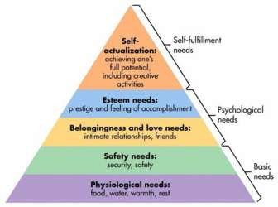

## Figure2.1: Maslow's Hierarchy of Needs Five Stage Pyramid

The deficiency or basic needs are said to motivate people when they are not achieved. Also, the need to fulfill such needs will become stronger, the longer the duration they are denied. For example, the longer a person goes without food, the hungrier he becomes. One must satisfy lower level basic needs before progressing to meet higher level growth needs. Once these needs have been reasonably satisfied, one may be able to reach the highest level called self- actualization. Every person is capable and has the desire to move up the hierarchy toward a level of self-actualization.

Changes to the original five-stage model are highlighted and include a seven-stage model and eight-stage model, both developed during the 1960's and 1970s.

* + 1. Biological and Physiological needs - air, food, drink, shelter, warmth, sex, sleep, etc.
    2. Safety Needs - protection from elements, security, order, law, stability, etc.
    3. Love and Belongingness Needs - friendship, intimacy, affection and love, - from work group, family, friends, and romantic relationships
    4. Esteem Needs-Self-Esteem, achievement, mastery, independence, status, dominance, prestige, managerial responsibility, etc.
    5. Cognitive Needs - knowledge and understanding, curiosity, exploration, need for meaning and predictability.
    6. Aesthetic Needs - appreciation and search for beauty, balance, form, etc.
    7. Self-Actualization Needs - realizing personal potential, self-fulfillment, seeking personal growth and peak experiences.
    8. Transcendence Needs - helping others to achieve self-actualization.

This study is related to the first theory of Maslow (1943) which was the original hierarchy of needs five-stage model in the area of biological and physiological needs which includes air, food, drink, shelter, warmth, sex, sleep. Clothing provide warmth to human being in the universe hence its relevance to the presence study.

This study is also related to Maslow‟s theory in the area of safety needs such as protection from elements which is another function of clothing among which Maslow categorizes on basic and psychological needs which ensure survival above.

This study is also related to Maslow‟s theory in the area of aesthetics which came up in Maslow‟s expanding theories step six which is aesthetic needs appreciation and search for beauty and clothing has beauty quality that is we use clothing to beautify ourselves. Maslow, (1943) states that people are motivated to achieve certain needs. When one need is fulfilled, a person seeks to fulfill the next one.The quest for the following needs of the pregnant women such as inability to still wear the garment they wore before pregnancy, unavailability of functional maternity garments/apparels, unavailability of commercial maternity garments patterns due to ban of importation of garments patterns in the country. These needs motivated the researcher for this study and also hinges the study on Maslow theory of needs.

## Aesthetic Theory

This theory states that clothingare worn for beauty sake. Schramm (2000), also notes that the present day trend toward interchangeability of parts of the wardrobe to effect greater variety in the clothing originated in the nineteenth century. It was about 1900 that bodice of skirt wasjoined at the waist line to a one-piece dress. The chief contribution of the twentieth century is the idea of the basic wardrobe and the basic clothes. On the other hand, Roschco, (1993)

observesthat the present generation has concept of good taste and of art different from the olden days. Most young fashion leaders of today have an education based on the principles of art. The modern dress design has a philosophy of art, fashion and history, plus imagination. Art is no longer only the ability to paint a picture, the focus is also on developing the ability to choose and assemble garments, accessories and home furnishings, displaying both creativity and appreciation. Intellectual and manipulative skills developed by practice can enhance one „s imaginative abilities, which can be seen in one „s choice of beauty and taste.

The theory is related to this study in the area of art, fashion, imagination aspect hence art is no longer only the ability to paint a picture, the focus is also on developing the ability to choose and assemble garments, accessories and home furnishings, displaying both creativity and appreciation. Intellectual and manipulative skills developed by practice can enhance one „s imaginative abilities, which can be seen in one „s choice of beauty and taste.

The idea of bodice and skirt joined at the waist line to formone-piece dress are part of this study because the constructed maternity apparels aim at aesthetic and bodice and skirt were also joined together to produce gown in this study.

## Conceptual Framework

Pregnancy according to Hornby (2002) is the state of having a baby developing inside a woman's womb. There are different types of pregnancy stages which include first trimester stage, second, trimester stage and third trimester stage. The first trimester stage is a period of the pregnancy from day one of fertilization to the end of third month while the second trimester stage begin with the fourth month to the end of six months and the third trimesters stage commerce with the seventh months to delivery day.

The course of pregnancy involves a lot of psychological, emotional and physical changes in women. These changes are as a result of hormones (oestrogen and progesterone) produced in the bodies which help in the maintenance of pregnancy in a woman. The changes affect the body size, enlargement of the stomach, every tissue and organ reacts to the stimulus of pregnancy and the metabolic, chemical and endocrine balance of the body is altered (Myles, 2005).

Pregnancy period is also characterized by changes in physical shape, appearance, body weight or size. Owing to pregnancy, the woman's sitting and standing postures as well as her walking position are altered. However, these physical changes which occur in pregnant women need special clothes usually known as maternity apparels for comfort and easy movement. Blunin (2001) also notes that pregnancy is a beautiful time to be comfortable and fashionable. Pregnancy does not mean that the comfort or stylish days are over, and so one should offer oneself the perfect means of comfort, fit, style (Annette, 2001). A pregnant woman's clothing standard should not be over looked because the pregnant woman also needs fashion, style and comfortable maternity apparels during pregnancy. When dressed in comfortable maternity garments, the pregnant woman has a feeling of assurance.

Pregnant women‟s clothing is functional when it meets the required standard such as comfort, protection, safely and aesthetics (Zicgal and Blareom, 1992). William, (1997) defines a pregnant woman as one who is carrying a developing fetus in her womb for about 36 weeks. In the same vein Doddes, Carter and Curininghan (1969) view pregnancy as a condition of being with a child. Pregnancy results from the fertilization of an Ovum by a spermatozoa and the implantation in the endometrial of the uterus, where it undergoes development (zygote, embryo and foetus) and in the human species is evacuated from the uterus after approximately 280 days‟ gestation. Blareom (1992) observes that maternity apparels should be comfortable and attractive

to enhance physical appearance. It should be light, loose and non-constricting to the body for psychological satisfaction. Certain conditions demand clothes to be constructed with certain features that could facilitate rather than hinder comfort. Such clothes are often referred to as functional clothes (Weber, 1990). Whenever a pregnant woman is happy most especially with the apparels on the growing body, there appears to be peace of mind which brings about psychological stability. However, these physical changes, in pregnant women need special clothes usually known as maternity apparels these can be met through either ready-made garments or custom garments and by developing comfortable adjustable maternity apparel for the pregnant women.

Patterns can be defined as required styles and designs adapted from basics blocks to meet the individual, groups, association, institution or organization and family apparel desires for proper development and constructions. These patterns can be commercial or drafted;the commercial patterns can be purchased with the figure size and used directly if available; if not available the basic blocks can be drafted and adapted to fit the style in need. According to Igbo (2003), there are two stages in pattern drafting: the making of a set of five basic patterns known as 'block patterns' or 'blocks', and secondly the adaptation of the blocks to the style required. The five blocks are-front and back bodice, sleeve, front and back skirt. The advantage of cutting from blocks is that the blocks provide a permanent record of the correct fit while dart movements, additional seams, fullness, etc., are planned on them. Cutting from blocks has the added advantage of being quicker than any other system. The method of using the same set of blocks to adapt to any style shows that all styles, no matter how different they may appear, must be related since they are all developed from the same basic shape and will thus fit the same figure. These basic blocks can be converted to functional maternity garments through the process of pattern

adaptation, use of fasteners and disposal of fullness.Disposal of Fullness is a technique used in clothing construction for creating comfort and variations which can be functional as well as decorative in other to get rid of excess fabric.

Fastenersare used to join and close opening in order to make it easier to put on and take off clothes. Fasteners are also use in pockets to prevent items from falling out. Fasteners also have decorative purposes and help to convey a certain style. Common fasteners include snap fasteners, Velcro, hook and loop fasteners, buttons, and zip fasteners. Each type of fastener has its benefits and application method therefore, choosing the right one for the clothing item requires some background information in order to make the best choice (Watkins, 1995). A carefully chosen fastener thus contributes to the overall look of the clothes. The fastener should also be easy enough to apply either manually or with a sewing machine while Fasteners can be bought from crafts shops or Markets.

Disposal of Fullness is a technique in clothing construction that creates the fitness with allowance for free movement in garments thereby can be used for different styles in clothing construction. Fullness can be used to solve figure problems or create illusion to enhance the figure wearing a garment been devised from the fourteenth century onwards, which include: darts, tucks, pleats, gathers, ease and shirring. Geetha and Rajitha (2005) view fullness as an important feature of style as well as a necessity for ease of movement in a well fitted garment, whereas fashion changes the basic methods of controlling fullness that frequently recur, though adapted to enhance the current style.

## Clothing Needs of Pregnant Women

The clothing needs of pregnant women include soft fabric like cottons, light, loose and non-constricting to the body for the purpose of airing, comfortable and attractive to enhance the aesthetics, psychological feelings and satisfactions. The pregnant women equally need apparels that will cut across the three trimester‟s stages up to post-natal. These pregnant women clothing needs, can be met through careful selection of fabric, styles, designs, patterns and techniques to achieve comfortable and psychological stability of pregnant women. Patterns are integral part of development and constructions which can never be dispensed as such serve as the foundation of designs and development in clothing constructions.

Ohaka, (2009) Observes that the pregnant woman of today wants to be as fashionable as her friends who are not pregnant and wants to surround herself with such luxurious fabrics as cashmere, lace, silk and fine cottons. The modern woman of today wants the adoring glances received before this magical journey began. The trends in maternity clothes are heading toward the more fitted shape to not hiding the belly, but to celebrate it. Just as many women want to appear slim, so also many women want to look pregnant and show it all off. Certain styles look especially beautiful on pregnant women such as A – line skirts, empire – waist dresses and tops, and pencil skirts paired with swing shirts (Rhayes, 2005). A pregnant woman needs a well – fitted bra – one that not only supports the changing breast size but promotes healthy functioning of the lymphatic and milk producing system in the breast (Fredrick, 2002). Brassieres should be well fitted with wide shoulder strips and breast should be adequately supported and the nipple not flattened. Clothing for pregnant women should be suitable for the time of the year (light, washable, hanging from the shoulders) and above all, attractive. They need cotton fabrics that will help keep the body cool.

Diane (2002) is of the view that metabolic rate increases by about 20% during pregnancy which means that if everyone else is shivering, from cold, a pregnant woman is likely to be complaining about feeling hot. A pregnant woman‟s clothing (maternity cloth) should consist of light, loose and non-constricting ones. They need proper quality undergarment. Lyle and Brinkley, (1983) are of the view that cotton undergarment is good, cool, easy to keep clean and can be bleached with liquid chlorine and washed in hot water. Webb-Lupo and Lester, (1999) are of the view that underpants, slips size and bra that allow size for changes and which provide a comfortable fit should be used. Maternity clothing should be designed to grow with a pregnant woman‟s body (Annette, 2000). He further notes that maternity clothes should not only be fashionable but should be transformed to accommodate the changing physical needs of the expectant mother. Maternity wears should hang from the shoulder and not from the waist. More so, attractive clothes are very important since it adds to the expectant mother‟sself-confidence and appearance. Clothes with loose and flowing line make expectant mothers cloth easier and safer to accommodate pregnancy in early months (Bennett and Linda, 1993). Thresyamma, (2002) and Michelle, (2002) note that pants without panels are better and more comfortable for pregnant women. Skirts, slacks or shorts cut longer or made of knit fabrics allow room for the growing baby. Shoes with low and wide heels are more stable and secure. Feet may swell, so shoes that do not have binding straps and that are not too tight may be more comfortable. Ziegel and Blarcom, (1992) opines that shoes with a wide heel base not necessarily low can be used if the mother is accustomed to wearing moderately high heeled shoes. For it provides a good arch for support and fit over the instep and are advisable for most of the day.

**Meeting the Clothing Needs:** Meeting the clothing needs of pregnant women is the act of providing clothes that will solve their problems. Provision is the act of supplying one‟s need or

want (Hornby, 2000). Griese (2002) reaffirms that some creative ways of providing clothing at affordable pricesare borrowing from friends or family members and renovating plus size clothes. In view of web-Lupo and Lester (1987) clothing can be provided through the following alternatives- purchasing, sewing, trading or Sharing and renting.

**Purchasing:** Clothes can be purchased at boutiques, department stores, outlets stores, supermarkets, markets, offices, from petty traders who carry clothes from house to house and store to store. Second hand clothing can be purchased from the used clothing stores and markets.

**Sewing:** Sewing is the only way to get new styles, colour and fit for some people. Sewing cloth requires time and skills. Some clothes are cheaper and easy to sew.

**Trading or Sharing:** People that are related or friends can share, trade or exchange clothes thereby getting a new item at no cost. Hand-me-downs are example of sharing.

**Renting:** Clothing can be rented especially when the garment is needed for a limited time.

**As Aids:** there are some charitable organizations who give out clothing items to the less privileged. Clothing can be acquired through the aid of non-government organizations which are interested in welfare of women, deserter and refugee teams as well as some religious organizations (Evangelical Lutheran Church America 2008) The United Nations Food and Agriculture Organization and World Health Organization in 2001, made a clarion call for efforts to be made to make probiotic products more widely available, especially for relief work and populations at high risk of morbidity and mortality.

## Drafting of Basic Block Patterns

The three major methods of garment construction include, draping, drafting and flat pattern making. It is a method of obtaining patterns by working from the measurements of the figure according to a set of instructions and drawing a shape on paper or card. The alternative is to work directly on a dress stand, either using a cheap fabric such as calico or muslin which is then used as a pattern to cut the fabric, or using the fabric itself. This system is known as 'modeling‟ and although it is the only suitable method for draped styles (as it enables the exact position and amount of fullness to be controlled), it would be very expensive and time-consuming to make every pattern by modeling (Ahuwan 1996).

**Patterns:** can be defined as required styles and designs adapted from basics blocks to meet the individual, groups, association, institution or organization and family apparel desires for proper development and constructions. These patterns can be commercial or drafted; the commercial patterns can be purchased with the figure size and use directly if available; if not available the basic blocks can be drafted and adapted to fit the style in need. According to Igbo (2003), there are two stages in pattern drafting: the making of a set of five basic patterns known as 'block patterns' or 'blocks', and secondly the adaptation of the blocks to the style required. The five blocks are-front and back bodice, sleeve, front and back skirt. The advantage of cutting from blocks is that the blocks provide a permanent record of the correct fit while dart movements, additional seams, fullness, etc., are planned on them. Cutting from blocks has the added advantage of being quicker than any other system. The method of using the same set of blocks to adapt to any style shows that all styles, no matter how different they may appear, must be related since they are all developed from the same basic shape and will thus fit the same figure. These basic blocks can be converted to functional maternity garments through the process of pattern

adaptation, use of fasteners and disposal of fullness. Disposal of Fullness is a technique used in clothing construction for creating comfort and variations which can be functional as well as decorative in other to get rid of excess fabric.

## The Development of Pattern Drafting used for Designed Maternity Apparels

The Flat Pattern Method was selected out of other patterns used for clothing construction such as pattern drafting, pattern draping, knock down pattern and computer aided design pattern; for construction of the maternity wears without fasteners and disposal of fullness techniques-1 (MWWFD-1) and the design maternity wears with fasteners and disposal of fullness techniques- 2 (MWWFD-2). Flat Pattern Method is a method that involves the use of a simple pattern which is changed or modified by specific directions to create a pattern for a chosen design (Hollen, 1966). The Flat Pattern Method was used due to its importance; as it contributes to a better understanding of pattern adaptation, garment fitting, and the use of fabric grain. It increases the ability to plan new procedures and make proper corrections; and practice economy in the restyling of out- of-date clothing and old patterns as well as the feeling of confidence which comes with an understanding of pattern making principles and the feeling of pleasure derived from creative activities. Flat Pattern designing begins with a basic pattern which may be called a sloper, block and master or foundation pattern. It consists of five pieces: bodice front, bodice back, sleeves, skirt front, and skirt back (Hollen, 1966). These basic blocks was traced out on brown paper after proper laying and pinning with the aid of dress makers' tracing paper following the straight pins, the patterns was cut out for adaptation.

## Concept of Fasteners and Closures in Designing Maternity Apparel.

A fastening is a method used to hold together the opposite matching parts of a garment. Aubrey (1999) is of the view that hook-and-eye closure is a very simple and secure method of

fastening garments together. It consists of a metal hook, commonly made of flattened wire bent to the required shape, and an eye (or "eyelet") of the same material into which the hook fits. Omar, (1999) sees button in modern clothing and fashion design, as a small fastener, now most commonly made of plastic, but also frequently of metal, wood or seashell, which secures two pieces of fabric together. In archaeology, a button can be a significant artifact. In the applied arts and in craft, a button can be an example of folk art, studio craft, or even a miniature work of art. Buttons are most often attached to articles of clothing but can also be used on containers such as wallets and bags. However, buttons may be sewn onto garments and similar items exclusively for purposes of ornamentation which is also applicable to maternity wears. Buttons serving as fasteners work by slipping through a fabric or thread loop, or by sliding through a buttonhole. Other types of fastenings include zippers, Velcro and magnets.

Watts, (1981) refers to Velcro as a self-fastening tape that is commercially produced in 2.5cm wide strips available in a range of colors. The fastening is made in two separate strips that grip together. One side is covered with small hooks; the other side has a soft looped surface. Directions are given on the pack for stitching. This is a time saving fastening with a wide variety of uses. Weber, (1990) saw Velcro as Hook and Loop Tape in which the tape is with tiny hooks on one strip and loops on the other can be pressed together and pulled apart very easily, used in small pieces to replace snaps or buttons, used in longer strips to replace a zipper or provide an adjustable closing. Applied at seam of pants or sleeve to permit easier dressing over a cast or brace. Neal, (2000) said that fastenings of garments should have as long life as the garments it serve, provided that its' been chosen and attached correctly. Neal, (2000) added that Fastenings chosen should be suitable for the:

1. garment (Zip Fasteners in skirts buttons and button holes in pajamas).
2. material (loops and buttons for fraying materials, button holes and buttons for firmer ones).
3. position (buttons and loops where edges meet, buttons and buttonholes where they overlap).
4. age of the wearer (ribbons for babies' garments, „Velcro‟ for children's garments). Watts, (1981) also said that whatever the fastening chosen, the method of attaching should comply with the following rules:
   1. Fastenings should always be sewn on to double material.
   2. They should be as inconspicuous as possible unless used as decoration.
   3. If the garment is likely to be washed, fastenings should also be washable (e. g. covered buttons should have washable, rustles molds).

Musheno (1977) said that Velcro as Nylon closure tape consists of two strips, one faced with minute hooks and one with pile, that intermesh when pressed together. It can be an indispensable aid for light weight, jam proof fastenings according to (Wingate, 1975): Velcro is a trade mark for a completely textile closure of hook-like nylon pile fabric to an opposing nylon pile. Velcro as a trade mark for a fastener consisting of two stripes, one with a dense layer of tiny Nylon strips, one with a dense layer of tiny nylon hooks and the other of loops that interlock with them used for outerwear, athletic shoes and luggage.

Zipper, zip, fly or zip fastener, formerly known as a clasp locker, is a device commonly used for binding the edges of an opening of fabric or other flexible material, like on a garment or a bag. It is used in clothing (e.g., jackets and jeans), luggage and other bags, sporting goods, camping gear (e.g. tents and sleeping bags), and other items. Whitcomb L. Judson was an American inventor from Chicago who invented and constructed a workable zipper. The method, still in use today, is based on interlocking teeth. Initially it was called the "hook less fastener" and was later

redesigned to become more reliable. According to Hubbers (2015), typical fasteners are buttons, loops that are designed with hand, including hooks as well as eyes, buttonholes, press studs, socket, Velcro, zips, clasps, and loops over buttons in addition to ball among others. Zips can be used as fasteners for clothes, chair covers, cushions, pillows and others. Zips are available in metal or nylon. Velcro is made up of two types, these are hooks and loops. When pressed together, they cling to each other. This is easy to sew on clothes as use of hand or machine stitch into place. It exists in different weights, colors and width (Hubbers, 2015).

1. to give good shape and proper fit to the garment;
2. to allow freedom of movement and comfort to the wearer and
3. to make the garment look attractive.

## Importance of Clothing Fasteners and Closures (Hook and Eye, Button, Velcro and Zip)

The hook and eye played an important role in women's corsetry; used in rows, which distribute the stress involved in restrictive garments. It was not until the first part of the 19th century that the industry was furthered in the United States. One of the greatest improvements in the attachment was the "Belong hump", patented in 1889 by the Richardson & Belong Hook and Eye Company of Philadelphia, Pennsylvania which was a raised elevation or "hump" in the wire hook that prevented the eye from slipping out of the hook, "except at the will of the wearer" Buttons are most often attached to articles of clothing but can also be used on containers such as wallets and bags. However, buttons may be sewn onto garments and similar items exclusively for purposes of ornamentation. Buttons serving as fasteners work by slipping through a fabric or thread loop, or by sliding through a buttonhole.

Metal zippers can be painted to match the surrounding fabric; plastic zippers can be made in any color of plastic. Plastic zippers mostly use polyacetal resin, though other thermoplastic polymers are used as well, such as polyethylene. Open-ended zippers use a box and pin mechanism to lock the two sides of the zipper into place (Benjamin, F. 2003).

The importance of Velcro on clothing can be seen through its qualities and numerous functions such as; Velcro is strong enough that a two-inch square piece is enough to support 175 pounds (75kg) person. The strength of the bond depends on how well the hooks are embedded in the loops, how much surface area is in contact with the hooks and the nature of the force pulling it apart. If Velcro is used to bind two rigid surface for example auto body panels and frames, the bond is particularly strong because any force pulling the pieces apart is spread evenly across all hooks. Also, any force pushing the pieces together is disproportionally applied to engaging more hooks and loops.

Vibration can cause rigid pieces to improve their bond. Full - body Velcro suit have been made so that they can hold a person to a suitably covered wall. When one or both of the pieces is flexible, for example a pocket flap, the pieces can be pulled apart with a peeling action that applies the force to relatively few hooks at a time. If a flexible piece is pulled in a direction parallel to the plane of the Velcro surface, then the force is spread evenly as it is with rigid pieces. Three ways to maximize the strength of a bond between the two flexible pieces according to (Beth, 2013) are to:

1. increase the area of the bond, for example using larger pieces of Velcro;
2. ensure that the force is applied parallel to the plane of the fattener surface, e.

g. bonding around a corner or a pulley; and

1. increase the number of hooks and loops per area unit.

Shoe closures can resist a large force with only a small amount of Velcro, this is because the straps are wrapped through a slot, having the force on the bond by acting as a pulley system thus gaining a mechanical advantage and further absorbing some of the forces in friction around the tight band. This layout also ensures that the force is parallel to the Velcro strips (Beth, 2013). Velcro is easy to use, safe and cheaper, and affordable; there is only a minimal decline in effectiveness even after many fastenings and unfastening. The tearing noise it makes can also be useful against pick pockets. In addition, in the United States air force, where Velcro is used to attach patches to flight suits, aircrews have learned that they can remove small cloth pile balls that accumulate on the suits by using the hook side on the back of the patches like a brush to remove them. Despite its numerous advantages, Velcro still has several deficiencies such as: it tends to accumulate hair, dust and fur in its hooks after a few months of regular use. The loops can become elongated or broken after extended use,

Velcro often becomes attached to articles of clothing especially loosely woven items like sweaters. The clothing may be damaged when one attempts to remove the Velcro even if they are separated slowly (Joseph, 2003). It continued by saying that the tearing noise made by unfastening Velcro makes it inappropriate for some applications, for example a soldier hiding from his enemy would not want to alert the enemy to his or her position by opening a Velcro pocket. It also absorbs moisture and perspiration when worn next to the skin and it smells if not washed. Textiles can contain chemicals or compounds for example dyes that may be allergic to sensitive populations. Velcro products have been tested according to the Oeko-tex Certification Standard which imposes limits on the chemical content of textiles to address the issue of human ecological safety.

Application of Velcro increases due to the fact that it is easy to use, affordable and safe, the hook and loop fasteners have been used for just about every conceivable application where a temporary bond is required. It's especially popular in clothing where it replaces buttons or zippers and as a shoe fastener for children who have not yet learned to tie shoelaces and for those who choose Velcro over laces (Joseph, 2003). Velcro is used in adaptive clothing, which is clothing designed for people with physical disabilities, the elderly and the infant who may experience difficulty in dressing themselves due to an inability to manipulate closures, such as buttons and zippers, as Velcro is easier to manipulate, it users a good replacement.

Velcro hold together a human heart during the first artificial heart surgery and it is used in nuclear power plant and army tanks to hold flashlights to walls, cars use it to bond headliners, floor mats and speaker covers. It is used in the home when pleating draperies, holding carpets in places and attaching upholstery, among many other things. It closes backpacks, briefcases and notebooks, secures pockets and holds disposable diapers on babies. It is an integral part of the game tag rugby; it is used in surfboard leashes and orthopedic braces. NASA makes significant use of Velcro each shuttle has ten thousand inches of a special Velcro made of Teflon loops, polyester hooks, and glass backing.

Velcro is used everywhere, from the astronauts‟ suits, to anchoring equipment. In the near weightless condition in orbit, Velcro is used to temporarily hold objects and keep them from floating away (Joseph, 2003). A Velcro patch is used inside astronaut's helmets where it senses as a nose scratcher, during mean times astronauts use trays that attach to their thighs using spring and Velcro fasteners. The U. S. army is another big user of Velcro: it uses Velcro fasteners on combat uniforms to attach name tape, rank insignia, and shoulder pockets for unit's patches, skill tabs and recognition devices such as on fared (R) Feedback American flag. They also had silent

Version of Velcro developed for use with army soldier uniforms, as ripping sound could betray a soldier's position.

The advantages of this new Velcro are that it is more durable that is it does not wear down over time, it is eight time stronger, and makes noise when fastened or unfastened. However, it is thicker and bulkier, which limits some of its applications and it is also not as flexible as Velcro. Velcro has worked its way into popular culture and common knowledge, as such it has been part of many movies and mentioned in songs and television shows (Beth, 2013).

## Concept of Fullness and Disposal of Fullness

Fullness is a special feature introduced in garments to create variation in designing. It may be described as the feature used in garments to incorporate easy movement and comfort. Fullness helps to get proper fit and comfort. Fullness controls the fabric drape. Example: Darts reduce the amount of fabric used and flare produces an opposite effect. Each type of fullness has unique features. Hence, great care and keen interest is needed to understand and learn the methods of drafting and constructing fullness. Fullness in this content is a means of creating comfort and variations (Rajitha, 2005). Clothing construction and fashion designing are based upon the concept of creating basic outfits and modifying them to suit one's figure on one hand and create variations on the other. Fullness modifies the basic pattern. They lay the strong foundation for dress designing. The concept of fullness bifurcates as follows: Fullness control and disposal of fullness in garments. Fullness in a garment may be for holding of the excess in a garment by the use of darts or may be used to release the fullness in the form of pleats, tucks etc. Fullness is introduced into garments for various reasons such as: Fullness can be added in garments for the following reasons: better shape, compatibility of movement, produce good fit, add beautification, and create variations. Fullness can be divided into two major types: Functional Decorative

Fullness, Functional Fullness is introduced in a garment in order to give proper fit to the wearer, example: Darts introduced on sari blouses. Decorative fullness on the other hand is introduced to create variation and to add increase in the appeal of the garment, example: Ruffles on a frock.

## Importance of Disposal of Fullness in Maternity Apparels

Disposal of Fullness is a technique in clothing construction that creates the fitness with allowance for free movement in garments thereby can be used for different styles in clothing construction. Fullness can be used to solve figure problems or create illusion to enhance the figure wearing a garment been devised from the fourteenth century onwards, which include: darts, tucks, pleats, gathers, ease and shirring. Rajitha (2005) view Fullness as an important feature of style as well as a necessity for ease of movement in a well fitted garment, whereas fashion changes the basic methods of controlling fullness that frequently recur, though adapted to enhance the current style.

Darts, tucks, pleats, gathers are some of the devices for introducing fullness. A tuck is a fold of fabric stitched in place by running stitch; pleats are folds of fabric that provide fullness in some parts of a garment which can be placed single or in series that can be pressed flat or left unpressed, based on the style of the garment. Pressed pleats give a smooth, slimming line to a garment, whereas, unpressed pleats provide a softer and fuller shape. Pleats are introduced usually at the waist line of skirts and dresses to provide fullness evenly all around. The preparation of pleats is similar to that of tucks, the main difference being that, pleats are seldom stitched all the way down. Sometimes pleats are stitched part way down the garment for flatness. Each pleat requires extra material of twice the width of the finished pleat. If pleats are to touch each other all round the garment, the amount of material needed is three times the finished width. Rajitha (2005) also further viewed that there are different types of pleats that can be used in

garment construction. Among more commonly used are: a Knife pleats that are usually about 1/2 inch to 1 inch wide and are turned towards the same direction. The direction may be reversed at Centre back or Centre front of the garment. Make all the pleats in the same direction. Pleats can be top stitched in place from waist to hip to produce the slender effect. The main function of a knife pleat in a tailored garment is to provide fullness at the bottom of the garment. Box pleats are two knife pleats turned away from each other one to the left and one to the right, these arc used quite often for uniform and are usually about 1/2 inch to 1 inch wide and are turned towards the same direction; the direction may be reversed at centre back or centre front of the garment. Inverted pleat is the opposite of a box pleat; it is made up of two knife pleats turned towards each other so that the folds meet in the middle on the right side of the garment. It is usually designed at centre front or centre back and looks like two knife pleats facing away from each other on the underside (Rajitha, 2005).

According to Marjorie and Baker (2007), Darts are used to shape fabric to fit the body which provides fullness to body curves. Sometimes, darts are used decoratively to provide a design line and are not used for fitting. It is important to be accurate when fitting, marking, stitching, and pressing darts. A well-constructed fitting dart should be directed towards the body curve, usually end 1/2 to 1 inch from the fullest part of the body curve, be tapered, smooth and free of puckers.it should be even and smooth in appearance; be pressed before being crossed by another line of stitching, and after the garment has been fitted. Uncut horizontal darts are usually pressed down; uncut vertical darts are usually pressed so the fold is toward the center front or center back. Have threads secured at both ends by tying a knot, lock stitching, or backstitching (use only on medium to heavy fabric or in seam line). Since darts are part of the pattern designed to fit a garment to the body, be sure darts are correctly positioned on the figure. Darts should be

directed toward the fullest part of the body curve. If you have a large body curve, two small darts will usually fit better than one large dart. Always check dart placement and make any necessary adjustments before permanently stitching and pressing (Marjorie and Baker, 2007)

Pleats can also be used to control fullness in a garment design that may be pressed or unpressed, soft or crisp. When selecting fabric for a pleated design, be sure it has good drape and is resilient and care should be taken when cutting and marking to see that pleats are on grain to ensure proper hang of the garment. Well-constructed Standard pleats will have a smooth, neat appearance on the outside and inside of a garment, provide ease for comfort and design silhouette. When marking pleats, you will need to mark the fold line, roll line, and placement line using the marking method most suitable for the fabric. It is always important that you carefully check the fit of pleats before permanently stitching and pressing. If there are pleats on either side of the center front or center back, be sure pleats are balanced on each side in relation to the area.

A pleated skirt design should hang straight from the hipline - unless it is a tapered pleat design line. Remember to allow for some ease at the waistline when fitting pleats (Marjorie and Baker, 2007).

## Types of Pleats

Marjorie and Baker (2007) also note types of pleats to be four which are:

* Knife or Side - are flat and are turned to one side, usually right to left on the outside of garment used in kilts, skirts, and on shoulders of bodices.
* Box - are two straight pleats with folds turned away from each other and are used in skirts, dresses, shirts, and jackets.
* Inverted - are two straight pleats with folds turned toward each other that meet in the center and are used primarily in skirts.

Accordion - are narrow pleats at the top and radiate to a wider width at the bottom which are not stitched down and are used in skirts, sleeve designs, and lingerie.

## Importance of Comfortable Clothes for Pregnant Women

According to Barari (2016) Comfortable Pregnancy Clothes for pregnant women have branched into a tiny little fashion industry these days. The pregnant women must wear comfortable clothes, hence Clothes for pregnant women are not always maternity clothes since pregnant women need to wear comfortable clothes before the baby bump starts showing. Getting proper clothes during pregnancy is also an integral part of prenatal care that a couple has to look into. What the pregnant women wear during pregnancy has a profound effect on their health. Why Comfortable Clothes for Pregnant Women? Firstly, for the pregnant women peace of mind, Pregnant Women will be otherwise uncomfortable in a thousand ways during pregnancy.

At least pregnant women apparel should make them feel at peace. During the first trimester of pregnancy, pregnant women will have attacks of morning sickness and nausea. There will be some indigestion too. In that case, it is better to avoid tight trousers or dresses that are tight around the waist. This is because it will make unsettled stomach wrestle even more. Many women complain about feeling hot during pregnancy. The hormones are on a roller coaster ride now so the pregnant women will sweat and feel exasperated or frustrated with heat, therefore wearing clothes that are too tight or of a material that makes one feel more hot will only aggravate the situation (Barari, 2016). The pregnant women will eventually start putting on weight from the second trimester, to accommodate the expanding figure there is need for the best

maternity clothes that will comfort the growing bump till the end of the third trimester. What Kind of Clothes Must Pregnant Women Wear? The typical maternity clothes used to be a shapeless sack. It does not have to be like that anymore. Comfortable clothes during pregnancy are frocks, rap around skirts and loose tunics that will be gentle on the expanding shape.

The pregnant women need to tone down the weight added and at the same time be comfortable with the clothes. The best maternity apparels are not always the loosest ones seen but also need to be fit in other to feel good about it and moreover, one can trip over the over flowing maternity gown if not careful. Try to favor skirts and dresses as opposed to trousers during pregnancy. This is because the pregnant women will have to pass out urine every now and then and trousers might be more restrictive in this regard. Also, as putting on weight will make the thighs rub against each other and get bruised. It is a very common problem among pregnant women and Skirts will give the bruised thighs some air whereas jeans trousers products will further bruise them and make walking very painful. If wearing of a saree is chosen, then do not tie the strings of the petticoat too tightly as it will obstruct the blood circulation. Clothes for pregnant women should be such that one can wear them without fuss over them (Barari, 2016).

## Review of Related Empirical Studies

This section of the study focuses on related empirical with the hope of establishing a gap for the present study.

Ohaka (2009) conducted a research on strategies for the provision of functional clothing for pregnant women in Imo state. The major purpose of this study is to investigate strategies for provision of functional clothing for pregnant women in Imo State. The study adopted the survey design approach. Multi-stage random sampling procedure was used in the selection of 530

respondents comprising 396 pregnant women, 54 nurses, and 80 Home Economics teachers drawn from both rural and urban locations in the study area. The questionnaire format followed a 5 point likert scale. The data was analyzed using mean and standard deviation for the research questions and t-test for the hypotheses. The study results reveal that the respondents have common opinion on pregnant women wearing clothes with features that should facilitate comfort instead of hindering it, there is also no dissenting opinion on the use of clothes to protect themselves against harsh weather, and pregnant women using clothing to enhance their appearance. The t-test result also reveals that there is no significant difference in the responses of urban and rural women on the factors that influence their clothing provision. Also, no significant difference exists between the responses of nurses and Home Economics teachers on clothing needs of pregnant women, while there is significant difference between the urban and rural pregnant women on problems encountered in their provision of functional clothing. Ohaka‟s research is similar to the present research in the area of pregnant women clothing and differ in the area of strategies for the provision of functional clothing for pregnant women in Imo state which was theoretical oriented while the present study is on practical development of functional maternity apparels pregnant women clothing from commercial block pattern, fasteners, and disposal of fullness in F.C.T. Abuja, Nigeria starting with pattern drafting to actual practical construction which is the gap to fill. It also differs in the area of design, the past study used survey while present study adopted research and development design (R&D).

Iloeje and Anyakoha (2009) conducted a study on the determination of mean body measurement of female youths (15-24 years) in tertiary institution in Enugu state. The purpose of the was to determine the mean body measurements of female youths (15-24 years) required to develop bodice block patterns (bodice, sleeve, skirt and pants) for three size categories small medium and

large. A purposive sample of nine hundred (900) female youths within the popular height range of 160cm -170cm were used. The instrument for collecting data for the study was an adopted Early Measurement Guide (BMG) from Aldrich (2002). It was used to take the body measurements of the subjects. It contained twenty-one (21) body measurements required for pattern drafting and sizing. The measurements were taken over one layer of garment. The results obtained showed that the mean body measurement for hips for small size 18 was 87.94cm, medium size 93.11cm and large size was 99.78cm. for waist measurement the mean for small size was 68.24cm, for medium size the mean was 71.38cm, while that of large size was 76.23cm. The mean body measurement obtained for bust was 81.90cm for small size, 85.96cm for medium size and 91.36cm for large size.

The study is related to the present study on the aspect of body measurement taken were classified into sizes for the purpose of using them for garment. Although, the size category was not used to produce basic garment pattern construction of maternity apparel for fit an aesthetic. In the present study, maternity apparel patterns were adapted from commercial blocks patterns for producing various maternity apparels for fit and aesthetic rating by users and judges rating.

Shailong (2017) conducted research work on development of self-instructional manual for teaching tailoring techniques to Home Economics students in Universities in north central Nigeria. The study aimed at enhancing students acquisition of some skills in tailoring techniques. Eight specific purposes guided the study. The study answered eight research questions and tested one hypothesis at 0.05 level of significant. The study adopted research and development (R&D) design which is similar to the present study design. The population was 4052 and sample size of 172 lecturers, technical instructors and final year students of Home Economics Universities of study and the instruments used for the data collection were four which include Tailoring

Techniques Need Self-instructional manual in Tailoring Techniques, Validates Assessment Questionnaire, Practical skill test items in tailoring techniques. Mean ANCOVA and t-test were used to analyze the data collected. It was discovered that the students taught with Self- instructional manual in Tailoring Techniques performed better than those taught with conventional methods. The past study differed from the present study in the area of eight research questions and one hypothesis for the past study while the present study is with seven research questions and four hypotheses.

Anya (1991) conducted a study on developing patterns for children's garment. The age involved were pre-school children to school age children. The study aims at highlighting new ideas and innovations to improve on children's classic block used in developing style patterns for garments that will impress both parents and children. Four blocks were drafted in four different children's size range. The most prominent areas treated in the work were patterns drafted for garment that would satisfy children in their physical and psychological developmental stages. Anya's research represented one of the ideas in developing patterns for pre-school children that will impress both parents and children similar to the present study in the area of developing patterns for pregnant women clothing; different in the area of practical construction of garments for pregnant women. The present study constructs garments for pregnant women using Hook and eye, Button, Velcro and Zip fasteners (as modification tools) F.C.T Abuja, different from Anya's location and level. The gap that will be filled by this present study is the actual practical construction of garments for pregnant women; hence Anya's research was on patterns drafting only, while the present study will be involved in patterns drafting and use of Hook and eye, Button, Velcro and Zip fasteners to produce different pregnant women garments.

Ying (2005) conducted an experimental research on physical mechanisms and characterization of smart infants‟ thermal clothing. The aim was to develop smart thermal functional textiles and clothing that can reduce heat loss problems of infants and provide a personal thermal comfort environment under changing temperature conditions. Microencapsulated Phase Change Materials (PCM) were incorporated into textiles. It absorbs heat energy when phase change materials change from solid to liquid and release heat when they change from liquid to solid. Using experimental investigations and numerical simulations, the thermoregulatory effects and mechanism of heat and moisture transfer behavior of single-layer PCM textiles and multilayer PCM assemblies were investigated and the thermal physiological responses of clothed infants were studied. Finally, based on the theoretical analysis and experimental investigation, smart thermal clothing – an infant‟s wrapper was designed and developed.

This research work shared relationship with the present study because both are developmental researches that dealt with innovation to design and develop clothing. However, the previous study was on thermal cloth for preventing heat loss among infants while the present study developed and designed maternity apparels to prevent problem of apparel choice for developmental stage (first second and third trimester stages) in pregnancy among pregnant women in FCT Abuja.

Yusuf (2017) conducted research on acceptability of adapted traditional Aso-oke in constructing garments for contemporary youths in Oyo state. The major objective of the study is to determine the acceptability of adapted traditional Aso-oke in constructing garments for contemporary youths in Oyo state, Nigeria. Specific objectives are: to ascertain the difference between individual yarns to produce contemporary Aso-oke fabric and conventional fabric in a way to reduce the weight among others. There were four objectives, four research questions and four

hypotheses respectively. Fine industrial yarn to produce Aso-oke fabric to improve the texture which was adapted to make garments for contemporary use. Experimental research design was used for the study. The population for the study was 43,640 and sample size of thirty (30) respondents were randomly selected by proportionate stratified random sampling technique. Hedonic card seeking for observation of respondents on appearance, texture and weight of the articles produced which was used to collect data for the study. Descriptive statistics was used involving mean to answer research questions and t-test was used to analyze the hypotheses at

0.05 level of significance. The findings revealed that six piles of yarn count for warp and weft of the conventional Aso-oke fabric escalated the weight and heaviness making the fabric uncomfortable to the wearer. It was concluded that reduction in yarn count to the use of two piles for warp and four piles for weft with plain weave dropped the weight of adapted Aso-oke and it was accepted.

This research work is related to the present study on the aspect of development and experimental Although the previous research work was youth acceptability while the present study was on development of functional design maternity apparel for pregnant women in FCT, Abuja. Research and development (R&D) design was used for the study, with the determination of average measurement for sizing first, second and third trimester stages in pregnant women.

Shailong and Igbo (2009), worked on the establishment of Average Body Measurement and Drafted Basic Block Patterns for male pre-school children in Enugu state. The purpose of the study was to: take body measurement of male pre-school children in Enugu State; establish average body measurements for male pre-school children in Enugu State; drafting standard basic block patterns for male pre-school children in Enugu State. A sample of three hundred (300) children and 38 dress makers/tailors who are specialist in sewing children wears were selected

for the survey and the experimental study. Measurements were taken from 17 parts of children body using tailors tape. The data obtained were used to draft basic block patterns for bodice (shirt), sleeve and trouser. The patterns were trued using calico fabric and corrections were made to come out with the correct blocks. Assessment criteria charts were developed by the researchers and it was used to judge the clothing fit on the models. Descriptive statistics was used in analyzing the data from the judge. The result was satisfactory and it was recommended that the block patterns should be used for mass production of garment for pre-school male children. This study is similar to the present study in the area of body measurement and drafted patterns and the present study also took relevant body measurement and drafted patterns. The present study differs from the previous one in the area of construction of maternity apparels for pregnant women in F.C.T. Abuja, it uses fasteners like hook and eyes, buttons, zips and Velcro as well as disposal of fullness (invited pleats) were used for producing maternity apparels that is functional from pre-natal to post-natal.The research design for the past study was survey design while the present study adopts research and development (R&D).

Ahmad (2014) conducted a comparative study between the use of buttons and Velcro fastener in production and use of clothing for pre-school children in Federal Capital Territory - Abuja. The major objective of this study was to examine the use of Velcro in the production of clothing for pre-school children in FCT- Abuja in Nigeria.The specific objectives are to: produce garments for pre-school children using Velcro fastener in all the openings for convenient self-dressing; compare the time used for wearing Uniform constructed with Velcro fasteners and the time used for wearing Uniform constructed with button fastener by pre-school children; three: ascertain time used for undressing Uniform with Velcro and time used for undressing Uniform with button fastener by pre-school children. The age involved was 3-5 years of pre-school children and the

Location was Abuja. The population for the study comprised five thousand and sixty-six pupils (5066) made up of all public Early Child Care Centers (ECC2), that is, Nursery II pupils‟ of 2011/2012 session in FCT Abuja. A total number of sixty pupils of thirty boys and thirty girls were randomly selected as the sample and randomly assigned to both experimental and control groups, that is, thirty (30) each. The research concept was on pattern and garment production which is similar with the present study but differ in the area of level which is on pregnant women clothing and on the area of variables which was two variables for the past study while this present study has four variables The major objective of this study is to examine the use of Velcro in the production of clothing for pre-school children in FCT- Abuja in Nigeria. The gap that the present study fills is in the area of additional variables and fasteners to be used for construction of pregnant women clothing as suggested by the external examiner in the previous study as well as the change in the research design such as past study was experimental design while the present study design is on research and development (R&D).

## Summary of Reviewed Literature

The Literature reviewed what different authors have written on pregnant women clothing. The Literature reviewed: Theoretical Framework on need for pregnant women Clothing, Concept of Hook and Eye, Button, Velcro and Zip fasteners, Importance of Hook and Eye, Button, Velcro and Zip as a Clothing Fastener, Types of Fastenings in Sewing Clothes and Clothing Fasteners Kinds, Importance of Comfortable Clothes for Pregnant Women, Six Tips for Maternity Clothes that are inexpensive and Empirical Studies. Literature reviewed above revealed the definition and meaning of various variables: such as pregnant women, Hook and eye, Buttons, Velcro and Zips fasteners. The Literature reviewed also points out the relevance of Maslow‟s Theory to the need for pregnant women‟s clothing. It also reveals the importance of fasteners involve in this

work as the hook and eye played an important role in women's corsetry; used in rows, which distribute the stress involved in restrictive garments. Buttons are most often attached to articles of clothing but can also be used on containers such as wallets and bags. However, buttons may be sewn onto garments and similar items exclusively for purposes of ornamentation. Buttons serving as fasteners work by slipping through a fabric or thread loop, or by sliding through a buttonhole.

Importance of Comfortable Clothes for Pregnant Women reveals that Comfortable Pregnancy Clothes for pregnant women have branched into a tiny little fashion industry these days. The pregnant women must wear comfortable clothes above all else. Clothes for pregnant women need to be comfortable clothes as such getting proper clothes during pregnancy is also an important element of parental care that a couple has to look into, for pregnant women peace of mind. Pregnant women will be otherwise uncomfortable in a thousand ways during pregnancy; at least pregnant apparel should make one feel at peace (Barari, 2016).

The gap noticed from previous researches that needed to be closed were: the previous researches did not produce patterns from commercial blocks while this research study fills the gap by the production of patterns from commercial blocks. Another gap noticed from previous researches that needed to be addressed include the need to produce apparels using fasteners. The present study, produced apparels using fastenerslike Hook and eye, Button, Velcro (that is hooks and loop fastener) and Zips. The researcher refers to it as converter that is multipurpose in use that was produce indifferent garments for pregnant womenin F.C.T.Abuja. This study also solved problems of undersize during first trimesters second trimesters and third trimesters. This study has particularly created new ways of using fastenersand disposal of fullness to hide the excess

when not pregnant and released the excess during pregnancy thereby creating job opportunity for the clothing industry.

48

## CHAPTER THREE

**RESEARCH DESIGN AND METHODOLOGY**

## PREAMBLE

This chapter deals with the research design and the methodology that is used in this research work under the following sub-headings.

* 1. Research Design
  2. Population for the Study
  3. Sample and Sampling Procedure
  4. Instruments for Data Collection
     1. Validation of the Instrument
     2. Pilot Study
     3. Reliability of the Instrument
  5. Procedure for Data Collection
  6. Procedure for Data Analysis

## Research Design

The research design used for this study was Research and Development design (R&D) which is a component of evaluation research; it aims at developing functional and effective products for needs according to detail specifications (Borg, Walter, Gall, Joyce, Gall, Meredith, 2007). The study is a research-based approach for developing new programs and materials to improve education. It uses research finding to design new products and procedures which are further subjected to field-test through research evaluation and refining to meet specified criteria of effectiveness, quality or similar standards (Borg et al., 2007).

In this study, the researcher adopts the R&D design being considered appropriate because R&D design is a component of evaluation research; it aims at developing functional and effective products for needs according to detail specifications while this study also aimed at developing functional and effective products of maternity apparels for the pregnant women in F.C.T Abuja with the use of fasteners (Hook and Eye, Button, Velcro and Zip).R&D design also produce products for needs according to detail specifications while this research also produce product (maternity apparels) for pregnant women needs according to detail specifications (see needs questionnaire in appendix II). For the purpose of the study, pregnant women apparels were sewn with fasteners for adjusting maternity apparels to different trimester stages. These adjustable maternity apparels were subjected to field-test through research evaluation instruments (questionnaires) and refining to meet specified criteria of effectiveness, quality or similar standard such as fit, comfort, aesthetics and expressive variables. According to Ajunwa (2015), business companies and State agencies, R & D would imply investigative activities aimed at making a discovery that can either lead to the development of new products or procedures, or for improve the existing products or procedures. R & D research design for higher institutions is one

of the means by which the horizon of knowledge can be expanded particularly by way of developing new products or processes to improve and expand the operations of vocational and technological departments. Gall and Borg (2007) provided a 7-step model for the process of R & D which was adapted into 6 phases for the design of various apparels for pregnant women.

## Method of Data Collection

**Phase I-** Questionnaire Distribution on the apparel needs of pregnant women

**Phase II-** Measurement of pregnant women based on trimesters **Phase III-** Adaptation of patterns from commercial block pattern **Phase IV-** Construction of the six Maternity Apparels

**Phase V-**Fitting by Users

**Phase VI-** Fitting by Judges

In line with the R & D model, the research was conducted in the following phases:

**Phase 1: Questionnaire Distribution:** this phase was thedevelopment and validation of instruments for data collection.

The following instruments were developed and validated for the study all in appendix II

* + 1. A Questionnaire on the apparel needs of pregnant women.
    2. Questionnaire on the apparels design features (functional, aesthetics and expressive) needs for adapting patterns.
    3. Questionnaire on the apparels design preferences using fasteners and disposal of fullness.
    4. Questionnaire on assessment criteria chart for pregnant women (users) rating on the appropriateness of the apparels in terms of fit, comfort, aesthetics, and expressive variables.
    5. Questionnaire on the assessment criteria chart for judges rating on the appropriateness of the apparels designed in terms of fit, comfort, aesthetics, and expressive variables.

This phase lasted for 4 weeks.

## Phase II:Measurement of Pregnant Women Based on Trimesters:

1. Measurements of pregnant women in first trimesters were taken.
2. Measurements of pregnant women in second trimesters were taken
3. Measurements of pregnant women in third trimesters were taken
4. Establishment of average body measurements.

This phase lasted for 2 weeks.

## Phase 3:Adaptation of Patterns from Commercial Block Patterns

1. Tracing and cutting of commercial block Pattern for adaptation of patterns (Appendix IV).
2. Adaptation of patterns for Maternity gown from commercial block patterns (Appendix V). (iii)Adaptation of patterns for Maternity blouse &skirt with zip fasteners from commercial block patterns (Appendix VI)
3. Adaptation of patterns for Maternity blouse on wrapper with zip fasteners from commercial block patterns (Appendix VII).
4. Adaptation of patterns for Maternity blouse on wrapper with hook and eye fasteners from commercial block patterns (Appendix VIII).
5. Adaptation of patterns for Maternity blouse on wrapper with Velcro fasteners from commercial block patterns (Appendix IX).
6. Adaptation of patterns for Maternity blouse on wrapper with buttons fasteners from commercial block patterns (Appendix X).

This phase lasted for 12 weeks.

## Phase IV- Construction of the Six Maternity ApparelsUsed for the Study

**(i)**. Laying, pinning of pattern pieces on fabrics and Cutting of fabric piece(Appendix XI)

1. Construction of the six Maternity Apparels (Appendix XII) This phase lasted for 12 weeks.

## Phase V-Fitting by Users (pregnant women) for Evaluation

* 1. Assessment by pregnant women using assessment charts to grade the wearing fit, comfort, aesthetics and expressive variables.

This phase lasted for four weeks

## Phase VI-Fitting by judges (clothing and textiles lecturers) for Evaluation

(i) Assessment by judges using assessment charts to grade the wearing fit,comfort, aesthetics and expressive variables‟.

This phase lasted for three weeks

## Population of the Study

The population for this study comprised of one hundred and twelve thousand, four hundred and thirty (112,430) pregnant women in F.C.T.A Hospitals, 2014(Source from F.C.T.A Health Research Ethics Committee Office Abuja). While one thousand three hundred and one (1301) pregnant women attending maternity clinic in General Hospital Abaji, 2017 field survey,

F.C.T Abuja with additional of ten (10) judges which include four Clothing and Textiles Lecturers,threeNurses and three registered Tailors. The pregnant women were considered because the researcher's defined study centered on pregnant women wears. Table 3.2 shows the population for the study

## Table 3.1: Population for the Study

**SUMMARY OF ANTE-NATAL CLINIC ATTENDANCE AND PREGNANCY OUTCOME IN FCTA HOSPITALS, 2014**

|  |  |  |  |  |  |  |  |  |  |  |  |  |  |  |  |  |  |  |  |
| --- | --- | --- | --- | --- | --- | --- | --- | --- | --- | --- | --- | --- | --- | --- | --- | --- | --- | --- | --- |
| **S/NO** | **HOSPITAL** | **ANC ATTENDANCE** | **LIVE BIRTHS** | | **FRESH STILL BIRTHS** | | **ASPHYXIA** | | **LOW BIRTH WEIGHT (<2.5KG)** | | **MACROSOMIC BABIES (<4.5KG)** | | **IMMEDIATE NEO NATAL DEATH** | | **BORN BEFORE ARRIVAL** | | **PREMATURITY (<34 WEEKS)** | | **MATERNAL DEATH** |
| **M** | **F** | **M** | **F** | **M** | **F** | **M** | **F** | **M** | **F** | **M** | **F** | **M** | **F** | **M** | **F** | **F** |
| 1. | WUSE | 14,790 | 938 | 840 | 15 | 21 | 46 | 25 | 27 | 34 | 40 | 28 | 4 | 1 | 22 | 29 | 20 | 16 | 1 |
| 2. | ASOKORO | 13,258 | 870 | 775 | 7 | 6 | 17 | 14 | 23 | 21 | 34 | 33 | 0 | 0 | 2 | 16 | 17 | 20 | 0 |
| 3. | MAITAMA | 9,611 | 705 | 693 | 12 | 10 | 18 | 18 | 27 | 28 | 14 | 42 | 2 | 6 | 12 | 13 | 17 | 21 | 3 |
| 4. | NYANYA | 14,550 | 1,248 | 1,162 | 14 | 12 | 25 | 23 | 63 | 49 | 39 | 43 | 8 | 4 | 26 | 28 | 18 | 13 | 8 |
| 5. | GWARIMPA | 12,074 | 907 | 939 | 7 | 8 | 8 | 10 | 20 | 15 | 14 | 28 | 0 | 0 | 10 | 15 | 6 | 7 | 1 |
| 6. | BWARI | 7,028 | 658 | 575 | 4 | 7 | 5 | 15 | 35 | 33 | 17 | 18 | 3 | 2 | 9 | 5 | 16 | 22 | 6 |
| 7. | KWALI | 9,391 | 474 | 422 | 2 | 11 | 9 | 5 | 36 | 34 | 5 | 3 | 6 | 2 | 12 | 9 | 5 | 5 | 3 |
| 8. | KUBWA | 10,627 | 1,251 | 1,155 | 21 | 19 | 18 | 12 | 117 | 98 | 10 | 5 | 5 | 3 | 13 | 11 | 11 | 16 | 5 |
| 9. | ABAJI | 5,570 | 273 | 209 | 3 | 3 | 2 | 4 | 10 | 17 | 2 | 2 | 2 | 2 | 3 | 7 | 3 | 2 | 0 |
| 10. | KARSHI | 6,616 | 466 | 509 | 12 | 9 | 2 | 6 | 21 | 20 | 8 | 5 | 0 | 2 | 6 | 5 | 1 | 2 | 1 |
| 11. | KUJE | 8,274 | 630 | 651 | 14 | 14 | 3 | 2 | 34 | 48 | 5 | 5 | 1 | 1 | 12 | 12 | 3 | 5 | 3 |
| 12. | RUBOCHI | 641 | 45 | 26 | 1 | 0 | 0 | 0 | 0 | 0 | 0 | 0 | 0 | 0 | 1 | 0 | 0 | 0 | 0 |
|  | **TOTAL** | **122,430** | **8,465** | **7,956** | **112** | **120** | **153** | **137** | **413** | **406** | **286** | **212** | **31** | **23** | **126** | **150** | **117** | **120** | **31** |
|  |  |  | 16,421 | | 232 | | 290 | | 810 | | 498 | | 54 | | 278 | | 246 | |  |

Source: FCTA Health Research Ethics Committee Office Abuja

53

## Table 3.2: Shows Ante-natal Clinic Attendance in General Hospital Abaji, Abuja 2017

|  |  |
| --- | --- |
| Months | Numbers of Pregnant Women |
| January | 135 |
| February | 115 |
| March | 87 |
| April | 92 |
| May | 77 |
| June | 96 |
| July | 141 |
| August | 69 |
| September | 73 |
| October | 102 |
| November | 55 |
| December | 259 |
| Total | 1301 |

**Source: Field Survey in General Hospital Abaji of F.C.T Abuja**

Table 3.2 shows the population for the study with one hundred and twelve thousand, four hundred and thirty (112,430) pregnant women from F.C.T.A Hospitals Abuja and table3.3 shows the population of one thousand three hundred and one pregnant women attendance in general hospital Abaji of F.C.T Abuja.

## Sample and Sampling Technique

The sample size of 399 pregnant women were used to generate primary data for the study. Purposive and Taro Yamane sampling technique were used in this study: purposive sampling technique was used to select one General hospital from F.C.T Abuja. The hospital was Abaji General Hospital. This General hospital was selected within F.C.T Abuja; of Nigeria to enable the researcher conduct the Research effectively. Purposive sample involve those that their contributions are relevant to the study (Uzoagulu, 1998). Taro Yamane method Sample size determination plays a significant role in research that uses primary data seeking responses from the use of questionnaires. The Taro Yamane method for sample size calculation was formulated by the statistician Tara Yamane in 1967 to determine the sample size from a given population. Below is the mathematical illustration for the Taro Yamane method: n= N/ (1+N (e) ^2). Where: n signifies the sample size, N signifies the population under study, e signifies the margin error (it could be 0.10, 0.05 or 0.01). In this study, the N is 112,430, e = 0.05. n= 112,430/ (1+112,430(0.05) ^2) from the above Taro Yamane sample size formula then n= 112,430/(1+112,430(0.0025)) n= 112,430/(1+281.075). n= 112,430/282.075 n= 398.581.n is

approximately 399 which is equal to sample size of the study. See (Appendix XV) for more detail. This was used to prepare one hundred and eighty (180) questionnaires for pregnant women needs of apparel, design features for the adaptation of patterns and functional apparels preferences of pregnant women data collection and one hundred and seventy (170) was returned. Thirty (30) pregnant women were measured to determine the average measurement and one hundred and seventy-nine (179) questionnaires was also distributed after the construction of the apparels to pregnant women (users) and 165 was returned. While other sample of

tenquestionnaires for judgeswere also distributed making total samples sizes 399 and 375 were returned for data analyses this was done with the ai research assistance.

## Instrument for Data Collection

Five major instruments were used to generate relevant primary data in this study and were developed and validated for the study (Appendix II) the instruments are listed below:

* + 1. A Questionnaire on the apparel needs of pregnant women: this consist of ten items describing the requirements of pregnant women apparels with five options for each for the respondents to select by ticking.
    2. Questionnaire on the apparels design features (functional, aesthetics and expressive) needs for adapting patterns: this consist of four items describing the apparels design features (functional, aesthetics and expressive) needs for adapting patterns with five options for each for the respondents to select by ticking.
    3. Questionnaire on the apparels design preferences using fasteners and disposal of fullness: this consist of seven items describing the apparels design preferences using fasteners and disposal of fullness with five options for each for the respondents to select by ticking.
    4. Questionnaire on assessment criteria chart for pregnant women (users) rating on the appropriateness of the apparels in terms of fit, comfort, aesthetics, and expressive variables: this consist of eight items describing the appropriateness of the apparels in terms of fit, comfort, aesthetics, and expressive variables with five options for each for the respondents to select by ticking.
    5. Questionnaire on the assessment criteria chart for judges rating on the appropriateness of the apparels designed in terms of fit, comfort, aesthetics, and expressive variables: this consist of eight items describing the appropriateness of the apparels in terms of fit, comfort, aesthetics, and expressivevariables that was assessed by judgeswith five options for each for the respondents to select by ticking.

This phase lasted for 4 weeks.

## Validation of the Instrument

In order to ensure the validity of the measuring instrument, four experts validated the five different instruments used for data collection both in face and content validity. The experts are: one expert from Textiles Science Department, two experts from the Department of Home Economics Ahmadu Bello University, Zaria and one expert from Department of Home Economics Federal College of Education, Zaria. The questionnaireswere appraised in relation to the apparel needs of pregnant women, the apparels design features, apparels design preferences using fasteners and disposal of fullness and its appropriateness of the apparels designed in terms of fit, comfort, aesthetics, and expressive variables respectivelyexperts‟ comments and suggestions were used to make correction on the instrument.

## Pilot Study

After necessary corrections and amendment of the measuring instrument, a pilot study as carried out at Salama Hospital at Kwangila in Zaria, Kaduna State of Nigeria. The pregnant women used for the pilot study were twenty (20) pregnant women present at the hospital. These samples had similar characteristics and background with the samples that were used for the study. The Pilot study was conducted by the researcher in which the questionnaires were given to the pregnant women to answer while the researcher waited and collect them. The 20 respondents

who were used as the pilot study were not used for the main study, but share similar characteristics in all respects. The researcher personally distributed the questionnaires and also waited to retrieve them for the purpose of determining the reliability of the instrument which was statistically carried out after the responses of the respondent. These were entered into the statistical package after coding and the Cronbach reliability alpha technique was applied.

## Reliability of the Instrument

The data obtained from the pilot study were statistically analyzed for the purpose of reliability Coefficient alpha (also known as "Cronbach's alpha") which was used to test the reliability as it is perhaps the most widely used reliability coefficient. It estimates test-score reliability was.731 from a single test administration using information from the relationship among test items. That is, it provides an estimate of reliability based on the variation among items internal to the test; which falls within the range suggested by Olayiwola (2010), who established that an instrument used for data collection was reliable and valid when reliability coefficients are between 0.70 and 1. According to Gaur and Gaur (2009), the closer the reliability result is to 1, the more reliable the instrument to be used for data collection.

## Procedure for Data Collection

The procedure for the development of pattern for pregnant women apparels were planned in six phases through which data for the study were collected. The phases were as follows:

## Phase 1:Distribution of questionnaire on the apparel needs for pregnant women

Distribution of questionnaire on the apparel needs for pregnant womento generate ideas on special features of pregnant women apparels to enable the researcher to construct garments that will take care of the various stages of pregnancy. To generate the ideas, a ten (10) items apparel

needs for pregnant women, four (4) items apparels design features and seven (7) items for apparel preferencesquestionnaire that was administered to ten respondents in salama hospital kwangila, Zaria for the pilot study after taken permission with the introductory letter from the Head of Department of Home Economics. A.B.U. Zaria and it was also used to seek for permission from Head of Admin General Hospital Abaji of F.C.T Abuja for the main study.

## Phase II- Measurement of Pregnant Women Based on Trimesters

The researcher went to the hospital with one research assistant to help in recording the measurement taken from pregnant women by the researcher trimesters. The measurements taken pictures are in appendix (See appendix IV)

## Phase III- Adaptation of Patterns from Commercial Block Pattern

In this phase the researcher adapted fifty pieces‟ patterns on brown papers with relevant body measurements taken that were used to construct the various maternity apparelssee appendix V for the patterns.

## Phase IV- Construction of the six Maternity Apparels used for the study

1. Construction of maternity gown with zip fasteners and disposal of fullness techniques (see appendix XII).
2. Construction of maternity blouse with zips fasteners and wrappers with disposal of fullness techniques (see appendix XII).
3. Construction of maternity blouse with zips fasteners and skirt with disposal of fullness techniques (see appendix XII).
4. Construction of maternity blouse with button fasteners and wrappers with disposal of fullness techniques (see appendix XII).
5. Construction of maternity blouse with hook and eye fasteners and wrappers with disposal of fullness techniques (see appendix XII).
6. Construction of maternity blouse with velcro fasteners and wrappers with disposal of fullness techniques (see appendix XII).

## Phase V-Fitting by Users (pregnant women) for evaluation

* 1. The users that is the pregnant women model the constructed apparel above
  2. Assessment by pregnant women using assessment charts to grade the wearing fit, comfort, aesthetics and expressive variables. The pictures of users are shown in (Appendix XIII)

## Phase VI-Fitting by Judges (clothing and textiles lecturers) for evaluation

1. The users that is the pregnant women model the constructed apparel above
2. Assessment by judges (Nurses, Clothing and textiles lecturers and the registered tailors) using assessment charts to grade the wearing fit, comfort, aesthetics and expressive variables‟. The pictures of judges are shown in (Appendix XIV)

## Procedure for Data Analysis

Procedures used for data analysis are of various types based on the type of instruments used for the study. Generally, descriptive and inferential statistics were employed for analyzing the data and were analyzedin different stages shownbelow:

A Questionnaire on the apparel needs of pregnant women was analyzed with descriptive statistic involving mean and cumulative mean compared with standard/decision rule of 3.000.

Questionnaire on the apparels design features (functional, aesthetics and expressive) needs for adapting patterns was analyzed with descriptive statistic involving mean and cumulative mean compared with standard/decision rule of 3.000.

Questionnaire on the apparels design preferences using fasteners and disposal of fullness was analyzed with descriptive statistic involving mean and cumulative mean compared with standard/decision rule of 3.000.

Questionnaire on assessment criteria chart for pregnant women (users) rating on the appropriateness of the apparels in terms of fit, comfort, aesthetics, and expressive variables were analyzed using means and standard deviations for answering the research question.

Questionnaire on the assessment criteria chart for judges rating on the appropriateness of the apparels designed in terms of fit, comfort, aesthetics, and expressive variableswere analyzed using means and standard deviations for answering the research question.

Independent t-test statistic was used to test for hypothesis one while Analysis of Variance (ANOVA) was applied to test the null hypothesis two, three and four at 0.05 levelof significance to determine if significance differences exist among the three sizecategories of pregnant women (first, second and third trimesters).All data obtained through the research questions were analyzed using the StatisticalPackage for Social Sciences (SPSS) version IBM 23.

The standard mean was computed based on the Likert scale options, thus (5+4+3+2+1)/5 =

3.000. A cumulative mean higher than the standard mean indicate positive, effect and extent while cumulative mean lower than the standard mean indicate negative response and low extent.A cumulative mean higher than the standard mean of 3.000 will be accepted in this research work, while the cumulative mean lower than the standard mean will be rejected.

The decision rule for test of hypotheses was that all hypotheses were tested at 0.05 alpha level of significant. Significant difference exists when the calculated alpha was lower than the 0.05 alpha

and when the calculated alpha was higher than the 0.05 alpha there was no significant difference. The null hypothesis will be rejected or accepted accordingly.

## CHAPTER FOUR

63

**DATA PRESENTATION AND ANALYSIS**

## PREAMBLE

The focus of this study was the Development of Functional Maternity Apparels from Commercial Block Patterns, Fasteners and Disposal of Fullnessin F.C.T.A. Nigeria. The primary data collected for this study were analyzed and presented in three stages based on the research questions and hypotheses that guided the study, under the following sub-headings:

* 1. Answer to Research Questions
  2. Test of Research Hypotheses
  3. Summary of Major Findings on
  4. Discussion of Findings

## Answer to Research Questions

**Research QuestionOne: What are the ional apparels requirements (needs)for pregnant women in F.C.T Abuja? N=170**

**funct**

In order to answer this research question one, mean and cumulative mean were used to answer this research questions and presented in Table 4.1.1

## Table 4.1: Functional Apparels Requirements for Pregnant Women.

**S/No Items Response Categories MEAN**

|  |  |  |  |  |  |  |  |
| --- | --- | --- | --- | --- | --- | --- | --- |
|  | SA | A | UD | D | SD |  | |
| **1** None restricting clothing with expandable features | 165 | 5 | 0 | 0 |  | 0 | 4.971 |
| **2** Cotton fabrics to keep the body cool | 155 | 15 | 0 | 0 |  |  | 4.912 |
| **3** Light, loose and non-constricting | 143 | 27 | 0 | 0 |  | 0 | 4.841 |
| clothing |  |  |  |  |  |  |  |
| **4** Clothing with fasteners for adjustment | 160 | 10 | 0 | 0 |  | 0 | 4.941 |
| **5** Dressing that enhances natural beauty and self confidence | 145 | 23 | 1 | 1 |  | 0 | 4.835 |
| **6** Light weight clothing to maintain proper | 150 | 13 | 4 | 3 |  | 0 | 4.824 |
| body balance |  |  |  |  |  |  |  |
| **7** Fabrics that is highly absorbent | 150 | 15 | 5 | 0 |  | 0 | 4.853 |
| **8** Clothing that will match work and activities | 140 | 26 | 4 | 0 |  | 0 | 4.800 |
| **9** Clothing that will camouflage the | 138 | 32 | 0 | 0 |  | 0 | 4.812 |
| middle contour |  |  |  |  |  |  |  |
| **10** Clothing with pleats, gathers and folds | 115 | 20 | 25 | 10 |  | 0 | 4.412 |
| ***Cumulative mean*** |  |  |  |  |  |  | 4.8201 |

### Standard/decision mean =3.00

According to the table 4.1.1 above, the functional apparels requirements (needs)of pregnant women in F.C.T Abuja was high. This was because the cumulative mean response of 4.8201 was above the 3.000 standard/ decision mean. All the respondents were of the view that none

restricting clothing with expandable features for functional apparels requirements (needs)for pregnant women as this view attracted the highest mean of 4.971. Also, most of the respondents believe that functional apparels requirements (needs)for pregnant women should includeclothing with fasteners for adjustment to trimestersas this was second highest mean of 4.920. In summary According to the table 4.1.1 above, include all the ten items on the table above hence the mean ranges from 4.971 to 4.429 which were above standard mean of 3.000 and also reflected in cumulative mean of 4.8201.

## Research QuestionTwo: What was the apparels design features (functional, aesthetics and expressive variables) needed for the adaptation of the patterns for functional apparels for pregnant women in F. C. T. Abuja? N=170

In order to answer this research question two, mean and cumulative mean were used to answer this research questions and presented in Table 4.1.2 below

## Table 4.2: The apparels design features (functional, aesthetics and expressive variables)

**S/N Items Response Categories MEAN**

|  |  |  |  |  |  |  |  |
| --- | --- | --- | --- | --- | --- | --- | --- |
|  | SA | A | UD | D | SD |  | |
| **1** Yoke for styling | 145 | 23 | 1 |  | 1 | 0 | 4.835 |
| **2** Pleats for disposal of fullness | 150 | 13 | 4 |  | 3 | 0 | 4.824 |
| **3** Fasteners for adjusting and converting | 150 | 15 | 5 |  | 0 | 0 | 4.853 |
| **4** Sleeves for styling | 140 | 26 | 4 |  | 0 | 0 | 4.800 |
| Cumulative mean |  |  |  |  |  |  | 4.828 |

### Standard/decision mean = 3.0000

According to table 4.2 above the design features (functional, aesthetics and expressive variables) needed for the adaptation of the patterns for functional apparels for pregnant women in F. C. T. Abuja include Yoke for styling, Pleats for disposal of fullness, Fasteners for adjusting and converting the apparel, andSleeves for styling hence the cumulative mean of 4.828are above the standard mean of 3.000. In summary, these are the design features (functional, aesthetics and expressive) needed for the adaptation of the patterns for functional apparels of pregnant women in F. C. T. Abuja.

## Research Question Three:What are the functional apparels design preferences of pregnant women using fasteners and disposal of fullness? N =170

In order to answer this research question three, mean and cumulative mean were used to answer this research questions and presented in Table 4.3 below

## Table 4.3:Functional Apparels Design Preferences of Pregnant Women Using Fasteners and Disposal of Fullness

**S/N Items Response categories MEAN**

|  |  |  |  |  |  |  |  |
| --- | --- | --- | --- | --- | --- | --- | --- |
|  | SA | A | UD | D | SD |  |  |
| **1** Blouse design and Hook and Eye | 166 | 4 | 0 |  | 0 | 0 | 4.976 |
| fasteners using disposal of fullness |  |  |  |  |  |  |  |
| techniques |  |  |  |  |  |  |  |
| **2** Blouse design with Button & Button | 155 | 15 | 0 |  | 0 | 0 | 4.912 |
| holes fasteners using disposal of fullness |  |  |  |  |  |  |  |
| techniques |  |  |  |  |  |  |  |
| **3** Blouse design with Velcro fasteners using disposal of fullness techniques | 149 | 21 | 0 |  | 0 | 0 | 4.876 |
| **4** Blouse design with Zip fasteners using | 161 | 9 | 0 |  | 0 | 0 | 4.947 |
| disposal of fullness techniques |  |  |  |  |  |  |  |
| **5** Blouse & Skirt Design with Zip fasteners using disposal of fullness | 149 | 20 | 0 |  | 1 | 0 | 4.865 |
| techniques |  |  |  |  |  |  |  |
| **6** Gown Design with Zip fasteners using disposal of fullness techniques | 152 | 13 | 2 |  | 3 | 0 | 4.847 |
| **7** Blouse & Wrapper Design without fasteners | 153 | 15 | 2 |  | 0 | 0 | 4.888 |
| Cumulative mean |  |  |  |  |  |  | 4.902 |

## Standard/decision mean = 3.00

Results of the above table 4.1.3 show that the functional apparels preferences of pregnant women using fasteners and disposal of fullness were all high quality.Since the respondents cumulative or general agreement level of 4.902 was higher than the 3.000 standard mean. Specifically, Blouse design with hook and eye fasteners using disposal of fullness techniques had the highest mean agreement of 4.976 followed by blouse design with zip fasteners using disposal of fullness techniques of 4.947 and also blouse with button fasteners using disposal of fullness techniques of 4.912 mean. In summary, the functional apparels preferences of pregnant women using fasteners and disposal of fullness are all of the above hence the entire mean and the cumulative mean are higher than the standard mean of 3.00 as such the researcher decided to experiment all.

## Research Question Four:What are the average body measurements of pregnant women in three sizes categories (first, second, third trimesters)? N-30

In order to answer this research question, needed parts of body measurements were taken as shown on the table below. The average body measurements were established. The analyses were presented in Tables 4.1.4, 4.1.5, 4.1.6 and 4.1.7 respectively.

## Table 4.4:The Average Body Measurements of Pregnant Women in Three Sizes Categories (first, second, third trimesters)

|  |  |  |  |  |  |  |
| --- | --- | --- | --- | --- | --- | --- |
|  | N |  | Mean | Std.  Deviation | Std. Error | Maximum |
| FIRST |  | 14 | 42.8448 | 1.16804 | .58402 | 44.22 |
| SECOND |  | 8 | 44.2056 | .80515 | .46485 | 44.90 |
| THIRD |  | 8 | 48.1472 | 1.88031 | 1.08560 | 50.20 |
| Total |  | 30 | 44.8438 | 2.63322 | .83270 | 50.20 |

The descriptive statistics in table 4.4 shows the average body measurements of pregnant women total frequency in three sizes categories (first, second, third trimesters). It shows that the average body measurements are 42.8448, 44.2056 and 46.1472 by pregnant women of First, Second and third trimesters respectively. It shows that the third trimester women have the highest body measurement followed by second trimester and least are the first trimester pregnant women.

## Table 4.5: The Average Body Measurements of Pregnant Women in the First Trimester N=10

**S/N Measurement of Maternity Apparels**

## MINIMUM MAXIMUM MEAN SD

|  |  |  |  |  |  |  |  |
| --- | --- | --- | --- | --- | --- | --- | --- |
|  | INCHES | CM | INCHES | CM | INCHES | CM |  |
| 1 Burst | 33.0 | 81.5 | 40 | 100.0 | 35.0 | 86.9 | 3.35 |
| 2 Waist | 34.0 | 85.0 | 40 | 100.0 | 35.4 | 83.7 | 2.27 |
| 3 Length of blouse | 24.0 | 60.0 | 27.0 | 67.5 | 25.1 | 62.5 | 0.99 |
| 4 Length of skirt | 39.0 | 97.5 | 55.0 | 135.0 | 45.1 | 111.9 | 7.88 |
| 5 length of Gown | 38.0 | 95.0 | 59 | 147.5 | 48.0 | 120.0 | .37 |
| 6 Sleeve Length | 10.0 | 25.0 | 11 | 27.5 | 10.4 | 26.0 | 0.51 |
| 7 sleeve circumference | 17.00 | 42.5 | 19 | 49.5 | 17.5 | 43.9 | 0.70 |
| 8 Neck line Length | 7.0 | 017.5 | 8 | 20.0 | 7.25 | 18.07 | 0.35 |
| 9 Neckline base | 4.0 | 0 | 4 | 11.3 | 43.5 | 3.26 | 0.24 |
| 10 Hip | 36.0 | 0 | 45 | 11.0 | 39.0 | 30.45 | 279 |
| 11 Yoke length | 7.0 | 0 | 75 | 18.5 | 27.8 | 5.55 | 2.57 |
| 12 Across Burst | 16.0 | 0 | 18 | 42.5 | 16.9 | 12.5 | 0.75 |

The descriptive statistics showed the average body measurements of pregnant women in first trimesters. It showed the average body measurements of bust is 35.0inches and 86.9. centimeters as shown above. The analysis equally shows the standard deviation 3.35 for fit and adjustable alteration range to first trimester.

## Table 4.6: The Average Body Measurements of Pregnant Women in the Second Trimester N=10

S/N Measurement of Maternity Apparels

MINIMUM MAXIMUM MEAN SD

|  |  |  |  |  |  |  |  |
| --- | --- | --- | --- | --- | --- | --- | --- |
|  | INCHES | CM | INCHES | CM | INCHES | CM |  |
| **1** Burst | 35 | 81.50 | 39 | 99.5 | 37.2000 | 93.0000 | 5.8 |
| **2** Waist | 35 | 89.5 | 39 | 99.5 | 37.4000 | 94.300 | 4.69 |
| **3** Length of blouse | 25 | 60.50 | 26 | 65.00 | 25.9000 | 64.550 | 1.42 |
| **4** Length of skirt | 39 | 97.5 | 56 | 140.00 | 50.5000 | 125.250 | 19.4 |
| **5** length of Gown | 39 | 97.50 | 54 | 135.0 | 43.9000 | 109.750 | 07.45 |
| **6** Sleeve Length | 10 | 25.0 | 11 | 29.5 | 10.7000 | 27.3500 | 1.84 |
| **7** sleeve circumference | 17 | 42.5 | 18 | 45.00 | 17.4000 | 43.5000 | 1.29 |
| **8** Neck line Length | 7.5 | 17.40 | 9.5 | 20.00 | 8.1500 | 18.3400 | 0.79 |
| **9** Neckline base | 4.5 | 11.3 | 4.5 | 11.30 | 4.5000 | 11.3000 | 0.00 |
| **10** Hip | 36 | 90.0 | 44 | 110.00 | 40.4000 | 101.6000 | 5.71 |
| **11** Yoke length | 7 | 17.50 | 8 | 20.0 | 7.8000 | 19.4500 | 0.92 |
| **12** Across Burst | 17.0 | 42.50 | 19 | 45.00 | 17.8000 | 43.0 | 1.05 |

The descriptive statistics shows the average body measurements of pregnant women in second

trimesters.It shows the average bust measurements of 37.200 inches and 93.000 centimeters as

shown above. The analysis equally shows 5.8 standard deviation for fit and adjustable alteration range to second trimester.

## Table 4.7: The Average Body Measurements of Pregnant Women in the Third Trimester N=10

S/N Measurement

of Maternity Apparels

MINIMUM MAXIMUM MEAN SD

|  |  |  |  |  |  |  |  |
| --- | --- | --- | --- | --- | --- | --- | --- |
|  | INCHES | CM | INCHES | CM | INCHES | CM |  |
| **1** | Burst 35 | 81.50 | 42 | 105.00 | 39.4000 | 98.5000 | 7.41994 |
| **2** | Waist 35 | 89.5 | 42 | 105.00 | 39.4000 | 99.300 | 5.58 |
| **3** | Length of 25  blouse | 60.50 | 274 | 69.50 | 26.5 | 66.4000 | 2.86550 |
| **4** | Length of skirt 39 | 97.5 | 58 | 140.5 | 51.40 | 126.550 | 19.53551 |
| **5** | length of 40 | 100.00 | 59 | 147.50 | 45.8000 | 114.500 | 20.30326 |
|  | Gown |  |  |  |  |  |  |
| **6** | Sleeve Length 10 | 25.0 | 102 | 30.0 | 38.300 | 28.2500 | 2.3717 |
| **7** | sleeve 18  circumference | 45.00 | 20 | 50.00 | 18.8000 | 47.4000 | 2.53640 |
| **8** | Neck line 7.5 | 18.5 | 85 | 20.0 | 30.95 | 19.5700 | .69450 |
|  | Length |  |  |  |  |  |  |
| **9** | Neckline base 4.5 | 11.30 | 5 | 12.50 | 4.6500 | 11.7800 | .055136 |
| **10** | Hip 4.3 | 90.0 | 45 | 112.5 | 30.4900 | 105.250 | 6.503 |
| **11** | Yoke length 7 | 17.50 | 8 | 20.00 | 7.9000 | 19.7500 | 0.790 |
| **12** | Across Burst 17.5 | 43.5 | 18 | 47.8 | 17.6000 | 44.7500 | 1.70375 |

The descriptive statistics shows the average body measurements of pregnant women in third trimesters. It shows the average body measurements of bust 39.400 inches and 98.5000 centimetersas shown above. The analysis equally shows the standard deviation of 7.41994for fit and adjustable alteration range to third trimester.

## Research Questions 5:How Can Apparel Patterns be Developed Through Adaptation of Commercial Block Patterns?

In order to answer this research question five, materials and human resources were used to answer this research questions and presented below

## Answer to Research Questions 5: Adaptation of patterns from Commercial Pattern.

Pattern were adapted from commercial pattern with relevant measurement taken form thirty pregnant women according to trimesters and average measurement were determined for constructing seven maternity apparels one as control and six treated and experimented for pregnant women in F. C. T. Abuja using New Horizons commercial pattern of size 20 inches and bust of 105 cm which is equivalent to 42 inches. The sleeve, front bodice, the back bodice, skirt front and back skirt blocks were adapted into design pattern for pregnant women apparels. These basic blocks were traced out on brown papers after proper laying and pinning with the aid of an improvised dress makers' tracing paper, the blocks were cut out for adaptation. The flat pattern method is a process of obtaining patterns by working from a set of measurements of a figure, adhering to a set of instruments and drawing to shape on paper or cardboard (Igbo and Iloeje,2012). This was used to obtain patterns for this research work with sets of measurements in table 4.5: Relevant Body Measurements taken as guide see (Appendix iv)

## The Basic Patterns

These are the commercial pattern blocks used for the Adaptation shown in plate1 below

## Plate 1: Commercial Pattern by New Horizon 1001

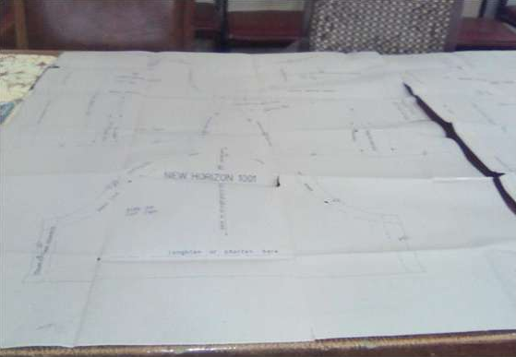

**The commercial pattern by new horizon 1001 was traced out for the patterns Adaptation below:Basic Patterns**

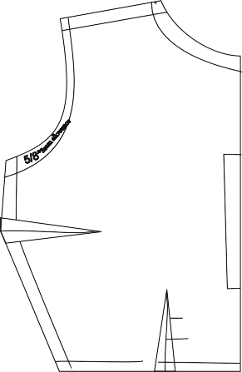

FRONT BODICE

Stitching line

Fold dart

line

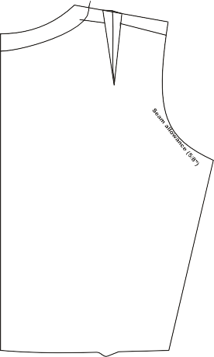

Back bodice

Stitching line

Fold dart

line

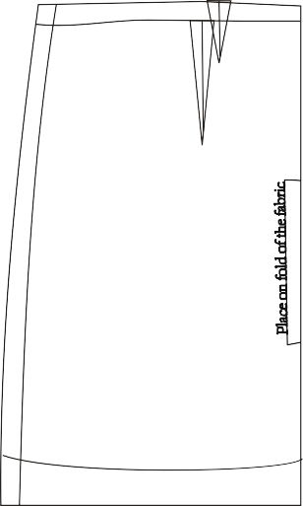

Size 20 cut one

Basic skirt front

or sh

n

or

Basic skirt back

or sh

n

or

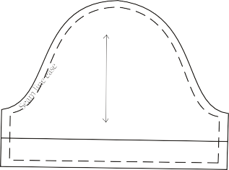

Lenghten or shorten here

Place on straight grain

PLACE ON FOLD

C/F Line

Centre back line (C/B)

## Method used for Adaptation of Maternity Apparels

**A). Maternity Gown**

## Front Bodice Pattern Lower Piece

1. The front bodice block was traced out.
2. Seam allowance of 1.5cm (5/8”) was also traced all round.
3. Pattern marks were all transferred on the pattern like notches, darts and place on fold.
4. Stiches, cutting and grain line were also indicated.
5. Same process was used for tracing out all the pattern blocks.
6. Basic front bodice was matched with traced out skirt front.
7. The dart of the bodice was matched with the dart of the front skirt to form one single dart.
8. The new waistline was drawn in and traced out on new brown paper and cut.
9. Yoke line was drawn in from armhole E to center front (c/f).
10. Burst line was drawn in from armhole base H to center front (c/f).
11. Hip line was squared up to c/f.
12. Yoke line was slashed through and kept aside.
13. The lower bodice front piece was divided into four equal parts with vertical lines from the yoke line to the hem line.
14. Each part was numbered 1 to 4 and was placed on new brown paper accordingly.
15. Fullness for the technique was added between slash three and four flowing from yoke line to hem line.Burst measurement was also considered.
16. Pinning was properly done and front bodice gown pattern was true and cutout.
17. Pattern marks were transferred in as shown below;



## Back Bodice Lower Piece

The back bodice pattern for maternity gown lower piece was adapted using the process of 1 to 17above for front bodice pattern; with basic back bodice and basic skirt back for the adaptation shown below:

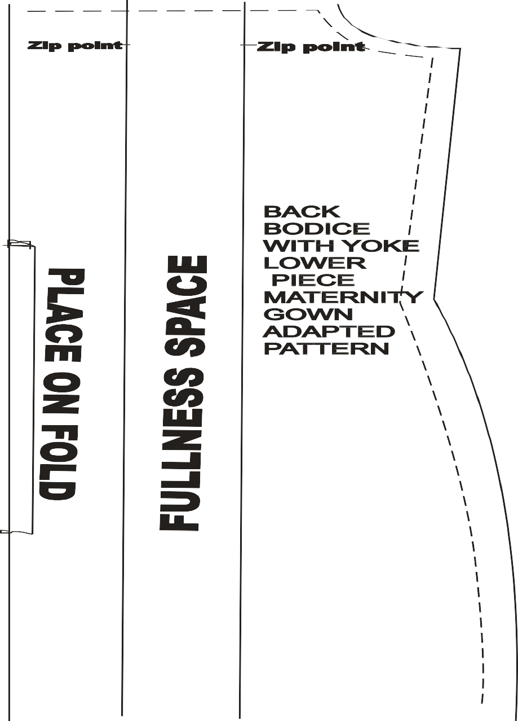

## Yoke and Neckline Front Pattern

* + 1. Slashed Yoke from front bodice was placed on the working table surface
    2. Extend A to A1 by 4.2” (11.3cm).
    3. Introduce curve from A1 to B.
    4. Slightly curve yoke base line to complete the new neckline
    5. Cut out the new neckline AA1B and its facing as shown below:



front

A

bodice maternity gown yoke

B



front bodice maternity gown yoke facing

## Yoke and Neckline Back Pattern

PLACE ON FOLD

* + - 1. Slashed Yoke from back bodice was placed on the working table surface
      2. Extend A to A1 by 4.2” (11.3cm).
      3. Introduce curve from A1 to B.
      4. Slightly curve yoke base line to complete the new neckline
      5. Cut out the new neckline AA1B and its facing as shown below:



A

A

Back bodice

B

A1 maternity

Gown yoke



Back bodice

maternity Gown yoke facing

5/8” seam allowance

## Maternity Gown Sleeve Adaptation

This was adapted from Igbo and Ileoje (2012)

1. The basic commercial sleeve was traced out on brown paper
2. Center sleeve was located at BF
3. From B, 1.2” inches were measured up: to locate B1
4. Sleeve head was trued from B1 to A and C as shown in fig below
5. From F, 2.2” inches were measured downward to locate F1
6. From F1 the sleeve base was adjusted to A and C with French curve to form the new Maternity gown sleeve.
7. Sleeve AB1CF1A was true on new brown paper
8. Pattern marks were transferred into the sleeveand cut out as shown below:

# B1

MATERNITY GOWN BASIC SLEEVE ADAPTED



FROM IGBO AND ILOEJE (2012)

# B

A C

# E

E F D F1

## Maternity Gown Sleeve Adapted Cut-2



B1

MATERNITY GOWN SLEEVE ADAPTED CUT -2

A

C

E

D

F1

1. **Maternity Blouse with Zip to be Worn on Skirt Lower Piece. Front Bodice Pattern**
   1. The front bodice block was traced out
   2. Seam allowance of 1.5cm (5/8”) was traced all round
   3. Pattern marks were all transferred on the pattern like notches, darts, and place on fold.
   4. Stiches, cutting and grain line were also indicated.
   5. The yoke line drawn in required position with yoke measurement above and indicate balance points to c/f
   6. Burst line was drawn in from armhole base H to center front (c/f)
   7. Hip line was squared up to c/f

FULLNESS

* 1. Yoke line was slashed through and kept aside
  2. The lower bodice front piece was divided into four equal parts with vertical lines from the yoke line to the hem line.
  3. Each part was numbered 1 to 4 and was placed on new brown paper accordingly.
  4. Fullness for the technique was added between slash three and four flowing from yoke line to hem line.
  5. Burst measurement was also considered
  6. Pinning was properly done and front bodice blouse pattern was true and cut out
  7. Pattern marks were transferred in as shown below:



Zip line

B

B

Zip line

FRONT BODICE MATERNITY BLOUSE WITH ZIP FASTENER FOR SKIRT

PLACE ON FOLD

## Back bodice Lower Piece Pattern

PLACE ON FOLD

The back bodice lower piece pattern was adapted using the process of 1 to 14 above for front bodice pattern; with basic back bodice for the adaptation shown below:



B

Zip line

B

Zip line

BACK BODICE MATERNITY BLOUSE WITH ZIP FOR SKIRT

## Yoke and Neckline pattern for Front Bodice

1 Slashed Yoke from front bodice was placed on the working table surface

1. Extend A to A1 by 4.2” inches (11.3cm).
2. Introduce curve from A1 to B.
3. Slightly curve yoke base line to complete the new neckline
4. Cut out the new neckline AA1B and its facing as shown below

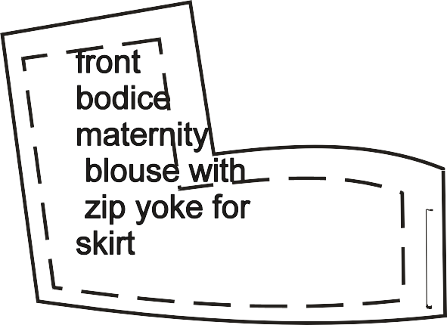

B



## Yoke and Neckline Pattern for Back Bodice

PLACE ON FOLD

1. Slashed Yoke from back bodice was placed on the working table surface
2. Extend A to A1 by 4.2” inches (11.3cm).
3. Introduce curve from A1 to B.
4. Slightly curve yoke base line to complete the new neckline
5. Cut out the new yoke and neckline AA1B and its facing as shown below



## Maternity Blouse Sleeve Adaptation



B

5/8” seam allowance

PLACE ON FOLD

This was adapted from Igbo and Iloeje (2012)

1. The basic sleeve was traced out on brown paper
2. Center sleeve was located at BF
3. Locate two notches position as shown on the sleeve below on two lines at equal interval of each side of BF.
4. Rule and slashed six lines,label the six parts accordingly to ensure orderliness when spreading
5. Slash through the six lines from sleeve head to the base (arm circumference)
6. Place each part on new brown paper, spread according to numbers and measurement, maintaining the center line BF and then pin to firm.
7. True out the new sleeve and cut.

## Maternity Skirt front Adapted



**Maternity Skirt Back Adapted**



## C.) Maternity Blouse with Zip to be Worn on wrapper Front Bodice pattern lower piece

1. The front bodice block was traced out
2. Seam allowance of 1.5cm (5/8”) was traced all round
3. Pattern marks were all transferred on the pattern like notches, darts, and place on fold.
4. Stiches, cutting and grain line were also indicated.
5. The yoke line drawn in required position with balance points to c/f
6. Burst line was drawn in from armhole base H to center front (c/f)
7. Hip line was squared up to c/f
8. Yoke line was slashed through and kept aside
9. The lower bodice front piece was divided into four equal parts with vertical lines from the yoke line to the hem line.
10. Each part was numbered 1 to 4 and was placed on new brown paper accordingly.
11. Fullness for the technique was added between slash three and four flowing from yoke line to hem line.
12. Burst measurement was also considered
13. Pinning was properly done and back bodice blouse pattern was true and cut out
14. Pattern marks were transferred in as shown below:

## Back Bodice Lower Piece Pattern

PLACE ON FOLD

The back bodice lower piece was adapted using the process of 1 to 14 above for front bodice pattern; with basic back bodice for the adaptation shown below:



B

Zip line

B

Zip line

BACK BODICE LOWER PIECE WITH ZIP ON WRAPPER

## Yoke andNeckline Pattern for Front Bodice

1. Slashed Yoke from front bodice was placed on the working table surface
2. Extend A to A1 by 4.2” (11.3cm).
3. Introduce curve from A1 to B.
4. Slightly curve yoke base line to complete the new neckline
5. Cut out the new neckline AA1B and its facing.

PLACE ON FOLD



Front bodice yoke facing for M.B.W. zip on wrapper

## Yoke and Neckline Pattern for Back Bodice

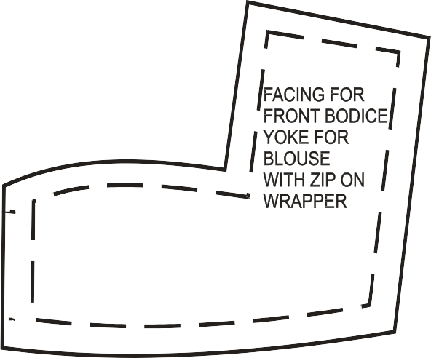

A

A1

B

PLACE ON FOLD

1. Slashed Yoke from back bodice was placed on the working table surface
2. Extend A to A1 by 4.2” inches (11.3cm).
3. Introduce curve from A1 to B.
4. Slightly curve yoke base line to complete the new neckline
5. Cut out the new yoke and neckline AA1B and its facing as shown below

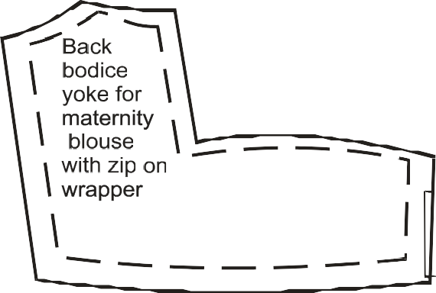

A

A1

B



Yoke facing for M.B.W.Z zip on wrapper back bodice

## Maternity Blouse Sleeve Adaptation

This was adapted from Igbo and Iloeje (2012)

1. The basic sleeve was traced out on brown paper
2. Center sleeve was located at BF
3. From B 1.2” inches were measured up to locate B1
4. Sleeve head was trued from B1 to A and C as shown in fig below
5. From F 2.2” inches were measured downward to locate F1
6. From F1 the sleeve base was adjusted to A and C with French curve to form the new Maternity gown sleeve.
7. Sleeve AB1CF1A was true on new brown paper
8. Pattern marks were transferred into the sleeve and cut out as shown below:

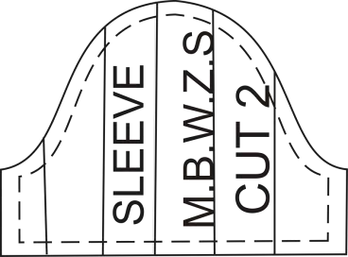

## D.) Maternity Blouse with Hooks and Eyes Fasteners Front Bodice Lower Piece Pattern

* 1. The front bodice block was traced out
  2. Seam allowance of 1.5cm (5/8”) was traced all round
  3. Pattern marks were all transferred on the pattern like notches, darts, and place on fold.
  4. Stiches, cutting and grain line were also indicated.
  5. The yoke line drawn in required position with balance points to c/f
  6. Burst line was drawn in from armhole base H to center front (c/f)
  7. Hip line was squared up to c/f
  8. Yoke line was slashed through and kept aside
  9. The lower bodice front piece was divided into four equal parts with vertical lines from the yoke line to the hem line.
  10. Each part was numbered 1 to 4 and was placed on new brown paper accordingly.
  11. Fullness for the technique was added between slash three and four flowing from yoke line to hem line.
  12. Burst measurement was also considered
  13. Pinning was properly done and front bodice blouse pattern was true and cut out
  14. Pattern marks were transferred in as shown below:

FULLNESS

PLACE ON FOLD OF FABRIC

PLACE ON FOLD OF FABRIC

## Back Bodice Lower Piece Pattern



A

B

B1

FRONT BODICE LOWER PIECE OF MATERNITY BLOUSE WITH

hook & eye

The back bodice lower piece pattern was adapted using the process of 1 to 14 above for front bodice pattern; with basic back bodice patternfor the adaptation shown below:

PLACE ON FOLD OF FABRIC

## Yoke and Neckline Pattern for Front Bodice



B1

A

Hook line

B

Eye line

BACK BODICE MATERNITY BLOUSE WITH

hook & eye lower piece.

CB

* + 1. Slashed Yoke from front bodice was placed on the working table surface
    2. Extend A to A1 by 4.2” (11.3cm).
    3. Introduce curve from A1 to B.
    4. Slightly curve yoke base line to complete the new neckline
    5. Cut out the new neckline AA1B and its facing.

PLACE ON FOLD



## Yoke and Neckline Pattern for Back Bodice

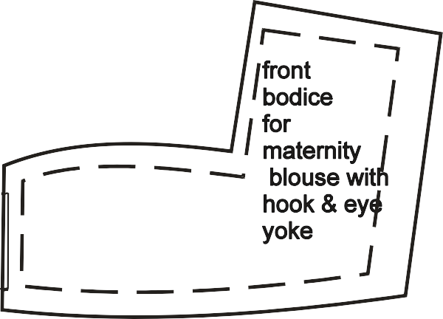

A

B

A1

PLACE ON FOLD

1. Slashed Yoke from back bodice was placed on the working table surface
2. Extend A to A1 by 4.2” (11.3cm).
3. Introduce curve from A1 to B.
4. Slightly curve yoke base line to complete the new neckline
5. Cut out the new neckline AA1B and its facing.



A

A1

B



## Maternity Blouse Sleeve Adaptation

This was adapted from Igbo and Iloeje (2012)

* 1. The basic sleeve was traced out on brown paper
  2. Center sleeve was located at BF
  3. From B 1.2” inches were measured up to locate B1
  4. Sleeve head was trued from B1 to A and C as shown in fig below
  5. From F 2.2” inches were measured downward to locate F1
  6. From F1 the sleeve base was adjusted to A and C with French curve to form the new Maternity blouse sleeve.
  7. Sleeve AB1CF1A was true on new brown paper
  8. Pattern marks were transferred into the sleeve and cut out as shown below



## E. Maternity Blouse with Velcro Fastener.

**Front Bodice Lower Piece Pattern**

1. The front bodice block was traced out
2. Seam allowance of 1.5cm (5/8”) was traced all round
3. Pattern marks were all transferred on the pattern like notches, darts, and place on fold.
4. Stiches, cutting and grain line were also indicated.
5. The yoke line drawn in required position with balance points to c/f
6. Burst line was drawn in from armhole base H to center front (c/f)
7. Hip line was squared up to c/f
8. Yoke line was slashed through and kept aside
9. The lower bodice front piece was divided into four equal parts with vertical lines from the yoke line to the hem line.
10. Each part was numbered 1 to 4 and was placed on new brown paper accordingly.
11. Fullness for the technique was added between slash three and four flowing from yoke line to hem line.
12. Burst measurement was also considered
13. Pinning was properly done and front bodice blouse pattern was true and cut out
14. Pattern marks were transferred in as shown below:



A

B

B1

FRONT BODICE LOWER PIECE MATERNITY

BLOUSE WITH VELCRO

STRAIGHT GRAIN

PLACE ON FOLD

## Back Bodice Lower Piece Pattern

The back bodice lower piece pattern was adapted using the process of 1 to 14 above for front bodice pattern; with basic back bodice for the adaptation shown below:



B1

B

A

BACK BODICE LOWER PIECE MATERNITY BLOUSE WITH VELCRO

## Yoke and NecklineFront Bodice Pattern

FULLNESS

STRAIGHT GRAIN

1. Slashed Yoke from front bodice was placed on the working table surface
2. Extend A to A1 by 4.2” (11.3cm).
3. Introduce curve from A1 to B.
4. Slightly curve yoke base line to complete the new neckline
5. Cut out the new neckline AA1B and its facing.

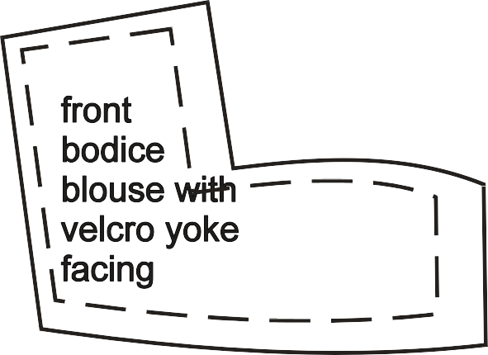

PLACE ON FOLD

## Yoke and NecklineBack Bodice Pattern

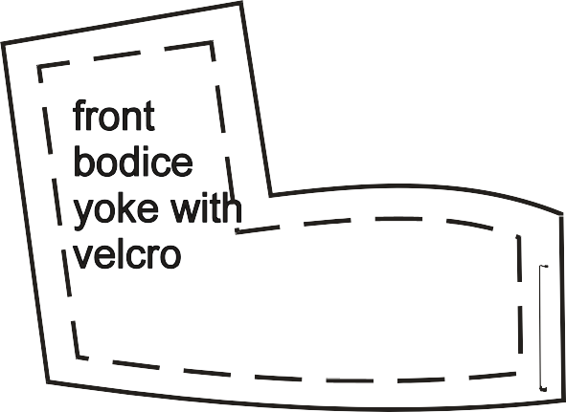

A

A1

B

PLACE ON FOLD

1. Slashed Yoke from back bodice was placed on the working table surface
2. Extend A to A1 by 4.2” (11.3cm).
3. Introduce curve from A1 to B.
4. Slightly curve yoke base line to complete the new neckline
5. Cut out the new neckline AA1B and its facing.



A

A1

B



## Maternity Blouse Sleeve Adaptation

This was adapted from Igbo and Iloeje (2012)

1. The basic sleeve was traced out on brown paper
2. Center sleeve was located at BF
3. From B 1.2” inches were measured up to locate B1
4. Sleeve head was trued from B1 to A and C as shown in fig below
5. From F 2.2” inches were measured downward to locate F1
6. From F1 the sleeve base was adjusted to A and C with Frenchcurve to form the new Maternity gown sleeve.
7. Sleeve AB1CF1A was true on new brown paper
8. Pattern marks were transferred into the sleeve and cut out as shown below:



## F. Maternity Blouse with Button Fasteners.

**Front Bodice Lower Piece Pattern**

1. The front bodice block was traced out
2. Seam allowance of 1.5cm (5/8”) was traced all round
3. Pattern marks were all transferred on the pattern like notches, darts, and place on fold.
4. Stiches, cutting and grain line were also indicated.
5. The yoke line drawn in required position with balance points to c/f
6. Burst line was drawn in from armhole base H to center front (c/f)
7. Hip line was squared up to c/f
8. Yoke line was slashed through and kept aside
9. The lower bodice front piece was divided into four equal parts with vertical lines from the yoke line to the hem line.
10. Each part was numbered 1 to 4 and was placed on new brown paper accordingly.
11. Fullness for the technique was added between slash three and four flowing from yoke line to hem line.
12. Burst measurement was also considered
13. Pinning was properly done and front bodice blouse pattern was true and cut out
14. Pattern marks were transferred in as shown below:



A

B

B1

Loop line

Button line

FRONT BODICE LOWER PIECE MATERNITY BLOUSE

WITH BUTTONS

STRAIGHT GRAIN

FULLNESS

PLACE ON FOLD ON FABRIC

## Back Bodice Lower Piece Pattern

PLACE ON FOLD ON FABRIC

The back bodice lower piece was adapted using the process of 1 to 14 above for front bodice pattern; with basic back bodice for the adaptation shown below:



B1

B

A

Loop line Button line

BACK BODICE LOWER PIECE MATERNITY BLOUSE

WITH BUTTONS FASTENER

## Yoke and Neckline Front Pattern

FULLNESS

STRAIGHT GRAIN

1. Slashed Yoke from front bodice was placed on the working table surface
2. Extend A to A1 by 4.2” (11.3cm).
3. Introduce curve from A1 to B.
4. Slightly curve yoke base line to complete the new neckline
5. Cut out the new neckline AA1B and its facing.

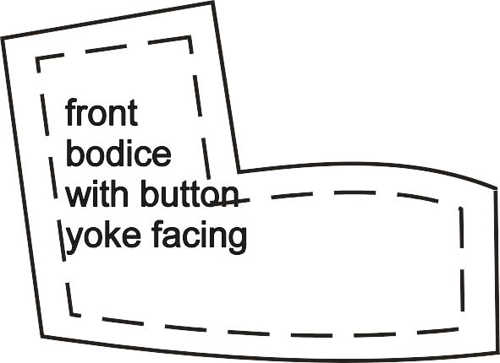

A1

## Yoke and Neckline Back Pattern

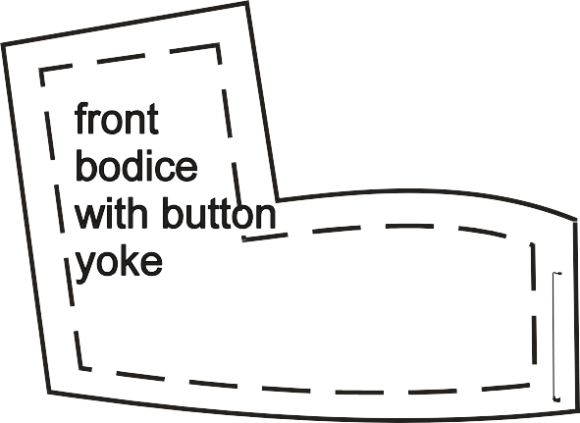

A

A1

B

PLACE ON FOLD

1. Slashed Yoke from back bodice was placed on the working table surface
2. Extend A to A1 by 4.2” (11.3cm).
3. Introduce curve from A1 to B.
4. Slightly curve yoke base line to complete the new neckline
5. Cut out the new neckline AA1B and its facing.

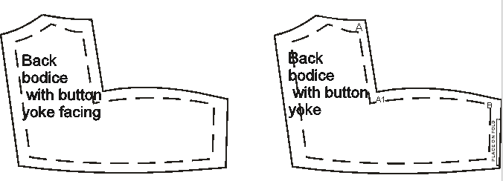

## Maternity Blouse Sleeve Adaptation

This was adapted from Igbo and Iloeje, (2012)

1. The basic sleeve was traced out on brown paper
2. Center sleeve was located at BF
3. From B 1.2” inches were measured up to locate B1
4. Sleeve head was trued from B1 to A and C as shown in fig below
5. From F 2.2” inches were measured downward to locate F1
6. From F1 the sleeve base was adjusted to A and C with French curve to form the new Maternity gown sleeve.
7. Sleeve AB1CF1A was true on new brown paper
8. 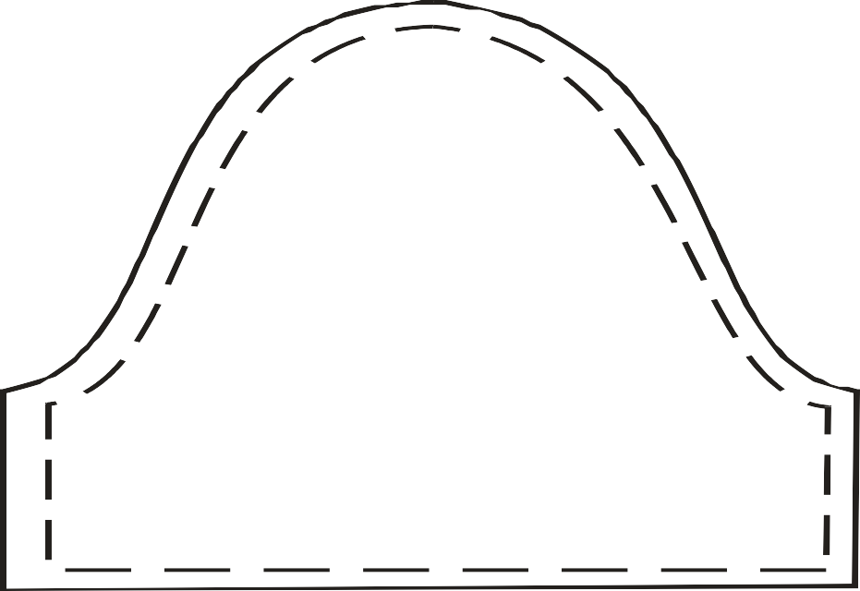Pattern marks were transferred into the sleeve and cut out as shown below

M . B . W . B . S L E E V E

The answer to research question five shows all the methods used for the Pattern adaptation from commercial pattern with relevant measurement taken from six pregnant women for constructing maternity apparels for pregnant women in F. C. T. Abuja using New Horizons commercial pattern of size 20 inches and bust of 105 cm which is equivalent to 42 inches. The sleeve, front bodice, the back bodice, skirt front and back skirt blocks were adapted into design pattern for pregnant women apparels.

## Research Question six: How can maternity apparels be constructed based on the adaptation of commercial block patterns?

To answer the Research Question six**,** Maternity apparels were constructed with adapted patterns for pregnant women in F.C. T Abuja with the methods below:

## GeneralConstruction Method

The unit method of construction was used for the construction of maternity apparels

1. The fabrics were folded along the grain line placed on the table while the adapted patterns werelaid on it.
2. The patterns were pin to the fabric following the rules of pinning that is facing the same direction.
3. The researcher cut out the fabric following the pattern accurately.
4. Then transferred the pattern marks from the brown paper pattern to the fabric.
5. Assemble pieces for each unit in order to be constructed.
6. Complete each unit of a garment stitching and pressing it before goingon to the next unit (unit construction).

## The Construction of the (MWWFD-1) and (MWWFD-2) Maternity Wears

The Construction of the (MWWFD-1) and (MWWFD-2) by the researcher using machine stiches starting by sewing the (MWWFD-1) first to serve as a guide on which (MWWFD-2) was build, with the method shown below:

## The Construction of MWWFD-1 Method

* The researcher sews each of the sleeve first
* followed by sewing each of the yoke with the facing
* attached the front yoke to bodice front
* attached the back yoke to bodice back
* join the shoulders of the two bodice together; putting into consideration right to face the right side
* then attached thesleeves to the main body under construction; and
* hem the base of the garment round and iron.

## The Construction of MWWFD-2 Method

* The researcher sews each of the sleeve first and set aside
* followed by sewing each of the yoke and facing together
* then introduction of the disposal of fullness by pleating the invited pleat at each burst point on the front and same point of the back bodices alongside with the fasteners
* join the shoulders of the two bodice together; putting into consideration right to face the right side
* then attached thesleeves to the main body under construction
* hem the base of the garment round and iron.
* The Buttons and hooks &Eye fasteners were fastened with needle and thread to the lower bodice front and bodice back of the garment at the point of the pleats mechanically. While the Velcro and Zips fasteners were attached with machine stitches. Finishing was properly done by trimming all the sewing thread along with ironing and package for data collection form pregnant women in Abaji general hospital F.C. T Abuja. The pictures of complete maternity wears are shown in Appendix IV
* this method was used for all the design maternity wears with fasteners (Hook and Eye, Button, Velcro and Zip).

The answer to research question six shows the modality used in the construction ofMaternity garments with adapted patterns for pregnant women in F.C. T Abuja with the General Construction Method, The Construction of MWWFD-1 Method and The Construction of MWWFD-2 Method.

## Research Questions 7:What are the mean responses of pregnant women (users) on fit, comfort, aesthetics and expressive variables?

In other to answer the research question the data collected from the respondent were analyzed with descriptive statistic involving mean and standard deviation for overall assessment and individual assessment of the parameters shown in tables below.

## Table 4.8: Overall Assessment of Mean Responses of Pregnant Women (users) on fit, Comfort, Aesthetics and Expressive Variables.

|  |  |  |  |  |  |  |  |
| --- | --- | --- | --- | --- | --- | --- | --- |
| S/N | Criteria | Response categories | | | | | MEAN |
| SA | A | UD | D | SD |
| 1 | free flow of air on wearing and movement | 95 | 34 | 18 | 5 | 13 | 4.170 |
| 2 | Adjustable to all stages (pre-natal, 2nd, 3rd trimesters and post-natal period) | 90 | 36 | 14 | 15 | 10 | 4.097 |
| 3 | Necklines well fitted | 88 | 40 | 23 | 12 | 2 | 4.212 |
| 4 | Burst line fitted well | 79 | 31 | 18 | 33 | 4 | 3.897 |
| 5 | Arm hole fitted well | 81 | 39 | 20 | 20 | 5 | 4.036 |
| 6 | Disposal of fullness are appropriate to all stages | 89 | 28 | 24 | 6 | 18 | 3.994 |
| 7 | The garments are beautiful (aesthetics) | 81 | 35 | 21 | 8 | 20 | 3.902 |
| 8 | Sleeves well fitted | 75 | 35 | 19 | 11 | 25 | 3.752 |
|  | Cumulative mean |  |  |  |  |  | 4.007 |

**Standard/decision mean = 3.00**

The table above shows the overall mean ratings of pregnant women (users) on fit, comfort, aesthetics and expressive variables which were relatively high. This was due to the result of the

cumulative mean agreement level of 4.007 which was greater than the 3.000 standard/decision mean. Specifically, the Necklines well fitted criteria, was with the highest mean response of

4.212 as details shows above that 128pregnant women agreed while 23 were undecided and 14 pregnant women disagree. In the same vein, the free flow of air on wearing and movement criteria has second high mean response of 4.170 as details shows that 129 were in agreement, 18 were undecided as against the rest 18 that disagreed. In summary, the mean ratings of pregnant women (users) on fit, comfort, aesthetics and expressive variables which is relatively high especially as the Necklines well fitted and free flow of air on wearing and movement were highly rated.

## Table 4.9: Assessment of Wearing fit by Pregnant Women (users) N=165

|  |  |  |  |  |  |  |  |
| --- | --- | --- | --- | --- | --- | --- | --- |
| S/N | Criteria | **SA** | **A** | **UD** | **D** | **SD** | **Mean** |
| 1 | Necklines well fitted | 89 | 42 | 15 | 10 | 9 | 4.164 |
| 2 | Bust line fitted well | 89 | 45 | 13 | 7 | 11 | 4.176 |
| 3 | Arm hole fitted well | 79 | 45 | 15 | 16 | 10 | 4.012 |
| 4 | Sleeves are well fitted | 95 | 33 | 13 | 11 | 13 | 4.127 |
| 5 | Shoulder seams are well stitched to fit | 84 | 41 | 15 | 16 | 10 | 4.067 |
| 6 | Yoke line well fit | 79 | 39 | 19 | 19 | 9 | 3.970 |
| 7 | Disposal of fullness appropriates to all stages | 69 | 45 | 19 | 19 | 13 | 3.836 |
|  | Cumulative mean |  |  |  |  |  | 4.050 |

Standard/decision mean =3.00

The Assessment of wearing fit of the maternity apparels by pregnant women(users) was high as the cumulative mean of 4.050 was above the 3.000 standard/decision mean. Specifically, bust line fitted well criteria had the highest mean response of 4.176. Necklines well fitted criteria was second as this had the mean response of 4.164, detail shown above in table 4.1.9.

## Table 4.10: Assessment of Wearing Comfort by Pregnant Women (users)

|  |  |  |  |  |  |  |  |
| --- | --- | --- | --- | --- | --- | --- | --- |
| S/N | Criteria | **SA** | **A** | **UD** | **D** | **SD** | **Mean** |
| 1 | Free flow of air on wearing and movement | 87 | 41 | 15 | 11 | 11 | 4.103 |
| 2 | Bust line | 90 | 43 | 13 | 8 | 11 | 4.170 |
| 3 | Arm hole | 80 | 43 | 15 | 9 | 18 | 3.958 |
| 4 | Sleeves | 95 | 25 | 13 | 10 | 22 | 3.976 |
| 5 | Shoulder seams are well stitched | 79 | 41 | 23 | 12 | 10 | 4.012 |
| 6 | Necklines | 82 | 43 | 19 | 12 | 9 | 4.073 |
| 7 | Adjustable to all stages (pre-natal, first, second, third trimesters and post-natal period) | 77 | 45 | 16 | 15 | 12 | 3.970 |
| 8 | Disposal of fullness appropriates to all stages | 75 | 38 | 16 | 14 | 22 | 3.788 |
|  | Cumulative |  |  |  |  |  | 4.006 |

Standard/decision mean=3.00

The Assessment of wearing comfort of the maternity apparels by pregnant women(users) was high as the cumulative mean of 4.006 was above the 3.000 standard/decision mean. Specifically, bust line fitted well criteria had the highest mean response of 4.170. Free flow of air on wearing

and movement criteria was second as this had the mean response of 4.103, detail shown above in table 4.1.10.

## Table 4.11: Assessment of Wearing Aesthetic and Expressive Variable by Pregnant Women (users)

|  |  |  |  |  |  |  |  |
| --- | --- | --- | --- | --- | --- | --- | --- |
| S/N | Criteria | **SA** | **A** | **UD** | **D** | **SD** | **Mean** |
| 1 | Necklines | 75 | 34 | 21 | 21 | 14 | 3.818 |
| 2 | Bust line | 90 | 40 | 14 | 13 | 8 | 4.158 |
| 3 | Arm hole | 89 | 37 | 12 | 26 | 1 | 4.133 |
| 4 | Sleeves | 91 | 21 | 19 | 13 | 21 | 3.897 |
| 5 | Shoulder seams are well stitched | 89 | 29 | 23 | 12 | 12 | 4.036 |
| 6 | Yoke line | 88 | 37 | 16 | 15 | 9 | 4.091 |
| 7 | Adjustable to all stages (pre-natal, first, second, third trimesters and post-natal period) | 75 | 45 | 16 | 17 | 12 | 3.933 |
| 8 | Disposal of fullness appropriates to all stages | 72 | 38 | 16 | 21 | 18 | 3.758 |
| 9 | The Garments are all beautiful (aesthetics | 81 | 40 | 15 | 17 | 12 | 3.976 |
|  | Cumulative mean |  |  |  |  |  | 3.977 |

Standard/decision mean=3.000

The Assessment of wearing aesthetic and expressive variables of the maternity apparels by pregnant women(users) was high as the cumulative mean of 3.977 was above the 3.000 standard/decision mean. Specifically, bust line fitted well criteria had the highest mean response

of 4.158. Arm hole criteria was second as this had the mean response of 4.133, detail shown above in table 4.11.

## Research Question Eight: What are the Mean Ratings of Judges on fit, Comfort, Aesthetics and Expressive Variables of the Apparels Produced? N=10

In order to answer this research question eight, mean and cumulative mean were used to answer this research questions and presented in Table 4.12 below.

## Table 4.12: The Overall Mean Rating of Judges on fit, Comfort, Aesthetics and Expressive Variables of the Apparels Produced

|  |  |  |  |  |  |  |  |
| --- | --- | --- | --- | --- | --- | --- | --- |
| S/N | Criteria | Response categories | | | | | MEAN |
| SA | A | UD | D | SD |
| 1 | Necklines well fitted | 6 | 4 | 0 | 0 | 0 | 4.600 |
| 2 | Burst line well fitted | 9 | 1 | 0 | 0 | 0 | 4.900 |
| 3 | Adjustable to all stages (pre natal, 2nd, 3rd trimesters and post natal period) | 7 | 3 | 0 | 0 | 0 | 4.700 |
| 4 | Sleeves are well fitted | 3 | 7 | 0 | 0 | 0 | 4.300 |
| 5 | shoulder seams well stitched | 7 | 3 | 0 | 0 | 0 | 4.700 |
| 6 | Arm hole fitted well | 7 | 3 | 0 | 0 | 0 | 4.700 |
| 7 | Disposal of fullness are appropriate to | 8 | 2 | 0 | 0 | 0 | 4.800 |

|  |  |  |  |  |  |  |  |
| --- | --- | --- | --- | --- | --- | --- | --- |
|  | all stages |  |  |  |  |  |  |
| 8 | The garments are beautiful (aesthetics) | 6 | 4 | 0 | 0 | 0 | 4.600 |
|  | Cumulative mean |  |  |  |  |  | 4.662 |

**Standard/decision mean = 3.000**

The table above showed that the overall mean ratings of judges on fit, comfort, aesthetics and expressive variables of the apparels produces were very high. Thefact was that cumulative mean agreement of 4.662 was greater than the 3.000 standard/decision mean. Specifically, Burst line well fitted was rated high with the highest mean response of 4.900 in the same vein judges also believe that the Disposal of fullness are appropriate to all stages as this attracted the second highest mean response of 4.800. Adjustable to all stages (pre-natal, 2nd, 3rd trimesters and post- natal period), had a mean rating of 4.700. In summary the mean ratings of judges on fit, comfort, aesthetics and expressive variables of the apparels produces were very high, especially as the Burst line well fitted, Disposal of fullness are appropriate to all stages as well as Adjustable to all stages (pre-natal, 2nd, 3rd trimesters and post-natal period) were rated higher respectively.

## Table 4.13: Assessment of Maternity Apparels fit by the Judges N-10

|  |  |  |  |  |  |  |  |
| --- | --- | --- | --- | --- | --- | --- | --- |
| S/N | Criteria | **SA** | **A** | **UD** | **D** | **SD** | **Mean** |
| 1 | Necklines well fitted | 2 | 4 | 2 | 2 | 0 | 3.600 |
| 2 | Bust line fitted well | 3 | 3 | 2 | 1 | 1 | 3.600 |
| 3 | Arm hole fitted well | 4 | 2 | 2 | 1 | 1 | 3.700 |
| 4 | Sleeves are well fitted | 5 | 2 | 2 | 1 | 0 | 4.100 |
| 5 | Shoulder seams are well stitched to fit | 4 | 2 | 1 | 2 | 1 | 3.600 |
| 6 | Yoke line well fit | 3 | 3 | 2 | 2 | 0 | 3.700 |
| 7 | Disposal of fullness appropriates to all stages | 4 | 3 | 1 | 1 | 1 | 3.800 |
|  | Cumulative mean |  |  |  |  |  | 3.729 |

Standard/decision mean=3.000

The Assessment of wearing fit of the maternity apparels by judges was high as the cumulative mean of 3.729 was above the 3.000 standard/decision mean. Specifically, Sleeves are well fitted criteria had the highest mean response of 4.100. Disposal of fullness appropriates to all stages criteria was second as this had the mean response of 3.800, detail shown above in table 4.13.

## Table 4.14: Assessment of Maternity Apparels Comfort by the Judges N-10

|  |  |  |  |  |  |  |  |
| --- | --- | --- | --- | --- | --- | --- | --- |
| S/N | Criteria | **SA** | **A** | **UD** | **D** | **SD** | **mean** |
| 1 | Free flow of air on wearing and movement | 3 | 3 | 2 | 2 | 0 | 3.700 |
| 2 | Bust line | 3 | 4 | 1 | 1 | 1 | 3.700 |
| 3 | Arm hole | 2 | 4 | 2 | 1 | 1 | 3.500 |
| 4 | Sleeves | 3 | 2 | 4 | 1 | 0 | 3.700 |
| 5 | Shoulder seams are well stitched | 3 | 2 | 2 | 2 | 1 | 3.400 |
| 6 | Necklines | 2 | 3 | 3 | 2 | 0 | 3.500 |
| 7 | Adjustable to all stages (pre-natal, first, second, third trimesters and post-natal period) | 3 | 3 | 2 | 1 | 1 | 3.600 |
| 8 | Disposal of fullness appropriates to all stages | 2 | 2 | 3 | 2 | 1 | 3.200 |
|  | Cumulative mean |  |  |  |  |  | 3.537 |

Standard/decision mean=3.000

The Assessment of wearing comfort of the maternity apparels by judges was high as the cumulative mean of 3.537 was above the 3.000 standard/decision mean. Specifically, Bust line criteria,free flow of air on wearing and movement and Sleeveshad the highest mean response of

3.700. While Adjustable to all stages (pre-natal, first, second, third trimesters and post-natal period) criteria was second as this had the mean response of 3.600, detail shown above in table 4.1.14.

## Table 4.15: Assessment of Maternity Apparels Aesthetic and Expressive Variable by the Judges N-10

|  |  |  |  |  |  |  |  |
| --- | --- | --- | --- | --- | --- | --- | --- |
| S/N | Criteria | **SA** | **A** | **UD** | **D** | **SD** | **Mean** |
| 1 | Necklines | 3 | 4 | 2 | 1 | 0 | 3.900 |
| 2 | Bust line | 2 | 3 | 2 | 2 | 1 | 3.300 |
| 3 | Arm hole | 1 | 4 | 3 | 1 | 1 | 3.300 |
| 4 | Sleeves | 3 | 4 | 2 | 1 | 0 | 3.900 |
| 5 | Shoulder seams are well stitched | 4 | 2 | 1 | 2 | 1 | 3.600 |
| 6 | Yoke line | 3 | 4 | 2 | 1 | 0 | 3.900 |
| 7 | Adjustable to all stages (pre-natal, first, second, third trimesters and post-natal period) | 2 | 3 | 2 | 2 | 1 | 3.600 |
| 8 | Disposal of fullness appropriates to all stages | 1 | 4 | 3 | 1 | 1 | 3.900 |
| 9 | The Garments are all beautiful (aesthetics |  |  |  |  |  | 3.200 |
|  | ***Cumulative mean*** |  |  |  |  |  | ***3.622*** |

### Standard/decision mean =3.00

The Assessment of wearing aesthetic and expressive variables of the maternity apparels by judges was high as the cumulative mean of 3.622 was above the 3.000 standard/decision mean.

Specifically, Necklines, Sleeves, Yoke line and Disposal of fullness appropriates to all stages criteria had the highest mean response of 3.900.Shoulder seams are well stitched and Adjustable to all stages (pre-natal, first, second, third trimesters and post-natal period)criteria were rated second as these had the mean response of 3.600, detail shown above in table 4.1.15.

## 4.2Test of Research Hypotheses

**Null Hypotheses 1: There is no significant difference between the mean ratings of users and Judges on the Requirements (needs) of Pregnant Women**.

In order to answer this research hypothesis, an inferential statistic involving independent t-test statistical tool was used and the results were presented in Table 4.2.1

## Table 4.16: The t-test Means Ratings of Users and Judges on the Requirements (needs) of Pregnant Women.

**Variable**

## Group

**N Mean Std Mean**

## differenc e

**Df** T

computed

T **P**

critical

Judge 10 37.300 1.766

Requirements (Needs) of pregnant women

0.500 173 0.753 1.96 0.461

Users 165 37.800 1.135

### Computed t > 1.96, calculated p < 0.05 at df 173

Outcome of the independent t- test statistics above showed that there is no significant difference in the mean ratings of users and judges on the requirements (needs) of pregnant women. Reason was that the calculated p value of 0.461 was higher than the 0.05 alpha level of significance and the computed t value of 0.753 was lower than the 1.96 t critical value at df 173. The meanratings of users and judges on the requirements (needs) of pregnant women were 37.300 and 37.800 by judges and users respectively. These indicate that both judges and users have different mean rating of requirements (needs) of pregnant women. Therefore, the null hypothesis which states that there is no significant difference between the mean ratings of users and judges on the requirements (needs) of pregnant women was hereby accepted and retained.

## Null Hypotheses 2: There is no Significant Difference among the Mean Rating of users on fit of Functional Apparels for First, Second and Third Trimesters. N=170

In order to answer this research hypothesis, an inferential statistic involving analysis of variancestatistical tool was used and the results were presented in Table 4.2.2.

## Table 4.17: Analysis of Variance on the Mean Rating of users on fit of Functional Apparels for First, Second and Third Trimesters.

**MEASUREMENTANOVA**

|  |  |  |  |  |  |
| --- | --- | --- | --- | --- | --- |
|  | Sum of  Squares | Df | Mean Square | F | Sig. |
| Between Groups | 49.944 | 2 | 24.972 | 14.029 | .004 |
| Within Groups | 12.461 | 7 | 1.780 |  |  |
| Total | 62.405 | 9 |  |  |  |

|  |  |  |  |  |  |
| --- | --- | --- | --- | --- | --- |
|  | N | Mean | Std. Deviation | Std. Error | Maximum |
| FIRST | 65 | 42.8448 | 1.16804 | .58402 | 44.22 |
| SECOND | 55 | 44.2056 | .80515 | .46485 | 44.90 |
| THIRD | 50 | 48.1472 | 1.88031 | 1.08560 | 50.20 |
| Total | 170 | 44.8438 | 2.63322 | .83270 | 50.20 |

Results of the Analysis of Variance statistics showed that significant different exist among the mean rating of users on fit of functional apparels for first, second and third trimesters. Hence the calculated p value of 0.004 was lower than the 0.05 alpha level of significance and the computed F value of 14.029 was greater than the 3.000 F critical value. The computed mean rating of users on fit of functional apparels for first, second and third trimesters are 42.848848, 44.2056 and

48.1472 by first, second and third trimester respectively. Therefore, the null hypothesis which states that there is significant different among the mean rating of users on fit of functional apparels for first, second and third trimesters was hereby rejected.

## Null Hypotheses 3:There is no Significant Difference among the mean rating of users (first, second and third trimesters) on the aesthetic attributes of the garments. N-170

In order to answer the research hypothesis three, an inferential statistic involving analysis of variancestatistical tool was used and the results were presented in Table 4.2.4.

## Table 4.18: ANOVA Mean rating of users (First, Second and Third Trimesters) on the Aesthetic Attributes of the Garments.

|  |  |  |  |  |  |
| --- | --- | --- | --- | --- | --- |
|  | Sum of  Squares | Df | Mean Square | F | Sig. |
| Between Groups | 40.251 | 2 | 23.811 | 1.212 | .560 |
| Within Groups | 11.52 | 6 | 1.650 |  |  |
| Total | 62.400 | 8 |  |  |  |

|  |  |  |  |  |
| --- | --- | --- | --- | --- |
|  | N | Mean | Std. Deviation | Std. Error |
| FIRST | 65 | 43.5508 | 0.985 | .5685 |
| SECOND | 55 | 43.1212 | .5846 | .3844 |
| THIRD | 50 | 43.5446 | 1.8666 | .8446 |
| Total | 170 | 43.8438 | 1.9898 | .5499 |

Results above on table 4.2.4 showed that there is no significant different among the mean rating of users (first, second and third trimesters) on the aesthetic attributes of the garments. Hence the calculated p value of 0.560 was greater than the 0.05 alpha level and the computed F value of

1.212 is lower than the F critical value 3.000. The computed mean rating of users (first, second and third trimesters) on the aesthetic attributes of the garments are 43.5508, 43.1212 and 43.5446 by first, second and third trimesters respectively. Therefore, the null hypothesis which states that there is no significant different among the mean rating of users (first, second and third trimesters) on the aesthetic attributes of the garments, was hereby accepted and retained.

## Null Hypotheses 4:There is no significant different among the mean responses of judges (nurses, clothing and textiles lecturers and garment makers) on the aesthetic attributes.

In order to answer the research hypothesis three, an inferential statistic involving analysis of variancestatistical tool was used and the results were presented in Table 4.2.6.

## Table 4.19: ANOVA on the Mean Responses of Judges (nurses, clothing and textiles lecturers and garment makers) on the Aesthetic Attributes

|  |  |  |  |  |  |
| --- | --- | --- | --- | --- | --- |
|  | Sum of  Squares | Df | Mean Square | F | Sig. |
| Between Groups | 60.200 | 2 | 30.100 | 2.634 | .090 |
| Within Groups | 308.600 | 27 | 11.430 |  |  |
| Total | 368.800 | 29 |  |  |  |

Aesthetic attributes **Descriptive**

|  |  |  |  |  |  |
| --- | --- | --- | --- | --- | --- |
|  | N | Mean | Std. Deviation | Std. Error | Maximum |
| Nurses | 4 | 32.2000 | 4.07712 | 1.28927 | 38.00 |
| Clothing lecturers | 3 | 32.1000 | 2.68511 | .84918 | 38.00 |
| garment members | 3 | 32.3000 | 3.23332 | 1.02252 | 39.00 |
| Total | 10 | 32.2000 | 3.56612 | .65108 | 39.00 |

Results of table 4.2.6 above shows that there is no significant different among the mean responses of judges (nurses, clothing and textiles lecturers and garment members) on the

aesthetic attributes of the functional apparels worn by pregnant women. Since the calculated p value of 0.090 is greater than the 0.05 alpha levels and the computed F value of 2.634 is lower than the F critical value 3.000. The computed mean of aesthetic attributes of the functional apparels worn by judges were 32.2000, 32.1000 and 32.3000 which are nurses, clothing and textiles lecturers and garment members respectively.Therefore, the null hypothesis which states that there is no significant difference among the mean responses of judges (nurses, clothing and textiles lecturers and garment members) on the aesthetic attributes of the functional apparels worn by pregnant women was hereby accepted and retained.

## Summary of the Major Findings

The followings are the summary of the major findings of the study:

* + 1. there was no significant difference in the mean ratings of users and judges on the requirements (needs) of pregnant women. The mean ratings of users and judges on the requirements (needs) of pregnant women were 37.3000 and 37.8000 by judges and users respectively. This indicate that both judges and users have the same mean rating of requirements (needs) of pregnant women hence there is no significant difference.
    2. significant differenceexists among the mean rating of users on fit of functional apparels for first, second and third trimesters. The computed mean rating of users on fit of functional apparels for first, second and third trimesters are 42.848848, 44.2056 and 48.1472 by first, second and third trimester respectively.
    3. There was no significant difference among the mean rating of users (first, second and third trimesters) on the aesthetic attributes of the garments. The computed mean rating of users (first, second and third trimesters) on the aesthetic attributes of the garments are 43.5508, 43.1212 and 43.5446 by first, second and third trimesters respectively.
    4. There is no significant difference among the mean responses of judges (nurses, clothing and textiles lecturers and garment members) on the aesthetic attributes of the functional apparels by pregnant women. The computed mean of the aesthetic attributes of the functional apparels by pregnant women are 32.2000, 32.1000 and 32.3000 by nurses, clothing and textiles lecturers and garment members respectively. The Post Hoc put all the three mean ratings in one subset implying that they had the same level of mean rating of users on the aesthetic attributes of the garments.

## Discussion of Findings

The findings reveal that the relevant body measurements used for the adapted pattern from commercial block pattern for this study. These include the measurement of the burst, waist, length of the bodice, length of the skirt, hip, sleeve length, sleeve width, neckline length and base, length of gown, yoke length and width and fullness added to each point for the design Maternity garments. Maternity Gown with Zip fastener Bodice measurement revealed in the study include burst 42”(105cm), waist 44” (110), length of bodice 57”(142.5), yoke length 7.5”(18.75), yoke width 16”(40), sleeve length 14” (35), sleeve width 16” (40), neckline length

* 1. ” (11.3), fullness to each point 4.5” (11.3).

The result shows all the methods used for the Pattern adaptation from commercial patternwith relevant body measurement taken for constructing maternity apparels for pregnant women in F.

C. T. Abuja using New Horizons commercial pattern of size 20 inches and bust of 105 cm which is equivalent to 42 inches. The sleeve, front bodice, the back bodice, skirt front and back skirt blocks were adapted into design pattern for pregnant women garments. The modality used in the construction of Maternity wears with adapted patterns for pregnant women in F.C. T Abuja,

werethe General Construction Method, the Construction of MWWFD-1 Method and The Construction of MWWFD-2 Method. These methods were used to produce six different maternity garments which imply that the study reveal that the methods could be to produce as much as possible.

The Comfort of Maternity apparels constructed with fasteners and disposal of fullness techniques was high which imply its acceptability during pre-natal, first, second, third trimester and post- natal period among pregnant women in F.C.T Abuja to the assessment of wearing comfort of the maternity apparels by judges was high as the cumulative mean of 3.537 was above the 3.00 standard/decision mean (see table 4.1.14).There is significant different in the mean rating of users on fit of functional apparels for first, second and third trimesters.The mean computed mean rating of users on fit of functional apparels for first, second and third trimesters are 42.848848, 44.2056 and 48.1472 by first, second and third trimester respectively. There was no significant difference among the mean rating of users (first, second and third trimesters) on the aesthetic attributes of the garments. The computed mean rating of users (first, second and third trimesters) on the aesthetic attributes of the garments are 43.5508, 43.1212 and 43.5446by first, second and third trimesters respectively(see table 4.2.2 and table 4.2.3) respectively.

There is no significant difference among the mean responses of judges (nurses, clothing and textiles lecturers and garment members) on the aesthetic attributes of the functional apparels by pregnant women The computed mean of the aesthetic attributes of the functional apparels by pregnant women are 32.2000, 32.1000 and 32.3000 by nurses, clothing and textiles lecturers and garment members respectively. The Post Hoc put all the three mean ratings in one subset implying that they had the same level of mean rating of users on the aesthetic attributes of the garments (see table 4.2.6 and table 4.2.7).

## CHAPTER FIVE

**SUMMARY, CONCLUSIONS AND RECOMMENDATIONS**

## Summary

This study focused on the development of functional maternity apparels from commercial block patterns, fasteners and disposal of fullness in Federal Capital TerritoryAbuja, Nigeria. The research discussed the general background of the study along with the major variables, source and identify relevant body measurements for producing maternity apparels. The research adapted various patterns using flat pattern methods and also used Igbo and iloeje(2012) adaptation method to produce various pattern pieces that were used for the construction of six sets of maternity garments that were used alongside with questionnaire to collect data for the study. This study determine pregnant women apparels needs, features, take body measurements of first, second, and third trimesters pregnant women, determine the average measurement and constructed maternity apparels with adapted patterns with fasteners and disposal of fullness techniques. Asses fit, comfort, aesthetics, and expressive variables of the constructed maternity apparels by the pregnant women (users) and judges in F.C.T Abuja. The modality used in the construction of Maternity apparels with adapted patterns for pregnant women in F.C. T Abuja, were the General Construction Method, the Construction of MWWFD-1 Method and the Construction of MWWFD-2 Method were also revealed. These methods were used to produce six different maternity apparels which imply that the methods could be used to produce as many as possible.

The Research and development design (R&D) was used for the study with five various questionnaires instruments with the constructed maternity apparels without fastener and disposal of fullness one (MWWFD-1) and the six constructed maternity apparels with fasteners and

13

2

disposal of fullness two (MWWFD-2) developed by the researcher and were validated by four experts one from Department of Textiles Science, two from Home Economics Department and one from F.C.E. Zaria before using. Reliability was realized through pilot study,the construction of six maternity apparels for this study: Namely maternity gown with zip fastener, maternity blouse and skirt with zip fasteners, maternity blouse and wrapper with hook and eye fasteners, maternity blouse and wrapper with zip fasteners, maternity blouse and wrapper with velcro fasteners, maternity blouse and wrapper with button fasteners.

The perception of respondents‟ cumulative mean and standard mean were compared for answering research questions while t-test and ANOVA statistics were used to analyze thehypotheses. There was significant difference in hypothesis two only and was rejected and there was no significant difference in hypotheses one, three and four therefore the three hypotheses were accepted and retained.One theresult is that there is no significant difference in the mean ratings of users and judges on the requirements (needs) of pregnant women. The mean ratings of users and judges on the requirements (needs) of pregnant women were 37.3000 and 37.8000 by judges and users respectively. This indicate that both judges and users have the same mean rating of requirements (needs) of pregnant women hence the different is insignificant from the computer analyses.

## Conclusions

In objective one to three the functional apparels requirements, features and preferences were determined with pre-date questionnaire. Relevant body measurements used for the adapted pattern pieces from commercial block pattern for this study were taken and the average were determined. The measurement of the burst, waist, length of the bodice, length of the skirt, hip,

sleeve length, sleeve width, neckline length and base, length of gown, yoke length and width as well as fullness added to each point for the design Maternity apparels were taken. All the methods used for the Pattern adaptation from commercial block patterns with relevant body measurement taken from thirty (30) pregnant women for constructing maternity apparels for pregnant women in F. C. T. Abuja were shown in chapter three. The modalities used in the construction of Maternity apparels for pregnant women in F.C. T Abuja include the General Construction Method, the Construction of MWWFD-1 Method and the Construction of MWWFD-2 Method.These signifies that in clothing and textiles construction, there must be relevant body measurement taken of the figures to wish the design is meant for; in other to obtain accurate pattern pieces that would be usedfor any proper and excellent result of the clothing construction for professionalism. The overall mean ratings of judges on fit, comfort, aesthetics and expressive variables of the apparels produces were very high. The fact was that cumulative mean agreement of 4.662 was greater than the 3.000 standard/decision mean. The overall mean ratings of pregnant women (users) on fit, comfort, aesthetics and expressive variables were relatively high. This was due to the result of the cumulative mean agreement level of 4.007 which was greater than the 3.000 standard/decision mean. These signify the acceptance of the constructed wears by both the users and the judges as such most of the users were demanding for the sales of the apparels during the study.

## Contributions to Knowledge

This study contributed to the general and specific knowledge in the following ways:

* + 1. It reveals the apparel needs for pregnant women, hence the finding of the research question shows that all the respondents were of the view that none restricting clothing

with expandable features are the best for functional apparels requirements (needs) for pregnant women as this view attracted the highest mean of 4.971. Also, most of the respondents believe that functional apparels requirements (needs) for pregnant women should include clothing with fasteners for adjustment to trimesters as this was second highest mean of 4.920, both means were greaterthan the decision mean of 3.00 mean. The t-test computed p-value of0.461 was higher than p < 0.05 at df 173 in test of hypothesis.

* + 1. The study contributed to knowledge asit reveals new method of patterns adaption for garments production which skill can also impacted to young generation. The patterns adaption features are Yoke for styling, Pleats for disposal of fullness, Fasteners for adjusting and converting the apparels to the various trimesters use, and Sleeves for styling hence the cumulative mean of 4.828 are above the standard mean of 3.00 meaning the acceptable features for the pattern adaptation. The fasteners for adjusting and converting the apparels to various trimester used, makes it functional and its calculated p- value of 0.004 was lower than 0.05 alpha value.
    2. The study contributed to knowledge asit reveals new method of using maternity apparels with fasteners and disposal of fullness. The functional apparels preferences of pregnant women using fasteners and disposal of fullness were all high quality. Since the respondents cumulative mean or general agreement level mean of 4.902 was higher than the 3.00 standard mean/decision rule.
    3. The study contributed to knowledge asit reveals new method of producing maternity apparels with fasteners and disposal of fullness. The answer to research question six shows the modality used in the construction of Maternity garments with adapted patterns from commercial blocks patterns for pregnant women in F.C. T Abuja with the General

Construction Method, The Construction of MWWFD-1 Method and The Construction of MWWFD-2 Method with material resources.

* + 1. The study contributed to knowledge (education) in terms of its new skills and designs such as new method of producing patterns for maternity apparels, sleeves, front bodies and back bodies that will be taught to students in schools by the Clothing and Textiles lecturers.Results of the Analysis of Variance statistics showed that significant different exist among the mean rating of users on fit of functional apparels for first, second and third trimesters of pregnant women in Abuja. Hence the calculated p value of 0.004 was lower than the 0.05 alpha level of significance
    2. The pregnant women in F.C.T Abuja, Nigeria especially those in the first pregnancy will find the knowledge from this study beneficial due to awareness of the right maternity garment to choose. From the findingsall the 30 respondents representing 100.0% have problems with clothing selection when pregnant for the first time as increment in size set in.
    3. knowledge from this study will also be beneficial to the pregnant women as it will solve the problem of fashion challenges such as is inability to use pre-natal clothes in first, second, third trimesters period of pregnancy and post-natal, which will lead to psychological comfort and peace of mind. Analysis of Variance statistics showed that there is no significant different among the mean rating of users (first, second and third trimesters) on the aesthetic attributes of the garments. Hence the calculated p value of 0.560 was greater than the 0.05 alpha level of significance.
    4. The academics especially those inPublic Health and Information sciences will find the content of this study very beneficial with regards to how to advise pregnant women on dressing code at

every stage of pregnancy especiallyin the first, second and third trimester of the pregnancy. The finding showed that there is no significant different among the mean responses of judges (nurses, clothing and textiles lecturers and garment members) on the aesthetic attributes of the functional apparels worn by pregnant women. Since the calculated p value of 0.090 was greater than the

0.05 alpha level.

## Recommendations

On the basis of the finding s from this study, the general basic recommendations are put forward:

* + 1. the functional apparels requirements (need) should be source for with the aid of questionnaire from the users.
    2. the functional apparels feature requirements should be determined with the aid of questionnaire from the users.
    3. for the purpose of proper pattern adaptation in clothing, relevant body measurements should be taken for average determination.
    4. in order to achieve accuracy in clothing construction, pattern pieces should be made correctly with relevant body measurement taken average.
    5. in this type of research construction of pregnant women apparels as part of instrument for data collection is a necessity for the study.
    6. fit, comfort, aesthetics and expressive variables should be considered in apparel construction hence the overall mean ratings of pregnant women (users) on fit, comfort, aesthetics and expressive variables were relatively high. This was due to the result of the cumulative mean agreement level of 4.007 which was greater than the 3.000 standard/decision.
    7. to ascertain the fit, comfort, aesthetics and expressive variables is the overall mean ratings of judges on fit, comfort, aesthetics and expressive variables of the apparels produces were very high. The fact was that cumulative mean agreement of 4.662 was greater than the 3.000 standard/decision mean
    8. the adjustability to all trimesters due to disposal of fullness technique as one of the criteria for pregnant women on wearing fit, comfort, aesthetics and expressive variables for designed maternity apparels was also rated high as it mean score of 3.600 was above the standard mean of 3.000.

## Suggestion for Further Study

The following topics have been suggested for further studies:

* + 1. development of designed maternity garments and its acceptability among pregnant women in Northern, Western and Eastern part of Nigeria.
    2. development of standard measurements and blocks for pregnant women apparels
    3. development of functional maternity apparels from commercial block patterns and its acceptability among disable in Northern or Eastern part of Nigeria.
    4. further studies should be carried out in sociocultural factors on maternity apparels.
    5. further studies should be carried using other variables apart from fasteners for maternity apparels.

## REFERENCES

Ahmad, A.B. (2014). *Comparative Study between the Use of Buttons and Velcro Fastener in Production and use of Clothing for Pre-school Children*. Thesis submitted to Department of vocational and technical education, Ahmadu Bello University, Zaria, Kaduna State, 1- 30.

Ajunwa, E. (2015). *Development of Patterns for Mass Production of Suits for Adolescents* Thesis Submitted to Department of Vocational and Technical Education, Ahmadu Bello University, Zaria, Kaduna State, 84-86.

Ampong, I., & Gavor, M., (2006). Assessment of Construction Quality of Garments Product by Ghanaian Micro-Scale Manufacturers. *Journal ofHome Economics Research Association of Nigeria*, 125-131.

Anya, S. (n.d.). Developing Pattern for Children's Garments in Clothing: A Comprehensive Study. Lippincolt : Philadelpha J.B. Lippincolt Company.

Annette, R., (2000). Alexis Maternity Collections. Annette @Alexis Maternity Collection Retrieved on November 12th 2007 from (Com Website Will Web Solution. Com.

Anyakoha, E., & Eluwa, M., (2008). Home Management for Schools and Colleges. Onitsha, Nigeria: AfricanaFirst Publishers Ltd.

Anyakoha, E., & Eluwa, M.A. (2010). Home Management for Schools and Colleges. Onitsha, Nigeria: Africana First Publishers Ltd.

Barari, A. (2016). Importance of Comfortable Clothes for Pregnant Women. nwesha Published. Monday, August22, 2011, 15:45 [1ST] retrieved from: http://www.boldsky

.com/pregnancy-parenting/prenatal/2011 /comfortable-clothes-pregnant-woman-220811

.html. Accessed 15/8/2016 database

Beth, K. (2013). Velcro Just Wants Some Closure. *Fortune 168*.

Benjamin, F. (2003-11-24)[.*"Zipping Up the World".*](http://www.forbes.com/global/2003/1124/089.html) *Forbes.com. Retrieved 2012-04-24.*

Bennett, V.R., & Linda, K.B., (1993). Text book for Midwives. London: Longman Publishers.

Blunnin, J. (2001). *People Love It.* Retrieved November 2, 2007, from http://www.maternity- clothing-fashion.com

Borg, Walter R., Gall, P. Joyce, & Gall, Meredith. (2007). *Educational research.An instroduction. Eighth edition.* New York: Pearson.

Chukwudumebi, O. F. (2009). *Comparative Analysis of Foreign and Nigeria Made Children's Garments: Implications for Consumers*.Thesis submitted to Department of vocational and technical education, Ahmadu Bello University, Zaria, Kaduna State.

Doddes, G.H, Carter, G.B and Gunninghan P.J (1969), A Dictionary of Midwifery and PublicHealth, Faber and Faber Limited London.

Diane, B (2002). Secrete of Maternity Dressing Retrieved on August 15th 2003 from ([http://health.yahoo.com](http://health.yahoo.com/)).

Encarta®, M. (2009). Microsoft Corporation. All rights reserved.

Frederick, R. (2002) Maternity Clothes: Options for Today‟s pregnant woman. Site 101 com Retrieved on August 15th 2003 form (website-http://www.maternity and Nursing .com).

Gaur, A., & Gaur, S. S. (2009). *Statistical Methods for Practice and Research: A Guide to Data Analysis Using SPSS. 2nd Edition.* Los Angeles: Sage Publishers.

Griese, R. N. (2002). Maternity Cloths Options for Today‟s Pregnant Women. August 2005 Http//: [www.](http://www/) Maternity and Nursing. Com

Harold, C., Mitchell, K. &George, H. C.J. (2005). *Washington Inaugural Button Collection.*

USA: Kirk Mitchell .

Hoffman, E. (1988). *The right to be human: A biography of Abraham Maslow.* Jeremy P. Tarcher, Inc.

Hollen, N. R. (n.d.). Flat Pattern Methods. Burges: Iowa. Burges Publishing Company.

Holmes, K. (n.d.). *6 Cheap Ways to Style Your Bump.* Retrieved July 7, 2016, from <http://idealistmom.com/cute-maternity-clothes/>

Hornby, A. S. (2000). Oxford Advanced Learner‟s Dictionary of Current English. Oxford York: Oxford University Press.

Hornby, A. (2002). *Oxford Advanced Dictionary of Current English.* Oxford University Press.

Hubber, H. (2015). *Types of Fastenings in Sewing Clothes - Clothing Fasteners Kinds.*

Igbo, C. A. &Iloeje, C. I. (2012). *The basics of dress pattern drafting.* Enugu. INSERBERG Nigeria Business Centre.

Iloeje, C. I., and Anyakoha, E. U. (2009). Determination of mean body measurements of female youths (15-24years) in tertiary institutions in Enugu State. Journal of Home Economics Research Association Nigeria 10811: pp.87-89

David, R. G. &J., A., (n.d.). *Aubrey's Brief Lives on*. Retrieved May 8, 2016, from Hook-and- eye_closure: https://en.wikipedia.org/wiki/Hook-and-eye_closure

Joseph, A.& Joe (2003). What You Didn't Know: 99 Fascinating Questions About the Chemistry of Everyday Life. Ecw Press.

Kenrick, D. T., Neuberg, S. L., Griskevicius, V., Becker, D. V., & Schaller, M. (2010). Goal Driven Cognition and Functional Behavior the Fundamental-Motives Framework. Current Directions in Psychological Science.

Lylie, D.S and Brinkley, J (1983) Contemporary Clothing America. Bennett and McKnight Publishing Company.

Majorie, M., & Baker, M. S. (2007). *Extension Associate for Textiles and Clothing. Kentucky.*

Kentucky: University of Kentucky Cooperative Extension.

M., S. (1992). Synthesizing evaluation perspectives, practices and evidences, proceedings other American evaluation Association. Seattle: 92 Extension evaluation Topical interest group, Seattle WA.

Maslow, A. H. (1943). *A Theory of Human Motivation. Psychological Review.* Retrieved August 17, 2016, from [www.simplypsychology.org:](http://www.simplypsychology.org/) [www.simplypsychology.org/maslow.html](http://www.simplypsychology.org/maslow.html)

Maslow, A. H. (1954). *Motivation and personality. New York: Harper and Row .* Retrieved August 17, 2016, from [www.simplypsychology.org/maslow.html](http://www.simplypsychology.org/maslow.html)

Maslow, A. H. (1962). *Towards a psychology of being. Princeton: D. Van Nostrand Company.*

Retrieved August 17, 2016, from [www.simplypsychology.org/maslow.html](http://www.simplypsychology.org/maslow.html)

Maslow, A. H. (1970a). *Motivation and personality. New York: Harper and Row.* Retrieved August 17, 2016, from [www.simplypsychologv.org/maslow.html](http://www.simplypsychologv.org/maslow.html)

Maslow, A. H. (1970b). *Religions, values, and peak experiences. New York: Penguin. .* Retrieved August 17, 2016, from [www.simplypsychology.org/maslow.html](http://www.simplypsychology.org/maslow.html)

McLeod, S. A. (2016). *Maslow's Hierarchy of Needs.* Retrieved August 17, 2016, from [www.simplypsychology.org/rnaslow.html](http://www.simplypsychology.org/rnaslow.html)

Michelle, A. (2002), Feeling Beautiful During Pregnancy. Retrieved on May 6th 2003 from (Willywebsolutions.com).

Musheno, E. (1977). *Vogue the Sewing Book*. Britain. Aglesbury, Bucks: Hazell Watson and Viney Ltd.

Myles. (2005). *A Text Book for Midwives.* Burgh and London: Edin-Burgh and London Churchill Living St

Neal, M. M. (2000). *Needlework for Schools*. Ibadan: Ibadan, Oluseyi Press Ltd Ibadan.

Ohaka, A. R. (2009). *Strategies for the Provision of functional Clothing for Pregnant Women.*A Research Project Published *.* University of Nigeria, Nsukka: Department of Vocational Teacher Education V.T.E Home Economics Unit. Masters Degree in Home Economics Education.

Okeke, T. (2009). Home Economics for Schools and colleges. Onitsha: Onitsha, Africana First Publishers PLC.

Olayiwola, A. O. (2010). Procedures in Educational Research. Nigeria. *HANJAM*.

Omar, k. (1999). *Fired steatite button. The Indus Civilization.* Retrieved March 11, 2010, from <http://www.harappa.com/indus2/128.html>

Rajitha, I. (2005). *Garment Making For the course of Fashion and Garment Making.* Hyderabad: Hyderabad. State Institute of Vocational Education Govt of Andhra Pradesh Hyderabad.

Rhayes (2005) Fashion Tips for Pregnant Women Published April 10, 2005. Retrieved on July 6th 2007 from ([http://health](http://health/) yahoo.com).

Shailong, C.N. and Igbo, C.A. (2009). Establishment of Average Body Measurement and Drafting of Basic Block Patterns for Male Preschool Children in Enugu State. Journal of Home Economics Research, 10: 86-94.

Shailong, N.C. (2017). *Development of self-Instructional Manual for Teaching Tailoring Techniques to Home Economics Students in Universities in North Central Nigeria.*A Research Project Published *.* University of Nigeria, Nsukka: Department of Vocational

Teacher Education V.T.E Home Economics Unit. Masters Degree in Home Economics Education.

S. G. (2005). *Concept of General Consideration of Clothing for Pre-School Children (2--fyears).*

Palampur, India: Department of Textile and Apparel Designing.

Steven, D. (2001). *The Big Idea: How Business Innovators Get Great Ideas to Market Kaplan.*

Business (Velcro). Kaplan: https://books.google.com/?id=F_yOHB54CxsC.

Stevens, J. (1986). *Applied multivariate statistics for the social sciences*. Hillsdale: NJ: Eribaum. Thresyamma, C.P. (2002) A Guide to Mid Wifery Students. Delhi: Brothers Medical

Publishers Ltd.

Uzoagulu, A. (1998). Practical Guide to Research project Reports. John Jacob„s Classic Publishers Ltd. Enugu.

Watts, G. (1981). *Modern Dressmaking a Textbook for Students*. London: Hutchinson and Co Publisher Ltd.

Webb, N.M., Shavelson, R.J., & Haertel, E.H. (2006). *Reliability Coefficients and Generalizabilty.*Theory. Handbook of Statistics. Cited by 247, cited by 82 in educational reserch. Brenner cited by 528.

Web-Lupo, A. and Lester, R.M (1987), Clothing Decision: America: Glencoe Publishing Company. A Division of Macmillan Inc.

Webb-Lupo, A and Lester R.M (1999). Clothing Decisions. USA. Glencoe

Macmilliam/Mc-Graw-Hill.

Weber, J. (1990). *Clothing, Fashion fabrics Construction*. United States of America. Glencoe: McGraw-Hill.

William, (1997). *Stay Fit in Fashion.* Retrieved August 5, 2007, from [www.Brace4Success.com](http://www.Brace4Success.com/) Wingate, I.B. (1975). *Fairchild's Dictionary of Textiles*. New York: Fairchild publications.

Yamane, T. (1967). *Statistics an introductory Analysis*. Second Edition New York, Harper and Row.

Ying, B. (2005). Physical mechanism and characterization of smart thermal clothing. Retrieved from ira.lib.polyu.edu.hk/handle/10397/3942 on 17/11/14

Yusuf, A. O. (2017). Acceptability of adopted traditional Aso-Oke in constructing garment for contemporary youths on Oyo State, Nigeria. Dissection submitted to Home Economics Dept. Faculty of Edu.A.B.U. Zaria, Nigeria. Pp. vii/1-9

Ziegel, E., & Blarcom, (1992). *Obstetric Nursing*. London: Collier Macmillan Publishers

## Appendix I INTRODUCTORY LETTER



**Appendix II Introductory Letter to the respondent**

Home Economics Department, Faculty of Education,

Ahmadu Bello University, Zaria. 25th Nov, 2017.

Dear respondents,

The researcher is a post graduate student of the above named institution, conducting a research on “Development of Functional Maternity Apparels from Commercial Block Patterns, Fasteners and Disposal of Fullnessin Federal Capital Territory Abuja, Nigeria” The pilot study will be conducted in Salama hospital while main study will be conducted in Abuja.

Please assist by expressing your opinion in providing answers to the questions on the attached questionnaire: you are assured that all information supplied will be kept strictly confidential. The researcher therefore solicits for your maximum support to make this study a success.

Thank you in anticipation for your cooperation.

Yours Sincerely, Ahmad AminatBint

## DATA QUESTIONNAIRE

**FOR PREGNANT WOMEN APPAREL NEEDS ASSESSMENT**

## INSTRUCTION: Please tick ( ) or supply asappropriate in the spaces provided for the option that best describes your opinion among the KEYS below:

**Strongly Agree-SA, Agree-A, Undecided – UD,**

## Disagree – D and Strongly Disagree – SD

**SECTION A: DEMOGRAPHIC**

1. Age (in years): 20 - 25yrs ( ) 26 - 30yrs ( ) 31 - 35yrs () 36 - 40yrs ( ) 41yrs & above ( )

1. What stage is the pregnancy: First trimester ( ) Second trimester ( ) Third trimester ( )
2. Is this your first pregnancy? Yes ( ) No ( )
3. When you were pregnant for the first time did you have problem of clothing selection as you begun to increase in size? Yes ( ) No ( )

## SECTION B: THE APPAREL NEEDS OF PREGNANT WOMEN

|  |  |  |  |  |  |  |
| --- | --- | --- | --- | --- | --- | --- |
| **S/N** | **Clothing needs of pregnant women** | **SA** | **A** | **UD** | **D** | **SD** |
| **1.** | **None restricting clothing with expandable features** |  |  |  |  |  |
| **2.** | **Cotton fabric to keep the body cool** |  |  |  |  |  |
| **3.** | **Light, loose and non-constricting clothing.** |  |  |  |  |  |
| **4.** | **Clothing with fasteners for adjustment** |  |  |  |  |  |
| **5.** | **Dressing that enhance natural beauty and self- confidence.** |  |  |  |  |  |
| **6.** | **Light weight clothing to maintain proper body balance** |  |  |  |  |  |
| **7.** | **Fabrics that is highly absorbent** |  |  |  |  |  |

|  |  |  |  |  |  |  |
| --- | --- | --- | --- | --- | --- | --- |
| **8.** | **Clothing that will match work and activities** |  |  |  |  |  |
| **9.** | **Clothing that will camouflage the middle contour** |  |  |  |  |  |
| **10.** | **Clothing with pleats, gathers and folds** |  |  |  |  |  |

**SECTION C:THE APPARELS DESIGN FEATURES (FUNCTIONAL, AESTHETICS AND EXPRESSIVE) NEEDS FOR ADAPTING PATTERNS.**

|  |  |  |  |  |  |  |
| --- | --- | --- | --- | --- | --- | --- |
| S/NO | **Apparels Design Features needs for adapting**  **patterns.** | SA | A | UD | D | SD |
| 1 | Yoke for styling |  |  |  |  |  |
| 2 | Pleats for disposal of fullness |  |  |  |  |  |
| 3 | Fasteners for adjusting and converting |  |  |  |  |  |
| 4 | Sleeves for styling |  |  |  |  |  |

## SECTION D: THE APPARELS DESIGN PREFERENCES USING FASTENERS AND DISPOSAL OF FULLNESS.

|  |  |  |  |  |  |  |
| --- | --- | --- | --- | --- | --- | --- |
| S/NO | **Apparels DesignPreferencesusing Fasteners and**  **Disposal of Fullness** | SA | A | UD | D | SD |
| 1 | Blouse Design with Hook and Eye fasteners using  disposal of fullness techniques |  |  |  |  |  |
| 2 | Blouse Design with Button & Buttonholes fasteners  using disposal of fullness techniques |  |  |  |  |  |
| 3 | Blouse Design with Velcro fasteners using disposal |  |  |  |  |  |

|  |  |  |  |  |  |  |
| --- | --- | --- | --- | --- | --- | --- |
|  | of fullness techniques |  |  |  |  |  |
| 4 | Blouse Design with Zip fasteners using disposal of  fullness techniques |  |  |  |  |  |
| 5 | Blouse & Skirt Design with Zip fasteners using  disposal of fullness techniques |  |  |  |  |  |
| 6 | Gown Design with Zip fasteners using disposal of  fullness techniques |  |  |  |  |  |
| 7 | Blouse & Wrapper Design without fasteners |  |  |  |  |  |

**SECTION E**

## POST DATA QUESTIONNAIRE FOR THE USERS (PREGNANT WOMEN).

**These are samples of finished Maternity Apparels; please try and wear the garment and indicate your opinions and observations by ticking ( ) in the chart below**

## KEYS

**Strongly Agree-SA, Agree-A, Undecided – UD, Disagree – D and**

## Strongly Disagree – SD

**SECTION E: ASSESSMENT CRITERIA CHART FOR PREGNANT WOMEN (USERS) RATING ON THE APPROPRIATENESS OF THE APPARELS IN TERMS OF FIT, COMFORT, AESTHETICS, AND EXPRESSIVE VARIABLES.**

|  |  |  |  |  |  |  |
| --- | --- | --- | --- | --- | --- | --- |
| **S/NO** | **Criteria** | **SA** | **A** | **UD** | **D** | **SD** |
| 1 | Free flow of air on wearing and movement |  |  |  |  |  |
| 2 | Adjustable to all  stages;(pre-natal, first, second, third trimesters and post-natal) period |  |  |  |  |  |
| **3** | Necklines well fitted |  |  |  |  |  |
| **4** | Bust line fitted well |  |  |  |  |  |

|  |  |  |  |  |  |  |
| --- | --- | --- | --- | --- | --- | --- |
| **5** | Arm hole fitted well |  |  |  |  |  |
| **6** | Disposal of fullness are  appropriates to all stages |  |  |  |  |  |
| **7** | The Garments are  beautiful (aesthetics) |  |  |  |  |  |
| **8** | Sleeves are well fitted |  |  |  |  |  |

## SECTION F

**POST DATA QUESTIONNAIRE FOR THE JUDGES.**

## These are samples of finished Maternity Garments Models please indicate your opinions and observations by ticking ( ) in the chart below

**KEYS**

## Strongly Agree-SA, Agree-A, Undecided – UD, Disagree – D and

**Strongly Disagree – SD**

## SECTION F: ASSESSMENT CRITERIA CHART FOR JUDGES RATING ON THE APPROPRIATENESS OF THE APPARELS DESIGNED IN TERMS OF FIT, COMFORT, AESTHETICS, AND EXPRESSIVE VARIABLES.

|  |  |  |  |  |  |  |
| --- | --- | --- | --- | --- | --- | --- |
| **S/NO** | **Criteria** | **SA** | **A** | **UD** | **D** | **SD** |
| 1 | Necklines well fitted |  |  |  |  |  |
| 2 | Burst line well fitted |  |  |  |  |  |
| 3 | Adjustable to all stages(pre-natal, first, second, third  trimestersand post-natal period) |  |  |  |  |  |
| **4** | Sleeves are well fitted |  |  |  |  |  |
| **5** | Shoulder seams well stitched |  |  |  |  |  |
| **6** | Arm hole fitted well |  |  |  |  |  |

|  |  |  |  |  |  |  |
| --- | --- | --- | --- | --- | --- | --- |
| **7** | Disposal of fullness are appropriates to all stages |  |  |  |  |  |
| **8** | The Garments are beautiful (aesthetics) |  |  |  |  |  |

**Appendix III**



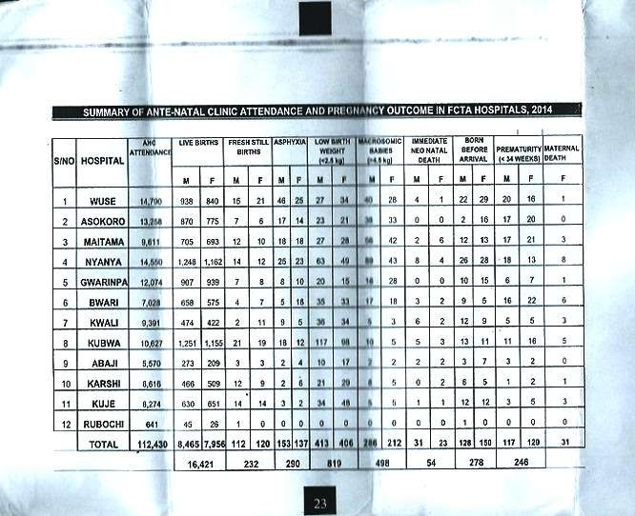

## Appendix IV

**BODY MEASUREMENT OF PREGNANT WOMEN**

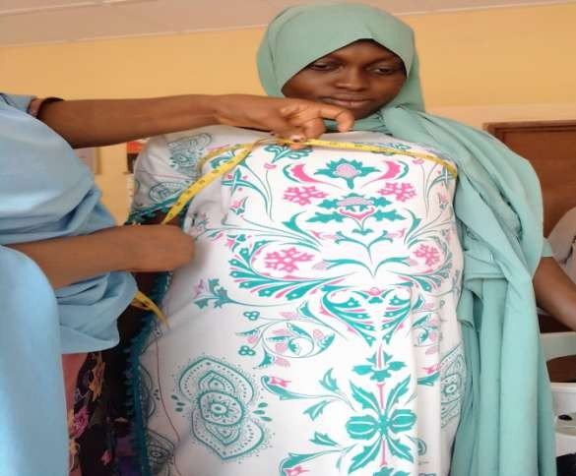

## Plate 1: Bust Measurement

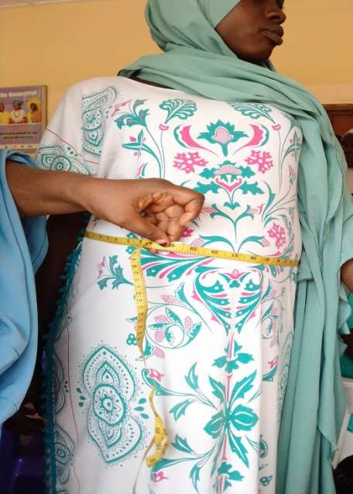

**Plate 2: Waist Measurement**

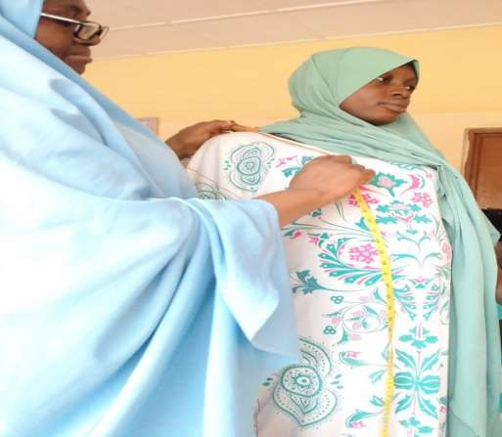

## Plate 3: Neckline Measurement

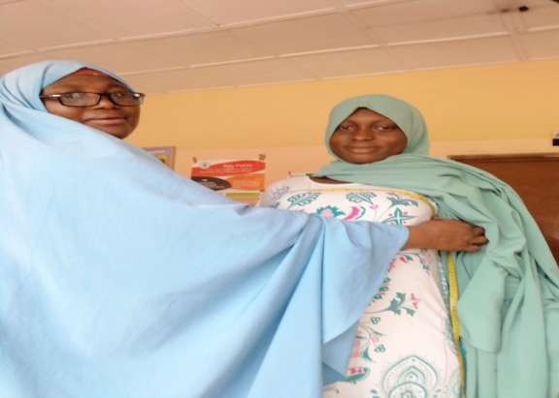

**Plate 4: Front Width Measurement**

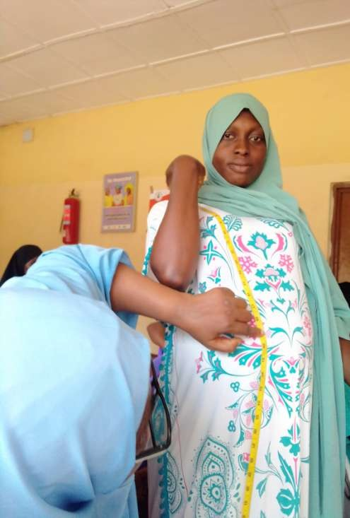

## Plate 5: Gown Length Measurement

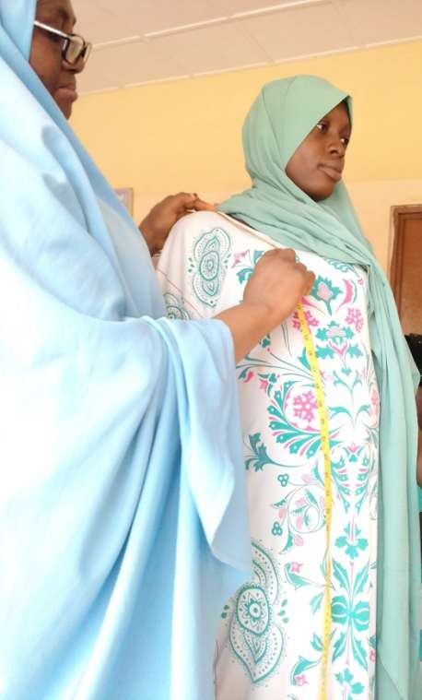

**Plate 6: Yoke Length Measurement**

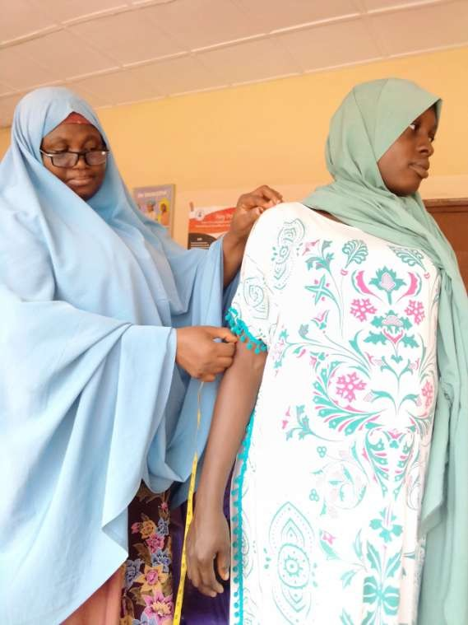

## Plate 7: Depth of Sleevehead Measurement

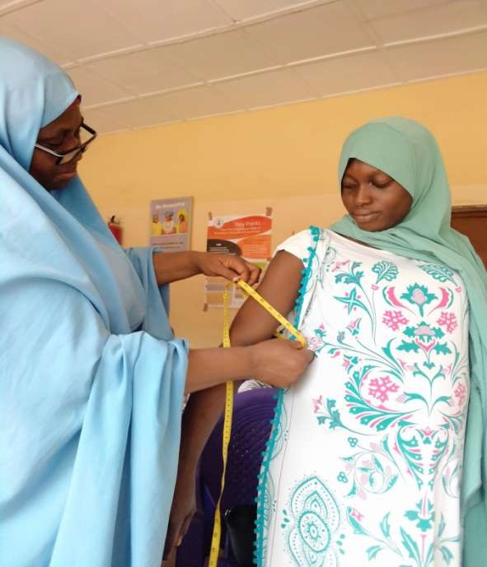

**Plate 8: Sleeve Band Measurement**

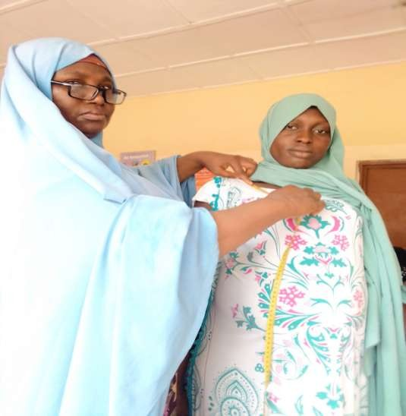

## Plate 9: Neckline Length Measurement

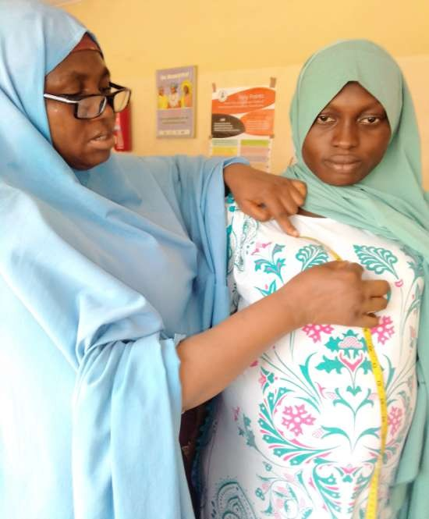

**Plate 10: Neckline Basemeasurement**

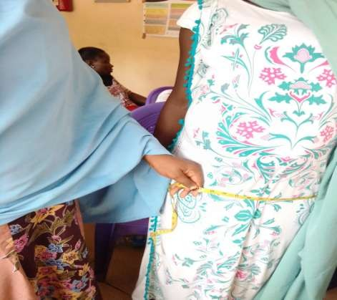

## Plate 11: Hip Measurement

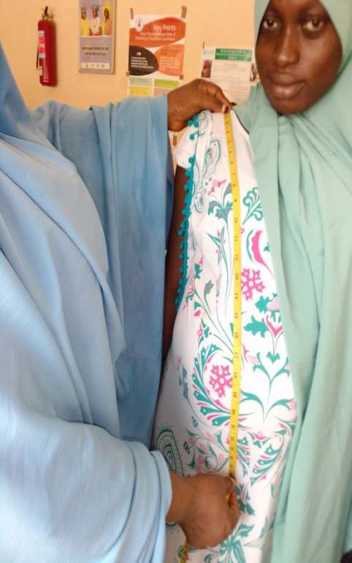

**Plate 12: Blouse Length Measurement**

**Average measurement for first trimester pregnant women N=10**

|  |  |  |  |  |  |  |  |  |
| --- | --- | --- | --- | --- | --- | --- | --- | --- |
|  | **Measurement of maternity apparel** | **MINIMUM** | | **MAXIMUM** | | **MEAN** | | **SD** |
|  |  | INCHES | CM | INCHES | CM | INCHES | CM |  |
| 1 | Burst | 33.0 | 81.5 | 40 | 100.0 | 35.0 | 86.9 | 3.35 |
| 2 | Waist | 34.0 | 85.0 | 40 | 100.0 | 35.4 | 83.7 | 2.27 |
| 3 | Length of blouse | 24.0 | 60.0 | 27.0 | 67.5 | 25.1 | 62.5 | 0.99 |
| 4 | Length of skirt | 39.0 | 97.5 | 55.0 | 135.0 | 45.1 | 111.9 | 7.88 |
| 5 | length of Gown | 38.0 | 95.0 | 59 | 147.5 | 48.0 | 120.0 | .37 |
| 6 | Sleeve Length | 10.0 | 25.0 | 11 | 27.5 | 10.4 | 26.0 | 0.51 |
| 7 | sleeve circumference | 17.00 | 42.5 | 19 | 49.5 | 17.5 | 43.9 | 0.70 |
| 8 | Neck line Length | 7.0 | 017.5 | 8 | 20.0 | 7.25 | 18.07 | 0.35 |
| 9 | Neckline base | 4.0 | 0 | 4 | 11.3 | 43.5 | 3.26 | 0.24 |
| 10 | Ho\ip | 36.0 | 0 | 45 | 11.0 | 39.0 | 30.45 | 279 |
| 11 | Yoke length | 7.0 | 0 | 75 | 18.5 | 27.8 | 5.55 | 2.57 |
| 12 | Across Burst | 16.0 | 0 | 18 | 42.5 | 16.9 | 12.5 | 0.75 |
|  |  |  |  |  |  |  |  |  |
|  |  |  |  |  |  |  |  |  |

**Average measurement for second trimester pregnant women N=10**

|  |  |  |  |  |  |  |  |  |
| --- | --- | --- | --- | --- | --- | --- | --- | --- |
|  | Measurement of maternity apparel | MINIMUM | | MAXIMUM | | MEAN | | SD |
|  |  | INCHES | CM | INCHES | CM | INCHES | CM |  |
| 1 | Burst | 35 | 81.50 | 39 | 99.5 | 37.2000 | 93.0000 | 5.8 |
| 2 | Waist | 35 | 89.5 | 39 | 99.5 | 37.4000 | 94.300 | 4.69 |
| 3 | Length of blouse | 25 | 60.50 | 26 | 65.00 | 25.9000 | 64.550 | 1.42 |
| 4 | Length of skirt | 39 | 97.5 | 56 | 140.00 | 50.5000 | 125.250 | 19.4 |
| 5 | length of Gown | 39 | 97.50 | 54 | 135.0 | 43.9000 | 109.750 | 07.45 |
| 6 | Sleeve Length | 10 | 25.0 | 11 | 29.5 | 10.7000 | 27.3500 | 1.84 |
| 7 | sleeve circumference | 17 | 42.5 | 18 | 45.00 | 17.4000 | 43.5000 | 1.29 |
| 8 | Neck line Length | 7.5 | 17.40 | 9.5 | 20.00 | 8.1500 | 18.3400 | 0.79 |
| 9 | Neckline base | 4.5 | 11.3 | 4.5 | 11.30 | 4.5000 | 11.3000 | 0.00 |
| 10 | Ho\ip | 36 | 90.0 | 44 | 110.00 | 40.4000 | 101.6000 | 5.71 |
| 11 | Yoke length | 7 | 17.50 | 8 | 20.0 | 7.8000 | 19.4500 | 0.92 |
| 12 | Across Burst | 17.0 | 42.50 | 19 | 45.00 | 17.8000 | 43.0 | 1.05 |
|  |  |  |  |  |  |  |  |  |
|  |  |  |  |  |  |  |  |  |

**Average measurement for third trimester pregnant women N=10**

|  |  |  |  |  |  |  |  |  |
| --- | --- | --- | --- | --- | --- | --- | --- | --- |
|  | Measurement of maternity apparel | MINIMUM | | MAXIMUM | | MEAN | | SD |
|  |  | INCHES | CM | INCHES | CM | INCHES | CM |  |
| 1 | Burst | 35 | 81.50 | 42 | 105.00 | 39.4000 | 98.5000 | 7.41994 |
| 2 | Waist | 35 | 89.5 | 42 | 105.00 | 39.4000 | 99.300 | 5.58 |
| 3 | Length of blouse | 25 | 60.50 | 274 | 69.50 | 26.5 | 66.4000 | 2.86550 |
| 4 | Length of skirt | 39 | 97.5 | 58 | 140.5 | 51.40 | 126.550 | 19.53551 |
| 5 | length of Gown | 40 | 100.00 | 59 | 147.50 | 45.8000 | 114.500 | 20.30326 |
| 6 | Sleeve Length | 10 | 25.0 | 102 | 30.0 | 38.300 | 28.2500 | 2.3717 |
| 7 | sleeve circumference | 18 | 45.00 | 20 | 50.00 | 18.8000 | 47.4000 | 2.53640 |
| 8 | Neck line Length | 7.5 | 18.5 | 85 | 20.0 | 30.95 | 19.5700 | .69450 |
| 9 | Neckline base | 4.5 | 11.30 | 5 | 12.50 | 4.6500 | 11.7800 | .055136 |
| 10 | Hip | 4.3 | 90.0 | 45 | 112.5 | 30.4900 | 105.250 | 6.503 |
| 11 | Yoke length | 7 | 17.50 | 8 | 20.00 | 7.9000 | 19.7500 | 0.790 |
| 12 | Across Burst | 17.5 | 43.5 | 18 | 47.8 | 17.6000 | 44.7500 | 1.70375 |
|  |  |  |  |  |  |  |  |  |
|  |  |  |  |  |  |  |  |  |

|  |  |  |  |  |  |  |  |  |
| --- | --- | --- | --- | --- | --- | --- | --- | --- |
|  | **Measurement of maternity apparel** | **MINIMUM** | | **MAXIMUM** | | **MEAN** | | **SD** |
|  |  | INCHES | CM | INCHES | CM | INCHES | CM |  |
| 1 | Burst | 33.0 | 81.5 | 40 | 100.0 | 35.0 | 86.9 | 3.35 |
| 2 | Waist | 34.0 | 85.0 | 40 | 100.0 | 35.4 | 83.7 | 2.27 |
| 3 | Length of blouse | 24.0 | 60.0 | 27.0 | 67.5 | 25.1 | 62.5 | 0.99 |
| 4 | Length of skirt | 39.0 | 97.5 | 55.0 | 135.0 | 45.1 | 111.9 | 7.88 |
| 5 | length of Gown | 38.0 | 95.0 | 59 | 147.5 | 48.0 | 120.0 | .37 |
| 6 | Sleeve Length | 10.0 | 25.0 | 11 | 27.5 | 10.4 | 26.0 | 0.51 |
| 7 | sleeve circumference | 17.00 | 42.5 | 19 | 49.5 | 17.5 | 43.9 | 0.70 |
| 8 | Neck line Length | 7.0 | 017.5 | 8 | 20.0 | 7.25 | 18.07 | 0.35 |
| 9 | Neckline base | 4.0 | 0 | 4 | 11.3 | 43.5 | 3.26 | 0.24 |
| 10 | Ho\ip | 36.0 | 0 | 45 | 11.0 | 39.0 | 30.45 | 279 |
| 11 | Yoke length | 7.0 | 0 | 75 | 18.5 | 27.8 | 5.55 | 2.57 |
| 12 | Across Burst | 16.0 | 0 | 18 | 42.5 | 16.9 | 12.5 | 0.75 |
|  |  |  |  |  |  |  |  |  |
|  |  |  |  |  |  |  |  |  |

**2NDtrimester pregnant women N=10**

|  |  |  |  |  |  |  |  |  |
| --- | --- | --- | --- | --- | --- | --- | --- | --- |
|  | Measurement of maternity apparel | MINIMUM | | MAXIMUM | | MEAN | | SD |
|  |  | INCHES | CM | INCHES | CM | INCHES | CM |  |
| 1 | Burst | 35 | 81.50 | 39 | 99.5 | 37.2000 | 93.0000 | 5.8 |
| 2 | Waist | 35 | 89.5 | 39 | 99.5 | 37.4000 | 94.300 | 4.69 |
| 3 | Length of blouse | 25 | 60.50 | 26 | 65.00 | 25.9000 | 64.550 | 1.42 |
| 4 | Length of skirt | 39 | 97.5 | 56 | 140.00 | 50.5000 | 125.250 | 19.4 |
| 5 | length of Gown | 39 | 97.50 | 54 | 135.0 | 43.9000 | 109.750 | 07.45 |
| 6 | Sleeve Length | 10 | 25.0 | 11 | 29.5 | 10.7000 | 27.3500 | 1.84 |
| 7 | sleeve circumference | 17 | 42.5 | 18 | 45.00 | 17.4000 | 43.5000 | 1.29 |
| 8 | Neck line Length | 7.5 | 17.40 | 9.5 | 20.00 | 8.1500 | 18.3400 | 0.79 |
| 9 | Neckline base | 4.5 | 11.3 | 4.5 | 11.30 | 4.5000 | 11.3000 | 0.00 |
| 10 | Ho\ip | 36 | 90.0 | 44 | 110.00 | 40.4000 | 101.6000 | 5.71 |
| 11 | Yoke length | 7 | 17.50 | 8 | 20.0 | 7.8000 | 19.4500 | 0.92 |
| 12 | Across Burst | 17.0 | 42.50 | 19 | 45.00 | 17.8000 | 43.0 | 1.05 |
|  |  |  |  |  |  |  |  |  |
|  |  |  |  |  |  |  |  |  |

**3RDtrimester pregnant women N=10**

|  |  |  |  |  |  |  |  |  |
| --- | --- | --- | --- | --- | --- | --- | --- | --- |
|  | Measurement of maternity apparel | MINIMUM | | MAXIMUM | | MEAN | | SD |
|  |  | INCHES | CM | INCHES | CM | INCHES | CM |  |
| 1 | Burst | 35 | 81.50 | 42 | 105.00 | 39.4000 | 98.5000 | 7.41994 |
| 2 | Waist | 35 | 89.5 | 42 | 105.00 | 39.4000 | 99.300 | 5.58 |
| 3 | Length of blouse | 25 | 60.50 | 274 | 69.50 | 26.5 | 66.4000 | 2.86550 |
| 4 | Length of skirt | 39 | 97.5 | 58 | 140.5 | 51.40 | 126.550 | 19.53551 |
| 5 | length of Gown | 40 | 100.00 | 59 | 147.50 | 45.8000 | 114.500 | 20.30326 |
| 6 | Sleeve Length | 10 | 25.0 | 102 | 30.0 | 38.300 | 28.2500 | 2.3717 |
| 7 | sleeve circumference | 18 | 45.00 | 20 | 50.00 | 18.8000 | 47.4000 | 2.53640 |
| 8 | Neck line Length | 7.5 | 18.5 | 85 | 20.0 | 30.95 | 19.5700 | .69450 |
| 9 | Neckline base | 4.5 | 11.30 | 5 | 12.50 | 4.6500 | 11.7800 | .055136 |
| 10 | Hip | 4.3 | 90.0 | 45 | 112.5 | 30.4900 | 105.250 | 6.503 |
| 11 | Yoke length | 7 | 17.50 | 8 | 20.00 | 7.9000 | 19.7500 | 0.790 |
| 12 | Across Burst | 17.5 | 43.5 | 18 | 47.8 | 17.6000 | 44.7500 | 1.70375 |
|  |  |  |  |  |  |  |  |  |
|  |  |  |  |  |  |  |  |  |

**1st trimester pregnant women N10**

|  |  |  |  |  |  |  |  |  |
| --- | --- | --- | --- | --- | --- | --- | --- | --- |
|  | **Measurement of maternity apparel** | **MINIMUM** | | **MAXIMUM** | | **MEAN** | | **SD** |
|  |  | INCHES | CM | INCHES | CM | INCHES | CM |  |
| 1 | Burst | 33.0 | 81.5 | 40 | 100.0 | 35.0 | 86.9 | 3.35 |
| 2 | Waist | 34.0 | 85.0 | 40 | 100.0 | 35.4 | 83.7 | 2.27 |
| 3 | Length of blouse | 24.0 | 60.0 | 27.0 | 67.5 | 25.1 | 62.5 | 0.99 |
| 4 | Length of skirt | 39.0 | 97.5 | 55.0 | 135.0 | 45.1 | 111.9 | 7.88 |
| 5 | length of Gown | 38.0 | 95.0 | 59 | 147.5 | 48.0 | 120.0 | .37 |
| 6 | Sleeve Length | 10.0 | 25.0 | 11 | 27.5 | 10.4 | 26.0 | 0.51 |
| 7 | sleeve circumference | 17.00 | 42.5 | 19 | 49.5 | 17.5 | 43.9 | 0.70 |
| 8 | Neck line Length | 7.0 | 017.5 | 8 | 20.0 | 7.25 | 18.07 | 0.35 |
| 9 | Neckline base | 4.0 | 0 | 4 | 11.3 | 43.5 | 3.26 | 0.24 |
| 10 | Ho\ip | 36.0 | 0 | 45 | 11.0 | 39.0 | 30.45 | 279 |
| 11 | Yoke length | 7.0 | 0 | 75 | 18.5 | 27.8 | 5.55 | 2.57 |
| 12 | Across Burst | 16.0 | 0 | 18 | 42.5 | 16.9 | 12.5 | 0.75 |
|  |  |  |  |  |  |  |  |  |
|  |  |  |  |  |  |  |  |  |

**2NDtrimester pregnant women N=10**

|  |  |  |  |  |  |  |  |  |
| --- | --- | --- | --- | --- | --- | --- | --- | --- |
|  | Measurement of maternity apparel | MINIMUM | | MAXIMUM | | MEAN | | SD |
|  |  | INCHES | CM | INCHES | CM | INCHES | CM |  |
| 1 | Burst | 35 | 81.50 | 39 | 99.5 | 37.2000 | 93.0000 | 5.8 |
| 2 | Waist | 35 | 89.5 | 39 | 99.5 | 37.4000 | 94.300 | 4.69 |
| 3 | Length of blouse | 25 | 60.50 | 26 | 65.00 | 25.9000 | 64.550 | 1.42 |
| 4 | Length of skirt | 39 | 97.5 | 56 | 140.00 | 50.5000 | 125.250 | 19.4 |
| 5 | length of Gown | 39 | 97.50 | 54 | 135.0 | 43.9000 | 109.750 | 07.45 |
| 6 | Sleeve Length | 10 | 25.0 | 11 | 29.5 | 10.7000 | 27.3500 | 1.84 |
| 7 | sleeve circumference | 17 | 42.5 | 18 | 45.00 | 17.4000 | 43.5000 | 1.29 |
| 8 | Neck line Length | 7.5 | 17.40 | 9.5 | 20.00 | 8.1500 | 18.3400 | 0.79 |
| 9 | Neckline base | 4.5 | 11.3 | 4.5 | 11.30 | 4.5000 | 11.3000 | 0.00 |
| 10 | Ho\ip | 36 | 90.0 | 44 | 110.00 | 40.4000 | 101.6000 | 5.71 |
| 11 | Yoke length | 7 | 17.50 | 8 | 20.0 | 7.8000 | 19.4500 | 0.92 |
| 12 | Across Burst | 17.0 | 42.50 | 19 | 45.00 | 17.8000 | 43.0 | 1.05 |
|  |  |  |  |  |  |  |  |  |
|  |  |  |  |  |  |  |  |  |

**3RDtrimester pregnant women N=10**

|  |  |  |  |  |  |  |  |  |
| --- | --- | --- | --- | --- | --- | --- | --- | --- |
|  | Measurement of maternity apparel | MINIMUM | | MAXIMUM | | MEAN | | SD |
|  |  | INCHES | CM | INCHES | CM | INCHES | CM |  |
| 1 | Burst | 35 | 81.50 | 42 | 105.00 | 39.4000 | 98.5000 | 7.41994 |
| 2 | Waist | 35 | 89.5 | 42 | 105.00 | 39.4000 | 99.300 | 5.58 |
| 3 | Length of blouse | 25 | 60.50 | 274 | 69.50 | 26.5 | 66.4000 | 2.86550 |
| 4 | Length of skirt | 39 | 97.5 | 58 | 140.5 | 51.40 | 126.550 | 19.53551 |
| 5 | length of Gown | 40 | 100.00 | 59 | 147.50 | 45.8000 | 114.500 | 20.30326 |
| 6 | Sleeve Length | 10 | 25.0 | 102 | 30.0 | 38.300 | 28.2500 | 2.3717 |
| 7 | sleeve circumference | 18 | 45.00 | 20 | 50.00 | 18.8000 | 47.4000 | 2.53640 |
| 8 | Neck line Length | 7.5 | 18.5 | 85 | 20.0 | 30.95 | 19.5700 | .69450 |
| 9 | Neckline base | 4.5 | 11.30 | 5 | 12.50 | 4.6500 | 11.7800 | .055136 |
| 10 | Hip | 4.3 | 90.0 | 45 | 112.5 | 30.4900 | 105.250 | 6.503 |
| 11 | Yoke length | 7 | 17.50 | 8 | 20.00 | 7.9000 | 19.7500 | 0.790 |
| 12 | Across Burst | 17.5 | 43.5 | 18 | 47.8 | 17.6000 | 44.7500 | 1.70375 |
|  |  |  |  |  |  |  |  |  |
|  |  |  |  |  |  |  |  |  |

## Appendix IV

**Procedure for the Construction Maternity Apparels**

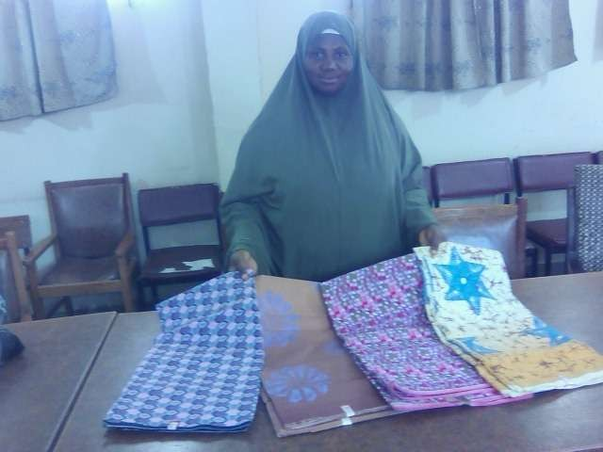

## Plate 13: Purchase of Initial Fabrics used for the Construction of Instruments for Data Collection

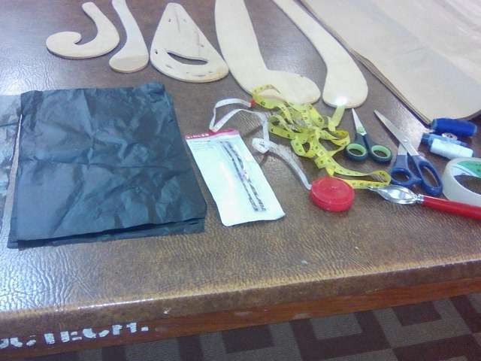

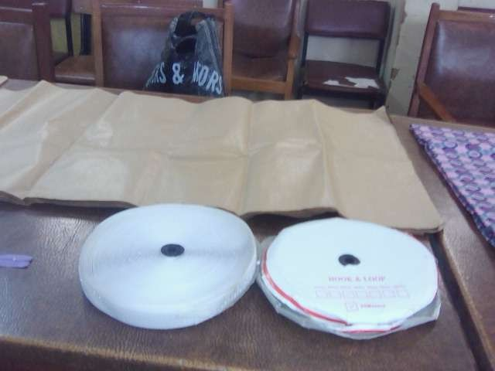

**Plate 14: Pattern, Sewing Tools and Materials**

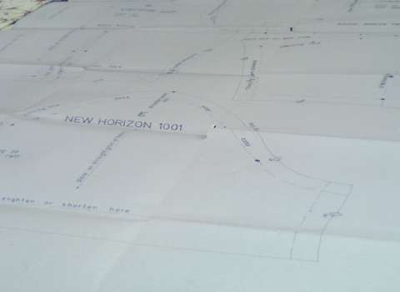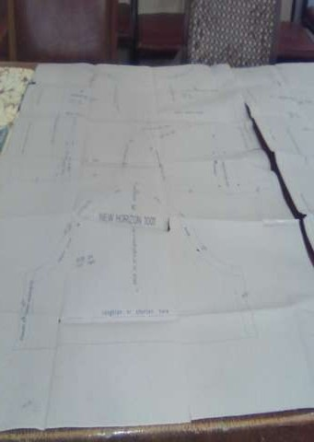

## Plate 15: Commercial Patterns

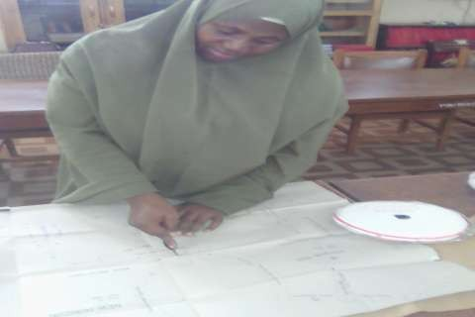

**Plate 16: Tracing of Pattern by the Researcher**

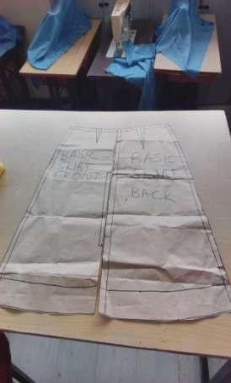 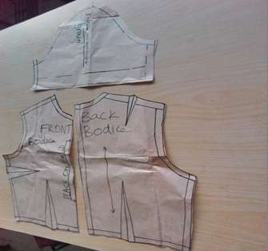

## Plate 17: Traced out Basic Patterns

**Appendix V**

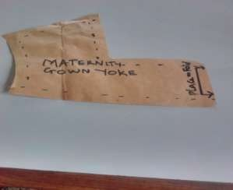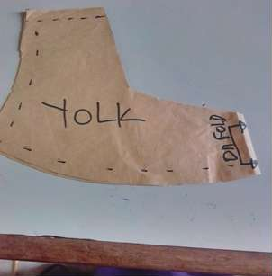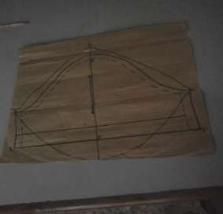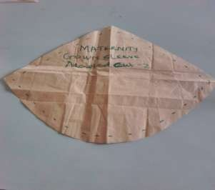

## Plate 18: Maternity Gown Patterns Adapted

**Appendix VI**



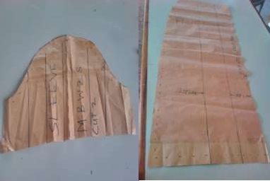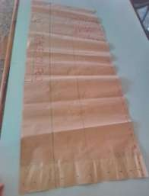

## Plate 19: Maternity Blouse with Zips and Skirt Adapted

**Appendix VII**

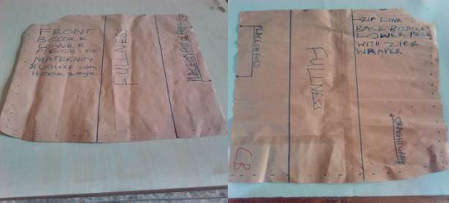

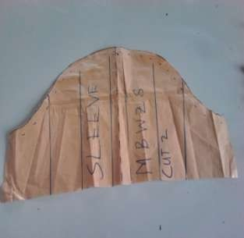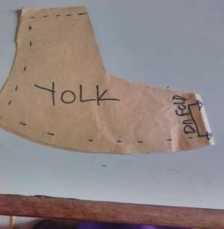

## Plate 20: Maternity Blouse with Zips to be worn on Wrapper

**Appendix VIII**

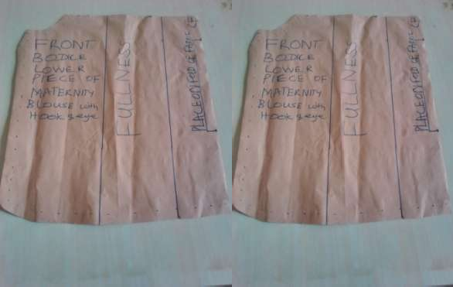

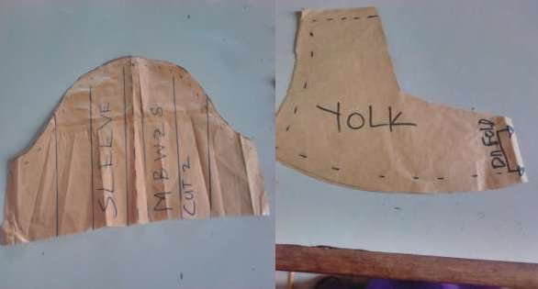

## Plate 21: Maternity Blouse with Hook and Eye

**Appendix IX**

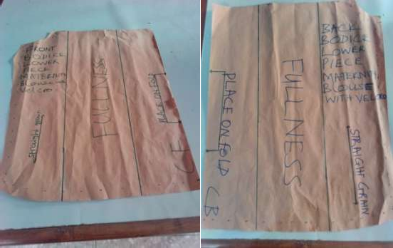

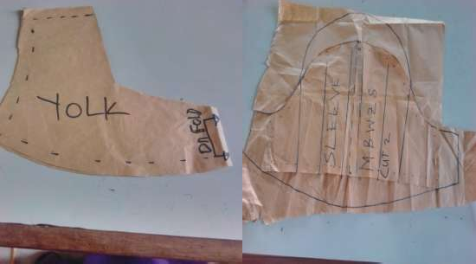

## Plate 22: Maternity Blouse with Velcro Fastener Adapted Patterns

**Appendix X**

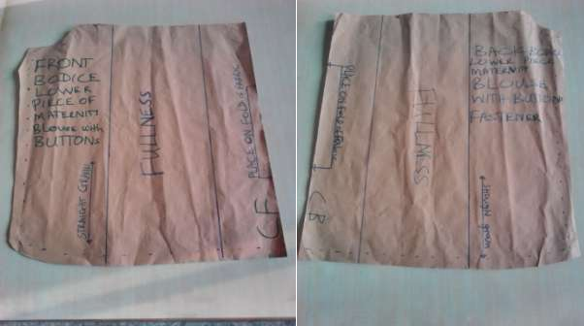

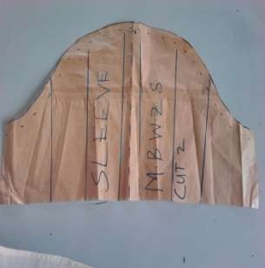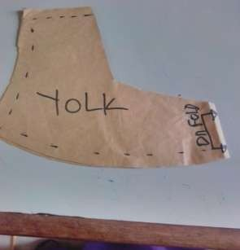

## Plate 23: Maternity Blouse with Buttons Fasteners Patterns Adapted

**Appendix XI Laying, pining and cutting of patterns on fabric**

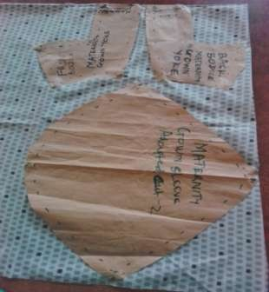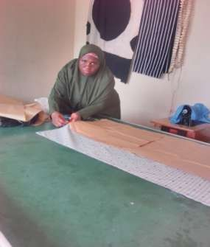

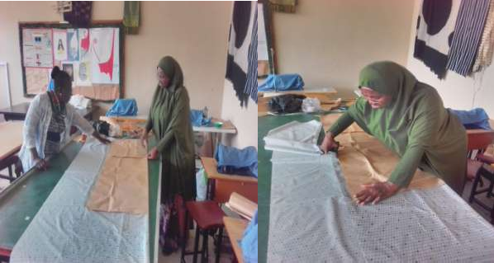

## Plate 24: Laying of Maternity Gown Patterns on Fabric

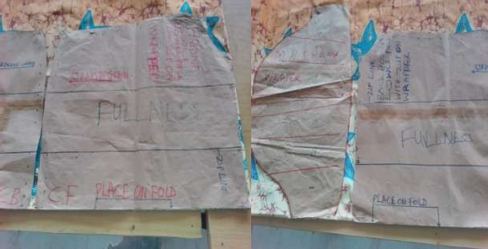

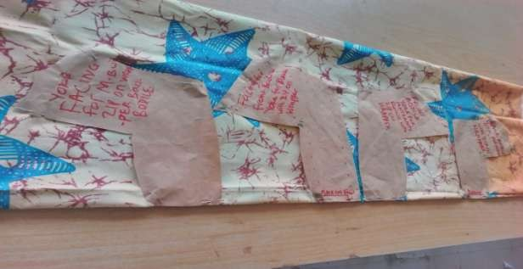

**Plate 25: Laying of maternity blouse with zips patterns on fabric**

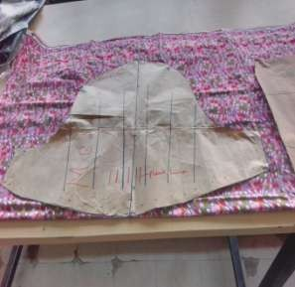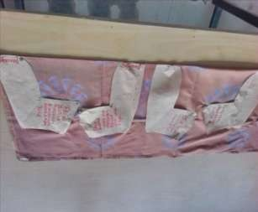

## Plate 26: Laying of Maternity Blouse with Velcro Patterns on Fabric

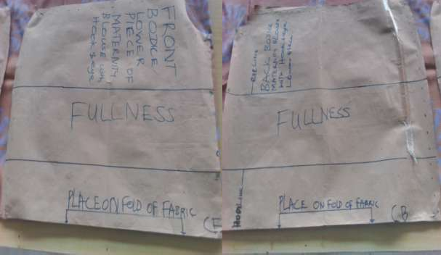

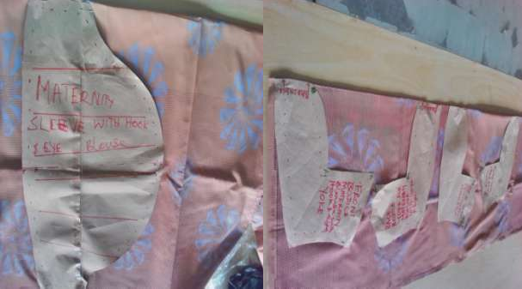

**Plate 27: Laying of Maternity Blouse with Hook and Eye Patterns on Fabric**

## Appendix XII Construction of the Maternity Apparels

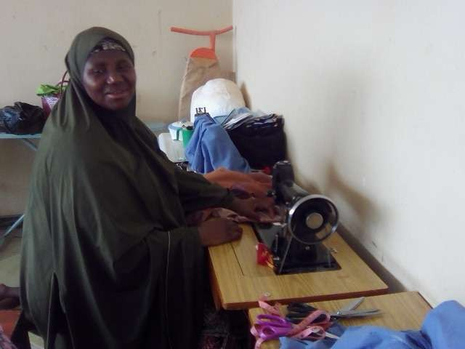

**Plate 28: Sewing of Maternity Garments by the Researcher.**

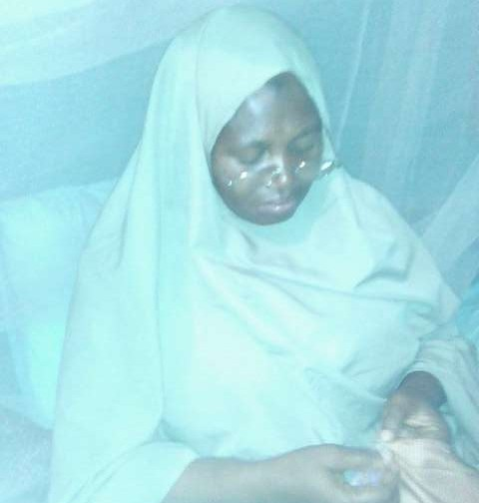

## Plate 29: Fastening of Fasteners by the Researcher

**Appendix XIII**

## Fitting by Users (Pregnant Women).

**Plate 19: The picture of Pregnant Woman, wearing the Produced Garments with Hook and Eye fasteners at first Trimesters**

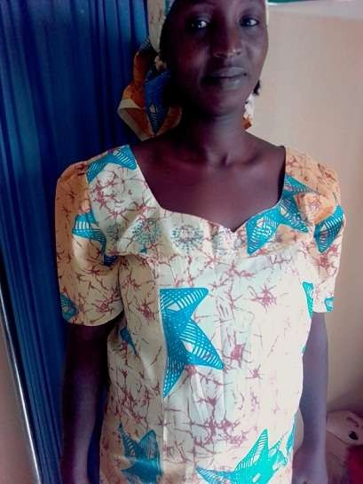

## Plate 30: The Picture of Pregnant Woman, Wearing the Produced Garment with Zip Fasteners at Second Trimesters

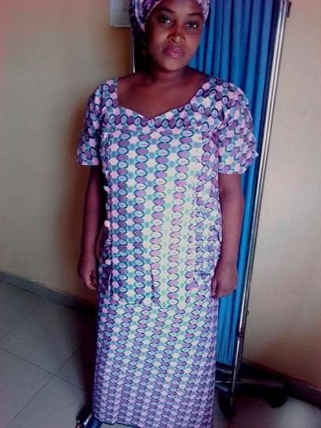

**Plate 31: The Picture of Pregnant Woman, Wearing the Produced Garment with Button Fasteners at Second Trimesters**

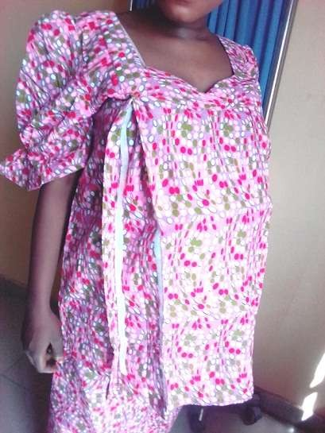

## Plate 32: The picture of pregnant woman, wearing the Produced Garmentwith Velcro fasteners at third Trimesters

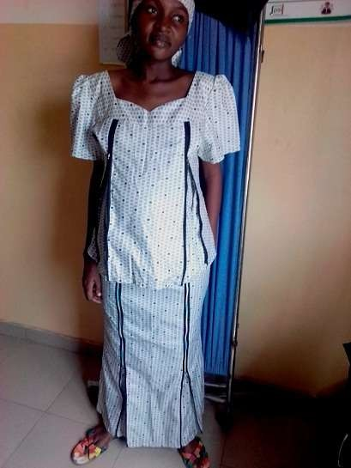

**Plate 33: The Picture of Pregnant Woman, wearing the Produced Skirt and Blouse with Zip Fasteners at third Trimesters**

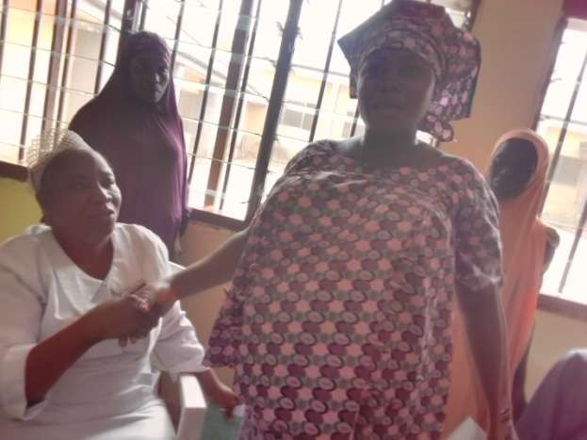

## Plate 34: The picture of a nurse and pregnant woman, wearing the produced maternity garment with button fasteners at third trimesters in Abaji general hospital Abuja.



**Plate 35: The Picture of Pregnant Women, Wearing the Produced Maternity Gown, Skirt and Blouse with Zip Fasteners at third trimesters in Abaji General Hospital Abuja**

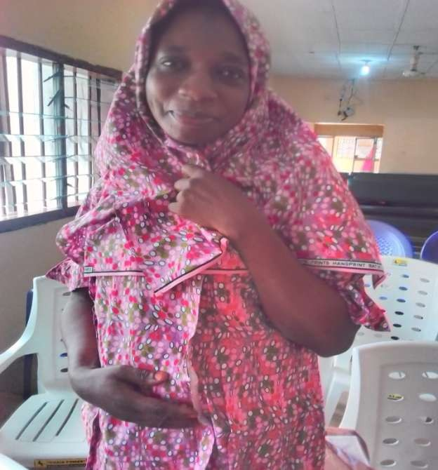

## Plate 36: The Picture of a Pregnant Woman, wearing the Produced Maternity garment with Velcro fasteners at first Trimester in Abaji General Hospital Abuja

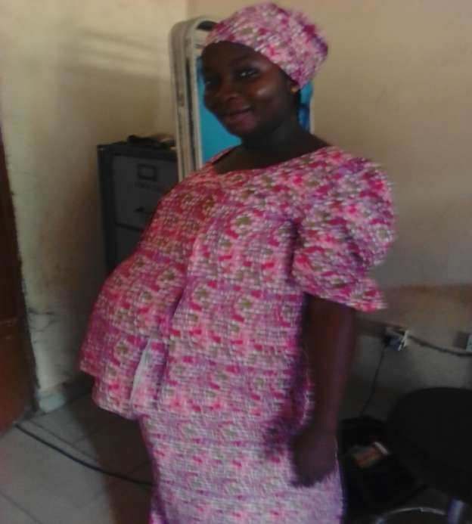

**Plate 37: The Picture of a Pregnant Woman, wearing the Produced Maternity garment with Velcro fasteners at third Trimester in Abaji General Hospital Abuja**

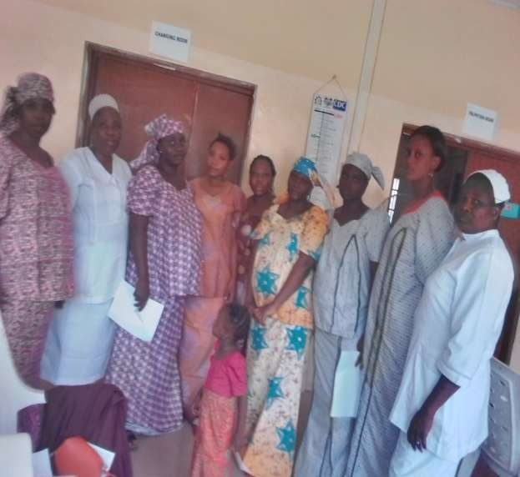

## Plate 38: The group Picture of Nurses and Pregnant Women wearing the Produced Maternity Garments with Fasteners, at various Trimesters in Abaji General Hospital Abuja

**Appendix XIV**

## Pictures of Judges Responding to the Questionnaire

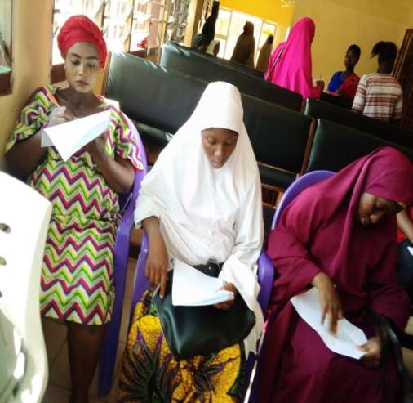

**Plate 39: Pictures of Pregnant Women Responding to the Questionnaire**



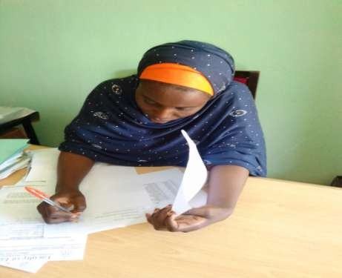

## Plate 40: Pictures of Judge (clothing and textiles lecturer) Responding to the Questionnaire



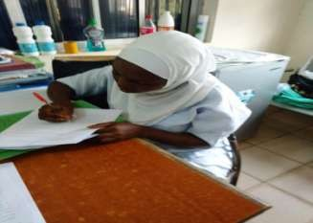



**Plate 41: Pictures of Nurse Judge Responding to the Questionnaire**

## Appendix XV

**TARO YAMANE SAMPLING SIZE METHOD**

In the academic environment especially the research aspect of it has seen sample size as one of the most vital character in statistics. The basic for a research based on primary data uses sample size as the starting point.

Most project/research students find it difficult to get a reliable sample size for the [research](http://www.uniprojectmaterials.com/education/project-topics-materials-for-final-year-students)

[works.](http://www.uniprojectmaterials.com/education/project-topics-materials-for-final-year-students) We found it very importance to use this medium to educate [project](http://www.uniprojectmaterials.com/departments) students on how to calculate sample size using TARO YAMANE method.

Sample size determination plays a significant role in research that uses primary data seeking responses from the use of questionnaires.

When the questionnaire for the [project topic](http://www.uniprojectmaterials.com/departments) was drafted, the research students were expected to know the population they were to distribute the questionnaires to, after the distribution, the research students were expected to calculate their sample size from the population they administer the questionnaires to. Let us see how we can calculate a reliable sample size using Taro Yamane method.

## TARO YAMANE METHOD

The Taro Yamane method for sample size calculation was formulated by the statistician Tara Yamane in 1967 to determine the sample size from a given population. Below is the mathematical illustration for the Taro Yamane method:

n= N/ (1+N (e) ^2)

Where:

n signifies the sample size

N signifies the population under study

e signifies the margin error (it could be 0.10, 0.05 or 0.01)

We will illustrate with the above formula to determine the sample size from a given population.

Determining sample sizefor this research was calculated by using Taro Yamane, the calculation formula of Taro Yamane was presented as follows.

Where ：

n= N/ (1+N (e) ^2)

N = 112,430

e = 0.05

Substitution of numbers in formula done as follow: n= 112,430/1+112,430(0.05) ^2), n = 112,430/1+112,430(0.0025), n = 112,430/1+281.075, n = 112,430/282.075, n= 398.581 rounded

up to be n= 399 because there is no half human being. Therefore, sample size for this study was 399.

## Appendix XVI

**Reliability**

## DEVELOPMENT OF FUNCTIONAL MATERNITY APPARELS FROM COMMERCIAL BLOCK PATTERNS, FASTENERS AND DISPOSAL OF FULLNESS IN FEDERAL CAPITAL TERRITORYABUJA, NIGERIA.

**Scale: ALL VARIABLES**

## Case Processing Summary

|  |  |  |  |
| --- | --- | --- | --- |
|  | | N | % |
|  | Valid | 20 | 200.0 |
| Cases | Excludeda | 0 | .0 |
|  | Total | 20 | 200.0 |

a. List wise deletion based on all variables in the procedure.

## Reliability Statistics

|  |  |  |
| --- | --- | --- |
| Cronbach's Alphaa | Cronbach's Alpha Based on Standardized  Items | N of Items |
| .731 | .811 | 21 |

A

## Item Statistics

|  |  |  |  |
| --- | --- | --- | --- |
|  | Mean | Std.  Devia tion | N |
| None restricting clothing with expandable |  |  |  |
|  | 4.70 | .675 | 20 |
| features |  |  |  |
| Cotton fabrics to keep the body cool | 4.50 | .527 | 20 |
| Light, loose and non constricting clothing | 4.30 | 1.252 | 20 |
| clothing with fasteners for adjustment | 4.80 | .422 | 20 |
| Dressing that enhances natural beauty and |  |  |  |
|  | 4.20 | .919 | 20 |
| self confidence |  |  |  |
| Light weight clothing to maintain proper |  |  |  |
|  | 3.50 | 1.179 | 20 |
| body balance |  |  |  |
| Fabrics that is highly absorbent | 4.40 | .516 | 20 |
| Clothing that will match work and activities | 4.50 | .707 | 20 |
| Clothing that will camouflage the middle |  |  |  |
|  | 4.30 | .949 | 20 |
| contour |  |  |  |
| Clothing with pleats, gathers and folds | 4.50 | .527 | 20 |
| Yoke for styling | 4.40 | .966 | 20 |
| Pleats for disposal of fullness | 4.40 | .966 | 20 |
| Fasteners for adjusting and converting | 4.20 | .919 | 20 |
| Sleeves for styling | 4.40 | .516 | 20 |

|  |  |  |  |
| --- | --- | --- | --- |
| Blouse design and Hook and Eye fasteners |  |  |  |
|  | 4.70 | .483 | 20 |
| using disposal of fullness techniques |  |  |  |
| Blouse design with Button & Button holes |  |  |  |
| fasteners using disposal of fullness | 4.70 | .483 | 20 |
| techniques |  |  |  |
| Blouse design with Velcro fasteners using |  |  |  |
|  | 4.30 | .675 | 20 |
| disposal of fullness techniques |  |  |  |
| Blouse design with Zip fasteners using |  |  |  |
|  | 4.90 | .316 | 20 |
| disposal of fullness techniques |  |  |  |
| Blouse & Skirt Design with Zip fasteners |  |  |  |
|  | 4.70 | .483 | 20 |
| using disposal of fullness techniques |  |  |  |
| Gown Design with Zip fasteners using |  |  |  |
|  | 4.70 | .483 | 20 |
| disposal of fullness techniques |  |  |  |
| Blouse & Wrapper Design without fasteners | 2.20 | .568 | 20 |

**Summary Item Statistics**

|  |  |  |  |  |  |  |  |
| --- | --- | --- | --- | --- | --- | --- | --- |
|  | Mean | Minimum | Maximum | Range | Maximum /  Minimum | Variance | N of Items |
| Item Means | 4.343 | 2.200 | 4.900 | 2.800 | 2.333 | .352 | 21 |

## The apparel needs of pregnant women Reliability

**Scale: ALL VARIABLES**

## Case Processing Summary

|  |  |  |  |
| --- | --- | --- | --- |
|  | | N | % |
|  | Valid | 20 | 200.0 |
| Cases | Excluded | 0 | .0 |
|  | Total | 20 | 200.0 |

a. List wise deletion based on all variables in the procedure.

## Reliability Statistics

|  |  |  |
| --- | --- | --- |
| Cronbach's Alphaa | Cronbach's Alpha Based on Standardized  Items‟ | N of Items |
| .800 | .821 | 20 |

**Item Statistics**

|  |  |  |  |
| --- | --- | --- | --- |
|  | Mean | Std.  Deviation | N |
| None restricting clothing with expandable |  |  |  |
|  | 4.70 | .675 | 20 |
| features |  |  |  |
| Cotton fabrics to keep the body cool | 4.50 | .527 | 20 |
| Light, loose and non constricting clothing | 4.30 | 1.252 | 20 |
| clothing with fasteners for adjustment | 4.80 | .422 | 20 |
| Dressing that enhances natural beauty and |  |  |  |
|  | 4.20 | .919 | 20 |
| self confidence |  |  |  |
| Light weight clothing to maintain proper |  |  |  |
|  | 3.50 | 1.179 | 20 |
| body balance |  |  |  |
| Fabrics that is highly absorbent | 4.40 | .516 | 20 |
| Clothing that will match work and activities | 4.50 | .707 | 20 |
| Clothing that will camouflage the middle |  |  |  |
|  | 4.30 | .949 | 20 |
| contour |  |  |  |
| Clothing with pleats, gathers and folds | 4.50 | .527 | 20 |

## Summary Item Statistics

|  |  |  |  |  |  |  |  |
| --- | --- | --- | --- | --- | --- | --- | --- |
|  | Mean | Minimum | Maximum | Range | Maximum /  Minimum | Variance | N of Items |
| Item Means | 4.370 | 3.500 | 4.800 | 1.300 | 1.371 | .127 | 20 |

The apparel design features (functional, aesthetics and expressive) needs for adapting patterns

## Reliability

**Scale: ALL VARIABLES**

## Case Processing Summary

|  |  |  |  |
| --- | --- | --- | --- |
|  | | N | % |
|  | Valid | 20 | 200.0 |
| Cases | Excludeda | 0 | .0 |
|  | Total | 20 | 200.0 |

a. List wise deletion based on all variables in the procedure.

## Reliability Statistics

|  |  |  |
| --- | --- | --- |
| Cronbach's Alpha | Cronbach's Alpha Based on Standardized  Items | N of Items |
| .840 | .823 | 4 |

**Item Statistics**

|  |  |  |  |
| --- | --- | --- | --- |
|  | Mean | Std. Deviation | N |
| Yoke for styling  Pleats for disposal of fullness | 4.40  4.40 | .966  .966 | 20  20 |

|  |  |  |  |
| --- | --- | --- | --- |
| Fasteners for adjusting  and converting Sleeves for styling | 4.20  4.40 | .919  .516 | 20  20 |

## Summary Item Statistics

|  |  |  |  |  |  |  |  |
| --- | --- | --- | --- | --- | --- | --- | --- |
|  | Mean | Minimum | Maximum | Range | Maximum /  Minimum | Variance | N of Items |
| Item Means | 4.350 | 4.200 | 4.400 | .200 | 1.048 | .020 | 4 |

**the apparel design preferences using fasteners and disposal of fullness Reliability**

## Scale: ALL VARIABLES

**Case Processing Summary**

|  |  |  |  |
| --- | --- | --- | --- |
|  | | N | % |
|  | Valid | 20 | 200.0 |
| Cases | Excludeda | 0 | .0 |
|  | Total | 20 | 200.0 |

a. Listwise deletion based on all variables in the procedure.

## Reliability Statistics

|  |  |  |
| --- | --- | --- |
| Cronbach's Alpha | Cronbach's Alpha Based on Standardized  Items | N of Items |
| .857 | .813 | 7 |

**Item Statistics**

|  |  |  |  |
| --- | --- | --- | --- |
|  | Mean | Std. Deviat  ion | N |
| Blouse design and Hook and Eye fasteners using disposal of |  |  |  |
|  | 4.70 | .483 | 20 |
| fullness techniques |  |  |  |
| Blouse design with Button & Button holes fasteners using |  |  |  |
|  | 4.70 | .483 | 20 |
| disposal of fullness techniques |  |  |  |
| Blouse design with Velcro fasteners using disposal of fullness |  |  |  |
|  | 4.30 | .675 | 20 |
| techniques |  |  |  |
| Blouse design with Zip fasteners using disposal of fullness |  |  |  |
|  | 4.90 | .316 | 20 |
| techniques |  |  |  |
| Blouse & Skirt Design with Zip fasteners using disposal of |  |  |  |
|  | 4.70 | .483 | 20 |
| fullness techniques |  |  |  |
| Gown Design with Zip fasteners using disposal of fullness |  |  |  |
|  | 4.70 | .483 | 20 |
| techniques |  |  |  |

|  |  |  |  |
| --- | --- | --- | --- |
| Blouse & Wrapper Design without fasteners | 2.20 | .568 | 20 |

## Summary Item Statistics

|  |  |  |  |  |  |  |  |
| --- | --- | --- | --- | --- | --- | --- | --- |
|  | Mean | Minimum | Maximum | Range | Maximum /  Minimum | Variance | N of Items |
| Item Means | 4.300 | 2.200 | 4.900 | 2.800 | 2.333 | .973 | 7 |

**Appendix XVII**

## status

|  |  |  |  |  |
| --- | --- | --- | --- | --- |
|  | Frequency | Percent | Valid  Percent | Cumulative  Percent |
| Users  Judges Clothing & textile lecturers, Valid nurses and judges  Pregnant women used for measurement  Total | 335 | 89.4 | 89.4 | 89.4 |
| 10 | 2.6 | 2.6 | 90.0 |
| 30 | 8 | 8 | 100.0 |
| 375 | 100.0 | 100.0 |  |

**RES QUES 8 RATINGS OF JUDGES** ON

## Frequencies

**Statistics**

|  |  |  |  |  |  |  |  |  |
| --- | --- | --- | --- | --- | --- | --- | --- | --- |
|  | Necklin | Burst | Adjustab | Sleeves | should | Arm | Dispos | The |
| es well | linewe | le to all | are | er | hole | al of | garment |
| fitted | ll | stages | well | seams | fitted | fullnes | s are |
|  | fitted | (pre | fitted | well | well | s are | beautifu |
|  |  | natal, |  | stitche |  | approp | l |
|  |  | 2nd, 3rd |  | d |  | riate to | (aestheti |
|  |  | trimester |  |  |  | all | cs) |
|  |  | s and |  |  |  | stages |  |
|  |  | post |  |  |  |  |  |
|  |  | natal |  |  |  |  |  |
|  |  | period) |  |  |  |  |  |
| Valid | 10 | 10 | 10 | 10 | 10 | 10 | 10 | 10 |
| N |  |  |  |  |  |  |  |  |
| Missing | 0 | 0 | 0 | 0 | 0 | 0 | 0 | 0 |
| Mean | 4.60 | 4.90 | 4.70 | 4.30 | 4.70 | 4.70 | 4.80 | 4.60 |
| Std. Deviation | .516 | .316 | .483 | .483 | .483 | .483 | .422 | .516 |

## Frequency Table

**Necklines well fitted**

|  |  |  |  |  |
| --- | --- | --- | --- | --- |
|  | Frequency | Percent | Valid Percent | Cumulative  Percent |
| A | 4 | 40.0 | 40.0 | 40.0 |
| Valid SA | 6 | 60.0 | 60.0 | 100.0 |
| Total | 10 | 100.0 | 100.0 |  |

## Burst linewell fitted

|  |  |  |  |  |
| --- | --- | --- | --- | --- |
|  | Frequency | Percent | Valid Percent | Cumulative  Percent |
| A | 1 | 10.0 | 10.0 | 10.0 |
| Valid SA | 9 | 90.0 | 90.0 | 100.0 |
| Total | 10 | 100.0 | 100.0 |  |

**Adjustable to all stages (pre-natal,1st, 2nd, 3rd trimesters and post-natal period)**

|  |  |  |  |  |
| --- | --- | --- | --- | --- |
|  | Frequency | Percent | Valid Percent | Cumulative Percent |
| A | 3 | 30.0 | 30.0 | 30.0 |
| Valid SA | 7 | 70.0 | 70.0 | 100.0 |
| Total | 10 | 100.0 | 100.0 |  |

## Sleeves are well fitted

|  |  |  |  |  |
| --- | --- | --- | --- | --- |
|  | Frequency | Percent | Valid Percent | Cumulative  Percent |
| A | 7 | 70.0 | 70.0 | 70.0 |
| Valid SA | 3 | 30.0 | 30.0 | 100.0 |
| Total | 10 | 100.0 | 100.0 |  |

**shoulder seams well stitched**

|  |  |  |  |  |
| --- | --- | --- | --- | --- |
|  | Frequency | Percent | Valid Percent | Cumulative  Percent |
| A | 3 | 30.0 | 30.0 | 30.0 |
| Valid SA | 7 | 70.0 | 70.0 | 100.0 |
| Total | 10 | 100.0 | 100.0 |  |

## Arm hole fitted well

|  |  |  |  |  |
| --- | --- | --- | --- | --- |
|  | Frequency | Percent | Valid Percent | Cumulative  Percent |
| A | 3 | 30.0 | 30.0 | 30.0 |
| Valid SA | 7 | 70.0 | 70.0 | 100.0 |
| Total | 10 | 100.0 | 100.0 |  |

**Disposal of fullness are appropriate to all stages**

|  |  |  |  |  |
| --- | --- | --- | --- | --- |
|  | Frequency | Percent | Valid Percent | Cumulative  Percent |
| A | 2 | 20.0 | 20.0 | 20.0 |
| Valid SA | 8 | 80.0 | 80.0 | 100.0 |
| Total | 10 | 100.0 | 100.0 |  |

## The garments are beautiful (aesthetics)

|  |  |  |  |  |
| --- | --- | --- | --- | --- |
|  | Frequency | Percent | Valid Percent | Cumulative  Percent |
| A | 4 | 40.0 | 40.0 | 40.0 |
| Valid SA | 6 | 60.0 | 60.0 | 100.0 |
| Total | 10 | 100.0 | 100.0 |  |

**OnewayDescriptive**

MEASUREMENT

|  |  |  |  |  |  |
| --- | --- | --- | --- | --- | --- |
|  | N | Mean | Std. Deviation | Std. Error | Maximum |
| FIRST | 14 | 42.8448 | 1.16804 | .58402 | 44.22 |
| SECOND | 8 | 44.2056 | .80515 | .46485 | 44.90 |
| THIRD | 8 | 48.1472 | 1.88031 | 1.08560 | 50.20 |
| Total | 30 | 44.8438 | 2.63322 | .83270 | 50.20 |

## ANOVA

MEASUREMENT

|  |  |  |  |  |  |
| --- | --- | --- | --- | --- | --- |
|  | Sum of  Squares | df | Mean Square | F | Sig. |
| Between Groups | 49.944 | 2 | 24.972 | 14.029 | .004 |
| Within Groups | 12.461 | 7 | 1.780 |  |  |
| Total | 62.405 | 9 |  |  |  |

## Post Hoc Tests

**Multiple Comparisons**

Dependent Variable: MEASUREMENT Scheffe

|  |  |  |  |  |  |
| --- | --- | --- | --- | --- | --- |
| (I) (J)  TRIMESTER TRIMESTER | Mean  Difference (I- J) | Std. Error | Sig. | 95% Confidence Interval | |
| Lower Bound | Upper Bound |
| SECOND | -1.36076 | 1.01901 | .452 | -4.4974 | 1.7759 |
| FIRST |  |  |  |  |  |
| THIRD | -5.30243* | 1.01901 | .004 | -8.4391 | -2.1658 |
| FIRST | 1.36076 | 1.01901 | .452 | -1.7759 | 4.4974 |
| SECOND |  |  |  |  |  |
| THIRD | -3.94167* | 1.08937 | .025 | -7.2949 | -.5885 |
| FIRST | 5.30243* | 1.01901 | .004 | 2.1658 | 8.4391 |
| THIRD |  |  |  |  |  |
| SECOND | 3.94167* | 1.08937 | .025 | .5885 | 7.2949 |

*. The mean difference is significant at the 0.05 level.

## Homogeneous Subsets

**MEASUREMENT**

Scheffe

|  |  |  |  |
| --- | --- | --- | --- |
| TRIMESTE R | N | Subset for alpha = 0.05 | |
| 1 | 2 |
| FIRST | 4 | 42.8448 |  |
| SECOND | 3 | 44.2056 |  |
| THIRD | 3 |  | 48.1472 |
| Sig. |  | .467 | 1.000 |

Means for groups in homogeneous subsets are displayed.

1. Uses Harmonic Mean Sample Size = 3.273.
2. The group sizes are unequal. The harmonic mean of the group sizes is used. Type I error levels are not guaranteed.

ONEWAY Aesthetic-attributes BY status

/STATISTICS DESCRIPTIVES

/MISSING ANALYSIS

/POSTHOC=SCHEFFE ALPHA(0.05).

## OnewayDescriptive

Aesthetic-attributes

|  |  |  |  |  |  |
| --- | --- | --- | --- | --- | --- |
|  | N | Mean | Std. Deviation | Std. Error | Maximum |
| Nurses | 10 | 32.2000 | 4.07704 | 1.28927 | 38.00 |
| Clothing lecturers | 10 | 32.1000 | 2.68535 | .84918 | 38.00 |
| garment members | 10 | 32.3000 | 3.23351 | 1.02252 | 39.00 |
| Total | 30 | 32.2000 | 3.56612 | .65108 | 39.00 |

## ANOVA

Aesthetic-attributes

|  |  |  |  |  |  |
| --- | --- | --- | --- | --- | --- |
|  | Sum of  Squares | df | Mean Square | F | Sig. |
| Between Groups | 60.200 | 2 | 30.100 | 2.634 | .090 |
| Within Groups | 308.600 | 27 | 11.430 |  |  |
| Total | 368.800 | 29 |  |  |  |

## Post Hoc Tests

**Homogeneous Subsets**

## Aesthetic-attributes

Scheffe

|  |  |  |
| --- | --- | --- |
| status | N | Subset for  alpha = 0.05 |
| 1 |
| Nurses | 10 | 32.2000 |
| Clothing lecturers | 10 | 32.1000 |
| garment members | 10 | 32.3000 |
| Sig. |  | .142 |

Means for groups in homogeneous subsets are displayed.

a. Uses Harmonic Mean Sample Size = 10.000.

GET

FILE='C:\Users\Ojo\Documents\FCT EBIRA USERS.sav'. DATASET NAME DataSet1 WINDOW=FRONT. FREQUENCIES VARIABLES=V1 V2 V3 V4 V5 V6 V7 V8

/ORDER=ANALYSIS.

## Frequencies users post data ques Frequency Table

**free flow of air on wearing and movement**

|  |  |  |  |  |
| --- | --- | --- | --- | --- |
|  | Frequency | Percent | Valid Percent | Cumulative  Percent |
| Valid SA | 10 | 100.0 | 100.0 | 100.0 |

## Adjustable to all stages (pre-natal, 2nd, 3rd trimesters and post-natal period)

|  |  |  |  |  |
| --- | --- | --- | --- | --- |
|  | Frequency | Percent | Valid Percent | Cumulative  Percent |
| A | 1 | 10.0 | 10.0 | 10.0 |
| Valid SA | 9 | 90.0 | 90.0 | 100.0 |
| Total | 10 | 100.0 | 100.0 |  |

**Necklines well fitted**

|  |  |  |  |  |
| --- | --- | --- | --- | --- |
|  | Frequency | Percent | Valid Percent | Cumulative  Percent |
| A | 4 | 40.0 | 40.0 | 40.0 |
| Valid SA | 6 | 60.0 | 60.0 | 100.0 |
| Total | 10 | 100.0 | 100.0 |  |

## Burst line fitted well

|  |  |  |  |  |
| --- | --- | --- | --- | --- |
|  | Frequency | Percent | Valid Percent | Cumulative  Percent |
| A | 1 | 10.0 | 10.0 | 10.0 |
| Valid SA | 9 | 90.0 | 90.0 | 100.0 |
| Total | 10 | 100.0 | 100.0 |  |

**Arm hole fitted well**

|  |  |  |  |  |
| --- | --- | --- | --- | --- |
|  | Frequency | Percent | Valid Percent | Cumulative  Percent |
| A | 5 | 50.0 | 50.0 | 50.0 |
| Valid SA | 5 | 50.0 | 50.0 | 100.0 |
| Total | 10 | 100.0 | 100.0 |  |

## Disposal of fullness are appropriate to all stages

|  |  |  |  |  |
| --- | --- | --- | --- | --- |
|  | Frequency | Percent | Valid Percent | Cumulative  Percent |
| A | 2 | 20.0 | 20.0 | 20.0 |
| Valid SA | 8 | 80.0 | 80.0 | 100.0 |
| Total | 10 | 100.0 | 100.0 |  |

**The garments are beautiful (aesthetics)**

|  |  |  |  |  |
| --- | --- | --- | --- | --- |
|  | Frequency | Percent | Valid Percent | Cumulative  Percent |
| A | 3 | 30.0 | 30.0 | 30.0 |
| Valid SA | 7 | 70.0 | 70.0 | 100.0 |
| Total | 10 | 100.0 | 100.0 |  |

## Sleeves well fitted

|  |  |  |  |  |
| --- | --- | --- | --- | --- |
|  | Frequency | Percent | Valid Percent | Cumulative  Percent |
| A | 6 | 60.0 | 60.0 | 60.0 |
| Valid SA | 4 | 40.0 | 40.0 | 100.0 |
| Total | 10 | 100.0 | 100.0 |  |

**T-Test hypo 1**

T-

## Group Statistics

|  |  |  |  |  |  |
| --- | --- | --- | --- | --- | --- |
|  | Status | N | Mean | Std. Deviation | Std. Error  Mean |
| Users  Aesthetic_atributes  Clothing lecturers | | 10  165 | 32.2558  34.9701 | 3.78023  2.54636 | .57648  .31109 |

**Independent Samples Test**

|  |  |  |  |  |  |  |  |  |  |
| --- | --- | --- | --- | --- | --- | --- | --- | --- | --- |
|  | Levene's Test for Equality of  Variances | | t-test for Equality of Means | | | | | | |
| F | Sig. | t | Df | Sig  . (2-  tail  ed) | Mean Diffe rence | Std. Error Diffe rence | 95% Confidence  Interval of the Difference | |
| Lo  wer | Upper |

|  |  |  |  |  |  |  |  |  |  |
| --- | --- | --- | --- | --- | --- | --- | --- | --- | --- |
| Equal varian ces assum es  Aesthetic_atributes Equal  varian ces not assum  es | 10.9  46 | .001 | -4.502  -4.144 | 108  66.437 | .00  0  .00  0 | - 2.714  34  - 2.714  34 | .6028  9  .6550  6 | -  3.9  093  6  -  4.0  220  4 | -1.51931  -1.40663 |

PILOT

FREQUENCIES VARIABLES=V1 V2 V3 V4

/ORDER=ANALYSIS.

## \ ANOVA

MEASUREMENT

|  |  |  |  |  |  |
| --- | --- | --- | --- | --- | --- |
|  | Sum of  Squares | df | Mean Square | F | Sig. |
| Between Groups | 49.944 | 2 | 24.972 | 14.029 | .004 |
| Within Groups | 12.461 | 7 | 1.780 |  |  |
| Total | 62.405 | 9 |  |  |  |

|  |  |  |  |  |  |
| --- | --- | --- | --- | --- | --- |
|  | N | Mean | Std. Deviation | Std. Error | Maximum |
| FIRST | 65 | 42.8448 | 1.16804 | .58402 | 44.22 |
| SECOND | 55 | 44.2056 | .80515 | .46485 | 44.90 |
| THIRD | 50 | 48.1472 | 1.88031 | 1.08560 | 50.20 |
| Total | 170 | 44.8438 | 2.63322 | .83270 | 50.20 |

## Post Hoc Tests Homogeneous Subsets

**MEASUREMENT**

Scheffe

|  |  |  |  |
| --- | --- | --- | --- |
| TRIMESTE R | N | Subset for alpha = 0.05 | |
| 1 | 2 |
| FIRST | 65 | 42.8448 |  |
| SECOND | 55 | 44.2056 |  |
| THIRD | 50 |  | 48.1472 |
| Sig. |  | .467 | 1.000 |

## ANOVA

on the aesthetic attributes of the garments

|  |  |  |  |  |  |
| --- | --- | --- | --- | --- | --- |
|  | Sum of  Squares | df | Mean Square | F | Sig. |
| Between Groups | 40.251 | 2 | 23.811 | 1.212 | .560 |
| Within Groups | 11.52 | 6 | 1.650 |  |  |
| Total | 62.400 | 8 |  |  |  |

|  |  |  |  |  |
| --- | --- | --- | --- | --- |
|  | N | Mean | Std. Deviation | Std. Error |
| FIRST | 65 | 43.5508 | 0.985 | .5685 |
| SECOND | 55 | 43.1212 | .5846 | .3844 |
| THIRD | 50 | 43.5446 | 1.8666 | .8446 |
| Total | 170 | 43.8438 | 1.9898 | .5499 |

## Post Hoc Tests

**Homogeneous Subsets**

Scheffe

|  |  |  |
| --- | --- | --- |
| TRIMESTER | N | Subset for alpha = 0.05 |
| 1 |
| FIRST | 65 | 43.5508 |
| SECOND | 55 | 43.1212 |
| THIRD | 50 | 43.54456 |
| Sig. |  | 44.8438 |

Textiles lecturers and garment members) on the aesthetic attributes of the apparel

## ANOVA N=10

Aesthetic-attributes

|  |  |  |  |  |  |
| --- | --- | --- | --- | --- | --- |
|  | Sum of  Squares | Df | Mean Square | F | Sig. |
| Between Groups | 60.200 | 2 | 30.100 | 2.634 | .090 |
| Within Groups | 308.600 | 27 | 11.430 |  |  |
| Total | 368.800 | 29 |  |  |  |

## Descriptive

Aesthetic-attributes

|  |  |  |  |  |  |
| --- | --- | --- | --- | --- | --- |
|  | N | Mean | Std. Deviation | Std. Error | Maximum |
| Nurses | 4 | 32.2000 | 4.07712 | 1.28927 | 38.00 |
| Clothing lecturers | 3 | 32.1000 | 2.68511 | .84918 | 38.00 |
| garment members | 3 | 32.3000 | 3.23332 | 1.02252 | 39.00 |
| Total | 30 | 32.2000 | 3.56612 | .65108 | 39.00 |

## Homogeneous Subsets

**Aesthetic-attributes**

Scheffe

|  |  |  |
| --- | --- | --- |
| Status | N | Subset for alpha = 0.05 |
| 1 |
| Nurses | 4 | 32.2000 |
| Clothing lecturers | 3 | 32.1000 |
| garment members | 3 | 32.3000 |
| Sig. |  | .142 |

Means for groups in homogeneous subsets are displayed.

a. Uses Harmonic Mean Sample Size = 10.000.

## Table Question one;

**1. What are the functional apparels requirements of pregnant women in F.C.T Abuja?**

## Frequency Table

**None restricting clothing with expandable features**

|  |  |  |  |  |
| --- | --- | --- | --- | --- |
|  | Frequency | Percent | Valid Percent | Cumulative  Percent |
| Valid SA | 10 | 100.0 | 100.0 | 100.0 |

## Cotton fabrics to keep the body cool

|  |  |  |  |  |
| --- | --- | --- | --- | --- |
|  | Frequency | Percent | Valid Percent | Cumulative  Percent |
| A | 5 | 50.0 | 50.0 | 50.0 |
| Valid SA | 5 | 50.0 | 50.0 | 100.0 |
| Total | 10 | 100.0 | 100.0 |  |

**Light, loose and non-constricting clothing**

|  |  |  |  |  |
| --- | --- | --- | --- | --- |
|  | Frequency | Percent | Valid Percent | Cumulative  Percent |
| A | 3 | 30.0 | 30.0 | 30.0 |
| Valid SA | 7 | 70.0 | 70.0 | 100.0 |
| Total | 10 | 100.0 | 100.0 |  |

## clothing with fasteners for adjustment

|  |  |  |  |  |
| --- | --- | --- | --- | --- |
|  | Frequency | Percent | Valid Percent | Cumulative  Percent |
| A | 2 | 20.0 | 20.0 | 20.0 |
| Valid SA | 8 | 80.0 | 80.0 | 100.0 |
| Total | 10 | 100.0 | 100.0 |  |

**Dressing that enhances natural beauty and self confidence**

|  |  |  |  |  |
| --- | --- | --- | --- | --- |
|  | Frequency | Percent | Valid Percent | Cumulative  Percent |
| D | 1 | 10.0 | 10.0 | 10.0 |
| A | 5 | 50.0 | 50.0 | 60.0 |
| Valid |  |  |  |  |
| SA | 4 | 40.0 | 40.0 | 100.0 |
| Total | 10 | 100.0 | 100.0 |  |

## Light weight clothing to maintain proper body balance

|  |  |  |  |  |  |
| --- | --- | --- | --- | --- | --- |
|  | | Frequency | Percent | Valid Percent | Cumulative  Percent |
|  | D | 3 | 30.0 | 30.0 | 30.0 |
| Valid | UD | 1 | 10.0 | 10.0 | 40.0 |
|  | A | 4 | 40.0 | 40.0 | 80.0 |

|  |  |  |  |  |  |
| --- | --- | --- | --- | --- | --- |
|  | SA | 2 | 20.0 | 20.0 | 100.0 |
| Total | 10 | 100.0 | 100.0 |  |

**Fabrics that is highly absorbent**

|  |  |  |  |  |
| --- | --- | --- | --- | --- |
|  | Frequency | Percent | Valid Percent | Cumulative  Percent |
| A | 6 | 60.0 | 60.0 | 60.0 |
| Valid SA | 4 | 40.0 | 40.0 | 100.0 |
| Total | 10 | 100.0 | 100.0 |  |

## Clothing that will match work and activities

|  |  |  |  |  |
| --- | --- | --- | --- | --- |
|  | Frequency | Percent | Valid Percent | Cumulative  Percent |
| UD | 1 | 10.0 | 10.0 | 10.0 |
| A | 3 | 30.0 | 30.0 | 40.0 |
| Valid |  |  |  |  |
| SA | 6 | 60.0 | 60.0 | 100.0 |
| Total | 10 | 100.0 | 100.0 |  |

**Clothing that will camouflage the middle contour**

|  |  |  |  |  |
| --- | --- | --- | --- | --- |
|  | Frequency | Percent | Valid Percent | Cumulative  Percent |
| D | 1 | 10.0 | 10.0 | 10.0 |
| A | 4 | 40.0 | 40.0 | 50.0 |
| Valid |  |  |  |  |
| SA | 5 | 50.0 | 50.0 | 100.0 |
| Total | 10 | 100.0 | 100.0 |  |

## Clothing with pleats, gathers and folds

|  |  |  |  |  |
| --- | --- | --- | --- | --- |
|  | Frequency | Percent | Valid Percent | Cumulative  Percent |
| A | 5 | 50.0 | 50.0 | 50.0 |
| Valid SA | 5 | 50.0 | 50.0 | 100.0 |
| Total | 10 | 100.0 | 100.0 |  |

**QUESTION Two**

## What are the design features (functional, aesthetics and expressive) needed for the adaptation of the patterns for functional apparels for pregnant women in F. C. T. Abuja?

**Frequencies Frequency Table**

## Yoke for styling

|  |  |  |  |  |
| --- | --- | --- | --- | --- |
|  | Frequency | Percent | Valid Percent | Cumulative  Percent |
| D | 1 | 10.0 | 10.0 | 10.0 |
| A | 3 | 30.0 | 30.0 | 40.0 |
| Valid |  |  |  |  |
| SA | 6 | 60.0 | 60.0 | 100.0 |
| Total | 10 | 100.0 | 100.0 |  |

**Pleats for disposal of fullness**

|  |  |  |  |  |
| --- | --- | --- | --- | --- |
|  | Frequency | Percent | Valid Percent | Cumulative  Percent |
| D | 1 | 10.0 | 10.0 | 10.0 |
| A | 3 | 30.0 | 30.0 | 40.0 |
| Valid |  |  |  |  |
| SA | 6 | 60.0 | 60.0 | 100.0 |
| Total | 10 | 100.0 | 100.0 |  |

## Fasteners for adjusting and converting

|  |  |  |  |  |
| --- | --- | --- | --- | --- |
|  | Frequency | Percent | Valid Percent | Cumulative  Percent |
| D | 1 | 10.0 | 10.0 | 10.0 |
| A | 5 | 50.0 | 50.0 | 60.0 |
| Valid |  |  |  |  |
| SA | 4 | 40.0 | 40.0 | 100.0 |
| Total | 10 | 100.0 | 100.0 |  |

**Sleeves for styling**

|  |  |  |  |  |
| --- | --- | --- | --- | --- |
|  | Frequency | Percent | Valid Percent | Cumulative  Percent |
| A | 6 | 60.0 | 60.0 | 60.0 |
| Valid SA | 4 | 40.0 | 40.0 | 100.0 |
| Total | 10 | 100.0 | 100.0 |  |

FREQUENCIES VARIABLES=C1 C2 C3 C4 C5 C6 C7

/ORDER=ANALYSIS.

## QUESTION 3

**What are the functional apparels preferences of pregnant women using fasteners and disposal of fullness?**

## Frequency Table

**Blouse design and Hook and Eye fasteners using disposal of fullness techniques**

|  |  |  |  |  |
| --- | --- | --- | --- | --- |
|  | Frequency | Percent | Valid Percent | Cumulative  Percent |
| A | 3 | 30.0 | 30.0 | 30.0 |
| Valid SA | 7 | 70.0 | 70.0 | 100.0 |
| Total | 10 | 100.0 | 100.0 |  |

## Blouse design with Button & Button holes fasteners using disposal of fullness techniques

|  |  |  |  |  |
| --- | --- | --- | --- | --- |
|  | Frequency | Percent | Valid Percent | Cumulative  Percent |
| A | 3 | 30.0 | 30.0 | 30.0 |
| Valid SA | 7 | 70.0 | 70.0 | 100.0 |
| Total | 10 | 100.0 | 100.0 |  |

**Blouse design with Velcro fasteners using disposal of fullness techniques**

|  |  |  |  |  |
| --- | --- | --- | --- | --- |
|  | Frequency | Percent | Valid Percent | Cumulative  Percent |
| UD | 1 | 10.0 | 10.0 | 10.0 |
| A | 5 | 50.0 | 50.0 | 60.0 |
| Valid |  |  |  |  |
| SA | 4 | 40.0 | 40.0 | 100.0 |
| Total | 10 | 100.0 | 100.0 |  |

## Blouse design with Zip fasteners using disposal of fullness techniques

|  |  |  |  |  |
| --- | --- | --- | --- | --- |
|  | Frequency | Percent | Valid Percent | Cumulative  Percent |
| A | 1 | 10.0 | 10.0 | 10.0 |
| Valid SA | 9 | 90.0 | 90.0 | 100.0 |
| Total | 10 | 100.0 | 100.0 |  |

**Blouse & Skirt Design with Zip fasteners using disposal of fullness techniques**

|  |  |  |  |  |  |
| --- | --- | --- | --- | --- | --- |
|  | | Frequency | Percent | Valid Percent | Cumulative  Percent |
| Valid | A  SA | 3  7 | 30.0  70.0 | 30.0  70.0 | 30.0  100.0 |

|  |  |  |  |  |  |
| --- | --- | --- | --- | --- | --- |
|  | Total | 10 | 100.0 | 100.0 |  |

## Gown Design wigh Zip fasteners using disposal of fullness techniques

|  |  |  |  |  |
| --- | --- | --- | --- | --- |
|  | Frequency | Percent | Valid Percent | Cumulative  Percent |
| A | 3 | 30.0 | 30.0 | 30.0 |
| Valid SA | 7 | 70.0 | 70.0 | 100.0 |
| Total | 10 | 100.0 | 100.0 |  |

**Blouse & Wrapper Design without fasteners**

|  |  |  |  |  |
| --- | --- | --- | --- | --- |
|  | Frequency | Percent | Valid Percent | Cumulative  Percent |
| SD | 1 | 10.0 | 10.0 | 10.0 |
| D | 7 | 70.0 | 70.0 | 80.0 |
| Valid |  |  |  |  |
| UD | 2 | 20.0 | 20.0 | 100.0 |
| Total | 10 | 100.0 | 100.0 |  |

## None restricting clothing with expandable features

|  |  |  |  |  |
| --- | --- | --- | --- | --- |
|  | Frequency | Percent | Valid Percent | Cumulative  Percent |
| UD | 16 | 9.4 | 9.4 | 9.4 |
| A | 16 | 9.4 | 9.4 | 18.8 |
| Valid |  |  |  |  |
| SA | 138 | 81.2 | 81.2 | 100.0 |
| Total | 170 | 100.0 | 100.0 |  |

**Cotton fabrics to keep the body cool**

|  |  |  |  |  |
| --- | --- | --- | --- | --- |
|  | Frequency | Percent | Valid Percent | Cumulative  Percent |
| A | 86 | 50.6 | 50.6 | 50.6 |
| Valid SA | 84 | 49.4 | 49.4 | 100.0 |
| Total | 170 | 100.0 | 100.0 |  |

## Light, loose and non-constricting clothing

|  |  |  |  |  |
| --- | --- | --- | --- | --- |
|  | Frequency | Percent | Valid Percent | Cumulative  Percent |
| SD | 17 | 10.0 | 10.0 | 10.0 |
| A | 44 | 25.9 | 25.9 | 35.9 |
| Valid |  |  |  |  |
| SA | 109 | 64.1 | 64.1 | 100.0 |
| Total | 170 | 100.0 | 100.0 |  |

**clothing with fasteners for adjustment**

|  |  |  |  |  |
| --- | --- | --- | --- | --- |
|  | Frequency | Percent | Valid Percent | Cumulative  Percent |
| A | 36 | 21.2 | 21.2 | 21.2 |
| Valid SA | 134 | 78.8 | 78.8 | 100.0 |
| Total | 170 | 100.0 | 100.0 |  |

## Dressing that enhances natural beauty and self confidence

|  |  |  |  |  |
| --- | --- | --- | --- | --- |
|  | Frequency | Percent | Valid Percent | Cumulative  Percent |
| D | 12 | 7.1 | 7.1 | 7.1 |
| A | 82 | 48.2 | 48.2 | 55.3 |
| Valid |  |  |  |  |
| SA | 76 | 44.7 | 44.7 | 100.0 |
| Total | 170 | 100.0 | 100.0 |  |

**Light weight clothing to maintain proper body balance**

|  |  |  |  |  |  |
| --- | --- | --- | --- | --- | --- |
|  | | Frequency | Percent | Valid Percent | Cumulative  Percent |
|  | D | 50 | 29.4 | 29.4 | 29.4 |
|  | UD | 16 | 9.4 | 9.4 | 38.8 |
| Valid |  |  |  |  |  |
|  | A | 68 | 40.0 | 40.0 | 78.8 |
|  | SA | 36 | 21.2 | 21.2 | 100.0 |

|  |  |  |  |  |  |
| --- | --- | --- | --- | --- | --- |
|  | Total | 170 | 100.0 | 100.0 |  |

## Fabrics that is highly absorbent

|  |  |  |  |  |
| --- | --- | --- | --- | --- |
|  | Frequency | Percent | Valid Percent | Cumulative  Percent |
| A | 95 | 55.9 | 55.9 | 55.9 |
| Valid SA | 75 | 44.1 | 44.1 | 100.0 |
| Total | 170 | 100.0 | 100.0 |  |

**Clothing that will match work and activities**

|  |  |  |  |  |
| --- | --- | --- | --- | --- |
|  | Frequency | Percent | Valid Percent | Cumulative  Percent |
| UD | 17 | 10.0 | 10.0 | 10.0 |
| A | 53 | 31.2 | 31.2 | 41.2 |
| Valid |  |  |  |  |
| SA | 100 | 58.8 | 58.8 | 100.0 |
| Total | 170 | 100.0 | 100.0 |  |

## Clothing that will camouflage the middle contour

|  |  |  |  |  |  |
| --- | --- | --- | --- | --- | --- |
|  | | Frequency | Percent | Valid Percent | Cumulative  Percent |
| Valid | D  A | 16  66 | 9.4  38.8 | 9.4  38.8 | 9.4  48.2 |

|  |  |  |  |  |  |
| --- | --- | --- | --- | --- | --- |
|  | SA | 88 | 51.8 | 51.8 | 100.0 |
| Total | 170 | 100.0 | 100.0 |  |

**Clothing with pleats, gathers and folds**

|  |  |  |  |  |
| --- | --- | --- | --- | --- |
|  | Frequency | Percent | Valid Percent | Cumulative  Percent |
| A | 80 | 47.1 | 47.1 | 47.1 |
| Valid SA | 90 | 52.9 | 52.9 | 100.0 |
| Total | 170 | 100.0 | 100.0 |  |

FREQUENCIES VARIABLES=B1 B2 B3 B4

/ORDER=ANALYSIS.

## Frequencies Frequency Table

**Yoke for styling**

|  |  |  |  |  |
| --- | --- | --- | --- | --- |
|  | Frequency | Percent | Valid Percent | Cumulative  Percent |
| D | 12 | 7.1 | 7.1 | 7.1 |
| A | 50 | 29.4 | 29.4 | 36.5 |
| Valid |  |  |  |  |
| SA | 108 | 63.5 | 63.5 | 100.0 |
| Total | 170 | 100.0 | 100.0 |  |

## Pleats for disposal of fullness

|  |  |  |  |  |
| --- | --- | --- | --- | --- |
|  | Frequency | Percent | Valid Percent | Cumulative  Percent |
| D | 12 | 7.1 | 7.1 | 7.1 |
| A | 52 | 30.6 | 30.6 | 37.6 |
| Valid |  |  |  |  |
| SA | 106 | 62.4 | 62.4 | 100.0 |
| Total | 170 | 100.0 | 100.0 |  |

**Fasteners for adjusting and converting**

|  |  |  |  |  |
| --- | --- | --- | --- | --- |
|  | Frequency | Percent | Valid Percent | Cumulative  Percent |
| D | 12 | 7.1 | 7.1 | 7.1 |
| A | 84 | 49.4 | 49.4 | 56.5 |
| Valid |  |  |  |  |
| SA | 74 | 43.5 | 43.5 | 100.0 |
| Total | 170 | 100.0 | 100.0 |  |

## Sleeves for styling

|  |  |  |  |  |  |
| --- | --- | --- | --- | --- | --- |
|  | | Frequency | Percent | Valid Percent | Cumulative  Percent |
| Valid | A  SA | 98  72 | 57.6  42.4 | 57.6  42.4 | 57.6  100.0 |

|  |  |  |  |  |  |
| --- | --- | --- | --- | --- | --- |
|  | Total | 170 | 100.0 | 100.0 |  |

FREQUENCIES VARIABLES=C1 C2 C3 C4 C5 C6 C7

/ORDER=ANALYSIS.

## Frequencies

**Statistics**

|  |  |  |  |  |  |  |  |  |  |  |
| --- | --- | --- | --- | --- | --- | --- | --- | --- | --- | --- |
|  | | Blouse | Blouse | Blouse | Blouse | Blouse | | Gown | | Blouse |
| design and | design | design with | design with | & Skirt | | Design | | & |
| Hook and | with | Velcro | Zip | Design | | with Zip | | Wrappe |
| Eye | Button & | fasteners | fasteners | with Zip | | fasteners | | r Design |
| fasteners | Button | using | using | fastener | | using | | without |
| using | holes | disposal of | disposal of | s using | | disposal | | fastener |
| disposal of | fasteners | fullness | fullness | disposal | | of fullness | | s |
| fullness | using | techniques | techniques | of | | techniques | |  |
| techniques | disposal |  |  | fullness | |  | |  |
|  | of fullness |  |  | techniqu | |  | |  |
|  | techniques |  |  | es | |  | |  |
|  | Valid | 165 | 165 | 165 | 165 | | 165 | | 165 | |
| N |  |  |  |  |  | |  | |  | |
|  | Missi  ng | 0 | 0 | 0 | 0 | | 0 | | 0 | |

## Frequency Table

**Blouse design and Hook and Eye fasteners using disposal of fullness techniques**

|  |  |  |  |  |
| --- | --- | --- | --- | --- |
|  | Frequency | Percent | Valid Percent | Cumulative  Percent |
| A | 44 | 26.7 | 26.7 | 26.7 |
| Valid SA | 121 | 73.3 | 73.3 | 100.0 |
| Total | 165 | 100.0 | 100.0 |  |

## Blouse design with Button & Button holes fasteners using disposal of fullness techniques

|  |  |  |  |  |
| --- | --- | --- | --- | --- |
|  | Frequency | Percent | Valid Percent | Cumulative  Percent |
| A | 47 | 28.5 | 28.5 | 28.5 |
| Valid SA | 118 | 71.5 | 71.5 | 100.0 |
| Total | 165 | 100.0 | 100.0 |  |

**Blouse design with Velcro fasteners using disposal of fullness techniques**

|  |  |  |  |  |  |
| --- | --- | --- | --- | --- | --- |
|  | | Frequency | Percent | Valid Percent | Cumulative  Percent |
| Valid | UD | 6 | 3.6 | 3.6 | 3.6 |

|  |  |  |  |  |  |
| --- | --- | --- | --- | --- | --- |
|  | A SA  Total | 25  134  165 | 15.2  81.2  100.0 | 15.2  81.2  100.0 | 18.8  100.0 |

## Blouse design with Zip fasteners using disposal of fullness techniques

|  |  |  |  |  |
| --- | --- | --- | --- | --- |
|  | Frequency | Percent | Valid Percent | Cumulative  Percent |
| A | 5 | 3.0 | 3.0 | 3.0 |
| Valid SA | 160 | 97.0 | 97.0 | 100.0 |
| Total | 165 | 100.0 | 100.0 |  |

**Blouse & Skirt Design with Zip fasteners using disposal of fullness techniques**

|  |  |  |  |  |
| --- | --- | --- | --- | --- |
|  | Frequency | Percent | Valid Percent | Cumulative  Percent |
| A | 17 | 10.3 | 10.3 | 10.3 |
| Valid SA | 148 | 89.7 | 89.7 | 100.0 |
| Total | 165 | 100.0 | 100.0 |  |

## Gown Design with Zip fasteners using disposal of fullness techniques

|  |  |  |  |  |
| --- | --- | --- | --- | --- |
|  | Frequency | Percent | Valid Percent | Cumulative  Percent |
| A | 16 | 9.7 | 9.7 | 9.7 |
| Valid SA | 149 | 90.3 | 90.3 | 100.0 |
| Total | 165 | 100.0 | 100.0 |  |

**Blouse & Wrapper Design without fasteners**

|  |  |  |  |  |
| --- | --- | --- | --- | --- |
|  | Frequency | Percent | Valid Percent | Cumulative  Percent |
| SD | 5 | 3.0 | 3.0 | 3.0 |
| D | 32 | 19.4 | 19.4 | 22.4 |
| Valid UD | 12 | 7.3 | 7.3 | 29.7 |
| SA | 116 | 70.3 | 70.3 | 100.0 |
| Total | 165 | 100.0 | 100.0 |  |

inches first trimester

## Statistics

|  |  |  |  |  |  |  |  |  |  |  |  |  |
| --- | --- | --- | --- | --- | --- | --- | --- | --- | --- | --- | --- | --- |
|  | Burst( inches  ) | Waist (inch es) | Lengt h of blouse (inche s) | Lengt h of skirt(i nches) | length of Gown (inche s) | Slefe Lengt h(inc hes) | sleefe circum ference (inches  ) | Neck line Lengt h(inc hes) | Neckli ne base(i nches) | Ho\ ip(i nch es) | Yo ke len gth (inc hes  ) | Ac ros s Bu rst (in ch  es) |
| Vali |  |  |  |  |  |  |  |  |  |  |  |  |
|  | 10 | 10 | 10 | 10 | 10 | 10 | 10 | 10 | 10 | 10 | 10 | 10 |
| d |  |  |  |  |  |  |  |  |  |  |  |  |
| N |  |  |  |  |  |  |  |  |  |  |  |  |
| Mis |  |  |  |  |  |  |  |  |  |  |  |  |
|  | 0 | 0 | 0 | 0 | 0 | 0 | 0 | 0 | 0 | 0 | 0 | 0 |
| sing |  |  |  |  |  |  |  |  |  |  |  |  |
|  |  |  |  |  |  |  |  |  |  | 39. | 27. | 16. |
|  | 35.00 | 35.40 | 25.10 | 45.10 | 48.00 | 10.40 | 17.500 | 7.250 |  |  |  |  |
| Mean |  |  |  |  |  |  |  |  | 4.3500 | 600 | 800 | 95 |
|  | 00 | 00 | 00 | 00 | 00 | 00 | 0 | 0 |  |  |  |  |
|  |  |  |  |  |  |  |  |  |  | 0 | 0 | 00 |
|  |  |  |  |  |  |  |  |  |  | 2.7 | 32. | .76 |
| Std. | 2.357 | 2.270 | .9944 | 7.880 | 8.379 | .5164 |  | .3535 |  |  |  |  |
|  |  |  |  |  |  |  | .70711 |  | .24152 | 968 | 572 | 19 |
| Deviation | 02 | 58 | 3 | 36 | 87 | 0 |  | 5 |  |  |  |  |
|  |  |  |  |  |  |  |  |  |  | 2 | 31 | 4 |
|  |  |  |  |  |  |  |  |  |  | 36. | 7.0 | 16. |
| Minimum | 33.00 | 34.00 | 24.00 | 39.00 | 38.00 | 10.00 | 17.00 | 7.00 | 4.00 |  |  |  |
|  |  |  |  |  |  |  |  |  |  | 00 | 0 | 00 |
|  |  |  |  |  |  |  |  |  |  | 45. | 75. | 18. |
| Maximum | 40.00 | 40.00 | 27.00 | 55.00 | 59.00 | 11.00 | 19.00 | 8.00 | 4.50 |  |  |  |
|  |  |  |  |  |  |  |  |  |  | 00 | 00 | 00 |

**Frequencies cm first trimester**

## Statistics

|  |  |  |  |  |  |  |  |  |  |  |  |  |
| --- | --- | --- | --- | --- | --- | --- | --- | --- | --- | --- | --- | --- |
|  | Burst( cm) | Waist (cm) | Len gth of blou se(c  m) | Length of skirt(c m) | length of Gown( cm) | Slev e Len gth( cm) | sleeve circu mfere nce(c m) | Neck line Lengt h(cm  ) | Neckli ne base(c m) | Ho\ip (cm) | Yok e lengt h(c  m) | Acro ss Burs t(cm  ) |
| V |  |  |  |  |  |  |  |  |  |  |  |  |
| a |  |  |  |  |  |  |  |  |  |  |  |  |
|  | 10 | 10 | 10 | 10 | 10 | 10 | 10 | 10 | 10 | 10 | 10 | 10 |
| li |  |  |  |  |  |  |  |  |  |  |  |  |
| d |  |  |  |  |  |  |  |  |  |  |  |  |
| N M |  |  |  |  |  |  |  |  |  |  |  |  |
| is |  |  |  |  |  |  |  |  |  |  |  |  |
| si | 0 | 0 | 0 | 0 | 0 | 0 | 0 | 0 | 0 | 0 | 0 | 0 |
| n |  |  |  |  |  |  |  |  |  |  |  |  |
| g |  |  |  |  |  |  |  |  |  |  |  |  |
|  | 86.90 | 88.70 | 62.5 | 111.95 | 120.00 | 26.0 | 43.95 | 18.07 | 3.260 | 30.45 | 5.55 | 12.5 |
| Mean |  |  |  |  |  |  |  |  |  |  |  |  |
|  | 00 | 0 | 500 | 00 | 00 | 000 | 00 | 00 | 0 | 00 | 00 | 000 |
| Std. | 6.190 | 5.672 | 2.58 | 18.362 | 20.949 | 1.29 | 2.278 | .8459 | 5.261 | 49.16 | 8.93 | 20.1 |
| Deviation | 49 | 5 | 683 | 78 | 68 | 099 | 52 | 7 | 01 | 325 | 635 | 3841 |
|  |  |  | 60.0 |  |  | 25.0 |  |  |  |  |  |  |
| Minimum | 81.50 | 85.0 |  | 97.50 | 95.00 |  | 42.50 | 17.50 | .00 | .00 | .00 | .00 |
|  |  |  | 0 |  |  | 0 |  |  |  |  |  |  |

|  |  |  |  |  |  |  |  |  |  |  |  |  |
| --- | --- | --- | --- | --- | --- | --- | --- | --- | --- | --- | --- | --- |
| Maximu  m | 100.0  0 | 100.0 | 67.5  0 | 135.00 | 147.50 | 27.5  0 | 49.50 | 20.00 | 11.30 | 110.0  0 | 18.5  0 | 42.5  0 |

**Frequencies inches 2nd trimester**

## Statistics

|  |  |  |  |  |  |  |  |  |  |  |  |  |
| --- | --- | --- | --- | --- | --- | --- | --- | --- | --- | --- | --- | --- |
|  | Burst (inch es) | Waist( inches  ) | Lengt h of blouse (inche s) | Lengt h of skirt(i nches) | lengt h of Gow n(inc hes) | Slefe Lengt h(inc hes) | sleefe circu mfere nce(in ches) | Neck line Lengt h(inc hes) | Neckli ne base(i nches) | Ho\i p(in ches  ) | Yok e leng th(in ches  ) | Acr oss Bur st(i nch  es) |
| Va |  |  |  |  |  |  |  |  |  |  |  |  |
|  | 10 | 10 | 10 | 10 | 10 | 10 | 10 | 10 | 10 | 10 | 10 | 10 |
| lid |  |  |  |  |  |  |  |  |  |  |  |  |
| N Mi |  |  |  |  |  |  |  |  |  |  |  |  |
| ssi | 0 | 0 | 0 | 0 | 0 | 0 | 0 | 0 | 0 | 0 | 0 | 0 |
| ng |  |  |  |  |  |  |  |  |  |  |  |  |
|  |  |  |  |  |  |  |  |  |  |  |  | 17. |
|  | 37.20 | 37.40 | 25.90 | 50.50 | 43.90 | 10.70 | 17.40 | 8.150 | 4.500 | 40.4 | 7.80 |  |
| Mean |  |  |  |  |  |  |  |  |  |  |  | 800 |
|  | 00 | 00 | 00 | 00 | 00 | 00 | 00 | 0 | 0 | 000 | 00 |  |
|  |  |  |  |  |  |  |  |  |  |  |  | 0 |
| Std. | 1.549 | 1.712 | .3162 | 7.947 | 6.983 | .4830 | .5164 | .9442 | .0000 | 2.41 | .349 | .91 |
| Deviation | 19 | 70 | 3 | 75 | 31 | 5 | 0 | 8 | 0 | 293 | 60 | 894 |

|  |  |  |  |  |  |  |  |  |  |  |  |  |
| --- | --- | --- | --- | --- | --- | --- | --- | --- | --- | --- | --- | --- |
|  |  |  |  |  |  |  |  |  |  | 36.0 |  | 17. |
| Minimum | 35.00 | 35.00 | 25.00 | 39.00 | 39.00 | 10.00 | 17.00 | 7.50 | 4.50 |  | 7.00 |  |
|  |  |  |  |  |  |  |  |  |  | 0 |  | 00 |
|  |  |  |  |  |  |  |  |  |  | 44.0 |  | 19. |
| Maximum | 39.00 | 39.00 | 26.00 | 56.00 | 54.00 | 11.00 | 18.00 | 9.50 | 4.50 |  | 8.00 |  |
|  |  |  |  |  |  |  |  |  |  | 0 |  | 00 |

**Frequencies cm 2nd trimester**

## Statistics

|  |  |  |  |  |  |  |  |  |  |  |  |  |
| --- | --- | --- | --- | --- | --- | --- | --- | --- | --- | --- | --- | --- |
|  | Burst(c m) | Waist( cm) | Lengt h of blouse (cm) | Lengt h of skirt( cm) | lengt h of Gow n(cm) | Slef e Len gth( cm) | sleef e circu mfer ence  (cm) | Neck line Lengt h(cm) | Neckl ine base( cm) | Ho\ip (cm) | Yoke length (cm) | Acro ss Burst (cm) |
| V |  |  |  |  |  |  |  |  |  |  |  |  |
| ali | 10 | 10 | 10 | 10 | 10 | 10 | 10 | 10 | 10 | 10 | 10 | 10 |
| d |  |  |  |  |  |  |  |  |  |  |  |  |
| N M |  |  |  |  |  |  |  |  |  |  |  |  |
| is |  |  |  |  |  |  |  |  |  |  |  |  |
|  | 0 | 0 | 0 | 0 | 0 | 0 | 0 | 0 | 0 | 0 | 0 | 0 |
| si |  |  |  |  |  |  |  |  |  |  |  |  |
| ng |  |  |  |  |  |  |  |  |  |  |  |  |
|  | 93.000 |  | 64.550 | 125.2 | 109.7 | 27.3 | 43.5 | 18.340 | 11.30 | 101.6 | 19.450 | 43.00 |
| Mean |  | 94.300 |  |  |  |  |  |  |  |  |  |  |
|  | 0 |  | 0 | 500 | 500 | 500 | 000 | 0 | 00 | 000 | 0 | 00 |
| Std. | 5.8023 |  | 1.4230 | 19.48 | 17.45 | 1.84 | 1.29 |  | .0000 | 5.714 |  | 1.054 |
|  |  | 4.6975 |  |  |  |  |  | .79331 |  |  | .92646 |  |
| Deviation | 0 |  | 2 | 824 | 828 | 165 | 099 |  | 0 | 50 |  | 09 |
|  |  |  |  |  |  | 25.0 | 42.5 |  |  |  |  |  |
| Minimum | 81.50 | 89.5 | 60.50 | 97.50 | 97.50 |  |  | 17.40 | 11.30 | 90.00 | 17.50 | 42.50 |
|  |  |  |  |  |  | 0 | 0 |  |  |  |  |  |

|  |  |  |  |  |  |  |  |  |  |  |  |  |
| --- | --- | --- | --- | --- | --- | --- | --- | --- | --- | --- | --- | --- |
| Maximum | 99.50 | 99.5 | 65.00 | 140.0  0 | 135.0  0 | 29.5  0 | 45.0  0 | 20.00 | 11.30 | 110.0  0 | 20.00 | 45.00 |

USE ALL.

COMPUTE filter_$=(TRIMESTER=3).

## Frequencies inches 3rd trimester

M

**Statistics**

|  |  |  |  |  |  |  |  |  |  |  |  |  |
| --- | --- | --- | --- | --- | --- | --- | --- | --- | --- | --- | --- | --- |
|  | Burst(i nches) | Waist(in ches) | Lengt h of blous e(inc hes) | Len gth of skirt (inc hes) | leng th of Gow n(in ches  ) | Slefe Leng th(in ches) | sleefe circu mfere nce(in ches) | Ne ck line Len gth (inc hes  ) | Neck line base( inche s) | Ho\i p(in ches  ) | Yo ke len gth (inc hes  ) | Acro ss Burst (inch es) |
| V  a l i d  N  i s s i n  g | 10 | 10 | 10 | 10 | 10 | 10 | 10 | 10 | 10 | 10 | 10 | 10 |
| 0 | 0 | 0 | 0 | 0 | 0 | 0 | 0 | 0 | 0 | 0 | 0 |

|  |  |  |  |  |  |  |  |  |  |  |  |  |
| --- | --- | --- | --- | --- | --- | --- | --- | --- | --- | --- | --- | --- |
|  |  |  |  |  |  |  |  | 30. |  |  |  |  |
|  | 39.400 |  | 26.40 | 51.4 | 45.8 | 38.30 | 18.80 |  | 4.650 | 30.4 | 7.9 | 17.60 |
| Mean |  | 39.4000 |  |  |  |  |  | 950 |  |  |  |  |
|  | 0 |  | 00 | 000 | 000 | 00 | 00 |  | 0 | 900 | 000 | 00 |
|  |  |  |  |  |  |  |  | 0 |  |  |  |  |
| Std. |  |  |  |  |  |  |  | 37. |  | 18.2 |  |  |
|  | 2.4129 |  | .6992 | 8.61 | 8.12 | 43.96 | .9189 |  | .2415 |  | .31 | .2108 |
| Deviatio |  | 2.41293 |  |  |  |  |  | 298 |  | 485 |  |  |
|  | 3 |  | 1 | 781 | 130 | 476 | 4 |  | 2 |  | 623 | 2 |
| n |  |  |  |  |  |  |  | 68 |  | 0 |  |  |
| Minimu |  |  |  | 39.0 | 40.0 |  |  | 7.5 |  |  | 7.0 |  |
|  | 35.00 | 35.00 | 25.00 |  |  | 10.00 | 18.00 |  | 4.50 | 4.30 |  | 17.50 |
| m |  |  |  | 0 | 0 |  |  | 0 |  |  | 0 |  |
| Maximu |  |  |  | 58.0 | 59.0 | 102.0 |  | 85. |  | 45.0 | 8.0 |  |
|  | 42.00 | 42.00 | 27.00 |  |  |  | 20.00 |  | 5.00 |  |  | 18.00 |
| m |  |  |  | 0 | 0 | 0 |  | 00 |  | 0 | 0 |  |

FREQUENCIES VARIABLES=B1 B2 B3 B4 B5 B6 B7 B8 B9 B110 B11 B12

/STATISTICS=STDDEV MINIMUM MAXIMUM MEAN

/ORDER=ANALYSIS.

## Frequencies cm 3rd trimester

M

**Statistics**

|  |  |  |  |  |  |  |  |  |  |  |  |  |
| --- | --- | --- | --- | --- | --- | --- | --- | --- | --- | --- | --- | --- |
|  | Burst( cm) | Waist (cm) | Lengt h of blouse (cm) | Lengt h of skirt( cm) | leng th of Gow n(c  m) | Slefe Lengt h(cm) | sleefe circum ference (cm) | Neck line Length (cm) | Nec klin e base  (cm) | Ho\ip( cm) | Yok e leng th(c  m) | Acr oss Bur st(c  m) |
| V |  |  |  |  |  |  |  |  |  |  |  |  |
| a |  |  |  |  |  |  |  |  |  |  |  |  |
| l | 10 | 10 | 10 | 10 | 10 | 10 | 10 | 10 | 10 | 10 | 10 | 10 |
| i |  |  |  |  |  |  |  |  |  |  |  |  |
| d |  |  |  |  |  |  |  |  |  |  |  |  |
| N  i |  |  |  |  |  |  |  |  |  |  |  |  |
| s |  |  |  |  |  |  |  |  |  |  |  |  |
| s | 0 | 0 | 0 | 0 | 0 | 0 | 0 | 0 | 0 | 0 | 0 | 0 |
| i |  |  |  |  |  |  |  |  |  |  |  |  |
| n |  |  |  |  |  |  |  |  |  |  |  |  |
| g |  |  |  |  |  |  |  |  |  |  |  |  |
|  |  |  |  |  | 114. |  |  |  |  |  |  | 44. |
|  | 98.50 | 99.30 | 66.40 | 126.5 |  | 28.25 | 47.400 | 19.570 | 11.7 | 105.2 | 19.7 |  |
| Mean |  |  |  |  | 500 |  |  |  |  |  |  | 750 |
|  | 00 | 0 | 00 | 500 |  | 00 | 0 | 0 | 800 | 500 | 500 |  |
|  |  |  |  |  | 0 |  |  |  |  |  |  | 0 |

|  |  |  |  |  |  |  |  |  |  |  |  |  |
| --- | --- | --- | --- | --- | --- | --- | --- | --- | --- | --- | --- | --- |
| Std. |  |  |  |  | 20.3 |  |  |  |  |  |  | 1.7 |
|  | 7.419 | 5.588 | 2.865 | 19.53 |  | 2.371 | 2.5364 |  | .551 | 6.503 | .790 |  |
| Deviatio |  |  |  |  | 032 |  |  | .69450 |  |  |  | 037 |
|  | 94 | 7 | 50 | 551 |  | 71 | 0 |  | 36 | 20 | 57 |  |
| n |  |  |  |  | 6 |  |  |  |  |  |  | 5 |
| Minimu |  |  |  |  | 100. |  |  |  | 11.3 |  | 17.5 | 43. |
|  | 81.50 | 89.5 | 60.50 | 97.50 |  | 25.00 | 45.00 | 18.50 |  | 90.00 |  |  |
| m |  |  |  |  | 00 |  |  |  | 0 |  | 0 | 50 |
| Maximu | 105.0 |  |  | 140.5 | 147. |  |  |  | 12.5 | 112.5 | 20.0 | 47. |
|  |  | 105.0 | 69.50 |  |  | 30.00 | 50.00 | 20.00 |  |  |  |  |
| m | 0 |  |  | 0 | 50 |  |  |  | 0 | 0 | 0 | 80 |