# DEVELOPMENT OF FISH POND MONITORING AND CONTROL SYSTEM

**BY**

# ATTA, Muhammad Jamiu MEng/SEET/2016/6489

**DEPARTMENT OF ELECTRICAL AND ELECTRONICS ENGINEERING, FEDERAL UNIVERSITY OF TECHNOLOGY,**

# MINNA

**DEVELOPMENT OF FISH POND MONITORING AND CONTROL SYSTEM**

# BY

**ATTA, Muhammad Jamiu MEng/SEET/2016/6489**

# A THESIS SUBMITTED TO THE POSTGRADUATE SCHOOL FEDERAL UNIVERSITY OF TECHNOLOGY, MINNA, NIGERIA IN PARTIAL FULFILLMENT OF THE REQUIREMENTS FOR THE AWARD OF THE DEGREE OF MASTER OF ENGINEERING (MEng) IN ELECTRICAL AND ELECTRONICS ENGINEERING (CONTROL AND INSTRUMENTATION)

**OCTOBER, 2019**

# DECLARATION

I hereby declare that this thesis titled: “**Development of Fish Pond Monitoring and Control System**” is my original work and has not been presented for any other qualification anywhere. Information from other sources (published or unpublished) has been duly acknowledged.

ATTA MUHAMMAD JAMIU SIGNATURE/DATE MEng/SEET/2016/6489

FEDERAL UNIVERSITY OF TECHNOLOGY MINNA, NIGERIA

# CERTIFICATION

The thesis titled: “**Development of Fish Pond Monitoring and Control System**” by **Atta Muhammad Jamiu (MEng/SEET/2016/6489)** meets the regulations governing the award of the degree of MEng of the Federal University of Technology, Minna and it is approved for its contribution to scientific knowledge and literary presentation.

ENGR. PROF. J. TSADO

MAJOR SUPERVISOR Signature & Date

ENGR. PROF. J. TSADO

HEAD OF DEPARTMENT Signature & Date

ENGR. PROF. E. N. ONWUKA

DEAN SEET Signature & Date

ENGR. PROF. S SADIKU

DEAN POSTGRADUATE SCHOOL Signature & Date

# ACKNOWLEDGMENTS

Words cannot express my gratitude to the Almighty God for His immeasurable and undeserved favors upon me. All praise and adorations are due to Him.

My sincere gratitude goes to Engr. Prof. J. Tsado whose guidance and excellent supervision made this work a great success. My heartfelt appreciation also goes to Engr. Dr. J. G. Kolo (my internal assessor) who really guided me within the short period I spent with him. I also sincerely appreciate Engr. Prof. B. A. Adegboye, Engr. Prof. M. N. Nwohu, Dr. A. U. Usman, Engr. O. J. Tola (the PG coordinator), Dr. U. S. Dauda and all the lecturers and staff of Electrical and Electronics Engineering Department for their support and guidance in making this research work a success.

My sincere appreciation also goes to my colleagues who stood by me through thick and thin to make this entire program a great success.

I also sincerely appreciate my family and friends for all their moral and mental support. Thank you all and God bless.

# ABSTRACT

Automated system of fish farming has become inevitable due to the immense importance of fisheries aquaculture. The efficiency of any fish rearing system depends on monitoring and control of pond water quality parameters as well as adequate feeding and a reliable power source. This work presents a fish pond monitoring and control system that improves on the efficiency of fish rearing. A sensor network consisting of temperature, pH, turbidity and water level sensors was used to measure water quality parameters and then relay the readings to the pond manager through a Global System for Mobile communication (GSM) module. Automatic feeding system controlled by servo motor and a real time clock (RTC) for adequate feeding of the fishes was also developed. The turbidity sensor was used to prevent feed wastage (and hence water pollution). Readings obtained from the sensors were displayed on liquid crystal display (LCD). An automatic water circulation system controlled by pumping machine and filters for pond water purification was also developed. The water level sensor ensured that the fish pond is filled with water only to the optimum level. Microcontrollers (Arduino Uno and Arduino mega) programmed using C++ language were used to effect the monitoring and control of the system. Each sensor was interfaced with the microcontrollers through analog to digital converters (ADC). A prototype fish pond was constructed to demonstrate the workability of this system and several tests were carried out on this prototype to verify the efficiency of the designed system. A total number of ten (10) catfish fingerlings were reared for a period of six (6) weeks within which water quality parameters, weight gain, and feed consumed were measured. Readings obtained were analyzed using Feed Conversion Ratio (FCR), which is measured as a ratio of the ratio of the total amount of feeds given to the total gain in weight by the fishes, and Feeding Efficiency (FE), measured as the inverse of the FCR expressed as a percentage. Similar amount of fishes were reared using a manually operated fish pond and the readings obtained were analyzed using the same parameters and then compared with the results from the designed automated system. The test results showed that the FCR for the fishes reared using the developed prototype was 1.18, which is smaller than that of the manually operated system which was 1.82. This indicated that fewer amounts of feeds were used in the developed system to achieve a higher productivity as compared to the manual system. Also, the FE of the fishes reared using the developed system was 84.7% which indicated a higher feeding efficiency as compared to 54.9% obtained in the manually operated system. Furthermore, the average gain in weight per fish for fishes in the automated system for the six weeks experimental period was 28.95g as compared to 18.45g of those in the manually operated system. These results also indicated a higher level of efficiency as compared to many existing automated fish ponds especially in the area of feeding efficiency. These results further showed the robustness and efficiency of the developed system over the conventional manual system of fish rearing.

# TABLE OF CONTENTS

**Page**

Cover page i

Title page ii

Declaration iii

Certification iv

Acknowledgments v

Abstract vi

Table of Contents vii

List of Tables xi

List of Figures xii

List of Plates xiv

Abbreviations, Glossaries and Symbols xv

CHAPTER ONE 1

* 1. INTRODUCTION 1
  2. Background of study 1
  3. Statement of Research Problem 3
  4. Aim and Objectives 3
  5. Justification 4
  6. Scope and Limitation 4

CHAPTER TWO 6

* 1. LITERATURE REVIEW 6
  2. Review of Fundamental Concepts 6
     1. Sensor 6
     2. Global System for Mobile communication (GSM) Module 6
     3. RF Radio 7
     4. Fish Rearing 7
     5. Fish Feeding and Nutrition 8
     6. Water Quality Parameters 8
     7. Control and Monitoring Systems 9
     8. Servo Motor 9
     9. Pump 10
     10. Performance Metrics 10
     11. Power Source 11
  3. Review of Related Work 12

CHAPTER THREE 21

* 1. METHODOLOGY 21
  2. Development of a Sensor Network 21
     1. The Input Devices 21
        1. pH Sensing 22
        2. Temperature Sensing 24
        3. Turbidity Sensing 25
     2. The Output devices of the Sensing Network 26
        1. The Display Interface 27
        2. The GSM Module Interface 27
     3. Software Design of the Sensing Network 29
  3. Development of an Automatic Feeding System 31
     1. Wireless Feeding Time Preset Module 31
        1. Input Devices of the Feeding Time Preset Module 31
        2. Output Devices of the Automatic Feeder 33
        3. Wireless Actuator 34
        4. Software Design of the Feeding Time Preset Module 37
  4. Development of Water Circulation System 41
     1. Automatic over-head pumping system 41
     2. Automatic Drip Control 42
     3. Principle of Operation of Water Circulation System 45
  5. Design of the Photovoltaic (PV) System 48
     1. Energy Required 48
     2. Solar Panel Sizing 50
     3. Battery sizing 50
     4. Determination of the Charge Controller Capacity 51
     5. Construction of the Prototype Fish pond 51

CHAPTER FOUR 55

* 1. RESULTS AND DISCUSSION 55
  2. Introduction 55
  3. Photovoltaic (PV) System Design Results 55
  4. Battery Charging/Discharging Test 56
  5. Functionality Test of the Feeder 57
  6. Functionality Test of the GSM module 58
  7. Temperature Test outside the Pond 59
  8. Temperature Test within the Fish Pond 60
  9. pH Test within the Fish Pond 62
  10. Test Results for Fishes Reared Using the Designed Fish Pond 63
  11. Test Results for Fishes Reared Using Manually Operated Fish Pond 65
  12. Discussions 68

CHAPTER FIVE 70

* 1. CONCLUSION AND RECOMMENDATIONS 70
  2. Conclusion 70
  3. Recommendations 71

REFERENCES 73

APPENDIX A 77

APPENDIX B 88

|  |  |  |
| --- | --- | --- |
| **Table** | **List of Tables** | **Page** |
| 2.1 | Summary of the Reviewed Related Works | 20 |
| 4.1 | Photovoltaic System Set up Testing | 55 |
| 4.2 | Battery Charging/Discharging Testing | 56 |
| 4.3 | Functionality Test of Automatic Feeder | 57 |
| 4.4 | Temperature Measurement outside the Prototype Pond | 59 |
| 4.5 | Temperature Measurement within the Prototype Pond | 60 |
| 4.6 | pH Measurement within the Prototype Pond | 62 |
| 4.7 | Results of Fishes Reared with the Designed the Prototype | 64 |
| 4.8 | Results of Fishes Reared Using the Manual Pond | 65 |

|  |  |  |
| --- | --- | --- |
| **Figure** | **List of Figures** | **Page** |
| 3.1 | Block diagram of the Sensor Network | 21 |
| 3.2 | Block diagram of pH Sensing | 22 |
| 3.3 | Circuit diagram of pH Senor Connection | 23 |
| 3.4 | Block diagram of Temperature Sensing | 24 |
| 3.5 | Circuit diagram of Temperature Senor Connection | 25 |
| 3.6 | Block diagram of Turbidity Sensing | 25 |
| 3.7 | Arduino Mega Board | 26 |
| 3.8 | Circuit diagram of GSM Module Connection | 28 |
| 3.9 | Circuit diagram of the Sensing Network | 29 |
| 3.10 | Flow Chart for the Sensing Network Design | 30 |
| 3.11 | Block diagram of the Feeding Time Preset Module design | 31 |
| 3.12 | Circuit diagram of the momentary switch with pull up resistor | 32 |
| 3.13 | Block diagram of encoder with controller and radio | 33 |
| 3.14 | Block diagram of the Feeding Time Preset Module set up | 34 |
| 3.15 | Block diagram of the wireless actuator sub-unit | 34 |
| 3.16 | Circuit diagram of RF433MHz module with decoder | 35 |
| 3.17 | LED with resistor | 36 |
| 3.18 | Flow chart for the design of feeding time preset module | 39 |
| 3.19 | Complete circuit diagram of automatic feeding system design | 40 |
| 3.20 | Circuit diagram of float switch, pump and battery | 41 |
| 3.21 | Diagram showing displacement of float switch | 42 |
| 3.22 | Circuit diagram of solenoid valve | 43 |
| 3.23 | Circuit diagram of the relay unit | 44 |

* 1. Complete circuit diagram of sensing network with water circulation 47
  2. Block diagram of the PV system 48
  3. Isometric drawing of the prototype 53
  4. Temperature variation outside the prototype fish pond 60
  5. Temperature variation within the prototype fish pond 61
  6. Temperature variation within and outside the prototype fish pond 62
  7. pH variation within the prototype pond 63
  8. Weight gain per fish in the prototype fish pond 65
  9. Weight gain per fish in the manually operated pond 67
  10. Weight gain per fish in the automated and manually operated pond 67

|  |  |  |
| --- | --- | --- |
| **Plate** | **List of Plates** | **Page** |
| I | Internal view of the sensing module | 31 |
| II | Internal view of the feeding time preset module | 37 |
| III | The design prototype | 53 |
| IV | The reared fishes within the pond | 53 |
| V | Screenshot of message received through GSM module | 57 |

# ABBREVIATIONS, GLOSSARIES AND SYMBOLS

|  |  |
| --- | --- |
| FAO | Food and Agriculture Organization |
| SMS | Short Message Service |
| GSM | Global System for Mobile communication |
| DC | Direct Current |
| BOD | Biochemical Oxygen Demand |
| CO2 | Carbon dioxide |
| PLC | Programmable Logic Controller |
| LCD | Liquid Crystal Display |
| RTC | Real Time Clock |
| RF | Radio Frequency |
| ADC | Analog to Digital Converter |
| USB | Universal Serial Bus |
| EEPROM | Electrically Erasable Programmable Read Only Memory |
| PWM | Pulse Width Modulation |
| ICSP | In-Circuit Serial Programming |
| IDE | Integrated Development Environment |
| H2M | Human to Machine |
| CMOS | Complementary Metal Oxide Semiconductor |
| UART | Universal Asynchronous Receiver/Transmitter |

LED Light Emitting Diode

PV Photovoltaic

FCR Feed Conversion Ratio

FE Feeding Efficiency

m metre

ft feet

V Voltage

A Ampere

Ω Ohm

# CHAPTER ONE

# INTRODUCTION

# Background of study

The need for an automated and monitoring system in fish farming in our world of today has become inevitable due to the ever growing importance of fisheries aquaculture (Jui-Ho *et al*., 2015). This importance is being reflected in terms of human consumption of fish and as a source of income for individuals and nations. Aquaculture, which is the cultivation of aquatic organisms (fish, aquatic plants and other organisms) in a controlled aquatic environment either for commercial, recreational, or consumption purposes, (John *et al.,* 2018), is one of the fastest growing industries in the world due to the rapid increase in the demand for fish and other seafood as major sources of protein. Aquaculture production accounts for about 40.1% of the total world fish production and 88.5% of the world aquaculture production is contributed by Asia (Muhammad *et al.,* 2018). The tremendous growth in human population globally has also led to a proportional growth in the demand and supply of fish. Fisheries aquaculture provided about 52.5 million tonnes of fish in 2008 with this statistics increasing to about 55.1 million tonnes in the year 2009. If the growth continues at this rate, the production will reach about 132 million tonnes of fish in the year 2020 (Trygve and Morten, 2012).

In Nigeria, aquaculture production is one of the productive and profitable sectors, contributing about 4.4% of the Gross Domestic Product (Thompson and Mafimisebi, 2014). Nigeria is one of the major inland fish producing countries in the world, having a total production ranging from

182.264 and 304.413 tonnes between 2004 and 2008 (Food and Agriculture Organization (FAO) of the United Nations, 2010). Despite this production level, the current demand for fish

massively surpasses the available supply, such that in 2014, it was estimated that the demand for fish was about four times the quantity produced locally (Ozigbo *et al.*, 2014).

Attempt to bridge this gap between the demand and supply of fish and fish products has led to various research works in the area of automation and monitoring of the aquaculture system (Wen-Tsai *et al.,* 2014). This research work therefore developed a fish pond monitoring and control system which provides an efficient fish rearing system. The rapidly growing demand for fisheries has necessitated the use of various technological approaches in fish pond management. This is in an attempt to improve fish production through automated system of fisheries aquaculture.

In this research work, an automatic feeder (hopper) is developed and then controlled by the application of a servo motor which controls the opening and closing at preset intervals. A unique aspect of this feeding system is such that additional feeds are only dropped after the fishes had consumed the already dropped feeds. This is being done in order to avoid feed wastage and water pollution as being presently experienced. This was achieved using the turbidity sensor.

This research work also develops an automatic water circulation system such that at any point in time the pond water is found to be polluted, this polluted water will be drained through plastic pipes to a water reservoir. Filters are incorporated to remove any waste particles in the water so that purified water is sent to another reservoir before being pumped back to the fish pond. Also, sensors that measure water quality parameters to update the fish pond manager through a Short Message Service (SMS) using a Global System for Mobile communication (GSM) module are incorporated.

The control aspect of the system is coordinated using the Arduino microcontroller. Two of these microcontrollers were used; the first one was interfaced with the servo motor that controls the opening and closing of the hopper (feeder) and also the pumping machine. The second was interfaced with the various sensors used in the system which are the sensors for measuring water quality parameters, water level sensor, and turbidity sensor.

# Statement of Research Problem

Due to the ever growing population in the world, the demands for fish and fish products are increasing tremendously by the day to the extent that dependence on wild-caught fish can no longer meet up the demands. Attempt to meet up with this demand has led to various research work in the area of monitoring and automation of the fish rearing system which are aimed at improving on the efficiency of the system (Muhammad *et al*., 2018). However, from literatures and investigation of some of the existing fish pond especially those within the New Bussa locality in Niger State, not much has been done in the area of automatic feeding system that reduces feed wastage and water pollution. Most of the existing fish ponds are usually faced with problems like water pollution, absence of sensor networks to monitor the status of water quality parameters (like pH, dissolved oxygen and temperature), and absence of a reliable power source to effectively manage the fish pond. Hence, an effective monitoring and automation system for fish ponds will put all these factors into consideration.

# Aim and Objectives

The aim of this research work is to develop a fish pond monitoring and control system. The objectives of this work are:

* + 1. To develop a sensor network to monitor pond water quality parameters and then relay the readings to the pond manager through Global System for Mobile communication (GSM) module.
    2. To develop an automatic feeding system that reduces feed wastage.
    3. To develop an automatic water circulation system.
    4. To develop a solar based power source to continuously power the system.
    5. To test and evaluate the performance of the developed fish pond.

# Justification

In order to improve the productivity and efficiency of the fish rearing system, there is need to operate the system in such a way that all or most of its operations are monitored and automated. Extensive research work has been carried out on the ways of monitoring and automating the various activities involved in fish pond management as the advantages of this automated system over the historical human monitoring system cannot be overemphasized. This automation and monitoring system has become necessary as a result of the frequent shortcomings associated with human controlled system such as time delay in feeding, water pollution, and inadequate knowledge of the status of water quality parameters. However, not much has been seen of a system which incorporates all the aspects of an efficient fish rearing system into a single automated unit. Hence, the possibility of developing a monitoring and automated system where all or most of the activities involved in an efficient fish pond management are being catered for is the motivation for this research work.

# Scope and Limitation

The scope of this research work is limited to designing an automation and monitoring system for a prototype fish pond, which consists of a single hopper (feeder), a plastic bowl (used as the fish

pond), and another plastic bowl used as the water reservoir. 30cm2 plastic bowls were used for this purpose. This prototype developed was powered by an independent energy source (solar power system) whose major components are the solar panel, a deep cycle battery, and charge controller which were sized based on the energy requirements of each of the components of the system.

# CHAPTER TWO

# LITERATURE REVIEW

# Review of Fundamental Concepts

# Sensor

A sensor is a device which can acquire information about physical quantities such as pH, flux, electric field and temperature which are not detected or perceived by human senses due to their minute nature (Electronics Hub, “Different Types of Sensors”, 2017). Sensors convert these physical quantities into signals such as electrical, mechanical or optical signals which can be easily processed. Sensors have certain characteristics such as sensitivity, stability and quick response time which are considered before choosing them for use.

A sensor network is an interconnection of sensing devices for the purpose of monitoring the environment or to provide an observation which can be used in various ways (Search Networking, 2010). Sensors, as well as sensor networks can be wired or wireless. A wireless sensor network (WSN) is a network of sensing devices used to monitor a physical environment such as temperature, water, pH or pressure and then send the acquired information through wireless links. A WSN can be mobile WSN, underground WSN, terrestrial WSN, underwater WSN or multimedia WSN.

# Global System for Mobile communication (GSM) Module

A GSM is a mobile digital network used by mobile network users which helps to compress data and convert it to digital form before sending it through a channel (Rouse, 2019). The idea of GSM was conceived and developed at the Bell Laboratories in 1970. The GSM module is an integrated circuit which is used to channel a communication between a mobile device and a

GSM system. The GSM module is used to communicate the state of the system to the pond manager. The GSM module used in this system is the sim800L which is a quad-band (that is, 850/900/1800/1900MHz frequency bands) module which can be used to transmit voice, SMS, and data information with low consumption of power (Alam *et al., 2018*) and it was selected because of its affordable price, low power consumption, and portability.

# RF Radio

Radio Frequency (RF) refers to the rate at which an electromagnetic wave oscillates between the ranges of 3 KHz to 300 GHz and also the alternating current which carries the radio signal (Rouse, 2017). Many mobile devices such as mobile phones make use of radio frequency. An RF module is an electronic device which is used to transmit and/or receive radio signals between two devices. Hence, the RF module is a transceiver since it comes in a pair consisting of the transmitter and receiver for sending and receiving signals. The RF transmitter gets a serial data and then sends it wirelessly through its antenna usually at transmission rates of between 1 kilobytes per second (kbps) and 10 kbps. Such transmitted data is received by the RF receiver pair which operates at the same frequency.

# Fish Rearing

One of the earliest evidence of fish rearing is recorded to have dated back as far as 1000BCE in the Chinese empire while the ancient Romans were the first European nation to venture into aquaculture (Alimentarium, 2019). As fish rearing developed over the years, people no longer depended on natural habitats of fish rearing but rather used a more favorable and controlled environment to improve on the productivity of fish rearing (European Commission, 2019). These developments in fish rearing systems continued up till the most recent methods where

emphasis are placed on the use of various machineries to enhance fish production (Mohammadmehdi, 2016).

# Fish Feeding and Nutrition

Fish feeding is another very important aspect of an efficient fish rearing system as the productivity of any system majorly depends on the efficiency of the feeding system and the types of feeds (Craig *et al.,* 2017). The feeds supplied to the fish have to be complete diets which supplies all the necessary ingredients required for optimum fish growth. These feeds can either be sinking or floating feeds and the type supplied depends on the species of fish being reared. The rate, frequency and timing of the feeding depend mainly on the size of the fish at various intervals of their growth. Also, the feeding can be done manually (hand feeding), by automatic feeders which are timed feeders or by demand feeders whereby feeding is done when the fish makes contact with a rod connected to a feed container.

# Water Quality Parameters

Monitoring of water quality parameters is an important aspect of fish rearing as polluted water adversely affects the productivity of any fish rearing system (Shi-Yang *et al.*, 2011). For any efficient fish rearing system, water quality parameters such as temperature, pH, and dissolved oxygen levels have to be constantly measured and ensured to be within the optimum level. Also, water recirculating system is another important aspect for high fish productivity and it uses different levels of water treatment to ensure that the same water can used over and over again (Carlos and Daniel, 2019).

# Control and Monitoring Systems

A control system is a system which manages and regulates the behavioral adaptations of other systems (Electrical4u, 2019). A control system can be a single system tasked with the control of another simple system such as an automatic change over switch in our homes tasked with changing the power supply of the building from the national grid supply to other alternative power source such as a solar system. Also, a control system can be a much larger system used in the control of industrial processes such as in the bottling company where a control system is used to move the bottles along a row, fill them up with drinks, seal them up and then place them in crates.

A monitoring system is a system used to keep track of the parameters of a system so that any changes in preset values or desired values can be detected (Electrical4u, 2019). Control and monitoring systems usually go hand in hand, for instance in the bottling company where a monitoring system is used alongside the control system to keep track of the level to which drinks are filled in the bottles.

# Servo Motor

A servo motor is a linear or rotary actuator which gives room for the exact control of the linear or angular position, velocity, and acceleration of a mechanism (Dave, 2019). It usually consists of a motor which is coupled to a position sensor to allow for position feedback. Hence, servo motors have special applications in closed loop control systems. In its simplest form of application in a closed loop control system, the servo motor measures the position of a mechanism and then compare it with the command or input signal from a controller. If there exits any disparity in the measured distance and the signal input from the controller, the servo motor then moves in the direction that will bring the mechanism to the desired position.

# Pump

Pumps are usually used to transfer liquids from one point to another usually through a pipe or hose (“What is a pump? – Centrifugal pumps, Displacement pumps, Multi stage pumps”, n.d.). Water pumps are used to transfer water along a hose from one point to another either for use at that point or to move out polluted water so as to make room for clean one. Water pumps usually have different capacities and hence different rates at which they can pump water depending on their ratings. Pumps are usually rated in horsepower (hp) which gives their power rating, with 1 hp approximately equivalent to 746 watts. These pumps also operate at different voltage levels, with some being single phase pumps that operate at approximately 240 V and others being three phase pumps which operate at about 415 V.

# Performance Metrics

The performance metrics used in this research work to evaluate the developed system are the Feed Conversion Ratio (FCR) and the Feeding Efficiency (FE). Feed Conversion Ratio (FCR) is the amount of feeds required to grow a kilogram of fish (USAID, 2011). It is an important performance evaluation index for a fish farmer as it enables him to estimate certain parameters such as the amount of feeds that will be required in a growing cycle and also the productivity of the fishes. It is measured as the ratio of the total amount of feeds given to the fishes to the total gain in the weight of the fishes. Lower value of FCR for the same kind of fishes reared under different conditions indicates higher productivity and hence better output. It can be computed using the formula in Equation (2.1) (USAID, 2011)

𝐹𝐶𝑅 = 𝑇𝑜𝑡𝑎𝑙 𝑎𝑚𝑜𝑢𝑛𝑡 𝑜ƒ ƒ𝑒𝑒𝑑𝑠 gi𝑣𝑒𝑛 (g)

𝑇𝑜𝑡𝑎𝑙 g𝑎i𝑛 i𝑛 w𝑒igℎ𝑡 𝑏𝑦 𝑡ℎ𝑒 ƒi𝑠ℎ (g)

(2.1)

Feeding Efficiency (FE) on the other hand is used to evaluate the efficiency of the feeding and hence the feeding system used by the farmer (Hugues, 2017). It is measured as the inverse of the FCR expressed as a percentage. Higher percentage of FE for the same kind of fishes reared under different conditions indicates a more efficient feeding and hence better feeding system. FE is computed from the formula given in Equation (2.2)

𝐹𝐸 = 1

𝐹𝐶𝑅

× 100% (2.2)

# Power Source

Sustainable power supply is an important aspect of the economy of any nation (Oseni, 2012). The economic and social growth of any nation is majorly determined by the availability of an adequate, reliable and also an affordable source of energy (Cherp and Jewell, 2013). After establishing the fact that efficient power source is an important aspect of any nation’s growth, different countries thereby try to diversify their energy sources by going into the area of renewable energy sources (Li *et al.,* 2012). Presently, the rate of exploitation of renewable energy sources is unlike before, and solar radiation, which is one of these renewable sources, is a good energy alternative for a country like Nigeria due to its geographical location (Bayar, 2013).

The solar panel, which is one of the components of a solar power system, is a combination of photovoltaic (PV) modules that form a PV array. The deep cycle battery is another component and is used in the PV systems to supply the required energy when there is low solar radiation as a result of nightfall or cloudy weather. They can be used continuously and drain to about 80% before recharging (Leonics, 2018). The charge controller is another important aspect of the PV system used in this research work and their function is to regulate the inflow of current from the PV array or panel to the battery in order to prevent over/under charging. It does this by cutting

off supply to the battery when the battery storage limit is reached. They also determine the depth of battery discharge (Leonics, 2018).

# Review of Related Work

Yeoh *et al.*, (2010) developed an automatic feeding machine for aquaculture industry. The aim of their work was to develop a machine which automatically feeds the fishes in a pond with the intention of automating the feeding process in order to overcome the problems of manually feeding the fishes. Their design has the ability to serve dried fish feed in different forms such as pellets, sticks, tablets or granules into the fish ponds in a controlled manner and for a preset period of time. The automatic feeder has a digital timer which is being used to feed the fish at specified intervals given by the operator. The limitation associated with their work is that only the feeding aspect of the fish pond was being taken care of in an attempt to automate the fish rearing system. Also, for such design to be used in a country where there is no constant power supply from the national grid, an independent power source has to be supplied to enable the system work constantly. Also, this work does not consider feed wastage and also the relaying information to the pond manager through a GSM module or other means.

Garcia *et al.*, (2011) did a research work on monitoring and control sensor system for fish feeding in marine fish farms. The aim of their work is to design a feeding control system which makes use of a group of sensors to take appropriate decisions that will avoid feed wastage when the fish are fed in marine fish farms. By making use of the data obtained from a group of sensors, their system is able to control the feeding of the fish, thereby reducing cost and also avoiding pollution of the pond water. In the design of their system, they made use of the nature of the movement of the fishes and some parameters from the water such as speed and direction of water current, water quality parameters like pH, temperature and salinity, water turbidity among others.

They made use of a group of under-water transducers to measure these parameters and then analyzed the data obtained to carry out control of the feeding process. The major gap identified with their work is the absence of a real time update of the pond manager on the status of the pond and also the absence of an independent power source.

Noor *et al.*, (2012) did a research on the design and development of automatic fish feeder system using PIC microcontroller. The essence of the research was to reduce the cost of labor as well as develop better pellet dispense system. The developed device consists of the mechanical and electrical systems to control the feeding activity of the fish. The main components of their device are the pellet (feed) storage, former, a stand, Direct Current (DC) motor, and microcontroller. Their device works in such a way that the pellets, contained in the pellet storage, are controlled by the DC motor. A timer was used in this device to control the rotation of the motor which is attached to sphere former that dispenses the pellets into the water. The rotation speed of the motor determines the rate at which the pellets are dispensed into the water. The microcontroller has a keypad which was used to determine the suitable speed for the motor. The limitation or gap associated with their work is that it did not address the problem of uneaten feeds in the fish pond. Hence more feeds are being dropped when the next feeding time is reached and this can result in feed wastage and water pollution.

Bhatnagar and Devi (2013) did a research work on Water Quality Guidelines for The Management of Pond Fish Culture. They showed that efficient fish production depends majorly on the physical, chemical, and biological condition of the water within which the fish resides. They considered water quality parameters such as temperature, pH, dissolved oxygen, turbidity, biochemical oxygen demand (BOD), alkalinity, carbon dioxide (CO2), salinity, chlorides, ammonia, and so on. They showed the effects of various levels of these parameters on fish

production, the desirable level that are essential for optimum fish production, and also the steps to be taken for control and treatment when these water quality parameters fall below or go above the desired limits. They did a good work in the area of water quality parameters for optimum fish production, even though they stopped short at demonstrating the workability of their research using and actual or a prototype fish pond.

Mbonu *et al.*, (2014) did a research work on an Intelligent User-friendly Aquarium Control System for Efficient Fish Production in Nigeria. Their work was based on designing and implementing a universal intelligent control system which automates the operation of an aquarium system. They made use of an intelligent microcontroller, AT89C51, to carry out water temperature control, lighting of aquarium environment, feeding of fish, and also draining and refilling of the aquarium tank. Their system is such that a keypad is interfaced to the controller through which the aquarium manager can select a suitable range of temperature and the feeding times. To be able to know when to drain and refill the aquarium, they used a dirty water detector (sensor) to detect the purity of the water. They simulated a prototype of this design before finally building the physical system. The major gap identified with their work is the absence of a real time update to the pond manager on the status of the pond and also the absence of an independent power source.

Chandanapalli *et al.*, (2014) did a research work on the design and deployment of aqua monitoring system using wireless sensor networks and IAR-Kick. Since in Aquaculture the water characteristics of the aquaculture pond determines the yield (fish, shrimp, and so on), their research work was therefore aimed at maximizing fish yields. To achieve this aim, they showed that certain parameters which include dissolved oxygen, temperature, salinity, turbidity, pH level, alkalinity and hardness, ammonia and nutrient levels have to be kept at certain optimal

levels in the water. To monitor these parameters, they designed a real time information system which consists of two modules; the transmitter station and the receiver station. In their design, parameters such as pH, humidity, and temperature both inside and outside of the water were used as sensor nodes at the transmitter station. In addition, microcontrollers, GSM, analog/digital converters were also present. At the other end, the receiver station has a GSM module which was used for receiving the sensing data from transmitter through a GSM network. A prototype of their design was made and tested which worked fine. However, this work only focused on the monitoring of water quality parameters and sending a report of the readings to the pond manager. This work is therefore short of developing an efficient feeding system for the fish and also automatic pond water circulation with the aim of purifying polluted pond water. Also, an independent power source is required to improve the efficiency of such a system.

Ani *et al.*, (2015) developed a solar powered automatic shrimp feeding system. The main objectives of their research work was to design an automatic feeding system in order to solve the problem of manual feeding and also to provide an alternative source of power (through solar system) in order to solve the crisis of epileptic power supply. They made use of a ten-hour timer which was set at intervals as desired by the user. However, the gap identified with this design which is improved upon in this research work is that it fails to address a situation whereby the fishes fail to eat the dropped feeds; hence dropping more feeds at the next programmed time will result in feed wastage and pollution of the pond water.

Ogunlela and Adebayo (2016) did a research work on the development and performance evaluation of an automatic fish feeder. They designed, constructed, and evaluated the performance of a simple and inexpensive automatic fish feeder which does not require high level of technical expertise for it to be operated. The main parts of the automatic feeder are stainless

steel hopper, bi-directional DC motor, feed platform and electrical control box. In their design, they considered certain parameters for the effective construction of the device, which include capacity of culture tank (pond), stocking density of the feed, bulk density of the feed, diameter of the feed, fish biomass, and angle of repose of the feeder. The major gap identified with their design is the absence of an independent power source to give constant power supply to the system which is needed to ensure continuous operation of the feeder at the specified periods of time.

Uddin *et al.,* (2016) did a work on the development of automatic fish feeder. They defined the automatic fish feeder as a device that automatically feeds the fish at a predetermined time. The essence of developing the automatic fish feeder was to control the feeding of the fish by using a feeder which combined the mechanical and electrical systems to form a device instead of manually feeding the fish by hand. Another essence of developing the automatic fish feeder was to save the fish pond manager from having to constantly go to the fish pond to manually feed the fish by hand. They also monitored the environment of the fish pond in terms of the water temperature. The components they used for the automatic fish feeding device were a motor, a stand, fish storage, Programmable Logic Circuit (PLC), and a Global System for Mobile communication (GSM) handset. The device was to work in such a way that it feeds the fish by dropping feeds from the storage through a hole, the size of the hole controlled by a piece of block attached to a motor. A timer was used to control the feeding times at an interval of time. Also, a feedback system was sued to sense the level of feed left in the storage and then send an alert to the pond manager through a Short Messaging Service (SMS). The main challenge they faced in their work was coding of the components (servo motor, PLC, and GSM handset) and also interfacing them to function as a unit. There was also cost limitation as most of the

components were not cost effective. Absence of an independent power source for the system is also a gap associated with the system.

Xie and Jiang (2016) developed an Intelligent Fishpond Monitoring System Based on STM32 and Zigbee. The aim of their work was to monitor the temperature and dissolved oxygen content in the fishpond, by ensuring that the dissolved oxygen content in the pond is at optimum level as required by the fishes. Their design was based on stm32 and Zigbee wireless transmission technology whereby Zigbee was used to set up a sensor network to monitor multiple fishponds. Temperature and dissolved oxygen sensors are used to acquire data from the fish pond and the data is transferred to the stm32 which is the master controller. Using the data obtained, a control strategy is then generated which could be used to control an oxygen-enriching machine used to produce an optimal amount of oxygen for the fish pond. Test results showed that the productivity of the fish pond was greatly increased by the monitoring and control system designed. The major gap identified with their work is the absence of a real time update of the pond manager on the status of the pond and also the absence of an independent power source.

Cahyono and Lestari (2017) carried out a research work on the automation of fish pond water circulation by using Arduino Uno based control system. Their work was based on the fact that the success of any freshwater aquaculture system depends on some factors, one of which is the pond water quality parameters (that is dissolved oxygen level, pH). The purpose of their work was to automate fish pond water circulation by using Arduino Uno microcontroller to control the pH level of the pond water. They also used water level sensor to measure the level of water in the fish pond. The recommendations they made at the end of their work in order to improve upon it was that the control system be updated such that the fish pond manager can have a real time update of the fish pond condition through a GSM SMS system.

Harun *et al.*, (2018) developed a real time fish pond monitoring and automation system using Arduino. The aim of their work was to develop a system which will automate the daily operations associated with the fish pond which usually includes monitoring water levels, temperature and feeding of the fish. In their work, they made use of a fish pond located in Malacca, Malaysia. They made use of various sensors to measure water, temperature, pH and dissolved oxygen (DO) levels which were then incorporated with an aerator and water supply pumps using a programmable controller called Arduino. Their research work also included presenting the measured information on display gadgets, Liquid Crystal Display (LCD), or sending them to an online site as long as there is an internet connection where they can be viewed by the pond manager. The gap associated with their work which is improved upon in this research work is the absence of a GSM module which can be incorporated into the design so that the pond manager can receive real time update on the pond status through an SMS on his mobile phone even when there is no internet connection. Also, an independent power source is required for such a system so as to avoid any downtime in operation due to power failure from grid supply.

Table 2.1 shows a summary of the reviewed related works.

The research gaps established from the reviews include: Absence of a communication channel between the pond manager and the pond, unreliable power supply source, failure to consider the efficiency of the developed feeder, complex systems which might not easily appeal to fish pond managers of low formal education, high cost systems which might not be easily affordable by low income earners. Therefore, an independent solar power system is introduced to continuously power the fish pond. Cost reduction was also put into considering by eliminating an inverter from the design by ensuring that all loads are direct current (DC) loads without any effect on the

system’s operation. A filtering section has been included to intermittently filter the pond water which further ensures high productivity. A turbidity sensor was included to ensure that feeding is efficient by ensuring that dropped feeds have been consumed by the fishes before the next feeding is done.

Table 2.1: Summary of the Reviewed Related works.

|  |  |  |  |  |
| --- | --- | --- | --- | --- |
| **S/N** | **AUTHOR(S)**  **(YEAR)** | **TITLE OF WORK** | **STRENGTH** | **WEAKNESS** |
| **1** | Yeoh *et al.*, (2010) | Development of an automatic feeding machine for aquaculture industry. | Automated feeding system developed. | No emphasis on the efficiency of the feeder. |
| **2** | Garcia *et al.*, (2011) | Monitoring and control sensor system for fish feeding in marine fish  farms. | Feeding system developed with a monitoring  system. | Not focus on efficiency of the feeding system and stable power source |
| **3** | Noor *et al.*, (2012) | Design and development of automatic fish feeder system using PIC  microcontroller. | An automatic feeder is developed. | No emphasis on the efficiency of the feeder |
| **4** | Bhatnagar and Devi (2013) | Water Quality Guidelines for The Management of Pond Fish Culture. | Good work on the area of water quality  guidelines. | Stopped short at demonstrating the workability of the work  on a practical pond. |
| **5** | Mbonu *et al.*, (2014) | Intelligent User-friendly Aquarium Control System for Efficient Fish.  Production in Nigeria | A good control system for fish production. | Nothing on updating the pond manager through a GSM system |
| **6** | Chandanapalli  *et al.*, (2014) | Design and deployment of aqua monitoring system using wireless sensor networks and IAR-Kick. | A good system monitoring pond water quality parameters was  developed. | Nothing on controlling the measured parameters. |
| **7** | Ani *et al.*, (2015) | Solar powered automatic shrimp feeding system. | A good feeder with independent  power source. | No consideration of the efficiency of the feeder |
| **8** | Ogunlela and Adebayo (2016) | Development and performance evaluation of  an automatic fish feeder. | A good feeder was developed  and evaluated. | Feeder has no independent power source |
| **9** | Xie and Jiang (2016) | Intelligent Fishpond Monitoring System Based on STM32 and Zigbee. | A good monitoring system was developed. | Deals mainly with a monitoring system without considering other factors responsible for efficient  fish rearing. |
| **10** | Cahyono and Lestari (2017) | Automation of fish pond water circulation by using Arduino Uno based  control system. | A good water circulation system was  developed. | No emphasis on monitoring water quality parameters. |

# CHAPTER THREE

# METHODOLOGY

This chapter presents the way by which the set objectives of this research work were achieved. A sensor network was developed to monitor the quality parameters of the pond water. An efficient feeding system that reduces feed wastage was also developed. A water circulation system which helps in circulation of the pond water to reduce water pollution was also developed. A solar based energy system was developed to power the entire system. A design prototype was then constructed to demonstrate the workability of the entire system.

# Development of a Sensor Network

The sensor network consists of input devices, controller, and output devices. This sensor network was used to sense pH, temperature, and turbidity of the water so as to ensure good water quality in order to achieve a healthy environment for the fishes. The block diagram in Figure 3.1 briefly shows these parts.

Output

Controller

Input

Figure 3.1: Block diagram of the Sensor Network

# The Input Devices

These consist of the sensing devices which are the pH senor, temperature sensor, and turbidity sensors.

# pH Sensing

The pH sensor used operates with an analog to digital converter (ADC) to monitor the pH of the pond water. Figure 3.2 shows how the pH and its ADC are interconnected with the controller which in turn is connected to a Liquid Crystal Display (LCD) for visual display.

Display

Controller

ADC

pH Sensor

Figure 3.2: Block diagram of the pH Sensing

The system as shown above senses the pH of the water via the transducer (pH sensor). The physical parameter (pH value) which is converted into an electrical signal is fed into the ADC which is then forwarded to the controller via the Serial Port Interface (SPI). The controller then receives the read data and does processing so that it can enable its display. The equation used in the pH conversion is given in Equation (3.1).

𝑝𝐻𝑣𝑜𝑙 = 𝑎𝑣g𝑝𝐻𝑣𝑎𝑙×𝑉𝑐𝑐×6

1024

(3.1)

𝑝𝐻𝑣𝑜𝑙 = Required pH value

𝑎𝑣𝑔𝑝𝐻𝑣𝑎𝑙 = Average value of pH read from the ADC

𝑉𝑐𝑐 = input voltage = 5𝑉

1024 represents the number of bits of ADC (i.e. 10 bits) and 6 is a conversion constant.

The equation involved in ensuring that the pH value obtained falls within pH range of 0 – 14 is given in Equation (3.2).

𝑟𝑒𝑎𝑙𝑝𝐻𝑣𝑎𝑙 = −5.70 × 𝑝𝐻𝑣𝑜𝑙 + 21.34 (3.2)

where −5.70 and 21.34 are calibration constants. The circuit diagram involved is shown in Figure 3.3

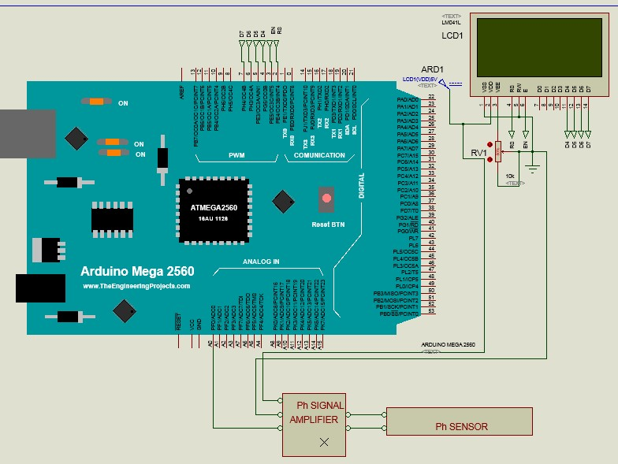

Figure 3.3: Circuit diagram of the pH sensor connection

# Temperature Sensing

The temperature was monitored using the LM35 temperature sensor. This was selected because it is cost effective and also readily available. Also, it has a considerable range of sensing between - 55℃ to 150℃ (Nikesh, 2016). Figure 3.4 shows how the LM35 was interfaced with the controller and the LCD.

Display

Arduino Mega (Controller)

Temperature

Sensor

Figure 3.4: Block diagram of the Temperature Sensing

The LM35 reads the temperature and then converts it to an electrical signal. This is then forwarded to the in-built ADC of the controller. Equation (3.3) shows the conversion formula of the read temperature.

𝑇𝑒𝑚𝑝𝑒𝑟𝑎𝑡𝑢𝑟𝑒 = 𝐴𝐷𝐶𝑣𝑎𝑙×𝑉𝑐𝑐×1000

1024

(3.3)

𝐴𝐷𝐶𝑣𝑎𝑙 = ADC value of the temperature

𝑉𝑐𝑐 = Input voltage = 5𝑉

1024 = 10 𝑏i𝑡𝑠 of the ADC and 1000 is a conversion constant. Figure 3.5 shows the circuit diagram connection of the LM35

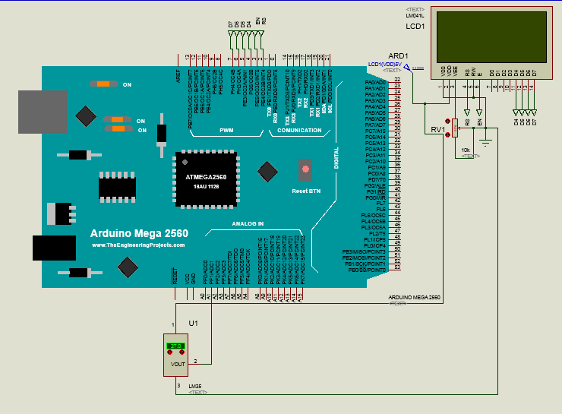

Figure 3.5: Circuit diagram of the temperature sensor connection

# Turbidity Sensing

The turbidity sensor was used to monitor how clear the water is in terms of fish feeds. This helped in knowing whether there are feeds on the water surface or not so that more feeds were not deployed when feeds from previous feeding session have not been consumed. Figure 3.6 shows how the turbidity sensor was interfaced with the controller and the LCD.

Display

Controller

Turbidity Sensor

Figure 3.6: Block diagram of the Turbidity Sensing

The turbidity sensor is digital in nature and gives an output logic “LOW” when the water is clear and logic “HIGH” when the water is turbid.

The controller used for this sensor network is the Arduino Mega. The reason for its selection was because it has many digital input/output pins which were required for interfacing with the sensors and the display. Also, it has an internal ADC which was utilized for temperature conversion. Figure 3.7 shows the Arduino Mega board.

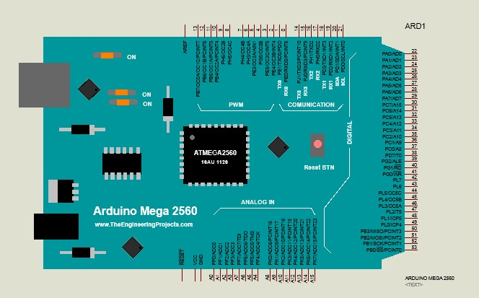

Figure 3.7: Arduino Mega board (TheEngineeringProjects.com)

# The Output devices of the Sensing Network

The output devices were used to present the results of the sensing network either via a display and a text message through a GSM module.

# The Display Interface

The display utilized for the visual display of the sensor readings is the 16 by 4 LCD. The device has 16 pins which were interfaced with the controller as specified in the manufacturer’s data sheet.

# The GSM Module Interface

The GSM module was used in this system to alert the farmer whenever the pH value of the pond water was out of the set range (6.8 – 8.5). To achieve this, sim800L was used. However, this device requires 4.3V to power it as specified in its data sheet. To achieve this voltage from the 5V generated by the voltage regulators, a diode was used to drop the voltage. Equation (3.4) shows this.

𝑉𝑜𝑙𝑡𝑎𝑔𝑒 𝑡𝑜 𝑏𝑒 𝑐𝑢𝑡 𝑜ƒƒ = 𝑉𝑐𝑐 − 𝑣𝑜𝑙𝑡𝑎𝑔𝑒 𝑛𝑒𝑒𝑑𝑒𝑑 (3.4)

= 5 − 4.3

= 0.7𝑉

Hence, since the diode has a barrier voltage of 0.7V, it was connected in forward biased mode with the GSM module as shown in Figure 3.8.

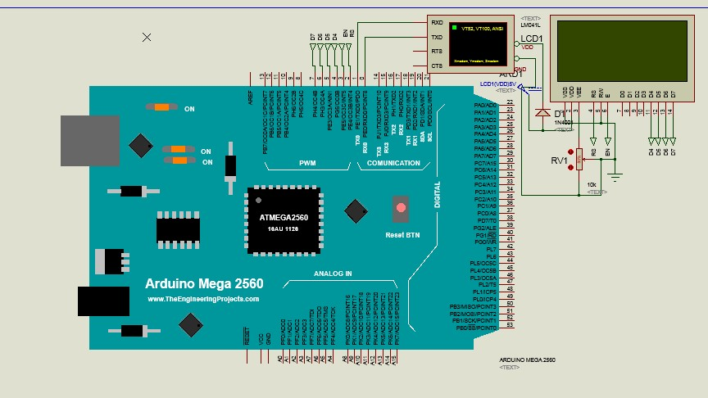

Figure 3.8: Circuit diagram of the GSM module connection

Furthermore, the GSM module and the controller were interfaced via their Universal Asynchronous Receiver-Transmitter (UART) ports.

Figure 3.9 shows the complete circuit diagram of the sensor network.

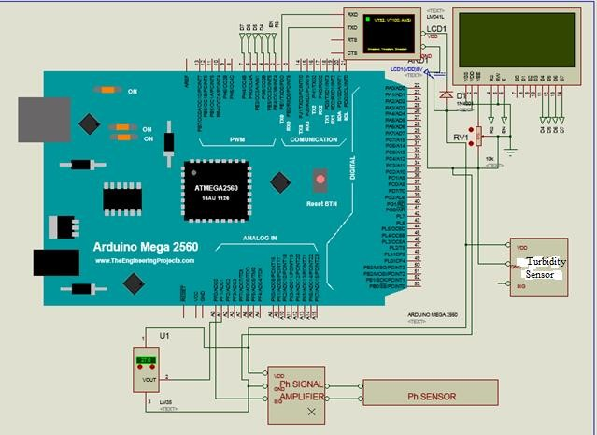

Figure 3.9: Circuit diagram of the sensing network

# Software Design of the Sensing Network

The Arduino Mega controller of the sensing network was programmed within Arduino Integrated Development Environment (IDE) using the C++ programming language. At start up, the system initializes the LCD and the GSM module. Furthermore, the range of the pH is set. For this system, the pH range was set from 7.0 to 8.5, which is the optimum pH range required for effective fish growth (Ozigbo *et al.*, 2014). The system then reads the temperature, pH and turbidity through the various sensors. The system then checks if the pH is out of the set range. If so, it sends an SMS through the GSM module to the farmer. Else, it goes back to read the parameters again.

A summary of this control program is shown in the flow chart in Figure 3.10 and the source code is shown in appendix B.



START

INITIALIZE LCD AND GSM; SET pH, TEMPERATURE RANGE

READ TEMPERATURE



READ pH

READ TURBIDITY

DISPLAY TEMPERATURE, TURBIDITY AND PH

IS MEASURED pH, TEMPERATURE WITHIN RANGE?

YES

NO

END

SEND MESSGAE (SMS) TO FARMER

Figure 3.10: Flow chart for the sensing network design Plate I shows the internal view of the sensing network module

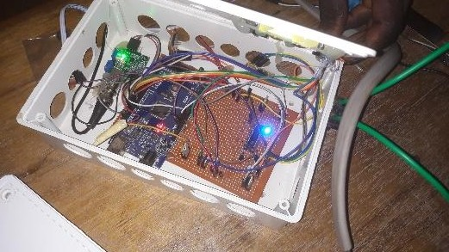

Plate I: Internal view of the sensing network module

# Development of an Automatic Feeding System

In this unit, an automatic feeding system that reduces feed wastage is developed. This was subdivided into two sub-units which are the wireless feeding time preset module and the wireless actuator.

# Wireless Feeding Time Preset Module

A block diagram showing the various parts of this module is shown in Figure 3.11.

Output Devices

Controller

Input Devices

Figure 3.11: Block diagram of the wireless feeding time preset module

# Input Devices of the Feeding Time Preset Module

Momentary switches were used as one of the input devices to set the feeding times. In this system, five feeding times were set. The switches were pulled up with a resistor as shown in Figure 3.12.

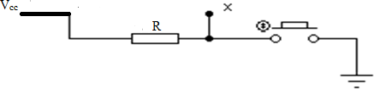

Figure 3.12: Circuit diagram of a momentary switch with a pull up resistor

The point “x” was connected to a digital pin in the controller. As the switch is opened, logic “HIGH” is given at the point “x” while logic “LOW’ is given with the switch closed. Equation (3.5) was used to calculate the value of the pull up resistor.

𝑉 = 𝐼𝑅 (3.5)

𝑉 = 𝑉𝑐𝑐 = 5𝑉 (from the manufacturer’s data sheet)

𝐼 = maximum current of the Arduino without being damaged and this has a value of 50mA (from the manufacturer’s data sheet)

Allowing a current of 𝐼 = 5𝑚𝐴 = 0.005𝐴 so as to allow for tolerance, then we have:

From Equation (3.5), 𝑅 = 𝑉 = 5

= 1000Ω

𝐼 0.005

Another input device which was deployed in this design is the Real Time Clock (RTC) which was used to keep track of the feeding times which were set. The chip used for the RTC is the DS1307. This selection was because it has high accuracy (Sadeque *et al., 2013*) and readily available at affordable price. The RTC uses a 32.76 KHz oscillator to aid accuracy in timing. It was interfaced with controller as specified in the manufacturer’s data sheet.

# Output Devices of the Automatic Feeder

An LCD was also used in the feeding time preset module to present a means of human to machine interface while setting the feeding times. The LCD in this case is the 16 by 2 LCD. This selection was made because it is readily available and also cost effective. Also, it serves the purpose required since only the timing is displayed here. It was interfaced with the controller as specified in the manufacturer’s data sheet.

A radio frequency (RF) transmitter was also used as an output device to transmit the feeding time signal to the actuator whenever it was time to feed. The RF433MHz was used to achieve this and this selection was because it has the ability to communicate with its receiver pair if within a 2KM radius as specified in its data sheet. To work effectively, the RF transmitter was connected

to an encoder as shown in Figure 3.13

RF433MHz

Encoder

Controller

Figure 3.13: Block diagram of the encoder interfaced with the controller and radio

The encoder is another output device in this unit which was used to encode the feeding signal to be transmitted remotely by the RF344MHz. The HT12E chip was the encoder used and it was selected because it is readily available at an affordable price and easily compatible with the Arduino controller. The need for encoding this feeding signal before transmitting is to avoid distortion of the signal due to interference from any other signal that might be present.

To give an overview of the feeding time preset module discussed, four of the momentary switches used to set the hour, minute, enter, and auto run were interfaced with Arduino Uno controller. The controller was also interfaced with the RTC, display, and the encoder which in turn was connected to the radio. This is depicted in the block diagram in Figure 3.14.

Display

Switches

Figure 3.14: Block diagram of the feeding time preset module set up

RTC

RF433MHz

transmitter

Encoder

Controller

The controller used in this feeding time preset module is the Arduino Uno. The reason for this selection was because it has approximately the required number of pins to interface with the RTC, momentary switches, and the output devices.

# Wireless Actuator

A wireless actuator was needed to open the vent of the hopper that contains the fish feeds. To achieve this, a DC servo motor was used and it was interfaced with a decoder, 433MHz receiver, and then the Arduino Mega controller earlier discussed. This is depicted in the block diagram in Figure 3.15.

Controller

Decoder

433MHz

receiver

DC

Servo motor

Figure 3.15: Block diagram of the wireless actuator sub-unit

The 433MHz receiver was used to receive the feeding signal sent by the feeding time preset module through the 433MHz radio transmitter. This feeding signal which is an encoded message was then forwarded to a decoder for further processing. It should be noted that this feeding signal was programmed to have a short pulse of 0.5 seconds. The reason for this was to ensure that feeding was done almost immediately a feeding signal was received with the least possible delay.

The decoder used is the HT12D which is the decoding pair of the encoder (HT12E) earlier mentioned. As the HT12D receives the encoded feeding signal from RF radio receiver, it decodes it in such a way that no message is lost or damaged. The decoded feeding signal was then forwarded to the controller which sends out the command to the actuator to open the feed hopper and feeding takes place almost immediately as the signal is received. The circuit diagram of the RF433MHz with HT12D is shown in Figure 3.16

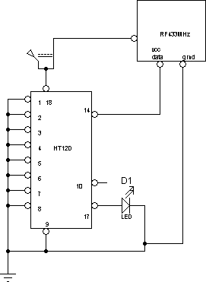

Figure 3.16: Circuit diagram of RF433MHz Module with decoder

The servo motor used as the actuator is the SG90. The reason for its selection is due to the fact that it can rotate through an angle of approximately 180⁰ (90⁰ in each directions) and this is a movement needed for the opening and closing of the vent of the feed hopper. The SG90 which is a three pin device has the Vcc pin, the ground pin and the signal pin. To control the servo motor, the controller sends a pulse (the feeding signal) with a width of 0.5 seconds and this opens the vent to dispense feeds. To return the spindle after feeding has taken place, the controller sends another pulse and this closes the vent of the feed hopper.

In the feeding time preset module, a Light Emitting Diode (LED) was used to indicate when a feeding signal is being sent for feeding to commence. To ensure that this LED operates without burning, a limiting resistor is placed in series as shown in the Figure 3.17 to reduce the flow of current.

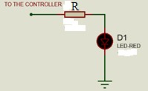

Figure 3.17: LED with resistor

From the manufacturer’s data sheet, the LED can sustain maximum of 2𝑉.

Also, maximum current is 40𝑚𝐴. A current of 𝐼 = 20𝑚𝐴 was allowed to pass for tolerance. Voltage output from the controller is VCC = 4.5𝑉 (from the manufacturer’s data sheet)

Hence, 𝑅 = 𝑉

𝐼

𝑅 = 4.5/20𝑚𝐴

𝑅 = 220Ω

Plate II shows the internal view of the feeding time preset module

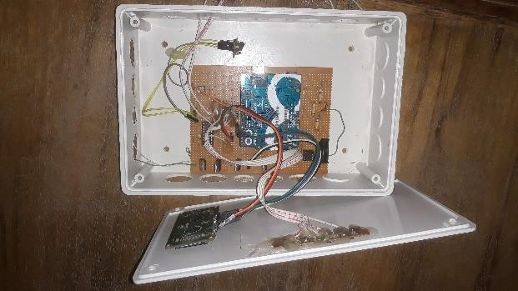

Plate II: Internal view of the feeding time preset module

# Software Design of the Feeding Time Preset Module

The Arduino Uno controller of the feeding time preset module was programmed within Arduino Integrated Development Environment (IDE) using the C++ programming language. At the start, the display is initialized alongside with the state of the switch (at open state) and then a welcome note is displayed. It remains on the welcome note until the enter switch is closed momentarily. When this is done, the program requests for feeding time 1 via the display. This feeding time is entered by the pond manager. When the enter switch is closed again momentarily, it requests for feeding time 2. This continues till all the feeding times have been entered (five feeding times being used for this design). After all the entries have been made, the program starts to count. If

the time equals any of the feeding time, feed dispensing signal is transmitted wirelessly. Afterwards, it loops to time counting before it finally comes to an end.

A summary of this control program is shown in the flow chart in Figure 3.18 while the source code is shown in appendix A.

A

Start

Enter Feeding Time 3

Initialize Switches

Initialize Display

Is Enter Switch closed? No Closed?

Display Welcome Note

Yes

Enter Feeding Time 4

Is Enter Switch Closed? No

Yes

Enter Feeding Time 1

Is Enter Switch Closed? No Yes

Enter Feeding Time 5

Is Enter Switch Closed? No

Is Enter Switch Closed? No

Yes

Enter Feeding Time 2

Yes

Start Counting

Is Enter Switch Closed? No

Yes A

Is it Feeding Time? No

Yes Output Control Signal



End

Figure 3.18: Flow chart for the design of the feeding time preset module

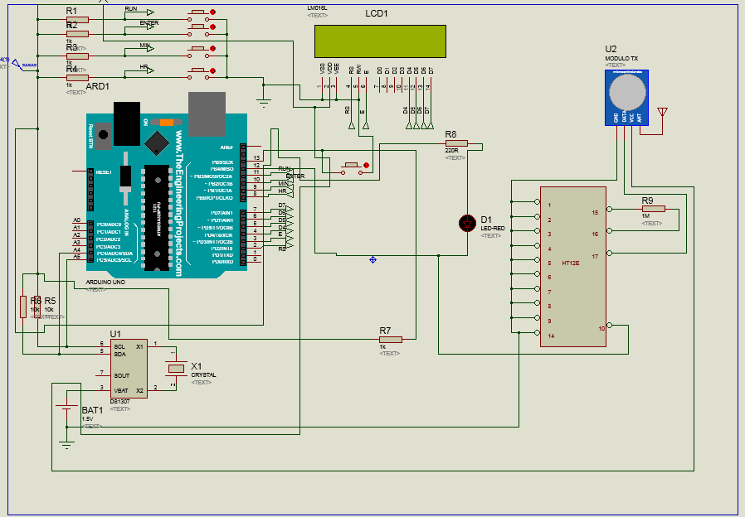

Figure 3.19: Complete circuit diagram of the automatic feeding system design

# Development of Water Circulation System

The water circulation system is sub-divided into two units which are the automatic over-head pumping system and the automatic drip control.

# Automatic over-head pumping system

An automatic over-head water pumping system was developed using the coordination of a float switch, DC pump and battery (power source).

The float switch has three pins which are common pin (C), normally closed pin (NC) and normally open pin (NO) as shown in Figure 3.20.

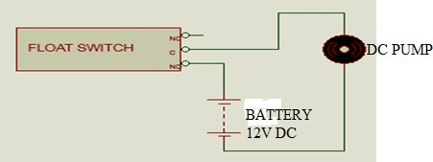

Figure 3.20: Circuit diagram of float switch, pump and battery.

The common and normally open pins of the float switch remain open when under the influence of gravity at position A as shown in Figure 3.21 when pivoted through a string at point P. This condition is as a result of absence of water in the underground tank. As the water in the underground tank increases, the float switch is displaced to position B at an angle of c. This makes the normally open (NO) and common (C) pins to close thereby giving current a path so as to power the pump which then cuts in to start the pumping of water from the underground tank to the overhead tank.

P



c

D

B

A

Figure 3.21: Diagram showing displacement of the float switch

# Automatic Drip Control

The automatic drip control was achieved via the use of a solenoid valve interfaced with the Arduino Mega controller. The circulation system was designed to drip water into the pond. However, it is important to stop the dripping during feeding time so as to prevent feeds from sinking as a result of water perturbation. Since the system was designed to stop dripping during feeding, the feeding signal acts as the input of this subsystem. When the feeding signal is received as emphasized in the automated feeding system, the controller sends a signal to the solenoid valve through a relay as shown in Figure 3.22. With this, the solenoid valve which was originally opened is then closed. As a result, water from the over-head tank which is channeled through the solenoid valve stops dripping into the pond. Five minutes after the valve was closed, it then returns to the open state to continue the dripping of water while it waits for the next feeding signal.

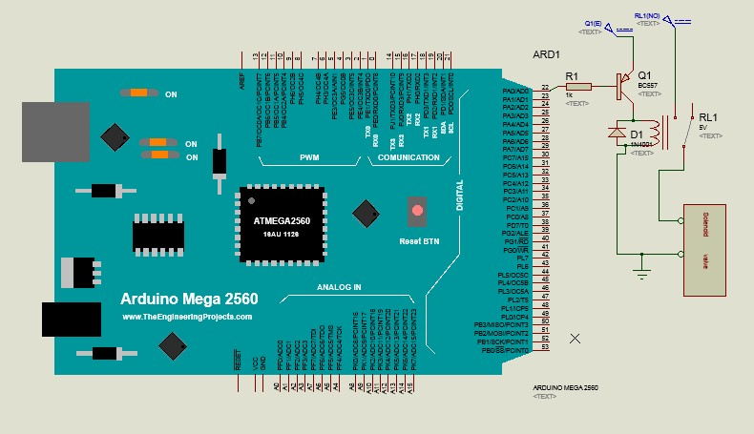

Figure 3.22.Circuit diagram of the solenoid valve.

The relay was driven via the use of BC557. The reason is because the controller cannot supply enough current to drive the relay or the solenoid valve. Therefore the controller sends the signal to a transistor which drives the relay. This relay in turn drives the solenoid valve. The circuit is as shown in Figure 3.23 followed by the mathematical analysis.

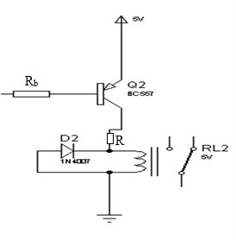

Figure 3.23: Circuit diagram of the relay unit

𝑉𝑐𝑐 = 𝑉𝑐𝑒 + 𝑉𝐼𝑅 (3.6)

𝑉𝐼𝑅 = 𝐼 × 𝑅 (3.7)

𝑉𝑐𝑐 = 5𝑉

Let 𝑅 = 100Ω (which is the standard value for the coil resistance of a 5V relay used here)

𝑉𝑐𝑐 = 𝑉𝑐𝑒 + 𝐼𝑅

5 = 𝑉𝑐𝑒 + 𝐼(100)

For the transistor to act as a switch, it has to operate at the saturation and cut off regions. Hence,

𝑉𝑐𝑒 = 0

5

𝐼 = 100 = 0.05𝐴

The value 0.05𝐴 above is the collector current, 𝐼𝑐

ℎƒ𝑒 = 𝐼𝑐

𝐼𝑏

(3.8)

𝐼𝑐

𝐼𝑏 = ℎƒ𝑒

ℎƒ𝑒 = 10

𝐼𝑏 =

0.05

10

𝑉𝑏 = 𝐼 × 𝑅𝑏 (3.9)

𝑉𝑏 = 4.2 𝑉 which is the output of the controller

4.2

𝑅𝑏 = 0.005 = 840Ω ≅ 1𝑘Ω

# Principle of Operation of Water Circulation System

For the purpose of reducing the level of water pollution in the pond, the system consists of an overhead water tank which drips water into the fish pond. The pond however has a pipe fixed at the center to a level. At that level, water that tends to overflow is channeled to an underground filter unit which consists of a sieve and activated charcoal. The sieve removes sediments and the activated charcoal helps to de-color and remove odor in the water. This purified water is then channeled to an underground water tank that contains a level switch which senses the level of the water in the underground tank. When the water reaches two third of the underground tank, it activates the pump which pumps the water to the over-head tank. However, it is important to note that during feeding periods, water dripping into the pond was stopped so as to ensure that the feeds dispensed by the automatic feeding system do not sink as a result of water perturbation. To achieve this, a solenoid valve interfaced with a controller was controlled to cut off water

supply that drips into the pond. The system maintains this state for five minutes before sending a control signal to open the valve after feeding is over.

Volume of the pond = 43𝑐𝑚 × 30𝑐𝑚 × 30𝑐𝑚 = 38,700𝑐𝑚3 = 38.7 𝑙i𝑡𝑟𝑒𝑠

Using a 40W, 12V DC windshield pump which has a flow rate of 12 litres per minute, the time taken to fill up the pond is calculated as follows:

Flow rate of pump = 12 𝑙i𝑡𝑟𝑒𝑠 𝑝𝑒𝑟 𝑚i𝑛𝑢𝑡𝑒

For a pond with volume of 38.7 𝑙i𝑡𝑟𝑒𝑠, time taken to fill it up = 38.7 𝑙i𝑡𝑟𝑒𝑠 × 1 𝑚i𝑛𝑢𝑡𝑒

12 litres

= 3.225 𝑚i𝑛𝑢𝑡𝑒𝑠

Figure 3.24 shows the complete circuit diagram of the sensing network with the water circulation system.

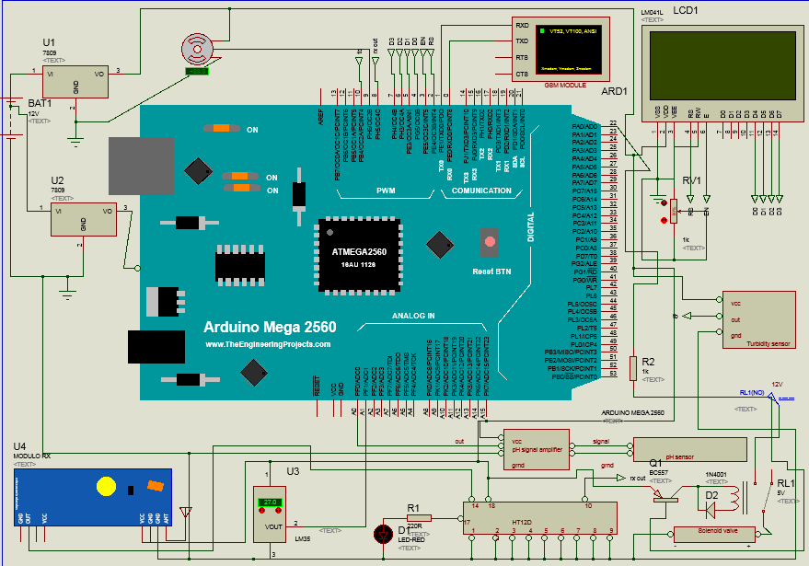

Figure 3.24: Complete circuit diagram of the sensing network with the water circulation system.

# Design of the Photovoltaic (PV) System

A solar based power source was used to power the fish pond so as to ensure a steady supply of power since power from the national grid is not reliable. In order to further minimize cost, the designed PV system consists of a solar panel, a deep cycle battery and a charge controller without the inclusion of an inverter. This was achieved by ensuring that all loads are purely DC loads. Figure 3.25 shows a block diagram of the PV system for the fish pond.

Incubator’s Power Unit

Charge Controller

Solar Panel

Solar radiation



Figure 3.25: Block diagram of the PV system for the fish pond

Battery

The energy requirement of each of the components was determined, and hence the total energy requirement of the system was determined. This total energy was then used to determine the sizing of the components of the solar power system.

The sizing of the various components of the solar power system is as outlined.

# Energy Required

The power consumption of an electrical appliance is given in Watts. To calculate the energy needed over a period of time, for every appliance, its power consumption is multiplied by its period of intended usage.

For water pump; it has a rating of 40W and its intended period of usage is 1 hour per day

𝐸𝑛𝑒𝑟𝑔𝑦 𝑟𝑒𝑞𝑢i𝑟𝑒𝑑 = 40 × 1 = 40W𝐻 𝑝𝑒𝑟 𝑑𝑎𝑦

For servo motor; it has a rating of 20W and intended period of usage is 30seconds ( 1

120

hour) per

day

𝐸𝑛𝑒𝑟𝑔𝑦 𝑟𝑒𝑞𝑢i𝑟𝑒𝑑 = 20 × 1

120

= 0.17W𝐻 𝑝𝑒𝑟 𝑑𝑎𝑦

For control Circuit; the microcontrollers have maximum rating of 15W and intended to be used for the 24hours of the day

𝐸𝑛𝑒𝑟𝑔𝑦 𝑟𝑒𝑞𝑢i𝑟𝑒𝑑 = 15 × 24 = 360W𝐻 𝑝𝑒𝑟 𝑑𝑎𝑦

For temperature sensor: it has a rating of 5W and intended period of usage if 12hours per day

𝐸𝑛𝑒𝑟𝑔𝑦 𝑟𝑒𝑞𝑢i𝑟𝑒𝑑 = 5 × 12 = 60W𝐻 𝑝𝑒𝑟 𝑑𝑎𝑦

For turbidity sensor: it has a rating of 10W and intended period of usage is 12hours per day

𝐸𝑛𝑒𝑟𝑔𝑦 𝑟𝑒𝑞𝑢i𝑟𝑒𝑑 = 10 × 12 = 120W𝐻 𝑝𝑒𝑟 𝑑𝑎𝑦

For the pH sensor: it has a rating of 10W and intended period of usage is 12hours per day

𝐸𝑛𝑒𝑟𝑔𝑦 𝑟𝑒𝑞𝑢i𝑟𝑒𝑑 = 10 × 12 = 120W𝐻 𝑝𝑒𝑟 𝑑𝑎𝑦

For the water level switch: it has a rating of 5W and intended period of usage is 12hours per day

𝐸𝑛𝑒𝑟𝑔𝑦 𝑟𝑒𝑞𝑢i𝑟𝑒𝑑 = 5 × 12 = 60W𝐻 𝑝𝑒𝑟 𝑑𝑎𝑦

Other small electronic components like switches used in the system where found to take around 110WH within a specified period of usage per day

𝑇𝑜𝑡𝑎𝑙 𝑒𝑛𝑒𝑟𝑔𝑦 𝑟𝑒𝑞𝑢i𝑟𝑒𝑑 = 40 + 0.17 + 360 + 60 + 120 + 120 + 60 + 110

= 870.17W𝐻 𝑝𝑒𝑟 𝑑𝑎𝑦

# Solar Panel Sizing

Equation (3.10) gives the total peak power generated by the sunlight, 𝑃𝑝𝑒𝑎𝑘 (Guda and Aliyu, 2015).

𝑃𝑝𝑒𝑎𝑘

= 𝐸r𝑑 T𝑠ℎ

3.10

where T𝑠ℎ = The average sun hours of the installation site per day

𝐸𝑟𝑑=Total energy demand

Nigeria experiences about six (6) hours of solar radiation per day (Oseni, 2012). Therefore, T𝑠ℎ is taken to be 6 hours.

Hence, the size of the solar panel used is obtained from equation 3.10 as:

𝑃 = 𝐸r𝑑 = 870.17𝖶𝐻 = 145.03W

𝑝𝑒𝑎𝑘

T𝑠ℎ

6𝐻

However, from the standard sizes of solar panels, 150W SUNBE solar panel was used for this system.

# Battery sizing

During the night or during cloudy weather when the sun goes down, additional backup is required to power the fish pond. This is obtained through the use of batteries.

As calculated from the energy required, the components use 870.17WH per day, nominal battery voltage, V𝑑𝑐𝑏 is 12V, a day of autonomy was chosen for this system and efficiency of 85%. Equation (3.11) gives the formula for the battery capacity calculation (Guda and Aliyu, 2015).

Battery capacity, 𝐵𝑐𝑎𝑝.

= 𝐸r𝑑×𝐷𝑎u𝑡

𝜂b×V𝑑𝑐

(3.11)

where (𝐸𝑟𝑑) is the total energy demand = 870.17WH , 𝐷𝑎𝑢𝑡 = 1 is number of days of autonomy, ηb = battery efficiency = 85% and (V𝑑𝑐) = 12V is the nominal battery voltage.

𝐵𝑐𝑎𝑝.

= 870.17×1

0.85×12

= 85.31 𝐴𝐻

From standard ratings, 100AH deep cycle battery of nominal voltage 12V was used in this work.

# Determination of the Charge Controller Capacity

The rating of the charge controller required is calculated from Equation (3.12). The Ampere Hour figure of the proposed battery is divided by its terminal voltage.

𝐶𝑐𝑜𝑛.

= 𝐵𝑐𝑎𝑝.

(V𝑑𝑐)

3.12

Hence, 𝐶𝑐𝑜𝑛.

= 100

12

= 8.33𝐴

From the standard ratings of charge controllers, a 10A charge controller can be used for this system. Due to unavailability of this rating in the market during construction, a 20A charge controller was used which also served the required purpose effectively.

# Construction of the Prototype Fish pond

For an ideal and efficient catfish rearing, the prescribed dimension of the pond for stocking 1,500 fishes from the juvenile stage till about six (6) months of maturity is (15 × 15)𝑚 or (50 × 50)ƒ𝑡, and a depth of about 4ft (Bamidele O., 2014). For the purpose of this research work, ten

(10) juvenile catfish were reared. Going by the prescribed dimension, a transparent plastic bowl having a surface dimension of (43 × 30)𝑐𝑚 and a height of 30cm was used for the fish pond to rear ten (10) juvenile catfish to a maturity period of six (6) weeks. Considering the fact that catfishes are quite prone to jumping within the water, the fish pond section was securely covered with fish pond net in order to keep the fishes within the pond. A similar bowl of the same dimensions was used for the over-head water, while a cylindrical bowl of diameter of about 30cm and a height of about 50cm was used for the underground water tank. A much smaller

cylindrical bowl of diameter 15cm and height of 15cm was used for the filtering section. Plastic pipes with adequate fittings were used to effectively link these four sections so as to achieve an efficient water circulation system. These four bowls where then strategically placed on a wooden body structure of a surface dimension of (140 × 75)𝑐𝑚 and a height of about 100cm which was constructed from well-furnished plywood. A plastic funnel was used to achieve the feed hopper which is controlled by the servo motor. Figure 3.26 shows an isometric drawing of the prototype.

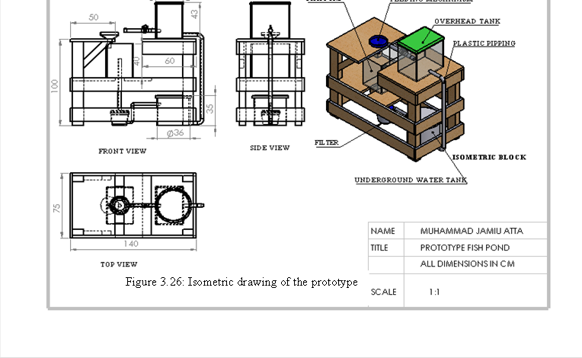

Figure 3.26: Isometric Drawing of The Prototype

Plate III shows the completed assemble of the design prototype powered by a solar system.

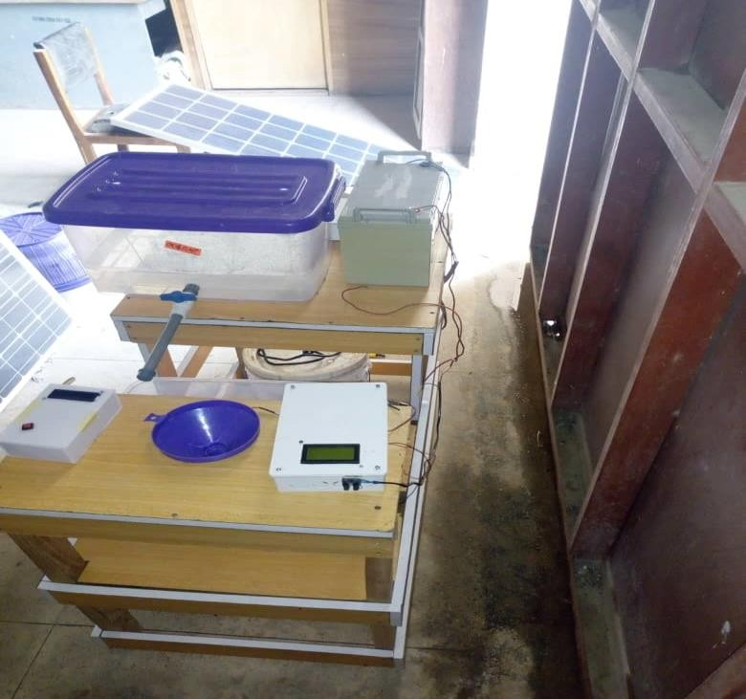

Plate III: The Design Prototype Plate IV shows the reared fishes within the pond

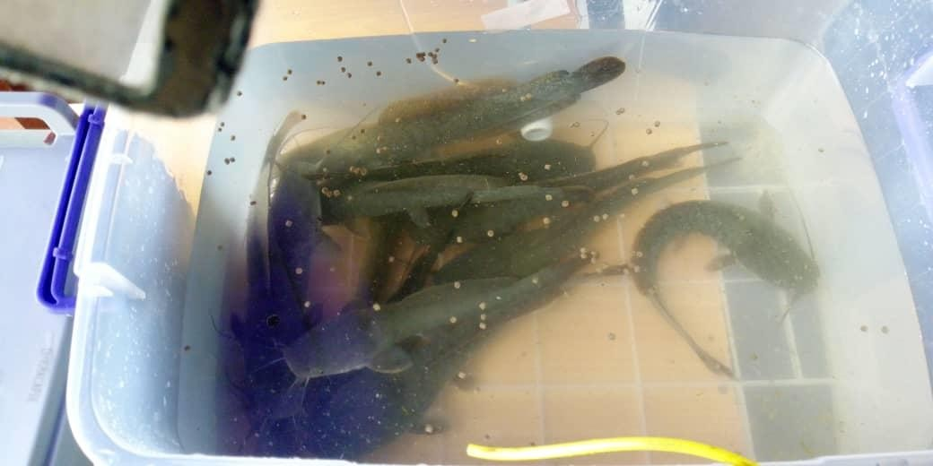

Plate IV: The reared fishes within the pond

# CHAPTER FOUR

# RESULTS AND DISCUSSION

# Introduction

This chapter presents the results obtained from the test carried out from the system as well as the various measurements made and their discussions. These tests include photovoltaic system design, battery charging test, functionality test of the feeder, temperature measurement outside and within the pond, pH measurement within the pond, as well as testing of the growth rate of fish reared using this system as compared with growth rate of fish reared in a manually operated system. The information obtained was also presented as graphs.

# Photovoltaic (PV) System Design Results

After the design and set up of the PV system, the voltages measured across the battery and solar panel upon installation and while in use at the first day of usage are presented in Table 4.1.

Table 4.1: PV System set up Testing

# Component Voltage (volts)

Battery before charging

Battery after charging

Solar panel during installation Solar panel in use

12.5

13.5

21.9

17.8

As seen from Table 4.1, the measured terminal voltage of the battery conforms to the design specification which requires the use of a 12V DC battery. Also, the measured voltages on the solar panel correctly reflect the value given on the name plate data.

# Battery Charging/Discharging Test

Table 4.2 shows the test results obtained from the charging and discharging test carried out on the battery used for the system.

Table 4.2: Battery Charging/Discharging Test

|  |  |  |  |  |  |  |  |
| --- | --- | --- | --- | --- | --- | --- | --- |
| **Date** | **Time** | **Charging**  **duration, t (hours)** | **Terminal**  **voltage before** | **Voltage**  **after charging,** | **Charging rate,**  𝑅 = | **Current (A)** | **Discharging**  **Duration (hours)** |
| **charging, Vi (V)** | | | | **Vf (V)** | (𝑉𝑓− 𝑉i)  𝑡  **(V/hour)** | | |

|  |  |  |  |  |  |  |
| --- | --- | --- | --- | --- | --- | --- |
|  |  |  |  |  |  |  |
| March | 12:00pm | 1 | 12.75 | 13.04 | 0.29 | 14.25 |
| 11 |  |  |  |  |  |  |
| March | 2:00pm | 2 | 12.50 | 12.87 | 0.19 | 14.33 |
| 12 |  |  |  |  |  |  |
| March | 4:00pm | 3 | 12.44 | 12.98 | 0.18 | 14.93 |
| 13 |  |  |  |  |  |  |
| March | 10:00am | 4 | 12.32 | 12.60 | 0.07 | 15.41 |
| 14 |  |  |  |  |  |  |
| March | 8:00am | 5 | 12.15 | 12.24 | 0.02 | 16.10 |
| 15 |  |  |  |  |  |  |

Table 4.2 shows the charging and discharging test carried out on the battery. The charging duration of the battery was constantly increased from one hour at the first day of the trial to five

hours at the fifth day. It could be seen that when the trial was done at a period that is not a peak period, that is, around the morning hours when the sun intensity is low, the rate of charging decreases, while the discharging duration gradually increases. Hence, we say that as the charging time becomes longer, the discharging time of the battery which drives the load also becomes longer.

# Functionality Test of the Feeder

Table 4.3 shows the result of the performance of the automatic feeder when put in operation.

Table 4.3: Functionality Test of the Automatic Feeder

|  |  |  |  |
| --- | --- | --- | --- |
| **Trial** | **Time** | **Feed Dispersal Time (seconds)** | **Amount of Feed Dispensed (g)** |
| 1 | 7:00am | 1.13 | 10.0 |
| 2 | 11:00am | 1.15 | 10.0 |
| 3 | 3:00pm | 1.17 | 10.0 |
| 4 | 7:00pm | 1.12 | 10.0 |
| 5 | 7:10pm | 0.00 | 00.0 |

Table 4.3 shows the results of the efficiency test carried out on the automatic feeder when put into operation. Five trials were made at set times. As a feeding time is reached, the motor operates and, according to the programmed feeding duration, feeds are dispensed. The first four feeding periods were successfully executed by the feeder, but the fifth feeding period (which was intentionally set as such to demonstrate the efficiency of the feeder) was skipped. This shows that feeds from the previous interval (fourth feeding period) have not been consumed by the fishes. These results show that the feeder worked efficiently when put into operation.

# Functionality Test of the GSM module

For the essence of testing the effectiveness of the GSM module, a case study of one of the messages sent to the pond manager through the GSM module is presented here. In this case, a message was sent to the pond manager notifying him of the need to change the pond water due to unfavorable pH within the pond. Since the controller was programmed to maintain a pH range of

7.0 – 8.5 under normal condition, it was then expected that anytime the pH was out of this range and it cannot be corrected through water circulation and the filtering used, a message should be sent to the pond manager notifying him of the abnormal pH condition and the need to change the pond water completely. A screen shot of the text message sent to the pond manager in this regards is shown in Plate V.

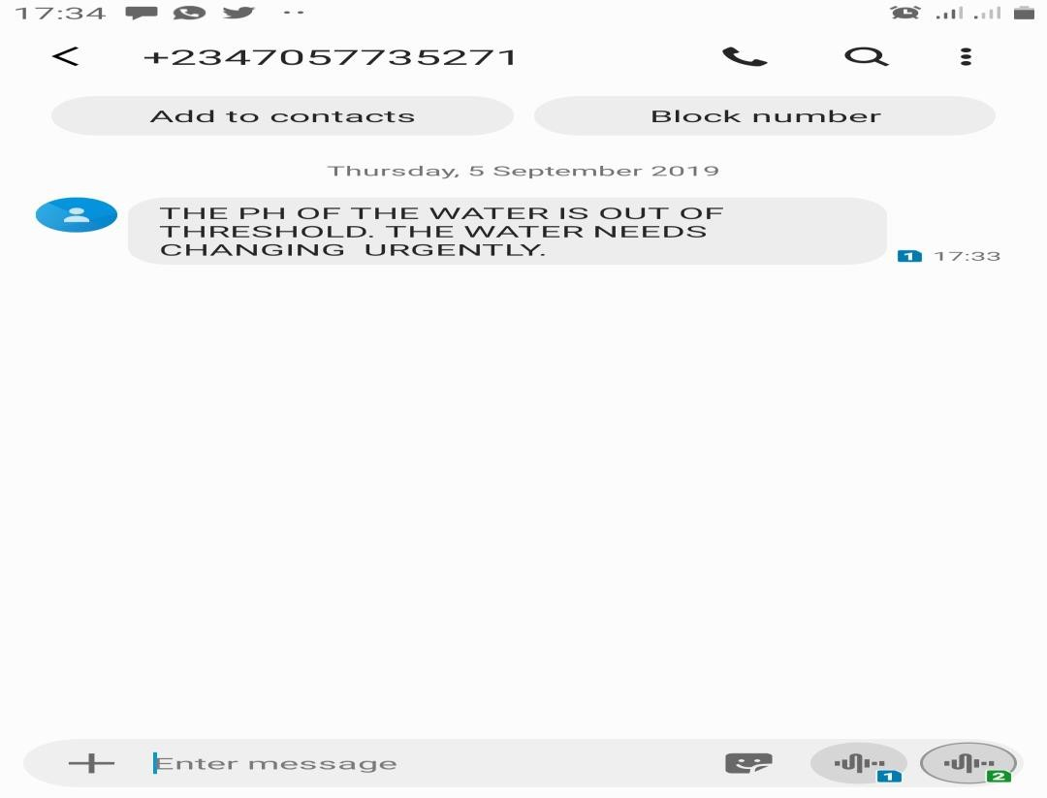

Plate V: Screenshot of message received through GSM module

# Temperature Test outside the Pond

Table 4.4 shows the test results for temperature measurement outside (environment) the pond in which the fishes were reared (designed prototype).

Table 4.4: Test Results for Temperature Measurement outside the Fish Pond

|  |  |  |  |
| --- | --- | --- | --- |
| **S/No** | **Date** | **Time** | **Temperature (℃)** |
| 1 | 01/04/2019 | 12:50pm | 27.0 |
| 2 | 15/04/2019 | 01:25pm | 31.0 |
| 3 | 30/04/2019 | 02:00pm | 27.5 |
| 4 | 12/05/2019 | 03:00pm | 27.5 |
| 5 | 25/05/2019 | 01:55pm | 28.0 |

Table 4.4 shows the results of the temperature measurement which was done in the environment of the fish pond. These measurements were taken using an external thermometer for a period of one and a half months. The essence of this is to be able to make a comparison with the temperature inside the pond so as to be able to regulate it and keep it an optimum level.

Figure 4.1 shows the data variation of the temperature measurement outside the prototype fish pond.

# Temperature outside the Pond

32



31

30

**Temperature (℃)**

29

28

27 Temperature (⁰C)

26

25



# Date

Figure 4.1: Data Variation of Temperature measurement outside the fish pond.

# Temperature Test within the Fish Pond

Table 4.5 shows the test results for temperature measurement within the designed fish pond in which the fishes were reared.

Table 4.5: Test Results for Temperature Measurement within the Fish Pond

|  |  |  |  |
| --- | --- | --- | --- |
| **S/No** | **Date** | **Time** | **Temperature (℃)** |
| 1 | 01/04/2019 | 12:50pm | 26.5 |
| 2 | 15/04/2019 | 01:25pm | 27.5 |
| 3 | 30/04/2019 | 02:00pm | 26.0 |
| 4 | 12/05/2019 | 03:00pm | 26.5 |
| 5 | 25/05/2019 | 01:55pm | 27.0 |

Table 4.5 shows the results of the temperature measurement within the fish pond. These measurements were taken using an immersed thermometer for a period of one and a half months. As can be seen, temperature readings fluctuated fairly between the ranges of 26.0⁰C to 30.0⁰C, which were the programmed optimum range to be monitored. The essence of this is to be able to make a comparison with the temperature outside the pond so as to be able to regulate the pond temperature and keep it an optimum level.

Figure 4.2 shows the data variation of the temperature measurement within the fish pond.

# Temperature within the fish pond

28



**Temperature (℃)**

27.5

27

26.5

26

25.5

25

Temperature (⁰C)



# Date

Figure 4.2: Data Variation of Temperature measurement within the fish pond.

Figure 4.3 shows the data variation of the temperature measurement within and outside the fish pond.

# Data variation of Temperatures within and outside the

**pond**

32



31

**Temperature ℃**

30

29

28

27

26 Temperature outside pond

25 (⁰C)

24 Temperature within pond

23 (⁰C)

# Date

Figure 4.3: Data variation of temperature measurement within and outside fish pond

# pH Test within the Fish Pond

Table 4.6 shows the test results for pH measurement within the designed fish pond in which the fishes were reared.

Table 4.6: Test Results for pH Measurement within the Fish Pond

|  |  |  |
| --- | --- | --- |
| **S/No** | **Date** | **pH Value** |
| 1 | 01/04/2019 | 7.1 |
| 2 | 15/04/2019 | 7.5 |
| 3 | 30/04/2019 | 7.2 |
| 4 | 12/05/2019 | 7.2 |
| 5 | 25/05/2019 | 8.0 |

Table 4.6 shows the results of pH measurement within the fish pond. These measurements were taken using an immersed pH meter for a period of one and a half months. The optimum pH level within the pond was programmed to be within the ranges of 7.0 and 8.5 and as seen from the results in table 4.6, these measured results were within these ranges.

Figure 4.4 shows the data variation of the pH measurement within the fish pond.

8.2

8

7.8

7.6

**pH**

7.4

7.2

7

6.8

6.6

# pH Variation within the Fish Pond

pH Value



# Date

Figure 4.4: Data variation of the pH measurement within the fish pond.

# Test Results for Fishes Reared Using the Designed Fish Pond

Table 4.7 shows the test results of fishes reared for a period of six weeks using the designed system. Ten numbers of fingerlings were experimented upon. Two parameters, namely Feed Conversion Ratio (FCR) and Feeding Efficiency (FE), were used for the performance evaluation of the system in fish rearing and the results were then compared with the same amount of fingerlings reared in a manual fish pond.

Table 4.7: Growth Rate of Fish Reared Using the Designed Fish Pond

|  |  |  |  |  |  |
| --- | --- | --- | --- | --- | --- |
| **S/N** | **Period** | **No of Fishes** | **Average Weight of Fish (g)** | **Feed Consumed per Fish (g)** | **Average Gain in Weight per Fish (g)** |
| 1 | Week 1 | 10 | 20.00 | 0.00 | 0.00 |
| 2 | Week 2 | 10 | 25.00 | 4.50 | 5.00 |
| 3 | Week 3 | 10 | 30.51 | 5.55 | 5.51 |
| 4 | Week 4 | 10 | 36.67 | 6.60 | 6.16 |
| 5 | Week 5 | 10 | 42.50 | 8.00 | 5.83 |
| 6 | Week 6 | 10 | 48.95 | 9.50 | 6.45 |

From Table 4.7, we see that the average gain in weight per fish during the six weeks period for which readings were taken is:

(0.00 + 5.00 + 5.51 + 6.16 + 5.83 + 6.45) = 28.95g

Also, the average feed consumed per fish during the same period of time is: (0.00 + 4.50 + 5.55 + 6.60 + 8.00 + 9.50) = 34.15g

Using Equation (2.1), the Feed Conversion Ratio (FCR) of the reared fishes is given as:

𝐹𝐶𝑅 = 34.15

28.95

= 1.18

Also, using Equation (2.2), the Feeding Efficiency (FE) of the fish is given as:

𝐹𝐸 = 1

1.18

× 100%

= 84.7%

Figure 4.5 shows the variation in weight gain of the fishes within the experimental period

# Average Gain in Weight per Fish in designed pond

7



6

5

**Weight (g)**

4

3 Average Gain in Weight

2 per Fish in automated

pond (g)

1

0

Week 1

Week 2

Week 3

Week 4

Week 5

Week 6

# Period

Figure 4.5: Variation in weight gain per fish in the prototype fish pond

# Test Results for Fishes Reared Using Manually Operated Fish Pond

Table 4.8 shows the test results of similar set of fishes reared in a manually operated fish pond for the same six (6) weeks period.

Table 4.8: Growth Rate of Fish Reared Using Manually Operated Fish Pond

|  |  |  |  |  |  |
| --- | --- | --- | --- | --- | --- |
| **S/N** | **Period** | **No of Fishes** | **Average Weight of Fish (g)** | **Feed Consumed per Fish (g)** | **Average Gain in Weight per Fish (g)** |
| 1 | Week 1 | 10 | 20.00 | 0.00 | 0.00 |
| 2 | Week 2 | 10 | 24.00 | 4.50 | 4.00 |
| 3 | Week 3 | 10 | 29.51 | 6.66 | 5.51 |
| 4 | Week 4 | 10 | 33.87 | 7.10 | 4.36 |
| 5 | Week 5 | 10 | 36.00 | 7.50 | 2.13 |
| 6 | Week 6 | 10 | 38.45 | 8.00 | 2.45 |

From Table 4.8, the average gain in weight per fish during the six weeks experimental rearing period is:

= (0.00 + 4.00 + 5.51 + 4.36 + 2.13 + 2.45)

= 18.45g

Also, average feed consumed per fish within the same period is:

= (0.0 + 4.50 + 6.55 + 7.10 + 7.50 + 8.00)

= 33.65g

Hence, using Equation (2.1), FCR is:

33.65

= 18.45

= 1.82

Also, from Equation (2.2), the Feeding Efficiency is:

1

= 1.82 × 100%

= 54.9%

Figure 4.6 shows the variation in weight gain of the fish within the experimental period.

# Average Gain in Weight per Fish in Manual Pond

6



5

4

**Weight (g)**

3

Average Gain in Weight

2 per Fish in manual pond

1 (g)

0

Week 1

Week 2

Week 3

Week 4

Week 5

Week 6

# Period

Figure 4.6: Variation in weight gain per fish in the manual fish pond

Shown in figure 4.7 is a graph of data variation in weight gain in both the automated and manually operated fish pond.

# Weight Gain per Fish in Automated and Manual Fish Pond

7



6

5

**Weight (g)**

4 Average Gain in Weight

3 per Fish in manual pond

2 (g)

Average Gain in Weight

1 per Fish in automated

0 pond (g)

Week 1

Week 2

Week 3

Week 4

Week 5

Week 6

# Period

Figure 4.7: Data variation in weight gain in both the automated and manually operated fish pond

# Discussions

The designed prototype, which was constructed to demonstrate the workability of the system, was made majorly from transparent plastic bowls because they are readily available and can be effectively used for a prototype fish pond.

The estimated energy required to power the system is 870.17WH per day. To ensure that the system is continuously powered at all times without any down time, it is powered through a solar energy source comprising a 150W solar panel, 100Ah deep cycle battery, and a 20A charge controller. No inverter was used since it was ensured that all loads were DC loads. The timer was also additionally powered by a Complementary Metal Oxide Semiconductor (CMOS) battery so as to ensure that even in the event of loss of power supply (which is very unlikely), the system still keeps track of time so that there will not be any down time in the operation of the system.

Table 4.3 shows the effectiveness of the automatic feeder developed. It shows that the feeder efficiently dispenses the required amount of feed as at when due, and also most importantly, the feeder is discriminatory in its operation such that feeding is held off until previously dispensed feeds are consumed by the fishes. This was achieved by programming the turbidity sensor network with the feeder. This prevents feed wastage and water pollution.

Tables 4.4, 4.5, and 4.6 shows the results of the sensor network which effectively keeps track of the temperature (both within and outside the developed fish pond) and also the pH levels. As can be seen from the results, the temperature was measured to be within the range of 26.0℃ to 27.5℃ while the pH was within 7.1 to 8.0. These results fall within the acceptable range required for optimum fish production in a fish pond.

A case scenario was presented to demonstrate the effectiveness of the communication aspect through the GSM module. Plate 4.1 showed the screenshot of the message sent to the pond manager when the pH was out of the set range. This shows that relaying of messages to the pond manager through the GSM module worked as expected.

In order to demonstrate the effectiveness of the developed automated system over the manual system of fish rearing, ten (10) numbers of juvenile catfish were reared (using both the automated system and the manual system) and readings were taken for a six (6) week experimental period. Two parameters, which are Feed Conversion Ratio (FCR) and Feeding Efficiency (FE), were then used to analyze the results. As seen from tables 4.7 and 4.8, the FCR for the fishes reared using the developed automated system was 1.18, which is much smaller than that of the manually operated system which was 1.82. Hence, in terms of the FE, we see that the FE of the fishes reared using the developed automated system was 84.7% while that of the manually operated system was 54.9%. Furthermore, the average gain in weight per fish for fishes in the automated system was 28.95g, while that in the manually operated system was 18.45g.

# CHAPTER FIVE

# CONCLUSION AND RECOMMENDATIONS

# Conclusion

A fish pond monitoring and control system which is powered by a solar energy source has been designed and demonstrated in this research work. A prototype system which consists of an automated feeder, a water circulatory system, and a sensor network was developed to demonstrate the workability of the system.

A sensor network was developed and also optimally programmed to keep track of the temperature, pH and turbidity of the pond water. The test results showed that the measured temperature in the pond was fairly within the ranges of 26.0℃ and 27.5℃ while the pH was within the ranges of 7.1 and 8.0. These values fall within the acceptable range required for an effective fish rearing system which requires pond water temperature to be within the ranges of 26⁰C and 30⁰C while pH is required to be within the ranges of 7.0 and 8.5 (Ozigbo *et al.*, 2014).

A total of ten (10) juvenile catfish (Clarias gariepinus) were reared using the developed prototype and two parameters; the Feed Conversion Ratio (FCR) and Feeding Efficiency (FE) were used to analyze the results. The results were then compared with test results obtained by rearing the same set of fish in a manually operated pond. The test results showed that the FCR for the fishes reared using the developed prototype was 1.18, which is much smaller than that of the manually operated system which was 1.82. Also, the results showed that the FE of the fishes reared using the developed prototype was 84.7% while that of the manually operated system was 54.9%. Furthermore, the average gain in weight per fish for fishes in the automated system was 28.95g, while that in the manually operated system was 18.45g. These figures show the

robustness and efficiency of the developed automated system over the conventional manual system of fish rearing. Hence, adoption of this automated system of fish rearing will greatly improve upon the output of fish production. The use of this system for a large scale fish production is therefore highly recommended for a country like Nigeria which is aiming at diversifying its economy as this will greatly improve on foreign exchange earnings when fish and fish products are exported. Also, individuals and organizations can adopt this system for fish production as a means of income generation.

A very unique aspect of this research work which has greatly contributed to knowledge is the uniqueness of the automated feeder. The feeder was developed in such a way that it is aided by a programmed sensor network to allow feeding only when the previously dispensed feeds have been consumed by the fishes. This has greatly helped to prevent feed wastage (hence making the developed system very economical) and also water pollution since feeding was not done when previous feeds have not been eaten.

# Recommendations

* + 1. More sensors that measure other important pond water quality parameters like dissolved oxygen, ammonia, and nitrates should be included in the sensor network. This will further help in keeping the pond water quality parameters in check.
    2. The system should be made in such a way that it can also control the monitored water quality parameters to some extent. For instance when temperature falls below the recommended optimum value, heaters placed at strategic positions (out of the reach of the fish) will be activated till the optimum temperature is restored. Also when temperature goes above the optimum value, a cooling system should be used to restore optimum temperature range.
    3. Since it is required that the system is continually powered at all times without any down time in power supply, a coordinated hybrid system should be designed and implemented to power the system so that when one source is not available, another source is made to supply power to the system. This will go a long way in improving the productivity and efficiency of the system.

# REFERENCES

Alam Md. E., Kader M. A., Proma S. A. and Sharma S. (2018). Development of a Voice and SMS Controlled Dot Matrix Display Based Smart Noticing System with RF Transceiver and GSM Modem. *IEEE 21st International Conference.*

Alan G. S. (2011). *Introduction to Arduino*: A piece of cake. Scotts Valley, US: Create Space Independent Publishing Platform.

Alimentarium (2019). The History of Aquaculture. Retrieved on August 22, 2019 from <https://www.alimentarium.org/en/knowledge/history-aqauculture>

Ani D. T., Meryll G. C. F., Niño J. D. G. and Kimberly R. P. R. (2015). Solar Powered Automatic Shrimp Feeding System. *Asia Pacific Journal of Multidisciplinary Research,* December 2015, 152-159. P-ISSN 2350-7756, E-ISSN 2350-8442

Bamidele O. (2015). Effective Business Ideas; Catfish Farming Step 1: Preparing Your Pond. Retrieved on August 21, 2019 from [https://www.effectivebusinessideas.com/catfish-](https://www.effectivebusinessideas.com/catfish-farming-preparing-your-pond/) [farming-preparing-your-pond/](https://www.effectivebusinessideas.com/catfish-farming-preparing-your-pond/)

Bayar T. (2013). *Germany Must Manage Growth and Costs of Renewable Power, IEA says.*

Retrieved on August 21, 2019 from <http://www.renewableenergyworld.com/> rea/news/article/2013/05/germany-must-manage-growth-and-costs-ofrenewable-power- iea-says?cmpid=SolarNL

Bhatnagar A. and Devi P. (2013). Water Quality Guidelines for the Management of Pond Fish Culture. *International Journal of Environmental Sciences,* 2013. ISSN 0976-4402

Bright Hub Engineering (2019). What is pump? Centrifugal pumps, Displacement pumps, Multi stage pumps. Retrieved on September 21, 2019 from <https://www.brighthubengineering.com/hvac/55540-pump-types-and-opeation/>

Cahyono D. and Lestari V. N. S. (2017). Automation of Fish Pond Water Circulation by Using Arduino Uno Based Control System. *International Multidisciplinary Conference and Call for Paper, Nganjuk March 18, 2017.* ISBN: 978-602-60736-6-2.

Carlos A. E. and Daniel M. (2019). Recirculating Aquaculture Technologies. *Research Gate; Aquaponics Food Production Systems,* 35-76. DOI:10.1007/978-3-030-15943-6_3

Chandanapalli S. B., Sreenivasa R. E. and Rajya L. D. (2014). Design and Deployment of Aqua Monitoring System Using Wireless Sensor Networks and IAR-Kick. *Journal of Aquaculture Research& Development.* DOI: 10.4172/2155-9546.1000283. ISSN: 2155- 9146

Cherp A. and Jewell J. (2013). Energy Security Assessment Framework and three Case Studies.

*International Handbook of Energy Security,* 164 – 173

Craig S., Helfrich L.A., Kuhn D. and Schwarz M. H. (2017). Understanding Fish Nutrition, Feeds, and Feeding. Virginia Corporative Extension; Virginia State University, Publication 420-256

Dave P. (2019). What You Need To Know About Motor Selection. Retrieved on September 22, 2019 from [https://www.controldesign.com/articles/2019/what-you-need-to-know-about-](https://www.controldesign.com/articles/2019/what-you-need-to-know-about-motor-selection/) [motor-selection/](https://www.controldesign.com/articles/2019/what-you-need-to-know-about-motor-selection/)

Electrical4u (2019). Control System. Closed Loop Open Loop Control System. Retrieved on September 22, 2019 from [https://www.electrical4u.com/control-system-closed-loop-](https://www.electrical4u.com/control-system-closed-loop-open-loop-control-loop-control-system) [open-loop-control-loop-control-system](https://www.electrical4u.com/control-system-closed-loop-open-loop-control-loop-control-system)

Electronics Hub (2018). Different types of Sensors. Retrieved on September 22, 2019 from [www.electronishub.org/different-types-of-sensors/?amp](http://www.electronishub.org/different-types-of-sensors/?amp)

European Commission (2019). A Short History; Aquaculture. Retrieved on September 20, 2019 from <https://ec.europa.eu/fisheries/cfp/aqauculture/aqauculturemethods/history_en>

Food and Agriculture Organization (FAO) of the United Nations (2010). *The State of World Fisheries and Aquaculture,* 2010 (Part 1, Aquaculture). FAO (2010a, 2010b)

Garcia1 M., Sendra1 S., Lloret1 G. and Lloret J. (2010). Monitoring and Control Sensor System for Fish Feeding in Marine Fish Farms. *Published in IET Communication.* DOI: 10.1049/iet-com.2010.0654. ISSN 1751-8628.

Guda H. A. and Aliyu U. O. (2015). Design of a Stand-Alone Photovoltaic System for a Residence in Bauchi. *International Journal of Engineering and Technology.* 5(1), 329- 334.

Harun Z., Reda E. and Hashim H. (2018).Real Time Fish Pond Monitoring and Automation Using Arduino. *IOP Conf. Series: Materials Science and Engineering 340 (2018) 012014.* DOI:10.1088/1757-899X/340/1/012014.

Hugues V., Hans K., Edwige Q. and Marc V. (2017). Improving Feed Efficiency in Fish Using Selective Breeding. A review. Research Gate Publication 318175959

John S. L., Paul C. S. and Craig S. T. (2017). Aquaculture: Farming Aquatic Animals and Plants.

Retrieved on August 21, 2019 from <https://www.books.google.com.ng/books?hl=en&lr>

=&id=KG10DwAAQBAJ&oi=fnd&pg=PA15&dq=what+is+aquaculture+&ots=P23dCX ipN&sig

Leonics (2018). “How to Design Solar PV System”. Retrieved on August 21, 2019 from [www.leonics.com/support/article2_12j_en,php](http://www.leonics.com/support/article2_12j_en%2Cphp)

Li D.H.W., Cheung K.L., Lam T.N.T. and Chan W. (2012) A study of grid connected photovoltaic (PV) system in Hong Kong. *Applied Energy* 90(2012) 122-127 doi:10.1016/j.apenergy.2011.01.054

Mbonu E. S., Ugwoke F. N., Okafor K.C., Nwonye C.A., Abudulqadir M. A. and Ezeh G. N. (2014). Aqua-Tronics: An Intelligent User-Friendly Aquarium Control System for Efficient Fish Production in Nigeria. *International Journal of Advance Foundation and Research in Science & Engineering (IJAFRSE)*, July 2014

Mohammedmehdi S., Asa G., Petre C., Aliaksandr P. and Jan U. (2016). Application of Machine Vision Systems in Aquaculturewith Emphasis on Fish: State of the Art and Key Issues. *Resaerch Gate; Reviews on Aquaculture* 9(4):369-387. December 2017. DOI:10.1111/raq.12143

Muhammad I. D., Udin M. H. and Sritrusta S. (2018). Design and Development of Smart Aquaculture System Based on IFTTT Model and Cloud Integration. MATEC Web of Conferences. 164, 01030 (2018)

Nikesh G. and Kawitkar R. S. (2016). IoT Based Smart Agriculture. *International Journal of Advanced Research in Computer and Communication Engineering (IJARCCE),* June 2016. ISSN (Online) 2278-1021. ISSN (Print) 2319 5940

Noor M. Z. H., Hussian A. K., Saaid M. F., Ali M. S. A. M. and Zolkapli M. (2012). The Design and Development of Automatic Fish Feeder System Using PIC Microcontroller. *2012 IEEE Control and System Graduate Research Colloquium (ICSGRC 2012).*

Ogunlela A. O. and Adebayo A. A. (2016). Development and Performance Evaluation of an Automatic Fish Feeder. *Journal of Aquaculture Research and Development.* DOI: 10.4172/2155-9546.1000407. ISSN: 2155-9546.

Oseni, M. O. (2012). Improving households’ access to electricity and energy consumption pattern in Nigeria: Renewable energy alternative. Renewable and Sustainable Energy Reviews. 16, 3967.

Ozigbo E., Anyadike C, Adegbite O. and Kolawole P. (2014). Review of Aquaculture Production and Management in Nigeria. *American Journal of Experimental Agriculture*. 4(10): 1137-1151, 2014.

Rouse M. (2017). Radio Frequency (RF). Search Networking. Retrieved on August 22, 2019 <https://www.searchnetworking.techtarget.com/definition/radiofrequency?amp=1>

Rouse M. (2019). Global System for Mobile Communication (GSM). Search Mobile Computing. Retrieved on August 23, 2019 from <https://www.searchmobilecomputing.techtarget.com/definition/GSM?amp=1>

Sadeque R. K., Arifa F. and Siddique R. K. (2013). Real Time Generator Fuel Level Measurement Meter Embedded with Ultrasonic Sensor and Data Acquisition System. *Journal of Automation and Control Engineering*, December 2013

Search Networking (2010). What is a Sensor Network? Retrieved on August 22, 2019 from <https://www.searchnetworking.techtarget.com/what-is-a-sensor-network>

Shi-Yang Z., Huang L., Gu L., Hui-Bi W., Xing-Guo L., Yan-Hong Y. and Ling T. (2011). An Integrated Recirculating Aquaculture System (RAS) for Land-based Fish Farming: The Effects on Water Quality and Fish Production. *ELSEVIER, Journal of Aquaculture Engineering* 45 (2011) 93-102

Thompson O. A. and Mafimisebi T. E. (2014). Profitability of Selected Ventures in Catfish Aquaculture in Ondo State, Nigeria. *Fisheries and Aquaculture Journal.* DOI: 10.4172/ 2150-3508.100096. ISSN: 2150-3508.

Trygve G. and Morten R. (2012). The Importance of Selective Breeding in Aquaculture to meet Future Demands for Animal Protein. Science Direct; Aquaculture. Volumes 350 – 353, 20 June 2012, 117 – 129

Uddin N. Md., Rashid Mm., Mostafa Mg., Belayet H., Salam Sm., Nithe Na., Rahman Mw. and Aziz A. (2016). Development of Automatic Fish Feeder. *Global Journal of Researches in Engineering: A Mechanical and Mechanics Engineering,* Volume 16 Issue 2 Version 1.0 Year 2016, Type: Double Blind Peer Reviewed International Research Journal Publisher: Global Journals Inc. (USA). Online ISSN: 2249-4596 Print ISSN: 0975-5861.

United States Agency International Development (2011). Helping Address Rural Vulnerabilities and Eco System Stability (HARVEST). Technical Bulletin 07

Wat Electrical (2019). Servo Motor – Types and Working Principle. Retrieved on August22, 2019 from <https://www.watelectrical.com/servo-motor-types-and-working-principle/>

Wen-Tsai S., Jui-Ho C., and Guo-Yan L. (2014). Automated Monitoring System for the Fish Farm Aquaculture Environment. 2015 IEEE International Conference

Xie X. and Jiang W. (2016). Intelligent Fishpond Monitoring System Based on STM32 and Zigbee. *Research Journal of Applied Sciences, Engineering and Technology* 13(6): 495- 502, 2016. DOI:10.19026/rjaset.13.3009. ISSN: 2040-7459; e-ISSN: 2040-7467

Yeoh S. J., Taip F. S., Endan J., Talib R. A. and SitiMazlina M. K. (2010). Development of Automatic Feeding Machine for Aquaculture Industry. *Pertanika Journal of Science and Technology.* 18 (1): 105 – 110 (2010)*.*Universiti Putra Malaysia Press. ISSN: 0128-7680

# APPENDIX A

**Source Code for the Design of the Automatic Feeding and Water Circulation Design**

#include<EEPROM.h> #include <Wire.h> #include "RTClib.h" #include<LiquidCrystal.h>

LiquidCrystal lcd(2, 3, 4, 5, 6, 7); RTC_DS1307 rtc;

const int Hr = 8; const int Min = 9; const int Enter =10; const int Run = 11; const int Move=13; int count =0;

int add =0; int s=0;

int Hor =0; int Minn=0; int en =0; int waka=0;

int wakaing=0; int T1;

int T2; int T12; int T3; int T4; int T34; int T5; int T6; int T56;

int T7; int T8; int T78; int T9; int T10; int T910;

int Hor1 =0; int Minn1=0; int en1 =0; int waka1=0; int tril=0;

int m=0; int feed=0;

int counting=1; int check=0; int flag =0; void setup() {

// put your setup code here, to run once: pinMode(12, OUTPUT); lcd.begin(16,2);

digitalWrite(12, LOW); while (!Serial); Serial.begin(2400);

if (! rtc.begin()) { Serial.println("Couldn't find RTC"); while (1);

}

if (! rtc.isrunning()) { Serial.println("RTC is NOT running!");

// following line sets the RTC to the date & time this sketch was compiled

rtc.adjust(DateTime(F( DATE ), F( TIME )));

// This line sets the RTC with an explicit date & time, for example to set

// January 21, 2014 at 3am you would call: rtc.adjust(DateTime(2019, 2, 11, 14, 46, 0));

}

//Wire.begin();

//rtc.begin();

pinMode (Hr, INPUT); pinMode (Min, INPUT); pinMode (Enter, INPUT); pinMode (Run, INPUT); lcd.clear();

delay(2000); lcd.setCursor(0,0);

lcd.print("WELCOME, LOADING");

delay(2000);

}

void loop() {

// put your main code here, to run repeatedly: while(s==0)

{

en=digitalRead(Enter); waka=digitalRead(Run); wakaing=digitalRead(Move); if(wakaing==LOW)

{

s=2;

delay(500);

}

if(waka==LOW)

{

lcd.setCursor(0,0);

lcd.print(" CLEARING "); lcd.setCursor(0,1);

lcd.print(" EEPROM ");

for ( int i = 0 ; i < EEPROM.length() ; i++ )

EEPROM.write(i, 0); delay(500);

}

if(en==LOW)

{

lcd.clear(); lcd.setCursor(0,0); lcd.print("Enter Time "); lcd.setCursor(12, 0); lcd.print(counting); lcd.setCursor(0,1); lcd.print("00:00 "); Hor1=00;

Minn1=0; delay(500); s=1;

}

}

while(s==1)

{

lcd.setCursor(12, 0); lcd.print(counting); Hor= digitalRead(Hr); Minn=digitalRead(Min);

en=digitalRead(Enter); waka=digitalRead(Run); if(Hor==LOW)

{

Hor1=Hor1+1; if(Hor1<=9)

{

lcd.setCursor(1,1); lcd.print(Hor1);

}

if(Hor1>=10)

{

lcd.setCursor(0,1); lcd.print(Hor1);

}

if(Hor1>=25)

{

Hor1=1;

lcd.setCursor(0,1); lcd.print('0'); lcd.setCursor(1,1); lcd.print(Hor1);

}

delay(500);

}

if(Minn==LOW)

{

Minn1=Minn1+1; if(Minn1<=9)

{

lcd.setCursor(4,1); lcd.print(Minn1);

}

if(Minn1>=10)

{

lcd.setCursor(3,1); lcd.print(Minn1);

}

if(Minn1>=60)

{

Minn1=0; lcd.setCursor(3,1); lcd.print(Minn1); lcd.setCursor(4,1); lcd.print(Minn1);

}

delay(500);

}

if((en==LOW)&&(counting <=5))

{

counting=counting+1; EEPROM.write(add, Hor1); add++;

EEPROM.write(add, Minn1); add++;

Hor1=0;

Minn1=0; delay(500); lcd.setCursor(0,1); lcd.print("00");

lcd.setCursor(3,1); lcd.print("00"); delay(1000);

}

if(counting>5)

{

s=2;

}

}

while(s==2)

{

if(check<11)

{

lcd.setCursor(0, 0);

lcd.print(" READING "); lcd.setCursor(0,1);

lcd.print(" EEPROM "); T1=EEPROM.read(0x00); if(T1==0)

{

T1='--';

}

delay(300); T2=EEPROM.read(0x01);

delay(300); T3=EEPROM.read(0x02); if(T3==0)

{

T3='--';

}

delay(300); T4=EEPROM.read(0x03);

/*if(T4==0)

{

T4='--';

}*/ delay(300);

T5=EEPROM.read(0x04); if(T5==0)

{

T5='--';

}

delay(300); T6=EEPROM.read(0x05);

/*if(T6==0)

{

T6='--';

}*/ delay(300);

T7=EEPROM.read(0x06); if(T7==0)

{

T7='--';

}

delay(300); T8=EEPROM.read(0x07);

/*if(T8==0)

{

T8='--';

}*/

delay(300); T9=EEPROM.read(0x08); if(T9==0)

{

T9='--';

}

delay(300);

/*T10=EEPROM.read(0x09); if(T10==0)

{

T10='--';

}*/ delay(300); check++;

}

s=3;

lcd.clear(); delay(500);

}

while(s==3)

{

flag=0;

DateTime now = rtc.now(); lcd.setCursor(0, 0); lcd.print(now.day(), DEC);

lcd.print("/"); lcd.print(now.month(), DEC); lcd.print("/");

lcd.print(now.year(), DEC);

lcd.print(" ");

lcd.setCursor(0, 1); if (now.hour()<10) lcd.print("0");

lcd.print(now.hour(), DEC);

lcd.print(":");

if (now.minute()<10) lcd.print("0"); lcd.print(now.minute(), DEC); lcd.print(":");

if (now.second()<10) lcd.print("0"); lcd.print(now.second(), DEC); Hor=now.hour(); Minn=now.minute(); flag=now.second();

if((Hor==T1)&&(Minn==T2)&&(flag==0))

{

digitalWrite(12, HIGH);

}

else if((Hor==T3)&&(Minn==T4)&&(flag==0))

{

digitalWrite(12, HIGH);

}

else if((Hor==T5)&&(Minn==T6)&&(flag==0))

{

digitalWrite(12, HIGH);

}

else if((Hor==T7)&&(Minn==T8)&&(flag==0))

{

digitalWrite(12, HIGH);

}

else if((Hor==T9)&&(Minn==T10)&&(flag==0))

{

digitalWrite(12, HIGH);

}

else

{

digitalWrite(12, LOW);

}

delay(1000);

}

}

# APPENDIX B

**Source Code for the Sensor Network Design**

#include<LiquidCrystal.h> #include<Servo.h>

LiquidCrystal lcd(2, 3, 4, 5, 6, 7); Servo myservo;

const int analogInPin = A0; int sensorValue = 0;

int s=0;

int jamiu=0;

unsigned long int avgValue; float b;

int feed; int turb;

float temperature; int buf[10],temp; void setup() {

myservo.attach(10); Serial.begin(9600); pinMode(8, INPUT); pinMode(9, INPUT); pinMode(10, OUTPUT); lcd.begin(16, 4); myservo.write(0); lcd.clear();

delay(2000); lcd.setCursor(0,0);

lcd.print("WELCOME, LOADING");

delay(2000); lcd.clear();

lcd.setCursor(0,0); lcd.print("pH = 000"); turb=digitalRead(9); if(turb==HIGH)

{

lcd.setCursor(0,1); lcd.print("Turbidity = NCLR ");

}

if(turb==LOW)

{

lcd.setCursor(0,1); lcd.print("Turbidity = CLR ");

}

lcd.setCursor(0, 2); lcd.print("Feeding = OFF");

//lcd.setCursor(0, 3);

//lcd.print("Temp= ");

}

void loop() { feed=digitalRead(8); turb=digitalRead(9); jamiu=analogRead(A1);

//temperature = jamiu*0.01;

//temperature= (jamiu/1024.0)*5000;

//temperature= temperature/10;

//lcd.setCursor(6, 3);

//lcd.print(temperature); if(turb==HIGH)

{

lcd.setCursor(0,1);

lcd.print("Turbidity = CLR ");

}

if(turb==LOW)

{

lcd.setCursor(0,1); lcd.print("Turbidity = NCLR ");

}

if((feed==LOW)&&(turb==HIGH))

{

lcd.setCursor(10, 2); lcd.print("ON "); delay(500); myservo.write(180); delay(1000); myservo.write(0);

}

if((feed==HIGH)&&(turb==LOW))

{

lcd.setCursor(10, 2); lcd.print("OFF");

//myservo.write(0);

//delay(1000);

//myservo.write(0);

}

if((feed==LOW)&&(turb==LOW))

{

lcd.setCursor(10, 2); lcd.print("OFF");

//myservo.write(0);

//delay(1000);

//myservo.write(0);

}

if((feed==HIGH)&&(turb==HIGH))

{

lcd.setCursor(10, 2); lcd.print("OFF");

//myservo.write(0);

//delay(1000);

//myservo.write(0);

}

for(int i=0;i<10;i++)

{

buf[i]=analogRead(analogInPin); delay(10);

}

for(int i=0;i<9;i++)

{

for(int j=i+1;j<10;j++)

{

if(buf[i]>buf[j])

{

temp=buf[i]; buf[i]=buf[j]; buf[j]=temp;

}

}

}

avgValue=0; for(int i=2;i<8;i++) avgValue+=buf[i];

float pHVol=(float)avgValue*5.0/1024/6; float phValue = -5.70 * pHVol + 21.34; lcd.setCursor(5,0);

lcd.print(phValue);

//Serial.print("sensor = ");

//Serial.println(phValue); if((phValue<6.8)||(phValue>7.5))

{

s=1;

delay(1000);

}

if((phValue>=6.8)&&(phValue<=7.5))

{

s=0;

delay(1000);

}

if(s==1)

{

Serial.print("AT+CMGF=1\r\n"); delay(5000);

Serial.print("AT+CMGS=\"+2348065946974\"");

Serial.write(0x0D); delay(5000);

Serial.print("THE PH OF THE WATER IS OUT OF THE THRESHOLD. THE WATER NEEDS CHANGING URGENTLY");

delay(100); Serial.write(0x1A);

Serial.print("AT+CMGF=1\r\n"); delay(5000);

Serial.print("AT+CMGS=\"+2348154475395\"");

Serial.write(0x0D); delay(5000);

Serial.print("THE PH OF THE WATER IS OUT OF THE THRESHOLD. THE WATER NEEDS CHANGING URGENTLY ");

delay(100); Serial.write(0x1A); s=2;

}

delay(1000);

}