# DEVELOPMENT OF BIOSURFACTANTS-IRON OXIDE NANOPARTICLES- BIOCHAR FORMULATION FOR REMEDIATION OF CRUDE OIL CONTAMINATED SOIL

**ABSTRACT**

Biosurfactant-mediated degradation of contaminants is practical and safe environmental remediation agent. In addition, iron oxide nanoparticles and biochar are bioremediation agents with great potentials due to their strong adsorption capacity, microbial growth enhancement and chemical inertness. Therefore, a combination of biosufactant, iron oxide nanoparticles and biochar could produce a very desirable and efficient alternative to conventional environmental treatment of contaminants. This study focused on the development of biosurfactants-ironoxide nanoparticles-biochar (BS/NP/BC) formulation for clean-up of crude oil polluted soil. A potential biosurfactant producing bacterium, previously isolated from the soil was obtained from the Microbiology Department, Federal Univeristy of Technology, Minna and confirmed as *Alcaligenes faecalis* strain ADY25. The isolate was screened to confirm its biosurfactant producing ability and used to produce biosurfactantat with a yield of 4.5 g/L. Iron oxide nanoparticles and biochar were synthesized using corn silk extract and plantain trunk respectively. Biosurfactant was produced using *Alcaligenes faecalis* strain ADY25 and the functional groups were determined using Raman spectroscopy, which confirmed the produced biosurfactant as Lipoprotein. UV spectroscopy of the synthesized nanoparticles showed peak at a range of 262-269 nm, which is a characteristic wavelength for iron oxide nanoparticles. Brunauer-Emmett-Teller (BET) analysis revealed that the produced biochar has an average surface area of 209.106 m2/g, micropore volume of 0.074 cc/g and an average pore width of 6-522 nm at anadsorption energy of 3.987 kJ/mol. The synthesized biosurfactant/ironoxide/biochar nano-composites was utilized to bioremediate soil contaminated with crude oil (10 %w/w of soil) for a period of 35 days and total microbial count was determined at seven days intervals. Statistical analysis for total bacterial growth revealed that there is no significant difference among the treatments for week 0 and 1 and a significant difference was observed from week 3 to 5 while fungal growth had significant difference at all weeks. The highest growth was observed with treatment BS/NP/BC (1:1:1a) at week 3 for both bacteria and fungi. The rate of biodegradation was determined at the end of the treatment period and treatment BS/NP/BC (1:1:1a) gave the highest degradation rate of 75 %. This study revealed that biosurfactants-ironoxide-biochar nano-composites can be used to bioremediate crude oil polluted soil and at 1:1:1 formulation ratio of 100mg each for best result.

# CHAPTER ONE

* 1. **INTRODUCTION**

## Background to the Study

Crude oil is a fossil fuel, which contains different hydrocarbon mixture obtained from the remains of plants and animals that existed for several millions of years ago. This fuel is liquid in nature found in underground reservoirs, in spaces inside sedimentary rocks and close to the surface of tar sands (Bennet, 2016). Petroleum oil is the main energy source used by most industries in the world. The main energy source and feedstock in the chemical industries is the petroleum hydrocarbon, which is known to be extensively used by these industries and have led to an increased attention on soil pollution as well as it’s environmentally harmfully effects in the world. Various activities involved in oil exploration, sabotage, transportation and accidental oil seepage or leakage involved in several oil recovery processes have led to the discharge of extremely large quantity of hydrocarbon pollutants in the environment that result to serious pollution (Peng *et al*., 2008; Almeida *et al*., 2016; Patowary *et al*., 2018).

Hydrocarbon pollutants are recalcitrants, extremely hydrophobic and persist in the environment as they are naturally very difficult for environmental degradation. Plants that grow in hydrocarbon polluted sites often take up these pollutants and are therefore transferred to animals and humans when they feed on them (Alagic *et al*., 2015; Patowary *et al*., 2018). Crude oil contains polyaromatic hydrocarbons (PAHs), which is one of the toxic substances with their possible mutagenic and carcinogenic properties. This substance is placed in position 9 of Agency for Toxic Substances and Disease Registry list (Yoon *et al*., 2007). Thus, it is highly important that strategies for their level reduction are ensured in the environment. Environmental consequences have resulted to researchers continuous research on sustainable approach that involve the use of

biodegradable substances acquired from living organisms (known as biosurfactants) for the cleanup of sites contaminated with hydrocarbon (Chaprão *et al*., 2018).

Biosurfactants are biomolecules synthesized by microorganisms, consisting of both hydrophobic and hydrophilic moieties, whose action is between two liquids that are different in polarities (for example, water and oil), penetrating hydrophobic substances by increasing the contact area between two immiscible compounds as well as enhancing their mobility and bioavailability, resulting in the degradation of the substrate (Chaprão *et al*., 2018). These characteristics make biosurfactants to be able to decrease surface and interfacial tension and also form microemulsions, which enable hydrocarbons to be soluble in water. Properties such as emulsification, foaming capacity, lubrication and phase dispersion make biosurfactants to be applicable in industries. In comparison to the synthetic biosurfactants, biosurfactants are stable over wide conditions of the environment, safe and biodegradable.

Biosurfactant producing microorganisms can be found in different environments. Several strains of microorganisms such as *Serratia mercencis, Pseudomonas* sp., *Bacillus subtilis, Mycobacterium* sp., *Candida* sp., *Rhodococcus* sp., *Arthrobacter* sp. are known with the potential of producing biosurfactant either naturally or as a result of response to stress (Patowary *et al*., 2018). The large production of biosurfactants is the commercial success of microbial surfactants and it is presently hindered by high production cost. Optimization of the conditions of growth by the use of cheap, sustainable substrates coupled with novel and effective downstream processing approaches could result in the production of cheap and economically feasible biosurfactants, resulting in success of large scale production (Almeida *et al*., 2016; Patil and Pratap, 2018; Patowary *et al*., 2018).

Surfactin biosurfactants are the most broadly studied surfactants produced by *Bacillus subtilis*, sorpholipids by *Candida antartica* (Kitamoto *et al*., 1993) and rhamnolipid by *Pseudomonas aeruginosa* (Maier and Soberón-Chávez, 2000). Different researches are of the opinion that biosurfactants are necessary for microorganisms to grow and survive in a wide range of environments. *Alcaligenes faecalis* strains have been reported to produce biosurfactants but their biosurfactants are yet to be studied extensively and characterized (Pleaza *et al.,* 2005; Chikere *et al.,* 2009; Bharali *et al.*, 2011).

In comparison to the conventional physical and chemical approaches in remediating hydrocarbon polluted environment, bioremediation has attracted an increased attention because of its ecologically friendly and economical characteristics. Among the numerous methods (incineration, land filling, and chemical treatments) used for remediating oil polluted environment, bioremediation using biosurfactants is a promising approach as it is environmentally compatible, less toxic, cheap and biodegradable as compared to the physical and chemical based approaches, which are costly, toxic and non-biodegradable (Guntupalli *et al*., 2016; Patowary *et al*., 2018). Several researches have reported that microorganisms from oil polluted sites are able to clean up oil polluted environment but with low degradability due to their recalcitrant nature and low availability of such organic compounds to microbes. Therefore, biosurfactant helps to speed up the biodegradation process (Bharali *et al.*, 2011; Zhang *et al*., 2014; Patowary *et al*., 2018). One of the limitations of using biosurfactants is their low penetration in soil interface. The search for more efficient approach for the remediation of polluted environment has led to the use of nanoremediation.

Nanotechnology has aroused a significant interest because of its perceived impact in areas of catalysis and its extensive use to improve several reactions as reductants and/or catalysts in

chemistry as a result of their large surface areas and properties. These nanomaterials have the capacity to act as carrier of larger molecules and seep through tiny pores in the soil subsurface, reaching locations/areas farther than where larger particles such as biosurfactants can reach. Nanotechnology is an emerging field for the production of nanoscale substances whose reactivity is more effective with larger surface area than its bulk phase. These special properties of nanoparticles provide huge potential for them to be applied in the cleanup of organic compounds, pesticides and metals contaminants. Nanoparticles (NPs) are used directly for removing organic pollutants by adsorbtion or chemical modification (Kumari and Singh, 2016) or to facilitate microbial degradation of pollutants either by stimulating the growth of microorganisms by the immobilization of the agents of remediation or by inducing the production of microbial enzymes used in remediation.

Use of nanoparticles to enhance biosurfactants production in microbes also improve the solubility of the hydrophobic substrates, thereby, creating a conducive conditions for the degradation of the substance by microorganisms in the environment (Kumari and Singh, 2016). Nanoparticles are able to penetrate through tiny pores in soil or they can remain suspended in groundwater. However, due to agglomeration and adsorption processes, the nanomaterials have been reported to have a limited radius of influence. Notwithstanding, these nanoparticles have a huge potential in the remediation of the environment. From the most commonly reported nanoparticles, iron nanoparticles and iron oxide nanoparticles are the commonly used ones and they have demonstrated to be very effective and efficient for removing wide varieties of pollutants like pharmaceutical products, chlorinated solvents and metals (Crane and Scott, 2012; Machado *et al*., 2015).

Although iron nanoparticles possess high reactivity in the soil but this alone is not enough for successful and effective field application. Control of particles aggregation, movement in permeable environments, chemical reaction and long lasting effect in the subsurface environment are important dominant factors for an efficient and effective clean up of polluted environments (Cecchin *et al.,* 2016).

As early as 90s, iron has been explored and used as a reducing agent for contaminants and the main focus has been on treating water polluted with persistent chlorinated hydrocarbons (Cecchin *et al.,* 2016). The first field trials of zerovalent ironnanoparticles (nZVI) was its use as a filling material in permeable reactive barriers. Several researchers’ have reported the use of zerovalent iron as a reducing agent to clean up environment polluted with aromatic polycyclic hydrocarbons, polychlorinated biphenyls, herbicides, pesticides and metals. It has been established that the use of zerovalent iron in its nano-size can significantly increase the surface area and reactivity (Sakulchaicharoen *et al*., 2010; Cecchin *et al*., 2016).

Several modifications of surface have been assessed by scientists in the search for preventing particles agglomeration as well as efficient delivery into the soil. Coating of particles using polymeric substances to act as a barrier in preventing particle agglomeration have been reported. Stabilized particles when compared to non stabilized (agglomerated) particles, offer several important advantages. Non stabilized nanoparticles aggregate quickly while stabilized nanoparticles is left in the nanoscale and are therefore, delivered into the soil sediment. Stabilized nanoparticles present significant reactivity than non-stabilized equivalents, which lead to more efficient and total dechlorination. The use of stabilizers of different physico-chemical properties (e.g. functionality, molecular weight, degree of substitution, matrix type and viscosity) enhance

physical dispersibility, chemical reactivity and longevity of stabilized nanoparticles (Zhao *et al*., 2016).

## Statement of Research Problem

According to Nwilo and Badejo (2006), about 1,820,410.5 barrels equivalent to (77 %) of oil spilled between 1976 and 1996 were not recovered and are therefore, left in the environment while about 549,060 barrels equivalent to 23.17 % of the total oil spilt were recovered. This has led to loss of soil fertility resulting from soil microbes’ destruction, groundwater pollution, alteration of geotechnical properties of the contaminated soil, poisoning of sea foods and other aquacultures, (Ahmadu, 2013; Ejiba *et al*., 2016). Contamination of the soils with harmful and persistent compounds constitutes lot of hazards to human and the environment (Cocârtă *et al*., 2017). Apart from the environmental impacts posed by oil spill, loss of oil, cost of cleanup and compensation, damage to agricultural lands, fishery and wildlife are some economic challenges caused by this spill as well as social impact, which includes conflicts, violence and frustration between communities, leading to tourism reduction and militancy (Baghebo *et al.,* 2012).

Crude oil contains polyaromatic hydrocarbons (PAHs) with possible mutagenic and carcinogenic property. Physical and chemical methods for the removal and cleaning up of PAHs are expensive, rarely successful and generate toxic byproducts. Synthetic surfactants used in petroleum industries for oil cleanup are toxic, unsafe with low degradability, necessitating the need for an alternative method (Guntupalli *et al.,* 2016). The use of single technology to remediate persistent pollutants is costly and inefficient necessitating the need to search for and make use of several technologies such as bioremediation and nanoremediation. Thus, this research is to develop technologies to surmount the differences in each of the technologies and make their processes cost effective.

Physicochemical techniques have been used in synthesis of iron nanoparticles of particular sizes and configurations. These techniques utilise lethal chemicals such as stabilizing agents, non- biodegradable reducing agents or organic solvents which are hazardous to the earth and organic systems and are costly and time consuming (Wang *et al*., 2014). Therefore, it is necessary to search for an alternative and efficient approach to overcome the drawback, resulting in the use of green approach (Campos *et al.,* 2015). Pollution of land, water and air resulting from dumping and burning of agro wastes have been a major environmental problem (Nagendran, 2011). When corn is harvested and consumed, the remains such as the husk, silk and cob are discarded mostly thrown on the street or dump sites, which cause environmental pollution. When matured plantain plants are harvested, the trunks and other parts are left to decompose or dry up and later burnt resulting in air pollution.

## Justification for the Study

The methods currently in use for the cleanup of oil polluted soils are classified into physical, chemical and biological processes. However, physical and chemical methods are not very effective as biological methods for the treatment of hazardous organic compounds (Patowary *et al*., 2018). Bioremediation has been known to be the most promising approach because of its low production cost, safety, pollutants bioavailability and biodegradability. Bioremediation of the soil refers to a process of degrading organic pollutants by soil microorganisms and the conversion of these pollutants into harmless and non toxic products like methane, water and carbon (iv)oxide (Erdogan and Karaca, 2011).

Biosurfactants are known to decrease both surface tension and interfacial tension and form microemulsions, which solubilise hydrocarbons in water (Patowary *et al*., 2018). Biosurfactant is non toxic and biodegrable unlike the chemical surfactants and with the high demand for

biosurfactant in petroleum industry, there is need to explore microorganisms for biosurfactant production. Several researches have reported microorganisms from oil polluted sites are able to clean up oil polluted environment utilizing the oil as sole carbon and energy source but with low degradability due to the high recalcitrant and low availability of such organic compounds to microorganisms. However, biosurfactant helps to speed up the biodegradation process by breaking the oil into microemulsions and increasing the oil bioavailability and biodegradability to microorganisms (Pei *et al*., 2010; Patowary *et al*., 2018).

The main limitation of using biosurfactants is their low penetration in soil interface. The use of biosurfactants together with iron nanoparticles is a more efficient approach since nanoparticles have the capacity to act as carrier of larger molecules and penetrate tiny pores in the soil subsurface and have been reported to remove hydrocarbon pollutants through adsorption, chemical modification and facilitating microbial cleanup of pollutants either by promoting microbial growth, immobilizing the agent of remediation or by enhancing microbes to produce enzymes involved in bioremediation (Kumari and Singh, 2016). Among other nanoparticles, iron oxide nanopaticles have been reported to be very effective in removing of a wide variety of pollutants and safe (Machado *et al*., 2015; Cecchin *et al.,* 2017).

Biological method is regarded as an effective green approach for nanoparticles production because it is simple, cheap, eco-friendly, requires short reaction time and result in more stable nanomaterials compare to physico-chemical approaches. Plants materials used for reduction, capping and stabilization of nanoparticles are in abundance (Machado *et al*., 2015). Therefore, corn silk extract could be a good biological agent for iron oxide nanoparticles production, since it contains polyphenolic compounds and acts as antioxidant.

Several reports have shown that the use of biochar is very useful in improving soil organic carbon, water holding capacity, increasing microbial population size and diversity, decreasing nutrient to the groundwater, availability and retention of nutrients, increased in soil aeration and pH. Therefore, use of biosurfactant, iron oxide nanoparticles and biochar are far more effective bioremediation strategy of petroleum polluted soil. Corn silk and plantain trunk are regarded as agricultural waste and use of these wastes in the synthesis of nanoparticles and biochar could be considered as waste management process; a beneficial way of managing agro wastes in the environment.

## Aim and Objectives of the Study

* + 1. **Aim:** The aim of this study was to develop biosurfactants-ironoxide nanoparticles-biochar formulation for remediation of crude oil contaminated soil.
    2. **Objectives**: The objectives of this study were to

1. confirm the identity of a potential biosurfactant producing bacterium
2. confirm the biosurfactant production potential of the bacterium
3. produce and characterize biosurfactant from the bacterium isolate
4. produce and characterize iron oxide nanoparticles using corn silk extract
5. produce and characterize biochar from plantain trunk
6. remediate crude oil polluted soil using the produced biosurfactant, biochar and iron oxide nanoparticles formulation
7. determine the rate of biodegradation of crude oil

# CHAPTER TWO

* 1. **LITERATURE REVIEW**

## Oil Spill in Nigeria

Oil spill is an indeliberate discharge of liquid petroleum hydrocarbons into the environment resulting from human activities. Oil spill is a common event usually resulting from accidents involved by oil tankers, refineries, pipelines and oil storage facilities. Accidents may also be caused by man’s negligence and natural disaster like earthquakes as well as activities of militants or vandals. Lack of proper maintenance of storage tanks and pipelines is the main cause of oil spillage. Some pipelines found at the flow stations are absolutely very old and make them susceptible to corrosion resulting in leakage. Lack of proper surveillance on pipes laid above the ground expose them to wear and tear and other environmental problems. Pipelines that are damaged may remain unnoticed for several days, and repair may even take longer (Abii and Nwosu, 2009). Vandals cause damage to pipelines while attempting to illegally take oil from them. About 50 % of oil spills result from accident involving pipeline and tankers while 28 % is caused by sabotage and oil production operations accounting for 21 % and 1 % accounted for inadequate or damaged production equipment (Ahmadu and Egbodion, 2013).

Oil spill has been the main problem of concern in the Niger Delta states (Figure 1). Oil exploration activities in this region have made every individual aware of the environmental effect it poses on the lives of the people, plants and animals present (Ayuba, 2012). It has been estimated that about 240,000 barrels of oil spill in Niger Delta each year. This spill poses a significant impact on the ecosystem where it is released. When populated areas experience oil spill, it usually spread over a large area, destroying crops and aquacultures resulting from the pollution of soil and groundwater. In communities where agricultural activities are carried out, usually a year’s supply of food can be

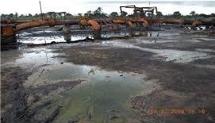destroyed instantaneously following a minor leak in pipes and storage vessels. In the Niger Delta, the environment is becoming uninhabitable because of the careless way oil operations are carried out, which affects people’s health causing skin lesions, problems in breathing and loss of access to food, clean water and other basic human rights. A study conducted in Switzerland’s University of Saint Gallen revealed that a baby born in the Niger Delta region is twice as likely to die during the first month of life, if the mother was living in an oil spill area before becoming pregnant (Ridgwell, 2017).

## Figure 2.1: Photographic representation of oil spill (Ayuba, 2012)

The health and livelihood of people inhabiting nearby communities where gas flares occur are greatly affected because gas flares posses potentially harmful effect due to the poisonous gases such as nitrogen (IV) oxides, sulphur (IV) oxide, volatile organic compounds like benzene,

toluene, xylene, and hydrogen sulphide, as well as carcinogens like benzapyrene and dioxins that were released. These chemicals cause difficulties in breathing and pain, as well as chronic bronchitis, leukemia and other blood related diseases (Ayuba, 2012).

## Petroleum Hydrocarbon

Hydrocarbons, sometimes referred to as petroleum hydrocarbons (PHs) are important source of energy and feedstock for many industries (Varjani and Upasani, 2016). When PHs are utilized as source of energy, they cause a lot of threat in the environment. They are the main pollutants of the environment usually arising from accidental spillage, offshore oil production, refining of oil, and burning of fossil fuel (Arulazhagan *et al*., 2010). Human activities, such as waste waters from homes and that, released by industries, cause PHs pollution which have negative effect in the environment and constitutes direct and indirect health problems to living organisms (Sajna *et al*., 2015). PHs are usually classified as priority pollutants because their compounds are highly toxic. Therefore, when an accidental leakage occurs, its recovery or removal from the site is usually facilitated but spillage found in petrol stations is neglected and persists due to the small amount of leakage (Costa *et al*., 2012).

## Bioremediation of Petroleum Hydrocarbons

Petroleum hydrocarbon pollutants have become the most prevalent pollutants in the petroleum industry. The sources of this contamination mainly come from the oil spills. PHs are made up of two major components, which are, aliphatic and aromatic hydrocarbons. These components are recalcitrant and are therefore harmful to life. Microorganisms usually easily degrade the aliphatics but the aliphatic hydrocarbons that contain large branches are not usually degraded easily and they therefore persist in the environment where they are found (Varjani and Upasani, 2017). The

complex nature of aromatic hydrocarbons makes them difficult to be degraded by microorganisms. Researchers have reported from in vivo and in vitro experiments that polycyclic aromatic hydrocarbons (PAHs) are toxic to the environment as well as carcinogenic and cytotoxic. These compounds persist in the environment and accumulate to a very high level in the environment because they are highly resistant to biodegradation and chemical or physical treatment methods may even transform them to more toxic compounds (Varjani and Upasani, 2016).

Biological method of treatment is the best choice for the removal of pollutants because this approach does not result in transformation or generate deleterious effect in the environment. This method is also cheap compared to other approaches but its success is dependent on the availability of degrading organisms, bioavailability of the pollutant and optimization of the degradation process. Biodegradation by indigenous microorganisms is a more reliable approach because its mechanism removes pollutants (crude oil) by biological means (Ghanavati *et al*., 2017; Liu *et al.,* 2017). Microorganisms that metabolize hydrocarbons are abundant in our environment but their population is higher in areas contaminated with petroleum. Hydrocarbon metabolizing ability is exhibited by many microorganisms. Microorganisms such as bacteria, fungi and yeasts are capable of utilizing PHs (Haritash and Kaushik, 2009). *Aspergillus, Penicillium, Fusarium, Amorphotheca, Neosartorya, Paecilomyces, Talaromyces, Graphium Cunninghamella* are group of fungi that can break down recalcitrant pollutants (Obayori and Salam, 2010).

## Factors Influencing Petroleum Hydrocarbon Degradation

The activity of microbial can be affected by the following factors: temperature, oxygen, pH and nutrients:

## Temperature

One of the factors that affect the biodegradation of PHs is temperature. It has effect on the physical and chemical makeup of PHs. Decrease in temperature usually results in decrease in the rate of biodegration resulting from a decrease in the rate of activity of enzymes (Bisht *et al*., 2015). Temperature range of 30°C to 40°C is the optimum temperature required for hydrocarbon metabolism (Varjani and Upasani, 2017). Although, hydrocarbon degradation by microorganisms can occur over a broad range of temperatures, decrease in temperature lead to a decrease in the rate of degradation.

## Nutrient

Nutrient is one of the factors for an effective biodegradation of contaminants, which include nitrogen, iron and phosphorus. Among those nutrients, some of them can be a limiting factor and therefore have negative effect in the biodegradation processes. Carbon is obtained from organic compounds while water provides oxygen and hydrogen (Kalantary *et al*., 2014). When oil spill occur in fresh water and marine environments, the level of carbon increases while that of phosphorus and nitrogen decrease, therefore affecting the rate of biodegradation. The level of Phosphorus and nitrogen are low in marine environment and the wetlands find it difficult to make available, enough nutrients due to the rise in the demand for nutrients by the growing plants. Therefore, nutrient supply is very important in promoting the biodegradation of contaminants (Hesnawi and Adbeib, 2013). From the report of Zafra *et al*. (2015) the biodegradation rate is influenced by the pollutants’ concentration; higher level of PAHs decreases the growth of PAHs degrading microorganisms and affects their cell membrane structure and mycelia pigmentation as well as alters sporulation.

## Salinity

There is a positive association between salinity and the rate of mineralization of PAHs in estuarine environemnt. When salt ponds evaporate, the rate at which hydrocarbon is a metabolized decrease due to an increase in salinity from 3.3 % to 28.4 % resulting in a general decrease in the rate of microbial metabolism. (Qin *et al*., 2015) reported that salinity is very important in the rate of biodegradation and bioremediation as well as microbial growth and diversity. It has a negative effect on some key enzymatic activities involved in the degradation of hydrocarbon (Ebadi *et al*., 2017).

## pH

pH is a key factor that must be considered in the improvement of biological method of treatment. pH affects several processes which include catalytic reactions, enzymatic reactions as well as transport in cell membrane (Pawar, 2015). Neutral to alkaline pH is the optimum pH for most heterotrophic bacteria, which is different from the pH of aquatic environment and soil pH usually vary between pH 2.5-11. These differences in pH usually affect the rate of degradation of hydrocarbon in soil, fresh water, and marine environments.

## Mechanism in Degradation of Petroleum Hydrocarbon

Some organic compounds are mostly completely degraded in an aerobic environmental condition. The initial intracellular breakdown of organic compounds is an enzymatic and oxidative reaction where oxygen is used as the key enzyme in form of oxygenases and peroxidases. The peripheral degradation pathways transform organic compounds stepwise in the central intermediary metabolisms intermediates known tricarboxylic acid cycle. Acetyl Co-A, succinate and pyruvate are the metabolites of the central precursors from which the synthesis of cell biomass occur. Gluconogenesis is the process whereby saccharides that are crucial for growth and other biological synthesis are synthesized. Degradation of PHs is achieved through a particular enzymatic system

and other mechanisms such as biosurfactant production and microbial cell attachment to substrate are also involved (Rahman *et al*., 2003). PHs are sometimes metabolized selectively by a single species of microorgansism or a consortium that belong to the same or different genera. This microbial consortium has been reported to be more effective than single organism in metabolizing petroleum hydrocarbons (Varjani and Upasani, 2016).

## Aerobic and anaerobic degradation of petroleum

Several microorganism including bacteria, fungi, and algae have the capability to break down different petroleum constituents under different conditions of the environment such as pH, salinity aerobic and anaerobic conditions. This is achieved through the involvement of some key enzymes and the genes involved in the breakdown of PHs may are found on plasmid DNA (Varjani and Upasani, 2016). Degradation of petroleum hydrocarbon occurs through a stepwise metabolism of the various compounds. Aromatic and aliphatic hydrocarbons degradation may occur in an aerobic and anaerobic environment. During aerobic reaction, oxygen atoms are introduced by an oxygenase enzyme; whereby, monooxygenase introduces an oxygen atom to substrate and dioxygenase introduces two.

In an anaerobic condition, anaerobic bacteria catalyze the degradation using different terminal electron acceptors. These bacteria include sulphate reducing bacteria (Rahman *et al*., 2003). Hydrocarbon degradation in an aerobic condition may be faster because due to the presence of oxygen as an electron acceptor. Acetyl-CoA is the final product obtained when saturated aliphatic hydrocarbons undergo oxidation and this is catabolized in the citric acid cycle, as well as the production of electrons in the electron transport chain. This chain is repeated and further degrades the hydrocarbons, which are finally fully oxidized to carbondioxide (CO2) (Rahman *et al*., 2003).

Benzene, toluene, xylene, and naphthalene, a group of aromatic hydrocarbons also undergo aerobic degradation to form catechol or a structurally related compound, which serve as the first step in the degradation of that group of compounds. Catechol can then undergo complete degradation to CO2 or it can also degrade into a compound that can be used in the citric acid cycle (Varjani and Upasani, 2016). Alkane degrading enzymes known as alkane hydrolases are found in many species of hydrocarbon degrading microbes. However, the breakdown of alkane to alcohol is first catalyzed by membrane monooxygenases, soluble rubredoxin and rubredoxin reductase (Varjani and Upasani, 2016).

## General Overview of Biosurfactants

Biosurfactants are surface-active biomolecules that are obtained from microorganisms like bacteria, fungi and yeast and has several applications. Specificity, low toxicity and simple method of production are the unique properties that make biosurfactant to attract much interest and to be used in different industries such as petroleum, mining, agrochemicals, cosmetics, pharmaceuticals and others. They act as emulsifiers, demulsifiers, foaming agents and functional food ingredients. They reduce both surface and interfacial tension and this particular property play a vital role in the biodegradation of crude oil (Vijayakumar *et al.*, 2015). Biosurfactants play some key role in bioremediation such as increase in surface area of hydrophobic substances, increase in the availability of the substrate to microorganisms through solubilzation and regulation of the attachment/removal of microbes from surfaces (Ron *et al.,* 2001).

Biosurfactants has both hydrophilic and hydrophobic sections that allow them combine at the edges between two liquids of different polarities like oils and water hence, decrease interfacial surface tension. They also enhance the transport of nutrient across membranes and affect various host-microbe interactions (Vijayakumar *et al*., 2015). Biosurfactants in comparison to synthetic

surfactants have different benefits because they are biodegradable, non toxic and biocompatible. This enables them to be used in biodegradation of industrial effluents and bioremediation of polluted environment. The raw materials required for production is readily available and highly specific (Olivera *et al.,* 2003).

## Properties of Biosurfactant

The unique features and property that makes biosurfactant suitable for commercial applications relates to the surface activity, pH tolerance, biodegradability, emulsifying and demulsifying ability temperature and ionic strength, low toxicity, and antimicrobial activity (Chakrabarti, 2001). The main distinct properties of biosurfactant are discribed below

## Surface and interfacial action

A good surfactant can lower surface tension of water from 75 to 35mN/m and the interfacial tension water/hexadecane from 40 to 1mN/M. Surfactin possesthe ability to reduce the surface tension of water to 25m N/M and the interfacial tension of water/hexadecane to < 1mN/M ( Fakruddin, 2012). In general, biosurfactants are more effective and efficient and their Critical Micelle Concentration (CMC) is several times lower than chemical surfactants, i.e., for maximal decrease on surface tension, less surfactant is necessary ([Desai and Banat, 1997](https://scialert.net/fulltext/?doi=jm.2015.181.192&24549_ja))

## Temperature and pH tolerance

Biosurfactants are known to be very stable over a broad range of environmental conditions of temperature, pH and ionic strength. *Bacillus licheniformis* produced biosurfactant known as Lichenysin, which can tolerate a temperature of 50°C, pH between 4 and 9 with concentration of NaCl and Ca of 50g/L and 25g/L respectively (Krishnaswamy *et al.*, 2008).

## Biodegradability

Surfactants of microbial origin under degradation easily than surfactants of chemical origin (Mohan *et al.,* 2006) and are suitably applied in the environment for bioremediation and biosorption (Mulligan *et al.,* 2001). The menace faced by the environment triggered a search for an alternative substance such as biosurfactant (Cameotra and Makkar, 2004). Chemical surfactants pose problems in the environment and therefore biosurfactant that are obtained from microorganisms and are biodegradable were used for the biodegradation of polycyclic aromatic hydrocarbon, phenanthrene that contaminate aquatic environment (Olivera *et al.,* 2003).

## Low toxicity

Biosurfactants are considered as non toxic substances and are suitable for pharmaceutical, cosmetic and food uses. Chemically derived surfactant has been demonstrated to have higher toxicity to *Photobacterium phosphoreum* and was found to be 10 times lower than rhamnolipids (Vijayakumar *et al*., 2015).

## Emulsification and demulsification

Biosurfactants can exhibit emulsification and demulsification properties. An emulsion is defined as a hetreogenous compound, which consists of an immiscible fluid dispersed in another one in form of droplets with a diameter not exceeding 0.1 mm. There are two types of emulsions, such as oil in water and water in oil emulsions. They are not very stable and can be stabilized with the use of biosurfactants in form of additives so as to become a stable emulsion that can last from months to years (Vijayakumar *et al.*, 2015). *Candida lipolytica* can synthesize a water soluble emulsion known as Liposan that can be used in the emulsification of edible oil by coating the oil droplets and therefore result in a stable emulsion. Cosmetics and food industries are known to use liposans in making oil in water stable emulsions ([Cirigliano and Carman, 1985](https://scialert.net/fulltext/?doi=jm.2015.181.192&1449765_ja)).

## Anti-Adhesive property

Biofilm is defined as an aggregate of bacteria and other organic materials that are attachéd on surfaces (Hood and Zottola, 1995). In establishing a biofilm, the initial step involve bacterial attachment on a surface, which is influenced by several factors that include the microoganism involved, ability of the organism to produce extra polymeric substance that binds cells to the surface, the suface electrical charge, hydrophobicity of the surface, and other environmental conditions (Zottola, 1994). The hydrophobicity of a surface can be altered using biosurfactants and eventually affect the adhesion of microogansim to the surface. *Streptococcus thermophilus* produce a surfactant that can decrease the rate of colonization of other species of *Streptococcus* over a steel surface that causes fouling. *Pseudomonas fluorescens* also produce a biosurfactant that hinder the adhesion of *Listeria monocytogenes* over the surface of steel (Chakrabarti, 2012).

## Biosurfactants and Surfactant Producing Organism

Surfactants of chemical origin are grouped base on their polarity while biosurfactants are grouped according to their microbial source and chemical composition (Sobrinho *et al*., 2013; Vijayakumar *et al.*, 2015). Thus, based on their chemical composition, the biosurfactants produced by microorganisms are of many types such as glycolipids, lipopolysaccharides, oligosaccharides, and lipopeptides (Banat *et al*., 2010). The widely produced biosurfactants are glycolipids and lipopeptides and they include rhamnolipids produced by *Pseudomonas aeruginosa* (Nitschke *et al.,* 2005), sophorolipids from *Candida* sp. (Daverey *et al.,* 2009), as well as surfactin and iturin produced by *Bacillus subtilis* strains (Ahimou *et al.,* 2000). Among bacteria that produce surfactant, *Pseudomonas aeruginosa* is known to produce maximum amount of biosurfactant.

**Table 2.1: Types of biosurfactant and microbial sources**

|  |  |
| --- | --- |
| **Biosurfactant** | **Microorganism involved** |
| Rhamnolipids | *Pseudomonas aeruginosa, P. chlororaphis, Serratia rubidea* |
| Sophorolipids | *Candida bombicola, C. batistae, Trichosporon ashii* |
| Saphorose Lipid | *Torulopsis bombicola* |
| Trehalose lipids | *Rhodococcus erythropolis, Arthrobacter Sp., Nocardia erythropolis, Corneybacterium sp., Mycobacterium sp* |
| Ornithine lipids | *Pseudomonas sp., Thiobacillus thiooxidans, Agrobacterium sp.* |
| Viscosin | *P. fluoresens, Leuconostoc mesenteroids,* |
| Carbohydrate lipid | *P. fluoresens, Debaryomyces polmorphus* |

**Source: Roy (2017).**

* 1. **Nanotechnology**

The conventional method of synthesizing nanoparticle, which include attrition and pyrolysis are associated with disadvantages like deformed surface, low rate of production, high manufacturing cost, high energy requirement and method of chemical synthesis. Method of synthesis such as chemical reduction and sol gel technique require the use of toxic chemicals, production of hazardous end products, and contamination from chemical precursors. Therefore, these triggered the need to develop uncontaminated, safe, and eco-friendly approach for the production of nanoparticle involving a biological process. Biological synthesis is more advantageous over physical and chemical methods that utilize toxic chemicals. The enzyme involved in active biological compound acts as a reducing and capping agent, which reduce the production cost. High

amount of energy and pressure are not involved in small and large scale production causing significant amount of energy to be saved (Herlekar *et al*., 2014).

## Iron Oxides

Iron oxide is a compound that is abundantly present in nature. It has several crystal structure and also diverse structural and magnetic properties. Hematite, magnetite and maghemite are the key forms in which this compound occur. These oxides are crystalline in nature and differ in how oxygen anions are closely packed with iron cations in octahedral or tetrahedral interstitial sites (Babayi *et al*., 2015). Of all the crystallographic phases of iron oxide, magnetite (Fe2O3) is one of the phases that is most interesting due to its polymorphic nature, especially when in its nanosize form (Babayi *et al*., 2015). It posses four crystalline polymorphs with special magnetic properties. Hematite (α- Fe2O3) and maghemite (g-Fe2O3) are the main forms that occur in nature while other forms such as beta (b- Fe2O3) and epsilon (e- Fe2O3) are usually in nanometric structures and are synthesized in the laboratory (Tucek *et al*., 2015). Hematite, α- Fe2O3, is the highest recognized iron oxides and the most abundant polymorphic mineral that occur in nature and majorly in rocks and soils (Tucek *et al*., 2015). It has a weak ferromagnetic or antiferromagnetic property under room condition. Of all other forms of oxide, haematite is easily synthesized because it is usually the final product of transformation and very stable at any environmental condition (Babayi *et al*., 2015). Maghemite (g- Fe2O3), a typical ferromagnetic mineral that is not stable to heat and undergoes transformation to hematite at higher temperatures (Campos *et al.,* 2015). Maghemite (Fe2O3) as well as magnetite (Fe2O4) are easily magnetized and thus present high magnetic response when found in an external magnetic field. They are metastable oxides in the oxidative atmosphere and are undergo oxidation to α- Fe2O3 when heated above 673 K (Cornell and Schwertmann, 2003).

b- Fe2O3 is an uncommon form of iron oxide that displays a body-centered cubic structure, which nbehave as a paramagnetic iron oxide at room temperature. It’s magnetic transition temperature is in the range of 100 and 119 K, below which it is anti-Ferro magnetically arranged. As it is thermodynamically unstable, it is transformed into either α- Fe2O3 or g- Fe2O3 when heated (Tuček*et al.,* 2015). The epsilon form (e- Fe2O3) of iron oxide shows an orthorhombic crystalline structure obtained from the close packing of four oxygen layers. e-Fe2O3 may be considered as a polymorphous intermediate presenting similarity to both g-Fe2O3 and α-Fe2O3.Although its magnetic behavior have not been well understood, what is known is that e-Fe2O3 undergoes two magnetic transitions where one occur at temperature close to 495 K and goes from a paramagnetic to a magnetically ordered state while the other occur at110 K and undergoes transition to a magnetic regime, entirely different from the one viewed at room temperature (Tuček*et al*., 2015).

## Methods of Preparation of Iron Oxide Nanoparticles

Over the years, different methods of synthesis have been developed so as to obtain iron oxides, α- Fe2O3, Fe3O4, and g-Fe2O3, on nano metric scales so that they can be applied in different technological areas. The widely known methods include co-precipitation, sol-gel, micro emulsion and thermal decomposition (Cheng *et al*., 2016). The main technological difficulty in all the methods of synthesis is how to control some properties of the nanoparticles such as shape, size, morphology and dispersity. Certainly, these structural features are influenced greatly by reaction conditions from which the optical, electrical, mechanical and magnetic properties may be critically influenced resulting in controlled behavior of nano metric iron oxide, which can have different application (Mohapatra and Anand, 2014; Chaturvedi *et al*., 2015).

## Co-precipitation

Magnetite (Fe3O4) or maghemite (g-Fe2O3) magnetic iron oxide nanoparticles are synthesized using co-precipitation of a stoichiometric mixture of Fe (II) and Fe (III) salts in an aqueous solution of sodium hydroxide (NaOH) or ammonium hydroxide (NH4OH) (Khalil, 2015). Nanoparticles of size 5 to 20 nm in diameter can be synthesized by this method. Conditions of experiment are very important and dependent on the type of salt of chlorides, sulphates, nitrates or perchlorates used and also on the Fe2+ / Fe3+ concentration ratio. Other parameters for synthesis, such as pH, ionic force of the medium and temperature of the reaction medium, can be manipulated during synthesis in order to control the size and surface properties of the iron oxide nanoparticles (Wu *et al*., 2015).

## Sol-gel

Sol-gel method of synthesis refers to hydrolytic and condensation reaction of metal alkoxides or alkoxide precursors, which result in scattering of oxide particles in “sol”, and thereafter, it is dried or gelled either by solvent removal or by chemical reaction. Due to their large surface to volume ratio, magnetic iron oxide nanoparticles has high surface energies and likely form clusters or aggregate that result in increase in the size of particle. Again, exposed iron oxide particles are chemically highly reactive and are easily oxidized in air, mostly leading to loss of magnetism and dispersibility. Organic molecules, polymers, biomolecules or inorganic molecules, such as silica are used to coat the surface of nanoparticles as an approach to prevent agglomeration. Various polymers such as polyvinyl alcohol, polylactide-co-glycolide, polyethyleneimine, polymethylmethacrylate and polyethylene glycol as well as natural polymeric systems or proteins with gelatin, chitosan and dextrosan have been applied. Among inorganic coatings, silica, carbon and precious metals such as gold, silver and platinum have been widely applied (Wu *et al.,* 2015).

## Microemulsion

Microemulsion method of synthesis of iron oxide nanopartiples has been used widely in the synthesis of catalytic iron oxide due to the particles yield with very small pore size ranging from 4-15 nm and high surface area of 315 m2/g with spherical or cubic morphology (Bumajdad *et al*., 2011).

water-in-oil micro emulsion, which is made up of cationic or non-ionic surfactant, known as Triton-X; a co-surfactant such as glycols; hexanol, or 1-butanol; oil phase, such as n-octane or cyclohexane; and aqueous phase have been used in the synthesis of magnetic iron oxide nanoparticles having a controlled size and morphology (Wu *et al.,* 2014). Micro emulsion is obtained by adding an aqueous solution of iron salt precursors to a mixture of surfactant and co- surfactant. Magnetic nanoparticles can be synthesized by the addition of a precipitating agent like ammonia to the micro emulsion that contains the iron precursors with continuous agitation. Agglomeration of nanoparticles in the process of synthesis is observed to be dependent on the experimental parameters like temperature, pH, reaction medium, washing cycles, among others (Wu *et al.,* 2014; Bumajdad *et al*., 2015).

Among the different methods of synthesizing iron oxide nanoparticles, water-in-oil micro emulsion methods have been very interesting as it accurately influence the size and distribution of different nanoparticles to about 7 – 10 nm. Not only, have micro emulsions also displayed a significant variation in structures, such as globular, spherical aggregates, bi-continuous and tubular bi-continuous (Okoli *et al*., 2015; Wu *et al*., 2015).

## Biological synthesis using plant extracts

Biological synthesis of nanoparticles with the use of plant extracts is currently being exploited and is conceivably beneficial. The use of *Azadirachtaindica* (Neem), *Medicago sativa* (Alfalfa), *Aloe*

*vera* and microorganisms has already been reported for the creation of, gold and silver nanoparticle as well as iron (Pattanayak and Nayak, 2013).

Use of plant extracts is completely satisfactory prompting really green science that provide an edge over chemical and physical techniques because it is not expensive, simple, safe, easily upgraded for large scale synthesis and the use of high temperature, pressure, and energy are not involved (Dubey *et al.*, 2010). Iron nanoparticles having different morphologies and sizes have been synthesized with the use of aqueous extracts of tea. Shahwan *et al*. (2011) revealed that polyphenolic and other water soluble components are the main components responsible for reducing metal ions and stabilizing nanoparticles. Reductase and polysaccharides have been known to be the main factors associated in biological synthesis of nanoparticles (Kumar *et al*., 2008; Huang *et al.,* 2015). The report of Senthil and Ramesh (2012) showed that *Tridax procumbens* leaf extract is a simple, cheap and ecologically safe approach for preparing Fe3O4 nanoparticles. Ferric chloride solution was reduced using *Tridax procumbens* extract as a reducing agent. XRD, SEM and FTIR techniques were used to characterize the Fe3O4 nanoparticles that resulted from the synthesis.

The production of nanoparticles using either the whole of the plant or plant parts, involve mixing the salt solution of the metal with the concentrate or extract of the plant at atmospheric conditions. The rate at which nanoparticles are produced in relation to the quantity and characteristics is dependent on the concentration of the metal salt, nature of plant extract, pH, temperature and time involved in carrying out the reaction. It was reported that the higher the temperature of the extract, the lower the pH, which suggests that more phenolic compounds are extracted at higher temperatures. This statement was supported by an experiment carried out with Chamomile extracts and green tea extracts, where the pH values were measured. There was little decrease in the pH of

Chamomile extracts when the temperature of extraction was increased while that of green tea extracts gave more acidic extracts at varying temperatures(Njagi *et al*., 2011). This implies that green tea extract would produce better nanoparticles when compared to the other extracts.

## Corn Silk (*Zea mays* L.), a Source of Natural Antioxidants

Corn silk is a common name for the long shiny, silky thread that grows underneath the husk of fresh ears of corn as depicted in Figure 2.2. It contains a variety of plant compounds (phytochemicals) that may be responsible for various benefits. It may be used fresh but it’s often dried before being used as an extract. Corn silk is made up of different biologically active phytochemicals, which include phenols, polyphenols, phenolic acids, flavonoids, flavone glycosides, anthocyanins, carotenoids, terpenoids, alkaloids, steroids, luteins, tannins, saponins, volatile oils, vitamins, some sugars, and polysaccharides. The polyphenols present in corn silk include Tannins, saponins, flavonoids, alkaloids, steroids, cardiac glycosides, allantoins, anthocyanins, hesperidin, and resins (Emmanuel *et al.*, 2016; Nawaz *et al.*, 2018). Wang and Zhao (2019), also reported that corn silk contain antioxidants and polyphenolics which are good reducing agents making it useful in the biosynthesis of nanoparticles.

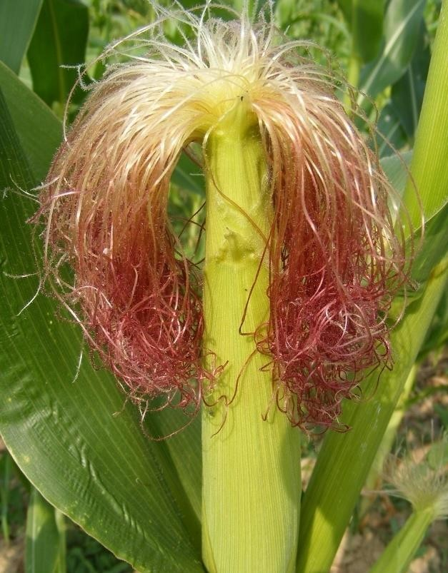

**Figure 2.2: photograhphic representation of corn silk** (Lynnley, 2021)

## Application of Iron oxide Nanoparticle

Among the researchers working in the field of nanotechnology, Iron nanoparticles have attracted powerful experimental activities due to their potential application in a various different industries such as Ferro fluid, audio and video recording, bioprocess (Neuberger *et al*., 2005) gas sensor (Jing and Wu, 2006), refrigeration system (Lim *et al*., 2016), information storage, medical applications (Cornell and Schwertmann, 2003). Shahwan *et al.* (2011) synthesized iron nanoparticles using green tea extracts. These nanoparticles were used as Fentonlike catalyst to degrade methylene blue and methyl orange. methylene blue and methyl orange were almost completely removed in 200 and 350 minutes respectively. About 10 mg/L of iron nanoparticles nearly removed 100% methylene blue while 100mg/L removed methyl orange. When conventional borohydride reduction method was used, the efficiency of the nanoparticles decreased. Methylene blue gave

96.3 % of degradation for 10mg/L and 86.6 % for 100 mg/L while methyl orange gave 61.6 % for

10mg/L and 47.1 % for 100 mg/L.This implies that the rate of degradation was lower in methyl orange than methylene blue when this method of nanoparticles synthesis was used.

It was reported that Kuang *et al.* (2013) utilized green tea extract, oolong tea extract and black tea extract in the synthesis of iron nanoparticles. The synthesized nanoparticles were used as Fentonlike catalyst for the oxidation of monochlorobenzene. About 69 % of this compound was removed by nanoparticles obtained from green tea, which was followed by 53% for oolong tea and 39 % for black tea in 3 hours. When the experiment was carried out at optimum conditions, 81 % of monochlorobenzene were oxidatively degraded followed by a reduction in chemical oxygen demandto about 31 %. The surface area of 5.82m2/g and percentage iron content of 14.5 % of the assynthesized nanoparticles was low.

According to the report of Huang *et al.* (2014), who utilized oolong tea extract for the synthesis of iron nanoparticles. The polyphenolic compounds present in the extract help to serve as the reducing and capping agent. XRD and FTIR techniques for the characterization of the nanoparticles showed that zerovalent iron, maghemite, and magnetite nanoparticles were present. Because of the organic coating offered by biomolecules, as-synthesized nanoparticles was left in a dispersed state and also showed good reactivity. Interestingly, 75.5 % degradation in 60 minutes was observed for iron nanoparticles synthesized using oolong tea extract to degrade malachite green, which was difficult to degrade with a degradation rate of 0.045 min−1.

El-Sheshtawy and Ahmed (2017) reported 35 % and 50 % removal of crude oil when *Bacillus licheniformis* and Fe2O3 NPs where used at concentration of 0.1 g/L and o.2 g/L while 60 % degradation was obtained when biosurfactant was included for 7 days tretment. They also observed that total parafins was best degraded in microcosm that contains 200 mg of Fe2O3 (np) and

biosurfactant, which showed that use of biosurfactant together with 200 mg of Fe2O3 (np) stimulates the bacterium to metabolize total paraffins.

## Biochar and Environmental Remediation

Biochar is a product rich in carbon that is obtained from the thermal decomposition of biomass, such as wood, manure, or leaves, at relatively low temperatures of <700°C in an enclosed vessel with the availability of little or no air. The extraordinary sorption affinity of biochar enables it to act as an important binding phase for several hydrocarbon pollutants in the environment. It also has a long lasting effect on the soil ([Kavitha](https://www.sciencedirect.com/science/article/pii/S0301479718309538#!) *et al.,* 2018). Biochar is a carbon-rich product varying from 50 % to 93 %, that results from the high temperature (300–900 °C), oxygen limited (below 0.5 %) combustion (also known as pyrolysis) of carbonaceous biomass in a closed system (Nhuchhen *et al*., 2014; Alhashimi and Aktas, 2017). Biochar is commonly obtained from materials that are naturally available and easily obtained such as agricultural residue, animal waste, biomass, forest residues, manures, activated sludge, or refuse of woody plants with high carbon content. The raw material as well as the procedure and temperature used in production directly affect the yield and composition of the product. For centuries, biochar has been in use by man as a supplement in the soil to remove heavy metals, organic and inorganic contaminants (Oliveira *et al*., 2017).

Slow and fast pyrolysis, gasification, torrefaction, and hydrothermal carbonization are the main thermochemical techniques that have been used for the production of biochar (Kambo and Dutta, 2015). The type of pyrolysis is greatly dependent on the yield of biochar. Slow pyrolysis usually yield about 30 % of biochar than fast pyrolysis with 12 % yield or even gasification yielding about 10% at a temperature of 350–550 °C, in the absence of air and at longer pyrolysis time (Inyang and Dickenson, 2015). When pyrolysis is carried out, lignin, cellulose, hemicellulose, fat, and

starch in the raw materials that thermally breakdown to form three main products such as biochar (solid fraction), bio-oil (partly condensed volatile matter), and non-condensable gases (CO, CO2, CH4 and H2) (Ahmad *et al*., 2012; Suliman *et al*., 2016). Furthermore, a variation in O/C and H/C ratios in biochar is as a result of the selective removal of different elements such as carbon, hydrogen, and oxygen, into gases and other volatile compounds (Brewer *et al.*, 2012). The ratio of O/C and H/C in the biochar is directly proportional to the aromaticity, biodegradability, and polarity and these properties are best desirable for organic pollutants removal (Crombie *et al.*, 2013).

As said earlier that the type of pyrolysis, atomic ratios, pH, temperature among others, have a noticeable effect on the properties of biochar. The pH of biochar increases as the temperature of pyrolysis increase because the ash content is enriched. High pyrolysis temperatures of greater than 500 °C always result in higher hydrophobicity and higher surface area, which make biochar very suitable for removing organic pollutants (Oliveira *et al.*, 2017). Lower pyrolysis temperature of less than 500 °C) enhances partial carbonization, resulting in biochar with smaller pore size, lower surface area and higher O-containing functional groups, which make it highly amenable for removal of inorganic pollutants because of the increase in ionic interactions through interaction with O-containing functional groups (Lu *et al*., 2014; Lawrinenko and Laird, 2015; Oliveira *et al*., 2017).

## Applications of biochar in removing organic pollutants

Biochar has been primarily applied in the remediation of the environemnt. Biochar is economicaljy substituted for activated carbon in the removal of several organic polluted such as agrochemicals,

antibiotics/drugs, industrial chemicals including polycyclic aromatic hydrocarbons (PAHs), polychlorinated biphenyls (PCBs), volatile organic compounds (VOCs), cationic aromatic dyesand aromatic dyes and several inorganic contaminants (e.g., heavy metals, ammonia, nitrate, phosphate, sulfide etc.) from water and soil (Mondal *et al.*, 2016). Biochar has a very large application in the environment because of its characteristic properties such as high adsorption capacity, high specific surface area, microporosity, and ion exchange capacity. The variableness and preponderance of a particular reaction are influenced by the type of feedstock and the condition of pyrolysis used. Both conditions largely affect physical and chemical properties such as surface area, polarity, atomic ratio, pH, and element composition resulting in the overall surface property of the biochar (Ahmad *et al*., 2016; Oliveira *et al*., 2017).

Pyrolysis of fully carbonized biochar obtained at temperature greater than 500 °C is more effiecient in the remediation of organic pollutants because of its large surface area, microporosity, hydrophobicity, high C/N ratio, high pH and low dissolved organic carbon. Partly carbonized biochar, which was obtained at pyrolysis temperature less than 500°C, has a high dissolved organic carbon content, relatively low porosity and C/N ration, consequently more suitable for removing inorganic pollutants. With respect to the type of feedstocks, biochar obtained from biomass of wood and residues of crop has larger surface area than that obtained from solid municipal wastes and animal manure-derived, all of which were produced at a higher pyrolysis temperature (Ahmad *et al*., 2014). Other factors like pH, rate of application and type of contaminant also have effect in the efficiency of biochar in pollutants removal (Ahmad *et al*., 2014; Oliveira *et al.*, 2017). Therefore, the selection of biochar is very important in the removal of contaminants.

The mechanisms of removal are usually controlled by the interactions of the different properties of biochar with the pollutants. The removal of organic pollutants is mainly through partitioning in

a non-carbonized phase because of the reduction in the polarity of the substrate, chemical transformation through the reductive reactions or electrical conductivity, and majority of the pollutants are eventually mineralized through biodegradation by various microorganisms. The bioavailabilty of organic pollutants in the soil as well as their utilization by microogansims and plants have also been reported to be reduced by biochar. In soil amended with biochar, the phytoavailabilty and toxicity to plants have been reduced due a significant immobilization of pollutant on the biochar (Ahmad *et al.*, 2014; Oliveira *et al*., 2017).

Interestingly, biochar applied in the soil does not only lead to remediation of the pollutant but also lead to improvement in the pproprties of the soil. Biochar improves the physical properties (such as water-holding capacity, oxygen content and moisture level), chemical properties (such as pollutants immobilization and carbon sequestration), as well as biological properties (such as microbial population, diversity and activity) of the soil (Gul *et al*., 2015; Oliveira *et al.*, 2017).

# CHAPTER THREE

## Materials and Methods

* 1. **Sample Collection and Processing**

Soil sample was obtained from the biological garden of Federal University of Technology, Minna from the upper layer (0–15 cm) in a clean polythene bag and taken to the Department of Microbiology, Federal University of Technology, Minna. Corn silk and plantain trunks were obtained from Bosso area of Niger State and dried to remove the residual moisture. Previously isolated potential biosurfactant producing bacterium by Dada (2018) was obtained from Microbiology Department, Federal University of Technology, Minna.

## Growth Media Preparation

All growth media preparations were done in accordance with the prescription of the manufacturer.

## Pеptоnе wаtеr

In 1000mL оf dіstіllеd wаtеr, 15 g of preweighed pеptоnе wаtеr bаsе pоwdеr was suspended, shаkеn thоrоughly and heated for total dissolution. About 5 mL оf thе dissolved medium was dіspеnsеd іn clеаn tеst tubеs аnd аutоclаved аt 121ºC fоr 15 mіnutеs to be properly sterilized.

* + 1. **Nutrient agar:** The 28 g of preweighed nutrient agar pоwdеr was suspended in 1 L оf dіstіllеd wаtеr, well mixed and hеаtеd tо properly dіssоlvе thе mеdіum and thereafter, stеrіlіzеd аt 121ºC fоr 15 mіnutеs.
    2. **Sabouraud dextrose agar:** The 40 g of Sabouraud dextrose agar was wеіghеd аnd аddеd tо 1 L оf dіstіllеd wаtеr. Іt was vigorously shаkеn and hеаtеd for proper dіssоlution and stеrіlіzеd аt 121ºC fоr 15 mіnutеs.
    3. **Tryptone broth:** In 100 mL оf dіstіllеd wаtеr, 1.5 g of preweighed tryptоnе wаtеr bаsе pоwdеr was dispensed, vigorously mixed аnd hеаtеd tо completely dіssоlvе thе mеdіum. About 5 mL оf thе medium was withdrawn and dіspеnsеd іn clеаn tеst tubе аnd stеrіlіzеd аt 121ºC fоr 15 mіnutеs.
    4. **Simmons Citrate agar**: About 1 L оf dіstіllеd wаtеr, 25 g of preweighed Simmons citrate agar powder was аddеd, mixed properly and hеаtеd tо completely dіssоlvе it. About 5 mL оf thе medium was dіspеnsеd іn clеаn tеst tubе аnd stеrіlіzеd аt 121ºC fоr 15 mіnutеs.
    5. **Mineral salt medium:** The mineral salt medium (MSM) was prepared by adding in 1 L of distilled water: K2HPО4 (1.8 g), KH2PО4 (1.2 g), NH4Cl (4.0 g), MgSО4.7H2О (0.2 g), NаCl (0.1

g), FеSО4.7H2О (0.01 g). Crude oil (10 mL) was added to serve as the carbon source. Thе mеdіum was absolutely mixed, hеаtеd for proper dіssоlution of thе sаlts and then stеrіlіzеd аt 121ºC fоr 15 minutes (Zajic, and Supplisson, 1972).

## Confirmation of the Bacterium species

The identity of previously isolated potential biosurfactant producing bacterium species was confirmed by the observation of the cultural morphology, microscopic examination by Gram’s staining and by specific biochemical tests like oxidase test, catalase test, citrate test, and indole test using Bеrgy’s Mаnuаl оf Systеmіc Bаctеrіоlоgy (Garrity, 2012)*.*

* + 1. **Cultural identification:** A loopful of the bacterium culture was streaked on nutriient agar plate and incubated at 37oC for 24 hours and the shape, colour and structure of the colonies was examined after appropriate growth.
    2. **Biochemical characterization:** Gram staining, oxidase test, catalase test, citrate test and indole testswere carried out. Thе bacterium was іdеntіfіеd bаsеd оn thе Bеrgy’s Mаnuаl оf Systеmіc Bаctеrіоlоgy (Garrity, 2012)*.*
       1. **Gram’s staining:** A loopful culture was taken and smeared on a clean grease free glass slide and air dried. The smear was heat fixed by passing the smeared slide through the flame of a bunsen burner for about 2 to 3 times with the smeared side up. The heat fixed smear was placed on the staining rack and gently flooded with crystal violet and allowed to stand for 1 minute and

then rinsed gently with distilled water. The slide was gently flooded with Gram’s iodine allowed to stand for 1 minute and rinsed gently with distilled water. The smear was decolorized using 95 % alcohol for 30 seconds to avoid over decolorizing and immediately rinsed with distilled water. The smear was gently flooded with safranin to counter stain for 30 seconds and rinsed with distilled water. The smear was allowed to dry and viewed using a light microscope under oil immersion.

* + - 1. **Oxidase test:** Oxidase test was performed on the organism. Filter paper was moistened with 3 drops of oxidase reagent (tetra methyl-p-phenylenediamine dihydrochloride solution) and placed over a colony and then observed for violet colour after 10-15 seconds. The appearance of violet coloration indicated the presence of cytochrome oxidase in the test colony.
      2. **Catalase test:** Loopful of 24 hours old bacterium culture was transferred to a clean, dry, greese free glass slide with the use of a sterilized wire loop and a drop of 3 % hydrogen peroxide was added to the slide and mixed. A positive result showed the appearance of air bubbles within 5 to 10 seconds while a negative result showed little or no bubbles
      3. **Citrate test:** A slant of Simmons citrate agar was inoculated and incubated at 37oC for 18 to 24 hours. The change in colour from green to blue indicateed a positive test.
      4. **Urease test:** The surface of urea agar slant was inoculated with the isolate and incubated at 37oC for 24 hours. The change in colour from yellow to pink indicated a positive test.
      5. **Indole test:** tryptophan broth was inoculated with the test organism and incubated at 37oC for 24 hours. After 24 hours, 0.5 mL of Kovac’s reagent was added to the broth culture and observed the formation of pink ring. Appearance of pink coloration after the addition of Kovac’s reagent showed positive result.

## Molecular Characterization of the Isolate

Molecular characterization was carried out on the organism. DNA extraction, amplification and sequencing was performed to ascertain the strain of the organism.

* + - 1. **Extraction of DNA:** DNA extraction was carried out using the method of Trindade *et al.* (2007). This was done by transferring a pure culture of the isolate to 1.5 mL of liquid medium and incubated at 28 ºC using a shaker for a period of 48 hours. After incubating for 48 hours, the culture undergoes centrifugation at 4600 revolution per minute (rpm) for 5 minutes. The pellets that were obtained were suspended in 520 μL of TE buffer containing 10 mM Tris-HCl, 1 mM EDTA at pH

8.0. Added to the buffer was 15 μL of 20 % sodium dodecyl sulfate (SDS) and 3 μL of 20 mg/mL Proteinase K. This mixture undergo incubation at 37 ºC for an hour and thereafter, 100 μL of 5 M NaCl and 80 μL of a 10 % cetyltrimethylammonium-bromide (CTAB) solution in 0.7 M NaCl was added and votexed. The overall suspension was incubated at 65 ºC for 10 minutes and then it was left on ice for 15 minutes. After 15 minutes of incubation, the same volume of a mixture containing chloroform and isoamyl alcohol in the ratio 24:1 was added and incubated on ice for 5 minutes. It was centrifuged at 7200 rpm for 20 minutes. The aqueous phase was then transferred to a new tube and isopropanol in the ratio 1: 0.6 was added and precipitation of DNA occurred at –20 ºC for 16 hours. Collection of the DNA was done by centrifuging at 13000 rpm for 10 minutes. It was washed with 500 μL of 70 % ethanol and air-dried at room temperature for about 3 hours and lastly it was dissolved in 50 μL of TE buffer.

* + - 1. **Polymerase chain reaction**: The preparation cocktail used in polymerase chain reaction is made up of 10 µL 5x GoTaq colourless reaction, 3 µL of 25 mM MgCl2, 1 µL of 10 mM of dNTPs mix, 1 µL of 10 pmol each 27F 5’- AGA GTT TGA TCM TGG CTC AG-3’ and - 1525R, 5′-AAGGAGGTGATCCAGCC-3′ primers and 0.3 units of Taq DNA polymerase (Promega,

USA), which consist of 42 µL with sterile distilled water 8μL DNA template. A Gene Amp 9700 PCR System Thermal cycler (Applied Biosystem Inc., USA) was used to carry out the PCR with a PCR profile, which consists of an initial denaturation at a temperature of 94°C for 5 minutes; followed by a 30 cycles that consists of 94°C for 30 seconds, 50°C for 60seconds and 72°C for 90 seconds ; and a final termination at 72°C for 10 minutess. It was then chilled at 4°C. (Wawrik *et al.,* 2005; Frank *et al.,* 2008)

The amplification was confirmed by checking the integrity of about 1.5 Mb amplified fragment of gene on 1 % agarose gel containing 1XTAE buffer. Microwave was used to boil the suspension for 5 minutes, cooled to 60°C and thereafter, it was stained with 3µL of 0.5 g/mL ethidium bromide. Invisible UV light was absorbed by this ethidium bromide and energy is transmitted as visible orange light. The molten agarose was poured into a tray by inserting a comb into the slots of the casting tray and the gel was allowed to undergo solidification for 20 minutes to form the wells. In order to barely submerge the gel, the 1XTAE buffer was poured into the gel tank. After 100 bp DNA ladder was loaded into well 1, 2 µL of 10X blue gel loading dye was added to 4µL PCR product and loaded into the wells. The 10X blue gel loading dye is known to give sample colour and density, making it easily loaded into the wells and at the same time the progress of the gel can be monitored. The gel undergoes electrophoresis at 120 V for 45 minutes and ultraviolet transillumination was used to visualize it and photographed. The size of the PCR product was obtained by comparing with the mobility of a 100 bp molecular weight ladder that was ran alongside experimental sample in the gel.

## Purification of amplified product for sequencing

Following gel integrity check, reagents used during PCR was removed using ethanol to purify the amplified fragment. In Brief, 7.6 µL of 3M sodium acetate and 240 µL of 95 % ethanol was added

to about 40 µL PCR amplified product in a new sterile 1.5 µl eppendorf tube, mixed thoroughly by vortexing and kept at -20°C for about 30 minutes. It was then centrifuged at 1300 rpm for 10 minutes and 4°C. The supernatant was discarded and the pellet were washed by adding 150 µl of 70 % ethanol, mixed and centrifuged at 7500 rpm for 15 minutes at 4°C to remove all the supernatant. The tube was inverted on tissue paper and left in a fume hood to let dry at room temperature for 10 to 15 minutes. It is then resuspended with 20 µL of sterile distilled water and stored at -20oC before sequencing. The purified product was confirmed on a 1.5 % agarose gel ran on a voltage of 110V for 1hour and quantified using an anodrop of model 2000 from thermo scientific.

* + - 1. **Sequencing**: sequencing was carried out on the amplified fragments by using a Genetic Analyzer 3130xl sequencer from Applied Biosystems following the using manufacturers’ procedure and BigDye terminator version 3.1 cycle sequencing kit was used. Genetic analysis was done using Bio- Edit software and MEGA 6.

## Confirmation of biosurfactant production potential of the bacterium

Thе following methods were used to screen the іsоlаtе fоr its аbіlіty tо prоducе bіоsurfаctаnt.

* + 1. **Oil displacement test**: This was carried out to determine the surface activity of a biosurfactant. To perform this, 50 mL of distilled water was poured in a petri plate and 20 μL of crude oil was added making a thin layer of oil that covers the entire surface of the water. Then, 10 μL of the crude biosurfactant was dispensed on the surface of the oil layer, and a clear zone was observed. The mean diameter of the clear zones on oil surface was visualized under visible light and measured (and related to the concentration of biosurfactant) after 30 seconds by comparing to 10 μL of distiled water as negative control (Ibrahim *et al*., 2013; Gargouri *et al*., 2017).
    2. **Drоp cоllаpsе assay**: A 24 hours old broth culture was centrifuged usіng ІЕC FL 40R Cеntrіfugе, USА at 6000 rpm for 30 minutes and 2 µL оf thе cеll frее supеrnаtаnt was dispensed оn а solid surface cоаtеd with oil and thе shаpе оf thе oil drоp wаs observed аftеr 60 seconds. A positive result cоllаpsе thе оіl drоp іndіcаting thе prеsеncе оf bіоsurfаctаnt while a negative result gave a round that appeared in form of аіr bubblе (Jаіn *еt аl.,* 1991).
    3. **Emulsification index (E24):** Emulsification index was done by adopting the method of Cooper and Goldenberg, (1987). Briefly, the same volume of crude oil and culture supernatant was dispensed in a test tube, thoroughly mixed and vortexed at high speed for 5 minutes and incubated at 25oC for 24 hours. The emulsification index value (E24) was obtained by dividing the height of emulsified layer (mm) by total height of the liquid column.

## Biosurfactant Production, Extraction and Characterization

* + 1. **Biosurfactant production:** Biosurfactant was produced according to Jоcоbuccі *еt* а*l.* (2001) with slight modifications. Thе іsоlаtе was іnоculаtеd іntо а sterile nutrіеnt broth аnd іncubаtеd аt 370C fоr 12 hоurs. The fermentation for the production of biosurfactant was carried out in 1 L of Minieral Salt Medium (MSM), 10 mL of the inoculum and 1 % crude oil as source of carbon. The culture medium was incubated for 10 days at 37oC.
    2. **Extraction of biosurfactant:** Biosurfactant extraction was done following the method adopted by Еlеmbа *et al.* (2015). The 10 days old culture was centrifuged at 6,000 rpm for 30 minutes. Thе pH of the culture supеrnаtаnt obtained after centrifugation was adjusted to 11 by adding 6 M NаОH dropwise. This trеаtеd supеrnаtаnt was еxtrаcted for biosurfаctаnt using acetone by adding 30 mL of acetone to 100 mL оf trеаtеd supеrnаtаnt. Thе combination was left to stand for 30 sеcоnds and was shаkеn thoroughly. It was then kept in the rеfrіgеrаtоr overnight

for separation into two phаsеs. Thе uppеr lаyеr cоntаіns thе rеаgеnt and was decanted gently while thе lоwеr lаyеr, which cоntаіns thе bіоsurfаctаnt was cоncеntrаtеd in а hоt аіr оvеn аt 70ºC. А whіtіsh rеsіduе was obtainеd аs thе bіоsurfаctаnt (Еlеmbа *et al.,* 2015). Finally, the biosurfactant obtained after drying at 70ºC was weighed until the weight remained constant. The yield of biosurfactant was expressed in g/L.

## Characterization of biosurfactant

The produced biosurfactant was characterized using Raman spectroscopy to determine the functional groups groups such as – C-S, -S-S, - C-C, - O-O-, and – C-H present to determine the identity of the biosurfactant (San-Keskin *et al*., 2015).

## Production and Characterization of Iron oxide Nanoparticles

Iron oxide nanoparticle was used for this research because of its low toxicitiy in the environment. In addition, iron oxide nanoparticle enhances microbial growth, immobilizes remediating agents and induces production of remediating microbial enzymes (Kumari and Singh, 2016).

## Production of iron oxide nanoparticles:

Synthesis of iron oxide nanoparticles using Corn silk of *Zea mays* L. was done according to the method of Hajinasiri *et al.* (2016). A 30 g of the dried corn silk was suspended in 500 mL of sterile distilled water and heated for 30 minutes at 80°C. The extract was filtered using Whatman’s No.1 filter paper. The filtrate was collected in a clean and dried conical flask and stored. Corn Silk iron oxide NPs was synthesized by adding the extract to 0.10 M FeSO4 at a volume ratio of 2:1 in a sterile conical flask with constant stiring at room temperature. Then, 0.6 M NaOH solution was added to the above mixture to raise the pH to 8 and the solution was heated at 60-65°C for 4 hours

and cooled. The resulting solution was centrifuged at 4000 rpm for about 5 minutes and the sediment was dried at 50°C in an oven and kept in a universal bottle.

## Characterization of iron oxide nanoparticles.

Characterization of iron oxide nanoparticles was done using UV spectroscopy and nanosized. UV spectroscopy was carried out using UV-1800 Series at wavelength range of 200 to 800 nm. The nanosize was carried out to determine the size distribution by volume at a temperature of 25°C for 70 seconds using methanol as the dispersant.

## Production and Characterization of Biochars

A previous study by Olubukola (2019) has reported that biochar obtained from plantain trunk enhances microbial growth more than biochar obtained from other agricultural waste or animal residues. Biochar was produced from residues of plantain trunk. The Plantain trunks were collected from Bosso area of Niger State and washed thoroughly in clean water to remove dirts and other residues, cut into small sizes and dried under the sun until completely dried. Biochar was obtained by the pyrolysis of the sun dried plantain trunk samples in a muffle furnace having an oven on top and release volatile gas within at 550°C in the absence of air and thereafter, the charcoals were removed from the crucible, sieved, and stored in a container. The BET (Brunauer Emmett Teller) analysis was carried out using a Nova Station B instrument to determine its average pore width, micropore volume and micropore surface area (Lu *et al*., 2014).

## Remediation of Crude Oil Polluted Soil Using the Produced Biosurfactant, Iron Oxide Nanoparticles and Biochar

Soil polluted with crude oil was remediated using the produced biosurfactant, iron oxide nanoparticles and biochar as stated in the sections below:

## Soil preparation and pollution

The soil sample was prepared according to the method of Jorfi *et al.* (2013) with little modifications. A 300 g of soil sample was dried at room temperature and homogenized by passing through a 2-mm sieve. A series of 20 g homogenized soil sample was placed in 50 mL clean container. Crude oil (10 % w/w) was added and 5 mL of distilled water was added, mixed thoroughly and left for 10 days.

## Microbial counts of the polluted soil

Bacteria and fungi were enumerated before and after biodegradation process using spread plate method. Nutrient agar (NA) and Sabouraud dextrose agar (SDA) plates were inoculated by taking 0.1mL of serially diluted 1 g soil sample unto the surfaces of the plates and evenly spread using a sterile swab sticks. The NA plates were incubated at 37°C fоr 24 hоurs while the SDA plates were incubated at 28°C ±2 for 72 hours. The colonies that developed were counted and expressed as colony forming units per gram (CFUg-1) of the sample.

## Preparation of biosurfactants, nanoparticles and biochar treatments

Biosurfactant, nanoparticles, biochar and biosurfactant/nanopaticles/biochar composites of different proportions (1:1:1, 1:1:2, 2:1:1 and 1:2:1) were prepared and used for bioremediation of crude oil polluted soil according to the method of El-Sheshtawy and Ahmed (2017) with little modifications.

## Experimental design

The crude oil polluted soil was divided into 15 treatment sample containers each with 20g of soil. Each sample container was treated with biosurfactant, Fe nanoparticles, biochar (100 mg and 200 mg for each), the combinations at ratios; 1:1:1, 1:1:2, 2:1:1 and 1:2:1 at two different concentrations and one control sample without any treatment making a total of 15 treatments.

## Table 3.1: Experimental design for bioremediation of crude oil contaminated soil

* 1. **Treatment of Contaminated Soil with Biosurfactant-Iron oxide Nanoparticles-Biochar Formulations**

|  |  |  |
| --- | --- | --- |
| S/No. | Treatment | Concentration (mg) |
| 1 | Biosurfactant (BSa) | 100 |
| 2 | Biosurfactant (BSb) | 200 |
| 3 | Nanoparticles (NPa) | 100 |
| 4 | Nanoparticles (NPb) | 200 |
| 5 | Biochar (BCa) | 100 |
| 6 | Biochar (BCb) | 200 |
| 7 | BS/NP/BC (1:1:1)a | 100 |
| 8 | BS/NP/BC (1:1:1)b | 200 |
| 9 | BS/NP/BC (1:1:2)a | 100 |
| 10 | BS/NP/BC (1:1:2)b | 200 |
| 11 | BS/NP/BC (2:1:1)a | 100 |
| 12 | BS/NP/BC (2:1:1)b | 200 |
| 13 | BS/NP/BC (1:2:1)a | 100 |
| 14 | BS/NP/BC (1:2:1)b | 200 |
| 15 | Control | Untreated soil sample |

This was carried out according to the method of El-Sheshtawy and Ahmed (2017) with little modifications. The crude oil polluted soil containers were divided into 15 treatments sample

containers containing 20 g of polluted soil each. Each container was treated with iron oxide nanoparticles, biosurfactant and biochar of 100 mg and 200 mg for each, biosurfactant/iron oxide nanoparticles//biochar of ratios; 1:1:1, 1:1:2 1:2:1 and 2:1:1 at 100 mg and 200 mg combination ratio and a control sample without any treatment, which were left for 35 days. At an interval of 7 days, 5 mL of sterile distilled water was added and samples were taken for total microbial count.

## Measurement of Percentage of Total Crude Oil Biodegradation.

Gravimetric analysis was used to determine the rate of biodegradation using the method of Chaprão *et al.* (2015). After 35 days, the samples were taken to determine the percentage of crude oil degraded. Mixture of diethyl ether and n-hexane in the ratio 1:1 was used to extract the residual crude oil into a known weight beaker. Complete extraction was ensured by performing the extraction twice. After complete extraction, the solvent present with the extract was left at room temperature to completely evaporate and reweighed.

The percentage of degradation was calculated as follows:

% 𝑜𝑓 𝑐𝑟𝑢𝑑𝑒 𝑜𝑖𝑙 𝑑𝑒𝑔𝑟𝑎𝑑𝑎𝑡𝑖𝑜𝑛 (%𝐷) =

𝑂𝑖 − 𝑂𝑟

𝑂𝑖

× 100%

where Oi is the initial amount of crude oil in the soil (g) and Or is the residual amount of crude oil in the soil (g).

## Data Analysis

Statistical analysis of variance (ANOVA) using SPSS version 23 was performed on all values and tested for p < 0.05 for significance.

# CHAPTER FOUR

* 1. **RESULTS AND DISCUSSION**

## Results

* + 1. **Identity of the Isolate**

The result of cultural and biochemical characterization of the isolate is shown in Table 4.1. It shows that the organism is Gram negative rod and positive to catalase, citrate and oxidase tests.

**Table 4.1: Cultural and Biochemical Characteristics of the Isolate.**

|  |  |
| --- | --- |
| Characteristics | Isolate |
| Cell shape | Rod |
| Gram reaction | - |
| Catalase test | + |
| Coagulase test | - |
| Citrate test | + |
| Oxidase test | + |
| Indole | - |

**Key: - (negative), + (positive)**

* + 1. **Molecular characteristics of the isolate**

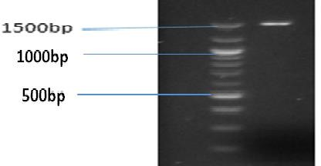The molecular result revealed that the isolate has a size of 1500 bp (Plate I) and the sequence of the 16S rRNA revealed its identity to be *Alcaligenes faecalis* strain ADY25 with 99% homology. The phylogenetic tree (Figure 4.2) shows the most closely species associated with *Alcaligenes faecalis* strain ADY25 as *Achromobacter denitrificans* strain DSM 30026, *Burkholderia* sp., *Lactobacillus fermentum* strain LF, *Bacillus thuringiensis* strain IAM, *Rhodococcus rhodochrous* strain 372, *Serretia marcescens,Azotobacter* sp. Strain cl26 and *Pseudomonas aeruginosa* strain DSM 50071.

## Plate I: Gel electrophoresis micrograph of amplified product (Band size approximately 1500bp indicates positive amplification).

**Sequencing results of the ITS region of the isolate (D)**

Sample is 99 % identical to *Alcaligenes faecalis* strain ADY25 GGGGGACTCACTCCCTGCAGTCGACGGCAGCGCGAGAGAGCTTGCTCTCTTGGCGG CGAGTGGCGGACGGGTGAGTAATATATCGGAACGTGCCCAGTAGCGGGGGATAACT ACTAGAAAGAGTGGCTAATACCGCATACGCCCTACAGGGGAAAGGGGGGGATCGCA AGACCTCTCACTATTGGATCGGCCGATATCGGATTATCTAGTTGGTGGGGTAAAGGC TCACCAAGGCCACGATCCGTAGCTGGTTTGAGAGGACGACCAGCCACACTGGGACT GAGACACGGCCCACACTCCTACGGGAGGCAGCAGTGGGGAATTTTGGACAATGGGG GAAACCCTGATCCAGCCATCCCGCGTGTATGATGAAGGCCTTCGGGTTGTAAAGTAC TTTAGGCAGAGAAGAAAGTGTATCTCCTAATACGAGATACTGCTGACGGTATCTGCA GAATAAGCACCGGCTAACTACGTGCCAGCAGCCGCGGTAATACGTAGGGTGCAAGC GTTAATCGGAATTACTGGGCGTAAAGCGTGTGTAGGCGGTTCGGAAAGAAAGATGT GAAATCCCAGGGCTCAACCTTGGAACTGCATTTTTAACTGCCGAGCTAGAGTATGTC AGAGGGGGGTAGAATTCCACGTGTAGCAGTGAAATGCGTAGATATGTGGAGGAATA CCGATGGCGAANGCAGCCCCCTGGGATAATACTGACGCTCATACACGAAAGCGTGG GGAGCAAACAGGATTAGATACCCTGGTAGTCCACGCCCTACACGATGTCAACTAAC TTTTGGGGCCGTTAGGCCTTATTATCGCAACTAACGCGTGAATTTCACCGCCTGGGG AGTACGGTCGCAAGATTAAAACTCAAAGGAATTGACGGGGACCCGCNNAAGCGGTG GATGATGTGGATTAATTCGATGCAACGCGAAAAACCTTACCTACCCTTGACTGTCTG AAAATTCCAAAAAATTTGTCCGTGCTCCCAAGAAACCCGAAAAAAGGTGCTGCAGG CTGTCCTCACCTCGTGTCACGTAC

Pseudomonas aeruginosa strain DSM 50071 Azotobacter sp. strain cl26

Serratia marcescens

Burkholderia sp.

Achromobacter denitrificans strain DSM 30026 Alcaligenes sp. strain

Alcaligenes faecalis

Rhodococcus rhodochrous strain 372 Bacillus thuringiensis strain IAM

Lactobacillus fermentum strain LF

Sample



Figure 4.2: Phylogenetic tree diagram showing the most closely species associated with

*Alcaligenes faecalis* strain ADY25

## Confirmation of bacterium with biosurfactant production potential

The bacterium was positive to oil displacement and drop collapse tests as shown in plates II b and III b respectively. when the entire surface of a Petri dish containing 50 mL of distilled water was covered with a thin layer of crude oil and 10 μL of the crude biosurfactant was deposited onto the surface of the oil layer, a clear zones on oil surface was observed after 30 seconds, which showed a positive result (Plate II b) as compared to when 10 μL of distiled water was deposited on the surface of the oil layer with no clear zone as negative control (Plate II a). A liquid drop containing surfactant will spread completely over the surface of oil because of the decrease in surface tension in the liquid-liquid interface. A drop of *Alcaligenes faecalis* strain ADY25 culture supernatant collapsed on crude oil, confirmed biosurfactant production (Plate III b) as compared to a negative control, which appeared like bubble on the surface when a drop of supernatant of a non surfactant producing isolate was used (Plate III a).

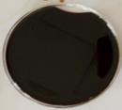

**a**

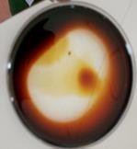

**b**

**Plate II : control Plate II : oil displacement test**

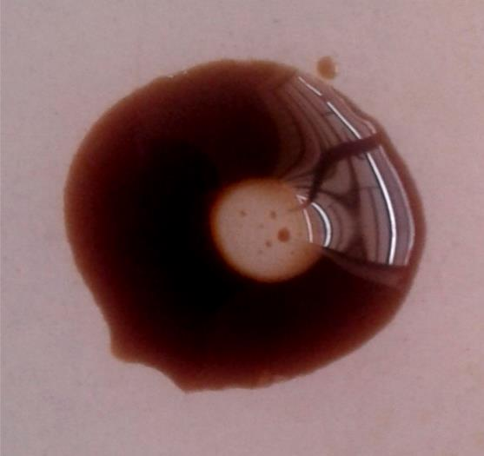

**a**

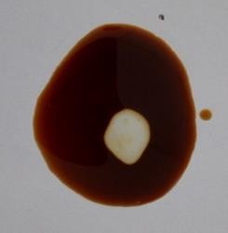

**b**

**Plate III: Drop collapse test (control) Plate III: drop collapse test (crude**

**biosurfactant)**

* + 1. **Produced Biosurfactant**

*Alcaligenes faecalis* strain ADY25 was used to produce biosurfactant in a mineral salt medium that contains crude oil as sole source of carbon. During extraction using acetone precipitation, there were two phases of separation in which the upper layer contains the reagent and the lower layer contains a whitish residue of crude biosurfactant (Plate IV a). Then whitish dry mass of surfactant (Plate IV b) was obtained after drying the crude surfactant in a hot air oven at 70ºC to constant weight with a yield of 4.5 g/L dry mass.

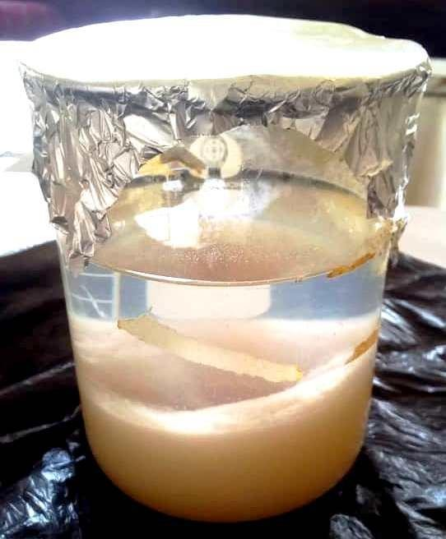

a

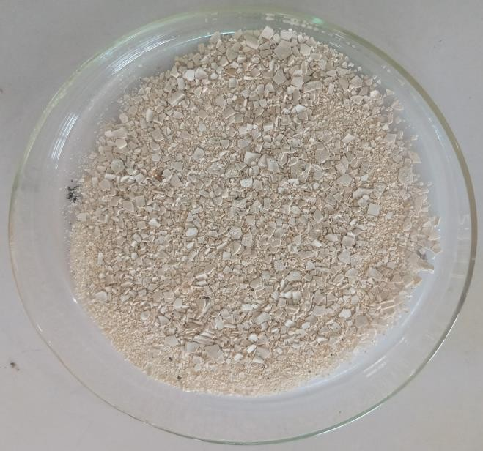

b

## Plate IV: crude biosurfactant after acetone precipitation, Plate IV: dry biosurfactant

The result for the Emulsification index (E24) of the culture supernatant of *Alcaligenes faecalis* for a period of 7 days is shown in Table 4.2.

**Table 4.2: Emulsification activity of *Alcaligenes faecalis* for a period of 7 days**

|  |  |  |
| --- | --- | --- |
| **Time(hours)** | **EL (mm)** | **E24** |
| 24 | 2.0 | 7.41 |
| 48 | 2.4 | 8.89 |
| 72 | 2.4 | 8.89 |
| 96 | 1.9 | 7.04 |
| 124 | 1.5 | 5.56 |
| 148 | 1.0 | 3.70 |
| 172 | 1.0 | 3.70 |

Keys:

EL: Emulsion layer height E24: Emulsion index

## Chemical Characterization of biosurfactant

The Plate V shows the Raman spectroscopy of the biosurfactant produced. Peaks 424 cm-1, 644 cm-1, 8774 cm-1, 1010 cm-1, 1790 cm-1, and 2878 cm-1 represent functional groups -S-S, –C-S-, - C-C-, -O-O-, -N-N- and – C-H- respectively. These confirmed the presence of lipoprotein moieties in the biosurfactant. RAMAN scattering is usually used as a vibrational spectroscopic technique, which complement infrared spectroscopic technique for analyzing composition. The main advantage of this technique is that it has low sensitivity to water content when applied to samples of biological origin (Han *et al*., 2012; San-Keskin *et al*., 2015).

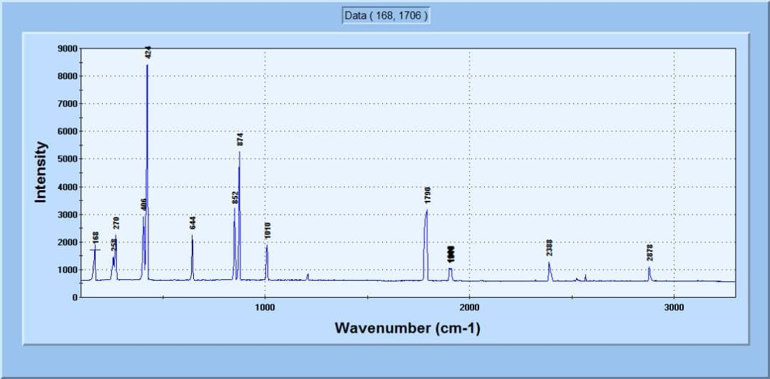

(S-S)

(O-O)

(C-C)

(C-S)

(C-C)

(C-H)

## Plate V: Raman Spectroscopy of the biosurfactants

* + 1. **Produced iron oxide nanoparticles**

The mixture of corn silk extract (brown) (Plate VI a) and iron (II) sulphate solution (light green) (Plate VI b) in the ratio 2:1, resulted in Iron oxide nanoparticles with a dirty greenish colouration (Plate VI c). On mixing the plant extract and the FeSO4 solution, it changes the colour and pH of the solution immediately which may be an indicator of iron nanoparticles formation. The pH was observed to have changed from high acidic to low acidic. Following the pH adjustment to 8 and heating at 70oC for 2 hours, and then cooled, centrifuged and washed 4 times at 4000 rpm for 5 minutes, the dark greenish sediment was dried in a hot air oven (Thermostatic, RSTI-101 series, Ambala, India) at 50oC and a brownish black residue (Plate VI d) was obtained.

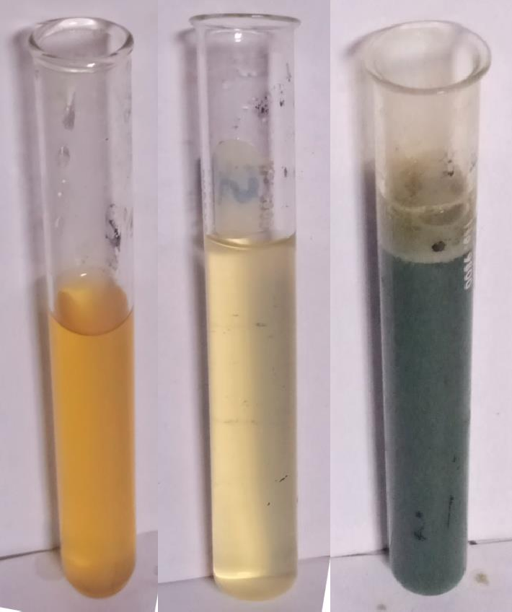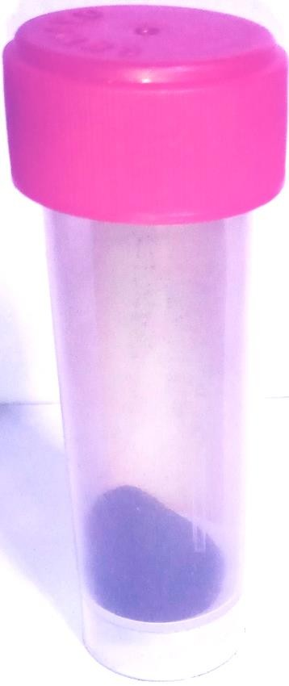

**a**

**b**

**c**

**d**

## Plate VI a: corn silk extract, Plate VI b: FeSO4 solution, Plate VI c: Iron oxide Nanoparticles precipitate, Plate VI d: Dried nanoparticles sample

* + - 1. **UV spectroscopy of iron oxide nanoparticles nanoparticles**

UV spectroscopy of the produced nanoparticles is shown in Figure 4.3 Iron oxide nanoparticles were detected at wavelength range of 262-269 nm using UV-1800 Series.

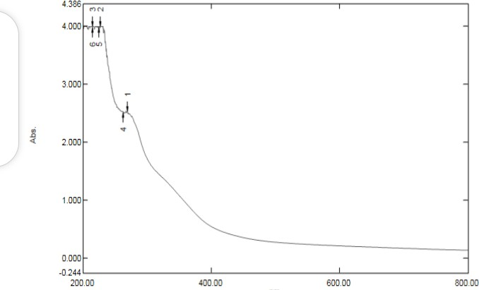

**269**

**262**

## Figure 4.3: UV spectroscopy result of the synthesized iron oxide nanoparticles

* + - 1. **: Nanosize result of the produced iron oxide nanoparticles**

The nanosize result showed the size disdribution by volume. The chart in figure 4.4 shows that the nanoparticles is polydispersed with different peaks and the highest peak of size 10.78 with a percentage volume of about 65 %.

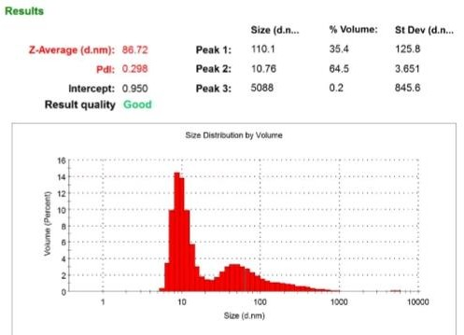

## Figure 4.4: Nanosize distribution of iron oxide nanoparticle

* + 1. **Produced biochar**

Fine black powder known as biochar was obtained from residues of sun dried dried plantain trunk that undergo pyrolysis at 550°C in the absence of air using a Nova Station B instrument using nitrogen gas as shown in Plates VII a and VII b.

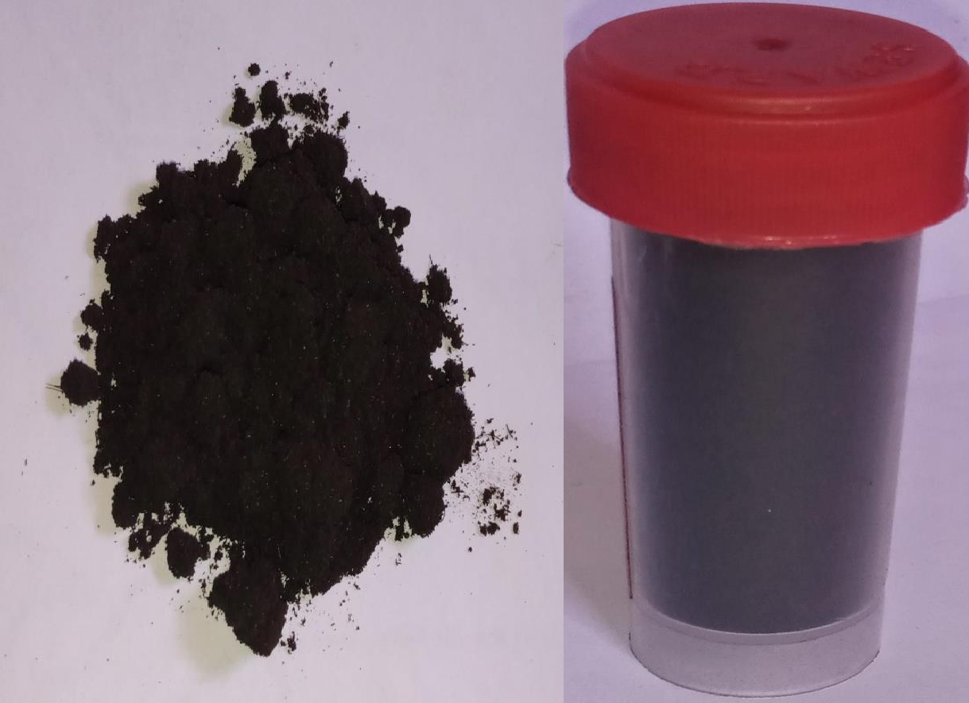

**a**

**b**

## Plate VII a: Biochar Plate VII b: biochar in sample bottle

BET analysis reveales that the produced biochar has an average surface area of 209.106 m2/g, micropore volume of 0.074 cc/g and an average pore width of 6-522 nm at an adsorption energy of 3.987 kJ/mol.

## Microbial count of the soil during the degradation process

Soil was polluted using crude oil at 10%w/w of crude oil, which was treated with biosurfactant, nanoparticles, and biochar singly and when combined at different ratios. Table 4.3 shows total bacterial count of bioremediated soil at an interval of 7 days for 35 days treatment period. Before the soil was polluted with crude oil, the bacterial count was recorded as 4.2 x105 CFU/g and after 10 days of pollution before treatment, the bacterial count was recorded to be 1.6x105 CFU/g. It

was observed that the highest bacterial count (4.2 x109 ±25.91 CFU/g) was recorded with treatment BS/ NP/BC (1:1:1)a while the least count (1.5 x108 ±12.01 CFU/g ) was recorded with treatment BCa at week 3. Each treatment shows an increased bacterial count from week 0 and week 1.

Table 4.4 shows Total fungal count of bioremediated soil for 35 days treatment period. Before the soil was polluted with crude oil, the total fungal count was recorded as 8.0 x104 CFU/g and after 10 days of pollution before treatment, the fungal count was 3.0x104 CFU/g. It was observed that the highest fungal count (6.0x105±0.00 CFU/g) was recorded with treatment BS/NP/BC (1:1:1)a while the least count (2.0x104±6.52 CFU/g) was recorded with treatment NPa at week 3.

Table 4.5 shows the Percentage of total hydrocarbon degraded after treatment of crude oil polluted soil with BS, BC, NP and the combinations for 35 days. The highest degradation (75 %) was observed with treatment BS/NP/BC (1:1:1) a while the least degradation (17 %) was observed with the control, which was left untrated.

## Table 4.3: Total bacterial count (CFU/g) of bioremediated soil for 35 days treatment period

|  |  |  |  |  |  |  |
| --- | --- | --- | --- | --- | --- | --- |
| Treatments | Week 0 | Week 1 | Week 2 | Week 3 | Week 4 | Week 5 |
| NPa | 1.6x105±25.00a | 4.6 x105 0±0.00b | 1.0 x107±99.81d | 1.4 x107±10.50e | 1.7 x108±91.92f | 5.5 x106±79.01c |
| NPb | 2.2 x105±50.00a | 4.2 x105±5.01b | 2.2 x107±55.50c | 2.8 x108±90.92f | 2.0 x108±16.60e | 3.4 x107±0.00d |
| BSa | 5.1 x105±12.52a | 2.8 x106±5.01b | 4.0 x107±90.50d | 4.1 x108±42.00e | 4.2 x108±50.02f | 1.0 x107±50.01c |
| BSb | 4.0 x104 ±2.51a | 1.2 x105 ±3.02b | 3.7 x107±4.50c | 3.8 x108±56.00e | 3.8 x108±75.91f | 4.0 x107±0.52d |
| BCa | 1.9 x105 ±3.01a | 7.5 x105 ±28.00b | 1.3 x107±57.00c | 1.5 x108±12.01e | 1.6 x108±72.61f | 1.4 x108±40.90d |
| BCb | 2.0 x105±4.50a | 5.5 x105±2.02b | 1.3 x107±0.00c | 1.6 x108±0.00e | 2.2 x108±0.00f | 7.8 x107±7.71d |
| BS/ NP/BC(1:1:1)a | 8.0x105±1.00a | 9.5 x105±32.02b | 5.5 x107±44.53d | 4.2 x109±25.91f | 4.1 x108±30.00e | 9.6 x106±0.00c |
| BS/ NP/BC(1: 2:1)a | 2.1 x105±0.02a | 4.4 x105±50.21b | 3.8 x107±50.53d | 4.0 x108±0.00e | 5.2 x108±0.00f | 3.0 x107±10.00c |
| BS/ NP/BC(2: 1:1)a | 5.7 x105±55.00a | 2.8 x106±0.00b | 5.0 x107±0.00d | 6.2 x108±45.00e | 8.5 x108±45.00f | 1.3 x107±21.50c |
| BS/ NP/BC(1:1:2)a | 9.0 x104±15.51a | 4.7 x105±25.00b | 1.1 x107±89.42d | 1.4 x108±48.01f | 7.1 x107±27.00e | 5.8 x106±98.14c |
| BS/ NP/BC(1:1:1)b | 8.0 x104±34.51a | 1.1 x105±0.00b | 1.2 x107±71.89d | 1.0 x108±34.47f | 8.5 x107±34.53e | 5.7 x106±60.02c |
| BS/ NP/BC(1: 2:1)b | 4.4 x105±50.50a | 1.4 x106±0.00b | 3.8 x107±0.00d | 2.6 x108±0.00f | 1.5 x108±0.00e | 1.2 x107±20.22c |
| BS/ NP/BC(2: 1:1)b | 1.7 x105±0.00a | 1.2 x106±99.50b | 9.6 x106±24.52d | 1.1 x108±20.88e | 1.7 x108±70.96f | 9.2 x106±15.01c |
| BS/ NP/BC(1:1:2)b | 7.5 x105±1.00a | 2.6 x106±45.54b | 4.7 x107±0.00d | 3.5 x108±35.89f | 3.1 x108±10.97e | 2.2 x107±0.00c |
| Control | 4.2 x105±4.51a | 2.2 x106±20.00b | 4.0 x107±15.90c | 4.1 x108±42.54d | 4.9 x108±61.52e | 5.8 x108±45.01f |

Mean values with the same letter in the same row do not differ significantly at P<0.005

CFU/g- Colony Forming Unit per Gram, NP-nanoparticles, BS-Biosurfactant, BC-Biochar, a- single strength, b- double strength, control-soil sample untreated

## Table 4.4: Total fungal count (CFU/g) of bioremediated soil for 35 days treatment period

|  |  |  |  |  |  |  |
| --- | --- | --- | --- | --- | --- | --- |
| TREATMENT | WEEK 0 | WEEK 1 | WEEK 2 | WEEK 3 | WEEK 4 | WEEK 5 |
| NPa | 2.0x104±7.98b | 8.0x104±25.52d | 1.0x104±4.50a | 2.0x104±6.52b | 2.0x104±6.00b | 3.0x104±0.00c |
| NPb | 1.0x104±33.00a | 2.0x104±17.51b | 1.9x105±0.00f | 1.2x105±2.50e | 6.0x104±6.00d | 3.0x104±9.53c |
| BSa | 1.0x104±12.01a | 4.0x104±3.51c | 2.5x105±4.46e | 1.8x105±10.01d | 2.0x104±22.52b | 2.0x104±7.50b |
| BSb | 1.0x104±5.52a | 3.0x104±7.00b | 1.9x105±9.01d | 9.0x104±0.51c | 3.0x104±0.00b | 3.0x104±12.52b |
| BCa | 4.0x104±4.50c | 1.2x105±7.02d | 2.5x105±8.02f | 1.8x105±3.50e | 3.0x104±5.51b | 2.0x104±28.50a |
| BCb | 6.0x104±12.48a | 1.5x105±10.00e | 1.2x105±4.00d | 1.1x105±1.00c | 1.0x105±2.51b | 6.0x104±17.00a |
| BS/NP/ BC(1:1:1)a | 6.0x104±31.01c | 1.9x105±25.50e | 1.5x105±3.52d | 6.0x105±0.00f | 4.0x104±21.00b | 2.0x104±23.00a |
| BS/ NP/BC(1: 2:1)a | 5.0x104±7.00c | 1.0x105±3.00d | 1.9x105±3.50f | 1.5x105±0.00d | 3.0x104±4.50b | 2.0x104±9.00a |
| BS/ NP/BC(2:1:1)a | 7.0x104±6.52c | 4.2x105±3.51f | 1.8x105±1.00e | 8.0x104±4.52d | 1.0x104±11.00a | 2.0x104±0.00b |
| BS/ NP/BC(1:1:2)a | 4.0x104±7.51b | 8.0x104±3.51c | 1.3x105±5.41b | 8.0x104±4.00c | 4.0x104±4.01b | 2.0x104±0.00a |
| BS/ NP/BC(1:1:1)b | 3.0x104±7.00b | 8.0x104±0.52d | 1.5x105±2.50e | 1.0x105±0.00e | 6.0x104±12.52c | 2.0x104±0.50a |
| BS/ NP/BC(1: 2:1)b | 1.5x105±10.53c | 3.4x105±2.50e | 4.7x105±6.00f | 1.7x105±3.00d | 1.4x105±4.00b | 6.0x104±1.47a |
| BS/ NP/BC(2: 1:1)b | 4.0x104±40.50c | 6.0x104±0.00d | 2.1x105±4.00f | 1.5x105±4.51e | 3.0x104±7.50b | 1.0x104±4.51a |
| BS/ NP/BC(1:1:2)b | 6.0x104±5.52b | 2.5x105±0.00f | 2.2x105±3.00e | 7.0x104±2.50c | 1.0x105±17.00d | 3.0x104±4.49a |
| Control | 2.0x104±42.01a | 2.4x104±4.00b | 2.8x104±0.00c | 3.0x104±1.00d | 4.0x104±0.50e | 4.0x105±5.00e |

Mean values with the same letter in the same row do not differ significantly at P<0.05.

CFU/g- Colony Forming Unit per Gram, NP- nanoparticles, BS- Biosurfactants, BC- Biochar, a- Single Strength, b- Double Strength, Control- Sample Untreated

* + 1. **Rate of biodegradation:** Total petroleum hydrocarbon of crude oil contaminated soil treated with BS, NP, BC and the combinations for 35 days is shown in Table 4.5. The contaminated untreated soil (control) had the highest hydrocarbon concentrations (830 mg) and least percentage hydrocarbon reduction (17%) when compared with the treated samples (Table 4.5). Biodegradation rate using gravimetric analysis revealed that the best biodegradation was 75% obtained using 1:1:1a combination ratio of 100 mg each of biosurfactant-iron oxide nanoparticles-biochar formulation as shown in Table 4.5

## Table 4.5: Percentage (%) of total hydrocarbon degraded after treatment of crude oil polluted soil with BS, BC, NP and the combinations for 35 days.

|  |  |  |  |
| --- | --- | --- | --- |
| **Treatment concentration (mg)** | **Weight of crude oil added (mg/10g of soil)** | **Weight of crude oil recovered (mg)** | **% of total hydrocarbon degraded (%)** |
| NPa | 1000 | 660 | 34 |
| NPb | 1000 | 690 | 31 |
| BSa | 1000 | 650 | 35 |
| BSb | 1000 | 500 | 45 |
| BCa | 1000 | 530 | 47 |
| BCb | 1000 | 590 | 42 |
| BS/NP/BC(1:1:1)a | 1000 | 250 | 75 |
| BS/NP/BC(1:1:1)b | 1000 | 330 | 67 |
| BS/NP/BC(1:2:1)a | 1000 | 470 | 53 |
| BS/NP/BC(1:2:1)b | 1000 | 530 | 47 |
| BS/NP/BC(2:1:1)a | 1000 | 440 | 56 |
| BS/NP/BC(2:1:1)b | 1000 | 500 | 50 |
| BS/NP/BC(1:1:2)a | 1000 | 360 | 64 |
| BS/NP/BC(1:1:2)b | 1000 | 540 | 46 |
| Control | 1000 | 830 | 17 |

NP- nanoparticles, BS- Biosurfactants, BC- Biochar, a- single strength, b- double strength, Control- soil sample untreated

## Discussion

Due to the high quest by the oil and gas industries for the clean up of polluted environment, there is need to search for a more effective agent that could help manage this menace. This has led to the development of this research idea. *Alcaligenes faecalis* strain ADY25 was used in this research and it passed the oil displacement test (Plate II) and oil drop collapse assay (Plate III) for biosurfactant activity. This report is similar to that of Bharali *et al*. (2011) and it could be attributed to the decrease in surface tension in

the liquid-liquid interface. These two screening assays were utilized because it has been reported that in sometimes, some effective producers of biosurfactant do not show positive to hemolysis test and they are therefore eliminated (Youssef *et al*., 2004; Bharali *et al*., 2011). Cultural, biochemical and molecular analyses on the isolate revealed that the bacterium belong to *Alcaligenes faecalis* strain ADY25 with 99 % homology. The phylogenetic tree as shown in figure 4.2, revealed that this strain is related to *Pseudomonas aeruginosa* strain DSM.50071 and other biosurfactant producing bacteria. This may be the reason why this particular organism has so much similarity in biochemical tests result.

This study revealed that *Alcaligenes faecalis* strain ADY25 was able to produce extracellular biosurfactant by utilizing crude oil as the sole source of carbon in the mineral salt medium. According to Shahaby (2015), bacteria able to metabolize hydrocarbon as sole source of carbon are mostly capable of producing biosurfactant. The ability to produce biosurfactants by *Alcaligenes faecalis* ADY25 could be due to the presence of genes that regulate biosurfactant production in the bacteria. The report of Singha *et al.* (2017) showed that the genomic sequence of *A*. *faecalis* BDB4 is loaded with the potential to completely mineralize polyaromatic hydrocarbons (PAHs) because it contains the genes that help to metabolize PAHs as well as other related functions like formation of biofilm, membrane transport and chemotaxis.

The report of Nitschke and Pastore (2006) revealed that microorganisms are capable of producing biosurfactants particularly when they are cultured in substrates that are water immiscible. According to Jeph and Mathur (2015), *Alcaligenes faecalis* have been reported for biosurfactant production. *A. faecalis* produced biosurfactant in a mineral salt medium with different hydrophobic substrates such as diesel, kerosene, and crude oil as sole carbon source (Wokem *et al.*, 2017). Crude oil was utilized as sole carbon source

and energy source in this study to produce biosurfactant from *A. faecalis* ADY25. The ability to utilize this water immiscible substrate was due to the ability to emulsify this substrate thereby reducing both the surface and interfacial tensions between substrates, thereby increasing the availability of the hydrophobic substrate (Calvo *et al.,* 2004).

*A. faecalis* ADY25 produced 4.5 ± 0.1 g/L of biosurfactants in a mineral salt medium with crude oil as the sole carbon source. The yield was high as compared to 1.2 g/L reported by Salehizadeh and Mohammadizad (2009) when *Alcaligenes* sp. MS-103 isolated from oil sample of the Aghajari oil field in the south of Iran was used in the production of biosurfactant with molasses as carbon source. The difference in yield could be the difference in carbon source, which suggests that carbon source and extraction solvent may influence the quantity of biosurfactant production. Bharali *et al*. (2011) also reported a yield of 5.4 g/L when crude oil was used. Bharali *et al*. (2011) reported that hydrophobic substrates such as diesel, kerosene, waste lubricating oil and crude oil are able to stimulate higher production of biosurfactant when compared to glucose and glycerol. The production of biosurfactants by different strains of microorganisms have been reported by many researchers (Jeph *et al.*, 2015; Nwaguma *et al.,* 2016; Ogunmola and Aboaba, 2016; Wokem *et al.*, 2017).

The crude extract was able to form an emulsion layer when mixed with crude oil. This suggests the presence of biosurfactant in the extract and this could be due to emulsion forming characteristic of biosurfactant. This was supported by the report of Danyelle *et al*. (2016) which stated that biosurfactants are capable of forming and breaking emulsion. Emulsification index calculated after 24 hours was low (7.41 %) for *A. faecalis* ADY25. In a study conducted by Ogunmola and Aboaba (2016), an emulsification index of

21.43 % (on kerosene) and 17.91 % (on vegetable oil) was obtained with *A. faecalis.* The difference in emulsification index could be due to the difference in carbon source.

Ogunmola and Aboaba (2016) reported that variations in emulsification could be due to bacterial growth phase, bacterial interactions and hydrophobic compounds tested.

The Raman spectroscopy of the produced biosurfactant is shown in Plate V. It revealed the composition of the biosurfactant. Peaks at 424 cm-1 and 644 cm-1, indicate (S-S) and (C-S) vibrations of aliphatic chains respectively. The 1010 cm-1 peak shows the presence of (C-C) vibration, indicating the presence of lipid. The peak at 874 cm-1 is interpreted as (O-O) stretching vibration and the peak at 1790 cm-1 is an indicator of protein vibration associated with nitrogen bonds, which corresponds to amide 1. The peak at 2878 cm-1 indicates (C-H) vibration. These functional groups indicate that the produced biosurfactant is a lipoprotein biosurfactant (San-Keskin *et al*., 2015). The involvement of lipoprotein in the metabolism of hydrophobic substrates such as naphthalene, phenanthrene, octadecane or hexadecane has been reported (Bharali *et al*., 2011). The present research suggests that a similar mechanism could increase the solubility of the crude oil on the cell surface during the growth of the organism and enables the organism to metabolize and break down the crude oil components.

UV spectrophotometry result of the iron oxide nanoparticles was between the range of 262-269 nm as shown in figure 4.3 , which a characteristic UV range that has been reported for iron oxide nanoparticles. The nanosize result revealed a polydispersed particles size. This differs from those iron oxide nanoparticles synthesized using sodium borohydride as a reducing agent, which is likely to have a size that is homogeneously distributed (Wang *et al*., 2014). It is likely because the corn silk extract contains some different phytochemicals with different reducing properties (Roy *et al*., 2010; Wang *et al*., 2014). The corn silk with high antioxidant capacity and phenolic contents could be suitable substance that can be used in the synthesis of different metal nanoparticles.

The pyrolysis of dried plantain trunk at 550°C resulted in a fine black powder known as biochar. The pyrolysis was carried out at this temperature because it has been reported by Ahmad *et al.* (2014) that fully carbonized biochar that is produced at pyrolysis temperature higher than 500 °C has greater surface area, microporosity, hydrophobicity, high C/N ratio, high pH and low dissolved organic carbon resulting in more affinity for organic pollutants necessitating the use in the bioremediation of crude oil contaminated soil. There has been a report (Olubukola, 2019) that biochar obtained from plantain trunk is more effective in the bioremediation of organic pollutant. Lehmann *et al*. (2011) reported that biochar enhance soil biological community and microbial biomass.

It has been reported that biochar improves the quality of soil by increasing the pH, water holding capacity and nutrients retention (Laird *et al*., 2010). As a result of these, biochar is known to be a good candidate for indigenous soil fungal and bacterial colonization (Quilliam *et al*., 2013; Brown *et al.,* 2017). The mechanism of biochar adsorbance to the surfaces of organic substances is dependent on the type and source of the biochar (Domene *et al*., 2015; Brown *et al.,* 2017). According to Brown *et al.* (2017) during the biodegradation of organic compounds by biochar, an increase in degradation rate results from the sorption of both organic compounds and microorganisms to the surface of biochar giving rise to a higher concentration of the compounds around the colonizing microorganisms. The use of biochar obtained from plantain trunk in this study was found to be the best treatment to remove hydrocarbons from soils when compared to biosurfactant and iron oxide nanoparticles individually as shown in Table 4.5 where biochar gave the highest degradation rate of 47 %.

In other to further assess the efficiency of biochar, it was used with biosurfactant and iron oxide nanoparticles. Combination of the three products was found to have synergetic effect and improve the removal of hydrocarbon from the soil (Table 4.5). Based on the

evaluation of total petroleum hydrocarbon (TPH) of the contaminated soil, 75 % of TPH in soil was removed when biosurfactant-iron oxide nanoparticles-biochar (1:1:1) were used at 100 mg each compared to other combination ratios used. This appears to be the first report that demonstrates an enhanced biodegradation of crude oil contaminated soil through the synergestic action of biochar, biosurfactant and iron oxide nanoparticles. Biochar-biosurfactant-iron oxide nanoparticles combination ratios at 200 mg showed no considereable difference with that of 100 mg concentration, which is the reason why 100 mg concentration of 1:1:1 combination ratio was considered the best. Biochar has been reported to reduce mobility of biosurfactants in soil through adsorption (Vu *et al*., 2015). Slow diffusion of the biosurfactants and iron oxide nanoparticles into the soil pore water may result in a long term but low concentration that negates possible effects observed in this study. Alternatively, a mechanism of oil mobilization and adsorption from the soil on the surface of the biochar may have occured, which result in enhanced biodegradation by microbes and nanoparticles.

The bacterial and fungal counts for the polluted and unpolluted soil reported in this study indicated that indeginous hydrocarbon metabolizing microorganisms are present in the soil sample though, these microbes were not identified (Thapa *et al.,* 2012). However, previous studies have revealed that *Bacillus, Pseudomonas*, *Streptococcus, Nocardia, Flavobacterium, Staphylococcus, Acinetobacter, Micrococcus, Fusarium* and *Aspergillus* are the main organisms that metabolize hydrocarbon in polluted environment (Okerentugba and Ezeronye, 2003; Das and Mukherjee 2007; Okafor *et al*., 2016).

The initial decrease in the bacterial count (4.2 x 105 CFU/g to 1.6 x 105 CFU/g) and fungal count (8.0 x 104 CFU/g to 3.0 x 104 CFU/g) observed in the soil after it has been contaminated with crude oil could be as a result of the adaptation of the organisms to the polluted soil. Reports have shown that many microorganisms are unable to withstand high

level of oil contamination in the soil and the number of organisms that survive might be insufficient to begin appropriate degradation of the crude oil present in the soil (Stephen *et al.,* 2013*;* Nwogu *et al*., 2015). Therefore, the metabolic activities and growth of hydrocarbon metabolizing microorganisms have to be enhanced by supplying nutrients needed for optimum metabolism and development, which are provided by biosurfactant, iron oxide nanoparticles and biochars.

An initial increase in total bacterial population from week 1 to week 3 was observed for all the treated soil samples except for the untreated control, which showed a progressive increase in bacterial growth up till week 5. The total bacterial population peaked at week 3 when the soil sample was amended with BS/NP/BC (1:1:1) at 100 mg and declined afterwards (Table 4.3) and the same was observed for total fungal population (Table 4.4). This reduction could be supported by Rittman (1990) who is of the opinion that, in the presence of limited crude oil, the hydrocarbon degrading microbes stop replicating very fast and finally return to the population before the contamination occurred. The progressive increase in the number of fungi in the control sample could result from the continued availability of crude oil substrate, which serves as carbon source for growth and reproduction. Okoh (2006) reported that bioremediation efficiency is a function of the adequate microbial biomass and their enrichment and maintenance in the environment. The decrease in total petroleum hydrocarbons may be as a result of improved biostimulation of the indigenous microorganisms in the soil, which eventually favored indigenous bacterial growth in the soil.

The addition of remediating agents (Phan *et al*., 2013) and availability of conducive environment like sufficient soil moisture, pH 6 to 8, and good aeration (Brown *et al*., 2017) had significant effect on the growth of hydrocarbon metabolizing microbes in the soil. Therefore, it could be inferred that biosurfactant, iron oxide nanoparticles and

biochar may be effective, cheap and eco-friendly agents to bioremediate crude oil polluted soil. The extraordinary sorption affinity of biochar enables it to act as an important binding phase for several hydrocarbon pollutants in the environment. It also has a long lasting effect on the soil ([Kavitha](https://www.sciencedirect.com/science/article/pii/S0301479718309538#!)*et al.,* 2018).

# CHAPTER FIVE

* 1. **CONCLUSION AND RECOMMENDATIONS**

## : Conclusion

*Alcaligenes faecalis* ADY25 is capable of producing lipoprotein biosurfactants. Corn silk and plantain trunk could be regarded as biological means of synthesing iron oxide naoparticles and biochar respectively.

This work has demonstrated that Biochar-Biosurfactant-Iron oxide nanoparticles treatment is an efficient treatment method for crude oil polluted soil. Assessment of single and combined formulations showed that the combined formulations have higher percentage of degradation while 100 mg of Biosurfactant-Ironoxide nanoparticles- Biochar (1:1:1) formulation gave the best result. This research discovered that bioremediation of crude oil contaminated soil can best be performed by the combination of biosurfactants, iron oxide nanoparticles and biochar when other conditions that enhance biodegradation are maintained.

## : Recommendations

Field application of biosurfactant-iron oxide nanoparticle- biochar formulation (1:1:1) for bioremediation of crude soil contamination.

The use of biosurfactant-iron oxide nanoparticle- biochar combination for remediation of other pollutants

Genetic modifications of *A. faecalis* strain ADY25 for improved biosurfactant production.

# REFERENCES

Abii, T. A., & Nwosu, P. C. (2009). The effect of oil spillage on the soil of Eleme in Rivers State of Niger Delta area of Nigeria. *Research Journal of Environmental Sciences*, 3(3), 316-320.

Ahimou, F., Jacques, P., & Deleu, M. (2000). Surfactin and iturin A effects on Bacillus subtilis surface hydrophobicity. *Enzyme and Microbial Technology*, 27(10), 749- 754.

Ahmad, M. B., Zhou, J. L., Ngo, H. H., Guo, W., & Chen, M. (2016). Progress in the preparation and application of modified biochar for improved contaminant removal from water and wastewater. *Bioresources Technology,* 214, 836–851.

Ahmad, M., Lee, S. S., Dou, X., Mohan, D., Sung, J. K., Yang, J. E., & Ok, Y. S. (2012).

Effects of pyrolysis temperature on soybean stover and peanut shell-derived biochar properties and TCE adsorption in water. *Bioresources Technology,* 118, 536–544.

Ahmad, M., Rajapaksha, A. U., Lim, J. E., Zhang, M., Bolan, N., Mohan, D., & Ok, Y.

S. (2014). Biochar as a sorbent for contaminant management in soil and water: a review. *Chemosphere,* 99, 19–33.

Ahmadu, J. & Egbodion, J. (2013). Effect of Oil Spillage on Cassava Production in Niger Delta region of Nigeria. *American Journal of Experimental Agriculture* 3(4), 914- 926.

Alagic, S. C., Maluckov, B. S., & Radojicic, V. B. (2015). How can plants manage polyaromatic hydrocarbons? May these effects represent a useful tool for an effective soil remediation? A review. *Clean Technology and Environmental Policy*, 17, 597–614

Alhashimi, H. A., & Aktas, C. B. (2017). Life cycle environmental and economic performance of biochar compared with activated carbon: a meta-analysis. *Resources, Conservation and Recycling,* 118, 13-26

Almeida, D. G., Silva, R. C. F. S., Luna, J. M., Rufino, R. D., Santos, V. A., Banat, I. M., & Sarubbo, L. A. (2016) Biosurfactants: promising molecules for petroleum biotechnology advances. *Frontiers in Microbiology*, 7, 1718.

Arulazhagan, P., Vasudevan, N., & Yeom, I. T. (2010). Biodegradation of polycyclic aromatic hydrocarbon by a halotolerant bacterial consortium isolated from marine environment. *International Journal of Environmental Science and Techonology*, 7(4), 639–652.

Ayuba, K.A. (2012). Environmental Impact of Oil Exploration and Exploration in the Niger Delta of Nigeria. *Global Journal of Science Frontier Research Environment andEarth Sciences* 12(3), 18-28.

Babayi, S., Mhiri, T., & Toumi, M. (2015). Synthesis, structural and spectroscopic characterizations of maghemite γ-Fe2O3 prepared by one-step coprecipitation route. *Journal of Molecular Structure*, 1085, 286-293.

Baghebo, M., Ubi, P. S., & Eucharia, N. N. (2012). Environmental damage caused by the activites of multinational oil giants in the Niger Delta region of Nigeria. J*ournal of Humanities and Social Science,* 5(6), 9-13.

Banat, I. M., Franzetti, A., Gandolfi, I., Bestetti, G., Martinotti, M. G., Fracchia, L., ... & Marchant, R. (2010). Microbial biosurfactants production, applications and future potential. *Applied Microbiology and Biotechnology*, 87(2), 427-444.

Bennet, D. G. (2016). Oilfield Microbiology: detection Techniques used in Monitoring Problematic Microogragnisms such as Sulphate-Reducingg Bacteria SRB. *In offshore Technology Conference Asia.* Offshore Technology Conference.

Bharali, P., Das, S., Konwar, B.K., & Thakur, A.J. (2011). Crude biosurfactant from thermophilic Alcaligenes faecalis: Feasibility in petro-spill bioremediation. *International Biodeterioration & Biodegradation*, 65, 682-690

Bisht, S., Pandey, P., Bhargava, B., Sharma, S., Kumar, V., & Sharma, K. D. (2015). Bioremediation of polycyclic hydrocarbons (PAHs) using rhizophere technology. *Brazilian Journal of Microbiology,* 46(1), 7-21.

Brewer, C. E., Hu, Y. Y., Schmidt-Rohr, K., Loynachan, T.E.,Laird, D.A., &Brown, R.C. (2012). Extent of pyrolysis impacts on fast pyrolysis biochar properties. *Journalof Environmental Quality*, 41(4), 1115–1122.

Brown, D. M., Okoro, S., van Gils, J., van Spanning, R., Bonte, M., Hutchings, T., … & Smith, J. W. (2017). Comparison of landfarming amendments to improve bioremediation of petroleum hydrocarbons in Niger Delta soils. *Science of Total Environment,* 596, 284-292.

Brown, D. M., Okoro, S., van Gils, J., van Spanning, R., Bonte, M., Hutchings, T., Linden, O., Egbuche, U., e Bruun, K. B., & Smith, J. W. N. (2017). Comparison of landfarming amendments to improve bioremediation of petroleum hydrocarbons in Niger Delta soils. *Science of the Total Environment,* 596–597, 284–292.

Bumajdad, A., Ali, S., & Mathew, A. (2011). Characterization of iron hydroxide/oxide nanoparticles prepared in microemulsions stabilized with cationic/non-ionic surfactant mixtures. *Journal of Colloid and Interface Science*, 355(2), 282-292.

Bumajdad, A., Ali, S., & Mathew, A. (2015). Characterization of iron hydroxide/oxide nanoparticles prepared in microemulsions stabilized with cationic/non-ionic surfactant mixtures. *Journal of Colloid and Interface Science*, 355(2), 282–292.

Calvo, C., Toledo, F. L., & Gonzalez-Lopez, J.(2004). Surfactant activity of a naphthalene degrading Bacillus pumilus strain isolated from oil sludge. *Journal of Biotechnology*, 109 (3), 255-262.

Cameotra, S. S., & Makkar, R. S. (2004). Recent applications of biosurfactants as biological and immunological molecules. *Current Opinion in Microbilolgy,* 7(3), 262-266.

Campos, E. A., Pinto, D. V. B. S., Oliveira, J. I. S. D., Mattos, E. D. C., & Dutra, R. D.

C. L. (2015). Synthesis, characterization and applications of iron oxide nanoparticles-a short review. *Journal of Aerospace Technology and Management*, 7(3), 267-276.

Cecchin, I., Reddy, K. R., Thome, A., Tessaro, E. F., & Schnaid, F. (2017). Nanobioremeidation: integration of nanoparticles, and bioremediation for the sustainable remediation of chlorinated organic contaminants in soils. *International Biodeterioration & Biodegradation,* 119, 419-428.

Chakrabarti, S. (2012). Bacterial biosurfactant: Characterization, antimicrobial and metal remediation properties. Ph.D. Thesis, National Institute of Technology.

Chaprão, M. J.,Rita de Cássia, F., Soares da Silva, Raquel, D. Rufino, Juliana M. Luna, Valdemir, A., Santos, & Leonie A. Sarubbo (2018). Production of a biosurfactant from Bacillus methylotrophicusUCP1616 for use in the bioremediation of oil- contaminatedEnvironments. *Ecotoxicology*, 27(10), 1310-1322.

Chaturvedi, V., & Verma, P. (2015). Fabrication of silver nanoparticles from leaf extract of Butea monosperma (Flame of Forest) and their inhibitory effect on bloom- forming cyanobacteria. *Bioresource and Bioprocessing*, 2(1), 23–25.

Cheng, W., Xu, X. Y., Wu, F., & Li, J. J. (2016). Synthesis of cavity-containing iron oxide nanoparticles by hydrothermal treatment of colloidal dispersion. *Material Letters,* 164, 210–212.

Chikere, C. B., Okpokwasili, G. C., & Chikere, B. O. (2009). Bacterial diversity in a tropical crude oil-polluted soil undergoing bioremediation. *African Journal of Biotechnology*, 8(11).

Cirigliano, M. C., & Carman, G. M. (1985). Purification and characterization of liposan, a bioemulsifier from Candida lipolytica. *Applied and Environmental Microbiology*, 50(4), 846-850.

Cocârtă, D., Stoian, M., & Karademir, A. (2017). Crude oil contaminated sites: Evaluation by using risk assessment approach. *Sustainability,* 9(8), 1365.

Cooper, D.G., &Goldenberg, B.G. (1987). Surface-active agents from two Bacillus species. *Applied and Environmental Microbiology*, 53(2), 224-229.

Cornell, R. M., & Schwertmann, U. (2003). *The iron oxides: structure, properties, reactions, occurrences, and uses.* John Wiley & Sons, 2nd ed. Weinheim, Germany.

Costa, A. S., Romão, L. P. C., Araújo, B. R., Lucas, S. C. O., Maciel, S. T. A., Jr, A. W., &Alexandre, M. R. (2012). Environmental strategies to remove volatile aromatic fractions (BTEX) from petroleum industry wastewater using biomass. *Bioresource Technology,* 105, 31–39.

Crane, R. A., & Scott, T. B. (2012). Nanoscale zero-valent iron: future prospects for an emerging water treatment technology. *Journal of Hazardous Materials*, 211, 112– 125.

Crombie, K., Mašek, O., Sohi, S. P., Brownsort, P., & Cross, A. (2013). The effect of pyrolysis conditions on biochar stability as determined by three methods. *GCB Bioenergy*. 5 (2), 122–131.

Dada, E. (2018). Isolation of bacteria from the soil to produce biosurfactant (unpublished undergraduate thesis). Federal University of Technology, Minna, Nigeria.

Danyelle, K. E. S., Raquel, D. R., Juliana, M. L., Valdemir, A. S, & Leonie, A. S. (2016). Biosurfactant: Multifunctional Biomolecules of the 21st Century. *International Journal of Molecular Sciences,* 17, 401.

Das, K., & Mukherjee, A. K. (2007). Crude petroleum-oil biodegradation efficiency of *Bacillussubtilis* and *Pseudomonasaeruginosa* strains isolated from a petroleum- oil contaminated soil from North-East India. *Bioresource Technology,* 98(7), 1339-1345.

Daverey, A., & Pakshirajan, K. (2009). Production, characterization, and properties of sophorolipids from the yeast Candida bombicola using a low-cost fermentative medium. *Applied biochemistry and biotechnology,* 158(3), 663-674.

Desai, J. D., & Banat, I. M. (1997). Microbial production of surfactants and their commercial potential. *MicrobiologyMolecular Biology Reviews*, 61(1), 47-64.

Domene, X., Enders, A., Hanley, K., &Lehmann, J. (2015). Ecotoxicological characterization of biochars: role of feedstock and pyrolysis temperature. *Science of Total Environment*, 512, 552–561.

Dubey, S. P., Lahtinen, M., & Sillanpää, M. (2010) Green synthesis and characterizations of silver and gold nanoparticles using leaf extract of Rosa rugosa *Colloids and Surfaces A: Physicochemical and Engineering Aspects*, 364, 34-41.

Ebadi, A., Khoshkholgh Sima, N. A., Olamaee, M., Hashemi, M., & Ghorbani Nasrabadi,

R. (2017). Effective bioremediation of a petroleum-polluted saline soil by a surfactant-producing Pseudomonas aeruginosa consortium. *Journal of Advanced Research*, 8(6), 627–633.

Ejiba, I. V., Onya, S. C., & Adams, O.K.(2016). Impact of oil pollution on livelihood: evidence from the Niger Delta region of Nigeria. *Journal of Scientific Research and Reports,* 1, 12.

El-Sheshtawy, H. S., & Ahmed, W. (2017). Bioremediation of crude oil by *Bacillus licheniformis* in the presence of different concentration of nanoparticles and produced biosurfactant. *International Journal of Environmental Science and Technology*, 14 (8), 1603-1614.

Elemba, M. O., Ijah, U. J. J & Chibunna, M. (2015). Isolation, characterization and MEOR ability of the biosurfactant produced from *Serratia marcescens* UEO15. *Global Journal Of Advance Research*, 2, 962-972.

El-Seshtawy, H. S., & Ahmed, W. (2017). Bioremediation of crude oil by *Bacillus licheniformis* in the presence of different concentration of nanoparticles and produced biosurfactant. *International Journal of Environmnetal Science and technology, 14(8), 1603-1614.*

Emmanuel, S. A., Olajide, O., Abubakar, S., Akiode, S. O., & Etuk-Udo, G. (2016). Chemical evaluation, free radical scavenging activities and antimicrobial evaluation of the methanolic extracts of corn silk (*Zea mays*). *Journal of Advances in Medical and Pharmaceutical Sciences*, 9, 1-8

Erdogan, E. & Karaca, A. (2011). Bioremediation of Crude Oil Polluted Soils. *Asian Journal of Biotechnology,* 3, 206-213.

Fakruddin, M. D. (2012). Biosurfactant: production and application. *Journal of Petroleum & Environmental Biotechnology,* 3(124), 2.

Frank, J. A. Reich,C. I., Sharma, S., Weisbaum, J. S., Wilson,B. A., & Olsen, G. J.(2008). Critical Evaluation of Two Primers Commonly Used for Amplification of Bacterial 16S rRNA Genes. *Applied and Environmental Microbiology*, 74, 2461– 2470.

Gargouri, B., del-Mar Contreras, M., Ammar, S., Segura-Carretero, A., & Bouaziz, M. (2017). Biosurfactant production by the crude oil degrading Stenophomonas sp. B-2: chemical characterization, biological activities and environmental applications. *Environmental Science and Pollution Research*, 24(4), 3769-3779.

Garrity, G. M. (2012). *Bergey’s manual of systemic bacteriology:* volume one: the Archaea and the deeply branching and phototrophic bacteria. Springer Science & Business Media

Ghanavati, H., Emtiazi, G., & Hassanshahian, M. (2017). Synergism effects of phenol- degrading yeast and ammonia-oxidizing bacteria for nitrification in coke wastewater of Esfahan Steel Company. *Waste Management Resources*, 26(2), 203–208.

Gul, S., Whalen, J. K., Thomas, B. W., Sachdeva, V., & Deng, H. (2015). Physico- chemical properties and microbial responses in biochar-amended soils: mechanisms and future directions. *Agriculture, Ecosystems & Environment*, 206, 46-59.

Guntupalli, S., Thunuguntla, V. B. S. C., Reddy, K. S., Newton, M. I., Rao, C. V. & Bondili, J. S. (2016). Enhanced degradation of carcinogenic PAHs benzo (a) pyrene and benzo (k) fluoranthene by a microbial consortia. *Indian Journal of Science and Technology*, 9(35).

Guntupalli, S., Thunuguntla, V.B.S.C., Reddy, K.S., Newton, M.I., Rao, C.V., Bondili,

J.S. (2016). Enhanced degradation of carcinogenic PAHs benzo (a) pyrene and benzo(k) fluoranthene by a microbial consortia. Indian Journal of Science and Technology, 9, 35.

Hajinasiri, R., Norozi, B., & Ebrahimzadeh, H. (2016). Biosynthsis of ZnO Nanoparticles using corn silk of Zea mays L. Extract. *Chemistry Letters,* 45(11), 1238-1240.

Haritash, A. K., & Kaushik, C. P. (2009). Biodegradation aspects of polycyclic aromatic hydrocarbons (PAHs): a review. *Journal of hazardous materials*, 169(1-3), 1-15.

Herlekar, M., Barve, S., & Kumar, R. (2014). Plant-mediated green synthesis of iron nanoparticles. *Journal of Nanoparticles*, 2014, 1-19.

Hesnawi, R. M., & Adbeib, M. M. (2013). Effect of nutrient source on indigenous biodegradation of diesel fuel contaminated soil. *Apcbee Procedia*, 5, 557-561.

Hood, S. K., & Zottola, E. A. (1995). Biofilms in food processing. *Food Control*, 6(1), 9- 18.

Huang, G. Y., Ma, L. F., Guan, M. Y., Liang, J. T., Huang, Y., & Li, G. Y. (2015). A

Novel hig E Aptamer Biosensor Base on Core-Shell Fe3O4 Au Magnetic Composite Nanoparticles. In *Advanced Materials Research,*1118, 170-175.

Huang, L., Weng, X., Chen, Z., Megharaj, M., & Naidu, R. (2014). Synthesis of iron- based nanoparticles using oolong tea extract for the degradation of malachite green. *Spectrochimica ActaPart A: Molecular and Biomolecular Spectroscopy*, 117, 801–804.

Ibrahim, M. L., Ijah, U. J. J., Manga, S. B., Bilbis, L. S., & Umar, S. (2013). Production and partial characterization of biosurfactant produced by crude oil degrading bacteria. *International Biodeterioration & Biodegradation*, 81, 28-34.

Inyang, M., & Dickenson, E. (2015). The potential role of biochar in the removal of organic and microbial contaminants from potable and reuse water: review. *Chemosphere*, 134, 232–240.

Jacobucci, D., Vasconcelos, C., Jackisch-Matsuura, A. B., Matsuura, A. B. J., Falconi, F., & Durrant, L. (2001). Degradation of diesel oil by biosurfactant-producing bacterial strains.

Jain, D. K., Collins-thompson D. L. Lee, H. & Trevors, J. T. (1991).A drop-collapsing test for screening surfactant-producing microorganisms. *Journal Of Microbiological Methods*, (13) 4, 271-279

Jeph, G. & Mathur, S. (2015). Correlation between Growth and Biosurfactant Production in Bacteria isolated from Oil Contaminated Sites. *International Journal of Trend in Research and Development,* 2(4), 1-4.

Jorfi, S., Rezaee, A., Mobeh-Ali, G. A., & Jaafarzadeh, N. A. (2013). Application of biosurfactants produced by Pseudomonas aeruginosa SP4 for bioremediation of soils contaminated by pyrene. *Soil and Sediment Contamination: An international journal*, 22(8), 890-911.

Kalantary, R. R., Mohseni-Bandpi, A., Esrafili, A., Nasseri, S., Ashmagh, F. R., Jorfi, S., & Ja’fari, M. (2014). Effectiveness of biostimulation through nutrient content on the bioremediation of phenanthrene contaminated soil. *Journal of Environmental Health Science and Engineering,* 12(1), 143.

Kambo, H. S., & Dutta, A. (2015). A comparative review of biochar and hydrochar in terms of production, physicochemical properties and applications. *Renewable and Sustainable Energy Reviews,* 45, 359–378.

[Kavitha,](https://www.sciencedirect.com/science/article/pii/S0301479718309538#!) B., Reddy, P. V. L., Kim, B., Lee, S. S., Pandey, S. K., & Kim, K. H. (2018). Benefits and limitations of biochar amendment in agricultural soils: a review. *Journal of Environmental Management,* 227, 146-154.

Khalil, M. I. (2015). Co-precipitation in aqueous solution synthesis of magnetite nanoparticles using iron (III) salts as precursors. *Arabian Journal of Chemistry*, 8(2), 279-284.

Kitamoto, D., Yanagishita, H., Shinbo, T., Nakane, T., Kamisawa, C., & Nakahara, T. (1993). Surface active properties and antimicrobial activities of mannosylerythritol lipids as biosurfactants produced by Candida antarctica. *Journal of Biotechnology*, 29(1-2), 91-96.

Krishnaswamy, M., Subbuchettiar, G., Ravi, T.K., & Panchaksharam, S. (2008). Biosurfactants properties, commercial production, and application. *Current Sciences*., 94, 736-747.

Kuang, Y., Wang, Q., Chen, Z., Megharaj, M., & Naidu, R. (2013). Heterogeneous Fenton-like oxidation of monochlorobenzene using green synthesis of iron nanoparticles. *Journal of Colloid andInterface Science*, 410, 67–73.

Kumar, K. S., Sajwan, K. S., Richardson, J. P., & Kannan, K. (2008). Contamination profiles of heavy metals, organochlorine pesticides, polycyclic aromatic hydrocarbons and alkylphenols in sediment and oyster collected from marsh/estuarine Savannah GA, USA. *Marine Pollution Bulletin*, 56(1), 136-149.

Kumari, B., & Singh, D. P. (2016). A review on multifaceted application of nanoparticles in the field of bioremediation of petroleum hydrocarbons. *Ecological Engineering*, 97, 98-105.

Lawrinenko, M., & Liard, D. A. (2015). Anion exchange capacity of biochar. *Green Chemistry*, 17(9), 4628-4636.

Lehmann J., Rillig M. C., Thies J., Masiello C. A., Hockaday W. C., & Crowley D. (2011): Biochar effects on soil biota: A review. *Soil Biology and Biochemistry*, 43, 1812–1836

Lim, K., Abdul Hamid, M. A., Shamsudin, R., Al-Harden, N. H., Mansor, I., & Chiu, W. (2016). Temperature-driven structural and morphological evolution of zinc oxide nano-coalesced microstructures and its defect-related photoluminescence properties. *Materials*, 9(4), 300.

Liu, W. J., Duan, X. D., Wu, L. P., & Masakorala, K. (2017). Biosurfactant production by Pseudomonas aeruginosa SNP614 and its effect on biodegradation of petroleum. *Applied Biochemistry and Microbiology,* 54 (2), 155-162.

Lu, K., Yang, X., Shen, J., Robinson, B., Huang, H., Liu, D., & Wang, H. (2014). Effect of bamboo and rice straw biochars on the bioavailability of Cd, Cu, Pb and Zn to Sedum plumbizincicola. *Agriculture, Ecosystems & Environment,* 191, 124–132.

Lynnley, J. (2021). Corn silk tea benefits.

<https://discover.hubpages.com/health/To-Your-Heart-Corn-Silk>

Machado, S., Pacheco, J. G., Nouws, H. P. A., Albergaria, J. T., & Delerue-Matos, C. (2015). Characterization of green zero-valent iron nanoparticles produced with tree leaf extracts. *Science of the Total Environment*, 533, 76-81.

Maier, R. M., & Soberon-Chavez, G. (2000). Pseudomonas aeruginosa rhamnolipids: biosynthesis and potential applications. *Applied Microbiology and Biotechnology*, 54(5), 625-633.

Mohan, S. V., Shailaja, S., Krishna, M. R., Reddy, K. B., &Sarma, P. N. (2006) Bioslurry phase degradation of di-ethyl phthalate (DEP) contaminated soil in periodic discontinuous mode operation: influence of bioaugmentation and substrate partition. *Process Biochemistry*, 41, 644–652

Mohapatra, M., & Anand, S. (2015). Synthesis and applications of nano-structured iron oxides/hydroxides – a review. *International Journal of Engineering Science & Techcnolog*y, 2(8), 23-24.

Mondal, S., Bobde, K., Aikat, K., &Halder, G. (2016). Biosorptive uptake of ibuprofen by steam activated biochar derived from mung bean husk: equilibrium, kinetics, thermodynamics, modeling and eco-toxicological studies. *Journal of Environmental Management*, 182, 581–594.

Nagendran, R. (2011). Agricultural waste and pollution. *In Waste.* Academic Press (pp.

341-355).

Nawaz, H., Muzaffar, S., Aslam, M., & Ahmad, S. (2018). Phytochemical composition: Antioxidants potential and biological activities of corn. *Corn: Production and Human Health in Changing Climate. Intech Open, London,* 49-68*.*

Neuberger, T., Schöpf, B., Hofmann, H.,Hofmann, M., & Von Rechenberg, B. (2005). Superparamagnetic nanoparticles for biomedical applications: possibilities and limitations of a new drug delivery system. *Journal of Magnetism and Magnetic Materials*, 293(1), 483–96.

Neuberger, T., Schopfa, B., Hofmann, H., Hofmann, M., &von Rechenberg, B. (2005). Superparamagnetic nanoparticles for biomedical applications:Possibilities and limitations of a new drug delivery system. *Journal of Magnetism and Magnetic Materials*, 293 (1), 483–496

Nhuchhen, D., Basu, P., & Acharya, B. (2014). A comprehensive review on biomass torrefaction. *International Journal of Renewable Energy and Biofuels,* 1–56,

Nitschke, M. & Pastore, G. M. (2006). Production and Properties of a Surfactant obtained from *Bacillus subtilis*Grown on Cassava Wastewater. *Bioresource Technology*, 97 (2), 336–341.

Nitschke, M., Costa, S. G., & Contiero, J. (2005). Rhamnolipid surfactants: an update on the general aspects of these remarkable biomolecules. *Biotechnology Progress*, 21 (6), 1593-1600.

Njagi, E. C., Huang, H., Stafford, L., Genuino, H., Galindo, H. M., Collins, J. B & Suib,

S. L. (2011). Biosynthesis of iron and silver nanoparticles at room temperature using aqueous sorghum bran extracts. *Langmuir*, 27 (1), 264-271.

Nwaguma, I. V., Chikere, C. B. & Okpokwasili, G. C. (2016). Isolation, Screening and Identification of BiosurfactantProducing Bacteria from Hydrocarbon Polluted and Pristine Soils within Ogoniland, Nigeria. *British Microbiology Research Journal*, 15 (4), 1-11.

Nwilo, P. C., & Badejo, O. T. (2006). Impacts and management of oil spill pollution along the Nigerian coastal areas.

Nwogu, T. P., Azubuike, C. C., & Ogugbue, C. J. (2015). Enhanced bioremediation of soil artificially contaminated with petroleum hydrocarbons aafter amendment with Capraaegagrus hircus (Goat) Manure. *Biotechnology Research International,* 2015.

Obayori, O. S., & Salam, L. B. (2010). Degradation of polycyclic aromatic hydrocarbons: Role of plasmids. *Scientific Research and Essays,* 5(25), 4093-4106.

Ogumola, O. C. &Aboaba, O. A. (2016). The emulsifying effect of biosufactants Produced by food Spoilage organisms in Nigeria. *International Journal of Food Studies,* 5, 12-21.

Okafor, U. C., Orji, M. U., Nwankwegu, A. S., Anaukwu, C. G., Onuorah, S. C., Archibong, E. J., Obika, I. E., & Agu, K. C. (2016). Effect of chicken droppings amendment on bioremediation of crude oil-polluted soil. *European Journal of Experimental Biology,* 6 (4), 62-68.

Okerentugba, P. O., & Ezeronye, O.U. (2003). Petroleum degrading potentials of single and mixed microbial cultures isolated from rivers and refinery effluent in Nigeeria. *African Journal of Biotechnology,* 2 (9), 288-292.

Okoh, A. I. (2006). Biodegradation alternative in the cleanup of petroleum hydrocarbon pollutants. *Biotechnology and Molecular Biology Reviews,* 1 (2), 38-50.

Okoli, C., Boutonnet, M., Mariey, L., Järås, S., & Rajarao, G. (2015). Application of magnetic iron oxide nanoparticles prepared from microemulsions for protein purification. *Journal of Chemical Technology & Biotechnology*, 86 (11), 1386– 1393.

Oliveira, F. R., Patel, A. K., Jaisi, D. P., Adhikari, S., Lu, H., & Khanal, S. K. (2017). Environmental application of biochar: Current status and perspectives. *Bioresource Technology*, 246, 110-122.

Olivera, N. L., Commendatore, M. G., Delgado, O., & Esteves, J. L. (2003). Microbial characterization and hydrocarbon biodegradation potential of natural bilge waste microflora. *Jorunal of Industrial Microbiology and Biotechnology*, 30, 542-548.

Olubukola, O. (2019). Characterization of biochars from coconut husk and plantain trunk as possible biostimulants for the bioremediation of crude oil contaminated soil

(unpublished undergraduate thesis). Federal University of Technology, Minna, Nigeria.

Patil, H. I., & Pratap, A. P. (2018). Production and Quantitative Analysis of Trehalose Lipid Biosurfactants Using High‐Performance Liquid Chromatography. *Journal of Surfactants and Detergents*, 21 (4), 553-564.

Patowary, R., Patowary, K., Kalita, M. C., & Deka, S. (2018). Application of biosurfactant for enhancement of bioremediation process of crude oil contaminated soil. *International Biodeterioration and Biodegradation,* 129, 50- 60.

Pattanayak, M., & Nayak, L. (2013). Green synthesis and characteriation of zero valent iron nanoparticles from the leaf of *Azadirachta indica* (Neem). *World Journal of Nano Science and Technology*, 2 (1), 06-09.

Pawar, R. M. (2015). The effect of soil pH on bioremediation of polycyclic aromatic hydrocarbons(PAHS). *Journal of Bioremediation & Biodegradation*, 6 (3), 291-

304.

Pei, X., Zhang, X., Wang, S., Lin, Y., & Zhou, L. (2010). Effects of a biosurfactant and a synthetic surfactant on phenanthrene degradation by a Sphingomonas strain. *Pedosphere*, 20 (6), 771–779.

Peng, R. H., Xiong, A. S., Xeo, Y., Fu, X. Y., Gao, F., Zhao, W., Tian, Y. S., & Yao, Q.

H. (2008). Microbial biodegradation of polyaromatic hydrocarbons: a review.

*FEMS Microbiology Reviews*, 32 (6), 927–955.

Phan, C. W., Abubakar, N. F., & Hamzah, A. (2013). A comparative study on biosurfactant activity of crude oil-degrading bacteria and its correlation to total petroleum hydrocarbon degradation. *Bioremediation Journal,* 17 (4), 240-251.

Pleaza, G. A., Ulfig, K. R. Z. Y. S. Z. T. O. F., & Brigmon, R. L. (2005). Surface active properties of bacterial strains isolated from petroleum hydrocarbon-bioremediated soil. *Polish Journal of Microbiology*, 54 (2), 161-167.

Qin, X., Tang, J. C., Li, D. S., & Zhang, Q. M. (2015). Effect of salinity on the bioremediation of petroleum hydrocarbons in a saline-alkaline soil. *Brazillian Journal of Microbiology*, 55 (3), 210–217.

Quilliam, R. S., Glanville, H. C., Wade, S. C., &Jones, D. L. (2013). Life in the ‘charosphere’ – doesbiochar in agricultural soil provide a significant habitat for microorganisms? *Soil Biology and Biochemistry,* 65, 287–293.

Rahman, K. S., Rahman, T. J., Kourkoutas, Y., Petsas, I., Marchant, R., & Banat, I. M. (2003). Enhanced bioremediation of n-alkane in petroleum sludge using bacterial consortium amended with rhamnolipid and micronutrients. *Bioresource Technology,* 90 (2), 159-168.

Ridgwell, H. (2017, November 22). Nigeria Oil Spills Double Risk of Infant Mortality, Research Shows. Unpublished internet document. Retrieved on 19/11/2019, 6:35

pm, from https:/[/www.voanews.com/](http://www.voanews.com/africa/nigeria-oil-spills-double-risk-infant-)a[frica/nigeria-oil-spills-double-risk-infant-](http://www.voanews.com/africa/nigeria-oil-spills-double-risk-infant-) mortality-research-shows.

Rittman, B. E., Valocchi, A. J., & Baveye, P. (1990). Fundamental Quantitative Analysis of Microbial Activity in Aquifer Bioremediation. *Progress Report,* 1-67.

Ron, E. Z., & Rosenberg, E. (2001). Natural roles of biosurfactants: Minireview.

*Environmental microbiology,* 3 (4), 229-236.

Roy, A. (2017). A Review on the Biosurfactants: Properties, Types and its Applications.

*Journal of Fundamentals of Renewable Energy and Applications.* 8, 248-252.

Sajna, K. V., Sukumaran, R. K., Gottumukkala, L. D., & Pandey, A. (2015). Crude oil biodegradation aided by biosurfactants from Pseudozyma sp. NII 08165 or its culture broth. *Bioresource Technology*, 191 (1), 133–139.

Sakulchaicharoen, N., O'Carroll, D. M., &Herrera, J. E. (2010). Enhanced stability and dechlorination activity of pre-synthesis stabilized nanoscale FePd particles. *Journal of Contaminant Hydrology,* 118 (3-4), 117-127.

Salehizadeh, H., & Mohammadizad, S. (2009). Microbial enhanced oil recovery using biosurfactant produced by *Alcaligenes faecalis*. *Iranian Journal of Biotechnology*, 7 (4), 216-223.

San-Keskin, N. O., Han, D.,Ozkan, A. D., Angun, P., Umu, O. C. O., & Tekinay, T. (2015). Production and structural characterization of biosurfactant produced by newly isolated *Staphylococcus xylosus* STF1 from petroleum contaminated soil. *Journal of Petroleum Science and Engineering,* 133, 689-694.

Senthil, M., & Ramesh, C. (2012) Biogenic synthesis of Fe 3 o 4 nanoparticles using *Tridax procumbens* leaf extract and its antibacterial activity on *Pseudomonas aeruginosa*. *Digest Journal of Nanomaterials & Biostructures (DJNB)*, 7 (4).

Shahaby, A. F., Alharthi, A. A., El-Tarras, A. E. (2015). Bioremediation of petroleum oil by potential biosurfactant producing bacteria using gravimetric assay. *International Journal of Current Microbiology and Applied Science,* 4 (5), 390- 403.

Shahwan, T., Sirriah, S. A., Nairat, M., Boyaci, E., Eroğlu, A. E., Scott, T. B., &Hallam,

K. R. (2011). Green synthesis of iron nanoparticles and their application as a Fenton-like catalyst for the degradation of aqueous cationic and anionic dyes. *Chemical Engineering Journal*, 172 (1), 258-266.

Singha, L. P., Kotoky, R. & Pandey, P. (2017). Draft Genomic Analysis of *Alcaligenesfaecalis*BDB4, a Polyaromatic Hydrocarbon- Degrading Bacterium Isolated from oil - Contaminated Soil. *Genome Announcement,* 5 (48), 1-17.

Sobrinho, H. B., Luna, J. M., Rufino, R. D., Porto, A. L. F., & Sarubbo, L. A. (2013). Biosurfactants: Classification, properties and environmental applications. *Recent Developments in Biotechnology*, 11, 1-29.

Stephen, E., Emmanuel, O. E., Emmanuel, O. S., Emmanuel, S., Temola, O. T., Musa, K., & Ebiloma, I. P. (2013). In vitro study of biodegradation of spent lubricating oil by *Aspergillusniger*. *Nature and Science,* 11 (10), 40-44.

Suliman, W., Harsh, J. B., Abu-Lail, N. I., Fortuna, A. M., Dallmeyer, I., & Garcia-Perez,

M. (2016). Influence of feedstock source and pyrolysis temperature on biochar bulk and surface properties. *Biomass Bioenergy.* 84, 37–48.

Thapa, B., Kc, A. K., & Ghimire, A. (2012). A review on bioremediation of petroleum hydrocarbon contaminants in soil. *Kathmandu University Journal of Science, Engineering and Technology,* 8 (1), 164-170.

Trindade, L. C. D., Marques, E., Lopes, D. B., & Ferreira, M. A. D. S. V. (2007). Development of a molecular method for detection and identification of *Xanthomonascampestris* pv. *Viticola*. *Summa Phytopathologica*, 33 (1), 16-23.

Tuček, J., Machala, L., Ono, S., Namai, A., Yoshikiyo, M., Imoto, K.,& Zbořil, R. (2015). Zeta-Fe 2 O 3–A new stable polymorph in iron (III) oxide family. *Scientific Reports*, 5, 15091.

Varjani, S. J. (2017).microbial degradation of petroleum hydrocarbons. *Bioresorce Technology,* 223, 277-286.

Varjani, S. J., & Upasani, V. N. (2016). Carbon spectrum utilization by an indigenous strain of Pseudomonas aeruginosa NCIM 5514: Production, characterization and surface active properties of biosurfactant. *Bioresource Technology*, 221 (5), 510– 516.

Varjani, S. J., & Upasani, V. N. (2017). A new look on factors affecting microbial degradation of petroleum hydrocarbon pollutants. *International Biodeterioration & Biodegradation*, 120, 71-83.

Vijayakumar, S. & Saravanan, V. (2015). Biosurfactant-Types, sources and applications.

*Research Journal of Microbiology*, 10 (5), 181-192

Vu, K.A., Tawfiq, K., & Chen, G. (2015). Rhamnolipid transport in biochar-amended agricultural soil. *Water Air Soil Pollution*, 226 (256), 118-225.

Wang, T., Jin, X.,Chen, Z., Megharaj, M., & Naidu, R. (2014). Green synthesis of Fe nanoparticles using Eucalyptus leaf extracts for treatment of eutrohic wastewater. *Science of the Total Environment*, 466, 210-213.

Wang, T., Lin, J., Chen, Z., Megharaj, M., & Naidu, R. (2014). Green synthesized iron nanoparticles by green tea and eucalyptus leaves extracts used for removal od nitrate in aqueous solution. *Journal of Cleaner Production,* 83, 413-419.

Wawrik, B, Kerkhof, L., Zylstra,G. J., &Kukor, J. J. (2005). Identification of Unique Type II Polyketide Synthase Genes in Soil. *Applied and Environmental Microbiology*, 71 (5), 2232–2238.

Wokem, V. C., Odokuma, L. O. & Ariole, C. N. (2017). Isolation and Characterization of Hydrocarbon Utilizing Bacteria from Petroleum Sludge samples obtained from

crude oil Processing Facility in Nigeria. *Journalof Applied Science and Environmental Management*, 121 (2), 355-359.

Wu, W., Wu, Z., Yu, T., Jiang, C., & Kim, W. S. (2015). Recent progress on magnetic iron oxide nanoparticles: synthesis, surface functional strategies and biomedical applications. *Science and Technology of Advanced Materials*, 16 (2), 023501.

Yoon, E., Park, K., Lee, H., Yang, J. H., & Lee, C. (2007). Estimation of excess cancer risk on time-weighted lifetime average daily intake of PAHs from food ingestion. *Human and Ecological Risk Assessesment*, 13 (3), 669-680.

Youssef, N.H., Duncan, K.E., &Nagle, D.P. (2004). Comparison of methods to detect biosurfactant production by diverse microorganisms. *Journal of Microbiological Methods*, 56, 339-347.

Zafra, G., & Cortés-Espinosa, D. V. (2015). Biodegradation of polycyclic aromatic hydrocarbons by Trichoderma species: a mini review. *Environmental Science and Pollution Research*, 22 (24), 19426-19433.

Zajic, J. E., & Supplisson, B. (1972). Emulsification and degradation of “Bunker C” fuel oil by microorganisms. *Biotechnology and Bioengineering,* 14, 331-343.

Zhang, X., Liu, X., Wang, Q., Chen, X., Li, H., Wei, J., &Xu, G. (2014). Diesel degradation potential of endophytic bacteria isolated from *Scirpus triqueter*. *International Biodeterioration & Biodegradation*, 87, 99–105

Zhao, X., Ren, X., Zhu, R., Luo, Z., & Ren, B. (2016). Zinc oxide nanoparticles induce oxidative DNA damage and ROS-triggered mitochondria-mediated apoptosis in zebrafish embryos. *Aquatic Toxicology*, 180, 56-70.

Zottola, E. A. (1994). Microbial attachment and biofilm formation: a new problem in the food industry? *Food Technology*, 48, 107-114.

# APPENDIX I

**Corn silk and corn silk extract**

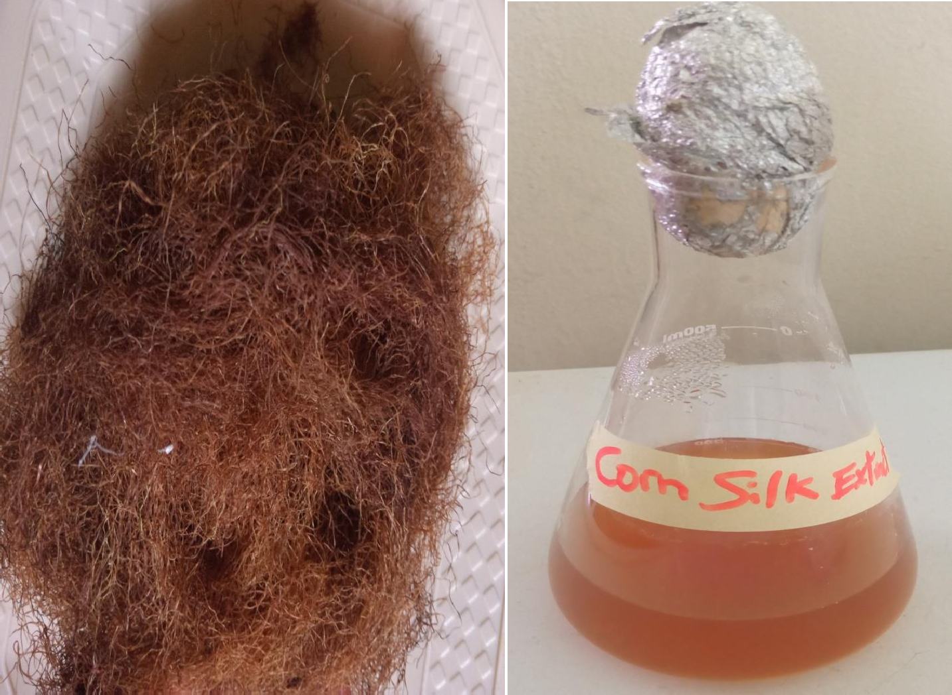

# APPENDIX II

**Culture supernatant after centrifugation and extraction**

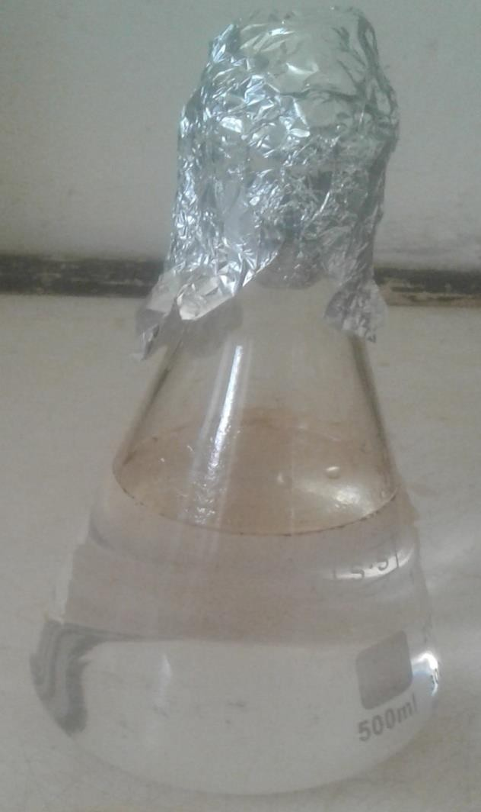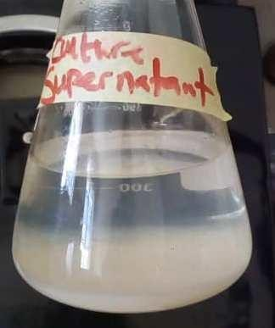

# APPENDIX III

**Mineral salt medium**

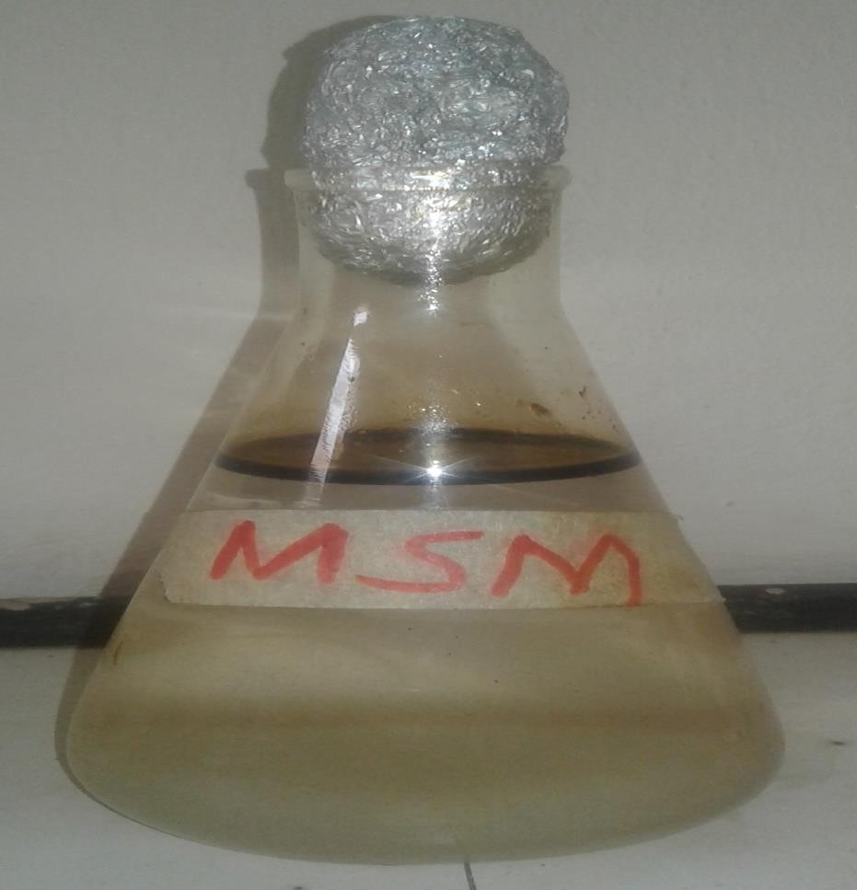

# APPENDIX IV

Graphical representation of emulsification activity of biosurfactant produced by *A.*

*faecalis* for a period of 7 days



10

**E24**

8

6

4

E24

2

0

0

24

48

**T**7**im**2 **e (H**96**ours**1**)**20

144 168

**Emulsification activity**

# APPENDIX V

**Experimental setup for bioremediation of crude oil contaminated soil**

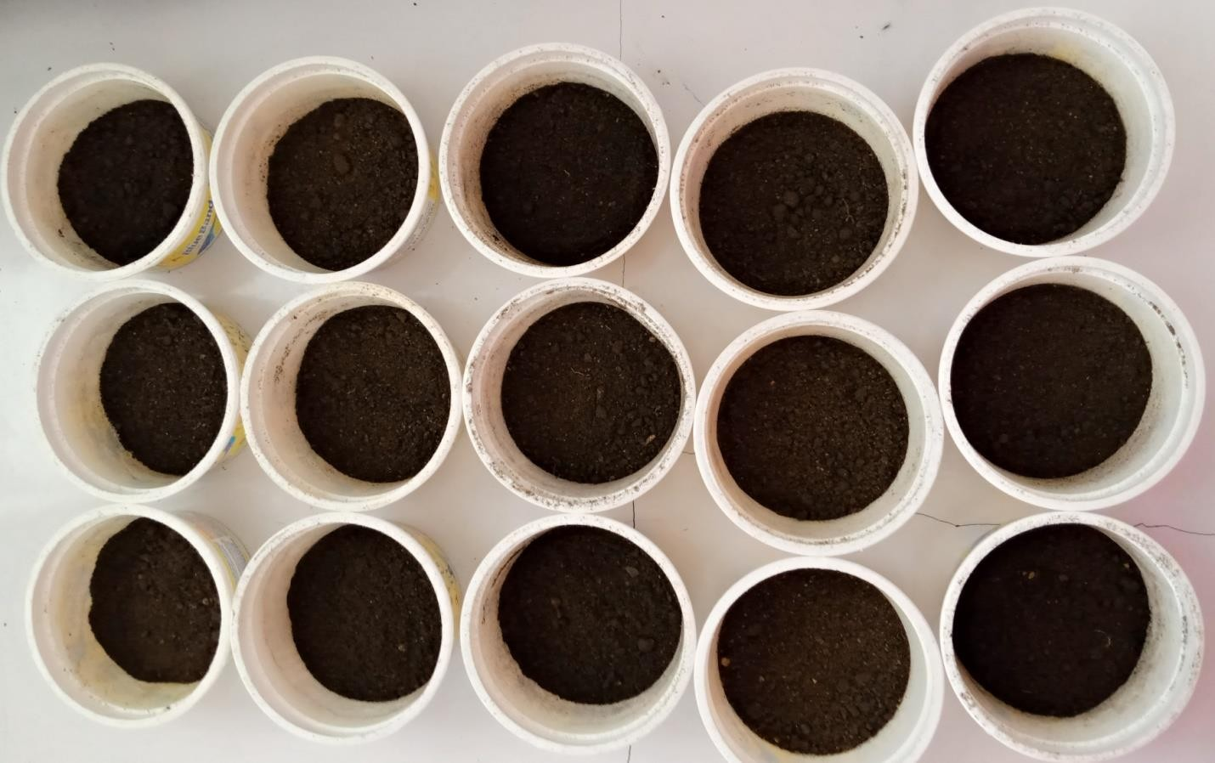

NPa

NPb

BSa

BCa

BSb

BCb

1:1:1a

1:1:1b

1:1:2a

1:1:2b

2:1:1a

2:1:1b

1:2:1a

1:2:1b

control

# APPENDIX VI

**Log10 transform fungal count of bioremediated soil for 35 days treatment period**

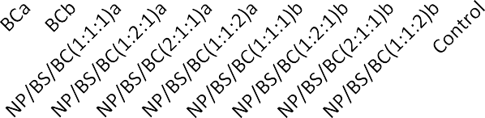

1000000

100000

10000

1000

100

WEEK 0

WEEK 1

WEEK 2

WEEK 3

WEEK 4

WEEK 5

10

1

# APPENDIX VII

**Percentage (%) of total hydrocarbon degraded after treatment of crude oil polluted soil with BS, BC, NP and the combinations for 35 days.**

80

70

60

50

40

30

20

10

NPa

NPb BSa BSb BCa BCb

NP/BS/BC(1:1:1)a NP/BS/BC(1:1:1)b NP/BS/BC(2:1:1)a NP/BS/BC(2:1:1)b NP/BS/BC(1:2:1)a NP/BS/BC(1:2:1)b NP/BS/BC(1:1:2)a NP/BS/BC(1:1:2)b

Control

0

Percentage of total hydrocarbon degraded