# DEVELOPMENT OF AN OPTIMIZED ROUTING SCHEME FOR A CAPACITATED VEHICLE MODEL

**BY**

**Zion ‘Tare MAYO**

**DEPARTMENT OF COMPUTER ENGINEERNG FACULTY OF ENGINEERING**

**AHMADU BELLO UNIVERSITY, ZARIA, NIGERIA.**

**MARCH 2019**

**DEVELOPMENT OF AN OPTIMIZED ROUTING SCHEME FOR A CAPACITATED VEHICLE MODEL**

**BY**

**Zion ‘Tare MAYO B.Eng. CU (2011) P15EGCP8033**

[**mayozion@gmail.com**](mailto:mayozion@gmail.com)

**A DISSERTATION SUBMITTED TO THE SCHOOL OF POSTGRAUATE STUDIES, AHMADU BELLO UNIVERSITY, ZARIA**

**IN PARTIAL FULFILMENT OF THE REQUIREMENTS FOR THE AWARD OF A MASTER OF SCIENCE (M.SC.) DEGREE IN COMPUTER ENGINEERING**

**DEPARTMENT OF COMPUTER ENGINEERING FACULTY OF ENGINEERING**

**AHMADU BELLO UNIVERSITY, ZARIA NIGERIA.**

**MARCH 2019**

# DECLARATION

I declare that the work in this dissertation entitled **“Development of an Optimized Routing Scheme for a Capacitated Vehicle Model”** has been carried out by me in the Department of Computer Engineering, Ahmadu Bello University, Zaria. The information derived from literature has been duly acknowledged in the text and a list of references provided. No part of this dissertation was previously presented for another degree or diploma at this or any other institution.

**Zion ‘Tare Mayo**

**Signature Date**

# CERTIFICATION

This dissertation entitled “**Development of an Optimized Routing Scheme for a Capacitated Vehicle Model”** by Zion ‘Tare MAYO meets the regulations governing the award of degree of Master of Science (MSc) in Computer Engineering of the Ahmadu Bello University, and is approved for its contribution to knowledge and literary presentation.

|  |  |  |
| --- | --- | --- |
| Prof. M. B. Mu’azu |  |  |
| Chairman, Supervisory Committee | (Signature) | Date |

|  |  |  |
| --- | --- | --- |
| Dr. E.A. Adedokun |  |  |
| Member, Supervisory Committee | (Signature) | Date |

|  |  |  |
| --- | --- | --- |
| Prof. M. B. Mu’azu |  |  |
| Head of Department | (Signature) | Date |

|  |  |  |
| --- | --- | --- |
| Prof. S.Z. Abubakar |  |  |
| Dean, School of Postgraduate Studies | (Signature) | Date |

# DEDICATION

This research work is dedicated to my Parents Pst. Steve and Pst. (Mrs.) Esther Mayo.

# ACKNOWLEDGEMENT

Despite the numerous efforts put into this work, it would not have been possible without the help of Almighty God, the fountain of all wisdom, knowledge and understanding. I am eternally indebted.

I would like to express my deepest gratitude to my supervisor Prof. M. B. Mu’azu, for his tireless efforts, valuable guidance and constant supervision towards the success of this work. The completion of this work could not have been possible without your constant participation and assistance. Thank you very much Sir. My thanks also go to my co-supervisor Dr. E. A. Adedokun for his constant encouragement and expertise. My deep appreciation goes to Dr.

A. T. Salawudeen for his mentorship, guidance and giving me the motivation to pull through this programme. Special thanks to the Computer & Control Research Group for all the contributions during those presentations.

I acknowledge with thanks all the lecturers of Computer Engineering, Ahmadu Bello University, namely: Dr. Y.A. Shaban, Dr. M.B. Abdulrazaq, Dr. I.A. Bello, Dr. I.J. Umoh, Dr. Bashir and most especially, those whose names could not be mentioned.

I am also thankful to my special friends Gideon Attuman, Ajayi Ore-ofe, Ernest Salefu, Zaharadeen, Francis Marshall, Abdulfatai, Luqman, Prosper and Muyideen. Their continuous support and contributions toward the success of this work would never be forgotten, may God reward them and strengthen our friendship. I am very much thankful to all my colleagues, Kachalla, Abdulahmid, Salami, Collins and others may God reward you all.

Above all, to my Parents, your endless love and support, kind and understanding personalities will always be appreciated. Thank you very much. To my siblings, Joannes Edward and King-David Mayo a big thank you, I am grateful for your constant support. God bless you all.

**Zion ‘Tare MAYO March 2019.**

# ABSTRACT

This dissertation presents the development of an optimized routing scheme for a capacitated vehicle model using Firefly Algorithm (FFA). The conventional model is a formal description involving mathematical equations formulated to simplify a more complex structure of logistic problems. The logistic problems are generalized as the Vehicle Routing Problem (VRP). When the capacity of the vehicle is considered, the resulting formulation is termed the Capacitated Vehicle Routing Problem (CVRP). In a practical scenario, the complexity of CVRP increases when the number of pickup or drop-off points increase making it difficult to solve using exact methods. Thus, researchers have over the years, proposed computational methods for solving CVRP problems. In this research, two scenarios of CVRP were considered. The solid waste management and supply chain for retail distribution. Thirty-six instances and ten instances in the solid waste management and retail supply chain respectively were used in formulating the optimization model. Certain parameters like number of vehicles, number of customers (pickup or drop off locations), capacity of vehicles, quantity of demand, the number of routes and depot position were considered in formulating the model. Some constraints like a vehicle must begin and end at the depot, all demand must be met, a customer is visited just once by a distinct vehicle each time, the demand on each route must not exceed the vehicle capacity were used to guide the model creation. Also some assumptions were made like observing normal road conditions with traffic, customers availability and a reduction in the total route distance inevitably reduces time and cost. Simulation was carried out using MATLAB R2015b and performance was evaluated on the two scenarios using total route distance covered. The simulated results shows a significant improvement occurred on the travelled distance with a slight percentage difference due to the enormous distance covered. The outcome indicates that the developed model had an overall improvement of 6.03% over the Particle Swarm Optimization (PSO) on the solid waste management and a 7.36% over the Best Known Solution (BKS) for the retail supply chain using the total route cost as performance metrics. For the various depot positions considered which are the Random, Optimized, Centered and Eccentric (ROCE), it is observed that the optimized depot position which is determined by this model had a 25% best result for the Instances of the solid waste management, 44.44% over the eccentric position and 77.78% over the centered and random depot placement. This informs that the developed scheme has significantly reduced the total travelled distance in a search space which can be applied to the logistics industry to save cost and time.

# TABLE OF CONTENTS

DECLARATION III

CERTIFICATION IV

DEDICATION V

ACKNOWLEDGEMEN VI

ABSTRACT VIII

LIST OF FIGURES XII

LIST OF TABLES XIII

LIST OF ABBREVIATIONS XIV

CHAPTER ONE: INTRODUCTION

* 1. Background 1
  2. Significance of Research 3
  3. Statement of Problem 3
  4. Aim and Objectives 4
  5. Methodology 4
  6. Dissertation Organization 5

CHAPTER TWO: LITERATURE REVIEW

* 1. Introduction 6
  2. Review of Fundamental Concepts 6
     1. Vehicle Routing Problem 6
     2. Capacitated Vehicle Routing Problem 8
     3. VRP Instances 10
     4. Metaheuristic Algorithms 14
  3. Review of Similar Works 18

CHAPTER THREE: METHODS AND MATERIALS

* 1. Introduction 26
  2. Materials 26
     1. Computer System 26
     2. MATLAB 27
  3. Conceptualized Framework for Solid Waste Management 27
  4. Development of the CVRP Model 28
     1. Depot Positions 30
  5. CVRP Optimization using Firefly Algorithm 33

CHAPTER FOUR: RESULTS AND DISCUSSIONS

* 1. Introduction 38
  2. Results of FFA-CVRP Model 38
  3. Results for Variations in Depot Positions 41
     1. Optimal depot position 42
     2. Depot location percentage improvement 44
  4. Results of Comparison for the PSO with the FFA Based Technique 46
  5. Results of Comparison for the ILS-SP, UHGS, BCP with FFA Based Technique 48

CHAPTER FIVE: CONCLUSION, SUMMARY AND RECOMMENDATION

* 1. Summary of findings 52
  2. Significant Contributions 53
  3. Conclusion 54
  4. Limitations 54
  5. Recommendations for Further Work 54

REFERENCES 56

APPENDIX A 59

APPENDIX B 61

APPENDIX C 65

APPENDIX D 66

# LIST OF FIGURES

Figure 2.1: Typical CVRP Scenario 8

Plate I: Pseudo-code for Firefly algorithm 16

Figure 3.1: Stages of Waste Management 27

Figure 3.2: A Random Positioned Depot 31

Figure 3.3: A Central Positioned Depot 32

Figure 3.4: An Eccentric Positoned Depot 33

Figure 3.5: An Unkown Positioned Depot 33

Figure 3.6: Flowchart of CVRP Model 35

Figure 4.1: Plot of Travelled Distance against Instances 41

Figure 4.2: Intersection of Various Depot Position 42

Figure 4.3: Plot of Depot Position against Frequency of Results 43

Figure 4.4: Line Chart of the Depot Location Improvement 44

Figure 4.5: Advantage Improvement of each Depot Placement 45

Figure 4.6: BKS For Supply Chain Instances 49

Figure 4.7: Performance of FFA-CVRP Model 50

Figure 4.8: Performance of the Instances for Supply Chain 50

# LIST OF TABLES

Table 3.1: Computer Specification 26

Table 3.2: Simulation Parameters of Solid Waste Management 36

Table 3.3: Simulation Parameters of Retail Supply Chain 37

Table 4.1: Result of FFA-CVRP Model 38

Table 4.2: Result of Depot Position 42

Table 4.3: Comparison between FFA and PSO 46

Table 4.4: Comparison between ILS-SP, UHGS, BCP and FFA 48

# LIST OF ABBREVIATIONS

|  |  |
| --- | --- |
| **Acronyms** | **Definition** |
| AFS | Alternative Fuelling Stations |
| ATM | Automated Teller Machine |
| BCP | Branch and Cut Price |
| BKS | Best Known Solution |
| CVRP | Capacitated Vehicle Routing Problem |
| DBCA | Density-Based Clustering Algorithm |
| FCVRP | Fuel Consumption Vehicle Routing Problem |
| FPVRP | Flexible Periodic Vehicle Routing Problem |
| FFA | Firefly Algorithm |
| GA | Genetic Algorithm |
| G_VRP | Green Vehicle Routing Problem |
| ILS | Iterated Local Search |
| ILS-SP | Iterated Local Search-Set Partitioning |
| MCWS | Modified Clarke and Wright Savings |
| MIP | Mix Integer Programming |
| PSO | Particle Swarm Optimization |
| PVRP | Periodic Vehicle Routing Problems |
| ROCE | Random, Optimized, Centred, Eccentric |
| SP | Set Partitioning |
| TSP | Travelling Salesman Problem |
| UHGS | Unified Hybrid Genetic Search |
| VNS | variable neighbourhood search |

VRP Vehicle Routing Problem

VRPCD Vehicle Routing Problem with Cross-Docking

VRPTW Vehicle Routing Problems with Time Windows

* 1. **Background**

# CHAPTER ONE INTRODUCTION

The rapid advancement in technologies have made logistics to become very important in budgetary considerations for government and its establishments and in revenue generation for private companies. The fact that anybody on the planet can be all around connected has prompted complex transport networks that are exceptionally requesting and are winding up progressively critical. Hence, an effective logistic system can have a tremendous effect to organizations and pertinent business operations. Highlighting the importance of logistics in some sectors like, groceries delivery, online stores delivery of goods, waste management, intra-city public transportation, product price can increase due to an increase in the distribution cost, whereas, vehicle routing has the potential of significant economic savings of up to 30% (Hasle & Kloster, 2007). Thus, the need for vehicle routing becomes necessary.

Vehicle Routing Problem (VRP) is a class of optimization problems that involve optimizing itineraries of a fleet of vehicles to serve a given set of customers (Cattaruzza *et al.*, 2017). This situation represents a large part of the flow of vehicles for various logistic purposes in cities. The framework is used to model an extremely broad range of issues in various applications like, supply chain management, delivery services, public transportation, telecommunications and production planning (Bocewicz *et al.*, 2017). The optimization of vehicle routing can bring about significant economic savings. The interest in VRP is due to its practical and economic importance. However, to solve a VRP is not a simple task as it belongs to the complexity class of decision problems (Kumar & Panneerselvam, 2012).

Variants of VRP (Subramanian *et al.*, 2013) include:

* + 1. Capacitated VRP (CVRP)
    2. VRP with simultaneous pickup and delivery
    3. VRP with mixed pickup and delivery
    4. Multi-depot VRP with mixed pickup and delivery
    5. VRP with access time windows.

In VRP, the objective can be the minimization of delivery and vehicle costs, optimization of the number of drivers and vehicles, minimizing the time spent during delivery, minimizing the total route cost, etc. (Mahmoudi & Zhou, 2016). The optimization problem may be developed in order to address any one or a combination of the stated objectives considering their constraints. Essential application fields incorporate fuel and diesel conveyance, the arrangement of the soldiers in a frontline, flights of airplanes, conveyance of food and beverage to the restaurants, conveyance of cash to the automated teller machines (ATMs), student and worker services, delivery of items that are purchased by shopping online, transportation and waste management (Kirci, 2016). The focus of this work will be on the CVRP as applied in waste management and supply chain.

In transportation, a CVRP model is an approach that can resolve the improper logistic scheduling in the movement of people that needs a commercial transportation service to ensure all customers are considered and picked up. Also, in supply chain, by taking into cognisance the demand (payload of each customer) and vehicle capacity which are used in planning for payload drop offs and pick up.

In Waste Management, environment quality is the extent to which the condition of an environment relative to the requirements of human need is rapidly deteriorating with

concerns to solid waste management, which increases CO2 emissions in the atmosphere and inevitably gives rise to global warming (Budzianowski, 2016). Waste management, has over the years, been modified and improved using various technologies due to increase in solid waste as a result of the growing population (Moh & Manaf, 2014).

## Significance of Research

This research is motivated by the growing concern in getting quality solutions especially for instances of routing models that put into consideration the number of vehicles and cost of the operation. Literature has shown that a better method applied to this routing problem can yield a more optimized solution (Uchoa *et al.*, 2017). For this reason, an algorithm that can be associated with the properties of the CVRP and its attributes will be applied which is the Firefly algorithm (FFA). The main characteristics of the FFA include the fact that, the nodes (fireflies) are more versatile in attractiveness, leading to higher mobility, and a more efficient exploration of the search space i.e. The best route will be more efficiently identified and exploited for vehicles to deliver to customers. Also, the brightness of a node is proportional to the attractiveness i.e. a less bright Firefly will move towards a brighter one through the shortest path. The brightness of every Firefly is determined by the landscape structure of the objective function. Thus, considering the fitness at each stage of motion, for each iteration, the nodes (customers) move to get a better result dropping the previous result to be replaced and this continues until the maximum iteration is reached.

## Statement of Problem

In optimizing route distance to save cost and other resources, first, the necessity to determine the total proximity of all other nodes by locating the best position for a depot which has an effect on the route distance has to be considered. Secondly, the problem of vehicle to route assignment knowing which vehicle to assign to which route, whilst observing the capacity

constraints on the model, is a task which needs a solution and such solution will enhance the total route cost. Lastly, a node –to – node travel path which determines the next node for the vehicle to proceed to, such decision has an overall reduced total travelled distance and inevitably will reduce the route cost.

## Aim and Objectives

The aim of this research is to develop an optimized routing scheme for route optimization and depot positioning on a capacitated vehicle model using the Firefly algorithm (FFA).

The objectives for this research are as follows:

* + 1. To develop the CVRP model and objective function considering the Random, Optimized, Centred and Eccentric (ROCE) depot positions.
    2. To optimize the developed model in (1) using the FFA and to apply it to instances for solid waste management and supply chain.
    3. To validate by comparison with the work of Hannan *et al*., (2018) and (Uchoa *et al.*, 2017) using total route distance, time and cost as performance metrics.

## Methodology

The methodologies for this research involve the following:

1. Development of the CVRP Model and objective function on various depot positions.
   1. Modeling the objective function of the ROCE positions of the depot.
   2. Creation of the CVRP model considering all constraints.
2. Application of Firefly algorithm to the developed model in (1) to obtain the optimum of the objective function.
   1. Initialize the parameters of Firefly.
   2. Development of brightness model.
   3. Development of attractiveness model.
3. Application of the optimized model in (2) to the instances for solid waste and retail supply chain management.
   1. Simulation and performance evaluation.
   2. Implement the instances for Solid Waste Management.
   3. Implement the instances for Retail supply chain management.
4. Validation by comparing with the work of Hannan *et al*., (2018) and (Uchoa *et al.*, 2017) using total route distance, time and cost as performance metrics.

## Dissertation Organization

The general introduction has been presented in Chapter One. The rest of the chapters are structured as follows: Detailed review of related literatures and relevant fundamental concept about the capacitated vehicle routing, the algorithm used is explained in Chapter Two. In- depth approach and relevant mathematical models describing the development of the capacitated vehicle routing problem model using the Firefly algorithm were presented in Chapter Three. The analysis, performance and discussion of the result were analysed in Chapter Four. Conclusion and recommendations make up the Chapter Five. Quoted references and Appendices are also provided at the end of this dissertation.

# CHAPTER TWO

**LITERATURE REVIEW**

## Introduction

This chapter comprises of mainly two sections which are review of fundamental concept and review of similar works. In the fundamental concept, most of the existing works on relevant fundamental theories of vehicle routing problem are discussed. In the review of similar works, some of the related literatures which are relevant to this research work are discussed.

## Review of Fundamental Concepts

In this section, concepts which are fundamental to the vehicle routing problems, capacitated vehicle routing problems, attributes of various instances, heuristics constrains, and various solution methods are discussed.

## Vehicle Routing Problem

The Vehicle Routing Problem (VRP) involves the process of determining the optimal routes utilized by a fleet of vehicles, usually located at one or more depots, in order to serve a given set of customers (Subramanian *et al.*, 2013). In practical application, there are usually operational and practical constrains associated in finding a suitable solution to VRP. For example, in a situation where the capacity of the vehicle is known, the load along each route must not exceed the capacity of such vehicle. The VRP service involve both collection and deliveries, the aggregate length of every route should not be more than a given limit, customers need to be met within a given time, the fleet can contain heterogeneous vehicles, priority relations can exist between the customers, the service of a customer may be divided between different vehicles, and the constant change in the demand or travel times.

The concept of VRP was first introduced by (Dantzig & Ramser, 1959) who considers a

central depot 0

using k independent delivery vehicles of identical capacity C, with a

quantity *dt*

of an item to be delivered to every customer

*i*  *N*  1,..., *n*. Items are to be

delivered at minimum total cost, with

*cij*  0

representing the cost of traveling from *i* to *j*

where 0  *i*, *j*  *n* . The structure of the cost is mostly assumed to be symmetric, i.e., *cij*  *c ji*

and *cii*  0 . A combinatorial solution to the VRP problem consists of partitioning of *N* into

*k* routes, with every route satisfying

1

*j**R d j*  *C* and a permutation

⬧ *i* corresponding to

each route specifying the service ordering. The VRP problems is associated with an

undirected graph consisting of nodes *N* ∪0, edges *E*, and edge-traversal costs *cij* ,*i*, *j* *E* .

When a union of *k* cycles intersects only at the depot node, a solution is formed. Each cycle relates to the route serviced by one of the *k* vehicles. An integer programming formulation can be formulated by associating a binary variable with each edges of the graph (Ralphs *et*

*al.*, 2003):

*f* (*x*)  min*ce xe*

*e**E*

 *xe*  2*k*

*e*{0, *j*}*E*

 *xe*  2*i*  *N*

*e*{*i*, *j*}*E*

 *xe*  2*b*(*S*)*S*  *N*, *S*  1

*e*{*i*, *j*}*E i**S* , *j**S*

(2.1)

(2.2)

(2.3)

(2.4)

0  *xe*  1*e*  {*i*, *j*} *E*, *i*, *j*  0 0  *xe*  2*e*  {0, *j*} *E*

(2.5)

(2.6)

*xe* int *e*  *E*

For ease of computation:

*b*(*s*)  *i**S di* / *C*

(2.7)

(2.8)

where b(S) is the lower limit associated with the number of trucks required to service the customers in set S. Equation (2.1) is the fitness function while equations (2.2) and (2.3) are degree constrains. Equation (2.4) is a generalization of the sub-tour elimination constraints derived from the Travelling Salesman Problem (TSP) and help to enforce solution connectivity also to check that no route has total demand exceeding the given capacity C. The inequalities in equations (2.5) and (2.6) are the capacity constraints.

## Capacitated Vehicle Routing Problem

The Capacitated Vehicle Routing Problem (CVRP) is a classic example of vehicle routing problem where the capacity of the vehicle is considered in modelling the problem. A typical example of a CVRP model generated in MATLAB R2015b is given in Fig. 2.1.

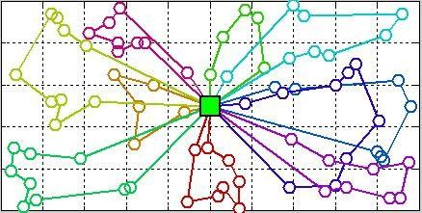

Fig. 2.1: Typical CVRP Scenario

Figure 2.1 shows an instance of a capacitated vehicle routing problem. The figure contains 77 nodes (bins), with 1 depot located at the center of the grid across 10 routes (they are

segmented in different color codes). Where a vehicle takes off from a depot, moves from one node to another and back to the depot, over a certain distance to form a route.

In the CVRP (Hannan *et al.*, 2018):

* + - 1. Every delivery is assigned to a customer
      2. the demands are known in advance and are deterministic
      3. the demands may not be split
      4. The vehicles are based at the depot
      5. The vehicles are imposed with a capacity constraint
      6. Total travel cost minimization is the ultimate objective of CVRP i.e. number of routes traveling cost (time, length etc.) required to serve all the customers

The input to a CVRP model involves a set of

*n* 1

points, a depot with *n* customers; an

*n* 1*n* 1

matrix *c*  which is the travel costs between a pair of points *i* and *j*; an n-

dimensional vectors of demand *d*  giving the amount to be collected from customer *i*; and

*ij*

*ij*

a vehicle capacity Q where objective is to find a solution with minimum total cost (Pecin *et**al.*, 2017). A solution is obtained as a set of routes which start and end at the depot and visit every customer precisely once, where the route constrain is to ensure that the total customers demand should not exceed the capacity of the vehicle Q. The CVRP is a widely studied problem modelling adequately a significant number of real logistic systems and a prototypical VRP variant playing an important role in vehicle routing research (Lin *et al.*, 2014).

A formal definition of the CVRP problem is as follows. Consider a fully connected graph

*G*  *V* , *E* with a set of vertices *V*  0,..., *n* where the vertex 0 represents the depot and the

remaining vertices represents the customers. Each edge *i*, *j* *E* has a positive cost

*cij*

and

every customer *i* *V* ' has an associated demand *di*. If *C*  1,..., *m* are a set of homogeneous vehicles with capacity *Q* (Subramanian, 2012), then the CVRP cost function model can be represented as:

*N N K*

*S*  min  *dij Pijk*

*i*0 *j* 0 *k* 1

(2.9)

Where, *S* is the cost function which optimize the total route distance. The nodes *i* and *j*, *d* defines the travel distance between the nodes, while *P* is the ability for a vehicle to travel from node to node. The basic concept of CVRP involves constructing a set of *m* routes such that (Chen *et al.*, 2006):

1. The beginning and ending point of every route is the depot;
2. The capacities of each vehicle is not surpassed;
3. all demands are accomplished;
4. The supply to a customer is done exactly once by a only a single vehicle
5. The overall total cost is minimized

## VRP Instances

Instances are the scenarios formulated by some attributes like number of customers, number of routes in some cases the route duration, the route distance, all these will be discussed. Literature demonstrated that the number of point (including the depot) and the number of routes should reflect the naming and formulation of instances. An example of a naming

nomenclature

*E*  *n*101 *k*8 is an instance that has 1 depot, 100 customers and 8 routes. The

series are usually named randomly by the authors. In the E series by (Nicos Christofides & Eilon, 1969) where locations are generated at random from a uniform distribution, some of the instances actually come from (Dantzig & Ramser, 1959) and (Gaskell, 1967) while some

are modifications on the capacity suggested by (Gillett & Miller, 1974). For the M series, customers are grouped into clusters as an attempt to represent practical cases and some instances are modifications of the E series by considering increment in customers and

capacity. For example, instances

*M*  *n*200 *k*17 and

*M*  *n*200 *k*16 differs only by the

number of routes. These new instances were formulated because

*M*  *n*200 *k*16

had

tightness very close to 1 (0.995625) that finding any feasible solutions maybe difficult. However, the optimal solution of M-n200-k16 instance may costs less than the optimal

solution of

*M*  *n*200 *k*17 (Christofides *et al.*, 1979). (N Christofides et al., 1979) defined

a CMT benchmark set, which consists of modifications of some E and M series whereby the number of routes are not fixed. This set also has an addition of maximum route duration and service time values while the vehicles are assumed to travel at unitary speed. The F series presents instances with data set from real-world applications, from grocery deliveries and delivery of goods to a gasoline service station (Fisher, 1994) etc. The A, B and P series by (Augerat *et al.*, 1998) proposed a scenario where the customers and depots are randomly positioned in the A series and clustered in the B series while the demands are picked from a uniform distribution in both series. The P series are just modifications in the capacity and the routes of some instances in A, B and E. (Hannan et al., 2018) presented an arrangement of 36 scenarios with a CVRP metaheuristic used to solve the occurrences.

The following are elements that are considered all together or in any varying combination to generate instances and parameters used in the CVRP (Uchoa et al., 2017):

## Depot Positioning

A depot can be a number of items with variances being stationed and stored in a particular location. It can be applied in transport, technology, pharmaceuticals or military troops. It is considered as the starting and finishing point of any VRP. The positioning of this depot

has an effect of the total output of a solution because it determines the distance covered by a moving vehicle to deliver to customers and return to the depot. This element in the formulation of the instance is controlled based on discretion but for real applications other things like cost of the location as compared to cost of the operation, nearness to customers compared to nearness to source of goods, then, the security of chosen location against invasion, can be considered. Below are various positions where a depot can be located on a [0, 1000] × [0, 1000] grid:

* 1. Random (R): the depot is positioned at a point with no defined pattern on the grid.
  2. Central (C): the depot is located at the exact middle point of the grid, point (500,500)
  3. Eccentric (E): the depot is placed in the corner of the grid, point (1000,1000)

## Customer Positioning

The positions and locations of customers are paramount in the result of an optimum solution because factors like distance and distribution plays a part in the architecture and modelling of the solution method. The following are alternatives that can be considered for customer positioning:

* 1. Clustered: A number of customers form cluster seeds which are picked from a uniform discrete distribution. It means that customers are put together as different groups to emulate the densities in some large urban agglomerations that have developed from less isolated units.
  2. Random: All customers are positioned arbitrarily in the grid
  3. Random-Clustered: A part of the customers are positioned at points, without a method of calculation for such locations while others are clustered. Superposition is not allowed so all customers have their distinct points on the grid.

## Route distance

This is the length of the course taken to move from the depot to serve a set of customers and return to the depot. It is the dimension of travel which will determine the total time taken and also the optimum solution for the given set of instances. Although some methods are best used for shorter distances, while some for long distances, but in this work will create a common ground for such uprising.

## Number of Vehicles

One major difference between the TSP and VRP is that in the latter, more than one vehicle is used to schedule a visit to the customers and return to the depot. The number of vehicles to be used for a VRP determines the speed at which customers can be served and also contributes to an optimum solution in the shortest time frame.

## Vehicle Capacity

The capacity of the vehicle gives a description on the available space that can accommodate the amount of goods that is demanded by the customer.

## Service Time

The time taken to deliver the expected demand to each customer is taken into consideration in some reviews. Also the time taken to travel from a customer to another is also taken into cognisance as such parameter is paramount in achieving an optimum solution in the best possible time.

## Demand

This is the amount of payload that is required by the customer(s), which inevitably determines the number of vehicles to be used in a specified space to oblige with the constraints where the total demand must not exceed the vehicle capacity.

For instances that have large number of routes and customers, the problem complexity can be quite high, so the solution may be better obtained using metaheuristic algorithms.

## Metaheuristic Algorithms

Metaheuristic algorithms are high-level techniques and frameworks, used to find and generate methods that may provide sufficient or optimal solutions to an optimization problem, without the knowledge of a complete information or specificity on the problem (BoussaïD *et al.*, 2013). Some metaheuristic algorithms used for the CVRP are discussed as follows:

* + - 1. Particle Swarm Optimization (PSO):

The particle swarm optimizer is best presented by explaining its conceptual development. Agents were thought of collision-proof birds and the original intent was to graphically simulate the unpredictable choreography of a bird flock (Kennedy, 2011).

A simulation relying on two props: nearest-neighbour velocity matching and “craziness.” A population of birds was randomly initialized with a position for each on a torus pixel grid with *X* and Y velocities. At each iteration a loop in the program determined for each agent (a more appropriate term than bird), the other agent was its nearest neighbour, then assigned that agent’s *X* and *Y* velocities to the agent in focus. Essentially this simple rule created a synchrony of movement. The flock settled on a unanimous, unchanging direction. Therefore, a stochastic variable called *craziness* was introduced (Innocente & Sienz). At each iteration, some change was added to the randomly chosen *X* and *Y* velocities.

More importantly, bird flocks and land where there is food. How do they find food? Anyone who has ever put out a bird feeder knows that within hours a great number of birds will likely find it, even though they had no previous knowledge of its location, appearance, etc. It seems possible that something about the flock dynamic enables members of the flock to capitalize on one another’s knowledge. The second variation of the simulation defined a “cornfield vector,” a two-dimensional vector of XY coordinates on the pixel plane. Each agent was programmed to evaluate its present position in terms of the equation (Eberhart & Kennedy, 1995):

*Eval*  (2.10)

( *presentx* 100)2  ( *presenty* 100)2

In the implementation of PSO, the velocity of each particles are updated using the equation 2.11 (Du & Swamy, 2016):

At iteration t+1, the swarm can be

*v* *t* 1  *v* *t* *cr* *x**t* *x**t* *cr* *xg* *t* *x* *t*

(2.11)

*i i* 1 *i* 2 *i*

Where, *c >* 0 is the acceleration constant, *r*1 and *r*2 are uniform random numbers generated within [0*,* 1]. The concept fitness*,* as do all evolutionary computation paradigms, shows the similarities between the adjustment toward *pbest* and *gbest* by the particle swarm optimizer and the crossover operation utilized by genetic algorithms.

* + - 1. Firefly Algorithm (FFA):

In describing the new FFA, the following three idealized rules are used (Yang, 2010):

* + - * 1. The fireflies are considered as unisex; thus, the Firefly can attract each other regardless of their gender;
        2. The brightness of the fireflies is proportional to their attractiveness, thus for any two flashing fireflies, the less bright one will move towards the brighter one. Both

attractiveness and brightness decrease as the distance between fireflies increases. If there is no brighter Firefly than the present Firefly, then, a random movement is performed.

* + - * 1. 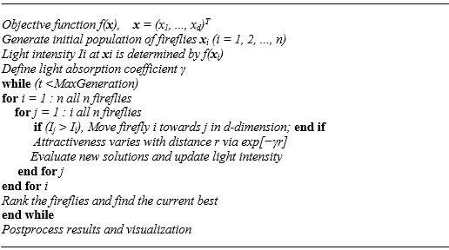The fireflies’ brightness can be determined by the optimization objective function landscape. In a maximization problem, the value of the objective function is proportional to the brightness (Yang, 2009).

Plate I: Pseudo-code for Firefly algorithm (Yang, 2009)

In FFA, there is always a distinction between the attractiveness formulation and light intensity. The attractiveness of a Firefly is determined by its brightness which is a function of the objective function. Usually, the brightness *I* at a location *x* chosen as *I* (*x*)*f* *x* . However, the attractiveness *β* is relative (Yang, 2010). Thus, it will vary with the distance *rij* between Firefly *i* and Firefly *j*. Also, the light intensity decreases

with the distance from its source. The light intensity *I* (*r*) is usually determined using

the inverse square law

*I* (*r*)  *I s* where,

*r*

2

*I s* is the source intensity. In a scenario

where the light absorption coefficient *γ* is fixed, the light intensity *I* vary with the distance *r,* where *I*0 is the original light intensity. To eliminate singularity problem at

*r*  0 in the expression *I s*

2

*r*

the combined effect of both the absorption and inverse

square law can be approximated using the Gaussian form given as (Arora & Singh,

2013).

*I* (*r*)  *I e**r*2

0

(2.12)

The attractiveness *β* of a Firefly, since its proportional to light intensity

 (*r*)   *e**rm*

0

(2.13)

The distance between two fireflies *i* and *j* at

*xi* and

*x j* , is represented as the cartesian

distance where

*xik*

is the *k*th element of the spatial coordinate *xi* of *i*th Firefly (Yang

& Deb, 2010).

*rij* 

*xi*  *x j*



(2.14)

The movement of a Firefly *i* which is attracted to a Firefly *j* with higher attractiveness (brightness) is determined by equation 2.15.

(*x*  *x*

*d*

*k* 1

*i*,*k j* ,*k*

)2

*x*  *x*   *e**rij* (*x*  *x* )   (*rand*  1 )

2

(2.15)

*i i* 0 *j i* 2

The second term of equation 2.15 is due to the attraction while the third term is randomization with *α* being the randomization parameter (Sayadi *et al.*, 2010).

## Review of Similar Works

Some literature relevant to the subject area of Vehicle routing problem and the approaches used to solve them are described in this section.

**Agatz *et al.* (2011)**presented a method for managing the tactical time slot home delivery. Customers were associated with each geographical location. The number of customers were distributed evenly within the given time slots in each schedule. Various ways were proposed to evaluate the travel time between two customers in the same zone, visited in the same time slot and between two zones visited at different time slots. Two different problem-solving approaches were described, considering demand clustering to reduce travel cost. For the first approach, the expected cost of a given assignment of time slot to zones was estimated using continuous approximation. A greedy iterative search heuristic was then used to modify this initial assignment. The second approach solved an integer programming problem with approximate delivery costs. However, tactical routes of vehicles over the zones are not considered in both cases hence, does not capture the vehicle to route assignment.

**Xiao *et al.* (2012)** proposed a string-model-based simulated annealing algorithm for the CVRP to optimize the fuel consumption. The VRP with their variants focusing at reducing the total distance under various constraints (such as: route length limit, capacity limit, depot positioning etc.) based on the assumption that a lower cost can be achieved through a delivery schedule with a shorter route length. However, in the case of fuel consumption, the optimum cost may not be as a result of shortest distance alone, since the vehicle’s load contribute jointly to the fuel consumed. The proposed algorithm was developed based on hybrid exchange rule that mitigated the problem of fuel consumption in the capacitated vehicle

routing problem. The simulation results showed that, a better fuel consumption was obtained when computational experiments on the 27 well-known CVRP benchmark instances was carried out, and the fuel consumption vehicle routing problem (FCVRP) was able to reduce the fuel consumption by 5% on average compared to the CVRP model which made it effective and efficient. However, other factors can affect the fuel consumption, such as speed of the vehicle and terrain were not considered.

**Kuo *et al.*, (2012)** proposed a hybrid genetic algorithm and particle swarm optimization for solving a capacitated vehicle routing problem with fuzzy demand. This is developed by using a chain-constraint model which uses the idea best solution of particle and a best global solution in the PSO combining it with the mutation crossover in the GA. Hence, the study used GA to modify the PSO with the hope of improving its performance and used fuzzy variables to deal with the uncertain parameters in developing the CVRP model. However, the concept of smart bin data was not implemented for an efficient waste collection, yielding a limited experiment alongside the non-consideration of the location of the depot.

**Subramanian *et al*., (2013)** developed a hybrid algorithm for a class of VRP with homogeneous fleet. This hybrid algorithm consists a set partitioning formulation and an iterated local search-based heuristic. The key aspects of the method is the interaction between a metaheuristic and a solver approach while solving a given mixed integer programming model and an efficient scheme of dynamically controlling the size for SP models when solving large size instances. Thus, the proposed technique was used to solve the problem associated with vehicle routing problems, since it can handle large size instances. Simulation

results showed that the proposed techniques were quite competitive with those found by heuristics devoted to specific variants. However, it had less improvement as compared to ties for the CVRP solutions and additional constraints weren’t considered such as time windows.

**Penna *et al.*, (2016)** developed a hybrid iterative local search algorithm and a set partitioning for electric fleet size and mix VRP with a recharging stations and time windows. Due to the increase in population, congestion in traffic, noise disturbance, energy consumption, and carbon emissions, have become a major concern. Electrical vehicle were developed but have some challenges with limited driving range and long recharging times. This proposed algorithm was developed to mitigate the electric fleet size and mix vehicle routing problem with time windows and recharging stations. The iterative local search algorithm was used to generate a set of good quality routes. Simulations results showed that, when the proposed algorithm was tested on 168 benchmark instances with 100 customers, it was capable of obtaining 76 new improved solutions and to equal the result of 8 instances. This made the proposed technique more robust in terms of solution quality. However, few customers were considered not exceeding 100 in number.

**Al Mamun *et al.*, (2016)** proposed an architecture and intelligent sensing algorithm for real time solid waste bin monitoring system that will contribute to the optimization of solid waste collection. The monitoring application uses wireless sensor network in sensing solid waste data. The architecture is built on three levels smart bin, gateway and control station. The elementary concept is that the smart bin collects the status of the waste at any change occurrence then transmits the data to the server in real time via a gateway, hence the field

test shows that the system has been able to monitor the real time bin status, that made it feasible to decide the payload of which bin to be collected and which not. These information can be used for waste collection planning, route optimization and collection cost. However, the sensor can only function on a two wheeled bin and the sensor sometimes produced erroneous output data due to the irregularities of the solid waste pattern. This brings about an inefficient waste collection approach.

**Grangier *et al.*, (2017)** presented a metaheuristic method using large neighbourhood search for vehicle routing problem with cross-docking (VRPCD). The VRPCD have to do with the set of routes that satisfy transportation needs between a set of pickup points, where the vehicles are homogeneous and a set of delivery points, where the vehicles are also homogenous but different from the former. This proposed technique was able to provide an efficient solution to the stated problem, by introducing the large neighbourhood search and periodically solving the set partitioning. Experimental results showed that, the proposed technique outperformed the existing methods having better solution quality when tested by the benchmarks. However, a threshold to the number of vehicles was not considered, when formulating the cost function.

**Bouzid *et al.*, (2017)** proposed an integration of Lagrangian split and variable neighbourhood search (VNS) for the CVRP. This Lagrangian relaxation method incorporates an integer linear programming (ILP) formulation, which optimally partition the giant tower in CVRP. Hence, it causes the problem of infeasible partitioning in the system, thus the Lagrangian split was a sub-gradient method that was used to repair and improve an infeasible partitioning

of a giant tour. The split can solve small size instances, but its resolution became impractical for relatively larger instances. The experimental result showed that the proposed technique finds good split solutions quickly in a wide range of situations and the integration to VNS have yielded relatively good solutions to large instances as related to studied literature. Hence, the proposed method did not put in perspective, tackling the vehicle routing problem in terms of time windows, distance restriction and heterogeneous fleets.

**Archetti *et al.*, (2017)** proposed a flexible periodic vehicle routing problem (FPVRP). The proposed technique was used to minimize the total routing cost. Since a carrier has to initiate a distribution plan to serve customers over a planning horizon, each customer has an aggregate demand that must be served within the horizon and a limit on the maximum quantity that can be conveyed at each visit. The FPVRP has service frequencies and schedules, this then gives it more advantages over the periodic vehicle routing protocol (PVRP). The experimental results showed that, the percentage relative reduction in the objective function value of the proposed technique is better that the PVRP technique. However, for the set of instances used in the experiment, the larger instances were not considered due to its complexity.

**Hernandez *et al.*, (2017)** presented a heuristics for tactical time slot management in a periodic vehicle routing problem. The tactical problem occurred when a time slot schedule for delivery service over a given planning horizon was selected in each zone of a geographical area. This, then makes the heuristic search which was able to evaluate each of the scheduling selection by constructing a corresponding tactical routing plan of minimum

cost based on the demand and service time. The tactical problem was solved using the three- phase approach of the heuristic, where the issue of periodic vehicle routing problem was mitigated and then a repair phase and a final improvement phase where the vehicle routing problem with time windows was also mitigated for each period of planning horizon. The proposed technique provided a solution to the tactical problem that decomposes the problem into a PVRP and a number of VRPTWs. However, solution to the large instances with larger zones were not provided but the small instances with fewer zones had feasible results.

**Bianchessi *et al.*, (2017)** presented a split delivery vehicle routing problem with time windows and customer inconvenience constraints. The split delivery allows customers to be served through multiple visits, not as in the case of classical routing problem that each customer was visited exactly once. But this several visit, may become a problem to the customer side, which at each visit there are interruptions of some primary activities of the customer so as to handle the goods receipt. This paper addressed the challenges with the split delivery distribution strategies. This then makes it paramount for the employment of the proposed techniques that investigated the measures that limit the customer inconvenience. The proposed technique used two different measures, a maximum number of visits and the temporal synchronization of deliveries. The objective function was formulated based on different measures such as comprising variable routing costs, costs related to route durations and fixed fleet costs. The vehicle routing problem with time windows was developed, in which the split deliveries were allowed and the corresponding generalization which accounts for customers inconvenience constraint were also designed. Which prompt to the design of the extended branch-and-cut algorithm to solve the stated problem. The experimental results

showed that, the proposed technique resolved the problem associated to the customers. However, in the set of benchmark used only the smaller-sized instances for 25 to 50 customers were considered.

**Uchoa et al., (2017)** proposed a new set of benchmark instances which consider number of customers ranging from 100 to 1000. This was formulated to provide a robust and balanced experimental setting using exact and heuristic methods. The methodology was to develop an efficient neighbourhood-based technique consisting of iterated local search based metaheuristic algorithm and a population technique which is based on unified hybrid genetic search. The ILS is coupled with an integer programming solver over a set partitioning (SP) formulation, which seeks to create new solutions in the light of known routes from the previous local optimums. In the UHGS, a continuous diversification was actualized by modifying the objective during the parents and survivor selection. This was to promote not only good but also diverse solutions. Both methods achieved quality results although the UHGS outperformed the ILS for instances containing large number of customers on a route. But for instances enclosing few number of customers per route, the ILS produced solutions of generally higher quality. For instances with large number of customers per route, the ILS demonstrates slower convergence and generally leads to solutions of lower quality. However, a single approach could not be used for both problems, in obtaining the number of routes the maximum number was fixed using the bin-packing problem which made the number of routes not adaptive to the number of customers.

**Hannan et al., (2018)** proposed a modified PSO algorithm in a capacitated vehicle routing problem model in determining an accurate waste collection and route optimization solution. A threshold waste level and scheduling concepts are applied to the model using various datasets. The acquired results from the datasets provide a competitive solution on efficiency on the travel distance, waste collection efficiency and tightness as compared with previous heuristics used. However, the position of the depot was not considered and the optimization used on some instances could not attain an optimal value.

From the literature reviewed, it is evident that there is minimal work on determining the best position to locate a depot and that there are various methods developed to solve the VRP scenario for large and small scale instances each. This proposed research will develop a model to optimally locate the best depot position and also use a single technique to solve large and small case scenarios putting into consideration the capacity of the vehicle and the demand of the customer. The problem of vehicle to route assignment identified in Agatz *et* *al.* (2011) is addressed in this dissertation using the FFA. Sampling few customers or small sized Instances in Penna *et al.*, (2016), Archetti *et al.*, (2017), Hernandez *et al.*, (2017) and Bianchessi *et al.*, (2017) does not depict a complete perspective to the method used and shows the inefficiency of the approach but the number of customers in this work used up to 1000 customers and the approach is used for both small and large Instances. The inefficient waste collection due to type of smart bin and its data in Kuo *et al.*, (2012) and Al Mamun *et al.*, (2016) was addressed with the use of Threshold Waste Level (TWL).

# CHAPTER THREE

**MATERIALS AND METHODS**

## Introduction

In this chapter, the materials, the methods and the reported procedures used for the implementation and simulation of the CVRP model and various depot positions are described based on the outline developed in section 1.6. The relevant assumptions necessary for the development of the optimized scheme. The mathematical equations governing the model formulation for performance evaluation are described.

## Materials

In this section, the materials used for the implementation of this research, presented in this report are discussed. These materials involve the specification of the computer system and the software used for the implementation.

## Computer System

All simulations performed in this research were carried out using a personal Lenovo ThinkPad E550 laptop. The specification of this computer are given below in Table 3.1.

Table 3.1 Computer Specification

|  |  |  |
| --- | --- | --- |
| S/N | Items | Specifications |
| 1 | System Type | 64-bit Operating System |
| 2 | Operating System | Microsoft Windows 10 Pro |
| 3 | Microsoft Word, Excel & Power Point | Office 2013 |
| 4 | Processor | Intel® Core™ i3-5005U CPU @ 2.00 GHz |
| 5 | Memory | 4GB of RAM |
| 6 | Hard disk | 500GB of hard disk space |
| 7 | Display | 1366x768 or higher resolution display with 16bits colours |

# MATLAB

The MATrix LABoratory (MATLAB) is the software used to implement all models in this research. The MATLAB is a numerical computing environment and programming language for engineers. Although, several versions of the MATLAB have been developed by MathWorks but, for the purpose of this research the R2015b was used.

## Conceptualized Framework of Solid Waste Management

The problem of waste management is in optimizing the best possible route to pick up waste (waste generation centre), take them to a dumpsite (waste collection centre) and then to a recycle factory (waste recycling centre) as shown in Fig. 3.1.



Bin

Bin

Bin

Depot

Bin

Bin

Bin

Bin

Logistics A

Bin

Bin

Waste Generation Center

Waste Collection Center

Recycle

Factory

Logistics B

Waste Recycling Center

Fig. 3.1 Stages of Waste Management

Fig. 3.1 shows the conceptualised framework which describes the stages of waste management. The bins (which are referred to as nodes) in the waste generation centre denotes the container that holds the quantity of the waste (demand). It is the first point of contact by the vehicles to pick up the demand from one node to another where the proposed model was be applied. When the pickup is completed, the vehicles proceed (logistics A) to the depot where the proposed model is also applied. At this stage, the demand is collected from various

vehicles and put together to deliver (logistics B) to the recycle factory for processing into various products e.g. fertilizers and other by-products to benefit mankind.

## Development of the CVRP Model

The basic concept of VRP is to serve a set of customers to find the least travel distance but when the vehicle capacity is considered, it becomes CVRP. This model objective is to determine a viable route that minimizes distance. There are some constraints accredited to the modelling of a CVRP explained in this study. Where *N* is the number of customers, a

nonnegative distance cost

*dij* and represents distance from bins *i* to *j* , where *i* 

*j* . A set of

vehicles *k*  1,2,..., *K*is available at the depot to either collect or deliver demand as the case maybe.

A route is established by the summation of multiple links. A link is formed with the notation

*Pk* which moves from customer *i* through to customer *j* , by a vehicle *k*, where the decision variables are dependent of the vehicle capacity and the customer demand which are modelled

*ij*

as follows:

𝑃𝑘 = {1, 𝑖𝑓 𝑣𝑒ℎ𝑖𝑐𝑙𝑒 𝑡𝑟𝑎𝑣𝑒𝑙𝑠 𝑓𝑟𝑜𝑚 𝑐𝑢𝑠𝑡𝑜𝑚𝑒𝑟 𝑖 𝑡𝑜 𝑗

(3.1)

𝑖𝑗

0, 𝑖𝑓 𝑜𝑡ℎ𝑒𝑟𝑤𝑖𝑠𝑒

The variables take only the integer (s) because the number of customers, vehicles and route cannot be a fraction,

*Pk* 0,1

*ij*

*i*, *j*  0,1,2,..., *N*; *k*  1,2,..., *K*

(3.2)

All vehicles begin and end at the depot i.e. each vehicle is not used more than once,

*N N*

 *Pk*  1

*a i*

*i*, *j*  0,1,2,..., *N*; *k*  1,2,..., *K*

(3.3)

*i*1 *j* 1 *j a*

Although the vehicle must not be re-used, the inequality is considered when the vehicle is also not being used out of the pool of vehicles at the depot. If all vehicles are used it will be an equal sign.

A customer is visited once, by only one vehicle each time,

*K N*

 *pk*  1

*ij*

*i*, *j*  0,1,2,..., *N*; *k*  1,2,..., *K*

(3.4)

*k* 1 *i* 0

*j* 0

There must be route continuity,

*N*

 *P*

*k*

*it*

*i*0

*N*

*k*

−  *P*

 0

*tj*

*i*0

*k*  1,2,..., *K*; *t*  1,2,..., *N*

(3.5)

The route has a limit (not exceeding the total distance),

*N N*

 *d k Pk*  *D*

*i*, *j*  0,1,2,..., *N*; *k*  1,2,..., *K*

(3.6)

*ij ij k*

*i* 0 *j* 0

The number of routes and vehicles must be above 1, else the model becomes a TSP and not a VRP, where the former deals with a vehicle and a single route,

*N N*

 *Pk*  1

*ij*

*i*, *j*  2,3,..., *N*; *k*  2,3,..., *K*

(3.7)

*i*2 *j* 2

The capacity of the vehicle must not exceed its maximum, there must be no overloading,

*Q*  *Q*

*k k*

max

*k*  1,2,..., *K*

(3.8)

The total demand 𝑞𝑇 on each route must not exceed the capacity of the vehicle on that route,

*N*  *N k* 

*qj*  *Pij*   *Qk*

*k*  1,2,..., *K*

(3.9)

*j* 0  *i*0 

All the demand must be accomplished,

𝑁 𝑁

𝑞𝑇 = {

𝑖𝑗

∑ 𝑞𝑗 (∑ 𝑃𝑘) 𝑖𝑓 𝑞𝑖𝑗 ≠ 0

(3.10)

𝑗=0 𝑖=0

0 𝑖𝑓 𝑜𝑡ℎ𝑒𝑟𝑤𝑖𝑠𝑒

The total cost and travel distance is minimized,

*N N K*

*S*  min  *dij Pijk*

(3.11)

*i*0 *j* 0 *k* 1

## Depot Positions

For this CVRP model, one depot is considered. The location of the depot is pivotal in achieving the set objective of the routing scheme. This approach is also used to determine the best location for the depot to be positioned as against other positions. Various depot positions are sampled across all the Instances. An Instance in CVRP are arrangement or scenarios formulated based on certain parameters as explained in subsection 2.2.3. These are standard point of references which can be used for comparison. The various positions considered are:

* + - 1. Random (R) – the depot is located at an arbitrary point on the search space (x, y).

There is no empirical or systematic approach that guides the decision for this location. However, the depot should be positioned such that the total cost which is the collective distance across all the vehicle pickup points is minimized. A typical scenario of a randomly positioned depot is given in Fig 3.2 below.

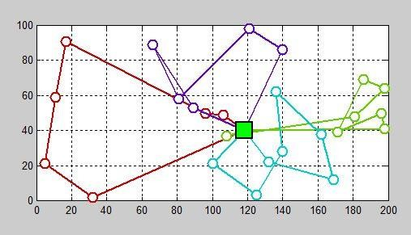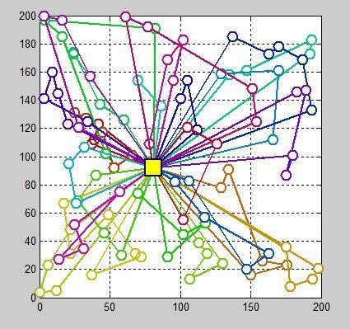

1. Instance A-n26-k4 b. Instance X-n101-k25 Fig. 3.2. A Random Positioned Depot

Fig 3.2 shows a snippet of randomly positioned depot of a CVRP model. The Fig

3.2a shows a depot (which is the rectangular node in the search space), four (4) route and twenty-five (25) pick-up locations scenario for the solid waste management system, where the depot is positioned in the search space at random. Fig 3.2b shows a depot, twenty-five (25) route and hundred (100) drop-off locations scenario for the retail supply chain, where the depot location is not pre-defined. This route and customer locations (which are the circular nodes) are generic for the samples explaining the various depot positions. Similar randomly positioned depot was implemented for the other scenario considered in this report.

* + - 1. Central (C) – in this case, the depot is positioned at the centre of search space. The search space is a 100X200 for solid waste management and 200X200 for retail supply

chain, thus, the depot is positioned at a coordinate given as

*D*sup  (*x*, *y*)

(3.12)

Where *x* is the coordinate in x-axis and y is the coordinate in y-axis whose values are selected as (100, 50) for the solid waste management. In the case of retail supply

chain, the positions of x and y are taken as (100, 100). Fig 3.3 shows the snippet of the two cases (supply chain and waste management).

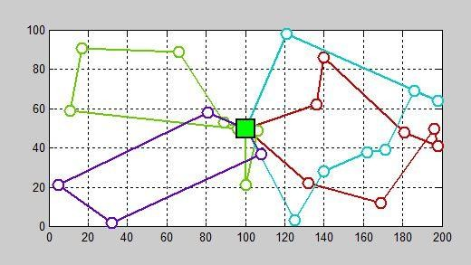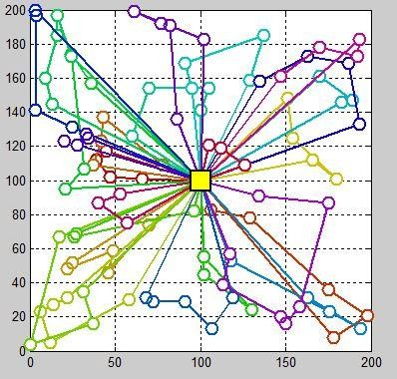

1. Instance A-n26-k4 b. Instance X-n101-k25 Fig. 3.3. A Central Positioned Depot
   * + 1. Eccentric (E) – the position of the depot is considered to be located at any of the edges of the search space. Where *x* is the coordinate in x-axis and y is the coordinate in y-axis whose values are selected as (195, 95) for the solid waste management. In the case of retail supply chain, the positions of x and y are taken as (195, 195). The snippet of the eccentric positioned depot for both cases (supply chain and waste management) is shown in Fig. 3.4

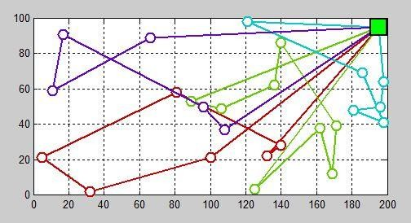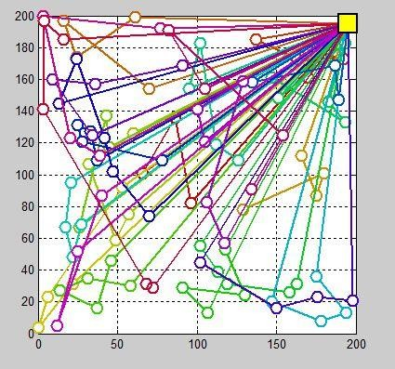

a. Instance A-n26-k4 b. Instance X-n101-k25 Fig. 3.4. An Eccentric Positioned Depot

* + - 1. Optimized (O) – the position (𝑥, 𝑦) on the x and y axis on the search space is decided by the algorithm. The search space is explored for the best possible location to fix the depot, relative to the pick-up locations, in order to serve the given set of customers, assuming the customer locations are fixed. The difference between this position and the Random (R) position is that in (R) there is no search done and any arbitrary point is just utilized.

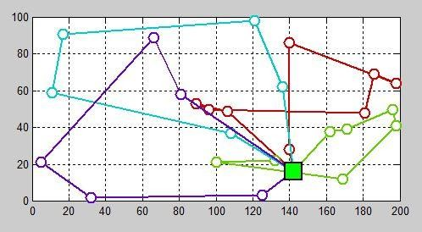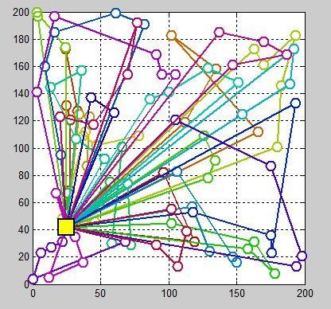

a. Instance A-n26-k4 b. Instance X-n101-k25 Fig. 3.5. An Optimized Position of a Depot

Fig 3.5 *a* and *b* shows the depot position actualised for the instance in both solid waste management and supply chain respectively. The various routes, also represent various path taken by different vehicles.

From the pictorial scenario above in Fig 3.5, it can even be visually observed that, the locations through which the vehicles move on the route are closer to the depot, which will turn out to have a shorter travelled distance considering all the constraints.

## CVRP Optimization using Firefly Algorithm

The Firefly based technique simply solves the CVRP model by identifying the nodes (customer points) as the stationary fireflies and a vehicle as the moving fireflies. Evaluating all the points and the given parameters to define the best position to locate the depot. Then, the vehicles are evaluated knowing which one is to be assigned to which route, after which it is attracted to the nearest customer location guided by the set constraints. This process continues until the CVRP is solved. In this research, a total of thirty-six cases for each of the positions (random, optimized, centre and eccentric) as explained in subsection 3.4.1, was employed for the waste management problem and the work of Hannan *et al.,* 2018 was used for comparison shown in Table 4.3. In the case of supply chain problem, only ten (10) of the total scenarios presented in the work (Uchoa *et al*., 2017) was used for the purpose of comparison shown in Table 4.4. This information was used along with the CVRP model parameters for the optimization models described in subsection 3.2. The total cost and travel distance of the CVRP described in (3.11) was then optimized using the Firefly optimization algorithm. The process of implementing according to the methodologies and systematic approach as seen in Appendix A and Appendix B in developing the routing scheme is structured in the flowchart for the FFA implementation which is given in Fig. 3.6.

Generate Initial positions of Fireflies (Depot)

Initialize CVRP parameters (Q, N, V, q)

& FFA parameters (I, J, Itr, npop)

Start

No

Evaluate Fitness value of each

Firefly

Yes

t=0

.

.

.

t <Itr

No

Print Best Fitness value

Evaluate Depot Positions

For i= 1:n

For j = 1:n

F(j) > F(i)

Yes

Evaluate Fitness of CVRP

Rank Fireflies based on their

Fitness

Move Firefly ‘I’ towards ‘j’

t = t+1

Stop

Fig. 3.6 Flowchart of the FFA-CVRP model

Fig 3.6 details the flow in developing the optimized routing scheme for the CVRP model. To implement this routing scheme, the parameters vehicle capacity (*Q*), number of customers

(N) which correspond to the number of fireflies, number of vehicles (*V*) which correspond to the search dimensions and the quantity of load (*q*) were initialized. The parameters of the FFA algorithm which are the initial customer points (*i*), the next customer point (*j*), number of iterations, and population were also initialized. The various depot positions (random, optimized, centred and eccentric) were generated at different points in the search space. This positions were evaluated for each Firefly. The fitness of these initial positions and parameters was evaluated and each Firefly are ranked according to their fitness. The vehicle moves from Firefly *i* to Firefly *j* and progresses in that order from the initial customer points (*i*), the next customer point (*j*), to the next point (*i+1),* then to (*j+1*) until the maximum number of fireflies is reached. The FFA solution search process was then performed in an enclosed loop and the fitness of the new positions were evaluated. The entire process was then evaluated over a number of iterations continuously until the maximum number of iteration is reached and the Firefly with the overall best position is taken as the optimum solution. The simulation parameters used is given in Table 3.2.

Table 3.2: Simulation Parameters of Solid Waste Management

|  |  |  |  |
| --- | --- | --- | --- |
| SN | Parameters | Values | Units |
| 1 | Number of Vehicles, *V* | 2 - 10 | --- |
| 2 | Number of Customers, *N* | 11 - 100 | --- |
| 3 | Capacity of vehicle, *Q* | 100 - 400 | kg |
| 4 | Capacity / Quantity of demand, *q* | 10 | kg |
| 5 | Travelled distance, *d* | 100 - 1500 | km |

Table 3.2 shows the simulation parameters used to implement the Instances in the CVRP model for Solid Waste Management.

Table 3.3: Simulation Parameters of Retail Supply Chain

|  |  |  |  |
| --- | --- | --- | --- |
| SN | Parameters | Values | Units |
| 1 | Number of Vehicles, *V* | 25 - 62 | --- |
| 2 | Number of Customers, *N* | 100 - 1000 | --- |
| 3 | Capacity of vehicle, *Q* | 13 - 794 | kg |
| 4 | Travelled distance, *d* | 20000 - 80000 | m |

Table 3.3 details the parameters used for the Instances in simulating the CVRP for Retail Supply Chain.

# CHAPTER FOUR

**RESULTS AND DISCUSSIONS**

## Introduction

In this Chapter, the performances of the model on the route using certain parameters are observed. Random, Optimized, Centred and Eccentric depot positions (ROCE) plots are presented to enhance the understanding of all the model uncertainties and obtain the best possible depot location. The performance of the proposed Firefly based capacitated vehicle routing problem model were compared with the performance of the PSO based technique as well as ILS-SP, UHGS and BCP with reference to total route distance.

## Results of FFA-CVRP Model

The results obtained when the Firefly algorithm was used to optimize the capacitated vehicle routing problems on the waste management scenario is given in Table 4.1

Table 4.1 Results of FFA on the CVRP Model

|  |  |  |  |  |  |  |  |  |  |
| --- | --- | --- | --- | --- | --- | --- | --- | --- | --- |
|  |  | Capacity of vehicle,  *Q* (unit) | Capacity of bin, *q* (unit) | TWL (%) |  |  | Distance | | |
| No. | Datasets | N | V | Standard |  |  |
|  |  |  |  |  | Improvement (%) |
|  |  |  |  |  | FFA |
| **1** | A-n33-k5 | 100 | 10 | 0 | 32 | 5 | 661 | 622 | 5.87 |
| 2 |  |  |  | 60 | 28 | 5 | 629 | 499 | 20.60 |
| 3 |  |  |  | 70 | 25 | 4 | 585 | 407 | 30.51 |
| 4 |  |  |  | 75 | 21 | 4 | 533 | 367 | 31.12 |
| 5 |  |  |  | 80 | 17 | 3 | 457 | 304 | 33.48 |
| 6 |  |  |  | 90 | 12 | 2 | 374 | 219 | 41.57 |
| **7** | A-n46-k7 | 100 | 10 | 0 | 45 | 7 | 914 | 842 | 7.82 |
| 8 |  |  |  | 60 | 38 | 7 | 895 | 699 | 21.91 |
| 9 |  |  |  | 70 | 28 | 5 | 750 | 413 | 44.94 |
| 10 |  |  |  | 75 | 22 | 4 | 634 | 339 | 46.53 |
| 11 |  |  |  | 80 | 18 | 4 | 548 | 310 | 43.51 |
| 12 |  |  |  | 90 | 14 | 3 | 449 | 235 | 47.59 |
| **13** | A-n60-k9 | 100 | 10 | 0 | 59 | 9 | 1371 | 1121 | 18.21 |

|  |  |  |  |  |  |  |  |  |  |
| --- | --- | --- | --- | --- | --- | --- | --- | --- | --- |
| 14 |  |  |  | 60 | 41 | 8 | 1258 | 909 | 27.75 |
| 15 |  |  |  | 70 | 38 | 8 | 1223 | 834 | 31.81 |
| 16 |  |  |  | 75 | 31 | 6 | 1048 | 663 | 36.77 |
| 17 |  |  |  | 80 | 29 | 6 | 979 | 528 | 46.04 |
| 18 |  |  |  | 90 | 19 | 4 | 693 | 317 | 54.19 |
| **19** | P-n40-k5 | 140 | 10 | 0 | 39 | 5 | 458 | 359 | 21.62 |
| 20 |  |  |  | 60 | 34 | 4 | 417 | 345 | 17.27 |
| 21 |  |  |  | 70 | 32 | 4 | 388 | 334 | 13.92 |
| 22 |  |  |  | 75 | 25 | 4 | 352 | 333 | 5.40 |
| 23 |  |  |  | 80 | 18 | 3 | 294 | 266 | 9.52 |
| 24 |  |  |  | 90 | 12 | 2 | 232 | 192 | 17.24 |
| **25** | B-n78-k10 | 100 | 10 | 0 | 77 | 10 | 1263 | 1091 | 13.60 |
| 26 |  |  |  | 60 | 54 | 9 | 1124 | 828 | 26.33 |
| 27 |  |  |  | 70 | 43 | 8 | 1069 | 732 | 31.49 |
| 28 |  |  |  | 75 | 27 | 6 | 732 | 409 | 44.16 |
| 29 |  |  |  | 80 | 21 | 4 | 613 | 304 | 50.41 |
| 30 |  |  |  | 90 | 11 | 2 | 346 | 111 | 68.01 |
| **31** | P-n101-k4 | 400 | 10 | 0 | 100 | 4 | 705 | 489 | 30.64 |
| 32 |  |  |  | 60 | 81 | 4 | 616 | 442 | 28.25 |
| 33 |  |  |  | 70 | 70 | 4 | 564 | 436 | 22.70 |
| 34 |  |  |  | 75 | 62 | 3 | 545 | 424 | 22.20 |
| 35 |  |  |  | 80 | 55 | 3 | 494 | 411 | 16.80 |
| 36 |  |  |  | 90 | 33 | 2 | 351 | 193 | 45.01 |

Table 4.1 shows the 36 instances featured in (Hannan et al., 2018). The result obtained using the FFA on the CVRP model shows improvement on the distance across all instances. Each set of instance has same capacity of all vehicles while the number of service points and TWL (threshold waste level) which is the level of the quantity of demand varies. Due to the decrease in the number of nodes (bins), the route length decrease s, thus only a few vehicles are needed. Although, the customer positions are randomly located. Each improvement is realised by the percentage difference between the FFA acquired distance and the standard from literature, which is the exact method used (Hannan et al., 2018). For the first set of

instances A-n33-k5, it gives a collective improvement of 27.19%, A-n46-k7 gives a collective improvement of 35.39%, A-n60-k9 gives a collective improvement of 35.80%, P- n40-k5 gives a collective improvement of 14.16%, B-n78-k10 gives a collective improvement of 39.00% and P-n101-k4 gives a collective improvement of 27.60%. The collective improvement is the average of the individual improvement in each set. From the table above, using the FFA metaheuristic approach, it is observed that there is total improvement on all instances, this interprets to a reduced total route distance. These results are further analysed under different depot positions using the bar chart given in Fig. 4.1

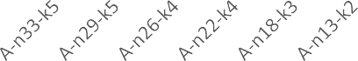

700

600

500

400

300

200

100

0

Instances

Standard PSO FFA

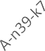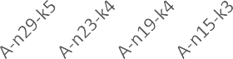

1000

800

600

400

200

0

Instances

Standard PSO FFA

Travelled Distance

Travelled Distance

A. Dataset A-n33-k5 B. Dataset A-n46-k7

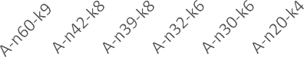

1600

1400

1200

1000

800

600

400

200

0

Inatnces

Standard PSO FFA

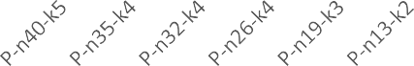

500

450

400

350

300

250

200

150

100

50

0

Standard

Instances

PSO

FFA

Travelled Distance

Travelled Distance

C. Dataset A-n60-k9 D. Dataset P-n40-k5

E. Dataset B-n78-k10 F. Dataset P-n101-k4 Fig. 4.1 Plot of Travelled distance against the Instances

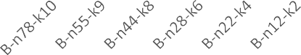

1400

1200

1000

800

600

400

200

0

Inatances

Standard PSO FFA

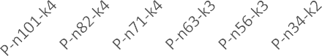

800

700

600

500

400

300

200

100

0

Inatances

Standard PSO FFA

Travelled Distance

Travelled Distance

Fig. 4.1 shows the plot of the travelled distance against the various set of Instances. This details the overview of the FFA-CVRP model used to solve the Instances in other to achieve a minimize travel distance. The thirty-six (36) Instances of the solid waste management, are grouped into six (6) sets, having different set of instances with same vehicle capacity but varies with their number of customers and number of vehicles. For example, Instance A-n33- k5 has a vehicle capacity with a demand capacity of 100 and 10 respectively, as shown in Table 4.1 which interprets the scenario having the numbers of customers to be 32 with 1 depot and 5 different routes. The latter values vary within the set of Instance.

## Results for Variations in Depot Positions

In this section, there is a detailed analysis of the depot position and its effect in obtaining the best route distance which is the lowest travelled distance. The charts Fig 4.3 and Fig 4.4 are segmented into three, the improved, the draw and the common results. There are four variations of the positions of the depot for each of the segments, the optimal, the eccentric, the centred and the random positions which have been explained in subsection 3.2.1.

## Optimal Depot Position

There are thirty-six instances used for the solid waste management model which the various depot positions where tested on, to determine which produces a result with the lowest total route distance. The number of iterations used for this simulation is 1000 and the extract from Table 4.2 is deduced from Appendix D which solves the quest to the first objective in section 1.4.

Table 4.2 Results of Depot Positions

|  |  |  |  |  |
| --- | --- | --- | --- | --- |
| Position | Improved | Draw | Common | Total |
| OD | 9 | 7 | 7 | 36 |
| ED | 5 | 6 | 7 | 36 |
| CD | 2 | 6 | 7 | 36 |
| RD | 2 | 3 | 7 | 36 |

Table 4.2 above shows out of the 36 instances, the optimized depot position have 9 times best results, the eccentric depot position have 5 times best results, the central and random depot placement each have 2 times best results each. This description explains the improved category.

The Fig 4.2 interprets the number of times each depot position obtained the same results with another depot positions. The summation of the frequency of a position constitute the numbers

of the Draw column in Table 4.2.

*CD*∩ *ED*  2 *OD*∩ *ED*  2 *OD*∩ *CD*  4 *ED*∩ *RD*  2 *OD*∩ *RD*  1

Fig 4.2 Intersection of various depot position

Fig 4.2 provides a breakdown on which depot had achieved same travelled distance as another. This gives a figurative caption on the *Draw* column in Table 4.2. It is seen that the

central and eccentric position obtained same result twice. The optimal and eccentric position also had same result twice. The optimal and central depot positions achieved the same result four times. Twice, the eccentric and randomly placed depot obtained same result, only the optimal and random depot position had same total travelled distance once.

The column *Draw* in Table 4.2 explains the summary of the above result in Fig 4.2 which is the total number of times each position had same results with one or more other positions but not all. The optimized depot position had same results 7 times with another depot position, 6 times, both the eccentric and central position shares same result with other depot positions and the randomly placed depot has the same result 3 times.

To further buttress the graphical representation of analysis, the output is shown in the Fig. 4.3.

10

9

8

7

6

5

4

3

2

1

0

OD

ED

CD

RD

Depot Postions

Improved Draw Common

Frequency of Results

|  |  |  |  |  |  |  |  |  |  |  |  |  |  |  |  |  |
| --- | --- | --- | --- | --- | --- | --- | --- | --- | --- | --- | --- | --- | --- | --- | --- | --- |
|  |  |  | | | | | | | | | | | | | | |
|  |  | | | | | | | | | | | | | | |
|  |  |  |  | | |  |  | | |  |  | | |  |  |
|  |  | |  |  | |  |  | | |  |
|  |  |  |  | |  | | |  |
|  |  |  | |  | | |  |
|  |  |  | |  | |  |  |
|  |  |  |  |  |  |  |
|  |  |  |  |  |

Fig. 4.3 Plot of Depot Position against Frequency of Result

Fig. 4.3 shows the plot of the various depot positions against the number of result outcomes of the 36 Instances. This gives a pictorial view of Table 4.2. It further describes a *Common* result for all the positions (the random, optimized, central and eccentric) acquired the same total travelled distance seven times. The figure also details that the optimized depot

placement gives the highest number of best results over the other positions, after which the eccentric, then the centred depot position and randomly placed depot position.

## Depot Location Percentage Improvement

In evaluating the performance of the developed model under different depot positions, the percentage improvement of the best result obtained by each depot position was determined against the total number of instances. The figure below is based on Table 4.2.



30.00%

25.00%

20.00%

15.00%

10.00%

5.00%

0.00%

Improved

Draw

Common

**CLASSIFICATION OF RESULTS**

OD ED CD RD

**PERCENTAGE IMPROVEMENT**

Fig. 4.4 Line Chart of the Depot location Improvement

The line chat in Fig 4.4 shows the plot percentage improvement against the classification of the results. It details the depot positions with the percentages of the improved result, the percentage of draw and the common results. Of the 36 instances, this shows that there is a 5.56% improvement positioning the depot at the centre or at a random (arbitrary) location. A 13.89% improved result is obtained when the depot is at an eccentric location (refer to 3.2.1). For an optimal position, there is a 25% improvement when the depot position is being decided by the Firefly algorithm within the search space. For the depot positions that obtained the same travelled distance similar to another, a 19.944% same result is obtained by the optimal depot position, both the eccentric and centrally placed depot each had 16.67%

and the randomly place depot had an 8.33%. All four positions had same travelled distance obtaining a 19.44% result of the 36 instances.

From the performance of each depot positioning, the extract from Table 4.2 and Fig. 4.2 informs the Fig 4.5. Fig 4.5 provides a graphical description on the advantaged result of the optimal depot position over the other positions as explained in graphical representation outcome of the simulation in subsection 3.4.1.



Improved

Draw

90.00%

80.00%

70.00%

60.00%

50.00%

40.00%

30.00%

20.00%

10.00%

0.00%

OD > ED

OD > CD

OD > RD

**Optimized Depot Position over other positions**

**Percentage Improvement**

Fig 4.5 Advantage Improvement of the optimal depot placement

Fig 4.5 shows the plot of the percentage improvement of the optimized depot position over the other three depot positions i.e. the advantage of the optimal depot position (OD) as against the eccentric depot position (ED), the centred depot position (CD) and the random depot position (RD). The detail obtained in the chart shows the OD has a 44.44% improvement over the eccentric position. There is also a 77.78% improvement in results over the centred and random positions. Also, for the draw, the OD has more same results with either of the other three depot positions, than each of them with other positions. This means the OD achieved more uniform results than either of three depot positions with a 14.29%

over the eccentric and centred positions have with either of the two depot positions. The OD also has a 57.14% more draw results than the RD.

This depicts the OD has more improved results and has more same results than the rest of the depot positions. This will give a better route navigation leading to a more reduced total route distance and reduced cost inevitably with an improvement of 44%, 78% and 78% over the eccentric, centre and random positions respectively. This explains that the human eye, is not best to give a random location for a depot to be placed just by mere taking into cognisance of the environmental layout and the customer distribution spread. This further informs us that the algorithm used to determine the best location is substantive. Hence, the optimized position determined by the FFA is the optimal depot position to achieve the minimum total travelled distance.

## Results of Comparison for the PSO with the FFA Based Technique

The developed FFA based CVRP model was compared with that of PSO based CVRP method considering the thirty-six-case scenario. The results obtained are given in Table 4.3

Table 4.3 Comparison between FFA and PSO

|  |  |  |  |  |  |  |  |  |  |
| --- | --- | --- | --- | --- | --- | --- | --- | --- | --- |
|  |  | Capacity of vehicle  (unit) | Capacity of bin (unit) | TWL (%) |  |  |  | Distance |  |
| No. | Datasets | N | V | |  |  |
|  |  |  |  | PSO |  | Improvement  (%) |
|  |  |  | FFA |
| **1** | A-n33-k5 | 100 | 10 | 0 | 32 | 5 | 661 | 622 | 5.87 |
| 2 |  |  |  | 60 | 28 | 5 | 599 | 499 | 16.63 |
| 3 |  |  |  | 70 | 25 | 4 | 518 | 407 | 21.52 |
| 4 |  |  |  | 75 | 21 | 4 | 430 | 367 | 14.62 |
| 5 |  |  |  | 80 | 17 | 3 | 316 | 304 | 3.80 |
| 6 |  |  |  | 90 | 12 | 2 | 212 | 219 | -3.07 |
| **7** | A-n46-k7 | 100 | 10 | 0 | 45 | 7 | 914 | 842 | 7.82 |
| 8 |  |  |  | 60 | 38 | 7 | 876 | 699 | 20.22 |
| 9 |  |  |  | 70 | 28 | 5 | 615 | 413 | 32.86 |
| 10 |  |  |  | 75 | 22 | 4 | 440 | 339 | 22.96 |

|  |  |  |  |  |  |  |  |  |  |
| --- | --- | --- | --- | --- | --- | --- | --- | --- | --- |
| 11 |  |  |  | 80 | 18 | 4 | 329 | 310 | 5.91 |
| 12 |  |  |  | 90 | 14 | 3 | 221 | 235 | -6.47 |
| **13** | A-n60-k9 | 100 | 10 | 0 | 59 | 9 | 1371 | 1121 | 18.21 |
| 14 |  |  |  | 60 | 41 | 8 | 1154 | 909 | 21.24 |
| 15 |  |  |  | 70 | 38 | 8 | 1091 | 834 | 23.56 |
| 16 |  |  |  | 75 | 31 | 6 | 801 | 663 | 17.27 |
| 17 |  |  |  | 80 | 29 | 6 | 699 | 528 | 24.43 |
| 18 |  |  |  | 90 | 19 | 4 | 350 | 317 | 9.29 |
| **19** | P-n40-k5 | 140 | 10 | 0 | 39 | 5 | 458 | 359 | 21.62 |
| 20 |  |  |  | 60 | 34 | 4 | 380 | 345 | 9.21 |
| 21 |  |  |  | 70 | 32 | 4 | 329 | 334 | -1.52 |
| 22 |  |  |  | 75 | 25 | 4 | 271 | 333 | -22.88 |
| 23 |  |  |  | 80 | 18 | 3 | 189 | 266 | -40.74 |
| 24 |  |  |  | 90 | 12 | 2 | 118 | 192 | -62.71 |
| **25** | B-n78-k10 | 100 | 10 | 0 | 77 | 10 | 1263 | 1091 | 13.60 |
| 26 |  |  |  | 60 | 54 | 9 | 1000 | 828 | 17.19 |
| 27 |  |  |  | 70 | 43 | 8 | 912 | 732 | 19.69 |
| 28 |  |  |  | 75 | 27 | 6 | 424 | 409 | 3.60 |
| 29 |  |  |  | 80 | 21 | 4 | 298 | 304 | -2.01 |
| 30 |  |  |  | 90 | 11 | 2 | 95 | 111 | -16.52 |
| **31** | P-n101-k4 | 400 | 10 | 0 | 100 | 4 | 705 | 489 | 30.64 |
| 32 |  |  |  | 60 | 81 | 4 | 538 | 442 | 17.84 |
| 33 |  |  |  | 70 | 70 | 4 | 451 | 436 | 3.33 |
| 34 |  |  |  | 75 | 62 | 3 | 421 | 424 | -0.71 |
| 35 |  |  |  | 80 | 55 | 3 | 346 | 411 | -18.79 |
| 36 |  |  |  | 90 | 33 | 2 | 175 | 193 | -10.29 |

Table 4.3 above shows the comparison for the results of the PSO technique and FFA technique on total route distance. Table 4.3 shows the total travelled distance obtained from the PSO and FFA. It is observed that there are improvements on result obtained by the FFA model over the PSO metaheuristic approach. The percentage difference between the FFA acquired distance and the PSO approach is the percentage improvement of the FFA based model. For the first set of instances A-n33-k5 has an improvement of 9.89%, A-n46-k7 has

an improvement of 13.88%, A-n60-k9 has an improvement of 19.00%, P-n40-k5 gives a decline of -16.17%, B-n78-k10 has an improvement of 5.93% and P-n101-k4 has an improvement of 3.67%. From Table 4.3, using the FFA metaheuristic approach, it is observed that there is a five out of the six set of instances have substantial improvements on the total route distance. From the above result, as the number of vehicles and customer points decrease, even with an increasing threshold waste level (TWL) from 0 – 90%, the total travel distance reduces. This is because technically, with less number of vehicles and customers interprets less number of routes which invariably gives a reduced travelled distance. Of the 36 instances where the FFA-CVRP model is tested on, the FFA has a 72% better results over the PSO.

## Results of Comparison for the ILS-SP, UHGS, BCP with FFA

The developed model in this research was validated using the iterated local search with set partitioning (ILS-SP), unified hybrid genetic search (UHGS) and branch and cut price (BCP) methods presented in the work of Uchoa *et al*., (2017). The data from the result is analysed in Table 4.4.

Table 4.4 Comparison between ILS-SP, UHGS, BCP and FFA

|  |  |  |  |  |  |  |  |  |  |  |  |
| --- | --- | --- | --- | --- | --- | --- | --- | --- | --- | --- | --- |
| Instance Characteristics | | | |  | Travelled distance achieved through Metaheuristic | | | |  | Improvement | |
| # | Name | n | Dposition | Q | ILS-SP | UHGS | BCP | BKS | FFA | Distance | (%) |
| 1 | X-n101-k25 | 100 | R | 206 | 27591 | 27591 | 27591 | 27591 | **22572** | 5019 | 18.19 |
| 2 | X-n153-k22 | 152 | C | 144 | 21340 | 21220 | 21140 | 21140 | **20538** | 602 | 2.85 |
| 3 | X-n200-k36 | 199 | R | 402 | 58626 | 58578 | 58455 | 58455 | **52052** | 6403 | 10.95 |
| 4 | X-n303-k21 | 302 | C | 794 | 21812 | 21748 | 21546 | 21546 | **19784** | 1762 | 8.18 |
| 5 | X-n401-k29 | 400 | E | 745 | 66453 | 66243 | 65971 | 65971 | **60194** | 5777 | 8.76 |
| 6 | X-n502-k39 | 501 | E | 13 | 69284 | 69253 | 69120 | 69120 | **65785** | 3335 | 4.82 |
| 7 | X-n613-k62 | 612 | C | 523 | 60229 | 59778 | 59323 | 59323 | **55361** | 3962 | 6.68 |
| 8 | X-n701-k44 | 700 | E | 87 | 82888 | 82293 | 81694 | 81694 | **78617** | 3077 | 3.77 |
| 9 | X-n801-k40 | 800 | E | 20 | 73830 | 73587 | 73124 | 73124 | **70175** | 2949 | 4.03 |
| 10 | X-n1001-k43 | 1000 | R | 131 | 73776 | 72742 | 71812 | 71812 | **67927** | 3885 | 5.41 |

Table 4.4 shows the total route distance achieved by using different metaheuristic approach on each Instance considered. The Table depicts the BKS that was obtained considering the previously used three algorithms (ILS-SP, UHGS and BCP). The BKS was then used to compare the results obtained by the FFA. It is seen that applying the FFA on the CVRP model minimized the total travelled distance for X-n101-k25 by 5019m, for X-n153-k22 by 602m, for X-n200-k36 by 6403m, for X-n303-k21 by 1762m, for X-n401-k29 by 5777m, for X-n502-k39 by 3335m, for X-n613-k62 by 3962m, for X-n701-k44 3077m, for X-n801-k40 2949m and for X-n1001-k43 by 3885m. This result was then implemented to calculate the percentage improvement for each of the Instances considered. The validated results obtained is plotted below in Fig 4.6.

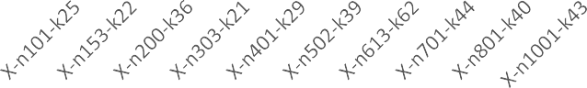

90000

80000

70000

60000

50000

40000

30000

20000

10000

0

Instances

ILS-SP UHGS BCP FFA

Travelled Distance

Fig 4.6 Best Known Solution for the Supply Chain Instances

Fig 4.6 shows the plot of the travelled distance against the Instances for the supply chain. The result of FFA possess the Best Known Solution in comparison with the algorithms used in (Uchoa et al., 2017). For all the 10 instances in serving 100 to 1000 customers, it is certified that the FFA now provides the new best known solution (BKS) amongst the four

techniques tested on the Instances. In order to further evaluate the performance of the developed method, the performance test given in Fig. 4.7 was generated.



350000

300000

250000

200000

150000

100000

50000

0

ILS-SP

**INSTANCES**

UHGS BCP

FFA

**PERFORMANCE**

Fig. 4.7 Perfromance of the FFA-CVRP Model

Fig. 4.7 highlights the plot of the performance of each of the algorithms as against the Instances. This details the efficiency of the FFA-CVRP Model which has shown to provide better results and outperforms the other methods used in solving both large and small scale instances for supply chain.

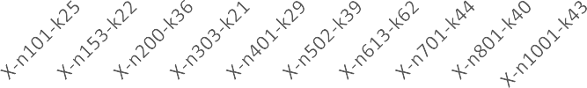

7000

6000

5000

4000

3000

2000

1000

0

INATANCES

DISTANCE DIFFERENCE

Fig. 4.8 Performance of the Instances for Supply Chain

Fig. 4.8 shows the performance if each of the instances, deduced from the difference in the BKS of Uchoa et al., (2017) and the FFA-CVRP Model. The instance X-n200-k36 has the highest value, which means the FFA-CVRP model is able to navigate channels faster and better with efficient productivity to obtain a more improved solution. This is due to the low ratio of the number of routes and the vehicle capacity to the number of customers and their demand distribution. The dip in the X-n153-k22 instance, shows it possess the lowest difference between the BKS of the earlier techniques used and the FFA based model.

# CHAPTER FIVE

**CONCLUSION SUMMARY AND RECOMMENDATION**

## Summary of findings

This research has presented a routing scheme for a capacitated vehicle routing model using the Firefly algorithm, aimed at minimizing the total route distance and identifying the best possible location to position a depot. Two Instances were used to test the model, 36 instances from solid waste management and 10 scenarios from supply chain. Against the PSO, results showed that for solid waste management, the first set of the instances A-n33-k5 shows an improvement of 5.87%, a 16.63% improvement occurs at instance A-n29-k5, A-n26-k4 has an improvement of 21.52%, a 14.62% improvement on A-n22-k4, a 3.80% on A-n18-k3 and A-n13-k2 has a decline of -3.07%. For the second set of instances, A-n46-k7 has a 7.82% improvement over the PSO while A-n39-k7 has a 20.22% improvement, there is a 32.86% improvement on instance A-n29-k5, a 22.96% improvement on A-n23-k4, 5.91% improvement on A-n19-k4 and A-n15-k3 has a decline of -6.47%. The third set of instances A-n60-k9, has an 18.21% improvement over the PSO, a 21.24% improvement on A-n42-k8, a 23.56% improvement on A-n39-k8, A-n32-k6 has a 17.27% improvement, while there is a 24.43% improvement on A-n30-k6 and 9.29% on A-n20-k4. For the fourth set of instances, P-n40-k5 has a 21.62% improvement, P-n35-k4 has an improvement of 9.21%, a series of decline occurs with a -1.52% on P-n33-k4, -22.88% on P-n26-k4, -40.74% on P-n19-k3 and

-62.71% on P-n13-k2. The fifth set of instances shows an improvement of 13.60% on instance B-n78-k10, a 17.19% on B-n55-k9, B-n44-k8 with a 19.69% improvement while a 3.60% on B-n28-k6, two scenarios of decline is experienced on B-n22-k4 with a -2.01% and

-16.52% on B-n12-k2. Lastly, the sixth set of instances shows half had results with

improvements, a 30.64% on instance P-n101-4, a 17.84% on P-n82-k4, a 3.33% on P-n71- k4 and half had a total route distance that declined with -0.71% on P-n63-k3, -18.79% on P- n56-k3 and -10.29% on P-n33-k2.

For the instances of supply chain to deliver demand between 100 to 1000 customers, improvement occurred across all instances. 18.19% on X-n101-k25, 2.85% on X-n153-k22, 10.95% on X-n200-k36, 8.18% on X-n303-k21, 8.76% on X-n401-k29, 4.82% on X-n502-

k39, 6.68% on X-n613-k62, 3.77% on X-n701-k44, 4.03% on X-n801-k40 and 5.41%

improvement on instance X-n1001-k43. The lowest ranked percentage improvement, which occurs on instance X-n153-k22 is due to the minimal difference in the distance between the BKS on the instances and the FFA-CVRP model. The slight percentage observed in the improvements is due to the distance covered which is large, hence, the difference compared to the largely covered distance will not have a high magnitude.

## Significant Contributions

The significant contributions of this research work are as follows:

* + 1. The developed routing scheme for the capacitated vehicle routing model using Firefly algorithm significantly improved the total route distance on both large and small sized instances by minimizing the travelled distance from a node to node path until all nodes and visited. For the solid waste management instances, the FFA-CVRP model contributed an overall improvement of 29.86% over the standard method and a 6.03% over PSO. The model outperformed the, ILS, UHGS and BCP approach used on the set of instances for supply chain with an average improvement of 7.36%. All the observations were made used assuming same conditions as other techniques used.
    2. The developed model achieved a distinct travel path and search in actualizing the best position to locate a depot. It obtained best results 25% of the instances, with a 44.44% advantage over the eccentric position, a 77.78% advantage over both the centre and randomly positioned depot as shown in Fig 4.4 extracted from Table 4.2.

## Conclusion

This research developed a routing scheme for capacitated vehicle routing problem (CVRP) which was optimized using the Firefly algorithm to obtain an optimal solution on the total route cost. The objective function was modelled considering various depot positions. The simulation was performed on MATLAB R2015b using instances on solid waste management and retail supply chain. The results obtained was compared with Hannan et al., (2018) and Uchoa et al., (2017). The result achieved an optimal depot placement for various classification of instances. The efficiency of this model improved the effectiveness of the Solid waste management and Retail supply chain by reducing its total route distance which in turn will minimize cost.

## Limitations

The limitations of this research work are highlighted as follows:

* + 1. Accounts of the peak periods when the customers will be available was not taken into consideration.

## Recommendations for Further Work

The following possible areas of further work are recommended for consideration for future research:

* + 1. Modelling time windows into the FFA-CVRP model can be investigated as there are periods for some pattern of transportation like the solid waste management due to the environmental pollution and cases like supply chain due to customer availability this will be a different type of VRP which is the VRPTW.
    2. FFA can be hybridized with another algorithm on the same CVRP model to test for improvement.
    3. A proposed platform that can simulate a mapped geographical area, channelling exact pattern of roads and extracting modelled scenarios for the CVRP can be implemented using this approach.

# REFERENCES

Agatz, N., Campbell, A., Fleischmann, M., & Savelsbergh, M. (2011). Time slot management in attended home delivery. *Transportation Science, 45*(3), 435-449.

Al Mamun, M. A., Hannan, M., Hussain, A., & Basri, H. (2016). Theoretical model and implementation of a real time intelligent bin status monitoring system using rule based decision algorithms. *Expert Systems with Applications, 48*, 76-88.

Archetti, C., Fernández, E., & Huerta-Muñoz, D. L. (2017). The flexible periodic vehicle routing problem. *Computers & Operations Research, 85*, 58-70.

Arora, S., & Singh, S. (2013). The Firefly optimization algorithm: convergence analysis and parameter selection. *International Journal of Computer Applications, 69*(3).

Augerat, P., Belenguer, J. M., Benavent, E., Corberán, A., Naddef, D., & Rinaldi, G. (1998). Computational results with a branch-and-cut code for the capacitated vehicle routing problem.

Bianchessi, N., Drexl, M., & Irnich, S. (2017). The Split Delivery Vehicle Routing Problem with Time Windows and Customer Inconvenience Constraints.

Bocewicz, G., Banaszak, Z., & Nielsen, I. (2017). Delivery-flow routing and scheduling subject to constraints imposed by vehicle flows in fractal-like networks. *Archives of Control Sciences, 27*(2), 135-150.

BoussaïD, I., Lepagnot, J., & Siarry, P. (2013). A survey on optimization metaheuristics.

*Information Sciences, 237*, 82-117.

Bouzid, M. C., Haddadene, H. A., & Salhi, S. (2017). An integration of Lagrangian split and VNS: The case of the capacitated vehicle routing problem. *Computers & Operations Research, 78*, 513-525.

Budzianowski, W. M. (2016). A review of potential innovations for production, conditioning and utilization of biogas with multiple-criteria assessment. *Renewable and sustainable energy reviews, 54*, 1148-1171.

Cattaruzza, D., Absi, N., Feillet, D., & González-Feliu, J. (2017). Vehicle routing problems for city logistics. *EURO Journal on Transportation and Logistics, 6*(1), 51-79.

Chen, A.-l., Yang, G.-k., & Wu, Z.-m. (2006). Hybrid discrete particle swarm optimization algorithm for capacitated vehicle routing problem. *Journal of Zhejiang University- Science A, 7*(4), 607-614.

Christofides, N., & Eilon, S. (1969). An algorithm for the vehicle-dispatching problem.

*Journal of the Operational Research Society, 20*(3), 309-318.

Christofides, N., Mingozzi, A., & Toth, P. (1979). Loading problems. *N. Christofides and al., editors, Combinatorial Optimization*, 339-369.

Dantzig, G. B., & Ramser, J. H. (1959). The truck dispatching problem. *Management science, 6*(1), 80-91.

Du, K.-L., & Swamy, M. (2016). *Search and optimization by metaheuristics*: Springer.

Eberhart, R., & Kennedy, J. (1995). *A new optimizer using particle swarm theory.* Paper presented at the Micro Machine and Human Science, 1995. MHS'95., Proceedings of the Sixth International Symposium on Micro Machine and Human Science, 39-43.

Erdoğan, S., & Miller-Hooks, E. (2012). A green vehicle routing problem. *Transportation Research Part E: Logistics and Transportation Review, 48*(1), 100-114.

Fisher, M. L. (1994). Optimal solution of vehicle routing problems using minimum k-trees.

*Operations research, 42*(4), 626-642.

Gaskell, T. (1967). Bases for vehicle fleet scheduling. *Journal of the Operational Research Society, 18*(3), 281-295.

Gillett, B. E., & Miller, L. R. (1974). A heuristic algorithm for the vehicle-dispatch problem.

*Operations research, 22*(2), 340-349.

Grangier, P., Gendreau, M., Lehuédé, F., & Rousseau, L.-M. (2017). A matheuristic based on large neighborhood search for the vehicle routing problem with cross-docking. *Computers & Operations Research, 84*, 116-126.

Hannan, M., Akhtar, M., Begum, R., Basri, H., Hussain, A., & Scavino, E. (2018). Capacitated vehicle-routing problem model for scheduled solid waste collection and route optimization using PSO algorithm. *Waste Management, 71*, 31-41.

Hasle, G., & Kloster, O. (2007). Industrial vehicle routing *Geometric modelling, numerical simulation, and optimization* (397-435): Springer.

Hernandez, F., Gendreau, M., & Potvin, J. Y. (2017). Heuristics for tactical time slot management: a periodic vehicle routing problem view. *International Transactions in Operational Research*.

Innocente, M., & Sienz, J. *Particle Swarm Optimization: Development of a General-Purpose Optimizer.* Paper presented at the Proceedings of the 6th ASMO UK Conference on Engineering Design Optimization.

Kennedy, J. (2011). Particle swarm optimization *Encyclopedia of machine learning* (pp. 760- 766): Springer.

Kirci, P. (2016). An optimization algorithm for a capacitated vehicle routing problem with time windows. *Sādhanā, 41*(5), 519-529.

Kumar, S. N., & Panneerselvam, R. (2012). A survey on the vehicle routing problem and its variants. *Intelligent Information Management, 4*(03), 66.

Kuo, R., Zulvia, F. E., & Suryadi, K. (2012). Hybrid particle swarm optimization with genetic algorithm for solving capacitated vehicle routing problem with fuzzy demand–A case study on garbage collection system. *Applied Mathematics and Computation, 219*(5), 2574-2588.

Lin, C., Choy, K. L., Ho, G. T., Chung, S. H., & Lam, H. (2014). Survey of green vehicle routing problem: past and future trends. *Expert Systems with Applications, 41*(4), 1118-1138.

Mahmoudi, M., & Zhou, X. (2016). Finding optimal solutions for vehicle routing problem with pickup and delivery services with time windows: A dynamic programming approach based on state–space–time network representations. *Transportation Research Part B: Methodological, 89*, 19-42.

Moh, Y. C., & Manaf, L. A. (2014). Overview of household solid waste recycling policy status and challenges in Malaysia. *Resources, Conservation and Recycling, 82*, 50- 61.

Osaba, E., Yang, X.-S., Diaz, F., Onieva, E., Masegosa, A. D., & Perallos, A. (2017). A discrete Firefly algorithm to solve a rich vehicle routing problem modelling a newspaper distribution system with recycling policy. *Soft Computing, 21*(18), 5295- 5308.

Pecin, D., Pessoa, A., Poggi, M., & Uchoa, E. (2017). Improved branch-cut-and-price for capacitated vehicle routing. *Mathematical Programming Computation, 9*(1), 61-100.

Penna, P. H. V., Afsar, H. M., Prins, C., & Prodhon, C. (2016). A Hybrid Iterative Local Search Algorithm for The Electric Fleet Size and Mix Vehicle Routing Problem with Time Windows and Recharging Stations. *IFAC-PapersOnLine, 49*(12), 955-960.

Ralphs, T. K., Kopman, L., Pulleyblank, W. R., & Trotter, L. E. (2003). On the capacitated vehicle routing problem. *Mathematical programming, 94*(2-3), 343-359.

Sayadi, M., Ramezanian, R., & Ghaffari-Nasab, N. (2010). A discrete Firefly meta-heuristic with local search for makespan minimization in permutation flow shop scheduling problems. *International Journal of Industrial Engineering Computations, 1*(1), 1-10.

Subramanian, A. (2012). Heuristic, exact and hybrid approaches for vehicle routing problems. *Universidad Federal Fluminense. Tesis Doctoral. Niteroi*, 13.

Subramanian, A., Uchoa, E., & Ochi, L. S. (2013). A hybrid algorithm for a class of vehicle routing problems. *Computers & Operations Research, 40*(10), 2519-2531.

Uchoa, E., Pecin, D., Pessoa, A., Poggi, M., Vidal, T., & Subramanian, A. (2017). New benchmark instances for the capacitated vehicle routing problem. *European Journal of Operational Research, 257*(3), 845-858.

Veenstra, M., Roodbergen, K. J., Coelho, L. C., & Zhu, S. X. (2016). *A simultaneous facility location and vehicle routing problem arising in health care logistics in the Netherlands*: CIRRELT.

Xiao, Y., Zhao, Q., Kaku, I., & Xu, Y. (2012). Development of a fuel consumption optimization model for the capacitated vehicle routing problem. *Computers & Operations Research, 39*(7), 1419-1431.

Yang, X.-S. (2009). *Firefly algorithms for multimodal optimization.* Paper presented at the International symposium on stochastic algorithms.

Yang, X.-S. (2010). Firefly algorithm, stochastic test functions and design optimisation.

*International Journal of Bio-Inspired Computation, 2*(2), 78-84.

Yang, X.-S., & Deb, S. (2010). Eagle strategy using Lévy walk and Firefly algorithms for stochastic optimization *Nature Inspired Cooperative Strategies for Optimization (NICSO 2010)* (pp. 101-111): Springer.

# APPENDIX A

**MATLAB script for the SOLID WASTE MANAGEMENT SCENARIO**

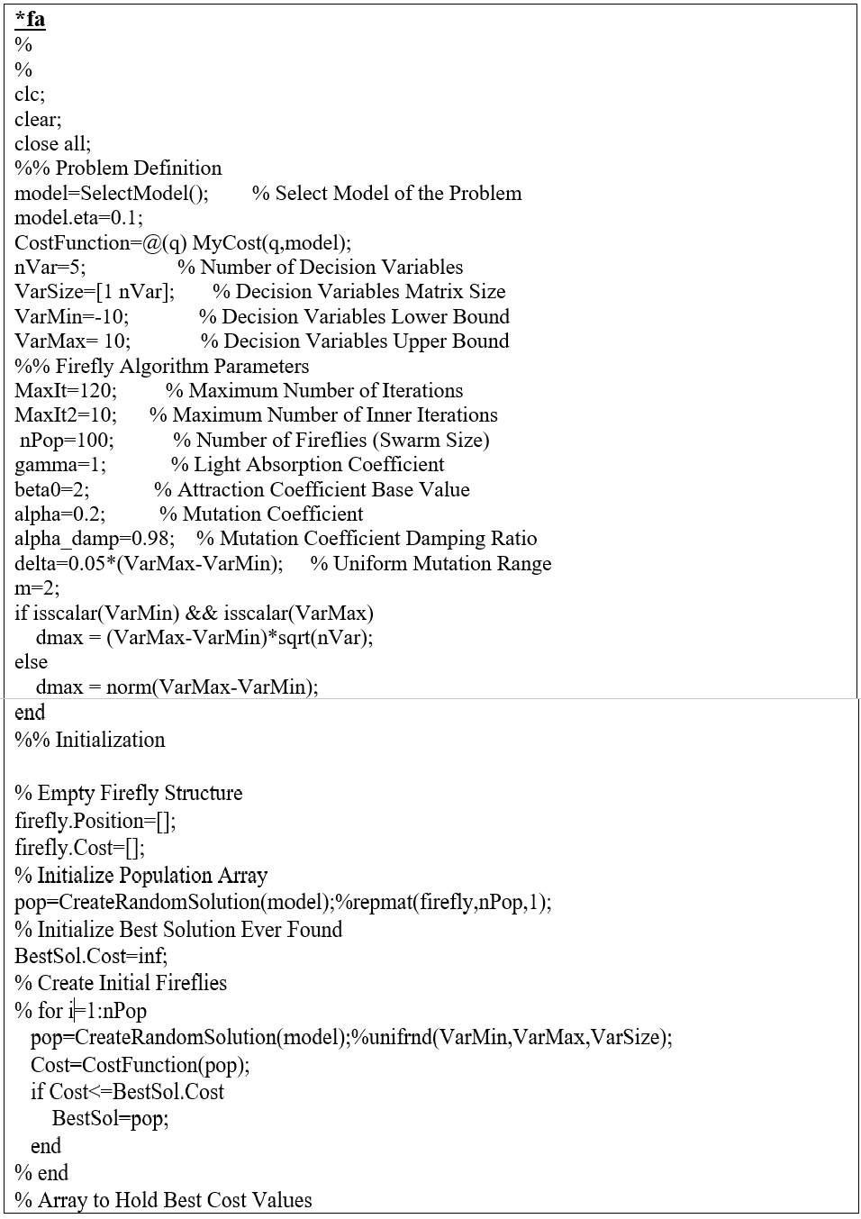

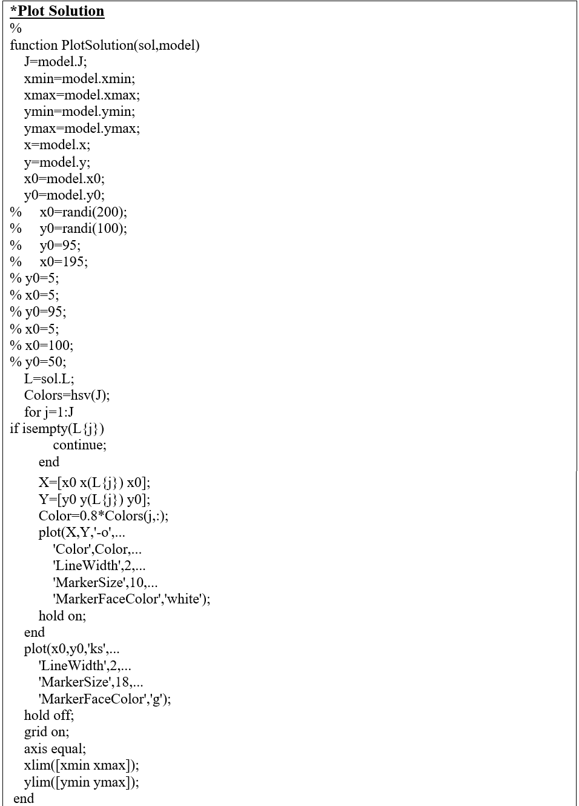

# APPENDIX B

**MATLAB script for SUPPLY CHAIN SCENARIO**

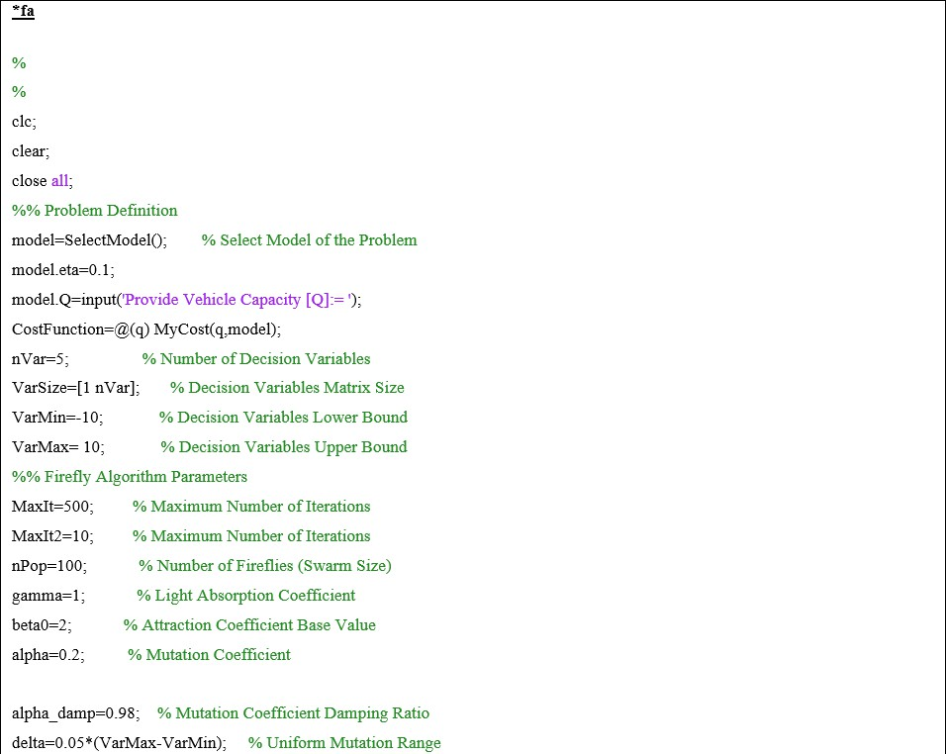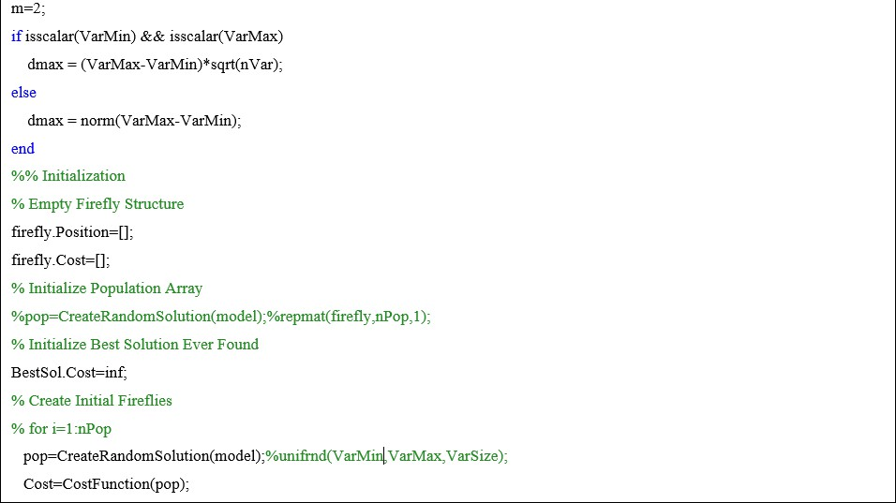

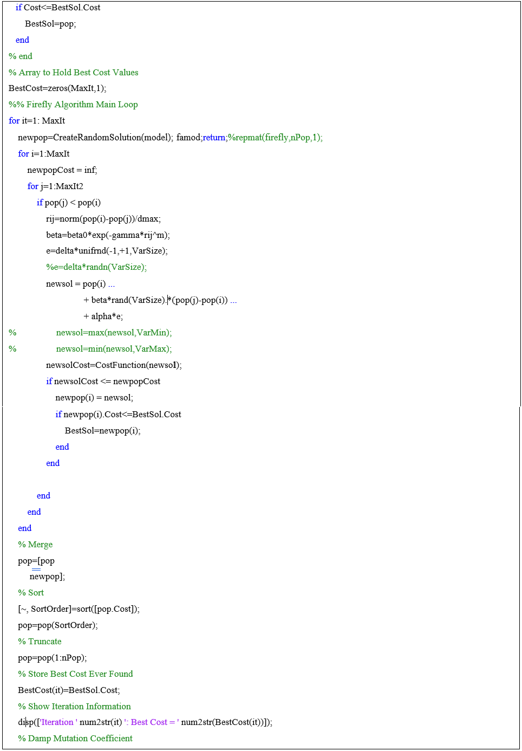

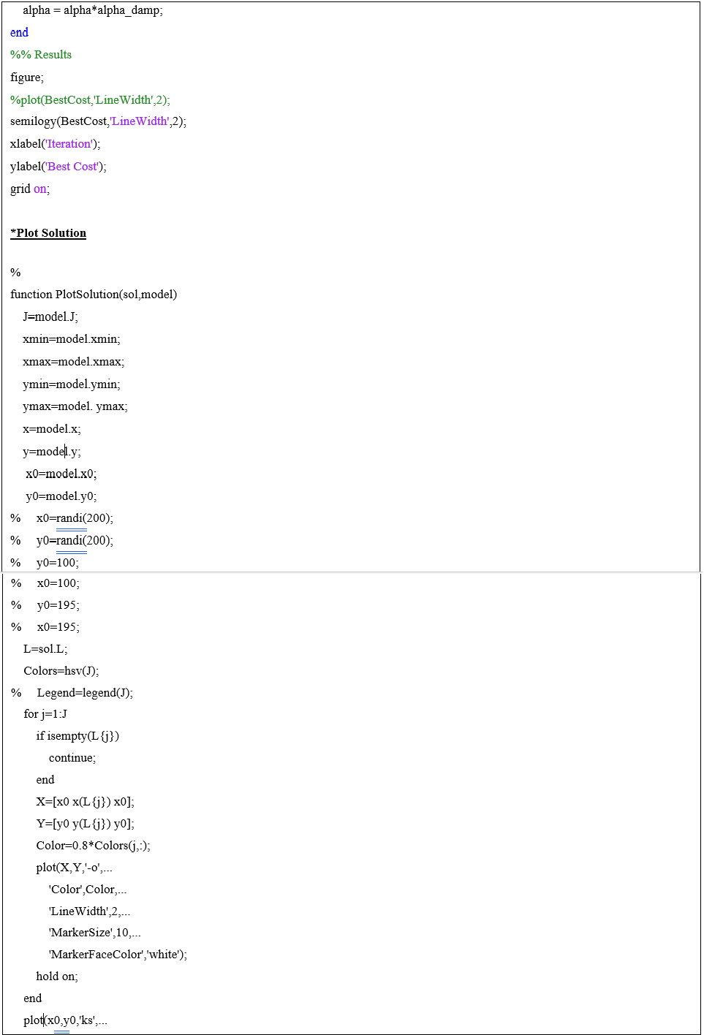

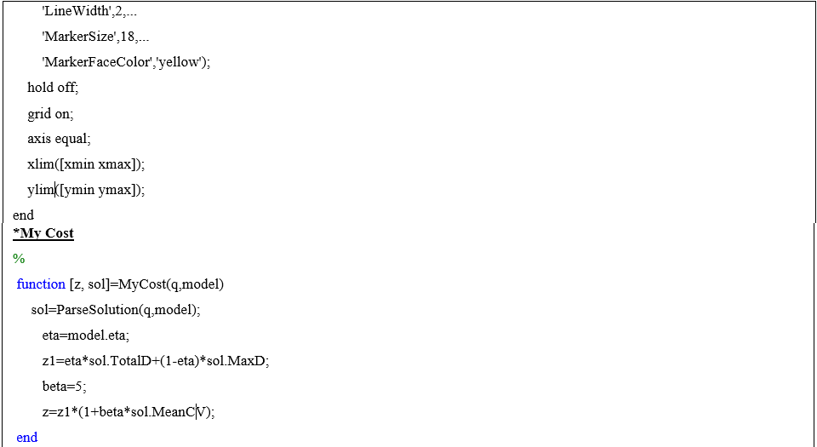

# APPENDIX C

**MATLAB script for the SELECT MODEL FUNCTION FOR SOLID WASTE MANAGEMENT AND SUPPLY CHAIN SECENARIOS**

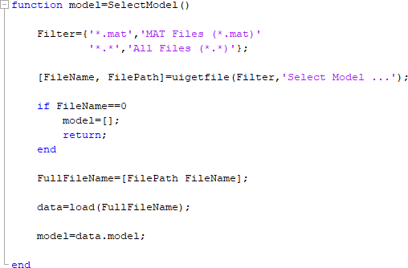

# APPENDIX D

**RESULT FOR THE ROCE DEPOT POSITIONS**

|  |  |  |  |  |  |  |  |  |  |  |  |
| --- | --- | --- | --- | --- | --- | --- | --- | --- | --- | --- | --- |
|  |  | Capacity of vehicle,  *Q* (unit) | Capacity of bin, *q* (unit) | TWL (%) |  |  | Distance (Unit) | **FFA** | **FFA** | FFA | **FFA** |
| No. | Datasets | N | V | **OD** | **CD** | **ED** | **RD** |
| **1** | A-n33-k5 | 100 | 10 | 0 | 32 | 5 | 661 | **322.69** | **322.03** | **322.09** | **324.11** |
| 2 |  |  |  | 60 | 28 | 5 | 629 | **347.00** | **351.53** | **355.16** | **345.48** |
| 3 |  |  |  | 70 | 25 | 4 | 585 | **332.00** | **340.06** | **337.74** | **335.92** |
| 4 |  |  |  | 75 | 21 | 4 | 533 | **305.00** | **304.56** | **305.09** | **304.62** |
| 5 |  |  |  | 80 | 17 | 3 | 457 | **304.00** | **308.91** | **314.94** | **308.91** |
| 6 |  |  |  | 90 | 12 | 2 | 374 | **218.52** | **218.52** | **218.52** | **218.52** |
|  | | | | | | | | | | | |
| **7** | A-n46-k7 | 100 | 10 | 0 | 45 | 7 | 914 | **364.00** | **362.93** | **352.60** | **363.94** |
| 8 |  |  |  | 60 | 38 | 7 | 895 | **364.00** | **359.10** | **364.87** | **370.11** |
| 9 |  |  |  | 70 | 28 | 5 | 750 | **346.00** | **346.88** | **346.66** | **354.21** |
| 10 |  |  |  | 75 | 22 | 4 | 634 | **306.00** | **308.42** | **306.44** | **308.61** |
| 11 |  |  |  | 80 | 18 | 4 | 548 | **303.00** | **301.84** | **300.65** | **301.55** |
| 12 |  |  |  | 90 | 14 | 3 | 449 | **235.08** | **235.08** | **235.08** | **235.08** |
|  | | | | | | | | | | | |
| **13** | A-n60-k9 | 100 | 10 | 0 | 59 | 9 | 1371 | **377.00** | **376.98** | **380.58** | **382.82** |
| 14 |  |  |  | 60 | 41 | 8 | 1258 | **348.55** | **348.93** | **348.44** | **348.68** |
| 15 |  |  |  | 70 | 38 | 8 | 1223 | **356.00** | **356.93** | **356.30** | **360.70** |
| 16 |  |  |  | 75 | 31 | 6 | 1048 | **296.00** | **296.29** | **299.87** | **297.47** |
| 17 |  |  |  | 80 | 29 | 6 | 979 | **344.00** | **345.69** | **342.79** | **343.12** |
| 18 |  |  |  | 90 | 19 | 4 | 693 | **286.00** | **285.97** | **286.51** | **286.55** |
| **19** | P-n40-k5 | 140 | 10 | 0 | 39 | 5 | 458 | **340.00** | **334.08** | **328.50** | **334.64** |
| 20 |  |  |  | 60 | 34 | 4 | 417 | **347.00** | **345.44** | **365.21** | **353.43** |
| 21 |  |  |  | 70 | 32 | 4 | 388 | **334.00** | **351.50** | **342.36** | **337.97** |
| 22 |  |  |  | 75 | 25 | 4 | 352 | **333.00** | **332.98** | **332.60** | **332.54** |
| 23 |  |  |  | 80 | 18 | 3 | 294 | **266.00** | **265.85** | **265.85** | **265.85** |
| 24 |  |  |  | 90 | 12 | 2 | 232 | **192.00** | **192.00** | **192.00** | **192.00** |
| **25** | B-n78-k10 | 100 | 10 | 0 | 77 | 10 | 1263 | **397.00** | **399.65** | **405.04** | **400.62** |
| 26 |  |  |  | 60 | 54 | 9 | 1124 | **362.00** | **364.07** | **369.51** | **362.92** |
| 27 |  |  |  | 70 | 43 | 8 | 1069 | **363.04** | **363.97** | **361.99** | **363.58** |
| 28 |  |  |  | 75 | 27 | 6 | 732 | **341.00** | **341.06** | **340.45** | **340.12** |
| 29 |  |  |  | 80 | 21 | 4 | 613 | **302.00** | **311.96** | **304.35** | **304.09** |
| 30 |  |  |  | 90 | 11 | 2 | 346 | **110.70** | **110.70** | **110.70** | **110.70** |
|  | | | | | | | | | | | |
| **31** | P-n101-k4 | 400 | 10 | 0 | 100 | 4 | 705 | **488.57** | **492.61** | **507.97** | **518.77** |
| 32 |  |  |  | 60 | 81 | 4 | 616 | **422.00** | **427.28** | **422.55** | **421.56** |

|  |  |  |  |  |  |  |  |  |
| --- | --- | --- | --- | --- | --- | --- | --- | --- |
| 33 | 70 | 70 | 4 | 564 | **435.91** | **435.94** | **463.86** | **445.58** |
| 34 | 75 | 62 | 3 | 545 | **446.22** | **453.20** | **450.53** | **424.00** |
| 35 | 80 | 55 | 3 | 494 | **427.00** | **419.88** | **411.19** | **423.54** |
| 36 | 90 | 33 | 2 | 351 | **192.00** | **193.00** | **183.00** | **190.00** |