DEVELOPMENT OF AN INTERNET OF THINGS BASED WATER MANAGEMENT SYSTEM USING DECISION TREE AND DEEP NEURAL NETWORK ALGORITHMS

**BY**

MICHAEL Ephraim MEng/SEET/2017/7436

**A THESIS SUBMITTED TO THE POSTGRADUATE SCHOOL, FEDERAL UNIVERSITY OF TECHNOLOGY, MINNA, NIGERIA, IN PARTIAL FULFILLMENT OF THE REQUIREMENTS FOR THE AWARD OF THE DEGREE OF MASTER OF ENGINEERING TECHNOLOGY IN COMMUNICATION ENGINEERING**

OCTOBER, 2021

ABSTRACT

Distribution of Water has been a major source of concern all over the world. Despite the fact that water is a scarce commodity, a lot of human activities in terms of poor management such as opening taps when not needed and careless attitudes towards broken pipes contribute to poor distribution. Furthermore, the supply of the commodity at constant pressure to areas when not needed contributes to little or no supply to where it is needed. This is because; a lot is wasted without being used as a result of leaks and these human activities. This necessitates the need for a system to manage water distribution effectively. To this end, this research presents the Development of an Internet of Things based Water Management system using Decision Tree and Deep Neural Network algorithms. To accomplish this research work, an efficient IoT water meter was developed to take consumption data from MI Wushishi Minna, which is our area of interest. The data generated was analyzed to understand the pattern of demand. Furthermore, a water tank capable of supplying the study area was simulated having constant valve resistance on Simulink. Based on the consumption behavior of the occupants of the estate, another simulation was done using Simulink in which the valve resistance was varied based on the demand. This results to saving water of about 3000 liters. To make the system smart, Deep neural Decision tree algorithm was used to achieve auto selection via classification. Compared to other existing work, the scheduling achieved via Decision Tree Algorithm in this research had an improved accuracy of 94.2%.

.

TABLE OF CONTENTS

**Content Page**

Cover page

Tittle page i

Declaration ii

Certification iii

Dedication iv

Acknowledgements v

Abstract vii

Table of contents viii

List of tables xiii

List of figures xv

List of plates xvi

List of abbreviation xvii

CHAPTER ONE

* 1. INTRODUCTION 1
  2. Background to the Study 1
  3. Statement of the Research Problem 9
  4. Aim and Objectives 10
  5. Justification for the Study 10
  6. Scope of the Study 11

CHAPTER TWO

* 1. LITERATURE REVIEW 12
  2. Overview 12
  3. Related Works on IoT 13
  4. Related Works on Water Optimization 20

2.4. Optimization using Decision tree algorithm 22

2.5 Study of the Area of Interest 35

CHAPTER THREE

* 1. MATERIALS AND METHODS 37
  2. Architecture of the System 37
  3. Hardware Materials used 38
  4. Software and tools used 38
  5. Hardware Design 39
     1. Controller Deployed 40
     2. Flow rate sensor 40
     3. Display used 42
     4. Power supply requirement 43
     5. Charging unit 46
  6. Mode of Communication 47
  7. Principle of Operation 48
  8. Flow Chart for the Firmware 50
  9. Development of Web Platform 52
  10. Mathematical Expression Representation of the Daily Pumping of Water

at Constant Valve Resistance 52

* + 1. Volume of water required, estimated for study area 52
    2. Simulation and assumptions 53
    3. Smart network 57
    4. Data generated 58
    5. Data preprocessing 58
    6. Deep neural network enhancement 58
    7. Data splitting 60
    8. Decision Tree Algorithm 60
    9. Mode of operation of CART algorithm. 61
    10. Evaluation of the model 62
  1. Physical architectural setup 62

CHAPTER FOUR

* 1. RESULTS AND DISCUSSION 64
  2. Highlights of expected Result and Discursion 64
  3. Performance of the IoT Node 64
  4. Consumption Pattern Implication 72
  5. Simulated Model For Water Supply at Constant Valve Flow

Resistance for the Study Area 72

* 1. Simulated Model For Varying Valve Resistance in WDN 73
  2. Optimization of Water Supply 75
     1. Valve Resistance 77
     2. Fuzzy Behavior of the System 79
  3. Performance Evaluation Of Prediction Model 81

CHAPTER FIVE

* 1. CONCLUSION AND RECOMMENDATIONS 84
  2. Conclusion 84
  3. Recommendations 84
  4. Future work 84

References 85

|  |  |  |
| --- | --- | --- |
|  | **LIST OF TABLES** |  |
| **Table**  2.1 | Summary of Literature Reviewed | **Page**  24 |
| 3.1 | A table of supply level distribution of water needed in M.I. Wushishi | 56 |
| 3.2 | Summary of Data Used | 58 |

|  |  |  |
| --- | --- | --- |
|  | **LIST OF FIGURES** |  |
| **Figure**  1.1 | Water Distribution Network | **Page**  1 |
| 1.2 | Internet of Things and its applications | 4 |
| 2.1 | Sigfox-LoRa mixed architecture of IoT based metering system | 15 |
| 2.2 | Location of Minna in Nigeria | 35 |
| 2.3 | Map showing the study area | 36 |
| 3.1 | Architecture of the System | 37 |
| 3.2 | Block Diagram of the Hardware | 39 |
| 3.3 | Circuit diagram of the controller. | 40 |
| 3.4 | Circuit Diagram of the Flow Rate Sensor Connected to the Controller | 41 |
| 3.5 | Set up of the Flow Sensor with the Tap | 42 |
| 3.6 | Circuit Diagram of LCD Interfaced with the System | 42 |
| 3.7 | Battery Powering the System | 43 |
| 3.8 | Voltage Conditioner Interfaced with the System | 45 |
| 3.9 | Complete Circuit Diagram | 47 |
| 3.10 | Flow Chart Implemented in the Firmware. | 51 |
| 3.11 | Analogical representation of the tank | 53 |
| 3.12 | Work flow in executing decision tree algorithm to aid smartness | 57 |
| 3.13 | Architecture of an autoencoder model | 59 |
| 3.14 | Representation of autoencoder | 59 |
| 3.15 | Test data used. | 60 |
| 3.16 | General Deployment Architecture | 63 |
| 4.1 | Graphical representation of water consumed in House A when |  |
|  | the node is connected to Public Power Supply | 65 |

* 1. Graphical Representation of Water Consumed in House B when

the Node is Connected to Public Power Supply 65

* 1. Graphical representation of water consumed in House A when the

node is connected to green power supply 70

* 1. Graphical representation of water consumed in House B when the node is connected to green power supply

71

|  |  |
| --- | --- |
| 4.5 Simulation of the tank supplying water to the area of study at constant  maximum flow rate | 72 |
| 4.6 Simulation of Varying Valve Resistance Based on Demand |  |
| in a WDN. | 74 |
| 4.7 Graphical representation of how water is used up in the elevated |  |
| tank in MI. Wushishi. | 75 |
| 4.8 Graphical illustration of drained elevated tank as a result of |  |
| varying valve resistance. | 76 |
| 4.9 Graphical Representation of Valve Resistance with Time | 77 |
| 4.10 Fuzzy representation of pump operation. | 70 |
| 4.11 Graphical representation of high valve resistance from 12:00am to 5:00am | 79 |
| 4.12 Graphical representation of low valve resistance from 5:00am to 8:00am | 80 |
| 4.13 Graphical representation of low valve resistance from 8:00am to 2:00pm. | 80 |
| 4.14 Graphical representation of low valve resistance from 2:00pm to 4:00pm. | 81 |
| 4.15 Graphical representation of low valve resistance from 4:00pm to 9:00pm | 81 |
| 4.16 Graphical representation of low valve resistance from 9:00pm to 12:00am | 82 |

4.17 Graphical Representation of Compared Result 83

|  |  |  |
| --- | --- | --- |
|  | **LIST OF PLATE** |  |
| **Plate**  I | Elevated tanks for water supply | **Page**  7 |
| II | The Developed Circuit in a Case | 49 |
| III | Complete system setup. | 49 |
| IV | Display of Developed IoT Water Meter | 50 |
| V | Pictorial view of the table from server depicting the water consumed |  |
|  | in house A with public supply. | 66 |
| VI | Pictorial view of the table from server depicting the water consumed in |  |
|  | house B with public supply. | 67 |
| VII | Pictorial view of the missien data. The missen data is represented as |  |
|  | NAN in the table. | 68 |
| VIII | Picture of the result of the analysis of the data of house A that shows |  |
|  | missen data when the node is powered with public power suply | 68 |
| IX | Pictorial view of the missien data. The missen data is represented as NAN |  |

in the table 69

X Picture of the result of the analysis of the data of house A that shows

missen data when the node is powered with public power suply 69

CHAPTER ONE

* 1. INTRODUCTION
  2. Background to the Study

The importance of water cannot be overemphasized as it is widely accepted as an important necessity for life (Abu-Mahfouz *et al*., 2016; Gwaivangmin, 2017; Paul, 2018). Being about 70% to 71% of the earth mass (Gupta *et al.,* 2018; Saravanan *et al.,* 2017), records show that 2.5% - 3.4% of it is fresh water (Rodrigues *et al.,* 2018; Saravanan *et al.,* 2017). Only about 0.07% - 0.08% of this is accessible for consumption (Gupta *et al*., 2018; Rodrigues *et al*., 2018). Water is used for both domestic and non- domestic activities and this is mostly drinking, irrigation and other domestic activities. For this reason, it is important to transport this essential commodity to where it is needed especially homes and industries. Hence, there is a need for the integration of so many relevant components like machines and other infrastructures, working together as a single complex and dynamic network, to aid the effective transportation of the commodity from the source to the point of use (De Corte & Sörensen, 2012; Hajebi *et al.,* 2016). Figure 1.1 shows the water distribution network referred to as Water Distribution Network (WDN).

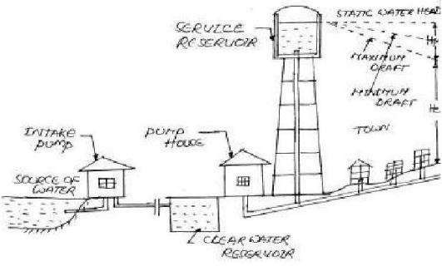

Figure 1.1: Water Distribution Network Source : Debnath (2019)

Several global efforts have been made by various water utility boards to ensure adequate and efficient distribution of good and quality water but it has been observed, according to Kara *et al.* (2016), that maintaining such a task is a global challenge. In a study by Ngancha *et al.* (2018), it is observed that over 348 million people experiences water scarcity. While according to the World Health Organization (WHO), 1.1billion people have no access to portable water (De Corte and Sörensen, 2016).

Ngancha *et al.* (2018) in a presentation, blamed the trend on the rapid growth of population that tripled the demand for water since 1950. This situation has been worsened by consistent reduction in the rate of rainfall due to climate change (Rodrigues *et al.,* 2018; Turcu *et al*., 2012). Furthermore, other factors contributing to the scarcity of water according to Rodrigues *et al*. (2018), can be linked to poor management on the part of the consumers and poor fund generation by water utility boards of various governments. It has also been reported that large portion of the fresh water distributed, flows back to the ocean unused (Saravanan *et al.,* (2017). This is as a result of opening of taps when not needed and carefree attitudes towards leaking distribution lines. This gives a clear picture of unsustainable use of water by consumers and Water Utility Boards. This however, tends to validate the assertion by the World Bank that an estimate of 32.7 billion m3 of water is lost every year. Furthermore, it was

observed that both real and apparent loss of water results to the loss of 14.6 billion USD per year (De Corte and Sörensen, 2016).

To optimize the network by minimizing losses, it is important for individuals and water utility boards to ascend a level of responsibility towards water management. This can be achieved by means of effective medium to monitor and quantify the amount of water

consumed or lost (Kara *et al.,* 2016). This however, could aid effective billing system that generates revenue and sustains the sector.

Overtime, water monitoring translating to bills has been a way to aid inclusiveness of consumers or customers and service providers in the maintenance of relevant infrastructure in order for consumers to be served efficiently. Several strategies are available for the monitoring of the usage of some basic utilities like electricity and gas with the aim of revenue generation either for expansion or maintenance of the infrastructure (Suresh *et al.,* 2017). Most developing countries like Nigeria and Niger state in particular do not have a means of measuring the exact quantity of water consumed by users of water (Kara *et al.,* 2016). This results to waste of resources, leading to overall hike in the cost of the process of water distribution (Rodrigues *et al*., 2018).

Prior to the application of meters in some nations, management of water especially in Nigeria has been done using humanitarian approach (Suresh *et al.,* 2017). This approach characterized with a no billing system or an estimated billing system was employed since there were no appropriate measures put in place to quantify the amount of water used or lost (Abu-Mahfouz *et al*., 2016; Tavares *et al.,* 2018). This may be one of the reasons why many Water Utility Boards are facing poor revenue generation (Hajebi *et al*., 2016) and a lot of water wastage. Furthermore, the later (estimated billing) and the recently used water meters that are either mechanical or electronic in nature still involves the frequent visit of utility officers to points of installation. This has caused frequent discord between the water service provider representative and the customers because of the issuing of estimated bills that are not justifiable. For this reason and for the sake of a better record keeping system, there is the need for a more efficient platform that aids real time monitoring of water supplied to customers without the need for new complex

infrastructure leading to the transparent generation of bills. To achieve this, the Internet of Things (IoT) becomes an obvious choice (Kamienski *et al.*, 2019).

Internet of Things (IoT) is a paradigm that allows everything and everyone to communicate through the internet (Granjal *et al.,* 2015; Lorawan, 2017). In other words, the internet, a platform for IoT is not only expected to connect people but, also anticipated by expert to connect more than 50 billion objects by the year 2020 (Khutsoane *et al.,* 2017). These things which may include mobile computing devices, sensors, actuators and other objects must be readable, locatable, recognizable, addressable and interconnected through the internet via a stipulated protocol called the internet protocol (IP) (Hauser *et al*., 2016; Patel and Patel, 2016; Li *et al.,* 2017). This is done so as to achieve smart services and environment as shown in Figure 1.2.

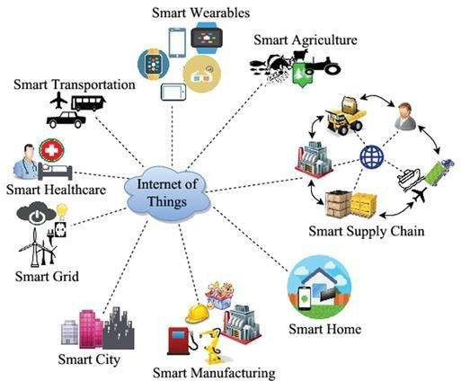

Figure 1.2: Internet of Things and its applications Source : Samaila *et al*., 2018

This technology, enabled by other technologies such as embedded systems, wireless sensor network (WSN), radio frequency identification (RFID), cellular technology, global position remote system (GPRS) and GSM (Doni *et al.,* 2018) is not limited by distance and aids real time monitoring of water consumed (Lloret *et al*., 2016). However, this could reduce frequent visits of utility representatives in the name of monitoring, aid improvement in the efficiency of water utility management, decrease operational cost, reduce customer dissatisfaction, reduce water loss (Kara *et al.,* 2016). Furthermore, data generated seamlessly could aid demand forecasting and variable water pricing and billing (McKenna *et al.,* 2014). In other words, unlike the traditional methods described by Bhoyar and Ingle, (2018) as labor intensive, also by Kara *et al.* (2016) as prone to error and characterized by discontinuous information gathering, this technology aids the continuous wireless gathering of water consumption dataset of customers in the cloud. This further enhances user experience and inclusiveness in water management by enabling each user the ability to monitor and control consumption remotely at any time. This however, aids water conservation (Curry *et al.,* 2018; Gupta *et al.,* 2018; Lloret *et al.,* 2016; Rodrigues *et al.,* 2018). This means the application of this technology to metropolitan area, will aid the generation of large volume of data generated at high velocity (Suresh *et al.,* 2017). In the long term, this data collection could foster demand prediction, detection of incidence such as tampering and leak, characterization of customers (Lloret *et al.,* 2016) and automatic execution of decision to curb damages, waste and ill services (Ahmed *et al.,* 2017).

In summary, the need for real time dataset of water consumed is necessary for effective billing and for smart techniques used for network optimization. This however, leads to revenue generation that aids sustainability of water infrastructure. This can be efficiently achieved via the use of IoT as a platform to monitor consumption and to aid consumer

inclusiveness in water management. Furthermore, this data will aid analysis and optimization techniques that will result to better water management and services. However, despite the positive effect of this technology, its application may be rather challenging in developing nations like Nigeria where some part of the country is characterized with erratic power supply. This will however, increase the probability of outage resulting in large loss of data aside the few times when downtime is experienced within the wireless network. To solve this problem, this study presents the design and development of IoT based water monitoring system powered by a Green source.

In a WDN, effective distribution is achieved via the use of two main approaches. The first approach involves the use of electric pump (Balekelayi & Tesfamariam, 2017) which pumps water from a reservoir of treated water usually underground, to the consumers. This however, seems inefficient because of the high power consumed for continues operation (Abdallah, 2020). According to Tsai *et al.* (2018), 30% to 40% of power of a metropolitan city is used to pump water. From this consumption, 80% to 90% of the power is absorbed by motor pump set (Sarbu, 2016). This however, increases the cost of operation (Sarbu, 2016). To further reduce the cost of operation, researchers have proposed and employed the second approach which is the use of elevated storage tanks mounted on calculated heights as shown in Plate I so as to achieve effective distribution, leveraging on pressure due to gravity (Muhammad & Safdar, 2020; Ree & Eddy, 2016; Torkomany & Abdelrazek, 2020). Usually, treated water served, had to be pumped to the tank for storage before being distributed. With this, required pressure is achieved via gravity to serve consumers if properly designed. This however, eliminates the costly frequent pumping operation. However, even with this, the aging infrastructure most times, impedes optimal use of the network since the aged network is characterized with leaking pipes (Balekelayi & Tesfamariam, 2017; Brooks *et al.,* 2018). Most times, as a

result of the inability to predict failure, reactive maintenance is often times given to the network. This however, does not ensure efficiency in distribution as many leaks can be noticed at the same time by different people in different location. This leads to low pressure and waste (Balekelayi and Tesfamariam, 2017) that will increase the frequency of pump operation if the whole network is characterized with constant maximum pressure.

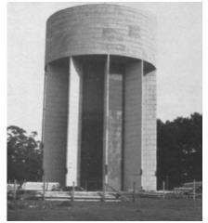

Plate I: Elevated tanks for water supply Source: Muhammad and Safdar, 2020

Logically, a total overhaul of the network may be suitable to cure the ailing network. However, the expenses to be incurred will be overwhelming. In the United States alone,

$3.6 trillion dollar will be needed by 2020 to fix the network (Brooks *et al.,* 2018). This may not be feasible in some developing nations as the annual budget may not be enough to undergo such project. This therefore, suggests that there is a need to optimize the design from the beginning of the development of a network and device a means to optimize the operation of the network to achieve acceptable pressure based on demand to aid water conservation on the long run.

Over the years, scheduled pumping operation in WDN has been used to aid water conservation and to reduce the cost of energy used in pump operation (Brentana *et al.,*

2017; Sarbu, 2016; Stokes *et al.,* 2016). This helps utility not to run into water shortage (Telles *et al.,* 2016). Generally, the operation is done via the use of district state pumping schedule. In the approach, the pump is turned on when needed and turned off when not needed (Abdallah, 2019; Archetti *et al.,* 2018). However, this may not be healthy for distribution since the demand curve in the network is not discrete. In other words, there can’t be a time when no water is needed in the network. Furthermore, for distribution method that employ the use of elevated tanks, maximum pressure is delivered as a result of gravity to all part of the network even if not needed. This causes waste in areas where fault is discovered. Furthermore, as the water level reduces, the extreme part of the network may be deprived of good quantity of water when needed since every part of the network is opened at the same pressure rate to the flow. However, for effective scheduling, the consumption behavior of the consumers must be considered (Torkomany

& Abdelrazek, 2020) in proffering solutions. This can be easily achieved via classification of valve resistance based on consumption pattern in the data collected by metering devices. By observation, it is noticed that in societies like Nigeria two major classes of customers exist. This includes the residential and nonresidential customers which includes offices, marketplace and schools. Usually, it is observed that there is population movement from points of residence to points of non-residence and back. This however, increases the dynamism of the demand curve in both residential and nonresidential areas. In other words, there are times of the day that more population is seen at residential areas while the nonresidential areas have less population and vise vassal. As a result, a behavioral pattern can be observed and used to channel more water to where is most needed and less water where it is least needed. This will be effective via the use of transparent mediums in collecting data such as IoT based water meters. The understanding and use of these data will ensure that water is not totally cut off when

demand is low at some point. To this end, this research presents development of an Internet of Things based water management system using decision tree and deep neural network algorithms.

* 1. Statement of the Research Problem

In Nigeria, the use of elevated tank system of distribution is ideal because of the inability of the ailing power sector to support continuous pumping of water in the WDN. As a result of the growing population, the need for more tanks is inevitable. However, the adaptation of old designs involving constant peak pressure discharge through a channel to the whole network may not give optimal performance of the network. This is because, as noted, the whole network could be classified as residential, nonresidential or both and therefore is characterized by varying volume of population at different points in time characterizing the network with varying demand at all times (Torkomany & Abdelrazek, 2020). For example, water demand in residences is more during the morning and evening hour (Sarbu, 2016). Therefore, pumping at constant high pressure (Sarbu, 2016), may not be sustainable if leaks are noticed in-between. Furthermore, huge losses may occur as a result of opened taps and broken lines in the distribution when water is supplied at constant high pressure to areas of low demand. This however may result to customer dissatisfaction and losses that increases the frequency of pumping, making the operation of a WDN costly. To cushion this ill, this research presents the Development of an Internet of Things based Water Management System using Decision Tree and Deep Neural Network Algorithms. In this presentation, IoT based monitoring device will be used to study the latent behavioral pattern as relate to consumption. Furthermore, various classes of valve resistance are predicted for automatic operations using the decision tree algorithm so as to optimize the distribution system.

* 1. Aim and Objectives of the Study

The aim of this research is to develop an Internet of Things based water management system using decision tree and deep neural network algorithms. This was achieved by the following to:

* + 1. Develop an efficient IoT based monitoring device (water meter) to study the consumption pattern in the location where it is installed.
    2. Simulate the daily pumping of water at constant valve resistance on Simulink using the leaking tank model.
    3. Simulate water pump operation with varying valve resistance to supply water based on demand using Simulink.
    4. Develop a smart distribution network using decision tree and deep learning algorithms.
    5. Comparative analysis and performance evaluation of objective ii, iii and iv.
  1. Justification of the Research

In several parts of the world today, the main objective of utility is to ensure efficient water distribution (Abdallah, 2020). One of the factors to measure efficiency remains the resilience of water delivery (Sarbu, 2016). However, one way to achieve this is the optimization of pump operation (Abdallah, 2020). This has been looked into by several researchers such as Torkomany and Abdelrazek (2020), Candelieri *et al.* (2020) and Abdallah (2019). The submission narrates how different techniques have been used to optimize water supply. One of such includes pump scheduling. However, based on review so far, the approach of variable valve resistance using the demand behavior of consumers in a location to fairly schedule how much water is to be supplied as used in this research, have not been done. This therefore, justifies this research.

* 1. **Scope of the Study**

The scope of the research work is restricted towards water conservation and consumption accountability achieved via the development of IoT water monitoring device and smart pump operation optimization that aids reliance in WDN in terms of water delivery in M.I Wushishi estate. The node was connected to two different houses on two different working days in the week to understand the pattern of water consumption in those houses. House ‘A’ contains four adults employed with the state government, one house maid who is a teenager and three children in primary school. House ‘B’ consists of just two adults. The proposed standards made by WHO of water required by individuals was then employed as the bases for simulation in Mat-lab. This helped to generate data used for pump operation optimization, resulting to varying flow resistance as a result of varying valve resistance.

CHAPTER TWO

* 1. LITERATURE REVIEW
  2. Overview

The management of water is key since fresh water which is supplied after being treated via the WDN is often difficult to source or access (Gupta *et al.,* 2018; Li *et al.,* 2017; Saravanan *et al.,* 2017). However, to curb waste as described by Saravanan, Das and Iyer (2017), aiding the sustainability of the commodity and WDN infrastructure, it is important that management should be consumer inclusive and not left for utility manager and the government alone. To achieve this, effective monitoring via the use of constrain devices is needed. This will also aid consumption awareness, leak detection, demand forecasting, variable water pricing (McKenna *et al.,* 2014) which will help to generate revenue through billing for the expansion and maintenance of the network. This will lead to reliable and efficient services in the distribution of water (Kara, Karadirek, *et al.,* 2016) and the development of optimization techniques needed to better water services. According to Kim *et al.* (2016), there are basically two methods of monitoring and managing water. The first is the Approach model base method. This method, which is also called supply oriented solution by Turcu *et al.* (2012) involves the search of new source of fresh water which is often demanding, difficult and exhaustive. The second method is the measurement based method which is also known as demand oriented solution (Turcu *et al.,* 2012). This involves the use of constrained devices such as water meters to monitor demand of water consumed which can be further translated to bills for consumers. Of these two approaches, the latter is most considered by researchers. As a result, water meters have evolved over the years so as to aid the periodic reading of water consumed and ensure efficient and transparent billing (Kara *et al.,* 2016).

* 1. Related Works on IoT

Over the years, there have been manual approaches used to ensure water quality monitoring and billing. Kara *et al.* (2016), in their study mentioned previous method used. This method involves samples of water manually taken to the lab to ascertain the quality. This time wasting venture was done so as to communicate to the consumers the status of water quality(Kara *et al.,* 2016). In the work of Bhoyar & Ingle (2019) and Doni *et al.* (2018) it was noted that utility officers in some countries such as India will have to go around town to get data from mechanical based water meters installed in homes. These data generated may be considered discontinuous and may be full of errors leading to inappropriate billing either as a result of fatigue while gathering the data or deliberate manipulation. Furthermore, according to the study, there may be instances when data cannot be collected because some meters may be inaccessible to some utility officers. For this reason, the approach mentioned above can be considered inefficient and therefore needs the application of real time technology.

In a city called Antalya in Turkey, a study by Kara *et al.* (2016) indicated the need for Real time monitoring in water management. In the study which focused on monitoring the quality of water, real time monitoring via the use of real time Supervisory Control and Data Acquisition (SCADA) helped to improve operations by buzzing alarms when parameters measured by constrained devices go beyond desired standard measurements. Furthermore, the research focuses on making WDN safe such as intended by Parameswari and Moses (2018) and Ramesh *et al.* (2017) by communicating the quality status of the water to the consumers wirelessly via the use of expensive IBM servers, UHF mass radios, repeaters and a Motorola gateway(Kara *et al.,* 2016).

Similarly, in another study, water quality was monitored by Saravanan *et al.* (2017) in a smart water grid achieved via the use of Low Power Wide Area Network (LPWAN) IoT

technology. At the front end, the sensors used includes: oxidation reduction potential sensor, pH sensor, salinity sensor, flow rate sensor, water level sensor, turbidity sensor and temperature sensor. Long range (LoRa) transceiver was used with a LoRa gateway to transmit data to the Ericson cloud used. Also, an alert was sent via SMS when parameter measured is critical.

A study presented by Abu-Mahfouz *et al.* (2016) also, emphasized the use of real time monitoring to achieve effective, efficient, reliable and adaptive WDN. The research, focused on how to overcome steady state limitations of a WDN such as energy waste when pumping water at periods of low demand with peak pressure. The authors proposed the development of water grid sense to aid data collection and control of the network. The proposed water grid sense is to monitor demand of consumers over the internet using IEEE 802.15.4 or Long range (LoRa) transceivers and aid power adjustment of the pump which in turn adjusts the pressure of the water distributed. With this, power is conserved and the life span of the pipes is increased.

Another study presented by Gwaivangmin (2017), focused on forecasting demands of water in Lamiga, Jos, Nigeria via the use of artificial neural network (ANN). The model was developed based on historic data generated by 15 demand nodes which generates data for 24 hours in sixty days. Afterwards, back propagation Neural Network was used for the predictions of water demands. The supervisory control of the network was achieved via the use of Supervisory Control and Data Acquisition (SCADA) software. This software which needs an experienced official in water cooperation aids remote control of flow rate, hydrostatic pressure and other parameters. At the end of the study, it was suggested that the results of demand predicted could be used for the expansion of the water project in Jos. This will reduce the risk of scarcity in the future.

To increase the efficiency of water monitoring which will lead to efficient billing, Bhoyar and Ingle (2018) presented a design of a LoRa Technology based low cost water Meter reading system. The design was conceived to overcome the limitation of not being able to access mechanical meters previously installed in India. With the use of LoRa, a wireless technology with low power consumption but longer-range communication capabilities, utility officers could stay around the area of operation and gather data from different meters in a geographical area without going close to the meter. Afterwards, the bills can be computed and sheared to customers. An advanced design was presented by Rubio-Aparicio *et al.* (2019). In their study, the demand of water can not only be monitored using low power technology such as sigfox and LoRa, it can also be controlled via the use of solenoid valve.

Figure 2.1 shows how demand data set is gathered from different meters using the LoRa or Sigfox technology which is preferred over the use of Bluetooth, zigbee, WiFi and NFC which are of short range.

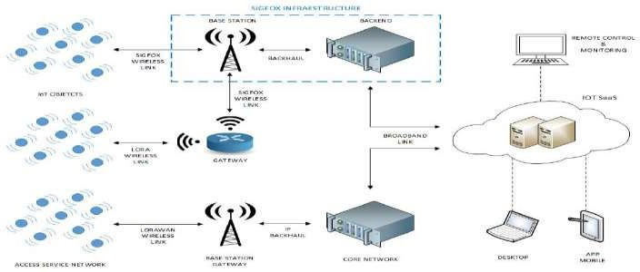

Figure 2.1: Sigfox-LoRa mixed architecture of IoT based metering system Source: Rubio *et al.,* 2019

Similar deployment of low power technology in IoT, reference architecture of technology like LoRa for smart meters as used for water was presented by Lloret *et al.* (2016). He, Zhang, and Wang, (2019) presented the design of an intelligent Meter reading Technology based on Narrow Band (NB) IoT. In the presentation low cost STM32F103 controller was interfaced with OV7725 camera module. This was done to capture the reading on mechanical based water recording meter. Afterwards, image processing is done to extract the numbers on the counter. This is then sent to the cloud via the use of narrow band IoT (He *et al.,* 2019).

Natraj and Begum, (2018) present a design in a study titled IoT based smart water meter for city water distribution and monitoring system. In the study, a flow rate sensor was used to measure the water consumed by customers. Afterwards, the controller MSP430 was used to process the data and compute the billing and then display the unit consumed on a liquid crystal display (LCD). This data and the billing are sent to a central data collection or the cloud system via the use of a WiFi module called ESP8266. To aid user inclusiveness, android application was designed to help customers to be able to see what is consumed and how bill is generated (Natraj and Begum, 2018).

Turcu *et al.* (2012) also presented an IoT approach for water monitoring and control. In the presentation, SCADA was suggested as a tool at the application layer. This was because of its wide applications which include water management, management in oil industries, process manufacturing and process facilities such as transportation. With a focus on the architecture that will aid IoT monitoring and control in the water sector, unique identification of things was tagged important. This is to aid localization of fault

finding within a WDN. To achieve this, it was suggested that RFID technology will be a low cost solution (Turcu *et al.,* 2012).

Hauser *et al.* (2016), in an effort to unravel communication protocols used for smart water network, listed different protocols. In his presentation, the choice of protocol was determined by some factors such as terrain, battery life and power consumption. However, it was emphasized that IP still remains the common choice of researchers. Furthermore, it was observed that the synergy of IoT and big data will have higher impact on the water sector.

In a presentation by Suresh *et al.* (2017) the focus was on consumer inclusiveness. In the presentation, a smart recording meter and an android application was developed so as to retrieve consumption data on the meter and then communicate it to a smart phone (Suresh *et al.,* 2017). The consumer can then send the consumption data to the utility office for billings to be done.

To reduce waste of natural resources and financial resources, Tavares *et al.* (2018) presented a microcontroller based system for telemetry measurement of water consumption using IoT. The work presented aids real time monitoring of consumption which can be used for billing and provides information like leaks. To achieve this design, a flow meter was used to measure the consumption of water. Also, a controller with IEEE802.15.4 standard was used so aid communication to the cloud via Wi-Fi. Furthermore, visual display of consumed water was presented to the customers (Tavares *et al.,* 2018).

Gupta *et al.* (2018) presented a paper that describes how IoT is used to manage water smartly in homes. The design which made used of ultrasonic sensor and turbidity sensor

monitors the level of water in a tank and also how clean the water is. The data generated from the monitoring is sent to the cloud. Also, an alert is sent when the water is critically low so that the consumer could call tanker for supplies (Gupta *et al.,* 2018).

As a result of scarcity of the water, Verma *et al.* (2015) observed unregulated storing of water in tanks in urban cities and campuses leading to inefficient distribution of water since the water stored is more than what is needed in a day. To improve this situation, they presented a design of a smart water distribution system. With the aim of monitoring all water tanks in a campus through a wireless sensor network, they designed and built an ultrasonic module that can help monitor the water level in the tanks across the campus. All the sensors are inter-networked via the use of low power sub-GHz radio. To achieve an efficient network three types of nodes were used. These includes the gate way nodes which route information gathered to the cloud, the end nodes which are the edge of the network connected to a sensor. These sensors and goes to sleep and then wakes up periodically to save power and relay nodes which aid the transmission of information gathered by an end node to another end node. Concluding the study, they achieved a sensor with an error of ±1.5% ( Verma *et al.*, 2015).

Li, *et al.* (2017) with the intension to optimize intelligence in water management, proposed the use of IoT to aids real time monitoring of water distribution in Taiwan. Furthermore, cloud storage and big data analytics was used to add value to the work. Focused on improving efficiency in water distribution, the work was sub divided into four parts. This includes the front end which is a data acquisition, network transmission, cloud storage and applications for analysis. With the proposed design, wasteful attitudes will reduce; water bill rate will improve as well as meter reading accuracy (Li *et al.,* 2017).

To reduce cost of water, Kalochristianakis *et al.* (2016) presented a holistic way of water management. In the research, an IoT system for residential water recycling based on open-source technologies was the focus. The system presented aids monitoring, control and the management of residential water. The maximization of water recycling was achieved by the processing of rain water collected, used shower water, water from toilets and sink within the building, and the system minimizes the cost of water for consumers. To achieve this, network of sensors was installed. This includes flow meters that help to monitor water consumption, tank level sensors for tanks that collect water that is to be recycled, electromagnetic control valves and metrological station that monitors weather. Also, Arduino Nano was used to control the valve via the use of Fuzzy Logic as a tool (Kalochristianakis *et al*., 2016).

Myers *et al.* (2014), in a study identified the excessive waste of water for outdoor activities such as watering the lawn. In the research, it was stated that often times, these lawns; especially in urban areas are saturated with water which is not necessary thereby, increasing the amount of water wasted. To curb this ill, an intelligent water management and information system which integrates real time sensed data and web available information to make decisions on water released for wetting lawns. With the application of semantics and IoT technology, a better and efficient way of automating lawn watering was achieved (Myers *et al.,* 2014).

Koo *et al.* (2015) in a study presented a schematic development of IoT application for Big data collection through a myriad of water client. In the presented work, data was collected both upstream and downstream via wireless sensor network and then connected to IoT. The downstream collects data for evaluation of consumption and system

performance while the upstream collects data similar to data of Automatic Meter Reading (AMR) (Koo *et al.,* 2015).

* 1. Related Works on Water Optimization

Generally, as a result of the scarce nature of fresh water, optimization has been seen by many researchers as key to ensuring the reduction of the risk of a failed water distribution system. Over the years, optimization has been generally achieved using one of these two approaches. The first approach which involves optimization from design point of view as described by Torkomany & Abdelrazek (2020) ensures the selection of pumps, pipes and other component of a water distribution network in order to achieve effective water distribution. However, this approach seems to be out of effective function overtime as a result of the growing population which tends to expand the network leading to the reduction in acceptable pressure and seizure in service delivery. To cushion this, the second approach which involves dynamism in pump operation have been suggested by Brooks *et al.* (2018) and Milano *et al.* (2016). This approach involves the regulation of pump pressure to ensure water needed is what is delivered to the network. Some of the methods used in these approaches are hence discoursed further.

The study presented by Abu-Mahfouz *et al.* (2016) exposes the inefficiency in water distribution as a result of pump operation which involves the use of peak pressure at periods of low demand. This leads to waste of power and can be cushioned via the use of pressure based adjustable pumps so as to ensure the reduction of the risk of water scarcity mentioned by Gwaivangmin, (2017). In a presentation by Torkomany & Abdelrazek, (2020) a general multi objective optimization framework was developed and implemented in a town called Safi in Yemen to ensure the resilience of the water distribution network via the selection of optimum diameters of pipes, pump power,

storage tank location, bottom elevations and head and flow velocity(Torkomany and Abdelrazek, 2020). All these were done to minimize cost while maximizing the resilience of the network. To achieve this, particle swarm optimization and EPANET was used.

Furthermore, Tsai *et al*. (2018) elaborated the use of variable speed pumps so as to reduce cost. In his presentation he solved the problem of analyzing the effect of variable speed pump in a WDN due to its correlation to leak and energy cost. To achieve this, the network problem was simulated as a black box feasible determination. Furthermore, stochastic partition algorithm was used as a solution.

In the quest to ensure effective management of a water distribution network, Zhangi *et al.* (2017) worked on the partitioning of a water distribution network using multi scale community detection and multi objective optimization. In their submission, the approach will help in narrowing down to detect leaks and other abnormally in the network. To preserve water quality at all times in the network, Amali *et al.* (2018) presented an optimization technique which helps to re-chlorinate the network when needed. To achieve high efficiency, the optimization of the locations where re- chlorination will take place had to be done. Two approaches were used to achieve this goal. This includes dynamic programming and the use of graph theory. When applied in Wilaya Rabat-Sale, the network of Morocco’s capital, results showed that the graph theory is better than dynamic programming.

Data driven approach has been seen as a major way to aid optimization of a WDN easily (Wu *et al.*, 2017). This was the approach applied by Wu *et al.* (2017) with the aim to achieve efficient integration of new information and information extraction from the data gathered from smart meters so as to aid smart decisions. In their submission, an aspect of Deep Neural Network (DNN) called Deep Belief Network (DBN) and extended Kalma

Filter was optimized using genetic algorithm for their aim. Although not restricted to WDN the approach was tested in different domains and the result shows good performance.

To increase the resilience of a WDN in terms of water delivery, authors in (Archetti *et al.,* 2018) used Bayesian optimization for pump operation. The aim of the work was to ensure the pump is turned off when no demand is met and turned on when water is demanded to avoid waste. Aside this pump schedule operations, pumps with variable speed were used. What informed their approach is: the none linear demand curve and the cost of power to pump water. Improvement on the resilience of WDN was the result of the application of this approach.

With the climate change at the earth’s disadvantage, more sources of water are needed so as to aid efficient distribution leading to resilience of water delivery. However, to discover more sources is proven to be challenging over the years. Furthermore, the effect of climate changes constantly reduces these sources of water as demand is growing. Authors in (Maiolo *et al.,* 2017) however, identified and compared water resource optimization solutions which is capable of accounting for possible future scenarios of reduction in water availability (Maiolo *et al.,* 2017).

**2.4. Optimization using Decision Tree Algorithm**

In recent times, the use of data driven approach to aid optimization in different fields of engineering and science cannot be over emphasized. This approach, which includes the use of various machine learning algorithms such as Support Vector Machine (SVM), Artificial Neutral Network (ANN), Deep Neural Networks (DNN), Decision Tree (DT), Random Forest Tree (RFT) and K Nearest Neighbor (KNN) have been used as solutions

for various problems. Among these the one widely used in optimization and automation of networks remains the DT because its interpretability(Yang *et al.*, 2018) which is needed to maintain ethical operation.

In the quest to optimize irrigation scheduling using the Ant Colony, Cong *et al.* (2017) had to analyze the problem using the decision tree graph before the Ant Colony algorithm was used for optimization.

Abrishambaf *et al.* (2019) presented the model to optimize energy in farms using DT. According to these studies, the approach was chosen because of its simplicity in terms of actualizing it via the use of a Programable Logic Controller (PLC). With the use of renewable energy, the DT approach reduced the rate of energy purchase from the utility grid (Abrishambaf *et al.,* 2019). The same author in 2020 used same DT approach to optimize both energy and water (Abrishambaf *et al.,* 2020).

With all the literature reviewed above which is also represented in Table 2.1, to the best of our knowledge, it is observed that despite the fact that much has been done to optimize water distribution with the aim of increasing accountability and resilience of the WDN at a reduced cost, none looked at the supply of water considering the dynamic of demands which changes as a result of the changes in the demographics of a particular place per time. Aside this, optimization attempted has always been on pumps which may not be feasible in developing countries because of the cost of running pumps. However, this research exploits the use of electrically controlled valve to achieve water distribution based on demand which changes as a result of the change in the demographics of a place per time.

Table 2.1. Summary of Literature Reviewed.

|  |  |  |  |  |
| --- | --- | --- | --- | --- |
| **S/N** | **Paper Title** | **Author and**  **Year** | **Methods** | **Results and Remark** |
| **1.** | Hydraulic Modeling of  Water distribution | Kara *et al.* (2016) | Monitored the pressure and flowrate  of water consumed via the use of a | Consumption profile was adequately  done. However, there was no indication |
|  | Network in Tourism |  | logger to study the consumption | that the internet was used for logging. |
|  | Areas with High Varying |  | profile of the population of the study | Therefore, the method used is limited |
|  | Characteristics |  | area | by distance. |
| **2.** | Real Time Monitoring and  Control of Water | Kara *et al.* (2016) | Presented the monitoring of the  quality of the water in the water | An alarm was triggered when the  quality of water is unsafe for drinking. |
|  | Distribution Systems for |  | distribution system. This was done | The radio and repeaters used was |
|  | Improving Operational |  | via the use of Real Time SCADA | expensive. |
|  | Efficiency |  |  |  |

1. LoRa Technology Based Bhoyar & Ingle, Presents the design of a low-cost The system proposed was developed.

Low Cost Water Meter (2019) reliable water meter using LoRa as a However, the use of LoRa Transceiver Reading System. medium for wireless data exchange. still makes the system limited in

distance.

1. Survey on Multi Sensor Doni *et al.* (2018) The author presented an IoT system Although, the system was achieved,

Based Air and Water that monitors air and Water quality The GPRS used may encounter data Quality Monitoring Using via the use of a microcontroller, Ph loss on cloudy days since it

Iot sensor, Temperature sensor, turbidity communicates via the use of satellite. and CO2 sensor. GPRS was used as

the gateway.

1. Smart water grid Saravanan *et al.* The author presented a smart water The design proposed was achieved.

management using (2017) grid via the use of a LoRa Low power However, the focus was on quality LPWAN IoT technology Wide Area Network. Oxidation management in the water sector and

reduction potential sensor, pH sensor, there was no attention paid to salinity sensor, flow rate sensor, consumption or conservation. water level sensor, turbidity sensor

and temperature sensor were used.

1. Real-time Dynamic Abu-Mahfouz *et* IEEE802.15.4 or LoRA was The research work was on the

Hydraulic Model for *al.* (2016) suggested to overcome steady state architecture of real time hydraulic Potable Water Loss limitations of a WDN such as energy model that aids water and power Reduction waste when pumping water at periods conservation. There was no work done

of low demand the method suggested on the metering that will help know the is to aid power adjustment of the water consumed.

pump which in turn adjusts the pressure of the water distributed and therefor conserve water.

1. Water Demand Prediction Gwaivangmin The Author worked on forecasting The research has the tendency to aid the

Using Artificial Neural (2017) water demand in Jos via the use or ability for the water distribution Network for Supervisory Artificial Neural Network. To network to be resilient. However, it Control generate data, 15 demand nodes were doesn’t aid conservation.

used.

1. An IoT-based Automated Rubio-Aparicio *et* Presented a design of an IoT based The system presented could help in the

Shower System for Smart *al.* (2019) smart shower systems for homes. The conservation of power since the heating Homes regulates the water temperature. power is automatically regulated.

Furthermore, the temperature is However, there is no way it aids water

|  |  |  |  |  |  |  |  |  |
| --- | --- | --- | --- | --- | --- | --- | --- | --- |
|  | | | | | | | monitored remotely | conservation. |
| **9** | An | Integrated | IoT | Lloret | *et* | *al.* | IoT architecture and communication | One limitation is that there is no |

Architecture for Smart (2016). protocols for smart meters was constant architecture forwater Metering presented in this research. distribution. This is because in

deploying IoT, various technologies are available.

* 1. Design of Intelligent He *et al.*(2019) The Authors presented a smart meter In the quest to maintain infrastructure,

Meter Reading which makes use of a camera to read cameras were used to process the Technology Based on NB- the conventional mechanical based readings on a mechanical meter.

IoT. meter. Narrow Band IoT is used in However, there are still challenges in their research work. the accurate conversion of numbers

from pictures.

* 1. IoT based Smart Water Natraj and Begum A water meter made with the aid of a The focus was on individual homes and

Meter for city water (2018) flowrate sensor, a controller, LCD there was no focus on water distribution and and a WiFi module was built to aid management based on demand which Monitoring system. accountability. may change as a result of demographics

* 1. An Internet of Things Turcu *et al.* The authors presented distributed Although control is achieved, the down

Oriented Approach for (2012) water monitoring and control via the side of the research is that the method Water Utility Monitoring use of IoT. SCADA was suggested as used still may not conserve water to its and Control. a tool since it is widely used for barest minimum since water is supplied

Utility management, at peak pressure when not needed.

* 1. Communication in Smart Hauser *et al.* The authors presented the different

Water Networks SWAN (2016) protocols used for IoT. However, Forum Interoperability among all, IP is stated as the most

Workgroup preferred. In his observation, a combination of IoT and Big Data will make huge impact on the water sector

* 1. A novel smart water- Suresh *et al.* The author aimed at consumer The system developed still encourage

meter based on IoT and (2017) inclusiveness by developing an IoT the pumping of water at high pressure smartphone app for city based water meter with an android which may not be advisable. distribution management app to aid remote monitoring

* 1. Telemetry for Domestic Tavares *et al.* The authors presented a The system developed focuses on water

Water Consumption (2018) microcontroller-based system for consumption management. However, Based on IOT and Open telemetry measurement of water there was nothing done on distribution Standards consumption using IoT using management.

flowrate sensor and Wi-Fi.

* 1. Smart Water Management Gupta *et al.* The authors present the development The design presented solves the

in Housing Societies using (2018) of IoT base water management problem of water management in IoT. system for an overhead tank. The individual homes. Same may not be

system was achieved with a applicable to a community. controller, water level sensor and

turbidity sensor. MQTTP was used as protocol for the IoT node.

* 1. Towards an IoT based Verma *et al.* Presented smart ways of monitoring The design presented solves the

water management system (2015) water in water tanks in a campus. problem of water management in for a campus Basically, the design measures water individual homes. Same may not be

levels in tanks. The radio used is a applicable to a community. sub-Gigahertz radio Furthermore, the radio used is still

limited by distance.

* 1. Adopting IoT technology Li *et al.* (2017) The author focused on real time water The research may not curtail waste

to optimize intelligent monitoring in Taiwan. The aim was to since it doesn’t make use of the water management reduce the wasteful attitude of the demographics to distribute water.

populace. Furthermore, billing rate will improve.

* 1. HOLISTIC: An IoT Kalochristianakis Presents a system that monitors, The scope of the research was only to

system for residential *et al.* (2016) control and manages residential residence. It may not be able to aid water recycling based on water. This was aimed to reduce the water conservation during distribution open source technologies cost of water production. This was

achieved via the use of Arduino controller, electrically controlled valves. Furthermore, fuzzy logic was used as a tool.

* 1. Stochastic optimization Tsai *et al*. (2018) The use of variable speed pump was The use of pumps may be costly as the

for feasibility elaborated so as to aid conservation of pump consumes more power. determination: an water thereby reducing the cost of

application to water pump water production. operation in water

distribution network.

* 1. Automatic Partitioning of Zhang *et al.* The authors worked on the This may reduce the waste of water. But

Water Distribution (2017) partitioning of a water distribution further waste can be impeded if an area Networks Using network using multi scale community in a city is supplied what is needed per Multiscale Community detection and multi objective time.

Detection and optimization. This will aid leak Multiobjective detection faster which will aid the

Optimization. conservation of water

* 1. Applying deep learning Wu *et al.* (2017) The researchers presented Data

|  |  |  |  |
| --- | --- | --- | --- |
| with | extended | kalman | driven approach to aid optimization. |
| filter | and | genetic | In their submission Deep Belief |

algorithm optimization for Network, Kalman filter and genetic

water distribution data- algorithm was used as tool to aid the

driven modeling optimization process.

* 1. Bayesian optimization of Archetti *et al,* Used Bayesian optimization This may not be applicable to places

pump operations in water. (2018) technique for optimizing pump where power is erratic and have to use

operations. overhead tanks.

* 1. Optimization of irrigation Cong *et al.* (2017) Used Decision Tree (DT) to analyze The system was specific towards scheduling using Ant the problem of optimization in irrigation. This may not be applicable to Colony algorithms and an agricultural systems. Afterwards, ant water distribution.

advanced cropping system colony was used for the optimization

model. irrigation scheduling.

* 1. Energy Scheduling Using Abrishambaf *et* As a result of the simplicity in It was achieved both using simulations

Decision Trees and *al*. (2019) controlling Programable Logic and experimentally. This shows that DT Emulation : Agriculture Controller, the author used DT to could be used for real life application.

Irrigation with Case Study optimize energy in farms

2.5 Study of the Area of Interest

Minna as shown in Figure 2.2 is the State capital of Niger state Nigeria. The multi-ethnic city is located at Latitude 9o 37’ North and Longitude 6o 33’ East (Isaac *et al.,* 2020). It is

made up of two local government namely, Bosso and Chanchaga local government. The development in this city includes infrastructure such as housing estates built by the state government for workers to have descent homes(Kemiki, 2015). M.I. Wushishi, one of the housing estates is located in Minna, Niger state, Nigeria as shown in Figure 2.2 and Figure 2.3, is characterized with 500 units of houses (Ringim, 2017).

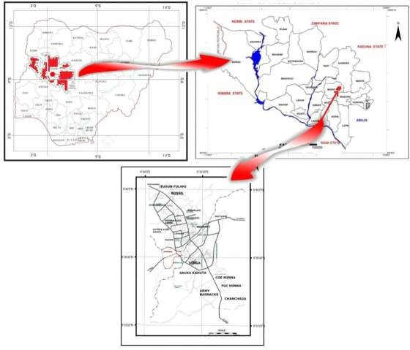

Figure 2.2: Location of Minna in Nigeria Source: Isaac *et.al.,* 2020

This location which has land area of 58.5 hectares (Kemiki, 2015), is censored to 4-9 persons per house (Isaac *et al*., 2020). However, in this research, we will take the average of 7 persons per house.

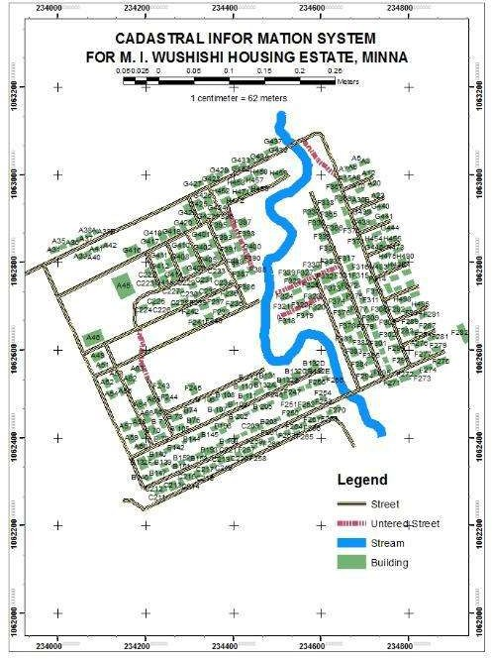

Figure 2.3: Map showing the study area Source: Kemiki ( 2015)

CHAPTER THREE

* 1. MATERIALS AND METHODS
  2. Architecture of the System

The architecture described in this section gives the ability to classify both components and interfaces (Lloret *et al.,* 2016) in the network. The architecture used is shown in Figure 3.1. This architecture is similar to the one described by Lloret *et al.* (2016) and is characterized by three layers. The first layer consists of the water meter, network device and communication protocol. In other words, it consists of the hardware, communication protocols and the network required to transmit data. In this layer, the flow rate is measured, converted to numeric data and sent to the gateway via the IEEE

802.11 technology. The second layer consists of the data receiving end also known as the cloud while the third layer consists of the artificial intelligence involved to make the system smart.

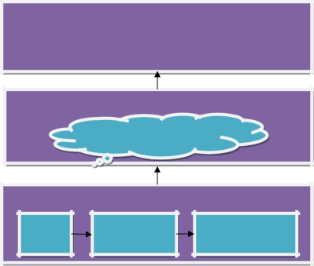

LAYER 3

Decision Tree algorithm

LAYER2

Cloud

LAYER 1

Water

meter

IEEE 802.11

Wireless router

Figure 3.1: Architecture of the System

* 1. Hardware Materials Used

In this work, the hardware is achieved with the following material:

* + 1. Flow sensor
    2. Battery
    3. Controller (Arduino Nano and Node MCU)
    4. Liquid crystal display (LCD)
    5. Relay module
    6. Solar panel
    7. Voltage conditioner
  1. Software and Tools Used

The software in this work is subdivided into firmware and application software. The firmware was implemented with C++ language on the Arduino Nano and Node MCU. The code aids the measurement of flow rate and the uploading of the numeric data that represents the flow rate to the cloud. Furthermore, PHP, MySQL, HTML and CSS were used to develop the web application for the cloud platform. Furthermore, water supply at constant flow rate and at varying flow rate based on demand was simulated on MATLAB. The system was then made smart using Decision Tree algorithm and deep neural network using python as a tool.

* 1. Hardware Design

The block diagram in Figure 3.2 shows how the node was achieved.

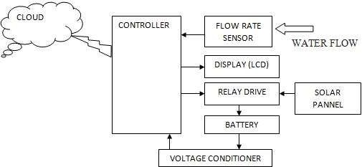

Figure 3.2: Block diagram of the hardware.

The hardware in Figure 3.2 shows the different sub units in the system. When water flows through the flowrate sensor, pulses with respect to the volume of water consumed is measured and read by the controller. This parameter, is then displayed as volume consumed on the Liquid crystal display (LCD). The same information is sent to the cloud database via the use of IP. However, since the intention is to make the system independent of public supply, the system is powered via a battery charged, using a solar panel of 8V. To avoid over-charging, a voltage conditioner helps to condition the battery voltage to values ranging from 0V to 2.5V. This fraction is fed into the analog pin of the controller. Furthermore, the system outputs logic that aids the charging of the battery by the 8V solar panel via the relay every three hours’ interval. As it charges, if the voltage read by the controller is as high as 8.2V, the controller outputs a counter control logic that de-energizes the relay, thereby terminating the charging of the batteries.

* + 1. **Controller Deployed**

To achieve compactness, the controller used for this design should have TCP/IP protocol stack, analog to digital input, consume less power and must have a medium of internet connection and digital inputs. However, due to these considerations, Node-MCU ESP8266 is used for the controller. Furthermore, because of the limitation of having just one analog to digital converter (ADC) which is less than what is needed, the Arduino Nano is used in addition to the NODE MCU to achieve desired result. Figure 3.2 shows how the Arduino Nano and the Node-MCU communicate via UART (soft serial). The transmitter pin D4 of the Arduino Nano is connected to the receiver of Node-MCU (PIN D4) while the receiver pin (D5) of the Arduino Nano is connected to the transmitter pin of the Node-MCU (D5). The Arduino nano was used to interface all other hardware including the display unit, the sensor, the relay drive and the voltage conditioner. While, the Node-MCU serves as the gateway and the timer of the whole circuit.

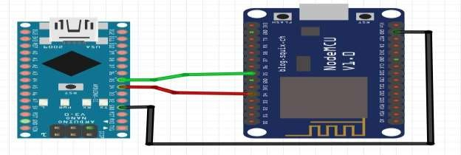

Figure 3.3: Circuit diagram of the controller.

* + 1. Flow rate sensor

The sensor used for the design of the system as shown in Figure 3.4 is YF-S201. The sensor can operate within 4.5V to 18V DC. The sensor, which can measure flow rate

between 1 to 30 liters per minutes, is connected such that the power pins are connected to Vcc and ground of the circuit, while, the point that generates the signal is connected to analog to digital converter pin (A0) of the Arduino nano controller. Figure 3.5 shows how it is set up. Its workability is hence governed by the equation:

*Q* = *vA* (3.1)

where *Q* is the flow rate

*v* is the velocity of the fluid

*A* is the cross sectional area of the pipe. Equation (1) can be rewritten as

*Q* = ( *D* )2 *v* (3.2)

##### 2

where *A* = ( *D* )2. To calculate for the volume of water consumed

2

*volume* = ( *Q T* ) m3 (3.3)

##### 60 sec

where T is the time of sensing

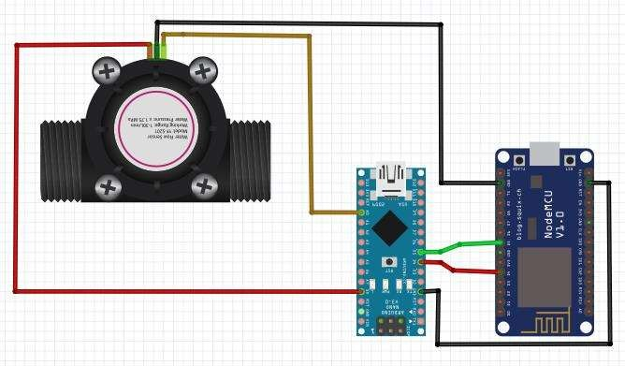

Figure 3.4: Circuit Diagram of the Flow Rate Sensor Connected to the Controller

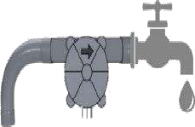

* + 1. Display

Figure 3.5: Set up of the Flow Sensor with the Tap Source: Tasong and Abao (2019)

A 16 by 2 liquid crystal display is used as shown in Figure. 3.6 to aid the display of total amount of water consumed so far. This is done to aid human to machine interaction

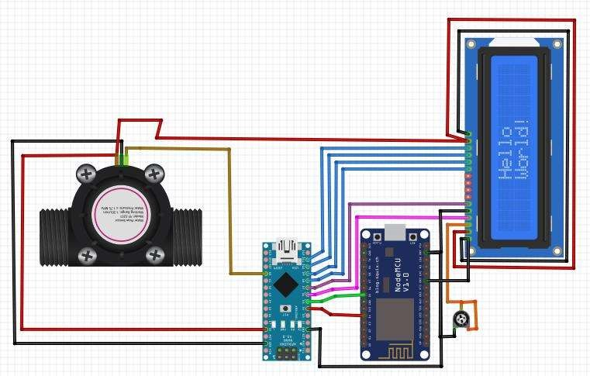

Figure 3.6: Circuit Diagram of LCD Interfaced with the System

* + 1. Power supply requirement

As recommended by the manufacturer, the controller (Node-mcu) can be powered with a 3.3V to 5V supply. Since the intention is to ensure that the system is independent of the public power supply characterized with erratic nature. A battery with voltage higher than 5V is considered suitable for optimal design. To achieve this, two 3.7V lithium batteries as shown in Figure 3.7 were connected in series so as to achieve voltage higher than 5V. Furthermore, a 7805-voltage regulator IC1 (see Figure. 3.7) was used to achieve the maximum required voltage to power the controller. The following mathematical analysis illustrated from equation 3.4 shows how the number of batteries was chosen to reduce the probability of outage

One battery produces 3.7*V* 1600*mAh*

Two batteries in series give a total voltage given as

( ) = 2 × (3.4)

= 3.7 for a lithium cell (3.5)

Therefore *Total voltage*(V*battery* ) = 2 3.7*V* = 7.4*V* 1600*mAh*

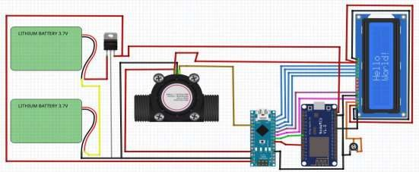

Figure 3.7: Battery Powering the System

To achieve longer periods of operation of the node, the following considerations were made based on the data sheet:

1. Maximum current consumed by the controller ( *I* max( *mcu*) ) =170*nA* (3.6)
2. Maximum current consumed by the display ( *I* max( *LCD*) ) = 2.5*mA* . (3.7)
3. Maximum current consumed by the flow-rate sensor ( *I* max( *flowrate*) ) =1.5*mA* (3.8)
4. Maximum current consumed by the relay ( *I* max( *relay*) ) = 70*mA* (3.9)
5. Maximum collector current consumed by the transistor A1015 (*I* max( *transistor* ) ) = 0.15*A* (3.10)

### V

1. Current flowing through voltage conditioner ( *I* max( *vc*) ) =

*battery*

###### R

(3.11)

Let *R* =100*k* Ω (3.12)

*I*max( *vc*) = 74 µ *A*

Total current consumed by node is given as

*I*

*total*

= *I*

max( *mcu* )

+ *I*

max( *LCD* )

+ *I*

max( *flowrate* )

+ *I*

max( *relay* )

+*I*

max( *transistor* )

+ *I*

max( *vc*)

(3.13)

*I total* = 0.161*A*

Total power supplied by the battery

### P

*battery*

= *V*

*battery*

*I*

*battery*

(3.14)

*Pbattery* = 7.4*V* 1600 *mAh* =11840*mWh*

Total power consumed by the device is given as

*P* = *V I*

(3.15)

*consumed reg total*

*Vreg* = 5*V*

##### *P* = 5 0.161 = 0.805*W*

*consumed*

The time to drain out the battery is

*P*

*T*= *battery* = 11.840 (3.16)

*drain P*

*consumed* 0.805

*Tdrain* =14.7*h*

Therefore, it takes 14.7h to drain the battery out. However, it is intended that the system should not drain the battery to a voltage less than 5.5V before charging takes place. Therefore, the time it will take to drain the battery out if it retains charge of 5.5V is given as

5.514.7 *h* = 11*h* = *T* (3.17)

7.4 *drain*(5.5)

Therefore, if fully charged, it will take *Tdrain* −*Tdrain*(5.5) hours for the battery to drain to the level of minimum threshold (5.5V) as monitored by the potentiometer in Figure 3.8. It therefore takes 4hours to drain the battery to 5.5V. Since minimum of 12 hours is needed

for night purpose, 4 pairs of this series connection are needed to achieve 4 1600 = 6400

which yields 4 4*hrs* =16*hrs* before the battery goes below 5.5V. This will be able to power the system all through the night when solar power is not available

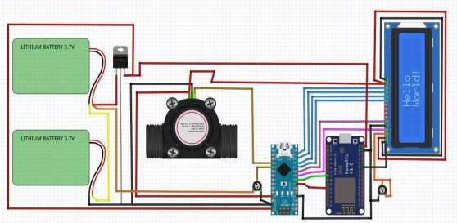

Figure 3.8: Voltage Conditioner Interfaced with the System

This unit aids the green nature of the device. This ensures that the probability of outage is as low as possible. To ensure such achievement, the solar panel used must be able to charge the system effectively.

* + 1. Charging unit

As specified earlier, to effectively power the system, 7.4V 6400mAh is needed. To charge the batteries and ensure that the life is not cut short, it is a common practice not to charge with more than one tenth of this current specification. Therefore, maximum of 6400mA current is needed to charge the specified battery cell.

To achieve full charging within three hours, the following was considered

Total battery power ( *P* ) = *V I*

*totalaB battery batterytotal* (3.18)

Note that the voltage delivered by the solar panel is 12V.

*PtotalB* = 7.4 6400 *mAh* = 47.36*watth*

Time it takes to charge the batter (*T* ) =

### P

*totalB* (3.19)

*ch* arg *ing P*

*ch* arg *ing*

Let solar panel charge with 80% of the specified charging current.

*I ch* arg*ing* = 0.8640*mA* = 0.512*A*

Charging with 12V solar panel, the voltage is regulated to 8V via voltage regulator 7808. Therefore:

Charging power ( *P* ) = 0.512 8 = 4.096*W* (3.20)

*ch* arg*ing*

Charging time (*T* ) = 47.36 =11.6*h* (3.21)

*ch* arg*ing* 4.096

This means it takes 11.6 hours to charge the battery when completely drained.

If it takes 11.6 hours to charge 7.4V battery, it will take:

11.65.5 = 8.6*h* to charge it to 5.5V.



##### 7.4

Therefore, it will take 3 hours to charge from 5.5V to full capacity. To control the charging, a relay module is used to cut off power from the charging unit when the battery is fully charged as shown in Figure 3.9.

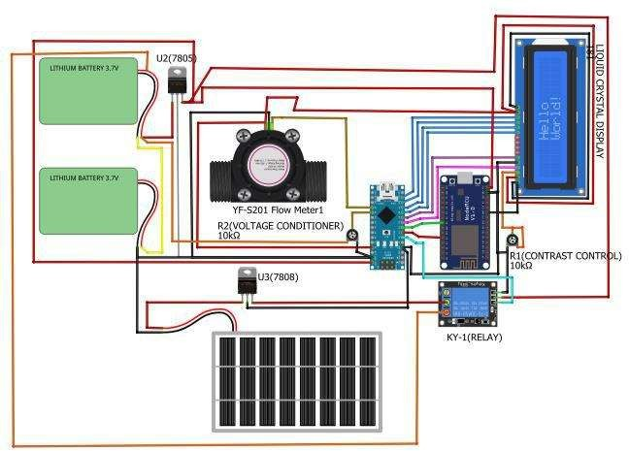

Figure 3.9: Complete Circuit Diagram

* 1. **Mode of Communication**

Generally, the mode of communication for IoT is classified into wired and wireless network. The wired network which includes, the use of Public Switch Telephone Network (PSTN), Fiber to Home (FTTx) and Asymmetric Digital Subscriber Line (Lloret

*et al.,* 2016) is limited since the range of communication is determined by the length of physical carrier such as cables. This makes wireless communication the most preferred choice for communication.

In the use of wireless communication, several solutions are available. This includes Terrestrial Trunk Radio (TETRA), 2G Global System for Mobile (GSM) communication, General Packet Radio Service (GPRS), 3G Universal Mobile Telecommunication System (UMTS) and Long-Range radios (LoRA). The diversity of these solutions contributes to the difficulty of IoT solutions being inter-operatable. In other words, two IoT solutions from different vendors can’t be used even if they solve same problems. However, in this research, the technology to be used must be available and affordable. Furthermore, it should be able to relay data through the mobile network to the cloud at short range so as to avoid channel impact such as reflection, detraction and signal absorption leading to weak signal that may result to data loss. This makes IEEE 802.11(WiFi) a better choice.

* 1. Principle of Operation

When the system is powered, the Liquid crystal displays the name of the project afterwards, when the Arduino Nano and Node-Mcu is fully booted. When water flows through the flow rate sensor, it generates pulses that are counted by the Arduino nano and converted to liters. Concurrently, the Node-Mcu begins a delay sequence. After 14 minutes 30 seconds, its demands all that have been recorded. The consumption data is then sent to the Node-Mcu which is the forwarded to the web site that contains the data base. Plate II, Plate III, and Plate IV shows the developed IoT system.

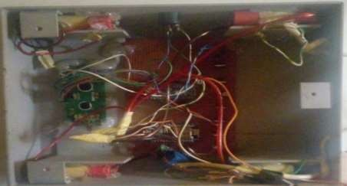

Plate II: The Developed Circuit in a Case

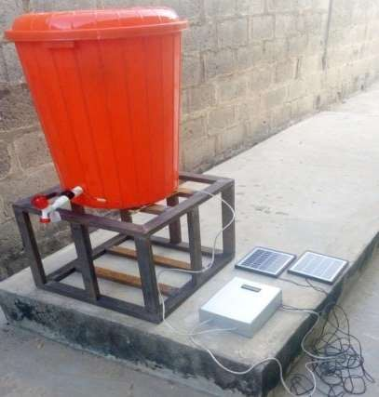

Plate III: Complete system setup.

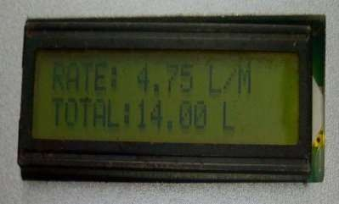

Plate IV: Display of Developed IoT Water Meter

* 1. Flow Chart for the Firmware

The diagram in Figure 3.9 shows the flow chart that is implemented on the hardware. Connection to the internet is first established via Wi-Fi. Afterwards, the hardware initiates access to the database. If it did not succeed, an error message is outputted on the UART terminal. However, if it succeeds, it initiates a 14-minute 30 seconds timer and checks if there is flow of water. If there is, it counts the pulses generated by the sensor and then converts it to liters. This consumption in liters is displayed on the Liquid Crystal display. Furthermore, same data is updated in the cloud if the timer initiated has elapsed. This process starts over again.

START

INITIATE WIFI CONNECTION

IS WIFI NO

CONNECTED?

YES

INITIATE ACCESS TO DATABASE

IS DATABASE

ACCESSED?

YES

START TIMER

OUTPUT ERROR

NO MESSAGE ON

UART WINDOW

NO

IS WATER FLOWING?

YES

COUNT PULSES AND CONVERT TO LITERS

DISPLAY CONSUMPTION IN LITERS

NO IS YES TIME=13MIN?

OUTPUT DATA TO CLOUD

END

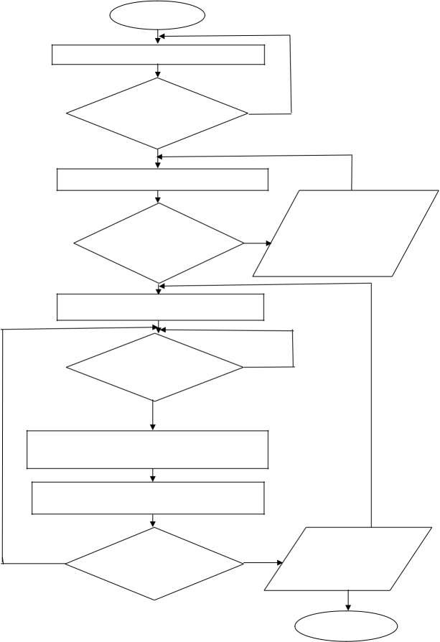

Figure 3.10 Flow Chart Implemented in the Firmware

* 1. Development of Web Platform

This was achieved via the use of a paid web platform hosted with Qserer.com the PHP script was written on notepad ++ and uploaded to the website after a domain name was created for the project. These scripts are presented in appendix B.

* 1. Mathematical Expression Representation of the Daily Pumping of Water at Constant Valve Resistance

Since the system cannot be actualized in reality due to tight budget, MATLAB was used to simulate the normal practice of distribution involving the use of constant valve resistance. To do this, a mathematical model was developed based on assumptions and calculations shown in the next section.

* + 1. Volume of water required, estimated for study area

According to the World Health Organization, the required volume per person per day is 50 litres (Wutich, 2019). Isaac *et al.,*(2020) stated that the number of persons per house hold in the study is between 4 to 9 persons. However, according to Razack *et al.*(2013), the population based on 2006 censors is 5 to 7 persons per household resulting to a total population of 5000 (Razack et al., 2013). This therefore implies that,

*y* = *x z* (3.22)

where y is the total volume of water needed for the study area, x is the required volume of water as specified by WHO and z is the total population.

*y* = 50 5000 *y*

= 250, 000*l*

* + 1. Simulation and assumptions

For the purpose of simulation, it is assumed that the source of water for the study area is an elevated tank with an electrical controlled valve. This will aid the variance in the resistance of water flow so as to optimize pumping operation, leading to water conservation. To simulate this, the mathematical model of a leaking tank as shown in equation (3.12) was adopted. Furthermore, it was also assumed that those that are residences of the estate are working with the state government. This, therefore means that large population in that area goes to work by 8:00am and comes back from work at most by 4:20pm after they close by 4:00pm.

Mathematical equation for the tank.

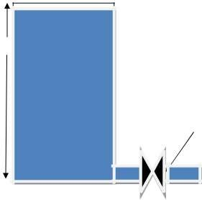As shown in Figure 3.11, it is assumed that the tank is cylindrical in nature. For that, the difference between the water inflow and the out flow will be the rate of change of the volume of water in the tank with respect to time. Furthermore, it is equal to the product if the rate of change in height of water with respect to time and the cross-sectional area of the tank.

TANK

H

valve with resistance R

Figure 3.11: Analogical representation of the tank

This is expressed as:

*dV* = *A dH* = *Fin* − *Fout* (3.23)

*dt dt*

where V= volume of the water in the tank, A= cross sectional area of the tank, H is the height of water in the tank, Fin= flow-rate of water going into the tank and Fout = flow- rate of water expelled out of the tank via the valve.

Assuming flow rate of water in the tank is 0 (Fin=0) and atmospheric pressure is considered negligible and the tank is full at every point in the tank, then:

*Fin* = 0 (3.24)

*H*

( *t* )

*Fout* =

*R*

(3.25)

where R is the resistance of the valve

#### H

*A dH* = −

( *t* )

(3.26)

*dt R*

However, equation (3.12) is the equation used for simulating both constant flow rate and varying flow rate. The difference between both is that for varying flow rate, the resistance will vary while for constant flow rate, the resistance is constant. To calculate for the minimum resistance, the volume of the tank is express as:

*V*=*AH* (3.27)

Let the height (H) of the tank be 10m.

*V* = 250000*l* = 250*m*3

*A* = *V* = 250 = 25*m*2 (3.28)

*H* 10

Remember that the larger the height H the more the pressure. While the closer the height of water in the tank is to the orifice, the lower the pressure. Therefore, a resistance R of the valve must be chosen such that the pressure for water will aid efficient delivery. Let us consider H to be as small as 0.142m

*R* = *H dvdt*

(3.29)

## 84600 *s*

*R* = 0.142 250

*R* = 48 sss

This is then simulated on MATLAB (Simulink) with constant resistance to flow of 48. To achieve water distribution resilience by varying the flow resistance, the following was assumption was made:

* + - 1. All residence in the estate are state government workers, therefore, they as well as their children will leave their homes every working day (Monday to Friday) by 8:00am. Therefore, the need for water will be minimal. However, it is important to note that water should not be totally cut of as suggested by some literatures as some people such as house wives and may be at home. With this practice and with leaking pipes around loss is minimized.
      2. Some children will be back by 2:00pm while the parents will be back by 4:00pm. At this point the demand for water increases to some level at 2:00pm and will be at peak at 4:00pm.
      3. Also, it is assumed that there is a time during the day when human activity places no much demand on water. This time from 9:00pm till 4:00am the next day, is assumed to be characterized with the lowest demand of water.

With these assumptions, since during the day from 8:00am to 2:00 pm the water needed

will be at minimum. To achieve this, let the resistance of the valve be increased by 30%

#### R

3 = (0.30 *R*) + *R*

*R*3 = (0.3 48) + 48 = 62.4

Furthermore, since some children will return back home by 2:00pm the demand will increase. Therefore, let the resistance R be increased by 13%

(3.30)

*R*2 = (0.14*R*)+*R*

#### R

2 = (0.1448) + 48 = 54.72 (3.31)

The distribution with respect to time and pump supply level is shown in the Table 3.1. Table 3.1: A table of supply level distribution of water needed in M.I. Wushishi

|  |  |  |  |  |  |
| --- | --- | --- | --- | --- | --- |
| **S/N** | **Time** | **Time in**  **seconds** | **Pump Level** | **Resistance at**  **pump level** | **Supply level**  **description** |
| **1.** | 12:00am-  05:00am | 0-18000 | 3 | R3 | Minimum |
| **2.** | 05:00am-  08:00am | 18000-28800 | 1 | R1 | Peak |
| **3.** | 08:00am-  02:00pm | 28800-50400 | 3 | R3 | Minimum |
| **4.** | 02:00pm-  04:00pm | 50400-57600 | 2 | R2 | Average |
| **5.** | 04:00pm-  09:00pm | 57600-75600 | 1 | R1 | Peak |
| **6.** | 09:00pm-  00:00am | 75600-86400 | 3 | R3 | Minimum |

* + 1. Smart network

The WDN was made smart via the use of a decision tree ML and autoencoding deep learning (DL) algorithms. The autoencoder helps to identify the different valve resistance within the data generated. The model diagram in Figure 3.12 describes the process involved in using the model.

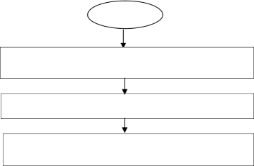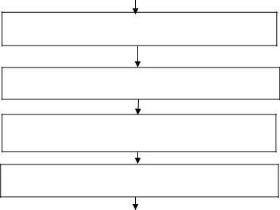

START

READ DATA

DATA PREPROCESSING

DIMENSIONAL REDUCTION VIA THE USE OF

AUTOENCODERS

SPLIT DATA INTO TEST DATA AND TRAINING DATA

BUILD THE DECISION TREE NETWORK

TRAIN THE NETWORK

EVALUATE MODEL

END

Figure 3.12: Work flow in executing decision tree algorithm to aid smartness.

* + 1. Data Generated

The data used in the ML was generated from the previous simulations that typifies an IoT node installed at the point of water delivery. The data is characterized with three attributes and three labeled called class. The total number of samples is 20001 generated at an interval of 10 seconds. Table 3.2 shows the summary of the data

Table 3.2: Summary of the Data Used

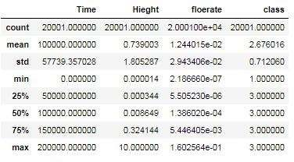

* + 1. **Data preprocessing**

The data used was preprocessed to ensure that there are no missing data from within the table. This was done via the use of pandas. This step is one of the important steps in Machine Learning so that the algorithm returns better results.

* + 1. **Deep neural network enhancement**

The deep neural network used to enhance the automation of the system is Autoencoder. The Autoencoder used in this work aids the replication of the input at the output. The model which consists of an encoder with an encoding function E(x) and a decoder with a decoding function of D(x) first compresses the input into a latent space. Afterwards, the input is recreated at the output via the decoder Figure 3.13 and Figure 3.14 shows the

architecture of the model. As a result of its use, the model is used to ascertain the classes of the valve resistance. To do that, the output sequence is compared to the input sequence to see if there is an error in the replication.

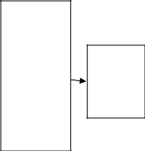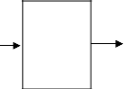

Input

sequence

Output

sequence.

Encoder

Decoder

Encoded

sequence

Figure 3.13: Architecture of an autoencoder model.

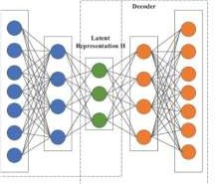

Figure 3.14: Representation of an autoencoder (Mac et al., 2018)

If the encoder and decoder transition is represented as α and β respectively. The transition can be represented as α: *X* → *F* this shows the transition of series data *X* transformed to a compressed data *F* which is reconstructed by β: *F* → *X* Therefore, the encoder

decoder transition can be represented as , = arg min  *X* − ( ) 2 . In other words,

,

if *x d* = *X* at the input is to be reconstructed at the output, it will first be mapped to

ħ *p* = *F* where ħ= (Wx+b). is the activation function, W is the weight and the

bios is b at the encoder. The output is then reconstructed as x = (W ħ+b ) at the

decoder.

* + 1. Data splitting

Generally, the data used for machine learning has to be split into test and train dataset. This is done so as to ensure that the algorithm do not learn the whole dataset. The training data is what the algorithm uses to learn while the test data is used to validate the accuracy of prediction of the target or the output. However, there are no valid split measure. Some researchers did 60% training data and 40% test or validation data. Some others 75% training data and 25% validation data. The main idea is to have more data for training and the remaining for validation. In this research, we will choose 70% for training while 30% of the data will be used for validation. The test data is shown in Figure

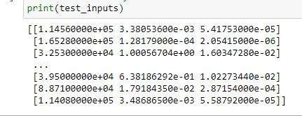

Figure 3.15: Test Data used

* + 1. The Decision Tree Algorithm

This algorithm was designed for supervised learning. In other words, the algorithm which often time used for classification and regression, works with data that consists of attributes and labeled targets when used for classification. The aim of using this algorithm is to predict the class of the resistance in the flow of water per time as water is delivered

to the study area based on demand. This is achieved via adhering to decision rules inferred from data used in training the model. At the end, the classifier which is a tree structured classifier will use the internal nodes called the attributes to build branches also known as decision rules to achieve the leaf nodes which are the outcomes. To do that, a Classification and Regression Tree Algorithm (CART) was used.

* + 1. Mode of operation of CART algorithm.

To predict the resistance of the flow, the model is trained with attributes which includes time in seconds, water height in elevated tank and flow rate. This resides in the root node. To proceed with the process, the model asks relevant true or false questions. Based on the answers, the root node is divided into sub nodes called child node. The reason for this sub division is to produce the purest possible distribution of the label. For every child node with mixed labels, further questions are asked so as to further divide child node into more child node until all labels are in their purest forms. To know what questions and when to ask such questions, the parameters called Gini impurities or Gini index and information gain are so important. Gini impurity or Gini index as shown in equation (13) is used to quantify the amount of uncertainty while the information gain on (14) helps to quantify how much uncertainty is reduced by the questions asked. The points when further questions can’t be asked, a leaf is added to the tree. All these are done by iterating though the attributes.

*Gini impurity* = 1 − *pi* (3.32)

*pi* is the probability of an item or feature with label *i*

inf *ormation* _ *gain* = *Entropy* ( *s* ) − [( *weighted* _ *Avg* ) *Entropy* (*each* _ *features*)] (3.33)

Entropy in the above equation is the measure of impurity in a given option. It measures randomness in the data and given as:

*Entropy* = − *p* ( *yes* ) log 2 *p* ( *yes* ) − *p* ( *no* ) log 2 ( *no*) (3.34)

* + 1. Evaluation of the model

To evaluate the performance of the model, the accuracy score was used. The test data was inputted for prediction to get the predicted target (flow resistance). Afterwards, the accuracy score was computed and this score was compared with other existing works.

* 1. Physical architectural setup

This subsection presents how the system was deployed in Figure 3.16. The overhead tank was filled with water to a height of 10m. The electrically controlled valve is to be connected to the cloud where the AI algorithm is being run. As the taps in different homes (home1 to home N) is opened at different times of the day, the demand is logged into the cloud. As the total of the demand data is computed as a test data, the valve resistance is predicted and the valve controlled to resist flow of the water based in demand.

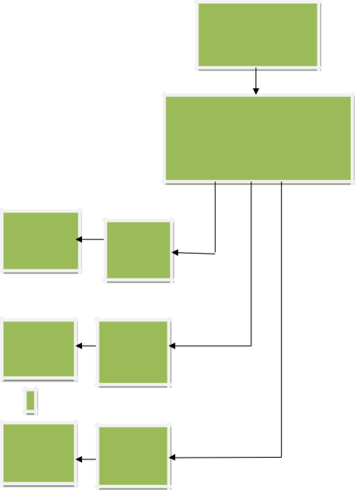

OVER HEAD TANK

ELECTRICAL CONTROLLED VALVE

HOUSE 1

NODE1

HOUSE2

NODE2

HOUSE N

NODE3

Figure 3.16: General Deployment Architecture

CHAPTER FOUR

* 1. **RESULTS AND DISCUSSION**

This chapter presents the performance of the developed IoT device in terms of data logged on line in graphical form. Furthermore, its performance in terms of data loss was evaluated. Similarly, the graphical representation of the simulations of water pumped to the area of study at constant and varying flow resistance is presented and analyzed. Afterwards, both simulated scenarios are compared to see if any optimization is achieved in terms of water conservation. The use of AI for class predication of flow resistance at every point in time so as to ensure the smartness of the system is analyzed in this section. The accuracy of the ML is the metrics used to compare it with already existing results.

* 1. Highlights of Expected Result and Discursion

The results are taken section by section so that the objective of the project is addressed one after the other. These results are as follows

* + 1. Performance of the IoT node.
    2. Simulated result for water supply with constant flow rate
    3. Simulated result for water supply at varying flow rate based on demand
    4. The decision tree and deep learning model to enhance the smartness of the system
    5. Performance evaluation of the system.
  1. Performance of the IoT Node

The system designed and developed was deployed in two different homes in M.I Wushishi estate so as to understand the consumption pattern as specified in objective one. The data uploaded are shown in graphical form in Figure 4.1 and Figure 4.2. To ascertain the efficiency of the system, data loss quality category assessment by TIPHON suggested by Hw *et. al.,*(2018) was carried out. Plate V shows the table generated on the database

from the server for house A when node is connected to public supply alone. Furthermore, Plate VI shows the data generated in house B when the node is powered using public power supply. This can be found in <http://iot.sedimdatacenter.com/>

username is [fut@gmail.com](mailto:fut@gmail.com) and password is abc123. Click on house on the left panel to

access the database

Water consumption in house A when node is connected to public power supply

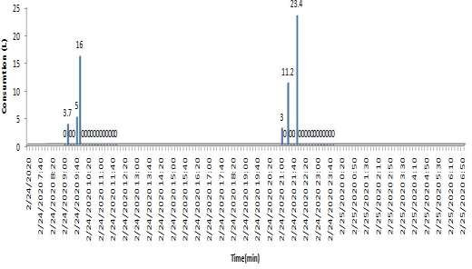

Figure 4.1: Graphical representation of water consumed in House A when the node is connected to public power supply

Consumption of water in house B when node is connected to public power supply

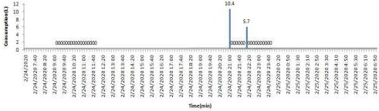

Figure 4.2: Graphical Representation of Water Consumed in House B when the Node is Connected to Public Power Supply

From the above it is observed that there are a lot of missing data due to the erratic nature of power supply from the public grid. The data generated these graphs on the server was downloaded as .CSV file. This file was preprocessed to revalidate points when the server was not accessed due to power failure. This is evident via the time difference which does not follow the interval of data capture it was designed for shown in Plate VII and plate VIII

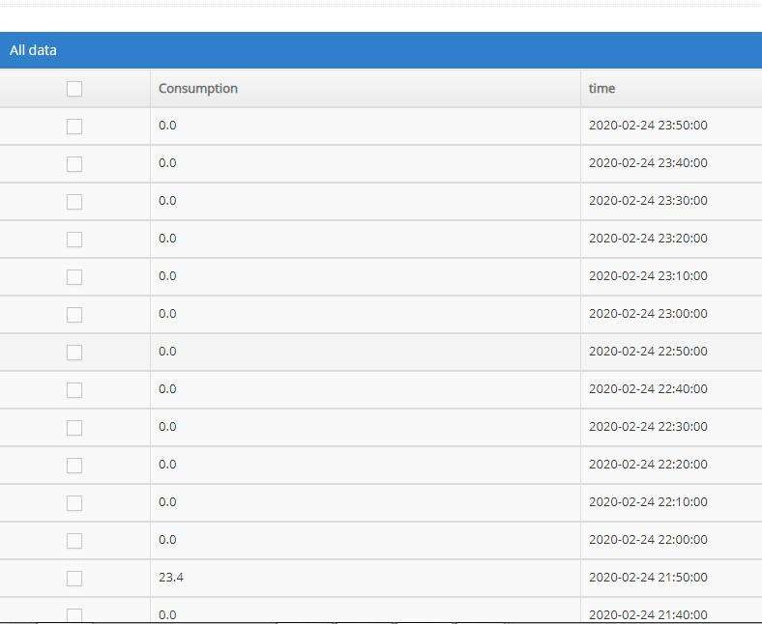

Plate V: Pictorial view of the table from server depicting the water consumed in house A with public supply.

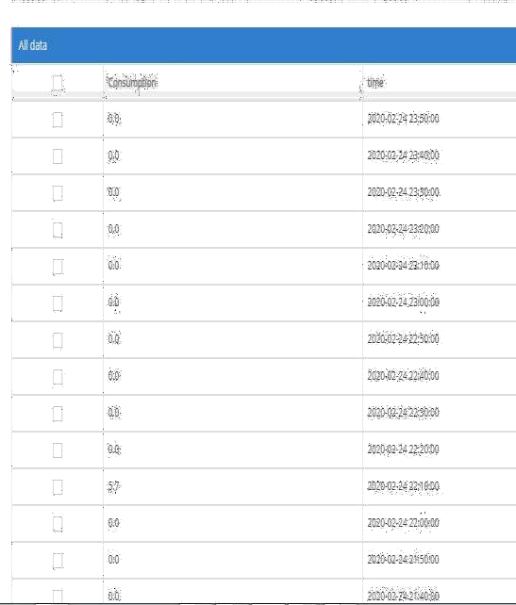

Plate VI: Pictorial view of the table from server depicting the water consumed in house B with public supply.

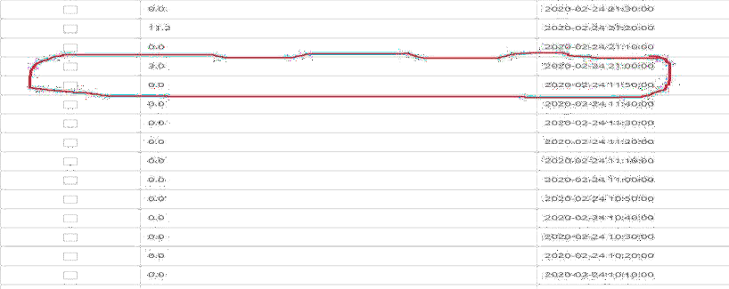

Plate VII: Time difference on the data to show missen data in experiments for house A

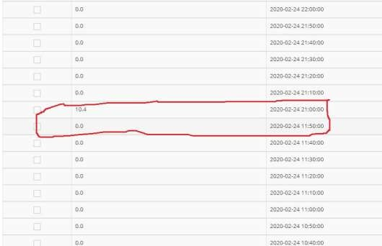.

Plate VIII: Time difference on the data to show missen data in experiments for house B

Analyzing the data using pandas, after importing the different libraries needed, the data was read and a line of code was used to check if there are missen data as shown in Plate

X From the result generated, the column called consumption had missen data. This is also reflected in Plate IX

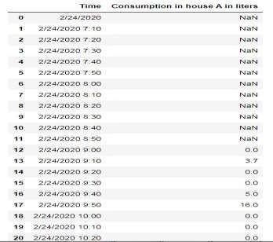

Plate IX: Pictorial view of the missien data. The missen data is represented as NAN in the table.

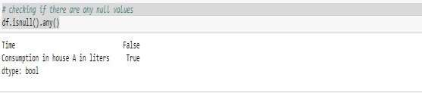

Plate X: Picture of the result of the analysis of the data of house A that shows missing data when the node is powered with public power suply

To calculate the data loss interms of efficiency for house A

%*dataloss* = *data* _ *sent* − *data* _ *recieved* 100 (3.35)

*total* _ *data* _ *sent*

*total* _ *data* _ *sent* =145

*total* _ *data* _ *recieved* = 35

# (145 −35)

%*dataloss* = 100 = 75.8%

For House B

*total* _ *data* _ *sent* =145

*total* _ *data* _ *recieved* = 35

# (145 −35)

%*dataloss* = 100 = 75.8%

Comparing the data loss with the one presented on the table in the paper presented by Hw *et al.* (2018). It was observed that the data loss is greater than 24%. These two results however, is tagged poor data according to TIPHON. This however, cannot gives a good understanding of the demand pattern of the occupants of the buildings. This necessitates the powering of the node with green source as designed. Figure 4.3 and Figure 4.4 shows the graphical representation of the uploaded data in the cloud and the percentage data loss is computed.

Water Consumption in house A when node has green power source

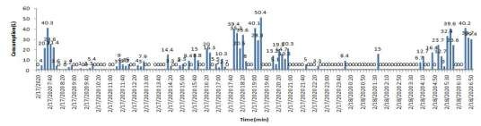

Figure 4.3: Graphical representation of water consumed in House A when the node is connected to green power supply

To calculate for the performance or the efficiency of the device for House A in terms of data loss

*total* _ *data* _ *sent* =145

*total* _ *data* _ *recieved* =141

## (145 −141)

%*dataloss* = 100 = 2.8%



##### 145

Consumption in house B when node is powered with green source

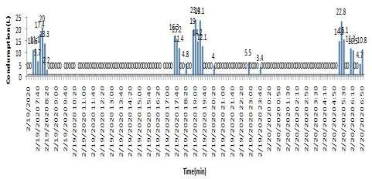

Figure 4.4: Graphical representation of water consumed in House B when the node is connected to green power supply

For House B

*total* _ *data* _ *sent* =145

*total* _ *data* _ *recieved* =142

## (145 −142)

%*dataloss* = 100 = 2.07%



##### 145

Comparing the percentage data loss with TIPHON specification, the efficiency of the node is enhanced with the green power supply as both are considered as very good data.

* 1. **Consumption Pattern Implication**

As observed in Figure 4.3 and Figure 4.4, the time water is most needed is from 4:00am to 8:00am in the morning. However, due to the presence few unemployed dependents like house helps and house wives, the demand is reduced all through from 8:00am to 2:00pm before increasing a bit as a result of the return of children comes back from school. The demand spikes up as from 4:00pm till 9:00pm when all occupants of the house are around.

* 1. Simulation For Water Supply at Constant Valve Flow Resistance for the Study Area

In normal pump operation, water is pumped at constant valve resistance leading to constant flow resistance. This is done to ensure that maximum pressure is achieved so that the homes at the extreme part of the network are served. This is simulated using Simulink MATLAB and presented in Figure 4.5 to address objective 2. This gives it a

## 1

flow rate of *R H*( *t* ) = 0.021 H(t) m/s

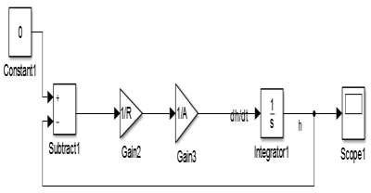

Figure 4.5: Simulation model of the tank supplying water to the area of study at constant maximum flow rate.

* 1. Simulation for Varying Valve Resistance in WDN

To aid water conservation, Figure 4.6 shows the simulation of the valve resistance or the flow resistance varied at different times based on demand as studied in the demand pattern of two extreme cases in the estate is presented. This design is based on the observations in Figure 4.3 and Figure 4.4. Furthermore, the assumptions in Table 1.0 presented previously in chapter 3 was considered. From this model, it is observed that the resistance of the valve is changed at different time bound in the network. However, it is important to note that there was no time that the supply was cut off. With this, the pumping of water at varying resistance was achieved.

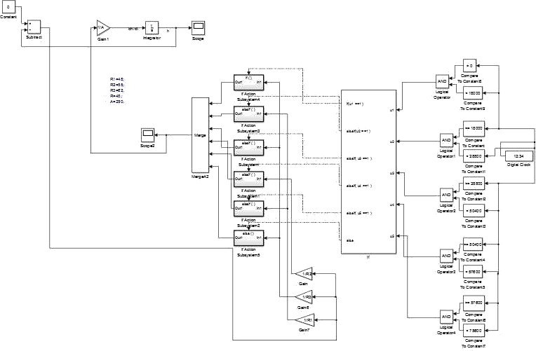

Figure 4.6: Model to Simulate of Varying Valve Resistance Based on Demand in a

WDN.

* 1. Optimization of Water Supply

The graphical representation in Figure 4.7 is the result generated from the method shown in Figure 4.5 (objective two). This shows how water is gradually used up in the tank at constant flow resistance. At a resistance of 48, it is observed that the water in the tank totally finishes at 84570 seconds.

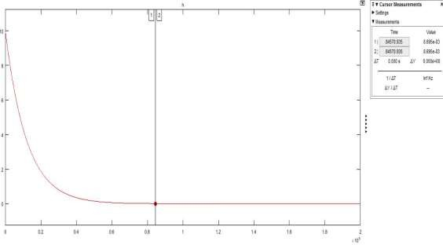

Figure 4.7: Graphical representation of who water is used up in the elevated tank in MI. Wushishi.

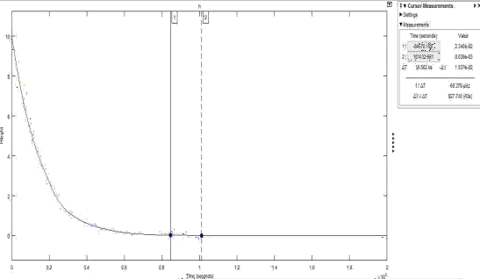

Figure 4.8: Graphical illustration of drained elevated tank as a result of varying valve resistance.

In Figure 4.8, the graphical illustration of the result of the method for objective three shown in Figure 4.6 is presented. As a result of the variation in the resistance of the valve, it is observed that some water is saved as the time for total drain is 101,132 seconds.

*difference* _ *in* _ *time* = 101132 − 84570 =16562*s*

*differenc* _ *in* _ *time* = 16562

1

60 60

*difference* _ *in* _ *time* = 4.6*hrs*

*change* _ *in* _ *H* = 0.01536

*change* _ *in* _ *V* = *Change* _ *in* _ *H A change* _ *in* _ *V* = 0.01536 250

*change* _ *in* _ *V* = 3.84 *m* 3 = 3840*l* per day.

By comparing these two results, it is observed that 3840l of water is saved per day. However, in one year, 1351680 litres will be conserved. However, it can be concluded that water has been conserved.

* + 1. **Valve Resistance**

In Figure 4.9, the valve resistance is plotted against time to be able to observe the behavior of the network in pump operation. The resistance R1 which is 48(s/m2) is the

least resistance that will enhance maximum flow.

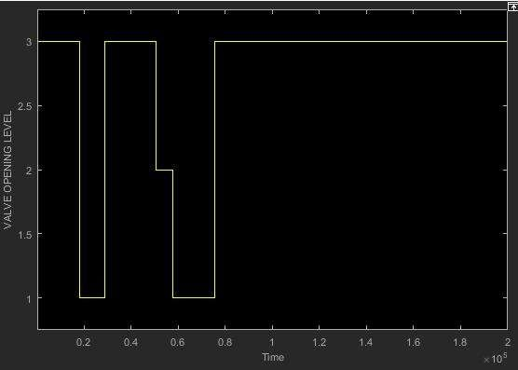

Figure 4.9: Graphical Representation of Valve Resistance with Time

Furthermore, the resistance R2 is the resistance in-between the lowest resistance and the highest resistance which is R3. R1 is denoted as ‘1’, R2 as ‘2’ and R3 as ‘3’. From the graph in Figure 4.9, it is observed that the valve poses highest resistance from 12:00 am which is 0 seconds to 4:00am which is 1800 seconds. This is because, residence of the estate will be sleeping at that time. At 4:00 am, some residence will have woken up to

start preparing for the day’s work. For this reason, the valve is characterized with the least resistance R1 to give maximum flow of water. This however, continues till 8:00am (28800s) when huge number of the residence of the estate will have left for work and children left for school. At this point, the resistance increases to the highest so that low flow is achieved. It maintains this until 2:00pm (50400s) when children are back from school. At this time, it increases the flow to medium. By 4:00pm (57600s) when everyone is back at home the valve resistance drops to the lowest till 9:00pm (75600s) so that the flow will be at its highest pressure before the resistance increases to the highest because of less activity with water from past 9pm till 12am. This however can be illustrated via the use of fuzzy as shown in Figure.4.10 with a set of rules

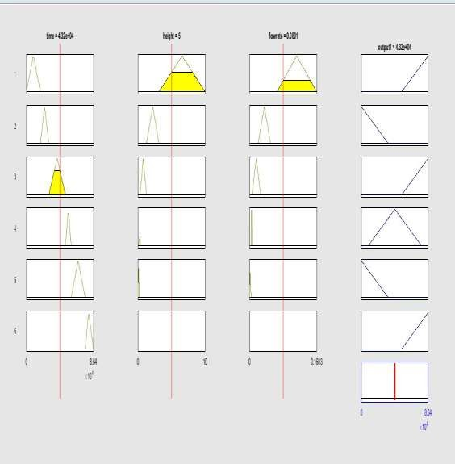

Figure 4.10: Fuzzy representation of pump operation.

* + 1. **Fuzzy Behavior of the System**

As seen, the system obeys some set of fuzzy rules which is explained in the Figure 4.11 to Figure. 4.16. In Figure. 4.11. the rule states that when the time is between 0 sec which is 12:00 am to 18000 seconds, at about 5:00 am and the height of the water in the tank is between 10m to 3.13m with the flow rate between 0.16m3/s to 0.0652m3/s the

resistance of the valve increases to the peak Limiting the flow of water by reducing the pressure to minimum though not zero. This is because at that time, the occupants of the estate are at sleep so the demand of water is at its minimum.

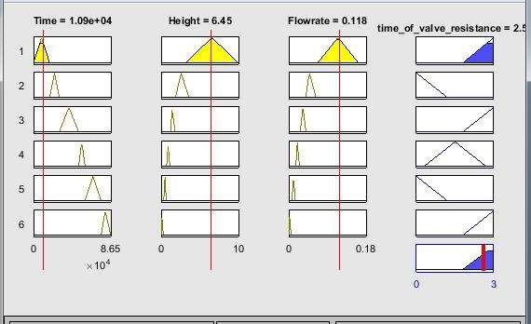

Figure 4.11: Graphical representation of high valve resistance from 12:00am to 5:00am Figure. 4.12 shows the behavior of the system where the resistance of the valve is reduced to the minimum so as to aid much flow of water. At this point, time is between 18000 to 28800 which is between 5:00am to 8:00 am. Furthermore, the height of water in the tank is from 3.13m to 1.27m with the flow rate ranging between 0.065m3/s to

0.020m3/s. The reason for this reduction in valve resistance is to increase flow since there in an increase in demand as the occupants prepare to go to work or to school.

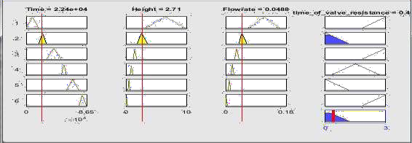

Figure 4.12: Graphical representation of low valve resistance from 5:00am to 8:00am

Figure 4.13 showns an increase in the valve resistance when the time is between 28800sec (8:00am) to 50400sec(2:00pm). At this point, the height of the water in the tank is between 0.31m to 1.27m and the flow rate is between 0.005 m3/s to 0.02 m3/s.

the reason for the decrease is as a result of more people out of the home to work. Therefore, demand is reduced.

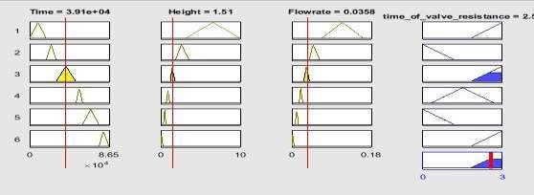

Figure 4.13: Graphical representation of low valve resistance from 8:00am and 2:00pm. As children comes back from school at about 2:00pm, the valve resistance will increase. However, not to the maximum. it will be at an average between the highest resistance and the lowest resistance. This will happen between 2:00pm to 4:00pm. At this point the height of water in the tank is 0.18m to 0.31m while the flow rate is between 0,003 m3/s

to 0.005 m3/s. Figure 4.14 illustrates this.

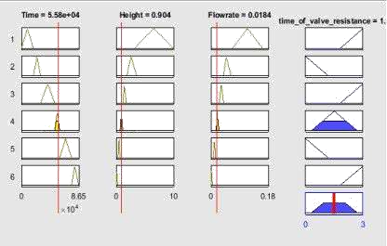

Figure 4.14: Graphical representation of low valve resistance from 2:00pm to 4:00pm.

At 4:00pm, when workers will be closed from work, the population density in the area will be at its full capacity. For that reason there will be a need to reduce the valve resistance to ensure maximum flow of water. This is illustrated in Figure 4.15. This valve resistance is maintained till 9:00pm

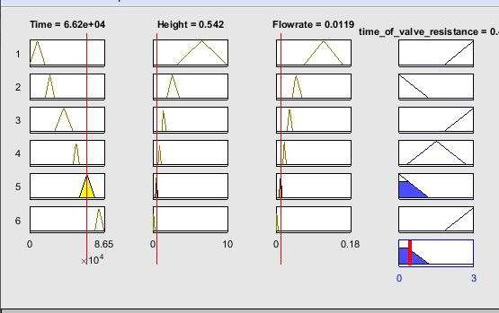

Figure 4.15: Graphical representation of low valve resistance from 4:00pm to 9:00pm.

As from 9:00pm till 12:00am, human activity will reduce. At that point most of the population will be in bed. This will aid the decline in demand. For this reason, the valve resistance will increase to its maximum value. This is shown in Figure 4.16.

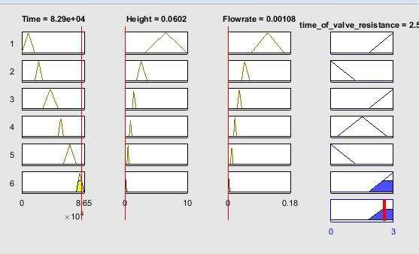

Figure 4.16: Graphical representation of low valve resistance from 9:00pm to 12:00am.

* 1. Performance Evaluation of Prediction Model

In making the system smart, decision tree algorithm was employed to aid the prediction of the valve resistance at every point in time. The metrics used to evaluate the performance of the system is accuracy. The accuracy of prediction is 94.2% as shown in Figure4.11. compared to the result in the multiclass classification done by Apostol & Mocanu, (2020) that got 86.3% accuracy as the best accuracy used. The decision tree used ordinary decision tree while what was used in this research is deep neural decision tree.

,

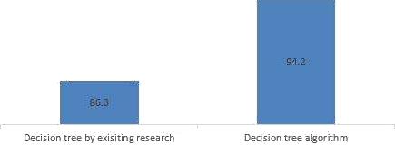

Figure 4.17: Graphical Representation of Compared Result

CHAPTER FIVE

* 1. **CONCLUSION AND RECOMMENDATION**
  2. Conclusion

In the quest to save water which is a scarce resource, this research has presented an efficient IoT based water meter used to study the behavioral pattern of consumers in the study area. The system which was made efficient via the use of green power supply, shows the pattern of water demand which was used to simulate the usual practice of supplying water at constant flow rate and the simulation of water supply with varying flow resistance using MATLAB. Comparing both practices, it is established that water can be saved without totally cutting off supply from a part of the network. Furthermore, to make the system smart, a decision tree algorithm with a deep neural network was used to predict the class of flow resistance at different time of the day based on demand. With this, the aim of the project, the development of an internet of things based water management system using decision tree and deep neural network algorithms was achieved.

* 1. Recommendations

More nodes can be built and installed for data gathering so as to deploy the system in real life situation.

**5.3. Future work**

In the future, it is the intention of the researcher to implement and analyze better ways of conserving water in the study area and in Nigeria as a whole.

REFERENCES

Abdallah, M. A. Y. (2020). Pump Scheduling for Optimised Energy Cost and Water Quality in Water Distribution Networks. *Doctorial Dissertation, University of Exeter*, *Colledge of Engineering Mathematicd and Physical Science, 1-167*

Abrishambaf, O, Faria, P., Vale, Z., & Corchado, J. (2019). Energy Scheduling Using Decision Trees and Emulation : Agriculture Irrigation with Run-of-the-River Hydroelectricity and a PV Case Study. *Energies*, *12*(20), 3987.

Abrishambaf, Omid, Faria, P., & Vale, Z. (2020). Emulation of Energy Scheduling for an Agriculture Irrigation System Considering Field Data. *2020 IEEE International Conference on Enviroment and Electrical Engineering and 2020 IEEE Industrial and Comercial Power System Europe (EEEIC/I &CPS Europe). IEEE,* 1–6.

Abrishambaf, Omid, Faria, P., & Vale, Z. (2019). Energy Resource Scheduling in an Agriculture System Using a Decision Tree Approach. *20th International Confrence on Intelligent System Application to Power System(ISAP) IEEE*, 1–5.

Abu-Mahfouz, A. M., Hamam, Y., Page, P. R., Djouani, K., & Kurien, A. (2016). Real- time Dynamic Hydraulic Model for Potable Water Loss Reduction. *Procedia Engineering*, *154*, 99–106. https://doi.org/10.1016/j.proeng.2016.07.426

Ahmed, E., Yaqoob, I., Hashem, I. A. T., Khan, I., Ahmed, A. I. A., Imran, M., & Vasilakos, A. V. (2017). The role of big data analytics in Internet of Things.

*Computer Networks*, *129*(December), 459–471. https://doi.org/10.1016/j.comnet.2017.06.013

Amali, S., Faddouli, N. E. L., & Boutoulout, A. (2018). Machine Learning and Graph Theory to Optimize Drinking Water. *Procedia Computer Science*, *127*, 310–319. https://doi.org/10.1016/j.procs.2018.01.127

Apostol, E., & Mocanu, M. (2020). An Advanced Learning-Based Multiple Model Control Supervisor for Pumping Stations in a Smart Water Distribution System. *Mathematics 8*(887), 1–27. https://doi.org/10.3390/math8060887

Archetti, F., Candelieri, A., & Perego, R. (2018). Bayesian optimization of pump operations in water. *Journal of Global Optimization*. 7(1), 213-235 https://doi.org/10.1007/s10898-018-0641-2

Balekelayi, N., & Tesfamariam, S. (2017). Optimization techniques used in design and operations of water distribution networks : a review and comparative study.

*Sustainable and Resilient Infrastructure*, *9689*(July), 1–16. https://doi.org/10.1080/23789689.2017.1328921

Bhoyar, D., & Ingle, M. (2019). LoRa Technology Based Low Cost Water Meter Reading System. *Confrenece of Internet of Things and Connected Technologies*, 26–27.

Brentana, B. M., Jr., E. L., Herrerab, M., Izquierdo, J., & Perez-Garcia, R. (2017). Hybrid regression model for near real-time urban water demand forecasting. *Journal of*

*Computation and applied Mathematics* 532–541. https://doi.org/10.1016/j.cam.2016.02.009

Brooks, B., Vanderveld, R. A., Wilson, K. H., May, A. P., Edelstein, S., & Zuckerbraun, J. (2018). Using Machine Learning to Assess the Risk of and Prevent Water Main Breaks. *In Proceedings of 24th ACM SIGKDD International Conference on Knowledge Discovery &Data Minning* https://doi.org/10.1145/

Candelieri, A., Galuzzi, B., & Giorda-, I. (2020). Learning Optimal Control of Water Distribution Networks through Sequential Model-based Optimization. *International Conference on Learning and Intelligent Optimization, Springer, Charm., 303-305*.

Cong, D., Nguyen, H., Ascough, J. C., Maier, H. R., & Dandy, G. C. (2017). Optimization of irrigation scheduling using Ant Colony algorithms and an advanced cropping system model. *Enviromental Modeling and Software*, 1–34.

Curry, E., Hasan, S., Kouroupetroglou, C., Fabritius, W., Ul Hassan, U., & Derguech, W. (2018). Internet of Things Enhanced User Experience for Smart Water and Energy Management. *IEEE Internet Computing*, *22*(1), 18–28. https://doi.org/10.1109/MIC.2018.011581514

De Corte, A., & Sörensen, K. (2012). Optimisation of water distribution network design: a critical review. *University of Antwerp, Faculty of Business and Economics Working Papers 2012016*.

De Corte, A., & Sörensen, K. (2016). An iterated local search algorithm for water distribution network design optimization. *Networks*, *67*(3), 187–198.

Debnath, K. (2019). Study of water distribution network of Bhogpur G.P. at Panskura in West Bengal by Watercad Software school of Water Resources *In Water Resources. June*. 1-44, https://doi.org/10.13140/RG.2.2.28558.00323

Doni, A., Murthy, M.V. C., & Kurian, M. (2018). Survey on Multi Sensor Based Air and Water Quality Monitoring Using Iot. *Indian Journal of Science Research 17*(2), 147–153.

Granjal, J., Monteiro, E., & Sa Silva, J. (2015). Security for the internet of things: A survey of existing protocols and open research issues. *IEEE Communications Surveys and Tutorials*, *17*(3), 1294–1312. https://doi.org/10.1109/COMST.2015.2388550

Gupta, K., Kulkarni, M., Magdum, M., Baldawa, Y., & Patil, S. (2018). Smart Water Management in Housing Societies using IoT. *Proceedings of the International Conference on Inventive Communication and Computational Technologies, ICICCT 2018*, *Icicct*, 1609–1613. https://doi.org/10.1109/ICICCT.2018.8473262

Gwaivangmin, B. I., & Jiya, J. D. (2017). Water Demand Prediction Using Artificial Neural Network for Supervisory Control. *Nigerian Journal of Technology (NIJOTECH)*, *36*(1), 148–154.

Hajebi, S., Roshani, E., Cardozo, N., Barrett, S., Clarke, A., & Clarke, S. (2016). Water distribution network sectorisation using graph theory and many-objective

optimisation. *Journal of Hydroinformatics*, *18*(1), 77–95. https://doi.org/10.2166/hydro.2015.144

Hauser, A., Sud, T., Nicolas Foret, S., Stuart, C., Jonathan, C., Quintilia, L., Elkin, H., Salil, M. K., Amin, R., Michal, K., Remy, M., & Nicolas, D. (2016). Communication in Smart Water Networks*. In SWAN Forum Interoperability Workgroup*. *Michal Koening (2016), 1-9.*

He, H., Zhang, Y., & Wang, S. (2019). Design of Intelligent Meter Reading Technology Based on NB-IoT. *International Journal of Science*, *6*(1), 19–25.

Hw, S., Sri, S., Supriyanto, E., & Putri, I. D. (2018). Sensor Data Analysis On Monitoring And Control System Of Temperature And Humidity Based On Android In Soybean Seed Storage Room Using Nodemcu. *Journal of Applied Information and Communication Technologies (JAICT) 3*(1), 1–8.

Isaac, I., Jerry, H., Nekede, F. P., & Salami, H. (2020). Socio-Demographic Predictors of Housing Satisfaction among Residents of Public Housing Estates in Minna , Nigeria. *SCHOLEDGE International Journal of Management & Development*, *7*(March), 1– 11.

Kalochristianakis, M., Katrinakis, D., Atsali, G., Malamos, A., Manios, T., & Panagiotakis, S. (2016). HOLISTIC: An IoT system for residential water recycling based on open source technologies. *2016 International Conference on Telecommunications and Multimedia, TEMU 2016*, *0*, 200–205. https://doi.org/10.1109/TEMU.2016.7551940

Kamienski, C., Soininen, J. P., Taumberger, M., Dantas, R., Toscano, A., Cinotti, T. S., Maia, R. F., & Neto, A. T. (2019). Smart water management platform: IoT-based precision irrigation for agriculture. *Sensors (Switzerland)*, *19*(2). https://doi.org/10.3390/s19020276

Kara, S., Ethem Karadirek, I., Muhammetoglu, A., & Muhammetoglu, H. (2016). Hydraulic Modeling of a Water Distribution Network in a Tourism Area with Highly

Varying Characteristics. *Procedia Engineering*, *162*, 521–529. https://doi.org/10.1016/j.proeng.2016.11.096

Kara, S., Karadirek, I. E., Muhammetoglu, A., & Muhammetoglu, H. (2016). Real time monitoring and control in water distribution systems for improving operational efficiency. *Desalination and Water Treatment*, *57*(25), 11506–11519. https://doi.org/10.1080/19443994.2015.1069224

Kemiki, O. (2015). Empirical Model for Determination of Rent within M . I . Wushishi Housing Estate , Minna , Niger – State. *American Journal of Economics*, *5*(August), 449–457. https://doi.org/10.5923/j.economics.20150505.01

Kemiki, O. A. (2015). Cadastral Information System for M . I . Wushishi Housing Estate.

*Journal of Enviromental and Earth Science*, *5*(16), 54–62.

Khutsoane, O., Isong, B., & Adnan, M. A.-M. (2017). IoT Devices and Applications based on LoRa/LoRaWAN. *IECON 2017-43rd Annual Confrence of the IEEE*

*Industrial Electronics Society*, 6107–6112.

Kim, Y., Je, S., Park, T., Lee, G., Chul, J., & Min, J. (2016). Robust leak detection and its localization using interval estimation for water distribution network. *Computers and Chemical Engineering*, *92*, 1–17. https://doi.org/10.1016/j.compchemeng.2016.04.027

Koo, D., Piratla, K., & Matthews, C. J. (2015). Towards Sustainable Water Supply: Schematic Development of Big Data Collection Using Internet of Things (IoT). *Procedia Engineering*, *118*, 489–497. https://doi.org/10.1016/j.proeng.2015.08.465

Li, E. Y., Wang, W. H., & Hsu, Y. S. (2017). Adopting IoT technology to optimize intelligent water management. *Proceedings of the International Conference on Electronic Business (ICEB)*, *2017*-*Decem*, 38–46.

Lloret, J., Tomas, J., Canovas, A., & Parra, L. (2016). An Integrated IoT Architecture for Smart Metering. *IEEE Communications Magazine*, *54*(12), 50–57. https://doi.org/10.1109/MCOM.2016.1600647CM

Maiolo, M., Mendicino, G., Pantusa, D., & Senatore, A. (2017). Optimization of Drinking Water Distribution Systems in Relation to the Effects of Climate Change. *Water* 9(10), 803 https://doi.org/10.3390/w9100803

McKenna, S. A., Fusco, F., & Eck, B. J. (2014). Water demand pattern classification from smart meter data. *Procedia Engineering*, *70*, 1121–1130. https://doi.org/10.1016/j.proeng.2014.02.124

Milano, P., Moro, A., Riva, L., Giuliani, M., & Castelleti, A. (2016). Profiling residential water users ’ routines by eigenbehavior modelling.*Proceeding of 8th International Conference on Enviromental Modelling and Software, Toulouse, France.* <http://scholarsarchive.byu.edu/iemssconference>

Muhammad, M., & Safdar, B. (2020). Comparative Analysis and Design of Elevated Water Tank using Conventional and BIM Approach.*(Doctorial Dessertation, Capital University)*

Myers, T., Mohring, K., & Andersen, T. (2014). IEEE Semantic Technology. *IEEE Design & Test*, *30*(5), 95–95. https://doi.org/10.1109/mdat.2013.2295293

Natraj, D., & Begum, S. P. (2018). IoT based Smart Water Meter for city water distribution and Monitoring system. *International Journal of Research in Engineering and Intelectual Computing (IJERIC)* 1–7.

Ngancha, P. B., Kusakana, K., & Markus, E. D. (2018). Optimal Pump Scheduling in an Open Reservoir Water-Treatment Incorporating Evaporation and Seepage Effect.

*2018 Open Innovations Conference, OI 2018*, 102–106. https://doi.org/10.1109/OI.2018.8535643

Parameswari, M., & Moses, M. B. (2018). Online measurement of water quality and reporting system using prominent rule controller based on aqua care-IOT. *Design*

*Automation for Embedded Systems*, *22*(1–2), 25–44. https://doi.org/10.1007/s10617-017-9187-7

Patel, K. K., & M Patel, S. (2016). Internet of Things-IOT: Definition, Characteristics, Architecture, Enabling Technologies, Application & Future Challenges. *International Journal of Engineering Science and Computing*, *6*(5), 10. https://doi.org/10.4010/2016.1482

Paul, B. (2018). Sensor based water quality monitoring system. *(Doctorial Dessertation, Brack University)* <http://dspace.bracu.ac.bd/xmlui/handle/10361/10840>

Ramesh, M. V., Nibi, K. V., Kurup, A., Mohan, R., Aiswarya, A., Arsha, A., & Sarang,

P. R. (2017). Water quality monitoring and waste management using IoT. *GHTC 2017 - IEEE Global Humanitarian Technology Conference, Proceedings*, *2017*- *Janua*, 1–7. https://doi.org/10.1109/GHTC.2017.8239311

Razack, A. B. D., Nelson, T. A., & Nazri, A. (2013). Comparative Analysis of Ecological Footprint of Two Different Neighbourhoods in Minna, Ni-geria. *International Journal for Science Engineering Research 4*(5), 178–183.

Ree, K., & Eddy, D.. (2016). A Study on Design of Water Tanks using SAP. *International Journal of Science Engineering and Technology Research 05*(29), 6136–6140.

Ringim, kabiru J. (2017). Effect of cost and quality of the mass housing delivery on residents ’ satisfaction : a study of public private partnership in minna - niger state. *Sahel Analyst: Journal of Management Science*, *14*(March), 128–145.

Rodrigues, R. R., Joel, J. J., Da Cruz, M. A. A., Khanna, A., & Gupta, D. (2018). An IoT-based Automated Shower System for Smart Homes. *2018 International Conference on Advances in Computing, Communications and Informatics, ICACCI 2018*, 254– 258. https://doi.org/10.1109/ICACCI.2018.8554793

Rubio-Aparicio, J., Cerdan-Cartagena, F., Suardiaz-Muro, J., & Ybarra-Moreno, J. (2019). Design and implementation of a mixed IoT LPWAN network architecture. *Sensors (Switzerland)*, *19*(3). https://doi.org/10.3390/s19030675

Samaila, M. G., Neto, M., Fernandes, D. A. B., Freire, M. M., & Inácio, P. R. M. (2018). Challenges of securing Internet of Things devices: A survey. *Security and Privacy*, *1*(2), e20. https://doi.org/10.1002/spy2.20

Saravanan, M., Das, A., & Iyer, V. (2017). Smart water grid management using LPWAN IoT technology. *GIoTS 2017 - Global Internet of Things Summit, Proceedings*. https://doi.org/10.1109/GIOTS.2017.8016224

Sarbu, I. (2016). A Study of Energy Optimisation of Urban Water Distribution Systems Using Potential Elements. *Water*, 8(12), 593. https://doi.org/10.3390/w8120593

Stokes, C. S., Maier, H. R., & Simpson, A. R. (2016). Effect of storage tank size on the minimization of water distribution system cost and greenhouse gas emissions while considering time- dependent emissions factors. *Journal of Water Resources Planning and Management 142*(2).

Suresh, M., Muthukumar, U., & Chandapillai, J. (2017). A novel smart water-meter based on IoT and smartphone app for city distribution management. *TENSYMP 2017 - IEEE International Symposium on Technologies for Smart Cities*, 1–5.

https://doi.org/10.1109/TENCONSpring.2017.8070088

Tasong, A. C., & Abao, R. P. (2019). Design and Development of an IoT Application with Visual Analytics for Water Consumption Monitoring. *Procedia Computer Science*, *157*, 205–213. https://doi.org/10.1016/j.procs.2019.08.159

Tavares, S. A. C., Cavalcanti, R. J. B. V. M., Silva, D. R. C., Nogueira, M. B., & Rodrigues, M. C. (2018). Telemetry for Domestic Water Consumption Based on IOT and Open Standards. *2018 Workshop on Metrology for Industry 4.0 and IoT, MetroInd 4.0 and IoT 2018 - Proceedings*, 186–191. https://doi.org/10.1109/METROI4.2018.8428333

Telles, J., Sullivan, W., Takos, P., Schrum, A., & Stevens, A. (2016). Historical Evolution of Design and Supply of Drinking Water Treatment Plant for the City of Bethlehem*, 1741-Present*.

Torkomany, M. R., & Abdelrazek, A. M. (2020). Optimum Reliable Design of Water Distribution Systems Using Particle Swarm Optimization Considering Pumping Power and Tank Siting. *Advance in Science and Engineering Technology International Conference (ASET),* 1-6, IEEE

Tsai, Y., Pedrielli, G., Ave, S. M., Zabinsky, Z. B., Huang, H., Candelieri, A., & Perego, R. (2018). Stochastic optimization for feasibility determination: an application to water pump operation in water distribution network. *In 2018 Winter Simulation Conference* 1945–1956.

Turcu, C., Turcu, C., & Gaitan, V. (2012). An Internet of Things Oriented Approach for Water Utility Monitoring and Control. *ECC’12 Proceedings of the 6th WSEAS European Computing Conference*, 175–180. <http://www.wseas.us/e-> library/conferences/2012/Prague/ECC/ECC-26.pdf

Verma P, Kumar A, Rathod N, Jain P, Mallikarjun S, Subramanian R, Amrutur B, Kumar MM, S. R. (2015). Towards an IoT based water management system for a campus. *IEEE First International Smart Cities Conference (ISC2)*, 1–6.

Wu, Z. Y., Rahman, A., & Li, Q. (2017). Applying deep learning with extended kalman filter and genetic algorithm optimization for water distribution data-driven modeling. *Computing and Control for Water Industry. Sheffield*, 5–11.

Wutich, A. (2019). Water insecurity : An agenda for research and call to action for human biology. *American Journal of Human Biology*, *September*, 1–16. https://doi.org/10.1002/ajhb.23345

Yang, Y., Morillo, I. G., & Hospedales, T. M. (2018). Deep Neural Decision Trees.

*ArXiv Preprint ArXiv*.

Zhang, D., Hølland, E. S., Lindholm, G., & Ratnaweera, H. (2018). Hydraulic modeling and deep learning based flow forecasting for optimizing inter catchment wastewater transfer. *Journal of Hydrology*, *567*, 792–802. https://doi.org/10.1016/j.jhydrol.2017.11.029

Zhang, Q., Wu, Z. Y., Zhao, M., & Qi, J. (2017). Automatic Partitioning of Water

Distribution Networks Using Multiscale Community Detection and Multiobjective Optimization. *Journal of Water Resourcs Planning and Management 143*(2014). https://doi.org/10.1061/(ASCE)WR.1943-5452.0000819.

APPENDIX

CODE FOR THE GATE WAY

#include <ESP8266WiFi.h> #include <SoftwareSerial.h> SoftwareSerial s(D5, D6); //rx, tx String data="";

String newdata=""; String a="";

const char* ssid = "TECNO SPARK 2"; const char* password = "*****";

const char* host = " [iot.sedimdatacenter.com](http://iot.sedimdatacenter.com/)";

void setup() { Serial.begin(115200); s.begin(9600); pinMode(D2, OUTPUT); delay(100); digitalWrite(D2, LOW);

//dht.begin();

Serial.println();

Serial.println(); Serial.print("Connecting to "); Serial.println(ssid); WiFi.begin(ssid, password);

while (WiFi.status() != WL_CONNECTED) { delay(500);

Serial.print(".");

}

Serial.println(""); Serial.println("WiFi connected"); Serial.println("IP address: "); Serial.println(WiFi.localIP()); Serial.print("Netmask: "); Serial.println(WiFi.subnetMask()); Serial.print("Gateway: "); Serial.println(WiFi.gatewayIP());

}

void loop() { delay(60000);

s.write("a"); if(s.available()>0){ data=s.readString(); newdata=data; Serial.println(data); delay(500); Serial.print("connecting to "); Serial.println(host); WiFiClient client;

const int httpPort = 80;

if (!client.connect(host, httpPort)) { Serial.println("connection failed"); return;

}

String url = "/api/insert.php?CONSUMPTION=" + String(newdata.toFloat()); Serial.print("Requesting URL: ");

Serial.println(url);

client.print(String("GET ") + url + " HTTP/1.1\r\n" + "Host: " + host + "\r\n" +

"Connection: close\r\n\r\n"); delay(500);

digitalWrite(D2, HIGH); delay(300); digitalWrite(D2, LOW); while(client.available()){

String line = client.readStringUntil('\r'); Serial.print(line);

}

Serial.println(); Serial.println("closing connection"); s.println("z");

}

}

CODE FOR THE METER

#include <LiquidCrystal.h> #include <SoftwareSerial.h>

LiquidCrystal lcd(7, 8, 9, 10, 11, 12);

SoftwareSerial s(5, 6); //rx,tx

volatile int NbTopsFan; //measuring the rising edges of the signal int Calc;

float TOTAL = 0.0; float vol=0.00; float volu=0.00; float rate=0.00;

int hallsensor = 2; //The pin location of the sensor void rpm () //This is the function that the interupt calls

{

NbTopsFan++; //This function measures the rising and falling edge of the hall effect sensors signal

}

// The setup() method runs once, when the sketch starts

void setup() //

{

lcd.begin(16, 2); s.begin(9600);

Serial.begin(9600); //This is the setup function where the serial port is initialised, pinMode(hallsensor, INPUT); //initializes digital pin 2 as an input

lcd.clear(); lcd.setCursor(0,0); Serial.println("water meter"); lcd.print("Water Meter"); lcd.setCursor(0,1);

lcd.print("****************"); delay(2000);

lcd.clear(); lcd.setCursor(0,0); lcd.print("RATE:0.00");

lcd.print(" L/M"); lcd.setCursor(0,1);

lcd.print("TOTAL:");

lcd.print(volu); lcd.print(" L");

attachInterrupt(0, rpm, RISING); //and the interrupt is attached

}

// the loop() method runs over and over again,

// as long as the Arduino has power void loop ()

{

NbTopsFan = 0; //Set NbTops to 0 ready for calculations sei(); //Enables interrupts

delay (1000); //Wait 1 second cli(); //Disable interrupts

Calc = (NbTopsFan * 60 / 7.5); //(Pulse frequency x 60) / 7.5Q, = flow rate in L/hour

//volu=vol+(Calc/3600); rate=Calc/60;

volu=volu + ((rate/60)/0.68); TOTAL=TOTAL+ ((rate/60)/0.68);

Serial.print (Calc, DEC); //Prints the number calculated above

Serial.print (" L/min\r\n"); //Prints "L/hour" and returns a new line

Serial.println (TOTAL);

//lcd.setCursor(0,0); lcd.setCursor(13,0); lcd.print(" "); lcd.setCursor(0,0); lcd.print("RATE:"); lcd.print(rate); lcd.print(" L/M"); lcd.setCursor(0,1); lcd.print("TOTAL:");

//lcd.setCursor(6,1); lcd.print(volu); lcd.print(" L"); if(s.available()>0)

{

char c=s.read(); Serial.println(c); if(c=='a'){

s.println(TOTAL);

Serial.println(TOTAL);// TOTAL=0;

rate=0.0;

}

}

}

CODE FOR THE DECISION TREE ALGORITHM

%matplotlib inline import os

import pandas as pd import numpy as np import seaborn as sns

import matplotlib.pyplot as plt

from sklearn.model_selection import train_test_split from sklearn.tree import DecisionTreeClassifier

from sklearn.metrics import classification_report, confusion_matrix#for visualizing tree from sklearn.tree import plot_tree

path='./data/'

datawater_read= os.path.join(path, "MIWISHIDHIDATA1.csv") #to read the data set file and join it to a path

df = pd.read_csv(datawater_read, na_values=['NA', '?']) # checking if there are any null values

df.isnull().any()

# to check the data type in each column df.dtypes

#check data summary df.describe() sns.pairplot(df, hue='class') # correlation matrix sns.heatmap(df.corr())

all_inputs = df[['Time', 'Hieght', 'flowrate']].values all_classes = df['class'].values

(train_inputs, test_inputs, train_classes, test_classes) = train_test_split(all_inputs, all_classes, train_size=0.7, random_state=1)

dtc = NeuralDecisionTree(criterion="entropy", max_depth=3, random_state=0 ) dtc.fit(train_inputs, train_classes)

dtc.score(test_inputs, test_classes)

y_pred=dtc.predict(test_inputs) print(y_pred) plt.figure(figsize=(40, 20))

dec_tree = plot_tree(decision_tree=dtc, feature_names = test_inputs,

class_names =["1", "2", "3"] , filled = True , precision = 4, rounded =

True)