# DEVELOPMENT OF AN ADAPTIVE TRACKING AREA LIST LOCATION MANAGEMENT SCHEME IN LONG TERM EVOLUTION (LTE) NETWORKS

**BY**

# AMINU AKINDELE SABA

**DEPARTMENT OF COMMUNICATIONS ENGINEERING, FACULTY OF ENGINEERING,**

# AHMADU BELLO UNIVERSITY, ZARIA

**APRIL 2018**

# DEVELOPMENT OF AN ADAPTIVE TRACKING AREA LIST LOCATION MANAGEMENT SCHEME IN LONG TERM EVOLUTION (LTE) NETWORKS

**BY**

# AMINU AKINDELE SABA, B.Sc. (LASU, 2008)

**P13EGCM8016**

# [aminusaba@gmail.com](mailto:aminusaba@gmail.com)

**A DISSERTATION SUBMITTED TO THE SCHOOL OF POSTGRADUATE STUDIES, AHMADU BELLO UNIVERSITY, ZARIA**

# IN PARTIAL FULFILLMENT OF THE REQUIREMENTS FOR THE AWARD OF MASTER OF SCIENCE (M.Sc) DEGREE IN TELECOMMUNICATIONS ENGINEERING

**DEPARTMENT OF COMMUNICATIONS ENGINEERING, FACULTY OF ENGINEERING,**

# AHMADU BELLO UNIVERSITY, ZARIA

**APRIL 2018**

# DECLARATION

I declare that the work in this Dissertation entitled “Development of an Adaptive Tracking Area List Location Management Scheme in Long Term Evolution (LTE) Networks.” was carried out by me in the Department of Communications Engineering. The information derived from the literature has been duly acknowledged in the text and a list of references provided. No part of this dissertation was previously presented for another degree or diploma at this or any other institution.

|  |  |  |
| --- | --- | --- |
| Aminu Akindele Saba |  |  |
| (Student) | Signature | Date |

# CERTIFICATION

This dissertation entitled “**DEVELOPMENT OF AN ADAPTIVE TRACKING AREA LIST LOCATION MANAGEMENT SCHEME IN LONG TERM EVOLUTION (LTE)**

**NETWORKS**” by AMINU AKINDELE SABA meets the regulations governing the award of the degree of Master of Science in Telecommunications Engineering by Ahmadu Bello University, Zaria and is approved for its contribution to knowledge.

Dr. A.D.Usman

(Chairman, Supervisory Committee) Signature Date

Dr. K.A. Abu Bilal

(Member, Supervisory Committee) Signature Date

Dr. A.D.Usman

(Head of Department) Signature Date

Prof. S.Z Abubakar

(Dean, School of Postgraduate Studies) Signature Date

# DEDICATION

This Dissertation is dedicated to Almighty Allah.

# ACKNOWLEDGEMENT

All praise belongs to Almighty Allah for His countless mercies and blessings. I thank Him for all the support throughout this work.

I acknowledged the support of my father Mr. Gbadesere Shakiru Saba whose unflinching moral and financial support contributed to my attending this program. I also acknowledge the support of my Mother, Wife (Hajia Samiat Thompson) and children for their understanding and moral support through the program.

I am immensely grateful to Dr. A.D. Usman, the chairman of my supervisory team and also doubles as the Head of Department, for his immense contributions and guidance. His suggestions have been invaluable towards the successful completion of this research work. May God reward you abundantly and bless your family beyond measure. Amin.

I would like to express my sincere thanks to Dr K.A. Abu Bilal for taking time to provide helpful suggestions and critical comments which always help in improving the quality of this research work.

I also seize this opportunity to acknowledge My Lecturers who taught me throughout the period of this Program. I really appreciate your efforts and Pray Almighty Allah reward you all abundantly. (Amin)

As for my colleagues, I express my heart-felt appreciation for the support and encouragement, together we have been able to prove that research is collaborative.

I would like to express my appreciation to ETISALAT Nigeria for supporting the Etisalat

Telecommunications Engineering Programme (ETEP) project as part of its corporate social responsibility. This research work is a function of the various training undergone through the

programme. Thanks to ETISALAT Nigeria. Thanks to Ahmadu Bello University, Zaria-Nigeria for providing the enabling platform for the ETEP.

Special thanks to the members of staff of the Department of Communications Engineering.

TABLE OF CONTENTS DECLARATION iii

CERTIFICATION iv

DEDICATION v

ACKNOWLEDGEMENT vi

LIST OF FIGURES x

LIST OF TABLES Error! Bookmark not defined.

LIST OF ABBREVIATIONS xiv

CHAPTER ONE: INTRODUCTION

* 1. Background of Study 1
  2. LTE Mobile Network 3
  3. Problem Definition 5
  4. Aim and Objectives 5
  5. Significance of the Research 5

CHAPTER TWO: LITERATURE REVIEW

* 1. Introduction 6
  2. Review of Fundamental Concepts 6
     1. Location Management in LTE 6
     2. Cell, TA and TAL Structures 7
     3. Conventional Tracking Area List in LTE 9
     4. Mobility Model 11
     5. Call Handling Model 13
     6. Traffic Model 14
     7. System Model 14
     8. Call to Mobility Ratio (CMR) 14
     9. Location Management Cost 15
  3. REVIEW OF SIMILAR WORKS 15

CHAPTER THREE: MATERIALS AND METHODS

* 1. Materials 21
  2. Methods 21
  3. Conventional TAL Structure 22
     1. Flow Chart of Conventional TAL Structure 23
     2. Ping Pong Movement Pattern 23
     3. Regular Movement Pattern 25
     4. Irregular Movement Pattern 27
  4. Adaptive Tracking Area List (aTAL) in Concept in LTE 28
     1. Adaptive tracking area list (aTAL) Table 29
     2. Adaptive Tracking Area List (aTAL) Model 30
     3. Paging Scheme 33
     4. aTAL Location Management Cost 34
     5. Hidden Markov Model Approach (HMM) 34
     6. Flow Chart of aTAL 36
     7. Adaptive TAL for assumed area 37
     8. Ping Pong Movement Pattern 38
     9. Regular Movement Pattern 41
     10. Irregular Movement Pattern 43

CHAPTER FOUR: RESULTS AND DISCUSSION

* 1. Introduction 45
  2. Results and Presentation 45
  3. Ping Pong Movement Pattern 45
  4. Regular Movement Pattern 50
  5. Irregular Movement Pattern 54
  6. Mass Movement Pattern 56

CHAPTER FIVE: CONCLUSION AND RECOMMENDATION

* 1. Summary 60
  2. Significant Contribution 60
  3. Conclusion 60
  4. Limitation 61
  5. Recommendation 61

References **63**

# LIST OF FIGURES

|  |
| --- |
| FIGURE DESCRIPTION |
| Figure 1.1: Ping Pong movement pattern 2 |
| Figure 1.2: Moving Train Scenario 2 |
| Figure 1.3: Regular movement of local UE 3 |
| Figure 1.4: Long Term Evolution Architecture (LTE) 4 |
| Figure 2.1: Tracking Area list concept in LTE 7 |
| Figure 2.2: Cell Structure 7 |
| Figure 2.3: TA structure with radius 4 8 |
| Figure 2.4: TAL structure with 16 TAs 9 |
| Figure 2.5: Conventional Tracking Area list 10 |
| Figure 2.6: Tracking area with 7 cells 11 |
| Figure 2.7: Markov based mobility model with N cell ring… 13 |
| Figure 3.1: Conventional Tracking Area list design 22 |
| Figure 3.2: Flow Chart Conventional Tracking Area list (3GPP) 23 |
| Figure 3.3: LM cost for Ping pong movement within the same TA group 24 |
| Figure 3.4: LM cost for Ping pong movement across two TA groups 25 |
| Figure 3.5: LM cost for Regular movement within same TA group 26 |
| Figure 3.6: LM cost for regular movement across two TA groups 27 |
| Figure 3.7: LM cost for irregular movement 28 |
| Figure 3.8: Adaptive Tracking Area list design 29 |
| Figure 3.9: Markov chain for Adaptive Tracking Area list (aTAL) design 31 |
| Figure 3.10: HMM for Adaptive Tracking Area list (aTAL) design 33 |
| Figure 3.11: Flow chart of Adaptive Tracking Area list (aTAL) design 35 |
| Figure 3.12: Adaptive Tracking Area list (aTAL) structure 36 |
| Figure 3.13: Ping pong movement within the same TA group 37 |
| Figure 3.14: LM cost for Ping pong movement within the same TA group 38 |
| Figure 3.15: Ping pong movement across two TA groups 39 |
| Figure 3.16: LM cost for Ping pong movement across two TA groups 39 |
| Figure 3.17: Regular movement within same TA group 40 |
| Figure 3.18: LM cost for Regular movement within same TA group 41 |
| Figure 3.19: Regular movement across two TA groups 41 |
| Figure 3.20: LM cost for regular movement across two TA groups 42 |
| Figure 3.21: Irregular movement 43 |
| Figure 3.22: LM cost for irregular movement 44 |
| Figure 4.1: Paging cost for ping pong movement within same TA group 46 |
| Figure 4.2: LU cost for ping pong movement within same TA group 47 |
| Figure 4.3: Cumulative LM Cost for Ping Pong Movement Within same TA ……47 |

|  |
| --- |
| FIGURE DESCRIPTION |
| Figure 4.4: Paging Cost for Ping Pong Movement across TA 48 |
| Figure 4.5: Location Update Cost for Ping Pong Movement across TA………49 |
| Figure 4.6: Cumulative LM Cost for Ping Pong Movement Across Two TA…49 |
| Figure 4.7: Paging Cost for Regular Movement within TA 51 |
| Figure 4.8: Location Update Cost for Regular Movement within TA 51 |
| Figure 4.9: Cumulative LM Cost for Regular Within Same TA 52 |
| Figure 4.10: Paging Cost for Regular Movement across TA 53 |
| Figure 4.11: Location Update Cost for Regular Movement across TA 53 |
| Figure 4.12: Cumulative LM Cost for Regular Movement Across TA 54 |
| Figure 4.13: Paging Cost for Irregular Movement 55 |
| Figure 4.14: LU Cost for Irregular Movement 56 |
| Figure 4.15: Cumulative LM Cost for Irregular Movement Pattern 56 |
| Figure 4.16: Mass Movement Pattern for aTAL (Case of 5 UEs) 57 |
| Figure 4.17: Mass Movement Pattern for Conventional TAL (Case of 5 UEs)...58 |
| Figure 4.18: Paging Cost for Mass Movement of 5 UEs 59 |
| Figure 4.19: Location Update for Mass movement of 5 UEs 59 |
| Figure 4.20: Cumulative LM Cost for Mass Movement of 5 UEs 60 |

**LIST OF TABLES**

Table 3.1: Results of Conventional strategy for ping pong within same TA **Error!**

# Bookmark not defined.

Table 3.2: Results of Conventional strategy for ping pong across TA . **Error! Bookmark not defined.**5

Table 3.3: Regular Movement within same TA group. 26

Table 3.4: Regular Movement across TA group 2**Error! Bookmark not defined.**

Table 3.5: Irregular Movement ............................................ **Error! Bookmark not defined.**8 Table 3.6: Tracking Area Table for Adaptive Tracking Area List Design**Error! Bookmark not defined.**

Table 3.7: Transition Matrix table for Markov Model **Error! Bookmark not defined.**

Table 3.8: Adaptive Tracking Area list table for aTal 3**Error! Bookmark not defined.**

Table 3.9: Ping Pong Movement within same TA result **Error! Bookmark not defined.**

Table 3.10: Ping Pong Movement across two TA groups..... **Error! Bookmark not defined.**9 Table 3.11: Regular Movement within same TA 40

Table 3.12: Regular Movement across two TA groups 41

Table 3.13: Irregular Movement for Adaptive TAL strategy 43

Table 4.1: LM cost of aTAL and conventional TAL for ping pong within same TA 45

Table 4.2: LM cost of aTAL and conventional TAL for ping pong across two TA 48

Table 4.3: LM cost of aTAL and conventional TAL for regular pattern same TA 50

Table 4.4: LM cost of aTAL and conventional TAL for regular across TA groups 52

Table 4.5: LM cost of aTAL and conventional TAL for irregular pattern 55

Table 4.6: LM cost of aTAL and conventional TAL for mass movement 58

# LIST OF APPENDICES

APPENDIX A

Adaptive Tracking Area List (aTAL) look up table **64**

APPENDIX B

Main function that simulates the Adaptive TAL (aTAL) strategy **66**

APPENDIX C

Hexagon functions that represent Tracking Areas and paging of UE **67**

APPENDIX D

Movement functions across the Tracking areas **68**

APPENDIX E

Main functions for tracking UE across the Tracking areas **74**

APPENDIX F

Main functions for allocating tracking area list to UEs **76**

# LIST OF ABBREVIATIONS

|  |  |
| --- | --- |
| 2G | Second Generation |
| 3G | Third Generation |
| 3GPP | 3rdGeneration Partnership Project |
| 4G | Fourth Generation |
| aTAL | Adaptive Tracking Area List |
| Br | Border Crossing Rate |
| BTS | Base transceiver station |
| CMR | Call to Mobility Ratio |
| CPLU | Call Plus Location Update |
| CWLU | Call Without Location Update |
| EPC | Evolved Packet Core |
| EUTRAN | Evolved Universal Terrestrial Radio Access Network |
| GSM | Global system for mobile communications |
| HMM | Hidden Markov Model |
| HSS | Home Subscriber Server |
| IMSI | International Mobile Subscriber Identity |
| LA | Location Area |
| LAC | Location Area Code |
| LM | Location Management |
| LTE | Long Term Evolution |
| LU | Location Update |
| Mbps | Mega bytes per second |
| MME | Mobile Management Entity |
| NoF | Network of Femto Cell |
| PCS | Personal Communication Service |
| PDN | Packet Data Network |
| QoS | Quality of Service |
| RA | Routing Area |
| RAN | Radio Access Network |
| SGW | Serving Gateway |
| SON | Self-Organizing Network |
| TA | Tracking Area |

|  |  |
| --- | --- |
| TAC | Tracking Area Code |
| TAU | Tracking Area Update |
| UE | User Equipment |
| UMTS | Universal mobile telecommunication system |

**ABSTRACT**

High signaling load due to location management (LM) scheme in Long Term Evolution (LTE) Networks is a major quality of service issue due to the significant amount of resources consumed by this scheme. This scheme needs to be managed efficiently to guarantee seamless connection to any user on the Network at any time. Increasing trends of connected mobile equipment has further increase the required signaling resources for the Location Management Scheme in LTE. There are different enhanced strategies in the literature with different requirements which are not visible on the present LTE network architecture. One of the reason for high LM cost in LTE is the mass User Equipment (UE) movement in same direction. This is due to its inability to adapt to UE movement. This research developed Adaptive Tracking Area List (aTAL) for LTE to improve LM cost by reducing the number of location updates and paging required to track and setup call to UEs successfully. This aTAL strategy systematically allocates TAL to UEs based on its movement across rings of contiguous Tracking Areas (TAs). The algorithm used initial state of 1 TA allocation to a UE and subsequent allocation, is group of TAs regarded as a TAL segment in this work. A TAL segment is a group of 3 TAs after the initial TA allocation. To implement this algorithm, A TAL table is configured with respect to the contiguous arrangement of the TAL. The adaptive algorithm is embedded in the configured TAL table. This adaptive TAL strategy improves location management cost for ping pong, regular, irregular and mass movement patterns by 45.07%, 9.86%, 24.32% and 33.51% respectively compared to Conventional Tracking Area List Strategy.

# Background of Study

# CHAPTER ONE INTRODUCTION

Personal Communication service (PCS) networks are mobile communication systems that enable mobile terminals to transfer information between desired locations at any time (Jie Li *et al.*, 2002). Modern mobile communication systems include second generation (2G) Global system for mobile communications (GSM), Third generation (3G) Universal mobile telecommunication system (UMTS) and forth generation (4G) Long term evolution (LTE), (Wang *et al.*, 2014 A). Location Management is very vital in PCS networks and it is required to track mobile user location. The primary objective of this tracking is to locate the mobile user and setup a successful call session between two users. There are two basic operations in location management; Location update and paging. Location update is the process of registering the user equipment location on the network while paging is process of searching the user equipment for call setup session (Bar-Noy *et al.*, 1995).

To facilitate registering and searching of user equipment in PCS networks, serving stations are aggregated into registration areas. The serving stations are network nodes that are used to communicate with user equipment over pre-assigned radio frequencies. The coverage area of each sectorial direction on a band of radio frequency channel is called cell (Wang *et al.*, 2008). Serving stations is called Base transceiver stations (BTS) in GSM, node B in UMTS and enode B in LTE. The registration areas are aggregation of contiguous serving stations in a PCS network and is called location area (LA) in circuit switch domain and routing area in packet switch domain of GSM and UMTS network. Registration areas in LTE are called Tracking area (TA) (Deng *et al.*, 2015).

The process of tracking in location management involved the user equipment doing location update when it crosses the border of one registration area to another and when the user equipment is called, the network page all cells in the registration area where the user equipment last performed an update (Keqin Li, 2013). This process is used in GSM and UMTS network and is regarded as static location management (Deng *et al.*, 2015) due to its inability to adapt to UE

movement pattern. From literature review, four movement patterns were identified to have varying impact of location management cost in mobile networks.

* + 1. Ping Pong UE movement across Tracking Areas (TAs). This occurs when UE moves across TAs back and forth continuously. This is called Toggling effect (Nowoswait and Milliken, 2013). There will be excessive Tracking Area (TA) updates which increase the cost of location update.

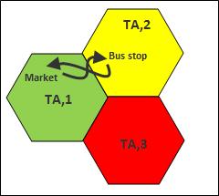

Figure 1.1: Ping Pong Movement Pattern between TAs (Nowoswait and Milliken, 2013) Figure 1.1 shows a ping pong movement pattern across two neighbor TAs due to UE movement from Bus stop to Market and Vice versa. Every UEs that crosses TA,1 to TA,2 does TA update which increase the cost of location management because of increase in TA update per TA crossing.

* + 1. Mass UE Movement Scenario. (Moving Train Scenario): This occurs when a massive movement of UEs such as people in a train moves across Tracking Areas as shown in Figure 1.2. This leads to signaling congestion on tracking areas border cells due to all UEs doing TA update at the same time (Razavi and Yuan, 2011).

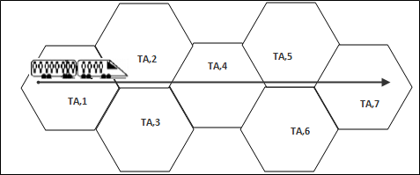

Figure 1.2: Moving Train Scenario (Razavi and Yuan, 2011).

* + 1. Regular Movement Pattern. This occurs in UEs that exhibits strong regularity in their movement pattern. They are regarded as local UE (Wang *et al.,* 2014B). An example is a

UE that leaves home for work and goes to lunch from work and back home daily. This is not considered when allocating TA in a conventional TAL strategy and as such the UE may have high TA updates cost or paging cost.

Figure 1.3 shows regular movement pattern of a local UE. The TA updates and paging cost of local UE is constant throughout its life cycle. The conventional TAL system does not adapt to movement pattern of local UE and as such does not improve location management cost in local UE.

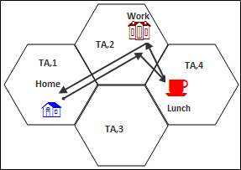

Figure 1.3: Regular Movement of Local UE (Wang *et al.,* 2014B)

* + 1. Irregular movement pattern. UE that exhibits irregular movement are regarded as global UE (Deng *et al.*, 2015). An example is a roaming UE. A UE that comes to a geographic location and transverse different points and leave the geographic location. This UE impacts high location update cost if its call to mobility attribute is high or low. Adaptive system will easily recognize these attributes and allocate appropriate TAL to ensure efficient location management cost.

Due to above challenges of Conventional location management strategy, Adaptive location management strategy is developed to improve location management cost by adapting TAL allocations to individual UEs based on a systematic arrangement of TALs that can adapt UE movement to a pattern.

# LTE Mobile Network

Long Term Evolution (LTE) is mobile cellular technology developed and standardized by Third Generation Partnership Project (3GPP), (Safa and Ahmad, 2015). It is purely IP based technology consisting of radio access and core network. The radio access is called evolved

universal terrestrial radio access network (EUTRAN) and core network is called Evolved Packet Core (EPC) (3GPP TS 23.401 V13.401, 2015). The main objectives for the radio access are high spectral efficiency, high peak data rates, short round trip time and flexibility in frequency and bandwidth. The objectives of the core network are avoiding unnecessary fragmentation of technologies; low complexity and packet switch optimized system. It has capability of high modulation rate and large bandwidth with highest theoretical peak data rate of 300 Mbps in downlink (with 4*4 spatial multiplexing) and 75 Mbps in the uplink (Anuradha and Kumar, 2014)

Figure 1.4 shows LTE architecture depicting major LTE components which is the Evolved packet core (EPC) and Evolved Universal Terrestrial Radio Access Network (EUTRAN). The EPC contains Mobility Management Entity (MME), Serving gateway (SGW) and Home Subscriber Server (HSS). The EPC is connected to the Packet Data Network (PDN) through the Packet gateway (PGW) (Cassey *et al.*,2013). The Evolved universal terrestrial radio (EUTRAN) handles the radio communication between the EPC and the user equipment (UE).

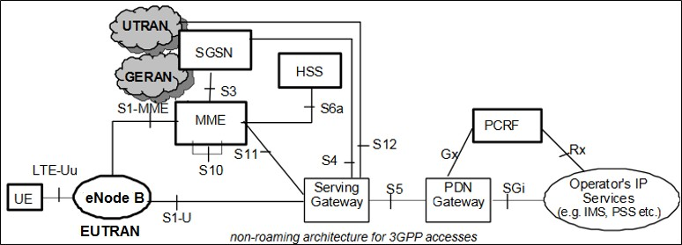

Figure 1.4: Long Term Evolution (LTE) Architecture ([www.3gpp.org/workshop](http://www.3gpp.org/workshop), May 2016)

The EUTRAN has only one component which is the enode B. The user equipment (UE) is the hand-held device used to communicate between network users. The MME handles the idle state mobility and radio bearer control messages in the control plane. It is responsible for allocation of tracking area list (TAL) to user equipment, paging of user equipment for setting up session and tracking of user equipment. It connects to the Home Subscriber Server (HSS) through the control plane. The HSS is a central database that contains information of all network subscribers. The

Serving gateway (SGW) serves as a router and forward user data between the enode Bs and the Packet data network gateway. The MME is the most significant component for location management in LTE and does the necessary computations to ensure effective tracking and paging of user equipment.

# Problem Definition

High paging load and tracking area updates when UEs movement pattern is ping pong, regular, irregular and mass UE moves in same direction. This high paging load and tracking area update leads to congestion of signaling resources in LTE. This research aims to develop adaptive tracking area list strategy to reduce the problem of high paging load and tracking area update in LTE.

# Aim and Objectives

The aim of this research is to develop an adaptive TAL (aTAL) allocation strategy in LTE network with the view of improving location management cost by minimizing the number of paged cells and tracking area update required to sustain network quality of service.

The Objectives of this research is as follows:

* + 1. Develop an adaptive TAL (aTAL) algorithm to adapt movement of UE to TA list allocation by adopting the conventional strategy that is in existence.
    2. Evaluate the performance of the adaptive TAL algorithm with different mobility patterns.
    3. Compare the adaptive TAL strategy with the conventional TAL strategy.

# Significance of the Research

Tremendous growth in signaling traffic of mobile networks due to location management have serious concern to researchers due to the impact it has on network quality of service such as signaling congestion. (Wang *et al.*, 2014). The location management signaling growth is subject to further increase due to capability of connecting more mobile devices, equipment and automotive users such as connected cars (Grigoreva *et al*., 2017). Adapting this signaling traffic to varying mobile devices becomes necessary to ensure network integrity and good quality of service.

# Introduction

# CHAPTER TWO LITERATURE REVIEW

This is provided in two perspectives: Review of fundamental concepts and the review of similar works.

# Review of Fundamental Concepts

In this section, Location management in LTE, conventional TAL scheme, the basic idea in Adaptive TAL strategy including cell structure, TA structure, TAL structure, mobility model, call handling models, traffic model and call to mobility ratio (CMR) are discussed.

# Location Management in LTE

To overcome the challenges of static location management strategies in GSM and UMTS networks, LTE technology adopts a new concept of location management called Tracking Area List (TAL) location management strategy (3GPP TS 23.401 V13.401, 2015). In the TAL strategy, LTE serving stations called enode Bs are continuously arranged and partitioned into non-overlapping registration areas called Tracking Areas (TA). These tracking areas are further grouped into tracking area list (Deng *et al.*, 2015). The user equipment is allocated group of tracking areas called tracking area list. The number of TAs in each TAL varies from one to sixteen (Wang *et al.*, 2014B). In LTE, TAL allocation is upper bounded to sixteen TAs. User equipment will only do TA update when it moves into a TA not included in its TAL. TA update is the registration update done in LTE. A UE is paged by the Mobility Management Entity (MME) by sending a polling signal to all cells in the allocated Tracking Area List (TAL) (Deng *et al.*, 2015).

Figure 2.1, shows the basic concept of TAL. Group of contiguous cells are arranged as Tracking Area Code (TAC), TAC1, TAC3 and TAC4.These TACs are further arranged as TAL. When UE moves between TAC1, TAC3 and TAC 4, no tracking area update is done, but when UE moves to TAC2, tracking area update is done because TAC2 is not in the tracking area list allocated to

the UE by the MME. When UE in TA list is called, all cells in TAC1, TAC3 and TAC4 will be paged simultaneously to connect the called UE.

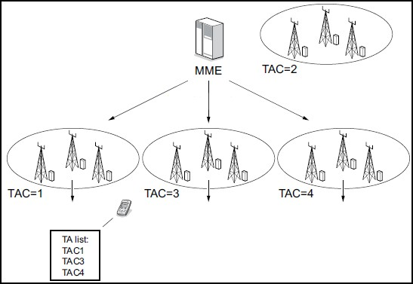

Figure 2.1: Tracking Area list concept in LTE ([www.qualcomm.com,](http://www.qualcomm.com/) May 2016)

# Cell, TA and TAL Structures

To ease mathematical approach to analyze TAL performance, structures should be assumed for cell, TA and TAL. A structure of regular hexagon is assumed for cell so that each cell will have maximum of six neighbors (Akyildiz *et al.*, 2000). This is shown in Figure 2.2

Figure 2.2: Cell Structure (Akyildiz *et al.*, 2000)

Tracking Area (TA) is group of contiguous cells within a geographical area. It is assumed to be group of regular hexagonal cells. These cells are arranged in ring with the center cell regarded as ring 0 with only one cell, then surrounded by ring 1 with six cells, then ring 2 with 12 cells and so on. The equation (2.1) satisfy the arrangement of cells in a ring format to form a tracking area (Wang *et al.*, 2014A).

𝑆𝑛 = 3𝑛2 − 3𝑛 + 1 (2.1)

where *Sn* is number of cells in the (TA) and n is radius of tracking area.

In Figure 2.3, the radius (n =4) implies tracking area from radius 0 to 3. The cell label (x,y) indicates x to be radius of TA and y to be the cell number in that radius. Substituting n to be 4 in equation (2.1), the total number of cells (*Sn* = 37) cells. This concept of TA arrangement is adopted in this work.

Figure 2.3 shows tracking area arrangement of radius 4. This implies the middle tracking area (0,1) has 3 complete tracking area arrangement forming a complete cycle around it.

3,10

3,9

3,11

3,8 2,7 3,12

3,7 2,6 2,8

3,13

2,5 1,4 2,9

3,6 1,3 1,5 3,14

2,4

0,1

2,10

3,5 1,2 1,6 3,15

2,3

1,1

2,11

3,4

2,2

2,12

3,16

3,3 2,1 3,17

3,2 3,18

3,1

Figure 2.3: TA structure with radius 4

Tracking area list is a group of contiguous tracking areas and can be assumed as shown in Figure

2.4. According to 3GPP, the number of TAL is upper bound with maximum number of sixteen TAs (Deng *et al.*, 2015).

Figure 2.4 shows a TAL with 16 TAs arrange in ring 0 with one TA (TA0,0), ring 1 with six TAs (TA1,0 – TA1,5) and ring 2 with nine TAs (TA2,0 – TA2,8). Equation 2.2 mathematical expression of the TAL structure was developed by (Deng *et al.*, 2015) as shown in equation (2.2).

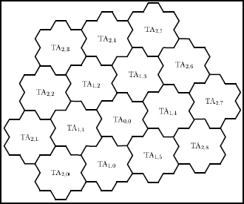

Figure 2.4: TAL structure with 16 TAs (Deng *et al.*, 2015)

0 𝑖𝑓 𝑥 = 0

𝑦 = 0.1 … … … 5, 𝑖𝑓 𝑥 = 1 0,1 … … … .8, 𝑖𝑓 𝑥 = 2

(2.2)

*y* Identities of TAs from a ring x starting from TA=0 and X= ring index of the TA in the TAL arrangement as shown in Figure 2.4

# Conventional Tracking Area List in LTE

TAs are arranged to form TAL. In conventional TAL design, one TA can only be in the list of one TAL (Razavi *et al.*, 2012). Figure 2.5 shows Conventional tracking area list concept with tracking Areas (1,2,3,4,5,6,7,8,9,10,11,12,13, and 14) Tracking Area list 1 has (1,2 and 3 TAs),

Tracking Area list 2 has (4,5,6,7 & 8 TAs), Tracking Area list 3 has (9 and 10 TAs) and Tracking Area List 4 has (11,12,13 and 14 TAs). When a UE is in Tracking Area list 1, It will not do tracking area update when it moves across tracking areas 1, 2 and 3. It will do tracking area update when it moves to tracking areas 4,6,11 or 12 not included in tracking area list 1. When a UE in tracking area list 1 is to be paged, The MME send a polling signal to all cells in the tracking area list 1 i.e. all cells in tracking areas 1,2 and 3.

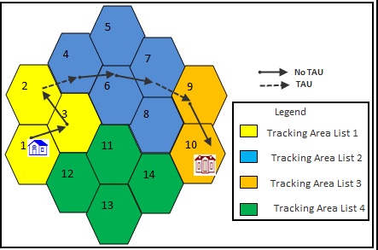

Figure 2.5: Conventional Tracking Area list (Nowoswait and Milliken, 2013) Conventional tracking area list design is prone to the following challenges:

* + - 1. Toggling effect: This is a ping pong effect that occurs when UE moves back and forth between border cells of two tracking area list. In Figure 2.5, if UE moves back and forth between tracking areas 2 and 4 for instance, continuous tracking area update occurs which lead to ping pong effect (Nowoswait and Milliken, 2013).
      2. Mass Movement Signaling congestion. If there is a mass movement of UEs between two tracking area list, such as a train movement. Massive tracking area update on all UEs in the train which will lead to signaling congestion and degrades network quality of service (Deng *et al.*, 2015).
      3. Symmetry Limitation. A TA can only be in one TAL. In Figure 2.5, Tracking Area 3 can only be in tracking area list 1 only. Though it is neighbor to TA (4,6) and TA (11,12) which are in tracking area list 2 and 4 respectively. The conventional TAL design is not adaptive (Razavi *et al.*, 2012).

An adaptive TAL arrangement is expected to improve location management cost in LTE. The improved location management cost is expected in the number of TA update done relative to UEs movement and number of cells paged to connect a call to a terminal mobile UE. A Tracking

area list lookup table will be configured on the Mobility Management Entity (MME) in which the algorithm will be embedded. The adaptive strategy will be evaluated in comparison to conventional TAL design for Ping pong movement pattern, mass UE movement scenario, regular movement pattern and irregular movement pattern. Improvement in total location management cost is expected in the adaptive strategy

# Mobility Model

This is the movement of mobile terminal across cells of the network. It is stochastic in nature and modeled using analytic probabilistic method. Many mobility models are in use, Prominent among them in the literature are:

* + - 1. **Random walk model:** The TA in Figure 2.6 has seven cells, assuming a mobile in center cell ring 0 moves, it moves to any of its neighbor cell in ring 1 with equal probability (1/6). When the radius of the TA becomes large, it becomes hazardous to compute sample space of possible movements within the TA. The random walk is good for experimental analysis but hinders mathematical explanations as it may be difficult to obtain a close loop formula as the location area gets bigger, (Wang *et al.*, 2014A).



1,4

1,3

1,5

0,1

1,2

1,6

1,1

Figure 2.6: Tracking area with 7 cells

* + - 1. **Fluid flow model:** This model is used to calculate the rate at which mobile terminal assembled in a close plane and crosses the border of the plane (Wang *et al.*, 2014A). It is called Border crossing rate (Br). It was used to establish the relationship between the cell residence time, TA residence time and TAL residence time (Deng *et al.*, 2015). The cell residence time and TA residence time is assumed to follow the exponential rate of 𝜂 and τ respectively. Using the border crossing (Br) rate under the fluid flow model (Wang *et al.,* 2014A). This is express by equation (2.3).

B = E(V)L

r

πA

(2.3)

From equation (2.3), Br is Border crossing rate, V is Velocity of the mobile terminal, L is Length of the close plane (Cell or TA) and A is Area of the close plane (Cell or TA). To make the mathematical model less complex, below assumptions are considered in the fluid flow model (Wang *et al.*, 2014A):

* + - * 1. The Mobile stations are uniformly distributed throughout the TA.
        2. The direction of the mobile station relative to the cell and TA borders is uniformly distributed over (0 to 2π)
        3. The mobile station speed at different location are independent and Identical distributed (i.i.d)
        4. All the cells in the TA and all the TAs in the network are homogenous.

Based on the assumptions, equation (2.4) show the relationship between the cell residence time and tracking area residence time. (Wang *et al*., 2014).

𝑟 = LLA ∗ Ac

(2.4)

𝜂 Lc

ALA

Where:

The Equation (2.4) details are: τ represent Exponential rate of LA residence time

𝜂 represent Exponential rate of cell residence time

*LLA* represent Length of tracking area *ALA* represent Area of tracking area *Lc* represent Length of Cell

*Ac* represent Area of Cell

* + - 1. **Markov Model:** Markov chain techniques are applied to analyze stationary stochastic process, solve integration and optimization problems in large dimensional spaces (Andrieu *et al.*, 2003). Several researches used Markov chains to model user mobility. An embedded Markov model was used to analyse paging and location update cost in GSM and UMTS network (Wang *et al.*, 2014A), A discrete time Markov model was adopted for location management strategy for network of femto cell (Ferragut and Bafalluy, 2012) and Markov

chain was used to analyse location management cost of global UE in an LTE network (Deng *et al.*, 2015). These researches explore the property of Markov process to analyze and model possible scenarios of UE mobility.

Figure 2.7 shows a sample Markov model. This work used the Markov model to describe possible movement across the group of TA segments. The hidden Markov model was used to describe measurements of each segments based on the movement of UE across group of 16 TAs.

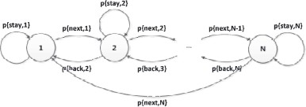

Figure 2.7: Markov Based Mobility Model with N Cell Ring (Ferragut and Bafalluy, 2012)

# Call Handling Model

Call handling model is the concept of performing TA update after every call or not. It is a strategy to ensure a reliable mobile terminal connectivity. There are two call handling models call plus location updates (CPLU) and call without location update (CWLU) (Deng *et al.*, 2015)

1. **Call plus location update (CPLU):** In this model, location update occurs every time a call is received and when a tracking area list boundary is crossed.
2. **Call without update (CWLU):** This model does not do location update every time a call is received. However, location update occurs every time tracking area list boundary is crossed.

Most Networks adopt the CWLU model to minimize signaling cost. This is due to the reason that UE location is known before call setup is established. This work will adopt the CWLU model. The purpose is that CPLU model increase the number of tracking area update on the network. However, dedicated handoff mechanism is in place to manage handoffs during call sessions when a UE is moving during a call.

# Traffic Model

Traffic model is based on two variables Call inter arrival time denoted by (ta) and Call holding time (th) as in (Wang *et a.,l* 2014A).

1. **Call Inter arrival time (ta):** This is the time interval between two consecutive calls
2. **Call holding time (th):** This is the time of conversation during a call.

Call inter arrival time (ta) and call holding time (th) is assumed to follow exponential distribution of rates *θ* and **µ** respectively. The call arrival process can be express as in equation (2.5). (Wang *et al.,* 2014A).

*F(t) = θe****-****θta* (2.5)

Where F(t) is call arrival rate, θ is Exponential distribution of call inter arrival time and **ta** is Call inter arrival time.

This work assumed a null call holding time as CWLU is considered.

# System Model

The signal load due to location management in LTE is due to UE distribution and mobility (Razavi *et al.*, 2012). From LTE system perspective, a UE is either in the following states:

* + - 1. LTE Active: The network knows the cell serving a UE and the UE is in a state of active communication
      2. LTE Idle: The network knows the location of the UE to the granularity of Tracking Area List. The UE is not in active communication but listens to system broadcast messages

# Call to Mobility Ratio (CMR)

This is the ratio of number of calls received to the number of cell crossed between two consecutive call arrivals. It is the ratios of call inter-arrival time to cell residence time (Wang *et al.,* 2014A).

𝐶𝑀𝑅 = 𝜃

𝜂

(2.6)

Where θ is Call inter arrival time and 𝜂 is Cell residence time.

This work assumed CMR of one. This implies for every movement, we assume a call is received. The purpose is to estimate number of required cells to be paged for every movement scenario.

# Location Management Cost

Location management cost is the sum of tracking area update and paging done within a period (Vekariya *et al.*, 2015). However, the scope of this work is to consider the cost in terms of number of tracking area updates and paging in LTE.

* + - 1. **Location Update Cost (NTAU):** This is the expected number of Location updates (LU) activity performed during call inter arrival time (ta) (Deng *et al.*, 2015)

(𝐍

) = 𝜆+ 𝑟 𝑁

(2.7)

𝐓𝐀𝐔

𝜆 𝑇𝐴𝑈 ,𝑆𝑇

𝜆 represents call inter arrival time, τ represent TA residence time and NTAU,ST represent Expected number of Tracking Area update triggered by state transition.

* + - 1. **Paging Cost (Cp):** This is the expected number of cells paged to locate the UE when an incoming call arrives (Wang *et al.*, 2014A).

𝐶𝑝 = 𝑑(3𝑛2 − 3𝑛 + 1)𝑥𝑝𝑎𝑔𝑖𝑛𝑔 (2.8)

d represent number of TAs in allocated TAL, n represent ring of cells in TA and Xpaging represent Cost attached to a paging.

The location management (LM) cost is sum of Location update cost (NTAU) and Paging cost (Cp) (Vekariya et al 2015). Objective of this work is minimizing the location update cost by adaptive TAL strategy compared to conventional TAL strategy. Four movement patterns was considered which are ping pong movement, a train movement scenario, regular UE movement and irregular UE movement.

# REVIEW OF SIMILAR WORKS

The following presents review of similar research work found in the literatures.

**Widjaja *et al.,* (2009)** work was based on a comparative study of Mobility Management Entity (MME) load based on centralized MME and Distributed MME architectures. The research

defined four main events that contribute to MME load. The four events are UE-originated session, UE-terminated session, handover and tracking area update. The study showed that distributed MMEs incurred higher MME signaling load compared to centralized MME architecture due to inter-MME communication. The work was based on MME load measurement comparison between centralized MME and distributed MME. The result obtained did not reflect total location management cost due to missing paging load in the parameter considered in the work.

**Razavi and Yuan, (2011)** developed a model for overlapping TAL allocation to solve the problem of TA updates (signaling storm) on location area border cells in LTE network. In this work, emphasis was placed on tracking area update in case of massive movement between location areas such as train movement, with assumption that paging would be of less critical issue in real-life deployment. The work improved possible storm by adopting overlapping TAL strategy. However, Impact of paging on this strategy was ignored due to assumption that paging was less critical. This affected the total location management performance result because cost of paging was not considered in the performance result.

**Chung, (2011)** developed a model for optimal TAL allocation between two call session using the movement based strategy. The model was used to derive the optimal movement threshold on assumption that a TA consisted of a cell. The research designed a binary search algorithm to implement the model for optimal TAL. In the model, every time a call is received by any UE, the MME would compute the optimal movement threshold and allocate new TAL based on the computation. This significantly increased the computation complexity of the MME which is a major challenge in the implementation of this strategy.

**Razavi *et al.,* (2012)** used the concept of Pareto-optimization to develop a bi-objective optimization trade-off between overall signaling overhead and cost of TA reconfiguration. This research was based on the fact that as network utility grows with increase in traffic trend, user mobility and traffic behavior changes. These changes overtime impacts network performance such as overhead signaling load. To adapt these changes on the network, there is need for reconfiguration of network tracking area (TAs) allocations. The cost of this reconfiguration is that the network will not be available for some minutes while the new configuration is implemented. The challenge in this work is that the model leads to network outages due to

reconfiguration. This is major challenge to network operators as network outages impact quality of service and network reliability.

**Ferragut and Bafalluy, (2012)** developed an algorithm for self-organizing tracking area list in Network of femto cells (NoFs). A NoF is a mesh network that provides multi hopping connectivity amongst femto cells and in turn to the Evolved Packet Core (EPC). The algorithm was based on discrete time markov chain. Two timers were introduced to enhance the complexity of the algorithm. The essence of the timer is to differentiate TAL allocation between different states in the markov chain. Three states ({Stay},(Next} and {Back})were identified and the model for TAL allocation was derived. The model is costly to implement as there will be two timers per subscriber on the MME. Major challenge of this work is implementation of this strategy considering the current LTE architecture.

**Roy *et al.,* (2012)** proposed two practical location management schemes to improve location based services in LTE. Bayesian-based tracking area update and entropy based tracking area update were proposed. The schemes used bi-objective consideration of TA updates and paging cost on one hand, and storage and computational overhead on the other hand. The Bayesian based strategy improves the paging cost with less storage and computational overhead while the entropy based strategy minimizes the tracking area update and paging cost with higher storage and computational overhead. However, the work is based on assumption that TA based strategy in LTE is a static location management scheme as in GSM and UMTS without considering the dynamic TAL allocation scheme recommended by 3GPP.

**Kreuger *et al.,* (2012)** work developed local neighbor model based on collective mobility patterns observed through successive paging attempts. These local neighbors are unique for each cell and are used to form and maintain TAL assigned to UEs. The local neighbors are obtained from traces per UE with cells it has interacted with based on location update, call setup and handover. Based on these local neighbors, all UEs served by the cell are allocated TAL. The challenge with this work is that the cost of tracing individual UE based on its interaction with cells is very difficult to obtain considering the present LTE architecture.

**Liou *et al.,* (2013)** considered a comparative analysis of location management in LTE using overlapping TAL allocation against the conventional static location management strategy in

GSM and UMTS, this study recommended three sequential paging strategies to limit the impact of paging cost. This study work tends to improve on the challenge of paging cost due to sequential paging scheme. The major challenge with this strategy is that it will not be effective for delay sensitive communications such as real time online gaming and video conferencing due to the sequential paging scheme.

**Toril *et al.,* (2013)** developed an algorithm for automatic re-planning of tracking areas (TA) in LTE. This concept is based on self-organizing network (SON) strategy. The algorithm is based on measurement of networks performance over a period, these measurements is plotted as a graph. The study introduced an indicator called graph correlation coefficient. This indicator is generated by measuring the similarities of network graphs built from measurement taken at different times. The indicator is used to determine when to change a TA plan. Once the TA re- plan is triggered, A graph partitioning algorithm is used to build a new tracking area (TA). The challenge however is that the work is based on assumption that a tracking area list (TAL) consist of one TA and the solution is going to increase the computational complexity of the network and increase cost of signaling required for the computation of the graph correlation coefficient and graph partitioning algorithm.

**Nowoswait and Milliken, (2013)** work deliberated on managing LTE core network signaling traffic. The work revealed some data on the distribution of signaling traffic in a U.S metropolitan LTE network. The data shows 33.60% of the signaling load was due to location management. Paging contributes 28.70% and tracking area update contributes 4.90%. With prospect of traffic growth trend, the work also shows effect of TA updates on UEs battery consumption. The findings estimated 10milliwatt of UE power is drained per TA updates procedure. From the data in the white paper, it can be deduced that implementing adaptive TAL scheme will contribute to power efficiency of the UE battery, channel bandwidth utilization on the radio access and signaling load on the core network. However, the study was mainly based on data of a US metropolitan network without bring up a solution to improve high paging load.

**Wang *et al.,* (2014 B)** developed a mathematical model to determine the cost of location management in local user equipment (UE). A local UE is regarded as a UE whose mobility exhibits strong regularity. This means the UE movement is regular and the TAs visited are consistent. A case study is a UE that goes to work from home, goes to lunch and return home.

The research used embedded Markov chain to derive the state probabilities of each TA transverse in the movement pattern. Through simulation, equilibrium probabilities of the TAs were derived and used to calculate the location management cost of the TAL. In the model, the research assumed the simulated TAL has five TAs, whereas 3GPP recommend an upper bound of 16 TAs to TAL. The model was based on UE with regular mobility and did not consider UE with irregular mobility such as a roaming UE.

**Qiang *et al.,* (2014) d**eveloped a security enhancement scheme for TA updates procedure in LTE. The work elaborates the procedure for TA update activity and identifies possible cause for Serving Gateway (SGW) overload which is due to the security incapability to authenticate bearer request sent by the Mobility Management Entity (MME). The security enhancement scheme propose that “create bearer request” message sent by the MME to SGW should contain International Mobile subscriber Identity (IMSI) which the SGW will use to check if any user has more than one create bearer request message. At this point, TA update procedure will seize and the SGW will send a query message to the MME to verify the authenticity of the create bearer request message. The work is based on the security of TA updates in LTE with objective of improving SGW overload but does not contribute to improvement in TA updates and paging load in LTE

**Ikeda *et al.,* (2014)** developed a rule to avoid location update storm when huge numbers of UEs moves into another tracking area such as train movement. In this case, it assumed that all UEs share the same tracking area list (TAL) thereby causing signaling congestion on the border cells of the new tracking area. To avoid this quality of service issue, the work developed a rule to mitigate this congestion by allocating TAs based on burst cell detection from location updates records. The challenge with this work is that TAs is assigned to cell based on location update burst record. The cost of obtaining individual UE location update cost is huge and will require complex computing capability of the MME.

**Deng *et al.,* (2015)** developed a mathematical model for estimating tracking area update and paging cost for a global UE. A global UE is a UE that exhibits weak regularity such as a roaming UE. He also considers TAL with sixteen TAs which is the upper limit recommended by 3GPP. He derived analytical formulas for location management cost for two call handling models – calls plus location update (CPLU) and calls without location update (CWLU). The analytical

formulas where simulated using Mont Carlo simulation software. This work is an upscale of (Wang *et al.*, 2014 B) whose model considers local UE. The model describes movement pattern of global UE with cost of location management based on the movement. The result obtain shows cost of paging and tracking area update. However, the result does not reflect and adaptive pattern that can improve cost for ping pong and train movement patterns.

**Safar and Ahmad, (2015)** used Tabu search method to improve the reconfiguration cost of maintaining optimal TA update and paging cost in LTE. The work is based on self-organizing network (SON) where TA assignment is reconfigured after a period to ensure optimal TAL performance. This reconfiguration is based on Tabu search heuristic algorithm with primary objective of allocating cells to different TAs without recourse to their geographic and contiguous arrangement. The cost of reconfiguration is a major challenge in this work as this will lead to network unavailability for some minutes.

**Grigoreva *et al.,* (2017)** developed an adaptive technique of forming tracking area list base on mobility prediction and variable TAL forms for connected cars. The work introduced a movement threshold counter on the mobile device that determines the radius of TAL and predictive mechanism to form 60 degrees and 120 degrees sector TAL forming. This method has high propensity for high paging load due to the ring counter method which can form minimum of 7 TAs initial TAL, the 60 degrees sector form minimum of 11 TAs initial TAL and the 120 degrees sector form minimum of 13 TAs initial TAL. This make the technique have susceptibility to high paging load due to the minimum initial TA of 7.

Improving location management cost is quite expensive as most works above introduced complex systems such as timer for each UE on the network, some introduce a call tracing model which is very expensive to achieve with the present network architecture, some considers reconfiguration of the whole TAL strategy due to traffic growth which causes network outages while some do not consider paging performance due to assumption that it is less critical. Most recent work adopt a sector forming strategy (Grigoreva *et al.,* 2017). This strategy has propensity of high paging load because the minimum TAL size achieved is 7 TAs.

This work therefore intends to develop an adaptive Tracking Area List (TAL) allocation base on UE movement pattern. Additional memory space and processor is what is required to implement

this algorithm on the MME which can easily be accommodated with the current LTE architecture.

# Materials

# CHAPTER THREE MATERIALS AND METHODS

Materials used for this work are HP labtop, MATLAB programing software, Microsoft Suit Application packages, 3GPP Technical Specification for EUTRAN access Release 13 document and Google earth software.

# Methods

The following methodology was adopted in carrying out this research work:

* + 1. Development of an algorithm to adapt UE movement to TAL allocation by:
       1. Adopting the conventional TAL structure.
       2. Improving the conventional TAL structure by introducing a lookup table.
       3. Embedding an algorithm on the lookup table to make the TAL structure adaptive.
    2. Evaluation of the TAL performance with different mobility patterns.
       1. Arranging TAL structure for an assumed geographical area.
       2. Simulating movement of UEs within the designed TAL structure for ping-pong, regular, irregular and mass movement.
       3. Estimating number of tracking area updates, number paged cells and cumulative location management cost for the simulated UE movements.
    3. Comparative analysis of the developed algorithm with the conventional TAL strategy
       1. Subjecting the movement pattern to the conventional strategy and obtain the location management cost
       2. Comparing the cumulative location management cost of the adaptive strategy and conventional strategy
       3. Identifying tracking area update and paging characteristics based on different mobility patterns. Ping pong, regular, irregular and mass movement.

# Conventional TAL Structure.

The conventional TAL strategy is static location management scheme (Deng, *et al.,* 2015). The Figure 3.1 shows the conventional TAL that will be evaluated with the movement patterns. The same parameters are considered for adaptive strategy.

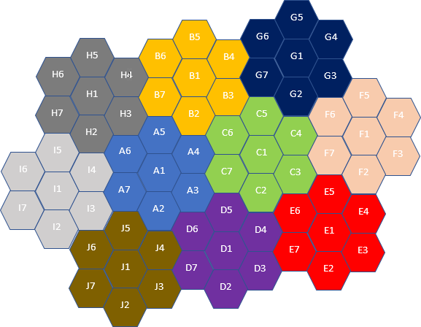

Figure 3.1: Conventional Tracking Area List Design

Ping pong, regular and irregular movement patterns considered to evaluate location management cost of conventional TAL in Figure 3.1.

# Flow Chart of Conventional TAL Structure

Flow chart of existing conventional TAL strategy is shown in Figure 3.2.

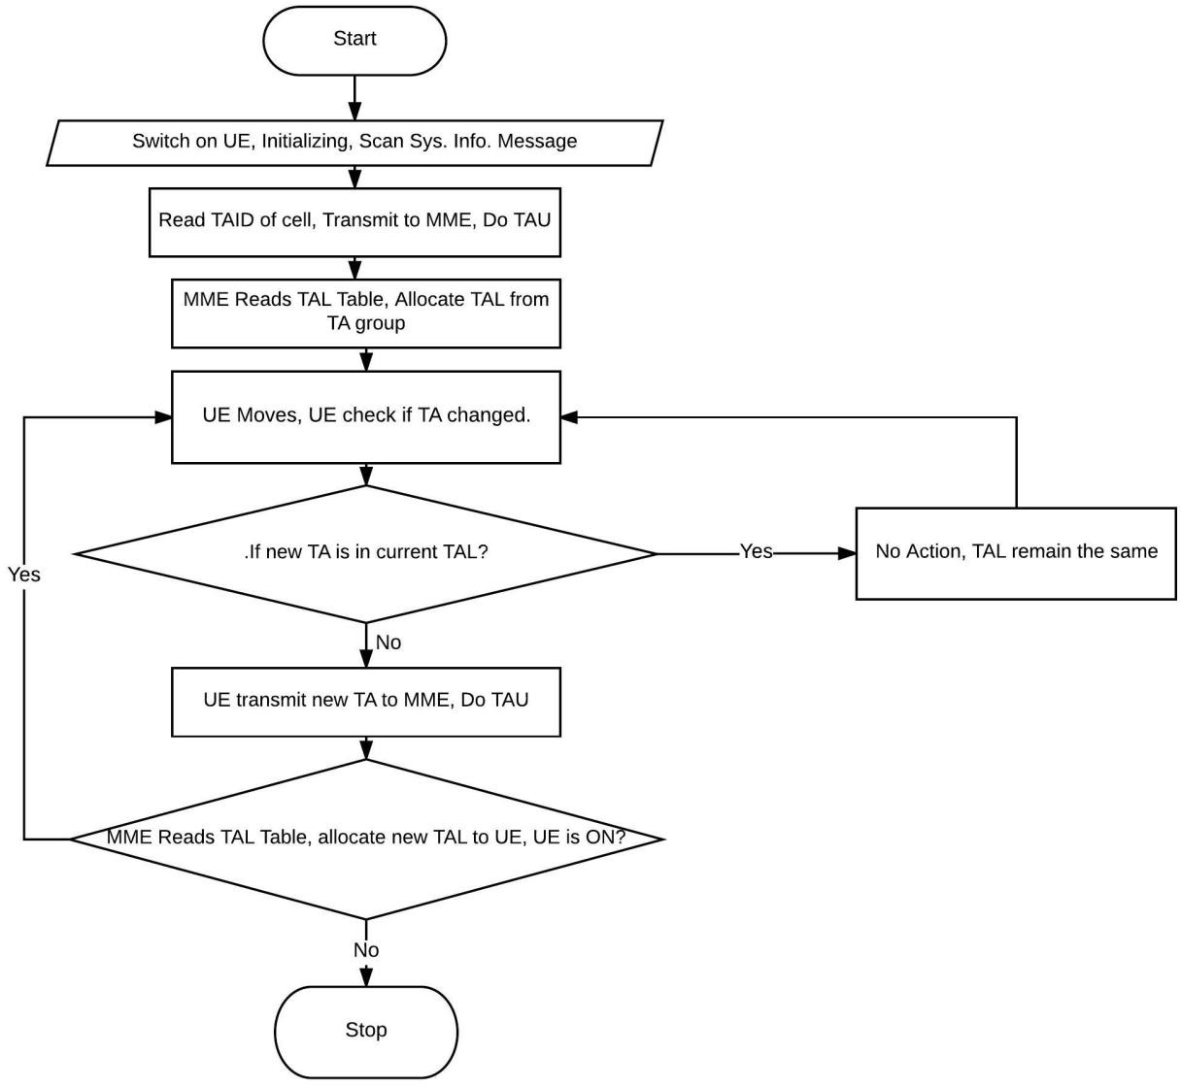

Figure 3.2: Flow Chart Conventional Tracking Area list (3GPP TS 23.401 V13.401, 2015)

# Ping Pong Movement Pattern

* + - 1. Ping Pong within a group of TA. The case use is the pattern: A1-A4-A1-A4-A1-A4-A1- A4-A1-A4. Figure 3.1 shows the Conventional TAL strategy and it used to simulate the movement pattern. The Matlab code used for simulating this scenario is in Appendix D. Result is shown in Figure 3.3. The result shows that only one TAU was done throughout the 10 steps considered while paging of all the 7 TAs was done for every single step.

Hence high paging load is observed in conventional strategy which caused high location management cost. LM cost is 71 in this case.

Table 3.1 shows the result of the Conventional strategy for Ping Pong within Same TA

Table 3.1: Results of Conventional strategy for Ping Pong within Same TA

|  |  |  |  |  |  |  |  |  |  |  |
| --- | --- | --- | --- | --- | --- | --- | --- | --- | --- | --- |
| **Parameters** | **Movement Steps** | | | | | | | | | |
| 1 | 2 | 3 | 4 | 5 | 6 | 7 | 8 | 9 | 10 |
| **Location update** | 1 | 0 | 0 | 0 | 0 | 0 | 0 | 0 | 0 | 0 |
| **Paging** | 7 | 7 | 7 | 7 | 7 | 7 | 7 | 7 | 7 | 7 |
| **Cumulative LM cost** | 8 | 15 | 22 | 29 | 36 | 43 | 50 | 57 | 64 | 71 |

Figure 3.3. shows the graphical representation of Paging and Location update result of Table 3.1

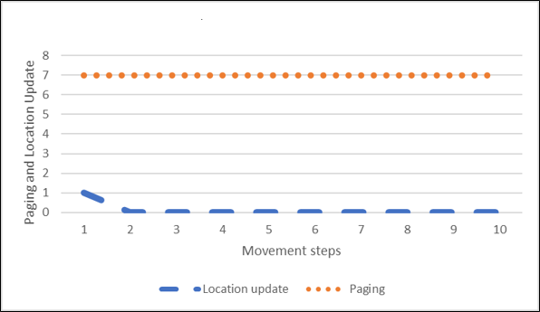

Figure 3.3: LM Cost for Ping Pong Movement Within the Same TA Group

* + - 1. Ping Pong across two groups of TAs. The case use is the pattern: A4-C6-A4-C6-A4-C6- A4-C6-A4-C6. The Matlab code used for simulating this scenario is in Appendix D Result is shown below in figure 3.4. The result show that the UE does TAU for every step and All 7 TAs are paged for every step. This implies both TAU and paging contributes to high LM cost. LM cost is 80 for this case.

Table 3.2 shows Results of Conventional strategy for Ping Pong across Groups of two TAs

Table 3.2: Results of Conventional strategy for Ping Pong across TA.

|  |  |  |  |  |  |  |  |  |  |  |
| --- | --- | --- | --- | --- | --- | --- | --- | --- | --- | --- |
| **Parameters** | **Movement Steps** | | | | | | | | | |
| 1 | 2 | 3 | 4 | 5 | 6 | 7 | 8 | 9 | 10 |
| **Location update** | 1 | 1 | 1 | 1 | 1 | 1 | 1 | 1 | 1 | 1 |
| **Paging** | 7 | 7 | 7 | 7 | 7 | 7 | 7 | 7 | 7 | 7 |
| **Cumulative LM cost** | 8 | 16 | 24 | 32 | 40 | 48 | 56 | 64 | 72 | 80 |

Figure 3.4 shows graphical representation of the Paging and Location update results of Table 3.2

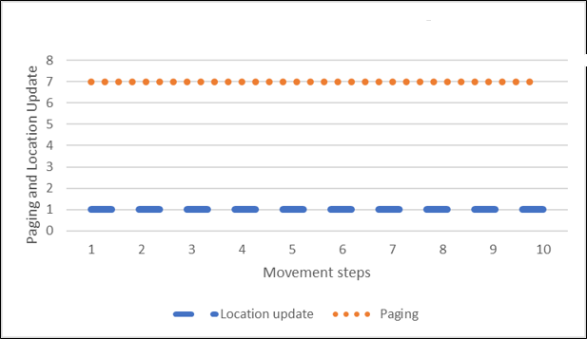

Figure 3.4: LM cost for Ping Pong Movement Across Two TA groups

# Regular Movement Pattern

* + - 1. Regular Movement within same TA group. The case adopted for this pattern is A7-A2- A3-A2-A7-A2-A3-A2-A7-A2-A3-A2-A7 movement. Matlab code used is in Appendix D.The result is shown in figure 3.5. The TAU done throughout the 10 steps is one while 7 TAs is paged every step. The cause of high LM cost in this case is due to high paging load. LM cost is 71 in this case.

Table 3.3 shows the result obtained for Regular Movement within same TA group Table 3.3: Regular Movement within same TA group

|  |  |  |  |  |  |  |  |  |  |  |
| --- | --- | --- | --- | --- | --- | --- | --- | --- | --- | --- |
| **Parameters** | **Movement Steps** | | | | | | | | | |
| 1 | 2 | 3 | 4 | 5 | 6 | 7 | 8 | 9 | 10 |
| **Location update** | 7 | 7 | 7 | 7 | 7 | 7 | 7 | 7 | 7 | 7 |
| **Paging** | 1 | 0 | 0 | 0 | 0 | 0 | 0 | 0 | 0 | 0 |
| **Cumulative LM cost** | 8 | 15 | 22 | 29 | 36 | 43 | 50 | 57 | 64 | 71 |

Figure 3.5 shows the graphical representation of paging and location update cost in Table 3.3

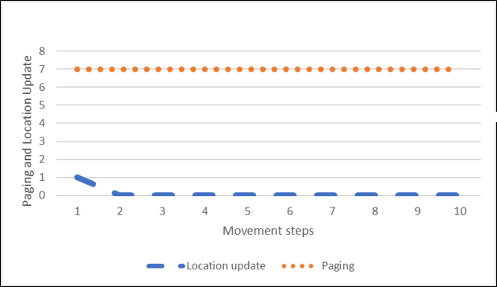

Figure 3.5: LM cost for Regular Movement Within Same TA group

* + - 1. Regular Movement across two TA groups. The case adopted for this pattern is A3-D5- C2-D5-A3-D5-C2-D5-A3-D5-C2-D5-A3 movement. Matlab code used in Appendix D. Result is shown in Figure 3.6. TAU is done in every step and 7 TAs are paged for every step. The high TAU and high paging contributes to high LM cost in this case. The LM cost for the 10 steps considered is 80.

Table 3.4 shows the result obtained for regular movement across TA in conventional strategy.

Table 3.4: Regular Movement across TA group

|  |  |  |  |  |  |  |  |  |  |  |
| --- | --- | --- | --- | --- | --- | --- | --- | --- | --- | --- |
| **Parameters** | **Movement Steps** | | | | | | | | | |
| 1 | 2 | 3 | 4 | 5 | 6 | 7 | 8 | 9 | 10 |
| **Location update** | 1 | 1 | 1 | 1 | 1 | 1 | 1 | 1 | 1 | 1 |
| **Paging** | 7 | 7 | 7 | 7 | 7 | 7 | 7 | 7 | 7 | 7 |
| **Cumulative LM cost** | 8 | 16 | 24 | 32 | 40 | 48 | 56 | 64 | 72 | 80 |

Figure 3.6 shows the paging and location update result obtained from the regular movement across TA group.

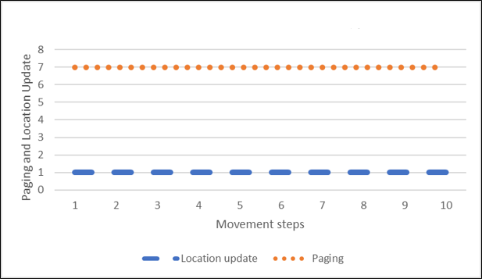

Figure 3.6: LM Cost for Regular Movement Across Two TA groups

# Irregular Movement Pattern

The case adopted for irregular movement pattern is I7-I1-I4-A6-A5-B2-B3-G7-G1-G4. Matlab code in Appendix D. Result is shown in Figure 3.7. High paging is the major cause of the high LM cost in this case. LM cost is 74

Table 3.5 shows the result obtained from the irregular movement considered in this work.

Table 3.5: Irregular Movement

|  |  |  |  |  |  |  |  |  |  |  |
| --- | --- | --- | --- | --- | --- | --- | --- | --- | --- | --- |
| **Parameters** | **Movement Steps** | | | | | | | | | |
| 1 | 2 | 3 | 4 | 5 | 6 | 7 | 8 | 9 | 10 |
| **Location update** | 1 | 0 | 0 | 1 | 0 | 1 | 0 | 1 | 0 | 0 |
| **Paging** | 7 | 7 | 7 | 7 | 7 | 7 | 7 | 7 | 7 | 7 |
| **Cumulative LM cost** | 8 | 15 | 22 | 30 | 37 | 45 | 52 | 60 | 67 | 74 |

Figure 3.7 the graphical representation of the paging and location management cost for irregular movement in conventional strategy.

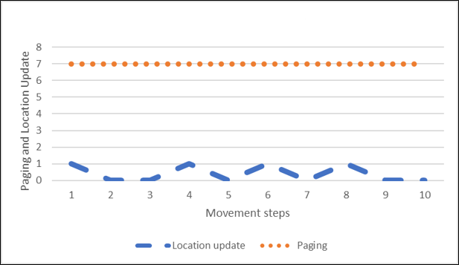

Figure 3.7: LM Cost for Irregular Movement

# Adaptive Tracking Area List (aTAL) in Concept in LTE

The concept of adaptive tracking area list adopted in this work is modeled with respect to UE movement across tracking areas from 1 TA to 16 TAs. A UE is allocated TAL from 1 TA to 16 TAs in group of segmented TAs base on its movement pattern within the ring of 16 TAs using the TAL arrangement as shown in Figure 3.8. The label x, y implies x = ring and y = TA number, i.e 2, 3 implies TA 3 in ring 2 of the tracking area list. The TAs are in color to show group of TAs in each segment. TAs ({2,1}, {2,2}, {2,3}) are in Segment 1 in Ring 2. TAs ({2,4}, {2,5}, {2,6}) are in segment 2 in Ring 2, TAs ({3,1},{3,2},{3,3}) in Segment 3 Ring 3,

TAs ({3,4},{3,5},{3.6}) and TAs ({3,7},{3,8} and {3,9}) in Segment 4 and Segment 5 of Ring 3 respectively. If the UE is switched on at TA {1,1} and tracking area update is done, the UE will be allocated TAL of 1 TA ({1,1}) If the UE moves to any TA in ring 2, It adds 3 TAs in that segment to the TAL to make it 4 TAs base on the segment the UE moves. An example is if a UE

moves along the path {1,1}-{2,2}-{3,2},The UE will do tracking area update and be allocated TAL ({1,1},{2,1},{2,2},{2,3},{3,1},{3,2} and {3,3}), If the UE transit from {3,2} via {3,3} to

{3,4}, TAs ({3,4},{3,5} and {3,6}) will be added to its TAL to make it 10 TAs, If it transit though {3,4} through {3,5} and {3,6} to {3,7}, then TAs ({3,7},{3,8} and {3,9}) will be added to TAL to make it 13 TAs. The maximum number of TAs that can be allocated in a TAL to a UE is 16 as recommended by 3GPP (Deng *et al.*, 2015).

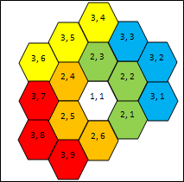

Figure 3.8: Adaptive Tracking Area List Design

The adaptive TAL will allocate TAL to UEs in order of 1,4,7,10,13 and 16 TAs respectively and will not consider reversal strategy. i.e Once TAL of 13 TAs is assigned and the UE moves back to ring 1 TA of the TAL, the TAL will not adjust to lower order TA such as 10 or 7. This is to mitigate tracking area update that will arise due to the reversal strategy. If reversal movement is put into consideration, it will impact the location management cost due to increase in number of tracking area update that will arise from the reverse movement.

# Adaptive tracking area list (aTAL) Table

A TA table shown in Table 3.6 is arranged to fit the concept of the aTAL strategy. It is replica of the aTAL design shown in Figure 3.8. An algorithm will be embedded on the table and configured on the MME for implementation.

Table 3.6: Tracking Area Table for Adaptive Tracking Area List Design

|  |  |  |  |  |  |
| --- | --- | --- | --- | --- | --- |
| **Ring 1** | | **Ring 2** | | **Ring 3** | |
| Segment 0 | TA {1,1} |  | TA {2,1} |  | TA {3,1} |
|  | | Segment 1 | TA {2,2} | Segment 3 | TA {3,2} |
|  | TA {2,3} |  | TA {3,3} |
|  | TA {2,4} |  | TA {3,4} |
| Segment 2 | TA {2,5} | Segment 4 | TA {3,5} |
|  | TA {2,6} |  | TA {3,6} |
|  | | | |  | TA {3,7} |
| Segment 5 | TA {3,8} |
|  | TA {3,9} |

# Adaptive Tracking Area List (aTAL) Model

Movement of UE across ring of contiguous TAs is modelled below using Markov model. The state in the Markov chain below is the TAL segment which comprises 3 TAs in segment two, three, four, five and six and 1 TA in segment one. In this work, the state Sx represents the State of the UE in a TA which is in Segment Sx. TA update is done when a UE moves from a TA of a segment to a neighbor segment. If the UE returns to the initial segment, no TA update is done as this concept does not put in consideration a reversal strategy.

The movement of UE between TA segment is analyzed using segment residence time (τ) and call inter arrival time (λ) (Deng *et al*., 2015).

Let σ denote the call to mobility ratio of a UE which is function of segment residence time (τ) and call inter arrival time (λ) (Deng *et al*., 2015).

σ = τ τ+ λ

(3.1)

The transition probabilities of the adaptive TAL in Figure 3.9 follows the number of exit pattern from a state to its neighbor state. State S7 refers to State S1 in a new set of 16 TAs.

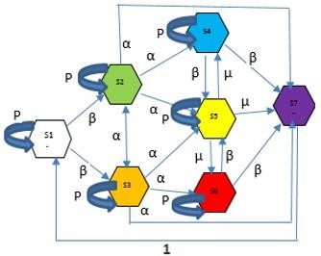

Figure 3.9: Markov Chain for Adaptive Tracking Area List (aTAL) Design

P denote transition probability within same segment as shown in equation (3.2), no TAU is done due to CWLU model,

𝑃 = 1 − σ

(3.2)

β denote transition probability from a state with two exit possibilities as shown in equation (3.3). This is state S1 in ring 1 to States S2 and S3 in ring 2. Also from states S6 and S4 in ring 3 to States S5 and S7 of ring 3 and new group of 16 TAs respectively.

β = σ 2

(3.3)

α denote transition probability from a state with four exit possibilities as shown in equation (3.4). This is states S2 and S3 in ring 2 to states S4, S5, S6 in ring 3, between States S2 and S3 of the same ring and transition probabilities between ring 2 and ring 1 of new group of 16 TAs regarded as S7

α = σ

4

(3.4)

µ denote transition probability form state with three exit points as shown in equation 3.5. This is between segment 5 ring 2 and its contiguous neighbor segment.

µ = σ

3

(3.5)

The transition matrix format of figure 3.9 Markov chain is shown in Table 3.7.

Table 3.7 shows the transition matrix of the Markov chain. Considering call without location update (CWLU) strategy.

Table 3.7: Transition Matrix Table for Markov Model

|  |  |  |  |  |  |  |  |
| --- | --- | --- | --- | --- | --- | --- | --- |
| **Matrix Table** | **s1** | **s2** | **s3** | **s4** | **s5** | **s6** | **s7** |
| **s1** | P | β | β | 0 | 0 | 0 | 0 |
| **s2** | 0 | P | α | α | α | 0 | α |
| **s3** | 0 | α | P | 0 | α | α | α |
| **s4** | 0 | 0 | 0 | P | β | 0 | β |
| **s5** | 0 | 0 | 0 | µ | P | µ | µ |
| **s6** | 0 | 0 | 0 | 0 | β | P | β |
| **s7** | 1 | 0 | 0 | 0 | 0 | 0 | 0 |

the only reason a UE leaves its state with a TAU done is when he moves between TAL segment in a forward manner. Example, A UE moves from S1 to S2, TAU will be done because the two states belong to different segments. The TAL allocated will be the TAs of the new segments S2 added to TA of former segments S1. The UE will be paged on all TAs in the segments traverse by the UE which in this case is TAs of segments 1 and segment 2. In this work, the initial transition state probability is assumed to be equal probability base on the number of exit points from a state.

To estimate the equilibrium probabilities of the states, denote π1 to be the equilibrium probability of state S1, π2 for S2 and so on. Let π be the row vector consisting state equilibrium probabilities of all the states in the Markov model. The balance equation of the Markov chain can be written as equation (3.6).

π Sx, y = π

(3.6)

Combining equation (3.6) with following normalization equation (3.7) (Deng el al, 2015)

∑π = 1

(3.7)

To analyze the numbers of a TAU, we need to identify crossing between TA segments by relating to call arrival interval. Knowing the segment residence time τ and call inter arrival time λ, Let T denote the expected time for transitions between two segments in forward transition shown in equation (3.8).

𝑇 = ∑ 𝜋𝑆𝑥, 𝑦 = 1/(𝑟 + 𝜆)

(3.8)

Let Ntau represents the expected number of TAUs triggered by transitions between segments within a group of 16 TAs or segment between different groups of 16 TAs. This follows that:

Ntau = β(2π1 + π2 + π3 + 2π5) + α(2π1 + π2 + π3 + π4 + 2π5 + π6) + µ(π1 + π4 + π6)

(3.9)

Let Ntau/t represents expected number of TAUs per unit time T shown in equation (3.10)

Ntau/t = Ntau/T = (τ + λ) ∗ Ntau

(3.10)

# Paging Scheme

Paging area is the tracking area list where the UE is identified to be located (Wang *et al.*, 2014A) The number of TA segment traverse within a group of 16 TAs is required to assess the paging impact in this concept. A segment counter is introduced to identify the number of unique cross across TA segment within a group of 16 TAs as expressed by equation (3.11).

Npaging = Nta, 1 + 3Nx(No of cells per TA)

(3.11)

Where Nx is Number of counts of unique crossed segment or segment counter Nta,1 is Number of cells in TA 1 of segment 1.

In this work, it is assumed that all TAs have the same number of cells.

# aTAL Location Management Cost

Total cost of signaling is the sum of location update and paging of the UE at a time period. Therefore, the location management cost for CWLU model is below in equation (3.12).

Ccwlu = Ntau/t + Npaging

(3.12)

Equation 3.10 is used to derive the cumulative LM cost shown in figure 3.3

# Hidden Markov Model Approach (HMM).

Hidden Markov model is adopted to measure the output at different state in the Markov Chain. Figure 3.10 shows the Hidden Markov chain model.

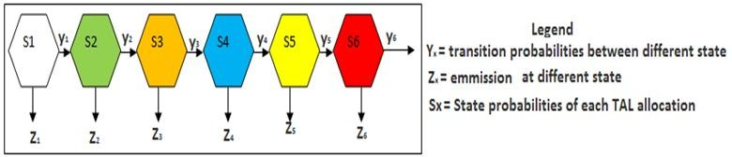

Figure 3.10: HMM for Adaptive Tracking Area List (aTAL) Design.

The following assumptions were considered to derive mathematical representation of the location management cost for the aTAL strategy derived from Hidden Markov Model of figure 3.10:

* + - 1. The Call to Mobility ratio of UE is one i.e for every unique step movement across a segment, A call is received
      2. Movement of UE is a step in a segment which implies UE moves across segment at each step.
      3. The total location management cost within a group of 16 TAs is calculated based on the number of unique segment crossed by the UE.
      4. Reversal movement is not considered due to the adaptive nature of the model The location management cost is calculated by equations (3.13) to (3.14) respectively.

Z1 = Ntau + Nta, 1

(3.13)

Z2 = Ntau + Nta, 1 + 3Nx

(3.14)

Z3 = Ntau + Nta, 1 + (3Nx ∗ 2)

(3.15)

Z4 = Ntau + Nta, 1 + (3Nx ∗ 3)

(3.16)

Z5 = Ntau + Nta, 1 + (3Nx ∗ 4)

(3.17)

Z6 = Ntau + Nta, 1 + (3Nx ∗ 4)

(3.18)

Z7 = Z1 = Ntau + Nta, 1

(3.19)

It should be noted that possible exit point from a group of 16 TAs is S2, S3, S4, S5 and S6.

# Flow Chart of aTAL

Figure 3.11 shows the flow chart of developed adaptive TAL.

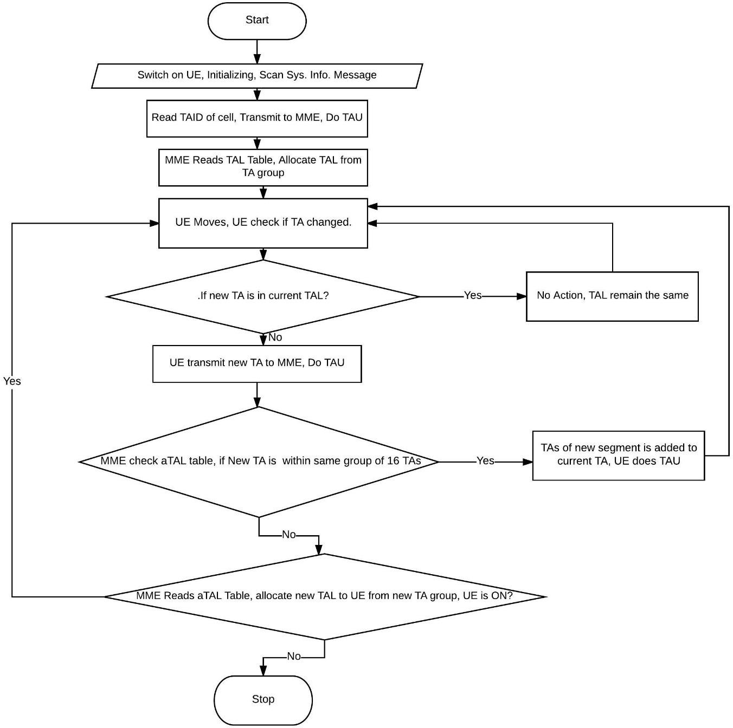

Figure 3.11: Flow Chart of Developed Adaptive Tracking Area List (aTAL) Design.

The Figure 3.11 aTAL flow chart differs from Figure 3.2 Conventional TAL flow chart base on the if statement that checks for new TA within group of 16 TAs arranged in the aTAL table.

# Adaptive TAL for assumed area

To effectively analyze the impactive of the adaptive TAL (aTAL) strategy with conventional TAL strategy. A similar structure of TAL was assumed for the adaptive and conventional strategy. Equations (3.11) through (3.17) were used to compute location management cost for the adaptive and conventional strategies. Comparative analysis of the results is discussed in Chapter

4. The aTAL structure is shown in Figure 3.12 with TA(A,1) numbering method. The emission of each state of the hidden Markov model indicates the LM cost for the UE. The alphabet indicates the groups of TAs and the figure represents the TA number in the group.

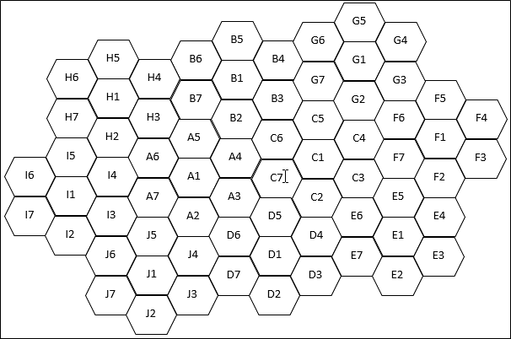

Figure 3.12: Adaptive Tracking Area List (aTAL) Structure

To implement that aTAL in Figure 3.12, A TAL lookup table is used and shown in Appendix A. Table 3.8 shows the first row in the table for aTAL implementation of Figure 3.12.

Table 3.8: Adaptive Tracking Area list table for aTAL.

|  |  |  |
| --- | --- | --- |
| **Ring 1** | **Ring 2** | **Ring 3** |
| A1 | A2 | J4 |
| A3 | D6 |
| A4 | D5 |
| A5 | C7 |
| A6 | C6 |
| A7 | B2 |
|  | B7 |
| H3 |
| H2 |

This location management cost is calculated for ping pong, regular and irregular movement pattern

# Ping Pong Movement Pattern

Two Ping Pong movement patterns is considered to observe effective of the aTAL strategy

1. Ping Pong within a group of TA. This is movement forth and back within the same TA group. In this pattern, the UE did not cross through to a new group of 16 TA. The case use is the pattern: A1-A4-A1-A4-A1-A4-A1-A4-A1-A4. Matlab code in Appendix D. Result is shown in figure 3.14. Only two TAU done through the 10 steps and 4 TAs paged through the steps. Total LM cost is 39. The emission equations of the HMM of figure 3.10 was use to obtain the result.

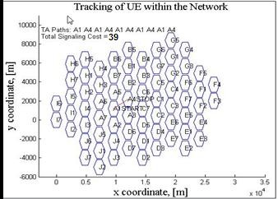

Figure 3.13: Ping Pong Movement Within Same TA group Table 3.9 shows the result obtained from the Ping Pong Movement within same TA

Table 3.9: Ping Pong Movement within Same TA result

|  |  |  |  |  |  |  |  |  |  |  |
| --- | --- | --- | --- | --- | --- | --- | --- | --- | --- | --- |
| Parameters | Movement Steps | | | | | | | | | |
| 1 | 2 | 3 | 4 | 5 | 6 | 7 | 8 | 9 | 10 |
| Location update | 1 | 1 | 0 | 0 | 0 | 0 | 0 | 0 | 0 | 0 |
| Paging | 1 | 4 | 4 | 4 | 4 | 4 | 4 | 4 | 4 | 4 |
| Cumulative LM cost | 2 | 7 | 11 | 15 | 19 | 23 | 27 | 31 | 35 | 39 |

Figure 3.14 shows the graphical representation of the Ping Pong Movement within Same TA for paging and Location update.

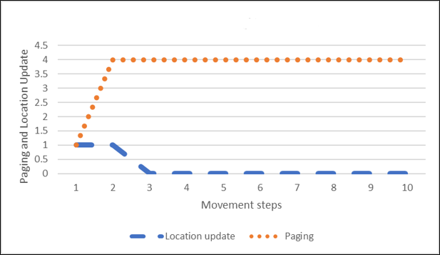

Figure 3.14: LM cost for Ping Pong Movement within Same TA group

1. Ping Pong across two groups of TA. This is movement forth and back across two TA groups. In this pattern, the UE did not cross to a new group of 16 TA. The case use is the pattern: A4-C6-A4-C6-A4-C6-A4-C6-A4-C6. Matlab code in Appendix D. Result is shown in figure 3.16 and it is same as the result obtained in figure 3.14. This implies the aTAL adapted to the ping pong pattern such that its result is not impacted in the two scenarios. Cumulative LM cost is 39.

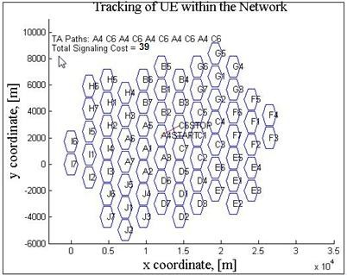

Figure 3.15: Ping Pong Movement Across Two TA groups

Table 3.10 shows the obtained result of Ping Pong Movement across two groups of TA. Table 3.10: Ping Pong Movement across two TA groups

|  |  |  |  |  |  |  |  |  |  |  |
| --- | --- | --- | --- | --- | --- | --- | --- | --- | --- | --- |
| **Parameters** | **Movement Steps** | | | | | | | | | |
| 1 | 2 | 3 | 4 | 5 | 6 | 7 | 8 | 9 | 10 |
| **Location update** | 1 | 1 | 0 | 0 | 0 | 0 | 0 | 0 | 0 | 0 |
| **Paging** | 1 | 4 | 4 | 4 | 4 | 4 | 4 | 4 | 4 | 4 |
| **Cumulative LM cost** | 2 | 7 | 11 | 15 | 19 | 23 | 27 | 31 | 35 | 39 |

Figure 3.16 shows the Paging and Location update cost of Table 3.10

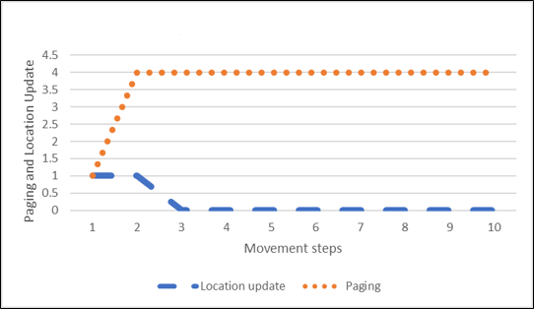

Figure 3.16: LM cost for Ping Pong Movement Across Two TA groups

# Regular Movement Pattern

1. Regular Movement within same TA group. The case adopted for this pattern is A7-A2- A3-A2-A7-A2-A3-A2-A7-A2-A3-A2-A7 movement. Matlab code in Appendix D. The LM cost is 64 and result is shown in Figure 3.18.

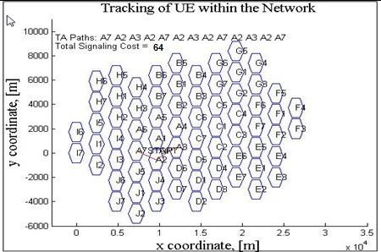

Figure 3.17: Regular Movement Within Same TA group

Table 3.11 shows the result obtained for Regular Movement within same TA for the adaptive strategy.

Table 3.11: Regular Movement within same TA

|  |  |  |  |  |  |  |  |  |  |  |
| --- | --- | --- | --- | --- | --- | --- | --- | --- | --- | --- |
| **Parameters** | **Movement Steps** | | | | | | | | | |
| 1 | 2 | 3 | 4 | 5 | 6 | 7 | 8 | 9 | 10 |
| **Location update** | 1 | 1 | 0 | 0 | 0 | 0 | 0 | 0 | 0 | 0 |
| **Paging** | 1 | 4 | 7 | 7 | 7 | 7 | 7 | 7 | 7 | 7 |
| **Cumulative LM cost** | 2 | 7 | 14 | 21 | 28 | 35 | 42 | 49 | 56 | 63 |

Figure 3.18 shows the graphical representation of paging and location update cost for the Adaptive strategy for Regular Movement within same TA.

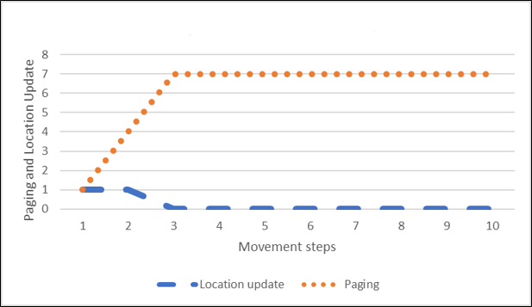

Figure 3.18: LM cost for Regular Movement Within Same TA group

1. Regular Movement across two TA groups. The case adopted for this pattern is A3-D5- C2-D5-A3-D5-C2-D5-A3-D5-C2-D5-A3 movement. Matlab code in Appendix D. The result obtained is shown in Figure 3.20. The total LM cost is 64 similar to the report of Figure 3.18. This means that aTAL adapted to both scenarios.

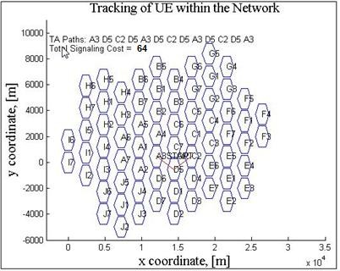

Figure 3.19: Regular Movement Across Two TA groups

Table 3.12 shows the result obtained for Regular Movement across TA for the adaptive strategy.

Table 3.12: Regular Movement across TA

|  |  |  |  |  |  |  |  |  |  |  |
| --- | --- | --- | --- | --- | --- | --- | --- | --- | --- | --- |
| **Parameters** | **Movement Steps** | | | | | | | | | |
| 1 | 2 | 3 | 4 | 5 | 6 | 7 | 8 | 9 | 10 |
| **Location update** | 1 | 1 | 0 | 0 | 0 | 0 | 0 | 0 | 0 | 0 |
| **Paging** | 1 | 4 | 7 | 7 | 7 | 7 | 7 | 7 | 7 | 7 |
| **Cumulative LM cost** | 2 | 7 | 14 | 21 | 28 | 35 | 42 | 49 | 56 | 63 |

Figure 3.20 shows the graphical representation of paging and location update cost for the Adaptive strategy for Regular Movement within same TA.

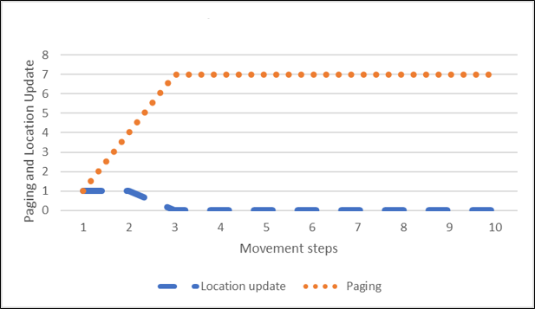

Figure 3.20: LM cost for Regular Movement Across Two TA groups

# Irregular Movement Pattern

The case adopted for irregular movement pattern is I7-I1-I4-A6-A5-B2-B3-G7-G1-G4. It is assumed that irregular movement pattern may not exist within a group of TAs. What is considered as irregular pattern in this work is assumption that a UE arrives in a location and traverse several TA groups within the geographical area and leave for another destination. Figure

3.22 shows the result obtained. The total LM cost is 56 for the 10 steps considered.

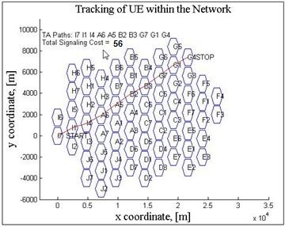

Figure 3.21: Irregular Movement

Table 3.13 shows the result obtained for Irregular Movement for the adaptive strategy.

Table 3.13: Irregular Movement for Adaptive TAL strategy

|  |  |  |  |  |  |  |  |  |  |  |
| --- | --- | --- | --- | --- | --- | --- | --- | --- | --- | --- |
| **Parameters** | **Movement Steps** | | | | | | | | | |
| 1 | 2 | 3 | 4 | 5 | 6 | 7 | 8 | 9 | 10 |
| **Location update** | 1 | 1 | 1 | 1 | 1 | 1 | 1 | 1 | 1 | 1 |
| **Paging** | 1 | 4 | 7 | 10 | 1 | 4 | 7 | 1 | 4 | 7 |
| **Cumulative LM cost** | 2 | 7 | 15 | 26 | 28 | 33 | 41 | 43 | 48 | 56 |

Figure 3.22 shows the paging and location update cost for Irregular movement pattern for adaptive TAL strategy.

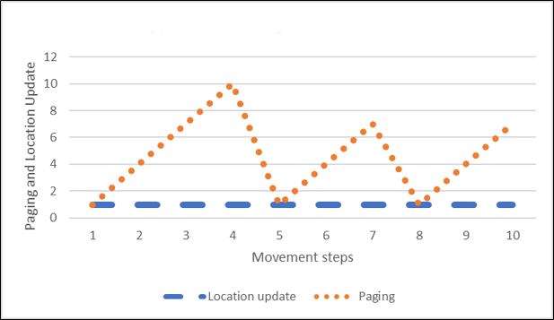

Figure 3.22: LM Cost for Irregular Movement

# CHAPTER FOUR RESULTS AND DISCUSSION

# Introduction

The performance of ping pong, regular, irregular and mass movement patterns are evaluated. The performance of these movement patterns for aTAL and conventional TAL are compared and analyzed.

# Results and Presentation.

This section presents various results obtained from the simulations and analysis of the results. A cost estimate of 1 is given to one TAU and number of TAs is attributed to the paging. All computations were from the emission equations (3.13) through (3.19) of the hidden Markov model. The performance improvement is obtained after ten steps of movement and equation (4.1) is used to obtain percentage improvement.

𝑃𝑒𝑟𝑐𝑒𝑛𝑡𝑎𝑔𝑒 𝐼𝑚𝑝𝑟𝑜𝑣𝑒𝑚𝑒𝑛𝑡 = 𝐶𝑜𝑛𝑣𝑒𝑛𝑡𝑖𝑜𝑛𝑎𝑙 𝐶𝑜𝑠𝑡 −𝐴𝑑𝑎𝑝𝑡𝑖𝑣𝑒 𝐶𝑜𝑠𝑡 ∗ 100% (4.1)

𝐶𝑜𝑛𝑣𝑒𝑛𝑡𝑖𝑜𝑛𝑎𝑙 𝐶𝑜𝑠𝑡

# Ping Pong Movement Pattern

* + 1. Ping Pong Movement Pattern within same TA group considered is A1-A4-A1-A4-A1- A4-A1-A4-A1-A4. The emission equations of the hidden Markov model was use to generate the result for both aTAL and conventional TAL. Similar parameters are considered for both strategies. 10 steps ping pong is considered and the cumulative location management cost is calculated. Table 4.1 shows the result for the adaptive and Conventional TAL.

Table 4.1: LM Cost of aTAL and Conventional TAL for Ping Pong Within same TA Group

|  |  |  |  |  |  |  |  |  |  |  |  |
| --- | --- | --- | --- | --- | --- | --- | --- | --- | --- | --- | --- |
| **Steps (n)** | | **1** | **2** | **3** | **4** | **5** | **6** | **7** | **8** | **9** | **10** |
| **Adaptive TAL** | **Location update** | 1 | 1 | 0 | 0 | 0 | 0 | 0 | 0 | 0 | 0 |
| **Paging** | 1 | 4 | 4 | 4 | 4 | 4 | 4 | 4 | 4 | 4 |
| **Cumulative LM cost** | 2 | 7 | 11 | 15 | 19 | 23 | 27 | 31 | 35 | 39 |
| **Conventional TAL** | **Location update** | 1 | 0 | 0 | 0 | 0 | 0 | 0 | 0 | 0 | 0 |
| **Paging** | 7 | 7 | 7 | 7 | 7 | 7 | 7 | 7 | 7 | 7 |
| **Cumulative LM cost** | 8 | 15 | 22 | 29 | 36 | 43 | 50 | 57 | 64 | 71 |

Table 4.1 shows that cumulative cost of TAU and paging done for aTAL is lesser than the conventional for the ping pong scenario as shown in figure 4.1. Two TAU done for the adaptive TAL for the 10 steps of movement while one TAU is done for the conventional TAL. However, the adaptiveness shows in the paging scenario in this strategy were only 4 TAs are paged to connect to this UE and 7 TAs are paged to connect to same UE in a conventional strategy. In this situation, using linear interpolation to examine the result, Paging load have been reduced by 47.14% whereas LU update increased by 1. The overall performance improvement based on the 10 steps consider in this scenario is 45.07%.

Figure 4.11 shows Paging load for Ping Pong within same TA for adaptive and Conventional strategy. Adaptive improved in paging load by 47.14%

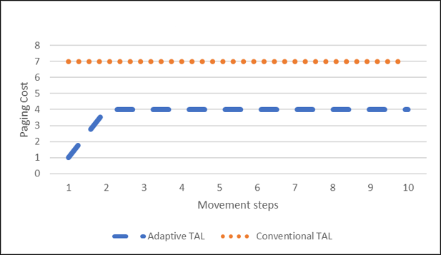

Figure 4.1: Paging Cost for Ping Pong Movement Within same TA Group.

Figure 4.12 shows Location update cost for Ping Pong within same TA for adaptive and Conventional strategy. Adaptive improved Location update cost increased by one.

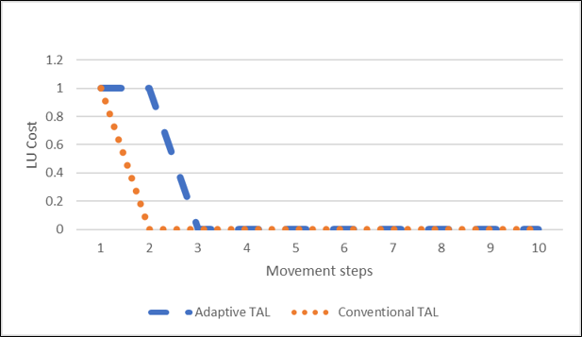

Figure 4.2: LU Cost for Ping Pong Movement Within same TA Group.

Figure 4.3 shows the cumulative LM Cost for Ping Pong Movement Within same TA Group. Improvement of 45.07% achieved in Adaptive strategy compared to the Conventional Strategy.



120

100

80

60

40

20

0

1

2

3

4

5

6

7

8

9

10

Steps (n)

Adaptive Conventional

LM Cost (Unit Integer)

Figure 4.3: Cumulative LM Cost for Ping Pong Movement Within same TA Group.

* + 1. Ping Pong Movement Pattern across two TA. The pattern considered is A4-C6-A4-C6- A4-C6-A4-C6-A4-C6 and below result is obtained from simulation.

Table 4.2: LM cost of aTAL and Conventional TAL for Ping Pong Across Two TA groups.

|  |  |  |  |  |  |  |  |  |  |  |  |
| --- | --- | --- | --- | --- | --- | --- | --- | --- | --- | --- | --- |
| **Steps (n)** | | **1** | **2** | **3** | **4** | **5** | **6** | **7** | **8** | **9** | **10** |
| **Adaptive TAL** | **Location update** | 1 | 1 | 0 | 0 | 0 | 0 | 0 | 0 | 0 | 0 |
| **Paging** | 1 | 4 | 4 | 4 | 4 | 4 | 4 | 4 | 4 | 4 |
| **Cumulative LM cost** | 2 | 7 | 11 | 15 | 19 | 23 | 27 | 31 | 35 | 39 |
| **Conventional TAL** | **Location update** | 1 | 1 | 1 | 1 | 1 | 1 | 1 | 1 | 1 | 1 |
| **Paging** | 7 | 7 | 7 | 7 | 7 | 7 | 7 | 7 | 7 | 7 |
| **Cumulative LM cost** | 8 | 16 | 24 | 32 | 40 | 48 | 56 | 64 | 72 | 80 |

The result shows significant improvement when a UE moves between two groups of TA. The paging improvement is very good. The step 10 of the data shows 80% improvement and TAU shows 47.14% improvement in Location update load and cumulative LM cost improvement is 51.25%. This strategy is very efficient in terms of TAU and paging load.

Figure 4.4 shows Paging cost of ping pong movement across TA between the adaptive and conventional strategy. The Paging Cost of the Adaptive strategy improved by 47.14%

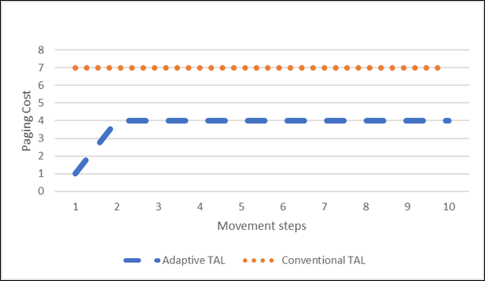

Figure 4.4: Paging Cost for Ping Pong Movement across TA.

Figure 4.5 shows the Location Update cost of ping pong movement across TA between the adaptive and conventional strategy. The Location Update Cost of the Adaptive strategy improved by 80% during the ten steps movement observation.

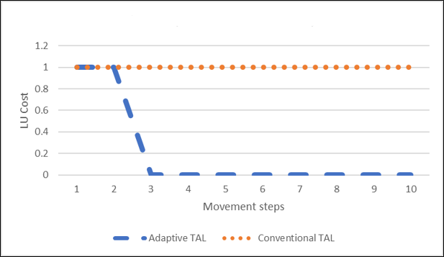

Figure 4.5: Location Update Cost for Ping Pong Movement across TA.

Figure 4.6 shows the Cumulative Location Management cost of ping pong movement across TA between the adaptive and conventional strategy. Cumulative LM cost improved by 51.25% on the adaptive strategy compared to the conventional strategy.



140

120

100

80

60

40

20

0

1

2

3

4

5

6

7

8

9

10

Steps (n)

Adaptive Conventional

LM Cost (Unit Integer)

Figure 4.6: Cumulative LM Cost for Ping Pong Movement Across Two TA groups.

# Regular Movement Pattern

* + 1. Regular Movement Pattern within same TA group.

The pattern considered is A7-A2-A3-A2-A7-A2-A3-A2-A7-A2-A3-A2-A7 and below result was obtained. This pattern shows TAU is lesser in conventional strategy to adaptive strategy with ratio of 1:3 which implies 150% TAU improvement on conventional strategy compared to aTAL strategy. However, Paging load improved by 12.86% and cumulative LM cost improved by 9.86%. The cumulative improvement in LM cost is due to the contribution of the paging load in the LM scheme. In conventional TAL, a static TAL of 16 TAs is technically hazardous and may lead to high paging load on the MME which will impact call establishment success rate. The adaptive aTAL considers the 16 TA grouping recommended by 3GPP (3GPP TS 23.401 V13.401 (2015).

Table 4.3: LM cost of aTAL and conventional TAL for Regular Movement Within same TA.

|  |  |  |  |  |  |  |  |  |  |  |  |
| --- | --- | --- | --- | --- | --- | --- | --- | --- | --- | --- | --- |
| **Steps (n)** | | **1** | **2** | **3** | **4** | **5** | **6** | **7** | **8** | **9** | **10** |
| **Adaptive TAL** | **Location update** | 1 | 1 | 0 | 0 | 0 | 0 | 0 | 0 | 0 | 0 |
| **Paging** | 1 | 4 | 7 | 7 | 7 | 7 | 7 | 7 | 7 | 7 |
| **Cumulative LM cost** | 2 | 7 | 14 | 21 | 28 | 35 | 42 | 49 | 56 | 63 |
| **Conventional TAL** | **Location update** | 1 | 0 | 0 | 0 | 0 | 0 | 0 | 0 | 0 | 0 |
| **Paging** | 7 | 7 | 7 | 7 | 7 | 7 | 7 | 7 | 7 | 7 |
| **Cumulative LM cost** | 8 | 15 | 22 | 29 | 36 | 43 | 50 | 57 | 64 | 71 |

Figure 4.7 shows Paging cost of Regular movement within TA between the adaptive and conventional strategy. The Paging Cost of the Adaptive strategy improved by 12.86%

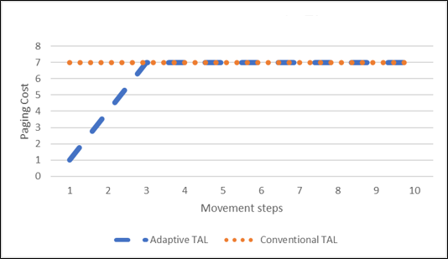

Figure 4.7: Paging Cost for Regular Movement within TA.

Figure 4.8 shows Location update cost of Regular movement within TA between the adaptive and conventional strategy. The Location Update Cost of the Adaptive strategy increased by one. However, the cumulative LM cost improved by 9.86%

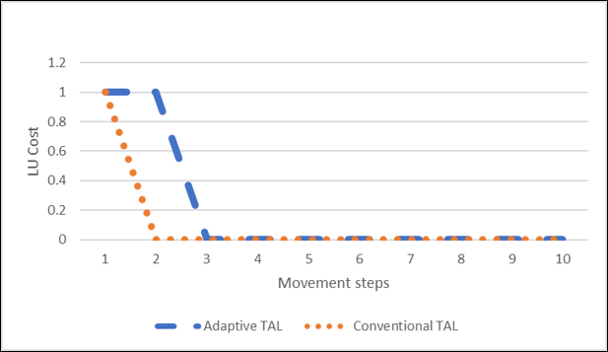

Figure 4.8: Location Update Cost for Regular Movement within TA.

Figure 4.9 shows the Cumulative Location Management cost of Regular Movement within TA between the adaptive and conventional strategy. Cumulative LM cost improved by 9.86% on the adaptive strategy compared to the conventional strategy.



80

70

60

50

40

30

20

10

0

1

2

3

4

5

6

7

8

9

10

Steps (n)

Adaptive Conventional

LM cost for mass movement

Figure 4.9: Cumulative LM Cost for Regular Within Same TA.

a) Regular Movement Pattern across TA groups.

The case adopted for this pattern is A3-D5-C2-D5-A3-D5-C2-D5-A3-D5-C2-D5-A3. The result show improvement in location management cost by 21.25% after 10 steps. TAU improves by 80% after 3 steps and Paging improvements is observed within to first 2 steps by 12.86%. The results is shown in Table 4.4 and Figure 4.4 respectively.

Table 4.4: LM cost of aTAL and Conventional TAL for Regular Across TA

groups.

|  |  |  |  |  |  |  |  |  |  |  |  |
| --- | --- | --- | --- | --- | --- | --- | --- | --- | --- | --- | --- |
| **Steps (n)** | | **1** | **2** | **3** | **4** | **5** | **6** | **7** | **8** | **9** | **10** |
| **Adaptive TAL** | **Location update** | 1 | 1 | 0 | 0 | 0 | 0 | 0 | 0 | 0 | 0 |
| **Paging** | 1 | 4 | 7 | 7 | 7 | 7 | 7 | 7 | 7 | 7 |
| **Cumulative LM cost** | 2 | 7 | 14 | 21 | 28 | 35 | 42 | 49 | 56 | 63 |
| **Conventional TAL** | **Location update** | 1 | 1 | 1 | 1 | 1 | 1 | 1 | 1 | 1 | 1 |
| **Paging** | 7 | 7 | 7 | 7 | 7 | 7 | 7 | 7 | 7 | 7 |
| **Cumulative LM cost** | 8 | 16 | 24 | 32 | 40 | 48 | 56 | 64 | 72 | 80 |

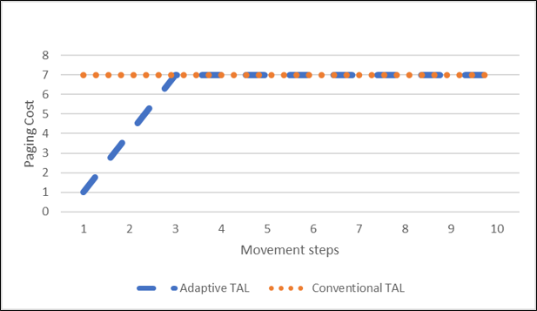Figure 4.10 shows the paging cost of regular movement across TA group between Adaptive TAL Strategy and Conventional Strategy. The Paging cost improved by 12.86% in Adaptive Strategy Compared to the Conventional Strategy.

Figure 4.10: Paging Cost for Regular Movement across TA.

Figure 4.11 shows improvement of 80% in Location update cost of Adaptive Strategy Compared to Conventional Strategy.

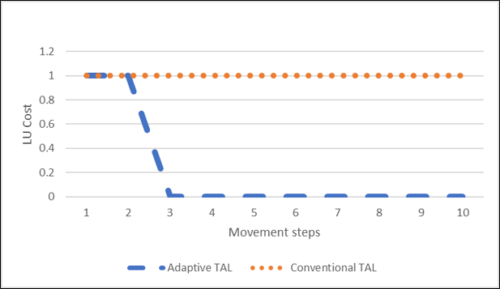

Figure 4.11: Location Update Cost for Regular Movement across TA.

Figure 4.12 shows that the LM cost improved in the Adaptive strategy compared to the Conventional Strategy by 21.25%.



90

80

70

60

50

40

30

20

10

0

1

2

3

4

5

6

7

8

9

10

Steps (n)

Adaptive Conventional

LM cost for mass movement

Figure 4.12: Cumulative LM Cost for Regular Movement Across TA groups.

# Irregular Movement Pattern

The adopted pattern is I7-I1-I4-A6-A5-B2-B3-G7-G1-G4. The result shows significant improvement of 34.29% in the paging load, however, the 150% additional TAU was observed on the aTAL strategy compared to the conventional strategy. This shows that the irregular pattern has more TAU due to irregular movement of the UE. Due to the impact of the paging load improvement in the aTAL strategy, cumulative improvement of 24.32% observed on aTAL location management strategy compared to conventional strategy. Therefore, the aTAL strategy is very good for improving paging load in irregular pattern, However, the TAU update will increase significantly compared to the conventional strategy. This is shown in Table 6 below.

Table 4.5: LM cost of aTAL and conventional TAL for irregular pattern.

|  |  |  |  |  |  |  |  |  |  |  |  |
| --- | --- | --- | --- | --- | --- | --- | --- | --- | --- | --- | --- |
| **Steps (n)** | | **1** | **2** | **3** | **4** | **5** | **6** | **7** | **8** | **9** | **10** |
| **Adaptive TAL** | **Location update** | 1 | 1 | 1 | 1 | 1 | 1 | 1 | 1 | 1 | 1 |
| **Paging** | 1 | 4 | 7 | 10 | 1 | 4 | 7 | 1 | 4 | 7 |
| **Cumulative LM cost** | 2 | 7 | 15 | 26 | 28 | 33 | 41 | 43 | 48 | 56 |
| **Conventional TAL** | **Location update** | 1 | 0 | 0 | 1 | 0 | 1 | 0 | 1 | 0 | 0 |
| **Paging** | 7 | 7 | 7 | 7 | 7 | 7 | 7 | 7 | 7 | 7 |
| **Cumulative LM cost** | 8 | 15 | 22 | 30 | 37 | 45 | 52 | 60 | 67 | 74 |

Figure 4.13 shows the paging cost of Irregular Movement between Adaptive TAL Strategy and Conventional Strategy. The Paging cost improved by 34.29% in Adaptive Strategy Compared to the Conventional Strategy.

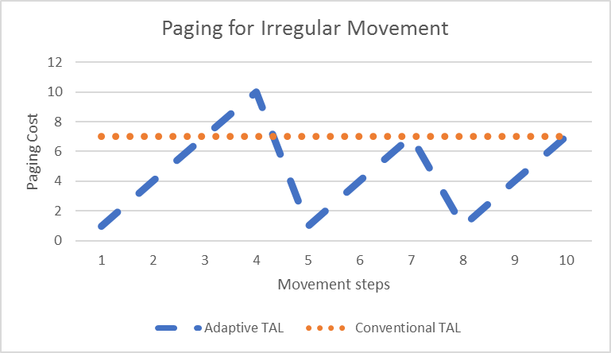

Figure 4.13: Paging Cost for Irregular Movement.

Figure 4.14 shows the Location Update cost of Irregular Movement between Adaptive TAL Strategy and Conventional Strategy. The Location Update cost is better in Conventional strategy compared to Adaptive Strategy by 150% in Adaptive Strategy. This is due to the erratic pattern in the movement. However, The Cumulative LM cost improved by 24.32% due to the improvement in paging cost.

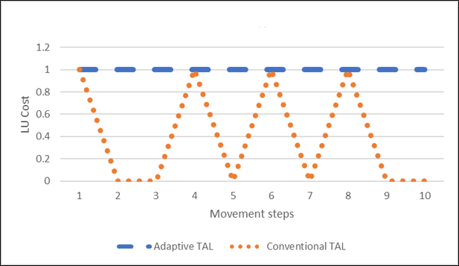

Figure 4.14: LU Cost for Irregular Movement.

Figure 4.15 shows that the cumulative location management cost in of the aTAL and conventional strategy. The aTAL strategy has improved cumulative LM cost of 24.32% compared to the conventional strategy.

LM cost for mass movement

Figure 4.15: Cumulative LM Cost for Irregular Movement Pattern.



80

70

60

50

40

30

20

10

0

1

2

3

4

5

6

7

8

9

10

Steps (n)

Adaptive Conventional

# Mass Movement Pattern

A pattern of movement is considered for five UEs (U1, U2, U3, U4 and U5) from within a group of TA. The initial point of the five UEs – U1, U2, U3, U4 and U5 are I2, I7, I6, I5 and I1 respectively. This is shown in Figure 4.6 for adaptive TAL and Figure 4.7 for Conventional TAL. This UE assumed to move to a point I4 after which they move together through pattern I4- A7-A1-A4-C7-C1-C4-F7-F1-F4. Table 4.6 shows the result obtained for the mass movement pattern. The result shows that location update for the adaptive is 59.18% higher compared to the conventional strategy, However the paging load is much better in the adaptive model with the conventional strategy having 43.71% paging load more than the adaptive strategy. The cumulative location management cost shows that adaptive strategy is 33.51% lesser in LM load compared to the Conventional strategy. This is due to the impact in the paging on LM cost. Figure 4.8, 4.9 and 4.10 shows the result for paging, TAU and cumulative LM cost respectively.

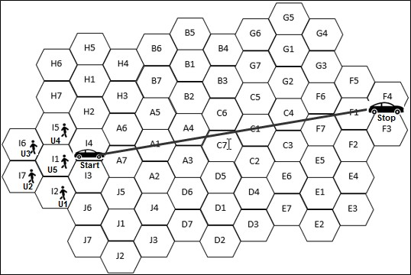

Figure 4.16: Mass Movement Pattern for aTAL (Case of 5 UEs)

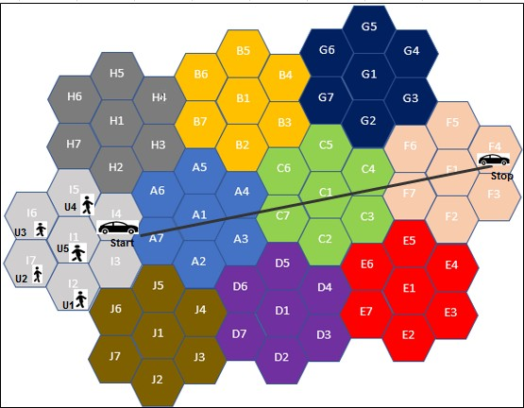

Figure 4.17: Mass Movement Pattern for Conventional TAL (Case of 5 UEs)

Table 4.6: LM cost of aTAL and Conventional TAL for Mass Movement

|  |  |  |  |  |  |  |  |  |  |  |  |  |
| --- | --- | --- | --- | --- | --- | --- | --- | --- | --- | --- | --- | --- |
|  | **Steps (n)** | | **1** | **2** | **3** | **4** | **5** | **6** | **7** | **8** | **9** | **10** |
| **Adaptive TAL** | | **Location update** | 5 | 4 | 5 | 5 | 5 | 5 | 5 | 5 | 5 | 5 |
| **Paging** | 29 | 23 | 11 | 26 | 23 | 11 | 26 | 17 | 14 | 17 |
| **Cumulative LM cost** | 34 | 61 | 77 | 108 | 136 | 152 | 183 | 205 | 224 | 246 |
| **Conventional TAL** | | **Location update** | 5 | 5 | 0 | 0 | 5 | 0 | 0 | 5 | 0 | 0 |
| **Paging** | 35 | 35 | 35 | 35 | 35 | 35 | 35 | 35 | 35 | 35 |
| **Cumulative LM cost** | 40 | 80 | 115 | 150 | 190 | 225 | 260 | 300 | 335 | 370 |

The Paging and TAU load is shown in Figure 4.18.



40

35

30

25

20

15

10

5

0

1 2 3 4 5 6 7 8 9 10

Steps (n)

Adaptive Conventional

Paging (no of cells)

Figure 4.18: Paging Cost for Mass Movement of 5 UEs.

The location update for the adaptive is higher for the mass movement as shown in figure 4.19



6

5

4

3

2

1

0

1

2

3

4

5

6

7

8

9

10

Steps (n)

Adaptive Conventional

Location Update

Figure 4.19: Location Update for Mass movement of 5 UEs.

The cumulative location management improved by 33.51% in the adaptive model compared to the conventional model as shown in figure 4.10



400

350

300

250

200

150

100

50

0

1

2

3

4

5

6

7

8

9

10

Steps (n)

Adaptive Conventional

LM cost for mass movement

Figure 4.20: Cumulative LM Cost for Mass Movement of 5 UEs

# Summary

# CHAPTER FIVE CONCLUSION AND RECOMMENDATION

This work developed an Adaptive Tracking Area List (aTAL) algorithm to improve location management cost in Long Term Evolution Networks. The conventional TAL system was adopted. A lookup table was introduced to which the aTAL algorithm was embedded. The result achieved shows improvement in aTAL location management strategy compared to the Conventional TAL strategy.

# Significant Contribution

The Contribution of this dissertation are as follows:

* + 1. Development of an Adaptive Tracking Area List (aTAL) algorithm.
    2. Improved paging load in ping pong, regular, irregular and mass movements patterns by 47.14%, 12.86%, 34.29% and 43.71% respectively compared to Conventional TAL strategy.
    3. Improved cumulative location management cost in ping pong, regular, irregular and mass movement patterns by 45.07%, 9.86%, 24.32% and 33.51% respectively compared to Conventional TAL strategy.
    4. aTAL algorithm is easily implementable considering the current LTE network architecture. Memory and high-speed processor is required. This can be achieved by upgrade of the Mobility Management Entity. (MME)

# Conclusion

The aTAL strategy improved Location Management cost by:

* + 1. Obtaining improved Paging load on ping pong, regular, irregular and mass movements from the simulation result of the aTAL compared to conventional strategy
    2. Tracking Area update improvement was also achieved in ping pong within and across TAs, regular movement across TA group for the aTAL compared to conventional strategy
    3. Cumulative Location Management Cost improvement was achieved in the four movement patterns. For the aTAL compared to conventional strategy

# Limitation

Mass UE movement of five users were considered due to memory and processor requirement for the simulation. Mass movement for train scenario that can accommodate hundreds of users would have been simulated.

The Experiment was limited to ten steps of movement due to memory and processor requirements.

# Recommendation

This work can be extended to hundreds of UEs for mass movement. More mobility pattern can analyze with the adaptive strategy. Machine learning method and modified adaptive TAL strategy can be introduced to improve LM performance and more steps can be adopted in simulating the movement patterns.

# REFERENCES

Akyildiz Ian F. and Wenye Wang (2002). *A Dynamic Location Management Scheme for Next Generation Multitier PCS Systems*. IEEE Transactions on wireless communications,

VOL. 1, NO. 1, JANUARY 2002

Akyildiz Ian F., Yi-Bing Lin, Wei-Ru Lai and Rong-Jaye Chen (2000). *A new random walk model for PCS Networks*. IEEE journal on selected areas in communications, vol. 18, no. 7, july

2000

Andrieu Christophe, Nando De Freitas, Arnaud Doucet and Micheal I. Jordan (2003), “A *Introduction to MCMC for Machine learning”*. Kluwer Academic publishers, Machine learning, 50, 5-43, 2003.

Anuradha and Kumar N, (2014). *BER Analysis for conventional and wavelet based OFDM in LTE using different modulation techniques*. in proceedings of 2014 RAECS, IEEE Publication ISBN: 978-1-4799-2290-1

Bar-Noy A., I. Kesler and M. Sidi,(1995). *Mobile users: To update or not to update*?. IEEE wireless network, Vol.1, no.2, pp. 175-185, 1995 ISSN 0743-166

[Cassey J.,](http://ieeexplore.ieee.org/search/searchresult.jsp?searchWithin=%22Authors%22%3A.QT.Deng%2C%20T..QT.&newsearch=true) Rajagopalan S., Yan M., [Booker G., Sprintson A.](http://ieeexplore.ieee.org/search/searchresult.jsp?searchWithin=%22Authors%22%3A.QT.Fan%2C%20P..QT.&newsearch=true), [Magnussen W.,](http://ieeexplore.ieee.org/search/searchresult.jsp?searchWithin=%22Authors%22%3A.QT.Li%2C%20K..QT.&newsearch=true) (2013). [*Supporting*](http://ieeexplore.ieee.org/xpl/articleDetails.jsp?arnumber=7234946&newsearch=true&queryText=modelling%20and%20evaluating%20performance%20of%20TAL%20in%20LTE) *voice over LTE: Solutions, Architecture and protocols*. [Computer Communications and](http://ieeexplore.ieee.org/xpl/RecentIssue.jsp?punumber=25) [Networks (ICCCN), 2013. IEEE conference Publications, July 2013.](http://ieeexplore.ieee.org/xpl/RecentIssue.jsp?punumber=25)

Chung Yun Won (2011). *Adaptive Design of Tracking Area List in LTE*. IEEE WCON, 2011 Page 1-5.

[Deng T.,](http://ieeexplore.ieee.org/search/searchresult.jsp?searchWithin=%22Authors%22%3A.QT.Deng%2C%20T..QT.&newsearch=true) [Wang, X.](http://ieeexplore.ieee.org/search/searchresult.jsp?searchWithin=%22Authors%22%3A.QT.Wang%2C%20X..QT.&newsearch=true); [Fan, P.](http://ieeexplore.ieee.org/search/searchresult.jsp?searchWithin=%22Authors%22%3A.QT.Fan%2C%20P..QT.&newsearch=true); [Li, K.](http://ieeexplore.ieee.org/search/searchresult.jsp?searchWithin=%22Authors%22%3A.QT.Li%2C%20K..QT.&newsearch=true) (2015). [*Modeling and Performance Analysis of Tracking*](http://ieeexplore.ieee.org/xpl/articleDetails.jsp?arnumber=7234946&newsearch=true&queryText=modelling%20and%20evaluating%20performance%20of%20TAL%20in%20LTE)[*Area List-Based Location Management Scheme in LTE Networks*.](http://ieeexplore.ieee.org/xpl/articleDetails.jsp?arnumber=7234946&newsearch=true&queryText=modelling%20and%20evaluating%20performance%20of%20TAL%20in%20LTE) [Vehicular Technology,](http://ieeexplore.ieee.org/xpl/RecentIssue.jsp?punumber=25) [IEEE Transactions on,](http://ieeexplore.ieee.org/xpl/RecentIssue.jsp?punumber=25) September, 2015. ISSN : 0018-9545.

Ferragut Jaime and Bafalluy Josep-Mangues (2012). *A self-Organized tracking area list mechanism for large- scale Networks of Femto cell*. IEEE ICC 2012 - Wireless Networks Symposium.

Grigoreva E., Jianghua Xu, and Wolfgang Kellera (2017). *Reducing mobility management signaling for Automotive Users in LTE Advanced.* [2017 IEEE International Symposium](http://ieeexplore.ieee.org/xpl/mostRecentIssue.jsp?punumber=7963870) [on Local and Metropolitan Area Networks (LANMAN)](http://ieeexplore.ieee.org/xpl/mostRecentIssue.jsp?punumber=7963870) Pages: 1 - 6, DOI: [10.1109/LANMAN.2017.7972167](https://doi.org/10.1109/LANMAN.2017.7972167), IEEE Conference Publications

Ikeda Satoshi, Nobuharu Kami and Takashi Yoshikawa (2014). *A Tracking Area List Configuration Method to Mitigate Burst Location Updates*. [Communications and](http://ieeexplore.ieee.org/xpl/mostRecentIssue.jsp?punumber=6908289) [Electronics (ICCE), 2014 IEEE Fifth International Conference on](http://ieeexplore.ieee.org/xpl/mostRecentIssue.jsp?punumber=6908289) July 30 2014-Aug. 1 2014, Print ISBN: 978-1-4799-5049-2

Ioannis Filippidis (2014). *https://*[*www.mathworks.com/matlabcentral/profile/authors/2249257*](http://www.mathworks.com/matlabcentral/profile/authors/2249257) *ioannis-filippidis*. Too Many Markers! 17th February 2013.

Jie Li,Yi Pan and Xianohua Jia (2002). *Analysis of Dynamic Location Management for PCS Networks*. IEEE Transactions on vehicular Technology, 51(5) 1109-1119.

Keqin Li (2013). *Analysis of Distance-Based Location management in wireless communication Networks*” IEEE transactions on parallel and distributed systems, vol. 24, no. 2, February 2013.

Kreuger Per, Daniel Gilliblad and Arvidsson A.(2012). *Zero Configuration Adaptive Paging(zCap)* IEEE Vehicular technology conference, ISSN:1090-3038 DOI

:1[0.1109/VTCFall.2012.6399016](http://dx.doi.org/10.1109/VTCFall.2012.6399016), IEEE Conference

Liou Ren-Huang, Yi-Bing Lin and Shang-Chih Tsai (2013). *An Investigation on LTE Mobility Management*. IEEE Transactions on Mobile Computing Vol. 12 no. 1, 2013

Nowoswait David and Milliken Godon (2013),“*Managing LTE Core network signaling traffic*”. Alcatel lucent White paper on-“Reduce core network signaling with a field proven

MME”.

Qiang Li, Zhou wen, Cui Baojiang and Liu Na (2014). *Security Analysis of TAU Procedure in LTE Network* [*P2P, Parallel, Grid, Cloud and Internet Computing (3PGCIC).* 2014 Ninth](http://ieeexplore.ieee.org/xpl/mostRecentIssue.jsp?punumber=7002489) [International Conference *on*](http://ieeexplore.ieee.org/xpl/mostRecentIssue.jsp?punumber=7002489)DOI: [10.1109/3PGCIC.2014.124](http://dx.doi.org/10.1109/3PGCIC.2014.124). IEEE Conference Publications.

Razavi S. Modarres and D. Yuan (2011), “*Mitigating Mobility signaling congestion in LTE by overlapping tracking area list*” in proceedings of the 14th ACM international conference on modeling, analysis and simulation of wireless and mobile systems, 2011 pp. 285-292

Razavi S. Modarres, Di Yuan, Fredrik Gunnarsson and Johan Moe (2012). *Performance and Cost Trade-off in Tracking Area Reconfiguration: A Pareto-optimization Approach*. Computer

Networks , Vol. 56, No. 1, 2012

Ref: 1, <http://www.3gpp.org/technologies/keywords-acronyms/98-lte>

Roy A., J. Shin and N. Saxena (2012). *Entropy-based location management in long-term evolution cellular systems*. JAN, 2014. [Communications, IET](http://ieeexplore.ieee.org/xpl/RecentIssue.jsp?punumber=4105970) VOL 6, ISSUE 2 ISSN 1751-8628 INSPEC Accession Number: 12571721.

Safa Haidar and Ahmad Nadine (2015). *Tabu Search Based Approach to Solve the TAs Reconfiguration Problem in LTE Networks*. [Advanced Information Networking and](http://ieeexplore.ieee.org/xpl/mostRecentIssue.jsp?punumber=7095453) [Applications (AINA), 2015 IEEE 29th International Conference](http://ieeexplore.ieee.org/xpl/mostRecentIssue.jsp?punumber=7095453) DOI: [10.1109/AINA.2015.241](http://dx.doi.org/10.1109/AINA.2015.241). . IEEE Conference Publications.

Ting-Yu Lin and Sheng-Po Kuo (2011). *A Survey on the Location Management Problem in Mobile Networks*. Cyber Journals: Multidisciplinary Journals in Science and Technology, Journal

of Selected Areas in Telecommunications (JSAT), March Edition, 2011

Toril Matías, Salvador Luna-Ramírez, and Volker Wille (2013). *Automatic Replanning of Tracking Areas in Cellular Networks*. IEEE transactions on vehicular technology, vol. 62, no. 5, june 2013

Vekariya Meghna H., Prof. Prashant B. Swadas (2015). *A Survey on Location Management Strategies in Cellular Networks*. International Journal of Engineering Research and General Science Volume 3, Issue 1, January-February, 2015. ISSN 2091-2730

Wang Xian, Pingzhi Fan, Jie Li & Yi Pan (2008). *Modeling and cost analysis of movement based location management for PCS networks with HLR/VLR Architecture, General location area and cell Residence Time distributions*. IEEE Transactions on vehicular technology, VOL.57, NO.6 2008

Wang Xian, Rose Qingyang Hu and Yi Qian (2014B). *Modeling of tracking area list-based location update scheme in Long Term Evolution*. IEEE ICC 2014 - Mobile and Wireless Networking Symposium

Wang Xian, Xianfu Lei, Pingzhi Fan, Rose Qingyang Hu and Shi-Jinn Horng (2014A). *Cost Analysis of Movement based Location management in PCS Networks : An embedded Markov chain approach*. IEEE Transactions on vehicular Technology , VOL.63, No.4, May 2014

Widjaja Indra, Peter Bosch and Humberto La Roche (2009). *Comparison of MME Signaling Loads for Long Term Evolution Architectures*. [Vehicular Technology Conference Fall](http://ieeexplore.ieee.org/xpl/mostRecentIssue.jsp?punumber=5377994) [(VTC 2009-Fall), 2009 IEEE Conference,](http://ieeexplore.ieee.org/xpl/mostRecentIssue.jsp?punumber=5377994) September 2009, ISSN : 1090-3038

[www.qualcom.com](http://www.qualcom.com/)

Xiao Yang (2003). *Optimal fractional movement-based scheme for PCS location management*

IEEE Communications Letters, Vol. 7, No. 2, February 2003

Yi-Bing Lin (1997). *Reducing Location Update Cost in a PCS Network*. IEEE/ACM transactions on networking, Vol. 5, No. 1, February 1997

3GPP TS 23.401 V13.401 (2015). *3rd Generation Partnership Project; Technical Specification Group Services and System Aspects; General Packet Radio Service (GPRS) enhancements for Evolved Universal Terrestrial Radio Access Network (E-UTRAN) access (Release 13)*” 3GPP 3rd Generation partnership project; Technical Specification Group services and system aspect, Sept 2015.

# APPENDIX A

**Adaptive Tracking Area List (aTAL) look up table**

|  |  |  |  |  |  |  |  |  |  |  |  |
| --- | --- | --- | --- | --- | --- | --- | --- | --- | --- | --- | --- |
| Ring 1 | Ring 2 | Ring 3 | Ring 1 | Ring 2 | Ring 3 | Ring 1 | Ring 2 | Ring 3 | Ring 1 | Ring 2 | Ring 3 |
| A1 | A2 | J4 | A4 | A3 | D6 | A7 | J5 | J1 | B3 | C6 | C7 |
| A3 | D6 | C7 | D5 | A2 | J4 | C5 | C1 |
| A4 | D5 | C6 | C2 | A1 | D6 | G7 | C4 |
| A5 | C7 | B2 | C1 | A6 | A3 | B4 | G2 |
| A6 | C6 | A5 | C5 | I4 | A4 | B1 | G1 |
| A7 | B2 | A1 | B3 | I3 | A5 | B2 | G6 |
|  | B7 |  | B1 |  | I5 |  | B5 |
| H3 | B7 | H3 | B6 |
| H2 | H3 | H2 | B7 |
| A2 | J4 | J3 | A5 | A1 | A2 | B1 | B2 | A4 | B4 | B3 | C6 |
| D6 | D7 | A4 | A3 | B3 | C6 | G7 | C5 |
| A3 | D1 | B2 | C7 | B4 | C5 | G6 | G2 |
| A1 | D5 | B7 | C6 | B5 | G7 | B5 | G1 |
| A7 | C7 | H3 | B3 | B6 | G6 | B1 | G5 |
| J5 | A4 | A6 | B1 | B7 |  |  |  |
|  | A5 |  | B6 |  | H4 |  | B6 |
| A6 | H3 | H3 | B7 |
| I5 | H4 | A5 | B2 |
| A3 | D6 | D7 | A6 | A7 | J5 | B2 | A4 | A3 | B5 | B1 | H4 |
| D5 | D1 | A1 | A2 | C6 | C7 | B4 | B7 |
| C7 | D4 | A5 | A3 | B3 | C1 | B6 | B2 |
| A4 | C2 | H3 | A4 | B1 | C5 |  | B3 |
| A1 | C1 | H2 | B2 | B7 | G7 | G7 |
| A2 | C6 | I4 | B7 | A5 | B4 | G6 |
|  | B2 |  | H4 |  | B5 |  |  |
| A5 | H1 | B6 |
| A6 | H7 | H4 |

|  |  |  |  |  |  |  |  |  |  |  |  |
| --- | --- | --- | --- | --- | --- | --- | --- | --- | --- | --- | --- |
| Ring 1 | Ring 2 | Ring 3 | Ring 1 | Ring 2 | Ring 3 | Ring 1 | Ring 2 | Ring 3 | Ring 1 | Ring 2 | Ring 3 |
| B6 | B7 | A5 | C2 | D4 | D3 | C5 | C1 | C2 | D1 | D2 | E7 |
| B1 | B2 | E6 | E7 | C4 | C3 | D3 | E6 |
| B5 | B3 | C3 | E1 | G2 | F7 | D4 | C2 |
| H4 | B4 | C1 | E5 | G7 | F6 | D5 | C7 |
| C7 | F7 | B3 | G3 | D6 | A3 |
| D5 | C4 | C6 | G1 | D7 | A2 |
|  |  |  | C5 |  | G6 |  | J4 |
| C6 | B4 | J3 |
| A4 | B1 |  |
| B7 | A5 | A1 | C3 | E6 | E7 | C6 | C7 | D5 | D2 | D3 | E7 |
| B2 | A4 | E5 | E1 | C1 | C2 | D1 | D4 |
| B1 | C6 | F7 | E4 | C5 | C3 | D7 | D5 |
| B6 | B3 | C4 | F2 | B3 | C4 |  | D6 |
| H4 | B4 | C1 | F1 | B2 | G2 | J4 |
| H3 | B5 | C2 | F6 | A4 | G7 | J3 |
|  | H1 |  | G2 |  | B4 |  |  |
| H2 | C5 | B1 |
| A6 | C6 | B7 |
| C1 | C2 | D4 | C4 | C3 | E6 | C7 | D5 | D1 | D3 | E7 | E2 |
| C3 | E6 | F7 | E5 | C2 | D4 | D4 | E1 |
| C4 | E5 | F6 | F2 | C1 | E6 | D1 | E6 |
| C5 | F7 | G2 | F1 | C6 | C3 | D2 | C2 |
| C6 | F6 | C5 | F5 | A4 | C4 | D5 |
| C7 | G2 | C1 | G3 | A3 | C5 | D6 |
|  | G7 |  | G1 |  | B3 |  | D7 |
| B3 | G7 | B2 |
| B2 | B3 | A5 |

clear all

# APPENDIX B

**Main function that simulates the Adaptive TAL (aTAL) strategy**

ta = 10; tc = 1;

n = 1; % number of transition between TAs Areas;

p=1;

%LM={'A7' 'A2' 'A3' 'A2' 'A7' 'A2' 'A3' 'A2' 'A7' 'A2' 'A3' 'A2' 'A7'};

while (p==1) disp(' ')

disp ('Enter 0 to Provide Location Movement Pattern')

path = input(' OR Enter 1 to provide the Number of TAs: p = '); if path==0

disp(' ')

disp('Enter the TAs in the Form: ') str={'A1 A2 A3 A4'};

disp(str) LM=input('LM = '); LM=strsplit(LM);

elseif path==1 LM={};

n=input('Enter Number of Trackable Location Movement, n = '); else

disp('Wrong Number!!! Enter 0 OR 1'); end

if n<=0

disp('n MUST be >0. Start Again') end

if ((path==0 || path==1) && n>0) p=0;

break; else

p=1;

end end

[All_TA,NumLU,N_paging,Update_Charges,CumCostAdapt,COST_CWLU] = trackingUE(ta,tc,n,Area1,path,LM); All_TA

NumLU; topology1

UE_tracking(All_TA,COST_CWLU) [stat_paging,stat_charge,CumCost,Tcost_stat] = staticEvaluation(Area1,All_TA); Plots

# APPENDIX C

Hexagon functions that represent Tracking Areas and paging of UE

function vec = hexagon(x_hex,y_hex) ISD = 1600;

a = ISD/2;

b = ISD/sqrt(3); theta0 = pi/6; theta = pi/3;

%generation of vertices vec.loc =[x_hex(:) y_hex(:)];

% Generation of the vertices for the center hexagon

for i = 0:5,

vec.vertcoor(1,i+1,1) = ISD/(sqrt(3))*cos(i*theta); vec.vertcoor(1,i+1,2) = ISD/(sqrt(3))*sin(i*theta);

end

% Generation of the sector boundary points for the center hexagon

vec.sectcoor(1,1,1) = 0; vec.sectcoor(1,1,2) = -a; % Sector B and C boundary vec.sectcoor(1,2,1) = -3*b/4; vec.sectcoor(1,2,2) = a/2; % Sector A and B boundary vec.sectcoor(1,3,1) = 3*b/4; vec.sectcoor(1,3,2) = a/2; % Sector C and A boundary

% Generation of the vertices and sector boundary points for the other hexagons for k = 1:length(vec.loc);%NumeNB,

vec.locy(k,:) = vec.loc(k,:);

vec.vertcoor(k,:,1) = vec.vertcoor(1,:,1) + vec.loc(k,1);

vec.vertcoor(k,:,2) = vec.vertcoor(1,:,2) + vec.loc(k,2); for j = 1:3,

vec.sectcoor(k,j,1) = vec.sectcoor(1,j,1) + vec.loc(k,1); vec.sectcoor(k,j,2) = vec.sectcoor(1,j,2) + vec.loc(k,2);

end end

# APPENDIX D

**Movement functions across the Tracking areas**

% line_fewer_markers - line with controlled amount of markers and correct legend behaviour

%

% LINE_FEWER_MARKERS(X,Y,NUM_MARKERS) adds the line in vectors X and Y to the current axes

% with exactly NUM_MARKERS markers drawn.

%

% LINE_FEWER_MARKERS(X,Y,NUM_MARKERS,'PropertyName',PropertyValue,...) plots the data

% stored in the vectors X and Y.

%

% LINE_FEWER_MARKERS returns handles to LINE/MARKER objects.

%

% [H1,H2,H3] =

LINE_FEWER_MARKERS(X,Y,NUM_MARKERS,'PropertyName',PropertyValue,...)

% performs the actions as above and returns the handles of all the plotted lines/markers.

% H1 = handle to the main marker(1 point); it may be put in array and used with legend

% H2 = handle to the continuous line (as in H2=plot())

% H3 = handle to all other markers

%

% Property/Value pairs and descriptions:

%

% Spacing - 'x' : ordinary uniform along x

% - 'curve' : equal lengths along curve y(x)

% - 'logx' : to be used with logarithmic x scale

%

% LockOnMax - 0 : first marker on 1st data point

% - 1 : offset all markers such that one marker on first max of y(x)

%

% LegendLine - 'on' : default, reproduce linestyle also in legend

% - 'off' : shows only marker in legend

%

% LineSpec: same as for LINE: LineStyle,LineWidth,Marker,MarkerSize,MarkerFaceColor...

%

%

% Example: plot 3 curves with 9,9, and 15 markers each, using different input styles

%

% figure; hold on;

% t = 0:0.005:pi;

% line_fewer_markers(t*180/pi,cos(t) ,9, '--bs','spacing','curve');

% line_fewer_markers(t*180/pi,sin(t) ,9, '-.ro','MarkerFaceColor','g', ...

% 'markersize',6,'linewidth',2);

% grey1 = [1 1 1]*0.5;

% line_fewer_markers(t*180/pi,sin(t).*cos(t) ,15, ':','marker','h','color',grey1, ...

% 'markerfacecolor',grey1,'linewidth',2,'LockOnMax',1);

% leg = legend('cos','sin','sin*cos','location','best');

%

% Inspired by Ioannis Filippidis's answer:

% <http://www.mathworks.com/matlabcentral/answers/2165-too-many-markers>

%

% rev.4, Massimo Ciacci, October 17, 2014

%

function [H1,H2,H3] = line_fewer_markers(x,y,num_Markers, varargin)

%% find marker spec in varargin and remove it; extract special params: LockOnMax,Spacing if mod(length(varargin),2)

if ischar(varargin{1}) linspec = varargin{1};

extraArgs = varargin(2:end); [varargInNoMk,varargInNoMkNoLn,lm,ms,mfc,LockOnMax,Spacing,LegendLine] =

parseargsLineSpec(linspec,extraArgs); else

error('odd sized [param | val] list, missing one param ?'); end

else

[varargInNoMk,varargInNoMkNoLn,lm,ms,mfc,LockOnMax,Spacing,LegendLine] = parseargs(varargin{:});

end

%% input size check

if isvector(x) && isvector(y)

% make x,y row vectors

if iscolumn(x), x = x.'; end if iscolumn(y), y = y.'; end

else

error('line_fewer_markers: input arguments must be 1D vectors'); end

% How the method works: plots 3 times:

% a) once only the line with all points with the style 'r--' and invisible handle,

% b) last time the markers, using fewer points with style 'ro' and again invisible handle.

% c) once with a visible handle, only the first point, using the complete style you specified (e.g. 'r--o')

%% a) once only the line with all points with the style

H2 = line(x ,y ,varargInNoMk{:}); %no markers here hasbehavior(H2,'legend',0); %prevent to appear in legends!

%% b) last time the markers, using fewer points with style if (strcmp(Spacing,'x') || strcmp(Spacing,'X'))

ti = round(linspace(1,length(x),num_Markers)); elseif (strcmp(Spacing,'logx') || strcmp(Spacing,'log'))

xi = logspace(log10(x(2)),log10(x(end-1)),num_Markers); ti = floor(interp1(x,(1:length(x)),xi));

elseif (strcmp(Spacing,'curve') || strcmp(Spacing,'Curve')) scaleY = 3/4; % 1/1 figure aspect ratio

yNrm = (y-min(y))./(max(y)-min(y))*scaleY; %NORMALIZE y scale in [0 1], height of display is prop to max(abs(y))

xNrm = (x-min(x))./(max(x)-min(x)); %NORMALIZE x scale in [0 1]

if (sum(isinf(yNrm))>0) || sum(isinf(x))>0 %spacing along curve not possible with infinites

ti = round(linspace(1,length(x),num_Markers)); else

t = 1:length(x);

s = [0 cumsum(sqrt(diff(xNrm).^2+diff(yNrm).^2))];%measures length along the curve si = (0:num_Markers-1)*s(end)/(num_Markers-1); %equally spaced lengths along the

curve

si(end) = s(end); %fix last point to be within the curve

ti = round(interp1(s,t,si)); %find x index of markers end

else

error('invalid spacing parameter'); end

if LockOnMax

%set one ti on max if found [Mv,idx] = max(y); idx=idx(1);

[mv,idxti] = min(abs(idx-ti)); deltati = ti(idxti)-idx;

ti = max(1,min(ti-deltati,length(y))); end

xi = x(ti);

yi = y(ti); H3 =

line(xi,yi,varargInNoMkNoLn{:},'Marker',lm,'MarkerSize',ms,'MarkerFaceColor',mfc,'LineStyle ','none'); %plot markers only

hasbehavior(H3,'legend',0); %prevent to appear in legends!

%% c) once with a visible handle, only the first point, using the complete style you specified if strcmp(LegendLine,'on')

H1 = line(xi(1),yi(1),varargInNoMk{:},'Marker',lm,'MarkerSize',ms,'MarkerFaceColor',mfc); else

H1 =

line(xi(1),yi(1),varargInNoMk{:},'linestyle','none','Marker',lm,'MarkerSize',ms,'MarkerFaceColo r',mfc);

end

%

% PARSE FUNCTIONS

%

% varargInNoMk = list of property pairs, marker specs removed

% varargInNoMkNoLn = list of property pairs, marker specs and line specs removed

function [varargInNoMk,varargInNoMkNoLn,lm,ms,mfc,LockOnMax,Spacing,LegendLine] = parseargs(varargin)

lm =[]; ms =[]; mfc=[]; LockOnMax=[]; Spacing=[]; LegendLine=[]; varargInNoMk = {};

varargInNoMkNoLn = {}; arg_index = 1;

while arg_index <= length(varargin) arg = varargin{arg_index};

% extract special params and marker specs from arg list

if strcmp(arg,'marker') || strcmp(arg,'Marker') || strcmp(arg,'Mk') || strcmp(arg,'mk') lm = varargin{arg_index+1};

elseif strcmp(arg,'MarkerSize') || strcmp(arg,'markersize') || strcmp(arg,'Mks') || strcmp(arg,'mks')

ms = varargin{arg_index+1}; elseif strcmp(arg,'MarkerFaceColor') ||

strcmp(arg,'markerfacecolor')||strcmp(arg,'MFC')||strcmp(arg,'mfc') mfc = varargin{arg_index+1};

elseif strcmp(arg,'LockOnMax') || strcmp(arg,'lockonmax') LockOnMax = varargin{arg_index+1};

elseif strcmp(arg,'Spacing') || strcmp(arg,'spacing') Spacing = varargin{arg_index+1};

elseif strcmp(arg,'LegendLine') || strcmp(arg,'legendline') LegendLine = varargin{arg_index+1};

else

% keep other params in arg list for line command

varargInNoMk = {varargInNoMk{:}, varargin{arg_index}, varargin{arg_index+1}}; if ~strcmp(arg,'LineStyle') && ~strcmp(arg,'linestyle')

% exclude line params for marker only plot

varargInNoMkNoLn = {varargInNoMkNoLn{:}, varargin{arg_index}, varargin{arg_index+1}};

end end

arg_index = arg_index + 2; end

%EXTRA DEFAULTS ARE SET HERE

if isempty(lm), lm = 'o' ; end if isempty(ms), ms = 10 ; end

if isempty(mfc), mfc = 'none'; end

if isempty(LockOnMax), LockOnMax = 1 ; end

if isempty(Spacing), Spacing = 'x' ; end %%'x' -> marker delta-x constant; 'curve' : spacing constant along the curve length

if isempty(LegendLine), LegendLine = 'on' ; end

%

% Parse LineSpec string and other arguments

% varargInNoMk = list of property pairs, marker specs removed

% varargInNoMkNoLn = list of property pairs, marker specs and line specs removed

function [varargInNoMk,varargInNoMkNoLn,lm,ms,mfc,LockOnMax,Spacing,LegendLine] = parseargsLineSpec(linspec, extraArgs)

% b blue . point - solid

% g green o circle : dotted

% r red x x-mark -. dashdot

% c cyan + plus -- dashed

% m magenta * star (none) no line

% y yellow s square

% k black d diamond

% w white v triangle (down)

% ^ triangle (up)

% < triangle (left)

% > triangle (right)

% p pentagram

% h hexagram

varargInNoMk = {}; varargInNoMkNoLn = {};

foundLine = false; stringSearch = {'-.','--','-',':'}; for ii=1:4

if strfind(linspec, stringSearch{ii}) foundLine = true;

ls = stringSearch{ii}; linspec = setdiff(linspec,ls); break

end end

if foundLine

varargInNoMk = {varargInNoMk{:},'lineStyle',ls}; else

varargInNoMk = {varargInNoMk{:},'lineStyle','-'}; end

if ~isempty(linspec) foundCol = false;

stringSearch = {'b','g','r','c','m','y','k','w'}; for ii=1:8

if strfind(linspec, stringSearch{ii})

foundCol = true;

colspec = stringSearch{ii}; linspec = setdiff(linspec,colspec); break

end end

if foundCol

varargInNoMk = {varargInNoMk{:},'color',colspec}; varargInNoMkNoLn = {varargInNoMkNoLn{:},'color',colspec};

end end

if ~isempty(linspec) foundMk = false;

stringSearch = {'.','o','x','+','*','s','d','v','^','<','>','p','h'};

for ii=1:13

if strfind(linspec, stringSearch{ii}) foundMk = true;

mkspec = stringSearch{ii}; break

end end

if foundMk, lm = mkspec; else lm = 'none'; end else

lm = 'none'; end

[extraArgs1,unused,lm2,ms,mfc,LockOnMax,Spacing,LegendLine] = parseargs(extraArgs{:}); if strcmp(lm,'none') && ~strcmp(lm2,'none') %if other marker specified in Property Pairs take that one

lm = lm2; end

varargInNoMk = {varargInNoMk{:},extraArgs1{:}}; varargInNoMkNoLn = {varargInNoMkNoLn{:},extraArgs1{:}};

# APPENDIX E

**Main functions for tracking UE across the Tracking areas**

function UE_tracking(All_TA,COST_CWLU)

hex_side = 2000; % in meters: the size of the hexagon's side s_3 = (sqrtm(3)/2)*hex_side;

x_ini = 0;

step_x = 0; step_y = 0; can=[2,5,7,7,7,7,7,7,7,7,5,2];

TAA=zeros(1,70); TA={[TAA]}; TA(1,1:2)={'I7', 'I6'};

TA(1,3:7)={'I2','I1','I5','H7','H6'};

TA(1,8:14)={'J7','J6','I3','I4','H2','H1','H5'};

TA(1,15:21)={'J2','J1','J5','A7','A6','H3','H4'};

TA(1,22:28)={'J3','J4','A2','A1','A5','B7','B6'};

TA(1,29:35)={'D7','D6','A3','A4','B2','B1','B5'};

TA(1,36:42)={'D2','D1','D5','C7','C6','B3','B4'};

TA(1,43:49)={'D3','D4','C2','C1','C5','G7','G6'};

TA(1,50:56)={'E7','E6','C3','C4','G2','G1','G5'};

TA(1,57:63)={'E2','E1','E5','F7','F6','G3','G4'};

TA(1,64:68)={'E3','E4','F2','F1','F5'}; TA(1,69:70)={'F3','F4'};

ji=0;

%t=1;

PN6 = zeros(length(All_TA),2);

for i = 1: length(can) for j = 1:can(i)

x_hex(i,j) = x_ini + step_x; TALL(i,j)=TA(1,ji+j);

if (i==2) y_ini=-1000;

elseif (i==3 || i==5 || i==7); y_ini=-4000;

elseif (i==4); y_ini=-5000;

elseif (i==6 || i==8 || i==10); y_ini=-3000;

elseif (i==9 || i==11); y_ini=-2000;

elseif (i==12); y_ini=2000;

else

y_ini=0; end

y_hex(i,j) = y_ini + step_y*s_3; step_y = step_y + 1;

end ji=ji+j;

step_x = step_x + 1.2*hex_side; step_y = 0;

end;tas = All_TA;

function topology1

%

% Cell coordinates

% Build a hexagon

# APPENDIX F

**Main functions for allocating tracking area list to UEs**

hex_side = 2000; % in meters: the size of the hexagon's side

s_3 = (sqrtm(3)/2)*hex_side; % Square-root of 3 devided by 2 x_ini = 0;

step_x = 0; step_y = 0; can=[2,5,7,7,7,7,7,7,7,7,5,2];

%{

figure(1

)

hold on

axis([-3000,35000, -6000,11000])

for i = 1: length(can) %num_hex % x coordinate : rows for j = 1:can(i) %num_hex % y coordinate : columns

x_hex(i,j) = x_ini + step_x; if (i==2)

y_ini=-1000;

elseif (i==3 || i==5 || i==7); y_ini=-4000;

elseif (i==4); y_ini=-5000;

elseif (i==6 || i==8 || i==10); y_ini=-3000;

elseif (i==9 || i==11); y_ini=-2000;

elseif (i==12); y_ini=2000;

else

y_ini=0; end

y_hex(i,j) = y_ini + step_y*s_3; step_y = step_y + 1;

plot(x_hex(i,j), y_hex(i,j),'kd'); hold on

xlabel('x coordinate, [m]','FontName','Times','Fontsize',15) % in meters ylabel('y coordinate, [m]','FontName','Times','Fontsize',15) % in meters title('TA Locations of LTE Heterogeneous

Networks','FontName','Times','Fontsize',15) % in meters end

step_x = step_x + 1.5*hex_side;

step_y = 0; end

p=hexagon(x_hex,y_hex); figure(2)

hold on

for k=1:length(p.loc) for m = 1:5,

line ([p.vertcoor(k,m,1),p.vertcoor(k,m+1,1)],[p.vertcoor(k,m,2),p.vertcoor(k,m+1,2)])

end

line ([p.vertcoor(k,6,1),p.vertcoor(k,1,1)],[p.vertcoor(k,6,2),p.vertcoor(k,1,2)]) for n = 1:3, line([p.loc(k,1),p.sectcoor(k,n,1)],[p.loc(k,2),p.sectcoor(k,n,2)],'linestyle','--') end

xlabel('x coordinate, [m]','FontName','Times','Fontsize',15) % in meters ylabel('y coordinate, [m]','FontName','Times','Fontsize',15) % in meters

title('Hexagonal Representations of the TAs','FontName','Times','Fontsize',15) % in

meters

%}

end

TAA=zeros(1,70); TA={[TAA]}; TA(1,1:2)={'I7', 'I6'};

TA(1,3:7)={'I2','I1','I5','H7','H6'};

TA(1,8:14)={'J7','J6','I3','I4','H2','H1','H5'};

TA(1,15:21)={'J2','J1','J5','A7','A6','H3','H4'};

TA(1,22:28)={'J3','J4','A2','A1','A5','B7','B6'};

TA(1,29:35)={'D7','D6','A3','A4','B2','B1','B5'};

TA(1,36:42)={'D2','D1','D5','C7','C6','B3','B4'};

TA(1,43:49)={'D3','D4','C2','C1','C5','G7','G6'};

TA(1,50:56)={'E7','E6','C3','C4','G2','G1','G5'};

TA(1,57:63)={'E2','E1','E5','F7','F6','G3','G4'};

TA(1,64:68)={'E3','E4','F2','F1','F5'}; TA(1,69:70)={'F3','F4'};

ji=0;

step_x = 0; step_y = 0; for i = 1: length(can)

for j = 1:can(i)

x_hex(i,j) = x_ini + step_x; TALL(i,j)=TA(1,ji+j);

if (i==2) y_ini=-1000;

elseif (i==3 || i==5 || i==7); y_ini=-4000;

elseif (i==4); y_ini=-5000;

elseif (i==6 || i==8 || i==10); y_ini=-3000;

elseif (i==9 || i==11); y_ini=-2000;

elseif (i==12); y_ini=2000;

else

y_ini=0; end

y_hex(i,j) = y_ini + step_y*s_3; step_y = step_y + 1;

end ji=ji+j;

step_x = step_x + 1.2*hex_side; step_y = 0;

end

p=hexagon(x_hex,y_hex); figure(3)

hold on

axis([-3000,35000, -6000,11000])

for k=1:length(p.loc) for m = 1:5,

line ([p.vertcoor(k,m,1),p.vertcoor(k,m+1,1)],[p.vertcoor(k,m,2),p.vertcoor(k,m+1,2)]) end

line ([p.vertcoor(k,6,1),p.vertcoor(k,1,1)],[p.vertcoor(k,6,2),p.vertcoor(k,1,2)]) if (sum(p.loc(k,:))==0)

text(p.loc(k,1),p.loc(k,2), TALL(1)) else

text(p.loc(k,1),p.loc(k,2), TALL(k)) end

xlabel('x coordinate, [m]','FontName','Times','Fontsize',15) % in meters ylabel('y coordinate, [m]','FontName','Times','Fontsize',15) % in meters title('TAs with ID Numbers','FontName','Times','Fontsize',15) % in meters

end

end

%}